UNIVERSITY OF OKLAHOMA
GRADUATE COLLEGE

sTUDENTS’ PERSPECTIVES AND APPLICATIONS OF THEIR WRITING
AS ILLUSTRATED THROUGH PORTRATURE

A DISSERTATION
SUBMITTED TO THE GRADUATE FACULTY
in partial fulfillment of the requirements for the
Degree of
DOCTOR OF PHILOSOPHY

By
L. UREKA WILLIAMS
Norman, Oklahoma
2019

STUDENTS’ PERSPECTIVES AND APPLICATIONS OF THEIR WRITING
INSTRUCTION AS ILLUSTRATED THROUGH PORTRATURE

A DISSERTATION APPROVED FOR THE
DEPARTMENT OF INSTRUCTIONAL LEADERSHIP AND ACADEMIC CURRICULUM

BY

Dr. Lawrence Baines, Chair
Dr. Curt Adams
Dr. Jiening Ruan
Dr. Crag Hill
Dr. Michele Eodice

© Copyright by L. UREKA WILLIAMS 2019
All Rights Reserved.

DEDICATION

There isn’t a day that passes that I don’t think about Henry and Mable Shaw. The time that I spent with you and the lessons I learned from you are evident in everything thing that I do. You were the best grandparents and your constant encouragement is what brought me to where I am today and shapes all that I am. I can still see the both of you sitting on the top bleachers of my elementary school gymnasium for my kindergarten graduation.
Grandmamma, I can still remember you lying across the bed listening to me practice the piano. Even when I’d hit the wrong keys, you’d still keep your eyes closed and rock your head back and forth. You always believed in me and always supported me, and with my own children, I honor your name by trying to do the same.
Granddaddy, oh, how I miss your “Suga Pies” and “Tons.” You truly defined what it means to be a real man. You were always there for your children and even more for your grandchildren; we all love and miss you. I still fondly smile when thinking of getting into your Gatorade and of riding with you to pick grandmamma up from work on Saturday nights. With your unconditional love, the two of you always made me feel special, important and appreciated and I will love you forever.
Gentry, thank you so much for always understanding and for rarely questioning why I had to go to the library and to Norman. I began this journey when you were four, so as you’re completing your freshman year of high school, I am finishing this doctorate. I am so proud of you and all of your accomplishments. You are destined for something great, so keep sprinting towards the finish line and the end zone!
Claire, I was finishing coursework when I had you, but your curiosity about my late-night library visits and trips to Norman were still there. Now you know why mommy was always on her “puter.” At nine, you are almost finished with elementary school, while mommy is ending this chapter. I pray that your curiosity about how things work and your willingness to make new friends is sustained and strengthened as both will be needed as you face life’s challenges.
Mama, thank you for always believing in me. My two hour drives back to Tulsa were made easier because you would talk to me on the phone from 10pm until midnight. We often postponed our Sunday evening phone calls so we’d have enough to talk about during my drives home. I love you.
Thomas, I have often felt undeserving of you and what we have. For over 20 years, you have treated me like a Queen and you have acted like a King. You always said that we were in this “thang” together. You never groaned about picking up the kids, even when I said, “I got it.” You understood that many nights and most Sundays I’d be working on the dissertation. You’ve always said that this was “our degree,” so now “we got it.” And, oh, you’re not the only Dr. in the house, now.

ACKNOWLEDGEMENTS
My fellow Tennessean Alex Haley once said, If you see a turtle on a fence post, you know it didn’t get there by itself. This dissertation would not have been possible without the selflessness and the belief in me from many people. I hold each of you with the highest regard.
I must thank our Tulsa family for picking up and keeping Gentry and Claire when Thomas and I were busy and for making sure that they were fed and entertained. I, especially, need to thank my sister-in-law, Dr. Vanessa P. Williams, for her constant encouragement and for helping me with Quant I and Quant II. I’ll never forget the morning I called you on the way to my 8am class with a question and by the time I parked my car, you’d provided the answer!
I’ve always said that I’ve been blessed to work in the environments that I have and with the people that I have. MANY THANKS are extended to Mary P. Walker, my former Associate Dean, for championing me, when I often didn’t believe in myself. When I met you, I honestly told you that I hadn’t even taught Sunday School, yet you still offered me a class. Through our years together of me working with you part time and full time, you supported my “bright ideas” and engaged in my curiosity. I haven’t had a better mentor than you and I work each day to live up to your legacy and to make you proud.
Drs. Patrick Idwasi and Juliet Evusa, no one could ask for better cheerleaders than the two of you. You’ve been on this journey with me from the very beginning and when I doubted myself, you encouraged me to get back on the saddle. Thank you for being good friends.
To my gurls [sic], Kim and Dana. We’ve been friends since Fisk and there hasn’t been a momentous moment in my life that I haven’t shared with you and I trust that you will continue to do the same. No one could ask for better godmothers to my children or friends to talk to during dark times. Thank you for always being real and now that I’m finished, we need to schedule another trip. New York was too long ago.
Drs. Janice O’melia and Susan Neubauer. What wonderful sister/colleagues you are. I have never taken your support and encouragement lightly. How kind of both of you to travel to Norman in a storm to hear my defense. However, the highlight was our girl chant of DRs as we were on the turnpike. Then, you surprised me once again by decorating my office door. I am beyond blessed to have your friendship and I look forward to more of our summer roadtrips, as long I can still sit in the passenger seat and take a nap on the way back.
Dr. Kelly Allen, thank you for being a kind and true friend. You have always been supportive when I discuss my doctoral work and I appreciate your encouragement.
Dr. Jennifer Kisamore, thank you for taking the time to answer all of my questions and to work with me, ensuring a successful defense and presentation. You made me feel comfortable and you were always diligent and precise. I appreciate you taking the time.
Dr. Michael Angelotti, although retirement prevented you from ushering me across the finish line, my hour and a half conversation with you many years ago is where this all began. It was you who accepted and admitted me into the doctoral program and for that I am grateful.
Drs. Ruan, Hill, and Eodice, you didn’t really know me, yet you agreed to serve on my committee anyway. I thank you for your belief in me and for supporting this project.
Dr. Curt Adams, when you were coaching my son’s fourth grade basketball team, I had no I idea that you would one day also give me pointers and add thoughtful insight into my work. I was often anxious before our Starbucks meetings, but you immediately put me at ease. You continued to reassure me that I was doing good work and I that I could finish this.
Dr. Lawrence Baines, you are chair extraordinaire. When I would slip, you would pull me back to the surface. You kept me focused and hungry to complete this. You introduced portraiture to me and together we ran with it. When I thought the doors had closed, you made sure that they remained open. Know that I have learned and grown through your mentorship and your example of compassion, character, and scholarship. Thank you for helping me give life to this project.
“Taylor,” “Lisa,” “Jill,” and “Zach,” you are the anchors to this dissertation. It would not have been possible without your contributions of time and of believing in me. I knew that each of you were special when I taught you many years ago, yet I didn’t know that we would reunite through such a serious endeavor. I am eternally indebted to your participation and I hope this project has enriched your lives as much as it has mine.
Sara Lawrence-Lightfoot, how very humbled and honored I was to meet you in May 2016 when my cousin Miles and your niece graduated from Harvard. Without knowing me, you welcomed me into your home and treated me like your other guests. When I told you about my dissertation and that I was using portraiture as my methodology, you were warm and accepting. Through this, I have been able to dig deeper and more closely than I had ever dreamed. Thank you for providing the words that framed my ideas, and that led the way.
I cannot conclude my acknowledgements without thanking God. Driving back and forth between Tulsa and Norman was no easy task, thus, your grace held my car safely on the highway never resulting in injury or an accident (even though I did get one ticket). When my eyes would get heavy and my hands would get tired, you lifted my eyelids and strengthened my body to guide me safely home. When I was staying in hotels, you always made sure that I was safe and comfortable. You made sure that my family was well while I was away so that I wouldn’t have to return home. You gave me the strength to regularly stay up past three in the morning, when I really wanted to be sleeping. Many years ago, you also gave me the vision to pursue a PhD and now-- goal accomplished.

TABLE OF CONTENTS

Dedication iv

Acknowledgements vi

List of Tables xii

List of Figures xiii

Abstract xiv

CHAPTER ONE: INTRODUCTION 1

Background and Statement of the Problem 1

Importance of the Study 7

Need for the Study 7

Research Questions 9

CHAPTER TWO: REVIEW OF THE LITERATURE 10

Comments/Feedback 21

Relevancy 22

CHAPTER THREE: METHODS 24

Research Design 24

Portraiture 25

Data Collection 31

Participants 33

CHAPTER FOUR: RESULTS 36

The Portraits: Taylor, Lisa, Jill, Zach 36

CHAPTER FIVE: CONCLUSIONS 103

Discussion 103

Limitations 110

Possible Further Research 112

Summary/Conclusion 113

REFERENCES 114

APPENDICES 120

LIST OF TABLES
Table Page
1 8
2 8
3 8
4 10
5 14
6 30
7 34
8 36
9 46
10 48
11 63
12 66
13 83
14 85
15 94
16 108

LIST OF FIGURES
Figure Page
1 37
2 39
3 42
4 50
5 54
6 57
7 70
8 72
9 74
10 75
11 88
12 88
13 90
14 93
15 101

ABSTRACT
As a teacher of composition, I have often wondered about the impact of my teaching on students’ lives. To obtain an understanding of my former students’ perspectives of their writing instruction, the following questions framed my study.
1. What effect, if any, did my English class have on the writing, reading, speaking, and listening of my former students?
- How do my former students use their writing, reading, speaking, and listening in their lives?
- What implications for instruction can be made, if any, regarding teaching English and communication skills in light of what my students learned and how they write, read, speak and listen in their lives?
To find answers to these questions, I interviewed four former students, re-examined their former writing, observed them at work, interviewed their co-workers, had them keep a journal of their communication activities, and had them write reflections. Reflections were focused on what they might have learned in my composition classes and how they actually communicated in their daily lives. Results indicated that what endured most with former students was our positive relationship. While the content of classes was important in building confidence in writing, its technical dimensions were secondary to the ongoing give-and-take of becoming better writers, thinkers, and speakers. My former students overwhelmingly used speaking most often in their work lives, but writing was quite important. Their jobs required them to write with precision and clarity and they were held accountable for how well they performed written tasks. Because writing is personal and can be “high stakes,” a positive relationship with the composition instructor and a healthy relationship with the written word are desirable. In hindsight, students in composition courses should engage in a multitude of different kinds of assignments, especially informational and expressive writing on topics in which they have a genuine interest.

CHAPTER ONE

INTRODUCTION

Background and Statement of the Problem

Unlike many of my peers who majored or minored in English, I have not had to become a barista or learn how to properly catalog resources in the library (Jaschik, 2014, p. 2; Flaherty, 2015, p. 1; Jaschik, 2015, p. 1; Kiley, 2015). Although I do acknowledge the previously mentioned occupations as essential, for me, there is no greater feeling than being able to do every day what I love and what I was trained to do. I have been honored and privileged to teach and to engage with students in classroom settings for the past 18 years. I began my teaching career as a graduate teaching assistant to non-native English speakers at The University of Tulsa while finishing my Masters in English Language and Literature. At that time, the only requisite for students to enroll in my courses (I taught two) was to have been born outside the United States. Even if the students came to the United States when they were very young and were highly fluent in English, they could still enroll in my courses because they were not born here.
Most of my students were from the United Arab Emirates, Saudi Arabia, or Angola, because of the college’s acclaimed petroleum engineering program. The courses presented interesting gender dynamics in that one was all male with one female and the other was all female with one male and this was not planned! The students’ skillsets ranged in that a few could read and write English proficiently because they had been in US educational systems. Some had survival English in that they knew how to ask for something to eat and to drink, where the restroom was, pronounce their names, and say how old they were. Yet, many of them severely struggled with English and had barely passed the TOEFL to take college courses.
I can recall quite vividly a vocabulary quiz I gave pertaining to relatives. When it came to discussing what a half-sister and a half-brother were, a few of them commented, “siblings with no legs or no arms” as this was articulated through their native tongue. Then, on a rainy, stormy, Friday morning, I commented that it was raining cats and dogs outside and the majority of the class rushed to the large window expecting to see tails and paws falling from the sky. Those experiences with my very first class would forever frame my teaching career, not just because they were my first, but because our varied language experiences created an engaging and provocative learning environment that kept me wanting to learn more.
Because my students were not miles, but continents away from home, I designed their final paper/project about something that might be strange in the United States, but popular/common in their country. I wanted to learn as much from them as I hoped they would learn from me. Concerning this relationship, Bruner shares that:
Unlike any other species, human beings deliberately teach each other in settings outside the ones in which the knowledge being taught will be used nowhere else in the animal kingdom is such deliberate “teaching found save scrappily among higher primates. (p. 20)
From this assignment, I learned that in many Mexican towns that drivers do not always obey the traffic signals and they just drive how they want. I learned from my one French student that drinking tea is a common practice in France and that young women often receive tea sets as presents and offer tea when someone visits their home. I also learned that in one country (which I will not name) if a relative dies from old age and not from a disease or wasn’t a bad person, the community would feast upon her/him. What the students lacked in sentence structure and grammar usage, they more than made up for in their determination to be good writers and supportive to their peers. I learned early that they highly valued the praise I would give for small accomplishments, such as capitalizing a letter or placing a phrase inside quotation marks. Although I do note grammatical and structural errors on my students’ papers, I, like many of my colleagues, consider the process of how my students write much higher than the finished product of what they compose (Warner, 2015, p. 1)
After graduate school, my first “real” teaching opportunity came from Tulsa School of Arts and Sciences (TSAS), which is Oklahoma’s first college preparatory charter high school. The first year, because our students had been selectively recruited from one of Tulsa’s best public high schools and many came from strong private schools and often possessed a considerable amount of social and economic capital (Ballantine and Spade, 2008, p. 100), my teaching experience mainly consisted of facilitating. These students’ vast world experiences and extensive reading repertoires provided them with diction that exceeded most adults and many of them went on to major in English and became English teachers.
It was during my fourth year at TSAS when I began to notice a shift in the student population. No longer were my students comfortable in writing about or discussing Hamlet or Rosencrantz and Guildenstern are Dead, but Harry Potter (Davis, 2004, p. 40) was firmly on the scene. As well, many of them preferred the visual components that graphic novels provided. Also, texting was rising in popularity, so I often felt the need to compete with electronic media in their coursework. I enjoyed the challenge of teaching high school for five years, but anxiously awaited a professional growth opportunity that would land me full-time employment on a college campus.
After teaching at Tulsa School of Arts and Sciences for five years, in the fall of 2006, I began full-time employment as an Assistant Professor of English at Tulsa Community College (TCC). While teaching at TSAS, I taught part time at TCC at 7 o’clock in the morning (which was superb for strong and engaged students); however, now that I was teaching at TCC full time, I got to see the unmasked wide array of strengths and weaknesses of college students.
Although I was teaching Composition I and II, many of my students could not distinguish between a verb and a noun, let alone construct a thesis statement. I would also give them an assignment to analyze an essay, poem, speech, etc. and they would submit a summary of it. It was around this time that I came to admit that my bachelor’s and master’s training in English had primarily prepared me for discussing and researching literature. I could also provide a little cocktail knowledge in facts like who was the first American to own a public telephone and how this same person was born the night that Halley’s comet came and passed away 75 years later when it returned. However, I was deficient in how to relay that information to my students in a way that would generate eloquent writing. I sort of sensed it, but I was not keenly aware that my role of teacher involved: enabling, modeling, empowering, and occasioning (Davis, 2004, p. 23). It was around this time that I cemented that if I was going to be of more use to my students (and to the part-timers I was mentoring) I was going to have to gain more understanding of the research and practices concerning teaching English, which is what led me to the doctoral program at The University of Oklahoma.
I had just completed my general exams, when one of my trusted colleagues and close friends at TCC, who is now a provost, inquired if I’d like to begin a program with him and another colleague (now retired) that would not only help our students, but would assist our part-time faculty, and the college as a whole. I was immediately fascinated by this idea and confirmed that I’d do whatever I could to help. The colleague who approached me with the idea had some graduate-level writing center experience and in addition to teaching full-time like me, he was also tutoring in the writing center during his spare time. We, along with one other colleague, decided to implement the Metro Writing Program, which would involve a more direct relationship with the Writing Center specialists, scheduled and organized meetings/workshops with part timers, and a component that would encourage more students to visit the Writing Center. I immediately insisted that the latter component be my part. With this, I researched and created a course for our college entitled Honors Peer Writing Coach where Honors students with strong academic records, unwavering support from two faculty members who could write well were selected as tutors.
We decided that our tripod approach for strengthening writing would receive more attention and support if we connected it to our college’s strategic plan (which has since adopted strategic plans twice under new administration) (Tulsa Community College Strategic Plan, 2018). My colleagues were able to relate their ideas to the plan and I was able to correlate Honors Peer Writing Coach with the first goal: Learning Effectiveness and Student Success.
We presented our recommendations to our Associate Dean (now retired) and Provost (now retired) in the summer of 2011 and both administrators enthusiastically gave us their support and release time to work on our endeavors. We were able to successfully have two Peer Writing Coach classes: Spring 2012 and Fall 2012.
In addition to my students coaching in the Writing Center three hours a week, I, too, was responsible for tutoring in the Writing Center three hours a week. Immediately, the perplexity that I once held towards students’ writing concerns and their frequent reluctance towards writing and research were erased with just one week of tutoring in the Writing Center. Taking off my instructor hat and instantly assuming the role of tutor made the students much more comfortable with me and we were able to create a learning/sharing space that doesn’t often thrive in dormant learning environments. Sometimes I felt like an intruder as I often didn’t tell them that I was a faculty member and not a writing center tutor. The free coffee, large windows and one-on-one setting offered students an opportunity to freely express their concerns, while learning to articulately craft their own ideas. Not only were the students gaining a sense of strength and identity through this experience, my weekly encounters with students forced me to rethink my own teaching philosophies and practices and to reconsider why it was that I pursued this major and profession in the first place: my love of language and its power to equip one with the ability to articulately express one’s self. I’ve long held to Nelson Mandela’s maxim: If you talk to a man in a language he understands, that goes to his head. If you speak to him in his language, that goes to his heart (CNN, 2008, “on negotiating”).
After 120 plus hours of tutoring in the Writing Center, I began to think about my own students, past and present. I wondered if they, too, had to seek assistance from a trusted friend or from a professional because of an assignment that I didn’t clearly explain. I wondered if I had stretched their curiosity through the readings we had and if I’d honed their understanding of the writing process. Most importantly, I wondered if they were able, in some way, to constructively use in their professional and personal lives much (or any) of the information that I’d taught them in composition or in literature. My curiosity about how my students fared after my courses has led me to where I am today. I don’t believe I can gain a stronger sense of what is or isn’t effective in writing instruction without communicating with the individuals best able to answer the question: my students. Thus, for this very reason, I have embarked upon a journey that uses my students to help provide insight into what worked in my classroom and what did not.

Importance of the Study
Although text messaging and Instagram have taken the place of sending letters, and in many cases even composing an email, composition has never been more important (Keller, 2009, p. 2). Ultimately, we know that students seek higher education to obtain gainful employment, but maintaining and potentially advancing in a career may likely depend on communication skills and writing prowess (Goldberger, 2014, p. 1). The Council of Writing Program Administrators, the National Council of Teachers of English and the National Writing Project contend that writing well is basic to a student’s success in college and beyond (2011, p. 2). A five-year study at Stanford University revealed that only 62% of the time students spent supposedly studying was not for classwork (Lunsford, 2009, p. 1). The study disclosed that students concentrated much more on their public persona and dedicated extensive time to creating a self-image as opposed to focusing on writing for their instructors. With this shift in writing practices, writing is not something just prepared for a grade, but, in large, good writing is substantial evidence of one’s ability to think critically (Goldberger, 2014, p. 1; Graff & Birkenstein, 2014, p. 90, Fowler & Aaron, 2012, p. ix) Writing well has never become cliché, and has continued to be one of life’s most valuable and admirable assets. Most English teachers wonder if what they do in a class has any enduring, real impact on the lives of their students, I decided to try to answer that question, at least in regards to my own practice.
Need for the Study
A 2011 study conducted by the National Assessment of Educational Progress (NAEP), also referred to as The Nation’s Report Card, presented that 80 percent of the United States’8th and 12th graders are able to write at a basic level; however, less than 1/3 are able to compose in a proficient capacity. To ponder the study’s results within the context of students with whom I work, I decided to review grade information for three semesters (I did not include summers). The graphs below show the distribution of Composition I and Composition II grades at the college where I am employed.
Table 1:
Fall 2015
Course | A | B | C | D | F | I | W | AU | Retention | Success
Comp I | 772 | 818 | 581 | 161 | 316 | 6 | 464 | 1 | 85% | 70%
Comp II | 311 | 324 | 193 | 48 | 140 | 6 | 209 | 0 | 83% | 67%

Table 2:
Spring 2016
Course | A | B | C | D | F | I | W | AU | Retention | Success
Comp I | 321 | 377 | 245 | 72 | 213 | 5 | 336 | 2 | 79% | 60%
Comp II | 796 | 648 | 364 | 97 | 147 | 7 | 239 | 0 | 90% | 79%

Table 3:
Fall 2016
Course | A | B | C | D | F | I | W | AU | Retention | Success
Comp I | 885 | 866 | 469 | 143 | 266 | 4 | 470 | 1 | 85% | 72%
Comp II | 346 | 341 | 195 | 54 | 127 | 7 | 158 | 0 | 87% | 72%

Before I begin to analyze the tables, I must provide the following explanations. Our college’s composition grading scale is as follows: 100%-90%=A, 89%-80%=B, 79%-70%=C, 69%-60%=D. Success is recorded as students having earned 70% or above in the course. Having taught Comp I and Comp II for the past 18 years, I am surprised to see how high the A and B ranges are considering many of my students are in the B and C ranges. I am also shocked at how many students feel the need to withdraw from the courses. I wonder if they feel their high school courses didn’t prepare them, or did something in their personal or professional lives distract them in some way? There are fewer withdrawals in Comp II, but, still, I still wonder why these students withdrew as well? Although most of the students appear to want to remain in the courses, to me, the success rates should be a higher. With as high as the retention is, I would think the success rate would reach at least 80%.
Why is there so much hesitation to put pen to paper or fingers to keys? It is because of my many queries that I have begun this endeavor to study students who have taken English courses from me.
Research Questions
To obtain a rich understanding of my former students’ perspectives of their writing instruction, the following questions frame my study.
- What effect, if any, did my English class have on the writing, reading, speaking, and listening of my former students?
- How do my former students use their writing, reading, speaking, and listening in their lives?
- What implications for instruction can be made, if any, regarding teaching English and communication skills in light of what my students learned and how they write, read, speak and listen in their lives?

CHAPTER TWO

REVIEW OF THE LITERATURE

Below are two graphs depicting the primary sources of literature used in this study.

Table 4

Timelines showing development in writing instruction.

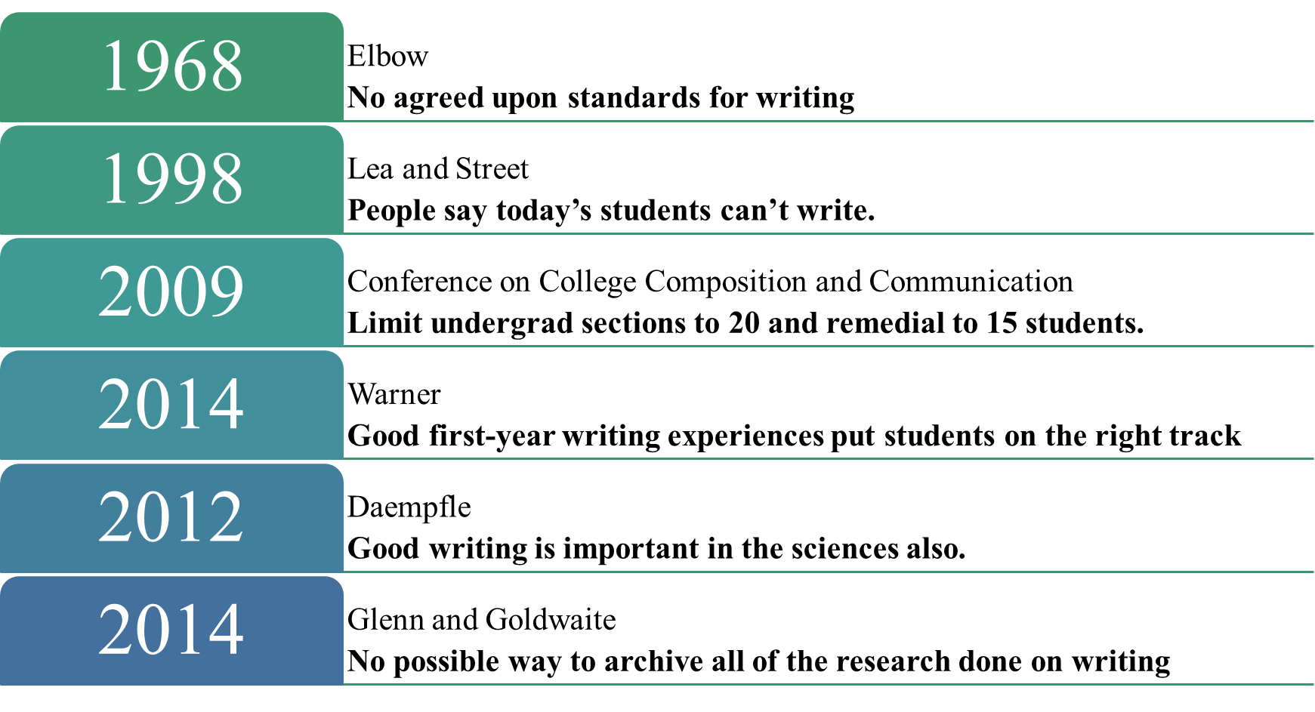

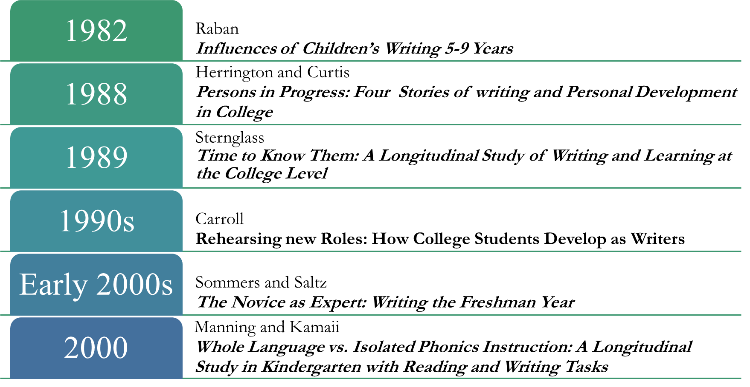

For years, teachers and some of the public have resolved that today’s students just can’t write (Lea & Street, 1998, p. 157). Some people may feel that writing should come easily or naturally to most people; however, Ede reminds us that “writers are made, not born, that writing is not an inherently magical or mysterious activity” (p. 32). It doesn’t help that composition classes are often over-crowded and often taught by part-time faculty and at larger institutions, graduate faculty, whom sometimes don’t often have the time or the opportunity to engage in frequent conversations with full-time faculty concerning theoretically based practices to enhance writing quality. In 2009, the Conference on College Composition and Communication suggested that undergraduate writing sections should be limited to 20 students and 15 students for remedial courses (Jaschik, 2009, p. 2). The Conference also concluded that no faculty member should be held accountable for teaching and grading more than 60 writing students a semester and 45 students in remedial courses.
Some students might find writing courses frustrating because, “we have no agreed-on rules for evaluating it—no procedures for showing that it is true, or even that it is false—not even conditionally” (Elbow, 1968, p. 192). Because many of our students haven’t been exposed to academic language and to the types of writing assignments that are required (Shaughnessy, 1994, p. 325), we should consider thinking about multiple ways to transition them into college-level writing.
Oftentimes, students don’t struggle with how to write, but with what to write. Instructors may need to reconsider how they compose and explain their writing assignments and requirements, because many of our students find them quite confusing (Lea & Street, 1998, p. 161; Holberg & Taylor, 2006, p. 1). Lea and Street claim:
Many of the difficulties they experienced with writing arose from the conflicting
and contrasting requirements for writing on different courses and from the fact
that these requirements were frequently left implicit. (p. 162)
If students don’t understand what they’ve been asked to do, then it’s illogical to be disappointed and surprised by the deficiencies in their work. Although the first composition classes in the 1880’s required students to perform rhetorical analysis (Jackson, 2010, p. 11), we can’t expect that today’s undergraduates can initiate the same or a similar task if their previous education or discourse community didn’t require it. Students are relying upon and expecting their writing instructors to guide them through the process of writing, Elbow petitions:
The only hope for the unskilled student we began with—who hated school and the
course—is to give him a teacher who is trying to learn and who shares the process
with the student (p. 199)
Few would dispute, as Warner would affirm (2014, p. 1), that a good experience in a first-year writing course has the potential to put students on a positive track that will carry throughout their educations. Council of Writing Program Administrators, National Council of Teachers of English and the National Writing Project also propose writing’s ability to ground students in success in college and beyond (2011). Writing continues to be important because it fosters deep learning and it is a higher-order skill (Pegoda, 2014, p. 1).
With written assignments, students have an opportunity to do better and
their knowledge is focused on meaningful, lasting information. Writing moves
assessment beyond low-level knowledge, as a basic recall, and moves towards
critical, creative, high-level thinking. And this is what education is truly about.
(2014, pp 2-3.)
The recognition of the value of good writing is not just limited to English or Humanities courses. Science instructors, too, have expressed the importance of writing in their courses:
A method of instruction for helping students organize this content is found in
explanatory writing. Explanatory writing requires that students organize their
thoughts to explain a science concept to a nonscientist friend. Writing can be a
powerful tool for expanding, modifying, and developing new language networks.
through writing, they can link together old and new ideas about science. These
mental structures would help students better link to the new information and
expectations of their college instructors. It follows that organizations should
focus on student writing to improve college science success. Writing helps to
emphasize not just what content is taught but how that content is produced and
conceptually placed. (Daempfle, 2012, pp 73-74).
This study presents a picture of what my former college students have deemed important during and after taking a composition or English course with me. Glenn and Goldthwaite (2014, p. 267) confirm that there is no possible way to represent or to archive all the composition research to date. However, this study will offer representative studies that have guided this researcher on the quest to uncover how students use writing and how they feel about it.
In a large-scale meta-analysis on writing conducted by Graham and Perin, it was found that direct instruction in grammar yields the least promising results with -0.22, while self-regulated strategy development presents the most favorable outcomes with 1.15. The chart below depicts the ten practices Graham and Perin identified as improving student writing, their effect sizes and the grades where the treatment should occur.

Table 5.
Writing strategies
Practice | Effect size | Grades
Strategy Instruction | 1.02 | 4-10
Summarization | 0.82 | 5-12
Peer assistance | 0.75 | 4-12
Setting Goals | 0.70 | 4-8
Word Processing | 0.55 | 4-12
Sentence Combining | 0.50 | 4-11
Professional Development | 0.46 | 4-12
Inquiry | 0.32 | 4-9
Prewriting | 0.32 | 4-9
Models | 0.25 | 4-12

A 2008 report conducted by the United States Department of Education entitled Improving Adolescent Literacy: Effective Classroom and Intervention Practices offers five recommendations to improve student literacy: “Explicit vocabulary instruction, direct and explicit comprehension strategy instruction, explicit instruction of text meaning and interpretation, increase student motivation and engagement in literacy learning, and make available intensive and individualized interventions for struggling readers that can be provided by trained specialists” (U.S. Department of Education, 2008, p. 11 ).
Regarding my personal instructional practices in relationship to Graham and Perin’s treatments, I conclude that summarization, peer assistance, word processing, prewriting, and models are most directly correlated with my teaching.
Because so many of my students are in workforce development fields, it’s important to share with them how to critically read information and filter the gist of it. This is accomplished through repetition and summarization.
I am a firm believer that one’s peers often explain concepts, ideas, and strategies better than professionals and this is why I developed a course entitled “Peer Writing Coach” where students who demonstrated that they were strong writers were selected to coach their peers through the writing process. Additionally, for major writing assignments in my classes, I have students participate in peer reviews where they critically read their peer’s paper and anonymously critique it using a very specific rubric.
In a world that has almost put pen and paper to rest, I thoroughly instruct my students on proper word processing techniques and etiquette and require that they use it for all out-of-class assignments.
Before all major writing assignments, I require that my students compose an abstract (summary) of their paper, provide a tentative outline of how their paper will flow, and to conclude with a working bibliography, so that we have some idea of the sources they will use. If students do this correctly and put much thought into it, they are essentially crafting their paper through these prewriting exercises.
Because what I say may not always transfer to what I am expecting, I provide models of all writing assignments for my students to review. When I was in high school and undergrad, we were only shown examples of A papers, which raised the bar of our writing expectations. However, I show my students A, B, and C, papers so they can see the range of student writing, and so that we can have a discussion about what would have strengthened the B and C papers.
Specifically, regarding my personal instructional practices, I intentionally provide a great deal of feedback on students’ papers. I want them to know what they’re doing well in addition to what they could improve. Essentially, it’s my conversation with them. Often, after their papers have been returned and they read the comments, they stay after class or email me to further discuss their work. Together, we are collaboratively working to strengthen their writing.
Another way that I connect with students is scheduling individual conferences in the middle of the semester. For all of my on-campus students, which is approximately 40 or so each semester, I schedule 10-minute conferences where we discuss their writing strengths, weaknesses, how they feel about the course, and what they would like to improve. We also discuss the remaining assignments that will be introduced during the latter half of the course.
Something that has been consistent from the very beginning of my teaching is my ability to establish and maintain relationships with my students. I often begin my class sessions by asking students how are things going at home and at work. I also ask them about the latest movie they have seen or book they’ve read. A very trusted mentor of mine once told me that students don’t care how much you know until you show them how much you care. These words have remained in the forefront of my interaction with students.
With all that I do to engage students and to make them feel welcome in the learning environment, I do recognize that my instruction does have areas in need of improvement. Aside from the regular discussions that we often have in class, there are not many opportunities for my students to formally present/share their work. In 16 weeks, there are not many occasions where students are presenting in front of their peers and this is something I would like to address. Additionally, something I continue to say that I am going to do more of, but I never get around to doing is having my students reflect more. I think it is important for students to pause and to think about what they are doing and reflecting would give them an opportunity to do that.
There have been many conversations about whether teaching is an art or a science. Currently, I hold no strong consideration in either camp. However, I have been teaching long enough to know that teaching takes time and practice and that it’s a collaborative process.
Over the years there have been numerous studies conducted to examine the relationship between students and writing. In the fall of 1989, Sternglass began a six-year study that began with 53 basic writing students from the City University of New York. At the end of her study only nine remained: 1 white, 4 African-Americans, 3 Hispanics, and 1 Asian. Through a case study, Sternglass wanted to know how writing experiences were influenced by homelife, work places, and communities. What is revealed in Sternglass’s Time to Know Them: A Longitudinal Study of Writing and Learning at the College Level is that “Writing development is shown to be neither neat nor linear…” (xiv) Additionally, issues of race, gender and sexual orientation, class, and ideology influence students, but do not limit them. (p. 60) and “students with poor academic preparation have the potential to develop critical reasoning processes that they must bring in academic writing if they are given the time.” (p. 296)
Sternglass (1997) was the participants’ instructor in their composition classes. To conduct her study, she collected writing samples from them from different courses (p. 236), she interviewed them twice a semester (p. 240), each time making sure to ask what they felt were their hardest and most difficult courses were and why they fell into that category. With the instructors’ permission, during the second year of the study, a graduate assistant observed a student in one of their classes. Sternglass also collected a portfolio of the students’ writing.
In the 1990’s, Carroll began a four-year study of 20 students from Pepperdine University. As Her book is titled Rehearsing New Roles: How College Students Develop as Writers. Like Sternglass, Carroll wanted to know how students developed as writers. What she learned is that a one or two semester course cannot fully meet students’ needs and that students learn to write differently rather than better. Like Sternglass, Carrroll used portfolios and interviews in her study. However, she also included questionnaires.
Persons in Process: Four Stories of Writing and Personal Development in College details Herrington and Curtis’s 4-year study with four basic writing students at The University of Massachusetts-Amherst in 1988 (p. 1). Herrington and Curtis used a case study to answer the question “How can teachers teach better and make writing experiences more positive for students?” To accomplish this, they conducted interviews with participants and their teachers, collected students’ writing samples from various courses, and did class observations. They devoted a chapter of their book to each participant, allowing her/him to be expert witnesses (p. 17). They learned through their study that delayed instructor feedback may hinder student development.
In the early 2000’s, Sommers and Saltz began studying 400 students, which was 25% of Harvard’s freshman class, over four years. (p. 126) They used student writing samples, interviews, and surveys to answer the questions, “What makes the transition to college writing so difficult?” and “What separates those who go on to be successful college writers from those who do not?” Through The Novice as Expert: Writing the Freshman Year, Sommers and Saltz share that, when students write about something that matters to them, they are able to maintain an interest in writing throughout their undergraduate and graduate careers (p. 127). They also state, “For freshman, who change so rapidly, writing is a mirror that helps reflect who they are as students, allowing them to see themselves in their own words.” (p. 129) The idea that students might get something other than a grade from writing became very important. (139). Most importantly:
According to students’ own reports, when they do not see a larger purpose for
writing other than completing an assignment, when they become complacent,
or when they remain perpetual novices throughout college, the conditions for learning
or thinking do not always exist. But when students are able to see what they can “get”
and “give” through writing, they speak passionately about writing as the heart of what
they know and how they learn; writing is not an end in itself but is a means for
discovering what matters. (p. 146)
There has also been research to examine writing in from kindergarten to adolescence. Manning and Kamii (2000) studied 38 Kindergartners from a lower middle-class neighborhood from the South in Whole Language vs. Isolated Phonics Instruction: A Longitudinal Study in Kindergarten With Reading and Writing Tasks. Half of the students were Caucasian and the other half were African American. All the participants were five years old at the beginning of the study. There were only two kindergarten classes at the school. Thirty-one percent of the students at this school received free and reduced lunch. There were 19 students in each group. Half of the students received instruction from a phonics teacher, while the other half were taught by a whole language instructor. The phonics class had daily phonics worksheets, oral-sound training, and many chalkboard activities. Children’s books were also read aloud, occasionally. In the whole language class, the teacher also read books aloud, but every day. Phonics was taught through shared reading, journal writing, and writing demonstrations. The teacher would also have the participants write a note to a custodian, or to a sick classmate.
Each child was also interviewed five times. First, they were asked to write eight words, then they were asked to read two to four sentences. Writing tasks consisted of writing pairs of words. Manning and Kamii’s research showed that the whole language group made more progress in both reading and writing.
Earlier than Manning and Kamaii, Raban preceded them with research that specifically looked at the influence on children’s writing between 5-9 years (1982) in the work Influences of Children’s writing 5-9 years. The researcher began with 20 students and used oral preschool language development, transcripts, interviews concerning parent and child interest in literacy, classroom observations of primary schooling, test results and writing evaluations to understand their writing practices. The researcher was more interested in understanding more about the process than the product of student composition (1982, p. 3) Over 30 teachers were observed interacting with students over their first two years in school.
At age five, three pieces of writing were taken from each student and scored from 1 to 6, with 6 being the highest on how well they wrote. At age seven, four writing samples were taken from the students. Three of the children were not writing independently, so their writing was not submitted. The journalistic style of Who, What, When, How was used to review the samples and the students were scored with: 0 absence of causality and 1 presence of causality.
At nine, 18 students had work submitted. Two participants were still not writing independently so their work was not included. Their work was scored holistically on content and surface features. The children were also observed in their classrooms. (1982, p. 13) The researcher wanted to see the different kinds of activities the students did and how they worked with them. Students would draw to create images or pictures of their understanding of news stories of the day. The teacher would transcribe from the teacher and the students would trace over her writing. (1982, p. 15)
Raban resolved from this longitudinal study that, if children were exposed to literacy in the home before their pre-school years, that the experience tended to endure and prepare them better for school. Raban noticed that the mother’s educational level positively influenced the children’s ability. (1982, p. 11) As well, students who came from poorer homes often had poorer writing and students who came from good homes had good writing. (1982, p. 19.)
In analyzing the longitudinal studies of writing, two themes that frequently emerged were the importance of feedback/comments and the importance of students to writing about topics that interested them.
Comments/Feedback
Perhaps the most intimate connection an instructor may have with his/her students is exhibited in the comments that the instructor places on written assignments. Veteran English instructors are well aware that, “Few students will question a poor grade on a math exam, yet with writing, many people believe that grades are ‘completely subjective.’ (Fowler & Ramsey, 2012, p. xxi). Even though the students’ views may seem a little presumptuous and petty, research indicates that writing grades are often subjective, unaccountable, and arbitrary (White, 2007, p. 68). While the grades assigned to written work may be somewhat confusing (well expressed by students in a short YouTube clip Beyond the Red Ink), primarily, it is the faculty member’s responsibility to review and to assign grades according to standards recommended by English faculty and approved by the college’s appropriate administrative council.
Seidman (1968) imparts that there are three types of feedback:
1) selective, supportive;
2) informative; and
3) no comments.
While there may be varying degrees associated with how instructors present feedback, Williams (2003) stresses that, “The goal of feedback is to teach skills that help students improve their writing proficiency to the point where they are cognizant of what is expected of them as writers and are able to produce it with minimal errors and with maximum clarity.
The reason why many may find the reviewing of papers and assigning them grades enigmatic is because writing is often undefined and unrestricted, unlike so many other assignments in math or science.
The uses of writing are so large—as a tool for learning new material, as a means
of power in a verbal world, as a way to understand complex ideas, as a route to
understanding the self, and so on—that we do want to narrow our purpose as
writing instructors to merely judging and enforcing group standards.
(White, 2007, p. 52).
For most students, relationships with their English teachers are somewhat different from their relationships with other instructors. According to Berrett (2014), students tend to feel that English teachers have an unwarranted authority over them, as much instructional time is devoted to helping students understand that they are engaged in a continual process of learning with their instructors (p. 3).
Relevancy
Because many students often find their writing assignments futile and unrelated to anything in their life, Jackson (2010, p. 9) suggests that instructors might consider creating writing assignments that resonate with students’ lives. Bruner (1963, p. 31) says a teacher has to make a subject worth knowing.
No matter what career path they choose, or what they do in their personal lives, the way that students present themselves through writing is often highly indicative of how others will receive them (Carroll, 2002). That may or may not armor students against barriers that they may need to cross. Ink pens and pencils may have been replaced by computer and smart phone keys, but they are all still forms of written communication that no one can escape. Writing is everywhere.

CHAPTER THREE
METHODS
Research Design

Undoubtedly, I am much better with words than I am with numbers. Even when I calculate my students’ grades, I frequently stare at the percentages (often returning to them the next day) hoping that they will reveal what the 90%, 75%, or, yes, in some cases 10%, actually mean. I often debate with myself if the students’ grades are an accurate reflection of their earnest performance in my course. I question whether they were able to truly absorb all of the material, or if the grade is an indication of their cultural capital (Kamberelis & Dimitriadis, 2006, p. 70; Spade & Ballantine, 2008, p. 15; Macedo & Freire, 1987, p. 111) which often trains them on how to negotiate the system. Or, is it a microscope on my strengths and weaknesses of being able to present the information in a manner that is relevant and accessible?
Because I am entrenched in the narratives of student performance and participation and in the overall process that writing involves, qualitative research would seem able to capture the nuances of composition. I am a much more comfortable exerting qualitative research methods and with subscribing to the results that they provide. Cresswell (2007, p. 37) explains that qualitative research begins with assumptions and a worldview in order to frame a theoretical lens that may offer insight into existing problems that affect individuals or groups. Merriam (2009, p. 5) notes that qualitative research is an attempt to gain an understanding of how individuals and groups interpret their experiences and relay that information to the culture around them.
The research questions are as follows:
- What effect, if any, did my English class have on the writing, reading, speaking and listening skills of my former students?
- How do my former students currently use writing, reading, speaking, and listening in their lives?
- What implications for instruction can be made, if any, regarding teaching English and communication skills in light of what my students learned and how they write, read, speak and listen in their lives?
Although I am confident that portraiture is the best method to capture my former students’ experiences, I recognize that others might question why I didn’t select more commonly recognized methodologies, such as ethnography and case studies. While an ethnography would allow me to immerse myself in my former students’ lives, it would also require me to report on their shared/collective experiences (Cresswell, 2007, p. 68). I wanted to concentrate on framing participants’ individual practices. A case study would have also permitted to me to conduct in-depth interviews and to gather artifacts for my data collection; however, it would not have permitted me to concentrate on the goodness of my former students lives, but to give equal consideration to all aspects.
I could have used phenomenology as my methodology since it focuses on the lived experiences of its subjects (Merriam, 2009, p. 24). It highlights the richness of everyday life and social interaction. Because it often builds upon emotions of strong intensity such as love, anger, and betrayal, I felt that concentration on former students’ ways of communication would be studied best through portraiture.
Portraiture
In recent years, more researchers have used portraiture to study the lived experiences of their subjects. P. Torcivia, used portraiture to study five adult women in STEM careers and The National Council for Curriculum and Assessment used portraiture to study the lives of 12 children to understand how they interacted in childhood settings. Although portraiture shares a common thread in subjects’ familiarity with the researcher, the focus is on the individual.
In research done by Sternglass, words frequently associated with her research pertain to images such as snapshots (Sternglass, 1993, pp. 236, 260) and rich pictures (Rogers, 2010, p. 270), which also lend themselves to portraiture.
After years of teaching and having students disappear into their professional and personal lives, I became curious about how my former students were using writing in their daily lives. I wondered what they thought about their writing instruction from the vantage point of their current lives. To best understand my former students’ experiences, I needed a methodology that would allow me in my former students’ space through observing them, having them journal about how they communicate in a day, interviewing their current co-workers about their communication habits, reviewing their prior coursework, and interviewing them about their experiences. Unlike ethnography, I didn’t want them to tell me a story; I was hoping to construct their story from what I observed and the information they provided (Lawrence-Lightfoot & Davis, 1997, pp. 13, 120). Thus, I elected to use Portraiture as my research method, which is defined as:
a method of qualitative research that blurs the boundaries of aesthetics
and empiricism in an effort to capture the complexity, dynamics, and
subtlety of human experience and organizational life. Portraitists seek to record
and interpret the perspectives and experiences of the people they are studying,
documenting their voices and their voices and their visions—their authority,
knowledge, and wisdom, (p. xv).
Lawrence-Lightfoot and Davis (1997) contend that Portraiture must explore its subjects through five primary lenses which include context, voice, relationships, emergent themes, and an aesthetic whole. Here is how Lawrence-Lightfoot and Davis explain Portraiture’s components.
Context, also referred to as setting, is important because it is rich in clues for interpreting the experience of the subjects in the setting. (Lawrence-Lightfoot and Davis, 1997, p. 41). The context also provides clues into how the subjects perceive and experience social reality (p. 43).
Voice is omnipresent and it is the over-arching domain that reflects the researcher and sketches the subjects through external and internal experiences. (p. 85) Voice is the metaphorical glue that connects the researcher’s observations with the subjects’ lived experiences.
Relationships are the center of portraiture. (p. 158) Without them, a portraiture study can not exist. This is how portraitists have a rich and extensive repertoire of data in which to frame their study.
Emergent Themes are the result of a highly meticulous and selective data collection process and the results that the data yield. Once the themes are identified, they are used to frame the portrait.
Aesthetic Whole is created as a result of merging the study’s data. There are four elements that form the aesthetic whole and they are: conception, structure, form, and coherence. Often considered the first tool for ordering material (p. 248), conception shapes and embraces the development of the narrative (p. 248). Structure is the portrait’s glue. It is the pillar that magnifies each frame of the study through careful articulation, observation, and presentation. Form is the texture of intellect, emotion, and aesthetics that support, illuminate, and animates the structural elements (p. 254). It is expressed in stories, examples, illustrations, illusions, ironies—gives life and movement to the narrative, providing complexity, subtlety, and nuance to the text. (p. 254). Finally, coherence is the framing and the sequencing of events and experiences and the articulation of a clear and consistent voice and perspective (p. 256).
Portraiture is unique in its ability to offer understandings through the presentation of rich data and the development of meaningful relationships between the portraitist and her participants. Such relationships yield important information that offers guidance to the often incomprehensible. Lawrence-Lightfoot shares:
Portaiture resists this tradition-laden effort to document failure. It is an intentionally
generous and eclectic process that begins by searching for what is good and healthy
and assumes that expression of goodness will always be laced with imperfections.
(1997, p. 9)
I began this research with questions that I had about my own teaching and how my former students were able to use my instruction outside of the classroom. Even though I knew there would probably be as many weaknesses as strengths that were revealed, deep down inside, I yearned to know what was good—positive. I wanted to capture what I had done well and enhance it with my former and current students.
In this research it was also very important that anyone, not just academics would find my writing style and research accessible and able to adopt in their own communication and instruction. Author Amy Tan describes this in “Mother Tongue” when she gives her mother’s verdict on one of her books—“so easy to read” (2012, p. 154). Lawrence-Lightfoot writes,
Academicians tend to speak to one another in a language that is often opaque and
esoteric. Rarely do the analyses and texts we produce invite dialogue with people in
the “real world.” Instead, academic documents—even those that focus on issues of broad
public concern are read by a small audience of people in the same disciplinary field, who
often share similar conceptual frameworks and rhetoric. (1997, pp. 9-10)
Other researchers have also found Portraiture to be a good methodology to conduct their research. Braun (2014) used Portraiture in her dissertation Portraits of Transformation in Higher Education. In her dissertation, she shares that she selected Portraiture as her methodology for the reasons I previously mentioned: she wanted to emphasize the goodness and the resiliency of her participants. She wanted to demonstrate how transformative education can become widespread in colleges and universities; she wanted to show how transformative education fosters relationships, and she also wanted her work to be accessible (p. 54).
Additionally, Moore (2011) used Portraiture as her methodology for her dissertation Allow the Music to Speak: A Portraiture Case Study of Pre-Service Teachers’ Experiences in a Music-Integrated Literacy Methods Course. Moore decided to use Portraiture because she liked the ability to use rich description and she was able to use her own insight as a music teacher in her study. McCarthy used Portraiture in her dissertation Full Circle: A Portraiture Study of Three Successful Indigenous Educators and Community Leaders Who Experience Personal Renewal in Their Practice of Cultural Restoration. (2017). In her work, she stressed the importance of goodness. (p. 40)
With portraiture, I was able to wait for the story, instead of listen to the story as with in an ethnography and case study. Through my participants’ interviews with them and their co-workers, observations, past assignments, journals, and their reflections, I was able to frame their beliefs about writing and to see how my instruction affected their lives from the information I gathered.
Table 6 shows the data I requested from participants and when I collected it.
Table 6.
Types of data collected and time of data collection.
Data | Date
Observations | June/July 2015
Interviews | Summer 2015
Artifacts (Journals, past assignments) | Summer 2015
Reflections | Summer 2015
Co- Worker Interviews | Spring 2016
Analysis | Spring 2016-Spring 2017
Write up | Fall 2017-Spring 2019

When I was confident that portraiture would be my methodology and that I needed to include former students and their work in my study, I began contacting them in the spring of 2015. I explained what I would be doing and presented my approval for the research and one by one they consented.
My first collection of data was a series of observations during the summer of 2015. With very little communication and not any direction, from a distance, I simply observed my former students in their work places. I was able to observe everyone except for Taylor, because she was unable to get permission from the hospital.
Next, I followed up with interviewing them. To learn more about their communication practices and what they thought of my instruction, I prepared a series of questions to which all of them responded.
Soon afterwards, all the participants began a week-long journal of how they communicated each day and they looked for past writing assignments from my courses.
I also requested that they reflect on writing and their experience in my courses. I wanted to know what resonated with them, what they remembered and what they wish they had learned more of.
Even though I had a strong sense of how my former students felt about my instruction from the interviews, journals, and reflections, I felt that interviewing at least one of their co-workers would provide another perspective on their communication practices, so I interviewed their co-workers in the spring of 2016.
Data Collection
In an effort to stay consistent with qualitative research and portraiture methodology, data collection for this study consisted of: observations, interviews, journaling, and documents that included the participants’ past writing assignments and their current reflections of their writing/English experiences.
Hubbard and Power (p. 1, 2003) contend that observations allow teachers to understand students’ worlds from their points of view, instead of the teacher’s perspective:
Students are the informants in teacher research, helping us to learn
both the recipes for behavior in their cultures and the learning
strategies that they employ. And central to the role of informants is
being an active collaborator in these research endeavors. (p. 1)
The researcher and each participant agreed upon a day and time for the observation to occur. With permission, all of the observations, except for one, took place in the participants’ work environments. Due to the sensitive nature of her employment, one participant was unable to receive permission for me to observe her because of HIPAA (Health Insurance Portability and Accountability Act) laws. The observations lasted from one to three hours. During each observation, I was able to witness each participant communicate through speaking and in writing with their colleagues and/or the general public.
To gain further insight into the participants’ thoughts and practices, I conducted several interviews. Patton (2002, p. 341) explains that the purpose of an interview is give access into the other person’s perspective. Interviews took place in study room of the The University of Oklahoma-Tulsa Library or in the private room of the Rudisill Regional Library. Before each interview transpired, I read and showed each participant a copy of the interview questions. Each participant was asked about the most frequent and the less frequent ways in which they communicate and their thoughts about their English/writing instruction. Subsequent questions for each participant surfaced from their observation or their reflection. Lawrence- Lightfoot and Davis (p. 122) contend, “With so much happening in the moment of the interview, it is useful if not necessary to tape and later transcribe interviews so that they can be revisited” this reason, each interview was recorded on a digital recorder and later transcribed for analysis. During each interview, the researcher also took handwritten notes.
Journals are often described as a way of creating field texts (Clandinin & Connelly, 2003, p. 103) and in recent years it has become a more widely accepted form of data (Cresswell, 2007, p. 129), thus, each participant also composed a one-week journal that detailed their communication practices. All participants described their communication activities in their journals. Each journal pertains to participants’ employment, personal thoughts, and social life. As well, each participant reflected on their English/writing instruction and were encouraged to include aspects of a class or classes they had with the researcher. In addition, all of the participants, except for one, submitted past assignments from the researcher’s classes for review.
Photographs and physical objects are considered substantial means of data (Merriam, 2009, p. 144), I included observations of participants at work and at school. In addition, two of the participants provided papers that they had composed for the researcher’s classes.
Participants
During the summer of 2015, when I felt confident that portraiture would be my methodology, I thought about potential candidates that would offer significant insight into the extent of what writing instruction had an impact on their work lives. I have maintained personal relationships with many former students. I chose participants who had taken an English class with me in high school or in college, were not be enrolled in college and were currently working. I also selected former students that had time to participate and with whom I remained in contact.
Once I settled on the former students I would contact, I communicated with five of them; however, only four were able to participate. All participants knew of my doctoral studies and agreed to participate. As well, each participant was given the opportunity to select his/her pseudonym for this study.
Table 7 describes this study’s participants, when they were in my course, what course they took from me and what they are doing now.

Table 7.
A description of study participants
Participants | Taylor | Jill | Lisa | Zach
Description | -Married AA female  -Late 20’s  -Mother of preschool daughter | - Single White female  -Late 30’s  -Mother of adult son | -Married AA female  -Late 30’s  -Mother of a young son and daughter | -Single White male  -Late 20’s  -No children
When she/he was in my course | -2009-2011, 2013 | -2007-2008 | -2002 | -2005-2006
What course she/he took from me | -Comp I, Comp II, and Advanced Comp | -Comp I & Comp II | -Comp II | -American Lit
What she/he is doing now | -Nurse’s aide | -Dental hygienist | -A lead plumber in Tulsa County | -Waiter

In several visits with the participants and with their co-workers, and with studying the documents they provided me, I was able to draw assumptions as to what impact my instruction had on them. I approached this research without any bias or notions, I wanted my work with my former students to reveal what they had learned, not what I hoped they remembered.
To date, I remain in frequent communication with Jill and with Lisa. The complexity of Taylor and Zach’s work situations and personal lives does not offer as much regular contact; however, I have no doubt that if I reached out to both of them that they would contact me as soon as they could.
The hope is that this study will yield results that have been carefully scrutinized and probed. Hubbard and Power assert that analysis involves “…sifting through data, seeing and seeing again, the truths underlying the busy-ness of classroom life” (2003, p. 132)
I used observations, journals, interviews, and documents, because I felt that together they would offer a comprehensive view of my former students’ experiences and frame the picture of my former students’ practices with regard to writing.

CHAPTER FOUR
RESULTS
The Portraits: Taylor, Lisa, Jill, Zach
Observations
The ensuing paragraphs are descriptions of the four participants in this study. To provide anonymity, each participant is identified with a pseudonym. Each section contains a grid that explains what information the researcher collected from the participant. Additionally, each section contains images of the participant and what the researcher remembers from the participant in her course.
Table 8.
Components of Taylor’s Portraiture
Observation | YES
Co-Worker Interview | NO (The hospital would not permit it, so a close friend/future business partner was interviewed.)
Participant Interview | YES
Weeklong Journal | YES
Past Assignments | YES
Reflection | YES

Taylor is a native of North Tulsa. She attended some of the city’s most academically and economically challenging schools that include: Choteau Elementary, Madison Middle School, and Central High School, before enrolling in Tulsa Community College in the fall of 2009. She has a 36-year-old sister, a 34-year-old brother, and a 16-year-old sister. Taylor’s father is a janitor and her mother operates an in-home daycare which significantly influenced her desire to help others. When she is not busy with her husband, her young daughter, or working as a medical assistant for Hillcrest Hospital, Taylor enjoys shopping, going to the park, reading, watching, TV, and attending rodeos. Her husband competes in rodeo relay races (aka pony express) and he is looking forward to teaching their daughter how to ride sheep.
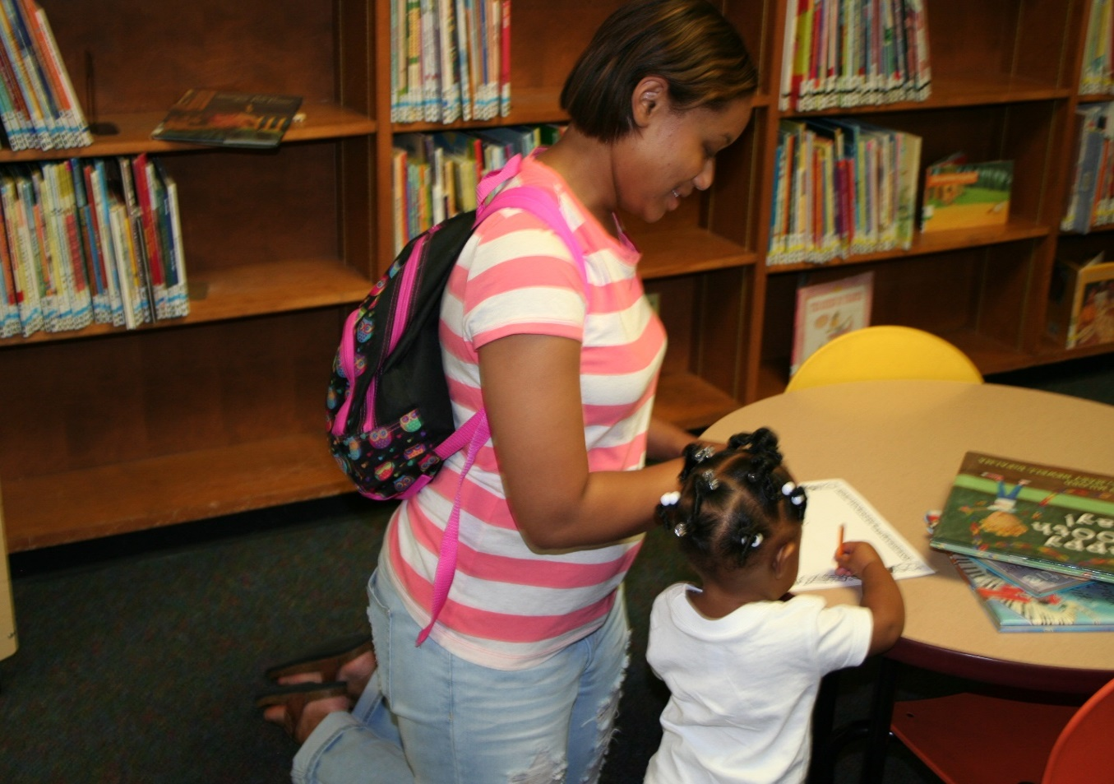

Figure 1. Taylor reading with her daughter in the library
Observation of Taylor
After I was able to get settled in the Children’s Section of the Rudisill Regional Library, I was warmly received by Taylor and her 13-month old daughter. Taylor was wearing blue jean capris pants and a peach blouse. Her outfit was complemented with brown leather thong sandals and a crisp coat of turquoise paint on her toenails. Taylor’s daughter greeted me with a curious stare and tilted head. As she moved her head, her soft jet-black pigtails moved to the side. She was wearing some snug blue jean shorts, striped socks, and some baby converse shoes. Spontaneously, she toddled off to the huge Lego station in the section…Taylor went after her. Next, Taylor positioned herself close behind her daughter, so that they could discuss the Legos’ colors. Patiently, Taylor would hold the Legos in front of her daughter and say their colors. Bright eyed and very consumed, her daughter would stare at the blocks as Taylor would put them away. Taylor would also read to her daughter. She would unhurriedly turn the pages as her daughter would look on. When her daughter had enough, she would race to the children’s computer station, which was already occupied and encourage her to come back to the Lego Station.
After some time in the library, one of the librarians asked Taylor if she wanted to sign her daughter up for a library card and enroll her in the library’s summer reading program. Taylor softly shrugged her shoulders and tilted her head and said, “Sure.” She asked the woman if she needed to provide proof of a utility bill to get the card and the African-American librarian who had her jet black hair pulled back in a stiff ponytail that’s length rested underneath her ears, which immediately placed emphasis on her bright red lipstick and sparkling white teeth said, “no.” The librarian explained that because Taylor already had a library card that her daughter was able to get one, so Taylor took the opportunity to sign her up. As Taylor was completing the library card paperwork, I was playing with her daughter. I read to her some of the magazines that were on the coffee table and she and I stacked pamphlets together, which was something that she seemed to enjoy as her little brown face was accompanied by a smile and laughter the entire time.



Figure 2. Taylor completing the application for her daughter to receive a library card
Near the end of my observation of Taylor with her daughter, she and I sat down at one of the children’s tables. After we finished our brief conversation, I walked Taylor to her car and we both thanked each other for a great afternoon and a time to get reacquainted. We agreed to meet again within the next three to four weeks to discuss her journals and my comments from her observation.
Taylor also agreed to prepare a one-week journal of her communication habits, which revealed that she listens with the most frequency and she reflects the least.
Being that Taylor works in a hospital, I was unable to receive clearance to observe her at work or to interview someone there; however, she did refer to me to a friend with whom she would like to potentially co-own a daycare.
Below is my interview with Kesha. The full transcription of my interview with Kesha is below.
Kesha, Taylor’s friend.

We were scheduled to meet on Thursday, March 31, 2016; however, the previous evening’s EF2 tornado ravished many homes and businesses in the area, leaving much debris in the streets that made simple travel concerning and impossible. So, she rescheduled her meeting with me until the following Tuesday, April 5.
With her black tresses flowing and sporting her yoga gear (black fitted pants and a long-sleeve navy shirt), Kesha, warmly greeted me in the driveway of the daycare she was preparing to open. The very next day, the Department of Human Services was scheduled to arrive for a walk-thru of her facility to determine whether or not it met the state’s requirements to care for young children. When I arrived, a gentleman was putting a crib in the building, but very quickly, he and another young lady left so that Kesha and I could visit alone.
Kesha ushered me into the back playroom that she was proud to share that she had been preparing for some time. As we took our seats at the kiddie table, Kesha shared that she and Taylor were going to open a daycare together, but that for right now Taylor wants to remain in healthcare. After I settled in, I asked Kesha if she was ready to begin and with her arms neatly folded in front of her, she nodded and smiled, “yes.”
Please note the following items as you read the transcript.
Ureka= the researcher

Kesha=the participant

Excerpts from the interview.

U= How long and in what capacity have you known Taylor?
K=I’ve known her for like three years, my husband and her husband are best friends.
U=Alright, ok, In what mode of communication: writing, speaking, listening, reflecting, and thinking, do you communicate most often with Taylor?
K=It would be writing. We do a lot of text messages
U=In what mode of communication do you communicate the least with Taylor?
K=On the phone.
U=Ok, um, What do you think are some of Taylor’s strong communication skills?
K=She’s very detailed.
U=Ok, alright, What are some of Taylor’s communication skills that you feel she could improve upon?
K=She really doesn’t like to talk.
U & K= Laughing, ok
During my brief interview with Kesha, I could tell that she was eager to continue to ready her facility for the next day’s visit. However, I did learn that she and Taylor communicates through texts (writing) the most and the least by talking on the phone. Kesha did not want to be photographed; however, she did allow me to take pictures in her daycare of the rooms the children would use.

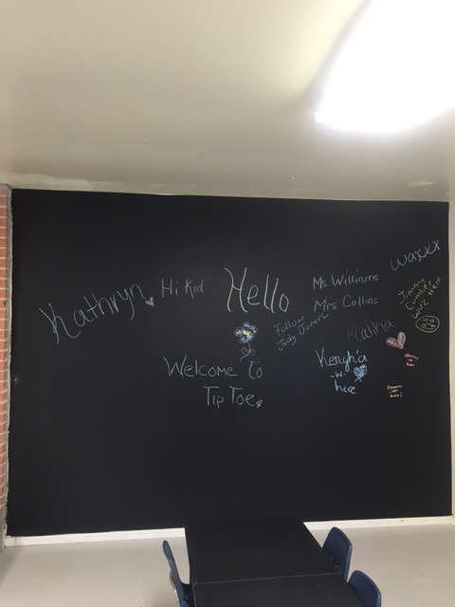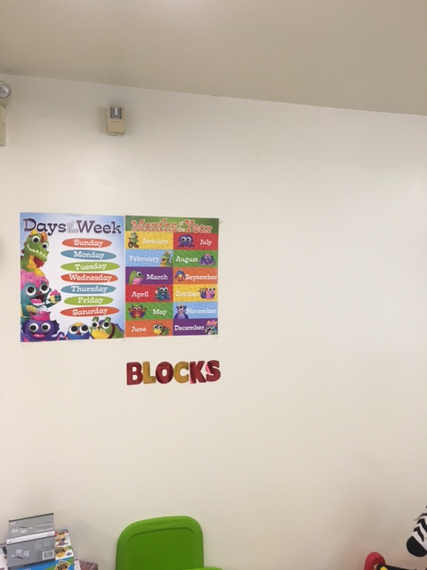
Figure 3. Kesha’s preschool classroom.
Taylor’s interview.
Even though Taylor has an extremely taxing schedule, she was able to find time to meet me for an interview. Below is our interview transcription.
It was a warm afternoon when Taylor met me in the library’s study room. With her light brown hair pulled back into a ponytail that rested on the center of her neck, Taylor arrived for our interview with her 14-month old daughter who was donning a 4th of July outfit and sparkly silver sandals with a bow that went across her toes. She was smiling from ear to ear in her mother’s arms as the jet black twists in her hair moved from side to side and from front to back. Taylor, whom hadn’t long gotten off from work, was wearing her gray scrubs.
Please note the following while reading the interview transcription.

U= Ureka, the researcher

T= Taylor, the participant

B= Baby, Taylor’s 14-month old daughter

The questions are in bold. Excerpts from the interview

Papers rustling…
U: From reviewing your weekly journal, it appears that you communicate most through speaking and less through writing and reflecting, how do you feel this relates to how you communicate in a day? So, really what I am saying is, do you feel like that’s an accurate reflection because I have you down with speaking on 71 instances, whereas with writing I have you down with 41 and with reflecting I have you down with 0. So do you feel that that relates to what you do in a day?
T: Very softly, Yes, for the most part it just depends on a day to day basis what provider I’m working with or for. When my coworkers need help, I pitch in and help them as well. I answer phone messages and give patients test results. I do a lot of reflecting when I do give patients their test results because they have more questions and they have questions about their medications in which I can’t give them medical advice like that. I have to relay it to the doctor and then the doctor will get back to me and then I’ll call the patient back. So, it just depends on a day to day basis. This week I worked with a provider that doesn’t require me to do a lot of writing and talking, so I am just quickly in and out of the room. I probably only spoke with about four patients on the telephone today and only roomed about seven patients in person. Whereas last week I may have spoken with over 50 patients. I probably roomed about 25 to 30 patients. So, day to day it just depends.
U: What impact, if any, did your English/writing instruction have on how you communicate at home and at work?

T: I would say English has made a great impact in my life and a positive one at that. Because I would say at home and at work I am different when it comes to speaking. At home I am lazy and I use a lot of slang, a lot of street words and stuff like that. Versus at work I am completely different, I am more professional and I try to use correct punctuation and speech that way the patients will know what I am talking about, then when I am communicating at home. Then, with coworkers and providers I try to use more medical terminology. So, it just depends on the setting, where I am at and who I am talking to. It just depends.
U: Okay.
T: Overall, English has made a great impact. It showed me how to chart correctly.
Looking at the baby getting restless in her chair
U: What impact, if any, do you feel English/writing classes had on your ability and attitude towards writing?
T: When it comes to writing…If I was given an assignment to write at work Laughing, I probably wouldn’t be too intrigued about it. Because being in school requires you to do so much writing. Even in Child Development, every week it seems like I had to write a paper. I really feel like I’ve just gotten burned out, you know, on doing major assignments, but as far as the work I do now, just communicating with patients and charting in their charts, I feel totally confident doing that. I really…
B: Uhhhh!!!
T: I forgot what I was going to say
U&T: Laughing
U: Let me just go ahead and go to the next one so you don’t have to worry about that.
U: So now as a parent, what do you understand about writing or communication that you will share with your daughter or others to assist them?
T: When it comes to my daughter, I try not to use baby talk and try to make her speak the words. Like now, she’s not telling me what she wants so I don’t know what she wants. But, when she gets a little bit older and can start and start learning to speak words more, I will show her how important it is to learn all of the stuff about English, writing, and language because it’s going to be hard to learn other subjects if you don’t know that first.
To obtain a realistic understanding of Taylor’s and the other participants’ communication habits, I had all of them journal for an entire week. Once they finished, they emailed them to me and I reviewed them multiple times to categorize communication habits. I denoted W for the frequency of Writing, S for Speaking, L for Listening, R fpr Reading, T for Taking and RE corresponds with Reflection.
Over the course of a week, Taylor’s journal reflected that she communicates most through speaking and less through writing. Reflection is not indicated on her communication habits.

Table 9
Taylor’s weeklong communication results
Participant | Taylor
Writing | 41
Speaking | 71
Listening | 57
Reading | 50
Thinking | 49
Reflecting | 0

In examining Taylor’s work in my class from many years ago, I noticed that I had written the following comment on a research paper on which she earned an A:
Taylor, this is a well-researched and informative paper. You do a thorough job of informing the reader. One of your references has a 2009 year, so it’s outside the 2011-2013 timeframe, so it isn’t accepted. I tried to comment there, but for some reason all of your references highlight?!? Carefully review all of the comments/corrections. Taylor, it was a pleasure having you in class, again. Best wishes to you and PLEASE keep in touch! ~Mrs. W
I gave students their old papers, the results of my computations regarding their uses of communications in a week, and I asked them to reflect on the role of writing and my composition courses in their lives.

Taylor’s Reflection (looking back on her writing)
Overview of Studying English Composition by Taylor
Growing up, I loved school! I loved to learn new things, write stories, and make books. As I have grown older I have realized how important having an education is. In high school, I dreaded writing because I could not be creative and write about things that interested me. My freshman year in college I was confused at the fact I was re-learning everything which had been taught to me in middle school and high school.
Overall, I feel my aptitude for writing papers and completing assignments for English class was great. I have always been quick to complete assignments and was ready to learn new things I did not know or master things I had a hard time trying to accomplish. My attitude on the class work I have completed so far is positive.
I do not believe I have a special talent when it comes to writing. I enjoy writing about what interests me. The problem I have with writing most of the time is finding the correct words to express the way I feel. Having a difficult time to find the right words mostly occurs when I am conversing with others. At times it seems as if my mind just goes blank.
When I created, “The Impact of Sexual Health and Diseases”, it helped me gain more confidence when educating the type of patients I worked with at the time. A great majority of the patients I worked with did not know the importance of taking care of their body and how to protect themselves. I really enjoyed writing that paper because I was able to back up what I taught with research I had found while writing the paper.
When I created, “Love of a First Time Father”, I wrote that paper based on personal experience with my father and family. Re-reading this paper formed tears in my eyes because my father is such a great dad! Now he only works one job so he is home during the day time, but works evening to late nights. For 14 years, my father worked 3 jobs, 6 days a week on just a few hours of sleep every night. We mostly bonded when he took vacation 2x a year and on weekends and holidays. Now, that I have a child and he works less they are able to bond as if she is his child. Every morning when he gets to his home from cleaning his first building, “Sophie” looks for her Papa so she can snatch his ball-cap off his head and place it on top of her head so they can eat breakfast together. She prefers to eat from his plate even though she’s already had breakfast for the day. While eating breakfast they talk and watch TV. Then she leaves to go play with her daycare friends. I have a 13 year old sister, but I feel like he has a 2nd chance to make up from where we didn’t spend a lot of time together.
When I created, “Why I Want to Care for Children and Become a Nurse”, I had my mind set on what two careers I wanted to pursue. At the time I also knew what steps I would take in order to pursue them. Although, I have taken a break from school to raise my daughter I will never forget all the things I have learned because most importantly I will have to teach them to my daughter. I still have a few resources that I look over from time to time to refresh my memory such as Owl Purdue’s online website.
Since I have taken three of Professor Williams’ Composition courses, I can honestly say she has helped me gain confidence in writing as well as speaking to others. I use language and writing very much at my place of work. On numerous occasions I have had to proofread lab results interpreted by providers as well as messages they send for us to relay to patients and there are words misspelled or made-up abbreviations which are not approved. I find it very time consuming to have to correct these errors. I do my personal best when communicating with a patient as well as documenting in a chart because it is a legal document. I always think of better ways to communicate with patients and providers and others I work with.
Table 10
Components of Lisa’s Portraiture
Observation | YES
Co-Worker Interview | YES
Participant Interview | YES
Weeklong Journal | YES
Past Assignments | NO
Reflection | YES

Lisa was a Tulsa native who attended some of the strongest schools in the city, Horace Greeley Elementary School, Carver Middle School, and Booker T. Washington High School. She is the oldest of five and has four brothers. Her mother is a retired speech pathologist and her late father was a general contractor. Her father had an HVAC (Heating, Ventilation, and Air Conditioning) license, but he had to quit because of an injury. That’s when he started doing warehouse work.
Lisa earned her Associates in Business Management from Tulsa Community College in 2010. In December 2014, she earned her Bachelor of Science in Business Management from Oklahoma State University. She has only had one boyfriend and she married him 16 years ago. She jokingly admits that he didn’t give her a “true” proposal, but that they have a loving and enjoyable relationship that now includes their 7-year old son.
Interestingly, most of the women in Lisa’s family cannot conceive naturally. The women on her mother’s side must undergo a minor procedure to have children. Lisa and her husband did not have the procedure. They decided to place their situation in God’s hands, As Lisa states, smiling, “If it was meant to be, it would be.” So, after they returned from one of their many vacations, Lisa, during an annual checkup, found she was 14 weeks pregnant.
Currently, Lisa works as Tulsa County’s Building Operations Lead Plumber. She has an Oklahoma Contractor’s plumbing license. She earned her degree through the county’s tuition reimbursement program. For Lisa to advance in her career in building operations, she had to earn her bachelor’s degree. She began studying to be a plumber while following her father around doing handyman work. She learned early that her gender might be an issue in her career when potential employers questioned her skills and her ability. Although she had more than prepared herself with advanced hands-on training, she soon realized that it would take more for her to prove herself.
When Lisa entered my class in the spring of 2002, she was an accounting major, yet she expressed her strong desire and interest in plumbing. I believe that students should follow their heart, so I told her, “Well then, just be a plumber,” and so she did.

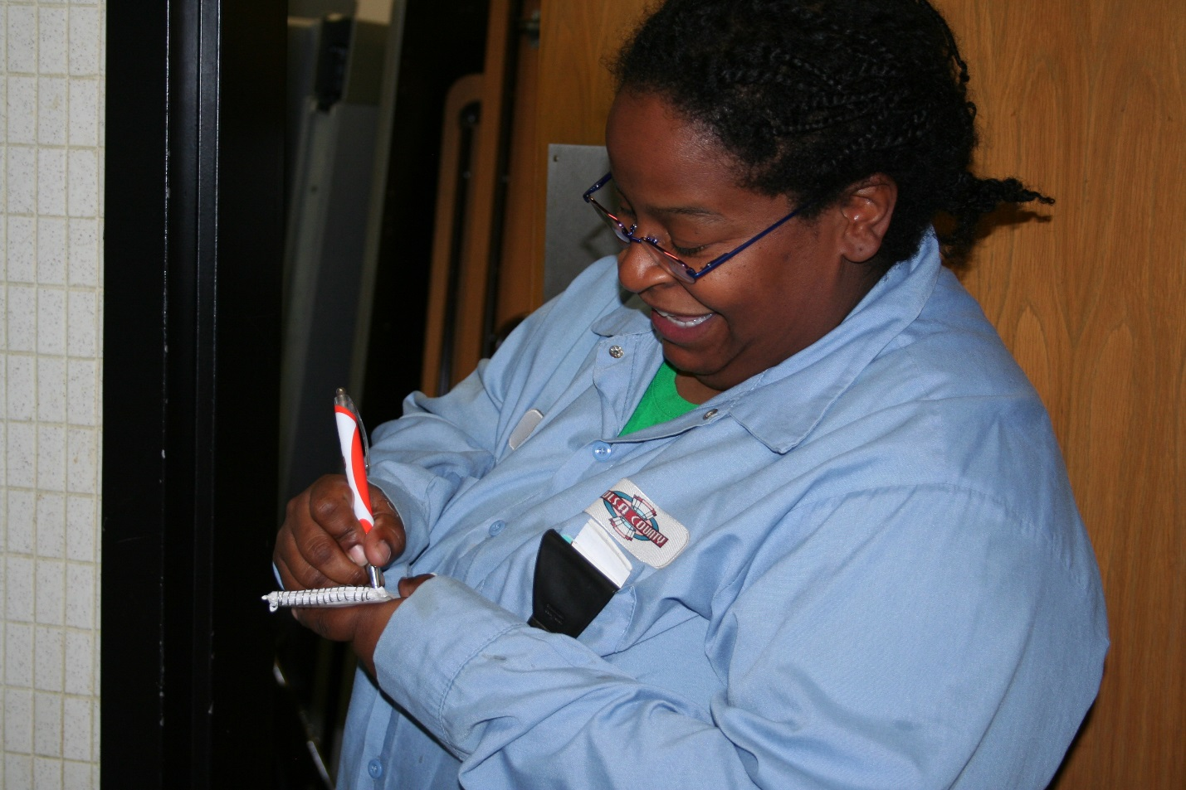
Figure 4. Lisa taking notes in the Women’s restroom of the Tulsa County Courthouse.
Observation of Lisa
Lisa told me to meet her at the courthouse. Not being very familiar with which particular buildings our government occupied downtown, I didn’t realize that we had three courthouses downtown, all in pretty close proximity to each other. I texted her to let her know that I was in front of the building and she called me back indicating that she didn’t see me. Then, we realized that I wasn’t in front of the correct courthouse. I was in front of the federal courthouse and she was over at the county courthouse. Laughing, she said that she would walk over to get me. About three minutes later, as cars are bustling down the one-way street at 8 o’clock in the morning, I see Lisa dressed in a County T-shirt and capris pants, smiling and looking both ways as she comes to usher me across the street. Smiling “Are you ready?” she says and I situate my camel satchel bag, black book bag, and black camera bag, and say, “yeah.” So, we hurry back across the street. First, we go down through the dark parking garage. Lisa informed me that I could have parked down there; however, I had already paid at one of the downtown meters. As she leads me to her office, I notice that the building’s floor is fairly tattered and worn as its crimson paint is chipping. Many people greet Lisa as we’re walking to her office and she reciprocates their kind gestures with genuine hellos. …The space that Lisa shares with another gentleman is quite cluttered. She has two empty water bottles and one empty juice bottle on her desk. In addition, there is also a Mountain Dew cup and an orange juice container there.
The office’s walls are a bright orange, which represents the colors of her favorite football team, the Oklahoma State Cowboys. The wall closest to the door has a picture with white flowers in it and it has a black background. Adjacent to that picture is a school photo of her handsome son. With a smile stretched from ear to ear, her little prince has on a light blue oxford that dons his school’s crest underneath his left shoulder and he has on a pair of navy slacks. On another wall, there is a picture of Lisa’s husband. With a bold smile like that of his son, her husband is wearing his Langston University academic regalia as it is his graduation portrait. Smiling, Lisa said that she needed to excuse herself, so she went to a small closet a short distance away to slip on her Tulsa County uniform, she later informed me that she’s required to wear something that has Tulsa County on it at work. Shortly, she said that we needed to head for her daily morning meeting. As I went to reach for my purse, she told me that the office would be locked, but I elected to bring my purse along with my notebook and camera. As we walked down the hall and around the corner to the meeting room, Lisa was warmly greeted by some other trade lead men who were already sitting around the rectangular-shaped table. The room’s walls were a strong baby blue color with a thick wooden rail around it. On the back wall there was a picture of the city of Tulsa. She affectionately introduced me and said that I was shadowing her for the morning. She shared that I was her former Composition II instructor and that I was interested in her communication skills for my dissertation. Some of her colleagues jokingly said that she didn’t have trouble communicating. As the gentlemen assembled, the Building Operations assistant director informed his team that a fireline would need to be drained in the morning.
Next, they discussed a room that needed to be painted and the manager asked who the painter was. Slightly sidetracked, an African-American gentleman commented on how cattle had disrupted the morning’s traffic. He indicated that a semi carrying cattle had flipped and the cattle started running down the road causing another accident. Someone joked that the cattle wanted people to eat more chicken. Bringing the group back to attention, the manager asked if they had completed the ceiling job and another gentleman indicated that they were working on it. Next, they discussed “Jon” who was on vacation that week and what he would need to do when he returned. After discussing what “Jon” needed to do upon his return, the manager asked if I had an update and I smiled and chuckled and said, “no.” Now it was Lisa’s turn. As she prepared to discuss what she was doing, she placed her arms behind her head and leaned comfortably back into the office chair. She shared that she hadn’t received a new computer. The assistant director took notes and then asked her if someone had looked at her county van. Smiling, Lisa shared that her truck had 60,000 miles on it and that one of its doors is starting to fall off. To this she laughingly and jokingly said, “no.” She then began talking about a job that she would do soon and she indicated that she would need a five-foot ladder. She also said that she would have one of the guys in her crew work on the janitor’s closet. The manager then indicated that the county had several surplus items that they were going to auction. Then, one of the men warned the group that he had seen snakes in the janitor’s closet. Next, the Mechanical Coordinator’s cell phone rang, so he jumped up and excused himself from the room.
At the end of the meeting, the manager asked who was going to call about a smoke detector that needed to be fixed and one of the guys said that he’d look into it. The manager then said he was going to try to work on Lisa’s truck and if he didn’t get it ready that day [Thursday] that he hoped to have it ready by Tuesday. The manager then started to collect his white notebook papers that were spread out in front of him. He concluded by saying, “Alright guys, get out there and be safe.” The African-American gentleman exclaimed to “eat more chicken,” to which most of the group laughed and smiled.
After the meeting, Lisa and I headed back into her office and she grabbed a pin and paper, so that she could complete her morning task. That morning she had to record if the tampon dispensers were working properly, and how much the county charged per tampon. Before we headed upstairs, Lisa went around the corner to hand a young woman with long brown hair who was sitting on the floor sorting papers a work order that she needed to address. Warmly, Lisa introduced me and shared why I was there and the young woman smiled and wished Lisa and I a nice day.
Lisa’s office and the meeting room are in the basement of the courthouse, so we had to travel upstairs for her to do her job. At every turn, county employees greeted Lisa. As we were
walking around the courthouse, I saw the community service room where non-threatening offenders go instead of serving jail time. As we continued to walk, I saw this long line of people frustratingly waiting for assistance. This is when Lisa shared that they were waiting on free legal service that the county provides. On each floor we went into the bathroom and Lisa checked each tampon dispenser writing down the amount and the cost. She said that the county had increased the tampon price from 10 cents to 25 cents per tampon.
After a while of walking in and out of bathrooms, Lisa and I finally ended up on the criminal floor. Lisa gave me unrestricted access into the judge’s chamber and into the jury’s deliberation room. On one hall, I actually got to see the elevator that the prisoners ride in so that they and their attorneys are not inundated by the media.

Figure 5. Sign in the Tulsa County Courthouse elevator
After our long morning, Lisa escorted me back upstairs so that I would more easily get to my car. She shared that she had clearance for me to shadow her around the courthouse that morning; however, it was a liability for me to ride in her truck, so our visit would conclude there. I graciously thanked her for inside access into her profession and into the courthouse and I shared that I looked forward to visiting with her again.
Like Taylor, Lisa, too, composed a one-week journal of her communication practices. Through Lisa’s journal I learned that she spends most of her day speaking with others and the least amount of time reflecting.
Additionally, I was also able to visit with Lisa’s supervisor about her communication skills, which is detailed below.
Interview with Mike, Lisa’s supervisor
With strands of hair blowing in my face and dust settling on my eyelashes from the downtown construction, I proceeded to the Tulsa County Courthouse to interview Mike in his office. When I arrived at the front door, a rather large and plump Caucasian woman very kindly asked me to place my bags on the conveyer belt so that they may be scanned. I complied and asked her if I also needed to remove my coat. She said, No, and after my things were scanned I waited for Lisa to arrive to escort me to Mike’s office. Shortly, I texted Lisa to let her know that I had arrived and I told her my location. Soon, she called and inquired where I was once more and very soon I saw her smiling and coming towards me. We hugged and she led me to Mike’s office.
We took the elevator to the basement. Then we took some more stairs to the sub-basement. We made a quick left and Mike was speaking with another man about harassment training. As soon as their conversation ended, Lisa, reminded Mike who I was and why I was there. Mike exchanged a genuine smile and invited us into his office to begin the interview. Before the interview began, I read the questions to Mike, so that he could begin thinking about answers. Smiling and nodding his head, he told me he was ready to begin.
Please note the following items as you read the transcript.
U: Ureka, the researcher
M: Mike, the participant
U: How long and in what capacity have you known Lisa?
M: (Looking towards Lisa) I would say about nine years
U: In what mode of communication: writing, speaking, listening, reflecting, and thinking do you communicate most often with Lisa?
M: Decisively, I would have to say speaking. We really don’t do much writing.
U: In what mode of communication do you communicate the least with Lisa?
M: I would have to say writing.
U: What are some of Lisa’s communication skills that you feel may need to be improved upon?
M: She could be a little more assertive when she’s got something to say.
U: Any final comments about Lisa’s communication?
M: (Smiling fondly) I’ve been working with Lisa for nine years and she’s a great employee. She’s good to get along with and she’s very helpful.
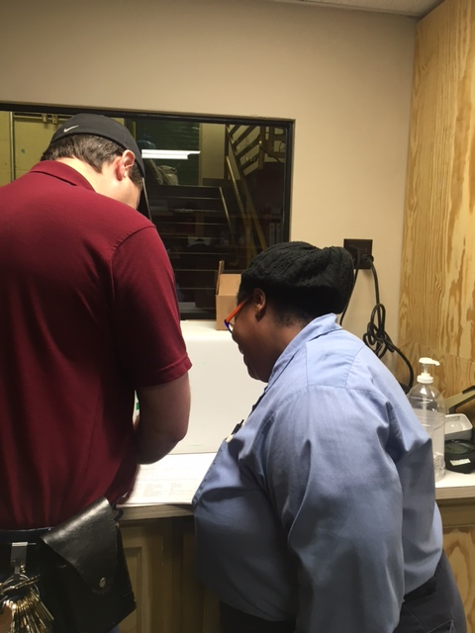

Figure 6. Lisa and her supervisor, Mike, reviewing a document.
I told her that was fine and then I began to take my seat. The three of us chatted for a little bit about our children and academic challenges that we have faced or heard about, and then I asked Lisa if she was ready to begin our interview and she smiled and said, “yes.”
Please note the following as you read this transcript.
U=Ureka, the researcher
L= Lisa, the participant
U: After reviewing your weekly journal, it appears that you communicate most through speaking and listening and less through reflecting and thinking. How do you feel this relates to how you communicate at home and at work? What impact, if any, did your English writing instruction have on how you communicate at work and at home?
L: I agree that I do, I communicate more in speaking and I feel it’s more because of the type of job that I do that I have to do more speaking and listening to the customers. I speak to my coworkers to tell them what I need them to do. No one really wants me to write down a plan of action on how to cut down a pipe. You know it’s more of speaking.
Because I am trying to climb the ladder in becoming a lead, so I’m gaining more writing experience in my work with emails and with communicating. With shutting down the water, I have to tell the whole building, you know, the powers that be, that I’m turning off your water so, I’m coming in on the weekend and we’re shutting off all the water at the courthouse.
Now, how about the impact of composition classes on my everyday work, I learned in class (laughing), in my communication class, about emails and properly writing emails because I work in a public job. My emails are monitored and are part of the open records act, so you really want them to be nice. You have to sound educated, just in case something happens and they pull your emails. They can pull our phone records. We signed a form for that when we signed on. We know that they can be part of the Open Records Act. Anything we do or say on county property can be a part of the Open Records Act.
So, yeah, (laughing) I have to be careful. I don’t want them to come back and say we have a situation where someone is suing the county for a plumbing thing that happened. Right now we have something that’s in litigation. I learned the proper etiquette in class with emails and things and what not to write in emails. You see the wrong way to write emails in the news all the time. Somebody wrote something derogatory about a person. A supervisor might think, “Well, how is this person leading in a position?” So, poor writing could really affect me. I have a young son, so anything that I learned I try to make sure that he’s doing it now, so that he’ll have better writing skills as he’s growing.
U: What effect, if any, do you feel English/writing classes had on your ability and attitude towards writing?
L: (decisively) I have a fear of writing! It’s been a while since I was in your class and it was kind of a scary situation for me when I was a freshman. My mom was a speech pathologist, so she was big on speaking correctly and my grandma was real big on speaking correctly. She didn’t want us to sound ignorant, so she would make sure we talked properly. When I got in my freshman year of high school, I did great in all of my classes, except my English class. I don’t know where I messed up, I was intimidated by the teacher
Which is funny because I love him now. He goes to church with me (laughing). But, back then, he scared me so bad. I had a big fear of speaking in public and he would make you speak. It was just all of that. You’d get the papers back and they’d be all red. Never before had I failed an English class until that class. I had to go to summer school for it.
As a teenager you think, “Oh, I’m never going to be good at it.”
I think it just stuck in my mind that I’m not good at English, even though one of my good friends and my mother-in-law are English people. I have them edit every paper I write. I ask them (smiling), “Can you read it?” And my best friend, she’ll say, “I don’t need to edit. This is already a good paper. It may not be an A paper, but you did what you needed to do.”
The last semester of college, which I just finished not too long ago, , I had my mother-in-law read my papers. She said, “You don’t need my editing skills, you’re fine” and because of that, I never thought about 6th, 7th, and 8th, grade when I did pass English.
I thought about 9th grade. “Ah man, that was the worst. When I took the classes later on in college, I thought, “No!”
Even when I continued to make wonderful grades in class like Business, I was still worried. When I continued after your class, I was still nervous every time I had to write a paper. I’m a business major, so I had to do an organization for action, which was a four page report. I was like (ecstatically), “ARGH!” Still, I can’t get over that 9th grade hump.
The fact that I had to go to summer school for English. At the time, Booker T would just kick you out. Now they don’t do that. My mom had graduated from Booker T; my grandma had graduated from Booker T, so it was a lot of pressure on me to make sure I stayed in that school. And graduate
U& L: Laughing
L: So, I think that was my fear
U: Lisa, I am sure that there are other students, who experienced the same thing that you have, other students who were also a little intimidated, if you will, by writing
L: Uh huh
U: So, what would you propose that current and future writing instructors do to ease those students into a welcoming and encouraging writing environment?
L: I really feel like it was a lot with the teacher. When I took Technical Writing at OSU, the teacher came from in front of the class and she said, “Everybody writes different. My teaching style and somebody else’s teaching style are different.”
There was MLA writing and APA writing. I had no idea.) One of my best friends (decisively) who’s a communications lady said, “Yeah” when I had her edit one of my papers. She asked me, “How does she want her style?” I said “I don’t know?”
That’s when it started to kind of help. They don’t teach you that. I had that fear from high school that I’m never going to get it. I never knew that one teacher would expect APA and one teacher would expect something else and teachers like the commas here and some teachers like the commas there. Writing was such a fear.
U: Um, huh
L: That I couldn’t see past it. It still red flags me every time I have to write a paper. Last week I had to write a note to send to the judges (laughing) and for the directors to tell the courthouse that we were closing the lobby down, that we had to do an emergency shut down of the hot water. I had to write a note that said our hot water will be shut down. Of course, (smiling) I wrote it and then I sent it to the secretary and had her edit it and send it back to me. She said, “There’s nothing wrong with this, just send it out.”
But, because of my fear of it not being correct, I sent it to the bookkeeper. She’d (softly) kill me if she knew I called her a secretary. You know, I think it’s just one of those things that some people just latch on to different fears. Some people are afraid of heights.
My director, the job that I’m working towards, has no qualms about writing anything. He sends out this stuff and I look at it and I think, “I know that’s not right.”
You know, (laughing) you have Word, you can edit that. But he doesn’t care and he doesn’t have that same fear of writing. I don’t know what happened different with him than with me. People are open to learning in a classroom environment. Everybody’s lifestyle is different and you have to remember that and tell them that early. A teacher didn’t like the way I wrote in my freshman year in high school. Later on, when I asked him in church, “I want my paper back,” he said “Oh, I’ll give it back.”
And he had the nerve to tell me that was the best paper ever written over a certain subject. I (ecstatically) just wanted to scream at him. He’s a nice guy, but he doesn’t know how bad that affected me.
U: Um huh
L: To need help and then when he told me that the paper was great, I was like WHAT?!? This is twenty years too late (Laughing…) That’s just something that, as a teacher, you have to remember that people take stuff more personally.

Table 11.

Lisa’s weeklong communication results.

Participant | Lisa
Writing | 15
Speaking | 68
Listening | 56
Reading | 17
Thinking | 3
Reflecting | 13

Like Taylor, Lisa also shows speaking to be how she communicates most. She also shows strength in listening. Of all the participants, Lisa records the highest number of reflection accounts.
Lisa took my composition course fifteen years ago and did not save any of her assignments and neither did I. However, below, is her recollection of her writing experiences.
Lisa’s Life changing reflection
8/4/15
When I think back to my beginning college days, I always think fondly of my Composition II course it had a major impact on my confidence and gave a positive spin on my English and writing classes for the future.
In middle school, students are told what to write and who to write about. However, once you reach high school the teachers there are trying to prepare you for college. I had a Freshman Composition teacher in high school that was brutal. He did not give students any slack. His class eventually led me to be terribly afraid of writing and eventually led me to begin completely loathing any writing class. Once I started college, I saw that Composition I and Composition II were requirements. I remember my Composition II class because it had a wonderful impact on my life.
I am a person who believes get the hard stuff done first, so I enrolled in the Composition II first thing in morning. One class period Mrs. Williams gave the assignment that I always feared, a paper solely based on my beliefs and opinion. The assignment was to write a paper on something you have wanted to do but society or others advise you not to do. I was excited for the first time about a paper since 9th grade. However, I was worried because I had to put my true feelings on paper to be critiqued. I was so nervous I did not let my normal editor (my best friend) read it.
I let the words flow out of me. I remember turning it in upside down. It was my true feelings out there. It was the first time I did that since I felt ridiculed in Freshman Composition. I remember the day she passed them back. Normally I always sit in the front of the class because I am short but because of my fear of English, I sat in the back for that class. Mrs. Williams passed the paper’s back and I received an A. However, there was a comment on the bottom to talk to her after class. I was nervous again, the fear of being ridiculed played in my mind. I thought maybe I did not earn an A she just gave it to me because of people we knew. I could not wait until the rest of the students filed out of the class I wanted to know what was happening.
Mrs. Williams was gathering her papers and putting them in her black bag. She asked, “What was my major?” I told her accounting. She asked, “Why?” I told her because that is what society expected. Well she said, she could feel the passion in my paper and I should pursue my dreams. I told her I could not do one of the things I had written in my paper because I made a promise to my grandmother but then she said the next sentence that changed my life forever. “Why don’t you become a Plumber?”
After that, I tried my best in her class. I knew it was because she was a teacher who read the papers and gave valuable feedback. I tried to give that class my one hundred percent. I eventually finished with a good grade. The next semester I enrolled in Plumbing class.
I thought it was ironic that the one class that I feared the most helped me to become stronger and achieve my dream. I will forever be grateful for that assignment and having a teacher who was caring enough to not just read a paper and give a grade but actually take the time to understand a paper and change my life.

Table 12.
Components of Jill’s portraiture
Observation | YES
Co-Worker Interview | YES
Participant Interview | YES
Weeklong Journal | YES
Past Assignments | YES
Reflection | YES

As I recall, it was the end of class and I was sitting with a student going over her paper errors when Jill, was about to exit the room. I asked her if she could wait a few moments and she softly nodded, “yes.” See, …a few days earlier I had asked the class what their career goals were and Jill said she wanted to be a dental assistant. Having immediate family members who are dentists, I knew that dental assistants were very skill driven and task oriented. I had had the opportunity to review Jill’s work and her composition and critical thinking skills were well beyond simple tasks and I wanted to share this with her.
As the student exited the room, Jill occupied her chair. We began by discussing how things were going in the class and she shared that she’d been out of school for a while and wanted to do something different. That’s when I told her that nothing was wrong with being a dental assistant; however, I really thought that she should aim for dental hygiene. Looking slightly confused and puzzled, that’s when Jill shared that she was a single mother with a young son and confessed that she hadn’t considered dental hygiene. I explained to her that two of my immediate family members were dentists and that I’d spent a great deal of time around and in dental practices. I told her that I felt like she could offer much more.
Over the semester, Jill continued to present her A-game in her papers. She was also engaged with class discussion. One of the most memorable things I can recall about Jill is that one winter it had snowed all night and throughout the morning. Our college had decided that we would do a late start. When I arrived to the class, Jill was already sitting in her seat and she said smiling, “I knew you would be here” and I said, “yep!” Only Jill and one other student showed up for that class. I kept saying to myself, “this girl is no dental assistant, she’s a hygienist.”
At the end of that course, Jill told me that she enrolled in my Comp II for the Spring Semester. I was excited about this because I could continue to encourage her.
A few years later, I had just finished class, when I realized that I’d left one of my dry erase markers in the room. As I was about to open the door I saw Jill. It was the greatest feelings as I hadn’t seen her in a while. I asked her what she was up to and she told me that she’d applied to our college’s dental hygiene program, but that she wasn’t accepted. …I felt as if I’d been punched in the stomach and I asked her to come in the room with me. She followed…In there she told me that she didn’t think she was the right fit and they didn’t seem really interested in her, as if they already knew who they wanted. I asked her why didn’t she contact me and she told me that she’d heard I had just had a baby and she didn’t want to bother me. It was true, my daughter was about five months at that time, but I would have helped Jill if she had contacted me. I told her my office hours and asked her to come visit me and a few weeks later she did.
During our conversation, Jill revealed that she felt the dental hygiene questions were like Miss America questions. For example, she said that one of the questions was: If you had any super power what would it be? She said that she was surprised that the interview was a group interview with about nine other girls. She thought that it was going to be an individual interview. After hearing all of that, we discussed the fact that our college did not have the only dental hygiene program and that she should pursue other options. I told her that I would write her a letter of recommendation and she should prepare the rest. About two months later she shared that she had been accepted into The University of Oklahoma’s Dental Hygiene Program and that the interview committee commented on her impressive letters of recommendation. We were both so excited! She then said that she wanted to go to lunch and we did.
Now that Jill has achieved her goal, it is so heart-warming and gratifying, especially to think that I had a teeny tiny part to play in it. Now Jill works as a part time dental hygienist two days a week in Bixby, Oklahoma, and spends the other days substitute teaching. On a blazing Thursday afternoon is when our connection resumed.
Observation of Jill
It was a blistering and sizzling Oklahoma day, when I met Jill at her place of employment. As I entered the office, a very pleasant young woman with a round face and long brown tresses informed me that Jill was busy, but that she would be with me momentarily. Before I could get comfortable in my seat, wearing black scrub pants and a pink scrub blouse with black on the sides, yellow and purple sneakers, her strawberry blonde hair neatly positioned in a smooth ponytail, and her black-framed glasses carefully situated on her cheeks, Jill, came from the back and told me she was ready for me. I gathered my belongings and we were on our way.
With her purple mask now pulled down by her chin, Jill asked me if there was anything that I needed her to write down and I assured her that I would take care of everything. She pursed her lips and nodded and led me to the breakroom where I could place my things. Very quickly, she told me that she had a patient in the chair and one waiting so she had to go, but to make myself comfortable. I thanked her for allowing me to spend the afternoon with her and told her I’d be out there momentarily.
As I walked down the white, green, and blue-tiled hallway, with limited
space and seating, I placed my things on one of the sinks while I began to observe Jill. In her operatory was a mother with short shorts on with her legs crossed at her knees, her over-permed blonde hair was fastened in a loose ponytail. Jill was finishing with her tween son whom was wearing athletic apparel and sneakers. Jill expertly told him that she needed to floss his teeth then he’d be ready to go. She reminded him that his back tooth had a cavity. She also told him
that his back teeth had grown in, so he needed to brush harder or that he would possibly get more cavities. Jill also told the child’s mother that she should consider braces for him and the mother asked if she had the name of an orthodontist. Jill mentioned the orthodontist’s name to whom the clinic usually refers patients, yet she also informed the mother that there are several others in the area and many in Tulsa. Jill asked the mother when she wanted to schedule an appointment to fill the cavities and the mother pleasantly told her that any day or time would work. Jill told the mother that the woman at the front desk would reschedule her to fill her son’s cavities and then she handed her an orthodontist’s card.
While finishing, the boy whom was wearing a pink Nike hat, gray shirt, red Michael Jordan shorts, and red sneakers looked anxious to complete his visit. Jill told him that she was going to give him some fluoride to rinse his mouth. She told him to swish and not to swallow the water and a bright smile stretched across his mother’s face. As the boy spit out the water, Jill reminded him that he could not have any food or drink for 30 minutes and to this he nodded, or that could affect his treatment. As the child’s visit ended, Jill told him that he could pick a green or blue toothbrush. The boy didn’t say anything and that’s when his mother interrupted that he was kind of shy. Jill said that was ok and that she would walk them out. As she was walking out she asked me if I wanted to come with her to get the next patient and I told her that I’d stay there and wait on them.
Very soon, I could hear Jill laughing and joking with her next patient as they were coming around the corner. This patient looked to be in his early twenties. He had closely-cropped brown curly hair and he wore glasses. He had on everyday-looking brown loafers,
relatively-worn blue jeans, and a gray shirt.
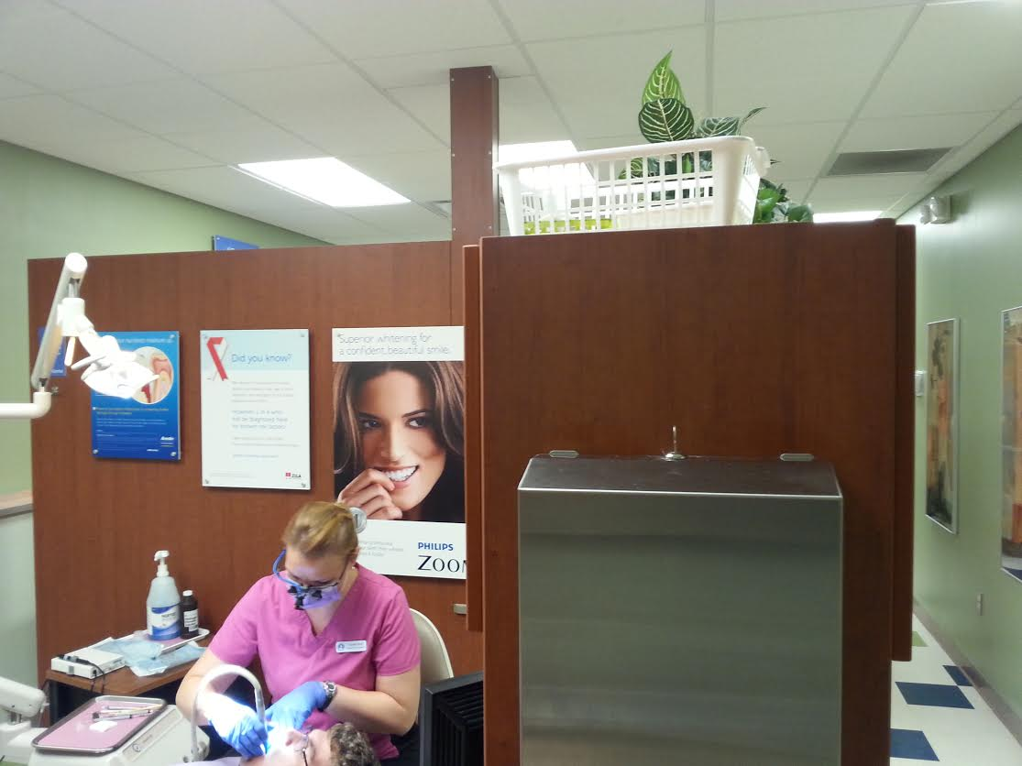

Figure 7 Jill cleaning a patient’s teeth
As he sat in Jill’s chair, she asked him if he was taking any medicine and he told her that he was taking something for a sinus infection. Next, she asked him if he was allergic to any medicine and he said, “No.” Then, she draped him with a purple bib and began to recline his chair. After careful examination of his mouth, Jill told him that his mouth looked good and he nodded up and down in agreement with her. Next, she told him that his teeth and gums looked very good; he nodded, again. She then asked him if he used an electric or a regular toothbrush and he said a regular toothbrush and she said that he tricked her, because she thought that he was using an electric one.
Later I learned that he was really there to get some cavities filled by the dentist. Jill informed him that bacteria also causes cavities, which are heavily influenced by one’s diet. He said he liked to drink diet sodas and she told him that the best thing to do was to drink it all at once so that it would normalize the PH in his mouth. She also told him that he should drink more water. He told her that he liked water, but that sodas went much better with sandwiches and they
both smiled and laughed. She then asked him if he was using a soft bristle toothbrush. He said that he uses a travel toothbrush and that it was pretty soft. That’s when Jill shared with him that using a hard-bristle brush was like waxing your car with a sand paper. Jill then told him that their visit was over and that he could go back to the waiting area until the dentist was ready.
As Jill ushered her patient back to the waiting area, I took some time to look around her operatory, which was number 3. On her olive-green wall was a large poster that shared information about periodontal disease. There was also a poster about the HPV virus. At her small working space, she had a black computer, tiny red fan, mug, yellow sticky notes, and a framed picture of her son. As I continued looking around her area, she came back to tell me that her next patient was new and that she would need to consult with her in another room. She asked me if I wanted to come and I excitedly, said, “YES!”
As I prepared to situate my things, I was greeted by a tall African-American woman wearing navy scrubs who informed me that I could place my things anywhere. I smiled and told her, “thank you.” Next, Jill asked the middle-aged woman who was wearing a black and white striped elbow-length sweater, white cropped pants, and white flower shoes, if it would be ok for me to observe their visit and she smiled and said, “yes.” She then shared with me, Jill, and the assistant that she had recently had a pap smear where the doctor asked if an intern could watch and see what he was doing, so this would be a piece of cake. Everyone in the room smiled and laughed!
As Jill reclined the woman, the woman’s glasses slipped onto her nose, so she used her freshly manicured red nails to push them up to her cheeks. As Jill was examining the woman’s mouth, she would call out a number and the dental assistant would click it on the screen. Jill was clear and precise with each tooth number that she had the dental assistant record. Once, the
dental assistant asked her to repeat a series of numbers, and Jill patiently and carefully told them back to her.
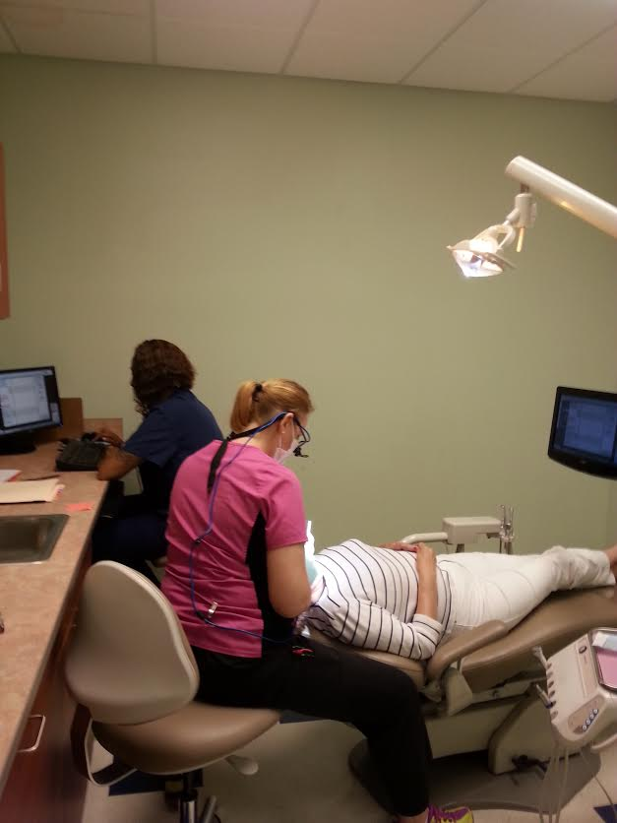
Figure 8. Jill examining a patient’s mouth
Next, Jill told the woman that she was going to review her x-rays to check for bone loss. Jill informed the woman that she did have some bone loss and some significant tarter buildup. She told the woman that she had early onset periodontal disease. She told her that she recommended a deep cleaning. She said that initially that she would need two appointments to address the issue, then she would need to be consistent about getting her teeth cleaned every three months. Jill shared with the patient that there was no cure for periodontal disease; however, there are ways to control it and that getting the deep cleaning would be the first step. Sitting up in
her chair, the woman smiled in agreement, and Jill told her that the office assistant would get with her to schedule her subsequent appointments.
As Jill and I walked back to her operatory, I shared with her how impressed with her I was in how she handles such a loaded schedule. She told me that she is the only hygienist in the clinic and there is only one full-time dentist. There are also only two assistants and then there is office personnel. She told me that everyday isn’t easy, but that she loves her job. As she has done MANY times, she shared with me, again, that I am the reason that she had the courage to pursue dental hygiene as a profession. Laughing…I told her that she already had it in her and that I just helped to pull it out. Soon, one of the office assistants came by to tell Jill that her last appointment didn’t show up or call and that she may be finished for the day. Jill said that she would wait around a little longer and that I could stay, too, or leave if I wanted. I told her I could stay for a few more minutes and then I would probably leave, too.
As Jill walked down the hall to visit with the ladies at the front desk for a moment, while still standing near her operatory, I heard the dentist asking one of the dental assistants if they wouldn’t mind reading the charts to give him a head’s up on things. The very young and newly-minted Asian dentist told the young girl who was wearing heavy make-up and had a her bleach-blonde hair pulled up in a frazzled bun, that one of the day’s patients was on a prescription used to treat osteoporosis. He said that had he not read her patient history, one of the medicines he could have used for her extraction might have counteracted with her current prescription. At this time, with Jill nowhere in sight, I decided to gather my belongings and leave for the day.
As I was leaving, I asked the very pleasant brunette office assistant where Jill was and she informed me that she was consulting with the patient about her periodontal disease. I peeked over the desk and I could see Jill and the woman discussing in the office….As I was loading my
car, Jill raced out and said she was sorry, but the woman had many questions. I told her that everything was fine, but that I was going to head back. I thanked her for allowing me to shadow her that afternoon and she graciously said that it wasn’t a problem. We hugged and I told her I’d get with her later about a follow-up interview.
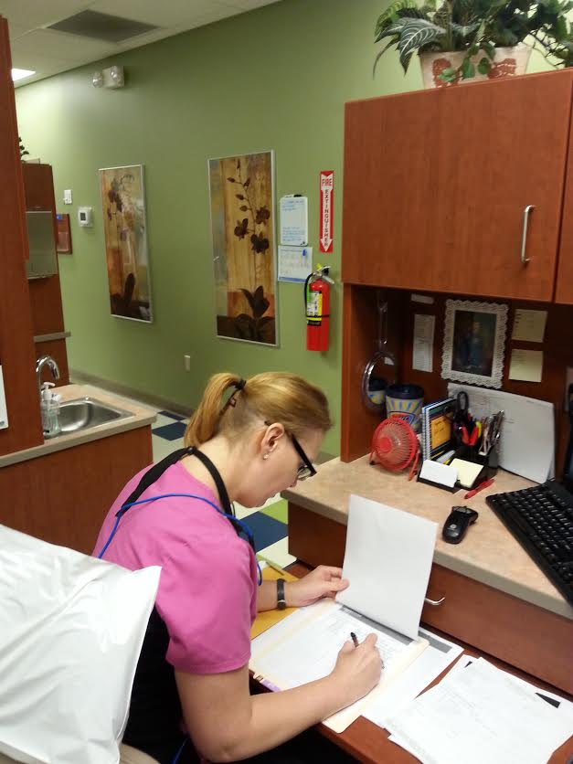

Figure 9. Jill writing in a patient’s chart

As the other participants, Jill, too completed a one-week communication journal, which revealed that Listening is what she does most frequently and Reflecting is what she does the least.
To obtain a broader since of Jill’s communication at work, I was granted permission to visit with her clinic’s supervisor, Dr. Rick. Dr. Rick and Jill work very well together because he also earned his dental training through The University of Oklahoma.
My interview with Dr. Rick disclosed that they communicate the most by speaking and the least through writing.

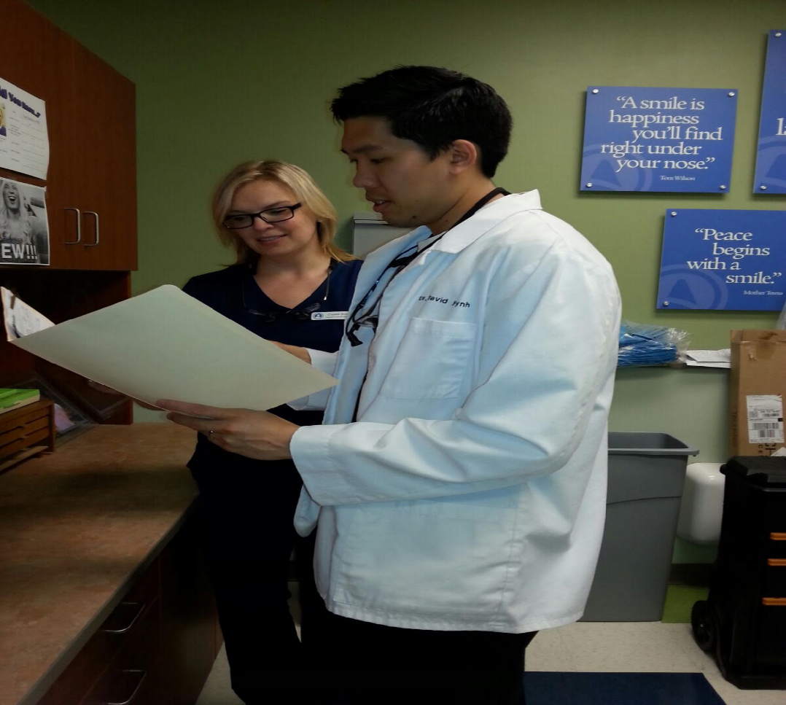
Figure 10. Dr. Rick reviewing a chart with Jill, followed by a transcription of my interview with him.

It was a pleasant spring day when I met Dr. Rick at the dental clinic in Northeastern Oklahoma. Immediately, I was greeted by a receptionist and an office assistant who kindly told me to have a seat until the dental hygienist could see me. Merely, just a few seconds later, fresh blonde ponytail in toe, Jill came around the corner and gave me a WARM and GENENUINE hug and explained that the doctor was busy, but that he’d be with me shortly. Jill took me to the doctor’s operatory where I saw pictures of his wife holding their infant daughter who was adorably dressed in a lavender outfit with an accompanying lavender headband. Just then, I heard, I’m sorry I’m late; I’ve been really busy. With a blank expression and exhausted demeanor, the dentist asked if I was ready and I told him, yes. It was lunch time, so he ushered me to the breakroom where he sat across from me in preparation for the interview to begin.
Please note the following information as you review the transcript.
U=Ureka, the researcher
R=Rick, the participant
Interview questions are in bold.
With his white lab coat and black scrubs on, Dr. Rick folded his arms neatly across his chest.
U: Ok, how long and in what capacity have you known Jill?
R: I’ve worked with Jill ever since I began working at the Owasso clinic. I began here around mid-June and I’ve known her since then. I didn’t know her prior at all, but I’ve since worked with her, she works Monday through Thursday, we’re basically professional. We’ve gone out a few times when we went out as an office, so that’s how I’ve known her.
U: In what mode of communication writing, speaking, listening, reflecting, do you most often communicate with Jill?
R: I would say speaking and listening is the way we most often communicate, especially concerning patients. We’re always just talking; we really don’t do much writing between each other. Although I do read the handwriting she has for her patients regarding their diagnosis or treatment, most of the time we just discuss treatment options and things like that.
U: In what mode of communication do you communicate the least?
R: I would say writing is probably the least.
U: What do you think are some of Jill’s strong communication skills?
R: Decisively, she’s very upfront and truthful about what she feels, if a patient has something that has some sort of treatment that they need she will just go and straight out tell them. She won’t sugarcoat it or try to soften it up. She’ll be very forthright. I think that’s very good, especially because sometimes patients will be surprised at the level of diagnosis. She’s able to let them know in clear terms what their diagnosis is, as well as what treatment they need. There’s no confusion, no misunderstanding, things of that nature.
U: What are some communication skills that you feel that Jill may need to improve upon?
R: Reflecting, I feel sometimes with that forthright speaking of being really honest of what the diagnosis is, she doesn’t understand that explaining those things can be hard for the patient to really hear, really to swallow. I think she can kind of expand or branch out how she can help with them afterwards. Maybe figure out a way to see how they will react to it, to soften it.
U: Ok
R: Yeah, still be honest and truthful, but maybe figure out a way to just kinda find a way to gauge their feelings, to ask how they’re doing. (Laughing) I’m not really sure, she can figure that out.
U: Any just final thoughts about Jill’s communication?
R: I really like the way she is forthright. I feel I’ve learned some things from her. She kinda just puts it out there. This is your diagnosis. This is what you need to have done. Everyone finds it hard to break cold news to people so, when I hear that she does it, it gives me confidence in the way that I can deliver the same type of thing to my patients. To see that it is very important that we do give it in a clear way. Even though it can be difficult to deliver, you don’t want to muddy it up by saying, “Well it’s ok. That treatment is not so bad,” when really it is. We don’t want to make a diagnosis seem even more severe or less severe than what it actually is. It should just be as it is. I really learn a lot from her in that regard.
Interview with Jill
As I was sitting at the computer, preparing for our interview, I heard the library’s sliding glass doors open and footsteps softly enter the carpeted area. When I looked up, I saw Jill. Looking a bit confused and wearing a short-sleeve black shirt, ankle-length horizontal black and white striped skirt, complemented with black strappy sandals, she surveyed the east side and then the west side of the library. I soon raised my left arm for her to come towards me. However, when I got up to greet her, she informed me that she needed to use the restroom, so it would be a moment. I told her that was fine and that while she was in the restroom I would get the Schusterman Center [University of Oklahoma-Tulsa Campus] library assistant to open our study room. The library assistant was relatively new, so the room wasn’t open by the time she Jill came from the restroom. We waited behind the library assistant for some time before I told the assistant that Jill had traveled a long distance [a suburb north of Tulsa] to get here and we needed to open the door. The plain-faced assistant with dark brown hair that settled just under her ears, flashed me an uncomfortable smile and said that she would open the study room door.
As Jill and I were getting settled, I gave her a copy of her portrait that I had typed as she said there were some minor corrections that she wanted to make, which she had texted me the previous night. While Jill was reviewing her portrait draft, I began taking out my notebooks. Soon, Jill was finished reviewing her portrait and we were ready to begin her interview.
While reviewing this transcript, please note the following information.
U= Ureka, the researcher
J= Jill, the participant
All questions are indicated in bold type.
U: When I met you in 2007, you didn’t seem to have much confidence in your writing, from where do you think that lack of confidence came?
J: I Long pause didn’t really have any encouragement in high school from my parents or my teachers really to pursue anything further. I just did the work that I had to do to get by, just to pass my classes and graduate. My main purpose in school was singing and choir and excelling in that because I did well in that. That was my sports in school.
U: um uh
J: So as long as I was eligible for singing, that was great.
U: Ok
J: So I graduated high school and I went on and kinda did dead end office jobs and clerical work and I didn’t have to do much deep thinking for that or writing or anything as far as extended duty for that. So no one ever really helped me build that confidence and I didn’t have that in myself
U: How did the type of writing you did for your online classes compare to what you composed for an on-campus class?
J: I don’t particularly like online classes.
U&J: soft laughter
J: But I did have to take several online classes at TCC and during my dental hygiene studies at OU. I didn’t have a choice at TCC because that was just what worked out for my schedule. Whereas, in dental hygiene, they pick your classes for you and some of those are online classes. So when you take the online classes, you have to do the reading, you have to read the syllabus, the work, the book, and sometimes there are podcasts that you have to listen to. Those are pretty mundane. And you’re doing the reading over and over, and then you’re doing the writing and the editing yourself, over and over. And you really don’t have a lot of feedback for it. So, when you’re in class, it’s so much nicer because you have your teacher and the other students to kind of help you to edit or bounce ideas off of. I just like the interpersonal connection with the on-campus classes rather than the online classes for writing. That’s just my personal preference. I did much better with that and with the Writing Center help. I could go to the Writing Center when I was at TCC and get help with my writing.
U: Alright, I see from reviewing your weekly journal that you communicate most through texting and Facebook, that you use both of those mediums. What impact, if any, does that have on the communicating that you do in your professional environment?
J: I use texting to communicate. Everybody uses texting to communicate, I use texting to communicate with my colleagues and my co-workers. I communicate with my boss; I use Facebook because there are dental hygiene pages that I am on. We share ALL kinds of information with each other, all kinds of personal information and all kinds of dental hygiene information. I’m part of a Facebook page that my dental hygiene class put together while I was in school. I am still a part of that page and we still communicate through that page, so it’s been very helpful. I am friends on Facebook with instructors from my dental hygiene school, that’s really nice so that I can stay in touch with them. There’s pages for the ODHA, softly Oklahoma Dental Hygiene Association, so I will get updates on CE courses because I have to take continuing ed classes to keep my license current.
U: Uh huh
J: I have to have 30 hours every three years in order to keep that current, so that helps me to do that, to stay in touch. It’s just a very helpful tool as far as that’s concerned. I wouldn’t say that I use Facebook and texting as much as I use speaking in my daily life, but they are helpful tools
U: From reviewing your weekly journal, it appears that you communicate most through listening and less through reflecting and thinking, How do you feel this relates to how you communicate in a day? What impact, if any, did your English/Writing instruction have on how you communicate at home and at work?
J: softly I totally zoned out…I use speaking and listening, but I wasn’t listening
U&J: soft laughter
Long Pause
J: I have to speak to patients and my colleagues all day, every day. It’s given me confidence to be able to do that. I have to be able to communicate with the public all day every day. I have to be able to communicate effectively with them. I can’t be brash or harsh, I have to be pleasant and I have to be able to read those people, my patients and my coworkers, throughout the day. all week, 24/7. So, it has definitely helped with that. And listening, it takes a lot of effort, believe it or not, to listen to people
U: Uh huh
J: I have to listen to patients when they are explaining their illness. I’m having to listen to the doctors when they are explaining treatment. I have to listen to coworkers when they are explaining how to do something on the computer or explaining my paycheck (laughter). I mean, all of these things are important in one way or another. If I didn’t have those skills from my classes then I definitely would still be doing dead-end jobs in the office. I really don’t feel like I had those skills before and at home. I’m a little more harsh at home. A little more brash. Teenagers will do that to you and long days dealing with the public will do that to you. It just carries over when you get home. Thinking and reflecting, I do those, but I don’t really know how much.
U: You indicated that you think and reflect, but just not as much as you speak and listen
J: Right, yeah, Um…
U: What impact, if any, do you feel English/writing classes had on your ability and attitude towards writing?
J: Oh, they definitely improved my ability and attitude towards writing. Now I am able to write anything I need to write. I can document in charts and anybody that picked up a chart, whether they be a professional dental employee or a lawyer an attorney in a court case, would know exactly what I meant by what I wrote in that chart. If I needed to write a letter for a patient to have surgery, anyone who read that letter would know exactly what I meant by what I said in that letter. I mean they’re gonna know from the beginning to the end, what I wrote, what I meant, like I have every ability to do that. There is no question in my mind. I handwrite cards and letters to my friends still, I feel like that’s a lost art to handwrite things. I really like that; I like receiving cards in the mail. I mean I still email, you know
U: Un huh
J: Everybody texts and that’s what’s convenient, but all of those things are important, whether it be a text message or a letter for a patient.
U: Well do you have any final comments or anything else you’d like to add?
J: I should reflect more
U: Laughing Ok…Do you think that would help in your professional life
J I think so
Jill’s Journal. Reviewing Jill’s communication results show that she listens much more than the other participants, which is slightly higher than her speaking accounts.
Jill tended to write with verve and emotion and I maintained an ongoing dialogue with her through my comments on her papers. (see Appendix C: Jill).
Table 13.
Jill’s weeklong communication results.
Participant | Jill
Writing | 32
Speaking | 40
Listening | 44
Reading | 28
Thinking | 18
Reflecting | 1

Jill’s Reflection.
In elementary school I loved reading. My second grade teacher wanted to advance me to the third grade class but my parents said ‘no’. Mom still has newspaper clippings of my awards for reading. At some point, my parents’ focus turned more toward my singing ability and less on my schoolwork and grades. When I was in middle school, my parents divorced and my confidence plummeted. While I favored reading and English classes, choir was my favorite and it remained so throughout the rest of my primary education. I was expected to go on to college after high school despite being poorly prepared both emotionally and educationally.
In high school I was given specific writing and/or research assignments usually unable to choose the topic or subject. I was not encouraged to neither question teachers or assignments nor think critically. I graduated with a 2.3 overall GPA and little direction in life. Roughly ten years later, I began classes at Tulsa Community College. Freshman Composition I was entirely different from any English course I’d had in high school. I felt my aptitude for writing was lacking and needed improvement and certainly needed polishing. That being said, I had a positive attitude in terms of wanting to learn and striving to excel.
When I wrote “Confessions” (see Appendix C), I was able to fully express my thoughts without the constriction of a rigid, disassociated assignment. That paper allowed me to open up and helped me build confidence in my writing ability.
When I wrote, “When Worlds Collide”(see Appendix C), I was able to compare and contrast how men and women interact, as well as, how social norms dictate the expectations of such interactions. This assignment uncovered the importance of communication and understanding others outside of one’s own behavioral norm.
When I wrote, “Mirror Reader Response,” I analyzed a poetic work by Sylvia Plath. I was moved by this piece and this assignment led me to explore more of Plath’s work. I found Mirror to feel very familiar and as I again read my response, I feel the connection to it once more.
Many times, I have thought of the skills I was able to obtain in my classes with Mrs. Williams, and I am certain our paths crossed for a reason. Not only has she encouraged me as a student to succeed. She has been a mentor and supporter unlike any other I have known. Her composition courses inspired me to think critically, to question and at times to debate. I learned how to communicate effectively both in written form and verbally. Maybe most importantly, I unearthed the confidence to use those skills to continue to mature as a person and a professional.
Table 14.
Components of Zach’s portraiture.
Observation | YES
Co-Worker Interview | YES
Participant Interview | YES
Weeklong Journal | YES
Past Assignments | YES
Reflection | YES

As the son of parents who owned and operated a successful business for years, Zach isn’t a stranger to hard work. He has worked in Tulsa’s world-renowned Mayo Hotel as an event planner, as a sales coordinator in Tulsa’s downtown Hyatt hotel, and he is currently a waiter at a fairly popular downtown restaurant. Zach has considered joining the Navy because it would pay off his student loans and he said it offers a $20,000 sign-on bonus. Through his research he learned that he could earn around $2,100 a month and he could get an extra $500 because he speaks fluent Russian. He scored a perfect 99 percent on the ASVB.
Zach shared that because his siblings are significantly older than him, he spent many evenings with his parents and their friends, which was often at the Tulsa Porsche Club. This is also the reason why he has always felt very comfortable speaking to adults and about sharing who he is. Zach is an openly gay man. At the tender age of 26, he continues to speak proudly and openly about his sexuality and his experiences.
Zach’s observation
I observed Zach in his place of employment, a local restaurant. The restaurant is located at the edge of Tulsa’s downtown and it casts a Cheers-type ambiance; however, it has low lighting and it has a vibrant bartender surrounded by animated and curious-looking patrons. Its walls are draped with pictures of Tulsa’s past. I told the bubbly blonde hostess who greeted me with a pleasant smile that I needed to sit in Zach’s section. She responded by slightly tilting her head and raising her eyebrows, she then grabbed a menu and said, “Right this way.” As I slid into the narrow booth, the hostess placed the menu on my table and imparted that she hoped I enjoyed my dinner. I smiled and told her “thank you.”
This was a BUSY night for Zach, I had been seated for a little while before he noticed me because he had three rectangular shaped tables pushed together to accommodate 23 guests. One by one he patiently and carefully took their drink orders. Zach had more guests at his table than the entire restaurant had total, so soon a young lady with long black shorts, a black, long-sleeve oxford shirt, and blonde hair shaved off except on the left side and on the top of her head came to assist Zach with his table. As he was making his way around the table, he softly told me that he would get with me when he had a chance, so I told him I understood.
Zach was so busy that evening that we both decided it might be best if I came back another time when he wasn’t so preoccupied with one table.
The day after the Emanuel African Methodist Episcopal Church massacre in Charleston, South Carolina, my son and I attended a city-wide vigil in Tulsa held at Morning Star Baptist
Church. Afterwards, he and I decided to have dinner at the restaurant where Zach works. On this evening, Zach was noticeably less busy and he was in quite a jovial mood. He seated my son and me in his section and handed us some menus to consider what we might have. Being that my son had never been at the restaurant, he studied his menu a little more than I did and Zach was extremely patient with my son’s questions about the different cheeses and with how dishes were prepared.

Figure 11. Zach writing an order
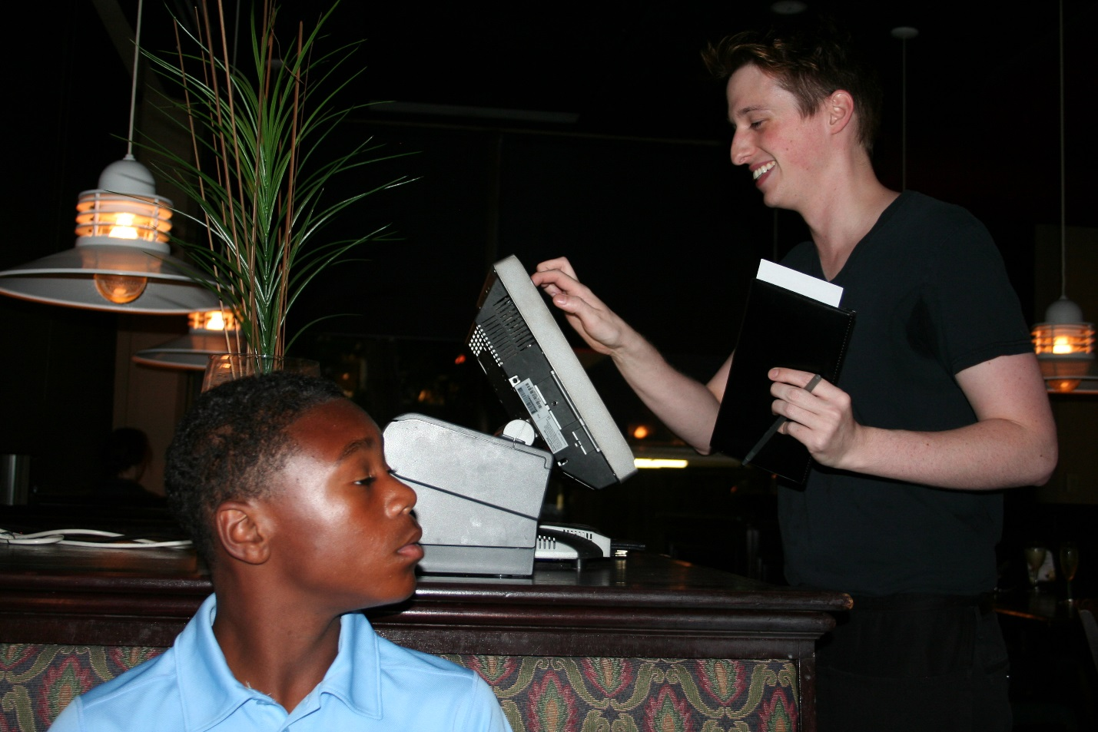

Figure 12: Zach typing an order; the photo includes the researcher’s son.

As the manager walked away, the hostess seated a couple at another one of Zach’s tables. The gentleman looked about six feet tall. He was wearing blue jeans and his summer-collared shirt that had gray and white blocks on it. His female companion had a healthy mane of gray that was slicked back. She, too, was wearing blue jeans and she had on a solid salmon pink short-sleeve shirt and a pair of silver flats. After going over the menu with them a few times, the gentleman ordered a drink from the bar and together they shared an order of black bean nachos, which happens to be one of the restaurant’s signature items.
Soon, smiling, Zach came to our table carrying a plate with a hamburger and French fries for my son and a large bowl with fresh greens and veggies for me. While we were eating, I could see Zach checking on his other two tables making sure that they were comfortable and that they didn’t need any refills. Then he came over to our table to inquire about our food. While removing mayonnaise from the corner of his full mouth, my son nodded and gave a thumbs up. I told Zach that my salad was crisp and delicious; however, I did not like the salad dressing. He asked why I didn’t ask for another dressing and I told him that I wanted to try a new one.
As we were finishing our food, my son and I perused the small desert menu. Previously I have had the carrot cake and I didn’t find it very desirable. Zach didn’t recommend the turtle brownie with ice cream as he didn’t think it was as tasty as the carrot cake, but my son and I ordered it anyway. As he was going back to place our dessert order, a guest from another table called him by a name I didn’t recognize. In full forward mode, Zach paused in respect towards the man. The man pulled out some bills from his wallet and paid for his dinner. Zach thanked the man and then the gentleman and his wife exited the restaurant. As Zach headed back over to our table, he shared that the man and his wife were frequent guests at the restaurant and that he thinks that the man may have early onset dementia as he had to repeat things to him several times and he acted as if he was unfamiliar with the menu when he has seen it many times. Next, he asked me if I wanted a tour of the kitchen. I said, “sure,” as I don’t recall ever being in a professional restaurant’s kitchen. In the kitchen, I saw many large silver bowls and pans, and all of the cooks were smiling and welcomed me into their space. Here, I got to see Zach officially place our dessert order.

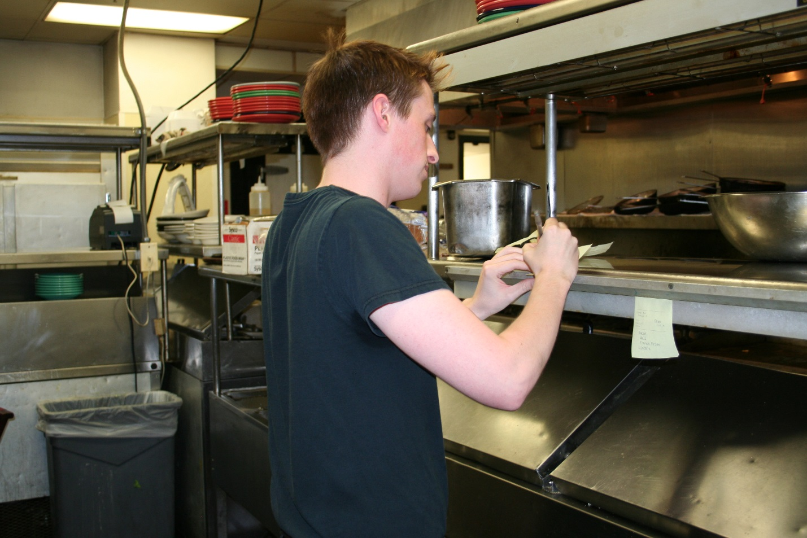
Figure 13. Zach writing an order for the kitchen to prepare

Zach also completed a one-week journal about his communication habits and through it we learn that he communicates most through Listening and that Thinking and Reflecting tied as least contenders.
To learn more about Zach’s communication habits, I interviewed one of his co-workers, a bartender, Steve, which is transcribed below.
Interview with Steve
It was a bustling weekday evening when I ventured to interview Steve about Zach. Being unfamiliar with the restaurant where we would meet, I drove up and down the same street for over an hour until Zach texted to see if I was still coming. I pulled over to text with an emphatic, YES! Zach then called and navigated me to the restaurant, which is neatly tucked in one of Tulsa’s side streets.
After I got out of my car, Zach greeted me with a jubilant hello and a tender hug. Exhausted and flustered from driving so long, I excused myself to the restroom, but made certain to order a sangria that would be waiting upon my return.
As I went back to the bar, I was greeted by a healthy-looking gentleman with a bright and toothy smile, who was Steve. I shook Steve’s hand and explained my study and offered the consent forms for his signature. I ordered a scrumptious Caesar salad to complement my beverage. Steve had some call-in orders to complete and said that we would visit after he was finished. I said, ok, and continued enjoying my meal and conversing with Zach.
A few short minutes later, white shirt and smoke gray tie covered in a black tuxedo vest and smiling, Steve indicated that he was ready to begin.
Please note the following items as you read the transcript.
U=Ureka, the researcher
S=Steve, the participant
Questions are identified in bold.
U: I’m doing well, How long and in what capacity have you known Zach?
S: Decisively, for about seven to eight months now (in a questioning tone)
U: In what mode of communication writing, speaking, listening, reflecting, thinking, do you communicate most often with Zach?
S: I’d have to say speaking and listening. I’d have to say both of them.
U: In what mode of communication do you communicate the least with Zach?
S:, Probably writing (decisively).
U: What do you think are some of Zach’s strong communication skills?
S: Eye contact followed by (laugh), eye contact for sure, definitely. I’d say enunciation; he speaks very clearly.
U: What are some of Zach’s communication skills that you feel could be improved upon?
S: Zach could wait to speak a little bit. Taking his time instead of interrupting. That happens every once in a while. He gets ahead of himself and starts talking a little faster.
U: Any final thoughts you have about Zach’s communication?
S: He’s one of the best people I’ve ever communicated with for sure, definitely. As far as listening, also understanding, it’s very easy to talk to him.
Steve described the most frequent communication between him and Zach to be speaking, while listening was last.
Below is a picture of Zach (left) and Steve (right) in the restaurant.
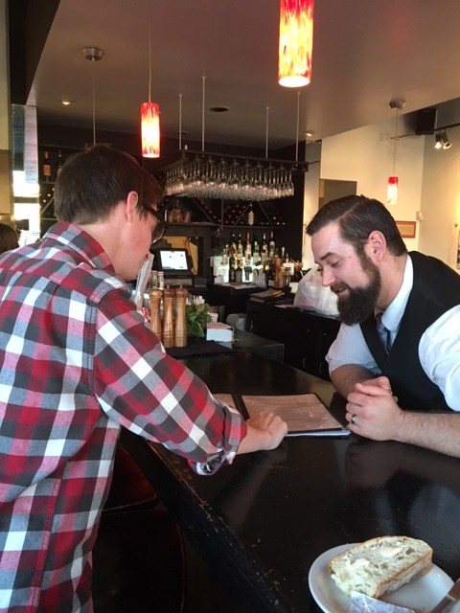
Figure 14. Zach and Steve reading the restaurant’s menu. Zach (left) and Steve (right) are in the restaurant.
Table 15.
Zach’s weeklong communication results
Participant | Zach
Writing | 6
Speaking | 10
Listening | 12
Reading | 12
Thinking | 5
Reflecting | 2

According to Zach’s journal, he spends the same amount of time listening and reading. While speaking is high on his communication chart, thinking and reflecting lag significantly.
Zach’s Interview.
It was a scorching summer night when Zach and I met in a study room in the Schusterman Library (University of Oklahoma-Tulsa) for our interview. With arms outstretched and a bright smile that extended from ear to ear, Zach embraced me with a warm and genuine hug. Wearing a yellow shirt trimmed in green…, Zach took his seat across the table from me in preparation for his interview. Sitting firmly in his chair with his rose petal pink lips positioned in curiosity, Zach placed his athletically-toned arms on the table in attention for my next instructions. As we were catching up on past acquaintances and Tulsa’s social history, I finally asked Zach if he was ready to begin our interview and he shook his head and nodded yes, so it commenced.
Please note the following information as you review this transcript.
U= Ureka, the researcher
Z= Zach, the participant
Interview questions are indicated in bold.
U: From reviewing your weekly journal, it appears that you communicate most through listening and speaking and less through thinking and reflecting, how do you feel this relates to how you communicate in a day? What impact, if any, did your English/Writing Instruction have on how you communicate at home and at work?
Z: To take the first part of that question, ok, let me see the question…
U: Passes the question paper over to Zach
Z: I would say how it…I agree first that I communicate most through listening and speaking. I don’t have a lot of patience with myself, so I focus a lot externally to get things solved, so I think how I communicate makes me more…it forces me to be more aware of people’s feelings and their state
U: Nodding, um huh
Z: In order to get feedback from them and in order to solve problems
U: Um huh
Z: So even personal problems I try to solve externally
Z: As far as English instruction, I mean I guess I could be communicating in Spanish
U& Z Laughing and Smiling
Z: Well, well, it’s difficult, I mean all of the instruction is such a cumulative thing
U: Um…
Z: It’s hard to quantify it exactly, because I don’t know, I can’t say that I only learned words in English class or I only learned eloquent terms of phrases, you know you just pick those things up
U &Z Laughing and Smiling
Z: But I think I had the fortune [experience] to have good English teachers throughout and, not good math teachers and it shows
U: Laughing
Z: But good English teachers, because with math teachers if you miss a single step you’re just screwed
U&Z: Laughing
Z: But, I don’t know I have always had an aptitude for English anyway and so any instruction that voice was always taken
U: Um huh, ok…
Z: As far as communicating at home and at work, I mean people always communicate, I mean people always tell me that I am like articulate or sometimes obscurely so, sometimes not in a helpful way because I prefer to have the exact right word rather than the word that some people know. I don’t know I think that’s as full of an answer as I can give
U: Ok that’s fine, that’s fine
U: Alright, What impact, if any, do you feel English/writing classes had on your ability and attitude towards writing?
Z: I’d say that… well obviously, they taught me that writing is a formula. You know that you have, that it’s like any other craft, that you have to build all of your tools. You have to have everything at your disposal and sharp at all times. I’ve always been a pretty good communicator, so it’s only furthering my main ability anyway. I don’t really write for pleasure anymore, although I used to,
U: Um huh
Z: I wrote a children’s book in college, I got two publishing offers on it, but I never took them. Leaning back in his chair and shaking his head from side to side, first off, they were ridiculously low.
U: Laughing
Z: I may not be a published author, but I’m not a snip, so I don’t know, writing has always been a good therapeutic outlet, so learning how to do that more thoroughly was helpful
Long Pause
Z: Let’s see, while placing his hand on his chin displaying the opulent platinum watch on his wrist, I am trying to think of specifics, it would be more helpful if I could think of specifics from your class
U: No, not necessarily
Z: No?!?
U: Shaking head no, um huh
U: I mean, you can
Z: Interrupting, well…Let’s see because I, when you think about how your English instruction has affected the way that you write you have to think about your own instruction, you’re most recent one, really. It’s hard to think, I can’t say for sure who taught me what a pronoun was, you know like, it’s murky
U: Laughing…
Z: I can’t say for sure who really made the five-paragraph thing stick with me
U: With her right hand placed above her head pointing to herself, but you do know where you had the most fun?
Z: Laughing and smiling, of course, of course!
U & Z: Laughing and smiling
U: You know where you did a video!
Z: Yeah, well like doing the video, things like that were, I think, honestly, for as rigid as the schooling was that I went through, I think I was pretty tired of writing, by the time I got nearly done with high school, so it was nice to have an English class that allowed me to express myself using English without having to write it down, so I really appreciate other outlets that show that I understood the language and the nuance of it and I knew exactly what everything meant rather than just, you know, I mean you’ve read, I’ve read people’s AP [Advanced Placement] like for when we do sample essays
U: Um huh…
Z: So it would be a perfect, just a perfect AP essay, perfect tied up with a bow, but they were never very interesting
U: Nodding yes, right
Z: I think that by the time I was in high school I was cynical enough that I knew how to make something interesting for it to be really good
U: Pursing lips, Ok
U: Well do you have any final comments or questions, anything else that you would like to add about your English/writing experience?
Z: Long pause…I am trying to think of other really impactful, this may not be so relevant, memorizing poetry, I feel, is a skill that is very useful. Memorizing period has fallen by the wayside, because we have constant access to information, because I have an amazon echo at home, have you seen those?
U: Shaking head no, um huh
Z: It’s a free-standing speaker about a foot tall and it’s got a microphone in it and it’s always listening to you.
U: Um…
Z: And you talk to it, so you say “Alexa, would you turn on the radio?” Or Alexa can I listen to this and she’ll just start. It’s really cool, you should get one.
U: Laughing
Z: It’s only a hundred and fifty bucks, it can turn on lights; you can have it do whatever. Enthusiastically, you can have it turn off and on the lights; you can have it do whatever, so if I have questions all I have to do is ask it, out loud, that’s all…
U: Um huh
Z: You know, if I’m wondering who the third president was, instead of knowing that it’s Jefferson
U: Um huh
Z: I just ask Alexa, Who’s the third President and she’ll just tell me. So like those muscles are getting weak. You made me memorize poetry.
U: Laughing Um huh
Z: I still remember them
U: I did
Z: “Faith is a fine invention”
U: Laughing
Z: Yeah, I remember that one and I forgot there was an English teacher I had before you, Mrs. Jones, I think she was only there a year, weird lady
U & Z Laughing
Z: She was treating us all like we were grade schoolers; I did not feel as though she taught high schoolers before. Very nice woman just very strange. She was also one of the ones who made us memorize and because of her I still have all of Ulysses by Tennyson memorized.
U: Um huh
Z: I don’t know I just always really appreciated that. Because it’s just good to have those things that you know that you know.
U: Um huh
Z: You know I know all of the presidents in order from, you know it puts you more culturally in tune.
U: Um huh
Z: And it keeps you more relevant

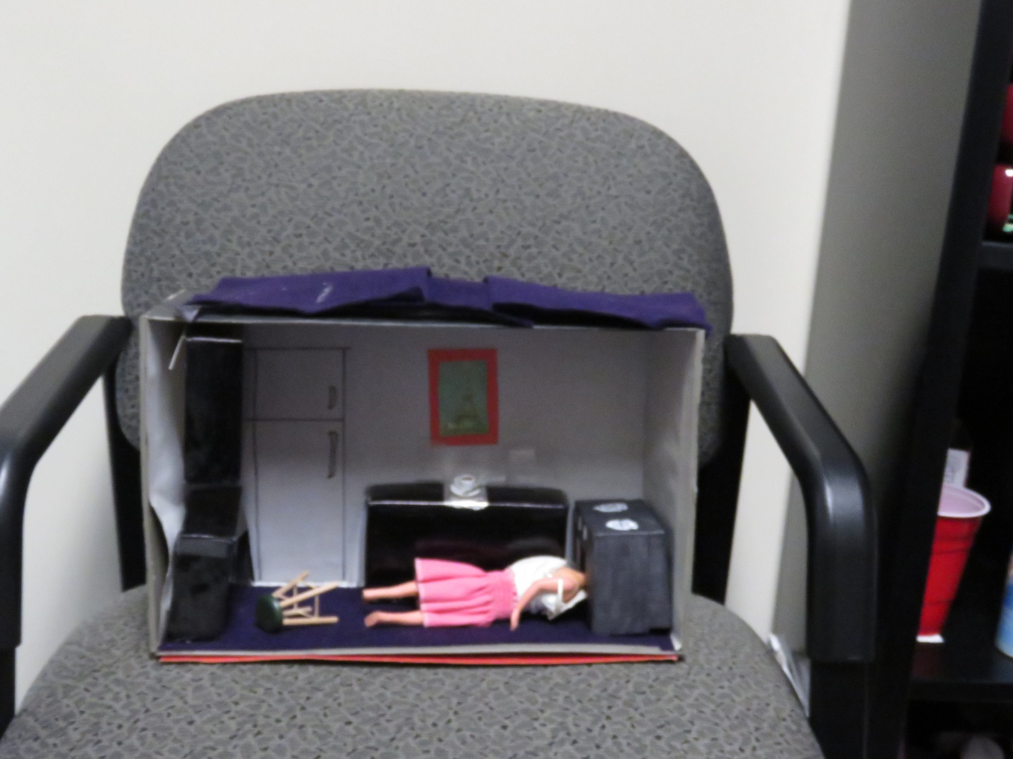
Figure 15. Diorama of Sylvia Plath that Zach created in 2005.
Zach’s Diorama Reflection
Well, needless to say the plot of The Bell Jar was not Its most impactful aspect. The writing was pleasant, and the story obviously a confessional, but the parallel between Sylvia Plath and her main character’s mental illness was what struck me the most. Perhaps it is the therapist in me, but it seemed the most important message to take away was “if you feel like this, seek help.” Sylvia Plath famously committed suicide very shortly after the publication of The Bell Jar.I had always known that she was one of the many authors who had decided to end their lives (although for inventiveness I can’t pretend that Virginia Woolf doesn’t steal the category), and knowing that about the author was what made me decide to read the book for my project in the first place.
In my middle school, we always had a yearlong project that culminated in a formal essay, a presentation, and a visual display of some kind, whether it be a game, model, poster, or diorama. I often favored the diorama since I cannot draw, but enjoy creating models and have always had a penchant for miniatures. This was not the first time I’ve rolled up my sleeves and whipped out the glue stick, but it undoubtedly had the most morbid and memorable result. My mother, also no stranger to the strange, helped me with my sketches for the project. She raised eyebrows when she was in high school when they had to make piñatas for a children’s hospital. Her classmates products of teddy bears and darling animals were by no means the favorite of the children – that honor belonged to mom’s very gross, very realistic housefly, which the children delighted in beating. However, even her first reaction to my plan was “I really don’t want to have to go to the school and tell them you aren’t disturbed, are you sure your teacher will think it is funny?” I told her I was about 70% sure.
Along with my teacher, the students in my class loved the presentation and talked about it for several days afterwards. In the era of PowerPoint, it is always refreshing to know that a hard product can have more standing impact than a flashy slide show.
CHAPTER FIVE
CONCLUSIONS
In this chapter, I offer a general overview of findings in relation to the research questions and discuss implications, limitations, and possibilities for future research.
Discussion
In thinking about my study’s research and findings in relationship to the four longitudinal studies selected, I did not have as many participants as Carroll and Sternglass; however, Sommers, Herrington, and Curtis, and I, all had four students in our studies. I relate to Sternglass in that I teach on an urban campus (downtown Tulsa) and my students vary in age, ethnicity, and skills. I am able to identify with much of what was presented in each study, because I, too, teach first-year composition, and three of the students in my study took me for Composition I, II, or both.
Sternglass wanted to know how students’ writing experiences are influenced by their homelife, workplace, and communities. She learned that writing isn’t neat or linear and that race, gender, sexual orientation, class, and ideology influence students, but do not limit them. Regarding neat and linear, after having Taylor and Jill in multiple classes, I would have to say that their writing improved over time as shown in the samples and expressed in the reflections in the appendices. When thinking about all of the potential things that could limit students, Taylor, Lisa, and Zach immediately come to mind.
Taylor and Lisa are both African-American females who grew up in working-class homes. Even though they didn’t live opulent lifestyles, they continued to work hard to reach their goals. Zach, however, did grown up attending country clubs and playing on golf courses. Even though his homosexuality might have made some people uneasy, he never wavered in expressing himself which is shown in my interview with him and in the Sylvia Plath diorama he created.
Carroll wanted to know how students developed as writers and what she learned is that it takes more than a one or two semester course. Writing development occurs over time. With this I think of Taylor and Jill. Taylor was in my Composition I, Composition II, and Advanced Composition courses. Although she earned an A in each course. Her level of fluency and confidence improved with each semester. Additionally, Jill was in my Composition I and Composition II class, she was already equipped with the writing skills, she just needed encouragement and guidance to pull it out.
When reading about Nam, Rachel, Lawrence, and Francois in Herrington and Curtis’s research, I was reminded my own four participants: Taylor, Lisa, Jill, and Zach. My students were not in basic writing, like the ones in Herrington and Curtis’s study; however, they, too, had much room for improvement. Like Herrington and Curtis’s students, my students, too, are also influenced by instructor feedback as Lisa discussed when she talked about earning an F in her high school English class and as Jill reflects over the comments that I made over her papers.
Even though none of the studies used Portraiture, I did capture glimpses of it from multiple studies. Sternglass discusses “snapshots” and “portraits” (p. 236) when referring to the participants’ data. Herrington and Curtis discussed how working with their four participants was more like an artist’s sketches rather than a photographer’s snapshots (p. 19). When thinking about the specific references to images, I am much more certain that portraiture was the best methodology for me to use for this study. It was very important for me to hear and experience what the participants allowed me to see, rather just observing the entire time.
I also wanted to make sure that I framed as best as I could the image that the students had created for me of their writing experiences once they left my classroom. Most people don’t want to just read about writing. However, if one presents a story about writing as Herrington and Curtis did with Nam, Rachel, Lawrence, and Francois, as Sommers and Saltz do with Jeremy, as Sternglass does with Linda and I as I do with Taylor, Lisa, Jill, and Zach, readers are able to empathize and imagine these students’ writing struggles, which inevitably leads to more conversations.
Research question 1: What impact, if any, did my writing instruction have on students’ lives?
After not seeing my former students for at least a few, but often, many years, I began to wonder what impact, if any, did my instruction have on them. After reviewing all of their reflections, the word that stood out in Taylor and Lisa’s reflections was confidence. Both discussed how they lacked the courage to write before my class, but now they felt much more confident when tasked to do writing.
Jill shared that she gained the ability to think critically and she had stronger written and verbal communication skills. Unlike the women in this study, Zach grew up in a privileged middle-class environment (where, as Brandt has noted, 2009, p. 106) parents tend to read to their children. Zach already had a strong sense of self-awareness and cultural capital that was stimulated and (I hope) enhanced after taking my class. Certainly, what students took away from composition depended upon what they came in with. Secondly, what students took away from composition was what they needed at the time they took the class.
When I began this project, I had no idea what studying my former students would do to my relationship with them, how they would feel about sharing personal information, or what I would learn about myself. The goodness that Lawrence-Lightfoot emphasizes in portraiture was immediately revealed when my former students enthusiastically agreed to participate in my study. None of us knew how long this process would take or what it would involve.
Warner (2014, p.1) writes about the importance of a good experience in the first-year writing course, which is why I take teaching Composition I very seriously. I know that for many students, it is their first experience/introduction to college and the way that I interact with them may affect their confidence and their decision to continue with college. In her reflection, Taylor shared that, since taking my class, she has much more confidence when writing and speaking with others. She said that she always puts forth her personal best. Lisa courageously shared the devasting, eye-opening impact failing her freshman English class in high school had on her. It crushed her spirit and left a sour taste in her mouth when it came to writing.
However, years later when she took my Composition II course, she received much-needed confidence after earning an A on a paper and learning that I thought she should pursue her dream of becoming a plumber. Lisa shared that the class that she feared the most helped her become stronger and enabled her to fulfill her dream. Jill shared in her reflection that taking my courses helped her to think more critically, question, and to debate in writing and verbally. She also warmly shared that she felt I gave her the confidence to continue developing as a person and as a professional. Raban (1982, pp. 11 & 19) explains how children from poor homes generally have poor writing skills and children from good homes usually have good writing skills and Zach is an example of this.
Before Zach came to high school, he had already attended some of the best schools in Tulsa and his parents communicated with him like an adult, which gave him confidence when interacting with others. I cannot say that I am responsible for any of the confidence that he clearly possessed when he became my student; however, as he indicated in his interview, he did learn that it was okay to express his understanding of literature in a different way besides writing as shown with his diorama of Plath.
All of the participants wrote about something that they cared about. Sommers and Saltz in The Novice as Expert: Writing the Freshman Year (2008, p. 127) explain how students should write about topics that interest them. Taylor discussed this in her reflection when she discussed her writing ability, I enjoy writing about what interests me. She also shares that when she wrote “The Impact of Sexual Health and Diseases,” it gave her stronger insight and empathy with the patients she was working with at the time, I do my best when communicating with a patient as well as documenting in a chart because it is a legal document. I always think of better ways to communicate with patients and providers and others I work with. When she wrote “Love of First Time Father,” she said that it brought tears to her eyes when thinking about how hard her father worked so hard when she was a child and now he is able to be there more for her younger sister and for Taylor’s daughter, “Sophie.” In her interview, Lisa discussed not having much freedom in her English class and the negative impact and a lack of freedom had on her. Jill shared in her reflection that she liked having a choice in her writing assignments. Zach enjoyed the flexibility to share his knowledge through artistic endeavors.
Research question 2: To what extent, if any, did my classes help prepare students for life after school?
Singularly, all instructors want to know that what they do matters. Instructors want students to be able to transfer the skills that they have learned inside our classrooms into their professional and personal lives. Not as much as they use other modes of communication, all of my participants did some form of writing at work. Zach emphasized how his writing must be clear when taking orders and Lisa, Jill, and Taylor stressed the importance of composing with accuracy as their writing could be viewed as a legal document.
Jill said that she has to document in charts as if a lawyer was charged with reading her notes. Taylor emphasized the same thing. Lisa relayed the pressure she felt when having to send out an email at the courthouse which would be read by judges, attorneys and other personnel.
What is striking in interactions with my former students is the range of communication skills that they use every day—certainly speaking and listening, but also reading, writing, and reflecting. TABLE 16 below shows that speaking and listening were participants’ primary means of communication during their work day. However, writing took on an air of significance and importance. What they wrote mattered, not just to them, but to others.
Participants’ week-long communication journal results: The numbers represent the frequency in which each participant recorded exhibiting the indicated communication skill throughout the week.
Table 16.
Frequencies of various means of communication used.
Participant | Zach | Taylor | Lisa | Jill | totals
Writing | 6 | 41 | 15 | 32 | 94
Speaking | 10 | 71 | 68 | 40 | 189
Listening | 12 | 57 | 56 | 44 | 169
Reading | 5 | 50 | 17 | 28 | 100
Thinking | 2 | 49 | 3 | 18 | 72
Reflecting | 2 | 0 | 13 | 1 | 16

To code the participants’ communication practice, I highlighted it. Once I completely read all of that day’s entry, I tallied the totals for the specific practices.
It was evident early in the interviews that writing was a crucial component in each individual’s their professional life. Taylor explained that she must pay close attention when she charts so that everything is documented correctly. Similarly, Jill shared the same sentiments when she discussed writing in her patients’ charts. She must make sure that everything is precise, so that an attorney is able to clearly understand all her documentation. Lisa discussed the Open Records Act and that she is cognizant every time she writes at work that it is subject to public access. Zach must write good notes every day even in his job as a waiter. He must make sure that his orders are accurate so that the cook prepares exactly what the customers ordered.
All the participants’ jobs required critical reading skills. Taylor must pay very close attention to the doctors and nurses’ written and verbal instructions. Working at the courthouse, Lisa is required to be attentive to emails or other communication that comes from judges or her supervisor and she must respond to them quickly and appropriately. Jill must make sure that she is reading the dentist’s and assistant’s notes correctly so that she may provide the best care plan for her patients. Not only must Zach be careful reading off the menu, occasionally, he must also read his customers as was the case with an elderly gentleman who visited the restaurant while my son and I were there. Zach was willing to read the menu to the customer numerous times, even though he had been to the restaurant before. As well, despite the elderly man not calling Zach by his name, I witnessed Zach continue to treat him and his wife with respect. He made sure they were comfortable throughout their meal.

Research question 3: What implications for instruction can be made, if any, regarding teaching English and communication skills in light of what my students learned and how they write, read, speak, and listen in their lives?
All participants framed clear pictures of their education and their thoughts about past and recent writing instruction. Yet, information that causes the most unease and discomfort comes from interviews with Lisa and Jill. Lisa’s explanation and feelings of how she failed her Freshman English class still concerned her many years after she had graduated high school and even after she earned her bachelor’s degree. I could not help but wonder if her high school English assignments were presented as thoroughly as they could have been (Lea & Street, 1998, p. 161; Holberg & Taylor, 2006, p. 1).
With a more positive experience in high school perhaps she would have developed a more receptive, less negative demeanor towards writing all those years. Jill discussed in her reflection that she was not encouraged to question teachers or assignments, or to think critically. This is concerning, much of what most teachers believe about writing goes back to what Damepfle said about writing being an explanatory process (2012, pp 73-74). Students are certainly unable to explore without questioning or critical thinking.
Perhaps the strongest revelation in this study is that students really are paying attention. Even though they may not always give eye-to-eye contact or offer much verbal conversation, they are paying attention to how we communicate. I will confess that Jill has told me and written to me on numerous occasions about the impact I have had on her life; however, I didn’t know that my comment to Lisa about becoming a plumber had affected her so much until she shared it to the audience when I was a guest speaker at her church. Additionally, when people ask me what I do, I proudly say that I am an English professor. To most, that likely means that I teach grammar or literature most days. While that may be somewhat true sometimes, the most important thing that I want to impart is for students to notice and to have empathy for others. I feel that with these participants my mission was accomplished, when Taylor and Jill explained how they communicate and interact with patients, how Lisa is very cognizant of her role as a public servant and how she must interact with everyone from judges to prisoners, and when Zach exhibited time and patience with the elderly man in the restaurant. I felt like my intense focus on writing was affirmed. If teachers can present material to students in a way that gives them new knowledge and encourages them to compassionately interact with others, then they are exhibiting the accessibility and realizing the “goodness” inherent in trying to get words down on paper.
Limitations
Patton (2002, p. 563) notes that there are three types of limitations that may occur in research. These limitations regard the situations in which participants are observed, the time period constraints, and the selectivity of the participants involved. The specific limitations in this study encompass time constraints and participant selectivity.
Because of my participants’ occupations, I had to obtain clearance to observe them and only for a designated amount of time on a specific day. Ideally, it would have been nice to observe the participants on multiple occasions, yet the sensitivity of their employment prohibited this.
As well, because all of the participants knew me as both an instructor and personally, their reflective journal and interview may have been swayed by our familiarity. Had I sent out a mass email to as many of my former students as I can find, this study might have generated different information.
I teach at a community college. Most of my students enroll to get a good job quickly and to provide for their families. They do not have a framework for the college experience, and they heavily rely upon what instructors and staff say. Because of this, it is very important that I continuously relay to them that I care about them as individuals first and that I hope they are able to learn and use a little of what I have taught in the process. As Noddings (2003, p. 176) explains:
When a teacher asks a question in class and a student responds, she receives not just
the “response” but the student. What he says matters, whether it is right or wrong,
and she probes gently for clarification, interpretation, contribution. She is not seeking the
answer but the involvement of the cared-for. For the brief interval of dialogue that grows
around the question, the cared-for indeed “fills the firmament.” The student is infinitely
more important than the subject matter.
This is further explained when Jill writes in her “Confessions” paper, Whether it is poetry, lyrics, or a letter to a friend, a part of myself is left on every page with each word.
When I ask questions in class or a student seems to be off track in a paper, I intentionally search and emphasize what is positive about what the student said or wrote and try not to put too much emphasis on what needs to be corrected. I know that students see their participation as an extension of them and I would not do anything to jeopardize their experience, even if it means extensively massaging the situation to where the error is not an issue. This is something that could be problematic when examining my former students’ work.

Possible Further Research
I began this study by simply wanting to know what my former students learned from my instruction. I was curious if they continued to use anything I taught them in their professional and personal lives. While my time studying them presented vivid results, four students is a small representation of the students I have taught from 2000-2019. While certainly not perfect, I know this is just the beginning of what I and other colleagues will do to reflect upon teaching practices.
The word essay derives from the French word essai which means to attempt or try. (Ballenger, 2015, p. 8) An essay was never meant to prove something, but to find out. Essays were not designed to be argumentative, but rather, explanatory as Daempfle (2012, pp73-74) suggests. Through this study, I have learned a great deal about a few of my former students’ communication practices; however, I understand that one person’s study of a few students can not reveal everything that students think about what they have learned in their English courses. For this reason, I would suggest that future studies use a larger sample of students to look at their communication practices. I would also consider studying my current students and following them into a few years into their professions.
While English courses might assign the majority of writing assignments, other classes in the Humanities and across disciplines also require students to read, write, listen, speak, reflect, and to think critically, thus, a study of how specific writing/communication assignments from those other disciplines impact students should be considered.
I am humbled to have gotten the opportunity that many instructors do not get, which is to work with former students again as Lisa was in my course in 2002 and Zach in 2005. All of their experiences were eye-opening, yet one that continues to resonate is Lisa failing her high school Freshman English class. I know that with mentors and strong friends, Lisa was able to overcome this and eventually earn a bachelor’s degree, but I do wonder what happens to other students who fail English? Lisa was not the first and she will not be the last to fail an English course. Studying those students would offer significant insight into learning and teaching practices and implications.
Summary/Conclusion
I have been teaching since 2000. For years I have wondered how my former students have fared in their personal and in their professional lives. I have wondered if much or if any of what I taught them has been beneficial. This study presented the very fortunate opportunity for me to explore, contemplate, and share in my former students’ spaces. Lawrence-Lightfoot and Davis writes a great deal about listening for a story rather than to one (p. 120), thus, I got to see first-hand how my former students use their critical thinking skills and the types of writing that they must do. From intimately engaging with my former students, I did learn that I (we) are doing good work, yet there is still more to be done. This type of study isn’t just applicable to writing or English, it would also complement our colleagues in math, science, and workforce development programs. In sum, we all need to know that what we are doing in our learning environment truly matters, and our current, future, and former students need to know that we remain invested and that we will never cease searching for answers.
As I pause and reflect over the work that I’ve done, I am reminded about what Sara Lawrence-Lightfoot calls the goodness of others. With all of the turmoil and confusion in the world, I am constantly baited and encouraged by the goodness that still exists and that yearns to be uncovered.

REFERENCES
Ballenger, B. (2015). The curious researcher: A guide to writing research papers. Boston, MA:
Pearson.
Berrett, D. (2014, November 13). Professors’ place in the classroom is shifting to the side.
The Chronicle of Higher Education.
Beyond the red ink: Teachers comments through students’ eyes. (2012, February).
YouTube. https://www.youtube.com/watch?v=PKfLRz7h7gs
Brandt, D. (2009). Literacy and learning: Reflections on writing, reading, and society. San
Francisco, CA: Jossey-Bass.
Braun, C. P. (2014). Portraits of Transformation in Higher Education. (Doctoral Dissertation)
Bruner, J. (1963). The process of education. Cambridge: MA, Vintage.
Bruner, J. (1996). The culture of education. Cambridge, MA: Harvard.
Cable News Network [CNN] (2008). Mandela at 90: Mandela in his own words. Retrieved from http://edition.cnn.com/2008/WORLD/africa/06/24/mandela.quotes/
Carroll, L.A. (2002). Rehearsing new roles: How college students develop as writers.
Carbondale, IL: Southern Illinois University Press.
CBS New (Phil Hirschkon). (2013, May 6). Oklahoma offers pre-k model for the nation. [Video file]. https://www.cbsnews.com/news/oklahoma-offers-pre-k-model-for-nation/
Connelly, F.M., & Clandinin, D. J. (2000). Narrative inquiry: Experience and story in Qualitative research. San Francisco, CA: Wiley and Sons.
Cresswell, J.W. (2007). Qualitative inquiry & research design: Choosing among five approaches. Lincoln, NE: Sage.
CWPA, NCTE, & NWP (2011, January). Framework for success in postsecondary writing.
Curtis, M. & Herrington, A. (2003). Writing Development in the college years: By whose
definition? College composition and communication conference, 55(1), 69-90.
Daempfle, P. (2012, December 16). Good science, bad science, pseudoscience, and just plain bunk. Lanham, MD: Rowman and Littlefield.
Davis, B. (2004). Inventions of teaching: A Genealogy. New York, NY: Taylor & Francis.
Ede, L. (1994). Reading the writing process. In T. Newkirk (Ed.) Taking stock: The writing process movement in the ‘90’s (pp. 31-40). New York, NY: Heinemann.
Elbow, P.H. (1968). The definition of teaching. College English, 30(3), 187-201.
Flaherty, C. (2015, January 26). Where have all the English majors gone? InsideHigherEd.
Fowler, R. H & Aaron, J.E. (2012). The little, brown handbook. Boston, MA: Pearson.
Glaser, B.G., & Strauss, A. (1967). The discovery of grounded theory. Chicago, IL: Aldine.
Goldberger, E. (2014, April 24). Essay on why all faculty need to consider the teaching of writing their responsibility. Inside HigherEd.
Goldthwaite, M.A., & Glenn, C. (2014). The St. Martin’s guide to teaching writing (7th ed.)
Boston, MA: Bedford/St. Martins.
Graff, G. & Birkenstein, C. (2014). They say, I say: The moves that matter in academic writing.
New York, NY: Norton.
Graham, S. & Perin, D. (2007). A meta-analysis of writing instruction for adolescent students.
Journal of Educational Psychology, 99(3), 445-476.
Grbich, C. (2013). Qualitative data analysis. Thousand Oaks, CA: Sage.
Haven, C. (2009, October 12). Stanford News Service.
Hirschkorn, P. & Laguerre-Wilkinson, M. (2013, May 4). Oklahoma offers pre-k model formation. Retrieved from CBS Evening News archives.
Horner, B. (1997). Students, authorship, and the work of composition. College English, 59(5), 505-526.
Jaime Escalante Quotes. https://www.azquotes.com/author/44850-Jaime_Escalante
Jaschik, S. (2009, March 18). Composition, overcrowded. Inside Highered.
Jaschik, S. (2014, December 1). Language jobs down. InsideHigherEd.
Jaschik, S. (2015, January 8). Economist offers critique of job market for Ph.D’s in English.
InsideHigherEd.
Kamberelis, G., & Dimitriadis, G. (2006). Theory for education. New York, NY: Routledge
Keller, J. (2009, June). Studies explore whether the internet makes students better writers. The Chronicle of Higher Education.
Kiley, B. (2015, January 30). The David Letterman Show.
Lawrence-Lightfoot, S. and Davis, J. (1997). The art and science of portraiture. San Francisco, CA: Jossey-Boss.
Lunsford, A. (October, 2009). The new literacy: Stanford study finds richness and complexity in students’ writing. Stanford News Service.
Macedo, D. & Freire, P. (1987). Literacy: Reading the word and the world. Westport, CT: Bergin & Garvey.
McCarthy, K.W. (2017). Full circle: A portraiture study of three successful indigenious
educators and community leaders who experience personal renewal in their practice of
cultural restoration. (Doctoral Dissertation Lesley University)
Manning, M. & Kamii, C. (2000). Whole language vs. isolated phonics instruction: A longitudinal study in kindergarten with reading and writing tasks. Journal of Research in Childhood Education, 15, 53-65.
Merriam, S. B (2009). Qualitative research: A guide to design and implementation. Jossey-Bass, San Francisco.
Moore, C. (2011). Allow the music to speak: A portraiture case study of pre-service teachers’
experiences in a multi-integrated literacy methods course. (Doctoral Dissertation Georgia State University)
Patton, M. Q. (2002). Qualitative research and evaluation methods. Thousand Oaks, CA: Sage.
Power, B.M, & Hubbard, R. S. (2003). The art of classroom inquiry: A handbook for teacher researchers. Portsmouth, NH: Heinemann.
Raban. B. (1982). Influences on children’s writing 5-9 Years. Newcastle, United Kingdom.
Annual Meeting of the United Kingdom Reading Association.
Sandy, K. (2006). Placing pedagogy at the center: The pain and the pleasure. In J.L. Holber & M. Taylor (Eds.), Pedagogy: Critical approaches to teaching literature, language,
composition, and culture (pp. 145- 153). Durham, NC: Duke.
Seidman, E. (1968). Marking students’ compositions: Implications of achievement motivation
theory. (Doctoral dissertation). Dissertation Abstracts International, 28, 2605-A.
Shaughnessy, M. (1994). Diving in: An introduction to basic writing. In The writing teacher’s Sourcebook (pp. 321-326).
Slevin, J. (1996). Disciplining students: Whom should composition teach and what should they know. Composition in the twenty-first century: Crisis and change (pp.153-165). Carbondale, Ill: Southern Illinois.
Sommers, N. & Saltz, L. (2004). The novice as expert: Writing the freshman year. College Composition, and Communication Conference, 56(1), 124-149.
Spade, J.Z. & Ballantine, J.H. (2008). Understanding education through sociological theory. In J.H. Ballantine & J.Z. Spade (Eds.), Schools and Society (pp. 5-19). Los Angeles: CA,
Pine Forge.
Starcher, K. (2010). The imposter with the roster: How I gave up control and became a better teacher. The Teaching Professor, 24(8), 1.
Stenburg, S. J. (2005). Professing and pedagogy: Learning the teaching of English. Urbana, IL: NCTE.
Sternglass, M. S (1997). Time to know them: A longitudinal study of learning and writing at
the college level. New York, New York: Routledge.
Street, B. V., & Lea, M.R. (1998). Student writing in higher education: An academic literacies Approach. Studies in Higher Education, 23(2), 157-172.
Taylor, M., & Holberg, J. L. (2006). Editors’ Introduction: The Teaching Self. In J.L. Holberg & M. Taylor (Eds.), Pedagogy: Critical approaches to teaching literature, language, composition, and culture (pp. 1-4). Durham, NC: Duke.
Tan, A. (2012). Mother Tongue. In F. Madden (Ed). Exploring Literature (pp. 150-154).
New York, NY: Pearson.
Torcivia, P.P. (2012). Five adult women science, engineering, technology, and mathematics (STEM) majors: A portraiture of their lived experiences. Doctoral Dissertation.
Tulsa Community College Strategic Plan
U.S. Department of Education. (August, 2008). Improving adolescent literacy: Effective classroom and intervention practices. https://ies.ed.gov/ncee/wwc/Docs/PracticeGuide/adlit_pg_082608.pdf
Warner, J. (2014, August 4). Saying farewell (forever) to a course. InsideHigherEd.
Warner, J. (2015, January 11). First-year-writing experiment: Jokes. InsideHigherEd.
Warner, J. (2015, March 25). Skills students need. InsideHigherEd.
White, E.M. (2007). Assigning, responding, evaluating: A writing teacher’s guide.
Bedford St. Martin’s, New York: New York.
Williams, J.G. (2003, October 10). Providing feedback on ESL students’ written assignments.
The Internet TESL Journal.
www.nationsreportcard.gov/writing_2011

Appendix A

Taylor

Taylor’s Journal
To understand the participants’ communication practices, refer to the bottom key.

W= Writing, will be underlined
S=Speaking, will be italicized
L=Listening, will be highlighted
R=Reading, the entire word will be bold
T=Thinking, the last letter will be bold
Re= Reflection, the first letter will be capitalized

Sunday- 6/7/2015
I called and texted my fiancée throughout the day.
I called my mother to let her know I was on my way to her home.
I texted my home health’s job manager to let her know I would still be able to work Sunday overnight.
I sent my future in-laws a picture of my daughter.
I uploaded photos on Facebook and Instagram. I commented on several posts and liked several photos and posts. I also replied to other’s comments on my posts.
I arrived to my second job’s assignment at a local hospital and sat with a patient. I kept her company throughout the night. We talked and watched TV. I paged the hospital staff multiple times at her request for things such as her medications, ice chips, beverages, etc. W/5, S/3, L/1, R/4, T/0, RE/0
Monday- 6/8/2015
I texted my home health’s jobs manager to see if someone would be relieving me or if I needed to leave right at 6am. She responded back stating I could leave at 6am.
I texted my fiancée throughout the day. I Face Time called my fiancée this morning so my daughter could see her dad and talk to him for a little while.
I uploaded photos on Facebook and Instagram. I commented on several posts and liked several photos and posts. I also replied to other’s comments on my posts.
I emailed my manager letting her know the clinic manager at the office I was assigned to sent me to work in a different department.
I roomed patients from 8am-4pm. (I called them back to the back office, got their weight, blood pressure, pulse, and pulse oximetry.) I also gave injections, printed lab orders, referrals, printed patient care plans.
I called patient’s throughout the day to give them their test results, discuss prescription refill request/ prior authorizations/ referrals.
I called insurance companies to get approvals on prior authorizations regarding patient prescriptions and tests.
I received incoming fax documents regarding patient prescription refill requests from pharmacies, prior authorization requests, medical records from other medical offices, discharge summaries from hospitals.
I faxed patient documents to the required destinations such as pharmacies and other medical offices.
I spoke with the physician I worked with throughout clinic about patient care.
I tasked refill requests to the physician as well as medical questions. He also responded and I completed the tasks he needed me to complete.
After work I call my fiancée to check on our daughter, my mother to see how my daughter was for the day and if she needs anything, I texted two of my closest friends.
My best friend called me needing me to do her hair so I had her come to my house and we talked while I did her hair.
I talked to my fiancée when he got home from practice.
Read my daughter a bedtime story.
W/6, S/8, L/5, R/8, T/4, RE/0
Tuesday- 6/9/2015
I woke my daughter up and talked to her that morning.
I texted my fiancée throughout the day. I Face Time called my fiancée this morning so my daughter could see her dad and talk to him for a little while.
I texted my mom letting her know I was on my way to drop my daughter off.
I greeted the other parents that were dropping their children off at daycare.
I emailed my manager letting her know the clinic manager at the office I was assigned to sent me to work in a different department.
I roomed patients from 8am-4pm. (I called them back to the back office, got their weight, blood pressure, pulse, respirations, and pulse oximetry.) I completed a few Medicare Wellness Assessment Screenings that day. I also gave injections, printed lab orders, referrals, and printed patient care plans.
I asked the other Medical Assistant I worked that day numerous questions about what they do in certain situations and all I would need to do that day. She was very helpful.
I called patient’s throughout the day to give them their test results, discuss prescription refill request/ prior authorizations/ referrals.
I called insurance companies to get approvals on prior authorizations regarding patient prescriptions and tests.
I received incoming fax documents regarding patient prescription refill requests from pharmacies, prior authorization requests, medical records from other medical offices, discharge summaries from hospitals.
I faxed patient documents to the required destinations such as pharmacies and other medical offices.
I spoke with the Nurse Practitioner I worked with throughout clinic about patient care.
I tasked refill requests to the Nurse Practitioner as well as medical questions. She also responded and I completed the tasks she needed me to complete.
I texted my hair stylist to see if she could fit me in the Friday. We texted back and forth until we made a mutual agreement.
My future sister-in-law called me to see if I was coming to my fiancée’s roping practice.
After work I call my fiancée to check on our daughter, my mother to see how my daughter was for the day and if she needs anything, I texted two of my closest friends.
I talked to my fiancée when he got home from practice.
Read my daughter a bedtime story.
W/6, S/12, L/10, R/9, T/1, RE/0
Wednesday- 6/10/2015
I woke my daughter up and talked to her that morning.
I texted my fiancée throughout the day. I Face Time called my fiancée this morning so my daughter could see her dad and talk to him for a little while.
I texted my mom letting her know I was on my way to drop my daughter off.
I greeted the other parents that were dropping their children off at daycare.
I am working front office today at a clinic answering incoming phone calls from patients and other medical offices.
I have scheduled patient appointments, given lab/test results.
I have also transferred calls.
I have texted and emailed my coworker throughout the day.
I emailed my manager.
I have talked with the other ladies that are working in the office today.
After work I call my fiancée to check on our daughter, my mother to see how my daughter was for the day and if she needs anything, I texted two of my closest friends.
I talked to my fiancée when he got home from practice.
Read my daughter a bedtime story.
W/8, S/4, L/4, R/1, T/0, RE/0
Thursday- 6/11/2015
I woke my daughter up and talked to her that morning.
I texted my fiancée throughout the day. I Face Time called my fiancée this morning so my daughter could see her dad and talk to him for a little while.
I texted my mom letting her know I was on my way to drop my daughter off.
I greeted the other parents that were dropping their children off at daycare.
I am working front office today at a clinic answering incoming phone calls from patients and other medical offices.
I have scheduled patient appointments, given lab/test results.
I have also transferred calls.
I have texted and emailed my coworker throughout the day.
I emailed my manager.
My manager called me and sent me to work in a different office.
I roomed patients the rest of the workday (I called them back to the back office, got their weight, blood pressure, pulse, respirations, and pulse oximetry.) I completed a few Medicare Wellness Assessment Screenings that day. I also gave injections, printed lab orders, referrals, and printed patient care plans. I assisted with a procedure.
I asked the other Medical Assistant I worked that day numerous questions about what they do in certain situations and all I would need to do that day. She was very helpful.
I called patient’s throughout the day to give them their test results, discuss prescription refill request/ prior authorizations/ referrals.
I called insurance companies to get approvals on prior authorizations regarding patient prescriptions and tests.
I received incoming fax documents regarding patient prescription refill requests from pharmacies, prior authorization requests, medical records from other medical offices, discharge summaries from hospitals.
I faxed patient documents to the required destinations such as pharmacies and other medical offices.
I spoke with the Doctor I worked with throughout clinic about patient care.
I tasked refill requests to the Doctor as well as medical questions. He also responded and I completed the tasks he needed me to complete.
I have talked with the other ladies that are working in the office today.
After work I call my fiancée to check on our daughter, my mother to see how my daughter was for the day and if she needs anything, I texted two of my closest friends.
I talked to my fiancée when he got home from practice.
Read my daughter a bedtime story.
W/9, S/16, L/12, R/11, T/11, RE/0
Friday- 6/12/2015
I woke my daughter up and talked to her that morning.
I texted my fiancée throughout the day. I Face Time called my fiancée this morning so my daughter could see her dad and talk to him for a little while. I texted my mom letting her know I was on my way to drop my daughter off.
I greeted the other parents that were dropping their children off at daycare.
I am working front office today at a clinic answering incoming phone calls from patients and other medical offices.
I have scheduled patient appointments, given lab/test results.
I have also transferred calls .
I have texted and emailed my coworker throughout the day.
I emailed my manager.
I roomed patients the entire work day (I called them back to the back office, got their weight, blood pressure, pulse, respirations, and pulse oximetry.) I completed a few Medicare Wellness Assessment Screenings that day. I also gave injections, printed lab orders, referrals, and printed patient care plans. I assisted with a procedure.
I asked the other Medical Assistant I worked that day numerous questions about what they do in certain situations and all I would need to do that day. She was very helpful.
I called patient’s throughout the day to give them their test results, discuss prescription refill request/ prior authorizations/ referrals.
I called insurance companies to get approvals on prior authorizations regarding patient prescriptions and tests.
I received incoming fax documents regarding patient prescription refill requests from pharmacies, prior authorization requests, medical records from other medical offices, discharge summaries from hospitals.
I faxed patient documents to the required destinations such as pharmacies and other medical offices.
I spoke with the Doctor I worked with throughout clinic about patient care.
I tasked refill requests to the Doctor as well as medical questions. He also responded and I completed the tasks he needed me to complete.
I have talked with the other ladies that are working in the office today.
After work I call my fiancée to check on our daughter, my mother to see how my daughter was for the day and if she needs anything, I texted two of my closest friends.
I called my hairstylist to let her know I was on my way. We talked the entire time I was there.
I called my little sister to let her know I was on my way to pick her up from home, so he could spend the night at my house.
I talked to my fiancée when I got home from the hairshop.
Read my daughter a bedtime story.
W/7, S/16, L/13, R/10, T/12, RE/0
Saturday- 6/13/2015
I woke my daughter up and talked to her that morning.
My fiancée and I made an agreement on what to eat for breakfast; he went to pick it up.
I fed my daughter, did her hair.
My fiancée told me he was leaving to go get ready for the rodeo.
My little sister and I talked and decided to go shopping.
I spoke with a Sales Associate at Drysdale’s about boots for my daughter. We bought matching shirts for the rodeo to coordinate with my fiancée.
My mom called me to see what time we were going to the rodeo.
I called my best friend to see if she still wanted to go to the rodeo and also see what time she wanted me to pick her up.
I called her when we were on our way. We went to the rodeo.
I talked to a few friends and family in person then sat to watch the rodeo.
When the rodeo was over I took my daughter and sister to my mom’s because I had to work early in the morning. I dropped my best friend off at her home. I texted my mom and best friend to let them know I made it home safely. I went home and got ready for bed and went to sleep.
W/1, S/7, L/8, R/1, T/0, RE/0
The following papers were written by Taylor when she took my courses.

[Taylor Assignment I]
Why I Chose both Nursing and Child Care as Career Paths
Taylor Smith
Tulsa Community College
3/15/13
Why I Chose both Nursing and Child Care as Career Paths
Since a child, I always knew I wanted to help people. I just did not know how or in what capacity. As I have grown older, I found my passion in healthcare, nursing, and child care. I work with patients, clients, and children every day from different backgrounds with different needs. I take care of them, educate them, and help them get better. The more education I pursue for myself, the more I can help myself, my patients, my clients, and the children in my community.
I have worked in the medical field for almost 2 years and I love it! I love helping others. I currently work as a Registered Medical Assistant and Certified Nurse Assistant. I aspire to become a neonatal nurse practitioner someday; until then I am going to pursue my Registered Nurse career. I really want to work with babies in the Neonatal Intensive Care Unit, but if I am not granted that position I will take which ever God has planned for me.
I have worked with children since I was a teen with my mom at her home daycare. I can remember being a child helping my mom make meals, play games with the kids, create new art projects, clean up, and learning how to feed a baby and change diapers. It was lots of work, but fun!
My senior year in high school I attended Tulsa Tech for Medical Assisting. I love it a lot because I was able to work closely with a nurse to make sure that was what I really wanted to do. I am glad that Tulsa Tech was a benefit to my education and career goals. I believe all high school children should be given that opportunity.
My mom has been my biggest influence on wanting a child care center of my own because you are making a difference in someone’s family. That child may look up to you and say I want to be just like you when I grow up. My mom having a home daycare not only inspired me, but it gave me self-discipline. It showed me that I should wait until I am financially stable to have children and prepared me to be able to live on my own as far as cooking, cleaning, and showing me that hard work pays off.
Working two part time jobs and being a full time student is currently very demanding, but I know what I want in life. This May 2013 I will graduate with my transferrable Pre-Nursing Associates degree. Next May 2014, I will graduate with my Child Development: Center Director degree. After I get my child development degree I plan to open a child care center with my mom and older sister. My next step will be to apply for the Langston-Tulsa Nursing Program for the fall 2014 semester.
I know that I want to pursue becoming a nurse and opening up my own daycare center because I love to help others. I know that the two can be very demanding, but with God and faith anything is possible. To many, this may be too much! To me, I know I can do it. I want to be a great role model to my little sister and my children in the future by providing healthcare to all individuals, no matter what their needs are, to improve the health of our community, and to help a child grow physically and mentally.
First, Taylor, I need to say what an honor it is to get the pleasure of working with you again! Kudos to you for having your Running head in the correct place, so far, you’re the only student in this class to do so. Even though your writing is vivid and fluent, try to avoid using second person and review the other comments/corrections.

~Mrs. W

[Taylor Assignment II]

Low-literacy Skills Related to Poor Health Recovery in the Older Adult
Taylor Smith
Tulsa Community College
Low-literacy Skills Related to Poor Health Recovery in the Older Adult
Summary
Jeungok Choi’s Literature Review: Using Pictographs in Discharge Instructions for Older Adults with Low-literacy Skills (2011) suggests understanding specific methods to help the elderly comprehend discharge instructions much clearer who have lower literacy skills (p. 2984). This problem can lead to a decline in a patient’s health when they return home because discharge instructions consist of recommended homecare actions that they do not understand (Choi, 2011, p. 2984).
Humans possess two information-processing systems: visual and verbal (Choi, 2011, p. 2986). Meaningful learning occurs when a learner selects relevant information in each system, organizing it into a coherent representation making connections between corresponding representations in each system (Choi, 2011, p. 2986).
Many older adults have a hard time reading directions due to length and dictation of the directions. To meet the need of this unresolved issue various forms of visual aids are used for patient education for example: clip art, animations, video clips, pictographs, or photographs (Choi, 2011, p. 2985).
Critique
After reading this article, the understanding is that elderly adults have varying barrier experiences that conflict with following through of their discharge plan. Many older adults cannot read and/or write. Others may forget how to read and/or write. It is the medical staff’s duty to ensure that the patient is understands and is able to follow through with their plan of care. The medical staff should have the patient demonstrate and verbalize to show that they understand because many elderly patients are sometimes ashamed to admit they cannot read and/or write or will say they can sometimes not knowing they cannot.
When sending home care instructions either a picture, drawing, or written diagram should be provided so that the patient can have something to reference to. Yes, these interventions may take time to complete, but it is well worth it especially because it can prevent the patients having to pay for hospital admittance or costly return visits that could have been avoided (Choi, 2011, p. 2984).
When it comes to patient education nurses and/or the nurse support is solely responsible because they usually are the first and last to have patient contact. Nurses and providers can also use the visual aid method as a way of therapeutic communication and to establish rapport. If I do not establish grounds for rapport with the patient then he or she will not trust me then they will not follow the plan of care because many older adults do not trust the health care system.

Reference Page
Choi, Jeungok. (2011). Literature Review: Using Pictographs in Discharge Instructions for Older Adults with Low-literacy Skills. Journal of Clinical Nursing, 2984-2996.
Taylor, I was surprised to see your struggles with this paper, please note the corrections. As well, it appears that you took parts of this for a paper you submitted last September and if your refer to the TCC OWL you will see that is a form of PLAGIARISM. You may not use prior work, ever, without informing your current professor as the consequences are often severe.

~Mrs. W

[Taylor Assignment III]

The Impact of Sexual Health and Diseases
Taylor Smith
Advanced Composition 2383
Mrs. Williams
May 3, 2013

According to the Centers for Disease Control and Prevention, a STD is a sexually transmitted disease also known as a sexually transmitted infection (STI). Any plant or animal that is able to reproduce sexually can acquire a STI. There are more than 25 infectious organisms that are transmitted primarily through sexual activity (U.S. Department of Health and Human Services, 2013). The best prevention is through education, responsibility, communication and income even though there may be barriers one can find a way to overcome these challenges to better oneself.
STDs are acquired during unprotected sex with an infected partner (U.S. Department of Health and Human Services, 2013). Biological factors that affect the spread of STDs include the asymptomatic nature of STDs. Many people who have STIs do not even know they have been infected until they get tested, begin to have symptoms which are abnormal (green discharge or foul odor or painful lesions), or their partner(s) have signs or symptoms. Gender disparities apply because women suffer more frequent and more serious STD complications than men do. Those serious STD complications are pelvic inflammatory disease, ectopic pregnancy (pregnancy outside of the uterus), infertility, and chronic pelvic pain (U.S. Department of Health and Human Services, 2013). Age disparities such as sexually active adolescents ages 15 to 19 and young adults ages 20 to 24 are at higher risk for getting STDs compared to older adults (U.S. Department of Health and Human Services, 2013). Lag time between infection and complications includes a long interval, sometimes years, occurring between acquiring an STD and recognizing a clinically significant health problem such as the age disparity risks mentioned above (U.S. Department of Health and Human Services, 2013).
Racial disparity in income and reported STIs plays a major role to infection likelihood (al., 2013). According to the American Journal of Public Health, it was found that African Americans were substantially higher than White Americans concerning STD infections related to less income and no insurance coverage (al., 2013). Minorities are at a higher risk for contracting an STD because they are not properly educated on awareness and prevention. All STDs are preventable.
A few of the most common curable STIs are the following: bacterial vaginosis, chlamydia, gonorrhea, trichomoniasis, pelvic inflammatory disease, pubic lice, scabies, syphilis, and urinary tract infections. Non-curable, but treatable STIs include: cytomegalovirus, genital warts, hepatitis, herpes, human immunodefiency virus, and human papilloma virus. Bacterial vaginosis, pubic lice, scabies, urinary tract infections, hepatitis (injectable drug use, handling contaminated blood), are not only contracted through sex. These infections can be non-sexually related. All curable, non-curable, and non-sexually related STIs can be treated or cured with antibiotics, antivirals, freeze therapy (warts), acid (warts), over the counter methods, NIT kits (lice), or scabene (scabies).
Many STIs aren’t curable or can no longer be curable depending on what stage the disease is for example gonorrhea and syphilis. Gonorrhea may become “untreatable” as drug-resistant strains are spreading across Europe, health officials said (Association, 2013). Currently, the CDC recommends that gonorrhea be treated with two different antibiotics, Azithromycin and Rocephin. Syphilis is cured with Penicillin if detected in its early stages if not, it can progress to nervous and brain system damage.
The rising issue and prevalence of STIs is much more important for humans because it concerns our health and well-being as well as fertility. Education is the number one key to prevention because if many of these teens and young adults were educated better the risks and infection rates would decrease effectively. Non-monogamous sexually active individuals need to be much more responsible for their actions. Many people feel as if they are too good to get infected with an STD or that it will never happen to them. Many others don’t feel comfortable going to the doctor especially with genital complaints. If the medical team knows that someone is shy about getting tested and/or treated they should first build rapport to make that patient more comfortable. Income and insurance is a major conflict when it comes to going to the doctor because many people cannot afford an office visit. Fortunately, there are many income based and free clinics who gladly see patients who cannot afford medical care. Unfortunately, many of those who need resources like this do not know about it or are not able to find reliable transportation.
Only 14% of men and 8% of women think they are at risk of getting an STD (ETR Associates, 2009). Half of all people who have sex will get an STD at some point in their lives (Incredible STIs pamphlet). It is our responsibility as a community of one to educate one another to prevent infection rates. Knowing your status is a critical step to stopping STD transmission (Centers for Disease Control and Prevention, 2013). If you know you are infected you can take steps to protect yourself and your partner(s) (Centers for Disease Control and Prevention, 2013). Less than 33% of U.S. doctors routinely test patients for STD (ETR Associates, 2009). Be sure to ask your healthcare provider to test you for STDs which is the only way you will know whether or not you are receiving the right tests (Centers for Disease Control and Prevention, 2013).
CDC recommends all adults and adolescents should be tested at least once for HIV (yearly for men who have sex with men), yearly trichomoniasis (HIV infected women), chlamydia, and gonorrhea screening for at-risk sexually active men and women under 27 (Centers for Disease Control and Prevention, 2013). Planned Parenthood recommends that you respect yourself, test yourself.
References Page
al., O.-E. e. (2013, 3 14). The Association Between Racial Disparity in Income and Reported Sexually Transmitted Infections. American Journal of Public Health.
Association, T. P. (2013, March 12). Gonorrhoea strains 'may become untreatable'. Retrieved from Nursing Times: www.nursingtimes.net
Centers for Disease Control and Prevention. (2013, 4 3). CDC. Retrieved from Centers for Disease Control and Prevention: http://www.cdc.gov/std
ETR Associates. (2009). Incredible STD Facts.
ETR Associates. (2012). 101 Ways to Say No to Sex. Retrieved from www.etr.org/pub
U.S. Department of Health and Human Services. (2013, April 10). Healthy People 2020. Retrieved from Healthy People 2020 Web site: http://www.healthypeople.gov/2020/topicsobjectives2020/overview.aspx?topicid=37

Appendix B:
Lisa
Lisa’s Journal
Wednesday June 10
I woke my son up with a morning song, talk to my husband until we made it to work.
Checked my emails at my desk, had a small meeting with my employee about what are our plans for the day.
Went to a meeting with fellow lead people and Supervisors where I communicated what my department was doing for the day.
Communicated with vendors about parts and supplies on the phone, Emailed Contractor’s about jobs being done
Emailed about my son’s class, texted his teacher then talked to her on the phone.
Texted the Director of VBS
Called my husband to see how my son did on arrival at camp, told him no lunch today.
Texted my friends throughout that day words of encouragement and acknowledgement.
Gave a presentation at Vacation Bible School, walked around taking pictures and talk to the teachers and helpers, text some of the teachers pictures
Talked to my husband about our day
Said prayers with my son before bed W/5, S/8, L/6, R/2, T/0, RE/3

Thursday June 11

Woke my son up with morning song, talk to my husband until we went to work.
Text my ex-professor to find her, talk to her while walking into the building and greeting people.
Had a small meeting with my employee about what we were doing today.
Had a meeting with fellow leads and the assistant director
Walked around greeting and talking to people while I was counting machines for the bookkeeper
Checked and responded to email
Text friends and family throughout the day
Talked to my coworkers about projects needing to get finished and started
Arrange d for a job to get started over the weekend through phone calls
Checked email, followed up on collecting parts and such for end of the year projects
Called my husband about lunch and how our son did going to camp
Gave a presentation at VBS, talked to the teachers and parents
Said prayers with my son
Talked to my husband about our day W/2, S/11, L/7, R/4, T/0, RE/3
Friday June 12

Talked to my husband and son until they dropped me off at work
Had a small meeting with my employee, checked emails
Had a meeting with my fellow leads discussed plans for the day
Called a customer about a problem
Texted a friend about her birthday
Posted a comment on her Facebook page per her request via text message
Ordered something of the internet
Called husband about our son
Called a vendor about a part needed immediately
Sang and wish my friend happy birthday
Talk to people while sitting at the information desk
Gave a presentation at VBS, talked to parents at closing picnic
Prayed with my son
Talked to husband about our day W/3, S/12/L/7, R/4, T/2, RE/2

Saturday June 13

Talk to my husband about plans for our day
Received a call from work about water availability
Talked to my Mother-in-Love about our son’s care for the day
Listened and asked questions on the black town tour presented by the Library
Talked and listened to people on the bus
Text my MIL about arriving late from the bus
Texted my brothers
Prayed and sang with my son
Talked to my MIL about our tour
Called my mom and told her about the tour, listened about some of our family history
Talked to my husband about our day W/2, S/7, L/8, R/2, T/0, RE/2

Sunday June 14

Talked to my son and husband while getting dressed for church, talked to my MIL about having my son prepared to leave with her,
Listened, commented and asked questions during Sunday School
Talked to the lady in the nursery about dropping off my son
Read a text from a choir member about a young lady sitting improperly, went and talked to the young lady
Talked to fellow members after church, discussed what we were going to eating
Text my best friend
Prayed, and read a book with my son
Talked to my husband about our plans for the week
W/2, S/4, L/6, R/3, T/1, RE/ 1
Monday June 15

Woke my son up with morning song, talk to my husband until we went to work
Had a small meeting with my employee, checked emails
Had a meeting with my fellow leads discussed plans for the day
Called vendors for follow up on weekend work, other vendors with unfinished business
Discussed the weekend with coworkers
Called vendors about parts and prices
Talked to customer about problem, walked around and greeted people
Went to discuss with a supervisor for a different vehicle
Called husband about lunch and son
Ordered lunch, talked to husband
Called contractors for price on projects
Emailed PO numbers to vendors and contractors to receive invoices
Talked to my son about his day after talking to the ladies at his day camp
Discussed dinner and day with my husband
W/1, S/15, L/13, R/1, T/0, RE/1

Tuesday June 16

Talked to my husband and son until they dropped me off at work
Checked my emails at my desk, had a small meeting with my employee about what are our plans for the day.
Went to a meeting with fellow lead people and assistant director where I communicated what my department was doing for the day
Talked to customers throughout the day about problems
Talked to coworkers about things needed and getting assistance
Called husband about lunch and son
Shared internet stories with my co-worker, watch videos and laughed
Talked and laughed with the parents at son’s camp
Discussed dinner with husband, asked son about his day, laughed and talked to my MIL.
Prayed with son
Talked to my husband about the day
W/0, S/11, L/9, R/1, T/0, RE/2

Appendix C:
Jill
Sunday June 14

I spoke with front desk personnel at my massage appointment and spoke to massage therapist during treatment. Stopped at front desk to check-out, pay and schedule my next appointment.

I spoke to the pharmacy tech at the drive thru window to pick up prescriptions.

I spoke with my family during breakfast. Discussed our plans for the day.

I spoke to my boyfriend regarding the makeup vanity he was assembling for me.

I worked spoke with my boyfriend to compile our weekly family dinner menu and grocery list. Also wrote weekly chore list for the two boys.

I conversed with boyfriend and store staff while shopping and making our transaction.

I texted my son while grocery shopping.

I spoke to family during dinner.

I checked Facebook and commented, liked and shared several posts, pictures and videos.

I checked my email and paid bills online. W/3, S/8, L/8, R/2, T/7, RE/0

Monday June 15

I checked Facebook and wrote a status update. I commented on other statuses and liked several pictures and videos.

I spoke with coworkers during our morning meeting/huddle at work and discussed our schedule for the day.

I spoke to patients, both new/potential and current/existing, throughout the day regarding their health history and current oral health habits. Also, I educated patient on their current disease process, when necessary and appropriate, as well as, recommended treatment. I reviewed oral health instruction with patient. I scheduled appointments and confirmed appointments, in person and via telephone. I completed transactions for balance due following treatment. I made written documentation in patient charts and in the computer regarding such things as patient health history, current oral health status, home care habits, recommended treatment, treatment diagnosed by the Dentist, radiographs taken, and referrals to other specialists. I spoke with all coworkers throughout the day in personal and professional conversation.

I joined a conference call via telephone for all hygienists in our region with our company for a Q & A with our territory hygiene director.

I phoned Avis car rental and spoke to a customer service representative regarding a charge to my account.

I went to Sam’s Club and had several verbal and nonverbal interactions with staff.

I texted my Mother and a friend after work several times.

I spoke with my family during dinner.

I checked Facebook and liked several statuses. I also liked, commented and shared several photos.

I checked my voicemail messages and returned phone calls.

I checked my email.
W/5, S/6, L/7, R/5, T/3, RE/0

Tuesday June 16

I spoke to the teller at the bank drive thru while making a deposit.

I spoke to the cashier at Starbucks to order coffee.

I spoke with coworkers during our morning meeting/huddle at work and discussed our schedule for the day.

I spoke to patients, both new/potential and current/existing, throughout the day regarding their health history and current oral health habits. Also, I educated patient on their current disease process, when necessary and appropriate, as well as, recommended treatment. I reviewed oral health instruction with patient. I scheduled appointments and confirmed appointments, in person and via telephone. I completed transactions for balance due following treatment. I made written documentation in patient charts and in the computer regarding such things as patient health history, current oral health status, home care habits, recommended treatment, treatment diagnosed by the Dentist, radiographs taken, and referrals to other specialists. I spoke with all coworkers throughout the day in personal and professional conversation.

I checked my work email and sent emails.

I spoke to the boys at home via telephone and in person over my lunch break.

I checked text messages and sent replies to several people.

I checked my voicemail and made return phone calls.

I spoke to my family during dinner.

I checked Facebook and liked several statuses. I also liked, commented and shared several
photos.

W/5, R/5, L/8, R/4, T/1, RE/0

Jill’s Writing Assignments
“Jill”
English 1113-115
Mrs. Williams
2/9/07

Confessions

I have never felt so independent and afraid all at the same time as when I am

writing. Whether it is poetry, lyrics, or a letter to a friend, a part of myself is left on every

page with each word. Each undertaking is a Technicolor of emotion; my despair,

curiosity, and elation poured into them.

Remembering my first poem or what it was about is difficult, but the amazing

feeling of exoneration that followed is unforgettable. At first, it was merely a thought in

my mind, like a small seed planted in soft nurturing soil; waiting, stirring, ready to

flourish. It just took a little nudge to persuade it to mature. It’s hard to say exactly what

made me want to put my pen to that piece of paper, yet I am thankful because it

gave me an escape from the world in which I lived as in a dream or a book. The

possibilities of my imagination were endless. A turbulent relationship or a lonesome

night at home, could now kindle my inclination to write.

You see, sometimes when I was feeling alone and had no one to turn to, it was

soothing to have a confidant. The paper was more like my priest. I would confess my

deepest darkest secrets, and it would be forgiving. I would have a notion and immediately

grab the nearest piece of paper; an envelope laying on the dining room table, a napkin at

the fast food place, you name it. Frantically, I would scratch out the words before they

left my brain. So many times, I have had things race through my head and been unable

to save them. Then there are the times when I write things that make me ashamed that I

had ever thought them. No one on this Earth except my notebook may ever know the

true person in this body. It’s a safety unlike any other.

I am not sure to whom I should attribute this creativity. After all, neither of

my parents have claimed to be artistic and have themselves seemed perplexed by my

path. I suppose it is something that isn’t meant to be known. I am, however, grateful for

the ability to confide in something that is without judgment or criticism. I am free to

say anything I want when writing. Nothing is off limits.

Although many of my influences have come from music, I have yet to master an

instrument. The words may be able to touch others differently if they were melodic. On

the other hand, I fear something may get lost in translation. Songwriting is a strange

land. I do not have dreams of becoming famous through writing. I don’t need others to

validate my self-worth through my work. I only aspire to be rehabilitated in some form

when the work is exhausted. Yet, if in the process another person can relate with a certain

time in my life, an emotion, or a feeling; it is certainly rewarding.

Regardless of the roller coaster of emotions that come along with it, I will

continue to write to my hearts content. It does something for me that nothing else can.

Through these words I can smile. I am able to dissect myself, rearrange the pieces, and

put them back together; I always see something new in the puzzle picture. It never looks

the same way twice.

Jill 1

“Jill”
Eng Comp 1113-115
Ms Williams
2/26/07

When Worlds Collide

It is truly apparent that women are drawn to the typical macho man. However,

men could benefit greatly by simply observing women’s behaviors and applying them in

their own world.

For instance, instead of being completely pompous and barbaric, men could

attempt being more open to their “softer side.” Our society stifles most young boys from

being sensitive men and showing their emotions. We have all heard the phrase “boys

don’t cry,” but in actuality, this emotional outlet would provide a healthier, stronger

connection with their loved ones. Ability to show emotion would allow men to

equally share the responsibility of being an emotional support in such circumstances as

pregnancy and in a crisis. Pregnant women often need a strong, understanding, and most

importantly patient partner that sympathizes with their condition. A little extra help

from him could ease the stress she feels at this time. He could do the grocery shopping,

assist with household chores, and pick up the children from preschool. These usually

simple tasks can be overwhelming to an already stressed woman while she is pregnant.

In a crisis, women are naturally quick to bond with others, seeking out comfort. Men, on

the other hand, are usually solitary. Just being there to console and listen to her is the

simplest yet most substantial response men could perform.

Jill 2

If men find it irritable that women are critical of themselves, they might try

looking in the mirror to sympathize with them. Men are far less criticized than women

about how they age. Women worry about wrinkles, frown lines, and crow’s feet. Men

could consider taking some pointers from the care taking rituals women complete to look

more beautiful. Women do not wake up with perfect makeup and every hair in its place.

Men could take consideration in their appearance; styling their hair, wearing cologne, and

matching their belt to their shoes, are easy ways to accomplish appreciation from his

partner by showing both empathy for how hard she works on herself, as well as, his

desire to improve himself.

Because men are so passive and withdrawn, they miss out on one other

exceptional insight that women possess. Most people call this “women’s intuition.”

Women’s ability to exercise active listening gives them an upper hand to understanding

their partner. Men tend to tune out when they become confused or uninterested in what

their partner is saying. Making a conscious effort to contribute meaningful conversation

will sprout a new level of respect and awareness of each other’s feelings.

Over all, men and women need to be patient with each other and realize that we

have surprising things to offer one another if we are just open to expressing them.

“Jill”
English 1213-105
Mrs. Williams
10/24/07

Reader Response

Mirror is a bold and entrancing piece of poetry that has made me want to read more of

Plath’s work. In the first stanza the mirror is personified in many ways by its ability to “give”

something to the onlooker. It also talks of the pink speckles of the wall being part of its heart.

The second stanza then has the mirror as a lake; vast and dark and too truthful to the woman

looking into it. The woman’s reflection in the lake is her constant, even though she isn’t

necessarily pleased with what she sees.

Sylvia Plath’s Mirror raises many queries within me regarding how I view myself

emotionally and physically, wondering if I am truly as stable as I let others think me to be. I

understand the plight of the mirror only reflecting what is in front of it. It’s interesting to

decipher Plath’s tone in this piece. She seems sad, yet confrontational. The mirror can only give

what it is given. Like many other people, I look in the mirror at times to see what others may see

but I can only reflect what is seen through my eyes. It doesn’t leave much to the imagination to

say the least. I don’t see the beauty that other’s tell me is there. I do not see the mother, the

daughter, the friend that I know I am to them. I feel empty when I look in the mirror. I don’t

avoid looking, I just avoid looking too long.

Wednesday June 17

I checked Facebook and liked several statuses. I also liked, commented and shared several photos.

I spoke with coworkers during our morning meeting/huddle at work and discussed our schedule for the day.

I spoke to patients, both new/potential and current/existing, throughout the day regarding their health history and current oral health habits. Also, I educated patient on their current disease process, when necessary and appropriate, as well as, recommended treatment. I reviewed oral health instruction with patient. I scheduled appointments and confirmed appointments, in person and via telephone. I completed transactions for balance due following treatment. I made written documentation in patient charts and in the computer regarding such things as patient health history, current oral health status, home care habits, recommended treatment, treatment diagnosed by the Dentist, radiographs taken, and referrals to other specialists. I spoke with all coworkers throughout the day in personal and professional conversation.

I texted my territory hygiene coordinator to confirm her visit to my office on Thursday.

I texted my boyfriend over my lunch break to see how his day was going.

I called my physician’s office to make an appointment.

I wrote a review on Hotels.com about a recent stay in Kansas City, MO.

I spoke with my family during dinner.

I texted my Mom to check on her health.

W/7, S/4, L/4, R/6, T/1, RE/1

Thursday June 18

I checked Facebook and liked several statuses. I also liked, commented and shared several photos.

I spoke with coworkers during our morning meeting/huddle at work and discussed our schedule for the day.

I spoke with my territory hygiene director throughout the day while she was visiting my office. We discussed my patient schedule, workload, office flow and she made a presentation over lunch with the two dentists, the office manager and me.

I spoke to patients, both new/potential and current/existing, throughout the day regarding their health history and current oral health habits. Also, I educated patient on their current disease process, when necessary and appropriate, as well as, recommended treatment. I reviewed oral health instruction with patient. I scheduled appointments and confirmed appointments, in person and via telephone. I completed transactions for balance due following treatment. I made written documentation in patient charts and in the computer regarding such things as patient health history, current oral health status, home care habits, recommended treatment, treatment diagnosed by the Dentist, radiographs taken, and referrals to other specialists. I spoke with all coworkers throughout the day in personal and professional conversation.

I texted my Mom and checked on how she was feeling today.

I texted my boyfriend and the two boys to check on them as well.

I checked Facebook and liked several statuses. I also liked, commented and shared several photos.

I called to confirm my massage appointment for Friday.

I spoke to my family during dinner.

W/5, S/4, L/4, R/4, T/3, RE/0

Friday June 19

I spoke to my boyfriend and had coffee before he left for work.

I checked Facebook and liked several statuses. I also liked, commented and shared several photos.

I spoke to the teller at the bank to replace my ATM card.

I spoke to staff at a thrift store while shopping and during my transaction.

I spoke to my son after arriving home from running errands, just to catch up.

I spoke to my boyfriend prior to a dental appointment he had scheduled. I then accompanied him to the appointment and spoke to staff there during his appointment.

I spoke to front desk staff at my massage appointment to check in and spoke to the massage therapist during my appointment. I spoke with staff to check out and make payment and to schedule my next appointment.

I spoke to my boyfriend and other staff while we were grocery shopping and making our transaction.

I checked Facebook and liked several statuses. I also liked, commented and shared several photos.

I texted several people and replied to texts throughout the day.

I checked my email and sent email replies.

I spoke to my family during dinner.

W/3, S/8, L/8, R/4, T/0, RE/0

Saturday June 20

I spoke to my boyfriend and we made plans for the day.

We went to Big Lots and Wal-Mart to purchase items for our home and I spoke to my boyfriend and staff at the store during our transaction. We also stopped by the produce stand and purchased fresh veggies on our way home. We spoke to the cashier at the stand to make our purchase.

I checked Facebook and liked several statuses. I also liked, commented and shared several photos.

I spoke to my son’s counselor to schedule an appointment.

I sent and received several text messages throughout the day.

I spoke to my family members while we cleaned our garage, priced items for a garage sale and did yard work during the afternoon.

I spoke to my family during dinner.

I checked Facebook and liked several statuses. I also liked, commented and shared several photos.

W/4, S/5, L/5, R/3 ,T/3, RE/0

Appendix D:
Zach

Zach’s Journal
Day 1
Today I spoke with my mother on the phone to see if she had arranged my psychiatrist appointment. She had, and we continued to chat for a bit. I went to work and had a decent night, although tips could have been more generous. After work I watched (read: put on to have something running in the background) Netflix and read Walden 2 by B.F. Skinner. Throughout the day I texted my friends in Tulsa, Denver, NYC, and LA. W/2, S/2, L/3, R/1, T/0, RE/0

Day 2
Today I had my shrink appointment (only 15 minutes – he’s private pay and restrictively expensive). I worked again but went home early since it was very slow. I continued reading Walden 2, made a spreadsheet schedule for my next semester at OSU, and paid some bills online.
W/1, S/2, L/2, R/1, T/0, RE/1

Day 3
I had drinks with my friend of ten years who is in town for the Summer. We went out for about three hours and then came back to my apartment to play the Jeopardy! Drinking game (drink if you get it wrong or guess it wrong). After she left I read some more, switching back to Paris 1919 which I started reading before Walden 2. W/0, S/1, L/1, R/1, T/1, RE/0
Day 4
Today I woke up to a text from a friend asking to help them move. I went over and helped her move and chatted with her and the other people there. After that I went to work where I had about 15 tables, then read some more Paris 1919 before going to bed. W/1, S/2, L/2, R/0, T/0, RE/0

Day 5
Today my mom called to remind me that our family dinner is tomorrow night. We always have my parents, my siblings, and their kids all together once a month. We talked on the phone for about 20 minutes about the new Architechtural Digest and how she should re-do the living room. I didn’t have work tonight, so I spent the night in having a bottle of wine and watching tv/reading.
W/0, S/1, L/1, R/1, T/0, RE/ 0

Day 6
Today I called my friend Ashley who lives in DC and spoke to her for about two hours about our lives and how they’re going. We have been friends since the fourth grade at the University School and have always kept in close touch despite going to different high schools and then different colleges in different states. After that I got my dish ready for the family dinner and then spent about 3 hours over there. My family is all very verbose and it is exhausting. I texted my other friends throughout the day.
W/1, S/1, L/2, R/1, T/0, RE/0

Day 7
Today was a going away party for my friend Katy who is moving to Nashville. I planned it and hosted it, but don’t have a facebook so I had to send out individual texts to invite people. There were only about 10-15 that showed up, but it was a great time. I stayed up with my guests until 4am. I am writing this the next morning, actually, since I was far too drunk to write anything at all last night (Jeopardy! Drinking game again). W/1, S/1, L/1, R/0, T/1, RE/1

