UNIVERSITY OF OKLAHOMA

GRADUATE COLLEGE

INFRASTRUCTURE DAMAGE DUE TO EARTHQUAKES AND FLOODING IN THE

LITTLE RIVER WATERSHED: A HAZUS INVESTIGATION

A THESIS

SUBMITTED TO THE GRADUATE FACULTY

in partial fulfillment of the requirements for the

Degree of

MASTER OF SCIENCE

By

JEREMIAH “KIRBY” BOLDES
Norman, Oklahoma
2023

INFRASTRUCTURE DAMAGE DUE TO EARTHQUAKES AND FLOODING IN THE

LITTLE RIVER WATERSHED: A HAZUS INVESTIGATION

A THESIS APPROVED FOR THE

SCHOOL OF CIVIL ENGINEERING AND ENVIRONMENTAL SCIENCE

BY THE COMMITTEE CONSISTING OF

Dr. Kanthasamy K. Muraleetharan, Chair

Dr. Philip S. Harvey

Dr. Gerald A. Miller

© Copyright by JEREMIAH “KIRBY” BOLDES 2023
All Rights Reserved.

To my family, friends and loved ones.

Especially the cat Callie, who sat on my reviser’s

keyboard whenever they were about to revise

Acknowledgments

I am grateful to my advisor, Professor Muraleetharan for his patience, guidance, and support throughout my graduate studies and work at the University of Oklahoma (OU). I would like to thank him for pushing me to work with my interests in Geographic Information Systems (GIS) and natural hazards. I’d like to thank him for pointing me in the right direction when looking for financial aid to ease my transition from my undergraduate studies to my graduate studies. I’d like to thank my committee members Professors Harvey and Miller for their expertise in earthquake engineering, soil dynamics, soil mechanics, and statistical analysis. I would also like to thank all the members of the SI team in the S3OK project for their valuable insights throughout my graduate studies on various aspects of natural hazards and the opportunity to work with them. I’d like to thank Dr. Muraleetharan for allowing me to work in the S3OK project, and the members of the S3OK project for providing me insights into their technical disciplines throughout the past three years.
Thank you to the geotechnical faculty and the faculty of the School of Civil Engineering and Environmental Science (CEES) at OU for your dedication and flexibility throughout my studies, especially when the place I lived was flooded during an ice storm. I’d also like to thank all my professors for all they have taught me throughout my studies through discussions and in their classes. I’d also like to give a special thanks to Molly Smith and Laura Swan for all their work in the administrative and student services aspects of CEES. Without them CEES wouldn’t run as smoothly as it does now.
Finally, I’d like to thank my friends and family who supported me throughout my studies. They offered me warmth and love throughout my work, kept me on track, and constantly kept me in their thoughts. They believed in me, offered me support and changed me for the better.

Table of Contents
Table of Contents i.
List of Tables ii.
List of Figures iii.
Abstract iv.
Chapter 1.0: Introduction 1
Chapter 2.0: Literature Review 4
2.1 Earthquakes in Oklahoma 4
2.2 Flooding in Oklahoma 7
2.3 HAZUS Validity/Models 9
Chapter 3.0: Infrastructure Data 12
Chapter 4.0: Earthquake Analysis 14
Chapter 5.0: Flooding Analysis 24
Chapter 6.0: Discussion of the Two Analyses 29
Chapter 7.0: Conclusions and recommendations for Future Research 31
References 32

List of Tables
Table 4.1: Modified EQ Historical Analysis GBS Estimated Damage by Make 19
Table 4.2: Modified EQ Historical Analysis GBS Estimated Damage by Occupancy 20
Table 4.3: Modified EQ Historical Analysis Essential Facility Estimated Damages 20
Table 4.4: Modified EQ Historical Analysis Utility Lines Estimated 23
Table 5.1: General Building Stock Exposure Based on Occupancy 26
Table 5.2: 100-Year Flood Chance of Damage by Building Occupancy 27
Table 5.3: 100-Year Flood Damage Level Count GBS by Make 27
Table 5.4: 100 Year Flood Estimated Damage to Essential Facilities 28
Table 5.5: Economic Losses (Millions of Dollars) for 100-Year Flood 28

List of Figures
Figure 1.1: Little River Watershed 3
Figure 2.1: OGS Recorded EQ’s 2009-2021 6
Figure 2.2: July 1, 2021 Flooding in Lions Park, Norman OK (Wood 2021) 8
Figure 4.1- HAZUS Fragility Curves for Major Roads 15
Figure 4.2: Peak Ground Acceleration Mapped Out for Historical Earthquake Analysis 17
Figure 4.3: Historical Earthquake General Building Stock Receiving Moderate Damage Mapped Out 17
Figure 4.4: Historical Earthquake Highway Bridges Mapped out Probability that the damage state Exceeds Moderate Damage 18
Figure 4.5: Modified Earthquake Analysis Epicenter 18
Figure 4.6 Modified Earthquake Analysis Highway Bridges Exceed Moderate Damage 21
Figure 4.7: Functionality of Utility Systems at Day 7 22
Figure 5.1: 100-Year Floodplain Mapping 25
Figure 5.2: 100 Year Flood Damage Level Proportions 27

Abstract
The Socially Sustainable Solutions for Water, Carbon, and Infrastructure Resilience in Oklahoma (S3OK) is a multidisciplinary research project to identify socially sustainable solutions to “wicked” problems within the State of Oklahoma. One such wicked problem is the vulnerability of the state’s infrastructure systems to natural disasters. This vulnerability needs to be quantified in a way that can be assessed by the S3OK team and communicated to stakeholders within the state. Hazard United States (HAZUS) is a natural disaster modeling simulator that is used by disaster planners to assess the risk, vulnerability, and resilience of infrastructure systems for specific disaster scenarios. In this thesis, HAZUS version 5.1 was used to simulate infrastructure systems within the Little River Watershed testbed for the S3OK project. The general building stock, essential facilities, transportation system, and potable and wastewater utility lines within the Little River Watershed were simulated within HAZUS to understand the vulnerability and resilience of these systems subjected to various earthquakes and flooding scenarios. The simulations revealed that, while most of the transportation infrastructure within the Little River Watershed is resilient, the general building stock and water infrastructure is expected to be vulnerable during scenario earthquakes and flooding.

1.0 INTRODUCTION
As technology advances, hazard managers have more tools at their disposal and new data to account for as they prepare for natural disasters. The study of hazards such as flooding, earthquakes, tornadoes, hurricanes, droughts, wildfires, and tsunamis have led to improvements in forecasting these hazards and modeling them spatially. The Federal Emergency Management Agency (FEMA) was established in 1979 as an organization to provide citizens of the United States with disaster relief. In addition, FEMA maintains data which many communities use to assess risk for themselves, such as flood maps. FEMA developed a program known as Hazard US (HAZUS) in 1997 to provide communities with tools for risk management. Though it is unclear when exactly the management of the program shifted into the hands of another agency, most of the metadata within HAZUS attributes and most of the authoring has been done by a a group of subcontractors who are now known as Niyam IT by the year 2019. HAZUS version 5.1, coupled with ArcGIS 10.8.1, is used to estimate damage to structures, recovery time, and economic loss after a disaster occurs within an area (FEMA 2022). These effects are modeled spatially through the ArcGIS mapping system. In essence, ArcGIS is the interface that HAZUS uses to display its data, while HAZUS is a package of different databases that are also managed through SQL in order to assess a theoretical disaster. FEMA provides HAZUS free of charge within the United States to anyone with access to ArcGIS. Due to its availability, HAZUS is known as the state of practice for assessing hazard risk within a large area.
The purpose of this thesis is to perform a risk assessment within Oklahoma using HAZUS. Among those researching the effects of hazards within the United States is the Socially Sustainable Solutions in Oklahoma (S3OK) project. The S3OK project is a joint effort for researchers within the state taking a multi-disciplinary approach toward resolving local issues with solutions that are sustained within the state through the team’s collaboration with constituents, government, and other relevant stakeholders. The goal of the project is to develop a framework for future hazard mitigation within Oklahoma that takes into account seasonal weather variations, water quality, terrestrial carbon, infrastructure systems, and public opinion.
Each focus area has a group which focuses on their topic, but they interact with the other focus areas to ensure new solutions and information are communicated to relevant stakeholders. The group that studies seasonal weather variations is known as the Season-to-Season (S2S). This group studies the driving processes to better understand season-to-season weather while improving modeling weather predictions. The next focus area is the Terrestrial Water and Carbon Dynamics (TWCD) group whose primary concern is the water and carbon uptake used for agricultural reasons, as well as trees, in the state. The Variable and Marginal Quality Water Supplies (V-MQW) group is primarily concerned with finding solutions for water quality and water reuse within the state. The Sustainable Infrastructure (SI) team seeks to make an aggregated resilience model that will consider Oklahoma’s diverse set of problems. Finally, there is the Social Dynamics (SD) group whose primary goal is to act as a bridge between stakeholders and the other focus areas in order to communicate the needs of each to the other group. This thesis was done within the parameters of the SI research group, creating a baseline for its model framework of an aggregated resilience model while also providing an overview of the available infrastructure data.
The state of Oklahoma has suffered a diverse range of hazards including tornadoes, flooding, droughts, wildfires, dust storms, and earthquakes over the past century. This diversity allows the state to be a prime area for risk assessment. The Little River Watershed was chosen as the testbed for the S3OK Project because the area includes grazing lands, energy and water infrastructure, oil and gas production facilities, and transportation corridors. The Little River Watershed (Figure 1.1) contains Hughes, Cleveland, Oklahoma, Seminole, and Pottawatomie counties. For further spatial reference, the watershed spans between Moore and Holdenville. The goal of this thesis is to provide a baseline framework and understanding of the Little River Watershed’s publicly known infrastructure for the SI team in the S3OK project.

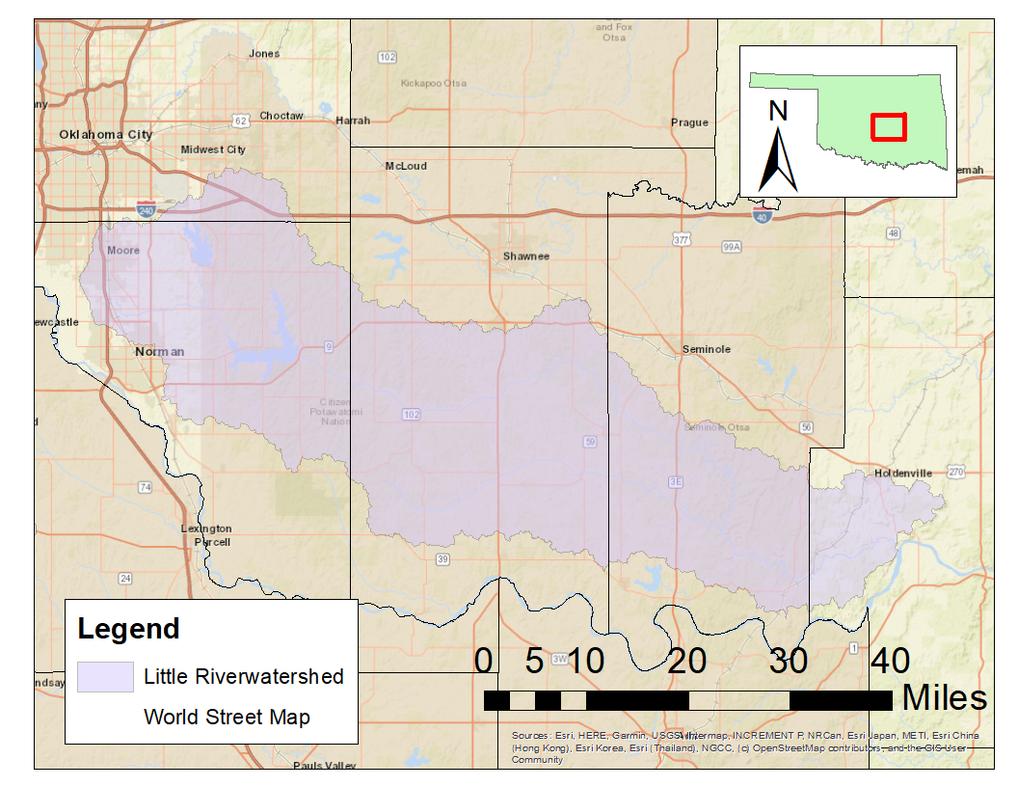
Figure 1.1: Map of the Little River Watershed

2.0 LITERATURE REVIEW
  - Earthquakes in Oklahoma
In the last decade, there was a larger number of earthquakes in Oklahoma in comparison to previous decades. Oklahoma is not completely unfamiliar with earthquakes; the southern part of Oklahoma is home to the Meers fault, which can theoretically produce earthquakes with a magnitude above 7.0. On record, the Meers Fault was considered essentially aseismic toward the start of the 1990s since the largest earthquake produced prior was estimated at a magnitude of 1.6 (Luza 1987). Prior to 2009, the state only averaged about two earthquakes per year above a magnitude of 3.0 (Walter et al. 2019). The northwestern region of the state was even quieter, recording one earthquake with a magnitude above 2.5 between 1990 and 2013 (Goebel et al. 2017). Both the frequency and magnitude of earthquakes in Oklahoma increased over the past decade. Since 1990 five earthquakes have registered at least a magnitude of 5.0, four of which have occurred since 2011 (Walter et al. 2019). Notably, the town of Fairview in the northwestern part of the state experienced a magnitude 5.1 earthquake on February 13, 2016 (Goebel et al. 2017). This surge of earthquakes produced a surge of studies pertaining to seismic activity in the state. Many of these studies were concerned with the mechanics behind said earthquakes. Some studies suggested that the earthquakes were induced by field-scale stress changes, or the overall change of stresses within the field (Goebler et al. 2017). Other studies suggested that some earthquakes were caused by previously inactive faults awakening due to recent activity along these fault lines (Schoenball et al. 2018). The consensus, though, was that decreasing the activity in wastewater injection wells would decrease local areas of seismic activity (Schoenball et al. 2018). These studies would spur the Oklahoma Corporation Commission (OCC) to mandate a reduction in the allowed amount of disposal rates for injection wells (Walter et al. 2019). In addition, the OCC shut down several wastewater injections wells entirely in 2018 (Querry 2018). While this helped produce a downturn in earthquakes across the state over the next several years, the state remains seismically active in comparison to years prior to 2009 according to the Oklahoma Geological Survey (OGS) (Figure 2.1).
This could be, in part, due to injection wells across the state still existing. As some papers cited that there was a “small, but non-zero probability of triggering a noticeable earthquake even if injection rates are small” (Goebel et al. 2017). It could also be due to the result of these earthquakes awakening previously unmapped faults (Walter et al. 2019). Even with the overall decrease in earthquakes, it should be analyzed whether these earthquakes are cause of concern for infrastructure within Oklahoma. The Oklahoma Department of Transportation (ODOT) has previously helped fund studies to assess highway bridges for earthquake induced hazards (Heinrich 2017;Harvey et al. 2018). While this study found that damage to bridges is unlikely, with an estimated 10% probability of slight damage, it concluded that the new attenuation models should consider a high frequency of small magnitude earthquakes. With a model to assess the effect of a higher frequency of small magnitude earthquakes, ODOT would theoretically be able to assess progressive failures, or how earthquakes may damage a structure through repeated straining. This study also recommended that the American Association of State Highway Transportation Officials (AASHTO) should create a design spectrum for the state that could determine how to incorporate induced seismic activity that was away from the Meers fault, or one that does not consider the Meers fault as the main source of earthquakes within Oklahoma (Heinrich 2017; Harvey et al. 2018).

Figure 2.1: OGS Recorded EQ’s 2009-2021

  - Flooding in Oklahoma
FEMA defines flooding as “a general and temporary partial or complete inundation of 2 or more acres of normally dry land or of 2 or more properties” (FEMA). Flooding usually occurs in a floodplain and can have a few different causes— such as overflow of rivers, lakes, coastal tides— one of the most common reasons being pluvial events. Typically, homebuilders and insurance companies plan flooding protection around the recurrence interval of an event within a given number of years. For example, a 100-year flood has a one percent chance of occurring within a year. The chance of a 100-year flood occurring within a given period can be found using Equation 2.b.1. For typical design practice, a 100-year flood is considered for a large majority of properties. Thus, these properties have a greater than 26% chance of experiencing this flood within n=30 years
$Probability of Occurence=1-{\left(1-0.01\right)}^{n}$ (2.1)
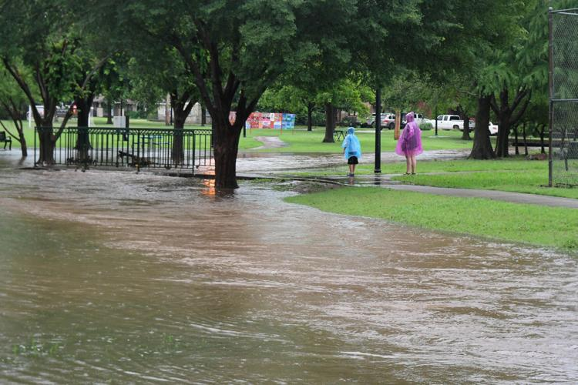
In October of 1986, the City of Tulsa experienced a flood due to the Keystone Reservoir overflowing past capacity between September and October. As this overcapacity flow was released by the Corp of Engineers over the two-month period of September and October, it increased the flow downstream in Arkansas River. The levee system down the river failed, and in doing so caused damage to 64 buildings in the City of Tulsa. More recently, the City of Norman had struggled with neighborhoods and business districts flooding due to rain events (Figure 2.2). Some areas have had water pipes that decay over time, allowing for bursts from pressure. One such example is when a pipe burst on Lindsey Street around 2016. This can be attributed to Norman’s growth, which has increased the percentage of impervious surface area within the city, allowing for the chance of flooding in areas to increase (Wood 2021). The chance of flooding in an area is a matter of concern for stakeholders, and as development continues in its current trend, typically so does the impervious surface area within a municipality. In urban areas like Norman, this can be a cause of concern for residents, particularly as the current in-place stormwater system ages over time. Development could have some impact on ecological areas and drainage systems, which hazard planners in the future should account for by comparing the vulnerability of already in-place infrastructure to suggested solutions and infrastructure alternatives.
Figure 2.2: July 1, 2021 Flooding in Lions Park, Norman OK (Wood 2021)

  - HAZUS Validity/Models
HAZUS provides three levels of analysis for its users, which FEMA categorizes as “basic” and “advanced”. A “basic” level of analysis, or Level 1, uses the built-in inventory, hazard, and damage information provided by HAZUS. The “advanced” levels of analysis, or Levels 2 and 3, are when the users of HAZUS provide their own information. For Level 2, the user provides more detailed local data to perform a more detailed analysis. This local data includes more in-depth soil types, different floodplain mapping such as depth-grids, and more up-to-date infrastructure data. For a Level 3 analysis, FEMA suggests the user should provide in-depth engineering data, such as providing their own formulas for fragility curves for the most accurate analysis. Although HAZUS has the option for a Level 3 analysis, it does not provide an approach on how to conduct a Level 3 analysis in its user guidance manuals. Due to this limitation, most studies concerning HAZUS’s validity and accuracy revolve around Level 1 and Level 2 analyses. The lack of in-depth engineering data may be a factor in why validity studies often find HAZUS systematically both underpredicts and overpredicts damage when compared to actual events.
For HAZUS’s earthquake modeling, there seems to be a trend in validity studies where HAZUS both underpredicts and overpredicts its damage estimates in comparison to actual events. Remo (2012) cites Kircher et al. (2006) in their sensitivity analysis, HAZUS-MH Earthquake Modeling in the Central USA. For Kircher et al (2006), HAZUS underpredicted and overpredicted. Where negative values indicate underprediction, their studies yielded values between -46% to +11% damage in thousands of buildings, -11% to 26% in billions of dollars economic losses, +250% in tens of deaths, and -75% of hundreds of injuries requiring hospitalization. Remo (2012), who used HAZUS 2.0, found that HAZUS’s prebuilt default soil type for all areas was classified as National Earthquake Hazards Reduction Program’s (NEHRP) Type D soil. The sensitivity analysis found that using the default soil type in HAZUS resulted in overpredicting 150-558 moderately damaged buildings by +68 to +221%. After employing NEHRP soil data, Remo (2012) commented that it “reduced building damage estimates and capital stock losses by 8-41%.” In general, Remo (2012) commented that providing higher resolution soil information is correlated with reducing predicted losses. For attenuation functions, Remo (2012) ran a series of simulations for the seven attenuation functions available in HAZUS for the Central and Eastern United States, classifying the simulations as either stochastic, deterministic, or a hybrid between the two. Remo (2012) found through these tests that the stochastic Frankel et al. (1996) attenuation function provided an upper bound of estimated damage. Meanwhile, the stochastic attenuation function. Atkinson and Boore (1995), provided a lower bound, while every other attenuation function provided a median estimate of damage. With liquefaction being considered, as HAZUS does not assume liquefaction in default analysis, Remo (2012) found that damage, loss, and casualty increased overall. Remo’s (2012) overall assessment found that a Level 1 analysis had results that were 155% greater than the documented damages, while using a Level 2 analysis reduced these results to 68% than documented. These results were like those previously observed by Kircher et al. (2006).
HAZUS’s flood model was developed more recently than its earthquake model. In one of the earliest builds of the HAZUS flooding models, Longenecker (2009) commented that the coastal flooding models lack Sea, Land, and Overland Surges from Hurricanes (SLOSH) modeling. Since the study was published, the SLOSH model has been incorporated into HAZUS. Longenecker (2009) also deemed, in this case, that a Level 1 loss analysis was invalid. When a sensitivity analysis was conducted, it was determined that the variability behind the flooding model was low. While Longenecker (2009) and Remo (2012) both agree with the use of HAZUS as a standard software for emergency planners, both studies take issue with the fact that the numbers provided by HAZUS are exact, with no ranges or uncertainty values. These create larger issues while interpreting results from HAZUS, where the users of HAZUS need to make proper judgment calls with the knowledge of the program.
Therefore, HAZUS would make a perfect program for a preliminary diagnosis and overview for quantifying what infrastructure may need to be addressed for the S3OK project within the terms of flooding and earthquake modeling. This diagnosis will consider the factors that HAZUS tends to overpredict and will not provide any uncertainty values or attempt to be “exact” through fractional means, like having too many decimal places. Thus, it is important to understand the basis of what infrastructure data is available in HAZUS and can be used in addition to the program.

INFRASTRUCTURE DATA
This thesis will examine the same infrastructure systems for both analyses to allow for a comparison between the two hazards to assess which may be of a higher priority for research in the future. For this thesis, infrastructure will be in reference to the organizational and physical structures that assist in the operation of a society such as: transportation, utilities, and buildings. For HAZUS, infrastructure is represented as points in its database management. The infrastructure examined will consist of data provided by HAZUS in its software package for Oklahoma. This will help give us a Level 1 according to HAZUS.
The version of HAZUS that was used for this thesis is HAZUS version 5.1. The infrastructure we will be looking at that has been provided by HAZUS will include mostly publicly available data. The sources that HAZUS builds its inventory from, therefore, may be outdated in some cases, if not outright missing some sources of infrastructure. The databases that HAZUS version 5.1 pulls from are: the 2010 U.S. Census Data, Homeland Infrastructure Foundation-Level Data (HIFLD), the National Center for Education Statistics (NCES), the Federal Highway Administration’s (FHWA) National Bridge Inventory (NBI), HIFLD Open Road Tunnels, the National Highway Planning Network (NHPN), HIFLD Open Railroad Networks, the Federal Railroad Administration (FRA), Amtrak, the Intermodal Passenger Connectivity Database (IPCD), National Transportation Atlas Database (NTAD), the Environmental Protection Agency (EPA) Envirofacts Data Warehouse Location Reference Table (LRT), the EPA’s Facility Registry Service (FRS), the HIFLD Open Natural Gas Pipelines, HIFLD Open Power Plants, and the Federal Communications Commission (FCC). It is known within these analyses that HAZUS version 5.1 behaves inconsistently with “polyline” data, or data that is represented as a collection of line segments, especially within the flooding module. The analyses were also confined to the counties that encompass the Little River Watershed in the broad simulations run through HAZUS but will narrow particular focus onto facilities or structures that are within the watershed itself.

4.0 EARTHQUAKE ANALYSIS
The HAZUS earthquake model requires the magnitude of an earthquake, the location, and the attenuation function to produce a risk assessment. The magnitude of an earthquake describes the strength of the earthquake. The hypocenter, or the focus of the earthquake, is the location of where the earthquake originates—latitude and longitude coordinates—as well as the depth of the earthquake beneath the earth’s surface. Finally, the attenuation function describes the loss of energy as the earthquake waves are transmitted through the earth. After these are given, HAZUS can perform analyses using the built-in fragility curves and estimate the loss in an area based on said curves. Fragility curves are probabilistic determinations of how much damage a structure would incur given a certain force input. For earthquakes, these inputs can vary between spectral acceleration, peak ground deformation, or peak ground acceleration experienced at a given location.
An example of a fragility curve can be seen in Figure 4.1, which HAZUS uses to estimate damage states for major roads like interstates and highways (FEMA 2022a). Using Figure 4.1 as an example, each “damage function” line—slight, moderate, extensive/complete— describes the different damage states for the urban road, or the piece of infrastructure. The horizontal axis describes the permanent ground deformation (PGD), or the intensity measure that could theoretically produce damage to a structure. The vertical axis, therefore, reflects the probability that the structure in question would experience a certain damage state. Since these are probabilities, these will usually range between 0.0~1.0, which can also be reflected in percentage chance as 0~100%. For example, if you were to read a PGD at an interstate location to be 12 inches you may read the probability of slight damage as 0.50, moderate damage at about 0.18, and complete at 0.01.
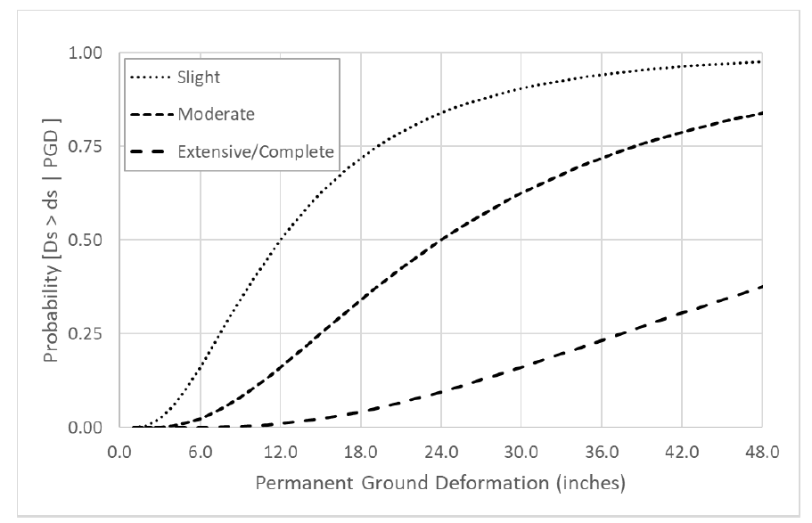
Figure 4.1: HAZUS Fragility Curves for Major Roads (FEMA 2022a)
Analyses for fragility curve usually consider general building code and building specifications within a city. For most residential buildings, there is a standard that is usually followed by contractors and construction crews. For structures such as highways, bridges, and emergency facilities these may be more specific to the structure. Fragility curves separate the output that is returned based on how an expected “damage state” may affect a building in its structural functionality. HAZUS defines its “damage states” as: none, slight, moderate, extensive, and complete. Every structure within the HAZUS database has different definitions concerning each “damage state”, but each state can be summarized simply. None, or no damage, refers to the likelihood of no damage happening. Slight damage is usually defined by minor damage, stretching, small cracking, or deformations within a structure’s materials. Moderate damage is usually defined by larger cracks in weaker rigid materials, small diagonal cracks within shear wall panels, and with steel beginning to yield. Extensive damage is usually characterized by large diagonal cracks across shear wall panels, wood splitting, most steel braces exceeding their yield capacity, as well as permanent lateral movement of floors and roofs. Complete damage shows large permanent lateral displacement, imminent danger of collapse, or collapse may have occurred already.
To give context within the study area, an analysis of how a historical earthquake within the years of the increased seismic activity had affected infrastructure within the study area will first be provided. Therefore, the first analysis focused on the highest magnitude earthquake experienced within Oklahoma between the years 2010-2020. Pulling from Oklahoma Geological Survey (OGS) data, we can find that the highest magnitude earthquake inside Oklahoma in this time frame was a 5.8 magnitude earthquake experienced in Pawnee County (Lat.: 36.44°, Long.: -97.70°) at a depth of 5.6 km. The results for peak ground acceleration using the historical analysis are shown in Figure 4.2. Figure 4.3 shows the general building count based on which buildings received moderate damage. For all highway bridges in the Little River Watershed, the probability that they would exceed moderate damage was no more than 3.5 %, as can be seen in Figure 4.4. With these probabilities being relatively low, and the damage counts from the historical analysis being low as well it was determined that we should move onto a theoretical analysis of an event closer to or within the Little River Watershed.
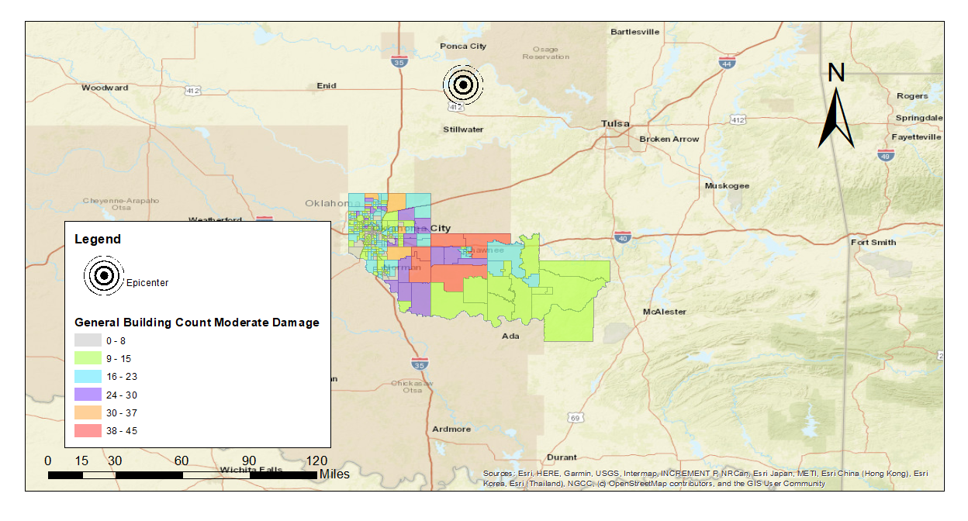
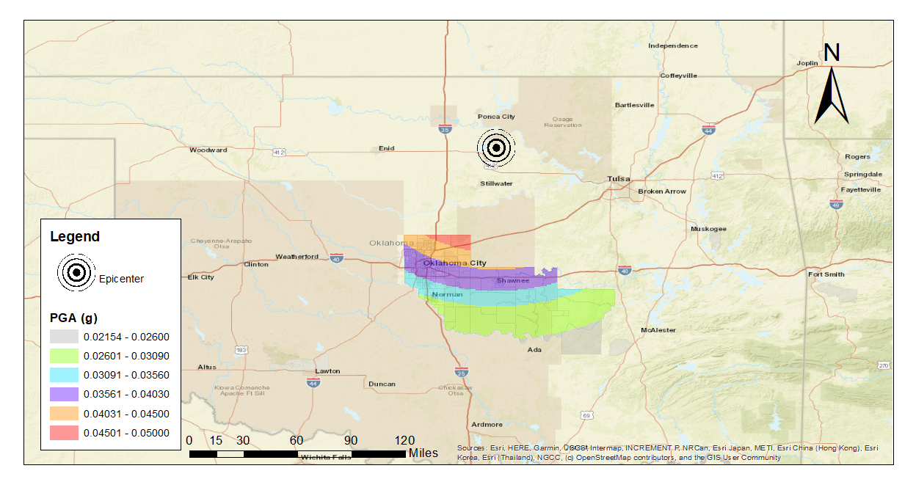
Figure 4.2: Peak Ground Acceleration Mapped Out for Historical Earthquake Analysis
Figure 4.3: Historical Earthquake General Building Stock Receiving Moderate Damage Mapped Out

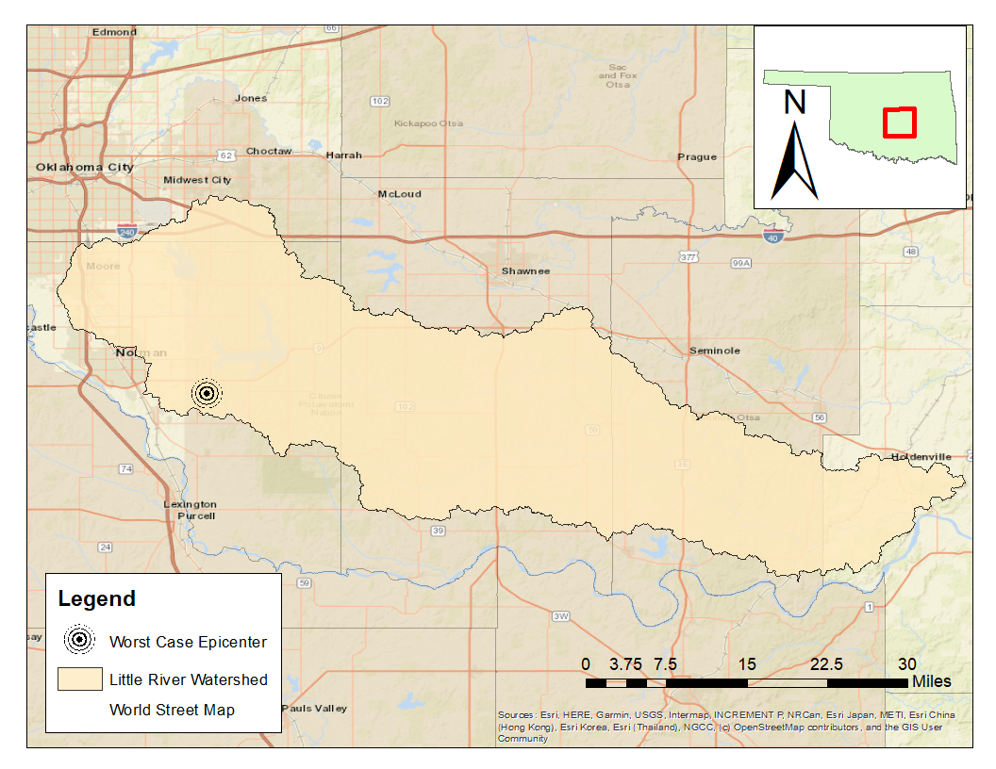
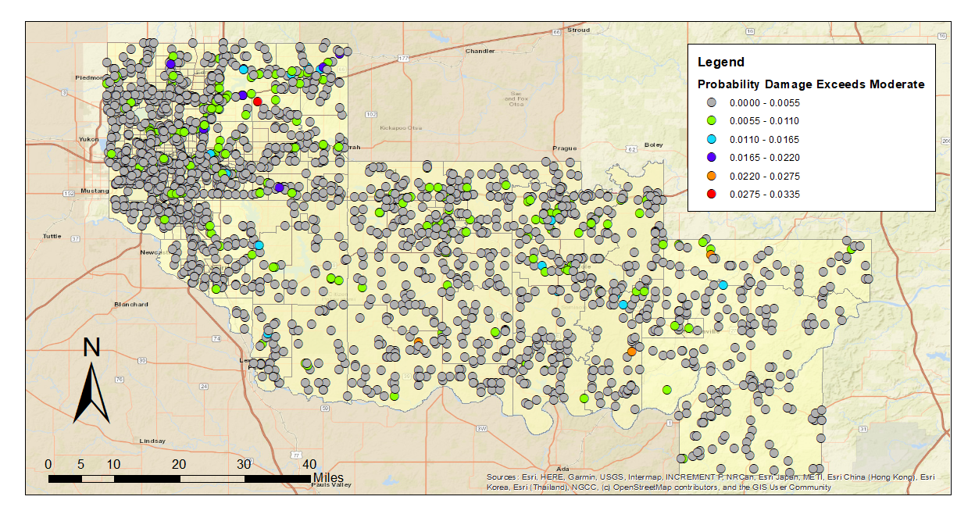
Figure 4.4: Historical Earthquake Highway Bridges Mapped out Probability that the Damage State Exceeds Moderate Damage
Figure 4.5: Modified Earthquake Analysis Epicenter

The second earthquake analysis considered a “worst case scenario” event. This event was the highest magnitude of an earthquake within our selected time frame. The next parameter was the average depth of the earthquakes during this time frame, 5.6 km. The last parameter was to move the epicenter of the earthquake into Cleveland County (Lat.: 35.17°, Long.: -97.32°) this epicenter was chosen from OGS data, where the highest magnitude earthquake in the study area occurred. These results showed more severe damage than the historical analysis, so they will have more in-depth results. The general building stock analysis does not include infrastructure or essential facilities. Table 4.1 displays the estimated damage based on the building design type. Considering moderate, extensive, and complete damage categories. Unreinforced Masonry (URM) experienced the most damage, followed by Wood, and then Manufactured Housing (MH). These building types have the highest proportion of their count being most likely to receive extensive to complete damage, as well as the highest building count. Reinforced Masonry (RM), meanwhile, was able to withstand the most damage. Table 4.2 shows the estimated damage to the general building stock based on the occupancy of the buildings. Both of these tables were generated by HAZUS, hence why the fractional parts of the building counts exist which is a known problem with the program. Essential facilities that were expected to incur the most damage in this case were schools, as can be seen in Table 4.3.
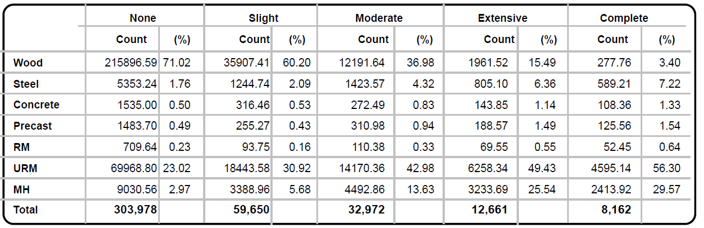
Table 4.1: Modified EQ Historical Analysis GBS Estimated Damage by Make
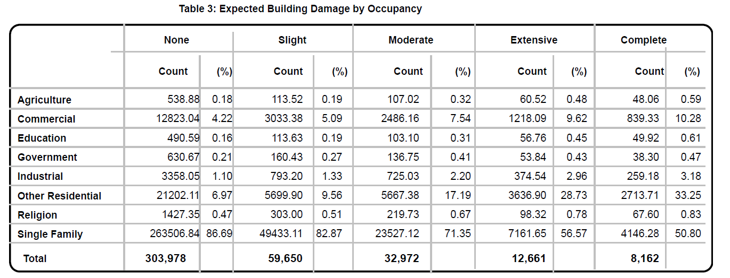
Table 4.2: Modified EQ Historical Analysis GBS Estimated Damage by Occupancy
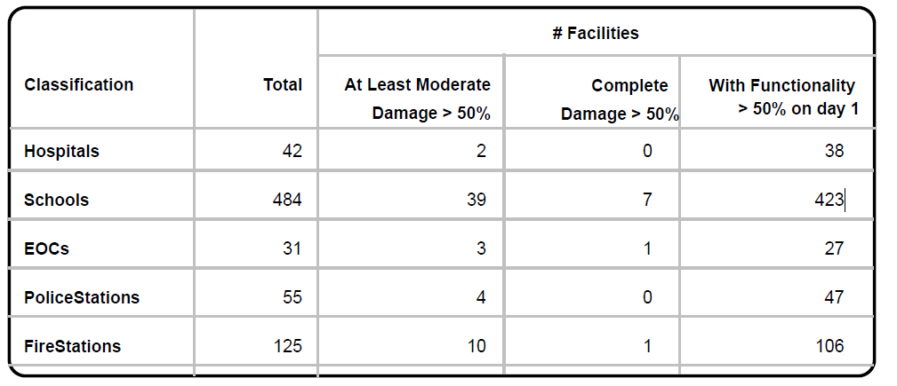
Table 4.3: Modified EQ Historical Analysis Essential Facility Estimated Damages

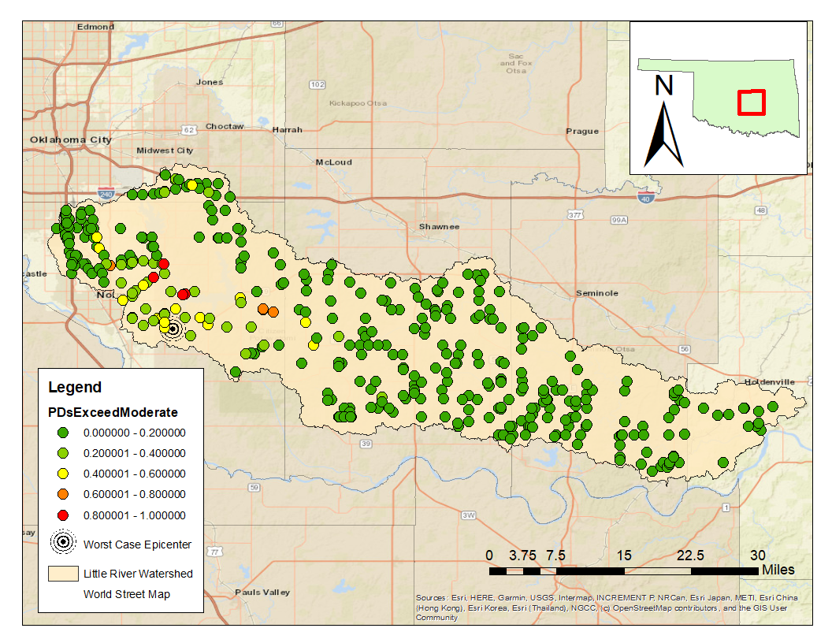
On the transportation side, 24 highway bridges were expected to experience at least moderate damage. The one with the most probability, at greater than 80% chance, exceeding a moderate damage state would be in Cleveland County, as seen in Figure 4.6. The BridgeIDs for these bridges would be: 60th Ave. NE bridge over Rock Creek, two bridges at E Almaeda Dr. over Lake Thunderbird, and a bridge at Franklin Rd. over the Little River. Another problem set of bridges that could be investigated are those that were further away from the epicenter but had a probability to exceed a moderate damage state are that are within the 50%~80% range. These bridges are: 6366C a county trail bridge over the Little River, 180th ave. SE over the Little River, and a bridge at 192nd Ave. over the Little River which were all named for the Little River. It
Figure 4.6: Modified Earthquake Analysis Highway Bridges Exceed Moderate Damage
should be noted that most of these bridges listed in the NBI are labeled as either “basically intolerable” or “meet the present minimum requirements” and all most are rather local, small bridges.
For utilities, several wastewater and electrical power facilities would receive at least moderate damage. With this considered, a few of the wastewater facilities were not expected to have been restored to complete functionality within a week’s time (see Figure 4.7). The biggest damage to utilities in this earthquake scenario was to the utility lines, as seen in Table 4.4. HAZUS could not create a figure to visualize the pipelines for potable water and wastewater systems themselves in this area and was only able to map out the facilities as seen in Figures 4.7. Facilities with a higher probability of having exceeded moderate damage states would also correspond to the facilities that took longer than a week to restore full functionality.
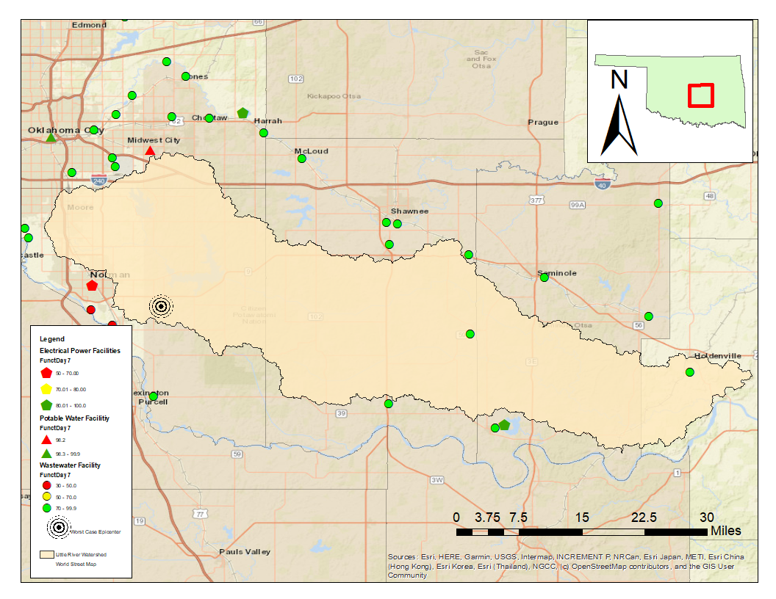
Figure 4.7: Functionality of Utility Systems at Day 7

Table 4.4: Modified EQ Historical Analysis Utility Lines Estimated Damage

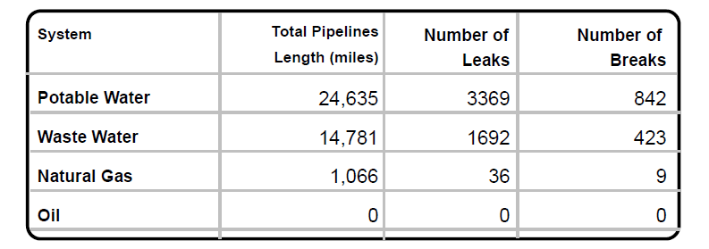
5.0 FLOODING ANALYSIS
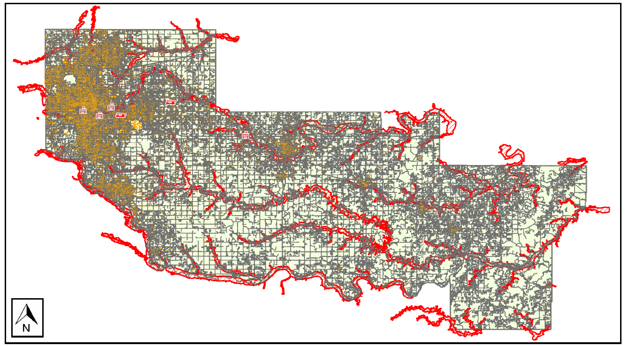
The way HAZUS models damage from earthquake and flooding are comparable, but they differ in how spatial factors are considered. Earthquakes can be modeled through a radial effect, meaning that they will have an effect within an area that is caught within the radius of its effect, often focused on the hypocenter. Flooding is often modeled as a local effect, meaning that the area of flooding is modeled around riverbanks, or locations where pluvial events may naturally accumulate due to the flow of water. With earthquakes, physical and structural damage can be used in many cases to define the losses a structure may accrue over the course of a disaster. HAZUS uses the FEMA Benefit-Cost Analysis Re-engineering (BCAR) functions to estimate the flooding damage based on the depth of water and the percentage chance that the event will occur. In a way the depth of flooding within an area and the percentage chance of that depth occurring is the intensity measure for flooding analysis. When an area is flooded, there is a 100% chance that it will incur damage, but the damage states can vary based on the depth of flooding and there is not a 100% chance that it suffers complete damage. Though, with bridges, the damage that is done is calculated by estimating erosion within the area. Similarly, as with the earthquake analysis, the flooding analysis will be done using a 100-year return period as a “worst case scenario” to provide insight into the potentially vulnerable infrastructure within the study area. This is because most analyses done for flood insurance claims use the 100-year floodplains. In addition, floodplain delineation was created using digital elevation models (DEM) provided by USGS from the years 2019-2021 with a 1-arc second resolution (~30.9-meter pixels). The floodplain delineation formulas in HAZUS do not consider impervious surface area, which can result in unaccounted risk within the study area if there is an unexpectedly large amount of impervious surface area in the area. As a result, these models may underestimate flooding risks to locations with high amounts of impervious surfaces but will provide a solid baseline analysis for vulnerabilities within the area.
Figure 5.1: 100-Year Floodplain Mapping
The 100-year flood analysis that HAZUS provides allows for a baseline estimate of the infrastructural damage that could result from a range of potential flooding scenarios in the state of Oklahoma. Figure 5.1 illustrates the 100-year flooding scenario provided by HAZUS, while also illustrating certain exposed facilities within the Little River Watershed. The red lines shown within the map illustrate the estimated perimeter of the 100-year floodplain according to HAZUS’s calculations. The HAZUS model can be used to estimate flood damage for individual buildings and general building stock. First, HAZUS calculates the area of the floodplain, after the floodplain area is calculated it will consider any of the buildings that are within the floodplain area as potentially damaged. The height, or depth of the water within an area of the floodplain, is then put against the “fragility curves” of individual buildings and potential damage is calculated from there. For the general building stock, this is done similarly but using census tract information to estimate the number of damaged buildings within an area based on the floodplain’s area of coverage. Table 5.1 illustrates the building exposure within the study area.
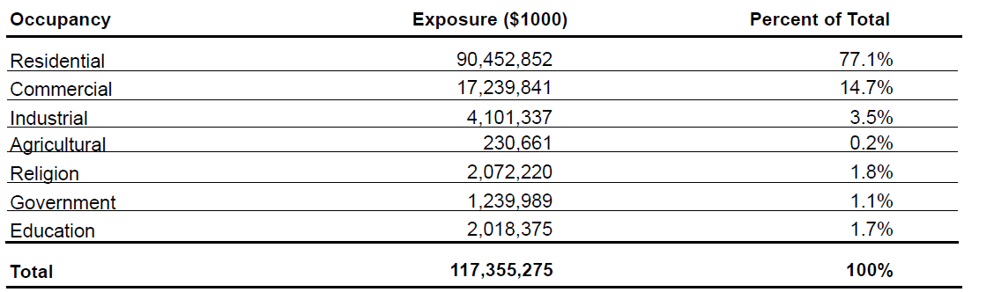
Table 5.1: General Building Stock Exposure Based on Occupancy for 100-year Flood

Tables 5.2 and 5.3 provide the damage for general building stock. These are primarily any buildings that are not deemed as essential facilities, or under private land ownership. For these tables, the numbers at the top of each column are the percentage damage range. The count is the count of buildings that will be in this damage percentage range (FEMA 2022b). The (%) column reflects the percentage of the buildings affected by the flood that are predicted to be in the damage percentage range. Figure 5.2 also generalizes the building damage level numbers. As may be expected, commercial and residential buildings account for the largest proportion of damage estimated in these flooding scenarios, due primarily to the proportion they make up of the overall building stock (see Table 5.1). Still, these results are worth noting in-themselves as it signals the potential dangers that constituents may face within the study area. Table 5.2 helps provide an understanding of the building types that are most in danger in the study area. By looking at the building counts damaged at least in the >50% damage type in Table 5.2: wood, and manufactured housing, and masonry have the highest potential to be damaged within the study area by flooding. Table 5.4 provides a summary of essential facility damage. Finally, a breakdown of the direct economic losses for the general building stock is shown in Table 5.5. Table 5.5 reveals that the highest economic losses to be in the commercial region for flooding.
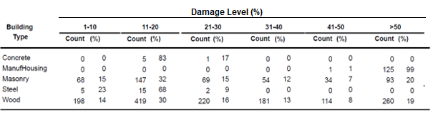
Table 5.2 General Building Stock Damage Estimates based on House Type
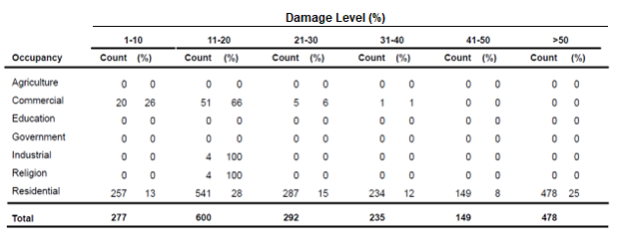
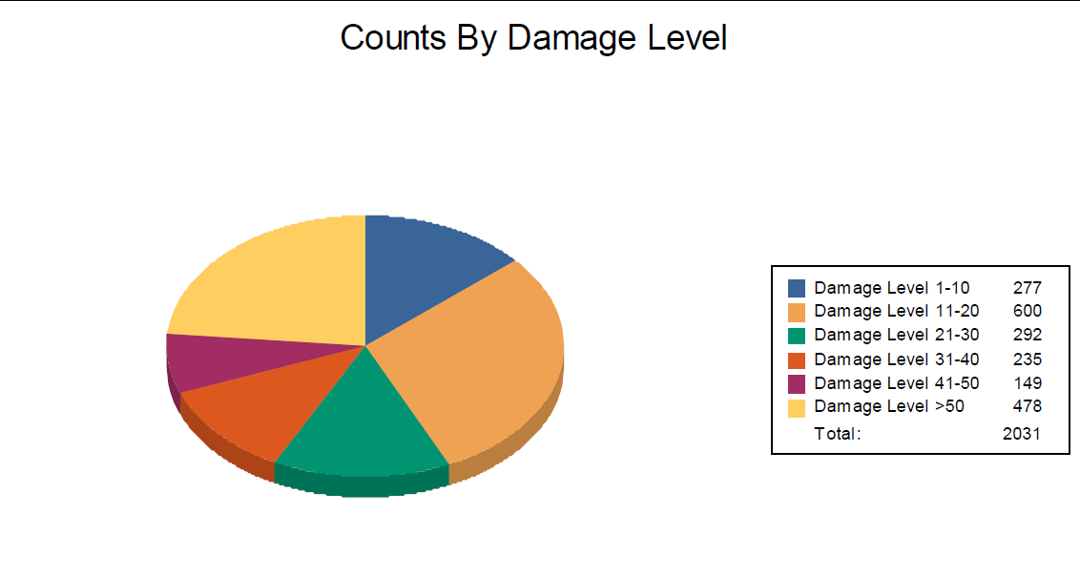
Table 5.3 General Building Stock Damage Estimates based on Occupancy
Figure 5.2: 100-Year Flood Damage Level Proportions

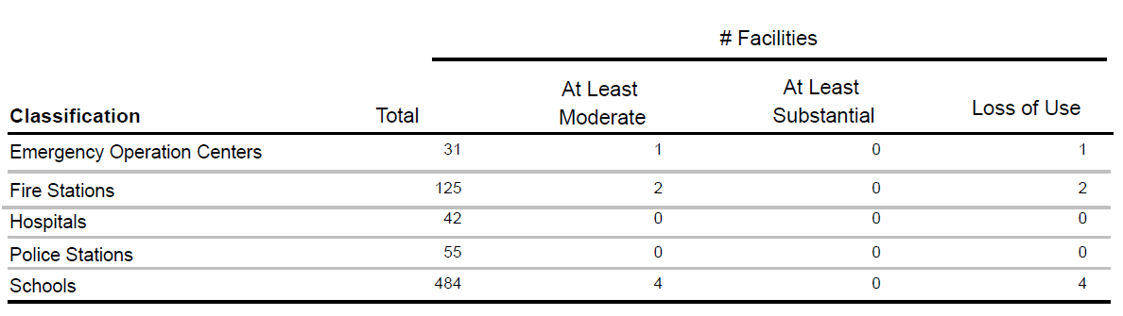
Table 5.4: 100 Year Flood Estimated Damage to Essential Facilities

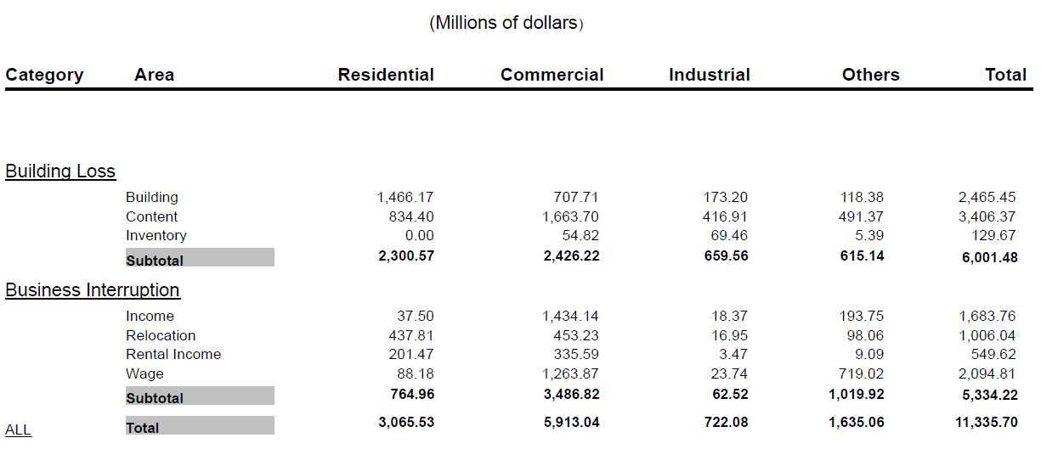
Table 5.5: Economic Losses (Millions of Dollars) for 100-Year Flood

Infrastructure damage should also be accounted for in the flood study, and throughout every county within the Little River Watershed, the wastewater utilities incurred the highest, and only, economic losses for the area. These incurred above 900 million USD in economic losses. This is most likely due to these types of facilities having the highest risk of damage in flooding situations, especially with how they are usually placed in lower elevation areas close to rivers so sewer system designs can use gravity conveyance. Transportation systems, by contrast, were not estimated to face any significant losses.

6.0 DISCUSSION OF THE TWO ANALYSES
Through the analyses of the two hazards in HAZUS there were a few principal findings for the infrastructure within the Little River Watershed. The first finding is that most of the transportation infrastructure within the state of Oklahoma is resilient enough to handle both earthquakes and flooding scenarios within the state. That is, barring the exception of traffic interruptions that may happen due to these events. The critical similarity between both earthquake and flooding models, however, was the estimated damage to wastewater utilities and the general building stock within the area. Most of the buildings within the state of Oklahoma were not designed for earthquakes of the scale examined since the state was not as seismically active until the last decade. The same can be said about the pipelines within the state for both wastewater utilities and potable water. While both the general building stock and water utility infrastructure remain vulnerable to both earthquakes and flooding, earthquake damage can be thought of as a comparatively lower risk given the recent downturn in seismic activity. Based on these results, it may make sense to prioritize mitigating flood damage over earthquakes during the hazard planning process.
HAZUS is the state of practice program for hazard analysis, and while the version used in this thesis was limited, even under time constraints it was still able to illustrate a few of the critically affected components of infrastructure within the Little River Watershed. The numbers the program generates should not be taken at full face value, but as a measure of vulnerability that hazard planners may consider. It should be noted that the severity of the flooding module may be understated by the dimension analysis that HAZUS uses to analyze floodplains. This means that the floodplains were modeled through using the height to understand how flooding water may accumulate, but it does not consider the material surface area within the area and that some areas could have higher severity of flooding than predicted due to high amounts of impermeable area, or that an increase of impermeable area may increase runoff from a storm. This can also be paired with S3OK’s S2S group’s theory, which is that the severity of weather events like flooding may increase over years to come in the state of Oklahoma due to climate change. For computation time, earthquake simulations and analyses for HAZUS are all rather quick, taking only a few minutes to complete. Meanwhile, the flooding analysis for HAZUS can take several days to a week depending on how fast one’s computer is and the results for flooding analysis have potential to be erroneous. The last thing to note about HAZUS for this project is that the version used serves as a good baseline for analyzing how these hazards may affect the infrastructure itself. The program has valid fragility curves for earthquakes, and reasonable measures for how to analyze flooding on a macro scale. If a group wanted to examine an area on a micro scale, it would be best to consider HAZUS’s weaknesses.

7.0 CONCLUSIONS AND RECOMMENDATIONS FOR FUTURE RESEARCH
With the S3OK project underway, it was necessary to get a baseline understanding on the hazards that have been modeled throughout the past century. HAZUS provides a baseline understanding at a macro scale for measuring the vulnerability of infrastructure within an area. While this is true, it is not recommended that HAZUS is used for micro-scale planning. At the time this thesis was being written, new updates of HAZUS have been rolled out into HAZUS version 6.0. The updates that were made were additions to primarily inventory data including: census data which now reflects the 2020 census data, an update in the National Structure Inventory for 2022, Essential Facility, Utilities, and some Transportation data updates and HIFLD open field updates (FEMA 2022c). As for the Little River Watershed and Oklahoma, HAZUS asserts that the highest amount of vulnerability within the state is for the residential and commercial buildings and for the wastewater utility systems. It is recommended that for future research to use HAZUS only as a basis for what needed to be analyzed further using more refined analyses. In addition, since HAZUS has working damage functions for its earthquakes and flooding models, it is best to use these damage functions to expedite preparatory work.

REFERENCES
- FEMA. (2022a). HAZUS Earthquake Model Technical Manual HAZUS 5.1. HAZUS User & Technical Manuals. Retrieved July 2022, from https://www.fema.gov/flood-maps/tools-resources/flood-map-products/hazus/user-technical-manuals.
- FEMA. (2022b). HAZUS Flood Technical Manual HAZUS 5.1. HAZUS User & Technical Manuals. Retrieved July 2022, from https://www.fema.gov/flood-maps/tools-resources/flood-map-products/hazus/user-technical-manuals.
- FEMA. (2022c). HAZUS Inventory Technical Manual HAZUS 6.0. HAZUS User & Technical Manuals. Retrieved July 2022, from https://www.fema.gov/flood-maps/tools-resources/flood-map-products/hazus/user-technical-manuals.
- Flood. FEMA.gov. Retrieved April 29, 2022, from https://www.fema.gov/glossary/flood
- Flooding History. City of Tulsa. Retrieved April 29, 2022, from
    - https://www.cityoftulsa.org/government/departments/engineering-services/floodcontrol/flooding-history/
- Goebel, T. H. W., Weingarten, M., Chen, X., Haffener, J., & Brodsky, E. E. (2017). The 2016 MW 5.1 Fairview, Oklahoma earthquakes: Evidence for long-range poroelastic triggering at >40 km from Fluid Disposal Wells. Earth and Planetary Science Letters, 472, 50–61. https://doi.org/10.1016/j.epsl.2017.05.011
- Grout, T., & Hong, Y. (2011). Significant Weather Events and Associated Socioeconomic Impacts (Federal Aid Expenditures) (2000-10). Weather, Climate, and Society, 4, 48-57.
- Harvey, P. S., Heinrich, S. K., & Muraleetharan, K. K. (2018). A framework for post-earthquake response planning in emerging seismic regions: An Oklahoma case study. Earthquake Spectra, 34(2), 503–525. https://doi.org/10.1193/053117eqs100m
- Heinrich, S. K. (2017). Oklahoma earthquakes and their effects on highway bridges (thesis).
- Longenecker, Herbert Eugene, I.,II. (2009). An evaluation of the HAZUS-MH coastal
    - flood model (Order No. 1473640). Available from ProQuest Dissertations & Theses Global. (304868203). Retrieved from https://login.ezproxy.lib.ou.edu/login?url=https://www-proquestcom.ezproxy.lib.ou.edu/dissertations-theses/evaluation-hazus-mh-coastal-floodmodel/docview/304868203/se-2?accountid=12964
- Luza, K.V. & Madole, Richard & Crone, Anthony. (1987). Investigation of the Meers fault in southwestern Oklahoma. Retrieved from
https://www.researchgate.net/publication/236473980_Investigation_of_the_Meers_fault_in_southwestern_Oklahoma
- Oklahoma City, Oklahoma. Flood Factor. Retrieved April 29, 2022, from https://floodfactor.com/city/oklahoma-city-oklahoma/4055000_fsid#current_protections
- Oklahoma Geological Survey Earthquake Catalog Download Tool. Oklahoma Geological Survey Public Web Apps. (n.d.). Retrieved April 29, 2022, from
    - https://ogsweb.ou.edu/eq_catalog/
- Querry, K. F. O. R.-T. V. and K. (2018, May 23). OCC: Some wastewater disposal wells told to stop operations after earthquakes. KFOR.com Oklahoma City. Retrieved April 29, 2022, from
    - https://kfor.com/news/occ-some-wastewater-disposal-wells-told-to-stop-operations-afterearthquakes/
- Remo, Jonathan W., F., and Nicholas Pinter. Hazus-MH Earthquake Modeling in the
    - Central USA. Natural Hazards 63.2 (2012): 1055-81. ProQuest. Web. 14 Feb. 2021.
- Schoenball, M., Walsh, F. R., Weingarten, M., & Ellsworth, W. L. (2018). How faults wake up: The guthrie-langston, Oklahoma earthquakes. The Leading Edge, 37(2), 100–106. https://doi.org/10.1190/tle37020100.1
- Walter, J. I., Ogwari, P., Thiel, A., Ferrer, F., Woelfel, I., Chang, J. C., Darold, A. P., & Holland, (2019). The Oklahoma Geological Survey Statewide Seismic Network. Seismological Research Letters, 91(2A), 611–621. https://doi.org/10.1785/0220190211
- Wood, M. R. (2021, July 28). Floating by: City staff grasp for future Stormwater Solutions. Norman Transcript. Retrieved April 29, 2022, from https://www.normantranscript.com/news/floating-by-city-staff-grasp-for-future-stormwatersolutions/article_fc05b99a-ea68-11eb-bfc6-cf3e3cad957a.html

