University of Oklahoma

Graduate College

FORECASTING ULTIMATE RECOVERY USING PROBABLISTIC MODEL FOR FLOW-REGIME CHANGES

A thesis

submitted to the Graduate Faculty

in partial fulfillment of the requirements for the

Degree of

Master of Science

By

DAVID R. CHILDERS
Norman, Oklahoma
2016

FOReCASTING ULTIMATE RECOVERY USING PROBABLISTIC MODEL FOR FLOW-REGIME CHANGES

A thesis approved for the
Mewbourne School of Petroleum and Geological Engineering

By

______________________________
Dr. Jeff G. Callard, Chair

______________________________
Dr. Mashhad Fahs

______________________________
Dr. Siddharth Misra

© Copyright by david r. childers 2016
All Rights Reserved.
To my wife Paula who has always supported me and stood by myside in all of my academic endeavors.

Acknowledgements
I would like to thank Dr. Callard for his time and patience in mentoring me in the application and rigors of Decline Curve Analysis. I would also like to thank Dr. Fahs and Dr. Misra for being a part of my thesis committee. Special thanks to Kevin Braddock, friend and colleague, for his insight into VBA coding.

Table of Contents
Acknowledgments iv
List of Table viii
List of Figures ix
Abstract xi
Chapter 1 1
Introduction and Literature Review 1
1.1 Overview 1
1.2 Purpose of Research 3
1.3 Literature Review 4
1.4 Organization of Thesis 5
Chapter 2 7
Well Evaluation Boundary-Dominated Flow-regime 7
2.1 Public Data Gathering 7
2.2 Caution when gathering production data 8
2.3 Development of the Production Profile for a well that has reached boundary-dominated flow 9
2.4 Analysis of the data and further development of the Model 12
Chapter 3 16
Well Evaluation for Linear-Post-Linear flow and Linear-flow regimes 16
3.1 Development of the Production Profile for a well that is in Linear-Post-Linear flow 16
3.2 Development of the Production Profile for a well that is in Linear-flow .... 22
3.3 Determination of the flow-regime of a well 25
Chapter 4 29
Determination of Stochastic Values for Estimated Ultimate Recovery Forecasting 29
4.1 Stochastic Methodology 29
4.2 Stochastic Methodology for the Arps’ Boundary-dominated Exponent 30
4.3 Stochastic Methodology Ratio of the Slopes of the Linear-Post-Linear-flow-regimes 31
4.4 Stochastic Methodology for the Time to the End of Linear-flow for Boundary-Dominated Reservoirs 33
4.5 Stochastic Methodology for the Time to the End of Linear-flow for Linear-Post-Linear and Linear-flow regimes 35
Chapter 5 40
Monte Carlo Simulations for Estimated Ultimate Recovery Probabilistic Analysis 40
5.1 Initial setup of the Monte Carlo Simulation 40
5.2 Determination of the Estimated Ultimate Recovery of oil wells in Boundary Dominate flow and Linear-Post-Linear-flow 41
5.3 Application of the Monte Carlo Simulation 43
5.4 Results of the Monte Carlo Simulation 44
5.5 Applying the Petroleum Resource Management System criteria 46
5.6 What the Results Say 49
5.7 Sensitivities of the Estimated Ultimate Recovery values for future Oil Commodity Prices 50
Chapter 6 51
Conclusion 51
6.1 Conclusion 51
References 52
Appendix A: Nomenclature 54
Appendix B: Bakken Production Data 56

List of Tables
Table 1: North Dakota Industrial Commission (NDIC) production data for the Clarks Creek 10-0805H 10
Table 2: North Dakota Industrial Commission (NDIC) production data for the Bohmbach 3-35H 18
Table 3: North Dakota Industrial Commission (NDIC) production data for the Fettig 24- 22H 23
Table 4: Tabulated values for the Stochastic Analysis 39
Table 5: Monte Carlo Input values for the Fettig 24-22H 44
Table 6: Deterministic and Monte Carlo Results for Proved, Probable and Possible Reserves 48

List of Figures
Figure 1. Bakken Shale, McKenzie and Williams Counties, North Dakota. (Great Northern Energy, 2016) 2
Figure 2. Graphical depiction of the Bakken wells evaluated for this study. 2

Figure 3. Cumulative production versus square-root-of-produced-time profile of the Clarks Creek 10-0805H. 11
Figure 4. The model fit to determine the time to the end of linear-flow for the cumulative production versus the square-root-of-produced-time in months, future model projection of the Clarks Creek 10-0805H... 14
Figure 5. Cumulative production versus square-root-of-produced-time profile of the Bohmbach 3-35H.. 19
Figure 6. Cumulative production versus the square-root-of-produced-time in months for the intersection of the Infinite Acting Linear-flow-regime and the Linear-Post-Linear-flow-regime of the Bohmbach 3-35H. 21
Figure 7. Showing the model fit of the linear-flow portion of the cumulative production versus square-root-of-produced-time profile Fettig 24-22H. 24
Figure 8. The model fit of the derivative of the cumulative production versus the square-root-of-produced-time in months of the Fettig 24-22H 27
Figure 9. The model fit of the derivative of the cumulative production versus the square-root-of-produced-time in months of the Bombach 3-35H 27
Figure 10. The model fit of the derivative of the cumulative production versus the square-root-of-produced-time in months of the Clarks Creek 10-805H 28
Figure 11. Log-Normal Distribution Arps’ Boundary-Dominated exponent. 31
Figure 12. Log-Normal Distribution ratio of slopes of the Linear-Post-Linear-flow regime 32
Figure 13. Log-Normal Distribution for the Time to the End of Linear-flow, Boundary-Dominated. 34
Figure 14. Log-Normal Distribution for the Intersection Time, Linear-Post-Linear. 36
Figure 15. Log-Normal Distribution Cumulative Probability Chart to determine the Time to the End of Linear-flow. 39
Figure 16. The cumulative production versus the square-root-of-produced-time in months of the Clarks Creek 10-805H with Estimated Ultimate Recovery. 42
Figure 17. The cumulative production versus the square-root-of-produced-time in months of the Bohmbach 3-35H with Estimated Ultimate Recovery. 42
Figure 18. Monte Carlo simulation for and Estimated Ultimate Recovery of Oil, Fettig 24-22H 45
Figure 19. The cumulative production versus the square-root-of-produced-time in months of the Fettig 24-22H with Estimated Ultimate Recovery 46

Abstract
Determination of the yet to be produced oil and gas prescribes the assets of a company. This is important internally in regard to budgeting and externally in regard to the valuation of the company. The yet to be produced oil and gas are known as reserves and their determination from historical trends, known as decline curves, are the subject of this thesis. The culmination of this work is to determine stochastic reserves for wells producing in infinite acting linear-flow based on statistical sampling of mature wells whose production life has extended into mature flow-regimes.

Chapter 1

Introduction and Literature Review
This chapter will briefly describe the intent of this research and its objective. A brief overview of the recent estimated ultimate recovery methodologies will be discussed based on current literature available in the public domain. An ephemeral synopsis will be given to the work flow of each chapter and describe the organization of the thesis.

1.1 Overview
The core of this research is to develop a probabilistic model that will empower the user, along with stochastic methodologies, to determine the estimated ultimate recoveries for wells that are still in the linear-flow regime. Society of Petroleum Engineers (2016), states that probabilistic methodologies acts as a check against the more traditional reliance upon deterministic methods quantifying at a high level the expected confidence associated with proved reserve volumes. This method is intended to be used by upstream companies, mid-stream companies, investment firms or entity looking to gain insight into an oil field based on the potential estimated ultimate recoveries of a field of interest coupled with current and future commodity prices for oil. Moreover, the Petroleum Resource Management System (PRMS) criteria will be used to establish proved, probable and possible reserves for public reporting and economic analysis. The research specifications for this study was for wells that have been producing for approximately three to seven years. All wells where required to be horizontally drilled and where drilled in either McKenzie or Williams Counties in North Dakota (Figure 1 and Figure 2), which are currently the most prolifically drilled counties in North Dakota at the time of this study.
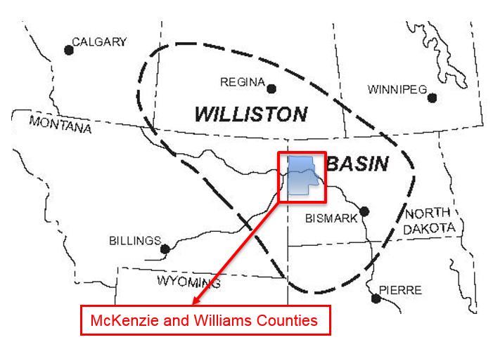
Figure 1. Bakken Shale, McKenzie and Williams Counties, North Dakota. (Great Northern Energy, 2016)

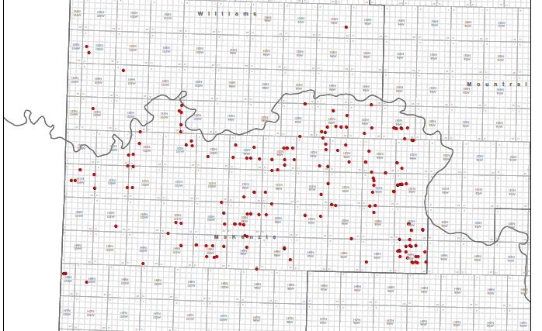
Figure 2. Graphical depiction of the Bakken wells evaluated for this study.

The average estimated ultimate recovery range of the wells in this research was found to be between 290,000 STBs to 470,000 STBs based on assumed operating costs and oil commodity prices that will be presented in detail in chapter five of this study.

1.2 Purpose of Research
The purpose of this research is to establish a new method of analyzing reserves for evaluating estimated ultimate recoveries of oil. At the time of this writing, approximately 75 United States oil and gas companies, (and counting) have filed for chapter 7 or chapter 11 bankruptcy protection since the fall of the oil and gas commodity prices in 2014, Haynesboone (2016). There are many aspects that lead to a company filing for bankruptcy; however, this is a trend that is all too common and cyclical, which make understanding reserves so important. When times are good and oil commodity prices are high, companies can get over-extended in their business portfolios and take on to much risk. High-risk, high-reward mentalities, comes at a cost and that cost could be jobs, forfeiture of a company and value degradation to shareholders, Olsen and Lee (2010). The purpose of this research is to develop a methodology that will allow for the probabilistic determination of the estimated ultimate recoveries of a field such that one can assign a degree of probability on the feasibility of being able to produce oil assets based on operating expenses and future and current oil commodity prices. The probabilistic analysis will be coupled with the Petroleum Resource Management System (PRMS) criteria to establish proved, probable and possible reserves when reporting reserve criteria to public, state or federal agencies.
1.3 Literature Review
Most of the available literature in circulation, at the time of this study, does not look at probabilistic estimated ultimate recoveries from a field production perspective. Most papers look at enhancing the estimated ultimate recoveries based on adding new technologies to improve the estimated ultimate recovery through knowledge of reservoir characterization, well construction and enhancing stimulation and completion practices. The methods found in the literature are mostly deterministic for evaluating ways to enhance the estimated ultimate recovery and have very little in regards to probabilistic analysis. Authors like Shaoyong and Dominic (2013), introduce a modified Stretch Exponential Production Decline Method, which is primarily used to evaluate estimated ultimate recoveries with wells with short production history. Cunningham et.al. (2012), uses multiple linear-regression models that compare and contrast multiple well design properties to the production of multiple wells of interest in the Marcellus Shale to better design the estimated ultimate recovery of future wells. Kabir and Lake (2011), provided analytical solutions considering concentric compressibility elements to be utilized in the continuity equation to ascertain production data from conceptual geobodies. One of the only papers found in the literature was authored by Freeborn and Russell (2015), which proposes a method that involves determining the aggregated distribution of estimated ultimate recoveries for a specified number of wells utilizing a statistical approach with Monte Carlo trials. However, almost all methods presented, with the exception of Freeborn and Russell, depend on reservoir properties or some form of insight into the mechanics of the well. However, most companies - like midstream companies and investment firms - are not able to acquire specific detailed information in regards to the reservoir characterization or the producer’s completion and production practices; both are central in determining potential reserves based on deterministic methods. Therefore companies must rely on available public data to use for their due-diligence analysis for specific oil assets.

1.4 Organization of Thesis
The primary chapters in regards to this research are in chapter two, three, four and five of this writing. Chapter two deals with the development of the model for a well in boundary-dominated flow going through the meticulous setup of the model and details the cumulative production versus square-root-of-produced-time profile that will be used as a diagnostic tool to determine various well parameters that will be used in the stochastic analysis.
Chapter three will detail two wells in linear-post-linear and linear-flow. These wells have not reached the time to the end of linear-flow and the use of a probabilistic tool utilizing Bayesian Theory will be employed to determine the estimated time to the end of linear-flow based on a probability confidence criteria. Once the procedure has been laid out in full, utilizing the well examples, the stochastic values for all wells of interest will be presented, which will be part of the Monte Carlo numerical simulation setup.
Chapter four will describe the stochastic analysis approach for determining stochastic parameters that will be used in the probabilistic predictions of the estimated ultimate recovery of oil.
Chapter five will show both deterministically found estimated ultimate recoveries of a well along with a Monte Carlo simulation based on the stochastic methods and well parameters found in chapters two, three and four. The Monte Carlo simulation will show the convergence, of an example well, along with the estimated ultimate recovery of the reservoir based on the well parameters found in chapters two and three.
Chapter six will discuss some conclusions and reiterate some important findings outlined in the study.

Chapter 2

Well Evaluation Boundary-Dominated Flow-regime
This chapter looks at the development of the cumulative production versus the square-root-of-produced-time profile with emphasis on a well that has reached boundary-dominated flow. Here the procedural layout will be given such that the user can apply this methodology to wells of interest in a production field. At the conclusion of this analysis four values will be ascertained from the analysis and will be values that will be used for the Monte Carlo simulation to evaluate the estimated ultimate recoveries of oil based on stochastic methods.

2.1 Public Data Gathering
The user of cumulative production versus the square-root-of-produced-time profile will need to identify a public database domain. This research utilized production data gathered from the North Dakota Oil and Gas Division (NDIC) to gather historical production data of horizontal wells that have been producing for three to seven years in the McKenzie and Williams counties of North Dakota (NDIC 2014). It is important to identify credible sites when extracting data that will be used to develop the cumulative production versus the square-root-of-produced-time profile analysis proposed in this research. There are many credible sites to choose from such as state oil and gas databases, NDIC for this research, IHS United States Production and Drillinginfo to name a few; however, it is strictly up to the readers discretion on the choice of production data collection. Once a site has been selected for data gathering it is important to do some background research on the credibility of the data being published. It is a good practice to ascertain how the data being used on the database sites was obtained and documented and what the requirements are to publish data in that domain. This information will be useful if one has to go back and do some due-diligence work to validate the results of one’s research when using the model. The requirements for NDIC for petroleum production reporting fall under the reporting standards of the American Petroleum Institute NDIC (2016).

2.2 Caution when gathering production data
It should be noted of the importance of understanding the data that will be used in this analysis. Data is the foundation and cornerstone to this research. If the data has been collected with unreliable methods or measurement instrumentation errors then the analysis, proposed in this research will yield inaccurate results that can have an effect on the decision-making processes with financial impacts. This research used a public database domain that publishes monthly production data only. Furthermore, since this research used a public data base that only publishes monthly production data, it should be understood that there may be some ambiguities when surmising information ascertained using this analysis that would only be seen in daily production data. Therefore, if it is possible to acquire daily production data then this data should be used in lieu of monthly production data. Monthly production data can hide some aspects of the physical phenomena, which can be better defined when using daily production data. Therefore, it is recommended, but not necessary, to use daily production data if possible to ensure optimal results.

2.3 Development of the Production Profile for a well that has reached boundary-dominated flow.
This research looked at over 500 wells from McKenzie and Williams Counties in North Dakota. Only 185 wells were evaluated using the production profile of the cumulative production verses the square-root-of-produced-time to conditions that where established at the beginning of this research. This research was done independent of any knowledge of a producing company’s completion or drilling practices.
For this example the Clarks Creek 10-0805H well will be analyzed in detail. The Clarks Creek 10-0805H well is a horizontal well located in McKenzie County, North Dakota. This well has been in production for approximately three years at the time of this study. To begin, well production data was gathered from the North Dakota Industrial Commission website (NDIC). The production data is given in Table 1.
Table 1: North Dakota Industrial Commission (NDIC) production data for the Clarks Creek 10-0805H
From Table 1 the cumulative production versus square-root-of-produced-time profile can be generated in accordance as follows, Figure 3.
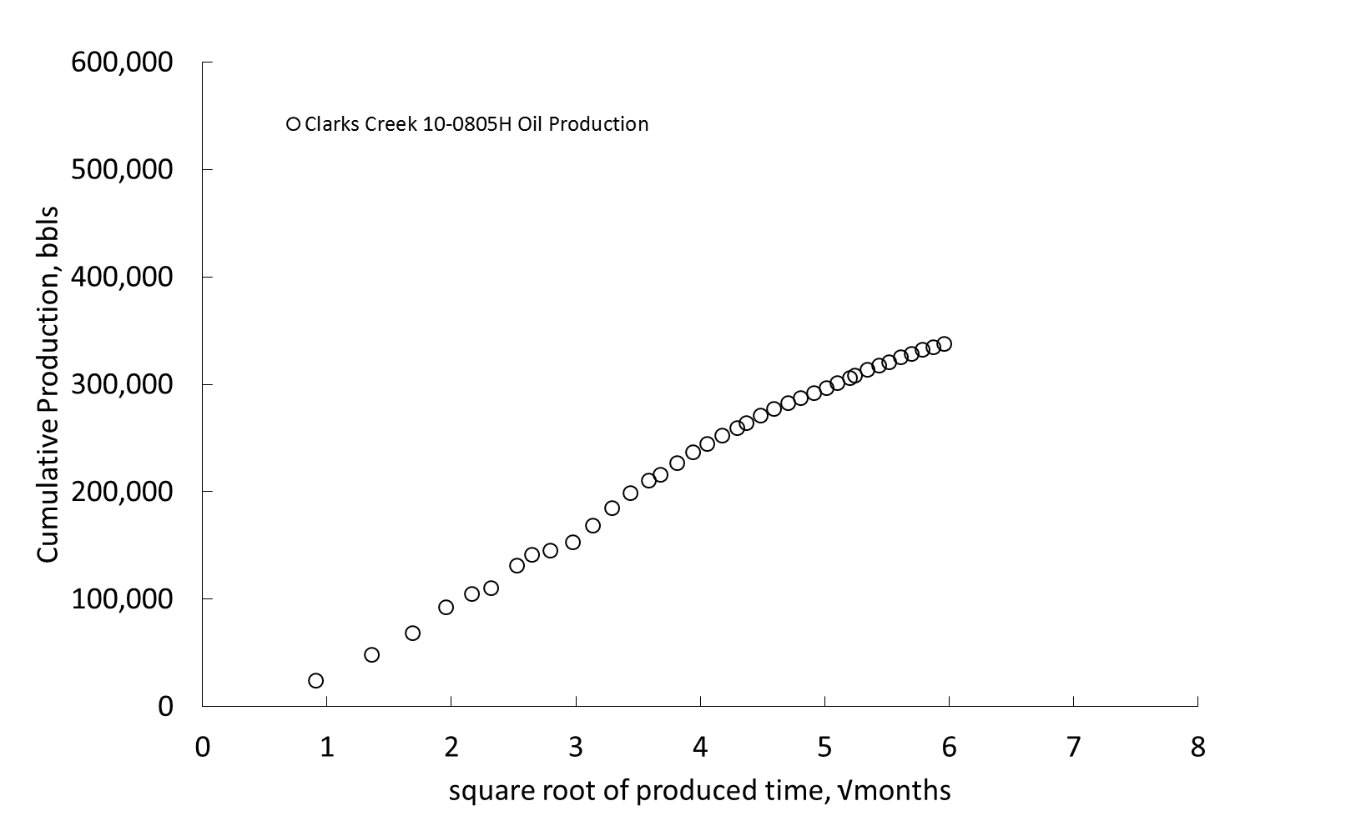
Figure 3. Cumulative production versus square-root-of-produced-time profile of the Clarks Creek 10-0805H.

Figure 3 exhibit the flowing behavior of the well’s production, and utilizing this plot the time at which the transition from the infinite-acting flow-regime to the pseudo-steady state boundary-dominated flow-regime can be determined. Henceforth, the infinite-acting linear-flow-regime will be referred to as “linear-flow”, and the pseudo-steady state boundary-dominated flow-regime will be referred to as “boundary-dominated flow”. For this research if a well exhibits an Arps’ exponent of two, from Rodrigues and Callard (2012), this will imply that the well would have an infinite reservoir such that the well would produce forever and never deplete. For example, from Poston and Poe (2008), wells that exhibit Arps’ exponent’s greater than one could be caused by highly variable permeability where layered and naturally fractured reservoirs may exhibit this type of Arps’ exponent; moreover, also from Poston and Poe, high Arps’ exponent values can be the formation of long-lived crossflow patterns caused by the oil or gas feeding from very-low permeability’s to high permeability zones. An infinite-acting reservoir is an impossibility over the life of a well due to the fact that all reservoirs are finite and determining when the time to the end of linear-flow occurs is the only way to truly determine the precise approximation of the estimated ultimate recoveries from a well.

2.4 Analysis of the Data and further development of the Model
The next step is to analyze both the linear-flow regime and the boundary-dominated flow regime regions of Figure 3 and prepare a model fit of the cumulative production versus square-root-of-produced-time profile.
To determine the model fit of the cumulative production versus square-root-of-produced-time profile, the linear-flow-regime will be analyzed such that a model fit curve can be applied to the linear portion of the cumulative production versus square-root-of-produced-time profile. This linear portion of the cumulative production versus square-root-of-produced-time profile is known as the infinite acting linear-flow regime. The model fit of the data can be shown for cumulative production versus square-root-of-produced-time (Figure 4) and is represented by the model fit, equation (2-1).
……….……...……………………………...………...…….(2-1)
where is the cumulative oil production, is the cumulative oil production intercept, is the slope of the cumulative production versus square-root-of-produced-time profile, is the square-root-of-produced-time in months. It should be noted by taking the derivative of the equation (2-1) it can be shown that the economic limit is equal to the cumulative production of oil rate, equation (2-2).
……….……...…………………….…………...………...…….(2-2)
where is the economic limit, is the slope of the linear-post-linear cumulative production versus square-root-of-produced-time profile is the current age of the well of interest.
Furthermore, the next step in the analysis is to develop a model fit of the cumulative production versus the square-root-of-produced-time profile. From Rodrigues and Callard, (2012) the equations needed to develop a model match of the actual production data of the cumulative production versus square-root-of-produced-time profile will utilize the Arps’ hyperbolic equation’s for model match analysis. As presented in Childers and Callard (2015), a key component of developing the stochastic approach is to determine the simultaneous match of the cumulative production at the end of linear-flow regime and the Arps’ hyperbolic exponent during boundary-dominated flow by minimizing the error between the Arps’s hyperbolic analysis and the actual oil production data. It is imperative to determine the simultaneous matching of both flow-regimes in order to properly determine the correct time to the end of linear-flow. Figure 4, shows the model match of the oil production for both the linear-flow regime and the actual production data. Figure 4 also displays the future oil production projection based on the model match of the oil production data.

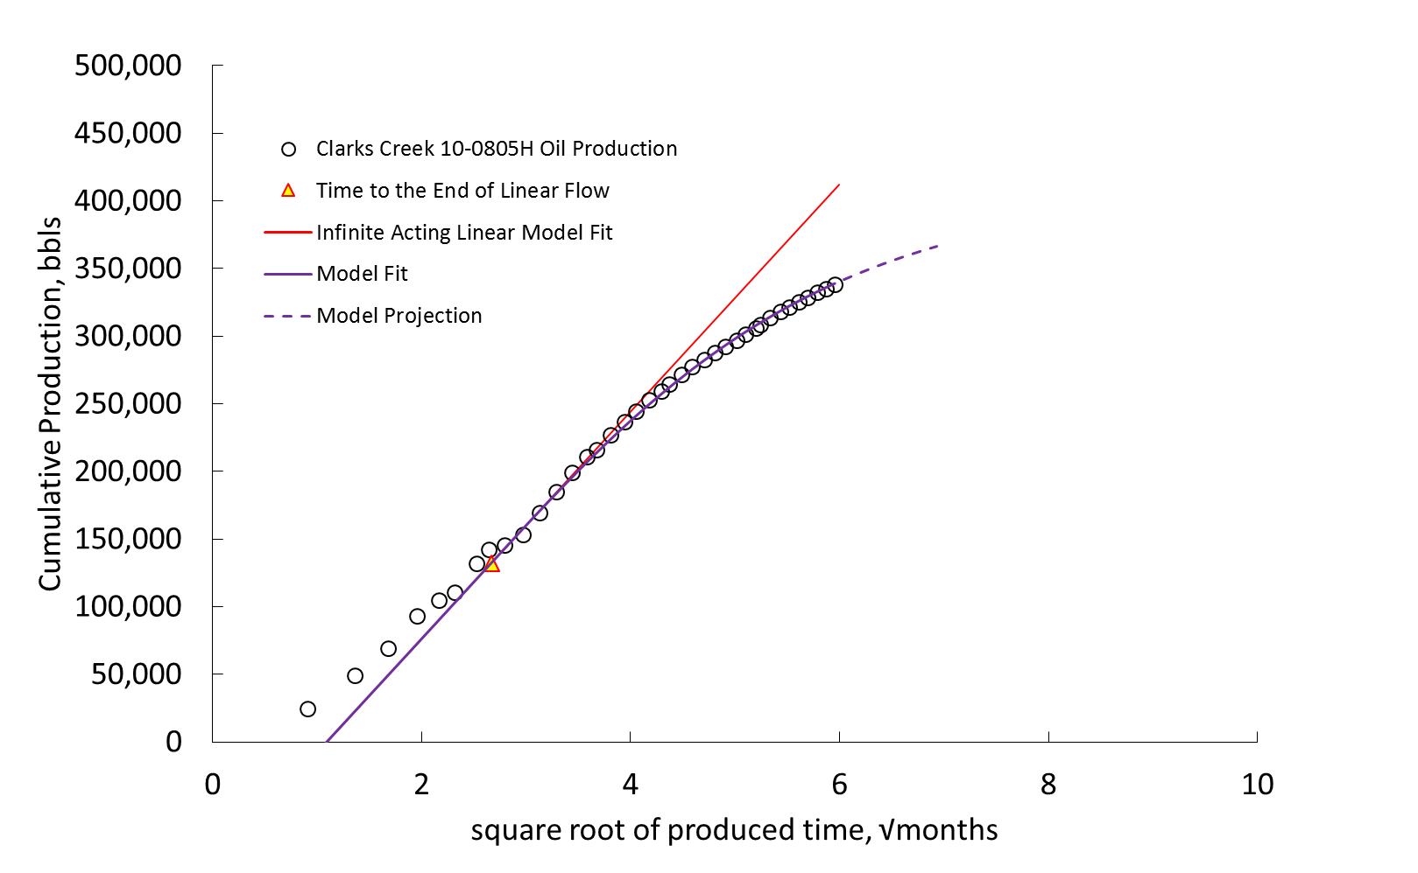
Figure 4. The model fit to determine the time to the end of linear-flow for the cumulative production versus the square-root-of-produced-time in months, future model projection of the Clarks Creek 10-0805H.

From Figure 4 one observations needs to be discussed when analyzing the cumulative production versus the square-root-of-produced-time profile for the model fit of the linear-flow-regime. First, the intercept of the cumulative production versus the square-root-of-produced-time profile can never be positive. From Rodrigues and Callard (2012), the intercept will be non-positive with exception of cases where infinite conductivity fractures occur and the intercept in this case would be zero.
Two variables can be determined from the model fit of the infinite-acting flow regime of the cumulative production versus square-root-of-produced-time profile and these values can be used to determine time to the end-of-linear-flow of a well of interest. The slop and intercept of the cumulative production versus the square-root-of-produced-time can be found from Figure 4, and are and respectively. The values of the slope and intercept as well as the time to the end of linear-flow for the Clarks Creek 10-0805H can be found in Appendix B of this study. Moreover, the estimated ultimate recovery for this well can be found deterministically; however, and will be used stochastically to develop the Monte Carlo simulation for wells that must use probabilistic methods to ascertain estimated ultimate recoveries of oil.

Chapter 3

Well Evaluation for Linear-Post-Linear flow and Linear-flow regimes
This chapter looks at the development of the cumulative production versus the square-root-of-produced-time profile with emphasis on a well that is in linear-post-linear-flow regime as well as a well that is in the linear-flow regime. Here the procedural layout will be given such that the user can apply this methodology to wells of interest in a production field. At the conclusion of this analysis, similar to that found in chapter two, two values will be ascertained from the analysis and will be values that will be used for Monte Carlo simulation to evaluate the estimated ultimate recoveries based on probabilistic methods.

3.1 Development of the Production Profile for a well that is in Linear-post-Linear flow
For this example the Bohmbach 3-35H well will be analyzed using the methodology defined in chapter two. Since this well is analyzed the same way as the Clarks Creek 10-0805H, a few of the steps carried out in the Clarks Creek 10-0805H will be omitted from this example. Appropriate tables and profiles will be shown but the detail as to how those profiles where created are the same as in the Clarks Creek 10-0805H example. The Bohmbach 3-35H well is a horizontal well located in McKenzie county North Dakota. This well has been in production for approximately three years at the time of this study. The difference that is demonstrated by the Clarks Creek 10-0805H that is dissimilar from the Bohmbach 3-35H is that this well is producing in the linear-post-linear-flow regime. As one works through the development of the cumulative production versus the square-root-of-produced-time profile steps, it will become clear that the time at which the end of linear-flow cannot be determined utilizing an error minimization approach, similar to Clarks Creek 10-0805H, through the simultaneous match of the cumulative production and the Arps’ hyperbolic exponent to determine the time to the end of linear-flow. Thus to determine the time to the end of linear-flow will require a model fit estimate between two linear-flow-regime fits, and the intersection of these model fits will be defined as the intersection time. The linear-post-linear-flow-regime is realized when a well, acting in the infinite acting linear-flow regime, encounters a boundary, which would give the appearance that the well is acting in boundary-dominated flow. However, the well feels one boundary but not all boundaries have been felt by the well at the onset of the first boundary. As the well continues to produce over time the well moves into a second infinite acting flow-regime, this phenomena is named linear-post-linear-flow and a detail analysis will be shown to reinforce the statements above. First the production data of the Bohmbach 3-35H is given in Table 2.

Table 2: North Dakota Industrial Commission (NDIC) production data for the Bohmbach 3-35H
From Table 2, the plot of the cumulative production versus the square-root-of-produced-time profile can be generated, Figure 5. The next step will be to determine a model fit of the production data using the Arps’ hyperbolic equation defined in Rodrigues and Callard (2012). Applying the Arps’ hyperbolic model fit analysis to Figure 4 and trying to use a error minimization analysis as demonstrated in the analysis of the Clarks Creek 10-0805H, it will become very apparent that a solution that can satisfy the error minimization cannot be found. In fact, since the Bohmbach 3-35H is a well that is in the linear-post-linear-flow regime, the Arps’ hyperbolic equations cannot be used.
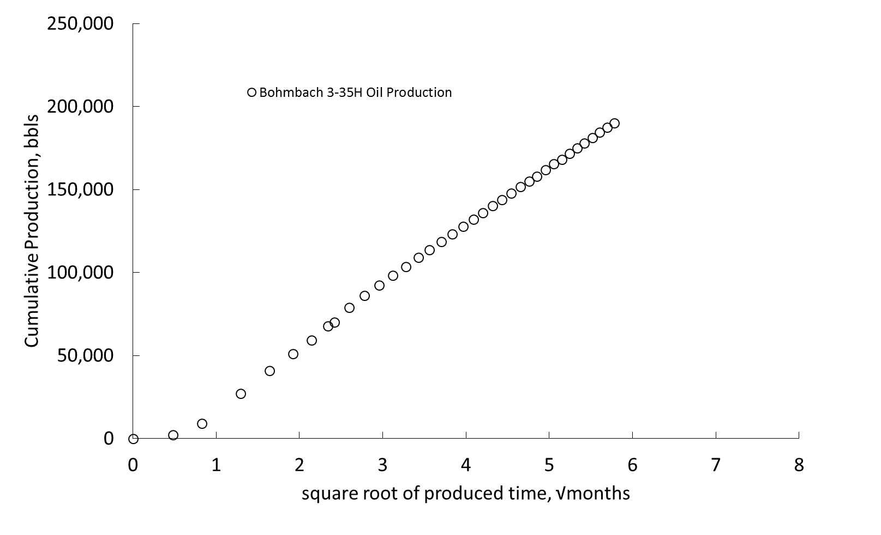
Figure 5. Cumulative production versus square-root-of-produced-time profile of the Bohmbach 3-35H.

Therefore, a new technique will need to be added to determine the intersection time between the linear flow and linear-post-linear flow regimes. To determine the intersection time for a well in linear-post-linear-flow-regime one will have to determine the slope of the first regression line of the infinite acting flow-regime, which in turn will help in the establishment of the slope of the second linear regression line of the second infinite acting flow-regime. A well that is in linear-post-linear-flow can be described as well that is in semi-infinite-acting-flow regime. The intersection time can be observed by determining the intersection of the infinite acting flow-regime and the linear-post-linear-flow regime Figure 6. The model fit of the linear-post-linear-flow regime can be modeled by using equation (2-1). It should be noted that a trial-and-error method would be employed such that one can find the approximate intersection of the infinite acting linear-flow regime and the linear-post-linear-flow regime. It’s important to note that the ratio of the slope of the infinite acting flow-regime and the slope of the linear-post-linear-flow-regime will always be less than one. Figure 6, shows the approximate location of the intersection time for a well operating in the linear-post-linear-flow regime.
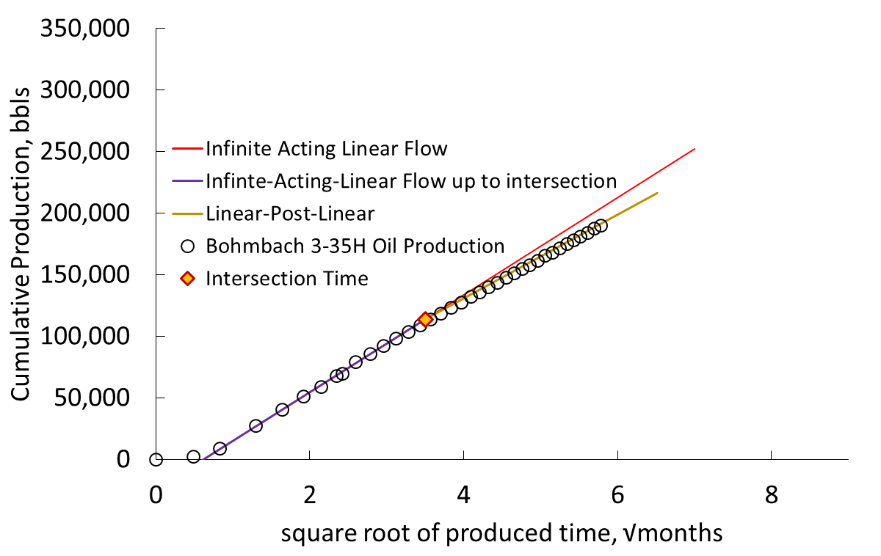
Figure 6. Cumulative production versus the square-root-of-produced-time in months for the intersection of the Infinite Acting Linear-flow-regime and the Linear-Post-Linear-flow-regime of the Bohmbach 3-35H.

From this analysis two additional parameters were found, which are the ratio of the slopes of the cumulative production versus the square-root-of-produced-time and the linear-post-linear best-fit regression analysis, m₂/m_{csrt}, and the intersection time for linear-post-linear-flow-regime, t_{x}. As in the Clarks Creek 10-0805H the values of the slope and intercept as well as the intersection time and the ratio of the slopes for the Bohmbach 3-35H can be found in Appendix B of this study. Moreover, the estimated ultimate recovery for this well can be found deterministically; however, m₂/m_{csrt} and t_{x} will be used stochastically to develop the Monte Carlo simulation for wells that must use probabilistic methods to ascertain estimated ultimate recoveries of oil.
3.2 Development of the Production Profile for a well that is in Linear-flow
For this example the Fettig 24-22H well will be analyzed using the methodology defined in chapter two. As stated in previous sections this well is analyzed the same way as the Clarks Creek 10-0805H and the Bohmbach 3-35H. Appropriate tables and profiles will be shown but the detail as to how those profiles where created are the same as in the Clarks Creek 10-0805H example. The Fettig 24-22H well is a horizontal well located in McKenzie county North Dakota. This well has been in production for approximately six years at the time of this study. The difference that is demonstrated by the Fettig 24-22H that is dissimilar from both the Clarks Creek 10-0805H and Bohmbach 3-35H is that this well is producing in the linear-flow regime and a boundary or boundaries have yet to be reached. As one works through the development of the cumulative production versus the square-root-of-produced-time profile steps, it will become clear that the time at which the end of linear-flow cannot be determined utilizing an error minimization approach nor the linear-post-linear approach described in section 3.1. Thus to determine the time to the end of linear-flow will require stochastic approach utilizing Bayesian theory. Bayesian theory will be discussed in detail in chapter four along with other stochastic values that will be needed in the development of the Monte Carlo simulations of the estimated ultimate recovery of oil. The production data for the Fettig 24-22H is presented in Table 3.
Table 3: North Dakota Industrial Commission (NDIC) production data for the Fettig 24-22H
Using the data found for the Fettig 24-22H the following cumulative production versus the square-root-of-produced-time profile can be created along with the model fit of the infinite acting linear-flow regime, Figure 7.

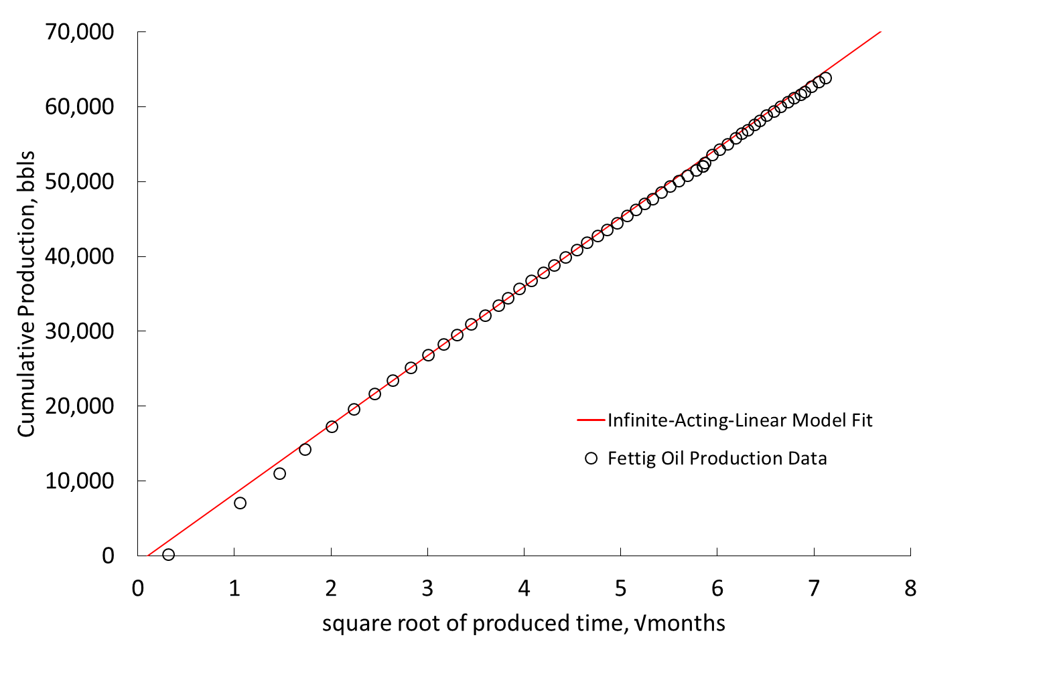

Figure 7. Showing the model fit the linear-flow portion of the cumulative production versus square-root-of-produced-time profile Fettig 24-22H.

One thing to notice in Figure 7 as the cumulative production increases over time is that the data never truly deviates from the linear flow model fit; therefore, as one works through the analysis for boundary-dominated flow in chapter 2, it becomes clear that the Fettig 24-22H is not in boundary-dominated flow but in fact in linear-flow. The next step in the analysis is to determine if the well is in linear-post-linear-flow or if the well is actually still in the linear-flow regime and has not felt a reservoir boundary. One could attempt to apply the second linear model fit to the cumulative production data above; however, since the production slightly deviates but never truly moves off the model fit curve, one can concluded that the Fettig 24-22H well is still in the linear-flow regime. Therefore, since the Fettig 24-22H is performing in the linear-flow regime, the time to the end of linear-flow, nor the intersection time, can be determined for this well utilizing the methods described thus far; in addition, the cumulative production at the end of linear flow cannot be determined. To determine the time to the end of linear-flow for a well in the linear-flow-regime will require a stochastic approach to determine the time to the end of linear-flow based on a probabilistic confidence criteria. To do this will require the use of Bayesian theory, which will be derived in detail in chapter four. As in the two well examples thus far, values of the slope and intercept can be found in Appendix B of this study for the Fettig 24-22H. However, m₂/m_{csrt} = 1 since this will is in the linear-flow regime. Monte Carlo simulations will be required to ascertain estimated ultimate recoveries of oil for a well in the linear flow-regime.

3.3 Determination of the flow-regime of a well
To determine the correct flow-regime of the well of interest will require taking the derivative of the cumulative production versus the square-root-of-produced-time data. Furthermore, three techniques for analyzing a well to determine if the well is in boundary-dominated flow, linear-post-linear-flow and linear-flow have been shown thus far. As one works through a multitude of wells there may be times that it is difficult to ascertain the correct flow-regime. Since the cumulative production versus the square-root-of-produced-time profile is a linear increasing linear profile in the infinite acting phase and an increasing at a decreasing rate in the boundary-dominated phase, the derivative of this plot can be used to determine what flow-regime the well is currently in. The derivative profile is a very useful tool that can help in diagnosing the flow-regime of a well. If a well is performing in the linear-flow regime the derivative of the cumulative production versus the square-root-of-produced-time data would yield a constant value on the derivative curve, straight line. The derivative of the linear-flow regime would yield a constant rate of change. Likewise a well that has reached boundary-dominated flow would yield a constant rate of change on the derivate profile followed by a decrease in the rate of change at a constant decreasing rate on the derivative curve indicating that all boundaries of the reservoir have been reached. For a well performing in the linear-post-linear-flow regime the rate of change on the derivative curve will be constant up to a point that a boundary appears to have been reached only to resume a constant rate of change but at a lower rate of change value. The derivative of the cumulative production versus the square-root-of-produced time are given in figures 8, 9 and 10 respectively. Utilizing the derivative and model fit of the derivative data, one can ascertain the flow regime the well is in. Note that once a boundary has been reached, in the case of boundary-dominated and linear-post-linear flow, the derivative will be constant up to the time to the end of linear flow or intersection time and then change to either linear decreasing rate (boundary-dominated) or a lower constant derivative (linear-post-linear).

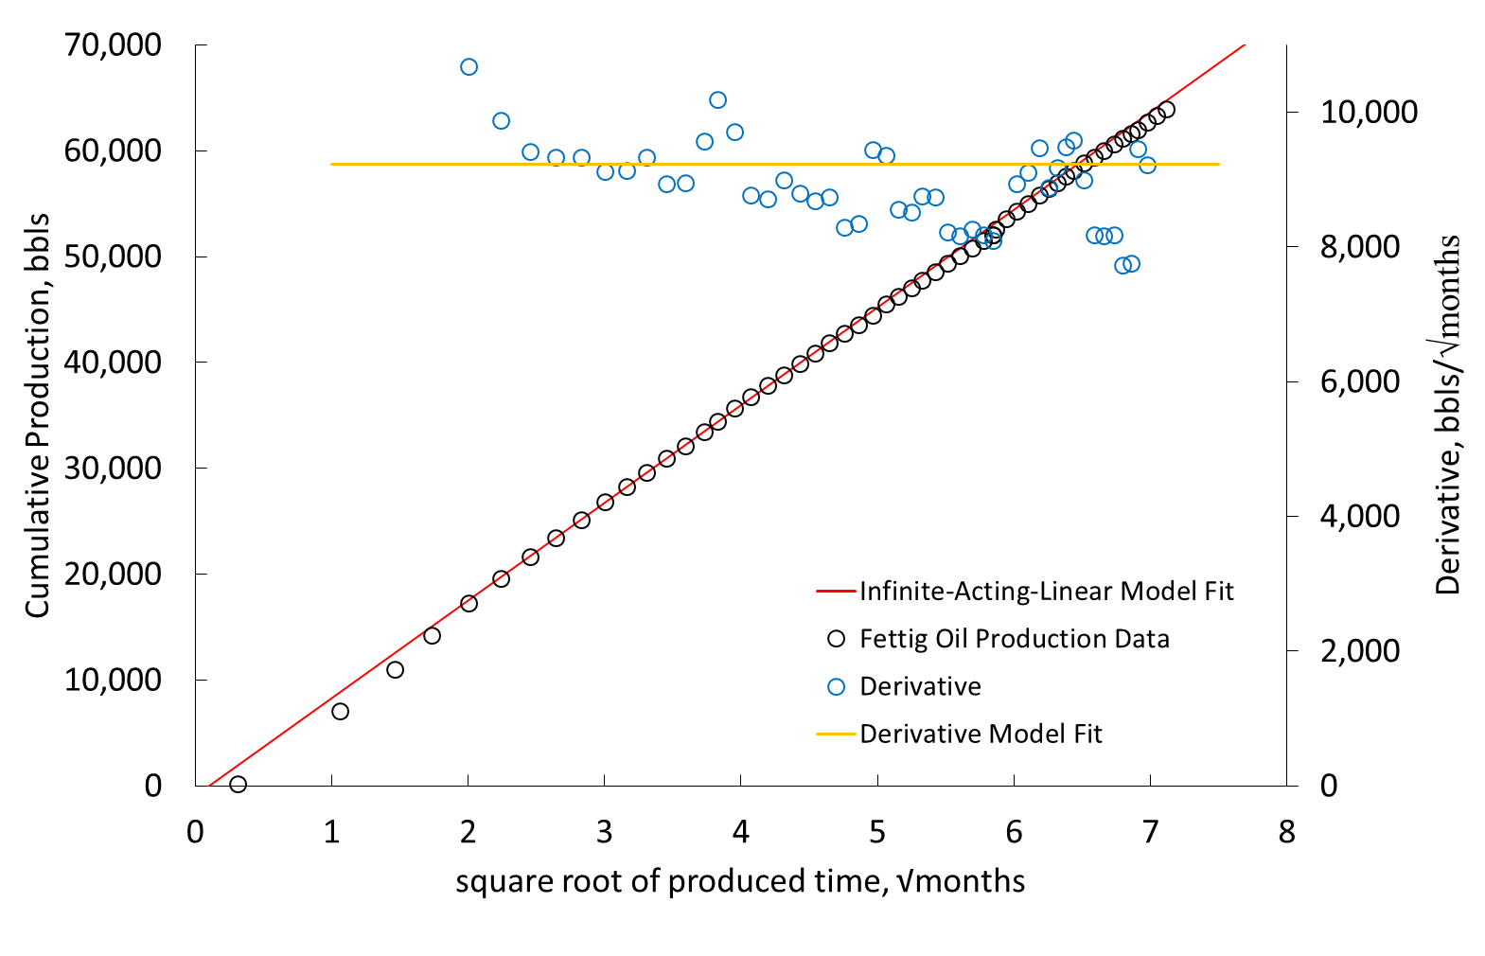

Figure 8. The model fit of the derivative of the cumulative production versus the square-root-of-produced-time in months of the Fettig 24-22H.

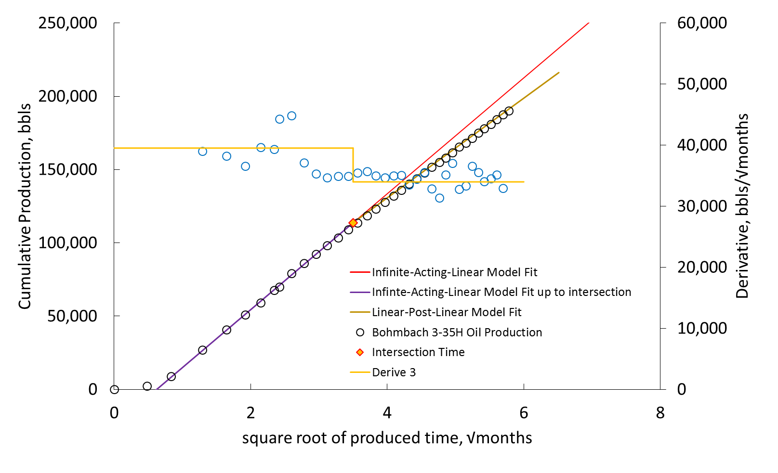

Figure 9. The model fit of the derivative of the cumulative production versus the square-root-of-produced-time in months of the Bombach 3-35H.
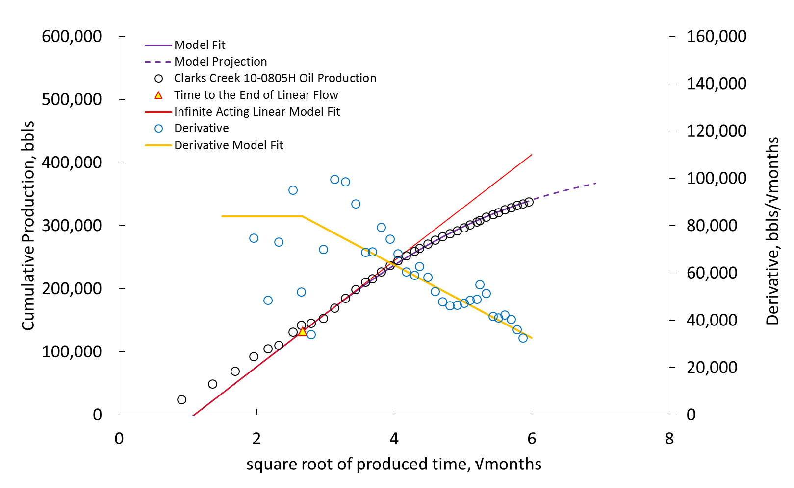

Figure 10. The model fit of the derivative of the cumulative production versus the square-root-of-produced-time in months of the Clarks Creek 10-805H

Chapter 4

Determination of Stochastic Values for Estimated Ultimate Recovery Forecasting

The next phase in the model development is to determine stochastic values looking at four parameters that will be found through analyzing wells in a similar fashion as in chapters two and three. This information will be used in the development of the Monte Carlo simulation for estimated ultimate recoveries of oil. Depending on the flowing behavior of the well, boundary-dominated, linear-post-linear and linear-flow regime will prescribe the evaluation of the well.

4.1 Stochastic Methodology
The stochastic methodology will look at four parameters that are uniquely inherent to the wells analyzed over a particular field. Stochastic analysis will be used for the Arps boundary-dominated exponent, the time to the end of linear-flow for wells in boundary-dominated flow-regime, the intersection time for wells in linear-post-linear-flow regime and the ratio of the slopes of the linear-post-linear-flow profiles. It should be noted that the results presented in this chapter are production field specific! Therefore, the procedure laid out in this chapter to analyze stochastically the four parameters of interest will be the same procedure one would use when applying this methodology to a field of interest; however, the result will be different.

4.2 Stochastic Methodology for the Arps’ Boundary-dominated Exponent
This study found, out of the 185 wells analyzed based on the previous specified evaluation criteria, 17 wells that exhibited a boundary-dominated flow-regime. To develop stochastic analysis for the Arps’ boundary-dominated exponent the following steps are needed to evaluate the data set.
- Collect the Arps’ boundary exponents for all wells in boundary-dominated flow.
- Sort Arps’ boundary exponents from least to greatest value.
- Count the number of Arps’ boundary-dominated exponent data point occurrences.
- Each occurrence will be divided by the total Arps’ boundary-dominated exponent count plus one (this represents the probability of the Arps’ exponent that will occur.)
- Find the inverse-standard-normal-cumulative distribution of each probability.
- Plot the log-normal distribution of the Arps’ boundary-dominated exponent versus the standard deviation Figure 11.

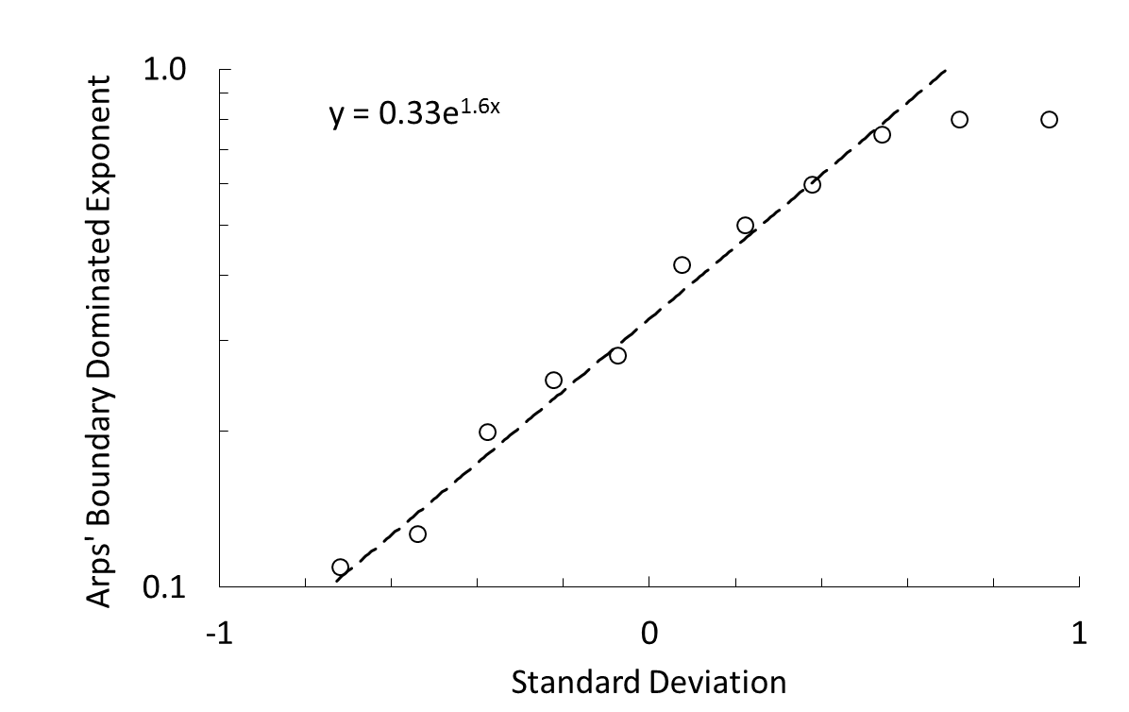
Figure 11. Log-Normal Distribution Arps’ Boundary-Dominated exponent
The slope of the log-normal distribution (the standard deviation) was found to be 1.60 and the mean of the log-normal distribution is 0.33.

4.3 Stochastic methodology Ratio of the Slopes of the Linear-post-Linear-flow-regimes
This study found, out of the 185 wells analyzed based on the previous specified research criteria, 134 wells exhibited a linear-post-linear-flow-regime. To develop stochastic analysis for the ratio of the slopes of the linear-post-linear-flow-regime the following steps are needed to evaluate the data set.
- Collect the ratio of the slopes for all wells in linear-post-liner flow-regime. Note that the ratios must be less than one.
- Sort ratio of the slopes from the least-to-greatest value.
- Count the number of ratio of the slopes data point occurrences.
- Each occurrence will be divided by the total ratio of the slope count plus one (the probability of the ratio of the slopes that will occur.)
- Find the inverse-standard-normal-cumulative distribution of each probability.
- Plot the log-normal distribution of the ratio of the slope of the linear-post-linear-flow-regime versus the standard deviation Figure 12.
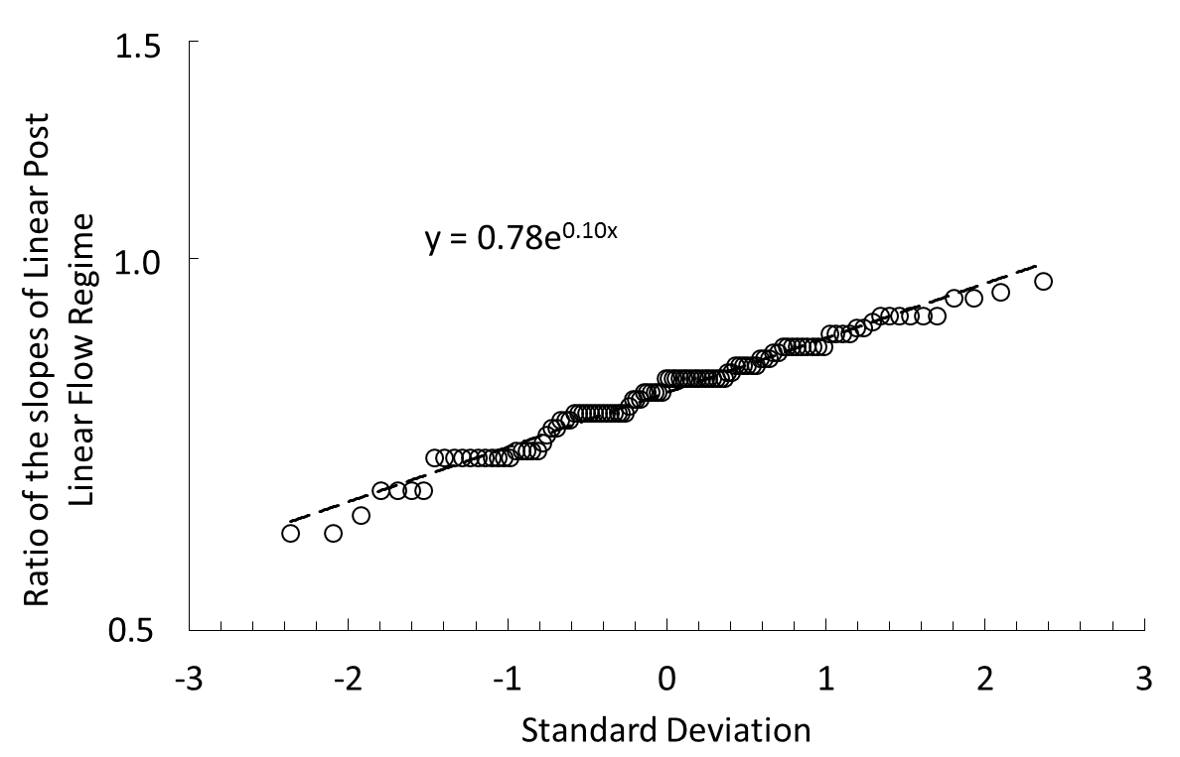
Figure 12. Log-Normal Distribution ratio of slopes of the Linear-Post-Linear-flow regime.

The slope of the log-normal distribution (the standard deviation) was found to be 0.1 and the mean of the log-normal distribution is 0.78.

4.4 Stochastic methodology for the Time to the End of Linear-flow for Boundary-Dominated Reservoirs
As stated previously for boundary-dominated wells, 17 wells exhibited boundary-dominated flow-regime. The time to the end of linear-flow for each well was observed from boundary-dominated analysis. Moreover, stochastic analysis for the time to the end of linear-flow using observed end of linear-flow time for boundary-dominated wells is as follows.
- Collect the time to the end of linear-flow data set.
- Sort the time to the end of linear-flow from the lowest to highest value.
- Count the number of data point times to the end of linear-flow occurrences.
- Each occurrence will be divided by the total time of end of linear-flow count plus one (the probability of the end of linear-flow time that will occur.)
- Find the inverse-standard-normal-cumulative distribution of each probability.
- Plot the log-normal distribution of the time to the end of linear-flow versus the standard deviation Figure 13.
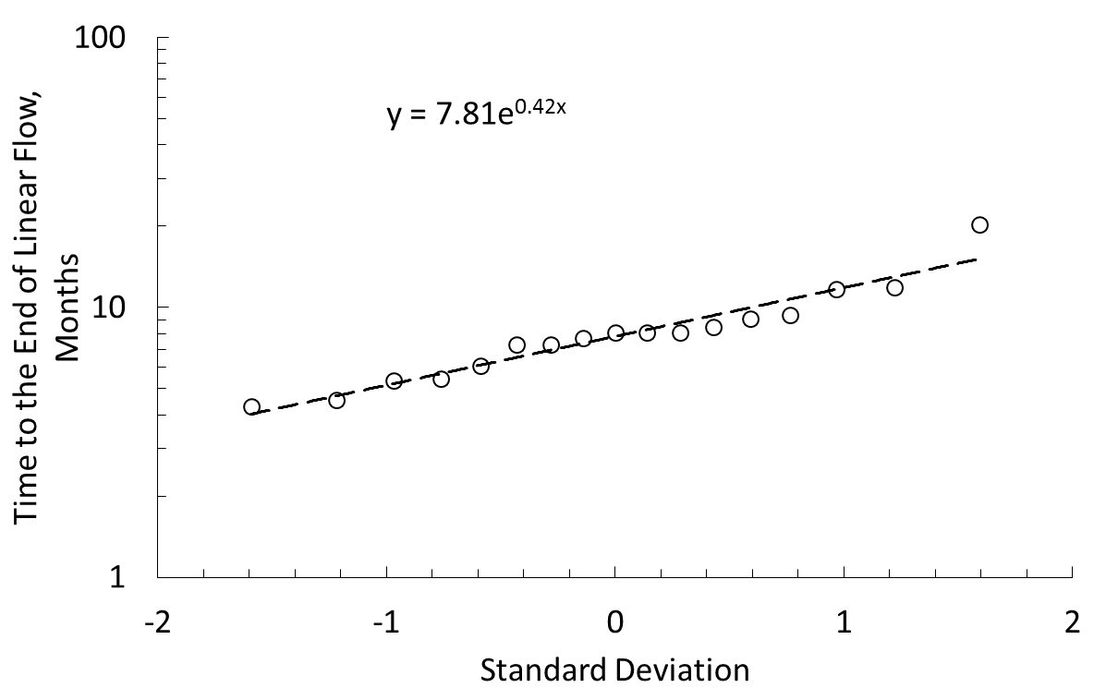
Figure 13. Log-Normal Distribution for the Time to the End of Linear-flow, Boundary-Dominated.

The slope of the log-normal distribution (the standard deviation) was found to be 0.42 and the mean of the log-normal distribution is 7.81.

4.5 Stochastic Methodology for the Intersection Time for wells in Linear-Post-Linear and Linear-flow regimes
The remaining wells in this study exhibited linear-post-linear (134 wells) and linear (34 well) flow-regimes. To predict the time to the end of linear-flow for wells that are still in the linear-flow-regime a new technique will be needed to predict the time at which the end of linear-flow can be ascertained based on a confidence probability. To do this Life Table Actuary Analysis and Bayesian Theory will be adapted to determine the end of linear-flow time of a well not yet reaching the end of linear-flow. The time to the end of linear-flow found for the linear-post-linear-flow regimes will be used in the development of the probabilistic analysis. Henceforth, this analysis will be called actuary time to the end of linear-flow.
First, it should be noted that the development of this time to the end of linear-flow Bayesian tool will be unique to the field production being evaluated. Therefore, the user of this probabilistic model will have to determine the actuary time to the end of linear-flow based on the field of interest.
To develop the actuary time to the end of linear-flow tool the following steps are needed:
- Collect the intersection time data set for the linear-post-linear-flowing wells.
- Sort the intersection time from the lowest to highest value.
- Count the number of data point intersection time occurrences.
- Each occurrence will be divided by the total intersection time count plus one (probability of the linear-post-linear intersection time that will occur.)
- Find the inverse-standard-normal-cumulative distribution of each probability.
- Plot the log-normal distribution of the intersection time versus the standard deviation Figure 14.

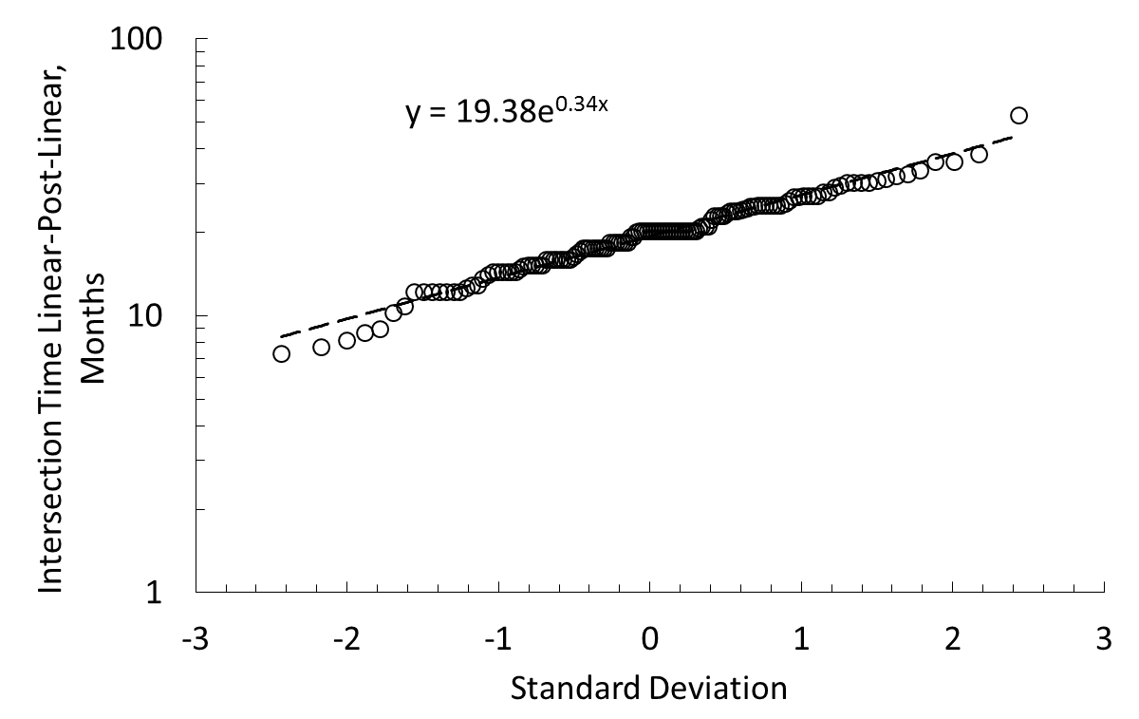

Figure 14. Log-Normal Distribution for the Intersection Time, Linear-Post-Linear.

The slope of the log-normal distribution of Figure 14, which is the standard deviation, was found to be 0.34 and the mean of the log-normal distribution is 19.38.
Applying Bayes Theorem to determine the time to the end of linear flow for wells that are still in the linear flow regime relates probabilities such that the probability of A given B is equal to the probability of A, multiplied by the probability of B given A, divided by the probability of B, equation (4-1). To illustrate, one is interested in knowing the potential time to the end of linear-flow for a well that has yet to reach the end of linear-flow regime will be related to the current production life of the well of interest. Information about the wells age can be used to more accurately assess the probability of what time to the end of linear-flow one can expect
…………………..………..………………………...……(4-1)
The parameters of Bayes Theorem for estimating the time to the end of linear flow is as follows:
, probability of expected age given current age given as a random variable [0, 1].
, probability of current given age an expected age greater than current age = 1. Probability of achieving an expected age greater than current age. Resulting probability yields expected age.
Probability of current age from log mean distribution.
Therefore, Bayes theorem can be reduced to equation (4-2)
……………...………………........…….….…..………………(4-2)
Apply equation (4-2) to find the standard deviation as a function of current well life and using that probability to determine and use a desired confidence probability interval for. Note that low confidence intervals will return a higher time to the end of linear-flow and higher confidence probability intervals will yield lower time to the end of linear-flow values. Once has been determined and has been selected equation (4-2) will be used to find. is the probability that a well will be at a specified time of end of linear-flow based on current production life and its probable outcome. Moreover, once has been found then the inverse-standard-normal-cumulative distribution of will be ascertained, this value will yield a corresponding standard deviation to the found probability.
Utilizing the procedures above one can generate a probabilistic profile of the expected end of linear-flow time based on Bayes Theorem.
Furthermore, to help aid in the visualization of utilizing Bayesian Theory to determine the time to the end of linear flow, one can develop the log-normal cumulative probability chart Figure 15. Therefore if one knows the age of a well of interest, then the end of linear flow can be determined. Using the data discussed previously for the time to the end of linear flow and intersection time, a log-normal cumulative probability distribution can be applied. Therefore, there is a six step process that will be used to determine the time to the end of linear flow for a well of interest. The process is as follows:
- Select the age of the well
- Determine P(age) based on current age of the well. This will be equal to.
- Apply Bayes Theorem by selecting a random number [0, 1], this will be equal to, determine the probability of achieving an expected age greater than current age. Note that the probability of achieving an expected age greater than current age will be less than the probability of current age based on the age of the well. This will be equal to
- Once the probability of achieving an expected age has been found, one will move horizontally to the cumulative probability curve.
- From the cumulative probability curve one will move vertically to the time to the end of linear flow data set.
- From the time to the end of linear flow data set move horizontally to the time to the end of linear flow axis. This will be the time to the end of linear flow based on the product of a randomly selected probability and the probability at current age.
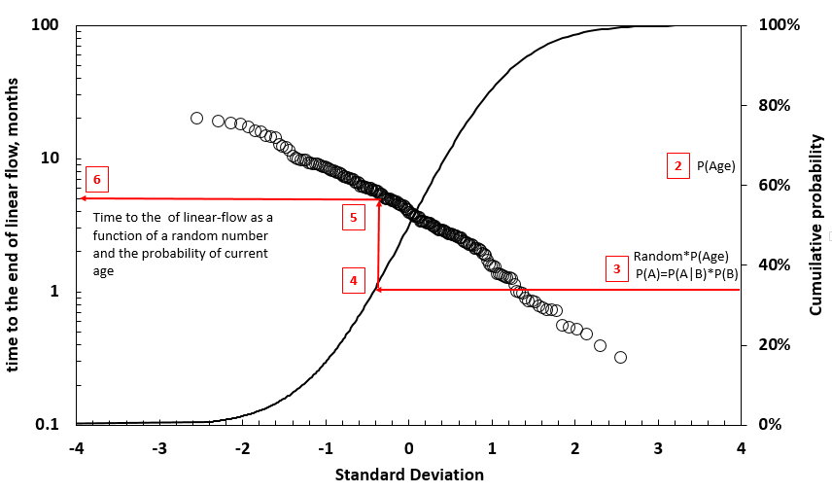

Figure 15. Log-Normal Distribution Cumulative Probability Chart to determine the Time to the End of Linear-flow.

The tabulated stochastic values for this research is given in Table 4.
Table 4: Tabulated values for the Stochastic Analysis

The parameters in Table 4 will be used in the Monte Carlo simulation for estimated ultimate recoveries of oil.
Chapter 5

Monte Carlo Simulations for Estimated Ultimate Recovery Probabilistic Analysis
Applying Petroleum Resource Management System (PRMS) criteria to the well values and the stochastically-found results in chapter four, one can use Monte Carlo simulations for random probabilistic variables for the stochastically-found results to determine the estimated ultimate recovery of a well or wells in a production field. Utilizing this information, one can develop a probabilistic estimated ultimate recovery forecast for economic evaluation purposes.

5.1 Initial setup of the Monte Carlo simulation
Once steps for finding the stochastic values for all wells analyzed from chapter four, Table 4, is completed, the process of setting up a Monte Carlo simulation to evaluate wells that are in boundary-dominated, linear-post-linear and linear-flow regimes to determine the estimated ultimate recovery of oil for a field of interest can begin.
Before one can begin the Monte Carlo setup, the economic limit of the field of interest must first be determined. The economic limit is the limiting amount of barrels one would produce economically. The economic limit is a function of the monthly operating costs, net revenue interest per working interest, severance, and oil commodity prices and will have to be applied accordingly to the evaluation of interest.
The next phase in setting up the Monte Carlo simulation is to acquire the slope and intercept of the cumulative production versus the square-root-of-produced-time profiles of the wells of interest. The three examples, laid out in chapters two and three, will be used and their parameters are found in Appendix B of this study. The slope and intercept for the cumulative production versus the square-root-of-produced-time will be specific to the well being studied. The stochastic values found, utilizing the methodology in chapter four, will be used commonly across all wells analyzed. The stochastic values for wells in boundary-dominated flow and linear-post-linear-flow can be found in Table 4.

5.2 Determination of the Estimated Ultimate Recovery of oil wells in Boundary-Dominated flow and Linear-Post-Linear-flow
To determine the estimated ultimate recoveries of wells in boundary-dominated, linear-post-linear and linear-flow will require the use of the hyperbolic equations defined in Table A.1 of the appendix of Rodrigues and Callard (2012). The equations will be relied on for the setup of the simulation using Monte Carlo numerical analysis.
To determine the estimated ultimate recovery for boundary-dominated flow and linear-post-linear flow regime can be found deterministically utilizing the parameters found in Appendix B for chapters two and three respectively. The deterministic results for the Clarks Creek 10-0805H and the Bohmbach 3-35H are given in Table 6 of section 5.5.
The cumulative production versus the square-root-of-produced-time profiles showing the deterministic estimated ultimate recoveries are given in Figure’s 16 and 17 respectively. It should be noted for the Clarks Creek 10-0805H it would have a total well life of approximately 39 years before the estimated ultimate recovery is achieved for the well parameters found through model matching and assumed operating expense defined in the economic limit. Likewise, for the Bohmbach 3-35H it will take approximately 37 years to achieve the estimated ultimate recovery of this well based on the well parameters and economic limit for this well.
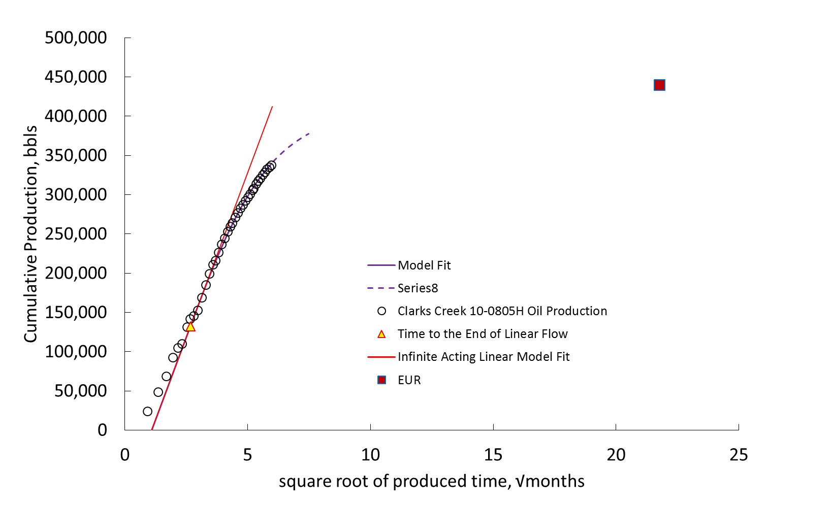
Figure 16. The cumulative production versus the square-root-of-produced-time in months of the Clarks Creek 10-805H with Estimated Ultimate Recovery.

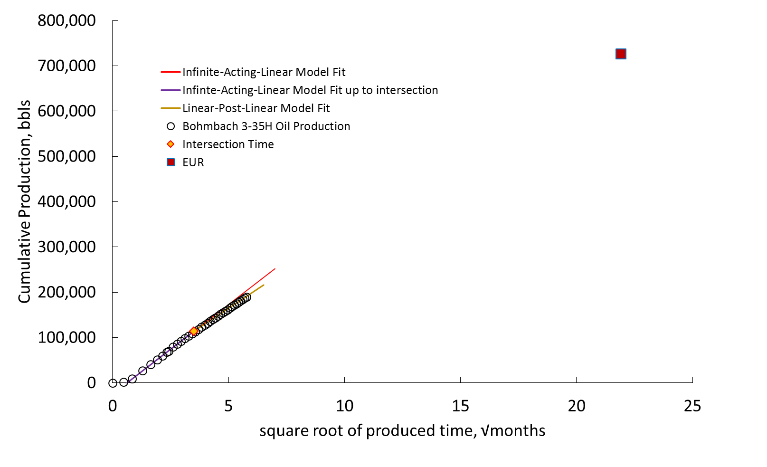
Figure 17. The cumulative production versus the square-root-of-produced-time in months of the Bohmbach 3-35H with Estimated Ultimate Recovery.

5.3 Application of the Monte Carlo Simulation
The Monte Carlo model will be setup such that the analysis will rely on a repeated random sampling of the proportion of wells that are in boundary-dominated flow to the wells in linear-post-linear and linear-flow. This analysis will rely on what will be called realizations based on the number of iterations required to reach convergence. The setup of the Monte Carlo simulation is as follows:
- Determine slope of the cumulative versus the square-root-of-produced-time profile.
- Determine the intercept of the cumulative versus the square-root-of-produced-time profile.
- Determine the current cumulative production at the current life of the well.
- Determine the economic limit of the field of interest.
- Determine the percentage of the wells in boundary-dominated flow-regime relative to the wells in linear-post-linear and linear-flow-regimes.
- Using the hyperbolic equations defined in Table A.1 of the appendix of Rodrigues and Callard (2012). Determine the estimated ultimate recoveries of a well in either boundary-dominated or linear-post-linear and linear-flow regimes.
- The Monte Carlo setup will be such that the estimated ultimate recovery of oil will converge on a series of realizations. Convergence will be acquired by the minimal change of the standard deviation relative to the mean.

5.4 Results of the Monte Carlo Simulation
The results of the linear-flow of the Monte Carlo analysis of the Fettig 24-22H is as follows. Note that the percent BD given in Table 5 is the ratio of the boundary dominated wells to the number of linear-post-linear wells plus the boundary dominated wells. This percentage is used in the decision process of the Monte Carlo simulation utilizing random sampling. Note that this study only found 17 wells that are in boundary dominated flow, 134 wells in linear-post-linear flow and 34 wells in linear flow; therefore, utilizing Bayesian theory, the probabilistic method laid out thus far, will be needed for wells in linear flow.
Table 5: Monte Carlo Input values for the Fettig 24-22H
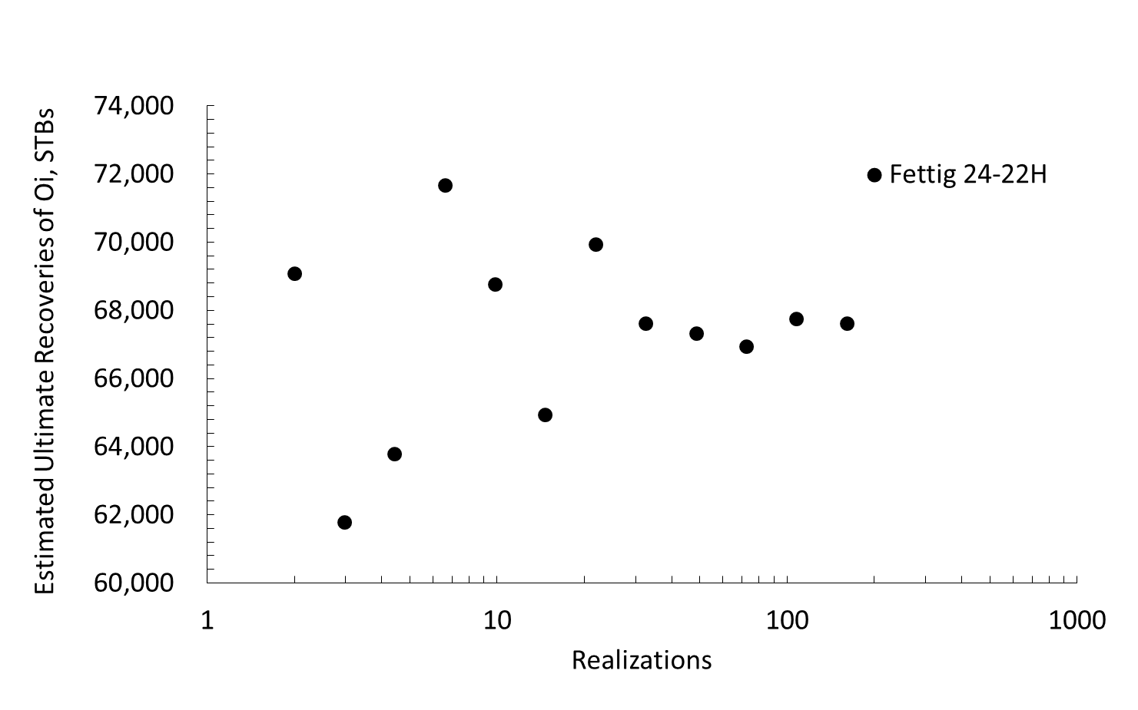
Figure 18. Monte Carlo simulation for and Estimated Ultimate Recovery of Oil, Fettig 24-22H.

Notice how as the realization increase the estimate ultimate recovery values converge on a solution. For the Fettig 24-22H, it took approximately 33 realizations to achieve convergence, Figure 18. The mean value of the estimated ultimate recovery of this well based on the parameters in Table 5 is 68,357 bbls. Figure 19, shows the Fettig 24-22H cumulative production versus the square root of produced time profile with the estimated ultimate recovery for this well utilizing the Monte Carlo estimated ultimate recovery method. It should be noted that based on the intial assumptions for the Monte Carlo analysis, it appears that the Fettig 24-22H will reach its estimated ultimate recovery in approximately 56 months from initial well life.
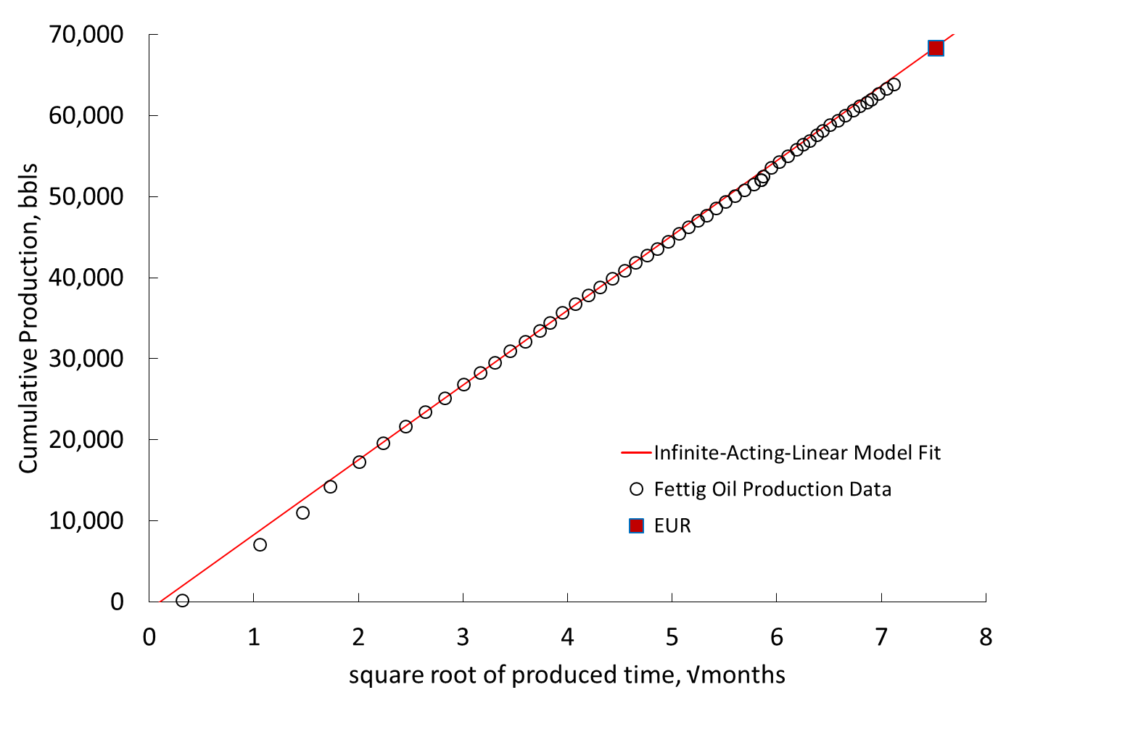
Figure 19. The cumulative production versus the square-root-of-produced-time in months of the Fettig 24-22H with Estimated Ultimate Recovery.

5.5 Applying the Petroleum Resource Management System criteria.
Petroleum Resource Management System Guidelines (PRMS) for proved, probable and possible reserves is used to quantify oil reserves for public reporting. From KelKar (2013), according to the Petroleum Resource Management System (PRMS) criteria, proved reserves represent the most important category of reserves and represent the 10th percentile reserves and should have a 90% probability that these reserves can be produced. KelKar also states, probable reserves represent the difference between the 50th and 10th percentile values or the difference between the 90% and the 50% probabilistic value; furthermore, possible reserves represent the difference between the 90th and 50th percentile or the difference between the 50% and 10% probabilistic value. Therefore, to determine the proved, probable and possible reserves for the Fettig 24-22H well given previously, the mean of the estimated ultimate recovery and the standard deviation was found and is given in Table 6. Note that the standard deviation is used to break down the mean into proved, probable and possible reserves. The process in determining Petroleum Resource Management System criteria (PRMS) is as follows:
- Determine the standard normal cumulative distribution of the proved, probable and possible, which is 90%, 50% and 10% probability respectively.
- Find the log-normal distribution of the estimated ultimate recovery based on proved, probable and possible criteria. is the estimated ultimate recovery found using the Monte Carlo simulation, z is the standard normal cumulative distribution values and is the standard deviation of the Monte Carlo values based on the realizations found.
- To determine proved, probable and possible reserves for public reporting one would multiply the 90% probability to the 90% Monte Carlo estimated ultimate recovery reserves for proved reserves. Furthermore, probable reserves is found by multiplying 50% to the difference in of the 90% and 50% Monte Carlo estimated ultimate recovery reserves. Possible reserves are found by multiplying 10% to the difference between 50% and 10% Monte Carlo estimated ultimate recovery reserves.
The results of the petroleum resource management criteria for the Fettig 24-22H well is as follows.

Table 6: Deterministic and Monte Carlo Results for Proved, Probable and Possible Reserves
From the analysis it can be seen that the reserves that would be used for public reporting are the summation of the proved, probable and possible reserve criteria, called Reportable Reserves, found in Table 6 for the Fettig 24-22H. For the Clarks Creek and the Bohmbach wells, the deterministic reserves, which represent the most conservative value, is based on the observed parameters determined through the utilization of the cumulative production versus the square-root-of-produced-time profile outlined in chapter two and three respectively.
Furthermore, if one is evaluating stochastically found reserves and one moves from the proved reservoir criteria and considers projects that would require a higher degree of risk then probable and possible reserve parameters may be used. Furthermore, another way to look at the numbers is to understand that the range of possible barrels that can be recovered, based on a producers operating costs and oil commodity prices, one will never be able to realize the total amount of oil production potential of a well. Therefore, it is important to understand what the numbers say and make economic decisions based on what the data is stating. For example, Fettig 24-22H, the 90% PRMS reserve barrels should be used in lieu of the ultimate potential of the well, in this case the ultimate potential found for this well is 76,651 bbls based on the assumed operating costs and oil commodity prices; however, the best possible outcome of this well cannot exceed the PRMS reserves value, which is the summation of the PRMS proved, probable and possible reserves. Therefore the 90% PRMS reserve value should be used for the economic decision process, which states that there is a 90% probability of producing this amount of barrels and any reservoir volumes greater than this only exasperates the risk potential.

5.6 What the Results Say
The results of the estimated ultimate recovery analysis can be applied to all 185 wells studied such that the estimated ultimate recoveries for oil can be found using the stochastic model for a field of interest. The Petroleum Resource Management System (PRMS) criteria coupled with the estimated ultimate recovery probabilistic reserve procedure proposed in this research exhibit a powerful tool that can help upstream companies, mid-stream companies and investment firms evaluate oil assets. It is possible that estimated ultimate recoveries can be found individually for wells using this technique; however, it needs to be understood that for one to be able to truly determine the correct estimated ultimate recovery of a single well will require knowledge of the production history from the beginning of well-life until abandonment. Since the wells studied in this analysis have only been producing for approximately three to seven years it could take years to determine the true estimated ultimate recovery of a well. Another important factor will be the historical commodity price of oil that will be needed to determine the estimated ultimate recovery of oil for the well in question. Therefore the results allow for an estimation of the ultimate recoveries for a field and should be applied on field-by-field basis.

5.7 Sensitivities of the Estimated Ultimate Recovery values for future Oil Commodity Prices
A powerful component to this technique is looking at sensitivity studies on future oil commodity prices. For example, if a mid-stream provider is looking to provide a transportation service for an upstream company to move oil from the well-head to third-party offloads or processing, a significant capital expense will be burdened by the mid-stream provider. It is paramount that the mid-stream provider carry-out their due-diligence to ensure that the project has an economic viability. The reserve procedure laid out in this research can give the mid-stream provider insight as to the expected ultimate recovery of the reserves by looking at the future commodity prices. This procedure will empower the mid-stream provider to weigh the economic risk burden to the company as well as develop a spending-capital timeline to maximize revenue and hit the acquired target-rate-of-return.

Chapter 6
Conclusion
6.1 Conclusion
The model for flow-regime changes for this study was a success. Deterministic reserves can be determined on boundary-dominated and linear-post-linear wells and two key distributions are desired from an area of interest studied for each late life flow regime. Stochastic reserves can be determined on infinite acting wells using these key distributions and this methodology is not limited to reservoir or fluid and can be used in other fields developed with horizontal wells with multistage fracture stimulation Furthermore, the model was able to allow for the approximation of the estimated ultimate recovery for a field of interest and allow for the quantification of reserves corresponding to the Petroleum Resource Management System (PRMS) criteria for reserve reporting purposes. This method can empower upstream companies, mid-stream companies and investment firms the ability to gain some insight into the potential ability to recover reserves from a field of interest. This model can be used in the economic decision-making process to compare and contrast, along with running sensitivity studies on future commodity prices of oil to ascertain the validity of an oil project or investment.

References
Childers, D., Callard, J., 2015. Forecasting Reserves in the Bakken Reservoir Incorporating Flow-regime Changes. Proc., SPE Production and Operations Symposium, SPE 173622-MS, Oklahoma City, Oklahoma
Cunningham, C., Cooley, L., Woxniak, G., Pancake, J., 2012. Using Multiple Linear-regression to Model EURs of Horizontal Marcellus Shale Wells. Proc., SPE East Regional Meeting, SPE 161343, Lexington, Kentucky
Freeborn, R., Russell, B. 2015. Creating More Representative Type Wells. Proc., SPE/CSUR Unconventional Resources Conference, SPE 175964-MS, Alberta, Canada
Haynes, Boone, 2016. Oil Patch Bankruptcy Monitor (12 May 2016), http://www.haynesboone.com/news-and-events/news/press-releases/2015/11/19/oil-patch-bankruptcy-monitor
Kabir, C., Lake, L. 2011. A Seminanlytical Approach to Estimating EUR in Unconventional Reservoirs. Proc., SPE North American Unconventional Gas Conference and Exhibition, SPE 144311, Woodlands, Texas
Kelkar, M., 2013. Petroleum Economics and Project Evaluation. Petroskills.,1-20,1-29,1-30,1-31
NDIC, 2016. Rules and Regulations (30 June 2016), II-70, https://www.dmr.gov/oilgas/rules/rulebook.pdf.
Olsen, G., Lee, J., Blasingame, T., 2010 Reserves Overbooking: The Problem We’re Finally Going to Talk About. Proc., SPE Annual Technical Conference and Exhibition, SPE 134014, Florence, Italy
Poston, S., Poe, B., 2008. Analysis of Production Decline Curves. Society of Petroleum Engineers.
Rodrigues, E., Callard, J., 2012. Permeability and Completion Efficiency Determination from Production Data in the Haynesville, Eagle Ford and Avalon Shales. Proc., SPE Eastern Regional Meeting, SPE 161335, Lexington, Kentucky
Society of Petroleum Engineers, 2016. Why a Universal Language for Evaluating Reserves Is Needed (30 June 2016), http://www.spe.org/industry/universal-language-for-reserves-definitions.php
Shaoyong Y., Dominic, J., 2013. An Improved Method to Obtain Reliable Production and EUR Prediction for Wells with Short Production History in Tight/Shale Reservoirs. Proc., SPE Unconventional Resources Technology Conference, SPE 168684, Denver, Colorado

Appendix A: Nomenclature
$b$ Arps’ exponent, dimensionless
$EUR$ Estimated Ultimate Recovery, bbls
$G$ Gas Production, Mcf
$IABD$ Infinite Acting Boundary-dominated
$m_{2}$ Slope of linear-post-linear regression line, STBs /√months
$m_{csrt}$ Slope of the cumulative production square-root-of-produced-time linear-flow- regime STBs /√months
${m_{2}}/{m_{csrt}}$ Ratio of slopes for linear-post-linear, dimensionless
$MOC$ Monthly Operating Cost, $/bbl
$NDIC$ North Dakota Industrial Commission
$NRI$ Net Revenue interest, %
$N$ Oil Production, bbls
$N_{P}$ Cumulative Oil Production, bbls
$N_{P_{i}}$ Cumulative Oil Production intercept, bbls
$P1$ Proved reserves, bbls
$P2$ Probable reserves, bbls
$P3$ Possible reserves, bbls
$STD$ Standard Deviation, dimensionless
$t_{elf}$ Time to the End of Linear-flow for boundary-dominated wells, months
$t_{p}$ Well age, months
$t_{p_{m}}$ Cumulative production months, month
$t_{x}$ Intersection time for linear-post-linear wells, months
$WI$ Working interest, %
$W$ Water Production, bbls
Subscripts
$csrt$ Cumulative production square-root-of-produced-time
$BD$ Boundary-dominated
$i$ Intercept
$LF$ Linear-flow
$Life$ Well current age
$LPL$ Linear-post-linear
$MC$ Monte Carlo
$n$ Itteration
$p$ Cumulative
$Prob$ Probability

Appendix B: Bakken Production Data

