UNIVERSITY OF OKLAHOMA

GRADUATE COLLEGE

USING VIDEO GAMES IN THE SECONDARY ENGLISH CLASSROOM FOR THE TEACHING OF WRITING AND RHETORICAL SKILLS

A THESIS
SUBMITTED TO THE GRADUATE FACULTY
in partial fulfillment of the requirements for the
Degree of
MASTER OF EDUCATION
By
Connor Woodard
Norman, Oklahoma
2021

USING VIDEO GAMES IN THE SECONDARY ENGLISH CLASSROOM FOR THE TEACHING OF WRITING AND RHETORICAL SKILLS

A THESIS APPROVED FOR THE
DEPARTMENT OF INSTRUCTIONAL LEADERSHIP AND ACADEMIC CURRICULUM

BY THE COMMITTEE CONSISTING OF

Dr. Crag Hill, Chair
Dr. James Zeigler
Dr. Kristy Brugar

© Copyright by Connor Woodard 2021
All Rights Reserved.

Table of Contents

Title………………………………………………………………………………………………..i
Committee ………………………………………………………………………………………..ii
Copyright………………………………………………………………………………………....iii
Table of Contents…………………………………………………………………………………iv
Abstract…………………………………………………………………………………………...v
Chapter 1: Introduction………………………………………………………………………...1
Chapter 2: Literature Review…………………………………………………………………..3
Theoretical Framework…………………………………………………………………..11
Chapter 3: Methodology……………………………………………………………………….12
Population………………………………………………………………………………..13
Activities/Research General Summary…………………………………………………..14
About Undertale………………………………………………………………………….15
Before Undertale………………………………………………………………………...19
The Undertale Unit………………………………………………………………………20
Data Collection…………………………………………………………………………..25
Post Interviews with students……………………………………………………………26
Data Analysis ……………………………………………………………………………26
Chapter 4: Findings…………………………………………………………………………….27
Grade Comparison Analysis……………………………………………………………..27
Classroom Engagement Findings………………………………………………………..36
Class Specific Results……………………………………………………………………38
Survey Results…………………………………………………………………………...44
Chapter 5: Conclusions………………………………………………………………………...55
Limitations……………………………………………………………………………….57
Areas of Further Study…………………………………………………………………..59
Appendix/Resources from Classroom…………………………………………………………61
References……………………………………………………………………………………….95

Abstract:
English Language Arts (ELA) teachers are searching for new and novel ways to engage students in classroom activities involving reading and learning reading/writing-related skills, such as rhetoric or the use of literary devices. One untapped area of education is using video games as a full classroom text in order to teach these ELA skills. This study aims to test the viability of using video games in the ELA classroom, and looks to compare using them with traditional print texts, such as novels. In order to test the viability of using video games as a full classroom ELA text, a study was done in five sophomore ELA classes, where students played the game Undertale together. The results suggest that video games can be just as viable as traditional print texts in teaching certain ELA skills, provided proper pedagogical practice is used in conjunction with an appropriate video game.

Introduction/Problem:

As a young child, I was both a voracious reader and an obsessive video-game player. As I entered adolescence, I began to notice that fewer and fewer of my friends regularly read for fun, but most of them still played video games. Thanks to my love for reading, I was generally able to coast through and enjoy my English classes in high school, but this certainly is not the case for most students. I quickly realized this when I began teaching 9th grade English Language Arts (ELA) classes and found that very few of my students actually read for fun, even when directly assigned to do so. During the four years that I have spent teaching English, I’ve had varying degrees of success with getting students to read in the classroom, generally ranging from bad to mediocre. Getting through a classroom novel frequently required me figuratively dragging students across the finish line through some combination of group reading, audio recordings, and myself reading aloud to the class with as much enthusiasm and animation as I could muster. I’ve improved at my incorporation of print texts into the classroom, but I don’t think that I’ve ever taught a novel to a class and considered it a resounding success. Oftentimes, ELA teachers are expected to teach/reinforce various literary skills alongside a book, but this can frequently prove a struggle. How, I wondered, could I teach students to analyze a text for concepts such as theme or conflict when I couldn’t even get them to read a book? While I improved enough as a teacher to be better at teaching these concepts using techniques like scaffolding and incorporating other types of texts, I’ve yet to use a book that my classes universally loved.
While some of my struggles were simply based on the inexperience that comes with being a new teacher, many of the problems I had were rooted in not having novel and engaging texts for my students to experience. While few of my students were reading for fun, almost all of them were playing video games (often when they were supposed to be reading). Using my own knowledge of video games, I was occasionally able to coax the same students who were resistant readers into deep conversations about games like The Last of Us and God of War; oftentimes, they were the very kind of conversations that I wanted them to have about whatever book I was trying to get them to read. I began to wonder if the problem was rooted into what I thought of as a meaningful classroom text. When I thought about the stories that were most meaningful to me, many were books, but just as many were video games. Frodo and Sam’s harrowing journey into Mordor in Tolkien’s The Lord of the Rings is rich in characterization and ripe for thematic analysis, but the journey that Joel and Ellie take into a post-apocalyptic Chicago in The Last of Us has many of those same elements while being accompanied by fantastic voice acting, gameplay, and music. Mark Twain’s Adventures of Huckleberry Finn is a timeless coming-of-age story featuring a boy and a father-figure travelling along a river, dealing with violence and prejudice. God of War features a comparable journey of a boy and his father travelling via boat and encountering new cultures and violence, but is accompanied by compelling gameplay and the ability to stop and explore environments in a way a novel doesn’t offer. I contend that there are video games with narratives that are both engaging and filled with the same kind of nuance and craft present in those same canonical texts that are often used to teach literary elements to high school students, while also adding extra layers of engagement and learning through the presence of multimodal elements. Through this research, I seek to answer the following questions:
1: In what ways can video games function as a multimodal text in an English classroom to improve engagement and academic performance?
2: What are the potential positive and negative effects of using video games as a multimodal text in an English classroom?
3. How does using a more traditional text like Dreamland Burning compare to using video games such as Undertale as the basis for teaching various literary skills?

Literature Review
Since the release of the first commercial video game Pong in 1972, video games have grown from a niche hobby to a multibillion dollar industry, and children make up a large portion of these sales. In fact, according to the Entertainment Software Association’s 2019 report, “70% of [American] families have a child who plays video games” (p. 11). A 2020 study from the NPD Group (p. 1) backs this up, saying that “three out of every four, or 244 million, people in the U.S. play video games.” Coincidentally, the United States’ scores in both math and reading have either stagnated or have been steadily decreasing since at least the year 2000. Furthermore, the U.S. has fallen from its status as an educational powerhouse to hovering around the 13-14 rank for international scores on the Programme for International Student Assessment (PISA), a common assessment used to compare international performance in reading, math, and science (Loveless, 2017). According to Simpson and Clem (2008), this could be at least in part due to teachers not adapting well to the ever-shifting digital age that American society finds itself in. They claim that “ the student population is getting harder to teach and motivate with traditional approaches, [and] our teacher population is aging.” The study suggests that, in the U.S., more than 25% of teachers are over age 50; the median age of teachers is 44.” These older teachers can sometimes have an increasingly difficult problem with connecting to students, at least in terms of their media usage, but a potential solution to this problem is to incorporate video games into traditional secondary education to match this changing reality.
The purpose of this study is to explore the idea of using video games as an alternative form of classroom text in a high school ELA class and to determine if using a particular video game can be a viable strategy either replacing or supplementing traditional pieces of classroom literature, and to see if they can potentially boost engagement and/or academic performance.

Video Games as a Digital Literacy:
Video games in the classroom can’t be used simply because they are engaging; they need educational merit as well. James Paul Gee, one of the most widely-cited authors on video games and education, discusses 36 different “learning principles” that video games can have embedded within them. One that specifically relates to literacy is the idea of the “Semiotic Principle,” which Gee (2008) defines as “any set of practices that recruits one or more modalities (e.g., oral or written language, images, equations, symbols, sounds, gestures, graphs, artifacts, etc.) to communicate distinctive types of meanings” (p. 17). This idea is used by Gee and Jewitt to establish the principle that people can be literate or illiterate in a wide variety of fields, such as reading, gardening, or playing video games. Gee stresses there is a crossover with using video games to help teach what he refers to as “print literacy,” since even reading requires multiple skill sets, depending on the type of text that one is reading.
This matches up with other research on the topic done in Selfe and Hardiner’s 2007 study, where specific gamers were examined and coded for different types of literacies.
Hardcore gamers (termed in this article as “insiders,”) exhibited several different functions when explaining video games to others, including those of teachers and knowledge producers, and that they examine high levels of literacy within the semiotic field of gaming, able to share “words, symbols, images, gestures, and artifacts” (Selfe et al., 2007). These authors highlighted concepts very similar to what Gee discusses, lending credence to his ideas. Smith and Deistch (2007) cite Gee’s work, where they bring up a different benefit of gaming. They discuss that video games can influence “local diversity and global connectedness,” in American students, due to the fact that many video games are made in Japan, a culturally different country. They discuss that “critical literacy in this semiotic domain has been informed not only by internal and external design grammars, but by forces beyond these local contexts and affinity groups' ' (2007, p. 62). They go on to discuss that they must use their semiotic domains as gamers in conjunction with those domains present in specifically Japanese games, which can encourage concepts that are often taught in secondary classrooms, such as empathy and social justice.

Multimodal Literacy and New Literacies:
Bringing Gee’s theoretical ideas into a more pedagogically specific paradigm is Jewitt and Kress’ work on Multimodality and New Literacy Studies for the classroom. Jewitt (2008) defines multimodality as a system that “attends to meaning as it is made” through different modes of meaning and communication including ‘image, gesture, gaze, body posture, sound, writing, music, speech,” or any text that incorporates more than one mode at the same time. In other words, multimodality combines something like visuals and music, such as the way a film might use a musical score to help enhance the feeling of a visual action scene. Jewitt and Kress’ (2010) understanding of multimodal literacy points to the importance of using different modalities in the English classroom beyond just print text. They argue that “A multimodal approach...investigates how the sociocultural world is realized through material representations in different modes and occasions of communications (p. 342),” implying that multimodality carries pedagogical implications by connecting students to the world at large and how they communicate in everyday life. In the world today, people generally do not only speak to each other over the phone, or only text. Instead, communication takes place through a number of mediums, including speech, text, pictures, music, hand gestures, and more. If people communicate using multimodality in the real world, there is no reason not to incorporate more of these modes of communication into the classroom texts that are used.
New Literacy Studies is discussed by Jewitt (2008) as an attempt to focus on “literacy events and literacy practices with texts in people’s everyday lives and the bid to document emergent literacies across different local contexts,(p. 244)” instead of only thinking of literacy as a narrowly defined emphasis on print. New literacies focus more on digital technologies such as photos, music, video, and video games, and how they can be “read.” Jewitt argues for the use of these new literacies into the classroom because of how frequently students engage these literacies outside of the classroom. They claim that “there is a need for further investigation of literacy practices as an intertextual web of contexts and media rather than isolated sets of skills and competences.” This suggests potential for incorporating digital literacies such as video games into pedagogical practice as opposed to keeping it in its own separate “out of school” place. Video games are a strong example of a multimodal text that is also a new literacy. One of the key benefits to using these multimodal and digital texts is that students will need to “learn how to recognize what is salient in a complex multimodal text” and learn “how to move from the representation of a phenomenon in an animation to a static image or written paragraph, and how to navigate through the multiple paths of a text” (p. 259).

Benefits of Video Games for Students:
The most obvious and immediate benefit of using video games in the classroom seems to be their ability to engage students. Simpson and Clem (2008) state that “As educators, we know that students learn more if they are actively engaged. Video games are designed to be engaging: “92% of children ages 2-17 play video and computer games...And middle schoolers are the most avid players; eighth grade boys average 23 hours a week and girls 12 hours (p. 2)” Simpson and Clem go on to make a connection to Mazano’s 2003 work in their study, claiming that “Research shows that motivation yields time on task, and time on task yields learning” (p. 2).

Improved cognitive skills in students:
One of the noted potential benefits that has been found for video games is the idea that certain video games can improve the cognitive skills of those who play them. In one study (Shute et al., 2015), college students were assigned one of two games to play for 8 hours. The participants played either Portal 2 or Luminosity, and were tested before and after playing the games for skills such as “problem solving, spatial skill, and persistence.” Luminosity is much more of an “edutainment” type of game, which is meant to be played daily to improve cognitive function, while Portal 2 is a popular narrative puzzle-solving game that has sold over 4 million copies. While the participants who played Luminosity showed little improvement in their scores, the players who played Portal 2 often demonstrated significant increases in their scores for the three skills. The study stated that “Average scores were computed for problem solving skill and spatial ability by standardizing each relevant measure and putting the tests on the same scale (higher is better)” (Shute et al., 2015, p. 64). The mean scores for problem solving went from .03 to .16, and spatial ability from .15 to .23 for Portal 2 players, while the scores for Luminosity players went from .01 to -0.18 and from -.17 to -.27, respectively. For the area of persistence, participants were instead tasked with giving themselves an initial self-report, and then took a post test afterwards for comparison. Portal 2 players’ persistence in the post was .18, while Luminosity players’ persistence was -.20. In the study, they used an ANCOVA model, with a p. score of .02, indicating statistical significance. This all points to the idea that “real” video games can potentially have greater impacts on its players than games specifically designed for education, though much more research would need to be done to confirm this theory.
In the Barr (2016) study, undergraduate students were given pre-assessments on “graduate attributes” such as adaptability, resourcefulness, and communication skills, and then were assigned to either an intervention or control group. The participants in the intervention group played specific video games over 8 weeks. Games played included Borderlands 2, Team Fortress 2, Gone Home, and Papers, Please. After 8 weeks, both groups were tested for these skills (adaptability, resourcefulness, and communication) again, and the intervention groups showed a higher likelihood for improvement. Communication scores went up for 25% of the control group, compared to 69% of the intervention group (p score of 0.24). The mean score change of the communication score was -2.8 for the control group, and 4.94 for the intervention group, suggesting a significant increase in scores. Adaptability mean score changes were -8.25 for the control and 11.31 for the intervention group, and resourcefulness mean score changes were .25 for the control and 9.69 for the intervention group. All of these scores together suggest positive benefits to playing video games. One study (Drummond and Sauer, 2014) found that, in general, there was “no evidence that academic performance in science, mathematics or reading ability, declined as a function of increased gameplay frequency, for single player or multiplayer video game use” (p. 3). The study did note a very small negative relationship between frequent use of video games and reading scores (d=.18) , but this study also did not take into account what types of video games were being played, and how much reading would even have been done in these games.

Successful Implementation of Video Games in the Classroom:
There have been a number of articles written about interventions done with students involving video games. One intervention (Adams, 2009) that was successfully implemented in a classroom was using the video game Neverwinter Nights, a fantasy video game based around the lore of Dungeons and Dragons, as an alternate text to increase the reading skills of struggling readers. The specific game was picked because it “relies heavily on text and written conversation” (p. 57). The student wasn’t simply turned loose to play the game. Instead, the student played the game with the teacher nearby in a tutoring setting, and the two took turns reading lines from the game out loud. The tutoring setting helped alleviate potential frustration with vocabulary issues, as the two could look up words together. The student was characterized as going from a “previously hesitant reader” to a “much more confident reader” who loved to play the game and explain why he made the choices that he did when playing. In this same study, Adams (2009) points out that many of these struggling readers in class do a large amount of “reading” outside of the classroom, but instead of it being books, this reading is done in the form of “text messages, blogs, comments on their online community pages, texts in their online games, and instructions on their Nintendo machines,” which closely echoes what Gee says about semiotic domains and the idea of how multiple types of “ images, equations, symbols, sounds, gestures, graphs” can be used to communicate meanings” (2008, p. 17). Adams also brings up the idea that the complicated vocabulary often present in these types of games can help keep these “texts” challenging to readers of multiple levels, not just remedial students.
Another successful study (Guerrero 2011) done was for English as a Foreign Language students at the secondary age done in a Columbian military academy where instead of a traditional English text, the video game Grand Theft Auto: San Andreas was used, and a curriculum was built around students playing the game, and then completing different classroom assignments. The study reported that students “were more entertained and attentive and demonstrated more engagement and disposition towards their English classes. Students also learned about matters related to the target language and culture, and were not only circumscribed to linguistic ones” (p. 1).
This study was an action research study done with students who were training to become officers in the military. Data was gathered using “field notes, a survey, and a semi-structured recorded interview with four participating students” (p. 7). Factors that were observed included engagement, attentiveness, and vocabulary gains. While the data gathered was a bit lacking in concrete information, vocabulary gains were reported “for some.” However, in reference to the vocabulary gains, the author did bring up the idea that more information is needed on “how such pseudo-vocabulary gains are significant and if they represent any learning in the long run” (p.7).
A final example of a positive classroom intervention involving video games is from a study (Marino et al., 2014), where 57 middle school students with learning disabilities alternated between traditional instruction and video game-based instruction during different units. These games were “edutainment” styles of games, meaning that they were specifically designed with learning in mind. The students with learning disabilities were reported as being “highly engaged” when participating in the units that used video games. However, some of the results were not necessarily statistically significant when highlighting improved scores for the students who participated in the intervention vs. students who only used traditional instruction. Despite these results, the researchers highlighted several different outside factors that could have influenced the test scores, such as the day before the test review. They also highlight the fact that the students only played around 100 minutes of class time playing video games out of 800 minutes, which is “far less than the 9 to 12 weeks Gersten and Edyburn (2007) advocate for during intervention research” (Marino et al., 2014, p. 11).

Gaps in the Literature
Students using video games in the classroom is certainly an area that has potential to bring many positive benefits into the classroom, as demonstrated by the articles reviewed. However, one of the fields of research that seems most deficient is the usage of video games for a prolonged period of time in a traditional secondary classroom, with units specifically designed around using video games to promote skills such as literacy and writing. There are plenty of examples of individual lessons or units using video games to help teach these skills, but there is a notable lack of empirical assessment done on the subject. There also needs to be more information on the types of video games that match up best with specific types of learning domains. Studies such as Marino et al. 's 2014 work also suggests the need to have assessments tailored specifically to video game-based curriculum, since there isn’t necessarily a 1:1 translation between common assessments. There seems to be great potential for video games being used to help with the teaching of reading and writing, but more and more teachers need to start trying it out in order to determine how best to use it.

Theoretical Framework
The theoretical framework was based on a combination of Gee’s idea of semiotic domains and Jewitt and Kress’ ideas on multimodal literacy and new literacy. As discussed in the literature review, Gee defines a semiotic domain as “Any set of practices that recruits one or more modalities (e.g., oral or written language, images, equations, symbols, sounds gestures, graphs artifacts, etc.) to communicate distinctive types of meanings” (p. 19).
My usage of video games as an ELA text is based on these same principles; it is more than the idea of incorporating print text one day and visual media on another. As Gee argues, “the combination of the two modes communicates things that neither of the modes does separately. And, indeed, multimodality goes far beyond images and words to include sounds, music, movement, and bodily sensations. Video gaming...is a multimodal literacy par excellence” (p. 18). Specifically, the use of the video game Undertale looks to touch on the multimodal and new literacy principles that Jewitt and Kress discuss. While students will examine the literal text that appears on the screen, they will do so in conjunction with other modes present in the video game, including images, animations, music, and the actual gameplay.

Chapter 3: Methodology

I conducted research by primarily using case study methodology that incorporates elements of phenomenology. Since the purpose of the study is to help determine if video games have a place in the ELA classroom as an alternate form of text in order to help improve literacy skills and engagement, I focused on the case and the phenomena. There is the case of the classes of students that I studied, and the phenomena of using video games as an ELA text. Gall and Borg (2003) describe the process of a case study in part by saying “In a case study, a substantial amount of data is collected about the specific case (or cases) selected to represent the phenomenon. These data are in the form of words, images, or physical objects, although some quantitative data may be collected as well.” More specifically, I am attempting to evaluate the validity of using video games as an alternate text, which requires the researcher to “create a thick description of the phenomenon being evaluated and identify salient constructs, themes, and patterns,” with the researcher acting as the “‘primary ‘measuring instrument’” who uses “empathy and other psychological processes to grasp the meaning of the phenomenon.”
It is because of this evaluative nature of my study that I decided not to make phenomenology the primary method used for my study. While I will certainly be conducting interviews and surveys that contain phenomenological questions asking participants how they felt about the study, their individual experiences with the phenomena are ultimately secondary to the overall connection of the phenomena to the case as a whole. It is also possible for a participant’s individual reactions to the phenomena to go against data that is developed. For example, a student might have positive emotions regarding playing video games in the classroom, but ultimately learn nothing about argumentative writing, or vise-versa. I am not conducting phenomenological reduction, which is the process of isolating the phenomenon “in order to comprehend its essence.” Instead, I attempted to investigate the phenomenon within the bounded system of the classes studied.

Population:

The population being studied is from a suburban district in a southern city. The specific high school in the study is fairly large, with approximately 2150 students. The racial demographics of the city are 77.3% White, 4.8% African American, 3.9% Native American, 4.8% Asian, 0.1% Pacific Islander, 1.9% from other races, and 7.6% from two or more races. Students who participated in the study were 15-16, selected based on convenience sampling of my own five sophomore English classes. These classes consisted of a total of 89 students, which is a lower number than average largely due to the COVID-19 pandemic driving many students to enroll in online school for the year. Unlike some schools in the country, students were fully in-person for the extent of the study, though some were gone for various parts of the study due to a variety of reasons, including sports-related absences, health issues, etc. These 5 classes included one honors level class, two “on-level” classes, and two co-taught on-level classes, which are same content as the on-level classes, but with the presence of a higher-than-normal number of students on IEPs, thus necessitating the need for a co-teacher in the classroom. These classes each developed their own unique outlooks, experiences, and narratives regarding video game learning, which will be detailed in the results section. All students participated in the Undertale unit using video games as learning, but only 14 participated in surveys, and only 2 participated in interviews.

Activities/Research General Summary:

Students in the study had, throughout the year, been taught various literacy concepts and skills based on the Oklahoma State Academic Standards for sophomores (see appendix 3.0 below) with traditional methods often used in an English classroom, which include reading short stories and novels in association with the specific literary concepts being taught. The study seeks to substitute these traditional texts with an appropriate video game in order to see if video games can work well as a form of alternate text. Over the course of the unit, which ended up being 18 class days long, my students, directed and sometimes assisted by me, played through the game, and completed various assignments and activities that related to the game, argumentative/rhetorical skills, literary terms (such as setting, theme, characterization, etc.), and then finished the unit with an argumentative essay. The game was projected onto the projector screen so that the entire class could more easily see.) After the unit (which was the final unit of the school year) was completed, average scores for a few key assignments from the Undertale unit were compared with similar assignments from earlier in the school year, which were centered around more traditional types of texts, including the novel Dreamland Burning, as well as some short stories and nonfiction pieces. Class averages on these assessments were compared to previous assessments to help determine the potential viability of using video games as a replacement text for instruction. This is for the purpose of gauging if students' literacy and argumentative skills improved as a result of the video game intervention. After the study, students were sent a voluntary online survey asking about their experiences. Some students were also interviewed via Zoom for more detailed recollections of their experiences. Furthermore, I kept an hourly log for each day of instruction in the Undertale unit to detail how engaged I thought the class was in the day, as well as commenting on any noteworthy happenings that I noticed. These qualitative methods are all for the purposes of measuring student engagement and potential gains in the related ELA skills, and to see if using Undertale as a primary text influenced any of these factors.

About Undertale

The video game played for the unit was the 2015 title Undertale, written by Toby Fox. The game was released to widespread critical acclaim (Metacritic), with specific praise given to its writing and music. The game has sold somewhere between 3 and 5 million copies, marking it as quite popular, despite its status as an “indie” game. The game is a top-down role-playing game (RPG), where the player controls a silent protagonist who is exploring an underground world filled with monsters. The game features a heavy amount of written dialogue, with the player talking to different characters and examining different objects as they progress through the game. The game’s dialogue is frequently humorous or satirical, and often fourth-wall breaking, encouraging players to think carefully about their actions, and featuring multiple decisions that can have repercussions later on in the game. The game’s simplistic graphics are reminiscent of older video games, such as the 1989 title Mother, keeping the focus on the characters and dialogue. While the game features combat, it is simple and relatively non-violent, allowing the game to keep an E-10+ rating, making it appropriate for high school-aged students.
This game was specifically chosen for a number of reasons. Firstly, the game was not designed with the intent to be an educational game; it was written to be entertaining and engaging. The quality and popularity of the game is significant, since many researchers, including Kirriemuir and Mcfarlane (2004), downplay the usefulness of games designed purely for education (often called “edutainment” games), since these games are often “simplistic,” “poorly designed,” and “patronizing” (Kirriemuir and Mcfarlane, 2004), effectively amounting to digital flashcards. Instead, I looked to do what Marc Prensky suggests, which is to take games that kids are already playing, and to find the educational potential within them” (2006). The game’s often comedic dialogue and satirical elements make it ideal for exploring literary concepts such as characterization and tone, and the shifts from comedy to more serious moments present excellent opportunities to discuss things like theme and setting. Because the game is text-based, the class had to actively participate in reading the story in the game aloud, instead of voice acting in the game doing the reading for them. Furthermore, the game was selected due to its length, which is approximately 4-6 total hours for an initial playthrough. This length was long enough for the game to last for an entire unit, but not so long that the amount of time spent on the game would be prohibitive.
The game’s combat system is also unique in that it allows players to choose between fighting and more peaceful options, such as telling a monster a joke or petting an overly friendly dog-monster. If players consistently chose the more peaceful options, the story remains more humorous and optimistic, with an ultimately happy ending. However, they will not be able to “level up” and become stronger, making the game more difficult to progress through. Meanwhile, if players consistently choose more violent options, they level up more and receive more money, making the game easier (with a few exceptions), but with a far darker tone that encourages the player to question their actions. This matches up with Moberly’s (2008) idea of computer games having the potential “to not only make students aware of how popular culture uses violence as a surrogate to convey and reinforce the value-systems it privileges but to make them aware of what is arguably the more insidious, violent discourse of consumerism that is disseminated through works of popular culture like computer games” (Moberly 2008, p. 296). These deeper messages presented throughout the course of the game allow for discussion on other literary topics such as topic, theme, and characterization. The decision-making in the game is also crucial for the focus on argumentative and rhetorical skills, which was the primary ELA skill being focused on in the intervention unit. One of the students interviewed echoed this, saying “For the argumentative part, that was also really good, because Undertale has such a huge emphasis on decision-making...It makes good class discussion material.”
In Undertale, the player is a small child of ambiguous gender who falls down a whole on a mountaintop, and finds themself in a world full of monsters of various dispositions; some are funny and friendly, while some are murderous and hate humans. The very first monster the players encounter is a flower named Flowey, who acts sweet and harmless towards the players until suddenly attempting to kill them, claiming “In this world, it’s kill or be killed.” This sets the tone for the player to be distrustful of monsters for the rest of the game, which helps to establish the points of contention for the classes to practice arguing over. The game features six major decision points, which all revolve around whether to fight or show mercy towards the important “boss monsters” of the game. These monsters are Toriel, a kind but suspicious motherly figure, Papyrus, a boisterous, bumbling, and well-meaning Skeleton, Undyne, a fierce and aggressive guard, Mettaton, a killer robot who dreams of being an actor, King Asgore, a reluctant but resolute killer of humans, and Flowey, the primary antagonist of the game, who occasionally shows up to taunt the player throughout the game, before serving as the game’s surprise final boss on an initial playthrough.
Depending on who the player kills and who the player spares, the game’s ending can change fairly dramatically. There are three commonly referred to “routes” that a player can choose in Undertale. My classes all played the “Neutral Route,” which is the default Undertale experience, where the player can make a variety of decisions that ultimately lead players on more or less the same pathway. Additionally, there is the “True Pacifist Route,” which requires the player to not harm a single creature during the entire playthrough, as well as completing several extra side quests where the player becomes friends with many of the game’s most important characters. This route was avoided due to adding an extra 1-2 hours of playtime onto the game. The “Genocide Route” requires players to, inversely, kill every single creature in the game, while also dramatically changing much of the content of the game, as characters react to a murderous rampage. This route is avoided both for concerns of appropriateness and for time/difficulty, as playing in this fashion makes the bosses significantly more difficult, cutting out much of the potential pedagogical and narrative value in exchange for raw gameplay. It’s basically impossible to wind up on either of these pathways on accident, and both are meant to be experienced on subsequent playthroughs of the game, instead of the initial playthrough. There are also a number of smaller decisions, such as trying to flirt with a character, or stating a preference on a flavor of pie. These choices have no long-term effects, and instead simply affect short-term dialogue responses.

Before Undertale (Stanley Parable and Dreamland Burning)

It is important to note that this was not these students’ first time using video games in my classroom. In the previous semester several months prior, as a sort of trial run for the Undertale unit, I played the game The Stanley Parable in front of my class, which is a short (10-20 minutes, typically) narrative game which heavily features player choice and encourages multiple playthroughs in order to see many different potential narrative paths. These short playthroughs were all referred to in the game as “parables,” which allowed for discussion on theme. This was a brief two-day lesson to help prepare both my class and myself for the future Undertale unit, and to see what worked well and what I would need to change for a longer unit with a video game as the core text. A few of the key takeaways from this trial run that helped inform my planning of the Undertale unit were:
-The fact that students generally lost interest in the game after about 30 minutes, likely exacerbated by the fact that they weren’t playing themselves, and were instead watching me play, while occasionally providing input.
-Class arguments/discussions were a little bit chaotic, since I went into them without teaching them how to argue/debate in a productive manner. Furthermore, some students got frustrated when their “side” of an argument lost, and sometimes checked out.
-The lesson was very difficult for students who missed the class to make up.
-The need for more pedagogically meaningful activities than solely using worksheets to accompany the text, just like I would want to with a book.

Directly before the Undertale unit, the classes completed a unit on the novel Dreamland Burning by Jennifer Latham, where they focused on being able to analyze a story for literary elements such as characterization, theme, setting, and point of view, and explain how these elements contributed to the narrative. Because it was a lengthy novel, much of the novel was played to the class in audiobook form, usually for 30 or so minutes, 3-4 times a week, over the course of the 5-6 week unit, though they also had days where they were assigned to individually read. The honors class was expected to do much more reading on their own, since they could generally be counted on to complete at-home reading, with more time in class focused on discussion, writing, and more challenging versions of the activities that the other four classes did. Because the honors class was generally more advanced both from an academic and a behavior standpoint, we were able to spend more time working on these more challenging activities. The other classes were still challenged, but at a slightly lower level that was more appropriate with their overall learning level.

The Undertale Unit:
In the weeks leading up to the unit, I played through the entirety of the game outside of school, despite having played the game to completion twice before for personal enjoyment. This third playthrough was to help map out “splits” (a term, when used for video games, generally refers to the amount of time segments will take), as well as to refresh myself on the content of the different sections of the game, in order to make sure that nothing that was in the game would surprise me. I also wanted to make sure that I knew which parts of the game would be best to focus on which ELA skills and activities, in the same way a teacher might read a novel before teaching it to a class.
The actual process of playing the game was done on a Nintendo Switch Console that was connected to the projector, so that the whole class could easily see/hear everything that was happening in the game. Each class had a separate save file, with their own unique character name and class choices, which is detailed in image 1 and 2 below. Each day that we played the game, I allowed students to volunteer to take turns playing the game, usually for 10-15 minute increments. If no students volunteered to play, then I would play for them, and just have the class give instructions for what actions I should take. Some classes competed eagerly for chances to control the character, while some classes were largely content to sit back and let me play. I would also take control if students were struggling in beating more challenging sections of the game for time’s sake, since I had practiced enough at the game to be able to clear it quickly and efficiently if we were behind on time. It was necessary to do this at times, largely due to the fact that the end of the school year was rapidly approaching, and we had a fairly strict schedule to keep. I also completed a few non-essential sections of the game for each class, and would occasionally play outside of class to gather things like healing items to make boss battles easier, since the player dying could cause significant time/attention span setbacks. As the game progressed, I would frequently stop and ask questions to the class, with the topics ranging from something more discussion based like “How are you guys feeling about this character so far? Do you think they’re telling the truth?” or something more focused on the learning content, such as “What did Sans use to convince us just now? Ethos, pathos, or logos?”
Because the game had no voice acting, students were assigned reading parts which rotated on different days. By the end of the unit, most students read one to two times, though each class certainly had some students with their favorite characters who read far more than was required. Students also had a series of 5 worksheets that were combined into a packet, which mostly had them write down basic plot/character types of questions, for them to consult back to when writing their essays, and to keep students from using days that we played Undertale as “free days.” To help students who missed days where we played the game, I put links to a silent “let’s play” on YouTube, which is a video of a person silently playing the game with no commentary. I posted 20-30 minute chunks that were roughly equivalent to what we had played in class to our class’s page on Canvas, so that students could at least watch gameplay footage, which is the closest I could approximate to letting them “read” the game outside of class. It’s tough to gauge how many students used this resource when they simply missed a day of class, but a large number of students were observed watching the YouTube videos when it came time for them to gather evidence and quotes for their argumentative essays.
As previously mentioned, the main learning objective of this unit was for students to improve their argumentative abilities, both verbal and written as outlined in the Oklahoma State Academic Standards (see appendix 3.0 below for the full list of standards that were used in this unit). Students had already gone over the basics of rhetorical appeals and argumentative writing during the prior semester, but results were mixed, and they generally expressed disinterest in the nonfiction texts that the prompt of the essay was based on. Before the first day of playing, I did a lesson with the classes where they were split into two groups and assigned various topics to debate. This was done both to generally practice their argumentative skills, but also to prepare them for the debates and discussions that we would be having as we played through the game together. Key aspects focused on were gathering evidence, providing an interpretation of this evidence through a strong argument, respectful listening, and the ability to formulate counterarguments to opposing viewpoints.
The honors class largely followed the same timeline as the other four classes in terms of playing Undertale and writing their argumentative essay. However, some of the more review-focused assignments were forgone with the honors students, and they also read passages from the William Shakespeare play Julius Cesar as a paired text. These review-focused assignments were generally less necessary for the honors students, due to a largely higher level of understanding of the basics of the material. Furthermore, instead of making persuasive posters, they made persuasive speeches for their arguments related to the characters of Dr. Alphys and Mettaton, and had slightly more rigorous requirements for their argumentative essays (6-7 paragraphs vs. 5 paragraphs), since many of these students were preparing to take AP English Language in the following year, and needed to practice making longer pieces of writing.
Over the next four weeks of class, classes played through Undertale using the aforementioned procedures. When it came time for the major story decisions, students used various forms of argumentative activities to make their cases as to how their class’s character should act. These decisions were tracked on a decision board, so that classes could not only see their own decisions, but the other classes’ decisions as well (see Figure 1 and Figure 2 below). These activities included debates, persuasive posters, short writing assignments, and then for the biggest decision of the game, an argumentative essay about whether they should fight or spare King Asgore, the ruler of the monster realm. We played the entirety of the game right up before the battle with Asgore, spent 4-5 days writing the argumentative essay, and then finished the last day of playing the game, with decisions made based on what students wrote in their essays.
Figure 1
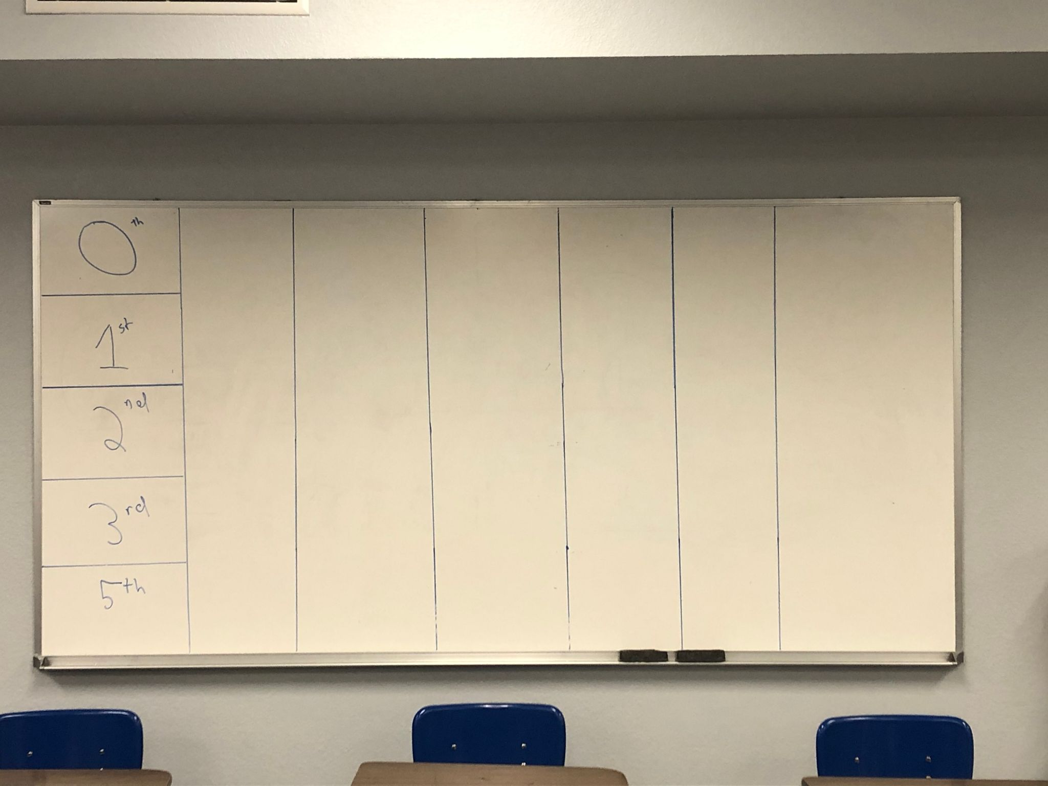
Figure 2
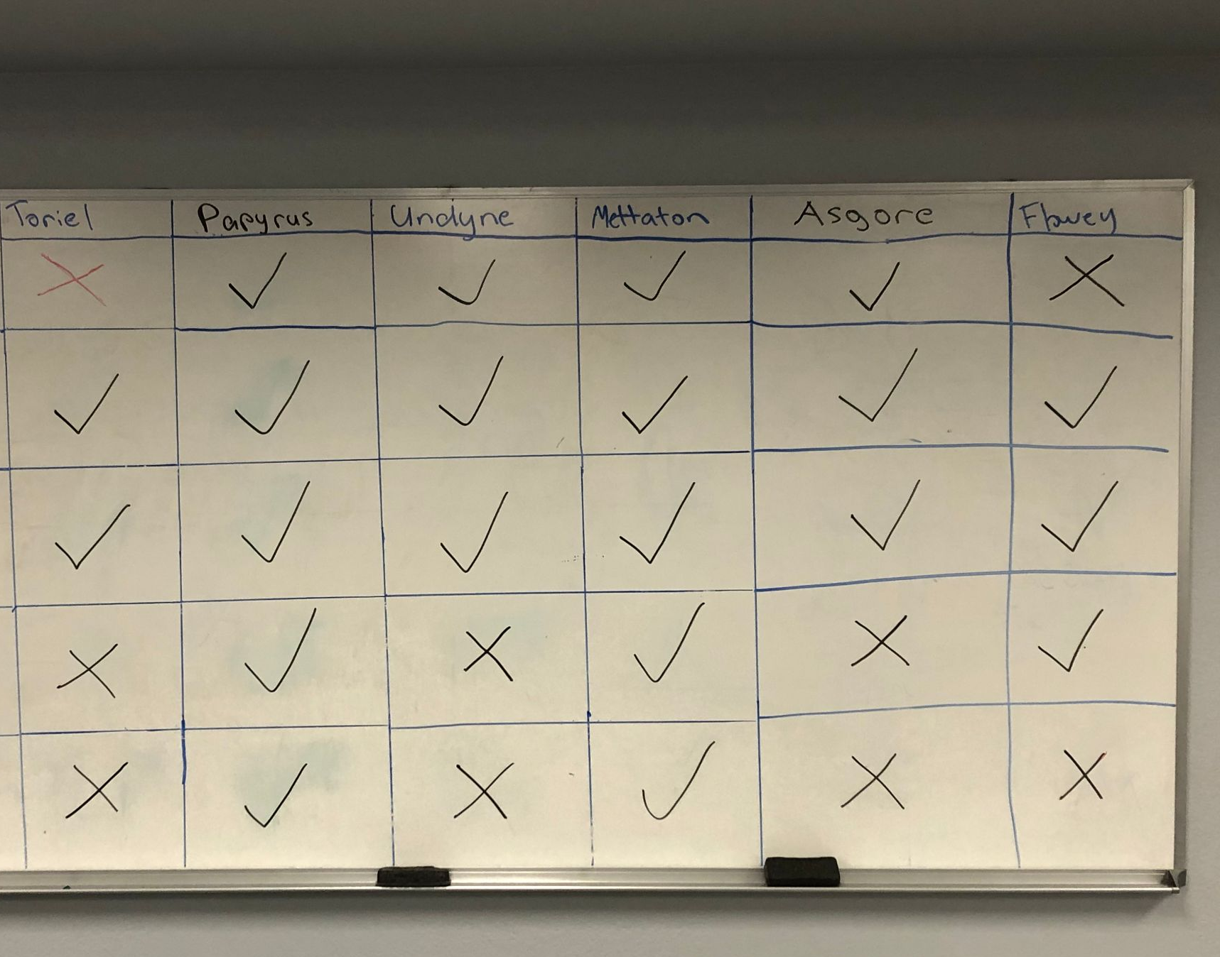

Data Collection:

The student survey was a Google Forms survey that consisted of 17 questions. There were three multiple-choice questions that focused on demographic information (age, race, and gender), and two multiple-choice questions that focused on the amount and type of video games that the participants played prior to the study. There were six Likert-like questions with a five-point scale that focused on Undertale and using video games in the classroom, followed by five short answer questions that asked students to provide specific positive and negative feedback regarding the video game lesson. Finally, there was a question that asked students to indicate if they were interested in doing a follow-up interview on the subject. Students were selected based on convenience sampling of the classrooms that the study was conducted in. Surveys were done by students in the classroom on their personal laptops. If students did not receive parental permission to participate in the survey, they answered “no” to a question at the start of the survey, which skipped the rest of the survey. Only students who received permission from their parents to participate took the full survey. Participants were given up to 20 minutes to complete the survey. A total of 13 students took the full survey out of a possible 89.
For grade analysis, a total of six assignments were looked at in the form of class averages across all 5 of the participating classes. Three of the assignments were done during the Undertale unit, and 3 of these assignments were from earlier in the year with non-video game activities. Each pair of assignments covered similar topics. There were two different argumentative essays, two persuasive posters that required the use of ethos/pathos/logos, and two more standard worksheets that each had students identify and discuss literary terms used in two different texts.

Post interviews with students

The student interview was a semi-structured interview that was based around having students go into greater detail about their thoughts on the process of using video games in the classroom, and what they thought about the specific lessons using the game Undertale. The questions covered the same general topics that the survey did, asking initial questions such as “How do you feel that the lessons using Undertale went?” and “Would you want to do more lessons using video games in the future?,” with additional follow-up questions based on their answers. Students were selected for the interview if they indicated on the survey that they were interested in a follow-up interview. A total of 2 students participated in the interview. The interviews were recorded via Zoom and transcribed at a later date. The audio will be recorded to, as Borg, Gall, and Gall suggest, provide “a complete verbal record” that can be “studied much more thoroughly than data in the form of interviewer notes” (Borg, Gall, and Gall 2003).

Data Analysis:
Following the activities, the surveys and interviews were examined and coded for common themes. The assessment results were compared to previous assessments done on previous non-video game-related activities, to see how using a video game as a text lines up with using a traditional print text, and to see if there is any improvement in engagement and/or literacy. Categories that were compared were the raw mean score, mean score without zeroes, and turn-in rate.

Chapter 4: Findings

Grade Comparison Analysis
As a point of comparison, I took three assignments from the Undertale unit, and compared the assessment results to three similar assignments from earlier in the year. A digital worksheet that required students to identify and analyze various literary elements in Undertale, such as theme, setting, and characterization, was compared to an almost identical assignment for Dreamland Burning. An artistic assignment that required students to make persuasive posters that utilized ethos/pathos/logos to argue for sparing/fighting a character in Undertale was compared to a project from the previous semester, where students had to make some kind of poster/video that utilized the same rhetorical appeals to make an argument on the topic of their choice. The final assessment of the unit, an argumentative essay where the students had to make an argument on how to handle the final boss of the game using both evidence and strong arguments, was compared to a similar argumentative essay from the first semester where students had to argue about the topic of nature vs. nurture in a subject of their choosing.
Three different numbers were looked at; the mean score of an assignment across all 5 classes, the mean score of an assignment without including zeroes, and the turn-in rate of the assignment. All grades were calculated on a standard A-F scale, with 100% being the highest possible. All raw scores (such as a 40 out of 50) were converted into percentages for consistency’s sake. The three grading categories that I analyzed for each assignment were the raw mean score of all of the classes combined, the mean score of the classes not including assignments that received a “zero” grade, and then the turn-in rate for the assignment. The turn-in rate will directly affect the mean score with zeroes, and is also generally one of the stronger indicator of overall student interest in an assignment, whether that’s from an intrinsic sense of engagement, or a more extrinsic “I need to do this assignment to get a grade” standpoint. The mean score without zeroes is the strongest indicator of how well the classes generally did on the assignment in terms of meeting standards and learning objectives, since it lacks the outlier zero scores that heavily bring down the average numbers

Grade comparison raw data:
 | Undertale Literary Terms | Dreamland Burning Literary Terms
Mean score of all classes with zeroes | 72.80% | 64.80%
Mean score of all without zeroes: | 85.90% | 82.60%
Turn-in rate: | 84.70% | 78.40%

 | Undertale Poster | T1 Persuasive Poster
Mean score of all classes with zeroes | 64.10% | 65.30%
Mean score of all without zeroes: | 86.85% | 83.50%
Turn-in rate: | 73.80% | 78.30%

 | Undertale Essay | T1  Argumentative Essay
Mean score of all classes with zeroes | 69.10% | 69.00%
Mean score of all without zeroes: | 80.90% | 78.00%
Turn-in rate: | 85.30% | 87.50%

Literary Terms Assignments:

The first assignments that are compared are two similar literary terms assignments, where students had to identify different literary terms, such as theme, characterization, or setting, within the texts of Dreamland Burning and Undertale. (See appendix 2.1 and 2.2 below for the full assignments). Standards measured were 10.3.R.2, 10.3.R.3, and 10.7.R (see appendix 3.0 below for full standards). This is probably the most directly comparable assignment, since it was done by the same students in the same classes (as opposed to the slight differences in class makeup from semester one to semester two), since these two assignments were completed within about a month of each other. Furthermore, the assignments were worth the same amount of points, with about the same amount of time in class to work on them, so multiple factors of the assignment are consistent.
The results are promising for the efficacy of using Undertale as a primary text, with all three measured areas being higher on the Undertale version of the assignment than the Dreamland Burning version. I attribute this largely to two different factors. First of all, the Undertale version of this assignment was their second time doing the assignment, so scores were more likely to be a bit higher just by nature of the students having a bit of practice at this sort of literary term identification and analysis. Secondly, the overall interest level was generally a bit higher in Undertale than it was with Dreamland Burning, so more students had “read” Undertale, which led to a fairly significant increase in turn-in rate.

Persuasive Poster Assignments:

Both persuasive poster projects were designed to primarily give students a multimodal and artistic way of showing their understanding of the rhetorical appeals of ethos, pathos, and logos. In both assignments, students had to make some kind of visual image, video, or other piece of media to convince their audience of something, and then had to include writing that explained how they used each of the three main rhetorical appeals in their projects in service of this goal. In the T1 Persuasive Poster Assignment, the students got to pick their chosen topic, and spent a full week in class designing and presenting these, so the results generally had more effort put into it, and the T1 assignment was worth significantly more points (80 vs. 20 for the Undertale poster). Standards measured were 10.4.W.2, 10.7.W, 10.7.R, 10.3.R.5, and 10.1.L.1.
The assessment results for the persuasive posters were more mixed, with the Undertale Posters having a 3.5% higher average non-zero mean, but with a 4.5% lower turn-in rate than the T1 Persuasive Posters. I attribute the higher turn-in rate largely to the fact that the T1 project was worth so many more points, but the fact that it was an assignment where students had a larger amount of creative freedom might have played into it as well. I attribute the higher grade average at least partially to the fact that this was most of the students’ second time doing an assignment like this, and they had a much stronger understanding of rhetorical appeals by the time they had gotten to this assignment. This could partially be attributed to their use of it via arguing in the Undertale unit, but could also be at least partially attributed to the fact that this was their second time doing a unit that focused on arguing.

Argumentative Essay Assignments:

The final assignments compared were the two argumentative essays. Both essays were 5-paragraphs long for the CP classes, and 6-7 paragraphs long for the honors class. Both essays required students to make strong thesis statements, and then find quotes from the respective texts and make arguments that helped to back up their thesis statements. Standards measured were 10.3.W.3, 10.3.W.4, 10.4.W.2, 10.7.R, 10.3.R.2 and 10.3.R.3.
While the turn-in rate for the Undertale essay was slightly lower than the T1 Argumentative Essay, I attribute this less to having to do with using video games as a key text, and far more to it being the last assignment of the school year. This assignment was turned in on the second-to-last normal day of the school year, which gave students a very small window (less than a week) to turn in the assignment late, as compared to the T1 Argumentative Essay, which was done in the middle of the first semester, giving students almost two months to turn in the assignment. Furthermore, I know of at least three students who, frustratingly, had completed a large portion (greater than 60%) of this essay, but then never turned in a draft, forcing me to give them a zero, as I never really had a chance to talk to them about turning the essay in late/incomplete, which certainly negatively affected the three scoring categories. Despite these factors working against the averages for the Undertale Essay, the non-zero mean score was still actually higher than that of the T1 Argumentative essay, and the turn-in rate was only 2% lower, which presents a solid result for the use of certain video games as a core text to write an essay over.

Overall grading notes:
As noted, with all three assignments, there were factors outside of the video game text that contributed to the grades being slightly higher or lower, so these comparisons are not perfect. However, all of the comparisons were remarkably close, with the biggest gap being only a 6% difference, and 6 of the 9 comparisons being in the favor of the Undertale unit. This could suggest that, at the very least, using video games as a text can be a viable alternative or supplemental text when compared to a traditional ELA text, and, with proper unit planning and text selection, potentially superior for at least some students.

Classroom Engagement Findings:
Anecdotally, I generally experienced strong results with the Undertale unit, in terms of the engagement with the material and performance on the related assignments. One way that I informally measured the engagement of the classes was through a daily “engagement journal” that I filled in after each class period over the course of the unit. For engagement, I’m using Axelson and Flick’s (2010) definition of student engagement, which is “how involved or interested students appear to be in their learning and how connected they are to their classes, their institutions, and each other.” In my engagement journal, I informally measured each class period on a scale of 1-5 per day, and added comments and notes on how the day’s lesson went with the different classes. For the purposes of this study, I have defined the numbers on the scale as follows:
1: Very poor engagement from virtually the entire class. Students are not enjoying or interested in the content at all, nor are they showing any signs of learning. Major behavior issues might be present as a byproduct of the lack of engagement. At least some students may express an explicit strong dislike of the lesson material.
2: Slightly better engagement by the majority of the class, but still below average. Many students are inattentive or unengaged, possible behavior issues as a result, or just little buy-in.
3. Average engagement. No points of engagement that stood out as remarkable or noteworthy, but no major issues, either. Maybe some kids are more/less engaged than usual, but the baseline of the class seems to be “fine.” Kids are paying attention, but not particularly interested, or the engagement might be inconsistent throughout the class period, with high and low points. This would be the baseline I would generally use to determine if a lesson was successful or not. Things above a 3 are what I would consider strong results, and things below 3 I would generally consider at least a partial failure.
4. A good level of engagement from a majority of class. There might be a few uninterested students, but most students are expressing a solid level of engagement throughout the majority of the lessons, and there are few/no behavior issues.
5. An excellent level of engagement from all or nearly all of the students in a class. There is a high level of interest in the learning material, and there is strong evidence of participation and learning from the students. Students express an explicit liking or appreciation for the lesson material.

Many days have a halfway score between a number, such as a 3.5 or a 4.5, which simply serves as a middle ground between the two numbers. Days highlighted in green are the days that we played any amount of Undertale. It should be stressed that these numbers are in no way empirical proof, and are based on my highly subjective personal experiences, usually based on a quick decision that I made immediately after a given class period. These numbers should be looked on more as a snapshot of my daily experiences.

Engagement Scores:
 |  | Class A | Class B | Class C | Class D | Class E | Daily Average Aggregate
 | Day 1 | 4 | 3.5 | 4.5 | 3 | 3 | 3.6
 | Day 2 | 3.5 | 3.5 | 4 | 3.5 | 2.5 | 3.4
 | Day 3 | 4 | 3 | 4.5 | 4.5 | 4 | 4
 | Day 4 | 3.5 | 3 | 4 | 4.5 | 4 | 3.8
 | Day 5 | 3.5 | 3 | 3.5 | 4 | 3.5 | 3.5
 | Day 6 | 3.5 | 3 | 4 | 4 | 3 | 3.5
 | Day 7 |  | 4 | 4 | 4 | 3.5 | 3.875
 | Day 8 | 3.5 | 2.5 | 3.5 | 4.5 | 4 | 3.6
 | Day 9 | 2.5 | 3 | 4 |  |  | 3.166666667
 | Day 10 | 3 | 3.5 | 4.5 | 4 | 2 | 3.4
 | Day 11 | 3.5 | 4 | 4 | 4 | 4.5 | 4
 | Day 12 |  | 4 | 4.5 | 3.5 | 4 | 4
 | Day 13 | 3.5 | 3.5 | 5 | 3.5 | 4.5 | 4
 | Day 14 | 3.5 | 4 | 4 | 3.5 | 2 | 3.4
 | Day 15 | 3 | 4 | 4 | 3.5 | 3.5 | 3.6
 | Day 16 | 3.5 | 4 | 4 | 3.5 | 4 | 3.8
 | Day 17 | 4 | 4 | 4 | 4 | 4 | 4
 | Day 18 | 3.5 | 3.5 | 5 | 5 | 5 | 4.4
 | Unit Average Per class (All Days) | 3.46875 | 3.5 | 4.166666667 | 3.911764706 | 3.588235294 | 3.724537037
Average per class (game days only) |  | 3.409090909 | 3.291666667 | 4.166666667 | 4.090909091 | 3.454545455 | 3.682575758
Average per class (non game days only) |  | 3.6 | 3.916666667 | 4.166666667 | 3.583333333 | 3.833333333 | 3.82

General results:
Overall, I would characterize the Undertale unit as a fairly strong success, from an engagement and interest perspective. There was an overall high level of interest in the story of the game, with particular high points of interest being the humor of the Sans and Papyrus section of the game along with the more serious and dramatic ending section with King Asgore. I generally saw a more engaged classroom on most days than I did during the previous few units, even though most students did express that they had enjoyed Dreamland Burning. The weakest engagement I saw was definitely when there was too much gameplay in one day, with a pretty sharp decline in interest after about 20-30 minutes of playing, which matched up with my expectations going in.
Students that would characterize themselves as “gamers” (people that frequently play video games outside of school for personal recreation, especially non-mobile games), almost universally loved the unit, and were generally the group that was most eager to play and discuss the game. This group also represented almost everyone that had played Undertale outside of class prior to my unit. While this group in my classes had more males than females, there was still a strong female contingent in my classes that were engaged in and enjoyed Undertale. Some students were simply happy to be playing a game in class, and viewed it much less as work, and more of a fun thing to do. A student that was interviewed echoed this sentiment, saying that “No other teachers [of mine] have ever really... used video games. Everybody in the class seemed really engaged, and actually seemed to enjoy playing it. On more than one occasion, I had random students who were not in my classes knock on my door and say things like “Oh my gosh, you’re playing Undertale? Can I stay and watch?” which was always a gratifying feeling. I also had several students give me Undertale art they made, including a painting of Sans and several pencil drawings of the cast, which is indicative of a deep appreciation for the game.
Of the students that I would characterize as non-gamers (people who seldom or never played video games for fun outside of class), there were mixed results. Some really got into the story of the game, while a few simply thought it was strange, and had a tough time relating to the story. As mentioned previously, students that missed multiple days of class had trouble catching up, which is very similar to past issues I’ve seen students have with missing many days of reading a play or a novel in class. In no class would I consider the usage of the game a negative to their overall engagement. At worst, it was a lateral move from using a text like a novel or a play for the large majority of students, and far more frequently, I saw strong levels of engagement that were at least partially from the usage of Undertale.

Class specific results:
Each class had its own unique narrative, which are all worth discussing individually.

Class A had the overall lowest engagement and scores on assignments, which I would partially attribute to its unique makeup. The class had a very small number of total students (12), but there were yearlong issues of chronic absences/tardies, so the number of students in the room was often 6-8. Of the students who regularly attended, about half of the students were really into the game, while the other half ranged from apathetic to inconsistently interested. It was usually the same 3-4 students volunteering to play the game and to do the reading voices, while others mostly only participated when required to. This class also had the poorest turn-in rate on assignments, both before and during the Undertale unit. For the most part, those who were interested in the game were those who had higher grades in the class, while those who had lower grades/had chronic absence/tardy issues were the ones who showed less interest in Undertale and activities related to the game, but these students had similar issues before the Undertale unit, so using a video game as the text was largely irrelevant. However, there was one student in the class with a very poor grade who was the most engaged I had seen them all year, due to how much they enjoyed Undertale, which was a promising result.

Class B was an interesting case, as they had the second lowest average engagement level, but were some of the strongest performers on the assessments, both in terms of grades and turn-in rate, which was generally the case for them throughout the entire year. This was one of the largest classes, with 23 total students, but it was often my most quiet class throughout the second semester. They frequently struggled with volunteering to participate in larger classroom discussions, but would almost always present strong work, and almost never had behavior issues. I had strong personal relationships with many of the students, so they would participate in discussions when I individually asked them, which I often had to do for both class debates over the characters and Undertale reading. There was, however, a core group of 6 or 7 students who were highly engaged throughout, having their favorite characters to “voice act” for, and always wanting to control the game. The general impression that I got from many of the students in this class (maybe 1/3rd of the total class) who seemed uninterested wasn’t that they disliked Undertale; they just saw it as another thing to get done with in school. These students were generally people who did not play video games outside of class, but even these students were able to get into certain parts of the game, especially the parts with more story and less gameplay.

Class C was the strongest performer in every area, except for turn-in rate, in which they occasionally fell behind Class B. This is unsurprising, since they were the honors class, and, with the exception of a few struggling students, had exceptional engagement and assessment results throughout the entire school year. With all but a few students, they seemed to really get into the game throughout, with strong participation in class debates and really entertaining class reading. One interesting aspect that presented itself in this class was the naming of the character. In every other class, the character’s name, which the player gets to choose, was simply named whatever the period of the class was (such as “1st Hour”). This was mostly done with the idea to avoid having the classes spend a large amount of time arguing about the name, and so that they felt like they were being specifically addressed. Class C, however, universally demanded that the name of their character be “Stuart,” and I decided to go with it, and I think it actually helped the students a lot in terms of increasing their personal attachment to the player character, who is a “silent protagonist. This class decided that Stuart was going to be a massive flirt, and attempted to flirt with every character with whom the game presented that as an option
While every class had a few students who had played Undertale before, this class had three diehard Undertale fans who knew as much about the game as I did. These students provided both positive and negative aspects to the class. On one hand, their enthusiasm for the game was generally quite infectious, and they did a fantastic job of really getting to the character voice acting. On the other hand, despite their desire to not spoil things for the rest of the class, they did occasionally slip up and say some things that influenced some of the class’s decisions in debates, and the rest of the class was generally inclined to just go with whatever their ideas were. One of those students reflected on that in the interview, saying “I had this bias of 'we can’t kill anyone, we have to get the good ending!’ so whenever someone else wanted to kill anyone, I was like ‘noo!’”
One unique assignment that only this class did was reading an excerpt from William Shakespeare’s play Julius Cesar and then writing a persuasive speech modeled after a speech from the character Brutus, but about the characters from Undertale, and these speeches were used for one of the debates for the character Mettaton. An example few lines from a speech:
“And would Mettaton’s eight to ten viewers not be sad?/And in the distance, I can hear the cries/ Of Tsunderplane’s family, mourning their loss/ We may be with monsters, but they are not evil/ They still love and are loved in return.” This was probably the most fun the class had throughout the whole unit, with the students writing some really funny and impressive speeches. In the future, I would probably do something similar with all of my classes. This class also had more advanced requirements with the final essay than the other classes did, but still performed the strongest, when looking at students who turned in their essays.

Class D was my other small class, with only 14 students. This was a co-taught class, meaning that I had several (around 5) students who were on IEPs/504 plans, or were generally low-performing. They were very middle-of-the-road with assessment results, but had the second highest engagement score after Class C, and had basically no “bad” days. However, this was a class with very few behavior issues, besides being very friendly/chatty, since many of the students in the class were very close with one another, and it was a class where I had very strong student/teacher relationships with many of the students. This class really got into the story of Undertale, and also did really well with the voice acting. This class had a large number of self-professed “gamers,” who played a lot of video games for fun outside of class, and they had been asking about playing Undertale for months, in the lead up to the game. There was frequent competition for both physically controlling the game and the voice acting parts. Some students in this class actually were so into the game that about 5 of them voluntarily stayed after the final (school scheduling changed on the last few days of school, which allowed this) in order to play through the pacifist ending of the game together. This class was generally very close in their debates and arguments, often having decisions made by a single deciding vote after a split debate. This class also did a very strong job of discussing the consequences of their actions, and looking at each decision individually, instead of simply deciding in advance what they wanted to do with all of the characters, which is what some other classes trended a bit more towards.
One student in this class did not match this enthusiasm, however. A student who basically never played games missed 5-7 days of class somewhere in the middle unit, and started to panic when they got back to school, being very confused about what was going on, to the point of getting emotionally overwhelmed. After a few days, they were largely able to get caught up and the situation resolved itself, but it did force me to acknowledge how difficult it is for students to catch up when missing a text that is largely gone over in-class, especially when it is presented in a medium that is very foreign to them.
Class E had generally been the class that I had struggled the most with throughout the year, both from a behavioral and a grading achievement perspective. This class frequently had issues with going extremely off-topic, needing more help with assignments, and having lower assessment scores than most of the other classes, besides Class A. It was also tied for being the largest class, while also being a co-taught class, which led to a very needy class in terms of personal attention. This class also had the most issues with irresponsible technology use, such as being on their phones or playing other games on their laptops during class.
When it comes to class E and the implementation of the Undertale unit, I saw both some of my biggest successes and biggest struggles. From an engagement perspective, this class had three of the worst days of being able to focus and pay attention out of any class, but still managed to have the 3rd highest overall engagement score, with a number of very strong days. One common element that I noticed in most of my classes is that students were generally interested in the parts of the game with more story and important events happening, but during times that it was more gameplay focused, such as long boss battles or extended puzzle segments, class interest was generally more mixed. This class was a notable exception to this, with a large number of students getting highly engaged with the actual gameplay. More than any other class, there was a large number of students competing over who got to use the controller, to the point that I had to make a queue list in order to make sure everyone got their fair turn. When it came to the more challenging and longer boss battles, students were highly supportive over whoever was playing, even if they weren’t in the same social circles in class, with students calling out words of encouragement or advice.
Class E was also perhaps the most responsive to the choices in the game, in terms of getting progressively more involved in the arguments as the game progressed. I vividly remember the very first student in this class to play a game’s first words when getting the controller: “When do I get to kill something?” Ironically, by the end of the game, this student was one of the biggest champions of the peaceful options, having developed a sense of empathy and attachment to some of the characters we were debating on fighting. This class in general did a very strong job with the debates, with some very close votes, with strong usage of evidence and rhetorical appeals from all sides of the arguments. Despite having a few of the worst days (which I would generally attribute more to issues of lesson planning and classroom management than the introduction of video games), I would in some ways characterize this class as the greatest example of success of the Undertale unit, as it took a class that frequently presented issues and channeled that energy into some large improvements.

Survey Results

Permission slips were given out to all 89 of my students. Of those 89 students, 19 returned signed permission slips, and were emailed links to the survey. Of those 19, 13 students completed the surveys. It is important to note that these survey results are skewed due to the optional nature of the survey, so a large majority (12 of 13) of the respondents had either an A or a B in my class. Furthermore, a large majority (10 of 13) of the students were from either class B or class C, though every class did have at least one representative in the survey. The sample size is small enough that these results shouldn’t be used to draw any conclusions about games in the classroom beyond my own classroom, and instead should be viewed as what students who were motivated to speak about video games in the classrooms had to say about it.

The results to the multiple choice questions were as follows:

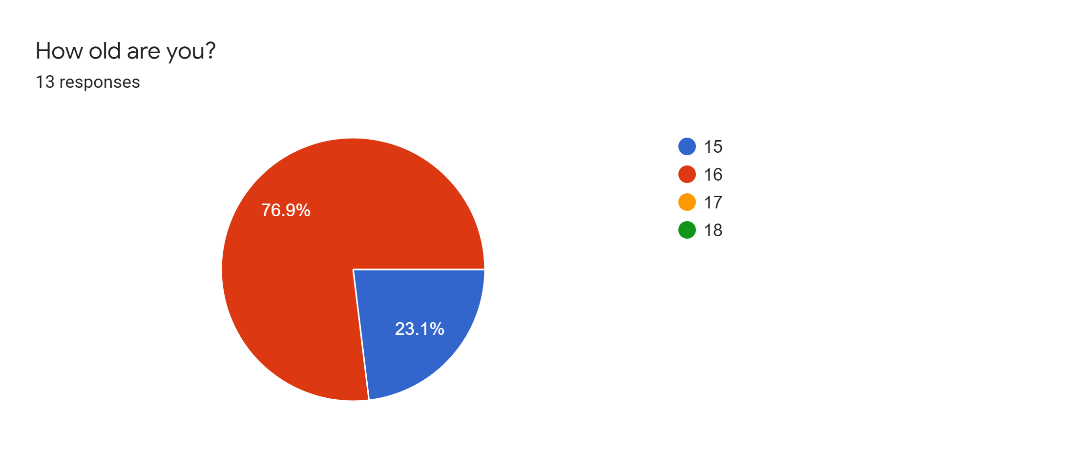
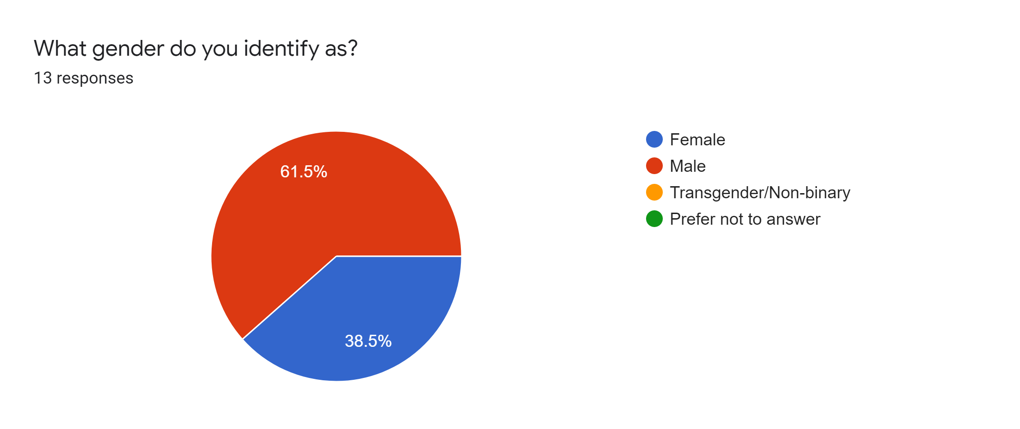

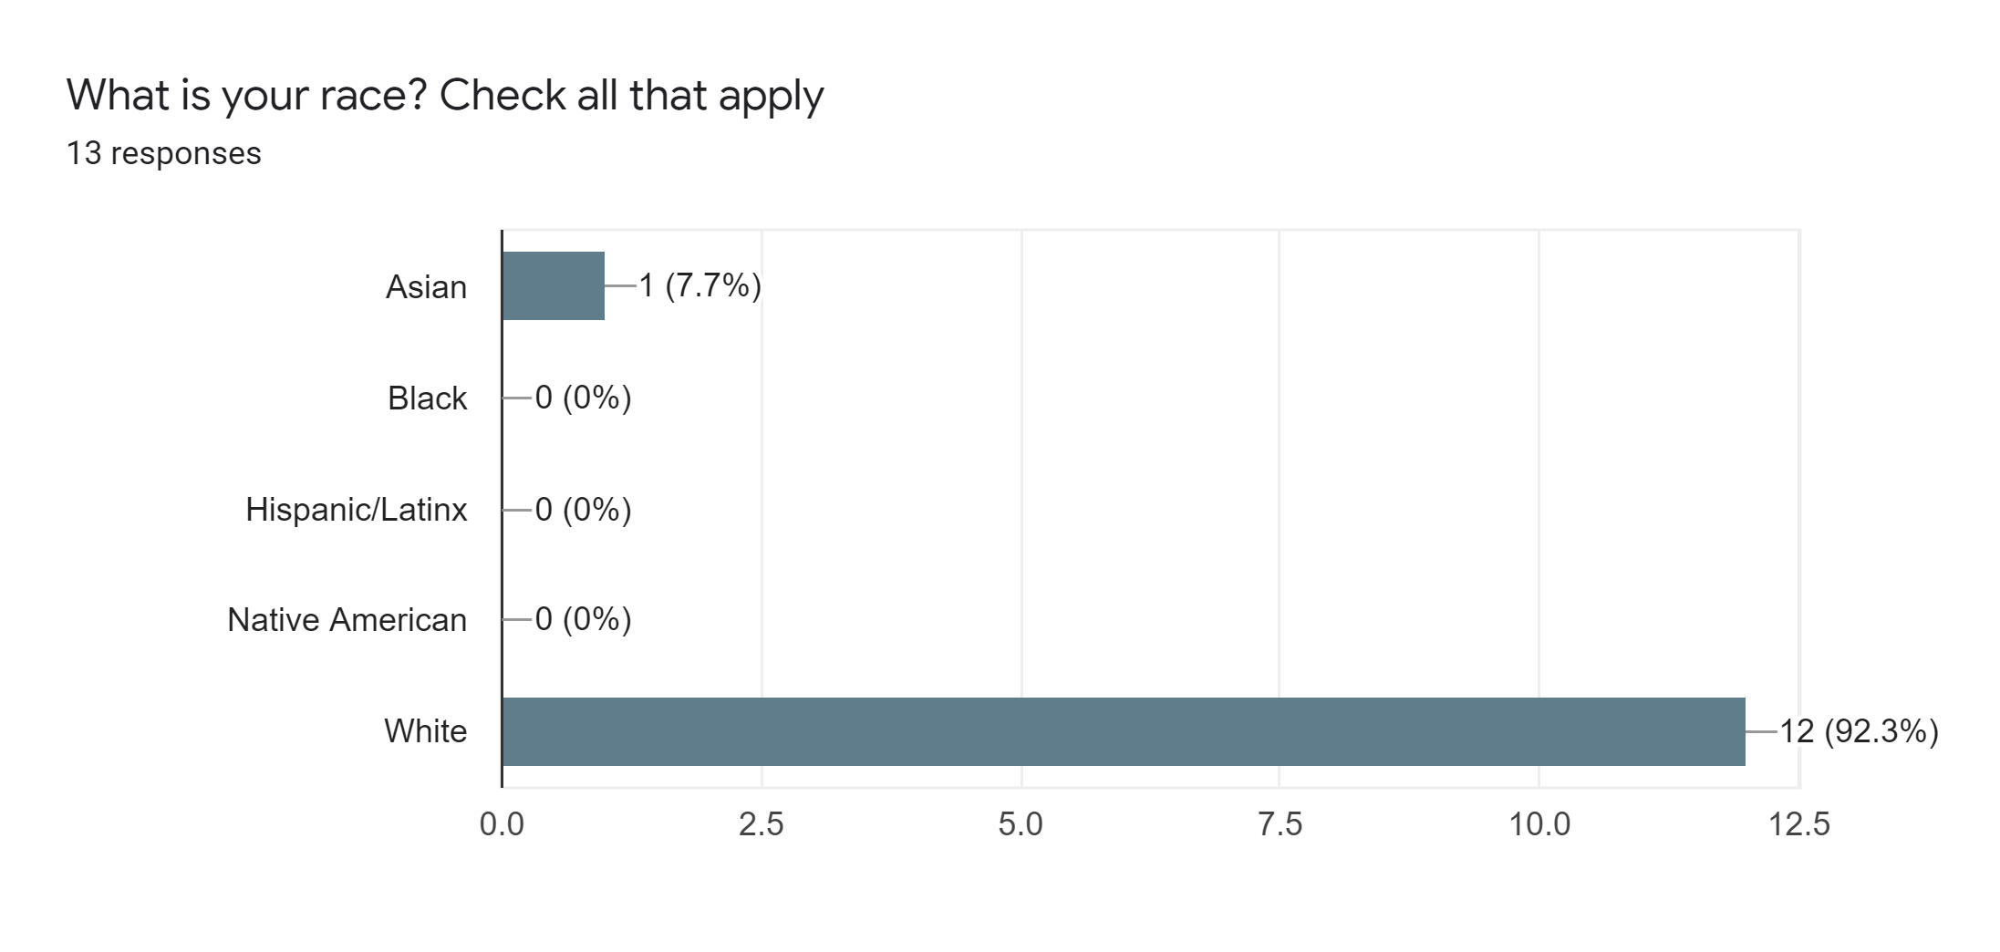
The responses to the above question more indicate the age, racial, and gender breakdown of my respondents than they suggest any kind of correlation between race and video game playing, due to the small sample size. There were a few students who were Black, Hispanic, and Native American in my classes that did not participate in the survey, but a small (generally less than five) number of each.
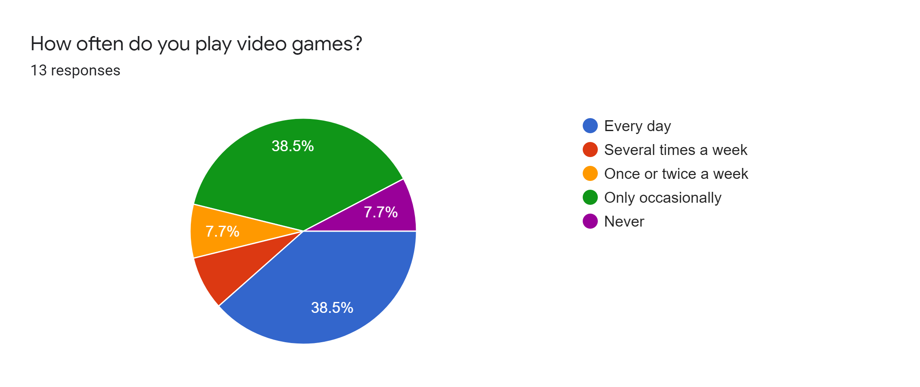
Unsurprisingly, all but one respondent reported that they played video games at least occasionally, with over half of the students playing video games at least once a week.

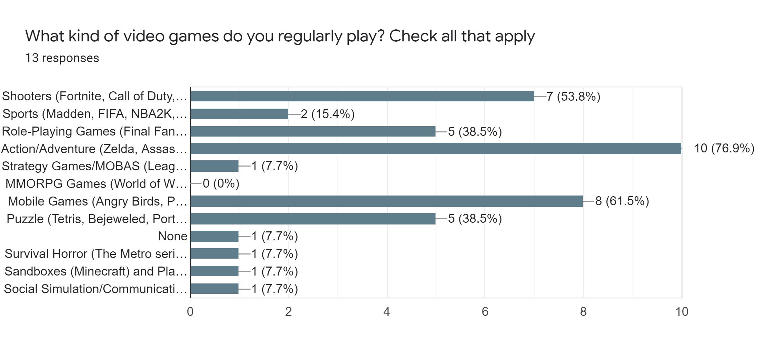
The most popular genres of games amongst the respondents are Action/Adventure games, mobile games, shooters, role-playing games, and puzzle games. Surprisingly, zero students reported playing Massively Multiplayer Online Role-Playing games, which was a much more popular genre circa 2010.

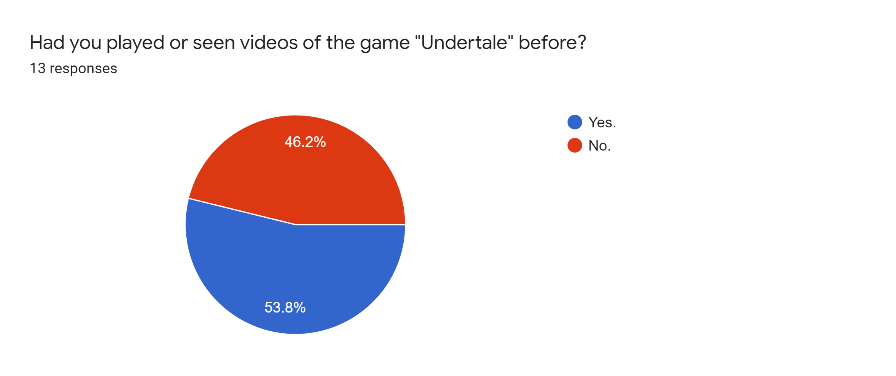

The results to the above question are also fairly heavily skewed due to the optional nature. More than half of my total students definitely had not played the game before the Undertale unit. Based on informal polling that I did, it was usually a few (three to five) students per class that had played the game. This does suggest that people who had played the game before were more willing to discuss the game more, in the form of a survey.

The following questions were Likert-type questions, with answers ranging from 1-5, with 1 being “Strongly Disagree,” and 5 being “Strongly Agree.”
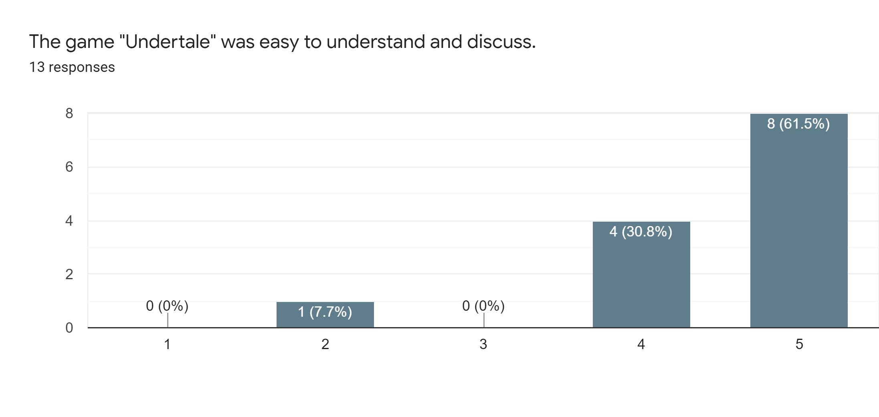

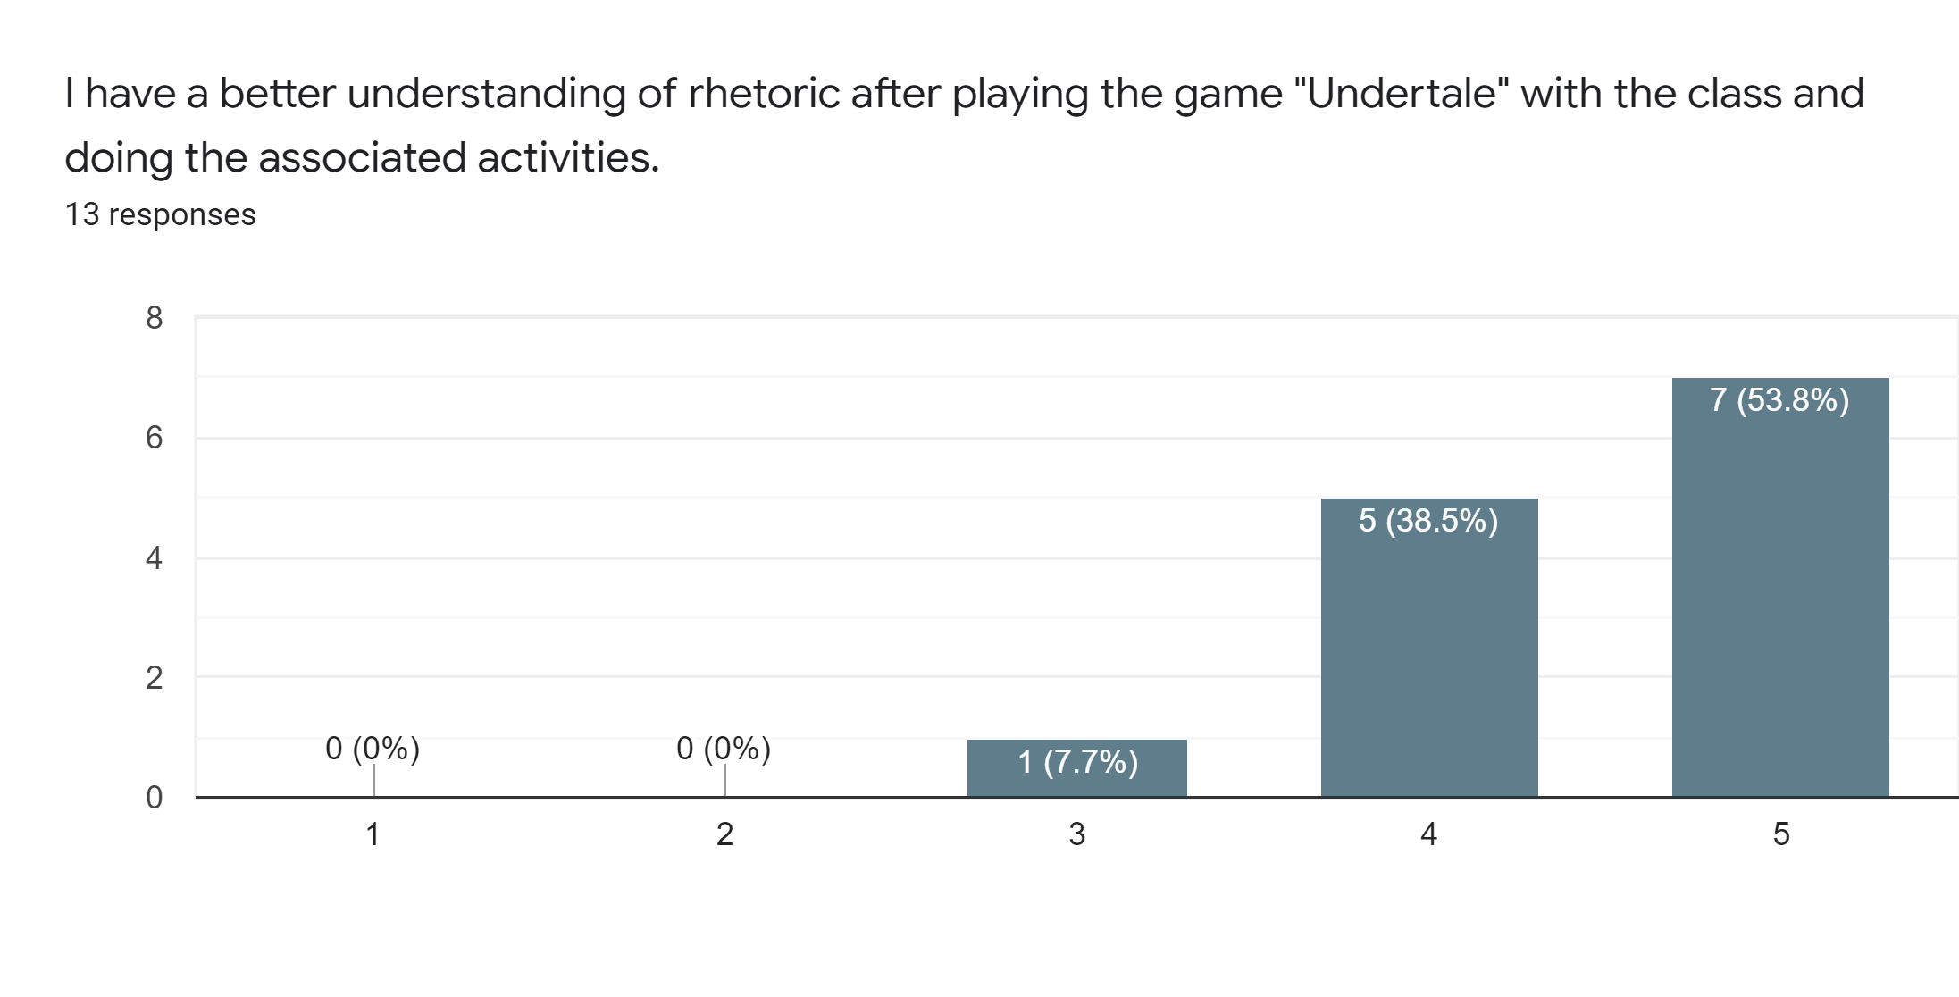
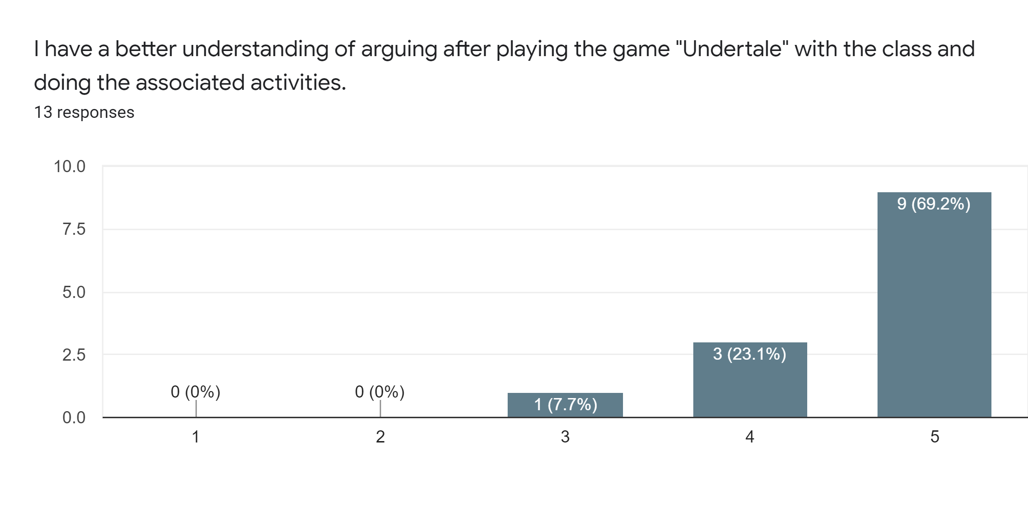
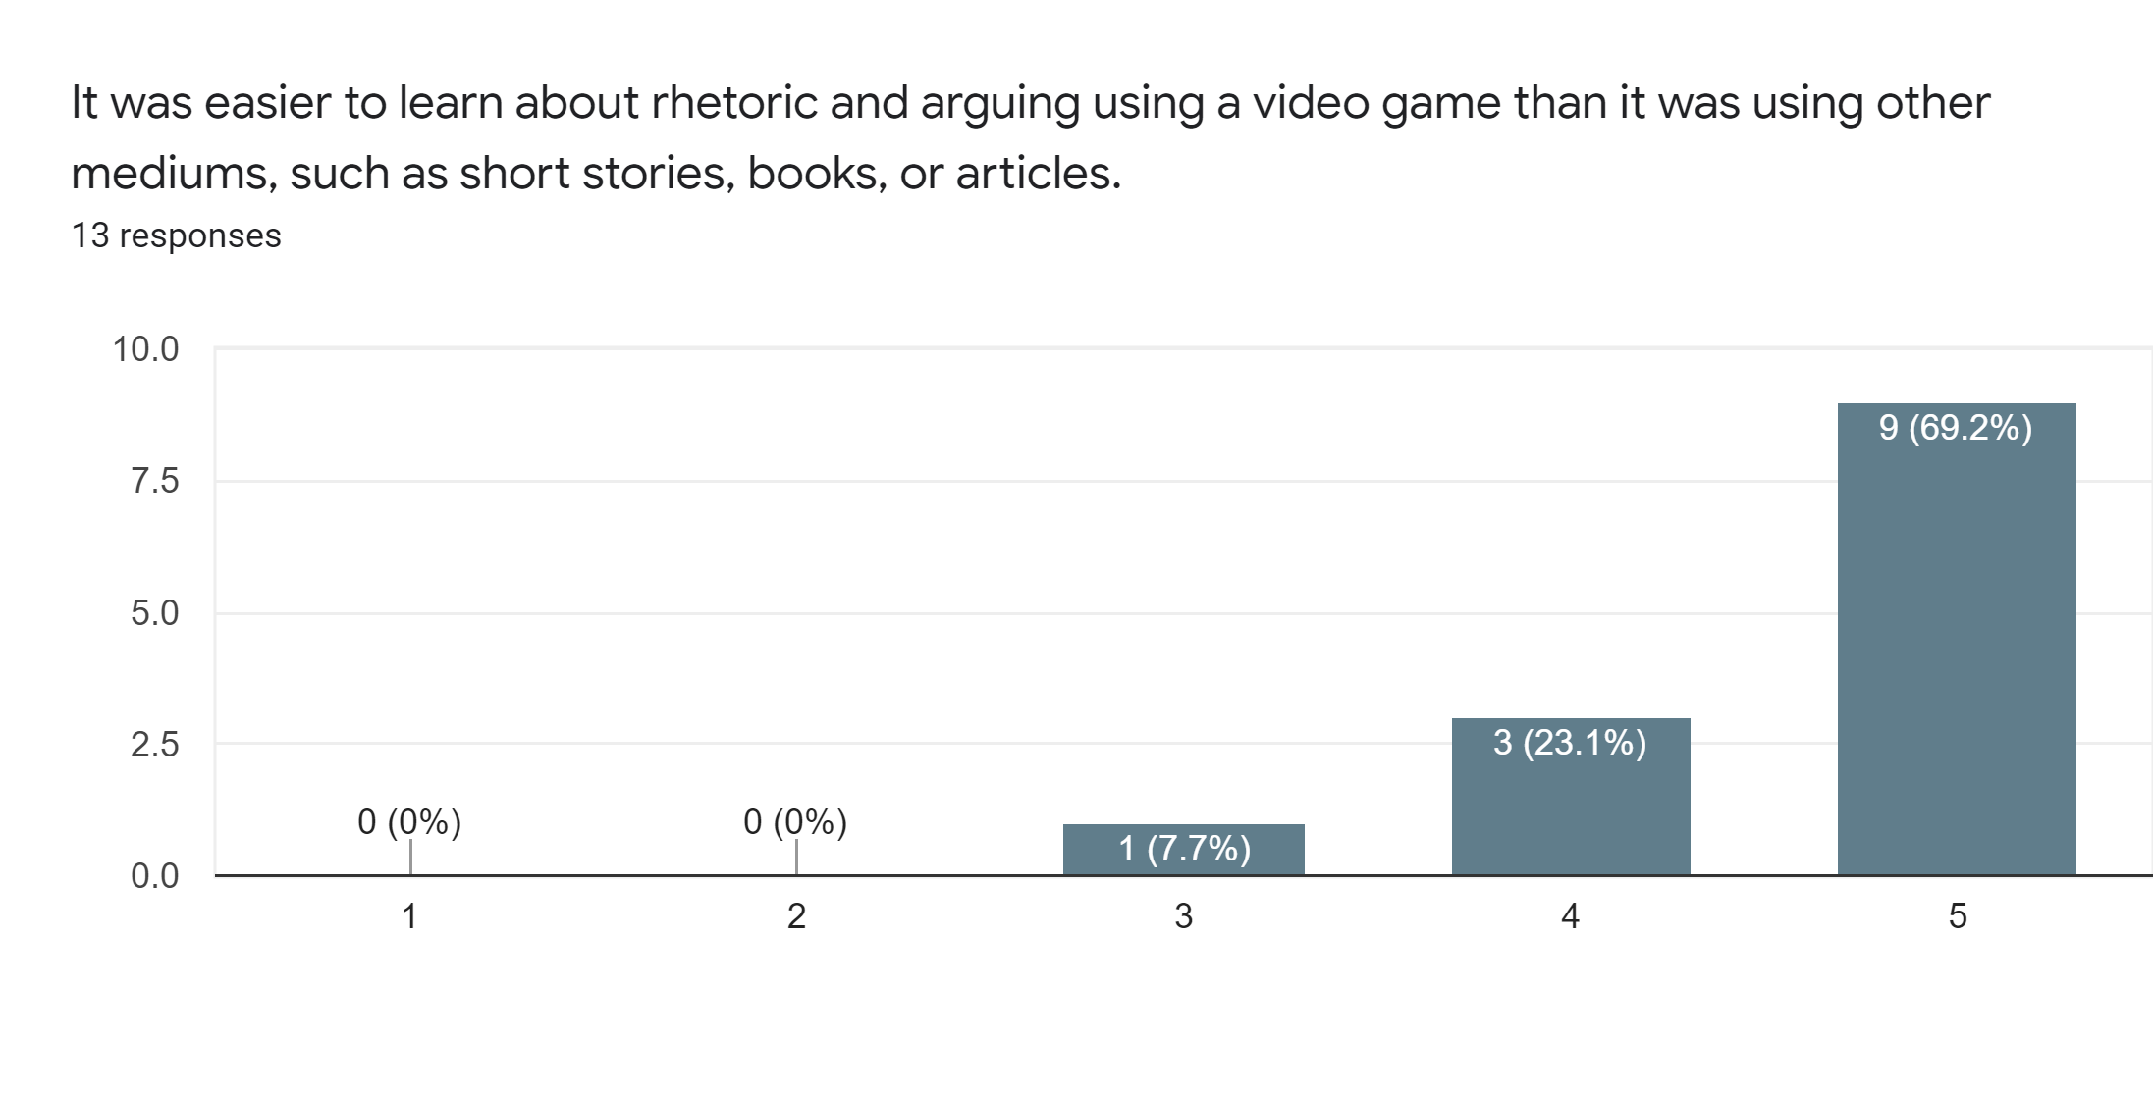
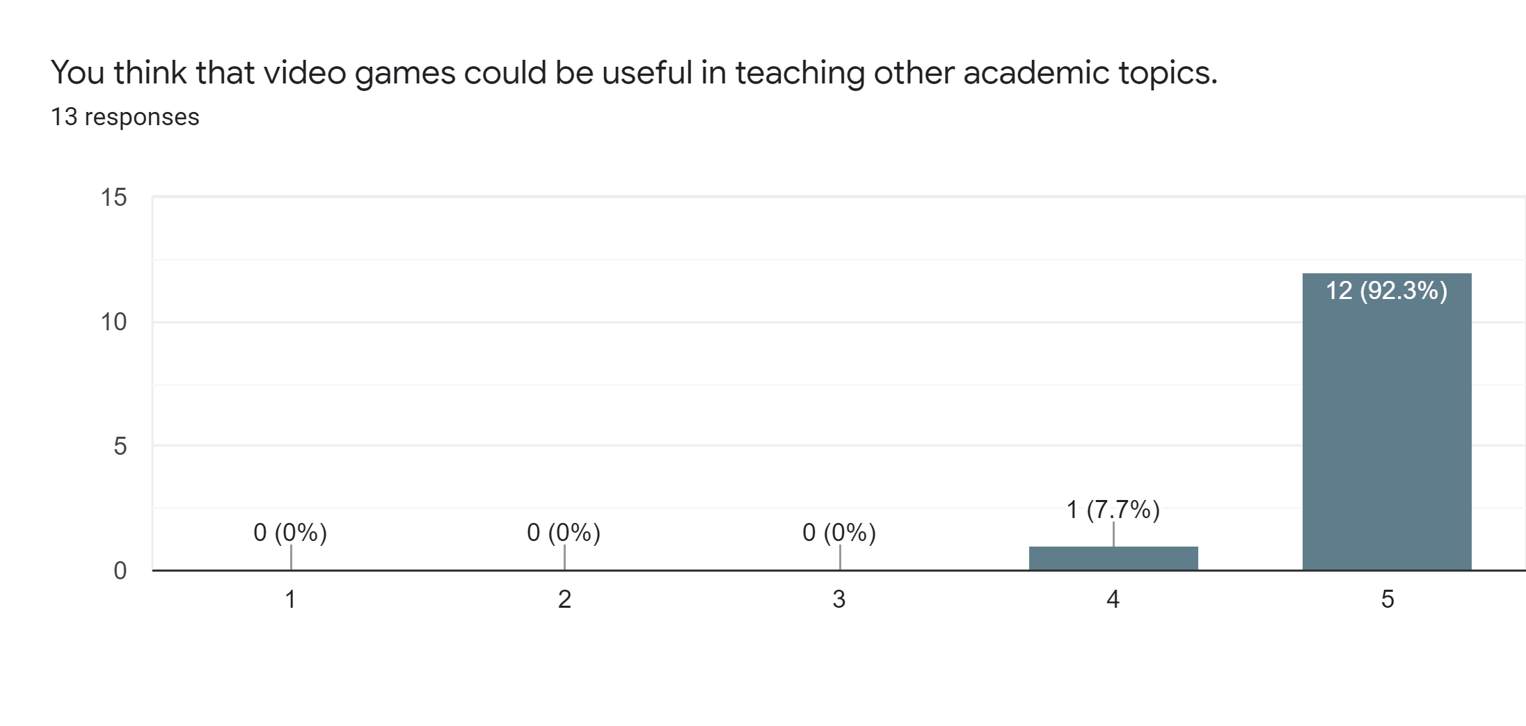
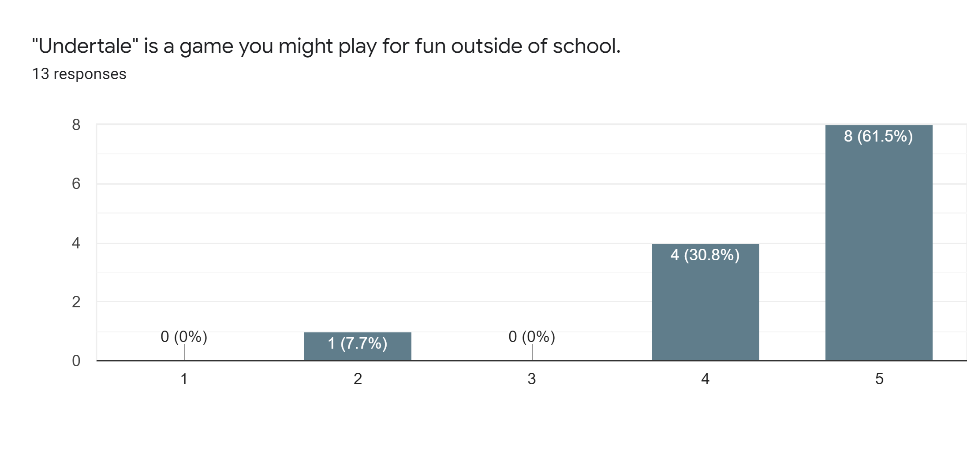
For all of the above questions, the responses were overwhelmingly in favor of liking Undertale both from an engagement perspective, and from a learning perspective. Again, this sample is heavily skewed towards students who enjoyed the game/were stronger students in general.

The following is a compilation of some of the answers to the short-answer questions that were asked. In this case, not every question was answered by every respondent.

In response to the question “What were your overall thoughts on the game Undertale?” students had a number of notable responses. Ten of the students indicated in some form that they found Undertale “fun” or “enjoyable,” with one student characterizing the game as “a unique experience.” One of the students who said it was fun did add the caveat of “…but I didn’t really understand it.” Another student, when commenting on the story, stated “It does an amazing job of dealing with a heavy topic through fun gameplay. The characters are memorable and the game is definitely one that will stick with the player for a long while.” One student wrote that it was “considered something fun rather than work.” Another student commented on how this engagement led to getting to know some of their classmates better, saying that “I noticed that...I learned a lot more about their morals and I got to engage with them more. Even the kids who do not typically play video games would offer to participate in class. Learning this way made school much more enjoyable overall.”

On positive aspects that students noticed about using Undertale to learn, and how it affected their understanding of rhetoric:
Several students commented on the engaging nature of the game compared to other units done in the class, observing things such as “It was very relatable and engaging compared to a textbook” and “As opposed to just reading a book, the students actually got to make their own choices and interact with the game, allowing for a better teaching experience.” Some form of the word “engaging” was used by 6 different students when describing the game and the classroom environment, with several students noting things like “The class paid attention more” or “Everyone was invested in the story which made everyone understand the topics went over in class.”
Some specific reasons that Undertale was engaging according to these students were aspects of the gameplay, story, and decision-making. One student stated that “It’s more interesting to watch and you have the opportunity to get a hands-on experience” while another said that “My favorite part was easily that the class was not only in control of the decisions we made, but in control of the path we were going down, without knowing how our decisions would determine the path.” Another talked about how the decision-making helped them stay connected with the text, saying “You were actively engaged in how the story went. You could remember and understand the story better because you got to be there and make the decisions. One student commented on a standout assignment, saying that “I really liked when we wrote the speech about violence in Undertale in a Shakespearean style. I felt I got to channel my dramatic side in a manner that was less constrained than typical English essays, and it was really fun to read it and hear other people read their speeches. It was a very creative way to combine two things I did not think could work together, as well as practice using ethos, pathos, and logos.”
Multiple students highlighted how the debate portions of the unit helped them get into the learning, especially the learning of rhetoric “With the amount of decisions you can make in games like Undertale, many people want to do different things. Because of this, we got to learn about arguments by arguing for what we as individuals wanted to do, which I thought was really cool.” Another student stated that “A very good positive aspect was that I noticed a lot more involvement from my fellow classmates. I learned a lot more about their morals and I got to engage with them more. Even the kids who do not typically play video games would offer to participate in class. Learning this way made school much more enjoyable overall.” One student commented on how the involvement helped them do better on assignments, saying that “Using video games was a lot more interactive and exciting than simply opening up a book and reading it, there was a lot more discussion among classmates about what actions should be taken in the game, and even when we had to write the argumentative essay or do other things similar to what we would do when reading a book, it felt more exciting and I was able to write and form arguments quicker.”

Negative aspects or issues that students noticed about using video games to learn:
When asked about negative aspects, one student gave a very thoughtful and detailed answer that I wanted to share in full:
“Unfortunately, there are a few negatives that come with implementing games with students. One of the most prominent is the fact that those who have experienced the game before might be inclined to spoil certain things about the story or how the game works. This information can alter the class opinion and cause people to make their decisions based on the spoilers that were said. Another smaller issue was the time limit which made it so that the teacher had to take over after some point in order to ensure that the story moved forward. This was disappointing but necessary as the schedule is not entirely flexible. Hopefully if this is done again it can be given more time so that the students may properly play the game without much fear of falling behind.”

Several students highlighted issues with some of the work that went along with the unit. 4 students claimed that the game could be “distracting” or that it could be “hard to focus,” especially when trying to do work at the same time that we were playing. One student was more detailed with this when referring to the daily worksheets that went along with the game, saying “I think that there should not have been so many questions about specific pieces of the game. The parts where we had to write the argument essays or paragraphs were good, but many of the other questions felt pretty unnecessary and took away from actually paying attention to the game.” Another student pointed “Less work oriented students will likely focus more on the game part of the activity rather than the actual learning involved. Some individuals also (for some strange reason) do not like games, which may hamper the learning experience,” and a third student pointed out that “some people didn't really see it as learning.”
While many students enjoyed the decision-making aspect of Undertale, some students did have some issues with it. One student said that “It was often a little frustrating to not know how your decisions would impact the course of the game, and that often made it harder for me to come to a conclusion about what to do,” while other students simply voiced their frustrations with the routes the class ended up going, saying things like “Some of the decisions I did not agree with, but the other people had a solid argument” and “people were occasionally pretty violent in what actions they wanted to take.”

Students on other potential uses for video games in education:
One student brought up the musical aspect of video games, and how it could be fitted to a music class, saying:
I believe that music classes can focus on recreating some of the phenomenal music...These video games not only encapsulate the player visually, but audibly as well and they accomplish that with flying colors. As a violist, being able to play music from my favorite games with my orchestra would be a dream come true. I do not think there is any other music I would feel more passionate about.

Another student brought up the potentially therapeutic and social advantages of games, saying “Video games are used mostly for entertainment, but they have many other uses as well. Many people have been brought closer together by these games, like friends, partners, and parents with their children. It also strengthens the bond between them. I also get stressed out a lot, and just coming home and relaxing by playing my favorite games is almost therapeutic.” Finally, one student mentioned that games could work well with creative writing, saying “It would be interesting to explore storytelling mechanics using video games, since games have many different ways they could present a story to the player. It could also serve as a good way to explore other literary elements like world building.”

Chapter 5: Conclusions
Overall, I would characterize this unit as a moderate success, in terms of using a video game as an ELA multimodal text. The data suggests that video games can have a worthwhile place in an ELA classroom, with engagement largely being above-average, and scores being comparable to those using print texts. I found Undertale to be a strong choice of text, and the combination of gameplay, story, music, and visuals served to engage a number of my students in a unique way that a more traditional text like Dreamland Burning could not do. Furthermore, this presence of multimodal aspects of Undertale allowed students to interact with the text in ways that they hadn’t necessarily done before in an ELA class. The memorable characters and humor helped draw in some students who were not necessarily into the pure gameplay element, while the act of getting to play a game in class was a novel concept that drew in some students who almost never wanted to participate. It was especially popular with the crowd of students that I would characterize as hardcore gamers, such as the bulk of Class D, who absolutely loved the game, and were the most engaged that I had seen them all year.
That is not to say that teaching using print text can’t be a great success in an English class, or even that all of my students hate everything related to reading. The Dreamland Burning unit that I did before this unit was a solid success in its own right, and score comparisons with the Undertale unit and more traditional units were relatively similar. Students generally liked the novel, (mostly) didn’t complain when we were reading it, and generally produced some solid academic results in the related activities. Using a book required much less setup and initial monetary investment on my part, and it was generally easier for students to catch up on a book than it was with a video game. If anything, I would compare playing Undertale in class much more closely to teaching a play like Romeo and Juliet, where the value is much more easily seen as a group activity, with assigning parts and reading aloud.
What this says for both myself and other English teachers is that video games absolutely can be a viable type of text to use to help engage and educate high school students. However, video games on their own are not a magical solution to be used in every scenario in class, nor would I recommend simply replacing every ELA class’s library with only video games. At their core, games like Undertale, when used within the context of teaching an English skill or concept, are simply a tool to help teach that skill or concept. Any kind of text, including a video game, requires strong pedagogical practices in their implementation, and the texts chosen should be ones that students can learn from and be engaged with. I think video games should only be used by teachers who are interested in them and actually want to use them; this is not a type of text that I think that every teacher around the world should be forced to use, as I think that teachers who are not interested in video games will struggle with implementation and authenticity. Text selection is also incredibly important, possible more so than with a novel, since the level of potentially educationally relevant content present in a video game will vary quite dramatically when compared to a novel. I would absolutely recommend other teachers trying to incorporate a game such as Undertale into an ELA class, potentially ranging from grades 8-10, due to the novel nature and overall strong engagement that they demonstrated during the unit. More than anything, I very frequently felt that my students were having fun while still learning, which is that highly desired combination that teachers so often find themselves searching for.

Limitations
One problem that presented itself in all of my classes was the fact that this was the last unit of the school year, which forced everything to be on a very tight schedule. This meant several days of playing Undertale for the entire hour, which almost always resulted in a drop-off in engagement after the first half of class. There was also some general “end of year fatigue,” which had students in some classes getting pretty antsy just from wanting summer vacation to start. There were also a small number of students who had very low grades who, with 3 weeks left in the school year, tried their best to avoid all possible work and participation, since they figured that there was no hope for them to pass.
Another limitation that is impossible to ignore is the presence of the COVID-19 pandemic in 2020-2021, and the effects that it had on school in general. By the time that I did my Undertale unit, the number of reported cases at my school had gone drastically down, and I did not have any students that missed significant class time due to the pandemic during the unit. However, I definitely did have many students miss multiple weeks of school due to COVID-related issues in the first semester, and that certainly could have impacted some of the grades from that semester. Furthermore, it being such a non-traditional school year with multiple transitions from remote to in-person learning, long-term effects of the pandemic possibly affected many aspects of students’ lives.
Due to the nature of the Institutional Review Board (IRB) requirements for using student interviews and surveys, it was difficult to ensure a large number of respondents, and I was reliant on entirely optional participation. As a result, as previously mentioned, the survey and interview results were heavily skewed towards motivated students who enjoyed the game and/or were willing to do a little bit of extra “work” to complete the survey. While I got some excellent feedback from these students, I was not able to get much formal feedback from the students who struggled with the material or thought it was just “ok,” which resulted in a fairly one-sided viewing of the video game unit. These regulations also prevented me from displaying completed student work, as that would have required extra permissions that would have taken a significantly greater amount of time to obtain.
One way in which this study is potentially limited is that in order to play Undertale in the classroom, I had to use my own personal Nintendo Switch and copy of the game, which I had to bring to school and find a way to hook up the switch to my classroom projector. This was not a major issue for me as I already owned them, but for others looking to replicate the study, they will have to find a way to get a console into their classroom. Furthermore, teachers without access to some kind of screen big enough for the whole class to see, such as a projector screen or a large television, might have a difficult time in using a video game as a classroom text in a similar fashion.
The next time I do this unit, I would change a few key aspects. I would move this unit to earlier in the year, which would help mitigate what was probably the biggest issue that I encountered, which was that of time. By moving the unit earlier in the year, I would be able to make the unit a little bit longer, which would give me more time to spread out the playing of the game, which would help some of those days with lower engagement stemming from playing the game too long in one day. I would probably try and formalize the debates and class votes a bit more, as some of them were very informal and didn’t require participation from too many students. When I did the very first practice debate, it was much more formalized, and I did a stronger job of emphasizing things like counterarguments and multiple people speaking, and I generally saw better engagement, so doing that during the actual Undertale debates would likely be a big improvement. Finally, I would try and work on adding some improved ways for students who missed class to be able to catch up on what we were doing, which was a problem that I noticed in several students.

Areas of further study

There are several other aspects of using video games as an ELA text that I think would be worth studying. I would be interested in trying to do an extended video game unit over the course of a whole semester/year, playing the game only once a week, instead of doing a 4-5 week unit, to see if using the video game as some kind of “special Friday event” type of playing would affect engagement in a positive/negative manner. Another way to test Undertale would be to see how playing the game as a class would compare to a scenario where students were given their own individual copies to play on their own, which could dramatically change the nature of the unit.
Of course, similar studies could be done with a number of other video games, and it would be interesting to see how engagement and grades would change across multiple years using many different games as primary text. Having an entire class based around using video games as the primary text, perhaps in a “Video Games as Literature” type of elective class. Having a second teacher/researcher/assistant in a classroom to provide a second measure of something subjective like engagement would be highly beneficial as well, in order to provide a more multi perspective view of the unit. Furthermore, it would be interesting to have a common assessment with another English class of the same grade, and compare how students who learned using games as their ELA text vs. students who used only traditional types of print texts do on said assessment.

Appendix/Resources from class (sample of assignments, etc.)

1.1 Full Unit Schedule:
Week 1
-Day 1:
Intro to arguing, arguing/debate practice.
-Day 2:
Undertale playthrough day 1: Introduction and Toriel’s House, Undertale Packet 1, class discussion.
Day 3:
Undertale playthrough day 2: Debate over Toriel, Toriel fight, finish Undertale Packet 1, Intro to Snowdin.
Day 4:
Undertale playthrough day 3: The rest of Snowdin, Papyrus debate and fight, Undertale Packet 2.

Week 2
Day 5:
Finish Papyrus fight for behind classes, Counterargument activity.
Day 6:
Undertale playthrough day 4: Papyrus Date, Sans Talk, Waterfall. Start packet 3. (Play through Junkyard at night).
Day 7:
Undertale playthrough day 5: Waterfall through Undyne save point, Undyne debate, finish packet 3. Counterargument assignment review.
Day 8: Undertale playthrough day 6: Undyne fight, Mettaton quiz show. Start Undertale packet 4
Day 9:
-Undertale playthrough day 7: Hotland, work on packet 4 (play through a bit at home, right up to Spider fight).

Week 3
Day 10:
Undertale playthrough part 8: Finish Hotland, skip Muffet with spider donut, hotel and Sans conversation. Finish packet 4.
Day 11:
Play up to right before Mettaton fight if needed, start working on persuasive speeches/posters for Mettaton.
Day 12:
Finish work on persuasive posters/speeches.
Day 13:
Present Posters/speeches and use them for the Mettaton debate. Undertale playthrough part 9: Mettaton fight.
Day 14:
Undertale playthrough part 10. Road to Asgore, Sans conversation, complete Undertale packet 5. Introduce essay if time.

Week 4

Day 15:
Work on argumentative essays.
Day 16:
Work on argumentative essays.
Day 17:
Finish argumentative essays, due on day 18.
Day 18:
Undertale playthrough part 11. Asgore debate and fight, Flowey fight and ending.

2.1 Undertale Literary Terms Assignment

- Provide characterization information for any 3 characters that we’ve met so far in Undertale.

a.

b.

C.

2. Describe the setting in Undertale, and explain how this setting contributes to the story.

3. What are possible themes of Undertale so far? Provide some kind of evidence or reference events in the game to support your idea.

4. What is the point of view of Undertale? How does the class being in control of the decisions that are made potentially affect how you have viewed the story?

5. How would you describe the writing style and language used in the game so far? How does this help contribute to the development of the plot and characters?

6. What could the author’s purpose be in making the story in this game?

7. What is the primary conflict of Undertale? What are some potential smaller conflicts in the game, and how do they relate to the primary conflict?

8. What are some possible symbols in Undertale?

2.2 Dreamland Burning Literary Terms Assignment

Give a definition for each of the following terms, and then find an example (either a quote or a paraphrasing) of each of these terms being used or established in Dreamland Burning. You aren’t going to find exact quotes where a character says something like “This is the theme!” Instead, it’s up to you to think critically and find an example that demonstrates the author using the specific literary terms.

1. Setting

Definition:

Example in Dreamland Burning:

2. Conflict

Definition:

Example in Dreamland Burning:

3. Language/Style

Definition:

Example in Dreamland Burning:

4. Characterization

Definition:

Example in Dreamland Burning:

5. Point of View

Definition:

Example in Dreamland Burning:

6. Author’s Purpose

Definition:

Example in Dreamland Burning:

7. Theme

Definition:

Example in Dreamland Burning:

8. Symbolism

Definition:

Example in Dreamland Burning:

2.3 Undertale Propaganda/Persuasive Poster Assignment

For the next decision in Undertale, instead of simply voting like we have been, you are going to make a piece of propaganda/a persuasive poster that is either pro or anti Mettaton or Alphys. What goes on your poster is up to you, but every poster should:

-Reference recent events and characters from Undertale
-Have Ethos, Pathos, and Logos
-Have a brief explanation written on the back of your poster that says where each of your three rhetorical appeals are
-Have enough words to make it clear what you are trying to convince people of doing
-Have color and effort put into it

This “poster” (it just needs to be on a piece of copy paper) is due at the start of class on Thursday, 5/13, and it will be potentially used to help decide our next major decision in Undertale.

2.4 Honors Persuasive Speech Assignment:

For the next major decision in Undertale (related to Mettaton and Dr. Alphys), you are going to write a persuasive speech in the style of Brutus and/or Mark Antony in Shakespeare’s Julius Caesar. Both speeches are pasted below, and both speeches involve trying to persuade the crowd of angry Roman citizens to be on their respective sides after the murder of Caesar. I

-Your speech needs to be either pro or anti-fighting in Undertale, and should specifically reference recent events in the game with Mettaton and Dr. Alphys.
-Your speech should include effective use of ethos, pathos, and logos, and should be roughly half a page long, using iambic pentameter (or at least try to make each line about 10 syllables long).
-Once you have finished your speech, highlight (in three different colors) your usage of ethos, pathos, and logos, and add comments to the side that explain your use of the three rhetorical appeals.

Brutus’ speech is attempting to calm the angry crowd and convince them to not be upset at the murder, while Mark Antony’s speech is subtly trying to rile up the crowd and make them upset that Caesar was killed.

2.5 Undertale Argumentative Essay Instructions (CP)

Prompt: In the game Undertale, is the player character justified in fighting King Asgore, or is peace the better option? When exactly is fighting the answer vs. working for peace? You will answer this question in a 5-paragraph argumentative essay that makes strong use of your argumentative abilities. These essays will directly influence the final decision that we will make in Undertale.

Requirements for your essay:
-An introduction paragraph with a strong qualified thesis statement that makes your argument clear while acknowledging a potential counterargument.
-2 body paragraphs that make a strong argument for how the class should handle King Asgore, using evidence from the game. Direct quotes are not required for this essay (you are allowed to paraphrase events/things that characters said), but A essays will generally have at least a few direct quotes.
-1 Counterargument paragraph where you bring up an opposing viewpoint, and then explain why this opposing viewpoint is flawed/not as good as your viewpoint.
-A concluding paragraph that wraps up your essay and makes it clear what you are arguing for.
-A works cited page that references any works you bring up.
-All essays should have MLA formatting.

Intro paragraph:
-Write a few sentences introducing the topic that you are talking about (Undertale, by Toby Fox).
-Your Thesis statement should be a clear statement of your opinion on how we should handle King Asgore in Undertale. However, in your thesis statement, you should qualify it, which is acknowledging another side.

Example:
Regular Thesis statement: Dogs make better pets than cats because they are smart, loyal, and funny.
Qualified Thesis statement: While cats are easier to raise than dogs, dogs still make the better pet because of their intelligence and loyalty.

Body Paragraphs:
You should have two traditional body paragraphs, which will have a claim sentence, two pieces of evidence supporting your claim, and a 2+ sentence explanation for each piece of evidence. These paragraphs should be 7-9 sentences long each.
Things you can use for evidence:
-Direct quotes from the game
-Descriptions of events that happened in the story that we’ve played and decisions that we’ve made.
-Evidence that you’ve written down in your packet
-Information that we read from the signs and echo flowers earlier in the story.
-You can always watch any of the videos from previous sessions that we’ve played so far to get quotes/remember things that happened.

Counterargument Paragraph:
-Your counterargument paragraph will look similar to a standard body paragraph, but the evidence that you will use in this paragraph will be ideas that people could use to argue against what it is that you are saying. After presenting this evidence, you will then explain either why this evidence/counterargument is incorrect, or why your arguments are more important. This paragraph should be 5-7 sentences long.

2.6 Undertale Argumentative Essay Rubric (CP)

Total ________/50 | A: | B: | C | D | F
A strong qualified thesis statement that makes a clear claim while also acknowledging an opposing point of view. The thesis also gives several reasons to justify the arguments being made. | 9  10 | 8 | 7 | 6 | 1 - 2 - 3 - 4 - 5
Quality of arguments in body paragraph 1. You present strong evidence that directly supports your claims and thesis by referencing events that happen in the game , while providing your own strong analysis(Not just summary). | 9  10 | 8 | 7 | 6 | 1 - 2 - 3 - 4 - 5
Quality of arguments in body paragraph 2. You present strong evidence that directly supports your claims and thesis by referencing events that happen in the game , while providing your own strong analysis(Not just summary). | 9  10 | 8 | 7 | 6 | 1 - 2 - 3 - 4 - 5
Counterargument paragraph that accurately acknowledges one or more arguments that oppose your own argument while also explaining the flaws with the counterarguments. | 9  10 | 8 | 7 | 6 | 1 - 2 - 3 - 4 - 5
Spelling/grammar: Minimal spelling/grammatical errors, with proper attention paid to “bad words” and character names (No “we,” “us,” “I,” “our”). | 5 | 4 | 3 | 2 | 1
MLA formatting:  -Times New Roman, 12 pt., double-spaced font. Have a proper MLA header, page numbers, and title. | 5 | 4 | 3 | 2 | 1

2.7 Undertale Argumentative Essay Instructions and Prompt (Honors)

Prompt: In the game Undertale, is the player character justified in fighting King Asgore, or is peace the better option? When exactly is fighting the answer vs. working for peace? You will answer this question in a 6 or more paragraph argumentative essay that makes strong use of your argumentative abilities. These essays will directly influence the final decision that we will make in Undertale.

Requirements for your essay:
-An introduction paragraph with a strong qualified thesis statement that makes your argument clear while acknowledging a potential counterargument.
-2-3 body paragraphs that make a strong argument for how the class should handle King Asgore, using evidence from the game. Direct quotes are not required for this essay (you are allowed to paraphrase events/things that characters said), but A essays will generally have at least a few direct quotes.
-1-2 Counterargument paragraphs where you bring up an opposing viewpoint, and then explain why this opposing viewpoint is flawed/not as good as your viewpoint.
-All body paragraphs should make strong use of the rhetorical appeals (Ethos, Pathos, and Logos). Not every paragraph should necessarily have all 3, but each should appear in your essay.
-A concluding paragraph that wraps up your essay, centers the argument back away from the counterargument and highlights your main points, and makes it clear what you are arguing for.
-A works cited page that references any works you bring up.
-All essays should have MLA formatting.

Intro paragraph:
-Write a few sentences introducing the topic that you are talking about (Undertale, by Toby Fox).
-Your Thesis statement should be a clear statement of your opinion on how we should handle King Asgore in Undertale. However, in your thesis statement, you should qualify it, which is acknowledging another side.

Example:
Regular Thesis statement: Dogs make better pets than cats because they are smart, loyal, and funny.
Qualified Thesis statement: While cats are easier to raise than dogs, dogs still make the better pet because of their intelligence and loyalty.

Body Paragraphs:
You should have two traditional body paragraphs, which will have a claim sentence, two pieces of evidence supporting your claim, and a 2+ sentence explanation for each piece of evidence. These paragraphs should be 7-9 sentences long each.
Things you can use for evidence:
-Direct quotes from the game
-Descriptions of events that happened in the story that we’ve played and decisions that we’ve made.
-Evidence that you’ve written down in your packet
-Information that we read from the signs and echo flowers earlier in the story.
-You can always watch any of the videos from previous sessions that we’ve played so far to get quotes/remember things that happened.

Counterargument Paragraph:
-Your counterargument paragraph will look similar to a standard body paragraph, but the evidence that you will use in this paragraph will be ideas that people could use to argue against what it is that you are saying. After presenting this evidence, you will then explain either why this evidence/counterargument is incorrect, or why your arguments are more important. This paragraph should be 5-7 sentences long.

2.8 Honors Undertale Argumentative Essay Rubric
Total ________/50 | A: | B: | C | D | F
A strong qualified thesis statement that makes a clear claim while also acknowledging an opposing point of view. The thesis also gives several reasons to justify the arguments being made. | 9-10 | 8 | 7 | 6 | ___/5
Quality of arguments in body paragraphs and use of Ethos/Pathos/Logos: You present strong evidence that directly supports your claims and thesis by referencing events that happen in the game , while providing your own strong analysis(Not just summary). | 20  19  18 | 17  16 | 15  14 | 13  12 | ___/10
Counterargument paragraphs that accurately acknowledges one or more arguments that oppose your own argument while also explaining the flaws with the counterarguments. This paragraph serves to strengthen your own argument, rather than weaken it. | 9-10 | 8 | 7 | 6 | ___/5
Spelling/grammar: Minimal spelling/grammatical errors, with proper attention paid to “bad words” and character names (No “we,” “us,” “I,” “our”). | 5 | 4 | 3 | 2 | 1
MLA formatting:  -Times New Roman, 12 pt., double-spaced font. Have a proper MLA header, page numbers, and title. | 5 | 4 | 3 | 2 | 1

2.9 T1 Argumentative Essay (also known as “Nature vs. Nurture argumentative Research Essay”).

For your Nature vs. Nurture essay, you must find six quotes for your three body paragraphs (2 for each paragraph). You have some quotes already from the last time we talked about Nature vs. Nurture, with the quotes coming from the stories The Outliers and The Sports Gene, as well as David Epstein’s Ted Talk. Depending on what your thesis statement is, these quotes may or may not be useful for your essay. You should not start doing research until you have written a thesis statement and have me look at it.

-You may use up to 2 quotes from these three stories.
-The other 4 quotes must come from research that you do on your own.
-These quotes should be specifically related to the topic of your three body paragraphs, and not just random things.

These quotes need to be from credible sources (news websites, research, things like .gov or .edu or .org). These quotes should all somehow relate to your thesis statement and help answer the question of: What is most important in how successful someone is in life: Nature (what a person is born with) or Nurture (how you are raised/trained)?

When you find a quote, copy and paste it into the outline document for the appropriate body paragraph. Then, copy and paste the website link underneath where you put the quote. This is very important for the citations that we will be doing together in a few days.

Think carefully about what you need to actually type in the search bar in order to find useful information. Do not just type in things like “nature vs. nurture quotes,” because that won’t give you anything specific. Instead, think of things related directly to your topic. If you are arguing that hard work is important, you might search for things like “the benefits of hard work” or “how many hours does ___ practice a day” and see what comes up.

2.10 Nature vs. Nurture 5-Paragraph Essay Rubric from Semester 1:
Student Name: _______________________________________
______/15 Intro Paragraph:
_____/5 Hook and background sentences
_____/10 Thesis statement that clearly answers the prompt, and has three reasons to
justify your opinion
______/20 Body Paragraph 1:
______/5 Claim Statement that goes back to your thesis statement
______/5 2 Relevant Quotes with Citations
______10 Both quotes are thoroughly explained and analyzed with at least two
sentences per quote
______/20 Body Paragraph 2:
______/5 Claim Statement that goes back to your thesis statement
______/5 2 Relevant Quotes with Citations
______10 Both quotes are thoroughly explained and analyzed with at least two
sentences per quote
______/20 Body Paragraph 3:
______/5 Claim Statement that goes back to your thesis statement
______/5 2 Relevant Quotes with Citations
______10 Both quotes are thoroughly explained and analyzed with at least two
sentences per quote
______/5 Concluding Paragraph:
______/10 Overall MLA Formatting, Spelling, and Grammar:
_____/5 Times New Roman, 12 Pt. Font, Double Spaced, Works Cited Page
_____/5 Proper Spelling, Grammar, and Punctuation, no “bad” words (you, I, etc.)
______/90 Total

2.11 Propaganda/Persuasive Media Project Instructions:
Now that you have learned about the rhetorical appeals and propaganda, it’s time to make some persuasive media of your own. Your goal is to make either a poster, short video, commercial, speech, or use other medium in order to persuade an audience to do something. This can be honest persuasion, or it can be propaganda. Your topic can be silly or serious, real or fictional. These projects will be presented to the class.
Step 1: Pick something that you want to convince an audience to do. This can be one of the following, or something different. It can be almost anything, as long as it is school appropriate and is approved by me. Once you’ve figured out what you want to do, you must complete the proposal sheet to be approved by me.
-Support a political change/law: (example: “Vote for Mr. Woodard for president!”)
-Change a school rule/policy: (example: “Students should be allowed to wear hats in school”)
-Get people to start, change, or quit a habit: (example: Stop smoking, or “Save the environment”)
-Get people to buy a product (example: “Buy Call of Duty MW23!”)
-An idea that you come up with on your own: Anything that you can think of that someone might use persuasion/propaganda for that doesn’t fall into one of the above categories. Must have teacher approval.
Step 2: Pick the medium that you are going to use for your propaganda. It can be one of the following:
-Poster/Flyer:
Requirements:
-Must be either one large poster (poster board size), or 3+ smaller posters (regular copy paper sized).
-Must be neat, detailed, and in full color.
-Must clearly use images and accompanying words to persuade the audience.
-Video/Commercial:
Requirements:
-Must be at least 90 seconds long
-Must have an accompanying script
-Must have editing and effort put into making it look good (audio should be clear, good transitions, etc.).
-Must use the video format to good effect— stuff should be happening in your video, it shouldn’t just be you reading off of a script.
-Speech/Presentation (to be presented to the class):
Requirements:
-Must be at least 2 minutes long
-Must have an accompanying script
-Must be clearly well-rehearsed and make good arguments to convince its audience
-Other idea that you come up with (must be approved by the teacher first).
-If you have an original idea, I will give you specific requirements individually.
Step 3: Pick the methods of persuasion that you want to use from the following list. You must use at least two of the three rhetorical appeals of ethos, pathos, or logos. Below are different ways that you can use the three. (You can also come up with your own with teacher approval, and there are more examples right here):
Ethos  Attacking the Person:  Testimonial:  BandWagon:  Pinpointing the Enemy: | Pathos  Appealing to Fear:  Appealing to Basic Needs & Desires  Slogans/Repetition  Powerful Images | Logos  Selection  Lying:  Rhetorical Questions  False Cause & Effect  Assertion  Broad Generalizations

Requirements for all types of project:
-Must have a clear message/idea that your propaganda is trying to convince an audience to follow.
-Must have at least three different instances of persuasion.
-Must use of all three of the rhetorical appeals (Ethos, Pathos, and Logos).

-Before starting to make your propaganda, you must have a filled out proposal sheet, approved by the teacher, which will tell me the choices that you are going to make for your project. This proposal sheet will be turned in for a separate grade.

Each project must be accompanied by a 1-paragraph paper that explains the following:
-A full paragraph with proper grammar, spelling, and punctuation.
-Explains what the piece is trying to persuade, the intended audience, and
the types of rhetorical appeals (Ethos, Pathos, and Logos) used, and how you used them.
-MLA Formatting

2.12 Propaganda/Persuasion Project Rubric from Semester 1:
________ /15 Presentation:
-Fully explain project by describing what the propaganda is trying to persuade,
the intended audience, and the types of persuasion used.

________/15 Accompanying Paragraph:
-A full paragraph with proper grammar, spelling, and punctuation.
-Explains what the piece is trying to persuade someone to do, the intended audience of the persuasion, the types of rhetorical appeals (Ethos, Pathos, and Logos) used, and how you used them.
-MLA Format

________/10 Participation: (Working on Project during class)

________/40 Project: See below

________/80 Total:

Poster/Flier  ______/8 Has a clear message/thing that is trying to persuade the audience to do.  ______/8 Either one large poster (poster board size), or 3+ smaller posters.  ______/8 Neat, detailed, and in full color.  ______/8 Clearly uses images and accompanying words to persuade the audience.  ______/8 Properly uses at least two of the rhetorical appeals (Ethos, Pathos, and Logos). | Video  ______/8 Has a clear message/thing that is trying to persuade the audience to do.  ______/8 At least 90 seconds long  ______/8 Has an accompanying script  ______/8 Good editing and effort put into making it. (audio should be clear, good transitions, etc.), makes good use of video format  ______/8 Properly uses at least two of the rhetorical appeals (Ethos, Pathos, and Logos). | Speech/Other  ______/8 Has a clear message/thing that is trying to persuade the audience to do.  ______/8 At least 2 minutes long  ______/8 Must have an accompanying script  ______/8 Must be clearly well-rehearsed and make good use of the speech format (good inflection, appropriate volume, etc.)  ______/8 Properly uses at least two of the rhetorical appeals (Ethos, Pathos, Logos).

2.13 Undertale Playthrough Packet

Undertale Day 1 and Day 2: The Ruins.

- Who is the main character? Where are they, and how did they get there?

- The player character meets two other characters very early in the story. Name and briefly describe each character and what your early impressions of this character are (Do you like them? Are they trustworthy?).

a.

b.

- At this point in the story, we’re not quite sure what is going on in the world. Write down as many “clues” as you can (at least 5) as we explore the ruins and the mansion. You will be using this as evidence for a future decision, so write down strong/useful information.

- What is your theory about what’s going on here?

- Based on what you’ve seen so far, write a 3 sentence argumentative statement (claim, evidence, and an explanation of your evidence) for how the class should resolve the conflict in the mansion.

- What did the class ultimately decide to do? Do you agree with their decision, or not?

CP Undertale Playthrough: Snowdin (Day 2-3)

1. After leaving the ruins, the player character meets two brothers. Describe these two brothers (looks, personality, etc.), and explain what you think of both of them.

2. Describe some of the devious traps and puzzles that the player character has to deal
with, thanks to the two brothers.

3. The two brothers frequently reference a third character. Who is this character, and what can we assume about them so far?

4. What specific kind of monsters guard the area? How did the class choose to deal with them?

5. When you get to the town of Snowdin, you will have 15 minutes to explore. Write down as much information about the world and the two brothers as you can (write down at least 5 things). This will be evidence used to formulate your argument.

6. Write down a 3 or more sentence argument discussing how the player should handle Papyrus. Use evidence from the previous question to support your argument.

7. How did the class decide to deal with the boss? Do you agree or disagree with their decision?

Honors Undertale Playthrough: Snowdin (Day 2-3)

- Write down as much information and evidence that you can gather about the world and the characters that we interact with today. You will eventually use this information to write an argumentative paragraph, so gather good information.

- How do you think that the player character should deal with the boss of the area? Write a short argumentative paragraph explaining your argument. Focus on using ETHOS in your arguments.

Undertale Day 4/5 (Waterfall)

- What ends up happening on the date with Papyrus?

- What do we learn in our conversation with Sans?

- What do we learn about the history of the world from the signs and echo flowers?

- Who tells us about Undyne, and what do we learn about her?

- After today’s playing, how do you feel about the class decision to spare Papyrus? Do you still think that you did the right thing? Explain your reasoning.

- What happens during the encounter with Undyne on the bridge?

- Write down a 2-3 sentence argument for how you think we should deal with Undyne, and explain your reasoning.

- Now that you’ve written your argument, write down a hypothetical counterargument to your own argument.

Undertale Packet: Hotland and the Core

- How did the class decide to handle Undyne, and how do you feel about the decision?

- Once inside the laboratory, the player meets two characters. Describe these two characters, and what they do upon meeting the player.

- What did we find inside of the lab?

- How does Dr. Alphys help us? What is suspicious about the help that she provides?

- How does Mettaton attempt to stop us? What is suspicious about these events?

a.

b.

c.

- Write down any useful information that you learn about Alphys, Mettaton, the Core, and King Asgore across our time in Hotland. Look for at least 5 things that you could potentially use as evidence.

- What do we eventually learn about the mystery of Alphys and Mettaton?

- How do you think we should handle Mettaton? Write a 3 sentence argument that uses at least TWO of the three rhetorical appeals (ethos, pathos, and logos).
- After the battle with Mettaton, what does Dr. Alphys tell the player character about escaping from the Underground?

- What important things do we learn on the way to Asgore’s castle from the various monsters?

- What do EXP and LOVE mean normally, and what do we learn that they mean in this game? Does this make you think differently about any of the decisions that we’ve made so far?

- Who is the Queen of the Underground/the wife of Asgore?

- Write down every potential reason that you can come up with for both fighting and sparing King Asgore. Come up with at least three of each, but the evidence you can gather here will be helpful for your essays. Consider not just what we learn in the Castle today, but about what all of the characters and lore has been saying about him/the world for the entire game.

Reasons to fight:

Reasons to spare:

3.0 Oklahoma State English Standards:
The following standards are excerpted from the 2021 Oklahoma State Academic Standards for English Language Arts. These are not all of the standards, just all of the standards that are relevant for the Undertale unit and associated lessons and activities.

10.1.L.1 Students will actively listen using agreed-upon discussion rules with control of verbal and nonverbal cues. 10.1.L.2 Students will actively listen in order to analyze and evaluate speakers’ verbal and nonverbal messages by asking questions to clarify purpose and perspective.

10.1.S.2 Students will follow agreed-upon rules as they engage in collaborative discussions about what they are reading and writing, expressing their own ideas clearly, building on the ideas of others, and respectfully disagreeing when necessary in pairs, diverse groups, and whole-class settings.

10.3.R.2 Students will evaluate authors’ perspectives and explain
how those perspectives contribute to the meanings of texts.

10.3.R.3 Students will evaluate how literary elements impact theme,
mood, and/or tone, using textual evidence:
● setting
● plot structure (e.g., foreshadowing, flashback, in media
res)
● conflict (i.e., internal, external)
● characters (e.g., protagonist, antagonist)
● characterization (i.e., direct, indirect)
● point of view (e.g., narrator reliability)
● archetypes

10.3.R.5 Students will evaluate the validity of a speaker’s argument:
● distinguish the kinds of evidence (e.g., logical,
empirical, anecdotal)
● distinguish substantiated from unsubstantiated claims
● analyze rhetorical appeals (i.e., ethos, logos, pathos)
● identify bias
● identify logical fallacies

10.3.R.6 Students will analyze how informational text structures
support the author’s purpose.

10.3.W.3 Students will compose argumentative essays, reviews, or
op-eds that:
● introduce precise, informed claims
● include a defensible thesis
● acknowledge counterclaims or alternate perspectives
● organize claims, counterclaims, and evidence in a
logical sequence
● provide the most relevant evidence to develop balanced
arguments, using credible sources
● use sentence variety and word choice to create clarity
and concision
● use style and tone that suits the audience and purpose

10.3.W.4 Students will blend narrative, informative, and argumentative
writing to suit their audience and purpose.

10.4.W.2 Students will select language to create a specific effect in writing according to purpose and audience.

10.7.W Students will create engaging multimodal content that intentionally addresses an audience and accomplishes a purpose.

10.7.R Students will analyze and evaluate the techniques used in a variety of multimodal content and how they contribute to meaning.

References
2019 Essential Facts About the Computer and Video Game Industry. (2019, May 29). Retrieved
July 9, 2019, from https://www.theesa.com/esa-research/2019-essential-facts-about-the-computer-and-video-game-industry/
Adams, M. G. (2009). Engaging 21st-century adolescents: Video games in the reading
classroom. English Journal, 98(6), 56-59. Retrieved from http://www.ncte.
org.steenproxy.sfasu.edu:2048/library/NCTEFiles/Resources/Joumals/EJ/0986-
july09/EJ0986Engaging.pdf
Axelson, Rick D., and Arend Flick. 2010. “Defining Student Engagement.” Change: The
Magazine of Higher Learning 43(1): 38–43.
Barr, Matthew. "Video Games Can Develop Graduate Skills in Higher Education
Students: A Randomised Trial." Computers & Education 113.C (2017): 86-97. Web.
Drummond, A., & Sauer, J. D. (2014). Video-games do not negatively impact adolescent
academic performance in science, mathematics or reading. PLoS One, 9(4) doi:http://dx.doi.org.ezproxy.lib.ou.edu/10.1371/journal.pone.0087943
Héctor Alejandro Galvis Guerrero. "Using Video Game-Based Instruction in an EFL Program:
Understanding the Power of Video Games in Education." Colombian Applied Linguistics Journal 13.1 (2011): 54-70. Web.
Gall, M. D., Borg, W. R., & Gall, J. P. (2003). Educational Research: an Introduction. Boston:
Pearson.
Gee, J. P. (2008). What video games have to teach us about learning and literacy.
Basingstoke: Palgrave Macmillan.

How Many People Play Video Games. NPD Group. (2020, July 20).
https://www.npd.com/news/press-releases/2020/more-people-are-gaming-in-the-us/.
Jewitt, C. (2008). Multimodality and Literacy in School Classrooms. Review of Research in
Education, 32(1), 241–267. https://doi.org/10.3102/0091732X07310586
Jewitt, C., & Kress, G. (2010). The Routledge International Handbook of English, Language and
Literacy Teaching. (D. Wyse, R. Andrews, & J. V. Hoffman, Eds.). Routledge.
Loveless, T. (n.d.). 2017 Brown Center Report on American Education: How Well are American
Students Learning?
Marino, M. T., Gotch, C. M., Israel, M., Vasquez, E., Basham, J. D., & Becht, K. (2014).
UDL in the Middle School Science Classroom: Can Video Games and Alternative Text Heighten Engagement and Learning for Students With Learning Disabilities? Learning Disability Quarterly, 37(2), 87–99. https://doi.org/10.1177/0731948713503963
Oklahoma State Department of Education. (n.d.). Oklahoma Academic English Standards.
Oklahoma State Department of Education. https://sde.ok.gov/oklahoma-academic-standards.
Selfe, C. L., Mareck, A. F., & Hardiner, J. (2007). Computer Gaming as Literacy. In
Gaming Lives in the Twenty-First Century (pp. 23–35). New York City, NY: Palgrave Macmillian.
Shute, V. J., Ventura, M., & Ke, F. (2015). The power of play: The effects of Portal 2 and
Lumosity on cognitive and noncognitive skills. Computers & Education, 80, 58–67. doi: 10.1016/j.compedu.2014.08.013
Simpson, Elizabeth, and Frances A. Clem. Video Games in the Middle School Classroom."
Middle School Journal 39.4 (2008): 1-14
Smith, E., & Deitsch, E. (2007). Lost (and Found) in Translation. In Gaming Lives in the
Twenty-First Century (pp. 53–70).
Smith, Spencer, and Samantha Chan. "Collaborative and Competitive Video Games for
Teaching Computing in Higher Education." Journal of Science Education and Technology 26.4 (2017): 438-57. Web.
Undertale. Metacritic. (2015, September 15). https://www.metacritic.com/game/pc/undertale.

