UNIVERSITY OF OKLAHOMA
GRADUATE COLLEGE

MODELING FUTURITY: EXAMINING EPISTEMOLOGICAL ASSUMPTIONS AND POLITICAL CONTEXT IN URBANIZATION MODELING

A THESIS
SUBMITTED TO THE GRADUATE FACULTY
in partial fulfillment of the requirements for the
Degree of
Master of Science
Geography and Environmental Sustainability

By
SHELBY SNAPP
Norman, Oklahoma
2022

MODELING FUTURITY: EXAMINING EPISTEMOLOGICAL ASSUMPTIONS AND POLITICAL CONTEXT IN URBANIZATION MODELING

A THESIS APPROVED FOR THE DEPARTMENT OF
GEOGRAPHY AND ENVIRONMENTAL SUSTAINABILITY

BY THE COMMITTEE CONSISTING OF

Dr. Jennifer Koch, Chair
Dr. Laurel Smith
Dr. Laura Harjo

© Copyright by SHELBY SNAPP 2022
All Rights Reserved.

Contents
Acknowledgements vi
Table of Figures vii
Table of Tables viii
Abstract ix
Chapter 1: Introduction 1
Chapter 2: Background 5
Chapter 3: Materials and Methods 14
3.1 Overview 14
3.2 Study area 14
3.3 Selection of Landscape Metrics 16
3.3.2 Landscape Level Metrics 17
3.3.3 Class Level Metrics 17
3.3.4 Patch Level Metrics 18
3.4 FUTURES Calibration 18
3.4.1 Oklahoma County 19
3.4.2 Tulsa County 22
3.5 Model Validation 24
Chapter 4. Results 26
4.1 Landscape Metrics Results 26
4.1.1 Statewide Landscape Metrics 26
4.1.2 Oklahoma City Landscape Metrics 26
4.2 FUTURES Simulation Results 31
4.2.1 Oklahoma County Results 31
4.2.2 Tulsa County Results 33
Chapter 5: Discussion 36
5.1 Decision to Use a Computer Simulation Model 36
5.2 Case Study of Three Input Datasets 38
5.2.1 Population projections based on Census Data 38
5.2.2 Protected Areas and Static Land Ownership 41
5.2.3 Land Use Data 45
5.3 A nayri kati Approach to Models and Data 48
5.4 Limitations and Further Research 50
Chapter 6. Conclusion 52
Bibliography 54

Acknowledgements

First and foremost, I would like to thank my advisor, Dr. Jennifer Koch, for her the time, support, encouragement, and insight she gave me throughout the entire duration of this project. I appreciate her patience and guidance as this project changed forms several times to become what it is today. I would also like to thank her for her broader support throughout my graduate experience from working on interesting projects together, to encouraging me to pursue opportunities I would have never gone for myself – I could not have done grad school without her! I also thank my committee members, Dr. Laurel Smith and Dr. Laura Harjo for their invaluable guidance both on this project and in the classroom. The classes I took with both of them challenged me to engage in thoughtful research, and I will carry the things I learned in their classes with me forever.
I also thank my friends and cohort in DGES for cultivating an invigorating learning environment in every class we shared. I cherish the opportunity to have learned from such a diverse group of just genuinely cool people. Thanks to Becky, James, Megan, and Olivia especially for the encouragement, support, and comradery over the past two years – I am going to miss you guys!
Finally, I would like to thank my friends, family, and community, especially my partner, Jordan. Thank you for listening to my countless ramblings about my project and for always asking me the tough questions, even when I didn’t want to hear them. Thank you for your love, friendship, and care. Thank you for encouraging me to pursue grad school and thank you for being there, always. I love you.

Table of Figures

Figure 1 Domain of Aboriginality Framework. Figure from Walter (2009) 12
Figure 2 Tribal land overlap with counties in the Oklahoma City Metropolitan area. 15
Figure 3 Tribal land overlap with counties in the Tulsa Metropolitan area. 16
Figure 4 Observed urbanization in Oklahoma County between 2001 and 2016 20
Figure 5 Observed urbanization in Tulsa County 2016-2019 23
Figure 6 Tribal Lands and Urbanized Areas in the Oklahoma City Metro 28
Figure 7 Tribal Lands and Urbanized Areas in the Tulsa Metro 30
Figure 8 Probability distribution of simulation results for Oklahoma County 32
Figure 9 Observed Urbanization in Oklahoma County 2016 – 2019 33
Figure 10 Probability distribution of simulation results for Tulsa County 34
Figure 11 Observed Urbanization in Tulsa County 2016 – 2019 35

Table of Tables

Table 1 Input data for FUTURES model 18
Table 2 Significant Predictors for Oklahoma County 21
Table 3 Significant Predictors 24

Abstract

Computer simulation models projecting urban expansion are useful for academics, planners, and stakeholders interested in land use patterns and their future implications. Although urban simulation models are being expanded to account for complex political dynamics present in the landscape, none have explored potential relationships between tribal borders and urbanization. In addition, each simulated output of such models examines only one possible future. It is important to recognize and critically engage with assumptions made throughout the modeling process, especially in Oklahoma where specific political processes such as land runs and allotment of tribal lands may have affected the physical landscape. Through calibrating an urban simulation model to Oklahoma, I examine any deviant spatial patterns in the landscape between tribal and non-tribal land, and critically engage with the modeling process. I do so by examining three key input datasets used to parametrize the model and I uncover epistemological assumptions that are absent of Indigenous epistemologies or are rooted in violence toward Indigenous people. In analyzing assumptions present in the three datasets, I also illustrate how alternative datasets could potentially be used to express planning priorities that align with Indigenous planning goals. This research is important because adding historic and modern political context to the modeling process may lead to widening the kinds of knowledge that are considered during the process going forward which can address questions of equity in planning processes.

Chapter 1: Introduction

Computer simulation models are useful tools for planners, academics, and stakeholders, among others, interested in both historic and potential future land use patterns. Land-change models such as the FUTure Urban-Regional Environment Simulation model (FUTURES), SLEUTH, and LandShift (Meentemeyer et al. 2013; Clarke et al. 2001; Schaldach et al. 2009) are being expanded and their applications improved to consider regional-specific phenomenon or account for the effect of future policy decisions on development patterns (Dorning et al. 2014; Lei et al. submitted 2022). The ability to account for regionally specific phenomena is especially important in places with unique political and cultural histories that have and continue to influence the physical landscape. Large swaths of Eastern Oklahoma, including parts of the Tulsa Metropolitan Statistical Area (MSA), were allotted in the 19th century, for example. To date, modeling scenarios using land-change models such as FUTURES have largely ignored urban areas overlapping with Indigenous land.
This research seeks to address this gap in three ways. The first is through a landscape analysis of Oklahoma’s two largest metropolitan areas, Oklahoma City and Tulsa. Every county in the Tulsa MSA exists entirely on tribal land. The second portion of the project consists of a calibration of the FUTURES model to simulate potential urbanization in the urban cores of Oklahoma City and Tulsa. The aim of this analysis is to see if any landscape patterns observed in the first step potentially persist over time. The third portion of this research analyses epistemological assumptions in the datasets and processes used in model calibration.
Definitions of landscape are diverse and are constantly reconfigured within the literature (Nazar and Mansouri 2017; Meinig 1976; Cresswell 2013). For the sake of this project, I encompass physical, historical, cultural, and political attributes of a place into the term “landscape” to fully encompass the myriad spatial imaginaries that exist concerning the same place. Cultural differences may encourage or discourage urban development or land use categorization. I chose to operate within this definition because each attribute influences urban development to some degree and are considered within FUTURES. For example, the physical slope of an area may discourage urban development, but so may the legal status of a parcel of land. I also include imaginations of the future of a place in my definition of landscape as modeling projects can be forward-looking. To exclude future transitions from landscape would leave the definition lacking. I am cognizant to leave this definition relatively broad to account for diverse relations to land or contending conceptualizations of the same landscape that I may not be able to recognize or engage within my positionality as a settler researcher.
Modeling landscape and urban scenarios such as the one described in this research are often used in planning contexts, which means that they have the potential to inform policy development (Jakeman et al. 2006). As such, it is important that the context and limitations of such modeling scenarios are carefully communicated (Edmonds and Akman 2002). While Edmonds and Akman (2002) argue that model results should be contextualized, this project seeks to expand that focus to include contextualizing input data and decisions made within the modeling process. Since data exist as political entities, it is important for this context to include historical relationships between data and the people or landscapes about and by which they are produced to be communicated alongside any modeling outcomes (Walter and Andersen 2013). For urban areas that exist on tribal land, this context is important considering the historical violence enacted on Indigenous peoples for such places to exist in the first place (Chang 2010; Wolfe 2006). This means uncovering and communicating the historic and contemporary relationships between agencies that produce and maintain data used to calibrate models and the people the data attempt to describe. Since models simulate potential future scenarios and often inform policy, they serve as tools of knowledge production (Edmonds et al. 2019). Thus, it is important to identify and contextualize epistemological assumptions that may be present in the data and modeling methodologies to examine who stands to gain or lose from simulated futures. This research, then, also explores historical relationships and epistemological assumptions present in the datasets and methodologies I used to calibrate FUTURES for the Oklahoma City and Tulsa urban cores. To this end, the modeling exercises I undertake in this research to serve primarily as a means by which I can engage with epistemological assumptions made in a specific modeling scenario, meaning that although I aim to simulate scenarios that display a business-as-usual historic pattern of urbanization, I am not attempting to predict where future urbanization may occur in Oklahoma. While the context of this project is assumptions made in and about Oklahoma’s largest urban areas, I hope to communicate the importance of contextualizing and historicizing quantitative analysis more broadly.
I chose to implement the FUTURES model since it is conceptually straight-forward and has been used to accurately simulate urban development in the past (Lei et al. submitted 202; Dorning et al. 2014). FUTURES also requires diverse datasets representing physical, cultural, and political aspects of the landscape that were well-suited to use in my critical engagement with input data. Finally, FUTURES is free and open source which means that this research could be easily duplicated by others, if desired.
The three main research questions I seek to address are:
1. In what ways do urbanization patterns differ between cities and towns in/outside those borders?
2. What assumptions are present in datasets commonly used in land use change simulations?
3. What kinds of knowledge are excluded during the modeling process?

Chapter 2: Background

Models are diverse and can be used for many purposes (Edmonds et al. 2019; Kelly et al. 2013). This project uses the FUTure Urban-Regional Environment Simulation (FUTURES) model, a computer simulation model designed to simulate future urban growth in a specific study area. This model, unlike its similar predecessors, accounts for the spatial configuration of a landscape by considering both “field-based and object-based representations of land change” (Meentemeyer et al. 2013: 787). FUTURES is a multilevel modeling framework comprised of three submodels: POTENTIAL, DEMAND, and a patch-growing algorithm (PGA). The POTENTIAL submodel considers socioeconomic, environmental, and infrastructural factors to determine site-suitability for future development. The DEMAND submodel calculates the rate of future development demands based on projected population growth and historical area demand. The PGA uses stochastic simulation to convert cells from “undeveloped” to “developed” based on site suitability determined by distance from a seed cell as well as weighted POTENTIAL indicators, including random elements to account for unpredictable human behavior (Meentemeyer et al. 2013). The latter allows us to account for leapfrogging patterns (Lei et al. submitted 202; Dorning et al. 2014). These elements affect both site selection and patch configuration.
FUTURES can account for policy measures, such as prioritizing infill, through a dynamic INCENTIVES parameter to reflect potential policy or planning guidelines to conserve forests or farmland (Meentemeyer et al. 2013). Dorning et al. (2014) used FUTURES to investigate conservation tradeoffs, such as protecting sensitive natural resources, between conservation strategies, such as prioritizing infill development, by adjusting incentive parameters. They also accounted for social phenomena, such as a strong property rights culture by building a development constraint parameter into the model. The ability to roughly factor social and political phenomena into a model results in a powerful knowledge production tool that allows planners and stakeholders to consider diverse hypothetical development scenarios that could inform future planning objectives and policy development (Jakeman et al. 2006).
However, Edmonds (2002) and Jakeman et al. (2006) stress that models are only useful if their context is fully articulated. This context dissuades modelers from “deceiving ourselves with overambitious schemes…” (Edmonds 2002: 235). To this end, Edmonds and Moss (2004) and Edmonds (2020) suggest a move away from the “Keep it Simple, Stupid (KISS)” modeling approach and moving toward the “Keep it Descriptive, Stupid (KIDS)" approach. There are many arguments in favor of keeping models simple, but this simplicity is problematic when simplicity is incorrectly conflated with truth, especially when modeling complex systems (Edmonds and Moss 2004). Further, accepting simplicity often means interpreting a set of assumptions as good or true without adequate justification or critical examination. Accepting a set of assumptions about complex systems is a political act that deserves attention and a critical lens. Therefore, communicating the limitations and complexity of a modeling scenario is vitally important. The KIDS modeling approach begins with complexity and only simplifies when doing so is thoroughly justified (Edmonds and Moss 2004).
While Edmonds and Moss (2004) advocate for the KIDS approach to model-development, complexity and context are also vital when using and communicating outcomes from existing models. Such context includes clearly indicating that models are only one out of many ways to conceptualize the world, meaning that the modeler must clearly differentiate between the model and the real world when discussing the results of a modeling exercise (Edmonds 2020). Quantitative analysis and data are often considered to be objective truths about the world. However, many feminist theorists among others have problematized objectivity, stating the impossibility of a “view from nowhere” (Haraway 1988). Quantitative data and research are produced by researchers with their own unique positionality that informs their selection of which metrics to measure (Walter and Anderson 2013). Thus, when modeling, it is critical to not only consider the context and complexity of model assumptions themselves, but also to examine the assumptions made within the input data used to parametrize the simulations, as this determines the implications and context of model output.
Walter and Andersen (2013) argue that quantitative analysis is inherently political in settler colonial states such as Oklahoma, because it can serve as a “settler artifact that serves [its] master and disserves [its] subjects” (21-22). Most of the land considered in the study area of this research is Indigenous land as decided by the ruling in the McGirt v. Oklahoma Supreme Court case (Miller 2020). The dispossession of Indigenous peoples from their land has been central to the United States’ policy of erasure and assimilation of Indigenous people (Wolfe 2006; Nakano Glenn 2014). In North America, the dispossession of land and sovereignty of Indigenous people, is a form of structural genocide (Wolfe 2006). This means that Indigenous futures are tied directly to the determination and sovereignty of the land (Cook-Lynn 1997). As far as urban simulation models analyze land use change, it is critical to consider the historical and contemporary political relationships between the producers and maintainers of the data used in the models and the land the models are considering.
This positionality is especially deserving of critical consideration in contexts where quantitative analysis has been used as a vehicle of violence in datasets, such as U.S. census data, that are frequently used to calibrate, validate, and drive land-change models in the United States. For example, Jobe (2004) articulates the ways that the U.S. constitution and the U.S. census created racial hierarchies used to assign political power through taxation and governmental representation in the United States. Additionally, the U.S. census provided numerical data to support the formation of settler-colonial policy as well as providing information on Indigenous populations to the Secretary of War to gauge potential threats to American settlers (Jobe 2004). Walter and Andersen (2013) argue that data generated through quantitative statistical methods, such as census surveys, both produce and express reality. The co-production of statistics and reality is apparent in the decisions of census surveyors in the 19th century to count some Indigenous people as “White” or “Indian” based on colonial measures such as blood quantum or degree of assimilation, as decided by the individual surveyor (Jobe 2004). Measures such as these sought to eliminate Native futures and cast Indigenous populations as historic artifacts that would not be present in an American future (Wolfe 2006; Tallbear 2013). In addition, data about Indigenous populations tends to be poorer in quality, irrelevant to the needs and desires of Indigenous communities, and controlled by entities external to those of the represented population (Rainie et al. 2017). Finally, the census has historically and systematically underrepresented Indigenous, and other historically marginalized, populations in counts which results in political underrepresentations (Bates and Mulry 2011; Rainie et al. 2017).
Maps and Geographic Information Systems (GIS) methodologies are also co-producers of reality that are often used to perpetuate colonial interests at the cost of Native futures (Palmer and Rundstrom 2013). Palmer and Rundstrom (2013) recount the historical development of GIS in the Bureau of Indian Affairs (BIA), one of the main vehicles of settler colonial policy and practice in the United States. The first implementation of GIS at the BIA was to help private corporations secure access to timber on Native land (Palmer and Rundstrom 2013). Blomley (2003) also emphasizes the role of spatial surveys as a means to impose settler spatial orders and property regimes on colonized lands by producing boundaries and a spatial ordering that could then be enforced through punitive legal means. The output of models are often maps, thus it is important to recognize the power and co-productive nature of mapping techniques and provide the context in which such maps should be considered and operationalized.
Most of the datasets used in this and similar research are also produced or maintained by state and federal agencies such as the Bureau of Land Management that imposed settler property regimes on Indigenous land (Blomley 2003). An imposition of settler property regimes onto Indigenous land is directly relevant to the study area, since many of the counties present in the study area, such as Muscogee County, were subject to allotment laws under the Dawes Act (Chang 2010). Under the Indian Removal Act in the 1830s, the Muscogee (Creek) Nation was forced to move from their ancestral homelands, in what is now Alabama, to what is now the Muscogee (Creek) Nation in Eastern Oklahoma (Chang 2010). Before allotment, the land within the Muscogee Nation was owned communally. In the years that followed the Civil War (1861-1865), land in the Muscogee Nation was allotted, with fixed amounts of land assigned to individuals based on the “Native blood” held by the individual (Chang 2010). Any leftover or “surplus” land was subsequently sold to white settlers. Allotment required a surveying and restructuring of the land for the physical makeup and ownership logics of the land to align with property hierarchies deemed necessary by American capitalism (Chang 2010). To follow Blomley’s (2003) logic, the restructured mapping of Muscogee land allowed for a “detached view” of the violence of allotment. These examples, then, reveal the settler positionality that seeks to erase Indigenous epistemologies and people present within quantitative data such as the census or surveys of the landscape. This political context is critical considering models are knowledge production tools that can be used to produce spatial imaginaries about the future of a place.
Walter and Andersen (2013) stress the co-productive nature of quantitative analysis. This co-production is especially important in simulation models where the results of simulations can often be misrepresented as a characteristic fact about the world or give undeserved weight to modeling outcomes (Edmonds 2020, 2022). Since models are knowledge production tools, their outcomes contribute to a particular imaginary of the future, thus a specific futurity, of the area modeled. The term “futurity” refers to the ways in which “the future is rendered knowable through specific practices… and, in turn, intervenes upon the present” (Tuck and Gatzambide-Fernandez 2013:80). Since urban simulation models such as FUTURES or SLEUTH seek to simulate and visualize potential future spatial arrangement of development, it is important to examine the assumptions that accompany simulations to examine the assertions of futurity embedded within the process. As demonstrated above, many datasets produced by settler entities have historically and contemporarily been used as tools of Indigenous erasure, meaning that a settler futurity is assumed within them and potentially prescribed for the future through validation approaches that aim to reproduce the past. Settler futurity always seeks to eradicate Indigenous peoples and sovereignty (Tuck and Gaztambide-Fernandez 2013). Since modelers, and potentially stakeholders, may implicitly assume settler futurities in their data and model scenarios, any description of model outputs must include not only assumptions made within the model, but in the data itself used to calibrate, parametrize, validate, or run the model, following Edmonds and Moss’s (2004) call for models to be descriptive more than anything else.
Since the scenario exercise in this research is concerned with future land use change, it is also important to consider which definitions and land use practices are assumed in the modeling process. By examining the disconnects between settler and Indigenous land use definitions and practices, the ways in which settler futurities can be assumed in the modeling process become clearer. In addition to differing land ownership principles as noted previously, planning principals also differ between settler and Indigenous frameworks. For example, Jojola (2008) argues that often a settler land use ethic “becomes the embodiment of a corporate entity that develops it with the primary intent of raising capital valuation” which can lead to “slash-and-burn economics” that includes the quick sale, resale, and development of land (43). An Indigenous land use ethic, however, would consider the environmental impacts of a development project in the “seven generations” context in which the effects of a project would be considered much further in the future (Jojola 2008). In the context of urban simulation modeling, algorithms such as the patch-growing algorithm in FUTURES can represent each ethic in terms of probabilistic weight. By defaulting to status-quo or business-as-usual development ethics and by aiming to represent the past processes that shaped a landscape to project into the future, we assume a settler development policy, thereby unintentionally risking contributing to and supporting the perpetuation of settler futures.
By addressing the ways in which modeling land use and urban scenarios can unintentionally uphold settler epistemologies, we can begin to imagine models as quantitative tools of Indigenous futurity. Simulation models, then, become tools with emancipatory capabilities following the framework of nayri kati (meaning, “good numbers” in the palawa Tasmanian Aboriginal language) proposed in Walter and Andersen (2013). nayri kati (capitalization foregone to maintain linguistic consistency with palawa language) is a research methodology that “does not take Euro-Australians or, in this context, Euro-Americans or their accompanying value system as the unacknowledged norm” (Walter and Andersen 2013:86) and instead centers Indigenous ontologies and value systems. nayri kati operates within the domain of Aboriginality in quantitative research, consisting of four clusters (Walter and Andersen 2013; Walter 2009). Figure 1 shows the four clusters: Poverty, Absences, Disregard, and Dispossession. I situate my thesis research in the second cluster, absences.
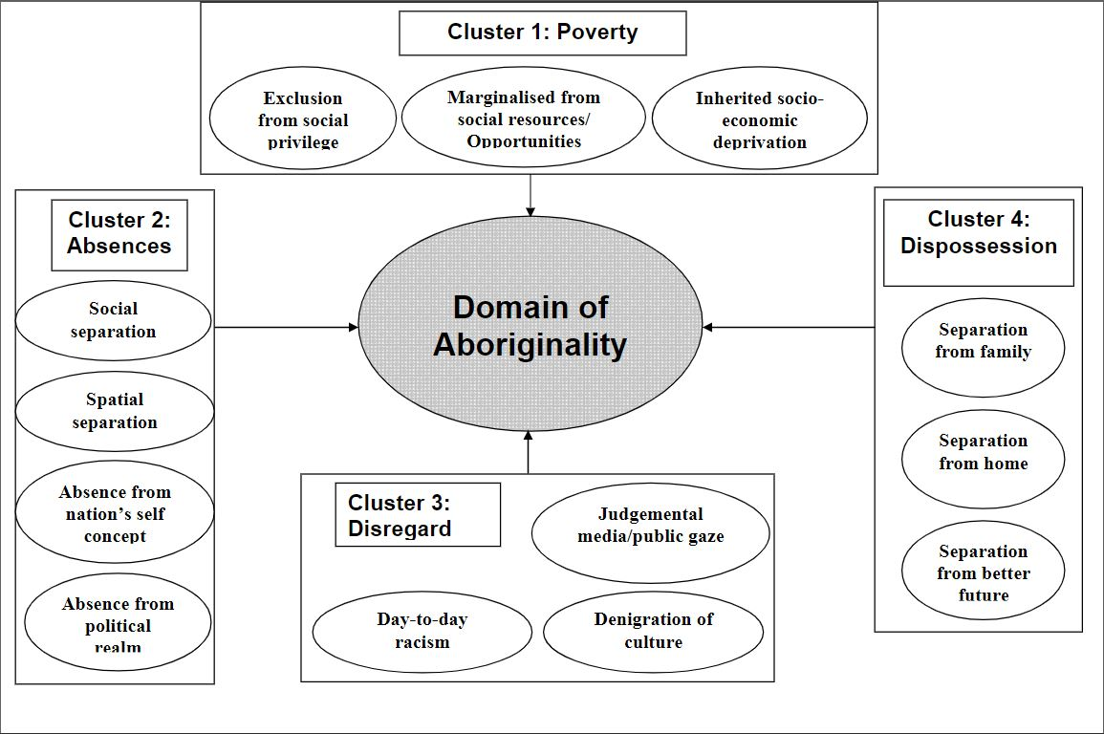
Figure 1. Domain of Aboriginality Framework. Figure from Walter (2009)

Walter and Andersen (2013) expand on the core ideas presented in Figure 1 to stress the absence of Indigenous peoples and epistemologies from social and political contexts. The exclusion of Indigenous epistemologies from modeling scenarios tacitly reinforces the historic and contemporary erasure of Indigenous epistemologies in quantitative data while also excluding them in conceptualizations of possible futures, furthering the erasure of Indigenous peoples and knowledge systems (Wolfe 2006; Walter and Andersen 2013). Since computer simulation models are used in planning contexts, it is, then, important to identify potential absences so that they may be addressed. nayri kati offers a way in which simulation models may be used to align with Indigenous epistemologies, for example land use planning, which may reflect relationships toward landscapes that differ from or are contentious with Euro-American epistemologies (Simpson 2014).
Identifying the ways in which quantitative analysis and the data used to undertake it can uphold settler epistemologies reveal the politics embedded within any modeling exercise. Models are often tools used to imagine possible futures for a place, meaning that defaulting to settler ways of knowing and interacting with landscapes continues the project of assimilation and erasure of Indigenous peoples in the United States. Modeling outputs such as maps of potential future development are often co-productive in the sense that they reflect one reality while shaping reality through imagination and, in some cases, policy decisions. Revealing absences in quantitative data and analysis is the first step toward producing modeling scenarios that can capture a more complete understanding of a place. Finally, it is imperative to speak to these absences as critical context to be considered when communicating model outputs and addressing their limitations.

Chapter 3: Materials and Methods

3.1 Overview

This section describes the materials and methods used to complete the landscape analysis and modeling exercises. I chose to first complete an analysis of landscape metrics to understand the spatial configurations of urban areas in both study areas. Understanding the landscape, then, contextualizes each modeling exercise and aide in the understanding of model outcomes.

3.2 Study area

I focus on the greater Tulsa and Oklahoma City metropolitan areas, the two largest in the state. The Oklahoma City metropolitan area consists of ten counties (Figure 2) has a population of over 1.2 million people according to the 2010 census (Oklahoma Department of Commerce 2012). At least part of each of the counties consisting of the Oklahoma City metro area overlaps with tribal land (Figure 2). For this research, tribal land is defined by the McGirt v. Oklahoma Supreme Court decision which upheld historic treaty lands, claiming congress never dissolved them when granting Oklahoma statehood (Miller 2020). The Tulsa Metropolitan Statistical Area also consists of seven counties (Figure 3) and has a population of nearly 940,000 in 2010 (Oklahoma Department of Commerce 2012).

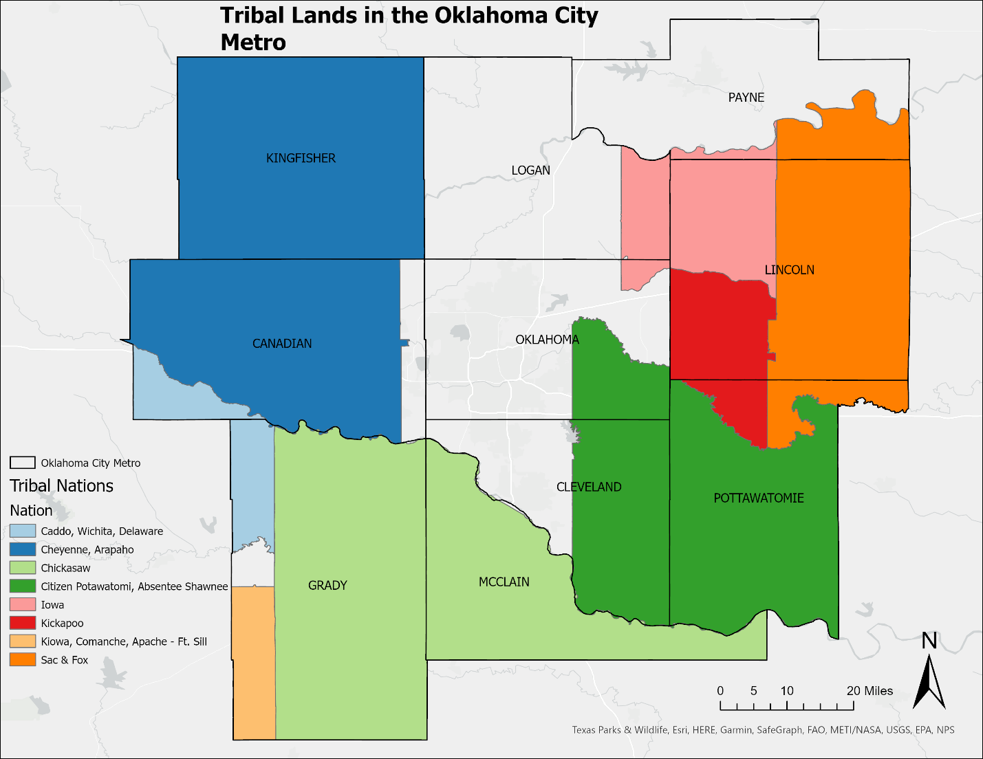
Figure 2. Tribal land overlap with counties in the Oklahoma City Metropolitan area.
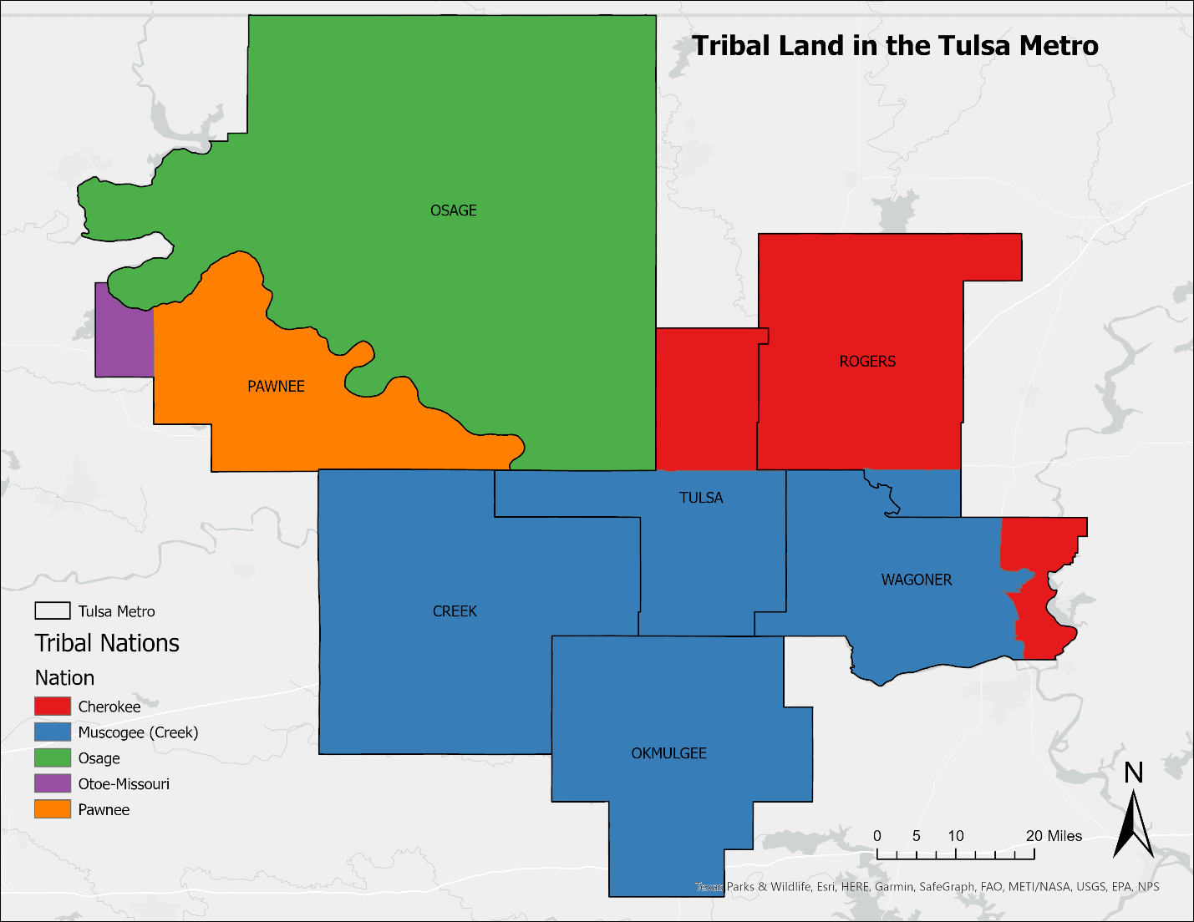
Figure 3. Tribal land overlap with counties in the Tulsa Metropolitan area.

3.3 Selection of Landscape Metrics

The aim of this analysis is to compare each of the metro areas with one another in addition to larger statewide landscape trends. Analysis occurred at the landscape, class, and patch levels (McGarigal et al. 2012). Each metric was chosen with the intention to represent any emergent patterns within the landscape with straight-forward and easy to interpret metrics. I calculated the selected metrics using land use data observed every five years between 2001 and 2016 (Dewitz 2019).

3.3.2 Landscape Level Metrics

Landscape coefficient of variance - This metric describes the area’s differences among patches in the landscape. Output equals 0 if all patches are identical in size and increases as variation of patch areas increases (McGarigal et al. 2012; Hesselbarth et al. 2019).
Landscape area mean - This metric summarizes the landscape as the area mean of all patches in the landscape and describes the composition of the landscape. Output approaches 0 if all patches are small (the smallest a patch can be is one 30m x 30m cell in this case) and increases without limit as patch areas increase (McGarigal et al. 2012; Hesselbarth et al. 2019).

3.3.3 Class Level Metrics

Class area standard deviation - This metric describes each class as the standard deviation of all patches belonging to class i and describes the difference in area among patches of the same class. Output equals 0 if all patches are identical in size and increases as variation increases (McGarigal et al. 2012; Hesselbarth et al. 2019).
Class patch density - This metric describes the fragmentation of a class. However, it does not provide information about the configuration or composition of the class. Values increase as the landscape gets patchier and reaches the maximum value if every cell is in a different class (McGarigal et al. 2012; Hesselbarth et al. 2019).
Class percent of landscape – This metric summarizes the percentage of the total landscape consisting of class i. The possible values for the output range from 0 to 100 (McGarigal et al. 2012; Hesselbarth et al. 2019).

3.3.4 Patch Level Metrics

Patch area – This metric measures the area of each patch in hectares. Albeit one of the simplest measures of patches, it is important to understand the distribution of patches in the chosen study areas. The values are greater than 0 and increases with patch sizes (McGarigal et al. 2012; Hesselbarth et al. 2019).
Patch contiguity index – This metric evaluates the spatial contiguity of cells in patches. I evaluated the cells in the Queen’s case in which neighbors are considered in 8 directions to include more cells in each patch since one class in the analysis is urban areas that may be connected in ways such as highways. The output ranges from 0 for single-celled patches to 1 for fully connected patches (McGarigal et al. 2012; Hesselbarth et al. 2019).

3.4 FUTURES Calibration

I calibrated FUTURES for Tulsa and Oklahoma counties since they contain the urban core of the two cities. The input data used for the two study areas (Table 1) come from the same sources but were clipped down to the respective areas.

Table 1. Input data for FUTURES model
Parameter | Description | Data Source
Topography | Slope derived from Digital Elevation Model | United States Geographical Service (2021)
Hydrological Features | Distance to waterbodies | National Landcover Database (2021)
Policy | Protected Areas | PAD-US (USGS 2020)
Infrastructural | Roads | TIGER (2019)
Environmental | Distance to forests | National Landcover Database (2021)
Socioeconomic | Population Projections and Trends | Oklahoma Department of Commerce (2012)
Policy | County Boundaries | TIGER (2021)

3.4.1 Oklahoma County

I initially calibrated the model to simulate land conversion to urbanized areas until 2016 to ensure that it could be adequately validated. I used National Landcover Database (NLCD) data for the years 2001, 2006, 2011, and 2016 to calibrate the model for Oklahoma County (Dewitz 2019). I reclassified the data into binary rasters representing urbanized and non-urbanized land with protected areas, water, and land outside the Oklahoma County boundary as null boundaries. The POTENTIAL submodel considers a set of coefficients using multilevel logistic regression that contribute to site suitability factors that affect the probability of a cell converting to developed (Meentemeyer et al. 2013). These factors include physical attributes that may increase the difficulty of development, such as slope or dense forest. I also included factors that may serve as desirable amenities that may attract development such as proximity to the Oklahoma River.

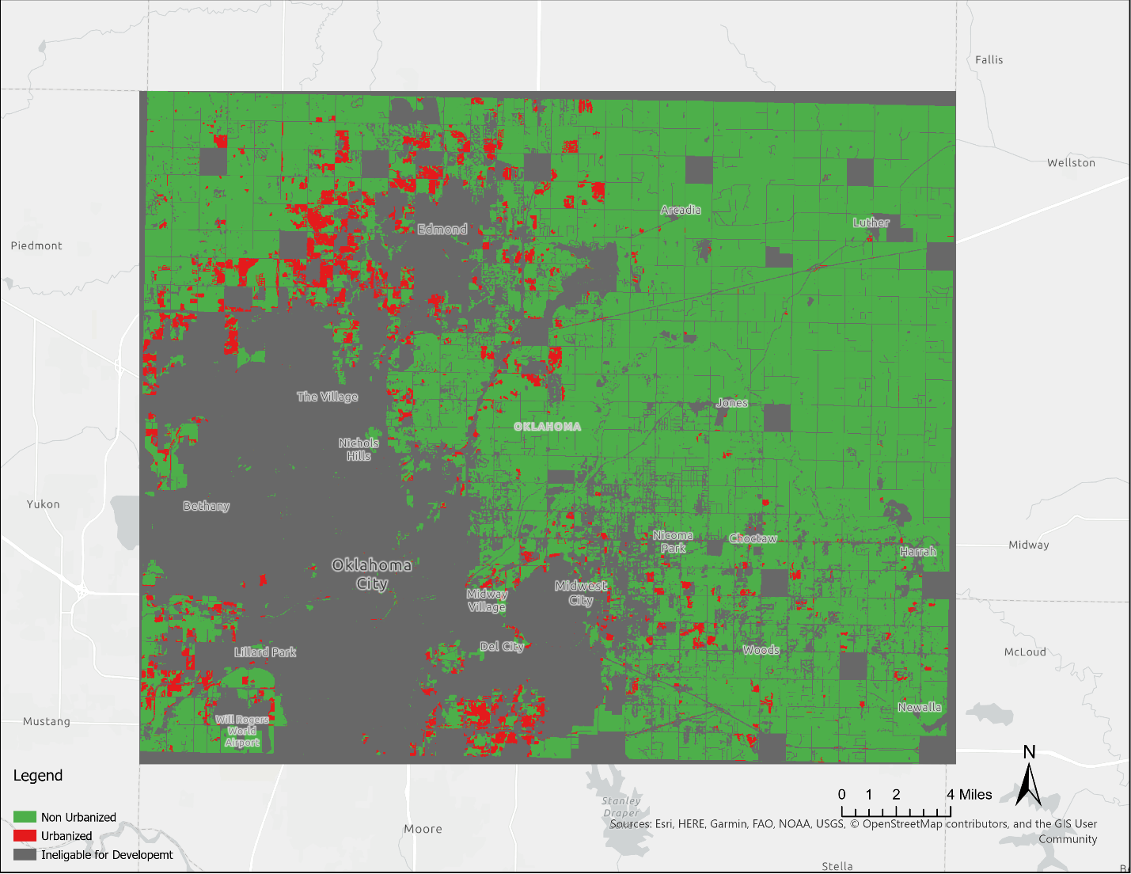
Figure 4. Observed urban change in Oklahoma County between 2001 and 2016

Next, I calculated development pressure based on observed development patterns between 2001 and 2016 (Figure 4). The development pressure reinforces the pressure of past development by assuming that conversion to developed in once cell increases the likelihood of conversion in neighboring cells (Meentemeyer et al. 2013). Development pressure is calculated based on the number of neighboring developed cells within a specified neighborhood size weighted by distance (gamma). As gamma increases, the influence of developed cells decays more rapidly with distance. By looking at the development change over time in Oklahoma County, I saw that development usually occurred near existing development and clustered development quickly turned into sprawling development, so I decided on a gamma value of 0.5 for calculating development pressure.
Next, I visualized the observed urban change between 2001 and 2016. Based on the number of cells converted to developed, I randomly generated 10,000 points in undeveloped cells and 5,000 points in developed cells in which to randomly sample and test the variables serving as POTENTIAL coefficients to model the relationship between the predictors and observed development. I then ran the POTENTIAL submodel to identify best predictors of urbanization for the study area. Table 2 lists the predictors and their significance at the 0.01 significance level. After finding significant predictors, I created a suitability map that depicts site suitability for future development.

Table 2. Significant Predictors at the 0.1 level for Oklahoma County
Predictor | Significant at 0.01 Significance Level (Y/N)
Slope | Y
Distance from Water | Y
Distance from Protected Areas | Y
Forested Areas | Y
Road Density | N

The DEMAND submodel calculates per capita land demand based on observed population trends and population projections. This determines the amount of land that will be converted to developed at each time step. I chose the logarithmic ($Y=A+B \log{(x}))$approach in which growth occurs slowly and is proportionate to the population because it was the best fit for the observed population growth trends. However, after 1,000 initial simulations of the model, it was apparent that the calculation was underpredicting land demand, so I overwrote the values to align with observed quantities of converted cells between 2001 and 2016.
Next, I calculated the distribution of patch sizes to derive the spatial configuration of newly developed patches. I determined a minimum patch size of at least 3 cells (2700m = (30m x 30m) * 3) to exclude small patches since the most influential development patches were quite large. Based on 75 stochastic simulations, I calculated a discount factor of 0.9, a compactness mean of 0.5, and a compactness range of 0.3. Using these parameters alongside the results of the two previous submodels, I ran 1,000 simulations of the FUTURES model to compute a final map of simulated urbanization. I then computed a raster map in which the value of newly converted cells corresponded with the number of times the cell was converted in each simulation. For example, a cell with a value of 0.85 converted from undeveloped to developed in 850 of the 1,000 simulations.

3.4.2 Tulsa County

For simulations of Tulsa County, I followed the same methodology as with Oklahoma County. I used attributes such as forest density, proximity to amenities, and slope in the POTENTIAL submodel. Then, I calculated development pressure based on observed development between 2001 and 2016 (Figure 5). Development in Tulsa County is much more sprawled than in Oklahoma County, but also tends to concentrate around centers of development, such as in Broken Arrow, so I used the same 0.5 gamma value, but increased the neighborhood size to capture this difference. I then randomly generated points in which to test the variables in the POTENTIAL submodel and created a suitability map using 10,000 points based on significant predictors (Table 3).
Since the population prediction datasets for Tulsa County was produced by the same agency as Oklahoma County, the logarithmic approach for population growth fit the trend for this simulation. The demand calculation in this simulation underpredicted land demand by a factor of 10, so I manually increased the values to align with observed quantities of converted cells between 2001 and 2016. Based on 75 stochastic simulations, I calculated a discount factor of 0.9, a compactness mean of 0.7, and a compactness range of 0.3. Finally, I ran 1,000 simulations of FUTURES and produced the same probability distribution map as I did with Oklahoma County.
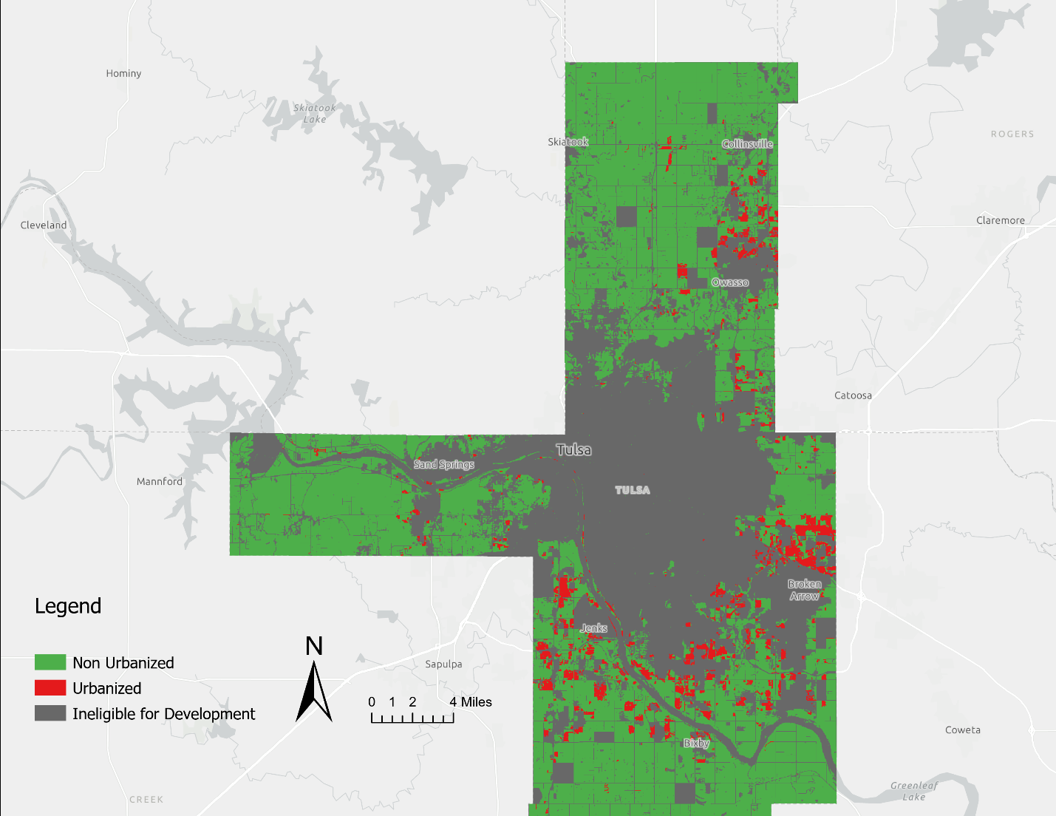
Figure 5. Observed urban change in Tulsa County 2001-2016

Table 3. Significant Predictors
Predictor | Significant at 0.01 Significance Level (Y/N)
Slope | Y
Distance from Water | Y
Distance from Protected Areas | N
Forested Areas | Y
Road Density | Y

3.5 Model Validation
For this project, I used Kappa Simulation (K_{simulation}) to validate model simulations (van Vliet et al. 2011). Model validation ensures that the simulation model operates within a desired range of accuracy that aligns with its intended purpose to ensure credibility (Sargent 2013). Simulation models in the past have been validated using the Kappa statistic. However, Pontius Jr. and Milliones (2011) have problematized Kappa as a measure of accuracy in the interpretation of suitability maps. Kappa only accounts for quantity disagreement in maps, meaning the number of cells that should belong to class i based on historic land use patterns, and those that belong to class i in simulated suitability maps. However, Kappa can be misleading since, in most suitability maps, most cells will agree due to land use persistence such as previously urbanized land or cells that never converted to developed (Pontius Jr. 2011). K_{simulation}, however, assesses agreement between simulated maps and observed land use maps adjusted for persistent land use and corrects for agreement expected by chance (van Vliet et al. 2011). The observed data used for validation must be independent, i.e., it was not used for the parametrization or calibration of the simulation model. For both Oklahoma and Tulsa counties, I used the independent 2019 NLCD land use data (Dewitz 2019).
The K_{simulation} metrics attempts to account for this by correcting for the expected distribution of transitions from deriving from the same initial dataset (van Vliet et al. 2011). Values for K_{simulation} range from -1 to 1 in which -1 indicates class transitions are less accurate than expected by chance “given a random allocation of class transitions,” 0 indicates the case in which the distribution is as “good as can be expected by chance given a random distribution [of] the given class transitions,” and 1 indicating perfect alignment (van Vliet et. al 2011: 1370). Neither modeling scenario in this research had a K_{simulation} value that indicated the results were much better than random chance (Chapter 4).

Chapter 4: Results

4.1 Landscape Metrics Results

At the landscape level, patches became more varied from one another over each timestep while the mean individual patch size decreased. At the class level, patches of urbanized land grew more varied from one another while patches of unurbanized land decreased in variation from each other. Both classes became patchier across each timestep. Finally, the total percentage of the landscape comprised of urbanized land in 2001 was 1.48% and grew to 1.73% by 2016.

4.1.1 Statewide Landscape Metrics

I identified patches of urbanized and non-urbanized land across the entire state of Oklahoma to gather statewide trends against which the Oklahoma City and Tulsa metro areas could be measured. At the landscape level, patches became more varied from one another over each timestep while the mean individual patch size decreased. At the class level, patches of urbanized land grew more varied from one another while patches of unurbanized land decreased in variation from each other. Both classes became patchier across each timestep. Finally, the total percentage of the landscape comprised of urbanized land in 2001 was 1.48% and grew to 1.73% by 2016. The two largest patches in the state were the Oklahoma City and Tulsa Metro Areas. The Oklahoma City metro area is both larger and denser than Tulsa.

4.1.2 Oklahoma City Landscape Metrics

At the landscape level for the Oklahoma City metro area, patches of urban and nonurban land increased in variation from one another as well as decreasing in size between 2001 and 2016. In 2001, urbanized areas comprised 4% of the total area of the ten counties considered in the Oklahoma City Metro. This number grew to nearly 5% by 2016. Both unurbanized and urbanized patches saw increased variation between patches throughout each timestep, differing from the trends observed both in Oklahoma more broadly and in Tulsa. In addition, patch density for each class decreased between 2001 and 2016, meaning each class grew patchier over the observed timeframe. The largest patch of urbanized land observed for the Oklahoma City Metro occurs in the city core, growing less dense as urbanization approaches the Edmond area to the North and the Norman area to the South. Other notable patches occurred in towns such as Stillwater in the Northeast and Shawnee in the East.

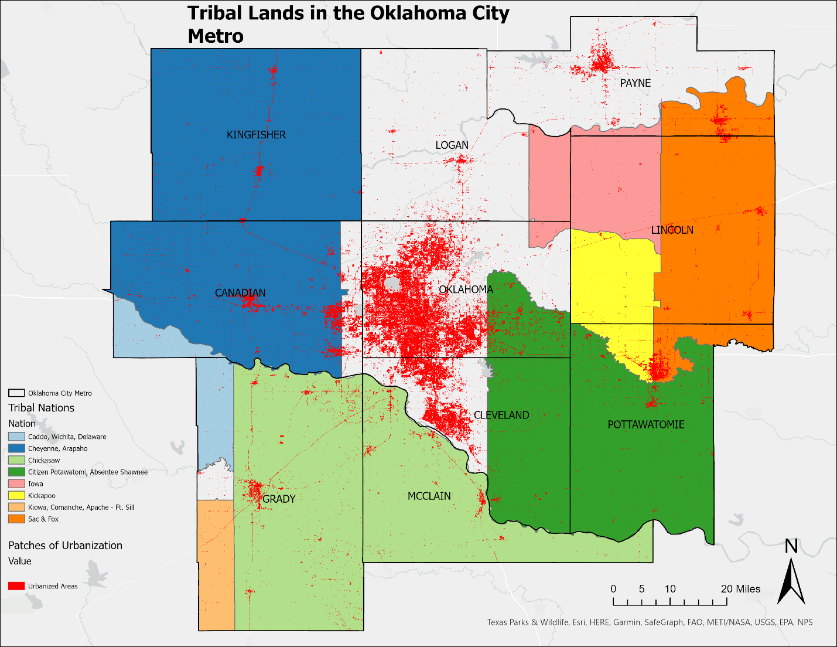
Figure 6. Tribal Lands and Urbanized Areas in the Oklahoma City Metro

Figure 6 shows the distribution of urbanized land as of 2016 in the Oklahoma City Metro area. Most urbanized patches occur around the core of Oklahoma County, and spreads mostly to the south. Cleveland County, which is the second most populated county in the study area after Oklahoma County, is interesting in respect to urbanization patterns and tribal area. The border between Cleveland and McClain counties also demarks the border between Oklahoma land and Chickasaw Nation land. Dense development occurs right up to the border, and then stops quite abruptly before becoming much scarcer in the Chickasaw Nation. We do not see a sharp change in urban density to the same extent as Canadian County encounters the Cheyanne-Arapaho Nation. There is a slight change in urban density as Oklahoma County encounters the Citizen Potawatomi and Absentee Shawnee Nations, but still not as stark as in Cleveland County.

4.1.3 Tulsa Landscape Metrics
Like the Oklahoma City Metro Area, the Tulsa area also saw an increase in patch variation from patch-to-patch and decreased in size from 2001 to 2016, following the same trend as observed in the larger state. At the class level, urbanized patches increased in variation from one another, while unurbanized patches decreased in variation, aligning with the statewide trend. Both classes became patchier over time, albeit at much less dramatic rates than the whole state or Oklahoma City. The percentage of urbanized land in 2001 measured at 3.4% and grew by 0.5% to 3.9% in 2016, resembling the growth observed in the percentage urbanized land in the whole state much more closely than Oklahoma City did.
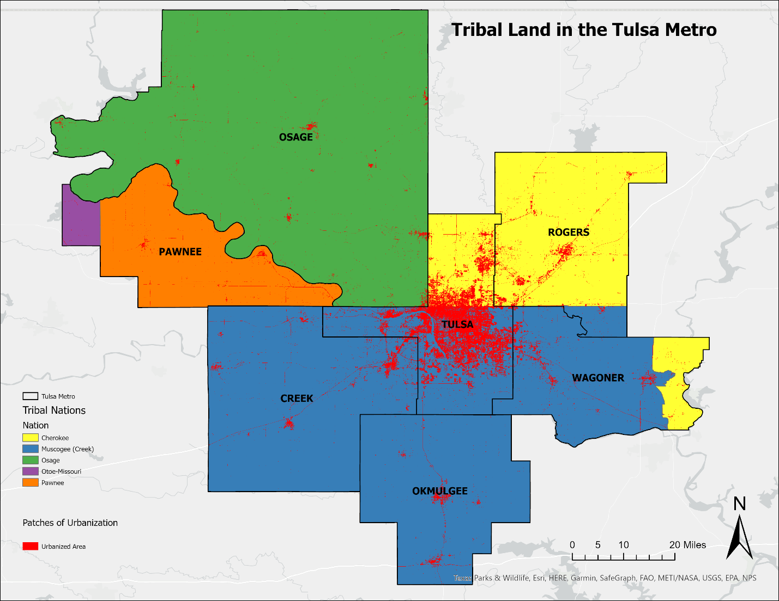
Figure 7. Tribal Lands and Urbanized Areas in the Tulsa Metro

Figure 7 shows the distribution of urbanized lands in the Tulsa Metro. The Tulsa Metro, unlike the Oklahoma City Metro, all urbanized lands overlap with tribal lands. As shown in Figure 7, urban density in Tulsa comes to a sharp end at the border between Tulsa and Osage counties, where the Osage reservation begins. This degree of difference is not recognized elsewhere in the study area.

4.2 FUTURES Simulation Results

4.2.1 Oklahoma County Results

I ran 1,000 repetitions of FUTURES for Oklahoma County from 2016 to 2019. I ran 1,000 repetitions since the PGA includes a random component not determined by site suitability and will produce a different outcome each time, so I wished to capture a more complete spatial distribution of simulated urbanization. Equation (1) illustrates the method for determining the final probability of conversion to developed where $P_{conversion }$ indicates the sum of cell values in each simulation divided by the number of simulations. For example, a cell with a value of 0.2 converted to developed in 20% of simulations.
EQ $P_{conversion }= \frac{\sum{t_{1}, t_{2}…}}{n}$ (1)
Figure 8 shows the spatial probability distribution of converted cells. We can see the effect of a gamma value of 0.5 in which development tends to infill and sprawling development is relatively uncommon.
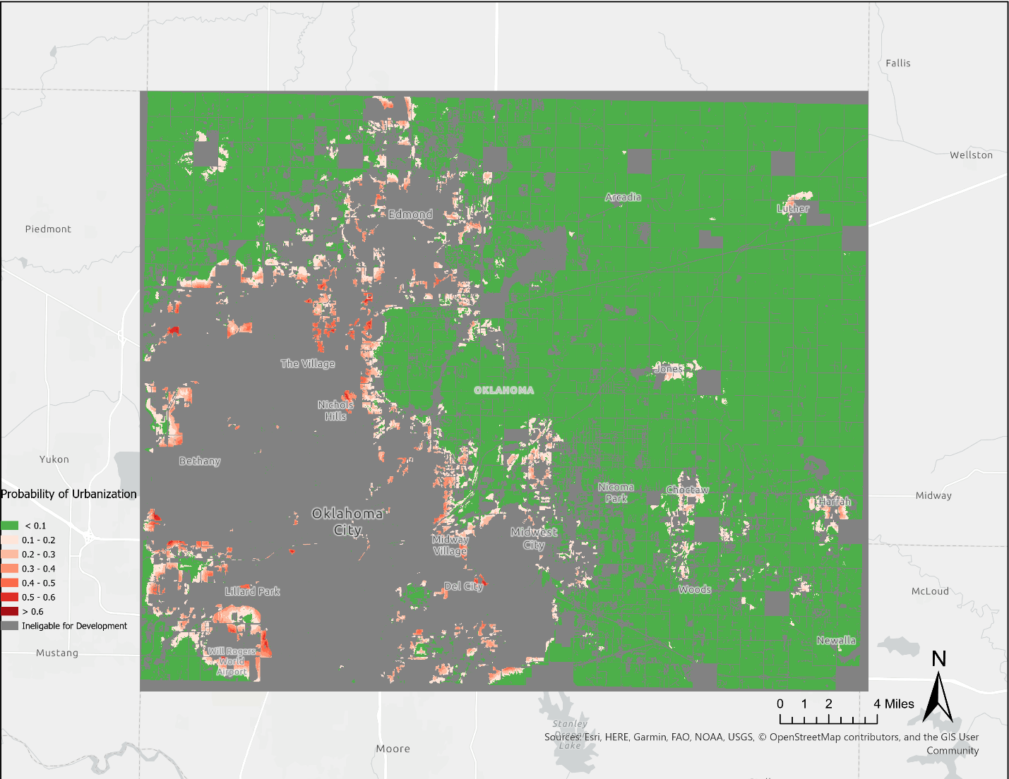
Figure 8. Probability distribution of urban expansion for Oklahoma County

The simulation for Oklahoma County wielded a relatively low K_{simulation} result (0.03), meaning that only 3% of cells were correctly simulated. After examining observed land use change in Oklahoma County from 2016 to 2019 (Figure 9), I saw that the model overpredicted infill in Northwest Oklahoma City while underpredicting sprawling development in Northeastern Edmond and into the suburbs West of Oklahoma City.
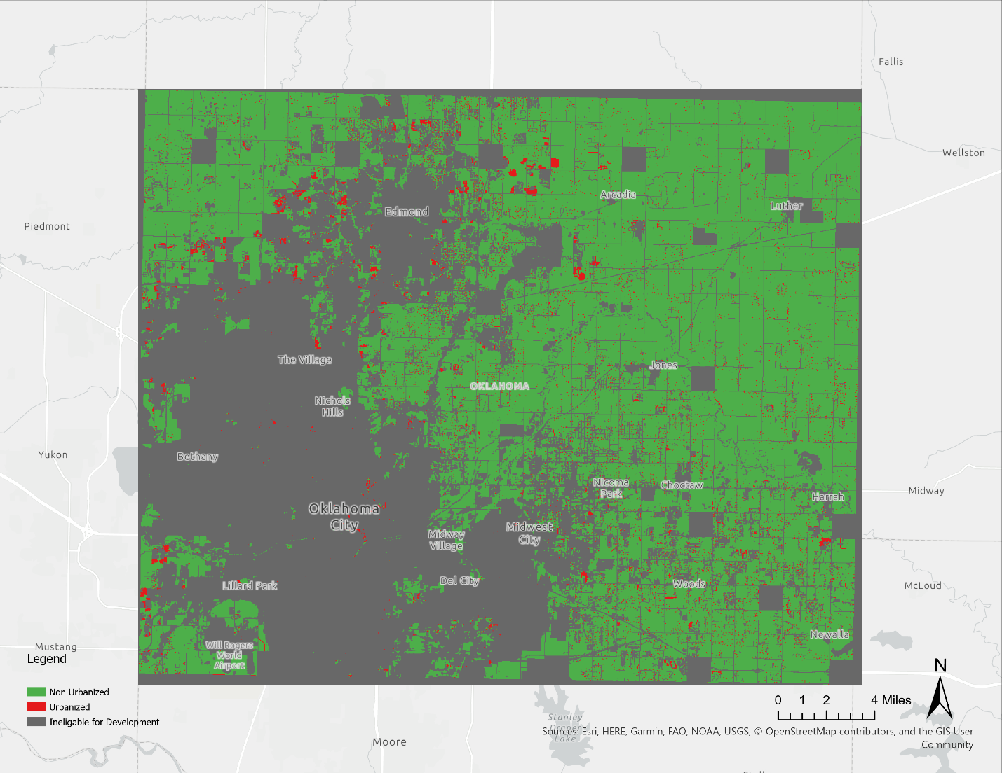
Figure 9. Observed Urban expansion in Oklahoma County 2016 – 2019

4.2.2 Tulsa County Results

I ran 1,000 simulations of FUTURES for Tulsa County from 2016 to 2019. I chose 1,000 simulations to collect a large enough sample of new urbanization to build an appropriate distribution. I used equation (1) to determine probability of conversion in each cell. Figure 10 shows the probability distribution for each cell, combining each timestep. We can see by looking at observed change between 2016 and 2019 (Figure 11), that by attempting to account for sprawl, The model overpredicted development dramatically in the Northeastern part of the county, but underpredicted development in the Southwestern part of the county, again wielding a relatively low K_{simulation} result (0.05).
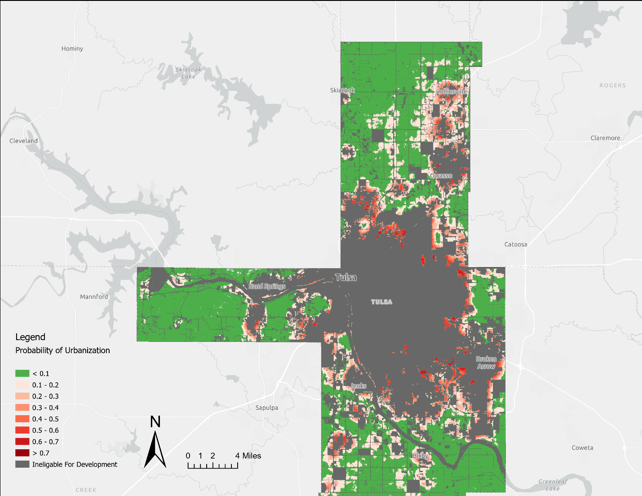
Figure 10. Probability distribution of urban expansion for Tulsa County 2016-2019.
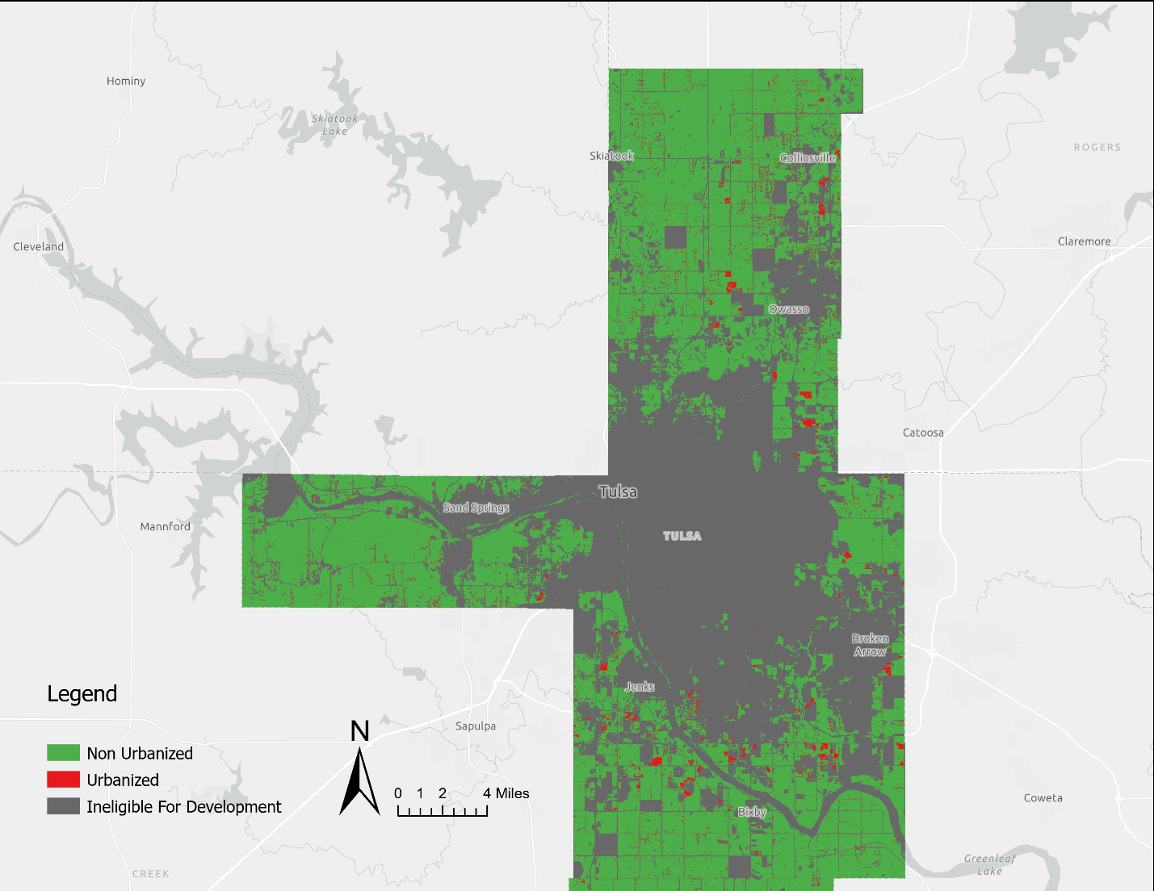
Figure 11. Observed Urbanization in Tulsa County 2016 – 2019

Chapter 5: Discussion

5.1 Decision to Use a Computer Simulation Model

The decision to apply modeling methodology to a particular landscape, in this case, the state and the two largest metropolitan cores in Oklahoma, is first decided by the researcher or modeler. Choosing to focus primarily on the two largest cities in the state is a decision that excludes rural communities from the study. The practice of modeling is only one ontological approach of many to understand a landscape. This approach assumes a unilateral relationship to a landscape in which it is analyzed and studied by the modeler.
Urban simulation models such as FUTURES are often used in the context of urban planning (Jakeman et al. 2006; Lei et al submitted 2022; Simpson 2001), meaning that assumptions made in the modeling process have the potential to be translated into policy or practice. Therefore, a critical analysis of such assumptions is necessary. The first set of assumptions to be addressed is those made in the decision to model a landscape and which model is chosen for this purpose. In this study, I chose the FUTURES model since it is straight-forward and can account for both social and physical characteristics of the landscape (Dorning et al. 2014). Edmonds (2020) stresses the importance of emphasizing that any simulation of a model is simply that – a simulation. Thus, it is important to state that potential urbanization simulated in this study is not definite, and only a hypothetical rendering of one potential future. Choosing one model over another, however, imposes a set of conditions on which this future is articulated. For example, FUTURES includes a patch growing algorithm (PGA) meaning that there is only one directionality assumed for urban areas – growth. Even other urban simulation models that operate at city-level scales such as SLEUTH (Clarke 1997) only allow for either growth or no growth. While it is possible in the model for an area to experience no growth, it is not possible for areas to experience negative growth. This assumption may be incongruous with the planning objectives of some communities. For example, some Indigenous communities falling within the study area may not wish urbanization to encroach on their lands (Jojola 2008). Using the nayri kati framework, implementing a scenario that does not align with the planning objectives of a community can foster the co-production of a future in which paternalistic approaches toward Indigenous communities are reproduced or Indigenous epistemologies are absent altogether (Jojola 2008).
However, since FUTURES treats datasets similarly, it is possible to use the model to explore different planning incentives. The nayri kati methodology calls for the inclusion of Indigenous epistemologies at all steps of the research process. Thus, the model could be used to explore scenarios that are deemed important by tribal leaders or community members. For example, if there were important plants growing in an area that would suffer from development, the development constraint parameter in the PGA could be adjusted to decrease the likelihood of development in simulations. These areas could also be excluded from development completely by changing all cells in which such plants were growing to null values, which would be ignored in the PGA and deemed unsuitable for future development.
Finally, the decision to model at all is one that imposes its own assumptions. As discussed previously, quantitative research has often been used by academia and planners to enact violence upon Indigenous communities (Walter and Andersen 2013; Harjo 2019). Because of this, communities may have negative associations or experience with planning and research and refuse to participate in any step of the process. Participatory modeling and planning are often seen to give models community credibility, so the refusal of one community to participate may reflect larger discomfort with planning methodologies and/or objectives. Refusal may mean refusing to give up locations of places of deep personal or cultural importance or it may mean the refusal of modeling methodologies altogether. Further, communities may have concerns about privacy and data management due to past negative experiences and may have their own data management policies and centers (Harjo 2019; Tsosie 2019). Literature on tribal data sovereignty has stressed the importance of working with not only tribal governments or research institutions, but also with individuals to establish informed consent and detailed plans of how data will be generated, used, stored, and who has access to the information (Walter and Suina 2019; Harjo 2019; Tsosie 2019).
Failure on the researcher’s part to respect refusal of a community to participate in participatory modeling exercises violates informed consent and ethical scientific practice and can foster hostilities between researchers and the public. It can take many weeks, months, or years to build deep and trusting relationships, and researchers should consider how their research may benefit or harm a community at the onset. In any case and at any scale, refusal must be accepted and respected.

5.2 Case Study of Three Input Datasets

5.2.1 Population projections based on Census Data

In my simulation with FUTURES, land demand in the DEMAND submodel is calculated based on historic trends in population and land use change (Meentemeyer et al. 2013). I used population projections report provided by the Oklahoma Department of Commerce through 2075 as they were the only ones available (Barker 2012). The population projections for the state are based on census data collected by the federal government (Barker 2012).
The Oklahoma Department of Commerce followed “generally accepted forecasting routines developed by the US Census Bureau” (Barker 2012:5) to produce the projections through 2075. This report includes all civilians living in the state as well as military members stationed in the state and incarcerated persons in private prisons (Barker 2012). The report does not analyze population projections by race but does state that the Hispanic population in Oklahoma is expected to grow. The authors of the report gathered death rate information from the US Centers for Disease Control and stated that mortality rates are expected to fluctuate due to health-focused state programs such as diabetes awareness in addition to improvements in healthcare technologies. However, since these changes are difficult to capture in population projections, the authors chose to keep age-specific survival rates constant throughout the projection period (Barker 2012). County level population projections were made using linear regression models in every county except those whose populations were expected to decline. Curved trendline models were applied in areas expecting decline (Barker 2012). While the decision to exclusively use data derived from Census data seems simple, it is important to understand the historical and political relationship between the Census Bureau and the people with which the data is concerned. Such political relationships are especially important in Oklahoma where statistics have been used to establish or support problematic racial hierarchies (Chang 2010; Jobe 2004).
I briefly discussed the violent colonial history of census data in Chapter 2 but will expand on here. The colonial context for the census is immediately relevant to the study area for this project. With such a large portion of the study area falling under tribal jurisdiction or association, it is important to consider the implications of datasets such as those built from census data. It is safe to assume that, with such a high proportion of the study area falling on tribal land, Indigenous and other minority groups have been underrepresented in population projections (Rainie et al. 2017). Census data has also historically flattened the identity of multi-racial people into one binary racial category, and multi-racial census options have only been available since 2000 (Sweet 2021). Afro-Indigenous people have historically had their Indigenous identities invalidated and have been denied from tribal enrollment due to anti-Black “one-drop” rules (Chang 2010).
By only using data derived from census data, the modeler is accepting and perpetuating this underrepresentation. If the modeler were to cross-reference population statistics provided by the state or federal government with tribal membership rolls or historical tribal population data, they could produce a more accurate representation of tribal populations in the study area. For example, Tallbear (2013) proposes a “coproductive” approach to racial categories, specifically Indigenous racial identities, that does not depend on colonial blood quantum or reliance on Native DNA. A coproductive approach to Indigenous racial identity complicates a reliance on settler mechanisms of racial categorization as they are always at odds with and seek to extinguish Native populations (Tallbear 2013; Wolfe 2006; Nakano Glen 2014). Tallbear (2013) advocates for a more nuanced approach to racial identity that accounts for cultural as well as genetic or genealogical claims. The DEMAND submodel does not prioritize data from any one agency. Thus, it would treat population datasets derived from tribal records the same as a dataset derived from census data. It is important for modelers to understand and communicate that even numerical population data are political entities imbued with historic epistemological assumptions that ripple into the future.

5.2.2 Protected Areas and Static Land Ownership

This section will explore epistemological assumptions and implications present in the Protected Areas (USGS 2020) layer used in simulations of the model. When parametrizing the model, I set all the areas falling into the category of “protected” as exempt from future development. By excluding these cells from development in simulations, I impose the assumption that both the land’s status as “protected,” and its ownership remain static throughout each timestep both in the model and in its output. While this assumption might make sense when considering the likelihood of a cell to move from “undeveloped” to “developed” in the model output, this assumption also participates in the articulation and imagination of one potential future for a landscape. These articulations are political in nature, although not always obviously so, and frequently well intended from an ecology and environmental conservation perspective.
The protected areas layer introduces all the areas in the state falling under the category “protected” into the model’s calculations for potential future development projections. This includes areas set aside for wildlife conservation, military bases, and schools, among others. The original version of the dataset (USGS 2020), upon which each version builds, is a product of a partnership between the PAD-US organization within the USGS and the UNEP-World Conservation Monitoring Center (USGS 2020). The project sought to standardize data gathered from regional Gap Analysis Project (GAP) data releases from the southwest, middle, and southeast regions of the United States with data from the Conservation Biology Institute and The Nature Conservancy in the northwest and northeastern parts of the country respectively (USGS 2020). The organization then assigned categories defined by the International Union for Conservation of Nature (IUCN) to each area in the US that met the IUCN’s definition of a protected area (IUCN 2015:1),
“a clearly defined geographical space, recognized, dedicated and managed, through legal or other effective means, to achieve the long-term conservation of nature with associated ecosystem services and cultural values.”
The categories such as “National Park,” “Wilderness Area,” and “Strict Nature Reserve” are included in the IUCN’s classification system (IUCN 2016). Since the original dataset’s publication in 2009, the PAD-US project has expanded partnerships with state and federal agencies such as the Bureau of Land Management (BLM) and conservation NGOs such as Ducks Unlimited (USGS 2020).
For my simulation with FUTURES, I used data only for my study areas. There are four distinct categories that exclude certain lands from development: proclamation lands, fee lands, designation lands, and easement lands. Proclamation lands are areas whose primarily boundaries designated are by congress and can include military land or tribal land used for planning purposes. Proclamation does not necessarily imply ownership of the land. Tinker Airforce Base in Oklahoma City is an example of proclamation land in the study area. Fee lands are those owned “outright” by state or federal agencies, NGOs, or private entities. School lands owned by the Commissioners of the Land (CLO) office are examples of fee lands represented in the study area. Designation lands are areas designated through policy and may overlap with other protected categories such as fee or easement lands, such as the Dog Iron Ranch and Will Rogers’ Birthplace, a state park located in the study area. Finally, easement lands are non-sensitive and open space areas provided by the National Conservation Easement Database (NCED). Easement lands include privately-owned land with a voluntary conservation agreement in place. Many such lands are present throughout the study area.
Of the 645 protected areas present in the PAD-US dataset for Oklahoma, 356 are managed by the federal government, 209 are managed by the state or local governments, 144 are privately managed, 72 are managed by NGOs such as The Nature Conservancy, and 3 are managed by Native tribes (USGS 2020). The ways in which land dispossession has contributed to the structural genocide of Indigenous peoples both in Oklahoma and in other parts of the country has been well-documented and discussed (Wolfe 2006; Chang 2010; Nakano Glenn 2014; Estes 2019). Wolfe (2006) argues that settler colonialism is not a process that happened once and ended, rather, settler colonialism is a form of “structural genocide” that continues to endure and inform interactions between Indigenous peoples and settler states. The continued dispossession of land is one way in which settler colonial states seek to eliminate Indigenous peoples and culture today. Further, Blomley (2003) defines property as “to have a right to some use or benefit of land” (121). In this framework, the assumption present in the model that ownership of protected lands remains static assumes a future in which tribes have little determination over areas exempt from development.
Additionally, Harvey (2019) problematizes the reliance on NGOs to address social problems. NGOs often perpetuate neoliberal property regimes and “define the interests of those they speak for” (Harvey 2019: 52). This is further problematized when put in the context of Oklahoma. Chang (2010), in his historic account of the process of allotment in the Muscogee (Creek) Nation, recounts in detail the ways in which the amount of “Indian blood” present in an individual determined their ability to care for their assigned allotments. For example, the more “white blood” and individual had, the more they could take care of their allotted land. The holding of land by the federal government and NGOs on tribal land further robs tribes of sovereignty and determination over their land, while perpetuating the belief that the inhabitants of the land are incapable of taking the conservation measures necessary to ensure the health of the land, thus, further problematizing the static land ownership and management status of protected areas in the modeling process.
Another assumption present in the data itself lies in the method through which protected areas are determined. By requiring some legal status as a benchmark to be included in the dataset, the determination of protected areas automatically falls to the settler state, whether it be Oklahoma, other states, or the United States federal government. By excluding only legal protected areas from development, we fail to account for the myriad ways individuals or communities depend on land outside of legal boundaries whether it be for survival, recreation, or land with cultural significance. This gap in understanding is important when considering tribal lands where land-based epistemologies might differ from settler understandings (Simpson 2014). Some scholars emphasize a distinction between “land use” and “land occupancy” that could be useful for expanding the definition of protected areas to include areas that fall outside legal borders but should be exempt from development nonetheless (Usher et al. 1992; Tobias 2000). Land use refers to “activities involving the harvest of traditional resources” (Tobias 2000:3) which can include hunting, fishing, and gathering medicinal plants, among others. Occupancy refers to the area in which “a particular group regards as its own by virtue of continuing use, habitation, naming, knowledge, and control” (Tobias 2000: 3). Through this framework, the IUCN’s definition of legally defined protected areas alone cannot account for all the areas and resources to which development would be detrimental. Thus, by using this dataset exclusively in modeling simulations, there is a risk of potentially leaving valuable natural and cultural resources unaccounted for in terms of protection.
Some potential ways to address this could be citizen science data including things such as feeding grounds or growing areas of critical animals and plants. Additionally, one might consider direct conversations with those living in the study area to determine sites that are important to the community but may not fall under the accepted definition of protected but are vital to community identity or culture, heeding the call by Walter and Suina (2019) to undertake quantitative methodologies that center “Indigenous worldviews, perspectives, values, and lived experience as their central axis” (234). So long as the data were spatial, the model would treat these datasets identical to the PAD-US (USGS 2020) layer; this implies not an epistemic flaw in the model, but an epistemology assumed by the modeler when relying on such data. Further, the inclusion of such datasets can include different relations or ontologies related to the study area than those present in data generated by the settler state which is almost always in contention with Indigenous sovereignty in Oklahoma. If tribal communities were to have input as to which areas on their lands should be protected or exempt from development, the model would treat the two datasets identically. However, the output of the simulations that included such a dataset would likely vary dramatically from simulations using different data.

5.2.3 Land Use Data

I used data from the National Land Cover Database 2016 (Dewitz 2019; Jin et al. 2019) product release to determine land use and isolate urban and nonurban areas for the calibration of my model. According to Jin et al. (2019), NLCD data products are widely accepted and considered the “cornerstone of U.S. land cover applications” (2). NLCD uses a land use classification system based on the Anderson Level II classification, first published in a 1976 USGS report (Jin et al. 2019; Anderson et al. 1976). The NLCD dataset has 20 different land use categories including classifications such as various types of forests, grasslands, agricultural lands, wetlands, and waterbodies. A cell can only have one land use which is assigned to the land use category that makes up most of the cell. For example, if a cell is 75% grassland and 25% other land uses, the cell is designated as grassland (Jin et al. 2019). This classification also locks land use categorization in a specific space-time configuration. NLCD 2016 was classified using several methods including parametrizing a model to correctly classify remote sensing data using historic data and “expert knowledge from ancillary data for [the] entire process” (Jin et al. 2019: 4). This knowledge primarily came from datasets that are already published from national agencies such as National Wetland Inventory (Jin et al. 2019). NLCD products categorize urban areas into four categories: Developed Open Space, Low, Medium, and High Intensity where each level indicates a different percentage of developed surface (Jin et al. 2019). For this project, I considered any cell falling into one of these four categories as developed.
This system of land categorization is widely used across land use planning research for reasons mentioned previously. However, this system excludes vital knowledge about land use that cannot be captured through traditional surveying or remote sensing techniques. The categorization system portrays a Western attitude toward land use in the sense that each classification begins and ends at the physical makeup of the landscape. Simpson (2014) offers a different relationship to land use through a story in which the land is a producer of knowledge. Fligg et al. (2022) identified a disconnect between land use policy and informal land use practices within the Curve Lake First nation in Canada. This is largely attributed to a disconnect between government-sanctioned land uses and informal land use practices in the community (ibid.). While it is important to communicate the ways in which land use practice differs across different Indigenous communities, it is also important to consider the ways in which land use epistemologies may differ from Western capitalist epistemologies. As discussed previously, a capitalist land use ethic may prioritize development and ownership and use may change hands quickly as the land becomes unprofitable to one party (Jojola 2008).
This capitalist epistemology becomes clear in the introduction of Anderson’s (1976) report on land use categorization, saying that land use categorization was necessary for “a modern nation, as a modern business… in order to make decisions” (1). This statement makes clear the intention of land use categorization is to ensure that the United States’ natural capital is well accounted for to continue the project of capitalist decision making. Capitalist land epistemologies have repeatedly been seen to contradict with Indigenous land epistemologies in instances such as the violent suppression of Indigenous land sovereignty at Standing Rock (Estes 2019). Since most of the study area in this project falls on tribal land, it is not unreasonable to conclude that actual land use in some areas may surpass those expressed in NLCD data. The ability or inability to define land use and produce land use must be socially and politically situated in power dynamics such as settler colonialism (Franklin et al. 2022; Andersen and Walter 2013). By situating land use data within a settler colonial framework, we can see the ways in which settler colonial land epistemologies have been assumed to be the baseline or the uncontested truth of land use in the United States by violently suppressing and attempting to erase Indigenous land use practices and knowledge. By accepting the assumption that settler land use categories are or neutral or wholly representative of the landscape, we are also incapable of uncovering ways in which they may be incomplete or incorrect (Franklin et al. 2022).
Using exclusively NLCD products when accounting for land use in models unintentionally upholds the exclusion of Indigenous land use epistemologies in the modeling process. Since land use change modeling scenarios are often used in planning, excluding Indigenous land use epistemologies exacerbates the disconnect between land use plans and actual land use at best and contributes to the further erasure of Indigenous epistemologies in conceptualizations of the future at worst. In the modeling scenarios in this project, I reclassify certain land uses such as developed land into arbitrary categories (0, 1… etc.) meaning that the model itself does not determine nor really consider the original land use category. Through this, then, there is no reason besides paucity of data that Indigenous land use categories could be used as the underlying land use for this modeling scenario. There is a need to fully understand the ways in which land use, both legally and informally determined, is realized in Indigenous communities to better align with the planning goals of the community (Fligg et. al 2022). Land use data generated with Indigenous communities, then, would be better suited for modeling and planning scenarios that center Indigenous planning goals and research questions. Models such as FUTURES, however, would treat this data the same as NLCD products, meaning that accepting settler land use epistemologies is not inherent within the model, but a choice made by the modeler.

5.3 A nayri kati Approach to Models and Data
To finish this discussion, I propose a potential nayri kati approach to modeling. Walter and Anderson (2013) emphasize that nayri kati must center research questions that reflect the values and sovereignty of Indigenous peoples. In urban simulation modeling exercises, this could entail sitting down and having conversations with community members to outline planning objectives that they deem important. These objectives should be considered with as much weight as those from other sources, such as municipal or state governments. From the onset of an exercise, community members should participate in decisions considering the ways in which data will be gathered, created, stored, and shared (Tsosie 2019). A nayri kati approach might mean that some datasets are produced and maintained by someone other than the modeler or researcher or kept privately and not made open source. Further, the positionality of the researcher should be explored and stated, including all funding sources as to prevent incidents such as the research scandal in Oaxaca in which Herlihy failed to disclose his funding from the United States military (Araujo 2009).
The modeler could also explore the co-production of datasets to be used as model inputs. For example, areas deemed unfit for development that are not included in datasets such as the Protected Areas dataset could be determined using simple sketch mapping as detailed in Tobias (2000). The sketch mapping technique could also be used to produce a land use/land cover dataset imbued with local knowledge. These land use categories could be used to replace or bolster existing datasets such as NLCD (Dewitz 2019) to include more than just physical characteristics of the landscape. This would allow community members to give insights into which land uses are more accurate to the needs and lived experiences of the community. For example, if an area categorized by NLCD as deciduous forest was primarily used as a recreational or cultural area to the community, its categorization could be adjusted, or model parameters could be adjusted to disincentivize development in that area or exclude it altogether. To protect Indigenous knowledge, the researcher could also consider engineering a degree of error in the datasets as to not risk valuable or sacred knowledge being weaponized, exploited, or exposed to settler institutions invested in the project of Indigenous erasure.
When a modeling exercise is completed, the researcher should thoroughly communicate the output and results of simulations. This should include explaining and justifying the places in which the researcher made unilateral decisions in the modeling process. Community members should also be included in the validation of model results and should be asked if the model outputs align with their own understanding and agreed-upon planning objectives decided at the onset of the exercise. Results should be communicated in an approachable and accessible way.
A nayri kati approach to modeling might take longer and require more resources than other modeling approaches, but if the goal of models is to be as descriptive as possible (Edmonds 2020), then this approach is vital to producing more complete, descriptive models. Further, since models are often used in planning purposes (Simpson 2001), it is important to involve those who will be impacted most in every step of the process, from the dictation of goals and objectives to the creation of input data, and to the interpretation of results. More complete and inclusive knowledge production methodologies are necessary to produce equitable futures.

5.4 Limitations and Further Research

My positionality as a white woman in the academy should be considered when reading this work. As a non-Indigenous person attempting to operate within Indigenous research methodologies, there are certain aspects, such as the experience of being Indigenous, that I cannot understand or represent in my work. Further, this project only considered heavily urbanized areas in Oklahoma, so the modeling methodologies cannot be applied to rural areas. Given the low validation scores, if these simulations were to be used in actual planning scenarios, the parameters of the model would need to be recalibrated in order to produce higher accuracy. However, since the modeling in this project is used entirely as an exercise to work through the modeling process, I chose to focus my efforts more on the datasets I used and the epistemological assumptions present within them. Additionally, the assumptions in the input data that I identified are specifically communicated in the context of the United States and Oklahoma. Other settler states such as Australia and Canada have different histories of violence associated with their own datasets. Finally, this work largely relied on an Indigenous/non-Indigenous binary when considering tribal land. Each tribal nation in the United States has unique planning goals, relationships to the land, and research methodologies. Each tribe has a different set of resources, and it should be acknowledged that tribes with more resources and political capital are more likely to produce quantitative data that can be used in modeling scenarios. This uneven potential to create and maintain data means that more work needs to be done to ensure that all tribes are represented in datasets to avoid harmful generalizations. More research into the interactions and legal structures occurring at is needed to understand the ways in which tribal borders affect urban development patterns and to better understand potential spatial configuration of urbanization in the future. There should also be more research into the production of better, more representative datasets to be used as inputs for urban simulation models.

Chapter 6: Conclusion

The aim of this project was to use a modeling exercise using an urban simulation model to critically engage with the modeling process and the input data used in the exercise to uncover epistemological assumptions while also exploring spatial patterns of developed land in Oklahoma’s two major cores. These simulations were primarily for the purpose of working through the modeling process to examine epistemological assumptions that inform potential future planning policy. Finally, I argue that historical and political context in which data are produced and maintained should be considered when communicating the context of any modeling exercise.
Throughout this project, I found that many datasets commonly used in simulation scenarios, such as census data, have violent histories in the context of the settler colonial project to assimilate and erase Indigenous peoples and epistemologies. Other datasets such as land use data or protected areas express settler epistemologies and assume that they are neutral or universal. These assumptions have several implications. Firstly, they fail to capture the positionality of the researchers or institutions that produced them, which can be imbued with racist attitudes toward Indigenous people or attempts to assimilate and erase Indigenous epistemologies. Assumptions of objectivity also erase differences such as race, class, or gender that have been both produced by settlers and used to justify violence toward marginalized communities. I illustrated that urban simulation models will often treat different datasets the same way which further emphasizes that the decision to use one dataset over another is a choice made by the modeler. However, there is often a deep disparity in the availability of data that reflect epistemologies that differ from those expressed in settler data, emphasizing the need for data that is created in good faith by and for the individuals that they represent.
Since models are tools of knowledge production, the absence of Indigenous epistemologies in datasets mean that disparities in visible knowledge structures are exacerbated. Even more, models such as FUTURES are used in planning scenarios that are often turned into real policy. The absence of Indigenous epistemologies, then, is not only problematic in the present, but these absences are projected into the future. The forward-looking lens of models raises questions of futurity. If settler epistemologies concerning land use, race, and conservation, among other aspects, are the only ones considered in models planning scenarios, then those epistemologies are the ones that get translated into policy. In other words, scenarios that center settler futures implicitly perpetuate a future in which Indigenous communities and epistemologies do not exist. This is a political act. However, models can serve as tools to imagine a future in which Indigenous epistemologies shape policy and determine the future of a landscape by stepping away from pragmatic or technocratic approaches and toward participatory and community-generated knowledge production approaches. This exposes models as powerful tools for imagining better futures because modeling methodologies are already widely used in planning and quantitative analysis often carries authoritative weight. To create better, more just futures, we must dare to imagine them, and models can aid in that endeavor.

Bibliography

Anderson, J. R., E. E. Hardy, J. T. Roach, and R. E. Witmer. 1976. A Land Use and Land Cover Classification System for Use with Remote Sensor Data. Washington, D.C.: United States Department of the Interior.
Araujo, S. 2009. Zapotec Indigenous People in Mexico Demand Transparency from U.S. Scholar. Grassroots International. https://grassrootsonline.org/blog/newsblogzapotec-indigenous-people-mexico-demand-transparency-us-scholar/.
Barker, S. 2012. 2012 Demographic State of the State Report: Oklahoma State and County Population Projections Through 2075. Oklahoma Department of Commerce.
Bates, N., and M. H. Mulry. 2011. Using a Geographic Segmentation to Understand, Predict, and Plan for Census and Survey Mail Nonresponse. Journal of Ofﬁcial Statistics :18.
Blomley, N. 2003. Law, Property, and the Geography of Violence: The Frontier, the Survey, and the Grid. Annals of the Association of American Geographers 93 (1):121–141.
Chang, D. A. 2010a. An Equal Interest in the Soil: Small-Scale Farming and the Work of Nationhood 1866-1889. In The Color of the Land: Race, Nation, and the Politics of Land Ownership in Oklahoma, 1832-129, 39–70. The University of North Carolina Press.
———. 2010b. Chapter 4: Policy and the Making of Landlords and Tenants; Allotment, Landlessness, and Creek Politics, 1906-1920s. In The Color of the Land: Race, Nation, and the Politics of Landownership in Oklahoma, 1832-1929, 109–148. Chapel Hill: University of North Carolina Press.
———. 2010c. Raw Country and Jeffersonian Dreams: The Racial Politics of Allotment. In The Color of the Land: Race, Nation, and the Politics of Landownership in Oklahoma 1832-1939, 73–138. The University of North Carolina Press.
Clarke, K. 1997. A self-modifying cellular automaton model of historical urbanization in the San Francisco Bay Area. Environment and Planning B: Planning and Design 24 (2):247–261.
Cook-Lynn, E. 1997. Who Stole Native American Studies? Wicazo Sa Review 12 (1):9–28.
Creswell, T. 2013. Geographic Thought: A Critical Introduction. Blackwell Publishing.
Dewitz, J. 2019. National Land Cover Database (NLCD) 2016 Products: U.S. Geological Survey data release. https://doi.org/10.5066/P96HHBIE.
Dorning, M. A., J. Koch, D. A. Shoemaker, and R. K. Meentemeyer. 2014. Simulating urbanization scenarios reveals tradeoffs between conservation planning strategies. Landscape and Urban Planning 136:28–39.
Edmonds, B. 2020. Basic Modelling Hygiene - keep descriptions about models and what they model clearly distinct. Review of Artificial Societies and Social Simulations.
———. 2022. The Poverty of Suggestivism - the dangers of “suggests that” modelling. Review of Artificial Societies and Social Simulations.
Edmonds, B., and V. Akman. 2002. Editorial: Context in Context. Foundations of Science 7:233–238.
Edmonds, B., C. Le Page, M. Bithell, E. Chattoe-Brown, V. Grimm, R. Meyer, C. Montañola-Sales, P. Ormerod, H. Root, and F. Squazzoni. 2019. Different Modelling Purposes. Journal of Artifical Societies and Social Simulation 22 (3):1–30.
Edmonds, B., and S. Moss. 2004. From KISS to KIDS - an “anti-simplistic” modeling approach. Confrence: Multi-Agent and Multi-Agent-Based Simulation :23.
Fligg, R. A., B. Ballantyne, and D. T. Robinson. 2022. Informality within Indigenous land management: A land-use study at Curve Lake First Nation, Canada. Land Use Policy 112 (1):1–14.
Franklin, R. S., E. C. Delmelle, C. Andris, T. Cheng, S. Dodge, J. Franklin, A. Heppenstall, M.-P. Kwan, W. Li, S. McLafferty, J. A. Miller, D. K. Munroe, T. Nelson, Ö. Öner, D. Pumain, K. Stewart, D. Tong, and E. A. Wentz. 2022. Making Space in Geographical Analysis. Geographical Analysis 0:1–17.
Haraway, D. 1988. Situated Knowledges: The Science Question in Feminism and the Privilege of Partial Perspective. Feminist Studies 14 (3):575–599.
Harjo, L. 2019. Spiral to the Stars: Mvskoke Tools of Futurity. The University of Arizona Press.
Harvey, D. 2005. Spaces of Global Capitalism: A theory of uneven geographical development. Verso.
Hesselbarth, M. H. K., M. Sciaini, K. A. With, K. Wiegand, and J. Nowosad. 2019. landscapemetrics: an open-source R tool to calculate landscape metrics. Ecography 42 (10):1648–1657.
Jakeman, A. J., R. A. Letcher, and J. P. Norton. 2006. Ten iterative steps in development and evaluation of environmental models. Environmental Modelling & Software 21 (5):602–614.
Jin, S., C. Homer, L. Yang, P. Danielson, J. Dewitz, C. Li, Z. Zhu, G. Xian, and D. Howard. 2019. Overall Methodology Design for the United States National Land Cover Database 2016 Products. Remote Sensing 11 (24):2971.
Jobe, M. M. 2004. Native Americans and the U.S. Census: A brief historical survey. Journal of Government Information 30 (1):66–80.
Jojola, T. 2008. Indigenous Planning—An Emerging Context. Canadian Journal of Urban Research 17 (1):37–47.
Kelly, R. A., A. J. Jakeman, O. Barreteau, M. E. Borsuk, S. ElSawah, S. H. Hamilton, H. J. Henriksen, S. Kuikka, H. R. Maier, A. E. Rizzoli, H. van Delden, and A. A. Voinov. 2013. Selecting among five common modelling approaches for integrated environmental assessment and management. Environmental Modelling & Software 47:159–181.
Lei, H., J. Koch, H. Shi, and S. Snapp. Submitted. How do land use policies affect future urban growth? A scenario-based modeling study of Xi’an, China.
McGarigal, K., S. Cushman, and E. Ene. 2012. FRAGSTATS v4: Spatial Pattern Analysis Program for Categorical and Continuous Maps. University of Massachusetts, Amherst.
Meentemeyer, R. K., W. Tang, M. A. Dorning, J. B. Vogler, N. J. Cunniffe, and D. A. Shoemaker. 2013. FUTURES: Multilevel Simulations of Emerging Urban—Rural Landscape Structure Using a Stochastic Patch-Growing Algorithm. Annals of the Association of American Geographers 103 (4):785–807.
Meinig, D. W. 1976. The beholding eye: ten versions of the same scene. In The Interpretation of Ordinary Landscapes, 33–48. Oxford University Press.
Miller, R. J. 2020. McGirt v. Oklahoma: The Indian Law Bombshell. The Federal Lawyer 68:2049–2104.
Nakano Glenn, E. 2014. Settler Colonialism as Structure: A Framework for Comparative Studies of U.S. Race and Gender Formation. Sociology of Race and Ethnicity 1 (1):52–72.
Nazar, B., and A. Mansouri. 2017. The Study Of “Landscape” Concept with an Emphasis on the Views of Authorities of Various Disiplines. Bagh-E Nazar 14:17–30.
Oklahoma Department of Commerce. 2012. Oklahoma State and County Population Projections through 2075.
Oklahoma Department of Transportation. 2018. Tribal Boundaries. https://gis-okdot.opendata.arcgis.com/datasets/okdot::tribal-boundaries/about (last accessed 24 August 2021).
Palmer, M., and R. Rundstrom. 2013. GIS, Internal Colonialism, and the U.S. Bureau of Indian Affairs. Annals of the Association of American Geographers 103 (5):1142–1159.
Pontius Jr., R. G., and M. Millones. 2011. Death to Kappa: birth of quantity disagreement and allocation disagreement for accuracy assessment. International Journal of Remote Sensing 32 (15):4407–4429.
Pontius Jr., R. G., and L. C. Schneider. 2001. Land-cover change model validation by an ROC method for the Ipswich watershed, Massachusetts, USA. Agriculture, Ecosystems and Environment 85:239–248.
Protected Area Categories. 2016. IUCN. https://www.iucn.org/theme/protected-areas/about/protected-area-categories (last accessed 25 February 2022).
Protected Areas. 2015. IUCN. https://www.iucn.org/theme/protected-areas/about (last accessed 25 February 2022).
Rainie, S. C., J. L. Schultz, E. Briggs, P. Riggs, and N. L. Palmanteer-Holder. 2017. Data as a Strategic Resource: Self-determination, Governance, and the Data Challenge for Indigenous Nations in the United States. The International Indigenous Policy Journal 8 (2). https://ojs.lib.uwo.ca/index.php/iipj/article/view/7511 (last accessed 26 February 2022).
Sargent, R. 2013. Verification and validation of simulatio models. Journal of Simulation 7:12–24.
Schaldach, R., J. Alcamo, and M. Heistermann. 2006. The multiple-scale land use change model LandShift: A scenario analysis of land use change and environmental consequences in Africa. ResearchGate.
Simpson, D. M. 2001. Virtual Reality and Urban Simulation in Planning: A Literature Review and Topical Bibliography. Journal of Planning Literature 15 (3):359–376.
Simpson, L. B. 2014. Land as pedagogy: Nishnaabeg intelligence and rebellious transformation. Decolonization: Indigeneity, Education & Society 3 (3). https://jps.library.utoronto.ca/index.php/des/article/view/22170 (last accessed 20 February 2022).
Sweet, E. L. 2021. Anti-Blackness/Nativeness and erasure in Mexico: Black feminist geographies and Latin American decolonial dialogues for U.S. urban planning. Journal of Race, Ethnicity and the City :1–16.
Tallbear, K. 2013a. Introduction. In Native American DNA, 1–29. University of Minnesota Press.
———. 2013b. Native American DNA: Tribal Belonging and the False Promise of Genetic Science. University of Minnesota Press.
———. 2013c. Racial Science, Blood, and DNA. In Native American DNA, 31–66. University of Minnesota Press.
Tobias, T. 2000. Land Use and Occupancy Mapping: A Defintion and A Warning. In Chief Kerry’s Moose, 1–3. Canada: The Union of BC Indian Chiefs and Ecotrust Canada.
Tuck, E., and R. Gaztambide-Fernandez. 2013. Cirriculum, Replacement, and Settler Futurity. Journal of Curriculum Theorizing 29 (1):72–89.
U.S. Census Bureau. 2019a. TIGER/Line Shapefiles Oklahoma Current County Subdivision State-based. https://catalog.data.gov/hu/dataset/tiger-line-shapefile-2019-state-oklahoma-current-county-subdivision-state-based (last accessed 25 September 2021).
———. 2019b. TIGER/Line Shapefiles Roadways. https://www.census.gov/geographies/mapping-files/time-series/geo/tiger-line-file.html (last accessed 25 September 2021).
U.S. Geological Survey (USGS) Gap Project Analysis (GAP). 2020. Protected Areas Database of the United States (PAD-US) 2.1: U.S. Geological Survey data release. https://doi.org/10.5066/P92QM3NT.
Usher, P. J., F. J. Tough, and R. M. Galois. 1992. Reclaiming the land: aboriginal title, treaty rights and land claims in Canada. Applied Geography 12 (2):109–132.
van Vliet, J., A. K. Bregt, and A. Hagen-Zanker. 2011. Revisiting Kappa to account for change in the accuracy assessment of land-use change models. Ecological Modelling 222 (8):1367–1375.
Walter, M. 2009. An Economy of Poverty? Power and the Domain of Aboriginality. International Journal of Critical Indigenous Studies 2 (1):1–13.
Walter, M., and C. Andersen. 2013. Indigenous Statistics, A Quantitative Research Methodology. Left Coast Press, Inc.
Walter, M., and M. Suina. 2019. Indigenous data, indigenous methodologies and indigenous data sovereignty. International Journal of Social Research Methodology 22 (3):233–243.
Wolfe, P. 2006. Settler colonialism and the elimination of the native. Journal of Genocide Research 8 (4):387–409.

