UNIVERSITY OF OKLAHOMA GRADUATE COLLEGE

A Tale of Two Pandemics and the Shortcomings of International Law: Examining gender-based violence in Bolivia in the context of the COVID-19 pandemic by scrutinizing international laws’ limitations in mitigating human rights abuses during periods of crisis

A THESIS
SUBMITTED TO THE GRADUATE FACULTY
in partial fulfillment of the requirements for the Degree of
MASTER OF ARTS IN INTERNATIONAL STUDIES

By
MICAELA MARIA CHAMON
Norman, Oklahoma 2021

A Tale of Two Pandemics and the Shortcomings of International Law: Examining gender-based violence in Bolivia in the context of the COVID-19 pandemic by scrutinizing international laws’ limitations in mitigating human rights abuses during periods of crisis

A THESIS APPROVED FOR THE
DAVID L. BOREN COLLEGE OF INTERNATIONAL STUDIES

BY THE COMMITTEE CONSISTING OF

Dr. Michelle Morais, Chair Dr. Rebecca Cruise Dr. Fabio de Sa e Silva

© Copyright by MICAELA MARIA CHAMON 2021 All Rights Reserved.

Table of Contents

Acknowledgements 2
Abstract 3
Introduction 4
I. Background 4
Literature on the Limitations of International Law Prior to COVID-19 12
International Law Framework 18
- History of International Law 18
- International Law, Human Rights, and Women’s Rights 22
The Universal Declaration of Human Rights, 1948 24
The International Bill of Human Rights, 1966 25
Convention on the Elimination of All Forms of Discrimination against Women (CEDAW), 1979 26
The UN Declaration on the Elimination of Violence against Women (DEVAW), 1993 29
United Nations Sustainable Development Goals – Goal 5: Gender Equality, 2015 30
- Bolivia, Human Rights, and International Law Controversies 32
Women’s Rights in Bolivia 34
- Framework: Laws and Institutions for the Protection of Women 34
- Statistics: Violence Against Women Indexes 42
COVID-19 Pandemic 44
- COVID-19, Human Rights, and Pandemic Measures in Bolivia 44
- Gender-Based Violence in Bolivia during the COVID-19 Pandemic 49
Gender-Based Violence (GBV) 51
- Human Rights in Bolivia 51
- Gender-Based Violence during Significant Change 56
Conclusions 59
I. Findings 59
Bibliography 63
Appendix A 80
Appendix B 81
Appendix C 82
Appendix D 83
Appendix E 84
Appendix F 85
Appendix G 86
Table of Tables
Table 1: Timeline of plans and legislation that foster women's rights and gender equality in Bolivia 42
Table 2: Political Constitution of Bolivia’s relevant articles for the protection and guarantee of women's rights 80

Acknowledgements

This project would not have been possible without:

My thesis chair, Dr. Michelle Morais, thank you for your wisdom, support, advice, and most importantly for believing in me. Without your guidance and direction, none of this would have been possible. Throughout the entirety of my master’s program, you have been a fundamental piece in inspiring and motivating me to grow academically, as well as professionally.
Dr. Fabio de Sa e Silva, thank you for all the academic suggestions for this project, alongside your support as a professor. Your recommended readings, scholars, and ideas have helped push my academic work one step further. I appreciate you taking the time to meet and offer your feedback.
Dr. Rebecca Cruise, I want to thank you for agreeing to serve on my thesis committee. I honestly cannot imagine what adding one more task to your extremely busy schedule is like, I really value the work you put into making things work for the college.
I also want to thank all of the students in my cohort, without your support throughout our numerous all-nighters and your provided peer-reviews of my work, I would not have been able to make it through our program.
Lastly, to the women role models that I have had throughout my life – my mom, teachers, professors, friends, and mentors – your example has pushed me to see beyond the limitations constructed from growing up in a patriarchal society. It has taught me that women are capable of holding a place wherever they desire to. Most importantly, thank you for showing me the value and importance of taking up space to speak up and work towards addressing issues that matter.

Abstract

International law was established as a part of the international relations sphere to prevent mass atrocity from ever occurring again in the way that it had throughout World War I and World War II. With the passage of time, it continued to evolve, seeking to address all issues, including human rights. Then, gender-based violence was defined and categorized as a human rights violation. Yet, although numerous international instruments have since been instituted to address and fight the issue, the prevalence of gender-based violence continues to plague communities worldwide.
The COVID-19 pandemic further exacerbated the issue of gender-based violence. This was mostly as a consequence of quarantine measures that sought to mitigate the public health crisis, since they confined women to their potential aggressors and left them with life-threatening choices – staying home and risking domestic violence or in the slight chance that they could, leaving and risking infection of the virus. As a result, domestic violence cases rose all over the world. This prompted a questioning of the true global impact that international law has, particularly in protecting women and their rights. In the case of Bolivia, a country where gender inequality and corruption are deeply rooted in its institutions, cultures, and traditions, accountability measures alone are unable to stop gender-based violence from taking the lives of women during normal circumstance. As a result, it has the most cases of gender-based violence in the continent, and in the case of COVID-19, a surge in those cases was also evident. This thesis, therefore, seeks to examine the interaction of COVID-19 and gender-based violence in Bolivia, and the shortcomings of international law to advocate for proactive measures and a re- evaluation of the elitist and quasi-judicial nature of international law related to this issue.

Keywords: international law, COVID-19, pandemic, gender-based violence, human rights, Bolivia, women’s rights policy

Introduction

Through creating an international system that functioned in a way that allowed for countries to engage and collectively tackle global challenges, international law was established as a branch that dealt with judicial aspects. The field continued to evolve, alongside the system itself, ultimately incorporating human rights, and specifically women’s rights, as a part of its responsibility. Gender-based violence, referring to the pervasive existence of violence against women, was defined in hopes of addressing and developing instruments to combat its prevalence. Multiple treaties and initiatives have since evolved and developed to better approach the phenomenon. Nonetheless, it continues to deeply affect women in areas all over the world.
As is the case in most situations of crisis or extreme change, violence is further magnified, and resources tend to be further limited. During the COVID-19 pandemic, this same trend was reported by countries worldwide as a result of quarantine measures that confined women at home with potential aggressors. It was further pronounced in developing countries, like Bolivia, who already struggle with this issue at concerning extents. An inability for women to leave their homes, paired with a limit and reduction in access to resources that provide support and help, led to this distressing surge. International law’s already restrictive nature was also further limited, unable to impact the exponential rise in violence cases. Half of it was as a result of its quasi-judicial nature, or in other words its inability to function in the same way a national judicial system might, and the other half was as a result of its role as a reactive measure, that usually jumps in once issues have already taken place. The combination of all of these factors leads to questioning international law’s existent limitations in specific regard to its inability to

foster safe environments for women, and as an ultimate call for restructuring its current form to focus on preventing future situations from following similar tragic patterns.

I. Background

Since the beginning of 2020, countries across the globe have been facing one of the most severe public health crises, with more than 141 million confirmed cases of COVID-19 and 3 million confirmed COVID-related deaths reported to date.¹ The pandemic has significantly affected the world as a whole, with countries attempting their best within their means to protect their citizens. Developing countries have found themselves in even more dire situations due to the struggle to adequately confront and actively fight the virus with very limited resources. The most widespread mechanisms of containment have predominantly been lockdowns, shelter-in- place orders, and strict quarantine measures. Due to the severity of pandemics, these extreme measures often prompt breakdowns of social infrastructures, leading to the intensification of already existent weaknesses.² In the case of the COVID-19 pandemic, while definitely contributing to the mitigation and reduction of the spread of the virus, measures instituted brought to light deep societal structural difficulties that as a result have been exacerbated and multiplied. One such issue, is gender-based violence, a ‘silent’ pandemic that has historically impacted women and girls all over the world. Gender-based violence³, defined as “any act of violence that results in, or is likely to result in, physical, sexual or psychological harm or

¹ CDC – National Center for Health Statistics – Homepage. https://www.cdc.gov/nchs/. February 21, 2020.
² GBV During COVID-19 Pandemic: Mini Review
³ For the purpose of this paper, gender is referring to women and girls given that statistics of gender-based violence usually do not include trans or female identifying individuals. This is definitely a space that needs work to hopefully change in the future to encompass all female identifying individuals.

suffering to women, whether occurring in public or private life”,⁴ became the focus of global attention as a part of the 1990’s human rights movements. Building on the work of smaller groups who had been striving to address this issue as more than just a domestic, private matter prior to the 1980’s, efforts coalesced and gender-based violence became a global topic that led to the eventual definition and incorporation of violence against women as a human rights violation.⁵
According to the World Health Organization, “one out of three women in the world experience physical or sexual violence in their lifetime” making it “the most widespread, but among the least reported human rights abuses.”⁶ Seeing that domestic violence, a very common form of gender-based violence, usually happens at home, implemented quarantine measures in efforts to mitigate the virus constrained women at home with their potential aggressors.
Consequently, the remedy for one pandemic quickly became a burden for the other. The two- year Ebola outbreak in West Africa saw this tendency, where efforts, policies, and focus concentrated solely on mitigating the spread, and as a result, left women vulnerable and neglected.⁷ In the case of COVID-19, unfortunately, the situation was the same. Cities all over the world reported rises in domestic violence cases. A report revealed that in Australia, for example, though there was an overall decrease in crime rates⁸, a survey of 15,000 Australian

⁴ “What Is Gender-Based Violence (GBV)?” June 9, 2020. https://www.friendsofunfpa.org/what-is- gender-based-violence- gbv/#:~:text=The%20United%20Nations'%20definition%20of,term%20than%20violence%20against%20 women.
⁵ Merry, Sally Engle. 2006. Human rights and gender violence: translating international law into local justice. Chicago: University of Chicago Press.
⁶ “Violence against Women: Strengthening the Health Response in Times of Crisis.” World Health Organization. World Health Organization, October 23, 2018. https://www.who.int/news-room/feature- stories/detail/violence-against-women.
⁷ United Nations. “Sustainable Development Goals: Goal 5: Achieve gender equality and empower all women and girls,” 2015. https://www.un.org/sustainabledevelopment/gender-equality/
⁸ Mittal, Shalini, and Tushar Singh. “Gender-Based Violence During COVID-19 Pandemic: A Mini- Review.” Frontiers in Women's Global Health. Frontiers, July 27, 2020. https://www.frontiersin.org/articles/10.3389/fgwh.2020.00004/full.

women showed that almost 5% of all women, and close to 10% of women living with a partner, endured physical or sexual violence this year.⁹ The same study revealed that upon implementation of quarantine measures in China, the country witnessed a three-fold increase in cases of domestic violence.¹⁰ In the case of the United Kingdom, calls to report domestic abuse increased by 150% and in the United States certain states saw a 21-35% increase in domestic violence reports.¹¹ In the case of Bolivia, there were around 24,000 physical, psychological, sexual, and economic cases of violence against women and 117 reported femicides (the murder of a woman because of her gender) in the lapse between the beginning of the pandemic until September 2020.¹² In comparison to 2019, where there were 15,936 cases, pandemic statistics reveal that there was almost a two-fold increase, though there was a decrease in femicides, with 119 reported the year prior.¹³ Though these figures are disconcerting, they are not fully revealing of the truth, given that as a result of the isolation caused by lockdown measures, many women were unable to reach out for help or report violence cases.¹⁴
As an issue that deeply affects the livelihood of women, when international law was established in the global sphere, mechanisms to address aspects related to human rights violations and specifically gender-based violence were incorporated into the field. The enactment

⁹ “2020 Is Australia's 'Worst Year for Domestic Violence,' Experts Say.” Global Citizen, December 3, 2020. https://www.globalcitizen.org/en/content/2020-australias-worst-year-domestic-violence/.
¹⁰ Allen-Ebrahimian, Bethany. “China's Coronavirus Quarantines Raise Domestic Violence Fears.” Axios, March 7, 2020. https://www.axios.com/china-domestic-violencecoronavirusquarantine-7b00c3ba-35bc- 4d16-afdd-b76ecfb28882.html.
¹¹ Ibid
¹² Saravia, Selma Isabel. “En Cuarentena, La Casa Fue La Condena De Muchas Mujeres.” Violentadas en Cuarentena, November 11, 2020. https://violentadasencuarentena.distintaslatitudes.net/portfolio/bolivia/. ¹³ “Fiscalía Registra 15.936 Hechos De Violencia Familiar En El País Hasta Julio.” Los Tiempos, July 17, 2019. https://www.lostiempos.com/actualidad/pais/20190717/fiscalia-registra-15936-hechos-violencia- familiar-pais-julio.
¹⁴ United Nations. “COVID-19 Worsening Gender-Based Violence, Trafficking Risk, for Women and Girls | | UN NEWS,” November 30, 2020. https://news.un.org/en/story/2020/11/1078812.

of the Convention on the Elimination of all Forms of Discrimination Against Women (CEDAW) was one of the first efforts in 1979.¹⁵ CEDAW is one of nine of the United Nations main human rights treaty bodies and the first of its kind that addresses women’s rights specifically.¹⁶ Composed of about thirty articles, it aims to address women’s rights in every area, fostering judicial changes, but also pushing towards cultural awareness.¹⁷ Today, CEDAW is no longer the only existent instrument for gender-based violence, given that more recent efforts have sought to continue to address this pressing issue. The most recent international push to undertake women’s equality specifically is through the United Nations Sustainable Development Goals (or Global Goals), that were set in 2015 with the intention to achieve all of its 17 targets in a 15-year span, by 2030. As a “blueprint to achieve a better and more sustainable future for all,” target 5 is to “eliminate all forms of violence against all women and girls in the public and private spheres.”¹⁸ It is important to highlight that gender-based violence has significantly decreased since the ratification of CEDAW.¹⁹ However, the continued existence of it, particularly in daunting amounts in developing countries, and specifically during public health crises, poses serious concerns on international efforts’ suitability to properly address and attend to this issue.
Laws are undoubtedly an essential component to tackling prevalent difficulties. A study on the effects of laws on the reduction of violence against women reported that women who live in

¹⁵ UN General Assembly, Convention on the Elimination of All Forms of Discrimination Against Women, 18 December 1979, United Nations, Treaty Series, vol. 1249, p. 13, available at: https://www.refworld.org/docid/3ae6b3970.html
16 The United States is the only country to have signed but not ratified the Convention. Other governments that have not ratified the treaty include Iran, Palau, Somalia, Sudan, and Tonga.
¹⁷ Ibid
¹⁸ “Gender Equality and Women's Empowerment – United Nations Sustainable Development.” United Nations. United Nations, 2015. https://www.un.org/sustainabledevelopment/gender-equality/.
¹⁹ Hill, Daniel W, 2010, Estimating the effects of human rights treaties on state behavior. The Journal of Politics, 72(4), 1161–1174;
Englehart, Neil A., Melissa Miller, 2014, The CEDAW Effect: International Law’s Impact on Women’s Rights, 13(1), 22-47

countries that have adopted domestic violence laws, have an average of 7% lower odds of experiencing violence in comparison to women living in countries without similar laws.²⁰ The same study revealed that each additional year after a country introduced domestic violence legislation showed a reduction of 2% in violence cases.²¹ Furthermore, when exploring laws at an international scale, the existence of treaties, declarations, and conventions has certainly served to bring countries who operate under different political and legal systems together to bind them under agreements that make up “universal law”. An array of scholars have explored the socialization of international human rights law, including Risse, Ropp, and Sikkink, who argue that the effects of socialization reach to underlying identities and interests.²² Yet, it is extremely important to also look at the effectiveness of laws in specific cases and strenuous situations.
Taking the heterogeneity of the world’s numerous cultures into consideration is crucial because the effects of laws in one area, do not necessarily resemble those in another. In the case of a global crisis, where other unprecedented factors become visible, the effectiveness of laws is certainly not similar. The case of gender-based violence in Bolivia shows evidence for this.
Apart from Bolivian women’s inability to leave home or their aggressors during the COVID-19 pandemic, another impediment arose, considering that public officials and institutions were entirely occupied with pandemic control and municipal services were closed. Bolivia’s Defensoría del Pueblo (Spanish for Ombudsman's Office) noted in a report to the Committee on the Elimination of all Forms of Discrimination Against Women (CEDAW) in July 2020 that there was a delay in the approval of the community violence prevention strategy in the

²⁰ Klugman, J; Hanmer, L; Twigg, S; Hasan, T; McCleary-Sills, J; Santamaria, J, 2014, Voice and Agency: Empowering Women and Girls for Shared Prosperity. Washington, DC: World Bank Group. ²¹ Klugman, J; Hanmer, L; Twigg, S; Hasan, T; McCleary-Sills, J; Santamaria, J, 2014, Voice and Agency: Empowering Women and Girls for Shared Prosperity. Washington, DC: World Bank Group.
²² Risse, Thomas, Stephen Ropp, and Kathryn Sikkink (Eds.), The Power of Human Rights: International Norms and Domestic Change. Cambridge, UK: Cambridge University Press, 1999.

framework of the COVID-19 pandemic and the National Strategy for the Prevention of Violence against girls, boys, adolescents. The office took advantage of the opportunity to also voice their concern stemming from observations that reported an increase in gender-based violence, despite the enactment of laws favorable to women. They also reported a lack of gender focus in the COVID-19 management guide of the Ministry of Health.²³ This begs the question of what, if any, impact international legislation has in mitigating human rights abuses during difficult circumstances.
It is imperative to recognize that laws and legislation alone will not eliminate gender-based violence. The previously mentioned statistics and information paint a picture that portrays that though there is change with the creation and enactment of laws, the impact continues to be disappointedly low, especially for issues of life-threatening nature. This could be accredited to informal norms that tend to be deeply rooted and embedded in values, traditions, and practices in different cultures and often times result from structural inequalities. In Bolivia, like in much of the rest of the world, and specifically in the South and Central American regions, patriarchy is deeply engrained in the roots of its institutions, relations, and gender perceptions. In addition, another taxing issue is Bolivia’s struggle with law-abidance. Corruption, bribery, and abuse of office have plagued the ability of its judicial system to function properly. Corruption reports in the country reveal that anti-corruption laws are poorly enforced, and impunity among government officials and public servants is a problem.²⁴ Corruption, paired with beliefs in

²³ “Defensoría Del Pueblo Considera Insuficientes Los Esfuerzos Del Estado Para Atender a Mujeres Víctimas De Violencia.” Defensoría del Pueblo : Estado Plurinacional de Bolivia, July 16, 2020. https://www.defensoria.gob.bo/noticias/defensoria-del-pueblo-considera-insuficientes-los-esfuerzos-del- estado-para-atender-a-mujeres-victimas-de-violencia.
²⁴ “Bolivia Corruption Report.” GAN Integrity, November 5, 2020. https://www.ganintegrity.com/portal/country-profiles/bolivia/.

inequality entrenched in the culture, make for a recipe of disaster. As a result, formal laws alone are unable to create changes to cultures and structural inequalities that are systemically strained by patriarchy, and therefore need the help of awareness initiatives and education efforts to create effective change outside of norms and legal structures. This is where international law becomes crucial. If countries are duty-bound to address issues, they are more likely to adopt alternate methods to complement policy and law. However, international legislation’s inability to impose its doctrine prevents real enforcement and accountability.
The concern of international law’s jurisdiction in a world that does not operate in a cosmopolitan-like system²⁵ definitely contributes to its lack of ability to scale down gender- based violence’s prevalence legally and jurisdictionally. Per contra, mentioning fundamental issues with available channels for dealing with gender-based violence is crucial to identifying elements that need modifications and amendments. Without that, the practice of building future instruments based on past models that do not work continues to be a problem. In the case of international relations, the Eurocentricity and male dominance of the realm has resulted in the creation of norms without much consultation of those who are affected by it, rendering them incapable of properly serving their purpose.²⁶ In addition, when comparing international systems meant to address gender-based violence with other similar human rights violations, the disparities that lead to recurring failed efforts are accentuated. CEDAW, the most significant instrument for women’s rights, struggles from structural challenges that restrict it from

²⁵ Cosmopolitanism is the idea that all human beings are, or could or should be, members of a single community.
Appiah, Anthony. “Cosmopolitanism: Ethics in a World of Strangers” 2006. WW Norton & Company.
26 Sabohi, Misbah, Maher Sahgir, Shafiqul Hasan Prince, 2019, Feminist Perspective of International Law and its Effect on International Courts and Tribunals. Journal of Legal, Ethical, and Regulatory Issues.
Vol: 22, Issue 1.

evaluating state’s reviews, which are the main apparatus for following up on signatory member states’ compliance. An extremely important question to raise regarding international law framework is whether the ratification of international treaties leads to compliance, or not. The core of international law is state accountability and responsibility, so in essence states are responsible for making sure they abide by the treaties they sign, creating a circular problem. The rise of Evo Morales in 2005, the first indigenous leader in Bolivia, led to a complete change in participation and mindset. As a result from centuries of repressions towards indigenous communities in the country, any notion pushed from the West, or the “Imperialists” as Morales referred to them as, was resented and created an even deeper issue with international law’s jurisdiction in the country. On that account, not only is jurisdiction an issue for international laws, but also its Eurocentric roots have resulted in reprisals and rejection.
Bolivia has been at the top of South American charts for gender-based violence cases for a very long time. As a developing country that has continuously struggled with deep economic disparities and social inequality, the COVID-19 pandemic further intensified many of its already existent issues. Though there have been laws put in place to mitigate the damages of gender- based violence in the past few years, the extent of its structural roots far outweighs the new laws’ efforts and capability to manage the issue. A delay in addressing the problem as a whole has also influenced the magnitude of the problem in the face of the pandemic, seeing that the first ever evaluation of gender-based violence carried out and made widely available by the government was published in 2016.²⁷ Bolivia has signed and ratified international agreements that address

²⁷ “Bolivia: Presentación Resultados ‘Encuesta De Prevalencia y Características De La Violencia Contra Las Mujeres (EPCVcM).” 2017. Mujeres libres de violencia. http://www.mujereslibresdeviolencia.usmp.edu.pe/bolivia-presentacion-resultados-encuesta-de- prevalencia-y-caracteristicas-de-la-violencia-contra-las-mujeres-epcvcm/

women’s rights and gender-based violence, like CEDAW, but there continues to be a lot of work that needs to be done to mitigate this pressing concern affecting women on a daily basis. In the 2019 Universal Periodic Review for Bolivia, though several peer states commended efforts in creating institutions to deal with gender-based violence, they still highlighted their concerns on the alarmingly elevated rates of gender-based violence and femicide in the country.²⁸
This paper seeks to investigate the shortcomings of international law in respect to gender- based violence in Bolivia during the COVID-19 pandemic. Through a qualitative analysis of past precedent of international law’s limitations; previous surges in gender-based violence cases in the face of crises; drops in figures related to the ratification of women’s rights law; and the state of human rights, specifically women’s rights in Bolivia, each component’s interrelation set a visible impression of the reality of this issue prior to the beginning of pandemic measures. This, paired with an examination into quantitative statistical evidence of surges in gender-based violence worldwide in the context of the COVID-19 pandemic, the potential factors leading to these surges, alongside the increased difficulty to report due to the constrained nature of lockdown measures, portrayed and re-emphasized the need for adequate tools to work towards prevention movements to work alongside existent international reactive instruments. The paper is structured as follows. It first explores the limits of international law prior to the pandemic, next it examines the history of international law and its later inclusion of human rights, as well women’s rights. The intention is to highlight the deficiencies in existent instruments available for this issue, along with its weaknesses that have been highlighted in previous crises. This section is also meant to highlight how its problematic elitist character has led to backlash sentiments

²⁸ UN Human Rights Council, Report of the Working Group on the Universal Periodic Review: Bolivia, December 17, 2019

towards international legislation and institutions in Bolivia. Following the international lens, the subsequent section delineates women’s rights framework nationally in the form of laws and norms, alongside providing data statistics and figures on violence against women in the country. Next, it reviews the effects of COVID-19 on human rights, pandemic measures that the Bolivian government enforced in hopes to contain the virus, and gender-based violence statistics in the country as a result of the public health crisis, the presented evidence will seek to serve as a way to underline the consequences that the pandemic has had. Then, through a thorough description of the history of human rights in Bolivia and the dexterity of international law on gender-based violence mitigation efforts, the paper provides a review of each area alongside their interrelated relations. Lastly, in the conclusion section, all areas will be brought together to portray an analysis of the impact of COVID-19 on gender-based violence in Bolivia and the ways in which international law’s restricted nature was further exacerbated by the crisis, failing to mitigate it, despite the precedent of similar surges in past crises and catastrophes.

International Law Framework

History of International Law

When referring to the birth of international law, its beginning is widely debated. Stephen Neff, for example, states that if international law refers “merely to the ensemble of methods or devices which give an element of predictability to international relations, then the origin may be placed virtually as far back as recorded history itself”.²⁹ Other scholars pinpoint its beginning to the 1648 Treaty of Westphalia, where its two peace treaties ended the Thirty Year War that had

²⁹ Neff, Stephen. “A Short History of International Law” (2003). In M. D. Evans (Ed.), International Law Oxford University Press. (pp. 31-58).

taken the lives of eight million people.³⁰ Prior to 1648, very few countries had centralized governments or any sort of legal systems of enforcement. However, the period following the Treaty of Westphalia saw a revolutionizing modernization in governance because of the Industrial Revolution. Even though an array of countries in the Americas began to gain independence in the following centuries, many others in Africa and Asia were affected by colonial subjugation.³¹ Dominant powers increasingly became dependent on international laws to properly manage their new territories and colonies. As a result, “international law during this period was one of dominant European/American powers largely interacting among each other as equals and treating the remainder of the world as inferior powers”.³² Essentially, dominant powers used these structures as a means of suppressing any revolutionary movements. Yet, with the rise of the United States as a world power and the introduction of the Monroe Doctrine in 1823, its effectiveness was limited.
World War I and World War II were the next benchmarks that changed international relations and international law. Not only did they both mark the failure of international diplomacy, but also the end of the colonial period. The cost of lives was astronomical, with some 17 million military and civilian deaths, accentuating the desire and need for mechanisms of diplomacy and enforcement of international law that would prevent further atrocities.³³ Following World War I, the League of Nations was created, yet the lack of involvement of major powers, specifically the United States or the Soviet Union, and a lack of a unanimity clause,

³⁰ Barton, Ed. “A Brief History of International Law.” Brief History of International Law, n.d. https://edbarton.com/topics/law/international-law/brief-history-international-law/.
³¹ Barton, Ed. “A Brief History of International Law.” Brief History of International Law, n.d. https://edbarton.com/topics/law/international-law/brief-history-international-law/.
³² Ibid
³³ Ibid

eventually led to its failure due to a vacuum in the position of an enforcement power.³⁴ Once World War II ended, the United Nations was established in 1945 as an international relations and international law institution meant to serve as a global forum that took on global challenges, including trying individuals for war crimes.³⁵ The United States and the Soviet Union emerged as the two major powers following the war and were therefore two out of the five permanent members of the UN Security Council. Their competition for military capability, political influence, and economic polarity eventually led to the Cold War, which ended with the fall of the Soviet Union in 1991. This left the United States as the sole global superpower.³⁶ Since 1945, multiple other mechanisms have been established within the United Nations, as well as outside of it, that stand today and manage modern international law affairs.³⁷
The brief synopsis of international law’s purpose is mainly to illustrate the Eurocentricity of its history as well as further serve to analyze the current issues that international law has.
Looking back at the initial relations that states had that eventually led to the development and creation of mechanisms and forums that allow the world to function on a global scale, the dominance of global hegemons and world powers is very evident. The system’s decisions currently are controlled by a few (the fifteen countries making up the United Nations Security Council), illustrating continued issues with the way international law functions and is used.
International law is meant to be universal; yet it was fundamentally founded on “western notions of self and sovereignty that have been grounded in claims of superiority, a higher knowledge of

34 Ibid
³⁵ Barton, Ed. “A Brief History of International Law.” Brief History of International Law, n.d. https://edbarton.com/topics/law/international-law/brief-history-international-law/.
³⁶ Neff, Stephen. “A Short History of International Law” (2003). In M. D. Evans (Ed.), International Law Oxford University Press. (pp. 31-58).
³⁷ Today, the United Nations (UN) has six main organs: the General Assembly, the Security Council, the Economic and Social Council, the Trusteeship Council, and the Secretariat

civil institutions, and a mission to elevate the other”.³⁸ James Thuo Gathii argues that a lack of engagement with “coercive realities of colonial history and the current neo-colonial era” has been conducive to the preservation of the ancient system, leading to a “continued distorted world view”.³⁹ Though many former colonies comprise of the formal modern international system structures, there has been a sort of erasure of imperial politics, ultimately repressing the historical record of Western power. Both Barton and Gathii also point out the system’s use of Christianity as its religious basis, further accentuating the extent of its fundamental exclusivity that continues to linger today. Barton highlights this by stating that “the major powers of the era set the parameters of international law, and generally framed up the tenets on Christian principles.”⁴⁰ Shaped and based on principles from a single religion from its beginning further delineates its homogeneity.
Aside from issues that stem from international law’s homogenous beginnings, its inability to properly exercise power has also limited its impact. In essence, when member states sign and ratify international treaties, the responsibility to take action to fulfill the rights enumerated in the treaties lies on states. In international treaties, like CEDAW for example, that are not legally binding and that have multiple states who have made reservations to the treaty, its efficiency is greatly reduced. In spite of that, there are scholars in the field, like Kathryn Sikkink, who provide an optimistic lens for the future of human rights. In her book, Evidence for Hope, Sikkink concludes that in order to enhance the protection of human rights, there needs to be a reduction

³⁸ Gathii, James Thuo. “International Law and Eurocentricity” European Journal of International Law, Vol. 9, Issue 1 (1998), pg. 187.
³⁹ Gathii, James Thuo. “International Law and Eurocentricity” European Journal of International Law, Vol. 9, Issue 1 (1998), 188
40 Barton, Ed. “A Brief History of International Law.” Brief History of International Law, n.d. https://edbarton.com/topics/law/international-law/brief-history-international-law/.

in conflict, more non-violent solutions, promotion of democracy, and an enforcement of human rights laws at both the international and domestic level, as well as strengthening transnational human rights networks.⁴¹ Sikkink’s evidence points to the possibility of success in human rights laws. However, in the case of Bolivia, on a national scale, its deep lying issues with corruption and compliance, make it extremely difficult to institute international laws. The recent adversity towards Western ideals in the past two decades has further augmented the enigma to instituting adherence to signed and ratified international treaties. Sikkink’s arguments in this case serves to demonstrate that there needs to be national institutional change, alongside international movements to promote human rights to harbor real change. Therefore, although the limitations that stem from international law’s troubling history pose a series of challenges, shifting strategies to better measure, evaluate, and promote human rights, while also working on strengthening human rights movements could result in a promising future.

International Law, Human Rights, and Women’s Rights

Albeit international law’s exclusive nature, there has been a significant shift within the sphere in the past decades resulting from its focus on human rights The most recent shift towards incorporating human rights into international relations has underlined its effort to address its inherent problematic nature, particularly by addressing differences in economic, political, legal, and social resources among countries, as well as the unequal relationships around the world. Yet, the Western and male dominance of international and individual state lawmaking continues to get in the way of properly addressing existent issues. A significantly impacted area is that of women’s rights. Discrimination and violence against women have existed since the beginning

⁴¹ Sikkink, Kathryn. 2017 Evidence for Hope: Making Human Rights Work in the 21st Century. Princeton, NJ: Princeton University Press. 336 pp.

and have unfortunately remained a pressing issue, even though it has been decades since women in most places have been granted the same rights as men. Jennifer L. Ulrich argues that the reason for this continued inequality is due to power structures heavily weighing in favor of men and “millennia of perceived feminine inadequacy”.⁴² Homogeneity at the table where decisions are made and policy is created, results in homogeneous decisions and policy that address issues that those around the table struggle with. Homogeneous, in this case, refers to the Western and male-dominated nature of those writing the laws. Multiple treaties and laws encompass women’s rights. Yet, there is no assurance that there is an equal presence of both in international institutions. This is especially problematic due to the inequality that resulted in a fraction of women holding any position of power. An example to delineate this can be found in Article 8 of the United Nations Charter. Article 8 states that it allows both women and men equivalent admission to the United Nations establishment. However, there was no provision incorporated to mandate the appointment of women to positions of power. Seeing that at the time, women’s involvement was not traditional and therefore practically non-existent, women were effectively not participatory members in UN policymaking.
Though numerous international organizations and human rights instruments were established in the fifty years succeeding World War II, figures have shown a worsening of women’s situations during armed conflict in the 20th century.⁴³ This can be accredited to the misappropriation and lack of a correct description of certain gendered violence crimes. Kelly Askin points out in her research that one of these issues can be found in the Fourth Geneva

⁴² Ulrich, Jennifer L. 2000 Confronting Gender-Based Violence with International Institutions: Is a Solution to the Pandemic Within Reach? Indiana Journal of Legal Studies: Vol 7: Iss 2, Article 11
⁴³ Askin, Kelly, D. "Prosecuting Wartime Rape and Other Gender-Related Crimes under International Law: Extraordinary Advances, Enduring Obstacles," Berkeley Journal of International Law 21, no. 2 (2003): 288-349

Convention. Though forced prostitution and rape are included, they are “erroneously linked with crimes of honor and dignity, instead of with crimes of violence, mischaracterizing the offense”.⁴⁴ Similarly, in the landmark Akayesu Trial presented by the Rwanda Tribunal on September 2, 1998, rape and other forms of sexual violence were deemed as “instruments of genocide” which “form part of widespread and systemic attacks, constituting crimes against humanity”.⁴⁵ It was the first ever conviction of genocide or crimes against humanity for a crime such as sexual violence. Jean-Paul Akayesu was charged for twelve counts of multiple crimes, except for gender-based violence. Two witnesses then took the stand to testify on the atrocities Akayesu committed, including telling their account of the gang rape by three soldiers that one of the witnesses’ six-year-old daughter endured. These stories provoked international exhortations to include gender-based violence as a part of Akayesu’s crimes. Whether the crisis is related to disease/viruses, disasters or armed conflict, the trend seems to follow the same pattern. Either victims are not recognized and therefore left unattended, or the crimes are recognized or identified, but perpetrators are not ultimately convicted for them specifically. Nonetheless, it is extremely important to recognize that the most significant milestone regarding human rights in the international sphere was the Universal Declaration of Human Rights, which was overseen by a woman, Eleanor Roosevelt.
The Universal Declaration of Human Rights, 1948

The Universal Declaration of Human Rights (UDHR) was the first universal recognition that “basic rights and fundamental freedoms are inherent to all human beings; inalienable and

⁴⁴ Ibid
⁴⁵ Askin, Kelly, D. "Prosecuting Wartime Rape and Other Gender-Related Crimes under International Law: Extraordinary Advances, Enduring Obstacles," Berkeley Journal of International Law 21, no. 2 (2003): 288-349

applicable in equal measure to all people, and that each and every person is born free and with equal rights”.⁴⁶ This international document was essentially the first of its kind, enshrining that rights are universal, without regard for race or sex. Eleanor Roosevelt’s role was almost as equally important as the declaration itself, seeing that it was one of the first times in history that a woman was in a leading role as Chairperson of the drafting committee of an international document of such an immeasurable impact.
Though the United Nations system was established three years prior, the UDHR was the first of its kind to pioneer the use of the phrase “rule of law”, effectively equally binding its signatory members by law at an international scale, regardless of the political system each member had. What this meant was that although multiple international systems had existed in the past, none had established legally binding measures in the way that the UDHR did. It became a milestone for future instruments to foster and promote human rights, including the development and formulation of the International Bill of Human Rights, which came into force in 1976. It is one of the few international instruments that has been ratified by all 193 member states of the United Nations.⁴⁷
The International Bill of Human Rights, 1966

The International Bill of Human Rights consists of The Universal Declaration of Human Rights, The International Covenant on Civil and Political Rights (ICCPR) with its two Optional Protocols, and the International Covenant of Economic, Social and Cultural Rights (ICESCR). The ICCPR is a multilateral treaty that was adopted at the end of 1966 and came into force in

⁴⁶ UN General Assembly, Universal Declaration of Human Rights, 10 December 1948, 217 A (III), available at: https://www.refworld.org/docid/3ae6b3712c.html
⁴⁷ “Universal Declaration of Human Rights.” United Nations. United Nations, n.d. https://www.un.org/en/about-us/universal-declaration-of-human-rights.

March of 1976. Following the footsteps of the UDHR, the ICCPR commits to “respect the civil and political rights of individuals, including the right to life, freedom of religion, freedom of speech, freedom of assembly, electoral rights, and rights to due process and a fair trial”.⁴⁸ The first Optional Protocol that is a part of the Covenant establishes an individual complaint instrument which allows for individuals to report violations of the Covenant to the Human Rights Committee. The second Optional Protocol abolishes the death penalty; a loophole, however, is that countries are authorized to make reservations to this Optional Protocol for the use of the death penalty for the most serious crimes.⁴⁹ The ICESCR is also a multilateral treaty whose signatories commit to “work toward the granting of economic, social, and cultural rights (ESCR) to the Non-Self-Governing and Trust Territories and individuals, including labor rights and the right to health, the right to education, and the right to an adequate standard of living”.⁵⁰ The International Bill of Human Rights took the UDHR a step further, by adding specifications for civil, political, economic, social, and cultural rights for people. The international mechanism that followed the International Bill of Human Rights with a specific focus on discrimination against women, was The Convention on the Elimination of All Forms of Discrimination against Women CEDAW, three years after the International Bill of Human Rights came into force.
Convention on the Elimination of All Forms of Discrimination against Women (CEDAW), 1979

The Convention on the Elimination of All Forms of Discrimination against Women (CEDAW) was adopted in 1979, instituted in September 1981, and has been ratified by 189

⁴⁸ UN General Assembly, International Covenant on Civil and Political Rights, 16 December 1966, United Nations, Treaty Series, vol. 999, p. 171, available at: https://www.refworld.org/docid/3ae6b3aa0.html
⁴⁹ Ibid
⁵⁰ UN General Assembly, International Bill of Human Rights, 10 December 1948, A/RES/217(III)A-E, available at: https://www.refworld.org/docid/3b00f08b48.html

countries in an effort to address this pressing issue.⁵¹ CEDAW has been recognized as “an international bill of rights for women”.⁵² The Convention’s focus is on eliminating discrimination against women, a violation of the principle of equality of rights and respect for human dignity.⁵³ By focusing on equal rights for men and women, it promotes the prohibition of discrimination based on sex in terms of both substantive, as well as formal equality. Article 2f, the core of the Convention, requires member states to “take all appropriate measures, including legislation, to modify or abolish existing laws, regulations, customs, and practices which constitute discrimination against women”.⁵⁴ Through the rest of its thirty articles, the Convention covers a collection of areas and issues including political participation, education, employment, health, and particularly the struggles that women in rural areas undergo.
A feature that sets CEDAW apart from other similar bodies is that this Convention “does not only proscribe discrimination but also advocated positive steps such as the elimination of sex-role stereotypes in the media and educational materials and the creation of ‘temporary special measures’ to benefit women, measures which are not forms of discrimination but efforts to overcome past disabilities”.⁵⁵ Through CEDAW’s cultural work, is has had the most significant influence and impact. Sally Engle Merry denotes in her work that “since the end of the Cold War, the idea that legitimate sovereignty rests on democratic governance and humane

⁵¹ UN General Assembly, Convention on the Elimination of All Forms of Discrimination Against Women, 18 December 1979, United Nations, Treaty Series, vol. 1249, p. 13, available at: https://www.refworld.org/docid/3ae6b3970.html
⁵² Merry, Sally Engle. 2006. Human rights and gender violence: translating international law into local justice. Chicago: University of Chicago Press: 2
⁵³ UN General Assembly, Convention on the Elimination of All Forms of Discrimination Against Women, 18 December 1979, United Nations, Treaty Series, vol. 1249, p.5
⁵⁴ UN General Assembly, Convention on the Elimination of All Forms of Discrimination Against Women, 18 December 1979, United Nations, Treaty Series, vol. 1249, Article 2f
⁵⁵ Merry, Sally Engle. 2006. Human rights and gender violence: translating international law into local justice. Chicago: University of Chicago Press: 73

treatment of humans has grown, so that the new international ‘standard of civilization’ includes acceptance of human rights”.⁵⁶ As a result, countries all across the world strive to present themselves as human rights compliant and as cooperative with the international realm of treaty laws. A CEDAW expert displayed a key example of this in Eastern Europe, where as a result from pressure by the European Union, the region has seen 90% effectivity of the Convention. Scholars Keek and Sikkink reveal that “transnational non-governmental organizations work through the boomerang principle, in which the NGOs in one country persuade transnational NGO networks in another country to convince their country to put pressure on the first country in order to enforce women’s rights”.⁵⁷
Apart from a lack of participation of women in policymaking positions, failing to meet requirements established in international laws is a prevalent issue. The most lawlike mechanisms of human rights are the system of treaties ratified by member states. Committees, which are often called treaty bodies, are the ones in charge of monitoring the compliance of signatory member states.⁵⁸ However, in the cases of certain committees, their limited power restrains their ability to compel states to comply.⁵⁹ Article 18 of the Convention requires States to submit reports within one year following ratification and every four years thereafter. An issue with this article is that CEDAW meets rarely, causing a significant backlog in evaluating reports of the countries who have submitted them.⁶⁰ The Convention also lacks a complaint mechanism through which to

⁵⁶ Keck, Margaret, and Kathryn Sikkink. 2001. “Historical Precursors to Modern Transnational Social Movements and Networks.” Globalizations and Social Movements: Culture, Power, and the Transnational Public Sphere, edited by John A. Guidry, Michael Kennedy, and Mayer Zald, 35–53. Ann Arbor: University of Michigan Press.
⁵⁷ Ibid, 73
⁵⁸ Ibid 74
⁵⁹ Foot, Rosemary, 2000. Rights Beyond Borders: The Global Community and the Struggle over Human Rights in China. Oxford: Oxford Univ Press. 269-270
⁶⁰ Ulrich, Jennifer L. 2000. Confronting Gender-Based Violence with International Institutions: Is a Solution to the Pandemic Within Reach? Indiana Journal of Legal Studies: Vol 7: Iss 2, Article 11. 644

challenge inaction of nations that have signed the treaty.⁶¹ Many legal scholars, activists, and organizations have expressed their concern regarding the absence of enforcement mechanisms in CEDAW’s process. A significant study from 2001 brought to light that “the gap between universal right and remedy has become inescapable and inexcusable, threatening the integrity of the international human rights legal regime. There are overwhelming numbers of overdue reports, untenable backlogs, minimal individual complaints from vast numbers of potential victims, and widespread refusal of states to provide remedies when violations of individual rights are found”.⁶² As a result, CEDAW, as one of the nine United Nations treaty bodies, stands as a law without sanctions.
The UN Declaration on the Elimination of Violence against Women (DEVAW), 1993

The United Nations Declaration on the Elimination of Violence against Women (DEVAW) is exceptional as far as international instruments are concerned, given that it was adopted in 1993 without a fair vote by the UN General Assembly, since the vote was 48 to 104. Its purpose is to address “the urgent need for the universal application to women of the rights and principles with regard to equality, security, liberty, integrity and dignity of all human beings".⁶³ DEVAW is mostly seen as a supportive and strengthening mechanism for CEDAW that is geared more towards addressing violence against women, rather than discrimination as a whole, given the alarmingly high worldwide rates of gender-based violence. DEVAW’s focus was to tear down the notion that violence against women was a private affair, dealt with domestically

⁶¹ Ulrich, Jennifer L. 2000. Confronting Gender-Based Violence with International Institutions: Is a Solution to the Pandemic Within Reach? Indiana Journal of Legal Studies: Vol 7: Iss 2, Article 11. 645 ⁶² Bayefski, Anne F. 2001. The UN Human Rights Treaty System: Universality at the Crossroads.
Ardsley, NY: Transnational Publishers
⁶³ UN General Assembly, Declaration on the Elimination of Violence against Women, 20 December 1993, A/RES/48/104, available at: https://www.refworld.org/docid/3b00f25d2c.html

without the need for state intervention. It later served as an inspiration for a movement launched by the UN fifteen years later in 2008, called “UNiTE to End Violence against Women” aiming to raise public awareness to the problem with hopes to put an end to violence women and girls face on a day-to-day basis.⁶⁴ The five goals this campaign established should be achieved by 2015 were:
- Adoption and enforcement of national laws to address and punish all forms of violence against women and girls, in line with international human rights standards.

- Adoption and implementation of multi-sectoral national plans of action that emphasize prevention and are adequately resourced.

- Establishment of data collection and analysis systems, on the prevalence of various forms of violence against women and girls.

- Establishment of national and/or local campaigns and the engagement of a diverse range of civil society actors in preventing violence and in supporting women and girls who have been abused.

- Systematic efforts to address sexual violence in conflict situations and to protect women and girls from rape as a tactic of war, and the full implementation of related laws and policies.⁶⁵

Though, unfortunately, none of its five objectives were fully achieved in the seven-year span they were aiming for, they became the platform and basis for one of the targets of the UN Sustainable Development Goals that were later set in 2015.
United Nations Sustainable Development Goals – Goal 5: Gender Equality, 2015

The Sustainable Development Goals (SDGs), or Global Goals, are 17 interrelated goals designed by the United Nations in 2015 to serve as a framework to building a better, more

⁶⁴ “UNiTE to End Violence against Women Campaign.” UN Women, 2008. https://www.unwomen.org/en/what-we-do/ending-violence-against-women/take-action/unite. ⁶⁵ Ibid

sustainable future for all by 2030. Sustainable Development Goal 5 is specifically concerned with the topic of gender equality. The official wording of the goal is to “achieve gender equality and empower all women and girls" through nine targets and 14 indicators.⁶⁶ Target 5.2, one of the “outcome-oriented” targets, directly addresses gender-based violence, by seeking to “eliminate all forms of violence against all females in the public and private spheres including trafficking, sexual and other types of exploitation”.⁶⁷ However, the United Nations recognized that the achievement of goal 5 and its targets have been severely compromised by the COVID-19 pandemic.⁶⁸ The UN Sustainable Development Goals report detailed that the impact the pandemic had on women has been:
  - Compounded economic impacts particularly for women who are generally earning less, saving less, and hold insecure jobs or living close to poverty.

  - The health of women is adversely impacted through the reallocation of resources and priorities, including sexual and reproductive health services.

  - Unpaid care work has increased, with children out-of-school, heightened care needs of older persons and overwhelmed health services.

  - Gender-based violence has increased exponentially due to restricted movement and economic strain. The lockdown has increased the cases of women and girls’ violence with over 30% domestic violence increase.⁶⁹

⁶⁶ UN General Assembly, Transforming our world : the 2030 Agenda for Sustainable Development, 21 October 2015, A/RES/70/1, available at: https://www.refworld.org/docid/57b6e3e44.html: Goal 5
⁶⁷ UN General Assembly, Transforming our world : the 2030 Agenda for Sustainable Development, 21 October 2015, A/RES/70/1, available at: https://www.refworld.org/docid/57b6e3e44.html: Target 5.2 ⁶⁸ Policy Brief: The impact of COVID-19 on Women
⁶⁹ United Nations, The sustainable development goals report 2020 (PDF). 30 December 2020. https://unstats.un.org/sdgs/report/2020/The-Sustainable-Development-Goals-Report-2020.pdf

Bolivia, Human Rights, and International Law Controversies

In terms of human rights and international law, Bolivia has ratified numerous treaties, including the American Convention of Human Rights, the Inter-American Convention on the Elimination of All Forms of Discrimination Against Persons with Disabilities, the Inter- American Convention on the Prevention, Punishment, and Eradication of Violence against Women(“Convention of Belem do Para”), the Inter-American Convention to Prevent and Punish Torture, the Inter-American Convention on Protecting the Human Rights of Older Persons, the ICCPR, the ICESCR, CEDAW, among others. Yet, the international organization that seems to have the most presence in the country is the Organizations of American States. Specifically, through its instrument, the Inter-American Commission on Human Rights (IACHR). As a member state of the Organization of American States (OAS), Bolivia’s human rights policies are monitored by the IACHR. Through this mechanism, Bolivia has acknowledged some of its human rights violations in the past, including enforced disappearances during the military dictatorship period in the 1980’s.⁷⁰
Political turmoil that resulted from the electoral crisis in 2019, however, further amplified adverse sentiments towards international organizations and institutions in the country. The Organization of American States’ report’s role in revealing electoral inadequacies in the October 2019 elections in Bolivia sparked controversial opinions across the board. The country had been at a standstill from protests for about 20 days following the election when the OAS report got published on November 10, 2019. Though upon the publication of the report, Morales reported plans to annul the elections, the same day, high ranking military officials suggested Morales step

⁷⁰ Ibsen Cárdenas and Ibsen Peña v. Bolivia. 2010. Inter-American Human Rights Court (Merits, Reparation, and Costs) https://www.corteidh.or.cr/docs/casos/articulos/seriec_217_ing.pdf

down, which ultimately led to his departure from the country on November 11, 2019.⁷¹ This created an ongoing dispute regarding whether what happened was a coup d’état vis-à-vis the military’s involvement and the sequence of events leading to Morales’ resignation. As a result of this, the OAS was pinpointed as partly responsible in facilitating the “coup”. It goes without saying that this further led to retaliation towards anything international, in addition to past rejection of it due to its imperialist and elitist nature, given Morales’ symbolism as the country’s modern-history first indigenous President. Protests amassed by Morales sympathizers subsequent to his resignation and their confrontation with military officials tasked with containing these protests resulted in 36 deaths in the cities of Senkata and Sacaba.⁷² Interestingly enough, the IACHR, an OAS institution, played a pivotal role in the investigation and ultimate classification of the events in Senkata and Sacaba as massacres in December 2019.⁷³ Yet again, there were controversies around the IACHR’s involvement, given that one of the justices serving at the IACHR, Eugenio Raúl Zaffaroni, was the lawyer of former President Morales.⁷⁴
The truth is that the mix of anti-imperialist/elitist sentiments that played a fundamental role in Morales and his party’s political discourse, alongside Bolivia’s pressing issue with corruption and abuse of power, as well as international law’s quasi-judicial nature, prevents any significant reductions in human rights violations, including gender-based violence, in Bolivia. All of these

⁷¹ Organization of American States “Press Release on Disinformation Campaign Regarding the Role of the OAS in the Bolivian Elections.” OAS, June 6, 2020. https://www.oas.org/en/media_center/press_release.asp?sCodigo=E- 064%2F20#:~:text=After%20the%20elections%2C%20on%20October,of%20the%20official%20vote%2 0count.
⁷² “Bolivia: Ex-Interim President Jeanine Áñez Arrested over 'Coup'.” BBC News. BBC, March 13, 2021. https://www.bbc.com/news/world-latin-america-56381697.
⁷³ “Corte IDH Aparta a Abogado De Evo De Casos Que Involucran a Bolivia.” Correo del Sur, February 10, 2020. https://correodelsur.com/politica/20200210_corte-idh-aparta-a-abogado-de-evo-de-casos-que- involucran-a-bolivia.html.
⁷⁴ Ibid

already problematic elements, in combination with the COVID-19 pandemic, further underline international law’s limitations. A system that operates through mechanisms of response is bound to find itself overwhelmed and incapable of properly conducting its job during situations of crisis. This is why an international system that seeks to instill proactive measures in its members states could operate more successfully. Institutions like the IACHR are incredibly powerful and significant in bringing justice to those who cannot find it through their countries’ systems. Its impact could be further magnified, however, if it was paired with movements to educate and address issues at the core, proactively. Reducing the amounts of cases international law has to deal with would alleviate the burden of attempting to respond to numerous calls of need in dire circumstances.

Literature on the Limitations of International Law Prior to COVID- 19
Transnational law was established with the goal of having a collective worldwide mechanism that could standardize regulations, as well as norms and, among many other things, prevent mass atrocity from taking place again. As it has developed, and continues to do so, international law has become increasingly multifaceted. Namely, among its roles, it works as a means of transnational justice, in addition to its capacity as a norm setter, controller, and facilitator. In the case of the former, it manifests in the form of “criminal trials and truth commissions to the official public commemoration of victims”.⁷⁵ In theory, it works as an

⁷⁵ Osiel, Mark. “The Uncertain Place of Purge Within Transitional Justice, and the Limitations of International Law in the World’s Response to Mass Atrocity ” In Dealing with Wars and Dictatorships Legal Concepts and Categories in Action, Israël Liora, and Guillaume Mouralis. The Hague: T.M.C. Asser Press, 2014. 253–69. https://link-springer-com.ezproxy.lib.ou.edu/content/pdf/10.1007%2F978-90- 6704-930-6_15.pdf

arbitrator in hopes of getting justice for victims whose governments and institutions might not have the ability of properly doing so. The most known international courts and tribunals that undertake these sorts of cases include the International Court of Justice, the International Criminal Court, the European Court of Human Rights, and the Inter-American Commission of Human Rights. Composed of independent judges who are tasked with following predetermined procedures of rule and law, the decisions they determine are binding on the basis of international law. It is important to emphasize that this aspect of international law is one of the few that is fully binding. In the case of the International Criminal Court (ICC), for example, people detained and sentenced are held in the ICC’s detention center located in The Hague, Netherlands. In the case of the latter aspect, international law faces an array of obstacles that often times stem from jurisdictional issues. In both cases, however, a significant constraint lies in the nature of international law as a reactive, rather than a proactive agent. Therefore, when looking at ways in which accountability can be introduced to international law in relation to gender-based violence and women’s rights in general, it would definitely be interesting to explore ways through which some features from the international court system could be incorporated or mirrored to the international treaty/agreement dynamic. Though this brings an array of other concerns, whether administrations or states themselves could be held accountable, and what that would look like, it serves as a foundational component to re-shaping international law in a way that can remove some of its current constraints in its facet of international treaties and agreements. Whether it be through its transnational justice form, or as its norm/law setting mechanism, international law focuses on responding to events and situations, rather than preventing them from happening in the first place.

International law was established through promoting movement towards political cooperation among transnational actors, aimed at negotiating responses to problems that affect more than one state or region. In the case of eliminating human sex trafficking, for example, Heather Smith’s research finds that “in spite of recent global efforts to measure and eliminate human sex trafficking, the problem has continued to grow since the passage of the Palermo Protocol”.⁷⁶ For context, a set of three Palermo protocols were adopted at the 2000 United Nations Convention Against Organized Crime (the Palermo Convention). Smith’s research refers to the impact of the first protocol, which was established as the “Protocol to Prevent, Suppress and Punish Trafficking in Persons, especially Women and Children”.⁷⁷ Smith concludes that the surge that followed the passage of the Protocol meant to punish traffickers was evidence that punishment alone is insufficient in the actual effort of eradicating trafficking. Another issue that is pointed out in her findings is that only a percentage of governments who sign and ratify international treaties, in the case of her research in regard to anti-trafficking, actually enforce those laws and convict perpetrators. A limitation of international legislation is what Smith calls an “enforcement gap”, the encouragement of governments to pass laws, but the lack of efforts to encourage them to rigorously enforce them.⁷⁸ Continuing the discussion on compliance and enforcement, Courtney Hillebrecht’s literature on three case studies regarding compliance in Argentina, Brazil, and Colombia, correlates with Smith’s findings. Hillebrecht emphasizes that

⁷⁶ Smith, Heather M. Sex Trafficking: Trends, Challenges, and the Limitations of International Law. Human Rights Review 12, (2011): 283 https://doi-org.ezproxy.lib.ou.edu/10.1007/s12142-010-0185-4 ⁷⁷ UN General Assembly, Protocol to Prevent, Suppress and Punish Trafficking in Persons, Especially Women and Children, Supplementing the United Nations Convention against Transnational Organized Crime, 15 November 2000, available at: https://www.refworld.org/docid/4720706c0.html
⁷⁸ Smith, Heather M. Sex Trafficking: Trends, Challenges, and the Limitations of International Law.
Human Rights Review 12, (2011): 284 https://doi-org.ezproxy.lib.ou.edu/10.1007/s12142-010-0185-4

“compliance is a fundamentally domestic and inherently political process”.⁷⁹ Compliance pertaining to human rights laws “requires delving into the relationships among domestic political actors and their motivations, capacities, and institutional strengths”.⁸⁰ There is a multi-step process in executive’s ability to influence human rights. Tribunals’ ruling and recommendations grant executives with agenda-setting powers, essentially making them gatekeepers. They have the ability of using that position to push for compliance when:
“1) they have a normative commitment to upholding particular human rights norms

- the tribunals' rulings provide an opportunity to focus resources and attention on human rights reforms and legitimize the executive's preferred human rights policies; and

- compliance would bring reputational and material benefits.”⁸¹

As ‘gatekeepers’, executives are in privileged positions to make change, but they still rely on other institutions, like the legislative and judiciary. The inherently bureaucratic character of this process, alongside power imbalances, can bring the process to a halt, as Hillebrecht presents with the case of Colombia. Yet, this is not impossible. In the case study of Argentina, for instance, Hillebrecht highlighted how compliance with the IACHR’s rulings and recommendations can have a significant and powerful effect on human rights. Smith and Hillebrecht’s contributions to the literature demonstrate that punishment and signing of treaties alone are not powerful enough to make a substantial change. Nevertheless, compliance and enforcement are certainly very

⁷⁹ Courtney Hillebrecht, "The Domestic Mechanisms of Compliance with International Human Rights Law: Case Studies from the Inter-American Human Rights System," Human Rights Quarterly 34, no. 4 (November 2012): 959-985
⁸⁰ Ibid
⁸¹ Ibid

powerful, and though the two can be attained through lengthy processes, when done, they have impactful influence.⁸²
Another factor that Smith’s research details is in respect to data-collection. There are political and empirical limitations to diverse methodology in terms of gathering information, which in international law is usually collected through “self-reporting, field reports from IO (international organization) agents, and government-to-government oversight”.⁸³ The positive side to having diverse methods of research is that they help mitigate dangers from relying on one type of data. On the negative side, this highlights that in the broad scope of international laws and treaties a self-reporting mechanism can be problematic if it is the only one required. The reality is that many treaties only require periodic reports that contain self-reporting data, not multiple sources of data. For example, Universal Periodic Reviews meant to evaluate human rights records for all UN member states rely on state-driven processes for self-reporting.⁸⁴ Though in this case, peer nations get to review and voice their concerns through comments in the review, the data they are reviewing stems from self-reported information.
Reporting and review processes have been widely scrutinized, especially concerning human rights treaties. Beth Simmons and Cosette Creamer’s research looks to answer the question of whether self-reporting regimes matter through exploring evidence from the Convention Against Torture. Their research provides favorable results on self-reporting, since as they indicate, “regularized reporting constitutes an occasion that generates information around

⁸² Courtney Hillebrecht, "The Domestic Mechanisms of Compliance with International Human Rights Law: Case Studies from the Inter-American Human Rights System," Human Rights Quarterly 34, no. 4 (November 2012): 959-985
⁸³ Smith, Heather M. Sex Trafficking: Trends, Challenges, and the Limitations of International Law. Human Rights Review 12, (2011): 284 https://doi-org.ezproxy.lib.ou.edu/10.1007/s12142-010-0185-4 ⁸⁴ “Universal Periodic Review.” OHCHR. https://www.ohchr.org/EN/HRBodies/UPR/Pages/UPRMain.aspx.

which civil society can mobilize to demand progress”.⁸⁵ What is interesting about Simmons and Creamer’s findings is that although their research sheds an advantageous light on self-reporting, they recognize the existence of numerous weaknesses in the system. Their conclusion is that self- reporting has played a substantial role in “starting conversations that reverberate domestically and open possibilities for change”, but that it is not a comprehensive solution to the world’s human rights abuses.⁸⁶ This finding re-emphasizes international law’s reactive, rather than proactive nature. Scholars have called to attention that having conversations about international law and human rights abuses is definitely fundamental for a path towards adequately addressing them, but there is a need for more. International legislation instruments are far too limited to do more than starting a conversation or responding when atrocities have already taken place, further emphasizing its shortcomings in that sense.
International law is useful in the extent that it guides the practice of international legislation of states.⁸⁷ Nonetheless, when culture, ethnicity, and traditions are part of the conversation, Christian Garris’ research has shown that international law is limited to interpreting processes and contemplating the aftermath.⁸⁸ Garris explores international law in the context of former-Yugoslavia’s civil war and particularly on its effects in Bosnia-Herzegovina and its ethnically diverse population. The challenges of the war concerning autonomy and territory put international law in scrutiny. Though international law has continued to evolve and change since 1994 when Garris was exploring this case, it still brings relevance to today’s

⁸⁵ Simmons, Beth A. and Creamer, Cosette D., "Do Self-Reporting Regimes Matter? Evidence From the Convention Against Torture" (2019). Faculty Scholarship at Penn Law. 2057. https://scholarship.law.upenn.edu/faculty_scholarship/2057
⁸⁶ Ibid
⁸⁷ Garris, Christian J. "Bosnia and the Limitations of International Law," Santa Clara Law Review 34, no. 3 (1994): 1039-1088
⁸⁸ Ibid

discussion of international law’s effectiveness. Emilie Hafner-Burton and Kiyoteru Tsutsui’s analysis of human rights law continues to question the relevance of treaties in different cases. The evidence in their findings displays that the influence of human rights law is not applicable in the most repressive states. This is due to the reality that often times repressive governments that formally commit to international treaties for the protection of basic human rights fail to bring international reform into action within their countries. Hafner-Burton and Tsutsui emphasize that “socialization, persuasion, and learning, if they are taking place over time, are not teaching the right messages to the governments that need the most help or are weak in the face of incapacity to implement; and that, in the few instances where new ways of acting are indeed being learned, leaders are not effectively implementing those ideas to better protect people”.⁸⁹ As a result, Hafner-Burton and Tsutsui raise important questions regarding this conundrum, “if commitment to international law appears to have no direct effect on reform for the world’s worst abusers, either because the treaties are too weak to do much good or the abusive states most open to reform are selecting not to join them, why are so many governments, organizations, and human rights advocates concerned with ratification?”.⁹⁰ It is mostly because mechanisms that respond and undertake cases that have any form of abuses, atrocities, or situations of crisis are certainly necessary. Yet, as scholars in the field, available literature, and historical records point to, starting conversations and responding to the repercussions of situations is not enough to catalyze necessary reshaping. International law’s reactiveness, paired with its reliance on states to

⁸⁹ Hafner-Burton, Emilie Marie and Tsutsui, Kiyoteru, Justice Lost! The Failure of International Human Rights Law to Matter Where Needed Most (May 2007). Journal of Peace Research, no. 4. pp. 407–425 vol. 44 https://ssrn.com/abstract=2701376
⁹⁰ Ibid

comply, results in shortcomings that prevent it from change and render it practically meaningless in places where it is mostly needed.

Women’s Rights in Bolivia

Framework: Laws and Institutions for the Protection of Women

In Bolivia, the situation of women has historically been one of inequality in relation to men, mainly due to the patriarchal foundations of the country, paired with cultural differentiated roles based on gender, causing unequal power relations. Consequently, this has resulted in discrimination in conditions and opportunities regarding access to health, education, employment, land tenure, in addition to high indexes of gender-based violence.⁹¹ Throughout the past two decades, work in favor of the promotion and exercise of women's rights has been made visible, particularly as a result of campaigns encouraging women’s social and political participation in different spaces. Public and private institutions, alongside social organizations have worked to foster these conversations and promote equality through debates, proposals, and collections of demands to present as concrete submissions to Bolivia’s Constituent Assembly.
The first successful national push for women’s rights legislation in the country was in 2008, through the National Plan for Equal Opportunities, “Women Building the New Bolivia to Live Well”, which was created as a result of further analysis, coordination, and consensus with various social organizations and other public entities of Bolivian civil society. This Plan was a development strategy with a common vision of recognizing the contribution of women to the

⁹¹ Opinión Bolivia. “Leyes Para La Mujer Boliviana.” Opinión Bolivia, March 8, 2012. https://www.opinion.com.bo/articulo/dia-internacional-mujer/leyes-mujer- boliviana/20120308012200407520.html#:~:text=Nadie%20ser%C3%A1%20torturado%2C%20ni%20suf rir%C3%A1,familia%20como%20en%20la%20sociedad.

growth of the country, as well as fostering their participation nationally. The Plan detailed that in order to achieve this vision, the Bolivian State as a whole must effectively invest in six development axes:
  - Economic, productive and labor scope

  - Education realm

  - Improving women's health

  - Eradicating gender-based violence

  - Reducing the barriers that limit participation of women in decision-making spaces

  - Institutionally strengthening public mechanisms in charge of executing national policies for women’s rights.⁹²
Movements like the National Plan for Equal Opportunities stimulated and inspired the inclusion and approval of key articles in the current Political Constitution of the State (CPE) that was drafted in 2009, which has given rise to the legal support of the creation of regulations that seek a society where there is equality between men and women.⁹³ There has been a total of four laws that followed the path of the newly instituted Constitution articles, specifically addressing women’s rights in Bolivian legislation. The first law, “Law Against Racism and All Forms of Discrimination”, was enacted on October 8, 2010, a year after the CPE was established. This law’s purpose was to establish mechanisms and procedures for the prevention and punishment of acts of racism and all forms of discrimination within the framework of the CPE and International Human Rights Treaties. Its objectives were aimed to consolidate public policies for the

⁹² Opinión Bolivia. “Leyes Para La Mujer Boliviana.” Opinión Bolivia, March 8, 2012. https://www.opinion.com.bo/articulo/dia-internacional-mujer/leyes-mujer- boliviana/20120308012200407520.html#:~:text=Nadie%20ser%C3%A1%20torturado%2C%20ni%20suf rir%C3%A1,familia%20como%20en%20la%20sociedad.
⁹³ Ibid

protection and prevention of crimes of racism and all forms of discrimination. Though not solely focused on women’s rights, this was the first law that included gender equality. Article E includes the definition of gender equality as “the recognition and appreciation of the physical and biological differences of women and men, in order to achieve social justice and equal opportunities that guarantee the full benefit of their rights, without prejudice to their sex in the areas of social, economic, political, cultural, and family life”.⁹⁴ been a total of four laws that followed the path of the newly instituted Constitution articles, specifically addressing women’s rights in Bolivian legislation. The first law, “Law Against Racism and All Forms of Discrimination”, was enacted on October 8, 2010, a year after the CPE was established. This law’s purpose was to establish mechanisms and procedures for the prevention and punishment of acts of racism and all forms of discrimination within the framework of the CPE and International Human Rights Treaties. Its objectives were aimed to consolidate public policies for the protection and prevention of crimes of racism and all forms of discrimination. Though not solely focused on women’s rights, this was the first law that included gender equality. Article E includes the definition of gender equality as “the recognition and appreciation of the physical and biological differences of women and men, in order to achieve social justice and equal opportunities that guarantee the full benefit of their rights, without prejudice to their sex in the areas of social, economic, political, cultural, and family life”.⁹⁵Been The second law titled “Law Against Harassment and Political Violence Towards Women” was drafted on May 28, 2012 as a result of the Association of Mayors and Councilors of Bolivia (ACOBOL)’s report revealing that from 2000 to 2009, 249 testimonies were brought to their attention about different

⁹⁴ Gaceta Oficial del Estado Plurinacional de Bolivia. Reglamento de la Ley Nº 045 “Ley contra el racismo y toda forma de discriminación”. Decreto Supremo Nº 762, 8 de octubre de 2010
⁹⁵ Ibid

cases of harassment and political violence. The goal of this law was for there to be a legal instrument that could properly sentence aggressors given that in the past, out of the total number of reported cases, 40% were referred to public government bodies, where all of them remaining unpunished. The other 32% did not have any response, and for the remaining 7.6%, institutions tasked with dealing with them excused themselves, indicating that they had no competence in the situation.⁹⁶
Third, the “Comprehensive Law Against Trafficking of Persons” was passed on July 31, 2012 to address the alarmingly high cases of trafficking of people. Data shared by the government revealed that from 2008 to 2014, there were a total of 1,750 reported cases of trafficking, of which 786 corresponded to teenage girls, 293 to women, 518 to teenage boys, and 137 to men.⁹⁷ Unfortunately, in the history of Bolivia, only 12 recorded cases of trafficking have had sentences.⁹⁸ Though this law was drafted with hopes to change trafficking’s prevalence in the country, in the years following its enactment, there have been reports of failed bureaucracy, corruption, inadequate interpretation of the law, and FELCC’s (Bolivia’s main police department) refusal to recognize sexual commercial violence, among many other factors, that have precipitated a general lack of effective and efficient responses, both from police officers, prosecutors, and justice administrators.⁹⁹

⁹⁶ Gaceta Oficial del Estado Plurinacional de Bolivia, Reglamento de la Ley Nº 243, “Ley contra el acoso y violencia política hacia las mujeres”. Decreto Supremo Nº 2935, 28 de mayo de 2012
⁹⁷ Gaceta Oficial del Estado Plurinacional de Bolivia. Reglamento de la Ley Nº 263, “Ley integral contra la trata y tráfica de personas”. Decreto Supremo Nº 1486, 31 de julio de 2012
⁹⁸ Diagnóstico sobre la situación de la trata y tráfico de personas en Bolivia, Agosto 2015 – Defensoría del Pueblo
⁹⁹ García Villagomez, Ana Paola. “Trata De Personas y El Acceso a La Justicia En Bolivia.” End Slavery, 2016. http://www.endslavery.va/content/endslavery/en/publications/reallove/garcia.html.

Lastly, the “Comprehensive Law to Guarantee Women a Life Free of Violence” was written into law on March 9, 2013, aiming to establish comprehensive mechanisms, measures, and policies for the prevention, care, protection, and reparation of women in situations of violence, as well as the persecution and punishment of aggressors in order to guarantee women a dignified life and the ability to fully exercise their rights to live well.¹⁰⁰ In the Latin American region, Bolivia has the highest figures of physical and sexualized violence against women.¹⁰¹ Research by the Pan-American Health Organization (PAHO) in 2013 revealed that 53% of women in Bolivia were affected by physical and sexualized violence. Bolivia’s Vice-Ministry of Equal Opportunity (VIO) also disclosed that 90% of women were victims of violence throughout their lives and that 87% of them suffered this violence within their family life. In addition, the Center for Investigation and Development of Women (CIDEM) revealed that on average, every three days, a woman was murdered in 2013.¹⁰²
Table 1: Timeline of plans and legislation that foster women's rights and gender equality in Bolivia

National Plan for Equal Opportunities | Political Constitution of the State: 20 articles | Law Against Racism and All Forms of Discrimination | Law Against Harassment and Political Violence Towards Women | Comprehensive Law Against Trafficking of Persons | Comprehensive Law to Guarantee Women a Life Free of Violence

¹⁰⁰ Gaceta Oficial del Estado Plurinacional de Bolivia. Reglamento de la Ley Nº 348 “Ley integral para garantizar a las mujeres una vida libre de violencia” Decreto Supremo Nº 2145, 14 de Octubre de 2014 ¹⁰¹ Camacho Justiniano, Rosse Mary. 2015. “In Latin America, Bolivia Reports the Most Cases of Violence against Women.” D C: Development and Cooperation. https://www.dandc.eu/en/article/latin- america-bolivia-reports-most-cases-violence-against-women
¹⁰² Ibid

2008 | 2009 | 2010 | 2012 | 2012 | 2013

Statistics: Violence Against Women Indexes

In 2014, following the adoption of the four laws related to women’s rights, Bolivia’s Ministry of Justice and Institutional Transparency, paired with the National Statistics Institute (INE) carried out its first “Survey on the Prevalence and Characteristics of Violence Against Women” or EPCVcM, for its acronym in Spanish. After two years of gathering data, in 2016 the EPCVcM’s results were presented. They prefaced the report by stating that “having statistical data, technically prepared by personnel trained for this purpose was essential for the creation of public policies, as well as functioning as a great tool for the process of eradicating violence against women in the country”.¹⁰³ The data of the EPCVcM revealed that overall, 74.7% of women aged 15 or older had suffered some form of violence in their relationships, whether that be in their family circle, their friendships, or their romantic relationships.¹⁰⁴ The survey dives deep into numerous forms of violence, as well as differences in the prevalence of violence in rural versus urban areas. Needless to say, the survey put on display the need for action to eradicate these violent practices that result in the violation of more than half of Bolivian women’s human rights. Here were some of their findings:

¹⁰³ Ministerio de Justicia, Instituto Nacional de Estadística. 2016. Encuesta de Prevalencia y características de la Violencia contra las mujeres
¹⁰⁴ Ibid

Figure 1: Bolivia: Women 15 or older who have experienced violence in the social domain throughout their life, 2016.
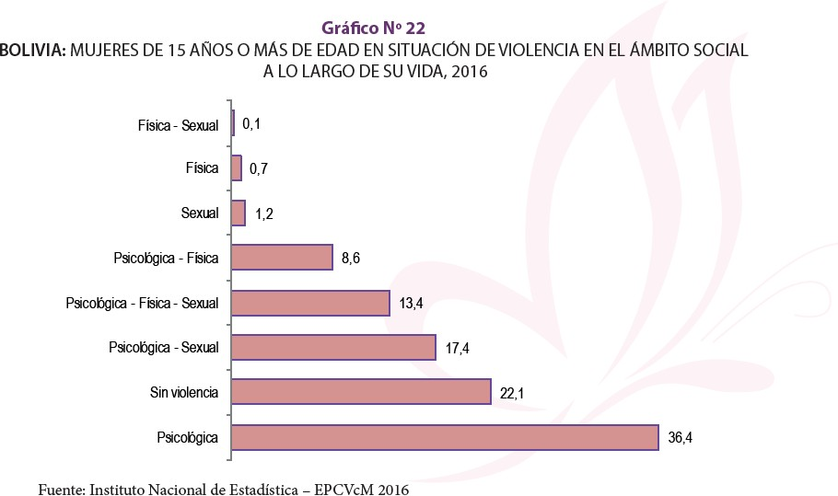

Figure 2: Bolivia: Women 15 or older that have experienced violence in their social environments based on area, department, and period of reference, 2016.¹⁰⁵
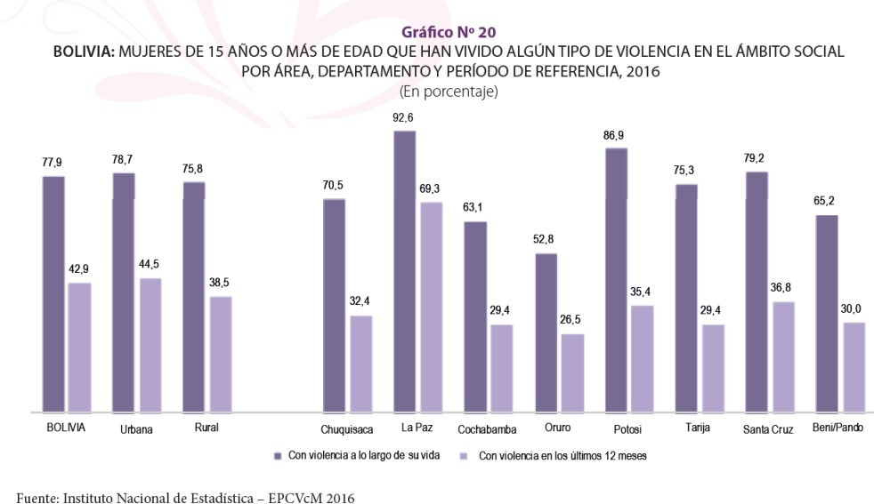

COVID-19 Pandemic

COVID-19, Human Rights, and Pandemic Measures in Bolivia

Research and information are quite limited given that the COVID-19 pandemic is still ongoing and some of its long-term effects are yet to be visible. However, exploring the effects that lockdowns implemented to mitigate the pandemic have had in terms of human rights and in the context of international law is still possible. Under traditional international human rights law, as Aubrey Lebret mentions, states have the ability to “limit the exercise of most human rights if it is necessary to protect the rights of others or collective interests”.¹⁰⁶ An example of this can be found in Article 27 of the American Convention on Human Rights (ACHR), which states that “in time of war, public danger, or other emergency that threatens the independence or security of a

¹⁰⁵ See Appendix A, B, C, D, E, and F for more detailed statistics and findings from the EPCVcM ¹⁰⁶ Lebret, Aubrey. “Covid-19 Pandemic and Derogation to Human Rights. Journal of Law and the Biosciences, 7(1): 2020. https://doi.org/10.1093/jlb/lsaa015

State Party, it may take measures derogating from its obligations under the present Convention to the extent and for the period of time strictly required by the exigencies of the situation, provided that such measures are not inconsistent with its other obligations under international law and do not involve discrimination on the ground of race, color, sex, language, religion, or social origin”.¹⁰⁷ Given the similarities between the COVID-19 pandemic crisis and warlike situations, governments had the same abilities to infringe on their human rights obligations under the intent of safeguarding the good of the whole. In Bolivia, pandemic measures limited the ability of people to leave their homes, infringing on some of the freedoms stated under the Universal Declaration of Human Rights.
As the poorest country in South America, Bolivia has struggled from a failing health system for quite some time.¹⁰⁸ Without enough hospitals, equipment, or enough health professionals, the country was not prepared to face a pandemic of such an unprecedented magnitude. Adding on to that challenge was the political turmoil Bolivia was going through, given it had been merely three months since the electoral crisis and civil unrest that led an interim government to take over. Not only that, but allegations of oppression on protestors resulting from the interim government’s use of military power once it took over led to even more tension. Examining the best options to contain the virus and prevent it from spreading was therefore a tremendously difficult task, but it led to the conclusion that the only way to prevent a rapid collapse of the health system was through enacting strict quarantine measures. Through Supreme Decree

¹⁰⁷ Organization of American States (OAS), American Convention on Human Rights, "Pact of San Jose", Costa Rica, 22 November 1969, available at: https://www.refworld.org/docid/3ae6b36510.html
¹⁰⁸ Blofield, Merike, Hoffmann, Bert, Llanos, Mariana (2020). Assessing the Political and Social Impact of the COVID-19 Crisis in Latin America. (GIGA Focus Lateinamerika, 3). Hamburg: GIGA German Institute of Global and Area Studies. https://www.giga-hamburg.de/en/publications/18749084-assessing- political-social-impact-covid-19-crisis-latin-america/

Number 4199, which was to be effective starting on midnight of March 22, 2020, interim president Jeanine Áñez implemented a fourteen-day lockdown.¹⁰⁹ The Supreme Decree detailed a closure of air, land, river, and lake borders; a suspension of international flights; a temporary suspension of any in-person classes; a suspension of public events including cultural or sporting activities; and strict restrictions on the movement of people.¹¹⁰ However, due to lack of compliance and continued threat, on March 26, Áñez declared a health emergency because of “unacceptably low compliance with quarantine requirements”.¹¹¹ Declaring the health emergency meant allowing for military involvement and prison sentences of up to 10 years for those who chose not to abide by the newly instituted measures.¹¹²
Supreme Decree 4199 detailed restrictions on the free movement of people throughout Bolivian territory. Based on the last digit of ID numbers, citizens over 18 and under 65 were allotted designated days of the week to get medicine and groceries from 7am-12pm. Mondays were for those whose IDs ended in 1 or 2, Tuesdays for 3 or 4, and so on and so forth.¹¹³ The use of motorized vehicles was prohibited; requiring people to either walk or bike to stock up on groceries on their designated days, unless they had a government issued permit. Through

¹⁰⁹ Escalante, Luis, Helene Maisonnave, 2021. "The impact of the COVID-19 pandemic on women's welfare and domestic burdens in Bolivia," https://ideas.repec.org/p/hal/wpaper/hal-03118060.html
¹¹⁰ Gaceta Oficial del Estado Plurinacional de Bolivia. Decreto Supremo Nº 4199, “Cuarentena Total en todo el territorio del Estado Plurinacional de Bolivia, contra el contagio y propagación del Coronavirus (COVID-19)”. 21 de marzo de 2020
¹¹¹ Blofield, Merike, Hoffmann, Bert, Llanos, Mariana (2020). Assessing the Political and Social Impact of the COVID-19 Crisis in Latin America. (GIGA Focus Lateinamerika, 3). Hamburg: GIGA German Institute of Global and Area Studies. https://www.giga-hamburg.de/en/publications/18749084-assessing- political-social-impact-covid-19-crisis-latin-america/
¹¹² Blofield, Merike, Hoffmann, Bert, Llanos, Mariana (2020). Assessing the Political and Social Impact of the COVID-19 Crisis in Latin America. (GIGA Focus Lateinamerika, 3). Hamburg: GIGA German Institute of Global and Area Studies. https://www.giga-hamburg.de/en/publications/18749084-assessing- political-social-impact-covid-19-crisis-latin-america/
¹¹³ “Gobierno Declara Cuarentena Total Desde Mañana Por 14 Días En Todo El País.” Diario Pagina Siete, March 21, 2020. https://www.paginasiete.bo/nacional/2020/3/21/gobierno-declara-cuarentena-total- desde-manana-por-14-dias-en-todo-el-pais-250378.html.

Supreme Decree 4200, these measures were extended to April 15, 2020. Then, Supreme Decree 4214 extended them to April 30, 2020. Though these measures initially worked to contain the virus, with positive cases ranging from 130-500 per day, the pressing issue was economic. In March, the government passed a bill to provide an unconditional-cash transfer, the “Bono Universal”, for anyone over the age of 18 who was not the recipient of any other cash transfer and was unemployed. Citizens would be able to receive it starting on April 15, 2020. Though it certainly helped, the 1,000 bolivianos (roughly $150 USD) from the cash transfer did not last long. With 62.5% of the economy coming from informal work and petty commerce, the government’s strategy to decelerate the spread of the virus led people to have to decide between exposing themselves to the deadly virus and not having the resources to cover their basic necessities.¹¹⁴ The final extension of strict quarantine measures was through Supreme Decree 4229 extending lockdown until May 10, 2020. Once strict lockdown ended, the country went into a “dynamic quarantine”. As a result, gradually, quarantine measures became less strict to accommodate some of these people’s need to work, but cases quickly rose to the thousands per day. The health system rapidly collapsed, leading to the implementation of makeshift beds in hallways, courtyards, and outside of hospitals. Until about August, positive cases ranged from 1,000 to 1,500 per day.¹¹⁵ The death rate continued to be one of the highest in the world as well, averaging about 3% to 5%.¹¹⁶

¹¹⁴ Blofield, Merike, and Fernando Filgueira. (2020) COVID19 and Latin America: Social Impact and Social Policies, 2 April, Buenos Aires: Centro de Implementación de Políticas Públicas para la Equidad y el Crecimiento (CIPPEC).
¹¹⁵ “Covid-19: Bolivia Reporta 1.693 Casos Nuevos y Un Total De 93.328.” Diario Pagina Siete, August 11, 2020. https://www.paginasiete.bo/sociedad/2020/8/11/covid-19-bolivia-reporta-1693-casos-nuevos- un-total-de-93328-264225.html.
¹¹⁶ Trigo, María Silvia, Anatoly Kurmanaev, and Allison Mccann. “As Politicians Clashed, Bolivia's Pandemic Death Rate Soared.” The New York Times. The New York Times, August 22, 2020. https://www.nytimes.com/2020/08/22/world/americas/virus-bolivia.html.

Dynamic quarantine measures continued, with restrictions separating citizens’ grocery and pharmacy day based on the last digit of the ID being even or odd, until the end of August, where through Supreme Decree 4314, the government began the post-confinement phase with the gradual reopening of the economic sector.¹¹⁷ Due to the electoral crisis the year prior, there still was a pending election that had been scheduled for May 2020 and then postponed. Given the circumstances surrounding the pandemic, it was postponed to September, and then ultimately to October 2020.¹¹⁸ The election took place on October 18, 2020 and Luis Arce Catacora was elected. Given that cases were ranging between 50-100 positive COVID-19 tests, about a month after his election, Arce allowed for the completely lift of measures until January 15, 2020, which allowed for events like graduation celebrations, which congregate hundreds of people, to take place.¹¹⁹ This, paired with the holiday season, unfortunately led to the second wave of COVID- 19 outbreaks, leading the cases in the country to go back up into the thousand cases for day, and surpassing the first wave’s figures. In efforts to mitigate the collapse of the public health system, in February 2020, Arce passed a Supreme Decree that would forbid private hospitals from asking for a down payment before patients would be admitted to Intensive Care Units in hopes of alleviating the burden on public hospitals. This caused a massive battle between doctors, private hospitals, and the government. Clearly, Bolivia’s struggles with providing basic necessities for human rights were further magnified by the pandemic.

¹¹⁷ Escalante, Luis, Helene Maisonnave, 2021. "The impact of the COVID-19 pandemic on women's welfare and domestic burdens in Bolivia," https://ideas.repec.org/p/hal/wpaper/hal-03118060.html
¹¹⁸ “El Centro Carter Apoya Al TSE De Posponer Las Elecciones Para El 18 De Octubre.” Diario Pagina Siete, July 24, 2020. https://www.paginasiete.bo/nacional/2020/7/24/el-centro-carter-apoya-al-tse-de- posponer-las-elecciones-para-el-18-de-octubre-262359.html.
¹¹⁹ Zapana, Verónica. “Gobierno Autoriza Todo Tipo De Actividades Hasta El 15 DE ENERO,” November 30, 2020. https://www.paginasiete.bo/sociedad/2020/11/30/gobierno-autoriza-todo-tipo-de- actividades-hasta-el-15-de-enero-276536.html#!

Gender-Based Violence in Bolivia during the COVID-19 Pandemic

In Bolivia, throughout the COVID-19 pandemic, a substantial number of women’s organizations reported surges in calls for help from women, “noting that the violence had become more brutal” during lockdown.¹²⁰ In early 2021, the government revealed that it had registered a total of 113 femicides in 2020. Though this figure was slightly lower than the one from the year prior, 117, prosecuting authorities revealed that “there was a latent index that revealed that the death of women in 2020 resulted from much more violent ways”.¹²¹ Throughout the two months and ten days of strict quarantine measures, 2,935 cases of violence were reported to the Ministry of Justice, of which 2,378 (81%) were related to domestic violence.¹²² As alarming as those figures are, authorities admitted that these figures do not portray the real incidence of violence within homes, since it is presumed that due to preventive confinement to mitigate the spread of COVID-19, victims were unable to file complaints, pointing to the possibility of much higher numbers.¹²³ Authorities from the Prosecutor's Office Specialized in Crimes of Sexual and Gender-Based Violence voiced their concern for victim’s who were incapable to seek help due to quarantine measures’ restrictive nature.
United Nations Women interviewed some of the most influential women’s right activists in Bolivia to take a look at their work during the pandemic as a result of the surge in cases.
Yobanca Fernández Flores, a women's rights activist who has been in the field for more than 35

¹²⁰ UN Women. “What Happened after COVID-19 Hit: Bolivia.” November 16, 2020. https://www.unwomen.org/en/news/stories/2020/11/what-happened-after-covid-19-hit-bolivia. ¹²¹ Deutsche Welle. “Bolivia Registró 113 Víctimas De Feminicidio En 2020: DW: 03.01.2021.”
DW.COM, January 2, 2021. https://www.dw.com/es/bolivia-registr%C3%B3-113-v%C3%ADctimas-de- feminicidio-en-2020/a-56117971.
¹²² Barriga, Daymira. “El 81% De Las Denuncias Por Delitos Contra La Ley 348 En La Cuarentena Es Por Violencia Intrafamiliar - La Razón: Noticias De Bolivia y El Mundo.” La Razón | Noticias de Bolivia y el Mundo, June 3, 2020. https://www.la-razon.com/ciudades/2020/06/03/el-81-de-las-denuncias-por- delitos-contra-la-ley-348-en-la-cuarentena-es-por-violencia-intrafamiliar/.
¹²³ Ibid

years and is also the Bolivian national president of Community Promoters for the Prevention of Gender-Based Violence, re-emphasized the pressing concern. Fernández Flores expressed that alongside hundreds of women leaders in the country, a network of activists was formed to provide direct support to victims and survivors of gender-based violence during the COVID-19 pandemic. Given the restrictive conditions of the pandemic, Fernández Flores and her network of activists had to find new ways to adapt in their ways of outreach and support, relying on virtual methods to reach victims. Liliana Fuentes, the Director of another women’s organization, Servicio Plurinacional de la Mujer y de la Despatriarcalización "Ana María Romero" (SEPMUD) (Spanish for Plurinational Service for Women and Depatriarchalization “Ana Maria Romero”), expressed her organization’s need to similarly rely on virtual tools. They appealed to the Municipal Integral Legal Services (SLIMs), which are centers found in more than 300 municipalities that are meant to provide both legal and psychological support for victims, to move their work to virtual channels in order to provide support for survivors locked at home.¹²⁴ In November 2020, UN Women collaborated with SEPMUD to facilitate this by preparing counsel for municipal authorities on ways to assist victims of gender-based violence during the context of the COVID-19 pandemic quarantine. With Swiss Agency for Development and Cooperation financial contributions, UN Women was able to provide continued support to local institutions and women’s organizations across the country, in efforts to main essential services working for survivors of gender-based violence to seek help. Though this is an example of the valuable work international organizations are undertaking during the pandemic, it highlights that the work continues to be reactive, rather than proactive. Examples like this one portray the important the role that international law plays in addressing gender-based violence and how a

¹²⁴ UN Women. “What Happened after COVID-19 Hit: Bolivia.” November 16, 2020. https://www.unwomen.org/en/news/stories/2020/11/what-happened-after-covid-19-hit-bolivia.

shift towards mitigating and preventing, rather than solely offering services, could greatly contribute to re-shaping through educational efforts.

Gender-Based Violence (GBV)

Human Rights in Bolivia

The last Universal Periodic Review (UPR) carried out by Bolivia for the United Nations Human Rights Council was executed in December 2019, a few months before the enactment of COVID-19 pandemic quarantine measures. The review found great improvements in terms of poverty in the country, revealing that “between 2006 and 2018, the extreme poverty rate had fallen from 37.7 to 15.2%, lifting more than 2.2 million people out of poverty, in a population of approximately 10 million. During the same period, the Gini coefficient had registered a significant decrease, from 0.60 in 2005 to 0.42 in 2018, the largest reduction in South America”.¹²⁵ The review also reports that “between 2014 and 2018, 95,990 housing units had been built, upgraded, extended and/or renovated, allocating around 23 per cent of them to older persons, persons with disabilities or women”.¹²⁶ Though many of these statistics look promising concerning Bolivia’s human rights record, the review does not mention any statistical improvements in the realm of mitigating gender-based violence rates. The delegation for Bolivia highlighted the adoption of measures to strengthen the protection of women’s rights through “the establishment of the Special Office for Combating Violence against Women and the Plurinational Service for Women and for Dismantling the Patriarchy”.¹²⁷ Yet, although the Republic of Korea, alongside many other peer states tasked with carrying out this review,

¹²⁵ UN Human Rights Council, Report of the Working Group on the Universal Periodic Review: Bolivia, December 17, 2019
¹²⁶ Ibid pg. 4
¹²⁷ Ibid pg, 6

commended the country’s efforts at promoting the rights of women and children, it highlighted their persistent concern at the high rate of femicides in the country. These concerns are not new, in Bolivia’s 2014 UPR, Ireland expressed concerns about “high levels of impunity for human rights violations and urged the Plurinational State of Bolivia to strengthen rule of law, ensuring that no person or institution was above the law and that impunity for human rights violations was not tolerated”.¹²⁸ Although in 2014, all of the existent women’s rights laws were already in place, Poland expressed concern about “the proper implementation of the law regarding preventing violence against women and children and about reports of discrimination against women and children”.¹²⁹ Under the same vein, Switzerland “noted that significant improvements in the judicial system were needed and that the implementation of the law to guarantee women a life free from violence should be strengthened”.¹³⁰ Going further back to Bolivia’s first UPR in 2010, the United Kingdom “noted that women suffered inequalities, especially in the workplace, and faced domestic violence”.¹³¹ In the same report, Norway “noted discrimination and violence against women”.¹³² These examples underscore a long withstanding concern with the pandemic of gender-based violence. UPR recommendations seem redundant, they commend efforts while still emphasizing their concern in the elevated indexes of gender-based violence, highlighting the need for measures that create change, rather than just attend in the aftermath.
The pattern seems to be that though there are measures that are implemented to address the high rates of gender-based violence, the need for more instruments to actually prevent the

¹²⁸ UN Human Rights Council, Report of the Working Group on the Universal Periodic Review: Bolivia, December 17, 2014
¹²⁹ UN Human Rights Council, Report of the Working Group on the Universal Periodic Review: Bolivia, December 17, 2014
¹³⁰ Ibid
¹³¹ UN Human Rights Council, Report of the Working Group on the Universal Periodic Review: Bolivia, March 10, 2010
¹³² Ibid

violence from taking place is where the problem lies. Similar to international law, these measures are more reactive, rather than proactive. Institutions that provide services for victims are crucial, there is no question about that, but if there are no measures that seek to get to the root of the problem, those services will quickly become overwhelmed and just become a part of the cyclical trap that gender-based violence finds itself now.
A fundamental factor to understanding gender-based violence in Bolivia is the large existent economic gender gap. The gender gap in Bolivia is evident across multiple areas and dimensions, including poverty, access to employment, and income level.¹³³ Poverty is distributed differently between men and women. Before quarantine, women experienced a national poverty rate of 37.6%, in comparison to men who experience it at 36.7% rate. There is also a distinction between urban and rural settings, with women experiencing a poverty rate of 51.6% in rural areas, the highest of the whole country.¹³⁴ In the formal sphere, Bolivian women’s labor force participation rate is of 65.2%, whereas men’s labor force participation rate is 82.6%. In addition, women’s scope of work sectors is significantly more narrow than that of men, seeing that they mostly participate in food service, education, health, and social service sectors.¹³⁵ All four of those sectors are forms of service sector, which puts them in vulnerable situations in the face of any crisis (whether that be from COVID-19 or political turmoil, which has been a significant part of Bolivia’s history). Besides their work in a “formal” setting (I quote formal, given that many women participate in the informal economy and petty commerce), women in most developing

¹³³ Luis Escalante, Maisonave, Helene. "The impact of the COVID-19 pandemic on women's welfare and domestic burdens in Bolivia”. (2021) https://ideas.repec.org/p/hal/wpaper/hal-03118060.html
¹³⁴ INE, 2019. Encuesta de Hogares 2019 Instituto Nacional de Estadística. https://www.ine.gob.bo/index.php/banco/base-de-datos-sociales
¹³⁵ INE, 2018a. Encuesta Continua de Empleo 4T. Instituto Nacional de Estadistica. https://www.ine.gob.bo/index.php/banco/base-de-datos-sociales

countries are also tasked with work in the non-commercial sphere.¹³⁶ That is, tasks including domestic chores and responsibilities, as well as childcare. According to a study, women in urban areas devote an average of 5.6 hours a day to domestic and care work, compared to an average of 3 hours by men.¹³⁷ Another study revealed that in rural areas, women about 7 hours per day on domestic work, in comparison to a mere 1.4 hours for men.¹³⁸ These figures serve as quantitative examples of the gender disparities in Bolivian society, both within the commercial and the non- commercial sectors. Data has shown that in particular, in regard to labor, the gender gap has narrowed in the past few decades. Nonetheless, it continues to exist and affects the poorest members of the population.
In the context of the COVID-19 pandemic, already existent inequalities between men and women in Bolivia’s labor sector have further exacerbated and widened the gap. Seeing that women in Bolivia have a tendency to participate in sectors of the economy that fall within service categories, women have been disproportionally affected in comparison to men. A study on Latin American countries’ economic sectors during the COVID-19 pandemic noted that the most affected sectors were wholesale and retail trade, community, social and personal activities, hotels and restaurants, real estate, business and rental activities, and manufacturing.¹³⁹ This had a substantial impact on the Bolivian economy, seeing that reports reveal it was one of the most

¹³⁶ Rubiano-Matulevich, Eliana; Viollaz, Mariana. 2019. Gender Differences in Time Use : Allocating Time between the Market and the Household. Policy Research Working Paper; No. 8981. World Bank, Washington, DC. © World Bank. https://openknowledge.worldbank.org/handle/10986/32274
¹³⁷ CEPAL, 2019. Panorama social de América Latina 2019. Comisión Económica para América Latina y el Caribe, Santiago
¹³⁸ Luis Escalante, Maisonnave, Helene. “The impact of the COVID-19 pandemic on women's welfare and domestic burdens in Bolivia," (2020). https://ideas.repec.org/p/hal/wpaper/hal-03118060.html
¹³⁹ CEPAL, 2020a. Sectores y empresas frente al COVID-19: emergencia y reactivación. CEPAL

affected countries in the region since its Gross Domestic Product (GDP) reduced by 11.11%.¹⁴⁰ This drop is due to the closure of most of the economic sector from quarantine measures detailed in Supreme Decree 4199, which as a result the pandemic left 47% of women and 39% of men unemployed.¹⁴¹ Research has revealed that unemployment often times results in upticks in gender-based violence. Sonia Bhalotra’s research revealed statistics that “male job loss results in a roughly 30% increase in the chances that a man perpetrates violence. Female job loss delivers a percentage increase in the chances that a woman is victimized that is almost twice as large”.¹⁴² As the pandemic has led to economic losses as a consequence of lockdowns and unemployment, alongside an increase in the time families spent together, Bhalotra’s research elucidates on a potential correlation with the recent surge in domestic violence.
When exploring the potential changes that the COVID-19 pandemic will affect in the future, it is significant to look at their effect on vulnerable populations. Jordi Honey-Roses et al. bring up the future design of public spaces, practices, and rules as a potential future concern in their research. Honey-Roses et al denote that public spaces encompass a variety of purposes, including serving as the only opportunity for recreational outdoor spaces and can provide relief from living conditions.¹⁴³ Aside from the recurring risk of gender-based violence within

¹⁴⁰ INE, 2020. Boletín Estadístico Producto Interno Bruto al Segundo Trimestre 2020. INE. https://www.ine.gob.bo/index.php/publicaciones/boletin-estadistico-producto-interno-bruto-alsegundo- trimestre-2020/
¹⁴¹ Gutiérrez, Diana, Martín, Guillermina, Ñopo, Hugo. 2020. El coronavirus y los retos para el trabajo de las mujeres en América Latina 88. https://www.grade.org.pe/en/publicaciones/el-coronavirus-y-los-retos- para-el-trabajo-de-las-mujeres-en-america-latina/
¹⁴² Bhalotra, Sonia. “Job Displacement, Unemployment Benefits, and Domestic Violence.” VOX, CEPR Policy Portal, November 13, 2020. https://voxeu.org/article/job-displacement-unemployment-benefits- and-domestic-violence.
¹⁴³ Honey-Roses, Jordi & Anguelovski, Isabelle & Bohigas, Josep & Chireh, Vincent Kuuteryiri Mr. & Daher, Carolyn & Konijnendijk, Cecil & Litt, Jill & Mawani, Vrushti & McCall, Mike & Orellana, Arturo, 2020. "The Impact of COVID-19 on Public Space: A Review of the Emerging Questions”. https://ideas.repec.org/p/osf/osfxxx/rf7xa.html

women’s household, the risk of exposure to a highly infectious and deadly virus has contributed to that burden. Honey-Roses et al emphasize that the already existent neoliberal urban policies in Latin America that have already limited the quantity of public spaces in lower-income neighborhoods due to insufficient safety and security measures.¹⁴⁴ If this becomes customary practice in the design of outdoor spaces in the future, it endangers women in lower-income neighborhoods and diminishes one of their few opportunities of escaping violence and seeking help. In Bolivia, where a majority of gender-based violence cases are among lower-income populations and rural areas, continued future changes that follow this line of policy could result in continued elevated rates of violence. Factors like economic losses and reduction of public places further enclose women to their homes, leaving them vulnerable to their aggressors, which further emphasizes a need for preventative measures.

Gender-Based Violence during Significant Change

Situations of crisis, catastrophe, or significant change frequently serve as catalysts that magnify underlying weaknesses and conflicts in societies, typically leading to an increase in gender-based violence cases. Though the magnitude of a pandemic like COVID-19 has never affected the world in a similar fashion, the HIV and Ebola epidemics, as well as the Bubonic plague, serve as case studies for public health crises that have seen surges in domestic violence and violence against women in general. There are usually two main reasons for this. The first one is that public health crises resulting from the propagation of viruses’ solutions tend to relate to the implementation of shelter-in-place measures in efforts to contain and reduce contagion. The result of this is that girls and women are trapped at home with their abusers, prompting more of an opportunity for aggression and violence. The second one is that due to the high alert that

¹⁴⁴ Ibid

governments find themselves in, resources are all redirected to helping mitigate and resolve the present threat, subsiding any other concern. This leads to a breakdown in law; thus, often leaving victims unrecognized and unable to receive the adequate support to escape those situations.
Perpetrators, on the other hand, find themselves exempt from any sort of legal consequence for their actions. More examples of crises that have led to comparable surges of gender-based violence can be found in the 2007 Haiti earthquake, Hurricane Katrina in 2005, the Indian Ocean earthquake and tsunami in 2004, the Black Saturday bushfires in Australia in 2019, and the Eruption of Mount Saint Helen in the 1980’s.¹⁴⁵ In the case of Hurricane Katrina, for example, one study found that “there was a four-fold increase in domestic violence, primarily driven by partner violence, among displaced women”.¹⁴⁶ Analyses of these cases have led scholars to conclude that “although the initial rise is generally observed during the acute phase of disaster, these surges in domestic violence are often sustained for years during the recovery”.¹⁴⁷
During the 2013 to 2015 Ebola outbreak in West Africa, an increase in sexual and gender-based violence was observed as well. Given that response efforts were focused on containing the disease, protocols to protect girls and women from violence during the outbreak were neglected. Quarantine measures “left women and adolescent girls vulnerable to coercion, exploitation, and sexual abuse”.¹⁴⁸ Similar to COVID-19, due to stay-at-home orders and health workers’ strict focus on containing the outbreak, figures were vastly under-reported and

¹⁴⁵ Daniel Alejandro Navarrete Solórzano, Gamez, María Rodríguez, de Corcho, Osvaldo Jiménez Pérez. Gender violence on pandemic of COVID-19. International Journal of Health Sciences, (2020): 10-18. https://doi.org/10.29332/ijhs.v4n2.437
¹⁴⁶ Kofman, Yasmin B, Garfin, Diana Rose. 2020. Home is not always a haven: The domestic violence crisis amid the COVID-19 pandemic. Psychological Trauma: Theory, Research, Practice, and Policy, 12(S1), S199–S201. https://doi.org/10.1037/tra0000866
¹⁴⁷ Ibid
¹⁴⁸ Adhiambo Onyango, Monica, and Alexandra Regan . “Sexual and Gender-Based Violence during COVID-19: Lessons from Ebola.” The Conversation, May 10, 2020. https://theconversation.com/sexual- and-gender-based-violence-during-covid-19-lessons-from-ebola-137541.

therefore difficult to determine. Yet, it was still evident in some places. Guinea reported a 4.5% increase in gender-based violence cases and twice as many rapes.¹⁴⁹ Sierra Leone and Liberia saw exponential growth in teenage pregnancy rates as well. The case of Ebola left key lessons learned regarding the ways in which “epidemics leave women and girls especially vulnerable to violence”.¹⁵⁰ In May 2020, two global health experts on the Ebola outbreak emphasized the valuable lessons that resulted from that crisis and their importance for COVID-19 responses.
Yet, as evidence from the past year points to, those lessons were unfortunately not taken into account.
Another example of situations of crises that have reported comparable tendencies of increases in gender-based violence are periods of war or mass violence. However, the reasons for those surges tend to be different. Given the prevalence of gender-related crimes throughout numerous wars, literature and findings on the subject are amply available. The reason for tying gender-based violence surges during the COVID-19 pandemic to other past crises like wartime gender-related crimes is that a similarity of lack of proper international instruments to help mitigate violence is shared by the two. Women and girls have suffered from sexual violence during wartime conflict repeatedly, yet documents that regulate armed conflicts either briefly and inappropriately characterize those crimes, or they simply fail to mention them.¹⁵¹ Mass atrocities and casualties are common during times of conflict, both men and women are murdered, tortured, imprisoned, etc. However, in addition to those risks, women are signaled out for additional violence – gendered violence. In the past this violence has ranged from sexual

¹⁴⁹ Ibid
¹⁵⁰ Ibid
¹⁵¹ Askin, Kelly D. "Prosecuting Wartime Rape and Other Gender-Related Crimes under International Law: Extraordinary Advances, Enduring Obstacles," Berkeley Journal of International Law 21, no. 2 (2003): 288-349

violence, to forced impregnations and abortions, which are risks that are exclusive to women.¹⁵² In the case of war and mass conflict, not only is international law unable to prevent violence due to the nature of war itself, but it also has failed to recognize and respond to the vulnerable position women are subjected to.
The COVID-19 pandemic’s effect on gender-based violence has had features of both situations seen during past public health crises, armed conflict, and natural disasters. Not only have women been at risk because they have been locked at home with their aggressors in light of shelter-in-place orders and fear of infection, but their ability to report violence also became immensely compromised from being in close and constant proximity of their violent partners.¹⁵³ The fear of being exposed to the virus also has prevented victims from leaving their abusive situations. The National Domestic Violence Hotline has “reported disturbing accounts of abusers harnessing COVID-19 to instill fear and compliance in their partners”.¹⁵⁴ A change in the way international law operates will be paramount for future public health crises, but it will especially be important in other situations of crisis, like war and mass conflict.

Conclusions

Gender-based violence has historically affected women’s livelihoods. Initiatives, mechanisms, definitions, movements, among many other efforts have sought to fight its devastating effect, yet continue to fail at ending it. International law’s shortcomings are mostly to blame, since instruments that exist fail to prevent violence from taking place. This, paired with

¹⁵² Ibid
¹⁵³ Kofman, Yasmin B, Garfin, Diana Rose. 2020. Home is not always a haven: The domestic violence crisis amid the COVID-19 pandemic. Psychological Trauma: Theory, Research, Practice, and Policy, 12(S1), S199–S201. https://doi.org/10.1037/tra0000866
¹⁵⁴ Ibid

corruption in developing countries, further constrains change; and in extreme situations, where crisis enters the equation, completely diminishes any potential effect. This is why it is of utmost importance for the international legal system to undergo review and ultimately re-shape its form. Working towards developing a part of the system that solely focuses on the prevention, rather than a reaction to gender-based violence, has the potential of establishing and creating a real change for women.
In the case of Bolivia, like many other developing countries, it is also important to recognize that in order to see any change, especially from new initiatives like the previously suggested, corruption needs to be addressed and diminished. The international system is interrelated to national systems in countries, so for one to be able to impact the other, it is extremely important for there to be change that will facilitate it in both. This will not only serve as a means for a reduction in violence against women, but it will also work to prevent surges like those seen during the COVID-19 pandemic and the Ebola outbreak from following the same pattern.

Findings

The COVID-19 pandemic has brought with it unprecedented, exceptional circumstances that have influenced and changed the way of life for people in areas all across the globe. Surges in gender-based violence, domestic violence, and sexual violence have taken place during previous crises, in part owing to existing issues in societal structures and systemic issues that were further provoked by situations of stress. COVID-19 was no different. However, the multifaceted effect that this pandemic has had contributed to a plethora of other frustrations resulting from economic downturn, displacement, and uncertainty, further magnifying and intensifying violence. Another particular issue with this pandemic has been the distressing

paradox victim’s face – they are either forced to stay at home with their aggressor, which could lead to enduring or escalating violence, or decide to leave (if able to) and risk exposing themselves to a highly infectious, deadly virus.¹⁵⁵ Since many did not even have the latter as an option, many cases of violence were left unreported, and lockdowns, strict measures, and an inability to report violence or seek help, took a serious toll on women who were left unable to escape their aggressors. In the case of Bolivia, prosecutors, authorities, and organizations have all reported an upsurge in the severity of violence that women were subjected to. Bolivian government officials also recognized that figures did not reveal true indexes of violence, given the limitations from stay-at-home orders. Experts on the 2013 to 2015 Ebola outbreak have highlighted a similar problem, still struggling to quantify gender-based violence cases six years later.
Pandemic aside, statistics from the past few years have revealed that Bolivia has led regional charts on gender-based violence. As a participant of all major international treaties meant to address women’s rights and gender equality, alongside enacting five different legislative mechanisms nationally to address gender equality in the past 11 years, this information leads to a questioning of international law’s effectiveness and ability to actually have a tangible impact on member states’ ability to mitigate human rights abuses. Available literature reveals that though international law has positively influenced the promotion of human rights by beginning conversations on prevalent issues worldwide, there needs to be more. The existent international jurisdictional structure serves as a mechanism that is meant to respond to atrocities and abuses once they have taken place. Instruments like the Inter-American Human

¹⁵⁵ Kofman, Yasmin B, Garfin, Diana Rose. 2020. Home is not always a haven: The domestic violence crisis amid the COVID-19 pandemic. Psychological Trauma: Theory, Research, Practice, and Policy, 12(S1), S199–S201. https://doi.org/10.1037/tra0000866

Rights Commission are fundamental to bringing justice in cases where states are unable to do so within their own institutions. However, laws and legislation alone are unable to wholistically address these issues at the core. Their reactive nature results in response measures, rather than actions that are proactive, seeking to prevent further iterations of abuses and atrocities.
Recognizing that international human rights law is further restricted during situations of crisis, like COVID-19 or periods of war/mass conflict, it is even more important to work towards adding on a second facet to the equation. Pairing educative efforts and campaigns, with international systems that can adequately review reports that provide real data, can have a significant impact on the reduction of human rights abuses worldwide, especially if future unprecedented situations impact the world in similar ways than COVID-19 has. An example of a movement that fosters education can be found in Brazil through its “promotoras legais populares” or Popular Legal Promoters (PLP) program. Established in 1993, this project was created to rethink the legal field so as to guarantee access to justice for all women.¹⁵⁶ Their training program serves as an instrument for the dissemination of women’s human rights, particularly in relation to domestic violence and sexual/reproductive rights. In much of the region, whether as a result from limited educational opportunities or language limitations, often times women are not aware of their rights and the options available to them. Through efforts like PLP in Brazil, women are equipped with lifesaving information that, when joined by existent reactive measures in the international arena, has the possibility of reducing indexes of violence. Expanding efforts like PLP to also educate men could even further this movement and contribute to change from the core.

¹⁵⁶ “Promotoras Legais Populares.” Themis. http://themis.org.br/fazemos/promotoras-legais-populares/.

Bolivia already has numerous institutions that have been established to respond to the prominence of gender-based violence. Empowering and utilizing them in order to fulfill a similar mission than that of PLP in Brazil has the ability to use those existent structures. Not only is this beneficial because it expediates the process of having to create brand new institutions, but it also empowers them to fulfill both needed facets – education and justice. Adding on to the benefit of their familiarity on the subject of gender-based violence. International organizations and instruments that are already in the country can, in the same way, become versatile and multidimensional. There will always be a need for judicial instruments for accountability but working towards re-shaping society has the potential of unloading the burden on the judicial side of the equation. However, it is of utmost importance for corruption to be addressed and properly dealt with first, because without doing so, any measure, institution, or policy that is created will be just as ineffective as the system is today. Corruption’s presence in Bolivia’s law enforcement institutions and its structural processes incapacitates the country’s ability to properly seek for accountability. Not only does this really affect credibility for enforcement capabilities, but it greatly decreases trust in criminal processes. With striking figures like in the case of trafficking, where only 12 sentences have been executed, there is a highlighted need for reform. Fighting corruption will foster trust in the system for victims of gender-based violence to seek help.
Therefore, there is an urgent need for institutional change throughout Bolivian establishments in order for real work dedicated to the elimination of gender-based violence in the country to be effective. Bolivians to have trust in the systems, processes, and institutions that are responsible for seeking accountability for victims and not have to fear that corruption will get in the way of accountability.

Although there are great initiatives based on educational and proactive approaches that can supplement existent international tools, it is also extremely crucial to have a detailed review of current international legislative framework to identify where it is failing. The quasi-judicial character of many instruments in the global sphere, the Eurocentric and elitist disposition of international law, and the homogeneity of participation in the field needs to be re-evaluated. If the international system continues to develop legislation that resembles what already exists today, it will continue to circle back to the same issues. Equal representation, acknowledgement of ethnic, traditional, and cultural factors, as well as structural inequality, alongside the plague of corruption that often times consumes countries’ institutions, forbidding them from abiding by international norms and treaties they are signed on to, must be a priority.
Recommendations for changes to the system should be mostly geared towards policy initiatives that strive to accommodate and protect women more. One suggestion is incorporating wide-scale safe haven programs for women who are victims of domestic violence or are in danger as a result of violence. Through establishing facilities that can host these women, the availability of resources for them not only significantly reduces their risk of immediate violence but could also be a great opportunity to explore instituting programs to contribute to their future success. Speaking of programs, another great initiative that could bridge together the international arena with local offices is the institution of educational programs that can prepare women in vocational training to open opportunities aside from the service industry. The pandemic underlined how at risk those in that particular sector are and through initiatives that grant opportunities that widen opportunities could have promising results for expanding women’s labor opportunities. Lastly, seeking to establish more policies that focuses on widespread information campaigns on women’s rights, especially for those who live in

vulnerable areas, could accommodate and equip women who might not have educational resources or services for support for victims of gender-based violence in ways that could save their lives. Working to collaborate between international and national efforts to incorporate policies that are multi-dimensional and can accommodate women from all backgrounds is essential to establish a starting point for a better, more equitable, and free of violence future for women.
In terms of a future scholarly outlook, exploring accountability and reparations on an international scale could have an enormous impact and motivation on the promotion of international human rights nationally. Still, it is important to recognize the obstacles that going that route might have. In the case of Bolivia, where there have been three presidents in the past year and a half, determining responsibility on administrations could be difficult. In that case, it could certainly be insightful for future literature to encompass different standards for accountability, at the state level or at the administration level. In any case, the COVID-19 pandemic and its effect on the spike of gender-based violence cases underline the need for change. The international legal arena needs to be amended, whether that be through the inclusion of educational proactive measures that attempt to strike the issue at the core, effective accountability measures that motivate compliance, reviewing the existent instruments to modify their deficiencies, or through a combination of all.

Bibliography

“2020 Is Australia's 'Worst Year for Domestic Violence,' Experts Say.” Global Citizen, December 3, 2020. https://www.globalcitizen.org/en/content/2020-australias-worst-year-
domestic-violence/.

Adhiambo Onyango, Monica, and Alexandra Regan . “Sexual and Gender-Based Violence during COVID-19: Lessons from Ebola.” The Conversation, May 10, 2020. https://theconversation.com/sexual-and-gender-based-violence-during-covid-19-lessons-
from-ebola-137541

Allen-Ebrahimian, Bethany. “China's Coronavirus Quarantines Raise Domestic Violence Fears.” Axios, March 7, 2020. https://www.axios.com/china-domestic- violencecoronavirusquarantine-7b00c3ba-35bc-4d16-afdd-b76ecfb28882.html.

Askin, Kelly D., "Prosecuting Wartime Rape and Other Gender-Related Crimes under International Law: Extraordinary Advances, Enduring Obstacles," Berkeley Journal of International Law 21, no. 2 (2003): 288-349

Bhalotra, Sonia. “Job Displacement, Unemployment Benefits, and Domestic Violence.” VOX, CEPR Policy Portal, November 13, 2020. https://voxeu.org/article/job-displacement- unemployment-benefits-and-domestic-violence.

Barriga, Daymira. “El 81% De Las Denuncias Por Delitos Contra La Ley 348 En La Cuarentena Es Por Violencia Intrafamiliar - La Razón: Noticias De Bolivia y El Mundo.” La Razón | Noticias de Bolivia y el Mundo, June 3, 2020. https://www.la-

razon.com/ciudades/2020/06/03/el-81-de-las-denuncias-por-delitos-contra-la-ley-348-en-

la-cuarentena-es-por-violencia-intrafamiliar/.

Barton, Ed. “A Brief History of International Law.” Brief History of International Law, n.d. https://edbarton.com/topics/law/international-law/brief-history-international-law/

Bayefski, Anne F. 2001. The UN Human Rights Treaty System: Universality at the Crossroads.

Ardsley, NY: Transnational Publishers

Blofield, Merike, and Fernando Filgueira. (2020) COVID19 and Latin America: Social Impact and Social Policies, 2 April, Buenos Aires: Centro de Implementación de Políticas Públicas para la Equidad y el Crecimiento (CIPPEC).

Bolivia.com, Redacción. 2014. “Asesinato De Sophia Calvo Reaviva La Alarma Por Violencia Machista.” https://www.bolivia.com/actualidad/nacionales/sdi/96632/asesinato-de-sophia-
calvo-reaviva-la-alarma-por-violencia-machista-en-bolivia

“Bolivia: Presentación Resultados ‘Encuesta De Prevalencia y Características De La Violencia Contra Las Mujeres (EPCVcM).” 2017. Mujeres libres de violencia. http://www.mujereslibresdeviolencia.usmp.edu.pe/bolivia-presentacion-resultados-
encuesta-de-prevalencia-y-caracteristicas-de-la-violencia-contra-las-mujeres-epcvcm/

“Bolivia Corruption Report.” GAN Integrity, November 5, 2020. https://www.ganintegrity.com/portal/country-profiles/bolivia/.

Bolivia: Ex-Interim President Jeanine Áñez Arrested over 'Coup'.” BBC News. BBC, March 13, 2021. https://www.bbc.com/news/world-latin-america-56381697.

Bott, Sarah, Andrew Morrison, and Mary Ellsberg. 2005. “Preventing and Responding to Gender-Based Violence in Middle and Low-Income Countries: A Global Review and Analysis.” PsycEXTRA Dataset. https://elibrary.worldbank.org/doi/abs/10.1596/1813-
9450-3618

Camacho Justiniano, Rosse Mary. 2015. “In Latin America, Bolivia Reports the Most Cases of Violence against Women.” D C: Development and Cooperation. https://www.dandc.eu/en/article/latin-america-bolivia-reports-most-cases-violence-against-
women

CDC – National Center for Health Statistics – Homepage. https://www.cdc.gov/nchs/. February

21, 2020.

CEPAL, 2019. Panorama social de América Latina 2019. Comisión Económica para América Latina y el Caribe, Santiago

CEPAL, 2020a. Sectores y empresas frente al COVID-19: emergencia y reactivación. CEPAL

“Corte IDH Aparta a Abogado De Evo De Casos Que Involucran a Bolivia.” Correo del Sur, February 10, 2020. https://correodelsur.com/politica/20200210_corte-idh-aparta-a-
abogado-de-evo-de-casos-que-involucran-a-bolivia.html.

“Covid-19: Bolivia Reporta 1.693 Casos Nuevos y Un Total De 93.328.” Diario Pagina Siete, August 11, 2020. https://www.paginasiete.bo/sociedad/2020/8/11/covid-19-bolivia-reporta-
1693-casos-nuevos-un-total-de-93328-264225.html.

Decker, Michele R. et al. 2015. “Gender-Based Violence Against Adolescent and Young Adult Women in Low- and Middle-Income Countries.” Journal of Adolescent Health 56(2): 188–
96. https://www.sciencedirect.com/science/article/pii/S1054139X14003838

“Defensoría Del Pueblo Considera Insuficientes Los Esfuerzos Del Estado Para Atender a Mujeres Víctimas De Violencia.” Defensoría del Pueblo : Estado Plurinacional de Bolivia, July 16, 2020. https://www.defensoria.gob.bo/noticias/defensoria-del-pueblo-considera-
insuficientes-los-esfuerzos-del-estado-para-atender-a-mujeres-victimas-de-violencia.

Deutsche Welle. “Bolivia Registró 113 Víctimas De Feminicidio En 2020: DW: 03.01.2021.” DW.COM, January 2, 2021. https://www.dw.com/es/bolivia-registr%C3%B3-113-
v%C3%ADctimas-de-feminicidio-en-2020/a-56117971

Díaz-Olavarrieta, Claudia et al. 2010. “The Co-Occurrence of Intimate Partner Violence and Syphilis among Pregnant Women in Bolivia.” Journal of Women’s Health 18(12): 2077– 86.

Donnelly, Jack. Universal Human Rights in Theory and Practice. Ithaca; London: Cornell University Press, 2013. http://www.jstor.org/stable/10.7591/j.ctt1xx5q2.

Echeburúa, Enrique, Javier Fernández-Montalvo, Paz De Corral, and José J. López-Goñi. 2008. “Assessing Risk Markers in Intimate Partner Femicide and Severe Violence.” Journal of Interpersonal Violence 24(6): 925–39

“El Centro Carter Apoya Al TSE De Posponer Las Elecciones Para El 18 De Octubre.” Diario Pagina Siete, July 24, 2020. https://www.paginasiete.bo/nacional/2020/7/24/el-centro-
carter-apoya-al-tse-de-posponer-las-elecciones-para-el-18-de-octubre-262359.html.

Englehart, Neil A., Melissa Miller, 2014, The CEDAW Effect: International Law’s Impact on Women’s Rights, 13(1), 22-47

Escalante, Luis, Maisonnave, Helene. “The impact of the COVID-19 pandemic on women's welfare and domestic burdens in Bolivia," (2020). https://ideas.repec.org/p/hal/wpaper/hal-
03118060.html

e.V., Transparency International. “Corruption Perceptions Index 2018.” www.transparency.org. https://www.transparency.org/cpi2018

“Fiscalía Registra 15.936 Hechos De Violencia Familiar En El País Hasta Julio.” Los Tiempos, July 17, 2019. https://www.lostiempos.com/actualidad/pais/20190717/fiscalia-registra- 15936-hechos-violencia-familiar-pais-julio.

Gaceta, Redacción LA. 2013. “En Bolivia La Mujer Aún Dice 'Me Pega Porque Me Quiere'.” https://www.lagaceta.com.ar/nota/533561/salud/bolivia-mujer-aun-dice-me-pega-porque- me-quiere.html

Gaceta Oficial del Estado Plurinacional de Bolivia. Reglamento de la Ley Nº 045 “Ley contra el racismo y toda forma de discriminación”. Decreto Supremo Nº 762, 8 de octubre de 2010

Gaceta Oficial del Estado Plurinacional de Bolivia, Reglamento de la Ley Nº 243, “Ley contra el acoso y violencia política hacia las mujeres”. Decreto Supremo Nº 2935, 28 de mayo de 2012

Gacta Oficial del Estado Plurinacional de Bolivia. Reglamento de la Ley Nº 263, “Ley integral contra la trata y tráfica de personas”. Decreto Supremo Nº 1486, 31 de julio de 2012

Gaceta Oficial del Estado Plurinacional de Bolivia. Reglamento de la Ley Nº 348 “Ley integral para garantizar a las mujeres una vida libre de violencia” Decreto Supremo Nº 2145, 14 de Octubre de 2014

Gaceta Oficial del Estado Plurinacional de Bolivia. Decreto Supremo Nº 4199, “Cuarentena Total en todo el territorio del Estado Plurinacional de Bolivia, contra el contagio y propagación del Coronavirus (COVID-19)”. 21 de marzo de 2020

García Villagomez, Ana Paola. “Trata De Personas y El Acceso a La Justicia En Bolivia.” End Slavery, 2016. http://www.endslavery.va/content/endslavery/en/publications/reallove/garcia.html

Garris, Christian J. "Bosnia and the Limitations of International Law," Santa Clara Law Review 34, no. 3 (1994): 1039-1088

Gathii, James Thuo. “International Law and Eurocentricity” European Journal of International Law, Vol. 9, Issue 1 (1998)

“Gender Equality and Women's Empowerment – United Nations Sustainable Development.” United Nations. United Nations, 2015. https://www.un.org/sustainabledevelopment/gender-equality/.

“Gobierno Declara Cuarentena Total Desde Mañana Por 14 Días En Todo El País.” Diario Pagina Siete, March 21, 2020. https://www.paginasiete.bo/nacional/2020/3/21/gobierno- declara-cuarentena-total-desde-manana-por-14-dias-en-todo-el-pais-250378.html.

Gutiérrez, Diana, Martín, Guillermina, Ñopo, Hugo. 2020. El coronavirus y los retos para el trabajo de las mujeres en América Latina 88. https://www.grade.org.pe/en/publicaciones/el-coronavirus-y-los-retos-para-el-trabajo-de-
las-mujeres-en-america-latina/

Hafner-Burton, Emilie Marie and Tsutsui, Kiyoteru, Justice Lost! The Failure of International Human Rights Law to Matter Where Needed Most (May 2007). Journal of Peace Research, no. 4. pp. 407–425 vol. 44 https://ssrn.com/abstract=2701376

Hill, Daniel W, 2010, Estimating the effects of human rights treaties on state behavior. The Journal of Politics, 72(4), 1161–1174

Hillebrecht, Courtney. "The Domestic Mechanisms of Compliance with International Human Rights Law: Case Studies from the Inter-American Human Rights System," Human Rights Quarterly 34, no. 4 (November 2012): 959-985

Honey-Roses, Jordi & Anguelovski, Isabelle & Bohigas, Josep & Chireh, Vincent Kuuteryiri Mr. & Daher, Carolyn & Konijnendijk, Cecil & Litt, Jill & Mawani, Vrushti & McCall, Mike

& Orellana, Arturo, 2020. "The Impact of COVID-19 on Public Space: A Review of the Emerging Questions”. https://ideas.repec.org/p/osf/osfxxx/rf7xa.html

Ibsen Cárdenas and Ibsen Peña v. Bolivia. 2010. Inter-American Human Rights Court (Merits, Reparation, and Costs) https://www.corteidh.or.cr/docs/casos/articulos/seriec_217_ing.pdf

INE, 2018a. Encuesta Continua de Empleo 4T. Instituto Nacional de Estadistica. https://www.ine.gob.bo/index.php/banco/base-de-datos-sociales

INE, 2019. Encuesta de Hogares 2019 Instituto Nacional de Estadística. https://www.ine.gob.bo/index.php/banco/base-de-datos-sociales

INE, 2020. Boletín Estadístico Producto Interno Bruto al Segundo Trimestre 2020. INE. https://www.ine.gob.bo/index.php/publicaciones/boletin-estadistico-producto-interno-
bruto-alsegundo-trimestre-2020/

Jewkes, Rachel. 2002. “Preventing Sexual Violence: A Rights-Based Approach.” The Lancelot. https://www.thelancet.com/journals/lancet/article/PIIS0140-6736(02)11135-4/fulltext

Keck, Margaret, and Kathryn Sikkink. 2001. “Historical Precursors to Modern Transnational Social Movements and Networks.” Globalizations and Social Movements: Culture, Power, and the Transnational Public Sphere, 35–53. Ann Arbor: University of Michigan Press. http://courses.washington.edu/pbaf531/KeckSikkink.pdf

Klugman, J; Hanmer, L; Twigg, S; Hasan, T; McCleary-Sills, J; Santamaria, J, 2014, Voice and Agency: Empowering Women and Girls for Shared Prosperity. Washington, DC: World Bank Group

Kofman, Yasmin B, Garfin, Diana Rose. 2020. Home is not always a haven: The domestic violence crisis amid the COVID-19 pandemic. Psychological Trauma: Theory, Research, Practice, and Policy, 12(S1), S199–S201. https://doi.org/10.1037/tra0000866

Lebret, Aubrey. “Covid-19 Pandemic and Derogation to Human Rights. Journal of Law and the Biosciences, 7(1): 2020. https://doi.org/10.1093/jlb/lsaa015

Lutz, Ellen L., and Kathryn Sikkink. "International Human Rights Law and Practice in Latin America." International Organization 54, no. 3 (2000): 633-59. Accessed March 22, 2021. http://www.jstor.org/stable/2601347

Mcilwaine, Cathy. 2013. “Urbanization and Gender-Based Violence: Exploring the Paradoxes in the Global South.” Environment and Urbanization 25(1): 65–79.

Meekers, Dominique, Sarah C Pallin, and Paul Hutchinson. 2013. “Intimate Partner Violence and Mental Health in Bolivia.” BMC Women’s Health 13(1).

Merry, Sally Engle. 2006. Human rights and gender violence: translating international law into local justice. Chicago: University of Chicago Press

Merry, Sally Engle. 2016. The Seductions of Quantification: Measuring Human Rights, Gender Violence, and Sex Trafficking. (Chicago series in law and society). University of Chicago Press.

Ministerio de Justicia, Instituto Nacional de Estadística. 2016. Encuesta de Prevalencia y características de la Violencia contra las mujeres

Mittal, Shalini, and Tushar Singh. “Gender-Based Violence During COVID-19 Pandemic: A Mini-Review.” Frontiers in Women's Global Health. Frontiers, July 27, 2020. https://www.frontiersin.org/articles/10.3389/fgwh.2020.00004/full.

Navarrete Solórzano, Daniel Alejandro, Gamez, María Rodríguez, de Corcho, Osvaldo Jiménez Pérez. Gender violence on pandemic of COVID-19. International Journal of Health Sciences, (2020): 10-18. https://doi.org/10.29332/ijhs.v4n2.437

Neff, Stephen. “A Short History of International Law” (2003). In M. D. Evans (Ed.), International Law Oxford University Press. (pp. 31-58).

Oelsner, Natalia. 2018. “Violencia Machista Normalizada En América Latina: ‘Las Mujeres Se Acostumbran a Ser Golpeadas.’” EuroNews.

https://es.euronews.com/2018/07/25/violencia-machista-normalizada-en-america-latina-

las-mujeres-se-acostumbran-a-ser-golpeada

Opinión Bolivia. “Leyes Para La Mujer Boliviana.” Opinión Bolivia, March 8, 2012. https://www.opinion.com.bo/articulo/dia-internacional-mujer/leyes-mujer-
boliviana/20120308012200407520.html#:~:text=Nadie%20ser%C3%A1%20torturado%2

C%20ni%20sufrir%C3%A1,familia%20como%20en%20la%20sociedad.

Organization of American States (OAS), American Convention on Human Rights, "Pact of San Jose", Costa Rica, 22 November 1969, available at: https://www.refworld.org/docid/3ae6b36510.html

Organization of American States “Press Release on Disinformation Campaign Regarding the Role of the OAS in the Bolivian Elections.” OAS, June 6, 2020. https://www.oas.org/en/media_center/press_release.asp?sCodigo=E-
064%2F20#:~:text=After%20the%20elections%2C%20on%20October,of%20the%20offici

al%20vote%20count.

Osiel, Mark. “The Uncertain Place of Purge Within Transitional Justice, and the Limitations of International Law in the World’s Response to Mass Atrocity ” In Dealing with Wars and Dictatorships Legal Concepts and Categories in Action, Israël Liora, and Guillaume Mouralis. The Hague: T.M.C. Asser Press, 2014. 253–69. https://link-springer-
com.ezproxy.lib.ou.edu/content/pdf/10.1007%2F978-90-6704-930-6_15.pdf

Palermo, T., J. Bleck, and A. Peterman. 2013. “Tip of the Iceberg: Reporting and Gender-Based Violence in Developing Countries.” American Journal of Epidemiology 179(5): 602–12.

“Promotoras Legais Populares.” Themis. http://themis.org.br/fazemos/promotoras-legais- populares/.

Risse, Thomas, Stephen Ropp, and Kathryn Sikkink (Eds.), The Power of Human Rights: International Norms and Domestic Change. Cambridge, UK: Cambridge University Press, 1999.

Rubiano-Matulevich, Eliana; Viollaz, Mariana. 2019. Gender Differences in Time Use : Allocating Time between the Market and the Household. Policy Research Working Paper; No. 8981. World Bank, Washington, DC. © World Bank. https://openknowledge.worldbank.org/handle/10986/32274

Saravia, Selma Isabel. “En Cuarentena, La Casa Fue La Condena De Muchas Mujeres.” Violentadas en Cuarentena, November 11, 2020. https://violentadasencuarentena.distintaslatitudes.net/portfolio/bolivia/.

Sanjel, S. 2015. “Gender-Based Violence: A Crucial Challenge for Public Health.” Kathmandu University Medical Journal 11(2): 179–84.

Shalhoub‐Kevorkian, Nadera. 2003. “Reexamining Femicide: Breaking the Silence and Crossing ‘Scientific’ Borders.” Signs: Journal of Women in Culture and Society 28(2): 581–608.

Sikkink, Kathryn. 2017 Evidence for Hope: Making Human Rights Work in the 21st Century.

Princeton, NJ: Princeton University Press. 336 pp.

Simmons, Beth A. and Creamer, Cosette D., "Do Self-Reporting Regimes Matter? Evidence From the Convention Against Torture" (2019). Faculty Scholarship at Penn Law. 2057. https://scholarship.law.upenn.edu/faculty_scholarship/2057

Smith, Heather M. Sex Trafficking: Trends, Challenges, and the Limitations of International Law. Human Rights Review 12, (2011): 284 https://doi-
org.ezproxy.lib.ou.edu/10.1007/s12142-010-0185-4

Trigo, María Silvia, Anatoly Kurmanaev, and Allison Mccann. “As Politicians Clashed, Bolivia's Pandemic Death Rate Soared.” The New York Times. The New York Times, August 22, 2020. https://www.nytimes.com/2020/08/22/world/americas/virus-bolivia.html.

Ulrich, Jennifer L. 2000. Confronting Gender-Based Violence with International Institutions: Is a Solution to the Pandemic Within Reach? Indiana Journal of Legal Studies: Vol 7: Iss 2, Article 11.

UN General Assembly, International Bill of Human Rights, 10 December 1948, A/RES/217(III)A-E, available at: https://www.refworld.org/docid/3b00f08b48.html

UN General Assembly, Universal Declaration of Human Rights, 10 December 1948, 217 A (III), available at: https://www.refworld.org/docid/3ae6b3712c.html

UN General Assembly, International Covenant on Civil and Political Rights, 16 December 1966, United Nations, Treaty Series, vol. 999, p. 171, available at: https://www.refworld.org/docid/3ae6b3aa0.html

UN General Assembly, Convention on the Elimination of All Forms of Discrimination Against Women, 18 December 1979, United Nations, Treaty Series, vol. 1249, p.5

UN General Assembly, Declaration on the Elimination of Violence against Women, 20 December 1993, A/RES/48/104, available at: https://www.refworld.org/docid/3b00f25d2c.html

UN General Assembly, Protocol to Prevent, Suppress and Punish Trafficking in Persons, Especially Women and Children, Supplementing the United Nations Convention against Transnational Organized Crime, 15 November 2000, available at: https://www.refworld.org/docid/4720706c0.html

UN General Assembly, Transforming our world : the 2030 Agenda for Sustainable Development, 21 October 2015, A/RES/70/1, available at: https://www.refworld.org/docid/57b6e3e44.html

UN Human Rights Council, Report of the Working Group on the Universal Periodic Review: Bolivia, December 17, 2019

UN Human Rights Council, Report of the Working Group on the Universal Periodic Review: Bolivia, December 17, 2014

UN Human Rights Council, Report of the Working Group on the Universal Periodic Review: Bolivia, March 10, 2010

UN Human Rights Council, 2012. “Report of the Special Rapporteur on violence against women, its causes and consequences”, Rashida Manjoo, A/HRC/20/16, 2012. New York: United Nations, General Assembly. http://www.ohchr.org/Documents/Issues/Women/A.HRC.20.16_En.pdf

UNiTE to End Violence against Women Campaign.” UN Women, 2008. https://www.unwomen.org/en/what-we-do/ending-violence-against-women/take-
action/unite.

UN Women “Ending Violence Against Women and Girls: Programming Essentials.” September 2, 2015. http://www.endvawnow.org/uploads/modules/pdf/1372349234.pdf

UN Women. “What Happened after COVID-19 Hit: Bolivia.” November 16, 2020. https://www.unwomen.org/en/news/stories/2020/11/what-happened-after-covid-19-hit-
bolivia.

United Nations, The sustainable development goals report 2020 (PDF). 30 December 2020. https://unstats.un.org/sdgs/report/2020/The-Sustainable-Development-Goals-Report-
2020.pdf

“Universal Periodic Review.” OHCHR. https://www.ohchr.org/EN/HRBodies/UPR/Pages/UPRMain.aspx

“Violence against Women: Strengthening the Health Response in Times of Crisis.” World Health Organization. World Health Organization, October 23, 2018. https://www.who.int/news-room/feature-stories/detail/violence-against-women.

“What Is Gender-Based Violence (GBV)?,” June 9, 2020. https://www.friendsofunfpa.org/what- is-gender-based-violence gbv/#:~:text=The%20United%20Nations'%20definition%20of,term%20than%20violence
%20against%20women.

World Health Organization. (2013). “Global and regional estimates of violence against women: prevalence and health effects of intimate partner violence and non-partner sexual violence”. Geneva: World Health Organization

Zapana, Verónica. “Gobierno Autoriza Todo Tipo De Actividades Hasta El 15 DE ENERO,” November 30, 2020. https://www.paginasiete.bo/sociedad/2020/11/30/gobierno-autoriza-
todo-tipo-de-actividades-hasta-el-15-de-enero-276536.html#!

Appendix A

Table 2: Political Constitution of Bolivia’s relevant articles for the protection and guarantee of women's rights

Article Number | Article Fundaments
Article 8 | The State is based on the values of unity, equality, inclusion, dignity, freedom, solidarity, reciprocity, respect, complementarity, harmony, transparency, balance, equal opportunities, social and gender equity in participation, common welfare, responsibility, social justice, distribution and redistribution of products and social goods, to live well.
Article 9 | The purposes and essential functions of the State, in addition to those established by the Constitution and the law, are: to constitute a just and harmonious society, founded on decolonization, without discrimination or exploitation, with full social justice, to consolidate plurinational identities; Guarantee the well-being, development, security and protection and equal dignity of individuals, nations, peoples and communities, and promote mutual respect and intracultural, intercultural and multilingual dialogue.
Article 11 | The State adopts a participatory, representative and community democratic form for its government, with equal conditions between men and women.
Article 14 | The State prohibits and sanctions all forms of discrimination based on sex, color, age, sexual orientation, gender identity, origin, culture, nationality, citizenship, language, religious creed, ideology, political or philosophical affiliation, marital status, condition economic or social, type of occupation, degree of education, disability, pregnancy or others whose objective or result is to nullify or undermine the recognition, enjoyment or exercise, under conditions of equality, of the rights of every person. Within the fundamental rights of the CPE, access to health, education and protection against all forms of violence, mainly against women, is guaranteed.
Article 15 | - Everyone has the right to life and to physical, psychological and sexual integrity. No one will be tortured, nor will they suffer cruel, inhuman, degrading or humiliating treatment. There is no death penalty.  - All people, particularly women, have the right not to suffer physical, sexual or psychological violence, both in the family and in society.

 | III. The State will adopt the necessary measures to prevent, eliminate and punish gender and generational violence, as well as any action or omission that has the purpose of degrading the human condition, causing death, pain and physical, sexual or psychological suffering, both in the field public and private.
Article 17 | Everyone has the right to receive education at all levels in a universal, productive, free, comprehensive and intercultural manner, without discrimination.
Article 26 | All citizens have the right to freely participate in the formation, exercise and control of political power, directly or through their representatives, and individually or collectively. Participation will be equitable and on equal terms between men and women.
Article 45 | Women have the right to safe motherhood, with an intercultural vision and practice; they will enjoy special assistance and protection from the State during pregnancy, childbirth and in the prenatal and postnatal periods.
Article 48 | The State shall promote the incorporation of women into work and shall guarantee the same remuneration as men for work of equal value, both in the public and private spheres. Women may not be discriminated against or fired because of their marital status, pregnancy status, age, physical characteristics or number of daughters or sons. The job tenure is guaranteed for women in a state of pregnancy, and for their parents, until the daughter or son reaches one year of age.
Article 63 | Marriage between a woman and a man is constituted by legal ties and is based on the equality of rights and duties of the spouses
Article 64 | The spouses or partners have the duty to attend, under equal conditions and through common effort, the maintenance and responsibility of the home, the education and comprehensive training of the daughters and sons while they are minors or have a disability.
Article 66 | Women and men are guaranteed the exercise of their sexual and reproductive rights.
Article 79 | Values will incorporate gender equity, the non-difference of roles, non- violence and the full enforcement of human rights.
Article 147 | In the election of assembly members, the equal participation of men and women will be guaranteed.
Article 172 | Appoint the ministers of the State, respecting the plurinational character and  gender equality of the ministerial cabinet.

Article 210 | The internal election of the leaders and of the candidates and the candidates of the citizen groups and of the political parties will be regulated and supervised by the Plurinational Electoral Body, which will guarantee the equal participation of men and women.
Article 300 | Promotion of employment and improvement of working conditions, within the framework of national policies for women.
Article 338 | The State recognizes the economic value of household work as a source of wealth and must be quantified in public accounts.
Article 395 | The endowment of public land will be made in accordance with the policies of sustainable rural development and the ownership of women to access, distribution and redistribution of land, without discrimination based on marital status or marital union.
Article 402 | The State has the obligation to promote policies aimed at eliminating all forms of discrimination against women in access, possession and inheritance of land.
Bolivia: Constitución Política del Estado de 2009.

Appendix B

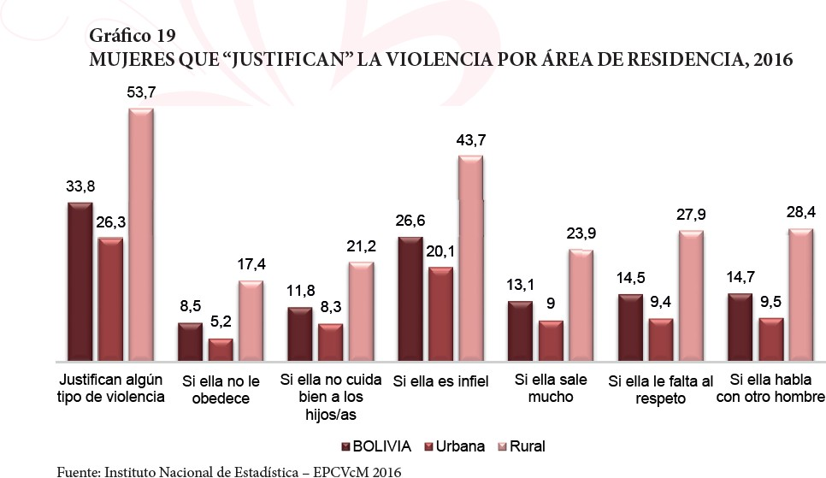
Women who “justify” violence based on residential area, 2016
If she does
not obey
If she does not
take proper care of her children
If she is
unfaithful
If she goes out
too much
If she If she speaks to
disrespects another man them
Justify any type of violence

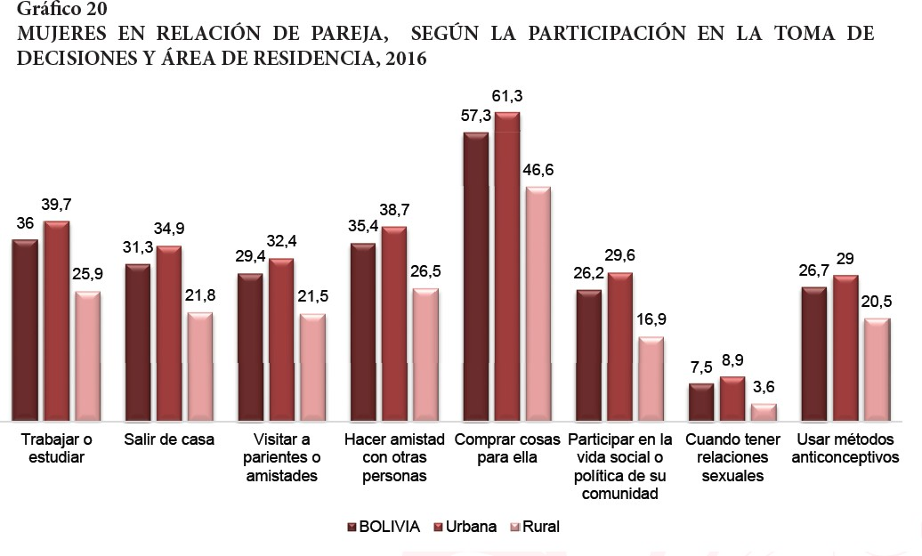

Appendix C

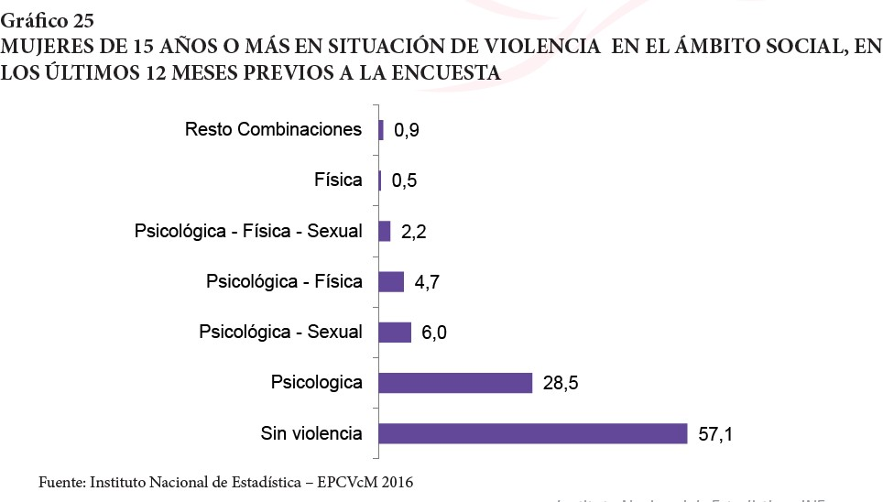

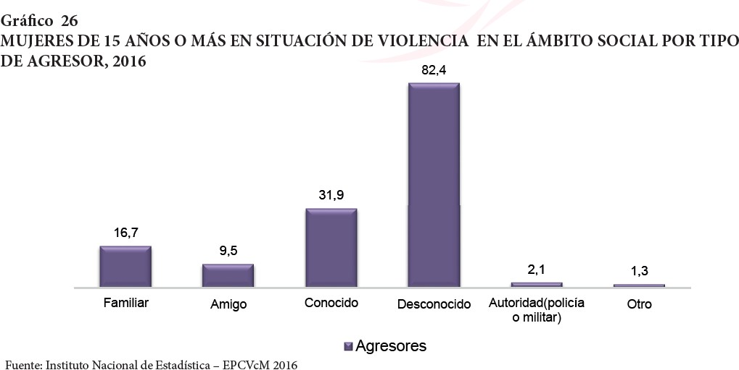

Appendix D

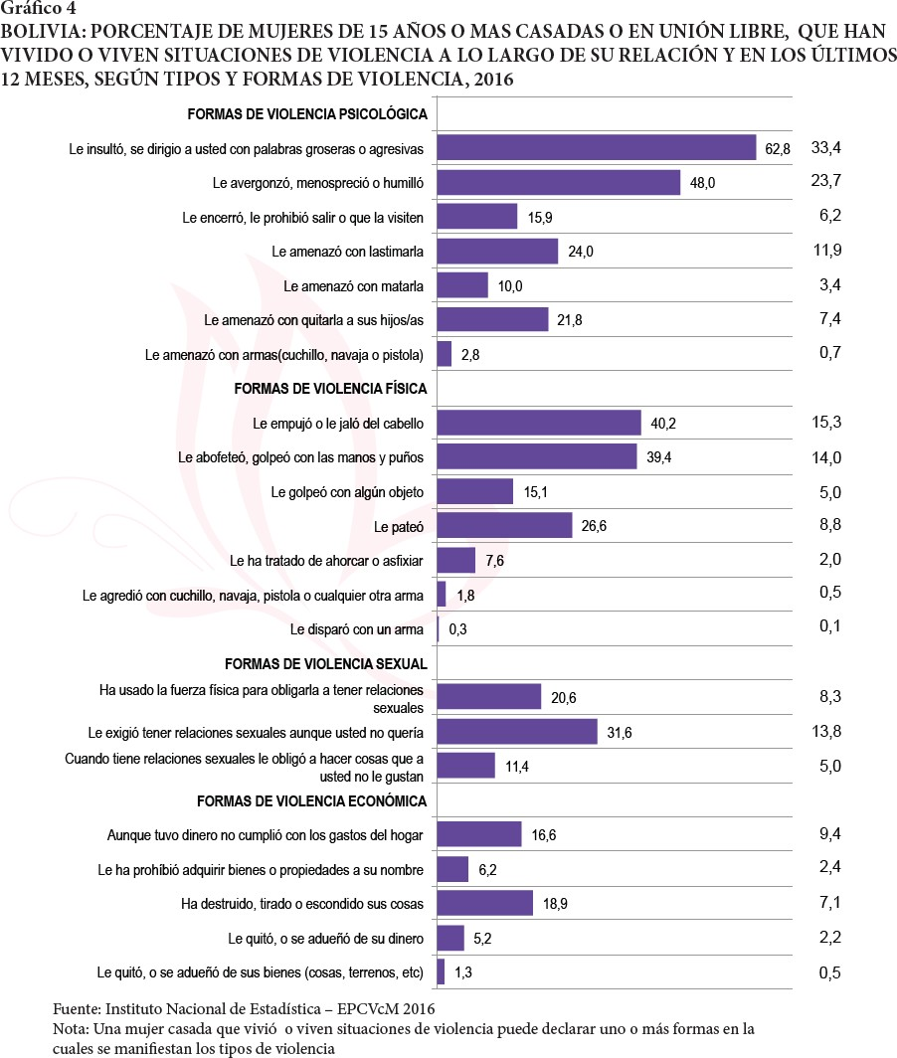

Appendix E

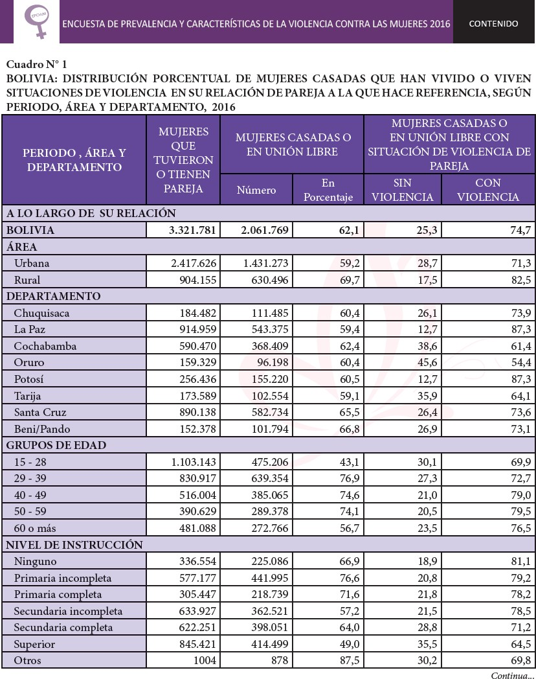

Appendix F

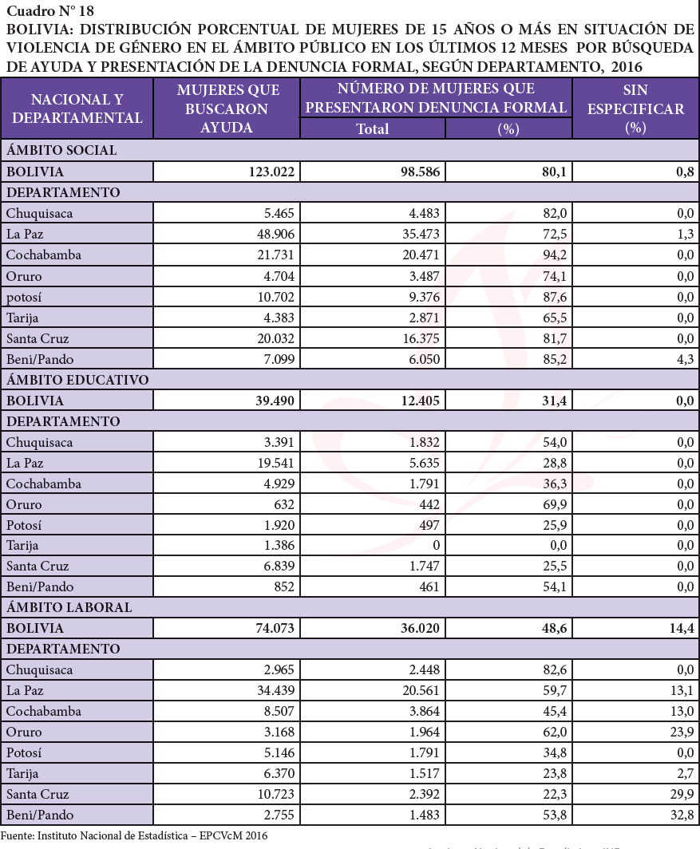

Appendix G
