UNIVERSITY OF OKLAHOMA

GRADUATE COLLEGE

UNDERSTANDING THE IMPACT OF MORTALITY SALIENCE ON THREAT PERCEPTION

A DISSERTATION

SUBMITTED TO THE GRADUATE FACULTY

in partial fulfillment of the requirements for the

Degree of

DOCTOR OF PHILOSOPHY

By

DUNCAN MCCOLLUM
Norman, Oklahoma
2024

UNDERSTANDING THE IMPACT OF MORTALITY SALIENCE ON THREAT PERCEPTION

A DISSERTATION APPROVED FOR THE
DEPARTMENT OF PSYCHOLOGY

BY

Dr. Luz-Eugenia Fuenzalida, Chair

Dr. Hairong Song

Dr. Erin Freeman

Dr. Laura Stein

© Copyright by DUNCAN MCCOLLUM 2024
All Rights Reserved.

Dedication
This dissertation is dedicated to my loving grandparents, Wayne and Carolyn Odom, along with Helen and Kinloch McCollum.
For the sense of curiosity, wonder, and appreciation of the natural world they instilled in me has left an indelible mark.
I love you more than tongue can tell.

Acknowledgments
Over the past several decades, I have found that the best things in life stem from my relationships with others. This work would not be possible without the guidance and support of more individuals than I could ever hope to acknowledge on this page.
First and foremost, I extend my deepest gratitude to my committee. I will be forever grateful for their mentorship, trust, and patience. Thank you for helping this project come to fruition and being there with me at each step in the process. Eugenia, thank you for never giving up on me. Your faith in me helped me understand what I could accomplish. Your guidance and care have been an inspiration and has changed how I approach not just hard work but life itself.
I would also like to recognize that I have been blessed with a phenomenal education by my parents and grandparents. This has allowed me to be molded by several gifted teachers along the way. I would like to extend my thanks to Scott Gronlund, Jennifer Bost, Tony Trulson, and Karie Thering. You all have instilled in me a passion for learning and have equipped me with numerous tools I use today to hopefully pass on that passion to the next generation.
This research would not have been possible without the generous funding of the Center for Intelligence and National Security. Whose mission is to create spaces for students to develop the skills and knowledge that will one day benefit our great country.
Finaly, I would like to recognize my beloved dog, Prince. He has been my constant companion and protector throughout this long journey. I could not have done it without his unwavering love.
Table of Contents
Dedication iv
Acknowledgments v
List of Tables viii
List of Figures ix
Abstract x
Understanding the Impact of Mortality Salience on Threat Perception 1
Terror Management Theory 2
Proximal Defenses 3
Distal Defenses 3
Attention 4
Drift Diffusion Modeling 6
Present Study 9
Hypotheses 11
Hypothesis 1a 11
Hypothesis 1b 12
Hypothesis 1c 12
Hypothesis 2 12
Hypothesis 3 13
Method 13
Participants 13
Materials 14
Procedure 14
Results 18
DDM Model Specification 18
Drift Rate (v) 23
Starting Point (z) 25
Non-decision Time (T_{er}) 26
Discussion 27
Limitations 32
Conclusion 35
References 38

List of Tables
Table 1. Descriptive Statistics for Accuracy Data 22
Table 2. PANAS Scores by Condition 23
Table 3. Descriptive Statistics for Drift Rate 24

List of Figures
Figure 1. Visualization of the DDM Process 8
Figure 2. Emotion Recognition Task Procedure. 17
Figure 3. Reaction Times Based on Condition and Stimuli Type 21
Figure 4. Recognition Accuracy Across Conditions 22
Figure 5. Drift Rate Estimates 24
Figure 6. Relative Starting Point for Each Condition 26
Figure 7. Non-decision Time by Condition 27

Abstract
With the development of higher cognitive faculties comes the ability to ask “the big questions.” Some questions, such as “How can life have meaning when everything will eventually die?” are profoundly unsettling. Approaches such as terror management theory have argued that we have tools to suppress the immediate impact of such dilemmas. However, these tools are imperfect, and the dilemma manifests uniquely. Understanding these manifestations is imperative for improving the performance of individuals who work in fields that regularly encounter death. This dissertation examines the impact of mortality salience, or death awareness, on aspects of emotion recognition. Earlier work in this area, have primarily focused on identifying accuracy differences driven by mortality salience. The pattern of accuracy and reaction times were consistent with previous emotional recognition and mortality salience research. Drift diffusion modelling was used to decompose performance indicators into additional measures such as bias towards a decision, the ability to detect evidence, and differences in non-processing time. Significant improvements in the ability to discern emotional indicators were observed for participants who were in anxiety evoking conditions. However, other predicted differences such as decisional biases, non-processing times, and advantages to processing non-threatening features were not found. Potential future avenues of research and applications of the utilized paradigm are discussed.

Understanding the Impact of Mortality Salience on Threat Perception
One of the oldest documented dilemmas humans have faced is understanding how life can have meaning, even though it only lasts for a moment compared to the world we see around us. Typically, the further out a potential risk is, the more uncertainty surrounds whether it will happen. This is not the case with death, as it is one of the only future events, we can be certain of happening. Additionally, it is arguably the most consequential future event we will experience. While many types of aversive thoughts impact us, contemplating mortality uniquely affects social perceptions and cognition (Helsen, 2016; Rosenblatt et al., 1989). These reactions are believed to act as a catharsis by helping develop a sense of meaning and spiritual immortality and ensure immediate survival (Greenberg & Arndt, 2012).
Individuals in fields such as law enforcement and the military are more likely to experience life-threatening risks than the public. How they respond to these situations is critical to their survival, the survival of others, and the public support of their organization. For instance, the 2005 Haditha Massacre occurred when marines killed 24 noncombatants when trying to clear an area following the bombing of a vehicle in their convoy (McGirk, 2006). The following investigation and political fallout harmed the public’s perception of the Iraq War (Savage & Bumiller, 2012). Recently, the Secretary of Defense, Lloyd Austin, issued a memorandum titled the Civilian Harm Mitigation and Response Action Plan. This memorandum acknowledges the strategic priority of protecting civilians and outlines a path forward for the military to handle better the problem of target misidentification (U.S. Department of Defense, 2022). Target misidentification incidents have a variety of causes, such as loss of situational awareness, environmental, technological, organizational, and individual (Rasmussen, 2007). This paper will primarily focus on understanding individual cognitive factors of attention and decision-making that change when exposed to ideas of death. This will allow for more successful interventions to be implemented to decrease the inappropriate use of force.
Prior work on recognizing emotions has primarily focused on accuracy and reaction time, which are informative but limited in their ability to advance theory (Tibbles, 2019). Modern computational modeling techniques such as drift-diffusion modeling have enabled researchers to use accuracy and the distribution of reaction times in forced-choice tasks to understand better the decision-making process (Ratcliff & McKoon, 2008). With these more advanced techniques, researchers can notice differences in biases toward making one decision, the ability to perceive evidence, and how hesitant someone is towards making a decision, among other things.
By applying advanced techniques to the ability to detect threats, a better understanding of the impact of the mindfulness of mortality on cognition can be gained. That understanding can then be used to improve the performance of first responders in lethal situations, thereby reducing unnecessary loss of life.

Terror Management Theory
Terror management theory (TMT) was first laid out by Greenberg and colleagues (1986) to explain how the awareness of one’s mortality can lead to a wide range of behaviors that are meant to relieve the anxiety that is engendered by this awareness. The theory has two premises: that individuals have instincts that are designed to keep them alive by helping them respond to threats and that the cognitive abilities we possess allow us to be conscious of the fact that death could come at any time and is unavoidable (Greenberg et al., 1986; Greenberg & Arndt, 2012). This awareness of our mortality has been termed mortality salience (MS). MS is a common manipulation used by TMT researchers because it evokes an experience similar to but not identical to state anxiety (Gauthier, 2012). Unlike state anxiety, it mediates coping mechanisms that affect cultural attitudes (Burke et al., 2010; Pyszczynski et al., 1999).

Proximal Defenses
When MS is experienced, we engage in rationalizations to help relieve that anxiety and remove it from our conscious awareness (Greenberg & Arndt, 2012; Pyszczynski et al., 1999). These rationalizations primarily take the form of denial of our vulnerability and pushing the prospect of our death into the far future (Pyszczynski et al., 1999). For example, an individual may consider their young age, good physical fitness, or the long lifespans of their family members.

Distal Defenses
While proximal defenses may allow us to suppress our immediate concerns about our mortality, we still cannot adequately resolve the conflict because death will always come (Pyszczynski et al., 1999). Additionally, we may not have the opportunity to use proximal defenses because of distractions, which induce a high cognitive load. In these cases, death-related thoughts can become more accessible (Greenberg et al., 1994). Distal defenses or a cultural anxiety buffer handles these remaining concerns. This buffer is primarily concerned with efforts to increase self-esteem and defend the validity of an individual’s worldview.
These distal defenses have been the primary focus of TMT researchers because they have a more significant impact on actual behavior rather than just cognition. The theory asserts that by identifying with a particular cultural worldview and satisfying its requirements, an individual achieves the ability to outlive their corporeal body through that worldview. This means that when experiencing MS, individuals respond more negatively to those who seem to challenge their cultural values and more positively to those who support them (Greenberg et al., 1992; Rosenblatt et al., 1989).
Recently, TMT has received criticism for being inconsistent with modern evolutionary theory, lacking parsimony, and attempting to explain everything (Kirkpatrick & Navarrete, 2006). Alternative theories, such as coalition psychology, have become more prominent. While the underlying theory has changed, the effects of MS have been widely demonstrated, and it is apparent that it functions as a cognitive bias (Heslen, 2016; Juhl & Routledge, 2016). For this reason, it is still important to investigate the impact of MS as it has applications in many domains, such as combat, law enforcement, intelligence collection, geopolitics, jury deliberations, and medical care.

Attention
Given that MS acts in a way that is like state anxiety, it is important to consider what kinds of predictions could be made based on modern theories of attention. This is particularly crucial given that it is a phenomenon that could be considered an extreme version of state anxiety, yet it is something distinct (Burke et al., 2010). A modern theory that could be useful for distinguishing MS from state anxiety is the attentional control theory (ACT), which was created by Eysenck and colleagues (2007) as an extension of the processing efficiency theory (Eysenck & Calvo, 1992).
Processing efficiency theory specifies that the amount of information that can be processed in working memory is limited. Anxiety and worry place a demand on the central executive, which regulates working memory performance. This additional demand removes resources from the task, leading to decreased efficiency and, eventually, impaired performance when no additional resources exist (Eysenck & Calvo, 1992). Processing efficiency theory, which integrated multiple contemporary theories but could not answer key questions, was useful at the time. For instance, how do emotional stimuli impact performance, which central executive functions are affected, and when might an anxious individual do better than someone not experiencing anxiety (Eysenck et al., 2007)?
ACT addressed these questions by emphasizing that attention consists of a top-down and a bottom-up system. Prior knowledge, expectations, and goals for the task at hand drive the top-down attentional system. The stimuli drive the bottom-up attentional system, which is heavily influenced by particularly salient stimuli (Eysenck et al., 2007). Under this theory, the ability to control the balance between goal-driven and stimulus-driven processing is impaired when an individual runs out of cognitive resources. This occurs through a diminished ability to inhibit task-irrelevant stimuli from “leaking” into working memory, as well as inefficient shifting of attention, which makes it harder to stay on-task.
In our day-to-day lives, this can be a nuisance and potentially harmful. For instance, test anxiety may cause you to have a more challenging time focusing on an exam, and you will not perform as well as you can. Or it is possible that while driving, you become overwhelmed by holding a conversation on the phone, and you fail to notice a red light. However, there may also be situations where this kind of change in processing may be beneficial. If a threat is present in your environment, there is a clear advantage in quickly processing a vast amount of information. You can focus on a single thing and process information effectively when not overwhelmed. In contrast, when you are overwhelmed, either by anxiety or simply a lack of cognitive resources, you can cast a wide spotlight on the environment, but nothing is processed as deeply. However, if a threat is present, there is a good chance that it is particularly salient, so it is unnecessary to process it thoroughly.

Drift Diffusion Modeling
At the heart of any quality work in psychology is a verbal explanation in the form of a theory. These theories lead to qualitative hypotheses, such as condition A will perform differently than condition B. This approach provides enough information to gather evidence that may support a theory. However, a qualitative approach has numerous shortcomings. It may be poorly specified with vague language, which allows it to be reinterpreted to explain new results while seeming to maintain its validity. This leads to bedeviling contradictions within the literature. It may also make it challenging to advance the theory in a way that does more than describe “what” happened rather than explain “why” it happened (Ratcliff, 1998).
Alternatively, approaches like mathematical modeling allow researchers to take those vague verbal descriptions and express them as rigorously specified models, which are used to evaluate a theory more effectively. These quantitative mathematical models can provide much more precise descriptions of behavior and predictions. These models are not a facsimile of the mind's inner workings but rather an abstraction that can be evaluated against competing models, allowing for interpretation of the underlying mechanistic processes (Myers et al., 2022; Ratcliff, 1998). Furthermore, these models allow for more complex, nonlinear descriptions of those processes while remaining rigorous and offering much more advanced insights (Cavagnaro et al., 2013).
Some models, such as WITNESS (Clark, 2003) and SAM (Raaijmakers & Shiffrin, 1981), have remained constrained to their respective domains. Others, such as the drift-diffusion model (DDM), have been found to be useful in many other domains (Ratcliff et al., 2016; Ratcliff & McKoon, 2008). The drift-diffusion model was first developed by Ratcliff (1978) to try and explain how memories are retrieved. The DDM can be described as a sequential sampling model that depicts how individuals make decisions in two-choice discrimination tasks. What is meant by “sequential sampling” is that at each point in time, the mind collects evidence from the environment, which directs it toward or away from a decision. It has been applied to many cognitive tasks, allowing for a much better understanding of the mind than traditional qualitative approaches (Ratcliff et al., 2016; Ratcliff & McKoon, 2008).
The DDM assumes that the reaction time for making a decision is broken into three parts: stimulus encoding, decision-making, and response execution (Myers et al., 2022; Ratcliff 1978). However, the primary focus of the model is the decision-making component. Furthermore, it assumes that the decision-making process is noisy, with evidence accumulated at each point in time for one of the two choices. During decision-making, the model conceptualizes a space with upper and lower boundaries to represent two decisions with the distance between the boundaries represented by a. This separation reflects how cautious a decision-maker is (Myers et al., 2022). When decision-making is initiated, the process has a starting point (z), which reflects a bias toward one decision or another. At each point, evidence is gathered, pushing the participant stepwise toward the upper or lower boundary. This stochastic process has an average step size the drift rate (v). Higher drift rates are indicative of a higher ability to integrate evidence. For example, individuals with ADHD have an impaired ability to inhibit task-irrelevant stimuli, which limits their ability to process task-relevant information, which would lead them to the correct decision quickly (Huang-Pollock et al., 2017). Due to the noisy evidence accumulation process, the time to decide (i.e., reach a boundary) will vary. This results in a distribution of decision reaction times with a positive skew (Ratcliff & McKoon, 2008).
Additionally, the model can estimate the non-decision time (T_{er}), quantifying the time participants spend before and after the decision-making process. Individuals must encode the information before the decision-making process begins into a format that the central executive can work with. This can be thought of as the perceptual process. The time between when a decision is made and when the response is recorded is also caught in this measure. The non-decision response time may vary due to privileged encoding due to priming or changing the method of response execution, such as recording saccades rather than button presses (Myers et al., 2022). For a depiction of the DDM decision process, see Figure 1
Figure 1
Visualization of the DDM Process
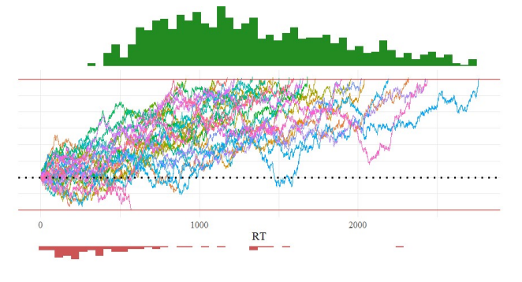
Note. This data was simulated using arbitrary parameters, and only 20 of the 1000 diffusion paths were sampled for this plot. The red horizontal lines represent the decision boundaries; the space between them is the boundary separation (a). The dashed line reflects the starting point of the decision process (z), which is a value between 0 and 1. In this case, it would be approximately 0.2. Each of the colored jagged paths reflects the process of gathering evidence to make a decision, and the average slope of these lines is the drift rate (v). Once one of the paths hits a threshold, the response is recorded as a response time reflected by the red and green histograms. The non-decision time (T_{er}) is not reflected in this visualization.

With this model, it is possible to use reaction times and accuracy data to estimate these parameters for individuals or conditions. Consider two participants; one has remarkably high accuracy on a task but is slow to respond. The other is very quick but makes many mistakes. They are different, but how they differ is not as apparent as when two participants have the same accuracy but different reaction times. By estimating the parameters of the DDM for each participant, the speed-accuracy tradeoff can be elucidated. It may be the case that the differences are due to differences in how much evidence each person requires before making a decision (i.e., boundary separation). Or perhaps one individual has a biased starting point with a lower drift rate, which would result in them having faster reaction times but a more significant number of false positives.

Present Study
This study seeks to understand how mortality salience affects aspects of attention as they relate to recognizing emotions. Participants who have been exposed to MS exhibit a similar pattern of performance as participants who are experiencing heightened state anxiety. This is true for many but not all cognitive tasks (Heslen, 2016). This suggests that while the two might be related, they are fundamentally different (Florian & Mikulincer, 1997; Gauthier, 2012; Heslen, 2016). To date, only one study has investigated the impact of MS on the ability to recognize emotions (Anaki et al., 2012). This study focused on the accuracy of recognition amongst combat and noncombat veterans who had undergone a MS or pain salience manipulation (Anaki et al., 2012). They demonstrated that performance was worse for both groups when recognizing negative emotions (i.e., fear and anger) than positive ones. Furthermore, the manipulations moderated the ability to recognize fear amongst noncombatant participants, such that MS improved their ability to recognize fear, and experiencing anxiety, which is unrelated to death, decreased it (Anaki et al., 2012). While this study did demonstrate that some differences exist in the ability to recognize emotions based on the manipulation participants received, it failed to address the underlying mechanisms that resulted in these differences.
DDMs have been used to help understand the impact of trait anxiety on threat detection and have been useful for decomposing reaction time and accuracy data to identify how anxiety affects different cognitive mechanisms. White and colleagues (2016) demonstrated that trait anxiety was associated with biased starting points, so participants started closer to the threat boundary. However, they did not demonstrate a drift rate or boundary separation difference. Threatening stimuli have been shown to receive privileged processing so that a higher drift rate may be expected (Öhman et al., 2001); this is particularly true when experiencing state anxiety (Rued et al., 2019). However, anxiety also limits the ability to inhibit distractions and impairs the ability to integrate information from stimuli (Eysenck et al., 2007), implying a worse drift rate. A lack of a change in drift rate by those experiencing higher anxiety may be due to these two effects essentially canceling each other out. With regards to the lack of change in boundary separation between high and low-trait anxiety participants in White et al. (2016), the change in starting point may have been more adaptive. By biasing the starting point towards a threat response, individuals can make more correct detections of threats faster. The downside is that they would have to spend more time accumulating evidence to determine that a face is not threatening and would be more likely to accidentally classify a non-threatening stimulus as threatening. The biased starting point could result from a response expectancy bias where a certain response is associated with a greater reward. The reward for high-trait anxiety participants would be to quickly identify a threat (White et al., 2016). In contrast, there is no penalty for taking a bit longer to correctly determine that there is not a threat present. In contrast to biasing the starting point, decreasing the boundary separation would improve the speed for both decisions at the cost of accuracy.

Hypotheses
Extending this line of work is natural, given the lack of research on facial threat detection within the mortality salience literature. Especially considering that DDMs provide the opportunity to understand the mechanisms that underlie observable behaviors. Specifically, it is important to establish firm evidence that MS regulates attention via different mechanisms than state anxiety.
This study randomly assigned participants to one of three conditions. A control group. A dental pain salience (DPS) group did a writing task that was intended to increase levels of state anxiety. As well as a mortality salience (MS) group, which reflected on the aspects of their death to evoke mortality salience. All participants engaged in a threat detection task to identify threatening faces as quickly and accurately as possible. This performance data was then analyzed using DDM, and the parameters were compared.

Hypothesis 1a
A main effect of stimulus type was expected to be observed on drift rates. Threatening stimuli were expected to have a lower drift rate than non-threatening stimuli across conditions. This is thought to be due to experience effects where we are more likely to encounter people with positive emotions in our everyday lives, so we have more practice identifying positive facial features that indicate happiness.

Hypothesis 1b
A main effect of treatment condition on drift rates was anticipated. When experiencing anxiety, the central executive is less effective at inhibiting distractions such as worrisome thoughts. For this reason, participants in the MS and DPS conditions were expected to be less effective overall at gathering evidence. They should have drift rates that are smaller in magnitude than the control group.

Hypothesis 1c
While participants in the MS and DPS conditions were expected to have lower drift rates overall, they were expected to experience a greater decrease in drift rates for non-threatening stimuli than threatening stimuli. That is to say, there will be an interaction between treatment condition and stimuli type on drift rates. As mentioned in the previous hypothesis, participants who are experiencing anxiety should be less effective at inhibiting distractions. However, some of these distractions will come in the form of what they are trying to alleviate, a threat. So, while the drift rates for threatening stimuli may decrease compared to the control group, it will not be as severe as the decrease observed for non-threatening stimuli.

Hypothesis 2
When compared to a control group, participants who have experienced MS or DPS are expected to exhibit a starting point that is biased toward threats. This prediction is consistent with White et al. (2016) due to a response expectancy bias intended to identify a threat as quickly as possible. This will reduce the speed at which participants can recognize non-threatening faces but faster at recognizing threatening faces.

Hypothesis 3
When examining a face for recognition or emotional content, we take a configural rather than a parts-based approach (Bombari et al., 2013). This is necessary because multiple emotions can have similar ways of being expressed on a feature-by-feature basis. For instance, it can be difficult to distinguish anger and happiness if you just see teeth. It is also necessary to see the brow's placement or the cheeks' positioning. Furthermore, there is evidence that recognition during speeded trials is done serially (You & Li, 2016), meaning that one set of configurations can be processed at a time. However, when a stimulus is threatening, we are more likely to engage in parallel pre-attentional processing (You & Li, 2016). This parallel pre-attentional processing allows us to cover a wider field of perception so that the attentional phase can begin sooner. This effect is exacerbated when the stimuli are something that a participant is particularly fearful of (Öhman et al., 2001). Due to this enhanced pre-processing of threatening stimuli, which are particularly feared, it is anticipated that there will be a main effect of treatment condition on the time encoding and executing a response (T_{er}) such that participants who are in the MS condition will complete this stage of the decision process the fastest.

Method

Participants
A total of 166 participants were recruited for this study on the Prolific platform, and they completed the 30-minute study for $6 of compensation. Two participants indicated that they did not feel like they provided quality data and opted to have it excluded, resulting in 164 participants. All participants passed at least one of the two attention checks. The average age of participants was 37.0 years old, with the youngest participant being 20 and the oldest being 63. Of the participants, 82 participants were female, 81 were male, and one indicated that they preferred not to answer. White participants made up 69% of the sample, 12% were Black, 9% were Asian, 9% were mixed race, and 2% specified that they were another race. All participants were located in the United States, spoke English, and used a QWERTY style keyboard.

Materials
The stimuli used in the emotion recognition task come from the Chicago Faces Database (Ma et al., 2015). The Chicago Faces Database includes standardized photographs of individuals who are white or black and male or female, expressing different emotions. Published norming data (Ma et al., 2015) was used to select 30 models from each combination of categories based on how highly they were rated in terms of suitability for use in a psychological study. This resulted in the selection of 120 models. Both threating and non-threatening (angry and happy, respectively) photos of each model were included in the study. The images were scaled to be presented at 500 pixels in height. These stimuli were randomized for each participant.

Procedure
The procedure for this experiment was reviewed and approved by the University of Oklahoma Institutional Review Board and followed American Psychological Association ethical guidelines. The experiment was administered online using the PsyToolkit data collection tool (Stoet, 2010; 2017).
At the start of the experiment, participants were given a brief description of the tasks they would be performing and provided informed consent. The treatment phase followed this. Participants were randomly assigned to one of three treatments: Mortality Salience (MS), Dental Pain Salience (DPS), and a Control treatment (CTL). Those assigned to the MS treatment were asked to spend 10 minutes writing about what they think will happen to their body after they die and elaborating on how this makes them feel. This is by far the most commonly used MS manipulation in the TMT literature and creates an immediate sense of awareness of mortality in participants without exposing them to truly life-threatening situations or graphic images (Burke et al., 2010; Rosenblatt et al., 1989). Most studies which have used this manipulation have found that it has been effective at eliciting the effects of MS (e.g., Helsen 2016; Rosenblatt et al., 1989). Participants who were assigned to the DPS group spent 10 minutes writing about the worst dental pain they had ever experienced and how it made them feel. This is a widely used manipulation in mortality salience research and is intended to provide a way to assess the effect of reflecting on an aversive, anxiety-producing event that is not explicitly related to mortality (Burke et al., 2010). Finally, if a participant was assigned to the control group, they were asked to write about their favorite automobile. This topic was selected because it is emotionally neutral.
TMT posits that a delay between MS induction and the measurement of the dependent variable causes mortality concerns to be pushed to distal defenses, which increases the magnitude of their effect (Burke et al., 2010). For this reason, a distractor task was used between the writing task and the emotion recognition task. Participants were asked to spend five minutes completing the Positive and Negative Affect Schedule (PANAS; Watson et al., 1988). The PANAS is the commonly used distractor task in TMT studies (Burke et al., 2010). This task was selected to disrupt processing of thoughts directly related to mortality and had the benefit of not inducing additional anxiety or creating demand characteristics for the participant.
Following the distractor task, participants completed the emotion recognition task. Participants were told that they would see a series of faces that were expressing either anger or happiness, and they should attempt to identify the emotion as quickly and accurately as possible using the “Z” or “M” keys (the emotion assigned to each button was counterbalanced between participants). The participants were then given an opportunity to practice the task. During the training trials, participants were shown a white screen for 1000 milliseconds; then, a fixation cross was shown for a variable duration between 400 to 600 milliseconds to focus the participant on where the face would be displayed. This was intended to decrease the likelihood that participants would get into a rhythm of when they should start the response process. After that, a non-threatening or threatening face was shown for a maximum of three seconds.
Additionally, visual reminders of the response keys were presented in the screen's bottom corners. The participant then pressed the Z or M key to indicate the emotion of the face. If the participant took longer than three seconds, a message indicating they took too long was displayed for 500 milliseconds. If the participant provided the wrong response, “incorrect” was displayed on their screen for 500 milliseconds. These messages were included to help motivate participants to work quickly but accurately. The participants were given 16 trials and had to correctly respond to 12 of them to continue to the main task. If they failed to complete the training, they were again shown the instructions and reattempted the task. A diagram depicting the emotion recognition task can be found in Figure 2.
Figure 2
Emotion Recognition Task Procedure.
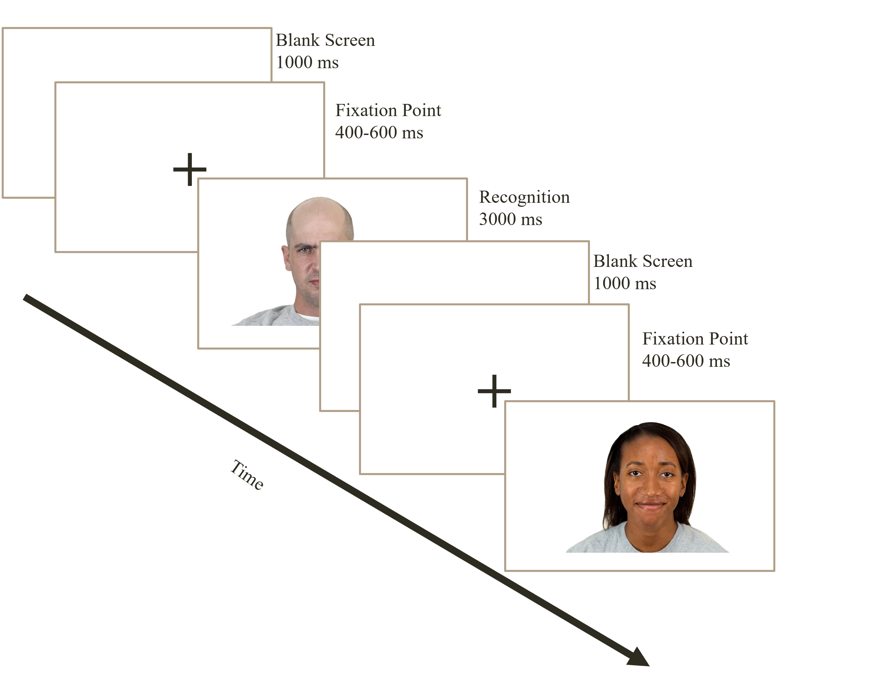
Upon successful completion of the training task, participants were told that they would now complete two blocks of 160 trials. These trials were identical to the training trials except that they did not include a visual reminder of the emotion associated with each key. During these trials, the accuracy and reaction time of each response was recorded. The first three trials of each block were considered “warm-ups” and were not included in the analysis.
Once participants finished both blocks of 160 trials, they were given a series of demographic questions, including attention checks. Next, participants were asked to indicate if their data did not reflect a genuine effort. They were told that how they responded to this question would only mean their data would be excluded from the analysis and would not impact their compensation. Finally, participants were debriefed on the purpose of the experiment, and the experiment concluded.

Results
Inclusion criteria required participants to have an accuracy level greater than 60% and an average reaction time faster than 1500 milliseconds. This is consistent with previous DDM research (e.g., Tibbles, 2023). No participants were removed based on these criteria. Additionally, any trial in which participants took too long to respond was excluded from the analysis (83 of 51,496).
Response time data contaminated with fast guesses can harm the robustness of parameter estimates in DDM (Ratcliff & Tuerlinckx, 2002). Various safeguards were implemented in the experiment to limit fast guesses, such as the variable duration fixation cross and the non-correct response feedback messages. Potential fast guesses were examined during data cleaning by determining the response time percentile at which participants had a 50% chance of an accurate response (Ratcliff & Tuerlinckx, 2002). 102 (of the 51,496) trials faster than this cutoff were removed from the analysis.

DDM Model Specification
The Fast-DM program (Voss & Voss, 2007) was used to independently estimate model parameters for each participant. To avoid the risk of overfitting, a parsimonious approach to model design was embraced (Lewandowsky & Farrell, 2011). To evaluate the proposed hypotheses, participants had their non-decision time, starting point, and boundary separation estimated. The variability of non-decision time was also estimated because it can greatly impact the shape of the reaction time distribution (Voss et al., 2015). Finally, the drift rate was allowed to vary between stimulus types for each participant.
Three common approaches are used for parameter estimation: maximum likelihood, chi-squared, and Kolmogorov-Smirnov (Voss et al., 2015). This study used the Kolmogorov-Smirnov approach due to its robustness against contaminated data and ability to handle small to moderate sample sizes (Voss et al., 2015).
Unfortunately, due to the substantial number of trials required for DDM analyses, standard statistical tests frequently provide false positives to assess model fit (Voss et al., 2015). For this reason, graphical approaches such as analyzing quantile-probability plots have traditionally been used (Ratcliff & Tuerlinckx, 2002). These plots present predicted versus empirical probabilities of getting a response correct across different quantiles of response times. If the prediction deviates from the observed probabilities to a significant degree, then it suggests a model misfit.
The graphical approach is subjective, and recently, Monte Carlo simulations have been used to determine a critical value for an acceptable fit statistic (Voss et al., 2015). This was the approach used in this study. First, parameters were estimated for each participant, and their Kolmogorov-Smirnov fit statistic was recorded. The parameter estimates were then used to construct a variance-covariance matrix. This variance-covariance matrix was used to define a multivariate normal distribution of the parameters from which samples of parameter combinations were drawn. This was done to create 1000 hypothetical participants with parameters that were related in a similar way to what was observed amongst the real participants. The construct-sample tool in the Fast-DM program was used to simulate response time and accuracy data for these hypothetical participants based on their sampled parameters. Next, Fast-DM was used to recover parameters from the simulated accuracy and reaction time data and will provide Kolmogorov-Smirnov fit statistics. This process yielded a distribution of plausible model fit values from which a critical region can be derived. Participants with a model fit that fell into this critical region were considered to have poor model fits and were removed from the dataset (Voss et al., 2013; Voss et al., 2015). Lastly, when examining the data regarding the drift rate analysis, the assumption of normality was violated. As a result, three participants were identified as outliers, with drift rates greater than the 99th percentile.
Additionally, these participants had unusual scores on other metrics, such as having a maximum possible score on the negative affect scale of the PANAS or having written responses that were in the sixth percentile in terms of word count. As a result, these three participants were excluded from the analysis. Ultimately, 137 participants were included in the analysis. All parameter estimates were in the typical ranges Voss et al. (2015) established.
The Monte Carlo process is very computationally expensive. This analysis was expected to take over an hour on a modern personal computer with 16 GB of RAM. To optimize the process, the Parallel package in R was used to distribute the task to 12 computing clusters to be run in parallel, which reduced the processing time to approximately six minutes. All data cleaning and statistical analysis were completed using the R software package (R Core Team, 2023).
As shown in Figure 3, participants across conditions tended to respond faster to non-threatening stimuli than threatening stimuli, and those in the two treatment conditions responded 5-6% faster on average than those in the control condition. An account of all the descriptive statistics for reaction time can be found in Table 1.
Additionally, when observing the accuracy of responses found in Figure 4, it is apparent that participants had an accuracy of approximately 95% across the board, with responses to threatening stimuli being marginally more accurate.
Figure 3
Reaction Times Based on Condition and Stimuli Type
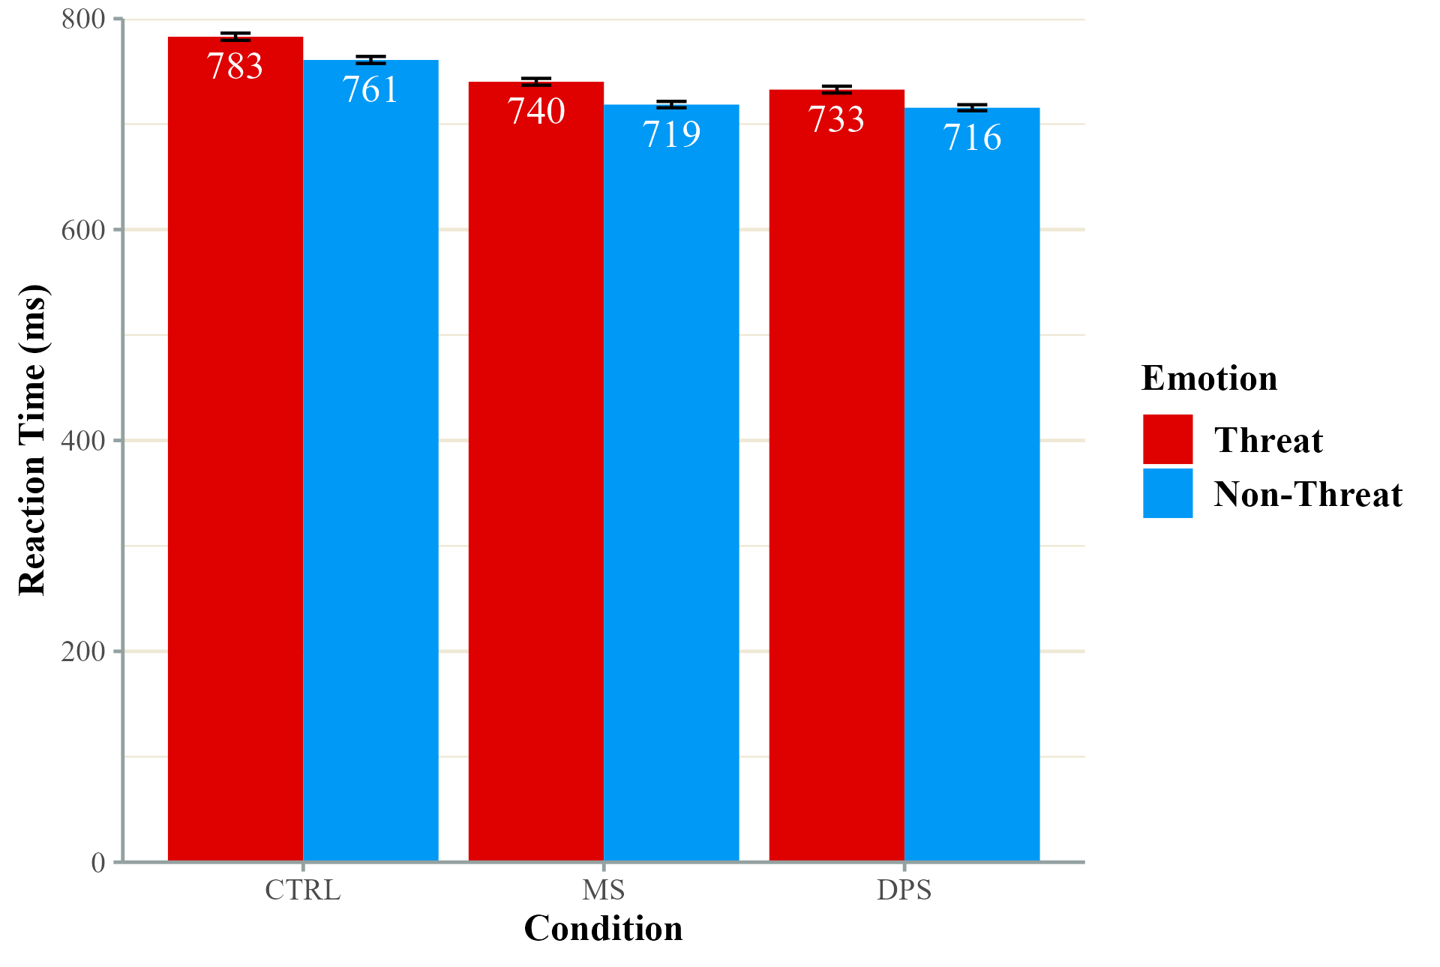
Note. Error bars reflect the standard error.

Figure 4
Recognition Accuracy Across Conditions
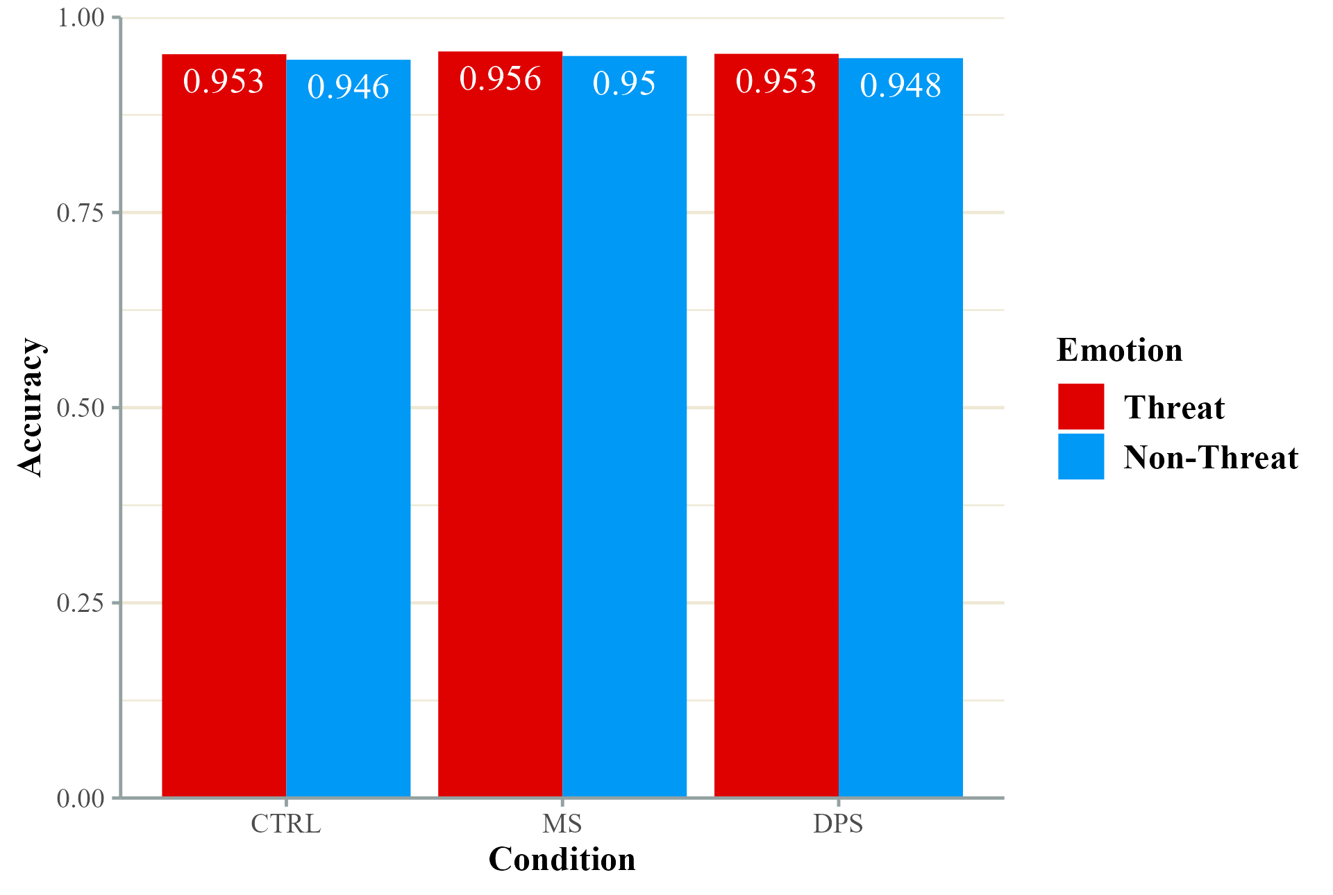
Table 1
Descriptive Statistics for Accuracy Data
Treatment |  | Non-Threatening Reaction Time |  |  |  | Threatening Reaction Time
 | n | M | SD | SE |  | M | SD | SE
CTL | 45 | 760.9 | 275.1 | 3.3 |  | 782.9 | 287.3 | 3.4
DPS | 46 | 715.5 | 241.8 | 2.8 |  | 732.7 | 273.9 | 3.2
MS | 46 | 718.5 | 255.3 | 3.0 |  | 740.2 | 273.2 | 3.2

PANAS scores were not found to significantly vary due to condition as indicated by a MANOVA with positive and negative affect as the dependent variables and condition as the fixed factor, F(4, 268) = 0.715, p = .58. This is consistent with previous TMT research which has found that MS does not directly impact affect (Cox et al., 2009; Greenberg et al., 1992). A report of PANAS scores can be found in Table 2.
Table 2
PANAS Scores by Condition
Treatment |  | Positive |  |  |  | Negative
 | n | M | SD | SE |  | M | SD | SE
CTL | 45 | 26.5 | 5.1 | 0.8 |  | 20.2 | 6.4 | 1.0
DPS | 46 | 28.3 | 5.9 | 0.9 |  | 19.8 | 6.2 | 0.9
MS | 46 | 27.2 | 6.9 | 1.02 |  | 20.9 | 7.8 | 1.1

Drift Rate (v)
In Figure 5, the mean drift rates have been plotted as a function of condition and emotion. Additionally, the descriptive statistics can be found in Table 3. A mixed ANOVA was used to determine if the treatment conditions and the emotion of the presented stimuli had an impact on the drift rate. This model included treatment condition as a between-subjects factor and condition as a within-subjects factor. The drift rates associated with non-threatening and threatening faces were approximately the same, and there was no significant difference, F(1, 134) = 0.315, p = .58, $η_{p}^{2}$ = .002. However, drift rates did vary to a statistically significant degree depending on the participant's condition in F(2, 134) = 3.348, p = .03, $η_{p}^{2}$ = .05. Post-hoc pairwise comparisons, which utilized a holm correction, revealed that participants in the control condition had drift rates that were significantly different from the DPS group (t(182) = 2.631, p < .01) and the MS group (t(182) = 1.557, p = .03). Finally, the model failed to detect a significant interaction between stimulus type and treatment condition, F(2, 134) = 0.226, p = .80, $η_{p}^{2}$ < .01.
Figure 5
Drift Rate Estimates
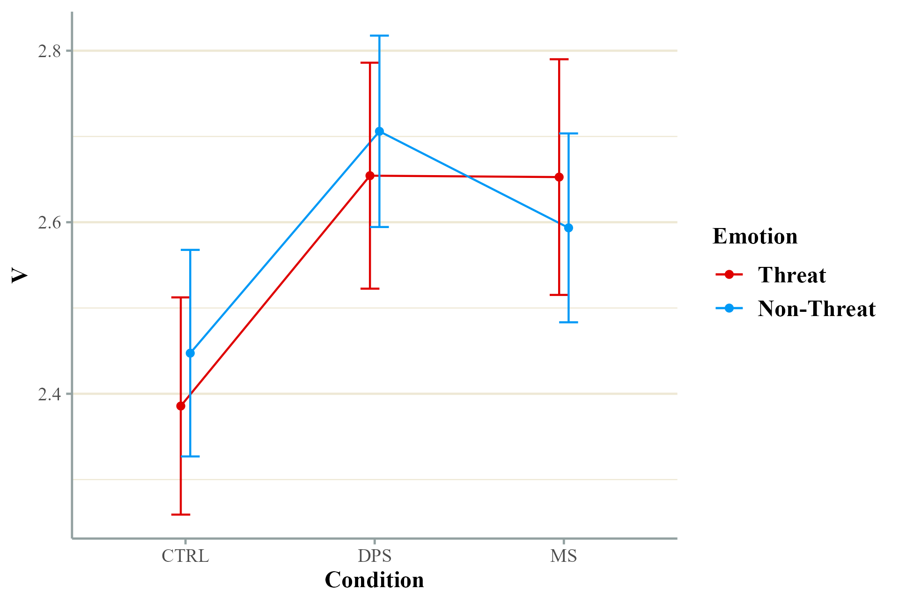Note. Error bars reflect the standard error.

Table 3
Descriptive Statistics for Drift Rate
Treatment | Non-Threat |  |  |  |  | Threat
 | n | M | SD | SE |  | n | M | SD | SE
CTRL | 45 | 2.4 | 0.7 | 0.1 |  | 45 | 2.3 | 0.7 | 0.1
DPS | 46 | 2.7 | 0.8 | 0.1 |  | 46 | 2.7 | 0.9 | 0.1
MS | 46 | 2.6 | 0.7 | 0.1 |  | 46 | 2.6 | 0.8 | 0.1

Starting Point (z)
Looking at the relative starting point of the decision-making process in Figure 6, most participants had starting points at approximately 0.5. Participants in the MS condition had the lowest starting point at 0.48 (SD = 0.05), whereas where those in the control condition had a mean score of 0.49 (SD = 0.05), and the DPS participants had an average score of 0.50 (SD = 0.07). Because this is a relative starting point that is bound between 0 and 1, a starting point of 0.5 indicates that participants did not have a decisional bias that led them to start making a decision favoring one response or another. A one-way ANOVA, which included condition as the between-subjects factor, found that the starting point of each group did not differ to a significant degree, F(2, 134) = 1.053, p = .35, $η^{2}$ = .02.
Figure 6
Relative Starting Point for Each Condition
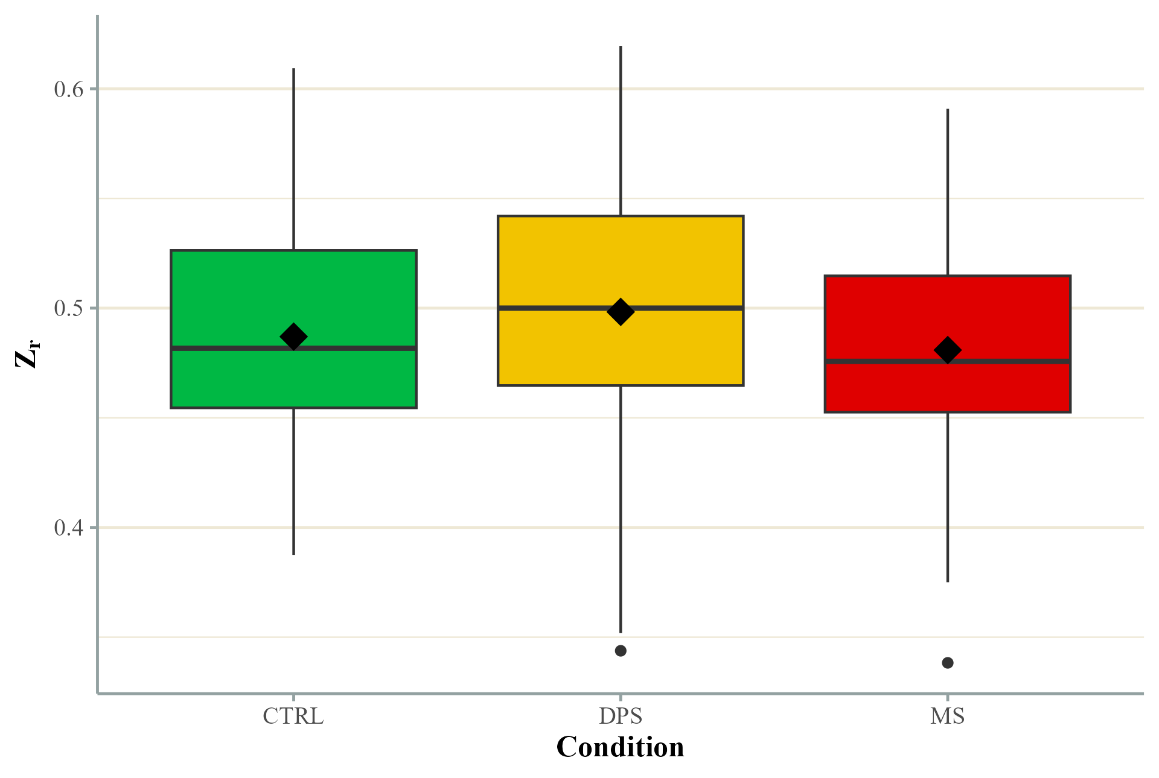

Non-decision Time (T_{er})
Lastly, the non-decision time was examined to determine if it varies as a function of the treatment condition. Another one-way ANOVA was used to determine statistical significance, and it included condition as its between-subjects factor. There was little variability between the groups, with the control group having an average non-decision time of 0.48 (SD = 0.06), which was only marginally higher than the DPS and MS conditions’ scores of 0.47 (SD = 0.09 and SD = 0.07, respectively). A visual depiction of these mean scores can be found in Figure 7. The ANOVA failed to provide evidence that these scores varied to a significant degree, F(2, 134) = 0.497, p = .61, $η^{2}$ < .01.
Figure 7
Non-Decision Time by Condition
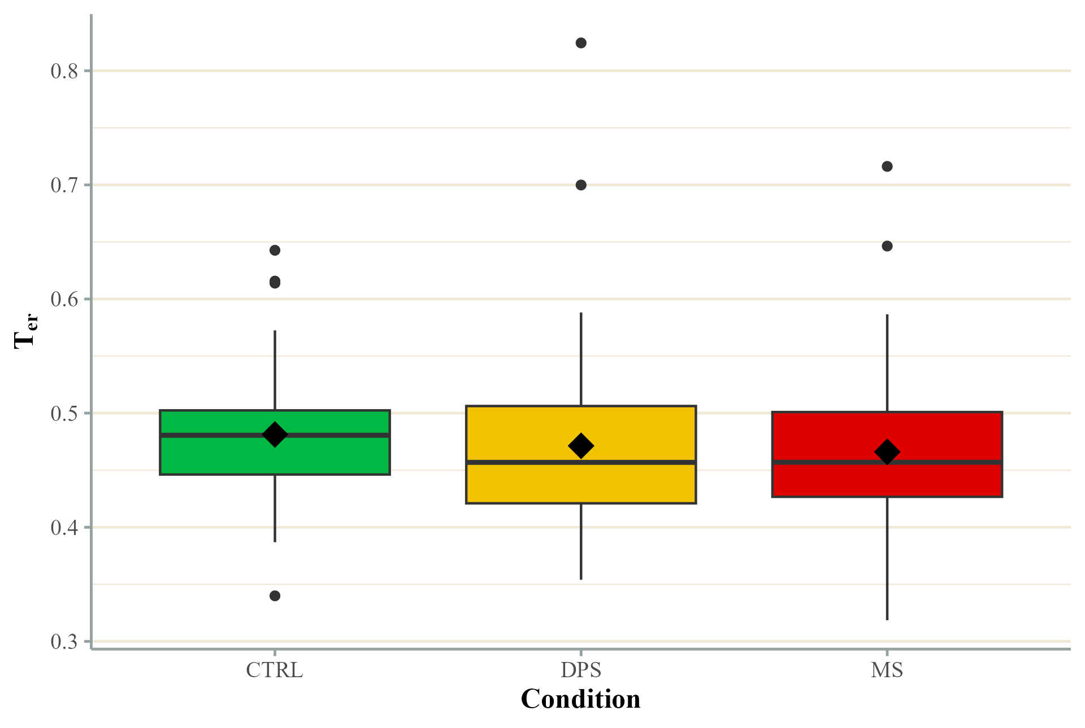

Discussion
The current study sought to further our understanding of how an awareness of mortality influences the cognitive process, specifically in the context of making decisions about emotions. Participants took part in a treatment that induced an awareness of mortality before completing a series of emotion recognition trials in which their accuracy and response times were recorded. A computational modeling approach was taken to decompose aspects of the decision-making process and determine the unique impacts of mortality salience on cognition.
It was hypothesized that the ability to identify features that indicate happiness was expected to be superior to those of threatening faces, regardless of whether a participant is in a state of anxiety or not (i.e., higher drift rates for non-threatening faces). Additionally, the anxiety elicited from experiencing mortality salience or from reflecting on a painful situation would inhibit participants’ ability to discern the emotional features of a face. Lastly, it was posited that while an attenuation in the ability to discern emotional features is expected for those experiencing anxiety, this ability will be more affected for faces expressing positive emotions. The relative starting point in the decision-making process was also examined, and it was hypothesized that participants in the anxiety-evoking conditions would bias their starting points toward identifying a face as a threat to compensate for their reduced ability to discern emotional features as outlined above. Finally, it was hypothesized that participants who experienced mortality salience would spend less time in the encoding and motor response period of the process than those in the pain condition or the control condition. This study was unable to find much support for these hypotheses. However, interesting conclusions may still be drawn from its findings.
The hypothesis regarding higher drift rates for non-threatening stimuli was not supported. There is a general trend for the control and DPS conditions, which does follow this prediction; however, the MS condition had the opposite pattern of results, and it is possible that this masked the main effect of the treatment. Based on this finding, I am unable to say that the positive features of facial expressions give them an advantage in processing.
Interestingly, a significant main effect of the condition was observed in drift rates. However, it went in the opposite direction of what was hypothesized. It was assumed that experiencing anxiety in the DPS and MS conditions would harm the ability to limit the influence of distractions, leading to a noisier evidence-collection process as suggested under ACT (Eysenck et al., 2007). Participants in these anxiety-inducing conditions were found to have significantly higher drift rates than those in the control condition. This suggests that the anxiety they experienced led to a higher state of vigilance and improved either their ability to perceive emotions or inhibit potential distractions. Given the simple nature of the task, it is not likely that participants experienced an exceedingly high cognitive load. If they had been doing a more complicated task, it is reasonable to assume that they may then be less effective at inhibiting distractors leading to more task irrelevant information disrupting their processing of the emotional information.
The last hypothesis regarding drift rates posited that while the ability to process emotional features would be harmed when experiencing anxiety, that ability would be less severely impacted by threatening features. This hypothesis was not supported. However, an interesting pattern was observed where the drift rates for those in anxiety conditions (DPS and MS) showed higher drift rates overall; the participants in the MS condition did not have as much of an increase for non-threatening faces as the DPS condition. While not significant, they had a higher drift rate for threatening faces, whereas the control and DPS conditions had higher drift rates for non-threatening faces. This suggests that while general anxiety like that which was experienced in the DPS condition increases this ability to discriminate emotional features, the unique anxiety that is engendered by contemplating death leads to greater discriminatory ability for threatening stimuli than non-threatening stimuli. Practically, this means that those who are experiencing MS could take longer to recognize a non-threatening stimulus, and there are more opportunities for random noise to influence the process, leading to a non-threatening stimulus being misidentified.
The second hypothesis which proposed a biased starting point hypothesis was not supported. This hypothesis was based on previous observations that anxiety biases the starting point toward identifying a threat (White et al., 2016). This contradiction may be due to the manipulation in this study affecting state anxiety, as where previous work examined trait anxiety. Trait anxiety may better prime individuals to require less evidence to decide that what they are looking at is a threat. Those who are not high on trait anxiety and are just experiencing a moment of state anxiety may not require a reduced amount of evidence when experiencing a threat. Furthermore, it was assumed that experiencing anxiety would decrease drift rates, and as a result, the starting point would be biased towards threat decisions to compensate for the increased time needed to gather sufficient evidence. Provided that the prior finding that anxiety increases drift rates is accurate, then there is no need to compensate by biasing the starting point. This means that those experiencing anxiety can decrease their reaction times due to high drift rates without sacrificing accuracy by having a biased starting point.
There was not sufficient evidence to support the hypothesis that participants who experienced MS would have faster non-decision times. The time spent encoding stimuli and then executing the response averaged approximately 470-480 milliseconds for all conditions. Earlier work had implied that recognition in speeded trials is done serially rather than in parallel (You & Li, 2016). However, other evidence indicated that objects that individuals are particularly fearful of can accelerate the perceptual phase so that further processing can be expedited (Öhman et al., 2001). It was thought that awareness of mortality might prime participants to be particularly fearful of threatening faces. It is possible that this was not observed because threats to life can come from many sources, not just threatening-looking individuals. Additionally, the advantage gained from stimuli that individuals are particularly fearful of may only apply to long-engrained fears such as phobias, which, over time, may change how aspects of those features are processed so there are fewer steps that need to take place to send the information from the eye to the prefrontal cortex and amygdala.
In relation to terror management theory, this study did not find overwhelming evidence that anxiety related to death uniquely impacted the process of identifying a threatening face. Most of the findings surrounding MS have focused on how the more social aspects of the distal defenses it creates (e.g., Rosenblatt et al., 1989). While other work, such as Helsen (2016), has found some evidence that MS affects aspects of attention and memory, it is difficult to determine if it impacts the threat recognition process at the kind of level that was examined in this study. The main effect of treatment on drift rates is interesting because while anxiety generally increases the discriminability of features, there was a trend that indicated that the improvement benefited threatening features more than non-threatening features. This same pattern was not found for the general anxiety evoked by the DPS treatment. This indicates that it is possible that MS does indeed have a unique impact on the threat identification process, but a different approach may be needed to make it apparent.
Assuming the findings of this study are accurate, it suggests that MS affects decision-making at a fine level in a different way that TMT might suggest. It is notable that participants did not bias themselves toward expecting a threating face to appear regardless of the condition they were in. Most importantly it appears that being exposed to thoughts that could evoke anxiety heightened vigilance and improved the ability to process emotional information. Lastly, the non-significant interaction of condition and type of stimuli presented demonstrates how it may be possible, with further research, to show how thoughts of death uniquely influence the ability to discern emotional information. The trend indicated that while there was an improvement in drift rates for anxiety evoking conditions, this improvement was limited for those who reflected on their mortality when processing non-threatening features. This suggests that a heightened ability to process emotions exists, additional stress from reflecting on mortality causes an added load that only affects non-threatening stimuli. Ultimately, this means that those exposed to MS could be less effective at correctly identifying a threatening individual as a target as quickly as someone who is anxious but not reflecting on their mortality. If these findings hold true, it indicates that individuals who may encounter death should be desensitized to thoughts of their own mortality, but ideally, they should still experience some level of anxiety in those situations. This will allow for the benefit in performance when experiencing anxiety without hindering their ability to identify non-threatening individuals.

Limitations
While this study took a unique approach to understanding the cognitive impacts of anxiety related to death by using a DDM, it does have its limitations. Under attentional control theory, stimulus-driven processes and goal management processes are balanced as long as individuals do not experience an overwhelming cognitive load (Eysenck, 2007). Several factors can influence cognitive load, such as managing multiple tasks at once or being unable to effectively inhibit distractors due to anxiety, exhaustion, or substance use. The design of this study was limited in its ability to heavily impact these factors. While the manipulation used for the MS condition has been commonly used and has been shown to mediate cultural attitudes (Greenberg et al., 1992; Rosenblatt et al., 1989), it may not be intense enough to create the kind of cognitive effects that were sought in this study.
To create a level of anxiety that would be sufficient to observe an impact on performance may be challenging to ethically do in the lab. While it would have greater ecological validity, it is difficult to determine how to implement a realistic fear of death in participants without harming them.
It may be possible to increase the cognitive load of participants to help elucidate the effect of MS. However, the assumptions of DDM limit the scope of tasks that can be analyzed. DDM is appropriate for use in very simple decision-making tasks which do not require multitasking or complex reasoning. For instance, it would be inappropriate to use it on an emotional Stroop task where participants must identify an emotional word that is superimposed on a face expressing a congruent or incongruent emotion as the word. This would violate the assumption that the drift rate does not systematically change during the decision-making process. This is because participants would spend the initial portion of that process overcoming the interference the incongruence creates (causing a low drift rate), and then their drift rate would rise once the interference is gone.
A potential solution for these issues may be using more salient stimuli. The images from the Chicago Faces Database were selected as stimuli for this study because of their standardization, quantity of available unique images from people of different sexes and races, and available norming data. Most images in this database are of individuals who are in their early twenties, and they were asked to express select emotions (Ma et al., 2015). These expressions of emotions may not be the most realistic and are not necessarily authentic. The inclusion of images of people expressing genuine anger would be much more effective as stimuli. This was considered when designing this study. However, it is difficult to find a source of ethically obtained images that is large enough to provide participants with enough unique stimuli to be able to analyze their results using DDM. Alternatively, other threatening images, such as predators and weapons, may have a greater emotional impact than the standardized faces used in this study, but the lack of standardization in these alternatives would increase the amount of variability in results, weakening the internal validity but yielding greater external validity. The increase in the salience of stimuli could potentially make up for the reduced internal validity due to them having a greater emotional impact overall.
This study could have also benefited from the inclusion of specific additional constructs such as state and trait anxiety as well as working memory capacity. Trait anxiety has been shown to influence the starting point when detecting threats (White et al., 2016). As discussed above, working memory capacity mediates participants' effectiveness in such a way that higher working memory capacity allows the central executive to manage distractors and anxiety-related thoughts more effectively. This also means that magnified effects of MS and DPS can be expected for individuals with lower working memory capacity. Ideally, random assignment should lead to conditions with similar levels of trait anxiety and working memory capacity. However, given that they are expected to have a systematic influence on DDM parameters in this context, it would be beneficial to statistically control for them. This would give the opportunity to affirm previous findings and reduce the risk of type I and II errors in this study. A measure of state anxiety would reinforce that MS and DPS are effective manipulations that increase state anxiety to similar degrees. If they do, then differences in dependent measures between the two groups could be attributed to the impact of thinking about death.
Finally, the estimation of the non-decision times was subject to excess variability due to a conflation of the encoding time and the response execution times. The focus of the hypothesis related to non-decision times was specifically on the encoding time of stimuli being shortened for the MS condition. The time it took to execute the response was not expected to be influenced by the manipulations. DDM is unable to separate these two times and estimate them independently. It could also be beneficial to control for participants' dominant hand or limit the sample to right-handed individuals only. Prior experience with the dominant hand may result in faster response times for the emotion associated with that hand. Controlling for handedness would help reduce the noise that is found in the non-decision time estimates.
The inclusion of additional participants would not just improve the estimation of effects but would also allow for other explanations of effects to be explored. It would be interesting to examine how the drift rate changes as the experiment proceeds. The emotion recognition task leads to a reasonable amount of fatigue, which implies low drift rates. With additional participants, a main effect of block can be determined. This would show if experiencing anxiety improves the ability to sustain vigilance. It is possible that these participants may still experience fatigue subjectively, but their ability to discriminate emotions remains intact longer than control participants.

Conclusion
Given that mortality is one of the largest dilemmas we face, it is surprising that we do not dwell on it every day. Understanding how we manage this source of anxiety and how it influences our decision-making is critical to improving the performance of individuals who find themselves in occupations that deal with mortality regularly. This study used DDM to better understand the threat identification process by having participants rapidly judge the emotional content of faces. Their accuracy and reaction times on this task were used to measure changes in how biased they were in leaning toward a given identification, how long they spent encoding an executing a response, and how well they could distinguish between emotional indicators. This represents a novel approach to understanding how contemplating death or experiencing general anxiety can impact the decision-making process.
Although it does not appear that mortality salience does not dramatically impact the emotion recognition process, there is some indication that it does have an influence that makes it qualitatively different from anxiety stemming from reflecting on mortality. Specifically, the finding that threatening faces are processed more effectively than non-threatening faces suggests that with a modified design, a greater understanding of how this type of anxiety affects cognition can be gleaned. This study was successful in utilizing a computational modeling approach for an emotion recognition task, which may prove useful as a paradigm for future researchers who want to examine the effects of other conditions on the recognition process. For example, children with autism struggle to develop the ability to detect subtlety in emotional expressions, and by adulthood they perform much better but still exhibit a deficit relative to individuals without autism (Rump et al., 2009). Exploring the development of these skills using DDM would allow researchers to understand if those with autism are truly improving at a rate consistent with those without autism (change in drift rate over time), or if they are developing compensatory strategies such as being more conservative in making a choice, resulting in longer reaction times. Additionally, individuals who have suffered from childhood trauma are more conservative in judgements of emotion (Pollak et al., 2000), and are faster and more accurate at recognizing threatening emotions (Bérubé et al., 2023). Using a DDM approach would explain if this was due to differences in the ability to detect threatening features or if it is the result of decisional bias towards assuming a threatening emotion. Furthermore, this approach would allow researchers to gain insight into the impact of different treatments meant to improve these skills. Approaches like signal detection theory are unable to provide the type of insight needed to answer this question but DDM would be an appropriate approach.
Going forward, additional research is necessary to fully understand how mortality salience affects the recognition process and other aspects of cognition. A better understanding of these cognitive effects will help further explain how this leads to the cultural biases that are magnified when reflecting on the prospect of our death. Further research will provide guidance for selection and training of soldiers and medical professionals, ensuring that they are able to perform their duties as effectively as possible.

References
Anaki, D., Brezniak, T., & Shalom, L. (2012). Faces in the face of death: Effects of exposure to life-threatening events and mortality salience on facial expression recognition in combat and noncombat military veterans. Emotion, 12(4), 860–867. https://doi.org/10.1037/a0029415
Bérubé, A., Turgeon, J., Blais, C., & Fiset, D. (2023). Emotion Recognition in Adults With a History of Childhood Maltreatment: A Systematic Review. Trauma, Violence & Abuse, 24(1), 278–294. https://doi.org/10.1177/15248380211029403
Bombari, D., Schmid, P. C., Schmid Mast, M., Birri, S., Mast, F. W., & Lobmaier, J. S. (2013). Emotion recognition: The role of featural and configural face information. Quarterly Journal of Experimental Psychology, 66(12), 2426–2442. https://doi.org/10.1080/17470218.2013.789065
Burke, B. L., Martens, A., & Faucher, E. H. (2010). Two decades of terror management theory: A meta-analysis of mortality salience research. Personality and Social Psychology Review, 14(2), 155–195. https://doi.org/10.1177/1088868309352321
Cavagnaro, D. R., Myung, J. I., & Pitt, M. A. (2013). Mathematical modeling. In The Oxford handbook of quantitative methods (Vol 1): Foundations. (pp. 438–453). Oxford University Press.
Clark, S. E. (2003). A memory and decision model for eyewitness identification. Applied Cognitive Psychology, 17(6), 629–654. https://doi.org/10.1002/acp.891
Cox, C. R., Cooper, D. P., Vess, M., Arndt, J., Goldenberg, J. L., & Routledge, C. (2009). Bronze is beautiful but pale can be pretty: The effects of appearance standards and mortality salience on sun-tanning outcomes. Health Psychology, 28(6), 746–752. https://doi.org/10.1037/a0016388
Eysenck, M. W., & Calvo, M. G. (1992). Anxiety and performance: The processing efficiency theory. Cognition & Emotion, 6(6), 409–434. https://doi.org/10.1080/02699939208409696
Eysenck, M. W., Derakshan, N., Santos, R., & Calvo, M. G. (2007). Anxiety and cognitive performance: Attentional control theory. Emotion, 7(2), 336–353. https://doi.org/10.1037/1528-3542.7.2.336
Florian, V., & Mikulincer, M. (1997). Fear of death and the judgment of social transgressions: A multidimensional test of terror management theory. Journal of Personality and Social Psychology, 73(2), 369–380. https://doi.org/10.1037/0022-3514.73.2.369
Gauthier, C. (2012). Are we afraid or anxious about death? Clarifying the meaning of “terror” in Terror Management Theory [Doctoral dissertation]. New School University.
Greenberg, J., & Arndt, J. (2012). Terror Management Theory. In P. A. M. V. Lange, A. W. Kruglanski, & E. T. Higgins (Eds.), Handbook of theories of social psychology (Vol. 1, pp. 398–415). SAGE.
Greenberg, J., Pyszczynski, T., & Solomon, S. (1986). The causes and consequences of a need for self-esteem: A terror management theory. In R. F. Baumeister (Ed.), Public Self and Private Self (pp. 189–212). Springer, New York. https://doi.org/10.1007/978-1-4613-9564-5_10
Greenberg, J., Pyszczynski, T., Solomon, S., Simon, L., & Breus, M. (1994). Role of consciousness and accessibility of death-related thoughts in mortality salience effects. Journal of Personality and Social Psychology, 67(4), 627–637. https://doi.org/10.1037/0022-3514.67.4.627
Greenberg, J., Simon, L., Pyszczynski, T., Solomon, S., & Chatel, D. (1992). Terror management and tolerance: Does mortality salience always intensify negative reactions to others who threaten one’s worldview? Journal of Personality and Social Psychology, 63(2), 212–220. https://doi.org/10.1037/0022-3514.63.2.212
Heslen, J. J. (2016). Leading a more effective intelligence community: Understanding and Managing the cognitive challenges of human intelligence collection in lethal environments [Doctoral dissertation]. University of Oklahoma.
Huang-Pollock, C., Ratcliff, R., McKoon, G., Shapiro, Z., Weigard, A., & Galloway-Long, H. (2017). Using the diffusion model to explain cognitive deficits in attention deficit hyperactivity disorder. Journal of Abnormal Child Psychology, 45(1), 57–68. https://doi.org/10.1007/s10802-016-0151-y
Juhl, J., & Routledge, C. (2016). Putting the terror in terror management theory: Evidence that the awareness of death does cause anxiety and undermine psychological well-being. Current Directions in Psychological Science, 25(2), 99–103. https://doi.org/10.1037/t09831-000
Kirkpatrick, L. A., & Navarrete, C. D. (2006). Reports of my death anxiety have been greatly exaggerated: A critique of terror management theory from an evolutionary perspective. Psychological Inquiry, 17(4), 288–298. https://doi.org/10.1080/10478400701366969
Lewandowsky, S., & Farrell, S. (2011). Computational modeling in cognition: Principles and practice. Sage Publications.
Ma, D. S., Correll, J., & Wittenbrink, B. (2015). The Chicago face database: A free stimulus set of faces and norming data. Behavior Research Methods, 47(4), 1122–1135. https://doi.org/10.3758/s13428-014-0532-5
McGirk, T. (2006, March 19). Collateral damage or civilian massacre in Haditha? Time. https://content.time.com/time/world/article/0,8599,1174649-1,00.html
Myers, C. E., Interian, A., & Moustafa, A. A. (2022). A practical introduction to using the drift diffusion model of decision-making in cognitive psychology, neuroscience, and health sciences. Frontiers in Psychology, 13, 1039172. https://doi.org/10.3389/fpsyg.2022.1039172
Öhman, A., Flykt, A., Esteves, F. (2001). Emotion drives attention: Detecting the snake in the grass. Journal of Experimental Psychology: General, 130(3), 466–478. https://doi.org/10.1037/0096-3445.130.3.466
Pleskac, T. J., Cesario, J., & Johnson, D. J. (2018). How race affects evidence accumulation during the decision to shoot. Psychonomic Bulletin & Review, 25(4), 1301–1330. https://doi.org/10.3758/s13423-017-1369-6
Pollak, S. D., Cicchetti, D., Hornung, K., & Reed, A. (2000). Recognizing emotion in faces: Developmental effects of child abuse and neglect. Developmental Psychology, 36(5), 679–688. https://doi.org/10.1037/0012-1649.36.5.679
Pyszczynski, T., Greenberg, J., & Solomon, S. (1999). A dual-process model of defense against conscious and unconscious death-related thoughts: An extension of terror management theory. Psychological Review, 106(4), 835–845. https://doi.org/10.1037/0033-295X.106.4.835
R Core Team (2023). R: A Language and Environment for Statistical Computing. R Foundation for Statistical Computing, Vienna, Austria. https://www.R-project.org/
Raaijmakers, J. G. W., & Shiffrin, R. M. (1981). Search of associative memory. Psychological Review, 88(2), 93–134.
Rasmussen, R. (2007). The wrong target [Master’s thesis]. Joint Forces Staff College.
Ratcliff, R. (1978). A theory of memory retrieval. Psychological Review, 85(2), 59–108. https://doi.org/10.1037/0033-295X.85.2.59
Ratcliff, R. (1998). The role of mathematical psychology in experimental psychology. Australian Journal of Psychology, 50(3), 129–130. https://doi.org/10.1080/00049539808258788
Ratcliff, R., & McKoon, G. (2008). The diffusion decision model: Theory and data for two-choice decision tasks. Neural Computation, 20(4), 873–922. https://doi.org/10.1162/neco.2008.12-06-420
Ratcliff, R., Smith, P. L., Brown, S. D., & McKoon, G. (2016). Diffusion decision model: Current issues and history. Trends in Cognitive Sciences, 20(4), 260–281. https://doi.org/10.1016/j.tics.2016.01.007
Ratcliff, R., & Tuerlinckx, F. (2002). Estimating parameters of the diffusion model: Approaches to dealing with contaminant reaction times and parameter variability. Psychonomic Bulletin & Review, 9(3), 438–481. https://doi.org/10.3758/bf03196302
Rosenblatt, A., Greenberg, J., Solomon, S., Pyszczynski, T., & Lyon, D. (1989). Evidence for terror management theory: I. The effects of mortality salience on reactions to those who violate or uphold cultural values. Journal of Personality and Social Psychology, 57(4), 681–690. https://doi.org/10.1037/0022-3514.57.4.681
Rump, K. M., Giovannelli, J. L., Minshew, N. J., & Strauss, M. S. (2009). The development of emotion recognition in individuals with autism. Child Development, 80(5), 1434–1447. https://doi.org/10.1111/j.1467-8624.2009.01343.x
Savage, C., & Bumiller, E. (2012, January 28). An Iraqi massacre, a light sentence and a question of military justice. The New York Times. https://www.nytimes.com/2012/01/28/us/an-iraqi-massacre-a-light-sentence-and-a-question-of-military-justice.html
Stoet, G. (2010). PsyToolkit: A software package for programming psychological experiments using Linux. Behavior Research Methods, 42(4), 1096–1104. https://doi.org/10.3758/BRM.42.4.1096
Stoet, G. (2017). PsyToolkit: A novel web-based method for running online questionnaires and reaction-time experiments. Teaching of Psychology, 44(1), 24–31. https://doi.org/10.1177/0098628316677643
Tipples, J. (2019). Recognising and reacting to angry and happy facial expressions: A diffusion model analysis. Psychological Research, 83(1), 37–47. https://doi.org/10.1007/s00426-018-1092-6
Tipples, J. (2023). Analyzing facial expression decision times: Reaction time distribution matters. Emotion, 23(3), 688–707. https://doi.org/10.1037/emo0001098
U.S. Department of Defense. (2022, August 25). Civilian Harm Mitigation and Response Action Plan. https://media.defense.gov/2022/Aug/25/2003064740/-1/-1/1/CIVILIAN-HARM-MITIGATION-AND-RESPONSE-ACTION-PLAN.PDF
Voss, A., Rothermund, K., Gast, A., & Wentura, D. (2013). Cognitive processes in associative and categorical priming: A diffusion model analysis. Journal of Experimental Psychology: General, 142(2), 536–559. https://doi.org/10.1037/a0029459
Voss, A., & Voss, J. (2007). Fast-dm: A free program for efficient diffusion model analysis. Behavior Research Methods, 39(4), 767–775. https://doi.org/10.3758/BF03192967
Watson, D., Anna, L., & Tellegen, A. (1988). Development and validation of brief measures of positive and negative affect: The PANAS scales. Journal of Personality and Social Psychology, 54(6), 1063–1070. https://doi.org/10.1037//0022-3514.54.6.1063
White, C. N., Skokin, K., Carlos, B., & Weaver, A. (2016). Using decision models to decompose anxiety-related bias in threat classification. Emotion, 16(2), 196–207. https://doi.org/10.1037/emo0000109
You, Y., & Li, W. (2016). Parallel processing of general and specific threat during early stages of perception. Social Cognitive and Affective Neuroscience, 11(3), 395–404. https://doi.org/10.1093/scan/nsv123

