UNIVERSITY OF OKLAHOMA
GRADUATE COLLEGE

THE EFFECT OF ACUTE CITRULLINE MALATE SUPPLEMENTATION ON MITOCHONDRIAL FUNCTION, OXYGEN SATURATION, HANDGRIP CRITICAL FORCE, AND RECOVERY OF FORCE IN THE FOREARM MUSCLES.

A THESIS
SUBMITTED TO THE GRADUATE FACULTY
in partial fulfillment of the requirements for the
Degree of
MASTER OF SCIENCE

By
ELISE JOCELYN HODGES
Norman, Oklahoma
2023

THE EFFECT OF ACUTE CITRULLINE MALATE SUPPLEMENTATION ON MITOCHONDRIAL FUNCTION, OXYGEN SATURATION, HANDGRIP CRITICAL FORCE, AND RECOVERY OF FORCE IN THE FOREARM MUSCLES.

A THESIS APPROVED FOR THE
DEPARTMENT OF HEALTH AND EXERCISE SCIENCE

BY THE COMMITTEE CONSISTING OF

Dr. Christopher D. Black, Chair
Dr. J. Mikhail Kellawan
Dr. Rebecca D. Larson

© Copyright by ELISE J. HODGES 2023
All Rights Reserved.

ACKNOWLEDGEMENTS
Dr. Black, thank you for everything you have done for me as a professor, mentor, and advisor. I greatly appreciate your advice, expertise, and especially your sense of humor through it all. I cannot believe it has already been over two years since you were only my capstone professor! You have made a huge impact on my life by making me a better student, researcher, and person. I am so thankful for all I have learned from you!
Dr. Kellawan and Dr. Larson, thank you for all of your insight and advice on this project. Your expertise was valuable, and you both helped make this project better. I appreciate how you have encouraged and advised me throughout this past year! To the entire HES department: I have been a part of this department since my freshman year in 2016 and every single staff or faculty member has made an impact on my life. Thank you for the past seven years!
To my lab mates and lab neighbors: Kristina, Richard, Ryann, Claire, Caitlin, Guun, Jordyn, Kelly, Cy, Sarah, Brady, and Grant. You have all helped me in some way or another throughout the past two years and I am so thankful! I cannot believe that we met only less than two years ago. Thank you for your words of encouragement, support, and your willingness to be pilot tested on! I appreciate every one of you more than you know.
To my family: Mom, Dad, Brooke, Lauren. I am so grateful for your support and love throughout my life but especially the past couple of years. Thank you for being a listening ear, for your inspiring text messages (especially those that included pictures of our dogs), for your care packages, and for your unwavering support. I love you all so much and could not have done this without you. To Kevin and Cindy, thank you for your support, your delicious home-cooked meals, and for being my cheerleaders! To Shelby, thank you for letting me pilot test on you, for helping move equipment and supplies, and for letting me nerd-out to you about my project and physiology in general. More importantly, thank you for being my rock and my support. This last school year has been challenging, but coming home to you has made it endlessly easier. I love you!
TABLE OF CONTENTS
ACKNOWLEDGEMENTS iv
LIST OF TABLES ix
LIST OF FIGURES x
ABSTRACT xi
CHAPTER I: INTRODUCTION 1
1.01 Introduction 1
1.02 Purpose 4
1.03 Research Questions 4
1.04 Sub Questions 4
1.05 Null Hypotheses 5
1.06 Research Hypotheses 5
1.07 Significance 6
1.08 Limitations 6
1.09 Delimitations 7
1.10 Assumptions 7
1.11 Operational Definitions 8
CHAPTER II: REVIEW OF LITERATURE 10
2.01 Outline 10
2.02 Introduction 10
2.03 Review Process 11
2.04 Proposed Mechanisms of Action 11
2.05 Citrulline Malate and Exercise 13
2.06 Citrulline and Exercise 16
2.07 Summary of CIT/CM Performance Effects 17
2.08 Emphasis on Only Sampling Women 17
2.09 Menstrual Cycle Considerations 18
2.10 Critical Force 20
2.11 Mitochondrial Function Testing via Near Infrared Spectroscopy 21
2.12 Summary of Literature Findings 22
CHAPTER III: METHODOLOGY 24
3.01 Introduction to Chapter 24
3.02 Participants 25
3.03 Inclusion Criteria 26
3.04 Exclusion Criteria 26
3.05 Experimental Design and Overview 26
3.06 Experimental Procedures 28
3.07 Supplementation Procedures 31
3.08 Data Analysis 32
3.09 Statistical Analysis 32
CHAPTER IV: RESULTS 34
4.01 Maximal Isometric Handgrip Strength 34
4.02 Critical Force 34
4.03 Critical Force-Time Integral 36
4.04 NIRS Estimation of Mitochondrial Function 37
4.05 NIRS-derived Area Under the Curve for Ox and DeOx Hemoglobin 38
4.06 NIRS-derived Oxygen Sat/Desaturation During HGCF Test 38
4.07 Recovery of MVC Following Exercise 43
CHAPTER V: DISCUSSION 45
5.01 Purpose and Hypotheses 45
5.02 Maximal Isometric Handgrip Strength 45
5.03 Critical Force 46
5.04 Critical Force-Time Integral 47
5.05 NIRS Estimation of Mitochondrial Function 48
5.06 NIRS-Derived Area Under the Curve for Ox and DeOx Hemoglobin 49
5.07 NIRS-Derived Oxygen Sat/Desaturation During HGCF Test 50
5.08 Recovery of MVC Following Exercise 50
5.09 Limitations 52
5.10 Significance and Future Study Recommendations 53
REFERENCES 56
APPENDIX A: IRB APPROVAL LETTER 71
APPENDIX B: INFORMED CONSENT FORM 72
APPENDIX C: HIPAA AUTHORIZATION FORM 77
APPENDIX D: INTERNATIONAL PHYSICAL ACTIVITIY QUESTIONNAIRE 80
APPENDIX E: PHYSICAL ACTIVITY READINESS QUESTIONNAIRE 86
APPENDIX F: MENSTRUAL HISTORY QUESTIONNAIRE 87
APPENDIX G: HEALTH STATUS QUESTIONNAIRE 88
APPENDIX H: EMAIL RECRUITMENT SCRIPT 91
APPENDIX I: VERBAL RECRUITMENT 93
APPENDIX J: RECRUITMENT FLYER 94

LIST OF TABLES
Table 1: Average Values on CM and PLAC Testing Days. Mean ± SD values for maximal voluntary contraction, sum of the final six contractions from the handgrip critical force test, sum of all 60 contractions from the handgrip critical force test, areas under the curve for oxygenated and deoxygenated hemoglobin values during the handgrip critical force test.

LIST OF FIGURES
Figure 1: Experimental timeline and overview of measures.
Figure 2: Peak force from all 60 contractions during the HGCF test.
Figure 3: Peak force from all 60 contractions during the HGCF expressed as a percentage of the highest MVC obtained on the respective testing day.
Figure 4: Mean force-time integral from each of the 60 contractions during the HGCF test.
Figure 5: Mean time constant (tau) values from the mitochondrial function test.
Figure 6: Five-second averages for OxHb (A), DeOxHb (B), and TSI% (C) during the HGCF and the one-minute rest period prior.
Figure 7: Twenty-second averages of OxHb during the HGCF test and one-minute prior.
Figure 8: Twenty-second averages of DeOxHb during the HGCF test and one-minute prior.
Figure 9: Twenty-second averages of TSI% during the HGCF test and one-minute prior.
Figure 10: Recovery MVCs performed one minute, two minutes, three minutes, and four minutes after completion of the HGCF test expressed as a percentage of the highest MVC recorded on the respective testing day.

ABSTRACT
Citrulline Malate has possible exercise performance enhancement abilities due to the vasodilatory effect of nitric oxide produced from citrulline combined with a possible increase in mitochondrial efficiency from malate. However, the latter mechanism is unclear and has not been studied in conjunction with an aerobic performance test. Additionally, there has been a lack of studying how a large enough dose with proper pharmacokinetic timing from consumption to exercise affects these measures. PURPOSE: The purpose of this study was to investigate how an acute, 12g dose of citrulline malate affects mitochondrial function, oxygen saturation, and performance of a handgrip critical force test in the forearm muscles. METHODS: Seventeen participants (all women aged 18-35 years) completed three visits consisting of one familiarization and two experimental. This study utilized a randomized, double-blind, crossover design where participants drank either a citrulline malate or placebo solution, underwent a one-hour rest period, completed the mitochondrial function test, and then performed the handgrip critical force test followed by four recovery contractions. Mitochondrial function (time constant tau values), oxygen saturation and desaturation during the handgrip test (measured using infrared spectroscopy), and critical force variables were measured and compared between the supplement and placebo days. RESULTS: No statistical differences for mitochondrial function, maximal strength, critical force, force-time integral, areas-under the curve for oxy- and deoxy-hemoglobin, hemoglobin difference, and tissue saturation index were found. Additionally, there was no significant difference between the rate of recovery of force (p > 0.05). While there were no significant differences between conditions for the 20-second, time-binned averages of oxy/deoxy-hemoglobin, hemoglobin difference, and tissue saturation index during the handgrip critical force test (p > 0.05), there were significant main effects for time for all four of these variables (p < 0.001). CONCLUSIONS: In conclusion, an acute, 12g dose of citrulline malate had no influence on mitochondrial function, oxygen saturation or desaturation, or performance of a handgrip critical force test. Future studies should investigate other mechanisms involved with this supplement, how or if citrulline malate affects electrically stimulated critical torque, or how other nitric oxide-producing supplements (like beet-root juice) affect mitochondrial function or aerobic performance. A larger sample size should also be included in future studies.

CHAPTER I: INTRODUCTION
1.01 – Introduction:
Nitric Oxide (NO) is an important signaling molecule involved in multiple physiological processes in the body, can influence mitochondrial respiration, and is a potent vasodilator (Vanhoutte et al., 2016). Increased vasodilation leads to more blood, and therefore oxygen, being delivered to tissues. Supplementing one’s diet with NO precursors such as L-citrulline (CIT) or citrulline malate (CM, the combination of L-citrulline and malate) has been shown to increase NO levels via the Nitric Oxide Synthase (NOS)-dependent pathway (Bescós et al., 2012). CIT, a nonessential amino acid found commonly in watermelon, is present in CM supplements and is converted to L-arginine by two argininosuccinate enzymes. L-arginine is then converted to NO via NOS, which can lead to increased vasodilation and a subsequent increase in oxygen delivery to exercising muscle (Vanhoutte et al., 2016). CM, however, is suggested to have additional ergogenic potential compared to CIT alone due to the addition of malate, an important intermediate in the Kreb’s Cycle, thought to improve aerobic metabolism efficiency via the Kreb’s Cycle and Malate-Aspartate Shuttle (Bendahan et al., 2002; Wu et al., 2007; Gough et al., 2021).
Supplementing with CM is of recent interest to exercise physiologists for its possible enhancement of exercise performance. Acute ingestion of single-doses of 8g of CM one-hour before exercise has been shown to increase the number of repetitions to failure at 60% of one-repetition maximum (Wax et al., 2016; Wax et al., 2015; Pérez-Guisado & Jakeman, 2010), increase maximal grip strength, and to increase peak/explosive power during a Wingate test (Glenn et al., 2016). Additionally, acute CM supplementation has been shown to significantly increase flow-mediated dilation (FMD, a surrogate measure of endothelial function) (Rogers et al., 2020). These results confirm that an acute dose of CM can influence NO bioavailability via the NOS pathway. However, the study of Rogers et al. (2020) did not pair their assessment of FMD with a test of exercise performance, so it remains unclear as to whether the improved vasodilatory capacity affects/improves exercise performance. In addition, despite several examples of CM supplementation influencing exercise performance, there are also reports of CM having no effect. Consumption of 8g of CM one-hour before exercise was shown to have no influence on the number of repetitions-to-failure (Chapell et al., 2018; Farney et al., 2019; Gonzalez et al., 2018), no change in peak torque or peak power (Farney et al., 2019), or subjective fatigue (Gonzalez et al., 2018). Doses utilized in other CIT/CM supplementation studies have ranged from 2.4g/day (Suzuki et al., 2016) to 6g/day of CIT (Bailey et al., 2015), 2g/day (Hwang et al., 2018), or a single dose of 8g and 12g (Cunniffe et al., 2016) of CM all with varying time between consumption and exercise. The mixed outcomes from studies involving CM supplementation and exercise performance may be confounded by the varying doses utilized in the studies. Peak plasma CIT levels are highest one-hour post-consumption and are dose-dependent (15g CIT showing the highest plasma levels as compared to 2, 5, and 10g), (Moinard et al., 2008). There is also an exponential decrease in plasma CIT levels beginning 60 minutes after ingestion (Moinard et al., 2008), so the timing of the exercise after consumption of the CIT or CM may also affect results. As the aforementioned studies have all utilized varied doses and timings of doses before exercise, it is difficult to compare the results between studies.
Despite substantial research involving both CIT and CM supplements and their effects on exercise performance, a clear understanding of the potential ergogenic mechanisms involved remains unclear (Gough et al., 2021). The CIT present in both supplements may improve NO bioavailability leading to a potential for increased blood flow to exercising skeletal muscle (Schwedhelm et al., 2008; Bescós et al., 2012), and the malate present in CM may improve mitochondrial function and thus aerobic metabolism (Wu et al., 2007; Gough et al., 2021), but the extent to which each mechanism contributes (if at all) to improved performance, has not been adequately tested. Given the potential for increased oxygen delivery and increased mitochondrial function, the lack of research on CM effects on aerobic exercise performance is glaring.
Critical power (CP) is a power output that can be indefinitely maintained via aerobic metabolism and is an under-studied dimension of aerobic metabolic function/capacity (Jones et al., 2010). While CP is often measured on a cycle ergometer, Burnley and colleagues (2009) have developed an exercise test that estimates critical force/torque in the knee extensor muscles using maximal isometric contractions at a 3-second contraction/2-second rest duty cycle for a total of five minutes. This test has been validated against traditional, multiple submaximal trial-to-task failure tests and has been found to yield strikingly similar values (Burnley et al., 2009). The test was adapted to the forearm flexor muscles by Kellawan & Tschakovsky (2014) with similar findings and patterns of fatigue.
CM supplements have been shown to improve exercise performance, but there is a need to further elucidate the aerobic mechanisms involved with possible exercise performance improvements after a large enough dose of CM with adequate time for absorption is given (Trexler, Persky, et al., 2019, Gonzalez & Trexler, 2020). To the author’s knowledge, there is no study to date that investigates the possible aerobic mechanisms with CM supplementation and how they could affect the performance of a critical force test (a type of exercise that is dependent on the proposed aerobic mechanisms). Therefore, the purpose of this study was to investigate how an acute 12g dose of CM, in comparison to a placebo, affects 1) mitochondrial function assessed by Near-Infrared Spectroscopy (NIRS), 2) oxygen saturation/desaturation in the muscle, and 3) performance of a handgrip critical force test (HGCF) in the forearm muscles.
1.02 – Purpose:
The purpose of this study was to examine the effects of a single, acute dose of CM on an exercise performance test that is influenced by oxygen and aerobic metabolic function. More specifically, the purpose was to investigate how an acute 12g dose of CM, in comparison to a placebo, affects 1) mitochondrial function assessed by Near-Infrared Spectroscopy (NIRS), 2) oxygen saturation in the muscle, and 3) performance of an HGCF test in the forearm muscles.
1.03 – Research Questions:
- Does a single, acute dose of CM supplementation affect mitochondrial function in the forearm muscles one-hour after ingestion?
- Does a single, acute dose CM supplementation affect oxygen saturation in the forearm muscles during the HGCF test one-hour after ingestion?
- Does a single, acute dose of CM supplementation affect oxygen desaturation in the forearm muscles during the HGCF test one-hour after ingestion?
- Does a single, acute dose of CM supplementation affect critical force (an equivalent to critical torque or critical power) in the forearm muscles one-hour after ingestion?
1.04 – Sub Question:
- Does a single, acute dose of CM supplementation affect recovery of force production over the course of four minutes beginning one minute after a fatiguing HGCF test in the forearm muscles one-hour after ingestion?

1.05 – Null Hypotheses:
- CM supplementation will have no effect on NIRS-assessed mitochondrial function in the forearm muscles.
- CM supplementation will have no effect on oxygen saturation in the forearm muscles during the HGCF test.
- CM supplementation will have no effect on oxygen desaturation in the forearm muscles during the HGCF test.
- CM supplementation will have no effect on critical force measures in the forearm muscles during the HGCF test.
- Sub Question – CM supplementation will have no effect on recovery of force production after a fatiguing HGCF test in the forearm muscles.
1.06 – Research Hypotheses:
- CM supplementation will improve NIRS-assessed mitochondrial function in the forearm muscles during the HGCF test when compared to a placebo.
- CM supplementation will cause oxygen saturation to decline less in the forearm muscles during the HGCF test when compared to a placebo.
- CM supplementation will attenuate oxygen desaturation in the forearm muscles during the HGCF test when compared to a placebo.
- CM supplementation will increase critical force measures in the forearm muscles when compared to a placebo.
- Sub Question – CM supplementation will lead to a faster recovery of force production after a fatiguing HGCF test in the forearm muscles when compared to a placebo.
1.07 – Significance:
This study will enhance the current body of literature and allow for a better understanding of the effect of an acute dose of CM supplementation on aerobic performance outcomes. Citrulline supplementation has been shown to improve blood pressure, increase satiety after eating, and could improve cardio-metabolic health in clinical populations (Burton-Freeman et al., 2021), but there is a need to further explore CIT/CM supplementation as an ergogenic aid in non-clinical populations. The current study provides further data that could eventually contribute to the application of CM supplementation in clinical populations or people with endothelial dysfunction and its effect on exercise.
1.08 – Limitations:
- Results of this study only apply to women aged 18-35 years.
- Results of this study only apply during the early follicular phase of the menstrual cycle (when experimental testing took place).
- Results of this study only apply to the forearm flexors muscle group and therefore, small muscle-mass exercise.
- Results of this study only apply to performance of static, isometric contractions of one’s non-dominant arm.
- Training status will not be controlled.
- Participant recruitment was limited depending on age, sex, location, and willingness to volunteer, which may not be fully representative of the sample population.
- The reported 2:1 ratio of citrulline to malate reported by Bulk Supplements was not confirmed by third-party testing.
1.09 – Delimitations:
- Healthy females aged 18-35 years.
- Females with a regular menstrual cycle.
- Females who have not consumed nicotine in any form for the past six months.
- Females who could tolerate consumption of 12g of CM supplementation.
- Females who could adhere to the testing schedule.
- Females who are not pregnant or breastfeeding.
- Females who are free from forearm musculoskeletal injuries.
- Females who do not have any known cardiovascular, pulmonary, or metabolic diseases/conditions that are affected by exercise performance.
- Females who are taking heart or metabolic medications that could affect endothelial responses to exercise.
1.10 – Assumptions:
- Participants gave a maximal effort during the critical force testing of the forearm muscles and during any other maximal contraction outside of this test.
- Participants adhered to the restrictions and instructions prior to testing.
- Participants followed all instructions prior to and throughout testing.
- Participants were truthful in their reports of dietary/supplement consumption and health information prior to and throughout testing.
- Participants will absorb the CM supplement similarly.
- CIT will be used to form NO after ingestion and absorption.
- Malate will enter the muscle cells and be used by the mitochondria after ingestion and absorption.
- The CM supplement will mechanistically act how it is proposed to.
- The actual ratio of citrulline to malate given is equal to the reported ratio by the supplement manufacturer.
1.11 – Operational Definitions:
- Citrulline Malate (CM): a supplement with a 2:1 L-citrulline to DL-malate ratio provided by Bulk Supplements.
- Near-Infrared Spectroscopy (NIRS): Wavelengths of light at 800nm and 760nm allow for measurement of oxy-hemoglobin, deoxy-hemoglobin, and total-hemoglobin in small blood vessels, capillaries, and muscle tissue (Mancini et al., 1994).
- Measure of Mitochondrial Function: Estimated by measuring the slopes of deoxygenated hemoglobin during intervals of blood flow occlusion and non-occlusion on an exponential curve (McCully et al., 2020).
- OxHb (Oxygenated Hemoglobin): Relative oxygenated hemoglobin concentrations. Value is a percentage of the participant’s maximum oxygen saturation immediately following the release of the blood pressure cuff after five minutes.
- DeOxHb (Deoxygenated Hemoglobin): Relative deoxygenated hemoglobin concentrations. Value is a percentage of the participant’s maximum desaturation of oxygen when the blood pressure cuff is inflated for five minutes.
- HgBDiff (Hemoglobin Difference): The relative difference between OxHb and DeOxHb taken as a percentage of the highest HgBDiff value during the five-minute occlusion and five-minute cuff-release.
- TSI% (Tissue Saturation Index): Representative of the oxygenation levels of the tissue being measured. In this case, the forearm flexor muscles.
- Maximal Voluntary Contraction (MVC): The maximum amount of force produced by a particular muscle/muscle group. In this case, the forearm flexor muscles. MVC will always represent the participant’s highest force production on that given testing day.
- Impulse: An applied force over a specific time interval, or the integral of force.
- Critical Force (CF): The average of the last six contractions during the handgrip critical force test. Represents a metabolic steady state as it is influenced by oxygen delivery and aerobic metabolic function (Burnley et al., 2009). Also, represents aerobic metabolic function and is a measure of aerobic capacity (Jones et al., 2010).
- Handgrip Critical Force Test (HGCF): A maximal, all-out test for the determination of critical force. Involves a three-second MVC followed by a two-second rest repeated for five minutes, or sixty contractions. This test is adapted from the one developed by Burnley et al. (2009) originally designed to estimate critical torque.
- Regular Menstrual Period: Having one period per month and for at least the past three months at the time of recruitment/informed consent.

CHAPTER II: REVIEW OF LITERATURE
2.01 – Outline:
The following chapter begins with an introduction to the research problem and highlights the review process and search criteria for reviewing the current literature. Next, the proposed mechanisms of action for citrulline (CIT) and citrulline malate (CM) are described. The effects of CM and CIT supplementation on exercise are detailed, followed by a summary of these performance effects. Next, the need for additional research using only female subjects and considering menstrual cycle phases is highlighted. Critical force and aerobic capacity are then explained. Next, the mitochondrial function test via NIRS is described, followed by the variables associated with the mitochondrial function test. This chapter is concluded with a summary of the literature findings.
2.02 – Introduction:
CIT and CM supplementation has been shown to improve time-trial cycling exercise and VO₂ kinetics, in addition to improving the total number of repetitions for multiple upper-body and lower-body resistance training exercises. CIT consumption leads to increased nitric oxide (NO) production, which increases vasodilation and, therefore, blood flow and oxygen delivery to the working muscles during exercise. CM, in addition to containing CIT, also contains malate, which would increase the bioavailability of malate for use in the Kreb’s Cycle and Malate Aspartate Shuttle (MAS), potentially leading to improved mitochondrial function; though, this mechanism is still unclear. While CM supplementation’s effect on exercise has been studied, the understanding of the extent to which CIT, malate, or the synergistic combination of both ingredients contributes to changes in exercise performance is not well understood. More specifically, the understanding of malate and its role in aerobic metabolic pathways and aerobic performance is less understood than the mechanisms involved with CIT. Additionally, larger, acute doses of both supplements have been shown to yield the greatest changes in exercise performance, but most studies employ a low or moderate dose. Altogether, investigating the extent (if at all) of CM supplementation on aerobic mechanisms and aerobic performance when using a large dose with adequate timing for absorption has not been studied to the author’s knowledge.
2.03 – Review Process:
Existing literature was searched through OU Libraries’ online databases, including PubMed and Web of Science. Keywords such as, “citrulline exercise”, “citrulline malate exercise”, “citrulline exercise performance”, “malate and exercise”, “critical power/torque”, “mitochondrial function”, and mitochondrial capacity”. Additionally, literature was also found by searching through the reference lists of meta-analyses reviewing CIT/CM studies.
2.04 – Proposed Mechanisms of Action:
The CIT and malate present in CM supplements is hypothesized to act differently mechanistically. Since both are present, it is possible that the effects of CIT, malate, or some combination of the two contribute more to possible enhancements of exercise performance. Thus, it is important to examine the possible mechanisms of each ingredient separately and then how they could function together.
CIT, when supplemented in the diet, can be combined with aspartate to form L-arginine by argininosuccinate synthase (Haines et al., 2010). L-arginine can then be converted to NO via Nitric Oxide Synthase (NOS), leading to eventual vasodilation and several other physiological mechanisms. One might ask why not supplement with L-arginine because it requires one less enzymatic reaction. A large amount of ingested L-arginine is cleared from the body, either by bacteria in the intestines (Castillo et al., 1993), with arginases (Wu, 1998), or metabolized by the liver (Morris, 2002). Unlike L-arginine, CIT does not undergo the same elimination processes leading to higher concentrations of it in the blood (Bescós et al., 2012). Therefore, CIT supplementation has been identified as a more efficient way to increase L-arginine levels and subsequently NO.
NO is an extensively researched molecule in exercise physiology due to its ability to regulate blood flow through vasodilation and mitochondrial respiration, thus affecting exercise performance (Oral, 2021). While it is widely known that NO is critical for vasodilation (Jones et al., 2021), there is nuanced evidence that NO can inhibit or enhance mitochondrial function depending on the circumstances (Pappas et al., 2023; Poderoso et al., 2019). More specifically, NO can inhibit cytochrome c oxidase, which is the final complex in the electron transport chain and mediates nearly all oxygen consumption in mammals (Poderoso et al., 2019). Because NO is a diatomic molecule similar in structure to oxygen, it competitively and non-competitively inhibits cytochrome c oxidase, which reduces mitochondrial efficiency (Stamler & Meissner, 2001). Additionally, NO can indirectly reduce aerobic respiration by inhibiting aconitase, which isomerizes citrate to isocitrate in the Kreb’s Cycle, leading to an overall reduction in ATP production (Williams & O’Neill, 2018).
Contrasting the possible reductions in mitochondrial function from NO and even NOS activity (Stamler & Meissner, 2001), other evidence suggests that NO can improve mitochondrial oxidative efficiency during exercise by increasing ATP synthase coupling and reducing the proton gradient (Pappas et al., 2023). It is possible that several of the above mechanisms are occurring simultaneously as NO has a host of targets (Stamler & Meissner, 2001). This is important information to be cognizant of when examining possible mechanisms involved with CM supplementation as NO has a hand in a multitude of physiological pathways (Jones et al., 2021).
With possible decreases in mitochondrial function because of NO, it begs the question of whether malate, an intermediate in the Kreb’s Cycle, could help mitigate any decrements to mitochondrial efficiency caused by NO production. Malate has been suggested to increase aerobic ATP production, in addition to delaying fatigue through the mitigation of lactic acid formation by promoting pyruvate oxidation into acetyl coenzyme-A (Bendahan et al., 2002; Gonzalez & Trexler, 2020). It is also hypothesized that malate will additionally enhance the efficiency of the MAS, further improving mitochondrial function (Gough et al., 2021). Still, the proposed mechanisms of enhancement to exercise performance from malate supplementation have not been directly observed in humans, resulting in an unclear understanding of aerobic respiration contributions to possible exercise performance enhancements (Gough et al., 2021).
The combination of malate and CIT in CM supplements is proposed to cause a synergistic enhancement to exercise performance. This is due to the eventual production of NO through NOS propagated and increased FMD (Rogers et al., 2020) by CIT coupled with possible improvements (or at least mitigating any decrements) to oxidative energy production via malate (Gonzalez & Trexler, 2020). Overall, it is unclear the extent to which CIT (through the NOS pathway) and malate (through the Kreb’s Cycle) contributes to aerobic pathways or performance.
2.05 – Citrulline Malate and Exercise:
As previously discussed, CM is suggested to improve or mitigate aerobic energy production capacity due to the combination of malate to CIT, possibly providing a synergistic ergogenic enhancement of exercise performance. In terms of CM supplementation studies and exercise performance, there is less research on types of aerobic exercises than there is on types of resistance exercises, further highlighting the need to better understand how CM supplementation influences aerobic variables. One of the first studies reporting on aerobic performance effects of CM supplementation found that rates of oxidative ATP production increased, but this was after ingesting 2g of CM per day for 15 days (Bendahan et al., 2002). However, the results from this article should be cautiously interpreted due to there being no control/placebo group and the participants being symptomatic of fatigue. Most studies have investigated how an acute dose of CM primarily affects resistance training, where maximum number of repetitions (MNR) was measured, which could give insight into aerobic aspects of exercise as aerobically trained individuals generally have a higher MNR (Panissa et al., 2013).
In a randomized, double-blind crossover study, participants increased total number of bench press repetitions after consuming an acute 8g dose of CM taken one hour prior to exercise (Pérez-Guisado & Jakeman, 2010). Using a similar study design, participants significantly increased total number of repetitions in the last of five sets of the leg press, hack squat, and leg extension after an acute 8g dose of CM taken one hour before exercise (Wax et al., 2015). Wax et al. (2016) also investigated changes to upper body lifting performance after an acute 8g dose of CM taken one hour prior to exercise, and reported a significant increase in total number of repetitions for chin-ups, reverse chin-ups, and push-ups. Participants in all three of the aforementioned studies were resistance-trained males.
In recreationally resistance-trained males, after an 8g dose of CM 40 minutes prior to exercise, there were no significant improvements to total repetitions after a bench press training protocol (Gonzalez et al., 2018). These results may, in part, be due to the fact that the CM dose was taken only 40 minutes before exercise as opposed to 60 minutes prior, which allows for the highest bioavailability of CIT in the plasma (Moinard et al., 2008). In another study involving recreationally active males, there was no significant increase in total repetitions of leg press or hack squat exercises following an acute 6g dose of CM taken one hour prior to exercise (da Silva et al., 2017). Again, one of the reasons behind the nonsignificant results could partly be because of the lower dose utilized in this study. Similarly, Chappell et al. reported no significant increases in total repetitions in leg curls (2020) or barbell curls (2018) after 8g of CM one hour prior to exercise.
In a study involving recreationally active males performing maximal leg extensions for five sets of 30 repetitions two hours after an acute 8g dose of CM, there were no significant changes to plasma nitrates, blood flow, metabolic efficiency, or hormonal response (Trexler, Keith, et al., 2019). In a similar study but with submaximal isotonic leg extensions, an acute 8g dose of CM taken two hours before exercise also did not improve performance, blood flow, metabolic efficiency, or hormonal response (Trexler et al., 2020). According to the findings reported by Moinard et al. (2008), the highest levels of plasma CIT are found one hour after ingestion and decrease by more than half two hours after ingestion. This suggests that at two hours post-CM-consumption, when exercise began in both aforementioned Trexler studies, there were not high enough levels of CIT available in the plasma, which could have contributed to the lack of significant results reported by both studies.
Overall, CM supplementation yielded the most improvements to performance with doses of 8g or higher given one hour prior to resistance exercise (Chappell et al., 2020; Glenn et al., 2016; Glenn et al., 2017; Pérez-Guisado & Jakeman, 2010; Wax et al., 2015; Wax et al., 2016) as opposed to doses smaller than 8g (da Silva et al., 2017) or doses given more than one hour after consumption (Trexler, Keith, et al., 2019; Trexler et al., 2020). The studies mentioned did little to no measuring of possible mechanisms involved with performance improvements, further supporting the need for exploration into this topic. Additionally, future recommendations from a recently published meta-analysis further emphasize that acute CM supplementation could improve muscle endurance, but further research is needed to confirm this claim; especially regarding the dosing, timing, and aerobic performance measures (Park et al., 2023).
2.06 – Citrulline and Exercise:
Because CIT is a main ingredient in CM supplements that can cause its own physiological responses independent of malate, it is necessary to discuss existing literature where only CIT supplementation was used. Several studies have investigated loading doses of CIT taken over the span of several days to several weeks, but the results from studies utilizing acute doses of CIT will be focused on as this is what is being tested in the current study.
There are perplexing results reported after acute CIT supplementation, which is most likely due to varying dosing and timing protocols used in each study. Cutrufello et al. (2015) found no significant changes to maximal oxygen consumption (VO₂ max) or FMD one or two hours after 6g of CIT supplementation. These results could be explained by the timing of the dosing, as peak plasma levels of CIT are highest one hour after consumption, rather than two (Moinard et al., 2008). In addition, larger doses of CIT consumption have been shown to increase plasma CIT levels the greatest (Moinard et al., 2008), suggesting that an acute dose of 6g was not enough to improve exercise performance due to less bioavailability of CIT. Similar results were reported by Hickner et al. (2006), wherein an acute 3g dose of CIT 3 hours before exercise or a 9g dose given over 24 hours did not elicit significant changes to VO₂ peak or submaximal oxygen consumption. Additionally, Martínez-Sánchez et al. (2017) reported participants who completed a half-marathon did not have any improvements in time to completion but did have a significant reduction in muscle soreness up to 72 hours after the race following ingestion of 500mL of watermelon juice (with 3.45g of CIT). These results emphasize the need to utilize optimal dosing and timing of supplementation before exercise in order to ensure exercise is taking place near the time point where CIT levels are increased rather than depleted (Gonzalez et al., 2023). Overall, acute doses of only CIT have inconsistent results that require further exploration.
2.07 – Summary on CIT/CM Performance Effects:
Despite a multitude of studies investigating both CIT and CM influence on a variety of exercise performance variables, it is challenging to make comparisons due to the varying dosing and timing protocols implemented in each study. Experiments investigating aerobic effects from CIT are lacking (Cutrufello et al., 2015; Hickner et al., 2006; Martínez-Sánchez et al., 2017). On the contrary, there is substantial evidence that CM supplementation could potentially alter aerobic performance variables as acute doses have significantly increased MNR performed in several exercises (Chappell et al., 2020; Glenn et al., 2016; Glenn et al., 2017; Pérez-Guisado & Jakeman, 2010; Wax et al., 2015; Wax et al., 2016).
2.08 – Emphasis on only Sampling Women:
Most literature investigating performance effects of CM have either solely involved males or included both males and females in the sample, as few have exclusively included females. One study involving resistance-trained females ingesting 8g of CM one hour before performing bench press and leg press exercises (6 sets at 80% 1-RM to failure) reported a significant increase in total repetitions for both lifts and a decrease in RPE during bench press for the CM group (Glenn et al., 2017). Another study only involving females reported a significant increase in maximal and average grip strength, and peak and explosive power during a Wingate test after an acute 8g dose of CM taken one hour prior to exercise (Glenn et al., 2016). Gills and colleagues (2022) investigated how an acute 8g dose of CM affected peak power and torque output during a 5-repetition and 50-repetition isokinetic knee extension test and found that CM did not influence performance on the 50-repetition test, but did increase total work completed during the 5-repetition test. The participants in this study were also tested during the menstruation phase of the menstrual cycle to control for estrogen levels (Gills et al., 2022), as estrogen has been shown to up-regulate genes related to NO production (Mendelsohn & Karas, 1994). These three studies are the only three, to the author’s knowledge, that only have female participants. Thus, there is a need to attempt to fill this gap in the literature which is one of the goals of this study.
In addition to contributing to the amount of literature solely using a female sample, there are some skeletal muscle biological sex differences between men and women that require acknowledgment. Women tend to have more type I, oxidative muscle fibers when compared to men who tend to have more type II, glycolytic muscle fibers (Staron et al., 2000; Lindholm et al., 2014). Type I fibers have higher amounts of mitochondria, more mitochondrial and oxidative enzymes, and increased capillary density (McArdle et al., 2015). Because of these differences, we wanted to use a sample that was similar in muscle composition.
2.09 – Menstrual Cycle Considerations:
It is important to consider the menstrual cycle and its potential impact on exercise performance outcomes and bioenergetics as hormones fluctuate greatly during the entire cycle. Current literature regarding menstrual phase and exercise is contradictory, but one thing is clear: it depends on what is being measured and what phase it is being measured in (McNulty et al., 2021). There are three phases of the menstrual cycle that are of particular interest: the menstruation or early follicular phase (EF), the midfollicular phase, and the luteal phase (Brown, 2022). Gonzales and colleagues (2020) reported no changes in exercise-onset vasodilator kinetics between the follicular phase and luteal phase after CIT supplementation, although vasodilator kinetics were slower during the luteal phase than follicular phase. Additionally, FMD (a proposed mechanism of NO production) has not been shown to fluctuate across the menstrual cycle in women with natural cycles and those on oral contraceptive pills (OCP) (Shenouda et al., 2018). Bioenergetics and mitochondrial dynamics have been shown to be regulated by estrogen via gene expression (Klinge, 2020), which could have implications on this study as estrogen levels fluctuate throughout the menstrual cycle and is elevated in the luteal phase. In a study analyzing substrate utilization fluctuations in healthy, physically active women, carbohydrate utilization and oxidation values were significantly higher in the follicular phase than in the luteal phase during aerobic exercise (Willett et al., 2021). The results from Klinge (2020) and Willett et al. (2021) demonstrate that mitochondrial activity and bioenergetics are subject to change during the menstrual cycle, which needs to be considered in the current study.
In the present study, it was decided to test during the EF phase due to there not being any changes in FMD (Shenouda et al., 2018), having no changes to vasodilator kinetics (Gonzales et al., 2020), and levels of the hormones associated with the menstrual cycle being the lowest (Holesh et al., 2023). Because mitochondrial dynamics and gene expression (Klinge, 2020) and substrate utilization (Willett et al., 2021) are influenced by estrogen levels, testing participants in the current study during the EF phase provides the best control for these variables as estrogen levels (among other hormones) are the lowest during this phase. Additionally, potential participants were not excluded due to the use of OCP specifically (Shenouda et al., 2018); they just needed to have a regular menstrual cycle with menstruation (defined as having one period per month for at least the past three months).
2.10 – Critical Force:
Critical power (CP) represents a threshold of power output that can be indefinitely maintained via oxidative ATP production and allows for a better understanding of fatigue and aerobic capacity (Jones et al, 2010). For this study, the term “impulse” is used because the exercise performed is an isometric contraction performed over a period of time with no lever arm. The concept of CP still applies to critical impulse (CI) and critical force (CF). The time to fatigue during high-intensity muscular exercise proceeds in an expected, hyperbolic fashion (Jones et al., 2010). A five-minute “all-out” test developed by Burnley and colleagues (2009) allowed for an estimation of critical torque (using isometric contraction of the knee extensors) that utilized a 3-second contraction/2-second rest duty cycle for five minutes. A similar protocol was employed by Kellawan & Tschakovsky (2014), but for an isometric handgrip exercise test with a 1-second contraction/2-second rest duty cycle for ten minutes. The current study combined aspects from each of these protocols as we used a 3-second contraction/2-second rest duty cycle for five minutes but for an isometric handgrip test. Altogether, this test provides an estimate of aerobic capacity.
Critical power/force is influenced by several variables, one of them being oxygen delivery to exercising tissues (Goulding & Marwood, 2023). When a cycling CP test was performed during blood-flow occlusion (hypoxic conditions), CP was significantly lower than during non-occlusion (Broxterman, Ade, et al., 2015). These results were also reported when blood flow was occluded during a handgrip CF test (Broxterman, Craig, et al., 2015). Contrastingly, when CP was measured on a cycle ergometer when breathing in hyperoxic gas, CP significantly increased in comparison to those who breathed in normoxic gas (Goulding et al., 2020). Whether blood flow or oxygen levels were inhibited (Broxterman, Ade, et al., 2015) or enhanced (Goulding et al., 2020), CP changed accordingly, which further confirms that CP is a parameter of aerobic metabolic function. Because CP is influenced by oxygen delivery, if blood flow or oxygen delivery is increased, oxygen extraction by the tissues presumably decreases due to a lower partial pressure of oxygen in the tissues, potentially influencing VO₂ and therefore CP (Broxterman, Ade, et al., 2015). Therefore, if CM supplementation does increase blood flow or oxygen delivery to exercising muscle through its proposed mechanisms, CF, in this case, could be altered. By performing a handgrip CF test (HGCF) after CM supplementation, and in comparison to a placebo, it allows for a better understanding of how (if at all) aerobic mechanisms involved with CP are affected by an acute dose of CM.
2.11 – Mitochondrial Function Testing via Near Infrared Spectroscopy (NIRS):
Traditionally, muscle oxidative capacity has been estimated using invasive procedures such as biochemically analyzing muscle biopsies (Nagasawa et al., 2003). More recently, though, noninvasive technologies have been developed to estimate muscle oxidative capacity, two of those being Magnetic Resonance Spectroscopy (MRS) and NIRS technology. MRS monitors phosphorus metabolites in the body by specifically measuring recovery rates of phosphocreatine (PCr) (Ryan et al., 2013), which estimates mitochondrial function as recovery of PCr levels is controlled by mitochondrial ATP production (Nagasawa et al., 2003). NIRS, another noninvasive tool to measure oxidative capacity or mitochondrial function, utilizes light at two different wavelengths to estimate oxygenated and deoxygenated forms of hemoglobin and myoglobin. More specifically, both oxygenated and deoxygenated forms of hemoglobin and myoglobin absorb light at 800nm, but only deoxygenated forms of hemoglobin and myoglobin absorb light at 760nm, allowing for an estimation of percentages of each form in small blood vessels, capillaries, and intracellular muscle points of oxygen uptake (Mancini et al., 1994).
An early study reported a significantly strong, positive correlation between post-exercise oxygen consumption time constant and recovery of PCr time constant (Nagasawa et al., 2003), further supporting PCr recovery rates representing validity in this measure to estimate mitochondrial function. More recently, a cross-validation study between P-MRS and NIRS testing conducted by Ryan et al. (2013), reported very high agreement between the time constants from P-MRS and NIRS, suggesting that NIRS testing is a valid way to measure mitochondrial function. This test has high repeatability day-to-day (Zhang et al., 2020). However, there are limitations to NIRS technology in terms of estimating skeletal muscle oxidative capacity. Sites with large layers of adipose tissue decrease accuracy of NIRS measurements as the signal only protrudes about 1.5cm deep, limiting accurate measurements to sites with less adipose tissue and good access to superficial muscles (Ferrari et al., 2011), which is partly the reason why the mitochondrial function test is being performed on the elbow flexor muscles in the current study.
2.12 – Summary of Literature Findings:
CM supplementation is hypothesized to influence exercise by increasing vasodilation via NO production from CIT and increasing mitochondrial function through the Kreb’s Cycle/MAS from malate (Wu et al., 2007; Gough et al., 2021). However, NO has been shown to inhibit or improve mitochondrial function depending on the circumstances (Pappas et al., 2023; Williams & O’Neill, 2018). This, in conjunction with the influence of malate, has led to ambiguity on possible mechanisms involved with CM and the implications on exercise performance as malate supplementation has only been studied in mice (Wu et al., 2007) and not humans. Specifically, estimating mitochondrial function while also analyzing an aerobic performance test after CM supplementation has not been done, let alone with proper pharmacokinetic dose and timing protocols (Moinard et al., 2008). CF, a measure of aerobic capacity (Jones et al., 2010) and is dependent on blood flow and oxygen delivery (Broxterman, Ade, et al., 2015; Goulding et al., 2020), has not been measured following CM supplementation, which is thought to influence these mechanisms. Furthermore, there is a lack of female representation in this body of research.

CHAPTER III: METHODOLOGY
3.01 – Introduction to Chapter:
Research has suggested that CM supplementation could improve exercise performance (Gills et al., 2022; Glenn et al., 2016; Glenn et al., 2017; Pérez-Guisado & Jakeman et al., 2010; Wax et al., 2015; Wax et al., 2016). CIT by itself is hypothesized to increase NO bioavailability, potentially leading to increased oxygen delivery to skeletal muscle (Bescós et al., 2012). Malate is hypothesized to increase mitochondrial function by increasing the efficiency of the Kreb’s Cycle and the MAS, but this is unclear and has only been observed in mice (Wu et al., 2007). Thus, it has been suggested that the CIT and malate present in CM supplements may provide a synergistic effect to improve exercise performance, but the mechanisms with malate and its role in aerobic metabolic pathways and how they affect aerobic exercise performance are not fully understood. Additionally, the utilization of a potent enough dose of CM with adequate timing for absorption and utilization in studies investigating CM is warranted. Finally, there is a lack of CM studies using solely female participants. To date, no studies have investigated how a large (12g) dose of CM affects a possible aerobic mechanism or an aerobic performance test in only women.
This chapter will begin by describing the sample that was used in the study, followed by a highlight of the inclusion and exclusion criteria. An explanation of the research design and the experimental overview is described. Next, the instruments and measurement protocols are detailed. The HGCF test, supplementation procedures (drinks, dose, timing, randomization) are then explained, followed by the data collection procedures. The chapter is then concluded by detailing the data management tools and devices, data analysis procedures, and statistical analyses used.

3.02 – Participants:
A total of 25 female participants (age: 21.8 ± 4.3 years, height: 161.2 ± 7.3 cm, weight: 64.4 ± 11.9 kg, values are mean ± SD) were recruited for the study, but only 17 completed all experimental procedures and were subsequently included in the analysis. Five participants dropped out of the study due to scheduling and period fluctuation issues, and three participants completed all visits after the deadline to be included in this sample. Convenience sampling was utilized for this study as all participants volunteered and were a part of the OU community. OU Mass-Mail emails sent out to all female faculty, staff, and students, paper flyers posted in classrooms and common areas in the Department of Exercise Science at OU, word-of-mouth, and announcements in student club meetings/classes were all methods used for recruitment of participants. A sample of 17 participants was found to be sufficient to detect an effect of 0.34 SD (low-moderate Cohen’s d effect size) using a dependent measures t-test (used in the present study to examine differences between the CM and placebo conditions on multiple measures; please see statistical analysis section) assuming a correlation of 0.90 between repeated testing. Additionally, a sample of 17 was sufficient to detect an interaction effect of 0.46 SD (moderate effect size) using a 2 condition x 16 time point completely within repeated measures ANOVA (see statistical analysis section).
Before any testing or data collection began, participants were made aware of all experimental procedures, gave informed consent, signed a HIPAA Authorization form, recalled their physical activity from the last seven days using the International Physical Activity Questionnaire (IPAQ), and completed the Physical Activity Readiness Questionnaire (PAR-Q) to determine if they were fit for exercise. Additionally, participants completed a Menstrual History Questionnaire to determine when the participants’ menstruation phase occurred and a Health Status Questionnaire to assess possible medications, nicotine habits, and basic health information. All participants were classified as either moderately- (600+ METmin/week) or highly-trained (1500+ METmin/week) according to the IPAQ classifications. All forms mentioned can be found in Appendices B-G.
3.03 – Inclusion Criteria:
To be included in the sample for this study, participants needed to be female between the ages of 18-35 years and have a regular menstrual period.
3.04 – Exclusion Criteria:
Exclusion from the study resulted if the person was outside of the specified age range, had musculoskeletal injuries that affected forearm exercise performance, answered “yes” to any questions on the PAR-Q, had consumed nicotine within the last six months, were pregnant or breastfeeding, had any known cardiovascular, pulmonary, or metabolic diseases that influenced exercise performance, or any took heart/metabolic medications that could affect endothelial responses to exercise.
3.05 – Experimental Design and Overview:
This study utilized a randomized, double-blind, placebo-controlled, crossover design. Participants completed three visits. Visit 1 included completion of paperwork, measurement of height and weight, and familiarization to the mitochondrial function test, handgrip MVCs, handgrip critical force (HGCF) test, and recovery MVCs. Visits 2 and 3 took place when participants were on their menstrual period and were separated by a minimum of 48 hours.
Before Visits 2 and 3, participants were instructed to not eat anything 8 hours prior to arrival time, not consume any non-steroidal anti-inflammatory drugs (NSAIDs), caffeine, or participate in any vigorous exercise for 12 hours before arrival time. These requirements are based on the recommendations from Harris et al. (2010) for FMD testing, which has been shown to be affected by CM supplementation (Rogers et al., 2020). Once at the laboratory, participants had a maximum of 15 minutes to drink either the CM or PLAC drink. Neither the participant nor researcher knew the contents of the drink. The order of drinks on testing days were randomly assigned and counter balanced. Immediately after the participant consumed the drink, a one-hour timer was started. During this time, the participants all watched the same 1.5-hour (45 min during Visit 2 and 45 min during Visit 3) documentary in a seated position. As soon as the one-hour rest period was completed, the mitochondrial function test began. After this was finished, participants transitioned to the custom handgrip apparatus and performed a series of MVCs, completed the HGCF test, and then performed four MVCs one minute apart beginning one minute after completion of the HGCF test (known as the recovery MVCs). The same procedures were completed for Visit 3, just after consuming the drink that was not consumed on Visit 2.
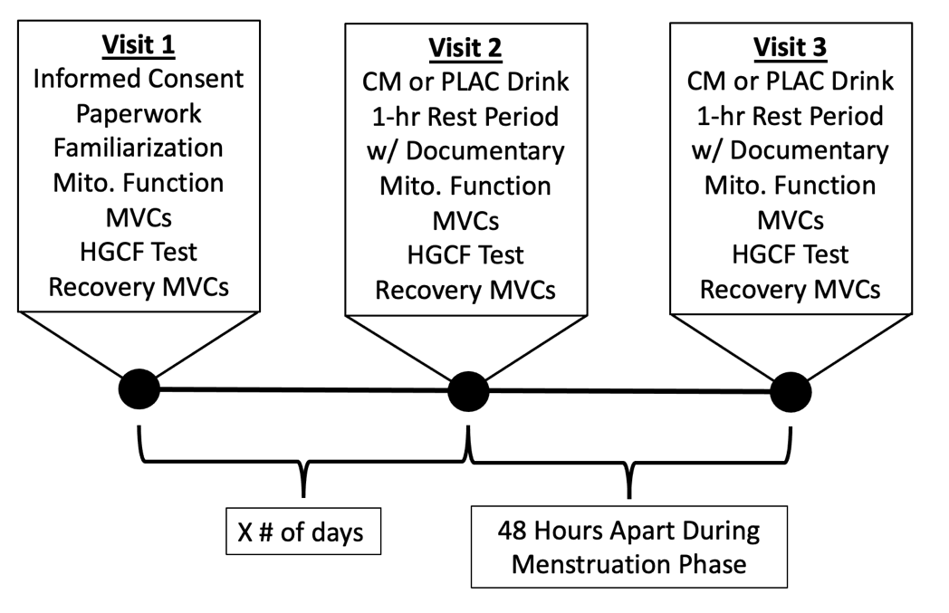
Figure 1: Experimental timeline and overview of measures.

3.06 – Experimental Procedures:
Mitochondrial Function Testing Using Near Infrared Spectroscopy (NIRS):
A total of three estimations of mitochondrial function using NIRS were completed on each participant, one during each visit. For each test, the subject laid on their back on a table with their legs uncrossed. Blood pressure was taken with a sphygmomanometer (Omron Healthcare, Inc., Lake Forest, IL 60045) and then recorded. The NIRS Portamon device (Artinis Medical Systems B.V., The Netherlands), after it was wrapped in plastic wrap to keep out moisture, was placed on the subject’s non-dominant forearm superficial flexor muscles felt for by palpation. The NIRS device was secured using two bandage wraps to keep out excess light. The device was connected to a laptop with OxySoft software (Artinis Medical Systems B.V., The Netherlands) via Bluetooth. The wavelengths utilized were 848nm and 759nm and the sampling rate was set at a rate of 10Hz.
A blood pressure cuff was placed on the upper part of the subject’s nondominant arm and connected to a Hokanson E20 Rapid Cuff Inflator and Hokanson AG101 Cuff Inflator Air Source (D.E. Hokanson, Inc., Bellevue, WA 98005). The pressure setting on the Hokanson Air Source was set to 100mmHg above the subject’s systolic blood pressure. Once the equipment was set up, a 2.5-minute resting period occurred to allow for the oxygenated hemoglobin (OxHb), deoxygenated hemoglobin (DeOxHb), difference between OxHb and DeOxHb (HgBDiff), and tissue saturation index percentage (TSI%) readings to normalize. After this 2.5-minute resting period, a series of cuff inflations, deflations, and exercise was performed according to the procedure below:
- Inflate 30 seconds/Deflate 30 seconds X 2
- Isometric Handgrip Pulse (2s on 2s off for 20 seconds)
- Rest period 3 seconds
- Inflate 5 seconds/Deflate 5 seconds X 7
- Inflate 7 seconds/Deflate 7 seconds X 4
- Inflate 10 seconds/Deflate 10 seconds X 4
- Isometric Handgrip Hold 3 seconds
- Inflate 5 minutes
- Deflate 5 minutes
This protocol was adapted from Brizendine et al. (2013). After the 5-minute deflation period, another file on the OxySoft software was opened for the HGCF test. The NIRS Portamon device on the forearm was not moved in between tests.
A blood volume correction was performed on the raw values of OxHb, DeOxHb, HgBDiff, and TSI%, as outlined by Ryan et al. (2012). Raw OxHb and DeOxHb values were used in the following equations:
(1) $\text{β = }\frac{\text{|OxHb|}}{\left|\text{OxHb}\right|\text{+|DeOxHb|}}$
(2) $\text{cOxHb} \text{=} \text{OxHb} \text{-} \text{[}\text{TotalHb}\text{ x }\left(\text{1- β}\right)\text{]}$
(3) $\text{cDeOxHb} \text{=} \text{DeOxHb} \text{-} \text{(}\text{TotalHb}\text{ x β)}$
Equation 1 represents 𝛽, the blood volume correction factor, and was calculated for every data point during the mitochondrial function test. To calculate the OxHb after correcting for blood volume, raw OxHb values were substituted into Equation 2. The same was done for DeOxHb values but using Equation 3. These methods are congruent with similar studies (Ryan et al., 2012). For estimation of mitochondrial function, the slope of the increase in DeOxHb after each inflation following the 20-second incremental handgrip exercise was determined. The slope was calculated by using Microsoft Excel to find the largest, most consistent segment during the inflation period. The slopes from the first six inflations after the handgrip exercise and the average of the first 30-second inflations was used in accordance with McCully et al. (2020) because the metabolic rate changes the greatest during the first six inflations and the date tends to be cleaner. More specifically, these slopes were fit with a single exponential decay curve in which a time constant (tau) value (measured in seconds) was calculated and used to estimate mitochondrial function.
Handgrip Critical Force (HGCF) Test and Setup:
The participant sat upright on a traditional preacher curl bench to attempt to limit as much arm movement as possible and keep the angle of the subject’s arm/forearm consistent between participants. The subjects grasped a custom, 3D printed handgrip device with four fingers wrapped around the handle and the thumb wrapped underneath. Their forearm was placed on a support while gripping the device. The custom handgrip device was connected to a force transducer which sampled at a frequency of 2000Hz (Transducer Techniques, Temecula, CA 92590). The table position was adjusted depending on the participant’s anthropometrics and comfort and recorded in order to replicate in future tests.
The force transducer transmitted a reading in Volts to a BIOPAC MP150 data acquisition system (BIOPAC Systems Inc., Goleta, CA 93117) for analysis with AcqKnowledge Acquisition and Analysis software (BIOPAC Systems Inc., Goleta, CA 93117). This signal was filtered using a low pass filter at 5Hz and converted to Newtons according to the manufacturer’s calibrations. A screen was placed directly in front of the participants which displayed the BIOPAC force outputs and a video with the timing of each contraction for them to observe and follow. Before completion of the HGCF test, participants performed multiple three-second MVCs to practice giving maximal effort. They observed their force output on the screen and tried to increase it with each effort. One minute of rest was provided between MVCs.
During the HGCF test, participants were instructed to perform a MVC for three seconds followed by a two-second rest period. This cycle repeated for a total of five minutes, or a total of 60 contractions. A PowerPoint presentation converted to a video with these timings played on the TV in front of the participants as a prompt of when to contract and relax. Verbal encouragement was given throughout the test. After the five minutes were completed, subjects completed four MVCs each with one minute of rest to represent recovery after a fatiguing test.
NIRS Recordings During the HGCF Test:
The NIRS device recorded OxHb, DeOxyHb, HgBDiff, and TSI values during the pre-test MVCs, HGCF test, and the recovery MVCs. These values were normalized to the subject’s 0% oxygen saturation (the minimum OxHb reading during the five minutes of total occlusion after the mitochondrial function test) and 100% oxygen saturation (the maximum OxHb reading during the four minutes of reactive hyperemia following cuff-release after the mitochondrial function test). These procedures are in accordance with previous studies (Ryan et al., 2012).
3.07 – Supplementation Procedures:
All drinks were prepared by the same researcher, but this researcher was blinded to the contents in the drinks used on a particular participants’ testing day and were randomly assigned by a different researcher. The PLAC drink contained 1g (one packet) of no-calorie saccharin sweetener (Walmart Inc., Bentonville, AR 72716) and 2.4g (one packet) of zero-sugar artificial raspberry lemonade electrolyte water beverage mix (Propel, distributed by Gatorade, Chicago, IL 60604) thoroughly mixed into 500mL of water. The CM drink contained 12g of 2:1 L-citrulline to DL-malate powder (Bulk Supplements, Henderson, NV 89011) measured out on a food scale. The same raspberry lemonade flavor packet used in the PLAC drink was mixed with the CM and 500mL of water. Both drinks were transparent and were indistinguishable by sight and taste. On Visits 2 and 3, participants were given 15 minutes maximum to drink the entire 500mL, but most consumed it in less than three minutes.
3.08 – Data Analysis:
The BIOPAC AcqKnowledge files for pre-exercise MVCs, HGCF test, and recovery MVCs were converted to text files and then run through a custom-written MATLAB (MathWorks Inc., Natick, MA 01760) script which calculated peak force, mean force, and area under the curve (impulse) for each contraction during the HGCF test. Critical force and critical force-time integral were calculated as the average of the final 6 contractions. The NIRS data for the mitochondrial function tests were exported as text files and downloaded into Microsoft Excel (version 16.71 for Mac) for analysis. Raw DeOxHb and OxHb values were corrected for blood volume changes using the calculations mentioned in section 3.06. The NIRS data (OxHb, DeOxHb, HgBDiff, and TSI%) from the HGCF test were exported as text files and downloaded to Excel for analysis. The values were corrected as mentioned in section 3.06. A custom-written Excel template then calculated the total areas under the curve (AUC), 5-second, time-binned averages, and 20-second, time-binned averages for each variable during exercise.
3.09 – Statistical Analysis:
Microsoft Excel and SPSS (version 28.0, IBM, Chicago, IL 60604) were used for statistical analyses. All data are reported as mean ± SEM unless otherwise noted. Dependent-measures t-tests were used to compare the CM and PLAC conditions for maximal isometric handgrip strength, critical force, critical force-time integral or impulse, NIRS estimation of mitochondrial function, NIRS-derived AUC for OxHb, DeOxHb. A 2 (condition; CM and PLAC) x 16 (time) completely within, repeated measures ANOVA was performed to analyze how OxHb, DeOxHb, and TSI% changed between the two conditions (CM and PLAC) and over 16 time periods (one pre-exercise and 15 during-exercise time points). This data was obtained from the 20-second, time-binned averages of each variable. Lastly, a 2 x 5 completely within, repeated measures ANOVA was performed to analyze how the recovery MVCs changed between the two conditions (CM and PLAC) and over five time periods (final contraction at the end of the HGCF test and four time points after HGCF test). The Greenhouse-Geisser correction was used if Machly’s test of sphericity was violated. Effect sizes are reported as Cohen’s d, calculated by dividing the mean difference of the variables by the pooled standard deviation. A small effect is 0.20, a moderate effect is 0.50, and a large effect is denoted as 0.80. The alpha level was set at p < 0.05 for all tests.

CHAPTER IV: RESULTS
4.01 – Maximal Isometric Handgrip Strength:
MVCs from the CM testing day and PLAC (182.7 ± 49.9 N vs 187.9 ± 53.2 N, respectively) testing day were averaged and compared (Table 1). A dependent samples t-test showed no significant differences between the CM condition and the PLAC condition (p = 0.288, Cohen’s d = -0.10).
4.02 – Critical Force:
The peak force from all 60 contractions of the critical force test are shown in Figure 2. A dependent samples t-test found no significant differences between the mean of the peak force from the final 6 contractions of the test in the CM condition and the PLAC condition (see figure insert; p = 0.857, Cohen’s d = 0.02). Peak contraction force, expressed as a percentage of each participant’s MVC on the respective testing day, can be seen in Figure 3. A dependent samples t-test showed no significant differences between the mean of the force from the final 6 contractions of the test in the CM condition and the PLAC condition (see figure insert; p = 0.443, Cohen’s d = 0.20).

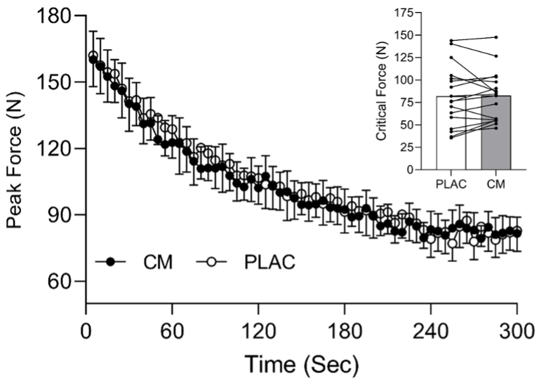
Figure 2: Peak force from all 60 contractions during the HGCF test. Values are mean ± SEM. Insert shows mean CF values calculated from the final 6 contractions.
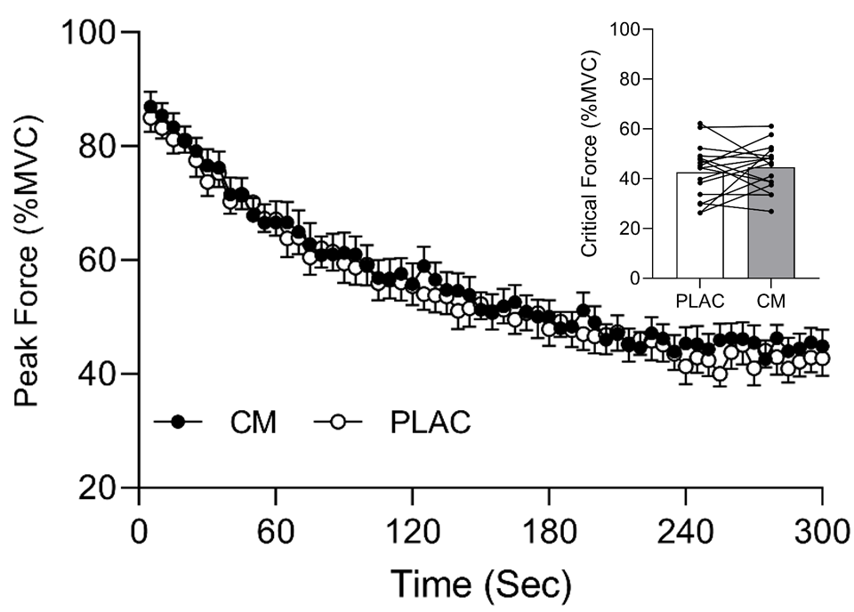
Figure 3: Peak force from all 60 contractions during the HGCF expressed as a percentage of the highest MVC obtained on the respective testing day. Values are mean ± SEM. Insert shows mean CF values calculated from the final 6 contractions expressed as a percentage of MVC.
4.03 – Critical Force-Time Integral:
The mean of force-time integral (FTI) from each of the 60 contractions during the test from the CM testing day and PLAC testing day are shown in Figure 4. A dependent samples t-test showed no significant differences between the average FTI over the final 6 contractions of the test in the CM condition and the PLAC condition (see insert; p = 0.093, Cohen’s d = 0.21). The sum of the FTI (area or impulse) during the final 6 contractions as well as the sum of all 60 contractions from the HGCF test for the CM testing day and the PLAC testing day are shown in Table 1. A dependent samples t-test revealed no significant differences between the CM condition and the PLAC condition for the sum of the final 6 contractions (p = 0.093, Cohen’s d = 0.21) and the sum all 60 contractions (p = 0.925, Cohen’s d = -0.008).
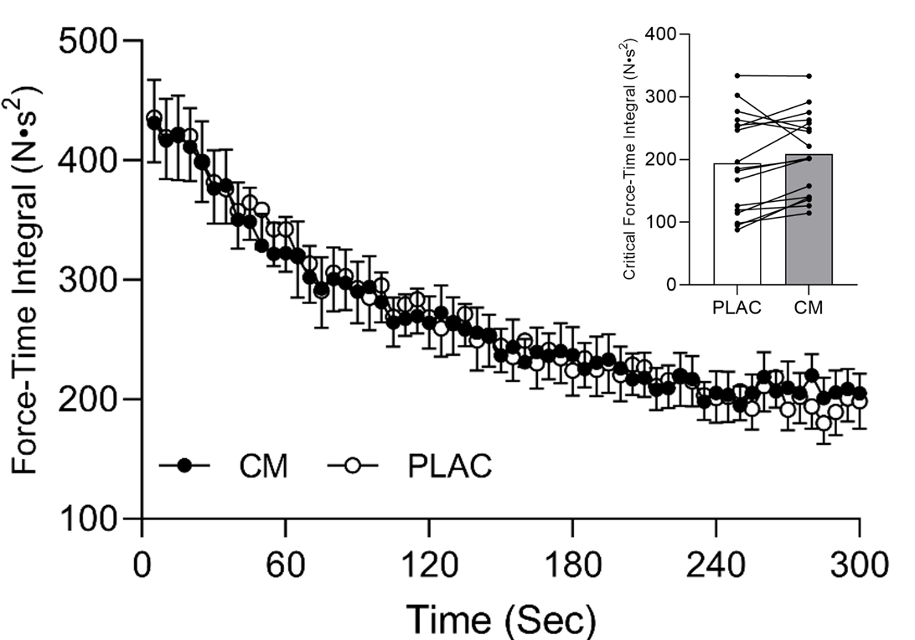
Figure 4: Mean force-time integral from each of the 60 contractions during the HGCF test. Values are mean ± SEM. Insert shows mean critical FTI calculated from the final six contractions.

4.04 – NIRS Estimation of Mitochondrial Function:
Mean time constant (tau) values from the single-exponential curve fit from the mitochondrial function tests are shown in Figure 5. Data from 2 participants were not included in the analysis due to software malfunction and data loss. Therefore, only 15 participants from the sample were analyzed. A dependent samples t-test revealed no significant differences between the CM condition and the PLAC condition (p = 0.790, Cohen’s d = -0.09).
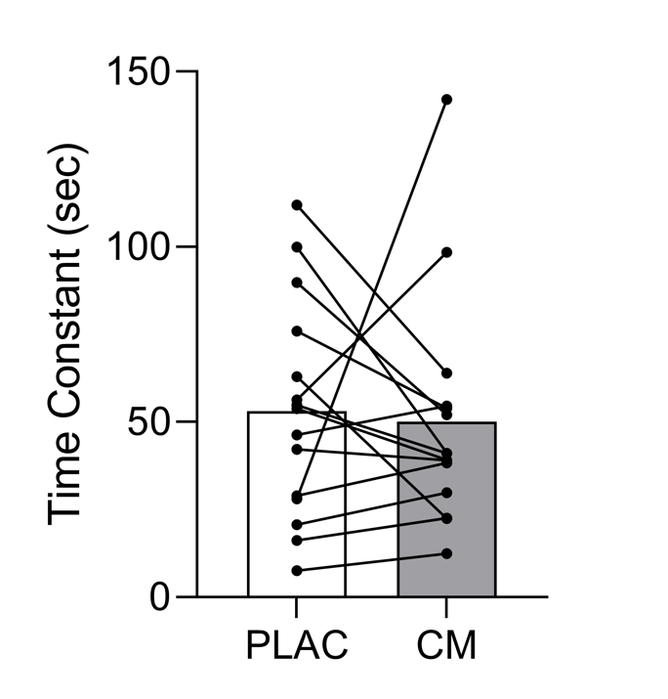
Figure 5: Mean time constant (tau) values from the mitochondrial function test. N = 15. Values are mean ± SEM.

Table 1. Average Values on CM and PLAC testing days.
 | CM | PLAC
MVC (Newtons)ª | 182.7 ± 49.9 | 187.9 ± 53.2
∑FTI Final 6 (N∙s)ª | 1254.5 ± 392.6 | 1165.3 ± 475.7
∑FTI All 60 (N∙s)ª | 16024.9 ± 5217.7 | 16070.6 ± 6004.5
AOC OxHb (µM∙s)^{b} | 3963.5 ± 2522.5 | 3860.5 ± 3789.8
AUC DeOxHb (µM∙s)^{b} | 14232.0 ± 5987.9 | 15535.8 ± 6878.0
Values are mean ± SD. ª indicates a sample size of 17 and ^{b} indicates a sample size of 16. CM = citrulline malate; PLAC = placebo; MVC = maximal voluntary contraction; ∑FTI Final 6 = the sum of the force-time integral of the last six contractions from the HGCF test; ∑FTI All 60 = the sum of the force-time integral of all 60 contractions during the HGCF test; AOC OxHb = area over the curve for oxygenated hemoglobin during HGCF test; AUC DeOxHb = area under the curve for deoxygenated hemoglobin during HGCF test.

4.05 – NIRS-derived Area Under the Curve (AUC) for Ox and DeOx Hemoglobin:
The mean area under/over the curve (area under/over the curve representing change from resting values) for the OxHb and DeOxHb during the HGCF test can be found in Table 1. A dependent samples t-test revealed no significant differences between the CM condition and the PLAC condition for the AOC for OxHb (p = 0.88, Cohen’s d = 0.03). A dependent samples t-test also revealed no significant differences between the CM condition and the PLAC condition for the AUC for DeOxHb (p = 0.722, Cohen’s d = -0.20).
4.06 – NIRS-derived Oxygen Sat/Desaturation During HGCF Test:
Figure 6 shows five-second averages for OxHb, DeOxHb, and TSI% from the 1-min pre-exercise, rest period and the HGCF test.
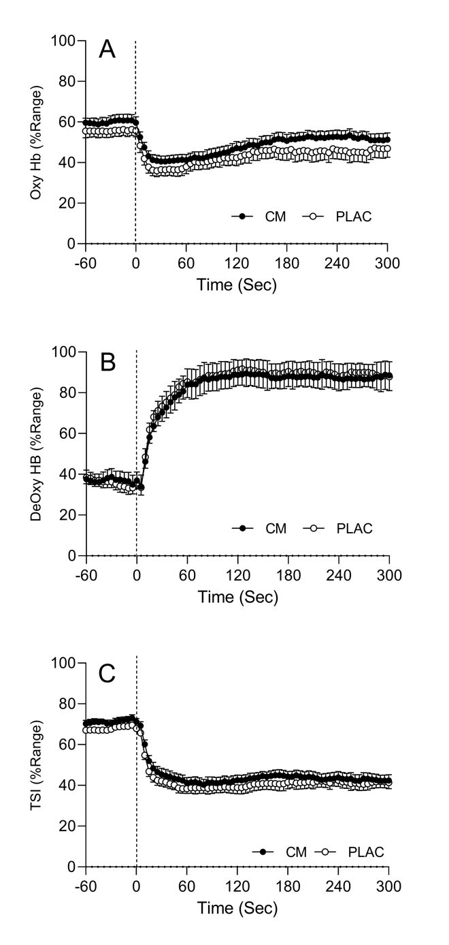
Figure 6: Five-second averages for OxHb (A), DeOxHb (B), and TSI% (C) during the HGCF and the one-minute rest period prior. Values are mean ± SEM.

Statistical analysis was performed on 20-second averages (20 seconds covers 4 contractions during exercise), due to having too few participants to compare the 60 contractions to each other and compared to the average across the 1-minute of rest prior to exercise. Values for OxHb can be seen in Figure 7. A two-way repeated measures ANOVA was performed to analyze the effect of CM supplementation (condition) and time on OxHb values in comparison to a placebo. Machly’s test of sphericity was violated for condition x time (p < 0.001), so the results are reported after using the Greenhouse-Geisser correction. There was not a significant condition x time interaction (p = 0.552) nor was there was a significant main effect for condition (p = 0.283). There was a significant main effect for time (p < 0.001). Analysis of main comparisons across time points showed pre-exercise values were significantly higher than all 15 time-points (p ≤ 0.012) during exercise. The average of OxHb values during the first 20 seconds (time point 1) was significantly lower than the resting time point (p < 0.001), significantly higher than the average of time points 2 and 3 (p ≤ 0.010), but not significantly different than time points 4-15 (p ≥ 0.090).
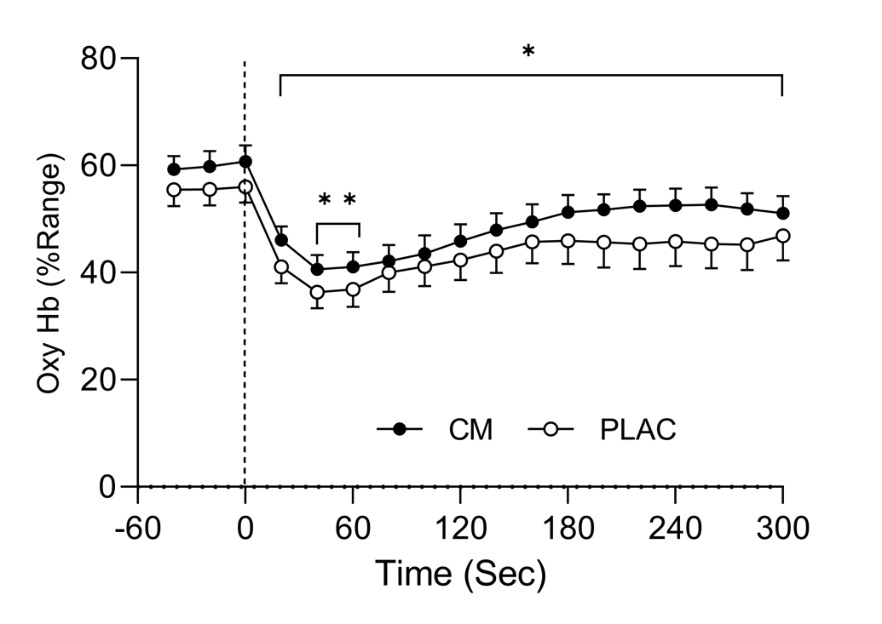
Figure 7: Twenty-second averages of OxHb during the HGCF test and one-minute prior. Values are mean ± SEM. * indicates pre-exercise values are significantly different than all 15 time points during test (p < 0.001). ** indicates time points 2 and 3 are significantly lower than time point 1 (p ≤ 0.010).
A similar trend was observed for DeOxHb values and can be seen in Figure 8. Machly’s test of sphericity was violated for condition x time (p < 0.001), so the results are reported after using the Greenhouse-Geisser correction. The was not a significant condition x time interaction (p = 0.666), nor was there was a significant main effect for condition (p = 0.738). There was a significant main effect for time (p < 0.001). The DeOxHb was significantly lower at rest than any of the 15 time points (p < 0.001) during exercise. The average of DeOxHb values during the first 20 seconds of exercise, during 20-40 seconds of exercise, and during 40-60 seconds of exercise were significantly larger than the resting time point and significantly differed from all other time points (p < 0.048).
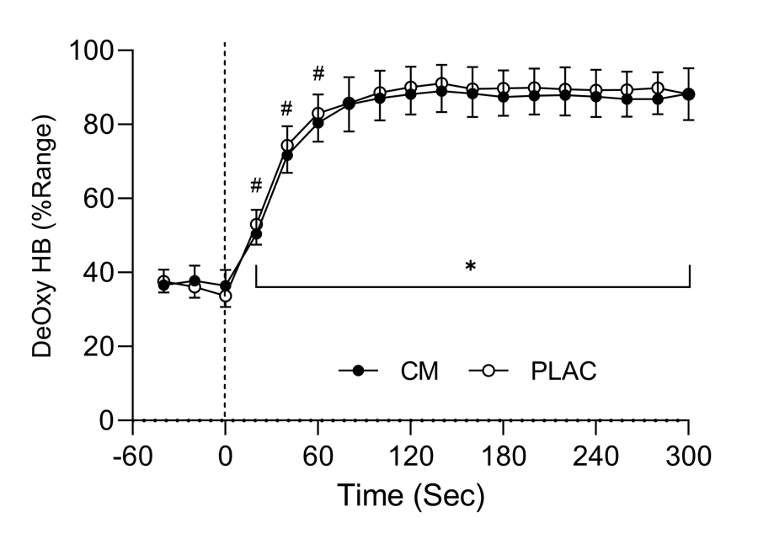
Figure 8: Twenty-second averages of DeOxHb during the HGCF test and one-minute prior. Values are mean ± SEM. * indicates pre-exercise values are significantly different than all 15 time points during test (p < 0.001). # indicates first, second, and third 20s averages were significantly larger than resting and significantly different than all other time points (p < 0.048).

Twenty-second averages of TSI% values are shown in Figure 9. Machly’s test of sphericity was violated for condition x time (p < 0.001), so the results are reported after using the Greenhouse-Geisser correction. There was not a significant condition x time interaction (p = 0.292). There was also not a significant main effect for condition (p = 0.358). There was a significant main effect for time (p < 0.001). The average of TSI% values from the resting point were significantly higher than all other time points (p < 0.001). The averages during the first 20sec of exercise were reduced compared to pre (p < 0.001) but elevated compared to all other time point (p < 0.001). The average TSI% values during 20-40sec of exercise was significantly larger than those from 40-60sec, 60-80 sec, and 80-100sec of exercise (p ≤ 0.027), but not significantly different from any of the time points after 100sec of exercise (p ≥ 0.067).
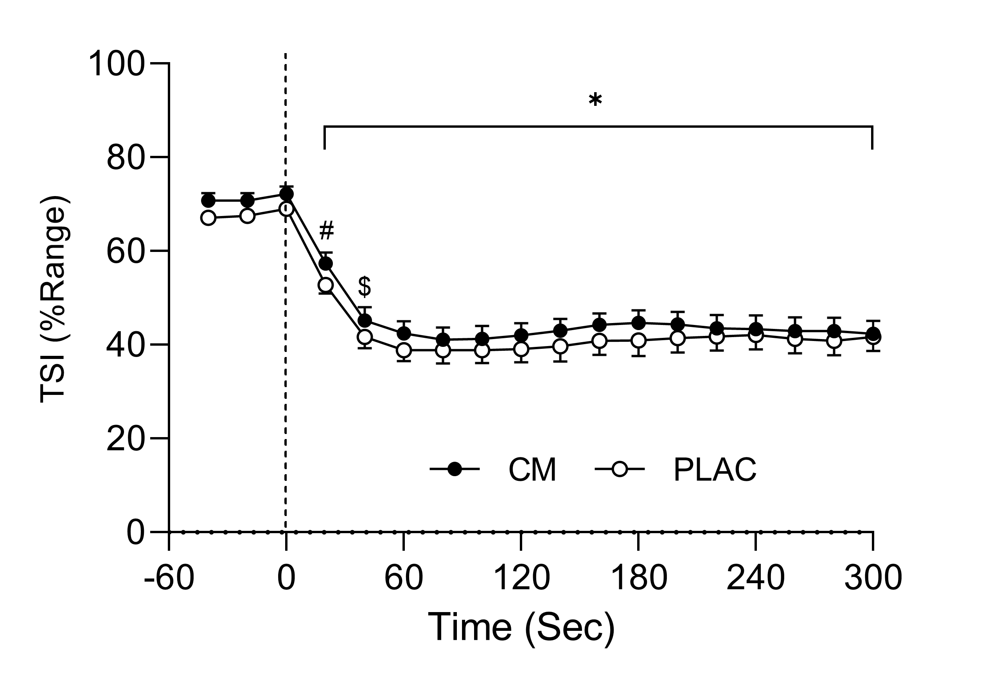
Figure 9: Twenty-second averages of TSI% during the HGCF test and one-minute prior. Values are mean ± SEM. * indicates pre-exercise values are significantly different than all 15 time points during test (p < 0.001). # indicates value from the 0-20sec differed from all other exercising time points, and $ indicates the value from 20-40sec of exercise differed from 40-60sec, 60-80 sec, and 80-100sec of exercise. (p < 0.05).
4.07 – Recovery of MVC Following Exercise:
The final contraction during the HGCF test (End) and four recovery MVCs (Rec1 – Rec4) were all divided by the largest MVC recorded during that test day and expressed as a percentage of MVC. This is represented in Figure 10. A 2 x 5 repeated measures ANOVA was performed to analyze the effect of CM supplementation (condition) and time on recovery MVCs as a % of MVC in comparison to a placebo. Machly’s test of sphericity was violated for condition x time (p = 0.003), so the results are reported after using the Greenhouse-Geisser correction. There was not a significant condition x time interaction (p = 0.642). There was also not a significant main effect for condition (p = 0.897). There was a significant main effect for time (p < 0.001). The value from the final contraction of the HGCF test was significantly lower than all 4 of the recovery MVCs (p < 0.001). Rec1, performed one minute after completion of HGCF test, was significantly lower than Rec2-4 (p ≤ 0.001). Similarly, Rec2 was significantly lower than Rec3 and Rec4 (p ≤ 0.001). Finally, Rec3 was significantly lower than Rec4 (p ≤ 0.004).
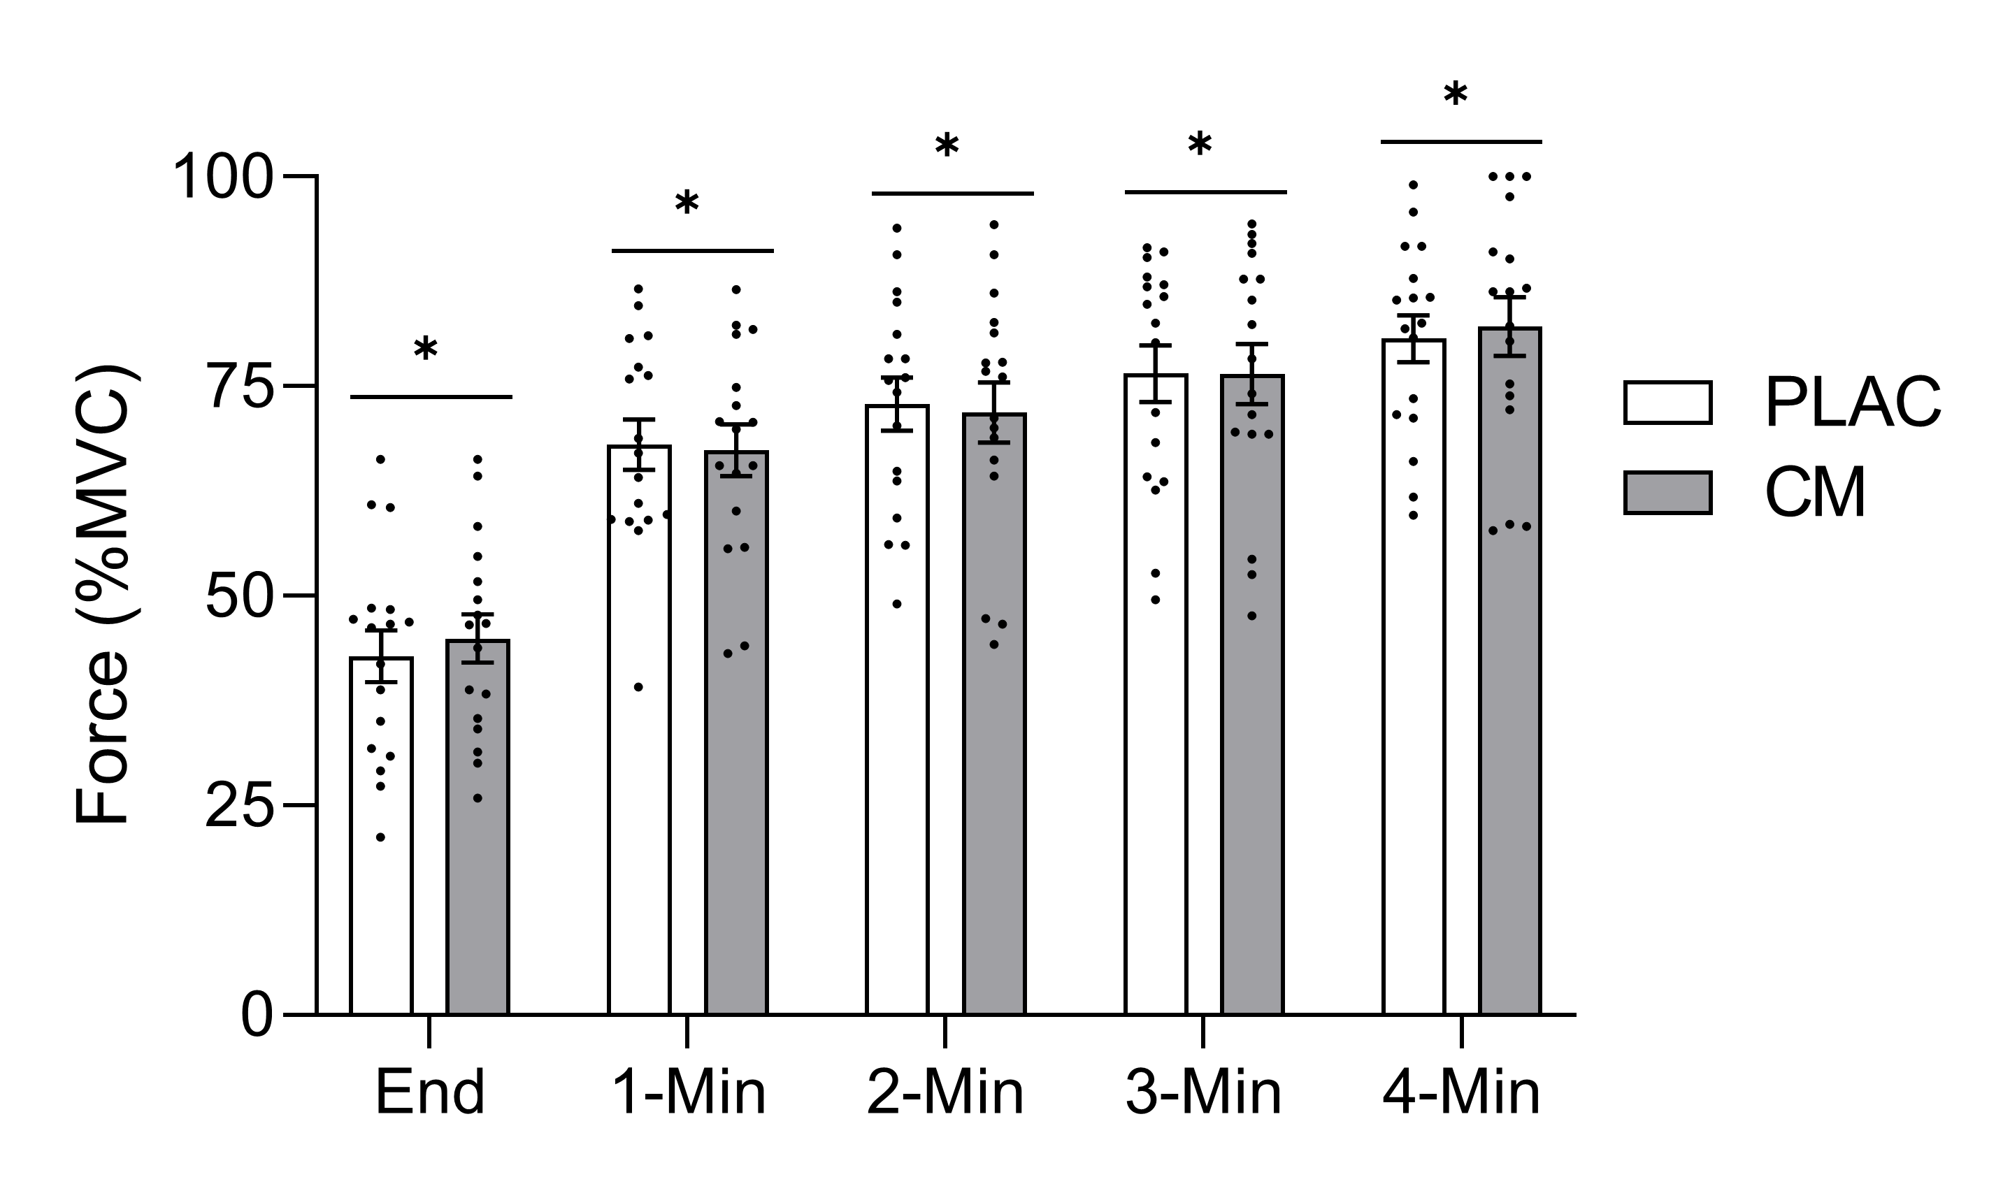
Figure 10: Recovery MVCs performed one minute, two minutes, three minutes, and four minutes after completion of the HGCF test expressed as a percentage of the highest MVC recorded on the respective testing day. “End” value represents the average of the final contraction of the HGCF test. Values are mean ± SEM. * indicates each time point differed from all other time points (p < 0.05).

CHAPTER V: DISCUSSION
5.01 – Purpose and Hypotheses:
The purpose of this study was to investigate if a single, acute dose of CM supplementation affects mitochondrial function, forearm flexor critical force, and oxygen saturation/desaturation in the forearm muscles during the critical force test, 60 minutes after ingestion. It was hypothesized that an acute dose of CM supplementation would increase mitochondrial function, improve performance of the HGCF test by increasing CF, and limit the fall in oxygen saturation and rise in desaturation during the HGCF test. Based on the results presented, none of these hypotheses are supported. Therefore, the null hypotheses are accepted. An acute, 12g dose of CM, in comparison to a placebo, did not affect mitochondrial function, performance of a HGCF test, or oxygen saturation/desaturation during the HGCF test in healthy women aged 18-35 years.
5.02 – Maximal Isometric Handgrip Strength:
Handgrip MVC was not significantly different between the PLAC and CM supplementation conditions. This contrasts the results from Glenn and colleagues (2016), where they reported a significant increase in peak and mean maximal grip strength in women 60 minutes after consumption of 8g of CM. However, their participants were older (average age of 51 years) and were avid tennis players. Additionally, the grip strength was measured in the subject’s dominant arm. The participants in the current study did all exercise performance on their non-dominant arm to control for possible unequal training. Because the ability to produce force decreases with age (Frontera et al., 2000; Rogers & Evans, 1993; Williams et al., 2002), this could explain the discrepancy between results as older women might have a decreased ability to produce force when compared to young women, allowing for more room for improvement. Glenn et al. (2016) discuss that maximal grip strength correlates with explosive power, which was also increased after CM supplementation. However, the mechanisms leading to the increased grip strength and explosive power reported by Glenn et al. (2016) are unclear because there were no measures of a possible mechanism in addition to the participants being in different menopausal stages.
5.03 – Critical Force:
CF and CF expressed as a percentage of MVC were not significantly different after CM supplementation. While there is no direct reporting of CM supplementation on CP or CF in previous studies, there are reports of CM supplementation on repetitions to failure. Glenn et al. (2017) showed a significant increase in total repetitions of the bench press exercise following 8g of CM supplementation in women. It is important to note that the type of exercise utilized by Glenn et al. (2017) required more muscle mass than the handgrip exercise employed in the current study. Thus, it is possible that performance effects of CM supplementation could be dependent on the size of muscle mass involved with the exercise due to the hemodynamic of small-mass and large-mass exercise. For example, Green et al. (2004) reported significantly higher sheer stress on the endothelium during cycling exercise when compared to handgrip exercise; possibly leading to more NO-mediated vasodilation with cycling exercise. This suggests that NO-mediated vasodilation is more predominant in large muscle-mass exercises when compared to small muscles-mass exercises like intermittent handgrip contractions (Green et al., 2005).
Similar to findings from the current study, Farney and associates (2019) reported CM did not attenuate muscular fatigue during high-intensity resistance training (squats, lunge jumps, squat jumps, and lateral jumps) after an acute dose of 8g. Similarly, Fick et al. (2021) reported no significant change in fatigue rate in the quadricep muscle. While Farney et al. (2019) and Fick et al. (2021) measured fatigue variables, there was no direct measurement of CF. Our results suggest that CM supplementation did not influence the absolute or relative average peak of the force produced in the last 30 seconds of a HGCF test in moderate- to highly-trained women. Additional research should be done investigating if CM affects CF in other populations, such as untrained individuals or men.
While CF or CP has not been directly measured after CM supplementation, CP has been measured after beetroot supplementation. Beetroot contains nitrate, which, when supplemented in the diet, can increase NO production through the nitrate-nitrite pathway independently of oxygen (Jones et al., 2021). Although through a different mechanism, beetroot supplementation could lead to an increase in vasodilation and oxygen delivery similarly to CIT/CM supplementation. In recreationally active males, acute beetroot supplementation did not influence CP performed on a cycle ergometer (Kelly et al., 2013). In this way, our results are congruent with this study.
5.04 – Critical Force-Time Integral:
The FTI is the mean of the area of the final six contractions during the HGCF test. This represents the absolute amount of work performed in the last 30 seconds of the HGCF test, and these results suggest, similar to critical force, that CM supplementation does not increase the work performed during this period when compared to a placebo. Similarly, the sum of the area from all 60 contractions was also not affected by CM supplementation. These measures represent the total amount of work done in the last 30 seconds and the total work during the whole 5-minute HGCF test, respectively. We are limited in the ability to directly compare these results to those of another study analyzing CIT or CM supplementation on CP/CF, but there are similar measures that can be discussed. Glenn and colleagues (2017) reported an increase in the total number of repetitions of the bench press after acute CM supplementation. A significant increase in number of repetitions to failure was also reported by Wax et al. (2015, 2016), and Pérez-Guisado & Jakeman (2010), but still, there are some studies that did not report any significant increase to total repetitions to failure (Gonzalez et al., 2018; Martínez-Sánchez et al., 2017; Trexler, Keith, et al., 2019). These incongruent results could be partly explained by the different doses and timing of CM supplementation utilized. However, one study that investigated how 12g of CM, the same dose used in the current study, affected a cycle time-to-exhaustion (TTE) test, and reported no significant change (Cunniffe et al., 2016). While this is a TTE test, this study used the same dose as the current one and found similar results. Gills et al. (2022) reported an increase in the total work done during a 5-repetition isokinetic leg extension protocol, but not in a 50-repetition protocol (though not technically a critical torque test) after acute supplementation of CM. These variables were measured during a leg extension test which involves additional muscle groups than the handgrip test in this study. In addition, the exercise tests conducted by Gills et al. (2022) measured power compared to fatigue and endurance resistance exercise used in the current study. Based on the results presented and those of other studies with similar outcomes, CM supplementation has not been able to consistently improve fatigue resistance or CP variables.
5.05 – NIRS Estimation of Mitochondrial Function:
A previous study in mice by Wu et al. (2007) found that 30 days of malate supplementation let to an increase in forced swimming time and an increase in mitochondrial malate dehydrogenase activity. As such, we hypothesized CM supplementation would improve NIRS assessed mitochondrial function in the present study. However, unlike these findings, CM did not improve the mitochondrial function as presented in this study, which suggests that a single, acute dose of CM was not sufficient enough to alter mitochondrial variables as hypothesized. The mean time constants (tau values) reported in this study were generally larger (therefore, slower) than those presented by Beever et al. (2020) (average tau value of 51sec vs. 23sec, respectively), though, these measurements were done in the vastus lateralis and gastrocnemius muscles. Similarly, the tau values in this study were also slower than those reported by DePauw et al. (2021), measured in the flexor forearm muscles (average tau value of 51sec vs. 35sec, respectively). These discrepancies could be due to the large variability in our results, as the time constants varied greatly between participants and even between testing days.
5.06 – NIRS-Derived Area Under the Curve (AUC) for Ox and DeOx Hemoglobin:
OxHb and DeOxHb were measured during the HGCF test and expressed as a percentage of peak saturation or desaturation from the total cuff occlusion measure. The AUC for DeOxHb and area over the curve (AOC) for OxHb were calculated to represent a measure of the change in oxygen saturation during the HGCF test. There was no significant difference between the change in OxHb and DeOxHb during exercise after CM supplementation, compared to a placebo. This finding contrasts with the results of Bailey et al. (2015), who reported an increase in VO₂ kinetics and a decrease in the amount of DeOxHb following CIT supplementation. They interpreted these results as CIT improving oxygen availability and distribution at the muscle. However, an acute dose of CM was used in the current study whereas a loading dose of CIT over the course of seven days was utilized by Bailey et al. (2015). Our results are, however, in agreement with the results of Trexler et al. (2020), where total muscle oxygen consumption measured via NIRS during exercise was not significantly different after 8g of CM supplementation.
5.07 – NIRS-Derived Sat/Desaturation During HGCF Test:
Throughout the HGCF test, OxHb, DeOxHb, and TSI% were measured and expressed as a percentage of peak saturation and desaturation, and TSI value during cuff occlusion. The average of all four of these variables were taken over 20-second intervals which represents four consecutive contractions.
During the HGCF test, OxHb levels decreased immediately after the test began and fell until they plateaued after ≈180 seconds. This trend is consistent with the results from Hammer et al. (2020) who also showed an immediate decline in OxHb until a plateau is reached during a HGCF test. Also congruent with the results from Hammer et al. (2020), the DeOxHb levels increased immediately after exercise began until a plateau was reached after ≈120 seconds of exercise. This same plateau of DeOxHb was also observed by Bailey et al. (2015), where DeOxHb leveled-off just before ≈120 second into a bout of moderate-intensity cycle exercise. Because the results presented in this study have the same patterns presented in other studies, it increases the confidence that CM supplementation did not affect the variables measured.
OxHb and DeOxHb are embedded into the TSI% calculation, which accounts for why there were no significant changes after CM supplementation. The changes in TSI% over time are consistent with what was reported by Hammer et al. (2020), where TSI% decreased immediately after the HGCF test began and eventually leveled-off after ≈100 seconds of exercise. Bailey et al. (2015) also reported a similar trend during a severe intensity cycling test.
5.08 – Recovery of MVC Following Exercise:
Another possible effect of CM supplementation could have been a faster recovery following exercise. We completed four MVCs after the HGCF test to test “recovery” of force after exercise. CM supplementation did not influence how quickly force recovered compared to a placebo. It was hypothesized that due to the possible vasodilatory effects of CIT, more blood flow to the exercising muscle after the fatiguing test would lead to a faster recovery of force when compared to a placebo, but this was not the case in this study. The only studies that exist investigating the effects of CIT/CM supplementation on recovery have mostly focused on perceptions of muscle soreness after exercise, not how quickly force or another exercise parameter was recovered after exercise. Most studies have reported a decreased feeling of muscle soreness between 24-48 hours after exercise when CIT/CM was supplemented (Tarazona-Díaz et al., 2013; Suzuki et al., 2016; and Pérez-Guisado & Jakeman, 2010; Rhim et al., 2020). Subjective perceptions of muscle soreness were not measured in this study, but we can report that force production after a fatiguing exercise test was not influenced by acute CM supplementation.
Given the lack of data using CIT or CM to examine the recovery of force following exercise, we looked to other supplements that lead to increases in NO bioavailability. Nitrate supplementation through beetroot juice and other foods leads to increased NO production and may influence of recovery rates following exercise (Larsen et al., 2011). This supplement acts through similar mechanisms via NO as CM is proposed to. Nitrate supplementation has been shown to speed up phosphocreatine (PCr) recovery kinetics after exercise, perhaps through increased oxygen delivery (Vanhatalo et al., 2014). Because PCr recovery is a function of aerobic ATP production, it is reasonable that if PCr is recovered faster, then this could translate to an increase in the rate of force production after a fatiguing test. PCr recovery was not assessed in the current study, however, given CM did not alter recovery of MVC it does not seem likley that PCr recovery was influenced by CM. Vanhatalo et al. (2014) did observe the increase in PCr recovery in a hypoxic environment, however, so it is possible that there needs to be some kind of oxygen deficit in order for CM supplementation to be effective in improving the recovery of force production.
5.09 – Limitations:
There are limitations to this study. A larger sample size is needed as 17 participants only allows for an effect size of (0.34-0.46 SD) to be detected. Additionally, plasma levels of CIT and arginine were not measured, so there was no indication of how CIT was absorbed and then converted to arginine. Therefore, we cannot confirm the extent to which CIT increased following supplementation and/or whether there were inter-participant differences. Additionally, the CF test was performed with voluntary contractions, and no measures specific to the origin of fatigue (central vs. peripheral) were made. Also, the dose of CM and timing of the dose given affects the amount of CIT available in the plasma to potentially be used in the NOS pathway. The dose used in this study was 12g of a 2:1 citrulline:malate ratio, which equates to 8g of CIT and 4g of malate. The quality of the supplement in this study was not sent off for secondary analysis, so the exact ratio was not determined. Therefore, we can only assume a 2:1 ratio was used, and, if different, could have affected results. Another limitation pertains to the testing taking place during the menstruation phase of the menstrual cycle, so these results may not be extrapolated to other phases of the menstrual cycle as levels of estrogen and progesterone could affect results (Gonzales et al., 2020). Finally, due to NIRS software malfunctions, some participants were delayed in the start of the HGCF test, usually by only 10 minutes. Because plasma CIT levels decrease exponentially one hour after consumption (Moinard et al., 2008), it is possible that just 10 minutes of delay could have drastically impacted the amount of CIT available. Lastly, the participants in this study were moderately or highly-trained, which could explain the lack of improvement in performance or other variables as there would be less room for improvement. This is supported by the findings of Gough et al. (2021), as there were less improvements to exercise performance tests if the participants were either resistance or aerobically trained.
5.10 – Significance and Future Study Recommendations:
The results of this study suggest that an acute dose of CM supplementation given approximately one hour before a mitochondrial function test and HGCF test, had no influence on aerobic capacity or aerobic performance in menstruating women aged 18-35 years. CM supplementation did not affect mitochondrial function. To our knowledge, this is the first study to examine CM supplementation on mitochondrial function in humans. Despite the proposed mechanisms of CM would affect aerobic exercise performance more so than anaerobic exercise performance, some studies have demonstrated improvements to anaerobic performance. In a repetitions to failure test using 80% of the subject’s one-repetition max, those who supplemented with CM were able to significantly increase in repetitions in the last set of exercise (Pérez-Guisado & Jakeman, 2010). The authors postulate that high-intensity anaerobic exercises could be greater influenced after CM supplementation. Glenn and associates (2016) reported a significant increase in peak and explosive power during a Wingate test after 8g of CM supplementation. This contrasts the results reported by Gills et al. (2021), where peak and mean power were not changed after an acute 8g CM dose. It could be interesting to explore the use of a larger dose of CM with effects on anaerobic performance moving forward.
Nitrate supplementation through consuming beet root juice is thought to work similar mechanistically to CIT/CM by increasing NO production. A meta-analysis reports greater performance on endurance exercises after nitrate supplementation comparted to CIT supplementation (d’Unienville et al., 2021), which is attributed to elevated nitrate and nitrite levels and a decrease in systolic blood pressure. Therefore, in the future, the effect of nitrate supplements on performance of a CF test could offer better insight to possible NO contributions to exercise. It could also be interesting to compare nitrate/beetroot supplementation to CM supplementation as both supplements could increase NO production but through different mechanisms.
The type of dose (acute or loading), amount of supplement, and timing of supplement before exercise could all impact results. Cunniffe et al. (2016) used the same dose of CM that we used and reported no significant differences between mean power or TTE of a cycle ergometer exercise test after CM supplementation compared to a placebo. Both the current study and Cunniffe et al. (2016) reported no significant changes to performance after an acute 12g dose of CM, but investigating how loading doses of CM affect performance is recommended for future studies. Loading doses of CIT (6g/day for seven days) were utilized by Bailey et al. (2015), who reported improved VO₂ kinetics and total amount of work done during an exercise performance test on a cycle ergometer. Similarly, Suzuki et al. (2016) utilized a 2.4g of CIT/day for seven days dosing regimen and reported a reduction in time to complete a 4-km cycling exercise. One of the only articles to investigate how a loading dose of CM (2g/day for four and eight weeks) affected lean mass and muscle strength reported no improvements after CM supplementation for 8 weeks (Hwang et al., 2018). However, only muscular strength variables were measured, so in the future, using a loading dose of CM to assess its effect on aerobic performance measures is justified.
It is possible that in the present study, participants were not performing at their maximal effort, but this cannot be confirmed as electromyography activity in the forearm muscles was not measured. Electrically stimulated critical torque tests the variables associated with peripheral fatigue as the muscle is being stimulated directly (Kent-Braun et al., 2012). In the future, assessing how (or if) CM supplementation solely affects peripheral fatigue during an electriclaly-stimualted critical torque test could allow for a better delination and understanding of fatigue. Additionally, the use of participants who are not trained is warranted as there could be a blunting of ergogenic effects with more trained individuals (Gough et al., 2021; Hultström et al., 2015).
The total amount of work completedwas increased during severe-intensity cycling exercise after a loading CIT dose was given for seven days, which was also accompanied by a significant decrease in DeOxHb during this test (Bailey et al., 2015). While this study did utilize a loading dose, it is possible that severe-intensity exercises that utilize a larger muscle mass are more sensitive to the variables that CM is suggested to change. Thus, utlilizing a severe-intensity exercise performance test is warranted in the future.

REFERENCES
Bailey, S. J., Blackwell, J. R., Lord, T., Vanhatalo, A., Winyard, P. G., & Jones, A. M. (2015). L-citrulline supplementation improves O₂ uptake kinetics and high-intensity exercise performance in humans. Journal of Applied Physiology, 119(4), 385–395. https://doi.org/10.1152/japplphysiol.00192.2014
Beever, A. T., Tripp, T. R., Zhang, J., & MacInnis, M. J. (2020). NIRS-derived skeletal muscle oxidative capacity is correlated with aerobic fitness and independent of sex. Journal of Applied Physiology, 129(3), 558–568. https://doi.org/10.1152/japplphysiol.00017.2020
Bendahan, D., Mattei, J. P., Ghattas, B., Confort-Gouny, S., Le Guern, M. E., & Cozzone, P. J. (2002). Citrulline/malate promotes aerobic energy production in human exercising muscle. British Journal of Sports Medicine, 36(4), 282–289. https://doi.org/10.1136/bjsm.36.4.282
Bescós, R., Sureda, A., Tur, J. A., & Pons, A. (2012). The effect of nitric-oxide-related supplements on human performance. Sports Medicine (Auckland, N.Z.), 42(2), 99–117. https://doi.org/10.2165/11596860-000000000-00000
Brizendine, J. T., Ryan, T. E., Larson, R. D., & McCully, K. K. (2013). Skeletal muscle metabolism in endurance athletes with near-infrared spectroscopy. Medicine & Science in Sports & Exercise, 45(5), 869. https://doi.org/10.1249/MSS.0b013e31827e0eb6
Brown, N. (2022, September 26). Phases of the menstrual cycle explained complete video. Elara Care. https://elara.care/hormones/video-phases-of-the-menstrual-cycle-explained/
Broxterman, R. M., Ade, C. J., Craig, J. C., Wilcox, S. L., Schlup, S. J., & Barstow, T. J. (2015). Influence of blood flow occlusion on muscle oxygenation characteristics and the parameters of the power-duration relationship. Journal of Applied Physiology, 118(7), 880–889. https://doi.org/10.1152/japplphysiol.00875.2014
Broxterman, R. M., Craig, J. C., Smith, J. R., Wilcox, S. L., Jia, C., Warren, S., & Barstow, T. J. (2015). Influence of blood flow occlusion on the development of peripheral and central fatigue during small muscle mass handgrip exercise. The Journal of Physiology, 593(Pt 17), 4043–4054. https://doi.org/10.1113/JP270424
Burnley, M. (2009). Estimation of critical torque using intermittent isometric maximal voluntary contractions of the quadriceps in humans. Journal of Applied Physiology, 106(3), 975–983. https://doi.org/10.1152/japplphysiol.91474.2008
Burton-Freeman, B., Freeman, M., Zhang, X., Sandhu, A., & Edirisinghe, I. (2021). Watermelon and l-citrulline in cardio-metabolic health: Review of the evidence 2000–2020. Current Atherosclerosis Reports, 23(12), 81. https://doi.org/10.1007/s11883-021-00978-5
Castillo, L., deRojas, T. C., Chapman, T. E., Vogt, J., Burke, J. F., Tannenbaum, S. R., & Young, V. R. (1993). Splanchnic metabolism of dietary arginine in relation to nitric oxide synthesis in normal adult man. Proceedings of the National Academy of Sciences, 90(1), 193–197. https://doi.org/10.1073/pnas.90.1.193
Chappell, A. J., Allwood, D. M., Johns, R., Brown, S., Sultana, K., Anand, A., & Simper, T. (2018). Citrulline malate supplementation does not improve German volume training performance or reduce muscle soreness in moderately trained males and females. Journal of the International Society of Sports Nutrition, 15(1), 42. https://doi.org/10.1186/s12970-018-0245-8
Chappell, A. J., Allwood, D. M., & Simper, T. N. (2020). Citrulline malate fails to improve German volume training performance in healthy young men and women. Journal of Dietary Supplements, 17(3), 249–260. https://doi.org/10.1080/19390211.2018.1513433\
Cunniffe, B., Papageorgiou, M., O’Brien, B., Davies, N. A., Grimble, G. K., & Cardinale, M. (2016). Acute citrulline-malate supplementation and high-intensity cycling performance. The Journal of Strength & Conditioning Research, 30(9), 2638–2647. https://doi.org/10.1519/JSC.0000000000001338
Cutrufello, P. T., Gadomski, S. J., & Zavorsky, G. S. (2015). The effect of l-citrulline and watermelon juice supplementation on anaerobic and aerobic exercise performance. Journal of Sports Sciences, 33(14), 1459–1466. https://doi.org/10.1080/02640414.2014.990495
Da Silva, D. K., Jacinto, J. L., De Andrade, W. B., Roveratti, M. C., Estoche, J. M., Balvedi, M. C. W., De Oliveira, D. B., Da Silva, R. A., & Aguiar, A. F. (2017). Citrulline malate does not improve muscle recovery after resistance exercise in untrained young adult men. Nutrients, 9(10), 1132. https://doi.org/10.3390/nu9101132
DePauw, E. M., Rouhani, M., Flanagan, A. M., & Ng, A. V. (2021). Forearm muscle mitochondrial capacity and resting oxygen uptake: Relationship to symptomatic fatigue in persons with multiple sclerosis. Multiple Sclerosis Journal - Experimental, Translational and Clinical, 7(2), 20552173211028876. https://doi.org/10.1177/20552173211028875
d’Unienville, N. M. A., Blake, H. T., Coates, A. M., Hill, A. M., Nelson, M. J., & Buckley, J. D. (2021). Effect of food sources of nitrate, polyphenols, L-arginine and L-citrulline on endurance exercise performance: A systematic review and meta-analysis of randomised controlled trials. Journal of the International Society of Sports Nutrition, 18, 76. https://doi.org/10.1186/s12970-021-00472-y
Farney, T. M., Bliss, M. V., Hearon, C. M., & Salazar, D. A. (2019). The effect of citrulline malate supplementation on muscle fatigue among healthy participants. The Journal of Strength & Conditioning Research, 33(9), 2464–2470. https://doi.org/10.1519/JSC.0000000000002356
Ferrari, M., Muthalib, M., & Quaresima, V. (2011). The use of near-infrared spectroscopy in understanding skeletal muscle physiology: Recent developments. Philosophical Transactions of the Royal Society A: Mathematical, Physical and Engineering Sciences, 369(1955), 4577–4590. https://doi.org/10.1098/rsta.2011.0230
Fick, A. N., Kowalsky, R. J., Stone, M. S., Hearon, C. M., & Farney, T. M. (2021). Acute and chronic citrulline malate supplementation on muscle contractile properties and fatigue rate of the quadriceps. International Journal of Sport Nutrition and Exercise Metabolism, 31(6), 490–496. https://doi.org/10.1123/ijsnem.2021-0117
Frontera, W. R., Hughes, V. A., Fielding, R. A., Fiatarone, M. A., Evans, W. J., & Roubenoff, R. (2000). Aging of skeletal muscle: A 12-yr longitudinal study. Journal of Applied Physiology (Bethesda, Md.: 1985), 88(4), 1321–1326. https://doi.org/10.1152/jappl.2000.88.4.1321
Gills, J. L., Glenn, J. M., Gray, M., Romer, B., & Lu, H. (2021). Acute citrulline-malate supplementation is ineffective during aerobic cycling and subsequent anaerobic performance in recreationally active males. European Journal of Sport Science, 21(1), 77–83. https://doi.org/10.1080/17461391.2020.1722757
Gills, J. L., Spliker, B., Glenn, J. M., Szymanski, D., Romer, B., Lu, H.-C., & Gray, M. (2022). Acute citrulline-malate supplementation increases total work in short lower-body isokinetic tasks for recreationally active females during menstruation. The Journal of Strength & Conditioning Research. https://doi.org/10.1519/JSC.0000000000004095
Glenn, J. M., Gray, M., Jensen, A., Stone, M. S., & Vincenzo, J. L. (2016). Acute citrulline-malate supplementation improves maximal strength and anaerobic power in female, masters athletes tennis players. European Journal of Sport Science, 16(8), 1095–1103. https://doi.org/10.1080/17461391.2016.1158321
Glenn, J. M., Gray, M., Wethington, L. N., Stone, M. S., Stewart, R. W., & Moyen, N. E. (2017). Acute citrulline malate supplementation improves upper- and lower-body submaximal weightlifting exercise performance in resistance-trained females. European Journal of Nutrition, 56(2), 775–784. https://doi.org/10.1007/s00394-015-1124-6
Gonzales, J. U., Fischer, S. M., Maharaj, A., Vellers, H., Anderson, T., Karnjanapiboonwong, A., Subbiah, S., Kellawan, J. M., & Figueroa, A. (2020). Response of exercise‐onset vasodilator kinetics to L‐citrulline supplementation during different phases of the menstrual cycle. Physiological Reports, 8(15), e14536. https://doi.org/10.14814/phy2.14536
Gonzalez, A. M., Spitz, R. W., Ghigiarelli, J. J., Sell, K. M., & Mangine, G. T. (2018). Acute effect of citrulline malate supplementation on upper-body resistance exercise performance in recreationally resistance-trained men. The Journal of Strength & Conditioning Research, 32(11), 3088–3094. https://doi.org/10.1519/JSC.0000000000002373
Gonzalez, A. M., Townsend, J. R., Pinzone, A. G., & Hoffman, J. R. (2023). Supplementation with nitric oxide precursors for strength performance: A review of the current literature. Nutrients, 15(3), 660. https://doi.org/10.3390/nu15030660
Gonzalez, A. M., & Trexler, E. T. (2020). Effects of citrulline supplementation on exercise performance in humans: A review of the current literature. The Journal of Strength & Conditioning Research, 34(5), 1480–1495. https://doi.org/10.1519/JSC.0000000000003426
Gough, L. A., Sparks, S. A., McNaughton, L. R., Higgins, M. F., Newbury, J. W., Trexler, E., Faghy, M. A., & Bridge, C. A. (2021). A critical review of citrulline malate supplementation and exercise performance. European Journal of Applied Physiology, 121(12), 3283–3295. https://doi.org/10.1007/s00421-021-04774-6
Goulding, R. P., & Marwood, S. (2023). Interaction of factors determining critical power. Sports Medicine, 53(3), 595–613. https://doi.org/10.1007/s40279-022-01805-w
Goulding, R. P., Roche, D. M., & Marwood, S. (2020). Effect of hyperoxia on critical power and VO₂ kinetics during upright cycling. Medicine & Science in Sports & Exercise, 52(5), 1041. https://doi.org/10.1249/MSS.0000000000002234
Green, D. J., Bilsborough, W., Naylor, L. H., Reed, C., Wright, J., O’Driscoll, G., & Walsh, J. H. (2005). Comparison of forearm blood flow responses to incremental handgrip and cycle ergometer exercise: Relative contribution of nitric oxide. The Journal of Physiology, 562(Pt 2), 617–628. https://doi.org/10.1113/jphysiol.2004.075929
Green, D. J., Maiorana, A., O’Driscoll, G., & Taylor, R. (2004). Effect of exercise training on endothelium-derived nitric oxide function in humans. The Journal of Physiology, 561(Pt 1), 1–25. https://doi.org/10.1113/jphysiol.2004.068197
Haines, R. J., Pendleton, L. C., & Eichler, D. C. (2010). Argininosuccinate synthase: At the center of arginine metabolism. International Journal of Biochemistry and Molecular Biology, 2(1), 8–23.
Hammer, S. M., Alexander, A. M., Didier, K. D., Huckaby, L. M., & Barstow, T. J. (2020). Limb blood flow and muscle oxygenation responses during handgrip exercise above vs. Below critical force. Microvascular Research, 131, 104002. https://doi.org/10.1016/j.mvr.2020.104002
Harris, R. A., Nishiyama, S. K., Wray, D. W., & Richardson, R. S. (2010). Ultrasound assessment of flow-mediated dilation: A tutorial. Hypertension, 55(5), 1075–1085. https://doi.org/10.1161/HYPERTENSIONAHA.110.150821
Hickner, R. C., Tanner, C. J., Evans, C. A., Clark, P. D., Haddock, A., Fortune, C., Geddis, H., Waugh, W., & Mccammon, M. (2006). L-citrulline reduces time to exhaustion and insulin response to a graded exercise test. Medicine & Science in Sports & Exercise, 38(4), 660–666. https://doi.org/10.1249/01.mss.0000210197.02576.da
Holesh, J. E., Bass, A. N., & Lord, M. (2023). Physiology, ovulation. In StatPearls. StatPearls Publishing. http://www.ncbi.nlm.nih.gov/books/NBK441996/
Hultström, M., Amorim de Paula, C., Antônio Peliky Fontes, M., Porcelli, S., Bellistri, G., Pugliese, L., Rasica, L., Marzorati, M., Pavei, G., Ferguson, S. K., Holdsworth, C. T., Musch, T. I., Poole, D. C., Bourdillon, N., Hoon, M. W., Burke, L. M., Michielli, D. W., Faiss, R., Millet, G. P., … Rehman, S. (2015). Commentaries on viewpoint: Can elite athletes benefit from dietary nitrate supplementation? Journal of Applied Physiology (Bethesda, Md.: 1985), 119(6), 762–769. https://doi.org/10.1152/japplphysiol.00640.2015
Hwang, P., Morales Marroquín, F. E., Gann, J., Andre, T., McKinley-Barnard, S., Kim, C., Morita, M., & Willoughby, D. S. (2018). Eight weeks of resistance training in conjunction with glutathione and L-citrulline supplementation increases lean mass and has no adverse effects on blood clinical safety markers in resistance-trained males. Journal of the International Society of Sports Nutrition, 15(1), 30. https://doi.org/10.1186/s12970-018-0235-x
Jones, A. M., Vanhatalo, A., Burnley, M., Morton, R. H., & Poole, D. C. (2010). Critical power: Implications for determination of VO_{2max} and exercise tolerance. Medicine & Science in Sports & Exercise, 42(10), 1876. https://doi.org/10.1249/MSS.0b013e3181d9cf7f
Jones, A. M., Vanhatalo, A., Seals, D. R., Rossman, M. J., Piknova, B., & Jonvik, K. L. (2021). Dietary nitrate and nitric oxide metabolism: Mouth, circulation, skeletal muscle, and exercise performance. Medicine & Science in Sports & Exercise, 53(2), 280. https://doi.org/10.1249/MSS.0000000000002470
Kellawan, J. M., & Tschakovsky, M. E. (2014). The single-bout forearm critical force test: A new method to establish forearm aerobic metabolic exercise intensity and capacity. PLoS ONE, 9(4), e93481. https://doi.org/10.1371/journal.pone.0093481
Kelly, J., Vanhatalo, A., Wilkerson, D. P., Wylie, L. J., & Jones, A. M. (2013). Effects of nitrate on the power–duration relationship for severe-intensity exercise. Medicine & Science in Sports & Exercise, 45(9), 1798. https://doi.org/10.1249/MSS.0b013e31828e885c
Kent-Braun, J. A., Fitts, R. H., & Christie, A. (2012). Skeletal muscle fatigue. In Comprehensive Physiology (pp. 997–1044). John Wiley & Sons, Ltd. https://doi.org/10.1002/cphy.c110029
Klinge, C. M. (2020). Estrogenic control of mitochondrial function. Redox Biology, 31, 101435. https://doi.org/10.1016/j.redox.2020.101435
Larsen, F. J., Schiffer, T. A., Borniquel, S., Sahlin, K., Ekblom, B., Lundberg, J. O., & Weitzberg, E. (2011). Dietary inorganic nitrate improves mitochondrial efficiency in humans. Cell Metabolism, 13(2), 149–159. https://doi.org/10.1016/j.cmet.2011.01.004
Lindholm, M. E., Huss, M., Solnestam, B. W., Kjellqvist, S., Lundeberg, J., & Sundberg, C. J. (2014). The human skeletal muscle transcriptome: Sex differences, alternative splicing, and tissue homogeneity assessed with RNA sequencing. The FASEB Journal, 28(10), 4571–4581. https://doi.org/10.1096/fj.14-255000
Mancini, D. M., Bolinger, L., Li, H., Kendrick, K., Chance, B., & Wilson, J. R. (1994). Validation of near-infrared spectroscopy in humans. Journal of Applied Physiology, 77(6), 2740–2747. https://doi.org/10.1152/jappl.1994.77.6.2740
Martínez-Sánchez, A., Ramos-Campo, D. J., Fernández-Lobato, B., Rubio-Arias, J. A., Alacid, F., & Aguayo, E. (2017). Biochemical, physiological, and performance response of a functional watermelon juice enriched in L-citrulline during a half-marathon race. Food & 6Nutrition Research, 61(1), 1330098. https://doi.org/10.1080/16546628.2017.1330098
McArdle, W. D., Katch, F. I., & Katch, V. L. (2015). Exercise physiology: Nutrition, energy, and human performance. Wolters Kluwer Health/Lippincott Williams & Wilkins.
McCully, K. K., Liebowitz, Z., Sumner, M. D., & Beard, S. (2020). Mitochondrial capacity using NIRS and incomplete recovery curves: Proximal and medial vastus lateralis muscle. Proceedings of SPIE--the International Society for Optical Engineering, 11237, 112370J. https://doi.org/10.1117/12.2546051
McNulty, K. L., Hicks, K. M., & Ansdell, P. (2021). Variation in physiological function within and between menstrual cycles: Uncovering the contributing factors. Experimental Physiology, 106(7), 1405–1406. https://doi.org/10.1113/EP089716
Mendelsohn, M. E., & Karas, R. H. (1994). Estrogen and the blood vessel wall. Current Opinion in Cardiology, 9(5), 619.
Moinard, C., Nicolis, I., Neveux, N., Darquy, S., Bénazeth, S., & Cynober, L. (2008). Dose-ranging effects of citrulline administration on plasma amino acids and hormonal patterns in healthy subjects: The citrudose pharmacokinetic study. The British Journal of Nutrition, 99(4), 855–862. https://doi.org/10.1017/S0007114507841110
Morris, S. M. (2002). Regulation of enzymes of the urea cycle and arginine metabolism. Annual Review of Nutrition, 22(1), 87–105. https://doi.org/10.1146/annurev.nutr.22.110801.140547
Nagasawa, T., Hamaoka, T., Sako, T., Murakami, M., Kime, R., Homma, T., Ueda, C., Ichimura, S., & Katsumura, T. (2003). A practical indicator of muscle oxidative capacity determined by recovery of muscle O₂ consumption using NIR spectroscopy. European Journal of Sport Science, 3(2), 1–10. https://doi.org/10.1080/17461390300073207
Oral, O. (2021). Nitric oxide and its role in exercise physiology. The Journal of Sports Medicine and Physical Fitness, 61(9), 1208–1211. https://doi.org/10.23736/S0022-4707.21.11640-8
Panissa, V. L. G., Azevedo, N. R. M., Julio, U. F., Andreato, L. V., Pinto e Silva, C. M., Hardt, F., & Franchini, E. (2013). Maximum number of repetitions, total weight lifted and neuromuscular fatigue in individuals with different training backgrounds. Biology of Sport, 30(2), 131–136. https://doi.org/10.5604/20831862.1044458
Pappas, G., Wilkinson, M. L., & Gow, A. J. (2023). Nitric oxide regulation of cellular metabolism: Adaptive tuning of cellular energy. Nitric Oxide, 131, 8–17. https://doi.org/10.1016/j.niox.2022.11.006
Park, H.-Y., Kim, S.-W., Seo, J., Jung, Y. P., Kim, H., Kim, A.-J., Kim, S., & Lim, K. (2023). Dietary arginine and citrulline supplements for cardiovascular health and athletic performance: A narrative review. Nutrients, 15(5), 1268. https://doi.org/10.3390/nu15051268
Pérez-Guisado, J., & Jakeman, P. M. (2010). Citrulline malate enhances athletic anaerobic performance and relieves muscle soreness. The Journal of Strength & Conditioning Research, 24(5), 1215–1222. https://doi.org/10.1519/JSC.0b013e3181cb28e0
Poderoso, J. J., Helfenberger, K., & Poderoso, C. (2019). The effect of nitric oxide on mitochondrial respiration. Nitric Oxide, 88, 61–72. https://doi.org/10.1016/j.niox.2019.04.005
Rhim, H. C., Kim, S. J., Park, J., & Jang, K.-M. (2020). Effect of citrulline on post-exercise rating of perceived exertion, muscle soreness, and blood lactate levels: A systematic review and meta-analysis. Journal of Sport and Health Science, 9(6), 553–561. https://doi.org/10.1016/j.jshs.2020.02.003
Rogers, M. A., & Evans, W. J. (1993). Changes in skeletal muscle with aging: Effects of exercise training. Exercise and Sport Sciences Reviews, 21, 65–102.
Rogers, J. M., Gills, J., & Gray, M. (2020). Acute effects of Nitrosigine® and citrulline malate on vasodilation in young adults. Journal of the International Society of Sports Nutrition, 17, 12. https://doi.org/10.1186/s12970-020-00343-y
Ryan, T. E., Erickson, M. L., Brizendine, J. T., Young, H.-J., & McCully, K. K. (2012). Noninvasive evaluation of skeletal muscle mitochondrial capacity with near-infrared spectroscopy: Correcting for blood volume changes. Journal of Applied Physiology, 113(2), 175–183. https://doi.org/10.1152/japplphysiol.00319.2012
Ryan, T. E., Southern, W. M., Reynolds, M. A., & McCully, K. K. (2013). A cross-validation of near-infrared spectroscopy measurements of skeletal muscle oxidative capacity with phosphorus magnetic resonance spectroscopy. Journal of Applied Physiology, 115(12), 1757–1766. https://doi.org/10.1152/japplphysiol.00835.2013
Schwedhelm, E., Maas, R., Freese, R., Jung, D., Lukacs, Z., Jambrecina, A., Spickler, W., Schulze, F., & Böger, R. H. (2008). Pharmacokinetic and pharmacodynamic properties of oral L-citrulline and L-arginine: Impact on nitric oxide metabolism. British Journal of Clinical Pharmacology, 65(1), 51–59. https://doi.org/10.1111/j.1365-2125.2007.02990.x
Shenouda, N., Priest, S. E., Rizzuto, V. I., & MacDonald, M. J. (2018). Brachial artery endothelial function is stable across a menstrual and oral contraceptive pill cycle but lower in premenopausal women than in age-matched men. American Journal of Physiology-Heart and Circulatory Physiology, 315(2), H366–H374. https://doi.org/10.1152/ajpheart.00102.2018
Stamler, J. S., & Meissner, G. (2001). Physiology of nitric oxide in skeletal muscle. Physiological Reviews, 81(1), 209–237. https://doi.org/10.1152/physrev.2001.81.1.209
Staron, R. S., Hagerman, F. C., Hikida, R. S., Murray, T. F., Hostler, D. P., Crill, M. T., Ragg, K. E., & Toma, K. (2000). Fiber type composition of the vastus lateralis muscle of young men and women. Journal of Histochemistry & Cytochemistry, 48(5), 623–629. https://doi.org/10.1177/002215540004800506
Suzuki, T., Morita, M., Kobayashi, Y., & Kamimura, A. (2016). Oral L-citrulline supplementation enhances cycling time trial performance in healthy trained men: Double-blind randomized placebo-controlled 2-way crossover study. Journal of the International Society of Sports Nutrition, 13, 6. https://doi.org/10.1186/s12970-016-0117-z
Tarazona-Díaz, M. P., Alacid, F., Carrasco, M., Martínez, I., & Aguayo, E. (2013). Watermelon juice: Potential functional drink for sore muscle relief in athletes. Journal of Agricultural and Food Chemistry, 61(31), 7522–7528. https://doi.org/10.1021/jf400964r
Trexler, E. T., Keith, D. S., Lucero, A. A., Stoner, L., Schwartz, T. A., Persky, A. M., Ryan, E. D., & Smith-Ryan, A. E. (2020). Effects of citrulline malate and beetroot juice supplementation on energy metabolism and blood flow during submaximal resistance exercise. Journal of Dietary Supplements, 17(6), 698–717. https://doi.org/10.1080/19390211.2019.1650866
Trexler, E. T., Keith, D. S., Schwartz, T. A., Ryan, E. D., Stoner, L., Persky, A. M., & Smith-Ryan, A. E. (2019). Effects of citrulline malate and beetroot juice supplementation on blood flow, energy metabolism, and performance during maximum effort leg extension exercise. The Journal of Strength & Conditioning Research, 33(9), 2321–2329. https://doi.org/10.1519/JSC.0000000000003286
Trexler, E. T., Persky, A. M., Ryan, E. D., Schwartz, T. A., Stoner, L., & Smith-Ryan, A. E. (2019). Acute effects of citrulline supplementation on high-intensity strength and power performance: A systematic review and meta-analysis. Sports Medicine, 49(5), 707–718. https://doi.org/10.1007/s40279-019-01091-z
Vanhatalo, A., Jones, A. M., Blackwell, J. R., Winyard, P. G., & Fulford, J. (2014). Dietary nitrate accelerates postexercise muscle metabolic recovery and O2 delivery in hypoxia. Journal of Applied Physiology, 117(12), 1460–1470. https://doi.org/10.1152/japplphysiol.00096.2014
Vanhoutte, P. M., Zhao, Y., Xu, A., & Leung, S. W. S. (2016). Thirty years of saying NO. Circulation Research, 119(2), 375–396. https://doi.org/10.1161/CIRCRESAHA.116.306531
Wax, B., Kavazis, A. N., & Luckett, W. (2016). Effects of supplemental citrulline-malate ingestion on blood lactate, cardiovascular dynamics, and resistance exercise performance in trained males. Journal of Dietary Supplements, 13(3), 269–282. https://doi.org/10.3109/19390211.2015.1008615
Wax, B., Kavazis, A. N., Weldon, K., & Sperlak, J. (2015). Effects of supplemental citrulline malate ingestion during repeated bouts of lower-body exercise in advanced weightlifters. Journal of Strength and Conditioning Research, 29(3), 786–792. https://doi.org/10.1519/JSC.0000000000000670
Willett, H. N., Koltun, K. J., & Hackney, A. C. (2021). Influence of menstrual cycle estradiol-β-17 fluctuations on energy substrate utilization-oxidation during aerobic, endurance exercise. International Journal of Environmental Research and Public Health, 18(13), 7209. https://doi.org/10.3390/ijerph18137209
Williams, G. N., Higgins, M. J., & Lewek, M. D. (2002). Aging skeletal muscle: Physiologic changes and the effects of training. Physical Therapy, 82(1), 62–68. https://doi.org/10.1093/ptj/82.1.62
Williams, N. C., & O’Neill, L. A. J. (2018). A role for the Kreb’s cycle intermediate citrate in metabolic reprogramming in innate immunity and inflammation. Frontiers in Immunology, 9. https://www.frontiersin.org/articles/10.3389/fimmu.2018.00141
Wu, G. (1998). Intestinal mucosal amino acid catabolism. The Journal of Nutrition, 128(8), 1249–1252. https://doi.org/10.1093/jn/128.8.1249
Wu, J. L., Wu, Q. P., Huang, J. M., Chen, R., Cai, M., & Tan, J. B. (2007). Effects of L-malate on physical stamina and activities of enzymes related to the malate-aspartate shuttle in liver of mice. Physiological Research, 56(2), 213–220. https://doi.org/10.33549/physiolres.930937
Zhang, C., Hodges, B., & McCully, K. K. (2020). Reliability and reproducibility of a four arterial occlusions protocol for assessing muscle oxidative metabolism at rest and after exercise using near-infrared spectroscopy. Physiological Measurement, 41(6), 065002. https://doi.org/10.1088/1361-6579/ab921c

APPENDIX A: IRB APPROVAL LETTER
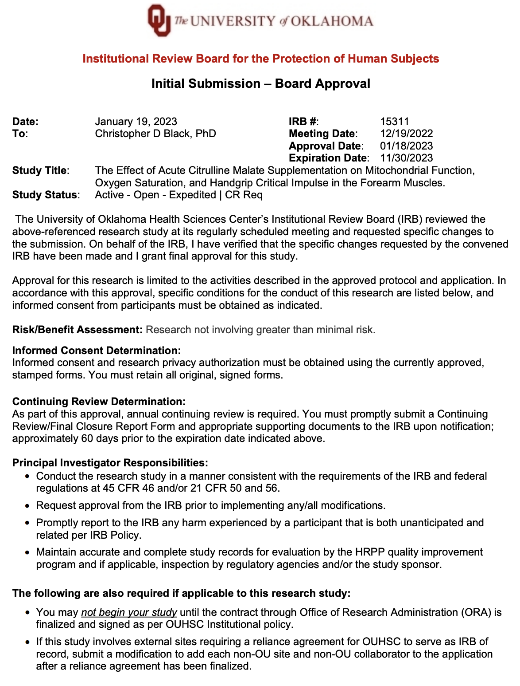


APPENDIX B: INFORMED CONSENT FORM
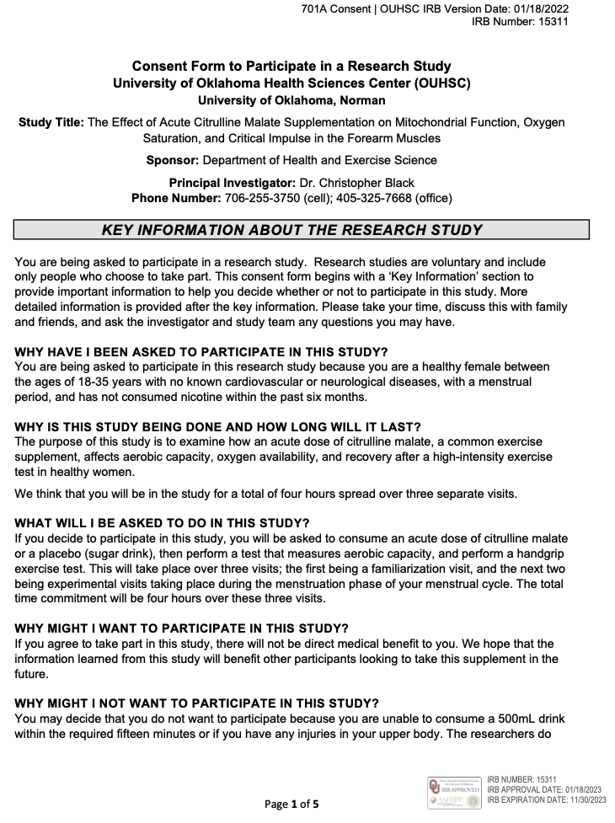

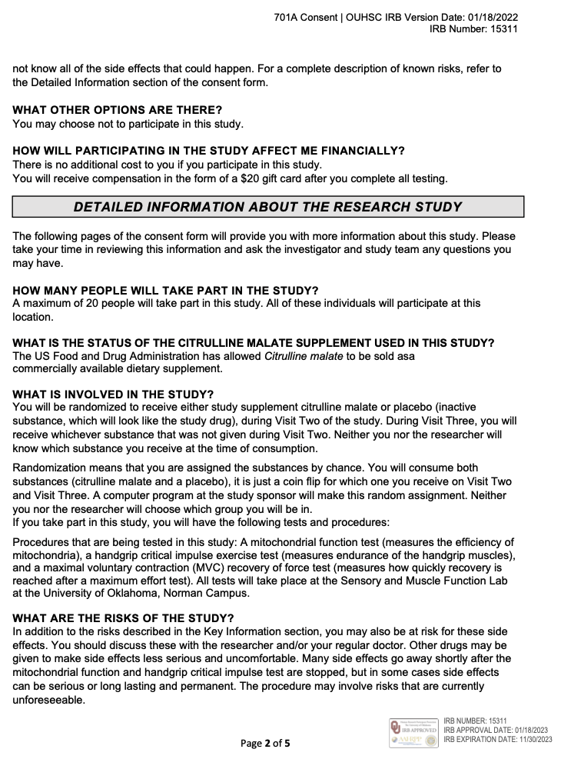

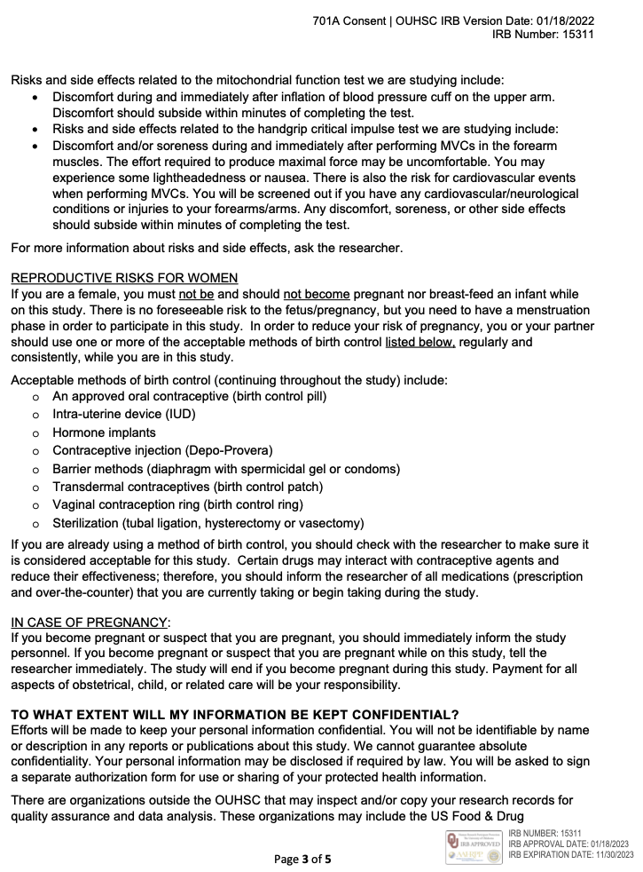
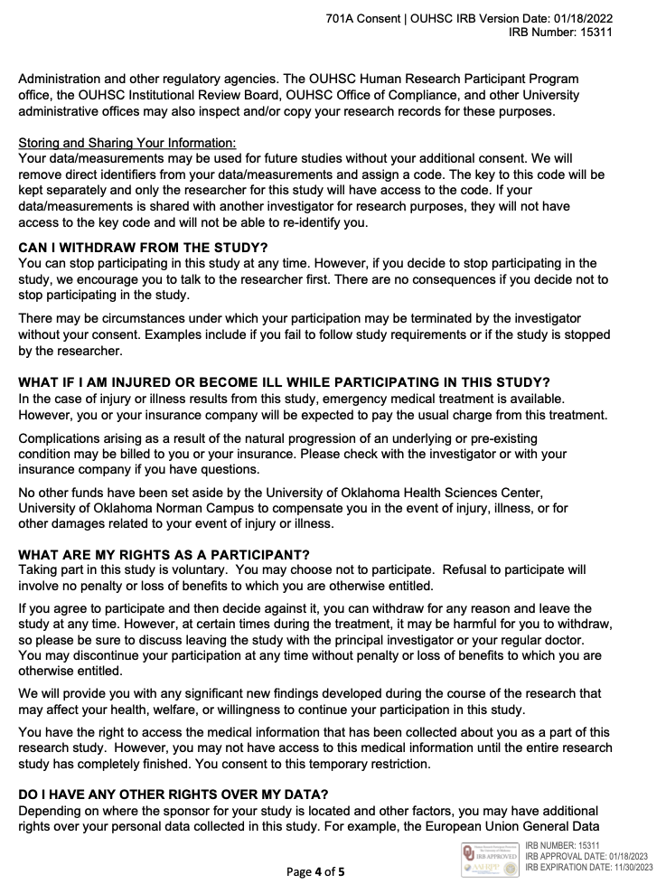
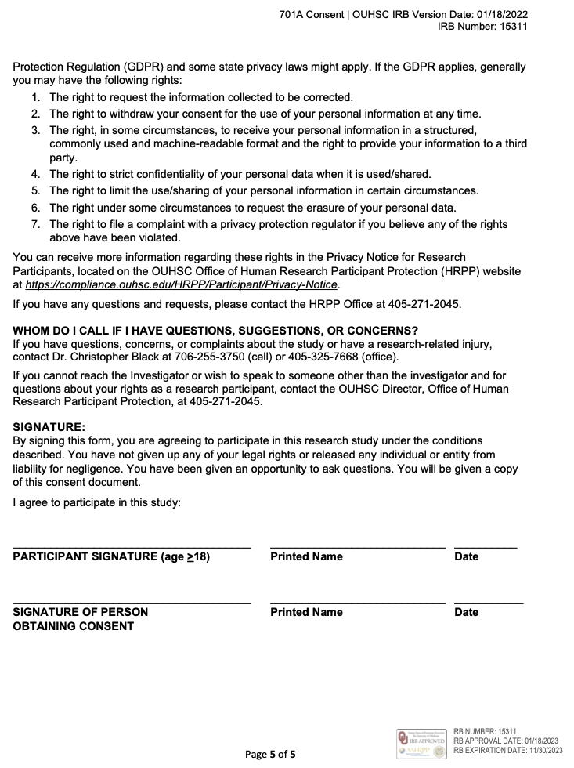

APPENDIX C: HIPAA AUTHORIZATION FORM
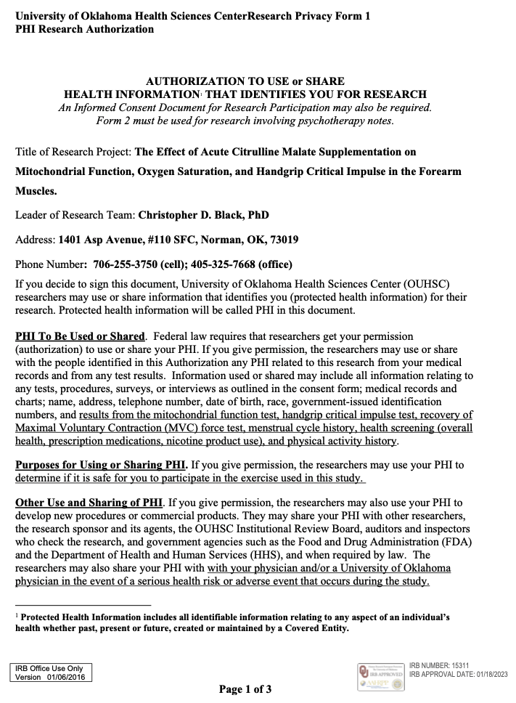

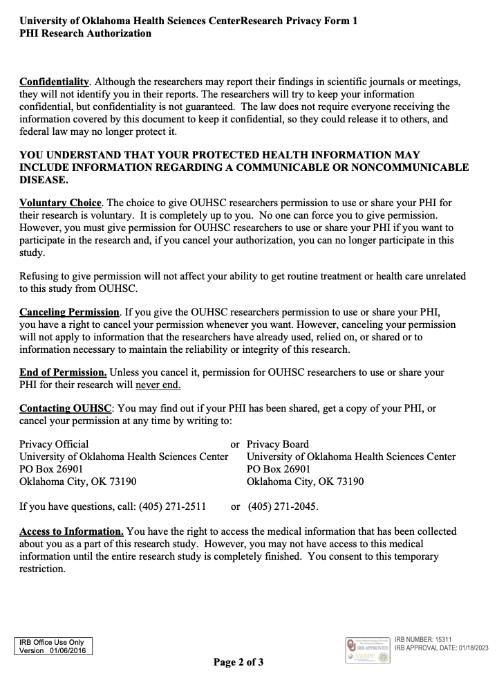
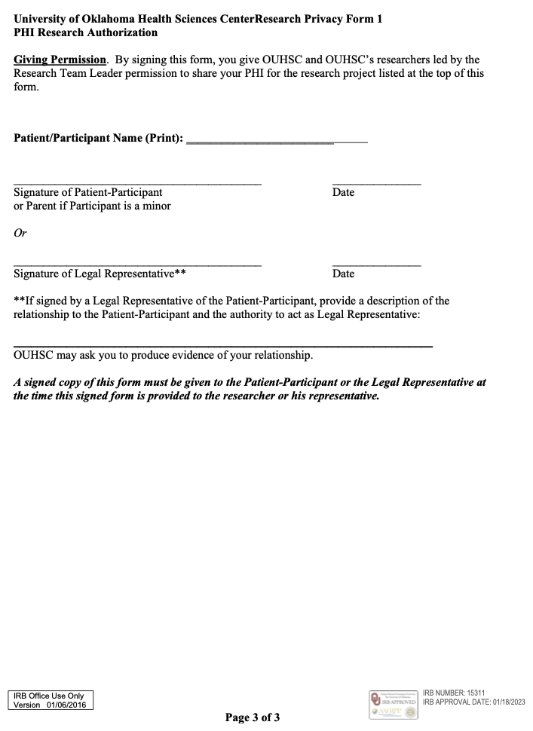

APPENDIX D: INTERNATIONAL PHYSICAL ACTIVITY QUESTIONNAIRE
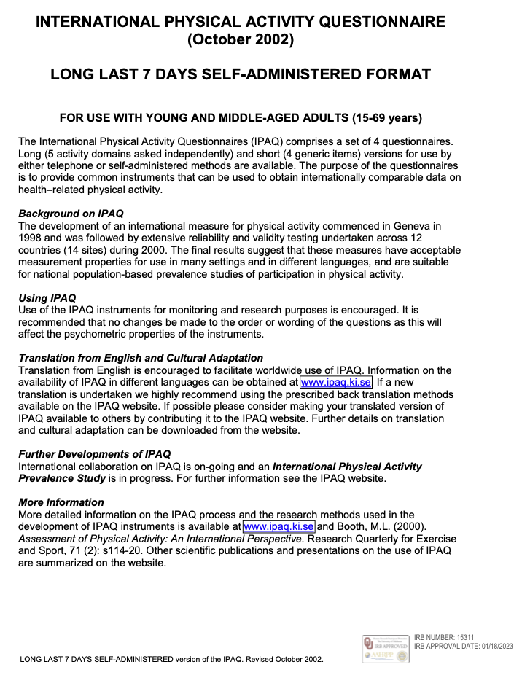

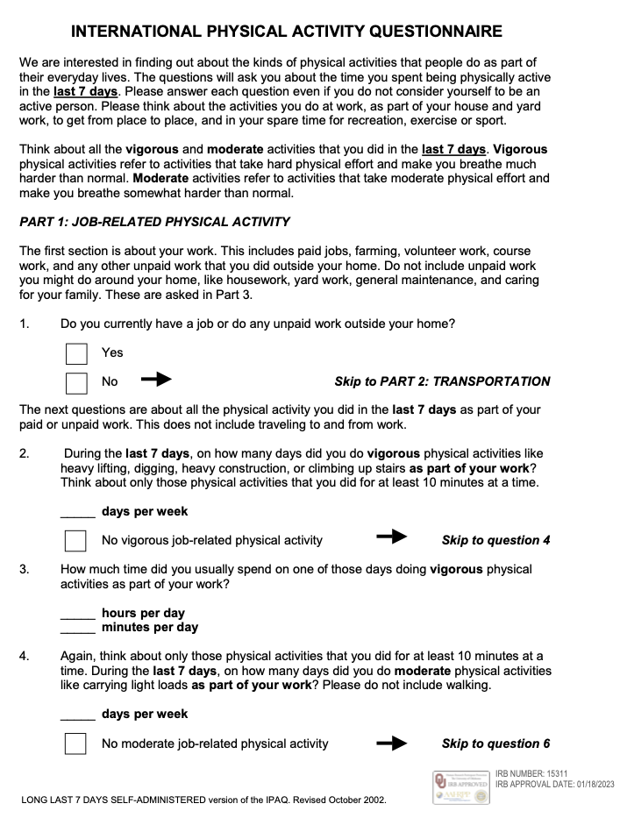

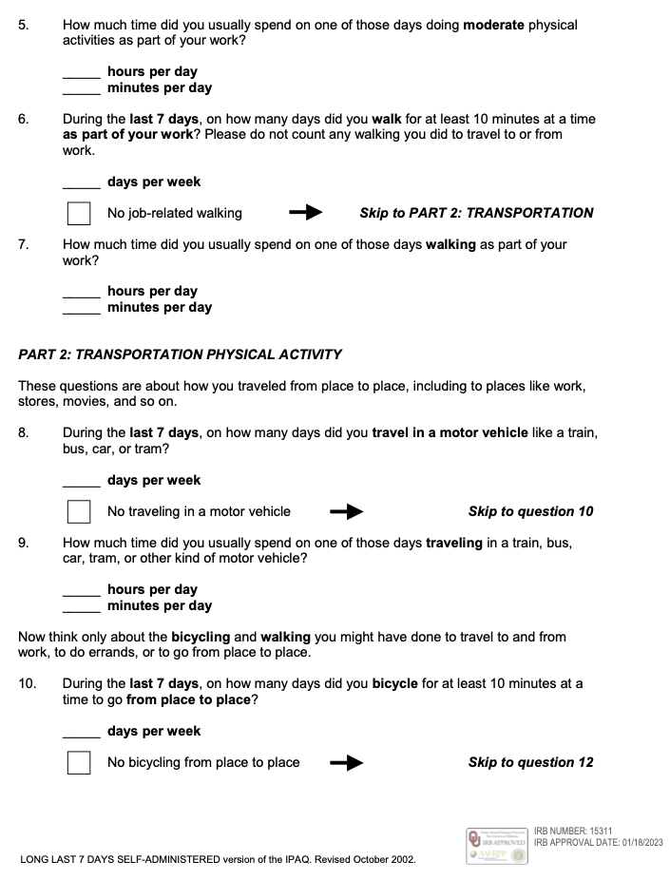
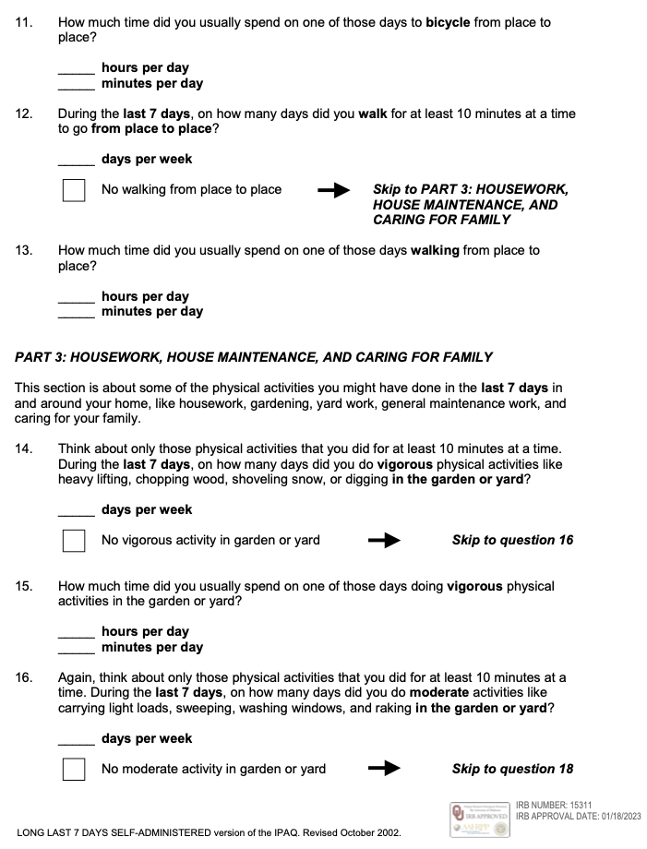
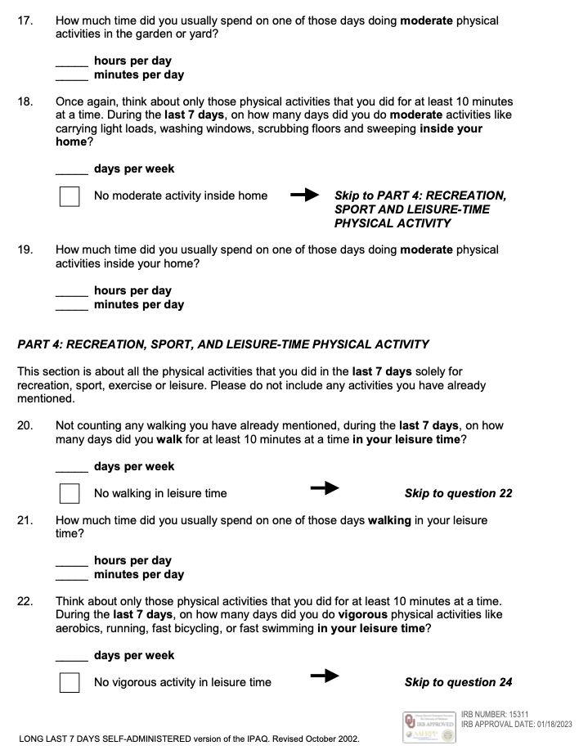
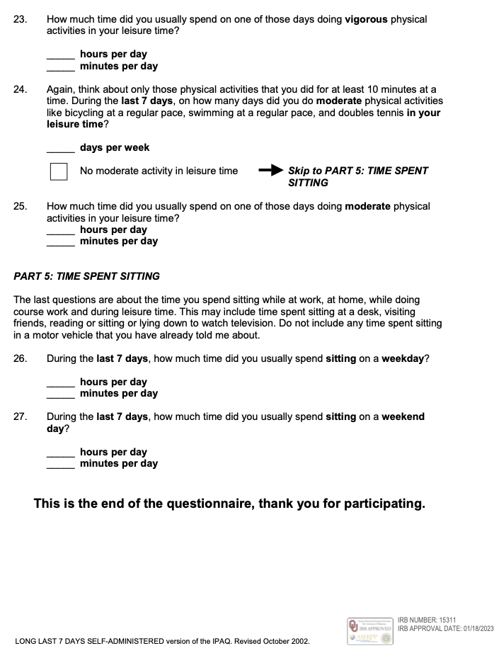

APPENDIX E: PHYSICAL ACTIVITY READINESS QUESTIONNAIRE
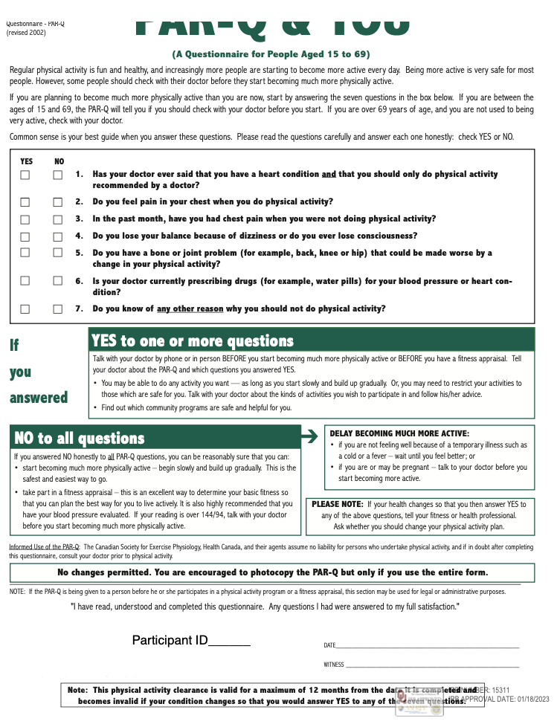

APPENDIX F: MENSTRUAL HISTORY QUESTIONNAIRE
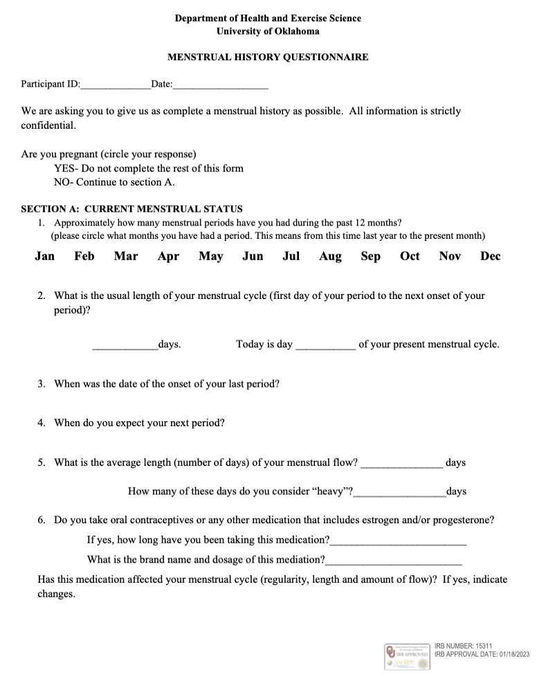

APPENDIX G: HEALTH STATUS QUESTIONNAIRE
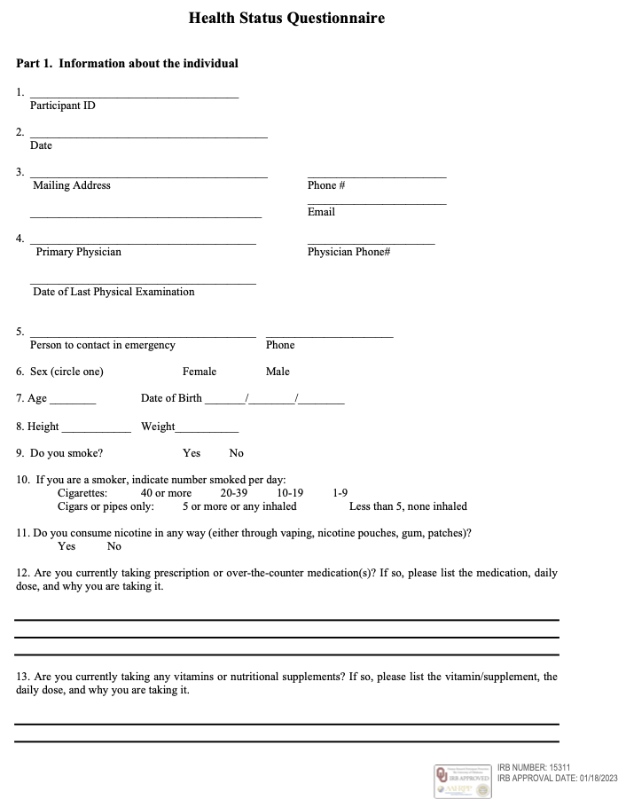

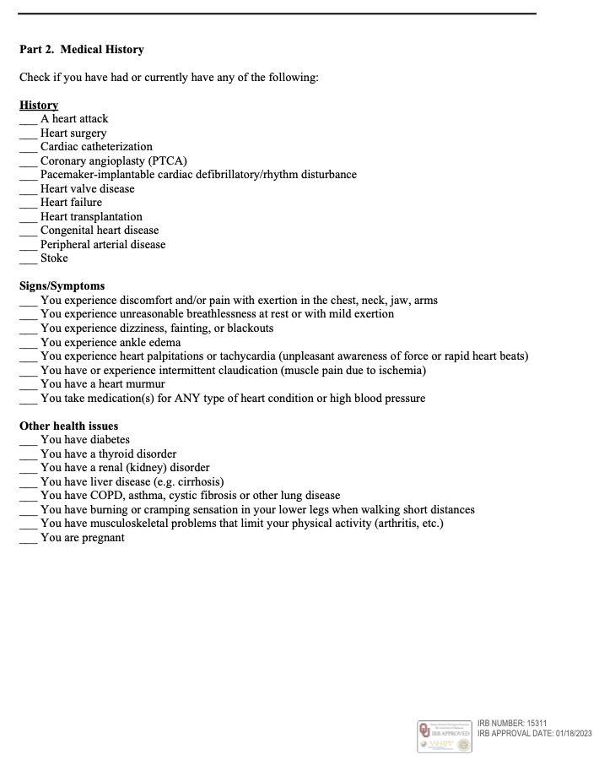
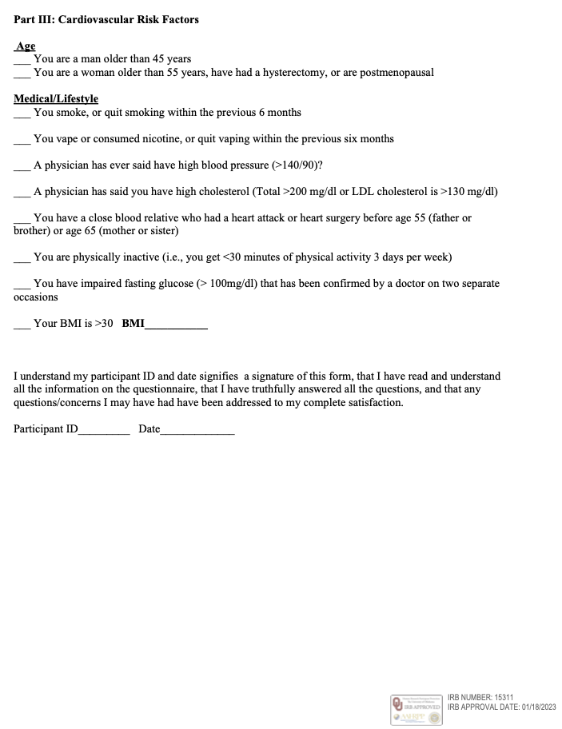

APPENDIX H: EMAIL RECRUITMENT SCRIPT
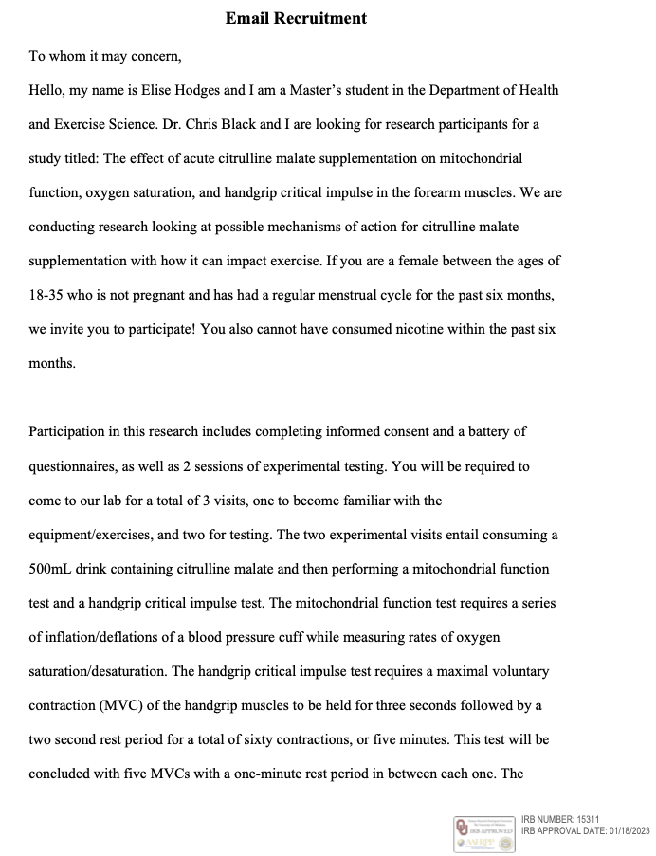

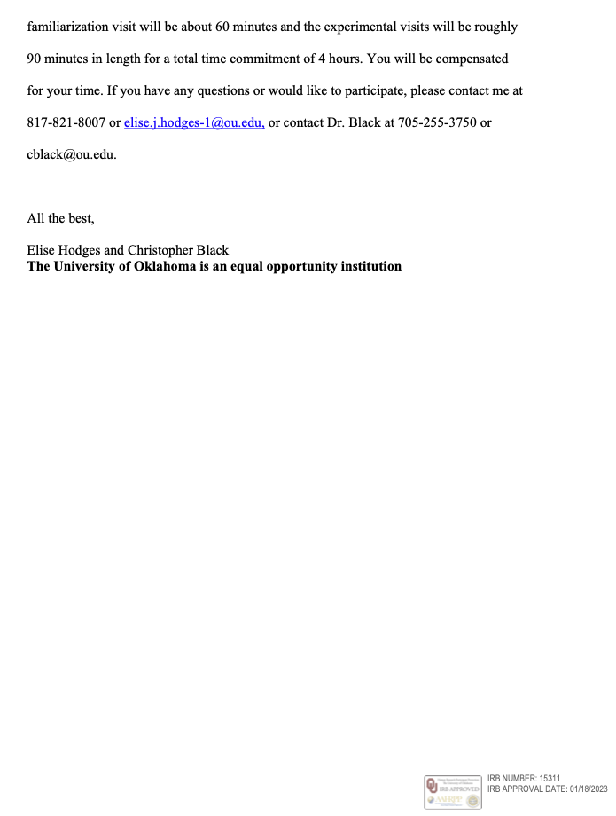

APPENDIX I: VERBAL RECRUITMENT
Hi everyone, my name is Elise Hodges and I am a second-year master’s student in Dr. Black’s sensory and muscle function lab. I am conducting my thesis research project on how the supplement citrulline malate affects muscle aerobic performance and fatigue specifically in women. Not much is known about specific mechanisms with citrulline malate, and there is even less research studying women especially.

Some requirements to participate are that you need to be a female with a regular menstrual cycle, between the ages 18-35, do not have any musculoskeletal injuries in the arm/forearm, do not have any known cardiovascular, pulmonary, or metabolic diseases, are not pregnant/breastfeeding, have not consumed nicotine within the past 6 months, and are not on any heart/metabolic medications.

There will be a total of three visits for a time commitment of about 4 hours. You will be compensated in the form of a $20 gift card at the end of the third and final visit.

If you meet the criteria and are interested in participating, please contact me either at my phone number or my email. I am leaving one of my study flyers up at the front which has my information on it. Thank you so much and I hope to hear from you!

APPENDIX J: RECRUITMENT FLYER
