University of Oklahoma

Graduate College

aPPLICATION OF ECOSYSTEM ENERGETIC INDICATORS FOR THE VALUATION OF ECOSYSTEM SERVICES AND HEALTH

Dissertation

submitted to the Graduate Faculty

in partial fulfillment of the requirements for the

Degree of

Doctor of Philosophy

By

JESsiCA DAWN BRUMLEY
Norman, Oklahoma
2014

APPLICATION OF ECOSYSTEM ENERGETIC INDICATORS FOR THE VALUATION OF ECOSYSTEM SERVICES AND HEALTH

A Dissertation approved for the
School of Civil Engineering and Environmental Science

By

______________________________
Dr.Robert Nairn, Chair

______________________________
Dr.Robert Knox

______________________________
Dr.Keith Strevett

______________________________
Dr.Bruce Hoagland

______________________________
Dr.Yiqi Luo

© Copyright by jesSICA DAWN BRUMLEY 2014
All Rights Reserved.

For my grandpa, Frank, and my son, Frank.

Acknowledgements

I would never have been able to finish my dissertation without the guidance of my committee members, help from friends, and support from my family. I would like to express my gratitude to my advisor, Dr. Robert Nairn, for his guidance, patience, and providing me with an excellent atmosphere for doing research and helping me find the joy in wetland sciences. My committee has given me the ultimate patience and that is greatly appreciated. The US Department of Education Graduate Assistantships in Areas of National Need Fellowship was what funded my research and studies; an excellent program that gave me many wonderful experiences. Field and lab work would not have been possible without the help of members from the Center for Restoration of Ecosystems and Watersheds. Rain, heat, cold, sleet, ice, and snow, everyone stepped in to help when needed! Mom and Dad, without your encouragement, this would not have been possible. Thank you for listening to “It will be finished this year!”, every year. This year, it is the truth! Aunt Beth, you inspired me to explore this path to the ivory tower! Lowell, Jennifer, Jason and Jackson, thank you for understanding my forgetfulness; birthdays and holidays will be remembered now! I would like to give a special thanks to what came to be a very close group of friends, which started out as a dissertation support group. They were always there to encourage on the days I wanted to quit. Hannah, thank you for reading through many copies, finding those out-of-place commas, and being patient with the many, many mistakes.

Table of Contents
Table of Contents iv
List of Tables ix
List of Figures xvi
Abstract xxv
Chapter 1: Introduction 1
1.1 Literature Review 1
1.1.1Ecosystem Services and Society 1
1.1.2 Ecosystem Health 4
1.1.3 Wetlands and Mine Drainage 9
1.2 Energy Based Indices: Emergy, Eco-Exergy and Ascendency 12
1.2.1 Emergy 13
1.2.2 Ascendency 14
1.2.3 Eco-exergy 17
1.3 Hypothesis and Scope of Research 20
Chapter 2 : Ecosystem and Litter Decomposition Analysis for Model Validation 23
2.1 Introduction 23
2.2 Methods 26
2.2.1 Study Site Descriptions 26
2.2.2 Water Collection and Analyses 34
2.2.3 Vegetation Sampling and Analyses 35
2.2.4 Decomposition Methods 36
2.3 Results 39
2.3.1 Water Analyses 39
2.3.2 Vegetation Surveys 43
2.3.3 Decomposition 58
2.4 Discussion 75
Chapter 3 : Generalized dynamic model for three hydrologically different wetlands 85
3.1 Introduction 85
3.2 Methods 87
3.2.1 Model Development 87
3.2.2 Temperature, Precipitation and runoff 89
3.2.3 Runoff 91
3.2.4 Total Inflows 93
3.2.5 Insolation 93
3.2.6 Evapotranspiration 95
3.2.7 Surface Outflow 97
3.3 Results 99
3.3.1 Model Validation 99
Chapter 4 : Development of Ecosystem and Geochemical Models 124
4.1 Literature Review 124
4.1.1 Generalized System Models 124
4.2 Model Development 127
4.2.1 Ecosystem Model 127
4.2.2 Iron and Zinc Models 131
4.2.3 Model Calibration 140
4.3 Results and Discussion 140
4.3.1 Ecosystem Model 140
4.3.2 Iron and Zinc Model 149
Chapter 5 : Total Systems Model and Energy Indices 162
5.1 Introduction 162
5.2 Methods 163
5.2.1 Generalized System Models 163
5.2.2 Emergy 164
5.2.3 Ascendency 166
5.2.4 Exergy 168
5.3 Results 171
5.3.1 Ecosystem, Hydrologic and Metals Model Results 171
5.3.1.1 Hockerville 174
5.3.1.2 Adams A 186
5.3.1.3 Rush W 197
5.3.1.4 Le Bosquet 208
5.3.1.5 Red Oak 219
5.3.1.6 Hartshorne 227
5.3.2 System Energy Indices 235
5.3.2.1 Emergy 235
5.3.2.2 Ascendency 244
5.3.2.3 Exergy 250
5.3.2.4 Relationship Between Indices 253
5.3.3 Conclusions 257
References 261
Appendix A: Sampling Sites Characteristics 289
Appendix B: STELLA Model Symbols Used 291

List of Tables
Table 1 The 24 attributes discussed by Odum (1969) and the trends that can be expected in developing and mature ecosystems. 8
Table 2 Period of record for the hydrologic and water quality data used with each system. 40
Table 3 Mean of basic water quality data (± standard deviation) from the seven wetland systems that were used in the vegetation surveys, decomposition studies, and for model calibration. 41
Table 4 Water quality means for each individual cell within the passive treatment systems. Definitions: Ox=Oxidation pond, VFW= Vertical flow wetland, Pol = Polishing wetland. The numbers indicate the sequence cell in the system. 42
Table 5 Coverage estimates from vegetative surveys. 43
Table 6 Belowground biomass for all the systems sampled (g/m²). 45
Table 7 Aboveground biomass for all the systems sampled (g/m²). 46
Table 8 Total Biomass in each system sampled (g/m²). 47
Table 9 Litter mass in each system sampled (g/m²). 48
Table 10 Values of the standing dead vegetation from systems sampled (g/m²). 49
Table 11 Iron concentrations in the belowground and aboveground vegetation, standing dead vegetation, litter and total live vegetation (mg/kg). 51
Table 12 Zinc concentrations in the belowground and aboveground vegetation, standing dead vegetation, litter and total live vegetation (mg/kg). 52
Table 13 Correlation r-values for iron concentrations throughout the parts of the plants. n =16, α=0.05. 53
Table 14 Correlation r values for zinc concentrations throughout the parts of the plants. n =16, α=0.05. 53
Table 15 Results from a one-wayANOVA between the systems’ vegetation. 55
Table 16 Results from a two-way ANOVA between the years and hydrologic zones for Rush W, Adams A and Hockerville. Years 2006 and 2007 were compared, but Rush 2006 was eliminated for the hydrological analysis. 56
Table 17 Results from a one-way ANOVA between the systems’ vegetation iron concentrations. 57
Table 18 Results from a two-way ANOVA comparing the iron concentrations in the different years (2006 and 2007) and hydrologic zones (FLD and SAT) for Rush W, Adams A and Hockerville. Rush W only had the year 2006 analyzed for the hydrologic zones. 57
Table 19 from a one-way ANOVA between the systems’ vegetation zinc concentrations. 58
Table 20 Results from a two-way ANOVA comparing the zinc concentrations in the different years (2006 and 2007) and hydrologic zones (FLD and SAT) for Rush W, Adams A and Hockerville. Rush W only had the year 2006 analyzed for the hydrologic zones. 58
Table 21 Means and standard deviations of the percentage remaining litter mass in each Tar Creek system at different hydrologic zones and over the various days of collection. 59
Table 22 Means and standard deviations of percent remaining litter mass for each treatment system across various days of sample collection 62
Table 23 Decay constants, regression values, and significance tests on Rush W, Adams A, and Hockerville System hydrologic zones. Bolded F-statistics indicate that there was no significance. 66
Table 24 Decay constants, regression values, and significance tests on Le Bosquet, Red Oak, and Hartshorne systems’ ponds. Bolded F-statistics indicate that there is no significance. 67
Table 25 Correlation values from Tar Creek systems and hydrologic zones comparing the iron and zinc concentrations with litter mass loss. df =10, p =0.05 71
Table 26 Correlation values, from the treatment systems and the treatment cells, comparing the iron and zinc concentrations to litter mass loss. df = 10, p = 0.05 for all systems 75
Table 27 Iron concentrations in vegetation from the literature. Superscripts refer to a: aboveground vegetation, b: leaves, c: underwater stems (Adapted from Kadlec and Wallace, 2009) 79
Table 28 Zinc concentrations in vegetation from the literature (Adapted from Kadlec and Wallace, 2009). 81
Table 29 Treatment wetland results in normal rainfall year versus drought year. 103
Table 30 The shallow wetland results with a normal precipitation year and a drought year. 105
Table 31 The deep water system results with a normal precipitation year and a drought year. 107
Table 32 Shows the correlation values, r, between various model variables and evapotranspiration. df = 2922 ; p = 0.05 110
Table 33 Constants used in Ecosystem Model. 130
Table 34 Calibrated values used in the Productivity Submodel used with the Zinc and Iron Models. 137
Table 35 Constants used for calibration in the iron, zinc, and sulfate submodels. 139
Table 36 Results for the ecosystem model, including each trophic level with the productivity and decomposition rates calculated in each of the runs of low, medium, and high productivity. 143
Table 37 Percent decrease found in field sites compared to the model's reduction rate. 153
Table 38 Literature review of reduction rates of iron and zinc in treatment systems (Adapted from Kadlec and Wallace, 2009). 154
Table 39 Iron concentrations in vegetation from literature. Superscripts denote: a - aboveground vegetation, b - leaves, c - underwater stems (Adapted from Kadlec and Wallace, 2009) 159
Table 40 Zinc concentrations in vegetation from literature (Adapted from Kadlec and Wallace, 2009). 161
Table 41 Mean iron and zinc outflows for field sites and models. 171
Table 42 Uptake values in the vegetation for field sites and model results. 172
Table 43 Total biomass for field sites and model results. 173
Table 44 Hydrology model results for each system. 174
Table 45 Hydrologic summary from the results of the Hockerville model. All values are given in m³ except depth which is in m. 177
Table 46 Ecosystem dynamics in the Hockerville system model. All numbers are in kcal/m². 179
Table 47 Iron dynamics in the Hockerville system model. 179
Table 48 Zinc dynamics in the Hockerville system model. 180
Table 49 Hydrologic summary from the results of the Adams A model. All values are given in m³ except Depth which is in m. 188
Table 50 Ecosystem dynamics in the Adams A system model. All numbers are in kcal/m². 190
Table 51 Iron dynamics in the Adam A system model. 190
Table 52 Zinc dynamics in the Adams A system model. 191
Table 53 Hydrologic summary from the results of the Rush W model. All values are given in m³ except Depth which is in m. 199
Table 54 Ecosystem dynamics in the Rush W system model. All numbers are in kilocalories/m². 201
Table 55 Iron dynamics in the Rush W system model. 201
Table 56 Zinc dynamics in the Rush W system model. 202
Table 57 Hydrologic summary from the results of the Le Bosquet model. All values are given in m³ except Depth which is in m. 210
Table 58 Ecosystem dynamics in the Le Bosquet system model. All values are in kilocalories/m². 212
Table 59 Iron dynamics in the Le Bosquet system model. 212
Table 60 Zinc dynamics in the Le Bosquet system model. 213
Table 61 Hydrologic summary from the results of the Red Oak model. All values are given in m³ except Depth which is in m. 221
Table 62 Ecosystem dynamics in the Red Oak system model. All values are in kcal/m³. 223
Table 63 Iron dynamics in the Red Oak system model. 223
Table 64 Hydrologic summary from the results of the Hartshorne model. All values are given in m³ except Depth which is in m. 229
Table 65 Ecosystem dynamics in the Hartshorne system model. All values are in kcal/m³. 231
Table 66 Iron dynamics in the Hartshorne system model. 231
Table 67 Emergy values for each system. has All values nverted in Joules for comparison to literature values. Transformity (seJ/J) and Emergy (seJ/yr). 241
Table 68 Calculated iron emergy values from each system model. 242
Table 69 Iron transformity values from the literature. 242
Table 70 Calculated zinc emergy values from each system model 243
Table 71 Zinc transformities from the literature. 243
Table 72 Calculated total system throughput, ascendency, capacity, overhead, and relative ascendency (A/C) from each of the system models. All values are in kcal bits/m²/yr unless otherwise noted. 248
Table 73 System network values from the literature. All values are in kcal bits/m²/yr unless otherwise noted. 249
Table 74 Exergy, specific exergy, and the exergy/emergy ratio for each of the systems models. 252
Table 75 Correlation r values between indices with all data having a logarithmic conversion. Underline values are α = 0.05 and bold values are α = 0.01. 256

List of Figures
Figure 1 Aerial photo of Commerce wetland taken in 2006 (Google Earth 2013). W = West Marsh, E = East March, A and B indicate seeps, Outflow was the final sampling point. 28
Figure 2 Aerial photo of the Hockerville wetland (Google Earth 2013). The wetland is outlined but this system did not have any specific inflow or outflow points for sampling. 29
Figure 3 Aerial of the Adams A wetland (Google Earth 2013). System is outlined above and A=the occasional outflow after rain events. 30
Figure 4 Aerial photo of the Rush W wetland outlined above (Google Earth 2013). A = Outflow point. 31
Figure 5 Aerial photo of the Hartshorne passive treatment system (Google Earth 2013). Each letter represents a sample point for each outflow as follows A=VALD, B = Ox1, C = VFW1, D = Ox2, E = VFW2, F = Ox3, G = PolWL. 32
Figure 6 Aerial photo of the Le Bosquet passive treatment system (Google Earth 2013). Each letter represents a sample point for each outflow as follows A=ALD, B = Ox, C = VegWL. 33
Figure 7 Aerial photo of the Red Oak passive treatment system (Google Earth 2013). Each letter represents a sample point for each outflow as follows A=ROW1, B = ROW2, C = ROW3, D = ROW4, E = ROW5, F = ROW6. 34
Figure 8 Percent remaining litter at two Adams A hydrologic zones. 60
Figure 9 Percent remaining litter at two Rush W hydrologic zones. 60
Figure 10 Percent remaining litter at two Hockerville hydrologic zones. 61
Figure 11 Percent of litter remaining for Hartshorne in all treatment cells in the system. 63
Figure 12 Percentage of litter remaining for Le Bosquet in all treatment cells in the system. 63
Figure 13 Percentage of litter remaining for Red Oak in all treatment cells in the system. 64
Figure 14 Iron concentrations in litter at Adams A throughout the decomposition process. 68
Figure 15 Zinc concentrations in litter at Adam A throughout decomposition process. 69
Figure 16 Iron concentrations in litter at Hockerville throughout decomposition process. 69
Figure 17 Zinc concentrations in litter at Hockerville throughout decomposition process. 70
Figure 18 Iron concentrations in litter at Rush W throughout decomposition process. 70
Figure 19 Zinc concentrations in litter at Rush W throughout decomposition process. 71
Figure 20 Iron concentrations in litter at Hartshorne throughout decomposition process. 72
Figure 21 Zinc concentrations in litter at Hartshorne throughout decomposition process. 72
Figure 22 Iron concentrations in litter at Le Bosquet throughout decomposition process. 73
Figure 23 Zinc concentrations in litter at Le Bosquet throughout decomposition process. 73
Figure 24 Iron concentrations in litter at Red Oak throughout the decomposition process. 74
Figure 25 Zinc concentrations in litter at Red Oak throughout decomposition process. 74
Figure 26 Generalized model for wetland hydrology using STELLA 8.1. 89
Figure 27 Submodels for temperature and rainfall time series calculation used to created a time series greater than 1500 data points. 90
Figure 28 Model results for temperature and insolation for northeast and southeast Oklahoma, using Mesonet data for temperature. Temperature and insolation keep the same expected pattern when insolation is adjusted to meet with temperature on the beginning of the year as done in Equation 8. 94
Figure 29 Submodel for wetland surface area calculation. 96
Figure 30 Example of how depth and volume relationship is developed using the natural log function. V is the volume and b is the coefficient used to fit the depth with the desired system. 96
Figure 31 Outflow coefficient graphs and data points calibrated in the different simulations. 98
Figure 32 Combining the time series data into the same converter to enable data sets greater than 1500 points. The same years are repeated due to the simulation programming repeating the same smaller data set multiple times. 100
Figure 33 Volume, surface area, and depth during years 5-8 for the treatment system. The top figure shows the system in a normal precipitation year and the bottom figure shows that Year 6 had a drought rainfall. 104
Figure 34 Volume, surface area, and depth during years 5-8 for the shallow water system. The top figure shows the system during a normal precipitation year and the bottom figure shows a drought during year 6. 106
Figure 35 Volume, surface area and depth during years 5-8 for the deep water system. The top figure shows the system during a normal precipitation year and the bottom figure shows a drought during year 6. 108
Figure 36 Figures for the treatment wetland simulations showing the evapotranspiration (EVT) and precipitation (PPT) for both the normal and drought runs. 111
Figure 37 Figures for the shallow wetland simulations showing the evapotranspiration (EVT) and precipitation (PPT) for both the normal and drought runs. 112
Figure 38 Figures for the deepwater wetland simulations showing the evapotranspiration (EVT) and precipitation (PPT) for both the normal and drought runs. 113
Figure 39 Relationship between insolation and evapotranspiration. 114
Figure 40 Relationships between volume and surface area in each simulation. 115
Figure 41 Relationship between the wetland surface area and amount of evapotranspiration with regression lines. 116
Figure 42 This figure shows where field data flows and model flows for a shallow wetland system are in relation to the rain patterns in northeast Oklahoma. Hockerville Dry shows where the wetland was dry only; flows and depths were not obtainable for this system, but it was noted when the system was dry during other sampling sessions. 121
Figure 43 Shallow wetland depths for both normal and drought year, seen in July 2006-January 2007. Although depth was not recorded for Hockerville, the periods of dry are marked. 122
Figure 44. Relationships between surface inflows, outflows, and depths of the modeled treatment wetland during the normal rainfall simulation with the field data from. 123
Figure 45 STELLA diagram of the trophic level submodel. STELLA symbols described in Appendix B: STELLA Model Symbols Used. 131
Figure 46 STELLA diagram of the iron submodel developed. STELLA symbols described in Appendix B: STELLA Model Symbols Used. 132
Figure 47 STELLA diagram for zinc model developed. STELLA symbols described in Appendix B: STELLA Model Symbols Used. 134
Figure 48 STELLA diagram of the sulfate submodel applied to the zinc model. STELLA symbols described in Appendix B: STELLA Model Symbols Used. 135
Figure 49 STELLA diagram of the productivity submodel used to calibrate the iron and zinc submodels. (STELLA symbols described in Appendix B: STELLA Model Symbols Used. 136
Figure 50 Figure of each trophic level from the low productivity model. 145
Figure 51 Figure of each trophic level from the medium productivity model. 146
Figure 52 Figure of each trophic level from the high productivity model. 147
Figure 53 Productivity rates and changes through the years in the ecosystem model for the high, medium, and low productivities. 148
Figure 54 Zinc, iron, and sulfate removal from water in each of the models. 155
Figure 55 Iron, zinc, and sulfate reaction rates for the first two years. The rates for sulfate and zinc stabilize after the second year. 156
Figure 56 Model results for zinc uptake in the biomass and accumulation with litter. Note the logarithmic scale on the vertical axis. 157
Figure 57 Model results for iron uptake in the biomass and accumulation with litter. Note the logarithmic scale on the vertical axis 158
Figure 58 Figure showing hydrologic trends in the Hockerville system model. 178
Figure 59 Ecosystem patterns in the Hockerville system model. Axis “A” is for detritus and Axis “B” is for the macrophytes, herbivores, predators, and litter. 181
Figure 60 Iron dynamics in the Hockerville system. It is noted that this figure reflects the total moles of iron in the total system volume and the total moles of iron outflowing with the outflow volume. 182
Figure 61 Productivity and iron levels in the biomass and detritus in the Hockerville system model. 183
Figure 62 Zinc dynamics in the Hockerville system. This figure reflects the total moles of zinc in the total system volume and the total moles of zinc outflowing with the outflow volume. 184
Figure 63 Productivity, zinc in the biomass and detritus in the Hockerville system model. 185
Figure 64 Figures showing hydrologic trends in the Adam A system model. 189
Figure 65 Ecosystem patterns in the Adam A system model. Axis “A” is for detritus and Axis “B” is for the macrophytes, herbivores, predators, and litter. 192
Figure 66 Iron dynamics in the Adam A system and outflows. It is noted that this graph reflects the total moles of iron in the total system volume and the total moles of iron outflowing with the outflow volume. 193
Figure 67 Productivity, iron in the biomass and detritus in the Adam A system model. 194
Figure 68 Zinc dynamics in the Adam A system and outflows. This graph reflects the total moles of zinc in the total system volume and the total moles of zinc outflowing with the outflow volume. 195
Figure 69 Productivity, zinc in the biomass and detritus in the Adam A system model. 196
Figure 70 Hydrologic trends in the Rush W system model. 200
Figure 71 Ecosystem patterns in the Rush W system model. Axis “A” is for detritus and Axis “B” is for the macrophytes, herbivores, predators, and litter. 203
Figure 72 Iron dynamics in the Rush W system and outflows. This figure reflects the total moles of iron in the total system volume and the total moles of iron outflowing with the outflow volume. 204
Figure 73 Productivity, iron in the biomass and detritus in the Rush W system model. 205
Figure 74 Zinc in the Rush W system and outflows. It is noted that this figure reflects the total moles of zinc in the total system volume and the total moles of zinc outflowing with the outflow volume. 206
Figure 75. Productivity, zinc in the biomass and detritus in the Rush W system model. 207
Figure 76 Figures showing hydrologic trends in the Le Bosquet system model. 211
Figure 77 Ecosystem patterns in the Le Bosquet system model. Axis “A” is for detritus and Axis “B” is for the macrophytes, herbivores, predators, and litter. 214
Figure 78 Graph of the iron in the Le Bosquet system and outflows. This graph reflects the total moles of iron in the total system volume and the total moles of iron outflowing with the outflow volume. 215
Figure 79 Productivity, iron in the biomass and detritus in the Le Bosquet system model. 216
Figure 80 Figure of the zinc in the Le Bosquet system and outflows. This figure reflects the total moles of zinc in the total system volume and the total moles of zinc outflowing with the outflow volume. 217
Figure 81 Productivity, zinc in the biomass and detritus in the Le Bosquet system model. 218
Figure 82 Figures showing hydrologic trends in the Red Oak system model. 222
Figure 83 Ecosystem patterns in the Red Oak System model. 224
Figure 84 Figure of the iron in the Red Oak system and outflows. This figure reflects the total moles of iron in the total system volume and the total moles of iron outflowing with the outflow volume. 225
Figure 85 Productivity, iron in the biomass and detritus in the Red Oak system model. 226
Figure 86 Graphs showing hydrologic trends in the Hartshorne system model. 230
Figure 87 Ecosystem patterns in the Hartshorne system model. 232
Figure 88 Figure of the iron in the Hartshorne system and outflows. This figure reflects the total moles of iron in the total system volume and the total moles of iron outflowing with the outflow volume. 233
Figure 89 Productivity, iron in the biomass and detritus in the Hartshorne system model. 234

Abstract
Ecosystems services are benefits that humans receive from ecosystem functions. Ecosystem health is a term that is commonly used in the literature to describe the state of an ecosystem. Ecologists and economists have stated that ecosystem health is important for the preservation and maintenance of ecosystem services essential to human society. Various methods and means have been proposed to assess ecosystem services and the economic values they provide to society, in relation to ecosystem health, by developing reliable holistic methods which assess health and services. Energy is a common denominator in all processes and measures of activity and if an ecosystem is distressed, it will not efficiently convert energy to work. In this study, energy indices were used to evaluate ecosystem health in relation to the ecosystem service of metals retention (iron and zinc) in wetlands. These indices included emergy (which evaluates the energy memory of the system), eco-exergy (a concept adapted to ecology to determine the efficiency of the work within the ecosystem) and ascendency (the diversity of the networks acting as an indicator of activity and organization within the system). Six wetlands, three volunteer and three treatment, which were all receiving metals contaminated water, were modeled using the STELLA dynamic simulation programming. A total system model was developed with hydrologic, ecosystem, and biogeochemical (iron and zinc retention) submodels. Field data from these systems were used to calibrate and validate each model. These models were evaluated for relationships between the indices, ecosystem service of metals retention, and to assess how the different systems (volunteer and treatment wetlands) vary between these indices. The results from this study suggest that there are relationships between ecosystem services and ecosystem health indices including iron retention and emergy, relative ascendency, specific exergy and the exergy/emergy ratio. In the case of zinc retention, there was a relationship with all indices excluding the exergy indices. Ascendency was a poor indicator of iron retention but it was also discovered that more zinc is retained in the higher ascendant systems. The systems with higher emergy had more metals retention suggesting that a system with greater emergy can provide a greater ecosystem service. This trend did not hold true with exergy and ascendency, meaning that as these indices increased, the service of metal retention decreased. Using exergy and ascendency indicators to determine a system’s potential to provide a service was less clear from the results. These six models, for both treatment and volunteer wetland systems, suggest that emergy is the only indicator that determines the potential ability of the system to provide a service.

Chapter 1: Introduction
This dissertation models treatment and volunteer wetland ecosystems that are contaminated with iron and zinc and assesses potential metal retention while comparing this retention to three energy indices calculated for each ecosystem: emergy, exergy and ascendency. After examining the history of indices that calculate energy efficiency and maturity in ecosystems and the importance of ecosystems for providing ecosystem services for society (Chapter 1), the following hypothesis were tested: Wetland ecosystems with high energy indices will indicate efficient, mature systems and will have higher metal retention. A total system model was developed to test this hypothesis and six wetlands were evaluated using this model. Chapter 2 discusses the field data collection and results for each of the six wetlands examined and these data were used to calibrate and verify the total system model. The total system model was a final accumulation of the hydrologic, ecosystem, and biogeochemical submodels and the development of these submodels are discussed in chapters three and four. In chapter five, the submodels are combined to formulate this total system model and calculate each of the ecosystem indices. Each of the six wetland ecosystems were modeled, to assess metals retention and ecosystem health using the calculated indices of emergy, exergy and ascendency.

1.1 Literature Review

1.1.1 Ecosystem Services and Society
Ecosystem services are the benefits that humans receive from ecosystem functions (e.g., Costanza et al., 1997). The concept of environmental degradation resulting in loss of ecosystem services for humans has been noted since the 5th century BC by Plato and again by Cicero, who both noticed that erosion had added costs to timber harvest, irrigation flows, and agricultural yields (Cicero 45 B.C./1997; Plato 360 B.C./2008). Ecosystem services provide the conditions that help sustain life: climatic stability, drought and flood mitigation, pest control, plant pollination, waste decomposition, water and air purification, and soil fertility (Costanza et al., 1997; Barkmann and Windhorst, 2000; Salzman et al., 2001). Costanza et al. (1997) estimated that the value of the world’s ecosystem services was $16 - 54 trillion per year as of 1994. Services provided by ecosystems are important to human society and welfare. If these services are lost due to ecosystem degradation, economic activity will be affected. For example, it is estimated that it would cost billions of dollars to replace the water purification services provided by ecosystems in the United States with active water treatment facilities (Rapport et al., 1998; Salzman et al., 2001).
Ecologists and economists have stated that ecosystem health is important to preserve and maintain the necessary ecosystem services essential to human society (Rapport et al., 1998; Rapport and Moll, 2000; Salzman et al., 2001; Costanza and Farley, 2007; Batker, et al., 2010). Although ecosystem services contribute to the economy directly and indirectly, these services and their values are not always reflected in traditional markets. The United States Environmental Protection Agency (EPA) has admitted that its current greatest challenge is adequately protecting ecosystems and their services (Salzman et al., 2001). Alterations of ecosystem properties, functions, and their capacity to provide services have impacts on human society directly and indirectly, socio-culturally and economically (Batker et al., 2010; Burkhard et al., 2010; Burkhard et al., 2011). This challenge creates a dilemma of how to keep ecosystems sustainable, monitor their degradation, and adequately restore and value their services (Rapport et al., 1998; Batker et al., 2010).
The devastation of New Orleans from Hurricane Katrina in 2005 is one of the most recent examples of what happens when ecosystems lose the ability to provide a service and detrimental effects on human welfare result (Costanza et al., 2006). Historically, wetlands surrounding New Orleans protected that city from storm surges but, these Louisiana coastal wetlands have been disappearing at the rate of 65 km² per year. New Orleans’ wetland loss has totaled more than 5000 km² since the 1930s. These wetland losses put large parts of the city and its inhabitants at increased risk of flooding from storms and increasing sea levels. If these wetlands had not been lost they could have significantly reduced the impact from storms by absorbing wave energy and reducing storm surge. It is estimated that a substantial amount of the $100 billion in damages due to Katrina would not have occurred had the natural wetlands been intact and providing the associated ecosystem services (Costanza et al., 2006; Costanza and Farley, 2007; Batker et al., 2010).
Another more general example of an ecosystem service and its economic impact is water purification. It has been thought that water purification provides one of the greatest reasons for galvanizing markets and regulations aimed at protecting ecosystems. One large community taking interest in protecting this valuable ecosystem service is New York City, which is investing $250 million to preserve up to 142,000 hectares where the citizens obtain part of their water supply in the Catskills Mountains watershed. The federal Safe Drinking Water Act, implemented in 1974, requires that water supplies must be filtered unless other steps are taken to make the water safe for human consumption. New York City determined they could save approximately $4.5 -6.5 billion by preserving the watershed rather than building a filtration plant (Salzman et al., 2001).

1.1.2 Ecosystem Health
Given the need for monetary valuation of ecosystem services, the importance of quantitatively assessing ecosystems has moved to the forefront of environmental management (Rapport et al., 1998; Jørgensen, 2005; Burkhard et al., 2011). Ecosystem health is a term that is commonly used in the literature to describe the state of an ecosystem and “healthy ecosystems” are considered important to preserve and maintain many ecosystem services essential to human society (Rapport et al., 1998; Xu et al., 1999; Barkmann and Windhorst, 2000; Xu et al., 2001). How the health of an ecosystem is related to ecosystem services, especially in disturbed environments, is not yet fully understood (Rapport et al., 1998). Various methods and means have been proposed to assess ecosystem services and their economic values to society, in relation to ecosystem health, by developing reliable holistic methods to assess health and services. This could help policymakers, communities and scientists determine the best conservation practices for each system and/or engineer ecosystems for specific services (Costanza et al., 1998; Rapport et al., 1998; Odum and Odum, 2000; Jørgensen, 2005).
Interest in quantifying ecosystem health has led to questions of how to measure it more effectively. Environmental managers often simply examine specific ecological indicators such as taxa richness or biological productivity to determine the health of the system (Costanza et al., 1998). Although this strategy may seem to be very straightforward, determining which indicators are the most valuable and how to use those indicators to determine holistic ecosystem health is problematic (Xu et al., 2001; Jørgensen, 2002).
There is considerable amount of literature that discusses the relationships between specific ecosystem indices and succession, such as associations between diversity, biomass, food chain complexity, ecosystem age and maturity (Odum, 1969; Christensen, 1994a; Rapport et al., 1998; Barkmann and Windhorst, 2000; Odum and Odum, 2000; Jørgensen et al., 2005a). However, the literature is often inconclusive as to the relationships between indices, which indices are the best indicators of overall ecosystem health or specific services.
Odum (1969) discusses the developmental and mature stages of ecosystems and provides 24 attributes for each of these stages (Table 1). This was an early attempt to link various ecosystem indices with stages of ecosystem development. Since the publication of Odum’s 1969 paper, several authors have tried to apply the 24 attributes to define ecosystem health or to quantify the successional state of ecosystems (e.g., Christensen, 1994a; Mageau et al., 1998; Jørgensen, 2002). In stressed systems, it can be expected that there will be a reversal or inhibition in ecosystem developmental processes (Odum, 1985; Mageau et al., 1998). Costanza (1992) states that ecosystem health includes six factors: homeostasis, absence of disease, diversity or complexity, stability or resilience, vigor or scope for growth, and balance between system components. A number of different indices have been proposed to determine the state of ecosystems and include gross ecosystem product, index of biotic integrity, ecosystem stress indicators, network ascendancy, overall system health, eco-exergy and buffer capacities (Costanza, 1992; Christensen, 1994b; Mageau et al., 1998; Ulanowicz, 2000a,b; Xu et al., 2001; Jørgensen et al., 2005b; Marques et al., 2005). Although these indices can be helpful in understanding the state of an ecosystem, they are limited in that they do not assist scientists in understanding the state of the ecosystem holistically.
Energy is a common quality to all processes and measures of activity. Ecosystems flow, store, and transform energy (Jørgensen, 2000). It has been proposed that an ecosystem will self-organize to more efficiently convert energy to work and that it will do so with as many networks as possible, networks being the connections between components within the ecosystem (Odum 1988; Odum 1996). Distressed ecosystems, or ecosystems experiencing an environmental crisis, are in what can be called an “entropy crisis” (Jørgensen, 2000). If an ecosystem is distressed, it will not efficiently convert energy to work. In theory, an untouched ecosystem will self-organize and arrive at a state resulting in indices that indicate a healthy state, such as those seen in Table 1. Given this knowledge, energy can be used as a common variable to calculate indices that assess ecosystem development, successional state, efficiency, organization and distance from thermodynamic equilibrium (Odum, 1969; Odum, 1996; Mageau et al., 1998; Jørgensen, 2000; Odum and Odum, 2000; Ulanowicz, 2000a,b; Jørgensen et al., 2005a).
Currently, the importance and value of ecosystem services are most commonly measured economically (Costanza et al., 1998; Rapport et al., 1998; Odum and Odum, 2000). Odum and Odum (2000) suggest that an accounting of energy systems be considered over economics alone. This suggestion provides a link towards assessing health using energetic indicators for the evaluation of ecosystems services. Using energetic indicators to define ecosystem health and evaluate resulting services may provide the necessary explanations to the public and policy makers to preserve, protect and develop ecosystems.

Table 1 The 24 attributes discussed by Odum (1969) and the trends that can be expected in developing and mature ecosystems.
 | Ecosystem Attribute | Developmental Stage |  | Mature Stage
 | Gross production/community respiration (P/R ratio) | Greater of less than 1 |  | Approaches 1
 | Gross production/standing crop biomass (P/B ratio) | High |  | Low
 | Biomass supported/unit energy flow (B/E ratio) | Low |  | High
 | Net community production (yield) | High |  | Low
 | Food chains | Linear, predominantly grazing |  | Web like, predominantly detritus
 | Total organic matter | Small |  | Large
 | Inorganic nutrients | Extrabiotic |  | Intrabiotic
 | Species diversity – variety component | Low |  | High
 | Species diversity – equitability component | Low |  | High
 | Biochemical diversity | Low |  | High
 | Stratification and spatial heterogeneity (pattern diversity) | Poorly Organized |  | Well-organized
 | Niche specialization | Broad |  | Narrow
 | Size of organism | Small |  | Large
 | Life cycles | Short, simple |  | Long, complex
 | Mineral cycles | Open |  | Closed
 | Nutrient exchange rate, between organisms and environment | Rapid |  | Slow
 | Role of detritus in nutrient regeneration | Unimportant |  | Important
 | Growth form | For rapid growth (r-selection) |  | For slow growth (k-selection)
 | Production | Quantity |  | Quality
 | Internal symbiosis | Undeveloped |  | Developed
 | Nutrient conservation | Poor |  | Good
 | Stability (resistance to external perturbations | Poor |  | Good
 | Entropy | High |  | Low
Information |  |  | Low |  | High

1.1.3 Wetlands and Mine Drainage
Wetlands provide important services not only for economic purposes but for human welfare, such as flood protection and water purification (Costanza et al., 1997; Acharya 2000; Salzman et al., 2001; Costanza et al., 2006; Farber 2007; Kareiva et al., 2007; Tong et al., 2007; Yang et al., 2008; Ghermandi et al., 2010; Fisher et al., 2011). Wetlands have also been noted for their ability to improve water quality and to provide habitat for many species, and offer protein, fuel, and housing material for human society. These valuable ecosystem services drive conservation policies to protect the world’s remaining wetlands from destruction (Mitsch and Gosselink, 2000). It is estimated that approximately half of the wetlands in North America, Europe, Australia and China have been lost since the early 20th century (Mitsch and Gosselink 2000, 2007; Gutzwiller and Flather, 2011; Moreno-Mateos et al., 2012). Because wetlands improve water quality, one of the concepts within the field of ecological engineering is developing treatment wetlands specifically for water quality improvement (Mitsch and Gosselink, 2000; Mitsch and Jørgensen, 2004).
A major source of water pollution is drainage from mining sites that contains metals (Batty and Younger, 2002; Mitsch and Jørgensen, 2004). Throughout the world, mine drainage can cause severe environmental damage and cost tens of billions of dollars to treat (Benner et al., 1999; Pruden et al., 2006). Various systems can be harmed from the effects of mine drainage. These include natural systems such as lakes, streams, and wetlands, as well as agricultural, municipal, and industrial systems. The corrosive effects from mine drainage not only harm the biological components of fisheries, but damage industrial equipment as well (Yeasted and Shane, 1976; Flanagan et al., 1994). Water from mine sites often has a low pH, elevated sulfate concentrations, and toxic trace metal concentrations. The EPA (1997) estimated that there are 200,000 abandoned mine lands and 5,000 to 10,000 miles of impacted streams (Pruden et al., 2007). Amezaga et al. (2011) reports that, in the United States, tens of thousands of kilometers of rivers are impacted by mine drainage; more than one million acres of abandoned coal mine lands are in poor quality and there is substantial environmental degradation at approximately 33,000 hard rock mine locations.
It is becoming more common to use the ecotechnology of passive systems as biogeochemical treatment systems for mine drainage rather than more conventional active chemical methods (Kadlec, 1989; Wieder, 1989; Baker et al., 1991; Eger, 1994; Hedin et al., 1994; Hellier, 1996; Mitsch and Wise, 1998; Mays and Edwards, 2001; Yang et al., 2008; Hedin et al., 2010; Nairn et al., 2010; Porter and Nairn, 2010; Strosnider and Nairn, 2010). Utilized since the late- 1970s, this ecological engineering alternative is low maintenance, cost-effective, and has aesthetic value. Passive treatment systems have an advantage over conventional methods, such as the use of active chemical treatment facilities, which can be expensive and labor intensive (Wieder and Lang, 1982; Kleinmann et al., 1983; Girts and Kleinmann, 1986; Stillings et al., 1988; Wieder, 1989; Tarlenton et al., 1984; Fennessy and Mitsch, 1989a, b; Baker et al., 1991; Flanagan et al., 1994). Passive systems treat and provide habitat, a function that can lead to other possible ecosystem services and buffer downstream impacts to systems such as lakes, streams, and rivers from the damaging effects of polluted waters (Fennessy and Mitsch, 1989a,b; Flanagan et al. 1994). In many cases, wetlands are built to promote processes that treat specific water quality problems, such as elevated metals and acidity in acid mine drainage or nutrients and bacteria in wastewater. This concept was first explored in the 1950s in Germany with experiments of emergent macrophytes being used to decrease bacteria and organic and inorganic material loads (Seidel, 1964, 1966; Mitsch and Gosselink, 2000; Mitsch and Jørgensen, 2004). Early research that explored using wetlands for metals removal involved natural sphagnum bogs to treat coal mine drainage (Huntsman et al., 1978; Wieder and Lang, 1982a). In the United States, wetlands for water quality improvement were initiated in the 1970s with peatlands filtering waste water in Michigan, and later, cypress domes in Florida (Kadlec et al., 1979; Ewel and Odum 1984; Mitsch and Gosselink 2000; Mitsch and Jørgensen, 2004; Kadlec and Wallace, 2009). These uses of wetlands, volunteer or constructed, are examples of allowing basic ecological functions (i.e., wetlands as biogeochemical sinks) to become important ecosystem services (i.e., nutrient or trace-metal removal).
Various studies have been done and models developed to evaluate the water, sediments and biological systems of natural and constructed wetlands that are receiving mine drainage. May and Edwards (2001) compared metals accumulation in constructed versus natural wetlands by examining sediments, plants, benthic organisms and fish. The ways in which different macrophyte species affect water treatment effectiveness was explored by Scholz and Xu (2002). Metals retention and alkalinity generation were studied in a passive treatment system built in southeast Oklahoma (Nairn and Mercer, 2000). At another passive treatment site, Porter and Nairn (2008) evaluated the impact of metals on ecosystem functions and organization. Another location, in northeast Oklahoma, has been impacted by lead and zinc mining and a previous study evaluated a volunteer wetland at this location for metals uptake in vegetation (Brumley et al., 2002). Another study evaluated the macro invertebrate community and habitat downstream from the same wetland (Bergey and White, 2010). Fish communities were also explored downstream from this volunteer wetland (Fransen et al., 2007). This same site had a passive treatment system constructed to treat the mine drainage in late 2008 (Nairn et al., 2010).
The proposed research focused on northeast Oklahoma wetlands that are stressed by, or have emerged voluntarily, in situations with trace metal pollution (volunteer wetlands), as well as southeast Oklahoma wetlands that have been built specifically to treat trace metal pollution (treatment wetlands). These wetlands were evaluated for metals retention using vegetation and water analyses, examination of their developmental state, and calculation of energetic indicators. This research should help further the understanding of the relationships between ecosystem health and ecosystem services, specifically the service of metals retention from polluted waters, by using the universal component of energy to evaluate both.

1.2 Energy Based Indices: Emergy, Eco-Exergy and Ascendency
Ecosystems change over time due to various endogenous and exogenous influences. Past studies on the networks of ecosystems are often static with data being collected only at a single point, making it difficult for understanding the dynamic processes within each system (Johnson et al., 2009). Holistic indicators, which encompass the health of the whole ecosystem, can be used to determine an ecosystem’s status. Using energy dynamics and concepts from thermodynamics, various indices have been developed to evaluate the status of an ecosystem’s health and the subsequent provision of services. These indices include the concepts of emergy, eco-exergy and ascendency. Emergy, which was introduced by H.T. Odum (1971, 1988), which evaluates the energy memory of the system. Second is eco-exergy, a concept used in mechanical engineering to determine the useful work from a machine and has been adapted to ecology to determine the efficiency of the work within the ecosystem (Jørgensen and Mejer 1979; Jørgensen and Mejer, 1981). Third is ascendency, which is similar to the diversity concepts developed in ecology and reflects the diversity of the system networks which act as an indicator of activity and organization within the system (Ulanowicz 1980, 1986, 1997). These indices, corresponding subindices, and the methods of these calculations are discussed in more detail in Chapter 5 of this dissertation.

1.2.1 Emergy
The concept of emergy is based on the maximum power principle and was developed by H.T. Odum (1971, 1988) from combining principles of Boltzmann (1905) and Lotka (1925). It states that a system with self-organizing processes will maximize power in the system networks. The processes that do not maximize power will not prevail. In his 1996 book, Environmental Accounting, Odum discusses changing the way natural and earth processes are valued by using what he calls emergy (Odum, 1996). Emergy is the energy memory of a product or service; in other words it is the total energy, directly and indirectly, required to make a product or service (Odum, 1996). Using the emergy concept, energy efficiencies of processes can be determined. For example, it takes more emergy to transport food 1000 km as opposed to growing the food only 10 km from its destination. The amount of energy to transport that food will give it a higher transformity value, meaning it takes more solar energy to grow and transport the food from far distances than nearby. Odum (1996) suggested that there is an energy transformity hierarchy and this states that all energy flows in the universe follow a hierarchy when transformed. In this case, a predator will have a higher emergy value than an autotroph because it takes more energy throughout the food chain to maintain the predator than the autotroph. Therefore, the predator is higher on the transformity hierarchy than an autotroph or herbivore. This same concept can be applied to ecosystems when attempting to place values on ecosystem services, such as with logging. Timber from an old growth forest will have a higher emergy value than timber from a young forest. Emergy has no reference state because it is based on the measureable energy flows of the system and its quality is based on the solar equivalents needed for that system, process or product.

1.2.2 Ascendency
Although Odum’s 24 attributes (Table 1) are a combination of quantitative and qualitative variables, there are other methods that have been developed to make ecosystem health diagnostics completely quantitative and holistic. These measurements include network-analysis and system-level information indices developed by Ulanowicz referred to as ascendency (1986; 1997; 2000b; Mageau et al. 1998). Ascendency is a measure of the size and organizational status of ecosystem network exchanges (Ulanowicz,1986; 1997; 2000a). Ascendency has been compared to Odum’s 24 properties of ecosystem maturity and was developed to assess the growth and organizational status of an ecosystem (Ulanowicz, 2000a). It has been suggested that increases in the 24 properties of ecosystem maturity, towards a mature state, will correspond to an increase in ascendency (Christensen, 1994a; Ulanowicz, 2000a). In like manner, fewer system disturbances lead to increased ascendency (Ulanowicz, 2000a,b). In most cases, high ascendency values equate to healthy and mature ecosystems, while developing or disturbed ecosystems have lower ascendancy (Marques et al., 2005).
Perturbations are a part of any ecosystem, thus systems quantitatively cannot be assumed to always average out (Ulanowicz, 2011). Ascendency indices were derived as a way to gauge which activity and organization are essential to the ecosystem and are a quantification of succession (Odum 1969; Ulanowicz, 2000b, 2011). Ecosystem processes are coupled to one another, which allows for the effects of chance events to be incorporated into the history of the system. How each chance event affects the system depends on the conditions elsewhere in the system. By using conditional probabilities within the quantitative calculation of the system, historical and non-local events can be incorporated (Ulanowicz, 2000a,b; 2011).
The indices and sub-indices calculated for this quantitative assessment of an ecosystem are ascendency (A), total system throughput (TST), developmental capacity (C), overhead (O), and relative ascendency (A/C). The total system throughput is the sum of all energy flows, exchanges and activities in the system and quantifies the system size (Ulanowicz, 2000a). Developmental capacity is a calculation of the upper bound energy made available and provides an upper limit to ascendency. Not all the developmental potential can be in the organized flow used in the ascendency calculation, but the developmental capacity calculation can give a quantitative understanding of the energy that can be made available for potential work. In other words, developmental capacity provides a scope for further ecosystem development and is expected to increase as the system matures (Kay et al., 1989; Christensen, 1995; Ulanowicz, 2000a,b). Overhead and relative ascendencies are values calculated from ascendency and developmental capacity. The overhead value is similar to the system’s buffer capacity, which is a term that refers to a system’s ability to resist changes from perturbations. The overhead value quantifies the system’s potential to recover from perturbations and maintain its structure within its connections (Ulanowicz, 2000a,b). Relative ascendency is the ratio of ascendency to developmental capacity. It provides a measure of the ecosystem’s organization and is expressed as a percentage (Ulanowicz, 2000a,b; Frisk et al., 2011). Relative ascendency allows the values to be compared between different ecosystems without differences in system size causing interference. For example, a system with a large biomass may have a high ascendency value when compared with a system with lower biomass, but it may have a lower relative ascendency than the lower biomass system.
Although there are other methods to measure ecosystem health, the literature often refers to Odum’s 24 attributes, ascendancy, emergy and eco-exergy as if they are synonymous and often demonstrate linear relationships to each other (Odum, 1969; Christensen, 1994a; Rapport et al., 1998; Barkmann and Windhorst, 2000; Odum and Odum, 2000; Jørgensen, 2002; Fath et al., 2004; Jørgensen et al., 2005a). Though the literature seems to show inconsistencies as to the relationships between these ecosystem health indicators, there are relationships seen between various ecosystem indices and attributes such as ascendency, biomass, information, and nutrients (Christensen and Pauly, 1992; Christensen, 1994a,b).

1.2.3 Eco-exergy
Exergy is a concept that was developed in the field of mechanical engineering to reflect the efficiency and optimize energy conversion systems (Silow and Mokry, 2010). Eco-exergy, similar to exergy, was introduced to ecology in the 1970s to reflect when the concept is used in ecological systems (Silow and Mokry, 2010). Eco-exergy is the amount of work a system does when it is brought to thermodynamic equilibrium (Çengel and Boles, 1998; Jørgensen, 2002). Thermodynamic equilibrium means there are no net inputs or outputs to the system and the system has degraded completely to inorganic components (Çengel and Boles, 1998; Jørgensen, 2002). Calculation of eco-exergy results in a measure of the distance of the system from equilibrium, thus giving a value for how much work it will take to reach thermodynamic equilibrium. The higher the eco-exergy value, the healthier the system and the further the system is from thermodynamic equilibrium. If a system has an eco-exergy value of zero, it is at equilibrium with its surrounding environment, i.e., that there are no inputs or outputs with the surrounding environment and the system will not perform work (Jørgensen and Bendoricchio, 2001; Jørgensen, 2002; Mitsch and Jørgensen, 2004; Jørgensen, 2005).
The calculation of eco-exergy was derived with various assumptions. First, a reference system exists at thermodynamic equilibrium, where all components are in their highest possible oxidized state, inorganic and homogeneous. This state is sometimes referred to as “the lifeless inorganic soup” where matter is broken down into its most basic components (Jørgensen 2000, 2002, 2005). In the lifeless inorganic soup, the eco-exergy would be chemical exergy only. The expression for eco-exergy is derived from the information concentrated in the study system. This results in calculations of how far the actual system is from the reference system. In the case of calculating eco-exergy, the reference system is the inorganic soup and the eco-exergy calculation measures the distance the ecosystem is from this inorganic soup.
The second assumption is that for an ecosystem to mature and maintain itself there must be growth, which includes an increase in biomass. Eco-exergy is used to create biomass, thus the biomass contains eco-exergy. This concept was developed by translating Darwin’s theory of survival of the fittest to thermodynamic concepts, where maintenance and increase of biomass equals survival (Jørgensen, 2000). As Jørgensen (2008) states:
“The prevailing conditions of an ecosystem steadily change. The system will continuously select the species and thereby the processes that can contribute most to the maintenance or even growth of the eco-exergy of the system.” (Jørgensen, 2008).
It is suggested that eco-exergy is affected by changes in forcing functions and the structure of the ecosystem, including increases and decreases in nutrient status (Jørgensen, 2005).
Successional stages of ecosystems have different eco-exergy characteristics. A mature system will have high eco-exergy storage (i.e., high quantities of biomass) and will need large amounts of eco-exergy to maintain itself. However, a young system will have a lower eco-exergy storage capacity and need less eco-exergy flowing into it from the surrounding environment for maintenance. The more mature and developed an ecosystem, the more complex it becomes with more information per unit of biomass. A linear relationship has been found to exist between biomass and eco-exergy in many different systems, from coral reefs to lakes (Christensen, 1994a; Jørgensen, 2002). In fact, eutrophic lakes had a very strong linear relationship between biomass and eco-exergy (Xu, 1997). On the other hand, Christensen (1994a) observed little correlation between eco-exergy and maturity. The author justifies the lack of correlation because the maturity rankings that were given to the various ecosystems (based on Odum’s 24 attributes for succession, Table 1) used many other factors rather than biomass, and eco-exergy strongly depends on biomass of each species in the system (Christensen 1994a).
Once the eco-exergy of a system is understood, the specific exergy and exergy/emergy ratio can be explored. Specific exergy is independent of nutrient levels in the system and measures the ability of the system to consume available resources. Because it uses total biomass, specific exergy expresses the prevalence of the higher trophic level organisms, giving a broader view of the ecosystem health because it considers the diversity of the system. High specific exergy indicates a healthy system and reflects 1) efficiency of energy use by organisms, 2) relative information content of the ecosystem, and 3) the ability of the ecosystem to regulate interactions between organisms or groups of organisms. For example, a system with a low specific exergy is a system dominated by organisms with less information, such as a eutrophic lake system (Jørgensen et al., 2005b). The eco-exergy/emergy ratio is a way to present the state of the system (exergy) in relation to the energy inputs (emergy) and reflects the efficiency of the system to convert energy to work. The eco-exergy/emergy ratio represents the quantity of inputs needed to maintain the system’s structure from equilibrium. As the ratio increases, natural selection makes the system follow a thermodynamic path towards a higher organizational level (Bastinanoni et al., 2005).

1.3 Hypothesis and Scope of Research
Previous research has suggested that using holistic energetic indicators to assess ecosystem health or a specific ecosystem function could assist in the understanding of relationships between ecosystem networks, indicators, maturity, and services (Christensen and Pauly, 1993; Costanza et al., 1997; Odum and Odum, 2000; Ulanowicz, 2000a; Jørgensen et al., 2005b). A more in depth understanding of how the indicators emergy, exergy and ascendency could represent disturb and built ecosystems may result from exploring these relationships. The information obtained from this research contributes to the understanding of ecosystem energetics and relationships with ecosystem services, specifically for wetland ecosystems and metals retention. Iron and zinc were assessed in each wetland system through plant and water analyses, which will be discussed in Chapter 2. By evaluating two different types of metals contaminated wetlands (volunteer and treatment) there can be increased understanding of how nature organizes energy flows to overcome the impacts created by humankind. With engineered systems, a better understanding may be gained as to whether these systems not only maximize ecosystem services, but also maximize and efficiently organize the ecosystem energy. With a better understanding of the relationships between ecosystem health, energetics and services, specifically the fate of metals, better diagnostics for ecosystem management and conservation can possibly be developed. The scope of this research includes developing a total system model including the submodels of hydrology, biogeochemistry, and ecosystem based on volunteer and passive treatment wetlands, both of which are impacted by mine drainage. Calibration and validation of these models was based on field and laboratory analyses of water, vegetation and decomposition at six different systems in Oklahoma (Chapter 2).
The proposed research will assess the following hypotheses:.
H₁: An ecosystem with higher emergy, eco-exergy, ascendancy and development will provide greater ecosystem services. Disturbed ecosystems will have lower emergy, eco-exergy, ascendancy and development than undisturbed systems, thus hindering the systems’ ability to provide services.

H_{2:} Wetlands receiving trace-metal contaminated water and with ecological energetic indicators signifying a healthy ecosystem will have greater metal retention, providing a greater ecosystem service. Specifically, wetlands receiving trace-metal contamination coupled with elevated eco-exergy, emergy, and ascendancy values will have greater metal retention. If this is the case, then these wetlands should also demonstrate ecosystem attributes of maturity.
These hypotheses will address the following proposed research questions:
- What are the relationships between ecosystem networks and energetic indicators, ecosystem developmental status, and services? (H₁)
- Could these energetic indicators predict an ecosystem’s capabilities to provide a service, in this research specifically, trace-metal removal? (H₂)
- How does ecosystem maturation and succession, as calculated by ascendency and related indices, compare at sites contaminated by different metals? (H₂)
These hypotheses and questions were addressed through the development of a total system model for wetland ecosystems (Chapters 3 and 4). The created total system model will be used to determine ecosystem networks and energy indices by using calculated indices for ecosystem service evaluation (Chapter 5). All of these hypotheses and research questions were to meet the goal of better understanding of the relationships between ecosystem services, health, and indicators.

Chapter 2 : Ecosystem and Litter Decomposition Analysis for Model Validation

2.1 Introduction
Six wetlands were modeled for predicting contributions to ecosystem services, in this case metals removal from water, and holistic ecosystem indices were then calculated within the models. Before the models could be fully developed and used, data were collected to calibrate each model and validate the model results. Water quality, vegetation biomass, metals accumulation, and vegetation decomposition were evaluated using field and laboratory analyses (Section 2.1) for each of the systems modeled. Water inflows and outflows were assessed on the systems that had these hydrological flows. The systems without inflows or outflows were sampled in the open bodies of water. Results of these hydrological sampling events allowed for a baseline to be established for each system model and calibration of the models to reflect the water chemistry changes in the real systems.
Assessing ecosystem biomass and primary productivity were necessary because there can be significant variation in the vegetation and productivity of various wetland systems (Mitsch and Gosselink, 2000; Cronk and Fennessy, 2001). Sampling the wetlands allowed the models to be validated for peak biomass. Iron and zinc cycling is dependent not only on the hydrologic flows, but also in the ecosystem. Biomass from those systems with vegetation was collected and analyzed for iron and zinc content to calibrate metals uptake in the models.
Decomposition was assessed in detail because it is critically important to the cycling of nutrients and energy within ecosystems. In fact, the process of decomposition turns exogenic energy into endogenic energy. Many of the processes of decomposition are driven by fungi and bacteria, but other species can be a part of this process as well (Jørgensen, 1994). Decomposition is also driven by physical and chemical processes. The rate of decomposition can be related to the chemical composition of the litter and environmental conditions (Webster and Benfield, 1986; Morris and Lajtha, 1986; Poi de Neiff et al., 2006). Without decomposition, outflows such as nutrients within an ecosystem would be reduced and there would be a large amount of energy storage within the system. For example, a Typha marsh may have a rapid decomposition rate, which would lead to rapid cycling of nutrients and energy within and out of the system. Yet a fen may have a much slower decomposition rate, leading to slower cycling and greater potential energy storage within the system as peat (Mitsch and Gosselink, 2000; Jørgensen, 2000).
Assessing the decomposition of wetlands that are built for anthrocentric purposes (treatment wetlands) or are disturbed by anthropogenic activity (volunteer wetland) could help in understanding system functions such as nutrient cycling, support for litter based food webs, and organic matter accumulation; all functions that influence or are influenced by the decomposition processes (Atkinson and Cairns, 2001). Studies have shown that flooded wetland systems will have a slower decay rate than wetland systems that remain dry or fluctuate between wet and dry (Brinson, 1977; (Brinson et al., 1981; Mitsch and Gosselink, 2000; Poi de Neiff et al., 2006). Other research suggests that systems that are inundated with water for a portion of the growing season have faster decay rates than systems that never flood (Brinson, 1977; Bell et al., 1978; Day, 1982; Shure et al., 1986; Neckles and Neill, 1994). The length of time the litter matter remains inundated seems to have less importance on decomposition rate than the fact that there is simply flooding during the growing season (Day, 1982; Sharma and Gopal, 1982). A microcosm study found that dry litter decomposed slower than flooded litter, but decomposition rates of litter subjected to different lengths of inundation were similar (Day, 1983). Neckles and Neill (1994) found that on the soil surface, where it is aerobic, flooding accelerates decomposition by increasing moisture. Below the surface, flooding creates anoxic conditions that slow decay. This suggests that seasonal flooding may maximize decomposition rates by reducing soil anoxia (Neckles and Neill, 1994). It was found that changes in a system’s hydrology affects the physical and chemical properties that contribute to decomposition (Day, 1983; Neckles and Neill, 1994; Mitsch and Gosselink, 2000; Poi de Neiff et al., 2006). According to Odum (1969), systems that are immature or disturbed will not efficiently cycle nutrients and carbon and therefore one would expect a disturbed system to have a small amount of organic matter, rapid nutrient exchange, low biogeochemical diversity and the role of detritus in nutrient regeneration to be unimportant. Understanding decomposition in disturbed systems further contributes to understanding the system’s stage of development and biogeochemical cycling.
The exogenous substrate and organic matter in treatment wetlands can provide habitats for the microflora and fauna that drive the chemical transformations in the system, as well as provide anaerobic conditions for denitrification and bacterial sulfate reduction. Including an inappropriate substrate can lead to hydraulic conductivity problems, nutrient deficiencies, pH concerns and may not provide the proper structure for vegetation, if vegetation is desired (Mitsch and Gosselink, 2000). Treatment wetlands are not typically built for ecosystem and habitat purposes, the main purpose is water quality improvement. However, a better understanding of decomposition will contribute to the calibrations and validations of energy cycling for the ecosystem model (Chapter 4).

2.2 Methods

2.2.1 Study Site Descriptions.
Seven different field locations were studied for water quality changes, measured by field and laboratory analyses, and ecological characteristics, including biomass, vegetation surveys and decomposition rates, which validated models used in this study. The purpose of building these models was to determine the various ecosystem energetic indices and compare them with metal retention in treatment and volunteer wetlands.
Finding volunteer systems with similar conditions of substrate. water source, and size was important for making valid comparisons. Four of the sites were volunteer wetlands located within the Tar Creek Superfund Site, Ottawa County, Oklahoma. This region was part of the Picher Mining Field of the Tri-State Mining District that had once been a substantial lead and zinc mining area. In the Tar Creek watershed, elevated zinc, lead and cadmium levels have been recorded in human blood, soil, mining wastes, and surface and ground water, leading to designation as an EPA Superfund site in 1983. One of the systems at Tar Creek (Commerce) was not similar to the other three systems and was used only for validating and verifying the model results after calibration (Chapters 3 and 4).
The Commerce wetland site (36° 55’ 17.86” N; 94° 52’ 21.42” W) had been a horse pasture until 1979, when mine water discharges began flowing from abandoned boreholes, inundating the land and forming a volunteer Typha spp. marsh (Figure 1). Two distinct hydrologically-connected wetlands existed at the time of this field study. East Marsh (approximately 1.00 ha) formed around the boreholes and along the flow of the mine drainage discharges toward the southeast. West Marsh (approximately 0.20 ha) was up-gradient of the discharges and formed due to storm water flows. A passive treatment system was designed and implemented at the site and water from the seeps began entering the system in November 2008 (Nairn et al., 2010). However, all field work for this study was completed prior to any construction disturbance and this system was not modeled. The data from the Commerce wetland prior to construction were used for calibration and validation of the models built and for comparison to the other systems studied.
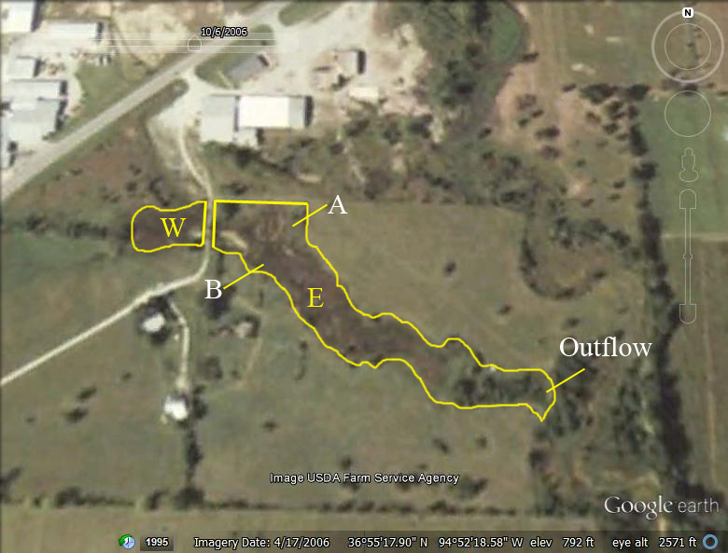
Figure 1 Aerial photo of Commerce wetland taken in 2006 (Google Earth 2013). W = West Marsh, E = East March, A and B indicate seeps, Outflow was the final sampling point.

The other three wetlands studied within the Tar Creek Superfund site were also volunteer wetlands, but were much smaller and hydrologically isolated. The hydrology of each was unique. The Hockerville wetland is located near Hockerville, OK, an abandoned mining town in the Tar Creek Superfund site (36° 59’ 48.78” N, 94° 46’ 51.42” W) (Figure 2). The Hockerville wetland had a chat substrate which is a fine gravel waste resulting from ore processing (EPA 2007). This wetland was approximately 0.10 ha in surface area and would seasonally fluctuate in water levels, sometimes going dry during the summer. There was no observable consistent water source, with the only observable source of water being direct precipitation and surface runoff. The only known consistent water outflow was evapotranspiration. The watershed runoff area was estimated using aerial photography from Google Earth (2011) and was approximately 1.13 ha.
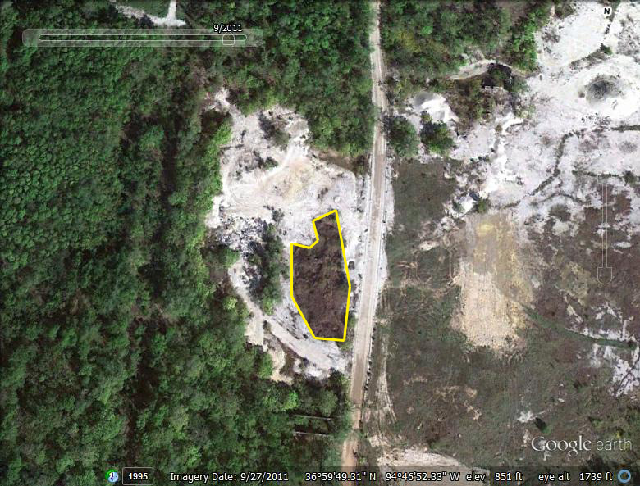
Figure 2 Aerial photo of the Hockerville wetland (Google Earth 2013). The wetland is outlined but this system did not have any specific inflow or outflow points for sampling.

The Adams A wetland (36° 57’ 42.10” N, 94° 50’ 37.26” W) was another volunteer wetland with a chat base located near Douthat, OK (Figure 3). The wetland surrounded a small body of water approximately >5 m deep and 0.03 ha in surface area with standing water remaining throughout the year. The vegetated wetland area was along the edge of the system and consisted of Juncus spp. and Typha spp. The only surface outflow observed was during high precipitation events when a small stream connected the system to another wetland. Otherwise, no other surface outflow was observed. The primary source of water was direct precipitation and surface runoff and the estimated watershed runoff area was 0.50 ha.
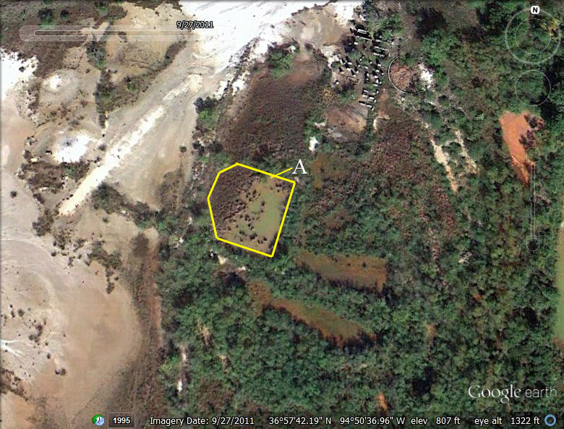
Figure 3 Aerial of the Adams A wetland (Google Earth 2013). System is outlined above and A=the occasional outflow after rain events.

Rush W wetland (36° 57’ 15.03” N, 94° 50’ 48.88” W) was also located near Douthat, OK, but was within an abandoned mine tailings impoundment (Figure 4). This system was approximately 0.30 ha in surface area and remained wet year-round from surface runoff. It was vegetated with Typha spp. and Salix spp. It did not always contain standing water as the soil would be saturated during dry periods. During high flow periods, there would be a surface outflow. The estimated watershed runoff area was 3.00 ha.
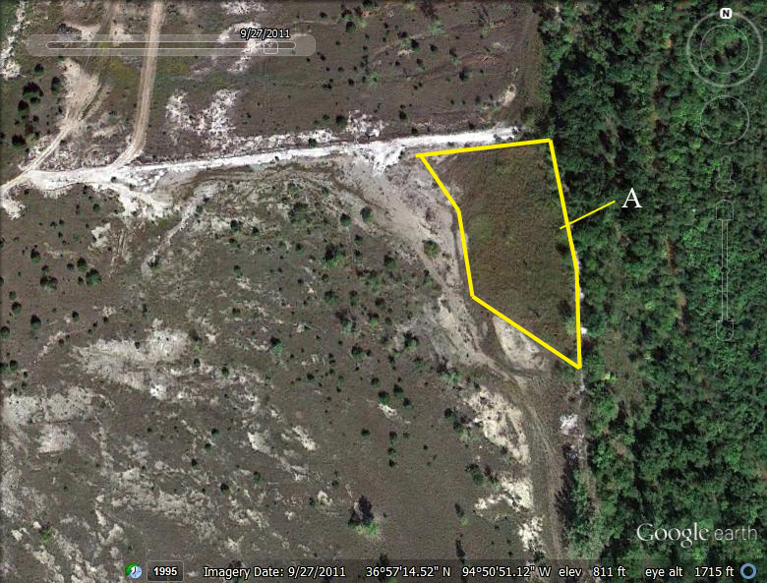
Figure 4 Aerial photo of the Rush W wetland outlined above (Google Earth 2013). A = Outflow point.

The other three systems studied were passive treatment systems constructed in southeast Oklahoma where watersheds were impacted from abandoned coal mines that produced acid mine drainage. Each treatment wetland had a series of ponds that were designed to provide individual biogeochemical treatment processes.
Hartshorne (34° 50' 51.95" N, 95° 32' 7.40" W) was a system constructed in 2005. The mine discharge water came from an abandoned, underground coal mine near Hartshorne, Pittsburg County, OK. The system was built with a vertical anoxic limestone drain (VALD) and a series of six ponds denoted as Oxidation Pond 1 (Ox1), Vertical Flow Wetland 1 (VFW1), Oxidation Pond 2 (Ox2), Vertical Flow Wetland 2 (VFW2), Oxidation Pond 3 (Ox3), and Polishing Wetland (PolWL). Total surface area was 0.49 ha (Figure 5). None of the ponds were vegetated during the period of study and the system had water flowing year round (La Bar et al., 2008). The estimated watershed runoff area was 0.12 ha.
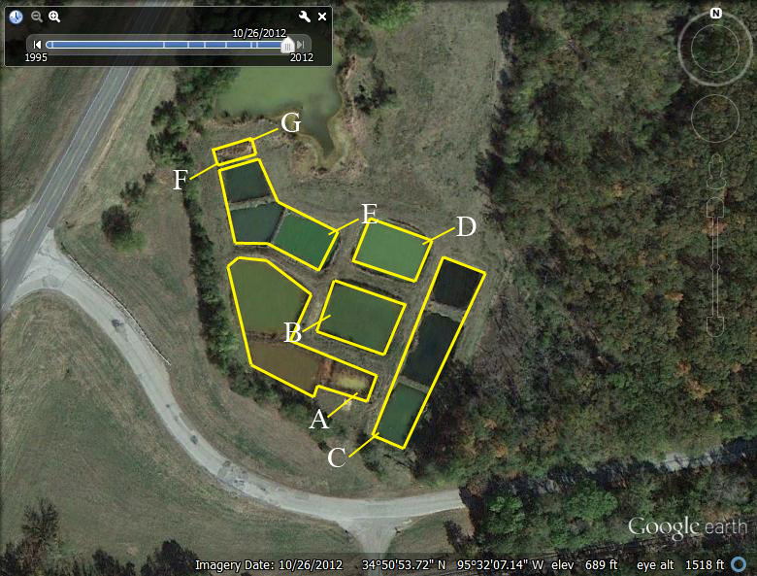
Figure 5 Aerial photo of the Hartshorne passive treatment system (Google Earth 2013). Each letter represents a sample point for each outflow as follows A=VALD, B = Ox1, C = VFW1, D = Ox2, E = VFW2, F = Ox3, G = PolWL.

The Le Bosquet Clean Stream Project passive treatment system (34° 56' 15.68" N, 94° 57' 19.20" W) was developed to remediate the acid mine drainage which impacted 2.4 km of Cedar Creek in Le Flore County, OK. The Le Bosquet system had an anoxic limestone drain (ALD) and two treatment ponds, an oxidation pond (Ox) and a vegetated polishing wetland (VegWL) that consisted mostly of Typha spp. and Salix spp. (Behum et al., 2006). The size of the system was 0.12 ha and the estimated area for watershed runoff was 0.03 ha (Figure 6).
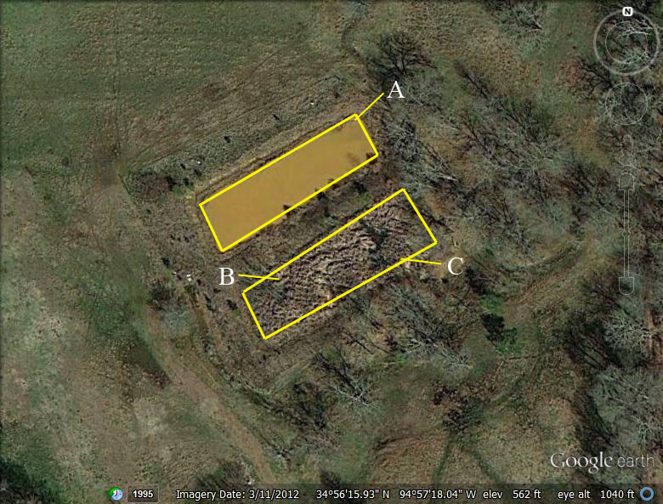
Figure 6 Aerial photo of the Le Bosquet passive treatment system (Google Earth 2013). Each letter represents a sample point for each outflow as follows A=ALD, B = Ox, C = VegWL.

The Red Oak passive treatment system (34° 55' 59.28" N, 95° 2' 4.91" W) was constructed in 2001 and is 0.41 ha in size. It receives acid mine drainage from the abandoned Bache and Denman coal mines in Latimer County, OK. Red Oak has five treatment ponds and the corresponding water sampling locations are: Seep of mine drainage (ROW1), Oxidation Pond (ROW2), Vertical Flow Wetland (ROW3), Oxidation Pond (ROW4), Vertical Flow Wetland (ROW5), and an Oxidation Pond (ROW6) (Figure 7; Porter, 2004). None of the ponds in this system were vegetated. The estimated watershed runoff area for this system was 0.10 ha.
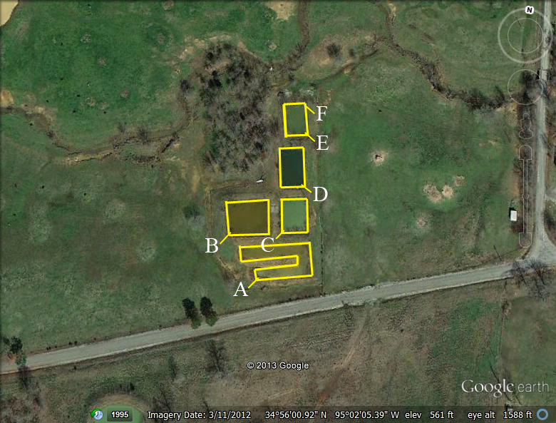
Figure 7 Aerial photo of the Red Oak passive treatment system (Google Earth 2013). Each letter represents a sample point for each outflow as follows A=ROW1, B = ROW2, C = ROW3, D = ROW4, E = ROW5, F = ROW6.

2.2.2 Water Collection and Analyses
At the sites that had flowing water, the volumetric discharge rates into and/or out of the system were measured using a calibrated bucket and stopwatch with triplicate measurement, during each sampling event. Temperature, pH, dissolved oxygen, oxidation-reduction potential (ORP), total dissolved solids (TDS), conductivity, and specific conductance were measured in situ using an YSI 600QS data sonde with a 650MDS controller. A Hach 2100P turbidimeter was used for turbidity measurements and total alkalinity was determined using titration with H₂SO₄ and a Hach digital titrator (Method 8203, immediately after sample collection. Water samples were collected in 250-mL high-density polyethylene (HDPE) bottles at inflows and outflows and preserved with trace-metal grade nitric acid until the sample reached pH < 2. If the system had a sequence of ponds, as in the case of the treatment wetlands, samples were taken at each of the inflows and outflows. For the systems with no flows, but standing water, a grab sample was obtained. The preserved metals samples were digested in a CEM MARSXpress Microwave Digestion System following EPA Method 3015 (USEPA, 2006). Digested samples were then analyzed with a Varian Vista-PRO Simultaneous Axial Inductively Coupled Plasma-Optical Emission Spectrometer following EPA Method 6010 (USEPA, 2006). Although the method used can determine concentrations for 15 analytes, only iron and zinc concentrations in the systems were used for model validation. Non-acidified samples were retained for anion analysis, specifically SO₄⁻², and were placed on ice (≤4°C) in the field. These samples were filtered at the laboratory with 0.2μm nitrocellulose filters and were analyzed with a Dionex 300 Ion Chromatograph following the EPA Method 300.1 (USEPA, 1993).

2.2.3 Vegetation Sampling and Analyses
In August 2006, vegetation sampling was done at Commerce, Rush W, Adams A and Hockerville. In August 2007, vegetation sampling was done at Rush W, Adams A, Hockerville, and Le Bosquet. Within each wetland, except Le Bosquet, two types of hydrologic zones were distinguished 1) the flooded zone (FLD), a zone that remained covered with standing water throughout the year and 2) a saturated zone (SAT), the zone for which water was temporary or the ground was saturated. In both zones, 1- m² square plots were chosen randomly, five in the flooded zone and five in the saturated zone. Le Bosquet had no flooded or saturated zones, but six random plots were chosen throughout the wetland. Vegetation cover was estimated in each 1-m² plot using the Braun-Blanquet scale for visual estimates and all plants were identified to genus (Sutherland, 1996). Square 625 cm² quadrats were placed at opposite corners of the plots and all the standing live vegetation, standing dead vegetation, and all litter were collected. Belowground biomass was sampled to the depth of 22-30 cm (Kellogg et al., 2003). The vegetation samples from all years, at all sites, were returned to the laboratory and frozen at -4ºC until they could be cleaned and dried. The samples were cleaned with tap water and dried at 65 ºC until constant weight was obtained.
The dried living, standing dead, litter and belowground vegetation for years 2006 and 2007 were randomly selected as grab samples within the bag of the dried vegetation and ground to pass through a 40-mesh (420 μm) using a Thomas Wiley Mini-Mill. All ground samples were digested using CEM MARSXpress Microwave Digestion System and EPA Method 3052 with 70% nitric acid (EPA, 2006). Digested samples were then analyzed with a Varian Vista-PRO simultaneous axial Inductively Coupled Plasma-Optical Emission Spectrometer following EPA Method 6010 (EPA, 2006) for two analytes, iron and zinc.

2.2.4 Decomposition Methods
Litter bag decomposition experiments were completed in six different wetlands, three that volunteered themselves at the lead and zinc mining site and three that were built to treat acid mine drainage from coal mining operations. The decomposition study was done using standing dead Typha spp. from three wetlands in the Tar Creek Superfund site. Senesced vegetation was collected from each wetland in August 2006, dried to a constant weight and cut to approximately 10 cm lengths and homogenized to fit in the litter bag. Litter bags were made out of fiberglass window screening and were sown to a 15 x 15 cm size; 5.0 grams of standing dead vegetation was placed in each bag. The bags were sewn closed with plastic labels inside. Litter bags were placed in six wetlands, the disturbed volunteer wetlands Adams A, Rush W and Hockerville and the treatment wetlands Hartshorne, Red Oak and Le Bosquet. In the volunteer systems, litter bags were placed in each previously identified hydrologic zones (FLD or SAT) with six plots within each zone. Five replicate bags were placed at each plot. In the treatment systems, litter bags were placed at six locations in each treatment pond, with five replicates at each location. At Hartshorne, the litter bags remained submerged throughout the experiment. At the Le Bosquet system, water flowed throughout the experiment in the oxidation pond and the litter bags remained submerged. The vegetated wetland had a mix of Salix spp. stands and Typha spp. Litter bags were distributed throughout the vegetated area. At Red Oak none of the ponds had standing vegetation and within the first month of the litter bag experiment, water was diverted from the last two ponds in the system. Litter bags in ROW4 remained submerged, but ROW5 was drained enough so the litter bags were not submerged.
The litter bags were collected in the field at days 51, 86, 140, 189, and 231 for the Tar Creek wetlands and days 51, 94, 136, 185, and 254 for the treatment wetlands. Each individual bag was placed in a labeled plastic bag, put on ice and then in a freezer (-4°C) upon return to the laboratory. For analyses, each litter bag was removed from the collection bag and placed in tap water for 3 - 4 hours to thaw and remove dirt. The litter bag was completely rinsed and the sample was placed in a paper bag and dried at 65 ºC for 48 hours. The litter bag and sample were weighed together and individually to determine if there was any mass loss from the fiberglass litter bags or if all loss was from the litter decomposition.
Each sample was assessed for iron and zinc content by first digesting samples in a CEM Microwave Accelerated Reaction System (MARS) with EPA Method 3052 using 70% nitric acid (EPA, 2006). Digested samples were then analyzed with the Varian Vista-PRO simultaneous axial Inductively Coupled Plasma-Optical Emission Spectrometer following EPA Method 6010 (EPA, 2006).
A single exponential decay model was used to express the decomposition rate. (Equation 1).
$\frac{X_{t}}{X_{0}}=e^{-kt}$ (1)
Where X_{t} is the remaining mass of the litter at time t, X₀ is the initial litter mass, k is the decay constant, and t is time in years (Wieder and Lang, 1982b; Atkinson and Cairns, 2001). To find the decay rates,, a least squares regression was completed between –ln(X_{t}/X₀) and t. The slope of the least squares regression was determined to be the decay constant (yr⁻¹) (Hobbie, 1996). This single exponential decay model was used to compare decomposition between each wetland and within the wetlands (Wieder and Lang, 1982b; Hobbie, 1996; Atkinson and Cairns, 2001).
Means comparison tests were completed to distinguish the differences and similarities within and between the different wetlands. The data were represented as percent remaining biomass and all data were normalized by making the day one value 100%. One way ANOVAs were performed to assess the decomposition rate difference within each system and between the different wetlands. Regression analyses were used to determine the significance of the least squares regression and to determine if there were any deviations greater than zero from the linear regressions calculated (Wieder and Lang 1982b; Sokal and Rohlf, 1987; Atkinson and Cairns, 2001). Correlation values were determined and assessed to understand the relationship between decomposition mass loss, and iron and zinc concentrations.

2.3 Results

2.3.1 Water Analyses
The water quality data were obtained during the periods indicated in Table 2. The mean water quality values for all seven wetlands for temperature (ºC), pH, dissolved oxygen (DO, mg/L), alkalinity (mg/L CaCO₃), Fe (mg/L), Zn (mg/L) and SO₄⁻² (mg/L) are shown in Table 3. The treatment systems in southeast Oklahoma (Le Bosquet, Red Oak, and Hartshorne) had low zinc levels, as expected in systems receiving coal mine waters. Commerce inflows had the highest concentrations of iron of the Tar Creek sites, yet Hartshorne inflows had the highest level of iron overall. Commerce had the highest concentrations of zinc of all the systems studied.

Table 2 Period of record for the hydrologic and water quality data used with each system.
System | Period of Record (monthly)
Commerce | October 2004 – March 2007
Hockerville | January 2007 – December 2007
Rush W | January 2007 – December 2007
Adam A | January 2007 – December 2007
Red Oak | June 2006 – December 2007
Hartshorne | January 2007 – December 2007
Le Bosquet | January 2007 – December 2007

The isolated wetlands, (Rush W, Adams A, and Hockerville) had low levels of iron, of <1 mg/L. These systems receive all their water from precipitation, so there is little hydraulic inflow of iron and it can be assumed that the majority of the iron cycled in the system comes from the substrate. More detailed water quality data for each treatment cell within the systems are shown in Table 4. Although the model developed will demonstrate these systems on the aggregate scale, understanding the water quality within the system will be important for understanding the decomposition of organic matter.
All systems remained at circum-neutral pH throughout the study, with the exception at Hartshorne Ox2 and Hartshorne Ox3. All three treatment systems had significant drops in iron concentrations after the first treatment pond. Zinc, as discussed earlier, was already at low levels in these systems and these systems were not constructed for zinc removal.
Table 3 Mean of basic water quality data (± standard deviation) from the seven wetland systems that were used in the vegetation surveys, decomposition studies, and for model calibration.
Site | Temperature (°C) | pH (su) | DO (mg/L) | Total Alkalinity (mg/L CaCO₃) | Fe (mg/L) | Zn (mg/L) | SO₄⁻² (mg/L)
Commerce In | 17.69  ±0.8 | 5.9  ±0.06 | 1.09  ±1.81 | 405.6  ±27.08 | 201.84 ±16.95 | 10.87  ±1.28 | 2027  ±250.5
Commerce Out | 15.56  ±3.84 | 6.04  ±0.08 | 2.08  ±1.82 | 331.9  ±101.6 | 152.69  ± 52.38 | 10.12  ±3.87 | 1882  ±509.6
Hockerville | 23.88  ±9.59 | 7.11  ±0.46 | 10.74  ±0.99 | 95.5  ±39.99 | 0.24  ±0.25 | 1.69  ±1.49 | 321.7  ±166.3
Rush W | 20.39  ±8.08 | 7.14  ±0.21 | 8.08  ±1.73 | 141.5  ±19.96 | 0.44  ±0.17 | 1.92  ±0.59 | 1157  ±666.6
Adams A | 20.71  ±8.97 | 7.05  ±0.46 | 8.41  ±2.34 | 105.7  ±34.57 | 0.63  ±0.79 | 5.59  ±7.15 | 678.3  ±260.3
Le Bosquet In | 17.75  ±1.42 | 6.34  ±0.07 | 0.49  ±0.35 | 190.5  ±24.29 | 42.74  ±1.49 | 0.012  ±0.006 | 114.3  ±7.9
Le Bosquet Out | 18.29  ±9.73 | 6.86  ±0.11 | 5.62  ±5.19 | 147.8  ±35.58 | 1.64  ±0.64 | 0.009  ±0.005 | 97.34  ±19.06
Red Oak In | 17.57  ±0.05 | 6.65  ±0.11 | 0.64  ±0.74 | 210.8  ±11.69 | 120.5  ±7.61 | 0.016  ±0.005 | 1057  ±89.55
Red Oak Out | 13.75  ±7.75 | 7.10  ±0.15 | 6.03  ±4.29 | 134.2  ±73.07 | 0.52  ±0.62 | 0.006  ±0.004 | 896.3  ±84.26
Hartshorne In | 20.40  ±0.72 | 6.17  ±0.12 | 1.07  ±0.54 | 469.8  ±49.02 | 546.8  ±277.9 | 0.053  ±0.026 | 6149  ±2031
Hartshorne Out | 17.93  ±8.84 | 6.32  ±1.63 | 9.62  ±4.49 | 49.82  ±56.07 | 2.4  ±1.44 | 0.087  ±0.283 | 2892  ±1434

Table 4 Water quality means for each individual cell within the passive treatment systems. Definitions: Ox=Oxidation pond, VFW= Vertical flow wetland, Pol = Polishing wetland. The numbers indicate the sequence cell in the system.
Site and Cell | Temperature (°C) | pH (su) | DO (mg/L) | Alkalinity  (mg/L  CaCO₃) | Fe (mg/L) | Zn (mg/L) | SO₄⁻² (mg/L)
Red Oak 1 Inflow | 17.57  ±0.05 | 6.65  ±0.11 | 0.64  ±0.74 | 210.8  ±11.69 | 120.5  ±7.61 | 0.016  ±0.005 | 1057  ±89.55
Red Oak 2 Ox | 20.02  ±8.59 | 6.72  ±0.48 | 7.51  ±2.55 | 47.78  ±30.91 | 9.52  ±8.96 | 0.008  ±0.003 | 1075  ±132.1
Red Oak 3 VFW | 19.16  ±8.03 | 7.09  ±0.23 | 1.04  ±1.59 | 256.6  ±208.2 | 0.10  ±0.17 | 0.43  ±0.12 | 910.7  ±130.4
Red Oak 4 Ox | 19.15  ±9.69 | 7.43  ±0.23 | 7.12  ±3.27 | 115.8  ±44.39 | 0.22  ±0.11 | 0.006  ±0.003 | 982.4  ±72.51
Red Oak 5 VFW | 16.94  ±8.15 | 7.07  ±0.16 | 1.74  ±0.55 | 198.6  ±117.8 | 0.12  ±0.13 | 0.005  ±0.003 | 870.5  ±121.1
Red Oak 6 Ox | 13.75  ±7.75 | 7.10  ±0.15 | 6.03  ±4.29 | 134.2  ±73.07 | 0.52  ±0.62 | 0.006  ±0.004 | 896.3  ±84.26
Le Bosquet 1 ALD | 17.75  ±1.42 | 6.34  ±0.07 | 0.49  ±0.35 | 190.5  ±24.29 | 42.74  ±1.49 | 0.012  ±0.006 | 114.3  ±7.9
Le Bosquet 1 Ox | 20.47  ±9.14 | 6.88  ±0.27 | 7.79  ±2.72 | 119.6  ±11.69 | 4.69  ±2.26 | 0.009  ±0.005 | 111.2  ±9.9
Le Bosquet 1 Pol | 18.29  ±9.73 | 6.86  ±0.11 | 5.62  ±5.19 | 147.8  ±35.58 | 1.64  ±0.64 | 0.009  ±0.005 | 97.34  ±19.06
Hartshorne 1 ALD | 20.40  ±0.72 | 6.17  ±0.12 | 1.07  ±0.54 | 469.8  ±49.02 | 546.8  ±277.9 | 0.053  ±0.026 | 6149  ±2031
Hartshorne 2 Ox | 18.44  ±8.99 | 4.12  ±1.08 | 7.61  ±2.25 | 5.76  ±15.70 | 201.8  ±189.2 | 0.032  ±0.02 | 6225  ±1844
Hartshorne 3 VFW | 17.56  ±7.77 | 6.71  ±0.26 | 0.76  ±0.45 | 207.0  ±81.58 | 46.69  ±59.94 | 0.014  ±0.007 | 5331  ±1674
Hartshorne 4 Ox | 17.99  ±8.95 | 7.12  ±1.53 | 11.61  ±6.60 | 117.1  ±95.67 | 16.02  ±40.31 | 0.016  ±0.01 | 5140  ±1495
Hartshorne 5 VFW | 16.94  ±7.84 | 7.23  ±0.15 | 0.54  ±0.34 | 213.7  ±111.8 | 6.51  ±9.62 | 0.011  ±0.004 | 4507  ±1505
Hartshorne 6 Ox | 17.93  ±8.91 | 8.24  ±0.68 | 13.03  ±7.58 | 165.8  ±83.63 | 0.67  ±0.62 | 0.014  ±0.006 | 4129  ±1763
Hartshorne 7 Pol | 17.93  ±8.84 | 6.32  ±1.63 | 9.62  ±4.49 | 49.82  ±56.07 | 2.40  ±1.44 | 0.087  ±0.28 | 2892  ±1434

2.3.2 Vegetation Surveys
Coverage estimates for the wetlands are shown in Table 5. Typha spp. and Juncus spp. were the most common species found in every wetland, with Typha spp. accounting for the highest percent coverage. The wetland with the most species was Rush W. Only Rush W and Adams A were not dominated by Typha spp. Hockerville, Le Bosquet, and Commerce were all considered Typha spp. dominated marshes.
Table 5 Coverage estimates from vegetative surveys.
 | Commerce (East and West Marsh) | Rush W | Adams A | Hockerville | Le Bosquet
Typha spp. | 90% | 6-25% | 6-25% | 26-50% | 60%
Juncus spp. | <5% | 6-25% | 26-50% | 6-25% | 20%
Scutellaria spp. |  | 6-25%
Salix spp. |  | 1-5% |  |  | 10%
Scirpus spp. |  | 1-5% | 1-5% | 1-5%
Graminea spp. |  | 6-25% | 1-5% | 1-5%
Cephalanthus spp. | <1% |  | 1-5%
Agalinis spp. |  | <1%
Equisetum spp. |  | <1%
Justicia spp. |  |  |  |  | <5%

Belowground, aboveground and total biomass, standing dead vegetation weight, and litter weights were determined for each system that had macrophytic vegetation (Table 6 to Table 10). Commerce (2006) had the lowest belowground weight and Rush W (2006) had the highest. Adam A (2007) had the lowest mean aboveground biomass and Commerce (2006) had the highest mean biomass where Typha spp. was the dominant vegetation. Le Bosquet (2007) aboveground biomass that included aboveground woody vegetation were the highest overall. When total biomass was calculated using aboveground and belowground values, Rush W (2006) had the greatest and Adam A (2007) had the lowest biomass. All of the Typha spp. dominated marshes had total biomass values over 1600 g/m² (Table 8). Litter mass ranged from 3.92± 9.71 g/m² at Adams A (2006) to Commerce (2006) at 1046±1207 g/m². The standing dead vegetation masses ranged from 166±214 g/m² at the Adams A (2006) system and 379±469 g/m² for Commerce (2006). Although the same systems include the minimum and maximum values for litter and standing dead vegetation masses, the same trend was not seen between the other systems’ litter and standing dead vegetation.

Table 6 Belowground biomass for all the systems sampled (g/m²).
 |  |  | Belowground Biomass
 | Mean | Standard Deviation |  | N | Maximum
Commerce 2006 | 802.10 | 787.15 |  | 9 | 2736
Rush W 2006 | 3208.80 | 1373.31 |  | 5 | 4887
Rush W 2007 | 1251.12 | 264.40 |  | 10 | 1897
Adams A 2006 | 1271.60 | 758.91 |  | 10 | 2352
Adams A 2007 | 896.24 | 549.74 |  | 10 | 1618
Hockerville 2006 | 1496.64 | 699.25 |  | 10 | 2762
Hockerville 2007 | 1307.76 | 442.54 |  | 10 | 2066
Le Bosquet 2007 | 972.53 | 934.82 |  | 6 | 2778

Table 7 Aboveground biomass for all the systems sampled (g/m²).
 |  |  | Aboveground Biomass
 | Mean | Standard Deviation |  | n | Maximum
Commerce 2006 | 812.44 | 635.37 |  | 9 | 2176
Rush W 2006 | 341.28 | 151.03 |  | 5 | 541
Rush W 2007 | 400.40 | 358.79 |  | 10 | 1102
Adams A 2006 | 363.52 | 374.87 |  | 10 | 1072
Adams A 2007 | 188.88 | 263.63 |  | 10 | 858
Hockerville 2006 | 430.16 | 520.50 |  | 10 | 1616
Hockerville 2007 | 408.00 | 463.05 |  | 10 | 1661
Le Bosquet 2007 | 469.73 | 425.34 |  | 6 | 1182
Le Bosquet 2007 with woody vegetation | 1384.13 | 1343.08 |  | 6 | 3884

Table 8 Total Biomass in each system sampled (g/m²).
 |  |  | Total Biomass
 | Mean | Standard Deviation |  | n | Maximum
Commerce 2006 | 1614.55 | 1004.44 |  | 9 | 3136
Rush W 2006 | 3550.08 | 1282.44 |  | 5 | 5240
Rush W 2007 | 1651.52 | 443.23 |  | 10 | 2446
Adam A 2006 | 1635.12 | 1080.42 |  | 10 | 3424
Adam A 2007 | 1085.12 | 759.36 |  | 10 | 2475
Hockerville 2006 | 1926.80 | 1123.37 |  | 10 | 3882
Hockerville 2007 | 1715.76 | 735.50 |  | 10 | 3397
Le Bosquet 2007 | 1442.27 | 802.01 |  | 6 | 2898
Le Bosquet 2007 with woody vegetation | 2356.67 | 2258.78 |  | 6 | 6662

Table 9 Litter mass in each system sampled (g/m²).
 |  |  | Litter
 | Mean | Standard Deviation |  | n | Maximum
Commerce 2006 | 1045.51 | 1207.07 |  | 9 | 3744
Rush W 2006 | 158.72 | 163.74 |  | 5 | 352
Rush W 2007 | 265.60 | 244.56 |  | 10 | 764
Adam A 2006 | 3.92 | 9.71 |  | 10 | 30
Adam A 2007 | 111.28 | 112.07 |  | 10 | 366
Hockerville 2006 | 568.00 | 100.13 |  | 10 | 688
Hockerville 2007 | 193.36 | 120.49 |  | 10 | 454
Le Bosquet 2007 | 161.60 | 157.90 |  | 6 | 454

Table 10 Values of the standing dead vegetation from systems sampled (g/m²).
 |  |  | Standing Dead
 | Mean | Standard Deviation |  | n | Maximum
Commerce 2006 | 379.02 | 468.81 |  | 9 | 1376
Rush W 2006 | 354.08 | 354.19 |  | 5 | 774
Rush W 2007 | 235.12 | 162.40 |  | 10 | 493
Adam A 2006 | 165.68 | 213.68 |  | 10 | 555
Adam A 2007 | 203.28 | 259.00 |  | 10 | 750
Hockerville 2006 | 454.32 | 466.74 |  | 10 | 1328
Hockerville 2007 | 349.60 | 378.44 |  | 10 | 1326
Le Bosquet 2007 | 246.00 | 161.04 |  | 6 | 435

Iron concentrations within the aboveground and belowground biomass, litter and standing dead vegetation can be found in Table 11. The mean iron concentrations were combined by estimating the roots as being 64% and live vegetation being 36% of the total plant biomass (Jørgensen, 1979). The calculated iron concentrations for the whole plants are in Table 11. The Commerce (2006) sample had the highest total plant iron concentration and Hockerville (2007) had the lowest. Iron concentrations were always greatest in the belowground biomass and Commerce 2006 had the highest belowground biomass iron concentration, but Adams A (2007) had the highest aboveground biomass iron concentration. The lowest iron concentrations in the roots were Hockerville (2007) and for aboveground biomass was Rush W (2007). Adams A (2007) had the highest standing dead vegetation and litter iron concentrations and Rush W (2006) had the lowest standing dead vegetation and liter iron concentrations.
Zinc concentrations within the aboveground and belowground biomass, litter and standing dead vegetation can be found in Table 12. Zinc concentrations were always highest in the belowground biomass with the exception of the Le Bosquet litter. Adam A (2006) had the highest belowground and aboveground biomass zinc concentrations. The lowest mean zinc concentrations were found in the roots for Le Bosquet and the aboveground biomass. Adams A (2007) has the highest standing dead vegetation and litter zinc concentration. Le Bosquet had the lowest zinc concentrations for both standing dead vegetation and litter. The highest and lowest mean zinc concentrations throughout the live plant matter were Adam A (2006) and Le Bosquet.

Table 11 Iron concentrations in the belowground and aboveground vegetation, standing dead vegetation, litter and total live vegetation (mg/kg).
 | Hockerville |  | Adams A |  | Rush W |  | Le Bosquet | Commerce
 | 2006 | 2007 | 2006 | 2007 | 2006 | 2007 | 2007 | 2006
Root | 957.6  ±830.2 | 866.0  ±586.2 | 4268  ±1248 | 3446  ±1434 | 2901  ±1157 | 3051  ±2025 | 1756  ±884.8 | 9840  ±3365
Live Vegetation | 24.32  ±20.40 | 20.85  ±14.77 | 59.49  ±83.20 | 125.4  ±126.8 | 113.6  ±256.1 | 7.11  ±2.33 | 10.42  ±5.11 | 41.61  ±71.88
Standing Dead | 107.4  ±82.15 | 156.8  ±127.2 | 345.4  ±405.9 | 1251  ±680.3 | 16.42  ±6.53 | 23.57  ±7.74 | 70.15  ±89.63 | 204.9  ±221.1
Litter | 1305  ±787.8 | 659.5  ±472.2 | 3644  ±2632 | 3699  ±2312 | 36.27  ±9.20 | 106.2  ±122.7 | 374.3  ±518.6 | 1323  ±1337
Total Plant | 621.6  ±538.7 | 561.8  ±380.5 | 2753  ±828.5 | 2250  ±963.7 | 1898  ±832.6 | 1955  ±1297 | 1128  ±568.1 | 6313  ±2180

Table 12 Zinc concentrations in the belowground and aboveground vegetation, standing dead vegetation, litter and total live vegetation (mg/kg).
 | Hockerville |  | Adams A |  | Rush W |  | Le Bosquet | Commerce
 | 2006 | 2007 | 2006 | 2007 | 2006 | 2007 | 2007 | 2006
Root | 1833  ±925.5 | 1651  ±753.6 | 3788  ±1633 | 2558  ±816.8 | 1468  ±290.2 | 1955  ±1380 | 5.24  ±1.85 | 895.0  ±942.4
Live Vegetation | 13.47  ±10.95 | 11.52  ±8.62 | 119.9  ±132.0 | 89.73  ±82.43 | 39.63  ±47.59 | 18.94  ±7.80 | 3.78  ±0.85 | 8.59  ±8.29
Standing Dead | 52.03  ±62.34 | 43.88  ±27.59 | 291.4  ±291.6 | 607.4  ±262.3 | 31.69  ±23.71 | 64.55  ±47.20 | 5.01  ±3.50 | 32.92  ±31.82
Litter | 353.1  ±134.6 | 257.4  ±174.7 | 2173  ±1025 | 1986  ±1116 | 89.36  ±56.55 | 269.8  ±277.2 | 6.77  ±3.63 | 138.7  ±140.1
Total Plant | 1178  ±596.3 | 1061  ±485.4 | 2467  ±1092 | 1670  ±552.5 | 954.1  ±202.9 | 1258  ±885.9 | 4.72  ±1.49 | 575.9  ±606.1

Correlation analyses were performed between the different vegetation metal concentrations to determine if there were any significant relationships (Table 13 and Table 14). For iron concentrations, standing dead vegetation and aboveground live vegetation, and standing dead vegetation and litter had a significant relationships (Table 13). Correlations between the zinc concentrations in the roots, live vegetation, standing dead vegetation and litter all showed positive relationships (Table 14).
Table 13 Correlation r-values for iron concentrations throughout the parts of the plants. n =16, α=0.05.
 | Root | Live Vegetation | Standing Dead | Litter | Total Iron
Root | 1 | 0.154 | 0.111 | 0.217 | 0.999
Live Vegetation | - | 1 | 0.644 | 0.478 | 0.163
Standing Dead | - | - | 1 | 0.797 | 0.117
Litter | - | - | - | 1 | 0.221
Total Iron | - | - | - | - | 1

Table 14 Correlation r values for zinc concentrations throughout the parts of the plants. n =16, α=0.05.
 | Root | Live Vegetation | Standing Dead | Litter | Total Zinc
Roots | 1 | 0.858 | 0.632 | 0.845 | 0.999
Live Vegetation | - | 1 | 0.796 | 0.952 | 0.863
Standing Dead | - | - | 1 | 0.889 | 0.637
Litter | - | - | - | 1 | 0.849
Total Zinc | - | - | - | - | 1

The correlation results for iron concentrations within the vegetation samples do not follow the same trend as the zinc concentrations. These data indicate that as the zinc concentration becomes greater in the roots, there can be an expectation of elevated concentrations in live vegetation, standing dead vegetation, and litter. These same positive trends are seen between live vegetation, standing vegetation, and litter. It is possible that these relationships were not seen in iron concentrations because copious iron oxyhydroxide plaque forms at the roots of vegetation (Batty and Younger, 2002). This plaque interferes with nutrient uptake in vegetation and possibly inhibits growth (Awad et al., 1994; Snowden and Wheeler 1995; Wenzel et al., 1999; Batty et al., 2000). Although growth inhibition was not examined in these plants, the oxidized iron plaques could interfere with iron uptake into the rest of the plant (Awad et al., 1994; Snowden and Wheeler 1995; Doyle and Otte, 1997; Wenzel et al., 1999; Batty et al., 2000; Hansel et al. 2001).
Standing dead vegetation and litter iron and zinc concentrations were greater than live vegetation concentrations at all sites with the exception of the samples from Rush (2006). It is possible that the standing dead vegetation exhibited greater metal concentrations due to senescence after the growing season, in which the vegetation concentrates the carbohydrates from the aboveground biomass into the roots and rhizomes (Lea and Leegood, 1993; Heldt and Piechulla, 2010). It is also possible that although the carbohydrates are transported, the metals remain in the cellular structures of the plant, such as the cell walls of the epidermis and mesophyll, thus giving higher concentrations of metals in the standing dead vegetation (Mathys, 1977; Jackson et al., 1990; Greger, 1999). In the case of litter, two explanations may be given. First, as the decomposition process happens there can be a higher concentration of metals remaining after organic matter has been consumed. Second, the metals in the soils can transfer and be absorbed onto the litter mass (Jacob and Otte, 2004). It is difficult to assess which would be the primary pathway to increased metals concentrations in litter without further studies, but visual observations of samples collected noted that iron oxide accumulated on many of the samples and had to be washed off before analyses.
For all the systems that had vegetation collections completed, a single classification ANOVA showed that the systems were significantly different. The exception was the standing dead vegetation (Table 15).
Table 15 Results from a one-way ANOVA between the systems’ vegetation.
 | df | F | p
Comparing Systems
Belowground | 9, 99 | 6.89 | 0.05
Aboveground | 9, 99 | 7.04 | 0.05
Total | 9, 99 | 5.00 | 0.05
Litter | 7, 63 | 5.12 | 0.05
Standing Dead | 7, 63 | 0.87 | 0.05

A two-way ANOVA with replication was done between Rush W (2007), Adams A (2006 and 2007), and Hockerville (2006 and 2007) and their different hydrologic zones, FLD and SAT (Table 16). Rush W (2006) was eliminated because it did not include two different hydrologic zones. For all samples, there was not a significant difference between systems and years, but there was a significant difference between the different hydrologic zones. This indicates that water saturation significantly impacts decomposition of biomass litter.

Table 16 Results from a two-way ANOVA between the years and hydrologic zones for Rush W, Adams A and Hockerville. Years 2006 and 2007 were compared, but Rush 2006 was eliminated for the hydrological analysis.
 | df | F | p
Comparing Systems and Years
Belowground | 4, 40 | 0.139 | 0.05
Aboveground | 4, 40 | 0.080 | 0.05
Total | 4, 40 | 0.144 | 0.05
Litter | 4, 40 | 4.591 | 0.003
Standing Dead | 4, 40 | 0.243 | 0.05
Comparing Hydrologic Zones
Belowground | 1, 40 | 138.5 | 0.05
Aboveground | 1, 40 | 45.40 | 0.05
Total | 1, 40 | 120.1 | 0.05
Litter | 1, 40 | 174.1 | 0.05
Standing Dead | 1, 40 | 51.80 | 0.05

Iron concentration differences between all the systems were significantly different for belowground biomass, litter, and standing dead vegetation. The iron concentrations in the aboveground vegetation were not significantly different between the systems (Table 17). As with the vegetative masses, Rush W (2006), Adams A (2006 and 2007) and Hockerville (2006 and 2007) and the hydrologic zones were analyzed for differences in iron concentrations. The same trends appear as did for all biomass, litter, and standing dead vegetation (Table 18). Although there was not a significant difference between the systems or between years, the differences in the hydrologic zones suggests that water saturation can have an effect on iron uptake in to the vegetative matter.

Table 17 Results from a one-way ANOVA between the systems’ vegetation iron concentrations.
 | df | F | p
Comparing Systems
Belowground | 9, 96 | 17.98 | 0.05
Aboveground | 9, 99 | 1.65 | 0.05
Litter | 6, 56 | 9.49 | 0.05
Standing Dead | 6, 56 | 19.56 | 0.05

Table 18 Results from a two-way ANOVA comparing the iron concentrations in the different years (2006 and 2007) and hydrologic zones (FLD and SAT) for Rush W, Adams A and Hockerville. Rush W only had the year 2006 analyzed for the hydrologic zones.
 | df | F | p
Comparing Systems and Years
Belowground | 4, 40 | 1.44 | 0.05
Aboveground | 4, 40 | 0.39 | 0.05
Litter | 4, 40 | 0.75 | 0.05
Standing Dead | 4, 40 | 1.59 | 0.05
Comparing Hydrologic Zones
Belowground | 1, 40 | 118.3 | 0.05
Aboveground | 1, 40 | 13.12 | 0.05
Litter | 1, 40 | 29.53 | 0.05
Standing Dead | 1, 40 | 22.54 | 0.05

Zinc concentrations for all sample types were significantly different from each other: belowground, aboveground, litter, and standing dead (Table 19). in the comparison between Rush W (2006), Adams A (2006 and 2007) and Hockerville (2006 and 2007) and the hydrologic zones, the same trends appear as did for biomass, litter and standing dead (Table 20). Although there was no significant differences between the systems or years, the differences in the hydrologic zones suggests that water saturation can have an effect on the zinc uptake in to the vegetative matter as well.
Table 19 from a one-way ANOVA between the systems’ vegetation zinc concentrations.
 | df | F | p
Comparing Systems
Belowground | 8, 92 | 10.58 | 0.05
Aboveground | 8.94 | 6.63 | 0.05
Litter | 6, 56 | 20.34 | 0.05
Standing Dead | 6, 47 | 21.28 | 0.05

Table 20 Results from a two-way ANOVA comparing the zinc concentrations in the different years (2006 and 2007) and hydrologic zones (FLD and SAT) for Rush W, Adams A and Hockerville. Rush W only had the year 2006 analyzed for the hydrologic zones.
 | df | F | p
Comparing Systems and Years
Belowground | 4, 40 | 1.44 | 0.05
Aboveground | 4, 40 | 0.39 | 0.05
Litter | 4, 40 | 0.75 | 0.05
Standing Dead | 4, 40 | 1.59 | 0.05
Comparing Hydrologic Zones
Belowground | 1, 40 | 118.4 | 0.05
Aboveground | 1, 40 | 13.12 | 0.05
Litter | 1, 40 | 29.53 | 0.05
Standing Dead | 1, 40 | 22.54 | 0.05

2.3.3 Decomposition
The percent mass of the litter lost during decomposition in the Adams A, Rush W, and Hockerville wetlands are found in Figure 8 to Figure 10. The mean values for each collection date can be found in Table 21. The most percent litter mass lost over time was in the FLD hydrologic zones. Starting at day 85, the data from the different hydrologic zones diverge from each other and different trends are seen. Comparisons were done between the two different hydrologic zones in the Tar Creek wetlands with a Student’s t-test. The only wetland that showed a significant difference between the two hydrologic zones was Rush W (t(68) = 1.999, p = 0.05) while there was no difference between the hydrologic zones for Hockerville (t(70) = 1.220, p = 0.05) and Adams A (t(69) = 1.552, p = 0.05). A single classification ANOVA between each Tar Creek wetland showed that all wetlands were similar in decomposition rates despite the differences in hydrology, vegetation and size (F(5,30) = 0.317, p = 0.05).

Table 21 Means and standard deviations of the percentage remaining litter mass in each Tar Creek system at different hydrologic zones and over the various days of collection.
 |  | Day 50 | Day 85 | Day 141 | Day 189 | Day 236
Adams A | FLD | 81.80  ±3.30 | 78.84  ±7.54 | 66.00  ±4.66 | 63.35  ±6.89 | 64.24  ±5.74
Adams A | SAT | 80.22  ±3.38 | 79.74  ±2.28 | 78.95  ±5.22 | 73.20  ±3.90 | 71.05  ±3.03
Rush W | FLD | 81.13  ±2.38 | 75.60  ±2.97 | 61.25  ±5.80 | 57.27  ±10.16 | 59.36  ±5.44
Rush W | SAT | 82.40  ±2.26 | 78.54  ±4.96 | 72.08  ±9.37 | 71.77  ±9.52 | 68.72  ±10.34
Hockerville | FLD | 77.42  ±3.34 | 74.75  ±2.32 | 68.67  ±8.64 | 59.10  ±9.99 | 65.65  ±5.70
Hockerville | SAT | 78.75  ±1.48 | 76.72  ±2.31 | 73.75  ±3.46 | 69.33  ±1.63 | 68.98  ±3.64

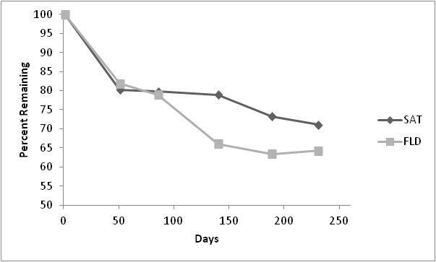
Figure 8 Percent remaining litter at two Adams A hydrologic zones.

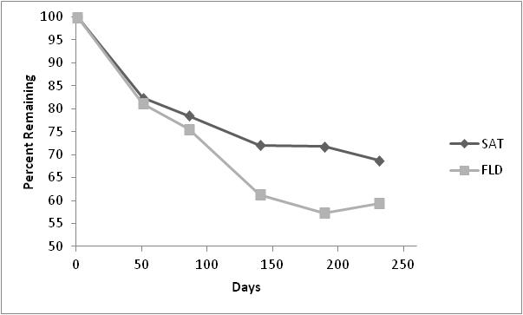
Figure 9 Percent remaining litter at two Rush W hydrologic zones.

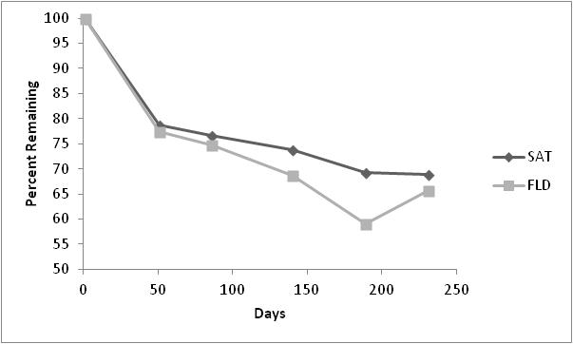
Figure 10 Percent remaining litter at two Hockerville hydrologic zones.

The percent mass lost during decomposition in Hartshorne, Le Bosquet and Red Oak can be found in Figure 11 to Figure 13 and means for each collection date can be found in Table 22. A single classification ANOVA was done between each of the different treatment cells at Hartshorne, Le Bosquet, and Red Oak and all three systems showed significant differences in decomposition between the different cells (Hartshorne: F(5,201) = 23.575, p = 0.05; Le Bosquet: F(1,66) = 15.486, p = 0.05; Red Oak: F(4,163) = 10.374, p = 0.05). In the treatment wetlands, decomposition occurred more rapidly in the litter bags closer to the outflow of the system. For all three wetlands, the slowest decomposition rate was in the first oxidation cell where iron accumulation was greatest. When comparing the decomposition rates between the systems, the Ox 1 cells were not significantly different from each other (F₍2,97) = 2.037, p = 0.05). The only system that did not follow the pattern of decomposition increasing successively throughout each cell was Red Oak where the last oxidation pond had a decrease in decomposition rate over the study period when compared to the previous cells.
Table 22 Means and standard deviations of percent remaining litter mass for each treatment system across various days of sample collection
 |  |  |  | Day 43 | Day 86 | Day 128 | Day 184 | Day 253
Hartshorne | Ox1 |  | 83.46  ±2.54 |  | 80.20  ±3.58 | 79.06  ±2.20 | 79.12  ±3.36 | 79.16  ±4.51
Hartshorne | VFW1 |  | 81.41  ±3.18 |  | 79.55  ±3.37 | 77.55  ±2.15 | 76.16  ±3.36 | 76.56  ±2.43
Hartshorne | Ox2 |  | 70.65  ±6.98 |  | 51.03  ±6.99 | 43.43  ±10.08 | 35.11  ±8.43 | 28.34  ±7.26
Hartshorne | VFW2 |  | 51.66  ±6.03 |  | 24.52  ±4.75 | 24.16  ±7.15 | 22.00  ±4.20 | 19.72  ±11.57
Hartshorne | Ox3 |  | 58.93  ±10.22 |  | 29.74  ±14.20 | 25.33  ±8.45 | 20.82  ±8.89 | 15.48  ±7.79
Hartshorne | Pol WL |  | 53.00  ±9.19 |  | 35.22  ±2.99 | 22.00  ±5.80 | 15.95  ±9.55 | 16.75  ±5.97
Le Bosquet | Ox |  | 81.39  ±2.45 |  | 77.67  ±2.34 | 72.51  ±6.77 | 71.39  ±2.56 | 65.72  ±7.90
Le Bosquet | Veg WL |  | 69.54  ±4.95 |  | 59.62  ±6.09 | 50.36  ±8.52 | 44.86  ±12.59 | 45.61  ±12.22
Red Oak | ROW 1 |  | 80.40  ±1.50 |  | 78.15  ±2.12 | 77.57  ±3.81 | 75.51  ±5.26 | 78.20  ±3.11
Red Oak | ROW 2 |  | 74.42  ±1.77 |  | 72.43  ±2.23 | 66.21  ±4.99 | 64.56  ±2.21 | 65.50  ±7.00
Red Oak | ROW 3 |  | 70.97  ±4.11 |  | 58.58  ±4.90 | 53.78  ±4.75 | 48.48  ±4.52 | 51.20  ±1.92
Red Oak | ROW 4 |  | 67.53  ±2.96 |  | 56.28  ±3.75 | 42.54  ±5.97 | 44.69  ±6.21 | 33.08  ±11.60
Red Oak | ROW 5 |  | 73.27  ±2.39 |  | 71.95  ±1.79 | 66.71  ±8.68 | 66.24  ±7.97 | 59.86  ±14.06

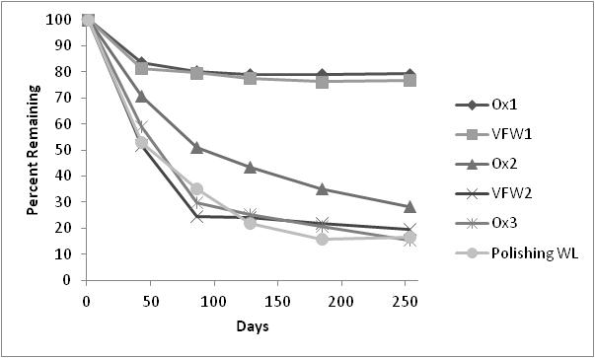
Figure 11 Percent of litter remaining for Hartshorne in all treatment cells in the system.

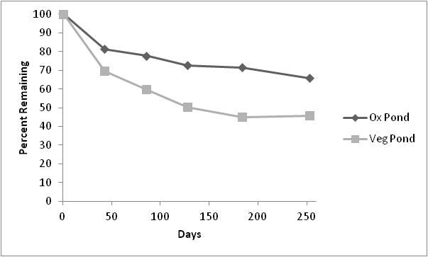
Figure 12 Percentage of litter remaining for Le Bosquet in all treatment cells in the system.

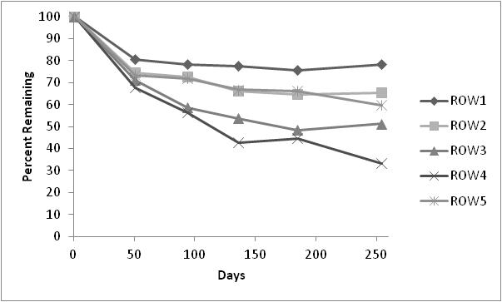
Figure 13 Percentage of litter remaining for Red Oak in all treatment cells in the system.

The decay model, –ln(X_{t}/X₀), was developed for each sample at each collection date. A single classification ANOVA determined if there was a significant difference between each point in time when the decomposition bags were collected and the F-statistics can be seen in Table 23 and Table 24. The ANOVA helped determine if a regression relationship was possible for these data. The only sample sites that did not show a significant difference were Rush W SAT, ROW 1, ROW 5, and Hartshorne Ox 1. Regression analyses were done to determine if there was a relationship (H_{o}: b = 0; H_{a}: b <> 0; null hypothesis is there is no relationship and the slope is zero. Alternative hypothesis is that there is a relationship with a positive or negative slope) and if there were deviations from the regressions. The regression analyses initially showed that the regressions in Hockerville FLD, ROW 1, ROW 2, ROW 3, and Hartshorne VFW 2 were not. Rush W FLD, ROW 3, and Hartshorne Pol WL had significant deviations from the linear regression line (Table 23 and Table 24, bolded values).
The k values were calculated for each sampling point and each system (Table 23 and Table 24). In the treatment systems, the oxidation ponds all had the lowest k values, indicating that these cells of the systems had the slowest decomposition. Decomposition increased sequentially throughout the treatment systems. The exception was Red Oak where the last pond had a decrease in decomposition, but this could possibly be due to the drainage of that pond during the experiment. In the Tar Creek systems, flooded sections (FLD) had higher k values than the dryer sections (SAT), suggesting that hydrology influences decomposition rate.

Table 23 Decay constants, regression values, and significance tests on Rush W, Adams A, and Hockerville System hydrologic zones. Bolded F-statistics indicate that there was no significance.
 |  |  |  | ANOVA |  |  | Regression ANOVA |  |  | Deviations from Regression
 | r² | k  (-yr) | k  (-day) | df | F | Fcrit 0.05 | df | F | Fcrit 0.05 | df | F | Fcrit 0.05
Rush W
FLD | 0.638 | 0.676 | 0.0019 | 4, 24 | 18.298 | 2.776 | 1, 3 | 16.908 | 10.128 | 3, 24 | 3.676 | 3.009
SAT | 0.288 | 0.366 | 0.0010 | 4, 24 | 2.700 | 2.776 | 1, 3 | 40.512 | 10.128 | 3, 24 | 0.248 | 3.009
Total | 0.429 | 0.555 | 0.0015 | 4, 52 | 10.858 | 2.550 | 1, 3 | 76.712 | 10.128 | 3, 52 | 0.545 | 2.783
Adams A
FLD | 0.513 | 0.513 | 0.0014 | 4, 25 | 11.164 | 2.759 | 1, 3 | 12.230 | 10.128 | 3, 25 | 2.932 | 2.991
SAT | 0.497 | 0.253 | 0.0007 | 4, 25 | 7.912 | 2.759 | 1, 3 | 24.060 | 10.128 | 3, 25 | 1.169 | 2.991
Total | 0.398 | 0.383 | 0.0010 | 4, 55 | 10.370 | 2.540 | 1, 3 | 38.430 | 10.128 | 3, 55 | 1.001 | 2.773
Hockerville
FLD | 0.349 | 0.446 | 0.0012 | 4, 25 | 6.465 | 2.759 | 1, 3 | 6.553 | 10.128 | 3, 25 | 2.707 | 2.991
SAT | 0.687 | 0.281 | 0.0008 | 4, 25 | 15.554 | 2.759 | 1, 3 | 77.454 | 10.128 | 3, 25 | 0.773 | 2.991
Total | 0.35 | 0.364 | 0.0010 | 4, 55 | 10.536 | 2.540 | 1, 3 | 12.570 | 10.128 | 3, 55 | 2.707 | 2.773

Table 24 Decay constants, regression values, and significance tests on Le Bosquet, Red Oak, and Hartshorne systems’ ponds. Bolded F-statistics indicate that there is no significance.
 |  |  |  | ANOVA |  |  | Regression ANOVA |  |  | Deviations from Regression
 | r² | k  (-yr) | k  (-day) | df | F | Fcrit 0.05 | df | F | Fcrit 0.05 | df | F | Fcrit 0.05
Le Bosquet
Ox | 0.548 | 0.386 | 0.0011 | 4, 23 | 7.592 | 2.796 | 1, 3 | 83.462 | 10.128 | 3, 23 | 0.351 | 2.550
Veg | 0.393 | 0.92 | 0.0025 | 4, 23 | 4.929 | 2.796 | 1, 3 | 17.056 | 10.128 | 3, 23 | 0.983 | 2.550
Total | 0.206 | 0.65 | 0.0018 | 4, 51 | 3.716 | 2.553 | 1, 3 | 31.228 | 10.128 | 3, 51 | 0.434 | 2.786
Red Oak
ROW 1 | 0.127 | 0.096 | 0.0003 | 4, 20 | 1.542 | 2.866 | 1, 3 | 3.424 | 10.128 | 3, 20 | 0.960 | 3.098
ROW 2 | 0.438 | 0.288 | 0.0008 | 4, 23 | 7.643 | 2.796 | 1, 3 | 2.348 | 10.128 | 3, 23 | 2.348 | 2.550
ROW 3 | 0.512 | 0.607 | 0.0017 | 4, 24 | 21.859 | 2.776 | 1, 3 | 7.314 | 10.128 | 3, 24 | 8.478 | 3.009
ROW 4 | 0.634 | 1.304 | 0.0036 | 4, 23 | 13.498 | 2.796 | 1, 3 | 29.161 | 10.128 | 3, 23 | 1.679 | 2.550
ROW 5 | 0.252 | 0.412 | 0.0011 | 4, 23 | 2.105 | 2.796 | 1, 3 | 51.052 | 10.128 | 3, 23 | 0.156 | 2.550
Total | 0.209 | 0.604 | 0.0017 | 4, 133 | 9.301 | 2.440 | 1, 3 | 67.841 | 10.128 | 3, 133 | 0.525 | 2.673
Hartshorne
Ox 1 | 0.133 | 0.083 | 0.0002 | 4, 25 | 1.851 | 2.759 | 1, 3 | 4.755 | 10.128 | 3, 25 | 0.955 | 2.991
VFW 1 | 0.277 | 0.114 | 0.0003 | 4, 25 | 3.286 | 2.759 | 1,3 | 13.459 | 10.128 | 3, 25 | 0.799 | 2.991
OX 2 | 0.718 | 1.66 | 0.0045 | 4, 22 | 16.154 | 2.817 | 1, 3 | 109.293 | 10.128 | 3, 22 | 0.575 | 3.049
VFW 2 | 0.229 | 1.29 | 0.0035 | 4, 24 | 4.589 | 2.776 | 1, 3 | 3.820 | 10.128 | 3, 24 | 2.692 | 3.009
Ox 3 | 0.508 | 2.36 | 0.0065 | 4, 24 | 8.339 | 2.776 | 1, 3 | 25.421 | 10.128 | 3, 24 | 1.174 | 3.009
Pol WL | 0.599 | 2.402 | 0.0066 | 4, 24 | 16.224 | 2.776 | 1, 3 | 13.352 | 10.128 | 3, 24 | 3.969 | 3.009
Total | 0.118 | 1.204 | 0.0033 | 4, 169 | 7.350 | 2.425 | 1, 3 | 13.310 | 10.128 | 3, 169 | 1.803 | 2.658

The iron and zinc concentrations consistently increased in the litter as decomposition progressed in the Tar Creek wetlands, as can be seen in Figure 14 to Figure 19. A correlation analysis was run between litter mass loss and metals concentrations for each hydrologic zone. Correlation values can be seen in Table 25. All the systems, except Rush W SAT showed statistically significant relationships between the concentration of iron and percent remaining of litter and the concentration of zinc and percent remaining of litter. The exception was the saturated zone for Rush W, which showed no significant relationship between litter mass loss and metal concentrations.
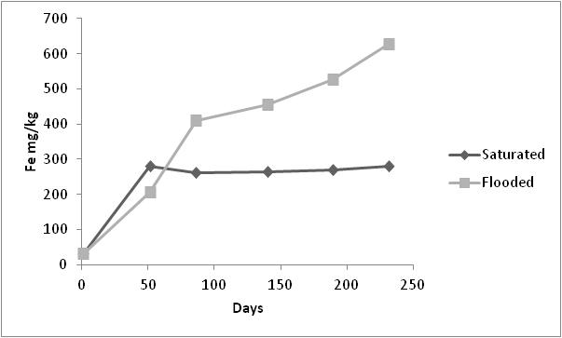
Figure 14 Iron concentrations in litter at Adams A throughout the decomposition process.
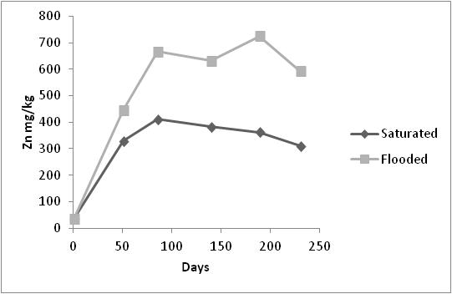
Figure 15 Zinc concentrations in litter at Adam A throughout decomposition process.

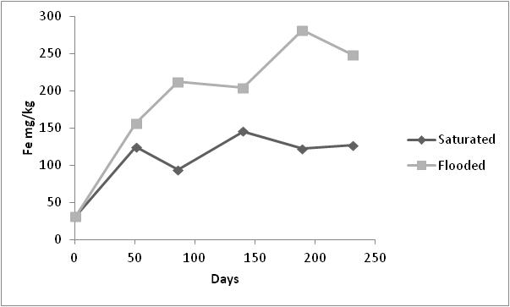
Figure 16 Iron concentrations in litter at Hockerville throughout decomposition process.

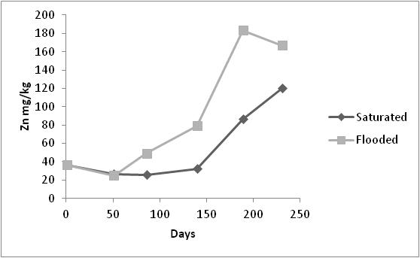
Figure 17 Zinc concentrations in litter at Hockerville throughout decomposition process.

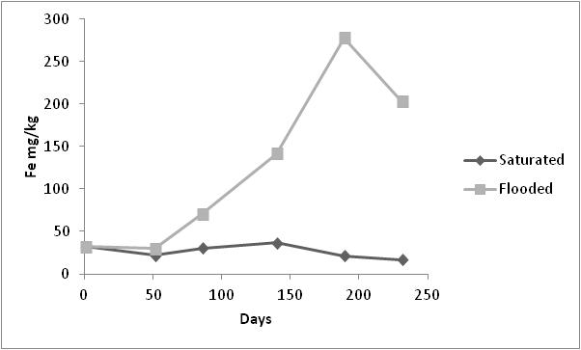
Figure 18 Iron concentrations in litter at Rush W throughout decomposition process.
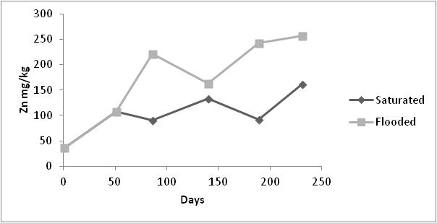
Figure 19 Zinc concentrations in litter at Rush W throughout decomposition process.

Table 25 Correlation values from Tar Creek systems and hydrologic zones comparing the iron and zinc concentrations with litter mass loss. df =10, p =0.05
 | Iron |  | Zinc
 | FLD | SAT | FLD | SAT
Adams A | -0.947 | -0.938 | -0.897 | -0.842
Rush W | -0.852 | 0.375 | -0.743 | -0.51
Hockerville | -0.983 | -0.898 | -0.869 | -0.865

The treatment systems metals concentrations of the litter had opposite trends for iron and zinc (Figure 20 to Figure 25). Iron consistently had a significantly negative correlation to percent remaining litter with the exception being the Le Bosquet polishing wetland. The correlation values for these relationships can be seen in Table 26. For all the systems and samples, zinc had a statistically significant positive relationship with the percent remaining litter mass.
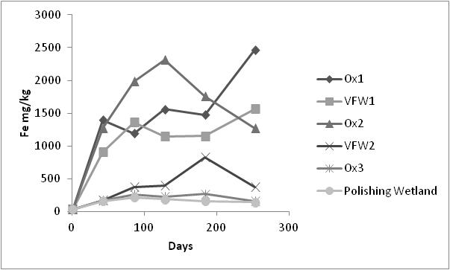
Figure 20 Iron concentrations in litter at Hartshorne throughout decomposition process.

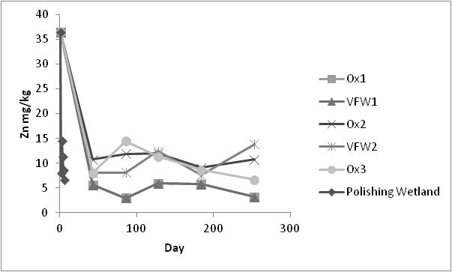
Figure 21 Zinc concentrations in litter at Hartshorne throughout decomposition process.

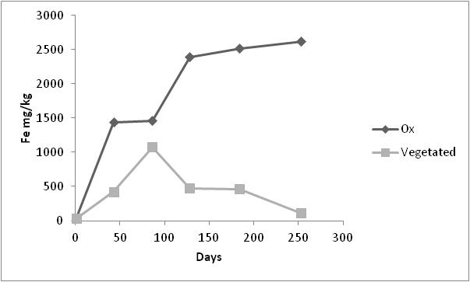
Figure 22 Iron concentrations in litter at Le Bosquet throughout decomposition process.

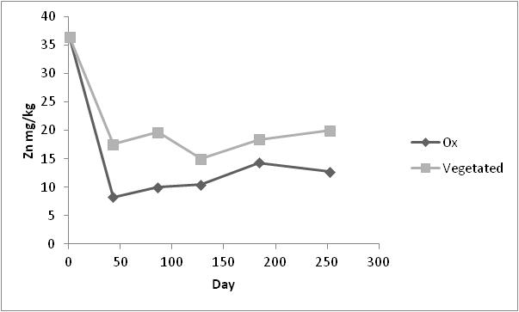
Figure 23 Zinc concentrations in litter at Le Bosquet throughout decomposition process.

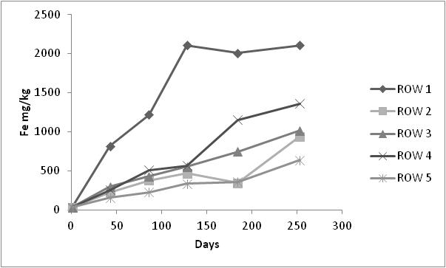
Figure 24 Iron concentrations in litter at Red Oak throughout the decomposition process.

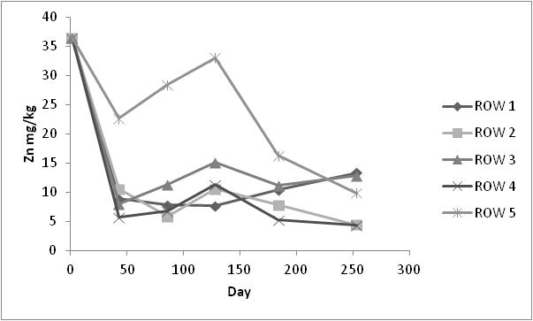
Figure 25 Zinc concentrations in litter at Red Oak throughout decomposition process.

Table 26 Correlation values, from the treatment systems and the treatment cells, comparing the iron and zinc concentrations to litter mass loss. df = 10, p = 0.05 for all systems
Site and Cells | Iron | Zinc
Red Oak 2 Ox | -0.845 | 0.963
Red Oak 3 VFW | -0.694 | 0.949
Red Oak 4 Ox | -0.862 | 0.824
Red Oak 5 VFW | -0.85 | 0.848
Red Oak 6 Ox | -0.836 | 0.717
Le Bosquet 2 Ox | -0.978 | 0.802
Le Bosquet 3 Pol | -0.323 | 0.861
Hartshorne 2 Ox | -0.851 | 0.977
Hartshorne 3 VFW | -0.937 | 0.972
Hartshorne 4 Ox | -0.754 | 0.845
Hartshorne 5 VFW | -0.739 | 0.864
Hartshorne 6 Ox | -0.834 | 0.853
Hartshorne 7 Pol | -0.768 | 0.889

2.4 Discussion
The Rush belowground biomass for the 2006 season could be due to the woody vegetation in the system, although this large number was not consistent with the aboveground vegetation value for the same year. Woody vegetation may not have been sampled in the aboveground vegetation, but the roots can grow into the quadrat where the belowground vegetation was sampled. The aboveground woody vegetation was able to be separated for the Le Bosquet (2007) sampling and it can be seen that there is a significant increase in the biomass when the woody vegetation is included (Table 7 and Table 8). Woody vegetation in these systems was Salix spp. Literature suggests that the percent of the total biomass in the belowground vegetation for Typha spp. dominated marshes is between 32-64% (Jørgensen, 1979). Belowground biomass in Typha spp. marshes (Commerce, Le Bosquet, and Hockerville) ranged from 50-78% of the total biomass. Rush W (2006) had belowground biomass account for 90% of the total biomass; this could be due to the woody biomass roots being within the quadrats sampled. Adams A had belowground biomass percentages of 78% and 83%. This system was dominated by Juncus spp., which had smaller root masses than Typha spp. (Cronk and Fennessy, 2001). The higher percentage of root biomass may be accounted for because many of the quadrats sampled did not have any standing visible aboveground vegetation, yet live root biomass was obtained.
Previous studies have suggested that peak biomass production for Typha spp. marshes is from July-September and all these systems were sampled during August, so it can be assumed that all results from these systems represent the results of yearly peak primary productivity rates (Odum, 1971; Mason and Bryant, 1975; Sharma et al., 2006; Rocha and Goulden, 2009). All of these systems are considered freshwater marshes and the typical range of total aboveground and belowground biomass production is from 900-5500 g/m²/yr. The total biomass of all the systems sampled fall within this range (Jørgensen, 1979; Mitsch and Gosselink, 2000; Cronk and Fennessy, 2001).
The iron and zinc concentrations in the vegetation were within the ranges found in the literature (Vymazal, 1995; NADB Database, 1998; Bernard, 1998; Ye et al., 2001a; Ye et al., 2001b; Kadlec and Wallace, 2009). Typha spp. is a documented accumulator of iron and zinc, sometimes in large amounts, so the uptake values of iron and zinc from these sites was not unexpected (Ye et al., 1997; Deng et al., 2004; Weis and Weis, 2004; Kadlec and Wallace, 2009). Commerce (2006) had the greatest mean iron concentration of 9840.08±3365.05 mg/kg in the belowground biomass. Iron concentrations found in various types of vegetation in iron contaminated systems can be seen in Table 27. Previous studies suggest that iron concentrations in Typha spp. can range from 1,022 - 68,469 mg/kg in systems with elevated iron (Vymazal, 1995; NADB Database, 1998; Bernard, 1998; Ye et al., 2001a; Ye et al., 2001b; Kadlec and Wallace 2009). For iron concentrations in aboveground vegetation, the literature values range from 45 - 7352 mg/kg (Table 27); the iron values found in this study fall in the lower end of that range. Most of the studies shown in Table 27, for Typha spp., show iron concentrations for aboveground vegetation in the range of 45 - 350 mg/kg; a range more comparable to that found in the Typha spp. dominated systems of this study. Adams A had a greater amount of Juncus spp. According to Ye et al. (2001a, 2001b), Juncus spp. iron concentrations reached 320 mg/kg for aboveground vegetation and 41,319 mg/kg for below ground vegetation. Table 27 shows that iron concentrations in the aboveground and belowground biomass can vary between different locations and conditions. The Tar Creek and treatment wetland systems studied have plant iron concentrations that fall within the range found in the literature.
Zinc concentrations found in various types of vegetation in iron contaminated systems can be seen in Table 28. Previous studies suggest that zinc concentrations in Typha spp. belowground biomass can range from 23.7 - 835 mg/kg in systems with elevated zinc (Zhang et al., 1990; Behrends et al., 1996; Nolte and Associates, 1998; Karpiscak et al 2001; Manios et al., 2003; Chague-Goff 2005; Maddison et al., 2005; Obarska-Pempkowiak et al., 2005; Paredes et al., 2006; Kadlec and Wallace, 2009). The Adams A (2006) system had the greatest mean zinc concentration (3787.63±1632.65 mg/kg) in the belowground biomass, being a much greater concentration than the literature. For zinc concentrations in aboveground vegetation, the literature gives a range of 3.5 - 61 mg/kg (Table 28). Zinc values found in all the systems aboveground vegetation fall within this range, with the exception of Adams A (2006) and (2007). Adams A had a higher amount of Juncus spp., but this species difference does not explain the higher zinc concentration in the vegetation because the literature does not suggest that Juncus spp. are more capable of accumulating zinc than other species. A previous study on zinc concentrations in various macrophytes suggests that root concentrations can reach up to 1571 mg/kg and up to 1158 mg/kg in aboveground vegetation (Cardwell et al., 2002). Although the zinc concentrations for the Adams A system seem excessively high in the roots and live vegetation when compared to the literature, this could be due to this system being established on either zinc and lead mining wastes or mine tailing impoundments. Although these systems also had elevated iron levels, the iron oxyhydroxide plaques were not as prominent as those found at Commerce. This could indicate that the zinc could possibly flow more freely into the roots and live vegetation without interference from iron plaques.

Table 27 Iron concentrations in vegetation from the literature. Superscripts refer to a: aboveground vegetation, b: leaves, c: underwater stems (Adapted from Kadlec and Wallace, 2009)
Species | Location | Reference | Aboveground (mg/kg) | Belowground (mg/kg)
Typha latifolia | Preson County, West Virginia | Sencindiver and Bhumbla, 1988 | 208 (88-304)ª
T. latifolia | Monongalia County, West Virginia | Sencindiver and Bhumbla, 1988 | 1919 (409-7352)^{b} | -
T. latifolia | Cascade County, Montana | Hiel and Kerins, 1988 | 286 (± 98)ª | -
T. latifolia | Coshocton County, Ohio | Fennessy, 1988 | 335^{c} | -
T. latifolia | Athens County, Ohio | Mitsch and Wise, 1998 | 2500 | -
T. latifolia | Lake Mendota, Wisconsin | Smith et al., 1988 | 138 | -
Typha spp. | TVA Mussel Shoals, Alabama | NADB database, 1998 | 45-142 | 1011-7437
Typha glauca | New York | Bernard, 1998 | 292 | 10745
T. glauca | New York | Bernard, 1998 | 67 | 18,006
T. latifolia | Widows Creek, Alabama | Ye et al., 2001a,b | 1217 | 68,469
T. latifolia | Coeur d'Alene, Idaho | De Volder et al., 2003 | 200 | -
T. latifolia | Wisconsin | Vymazal, 1995 | 138 | 1,055
Typha angustifolia | Germany | Vymazal, 1995 | 1100 | -
T. angustifolia | 11 lakes, Poland | Samecka-Cymerman and Kempers, 2001 | 350 | -
Phragmites australis | TVA Mussel Shoals, Alabama | NADB database, 1998 | 112-161 | 2533-4547
P. australis | Nucice, Czech Republic | Vymazal and Krasa, 2005 | 139 | -
P. australis | New York | Eckhardt et al., 1999 | 618-799 | 7060-9280
P. australis | Brehov, Czech Republic | Vymazal, 2006 | 74 | 3677
Table continues on next page
Table 27 (continued)

P. australis | 11 lakes, Poland | Samecka-Cymerman and Kempers, 2001 | 1053 | -
Phalaris arundinacea | TVA Mussel Shoals, Alabama | NADB database, 1998 | 89-309 | 2445-8352
P. arundinacea | Nucice, Czech Republic | Vymazal and Krasa, 2005 | 323 | -
P. arundinacea | Brehov, Czech Republic | Vymazal, 2006 | 70 | 3383
P. arundinacea | 11 lakes, Poland | Samecka-Cymerman and Kempers, 2001 | 1202 | -
Scirpus acutus | TVA Mussel Shoals, Alabama | NADB database, 1998 | 47-107 | 1820-2754
Scirpus cyperinus | TVA Mussel Shoals, Alabama | NADB database, 1998 | 83-723 | 1185-2228
Scirpus lacustris | Czech Republic | Vymazal, 1995 | 129 | -
S. lacustris | Germany | Vymazal, 1995 | 780 | -
S. lacustris | 11 lakes, Poland | Samecka-Cymerman and Kempers, 2001 | 430 | -
Juncus effuses | Widows Creek, Alabama | Ye et al., 2001 a,b | 320 | 41318
Sagittaria latifolia | Coeur d'Alene, Idaho | De Volder et al., 2003 | 220 | -
Algae | Ireland | O'Sullivan et al., 2000 | 39 | -
Algae | Ireland | O'Sullivan et al., 2000 | 108 | -

Table 28 Zinc concentrations in vegetation from the literature (Adapted from Kadlec and Wallace, 2009).
Species | Reference | Water (ug/L) | Aboveground (mg/kg) | Belowground (mg/kg)
Scirpus acutus | Behrends et al., 1996 | 600 | 19 | 23
S. acutus | Nolte and Associates, 1998 | 36 | 10 | 36.2
Scirpus atovirens | Behrends et al., 1996 | 600 | 10 | 17
Scirpus cyperinus | Behrends et al., 1996 | 600 | 11 | 14
Scirpus lacustris | Samecka-Cymerman and Kempers, 2001 | 94 | 20
Scirpus spp. | Karpiscak et al., 2001 | 67 | 14.3 | 32.6
Juncus effuses | Samecka-Cymerman and Kempers, 2001 | 272 | 15
Juncus spp. | Chague-Goff , 2005 | 18 | 14 | 23
Phalaris arundinacea | Behrends et al., 1996 | 600 | 20 | 48
P. arundinacea | Vymazal and Krasa, 2005 | 198 | 23.9
P. arundinacea | Vymazal, 2006 | Sewage | 16.8 | 65
P. arundinacea | Samecka-Cymerman and Kempers, 2001 | 311 | 20
Phragmites australis | Vymazal, 2006 | Sewage | 12 | 85
P. australis | Behrends et al., 1996 | 600 | 28 | 62
P. australis | Vymazal and Krasa, 2005 | 198 | 28.7
P. australis | Samecka-Cymerman and Kempers, 2001 | 311 | 23.6
Typha spp. | Behrends et al., 1996 | 600 | 12 | 38
Typha latifolia | Obarska-Pempkowiak et al., 2005 | Sewage | 10.9
T. latifolia | Maddison et al., 2005 | Sewage | 14.5 | 181
T. latifolia | Paredes et al., 2006 | 1500 | 96 | 835
T. latifolia | Manios et al., 2003 | Sludge | 34-61 | 293-392
T. latifolia | Zhang et al., 1990 | 137 | 38 | 170
Typha domingensis | Nolte and Associates, 1998 | 36 | 11.3 | 30.8
T. domingensis | Karpiscak et al., 2001 | 67 | 3.5 | 49.4
Typha angustifolia | Samecka-Cymerman and Kempers, 2001 | 94 | 14
Glyceria maxima | Obarska-Pempkowiak et al., 2005 | Sewage | 12.3 | 25.2
Anemopsis californicus | Karpiscak et al., 2001 | 67 | 15 | 23.7
Lythrum hyssopifolia | Chague-Goff, 2005 | 18 | 49 | 86
The decay constants (k) for in the Tar Creek wetlands are similar to other Typha spp. decay constants in other systems (k = 0.0012 - 0.0240 day⁻¹; Mitsch and Gosselink, 2000). It is possible that the Adams A and Hockerville wetlands would have seen a more significant difference between the FLD and SAT zones had the precipitation been greater than that in the years the study was completed. In both wetlands, for multiple sampling dates, the FLD zones were dry and the litter bags collected were dry as well. Rush W had FLD zones that were constantly wet and water was flowing out of the system when the system was visited for each sampling event. It has been shown that systems with fluctuated flooding can have higher decomposition rates (Brinson, 1977; Mitsch and Gosselink, 2000). This previously noted relationship between flooding and decomposition could explain why the FLD zones of the Tar Creek wetlands had higher decay constants
There could be a number of reasons why the first oxidation ponds consistently had the lowest rates of decomposition. Many of the samples collected from those cells were coated with iron oxides, which could prevent biological activity at the surface of the litter and also prevent anything from being released from the litter bag (Miltner and Zech, 1998; Siefert and Mutz, 2001; Schlief and Mutz, 2005). Decay constants increase successively through the treatment wetland systems (see Table 24) and this could indicate an increase in microflora/fauna activity in the substrate. Whether this could be related to an improvement in water quality was not explored in this study, but may be important to explore in future studies.
Wieder et al. (1983) did a study of decomposition within surface mine runoff. Their research indicated that decomposition was reduced at sites where the soil was highly acidic, compared to soils that were moderately acidic. If the same conclusion could be drawn for systems with acidic waters, then it is possible that higher acidity of a system could reduce decomposition of the litter. Wieder et al. (1983) also explored the possibility of differences in abiotic factors at different sites affecting decomposition. Sites that are highly vegetated could have fewer fluctuations in microclimates, daily temperatures, and soil moisture levels. Surfaces that are not vegetated are exposed directly to the sun, potentially reaching extremely high temperatures and leading to low soil moisture, conditions that limit decomposer activities. This could explain the lower decomposition rates in the SAT hydrologic zones at the Tar Creek site. Many litter bags were in zones that were not abundant in vegetation, had low organic matter, and remained dry.
Batty and Younger (2007) documented increasing concentrations of metals in litter over time for both iron and zinc. The study observed litter with a starting iron concentration of 279±50 mg/kg and the litter increased in iron concentration by as much as 2961 mg/kg. The same trend was observed with zinc, starting with 37±9 mg/kg and increasing by 130 mg/kg. Litter in the Tar Creek systems did not increase in iron as much as litter in the first cells of the treatment systems, with the Tar Creek wetlands having a maximum increase of 594 mg/kg and the treatment systems having a maximum increase of 2585 mg/kg. Zinc increased as much as 556 mg/kg at the Tar Creek wetlands making it much higher than what is reported in the literature in similar studies, but the mean was 231 mg/kg in the Tar Creek wetlands. The treatment systems had a decrease in zinc up to 33 mg/kg.
Batty and Younger (2007) suggested that the increase of iron in the litter could be due to biological activity of microorganisms on the litter and the accumulation of iron oxides, facilitating adsorption of other metals. The trend of metal concentration increasing as litter decomposes suggests that litter can act as a sink for metals in wetlands (Batty and Younger, 2007). This trend can be seen in all systems, with the exception being zinc in the treatment systems. The treatment systems all had very low zinc concentrations in the water (0.006 - 0.087 mg/L) and the litter started out with a concentration of zinc at 36 mg/kg. These findings suggest that zinc could be released from biological matter rather than be stored and, as in the case of the oxidation wetlands in the treatment system, iron was not facilitating the adsorption of zinc in those systems.
This study shows that wetland hydrology can greatly influence the decomposition of litter. It also gives interesting observations as to the changes in decomposition rates with flow through treatment wetland cells. Although litter bags remained submerged throughout the study in the treatment wetlands (not including ROW5), it can be concluded that other biological and chemical factors could be influencing how litter decomposes in these systems. The behavior of metals during the decomposition process and subsequent understanding of the contribution of litter as a sink for metals could be of benefit in developing or altering wetlands for improving water quality.

Chapter 3 : Generalized dynamic model for three hydrologically different wetlands

3.1 Introduction
Wetlands can provide many important ecological and societal services, including but not limited to, flood control, habitat provision, and removal of contaminants. Wetlands, therefore, are often restored or created to provide one or more of these services (Mitsch and Wilson, 1996; Porter, 2004; Behum, et al., 2006; Armitage and Fong, 2004; Moreno-Mateos and Comin, 2010; Nairn et al., 2010; Smiley and Allred, 2011). Of all the services provided, hydrologic processes need to be considered during creation and restoration (Kadlec, 1997; Mitsch and Gosselink, 2000; Hammersmark et al., 2005). It has been estimated that wetlands provide a total global value of 4.8 trillion US dollars per year and the hydrological services of global water regulation and supply provide an estimated 1.2 trillion US dollars per year (Costanza et al., 1997).
The hydrologic processes within a wetland are the primary forcing functions in these ecosystems (Mitsch and Gosselink, 2000). In fact, many of the first studies of wetland hydrology observed the relationships between water depth and wetland productivity or species composition (Heinselman, 1963; Hemiburg, 1984; Kadlec, 1989). For example, the species composition of wetlands can be strongly influenced by hydrologic processes such as the amount of water entering the system and hydrologic perturbations such as flooding or drought periods. The vegetation that grows in the system and related organisms such as beavers can influence the flow and retention of water and can be examples of naturally occurring alterations to a wetland’s hydrology (Junk et al., 1989; Mitsch and Gosselink, 2000; Hammersmark et al., 2005). Hydrology can influence how a wetland progresses and develops, thus understanding each system’s hydrology is important for modeling the system.
Models of wetland hydrologic and ecosystem processes have been developed since the 1970s (Bayley and Odum, 1976; Hopkinson and Day, 1980; Mitsch et al., 1988; Poiani and Johnson, 1993; Cronk and Mitsch, 1994; Barnfireun and Roulet, 1998; Winter and Rosenberry, 1998; Zhang et al., 2002). Some models have been developed to evaluate ideal hydrologic processes for created and restored wetland design and construction (Kadlec, 1997; Trepel et al., 2000; Arnold et al., 2001; Toscano et al., 2009; Min and Wise, 2009). Other models have been developed to understand the hydrologic functions in natural wetland systems (Hammer and Kadlec, 1986; McKillop et al., 1999; Mansell et al., 2000; Su et al., 2000; Chen and Zhao, 2011).
Recent modeling research has demonstrated that a wetland’s hydrology has an impact on ecosystem dynamics (Raisin et al., 1999; Cole and Brooks, 2000; Price and Waddington, 2000; Su et al., 2000; Spieles and Mitsch, 2000, 2003; Mitchell et al., 2001; Raghunathan et al., 2001; Ahn and Mitsch, 2002 a, 2002b; Zacharias et al., 2004; Zhang and Mitsch, 2005). When developing or improving wetlands for ecological services, understanding the hydrologic conditions, including predicting and estimating how a system responds to flood or drought conditions, could be important for management (Muller and Windorst, 2000; Zhang and Mitsch, 2005). Water and how it functions in wetlands is also important for transport of matter and organisms and the ecosystem energy balance (Mitsch and Gosselink, 2000). Water gets transported through many pathways in a wetland, including plants, soils, leaching, interflow, seepage, storage, groundwater, surface water, transpiration and evaporation. An understanding of hydrologic flows and stores in any system is central for ecosystem budgeting and necessary to get an accurate model (Muller and Windhorst, 2000).
Total ecosystem energetic models need a hydrologic model component to account for variations in plant growth rates, chemical reaction rates, and transport of materials and organisms within the ecosystem. The hydrologic submodel developed here will provide these important components. This study attempted to develop a generalized hydrologic model that can be utilized within other system models and be easily adjusted for different types of wetland systems. Three types of wetlands, a treatment wetland, a shallow wetland and a deep-water wetland, were simulated to test model responses during two different scenarios, normal rainfall years and years with a drought. Significant differences and trends were noted in the results and expectations compared between shallow and deep natural wetlands and treatment wetlands.

3.2 Methods

3.2.1 Model Development
Possible surface inflows for the hydrologic model included precipitation, surface runoff, groundwater seeps, and/or streams. Outflows include evapotranspiration and surface outflow. Three types of wetland systems were modeled in this study. First a treatment wetland was modeled, with an artesian flowing seep with a constant inflow rate. Precipitation and runoff from precipitation were also included in this hydrologic submodel. The treatment system’s primary outflow was assumed to be a surface outflow that remained fairly constant year round. Evapotranspiration was a source of secondary outflow. Second, a deep water system was modeled, which would never go dry and had no consistent surface inflow. The primary inflows were assumed to be precipitation and surface runoff. Surface outflow only occurred if the volume got above a specified elevation. Third, a shallow system was modeled, where the main inflows were precipitation and surface runoff. The surface outflow would only occur when the system had reached a volume overflow. These three simulations were compared to observations from Hockerville (shallow system), Rush W (shallow system), Adams A (deep water system), and Red Oak (treatment system). For all systems, groundwater inflows and outflows, other than artesian mine drainage seeps, were assumed to have little or no impact on system hydrology. For treatment systems, the substrate was designed to prevent groundwater inflow and outflow. For the volunteer systems, groundwater inflows and outflows were not observed or explored in field collection.
The generalized hydrologic model in STELLA 8.1 format is shown in Figure 26. Detailed explanation of icons in model figures can be found in Appendix B: STELLA Model Symbols Used. This model includes the main inflows of precipitation and surface inflow and the main outflows from surface outflow and evapotranspiration. These inflows and outflows determine the volume of the system. These flows were calculated using watershed area, wetland surface area, rainfall, insolation, temperature and outflow rates. They are discussed in more detail in Sections 3.2.2 – 3.2.7.
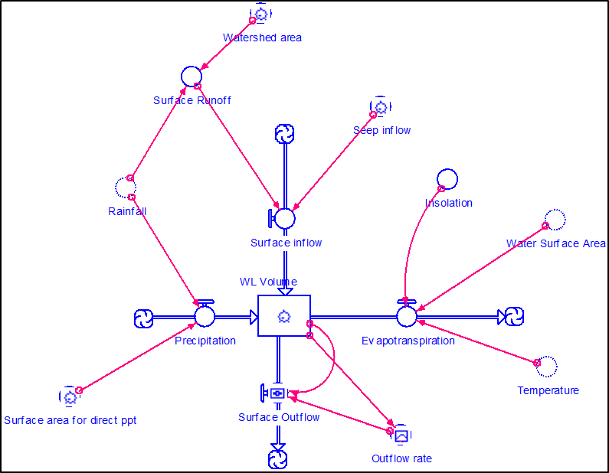
Figure 26 Generalized model for wetland hydrology using STELLA 8.1.

3.2.2 Temperature, Precipitation and runoff
The models developed for this study use data from three treatment wetlands located in the eastern portion of Oklahoma and three shallow and deep volunteer wetlands located in the Tar Creek Superfund site in northeastern Oklahoma. Four years of temperature and precipitation data were obtained from the Oklahoma Mesonet at the locations closest to these reference sites in Miami, OK (N 36°53’17”; W 94°50’39”) for northeast Oklahoma and McAlester, OK (N 34°52’56”; W 95°46’51”) for eastern Oklahoma sites. The dates of January 2005-December 2008 were used for the four years of the study (Oklahoma Climatological Survey, 2009).
STELLA is limited to entering 1500 data points into the graphical function and thus the model is limited to just 1500 days when using real-time data. To circumvent this limitation, multiple graphs were created for precipitation and temperature and were added consecutively into a separate converter to develop a continuous data set as can be seen in Figure 27 and Equations 2 and 3 (providing a total time period of 4389 days in this model). In the constructed temperature and rainfall submodels, this method repeated the time period of January 2005 - December 2008 as many times as the equation specifies to create a long time series of real-time data. Although it would be optimal to have a time series of data for a longer period rather than just repeating the same time series, this was not necessary because the only first four years of the simulation were needed for the hydrologic model to reach a dynamic equilibrium.
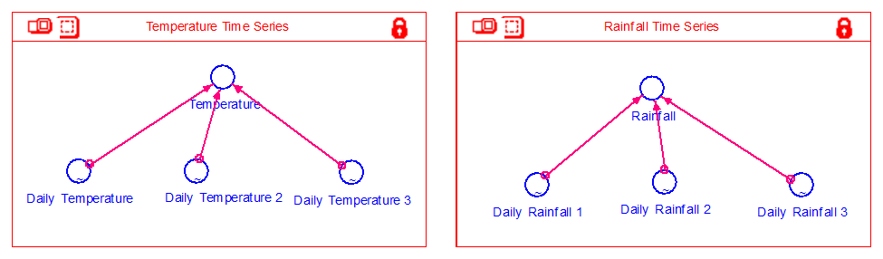
Figure 27 Submodels for temperature and rainfall time series calculation used to created a time series greater than 1500 data points.

Precipitation and temperature calculations were developed as Equations 2 and 3:

$Rainfall=Daily Rainfall 1+Daily Rainfall 2+Daily Rainfall 3$ (2)
$Temperature=Daily Temperature 1+Daily Temperature 2+Daily Temperature 3$(3)
It must be noted that in the graphical function, the last data point in the time series remains that same value throughout the whole simulation, potentially leading to erroneous calculations throughout the model. To correct for this fact, all of the time series that are added together had a zero manually placed into the end of each data set. The zero was able to be removed from the data set before analysis and does not affect the calculations within the simulations. Total precipitation was determined from rainfall and the maximum potential wetland surface area (Equation 4).
$Precipitation \left(m^{3}\right)=Daily Rain*Surface Area$ (4)

3.2.3 Runoff
The Rational method was used to calculate daily runoff as shown in Equation 5 (Kadlec and Wallace, 2009):
$Runoff \left(m^{3}\right)=Daily Rain*k*Watershed$ (5)
Where daily rain (m) is the same real-time data used in the precipitation calculations, watershed is the area (m²) that drains into the wetland and k is the hydrologic response coefficient. Parameters such as permeability, the type of landscape and the catchment area are considered and affect the coefficient value. Areas that have highly impermeable terrain had a higher hydrologic response coefficient of 0.80-1.00. Vegetated areas with sandy and gravelly soils had a coefficient from 0.30-0.40 while values of 0.40-0.50 were used for heavy clay soils and shallow soils over bedrocks. The more permeable the soils, the lower the hydrologic response coefficient (Dunne and Leopold, 1978; Mitsch and Gosselink, 2000; Blume et al., 2007; Kadlec and Wallace, 2009).
For treatment wetlands, with surrounding berms, runoff occurs on the area within the berms with a runoff area of approximately 25% the size of the wetland (Kadlec and Wallace, 2009). Treatment wetland bottoms are also built to minimize permeability to water, resulting in a higher runoff coefficient. The wetlands used in this study had large amounts of vegetation established along the berms, which can reduce runoff.
Vegetation reduces the impact of the raindrops and reduces the energy of the runoff (Bochet et al., 1999; Duran-Zuazo and Rodriguez-Plequezuelo, 2008). Evidence suggests that the interactions between vegetation and soil hydrology are generally non-linear positive relationships (Thornes, 2004; Moreno-de las Heras et al., 2009). Other studies of the hydrological behavior of natural and reclaimed soils show this same positive behavior with vegetation (Sanchez and Wood, 1989; Castillo et al., 1997; Loch, 2000; Cerda. 2007; Marques et al., 2007). Experimental slopes, with large amounts of vegetation, can increase soil infiltration capacity, reduce soil erodibility, and delay runoff (Elwell and Stocking, 1976; Bochet et al., 1999; Moreno-de las Heras et al., 2009).
The volunteer wetlands studied at the abandoned mine sites in northeast Oklahoma had vegetated chat (gravel-like mining waste) and surfaces with less slope than the catchments of the treatment wetlands. For modeling purposes, the runoff coefficient value of 0.45 was chosen for both volunteer and treatment wetlands. This number reflects the vegetated surface, gravelly and sandy surfaces, and permeability of the various soils. A generalized 25% catchment area was used for the treatment wetland simulations. The catchment areas for the volunteer wetlands in were determined from aerial photos (Google Earth, 2013).

3.2.4 Total Inflows
Inflows for the system were added together for the model and included precipitation, runoff and any mine water seeps, if present at the site. The total system inflows were calculated using Equation 6:
$Inflow{(m}^{3})=Precipitation+Runoff+Seep$ (6)
Included in the inflows of the model are precipitation, surface runoff and flow from a seep . The seep’s flow was calculated as m³/day and used data from the field measurements at each system with a seep.

3.2.5 Insolation
Insolation was calculated in the model and used in the evapotranspiration calculations. The calculation for insolation is shown in Equation 7 (Spieles and Mitsch, 2003).
$Insolation \left(cal{ cm}^{2}day\right)=(400+200*cos\left(\frac{\left(2π*time\right)+312}{365}\right)$ (7)
Time in the equation represents the program’s (STELLA) current point of time in the simulation. The function was adjusted to fit with the real-time data of temperature throughout the year. The models developed from these equations began and used real-time data on January 1st of the pre-set starting year. The equation used by Spieles and Mitsch (2003) would start the insolation curve in the middle of the summer. The adjustment is shown in Equation 8 and allows the insolation to match the date where temperature and precipitation would start on January 1st of the initial year (Figure 28).
$Insolation \left(cal {cm}^{2}day\right)=(400+200*cos\left(\frac{\left(2π*time\right)+1000}{365}\right)$ (8)

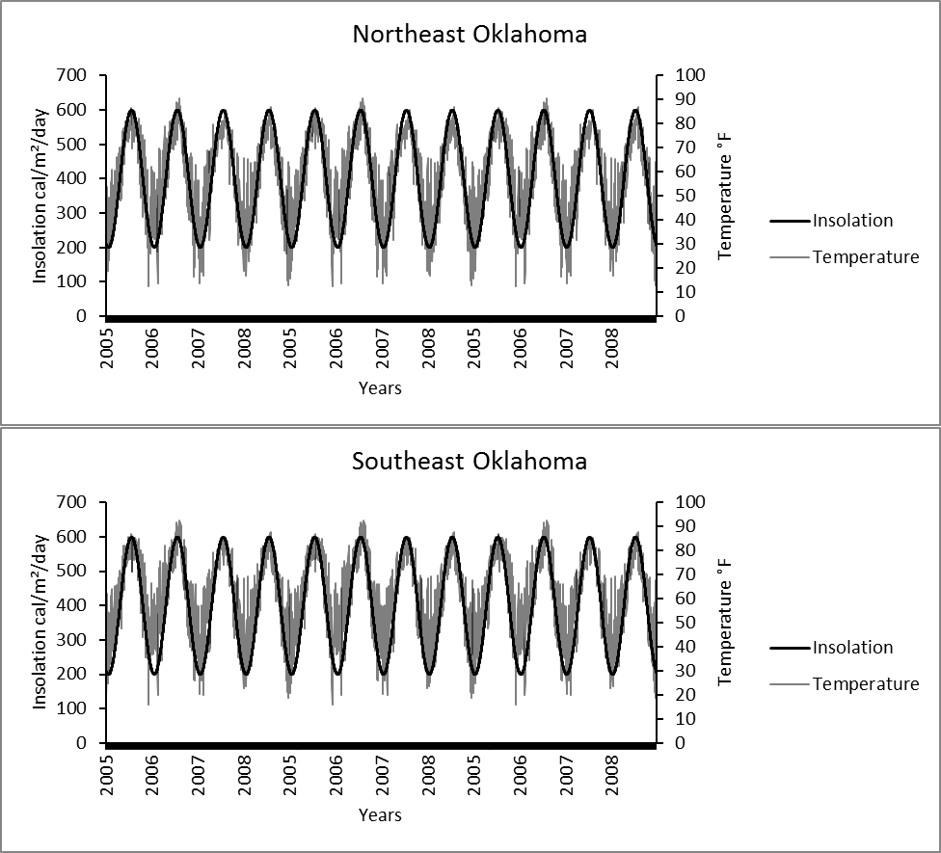
Figure 28 Model results for temperature and insolation for northeast and southeast Oklahoma, using Mesonet data for temperature. Temperature and insolation keep the same expected pattern when insolation is adjusted to meet with temperature on the beginning of the year as done in Equation 8.

3.2.6 Evapotranspiration
There are many different methods that can be used to estimate local evapotranspiration by including selected physical variables. The Penman method uses temperature, wind speed, solar radiation, elevation, and vapor pressure. The Thornthwaite method uses temperature and the Penman-Monteith method incorporates the factors of stomatal resistance of the plants and the wind evapotranspiration (Cronk and Fennessy, 2001). For this study, the Jensen-Haise equation was used (Equation 9) because it relies strongly on direct insolation and temperature, both variables that are easily calculated within the model (Rosenberry et al., 2004).
$Evapotranspiration \left(mm {day}^{-1}\right)=\left(0.014T-0.37\right)\left(I*0.000673\right)*Surface area*25.4$ (9)
Where T is temperature in °F and I is solar radiation in cal cm²/day⁻¹ (McGuinness and Borne, 1972; Rosenberry et al., 2004).
At a given temperature and surface area, evapotranspiration should be constant. If a constant volume is being removed and if the model ran dry, the system would continue to evapotranspire, which is impossible. The system would continue to evapotranspire, which is impossible. To correct this, the hydrology model needed to include surface area calculations that were dependent on the wetland’s volume. The assumption that the wetland would be a half ellipsoid allowed for the calculation of the wetland surface area based on the wetland’s volume and a graphical function for depth as seen in Figure 29.
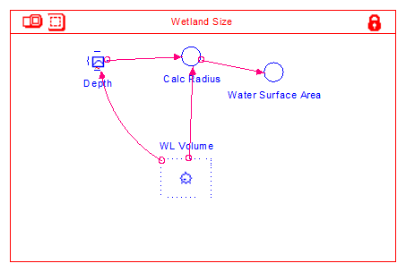
Figure 29 Submodel for wetland surface area calculation.

A wetland size submodel was developed to determine the surface area of the wetland at each volume calculation. Depth was first obtained using a natural log function of the volume of the system. A multiplier b was then used to correct the log function to the correct depth of the system and a graph was produced for the model’s function. See Figure 30 for an example.
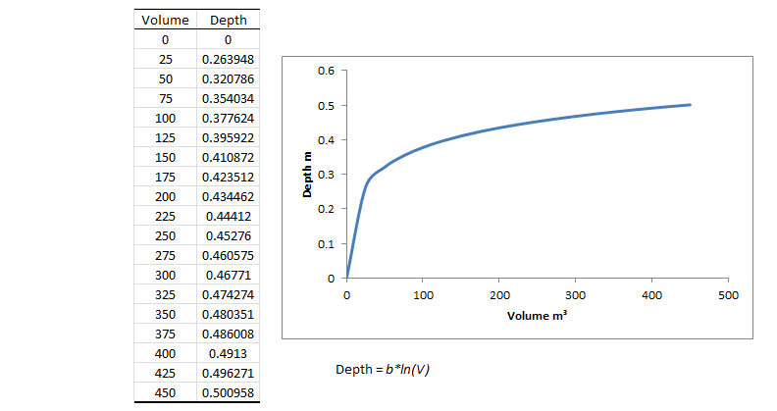
Figure 30 Example of how depth and volume relationship is developed using the natural log function. V is the volume and b is the coefficient used to fit the depth with the desired system.

To get to the surface area calculation, the radius of the surface area must be determined first from the depth and volume (Equation 10):
$r=\sqrt{\frac{3V}{2πd}}$ (10)
From the volume and depth graphical function, the wetland’s surface area can be calculated using the surface area function for a circle (Equation 11):
$Surface Area \left(m^{2}\right)=r^{2}π$ (11)
The equations for the area and depth calculations in this model make the assumption that the shape of the system is a half-ellipsoid with a pair of equal semi-axes (the surface area radius) and a distinct axis (the depth). Although most systems are not of this exact shape, this simplification approximates environmental conditions.

3.2.7 Surface Outflow
Surface outflow was calculated using by Equation 12:
$Surface Outflow\frac{m^{3}}{day}=Wetland Volume*Outflow Coefficient$ (12)
Where the outflow coefficient is a graphical function determined for the specific system. The outflow rate is determined by multiplying the volume of the water and the calibrated outflow coefficient. The shallow wetland and the deep water systems had no outflows unless the water inflow, usually during a rain event, raised the system’s volume to an overflow point. Treatment wetlands are designed to have a specified detention time in order to treat the water, thus these systems do not have significant variability in the flow and water elevations (Mitsch and Jørgensen, 2004). In the case of a treatment wetland, when the water depth goes below the outflow point, there will be no outflow. When the wetland’s volume increases significantly, the amount of water leaving the system increases. Therefore, if the water rises above the berms the wetland will overflow. By using the graphical function in STELLA, the user can adjust the outflow coefficient to change during these different scenarios. The graphical functions used in these models can be seen in Figure 31.
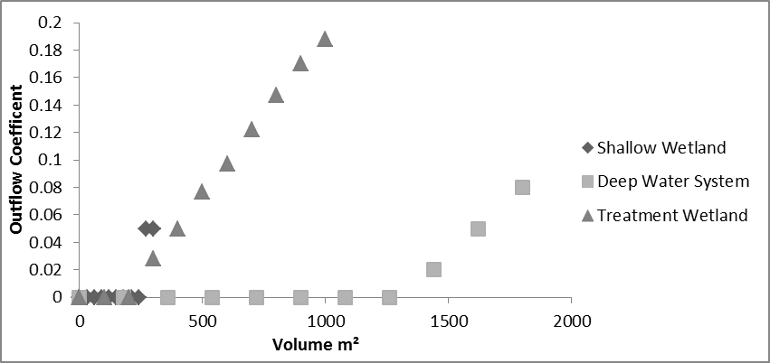
Figure 31 Outflow coefficient graphs and data points calibrated in the different simulations.

3.3 Results

3.3.1 Model Validation
The model was run to simulate the three types of wetlands over a 12 year period. Analysis was done for the four years at the center of the run, Years 5-8. This allowed the model to stabilize and to make sure the results analyzed reflected a system that has been in existence for four or more years. The last four years were also left out for most of the analyses because the results of those last four years reflected the same data from the Years 5-8, showing no difference. The drought years were also inserted into the middle of the model run at year six. Limiting the analyses to Years 5-8 allowed for focus on the effects of the drought in that short time span. All models ran recovered by year nine.
The combination of multiple graphical functions within the same converter (Figure 27; Equations 2 and 3) provided a continuous real time data series for precipitation and temperature for the simulations as seen in Figure 32. This successfully allowed the model work around the 1500 data point limitations of STELLA.

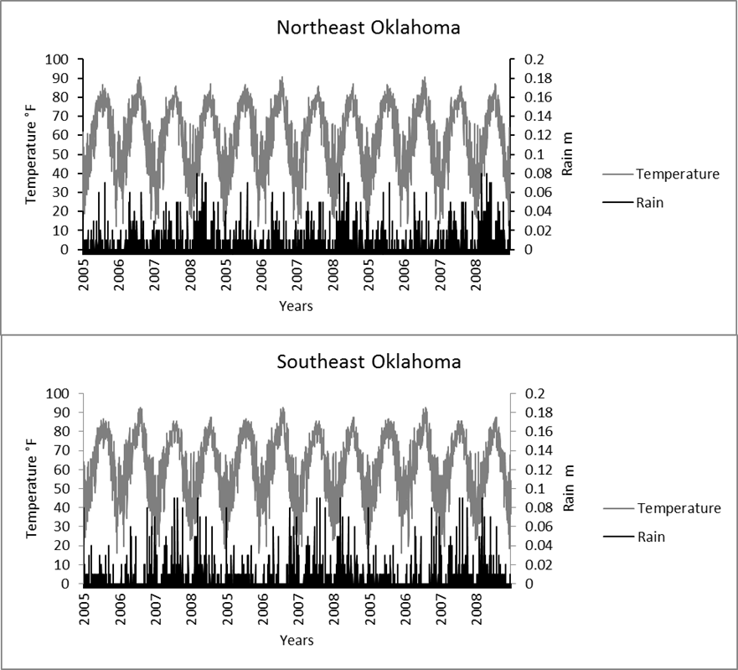
Figure 32 Combining the time series data into the same converter to enable data sets greater than 1500 points. The same years are repeated due to the simulation programming repeating the same smaller data set multiple times.

The shallow wetland had precipitation and surface runoff from a small watershed as the only inflow sources and the primary outflow was evapotranspiration. Overflow is the only surface outflow for the system. The wetland could possibly go dry during hot, dry times of the year. This situation was simulated during a drought year in the second run of the model.
The deep water system modeled had precipitation and evapotranspiration as the primary inflow and outflows, respectively. In the deep water system, the surface inflow came from a large watershed and surface outflow only occurred when the system volume was enough to overflow, as designated in the graphical function. This system never went dry, even during drought years.
The last system modeled was a treatment wetland. These types of systems are designed to treat a specified amount of water entering and leaving the system. The primary inflow was seepage with some contribution from precipitation. There is no surface runoff in this model. Because of these parameters, the treatment system model is expected to have little fluctuation in the wetland volume.
Each type of system responded differently to the drought year added to the model. A Student’s two-tailed t-test was used to identify any differences between the normal and drought years. Treatment wetlands are expected to be consistent and not have significant changes in flows and volumes throughout the year (Figure 33). The model with the drought year reflected this expectation, with no significant differences between the model’s calculations for evapotranspiration (t(2920) = 0.46, p = 0.05), precipitation (t(2920) = 0.47, p = 0.05), surface outflow (t(2920) = 1.16, p = 0.05) and surface inflow (t(2920) = 0.47, p = 0.05). Whereas the system’s volume (t(2920) = 4.32, p = 0.05), depth (t(2920) = 5.31, p = 0.05), radius (t(2920) = 4.47, p = 0.05), and surface area (t(2920) = 4.27, p = 0.05) showed significant differences between the two simulations. The differences in the variables between the two different simulations can be found in Table 29.
The small shallow wetland was expected to go dry during drought times and these results were visible during the drought year in
Figure 34. The differences between the simulations can be seen in Table 30. This wetland’s variability in hydrology gave results of significant difference between volumes (t(2920) = 2.66, p = 0.05), depth (t(2920) = 7.13, p = 0.05), radius (t(2920) = 4.77, p = 0.05) and surface area (t(2920) = 3.14, p = 0.05) in the two model runs. There was not a significant difference between the model’s evapotranspiration (t(2920) = 1.69, p = 0.05), precipitation (t(2920) = 0.47, p = 0.05), surface inflow (t(2920) = 0.47, p = 0.05), and surface outflow (t(2920) = 0.01, p = 0.05),
A large drop in the deep water system’s volume and depth during the drought can be seen in the 6th year and there is not much drop in the surface area, as can be found in
Figure 35 and Table 31. There was no difference in the runs for the deep water system for evapotranspiration (t(2920) = 0.05, p = 0.05), precipitation (t(2920) = 0.25, p = 0.05), surface inflow (t(2920) = 0.25, p = 0.05), surface outflow (t(2920) = 0.59, p = 0.05), volume (t(2920) = 0.61, p = 0.05), depth (t(2920) = 0.66, p = 0.05), radius (t(2920) = 0.63, p = 0.05), and surface area (t(2920) = 0.62, p = 0.05).

Table 29 Treatment wetland results in normal rainfall year versus drought year.
Normal Precipitation
 | Volume (m³) | Depth (m) | Surface Area (m²) | Radius (m) | Evapotranspiration (m³/day) | Precipitation (m³/day) | Surface runoff (m³/day) | Surface Inflow (m³/day) | Surface Outflow (m³/day)
Mean | 454.38 | 0.92 | 742.51 | 15.37 | 2.85 | 2.08 | 0.23 | 30.23 | 29.46
Standard Deviation | 17.70 | 0.01 | 24.11 | 0.25 | 1.93 | 7.41 | 0.83 | 0.83 | 3.37
Max | 560.08 | 0.95 | 885.27 | 16.79 | 6.59 | 71.32 | 8.02 | 38.02 | 49.86
Median | 453.26 | 0.92 | 740.93 | 15.36 | 2.54 | 0.00 | 0.00 | 30.00 | 29.18
Min | 423.45 | 0.91 | 700.24 | 14.93 | 0.00 | 0.00 | 0.00 | 30.00 | 23.85
Drought Precipitation
 | Volume (m³) | Depth (m) | Surface Area (m²) | Radius (m) | Evapotranspiration (m³/day) | Precipitation (m³/day) | Surface runoff (m³/day) | Surface Inflow (m³/day) | Surface Outflow (m³/day)
Mean | 453.97 | 0.92 | 741.95 | 15.37 | 2.85 | 2.01 | 0.23 | 30.23 | 29.39
Standard Deviation | 17.95 | 0.01 | 24.46 | 0.25 | 1.93 | 7.32 | 0.82 | 0.82 | 3.41
Max | 560.08 | 0.95 | 885.27 | 16.79 | 6.59 | 71.32 | 8.02 | 38.02 | 49.86
Median | 453.15 | 0.92 | 740.80 | 15.36 | 2.54 | 0.00 | 0.00 | 30.00 | 29.16
Min | 423.15 | 0.91 | 699.81 | 14.93 | 0.00 | 0.00 | 0.00 | 30.00 | 23.80

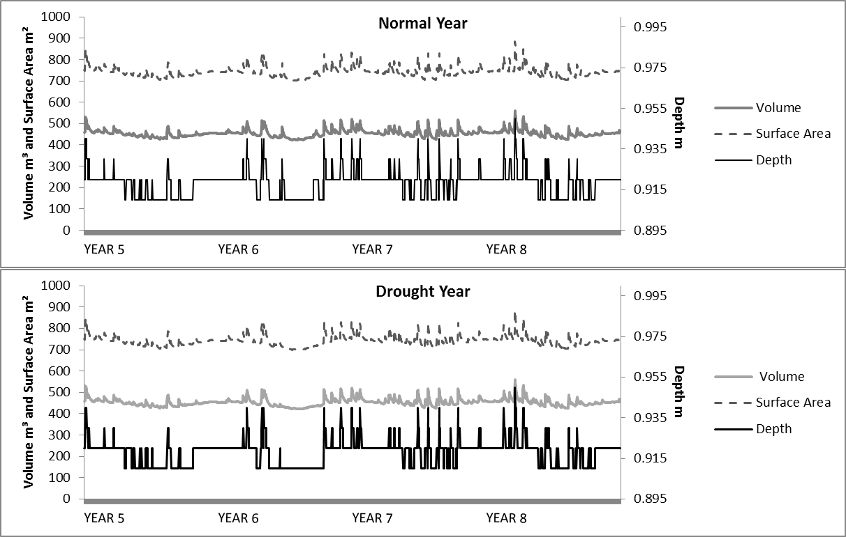
Figure 33 Volume, surface area, and depth during years 5-8 for the treatment system. The top figure shows the system in a normal precipitation year and the bottom figure shows that Year 6 had a drought rainfall.

Table 30 The shallow wetland results with a normal precipitation year and a drought year.
Normal Precipitation
 | Volume (m³) | Depth (m) | Surface Area (m²) | Radius (m) | Evapotranspiration (m³/day) | Precipitation (m³/day) | Surface runoff (m³/day) | Surface Inflow (m³/day) | Surface Outflow (m³/day)
Mean | 112.25 | 0.39 | 412.64 | 11.21 | 1.47 | 0.87 | 0.65 | 0.65 | 0.05
Standard Deviation | 58.01 | 0.05 | 170.66 | 2.39 | 1.25 | 2.63 | 1.97 | 1.97 | 0.57
Max | 266.85 | 0.47 | 842.93 | 16.38 | 5.52 | 25.15 | 18.86 | 18.86 | 11.94
Median | 107.25 | 0.40 | 404.84 | 11.35 | 1.17 | 0.00 | 0.00 | 0.00 | 0.00
Min | 27.29 | 0.28 | 145.66 | 6.81 | 0.00 | 0.00 | 0.00 | 0.00 | 0.00
Drought Precipitation
 | Volume (m³) | Depth (m) | Surface Area (m²) | Radius (m) | Evapotranspiration (m³/day) | Precipitation (m³/day) | Surface runoff (m³/day) | Surface Inflow (m³/day) | Surface Outflow (m³/day)
Mean | 106.30 | 0.37 | 391.62 | 10.72 | 1.39 | 0.82 | 0.62 | 0.62 | 0.05
Standard Deviation | 62.70 | 0.09 | 190.70 | 3.13 | 1.26 | 2.57 | 1.93 | 1.93 | 0.57
Max | 266.82 | 0.47 | 842.84 | 16.38 | 5.52 | 25.15 | 18.86 | 18.86 | 11.93
Median | 103.92 | 0.39 | 394.94 | 11.21 | 1.05 | 0.00 | 0.00 | 0.00 | 0.00
Min | 0.00 | 0.00 | 0.00 | 0.00 | 0.00 | 0.00 | 0.00 | 0.00 | 0.00

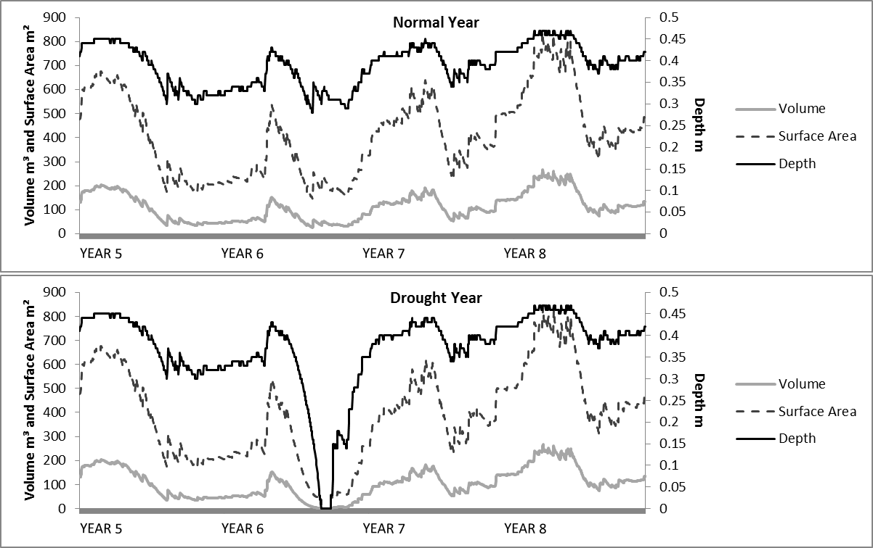

Figure 34 Volume, surface area, and depth during years 5-8 for the shallow water system. The top figure shows the system during a normal precipitation year and the bottom figure shows a drought during year 6.

Table 31 The deep water system results with a normal precipitation year and a drought year.
Normal Precipitation
 | Volume (m³) | Depth (m) | Surface Area (m²) | Radius (m) | Evapotranspiration (m³/day) | Precipitation (m³/day) | Surface runoff (m³/day) | Surface Inflow (m³/day) | Surface Outflow (m³/day)
Mean | 1336.54 | 6.94 | 288.70 | 9.58 | 1.05 | 0.87 | 13.03 | 13.03 | 12.83
Standard Deviation | 79.51 | 0.05 | 15.13 | 0.25 | 0.77 | 2.63 | 39.47 | 39.47 | 16.36
Max | 1757.74 | 7.06 | 373.60 | 10.91 | 2.56 | 25.15 | 377.19 | 377.19 | 128.24
Median | 1311.38 | 6.93 | 283.95 | 9.51 | 0.91 | 0.00 | 0.00 | 0.00 | 7.49
-Min | 1241.77 | 6.87 | 270.93 | 9.29 | 0.00 | 0.00 | 0.00 | 0.00 | 0.00
Drought Precipitation
 | Volume (m³) | Depth (m) | Surface Area (m²) | Radius (m) | Evapotranspiration (m³/day) | Precipitation (m³/day) | Surface runoff (m³/day) | Surface Inflow (m³/day) | Surface Outflow (m³/day)
Mean | 1322.64 | 6.93 | 286.09 | 9.54 | 1.04 | 0.82 | 12.35 | 12.35 | 12.12
Standard Deviation | 94.03 | 0.06 | 17.83 | 0.29 | 0.76 | 2.57 | 38.60 | 38.60 | 16.48
Max | 1757.74 | 7.06 | 373.60 | 10.91 | 2.54 | 25.15 | 377.19 | 377.19 | 128.24
Median | 1306.22 | 6.92 | 282.99 | 9.49 | 0.90 | 0.00 | 0.00 | 0.00 | 6.71
Min | 1095.14 | 6.75 | 243.23 | 8.80 | 0.00 | 0.00 | 0.00 | 0.00 | 0.00

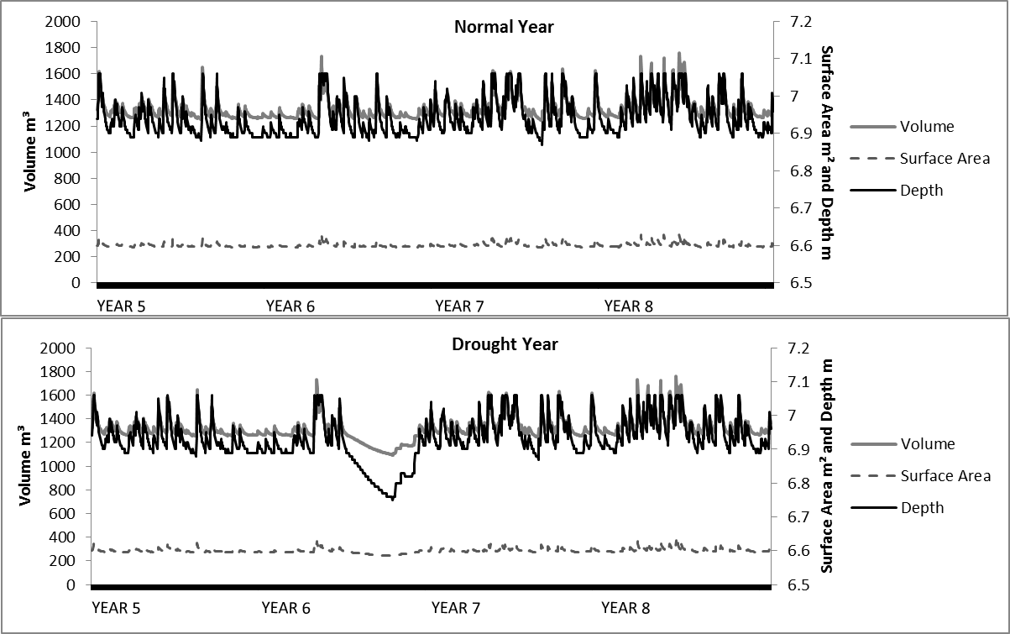

Figure 35 Volume, surface area and depth during years 5-8 for the deep water system. The top figure shows the system during a normal precipitation year and the bottom figure shows a drought during year 6.

The period for a drought was for only one growing season and did not affect the rest of the years. Even with the rainfall being eliminated for that growing season, the drought precipitation did not show significant difference nor did evapotranspiration from the system with normal precipitation and evapotranspiration. The trends for all six simulations can be seen in Figure 36 to Figure 38. The only system that had a complete elimination of evapotranspiration during the drought period was the shallow wetland and when the system went completely dry during the drought. The treatment system and the deep water system had water remaining, which allowed for constant evapotranspiration during the drought. The oscillation seen within Figure 36 to Figure 38 for evapotranspiration follows the trend of insolation. The trend of fluctuating water volume from evapotranspiration show that evapotranspiration is most dependent on the insolation throughout the year (Figure 39 and Table 32). The difference in the correlation values for the shallow system is because the system went dry and, while there was insolation, there was no water to evaporate. Temperature also showed a positive correlation with evapotranspiration (Table 32). The relationship between wetland volumes and surface areas with evapotranspiration had the most variability between the simulations. The treatment system had a negative relationship between the evapotranspiration, volume and surface area. This could be due to the continuous source of water to the treatment system, giving the system little variation in the hydrology (Table 32).

Table 32 Shows the correlation values, r, between various model variables and evapotranspiration. df = 2922 ; p = 0.05
 | Evapotranspiration
 | Deep System | Treatment System | Shallow System
Precipitation | 0.071 | 0.004 | 0.11
Insolation | 0.96 | 0.96 | 0.81
Wetland Volume | 0.22 | -0.49 | 0.43
Temperature | 0.94 | 0.95 | 0.77
Water Surface Area | 0.22 | -0.49 | 0.43

One of the relationships assumed was the change in volume and surface area (Figure 40). All systems showed a positive relationship between the two variables, affirming the model’s mathematical validity for this relationship. The calculation of surface area was determined to be necessary for correct evapotranspiration calculations. While surface area is important to determine the total volume of water that evapotranspires, insolation holds a stronger correlation with total evapotranspiration (Table 32). These relationships can be seen in Figure 39 and Figure 41, which demonstrate that insolation has a stronger relationship with the amount of water that is removed through evapotranspiration than evapotranspiration has with the total surface area. The shallow wetland shows more scatter in the relationships between insolation, surface area and evapotranspiration. This would occur because the shallow wetland goes dry during periods in the model, creating less of a relationship between these variable.
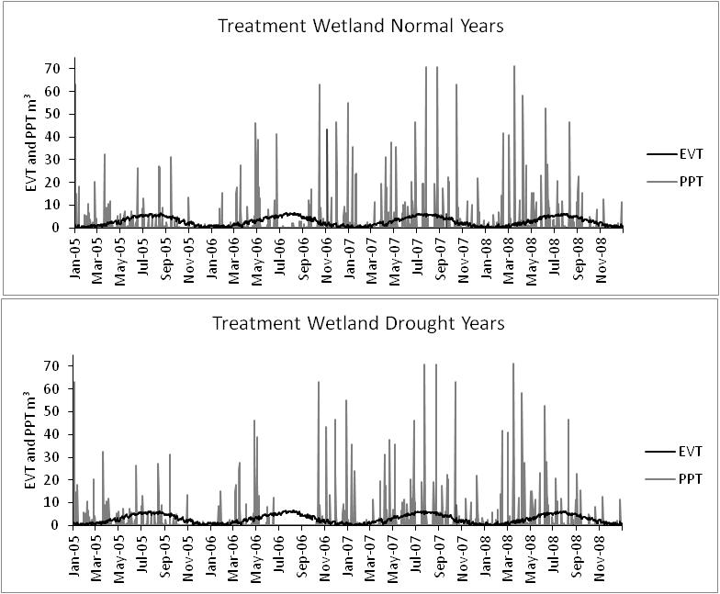
Figure 36 Figures for the treatment wetland simulations showing the evapotranspiration (EVT) and precipitation (PPT) for both the normal and drought runs.
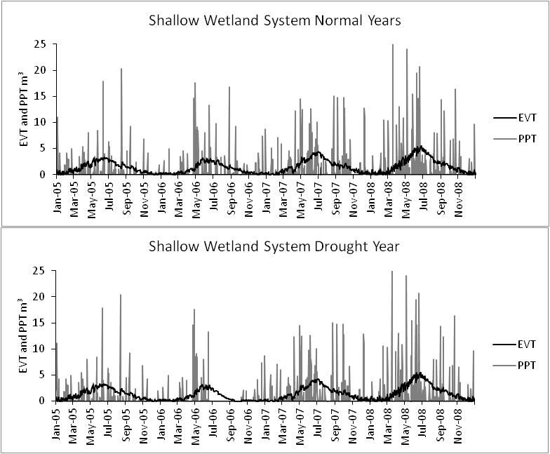
Figure 37 Figures for the shallow wetland simulations showing the evapotranspiration (EVT) and precipitation (PPT) for both the normal and drought runs.
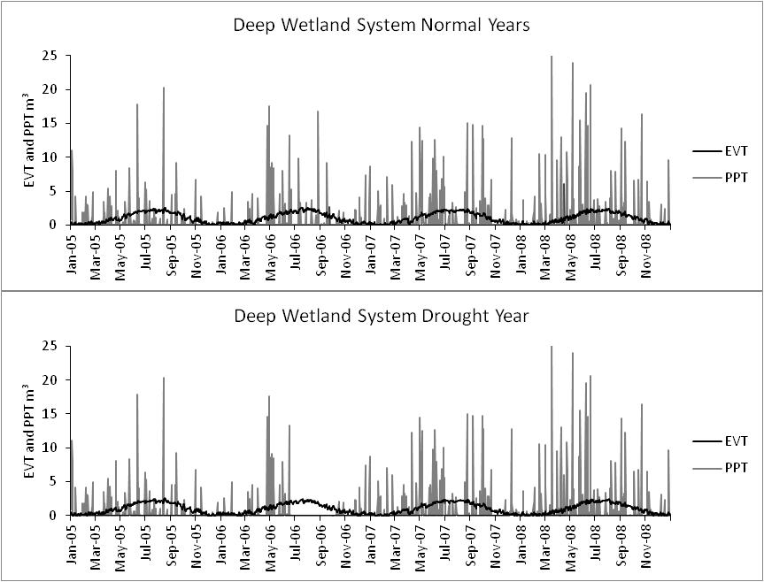
Figure 38 Figures for the deepwater wetland simulations showing the evapotranspiration (EVT) and precipitation (PPT) for both the normal and drought runs.
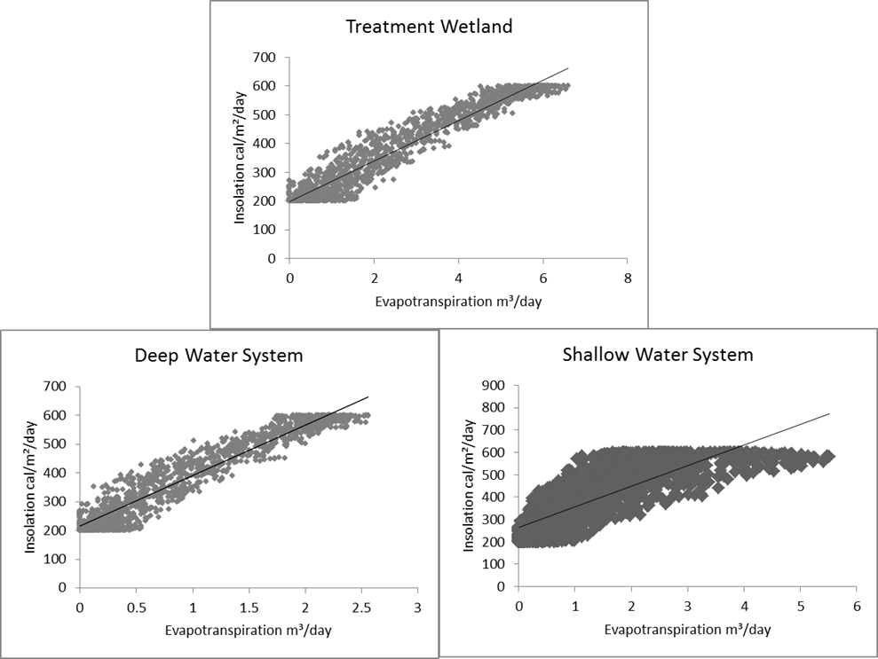
Figure 39 Relationship between insolation and evapotranspiration.
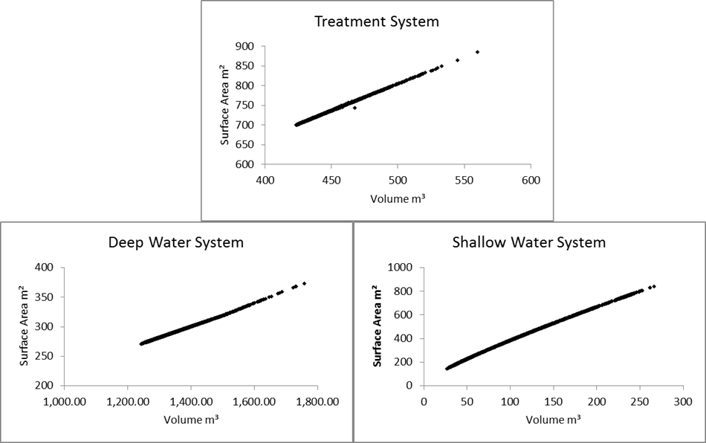
Figure 40 Relationships between volume and surface area in each simulation.
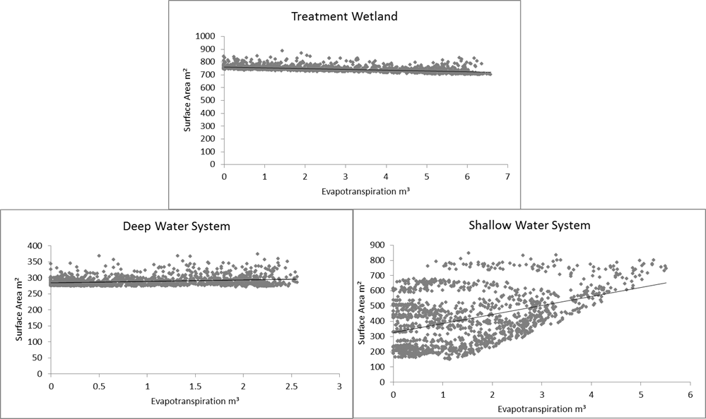
Figure 41 Relationship between the wetland surface area and amount of evapotranspiration with regression lines.

These positive relationships between evapotranspiration and insolation do not necessarily imply that surface area is not important in the determination of the volume removed by evapotranspiration. However, this does question whether the complexity of the submodel, for surface area calculation, adds value to the hydrologic model. When developing models, balance is needed to determine the complexity of the model versus the complexity of the system. Previous research has determined that intermediately complex models are best at representing systems and are no less accurate then more complex models (Costanza and Sklar, 1985; Hakanson, 1995; Mitsch and Jørgensen, 2004; Haefner, 2005). Thus, the modeler has to determine if adding more components and more complexity will benefit the simulation or just create more uncertainty.
The shallow wetland model shows no difference between the surface outflows for the normal rainfall year and drought year (Figure 42). The reason there is little difference is the surface outflows did not occur until April – July 2008 in both simulations. The drought was set to occur during July – October 2006. No outflows occurred during a normal year and the drought was not going to make a difference between the surface outflows at that time period. The shallow wetland system recovers by the same time the following year and the drought in the previous year has no effect on the model’s surface outflow. These trends justify how the two simulations do not show a significant difference in surface outflows.
The Rush W wetland had outflows recorded for the time period from May 2007 - January 2008 (Figure 42). This system had outflows during periods when the simulation did not have outflows at the same time of the year. This suggests that the Rush W wetland may have another water source, such as a groundwater seep, that was not recorded during field studies.
The Hockerville wetland was a system that never had recorded outflows in field collection. Depths of this wetland were not obtained during field studies either. Records indicate that the Hockerville wetland was dry during the months of August – October 2007 (Figure 43). The Hockerville system has similar characteristics to a prairie pothole wetland. Prairie pothole wetlands tend to go dry in August during a wet year and in June-November during a dry year (Van der Valk, 1989; Mitsch and Gosselink, 2000).
The treatment wetland simulations showed no difference in the flows, depth, or volume and this could be attributed to the system’s interactions with a seep providing constant inflow. The treatment wetland model estimates a constant seepage flow. The field site, Red Oak, shows variability in the inflows and outflow and the inflow measured was assumed to come directly from a groundwater upwelling. It was also assumed that the fluctuations in the volume of water coming from the seep are influenced by precipitation, demonstrated by the trends in Figure 44. Although the Red Oak site had large fluctuations in the inflow and outflow, the treatment wetland model did not have the same trend. The changes in the model’s inflows were solely due to direct precipitation and runoff from the berms. The types of treatment wetlands that will be simulated using this model are mine drainage treatment wetlands and are not meant to be event driven (e.g., storm water treatment wetlands). Treatment wetlands can be expected to have a continuous inflow of contaminated water, which is what this hydrologic model is assumes (Kadlec and Wallace, 2009). Although the differences in the surface inflows and outflows between the model and the Red Oak system show that the real system has more variability than the simulation, the depths had the least variability (Figure 44).
The deep water system simulation results were similar to the Adams A system. Again while the purpose of the field studies was not to do hydrological studies, basic hydrologic observations were made. This system was approximately 8 m deep. The wetland part of the system is along the edge where the water fluctuates in saturation and the surface area is irregular. The model is inadequate in the natural log function for determining the depth at the different volumes because assumes a bowl shaped system. This is done for model simplification, but limits the ‘lip’ of the water where vegetation can grow. The volume, depth, surface area, and radius of the system had significant differences between the normal and drought years, showing how dependent the system is on precipitation for inflows. The surface area also fluctuated from 271 to 374 m² and 243 to 374 m² for normal years and drought years, respectively. This is a >100 m² fluctuation in the surface area. Depth only fluctuated from 6.87 to 7.06 m for a normal year and 6.75 to 7.06 m for a drought year. With the system only fluctuating approximately a quarter of a meter in depth, the volume of the water allowed the surface area to increase more than 100 m².
This generalized model was used to show three different systems. The treatment system’s hydrology was expected to remain predictable and this model successfully simulated these conditions. The volumes between the two normal and drought had significant differences, but the flows were not significantly different. This is an expected response for a treatment system. The model also showed itself to be generalized and flexible enough to be used for a deep and a shallow water system. Both the deep and shallow water models behaved as expected. The shallow water wetland had similar trends of a prairie pothole system by going dry during the drought year. The deep water system did not have large changes in depth and behaved similarly to a marsh that may be fed by a groundwater system (Mitsch and Gosselink, 2000). Groundwater influence was left out of this model and assumed to not be a major influence on these systems. It is possible that by adding a groundwater component to this model, there may be some benefit provided to help understand how these systems behave. The verification of this hydrologic model and its range of application for various hydrology profiles show that it will be beneficial for integration with other dynamic system models developed in this dissertation.

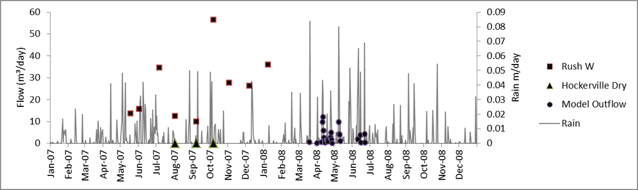
Figure 42 This figure shows where field data flows and model flows for a shallow wetland system are in relation to the rain patterns in northeast Oklahoma. Hockerville Dry shows where the wetland was dry only; flows and depths were not obtainable for this system, but it was noted when the system was dry during other sampling sessions.

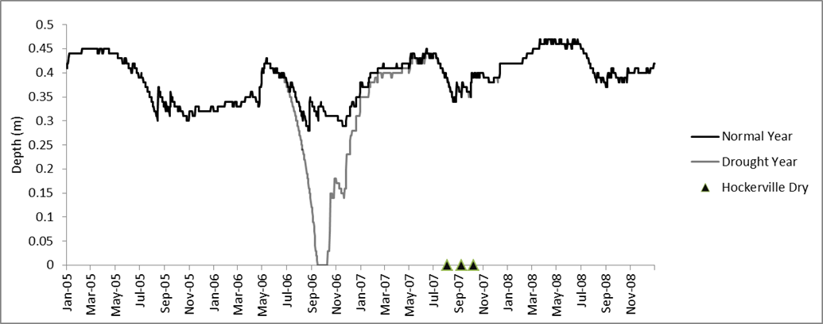
Figure 43 Shallow wetland depths for both normal and drought year, seen in July 2006-January 2007. Although depth was not recorded for Hockerville, the periods of dry are marked.

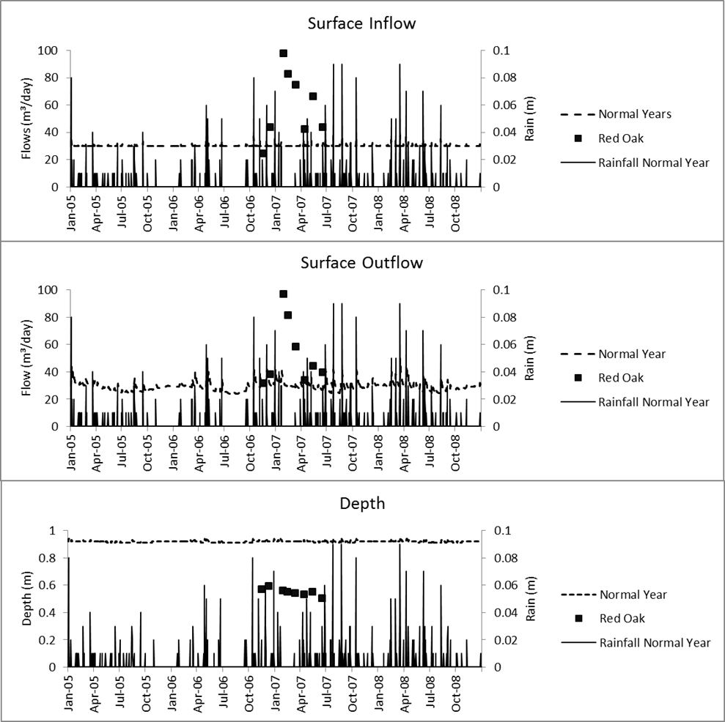
Figure 44. Relationships between surface inflows, outflows, and depths of the modeled treatment wetland during the normal rainfall simulation with the field data from.

Chapter 4 : Development of Ecosystem and Geochemical Models

4.1 Literature Review

4.1.1 Generalized System Models
Sir Arthur Tansley, an English botanist, recognized that animals depend on plants, that plants depend on animals, and nonliving components are essential for both; all are closely knit together. He coined the term ‘ecosystem’ for the biotic and abiotic components that interact together as a whole, using the term ‘system’ to indicate an organizational entity (Tansley, 1935; Odum, 1993). Tansley stated of his concept, that it
“is the idea of progress towards equilibrium, which is never, perhaps completely attained, but to which approximation is made whenever factors at work are constant and stable for a long enough period of time” (Tansley, 1935).
Some early models of trophic levels involved mathematical descriptions of predator/prey dynamics such as the Lotka-Volterra Model. Population stability and complexity and limitation of resources were examined in others (Lotka, 1925; Volterra, 1931; Hutchinson, 1948; Holling, 1959; May, 1973). H.T. Odum (1971) was the first to suggest using energy units as the common denominator when modeling ecosystems. For Odum, solar radiation was the fundamental energy input into the ecosystem. Ecosystem models, while tools used to synthesize relationships in the ecosystem, can be used to analyze and understand properties of system levels and predict system behaviors. Ecological models can provide an overview of ecological problems (e.g., pollution, hydrologic modifications) and predict reactions of the entire system to changes (Mitsch and Jørgensen, 2004). Models can also be used to understand the economic impacts of the changes in ecosystems. One area this has been seen is fishery sciences, where multi-trophic level models with complex networks for understanding ecosystem state and structure have been developed (Christiansen and Pauly, 1993). Dynamic simulation models for predicting natural development of a fish community were done by Metzker and Mitsch (1997) and showed that various population structures can occur with changing environmental conditions. Spieles and Mitsch (1998; 2003) developed a trophic level model, which included various abiotic changes, and shows associations between community development and primary productivity with environmental conditions.
Various models have been developed to simulate the impact of mine drainage on natural wetland ecosystems and how treatment wetlands perform to mitigate mine drainage (Wieder, 1989; Flanagan et al., 1994; Lung and Light, 1996; Flanagan, 1997; Tarutis et al., 1999; Drury, 2000). Various conceptual models have been developed which describe the removal of metals, through retention and cycling in systems, from mine drainage (Mitsch et al., 1983; Fennessy and Mitsch, 1989a; 1989b; Mitsch and Wise, 1998). An early model of how metals cycle, are distributed throughout, and impact ecosystems was done by Jørgensen (1979) through the assessment of metal concentrations in dry vegetation and metal exchanges between sediment and water as the major parameters for calculating potential distributions. Baker et al. (1991) developed a model that simulated iron retention in relation to pH, loading rates, and Typha spp. biomass. A dynamic computer model was developed by Flanagan et al. (1994) to simulate specific pathways for metal retention in passive treatment systems. Flanagan (1997) also showed with emergy analysis and field indicators that constructed and natural wetlands have significant differences in structure and function. These can include differences in organic carbon content, species richness, species biomass, and emergy of system inputs and outputs (Flanagan, 1997). Comparisons between various natural and constructed wetlands and their metals retentions have been done, revealing that there can be significant differences between the two (Gazea et al., 1996; Goulet et al., 2001; Mays and Edwards, 2001; Scholz and Xu, 2002; Peltier et al., 2003).
To better understand ecosystem energetics and their effects on how wetlands retain metals from mine water, a generalized trophic level submodel, and two generalized metal cycling submodels (one for iron in the system and the other for zinc) were developed in this study. The ecosystem model addressed three trophic levels including primary producers, primary consumers, and secondary consumers, were all flows were based in solar irradiation. The sink for carbon in the system was detritus from the mortality and decomposition of each of these three trophic levels. Both metals followed the same pathways in the submodels; the only significant difference was the chemical reactions that contributed to the retention of the metals. Biologically, metals can be taken up by surrounding vegetation or transformed by bacteria. Some types of vegetation will accumulate various metals in the roots, shoots, leaves, or reproductive parts. As the vegetation senesces, metals will be released with the plant material and eventually end up in the detritus and sediments or cycle back into the water column. Specific bacteria may either reduce or oxidize the metals, contributing to the sequestration of metals within the wetland. The major metals pathways within the models included the inflows of water containing metals, the uptake of metals in the vegetation, the reactions that occurred within the water, the flow of metals to the sediment, and the flow of remaining metals in the water as it left the system. These submodels were used in the total systems model (discussed in Chapter 5) to evaluate the system energetics, ecosystem structure, and metal removal from natural and constructed wetlands. This chapter discusses the three submodels for ecosystem and biogeochemical dynamics, their development, calibration, and validation.

4.2 Model Development

4.2.1 Ecosystem Model
The model was developed using STELLA 8.1 and is shown in Figure 45 with flows, stocks, and converters. Explanation of icons in model figures can be found in Appendix B: STELLA Model Symbols Used. The basic unit for flows and stocks used throughout the model is kilocalories. The source of energy for the system is solar radiation (I) based on the yearly cycle given in Equation 13, (Spieles and Mitsch, 2003).
$I \left(kcal m^{-2} {day}^{-1}\right)=4000+2000*cos⁡\frac{\left(2πt+312\right)}{365}$ (13)
Leaf area index (LAI) and solar radiation contribute to the calculation of productivity (P), which can be seen in Equations 14 and 15 (Haefner, 2005),
$LAI=0.002*M$ (14)
Here 0.002 is a calibrated value with no dimension and M is the macrophyte mass at time t.
$P(kcal m^{2} day)= \frac{LAI*α*I*P_{max}}{\left(α*I\right)+(LAI* P_{max})}$ (15)
In equation 15 for productivity, I represents solar radiation, P_{max} is the calibrated maximum productivity and α is an empirically determined constant. For this model, α is a value altered to observe how the initial primary productivity changes affect the ecological indices and ecosystem trophic structure (Haefner, 2005).
Herbivores were used as the primary consumer for macrophytes. The herbivory rate was determined by the mass of herbivores in the system and the macrophyte mass available for consumption. Herbivory was calculated by Equation 16,
$H_{r}\left(kcal m^{2} day\right)=\left(M-80\right)H_{m}r_{h}$ (16)
Where H_{r} is the calculated herbivory rate, M is the macrophyte mass at time t, H_{m} is the herbivore mass and r_{h} is a calibrated constant for herbivore consumption.
Predators were the next consumers in the trophic chain. Predation rate was also a density-dependent calculation based on the mass of the herbivores and the predators in the system and can be seen in Equation 17,
$P_{r}\left(kcal m^{2} day\right)=(H_{m}-4)P_{m}r_{p}$ (17)
Where P_{r} is the predation rate, H_{m} is the herbivore mass, P_{m} is the predator mass and r_{p} is a calibrated constant for predation.
Assumptions were made for the pathways to detritus that macrophytes first had a pool of litterfall before decomposing into detritus. The herbivore and predators, after mortality, decomposition was assumed to flow directly into the detritus stock. The equations for quantity of macrophyte litterfall (Equation18), rate of litter decomposition (Equation 19), herbivore mortality (Equation 20), and predator mortality (Equation 21) can be seen below.
$L_{f}(kcal m^{2}day)=\left(M-80\right)*r_{l}$ (18)
In macrophyte litterfall equation, L_{f} is the litterfall rate, M is the macrophyte mass and $r_{l}$ is the calibrated constant for litterfall.
$D_{L}\left(kcal m^{2} day\right)= M_{L}*r_{d}$ (19)
In the rate of litter decomposition, D_{L} is the rate of litter decomposition, M_{L} is the litterfall mass in kcal and $r_{d}$ is a calibrated constant for litter decomposition.
$H_{d}\left(kcal m^{2} day\right)=\left(H_{m}-4\right)*r_{hd}$ (20)
Herbivore mortality, H_{d} is the herbivore mortality and decomposition, H_{m} is the herbivore mass, and $r_{hd}$ is the calibrated constant for herbivore mortality and decomposition.
$P_{d}\left(kcal m^{2} day\right)=\left(P_{m}-4\right)* r_{pd}$ (21)
In equation 21, P_{d} is the predator mortality and decomposition, P_{m} is the predator mass and the r_{pd} is the calibrated constant for predator mortality and decomposition. The values used for the values and constants in the above equations (15-21) can be seen in Table 33.

Table 33 Constants used in Ecosystem Model.
Variable | Value | Source
Empirically determined constant (α) | 0.001, 0.01, 0.05 | Calibration
Maximum productivity (P_{max}) | 10 | Calibration
Herbivory rate (r_{h}) | 0.00001 | Calibration
Predation rate (r_{p}) | 0.0001 | Calibration
Litterfall rate (r_{l}) | 0.00001 | Calibration
Litter decomposition rate (r_{d}) | 0.00001 | Calibration
Herbivore mortality (r_{pd}) | 0.01 | Calibration
Predator mortality (r_{pd)} | 0.1 | Calibration

Figure 45 STELLA diagram of the trophic level submodel. STELLA symbols described in Appendix B: STELLA Model Symbols Used.

4.2.2 Iron and Zinc Models
Iron is a common component of acid mine drainage and elevated iron concentrations can degrade ecosystems exposed to this drainage. As pH decreases, the amount of iron oxidation occurring through abiotic processes decreases, meanwhile the oxidation continues due to biotic oxidation processes. For iron removal, a common removal method is abiotic iron oxidation at circum-neutral pH, a process demonstrated in Equations 22 and 23 (Younger et al., 2002).
${FeS}_{2}+3.5{ O}_{2}+H_{2}O→{Fe}^{2+}+2{ SO}_{4}^{2-}+2 H^{+}$ (22)
${Fe}^{2+}+0.25{ O}_{2}+2.5 H_{2}O→Fe{\left(OH\right)}_{3}+2{ H}^{+}$ (23)
Iron in the modeled systems may enter multiple pathways, (which can be found in Figure 46).
Figure 46 STELLA diagram of the iron submodel developed. STELLA symbols described in Appendix B: STELLA Model Symbols Used.

Iron was taken up by the vegetation and an uptake coefficient was used to estimate that quantity. Once the vegetation senesced, iron was released in biological decomposition processes. Most iron removal in circum-neutral water for the treatment processes is removed through oxidation processes. Dissolved oxygen and pH determine the rate of oxidation. Microbial processes minimally influence the oxidation of iron in this model and are not accounted for in development. The rate law for the oxidation of ferrous iron is seen in Equation 24 (Stumm and Morgan, 1981).
$\frac{-d[{Fe}^{2+}]}{dt}=\frac{k_{Fe}\left[{Fe}^{2+}\right][O_{2\left(aq\right)}]}{[H^{+}]^{2}}$ (24)
The calculation within the iron model was developed based on (Baker et al., 1991), where pH and the constant, k, are the determining factors for the rate of iron oxidation. In the model calibration, a circum-neutral pH of 6.5 was assumed.
$\left[{Fe}^{3+}\right]=\left[{Fe}^{2+}\right]k*pH$ (25)
Zinc is essential for both plants and animals and it occurs in natural water primarily as Zn⁺² where it forms ionic hydrates, carbonates, and complexes with organics (Greger, 1999). The sulfide form is highly insoluble (solubility product of 4.5x10⁻²⁴ for ZnS) and is a major sink for zinc in aquatic environments (Watzlaf et al., 2004; Kadlec and Wallace, 2009). Zinc has a number of pathways it can travel within the model as well. It can be taken up by vegetation and there are a number of various chemical pathways. The pathways used in this model can be seen in Figure 47. Dissolved zinc enters the system as Zn⁺². It can precipitate as zinc carbonate but has a very narrow window in the relationship to redox potential and pH. The other possibility for precipitation is as zinc sulfide, as seen in Equation 26. For precipitation to occur there needs to be organic matter and a reducing environment to create conditions conducive to sulfate reduction. Precipitation of zinc will not happen if the pH is less than 4 (Lindsay et al., 2008). The reaction for zinc sulfide was assumed to be the dominating reaction for removing zinc from the water due to the circum-neutral pH in this zinc model and the organic matter from the vegetation.
${Zn}^{2+}+{SO}_{4}^{2-}→ZnS_{(s)}+{2 O}_{2}$ (26)
The rate of removal of zinc from the water is determined by Equation 27,
$\frac{d[{Zn}^{2+}]}{dt}=\left[H_{2}S\right]\left[{Zn}^{2+}\right]k_{2}$ (27)
Where k₂ is the calibrated constant.
Figure 47 STELLA diagram for zinc model developed. STELLA symbols described in Appendix B: STELLA Model Symbols Used.

Sulfate reduction is facilitated by the fermentation of plant cellulose from the anaerobic respiration of sulfate-reducing organisms. The sulfate is an electron accepter for the microbes as can be seen in Equation 28. The sulfate submodel was developed to interact with the decomposition in the productivity model and can be seen in Figure 48.
${SO}_{4}^{2-}+2CH_{2}O→H_{2}S+2 HCO_{3}^{-}$ (28)
Where CH₂O represents labile organic matter. The reduction rate was determined in the model using Equation 29, which is based on the Michaelis-Menten model (Snoeyink and Jenkins, 1980; Haefner, 2005).
$\frac{d[{SO}_{4}^{2-}]}{dt}=k_{3}\left[{SO}_{4}^{2-}\right]\left[CH_{2}O\right]-k_{4}[H_{2}S]$ (29)
Where k₃ and k₄ are constants and [CH₂O] is the carbon concentration from detritus. The determination of carbon comes directly from the productivity submodel. The detritus concentrations are given in kilocalories and, therefore, the amount of carbon was determined by estimating that most of the weight of the detritus was from plant cellulose with the energy per gram of organic matter at approximately 4.3 kcal/g (Jørgensen, 1979). Throughout this study, all conversions of energy to mass used this value.
Figure 48 STELLA diagram of the sulfate submodel applied to the zinc model. STELLA symbols described in Appendix B: STELLA Model Symbols Used.

The metals (iron and zinc) models make the assumption that primary productivity is an important part of metal cycling in the system. The productivity of vegetation influences how much metal is accumulated in the plant material and subsequently released by the vegetation during decomposition back into the sediment. The rates of productivity, litter fall, and decomposition strongly affect how fast the metals cycle through the system. For the calibration of the zinc and iron models a simple vegetation growth submodel replaced the full trophic level. (The full trophic level and metals submodels are connected in chapter five). This vegetation growth submodel included the solar radiation, productivity, litterfall, and litter decomposition equations discussed in the trophic model (Section 4.2.1) and the diagramed stocks and flows can be seen in Figure 49. The constants used in the submodel had to be calibrated for a single trophic level and these calibrated values used can be seen in Table 34.
Figure 49 STELLA diagram of the productivity submodel used to calibrate the iron and zinc submodels. (STELLA symbols described in Appendix B: STELLA Model Symbols Used.

Table 34 Calibrated values used in the Productivity Submodel used with the Zinc and Iron Models.
Variable | Value | Source
α (Productivity Rate) | 0.05 | Calibration
P_{max} | 10 | Calibration
Litterfall Rate (r_{l}) | 0.012 | Calibration
Decomposition Rate (r_{d}) | 0.005 | Calibration

The uptake of the metals in the vegetation was determined by the productivity of the vegetation and an empirical constant calibrated from the literature and field data which can be seen in Equation 30.
$U_{i}(mol kcal day)=P*c_{i}$ (30)
Where U_{i} is the uptake rate in mol/kcal/day for zinc or iron, P is productivity and $c_{i}$ is the calibrated constant for zinc or iron. The metals are introduced into the detritus when the vegetation senesces during litter fall. This metal loss from the vegetation is shown in Equation 31.
$S_{i}(mol /day)=B_{Mi}*L*L_{Mi}$ (31)
Where S_{i} is the metal loss rate from senesced vegetation, B_{Mi} is the metal in the biomass, L is the litterfall and L_{Mi} is the constant calibrated for determining the loss for each metal. The metals that are released during the decomposition process were determined by the decomposition of the vegetation into detritus. This calculation can be seen in Equation 32.
$D_{Mi}(mol /day)={Det}_{M}*(Detritus*d)$ (32)
Where D_{Mi} is the rate at which metals are assimilated into the sediment from the detritus, ${Det}_{M}$ is the metal concentration in the detritus (detritus from the trophic submodel) and d is the empirically determined constant. The final outflow in the water of metal concentrations from the system was the difference between the concentration of metals in the water and the metals removed from precipitation and sedimentation.
Table 35 Constants used for calibration in the iron, zinc, and sulfate submodels.
Variable | Field or Literature Value | Final Calibrated Value | Source
Fe²⁺ | 0.004 – 9.79 mol/m³ | 3.5812 mol/m³ | Calibration
Zn²⁺ | 0.0002 - 0.17 mol/m³ | 0.3059 mol/m³ | Calibration
SO₄²⁻ | 1.19 – 64.01 mol/m³ | 0.2166 mol/m³ | Calibration
pH | 5.9 - 7.14 | 6.5 | Field data
k₁ | 0.14 | 0.13 | Baker et al. 1991
k₂ | 0.029 | 0.17 | Hemsi et al. 2005
k₃ | 0.55, 0.625 | 0.5 | Hemsi et al. 2005; Wageringen et al. 2006
k₄ | 0.19, 0.01 | 0.2 | Hemsi et al. 2005 Wageringen et al. 2006
C_{Fe} | 0.0004 | 0.001 | Baker et al. 1991
C_{Zn} | 3.2x10⁻⁸ | 0.0002 | Jørgensen 1979
L_{Fe} | 0.0004 | 0.013 | Baker et al. 1991
L_{Zn} | 0.0004 | 0.02 | Baker et al. 1991
d | - | 0.00001 | Calibration

4.2.3 Model Calibration
The constants used for the models are shown in Table 33 to Table 35. Calibrated values were determined by starting with values from the literature or field data and then adjusted to get the desired results. The equations for determining the materials flows were adjusted to prevent the models from crashing to zero with every cycle or increasing infinitely, unless the stock has no outflow. The models were run to simulate 10 years and the results then were compared to actual field results discussed in chapter two and previous literature.

4.3 Results and Discussion

4.3.1 Ecosystem Model
The trophic level model was run for three different productivity rates (low, medium, and high), determined by the variation in the α value (0.001, 0.01, 0.05) in the productivity equation (Equation 15). Each rate gave a different range of trophic values once the model reached equilibrium and could be compared to various ecosystems (Table 36). The low productivity range fit the productivity ranges for a mature ecosystem, northern peat land or bog which can have a primary productivity range of 2.36 - 18.14 kcal/m²/day (Mitsch and Gosselink, 2000; Cronk and Fennessy, 2001). The medium productivity range in this study might be considered high productivity and might be found in a developing wetland ecosystem or possibly seen in swamp and riparian forest (Mitsch and Gosselink, 2000; Cronk and Fennessy, 2001). The highest productivity had a range of 53.05 – 139.05 kcal/m²/day. This would be considered an extremely high productivity for a developing wetland, however, freshwater marshes have been known to have a productivity value as high as 64.79 kcal/m²/day (Mitsch and Gosselink, 2000; Cronk and Fennessy, 2001). Most of the systems observed in the field had a medium productivity range when compared to the model, but the highest productivity was at the Commerce wetland and could be considered a high productivity system based on the trophic level model.
Ratios of the energy flows at different points within the food chain and trophic levels are referred to as ecological efficiencies (Odum, 1971) and can be displayed as a unit less measurement or percentage to compare the energy transfer efficiencies in different ecosystems. They were calculated with the ecosystem model to validate the model results and compare with different ecosystems from the literature (Odum, 1971). All ratios are shown in order of producers: herbivores: predators. The ratio for trophic level masses was 190: 55: 1 kcal/m² in the low productivity model, 20: 9: 1 kcal/m² in the medium productivity model, and 10: 1: 1 kcal/m² in the high productivity model. Ecological efficiencies seen in the model were as follows (producers to primary consumers and primary consumers to secondary consumers): low productivity - 29% and 1.81%; medium productivity - 45% and 11%; and high productivity - 10% and 100%. The energy transfer from the primary consumers to the secondary consumers appeared to be the most efficient for all systems, except the high productivity model system, implying that the high productivity system took more energy transfer for every unit of growth at the next trophic level of primary consumption. The low productivity model system was the least efficient in converting energy from primary to secondary consumers and the high productivity was the most efficient. The assimilation efficiencies are generally in the range of 10 to 50%, but higher efficiencies can occur. While 100% is not common, it is suggested that this efficiency can be seen in highly nutrient dense systems. Odum (1971) stated that,
“Any increase in the efficiency of a biological system will be obtained at the expense of maintenance. There always comes a point where a gain from increasing the efficiency will be lost in increased cost, not to mention the danger of increased disorder that may result from oscillations” (Odum, 1971).
This increased disorder from oscillations can be seen in the frequency of oscillations and their range in the high productivity model.
One of the earliest trophic pyramids used was developed from Silver Springs, Florida (Odum 1957). The ratio was 807: 37: 11 kcal/m² for a standing crop of producers, primary consumers, and secondary consumers. With the Silver Springs ratio, producers to primary consumers had an ecological efficiency ratio of 4.58% and primary consumers to secondary consumers was 2.97% (Odum, 1957; Odum, 1971) These three models (high, medium, and low productivities) had much higher efficiencies than the Silver Springs system, with an exception being that the low productivity model had low secondary consumer efficiency.
The herbivory rate, predation rates, herbivore mortality rate, predator mortality rate, and litterfall all increased as the productivity and as range of variances of the system increased. This meant that there was a fluctuation in all rates as the productivity increased. The detritus stock in the model did not have an outflow function and the model assumption was that the system would accumulate detritus with no detritus outflows. Because of this assumption, the detritus in the all the models demonstrated continuous increase. This assumption is not a reflection of how detritus functions in ecosystems because detritus will flow outside of the ecosystem due to consumption by detritivores and floods acting as a forcing function.
Table 36 Results for the ecosystem model, including each trophic level with the productivity and decomposition rates calculated in each of the runs of low, medium, and high productivity.
 | Low Productivity
 | Productivity (kcal/m²/day) | Decomposition (kcal/m²/day) | Macrophytes (kcal/m²) | Herbivores (kcal/m²) | Predators (kcal/m²) | Litter (kcal/m²) | Detritus (kcal/m²)
Mean | 3.34 | 4.11E-04 | 1116.56 | 322.31 | 5.87 | 41.06 | 9981
Standard Deviation | 1.03 | 1.03E-05 | 68.09 | 15.03 | 0.12 | 1.03 | 361.1
Minimum | 1.83 | 3.92E-04 | 1021.05 | 301.05 | 5.69 | 39.20 | 9351
Median | 3.39 | 4.11E-04 | 1116.21 | 323.90 | 5.88 | 41.09 | 9993
Maximum | 4.74 | 4.28E-04 | 1213.62 | 342.70 | 6.04 | 42.85 | 10585
 | Medium Productivity
 | Productivity (kcal/m²/day) | Decomposition (kcal/m²/day) | Macrophytes (kcal/m²) | Herbivores (kcal/m²) | Predators (kcal/m²) | Litter (kcal/m²) | Detritus (kcal/m²)
Mean | 20.21 | 8.04E-04 | 2170.89 | 962.93 | 110.01 | 80.41 | 67280
Standard Deviation | 4.30 | 2.06E-05 | 181.42 | 86.65 | 33.03 | 2.06 | 2037
Minimum | 13.37 | 7.67E-04 | 1926.76 | 831.93 | 56.74 | 76.65 | 63608
Median | 20.98 | 8.04E-04 | 2139.91 | 955.70 | 113.24 | 80.45 | 67443
Maximum | 25.44 | 8.40E-04 | 2479.49 | 1123.74 | 165.35 | 84.01 | 70995
 | High Productivity
 | Productivity (kcal/m²/day) | Decomposition (kcal/m²/day) | Macrophytes (kcal/m²) | Herbivores (kcal/m²) | Predators (kcal/m²) | Litter (kcal/m²) | Detritus (kcal/m²)
Mean | 91.59 | 2.99E-03 | 9176.79 | 901.67 | 906.62 | 298.75 | 292451
Standard Deviation | 20.70 | 9.25E-05 | 2068.65 | 1645.64 | 1518.64 | 9.27 | 9427
Minimum | 58.70 | 2.82E-03 | 5456.69 | 6.22 | 7.81 | 282.42 | 274419
Median | 92.06 | 2.99E-03 | 9085.68 | 64.77 | 138.03 | 298.97 | 291245
Maximum | 135.73 | 3.15E-03 | 13097.72 | 6482.00 | 6411.65 | 314.61 | 310825

Mean decomposition rates followed the mean productivity rate sequentially with the lowest productive system having the lowest decomposition rates at 4.11E-04±1.03E-05
kcal/m²/day. The medium productivity model had decomposition rates of 8.04E– 04±2.06E-05 kcal/m²/day. The highly productive model with the highest decomposition rates showed 2.99E-03±9.25E-5 kcal/m²/day. Compared to the decomposition rates from the decomposition study in chapter two, the model calibrated to a slower decomposition rate than any of the systems. The difference could possibly be explained due to the model estimating for total mass of the primary producers, hence total decomposition of all primary producers is reflected in the model and would occur at a much slower rate than decomposition rates from the field data.

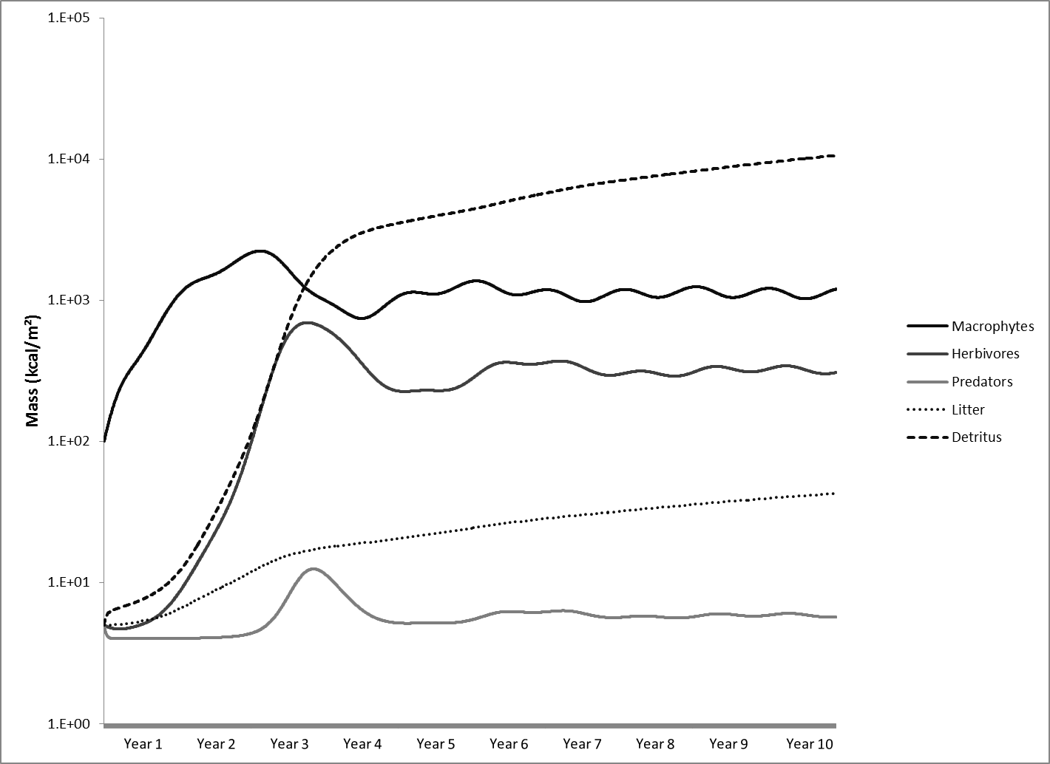
Figure 50 Figure of each trophic level from the low productivity model.

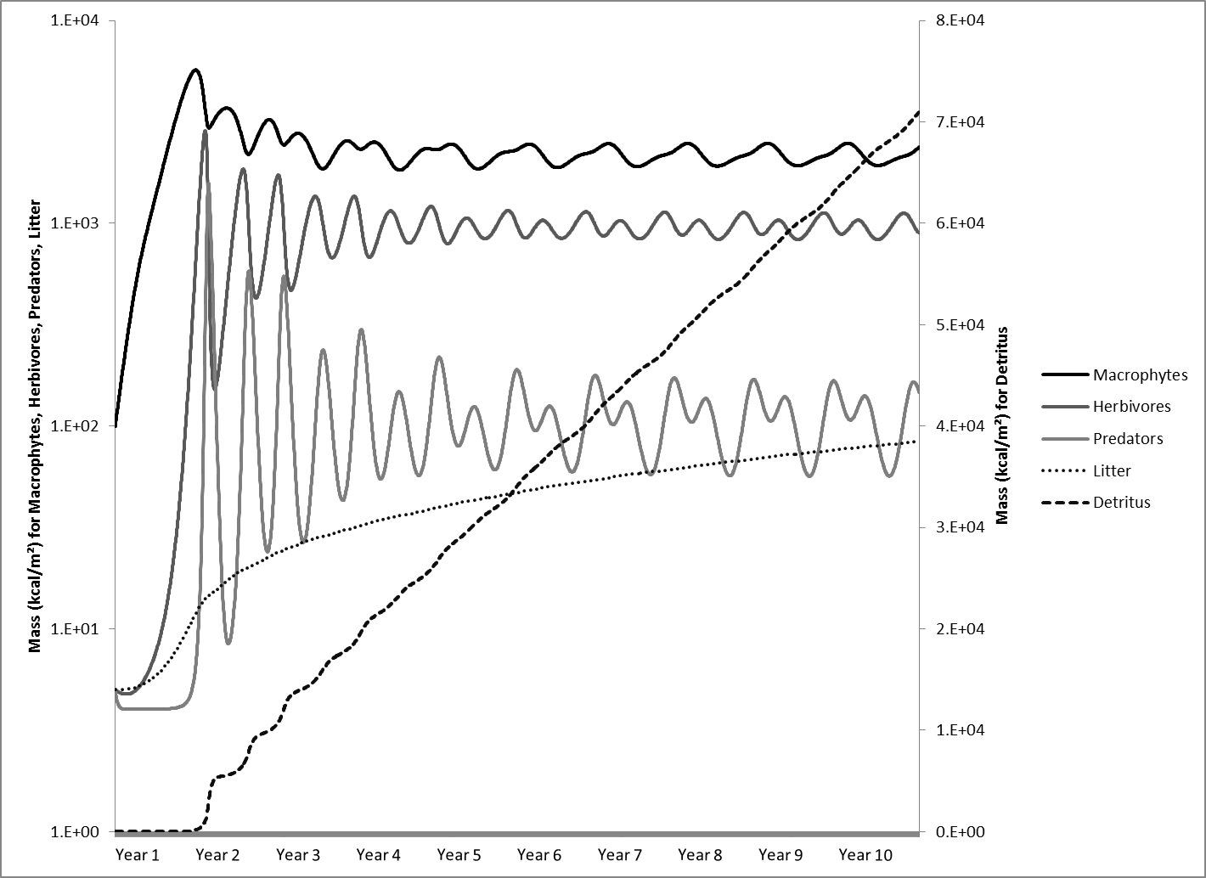
Figure 51 Figure of each trophic level from the medium productivity model.

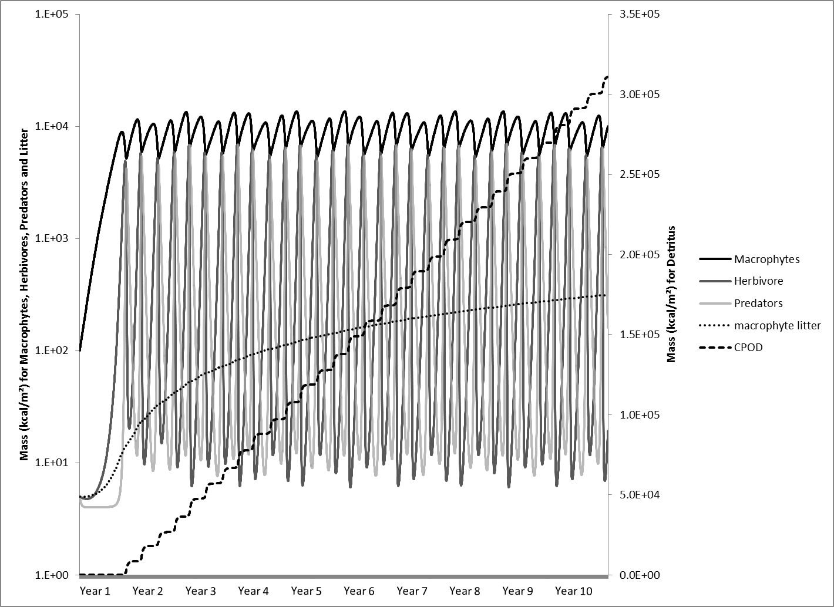
Figure 52 Figure of each trophic level from the high productivity model.

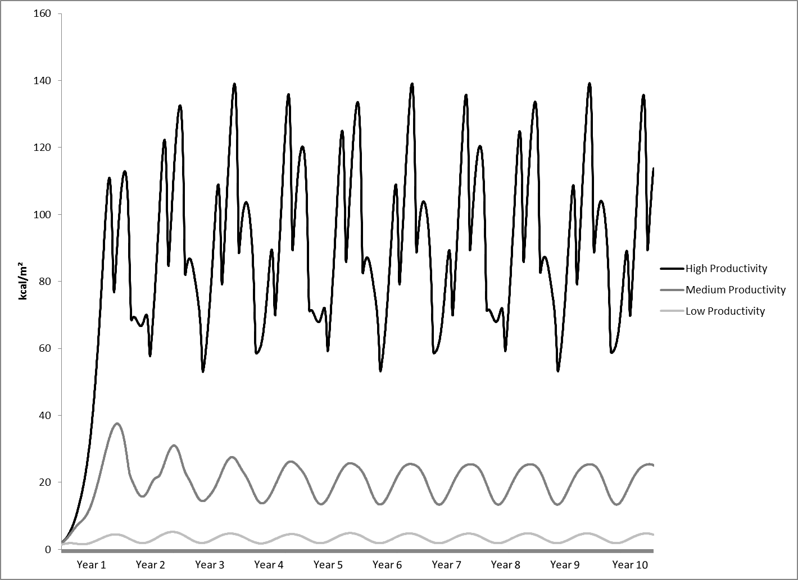
Figure 53 Productivity rates and changes through the years in the ecosystem model for the high, medium, and low productivities.

4.3.2 Iron and Zinc Model

The models were set to have daily inflow 3.58 mol/m³ of iron and 0.31 mol/m³ of zinc. The calibrated model runs showed that iron was continuously removed at 3.0262 mol/m³/day and zinc at 0.2166 mol/m³/day. the percent concentration reduction of iron was 84.50% and for zinc 70.81%.
Compared to the treatment system studies within, Red Oak, Le Bosquet and Hartshorne, the iron removal concentration percentages in the model were lower than these three field systems, with each system having >95% reduction of iron (Table 37). When comparing the metals model to a natural volunteer system with elevated iron concentrations, the model displayed a greater reduction percentage than Commerce. Literature shows that treatment systems can remove 25 - 99% of the iron entering the system, with a mean of 81.88± 21.5% (Table 38). The systems of Adams A, Rush W, and Hockerville could not be monitored for inflow/outflow concentrations, so these systems could not be used to evaluate reduction percentages.
When comparing zinc removal to the study sites, they had much more variation than iron, which ranged from 64.15 - 96.25% in the treatment systems. The zinc model had much higher zinc inflow than the built treatment systems. Treatment systems were not built for zinc removal; this could explain the difference. Historically, other treatment systems within the study have shown a percent reduction of 43- 98% with an average of 76.6±20.85% , putting this model’s result for zinc removal within the range of other systems as seen in Table 38. As for volunteer systems, Commerce had a 6.9% removal of zinc, much lower than the model’s results.
The reaction rates, shown in Figure 54, for zinc and sulfate have oscillating patterns ranging from 0.428 - 0.438 mol/m³/day and 0 - 0.433 mol/m³/day, respectively. Zinc is dependent on sulfate reduction and uses all the sulfides produced in the model, which creates the oscillating pattern. The sulfate concentration used to calibrate this model (0.2166 mol/m³) were lower than the systems studied where concentrations ranged from 1.19 - 64.01 mol/m³. The purpose of the zinc metals model was to monitor metals in the system, so the sulfate number was chosen to facilitate the necessary zinc removal and not to observe sulfate behavior in the system. Future models could introduce sulfate at a higher concentration. Iron did not oscillate, but remained at a steady, linear rate of 3.026 mol/m³/day. This behavior was expected because the iron reaction is a linear equation. A determinant of iron oxidation is pH, but this model assumes that pH remains stable based on the circum-neutral pH of all systems studied.
It took five years for the productivity submodel in the metals model to stabilize. The macrophytes in the productivity submodel followed the yearly cycle of growth and senescence, reaching a maximum growth of 93.69 kcal/m² (1697.23 g/m²) and minimum of 54.66 kcal/m² (1272.71 g/m²). These numbers reflect the total biomass of vegetation and include the mass of the roots, which explains the remaining biomass during periods of low productivity. Of the five wetlands that had vegetative surveys done, the total biomass ranged from 1085 g/m² (Adam A 2007) to 3550 g/m² (Rush W 2006) with a median value of 1668 g/m². The submodel’s productivity reflected this median value. The assumption is that the biomass remaining during the senescence period is the root biomass in the model. The values for the root biomass in the field data ranged from 802 g/m² (Commerce 2006) to 3209 g/m² (Rush W 2006) with a median of 1261 g/m², thus fitting the model’s assumption that the remaining biomass after senescence is root biomass.
Litter biomass in the model ranged from 14,522 kcal/m² to 15,746 kcal/m² (3377 g/m² - 3662 g/m²), which were higher values than what were found in the field data. The field data ranged from 3.92 g/m² (Adam A 2006) to 1046 g/m² (Commerce 2006). If maximum values of litter accumulation were used to validate the litterfall in the trophic model, these field values would range from 30.4 (Adams A 2006) to 3744 (Commerce 2006)] g/m² with the maximum litterfall value from Commerce (2006) fitting the model’s range. Even if it is assumed in the trophic model that the standing dead vegetation was part of the litter stock, as recommended by Kadlec and Wallace (2009), the field values (Table 10) do not correspond to the modeled values with means of 170 to- 1425 g/m², and maximum values of 586 to 5120 g/m² (median of 1192 g/m²). Although the field data supports the model in showing that it is possible for litter values to be as high as they are in the model, the model does not match with the mean values from field data. It should be noted that litter was collected only in the summer and litter values would probably be higher when collected in the winter. Litter accumulation in the model was strongly associated with the decay rate for detritus accumulation. Since the field studies only collected fresh litter, the model reflects litter accumulation after a few years before complete decomposition.
For the zinc model, the zinc uptake in the biomass ranged from 329 to- 561 mg/kg and with zinc in the litter ranging from 197 to- 357 mg/kg. The zinc model’s results are much lower than what was found in field collection (Table 12). For the Tar Creek systems, the zinc accumulations for total vegetation ranged from 576 (Commerce 2006) to 2467 (Adams A 2006) mg/kg. Litter ranged 89.36 (Rush W 2006) to 2173 (Adams A 2006) mg/kg. The Le Bosquet treatment system had zinc uptake of 5.24 mg/kg in the roots and 3.77 mg/kg in the live vegetation. The other treatment systems, Red Oak, and Hartshorne did not have vegetation to be collected for metals analysis.
The model for iron had a range of biomass iron accumulation of 2166 to 3680 mg/kg and litter iron accumulations of 839 to 1523 mg/kg. Compared to the iron concentrations in the roots of vegetation from all five wetlands studied, the means ranged from 866 (Hockerville 2007) to 9840 mg/kg (Mayer 2006) For live vegetation the means ranged from 7.11 (Rush W 2007) to - 125 mg/kg (Adam A 2007). Litter and standing dead iron concentrations ranged from 16.42 (Rush W 2006) to 3699 mg/kg (Adam A 2007) (Table 11).
Iron and zinc accumulations in biomass vary significantly across species of vegetation (Table 39 and Table 40). The vegetation at the field sites studied was primarily Typha spp. and so much of the model’s assumptions for metal uptake is done based on the analysis of these cattail species. Literature provides values for iron uptake in Typha spp. of 1055 - 68,469 mg/kg in the roots and 45 - 7,352 mg/kg in the aboveground mass (Table 39). For zinc the ranges are 23.7 - 835 mg/kg in the roots and 10.9 - 96 mg/kg in the aboveground mass (Table 40). These are wide ranges with much variation and the iron and zinc models’ metal uptake is within the range of the field data and the literature (Table 39 and Table 40).
Trends seen in the trophic level and metals models fall within the ranges seen in field studies and in the literature, therefore these submodels could be suitable to include into a total system model. in such a model, these submodels are combined with the hydrology submodel from chapter three to evaluate the metal cycling in different hydrologic regimes, productivity levels of the ecosystem, and metal concentrations. From these models, the energetics of the trophic mode energy indices and networks will be evaluated to better understand the structure and functions in each system (Chapter 5).

Table 37 Percent decrease found in field sites compared to the model's reduction rate.
System | Fe Reduction (%) | Zn Reduction (%)
Red Oak | 99.57 | 96.25
Le Bosquet | 96.16 | 25.00
Hartshorne | 99.56 | -64.15
Mayer | 24.35 | 6.90
Model | 84.50 | 70.81

Table 38 Literature review of reduction rates of iron and zinc in treatment systems (Adapted from Kadlec and Wallace, 2009).
System | Water Source | Fe Reduction (%) | Zn Reduction (%) |  | Source
Eleven Systems, United Kingdom | Coal Mine water | 87 |  | Younger, 2000
Ten Systems, Tennessee | Coal Acid Mine | 82 |  | Brodie, 1990
Albright, Pennsylvania | Coal Mine water | 87 | 55 | Hoover et al., 1998
Springdale, Pennsylvania | Coal Mine water | 98 | 73 | Hoover et al., 1998
Musselwhite, Ontario | Metal Mine Water | 75 |  | Bishay and Kadlec, 2005
Kanata Monahan, Ontario | Metal Mine Water | 25 | 50 | Goulet and Pick, 2001; Goulet and Pick. 2001
Elliot Lake Panel, Ontario | Metal Mine Water | 98 |  | Goulet and Pick, 2001
Woodcutters, NT, Australia | Metal mine water |  | 98 | Noller et al., 1994
Tom's Gully, NT, Australia | Metal mine water |  | 96 | Kadlec and Wallace, 2009
Dunka Mine, Minnesota | Metal mine water |  | 65 | Kadlec and Wallace, 2009
Orcopampa, Peru | Metal mine water |  | 93 | Kadlec and Wallace, 2009
Wheal Jane, United Kingdom | Tin/zinc mine water | 86 | 43 | Younger, 2000
Dunka Mine, Minnesota | Metal mine water |  | 95 | Kadlec and Wallace, 2009
Mayer Ranch, Oklahoma | Metal Mine Water | 99 | 98 | Nairn et al., 2010
Mean |  | 81.88 | 76.6
Standard Deviation |  | 21.5 | 20.85

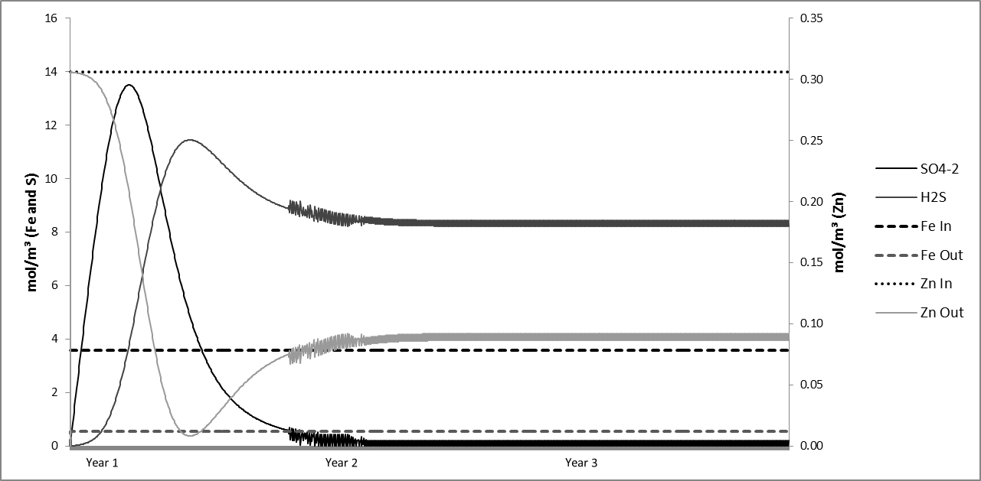
Figure 54 Zinc, iron, and sulfate removal from water in each of the models.

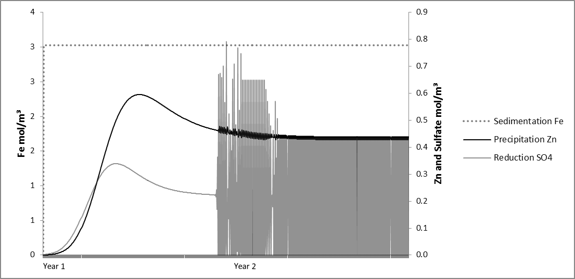
Figure 55 Iron, zinc, and sulfate reaction rates for the first two years. The rates for sulfate and zinc stabilize after the second year.

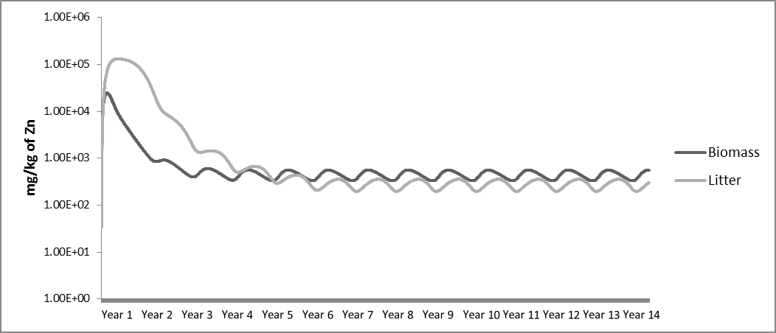
Figure 56 Model results for zinc uptake in the biomass and accumulation with litter. Note the logarithmic scale on the vertical axis.

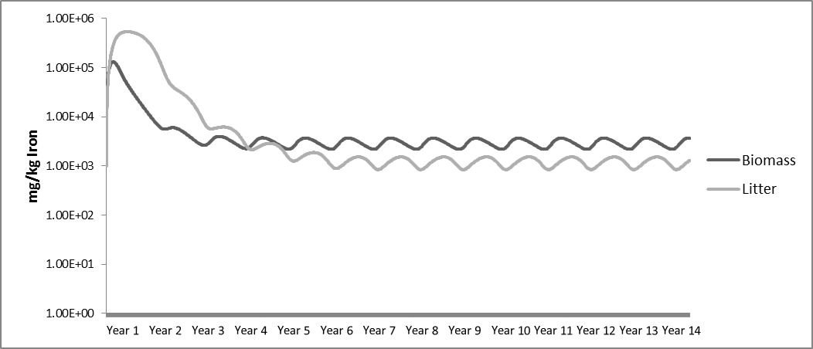
Figure 57 Model results for iron uptake in the biomass and accumulation with litter. Note the logarithmic scale on the vertical axis
Table 39 Iron concentrations in vegetation from literature. Superscripts denote: a - aboveground vegetation, b - leaves, c - underwater stems (Adapted from Kadlec and Wallace, 2009)
Species | Location | Reference | Aboveground (mg/kg) | Belowground (mg/kg)
Typha latifolia | Preston County, West Virginia | Sencindiver and Bhumbla, 1988 | 208 (88-304)ª
T. latifolia | Monongalia County, West Virginia | Sencindiver and Bhumbla, 1988 | 1919 (409-7352)^{b} | -
T. latifolia | Cascade County, Montana | Hiel and Kerins, 1988 | 286 (± 98)ª | -
T. latifolia | Coshocton County, Ohio | Fennessy, 1988 | 335^{c} | -
T. latifolia | Athens County, Ohio | Mitsch and Wise, 1998 | 2500 | -
T. latifolia | Lake Mendota, Wisconsin | Smith et al., 1988 | 138 | -
Typha spp. | TVA Mussel Shoals, Alabama | NADB database, 1998 | 45-142 | 1011-7437
Typha glauca | New York | Bernard, 1998 | 292 | 10745
T. glauca | New York | Bernard, 1998 | 67 | 18,006
T. latifolia | Widows Creek, Alabama | Ye et al., 2001 a,b | 1217 | 68,469
T. latifolia | Coeur d'Alene, Idaho | De Volder et al.,2003 | 200 | -
T. latifolia | Wisconsin | Vymazal, 1995 | 138 | 1,055
Typha angustifolia | Germany | Vymazal, 1995 | 1100 | -
T. angustifolia | 11 lakes, Poland | Samecka-Cymerman and Kempers, 2001 | 350 | -
Phragmites australis | TVA Mussel Shoals, Alabama | NADB database, 1998 | 112-161 | 2533-4547
P. australis | Nucice, Czech Republic | Vymazal and Krasa, 2005 | 139 | -
P. australis | New York | Eckhardt et al., 1999 | 618-799 | 7060-9280
P. australis | Brehov, Czech Republic | Vymazal, 2006 | 74 | 3677
Table 39 continued on next page
Table 39 (Continued)
P. australis | 11 lakes, Poland | Samecka-Cymerman and Kempers, 2001 | 1053 | -
Phalaris arundinacea | TVA Mussel Shoals, Alabama | NADB database, 1998 | 89-309 | 2445-8352
P. arundinacea | Nucice, Czech Republic | Vymazal and Krasa, 2005 | 323 | -
P. arundinacea | Brehov, Czech Republic | Vymazal, 2006 | 70 | 3383
P. arundinacea | 11 lakes, Poland | Samecka-Cymerman and Kempers, 2001 | 1202 | -
Scirpus acutus | TVA Mussel Shoals, Alabama | NADB database, 1998 | 47-107 | 1820-2754
Scirpus cyperinus | TVA Mussel Shoals, Alabama | NADB database, 1998 | 83-723 | 1185-2228
Scirpus lacustris | Czech Republic | Vymazal, 1995 | 129 | -
S. lacustris | Germany | Vymazal, 1995 | 780 | -
S. lacustris | 11 lakes, Poland | Samecka-Cymerman and Kempers, 2001 | 430 | -
Juncus effuses | Widows Creek, Alabama | Ye et al., 2001 a,b | 320 | 41318
Sagittaria latifolia | Coeur d'Alene, Idaho | De Volder et al., 2003 | 220 | -
Algae | Ireland | O'Sullivan et al., 2000 | 39 | -
Algae | Ireland | O'Sullivan et al., 2000 | 108 | -

Table 40 Zinc concentrations in vegetation from literature (Adapted from Kadlec and Wallace, 2009).
Species | Reference | Water (μg /L) | Aboveground (mg/kg) | Belowground (mg/kg)
Scirpus acutus | Behrends et al., 1996 | 600 | 19 | 23
S. acutus | Nolte and Associates, 1998 | 36 | 10 | 36.2
Scirpus atovirens | Behrends et al., 1996 | 600 | 10 | 17
Scirpus cyperinus | Behrends et al., 1996 | 600 | 11 | 14
Scirpus lacustris | Samecka-Cymerman and Kempers, 2001 | 94 | 20
Scirpus spp. | Karpiscak et al., 2001 | 67 | 14.3 | 32.6
Juncus effuses | Samecka-Cymerman and Kempers, 2001 | 272 | 15
Juncus spp. | Chague-Goff , 2005 | 18 | 14 | 23
Phalaris arundinacea | Behrends et al., 1996 | 600 | 20 | 48
P. arundinacea | Vymazal and Krasa, 2005 | 198 | 23.9
P. arundinacea | Vymazal, 2006 | Sewage | 16.8 | 65
P. arundinacea | Samecka-Cymerman and Kempers, 2001 | 311 | 20
Phragmites australis | Vymazal, 2006 | Sewage | 12 | 85
P. australis | Behrends et al., 1996 | 600 | 28 | 62
P. australis | Vymazal and Krasa, 2005 | 198 | 28.7
P. australis | Samecka-Cymerman and Kempers, 2001 | 311 | 23.6
Typha spp. | Behrends et al., 1996 | 600 | 12 | 38
Typha latifolia | Obarska-Pempkowiak et al., 2005 | Sewage | 10.9
T. latifolia | Maddison et al., 2005 | Sewage | 14.5 | 181
T. latifolia | Paredes et al., 2006 | 1500 | 96 | 835
T. latifolia | Manios et al., 2003 | Sludge | 34-61 | 293-392
T. latifolia | Zhang et al., 1990 | 137 | 38 | 170
Typha domingensis | Nolte and Associates, 1998 | 36 | 11.3 | 30.8
T. domingensis | Karpiscak et al., 2001 | 67 | 3.5 | 49.4
Typha angustifolia | Samecka-Cymerman and Kempers, 2001 | 94 | 14
Glyceria maxima | Obarska-Pempkowiak et al., 2005 | Sewage | 12.3 | 25.2
Anemopsis californicus | Karpiscak et al., 2001 | 67 | 15 | 23.7
Lythrum hyssopifolia | Chague-Goff, 2005 | 18 | 49 | 86

Chapter 5 : Total Systems Model and Energy Indices

5.1 Introduction
This chapter combines the hydrologic, trophic level, and metals submodels to create a total systems model. The total system model simulated the productivity, hydrology, and metals removal from the Rush W, Adams A, Hockerville, Le Bosquet, Red Oak and Hartshorne systems. From these simulations the energy-based ecosystem indices were calculated. The indices calculated included emergy, ascendency, and exergy as well as derived sub-indices. The model results and indices calculations were used evaluate the hypotheses presented in Chapter 1 and reiterated here:
- An ecosystem with greater emergy, eco-exergy, ascendancy, and development will provide greater ecosystem services.
- Disturbed ecosystems will have decreased emergy, eco-exergy, ascendancy, and development, thus hindering the system’s ability to provide services.
- Wetlands receiving metal contamination and having elevated eco-exergy, emergy, and ascendancy values will have greater metal retention.
This chapter discusses if applying holistic ecosystem indicators to indicate the potential benefit of a specific ecosystem function is a reliable methodology. This analysis enabled a better understanding of these ecosystem indictors vs. ecosystem function relationships and how well these holistic ecosystem indicators represent disturbed and human-built systems as well as the relationships to one another and ecosystem maturity.

5.2 Methods

5.2.1 Generalized System Models
A total systems model was developed by combining the hydrology, ecosystem, and metals submodels described in chapters three and four. By adding the hydrology submodel, which calculated the wetland physical parameters of volume, depth, and surface area, to the trophic level and metals submodels, wetland productivity and total loading of metals can be calculated. Productivity was assumed to be limited based on system depth and a graphical function was developed to assume the maximum productivity potential (P_{max}). In this case, a dry system had a lower maximum productivity, but productivity potential increased as the system becomes saturated. Once the system depth reached a meter or deeper the productivity decreased due to the reduction in light saturation. The total volume is used to determine the total metal concentrations and the surface outflow is used to determine total metals that leave the system. Metal toxicity was not considered for these models because the field data indicated that iron and zinc were not interfering with vegetative growth.
The models ran for 5,000 days or approximately 13.5 years. The time (t) in this simulation was enabled to allow all components of all the models to stabilize and reach equilibrium. What made modeling isolated wetland systems such as Hockerville, Rush W, and Adams A challenging is that, when evaluating metals accumulation, retention, and flows, these systems have no consistent hydrologic outflow and the only surface outflow that occurs is from an overflow after a rain event. Overflows and rain events were never observed in the field, so the point where there is an overflow was determined through calibration by adjusting the outflow coefficient until the system depth remained within the limits in the simulation for this system. Each of the total system model results were used to calculate system energetic indices, and to evaluate system treatment effectiveness, efficiency, and health.

5.2.2 Emergy
Emergy is defined as “the available energy of one kind, previously used up directly and indirectly to make a service or product” (Odum, 1996). The unit used for emergy is referred to an emjoule. Emjoules are referred to as solar emjoules if the most basic energy used is solar energy, also known as solar emergy. Solar emergy is the total solar energy used directly and indirectly to make the product or service. The solar emjoule is the most common denominator used to describe the emergy of a system. To find the emergy of a system, the transformity must be determined. Transformity is the emergy per unit energy as seen in Equation 33 (Odum, 1996).
$Transformity \left({sej}/J\right)=\frac{Product Emergy (sej)}{Energy of the product (J)}$ (33)
Where the product’s emergy is the total solar energy that goes into producing the product or service, and energy of the product is the actual energy obtained from the product or service. Often times, the transformity is in solar joules (seJ) per joule (J) or seJ/J, but can also be expressed in seJ/g or seJ/L. For example, a plant could have the energy value of 10 J/day but the amount of direct and indirect solar energy needed to produce this 10 J/day is 40,000 seJ/day. This would give the plant a transformity of 4000 seJ/J, meaning that it take 4000 joules from the sun, directly and indirectly, to create just 1 joule of plant material. Odum (1988) also suggests that there is an energy transformity hierarchy in which all energy flows in the universe follow a hierarchy when transformed. For example, a carnivore is going to have a higher transformity value and take more emergy to produce than a macrophyte. As we move up the trophic levels of an ecosystem, the emergy needed to maintain the higher trophic levels is more than the lower trophic levels.
Emergy values were calculated using model energy values totaled for a year of the simulation. Emergy values for the inputs and products of the systems were calculated; the inputs being energy from the sun, total water inflow, and the solar energy contributing to evapotranspiration and the products being macrophytes, herbivores, predators, and organic matter (detritus). For the trophic model, the flows of energy are calculated all the way back to the solar energy source to determine the emergy for each stock which was then divided by the energy of each trophic level to determine the transformity of each trophic level. Comparing transformities between each system will allow a comparison of which system is most efficient at the different trophic levels. Low transformity indicates a more efficient system. Total yearly water inflows and evapotranspiration were determined for each system. Transformity has been determined for water using its chemical and geopotential giving a value of 1.54E+05 seJ/J; likewise evapotranspiration transformity has been calculated to be 1.50E+04 seJ/J (Odum, 1996; Flanagan, 1997). Energy values for water were based on the Gibbs Free Energy Value of 4.94 J/g as discussed by Odum (1996).
The emergy and transformity values for the iron and zinc removed were determined by calculating the yearly total amount of each metal removed. The total energy used to remove the metals came from solar, water, and ecosystem energies. The energy of the iron and zinc removed was divided by the total system energies to determine the transformity of the metals removed in that system in seJ/g.

5.2.3 Ascendency
Ascendency is a way to distinguish between the growth and development of the system, with Total System Throughput (TST) representing growth and a more quantitative perspective and Average Mutual Information (AMI) representing development and a more qualitative perspective (Nielsen and Muller, 2009). Throughput describes the vigor or size of a system and it represents a measure of system flows to each pool. Ascendency calculations include both size and organization of the systems. Quantifying growth can be done by designating the magnitude of the transfer of material or energy from a donor to a receptor (such as the flow of prey to predator) and the sum of all these exchanges is referred to as the Total System Throughput (TST) which can be seen in Equation 34. TST is a direct summation of all the inputs, outputs and flows transferred in the system. AMI gives a measure of the information regarding the network of material exchange in the system. Organization refers to the number and diversity of interactions between its components. The developmental capacity (C) quantifies the upper limit to ascendency and the relative ascendency (A/C) describes the degree of maximum specialization that is actually achieved in the system (sometimes referred to as the maturity index) (Baird and Ulanowicz, 1993; Costanza and Mageau, 1999). Because the actual ascendency value varies significantly between systems, the relative ascendency can give a better comparison between and understanding of the system’s efficiency and resilience. Hence this ratio, relative ascendency, can also be used to understand the system’s ability to withstand disturbances (Ulanowicz, 1986; 1997). All these ecological indices have been widely used to describe and compare a variety of ecosystems of different spatial sizes, geographic locations, and complexities (Monaco and Ulanowicz, 1997; Jarre-Teichmann and Christensen, 1998; Niquil et al., 1999; Heymans and Baird, 2000; Wolff et al., 2000; Ortiz and Wolff, 2002; Arias- González et al., 2004; Patrício and Marques, 2006).
To determine the ascendancy of an ecosystem, the total TST and AMI must be calculated. The flow from each component is represented by T_{ij} with i representing the donor and j the receptor (Mageau et al., 1998; Ulanowicz, 1997; Ulanowicz, 2000a). TST is defined operationally in Equation 34 (Mageau et al., 1998; Ulanowicz, 1997; Ulanowicz, 2000a):
$TST= \sum{T_{ij}}$ (34)
AMI is a measure of the information in the network that is being exchanged in the ecosystem and the base of the logarithm is 2, giving the units of these information networks in bits. AMI is calculated using the TST (Equation 35) (Mageau et al. 1998; Ulanowicz, 1997; Ulanowicz, 2000a):
$AMI (kcal bits/m²/yr)=\sum{\frac{T_{ij}}{TST}\log\left[\frac{T_{ij}TST}{T_{i}T_{j}}\right]}$ (35)
Where T_{i} is all the material that is leaving i (donor) and T_{j} (recipient) is all the material that enters j. Ascendancy is a product of TST and AMI, which yields Equation 36 (Mageau et al., 1998; Ulanowicz 1997, 2000a; Jørgensen 2002):
$A (kcal bits/m²/yr) =TST*AMI$ (36)
Capacity follows with the trend of C ≥ A ≥0 and is calculated in Equation 37 as a way to determine the potential capacity of the system to reach.
$C (kcal bits/m²/yr)=-\sum{T_{ij}\log{\frac{T_{ij}}{TST}}}$ (37) If capacity exceeds the measure of constraint (ascendency), the difference is referred as system overhead. Overhead (O) is a form of redundancy and can be used to better evaluate a system’s resilience to perturbations. Overhead is calculated as the difference between the capacity and the ascendency and can be seen in Equation 38:
$O=C-A$ (38)

5.2.4 Exergy
When information contributes to the exergy of the system, it contributes to the work of the system and Boltzmann (1974) introduced its relationship to work, as seen in Equation 39:
$W=RT\ln{N}$ (39)
Where W is the work done by the system, R is the gas constant (8.314 J/ mol K), T is the temperature of the system in Kelvin (K), and N is the information available (Jørgensen, 2002). Given that exergy is the work performed by the environment when brought to thermodynamic equilibrium, Equation (40) was derived from Boltzmann’s equation to calculate the exergy of an ecosystem (Jørgensen, 2000, 2002).
$Ex=RT\sum_{i=0}^{i=n}{C_{i}\ln{\frac{C_{i}}{C_{i,0}}}}$ (40)
Where Ex is the exergy in kcal/m³, R is the gas constant (8.314 J/ mol K), T is the temperature of the environment (K), C_{i} is the concentration of the ith organic component or biomass in g/L (which can also be expressed as g detritus/L by multiplying the result with 18.7 kJ/g in detritus), n is the number of different components, and C_{i,0} is the concentration of the component at thermodynamic equilibrium.
Equation 40 is suggested to be a better estimate of how the chemical exergy of an ecosystem dominates, but does not contribute to the exergy that comes from the information (Jørgensen et al., 2005a). For this situation, β, a weighing factor was developed and has been calculated previously based on the information within the genetic structure of the organisms. β is the approximate value of ln(C_{i}/C_{i,0}) as seen in Equation 41 (Jørgensen et al., 1995; Jørgensen, 2002; and Jørgensen et al., 2005a). β reflects the exergy that the different system components have from chemical energy. Values for β have previously been calculated from information in DNA based on the non-repetitive genes (Jørgensen et al., 2005a; Jørgensen, 2006). Non-repetitive genes refer to information that the organism carries. This assumes that there is a relationship between how many genes an organism has and how much work the organism can perform. For example, an organism such as a mosquito will have a smaller β value than a deer. This is because the mosquito has less genetic information than a deer and would contribute less to the energy utilization of the ecosystem. These values have been calculated for the concentrations of the components when they are considered detritus at 18.7 kJ/g and from the amount of information in the non-repetitive genes (Jørgensen et al., 2005a; Jørgensen, 2006). Using the weighting factor in the original exergy calculation (Equation 40), the system’s exergy can be simplified to Equation 41:
$Ex=\sum{C_{i}}β$ (41)
Exergy gives a value for the whole system based mostly on biomass, giving the impression that the system may have higher information without considering the complete structure of the system. For example, a lake that is highly eutrophic may have a higher exergy value, but is dominated by algae and because algae have a lower β value, the exergy value reflects more of the biomass of the system. For this discrepancy between system information and structure, specific exergy was developed. Specific exergy is independent of nutrient levels in the system. It measures the ability of the system to consume available resources by dominant higher organisms, which carry more information per unit of biomass. Specific exergy is determined by dividing the exergy value by the biomass value as seen in Equation 42 (Jørgensen et al., 2005a, 2005b).
${Ex}_{sp}=\frac{Ex}{B}$ (42)
Where Ex_{sp} is the specific exergy in J/mg, Ex is exergy in J and B is biomass in mg.
Exergy/Emergy (converted to give J year/seJ) ratio, Ex/Em, was calculated from both the exergy and emergy. This calculation gives an efficiency of the system and indicates the quality of external input necessary to maintain a structure which is far from equilibrium. The higher the values of the Ex/Em ratio, the higher the efficiency of the system. If the Ex/Em ratio increases, it generally indicates that the system is following a thermodynamic path that will bring it to a higher organizational level (Bastianoni et al., 2005).

5.3 Results

5.3.1 Ecosystem, Hydrologic and Biogeochemical Model Results
All field values with the corresponding models’ values generally had the same means for iron outflow and uptake, zinc outflow and uptake, and biomass. Mean results of the models can be seen in Table 41 to Table 43, but more detailed results and trends for each model are discussed in Sections 5.3.1.1 to 5.3.1.6. Both iron and zinc outflows in the models did not show a significant difference from the field data (t(10) = 0.633, p = 0.05; t(6) = 0.204, p = 0.05; respectively). Table 41 shows each system with the zinc and iron outflows and the model results.

Table 41 Mean iron and zinc outflows for field sites and models.
 | Field Data |  |  |  | Model Results
Site | Fe Inflow (mg/L) | Fe Out (mg/L) | Zn In (mg/L) | Zn Out (mg/L) |  | Fe In  (mg/L) | Fe Out (mg/L) | Zn In (mg/L) | Zn Out (mg/L)
Hockerville | n/a | 0.24  ±0.25 | n/a | 1.69  ±1.49 |  | 0.24 ±0.07 | 0.02 ±0.16 | 1.62 ±4.09 | 0.90 ±1.32
Rush W | n/a | 0.44  ±0.17 | n/a | 1.92  ±0.59 |  | 1.89 ±1.71 | 1.20 ±0.43 | 3.25 | 1.63 ±2.65
Adam A | n/a | 0.63  ±0.79 | n/a | 5.59  ±7.15 |  | 32.37 ±33.16 | 0.54 ±0.21 | 11.18 | 5.52 ±8.13
Le Bosquet | 42.74  ±1.49 | 1.64  ±0.64 | 0.012  ±0.006 | 0.009  ±0.005 |  | 43.47 ±0.93 | 0.80 ±0.05 | 0.0119 | 0.0059±0.0060
Red Oak | 120.5  ±7.61 | 0.52  ±0.62 | Not modeled | Not modeled |  | 122.64±3.28 | 1.07 ±0.09 | Not modeled | Not modeled
Hartshorne | 546.8  ±277.9 | 2.4  ±1.44 | Not modeled | Not modeled |  | 556.7±9.97 | 3.01 ±0.16 | Not modeled | Not modeled

The iron and zinc vegetation uptake in the models were not significantly different than the field data for either years [Iron (2006) t(5) = 0.364, p = 0.05; (2007) t(7) = 0.267, p = 0.05; Zinc (2006) t(5) = 0.231, p = 0.05; (2007) t(7) = 0.899, p = 0.05]. Red Oak and Hartshorne biomass were not sampled for iron or zinc uptake because these systems did not have standing vegetation. The model results for Red Oak and Hartshorne values were calibrated to reflect phytoplankton and are discussed in more detail in Sections 5.3.1.5 and 5.3.1.6. The Hockerville model tended to provide higher iron values and lower zinc values. Rush W model results fell within the field data’s range, but Adams A model exults were much higher for iron than the field values.
Table 42 Uptake values in the vegetation for field sites and model results.
 | Field Data |  |  |  | Model Results
Site | Iron 2006  (mg/kg) | Iron 2007  (mg/kg) | Zinc 2006  (mg/kg) | Zinc 2007 (mg/kg) |  | Iron (mg/kg) | Zinc (mg/kg)
Hockerville | 621.6  ±538.6 | 561.8  ±380.5 | 1178  ±596.3 | 1061  ±485.4 |  | 990.7  ±180.4 | 879.9  ±147.4
Rush W | 1898  ±832.6 | 1955  ±1297 | 954.1  ±202.9 | 1258  ±885.9 |  | 1725  ±415.3 | 980.5  ±241.5
Adam A | 2753  ±828.5 | 2250  ±963.7 | 2467  ±1092 | 1669  ±552.5 |  | 3940  ±377.5 | 2233  ±221.6
Le Bosquet | n/a | 1128  ±568.1 | n/a | 4.72  ±1.49 |  | 1446  ±128.6 | 4.36±0.39
Red Oak | n/a | n/a | n/a | n/a |  | 3298  ±663.7 | Not Modeled
Hartshorne | n/a | n/a | n/a | n/a |  | 3267  ±542.0 | Not Modeled

There was no significant difference between the years sampled and the model results for biomass [(2006) t(5) = 0.215, p = 0.05; (2007) t(7) = 0.446, p = 0.05]. Table 43 displays the total biomass values. Biomass was never sampled at Red Oak or Hartshorne and the biomass results from those models are discussed further in Sections 5.3.1.5 and 5.3.1.6. The model results for Rush W fell within the range of 2006 and 2007 samples. Adam A model results were slightly lower. Even so, the values fell with expected ranges.
Table 43 Total biomass for field sites and model results.
 | Field Data |  | Model Results
Site | 2006  (g/m²) | 2007  (g/m²) | (g/m²)
Hockerville | 1927±1123 | 1716±735.5 | 1939±440.5
Rush W | 3550±1282 | 1652±443.2 | 2490±597.9
Adam A | 1635±1080 | 1085±759.4 | 1014±147.1
Le Bosquet | n/a | 1442.2±802.0 | 1255±54.93
Red Oak | n/a | n/a | 2224±203.7
Hartshorne | n/a | n/a | 1802±121.3

The hydrology model results were difficult to validate because hydrologic flows were not always obtainable at every system. Systems of Hockerville and Adams A never had outflows and the presence of water was the recorded factor. Future research should include more rigorous measurements of depth to better validate these models. The models for the treatment wetlands were within the expected ranges for inflow and outflow, the exception was Le Bosquet inflow was higher than the corresponding model. The volunteer system models were in the expected ranges, but hydrology data was more difficult to obtain at these locations. Depths of Hockerville and Adams A were as expected. Rush W maintained a higher outflow in the model than in the field (Table 44).

Table 44 Hydrology model results for each system. Real time data averages are shown in parentheses.
 |  | Volume (m³/day) | Depth (m) | Surface Inflow (m³/day) | Surface Outflow (m³/day)
Volunteer Wetland | Hockerville | 71.92 | 0.17 | 3.91 | 4.74
Volunteer Wetland | Adams A | 1452 | 7.02 (8) | 6.52 | 6.26
Volunteer Wetland | Rush W | 272.7 | 0.20 | 39.12 | 40.98 (25.8)
Treatment Wetland | Hartshorne | 2658 | 1.02 | 56.44 (57.6) | 54.41 (56.3)
Treatment Wetland | Red Oak | 1399 | 0.62 | 61.17 (59.4) | 58.81 (52.8)
Treatment Wetland | Le Bosquet | 510.9 | 0.62 | 15.33 (47.6) | 13.62

5.3.1.1 Hockerville
The hydrologic submodel summary for the Hockerville system is displayed in Table 45. The wetland’s increasing volume was influenced by direct precipitation and surface runoff. The highest surface runoff was 113 m³/day, with an average of 3.91±11.86 m³/day. Precipitation averaged 2.93±8.87 m³/day with maximum calculated precipitation being 84.84 m³/day. Evapotranspiration averaged 2.10±1.74 m³/day. As can be seen from Table 45, the volume of the system had a mean of 71.92±34.59 m³/day, the surface inflow had a mean of 3.91±11.86 m³/day and the surface outflow had a mean of 4.74±23.36 m³/day. Surface inflows and outflows, however, were not daily events; inflows only occur with a precipitation event and outflows only occur when the system reaches the overflow point.
The hydrologic submodel took approximately eight days to stabilize and the trends for volume, surface area, and depth can be seen in Figure 58. All three variables in the hydrology model were set to follow the same trend, increasing and decreasing with each other. Surface inflows and outflows can also be seen in Figure 58. Outflow trends followed the trends for volume, surface area, and depth, which was expected given that the model’s outflow rate was determined by the system’s volume. The system had a maximum possible depth, volume, and surface area because when that maximum point was reached there was an overflow of water.
Inflows and outflows for the Hockerville system were never observed in the field, making all calculations in the model estimates of when the flows occur. As was discussed in Chapter 3, Hockerville is considered a shallow hydrologic system and was observed to go dry during part of the sampling period. This dry period is not reflected in this model, in which the system’s lowest depth was 0.11 m during the simulation. It is possible that there is groundwater saturation that was not included in the model.
For the Hockerville trophic level submodel, the trophic level patterns and values can be seen in Table 46 and Figure 59. Hockerville had an average macrophyte biomass, in units of energy, of 8335±1894 kcal/m²/day with a maximum value of 12043 kcal/m² at peak productivity. Herbivores and predators had average values of 954±1557 kcal/m²/day and 708±1263 kcal/m²/day, respectively. Detritus, being a sink for the biomass in the system and with no outflow, had constant increases in the model as expected. Litter, from macrophyte litterfall, followed the seasonal oscillation of the trophic levels. This litter oscillation increased for five years and then maintained equilibrium in the 6th year. Macrophytes, herbivore, and predators all oscillated with the productivity of the system, with an oscillating equilibrium being reached in the 3rd year of the simulation. The simulation reflects three oscillations in each year for macrophytes, herbivores, and predators as seen in the high productivity systems in Chapter 4. This could be a reflection of the oscillating consumption and regrowth patterns seen in systems with long growing seasons and macrophyte mass in the model does not go below 4844 kcal/m², which reflects the remaining living belowground biomass after the aboveground live vegetation senesces. The Hockerville ecosystem is a small wetland ecosystem within a larger biome and with this; the herbivores and predators are not limited to the wetland systems with migration in and out of the system. The macrophyte biomass is within the range of the 2006 and 2007 vegetative sampling at the Hockerville site. The litter pool in the model had a mean of 3300±50.81 kcal/m²/day and the Hockerville field data for litter and standing dead yielded values of 4396±132 kcal/m² and 2335±116 kcal/m² for 2006 and 2007, respectively. This indicates that the model falls within the range of the field data collected.
The iron dynamics in the Hockerville system model can be seen in Figure 60 and Figure 61. As can be seen in Table 47, the concentration of iron in the incoming water and in the body of water averaged 0.24±0.07 mg/L and the outflow iron concentration was 0.02±0.16 mg/L The concentrations of iron in the biomass were 991±180 mg/kg.
The zinc dynamics in the Hockerville system model can be seen in Figure 62 and Figure 63. As can be seen in Table 48, the concentration of zinc in the incoming water and in the body of water averaged 1.62±4.09 mg/L and the outflow zinc concentration was 0.90±1.32 mg/L. The concentration of zinc in the biomass was 880±147 mg/kg. The biomass iron and zinc uptake followed the same oscillation pattern as productivity as well as the detritus iron concentration and can be seen in Figure 61 and Figure 63.

Table 45 Hydrologic summary from the results of the Hockerville model. All values are given in m³ except depth which is in m.
 | Volume | Surface Inflow |  | Surface Outflow | Precipitation | Evapotranspiration | Surface Runoff | Surface Area | Depth
Mean | 71.92 |  | 3.91 | 4.74 | 2.93 | 2.10 | 3.91 | 624.5 | 0.17
Standard Deviation | 34.59 |  | 11.86 | 23.36 | 8.87 | 1.74 | 11.86 | 238.5 | 0.02
Maximum | 312.0 |  | 113.4 | 218.4 | 84.84 | 11.60 | 113.4 | 2391 | 0.20
Median | 67.78 |  | 0.00 | 0.00 | 0.00 | 1.71 | 0.00 | 602.8 | 0.17
Minimum | 14.42 |  | 0.00 | 0.00 | 0.00 | 0.00 | 0.00 | 202.6 | 0.11

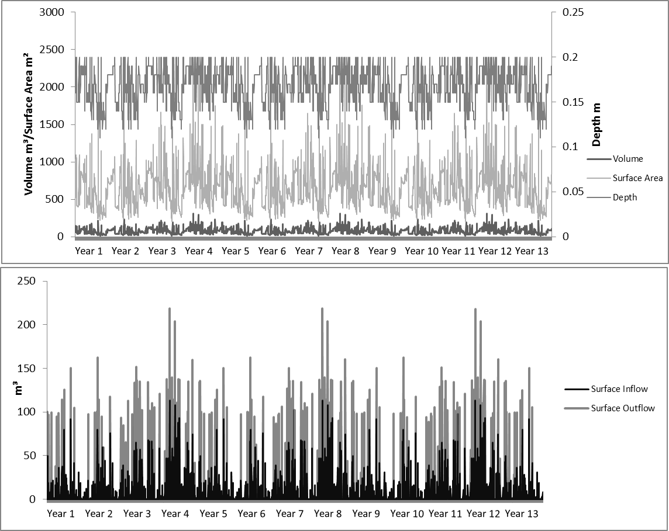
Figure 58 Figure showing hydrologic trends in the Hockerville system model.

Table 46 Ecosystem dynamics in the Hockerville system model. All numbers are in kcal/m².
 | Macrophyte | Herbivore | Predators | Litter | Detritus
Mean | 8335 | 953 | 707.7 | 3300 | 255168
Standard Deviation | 1894 | 1556 | 1263 | 50.81 | 73667
Maximum | 12043 | 6043 | 5787 | 3423 | 385632
Median | 8339 | 120.5 | 77.32 | 3300 | 254748
Minimum | 4844 | 8.29 | 6.80 | 3179 | 128346

Table 47 Iron dynamics in the Hockerville system model.
 | Biomass Fe (mg/kg) | Inflow Fe (mg/L) | Outflow Fe (mg/L)
Mean | 990.7 | 0.24 | 0.02
Standard Deviation | 180.4 | 0.07 | 0.16
Maximum | 1305 | 0.94 | 2.34
Median | 1006 | 0.26 | 0.00
Minimum | 617.4 | 0.00 | 0.00

Table 48 Zinc dynamics in the Hockerville system model.
 | Biomass Zn (mg/kg) | Inflow Zn (mg/L) | Outflow Zn (mg/L)
Mean | 879.9 | 1.62 | 0.90
Standard Deviation | 147.4 | 4.09 | 1.32
Maximum | 1187 | 3.25 | 1.99
Median | 890 | 0.35 | 0.00
Minimum | 574.7 | 0.00 | 0.00

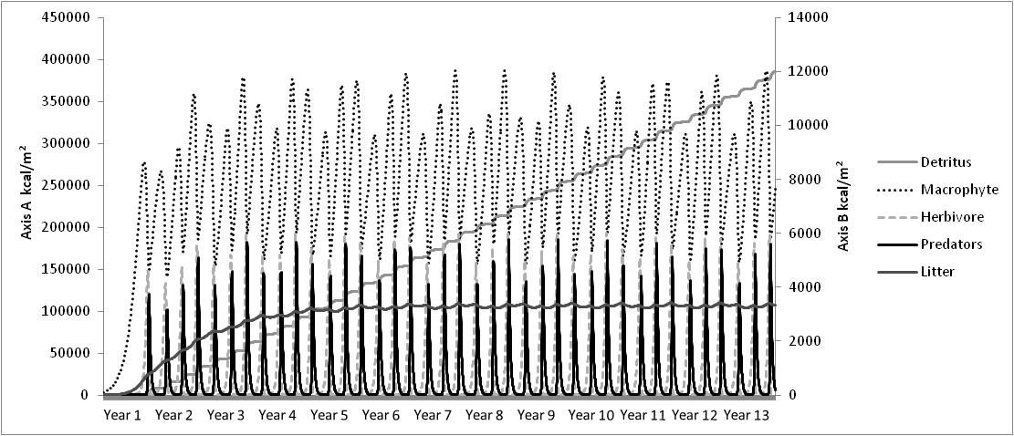
Figure 59 Ecosystem patterns in the Hockerville system model. Axis “A” is for detritus and Axis “B” is for the macrophytes, herbivores, predators, and litter.

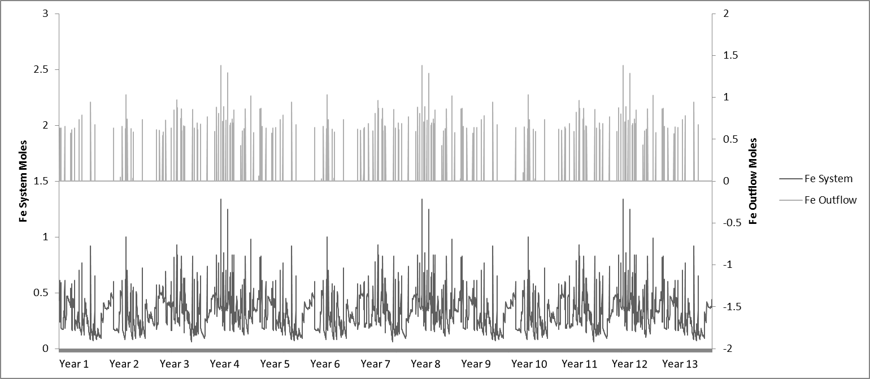
Figure 60 Iron dynamics in the Hockerville system. It is noted that this figure reflects the total moles of iron in the total system volume and the total moles of iron out flowing with the outflow volume.

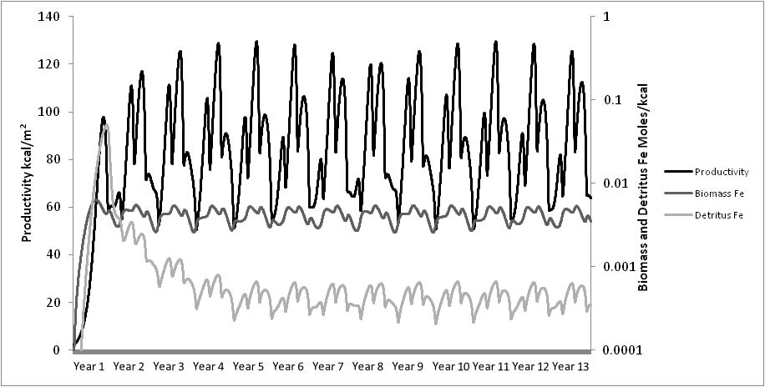
Figure 61 Productivity and iron levels in the biomass and detritus in the Hockerville system model.

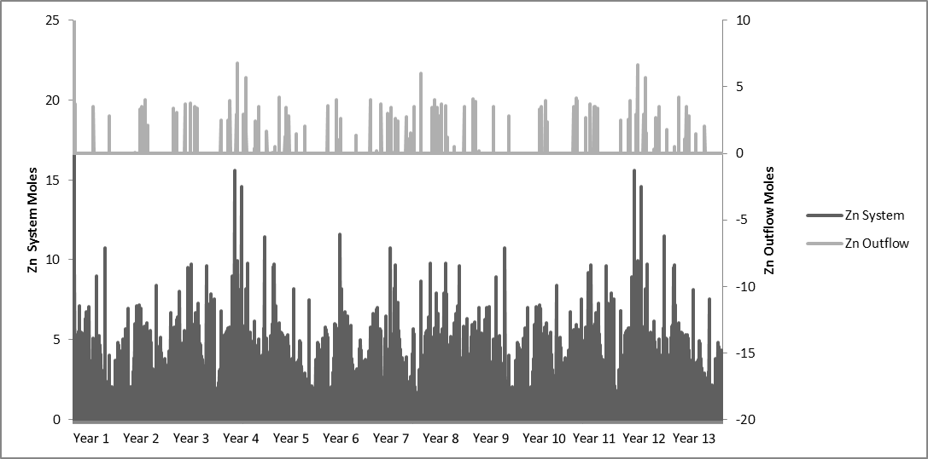
Figure 62 Zinc dynamics in the Hockerville system. This figure reflects the total moles of zinc in the total system volume and the total moles of zinc out flowing with the outflow volume.

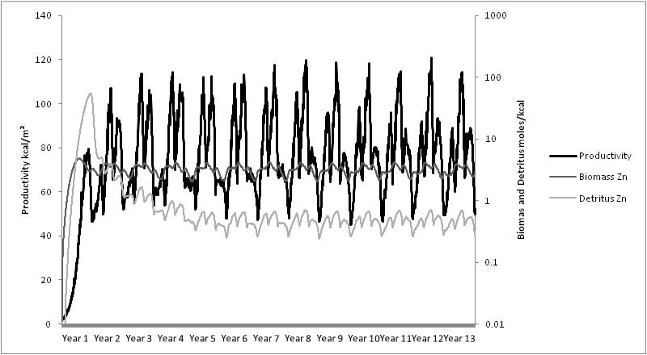
Figure 63 Productivity, zinc in the biomass and detritus in the Hockerville system model.

5.3.1.2 Adams A
The hydrologic result summary for the Adams A system model is displayed in Table 49. The system’s increasing volume was influenced by the direct precipitation and surface runoff with the highest surface runoff being 189 m³/day, but averaging 6.52±19.76 m³/day. Precipitation averaged 0.87±2.63 m³/day, with maximum calculated precipitation of 25.20 m³/day. As can be seen from Table 49, the volume of the system had a mean of 1453±30.24 m³/day, the surface inflow had a mean of 6.52±19.76 m³/day and the surface outflow had a mean of 6.26±12.28 m³/day. Surface runoff was the only surface inflow assumed for this site because field visits showed no other possible hydrologic inflow such as a seep. Evapotranspiration was the only other outflow of water having a mean of 1.12±0.82 m³/day. The model took approximately 168 days to stabilize and the trends for volume, surface area, and depth can be seen in Figure 64. Surface inflows and outflows can also be seen in Figure 64 where the outflow trend follows the trend for volume, surface area, and depth. This was expected since the model’s outflow rate is determined by the system’s volume, with overflow of water beginning at the volume of 1440 m³. Adams A never had documented surface inflow or outflow during field sampling, so all model calibrations are based on assumptions of estimations of the system’s depth, surface area, and volume. This was a very deep system with the wetland ecosystem existing around the edges. This model included the hydrology of the ‘non-wetland’ section of the system because the water depth influences the saturation of the wetland vegetation.
For the Adams A trophic level model, the patterns and values can be seen in Table 50 and Figure 65. Adams A had an average macrophyte biomass of 4360±632 kcal/m² with a maximum value of 5474 kcal/m². Herbivores had an average value of 966±766 kcal/m² and predators had an average value of 321±411 kcal/m². Detritus, being an energy sink, constantly increased. Litter, from macrophyte litterfall, followed the seasonal oscillation of the trophic levels. The litter oscillation increased for one year and then maintained equilibrium in the second year. Macrophytes, herbivore, and predators all increased the first year before oscillation began in the second year, with the trend following the system productivity (productivity shown in Figure 65). In the second year, the highest biomass were reached for the whole simulation but the Adams A model’s biomass did not stabilize until the seventh year. The simulation reflected three oscillations in each year for macrophytes, herbivores, and predators.
The iron dynamics in the Adams A system model can be seen in Figure 66 and Figure 67. As can be seen in Table 51, the concentration of iron in the incoming water and in the body of water averaged 32.37±33.16 mg/L and the mean outflow iron concentration was 0.54±0.21 mg/L, showing an iron reduction of 98.33%. The concentration of iron in the biomass averaged 3940±378 mg/kg. The biomass iron uptake followed the same oscillating pattern as productivity and the detritus which can be seen in Figure 67.
The zinc dynamics in the Adams A system model can be seen in Figure 68 and Figure 69. As can be seen in Table 52, the concentration of zinc in the incoming water averaged 11.18 mg/L and the outflow of zinc had a mean of 5.52±8.13 mg/L, showing zinc reduction of 50.63%. The concentration of zinc in the biomass averaged 2233±222 mg/kg. The biomass zinc uptake followed the same oscillating pattern as productivity and the detritus, which can be seen in Figure 69.

Table 49 Hydrologic summary from the results of the Adams A model. All values are given in m³ except Depth which is in m.
 | Volume | Surface Inflow | Surface Outflow | Precipitation | Evapotranspiration | Surface Runoff | Surface Area | Depth
Mean | 1453 | 6.52 | 6.26 | 0.87 | 1.12 | 6.52 | 310.2 | 7.02
Standard Deviation | 30.24 | 19.76 | 12.28 | 2.63 | 0.82 | 19.76 | 5.90 | 0.01
Maximum | 1665 | 189.0 | 95.83 | 25.20 | 2.75 | 189.0 | 353.9 | 7.06
Median | 1442 | 0.00 | 0.96 | 0.00 | 0.98 | 0.00 | 308.2 | 7.02
Minimum | 1399 | 0.00 | 0.00 | 0.00 | 0.00 | 0.00 | 300.3 | 6.99

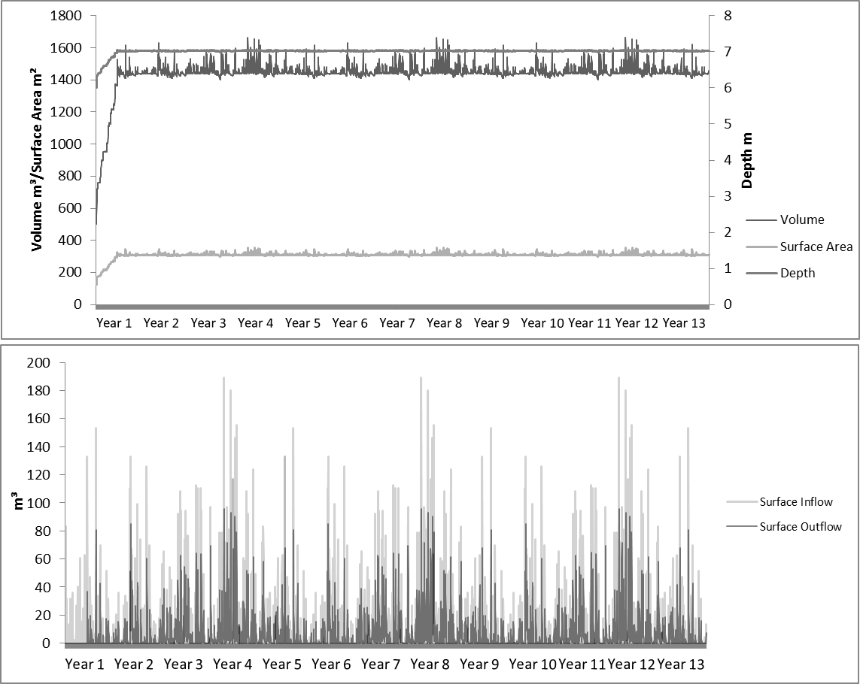
Figure 64 Figures showing hydrologic trends in the Adam A system model.

Table 50 Ecosystem dynamics in the Adams A system model. All numbers are in kcal/m².
 | Macrophyte | Herbivore | Predators | Litter | Detritus
Mean | 4360 | 966.1 | 320.9 | 171.3 | 137314
Standard Deviation | 632.5 | 766.6 | 411.1 | 12.64 | 38318
Maximum | 5474 | 2639.7 | 1512 | 198.3 | 202933
Median | 4406 | 640.7 | 99.77 | 170.9 | 138057
Minimum | 3167 | 192.1 | 16.36 | 146.7 | 69909

Table 51 Iron dynamics in the Adam A system model.
 | Biomass Fe (mg/kg) | Inflow Fe (mg/L) | Outflow Fe (mg/L)
Mean | 3940 | 32.37 | 0.54
Standard Deviation | 377.5 | 33.16 | 0.21
Maximum | 4485 | 80.79 | 0.67
Median | 4024 | 21.09 | 0.63
Minimum | 3145 | 0.00 | 0.00

Table 52 Zinc dynamics in the Adams A system model.
 | Biomass Zn (mg/kg) | Inflow Zn (mg/L) | Outflow Zn (mg/L)
Mean | 2233 | 11.18 | 5.52
Standard Deviation | 221.6 | 0.00 | 8.13
Maximum | 2557 | 11.18 | 9.80
Median | 2281 | 11.18 | 0.00
Minimum | 1758 | 0.00 | 0.00

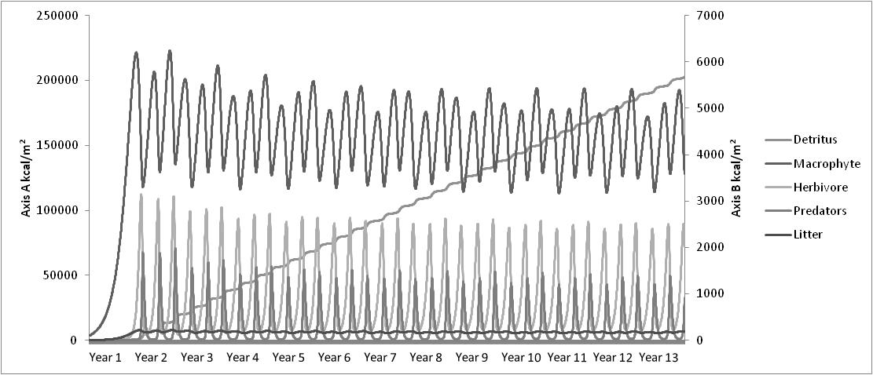
Figure 65 Ecosystem patterns in the Adam A system model. Axis “A” is for detritus and Axis “B” is for the macrophytes, herbivores, predators, and litter.

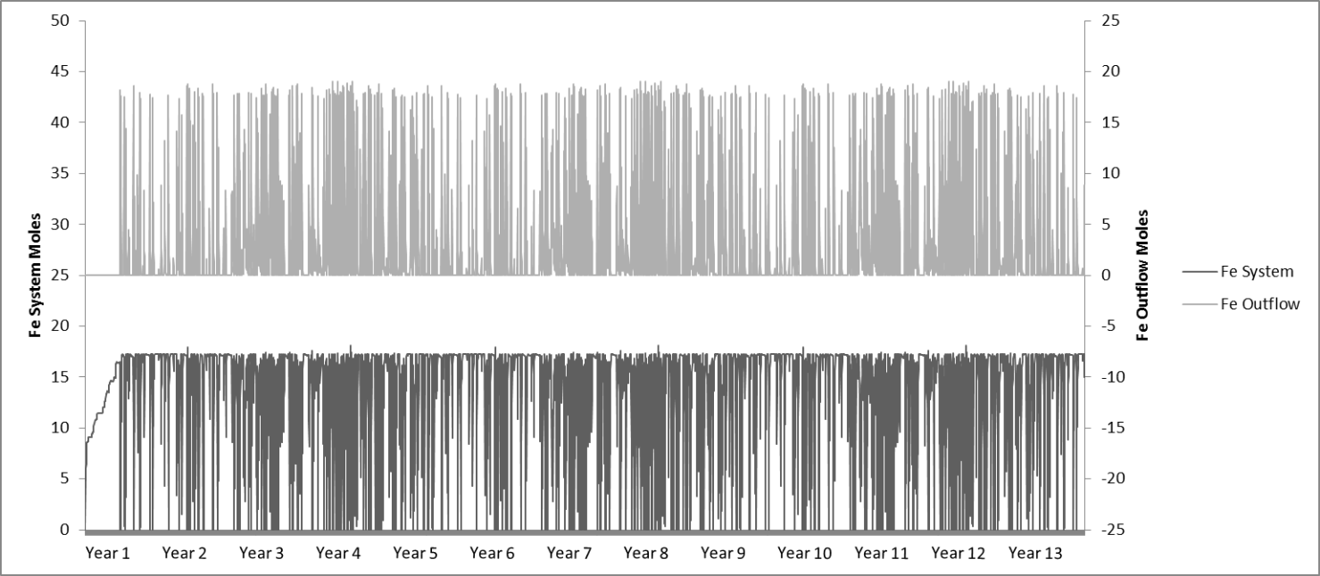
Figure 66 Iron dynamics in the Adam A system and outflows. This figure reflects the total moles of iron in the total system volume and the total moles of iron out flowing with the outflow volume.

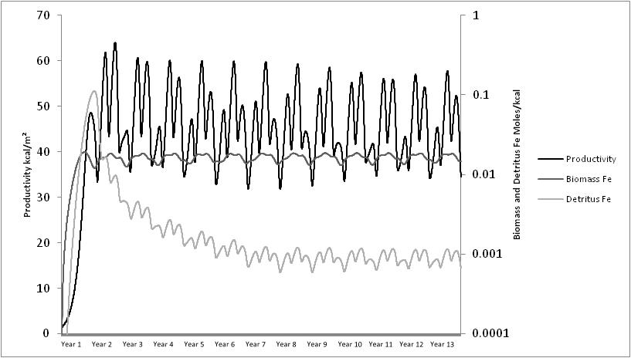
Figure 67 Productivity, iron in the biomass, and detritus in the Adam A system model.

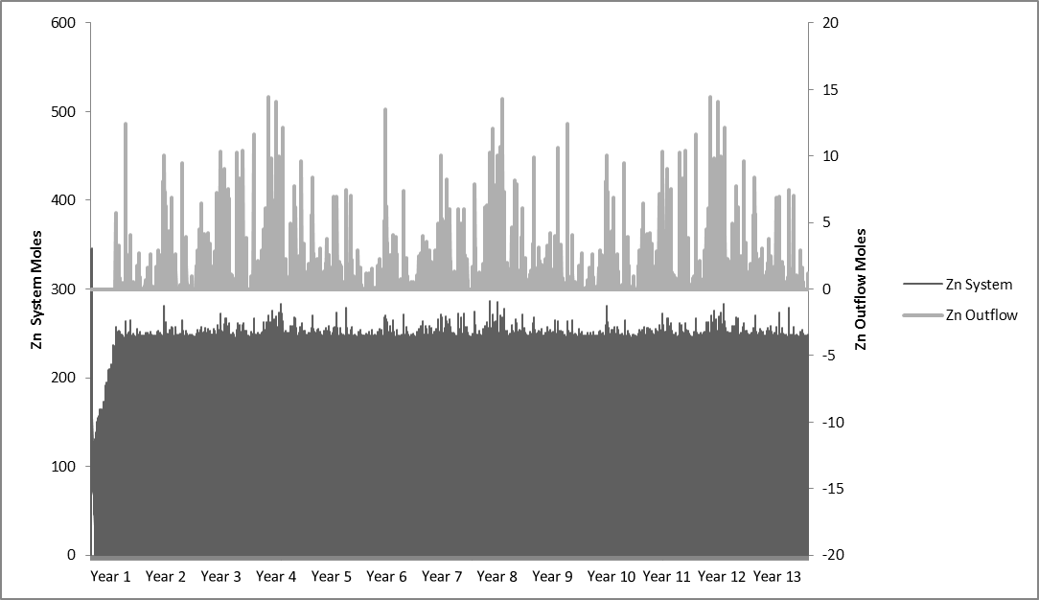
Figure 68 Zinc dynamics in the Adam A system and outflows. This figure reflects the total moles of zinc in the total system volume and the total moles of zinc out flowing with the outflow volume.

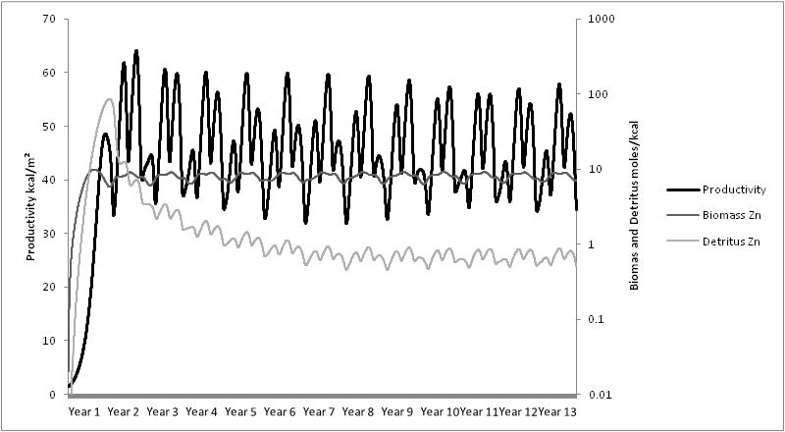
Figure 69 Productivity, zinc in the biomass, and detritus in the Adam A system model.

5.3.1.3 Rush W
The hydrologic summary and trends for the Rush W system model are displayed in Table 53 and Figure 70. As with the Hockerville and Adams A systems the increasing volume was influenced by direct precipitation and surface runoff. The highest surface runoff was 1,134 m³/day, averaging 39.12±119 m³/day. Precipitation averaged 8.69±26.35 m³/day with a maximum calculated precipitation of 252 m³/day. Evapotranspiration averaged 6.83±8.62 m³/day. Table 53 shows the mean volume of the system of 273±276 m³/day, mean surface inflow of 39.12±119 m³/day, and mean surface outflow of 40.98±48.11 m³/day. The hydrologic submodel took approximately 8 days to stabilize and the trends for volume, surface area, and depth can be seen in Figure 70. Surface inflows and outflows can also be seen in Figure 70 and surface outflow occurs from overflow starting when the wetland reaches a volume of 20 m³.
The trophic level patterns and values for the Rush W model can be seen in Table 54 and Figure 71. Rush W had an average macrophyte biomass of 10709±2571 kcal/m² with a maximum of 16031 kcal/m². Herbivores had averages of 1061±1865 kcal/m² and predators of 1008±1759 kcal/m². Detritus, being a sink for the biomass in the system, had no outflow which is why it had constant increase in the model. Litter, from macrophyte litterfall, followed the seasonal oscillation of the macrophyte trophic levels. This litter oscillation increased for five years and then maintained at an oscillating equilibrium in the fifth year. Macrophytes, herbivores, and predators all oscillated with the productivity of the system (productivity shown in Figure 70), with an oscillating equilibrium being reached in the second year of the simulation. The simulation reflects three oscillations in each year for macrophytes, herbivores, and predators.
The iron dynamics in the Rush W system model can be seen in Figure 72 and Figure 73. As can be seen in Table 55, the concentration of iron in the incoming water and in the body of water averaged 1.89±1.20 mg/L and the outflow of iron had a mean of 1.20±0.43 mg/l, demonstrating a 36.51% iron reduction. The concentration of iron in total biomass was 1725±415 mg/kg The biomass iron uptake and detritus iron concentration followed the same oscillation pattern as productivity and can be seen in Figure 73.
The zinc dynamics in the Rush W system model can be seen in Figure 74 and Figure 75. Table 56 shows the concentration of zinc in the incoming water was set to average 3.25 mg/L and the outflow of zinc had the mean of 1.61±2.65 mg/L, showing a 50.47% reduction in zinc concentration. The concentration of zinc in total biomass was 981±242 mg/kg. The biomass zinc uptake followed the same oscillation pattern as productivity as well as the detritus zinc concentration and can be seen in Figure 75.
.

Table 53 Hydrologic summary from the results of the Rush W model. All values are given in m³ except Depth which is in m.
 | Volume | Surface Inflow | Surface Outflow | Precipitation | Evapotranspiration | Surface Runoff | Surface Area | Depth
Mean | 272.7 | 39.12 | 40.98 | 8.69 | 6.83 | 39.12 | 1765 | 0.20
Standard Deviation | 276.0 | 118.6 | 48.11 | 26.35 | 8.62 | 118.6 | 1534 | 0.04
Maximum | 1670 | 1134 | 289.2 | 252.0 | 55.87 | 1134 | 9629 | 0.26
Median | 179.4 | 0.00 | 23.36 | 0.00 | 3.56 | 0.00 | 1296 | 0.21
Minimum | 6.11 | 0.00 | 0.14 | 0.00 | 0.00 | 0.00 | 126.7 | 0.07

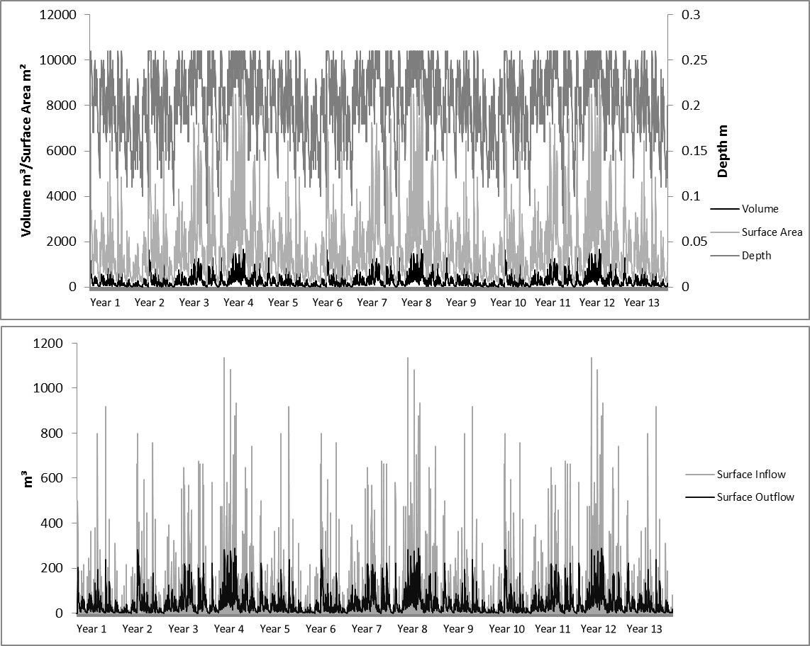
Figure 70 Hydrologic trends in the Rush W system model.

Table 54 Ecosystem dynamics in the Rush W system model. All numbers are in kilocalories/m².
 | Macrophyte | Herbivore | Predators | Litter | Detritus
Mean | 10708 | 1061 | 1008 | 4237 | 368578
Standard Deviation | 2570 | 1865 | 1759 | 76.88 | 102831
Maximum | 16031 | 7726 | 8484 | 4400 | 545348
Median | 10698 | 89.22 | 133.5 | 4239 | 372832
Minimum | 5813 | 5.13 | 8.97 | 4067 | 190554

Table 55 Iron dynamics in the Rush W system model.
 | Biomass Fe (mg/kg) | Water Fe (mg/L) | Outflow Fe (mg/L)
Mean | 1725 | 1.89 | 1.20
Standard Deviation | 415.3 | 1.71 | 0.43
Maximum | 2538 | 8.68 | 1.78
Median | 1724 | 1.47 | 1.36
Minimum | 949.7 | 0.00 | 0.00

Table 56 Zinc dynamics in the Rush W system model.
 | Biomass Zn (mg/kg) | System Zn (mg/L) | Outflow Zn (mg/L)
Mean | 980.5 | 3.25 | 1.61
Standard Deviation | 241.5 | 0.00 | 2.65
Maximum | 1473 | 3.25 | 3.25
Median | 975.5 | 3.25 | 0.05
Minimum | 533.9 | 0.00 | 0.00

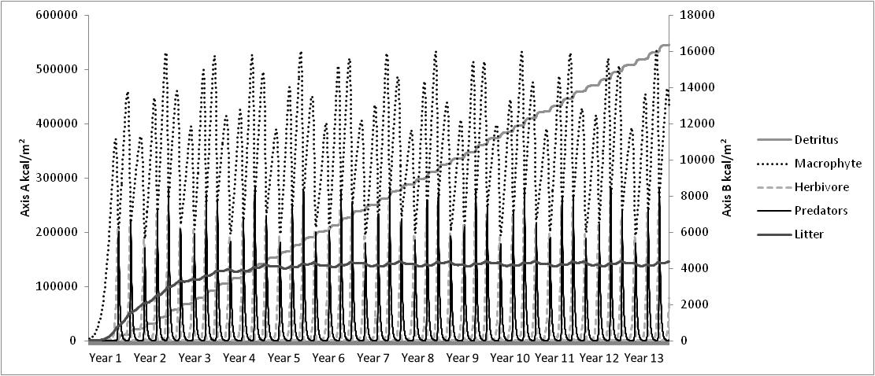
Figure 71 Ecosystem patterns in the Rush W system model. Axis “A” is for detritus and Axis “B” is for the macrophytes, herbivores, predators, and litter.

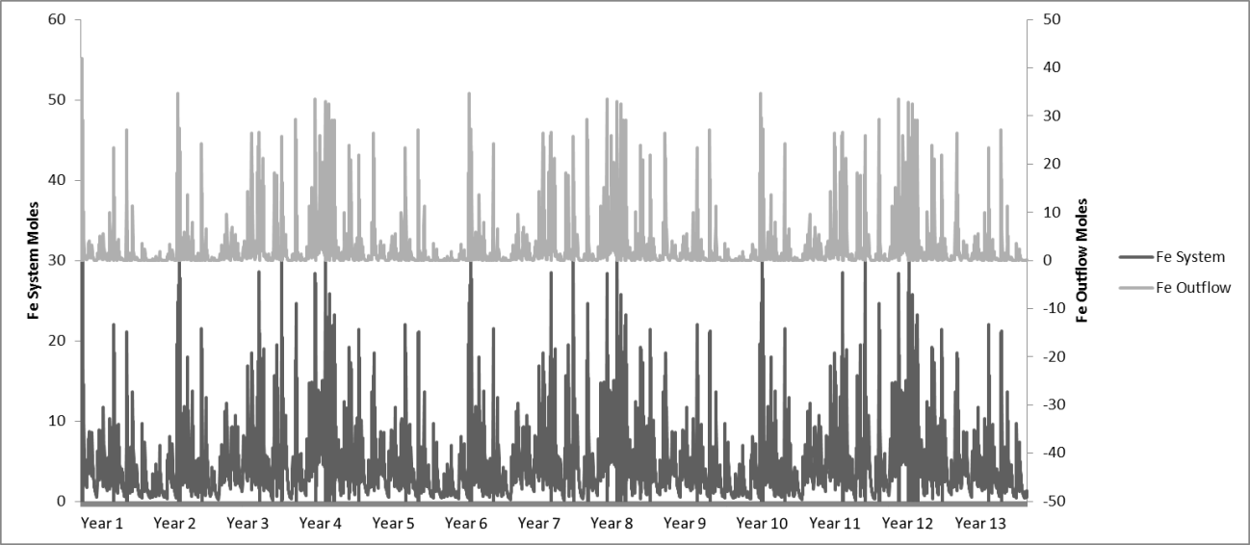
Figure 72 Iron dynamics in the Rush W system and outflows. This figure reflects the total moles of iron in the total system volume and the total moles of iron out flowing with the outflow volume.

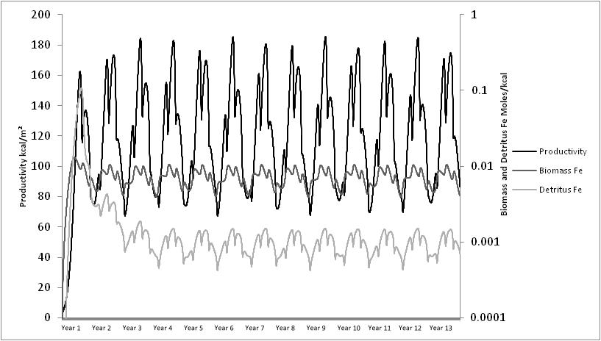
Figure 73 Productivity, iron in the biomass, and detritus in the Rush W system model.

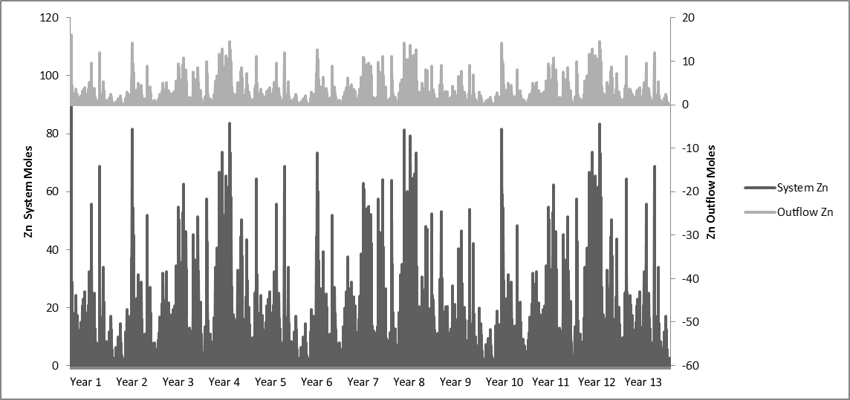
Figure 74 Zinc in the Rush W system and outflows. This figure reflects the total moles of zinc in the total system volume and the total moles of zinc out flowing with the outflow volume.

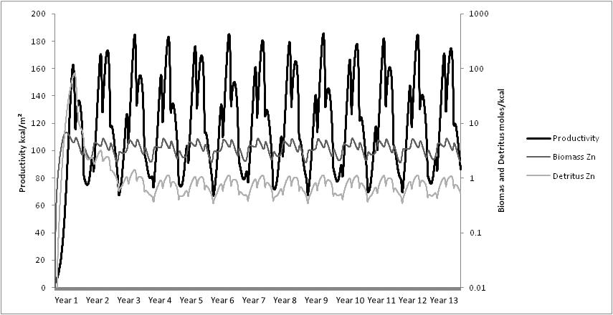
Figure 75. Productivity, zinc in the biomass, and detritus in the Rush W system model.

5.3.1.4 Le Bosquet
The hydrologic results for the Le Bosquet system model are displayed in Table 57. The system was modeled with a constant volume for seep inflow and the fluctuations in surface inflow come from the surface runoff: seep inflow being set at 15.00 m³/day and the highest surface runoff being 11.21 m³/day, averaging 0.33±1.17 m³/day. As can be seen from Table 57, the volume of the system had a mean of 510.90±30.81 m³/day , the surface inflow had a mean of 15.33±1.17 m³/day and the surface outflow had a mean of 13.62±4.48 m³/day. Precipitation had a mean of 2.99±10.64 m³/day and evapotranspiration 4.69±3.13 m³/day. The model took approximately 36 days to stabilize hydrologically with the trends for volume, surface area, and depth can be seen in Figure 76 and all three variables in the model are set to have a relationship and this relationship can be seen. Surface inflows and outflow can all so be seen in Figure 76. The outflow trend follows the trend for volume, surface area, and depth as well, which was expected since the model’s outflow rate is determined by the system’s volume.
For the Le Bosquet system model the trophic level patterns and values can be seen in Table 58 and Figure 77. Le Bosquet model had an average macrophyte biomass, in units of energy, of 5396.10±236.22 kcal/m² with a maximum of 5935.77 kcal/m². Herbivores and predators had averages of 1415.69±86.82 kcal/m² and 15.53±10.02 kcal/m², respectively. Detritus, a sink for the biomass in the system with no outflow set, had constant increase as the model predicted. Litter from macrophyte litterfall also had a constant increase in the model. Macrophytes, herbivores, and predators all oscillated with the productivity of the system (productivity is shown in Figure 79), with an oscillating equilibrium being reached in the 7th year of the simulation.
The iron dynamics in the Le Bosquet system model can be seen in Figure 78 and Figure 79. As can be seen in Table 59, the concentration of iron in the incoming water averaged 43.47±0.93 mg/L and the outflow of iron had the mean of 0.80±0.05 mg/L, showing the reducing effect of the treatment system on the iron concentration. The concentrations of iron in the biomass were 1445.67±128.59 mg/kg. The biomass iron uptake followed the same oscillation pattern as productivity as well as the detritus iron concentration.
The zinc dynamics in the Le Bosquet system model can be seen in Figure 80 and Figure 81. As can be seen in Table 60, the concentration of zinc in the incoming water averaged 0.0119 mg/L and the outflow of zinc had the mean of 0.0059±0.006 mg/L, showing the reducing effect of the system on the zinc concentration. The concentrations of zinc in the biomass were 4.36±0.39 mg/kg . The biomass zinc uptake followed the same oscillation pattern as productivity as well as the detritus zinc concentration.

Table 57 Hydrologic summary from the results of the Le Bosquet model. All values are given in m³ except Depth which is in m.
 | Volume | Surface Inflow | Surface Outflow | Precipitation | Evapotranspiration | Surface Runoff | Surface Area | Depth
Mean | 510.9 | 15.33 | 13.62 | 2.99 | 4.69 | 0.33 | 1236 | 0.62
Standard Deviation | 30.81 | 1.17 | 4.48 | 10.64 | 3.13 | 1.17 | 71.37 | 0.00
Maximum | 668.1 | 26.21 | 29.39 | 102.35 | 10.80 | 11.21 | 1613 | 0.62
Median | 510.1 | 15.00 | 13.53 | 0.00 | 4.26 | 0.00 | 1231 | 0.62
Minimum | 456.2 | 15.00 | 5.22 | 0.00 | 0.00 | 0.00 | 1118 | 0.61

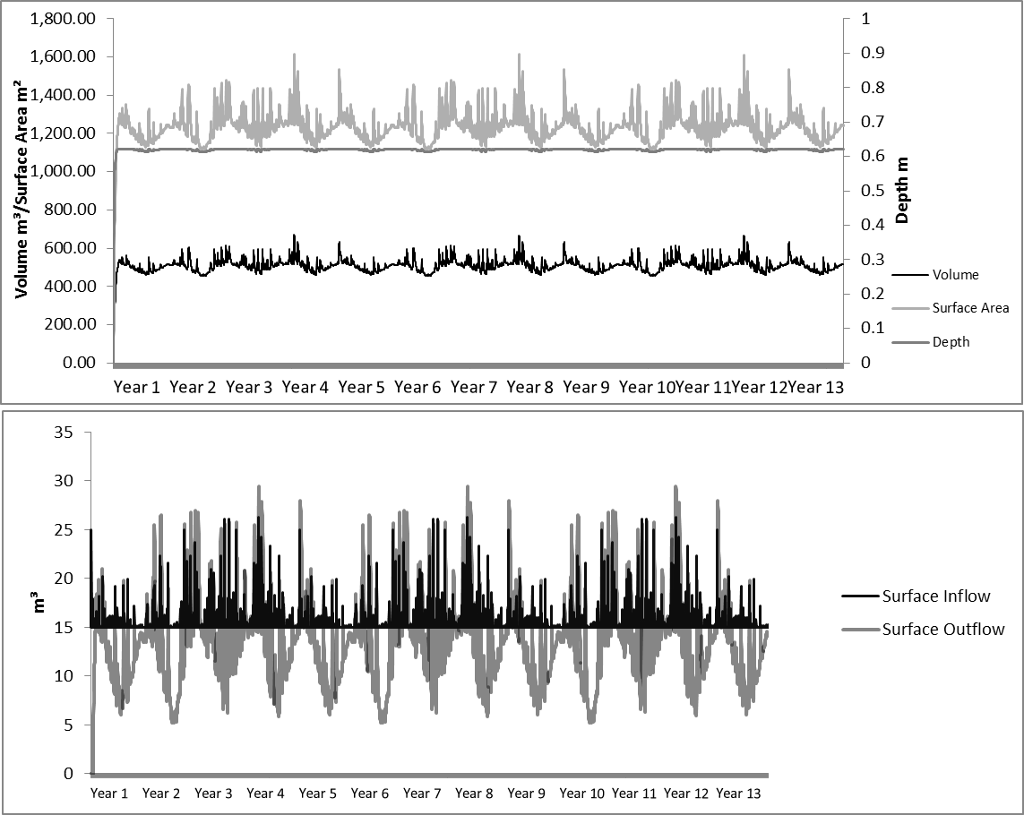
Figure 76 Figures showing hydrologic trends in the Le Bosquet system model.

Table 58 Ecosystem dynamics in the Le Bosquet system model. All values are in kilocalories/m².
 | Macrophyte | Herbivore | Predators | Litter | Detritus
Mean | 5396 | 1416 | 15.53 | 75184 | 48648
Standard Deviation | 236.2 | 86.82 | 10.02 | 16061 | 18969
Maximum | 5936 | 2035 | 75.30 | 101763 | 82750
Median | 5396 | 1403 | 13.39 | 75951 | 47984
Minimum | 5026 | 1320 | 11.79 | 46119 | 16235

Table 59 Iron dynamics in the Le Bosquet system model.
 | Biomass Fe (mg/kg) | Inflow Fe (mg/L) | Outflow Fe (mg/L)
Mean | 1446 | 43.47 | 0.80
Standard Deviation | 128.6 | 0.93 | 0.05
Maximum | 1598 | 45.07 | 1.05
Median | 1480 | 43.61 | 0.80
Minimum | 1201 | 35.46 | 0.72

Table 60 Zinc dynamics in the Le Bosquet system model.
 | Biomass Zn  (mg/kg) | Inflow Zn  (mg/L) | Outflow Zn  (mg/L)
Mean | 4.36 | 0.0119 | 0.0059
Standard Deviation | 0.39 | 0.0000 | 0.0060
Maximum | 4.82 | 0.0119 | 0.0123
Median | 4.47 | 0.0119 | 0.0049
Minimum | 3.62 | 0.0000 | 0.0000

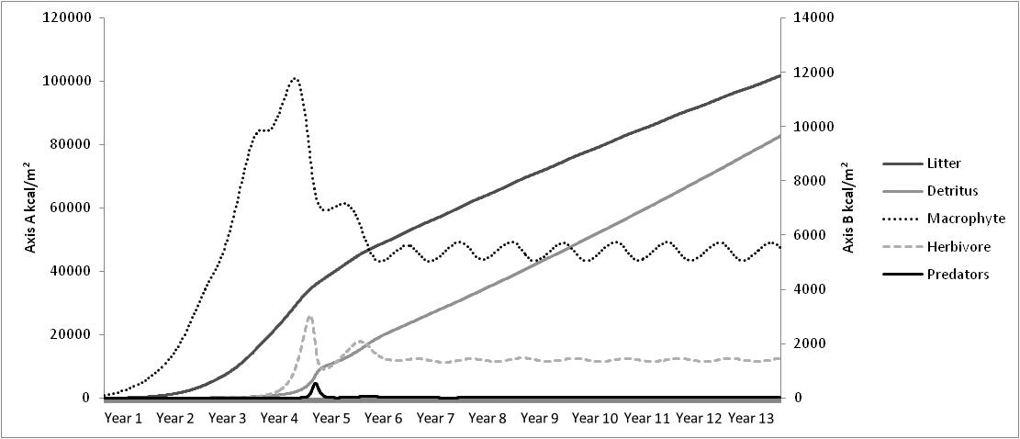
Figure 77 Ecosystem patterns in the Le Bosquet system model. Axis “A” is for detritus and Axis “B” is for the macrophytes, herbivores, predators, and litter.

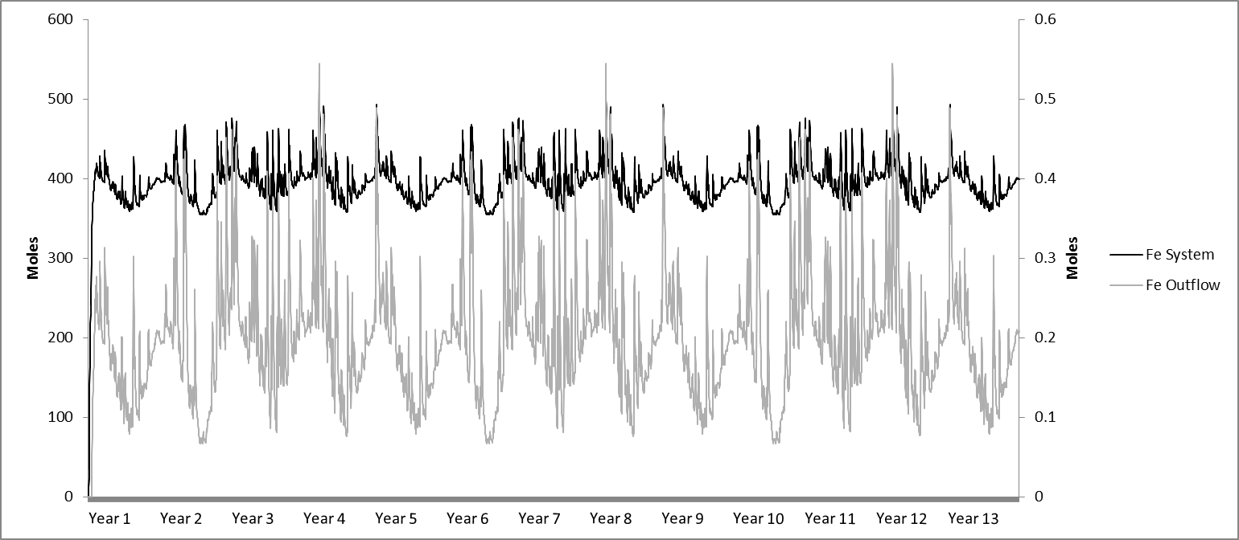
Figure 78 Figure of the iron in the Le Bosquet system and outflows. This figure reflects the total moles of iron in the total system volume and the total moles of iron out flowing with the outflow volume.

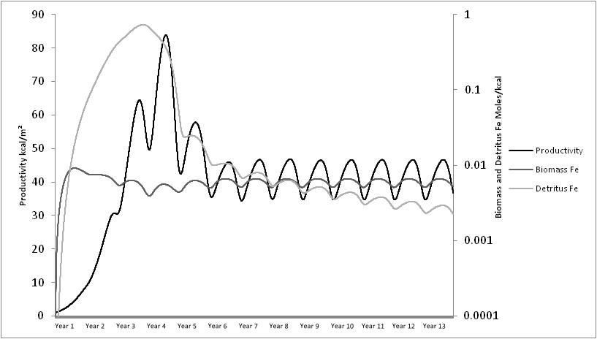
Figure 79 Productivity, iron in the biomass, and detritus in the Le Bosquet system model.

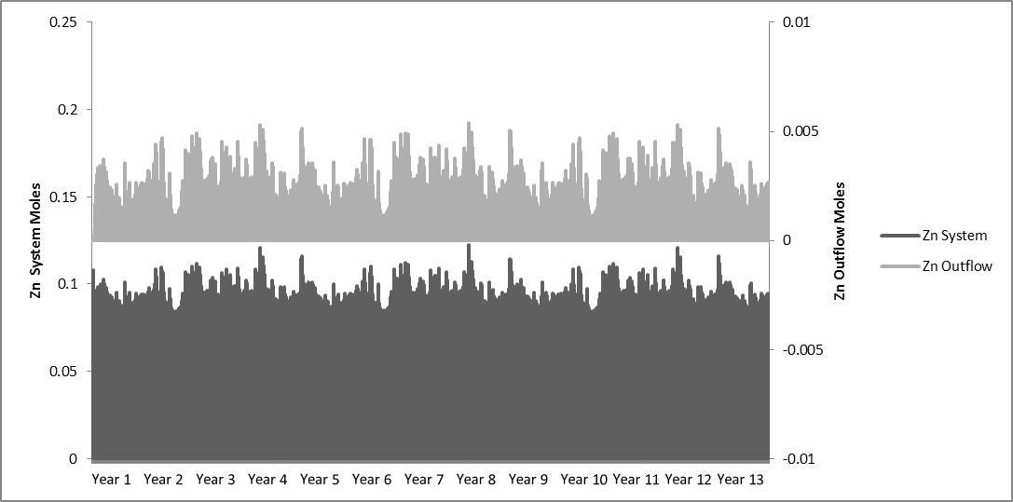
Figure 80 Figure of the zinc in the Le Bosquet system and outflows. This figure reflects the total moles of zinc in the total system volume and the total moles of zinc out flowing with the outflow volume.

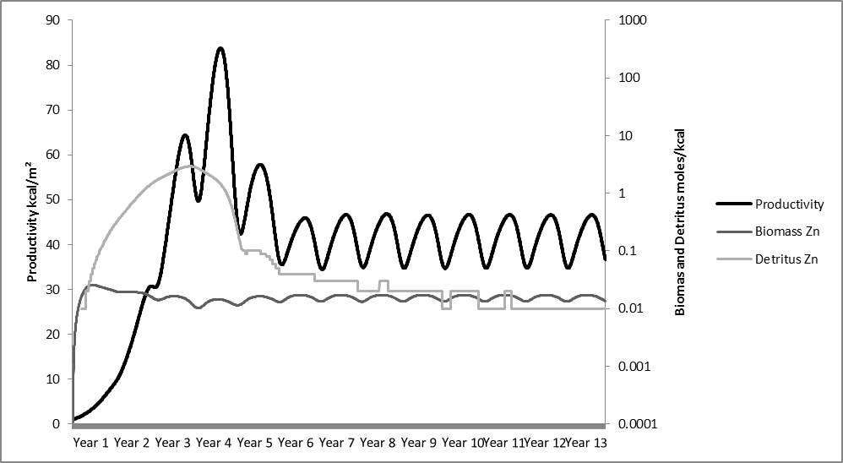
Figure 81 Productivity, zinc in the biomass, and detritus in the Le Bosquet system model.

5.3.1.5 Red Oak
The hydrologic results from the Red Oak system model are displayed in Table 61. The system was modeled with a constant volume of seep inflow and the fluctuations in surface inflow come from the surface runoff, seep inflow was set at 60 m³/day and the highest surface runoff being 40.05 m³/day, averaging 1.17±4.16 m³/day. As can be seen from Table 61, the volume of the system had a mean of 1398.70±112.71 m³/day, the surface inflow had a mean of 61.17±4.16 m³/day and the surface outflow had a mean of 58.81±13.88 m³/day. Precipitation had a mean of 10.53±37.47 m³/day and evapotranspiration 12.89±8.52 m³/day. The model took approximately 38 days to stabilize and the trends for volume, surface area, and depth can be seen in Figure 82 and all three variables in the model are set to have a relationship and this relationship can be seen. Surface inflows and outflows can all so be seen in Figure 82 where the outflow trend follows the trend for volume, surface area, and depth which was expected given that the model’s outflow rate is determined by the system’s volume.
For the Red Oak system model the trophic level patterns and values can be seen in Table 62 and Figure 83. Red Oak had an average macrophyte biomass, in units of energy, of 9563.42±876.07 kcal/m³ with a maximum of 10919.61 kcal/m³. Herbivores and predators had averages of 1949.64±182.68 kcal/m³ and 180.63±69.88 kcal/m³, respectively. Detritus, being a sink for the biomass in the system and with no outflow set for the detritus in the model, had a predicted constant increase in the model expected. Litter, from macrophyte litterfall, also had a constant increase in the model. Litter was more abundant than the detritus until the 11th year when the detritus mass surpassed the litter. Macrophytes, herbivore, and predators all oscillated with the productivity of the system (productivity shown in Figure 85), with an oscillating equilibrium being reached in the 11th year of the simulation. Red Oak did not have any macrophyte vegetation for evaluation, but a previous study confirmed that the system supports a phytoplankton average of 0.75±1.58 mg Chlorophyll a/L to 60.55±73.09 mg Chlorophyll a/L which increased sequentially through the system (Porter, 2004). In energy units, this would range from 241.9 kcal/m³ – 19314.0 kcal/m³, averaging 7040.0 kcal/m³. The model seems to have a higher biomass average than the estimated mass from the Chlorophyll a study. Porter’s (2004) study looked at the Chlorophyll a concentrations from June 2003 - December 2003. The last pond, ROW 6, peaked in biomass in August with 245.05 mg Chlorophyll a/L. ROW 4 showed two oscillations in that time period, a similar pattern seen in the multiple oscillations in the year seen in the high productivity models discussed in Chapter 4. These trends suggested that the system could have had a higher productivity than reflected in the field data, thus imitating the model.
The iron dynamics in the Red Oak system model can be seen in Figure 84 and Figure 85. Table 63 shows the concentration of iron in the incoming water averaged 122.64±3.28 mg/L and the outflow of iron had the mean of 1.07±0.09 mg/L, showing the reduction of iron by 99.13%. The concentration of iron in the biomass was 3,298.33±663.74 mg/kg. The biomass iron uptake followed the same oscillation pattern as productivity and of the detritus iron concentration. The zinc concentration was not modeled for this system due to low levels of zinc and the purpose of the Red Oak system was not to remove zinc from the waters.

Table 61 Hydrologic summary from the results of the Red Oak model. All values are given in m³ except Depth which is in m.
 | Volume | Surface Inflow | Surface Outflow | Precipitation | Evapotranspiration | Surface Runoff | Surface Area | Depth
Mean | 1399 | 61.17 | 58.81 | 10.53 | 12.89 | 1.17 | 3407 | 0.62
Standard Deviation | 112.7 | 4.16 | 13.88 | 37.47 | 8.52 | 4.16 | 236.7 | 0.01
Maximum | 1962 | 100.1 | 153.1 | 360.5 | 30.41 | 40.05 | 4638 | 0.63
Median | 1396 | 60.00 | 56.98 | 0.00 | 11.64 | 0.00 | 3402 | 0.62
Minimum | 1163 | 60.00 | 35.31 | 0.00 | 0.00 | 0.00 | 2908 | 0.60

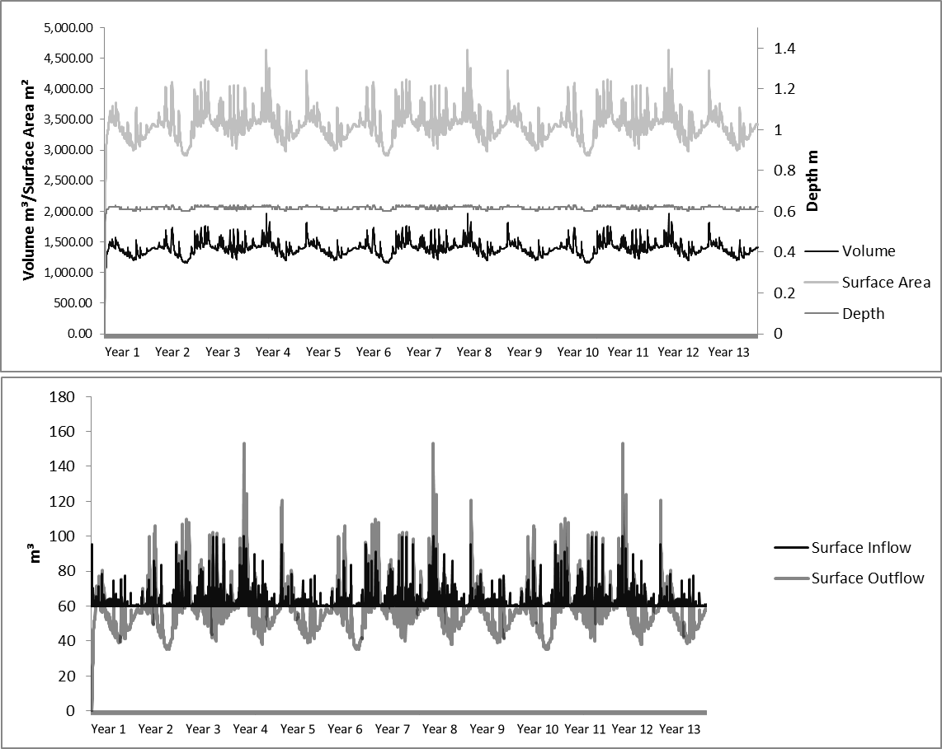
Figure 82 Figures showing hydrologic trends in the Red Oak system model.

Table 62 Ecosystem dynamics in the Red Oak system model. All values are in kcal/m³.
 | Macrophyte | Herbivore | Predators | Litter | Detritus
Mean | 9563 | 1950 | 180.6 | 129535 | 123103
Standard Deviation | 876.1 | 182.7 | 69.88 | 29020 | 42243
Maximum | 10920 | 2499 | 400.2 | 177712 | 198992
Median | 9610 | 1931 | 161.9 | 131135 | 122288
Minimum | 8168 | 1544 | 59.09 | 77109 | 52834

Table 63 Iron dynamics in the Red Oak system model.
 | Biomass Fe (mg/kg) | Water Fe (mg/L) | Outflow Fe (mg/L)
Mean | 3298 | 122.6 | 1.07
Standard Deviation | 663.7 | 3.28 | 0.09
Maximum | 4147 | 128.4 | 1.50
Median | 3411 | 123.2 | 1.07
Minimum | 2220 | 95.00 | 0.88

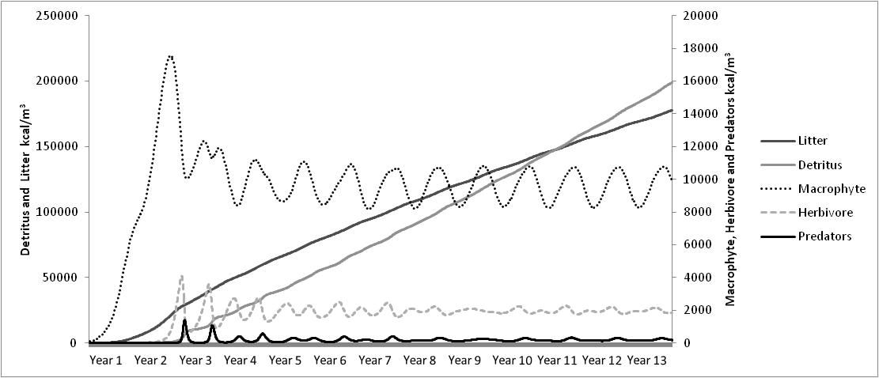
Figure 83 Ecosystem patterns in the Red Oak System model.

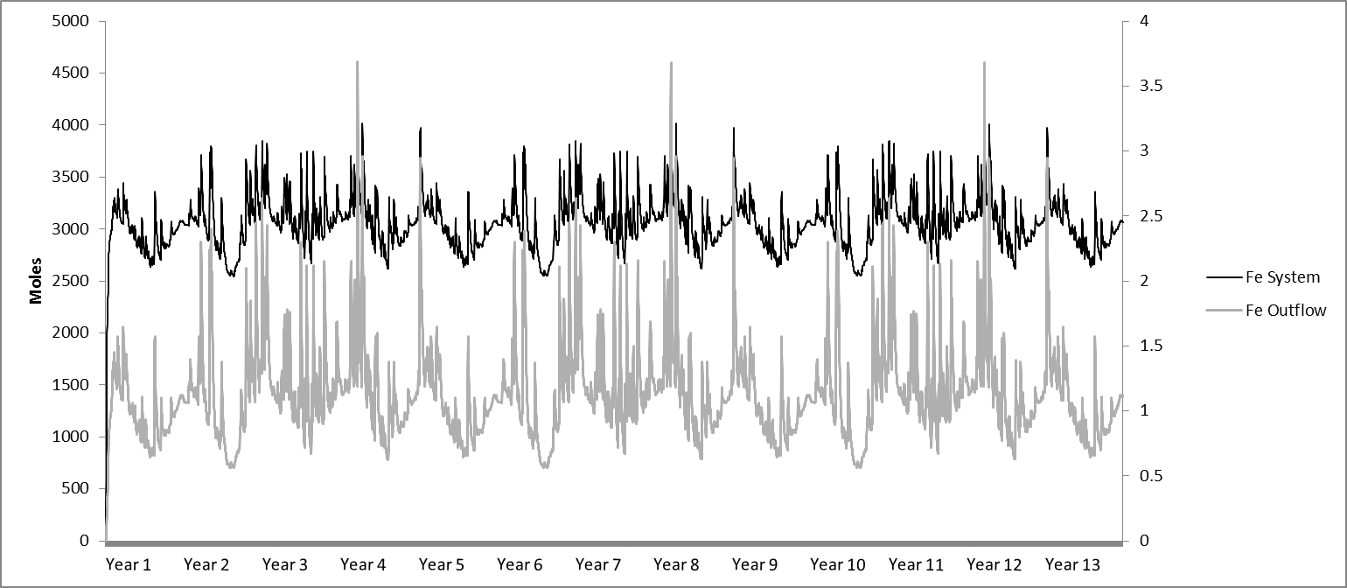
Figure 84 Figure of the iron in the Red Oak system and outflows. This figure reflects the total moles of iron in the total system volume and the total moles of iron out flowing with the outflow volume.

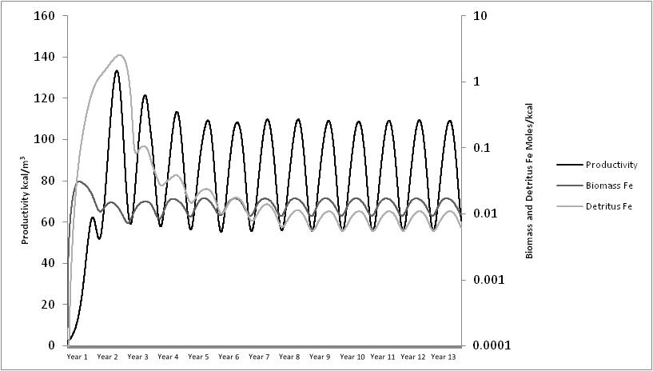
Figure 85 Productivity, iron in the biomass, and detritus in the Red Oak system model.

5.3.1.6 Hartshorne
The hydrologic results from the Hartshorne system model are displayed in Table 64. The system was modeled with a constant volume of seep inflow and the fluctuations in surface inflow coming from the surface runoff. At its greatest seep inflow of 55 m³/day is almost equal to the highest surface runoff of 49.42±5.14 m³/day. As can be seen from Table 64, the volume of the system had a mean of 2657.98±137.71 m³/day, the surface inflow had a mean of 56.44±5.14 m³/day, and the surface outflow had a mean of 54.41±16.61 m³/day. Precipitation had a mean of 12.83±45.66 m³/day and evapotranspiration 14.87±9.98 m³/day. The model took approximately 42 days to stabilize and the trends for volume, surface area, and depth can be seen in Figure 86 and all three variables in the model are set to have a relationship and this relationship can be seen. Surface inflows and outflow can all so be seen in Figure 86 where the outflow trend follows the trends for volume, surface area, and depth which is expected given that the model’s outflow rate is determined by the system’s volume.
For the Hartshorne system model the trophic level patterns and values can be seen in Table 65 and Figure 87. Hartshorne had an average macrophyte biomass, in units of energy, of 7746.67±521.52 kcal/m³ with a maximum of 8537.40 kcal/m³. Herbivores and predators had averages of 1916.84±160.95 kcal/m³ and 107.41±48.69 kcal/m³, respectively. Detritus, being a sink for the biomass in the system with no outflow set, had constant increase in the model as expected. Litter, from macrophyte litterfall, may also have had a constant increase in the model, but was greater than the detritus until the 12th year where the detritus mass surpassed the litter. Macrophytes, herbivore, and predators all oscillated with the productivity of the system (productivity shown in Figure 89), with an oscillating equilibrium being reached in the 11th year of the simulation.
The iron dynamics in the Hartshorne system model can be seen in Figure 88 and Figure 89. As can be seen in Table 66, the concentration of iron in the incoming water averaged 556.67±9.97 mg/L and the outflow of iron had the mean of 3.01±0.16 mg/L, showing the reducing effect of the system on the iron concentration. The concentrations of iron in the biomass were 32,670.65±5419.98 mg/L. The biomass iron uptake followed the same oscillating pattern as productivity and as the detritus iron concentration. The stabilization of the system model varied in the iron dynamics. For the water concentration, the iron concentrations stabilized at 42 days as with the hydrology, but the ecological patterns took much longer. The concentrations of iron in the biomass could take 4 years and detritus iron concentrations up to 10 years.

Table 64 Hydrologic summary from the results of the Hartshorne model. All values are given in m³ except Depth which is in m.
 | Volume | Surface Inflow | Surface Outflow | Precipitation | Evapotranspiration | Surface Runoff | Water Surface Area | Depth
Mean | 2658 | 56.44 | 54.41 | 12.83 | 14.87 | 1.44 | 3889 | 1.02
Standard Deviation | 137.7 | 5.14 | 16.61 | 45.66 | 9.98 | 5.14 | 175.6 | 0.01
Maximum | 3348 | 104.42 | 162.68 | 439.22 | 33.52 | 49.42 | 4759 | 1.06
Median | 2648 | 55.00 | 52.35 | 0.00 | 13.33 | 0.00 | 3876 | 1.02
Minimum | 2381 | 55.00 | 24.85 | 0.00 | 0.00 | 0.00 | 3533 | 1.01

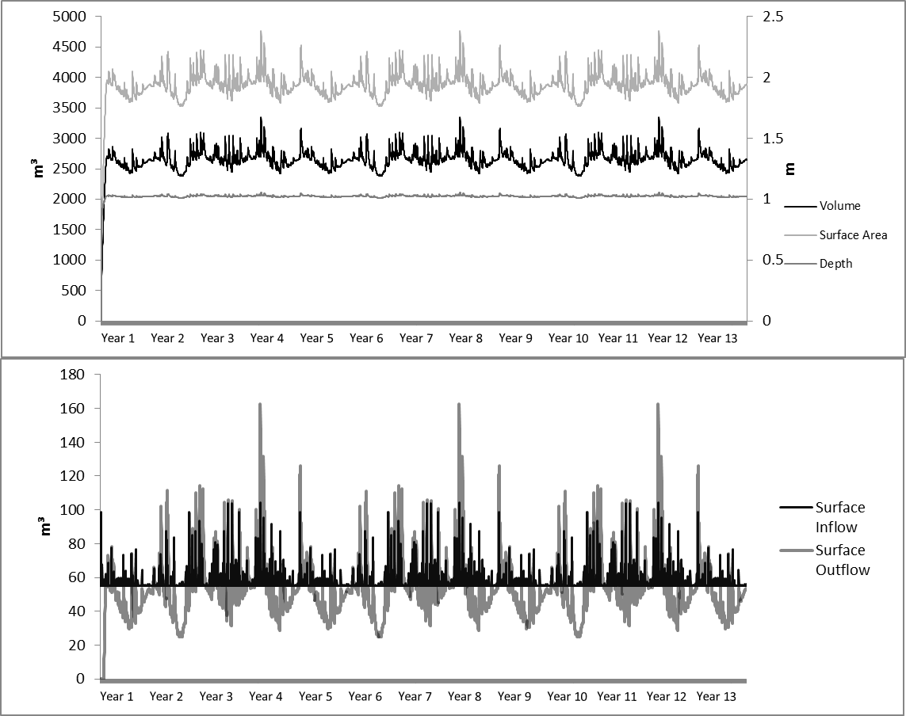
Figure 86 Graphs showing hydrologic trends in the Hartshorne system model.

Table 65 Ecosystem dynamics in the Hartshorne system model. All values are in kcal/m³.
 |  | Macrophyte | Herbivore |  | Predators | Litter | Detritus
Mean | 7747 |  | 1917 | 107.4 |  | 106579 |  | 95880
Standard Deviation | 521.5 |  | 160.9 | 48.69 |  | 23296 |  | 33821
Maximum | 8537 |  | 2253 | 220.0 |  | 145175 |  | 156744
Median | 7788 |  | 1899 | 90.45 |  | 107790 |  | 95364
Minimum | 6960 |  | 1663 | 50.08 |  | 64387 |  | 39616

Table 66 Iron dynamics in the Hartshorne system model.
 | Biomass Fe (mg/kg) | Water Fe (mg/L) | Outflow Fe (mg/L)
Mean | 3267 | 556.7 | 3.01
Standard Deviation | 542.0 | 9.97 | 0.16
Maximum | 3931 | 574.4 | 3.78
Median | 3378 | 558.2 | 2.99
Minimum | 2338 | 470.7 | 2.69

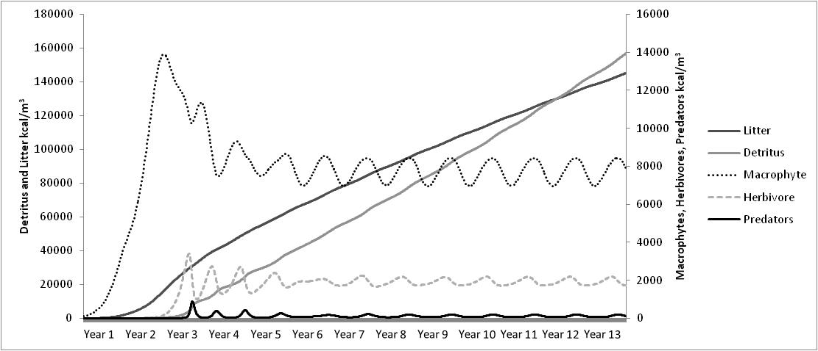
Figure 87 Ecosystem patterns in the Hartshorne system model.

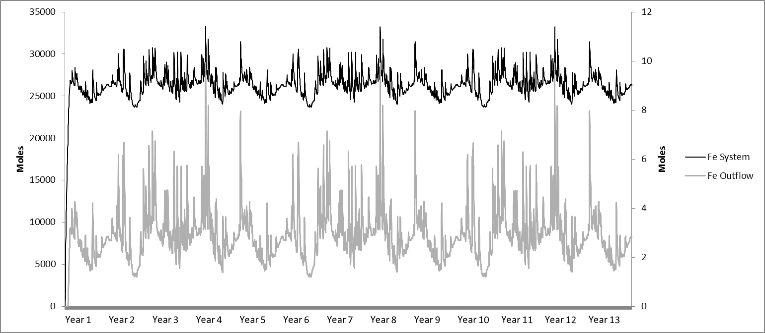
Figure 88 Figure of the iron in the Hartshorne system and outflows. This figure reflects the total moles of iron in the total system volume and the total moles of iron out flowing with the outflow volume.

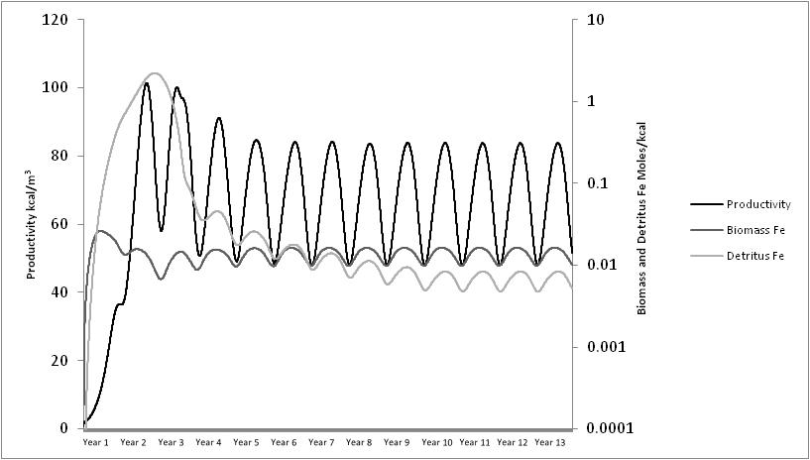
Figure 89 Productivity, iron in the biomass, and detritus in the Hartshorne system model.

5.3.2 System Energy Indices
The ecosystem, hydrologic, and biogeochemical results in the model were used to determine the energetics of the system and to calculate various indices to describe the states of each system. These indices of emergy, ascendency and exergy were used to evaluate system efficiency, maturity, resistance and health. Relationships between these indices and the ecosystem services of iron and zinc retention were evaluated.

5.3.2.1 Emergy
An emergy analysis was done for each model to determine the amount of emergy used for iron and zinc sequestration in each system. The results of emergy analyses for the hydrologic and ecosystem components can be seen in Table 67. Transformities, calculated from the model’s energy flows that went into each trophic level, were used to calculate the emergy for the trophic levels of the ecosystem. The higher the transformity the higher the energy needed to create that unit of energy. From the concepts of thermodynamics it can be assumed that the lower the transformity the more efficient the process that creates the ‘product’. Transformity can also be an indicator the hierarchical position in the trophic levels. The differences in the transformities within the trophic level model were expected. The efficiencies of the processes can increase or decrease as the components change. As the energy moves through the trophic levels, a higher transformity occurs.
In all systems, except Red Oak, the detritus content had a lower transformity than the predators had. This could be explained by the fact that the primary producers in the system are main source of organic matter. The detritus transformities for the treatment systems ranged from 6.30E+05 to 1.57E+06 seJ/J with the Le Bosquet system having the greatest difference between the highest trophic level and detritus. The volunteer wetland systems had detritus transformities ranging from 1.58E+05 to 4.11E+05 seJ/J. Transformity values for soil organic content and detritus in the literature range from 5.89E+03 to 3.09E+05 seJ/J. The treatment wetlands had higher transformity values for the detritus and the volunteer wetlands maintained the lower detritus transformities, indicating that the volunteer wetlands closely resembled the values found in other research. The higher transformity values in the Red Oak and Hartshorne system were closer to the transformity value of phytoplankton detritus found by Campbell (2004) of 1.72E+06 seJ/J.
Individual water and evapotranspiration transformities for each wetland were not calculated because it was assumed that water and evapotranspiration energies did not vary significantly between each system and are based on the chemical value of water from its Gibb’s Free Energy. The total emergy values for the inputs (solar, water inflows, and evapotranspiration) range from 1.94E+12 to 6.71E+12 seJ/m²/yr. There was a strong relationship between the water inflow and the total emergy input (r =0.99, n=12, α=0.01). This implies that the water inflow is the energy input that creates the differences between the systems’ emergy. The solar energy has less energy variation as an input than that for water, which is expected given that each system is in similar areas throughout the central U.S.
The trophic level emergy analysis showed a difference in the ranges between the treatment and volunteer wetlands, but the difference was not significant (t(6) = 0.92, p = 0.05). The total trophic level emergy values for the treatment wetlands ranged from 4.98E+13 to 1.09E+14 seJ/m²/yr and the volunteer systems had total trophic level emergy values of 4.19E+13 to 4.67E+13 seJ/m²/yr. While these total emergy values are important at understanding the amount of energy it takes to support the ecosystem, it is the transformities that give a numerical value to the efficiency at converting that energy to a product in the system.
Rush W was the most efficient system for macrophyte production and this system had the largest biomass accumulation as well. This was also a system that had saplings of Salix spp. in the ecosystem, along with other macrophytes, and systems with wood production tend to have a lower transformity (Brown and Ulgiati, 2005). When the trees senesce only the leaves become a part of the detritus cycle. This biomass from the wood acts as energy ‘storage’ and the tree needs less energy to regrow the next season, giving it a lower transformity. The herbivore and predator trophic levels followed the trend of the predators always having a higher transformity then the herbivores. This follows the hierarchical concept in which emergy is based: as one moves up the trophic level, it takes more energy to create a unit of energy at that level. In the case of the Rush W system, the predators have a higher biomass than the herbivores (per m²). In most ecosystems, this would be considered an unstable relationship but these are small systems and much of the herbivore and predator interactions are assumed to be due to import and export to/from the system. This would explain why either trophic level does not crash in the model. All systems are considered small and field studies of each did not determine a permanent population of either herbivore or predators. Although the total values of the trophic levels did always follow an expected hierarchical pyramid, it is possible that when an ecosystem is stressed the relations between the components can change and the hierarchy can be altered (Brown and Ulgiati, 2005). Transformities in all systems ranged from 1.50E+05 to 1.11E+06 seJ/J for herbivores and 1.67E+05 to 1.48E+07 seJ/J for predators. Literature suggests that average transformities for herbivores and invertebrates (the assumed dominant herbivores in the systems studied for this dissertation) are from 1.91E+04 to 3.24E+05 seJ/J, which fit the ranges for herbivores in these models. However, the higher values of herbivores transformities in this model would fit for herbivores like birds or mammals. For predators the average literature calculations for transformities range from 1.52E+05 to 4.06E+07, which these models fit.
Transformity values were calculated for iron removed from the incoming water by each system and are shown in Table 68. The three treatment systems in southeast Oklahoma showed the largest amount of iron retention in the models from 7.03E+03 to 1.09E+05 g/m²/yr. The volunteer systems had iron retention rates of 5.62 to 8.66E+02 g/m²/yr. The systems built for iron removal not only had the most iron removal per square meter, they also had the lowest transformity, indicating that these systems are more energy efficient than the volunteer systems at Tar Creek in removing iron. The transformities for the treatment systems ranged from 1.02E+09 to 7.74E+09 seJ/g and for the volunteer systems from 5.62E+10 to 8.65E+12 seJ/g. The transformities indicated how much total ecosystem energy is needed to transform one gram of iron (transforming iron in these models means oxidizing and hydrolyzing iron to precipitate from the water column). The transformities for iron production and ore vary throughout the literature and can be seen in Table 69. Calculated transformities for iron production from the literature range from 1.25E+04 to 1.91E+08 seJ/g. Odum (1996) estimated that the transformity for iron ore production in the United States is 1.76E+08 seJ/g and furthermore the global iron transformity, without labor and services, was estimated at 9.72E+07 seJ/g (Ingwersen, 2010b). The treatment systems’ iron transformities fall into the range between the recycled iron and the global iron ore production estimates; Le Bosquet being the least efficient of the three. The transformities for the volunteer wetlands were all higher than any of the iron production transformities in the literature. Adam A was shown to be the most efficient, but it is also the deepest system with the highest volume. If transformities were calculated based on the volume, rather than the surface area in this case, it is possible that Adams A would have been the least efficient system. These emergy values suggest that natural systems are going to less efficient for metal retention than a system built specifically for this purpose. The systems with the most vegetation also had the lowest efficiency showing that macrophytes, specifically, are not making the system more efficient in retaining iron.
Transformity values were calculated for the zinc removed from the incoming water for the volunteer wetlands and Le Bosquet and can be shown in Table 70. Zinc removal was not assessed for Red Oak and Hartshorne because these systems were not built for zinc removal nor had high quantities. The Le Bosquet system had a zinc removal amount of 2.93E-02 g/m²/yr being the lowest amount removed, but this system also had the least amount of zinc entering the system. The volunteer systems, Adams A, Rush W, and Hockerville, had zinc retention rates of 1.28 to 3.03+02 g/m²/yr, with the Adams A system having the largest total zinc retention. The treatment system, Le Bosquet, had the highest transformity at 1.85E+15 seJ/g, but this system was not built for zinc removal and the water also had low zinc concentrations.
The transformities for the volunteer systems ranged 1.60E+11 to 3.81E+13 seJ/g and Adams A had the lowest transformity. The transformities for zinc production and ore vary throughout the literature and can be seen in Table 71, ranging from 3.64E+07 to 7.20E+10 seJ/g. Mined zinc has the lowest transformity and the calculated global zinc had the highest transformity (Odum, 1991; Cohen and Brown, 2007). Zinc removed from mine wastewater has been assessed to have a transformity of 6.00E+09 (Odum, 2000). None of the systems modeled had transformities within the ranges found in the literature. With the Le Bosquet system, this was expected given that this system was not built for zinc removal. The volunteer systems received large amounts of zinc, but also remained less efficient for zinc retention than industrial mining for zinc. Of the volunteer systems, Adam A was shown to be the most efficient; it is also the deepest system with the highest volume. If transformities were calculated based on the volume, rather than the surface area in this case, it is possible that it would have been a less efficient system.

Table 67 Emergy values for each system. All values converted in Joules for comparison to literature values. Data (J/m²/yr), Transformity (seJ/J), and Emergy (seJ/yr).
Red Oak |  |  |  | Hockerville
 | Data | Transformity | Emergy |  |  | Data | Transformity | Emergy
Inputs |  |  |  | Inputs
Direct Sun | 6.11E+09 | 1.00E+00 | 6.11E+09 | Direct Sun |  | 6.11E+09 | 1.00E+00 | 6.11E+09
Evapotranspiration | 5.81E+06 | 1.50E+04 | 8.71E+10 | Evapotranspiration |  | 3.80E+06 | 1.50E+04 | 5.70E+10
Water inflows | 3.19E+07 | 1.54E+05 | 4.91E+12 | Water inflows |  | 1.22E+07 | 1.54E+05 | 1.88E+12
Sum |  |  | 5.01E+12 | Sum |  |  |  | 1.94E+12
Products |  |  |  | Products
Macrophytes | 4.57E+07 | 1.90E+05 | 8.68E+12 | Macrophytes |  | 5.04E+07 | 1.94E+05 | 9.77E+12
Herbivores | 1.05E+07 | 4.50E+05 | 4.71E+12 | Herbivores |  | 2.53E+07 | 2.14E+05 | 5.41E+12
Predators | 1.68E+06 | 9.50E+05 | 1.59E+12 | Predators |  | 2.42E+07 | 2.43E+05 | 5.89E+12
Organic matter | 7.24E+07 | 1.30E+06 | 9.42E+13 | Organic matter |  | 1.31E+08 | 1.96E+05 | 2.56E+13
Sum |  |  | 1.09E+14 | Sum |  |  |  | 4.67E+13
Hartshorne |  |  |  | Adam A
 | Data | Transformity | Emergy |  | Data |  | Transformity | Emergy
Inputs |  |  |  | Inputs
Direct Sun | 6.11E+09 | 1.00E+00 | 6.11E+09 | Direct Sun | 6.11E+09 |  | 1.00E+00 | 6.11E+09
Evapotranspiration | 5.50E+06 | 1.50E+04 | 8.24E+10 | Evapotranspiration | 6.83E+06 |  | 1.50E+04 | 1.02E+11
Water inflows | 2.53E+07 | 1.54E+05 | 3.90E+12 | Water inflows | 4.29E+07 |  | 1.54E+05 | 6.60E+12
Sum |  |  | 3.98E+12 | Sum |  |  |  | 6.71E+12
Products |  |  |  | Products
Macrophytes | 3.57E+07 | 2.47E+05 | 8.84E+12 | Macrophytes | 2.29E+07 |  | 3.68E+05 | 8.44E+12
Herbivores | 9.43E+06 | 5.68E+05 | 5.36E+12 | Herbivores | 1.13E+07 |  | 4.06E+05 | 4.58E+12
Predators | 9.21E+05 | 1.62E+06 | 1.49E+12 | Predators | 6.33E+06 |  | 5.27E+05 | 3.33E+12
Organic matter | 5.86E+07 | 1.57E+06 | 9.21E+13 | Organic matter | 6.23E+07 |  | 4.11E+05 | 2.56E+13
Sum |  |  | 1.08E+14 | Sum |  |  |  | 4.19E+13
Le Bosquet |  |  |  | Rush W
 | Data | Transformity | Emergy |  | Data |  | Transformity | Emergy
Inputs |  |  |  | Inputs
Direct Sun | 6.11E+09 | 1.00E+00 | 6.11E+09 | Direct Sun | 6.11E+09 |  | 1.00E+00 | 6.11E+09
Evapotranspiration | 7.45E+06 | 1.50E+04 | 1.12E+11 | Evapotranspiration | 4.15E+06 |  | 1.50E+04 | 6.23E+10
Water inflows | 2.87E+07 | 1.54E+05 | 4.42E+12 | Water inflows | 2.87E+07 |  | 1.54E+05 | 4.43E+12
Sum |  |  | 4.54E+12 | Sum |  |  |  | 4.49E+12
Products |  |  |  | Products
Macrophytes | 2.48E+07 | 4.04E+05 | 1.00E+13 | Macrophytes | 6.71E+07 |  | 1.37E+05 | 9.22E+12
Herbivores | 8.52E+06 | 1.11E+06 | 9.48E+12 | Herbivores | 3.23E+07 |  | 1.50E+05 | 4.85E+12
Predators | 3.15E+05 | 1.48E+07 | 4.67E+12 | Predators | 3.55E+07 |  | 1.67E+05 | 5.93E+12
Organic matter | 4.06E+07 | 6.30E+05 | 2.56E+13 | Organic matter | 1.62E+08 |  | 1.58E+05 | 2.56E+13
Sum |  |  | 4.98E+13 | Sum |  |  |  | 4.56E+13

Table 68 Calculated iron emergy values from each system model.
 | Iron retention  (g/m²/yr) | Transformity (seJ/g) | Emergy (seJ/m²/yr)
Red Oak | 1.54E+04 | 7.41E+09 | 1.14E+14
Hartshorne | 1.09E+05 | 1.02E+09 | 1.12E+14
Le Bosquet | 7.03E+03 | 7.73E+09 | 5.43E+13
Hockerville | 5.62E+00 | 8.65E+12 | 4.86E+13
Rush W | 3.08E+01 | 1.63E+12 | 5.01E+13
Adam A | 8.66E+02 | 5.62E+10 | 4.87E+13

Table 69 Iron transformity values from the literature.
 | Transformity (seJ/g) | Source | Location
Iron Ore Production | 1.76E+08 | Odum, 1996 | United States
Iron Recycled | 1.25E+04 | Luchi and Ulgaiti, 2000 | Italy
Iron | 2.68E+07 | Cohen et al., 2007 | Global
Iron without labor and services | 9.72E+07 | Ingwersen, 2010b | Global
Iron Chloride | 1.91E+08 | Ingwersen, 2010a | Peru mine
Iron Ore Powder | 6.35E+06 | Zhou and Jiang, 2009 | China

Table 70 Calculated zinc emergy values from each system model
 | Zinc  (g/m²/yr) | Transformity (seJ/g) | Emergy  (seJ/m²/yr)
Le Bosquet | 2.93E-02 | 1.85E+15 | 5.43E+13
Hockerville | 1.28E+00 | 3.81E+13 | 4.86E+13
Rush W | 1.54E+00 | 3.26E+13 | 5.01E+13
Adam A | 3.03E+02 | 1.60E+11 | 4.87E+13

Table 71 Zinc transformities from the literature.
 | Transformity (seJ/g) | Source | Location
Mine Zinc | 3.64E+07 | Odum, 1991 | Ecuador
Zinc (without labor and services) | 7.20E+10 | Cohen and Brown, 2007 | Global
Zinc in Mine Wastewater | 6.00+09 | Odum, 2000 | Treatment Wetland
Zinc Alloys | 6.80E+10 | Roudebush, 1998 | Building Materials
Zinc | 1.43E+09 | Odum, 1996; Siche and Ortega, 2006 | Peru

5.3.2.2 Ascendency
Calculated network system indices for ascendency are shown in Table 72. The volunteer system models had a large range between the systems 28672 to 62411 kcal bits/m²/yr and the treatment systems’ ascendency values ranged from 18189 to 42884 kcal bits/m²/yr. There was not a significant different in the ascendency values between the different types of systems (t(6) = 1.18, p = 0.05). The models for these systems all shared the same compartments, so the variation in the network calculations was due to the changes in the same flows and not a change in the number of compartments.
There was a strong relationship between the system ascendency and the peak biomass (r = 0.96; n = 12, p = 0.05), but a higher biomass does not necessarily indicate a higher ascendency. This can be observed in the difference in the biomass-ascendency relationship seen between the Le Bosquet system and the Adams A system. The relative ascendency (A/C) was 66.26 to 69.94% for the treatment systems and 75.93 to 82.37% for the volunteer systems, showing a significant difference (t(6) = 5.32, p = 0.05).
It has been suggested that sustainability and vitality of a system depend heavily on efficiency and resilience (May, 1972; Holling, 1973, 1986; Walker et al., 2006; Goerner et al., 2009). Systems that are more fragile and have too little diversity also seem to be most efficient. Diversity benefits a system’s resilience by giving the system additional options with which to rebound. Yet, excessive diversity and redundancy can hinder throughput efficiency, leading the system to become stagnant and less efficient. Flow-network sustainability can be defined as the optimal balance of efficiency, diversity, and resilience. New literature refers to ascendency as system efficiency with resilience as the system overhead (Goerner et al., 2009). By these definitions, the systems that have the least resilience will have lower overhead values and ascendency is closer to the system capacity. In theory, the most efficient system will have almost no resilience, but a balanced network will have a buffer between the ascendency and capacity, allowing for more overhead. This suggests that the relative ascendency (A/C) indicates that the volunteer wetlands are more mature systems, with a lower overhead and being more efficient, while the treatment systems are not as mature as the volunteer systems; there is a greater buffer capacity with more resilience and less efficiency. There was neither a significant difference between the capacity and overhead between the different systems (capacity: t(6) = 0.63, p = 0.05; overhead: t(6) = 1.03, p = 0.05).
In previous research that analyzed eutrophication levels (non-eutrophic, intermediate eutrophic, and strongly eutrophic), it was the intermediate eutrophic system that had the lowest ascendency and capacity (Patricio et al., 2006). The non-eutrophic system had the highest ascendency and capacity and the most disturbed system had the second highest ascendency and capacity. The authors suggested a theory that the non-disturbed and most disturbed sites have stabilized (in these examples, they were estuaries) and the intermediate eutrophic area had not stabilized. It is also suggested that communities with macrophyte production have a lower efficiency to transfer energies because the macrophytes often have to decompose as part of the consumption process, whereas phytoplankton can be consumed directly and decompose faster than macrophytes (Patricio et al., 2006).
Odum (1969) has suggested that mature ecosystems recycle a greater percentage of their constituent material and energy than do pioneer or disturbed communities. It has been observed that disturbed systems also often exhibit greater degrees of recycling (Ulanowicz and Wulff, 1991). The speculation is that such increase in cycling in disturbed systems is the homeostatic response that maintains the circulation of resources, while before the perturbation there had been storage as biomass in the higher organisms (Ulanowicz, 1984; Ulanowicz and Wulff, 1991). These theories support what was seen in the relationships between the treatment system models and the volunteer system models. The built systems are built for a service and not necessarily ecosystem efficiency, although when compared to literature relative ascendencies (Table 73) they appear efficient. These systems were also built to remain consistent so water treatment does not differ due to perturbations, which is reflected in buffer capacity. The volunteer systems, while not as efficient for a service such as iron removal, have a higher maturity level but could possibly be less resilient due to the overhead having a lower proportion to ascendency. Constructed treatment systems are also more efficient according to the ascendency values.
These conclusions may seem contradicting in the diversities, efficiencies and resilience. When compared to the literature, these systems all had higher relative ascendencies. Literature suggests that optimal relative ascendencies ranging from 21 to 60% and all systems modeled are higher than literature values (Bondavalli et al., 2000; Ulanowicz, 2000b; Baird et al., 2004; Patricio et al., 2006; Ortiz, 2008; Ray, 2008; Frisk et al., 2011; Niquil et al., 2012). What makes the most efficient and resilient systems are two extremes at either end of the spectrum; efficient systems are having a high relative ascendency and resilient systems having low relative ascendency. Ecologically, the goal is a system that is somewhere in the middle of either extreme such as a medium relative ascendency. It is possible that the high values for relative ascendency suggest that these systems are stressed, a side effect of being more efficient and less resilient, though the treatment systems remain the most resilient of all systems modeled.
Each system is ranked based on these indices below to show which system is considered the most mature and efficient based on ascendency indices.
- Total System Throughput: Rush W > Hockerville > Red Oak > Hartshorne > Adams A > Le Bosquet
- Ascendency: Rush W > Hockerville > Red Oak > Hartshorne > Adams A > Le Bosquet
- Capacity: Rush W > Red Oak > Hockerville > Hartshorne > Adams A > Le Bosquet
- Overhead: Red Oak > Hartshorne > Rush W > Hockerville > Adams A > Le Bosquet
- Relative Ascendency: Rush W > Hockerville > Adams A > Le Bosquet > Red Oak > Hartshorne

Table 72 Calculated total system throughput, ascendency, capacity, overhead, and relative ascendency (A/C) from each of the system models. All values are in kcal bits/m²/yr unless otherwise noted.
 | Total System Throughput | Ascendency | Capacity | Overhead | A/C (%)
Hockerville | 120,773 | 45,907 | 56,620 | 10,712 | 81.08
Adams A | 61,444 | 28,673 | 37,760 | 9,087 | 75.93
Rush W | 170,104 | 62,411 | 75,770 | 13,360 | 82.37
Hartshorne | 67,889 | 33,050 | 49,878 | 16,828 | 66.26
Red Oak | 86,368 | 42,884 | 64,445 | 21,561 | 66.54
Le Bosquet | 39,073 | 18,189 | 26,006 | 7,817 | 69.94

Table 73 System network values from the literature. All values are in kcal bits/m²/yr unless otherwise noted.
System Name | Ascendency | Capacity | Overhead | A/C (%) | Throughput | Source
Kelp Ecosystem | 93462 | 207777 | 112548 | 45 | 311801 | From Ortiz, 2008
Algae Ecosystem | 77613 | 200609 | 117678 | 38.7 | 215451 | From Ortiz, 2008
Barren Ground | 72138 | 197370 | 125232 | 36.5 | 215571 | From Ortiz, 2008
Summary of Estuarine Ecosystems | NA | NA | NA | 33.4-49.5 | 2037-25716 | Niquil et al., 2012
Zostera meadows (no disturbance) | 71161 | 168241 | 97079 | 42.3 | 46663 | Patricio et al., 2006
Intermediate eutrophic area | 7438 | 24489 | 17050 | 30.4 | 4965 | Patricio et al., 2006
Highly eutrophic area | 17097 | 46573 | 29475 | 36.7 | 11233 | Patricio et al., 2006
Florida Cypress Wetland, Wet Season | 21826 | 50533 | 28706 | 43.19 | 10900 | Bondavalli et al., 2000
Florida Cypress Wetland, Dry Season | 16258 | 37199 | 20941 | 43.70 | 7920 | Bondavalli et al., 2000
Neuse River Estuary, North Carolina | 62439 | 134692 | 72253 | 46.4 | 32446 | Baird et al., 2004
Cone Spring Ecosystem | 56725 | 93171 | 36446 | 60.9 | 42445 | Tilly, 1968; and Ulanowicz, 2000b
Detritus based mangrove estuarine system, Virginia | 203087 | 700300 | 497213 | 29 | 136570 | Ray, 2008
Detritus based mangrove estuarine system, Reclaimed | 951270 | 2571000 | 1619730 | 37 | 539040 | Ray, 2008
Delaware Bay ecosystem | 1255194 | 5977115 | 4721921 | 21 | 1527834 | Frisk et al., 2011

5.3.2.3 Exergy
Eco-exergy, specific exergy and the exergy/emergy ratio were determined and the results can be seen in Table 74. The calculation of exergy is heavily dependent on the biomass accumulation in the system, so the maximum exergy for the year is used to describe the system. The volunteer systems had exergy values ranging from 6.51E+05 to 2.31E+06 kcal/m³ and the treatment systems has values of 6.17E+05 to 1.11E+06 kcal/m³, giving no significant difference (t(6) = 1.31, p = 0.05). Specific exergy ranges for the treatment systems from 101.76 to 103.94 and from 118.85 to 144.14 for the volunteer systems, giving a significant difference (t(6) = 3.96, p = 0.05). The exergy/emergy ratio for the treatment systems ranged from 2.98E-05 to 4.18E-05 and 1.03E-04 to 8.16E-05 for the volunteer systems, giving no significant difference (t(6) = 2.27, p = 0.05).
The eco-exergy values suggested that Rush W and Hockerville were the furthest from thermodynamic equilibrium and that the Red Oak system was the furthest from equilibrium of the treatment systems. When evaluating the specific exergy, Rush W and Hockerville remained the most dominant systems, but Red Oak became the closest to thermodynamic equilibrium. Specific exergy expresses the dominance of the higher organisms. This expectation was seen when comparing the treatment systems to the volunteer systems. All the treatment systems had lower specific exergy values and the volunteer system had higher exergy values. This demonstrated that the herbivores and predators are not as dominant in the treatment systems as they would be in the volunteer systems. It should be noted that a system with a high exergy does not necessarily have a high specific exergy. For example, eutrophic systems might have high exergy because of high biomass, but might have low specific exergy because they are dominated by monocultures which indicate that these systems are closer to thermodynamic equilibrium and that they take more work to move further from thermodynamic equilibrium. Specific exergy is dependent on the concentration of information; more diverse systems have a higher concentration of information per unit of biomass than a monoculture system (Jørgensen, 2005).
The exergy/emergy ratio calculated suggests that Rush W is the most efficient system but also the furthest from thermodynamic equilibrium. Although all the treatment systems were the next most efficient systems in the order determined, Adams and Hockerville were the least. This suggests that although a system can be far from thermodynamic equilibrium, it can still be considered an inefficient system as seen with Hockerville. Ecosystem health based on the three indices can be expressed in the order of healthiest to least healthy according to the exergy calculations.
- Eco-exergy: Rush W > Hockerville > Red Oak > Hartshorne > Adams A > Le Bosquet.
- Specific exergy: Rush W > Hockerville > Adams A > Le Bosquet > Hartshorne > Red Oak.
- Exergy/Emergy Ratio: Rush W > Hartshorne > Red Oak > Le Bosquet > -Adams A > Hockerville

Table 74 Exergy, specific exergy, and the exergy/emergy ratio for each of the systems models.
 | Rush W | Adams A | Hockerville | Le Bosquet | Hartshorne | Red Oak
Exergy  (kcal/m³) | 2.31E+06 | 6.51E+05 | 1.62E+06 | 6.17E+05 | 8.87E+05 | 1.11E+06
Specific Exergy (J/mg) | 144.14 | 118.85 | 134.80 | 103.94 | 103.94 | 101.76
Exergy/Emergy (J year⁻¹/seJ) | 1.03E-04 | 4.36E-05 | 8.16E-05 | 4.18E-05 | 2.98E-05 | 3.57E-05

5.3.2.4 Relationship Between Indices
Logarithmic transformations of the data and correlations were done between the metals retained, the metal transformities, and the indices. Correlations were also done between the indices to assess the relationships between the energetics and networks. Logarithmic transformations were chosen due to large variances. A summary of the r-values for correlated relationships between indices can be seen in Table 75.
Emergy is a measure of all the energies entering the system and overhead would be an indicator of how much of the energy is converted and stored. Higher overhead indicates more storage and resilience to rebound from a disturbance. Emergy includes the detritus storage into its calculation which would explain the positive relationship between higher overhead and emergy (Table 75). The emergy was significantly related to the amount of iron and zinc retained. Iron showed a positive relationship and zinc had a negative relationship. There was also a relationship between the emergy and transformity for each metal, negative for iron and positive for zinc.
In this study, the higher emergy systems had more iron retention, but they were more efficient. The trend was opposite for zinc. It is possible that zinc has a stronger relationship with the network indices because it occurs in such small amounts; bioaccumulation of the zinc occurs even when extremely low amounts of zinc may be in the water, as seen with the Le Bosquet system. Zinc retention is also dependent on the detritus formation. Iron is more strongly associated with oxidation in the water column and bioaccumulation of iron was only a small contribution to the retention. When comparing the two metals retention and transformity values, only zinc retention and zinc transformity had a strong relationship with TST, ascendency, capacity and overhead. The relationship between relative ascendency (A/C) and metals retention and transformities were all significant.
Relative ascendency indicates a system’s ability to rebound from a disturbance and its efficiency. A high relative ascendency indicates an efficient system but less overhead to allow the system to recover. The negative relationship between the relative ascendency and iron retention suggests that the systems which retained large amounts of iron were less efficient even though they have more overhead.
Because iron retention was modeled in each system, correlations were done to determine if there was a relationship between the amount of iron being removed from the water and the ascendency. No significant relationship was found between ascendency and the amount of iron or iron transformity. There was a positive relationship between the relative ascendency and the transformity of system iron. This explains that as the system become more efficient ecologically, iron removal became less efficient. The systems with the lower relative ascendency had a greater overhead, meaning the system had more resilience to recover from a disturbance and that the positive correlation between the relative ascendency and the iron transformity displayed that the treatment systems may not be the most mature of the systems modeled, but that they are the more efficient in iron removal.
Overhead and relative ascendency had strong positive and negative trends with emergy. Exergy, specific exergy and the exergy/emergy ratio all had positive relationships with iron retained and iron transformity, but the total emergy had no relationship with exergy. The negative relationships show that systems which retain the most iron had a decrease in distance from thermodynamic equilibrium which suggests that they are more vulnerable to perturbations and breaking down into a thermodynamic state of zero (Table 75).
Overhead had a negative trend with the exergy/emergy ratio, suggesting that efficient systems have lower resilience. The observed trends supported the theories that efficiency and resilience are two extremes and that a system cannot be highly efficient and highly resilient at the same time. The relative ascendency had positive relationships with specific exergy and exergy/emergy, suggesting that there is a relationship within the systems (Table 75). This result contradicts the theory discussed earlier that mature systems are not necessarily efficient systems. It is possible that while the high relative ascendency represents a more mature system, the values calculated for these systems indicate that they are stressed and moving further away from efficiency. Yet this is different than thermodynamic efficiency such as the specific exergy and exergy/emergy ratio suggest. These thermodynamic values and their relationship with relative ascendency suggest that as the system matures, it is moving away from thermodynamic equilibrium and to a higher organizational level. This difference in efficiency is a factor to consider when comparing network efficiency, such as ascendency, and thermodynamic efficiency, such as exergy.

Table 75 Correlation r values between indices with all data having a logarithmic conversion. Underline values are α = 0.05 and bold values are α = 0.01.
 | Iron | Iron Trans-formity | Zinc | Zinc Trans-formity | Emergy | Total System Through-put | Ascend-ency | Capa-city | Overhead | A/C | Exergy | Specific Exergy | Exergy /Emergy
Iron | 1.000 | -0.997 | -0.152 | 0.160 | 0.776 | -0.333 | -0.221 | -0.041 | 0.539 | -0.812 | -0.669 | -0.927 | -0.940
Iron Transformity |  | 1.000 | 0.140 | -0.148 | -0.726 | 0.342 | 0.241 | 0.071 | -0.480 | 0.785 | 0.712 | 0.926 | 0.939
Zinc |  |  | 1.000 | -1.000 | -0.798 | 0.888 | 0.909 | 0.915 | 0.950 | 0.854 | -0.075 | 0.276 | -0.070
Zinc Transformity |  |  |  | 1.000 | 0.803 | -0.890 | -0.911 | -0.917 | -0.951 | -0.858 | 0.069 | -0.283 | 0.064
Emergy |  |  |  |  | 1.000 | -0.172 | 0.005 | 0.219 | 0.823 | -0.854 | -0.146 | -0.708 | -0.712
Total System Throughput |  |  |  |  |  | 1.000 | 0.980 | 0.919 | 0.402 | 0.648 | 0.016 | 0.281 | 0.073
Ascendency |  |  |  |  |  |  | 1.000 | 0.977 | 0.562 | 0.504 | 0.046 | 0.194 | -0.013
Capacity |  |  |  |  |  |  |  | 1.000 | 0.727 | 0.307 | -0.001 | 0.026 | -0.175
Overhead |  |  |  |  |  |  |  |  | 1.000 | -0.430 | -0.120 | -0.500 | -0.607
A/C |  |  |  |  |  |  |  |  |  | 1.000 | 0.208 | 0.755 | 0.643
Exergy |  |  |  |  |  |  |  |  |  |  | 1.000 | 0.757 | 0.796
Specific Exergy |  |  |  |  |  |  |  |  |  |  |  | 1.000 | 0.953
Exergy/Emergy |  |  |  |  |  |  |  |  |  |  |  |  | 1.000

5.3.3 Conclusions
The results from this study suggest that there are various positive and negative relationships between ecosystem services and ecosystem health indices. As suggested from the first hypothesis, “an ecosystem with higher emergy, eco-exergy, ascendancy, and development will provide greater ecosystem services. Disturbed ecosystems will have lower emergy, eco-exergy, ascendancy and development than undisturbed systems, thus hindering the system’s ability to provide services.” This hypothesis did not hold true for the exergy and ascendency values with regards to iron retention; as these indices increased the service of iron retention decreased. This hypothesis could also be rejected for the emergy and exergy values with regards to zinc. When looking at the relationships between iron and emergy values and zinc and ascendency values, this hypothesis could be supported.
The general conclusion from this study is that mature wetland systems in Oklahoma, USA retained less iron than developing systems. Iron and zinc retention values both had different relationships to emergy, with iron having a positive relationship and zinc a negative. This implied that wetland systems with the most emergy retained the most iron, yet high emergy systems retained less zinc. When observing the relationships between relative ascendency and iron, it is suggested that more resilient systems retain more iron. In this case, lower relative ascendency indicated a higher overhead with more buffering capabilities for recovering from perturbations. This was seen in all the treatment systems modeled and these systems all retained more iron. The exergy/emergy ratio indicates the ecosystem efficiency of the wetlands and the more ecosystem efficient systems have lower iron retention. In contrast, transformity indicated system efficiency to retain metals. As can be seen in treatment wetlands, they are ecologically inefficient, but are more efficient in retaining iron than the volunteer wetlands.
Ascendency was a poor indicator for iron retention but it was also discovered that more zinc is retained in the higher ascendant systems. This could imply that diversity and maturity of a system is a poor indicator for determining the potential of the ecosystem service of metals retention. This positive relationship between zinc retention and the ascendency index, could be explained because of the propensity for zinc to cycle in trophic levels and of the detritus propensity for retaining zinc. It is possible that nutrients tightly linked to the ecosystem, like zinc, occurring in lower concentrations could be retained more efficiently in systems with higher exergy and ascendancy because of system networks and cycling. The assessment of zinc retention was limited to only four of the systems. The positive relationship between zinc retention and ascendency could be due to the more diverse systems studied (volunteer wetlands) having more zinc than the treatment systems due to the location.
The second hypothesis stated that “wetlands receiving trace-metal contaminated water and with ecological energetic indicators signifying a healthy ecosystem will have greater metals retention and greater ecosystem service. Specifically, wetlands receiving trace-metal contamination coupled with elevated eco-exergy, emergy, and ascendancy values will have greater metals retention. If this is the case, then these wetlands should also demonstrate ecosystem attributes of maturity.” This hypothesis could be completely rejected for iron because systems indicated to be healthy had decreased iron retention. The indices of ascendency, overhead, and capacity had no relationship with iron transformity, yet, relative ascendency and exergy had a positive relationship with iron transformity, indicating iron retention inefficiency. There were mixed results for zinc retention with only the ascendency values indicating a healthy system having increased zinc retention and low zinc transformities.
All systems were considered disturbed but the constructed wetlands were built to thrive under disturbed conditions with trace metals. The relative ascendency values suggested that all systems were stressed when compared to the literature (Tilly, 1968; Bondavalli et al., 2000; Ulanowicz, 2000b; Baird et al., 2004; Patricio et al., 2006; Ortiz, 2008; Ray, 2008; Frisk et al., 2011; Niquil et al., 2012). There was a positive relationship between emergy and overhead, suggesting that more storage within a system indicates more system resilience. High detritus stores contributed to the emergy and overhead values, explaining the relationships to each other. The models did indicate that Adams A should have had the most metals entering the system of all the volunteer systems, yet this system consistently ranked lowest for exergy indices and ascendency indices of the volunteer systems. The Adams A system had the highest emergy values, suggesting that systems with high emergy and metals retentions do not necessarily have high exergy and ascendency values. This relationship was less clear with the treatment systems. Using exergy and ascendency indicators to determine a system’s potential to provide a service is less clear from the results.
These models supported many of the relationships previously discussed in the literature (See 5.3.2 System Energy Indices) for ecosystem resilience and efficiency but how the relationships of the indices and ecosystem services interacted remained less clear. In these six models, for both treatment and volunteer wetland systems, emergy was the only indicator which could help determine the potential ability of the system to provide a service. For these systems, exergy and ascendency indices did not provide a strong relationship to the ecosystem service of retaining iron, yet they did have a strong positive relationship to iron transformity, an indicator of inefficiency.

-

References
Acharya, G. (2000). Approaches to valuing the hidden hydrological services of wetland ecosystems. Ecological Economics, 35(1), 63-74.
Ahn, C. (2001). Ecological engineering of wetlands with a recycled coal combustion by-product. Doctoral Dissertation. OH: Ohio State University.
Ahn, C., Mitsch, W.J. (2002a). Evaluating the use of recycled coal combustion products in constructed wetlands: An ecologic-economic modeling approach. Ecological Modeling. 150, 117-140.
Ahn, C., Mitsch, W.J. (2002b). Scaling considerations of mesocosm wetlands in simulating large created freshwater marches. Ecological Engineering. 18, 327-343.
Amezaga, J. M., Rötting, T. S., Younger, P. L. Nairn, R. W., Noles, A. J., Oyarzún, R., and Quintanilla, J. (2011). A rich vein? Mining and the pursuit of sustainability. Environmental Science and Technology-Columbus, 45(1), 21.
Arias-González, J. E., Nuñez-Lara, E., González-Salas, C., and Galzin, R. (2004). Trophic models for investigation of fishing effects on coral reef ecosystems. Ecological Modelling, 172(2), 197-212.
Armitage, A.R., and Fong, P. (2004). Gastropod colonization of a created coastal wetland: Potential influences of habitat suitability and dispersal ability. Restoration Ecology. 12(3), 391-400
Arnold, J.G., Allen, P.M., and Morgan, D.S. (2001). Hydrologic models for design and constructed wetlands. Wetlands. 21( 2), 167-178.
Atkinson, R.B. and Cairns, J. (2001). Plant decomposition and litter accumulation in depressional wetlands: Functional performance of two wetland age classes that were created via excavation. Wetlands. 21, (3) 354-362.
Awad, F., Romheld, V., and Marchner, H. (1994). Effect of root exudates on mobilization in the rhizosphere and uptake of iron by wheat plants. Plant and Soil. 165, (2) 213-218.
Baird, D., Christian, R.R., Peterson, C.H. and Johnson, G.A. (2004). Consequences of hypoxia on estuarine ecosystem function: Energy diversion from consumers to microbes. Ecological Applications. 14(3), 805-822.

Baird, D., Ulanowicz, R. (1993). Comparative study on the trophic structure, cycling, and ecosystem properties of four tidal estuaries. Marine Ecology Progress Series 99, 221–237.

Baker, K.A., Fennessy, M.S, and Mitsch, W.J. (1991). Designing wetlands for controlling mine drainage: An ecologic economic modelling approach. Ecological Economics. 3,1-24.
Barkmann, J. and Windhorst, W. (2000). Hedging our bets: The utility of ecological integrity. 497-517. In: S.E. Jørgensen and F. Müller (Eds.) Handbook of Ecosystem Theories and Management. Boca Raton, FL: Lewis Publishers.
Barnfireun, B.A., and Roulet, N.T. (1998). The base-flow and storm flow hydrology of a Precambrian shield headwater peatland. Hydrological Processes.12, 57-72.
Bastianoni, S., Marchettini, N., Pulselli, F.M. and Rosini, M. (2005). The joint use of exergy and emergy as indicators of ecosystems performances. In S.E. Jørgensen, R. Costanza, and F.L. Xu, (Eds). Handbook of ecological indicators for assessment of ecosystem health. Boca Raton, FL: Taylor and Francis. 239-248
Batker, D., De La Torre, I., Costanza, R., Swedeen, P., Day, J., Boumans, R., and Bagstad, K. (2010). Gaining ground: Wetlands, hurricanes, and the economy: The value of restoring the Mississippi River Delta. Tacoma, WA: Earth Economics.
Batty, L.C., Baker, A.J.M, Wheeler, B.D., and Curtis, C.O. (2000). The effect of pH and plaque on the uptake of Cu and Mn in Phragmites australis. Annals of Botany. 26, 647-653.
Batty, L.C. and Younger, P.L. (2002). Critical role of macrophytes in achieving low iron concentrations in mine water treatment wetlands. Environmental Science and Technology 36, (18) 3997-4002.
Batty, L.C. and Younger, P.L. (2007). The effect of pH on plant litter decomposition and metal cycling in wetland mesocosms supplied with mine drainage. Chemosphere. 66, (1) 158-164.
Bayley, S. and Odum, H.T. (1976). Simulation of interrelations of the everglades’ marsh, peat, fire, water, and phosphorus. Ecological Modelling. 2(3), 169-188.
Behrends L.L., Bailey E., Bulls, M., Coonrod H.S., and Sikora F. (1996). Seasonal trends in growth and biomass accumulations of selected nutrients and metals in six species of emergent aquatic macrophytes. Retrieved from U.S. Department of Energy, Oak Ridge, TN website http://www.osti.gov/bridge.
Behum, P.T., Canty, G.A. and Nairn, R.W. (2006). Implementation of passive treatment of acid mine drainage (AMD) in the mid-continent region: The Le Bosquet clean streams project. Poster paper presented at the 7th International Conference on Acid Rock Drainage (ICARD), March 26-30, 2006, St. Louis, MO. R.I. Barnhisel (ed.) Lexington, KY: American Society of Mining and Reclamation (ASMR).
Bell, D. T., Johnson, F. L., and Gilmore, A. R. (1978). Dynamics of litter fall, decomposition, and incorporation in the streamside forest ecosystem. Oikos, 30 76-82.
Benner, S. G., Blowes, D. W., Gould, W. D., Herbert, R. B., and Ptacek, C. J. (1999). Geochemistry of a permeable reactive barrier for metals and acid mine drainage. Environmental Science and Technology, 33(16), 2793-2799.
Bergey, E. A., and White, J. G. (2010). Mine effluent effects on the macro-invertebrates and habitat in a small stream in the Tar Creek watershed (Ottawa County, Oklahoma). In Proceedings Oklahoma Academy Sciences. 90, 11-26.
Bernard, J. M. (1998). Seasonal growth patterns in wetland plants growing in landfill leachate. In: G. Mulamoottil, E.A. McBean, and F. Rovers, (Eds) Constructed wetlands for the treatment of landfill leachates. USA: CRC Press, LLC, 223-233.
Bishay F., Kadlec R.H. (2005). Wetland treatment at Musselwhite mine. In: Natural and constructed wetlands: Nutrients, metals, and management, Vymazal J. (ed.) Leiden, The Netherlands: Backhuys Publishers. 176–198.
Blume, T., Zehe, E., and Bronstert, A. (2007). Rainfall-runoff response, event-based runoff coefficients and hydrograph separation. Hydrological Sciences Journal. 52(5), 843-862.
Bochet, E., Rubio, J.L., Poesen, J., (1999). Modified topsoil islands within patchy Mediterranean vegetation in S.E. Spain. Catena. 38(1) 23-44.
Boltzmann, L. (1905). The Second Law of Thermodynamics (Populare Schriften. Essay No. 3 (Address to Imperial Academy of Science in 1886)). Reprinted in English in: Theoretical Physics and Philosophical Problems, Selected Writings of L. Boltzmann. D. Riedel, Dordrecht.
Boltzmann, L.E. (1974). Theoretical physics and philosophical problems: selected writings. Volume 5 of Vienna circle collection. New York, NW: Springer. 280.
Bondavalli, C., Ulanowicz, R.E., and Bodini, A. (2000). Insights into the processing of carbon in the south Florida cypress wetlands: A whole-ecosystem approach using network analysis. Journal of Biogeography. 27. 697-710.
Brinson, M. M. (1977). Decomposition and nutrient exchange of litter in an alluvial swamp forest. Ecology. 58(3) 601–609.
Brinson, M. M., Lugo, A. E. and Brown, S. (1981). Primary productivity, decomposition and consumer activity in freshwater wetlands. Annual Review Ecology and Systematics. 12,123–161.
Brodie G.A. (1990). Constructed wetlands for treating acid drainage at Tennessee Valley Authority coal facilities. Cooper, P.F., Findlater, B.C. (eds.) Proceedings of the International Conference on the Use of Constructed Wetlands for Water Pollution Control, 24–28 September 1990. Cambridge, United Kingdom: Pergamon Press. 461–470.
Brown, M. T., Cohen, M. J., Bardi, E., and Ingwersen, W. W. (2006). Species diversity in the Florida Everglades, USA: A systems approach to calculating biodiversity. Aquatic Sciences-Research Across Boundaries, 68(3), 254-277
Brown, M.T., and Ulgiati, S. (2005). Emergy, transformity, and ecosystem health. In: S.E. Jørgensen, F.L. Xu, and R. Costanza (Eds). Handbook of Ecological indicators for assessment of ecosystem health. Boca Raton, FL: CRC Press. 332-352.
Brumley, J., Nairn, R.W. and Strevett, K.A. (2002). Preliminary vegetative analyses to assess mine drainage impacts on marshes. Paper presented at the 2002 National Meeting of the American Society of Mining and Reclamation, Lexington, Kentucky, June 9-13, 2002. Lexington, KY: ASMR.
Burkhard, B., Fath, B.D. and Muller, F. (2011). Adapting the adaptive cycle: Hypotheses on the development of ecosystem properties and services. Ecological Modelling. 222, 2878-2890.
Burkhard, B. Petrosillo, I. and Costanza, R. (2010). Ecosystem services-bridging ecology, economy, and social sciences. Ecological Complexity. 7(3), 257-259.
Campbell, Daniel E. (2004). Evaluation and emergy analysis of the Cobscook Bay ecosystem. Northeastern Naturalist 11(2), 355-424.
Cardwell, A. J., Hawker, D. W., and Greenway, M. (2002). Metal accumulation in aquatic macrophytes from southeast Queensland, Australia. Chemosphere, 48(7), 653-663.
Castillo, V.M., Martinez-Mena, M., Alvadalejo, J. (1997). Runoff and soil loss response to vegetation removal in a semi-arid environment. Soil Science of America Journal 61, 1116–1121.
Çengel, Y.A., Boles, M.A. (1998). Thermodynamics – An engineering approach. Boston, MS: McGraw-Hill. 1010.
Cerdà, A. (2007). Soil water erosion on road embankments in eastern Spain. Science of the Total Environment 378, 151–155.
Chague-Goff C. (2005). Assessing the removal efficiency of Zn, Cu, Fe, and Pb in a treatment wetland using sequential chemical extraction. Water, Air, and Soil Pollution. 160(1-4): 161–179.
Chen, H. and Zhao, Y.W. (2011). Evaluating the environmental flows of China’s Wolonghu wetland and land use changes using a hydrological model, a water balance model, and remote sensing. Ecological Modelling. 222, 253-260.
Christensen, V. (1994a). On the behavior of some proposed goal functions for ecosystem development. Ecological Modelling. 75/76, 37-49.
Christensen, V. (1995a). Ecosystem maturity–towards quantification. Ecological Modelling 77, 3-32
Christensen, V. (1994b). Emergy-based ascendancy. Ecological Modelling. 72, 129-144.
Christensen, V. and Pauly, D. (1992). ECOPATH II – Software for balancing steady-states ecosystem models and calculating network characteristics. Ecological Modelling. 61, 169-185.
Christensen, V. and Pauly, D. (1993). Trophic Models of Aquatic Ecosystems. Manila, Philippines: International Center for Living Aquatic Resources Management. 390
Cicero, M.T. (1997). On the nature of the gods. P.G. Walsh, (Trans). New York, NY: Oxford University Press, Pp230. (Original work published 45 B.C.)
Cohen, M. J., Sweeney, S., and Brown, M. T. (2007). Computing the unit emergy value of crustal elements. In: Proceedings of 4th Biennial Emergy Conference, Emergy Synthesis. Vol. 4.
Cole, C.A. and Brooks, R.P. (2000). A comparison of the hydrologic characteristics of natural and created mainstem floodplain wetlands in Pennsylvania. Ecological Engineering. 14, 221-231.
Costanza, R. (1992). Toward an operational definition of ecosystem health. In: Ecosystem health: New goals for environmental management, 239-256. Costanza, R., Norton, B. G., and Haskell, B. D. (Eds.). Island Press.
Costanza, R., d’Arge, R., de Groot, R., Farber, S., Grasso, M., Hannon, B., Limburg, K. Naeem, S., O’Neill, R.V., Paruelo, J., Raskin, R., Sutton, P. and van den Belt, M. (1997). The value of the world’s ecosystem services and natural capital. Nature. 387, 253-260.
Costanza, R., and Farley, J. (2007). Ecological economics of coastal disasters: Introduction to the special issue. Ecological Economics 63, 249-253.
Costanza, R., Mageau, M. (1999). What is a healthy ecosystem? Aquatic Ecology. 33, 105–115.
Costanza, R., Mageau, M., Norton, B., and Patten, B.C. (1998) Chapter 15: What is sustainability? In: D. Rapport, R. Costanza, P.R. Epstein, C. Gaudet, R. Levins (Eds.) Ecosystem Health. Malden, MA: Blackwell Science, Inc.. 372.
Costanza, R., Mitsch, W.J., and Day, J.W. (2006). A new vision for New Orleans and the Mississippi delta: Applying ecological economics and ecological engineering. Frontiers in Ecology and the Environment. 4, 465-472.
Costanza, R., and Sklar, F. H. (1985). Articulation, accuracy, and effectiveness of mathematical models: A review of freshwater wetland applications. Ecological Modelling, 27(1), 45-68.
Costanza, R. and Voinov, A. (2001). Modelling ecological and economic systems with STELLA: Part III. Ecological Modelling. 143, 1-7.
Cronk, J.K. and Fennessy, M.S. (2001). Wetland plants: Biology and ecology. Boca Rotan, FL: CRC Press LLC. 462.
Cronk, J.K. and Mitsch, W.J. (1994). Periphyton productivity on artificial and natural surfaces in four constructed freshwater wetlands under different hydrologic regimes. Aquatic Botany. 48, 325-341.
Day Jr, F. P. (1982). Litter decomposition rates in the seasonally flooded Great Dismal Swamp. Ecology, 670-678.
Day Jr, F. P. (1983). Effects of flooding on leaf litter decomposition in microcosms. Oecologia, 56(2-3), 180-184.
Deng, H., Ye, Z. H., and Wong, M. H. (2004). Accumulation of lead, zinc, copper and cadmium by 12 wetland plant species thriving in metal-contaminated sites in China. Environmental Pollution, 132(1), 29-40.
DeVolder, P.S., Brown S.L., Hesterberg D., Pandya, K. (2003). Metal bioavailability and speciation in a wetland tailings repository amended with bio-solids compost, wood ash, and sulfate. Journal of Environmental Quality 32(3), 851–864.
Doyle, M.O. and Otte, M.L. (1997). Organism-induced accumulation of iron, zinc, and arsenic in wetland soils. Environmental Pollution. 96, 1-11.
Drury, W. J. (2000). Modeling of sulfate reduction in anaerobic solid substrate bioreactors for mine drainage treatment. Mine Water and the Environment, 19(1), 19-29.
Dunne, T. and Leopold, L.B. (1978). Water in environmental planning. San Francisco, CA: Freeman. 818.
Durán-Zuazo, V.H., Rodríguez-Plequezuelo, C.R. (2008). Soil-erosion and runoff prevention by plants cover. A review. Agronomy for Sustainable Development 28, 65–86.
Dyal, R. S., Smith, F. B., and Allison, R. V. (1939). The decomposition of organic matter in soils at different initial pHs. Journal of the American Society of agronomy, 31, 841-850.
Eckhardt D.A.V., Surface, J.M., Peverly, J.H. (1999). A constructed wetland system for treatment of landfill leachate. In: Constructed Wetlands for the Treatment of Landfill Leachate, Mulamoottil G., McBean E., Rovers F.A. (eds.) Boca Raton: FL CRC Press.
Eger, P. (1994). Wetland treatment for trace metal removal from mine drainage: the importance of aerobic and anaerobic processes. Water Science and Technology, 29(4), 249-256.
Elwell, H. A., and Stocking, M. A. (1976). Vegetal cover to estimate soil erosion hazard in Rhodesia. Geoderma, 15(1), 61-70.
Ewel, K.C., Odum, H.T. (1984) Cypress Swamps. Gainesville, FL: University of Florida Press.
Farber, S. (2007). Welfare loss of wetlands disintegration: A Louisiana study. Contemporary Economic Policy, 14(1), 92-106.
Fath, B.D., Jørgensen, S.E., Patten, B.C., and Straskraba, M. (2004). Ecosystem growth and development. BioSystems. 77, 213-228.
Fennessy, M.S. (1988). Reclamation of coal mine drainage using a created wetland: Exploring ecological treatment systems. M.S. Thesis. Columbus, OH: The Ohio State University.
Fennessy, M.S. and Mitsch, W.J. (1989a). Design and use of wetlands for renovation of drainage from coal mines. In: W.J. Mitsch and S.E. Jørgensen (Eds.), Ecological Engineering: An Introduction to Ecotechnology. New York, NY: John Wiley and Sons. 231-253.
Fennessy, M.S. and Mitsch, W.J. (1989b). Treating coal mine drainage with an artificial wetland. Research Journal Water Pollution Control Federation. 61, 1691-1701.
Fisher, B., Polasky, S., and Sterner, T. (2011). Conservation and human welfare: economic analysis of ecosystem services. Environmental and Resource Economics, 48(2), 151-159.
Flanagan, N.E. (1997). Comparing ecosystem structure and function of constructed and naturally occurring wetlands: Empirical field indicators and theoretical indices. OH: Ohio State University Doctoral Dissertation.
Flanagan, N.E., Mitsch, W.J., and Beach, K. (1994). Predicting metal retention in a constructed mine drainage wetland. Ecological Engineering. 3, 135-159.
Fransen, C. M., Brooks, M. A., Parham, R. W., Sutherland, K. G., and Matthews, W. J. (2007). Small-bodied fishes of Tar Creek and other small streams in Ottawa County, Oklahoma. In Proceedings – Oklahoma Academy of Science. 86, 9.
Frisk, M.G., Miller, T.J., Latour, R.J. and Martell, S.J.D. (2011). Assessing biomass gains from marsh restoration in Delaware Bay using Ecopath with Ecosim. Ecological Modelling. 22, 190-200.
Gazea, B., Adam, K., and Kontopoulos, A. (1996). A review of passive systems for the treatment of acid mine drainage. Minerals engineering, 9(1), 23-42.
Ghermandi, A., Van Den Bergh, J. M. J. C., Brander, L., M., de Groot, H. L. F., and Nunes, P. A. L. D. (2010). Values of natural and human-made wetlands: A meta-analysis. Water Resources Research, 46(12), 1-12.
Girts, M. A. and R. L. P. Kleinmann, (1986). Constructed Wetlands for Treatment of Acid Mine Drainage: A Preliminary Review. 1986 National Symposium on Mining, Hydrology, Sedimentology and Reclamation. University of Kentucky, Lexington, KY, pp. 165-171.
Goerner, S. J., Lietaer, B., and Ulanowicz, R. E. (2009). Quantifying economic sustainability: Implications for free-enterprise theory, policy, and practice. Ecological Economics, 69(1), 76-81.
Google Earth, Inc. (2013, July 1). [Adams A wetland], Douthat, OK (36° 57’ 42.10” N, 94° 50’ 37.26” W). http://www.google.com/earth/index.html
Google Earth, Inc. (2013, July 1). [Commerce wetland], Ottawa Country, OK (36° 55’ 17.86” N; 94° 52’ 21.42” W) http://www.google.com/earth/index.html
Google Earth, Inc. (2013, July 1). [Hartshorne passive treatment system]. Hartshorne, OK (34° 50' 51.95" N; 95° 32' 7.40" W) http://www.google.com/earth/index.html
Google Earth, Inc. (2013, July 1). [Hockerville wetland], Hockerville, OK (36° 59’ 48.780” N, 94° 46’ 51.420” W) http://www.google.com/earth/index.html
Google Earth, Inc. (2013, July 1). [Le Bosquet passive treatment system]. Le Flore County, OK (34° 56' 15.68" N; 94 °57' 19.20" W) http://www.google.com/earth/index.html
Google Earth, Inc. (2013, July 1). [Red Oak passive treatment system]. Latimer County, OK (34° 55' 59.28" N; 95° 2' 4.91" W) http://www.google.com/earth/index.html
Google Earth, Inc. (2013, July 1). [Rush W wetland]. Douthat, OK (36° 57’ 15.03” N, 94° 50’ 48.88” W) http://www.google.com/earth/index.html
Goulet R.R., Pick, F.R. (2001). The effects of cattails (Typha latifolia L.) on concentrations and partitioning of metals in surficial sediments of surface-flow constructed wetlands. Water, Air, and Soil Pollution 132(3-4), 275–291.
Greger, M. (1999). Metal availability, uptake, transport and accumulation in plants. In M.N.V. Prasad. (Ed.). Heavy Metal Stress in Plants: From Biomolecules to Ecosystems. 2nd Ed. Berlin, Germany: Springer.
Gutzwiller, K. J., and Flather, C. H. (2011). Wetland features and landscape context predict the risk of wetland habitat loss. Ecological Applications, 21(3), 968-982.
Haefner, J.W. (2005). Modeling Biological Systems: Principles and Application. 2nd ed. New York, NY: Springer Science. 475.
Håkanson, L. (1995). Optimal size of predictive models. Ecological Modelling, 78(3), 195-204.
Hammer, D.E. and Kadlec. R.H. (1986). A model for wetland surface water dynamics. Water Resources Research. 22(13),1951-1958.
Hammersmark, C.T., Fleenor, W.E., and Schladow, S.G. (2005). Simulation of flood impact and habitat extent for a tidal freshwater marsh restoration. Ecological Engineering. 25, 137-152.
Hansel, C.M, Fendork, S. Sutton, S. Newville, M. (2001). Characterization of Fe plaque and associated aquatic plants. Environmental Science and Technology. 35, 3863-3868.
Hedin, R. S., Watzlaf, G. R., and Nairn, R. W. (1994). Passive treatment of acid mine drainage with limestone. Journal of Environmental Quality, 23(6), 1338-1345.
Hedin, R., Weaver, T., Wolfe, N., and Weaver, K. (2010). Passive treatment of acidic coal mine drainage: The Anna S mine passive treatment complex. Mine Water and the Environment, 29(3), 165-175.
Heimburg, K. (1984). Hydrology of north-central Florida cypress domes. In: K.C. Ewel, , H.T. Odum. (Eds), Cypress Swamps. Gainesville, FL: University Presses of Florida. 72-82.
Heinselman, M.L. (1963). Forest site, bog processes, and peatland types in the glacial Lake Agassiz region. Minnesota. Ecological Monographs. 33, 327-336.
Heldt, H. W., and Piechulla, B. (2010). Plant biochemistry. Burlington, MA: Academic Press.
Hellier, W. W. (1996, May). The Bark Camp Run constructed wetlands: Findings and recommendations for future design criteria. In Proceedings, Thirteenth American Society for Surface Mining and Reclamation Conference. Knoxville, TN. 550-559.
Hemsi, P.O., Shackelford, C.D. and Figueroa, L.A. (2005). Modeling the influence of decomposing organic solids on sulfate reduction rates for iron precipitation. Environmental Science and Technology, 39. 3215-3225.
Hemsi, P.S., Shackelford, C.D. and L.A. Figueroa. (2010). Calibration of reactive transport models for remediation of mine drainage in solid-substrate biocolumns. Journal of Environmental Engineering. 914-925.
Heymans, J., Baird, D. (2000). A carbon flow model and network analysis of the northern Benguela upwelling system, Namibia. Ecological Modelling. 126, 9–32.
Hiel, M.T. and Kerins Jr., F.J. (1988). The Tracy wetlands: A case study of two passive mine drainage treatment systems in Montana. In Mine Drainage and Surface Mine Reclamation, Vol. I: Mine Water and Mine Waste, pp. 382-388. Bur. Mines Inf. Circ. No. 9183. Pittsburgh, PA.
Hobbie, S.E. (1996). Temperature and plant species control over litter decomposition in Alaskan tundra. Ecological Monographs. 66, 503-522.
Hogan, D.M., Jordan, T.E., and Walbridge, M.R. (2004). Phosphorus retention and soil organic carbon in restored and natural freshwater wetlands. Wetlands. 24. 573-585.
Holling, C.S. (1959). The characteristics of simple type of predation and parasitism, Canadian Entomologist. 91, 385-398.
Holling, C.S., (1973). Resilience and the stability of ecological systems. Annual Review of Ecology and Systematics. 4, 1–23.
Holling, C.S. (1986). The resilience of terrestrial ecosystems: Local surprise and global change. In: W.C. Clark, R.E. Munn, (Eds.), Sustainable Development of the Biosphere. Cambridge, UK: Cambridge University Press. 292–317.
Hoover, K.L., Rightnour, T.A., Collins, R., Herd, R. (1998). Applications of passive treatment to trace metals removal. Proceedings of the American Power Conference in Chicago, Illinois. Tulsa, OK: Pennwell Publishing.
Hopkinson, C.S. and Day, J.W. (1980). Modeling hydrology and eutrophication in a Louisiana swamp forest ecosystem. Environment Management. 4, 325-335.
Huntsman, B. E., Solch, J. G. and Porter, M. D. (1978). Utilization of Sphagnum species dominated bog for coal acid mine drainage abatement. Abstracts from the Geological Society of America 91st Annual Meeting (Toronto, Ontario, Canada). 322.
Hutchinson, G.E. (1948). Circular causal systems in ecology. Annals of the New York Academy of Sciences. 50, 221-246.
Ingwersen, Wesley W. (2010a). Advances in life cycle assessment and emergy evaluation with case studies in gold mining and pineapple production. Dissertation. FL: University of Florida.
Ingwersen, Wesley W. (2010b).Uncertainty characterization for emergy values. Ecological Modelling 221(3), 445-452.
Jackson, P. J., Unkefer, P. J., Delhaize, E., and Robinson, N. J. (1990). Mechanisms of trace metal tolerance in plants. In: F. Katterman. (Ed) Environmental Injury to Plants. San Diego, CA: Academic Press. 231-258.
Jarre-Teichmann, A., and Christensen, V. (1998). Comparative modelling of trophic flows in four large upwelling ecosystems: Global vs. local effects. In M. H. Durand, P. Cury, R. Mendelssohn, C. Roy, A. Bakun, and D. Pauly. (Eds). From Local to Global Changes in Upwelling Systems. Paris: ORSTOM. 423–443
Jacob, D.L. and Otte, M.L. (2004). Long-term effects of submergence and wetland vegetation on metals in a 90-year old abandoned Pb-Zn mine tailings pond. Environmental Pollution. 130, 337-345.
Jenkinson, D. S. (1977). Studies on the decomposition of plant material in soil. V. The effects of soil cover and soil type on the loss of carbon from '4C-labelled ryegrass decomposing under field conditions. Journal of Soil Science, 28, 424-434.
Johnson, J.C., Luczkovich, J.J., Borgatti, S.P., Snijders. T.A.B. (2009). Using social network analysis tools in ecology: Markov process transition models applied to the seasonal trophic network dynamics of the Chesapeake Bay. Ecological Modelling. 220, 3133 - 3140.
Jørgensen, S.E. (1979a). Handbook of environmental data and ecological parameters. Oxford, England: Pergamon Press. 1162.
Jørgensen, S.E. (1979b). Information from the handbook of environmental data and ecological parameters. Oxford, England: Pergamon Press. 1162.
Jørgensen, S. E. (1979c). Modelling the distribution and effect of heavy metals in an aquatic ecosystem. Ecological Modelling, 6(3), 199-222.
Jørgensen, S.E. (1982). (A holistic approach to ecological modeling by application of thermodynamics. In: W. J. Mitsch, R.W. Regade, R.W. Bosserman, J. Dillon(Eds). Systems and Energy. Ann Arbor, MI: 61-72
Jørgensen, S.E. (1994). Fundamentals of ecological modelling (2nd Ed). Developments in Environmental Modelling, 19. Amsterdam, Holland: Elsevier. 628.
Jørgensen, S.E. (2000a). A general outline of thermodynamic approaches to ecosystem theory. In: Jørgensen, S.E. and Müller, F. (Eds.) Handbook of Ecosystem Theories and Management. Boca Raton, FL: Lewis Publishers. 113-132.
Jørgensen, S.E. (2000b). The tentative fourth law of thermodynamics. In: S.E. Jørgensen and F. Muller, Handbook of ecosystem theories and management. Boca Raton, FL: Lewis Publishers. 161-175. 584.
Jørgensen, S.E. (2002). Integration of ecosystem theories: A pattern. 3rd ed. Dordrecht, Netherlands: Kluwer Academic. 420.
Jørgensen, S.E. (2005). Introduction. In: S.E. Jørgensen, R. Costanza, and F.L. Xu, (Eds.) Handbook of ecological indicators for assessment of ecosystem health. Boca Raton, FL: Taylor and Francis.
Jørgensen, S.E. (2006). Eco-exergy as sustainability, series. The sustainable world, Vol. 16. Southhampton, UK: WIT Press. 207.
Jørgensen, S.E. (2008). Modelling the eutrophication. In: M. Sengupta, and R. Dalwani, (Eds). Proceedings of Taal2007: The 12th World Lake Conference. 799-811. Available at http://moef.nic.in/sites/default/files/nlcp/F%20-%20Eutrophication%20and%20its%20Control/F-2.pdf
Jørgensen, S. E., and Bendoricchio, G. (2001). Fundamentals of ecological modelling Oxford, UK: Elsevier Science Limited. 21.
Jørgensen, S.E., Ladegaard, N., Debeljak, M. and Marques, J.C. (2005a). Calculations of exergy for organisms. Ecological Modelling. 185, 165-175.
Jørgensen, S.E. and Mejer, H. (1979). A holistic approach to ecological modeling. Ecological Modelling. 7, 169-189.
Jørgensen, S. E., and Mejer, H. (1981). Exergy as a key function in ecological models. Energy and ecological modelling. Developments in Environmental Modelling, 1, 587-590.
Jørgensen, S.E., Nielsen, S.N., and Mejer, H. (1995). Emergy, environ, exergy, and ecological modelling. Ecological Modelling. 77. 99-109.
Jørgensen, S.E., Xu, F.L., Salas, F., Marques, J.C. (2005b). Application of indicators for the assessment of ecosystem health. 5-66. In: Jørgensen, S.E., Costanza, R. and Xu, F.L. (Eds.) Handbook of Ecological Indicators for Assessment of Ecosystem Health. Boca Raton, FL: Taylor and Francis.
Junk, W.J., Bayley, P.B. and Sparks, R.E. (1989). The flood pulse concept in river-floodplain systems. In: D.P. Dodge [ed.]. Proceedings of the International Large River Symposium. Canada: Special Publication of Fisheries and Aquatic Sciences. 106, 110-127.
Kadlec, R.H. (1989). Hydrologic factors in wetland water treatment. In: D.A. Hammer, (Ed.), Constructed Wetlands for Wastewater Treatment. Chelsea, MI.: Lewis Publishers, 21-40.
Kadlec, R.H. (1997). Deterministic and stochastic aspects of constructed wetland performance and design. Water Science and Technology. 35(5), 149-156.
Kadlec, R. H., Tilton, D. L., and Ewel, K. C. (1979). The use of freshwater wetlands as a tertiary wastewater treatment alternative. Critical Reviews in Environmental Science and Technology, 9(2), 185-212.
Kadlec, R.H. and Wallace, S.D. (2009). Treatment wetlands. 2nd ed. Boca Raton, FL: CRC Press.1016.
Kareiva, P., Watts, S., McDonald, R., and Boucher, T. (2007). Domesticated nature: Shaping landscapes and ecosystems for human welfare. Science, 316(5833), 1866-1869.
Karpiscak M.M., Sanchez L.R., Freitas R.J., Gerba C.P. (2001). Removal of bacterial indicators and pathogens from dairy wastewater by a multi-component treatment system. Water Science and Technology 44(11-12), 183–190.
Kay, J.J., Graham, L.A., Ulanowicz, R.E. (1989). A detailed guide to network analysis. In: F. Wulff, J.G. Field, K.H. Mann, (Eds.) Network Analysis in Marine Ecology: Methods and Applications. Heidelberg, Germany: Springer-Verlag. 15–61
Kellogg, C.H., Bridgham, S.D., and Leicht, S.A. (2003). Effects of water level, shade and time on germination and growth of freshwater marsh plants along simulated successional gradient. Journal of Ecology. 91. 274-282.
Kleinmann, R.L.P., Tiernan, T.O., Solch, J.G., Harris, R.L., (1983). A low-cost. low maintenance treatment system for acid mine drainage using Sphagnum moss and limestone. In: Carpenter, S.B., DeVore, R.W. (eds.), Proceedings of the 1983 Symposium on Surface Mining, Hydrology, Sedimentology and Reclamation, Lexington, KY, p. 241–245
Kuehn, K.A., Lemke, M.J, Suberkropp, K., and Wetzel, R.G. (2000). Microbial biomass and production associated with decaying leaf litter of emergent macrophyte Juncus effuses. Limnology and Oceanography. 45. 862-870.
Labar, J.A., Nairn, R.W. and Canty, G.A. (2008). Generation of 400-500 mg/L alkalinity in a vertical anoxic limestone drain. Paper presented at the 2008 National Meeting of the American Society of Mining and Reclamation, Richmond, VA, New Opportunities to Apply Our Science June 14-19, 2008. R.I. Barnhisel (Ed.) Lexington, KY: ASMR
Lauenroth, W.K. (2000). Methods of estimating belowground net primary productivity. In: Methods in ecosystem science. O.E. Sala, R.B. Jackson, H.A. Mooney, and R.W. Howarth, (Eds). New York, NY: Springer.
Lea, P. J., and Leegood, R. C. (1993). Plant biochemistry and molecular biology. Australia: John Wiley and Sons.
Lindsay, M.B.J., Ptacek, C.J., Blowes, D.W., and Gould, W.D. (2008). Zero-valent iron and organic carbon mixtures for remediation of acid mine drainage: Batch experiments In: Applied Geochemistry 23. 2214-2225
Lotka, A.J. (1925). Elements of physical biology. Baltimore, MD: Williams and Wilkins.
Loch, R.J. (2000). Using rainfall simulation to guide planning and management of rehabilitated areas. Part 1: Experimental methods and results from a study at the Northpakes mine, Australia. Land Degradation and Development 11, 221–240.
Luchi, F., and Ulgiati, S. (2000) Energy and emergy assessment of municipal waste collection. A case study. Emergy Synthesis: Theory and Applications of the Emergy Methodology. 303-316
Lung, W.S. and R.N. Light. (1996). Modelling copper removal in wetland ecosystems. Ecological Modelling. 93. 89-100.
Maddison M., Soosaar K., Lohmus K., Mander Ü. (2005). Cattail population in wastewater treatment wetlands in Estonia: Biomass production, retention of nutrients, and heavy metals in phytomass. Journal of Environmental Science and Health, Part A. 40(6), 1157–1166.
Mageau, M.T., Costanza, R., Ulanowicz, R.E. (1998). Quantifying the trends expected in developing ecosystems. Ecological Modelling. 112, 1-22.
Manios T., Stentiford E.I., Millner, P. (2003). Removal of heavy metals from a metaliferous water solution by Typha latifolia plants and sewage sludge compost. Chemosphere 53(5), 487–494.
Mansell, R.S., Bloom, S.A. and Sun, G. (2000). A model for wetland hydrology: Description and validation. Soil Science. 165(5), 384-397.
Marqués, M.J., Bienes, R., Jiménez, L., Pérez-Rodríguez, R. (2007). Effect of vegetal cover on runoff and soil erosion under light intensity events. Rainfall simulations over USLE plots. Science of the Total Environment 378, 161–165.
Marques, J.C., Salas, F., Patricio, J.M., and Pardal, M.A. (2005). Application of ecological indicators to assess environmental quality in coastal zones and transitional waters: Two case studies. In: S.E. Jørgensen, R. Costanza, and F.L. Xu. (Eds) Handbook of Ecological Indicators for Assessment of Ecosystem Health. Boca Raton, FL: CRC Press. 67-104.
Mason, C.F. and Bryant, R.J. (1975). Production, nutrient content and decomposition of Phragmites communis Trin. and Typha angustifolia L. The Journal of Ecology. 63, 71-95.
Mather, J.R. and Ambroziak, R.A. (1986). A search for understanding potential evapotranspiration. The Geographical Review. 76(4), 355-370.
Mathys, W. (1977). The role of malate, oxalate, and mustard oil glucosides in the evolution of zinc‐resistance in herbage plants. Physiologia Plantarum, 40(2), 130-136.
May, R.M. (1972). Will a large complex system be stable? Nature 238, 413-414.
May, R. (1973). Time-delay versus stability in population models with two and three trophic levels. Ecology. 54, 315-325.
Mays, P. A., and Edwards, G. S. (2001). Comparison of heavy metal accumulation in a natural wetland and constructed wetlands receiving acid mine drainage. Ecological engineering, 16(4), 487-500.
McGuinness, J. L., and Bordne, E. F. (1972). A comparison of lysimeter-derived potential evapotranspiration with computed values (No. 1452). U.S. Dept. of Agriculture.
McKillop, R., Kouwen, N., and Soulis, E.D. (1999). Modeling the rainfall-runoff response of a headwater wetland. Water Resources Research. 35(4).1165-1177.
McNaughton, S.J. and Wolf, L.L. (1979) General Ecology, 2nd ed. New York, NY: Holt Rinehart and Winston. ISBN 0-03-019801-1. 702.
Metzker, K. D., and Mitsch, W. J. (1997). Modelling self-design of the aquatic community in a newly created freshwater wetland. Ecological Modelling, 100(1-3), 61-86.
Miltner, A., and Zech, W. (1998). Carbohydrate decomposition in beech litter as influenced by aluminium, iron, and manganese oxides. Soil Biology and Biochemistry, 30(1), 1-7.
Min, J.H. and Wise, W.R. (2009). Simulating short-circuiting flow in a constructed wetland: The implications of bathymetry and vegetation effects. Hydrological Processes. 23, 830-841.
Mitchell, V.G., Mein, R.G., and McMahon, T.A. (2001). Modelling the urban water cycle. Environmental Modelling and Software. 16, 615-629.
Mitsch, W. J. (1983). Ecological models for management of freshwater wetlands. Application of Ecological Modeling in Environmental Management, Part B. Developments in Environmental Modelling B, 4, 283-310.
Mitsch, W.J. and Gosselink, J.G. (2000). Wetlands. 3rd Ed. New York: John Wiley and Sons, Inc. 920.
Mitsch, W. J, Gosselink, J. G. (2007) Wetlands. Hoboken N.J.: John Wiley and Sons, Inc. 177–183.
Mitsch, W.J. and Jørgensen, S.E. (2004). Ecological engineering and ecosystem restoration. Hoboken, NJ: John Wiley and Sons, Inc. 411.
Mitsch, W. J., Straskraba, M., and Jørgensen, S. E. (1988). Summary and state of the art of wetland modelling. Developments in Environmental Modelling, 12, 217-222.
Mitsch, W.J. and Wilson, R.F. (1996). Improving the success of wetland creation and restoration with know-how, time, and self-design. Ecological Applications. 6(1): 77-83.
Mitsch, W.J. and Wise, K.M. (1998). Water quality, fate of metals, and predictive model validation of a constructed wetland treating acid mine drainage. Water Research. 32(6), 1888-1900.
Monaco, M., Ulanowicz, R., 1997. Comparative ecosystem trophic structure of three U.S. mid-Atlantic estuaries. Marine Ecology Progress Series. 161. 239–254.
Moreno-de las Heras, M., Merino-Martín, L., Nicolau, J.M. (2009). Effect of vegetation cover on the hydrology of reclaimed mining soils under Mediterranean-continental climate. Catena 77, 39-47.
Moreno-Mateos, D., and Comín, F. A. (2010). Integrating objectives and scales for planning and implementing wetland restoration and creation in agricultural landscapes. Journal of Environmental Management, 91(11), 2087-2095.
Moreno-Mateos, D., Power, M. E., Comín, F. A., and Yockteng, R. (2012). Structural and functional loss in restored wetland ecosystems. PLoS biology, 10(1). e1001247.
Morris, J.T. and Lajtha, K. (1986). Decomposition and nutrient dynamics of litter from four species of freshwater emergent macrophytes. Hydrobiologia. 131, 215-223.
Muller, F. and Windhorst, W. (2000). Ecosystems as functional entities. In. S.A. Jørgensen, and F.Muller (Eds.). Handbook of Ecosystem Theories and Management., city unknown: Lewis publishers. 33-37.
NADB database. (1998). North American treatment wetland database (NADB). Version 2.0. Gainesville, FL.: CH2MHill. http://firehole.humboldt.edu/wetland/twdb.html
Nairn, R.W., LaBar, J.A., Strevett, K.A. , Strosnider, W.H., Morris, D., Garrido, A.E., Neely C.A., and Kauk, K. (2010). Initial evaluation of a large multi-cell passive treatment system for net-alkaline ferruginous lead-zinc mine waters. In paper presented at the 2010 National Meeting of the American Society of Mining and Reclamation, Pittsburgh, PA. In R.I. Barnhisel (Ed.) Bridging Reclamation, Science and the Community June 5 - 11, 2010. Lexington, KY:ASMR.
Nairn, R.W. and Mercer, M.N. (2000). Alkalinity generation and metals retention in a successive alkalinity producing system. Mine Water and the Environment. 19, 124-133.
Neckles, H. A., and Neill, C. (1994). Hydrologic control of litter decomposition in seasonally flooded prairie marshes. Hydrobiologia, 286(3), 155-165.
Nelson, J.W., Kadlec, J.A., and Murkin, H.R. (1990). Seasonal comparisons of weight loss of two types of Typha glauca gold. leaf litter. Aquatic Botany. 37, 299-314.
Niquil, N., Arias-Gonzàlez, J., Delesalle, B., Ulanowicz, R. (1999). Characterization of the planktonic food web of Tarapoto Atoll lagoon, using network and analysis. Oecologia 118. 232–241.
Niquil, N., Chaumillon, E., Johnson, G.A., Bertin, X., Grami, B., David, V., Bacher, C., Asmus, H., Baird, D., and Asmus, R. (2012). The effect of physical drivers on ecosystem indices derived from ecological network analysis: Comparison across estuarine ecosystems. Estuarine, Coastal and Shelf Science 108. 132-143.
Noller, B.N., Woods, P.H., Ross, B.J. (1994). Case studies of wetland filtration of mine wastewater in constructed and naturally occurring systems in Northern Australia. Water Science and Technology 29(4), 257–265.
Nolte and Associates. (1998) Sacramento regional wastewater treatment plant demonstration wetlands project: Five year summary report 1994–1998, Report to Sacramento Regional County Sanitation District, http://www.srcsd.com/cw.html, Nolte and Associates.
Nuttall, M.A., Jordann, A., Cerrato, R.M. and Frisk, M.G. (2011). Identifying 120 years of decline in ecosystem structure and maturity of Great South Bay, New York using the Ecopath Modelling approach. Ecological Modelling 222. 3335-3345.
Obarska-Pempkowiak H., Haustein E., Wojciechowska E. (2005). Distribution of heavy metals in vegetation of constructed wetlands in agricultural catchment. In: Natural and Constructed Wetlands - Nutrients, Metals, and Management, J. Vymazal (ed.) Leiden, The Netherlands: Backhuys,. 125–134.
Odum, E.P. (1969). The strategy of ecosystem development. Science. 164, 262-270.
Odum, E.P. (1971) Fundamentals of ecology. 3rd ed. W.B. Saunders Company. 574.
Odum, E.P. (1985). Trends expected in stressed ecosystems. Bioscience. 35, 419-422.
Odum, E.P. (1993). Ecology and our endangered life-support systems. 2nd Ed. Sunderland: Sinauer Associates Inc. 301.
Odum, H. T. (1957). Trophic structure and productivity of Silver Springs, Florida. Ecological monographs, 27(1), 55-112.
Odum, H.T. (1971). Environment, power, and society. New York, NY: Wiley. 331pp.
Odum, H.T. (1988). Self-organization, transformity, and information. Science. 242, 1132-1139.
Odum, H.T. (1996). Environmental accounting: Emergy and environmental decision making. New York, NY: John Wiley and Sons, Inc. 370.
Odum, H.T. and Collins, D. (2003). Transformities from ecosystem energy webs with the eigenvalue method. Emergy Conference Proceedings Ecosystems. 2.
Odum, H.T. and Odum, E.C. (1976). Energy basis for man and nature. New York, NY: McGraw-Hill. 296.
Odum, H.T., Odum, E.P. (2000) The energetic basis for valuation of ecosystem services. Ecosystems. 3, 21-23.
Oklahoma Climatological Survey. (2009). Mesonet climatological data summary. January 2004 December 2007. Miami and Ottawa County, OK. www.mesonet.org.
Oklahoma Water Resources Board. (November 2005). Standard operating procedure for the collection of water quality samples in streams. Oklahoma City, OK: Oklahoma Water Resources Board. 15.
Ortiz, M. (2008). Mass balanced and dynamic simulations of trophic models of kelp ecosystems near the Mejillones Peninsula of northern Chile (SE Pacific): Comparative network structure and assessment of harvest strategies. Ecological Modelling. 216. 31-46.
Ortiz, M., Wolff, M. (2002). Trophic models of four benthic communities in Tongot Bay (Chile): Comparative analysis and preliminary assessment of management strategies. Journal. Exp. Marine Biology Ecology. 268, 205–235.
O’Sullivan, A.D., Murray D.A., Otte, M.L. (2000). Rehabilitating mine tailings water using constructed wetlands. W.L., Daniels, S.G., Richardson, (eds.) Proceedings of the 17th annual meeting. Tampa, FL: American Society for Surface Mining 11–15 June, 2000. 438–445.
Paredes, D., Velez, M.E., Kuschk, P., Mueller, R.A. (2006). Effects of type of flow, plants and addition of organic carbon in the removal of zinc and chromium in small-scale model wetlands. V. Dias, Vymazal J. (eds.) Proceedings of the 10th International Conference on Wetland Systems for Water Pollution Control, 23–29 September 2006; Lisbon, Portugal: Ministerio de Ambiente, do Ordenamento do Territori e do Desenvolvimento Regional (MAOTDR) and IWA. 497–505.
Patrício, J., and Marques, J. C. (2006). Mass balanced models of the food web in three areas along a gradient of eutrophication symptoms in the south arm of the Mondego estuary (Portugal). Ecological Modelling, 197(1), 21-34.
Peltier, E. F., Webb, S. M., and Gaillard, J. F. (2003). Zinc and lead sequestration in an impacted wetland system. Advances in Environmental Research, 8(1), 103-112.
Pimm, S.L. and Lawton, J.H. (1977). Number of trophic levels in ecological communities. Nature. 268, 329-331.
Plato. (2008). Timaeus and critias. Robin Waterfield, (Trans). New York, NY: Oxford University Press. 163. (Original work published 360 B.C.)
Poiani, K.A. and Johnson, W.C. (1993). A spatial simulation model of hydrology and vegetation dynamics in semi-permanent prairie wetlands. Ecological Applications. 3(2), 279-293.
Poi de Neiff, A., Neiff, J.J. and Casco, S.L. (2006). Leaf litter decomposition in three wetland types of the Parana river floodplain. Wetland. 26, 558-566.
Porter, C.M. (2004). Mine drainage remediation: the impacts of high and low metal mine drainage on biological organization and the evaluation of ecosystem functions in a constructed treatment wetland. M.S. Thesis. Norman, OK: University of Oklahoma.
Porter, C.M. and Nairn, R.W. (2008). Ecosystem functions within a mine drainage passive treatment system. Ecological Engineering. 32(4), 337-346.
Porter, C. M., and Nairn, R. W. (2010). Fluidized bed ash and passive treatment reduce the adverse effects of acid mine drainage on aquatic organisms. Science of the Total Environment, 408(22), 5445-5451.
Pruden, A., Pereyra, L.P., Hiibel, S.R., Inman, L.Y., Kashani, N., Reardon, K.F. and Reisman, D. (2006). Microbiology of sulfate-reducing passive treatment systems. Paper presented at the 7th International Conference on Acid Rock Drainage (ICARD), March 26-30, 2006, St. Louis MO. R.I. Barnhisel ed. Lexington, KY: Published by the American Society of Mining and Reclamation (ASMR).
Pruden, A., Messner, N., Pereyra, L., Hanson, R.E., Hiibel, S.R., and Reardon, K.F. (2007). The effect of inoculum on the performance of sulfate-reducing columns treating heavy metal contaminated water. Water Research. 41, 904-914.
Price, J.S. and Waddington, J.M. (2000). Advances in Canadian wetland hydrology and biogeochemistry. Hydrological Processes. 14, 1579-1589.
Raghunathan, R., Slawecki, T., Chen, Z.Q., Dilks, D.W., Bierman, V.J. and Wade, S. (2001). Exploring the dynamics and fate of total phosphorus in the Florida everglades using a calibrated mass balance model. Ecological Modelling. 142, 247-259.
Raisin, G., Bartley, J. and Croome, R. (1999). Groundwater influence on the water balance and nutrient budget of a small natural wetland in northeastern Victoria, Australia. Ecological Engineering. 12, 133 – 147.
Rapport, D.J., Costanza, R. and McMichael, A.J. (1998). Assessing Ecosystem Health. Trends in Ecology and Evolution. 13, 397-402.
Rapport, D.J., and Moll, R.H.H. (2000). Applications of Ecological Theory and Modelling to Assess Ecosystem Health. 487 – 496. In: Jørgensen, S.E. and Müller, F. (Eds.) Handbook of Ecosystem Theories and Management. Boca Raton, FL: Lewis Publishers.
Ray, S. (2008). Comparative study of virgin and reclaimed islands of Sundarban mangrove ecosystem through network analysis. Ecological Modelling, 215(1), 207-216.
Riposo, D. M. (2008). Integrated energy and environmental analysis of utility-scale wind power production. Masters Thesis. MD: University of Maryland
Robertson, G.P. and Paul, E.A. (2000). Decomposition and soil organic matter dynamics. In: O.E. Sala, R.B. Jackson, H.A. Mooney, and R.W. Howarth. (Eds). Methods in ecosystem science. New York, NY: Springer.
Rocha, A. V., and Goulden, M. L. (2009). Why is marsh productivity so high? New insights from eddy covariance and biomass measurements in a Typha marsh. Agricultural and Forest Meteorology, 149(1), 159-168.
Rosenberry, D. O., Stannard, D. I., Winter, T. C., and Martinez, M. L. (2004). Comparison of 13 equations for determining evapotranspiration from a prairie wetland, Cottonwood Lake area, North Dakota, USA. Wetlands. 24(3), 483-497.
Roudebush, W.H. (1998). An environmental value engineering application to assess the environmental impact of construction waste. Paper presented at the North Carolina Recycling Association 8th Annual NCRA Conference and 3rd Annual Southeastern Green Building Conference. March 2-4, 1998. Greensboro, NC.
Salzman, J. Thompson, B.H., and Daily, G.C. (2001). Protecting ecosystem services: Science, economics and law. Stanford Environmental Law Journal. 20(309), 309-332
Samecka-Cymerman, A., Kempers, A.J. (2001). Concentrations of heavy metals and plant nutrients in water, sediments, and aquatic macrophytes of anthropogenic lakes (former open cut brown coal mines) differing in stage of acidification. Science of the Total Environment 281, 87–98.
Sanchez, C.E. and Wood, M.K. (1989). Infiltration rates and erosion associated with reclaimed coal mine spoils in West Central New Mexico. Landscape and Urban Planning. 17, 151–168.
Schlief, J., and Mutz, M. (2005). Long-term leaf litter decomposition and associated microbial processes in extremely acidic (pH< 3) mining waters. Archiv für Hydrobiologie, 164(1), 53-68.
Scholz, M. and Xu, J. (2002). Performance comparison of experimental constructed wetlands with different filter media and macrophytes treating industrial wastewater contaminated with lead and copper. Bioresource Technology. 83, 71-79.
Sencindiver, J. C., and Bhumbla, D. K. (1988, April). Effects of cattails (Typha) on metal removal from mine drainage. Mine Drainage and Surface Mine Reclamation. 1, 359-366.
Sharma, P., Asaeda, T., Manatunge, J., and Fujino, T. (2006). Nutrient cycling in a natural stand of Typha angustifolia. Journal of Freshwater Ecology, 21(3), 431-438.
Sharma, K. P., and Gopal, B. (1982). Decomposition and nutrient dynamics in Typha elephantina Roxb. under different water regimes. In B Gopal (Ed) Wetlands ecology and management: Proceedings of First International Wetlands Conference, New Delhi, India, 10-17 September 1980.
Shure, D. J., Gottschalk, M. R., and Parsons, K. A. (1986). Litter decomposition processes in a floodplain forest. American Midland Naturalist, 314-327.
Seidel, K. (1964). Abbau von Bacterium Coli durch höhere Wasserpflanzen. Naturwissenschaften 51, 395
Seidel, K. (1966) Reinigung von Gewässern durch höhere Pflanzen. Naturwissenschaften 53, 289-297.
Siche, J. R., and Ortega, E. (2006). Emergy-based sustainability of the Peruvian economy. Biennial Emergy Analysis conference proceedings. 4,11-1.
Siefert, J., and Mutz, M. (2001). Processing of leaf litter in acid waters of the post-mining landscape in Lusatia, Germany. Ecological Engineering, 17(2), 297-306.
Silow, E.A. and Mokry, A.V. (2010). Exergy as a tool for ecosystem health assessment. Entropy. 12, 902-925.
Sinicrope, T.L., Langis, R., Gersberg, R. M., Busnardo, M. J., and Zedler, J. B. (1992, December). Metal removal by wetland mesocosms subjected to different hydroperiods. Ecological Engineering. 1(4). 309-322.
Smiley, P.C. and Allred, B.J. (2011). Differences in aquatic communities between wetlands created by an agricultural water recycling system. Wetlands Ecology and Management. 19(6), 495-505.
Smith, C.S., Adams, M.S., and Gustafson, T.D. (1988). The importance of belowground mineral element stores in cattails (Typha latifolia L.). Aquatic Botany. 30, 343-352.
Snoeyink, V.L., and Jenkins, D. (1980) Water chemistry. New York: John Wiley and Sons Inc. 463.

Snowden, R.E.D. and Wheeler, B.D. (1995). Chemical changes in selected wetland species with increasing Fe supply, with specific reference to root precipitates and Fe tolerance. New Phytologist. 131, 503-520.
Sokal, R. R., and Rohlf, F. J.(1987). Introduction to Biostatistics. New York: Freeman and Company, New York, 363.
Spieles, D. J. (1998). Nutrient retention and macroinvertebrate community structure in constructed wetlands receiving wastewater and river water. Doctoral Dissertation. OH: Ohio State University.
Spieles, D.J and Mitsch, W.J. (2000). The effects of season and hydrologic and chemical loading on nitrate retention in constructed wetland: A comparison of low and high nutrient riverine systems. Ecological Engineering. 14, 77-91.
Spieles, D.J. and Mitsch, W.J. (2003). A model of macroinvertebrate tropic structure and oxygen demand in freshwater wetlands. Ecological Modelling. 161,183 – 194.
Stefanik, K.C. and W.J. Mitsch. (2012). Structural and functional vegetation development in created and restored wetland mitigation banks of different ages. Ecological Engineering. 39: 104-112.
Stillings, L. L., Gryta, J. J., and Ronning, T. A. (1988, April). Iron and manganese removal in a Typha-dominated wetland during ten months following its construction. In Mine Drainage and Surface Mine Reclamation 1. 317-324.
Stumm, W., and Morgan, J. J. (1981). Aquatic chemistry. New York, NY: Wiley.
Strosnider, W. H., and Nairn, R. W. (2010). Effective passive treatment of high-strength acid mine drainage and raw municipal wastewater in Potosí, Bolivia using simple mutual incubations and limestone. Journal of Geochemical Exploration, 105(1), 34-42.
Su, M., Stolte, W.J., and van der Kamp, G. (2000). Modelling Canadian prairie wetland hydrology using a semi-distributed streamflow model. Hydrological Processes. 14, 2405-2422.
Sutherland, W. J. (Ed.). (1996). Ecological census techniques: A handbook. Cambridge, England: Cambridge University Press. 336.
Tansley, A.G. (1935). The use and abuse of vegetational concepts and terms. Ecology 16, 284-307.
Tarleton, A.L., Lang, G.E., and Wieder, R.K. (1984). Removal of iron from acid mine drainage by sphagnum peat: results from experimental laboratory microcosms. In: Proceedings national Symposium of Surface Mining, Hydrology, Sedimentology and Reclamation. Lexington, KY: University of Kentucky. 413-420.
Tarutis, W.J., Stark, L.R., and Williams, F.M. (1999). Sizing and performance estimation of coal mine drainage wetlands. Ecological Engineering. 12. 353-372.
Thornes, J.B. (2004). Stability and instability in the management of Mediterranean desertification. In: Wainwright, J., Mulligan, M. (Eds.), Environmental Modelling. Finding Simplicity in Complexity. Chichester, UK: John Wiley and Sons Ltd.. 303–315.
Tilly, L. J. (1968). The structure and dynamics of Cone Spring. Ecological Monographs, 38(2), 169-197.
Tong, C., Feagin, R. A., Lu, J., Zhang, X., Zhu, X., Wang, W., and He, W. (2007). Ecosystem service values and restoration in the urban Sanyang wetland of Wenzhou, China. Ecological Engineering, 29(3), 249-258.
Toscano, A., Langergraber, G., Consoli, S. and Cirelli, G.L. (2009). Modelling pollutant removal in a pilot-scale two-stage subsurface flow constructed wetlands. Ecological Engineering. 35, 281-289.
Trepel, M., O’Dall, M., Cin, L.D., de Wit, M., Opitz, S., Palmeri, L., Persson, J., Pieterse, N.M., Timmermann, T., Bendoricchio, G., Kluge, W., Jørgensen, S.E. (2000). Models for wetland planning, design and management. Ecosystems 8, Special issue on Guidelines for Wetland Monitoring, Designing and Modelling. 93-137.
Ulanowicz, R.E. (1980). A hypothesis on the development of natural communities. Journal of Theoretical Biology, 85, 223-245.
Ulanowicz, R. E. (1984). Community measures of marine food networks and their possible applications. In M. J. R. Fasham (ed.) Flows of energy and materials in marine ecosystems. London: Plenum. 23–47.
Ulanowicz, R.E. (1986). Growth and development: Ecosystems phenomenology. New York, NY: Springer-Verlag. 203.
Ulanowicz, R.E. (1997). Ecology, the ascendant perspective. New York, NY: Columbia University Press. 201.
Ulanowicz, R.E. (2000a). Ascendancy: A measure of ecosystem performance. In: Jørgensen, S.E. and Müller, F. (Eds.) Handbook of Ecosystem Theories and Management. Boca Raton, FL: Lewis Publishers. 303-315.
Ulanowicz, R.E. (2000b). Growth and development: Ecosystems phenomenology. New York: Springer–Verlag.
Ulanowicz, R.E. (2011). The central role of information theory in ecology. In: Toward an Information Theory of Complex Networks. Eds. M. Dehmer, F. Emmert-Streib, A. Mehler, Springer, New York. 395.
Ulanowicz, R. E. and Wulff, F. (1991). Comparing ecosystems structures: The Chesapeake Bay and the Baltic Sea. In J. Cole, G. Lovett and S. Findlay (eds.) Comparative analyses of ecosystems: Patterns, mechanisms and theories. New York, NY: Springer Verlag. 140–166.
United State Environmental Protection Agency (USEPA). (1993). Determination of inorganic anions by ion chromatography. United State Environmental Protection Agency Method 300.1. Washington, DC: Environmental Monitoring Systems Laboratory, Office of Research and Development.
United State Environmental Protection Agency (USEPA). (1997). EPA’s national hardrock mining framework. Washington, DC: United States Environmental Protection Agency Office of Water.
United States Environmental Protection Agency (USEPA). (2006a). Test Methods for Evaluating Solid Wastes, Physical and Chemical Methods. USEPA SW-846, Office of Solid Waste, Washington, D.C. (http://www.epa.gov/epaoswer/hazwaste/test/sw846.htm )
United State Environmental Protection Agency. (2007). Tri-State Mining District – chat mining waste. June 2007. EPA530-F-07-016B. www.epa.gov/osw.
Vance, E.D., Brookes, P.C, and Jenkinson, D.S. (1987). An extraction method for measuring microbial biomass C. Soil Biology and Biochemistry. 19. 703-707.
Van der Valk, A.G. ed. (1989). Northern prairie wetlands. Ames, IA: Iowa State University Press. 400.
Volterra, V. (1931). Lecons sur la théorie mathématique de la lute pour la vie. Paris: Gauthier-Villars.
Vymazal J. (1995). Algae and nutrient cycling in wetlands. Boca Raton, FL: CRC Press/Lewis Publishers.
Vymazal J. (2006). Constructed wetlands with emergent macrophytes: From experiments to a high quality treatment technology. Dias V., Vymazal J. (eds.) Proceedings of the 10th International Conference on Wetland Systems for Water Pollution Control, 23–29 September 2006; Lisbon, Portugal: Ministério de Ambiente, do Ordenamento do Territóri e do Desenvolvimento Regional (MAOTDR) and IWA.. 3–27.
Vymazal J., Krasa P. (2005). Heavy metals budget for constructed wetland treatment municipal sewage. In: J. Vymazal (ed.) Natural and Constructed Wetlands - Nutrients, Metals, and Management, Leiden, The Netherlands: Backhuys Publishers. 135-142.
Wageningen, H. S., Sötemann, S. W., Ristow, N. E., Wentzel, M. C., and Ekama, G. A. (2006). Development of a kinetic model for biological sulphate reduction with primary sewage sludge as substrate. Water SA, 32(5)
Walker, B.H., Anderies, J.M., Kinzig, A.P., and Ryan, P. (2006). Exploring resilience in social-ecological systems: comparative studies and theory development. Special issue of Ecology and Society. B H. Walker (Ed). Collingwood, Victoria: Australia: CSIRO Publishing
Wang, X. J., Behrenfeld, M., Le Borgne, R., Murtugudde, R., and Boss, E. (2008). Regulation of phytoplankton carbon to chlorophyll ratio by light, nutrients and temperature in the equatorial Pacific Ocean: A basin-scale model. Biogeosciences Discuss. 5, 3869-3903.
Watzlaf, G. R., Schroeder, K. T., Kleinmann, R. L., Kairies, C. L., and Nairn, R. W. (2004). The passive treatment of coal mine drainage. Washington, D.C.: United States Department of Energy National Energy Technology Laboratory Internal Publication. http://seca.doe.gov/technologies/coalpower/ewr/water/pdfs/Passive%20Treatment.pdf
Webster, J. R. and E. F. Benfield. (1986). Vascular plant breakdown in freshwater ecosystems. Annual Review of Ecology and Systematics.17, 567–594.
Weis, J. S., and Weis, P. (2004). Metal uptake, transport, and release by wetland plants: implications for phytoremediation and restoration. Environment International, 30(5), 685-700.
Wenzel, W.W., Lombi, W. and Adrino, D.C. (1999). Root and rhizosphere processes in metal hyperaccumulation and phytoremediation technology. In M.N.V. Prasad (Ed.): Heavy Metal Stress in Plants: From Biomolecules to Ecosystems. 2nd Ed.. Berlin, Germany: Springer.
Wieder, R.K. (1989). A survey of constructed wetlands for acid coal mine drainage treatment in the eastern United States. Wetlands, 9, 299-315.
Wieder, R.K., Carrel, J.E., Rapp, J.K, and Kucera, C.L. (1983). Litter on surface mines and a tallgrass prairie in central Missouri, USA. The Journal of Applied Ecology. 20, 303-321.
Wieder, R. K. and Lang, G. E. (1982a). Modification of acid mine drainage in a freshwater wetland. In B. R. McDonald, Ed. Proceedings of the Symposium on Wetlands of the Unglaciated Appalachian Region, Morgantown, WV: West Virginia University. 43-53.
Wieder, R.K. and Lang, G.E. (1982b). A critique of the analytical methods used in examining decomposition data obtained from litter bags. Ecology. 63, 1636-1642.
Wiliams, P. J. and Cooper, J. E. (1976). Nitrogen mineralization and nitrification in amended colliery spoils. Journal of Applied Ecology. 13, 533-543.
Winter, T.C., and Rosenberry, D.O. (1998). Hydrology of prairie pothole wetlands during drought and deluge: A 17 – year study of the Cottonwood Lake wetland complex in North Dakota in the perspective of longer term measured and proxy hydrological record. Climatic Change. 40, 189-209.
Wolff, M., Koch, V., Isaac, V., 2000. A trophic flow model of the Caet´s mangrove estuary (North Brazil) with considerations for the sustainable use of its resources. Estuary Coastal Shelf Science 50, 789–803.
Wright, A.L. and Reddy, K.R. (2001). Phosphorus loading effects on extracellular enzyme activity in everglades wetland soils. Soil Science Society of America Journal. 65.588-595.
Xu, F. (1997). Exergy and structural exergy as ecological indicators for the development state of the Lake Chaohu ecosystem. Ecological Modelling. 99, 41-49.
Xu, F.L., Jørgensen, S.E. and Tao, S. (1999). Ecological indicators for assessing freshwater ecosystem health. Ecological Modelling. 116, 77-106.
Xu, F.L., Tao, S., Dawson, R.W., Li, P.G., and Cao, J. (2001). Lake ecosystem health assessment: Indicators and methods. Water Research. 35, 3157-3167.
Yang, W., Chang, J., Xu, B., Peng, C., and Ge, Y. (2008). Ecosystem service value assessment for constructed wetlands: A case study in Hangzhou, China. Ecological Economics, 68(1), 116-125.
Ye, Z. H., Baker, A. J. M., Wong, M. H., and Willis, A. J. (1997). Zinc, lead, and cadmium tolerance, uptake and accumulation by Typha latifolia. New Phytologist, 136(3), 469-480.
Ye, Z.H., Whiting, S.N., Lin, Z.Q., Lytle, C.M., Qian, J.H., Terry, N. (2001a). Removal and distribution of iron, manganese, cobalt, and nickel within a Pennsylvania constructed wetland treating coal combustion by-product leachate. Journal of Environmental Quality 30(4), 1464–1473.
Ye Z.H., Whiting, S.N., Qian J.H., Lytle C.M., Lin Z.Q., Terry, N. (2001b). Trace element removal from coal ash leachate by a10-year-old constructed wetland. Journal of Environmental Quality 30(5), 1710–1719.
Yeasted, G.J. and Shane, R. (1976). pH profiles in a river system with multiple acid loads. Journal of Water Pollution Control Federation. 48, 91-106.
Younger, P.L. (2000). The adoption and adaptation of passive treatment technologies for mine waters in the United Kingdom. Mine Water and the Environment 19, 84–97.
Younger, P. L., Banwart, S. A., and Hedin, R. S. (Eds.). (2002). Mine water: Hydrology, pollution, remediation (Vol. 5). Springer. 442pp.
Zacharias, I., Dimitriou, E., and Koussouris, T. (2005). Integrated water management scenarios for wetland protection: application in Trichonis Lake. Environmental Modelling and Software. 20, 177-185.
Zhang, T., Ellis J.B., Revitt, D.M., Shutes, R.B.E. (1990,). Metal uptake and associated pollution control by Typha latifolia in urban wetlands. In P.F. Cooper and B.C. Findlater, (eds.) Proceedings of the International Conference on the Use of Constructed Wetlands for Water Pollution Control, 24–28 September 1990. Cambridge, England: Pergamon Press.
Zhang, Y. C., Li, C.C., Trettin, Li, H., and Sun, G. (2002). An integrated model of soil, hydrology, and vegetation for carbon dynamics in wetland ecosystems. Global Biogeochemical Cycles. 16(4), 9-1 – 9-17
Zhang, L., and Mitsch, W.J. (2005). Modelling hydrological process in created freshwater wetlands: an integrated system approach. Environmental Modelling and Software. 20, 935-946.
Zhou, J. B., Jiang, M. M., Chen, B., and Chen, G. Q. (2009). Emergy evaluations for constructed wetland and conventional wastewater treatments. Communications in Nonlinear Science and Numerical Simulation, 14(4), 1781-1789.

Appendix A: Sampling Sites Characteristics
System | Location | Size | Type | Substrate |  | Water Sources | Runoff Area | Notes
Commerce | Ottawa Country, OK (36° 55’ 17.86” N; 94° 52’ 21.42” W) | 1.2 ha | Typha Marsh | Soil |  | Mine boreholes, Precipitation, Runoff | N/A | East Marsh (approximately 1 ha) formed around boreholes. West Marsh (approximately 0.2 ha) was up-gradient of the discharges and formed due to storm water flows. System was not modeled. Used for validation of the models built and comparison to the other systems studied.
Hockerville | Hockerville, OK, (36° 59’ 48.780” N, 94° 46’ 51.420” W). | 0.2 ha | Typha spp. dominant | Chat |  | Precipitation, Runoff | 1.13 ha
Adams | Douthat, OK (36° 57’ 42.10” N, 94° 50’ 37.26” W) | 0.03 ha | Deep water (5+ m deep), wetland surrounds water body | Chat |  | Precipitation, Runoff, (Deep system, possible groundwater but never confirmed) | 0.5 ha
Rush | Douthat, OK  (36° 57’ 15.03” N, 94° 50’ 48.88” W) | 0.3 ha | Salix spp. stand. | Mine tailings |  | Precipitation, Runoff, | 3 ha
Treatment Wetlands
Hartshorne | Hartshorne, OK (34° 50' 51.95" N; 95° 32' 7.40"W) | 0.4935 hectares | Constructed treatment wetland (2005). No vegetation |  | Underground Acid coal mine drainage, precipitation, runoff |  | 0.12 ha | Vertical anoxic limestone drain (VALD) and a series of six ponds known as Oxidation Pond 1(Ox1), Vertical Flow Wetland 1(VFW1), Oxidation Pond 2(Ox2), Vertical Flow Wetland 2(VFW2), Oxidation Pond 3(Ox3) and Polishing Wetland (PolWL)
Le Bosquet | Le Flore Country, OK (34° 56' 15.68" N; 94 °57' 19.20" W) | 0.115 hectares | Constructed treatment wetland. Typha and Salix spp. in the vegetated part of the system. |  |  | Acid Coal Mine Drainage, precipitation, runoff | 0.028 ha | Anoxic limestone drain (ALD) and two treatment ponds, an oxidation pond (Ox) and a vegetated polishing wetland (VegWL).
Red Oak | Latimer County, OK (34° 55' 59.28" N; 95° 2' 4.91"W) | 0.405 hectares | Constructed treatment wetland (2001) |  |  | Acid coal mine drainage, precipitation, runoff | 0.1 ha | Five treatment ponds and the corresponding sampling locations for water leaving each pond are shown in parentheses: Oxidation Pond (ROW1), Vertical Flow Wetland (ROW2), Oxidation Pond (ROW3), Vertical Flow Wetland (ROW4) and an Oxidation Pond (ROW5) (Porter, 2004).

Appendix B: STELLA Model Symbols Used
Model Figure | Definition | Example
 | Stock accumulation whatever flows into them and nets whatever flows out. | Water volume in a lake
 | The flow determines what fills and drains the stock, as well as the direction the flow goes. | Stream flowing into lake
 | The converter holds values for constants, defines external inputs into the model, calculates relationships and can serve as a graphical function. | Flow rate of stream
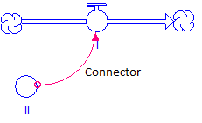 | Connects the model elements together | Connects the Flow rate to the stream flow
 | The decision process allows the user to hide the intricacies of a decision process. The process can be accessed, but all details are not shown on the surface of the model. | Determining when the stream holds and releases water.
 | If a stock, flow or converter is shown with a dotted outline, it is known as a ‘ghost’. The ghost simply allows the function to be moved to another section of the model without having to use connectors. | Water volume needs to be connected to a geochemical submodel.

