UNIVERSITY OF OKLAHOMA
GRADUATE COLLEGE

DEVELOPment of a NEW SYNTHETIC SCHEME FOR VINYL DIETHERs AND SYNTHESIS OF PRODRUGS FOR TARGETED DELIVERY AND VISIBLE/NIR LIGHT-TRIGGERED RELEASE

A DISSERTATION
SUBMITTED TO THE GRADUATE FACULTY
in partial fulfillment of the requirement for the
Degree of
Doctor of Philosophy

By
GREGORY N. NKEPANG
Norman, Oklahoma
2014

DEVELOPING NEW SYNTHETIC SCHEME FOR VINYL DIETHER AND SYNTHESIS OF PRODRUGS FOR TARGETED DELIVERY AND VISIBLE/NIR LIGHT-TRIGGERED RELEASE

a Dissertation approved for the
department of chemistry and biochemistry

BY

__________________________
Dr. Kenneth Nicholas, Chair

__________________________
Dr. Youngjae You

__________________________
Dr. Daniel Glatzhofer

__________________________
Dr. Wai Tak Yip

__________________________

Dr. Elisens Wayne

© Copyright by GREGORY NKEPANG 2014
All Rights Reserved.

Acknowledgments
I would like to express my sincere gratitude to: my advisor, Dr. Youngjae You, for his direction, criticism and encouragement which has seen me through the project, the chair of my graduate committee Dr. Kenneth Nicholas for his patience and advice, my graduate committee members: Dr Elisens Wayne, Dr. Wai Tak Yip, Dr. Daniel Glatzhofer for the kind encouragement and understanding throughout the program.
Members of medicinal chemistry laboratory both past and present are not also forgotten especially Dr. Praveen Kumar Pogula and Dr. Bio Moses that I worked with in developing the synthetic scheme for the vinyl diethers and analogs, and Dr. Pallavi Rajaputra, Dr. Samuel Awuah, Dr. Abugafar Hossion for their contributions to the project in one way or another.
I also thank my family especially my kids that are not with me now and to friends for their support and encouragement. I would like to dedicate this work in memory of my late father who passed away while I was here in the US to pursue my PhD degree.

Table of Contents Page List of Abbreviations………...................................................................................x
List of Tables…………………………………………………………………………...xiii
List of Figures ……………………………………………….…………………………xv
List of Schemes………………..………………………………………………………xiv
Abstract …………………………………………………………………………………xx
Chapter 1. Introduction.......................................................................................1
1.1. Photodynamic therapy....................................................................................2
1.1.1. Mechanism of PDT..................................................................................2
1.1.2. Singlet oxygen………………………………………………………………...4
1.1.2.1. Generation of singlet oxygen .…………………………………….…5
1.1.2.2. Photochemical reactions of singlet oxygen…………………………7
1.1.2.3. Singlet oxygen life time………………………………………………10
1.1.3. Photosensitizers……………………………………………………………...11
1.2. Receptor-targeted drug delivery………………………………………………...18
1.2.1. Folate receptor-mediated drug targeting.................................................19
1.2.2. Limitations of folate-targeted drug delivery………………………………..22
1.3. Current drug delivery systems………………………………………….....…....23
1.3.1. Dendrimer drug delivery..……………………………………………………23
1.3.2. Liposome drug delivery................……........……...................................24
1.3.3. Polymeric micelle drug delivery................... .....……..............................25
1.3.4. Polymeric nanoparticle drug delivery….....……...............…………......26
1.4. Visible/near IR light as external stimulus for controlling the release of drug.26
1.5. Aim and scope…….....……...............………………......................................27
1.5.1. Hypothesis……….....……...............…………….....................................28
1.5.2. Specific aim…….....……...............………………....................................28

Chapter 2. Facile Synthesis of Vinyl Diether and Analogs, and Photooxidation by Singlet Oxygen………………………..................................30
2.1. Introduction...................................................................................................30
2.2. Materials and Methods.………………………................................................32
2.3. Experimental Section..... .....…….............................................................32-33
2.3.1. Synthesis of 2.......................................................................................35
2.3.2. Synthesis of 3..... .....……......................................................................36
2.3.3. Synthesis of 4........................................................................................37
2.3.4. Synthesis of 6.........................................................................................38
2.3.5. Synthesis of 7........................................................................................38
2.3.6. Synthesis of 8........................................................................................39
2.3.7. Synthesis of 9…………….....……...............….……………….................40
2.3.8. Synthesis of 5…….....……...............…………………………..................40
2.3.9. Synthesis of 10……….....……...............………………….......................41
2.3.10. Synthesis of 11….....……...............…………………………………42
2.3.11. General photooxidation procedure……...............……………........43
2.4. Results and Discussion…….....……...............…………................................45
2.5. Potential biological applications……….....……...............……......................48
2.5.1. Introduction……….....……...............…………......................................48
2.5.2. Experimental section…….....……...............……………........................50
2.5.2.1. Synthesis of combretastatin A-4 (CA-4)………............................50
2.5.2.2. Synthesis of 12……………….......................................................50
2.5.2.3. Synthesis of 13………..........……..................…….......................50
2.5.2.4. Synthesis of 14…….....……...............………...............................50
2.5.2.5. Synthesis of 15………….....……...............………........................50
2.5.3. Results and discussion……….....……...............….................................51
2.6. Conclusion……….....……...............……………….........................................52
Chapter 3. Design, Synthesis and Characterization of Folate and Biotin Targeted Prodrug Delivery System for PC-CA4 Conjugate…........................53
3.1. Introduction…….....…….....……....................................................................53
3.2. Hypothesis….....……...............……….....……...............………….................57
3.3. Experimental Design….....……....................…...............……………….........57
3.3.1. Design of FA- and biotin-prodrug conjugates and their intracellular release mechanism………….......……..................……........................................59
3.4. Experimental procedure.........…….................……..................…………......63
3.4.1. General method…........…….................……......................…...........63
3.4.2. Organic synthesis….....……...............……………............................63
3.4.2.1.-3.4.2.18. Synthesis of 17-38….....……...............…................65-87
3.5. Photophysical studies…….....……........……….…......................……...........87
3.5.1 Aggregation tendencies……..........……...............……....................87
3.6. In vitro studies……….....….....……...............…...............……………............89
3.6.1. Dark toxicity….....……...............………………….............................89
3.6.3 Photoxicity…….....……...............………………………....................91
3.6.4. Cellular uptake................………………………………………..........92
3.6.5. Competitive binding assays conjugates with excess folic acid and biotin……….....……...............……....................…………….................................93
3.6.7. Estimation of cellular uptake of conjugates by confocal fluorescence microscopy...........…….............……...............……..............................................94
3.7. In vivo optical imaging….......……..................……...............………..............94
3.8. Results and discussion...……....................……...............…………..............95
3.8.1. Synthesis….....……........……...........................……….....................95
3.8.2. Electronic and photophysical properties….....……...............…........96
3.8.3. Aggregation tendency…….........……................……...............….....98
3.8.4. Photoxicity…….....……....................……...............………………….98
3.8.5. Preliminary in vivo PDT …….....……...............…............................99
3.8.6. Estimation of cellular uptake of conjugates by confocal fluorescence microscopy..................................……....................……....................................104
3.8.7. Cellular uptake…….....……...............…………................................105
3.8.8. Competition assay….....……...............….....……...............…….......107
3.8.9. In vivo imaging….........……................……...............…………….....109
3.9 Conclusions….....……...............….....……...............……………..................119
Chapter 4. Conclusions............…….................…….....................……...........120
References………….....……....................……...............…………………..........160

List of Abbreviations

¹O₂: Singlet oxygen
¹PS: Singlet state photosensitizer
³O₂: Molecular oxygen or triplet oxygen
³PS: Triplet state photosensitizer
CA-4: Combretastatin A-4
CMPLCA4: Dithiaporphyrin-linker- Combretastatin A-4
CMP: Core-modified porphyrin (Dithiaporphyrin )
DIEA: Diisopropylethylamine
DMSO: Dimethyl sulfoxide
DNA: Deoxyribonucleic acid
FRET: Fluorescence resonance energy transfer
HBTU: O-(benzotriazol-yl)-N,N,N’,N’-tetramethyluronium hexafluorophosphate
IP: Intraperitoneal
ISC: Inter-system crossing
MCF-7: Michigan cancer foundation-7(human breast adenocarcinoma cell line)
MTT: 3-(4,5-Dimethylthiazol-2-yl)-2,5-diphenyltetrazolium bromide
NMR: Nuclear magnetic resonance
PAMAM: Polyamidoamine
PMDETA: N,N,N′,N′′,N′′-pentamethyldiethylenetriamine
POPAM Modified poly (propyleneimine)
PTPC: Permeability transition pore complex
PDT: Photodynamic therapy
PEG: Polyethylene glycol
PGA: Polylactide-co-glycolide
PLA: Polylactic acid
PLGA: Polylactide-co-glycolide
PS: Photosensitizer
PCD: Programmed cell death
Rh-123: Rhodamine-123
Rh B: Rhodamine B
SO: Singlet oxygen
TFA Trifluoroacetic acid
TPP: Tetraphenyl porphyrin
TPP-OH: 5,10,15-triphenyl-20-(4-hydroxyphenyl)-21H,23H-porphyrin

List of Tables

Table Page
1) Names of photosensitizers and their clinical applications......…….............12-14
2) Reaction products from the vinylation reactions at the final step……………...34
3) Kinetic data of oxidation of olefins….....……...............….................................38
4) Extinction coefficients of the conjugates….....……...............….......................97

List of Reaction Schemes
Scheme Page
- General synthetic scheme for vinyl diethers and analogs…………………33
- Cleavage products from heteroatom substitutedalkenes…………….…...46
- Proposed scheme for the synthesis of CMP-L-CA4 using vinyl diether linker………………………………………………………………………….....49
- General synthetic scheme for the folate and biotin conjugates………......64
- Synthesis of compound 17….....……...............…………………………….65
- Synthesis of compound 18….....……........……...........................…..........66
- Synthesis of compound 21………........…….................……...............…...68
- Synthesis of compound 22….....……....................……...............………...70
- Synthesis of compound 23….....……...............….....……...............……..72
- Synthesis of compound 27….....……...............…………….....................74
- Synthesis of compound 28…….....……...............………………………...75
- Synthesis of compound 20………….....……...............……………….......78
- Synthesis of compounds 34 and 35…….....……...............………...........80
- Synthesis of compound 31…….....……...............……………................81

List of Figures

Figure Page
1. Modified Jablonsky diagram….....…….....……......................…………..............3
2. Different types of singlet oxygen and energies….....……...............…................5
3) Equations for the formation of singlet oxygen…….............……........................6
4. Quantum mechanical description of singlet oxygen….....……...........................7
5. ‘Ene’ reactions of singlet oxygen……...........……..............................................8
6. [2+4] cycloaddition reactions of singlet oxygen…….....……...............…............8
7. [2+2] reactions of singlet oxygen…….....……..........................……...................9
8. Decomposition of dioxetanes…….....……...............……………........................9
9. Photosensitizers in clinical use…......…...............…………........................16-17
10. Structure of Folic Acid………….....……...............……...................................22
11. Rate of decomposition and formation of cleavage product…….…................47
12. Structure of Biotin.................……..........................…….................................56
13. Schematic design of multifunctional prodrug.... .....……................................59
14. Structures of compounds 21, 27, and 29 synthesized. ……………...............61
15. Structures of compounds 36, 37, and 38 synthesized………........................62
16. Structure of 32.………………….....……...............……...................................82
17. Structure of 33 …………………….....……...............…………........................83
18. Structure of compounds 34 and 35…….....……...............………...................84
19. Structure of compound 36.............……..................……................................85
20. Structure of compound 37…….....….....……...............…...............…………..86
21. Structure of compound 38……….....……...................……................………..87
22. Aggregation tendency of various conjugates…….....…….................….........99
24. Phototoxicity of three conjugates….....……...............……………….............101
25. In vivo efficacy of PC-CA4 treated, FA-PC-CA4 treated, and control group of mice.................................……................................................……....................102
26. In vivo PDT acute toxicity test of PC-CA4 treated, FA-PC-CA4 treated and control group of mice............................................……......................................102
27. Pictures of balb/c mice treated with FA-PC-CA4, PC-CA4, and control group............................................……......…….................................................103
28. Cellular uptake by confocal microscopy…….........……................……........105
29. Bar chart representations of the cellular uptake in concentration/M………106
30. Graphic representation of the cellular uptake in concentration/M................107
31. Competition assays for Boc-PEG-PC-CA4, FA-PEG2K-PC-CA4 and Biotin-PEG897-PC-CA4..........……...........….......……...............…..............................108
32. In vivo images of FA-PEG2K-PC-CA4 uptake…..........…….......................112
33. In vivo images of Biotin-PEG897-PC-CA4 uptake…..................................113
34. In vivo images of FA-PEG897-PC-CA4 uptake….......................................114
35. In vivo images of PC-CA4 uptake……...........……....................……...........115
36. In vivo images of Boc-PEG897-PC-CA4 uptake........... .....……................116
37. In vivo images of FA-PEG2-PC-CA4 uptake...........…….............................117
38. In vivo images of FA-PC-CA4 uptake..................................…….................118
39. ¹H and ¹³C-NMR of 2………….....….....……...............…...............………....129
40. ¹H and ¹³C-NMR of 3…………........……..............……..................…….......130
41. ¹H and ¹³C-NMR of 4…….....…….....……..............................………………131
42. ¹H and ¹³C-NMR of 5……….....…….................……..................……………132
43. ¹H and ¹³C-NMR of 6……..........……...............…….......................………...133
44. ¹H and ¹³C-NMR of 7……………........…….................……...............………134
45. ¹H and ¹³C-NMR of 8………….....…….............….........……………….........135
46. ¹H and ¹³C-NMR of 10………………………................................................136
47. ¹H and ¹³C-NMRs of 11….....….....……...............…...............………...........137
48. ¹H-NMR of E- and Z-4…….....……...............……………………...................138
49. ¹H-NMR of E-and Z-8….....……...............…………………...........................139
50. Kinetic NMR spectra of control…….....……...............……………................140
51. Kinetic NMR spectra of 6….....….....……...............…...............…................141
52. Kinetic NMR spectra of 8…….....……...............…………............................142
53. Kinetic NMR spectra of 11….....……...............……………….........…….......142
54. ¹H-NMR of compound 12....................................……..................................143
55. ¹H-NMR of 17….....….....…….............................…...............…………........144
56. ¹H-NMR of PC-CA4…………….....……...............……….............................144
57. ¹H-NMR of FA-PC-CA4………….......……..................……...............……...143
58. HRMS-ESI of FA-PC-CA4……………...........….....……...............…............146
59. HPLC of FA-PC-CA4…….....……...............………………...........................146
60. ¹H-NMR of FA-PEG2-PC CA4…….....…….....…….....................................147
61. HRMS-ESI of FA-PEG2-PC-CA4…………….......……......……...................147
62. HPLC of FA-PEG2-PC-CA4……….....……...............……………................148
63. ¹H-NMR of compound FA-PEG2K-PC-CA4…......……...............................146
64. ¹H-NMR of compound 28…….....……...............……………….....................149
65. ¹H-NMRs of compound FA-PEG2000-NH₂ and FA-PEG2K-PC-CA4…..…150
66. NMR of Biotin-PEG897-PC-CA4………….....……...............…….................151
67 ESI (ion trap of Biotin-PEG897-PC-CA4)………......……...............………....151
68. Stacked NMRs of Biotin-PEG897 and of Biotin-PEG897-PC-CA4…..........152
69. HPLC of Biotin-PEG897-PC-CA4…….....…….......................……...............152
70. ¹H-NMR of Boc–PEG897-PC-CA4…….....……...............……....................153
71. HPLC of Boc-PEG897-PC-CA4….....……...............………….....................153
72. HRMS-ESI of FA-PEG897-PC-CA4......……......……...............…...............154
73. H-NMR of FA-PEG897-PC-CA4….....……...............…...............................155
74. HPLC of FA-PEG897-PC-CA4…….........……................……...............……155
76. ¹H-NMR of compound 22…….....……...............…………............................156
77. ¹H-NMR of compound 23…….....……....................……...............……........156
78. ¹H-NMR of compound 24…………………….....……...............….................157
79. ¹H-NMR of compound 25…….....……...............…………………….….........157
80. ¹H-NMR of compound 31……….....……...............…………………..............158
81. HRMS-ESI of compound 31…….....……...............…………………………..158
82. ¹H-NMR of Boc-PEG897-FA…………….....……...............………...............159
83. ¹H-NMR of Boc-PEG897-Biotin…….....……...............……..........…….......159

Abstract
Tumor specific drug delivery has become increasingly interesting in cancer therapy, as the use of chemotherapeutics is often limited due to severe side effects. Targeted chemotherapy for cancer treatment offers a great potential advantage in tumor treatment due to greater specificity of delivery, which leads to an increased dose of the cytotoxin delivered to the malignant cells relative to healthy cells in the rest of the body. There are two general directions in anticancer drug delivery that focus on achieving a high local drug concentration specifically in the cancerous tissue while reducing its uptake in healthy cells. i) Site-specific delivery can be achieved by conjugating the drug or coating the delivery vehicle (liposomes, micelles, etc.) with ligands or antibodies that target overexpressed receptors in the tumor tissue. This could also possibly be used to direct a drug away from the body sites that are sensitive to the toxic action of the carried drug (site avoidance). ii) By incorporating an active and site-specific release mechanism within the prodrug or delivery vehicle, it is possible to increase the release and therapeutic efficacy of the cytotoxic agent. A chemotherapeutic drug delivery system designed to combine these two principles (site–specific targeting and site-specific triggering) will fulfill Paul Ehrich’s vision of a magic bullet in the treatment of diseases there by overcoming the selectivity problems of conventional chemotherapy.
The folate receptor (FR) is a potentially useful biological target for the management of human cancers. Owing to the overexpression of the FRs on the surface of malignant cells, conjugation of the cytotoxic agent to folic acid (FA) via suitable spacers has demonstrated the enhanced selective drug delivery to the tumor site. Furthermore the degree of over-expression has been found to correlate with the stage of tumor growth. Various FA-conjugated prodrugs and folate targeted delivery vehicles have been synthesized and are currently in preclinical and clinical trials. Biotin (vitamin B7) is also an essential cellular micronutrient responsible for various normal cellular functions, and its receptors are overexpressed in various cancer cell lines. It has been suggested that the sodium dependent multivitamin transporter (SMVT) is responsible for the uptake of biotin. It has also been indicated that there has been a higher expression of SMVT in several lung, renal, colon and breast cancer cell lines than FR. Several biotinylated anticancer agents have also been used in the selective delivery to cell lines overexpressing the SMVTs. Most of the folate and biotinylated conjugates are equipped with release mechanisms that rely on intrinsic activating agents such as small changes in temperature, pH differences, enzyme and an external activating tool such as light triggered release (light of shorter wavelengths). The use of light of longer wavelengths with better tissue penetration to active release of the drugs is warranted, which then will lead to the search for novel singlet oxygen photocleavable linkers.
To address this issue, our lab has screened various olefins and identified vinyl diether linker as a potential singlet oxygen-mediated photocleavable linker that can be cleaved with a fast rate and in the presence of a photosensitizer (core-modified porphyrin). The reported synthetic schemes were for symmetric molecules with lengthy reaction steps and some reaction conditions not being functional group tolerant. Herein, the chemical synthesis (synthetic scheme) and kinetic studies of vinyl diether and some nitrogen and sulphur analogs will be described. The potential application of the vinyl diether linker to the synthesis of the biological active molecule was not achieved due to high instability of the linker in the presence of light. Hence we turned our attention to the alternative linker, the aminoacrylate linker, which could be synthesized with high yields and was functional group tolerant.
A multifunctional drug delivery system constituted of the folate (or biotin) linked to the photosensitizer (phthalocyanine) by PEG and combretastatin A-4 linked to the photosensitizer by a photolabile linker (aminoacrylate) was designed and synthesized, and biological activity of six conjugates were determined. The conjugates were prepared through straightforward and versatile synthetic routes. The evaluation of cell specificity was examined using colon 26 cells that overexpress both the folate receptors and biotin receptors. Three of the conjugates (FA-PEG2K-PC-CA4, Biotin-PEG897-PC-CA4 and FA-PEG897-PC-CA4) exhibited high specificity in the in vitro test conducted and in vivo imaging using the colon 26 cells. Preliminary in vivo PDT indicated tumor shrinkage after the irradiation with two of these conjugates: FA-PEG2K-PC-CA4 and Biotin-PEG897-PC-CA4. (Data not included in the thesis)
The ability of the multifunctional prodrugs of optical imaging and treatment by a combination of PDT and local chemotherapy could possibly lay the foundations for further development for the clinical management of FR and biotin receptor overexpressing tumors.

Chapter 1: Introduction
Cancer is one of the most devastating diseases in America and worldwide with an estimated 16 million new cases expected per year globally by 2020.^{1,2} Cancer remains a challenging disease to combat because cancer cells share many common characteristics with the normal cells from which they originate.³ Despite significant progress in the development of anticancer technologies (involving tumor detection, prevention, surgery and chemotherapeutic treatments) there is no efficient cure for patients with malignant diseases. Thus, current methods for diagnosis of cancer often reveal the malignant tissue only after it has already metastasized to other parts of the body.⁴ The main treatment at this stage is chemotherapy, which usually can have marginal efficacy due to dose-limiting toxicities, inadequate potency, rapid clearance from the body, poor aqueous solubility and compromised in vivo stability.⁵ To limit the onset of severe side effects, anticancer chemotherapeutics are often given at suboptimal doses which hamper their ability to reach tumor-destroying drug concentrations while prompting after prolonged treatments, prompting the development of resistance phenomena. Moreover, chemotherapeutic drugs also display a high degree of toxicity against normal tissues that show enhanced proliferation rates such as the bone marrow, gastrointestinal tract, and hair follicles.^{6,7} Thus, minimally invasive novel cancer treatment modalities that can have selective therapeutic action at the malignant tissue are needed.

1.1. Photodynamic Therapy (PDT)
Photodynamic therapy (PDT) is a clinically approved, minimally invasive treatment modality that can induce cytotoxic effects in tumor tissues with some selectivity.⁸ Selectivity can be achieved by focused irradiation to tumors and by using photosensitizers that preferentially accumulate in tumors.⁹⁻¹¹ Currently, PDT is applied for the treatment of different types of solid tumors as well as some non-cancerous diseases such as age-related macular degeneration, endometriosis¹² and microbial infection.^{8,13}
1.1.1. Mechanism of PDT
Unlike conventional cancer treatments, PDT does not cause major systemic toxicity. It enables the selective destruction of malignant tissues due to specific interaction of three individual non-toxic components a photosensitizer (PS), light (600-800 nm) and molecular oxygen.¹⁴ Clinically the PS is administered into patients intravenously, intraperitoneally or topically. At some time interval after the PS administration, the majority of it is cleared from most body tissues but retained mainly in tumor, skin and organs of the reticuloendothelial system.^{15,16} Upon the irradiation by light of appropriate wavelength mostly from laser source or light emitting diode, photosensitizers are excited to the first singlet state (S₁) (Figure 1). The absorbed energy can be released as heat, emitted as fluorescence (utilized for cancer diagnosis) or may undergo an intersystem crossing (ISC) into a long-lived triplet state (T₁). The energy of the triplet state may also be released as heat and/or light (phosphorescence) or be used in photochemical or photophysical reactions to form reactive oxygen species (ROS). 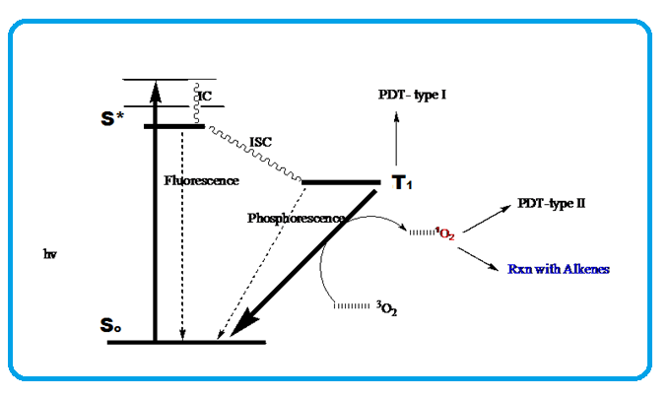
Figure 1. Modified Jablonski diagram.¹⁷
The triplet state may react in two ways. In what is known as type I mechanism, the excited photosensitizer reacts with substrate molecule through a hydrogen-atom abstraction or electron transfer reactions to yield free radicals and radical ions that react with molecular oxygen, and produce reactive oxygen species (ROS) such as superoxide, hydrogen peroxide and hydroxyl radicals. ROS are thought to play an important role in an increasing number of physiological and pathological processes in living organisms. A type II mechanism involves the direct transfer of the energy of the excited triplet photosensitizer to molecular oxygen to generate singlet oxygen another ROS. Generally type I reactions occur at low oxygen (hypoxia) and high substrate concentrations while type II reactions occur in oxygenated environments.¹⁸ The photodynamic generation of reactive oxygen species, especially singlet oxygen, to damage the target disease is the base of cancer treatment known as photodynamic therapy (PDT).¹⁹⁻²² Singlet oxygen is known as a main ROS in photoinduced processes of PDT.^{23,24} The ROS then oxidizes amino acids (tryptophan, phenylalanine histidine, and methionine), unsaturated fatty acids and cholesterol found in membranes as well as nucleic acid (guanine), which leads to cell death.^{25,26}
1.1.2. Singlet Oxygen (¹O₂)
Singlet oxygen is the main cytotoxic agent in PDT. Although molecular oxygen has a double bond, its outermost pair of electrons are in different (π*_{x} and π*_{y} antibonding) orbitals and have their spins parallel, which makes the ground state a triplet (³∑_{g}). Furthermore, two other arrangements of these two electrons are possible and result in the presence of two low-lying singlet states (¹∑_{g} and ¹Δ_{g} states). The ¹Δ_{g} lies only 22.5 kcal above the ground state and has a remarkable life time of 1 h in the absence collisions with other molecules,²⁷ while ¹∑_{g} is 37.51 kcal²⁸ above the ³∑_{g} ground state and has a very short lifetime. It is ¹Δ_{g} that has come to be called singlet oxygen (¹O₂): it is the only species that lives long enough to take part in chemical reactions.

Figure 2. Singlet oxygen MO energy levels ^{29,30}
1.1.2.1. Generation of Singlet Oxygen
Singlet Oxygen can be generated in many ways. Although ¹O₂ is formed in the earth’s biosphere by the absorption of visible and ultraviolet light from the sun,³¹ which usually leads to the electronic excitation of the molecules (direct photoexcitation), this is not practical since the transition is spin-forbidden. Since ¹O₂ permeates most organic matter, oxygen is a common quencher of electronic excitation of organic matter.^{30,32,33} The quenching of the triplet sensitizer by triplet molecular oxygen to afford ground sensitizer and singlet oxygen is the most common and practical method of generating the ¹O₂ (eq 1).^{30,34} When the molecular oxygen in its ground triplet state interact with an excited photosensitizer in its triplet state, an energy transfer by triplet-triplet annilation³⁵ occurs, which proceeds an electron exchange mechanism and result in the inversion of the outermost electronic spin and pairing in one π*-antibonding orbital. Singlet oxygen has also been generated the quenching of a singlet sensitizer with molecular oxygen to afford triplet excited sensitizer (eq 2).^{36,37}
Figure 3. Equations for the formation of the singlet oxygen
The singlet oxygen state is difficult to be represented in a conventional orbital diagram in which the electrons are in two antibonding orbitals because it is a two-fold degenerate compared to the triplet ground state molecular oxygen. One component has two electrons in different orbitals. This is a stable arrangement and cannot account for the observed reactivity of the singlet oxygen.
Figure 4 A. ¹Δ_{g} (¹O₂) formation via triplet-triplet annihilation

The other component with both electrons in the same orbital as indicated by the wave function is the most unstable species because this destabilizes the molecule and may account for the high reactivity of this singlet oxygen species (¹Δ_{g}⁺).²⁹
Figure 4 B. ¹Δ_{g} (¹O₂) formation via triplet-triplet annihilation. ^{29,35,37,38}
The orbital wave function also indicates that both electrons are in the same orbital for the ¹∑_{g}⁺ state.²⁹
1.1.2.2. Photochemical Reactions of ¹O₂
The two principal reactions characteristic of ¹O₂ are cycloaddition ([2+2] and [2+4]) and the ‘ene’ reactions.
Ene- Reactions: ¹O₂ reacts rapidly with allylic alkenes to give allylic hydroperoxides.^{39,40} It has been shown that the attack of the singlet oxygen and the subsequent removal of the hydrogen occur in a cis-manner.⁴¹
Figure 5. ‘Ene’ reactions of singlet oxygen. ⁴²⁻⁴⁴
[2+4]-Cycloaddition Reactions: Singlet oxygenation of arenes and conjugated or 1,3-diene compounds leads to the formation six-membered ring peroxides called endoperoxides.^{45,46} These reactions are examples of the 1,4-cycloaddition of singlet oxygen to cisoid conjugated dienes.

Figure 6. [2+4] reactions of singlet oxygen. ⁴⁷⁻⁴⁹

[2+2]-Cycloaddition Reactions: ¹O₂ reacts with electron-rich olefins, alkenes without allylic protons or with sterically hindered alkenes to give four-membered ring peroxides called 1,2-dioxetanes.^{50,51} The photooxidation of the alkenes proceeds rapidly with visible light, but stops after the consumption of one equivalent of oxygen.
Figure 7. [2+2] Reactions of singlet oxygen. ^{52,53}
Dioxetanes tend to unstable and decompose spontaneously two carbonyls.
Figure 8. Decomposition of dioxetanes.^{54,55}
Biologically, ¹O₂ tend oxidize amino acids in proteins and peptides (tryptophan, cysteine, histidine, methionine and phenylalanine), unsaturated fatty acids, cholesterol and nucleic acid bases (such as guanine).
1.1.2.3. Lifetime of singlet oxygen
The lifetime of ¹O₂ varies from one solvent to another. In particular in halogenated solvents ¹O₂ has a longer lifetime than in non-halogenated solvents or in aqueous solvents. For example, ¹O₂ lifetime in CCl₄ is 700 us while that in non-halogenated solvents is between 10 -100 us, water 2 us and biological systems < 0.04 us. An explanation of the variation of lifetimes with solvent has been presented by Kearns.⁵⁶ He has shown that there is correlation between the lifetime of singlet oxygen and the infrared spectral properties of solvent. Solvents such as water, biological media, alcohols and hydrocarbons with overtones and combination bands that absorb strongly near 8000 cm⁻¹of IR spectra region have been shown to have a short oxygen lifetime. This suggests the direct conversion of the electronic energy from singlet oxygen into the vibrational energy of the solvent is predominant in determining the decay of singlet oxygen. There is little indication of heavy–atom effect on the lifetime of singlet oxygen.⁵⁷
Since the lifetime of ¹O₂ in cells is short and it has a limited diffusion distance (10-300 nm) ^{21,58,59}, the ¹O₂ generated in the irradiated part of the body cannot directly damage cells in the unirradiated part. In PDT, it means the source and the concentration of oxygen may have a major impact on the ¹O₂ generating capacity and hence the biological activity. The concentration of ¹O₂ varies from one medium to another and from one compartment to another. For example, the oxygen concentration at atmospheric pressure in water is 270 µM while that in the blood is 68-171 µM and in tissue is 7-34 µM.⁶⁰ Solid tumors are known to exist under hypoxic conditions.⁶¹ The biological implications are that we can selectively generate ¹O₂ only in particular locations to damage the diseased cells while sparing the healthy ones when the light is focused only on those cells. Therefore, PDT-induced oxidative damage is highly localized to regions around the photosensitizer.⁶² This specific damage to the targets can also be improved by using a targeted delivery system for the photosensitizer to selectively accumulate only in the diseased cells.
1.1.3. Photosensitizers
Porphyrin or porphyrin-related compounds form the bulk of the PSs used in PDT in clinical settings. (Figure 9) Photofrin was the first generation photosensitizer approved in 1993 for the treatment of bladder cancer and as prophylactic treatment of several others, such as the treatment of early stage esophageal, gastric, cervical and lung cancers.^{10,63}. However, this first generation photosensitizer had several limitations with respect to its clinical use such as ^{38,63-65} composition of undefined mixture of hematoporphyrin derivatives (HpD), induction of long-lasting skin photosensitization, a low extinction coefficient at wavelengths for optimal tissue penetration and limited selectivity for target tissue. Other first generation photosensitizers were chlorine, bacteriochlorin and other porphyrins (Figure 9).⁶⁶
Second generation PSs were then developed with better features or characteristics such as⁶⁷ single and chemically pure compound, low tendency to aggregate, high singlet oxygen quantum yield, low phototoxicity towards healthy tissue, no dark toxicity, fast clearance from the healthy parts of the body and specific retention in diseased tissues, stability and good solubility in pharmaceutically acceptable formulations and in biological media, high photostability and fluorescence, strong absorbance in near infrared (NIR) region and a minimum absorbance between 400 to 600 nm. PSs with lowest absorbance in the range (400 to 600 nm) where daylight intensity is the highest will tend to avoid skin photosensitization when used clinically. Furthermore, optimal light penetration into the tissue is favored by strong absorbance in the NIR region between 600 to 800 nm (since wavelengths above 800 nm are absorbed by water molecules and singlet oxygen generation is suboptimal), which thereby results in more efficient PDT when treating deeper seated lesions.^{62,68,69}
Selective accumulation of PS in tumor combined with it controlled light activation enables selective destruction of tumor, sparing the neighboring healthy tissue. Selectivity of PS for tumor tissues over healthy tissues is thought to be a multifactorial process including physico-chemical properties and binding to plasma proteins as well as the particular characteristics of tumors such as leaky vasculature, low lymphatic drainage, expression of specific enzymes and receptors and pH variation. PSs exhibit direct or indirect cell killing, vascular occlusion, release of cytokines and the response of the immune system depending on their cellular or intracellular localization or relocalization.
Figure 9 gives the chemical structures of some PSs investigated in clinical trials, while Table 1 summarizes the same PSs with their potential therapeutic application in oncology.
References ^{10,12,63,70-81}
Trade Name | Absorption wavelength | Potential Indications
Photofrin, Photogem, Photosan, Hemporfin | 630 nm | Cervical, brain, Oesophagus, breast, head and neck, lung, bladder, superficial gastric cancers, Bowen’s disease, cutaneous Kaposi’s sarcoma
Foscan | 652 nm | Oesophageal, prostate and pancreatic cancer, advanced head and neck tumors
Visudyne | 689 nm | Basal and squamous cell carcinomas
Photochlor | 665 nm | Basal cell carcinoma, Oesophageal cancers, head and neck tumors
Tookad | 763 nm | Prostate cancer
BOPP | 630 nm | Malignant gliomas
Pc 4 | 675 nm | Cutaneous and Subcutaneous lesions from diverse solid tumor origins
CGP55847 | 670 nm | Squamous cell carcinoma of upper aerodigestive tract
Photosens | 675 nm | Skin, breast, lung, oropharingeal, breast, larynx, head and neck cancers, Sarcoma M1, epibulbal and choroidal tumors, eyes and eyelis tumors, cervical cancer
Purlytin,  Photrex | 659 nm | Kaposi’s sarcoma, cutaneous metastatic adenocarcinomas, prostate, brain, lung cancers, basal cell carcinomas
NA | 515 nm | Breast, myeloma, non-melanoma skin cancer
Levulan | 630 nm | Skin tumors, head and neck, gynaecological tumors and basal cell carcinomas
 | 375- 400 nm | Brain, head and neck and bladder cancer photodetection
Talaporfin, laserphyrin | 664 nm | Solid tumor, lung cancer, cutaneous malignancies
Lutex | 732 | Prostate, cervical, breast, brain cancer, melanoma

Table 1. Summary of PSs and potential therapeutic applications in oncology
Figure 9: Structures of PSs in clinics
Figure 9: Structures of PSs in clinics
1.2. Receptor-Targeted Drug Delivery
Receptor-mediated drug delivery has two advantages over conventional nontargeted therapies. 1) It can enhance net drug up-take by pathologic or diseased cells. 2) It reduces drug deposition into nonmalignant cells, which therefore reduces the collateral toxicity to normal cells. Differences in the structure and behavior of normal and tumor tissue could be used for designing drug delivery system facilitating tumor-specific delivery of drug or prodrug and specific activation. Generally three targets for the delivery of anticancer drugs in drug delivery research have been identified–tumor vasculature, extracellular space in the tumor tissue and tumor cells.
Targeting techniques are classified into passive targeting and active targeting. Tumor vasculature continuously undergoes angiogenesis to provide the blood supply that feeds the growing tumor.⁸² High molecular weight molecules and other nanoparticles will accumulate in solid tumors at much higher concentrations than in normal tissues or organs due to enhanced permeability and retention (EPR) effect. Passive targeting is achieved in this case by EPR effect as a result of leaky vasculature and limited lymphatic drainage, which is found in tumor tissues but absent in normal tissues.⁸³⁻⁸⁵ An example of such a targeting technique is Doxil. This is a polyethylene glycol (PEG)-modified liposome containing doxorubicin (DOX).^{86,87}. Although this technique is useful in cancer therapy, it is difficult to completely eliminate the adverse effects of antitumor drugs.⁸⁸ Hence, there is need for the development of drug delivery systems with both passive and active targeting capabilities.
Certain antigens and receptors are known to be aberrantly up-regulated on the surfaces of cancer cells compared to those of normal cells. The tumor antigen- or receptor-mediated approach has been largely exploited to enhance the selective delivery of cytotoxic agents or imaging probes to target tumors. Therefore, to actively target such receptors or antigens, chemical modification of drug carriers with tumor targeting ligands such as sugars,⁸⁹ transferrin,⁹⁰ antibodies,⁹¹ peptides^{92,93} and folic acid⁹⁴ is used. The other receptors devoted to the transport of vitamin B12,⁹⁵ biotin,^{96,97} and riboflavin⁹⁸ have been quite recently introduced as methods for targeted drug delivery. Of these ligands, FA is one of the most widely used because of the advantages. The concept of active targeting consists in grafting a molecule ( termed ‘promoiety’) onto an active drug molecule that will help it in reaching the pharmacological target, while ensuring that the promoiety can afterwards be removed to regenerate the biologically active compound.⁹⁹
1.2.1. Folate Receptor-mediated drug Targeting
Folic acid (FA) is natural vitamin B9 with molecular weight of 441 g/mol that plays an essential role in cell survival. It is a vitamin required for a one carbon transfer reaction in several metabolic pathways. Rapidly proliferating cells consume the vitamin in elevated levels because it is essential for the biosynthesis of the nucleotide bases for the nucleic acids (DNA and RNA). There are two routes of transportation of the folate across the plasma membrane in normal cell cells under physiological conditions using membrane associated-proteins viz, the reduced folate carrier or the folate receptor. The reduced-folate carrier¹⁰⁰ is the major route of reduced form of vitamin (5-methyl-tetrahydrofolate) entry into nonmalignant (normal) cells and will not transport folate conjugates of any type under physiological conditions.
The folate receptor (FR), a 38 kDa glycosylphosphatidylinositol (GP1) anchor glycoprotein¹⁰¹, exists in three isoforms¹⁰² namely FR-α, FR-β, and FR-γ. Among them, the FR-α is often up regulated on cell surface of a wide variety of human carcinomas, which include ovary, brain, kidney, breast, colon, myeloid cells and lung malignancies, but it is rarely expressed on most normal cells. FR- β is expressed on activated macrophages and on the surface of malignant cells of hematopoietic origin. The over expression of the folate receptor on the cancer cells perhaps enable the malignant cells to compete successfully for the vitamin when supplies are limited.^{103,104} The inability of folate conjugates to penetrate the reduced–folate carrier greatly contributes the low toxicity of folate-linked therapeutic agents to normal cells. The FR is significantly upregulated on many cancer cells compared to their non-transformed counterparts, and the FR-α density also appears to increase as the stage of the cancer increases.¹⁰⁴ Taken together, it is conceivable that the more advanced stage, the higher grade, and chemotherapy-resistant cancers, i.e. the tumors that are most difficult to treat by standard procedures, comprise the population of cancers most readily targeted by folate-linked drugs. An additional correlation has been reported between the degree of expression and resistance to standard chemotherapy.¹⁰⁵ Since the folate receptors bind folic acid with nanomolar affinity ¹⁰⁶ (K_{d} ~ 0.1- 1.0 nmol/L) and transport the captured vitamin into the cell by receptor-mediated endocytosis,¹⁰⁷ the striking consequence is that those FRs over expressed by cancer cells can be selectively be exploited for specific delivery of folate-linked drugs into the cancer cells.⁹⁸ Further reasons for the attractiveness of FA as a ligand for FRs are that it is stable and compatible with a variety of organic and aqueous solvents, inexpensive, a generally poor immunogenic chemical endowed with high affinity for FRs that enhances the differential specificity of therapeutic and imaging compounds/particles by targeting folate receptor positive cells and can easily be linked to a variety of molecules.¹⁰⁸
FA conjugates covalently linked via folate’s γ-carboxyl moiety to target tumor cells maintain a high affinity for the FRs, and their cellular uptake mechanism by FRs is as effective as that displayed by FA in its free form.¹⁰⁹ Folate conjugates enter cells by FR-mediated endocytosis and move through the organelles, and deliver their carried cargo to the cell cytoplasm (cytosol) or deposit them in a nondegradative compartment. The drug is then released in the endosomes/lysosomes mainly by enzymatic cleavage (owing to the acidic environment occurring in lysosomes, pH-dependent drug release has also been extensively considered).¹¹⁰ Because of the recycling of the unlitigated FR back to cell surface, the cellular uptake process of these conjugates can be repeated and allow a continuous supply into the cell.
Figure 10. Structure of folic acid (FA)
The success of FR targeting is in the enhancement of the intracellular delivery of attached macromolecules such as a large number of folate appended polymeric drug carriers (liposomes,¹¹¹⁻¹¹⁴, dendrimers,¹¹⁵, polysaccharides,^{116,117}, and micelles,¹¹⁸, protein toxins,^{119,120}, viruses,¹²¹, antisense oligosaccharides,¹²²⁻¹²⁴, gene therapy vectors,¹²⁵⁻¹²⁷, imaging compounds and neutron activation agents.¹²⁸⁻¹³¹
1.2.2. Limitations of Folate-targeted drug delivery
Folate-mediated targeted delivery of drugs/carriers towards solid tumors seems very attractive in solid tumor chemotherapy. Unfortunately, not all cancers over-express a FR. In this light, prostate, pancreatic, bladder and lymphoid cancers that do not have folate receptors will have to use alternative tumor-specific ligands if drug therapies were to be used.
The second and major concern is that not all FR targeting trials were successful. Because of the high affinity of folate for its receptor, some conjugates may release slowly from the receptor to permit accumulation of the therapeutic dose. This problem has been solved by the use of hydrolysable linkers to discharge the payload or use of therapeutic agents that are effective in the attached form constituted the two possible solutions for this potential problem. The most critical issue is how to control the release of free drugs (active forms) from the delivery system (inactive drug forms) after cellular uptake (need for extrinsic stimulus) since the two possible solutions enumerated above relied on intrinsic stimuli (physiological conditions within the tumor microenvironment).
1.3. Current Drug Delivery Systems
1.3.1. Dendrimers
These are uniform spherical (globular) nanostructures (macromolecules) ranging from 5-10 nm in diameter. Each dendrimer carrier has an initiator core and arms made of repeated monomer subunits that act as branching points. Generation or layers are synthesized in multiple reaction steps to add layers of monomers until the overall structure reaches the desired size.¹³² Dendrimers synthesized in this way create a structure with multiple functionalities for conjugation of functional groups or drugs.¹³³ As the generation increases, the repetitive synthetic steps produce a highly branched macromolecule with a three-dimensional structure characterized by interior cavities capable of encasing therapeutic drugs or imaging units and reactive terminal groups capable of attaching drugs, dyes, and/or a variety of sensors.¹³⁴ Drug release kinetics controlled through the properties of the polymer chains that have been designed to be degraded for release of a payload.¹³⁵ Dendrimeric structures including polyamidoamine (PAMAM), ¹³⁵⁻¹³⁷ modified poly(propyleneimine) [POPAM] and aromatic ether-type dendrimers have been developed for drug delivery.¹³⁸
1.3.2. Liposomes Drug Delivery
These are spherical vesicles formed by the self-assembly of amphiphilic lipids and excipients. Lipids form a bilayer based on hydrophobic interactions in continuous parallel packing with the hydrophilic head groups positioned towards the aqueous environment. Hydrophilic molecules can be encapsulated in the inner aqueous phase while hydrophobic molecules can be carried in the hydrophobic domains of the lipid bilayer. The membrane is composed of a phospholipid and cholesterol bilayer with an aqueous solution at the core. They represent one of the first “nanotechnologies” to enter clinical medicine.¹³⁹ They have been utilized for drug delivery due to their ability to encapsulate or sequester DNA or drugs that would normally not enter the intercellular compartment. When these molecules are encased in a liposome, they can be delivered to cells through diffusion as well as receptor-mediated events. They have already been used to deliver a wide variety of therapeutics and imaging agents, which include small molecule drugs, gene therapies and antisense oligonucleotides.¹⁴⁰ ¹⁴¹ Another example is Doxil, which is a PEGylated liposome clinically used to treat multiple types cancer, and is one of the most important liposomal drug delivery systems. It consists of a packed PEGylated surface loaded with doxorubicin through drug diffusion based on ammonium salt gradient.¹⁴² The liposomal formulations are able to change surface charge (zeta potential) with a change in solution pH. The charge switch at acidic pH results in the fusion with the cell membrane during endocytosis uptake and allows escape of nanocarriers into the cytoplasm to deliver the therapeutic load.¹⁴³ Some of the challenges posed by the liposomal formulations are instability in the blood stream, poor solubility of many drugs in the lipid/ surfactant solution, rapid burst release of drug and the severe side effects due to their accumulation in skin tissue. Another challenge posed in this formulation system is the difficulty to control prolonged drug release kinetics
1.3.3. Polymeric Micelles
Micelles are composed of spherical vesicles of lipids or other amphiphilic molecules, such as polymers or polyamino-acids that self-assemble into small nanoparticles with a hydrophobic core. They have been developed as drug delivery carriers for hydrophobic drugs.^{144,145}. Genexol-PM is the first non-targeted polymeric micellar formulation approved for cancer therapy or metastatic cancer breast cancer and NSCL cancer, and in the USA it is in a clinical phase II trial for metastatic pancreatic cancer therapy.¹⁴⁶ Genexol is composed of a block copolymer PDLLA (1.75 kDa)-mPEG (2 kDa) forming micelles with size of ~ 60 nm and taxol loading of ~ 15%(w/w).^{146,147} Micellar drug delivery systems are also being developed for myriad of anticancer agents using formulations with sizes ranging from 10-200 nm using polyamino acids and synthetic polymers.^{148,149}

1.3.4. Polymeric Nanoparticles
Polymeric nanoparticles represent the most effective nanocarriers for prolonged delivery. They provide significant flexibility in design because polymers can be biodegradable or nonbiodegradable and made synthetically or derived from natural sources. Common polymers used include poly (lactic acid)(PLA), dextran, and chitosan.¹⁵⁰ The polymers are degraded into individual monomers, which are metabolized and removed from the body via metabolic pathways. Degradation and drug release kinetics can be precisely controlled by physicochemical properties of the polymer such as molecular weight, dispersity index, hydrophobicity, and crystallinity. Hydrophilic polymer such as PEG is usually grafted, conjugated or adsorbed unto the surface of the nanoparticle to stabilize it, reduce hepatic uptake and improve circulation half-life. The polymeric nanoparticles are now in several stages of preclinical and clinical development e.g. drug–loaded polymethacrylate encapsulated nanocapsules have been developed. These are most commonly approved drug delivery systems in late stage of clinical trials. Multiple factors affect the pharmacokinetic behavior, but the surface charge, size, shape and stealth properties are the most critical,¹⁵¹.
1.4. Visible/ near IR light as an external stimulus for controlling the release of drugs
Being an external stimulus with unique properties such as external applicability, tenability of intensity, flexibility of wavelength and deliverability via various methods, light has been considered as a very important tool for a spatiotemporal control of drug release/ activation.¹⁵² Its success has been seen the release of drugs and bioactive compounds (caged compounds-deactivated forms of drugs from bioactive compounds).¹⁵³ UV and short visible (< 400 nm) light have been used for the controlled release of drugs to cultured monolayer cells and skin surface or the mucosa.¹⁵⁴⁻¹⁵⁶ The major limitation of using light of wavelength below 700 is due to limited tissue penetration ability because of scattering and high level of endogenous absorbers such as oxy and deoxy-haemoglobin, lipid and water.¹⁵⁷ Visible/NIR light (650-900 nm) is desired due to its ability to reach deeper tissues for the treatment of deep residing (solid) tumor. However, due to the low energy light, its direct application in drug release is impossible since the light energy cannot directly trigger the chemical bond (linker) cleavage often required for releasing the drugs.¹⁵⁸⁻¹⁶² (This section is an invited book chapter in press by G. Nkepang and Dr. You Y. in: The Chemistry of Peroxides Volume 3 (Patai series)).¹⁶³
1.5. Specific aims and scope
The chemical principle underlying PDT is the activation of photosensitizer by light to convert triplet state oxygen to singlet state oxygen, which can then react with biomolecules to cause cell modification or death. Reactions of singlet oxygen with double bonds in biological molecules are either through the 1,4- or 1,2-cycloaddition reactions or through the ‘ene’-reactions. 1,2-Cycloaddition reactions generate two carbonyl fragments through the dioxetane intermediate. It is from this basis that singlet oxygen photocleavable prodrug release systems have been developed. Following the same idea, we have proposed that a photodynamic multifunctional drug delivery platform could be developed to release drug molecules bearing either –OH, -NH or –SH functional groups.
1.5.1 Hypothesis:
A multifunctional prodrug system made up of a drug molecule covalently conjugated via a photocleavable linker could be designed. The active drug can be released by cleavage of the linker using singlet oxygen generated by PS upon activation by near infrared (NIR) light. This could serve as a new strategy for controlling drug-release by NIR that is biocompatible and penetrate deeper tissue than UV and Visible light.
1.5.2. Specific aims.
To test our hypothesis, the following specific aims were established.
- Develop a facile synthetic scheme to model conjugates constituting of two different molecules containing -OH, -NH and /or –SH as a common functional groups readily encountered in drug molecules that were linked via vinyl diether bond or analogs [electron rich-double bonds] based on previous screening in our lab.
- Synthesize a prototype prodrug constituting of a drug and photosensitizer using the above chemistry and conduct photophysical and biological studies (in vitro and in vivo studies) with the prototype prodrug.
- Synthesize a multifunctional drug delivery platform constituting of a photosensitizer and drug molecule(s), covalently attached using the photolabile linker and targeting moiety (folic acid or biotin) on a common platform and carry out both in vitro and in vivo studies.

CHAPTER 2: FACILE SYNTHESIS OF VINYL DIETHER AND ANALOGS, AND PHOTOOXIDATION BY SINGLET OXYGEN
2.1. Introduction
Although vinyl diether looks as simple as it is, synthesis of this functional group was not easy. Very little work has been done in the past for the development of the vinyl diether linker since it had very little importance until recent developments in drug delivery systems that require it. Previous methods are limited to symmetric molecules, lengthy steps, low yields, harsh reaction conditions and non-stereospecficity (mixture of E and Z-isomers). I will cite only the most recent references used for the synthesis of vinyl diether linker and monoether monothioether linkers.(This chapter is an already published work by G. Nkepang)¹⁶⁴
1,2-Diphenoxyethene was synthesized from ethylene chlorohydrins in a 7-step sequence involving high pressure and temperature by Baganz et al. (1959).¹⁶⁵ The other method for the same compound involved chlorination and dehydrochlorination of 1,2–diphenoxyethane was used by Serratosa et al. (1979).¹⁶⁶ This method is limited for the synthesis of symmetric molecules and yields a mixture of E and Z-products in low yields. Bauld et al. (1999) developed the most recent method for the preparation of 1,2-diphenoxyethene and derivatives involving bromination, followed by stereospecific debromination to give either the E- or Z-intermediates. Treatment of the cis- or trans- intermediates with n-BuLi, followed by either protonation or methylation, then afforded pure cis or trans- 1,2-diphenoxyethene or the corresponding 4,4’-dimethyl derivative. This method has a number of problems such as limitation only to symmetric vinyl diether molecules, facile electrophilic ring bromination on the phenyl or benzene ring para to the ether functionality, lengthy steps, and finally low yields.¹⁶⁷ These are the methods developed so far for the synthesis of vinyl diether bonds with phenolic of aryl alcohols. Methods involving aliphatic alcohols are quite different and requires a different approach as shown by Dolphin et al.(2008).¹⁶⁸ The only synthetic scheme of compounds with unsymmetrical molecules (2-aryloxyvinyl)phenylsulfanes involving the reaction of phenyl hypchlorothioite with vinylaryl ethers was developed by Bychkova et al. (1984).¹⁶⁹ This method required harsh reaction conditions.
Many reaction schemes have been tried to establish the vinyl diether linker, however, the limited available synthetic methods for 1,2-diheteroatom-substituted olefins have been one of the major hurdles. Here, we describe the first facile synthetic approach for the 1,2-diheteroatom substituted olefins (scheme 1). It is a versatile, efficient, and stereospecific method in as few as four steps from starting materials. We have been able to demonstrate that the chemistry can be used for the preparation of both symmetrically and asymmetrically diheteroatom-substituted olefins from a variety of functional groups such as –OH, -NH, and –SH (Table2). The photooxidation of those olefins that were not tested in the previous paper is also reported (Figure 11).

2.2. Materials and Methods
All solvents and reagents were used as obtained from Sigma Aldrich and Thermo Fisher Scientific unless otherwise stated. All reactions were monitored by TLC using 5-17 μm silica gel plates with fluorescent indicators from Sigma-Aldrich. All column chromatography was done using 40-63 μm silica gel from Sorbent Technologies. NMR spectra were recorded at 25 ºC using a 300 MHz Spectrometer (NMR data of E/Z-4 and E/Z-8 were recorded with a 400 MHz Spectrometer). NMR solvents with residual solvent signals were used as internal standards. ESI mass spectrometry was done at Mass Spectroscopy South Dakota State University, University of Oklahoma, or University of Buffalo. IR spectra were recorded on a BioRad FT-155FT-IR spectrometer (using dichloromthane as solvent). Melting points were determined by using a Mel-temp® Electrothermal instrument.
2.3. Experimental Section
Scheme 1. General synthetic scheme for vinyl diethers and analogs: A) i) KH (55 mmol), 1 (37 mmol) at rt, THF, ~30 min, ii) Trichloroethylene (44mmol) at -78 ºC warm to rt, overnight, B) 2 (7.67 mmol), TMEDA (23 mmol), n-BuLi (23 mmol) at -78 ºC , 1h to -40 ºC, 40 min, Et₂O, C) i) Cp₂ZrCl₂ (20.3 mmol), LiEt₃BH (20 mmol) at rt, THF, 1 h, ii) 3 (10.2 mmol) at rt, 30 min, iii) I₂ (20.5 mmol) , 40 min, D) 10 mol % CuI, 10 mol % ligand, 2 eq Cs₂CO₃, 1 eq HXR , 50-80 ºC, 10-48 h.

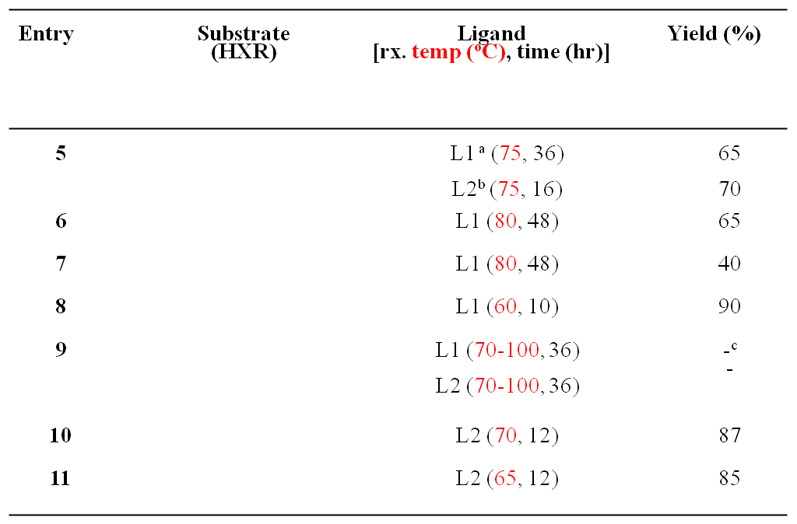
ª L1 = trans-N-(2pyridylmethylene)aniline
^{b} L2 = 2-pyridin-2-yl-benzoimidazole
^{c} Not isolable quantity

Table 2. Reaction Products from vinylation reactions at the final step

2.3. Synthesis of Compounds
2.3.1. Synthesis of 4-((1,2-dichlorovinyl)oxy)-1,1'-biphenyl (2): To a two-necked, round bottom flask (250 mL) equipped with a magnetic stirrer, pressure equalizing funnel and rubber septum was suspended oil free potassium hydride (2.20 g, 55 mmol, 1.50 eq) in tetrahydrofuran (THF, 25 mL). 4-Phenylphenol (6.30 g, 37 mmol, 1.00 eq) in THF (50 mL) was then added drop-wise with stirring for over 20 min via the funnel. After the evolution of hydrogen was complete, the orange-yellow slurry was cooled to -78 ºC, and then treated with drop-wise solution of trichloroethylene (5.8 g, 44 mmol, 1.2 eq.) in THF (25 mL) for over 10 min. The cooling bath was removed and the reaction mixture was allowed to warm to room temperature (rt) and then maintained for overnight (12 h). To the dark brown mixture was carefully added water (10 mL) using a syringe and then partitioned between water (200 mL) and ethyl acetate (200 mL). The organic phase was then washed with brine (200 mL). Extraction of the combined aqueous layers was done using ethyl acetate (150 mL x 3). The combine organic phases were dried over anhydrous magnesium sulfate, filtered and concentrated using the rotary evaporator to give yellowish brown oil. Silica gel (200 g) column chromatography was done using hexane as eluent to afford 2 (10.5 g, 85 %) as colorless oil that later crystallized to white crystals: mp 52-55 ºC. ¹H NMR (300 MHz, CDCl₃): 7.62-7.54 (m, 4H, HAr), 7.48-7.41 (m, 2H, HAr), 7.39-7.32 (m, 1H, HAr), 7.18-7.12 (m, 2H, HAr), 6.00 [s, 1H, HC(Cl)=C(O)] ppm; ¹³C NMR (75 MHz, CDCl₃): 153.3, 140.2, 137.8, 128.8, 128.5, 127.3, 127.0, 117.4, 103.9 ppm; IR (cm⁻¹): 3105, 3031, 1898, 1658, 1630, 1603, 1585, 1543, 1310, 1203, 1184, 1107, 1074, 1008, 996, 915, 863, 840, 641, 547, 511; HRMS (ESI) Calculated for C₁₄H₁₀Cl₂O [M-H]⁻ 263.0031; Found 263.0030.
2.3.2. Synthesis of 4-(ethynyloxy)-1,1'-biphenyl (3): To a two-necked, round-bottomed flask (100 mL) equipped with a nitrogen inlet adapter and rubber septum was added the vinyl ether 2 (2.0 g, 7.6 mmol, 1.0 eq), anhydrous diethyl ether (30 mL), and TMEDA (23 mmol, 3.3 mL, 3.0 eq), and then cooled at -78 C. 2.5 M n-butyllithium (9.0 mL, 23 mmol, 3.0 eq) was then added drop-wise to the reaction mixture for over 5 min. The reaction mixture was then maintained at -78 C for 1 h and at - 40 ºC for 40 min, and then cooled to -78 ºC while 10% ethanol in pentane (10 mL) was added drop-wise. After 10 min, the reaction mixture was then diluted with n-pentane (20 mL) and the washed with saturated solution of ammonium chloride (25 mL). The organic phase was later washed twice with water (20 mL) and then finally with brine (20 mL), dried over anhydrous sodium sulfate, filtered and concentrated to give brown oil. The oil was purified by column chromatography with hexane as the eluent to yield 3 as dark brown oil (0.84 g, 70 %) that later crystallized out as brown amorphous solid: mp 48-49 ºC. The compound was placed in a round bottom flask and was flushed with nitrogen and kept at -78 ºC to avoid the decomposition if it was not to be used immediately. ¹H NMR (300 MHz, CDCl₃): 7.64-7.52 (m, 4H, HAr), 7.48-7.41 (m, 2H, HAr), 7.40-7.34 (m, 3H, HAr), 2.13(s, 1H, ) ppm; ¹³C NMR (75 MHz, CDCl₃): 155.0, 140.1, 138.0, 128.9, 128.4, 127.4, 127.0, 115.4, 84.5, 33.5 ppm; IR (cm⁻¹): 3317(), 3029, 2927, 2174(), 1606, 1512, 1484, 1208, 1166, 1062, 1008, 941, 838, 641, 548, 450; HRMS (ESI) Calculated for C₁₄H₁₀O [M-H]⁻ 193.0654; Found 193.0651.
2.3.3. Synthesis of (E)-4-((2-iodovinyl) oxy)-1,1'-biphenyl (4): To an oven dried, two-necked flask (250 mL) under nitrogen and protected from light was added Cp₂ZrCl₂ (5.2 g, 20.3 mmol, 2.0 eq), dry THF (30 mL), and 1M lithium triethylborohydride (Super Hydride) in THF (20 mL, 20 mmol, 1.9 eq). The mixture was stirred for 1 h where the alkyne 3 (1.97 g, 10.2 mmol, 1.0 eq) was added. After 30 min, iodine (2.57 g, 20.3 mmol, 2.0 eq) was added and the reaction mixture was stirred for 30-40 min while protected from light. The reaction was quenched by diluting with ethyl acetate/hexane (1:1, 50 mL). The diluted mixture was then washed twice with saturated solution of sodium bicarbonate (150 mL) and the combined aqueous layers were extracted with ethyl acetate/hexane mixture (1:1). 10% aqueous sodium thiosulphate (100 mL) was used to wash the combined organic phases followed by brine (100 mL), dried over sodium sulfate, filtered, concentrated to yellowish slurry which was purified by silica gel column chromatography using 100% hexane as eluent (silica gel was pretreated with 2.5 % v/v triethylamine) to afford 4 as white amorphous crystals (1.80 g, 55 %): mp 64-66 ºC. ¹H NMR (300 MHz, CDCl₃): 7.64-7.52 (m, 4H, HAr), 7.49-7.41 (m, 2H), 7.38-7.32 (m, 1H, HAr), 7.13-7.01 (m, 3H, HAr), 5.74 (s, 1H, CH=CH, J = 12.2 Hz) ppm; ¹³C NMR (75 MHz, CDCl₃): 155.5, 150.3, 140.3, 137.0, 128.9, 128.4, 127.2, 126.9, 117.5, 57.9 ppm; IR (cm⁻¹): 3316, 3077, 3034, 2960, 2924, 2874, 2174, 1643, 1623, 1601, 1515, 1485, 1330, 1307, 1226, 1186, 1173, 1093, 1008, 919, 854, 837, 697, 579, 549.
2.3.4. General procedure for Coupling Reactions using trans-N-(2-pyridylmethylene)aniline (L1): (E)-4-((2-(4-(tert-butyl)phenoxy)vinyl)oxy)-1,1'-biphenyl (6): An oven dried, three- necked, round- bottomed flask (50 mL) equipped with a nitrogen inlet, reflux condenser, rubber septum was repeatedly evacuated and back-filled with dry and pure nitrogen, and was then charged with CuI (0.09 g, 0.50 mmol), L1 (0.09 g, 0.50 mmol), tert-butyl phenol (0.18 g 1.2 mmol), and Cs₂CO₃ (0.81 g, 2.5 mmol), followed by the addition of anhydrous and degassed acetonitrile (1.2 mL). The flask was evacuated and back-filled with nitrogen and trans - 4 (0.32 g, 1.0 mmol) added at rt. The reaction mixture was stirred and heated to the required temperature of 80 ºC for the 48 h. After cooling to rt, the mixture was diluted with dichloromethane (DCM, 20 mL) and filtered through a plug of celite, with the filter cake being further washed with DCM (10 mL). The filtrate was washed with saturated NH₄Cl (15 mL), and twice with water (10 mL). The collected aqueous phases were extracted twice with DCM (10 mL). The organic layers were collected, dried over MgSO₄, filtered, and concentrated in vacuo to yield brown solid. The crude product was fixed with 6.0 g silica gel and then purified by silica gel chromatography (100 % hexane) to afford 6 a white solid (0.20 g 65%): mp 59-62 ºC. ¹H NMR (300 MHz, CDCl₃) 7.59-7.52 (m, 4H, HAr), 7.46-7.40 (m, 2H, HAr), 7.38-7.33 (m, 3H, HAr), 7.15-7.09 (d, 2H, J = 8.5 Hz, HAr), 7.02-6.97 (d, 2H, J = 8.6 Hz), 6.91 (s, 2H, CH=CH), 1.32 (s, 9H, 3 x -CH₃) ppm; ¹³C NMR (75 MHz, CDCl₃) 157.2, 155.3, 145.6, 140.6, 135.7, 135.3, 134.2, 128.8, 128.4, 127.0, 126.8, 126.5, 116.0, 115.3, 34.3, 31.5 ppm; IR (cm⁻¹): 3052, 2961, 2931, 2867, 1607, 1512, 1487, 1367, 1298, 1229, 1187, 1127, 1105, 1079, 1006, 839, 723;HRMS(ESI), Calculated for C₂₄H₂₄O₂ [M+H]⁺ 345.1854; Found 345.1849.
2.3.5. Synthesis of (E)-4-[2-(4-methoxyphenoxy)vinyloxy]biphenyl (7): Compound 7 was prepared according to the general method described for compound 6 above, employing trans-- 4 (0.20 g, 0.62 mmol, 1.0 eq) and 4-methoxyphenol (0.077 g, 0.62 mmol, 1.0 eq), Cs₂CO₃ (0.50 g, 1.6 mmol, 2.5 eq), CuI (0.59 g, 0.31 mmol, 0.50 eq) and L1 (0.057 g, 0.31 mmol, 0.50 eq) heating the reaction mixture at 80 ºC for 48 h to furnish the crude product which was purified by column chromatography using hexane as the eluent to afford 7 as white crystals (40 mg, 40 %): mp 112-115 ºC. ¹H NMR (300 MHz, CDCl₃): 7.61-7.52 (m, 4H, HAr), 7.47-7.40 (m, 2H, HAr), 7.36-7.30 (m, 1H, HAr), 7.10 (d, 2H, J = 8.6 Hz), 7.00 (d, 2H, J = 9.0 Hz), 6.91-6.84 (m, 4H, HAr and HC(O)=C(O)H), 3.80 (s, 3H, -CH₃) ppm. ¹³C NMR (75 MHz, CDCl₃): 156.3, 154.3, 150.5, 139.5, 135.6, 135.1, 132.7, 131.4, 129.0, 127.8, 127.3, 125.8, 116.1, 115.0, 113.8, 54.7 ppm; IR(cm⁻¹): 3059, 1658, 1605, 1517, 1485,1420, 1319, 1264, 1226, 1173, 1122, 896, 838, 737, 639; HRMS(ESI), Calculated for C₂₁H₁₈O₃ [M-H]⁻ 317.1178; Found 317.1158.
2.3.6. Synthesis of (E)-(2-([1,1'-Biphenyl]-4-yloxy)vinyl)(phenyl)sulfane (8): The compound 8 was prepared according to the general procedure described for the compound 6 above employing trans- 4 (0.15g, 0.47 mmol, 1.0 eq) and thiophenol (0.051g, 0.050 mL, 0.47 mmol, 1.0 eq), Cs₂CO₃ (0.38 g, 1.2 mmol, 2.6 eq), CuI (0.044 g, 0.23 mmol, 0.49 eq) and L1 (0.042 g, 0.23 mmol, 0.49 eq) heating the reaction mixture at 60 ºC for 10 h to give crude product, which was purified by silica gel column chromatography (100 % hexane) to give compound 8, as white crystals (0.12 g, 90 %). [When a mixture of Z and E-4 (1:9) was used as the starting material under same conditions at a temperature above 100 ºC afforded a mixture of Z and E-8 (1:9). They were distinguished from each other by their coupling constants. J_{cis} = 5.7 Hz while J_{trans}= 12 Hz (¹H-NMR data of these mixtures are found below). The characterization data below is that of pure 8 obtained from the reaction pure 4 with thiophenol: mp 92-96 ºC. ¹H NMR (300 MHz, CD₂Cl₂): 7.66-7.54 (m, 4H, HAr), 7.48-7.40 (m, 2H, HAr), 7.37-7.28 (br s, 6H, HAr), 7.20-7.09 (m, 3H, HAr), 6.09-6.10 (d, 2H CH=CH, J = 12.0 Hz) ppm; ¹³C NMR (300 MHz, CDCl₃): 155.9, 150.6, 140.3, 137.5, 137.1, 128.9, 128.8, 128.5, 127.2, 127.0, 126.9, 125.7, 117.4, 102.1; IR(cm⁻¹): 3054, 2985, 1659, 1624, 1599, 1515, 1485, 1265, 1233, 1185, 1174, 1112, 1086, 1025, 1007, 924, 839, 739, 407; HRMS (ESI) Calculated for C₂₀H₁₆OS[M+H]⁺ 305.1000; Found 305.0998.
2.3.7. Synthesis of (E)-N-(2-(Biphenyl-4-yloxy)vinyl)aniline (9) : Compound 9 was tried to be prepared according to the general methods described for compound 6 (and 5) above, employing trans- 4 (0.15 g, 0.47 mmol, 1 eq), aniline (0.043 g, 0.47 mmol, 1 eq), Cs₂CO₃ (0.38 g, 1.1 mmol, 2.5 eq), CuI (0.044 g, 023 mmol, 0.5 eq) and L1 (0.042 g, .23 mmol, 0.5 eq) at 80 ºC to give a new weak spot on TLC which might be the product. However, it could not be purified using a silica gel column chromatography.
2.3.8. General procedure for Coupling Reactions using 2-pyridin-2yl-1H-benzoimidazole (L2): (E)-4-((2-(phenoxy) vinyl) oxy)-1,1'-biphenyl (5): An oven dried, three- necked, round- bottomed flask (50 mL) equipped with a nitrogen inlet, reflux condenser, rubber septum was repeatedly evacuated and back-filled with dry and pure nitrogen, and was then charged with CuI (0.074 g, 0.39 mmol, 0.5 eq), L2 (0.076 g, 0.39 mmol, 0.5 eq) and Cs₂CO₃ (0.63 g, 2.0 mmol, 2.5 eq), followed by addition of DMF (2 mL). The solution was stirred for 10 min at rt until reaction turn light green color. The appropriate substrate phenol (0.073 g, 0.78 mmol, 1 eq) was added to the reaction mixture and then stirred for addition 5 min at rt. Trans- 4 (0.25 g, 0.78 mmol, 1eq) was dissolved in minimum amount of solvent and then added into the reaction mixture. The reaction mixture was then heated from rt to between 50-75 ºC for 12-36 hr depending on the substrate. The reaction mixture was cooled and then through pad of silica gel using ethyl acetate and hexane mixture (20:80, 100 mL) and then washed three times with the same solvent mixture (100 mL). Filtrate was washed with water (100 mL x 3) followed with brine (200 mL), dried using anhydrous sodium sulfate and concentrated in vacuo to yield brown oil. The crude oil was then purified by silica gel column chromatography using 100% hexane to afford 5 as white crystals. (0.18 g, 70 %): mp 60-63 ºC. ¹H NMR (300 MHz, CDCl₃): 7.59-7.54 (m, 4H, HAr), 7.47-7.40 (m, 2H, HAr), 7.37-7.31 (m, 1H, HAr), 7.16-7.03 (m, 7H), 6.92 (s, 2H, HC=CH); ¹³C NMR (75 MHz, CDCl₃): 157.6, 157.2, 140.4, 135.8, 134.9, 134.6, 129.7, 128.8, 128.4, 127.0, 126.9, 122.7, 116.0, 115.8; IR (cm⁻¹): 3061, 2962, 2870, 1606, 1510, 1485,1419, 1365, 1230, 1183, 1174, 1124, 1105, 1006, 896, 836, 728; HRMS (ESI), Calculated for C₂₀H₁₆O₂ [M-H]⁻ 287.1072; Found 287.1053.
2.3.9. Synthesis of (E)-1-(2-([1,1'-Biphenyl]-4-yloxy)vinyl)-1H-indole (10): The compound 10 was prepared following the procedure described for 5 with trans- 4 (0.32 g, 1 mmol, 1 eq), indole (0.14 g, 1.2 mmol, 1.2 eq), Cs₂CO₃ (0.81 g, 2.5 mmol, 2.5 eq), CuI (0.095 g, 0.5 mmol, 0.5 eq) and L2 (0.097 g, 0.5 mmol, 0.5 eq) at 70 ºC for 12 hr to give crude product which were purified by silica gel column chromatography using ethyl acetate-hexane (9:95) to afford compound 10 as white crystals (0.27 g, 87 %): mp 140-142 ºC. ¹H NMR (300 MHz, CDCl₃): 7.58-7.46 (m, 6H, HAr), 7.40-7.32 (m, 3H, HAr), 7.25-7.21 (m, 1H, HAr), 7.20-7.14 (m, 2H, HAr), 7.12-7.02 (m, 4H, HAr and H(O)C=(N)CH), 6.55 (d, H, J = 3.1 Hz, HAr). ¹³C NMR (75 MHz, CDCl₃): 156.8, 140.4, 136.5, 136.4, 128.9, 128.8, 128.5, 127.1, 126.9, 125.7, 125.6, 121.2, 120.5, 116.5, 115.2, 109.8, 104.0 ppm; IR (cm⁻¹): 3034, 2358, 2338, 1682, 1606, 1515, 1485, 1475, 1462, 1358, 1333, 1322, 1301, 1232, 1202, 1186, 1174, 1134, 1115, 1088, 1031, 1007, 907, 865, 834; HRMS (ESI), Calculated for C₂₂H₁₇NO [M+H]⁺ 312.1388; Found 312.1381.
2.3.10 Synthesis of (E)-1-[2-(Biphenyl-4-yloxyl)vinyl]-1H pyrrole (11): The compound 11 was prepared following the procedure described for 5 with trans- 4 (0.2 g, 0.62 mmol, 1 eq), pyrrole (0.062 g, 0.93 mmol, 1.5 eq), Cs₂CO₃ (0.40 g, 1.2 mmol, 2.5 eq), CuI (0.059 g, 0.31 mmol, 0.5 eq) and L2 (0.060 g, 0.31 mmol, 0.5 eq) at 70 ºC for 12 hr to give crude product which were purified by silica gel column chromatography using ethyl acetate-hexane (9:95) to afford compound 11 as white crystals (0.14 g, 85 %): mp 102-105 ºC. Olefinic protons coupling on the named compound gave an AB-system with a typical roof effect with peaks centered at 7.04 and 6.99 ppm. ¹H NMR (300 MHz, CDCl₃): 7.62-7.53 (m, 4H, HAr), 7.48-7.40 (m, 2H, HAr), 7.38-7.31 (m, 1H, HAr), 7.17-7.09 (m, 2H, HAr), 7.04 (distorted d, 1H, J = 11.1 Hz, (O)-CH=CH(N)), 6.99 (distorted d, 1H, J = 11.1 Hz, (O)-CH=CH(N)), 6.82 (dd, 2H, J₁ = 4.2 Hz, J₂ = 2.2 Hz, CH=CH of pyrrole), 6.28 (dd, 2H, J₁ = 4.2 Hz, J₂ = 2.2 Hz, CH=CH); ¹³C NMR (75 MHz, CDCl₃): 156.8, 140.4, 136.3, 135.0, 128.8, 128.4, 127.1, 126.9, 119.6, 118.3, 116.5, 110.0 ppm; IR (cm⁻¹): 3086, 3034, 2715, 2682, 1659, 1607, 1587, 1517, 1485, 1360, 1326, 1300, 1239, 1229, 1185, 1173, 1119, 1094, 1072, 1056, 1007, 975, 907, 857, 838, 614; HRMS (ESI) Calculated for C₁₈H₁₅NO [M+H]⁺ 262.1232; Found 262.1233.

2.4. General photooxidation procedure: To a 0.5 mL CDCl₃ in an NMR was dissolved an olefin(0.0048 mmol).. The photosensitizer [5-(4-methoxyphenyl)-10,15,20-triphenyl-21-23-dithiaporphyrin, CMP-OMe, 3 mg, 0.0048 mmol] was added to this solution. Then, the reaction mixture was irradiated for 15 min using a diode laser (690 nm, 200 mW/cm²). The reaction of olefins with singlet oxygen was monitored by the decrease of olefinic peaks, while the formation of the photooxidation products were also measured by the increased in the formate peaks in ¹H-NMR spectra.
2.5. Results and Discussion
For the synthesis of the diheteroatom-substituted olefins, four-step scheme was developed where 4-phenylphenol 1 was used in one side. First, 4-phenylphenol was vinylated using 1,1,2-trichloroethylene ¹⁷⁰ to give the corresponding 4-((1,2-dichlorovinyl)oxy)-1,1'-biphenyl 2 with yield of more than 85%.^{171,172} Then, 4-(ethynyloxy)-1,1'-biphenyl 3 was prepared by elimination reaction using n-BuLi in 70 % yield.^{171,172} Although 1 was used in this paper, other types of alcohols and phenols can also be converted to the alkyne form.¹⁷¹ Hydrozirconation and iodinolysis of 3 led to 2-iodoenol ether 4 in 55 % yield.^{173,174} Using the copper-catalyzed coupling reaction, 4 were linked with various substrates bearing the different functional groups.¹⁷⁵⁻¹⁷⁷
The reaction with thiophenol gave the best yield (8: 90%) and short reaction time followed by reactions with aromatic amines (10: 87%, 11: 85%) and least yield by the reaction with phenols (compounds 5, 6, 7). The trend could be explained by the relative nucleophilicity of the substracts (-SH > -NH > -OH) (Table 1). Two coupling conditions were used; either trans-N-(2-pyridylmethylene)aniline as ligand in acetonitrile as solvent ^{176,178} or 2-pyridin-2-yl-benzoimidazole as ligand in DMF as solvent.¹⁷⁷ For the compound 5, slightly better yields were obtained using the latter coupling condition and the reaction time was reduced to 16 h compared to the former condition (36 h). To test the robustness of our method, some selected analogues of the phenolic and azole derivatives were synthesized. Phenolic derivatives required high temperatures of 70-80 ºC for 16-48 h of reaction time and yields were poor-good (40-70 %). Further optimization of reaction conditions for these low yielding coupling reactions will be pursued. Reaction with the azole derivatives required low temperatures between 50-75 ºC and shorter reaction time, 12 h. The yields for 10 and 11 were very good (87 and 85 % respectively). Our methodology encountered, however, a limitation in the case of aniline. Coupling using aniline substrate gave an extremely low yield that the product could not be isolated. In all of these reactions the products gave single isomers (E-1,2-diheteroatom-substituted olefins) since only the trans- 4 was used for the coupling.¹⁷⁷ This is well-known Ullmann-type coupling reaction which proceeds in stereospecific fashion.^{175,177} The stereospecificity of the reaction was also supported by the fact that a mixture of E/Z-4 (9:1) at > 100 ºC gave a mixture of E/Z-8 at the same ration of 9:1 (NMR data in SI).
Unlike typical coupling constants of 12-18 Hz for protons at E-olefins and 6-12 Hz at Z-counterparts, the coupling constants of the hydrogen atoms on 1,2-diheteroatom-substitituted olefins were found to be reduced and in some cases even to zero. Only a peak was observed from 1,2-diaryloxyalkenes (5, 6, and 7) where the two olefinic protons are in very similar environment. On the other hand, while 8 showed doublet peaks, 11 showed distorted doublet peaks (AB system): E-8 (J = 12 Hz), Z-8 (J = 5.3 Hz), E-11 (J = 11.1 Hz). Such unusual small coupling constants of olefins were also observed in monohetereoatom-substituted olefins, especially the oxygen-substituted olefins.¹⁷⁵⁻¹⁷⁷
To examine the oxidation rate of these electron rich alkenes with singlet oxygen (Scheme 2), we irradiated compounds 6, 8, and 11 in the presence of 5-(4-methoxyphenyl)-10,15,20-triphenyl-21,23-dithiaporphyrin as a photosensitizer.¹⁷⁹ All experiments were done following the standard procedure previously set by our group with a slight modification by using a 690 nm diode laser source (200 mW/cm²).¹⁸⁰ The 1:1 ratio of olefin and photosensitizer was used to mimic the situation of prodrug where the olefinic linker could be used for connecting one drug and one photosensitizer (14, 15). The reaction solutions were irradiated for 15 min and monitored every 5 min using olefinic peaks in ¹H-NMR each time to monitor the progress of the reactions. Upon the oxidation by singlet oxygen, the olefinic peaks decreased.
Scheme 2. Cleavage Products from Heteroatom substituted Alkenes

Figure 11. Rate of decomposition and formation of cleavage product singlet oxygen- mediated oxidation of the heteroatom substituted alkenes
(E)-1,2-Bis(phenylthio)ethylene was used as a control against which the reaction rates were compared. Analysis of the data indicated that not much difference exists amongst these linkers with respect to their rate of reaction with singlet oxygen (Fig. 11 and Table 3). Double bond peaks of all the four substrates disappeared within 15 min of the irradiation. The fast reaction of 6 (1,2-diaryloxyalkene) and 8 (1-aryloxy-2-arythio-alkene) is consistent with our previous report ¹⁸⁰. The cleaved formate products 6a, 6b, 8a were formed consistent with the decrease of the olefins 6 and 8 (Table 3). On the other hand, cleaved thioformate products 8b was formed much less (about half) than oxidized olefin 8, presumably, due to the oxidation at sulfur¹⁸⁰. The fast reaction of 11 (1-aryloxy-2-amino-alkene) with singlet oxygen was also observed. The olefinic peaks of 11 completely disappeared in 10 min. In addition, we also observed the decrease of the peaks of protons at the pyrrole ring at a little bit slower rate: 73% (olefinic proton) vs. 60% (protons at the pyrrole ring) reduction after 5 min. One notable observation is that the formate product 11a was not detected in the ¹H-NMR from the oxidation of 11. Further investigation is needed to reveal the detailed mechanism of oxidation of 11.
2.6. POTENTIAL FOR BIOLOGICAL APPLICATION
For our synthetic scheme to be useful we set out to synthesize a model compound constituted of combretastatin A4, CA-4, a compound, structurally related to colchicines ¹⁸¹ (tubulin-binding agents) which has been shown to interact with tubulin ¹⁸² and caused vascular shutdown in solid tumors with a 5-(4-hydroxyphenyl)-10,15,20-triphenyl-21,23-dithiaporphyrin, CMP, (15) as a photosensitizer using the vinyl diether linker to give a prodrug, 16, that can easily be cleaved using a laser diode or NIR.. Our intention was to get the model compound then test it in vitro and subsequently in vivo. The target compound, 16, was synthesized but due to its high reactivity, we could not handle the product due to its instability even in NMR solvent.

Scheme 3. Proposed scheme for the synthesis of CMP-L-CA4 using vinyl diether linker: A) i) KH (0.55 mmol), CA-4 (0.37 mmol) at rt, THF, ~30 min, ii) Trichloroethylene (0.44mmol) at -78 ºC warm to rt, overnight, B) 12 (0.37 mmol), TMEDA (3.65 mmol), n-BuLi (3.65 mmol) at -78 ºC, 1h to -40 ºC, 40 min, Et₂O, C) i) Cp₂ZrCl₂ (0.42 mmol), LiEt₃BH (0.42 mmol) at rt, THF, 1 h, ii) 13 (0.23 mmol) at rt, 30 min, iii) I₂ (1.05 mmol) , 40 min, D) 10 mol % CuI, 10 mol % ligand, 2 eq. Cs₂CO₃, 1 eq. 14, 1 eq. 15 , 50-80 ºC, 10-48 h

2.6.2. EXPERIMENTAL SECTION
2.6.2.1. Synthesis of combretastatin A-4 (CA-4). The compound was synthesized as reported in literature.¹⁸³. ¹H-NMR (300 MHz, CD₂Cl₂): 3.70 (s, 6H), 3.84 (s, 3H), 3.87 (s, 3H), 5.53 (s, 1H), 6.41 (d, J = 12.3 Hz, 1H), 6.47 (d, J = 12.3 Hz, 1H), 6.53 (s, 2H), 6.73 (d, J = 8.5 Hz, 1H), 6.80 (dd, J = 2.0, 2.0 Hz, 1H), 6.92 (d, J = 2.0 Hz, 1H). HRMS-ESI (m/z): Calculated for C₁₈H₂₀O₅ [M+ Na]⁺ : 339.1300; found: 339.1206
2.6.2.2. Synthesis of compound 12: compound 12 was prepared according to the method described for compound 2 employing combretastatin A-4 (CA-4) (1 eq.), potassium hydride (1.5 eq.), trichloroethylene ( 1.2 eq.) to give a white solid compound 12 (0.4g, 80 %).¹H-NMR (300 MHz, CD₂Cl₂): 3.70 (s, 6H), 3.84 (s, 3H), 3.87 (s, 3H), 5.53 (s, 1H), 6.41 (d, J = 12.3 Hz, 1H), 6.47 (d, J = 12.3 Hz, 1H), 6.53 (s, 2H), 6.73 (d, J = 8.5 Hz, 1H), 6.80 (dd, J = 2.0, 2.0 Hz, 1H), 6.92 (d, J = 2.0 Hz, 1H).
2.6.2.3. Synthesis of compound 13: Compound 13 was prepared according to the method described for compound 3 employing compound 12 (150 mg, 0.37 mmol), 1.60 M n-BuLi (2.28 mL, 3.65 mmol), TMEDA (1.08 mL, 3.65 mmol) in 6 mL of dry Et₂O to afford 13 as orange brown solid (86.70 mg, 60%). ¹H-NMR (300 MHz, CDCl₃): 3.02 (s. 1H), 3.70 (s, 6H), 3.84 (s, 3H), 3.87 (s, 3H), 5.53 (s, 1H), 6.41 (d, J = 12.3 Hz, 1H), 6.47 (d, J = 12.3 Hz, 1H), 6.53 (s, 2H), 6.73 (d, J = 8.5 Hz, 1H), 6.80 (dd, J = 2.0, 2.0 Hz, 1H), 6.92 (d, J = 2.0 Hz, 1H).
2.6.2.4. Synthesis of compound 14: Compound 14 was prepared according to the method described for compound 4 by employing compound 13 (80 mg, 0.23 mmol), Cp₂ZrCl₂ (128.97 mg, 0.42 mmol), LiEt₃BH (0.42 mL, 0.42mmol) and Iodine (I₂) (132.82 mg, 1.05 mmol) to obtain 14 as white crystals.
2.6.2.5. of compound 15: Compound 15 was synthesized and characterized as reported in literature.¹⁸⁴

2.6.3 Results and discussion
Synthesis of the intermediates for the conjugates was successful until the final step. In the coupling reaction we followed the method described for compounds 6. Separation of the final conjugate was performed using the preparative TLC but the NMR of the final compound could not be obtained as it decomposed spontaneously within the NMR tube. The result could be interpreted as such; CMP has a very high singlet oxygen quantum yield, hence, minimum amount of light could excite it. Direct conjugation of the electron-rich (vinyl diether) bond led to the generation of ¹O₂ at the vicinity of the bond with minimum light that cleaved the bond and was responsible with the observed instability of 16. Therefore, the strategy to ensure the stability of the prodrug should be developed.

2.7. Conclusion
In summary, a facile and versatile synthetic scheme for E-1,2-diheteroatom-substituted electron-rich alkenes was established for the first time. Not only symmetric vinyl diethers but also unsymmetrically heteroatom-substituted olefins could be prepared using phenols, thiols, and N-heterocycles with high stereospecificity. In addition to 1,2-diaryloxyalkene and 1-aryloxy-2-arylthio-alkene, 1-aryloxy-2-amino-alkene also seems to react fast with singlet oxygen.
Because we were faced with the challenge of the synthesis of the prodrug, using the vinyl diether linker, we resort to use the alternative linker (aminoacrylate linker) was developed which offer a number of advantages compared to the vinyl diether such as synthesis via easy and high yield reactions, stability, and regeneration of parent drug after cleavage. Moreover, the use of n-Buli in one of the steps limited the used of the scheme especially when the drugs were sensitive or unstable to the n-BuLi.

Chapter 3: DESIGN, SYNTHESIS AND CHARACTERIZATION OF FOLATE AND BIOTIN TARGETED PRODRUG DELIVERY SYSTEM OF PC-CA4
3.1. Introduction
Chemotherapy is often used to treat cancer, and it is expected to destroy the tumor cells for maximum treatment efficacy, while minimizing the side effects to other organs.¹⁸⁵ However, conventional anticancer agents often have such a poor distribution, normal tissue damage and lack of target specificity. The development of tumor targeting drug delivery systems, able to selectively transport cytotoxic agents into the tumor site by exploiting subtle morphological and physiological differences between healthy and malignant cells, currently stands as one of the attractive strategies to overcome the selectivity problems of conventional chemotherapy. Active investigation in cancer treatment is being carried out on new targeted chemotherapeutic drugs that can report on the localization and activation of the drug upon selective internalization.¹⁸⁶⁻¹⁸⁸ As mentioned in the introduction, to actively target the drug delivery system or carrier, chemical modification by tumor targeting ligands is popular, e.g., biotin, antibody⁹¹, transferrin, folic acid epidermal growth factor and RGD peptide, among others. ¹⁸⁹
Folic acid (FA) is a prominent ligand capable of specific interaction with cells expressing the folate receptor (FR). The folate receptor is a well-known tumor–associated receptor that is overexpressed in many tumors, including those of the breast, lung, kidney, and brain and has little expression in normal tissues.^{187,190-192} The overexpression of FR provides tumor cells with increased amounts of FA essential for DNA synthesis and seems to aid in aggressive tumor growth. Seminar observation of cancer patients overexpressing folate isoform α (FR-α) is that it tends to correlates with higher histological grade and more advanced stage of this disease.¹⁰⁵ Therefore, FR can serve as both as a marker and target molecule for diagnosis and therapy of cancer.¹⁸⁷ Various folate – drug conjugates such as folate conjugated to cytotoxic drugs e.g., camptothecin,¹⁹³ taxol,¹⁹⁴ mitomycin C,¹⁹⁵⁻¹⁹⁷ and folate tethered protein toxins such as momordin¹⁹⁸ and Pseudomonas exotoxins,¹⁹⁹ etc. have been developed and tested in culture cells, animal models, and in human clinical trials with successful results as stated in the introduction. The drugs are conjugated through cleavable linker that constitute prodrugs that are released upon cell internalization but none of these conjugates possesses both activatable cytotoxicity and fluorescent imaging capabilities and intracellular localization upon cell entry.¹⁹³⁻¹⁹⁷ Although folate conjugates with florescent dyes and nanoparticles have been developed to determine the intracellular localization and presence of folate receptor, they lack therapeutic modality.^{200,201}. Moreover, some of the folate conjugates such as; bis-( haloethyl) phosphoramidites,²⁰² PEG carboplatin,²⁰³ 10–mer a conjugate of thymidylate synthase inhibitor, 5-fluoro-2’-deoxyuridine-5’-O-monophosphate (FdUMP),²⁰⁴ and paclitaxel,²⁰⁵ although synthesized, were of limited success (lower potencies)²⁰⁶ probably due to lack of active release mechanisms within the conjugates. Hence, there is need for multimodal folate targeting drug delivery system which can actively target the cancer cells, release the payload, image and carryout therapeutic functions.
Biotin (vitamin B₇, vitamin H, Figure 12) is an essential micronutrient for normal cellular function growth and development.²⁰⁷ Biotin is involved in two ways in targeted cancer therapy. 1) In rapidly dividing cancer cell lines, biotin uptake is greater than that seen in normal tissues.²⁰⁸ Biotin receptors are over expressed more than FA receptors on several cancer cell lines, including leukemia (L1210FR), lung (M109), renal (RENCA, RD0995) and breast cancer cells (4T1, JC, MMT06056).²⁰⁹Although the structure(s) of the biotin receptor is /are not known,^{209,210} it has been suggested that the sodium-dependent multivitamin transporter is involved in biotin uptake.^{211,212} Cells that overexpressed biotin receptors are known to be targeted by the biotin conjugates via endocytosis.²¹³ (ii) Biotin has the highest affinity to two proteins avidin and streptavidin with a dissociation constant of 10⁻¹⁵.²¹⁴ We will not focus on this biotin streptavidin drug targeting methodology but rather we will focus on the targeting of active species by conjugation to biotin via their receptors. Since its research has indicated that cancer cell lines that overexpress folate receptors, most of time equally show the overexpression of the biotin receptors,²⁰⁹ it stands to reason that developing a drug delivery system using the biotin as the homing device^{211,215-217} should be possible since not much clinical work has been done that far on this newly discovered receptor and can possibly be a substitute for the folate or serve as a dual targeting ligand together with the folate in the same construct.
‘
Figure 12. Structure of Biotin
As I said in the introduction, PDT is a promising new therapeutic tool for the management of a variety of solid tumors. It involves the administration of a nontoxic photosensitizer a drug, followed by activation of the drug with light of specific wavelength (600-800 nm). PDT generates singlet oxygen and other reactive oxygen species (ROS) that cause an oxidative stress and membrane damage in the treated cells and eventually cell death. The selectivity of PDT is a result of a low-to-moderate degree of selective photosensitizer uptake caused by proliferating malignant lesion followed by the focused illumination of tumor with red or NIR that is able to penetrate the tissue. The conventional PDT has been less commonly used for cancer therapy because the current non-targeted photosensitizers are also taken up by normal tissues, which causes side effects, including skin photosensitization.^{10,62,218} Various methods used in targeting chemotherapeutic agents have also been used to target the photosensitizers. Various combinations of conventional photosensitizers and monoclonal antibodies (mAbs) have been tested to improve their selectivity with limited success, especially when measured by in vivo therapeutic effects.²¹⁹⁻²²³ Polymeric carriers including polymer–photosensitizer conjugates,^{224,225} PS-loaded nanocarriers, long circulating liposomes²²⁶ and polymeric micelles,²²⁷⁻²³⁰ have also been developed to passively target the tumor via enhanced permeability and retention (EPR) effect.²³¹ PSs have also been conjugated to peptides, ²³²as well as other small ligands such as folic acid ^{233,234} for site-specific targeting photosensitizers to tumor tissues. Each of this targeting methodology has always been encountered with other challenges at the animal models. Hence, there is need to design specifically targeted photosensitizers in order to enhance phototoxicity as a result of higher and more selective accumulation in tumor cells and reduction in skin phototoxicity of this therapy.
3.2. Hypothesis
We hypothesized that by conjugating prodrug to folic acid via a PEG spacer we could actively target the prodrug to the tumor tissue by exploiting the high affinity of the FA to the FR ultimately improving the photodynamic response and at the same time actively triggering the release of the CA-4 into the tumor mass while sparing the healthy tissues.

3.3. Experimental Design
In this study we evaluated the ability of both folate and biotin targeted prodrugs to deliver the conjugates to the tumor by exploiting the overexpression of their receptors on the cancer cells as compared to the normal cells. Seven conjugates: FA-PC-CA4, PC-CA4, FA-PEG2-PC-CA4, Boc-PEG897-PC-CA4, FA-PEG897-PC-CA4, Biotin-PEG897-PC-CA4 and FA-PEG2K-PC-CA4 were designed and synthesized. They were synthesized by conjugating PC-CA4 (generated click reaction of 17 to 16) to FA directly or PEGylated folic acid or biotin of variable lengths as seen in the synthetic schemes below. To evaluate the efficiency of the conjugates as photosensitizers, some of the photophysical properties of all the six conjugates and the in vitro photodynamic activities of three lead conjugates selected from in vivo imaging screening were studied.
Photophysical studies: the UV/Visible absorption spectra, molar extinction coefficients and the aggregation tendency were studied.
In vitro studies of dark toxicity, phototoxicity, cellular uptake, competition assays, and sub-cellular localization of selected conjugates were evaluated using colon 26 cell lines.
In vivo optical screening: The rate of uptake and receptor targeting capabilities of the conjugates were evaluated in vivo in balb/c mice bearing colon 26 cancer cell lines and leads were then selected for further studies.
These conjugates were designed and synthesized combining the two basic principles that may be necessary to fulfill “Paul Ehrlich’s” vision of “magic bullet” for the treatment of diseases. 1) Site-specific delivery by targeting either the FR or biotin receptors in the tumor to direct the drug (CA-4) away from normal tissues that is particularly sensitive to the toxic action of the carried payload. 2) Site-specific triggering mechanism which by incorporating the photocleavable aminoacrylate linker could increase the release and therapeutic efficiency of the carried drug dramatically (this concept has been proven by Dr. Bio Moses in our lab).¹⁵⁸ The combination of these two principles could lead to high local drug bioavailability specifically in tumor tissue while maintaining the stability of the drug delivery system in circulation. Furthermore, in designing the folate conjugates other useful criteria for producing active lead compounds were also taken.
3.3.1. Design of FA- and biotin-prodrug conjugates and their intracellular release mechanism
Figure 13. Schematic design of multifunctional prodrug.
- Use of highly potent drug (module 5): Since there is finite number of FR per cell and the folate recycling rate is 8-12 h, there will be a saturable period of exposure to the CA-4 and under these conditions CA-4 with its intrinsic IC50 value in the low µM range will produce the required cytotoxic effects.
- Enhanced hydrophilicity: The PC-CA4 prodrug is highly lipophilic and can passively diffuse through the cell membrane bilayer. By PEGylation or introducing a hydrophilic spacer (module 2) between the FA (module 1) and PC (module 3) we hope not only to increase the biocompatibility of the prodrug but to also enhance the hydrophilicity, thereby forcing the greasy prodrug to exclusively enter the FR positive cells via FR-mediated endocytosis rather than indiscriminate diffusion into the cells. The spacers used by other groups for this purpose are peptides ^{195,235-239} or carbohydrates.^{235,240-242} By using PEGs of variable lengths we wanted to achieve a minimum chain length that can not only ensure the hydrophility of our prodrug but also easy targetability of FR on tumor tissue in vivo.
- Choice of photosensitizer. We choose silicon dichloride phthalocyanine because it could easily be functionalized at the axial position, let alone the fact that most metallated phthalocyanines are used clinically as PDT and imaging agents. Therefore using the two axial positions available in pc-4 we could asymmetrically functionalized them with homing device and the drug- linker. In this study, we developed a folate base photosensitizer that is activated by NIR light for theranostic purpose when uptaken by the cancer cells. Further, because this agent also emits fluorescence, it can also be used to direct the application of light to minimize exposure to non-relevant tissues and to noninvasively monitor any therapeutic effects of excitation light.
- Low molecular weight: By limiting the average size of our conjugates well below 4000Da we anticipate that they will allow for better penetration into the solid tumors with simultaneous rapid systemic clearance.

Figure 14. Structures of compounds 21, 27, and 29 synthesized
Figure 15. Structures of compounds 36, 37 and 38 synthesized
3.4 Experimental Procedure
3.4.1. General Method
All solvents and reagents used were obtained from Sigma-Aldrich, Alfa Aesar, Thermo Fisher Scientific, Polypure Inc., and Nanocs Technology Inc. unless otherwise stated. All reactions were monitored by TLC using 5-17 µm silica gel plates with fluorescent indicators from Sigma Aldrich (catalog # Z193291-1PAK). All chromatography was performed using 32-63 µm silica gel Sorbent Technologies (Catalog # 02826-26). All preparative TLC separations were performed using silica gel GF preparative layer uniplate chromatography plates with UV254 prep-scored 20 X 20 microns from Analtech Inc. (Catalog # 02003) All dialysis were performed using 7 Spectra/Por dialysis membrane (MWCO: 1000 DA) from Spectrum Laboratories, Inc. NMR solvents with residual solvent signals were used as internal standards and NMR spectra were recorded using a Mercury 300 MHz spectrometer.
3.4.2. Organic Synthesis

Scheme 4. General synthetic scheme for the conjugates. A) Silicon phthalocyanine dichloride (1), (1.15 mmol), 1-(2- Hydroxyethyl)piperazine (10.30 mmol), Reflux, Toluene/Pyridine ( 70 mL/1.75 mL) overnight, 80% yield. B) 17 (0.47 mmol), 16 (0.47 mmol), in THF (150 mL) at rt for 1 h, 60% yield. C) i) 19 (0.034 mmol) DCC (0.21 mmol) DMF/Pyridine (5:1 v/v), Sonicate, 30 min, ii) add 18 (0.034 mmol) at rt, 24 h, iii) precipitate, Et₂O/Acetone (3:1 v/v), iv) Dialysis, 48 h, 60% yield. D) 18 (0.086 mmol), 5-Hexynoic acid (0.17 mmol), HBTU (0.17 mmol), DIPEA (0.34 mmol), DCM (4 mL) at rt, 1 h, 80% yield. E) 18 (0.072 mmol), Digycolic anhydride (0.072 mmol) at rt, DMF (6 mL), 36 h, 70% yield. F) i) 22 (0.033 mmol), N₃CH₂CH₂PEG2FA (26) (0.033 mmol), CuBr (0.033 mmol), PMDETA (0.033 mmol) at 37 ºC, DMF (2 mL), 48 h, ii) Dialysis, 72 h, 60% yield. G) 23 (0.033 mmol), NH₂CH₂CH₂PEG2KFA (28) (0.033 mmol), HBTU (0.050 mmol), DIPEA (0.099 mmol) at rt DMF (4 mL) overnight, 70%.
3.4.2.1. Synthesis of compound 17
Scheme 5. Synthesis of compound 17: A) 9 eq 1-(2-Hydroxyethyl)piperazine , toluene/pyridine (5:1 v/v), reflux 8 h
A mixture of silicon (IV) Phthalocyanine dichloride (0.7 g, 1.15 mmol), 1-(2-Hydroxyethyl) piperazine (1.34 g, 10.30 mmol), and pyridine (1.75 mL) in toluene (70 mL) was refluxed overnight. After evaporation of the solvent at reduced pressure using the rotavap, the residue was then dissolved in DCM (300 mL) and then washed with water (400 mL x 4). The organic layer was collected and evaporated to dryness and the crude product recrystallized from DCM/ Hexane (1:9 v/v) to give a deep solid product (0.74 g, 80% yield).²⁴³
¹H-NMR (300 MHz, CD₂Cl₂): -1.19 (t, J = 5.8 Hz, 4H), -0.82 (t, J = 5.8 Hz, 4H), 0.29 (m, 8H), 1.75 (m, 8H), 8.30 - 8.40 (m, 8H, Pc-H), 9.55-9.69 (m, 8H, Pc-H), MS-ESI (m/z): Calculated for C₄₆H₄₉N₁₂O₂Si [M+H]⁺ 828.38 Found: 828.37
3.4.2.2. Synthesis of PC-CA4 (18)
Scheme 6. Synthesis of compound 18: B) 17 (0.47 mmol), 16 (0.47 mmol), in THF (150 mL) at rt, 1 h, 60% yield.
To a 150 mL dry THF solution in a round-bottom flask equipped with a magnetic stirring bar was added 17 (0.38 g, 0.47 mmol). The solution was purged and maintained for 10 min in N₂ atmosphere. CA-alkyne (16) (0.17 g, 0.47 mmol) dissolved in 30 mL dry THF was then added drop-wise into a vigorously stirring solution of 17 for over 1.5 h and then allowed to stir for further 15 min. The reaction mixture was then evaporated under reduced pressure and the crude product was purified using either the preparative TLC or a short column chromatography first using the solvent system ethylacetate/methanol (4:1 v/v) to remove the di-substituted product, followed by DCM/MeOH/NH₄OH (79:17: 4 % v/v/v) to afford the target compound 18 as a blue solid (0.32 g, 60%). This compound then served as an intermediate for all the conjugates.²⁴⁴
¹H-NMR (300 MHz, CD₂Cl₂-d₂): 9.67 (br s, m, 8H), 8.38 (br s, 8H), 7.19 (d, J = 11.9 Hz, 1H), 7.00 (m, 2H), 6.85 (d, J = 11.9 Hz, 1H), 6.52 (s, 2H), 6.46 (m, 2H), 4.35 (d, J = 12.99 Hz, 1H) 3.76 (s, 3H, OMe), 3.70 (s, 3H, OMe), 3.65 (s, 6H, OMe), 2,19 (br s, 8H), 1.65 (br s, 1H, NH), 0.29 ( br s, 8H), -0.37 ( m, 4H), -1.94 (m, 4H). HRMS-ESI: Calcd for C₈₄H₇₉N₁₉O₁₃Si: m/z 1166.4583; [M+H]⁺, 1167.4661, [M+Na]⁺, 1189.4481. Found: [M+H]⁺, 1167.4665, [M+Na]⁺,1189.4479.

3.4.2.3. Synthesis of FA-PC-CA4 (21)
Scheme 7. Synthesis of compound 21: C) i) 19 (0.034 mmol) DCC (0.21 mmol) DMF/Pyridine (5:1 v/v), Sonicate, 30 min, ii) add 18 (0.034 mmol) at rt, 24 h, iii) precipitate, Et₂O/Acetone (4:1 v/v), iv) Dialysis, 48 h, 60%.
To a stirring solution of folic acid (0.015 g, 0.034 mmol) in anhydrous DMF/pyridine (5:1 v/v) solution, DCC (0.043 g, 0.21 mmol) was added in one portion. The reaction mixture was kept in an ultrasound bath in the dark for 30 min. Then the resulting suspension was quickly filtered over a sintered funnel and the precipitate was washed with minimum amount of DMF/pyridine solution.²⁴⁵ Solution of 18 (0.040 g, 0.034 mmol) was added into the filtrate. The resulting mixture was further stirred at room temperature in the dark for 24 h. The crude reaction mixture was then purified either by passed through gel permeation G-15 Sephadex column, using DMF as the eluent to separate the product from the unreacted folic acid starting material. The top stop was then collected and poured drop-wise into a stirred solution of cold Et₂O/ acetone (4:1 v/v) to afford a green precipitate that was collected over a sintered glass funnel. An alternative method wash by simply precipitating in cold Et₂O/ acetone (4:1 v/v) then followed by dialysis in DMF with cellulose membrane of MWCO of 1000 Da for 48 h. After washing several times with cold acetone and Et₂O the material was dried to give a deep blue solid product (33.5 mg, 60%) with more than 90% purity. See SI for the HPLC chromatogram.
¹H-NMR (300 MHz, DMSO-d₆): 9.67 (br s, 9H), 8.65 (s, 1H), 8.49 (m, 8H), 7.64 (d, J = 7.75 Hz, 2H), 7.11-6.90 (m, 5H), 6.67 (d, J = 8.0 Hz, 2H), 6.55 (br s, 2H), 6.48 (m, 2H), 4.49 (br s, 2H), 4.30 (d, J = 11.43 Hz), 4.17 (m, 1H), 3.71 (s, OCH_{3,} 3H), 3.61 (s, 3OCH₃, 9H), 2.35 (m, 2H), 2.20 (br s, 8H), 1.21 (br s 2H), 0.22-0.12(0.18) (m, 8H), -0.7 (m, 4H). ¹³C-NMR (75 MHz, DMSO-d₆): 166.64, 152.98, 152.98, 151.33, 149.25, 140.37, 135.42, 132.57, 132.41, 129.02, 124.03, 112.86, 106.39, 60.48, 56.11, 56.06, 31.16. MS-ESI: Calcd for C₈₄H₇₉N₁₉O₁₃Si: m/z 1589.59; [M+H]⁺, 1590.60; [M+H]⁺², 795.30. Found: [M+H]⁺, 1590.59; [M+H]⁺², 795.30
3.4.2.4. Synthesis of 22

Scheme 8. Synthesis of compound 22: 18 (0.085 mmol), 5-Hexynoic acid (0.17 mmol), DIEA (0.34 mmol), HBTU (0.17 mmol), DCM (5 mL) at rt, 2h, 80 %.
To a 5 mL dry DCM stirring solution of 18 (0.10 g, 0.085 mmol), was added 5-hexynoic acid (0.019 g, 0.17 mmol) and N,N-diisopropylethylamine (DIEA) (56.6 µL, 0.044 g, 0.34 mmol) and O-(benzotriazol-yl)-N,N,N’,N’-tetramethyluronium hexafluorophosphate (HBTU) (0.065 g, 0.17 mmol). The reaction mixture was left for 2 h at room temperature and monitored using the TLC. At the end of the reaction, the reaction mixture was diluted with 60 mL of DCM and washed with water (200 ml x 3 times). The organic filtrate was then dried using anhydrous sodium sulfate (Na₂SO₄) and evaporated to dryness in vacuo. The crude was re-dissolved in minimum DCM, and the recrystallized using a mixture of cold hexane/ Et₂O. The solid residue was washed several times with diethyl ether to afford a deep blue solid product (87 mg, 80%).
¹H-NMR (300 MHz, CD₂Cl₂-d₂): 9.67 (br s, m, 8H), 8.38 (br s, 8H), 7.19 (d, J = 11.9 Hz, 1H), 7.00 (m, 2H), 6.85 (d, J = 11.9 Hz, 1H), 6.52 (s, 2H), 6.46 (m, 2H), 4.35 (d, J = 12.99 Hz, 1H) 3.76 (s, 3H, OMe), 3.70 (s, 3H, OMe), 3.65 (s, 6H, OMe), 2.51 (s, 1H) 2,19 (br s, 8H), 1.95(m, 2H), 1.56 (m, 4H), 0.29 ( br s, 8H), -0.37 ( m, 4H), -1.94 (m, 4H). HRMS-ESI: Calcd for: C₇₁H₆₈N₁₂O₉Si m/z 1260.5001; [M+Na]⁺,1283.4899; Found [M+Na]⁺,1283.4879.
3.4.2.5. Synthesis of 23
Scheme 9. Synthesis of compound 23: E) 18 (0.072 mmol), Digycolic anhydride (0.072 mmol) at rt, DMF (6 mL), 36 h, 70%.
To a 6 mL anhydrous DMF in 10 mL round bottomed flask equipped with magnetic stir bar was added 18 (0.084 g, 0.072 mmol), and diglycolic anhydride (0.0084 g, 0.072 mmol) at room temperature and allowed to run for 36 h. The reaction mixture was poured drop-wise into cold Et₂O and the blue precipitate was filtered using a sintered glass funnel. This was further washed with more diethyl ether solvent to obtain a blue solid (64 mg, 70 %).
¹H-NMR (300 MHz, CD₂Cl₂): 9.67 (br s, m, 8H), 8.38 (br s, 8H), 7.19 (d, J = 11.9 Hz, 1H), 7.00 (m, 2H), 6.85 (d, J = 11.9 Hz, 1H), 6.52 (s, 2H), 6.46 (m, 2H), 4.35 (d, J = 12.99 Hz, 1H), 3.98 (s, 2H), 3.91 (s, 2H) 3.76 (s, 3H, OMe), 3.70 (s, 3H, OMe), 3.65 (s, 6H, OMe), 2,19 (br s, 8H), 1.65, 0.29 ( br s, 8H), -0.37 ( m, 4H), -1.94 (m, 4H). HRMS-ESI: Calcd for C₆₉H₆₇N₁₂O₁₂Si, m/z 1282.4692; [M+H]⁺, 1283.48. Found [M+H]⁺ 1283.4761.
3.4.2.6. Synthesis of FA-PEG2-PC-CA4 (27)
Folate-PEG2-N₃ [N₃CH₂CH₂PEG2FA, (26)] (0.020 g, 0.033 mmol) and 22 (0.042 g, 0.033 mmol) were dissolved in 1.5 mL anhydrous DMF. After purging with nitrogen gas at room temperature, N,N,N′,N′′,N′′-pentamethyldiethylenetriamine (PMDETA) (0.0058 g, 0.033 mmol, 7 µL) and CuBr (0.0048g, 0.033 mmol) were added and the solution stirred at 37 ºC for 48 h. The reaction was stopped by opening to air and mixture diluted with DMF. It was then washed with water to eliminate copper and the crude extensively dialyzed against DMSO for 72 h (cutoff MW 1000) and then precipitated using cold Et₂O / acetone mixture (4:1 v/v) to afford 27 as green precipitate, 60%.
HRMS-ESI: Calcd for [C₉₆H₁₂₀N₁₂₃O₁₆SiNa]⁺²; [M+H₂O+Na+H]⁺², 951.45 (100 %); 951.95 (40 %). Found [M+H₂O+Na+H]⁺², 951.4401(100 %), 951.9423 (40 %)
Scheme 10. Synthesis of compound 27. 22 (0.033 mmol), N₃CH₂CH₂PEG2FA (26) (0.033 mmol), CuBr (0.033 mmol), PMDETA (0.033 mmol) at 37 ºC, DMF (2 mL), 48 h, ii) Dialysis, 72 h, 60%.
3.4.2.7. Synthesis of N₃CH₂CH₂PEG2-FA (26)
Following the same method described for the synthesis of compound 21 (PC-CA4), compound 25 (217 mg, 1.25 mmol), FA (19) (500 mg, 1.13 mmol), DCC (1440 mg, 6.99 mmol) and 48 mL toluene/pyridine (5:1 v/v) were employed to obtain compound 26 as yellow solid (450 mg, 65 %).²⁴⁵
Scheme 11. Synthesis of compound 28. A) Triethylene glycol (25.7 mmol), methanesulfonyl chloride (51.50 mmol) TEA (51.50 mmol) in 10 mL THF reflux at 120 ºC. B) 24 (15.40 mmol), 0.65M H₃PO₄ (40 mL), PPh₃ (15.20 mmol, 30 mL), C) i) 19 (0.034 mmol) DCC (0.21 mmol) DMF/pyridine (5:1 v/v), sonicate, 30 min, ii) add 25 (0.034 mmol) at rt, 24 h, iii) precipitate, Et₂O/Acetone (4:1 v/v), iv) Dialysis, 48 h, 60%.
3.4.2.8. Synthesis of compound 24
To 40 mL of dry THF under N₂ was added triethylene glycol (3859.37 mg, 24.7 mmol). methanesulfonyl chloride (4.01 mL, 51.50 mmol) was added by syringe, and the solution was stirred in an ice bath as TEA (7.24 mL, 51.50 mmol) in 10 mL of THF was added for 30 min. The ice bath was removed after 1 h of stirring, and the mixture stirred for an additional 5 h with occasional swirling. The yellow-white precipitate was dissolved by addition of H₂O (24.40 mL), and the resulting two phases were chilled on a cold water bath. NaHCO₃ (2.50 g, to pH 8) was added followed by NaN₃ (3.35 g, 51.50 mmol), and stirring was commenced. Then, THF was removed by distillation, and the solution was refluxed for 48 h at a temperature of 120 ºC. The aqueous layer was extracted five times with 20 mL aliquots of Et₂O, with each layer of Et₂O back-extracted with the same 20 mL aliquot of brine (saturated NaCl). The organic layers were then combined, dried over anhydrous Na₂SO₄ and filtered. Concentration of the organic layers by rotary evaporation yielded 24 as a yellow oil (4.40 g, 80 %) .²⁴⁶
¹H-NMR (300 MHz, CDCl₃): 3.61 (m, 8H), 3.32 (m, 4H). MS-ESI: Calcd for C₆H₁₂N₆O₂: m/z 200.10; [M+H]⁺, 201.11. Found; [M+H]⁺, 201.12
3.4.2.9. Synthesis of compound 25
Aqueous H₃PO₄ (40 mL of 0.65 M) was added to the diazide 24 (2894.53 mg, 15.4 mmol) and the solution was brought to stirring with PPh₃ (3390 mg, 15.20 mmol) in 30 mL of Et₂O was added drop-wise over 1 h. The addition funnel was then rinsed with 10 mL of ether, and the solution was placed under N₂ and stirred for 24 h. The aqueous layer was separated and washed with 4 x 30 mL of Et₂O and 3.20 g of KOH was added. The mixture was cooled to 4 ºC after removal of traces of ether by evaporation. After 16 h, the PPh₃ was removed by filtration followed by addition of 9.20 g of KOH (to 4.0 M). The aqueous solution was then extracted several times with 20 mL aliquots of DCM, which were then dried over anhydrous Na₂SO₄, filtered and concentrated under reduced pressure to afford 25 as a brownish oil (1.07 g, 70 %) .²⁴⁶
¹H-NMR (300 MHz, CDCl₃): 3.63 (m, 6H), 3.51 (m, 2H), 3.32 (m, 2H), 2.83 (m, 2H), 2.0 (br s 2H, NH₂). MS-ESI: Calcd for C₆H₁₄N₄O₂: m/z 174.11; [M+H]⁺, 175.12. Found; [M+H]⁺, 175.12.
3.4.2.10. Synthesis of FA-PEG2K-PC-CA4 (29)
Scheme 12. Synthetic scheme for compound 29: G) 23 (0.033 mmol), NH₂CH₂CH₂PEGnFA (28) (0.033 mmol), HBTU (0.050 mmol), DIEA (0.099 mmol) at rt, DMF (4mL), overnight, 70%.

To a 4 mL anhydrous DMF in a 10 mL round-bottom flask equipped with a magnetic stir bar was added FA-PEGn-CH₂CH₂NH₂ (28) (0.078 g, 0.033 mmol), 23 (0.044 g, 0.034 mmol), DIEA (0.099 mmol), and HBTU (0.019 g, 0.050 mmol) at room temperature and allowed to stir for 3 h. The crude reaction mixture was passed through a G-15 Sephadex column using DMF as the eluent. With the molecular weight of the final product greater than 1500 g/mol, the products passed through the void volume and were collected as the fast moving spot from the solvent front. The product was dialyzed for 48 h against DMF and subsequently DCM for 12 h to get rid of the DMF. (MWCO 1000 Da). The Product in DCM was concentrated in vacuo and precipitated into 71 mg sticky dark green solid product using cold Et₂O. ¹H-NMR (300 MHz, DMSO-d₆) (Figure 63): 9.67 (m, 9H, 1’, 4’, 20), 8.40 (m, 8H, 2’,3’), 7.96 ( br s, DMF peak), 7.69 (m, 1H), 7.41 (m, 2H, 14, 17), 7.10 d, J = 11.9 Hz, 1H, 5), 7.00 (m, 2H, 9, 7), 6.85 (m, 2H, 6, 13), 6.52 (br s, 4H, 15,16,1,2), 6.46 (m, 1H, 12), 4.35 (d, J = 12.99 Hz, 1H, 8), 4.24 (m, 1H, 12), 3.85 (br s, 2H, g, m), 3.78 (s, 4H, e, f), 3.73 (s, OMe, 3H), 3.68 (s, 3xOMe, 9H), 3.58 ( br s, complex, j, t, h), 2.91 (s, DMF), 2.82 (s, DMF), 2.21 (m, 8H, c), 1,67 ( br s, H₂O), 0.31 (m, 8H, d, d’), -0.58 (m, 4H, b), -1.90 (br s, 4H, a)
3.4.2.11. Synthesis of FA-PEG897-NH₂ (35) and Biotin-PEG897-NH₂ (36)
Scheme 13. Synthesis for compound 34 and 35. A) 30 (0.56 mmol), Boc₂O (0.56 mmol) TEA (1.67 mmol), anhydrous MeOH (9.31 mL), reflux, 24 h. B) sonicated FA, (0.19 mmol) in DCC (1.13 mmol), 30 min, DMF/Pyridine (5:1 v/v), 31 (0.19 mmol) at rt, 36 h precipitate in Et₂O/Acetone (3:1 v/v). C) 31(0.23 mmol), D-Biotin (0.23 mmol), HBTU (0.23 mmol), DIEA (0.23 mmol), anhydrous DMF (4 mL) at rt , 3 h. D) TFA at rt, 4 h.
3.4.2.12. Synthesis of mono-protected diamine (31)
Scheme 14. Synthesis of compound 31: 30 (0.56 mmol), Boc₂O (0.56 mmol), TEA (1.67 mmol), reflux, anhydrous MeOH (9.31 mL), 24 h, 75%.
A stirring solution of PEG-diamine (30) (500 mg, 0.56 mmol) in anhydrous MeOH (9.31 mL) was treated with Boc₂O (122.50 mg, 0.56 mmol) and TEA (177.60 µL, 1.67 mmol). The reaction mixture was left at reflux for 24 h. The solvent was removed under reduced pressure and the resulting yellow oil was purified by silica gel chromatography using DCM/MeOH/NH₄OH (79:17:4 % v/v/v) as the eluent to give 31 as a colorless/white solid after freezing (400 mg, 75 %). ²⁴⁵
¹H-NMR (300 MHz, D₂O-d₂): 3.64 (br s, -CH₂- of PEG), 3.20 (m, 4H), 3.00 (m, 4H), 1.43 (s, 9H, t-butyl group). MS-ESI: Calcd for C₄₅H₉₂N₂O₂₁: m/z 996.62; [M+H]⁺, 997.63. Found; [M+H]⁺, 997.70.
3.4.2.13. Synthesis of Boc-PEG 897-FA (32).
Figure 16. Structure of compound 32
To a stirring solution of FA (0.083 g, 0.19 mmol) in anhydrous DMF/pyridine (5:1 v/v) solution, DCC (0.23 g, 1.13 mmol) was added in one portion. The reaction mixture was kept in an ultrasound bath in the dark for 30 min. Then the resulting suspension was quickly filtered over a sintered funnel and the precipitate was washed with minimum amount of DMF/pyridine solution. Mono-protected diamine (31) (180 mg, 0.19 mmol) was then added to the filtrate and allowed to stir in dark for 36 h. The reaction mixture was then poured drop-wise into a stirred solution of cold Et₂O/ acetone (4:1 v/v) to afford a yellow precipitate that was collected on a sintered glass funnel. After washing several times with cold acetone and Et₂O the material was dried to give a deep yellow solid product which was further purified by passing over Sephadex G-15 using deionized water as a solvent to remove any unreacted folic acid (196 mg, 80 %).
¹H-NMR (300 MHz, D₂O-d₂) [Figure 82]: 8.60 (s, 1H, 20), 7.52 (br s, 2H, 15, 16), 6.62 (br s, 2H, 14, 17), 3.52 (br s, -CH₂- of PEG block), 1.27 (s, 9H, t-butyl group). MS-ESI: Calcd for C₆₄H₁₀₉N₉O₂₆: m/z 1419.75; [M+H]⁺, 1420.76. Found; [M+H]⁺, 1420.70, [M+Na]⁺, 1442.70.
3.4.2.14. Synthesis of Boc-PEG 897-Biotin (33)
Figure 17. Structure of compound 33
A mixture of D-(+)-Biotin, (54.88 mg, 0.23 mmol), compound 31, (214.10 mg, 0.23 mmol), HBTU (85.22 mg, 0.23 mmol) and DIEA (37 µL, 0.45 mmol) in 3 mL DMF was stirred at rt for 2 h. The reaction mixture was concentrated in vacuo, and the residue was purified by silica gel column chromatography using DCM /MeOH as eluent (9:1 v/v) to give a gray colored solid (84 %).
¹H-NMR (300 MHz, CDCl₃) [Figure 83]: 7.79 (d, J = 8 Hz, 1H), 7.60 (d, J = 8.2 Hz, 1H), 7.38- 7.25 (m, 1H), 7.00 (m, 1H), 4.46 (m, 1H) 4.30-4.20 (m, 1H), 3.59-3.49 (complex, PEG, H), 2.24 (m, 2H), 1.71-1.51 (m, 5H), 1.42 (br s, 9H). MS-ESI: Calcd for C₆₄H₁₀₉N₉O₂₆: m/z 1419.75; [M+H]⁺, 1420.76. Found; [M+H]⁺, 1420.70, [M+Na]⁺, 1442.70
3.4.2.15. Synthesis of H₂N-PEG 897-FA (34) and H₂N-PEG 897-Biotin (35)
Figure 18. Structures of compound s 34 and 35
Boc deprotection on both compound 32 and 33 were accomplished using TFA at room temperature and the deprotected products used for the next respective steps without further purification.
3.4.2.16. Synthesis of FA-PEG897-PC-CA4 (36)
Figure 19. Structure of compound 36
The procedure for this synthesis was similar to that of compound 29. Compound 34 (0.082 g, 0.062 mmol), compound 23 (0.080 g, 0.062 mmol), HBTU (0.026 g, 0.069 mmol) and DIEA (22.80 µL, 0.14 mmol) in 4 mL anhydrous DMF afforded a dark green solid product after similar purification process (100.90 mg, 70 %).
¹H-NMR (300 MHz, CD₂Cl₂₋d₂ ) [Figure 73]: 9.67 (m, 8H, 1’, 4’, 2), 8.40 (m, 8H, 2’,3’), 7.69 (m, 1H), 7.41 (m, 2H, 14, 17), 7.10 d, J = 11.9 Hz, 1H, 5), 7.00 (m, 2H, 9, 7), 6.85 (m, 2H, 6, ), 6.52 (br s, 2H, 15, 1,2), 12), 4.35 (d, J = 12.99 Hz, 1H, 8), 3.85 (br s, 2H, g, m), 3.78 (s, 4H, e, f), 3.73 (s, OMe, 3H), 3.68 (s, 3xOMe, 9H), 3.58 (br s, complex, j, t, h), 2.21 (m, 8H, c), 1,67 (br s, 9H, 10), 0.31 (m, 8H, d, d’), -0.58 (m, 4H, b), -1.90 (br s, 4H, a).
3.4.2.17. Synthesis of Biotin-PEG897-PC-CA4 (37)
Figure 20. Structure of compound 37
The procedure was similar to that of compound 29. H₂N-PEG 897-Biotin (35) (48 mg, 0.043 mmol), compound 23 (55.42 mg, 0.043 mmol), HBTU (18.02 mg, 0.047 mmol) and DIEA (16 µL, 0.095 mmol) in 4 mL of anhydrous DMF stirring at room temperature for 4 h gave dark green solid (51.25 mg, 60 %).
¹H-NMR (300 MHz, CD₂Cl₂₋d₂) [Figure 148]: 9.64 (m, 9H, 1’, 4’, ), 8.38 (m, 8H, 2’,3’), 7.69 (m, 1H), 7.41 (m, 2H, 14, 17), 7.09 (d, J = 11.9 Hz, 1H, 5), 6.94 (m, 2H, 9, 7), 6.83 (m, 1H, 6, ), 6.50 (br s, 2H, 1,2), 6.43 (m, 2H, 3, 4), 4.44 (m, 1H, 14’), 4.34 (d, J = 12.99 Hz, 1H, 8), 4.25 (m, 1H, 14), 3.94 (br s, 2H, e), 3.85 (br s, 2H, f), 3.76 (s, 3H, OMe, 3H), 3.70 (s, OMe, 3H), 3.65 (s, 2 x OMe, 6H) 3.58 ( br s, complex, j, t, h), 2.19 (m, 10H, c, 10), 1.59 (m, alkyl chain), 1.22 (from PEG chain), , 0..29 (m, 8H, d, d’), -0..37(m, 4H, b), -1.93(br s, 4H, a). MS-ESI: Calcd for C₁₁₉H₁₆₂N₁₆O₃₂SSi: m/z 2388.83; [M+H]⁺, 2389.11. Found; [M+H]⁺, 2389.20.
3.4.2.18. Synthesis of Boc-PEG897-PC-CA4 (38)
Figure 21. Structure of compound 38
This compound was synthesized as a control following the same procedure described for compound 29. Compound 23 (102 mg, 0.080 mmol), compound 31 (75.73 mg, 0.078 mmol), HBTU (33.18 mg, 0.088 mmol) and DIEA (28 µL, 0.18 mmol) in 4 mL anhydrous DMF gave a green solid (130 mg, 80 %).
¹H-NMR (300 MHz, CD₂Cl₂₋d₂) [Figure 150]: 9.67 (m, 8H, 1’, 4’), 8.40 (m, 8H, 2’,3’), 7.69 (m, 1H), 7.10 (d, J = 11.9 Hz, 1H, 5), 7.00 (m, 2H, 9, 7), 6.85 (m, 1H, 6, ), 6.52 (br s, 2H,1,2), , 4.35 (d, J = 12.99 Hz, 1H, 8), 4.24 (m, 1H, 12), 3.85 (br s, 2H, g, m), 3.78 (s, 4H, e, f), 3.73 (s, OMe, 3H), 3.68 (s, 3xOMe, 9H), 3.58 ( br s, complex, j, t, h), 2.21 (m, 8H, c), 1.46 ( br s, 9H, t-butyl), 0.31 (m, 8H, d, d’), -0.58 (m, 4H, b), -1.90 (br s, 4H, a). MS-ESI: Calcd for C₁₁₄H₁₅₆N₁₄O₃₂: m/z 2261.08; [M+Na]⁺, 2284.07. Found; [M+Na]⁺, 2284.02.
3.5. Photophysical studies
3.5.1. Aggregation tendencies
Aggregation tendency involves an association of solute molecules that does not involve covalent bonding to give assemblies of individual units in solutions.²⁴⁷ Being a critical problem in PDT, photosensitizers readily aggregate in aqueous media producing species with lower quantum yields of singlet oxygen generation and thus lower photodynamic activities.²⁴⁸ The energy absorbed by a photosensitizer upon irradiation is lost to other photosensitizer molecules in the aggregates by collisional quenching leading to reduced fluorescence and singlet oxygen generation. When the fluorescence of PS is monitored in an aqueous media compared to that in organic solvents, then the aggregation tendency in the biological media such as blood and cytosol can be estimated.²⁴⁹
To determine the aggregation tendency of the conjugates in aqueous media, the fluorescence emission was compared with that observed in organic solvents (where the samples exist in monomeric forms). All experiments were carried out in aqueous media; thus, a comparison of the decrease in fluorescence observed in media compared to that observed in DMSO was used to estimate the aggregation. Although the aggregation tendency of dyes generally increases with their concentrations, only one concentration was chosen to test the solubility in different solvents.
2 mM stock solutions of the respective conjugates were prepared in DMSO and diluted to 1 mL of 10 uM concentrations with the distilled water and DMSO respectively. The solutions were left 1 h after which the fluorescence readings were taken at 605 nm excitation and 640-800 nm emission wavelengths. The change in the fluorescence of the conjugates in water compared to that in DMSO was used as a measure of the aggregation tendencies which indirectly translates to their solubility.

3.6. In vitro studies
3.6.1. Dark Toxicity
In order to determine the cytotoxicity of the conjugates in the absence of light (dark toxicity), folated, biotinylated and non-targeted prodrugs were evaluated for cytotoxicity without illumination against the colon 26 cell line. A total 5-10 x 10³ cells in 190 µL of the complete medium per well were plated in a 96-well plate, followed by incubation for 24 h at 37 ºC in 5 % CO₂. 10 µL of respective dilute solutions of the conjugates (previously diluted from the 4 mM stock solution to the appropriate concentrations using complete media) was then added to 190 µL of complete media in each well to achieve final concentrations ranges (0.0001- 2 µM) and the well plates incubated for 24 h. Then the medium was removed and cell monolayers washed with ice-cold PBS (190 µL) three times. Clear medium, with neither phenol red nor bovine growth serum, was then added to the wells and the well plates were kept in the dark for 1 h. The clear medium was removed after this time and 190 µL of the complete medium was added. The plates were then incubated for 3 days at 37 ºC in 5 % CO₂ after which the cell viability was determined by MTT assay. In brief, a volume of 10 µL of MTT at a concentration of 10 mg/mL was added to 190 µL of complete media in each well. After 4 h of incubation, MTT solutions were removed and formazan crystals formed were dissolved in 200 µL of DMSO and the absorbance was measured at 570 nm with background subtraction at 650 nm. The cell viability was then quantified by measuring the absorbance of the treated wells, compared to that of the untreated wells (controls). The controls in the assays involve tests done with cells not incubated with the conjugates.
The IC₅₀ value for each was calculated using nonlinear regression curve in GraphPad Prism 5.03 software based on the Hill (sigmoid Emax) equation.^{184,250}The logarithmic concentrations of the conjugates were plotted against the percentage viability of cells grown in the absence of conjugate prodrugs.
% Cell Survival =$\frac{\left(A570nm-A650nm\right)Treated cells}{\left(A570nm-A650nm\right)control}$X 100%
3.6.2. Phototoxicity
In order to determine the cytotoxicities of the folated, biotinylated and non-targeted prodrugs upon light exposure (phototoxicity), colon 26 cells were seeded on a 96 well plates at densities of 5-10 x 10³ cells/well. The same procedure and concentrations ranges were used as in the determination of the dark toxicity and after 24 h incubation; the medium was removed and rinsed twice with 0.9 % NaCl solution. Clear medium, without phenol red and bovine growth serum, was then added to the wells and well plates irradiated for 30 min. To ensure a uniform distribution or illumination of light, the well plate was placed on an orbital shaker (Lab-line, Barnstead International) and the well plate lid removed before exposing the wells for 30 min to a 5.6 mW/cm² from a 690 nm diode source and then gently orbiting the well plate over the entire 30 min. After the 30 min irradiation, the clear medium was then removed, and 190 µL of complete medium was added to the wells. The well plates were then incubated at 37 ºC in 5 % CO₂ for 3 days after which the cytotoxicity was determine by MTT assay and expressed as a percentage of the controls to that of cells exposed to light and not treated with the conjugates.¹⁸⁴

3.6.3. Cell Uptake Experiments
To determine the intracellular accumulations of the folated, biotinylated, PC-CA4 and non-targeted PEGylated conjugates, colon 26 cells were seeded in 6 well plates at 5 x 10⁴ cells/well in 1.5 mL complete medium and incubated at 37 ºC in 5 % CO₂ for 24 h. The 4 mM stock solutions of the conjugates in DMSO were diluted to 100 µM with cremophor formulation mixture composed PBS/EtOH/Cremophor (18:1:1 v/v) before addition to the wells. 300 µL of the respective dilute solutions were then added to 1200 µl of complete media in each well to achieve a 20 µM final concentration of conjugate per well and the well plates incubated at various time points. After every time point of incubation, the medium was removed and the cell monolayer was rinsed twice with PBS. 120 uL of DMSO was then added to each well to solubilize the cells for 5 min after which an additional 280 µL of absolute EtOH was added to the DMSO solution already in the wells and the fluorescence from PC was read using the multi-well plate reader (Molecular Devices, SpectraMax M2 model) set at 605 nm excitation and 640 – 800 nm emission wavelengths. The intracellular concentrations of the conjugates were determined from the standard fluorescence curve obtained by dissolving the stock solutions of the conjugates in DMSO/EtOH in the same ratio as used in the used in fluorescence uptake experiment to obtain dilute solutions. The results were expressed in concentrations (M).

3.6.4. Competitive binding assay of conjugates with excess folic acid or excess biotin
In order to demonstrate that FA and FA-conjugates and biotin and biotin conjugates compete for of receptors, we preincubated 5 x 10⁴ colon 26 cells in 6 well plates which are FR-alpha receptor positive as well as biotin receptor positive with 1 mM FA and 1 mM biotin respectively. After 1 h in this condition we added FA-PEG2K-PC-CA4 or Biotin-PEG 897-PC-CA4 (all at 20 µM). At the end of each incubation period, fluorescence emission was taken as indicated in the uptake experiment.
Briefly, colon 26 cells were incubated at cell densities of 5 x 10⁴ cells in complete medium in 6 well-plates at 37 ºC in 5 % CO₂ for 24 h. The 5 mM folic or biotin stock solutions were prepared by dissolving appropriate amounts of the respective compounds in 1 mL DMSO at 60 ºC and later diluting them in deionized water to make a total volume of 10 mL. 200 µL of the solution was then added to 1000 µL of complete medium in the well plate and incubated for 1 h prior to the addition of 300 µl of the prodrug conjugates to compete with receptors available on cancer cell membranes. At various time points, fluorescence of wells with free FA or biotin is taken following the same protocol as in the uptake experiment and compared with wells without free FA or biotin at that same time point. The results are expressed as fluorescence units within a given volume of solvent.
3.6.5. Estimation of cellular uptake of conjugates by confocal fluorescence microscopy
To assess the specificity of the conjugates to the cancer cells, colon 26 cells were seeded at densities of 1x10⁴ cells/well in 24 well-plates containing 12 mm diameter cover slides and was then incubated for 24 h. FA-PEG2K-PC-CA4 and Boc-PEG897-PC-CA4 conjugates were diluted to appropriate concentration and 25 µl of each diluted solution then added to the well-plates to achieve 10 uM final concentrations per well. The cells were incubated for 1.5 h and then the media was removed and cell monolayer rinsed three times with the complete media. The cover slides were removed and then mounted on the glass slide. The fluorescence caused by the two conjugates (all excited at 633 nm, monitored at 650-750 nm) was recorded using confocal scanning microscope and images were taken using a leica DMI4000B fluorescence microscope fitted with QI imaging Fast camera and the spot advance version 4.6 processing software. ²⁵¹
3.7. In vivo optical imaging
All animal experiments were carried out in compliance with the Animal Management Rules of IACCUC and the guidelines for the Care and Use of Laboratory Animals of the University of Oklahoma Health Sciences Center.
Three to 4-week old female balb/c mice (n=3) (approximately 20 g, Charles Rivers Laboratories Inc.) were used to monitor, the bio-distribution and the tumor targeting ability of the seven conjugates synthesized (viz; PC-CA4, FA-PC-CA4, FA-PEG2-PC-CA4, FA-PEG2K-PC-CA4, Boc-PEG897-PC-CA4, FA-PEG897-PC-CA4 and Biotin-PEG897-PC-CA4). The mice were implanted sub-cutaneously with 2 X 10⁶ colon 26 cells in PBS (100 µL) on the lower back neck region and tumor growth was monitored with digital caliper for 10 days until when the tumor diameter reached 5-6 mm length. The mice were then anesthetized in acrylic chamber with 2.5 % isoflurane/air mixture followed by injection with cremophor solutions (consisting of PBS/EtOH/Cremophor, 18:1:1 v/v) of the conjugates (2 umol/kg, i.v.). Then the images were taken using the IVIS imaging system (Caliper Life Sciences), which consisted, of cryogenically cooled imaging system coupled to the data acquisition computer running Living Image software. Fluorescence images were taken at 0, 15 min, 1h, 3 h, 7 h, 9 h 24 h, 48 h, and 72 h post injection. During the imaging process, five different exposure times were selected viz; 0.5 s, 1 s, 2 s, 3 s and 5 s. The excitation and emission wavelengths were 633 nm and 675-720 nm respectively. Prior to the imaging the mice were anesthetized and during the post processing, image counts were adjusted to 5 x10³ as minimum and 3 x 10⁴ a.u. as maximum color scale.²⁵²
3.8. RESULTS AND DISCUSSION
3.8.1. Synthesis
We design the conjugates base on the following principles 1) Phthalocyanine is an effective imaging and therapeutic agent. 2) PEG is a biocompatible and stable linker that increases the hydrophilicity of the conjugate and is recommended by FDA for biomedical applications. 3) Folate and biotin are effective homing molecules targeting FR and biotin receptor expressing tumors respectively. 4) CA-4 is chemotherapeutic agent (antitubulin agent). On the basis of this design, we synthesized four folated and one biotinylated PC-CA4 prodrugs as seen in the scheme following very versatile methods and high yields as seen in the scheme above.
3.8.2. Electronic absorption and photophysical properties
The absorption spectra of six out of the seven conjugates are summarized in Table 4. The compounds gave absorption spectra that were typical phthalocyanine derivatives showing the B- band at 354-356 nm, Q- band at 672- 676 and two other vibronic bands at 604-607 and 642-647 nm.²⁴³ The similarity in their Q- bands absorption indicates that the π-system of these compounds is not perturbed by the axial ligands. It is worth noting that λ_{max} for both FA-PC-CA4 and FA-PEG897-PC-CA4 are quite similar in almost all the wavelengths and a bit lower than those of the other conjugates. The explanation for FA-PC-CA4 may be due to the direct conjugation of FA (which is highly insoluble in most organic solvent except DMF and DMSO) to a highly lipophilic prodrug (PC-CA4) introduce some ampiphilicity to the molecule that may lead to π- π stack stacking and subsequent aggregation even in the organic solvent. But the introduction of PEG 897 which is shorter between FA and PC seems not to alleviate the situation hence a need for a longer PEG. There may be some other reason attached to that reduced extinction coefficient for this compound. We did expect similar results from FA-PEG2-PC-CA4 due to the short nature of the spacer but contrary to this, the compound had similar extinctions coefficients like the other compounds. May be the nature of the spacer also has an attribute since there is the presence of the tetrazole ring within this chain coupled with the saturated alkyl chain. We may conclude that solubility of the conjugates contributed a lot to the observed results.

Compd | λ_{max} (nm) (log ε)
PC-CA4 | 674(5.25) | 645(4.40) | 607(4.47) | 355(4.79)
FA-PC-CA4 | 674(5.08) | 646(4.24) | 607(4.30) | 355(4.66)
FA-PEG2K-PC-CA4 | 676(5.36) | 646(4.52) | 607(4.59) | 355(4.93)
FA-PEG2-PC-CA4 | 675(5.26) | 646(4.46) | 607(4.50) | 355(4.80)
FA-PEG897-PC-CA4 | 674(5.08) | 645(4.24) | 607(4.29) | 355(4.73)
Biotin-PEG897-PC-CA4 | 675(5.30) | 646(4.46) | 607(4.53) | 355(4.85)

Table 4: Extinction coefficient at various λ_{max}

3.8.3. Aggregation Tendency
The fluorescence of the conjugates in DMSO was compared with those in aqueous medium. The following observations were made. The fluorescence of all the conjugates in DMSO was quite similar except that of FA-PC-CA4 which might be attributed to aggregation of the molecule (we have observed the reduction in its extinction coefficient above). The decrease in the fluorescence intensities of the conjugates in culture media compared to that of the DMSO was quite apparent (Figure 22), since they contain the highly lipophilic photosensitizer (phthalocyanine). The reduction was quite conspicuous with FA-PC-CA4 (aggregated most). The least aggregated of all the conjugates was FA-PEG2K-PC-CA4 with a long PEG that increases the hydrophilicity of the molecule. Although FA-PEG897-PC-CA4 and Biotin-PEG897-PC-CA4 had the same PEG lengths, FA-PEG897-PC-CA4 aggregated more in the media than Biotin-PEG897-PC-CA4. This discrepancy could be attributed the less solubility of FA compared to that of biotin. The order of aggregation in culture medium were; FA-PC-CA4 > FA-PEG2-PC-CA4 > PC-CA4 > FA-PEG897-PC-CA4 > FA-PEG897-PC-CA4 > FA-PEG2K-PC-CA4. This data suggests that the longer the PEG spacer, the more hydrophilic the conjugate becomes and the less prone to form aggregates in aqueous medium.²⁴³

Figure 22. Aggregation tendency of various conjugates
3.8.4. Phototoxicity
Boc-PEG897-PC-CA4, Biotin-PEG897-PC-CA4 and FA-PEG2K-PC-CA4 all selected from in vivo imaging were evaluated against colon 26 cells for in vitro studies. Figure 24 shows the phototoxicity of the three conjugates. All three conjugates showed similar survival curves.
3.8.5. Preliminary antitumor efficacy study of FA-PC-CA4 and PC-CA4
The preliminary antitumor efficacy study in vivo was performed for FA-PC-CA4 and PC-CA4 (Figure 25 and 26). Tumor growth in balb/c mice implanted with colon 26 cells were completely suppressed for 9 days by the treatment with PC-CA4 [dose of 2 µmole/kg in 200 µL cremorphor EL 5 % in PBS, and light of 200 W/cm² intensity from a 690 nm diode laser for 30 min] while FA-PC-CA4 showed a substantial reduction in the size of the tumor compared to the control group (Figure 27). No significant body weight loss was observed from any group (Figure 26). (Drs. Pallavi Rajaputra and Bio Moses performed this study.)
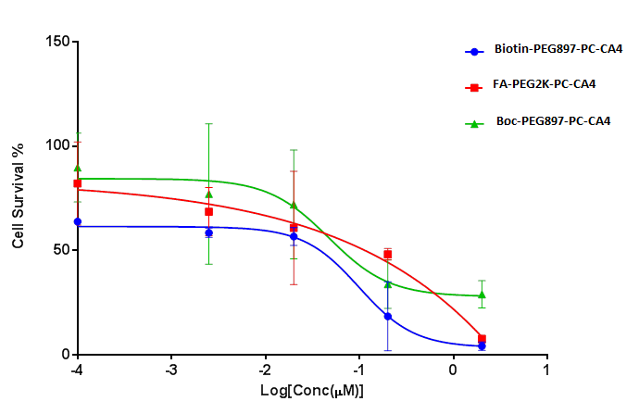
Figure 24. Phototoxicity of the three conjugates

Figure 25. In vivo PDT efficacy of PC-CA4 treated, FA-PC-CA4 treated and conrol group of mice
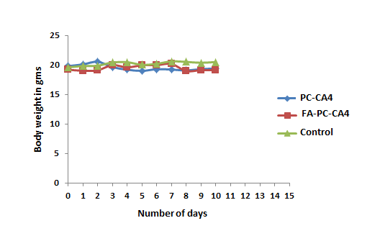
Figure 26. In vivo PDT acute toxicity test on PC-CA4 treated, FA-PC-CA4 treated and control group or mice

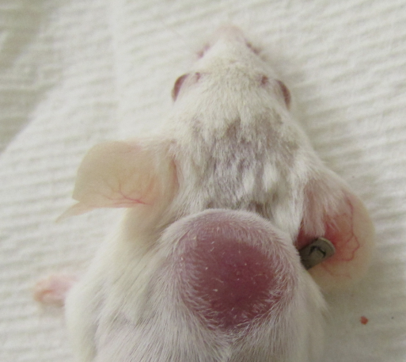
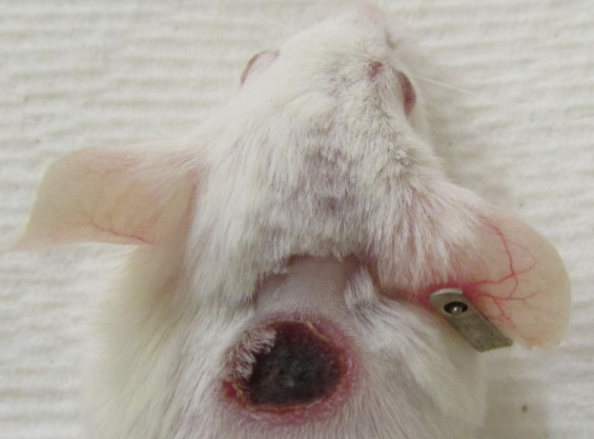
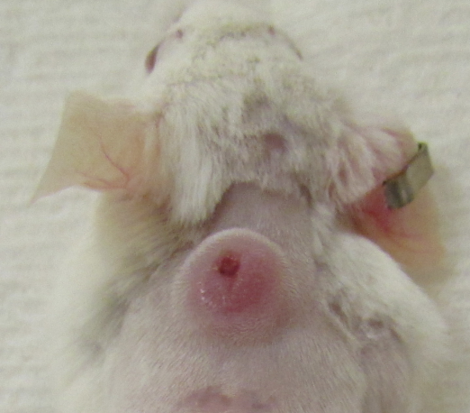
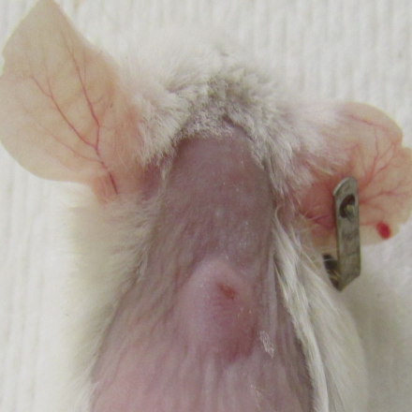
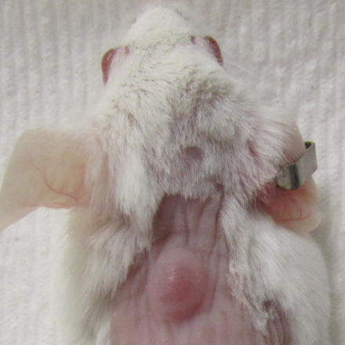
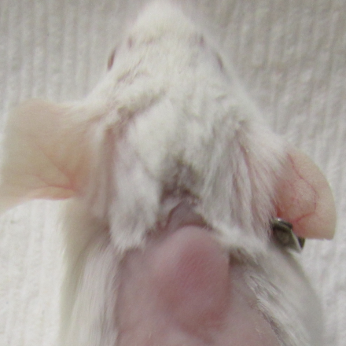
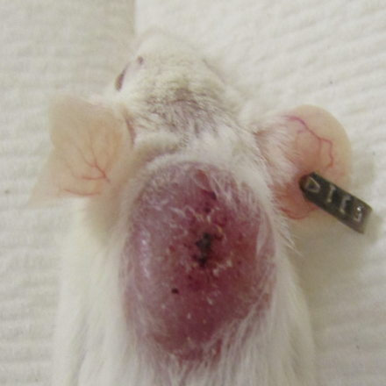
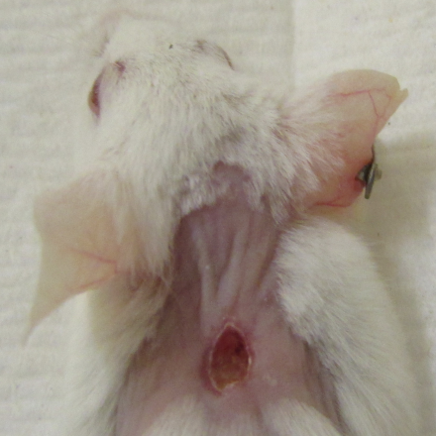
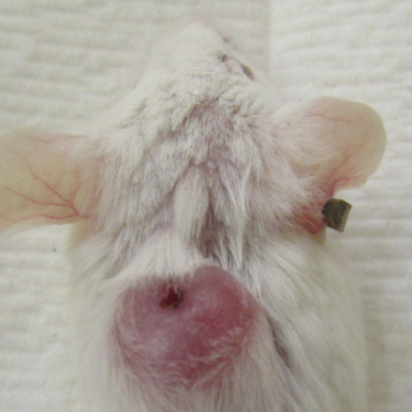
Day 5
Control
PC-CA4
FA-PC-CA4
Day 0
Day 9

Figure 27: Pictures of balb/c mice treated with FA-PC-CA4 and PC-CA4 and control group

3.8.6. Estimation of cellular uptake of conjugates by confocal fluorescence microscopy
Cellular uptake of the FA-PEG2K-PC-CA4 and Boc-PEG897-PC-CA4 were estimated using an Olympus FV 1000 confocal laser scanning microscopy and the multi-plate reader. Strong fluorescence of the FA-PEG2K-PC-CA4 was observed after treatment for 1.5 h in colon 26 cells, a folate receptor positive cell line. (Figure 28) In contrast, the fluorescence of the Boc-PEG 897-PC-CA4 was negligible (not bright) suggesting the folate moieties in the folated conjugate accelerated its uptake in the colon 26 cells. This may have been expected as targeted and non-targeted conjugate were water soluble and the major means of transport across the cell membrane would be through folate mediated-endocytosis for the targeted conjugate while hydrophilic non-targeted conjugate could not easily diffuse across cell membrane. This has been attested with the in vitro-uptake data that although some random diffusion may occur but that uptake was quite negligible. The results showed that these two conjugates had no organelle specificity and were distributed throughout the cytoplasm.
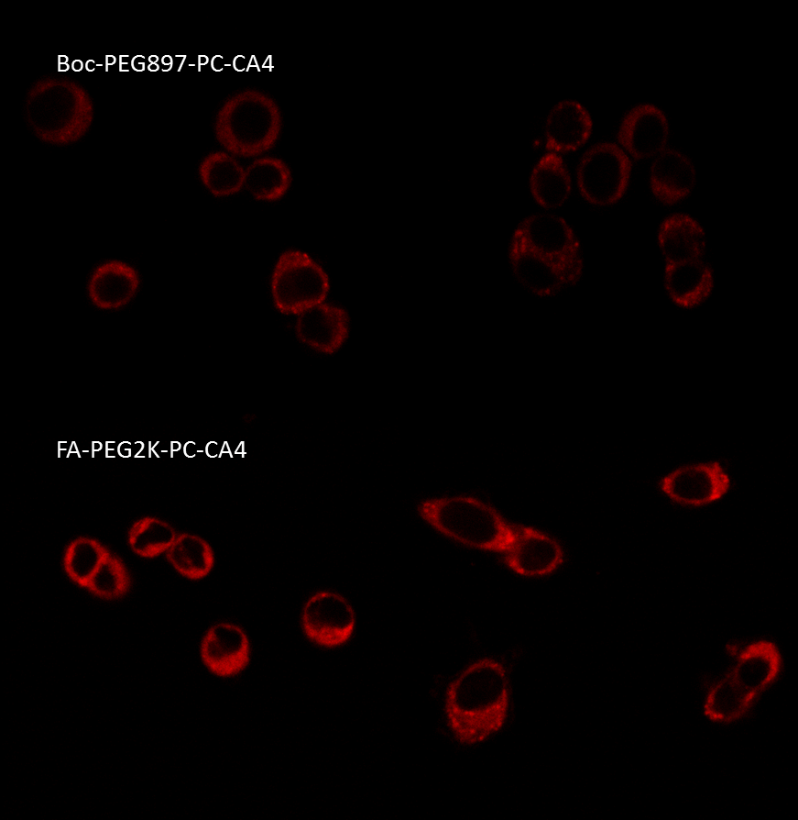
Figure 28. Estimation of cellular uptake by confocal microscopy of Boc-PEG897-PC-CA4 and FA-PEG2K-PC-CA4
3.8.7. Cellular uptake
The cellular uptake of Boc-PEG897-PC-CA4, used as reference in this study FA-PEG2K-PC-CA4 and Biotin-PEG897-PC-CA4 conjugates as function of incubation time was examined at 20 µM concentration. (Figure 29 and 30) Summarily within the first 6 h of incubation of the conjugates, the uptake increased rapidly and almost saturated or increased gradually from 6-9 h for both conjugates. Compared to the reference conjugate, the uptake of FA-PEG2K-PC-CA4 was 7-fold higher while that Biotin-PEG897-PC-CA4 was 4-fold within this time period. The rapid increase and then followed by a plateau within 6-9 h is not strange because the folate recycling rate has been estimated to be 8-12 h depending on the cell line.²⁵³ Within the saturation period not many receptors are available to cause any meaningful change in the uptake rate. At the end of 24 h exposure, the uptake of FA-PEG2K-PC-CA4 was 18.8-fold higher than the concentration Boc-PEG897-PC-CA4 while the uptake Biotin-PEG897-PC-CA4 was 4-fold higher than the concentration of Boc-PEG897-PC-CA4. The steady increase of the cellular uptake of the conjugates over a 24 h period suggested active transport via receptor- mediated endocytosis rather than nonspecific absorption. Better results will have been achieved if a folate free medium was used in the incubation of the cells.

Figure 29. Cellular uptake of four selected conjugates in concentration/ M

Figure 30. Graphic Representations of the cellular uptake in concentration/M
3.8.8. Competition Assays.
The dependence of uptake on the folate or biotin receptor in colon 26 cells was evaluated by performing a competitive uptake assay in the presence of excess folic acid or biotin (1 mM, 500-fold higher than the conjugates). After 6 h of exposure, the accumulation of FA-PEG2K-PC-CA4 and Biotin-PEG897-PC-CA4 were higher than that of non-targeted conjugate. Figure 31 shows that 1 mM FA and I mM biotin significantly reduced the uptake of FA-PEG2K-PC-CA4 and Biotin-PEG897-PC-CA4 produgs respectively, but no significant effect was observed for Boc-PEG897-PC-CA4. The cellular uptake of Boc-PEG897-PC-CA4 conjugate was not significantly influenced by the presence of either a competitive folic acid or biotin in the medium. While the introduction of excess folic acid (500-fold) reduced the uptake of FA-PEG2K-PC-CA4 by 60 %, that of excess biotin (500-fold) was reduced by approximately 40 %. The cellular uptake study clearly indicates that both the folate and biotin targeted conjugates were internalized by folate or biotin receptor-mediated endocytosis, consistent with previous reports on folate or biotin receptor-mediated cellular uptake of the folate or biotin-conjugated nanocarriers.²⁵⁴ ²⁵⁵ Although these compounds were synthesized to improve targeting to cancer cells compared to normal tissues or cells, some uptake was also observed which suggest that the presence of folic acid and biotin could also enhance nonspecific uptake or that better results will have been seen had it been a folate free medium was used in the case of folated conjugate.

Figure 31. Competition Assays of Boc–PEG897-PC-CA4, FA-PEG2K–PC-CA4 and Biotin-PEG897-PEG-PC-CA4
3.8.9. In vivo optical imaging
In order to access the specificity of the conjugates to tumor in vivo optical imaging was performed with the following compounds FA-PC-CA4, PC-CA4, FA-PEG2-PC-CA4, Boc-PEG897-PC-CA4, FA-PEG897-PC-CA4, Biotin-PEG897-PC-CA4 and FA-PEG2K-PC-CA4 using IVIS imaging system (Caliper Life Sciences). Generally, all the targeted conjugates accumulated in the tumor but worth noting is the fact some accumulated gradually while others were fast up taken by the tumor tissue. We set our exposure time to 0.5 s. Using these criteria, three hits were selected for further studies, viz; FA-PEG897-PC-CA4, Biotin-PEG897-PC-CA4 and FA-PEG2K-PC-CA4. From Figure 32, FA-PEG2K-PC-CA4 was fastest to be accumulate with bright fluorescence appearing on tumor within the first 3 h and being maximum (peak or brightest fluorescence) at 7 h time point. Fluorescence reduced gradually after 7 h time point but still a hot spot still concentrated at the tumor until after 48 h post injection. It was also observed that the conjugate was cleared via the kidney as intensity fluorescence from the kidney regions increased with time. Biotin-PEG897-PC-CA4 was the second conjugate to be accumulated in the tumor (Figure 33). The accumulation of this this was gradual compared to FA-PEG2K-PC-CA4 reaching a maximum tumor-to-skin fluorescence between 9-24 h post injections. The difference between the two conjugates may stem from differences in binding affinities of the receptors to their respective targeting ligands (folate receptors are known to bind folic acid with nanomolar affinity,¹⁰⁶ thus, indicating a fast up take when compared with biotin receptor(s)). FA-PEG897-PC-CA4 (Figure 34) was the least of the conjugates to have brighter fluorescence on tumor. Although FA-PEG897-PC-CA4 has the same PEG chain lengths like Biotin-PEG897-PC-CA4 and similar FA like in FA-PEG2K-PC-CA4 its kinetics were slow but similar to that FA-PEG2K-PC-CA4. We observed that FA-PEG897-PC-CA4 compound had some solubility issues from the aggregation tendency as a result of PEG chain not being long enough to completely solubilize FA conjugated to the PC-CA4 prodrug in aqueous medium. This could probably explain the difference in in vivo optical imaging of FA-PEG897-PC-CA4 which is poorly soluble (aggregates more) and Biotin-PEG897-PC-CA4 which is highly soluble in aqueous medium although they have the same PEG chain lengths. The exceptional high tumor to skin fluorescence when treated with these targeted conjugates can be attributed to folate and biotin-mediated targeting of the conjugates to the colon 26 cell lines that overexpress both FR-α and biotin receptors. The PC-CA4 conjugate was used as one of the standard non-targeted prodrug. From the in vivo images this prodrug was not localized compared to the targeted counter-parts. It was distributed everywhere within the system (Figure 35). Boc-PEG897-PC-CA4 was another non-targeted prodrug used to assess the effect of PEG to the localization into the tumor (Figure 36). Boc-PEG897-PC-CA4 showed the high photon counts in both tumor and skin with low maximum tumor/skin ratio (~ 1.70) after 72 h post IV injection. It seemed PEG897 did not specifically delivery the prodrug to tumor. From the tumor/ skin photon count ratios the following conclusions could be made about the conjugates. 1) Maximum tumor/skin ratio (3.12, 7 h post-IV injection) for FA-PEG2K-PC-CA4 was greater than that for FA-PEG897-PC-CA4 (2.31, 7 h post-IV injection). This may imply that the longer PEG was better. 2) The maximum tumor/ skin ratio for FA-PEG897-PC-CA4 was higher than that of Boc-PEG897-PC-CA4 (1.36, 7 h post-IV injection). Since both conjugates are similar but for the ligand (FA), FA seemed necessary for localization. 3) Biotin-PEG897-PC-CA4 had higher tumor/skin ratio (3.2, 9 h post-IV injection) than FA-PEG897-PC-CA4. Both conjugates only differ in their ligands. We may come to conclude that biotin (it also showed a slow and decreased clearance rate from the tumor) is may be better than FA in targeting for this tumor model, although some factors such as solubility of the conjugate may also contribute to the observed difference. The longer the PEG length the more soluble the conjugate becomes and the higher the accumulation in the tumor compared to the skin or normal tissue. This is why conjugates with either no PEG (Figure 37) or shorter PEG chain length (Figure 38) showed no significant or little fluorescent brightness in the respective tumor accumulation of the conjugates due partly to solubility and to aggregation in the blood stream of the mice.

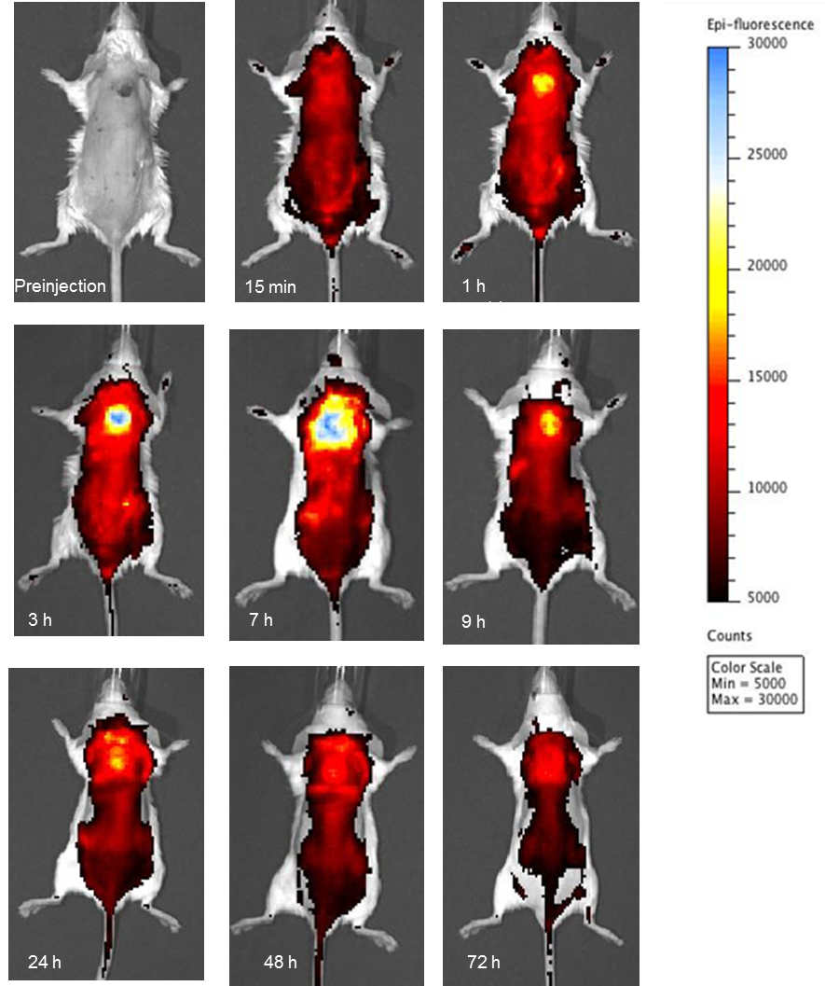
Figure 32. In vivo images of FA-PEG2K-PC-CA4 uptake
.

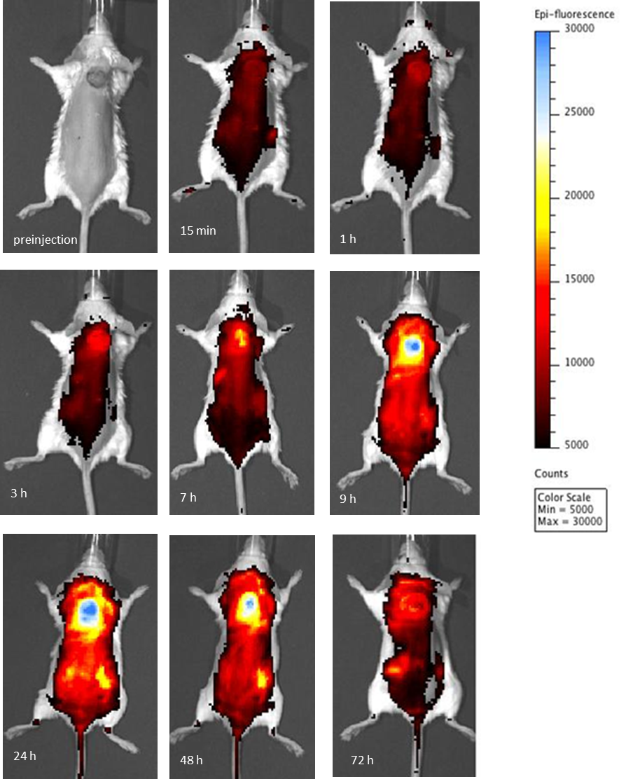
Figure 33. In vivo images Biotin-PEG897-PC-CA4 uptake

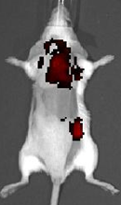
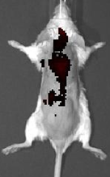
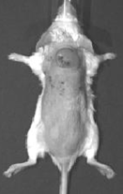
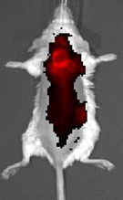
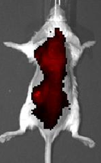
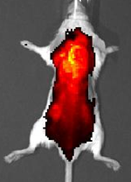
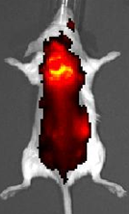
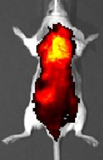
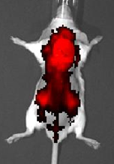
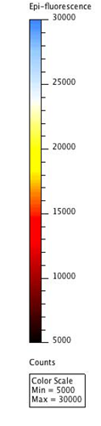
15 min
1 h
3 h
7 h
9 h
24 h
48 h
72 h
preinjection

Figure 34. In vivo images of FA-PEG897-PC-CA4 uptake
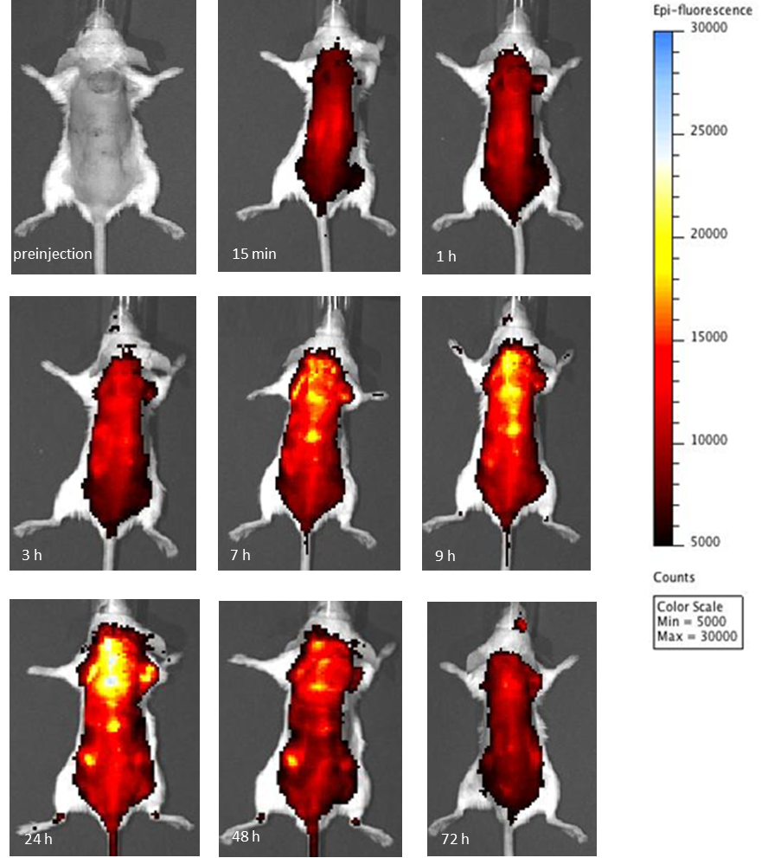
Figure 35. In vivo images of PC-CA4

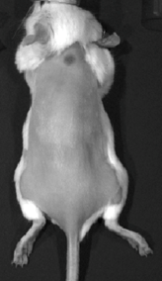
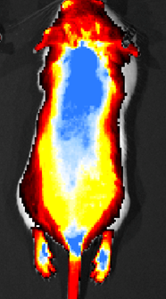
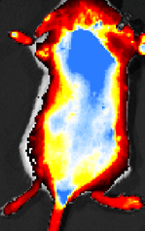
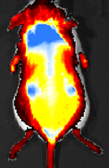
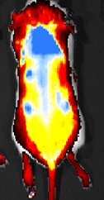
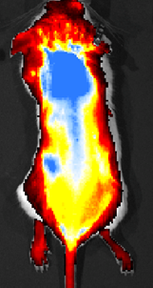
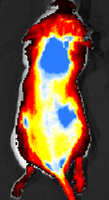
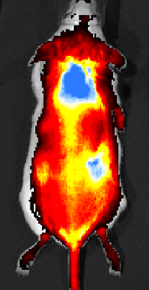
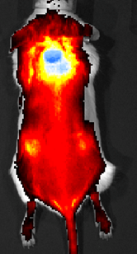
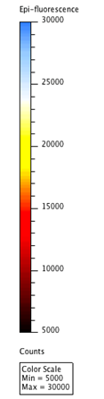
preinjection
15 min
1 h
3 h
7 h
9 h
24 h
48 h
72 h

Figure 36. In vivo images of Boc-PEG897-PC-CA4 uptake
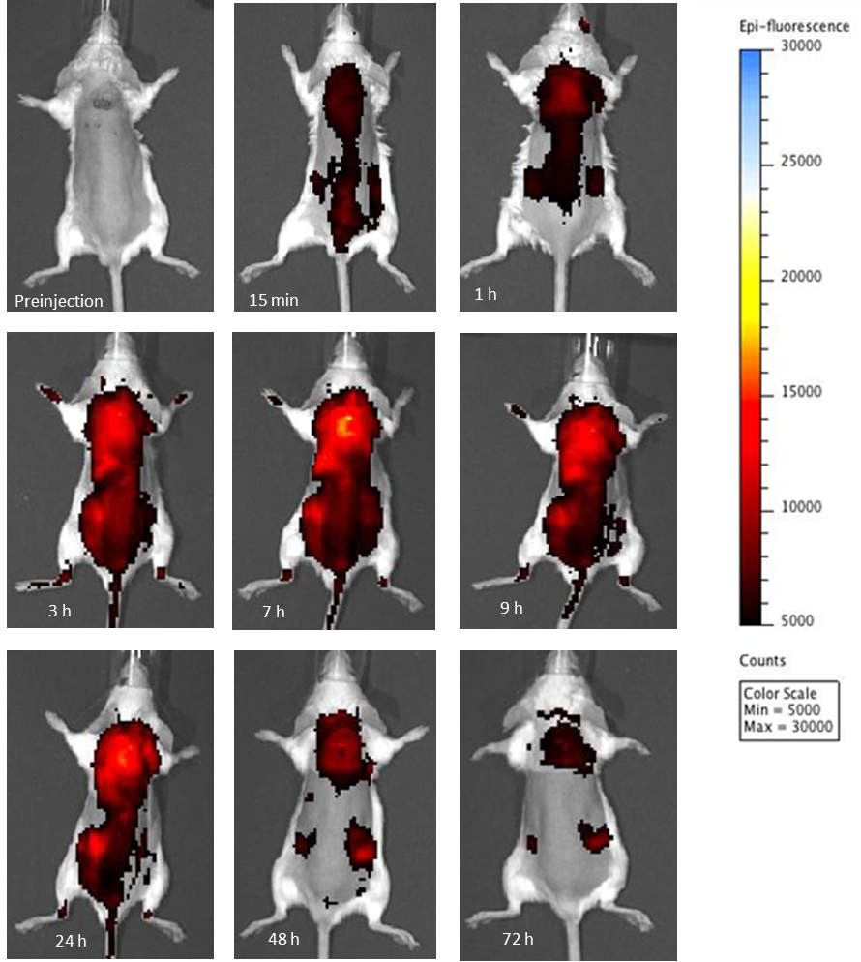

Figure 37. In vivo images of FA-PEG2-PC-CA4 uptake

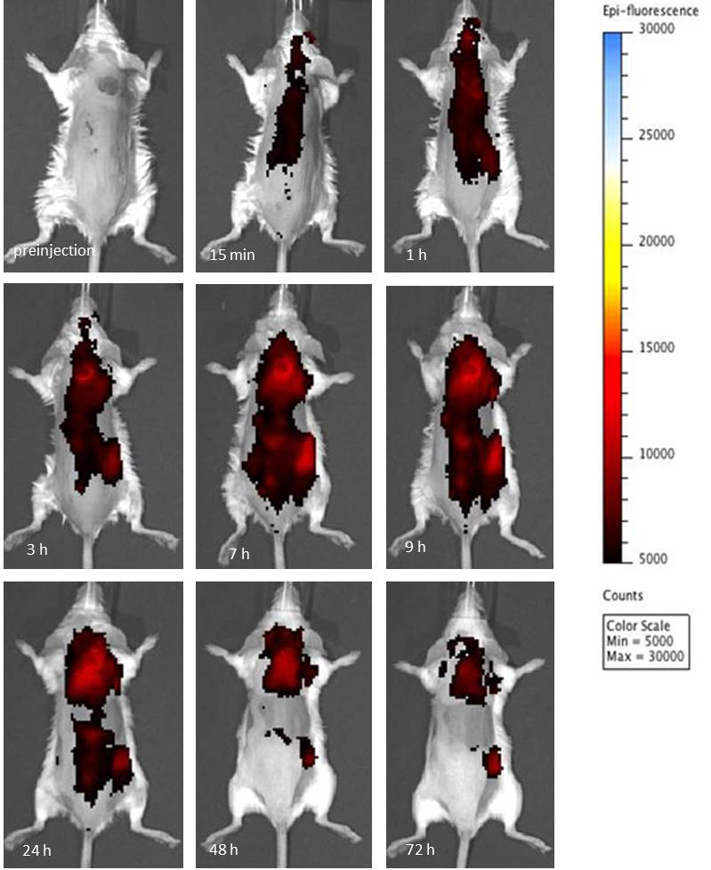
Figure 38. In vivo images of FA-PC-CA4 uptake

3.9. Conclusions
We have been able to design multifunctional conjugates of silicon phthalocyanine, evaluate the cellular uptake using the confocal microscopy and fluorescence from multiplate reader. In vivo uptake using the fluorescence from in vivo imaging in balb/c mice inoculated with colon 26 cells was also evaluated therefore proving the concept of folate- and biotin-mediated uptake of these prodrugs at cellular and animal model.

CHAPTER 4. CONCLUSIONS
The main goal of this study was to develop a tumor-targeting drug delivery system with the capabilities of selectively transport of cytotoxic agents into tumor by exploiting overexpressed receptors on malignant cells, and an active or remote controlled release of the drug by near infra-red (NIR) light as an externally activating agent. A combination of active site-specific targeting and site–specific triggering release of an anticancer drug from a drug delivery system is expected to increase the local bioavailability of a cytotoxic at the tumor site and stands as attractive local treatment to overcome the selectivity problems of conventional chemotherapy. Several tumor-targeted delivery vehicles (prodrugs, liposomes, dendrimers, micelles, etc.) have been designed, synthesized and some are in clinical studies, but most of them lack the active release mechanisms within the construct. Although some may be equipped with the release mechanism, most of them relied on intrinsic activating agents such as enzymes, pH, etc. of the tumor micro-environment. The use of light as an extrinsic activating agent looks attractive for the site specific release mechanism, but the major hurdle to achieving our aim was to develop a synthetic scheme for the vinyl diether linker that was screened in our lab as potential linker to use in the release of a drug from the caged molecule or prodrug using NIR light.
The electron rich-alkenes activated by heteroatoms have been shown to react with singlet oxygen through 1,2-cycloaddition reaction and have been proposed for photo – triggerable drug release systems in the form of liposomes, cyclodextrin complex and prodrugs. While these linkers and other hetero-olefinic bonds appear to be potentially excellent linkers to drug delivery, no facile approach to the synthesis have been reported, even though the linkers look very simple. Previous methods were limited to symmetric molecules, lengthy steps, harsh reaction conditions and low yields. Hence, in collaboration with lab colleagues (Drs. Praveen and Bio Moses), we were able to develop new synthetic route for O-, N-, and S- vinylation for singlet oxygen labile linkers and the kinetic study of the cleavage of these linkers was done.
To apply our synthetic scheme to biologically active molecule, we set to conjugate combretastatin A-4 (CA-4) to core modified porphyrin (CMP) to make CA4-L-CMP prodrug linked by the vinyl diether bond, but to our greatest dismay the final product was unstable even in an NMR solvent. The intermediates were synthesized with great purity and successfully, but the final product, although seen as being formed from the TLC pattern, could not be isolated and characterized. Owing to the high instability of the prodrug synthesized presumably due to the close proximity of the CMP photosensitizer to the electron rich double bond, we attempted using a spacer but still failed due to the incompatibility of the spacer with the reaction conditions. Moreover, one of the main disadvantages of using this scheme was that n-BuLi was used in one of the steps; hence, drug molecules that carry sensitive functional groups could not be used in this scheme.
With a few problems concerning the vinyl diether linker, we turned our attention to an alternative linker (aminoacrylate linker) that was developed in our lab. The amino acrylate linker has advantages that could not be met with the vinyl diether linker such as easy synthesis, high yields, and mild reaction conditions leading to functional group tolerance, and regeneration of parent drugs after cleavage. Dr. Bio Moses used this linker to synthesize a prodrug of CA-4 and CMP and the first ever prove of the concept of site–specific release mechanism of cytotoxic agent both in vitro and in vivo using NIR light.
With site-specific triggering prodrug concept proven, I set out to synthesize the multifunctional prodrug system combining the triggering capabilities to active targeting in order to increase local bioavailability of the drug at the tumor site. The targeting vector I set was the folic acid and/or biotin whose receptors are overexpressed on cancer cells and that are common vitamins required by rapidly proliferating tumor cells. The prodrug was envisaged to rapidly accumulate in tumor tissue compared to the normal tissue. The prodrug delivery system to be synthesized was supposed to be three-in-one tumor targeting system. This system consisted of a tumor recognition moiety (FA) that binds to folate receptors frequently overexpressed on the surface of malignant cells) linked by a spacer to photosensitizer and a cytotoxic warhead (drug) also connected by the aminoacrylate linker to the photosensitizer. The three are supposed to form a conjugate that is inactive and sufficiently stable while in circulation; then once selectively internalized into cancer cells, cleavage of the conjugate upon irradiation with visible light or NIR light restores the active cytotoxic warhead (drug). Two of these conjugates were initially synthesized, which consisted of FA-TPP-CA4 (results not presented in the dissertation) and FA-PC-CA4 by direct conjugation of the FA to the photosensitizers.
From the synthetic point of view, even though the two conjugates can be synthesized in principle by straightforward coupling reactions between the linkers, FA, CA-4 and photosensitizer, some problems regarding FA-containing reaction intermediates must be pointed out.
- The main hurdle in the synthesis is extreme sensitivity of these reactions especially when the drug-linker is attached to the PS. This made it difficult to get the high mass of these conjugates from other methods other than the ESI since the aminoacrylate linker was being cleaved by laser light used, the inability of some of the conjugates to be ionized easily when they are conjugated to FA and with molecules above a certain molecular weight range.
- Secondly, the synthesis of FA-derivatives is represented by very poor solubility of all the FA-containing products in organic solvents (except DMSO and DMF). On the one hand, this made most of the reaction intermediates unsuitable for purification on common solid chromatographic supports. For this reason, precipitation was always preferred to purify reaction productions to eliminate traces of unreacted reagents and other byproducts. On the other hand, solubility problems often resulted in slow reaction rates, both in the coupling of FA with various nucleophiles and in the following synthetic steps; this led to low yields and, after prolonged reaction times, to the formation of a complex mixture of products. Therefore accurate tuning of reaction conditions was considered to avoid contamination of reaction products by undesired compounds and thus to ensure efficient purification of the desired folate conjugates.
- Thirdly, the problem was also in the characterization of the final products. Due to high instability, the high mass could not be determined using other mass spect methods except ESI. The final molecules seemed to be completely ablated by laser light used in MALDI, FAB, etc. The low volatility of FA conjugates above a certain mass range made the analysis difficult (above 1800 the signal for the internal standards are always too low to get the molecular ion peak). Concerning the problem of mass, SUNY at Buffalo is developing a method for the determination of the masses of these unstable molecules. NMR of FA conjugates are poorly resolved, which has thus led to alternative methods of characterization such as UV, IR, etc.
Despite all the challenges faced in the synthesis, preliminary in vitro test (figure U) conducted on the first conjugate (FA-PC-CA4) synthesized by direct reaction of the FA to the photosensitizer indicate that it was not accumulating in the colon 26 cell line. When we investigated the behavior of this conjugate in cell culture media or aqueous medium, we realized that this conjugates was highly aggregating, and that is why their fluorescence was completely quenched, and it was stacked in the medium (due to its ampiphilicity) and not taken up by cells. The NMR this conjugate (FA-PC-CA4) was not good, which indicated the aggregation even in DMSO as the most polar NMR solvent in use. We decided to pursue the modification of the PC4 core by sequentially increasing its solubility by varying the PEG chain length. Interestingly, the first modification with short PEG could not improve the solubility, but after adding a longer spacer of approximately 2000 Da, the conjugate showed marked uptake by the cells. It is noteworthy that the effect of PEG lengths on target ability of the FA has been investigated by several research groups on the receptor-mediated uptake of nano-particulate conjugates such as liposomes, micelles but not with the prodrug delivery systems and photosensitizers. With FA-PEG2K conjugates being non-monodisperse polymers, we decided to synthesize prodrugs of FA and biotin with pure (>95 %) PEG (897 Da). The prodrugs showed good uptake in the cell culture medium. The best of the conjugates was FA-PEG2K-PC-CA4 followed by Biotin-PEG897-PC-CA4 and lastly FA-PEG897-PC-CA4. With all the seven conjugates synthesized, we decided to assess the accumulation in mice tumor models using in vivo imaging. Interestingly, FA-PEG2K-PC-CA4 showed the best accumulation with fluorescence peaking between 3 to 7 h post injections followed by the biotin conjugate (Biotin-PEG897-PC-CA4) with fluorescence peaking between 9 to 24 h post-injection. FA-PEG897-PC-CA4 had the similar kinetic like that of FA-PEG2K-PC-CA4, but the uptake was not all that great compared to the latter. With these three leads selected, we went ahead to carry out the in vitro test using both the confocal microscopy and cellular accumulation with a multi-plate reader at every time point. Finally using the competition assays we were able to demonstrate folate- and biotin-mediated uptake of these conjugates. We were able to achieve 19 fold cellular accumulations in the cells after 24 h of incubation of our folate prodrugs while that of the biotin was 4 folds compared to the standard compound Boc-PEG897-PC-CA4. Uptake accumulations of folate prodrug were done in normal medium having some folic acid. This indicates that we would have achieved better results had a folate free medium been used.²⁵⁶ I was able to design, synthesize and demonstrate the concept of folate or biotin mediated uptake of our prodrug using PEG of various chain lengths to solubilize the highly hydrophobic PC molecules. Although folate active targeting has been used in other delivery vehicles such as liposomes, micelles, nanoparticulate delivery systems, the use of active targeting on the drug or prodrug is more appealing than targeting the macromolecules since there is always an issue of the stability of these polymers in circulation. To best of my knowledge very little has done in the development of drug delivery system the can actively target and actively release the carried payload using NIR light. Moreover our prodrugs function as multimodal drug delivery system performing the following functions:
- Imaging (diagnostic application)
- PDT agent
- Targeting agent due folate or biotin attached
- A therapeutic agent; Delivery system for chemotherapeutic drugs.
To the best of our knowledge, the systems developed so far may constitute only three of the above four functions as theranostic agents, which thereby indicates the importance of our prodrug delivery system. Because of the high expression of folate receptors and biotin receptors in most cancer cell lines such as ovarian, breast, lung, etc., our prodrugs will definitely find good use not only in the treatment of aggressive solid tumors such as those mentioned above (ovarian and breast cancer especially) but in the delivery of bioactive molecule. In vivo PDT is underway to determine the efficacy of these prodrugs to treat bigger tumors although the non-targeted analog (Figure Z) has proven to be quite effective in our lab.

¹H- NMR (upper) and ¹³C-NMR (lower) spectra of the compounds
2
Figure 33

Figure 39

Figure 40
5
Figure 41

6
Figure 42
7
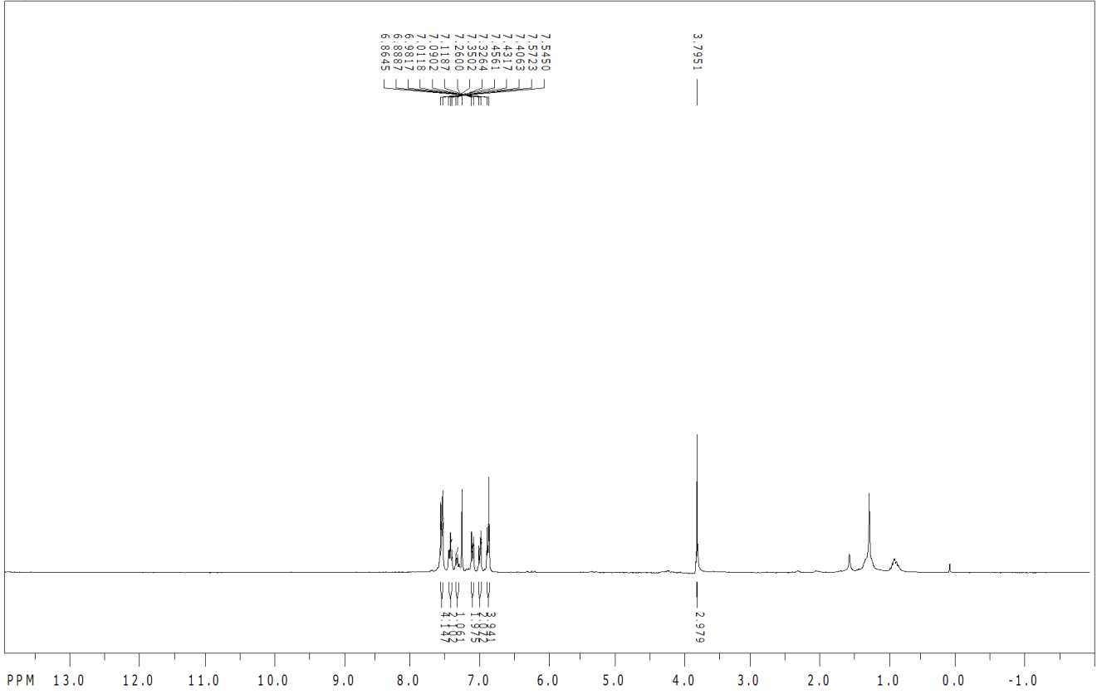
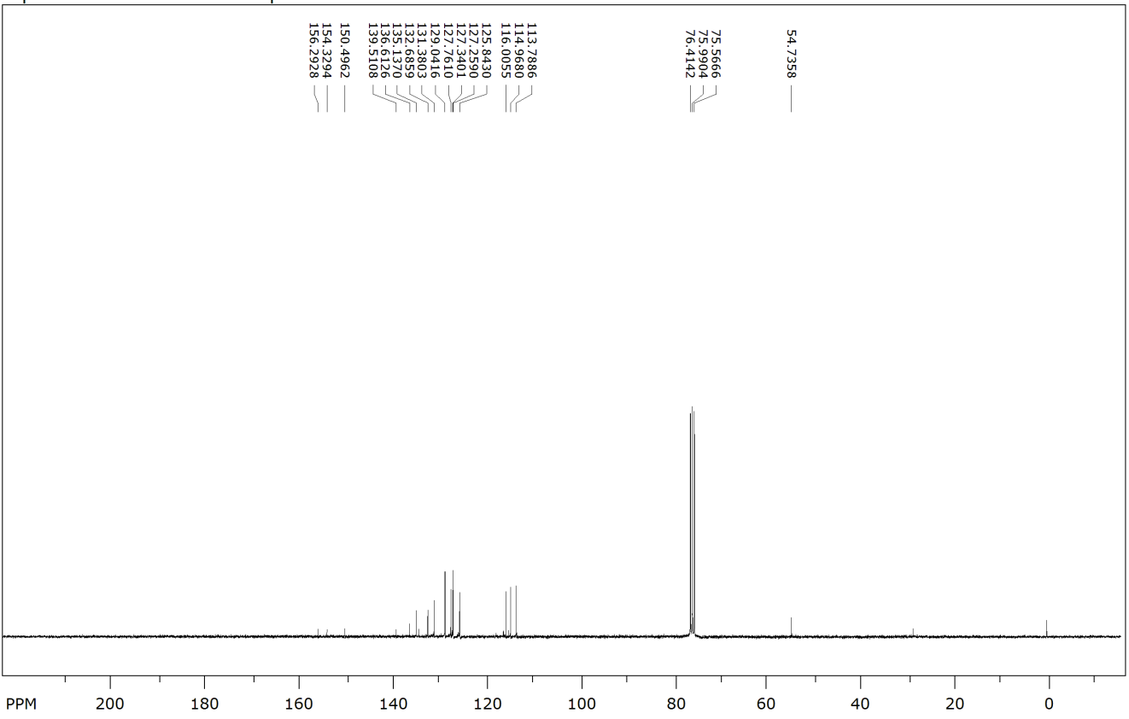
Figure 43

8
Figure 44

10
Figure 45

11
Figure 46

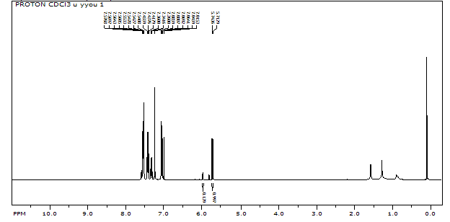
Z-4
E-4
E-4

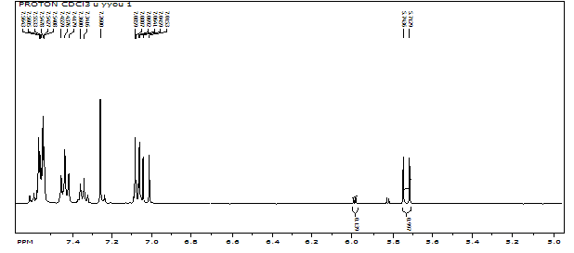
Z-4
E-4
E-4

Figure 47
Z-8
E-8
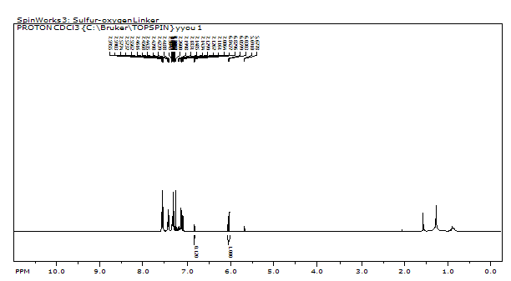
Z-8
E-8
Z-8
E-8
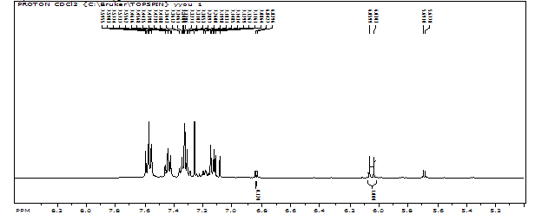
Figure 48
Z-8
E-8
Z-8
E-8

Table 3. Kinetic data of oxidation of olefins.

 | Remaining Starting Compound (%) |  |  |  | Observed Product (%)
Time (min) | control | 6 | 8 | 11 | Ca | (6a+6b)/2* | 8a | 8b
0 | 100 | 100 | 100 | 100 | 0 | 0 | 0 | 0
5 | 38 | 26 | 29 | 27 | 0 | 53 | 67 | 32
10 | 11 | 2 | 0 | 0 | 1 | 87 | 99 | 48
15 | 0 | 0 | 0 | 0 | 2 | 92 | 99 | 48
* In 1H-NMR, the formate peaks of expected products of 6 (6a and 6b) were too close. Thus, two peaks were integrated together and divided by 2.

Figure 49: Kinetic NMR Spectra of Control

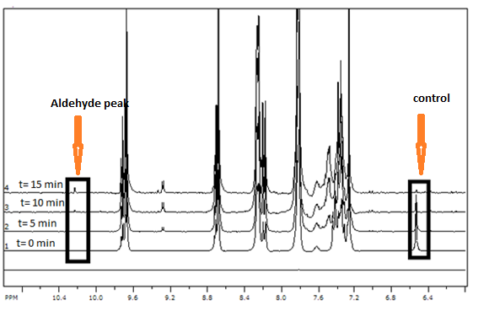

1H of formyl, Ca
2H of olefin,
Control

Figure 49: Kinetic NMR spectra of 6
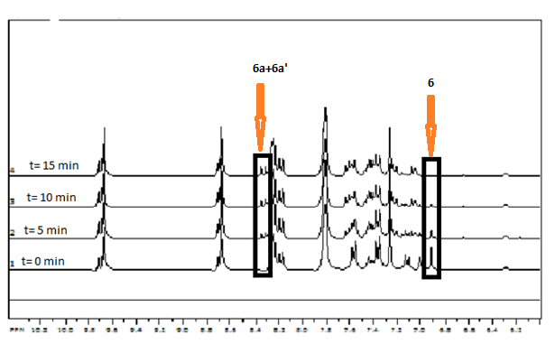

1H of 6a +
1H of 6b
2H of olefin, 6

Figure 50: Kinetic NMR spectra of 8
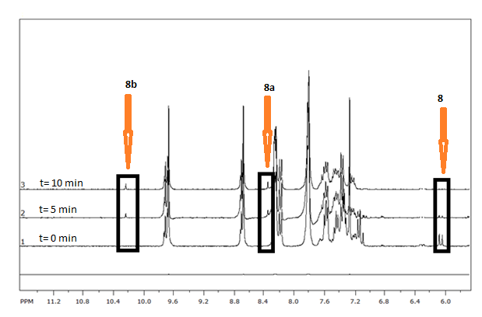

1H of formyl, 8b

1H of formyl, 8a
2H of olefin, 8

Figure 51: Kinetic NMR spectra of 11
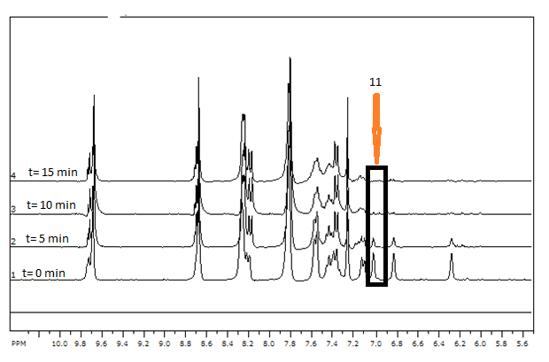

2H of olefin, 11

4H of pyrrole, 11

Figure 52

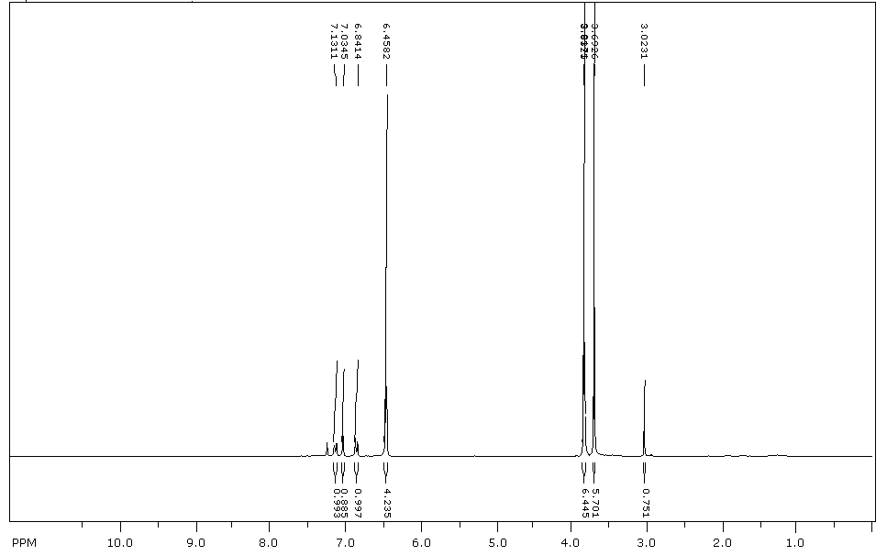
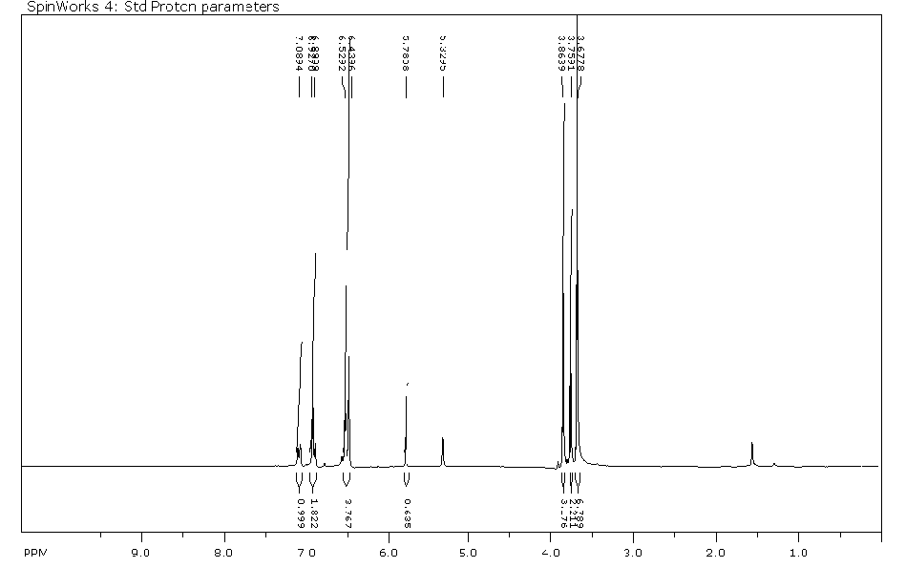

Figure 54
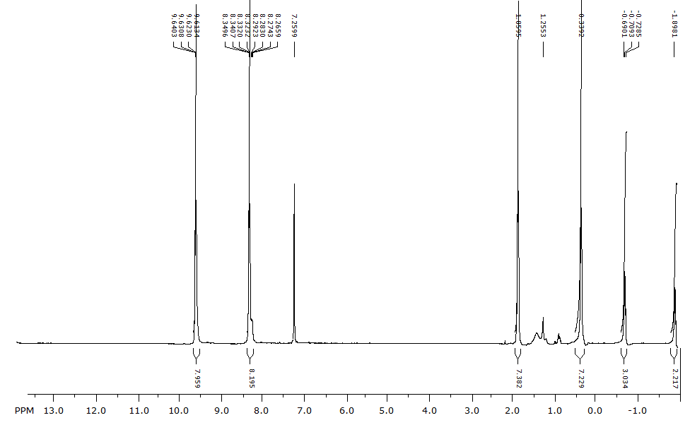

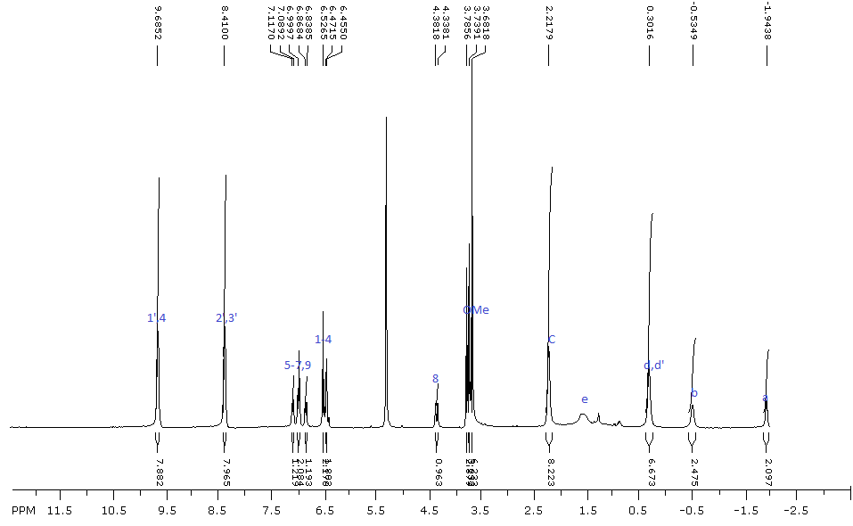
Figure 56

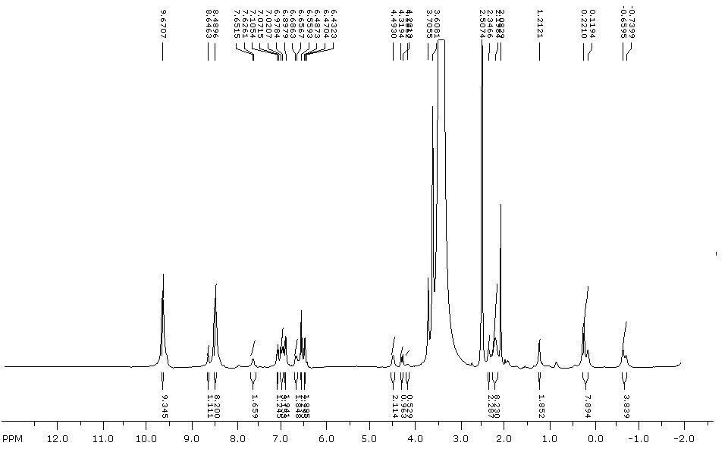
Figure 57: ¹H NMR of FA-PC-CA4

Figure 58 HRMS of FA-PC-CA4

Figure 58: HPLC of FA-PC-CA4
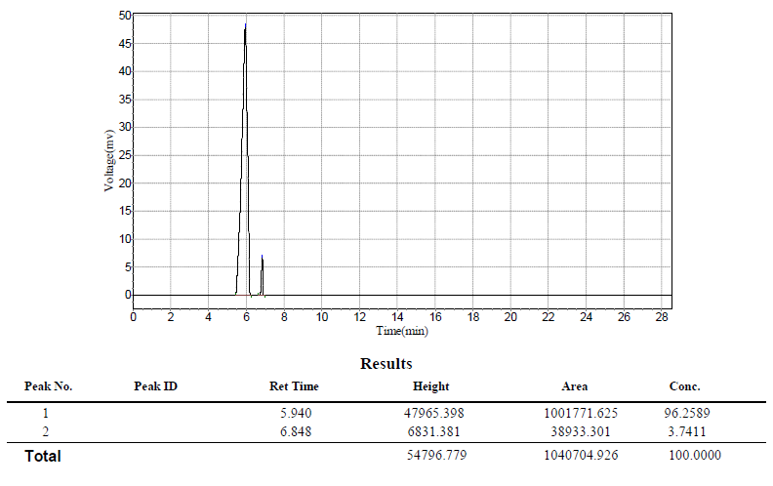

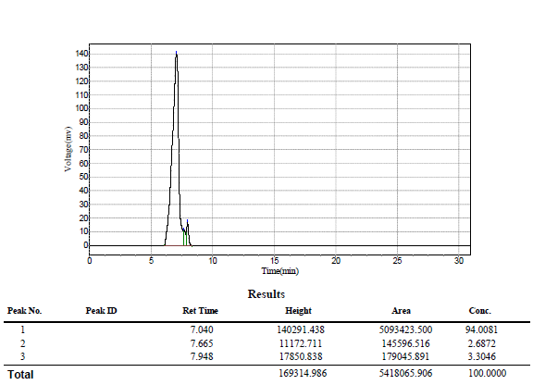

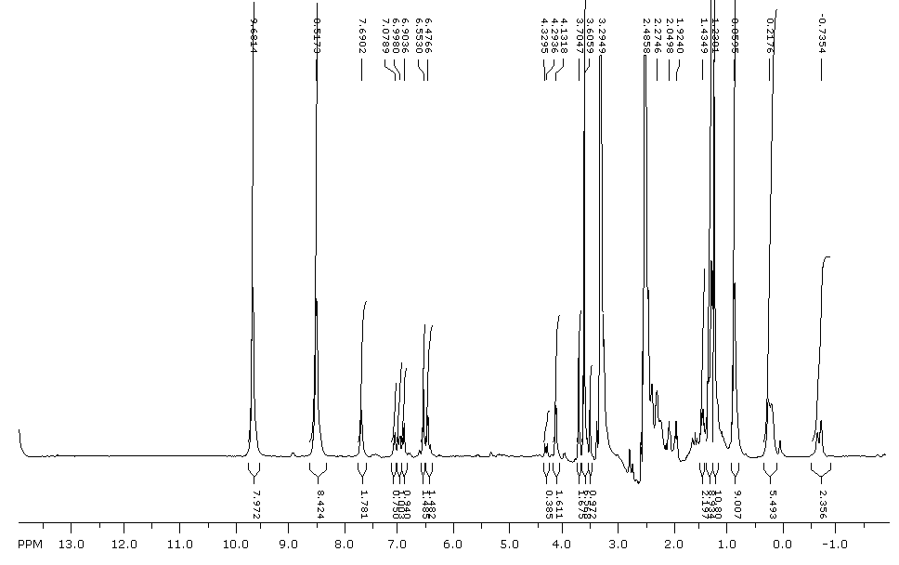
Figure 60: NMR or FA-PEG2-PC-CA4

Figure 60: Mass Spec of FA-PEG2-PC-CA4

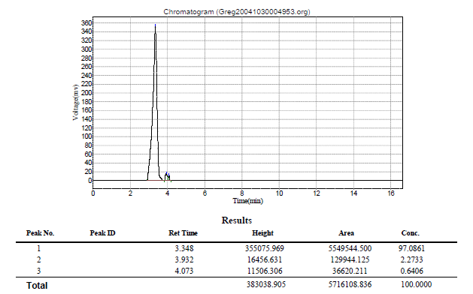
Figure 62: HPLC chromatogram of FA-PEG2-PC-CA4

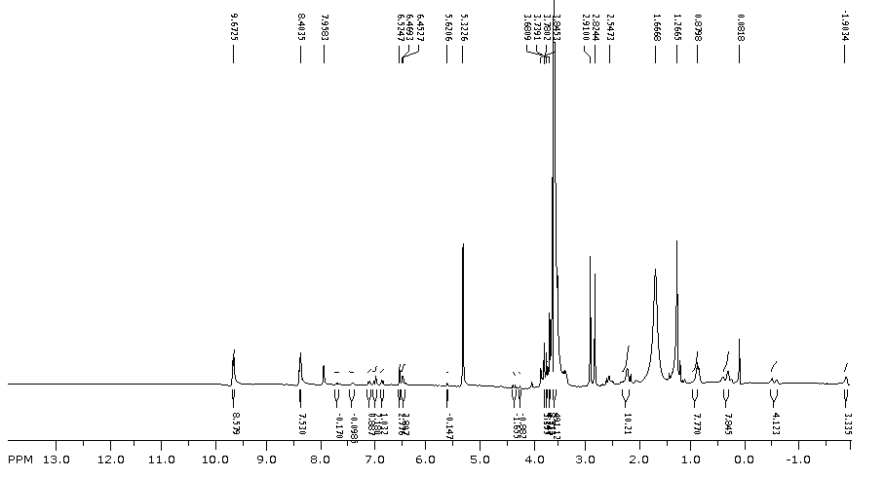
Figure 62: NMR of FA-PEG2K-PC-CA4
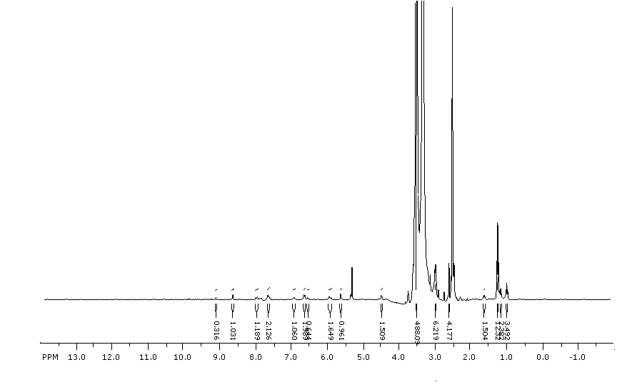

Figure 63: NMR of Compound 28

Figure 64: Stacked NMR of FA-PEG2000-NH2 (28) and FA-PEG2K-PC-CA4

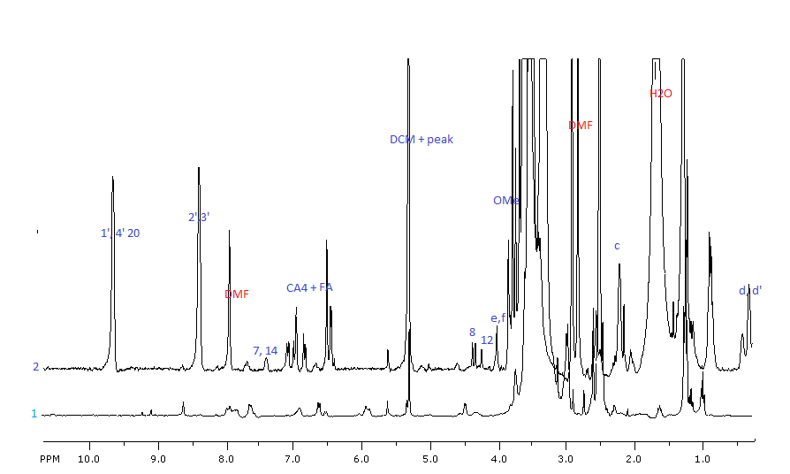
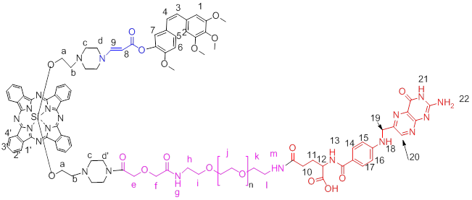

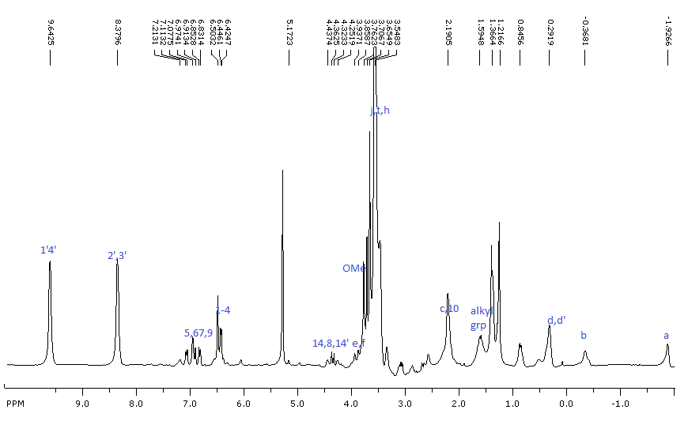

Figure 65: NMR of Biotin-PEG-PC-CA4

Figure 66: ESI (Ion trap) of Biotin-PEG897-PC-CA4

Figure 67: Stacked NMRs of Boc-PEG897-Biotin and Biotin-PEG897-PC-CA4
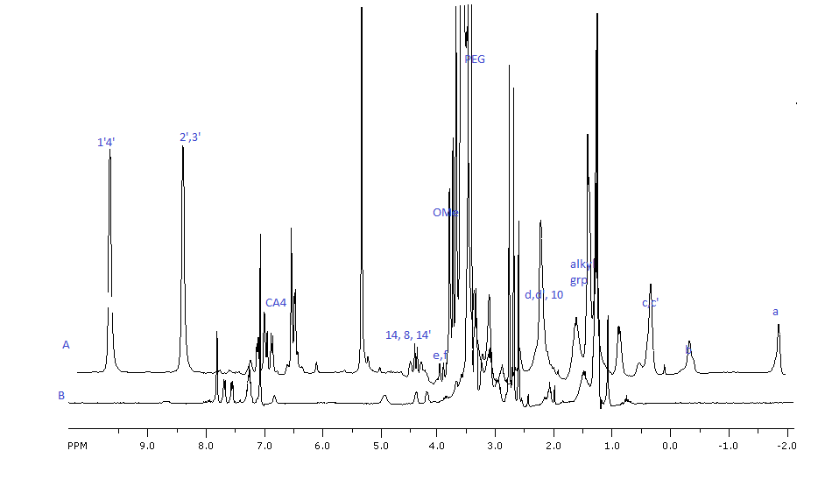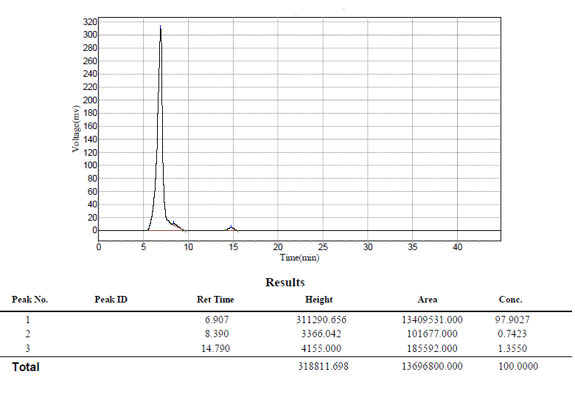
Figure 68: HPLC of Biotin-PEG897-PC-CA4

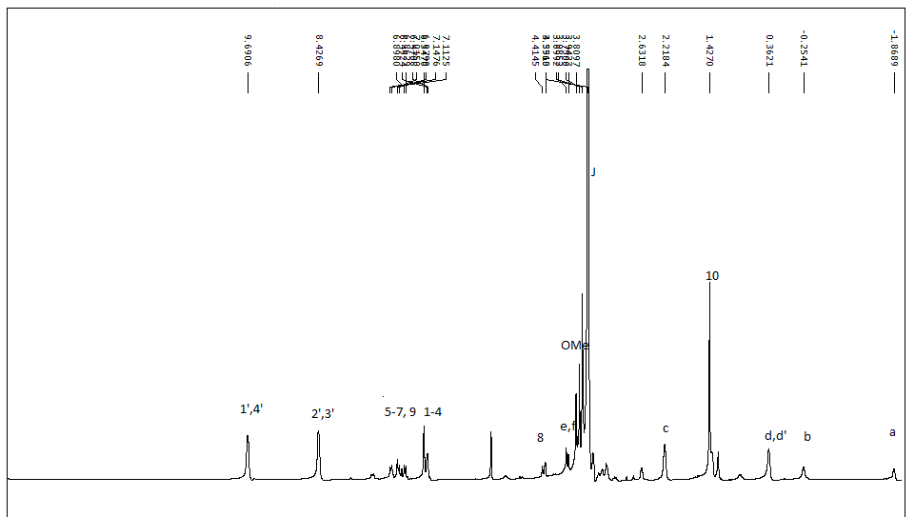

Figure 69: NMR of Boc-PEG897-PC-CA4
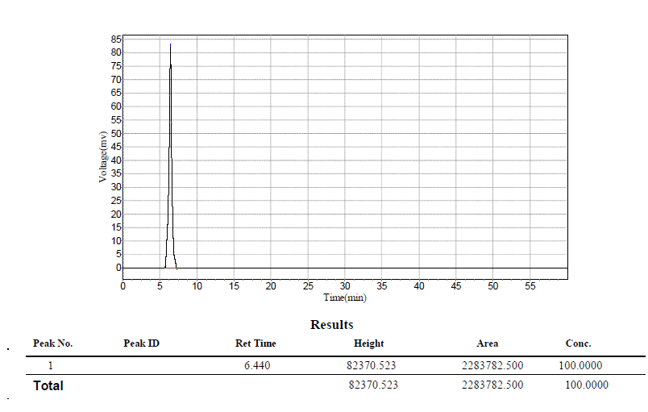
Figure 70: HPLC of Boc-PEG897-PC-CA4

Figure 71: HRMS-ESI or Boc-PEG897-PC-CA4

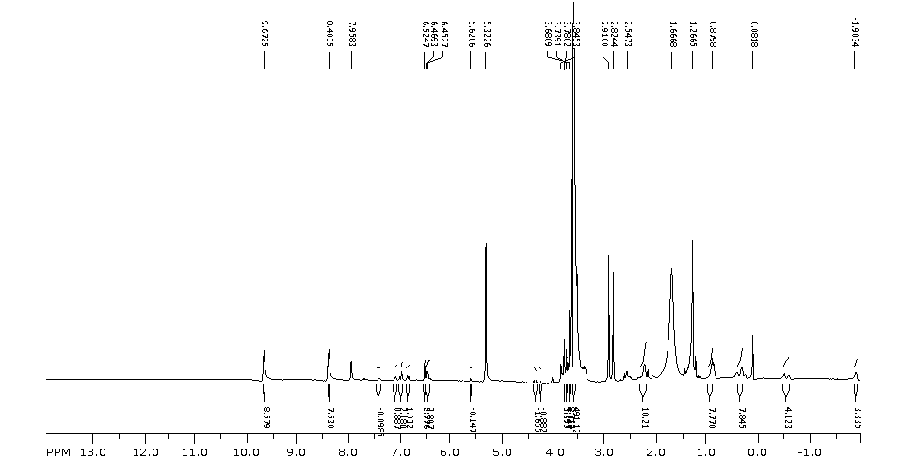
Figure 73: ¹H-NMR FA-PEG897-PC-CA4

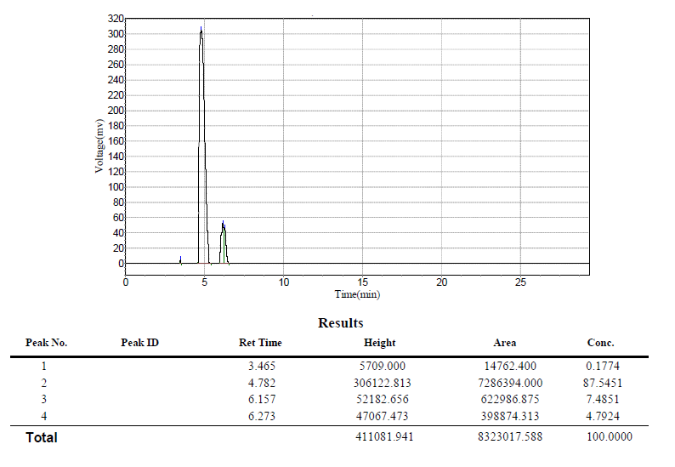
Figure 73: HPLC of FA-PEG897-PC-CA4

Figure 74: ¹H-NMR of compound 22
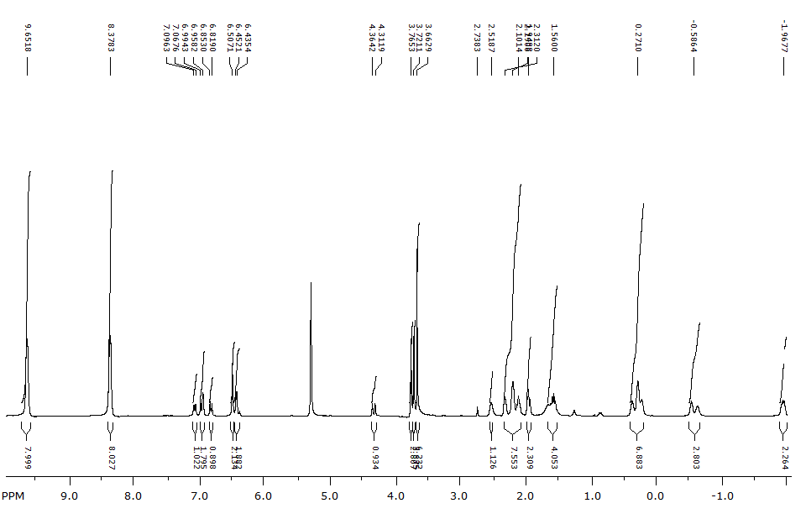

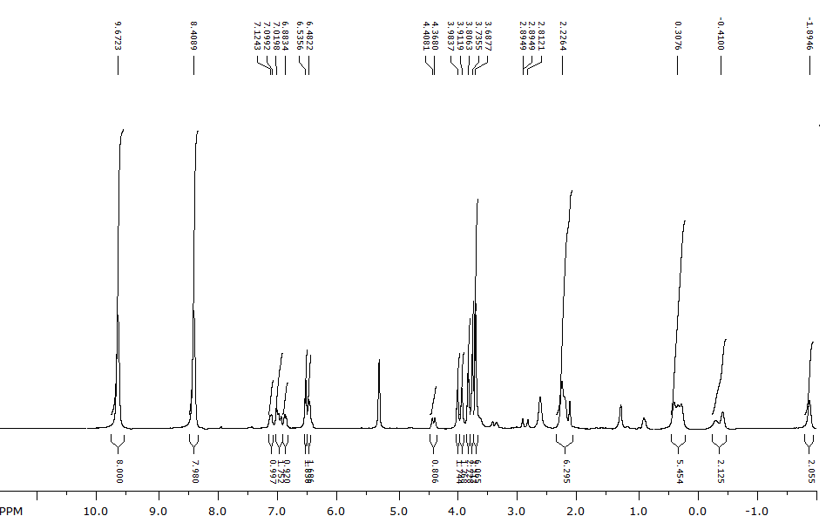

Figure75: ¹H-NMR of compound 23

Figure 76: 1H-NMR of compound 24

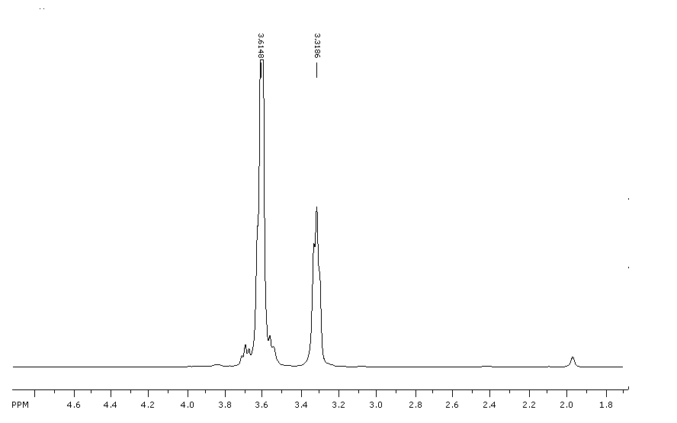

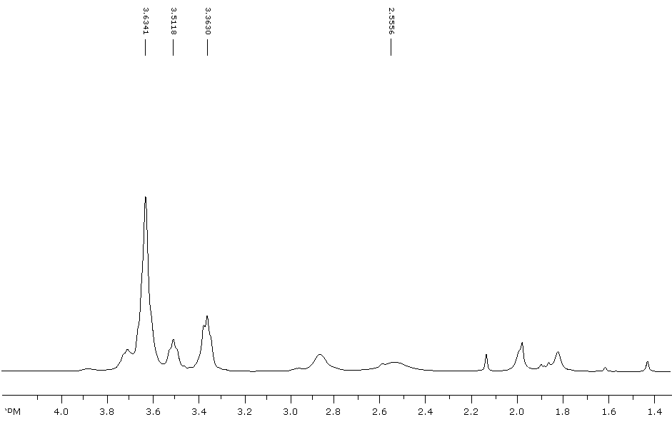

Figure 77: 1H-NMR of compound 25

Figure 78: ¹H-NMR of compound 31

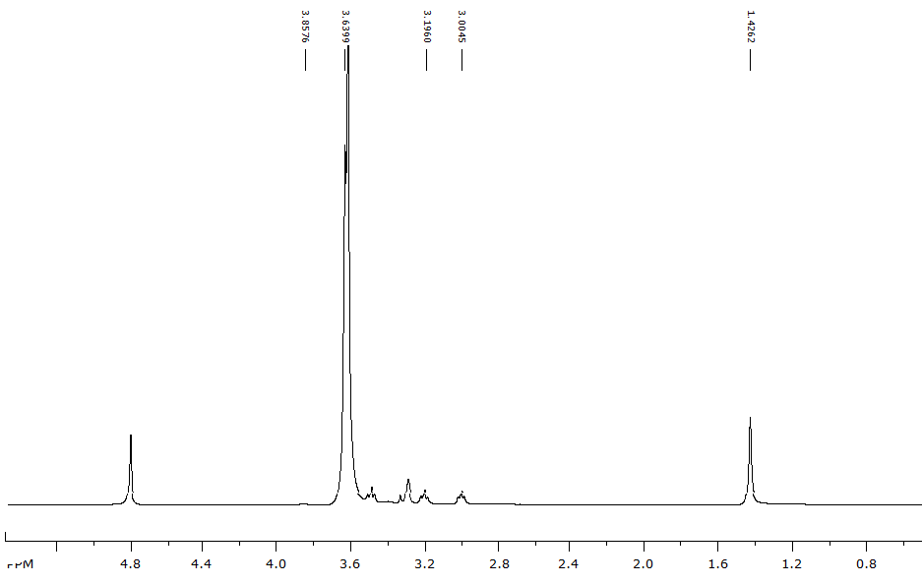

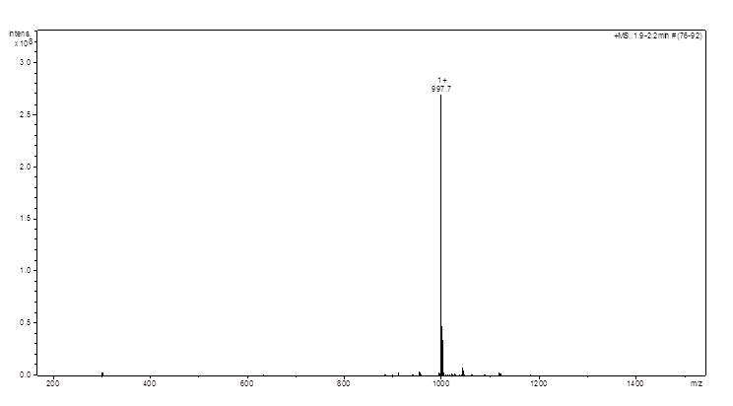
Figure 79: HRMS-ESI of compound 31

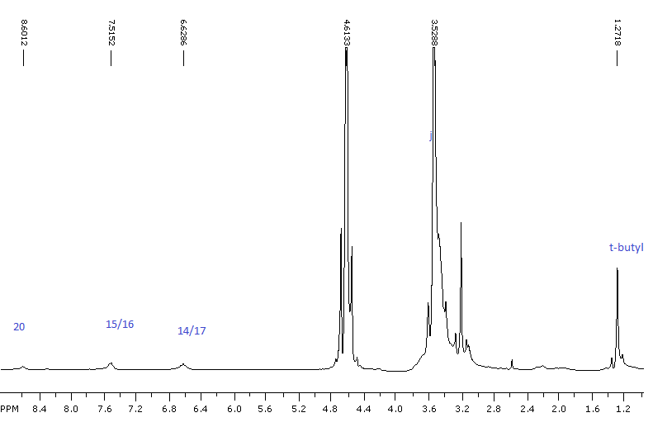
Figure 80: 1H-NMR of Boc-PEG897-FA

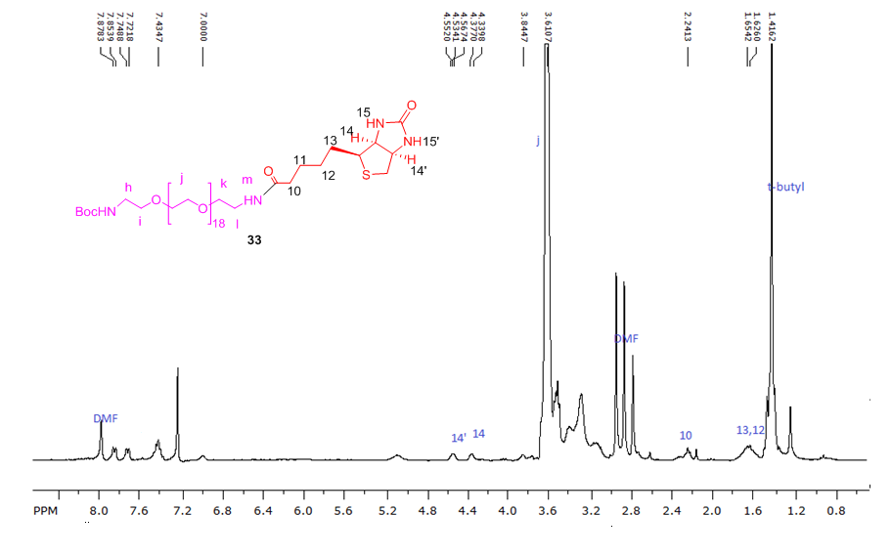
Figure 81: ¹H-NMR of Boc-PEG897-Biotin

REFERENCES
(1) Master, A. M.; Rodriguez, M. E.; Kenney, M. E.; Oleinick, N. L.; Gupta, A. S. J Pharm Sci 2010, 99, 2386.
(2) Wang, K. K.; Wilson, J. D.; Kenney, M. E.; Mitra, S.; Foster, T. H. Photochem Photobiol 2007, 83, 1056.
(3) Kamb, A.; Wee, S.; Lengauer, C. Nat Rev Drug Discov 2007, 6, 115.
(4) Menon, U.; Jacobs, I. J. Curr Opin Obstet Gynecol 2000, 12, 39.
(5) Li, C. Adv Drug Deliv Rev 2002, 54, 695.
(6) Pizzolato, J. F.; Saltz, L. B. Lancet 2003, 361, 2235.
(7) Mross, K.; Richly, H.; Schleucher, N.; Korfee, S.; Tewes, M.; Scheulen, M. E.; Seeber, S.; Beinert, T.; Schweigert, M.; Sauer, U.; Unger, C.; Behringer, D.; Brendel, E.; Haase, C. G.; Voliotis, D.; Strumberg, D. Ann Oncol 2004, 15, 1284.
(8) Agostinis, P.; Berg, K.; Cengel, K. A.; Foster, T. H.; Girotti, A. W.; Gollnick, S. O.; Hahn, S. M.; Hamblin, M. R.; Juzeniene, A.; Kessel, D.; Korbelik, M.; Moan, J.; Mroz, P.; Nowis, D.; Piette, J.; Wilson, B. C.; Golab, J. CA Cancer J Clin 2011, 61, 250.
(9) Detty, M. R. Expert Opin Ther Pat 2001, 11, 1849.
(10) Dolmans, D. E.; Fukumura, D.; Jain, R. K. Nat Rev Cancer 2003, 3, 380.
(11) Pervaiz, S.; Olivo, M. Clin Exp Pharmacol P 2006, 33, 551.
(12) Brown, S. B.; Brown, E. A.; Walker, I. Lancet Oncol 2004, 5, 497.
(13) Hamblin, M. R.; Hasan, T. Photochem Photobiol Sci 2004, 3, 436.
(14) Sibata, C. H.; Colussi, V. C.; Oleinick, N. L.; Kinsella, T. J. Expert Opin Pharmacother 2001, 2, 917.
(15) Gomer, C. J. Semin Hematol 1989, 26, 27.
(16) Dougherty, T. J. Oncol (Williston Park) 1989, 3, 67.
(17) Berg, K.; Folini, M.; Prasmickaite, L.; Selbo, P. K.; Bonsted, A.; Engesaeter, B. O.; Zaffaroni, N.; Weyergang, A.; Dietze, A.; Maelandsmo, G. M.; Wagner, E.; Norum, O. J.; Hogset, A. Curr Pharm Biotechno 2007, 8, 362.
(18) Rosenthal, I.; Ben-Hur, E. Int J Radiat Biol 1995, 67, 85.
(19) Moan, J.; Christensen, T. Cancer Lett1979, 6, 331.
(20) Niedre, M. J.; Secord, A. J.; Patterson, M. S.; Wilson, B. C. Cancer Res 2003, 63, 7986.
(21) Niedre, M.; Patterson, M. S.; Wilson, B. C. Photochem Photobiol 2002, 75, 382.
(22) Sonoda, M.; Krishna, C. M.; Riesz, P. Photochem Photobiol 1987, 46, 625.
(23) Weishaupt, K. R.; Gomer, C. J.; Dougherty, T. J. Cancer Res 1976, 36, 2326.
(24) Foote, C. S. Photochem Photobiol 1991, 54, 659.
(25) Davies, M. J. Biochem Bioph Res Co 2003, 305, 761.
(26) Girotti, A. W. J Photochem Photobiol B 2001, 63, 103.
(27) Herzberg, G. Nat 1934, 133, 759.
(28) Childs, W. H. J.; Mecke, R. Z Phys 1931, 68, 344.
(29) Ogryzlo, E. A. Photophys 1970, 5, 35.
(30) Foote, C. S. Acc Chem Res 1968, 1, 104.
(31) Pathak, M. A.; Joshi, P. C. Biochimet Biophy Acta 1984, 798, 115.
(32) Corey, E. J.; Taylor, W. C. J Am Chem Soc 1964, 86, 3881.
(33) Foote, C. S.; Wexler, S. J Am Chem Soc 1964, 86, 3879.
(34) Foote, C. S.; Wexler, S. J Am Chem Soc 1964, 86, 3880.
(35) Duncan, C. K.; Kearns, D. R. Chem Phys Lett 1971, 12, 306.
(36) Kearns, D. R. Chem Rev 1971, 71, 395.
(37) Duncan, C. K.; Kearns, D. R. J Chem Phys 1971, 55, 5822.
(38) Ackroyd, R.; Kelty, C.; Brown, N.; Reed, M. Photochem Photobiol 2001, 74, 656.
(39) Alberti, M. N.; Orfanopoulos, M. Tetrahedron 2006, 62, 10660.
(40) Stratakis, M.; Orfanopoulos, M. Tetrahedron 2000, 56, 1595.
(41) Nickon, A.; Bagli, J. F. J Am Chem Soc 1959, 81, 6330.
(42) Higgins, R.; Foote, C. S.; Cheng, H. Adv Chem Ser 1968, 102.
(43) Young, R. H.; Wehrly, K.; Martin, R. L. J Am Chem Soc 1971, 93, 5774.
(44) Murray, R. W.; Lin, J. W. P.; Kaplan, M. L. Ann Ny Acad Sci 1970, 171, 121.
(45) Oshea, K. E.; Foote, C. S. J Org Chem 1989, 54, 3475.
(46) Sheu, C.; Foote, C. S. J Am Chem Soc 1993, 115, 10446.
(47) Matsumoto, M.; Dobashi, S.; Kondo, K. Tetrahedron Lett 1977, 2329.
(48) Matsumoto, M.; Kondo, K. J Am Chem Soc 1977, 99, 2393.
(49) Gollnick, K. Adv Chem Ser 1968, 78.
(50) Bartlett, P. D.; Schaap, A. P. J Am Chem Soc 1970, 92, 3223.
(51) Mazur, S.; Foote, C. S. J Am Chem Soc 1970, 92, 3225.
(52) Mazur, S.; Foote, C. S. J Am Chem Soc 1970, 92, 3225.
(53) Bartlett, P. D.; Schaap, A. P. J Am Chem Soc 1970, 92, 3223.
(54) Belyakov, V. A. Photochem Photobiol 1970, 11, 179.
(55) Wilson, T.; Schaap, A. P. J Am Chem Soc 1971, 93, 4126.
(56) Merkel, P. B.; Kearns, D. R. J Am Chem Soc 1972, 94, 7244.
(57) Long, C. A.; Kearns, D. R. J Am Chem Soc 1975, 97, 2018.
(58) Moan, J. J Photochem Photobiol B 1990, 6, 343.
(59) Skovsen, E.; Snyder, J. W.; Lambert, J. D.; Ogilby, P. R. J Phys Chem B 2005, 109, 8570.
(60) Sitkovsky, M.; Lukashev, D. Nat Rev Immunol 2005, 5, 712.
(61) Brown, J. M.; William, W. R. Nat Rev Cancer 2004, 4, 437.
(62) MacDonald, I. J.; Dougherty, T. J. J Porphyr Phthalocya 2001, 5, 105.
(63) Sharman, W. M.; Allen, C. M.; van Lier, J. E. Drug Discov Today 1999, 4, 507.
(64) Brown, S. B.; Brown, J. E.; Vernon, D. I. Expert Opin Investig Drugs 1999, 8, 1967.
(65) Allison, R. R.; Downie, G. H.; Cuenca, R.; Hu, X. H.; Childs, C. J. H.; Sibata, C. H. Photodiagn Photodyn 2004, 1, 27.
(66) Sternberg, E. D.; Dolphin, D.; Bruckner, C. Tetrahedron 1998, 54, 4151.
(67) Josefsen, L. B.; Boyle, R. W. Met Based Drugs 2008, 2008, 276109.
(68) Jori, G. J Photochem Photobiol A 1992, 62, 371.
(69) Boyle, R. W.; Dolphin, D. Photochemand Photobiol1996, 64, 469.
(70) Brasseur, N.; Menard, I.; Forget, A.; el Jastimi, R.; Hamel, R.; Molfino, N. A.; van Lier, J. E. Photochem Photobiol 2000, 72, 780.
(71) Ferreira, J.; Menezes, P. F. C.; Kurachi, C.; Sibata, C. H.; Allison, R. R.; Bagnato, V. S. Laser Phys Lett 2007, 4, 743.
(72) Fickweiler, S.; Abels, C.; Karrer, S.; Baumler, W.; Landthaler, M.; Hofstadter, F.; Szeimies, R. M. J Photochem Photobiol B 1999, 48, 27.
(73) Jori, G. J Photochem Photobiol B 1996, 36, 87.
(74) Karrer, S.; Abels, C.; Szeimies, R. M.; Baumler, W.; Dellian, M.; Hohenleutner, U.; Goetz, A. E.; Landthaler, M. Arch Dermatol Res 1997, 289, 132.
(75) Mathai, S.; Bird, D. K.; Stylli, S. S.; Smith, T. A.; Ghiggino, K. P. Photochem Photobiol Sci 2007, 6, 1019.
(76) Mody, T. D. J Porphyr Phthalocya 2000, 4, 362.
(77) Nyman, E. S.; Hynninen, P. H. J Photoch Photobio B 2004, 73, 1.
(78) Palumbo, G. Expert Opin Drug Del 2007, 4, 131.
(79) Usuda, J.; Kato, H.; Okunaka, T.; Furukawa, K.; Tsutsui, H.; Yamada, K.; Suga, Y.; Honda, H.; Nagatsuka, Y.; Ohira, T.; Tsuboi, M.; Hirano, T. J Thorac Oncol 2006, 1, 489.
(80) Rosenthal, M. A.; Kavar, B.; Hill, J. S.; Morgan, D. J.; Nation, R. L.; Stylli, S. S.; Basser, R. L.; Uren, S.; Geldard, H.; Green, M. D.; Kahl, S. B.; Kaye, A. H. J Clin Oncol 2001, 19, 519.
(81) Ochsner, M. J Photoch Photobio B 1996, 32, 3.
(82) Hanahan, D.; Folkman, J. Cell 1996, 86, 353.
(83) Danhier, F.; Feron, O.; Preat, V. J Control Release 2010, 148, 135.
(84) Matsumura, Y.; Maeda, H. Cancer Res 1986, 46, 6387.
(85) Talekar, M.; Kendall, J.; Denny, W.; Garg, S. Anticancer Drugs 2011, 22, 949.
(86) Schiffelers, R. M.; Koning, G. A.; ten Hagen, T. L.; Fens, M. H.; Schraa, A. J.; Janssen, A. P.; Kok, R. J.; Molema, G.; Storm, G. J Control Release 2003, 91, 115.
(87) Maruyama, K. Adv Drug Deliv Rev 2011, 63, 161.
(88) Hong, R. L.; Huang, C. J.; Tseng, Y. L.; Pang, V. F.; Chen, S. T.; Liu, J. J.; Chang, F. H. Clin Cancer Res 1999, 5, 3645.
(89) Roche, A. C.; Fajac, I.; Grosse, S.; Frison, N.; Rondanino, C.; Mayer, R.; Monsigny, M. Cell Mol Life Sci 2003, 60, 288.
(90) Nakamura, H.; Miyajima, Y.; Takei, T.; Kasaoka, S.; Maruyama, K. Chem Commun (Camb) 2004, 1910.
(91) Harata, M.; Soda, Y.; Tani, K.; Ooi, J.; Takizawa, T.; Chen, M. H.; Bai, Y. S.; Izawa, K.; Kobayashi, S.; Tomonari, A.; Nagamura, F.; Takahashi, S.; Uchimaru, K.; Iseki, T.; Tsuji, T.; Takahashi, T. A.; Sugita, K.; Nakazawa, S.; Tojo, A.; Maruyama, K.; Asano, S. Blood 2004, 104, 1442.
(92) Sugahara, K. N.; Teesalu, T.; Karmali, P. P.; Kotamraju, V. R.; Agemy, L.; Girard, O. M.; Hanahan, D.; Mattrey, R. F.; Ruoslahti, E. Cancer Cell 2009, 16, 510.
(93) Sugahara, K. N.; Teesalu, T.; Karmali, P. P.; Kotamraju, V. R.; Agemy, L.; Greenwald, D. R.; Ruoslahti, E. Science 2010, 328, 1031.
(94) Lu, Y. J.; Low, P. S. Adv Drug Deliver Rev 2002, 54, 675.
(95) Gupta, Y.; Kohli, D. V.; Jain, S. K. Crit Rev Ther Drug Carrier Syst 2008, 25, 347.
(96) Ojima, I. Acc Chem Res 2008, 41, 108.
(97) Chen, S.; Zhao, X.; Chen, J.; Kuznetsova, L.; Wong, S. S.; Ojima, I. Bioconjug Chem 2010, 21, 979.
(98) Bareford, L. M.; Swaan, P. W. Adv Drug Deliv Rev 2007, 59, 748.
(99) Bildstein, L.; Dubernet, C.; Couvreur, P. Adv Drug Deliv Rev 2011, 63, 3.
(100) Lu, J. Y.; Lowe, D. A.; Kennedy, M. D.; Low, P. S. J Drug Target 1999, 7, 43.
(101) Sabharanjak, S.; Mayor, S. Adv Drug Deliv Rev 2004, 56, 1099.
(102) Elnakat, H.; Ratnam, M. Adv Drug Deliv Rev 2004, 56, 1067.
(103) Garin-Chesa, P.; Campbell, I.; Saigo, P. E.; Lewis, J. L., Jr.; Old, L. J.; Rettig, W. J. Am J Pathol 1993, 142, 557.
(104) Toffoli, G.; Cernigoi, C.; Russo, A.; Gallo, A.; Bagnoli, M.; Boiocchi, M. Int Jof Cancer 1997, 74, 193.
(105) Toffoli, G.; Russo, A.; Gallo, A.; Cernigoi, C.; Miotti, S.; Sorio, R.; Tumolo, S.; Boiocchi, M. IntJof Cancer 1998, 79, 121.
(106) Kamen, B. A.; Caston, J. D. Biochem Pharmacol 1986, 35, 2323.
(107) Antony, A. C. Annu Rev Nutr 1996, 16, 501.
(108) Reddy, J. A.; Low, P. S. Crit Rev Ther Drug Carrier Syst 1998, 15, 587.
(109) Wang, S.; Low, P. S. J Control Release 1998, 53, 39.
(110) Xia, W.; Low, P. S. J Med Chem 2010, 53, 6811.
(111) Chen, H.; Ahn, R.; Van den Bossche, J.; Thompson, D. H.; O'Halloran, T. V. Mol Cancer Ther 2009, 8, 1955.
(112) Gabizon, A.; Tzemach, D.; Gorin, J.; Mak, L.; Amitay, Y.; Shmeeda, H.; Zalipsky, S. Cancer Chemoth Pharm 2010, 66, 43.
(113) Riviere, K.; Huang, Z. H.; Jerger, K.; Macaraeg, N.; Szoka, F. C. J Drug Target 2011, 19, 14.
(114) Watanabe, K.; Kaneko, M.; Maitani, Y. Int J Nanomed 2012, 7, 3679.
(115) Wang, Y.; Cao, X. Y.; Guo, R.; Shen, M. W.; Zhang, M. G.; Zhu, M. F.; Shi, X. Y. Polym Chem-Uk 2011, 2, 1754.
(116) Sahu, S. K.; Mallick, S. K.; Santra, S.; Maiti, T. K.; Ghosh, S. K.; Pramanik, P. J Mater Sci-Mater M 2010, 21, 1587.
(117) Scomparin, A.; Salmaso, S.; Bersani, S.; Satchi-Fainaro, R.; Caliceti, P. Eur J Pharm Sci 2011, 42, 547.
(118) Kim, D.; Lee, E. S.; Oh, K. T.; Gao, Z. G.; Bae, Y. H. Small 2008, 4, 2043.
(119) Leamon, C. P.; Low, P. S. J Biol Chem 1992, 267, 24966.
(120) Atkinson, S. F.; Bettinger, T.; Seymour, L. W.; Behr, J. P.; Ward, C. M. J Biol Chem 2001, 276, 27930.
(121) Ward, C. M. Curr Opin Mol Ther 2000, 2, 182.
(122) Wang, S.; Lee, R. J.; Cauchon, G.; Gorenstein, D. G.; Low, P. S. P Natl Acad Sci USA 1995, 92, 3318.
(123) Ginobbi, P.; Geiser, T. A.; Ombres, D.; Citro, G. Anticancer Res 1997, 17, 29.
(124) Li, S.; Deshmukh, H. M.; Huang, L. Pharmaceut Res 1998, 15, 1540.
(125) Lee, R. J.; Huang, L. J Biol Chem 1996, 271, 8481.
(126) Douglas, J. T.; Rogers, B. E.; Rosenfeld, M. E.; Michael, S. I.; Feng, M. Z.; Curiel, D. T. Nat Biotechnol 1996, 14, 1574.
(127) Xu, L.; Pirollo, K. F.; Chang, E. H. J Control Release 2001, 74, 115.
(128) van Dam, G. M.; Themelis, G.; Crane, L. M.; Harlaar, N. J.; Pleijhuis, R. G.; Kelder, W.; Sarantopoulos, A.; de Jong, J. S.; Arts, H. J.; van der Zee, A. G.; Bart, J.; Low, P. S.; Ntziachristos, V. Nat Med 2011, 17, 1315.
(129) Mathias, C. J.; Wang, S.; Waters, D. J.; Turek, J. J.; Low, P. S.; Green, M. A. J Nucl Med1998, 39, 1579.
(130) Kennedy, M. D.; Jallad, K. N.; Thompson, D. H.; Ben-Amotz, D.; Low, P. S. J Biomed Opt 2003, 8, 636.
(131) Themelis, G.; Yoo, J. S.; Soh, K. S.; Schulz, R.; Ntziachristos, V. J Biomed Opt 2009, 14, 064012.
(132) Gillies, E. R.; Frechet, J. M. J. Drug Discovery Today 2005, 10, 35.
(133) Najlah, M.; Freeman, S.; Attwood, D.; D'Emanuele, A. Int J Pharmac2006, 308, 175.
(134) Wiener, E. C.; Brechbiel, M. W.; Brothers, H.; Magin, R. L.; Gansow, O. A.; Tomalia, D. A.; Lauterbur, P. C. Magnetic resonance in medicine : official J Soc of Magnetic Resonance in Med / Soc Magnetic Resonance Med1994, 31, 1.
(135) Mullen, D. G.; McNerny, D. Q.; Desai, A.; Cheng, X. M.; Dimaggio, S. C.; Kotlyar, A.; Zhong, Y.; Qin, S.; Kelly, C. V.; Thomas, T. P.; Majoros, I.; Orr, B. G.; Baker, J. R.; Banaszak Holl, M. M. Bioconjug Chem 2011, 22, 679.
(136) Ward, B. B.; Dunham, T.; Majoros, I. J.; Baker, J. R., Jr. J oral and maxillofacial surgery : official J Am Assoc of Oral and Maxillofacial Surgeons 2011, 69, 2452.
(137) Li, M. H.; Choi, S. K.; Thomas, T. P.; Desai, A.; Lee, K. H.; Kotlyar, A.; Banaszak Holl, M. M.; Baker, J. R., Jr. Eur JMed Chem2012, 47, 560.
(138) D'Emanuele, A.; Attwood, D. Adv Drug Deliv Rev 2005, 57, 2147.
(139) Alexis, F.; Pridgen, E. M.; Langer, R.; Farokhzad, O. C. Handbook of Experimental Pharmacology 2010, 55.
(140) Yu, W.; Pirollo, K. F.; Rait, A.; Yu, B.; Xiang, L. M.; Huang, W. Q.; Zhou, Q.; Ertem, G.; Chang, E. H. Gene therapy 2004, 11, 1434.
(141) Jhaveri, M. S.; Rait, A. S.; Chung, K. N.; Trepel, J. B.; Chang, E. H. Mol Cancer Ther 2004, 3, 1505.
(142) Haran, G.; Cohen, R.; Bar, L. K.; Barenholz, Y. Biochim et Biophy Acta 1993, 1151, 201.
(143) Goren, D.; Horowitz, A. T.; Tzemach, D.; Tarshish, M.; Zalipsky, S.; Gabizon, A. ClinCancer Res : an official J Am Assoc for Cancer Res 2000, 6, 1949.
(144) Yokoyama, M.; Fukushima, S.; Uehara, R.; Okamoto, K.; Kataoka, K.; Sakurai, Y.; Okano, T. J Control Release 1998, 50, 79.
(145) Lu, Y.; Low, P. S. Adv Drug Deliv Rev 2002, 54, 675.
(146) Kim, S. C.; Kim, D. W.; Shim, Y. H.; Bang, J. S.; Oh, H. S.; Kim, S. W.; Seo, M. H. J Control Release 2001, 72, 191.
(147) Werner, M. E.; Cummings, N. D.; Sethi, M.; Wang, E. C.; Sukumar, R.; Moore, D. T.; Wang, A. Z. Int J Radiat Oncol 2013, 86, 463.
(148) Arnida; Nishiyama, N.; Kanayama, N.; Jang, W. D.; Yamasaki, Y.; Kataoka, K. J Control Release 2006, 115, 208.
(149) Nishiyama, N.; Kataoka, K. Nihon rinsho. Jap J Clin Med 2006, 64, 199.
(150) Ulbrich, K.; Subr, V. Adv Drug Deliv Rev 2004, 56, 1023.
(151) Alexis, F.; Rhee, J. W.; Richie, J. P.; Radovic-Moreno, A. F.; Langer, R.; Farokhzad, O. C. Urol Oncol 2008, 26, 74.
(152) Alvarez-Lorenzo, C.; Bromberg, L.; Concheiro, A. Photochemistry and Photobiology 2009, 85, 848.
(153) Choi, S. K.; Thomas, T.; Li, M. H.; Kotlyar, A.; Desai, A.; Baker, J. R. Chem Commun 2010, 46, 2632.
(154) Mccoy, C. P.; Rooney, C.; Edwards, C. R.; Jones, D. S.; Gorman, S. P. J Am Chem Soc 2007, 129, 9572.
(155) Normand, N.; Valamanesh, F.; Savoldelli, M.; Mascarelli, F.; BenEzra, D.; Courtois, Y.; Behar-Cohen, F. Mol Vis 2005, 11, 184.
(156) Donnelly, R. F.; McCarron, P. A.; Cassidy, C. M.; Elborn, J. S.; Tunney, M. M. J Control Release 2007, 117, 217.
(157) Klohs, J.; Wunder, A.; Licha, K. Basic Res Cardiology 2008, 103, 144.
(158) Bio, M.; Rajaputra, P.; Nkepang, G.; Awuah, S. G.; Hossion, A. M.; You, Y. J Med Chem 2013, 56, 3936.
(159) Hossion, A. M. L.; Bio, M.; Nkepang, G.; Awuah, S. G.; You, Y. ACS Med Chem Lett 2013, 4, 124.
(160) Mahendran, A.; Kopkalli, Y.; Ghosh, G.; Ghogare, A.; Minnis, M.; Kruft, B. I.; Zamadar, M.; Aebisher, D.; Davenport, L.; Greer, A. Photochem Photobiol2011, 87, 1330.
(161) Zamadar, M.; Ghosh, G.; Mahendran, A.; Minnis, M.; Kruft, B. I.; Ghogare, A.; Aebisher, D.; Greer, A. Abstr Pap Am Chem S 2011, 241.
(162) Zamadar, M.; Ghosh, G.; Aebisher, D.; Alqaim, M.; Greer, A. Abstr Pap Am Chem S 2010, 240.
(163) Nkepang, G. a. Y., Y. In The Chemistry of Peroxides; John Wiley $ Sons, Ltd: The Atrium Gate, Chichester, West Sussex England, 2013; Vol. 3, p in Press.
(164) Nkepang, G.; Pogula, P. K.; Bio, M.; You, Y. Photochem Photobiol 2012, 88, 753.
(165) Baganz, H. Angew Chem Int Edit 1959, 71, 366.
(166) Sales, F.; Serratosa, F. Tetrahedron Lett 1979, 3329.
(167) Yang, J. K.; Bauld, N. L. J Org Chem 1999, 64, 9251.
(168) Jiang, M. Y.; Dolphin, D. J Am Chem Soc 2008, 130, 4236.
(169) Bychkova, T. I.; Vasileva, M. A.; Kalabina, A. V.; Rozova, T. I.; Ratovskii, G. V. Zh Org Khim+ 1984, 20, 524.
(170) Kaberdin, R. V.; Potkin, V. I. Uspekhi Khimii 1994, 63, 673.
(171) Moyano, A.; Charbonnier, F.; Greene, A. E. J Org Chem 1987, 52, 2919.
(172) Dudley, G. B.; Takaki, K. S.; Cha, D. D.; Danheiser, R. L. Org Letts 2000, 2, 3407.
(173) Lipshutz, B. H.; Ellsworth, E. L. J Am ChemSoc 1990, 112, 7440.
(174) Dussault, P. H.; Han, Q.; Sloss, D. G.; Symonsbergen, D. J. Tetrahedron 1999, 55, 11437.
(175) Taillefer, M.; Ouali, A.; Renard, B.; Spindler, J. F. Chemistry 2006, 12, 5301.
(176) Kabir, M. S.; Van Linn, M. L.; Monte, A.; Cook, J. M. Org Lett 2008, 10, 3363.
(177) Cook, J. M.; Kabir, M. S.; Lorenz, M.; Namjoshi, O. A. Org Lett 2010, 12, 464.
(178) Kaddouri, H.; Vicente, V.; Ouali, A.; Ouazzani, F.; Taillefer, M. Angew Chem Int Ed Engl 2009, 48, 333.
(179) You, Y.; Gibson, S. L.; Hilf, R.; Davies, S. R.; Oseroff, A. R.; Roy, I.; Ohulchanskyy, T. Y.; Bergey, E. J.; Detty, M. R. J Med Chem 2003, 46, 3734.
(180) Murthy, R. S.; Bio, M.; You, Y. J. Tetrahedron Letters 2009, 50, 1041.
(181) Dark, G. G.; Hill, S. A.; Prise, V. E.; Tozer, G. M.; Pettit, G. R.; Chaplin, D. J. Cancer Res 1997, 57, 1829.
(182) Lin, C. M.; Singh, S. B.; Chu, P. S.; Dempcy, R. O.; Schmidt, J. M.; Pettit, G. R.; Hamel, E. Mol Pharmacol 1988, 34, 200.
(183) Gaukroger, K.; Hadfield, J. A.; Hepworth, L. A.; Lawrence, N. J.; McGown, A. T. J Org Chem 2001, 66, 8135.
(184) You, Y.; Gibson, S. L.; Detty, M. R. J Photochem Photobiol B 2006, 85, 155.
(185) Wong, H. L.; Bendayan, R.; Rauth, A. M.; Li, Y.; Wu, X. Y. Adv Drug Deliv Rev 2007, 59, 491.
(186) Kim, K.; Lee, M.; Park, H.; Kim, J. H.; Kim, S.; Chung, H.; Choi, K.; Kim, I. S.; Seong, B. L.; Kwon, I. C. J Am Chem Soc 2006, 128, 3490.
(187) Low, P. S.; Henne, W. A.; Doorneweerd, D. D. Acc Chem Res 2008, 41, 120.
(188) Weinstain, R.; Segal, E.; Satchi-Fainaro, R.; Shabat, D. Chem Commun (Camb) 2010, 46, 553.
(189) Onodera, R.; Motoyama, K.; Okamatsu, A.; Higashi, T.; Arima, H. Scientific Reports 2013, 3, 1104.
(190) Mattes, M. J.; Major, P. P.; Goldenberg, D. M.; Dion, A. S.; Hutter, R. V.; Klein, K. M. Cancer Res 1990, 50, 880s.
(191) Ross, J. F.; Chaudhuri, P. K.; Ratnam, M. Cancer 1994, 73, 2432.
(192) Weitman, S. D.; Lark, R. H.; Coney, L. R.; Fort, D. W.; Frasca, V.; Zurawski, V. R., Jr.; Kamen, B. A. Cancer Res 1992, 52, 3396.
(193) Henne, W. A.; Doorneweerd, D. D.; Hilgenbrink, A. R.; Kularatne, S. A.; Low, P. S. Bioorg & Med Chem Lett 2006, 16, 5350.
(194) Lee, J. W.; Lu, J. Y.; Low, P. S.; Fuchs, P. L. Bioorg & Med Chemistry 2002, 10, 2397.
(195) Vlahov, I. R.; Santhapuram, H. K.; Kleindl, P. J.; Howard, S. J.; Stanford, K. M.; Leamon, C. P. Bioorg & Med Chem Lett 2006, 16, 5093.
(196) Leamon, C. P.; Reddy, J. A.; Vlahov, I. R.; Kleindl, P. J.; Vetzel, M.; Westrick, E. Bioconjug Chem 2006, 17, 1226.
(197) Leamon, C. P.; Reddy, J. A.; Vlahov, I. R.; Vetzel, M.; Parker, N.; Nicoson, J. S.; Xu, L. C.; Westrick, E. Bioconjug Chem 2005, 16, 803.
(198) Leamon, C. P.; Low, P. S. J Biol Chem 1992, 267, 24966.
(199) Leamon, C. P.; Pastan, I.; Low, P. S. J Biol Chem 1993, 268, 24847.
(200) Yang, J.; Chen, H.; Vlahov, I. R.; Cheng, J. X.; Low, P. S. Proc Natl Acad Sci U S A 2006, 103, 13872.
(201) Urano, Y.; Asanuma, D.; Hama, Y.; Koyama, Y.; Barrett, T.; Kamiya, M.; Nagano, T.; Watanabe, T.; Hasegawa, A.; Choyke, P. L.; Kobayashi, H. Nat Med 2009, 15, 104.
(202) Steinberg, G.; Borch, R. F. J Med Chem 2001, 44, 69.
(203) Aronov, O.; Horowitz, A. T.; Gabizon, A.; Gibson, D. Bioconjug Chem 2003, 14, 563.
(204) Liu, J. Q.; Kolar, C.; Lawson, T. A.; Gmeiner, W. H. J Org Chem 2001, 66, 5655.
(205) Lee, J. W.; Lu, J. Y.; Low, P. S.; Fuchs, P. L. Bioorg & Med Chem 2002, 10, 2397.
(206) Leamon, C. P.; Reddy, J. A. Adv Drug Deliv Rev 2004, 56, 1127.
(207) Zempleni, J.; Wijeratne, S. S. K.; Hassan, Y. I. Biofactors 2009, 35, 36.
(208) Yang, W.; Cheng, Y.; Xu, T.; Wang, X.; Wen, L. P. Eur Journal MedChem2009, 44, 862.
(209) Russell-Jones, G.; McTavish, K.; McEwan, J.; Rice, J.; Nowotnik, D. J Inorg Biochem 2004, 98, 1625.
(210) Na, K.; Lee, T. B.; Park, K. H.; Shin, E. K.; Lee, Y. B.; Cho, H. K. Eur J Pharm Sci 2003, 18, 165.
(211) Yellepeddi, V. K.; Kumar, A.; Palakurthi, S. Anticancer Res 2009, 29, 2933.
(212) Minko, T.; Paranjpe, P. V.; Qiu, B.; Lalloo, A.; Won, R.; Stein, S.; Sinko, P. J. Cancer Chemother Pharmacol 2002, 50, 143.
(213) Horn, M. A.; Heinstein, P. F.; Low, P. S. Plant Physiol 1990, 93, 1492.
(214) Green, N. M. Method Enzymol 1990, 184, 51.
(215) Lis, L. G.; Smart, M. A.; Luchniak, A.; Gupta, M. L., Jr.; Gurvich, V. J. ACS Med Chem Lett 2012, 3, 745.
(216) Sambaiah, T.; King, K. Y.; Tsay, S. C.; Mei, N. W.; Hakimclahi, S.; Lai, Y. K.; Lieu, C. H.; Hwu, J. R. Eur J Med Chem 2002, 37, 349.
(217) Byrd, C. A.; Bornmann, W.; Erdjument-Bromage, H.; Tempst, P.; Pavletich, N.; Rosen, N.; Nathan, C. F.; Ding, A. Proc Natl Acad Sci U S A 1999, 96, 5645.
(218) Dougherty, T. J.; Gomer, C. J.; Henderson, B. W.; Jori, G.; Kessel, D.; Korbelik, M.; Moan, J.; Peng, Q. J Natl Cancer I 1998, 90, 889.
(219) Vrouenraets, M. B.; Visser, G. W.; Stigter, M.; Oppelaar, H.; Snow, G. B.; van Dongen, G. A. Cancer Res 2001, 61, 1970.
(220) Vrouenraets, M. B.; Visser, G. W.; Stewart, F. A.; Stigter, M.; Oppelaar, H.; Postmus, P. E.; Snow, G. B.; van Dongen, G. A. Cancer Res 1999, 59, 1505.
(221) Mew, D.; Lum, V.; Wat, C. K.; Towers, G. H.; Sun, C. H.; Walter, R. J.; Wright, W.; Berns, M. W.; Levy, J. G. Cancer Res 1985, 45, 4380.
(222) Hamblin, M. R.; Miller, J. L.; Hasan, T. Cancer Res 1996, 56, 5205.
(223) Carcenac, M.; Dorvillius, M.; Garambois, V.; Glaussel, F.; Larroque, C.; Langlois, R.; Hynes, N. E.; van Lier, J. E.; Pelegrin, A. Brit J cancer 2001, 85, 1787.
(224) Shiah, J. G.; Sun, Y.; Peterson, C. M.; Straight, R. C.; Kopecek, J. Clini Cancer Res : an official Jl Am Assoc for Cancer Res 2000, 6, 1008.
(225) Hamblin, M. R.; Miller, J. L.; Rizvi, I.; Ortel, B.; Maytin, E. V.; Hasan, T. Cancer Res 2001, 61, 7155.
(226) Derycke, A. S. L.; de Witte, P. A. M. Adv Drug Deliv Rev 2004, 56, 17.
(227) Cinteza, L. O.; Ohulchanskyy, T. Y.; Sahoo, Y.; Bergey, E. J.; Pandey, R. K.; Prasad, P. N. Mol Pharmaceut 2006, 3, 415.
(228) Li, B. H.; Moriyama, E. H.; Li, F. G.; Jarvi, M. T.; Allen, C.; Wilson, B. C. Photochem Photobiol 2007, 83, 1505.
(229) Le Garrec, D.; Taillefer, J.; Van Lier, J. E.; Lenaerts, V.; Leroux, J. C. J Drug Target 2002, 10, 429.
(230) Zhang, G. D.; Harada, A.; Nishiyama, N.; Jiang, D. L.; Koyama, H.; Aida, T.; Kataoka, K. J Control Release 2003, 93, 141.
(231) Bae, B. C.; Na, K. Int J Photoenergy 2012.
(232) Schneider, R.; Tirand, L.; Frochot, C.; Vanderesse, R.; Thomas, N.; Gravier, J.; Guillemin, F.; Barberi-Heyob, M. Anti-cancer Agents in Med Chemistry 2006, 6, 469.
(233) Gravier, J.; Schneider, R.; Frochot, C.; Bastogne, T.; Schmitt, F.; Didelon, J.; Guillemin, F.; Barberi-Heyob, M. J Med Chem 2008, 51, 3867.
(234) Schneider, R.; Schmitt, F.; Frochot, C.; Fort, Y.; Lourette, N.; Guillemin, F.; Muller, J. F.; Barberi-Heyob, M. Bioorg & Med Chem 2005, 13, 2799.
(235) Vlahov, I. R.; Santhapuram, H. K.; You, F.; Wang, Y.; Kleindl, P. J.; Hahn, S. J.; Vaughn, J. F.; Reno, D. S.; Leamon, C. P. J Org Chem 2010, 75, 3685.
(236) Vlahov, I. R.; You, F.; Santhapuram, H. K.; Wang, Y.; Vaughn, J. F.; Hahn, S. J.; Kleindl, P. J.; Fan, M.; Leamon, C. P. Bioorg & Med ChemLett 2011, 21, 1202.
(237) Reddy, J. A.; Dorton, R.; Westrick, E.; Dawson, A.; Smith, T.; Xu, L. C.; Vetzel, M.; Kleindl, P.; Vlahov, I. R.; Leamon, C. P. Cancer Res 2007, 67, 4434.
(238) Sausville, E. A.; Anthony, S. P.; Garbo, L. E.; Shkolny, D.; Yurkovetskiy, A. V.; Bethune, C.; Schwertschlag, U.; Fram, R. J. Mol Cancer Ther 2007, 6, 3383s.
(239) Vlahov, I. R.; Santhapuram, H. K.; Wang, Y.; Kleindl, P. J.; You, F.; Howard, S. J.; Westrick, E.; Reddy, J. A.; Leamon, C. P. J Org Chem 2007, 72, 5968.
(240) Vlahov, I. R.; Leamon, C. P. Bioconjug Chem 2012, 23, 1357.
(241) Kamen, B. A.; Smith, A. K.; Anderson, R. G. J Clin Investig 1991, 87, 1442.
(242) Leamon, C. P.; Reddy, J. A.; Klein, P. J.; Vlahov, I. R.; Dorton, R.; Bloomfield, A.; Nelson, M.; Westrick, E.; Parker, N.; Bruna, K.; Vetzel, M.; Gehrke, M.; Nicoson, J. S.; Messmann, R. A.; LoRusso, P. M.; Sausville, E. A. J Pharmacol and Exper Therap2011, 336, 336.
(243) Jiang, X. J.; Lo, P. C.; Tsang, Y. M.; Yeung, S. L.; Fong, W. P.; Ng, D. K. P. Chem-Eur J 2010, 16, 4777.
(244) Bio, M.; Nkepang, G.; You, Y. Chem Commun (Camb) 2012, 48, 6517.
(245) Guaragna, A.; Chiaviello, A.; Paolella, C.; D'Alonzo, D.; Palumbo, G. Bioconjug Chem 2012, 23, 84.
(246) Bae, J. W.; Pearson, R. M.; Patra, N.; Sunoqrot, S.; Vukovic, L.; Kral, P.; Hong, S. Chem Commun 2011, 47, 10302.
(247) Kano, K.; Minamizono, H.; Kitae, T.; Negi, S. J Phys Chem A 1997, 101, 6118.
(248) J. Moan, K. B. a. V. I. In Photodynamic tumour therapy 2nd and 3rd generation photosensitizers; Moser, J. G., Ed.; Harwood Academic Publishers: Amsterdam, 1998, p pp. 169.
(249) Akins, D. L.; Ozcelik, S.; Zhu, H. R.; Guo, C. J Phys Chem-Us 1996, 100, 14390.
(250) You, Y.; Gibson, S. L.; Hilf, R.; Ohulchanskyy, T. Y.; Detty, M. R. Bioorg & Med Chem 2005, 13, 2235.
(251) Zhang, F. L.; Huang, Q.; Zheng, K.; Li, J.; Liu, J. Y.; Xue, J. P. Chem Commun 2013, 49, 9570.
(252) Liu, F.; Deng, D. W.; Chen, X. Y.; Qian, Z. Y.; Achilefu, S.; Gu, Y. Q. Mol Imaging Biol 2010, 12, 595.
(253) Paulos, C. M.; Reddy, J. A.; Leamon, C. P.; Turk, M. J.; Low, P. S. Mol Pharmacol 2004, 66, 1406.
(254) Yoo, H. S.; Park, T. G. J Control Release 2004, 96, 273.
(255) Esmaeili, F.; Ghahremani, M. H.; Ostad, S. N.; Atyabi, F.; Seyedabadi, M.; Malekshahi, M. R.; Amini, M.; Dinarvand, R. J Drug Target 2008, 16, 415.
(256) Backus, H. H. J.; Pinedo, H. M.; Wouters, D.; Padron, J. M.; Molders, N.; Van der Wilt, C. L.; Van Groeningen, C. J.; Jansen, G.; Peters, G. J. Int J Cancer 2000, 87, 771.

