University of Oklahoma

Graduate College

Electroencephalographic signatures in developIng motor brain of infants at time of crawling skill acquisition

A thesis

submitted to the Graduate Faculty

in partial fulfillment of the requirements for the

Degree of

Master of Science

By

alejandro Patino
Norman, Oklahoma
2017

Electroencephalographic signatures in developIng motor brain of infants at time of crawling skill acquisition

A thesis approved for the
School of Electrical and Computer Engineering

By

______________________________
Dr. Lei Ding, Chair

______________________________
Dr. Liangzhong Xiang

______________________________
Dr. Thubi A. Kolobe

© Copyright by alejandro patino 2017
All Rights Reserved.

Acknowledgements
I would like to sincerely thank my advisor, Dr. Lei Ding, for his advice, encouragement, and mentorship throughout my graduate studies. His friendly wisdom has provided an enjoyable learning experience for me as a student and as a professional. I would also like to thank my advisory committee members, Dr. Liangzhong Xiang and Dr. Thubi Kolobe, for their generous guidance throughout my thesis work.
Additionally, I would also like to thank Dr. Andrew Fagg and Dr. David Miller, who have served as mentors to me throughout my time involved in this project. I want to express my gratitude to them, as well as Dr. Ding and Dr. Kolobe, for providing me the opportunity and support to participate in this fascinating and rewarding project. I would also like to thank everyone else on this project who have had a significant role in its success: Brandon Boos, Rebecca Browder, Gregory Butron, Emily Shelton, Ann Marie Berryhill, Thomas Owens, Octavio Serrano, Mustafa A. Ghazi, Steven Grissom, Zac Morris, Michael Nash, Amanda Porter, Laura Johnson, Elise Hughes, Emily North, Tyler Schmiderberg, Joshua B. Southerland, Jennifer Spillers and Leonard W. Wilson. Furthermore, I would like to thank the members of my lab for their continuous support, assistance, and feedback that have been critical to my success: Ran Xiao, Guofa Shou, Deepika Dasari, Chuang Li, Junwei Ma and Ali Khan.
Lastly, I would like to express my deepest gratitude to my family for their constant support and encouragement throughout this process: Yurisha Patino, Pedro Patino, Carlos Patino, Choquis Patino, Danielle Eppard, Beetu O’Three, Eric Hernandez, Joshua Brown, Hayden Nunley, and Johnny O’Keeffe,

Table of Contents
List of Figures viii
Abstract x
Chapter 1: Introduction and Background 1
1.1 Motor Development 1
1.2 Cerebral Palsy 3
1.3 Fundamentals of EEG 7
1.4 Neuroplasticity 11
1.5 Biomarkers 13
1.6 Motivation of This Study 15
1.7 Objectives 15
1.8 My Contributions 16
Chapter 2: Methods 18
2.1 Self-Initiated Prone Progression Crawler 18
2.2 Participants 22
2.3 Experimental Procedure 23
2.4 Data Acquisition 25
2.5 Preprocessing of Raw EEG Data 26
2.6 Spectral Analysis of EEG Data 29
2.7 Spectral Peak Statistics 31
2.8 Clustering Analysis 31
Chapter 3: Results 35
3.1 EEG Patterns of Typically Developing Infants from 1st Cohort 35
3.2 Independent Analysis of EEG Patterns of
Typically Developing Infants from 2nd Cohort 41
3.3 EEG Patterns from Different SIPPC Assistive Modes 46
Chapter 4: Discussion 54
4.1 EEG Spatio-Spectral Patterns 54
4.2 Validation of Typically Developing Infant Results 55
4.3 EEG Differences from Varying Methods of Robot Assistance 56
4.4 Limitations and Future Work 58
4.5 Conclusion 59
References 60

List of Figures
Figure 1. Diagram of pyramidal neuron current path 8
Figure 2. Infant on Self-Initiated Prone Progression Crawler 20
Figure 3. Equipment setup for EEG data collection 26
Figure 4. Electrode locations for EGI 124-channel sensor net 27
Figure 5. Preprocessed EEG example 29
Figure 6. Weekly PSD of Phase 1 Group 37
Figure 7. Clustering results of Phase 1 Group 38
Figure 8. Monthly spatial topographies of Phase 1 Group 40
Figure 9. Peak distribition of Phase 1 Group 41
Figure 10. Weekly PSD of Phase 2 Group 42
Figure 11. Clustering results of Phase 2 Group 44
Figure 12. Monthly spatial topographies of Phase 2 Group 45
Figure 13. Peak distribition of Phase 2 Group 46
Figure 14a. Force control group weekly power spectral density plots 48
Figure 14b. Power steering group weekly power spectral density plots 48
Figure 14c. Suit assist group weekly power spectral density plots 49
Figure 15a. Force control group monthly spatial topographies 50
Figure 15b. Power steering group monthly spatial topographies 51
Figure 15c. Suit assist group monthly spatial topographies 51
Figure 16a. Force control group monthly spectral peak distributions 52
Figure 16b. Power steering group monthly spectral peak distributions 53
Figure 16c. Suit-assisted group monthly spectral peak distributions 53

Abstract
Electroencephalography (EEG) is the aggregate of electrical signals emitted from the brain. Study of EEG has been widely used as a useful noninvasive method of collecting bioelectric signals from humans. Processing and modeling of bioelectric signals allows us to understand the fundamental nature of human behavior. The relationship between EEG and brain functions can be related to their frequency and spatial patterns. These properties are relatively unknown in infants during the first year of life. During this time period, infants typically acquire the ability to crawl. This skill is important in developing necessary motor skills for future locomotion as well as primary cognitive abilities for interacting with their environment. Infants with cerebral palsy (CP) experience severe delays in acquisition of locomotive skills, which hinders them throughout the rest of their lives. Our interdisciplinary group has designed a Self-Initiated Prone Progression Crawler (SIPPC) locomotion assistive robot to aid infants in developing crawling patterns. In this discussion, results from an ongoing study of EEG data collected from typically developing infants using the SIPPC robot are presented. Weekly collection of resting EEG data prior to crawling are studied longitudinally to understand infants’ progression developmentally and assess neural effects from varying degrees of robot assistance.
Chapter 1: Introduction and Background
This thesis focuses on the research of development of electroencephalographic (EEG) rhythmic activity in infants prior to crawling. The primary focus of this study is the development of infant EEG spatio-spectral patterns related to crawling skills acquisition. Crawling serves as an important first step for acquiring motor and cognitive abilities throughout a person’s lifetime. Infants with motor deficiencies, particularly those with cerebral palsy, experience severe difficulties in developing those skills (Jones et al. 2007). We expect EEG patterns for those individuals to exhibit longitudinal differences from their typically developing peers. Consequently, we propose that EEG spatio-spectral patterns could serve as useful biomarkers for differentiating typically developing infants from those at the risk of cerebral palsy. This chapter provides background over the meaning of motor development and its dependency on crawling. Next, definitions and information on cerebral palsy are presented for better understanding of the disability and its effects. Afterwards, an introduction to the fundamental properties of EEG are detailed. Lastly, previously suggested biomarkers for motor development are presented and reviewed.
1.1 Motor Development
Motor development is defined as the change in movement behavior to fulfill different needs over a human life span (Poranen-Clark, 2015; Hadders-Algra, 2000). Acquisition of motor abilities relies on the relationship between internal voluntary movements and the effects they have on the person and the surroundings. Voluntary movements are reinforced by sensory feedback from external stimuli to meet intrinsic and extrinsic needs (Hadders-Algra, 2000). As humans experience external and internal responses to their actions, they develop strategies for future interactions. Humans require motor development to interact with their environment in a meaningful manner throughout each phase of their lives. Arguably, the most critical period of rapid growth during infancy is when an infant is learning to crawl (Anderson et al., 2014). Movement skill acquisition is sequential, and thus crawling is vital to the acquisition of subsequent skills (Cech and Martin, 2012). As humans acquire new motor abilities such as crawling, walking, and fine motor skills, interacting with new environments becomes possible. In addition to interaction with their environment, humans require progressive motor development for proper social interaction as well. Typical motor development is necessary for locomotion as well as a prerequisite for future development of the central nervous system (Poranen-Clark, 2015; Cech and Martin, 2012; Serdarevic et al., 2015). As a result, motor development serves a significant purpose in cognitive, social and other aspects of human development in addition to motor capabilities (Aisen et al., 1994).
A primary focus of the effects of motor development is its relation to cognitive development, which emphasizes its extensive significance in a human lifespan. Several studies, such as those presented by (Poranen-Clark, 2015) and (Choisdealbha and Reid, 2014) have concentrated on the long-term effects of motor development on cognitive abilities by studying adult cognitive performance and their correlation to early motor execution. Others such as (Charitou et al., 2010), (Serdarevic et al., 2015), and (Murray et al., 2006), have focused on motor and cognitive development during infancy. These studies agree that motor and cognitive abilities displayed during infancy have significant long-term effects. Consequently, infants that display deficiencies in motor development typically experience shortcomings in behavioral and cognitive performance (Choisdealbha and Reid, 2014). Infants that showed deficiencies in early motor development did not perform as well on cognitive assessments compared to their peers (Serdarevic et al., 2015). Thus, crawling appears to affect more than an infant’s initial movement and walking skills. As infants begin to display new motor abilities, maturation of motor brain neural circuits occurs as well (Poranen-Clark, 2015). Functions such as goal-directed movement and cause/effect memory instances are developed during infancy (Murray et al., 2006). Longitudinal effects of crawling over a lifespan present the importance of motor development.
1.2 Cerebral Palsy
Motor development can be delayed due to various neural, spinal, or other genetic afflictions. One disorder most commonly associated with motor impairments is cerebral palsy. Cerebral palsy (CP) is a diagnosis that encompasses a range of development and posture disorders in children caused by problems in the cerebral motor cortex of the brain (Colver et al., 2014). CP is a disorder that affects a person’s ability to move or function on the level of their healthy peers. Some likely causes of cerebral palsy include premature birth, physical brain injury after birth, or infections of the mother during pregnancy (Rosenbaum et al.,2014). Because CP afflictions can result from a multitude of symptoms and disabilities, severity of its effects can widely range for each person. Afflictions of this disability range from contracture of limbs on one side of the body resulting in sensory inattention, to scoliosis resulting in restricted movement of all limbs (Colver et al., 2014). Other effects of cerebral palsy include loss of limb function, excessive fatigue, and limitation in muscle activity (Bayon et al., 2017). In some cases, motor deficiencies could be severe enough to require wheelchair or other significant forms of daily motor assistance.
Cerebral palsy affects those with the disability throughout their life, but its impact is first apparent during infancy. Infants that are affected by disabilities such as cerebral palsy are hindered in their ability to crawl. This disability inhibits the development of motor abilities for infants, which consequently results in permanent impairments through adulthood (Bayon, 2017). Infants afflicted by CP display motor as well as cognitive deficiencies compared to healthy infants of the same age. The varying nature of impairments and severity results in scarce diagnosis of infants at early stages of development. Additionally, many symptoms mimic those of epilepsy, which causes further difficulties in diagnosis (Colver et al., 2014; Aisen et al., 1994). This causes further reservations in diagnosing patients based solely on behavioral limitations.
Despite lack of early diagnosis, various forms of rehabilitation have been applied to combat the effects of cerebral palsy through rehabilitation and assistive technology. Rehabilitation for motor weakness due to cerebral palsy can involve task-specific intensive therapy as well as functional neurostimulation (Holt et al., 1994). This process involves the use of electrodes to provide electric stimuli to the brain as an attempt to alter the damaged regions. Few studies have focused on this type of intervention, and the results have not been generally consistent with successful outcomes. Early intervention to expose cerebral palsy patients to enriched sensorimotor capabilities have been associated to improve cognitive outcomes over time (Bayon et al. 2014). Visual deficiencies occur in 35% of cerebral palsy patients, so corrective lenses and other strategies are common in cerebral palsy patients (Holt et al., 1994). Other effects of cerebral palsy may be intervened through medical means such as muscle relaxants (Colver et al., 2014). Due to the wide range of secondary effects and symptoms of cerebral palsy, specific rehabilitations are done on an individual patient basis. However, since cerebral palsy deals primarily with motor impairments, rehabilitation focused specifically on motor development could provide the most significantly positive results.
Since this study focuses on neural changes related to infant development involved with robotic rehabilitation, a review of current practices serves to reinforce justification of our methods. Rehabilitation of motor physical impairments from cerebral palsy has also been attempted through surgical and biomechanical intervention. The main goal of rehabilitating cerebral palsy is not simply to develop motor skills, but rather to improve the quality of life of people suffering from the disease by creating opportunities to interact with their environment and engage in daily life activities. One example of this is the use of orthopedics to alleviate pain and movement difficulties encountered in the patients’ hips (Colver et al., 2014). More recently, the use of assistive robotics and other biomechanical devices focused on locomotion have been tested for rehabilitation of cerebral palsy. Bayon et al., 2014 have designed a robotic exoskeleton for children with cerebral palsy known as the CPWalker, which combines a smart walker with a neuroprothesis for therapeutic walking assistance. Additionally, this system is designed to incorporate kinematic and EEG sensors for biofeedback to the patients, as well as for progress evaluation (Bayon et al., 2017). However, clinical trials with this robot have not been performed. Meyer-Heim et al., 2009, used the commercially available driven gait orthosis Lokomat exoskeleton that engages walking patterns through movement of linear drivers at the hip and knee joints. This study involved therapeutic sessions with children diagnosed with CP, who showed overall gait improvements over several weeks using the robot assistance (Meyer-Heim et al., 2009).
Although these assistive robotic technologies have not produced significant improvements of motor abilities for children diagnosed with CP, we believe that early intervention during infancy could be even more impactful. The work involved in this thesis incorporates the use of an assistive robot, known as the Self-Initiated Prone Progression Crawler (SIPPC) (US Patent No. 8942874 B2, 2015), designed for infants with high risk of cerebral palsy diagnosis to aid them with crawling skills acquisition. Due to limited treatment for infants with cerebral palsy and the delayed nature of its diagnosis, the SIPPC study focuses on early intervention.
To assess the effects of the early intervention practices employed by this study, a proper quantitative biomarker is needed. We propose to study EEG rhythmic spatio-spectral patterns to understand the longitudinal developmental effects of using an assistive robot as rehabilitation for cerebral palsy during infancy prior to crawling. High density EEG can serve as a useful method of defining biomarkers because of its inexpensive and noninvasive nature, as well as the portability of EEG systems compared to other modalities such as magnetic resonance imaging (MRI) or magneto encephalopathy (MEG).
1.3 Fundamentals of EEG
Since the major focus of this thesis is a study of EEG patterns in infants, fundamental understanding of the origins and properties of EEG is necessary for in-depth analysis. The source of EEG signals comes from electrical currents emitted from the brain. Neurons form the basic electrical connections within the human body. Connections of neurons serve as the pathway of information from the brain to all extremities of the human body. It is believed that electroencephalography recorded on the scalp originates from vertically oriented cortical pyramidal neurons (Webster and Clark, 2010) shown in Figure 1 (Binnie, 1989). The current flow direction of through the neurons depends on whether the synapses are in an inhibitory or excitatory state. Synaptic inputs cause depolarization of the membrane resulting in current flow through the dendrites of the cell (Webster and Clark, 2010). When a stimulus is encountered, the neuronal synaptic potentials are brief but produce electric fields as radially oriented dipoles with amplitudes ranging from 5 to 200 uV (Binnie, 1989). The amplitudes of such signals are significantly reduced on the scalp surface, which makes it more difficult to detect them. EEG electrodes are designed to acquire the signals, but require amplification for processing. Despite its high susceptibility to noise, EEG has been popularly used for its cost-effective and non-invasive nature.
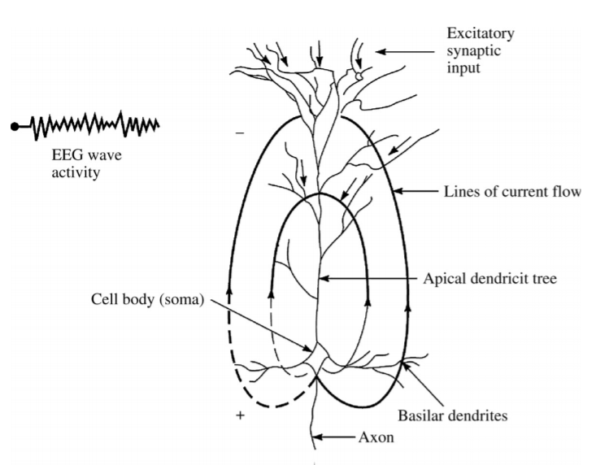
Figure 1: Diagram of pyramidal neuron current path
To properly make sense of EEG data, decomposition of signals into their spectral properties is necessary. Different cognitive or motor functions in the brain produce signals with unique properties. Specifically, the power amplitudes of these signals differ by frequency depending on the function that the brain is focusing on. In particular, the spectrum of EEG has been divided into various frequency bands, including the delta band, (<4 Hz), theta band (4-7 Hz), alpha band (8-15 Hz), beta band (16-31 Hz), and gamma band (>32 Hz) (Bell, 1991; Marshall et al., 2010). The delta band, which in adults is characterized by decision making in the parietal locations of the brain, and auditory responses are prominent in the frontal cortex (Başar et al., 1999). The theta band is also dominant during cognitive functions and sensory stimulation. When a person is engaging in deep cognitive interaction, the electrical signals characterized at 3.5-7 Hz are more dominant in power (Binnie, 1989). The alpha band, also known as the mu rhythm is characterized mostly by memory and motor functions in the motor cortex (McFarland and Ashton, 1978). Particularly, activity in the mu rhythm is expected during resting state and suppressed during movement or motor imagery. Since we are interested in motor development, this study will focus primarily on the motor cortex and the EEG mu rhythm relations to movement.
Classical definitions of EEG rhythms have been well established in adults, but not as much in infants. Understanding of band characteristics in adults serves as a useful reference point for infant studies as we expect infant EEG rhythms to progressively approach adult values. Although a few infant studies have focus on the beta and gamma bands (Başar et al., 1999), the majority of infant studies have focused on understanding the delta, theta, and alpha bands (Saby and Marshall, 2012; Marshall et al., 2010). However, most studies in the past have presented inconsistent data on the definitions of these bands and, in particular, their relationship to the age-related development during the first year of life (Marshall et al., 2010; Hagne et al., 1973; Gentili et al., 2010). Specifically, these studies suggest different frequency band values and variations in timing of their shifts towards expected adult values. This study aims to differentiate and improve from previous studies by using high-density EEG at a weekly recording resolution to understand the longitudinal development of EEG rhythms in the first year life of infants. By defining typical EEG spatio-spectral patterns at weekly and monthly ages, we can attempt to establish those patterns as biomarkers for motor development.
Collection of EEG data can be performed using different orientation of electrode locations, as well varying degrees of electrode densities. Density of EEG sensor nets refers to the spatial distance between the electrodes on the scalp. Studies have proposed that limitations of EEG density with sensor distances greater than 2 centimeters result in a significant loss of information (Malimivuo and Plonsey, 1998; Ryynanen et al., 2006). This loss of data could be significant as it may provide the necessary spatial resolution to solve the inverse problem to properly image the cortical sources of the EEG activity. Some studies have proposed that densities of approximately 128 channels could provide the necessary resolution for localization and detection of neuropathology (Holmes et al., 2004; Lantz et al., 2003).Our study aims to differentiate and improve from previous studies by using high-density EEG (124-channel Electrical Geodesics Inc Sensor nets) at a weekly recording resolution to understand the longitudinal development of EEG rhythms in the first year life of infants. By defining typical EEG spatio-spectral patterns at weekly and monthly ages, we can attempt to establish those patterns as biomarkers for motor development.
1.4 Neuroplasticity
Longitudinal changes in EEG rhythmic patterns are believed to be related to the adaptations of the brain neural circuits over time. The ability of the brain to adapt its neural circuits in response to external and external stimuli over a lifespan is defined as neuroplasticity (Olie et al. 2004). This concept explains how various regions of the brain change and form new neuronal connections themselves, as well as synchronization with other regions. Neuroplasticity can be related to a variety of factors, through natural development, acquisition of specific skills, or recovery from damages to brain (Olie et al., 2004; Thompson et al., 2000). Each of these factors affect formation of updated neural circuits similarly, so distinguishing the cause of specific instances evident neuroplasticity can provide valuable information for understanding the human brain. In particular, reduced plasticity has been suggested to be correlated with functional deficits (Opie et al., 2017). Determining the root causes of neuroplasticity during time of significant growth can provide a basis for establishing biomarkers related to development.
Changes in EEG spatio-spectral patterns, which form the focus of this study, could be a direct indication of neural circuits altering due to motor development or acquisition of motor skills. Similarities in activity between neurons of different regions, known as coherence, has been linked to development of the mu rhythm in adults (Cuevas et al., 2014). Event-related synchronization and desynchronization associated with the mu rhythm have been proposed to reflect neuronal activity in sensorimotor deactivation and activation (Pfurscheller and Lopes de Silva, 1999). The link between brain coherence and the mu rhythm suggests that neuroplasticity may be reflected in EEG data. The strengthening of synapse transmission between neurons, known as long-term potentiation, has been studied in motor training for adults (Avanzino et al., 2015). Avanzino et al., 2007, suggests that neuroplasticity in the primary motor cortex occurs as a result of motor imagery training. These results suggest that cortical patterns can be altered through rehabilitative practices in damaged cortical areas.
Understanding neuroplasticity at critical development periods, such as infancy, can provide significant insight on cortical structures longitudinally. Forms of neuroplasticity, such as the ability of sensory maps to reorganize, have been proposed to be at its maximum during early developmental stages (Cramer et al., 2012). Because of the importance of this time period, early brain injury can lead to severe impairments of subsequent plasticity (Gonzalez et al., 2016). Cortical deficiencies due to early injury can be expected to be reflected in EEG spatio-spectral patterns longitudinally. Infant brains that have experienced insults, such as cerebral palsy, should be expected to display different spatio-spectral patterns from their typically developing peers. This concept forms the basis of our motivation to use EEG as a longitudinal biomarker for infant development.

1.5 Biomarkers
Tracking the dynamics of brain response as opposed to using only behavioral data allows for a quantitative neuroimaging method of studying development. EEG is particularly useful in assessing the functional status of the brain due to its high temporal resolution (Gentili et al., 2010). Thus, longitudinal analysis of EEG could be useful for establishing biomarkers in typical development as a standard.
Currently, only a few studies have attempted to identify potential functional biomarkers for typical development. Gentili et al., 2010, have theorized that low frequencies in the theta and alpha band could be potential indicators for neural adaptation of sensorimotor learning. Additionally, it is suggested that decreased phase synchronization reflects attenuation of cortical resources that are unnecessary for specific sensorimotor functions (Gentili et al., 2010). Thus, reduced amplitude in a cerebral region can also be an indication of abnormal EEG activity. Attenuation of the delta rhythm in the frontal and occipital lobes has been detected from intracranial lesions (Binnie, 1989) Results from dyslexia studies have also shown that right hemisphere activity appears to compensate for left hemisphere deficiencies (Mahmoodin et al., 2008). Because of inconsistencies in reliability for these potential EEG biomarkers, we propose to focus on the longitudinal mu rhythm relation to the motor cortex during resting state, which has been generally accepted for adults. The mu rhythm, a subset of the alpha band typically associated with motor activity, could serve as a biomarker for motor development.
Abnormalities in the alpha band has been detected in other parts of the brain in addition to the motor cortex. Slowing of alpha rhythms within the posterior region has been seen in systemic disorders like hepatic encephalopathy (Binnie, 1989). This concept presents the idea that alpha frequencies are can be disrupted due to diseases. The relation between alpha band frequencies and the cerebral motor cortex suggests there is a potential for those specific frequency-temporal relationships to serve as biomarkers for motor development through analysis of the mu rhythm (Sauseng et al., 2009). Unusual mu rhythm activity in the motor cortex compared to expected patterns for typical development could be strong indicator of sensorimotor deficiencies. However, application of such characteristics as biomarkers is difficult due to the similarities between immature structures and abnormal causes (Bonstrup et al., 2015). We expect mu rhythm activity along the motor cortex in typically developing infants should exhibit progressions toward established adult patterns, while atypically developing brains should display spatio-spectral differences or delays from such expected patterns. Establishing consistent biomarkers requires the distinction between differences in patterns as a brain matures and those due to some type of affliction. This concept is especially important when studying diseases that occur early in development and continually affect the progress of brain maturation. It is important for us to establish a basis for how EEG from typically developing infant brains should be both spatially and spectrally. Using it as the reference, we can then compare individual infants diagnosed with cerebral palsy (or other brain disorders) to understand how their brain differs from the healthy expectation.
1.6 Motivation of This Study
Cerebral palsy is the most common childhood disability, affecting 17 million people in the world (cerebralpalsy.org). From those afflicted by cerebral palsy, 70-80% of those cases arise from damage to the motor cortex ( cerebralpalsy.org). Due the lifelong nature of this disability, early detection and intervention is crucial for improved quality of life for those affected. EEG is a cost-effective and noninvasive for detection of abnormalities in infants learning to crawl. The goal of this study is to analyze high density EEG collected from infants immediately prior to crawling to reinforce previous findings of EEG spectral profiles of healthy infants.
1.7 Objectives
Data presented in this work were collected from infants enrolled in a large study on prone locomotion involving an assistive robot known as the Self-Initiated Prone Progression Crawler (SIPPC). The primary goal of the SIPPC is to serve as a rehabilitative tool to assist infants in crawling skills acquisition, particularly those with motor deficiencies. The purpose of collecting EEG data from this study on locomotion and assistive robotics is to understand changes in neural rhythmic patterns during a period of crucial motor development in infants. Resting state EEG data, as well as data during locomotion on the SIPPC, were collected weekly to compare development of infants at different conditions. However, only results from the resting condition are presented in this thesis. This study involving human subjects was reviewed and approved by the institutional review board at the University of Oklahoma Health Sciences Center (IRB number 3755).
This study aims to use EEG power spectral density acquired from infants immediately prior to crawling to understand developmental neural pattern changes. The first step is to establish spatial and spectral group averages at equivalent ages of healthy infants. The data collection and development of several signal processing technique used in this thesis were performed by previous members of our research group. The purpose of this analysis is to distinguish infant frequency bands and their dynamic properties during development. Next, we will reproduce these findings using a different subject set applying an independent analysis procedure. From this more extensive dataset we aim to establish potential biomarkers to describe the typically developing group. Lastly, we intend to study neural rhythmic differences in infants due to varying degree of robotic crawling assistance longitudinally.
Our study aims to answer the following research questions: Can high density EEG recorded on a weekly basis be used to improve our understanding of infant neural development? Can our findings be validated for assessment of the sensitivity of our methods and propositions for developmental motor brain biomarkers?
1.7 My Contributions
Data collection protocols, as well as algorithm and code scripts for signal processing were initially developed by members of our research group previously engaged in this study. Particularly, Matlab code scripts for the EEG preprocessing and group spectral analysis were established prior to my involvement in this project. Additionally, data collection and processing was performed on subjects of the first cohort of analysis published in (Xiao et al., 2017). My contributions to this project involve serving as primary EEG data collector for the majority of subjects in the second cohort as well as the atypically developing infants. Additionally, I improved existing Matlab scripts to handle larger datasets and more extensive temporal age spans. The majority of the data presented in this thesis, were processed and analyzed by my own effort. I believe that my contributions have served to expand on previous efforts to understand infant motor development, as well as test the sensitivity of our proposed biomarkers.
Chapter 2: Methods
This chapter will focus on the experimental protocol and subject groups used for this study, as well as explanation of the data processing. First, detailed description of the SIPPC assistive robotic mechanism involved is included for a comprehensive understanding of the goals of this study and how they relate to neuroplasticity of infants. Next, information on the human participants and their classifications into subgroups are defined. Classification of subjects is performed to compare infants of different groups among healthy groups assigned to varying degrees of assistance from the SIPPC robot, as well as to compare atypically developing individuals to the healthy baseline. Afterwards, the EEG data acquisition procedure and equipment used for data collection are specified. Lastly, detailed explanations of the preprocessing and data analysis steps, including power spectral density calculation, clustering analysis, and peak detection are described.
2.1 Self-Initiated Prone Progression Crawler
One method of intervention to help infants afflicted with motor deficiencies is through assistive robotics. Since crawling is a vital part of infant development, intervention during the time of typical crawling acquisition can have significant impact for future locomotive abilities. This study focused on the use of a Self-Initiated Prone Progression Crawler (SIPPC) (Ghazi et al., 2016). The purpose of this robot is to reinforce specific movements or reactions performed by the infants when presented with desirable stimuli.
Design of the SIPPC was intended to focus on prone locomotion in any horizontal direction, as well as assistance in postural control. The robot is designed with 3 wheels in a Y shape around a central support platform for the infant depicted in Figure 2 (Ghazi et al., 2016). The intent of this design was to use the minimum number of required wheels oriented to allow maximal vision for the infant. The infants are able to lay comfortably in a prone position with freedom to move their arms and legs. Multiple safety measures are included in design of the SIPPC, which are especially necessary for infant use. All actuators and motors can be immediately stopped through the software user interface, a physical button located on the robot, or when communication with the control server is interrupted (Ghazi et al., 2016). The SIPPC assists the infants through incremental movements that reinforce limb movements generated by the infants, which are detected by inertial measurement unit (IMU) sensors worn by the infants and a force torque sensor attached to the robot.

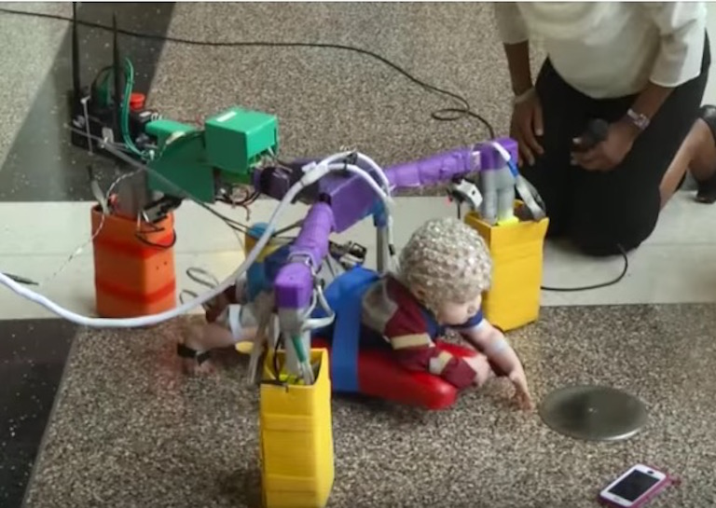
Figure 2: The Self-Initiated Prone Progression Crawler
Implementation of the force torque sensor and IMU sensors using different settings is the basis for categorization of the infants in the healthy group. The 6 degrees of freedom force torque sensor is located above the central support pad and connected to the Control Server through a Control Area Network bus (Ghazi et al., 2016). The basic method for moving the SIPPC is known as the force control. This basic setting relies on forces applied by the infants against the ground, which are detected by torque forces multiplied by a specified gain to form the basis of the robot movement velocity. Additionally, discrete periodic movements can be added to the force control velocity in the power steering setting. Forces that exceed preset thresholds are detected by the force torque sensor, which triggers the control server to move the motors over a specified time period (Ghazi et al., 2016). When the threshold is exceeded, a period of discrete jerk velocity is triggered that moves the robot in the intended horizontal direction. This overall global velocity of the SIPPC robot can be represented by the following equation:
$$V_{D}= K_{D}F_{D}+ V_{A}(t)$$
where $K_{D}F_{D}$ is the gain times the torque force, and $V_{A}$ is the discrete jerk velocity present in the power steering and suit assist modes (Ghazi et al., 2016).
In addition to the force torque sensor serving as the main form of movement detection in the power steering and simple force control settings, a kinematic suit worn by the infants allows for an alternative method of moving the SIPPC displayed in Figure 2. The suit contains sensors on each limb of the suit, as well as on the back. Each UM6 IMU sensor module contains a 3-axis, accelerometer, gyroscope, and magnetometer (Southerland et al., 2012). Information from the suit sensors is analyzed by the software algorithm that detects specific gestures, developed by our collaborators from Southerland et al. Detection of the predefined gestures serves to move the SIPPC in the same manner as the force torque control. Thus, the suit-assisted gesture control can be an equivalently useful method of controlling the robot for infants lacking ability to push the robot, particularly those with motor deficiencies.
Infants within the healthy group were randomly classified into one of the three groups: force control, power steering, and suit assist. Infants assigned to a specified group were assisted by the SIPPC robot during movement trials by the respective SIPPC assistive mode. Classification of the infants into the groups was performed so that the subjects’ parents were unaware of the given subject’s designation. This was primarily done to eliminate any bias in assistance to different subjects during the trials. Movement training of each infant using toys and other similar stimuli was generally consistent across all subjects. Similarly, EEG data from subjects of all groups were recorded using the same procedure for each infant, detailed in the experimental procedure description. Information on participants in this study and their group status within the projects is presented in the following section.
2.2 Participants
Twenty-five typically developing infants were recruited for this study with consent from their parents. The adjusted age after gestation for these infants ranged from 17 to 23 weeks at the beginning of their participation in the study. Subjects in this study were separated into two groups known as Phases 1, and 2. Some subjects enrolled in this study were not included in this analysis due to their early exiting from participation. The first cohort of infants, consisting of the first 10 subjects, are identified as Phase 1 (denoted as subjects #1-13), 3 of which were not retained for the study. This group consisted of the first testing group of typically developing infants. The remaining typically developing infants enrolled for a lengthened training period, known as Phase 2 subjects (denoted as subjects #14-35), remained in the study for up to 16 weeks or until they began to crawl. Separation of Phases 1 and 2 served to compare the results from the first test groups to results from a larger cohort involved in the study for a longer duration. The definition of “typical development” was determined by the Test of Infant Motor Performance (TIMP) (Campbell et al., 2002). This test examines dichotomous observed items on spontaneously emitted movements as well as movement response to different stimuli (Campbell et al., 2002). The TIMP aims to serve as a consistent and accurate tool for prediction of future motor development, which is necessary for prediction of cerebral palsy. Prior to collection of the first week of EEG data, participants were screened using the TIMP to determine whether they would be considered for the healthy or atypically developing groups. Infants in the atypically developing group continued the study for a total of 20 weeks and 16 weeks for those in the typically developing group.
2.3 Experimental Procedure
Experimental sessions consisted of 5 minutes of baseline EEG recording, as well as 1-3 five-minute trials of training the infant on the SIPPC robot. Each infant’s head circumference was measured prior to each recording to determine the appropriate net size. Collection of the EEG data was performed by 124-channel high-density HydroCel Geodesic Sensor Nets manufactured by Electrical Geodesics Inc (EGI). Three different net sizes (40-42 cm, 42-43 cm, and 43-44 cm) were used in this study to accurately fit the varying head circumferences of the infants. The EEG electrode net to be used was soaked for 5 minutes in an electrolyte water-based solution prior to placing it on the subject. Once the sensor net was placed on the infant’s head, an impedance test was conducted to obtain a minimum scalp to electrode impedance of 75kohm. Additional electrolyte solution was applied to individual sensors that did not meet the impedance criteria. The baseline EEG recordings were performed while the infants were sitting upright held still by their parents for five minutes. Parents were instructed to avoid moving or feeding the infant during this time. Additionally, toys and other entertaining stimuli were presented to prevent the subject from moving excessively, while maintaining a distance to avoid reaching by the infant. Resting baseline recordings were terminated prior to 5 minutes if the parent or physical therapist deemed the infant to be too upset to continue.
After the resting baseline period, movement trials on the SIPPC were conducted. The trials on the SIPPC robot consisted of the infants’ parents using toys to entice the infant to move while on the robot. Presentation of desirable toys for the infants while on the SIPPC served to motivate the infants to develop goal-oriented strategies for locomotion. , Infants wore the kinematic suit and laid on the central resting pad of the SIPPC as described in the previous section. Additionally, EEG was continually recorded throughout the SIPPC movement trials in addition to the resting baseline. An example of an infant wearing the kinematic suit and EEG sensor cap while using the SIPPC is pictured in Figure 2. To synchronize the SIPPC trials with the continuous EEG recording, a digital signal was emitted from the SIPPC to the Net Station software every 10 seconds. Although the goal was to perform 3 trials each session, discretion was left to the parents or physical therapists to stop the trials if they felt that the infant was becoming too upset or tired.
2.4 Data Acquisition
The EEG signals collected from the sensor net were amplified using a Net Amps 300 amplifier sampled at 1kHz. The setup of this equipment is pictured in Figure 3. Conductivity between the electrodes and the scalp was maximized using a potassium-chloride, baby shampoo and distilled water electrolyte solution. The threshold for acceptable impedance levels for this study was set as 75kohms. Additionally, video recordings of the infants were captured as a visual reference for segments of excessive noise in the EEG data or issues encountered during recording. Synchronization and storage of the data was performed using the Net Station 4.5.1 Software provided by EGI. Since recording of the EEG data involved movement trials on the SIPPC, the entire EEG data acquisition system was placed on a moving cart to follow the infants while the sensor net remained on their head (Fig. 3).
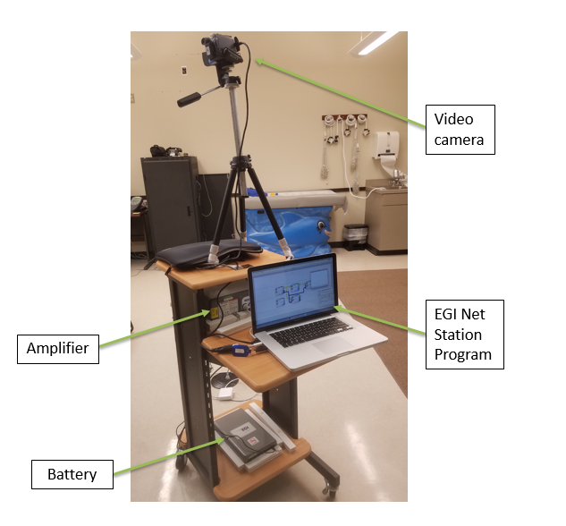
Figure 3: Equipment setup for EEG data collection
2.5 Preprocessing of Raw EEG Data
Despite the significant efforts to minimize noise during experimental recording, further preprocessing of the EEG data is required for adequate analysis. Signal processing techniques to improve signal to noise ratio of the recorded EEG data were applied after the data acquisition. First, a 0.3Hz-30Hz bandpass filter was initially applied using the Net Station software to remove DC and higher frequency noise. The bandwidth was selected to include typical delta (<4 Hz), theta (4-7 Hz), and alpha (8-15 Hz) EEG frequency bands described from Chapter 1. Next, channels on the exterior of the cap most susceptible to facial and other muscle movements were removed. This process resulted in 70 inner channels, which were used for analysis presented in this study. The channel location layout of the scalp is illustrated in Figure 4, with red points denoting excluded channels on the exterior, while green and black points denoting the inner 70 remaining channels. The black cross points depict the 30 channels along the motor cortex used in the power spectrum density analysis explained in the following sections.
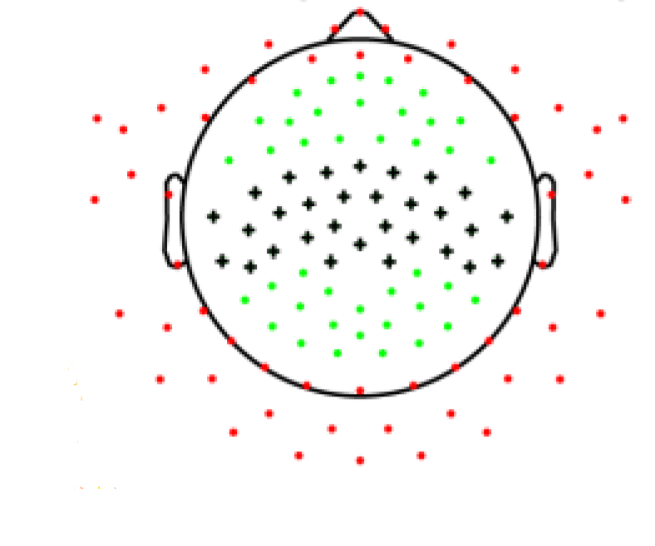
Figure 4: Electrode locations from EGI 124-channel sensor net
Next, EEGLab Matlab toolbox functions (Delorme et al., 2002) were used to remove unwanted segments of time along with interpolation of bad channels from the raw data. Automatic detection of segments and channels with kurtosis levels greater than 5 were interpolated. The kurtosis level of a signal describes the peakedness of a distribution. Afterwards, an Independent Component Analysis (ICA) was performed to detect undesirable motion artifacts. ICA is an algorithm that represents the entire set of data from all channels on the sensor net, as linear combinations of statistically independent component variables (Jung et al., 2002). The ICA method divides the data into 60 components that represent the EEG as spatially filtered multi-channel data. For this first step, 60 components were chosen to limit the weight of each component to avoid excessive reduction of data rejection. Through visual inspection of the independent components, motion artifacts created by movements from the eyes or other bioelectric signals are reduced. Further bad segments were selected through visual inspection of large amplitude fluctuations relative to the rest of the data. From these selections, channels with kurtosis levels greater than 5 were automatically flagged as unwanted channels. Additionally, further visual inspection of individual channels with visibly large fluctuations across the entire recording were selected as bad channels and interpolated. Subsequently, a common average reference (CAR) filter was applied to rereference the data, further reducing the noise across electrodes. This process determines an average value from the spatially interpolated channels and removes that value to further reduce common noise (Mahmoodin et al., 2008). Lastly, a second ICA step was applied to the data for final rejection of any remaining motion artifacts. This second ICA procedure divided the data into 30 components. Figure 5 displays the EEG waveforms before and after result of the preprocessing methods.
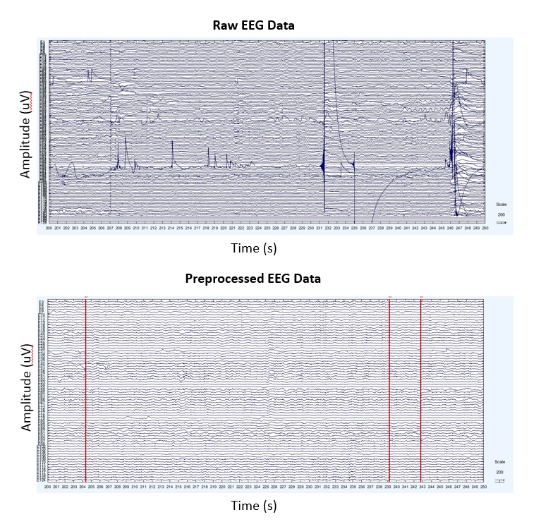
Figure 5: Preprocessed EEG example
2.6 Spectral Power Analysis of EEG Data
Power spectral densities (PSD) for each EEG channel were calculated based on Welch’s method of power estimation was used through the pwelch function in Matlab R2015a software (R2015a, MathWorks Inc., Natick, MA). Welch’s method works by dividing the signal into segments, multiplying the segments by a specified window, and calculating power magnitudes from the Fast Fourier transform of the signal (Mahmoodin et al., 2008). Implementation of Welch’s method on all data in this study was performed using a three-second Hanning window with overlapping epochs by 50%. While the Welch method is beneficial in practicality and noise reduction, its limitation is the reduction of frequency resolution due to the segmentation of data. The output PSD for each channel resulted in a frequency resolution of 1/3 Hz, which as deemed sufficient for our analysis (Xiao et al., 2017).
To account for variability across subjects and weekly recordings, relative power spectral density between 1 and 30 Hz was calculated by normalization of the absolute PSD estimates:
$$R_{f}= P_{f}/\sum_{f=1}^{30}{P_{f}, f=1,\frac{4}{3},\frac{5}{3}, 2,…, 30 Hz}$$
where $R_{f}$ is the relative power at frequency $f$, and $P_{f}$ is the absolute power density at that frequency (Xiao et al., 2017). Relative PSDs corresponding to electrode locations were generated to produce longitudinal topographies for each frequency bin. One fundamental characteristic of EEG is its frequency power-law decay property, which describes how PSD magnitudes decrease as frequency increases. To address this, powers at each channel were normalized to obtain Z scores:
$$Z_{f}= \frac{R_{f}- µ_{R_{f}}}{σ_{R_{f}}}, f=1,\frac{4}{3},\frac{5}{3}, 2,…, 30 Hz$$
Where $Z_{f}$ is the normalized Z score for that channel, $µ_{R_{f}}$is the mean, and $σ_{R_{f}}$ is the standard deviation at the frequency bin $f$ (Xiao et al., 2017).
2.7 Spectral Peak Statistics
Analysis of frequency shifts in power spectral density peaks has been suggested as an important aspect of my rhythm evaluation (Marshall et al., 2010). A peak detection algorithm selects local maxima within a specified window of nearby data points (Barr et al., 1978). Spectral peaks in this study were identified from PSD’s of individuals at each age for each frequency bin between 2 and 9 Hz across channels in the central motor cortex. A peak was identified from PSD at a given frequency bin compared to 2 bins before and 2 bins after it. Thus, the peak detection algorithm implemented a 5-point moving window to identify local maxima for the PSD frequency range of each session. The aggregate of peaks presented in this study was constructed from a summation of the peaks at each frequency bin at every time point. Additionally, monthly group average peak distributions were normalized by dividing the averaged peaks at each frequency bin by the total number of sessions within that monthly age. Gaussian fitted curves were plotted on top of the peak distribution bar plots for quantification of the frequency peak shifts. Curve fitting was performed for the assumed theta range of 2 to 4.33 and the assumed alpha range of 6 to 9 Hz.
2.8 Clustering Analysis
To properly classify frequency bands and their dynamic boundary shifts, particularly within the mu rhythm, a clustering analysis was performed on the EEG spatio-spectral patterns. The analysis was performed based on the concept of “functional topography” which hypothesized that neighboring frequency bins belonging to the same band should exhibit similar topographic representations (Hartigan and Wong, 1979; Kuhlman, 1978). We expected these topographies to change as they reflect the dynamic nature of rhythmic activities. Therefore, multiple sessions at different levels of temporal resolutions were input into the clustering algorithm for simultaneous classification in both spectral and temporal domains. Individual spatial patterns at different frequency bins and temporal time points were clustered into three classes using the K-Means clustering method (Orekhova et al., 2006). The K-means method works by assigning the spatio-spectral patterns at each time point and frequency bin to one of “K” initial random centroids, with K being the number of desired clusters. After the initial assignment, the new centers are recalculated from the current clusters and all points are reassigned to the centroid with the shortest Euclidean distance to it. This process is repeated until the centroids no longer change and the clusters are finalized.
Implementation of the K-means algorithm for this data was completed with 3 clusters to represent the delta, theta and alpha frequency bands. Previous clustering attempts for Phase 1 subjects were tested with 9 clusters to represent the three frequency bands as well as the three monthly age points covered during the study. However, 3 clusters produced the most distinguishable classifications for the group averages among frequency ranges, as is apparent in the results shown in Chapter 3. Clustering analysis using 3 clusters was performed on the normalized spectral topographies of individual frequency bins between 2-9 Hz. This process repeated at an individual participant sessions level, an average across participants at equivalent weekly age points, and an average at same monthly ages. Averaging across subjects for group level analysis was performed at multiple temporal resolutions based on the subjects adjusted age after gestation. Resolution of weekly averages was performed by aligning subjects of equal weekly adjusted ages and averaging their PSD data. Additionally, infants were grouped and averaged by monthly age in the same manner. This resolution was based off the adjusted weekly ages, where every 4 weeks constituted a monthly age. These groupings resulted in group average patterns for monthly ages 5, 6 and 7 in Phase 1, and ages 5, 6, 7 and 8 for Phases 2 and 3.
Based on obtained results, the most evident cluster separations were clearly present in data of the monthly resolution. Frequency boundaries at this resolution level were used to establish the boundaries for the delta, theta, and alpha bands dynamically. Frequency range values were redefined based on the changing boundaries at each monthly age. The dynamically defined frequency band boundaries were then used to generate topographic maps of individual EEG rhythms on a monthly basis. The normalized average of these maps across all participants at each frequency band was presented for months 5-7 in Phase 1 and months 5-8 for Phases 2 and 3. Normalized powers at each channel were plotted as topographic maps for spatial analysis of the distribution. The EEGlab “topoplot” function interpolates area between channels to produce a smooth topographic map. Normalized spatial topographies of weekly group averages were plotted for each frequency bin between 2 and 9 Hz, which covers the range of the most significant rhythmic activity in infant EEG.

Chapter 3: Results
This chapter presents results from healthy as well as atypically developing infants enrolled in the Self-Initiated Prone Progression Crawler study. Initially, spatio-spectral patterns of the healthy groups of infants are presented. Relative PSD, spatial topographies, clustering results, and spectral peak distributions from the first 8 subjects denoted as Phase 1 are first introduced to understand typical EEG rhythmic development of healthy infants and to serve as a basis for comparison of subsequent results. Next, a larger group of 17 healthy infants, from Phase 2, is processed using the same methods as Phase 1 one, but analyzed as an independent cohort from the Phase 1 group. This juxtaposition of healthy groups was completed as an attempt to validate the Phase 1 findings using an independent analysis procedure, larger sample size, and extended duration of temporal developmental focus. For the Phase 2 group, categorization of subgroups based on the various SIPPC assistive mode designations was performed to compare neural developmental effects of differing levels and methods of locomotive assistance.
3.1 EEG Patterns of Typically Developing Infants from 1st Cohort
Since current understanding of rhythmic EEG activity of motor development in infants is limited, a preliminary study of healthy individuals was performed to form a baseline for comparison. Subjects in the Phase 1 group of this study served as the initial group for high density EEG analysis to compare with previous findings, as well as the basis for validation with Phase 2 results. Power spectrum densities from the 8 subjects in Phase 1 were averaged together over three temporal resolutions: individual sessions, weekly age, and monthly age.
Weekly averages of relative power as a function of frequency are displayed in Figure 6. Each plot represents an average across subjects of the weekly age ranging from 20 to 31 weeks. Evidence of peaks centered in the proposed theta and alpha bands are seen. A general shift of increasing relative powers centered near 4 and 7 Hz is present visually, along with a slight shift to higher frequencies of 3.67 to 4 Hz in the theta peak and 6.67 to 7.67 Hz in the alpha peak from the first to last week. Despite weekly fluctuations of relative power magnitudes between progressions in the theta frequency band, the shift tends to be toward higher frequencies and stronger relative power overall.
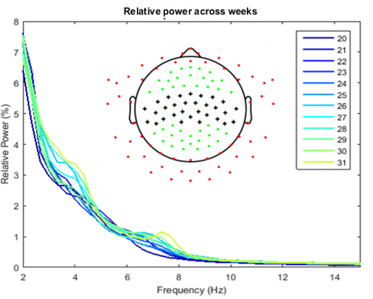
Figure 6: Weekly PSD of Phase 1 Group
Clustering analysis was performed on the spatio-temporal normalized group average patterns over 3 temporal resolutions: individual sessions, weekly age, and monthly age. The clustering results from those groupings are depicted in Figure 7. The cluster separation is clearly seen between frequencies instead of specific time points. Similar separations appear to be smeared on the individual session resolution. This finding suggests that differentiation across the 10 weeks spanned in this study is more distinct in the frequency domain than the time domain. The results illustrated in Figure 7 show evident distinction between the three clusters, particularly in the weekly and monthly age resolutions. Three clusters were chosen to represent the three frequency bands of interest in infants: delta, theta, and alpha. Each of these clusters were used to define frequency bands for this group of infants on a monthly resolution as they show overall distinct separation in the frequency domain. Thus, each cluster represented by differing colors was defined as the delta (yellow), theta (green), and alpha (blue) frequency bands. Shifts of frequency band boundaries are seen particularly from month 5 to 6 between the delta and theta bands, changing from 2.67 Hz to 3 Hz. Boundary shifts are also seen between the theta and alpha bands changing incrementally from 5.33 Hz to 6 Hz from the first to last month.
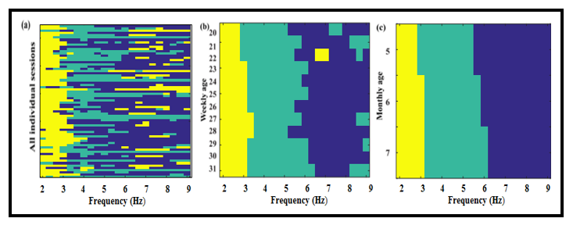
Figure 7: Clustering results of Phase 1 Group
Frequency range boundary definitions of each band were defined at each month to reflect the changing cluster boundaries, as seen in Figure 7c. Specifically, grouping of spectral powers among the three frequency bands was determined based on the clustering results at each respective month. The purpose of changing the frequency grouping is to account for the dynamic nature of the bands spatially as well as spectrally. Frequency band boundaries defined from the clusters at each month were used to calculate and plot monthly spatial topographies of each frequency band shown in figure 8. Each topographic map illustrates relative normalized spectral power across the entire scalp from the inner 70 channels by interpolating area between the discrete electrode points. The scalp illustrations are arranged with the frontal region being the top of each portrait. The colorbar on the right shows the colorized normalization value range, with red reflecting stronger relative power and blue representing values below the average.
Distinguishable spatial patterns at each frequency band are apparent in the monthly topographic maps. The most consistent pattern apparent from the topographic maps is the frontal central activity in the delta band. Theta band power appears to be focused on the posterior region in a generally bilateral pattern, although monthly consistency is not as persistent as the delta patterns. Alpha band powers appear most dominant in the central cortices within the left, central, and right regions. Although the alpha and theta patterns show some bilateral nature in the later months, they are not entirely symmetric. This asymmetry is particularly visible in month 5 alpha band distribution, which depicts stronger activity in the right side compared to the left.
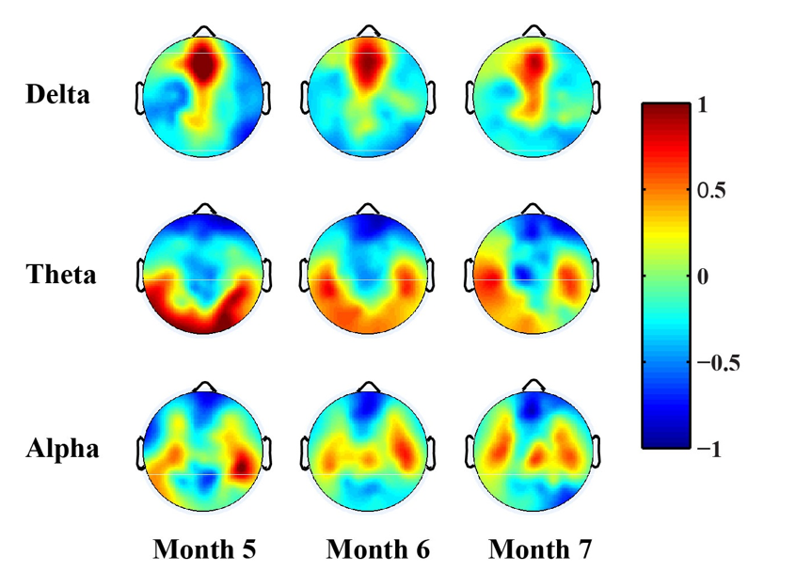
Figure 8: Monthly spatial topographies of Phase 1 Group
Shifts of frequency power in both the theta and alpha bands are also noticeable in monthly peak distributions. Average monthly peak distribution plots at a frequency resolution of 1/3 Hz are displayed in Figure 9. Each blue barplot represents the average number of peaks at that frequency after normalization from all sessions for that month. Fitted Gaussian curves are plotted on top of the barplots in red and green depicting the theta and alpha band respectively. While the theta peak distribution is significantly less prominent in month 5, a shift in centralization of peaks is evident from month 6 to 7. Changes in the mu rhythm are more obvious as the central peak distribution clearly shifts to higher frequencies, moving from 6.67 Hz to 7.3 Hz. This phenomenon suggests not only frequency shifts of the frequency band boundaries, but also peak frequency shifts with the bands to higher values as well.
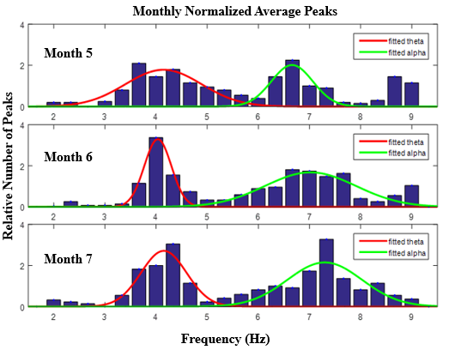
Figure 9: Peak distribution of Phase 1 Group
3.2 Independent Analysis of EEG Patterns of Typically Developing Infants from 2nd Cohort
To test reproducibility of the methods and results from Phase 1, the same methodologies were used on the entire Phase 2 group. For this reproducibility analysis, subgroups within Phase 2 were firstly disregarded. Namely, all 17 subjects from phase 2 were grouped together for this analysis to compare this group to the group from Phase 1. Since subjects in Phase 2 continued the study for longer durations than those in Phase 1, their plots include data up to 8 months of age as well.
Spectral plots for the Phase 2 subjects depicted in Figure 10 show weekly averages from 20 to 35 weeks of age. Contrast to the Phase 1 group, the Phase 2 plots extend to the additional 4 weeks after 31, which are displayed in yellow and orange. Peaks centered around 4 Hz in the theta band appear to depict an increasing nature across the weekly progression. Similarly, peaks in the alpha band centered between 6 and 7 Hz also show a gradual increase of amplitude across weeks. While these plots suggest shifts of peaks to higher frequencies, they are not as evident as in the peak detection distribution plots. However, the centralized frequency values and dynamic properties of these spectral plots are consistent with the Phase 1 findings.
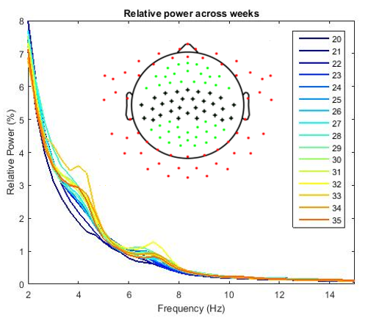
Figure 10: Weekly PSD of Phase 2 group
Clustering analysis results for Phase 2 are presented in Figure 11 in the same three temporal resolutions as before. Separation of clusters appears to be more visible in weekly and monthly resolutions, while smearing is more common in the individual sessions. Boundaries between the frequency bands show dynamic properties, most evidently in the monthly resolution. The boundary between delta (yellow) and theta (green) displays shifts from 3-3.33 Hz from 5 to 6 months, 3.33-3.67 Hz from 6 to 7 months, and 3.67-4.33 Hz from 7 to 8 months. Shifts between the theta and alpha band boundary are seen between months 5 and 6 from 5.67-6 Hz, as well as between months 7 and 8 from 6-6.33 Hz. Compared to Phase 1, results from this group shows continual shifts in the delta-theta boundary, while the previous group did not show shifts between months 6 and 7. Conversely, the Phase 1 clusters showed shifts in the theta-alpha boundary at each month, while the Phase 2 results do not display a shift between month 6 and 7. However, this shift is seen between month 7 and 8. Additionally, cluster similarities between the proposed theta frequencies and the higher frequencies from 8-9 Hz are evident from the green area at those values. Overall, the dynamic properties of the frequency bands for this group are consistent with the findings in the Phase 1 group.
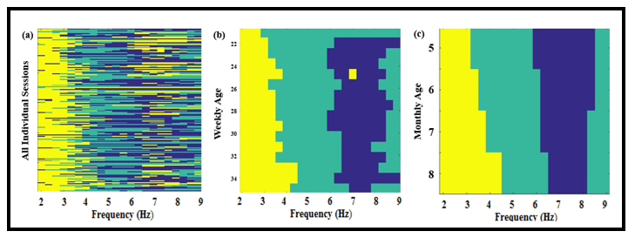
Figure 11: Clustering results of Phase 2 Group
Results from the clustering analysis were again used to define frequency band boundaries. Monthly normalized spatial topographies for the Phase 2 group are illustrated in Figure 12. The delta band patterns are focused in the central frontal area of the scalp in each month, but additional activity in the central motor cortex becomes evident in months 7 and 8. This delta activity within the central motor cortex was not apparent in the Phase 1 group. Theta band activity appears overall consistent in the posterior regions, as well as bilaterally on the left and right exterior sides of the scalp. Activity in the central motor cortex is evident in the alpha region with some bilateral properties, but less than the theta. Contrast to the Phase 1 results, alpha band activity is also seen in the posterior region, particularly in months 6 and 8.
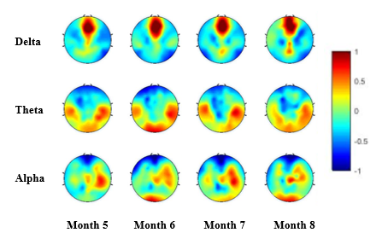
Figure 12: Monthly spatial topographies of Phase 2 Group
Peak distributions for Phase 2 are displayed in Figure 13, which show shifts to higher frequencies, as well as overall increase in average number of peaks within each month. Theta band peaks show shifts gradual shifts in fitted curve centers from month 6 to month 8, while peaks in month 5 are not quite as protruded. In addition to shifting centralization of peak frequency, noticeable increases in average peak numbers are evident from month to month, with exceedingly larger number of peaks in the final month. Alpha peaks also show continual shifting patterns to higher frequency from month 5 to 8. These peak distribution shifts are also consistent with the Phase 1 findings. Specifically, mu rhythm peaks display a shift from 6.67 Hz to 7.33 Hz between the first and last months in both groups. Although the Phase 1 distributions show a more rapid shift of those peak frequencies (month 5 to month 7) compared to Phase 2 (month 5 to month 8), the end result is the same.
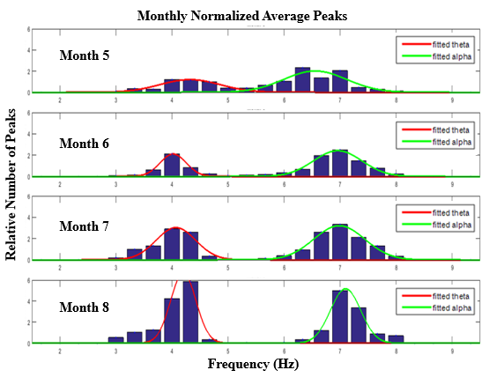
Figure 13: Peak distribution of Phase 2 Group
3.3 EEG Patterns from Different SIPPC Assistive Modes
Because infants in Phase 2 not receive the same assistance from the SIPPC robot throughout the study, subgroups within the Phase 2 cohort can be defined. As described in Chapter 2, infants were placed in one of three assistive mode groups: force control mode, power steering mode, or suit assist mode. To study potential differences in neural development from varying locomotive assistance modes, EEG data from Phase 2 was separated and averaged within the 3 respective groups. Averaged data from the three groups were examined using the same methods that were used for the entire Phase 2 group analysis. To properly study the differences of each component across the groups, each dimension of comparison in this section is presented together as opposed to group by group. Each plot is structured in the same fashion as the Phase 1 and 2 results.
Weekly spectral plots of each subgroup are depicted in Figure 14 (a-c). Overall, the spectral profiles of each subgroup are similar to the total group average of Phase 2. Peaks are evident in the theta band centered around 4 Hz and the alpha band centered around 7 Hz. The most noticeable differences between the subgroups is the inconsistent growth of peaks in both the theta and alpha bands within the force control groups, compared to the other two groups. Although both frequency bands exhibit noticeable peaks in the force control group (Fig. 14a), their amplitudes are not as prominent as the other two groups and dynamic changes of the mu rhythm over weeks are not as structured as the other two groups. However, these frequency peaks at all groups show an overall slight shift toward higher frequencies, especially in the alpha band.
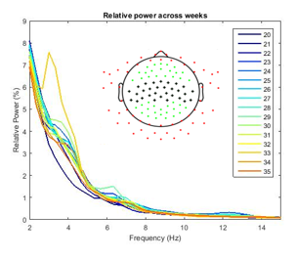
Figure 14a: Force control group weekly power spectral density plots
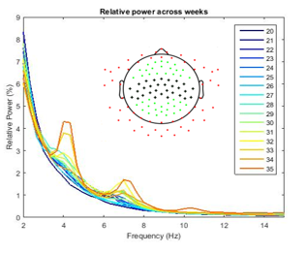
Figure 14b: Power steering group weekly power spectral density plots
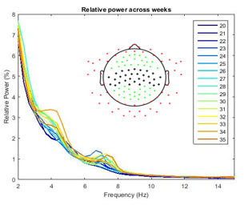
Figure 14c: Suit assist group weekly power spectral density plots

Figure 15 (a-c) displays monthly spatial topographies of the force control, power steering, and suit assist gesture control groups respectively. The three group spatial plots each show overall similarities to the Phase 2 total group average. Namely, each group consistently exhibits the same frontal central delta band activity. Although some similarities are apparent across the three subgroups, several differences are evident. The most noticeable distinction in the delta band is the lack of decreased central motor cortex activity in the suit assist group (Fig 15c). The central motor cortex activity seen in the previous results is also visible in all three groups. This pattern is especially strong in months 7 and 8 of the power steering group (Fig 15b). The theta band in each group displays overall bilateral activity, mainly focused along the temporal and occipital regions with exceptions in a few months. Bilateral activity along the motor cortex is also evident in the alpha band, similarly to the entire group average. Occipital activity is also present in the alpha band for both the power steering and suit assist groups. This pattern is evident in the group average as well (fig 12), due to the activity present in these two groups.
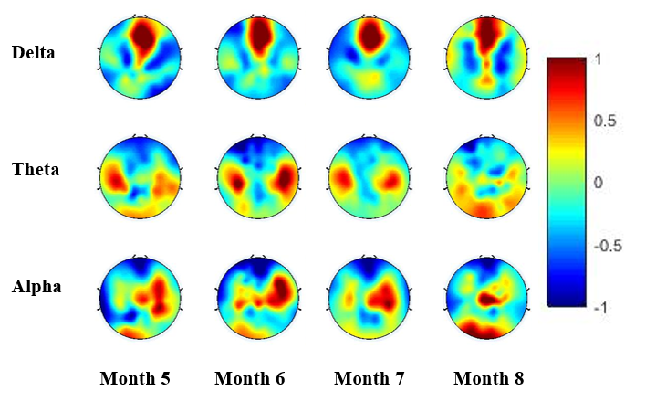
Figure 15a: Force control group monthly spatial topographies
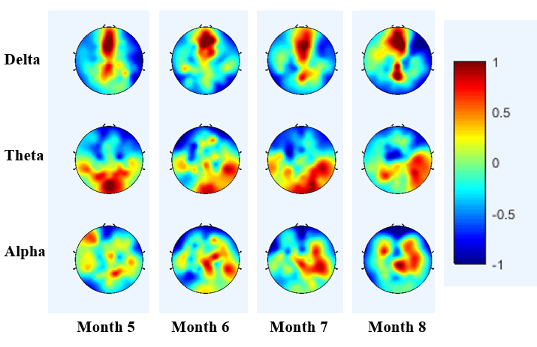
Figure 15b: Power steering group monthly spatial topographies
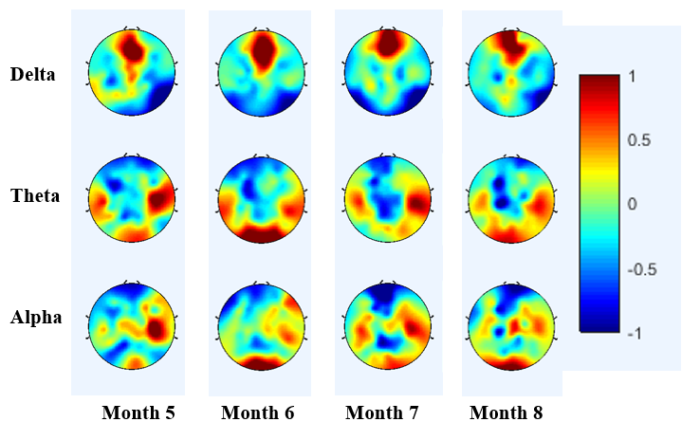
Figure 15c: Suit-assisted group monthly spatial topographies

Power spectrum peak distribution plots are displayed in Figure 16. Generally, central peak distribution values for frequency peaks tend to shift to higher frequencies. This shift in the theta band is seen most particularly from months 6 to 8, with month 5 being a bit inconsistent compared with the others. The alpha band shows more consistent shifts compared to the theta band. Of the three groups, the force control group shows the least obvious shift in the alpha band (fig 16a). In addition to shifting to higher frequencies, the increase in relative number of peaks is apparent from month to month. This pattern is most evident in the power steering and suit assist groups (fig 16 a-b).
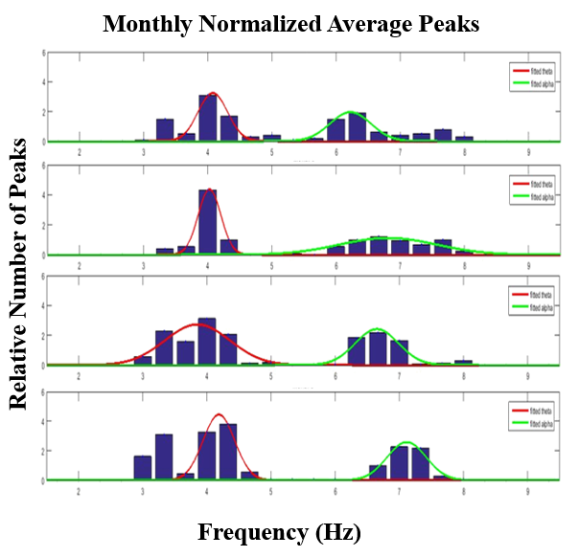
Figure 16a: Force control group monthly spectral peak distributions
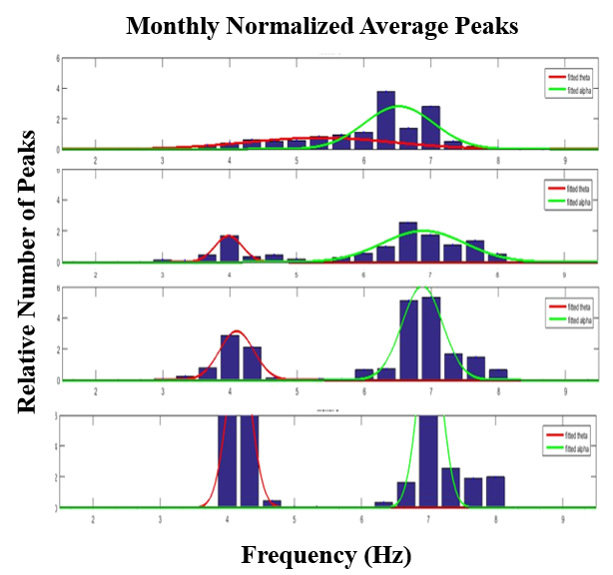
Figure 16b: Power steering group monthly spectral peak distributions
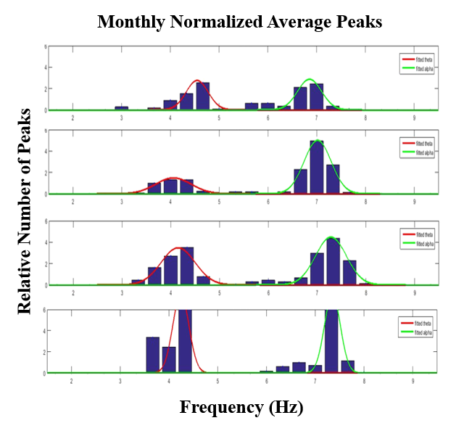
Figure 16c: Suit-assisted group monthly spectral peak distributions
Chapter 4: Discussion
This chapter presents a discussion on the EEG spatio-spectral patterns of infants enrolled in the Self-Initiated Prone Progression Crawler. Firstly, analysis of results from the first cohort is introduced. Secondly, feasibility of reproducing results using an independent analysis for the second cohort is addressed. Next, a comparison of infant EEG from different SIPPC assistive modes and their various spatio-spectral patterns are presented. Lastly, contrasts between the healthy baseline group and the atypically developing individuals are analyzed. Our study aims to answer the following research questions: Can high density EEG recorded on a weekly basis be used to improve our understanding of infant neural development? Can our findings be validated for assessment of the sensitivity of our methods and propositions for developmental motor brain biomarkers?
4.1 EEG Spatio-Spectral Patterns
Several studies have focused on the alpha band development relation to infant motor development (Webster and Clark, 2010; Sauseng et al., 2009; Kuhlman, 1978; Stroganova et al., 1999). However, difficulties due to limitations in spatial and temporal resolutions in formulating consistent definitions of infant neural circuit development associated with motor development, has served as the motivation for this study to improve on previous findings. Additionally, inconsistencies about the origin of the mu rhythm between the theta and alpha bands have led to further questions on its development (Marshall et al., 2010; Berchicci et al., 2011). This study aims to use the benefits of the high temporal resolution of the designed experimental protocol to improve on previous findings.
The first cohort of 10 infants displays developmental patterns consistent with literature. Particularly, mu rhythm activity displays clear developmental progression toward adulthood in spectral and spatial domains. In the Phase 1 cohort, peak frequency bumps are evident within the alpha band as early as 20 weeks of age. This bump shape phenomenon continues to progress to higher relative power values in later weeks. Additionally, the peak shifts within the band to higher frequencies evident in the PSD plots, as well as the peak detection distributions, implies the shift of mu rhythm towards higher expected frequencies. Concurrently, the high-resolution spatial patterns in the alpha band centralized bilaterally along the motor cortex support the reported relation between the mu rhythm and motor cortex (Sauseng et al., 2009). The findings from these results suggest that the mu rhythm shift toward higher frequencies is progressively approaching expected values established in adults. Consistencies of this first cohort with previous findings provide confidence for expanding the same analysis to a larger group of subjects with the intent to validate these findings.
4.2 Validation of Typically Developing Infant Results
Similarities in the results from Phase 1 and 2 suggest that EEG spatio-spectral patterns of healthy infants are consistent. Use of an independent analysis for the Phase 2 group separate from Phase 1 allowed us to test for any bias potentially added during data collection, preprocessing, or spectral analysis. Although some differences from the first group appear in the Phase 2 spatial topographies, particularly in the theta and alpha bands, the overall patterns are generally the same. These findings are further reinforced by the weekly PSD and peak detection plots. Results from this analysis support confidence in our methods and overall results for the typically developing infants. Furthermore, the validation of these results suggests that our proposed biomarkers for motor development are sensitive to independent analysis procedures and subject groups.
4.3 EEG Differences from Varying Methods of Robot Assistance
Although some similarities are present between the three SIPPC assistive mode groups (force control, power steering, and suit assist), there are some noticeable differences in their spatial patterns. The force control group differs from the other two in the theta band topographies where activity is present along the central motor cortex until the final month. This could suggest that infants in this group display minimally distinguishable patterns between their proposed theta and alpha bands, as the band frequency boundary may not be as clearly defined during this time period. This concept of similarities between the theta and alpha bands in the force control groups also supported by the occipital activity in the final month apparent in the alpha band. This concept is also supported by the occipital activity in the final month apparent in the alpha band. Activity for this group shows strong visual activity in addition to central motor activity only in that specific month and band. Contrast to this, the other two groups generally display posterior activity in the theta band throughout each month. However, the suit-assist group also shows some visual activity in months 6-8, whereas the power steering group does not. This could imply that infants in the power steering group do not invoke the visual cortex as much as the other two groups during recordings, potentially due to limited awareness of depth perception restricted by the amount of mobility available to them. However, current results do not provide enough information to formulate conclusive results from these patterns, which should be expanded upon in future studies.
Differences between groups from the weekly PSD and peak distributions are not as obvious, but some are noticeable. The weekly PSD plots of the force control group show more inconsistencies week to week compared to the other two groups. In particular, peaks within the alpha band are not as obvious in this group, which could suggest decreased mu rhythm activity for this group compared to the others. The apparent delays of mu rhythm peak shifts appear to reflect the limited robotic assistance provided to the force control group compared to the other two groups. support the functionality of the SIPPC robot as a positive influence. The relation between relatively limited mu rhythm activity in the force control group compared to the other groups is supported by the proposed association between motor experience and mu rhythm activity (van Elk et al., 2008). This pattern is supported by the peak detection distributions as well. Although each group shows a progressive central peak shift to higher frequencies in the alpha band, the force control group shows drastically less relative peaks each month than the other groups. Limitations presented by the force control group suggest that analysis of moving data using a larger sample size could provide insight on the effectiveness of the SIPPC robot.
Despite the noticeable differences between the three assistive modes, general similarities suggest that our proposed biomarkers are further validated by distinction of subgroups. Spatio-spectral patterns display similar progressions to the Phase 1 and Phase 2 group averages. The difference in these spatial patterns is apparent in the visual cortex activity evident in the force control and suit assist groups. However, activity in the alpha band consistently appears across the motor cortex in the spatial topographies of each group, which is consistent with the entire typically developing averages. Additionally, each subgroup displays similar trends in PSD plots and their peak distributions as they progress toward higher peak frequencies in the alpha band. This suggests that the use of the mu rhythm development can suggest accurate developmental patterns, despite varying degrees of assistance.
4.4 Limitations and Future Work
Results presented in this study contain limitations that could be improved on in future works. Although this research contributes with a high temporal resolution across monthly ages of 5-8 months, equally high temporal resolution data is not available for infants outside of this age range. Additionally, the number of subjects presented in each group is relatively small. Similar analyses should be performed using larger numbers of subjects in all groups. To properly assess developmental effects of the SIPPC assistive robot, a true control group of EEG from similarly aged infants unexposed to the assistive technology could be analyzed. Lastly, movement EEG data from the SIPPC trials have currently not displayed obviously conclusive mu rhythm results, therefore only resting results are presented in this study. Future works should focus on improving upon current practices to compare the resting data to the movement data for a more comprehensive study on infant locomotion.
4.5 Conclusion
This thesis has presented research on EEG rhythmic activity from infants prior to crawling. This study, part if the larger study on the assistive locomotive robot known as the Self-Initiated Prone Progression Crawler, has focused primarily on spatio-spectral patterns involved with motor development. Early intervention during the period of crawling skill acquisition is paramount for improving the quality of life for those afflicted with cerebral palsy. Understanding of neural correlates of motor development can serve as a feedback for rehabilitation techniques as well as a quantitative biomarker for typical development. Spatio-spectral patterns of two independent cohorts of typically developing infants were analyzed to establish and reinforce expected characteristics of infants. Power spectral density analysis of frequency bands, peak frequency, and topographic maps displayed consistent results in both groups, especially within the mu rhythm. Assessment of differences between distinct SIPPC assistive modes was performed to explore potential differences in EEG rhythmic patterns due to variations in robotic assistance.

References
Aisen M., D. Iverson, C. Schwalbe, B. Weaver and P. Aisen, "Falls on a Neurorehabilitation Unit: Reassessment of a Prevention Program", The Journal of The American Paraplegia Society, vol. 17, no. 4, pp. 179-182, 1994.
Anderson, D.I., Campos, J.J., Witherington, D.C., Dahl, A., Rivera, M., He, M., Uchiyama, I., Barbu-Roth,M. The role of locomotion in psychological development. Front. Psychol.4,1–17, 2013.
Avanzino L, Teo JT, Rothwell JC. Intracortical circuits modulate transcallosal
inhibition in humans. J Physiol. 2007.
Barr R., J. Ackmann and J. Sonnenfeld, "Peak-detection algorithm for EEG analysis", International Journal of Bio-Medical Computing, vol. 9, no. 6, pp. 465-476, 1978.
Başar E., C. Başar-Eroğlu, S. Karakaş and M. Schürmann, "Are cognitive processes manifested in event-related gamma, alpha, theta and delta oscillations in the EEG?", Neuroscience Letters, vol. 259, no. 3, pp. 165-168, 1999.
Bayón C., O. Ramírez, J. Serrano, M. Castillo, A. Pérez-Somarriba, J. Belda-Lois, I. Martínez-Caballero, S. Lerma-Lara, C. Cifuentes, A. Frizera and E. Rocon, "Development and evaluation of a novel robotic platform for gait rehabilitation in patients with Cerebral Palsy: CPWalker", Robotics and Autonomous Systems, vol. 91, pp. 101-114, 2017.
Bell A., B. McClure, P. McCullagh and R. McClelland, "Variation in Power Spectral Analysis of the EEG with Gestational Age", Journal of Clinical Neurophysiology, vol. 8, no. 3, pp. 312-319, 1991.
Berchicci M., T. Zhang, L. Romero, A. Peters, R. Annett, U. Teuscher, M. Bertollo, Y. Okada, J. Stephen and S. Comani, "Development of Mu Rhythm in Infants and Preschool Children", Developmental Neuroscience, vol. 33, no. 2, pp. 130-143, 2011.
Binnie C., "Fundamentals of EEG Technology Volume 2 Clinical Correlates", Journal of Neurology, Neurosurgery & Psychiatry, vol. 52, no. 10, pp. 1214-1214, 1989.
Bönstrup M., J. Hagemann, C. Gerloff, P. Sauseng and F. Hummel, "Alpha oscillatory correlates of motor inhibition in the aged brain", Frontiers in Aging Neuroscience, vol. 7, 2015.
Campbell S., T. Kolobe, B. Wright and J. Linacre, "Validity of the Test of Infant Motor Performance for prediction of 6-, 9- and 12-month scores on the Alberta Infant Motor Scale", Developmental Medicine and Child Neurology, vol. 44, no. 04, p. 263, 2002.
Cech D. and S. Martin, Functional movement development across the life span. St. Louis, Mo.: Elsevier, 2012.
Charitou S., K. Asonitou and D. Koutsouki, "Prediction of infant's motor development", Procedia - Social and Behavioral Sciences, vol. 9, pp. 456-461, 2010.
Choisdealbha Á. Ní and V. Reid, "The developmental cognitive neuroscience of action: semantics, motor resonance and social processing", Experimental Brain Research, vol. 232, no. 6, pp. 1585-1597, 2014.
Colver A., C. Fairhurst and P. Pharoah, "Cerebral Palsy", Obstetrical & Gynecological Survey, vol. 69, no. 8, pp. 447-449, 2014.
Cramer, S. C., Reply: Harnessing neuroplasticity for clinical applications. Brain, 135(4). doi:10.1093/brain/aws018. 2012.
Delorme A., S. Makeig, M. Fabre-Thorpe and T. Sejnowski, "From single-trial EEG to brain area dynamics", Neurocomputing, vol. 44-46, pp. 1057-1064, 2002.
Gentili R., T. Bradberry, H. Oh, B. Hatfield and J. Contreras Vidal, "Cerebral cortical dynamics during visuomotor transformation: Adaptation to a cognitive-motor executive challenge", Psychophysiology, vol. 48, no. 6, pp. 813-824, 2010.
Ghazi M., M. Nash, A. Fagg, L. Ding, T. Kolobe and D. Miller, "Novel Assistive Device for Teaching Crawling", Field and Service Robotics, 2016.
Gonzalez, S. L., Reeb-Sutherland, B. C., & Nelson, E. L., Quantifying Motor Experience in the Infant Brain: EEG Power, Coherence, and Mu Desynchronization. Frontiers in Psychology, 7. doi:10.3389/fpsyg.2016.00216. 2016.
Hadders-Algra M., "The neuronal group selection theory: promising principles for understanding and treating developmental motor disorders", Developmental Medicine & Child Neurology, vol. 42, no. 10, pp. 707-715, 2000.
Hagne, I., Persson, J., Magnusson, R., and Petersen, I. “Spectral analysis via fast fourier transform of waking EEG in normal infants”, Automation of clinical EEG, (1973):
Hartigan J. and M. Wong, "Algorithm AS 136: A K-Means Clustering Algorithm", Applied Statistics, vol. 28, no. 1, p. 100, 1979.
“Help, Resources for Children with CP,” cerebralpalsy.org. [Online]. Available: http://www.cerebralpalsy.org/. [Accessed: 23-May-2017].
Holmes, M. D., Dense array EEG: Methodology and new hypothesis on epilepsy syndromes. Epilepsia, 49, 3-14. 2008
Holt S., "Cerebral Palsy: A Study of Parental Attitudes Regarding the Choice of Treatment Modalities", Physiotherapy, vol. 82, no. 11, p. 635, 1996.
Jones, M.W., Morgan, E., Shelton, J.E., and Thorogood, C., Cerebral palsy: introduction and diagnosis (part I). J Pediatr Health Care. 21(3): 146-152, 2007
Jung, M H.. Park, H. Kim and M. Hahn, "Speaker Adaptation Using ICA-Based Feature Transformation", ETRI Journal, vol. 24, no. 6, pp. 469-472, 2002.
Kennett R., "Modern electroencephalography", Journal of Neurology, vol. 259, no. 4, pp. 783-789, 2012.
Kolobe, H.A., Pidcoe, P.E., ‘Self-initiated prone progression crawler’, US 8942874 B2, 2015
Kuhlman, W.N.: Functional topography of the human mu rhythm. Electroencephalography Clinical Neurophysiology. 44(1): 83-93, 1978.
Lantz, G., Grave de Peralta, R., Spinelli, L., Seeck, M., & Michel, C. M., Epileptic source localization with high density EEG: how many electrodes are needed? Clin Neurophysiol, 114(1), 63-69. 2003.
Malmivuo, J. & Plonsey, R., Bioelectromagnetism. New York: Oxford University Press, 1995)
Marshall P., T. Young and A. Meltzoff, "Neural correlates of action observation and execution in 14-month-old infants: an event-related EEG desynchronization study", Developmental Science, vol. 14, no. 3, pp. 474-480, 2010.
McFarland K. and R. Ashton, "The Influence of Brain Lateralization of Function on a Manual Skill", Cortex, vol. 14, no. 1, pp. 102-111, 1978.
Meyer-Heim A., C. Ammann-Reiffer, A. Schmartz, J. Schafer, F. Sennhauser, F. Heinen, B. Knecht, E. Dabrowski and I. Borggraefe, "Improvement of walking abilities after robotic-assisted locomotion training in children with cerebral palsy", Archives of Disease in Childhood, vol. 94, no. 8, pp. 615-620, 2009.
Murray G., J. Veijola, K. Moilanen, J. Miettunen, D. Glahn, T. Cannon, P. Jones and M. Isohanni, "Infant motor development is associated with adult cognitive categorisation in a longitudinal birth cohort study", Journal of Child Psychology and Psychiatry, vol. 47, no. 1, pp. 25-29, 2006.
Olié, J.-P., Macher, J.-P. and Silva J. A. C. e., Neuroplasticity: a new approach to the pathophysiology of depression. London: Science Press, 2004.
Opie, G. M., Post, A. K., Ridding, M. C., Ziemann, U., & Semmler, J. G. Modulating motor cortical neuroplasticity with priming paired associative stimulation in young and old adults. Clinical Neurophysiology, 128(5), 763-769. doi:10.1016/j.clinph.2017.02.011, 2017
Orekhova, E.V., Stroganova, T.A., Posikera, I.N., and Elam, M., EEG theta rhythm in infants and preschool children. Clinical Neurophysiology, pp. 1047-1062, 2006
Pfurtscheller, G., & Silva, F. L., Event-related EEG/MEG synchronization and desynchronization: basic principles. Clinical Neurophysiology, 110(11), 1842-1857. doi:10.1016/s1388-2457(99)00141-8, 1999
Poranen-Clark T., M. von Bonsdorff, J. Lahti, K. Räikkönen, C. Osmond, T. Rantanen, E. Kajantie and J. Eriksson, "Infant motor development and cognitive performance in early old age: the Helsinki Birth Cohort Study", AGE, vol. 37, no. 3, 2015.
"Proposed definition and classification of cerebral palsy, April 2005", Developmental Medicine & Child Neurology, vol. 47, no. 8, pp. 571-571, 2007.
Ryynanen, O. R., Hyttinen, J. A., & Malmivuo, J. A. Effect of measurement noise and electrode density on the spatial resolution of cortical potential distribution with different resistivity values for the skull. IEEE Trans Biomed Eng, 53(9), 1851-1858. 2006
Saby J. and P. Marshall, "The Utility of EEG Band Power Analysis in the Study of Infancy and Early Childhood", Developmental Neuropsychology, vol. 37, no. 3, pp. 253-273, 2012.
Sauseng P., W. Klimesch, C. Gerloff and F. Hummel, "Spontaneous locally restricted EEG alpha activity determines cortical excitability in the motor cortex", Neuropsychologia, vol. 47, no. 1, pp. 284-288, 2009.
Serdarevic F., T. van Batenburg-Eddes, S. Mous, T. White, A. Hofman, V. Jaddoe, F. Verhulst, A. Ghassabian and H. Tiemeier, "Relation of infant motor development with nonverbal intelligence, language comprehension and neuropsychological functioning in childhood: a population-based study", Developmental Science, vol. 19, no. 5, pp. 790-802, 2015.
Southerland, J.B.: “Activity recognition and crawling assistance using multiple inexpensive inertial measurement units”, Master’s thesis, School of Computer Science, University of Oklahoma, May 2012
Stroganova, T.A., Orekhova, E.V., and Posikera, I.N., “EEG alpha rhythm in infants”, Clinical Neurophysiology. pp. 997-1012, 1999.
Thapa R., "Symptom Recognition and Diagnosis of Cerebral Palsy in Nepal", Journal of Autism and Developmental Disorders, vol. 47, no. 6, pp. 1739-1748, 2017.
van Elk, M., van Schie, H.T., Hunnius, S., Vesper, C., and Bekkering, H. (2008): You’ll never crawl alone: psychophysiological evidence for experience-dependent motor resonance in infancy.
Neuroimage. 43(4): 808–814. DOI: 10.1016/j.neuroimage.2008.07.057
Thompson, C. K. ,“Neuroplasticity,” Journal of Communication Disorders, vol. 33, no. 4, pp. 357–366, 2000.
Webster J. and J. Clark, Medical instrumentation. Hoboken, NJ: John Wiley & Sons, 2010.
Xiao R., X. Qi, A. Patino, A. Fagg, T. Kolobe, D. Miller and L. Ding, "Characterization of infant mu rhythm immediately before crawling: A high-resolution EEG study", NeuroImage, vol. 146, pp. 47-57, 2017.

