UNIVERSITY OF OKLAHOMA
GRADUATE COLLEGE

AN NEUROSCIENCE APPROACH TO INVESTIGATE CREATIVITY IN ENGINEERS WITH THE EFFECTS OF INDOOR ENVIRONMENT QUALITY (IEQ)

A DISSERTATION
SUBMITTED TO THE GRADUATE FACULTY
in partial fulfillment of the requirements of the
Degree of
DOCTOR OF PHILOSOPHY

By
Md Tanvir Ahad
Norman, Oklahoma
2023

AN NEUROSCIENCE APPROACH TO INVESTIGATE CREATIVITY IN ENGINEERS WITH THE EFFECTS OF INDOOR ENVIRONMENT QUALITY (IEQ)

A DISSERTATION APPROVED FOR THE
SCHOOL OF AEROSPACE AND MECHANICAL ENGINEERING

BY THE COMMITTEE CONSISTING OF

Prof. Jie Cai

Prof. Li Song

Prof. Yingtao Liu

Prof. Choon Yik Tang

Prof. Zahed Siddique

© Copyright by Md Tanvir Ahad 2023
All Rights Reserved.

Dedicated to:
To the Almighty Allah, With an Apology
My Mother, Maleka Parvin
My Father, Md Abdul Sattar Mojumder
My Sisters, Farhana Nahid and Ishrat Jahan
And My Wife, Farzana Akter Soma

ACKNOWLEDGEMENT
There are countless people to whom I would like to express my gratitude; a few of them I interacted with personally, and many I learned and benefited from their work through a diverse set of media. Although I would like to thank everyone, I do not see a space enough to do so. Given this space limitation, I will only explicitly mention the people who played a significant role in shaping my personality and the work I am presenting here.

I would like to express my deepest gratitude for my academic advisor Dr. Zahed Siddique. His support and guidance throughout my graduate studies have been invaluable. Thank you for always setting the standards high and all support during the journey. You have been more than an advisor to me. I also would like to thank my advisory committee, Dr. Jie Cai, Dr. Yingtao Liu, Dr. Li Song and Dr. Choon Yik Tang for their comments and
suggestions which positively guided this work.

I would like to thank my colleagues who I worked with in different labs, especially those I worked with in the Engineering Creativity Lab, Amin G. Alhashim, Tess Hartog, Megan Marshall and Mehri Mobaraki Omoumi. I enjoyed every moment we spent together collecting EEG data, learning from each other, and catching up with life.

I would like to thank my family, who provided continuous support throughout this long doctorate journey which started in 2018! Throughout my studies in Norman, even though they were miles away, they were always with me. Special thanks go to my mother (Maleka Parvin) and father (Md Abdul Sattar Mojumder) for their engouement, financially and lifelong support. Special thanks also go to my two sisters, Farhana Nahid and Ishrat Jahan who have been encouraging and supporting me emotionally to continue this journey despite all the hardships they were facing. If I forgot, I would not forget all the effort that my wife, Farzana Akter Soma, has been doing from the first day we met and throughout this journey without her, I am sure, which is the only thing that I am confident about in this dissertation, that all what I have accomplished so far is impossible. This successful accomplishment would not have been conceivable without their everlasting support.

TABLE OF CONTENTS
ACKNOWLEDGEMENT ............................................................................................................................. V TABLE OF CONTENTS ............................................................................................................................... VII
LIST OF TABLES ......................................................................................................................................... XI
LIST OF FIGURES ...................................................................................................................................... XII
ABSTRACT ............................................................................................................................................. XIV
1.1. Neuroscience In Creativity Study for Engineering Education 1
1.1.1. Chapter 2 Overview 1
1.1.2. Chapter 3 Overview 2
1.1.3. Chapter 4 Overview 2
1.1.4. Chapter 5 Overview 3
1.1.5. Chapter 6 Overview 4
NEUROSCIENCE IN CREATIVITY STUDY FOR ENGINEERING EDUCATION 6
CHAPTER 2: WIP: USING NEURO-RESPONSES TO UNDERSTAND CREATIVITY, THE ENGINEERING DESIGN PROCESS, AND CONCEPT GENERATION 7
2.1. Introduction 7
2.2. Neuroimaging Methods 10
2.2.1. Functional magnetic resonance imaging (fMRI) 10
2.2.2. Electroencephalogram (EEG) 12
2.3. The Engineering Design Process 16
2.4. Utilizing Neurological Techniques to Study Engineering Design 20
2.4.1 Current use of fMRI in the study of ED&CG 21
2.4.2 Current use of EEG in the study of ED&CG 22
2.4.3 Current use of other techniques in the study of ED&CG 23
2.5. Preliminary ERP investigation 23
2.5.1 The study 24
2.5.2 Results 25
2.6. Future Directions 28
2.7. Conclusion 31
2.8. Acknowledgement 32
2.9. References 32
CHAPTER 3: PILOT STUDY: INVESTIGATING EEG BASED NEURO-RESPONSES OF ENGINEERS VIA A MODIFIED ALTERNATIVE USES TASK TO UNDERSTAND CREATIVITY 39
3.1. Introduction 39
3.2. Background 41
3.2.1. Electroencephalography (EEG) and event related potentials (ERPs) 41
3.2.2. Literature review 45
3.2.3. Utilizing ERPs to study creativity 51
3.3. The Pilot Study 52
3.3.1. Participants 53
3.3.2. Task design/procedure 53
3.3.3. EEG recording 56
3.3.4. Data analysis 57
3.3.5. Results and discussion 58
3.4. Conclusions And Future Directions 61
3.5. Acknowledgements 64
3.6. References 64
CHAPTER 4: INVESTIGATING THE N400 EVENT RELATED POTENTIAL AS A MEASURE OF CREATIVITY 71
4.1. Introduction 71
4.2. The Experiment 73
4.2.1. Designing the current study 73
4.2.2. Experimental procedures 76
4.2.3. Participants 78
4.2.4. Data collection setup 78
4.2.5. Data analysis 79
4.3. Results and Discussion 80
4.3.1. The N400 component 81
4.3.2. The post-N400 component 83
4.3.3. Contour maps and alpha band power 84
4.4. Conclusions and Future Work 88
4.5. Acknowledgements 89
4.6. References 89
CHAPTER 5: ELECTROENCEPHALOGRAM EXPERIMENTATION TO UNDERSTAND CREATIVITY OF MECHANICAL ENGINEERING STUDENTS 92
5.1. Introduction 92
5.2. Background 97
5.2.1. Neuroimaging 97
5.2.2. Machine learning and neuroimaging 99
5.3. Experimental Setup and Data Acquisition 100
5.3.1. Participants 100
5.3.2. Experimental equipment and setup 101
5.3.3. Experimental tasks 102
5.4. EEG Signal Analysis 104
5.4.1. ERPs 104
5.4.2. TRP 105
5.5. Results 107
5.5.1. N400 results 107
5.5.2. Alpha task related power (TRP) results 110
5.6. Classification of Neural Responses 115
5.7. Discussion 120
5.8. Limitations 122
5.9. Conclusion and Future Directions 122
5.10. Acknowledgement 124
5.11. References 124
5.12. Appendix 131
CHAPTER 6: EVIDENCE OF INDOOR ENVIRONMENTAL SETTINGS PREFERENCE FOR THE TEMPORAL DYNAMICS OF CREATIVITY IN ENGINEERING 134
6.1. Introduction 134
6.2. Experimental Design 139
6.2.1. Participants 139
6.2.2. Experimental equipment 139
6.2.3. Experimental chamber 140
6.2.4. Experimental conditions 141
6.2.5. Experimental process 142
6.2.6. Experimental tasks 142
6.2.7. EEG signal analysis 144
6.3. Results and Discussion 146
6.3.1. Psychophysiological response result 146
6.3.2. Performance response under thermal stressors 149
6.3.3. Temporal process of mental effort 154
6.4. Conclusion 158
6.5. References 159

LIST OF TABLES
TABLE 2.1 - Neuroimaging investigations needed for the engineering design process. ……………………………19
TABLE 3.1 - Stimulus presentation order in [40] versus current study. Time is in milliseconds (ms). ……….54
TABLE 3.2 - Example of an item and the three use types with expected participant Responses. See appendix a for a full list of items and their uses. …………………………………………………………………………………………………….56
TABLE 4.1 - Design problems and associated Common, Creative, and Nonsense keywords [14]. …………….76
TABLE 5.1 - Participant responses for an item with the three uses [13]. ………………………………………………...104
TABLE 5.2 - Assignment of Data Used for Training and Testing of ML Models. ……………………………………….119
TABLE 5.3 - Overall Model performance of the study. …………………………………………………………………………...119
TABLE 6.1 - Experiment environmental conditions on Psychrometric Chamber. …………………………………….142
TABLE 6.2 - Participant’s thermal preferences for the creativity task. …………………………………………………….153
LIST OF FIGURES
FIGURE 2.1 - MRI machine and image produced from BOLD contrast. ………………………………………………….....12
FIGURE 2.2 - Mobile EEG cap with 24 channels and corresponding electrode layout taken from [44]. Electrodes circled (Cz, CPz, Pz, and POz) are for reference later in the text (Section 5.2). …………………….....13
FIGURE 2.3 - Raw EEG data from 24 electrodes filtered between .5-100 Hz (Top) and corresponding electrical activity head maps at two points (bottom). ………………………………………………………………………….....................15
FIGURE 2.4 - ERP images from one electrode for three different types of stimuli. Box represents the 300 ms - 500 ms post-stimulus range, where the N400 effect could be found. …………………………………………………….16
FIGURE 2.5 - Typical Engineering Design Process..........................................................................................18
FIGURE 2.6 - Mean amplitudes from four electrodes (Cz, CPz, Pz, and POz) for the three types of item-use pairs (creative uses, nonsensical uses, and common uses) for the 300-500 ms time window investigating the N400 effect. ...................................................................................................................................................26
FIGURE 2.7 - ERPs from the Cz (top) and CPz (bottom) electrodes from one individual. The box outline indicates the 300-500 ms window of investigation of the N400 effect. ........................................................27
FIGURE 3.1 - Mobile EEG cap with 24 channels and corresponding electrode layout. Electrodes of interest are circled. See section 3.2 for more information about these electrodes. (Taken from [30]). ....................42
FIGURE 3.2 - Raw EEG data from 24 electrodes filtered between .5-100 Hz (top) and corresponding electrical activity head maps at two points (bottom). ..................................................................................................43
FIGURE 3.3 - Enhancing creativity in engineering design education. ………………………………………………………...46
FIGURE 3.4 - Block diagram of the data analysis process. .............................................................................57
FIGURE 3.5 - Mean amplitudes from four electrodes (Cz, CPz, Pz, and POz) for the three types of item-use pairs for the 300-500 ms time window..........................................................................................................60
FIGURE 3.6 - ERPs from the Cz (top) and CPz (bottom) electrodes from one individual. The box outline indicates the 300-500 ms window of investigation of the n400 effect. .........................................................61
FIGURE 4.1 - Experimental design. …………………………………………………………………………………………………………...77
FIGURE 4.2 - Grand average signal of Cz, CPz, and Pz electrodes for All subjects. ........................................81
FIGURE 4.3 - Mean amplitudes for the n400 component. ………………………………………………………………………...83
FIGURE 4.4 - Mean amplitudes for post n400 component. ……………………………………………………………………….84
FIGURE 4.5 - Contour maps of mean amplitude of n400 time window. …………………………………………………...85
FIGURE 4.6 - Contour maps of mean amplitude of post-n400 time window. ……………………………………………85
FIGURE 4.7 - General pattern of TRP for the task across electrodes. ...........................................................86
FIGURE 4.8 - General pattern of TRP interactions for the task across electrode locations. …………..............87
FIGURE 5.1 - Locations of electrodes on the scalp with lowest possible impedance level during experiment. ………………………………………………………………………………………………………………………………….……………………….....101
FIGURE 5.2 - Schematic showing the experimental tasks AUT with time intervals. …………………………........103
FIGURE 5.3 - Mean amplitudes of the four electrodes (Cz, CPz, Pz, and POz) for creative uses, nonsensical uses, and common uses investigating the N400 effect. ………………………………………………………………………….109
FIGURE 5.4 - Averaged ERPs from the five participants and the box indicates the 300-500 ms window of investigation of the N400 effect. …………………………………………………………………………………………………………...110
FIGURE 5.5 - Individual participants task-related power changes (log μV²) in EEG alpha power during the generation of creative/original uses (a) left hemisphere (b) right hemisphere; nonsense uses (c) left hemisphere (d) right hemisphere; common uses (e) left hemisphere (f) right hemisphere in the modified Alternative Uses (AU) task. ……………………………………………………………………………………………………………………111
FIGURE 5.6 - ANOVA general pattern of Task-related changes of EEG alpha band power (TRP) during modified AUT: (a) Interaction plot between AREA and HEMISPHERE; (b) Interaction plot between AREA and TASK; (c) Interaction plot between HEMISPHERE and TASK. ………………………………………………………………….116
FIGURE 6.1 - OU environmental chamber: human subject inside the chamber; middle: chamber control and monitoring system right: Psychometric climate chamber showing experimental setup. …........................141
FIGURE 6.2 – Comparison of the mental workload index (a), mental stress index (b), and Frontal asymmetry index (c) of Alternative Uses of Task (AUT) creativity task under the three thermal conditions. ……………………………………………………………………………………………………………………………………………………………….148
FIGURE 6.3 – “Inverted-U model” (also known as the Yerkes-Dodson Law) illustrates the peak performance of Alternative Uses of Task (AUT) creativity task under the three thermal conditions for each participant. ……………………………………………………………………………………………………………………………………………………………….151
FIGURE 6.4 – Contour Maps of Alpha energy for three thermal conditions in (300 -500 ms) Time Window. ……………………………………………………………………………………………………………………………………………………………….155

ABSTRACT
Investigations of creativity have been an intriguing topic for a long time, but assessing creativity is extremely complex. Creativity is a cornerstone of engineering disciplines, so understanding creativity and how to enhance creative abilities through engineering education has received substantial attention. Fields outside of engineering are no stranger to neuro-investigations of creativity and although some neuro-response studies have been conducted to understand creativity in engineering, these studies need to map the engineering design and concept generation processes better. Using neuroimaging techniques alongside engineering design and concept generation processes is necessary for understanding how to improve creativity studies in engineering. Recently, a growing number of studies have revealed that some types of indoor environmental stimuli can enhance human creativity. Further, for generating creative ideas temporal dynamics of cognitive processes are critical. However, how the temporal dynamics of creativity are influenced by the indoor environment remains unclear. This research found that each stage of the temporal dynamics of creativity may be differently correlated with neural function. Further, indoor environmental factors may have various, and sometimes contrasting, effects on the temporal dynamics of creativity. Despite recent progress, there are significant gaps in understanding the effects of indoor environmental quality (IEQ), especially air quality and factors related to visual, thermal and acoustic comfort that are closely tied to performance on cognitive tasks. This is due to the lack of understanding of the effects of IEQ on human physiological and neural responses. Nonetheless, this is the first study to clarify the influence of indoor environmental settings on the temporal dynamics of creativity from the perspective of neuroscience.

CHAPTER 1: INTRODUCTION

Neuroscience In Creativity Study for Engineering Education

1.1.1. Chapter 2 Overview
Investigations of creativity have been an intriguing topic for a long time, but assessing creativity is extremely complex. Creativity is a cornerstone of engineering disciplines, so understanding creativity and how to enhance creative abilities through engineering education has received substantial attention. Fields outside of engineering are no stranger to neuro-investigations of creativity and although some neuro-response studies have been conducted to understand creativity in engineering, these studies need to map the engineering design and concept generation processes better. Using neuroimaging techniques alongside engineering design and concept generation processes is necessary for understanding how to improve creative idea generation and creativity studies in engineering. In this paper, a survey is provided of the literature for the different neurological approaches that have been used to study the engineering design process and creative processes. Also presented are proposed strategies to apply these neurological approaches to engineering design to understand the creative process in greater detail. Furthermore, results from a pilot study investigating neuro-responses of engineers are presented.

1.1.2. Chapter 3 Overview
Assessing creativity is not an easy task, but that has not stopped researchers from exploring it. Because creativity is essential to engineering disciplines, knowing how to enhance creative abilities through engineering education has been a topic of interest. In this paper, the event related potential (ERP) technique is used to study the neural responses of engineers via a modified alternative uses task (AUT). Though only a pilot study testing two participants, the preliminary results of this study indicate general neuro-responsiveness to novel or unusual stimuli. These findings also suggest that a scaled-up study along these lines would enable better understanding and modeling of neuroresponses of engineers and creative thinking, as well as contribute to the growing field of ERP research in the field of engineering.

1.1.3. Chapter 4 Overview
Creativity” is one of the highly valued competencies in the engineering discipline. In this research, investigators remodeled modified Alternative Uses of Task (AUT) created by Kröger et al, by asking participants to judge the novelty and appropriateness of a given function as it is relates to a design solution. Whilst in the original Kröger et al model, participants were asked to judge the novelty and appropriateness of an alternative “use” or “function” for an object in their study. In the current study, the keywords were used as potential functions a solution to the associated design task might have.
The main outcome of this study is to understand the N400, post-N400 components and the alpha band TRP activity in relation to the process of conceptual expansion used to identify the novelty and appropriateness of an engineering function. Besides this main outcome, another important outcome is to successfully test and develop an ERP experiment for engineering design tasks, which has not yet been done. These outcomes contribute to the main objective of this research: to further understanding in the field of creativity in engineering. This experiment data creates the contour maps to identify which scalp areas of the brain showed the most activity for the N400 and post-N400 time windows and finds the most negative activity located in a frontocentral distribution during N400 time window. N400 can provide nonresponse guidance to what type of function to object mapping example to provide the students during idea generation.

1.1.4. Chapter 5 Overview
Electroencephalogram (EEG) alpha power (8–13 Hz) is a characteristic of various creative task conditions and is involved in creative ideation. Alpha power varies as a function of creativity-related task demands. This study investigated the event-related potentials (ERPs), alpha power activation and potential machine learning to classify the neural responses of engineering students involved with creativity tasks. All participants performed a modified Alternate Uses Task (AUT), in which participants categorized functions (or uses) for everyday objects as either creative, nonsense or common. At first this study investigated the fundamental ERPs over central and parietooccipital temporal area. The bio-responses to understand creativity in engineering students demonstrates that nonsensical and creative stimuli elicit larger N400 amplitudes (-1.107 mV and -0.755 mV, respectively) than common uses (0.0859 mV) on the 300-500 ms window. N400 effect was observed on 300-500 ms window from the grand average waveforms of each electrode of interest. ANOVA analysis identified a significant main effect: decreased alpha power during creative ideation, especially over (O1/2, P7/8) parietooccipital temporal area. Machine learning is used to classify the specific temporal area data's neural responses (creative, nonsense and common). A k-nearest neighbors (kNN) classifier was used, and results were evaluated in terms of accuracy, precision, recall, and F1- score using the collected datasets from the participants. With an overall 99.92% accuracy and Area Under the Curve at .9995, the kNN classifier successfully classified the participants' neural responses. These results have great potential for broader adaptation of machine learning techniques in creativity research.

1.1.5. Chapter 6 Overview
There is limited research specifically examining the effect of indoor environment quality (IEQ), including temperature, on the temporal dynamics of creativity in engineering. However, some studies suggest that temperature can have an impact on the different stages of the creative process. Research suggests that indoor environment quality, including temperature, can influence creativity. Literature supported that; a moderately warm temperature (77°F) was associated with higher creativity compared to a cooler temperature (68°F). Also, previous studies found that, a warmer temperature (77°F) was associated with higher performance in divergent thinking, which is the process of generating many ideas or solutions. The researchers speculated that this could be because a warmer environment encourages people to think more abstractly, which is a key component of creative thinking. However, some studies found that a cooler temperature (68°F) was associated with higher performance in convergent thinking, which is the process of evaluating and selecting the best idea or solution from among many. It's important to note that creativity is a complex process that involves multiple stages, and the optimal temperature for each stage may be different. Additionally, individual differences in temperature preference and tolerance may play a role in how temperature affects creativity. A very few studies focused on the IEQ effect on the temporal dynamics of creativity in engineering. Research is needed to fully understand the relationship and to identify the optimal temperature conditions for each stage of the creative process. The current study experimented with three different indoor temperatures (68°F, 75.92°F, 78.8°F) effect on engineering students to fully understand the effect of IEQ during creativity task and participant’s preferences during the task performance. This study found that, during the alternative uses of task (AUT) engineering students tend to prefer slightly warmer temperature 78.8°F in terms of mental workload index, mental stress index and engagement index during the task performance. The study used an inverted U model to find the temperature preferences from the participants. The temporal dynamics of the participants also support the similar trends during the AUT task performance for the three different temperatures selected for the study. The study provides promising insights into how the thermal environment influences engineering student’s creativity by affecting their mental workload, mental stress and engagement from the neuroscience perspective.

NEUROSCIENCE IN CREATIVITY STUDY FOR ENGINEERING EDUCATION
The focus is neuroscience in creativity study for engineering education. First, to understand creativity, the engineering design process and concept generation from neuroscience perspective a pilot study conducted using modified alternative uses of tasks (AUT). Event Related Potentials (ERP) Study to Understand Function to Object Mapping for Engineering Student. Then this dissertation expanded to explore how a collected neuro dataset could be used on creativity study in terms of ERP study, task related power study, statistical analysis and explore the machine learning classification possibilities. Later, this dissertation explored discussed how the temporal dynamics of creativity are influenced by the indoor environment quality (IEQ) factors.

The work presented in this part of the dissertation has been published in:
- Hartog, T., & Marshall, M., & Alhashim, A. G., & Ahad, M. T., & Siddique, Z. (2020, June), Work in Progress: Using Neuro-responses to Understand Creativity, the Engineering Design Process, and Concept Generation Paper presented at 2020 ASEE Virtual Annual Conference Content Access, Virtual Online. 10.18260/1- 2-35701. https://peer.asee.org/work-in-progress-using-neuro-responses-to­ understand-creativity-the-engineering-design-process-and-concept-generation.
- Hartog, T, Marshall, M, Ahad, MT, Alhashim, AG, Okudan Kremer, G, van Hell, J, & Siddique, Z. "Pilot Study: Investigating EEG Based Neuro-Responses of Engineers via a Modified Alternative Uses Task to Understand Creativity." Proceedings of the ASME 2020 International Design Engineering Technical Conferences and Computers and Information in Engineering Conference. Volume 3: 17th International Conference on Design Education (DEC). Virtual, Online. August 17-19, 2020. V003T03A019. ASME. https://doi.org/10.l115/DETC2020- 22614
- Siddique, Z., Ahad, M. T., Mobaraki-Omoumi, M., Marshall, M., & Hartog, T. (2022, August). Event Related Potentials (ERP) Study to Understand Function to Object Mapping for Engineering Student. In 2022 ASEE Annual Conference & Exposition.
- Ahad, M. T., Hartog, T., Alhashim, A. G., Marshall, M., & Siddique, Z. (2023). Electroencephalogram Experimentation to Understand Creativity of Mechanical Engineering Students. ASME Open Journal of Engineering, 2.

CHAPTER 2: WIP: USING NEURO-RESPONSES TO UNDERSTAND CREATIVITY, THE ENGINEERING DESIGN PROCESS, AND CONCEPT GENERATION

2.1. Introduction
Intelligence, measured by IQ and SAT, has been in a steady increase in America since 1990 [1, 2]. On the other hand, creativity, measured by Torrance Tests of Creative Thinking (TTCT), a widely used and validated measure [3-5] proposed by Ellis Paul Torrance in 1966, has been in steady decline since then [1, 2]. The creative ability is the most or among the most important, core, and necessary skills to national prosperity in the 21st century [6, 7]. Hence, nurturing it and/or slowing its decline is vital. Many researchers argued for immediate and serious actions at different levels, starting from parents and ending with nations [1, 2].

The National Academy of Engineering has noted that there is a need for creative, as well as competent, engineers [8, 9]. The desire for creativity in engineers has been noted since around the 1960s [10-12] and has continued to be a desirable aspect [5, 13]. However, students graduating from engineering fields are lacking the creative ability [14-16] even though creativity and innovation are assumed to be hallmarks of engineering [17, 18]. Moreover, creativity is considered a necessary prerequisite to innovation [15], which means any decline in the creative ability will lead to a decline in the ability of engineers to be innovative.

A survey by [16] at the University of Connecticut found that there is a lack of creativity in the engineering curriculum that is taught, and that students believed educators focused on the use of conventional solutions to problems rather than novel solutions. At the same time, though, instructors claimed to value creativity but didn’t see it in their students. Similarly, a study by [19] reported that as students move forward in their engineering education, they believe that creativity is not highly valued. Furthermore, many researchers have found that the engineering discipline has become more focused on convergent thinking and rote learning as opposed to other, more innovative approaches [9, 20-28].

Fortunately, research has shown that creative ability is like a muscle and can be trained and enhanced via certain types of processes, exercises, and techniques. Studies performed by [29] and [30] showed through both behavioral and neuroscientific methods that the creative ability can be trained and enhanced by showing that the brain activates differently after using creativity enhancing exercises and techniques. Though using behavioral approaches to study the impact of these processes, exercises, and techniques on creativity is useful, the use of these approaches does not provide a direct way to investigate the causes that underlie creativity, which may lead to contradicting conclusions. Neurological approaches can provide a direct way to study these underlying processes.

The use of neuroimaging allows researchers to have visible, physical results that connect creativity to biological processes and structures. These techniques give us a better, more accurate view of creativity via the direct acquisition of objective, quantitative data versus the indirect transformation of qualitative behavioral data into quantifiable data. This allows researchers to have a more direct, clear-cut view on whether methods claiming to improve creativity actually do so. Methods that are said to aid in innovative design could be utilized with neuroimaging techniques to gain quantifiable measurements directly related to these methods. Instead of relying on human-based scoring methods alone (which are subjective), the use of neuroimaging could give us a better objective understanding as to how creative an individual truly is.

In this paper, we investigate the development of new experimental approaches that can relate widely used engineering design and concept generation techniques with neuroimaging techniques. First, we provide information about two main neuroimaging techniques and how they work (Section 2) and discuss the engineering design process (Section 3). Then, we provide an overview of how neuroimaging has been used in conjunction with engineering design in the past with the two selected techniques (Section 4). Additionally, we present results of a pilot study conducted by our lab investigating creativity via the use of EEG (Section 5). Finally, we suggest future research into the application of neuroimaging techniques to the engineering design process in order to further understand and improve creativity in engineering and design education (Section 6).

2.2. Neuroimaging Methods
There are many neuroimaging techniques that have been used to investigate creativity: PET [31], SPECT [32], NIRS [33, 34], and DTI [35, 36] are just a few that have been used. In this paper, we focus on two of the most commonly used ones: functional magnetic resonance imaging (fMRI) and electroencephalography (EEG). These methods are introduced below, along with a discussion of their strengths and weaknesses. For more comprehensive reviews of these techniques, see [37-41].

2.2.1. Functional magnetic resonance imaging (fMRI)
The most used neuroscience technique to investigate creativity is the functional magnetic resonance imaging (fMRI) technique [41]. The fMRI technique works by applying a strong magnetic field to measure the changes in the ratio of oxygenated to deoxygenated blood in the brain. As brain activity occurs, blood is transported to the active parts of the brain to deliver oxygen to sustain brain processes [40]. Measuring this change in ratio allows brain activity to be physically mapped with a high spatial resolution. Unfortunately, as delivery of oxygenated blood is an after effect of brain activity meant to replenish and sustain processes, temporal resolution is low, with a built-in time lag. Though the low temporal resolution is a drawback of this method, its high spatial resolution capabilities have made it a popular choice for studies focusing on what physical areas of the brain are most active during specific processes. Another advantage of this method is that it is noninvasive, which makes it a cleaner, simpler process compared to those that utilize the injection of radioactive tracers into subjects [40]. Though this method is noninvasive, it does require the patient to lay in an fMRI machine with as little movement as possible. This limits the types and duration of tasks that can be studied as well as the responses a subject can give to a task. fMRI trials tend to only last about forty minutes, including trial blocks of stimulation tasks, response times, and pauses. Compared to other methods, though, fMRI does allow for longer trial periods, which allows researchers to obtain more statistically significant data. Working in a magnetic environment though, does add the disadvantage of limiting types of data collection hardware to those with non-magnetic components [40]. These limitations of data collection hardware and communication to researchers of subjects’ responses leads to responses being communicated after trial blocks. Though this overcomes the problem of interference during the fMRI, answers may be completely forgotten, changed, or elaborated upon after the trial block. Figure 2.1 illustrates MRI machine and image produced from MRI.

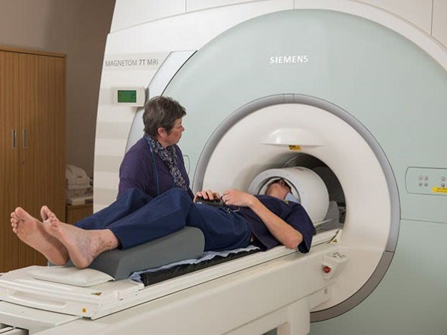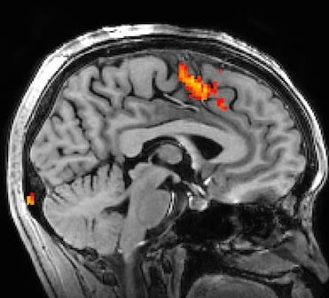

Figure 2.1 - MRI machine and image produced from BOLD contrast taken from [42].

2.2.2. Electroencephalogram (EEG)
High Another technique used in creativity research is the electroencephalogram (EEG). An EEG is a device used to measure and record the “...electrical potentials generated in the extracellular fluid as ions flow across cell membranes and neurons talk to one another via neurotransmitters” [43].

These electrical signals are collected through electrodes placed on the scalp. From these signals, responses to stimuli can be extracted and analyzed, providing high temporal resolution of brain activity. EEG signals are analyzed based on frequency, amplitude, and electrode position. Frequency bands such as delta (0.1-4 Hz), theta (4-8 Hz), alpha (8-13 Hz), beta (13-30 Hz), and gamma (30-100 Hz) relate to specific states of brain activity, and these states can be mapped to various areas of the brain with high temporal accuracy.
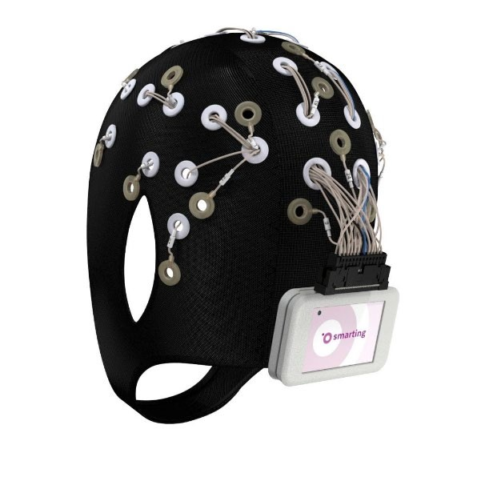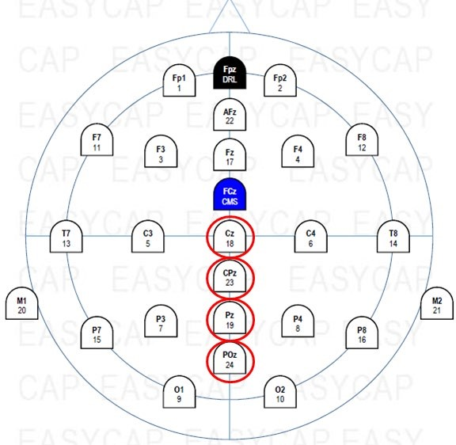
Figure 2.2 - Mobile EEG cap with 24 channels and corresponding electrode layout taken from [44]. Electrodes circled (Cz, CPz, Pz, and POz) are for reference later in the text (Section 5.2).

Alpha waves have been noted in various studies to correlate to tasks requiring creative responses. Many of these studies have examined a phenomenon called alpha synchronization, a period when alpha frequency (activity around the alpha band of 8-13 Hz) increases in power. The synchronization period is associated with periods of cognitive idling or rest. Alpha desynchronization, on the other hand, is related to a loss of power in the alpha frequency band and typically presents when cognition is actively engaged. Increased alpha synchronization had been linked to greater creative ability [45, 46] as well as more original ideas [47-49]. Several researchers have also reported that creative training was related to higher alpha activity, thus indicating the possibility that creative ability can be enhanced [50-52].

EEGs can also be used to record event-related potentials (ERPs). ERPs are signals that are time locked to a stimulus and provide a step-by-step visualization of the brain processes at each electrode during a trial [40]. They are direct measurements, down to the millisecond, of neurotransmitter activity [53]. Several components, noted as positive or negative signal amplitude peaks or fluctuations correlated to specific times, have been discovered that relate to specific brain processes. Specifically, the N400, post-N400, and P50 components have been related to creative processes. The N400 is a negatively (signified by the “N”) peaking potential that occurs between 300-500 ms after stimulus presentation. It has been related to the processing of semantic mismatches and violations of prior knowledge [40]. Additionally, a study by [54] linked the N400 component to conceptual expansion and noticed it responds to unusual stimuli.

Similarly, [55] reported the N400 as responsive as a function of unusualness or novelty to their experimental stimuli while investigating conceptual expansion. The post-N400 component is a negative response that varies directly following the N400 component and is related to interpretation processes and concept integration. Similarly, the P50 is a positively (signified by the “P”) peaking potential occurring around 50 ms after stimulus presentation. This component is related to sensory gating of relevant and irrelevant information.
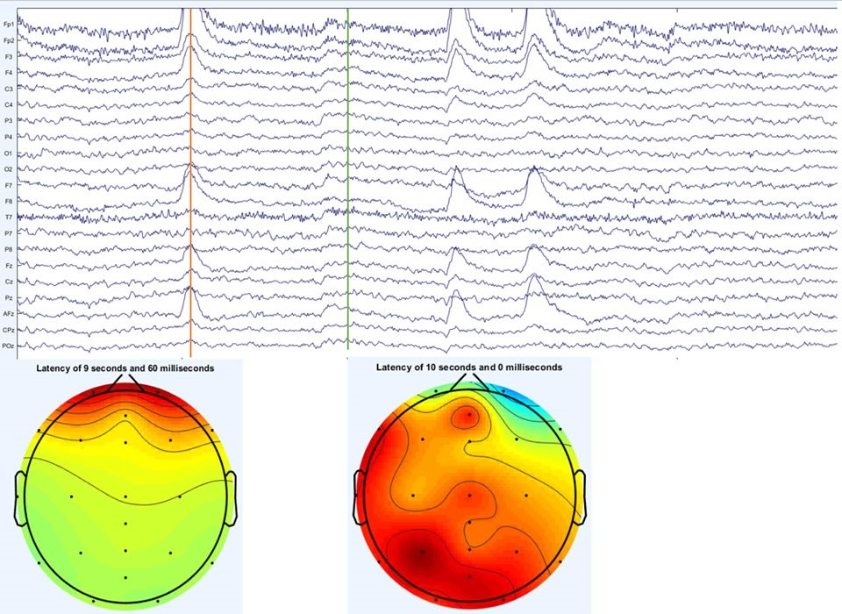
Figure 2.3 - Raw EEG data from 24 electrodes filtered between .5-100 Hz (Top) and corresponding electrical activity head maps at two points (bottom).

Because of its high temporal precision, the use of EEG and ERP in studies are ideal for providing data about the neural processes that occur between stimulus presentation and neural response. Currently, ERP has been used to understand language processing and Alternative Usage Task experiments. Overall, measuring temporal variation of neuro-response during idea generation can provide ways to better understand creative thinking by allowing us to measure creative ideas and relate them with neuro-responses.
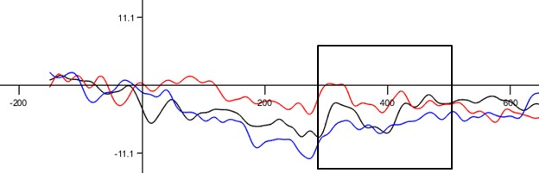
Figure 2.4 - ERP images from one electrode for three different types of stimuli. Box represents the 300 ms - 500 ms post-stimulus range, where the N400 effect could be found.

2.3. The Engineering Design Process
In this section is presented a generalized engineering design process to which neuroscientific techniques could be applied to understand creativity and divergent thinking in engineering design and concept generation (ED&CG). As discussed in Section 1, it is imperative to develop creativity in engineers. Creativity is key to providing innovative solutions to unique and difficult problems. One process that engineers use to solve these problems is the engineering design process. Though there are several different groups of thought and various specific methods and techniques, the basic process is as follows:
- Identify the problem or need,
- Generate possible solutions,
- Down select one or more solutions
- Prototype the solution,
- Test and evaluate the solution.

Each step is its own iterative process, and if necessary, steps may be repeated to obtain a final solution. In the first step, a problem or need is identified and researched. Stakeholders, requirements, and constraints all need to be established to understand the actual problem to be addressed. Once the “actual” problem has been established, step two can commence, and solutions can be generated that address this problem. In step 3, generated solutions are down selected to a small number to prototype, allowing for important tradeoffs to be made and money to be saved from prototyping less appropriate solutions. Once a prototype reaches step 5, if it fails or needs improvement, engineers may go back to step 3 or even step 2. If it succeeds, it may be further improved or exit the design process and continue to be manufacturing. See Figure 2.5.
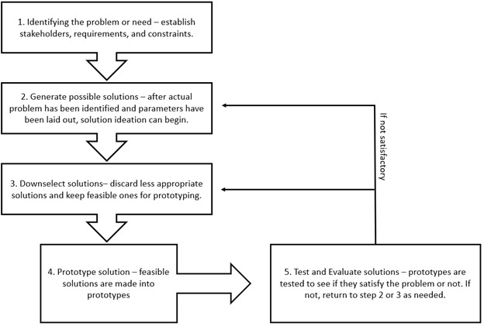
Figure 2.5 -Typical Engineering Design Process.

Creativity in this process is important, but how does one measure the amount of creativity that an engineer uses during this process? This kind of process is not executed in a vacuum. Engineers must work in teams, communicate with stakeholders, integrate new knowledge, and use various methods, techniques, and tools. Each process takes days and weeks to complete. How can a complicated process like this be broken down and studied from a neuroscientific point of view? Table 2.1 shows what needs to be studied in relation to the engineering design process. Use of techniques for spatial investigations (such as fMRI, etc.) can shed light on which areas of the brain are active during certain parts of the engineering design process. Next, since spatial investigations find out which areas of the brain are active, the corresponding areas can be investigated using temporal methods (i.e., EEG). Overall, the location alone is not enough for understanding how to change engineering curriculum. There is a specific need to focus on temporal investigations with respect to the generation of solutions to problems. The use of timebased techniques will advance research since these experiments will show exactly when idea generation occurs (down to the millisecond), what prompted the idea or what was happening when it occurred, and how that prompt or action can be used in education. This will be especially useful for creative or novel idea generation.

Table 2.1 - Neuroimaging investigations needed for the engineering design process.
Design Process Step | Spatial (Location) Investigation | Temporal (Time) Investigation
1 - Identifying the problem or need | ✔
2 - Generate possible solutions | ✔ | ✔✔
3 - Downselect one or more solutions | ✔
4 - Prototype the solution | ✔
5 - Test and evaluate the solution | ✔

2.4. Utilizing Neurological Techniques to Study Engineering Design
Though neuroimaging methods have been used to investigate general concepts and theories of creativity, application of these methods to investigate creativity in engineering design and concept generation has been minimal. An important aspect to consider when selecting a neuroimaging method is whether the device has better spatial resolution or temporal resolution. Spatial resolution relates to a method’s capability to provide fine location detail, to map the areas of the brain experiencing activity. Temporal resolution refers to the granularity of time detail obtained when brain activation is occurring. Different techniques offer different combinations of spatial and temporal resolution, but typically fMRI is regarded as having high spatial resolution and poor temporal resolution, while EEG is the opposite, having poor spatial resolution and excellent temporal resolution. Thus, technique type needs to be taken into consideration when designing experiments based upon what is to be examined. In this section, some of the current neurological investigations of engineering design and concept generation (ED&CG) are presented. Overall, there is a limited amount of work that has been published relating neuroimaging and design [56]. There are some studies that make use of fMRI and EEG, but at this time, no papers were found applying ERP to engineering design type problems.

2.4.1 Current use of fMRI in the study of ED&CG
One of the first design investigations was conducted by [57] who utilized fMRI to study the difference in the cognitive processes employed when solving design tasks compared to non-design tasks. The authors found that design tasks and non-design tasks employ different cognitive processes. These cognitive processes are linked to different regions of the brain and there was extensive activation of these regions when solving the design tasks compared to the non-design tasks. The paper further suggests that general problem-solving and design thinking are distinct. Although [57] is not a plain study of creativity, the methodology used to study the design process can be adopted when studying creativity in the ED&CG process.
A study by [58] used fMRI to investigate design ideation and concept generation with and without the support of inspirational stimuli (e.g., analogies). While not all participants were in the field of engineering, participants were graduate-level students specializing in engineering, design, or product development, which included mechanical engineering students. Results indicated that brain activation was different for participants that were able to successfully use the inspiration to generate an insightful design and those that were unsuccessful (mostly those that did not receive inspiration).
The study in [59] used fMRI to investigate brain activity of engineering designers during conceptual generation in order to see if design fixation (defined as adherence to a set of ideas or concepts that limit the final output of a design) could be detected when participants were solving design problems. Some participants were given example images (sketches) and others were not. Areas of the brain associated with creative output were found to be less active in the example condition.

2.4.2 Current use of EEG in the study of ED&CG
Researchers from Concordia University have done a case study analyzing design activities via EEG [60]. In this research, the participant was given a design problem that asked the participant to arrange furniture in a room based on a given set of circumstances and measurements. In a follow-up study by [61], engineering students were asked to design a house that could fly while EEG was recorded. This experiment used a technique called clustering that examined the power spectral density in the different halves of the brain, but there were no significant results. Yet another study by [62] recorded EEG and heart rate while engineering students worked on a design problem of their choice, however most picked the same house design problem as listed before. They found that mental effort (which they used as an indirect measure of creativity and measured via EEG) was lowest when mental stress is highest (measured via the heart rate monitor). These small-scale studies indicate that it is possible to use EEG alongside design-type problems, yet it is complex due to a multitude of factors such as the intricacies involved in the engineering design process, the associated processing of data, and the isolation of creative thought processes.
A recent EEG study by [63] replicated the [57] study mentioned above (Section 4.1). The experiment consisted of 18 mechanical engineering students and 18 architects. The experimental setup incorporated an additional open design task that included free-hand sketching. Findings indicated design neurocognition differed when problem-solving versus designing, particularly in the sketching task, as indicated by transformed power and task-related power within the EEG readings.

2.4.3 Current use of other techniques in the study of ED&CG
While not a primary talking point of this paper, a notable investigation with the use of functional near infrared spectroscopy (fNIRS) is worthy of mention. This technique works via the absorption or reflection of hemoglobin in certain areas of the brain. Researchers in [64] utilized fNIRS to investigate the neurological differences in freshman and senior-level engineering students during an engineering design brainstorm. Even though this study did not look at the novelty of ideas generated, this study found that freshmen generated more solutions and had five times greater activation in regions of the brain related to memory, planning, decision making, and ability to think about multiple concepts at once than seniors. On the other hand, seniors had ten times the activation in areas associated with behavior control, uncertainty management, and self-reflection in decision making.

2.5. Preliminary ERP investigation
As noted above, there are currently no ERP based experiments of engineering design and creativity. Furthermore, as of date, our research has not found any ERP studies related to engineering in any aspect. In order to investigate ERPs near the realm of engineering, our lab has run a pilot study investigating the N400 response of engineers following a design similar to the experiment in [55]. Two male individuals, one in Aerospace and Mechanical Engineering and the other in Industrial and Systems Engineering, participated in one trial each for this pilot study. Their results were averaged together for further analysis and then presented here. A brief overview of the experiment will follow. While this experiment was not a direct investigation of engineering design, this experiment presents promising results related to engineering and neuroresponses. Additionally, since the basis of investigations of this type are not present, it is necessary to complete studies of this type in order to construct a base to build upon. Once the basics are covered, there are many different possibilities for neurological research in engineering, which are discussed in the next section of this paper (Section 6).

2.5.1 The study
The pilot study presented here is based off the study that Kroger et. al. [55] implemented in an experimental effort to look at ERPs as an investigation of conceptual expansion. Their team investigated cognitive expansion as a central component of creative thinking based off of a 2012 study [54], which found that conceptual expansion was linked to the N400 component. Kroger et al. [55] looked at ERP data from 24 students from their university with unspecified majors in order to relate the N400 component to unusualness or novelty of stimuli via the use of a modified alternative usage task (AUT). Traditionally, the AUT asks participants to generate as many alternative uses as possible for a common object, such as a pencil. Instead of generating uses for a given item, though, participants were shown a word of an object in conjunction with a potential use for that object as a stimulus. There were three categories of stimuli: creative uses (i.e.,
Shoe > Pot Plant), nonsense uses (i.e., Shoe > Easter Bunny), and common uses (i.e., Shoe > Clothing). Participants were then asked to decide if the given use was unusual and if it was appropriate and they would answer these questions by pushing buttons. Our pilot study narrows down the general focus of [55] to investigate results of individuals solely from engineering.

2.5.2 Results
The Results from this study follow a similar pattern of [55], which indicates that the N400 component is sensitive to semantic difference as well as novelty which is indicated by differences in the mean amplitudes of the four electrodes of interest for each stimulus type, see Figure 2.6. The four electrodes of interest (Cz, CPz, Pz, and POz) were chosen here based upon electrodes identified in [54]. Locations of these electrodes are highlighted in Figure 2.2. Data indicated that stimuli classified as nonsensical or creative elicit larger N400 amplitudes than the common uses. Given the higher amplitudes for the nonsense and creative uses, it is an indication that the N400 in engineers is sensitive to levels of novelty or unusualness.
In summary, data from this pilot study indicates that the N400 component in engineers is influenced by novelty and unusualness. In the future, we aim to increase the number of participants in order to validate the pilot study, investigate the post-N400 response, and remove the POz electrode from analysis due to its ties to vision as opposed to creative thinking processes. The waveforms of single electrode sites Cz and CPz from one of the trials are depicted below in Figure 2.7.
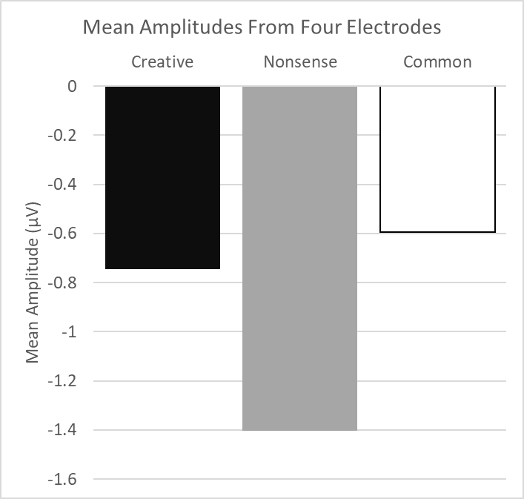
Figure 2.6 - Mean amplitudes from four electrodes (Cz, CPz, Pz, and POz) for the three types of item-use pairs (creative uses, nonsensical uses, and common uses) for the 300-500 ms time window investigating the N400 effect.

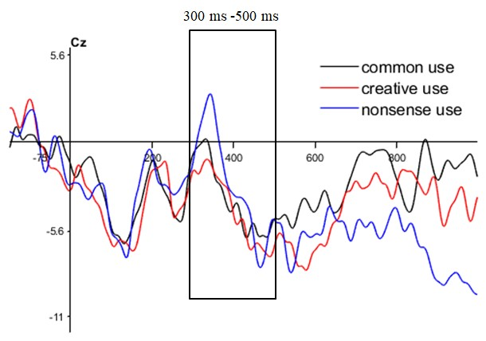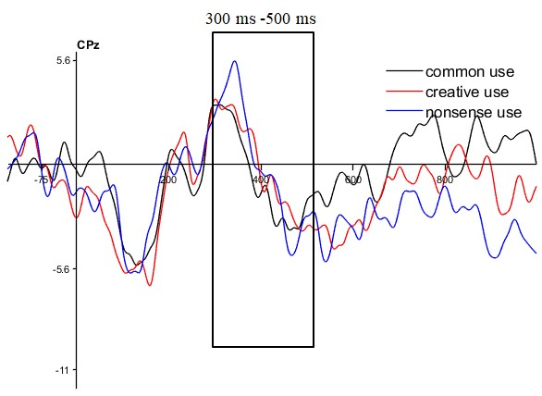
Figure 2.7 - ERPs from the Cz (top) and CPz (bottom) electrodes from one individual. The box outline indicates the 300-500 ms window of investigation of the N400 effect.

2.6. Future Directions
Designing experiments to study the neurological responses on engineering design and concept generation is not a straightforward task. However, by using tools like fMRI, areas of the brain that are active during the engineering design process could be highlighted. This would be achieved by designing experiments such that fMRI could be recorded while addressing different parts of the engineering design process or during idea generating tasks. Then, since the general area of interest would be known, this would allow further investigations with other methods like EEG, and appropriate approaches to EEG experiments could be determined. In this paper, we focus more on potential EEG experiments than on fMRI, and present two experimental concepts for future investigations.
One important consideration when studying engineering design and concept generation is breaking up these complex, multi-step processes into neuro scientifically measurable processes. The studies reported in Section 4 treated the problem solving and design process as a black box (i.e., as a single, long step). However, when wanting to investigate the effect of a treatment on a single part of the problem solving or design process (e.g., the idea generation step or the problem finding step), there is work needed to design these experiments.

For example, no research has yet been completed on studying the effect of using the alternative uses task (AUT) on engineering students’ divergent thinking skills when generating concepts to solve an engineering problem. This could be accomplished as follows. Two groups of engineering students would be asked to solve a design problem. One group would be asked to practice with the AUT before solving the engineering problem, and the other group (the control group) would solve the engineering problem without practicing with the AUT. The AUT portion of the experiment would not have to be monitored with an EEG, as the creativity will be measured from the engineering problem. The engineering problem would be broken into two steps. First, participants would be presented with a problem that requires a solution (e.g., prevent water from sticking to a glass surface). Then, participants would be asked to generate simple alternative ideas that would satisfy the problem. After the idea generation step, the participants would be asked to use their concepts to come up with one complete solution. EEG would be recorded for the entirety of the engineering portion of the experiment. These signals could then be compared to find differences between the two groups. It would also be possible to utilize ERP, as well. In this case, the participant could press a button every time they think of a solution and the ERP could be analyzed around that time.

Since no ERP studies related to engineering design and concept generation have been done, including how to improve instructions for these approaches, there is a need for further investigations into this area. In designing ERP experiments, it is important to identify components of interest (i.e., N400). As mentioned in Section 2.1.2, the N400 or Post-N400 components would be a good place to start since studies have shown there is some relation to novelty, unusualness, and conceptual expansion [54, 55]. Since ERPs are responses to stimuli, it is important to have ED&CG experiments broken up into small, manageable parts, as suggested above. Methods like function structure diagrams and Energy-Material-Systems (EMS) models are useful in breaking down engineering problems into smaller chunks and thus could be used to design short and simple experiments appropriate for ERP analysis. For instance, it would be possible to present certain aspects of a problem to a participant followed by possible solutions (e.g., selecting an energy source for a machine followed by different types of energy sources such as solar power, wind power, natural gas, etc.) to measure the effect a suggested solution has on brain activity. On the same note, it would be possible to present a problem to a participant and have them press a button when they generate their own possible solution all while recording EEG (e.g., telling participant to come up with possible energy sources for a machine and pressing a button when they come up with a solution).

With neurological research into engineering design and concept generation starting to bud, there are several sub-areas that could be further investigated. Potential experiments include studying creativity and improving instruction at different stages of the engineering design process (as suggested above), studying the effects of different models and techniques such as EMS, TRIZ, etc. on ideation, studying creative responses and idea generation within teams, studying the effects of diversity within teams on the engineering design process, and studying the effect of experience on creative responses and idea generation.

Through these experiments, various processes, exercises, and techniques used to improve an individual’s creativity could be tested for their effectiveness. The neuro-responses during concept generation and steps of the engineering design process could also be used to understand how the brain operates during these activities. Specific EEG frequencies and ERP components could be identified as key to concept generation and specific steps in the design process. These responses could then be related to experimental data from specific creativity improving processes, exercises, and techniques to obtain targeted improvement of specific brain processes. These processes, exercises, and techniques could then be appropriately implemented within the engineering curriculum to effectively improve students’ creativity. The neuro-responses can inform which design tools to use at different steps of the design process and how to improve instructions on proper application of the tools.

2.7. Conclusion
Since creativity is not well understood with respect to engineering [15, 21, 65], nor is there a lot of previous neuroscientific research investigating ED&CG, it is difficult to design experiments related to the topic. In this paper, we discussed neuroimaging techniques as well as how these techniques have been used in relation to ED&CG up to this point. We also provided suggestions for experiments, and the next step would be to conduct these investigations. As more data from these future investigations becomes available, it can be used to improve engineering education. This data will aid researchers in understanding what cognitive processes are used in the engineering design process. Furthermore, creativity improving techniques could be measured using neuroscientific data. These techniques could then be incorporated into engineering education curriculum to promote creativity in engineers.

2.8. Acknowledgement
This material is based upon work supported by the National Science Foundation under Grant No. 1561660 and 1726358, 1726811, and 1726884. Any opinions, findings, and conclusions or recommendations expressed in this material are those of the author(s) and do not necessarily reflect the views of the National Science Foundation.

2.9. References
- K. H. Kim, “The Creativity Crisis: The Decrease in Creative Thinking Scores on the Torrance Tests of Creative Thinking,” Creativity Research Journal, vol. 23, no. 4, pp. 285–295, 2011.
- K. H. Kim and R. A. Pierce, “Torrance’s innovator meter and the decline of creativity in America,” The Routledge International Handbook of Innovation Education, vol. 5, pp. 153–167, 2013.
- G. A. Davis, “Testing for creative potential,” Contemporary Educational Psychology, vol. 14, no. 3, pp. 257–274, 1989.
- K. H. Kim, “Can We Trust Creativity Tests? A Review of the Torrance Tests of Creative Thinking (TTCT),” Creativity Research Journal, vol. 18, no. 1, pp. 3–14, Jan. 2006.
- H. B. Parkhurst, “Confusion, Lack of Consensus, and the Definition of Creativity as a Construct,” The Journal of Creative Behavior, vol. 33, no. 1, pp. 1–21, 1999.
- R. Florida, The rise of the creative class--revisited: Revised and expanded. Basic Books (AZ), 2014.
- “IBM 2010 Global CEO Study: Creativity Selected as Most Crucial Factor for Future Success,” IBM Newsroom - 2010-05-18 IBM 2010 Global CEO Study: Creativity Selected as Most Crucial Factor for Future Success - United States, 18-May-2010. [Online]. Available: https://www-03.ibm.com/press/us/en/pressrelease/31670.wss. [Accessed: 12-Mar-2020].
- National Academy of Engineering, U. S. The engineer of 2020: Visions of engineering in the new century. Washington, DC: National Academies Press, 2004.
- Olson, Steve, ed. Educating engineers: Preparing 21st century leaders in the context of new modes of learning: Summary of a forum. National Academies Press, 2013.
- F. E. Jones, “Predictor variables for creativity in industrial science.,” Journal of Applied Psychology, vol. 48, no. 2, pp. 134–136, 1964.
- C. D. Mcdermid, “Some correlates of creativity in engineering personnel.,” Journal of Applied Psychology, vol. 49, no. 1, pp. 14–19, 1965.
- T. B. Sprecher, “A study of engineers criteria for creativity.,” Journal of Applied Psychology, vol. 43, no. 2, pp. 141–148, 1959.
- B. D. Bleedorn, “Creativity: Number One Leadership Talent for Global Futures,” The Journal of Creative Behavior, vol. 20, no. 4, pp. 276–282, 1986.
- K. Bateman, “IT students miss out on roles due to lack of creativity,” ComputerWeekly, 18Apr-1013. [Online]. Available: https://www.computerweekly.com/blog/ITWorks/ITstudents-miss-out-on-roles-due-to-lack-of-creativity. [Accessed: 12-Mar-2020].
- D. H. Cropley, "Creativity in engineering." In Multidisciplinary contributions to the science of creative thinking, pp. 155-173. Springer, Singapore, 2016.
- K. Kazerounian and S. Foley, “Barriers to Creativity in Engineering Education: A Study of Instructors and Students Perceptions,” Journal of Mechanical Design, vol. 129, no. 7, pp. 761–768, 2007.
- C. Charyton, Creative engineering design assessment: background, directions, manual, scoring guide and uses. London: Springer, 2014.
- L. Richards, “Stimulating creativity: teaching engineers to be innovators,” FIE 98. 28th Annual Frontiers in Education Conference. Moving from Teacher-Centered to LearnerCentered Education. Conference Proceedings (Cat. No.98CH36214), vol. 3, pp. 1034– 1039, Nov. 1998.
- C. Masters, S. Hunter, and G. Okudan. "Design Process Learning and Creative Processing: Is There a Synergy." In ASEE Conference Proceedings. 2009.
- J. P. Adams, S. Kaczmarczyk, P. Picton, and P. Demian. "Improving problem solving and encouraging creativity in engineering undergraduates." From International Conference on Engineering Education, 2007.
- D. H. Cropley, “Promoting creativity and innovation in engineering education.,” Psychology of Aesthetics, Creativity, and the Arts, vol. 9, no. 2, pp. 161–171, 2015.
- J. J. Duderstadt, “Engineering for a Changing Road, a Roadmap to the Future of
Engineering Practice, Research, and Education.,” 2007
- C.L. Dym, A. M. Agogino, O. Eris, D. D. Frey, and L. J. Leifer. "Engineering design thinking, teaching, and learning." Journal of engineering education 94, no. 1, pp. 103120, 2005.
- R. M. Felder, "Creativity in engineering education." Chemical Engineering Education 22, no. 3, pp. 120-125, 1988.
- J. A. Plucker, R. A. Beghetto, and G. T. Dow, “Why Isnt Creativity More Important to Educational Psychologists? Potentials, Pitfalls, and Future Directions in Creativity Research,” Educational Psychologist, vol. 39, no. 2, pp. 83–96, 2004.
- J. C. Santamarina, "Creativity and Engineering-Education Strategies." Proc. Int. Conference on Engineering Education in Honor of JTP Yao, Texas A&M, pp. 91-108, 2003.
- R. Stratton, D. Mann, and P. Otterson. "The Theory of Inventive Problem Solving (TRIZ) and Systematic Innovation-a Missing Link in Engineering Education?." TRIZ Journal, 2000.
- S. Törnkvist, “Creativity: Can It Be Taught? The Case of Engineering Education,” European Journal of Engineering Education, vol. 23, no. 1, pp. 5–12, 1998.
- E. Gregory, M. Hardiman, J. Yarmolinskaya, L. Rinne, and C. Limb, “Building creative thinking in the classroom: From research to practice,” International Journal of Educational Research, vol. 62, pp. 43–50, 2013.
- C. J. Limb and A. R. Braun, “Neural Substrates of Spontaneous Musical Performance: An fMRI Study of Jazz Improvisation,” PLoS ONE, vol. 3, no. 2, 2008.
- N. Bechtereva, A. Korotkov, S. Pakhomov, M. Roudas, M. Starchenko, and S. Medvedev, “PET study of brain maintenance of verbal creative activity,” International Journal of Psychophysiology, vol. 53, no. 1, pp. 11–20, 2004.
- R. A. Chávez-Eakle, A. Graff-Guerrero, J.-C. García-Reyna, V. Vaugier, and C. CruzFuentes, “Cerebral blood flow associated with creative performance: A comparative study,” NeuroImage, vol. 38, no. 3, pp. 519–528, 2007.
- B. S. Folley and S. Park, “Verbal creativity and schizotypal personality in relation to prefrontal hemispheric laterality: A behavioral and near-infrared optical imaging study,” Schizophrenia Research, vol. 80, no. 2-3, pp. 271–282, 2005.
- C. Gibson, B. S. Folley, and S. Park, “Enhanced divergent thinking and creativity in musicians: A behavioral and near-infrared spectroscopy study,” Brain and Cognition, vol. 69, no. 1, pp. 162–169, 2009.
- H. Takeuchi, Y. Taki, Y. Sassa, H. Hashizume, A. Sekiguchi, A. Fukushima, and R. Kawashima, “Regional gray matter volume of dopaminergic system associate with creativity: Evidence from voxel-based morphometry,” NeuroImage, vol. 51, no. 2, pp. 578–585, 2010.
- H. Takeuchi, Y. Taki, Y. Sassa, H. Hashizume, A. Sekiguchi, A. Fukushima, and R. Kawashima, “White matter structures associated with creativity: Evidence from diffusion tensor imaging,” NeuroImage, vol. 51, no. 1, pp. 11–18, 2010.
- L. M. Pidgeon, M. Grealy, A. H. B. Duffy, L. Hay, C. Mcteague, T. Vuletic, D. Coyle, and S. J. Gilbert, “Functional neuroimaging of visual creativity: a systematic review and meta-analysis,” Brain and Behavior, vol. 6, no. 10, Nov. 2016.
- A. Fink and M. Benedek, “EEG alpha power and creative ideation,” Neuroscience & Biobehavioral Reviews, vol. 44, pp. 111–123, 2014.
- R. Arden, R. S. Chavez, R. Grazioplene, and R. E. Jung, “Neuroimaging creativity: A psychometric view,” Behavioural Brain Research, vol. 214, no. 2, pp. 143–156, 2010.
- A. Abraham, The neuroscience of creativity. Cambridge, United Kingdom: Cambridge University Press, 2019.
- A. Dietrich and R. Kanso, “A review of EEG, ERP, and neuroimaging studies of creativity and insight.,” Psychological Bulletin, vol. 136, no. 5, pp. 822–848, 2010.
- Nuffield Department of Clinical Neurosciences. University of Oxford. Retrieved April 6, 2020, from https://www.ndcn.ox.ac.uk/divisions/fmrib/what-is-fmri/how-is-fmri-used.
- G. F. Woodman, “A brief introduction to the use of event-related potentials in studies of perception and attention,” Attention, Perception, & Psychophysics, vol. 72, no. 8, pp. 2031–2046, 2010.
- MBrainTrain. Fully Mobile EEG Devices. Retrieved February 3, 2020, from https://mbraintrain.com/, 2018.
- A. Fink, R. H. Grabner, M. Benedek, G. Reishofer, V. Hauswirth, M. Fally, C. Neuper, F. Ebner, and A. C. Neubauer, “The creative brain: Investigation of brain activity during creative problem solving by means of EEG and FMRI,” Human Brain Mapping, vol. 30, no. 3, pp. 734–748, 2009.
- E. Jauk, M. Benedek, and A. C. Neubauer, “Tackling creativity at its roots: Evidence for different patterns of EEG alpha activity related to convergent and divergent modes of task processing,” International Journal of Psychophysiology, vol. 84, no. 2, pp. 219–225, 2012.
- A. Fink and A. C. Neubauer, “EEG alpha oscillations during the performance of verbal creativity tasks: Differential effects of sex and verbal intelligence,” International Journal of Psychophysiology, vol. 62, no. 1, pp. 46–53, 2006.
- R. H. Grabner, A. Fink, and A. C. Neubauer, “Brain correlates of self-rated originality of ideas: Evidence from event-related power and phase-locking changes in the EEG.,” Behavioral Neuroscience, vol. 121, no. 1, pp. 224–230, 2007.
- D. Schwab, M. Benedek, I. Papousek, E. M. Weiss, and A. Fink, “The time-course of EEG alpha power changes in creative ideation,” Frontiers in Human Neuroscience, vol. 8, 2014.
- A. Fink, R. H. Grabner, M. Benedek, and A. C. Neubauer, “Divergent thinking training is related to frontal electroencephalogram alpha synchronization,” European Journal of Neuroscience, vol. 23, no. 8, pp. 2241–2246, 2006.
- A. Fink, R. H. Grabner, M. Benedek, and A. C. Neubauer, “Divergent thinking training is related to frontal electroencephalogram alpha synchronization,” European Journal of Neuroscience, vol. 23, no. 8, pp. 2241–2246, 2006.
- A. Fink, D. Schwab, and I. Papousek, “Sensitivity of EEG upper alpha activity to cognitive and affective creativity interventions,” International Journal of Psychophysiology, vol. 82, no. 3, pp. 233–239, 2011.
- S. Luck, An Introduction to the Event-Related Potential Technique. Second edition. Cambridge, Massachusetts: The MIT Press, 2014.
- B. Rutter, S. Kröger, H. Hill, S. Windmann, C. Hermann, and A. Abraham, “Can clouds dance? Part 2: An ERP investigation of passive conceptual expansion,” Brain and Cognition, vol. 80, no. 3, pp. 301–310, 2012.
- S. Kröger, B. Rutter, H. Hill, S. Windmann, C. Hermann, and A. Abraham, “An ERP study of passive creative conceptual expansion using a modified alternate uses task,” Brain Research, vol. 1527, pp. 189–198, 2013.
- T. Shealy, and M. Hu. "Evaluating the potential of neuroimaging methods to study engineering cognition and project-level decision making." EPOC-MW Conference, Engineering Project Organization Society, Fallen Leaf Lake, CA USA, 2017.
- K. Alexiou, T. Zamenopoulos, J. Johnson, and S. Gilbert, “Exploring the neurological basis of design cognition using brain imaging: some preliminary results,” Design Studies, vol. 30, no. 6, pp. 623–647, 2009.
- K. Goucher-Lambert, J. Moss, and J. Cagan, “A neuroimaging investigation of design ideation with and without inspirational stimuli—understanding the meaning of near and far stimuli,” Design Studies, vol. 60, pp. 1–38, 2019.
- K. K. Fu, B. Sylcott, and K. Das, “Using fMRI to deepen our understanding of design fixation,” Design Science, vol. 5, 2019.
- T. A. Nguyen, T. An, and Y. Zeng. "Analysis of design activities using EEG signals." ASME 2010 international design engineering technical conferences and computers and information in engineering conference. American Society of Mechanical Engineers Digital Collection, 2010.
- T. A. Nguyen, and Y. Zeng. "Clustering designers’ mental activities based on EEG power." Tools and methods of competitive engineering, Karlsruhe, Germany, 2012.
- T. A. Nguyen and Y. Zeng, “A physiological study of relationship between designer’s mental effort and mental stress during conceptual design,” Computer-Aided Design, vol. 54, pp. 3–18, 2014.
- S. L. D. S. Vieira, J. S. Gero, J. Delmoral, V. Gattol, C. Fernandes, and A. A. Fernandes, “Comparing the Design Neurocognition of Mechanical Engineers and Architects: A Study of the Effect of Designer’s Domain,” Proceedings of the Design Society: International Conference on Engineering Design, vol. 1, no. 1, pp. 1853–1862, 2019.
- T. Shealy, J. Grohs, M. Hu, D. Maczka, and R. Pannenton, "Investigating design cognition during brainstorming tasks with freshmen and senior engineering students using functional near infrared spectroscopy." ASEE, Columbus, OH, 2017.
- R. Jonczyk, J. van Hell, G. Okudan Kremer, and Z. Siddique. "Neurocognitive Evidence on the Impact of Topical Familiarity in Creative Outcomes.", 2019.

CHAPTER 3: PILOT STUDY: INVESTIGATING EEG BASED NEURO-RESPONSES OF ENGINEERS VIA A MODIFIED ALTERNATIVE USES TASK TO UNDERSTAND CREATIVITY

3.1. Introduction
In Creative thinking is important, and arguably necessary, to increase the quality of living in the 21st century [1, 2]. However, even though intelligence has been increasing over time, creativity has been in steady decline and action needs to be taken to end this decline [3, 4]. Engineers should not be excluded from this prevention of creativity loss. In fact, the National Academy of Engineering has noted that there is a need for creative, as well as competent, engineers [5, 6]. The demand for creative engineers has been highlighted since before the 1960s [7-9] and creativity continues to be a desirable characteristic [10, 11]. In spite of this demand, it appears that higher education is not preparing students for this type of thinking and students graduating from engineering fields are lacking creative ability [12-14]. Surveys from the University of Connecticut found that students thought instructors focused too much on the use of conventional solutions to problems rather than novel solutions and found that the curriculum taught lacks creativity [14]. Similarly, another study reported that as students moved further down their engineering paths, they believed that there was little value placed on creativity [15]. A multitude of other studies and investigations found that the engineering discipline has become more focused on rote memorization and learning as well as convergent thinking as opposed to other, more innovative approaches [6, 16-24]. Creativity and innovation are trademarks of engineering and creativity is considered to be an imperative prerequisite to innovation, which means that a decline in creative ability will correspond to a decline in the number of innovative engineers [25, 26]. Fortunately, research has shown that creative ability can be enhanced via certain types of exercises and techniques. Through the use of behavioral and neurological approaches, studies have demonstrated changes in brain activity and behavioral outcomes after using creativity enhancing exercises and techniques [27, 28]. Though using behavioral approaches to study the impact of these exercises and techniques on creativity is useful, behavioral approaches do not provide a direct way to investigate the neural mechanisms that underlie creativity. Neurological approaches can provide a direct way to study these underlying processes.

Using neurological approaches allows researchers to obtain visible, physical results that connect stimuli or prompts related to creativity to biological processes and structures. These approaches also allow researchers to test whether or not methods claiming to improve creativity or aid in problem solving actually do so. That is, the effectiveness of methods that claim to aid in innovative design or problem solving could be critically tested utilizing neurological approaches that provide neurological and quantifiable measurements.

In this paper, a pilot study using event-related potentials to investigate the neural responses of engineers completing a modified alternative uses task (AUT) is presented. First, in Section 2, electroencephalography (EEG) and event-related potentials (ERPs) will be introduced, along with a review of the literature concerning neuroimaging, design, concept generation, and problem solving. In Section 3, the pilot study will be described, and the outcomes will be presented. Finally, the paper concludes with a discussion of the outcomes and future directions (Section 4).

3.2. Background

3.2.1. Electroencephalography (EEG) and event related potentials (ERPs)
One technique used to study neural activity of the brain is the electroencephalogram (EEG). An EEG is a device used to measure and record the electrical potential created when neurons release neurotransmitters and other ions [29]. These electrical signals are collected through electrodes placed on scalp, as shown in Figure. 3.1. From these signals, responses to stimuli can be extracted and analyzed, providing high temporal resolution of brain activity. In the majority of studies, EEG signals are analyzed based on frequency, amplitude, and electrode position. Frequency bands such as delta (0.1-4 Hz), theta (4-8 Hz), alpha (8-13 Hz), beta (13-30 Hz), and gamma (30-100 Hz) relate to specific states of brain activity. Figure 3.2 shows raw EEG data and corresponding electrical activity head maps.

Most EEG research surrounding creative ideation focuses around alpha waves, since alpha waves have been noted in various studies to correlate to tasks requiring creative responses [31]. The majority of these studies have examined a phenomenon called alpha synchronization, a period when alpha frequency (activity around the alpha band of 8-13 Hz) increases in power. The synchronization period is associated with periods of cognitive idling or rest. Alpha desynchronization, on the other hand, is related to a loss of power in the alpha frequency band and typically presents when cognition is actively engaged.

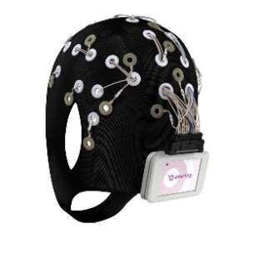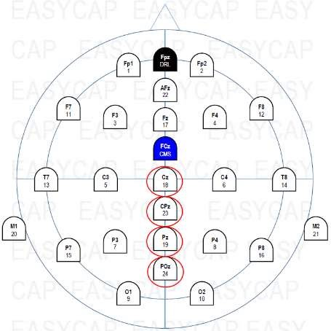
Figure 3.1 - Mobile EEG cap with 24 channels and corresponding electrode layout. Electrodes of interest are circled. See section 3.2 for more information about these electrodes. (Taken from [30]).
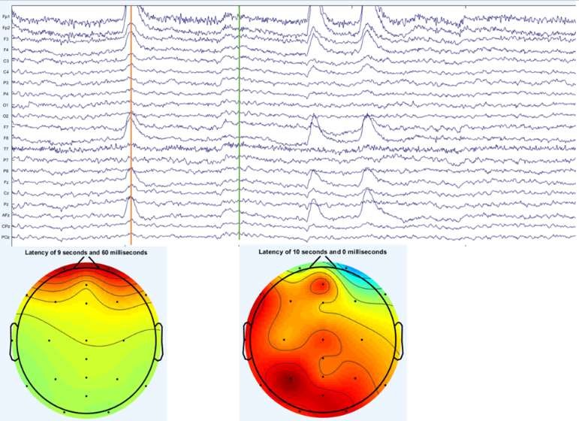
Figure 3.2 - Raw EEG data from 24 electrodes filtered between .5-100 Hz (top) and corresponding electrical activity head maps at two points (bottom).

The Increased alpha synchronization has been linked to greater creative ability [32, 33] as well as more original ideas [34-36]. Higher alpha activity has also been related to creativity training tasks, thus indicating the possibility that the creative ability can be enhanced [34, 37]. Though studies regarding alpha activity have greatly contributed to useful knowledge in the field of creativity research, there is another technique using EEG that could be used to understand the creative process: event-related potentials (ERPs). ERPs are signals that are time-locked to a stimulus and provide a step-by-step visualization of the brain processes at each electrode during a trial [31]. They are direct measurements, down to the millisecond, of neural activity [38]. Several components, noted as positive or negative signal amplitude peaks or fluctuations correlated to specific times, have been discovered that relate to specific brain processes. Specifically, the N400 has been related to cognitive processes essential to creativity. The N400 is a negatively (signified by the “N”) peaking potential that occurs between 300-500 ms after stimulus presentation.

The N400 component has been related to the processing of semantic mismatches and violations of prior knowledge [31]. Additionally, a study by Rutter et al. linked the N400 component to conceptual expansion and noticed it responds to unusual stimuli [39]. Similarly, Kroger et al. reported the N400 as responsive as a function of unusualness or novelty to their experimental stimuli while investigating conceptual expansion through the use of the AUT [40]. Because of their high temporal precision, the use of EEG and ERP in studies are ideal for providing data about the neural processes that occur between stimulus presentation and neural response. For example, ERP has been used to understand language processing and Alternative Uses Task experiments (such as in [40]). Overall, measuring the temporal variation of neuro-responses during idea generation can provide a better understanding of creative thinking and a way to measure creative ideas and relate them directly to neuro-responses.

In a broader scope, neuro-responses can be utilized to enhance engineering design education by studying the effect of teaching alternative approaches at different stages of the design process on students’ creativity as shown in Fig. 3.3. By noting the effect of each approach on each student's cognitive processes during each stage of the design process and linking that to the creative outcome produced, more personalized instructions can be developed based on differences in personality and learning styles, knowledge, and/or environmental factors such as team, classroom, and instructor.

3.2.2. Literature review
Before diving into the current study, it is important to include a literature review of past studies. Even though there are many neuroimaging techniques, we will touch on only a select few: functional magnetic resonance imaging (fMRI), functional near infrared spectroscopy (fNIRS), and EEG. For more comprehensive reviews of fMRI and EEG, see [31, 41,44]. It is important to note that fMRI and fNIRS focus on spatial resolution as opposed to temporal. Spatial resolution allows researchers to investigate which areas of the brain are most active during specific processes. EEG, on the other hand, has high temporal resolution which makes it ideal for providing data about the neural processes that occur between stimulus presentation and neural response. More specifically, temporal resolution refers to the granularity of time detail obtained when brain activation is occurring. Due to the high temporal resolution of EEG, we are able to measure ERPs down to the millisecond.
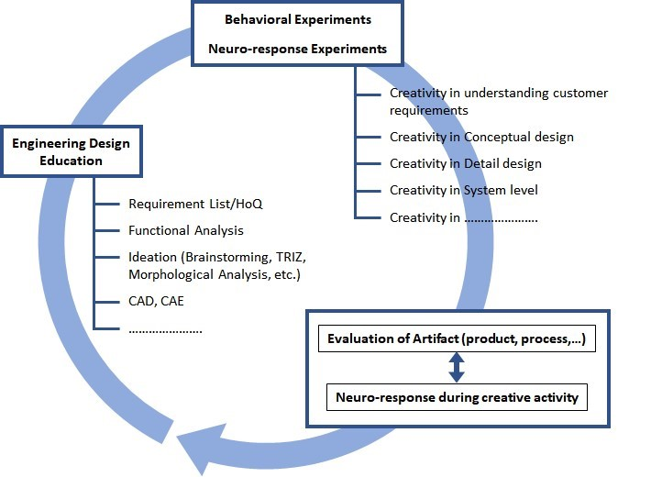
Figure 3.3 - Enhancing creativity in engineering design education.

fMRI fMRI is the most common technique used to investigate creativity [44], yet its use of studying solely engineers, engineering-based problems, or design is limited. One of the first investigations of design and fMRI was used to investigate cognitive processes used for design versus non-design tasks [45]. While this paper was not a study of creativity, the authors found that different cognitive processes were used for design tasks and non-design tasks. The cognitive processes pointed out here were linked to different regions of the brain, where there was extensive activation when solving the design tasks compared to the non-design tasks. A 2013 study utilized fMRI to determine which areas of the brain were activated when participants were asked about products that varied in product form, product function, or both [46]. This form-function tradeoff investigation revealed that choices based on products that vary in both aspects (form and function) involve not only unique, but also common, brain networks as compared to choices that were based only on form or only on function. Specifically, the activated regions were those related to emotion when form and function conflicted with one another. Specifically, the activated regions were those related to emotion when form and function conflicted with one another.

In a more recent fMRI paper related to engineering and design, Hay et al. sought to investigate which regions of the brain were activated in product design engineers with professional experience [47]. In this study, brain activation patterns of open-ended and constrained tasks were compared. The key findings were that product design en gineer ideation was associated with greater activity in left cingulate gyrus, but no significant differences were observed between constrained or open-ended tasks. Furthermore, there was preliminary association with activity in the right superior temporal gyrus for concept generation during ideation tasks. Finally, an fMRI study by [48] tested graduate-level students specializing in engineering, design, or product development to investigate design ideation and concept generation with and without the support of inspirational stimuli (e.g., analogies). Here, brain activation differed for participants that were able to successfully use the inspiration to generate an insightful design and those that were unsuccessful, most of which did not receive inspirational stimuli.

fNIRS
A few notable investigations have used fNIRS to explore the brains of engineering students. One of the earlier investigations of fNIRS and engineering found that freshman level engineering students had five times greater activation in regions of the brain related to memory, planning, decision making, and ability to think about multiple concepts at once than seniors [49]. Seniors, on the other hand, had ten times the activation in areas associated with behavior control, uncertainty management, and self-reflection in decision making. Another study looked at neuro-cognitive differences among engineering students when using different concept generation techniques. This study indicated intra-hemisphere connectivity in the left hemisphere for unstructured techniques, intra-hemisphere connectivity in the right hemisphere for partially structured techniques, and inter-hemisphere connectivity between both the left and right hemisphere for structured techniques [50].

Another investigation has focused on hemisphere differences for brainstorming, morphological analysis, and TRIZ [51]. With respect to concept generation, there is left hemisphere dominance. More specifically, the left dorsolateral prefrontal cortex (dlPFC), which is central to spatial working memory and filtering information, was active. In terms of the concept generation techniques, the left dlPFC was again active during morphological analyses and TRIZ, the right dlPFC and medial PFC for brainstorming. The right dlPFC is related to divergent thinking and mPFC facilitates memory retrieval.

EEG and ERP
Researchers at Concordia University have done several EEG studies of design activities. In one of their case studies, a participant was asked to arrange a room based on a set of parameters while EEG was recorded [52]. They reported that the participant showed more efforts in the prefrontal lobe in solution evaluation and high visual high visual thinking effort in solution generation compared to solution evaluation. In one of their follow-up studies, EEG was recorded while engineering students were asked to design a house that could fly [53]. This experiment used a technique called clustering that examined the power spectral density in the different halves of the brain, but there were no significant results. A third study recorded EEG as well as heart rate while engineering students worked on a design problem of their choice, however most picked the same house design problem as listed before. Results here indicated that mental effort (which they used as an indirect measure of creativity and measured via EEG) was lowest when mental stress is highest, as indicated by the heart rate monitor [54].
A study by [55] attempted to investigate the influence of different problem statements on designers’ cognitive behaviors from three perspectives, namely divergent thinking, convergent thinking, and mental workload. This task-related alpha power investigation found higher alpha power in the temporal and occipital regions with open-ended problem statements compared to decision-making or constrained statements. Activity in the left hemisphere was stronger for decisionmaking and constrained statements. Moreover, designer's mental workload was the highest for constrained problem statements.

Vieira and colleagues looked at an open design task that included free-hand sketching [56]. Testing 18 mechanical engineering students and 18 architects, their findings indicated that design neurocognition differed when comparing problemsolving versus designing, particularly in the sketching task, as indicated by transformed power and task-related power within the EEG readings. Fritz, Deschenes, Pandey [57] used EEG to evaluate an individual’s performance in a group setting. EEG data revealed a correlation between raw amplitude and level of team contribution, a higher variation in the channel power spectral density during individual versus team tasks, and a degradation of alpha activity moving from individual to group work. Results from another EEG data set point out that design activities were associated with beta-2, gamma-1, and gamma-2 bands between 20-40Hz while resting is mostly associated with alpha band (8-14Hz) [58].

As for ERPs, there is limited research in this area. Search results showed a few studies related to package design and products. For instance, Rojas and colleagues used EEG and eye tracking to explore the combination of ERPs, eye-tracking techniques, and visual product perception [59]. No significant differences were found. A 2015 inquiry was able to predict participants’ choice of two products based on ERPs [60]. They found and increase in the N200 component of a mid-frontal electrode and a weaker theta band power that correlates with a more preferred product. Finally, a third paper examined EEG and ERPs, but did not list a specific ERP for their investigation [61]. Instead, they list times in which there were positive or negative going waveforms during their experimentation and mention that the activation they find around 400ms might be the P3 component. They also mention the possibility of the FN400 component. At this time, no papers were found applying ERP to engineering design type problems. At this time, no papers were found applying ERP to engineering design type problems, so more research is needed.

3.2.3. Utilizing ERPs to study creativity
The pilot study presented in this paper is based off the study in [40] that implemented an ERP experimental design in order to investigate conceptual expansion. Their team investigated cognitive expansion as a central component of creative thinking based off a 2012 study by [39], which found that conceptual expansion was linked to the N400 component. The study in [40] used ERP to relate the N400 component to unusualness or novelty of stimuli. They utilized 24 students from their university with unspecified majors and implemented a modified alternative usage task (AUT). Traditionally for the AUT, participants generate as many alternative uses as possible for a common object, such as a pen. This task may be repeated for several objects, one object at a time, with each object recorded as a separate trial. Instead of generating uses for a given item, though, participants were shown a word of an object in conjunction with a potential use for that object as a stimulus. Participants were then asked to decide if the given use was unusual and if it was appropriate. Participants would answer these questions by pushing buttons. Our pilot study narrows the general focus of the article [40] to investigate results of individuals solely from the field of engineering.

It is important to notice that the studies mentioned in the literature review mainly focus on design, concept generation, and problem solving. Even though a few of the papers listed above mention divergent thinking or creativity, none of the studies put a particular emphasis on creativity or novelty. Additionally, none of them were ERP tasks. Given that, it is necessary to utilize ERP and understand how the brain reacts to unusualness, novelty, or creative stimuli. This is something that we aim to do. Furthermore, it is of great importance to research solely engineers in order to build up research in this area. Results from [40] analyzed data form participants with unnamed majors or degree programs. Thus, this study (and future studies like it) will focus only on engineers.

3.3. The Pilot Study
In this section we present the experimental procedure, data analysis, and the results for our pilot study. This study followed a similar procedure to [40] with a few minor differences as noted in the following sections. These changes were made in order to simplify the experiment, reduce the programming and written code behind the experiment, and ensure a shorter experiment time. Two male individuals in the engineering college participated in one trial each for this pilot study, and their results were averaged for further analysis.

3.3.1. Participants
Two engineer volunteers, one from Aerospace and Mechanical Engineering (AME) and the other from Industrial and Systems Engineering (ISE), participated in this case study consisting of two trials. Participants were both right-handed, bilingual, and spoke English as a second language. Both participants have normal vision and neither had a history of neurological or psychiatric illness. This study followed the University of Oklahoma Institutional Review Board guidelines and was approved by the responsible committee. No identifiable personal information was kept in the research data.

3.3.2. Task design/procedure
The experiment was coordinated in a low noise environment. Participants were seated in a chair in front of a computer where the EEG Cap was fitted. Participants were told about what they would see during the experiment and the corresponding buttons they would push. The experiment on the computer would further go over these buttons as a reminder. To reduce EEG artifacts participants were asked to avoid uncontrolled body movements.

In order to familiarize the participant with the experimental procedure and the experiment stimuli, there was a short practice segment presented before the start of the experiment on the computer. After the practice session, participants could start the experiment at their own pace. Each trial started with a fixation cross (+) presented in the middle of the screen for 1000 ms. After a 500 ms blank screen, the participant would see an item use pair (“item > use”) for 2000 ms followed by another blank screen for 500 ms. Participant would see the first question (“Unusual?”) for 1700 ms followed by another blank screen for 500 ms followed by the second question (“Appropriate?”) for 1700 ms followed by another blank screen for 500 ms. The cycle would then repeat, but individual stimulus pairs would not. Unlike in [40], the item alone was not presented by itself before the presentation of the item-use pair. Furthermore, there was no self-paced pause after the stimulus presentation. See Table 1 for the experimental time differences.

Table 3.1 - Stimulus presentation order in [40] versus current study. Time is in milliseconds (ms).

 | Kroger et al. [40] |  | Currenty Study
 |  | Time |  | Time
1 | Fixation | 700-1000 | Fixation | 1000
2 | Blank | 200 | Blank | 500
3 | Item | 1000 | Item > Use | 2000
4 | Blank | 500 | Blank | 500
5 | Item -> Use | 1000 | Unusual? | 1700
6 | Blank | 1000 | Blank | 500
7 | Unusual? | 1500 | Appropriate? | 1700
8 | Blank | 500 | Blank | 500
9 | Appropriate? | 1500 | Return to (1)
10 | Blank | 500
11 | Pause | Self-Paced
 | Return to (1)
 | Total time (no pause) | 8400-8700 | Total Time | 8400

Many of the item-use pairs were taken from [40], but some were discarded due to unclear translations from German to English. Additionally, some item-use pairs were created by our lab but were not tested for word length or frequency of occurrence in the English language as was mentioned in [40]. Overall, stimuli consisted of 162 item-use pairs as compared to 135 stimuli in [40]. Item-use pairs were presented randomly but did not repeat. To be clear, item-use pairs shown to the participant never repeated and were unique even though each item has one use of each type (each item has its own creative, common, and nonsense use), as seen in Table 3.2. Subjects were asked to give a yes/no answer to each of these questions by pressing either the left or the right mouse buttons, respectively. As stated in [40], to prevent misunderstandings with what was meant with the words “unusual” and “appropriate”, participants were told that a use was to be classified as “unusual” if it was novel or unfamiliar to them and “not unusual” if it was known or familiar. They were also instructed that a use was to be classified as “appropriate” if it was fitting or relevant and “not appropriate” if it was unfitting or irrelevant. The item-use pairs were thus categorized into three categories: common use (noyes response), creative use (yes-yes response), and nonsense use (yes-no response). See Table 2 for an example.

Table 3.2 - Example of an item and the three use types with expected participant responses. See appendix A for a full list of items and their uses.
Item | Use Type | Expected response for  “Unusual?” and  “Appropriate?” questions, respectively
Shoe | Clothing Common | No - Yes
Shoe | Pot Plant Creative | Yes - Yes
Shoe | Easter Bunny Nonsense | Yes - No

3.3.3. EEG recording
A wireless SMARTING amplifier [30] with a 24 channel EEG acquisition system and the company’s corresponding recording software was used for this experiment. EEG caps of appropriate sizes were selected to fit the subject’s head, and conductive gel was used for proper electrical conduction between the scalp surface and cap electrodes. Low impedance around 5-10kΩ was kept during the experiment. The recording was sampled at 500 Hz and recorded from 24 electrodes positioned according to the international 10/20 placement map shown in Fig. 2. Stimulus presentation was synchronized with EEG acquisition via Neurobs Presentation software (Neurobehavioral Systems, Inc., Albany, CA). Stimuli presentation duration and the practice segment in the experiment differ slightly from [40] but should not interfere with results.

3.3.4. Data analysis
The overall data analysis can be illustrated by the following diagram, Figure. 3.4.
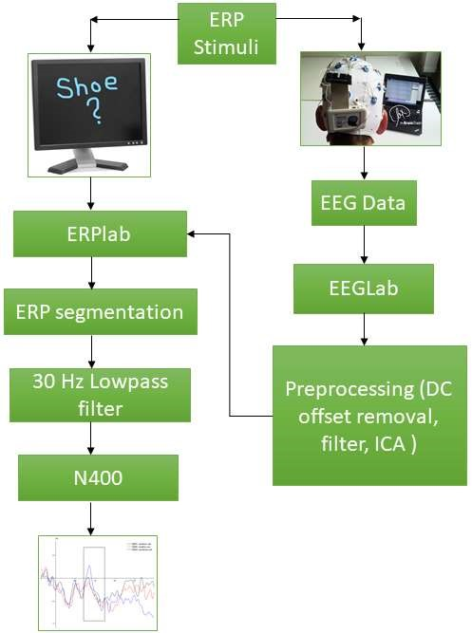
Figure 3.4 - Block diagram of the data analysis process.
For category grouping and processing purposes, only stimuli that participants answered “correctly” were included in the data analysis, i.e., participant answered no-yes to a common use, yes-yes to a creative use, and yes-no to a nonsense use.
Each participant had a minimum of 25 “correct” responses for each stimulus type for data processing. This is different from the minimum of 30 in [40] due to the limited number of participants and continuous EEG recordings.
EEG data was processed using EEGlab plugin on Matlab. Raw data was filtered from 0.1-100 Hz in order for the experimenter to visually inspect data and reject any messy parts. An independent component analysis (ICA) was then performed in order to investigate components and remove the ones not related to brain data, i.e., eye and muscle movements. Data was then processed via ERPlab in MATLAB to obtain ERP segments. Data was epoched into 1150 ms segments, with each segment starting 150 ms before presentation of item-use pair. Segments were baseline-corrected using the 150 ms time window before the onset of the item-use pair. A 30 Hz low-pass filter with a slope of 24 dB/Oct was applied and additional artifacts were removed with amplitude exceeding +/-100 μV. ERP waveforms were averaged for each participant and each condition. Subsequently grand-averaged ERPs of all participants were calculated in time windows of interest. The N400 component was the main interest of this paper and postN400 components were not analyzed at this time. Electrodes of interest included Cz, CPz, Pz, and POz based on electrodes identified in [38], the circled electrode sites in Figure. 3.2. The number of electrodes examined in this study differ from [38] due to differences in the total number of electrodes utilized; 24 total channels in this study versus 64 total channels in [40], which is simply due to the fact that different EEGs were used.

3.3.5. Results and discussion
Statistical tests were not performed at this time due to the small sample size, but data indicates similar results to those from [40] with slight differences in the N400 component for all three item-use conditions The mean amplitude for the two trials was generated. The average for the nonsense uses produced the largest response (ave = -1.4), followed by the creative uses (ave = -0.74), then common uses (ave = -0.59). It is stressed here that this is not a significant difference, only a different average number for the mean amplitudes. Though not definite, these preliminary results point towards sensitivity of the N400 to semantic difference as well as novelty, which is indicated by the different mean amplitudes of the four electrodes of interest for each stimulus type. See Figure 3.5. The waveforms of single electrode sites Cz and CPz from one of the trials are depicted below in Figure. 3.6. In the future, with more participants, the postN400 effect (500-900 ms) would also be investigated.

The aim of the current pilot study was to investigate the N400 ERP component in engineers by the creative process of conceptual expansion when compared to the information processing of mere novelty or appropriateness, similar to [40] with the main difference of interest being the focus on engineering-based participants. The mean amplitudes values suggest that stimuli that were classified as nonsensical or creative elicit larger N400s than the common uses. The numerically larger amplitudes for the nonsense and creative uses as compared to the common uses suggest that the N400 is sensitive to levels of novelty or unusualness. Again, we stress that the data was not tested for significant differences at this time due to the small sample size of two participants. Additional data would be needed in order to obtain more definite results.
-1.6
-1.4
-1.2
-1
-0.8
-0.6
-0.4
-0.2
0
Creative Nonsense Common
Mean Amplitude (

µV)

Figure 3.5 - Mean amplitudes from four electrodes (cz, cpz, pz, and poz) for the three types of item-use pairs for the 300-500 ms time window.
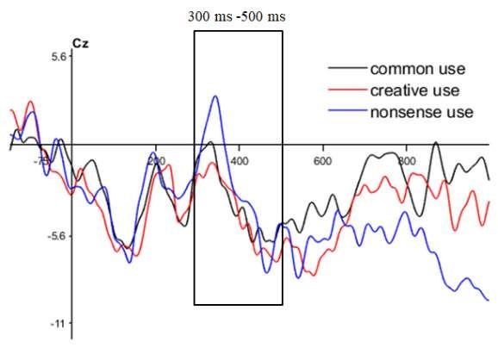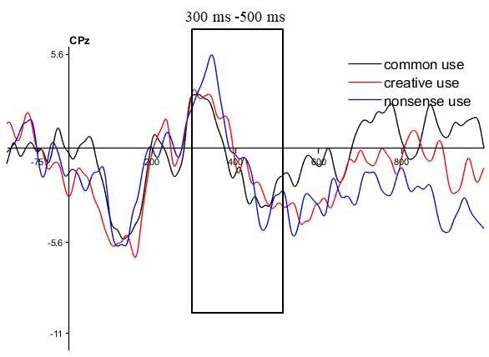
Figure 3.6 - ERPs from the cz (top) and cpz (bottom) electrodes from one individual. The box outline indicates the 300-500 ms window of investigation of the n400 effect.

3.4. Conclusions And Future Directions
In Data from this pilot study seems to indicate that the N400 component in engineers is influenced by novelty and unusualness. Statistical tests would be necessary to determine whether these results are significant or not. More subjects and further investigation of the post-N400 component is also necessary to obtain a better understanding of the results and gain a better understanding of the post-N400 component. As noted in [40], the N400 window would reflect the novelty or unusualness of the stimuli (not the appropriateness) and the post-N400 would reflect the processing of the appropriateness (not novelty/unusualness). This rationale behind the post-N400 analysis is based on the findings of [62-65], which show slow wave effects long after stimulus presentation (up to 1000ms post stimulus). This late processing was mostly linked to interpretation, comprehension, and cognitive computations. While there might not be definite ERPs in this time slot (around 500-900ms post stimulus), it would be interesting to see if there are lasting effects long after stimulus presentation. Given this rationale, it is likely important for these two components to be analyzed together in order to get the entire picture of neural processing of unusualness and appropriateness.

Future studies would include these analyses. Furthermore, in the future we will consider a subject-based selection of which stimuli belong in which of the three categories, rather than only including “correct” responses for the common, creative, or nonsense category. By this, we mean that the category of the item-use pair (common, creative, or nonsense) was “predetermined” and responses that were “incorrect” were not used. Changing this so that the subject determines which item use pair goes in to which of the three categories will ensure the individual validation of the experimental design.

Even though there is a relatively small number of investigations between neuroimaging and the field of engineering, interest is starting to bud. Once the basics are covered, there are many different possibilities for neurological research in engineering. Potential experiments include studying creativity at different stages of the engineering design process, studying the effects of different models and techniques (such as EMS, TRIZ, etc.) on ideation, studying creative responses and idea generation within teams, studying the effects of diversity within teams on the engineering design process, and studying the effect of experience on creative responses and idea generation. The neuro-responses during concept generation and steps of the engineering design process could also be used to understand how the brain operates during these activities.

Even though this is a work in progress, we hope that down the line, as the data from these future investigations becomes available, results can be used to improve engineering education. Furthermore, this data will aid researchers in understanding what cognitive processes are used in the engineering design process. Additionally, creativity improving techniques could be measured using neuroscientific means. These techniques could then be incorporated into engineering education curriculum to promote creativity in engineers. Overall, there are a plethora of uses for neuro-scientific research in the field of engineering that would have profound impacts on engineering design and education.
The main problem standing in the way of all of this potential research is the fact that it is not a straightforward task to design experiments to study the neurological responses on engineering design, creativity, and concept generation. Since no ERP studies related to engineering have been completed, there is a need for further investigations into this area. In designing ERP experiments, it is important to identify components of interest (i.e. N400). As mentioned throughout, the N400 or post-N400 components would be a good place to start since studies have shown there is some relation to novelty, unusualness, and conceptual expansion [39, 40].

3.5. Acknowledgements
This material is based upon work supported by the National Science Foundation under Grant No. 1561660 and 1726358, 1726811, and 1726884. Any opinions, findings, and conclusions or recommendations expressed in this material are those of the author(s) and do not necessarily reflect the views of the National Science Foundation.

3.6. References
- R. Florida, The rise of the creative class--revisited: Revised and expanded. Basic Books, Arizona (2014).
- “IBM 2010 Global CEO Study: Creativity Selected as Most Crucial Factor for Future Success,” IBM News room - 2010-05-18 IBM 2010 Global CEO Study: Creativity Selected as Most Crucial Factor for Future Success - United States, 18-May-2010. [Online]. Available: https://www- 03.ibm.com/press/us/en/pressrelease/31670.wss. [Accessed: 12-Mar-2020].
- K. H. Kim, “The Creativity Crisis: The Decrease in Creative Thinking Scores on the Torrance Tests of Creative Thinking,” Creativity Research Journal, Vol. 23, No. 4 (2011): pp. 285–295.
- K. H. Kim and R. A. Pierce, “Torrance’s innovator meter and the decline of creativity in America,” The Routledge International Handbook of Innovation Education, Vol. 5 (2013): pp. 153–167.
- National Academy of Engineering, U. S. The engineer of 2020: Visions of engineering in the new century. Washington, DC: National Academies Press, 2004.
- Olson, Steve, ed. Educating engineers: Preparing 21st century leaders in the context of new modes of learning: Summary of a forum. National Academies Press, 2013.
- F. E. Jones, “Predictor variables for creativity in industrial science,” Journal of Applied Psychology, Vol. 48, No. 2 (1964): pp. 134–136.
- C. D. Mcdermid, “Some correlates of creativity in engineering personnel,” Journal of Applied Psychology, Vol. 49, No. 1 (1965): pp. 14–19.
- T. B. Sprecher, “A study of engineers’ criteria for creativity.” Journal of Applied Psychology, Vol. 43, No. 2 (1959): pp. 141–148.
- B. D. Bleedorn, “Creativity: Number One Leadership Talent for Global Futures,” The Journal of Creative Behavior, Vol. 20, No. 4 (1968): pp. 276–282.
- H. B. Parkhurst, “Confusion, Lack of Consensus, and the Definition of Creativity as a Construct,” The Journal of Creative Behavior, Vol. 33, No. 1 (1999): pp. 1–21.
- K. Bateman, “IT students miss out on roles due to lack of creativity,” Computer Weekly, 18-Apr-1013. [Online]. Available: https://www.computerweekly.com/blog/ITWorks/ITstudents-miss-out-on-roles-due- to-lack-of-creativity. [Accessed: 12-Mar-2020].
- D. H. Cropley, "Creativity in engineering." In Multidisciplinary contributions to the science of creative thinking (2016): pp. 155-173. Springer, Singapore.
- K. Kazerounian and S. Foley, “Barriers to Creativity in Engineering Education: A Study of Instructors and Students Perceptions,” Journal of Mechanical Design, Vol. 129, No. 7 (2007): pp. 761–768.
- C. Masters, S. Hunter, and G. Okudan. "Design Process Learning and Creative Processing: Is There a Synergy." In ASEE Conference Proceedings. 2009.
- J. P. Adams, S. Kaczmarczyk, P. Picton, and P. Demian. "Improving problem solving and encouraging creativity in engineering undergraduates." From International Conference on Engineering Education, 2007.
- D. H. Cropley, “Promoting creativity and innovation in engineering education,” Psychology of Aesthetics, Creativity, and the Arts, Vol. 9, No. 2 (2015): pp. 161– 171.
- J. J. Duderstadt, “Engineering for a Changing Road, a Roadmap to the Future of Engineering Practice, Research, and Education.” 2007
- C.L. Dym, A. M. Agogino, O. Eris, D. D. Frey, and L. J. Leifer. "Engineering design thinking, teaching, and learning." Journal of engineering education 94, No. 1 (2005): pp. 103-120.
- R. M. Felder, "Creativity in engineering education." Chemical Engineering Education 22, Vol. 22, No. 3
(1988): pp. 120-125.
- J. A. Plucker, R. A. Beghetto, and G. T. Dow, “Why Isnt Creativity More Important to Educational Psychologists? Potentials, Pitfalls, and Future Directions in Creativity Research,” Educational Psychologist, Vol. 39, No. 2 (2004): pp. 83–96.
- J. C. Santamarina, "Creativity and Engineering-Education Strategies." Proceedings Int. Conference on Engineering Education in Honor of JTP Yao, Texas A&M, pp. 91-108, 2003.
- R. Stratton, D. Mann, and P. Otterson. "The Theory of Inventive Problem Solving (TRIZ) and Systematic Innovation-a Missing Link in Engineering Education?." TRIZ Journal, (2000).
- S. Törnkvist, “Creativity: Can It Be Taught? The Case of Engineering Education,” European Journal of Engineering Education, Vol. 23, No. 1 (1998): pp. 5–12.
- C. Charyton, Creative engineering design assessment: background, directions, manual, scoring guide and uses. London: Springer, 2014.
- L. Richards, “Stimulating creativity: teaching engineers to be innovators,” FIE 98. 28th Annual Frontiers in Education Conference. Moving from Teacher-Centered to Learner-Centered Education. Conference Proceedings (Cat. No.98CH36214), Vol. 3 pp. 1034–1039, Nov. 1998.
- E. Gregory, M. Hardiman, J. Yarmolinskaya, L. Rinne, and C. Limb, “Building creative thinking in the classroom: From research to practice,” International Journal of Educational Research, Vol. 62 (2013): pp. 43–50
- C. J. Limb and A. R. Braun, “Neural Substrates of Spontaneous Musical Performance: An fMRI Study of Jazz Improvisation,” PLoS ONE, Vol. 3, No. 2 (2008).
- G. F. Woodman, “A brief introduction to the use of eventrelated potentials in studies of perception and attention,” Attention, Perception, & Psychophysics, Vol. 72, No. 8 (2010): pp. 2031–2046.
- MBrainTrain. Fully Mobile EEG Devices. Retrieved February 3, 2020, from https://mbraintrain.com/, 2018.
- A. Abraham, The neuroscience of creativity. Cambridge, United Kingdom: Cambridge University Press, 2019.
- A. Fink, R. H. Grabner, M. Benedek, G. Reishofer, V. Hauswirth, M. Fally, C. Neuper, F. Ebner, and A. C. Neubauer, “The creative brain: Investigation of brain activity during creative problem solving by means of EEG and FMRI,” Human Brain Mapping, Vol. 30, No. 3 (2009): pp. 734–748.
- E. Jauk, M. Benedek, and A. C. Neubauer, “Tackling creativity at its roots: Evidence for different patterns of EEG alpha activity related to convergent and divergent modes of task processing,” International Journal of Psychophysiology, Vol. 84, No. 2 (2012): pp. 219–225.
- A. Fink, R. H. Grabner, M. Benedek, and A. C. Neubauer, “Divergent thinking training is related to frontal electroencephalogram alpha synchronization,” European Journal of Neuroscience, Vol. 23, No. 8 (2006): pp. 2241– 2246.
- R. H. Grabner, A. Fink, and A. C. Neubauer, “Brain correlates of self-rated originality of ideas: Evidence from event-related power and phase-locking changes in the EEG,” Behavioral Neuroscience, Vol. 121, No. 1 (2007): pp. 224–230.
- D. Schwab, M. Benedek, I. Papousek, E. M. Weiss, and A. Fink, “The time-course of EEG alpha power changes in creative ideation,” Frontiers in Human Neuroscience, Vol. 8 (2014): pp. 310.
- A. Fink, D. Schwab, and I. Papousek, “Sensitivity of EEG upper alpha activity to cognitive and affective creativity interventions,” International Journal of Psychophysiology, Vol. 82, No. 3 (2011): pp. 233–239.
- S. Luck, An Introduction to the Event-Related Potential Technique. Second edition. Cambridge, Massachusetts: The MIT Press, 2014.
- B. Rutter, S. Kröger, H. Hill, S. Windmann, C. Hermann, and A. Abraham, “Can clouds dance? Part 2: An ERP investigation of passive conceptual expansion,” Brain and Cognition, Vol. 80, No. 3 (2012): pp. 301–310.
- S. Kröger, B. Rutter, H. Hill, S. Windmann, C. Hermann, and A. Abraham, “An ERP study of passive creative conceptual expansion using a modified alternate uses task,” Brain Research, Vol. 1527 (2013): pp. 189–198.
- L. M. Pidgeon, M. Grealy, A. H. B. Duffy, L. Hay, C. Mcteague, T. Vuletic, D. Coyle, and S. J. Gilbert, “Functional neuroimaging of visual creativity: a systematic review and meta-analysis,” Brain and Behavior, Vol. 6, No. 10 (2016).
- A. Fink and M. Benedek, “EEG alpha power and creative ideation,” Neuroscience & Biobehavioral Reviews, Vol. 44 (2014): pp. 111–123.
- R. Arden, R. S. Chavez, R. Grazioplene, and R. E. Jung, “Neuroimaging creativity: A psychometric view,” Behavioural Brain Research, Vol. 214, No. 2 (2010): pp. 143–156.
- A. Dietrich and R. Kanso, “A review of EEG, ERP, and neuroimaging studies of creativity and insight,” Psychological Bulletin, Vol. 136, No. 5 (2010): pp. 822– 848.
- K. Alexiou, T. Zamenopoulos, J. Johnson, and S. Gilbert, “Exploring the neurological basis of design cognition using brain imaging: some preliminary results,” Design Studies, Vol. 30, No. 6 (2009): pp. 623–647.
- Sylcott, B., Cagan, J., and Tabibnia, G., “Understanding Consumer Tradeoffs Between Form and Function Through Metaconjoint and Cognitive Neuroscience Analyses,” Journal of Mechaical Design, Vol. 135, No. 10 (2013).
- Hay, L., Duffy, A., Gilbert, S., Lyall, L., Campbell, G., Coyle, D., and Grealy, M., “The Neural Correlates of Ideation in Product Design Engineering Practitioners,” Design Science, Vol. 5 (2019).
- K. Goucher-Lambert, J. Moss, and J. Cagan, “A neuroimaging investigation of design ideation with and without inspirational stimuli—understanding the meaning of near and far stimuli,” Design Studies, Vol. 60 (2019): pp. 1–38.
- Shealy, T., Grohs, J., Hu, M., Maczka, D., & Panneton, R., “Investigating design cognition during brainstorming tasks with freshmen and senior engineering students using functional near infrared spectroscopy”. ASEE, Columbus, OH, 2017.
- Hu, M., Shealy, T., and Gero, J. S. “Neuro-cognitive Differences among Engineering Students when Using Unstructured, Partially Structured, and Structured Design Concept Generation Techniques,” ASEE Conference & Exposition, Salt Lake City, UT, June 24 – 27, 2018.
- Shealy, T., and Gero, J, “The Neurocognition of Three Engineering Concept Generation Techniques,” Proceedings of the Design Society: International Conference on Engineering Design, Vol.1, No. 1(2018): pp. 1833-1842.
- T. A. Nguyen, T. An, and Y. Zeng. "Analysis of design activities using EEG signals." ASME 2010 International design engineering technical conferences and computers and information in engineering conference. American Society of Mechanical Engineers Digital Collection, 2010.
- T. A. Nguyen, and Y. Zeng. "Clustering designers’ mental activities based on EEG power." Tools and methods of competitive engineering, Karlsruhe, Germany, 2012.
- T. A. Nguyen and Y. Zeng, “A physiological study of relationship between designer’s mental effort and mental stress during conceptual design,” Computer-Aided Design, Vol. 54 (2014): pp. 3–18.
- Liu, L., Li, Y., Xiong, Y., Cao, J., and Yuan, P., “An EEG Study of the Relationship Between Design Problem Statements and Cognitive Behaviors During Conceptual Design,” Artificial Intelligence for Engineering Design, Analysis and Manufacturing, Vol. 32, No.3 (2018): pp. 351-362, 2018.
- S. L. D. S. Vieira, J. S. Gero, J. Delmoral, V. Gattol, C. Fernandes, and A. A. Fernandes, “Comparing the Design Neurocognition of Mechanical Engineers and Architects: A Study of the Effect of Designer’s Domain,” Proc. of the Design Society: Int. Conf. on Engineering Design, Vol. 1, No. 1 (2019): pp. 1853–1862.
- Fritz, K., Deschenes, L., and Pandey, V., 2018, “Effective Design Team Composition Using Individual and Group Cognitive Attributes,” Proc. of the ASME 2018 Int. Mechanical Engineering Congr. & Exp,. November 9– 15, 2018.
- Liu, L., Nguyen, T. A., Zeng, Y., and Hamza, A. B., 2016, “Identification of Relationships Between
Electroencephalography (EEG) Bands and Design Activities,” Proc. of the ASME 2016 Int. Design Engineering Technical Conf. and Computers and Information in Engineering Conf., August 21–24, 2016.
- J. C. Roja, M. Contero, J. D. Camba, M. C. Castellanos, E. García-González, and S. Gil-Macián. Design perception: combining semantic priming with eye tracking and event-related potential (ERP) techniques to identify salient product visual attributes. ASME 2015 Int. Mechanical Engineering Congr. and Expo., Paper No. V011T14A035, Houston, TX, USA, November 13–19, 2015.
- A. Telpaz, R. Webb, and D. J. Levy. "Using EEG to predict consumers’ future choices." Journal of Marketing Research Vol. 52, No. 4 (2015): pp. 511-529.
- C. Yang, F. An, C. Chen, and B. Zhu. “The effect of product characteristic familiarity on product recognition.” IOP Conference Series: Materials Science and Engineering 231, 012016, 2017.
- S. M. Rhodes, and D. I. Donaldson. "Association and not semantic relationships elicit the N400 effect: Electrophysiological evidence from an explicit language comprehension task." Psychophysiology, Vol. 45, No. 1 (2008): pp. 50-59.
- J. Pijnacker, B. Geurts, M. Van Lambalgen, J. Buitelaar, and P. Hagoort. "Reasoning with exceptions: an eventrelated brain potentials study." Journal of Cognitive Neuroscience, Vol. 23, No. 2 (2011): pp. 471-480, 2011.
- S. Coulson, and Y.C. Wu. "Right hemisphere activation of joke-related information: An event-related brain potential study." Journal of cognitive neuroscience Vol. 17, No.3 (2005): pp. 494-506.
- G. Baggio, M. Van Lambalgen, and P. Hagoort. "Computing and recomputing discourse models: An ERP study." Journal of Memory and Language Vol. 59, No. 1 (2008): pp. 36-53.
- G. Baggio, T. Choma, M. Van Lambalgen, and P. Hagoort. "Coercion and compositionality." Journal of cognitive neuroscience 22, No. 9 (2010): pp. 2131-2140

CHAPTER 4: INVESTIGATING THE N400 EVENT RELATED POTENTIAL AS A MEASURE OF CREATIVITY

4.1. Introduction
Creativity has long been considered a key competency in engineering [1]–[3], and multiple recent articles have underscored the need for engineers to be “creative” and “innovative,” in addition to possessing solid technical skills [4]–[7]. Creativity will be crucial to providing solutions to the new and increasingly difficult challenges of a rapidly developing technological era. It is critical that creativity be part of engineering education to prepare the next generation of engineers, but how can a student’s creative ability and growth be measured?

One way to measure creative cognition is through neuroscientific techniques. The majority of published neuroscientific studies of creativity use high spatial/temporal resolution techniques, such as functional magnetic resonance imaging (fMRI) and electroencephalography (EEG). Creativity studies using EEG tend to focus on investigating the total signal power to measure cognitive activity in various regions and within specific frequency bands, such as the alpha band (8-13Hz) [8]–[10]. Few studies have used high temporal resolution techniques such as event related potentials (ERPs) to investigate the exact timing of creative cognitive processes. ERPs are processed from EEG data and are time-locked components relative to a stimulus noted as positive or negative signal amplitude peaks [8], [11].

One set of studies that used the ERP technique was by Rutter et al.[12] and Kröger et al [13]. They investigated the N400 ERP relative to conceptual expansion, a process related to creativity, and the novelty and appropriateness of a stimulus [12], [13]. They investigated the N400 ERP, a negative peaking potential occurring between 300-500 ms after stimulus presentation associated with the processing of semantic mismatches and violations of prior knowledge which they tied to conceptual expansion novelty and appropriateness are the two most commonly agreed upon aspects of creativity, where novelty represents the uniqueness or statistical infrequency within a context and appropriateness is value or usefulness within a context [8], [12], [13]. In their studies, the N400 was responsive as a function of novelty to stimuli featuring metaphorical phrases and the alternate uses task (AUT). A post-N400 component, a negative varying response directly following the N400 component, was also explored in relation to interpretation processes and concept integration [12], [13]. More work is needed to understand how these components can be used to measure conceptual expansion and other creative processes, especially in engineers.

Several studies in recent years have focused on creativity and engineering, though again the majority of these use high spatial resolution techniques like fMRI and EEG to identify the specific cognitive regions and networks most active during creative processes [14]. One study of note was conducted by Goucher-Lambert et al. [15]. They used fMRI to explore the differences between design ideation and concept generation with and without inspirational analogies. For this experiment, participants were presented with a simplified design problem and asked to generate solutions. Five words were presented after each design task, including analogically near words, analogically far words, and control words from the design task to provide solution inspiration. Results showed that brain activation differed for participants that were successfully inspired to generate creative concepts and those that were not inspired [15].

A few studies have explored ERPs with respect to creativity in engineering [14], and results showed the N400 component was observed in relation to appropriateness [16], the N200 was associated with categorization of preference [17], and the N400 and P3 components were observed in relation to idea recognition and memory recall [18]. It was the goal of this study to investigate how creative processes can be measured in engineers during a design task, specifically using ERPs.

4.2. The Experiment

4.2.1. Designing the current study
The This study was designed based on Kröger et al.'s 2013 [13] study in conjunction with Goucher-Lambert et al.'s [15] study. Kröger et al. [13] investigated conceptual expansion, which they defined as the ability to broaden the bounds of a semantic concept beyond its typical characteristics. They used the modified AUT task, in which participants were asked to judge the novelty and appropriateness of an alternative "use" or "function" for an object. In their research, they found that the N400 component modulated depending on whether the stimulus was perceived as common (low novelty, high appropriateness), creative (high novelty, high appropriateness), or nonsense (high novelty, low appropriateness). The most positive N400 responses occurred when stimuli were perceived as common, while more negative N400 responses resulted when stimuli were designated creative or nonsense. Only differences between creative-common and nonsense-common were statistically significant [13].

Goucher-Lambert et al. investigated analogical reasoning, which they defined as the process of applying information from a source to a target through shared connections, relationships, or representations [15]. They used inspirational word sets collected from their 2017 study, text-mined from crowd sourced responses to obtain near vs. far inspirational stimuli. The frequency of appearance of a keyword within their data set was used to measure the analogical distance, i.e., its novelty. The frequency of appearance of analogically near keywords in submissions accounted for the top 25% of the frequency distribution of all submitted keywords, while analogically far, or novel, keywords only appeared once within the data set. [19].

For this experiment, the design questions and matching keywords from Goucher-Lambert et al.'s [15] study were combined with Kröger et al.'s [13] experimental design. Keywords were initially designated according to the results of the Goucher-Lambert et al. [19] and [15] studies: “analogically near” were “common,” “analogically far,” were “creative,”and “nonsense” keywords were taken from other design questions or from the categories designated in a study by Alhashim et al. [14], [20]. The keywords were used as potential functions a solution to the design task might incorporate. First, a design question was presented to the participant, followed by the matching functions listed in Table 4.1 presented in a random order. Participants responded "yes" or "no" to whether a presented function was "Unusual" and/or "Appropriate" in relation to the design question while their EEG signals were recorded [14].

Table 4.1: Design Problems and Associated Common, Creative, and Nonsense Keywords [14].
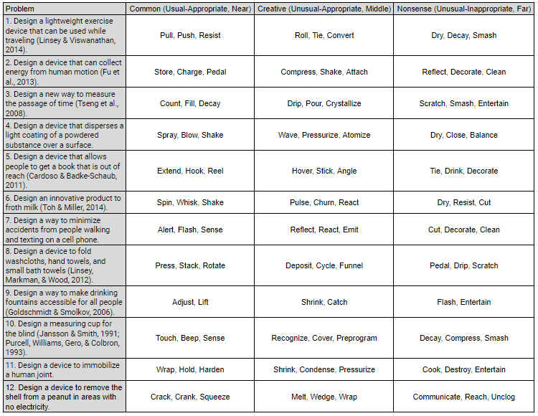

4.2.2. Experimental procedures
Sample Participants were seated in a chair in front of a computer while the EEG cap was fitted, and the electrodes prepared for data collection. Participants were verbally walked through experiment protocols, including what stimuli to expect, how to respond, and to avoid any unnecessary body movements to reduce artifacts. Each participant then completed a self-paced tutorial which included two example design tasks. After the tutorial, participants completed ten design tasks as part of the experiment. Each task was structured as shown in Figure 4.1.
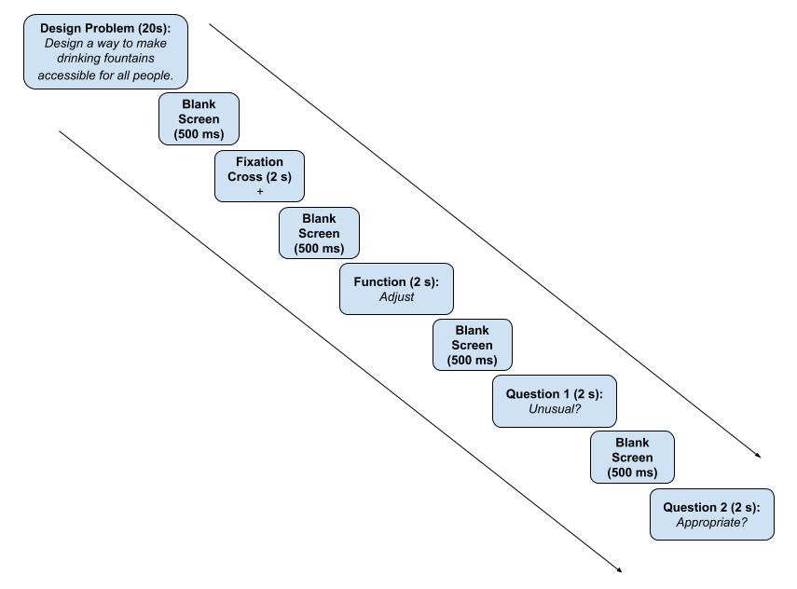
Figure 4.1 - Experimental design.

After the design problem was shown, nine functions were presented in random order including three creative, three common, and three nonsenses. The questions were followed by a 500 ms blank screen and 2 second fixation cross before continuing to the next design task. To respond, participants were asked to press the right touchpad button on the laptop for “yes,” and the left for “no.” To prevent misunderstandings with preconceived definitions for “unusual” and “appropriate,” participants were told to classify a function as “unusual” if it was novel or unfamiliar to them within the presented context, and “not unusual” if it was known or familiar. A function would be classified as “appropriate” if it fit within the presented context, and “not appropriate” if it was unfitting or irrelevant. It was expected that “common” functions would be “not unusual” and “appropriate,” “creative” functions “unusual” and “appropriate,” and “nonsense” functions “unusual” and “inappropriate.”

4.2.3. Participants
There were four participants from a large public institution for this initial study, including two male students, one female student, and one male Mechanical Engineering professor, all right-handed. No compensation was given. The male participants spoke English as a second language. All participants self-reported normal or corrected to normal vision, no history of neurological or psychiatric illness, and no drug use. All gave written informed consent prior to participation; no identifiable personal information was kept in the data. The experiment followed the Institutional Review Board guidelines and was approved by the responsible committee of University of Oklahoma.

4.2.4. Data collection setup
Data collection took place in a low noise environment. A wireless 24 channel SMARTING EEG acquisition system with amplifier and recording software from MBrainTrain were used for this experiment. Data was sampled at 500 Hz, recorded from all 24 electrodes positioned according to the international 10-20 placement map. Neurobs Presentation software (Neurobehavioral Systems, Inc., Albany, CA) synchronized with the EEG acquisition system was used to present stimuli. A low impedance of about 5-10 kΩ was kept for each electrode during the experiment. A 64-bit Dell Latitude laptop with i5-8250U CPU 1.8 GHz with 7.86 GB usable ram was used to present stimuli and record participant responses via the left and right touchpad buttons. Lab personnel monitored signal data collection real time through a separate connected monitor.

4.2.5. Data analysis
EEG data was processed using MATLAB’s EEGlab plugin. First, a band pass filter from 0.1-100 Hz and a 60 Hz notch filter were applied to exclude unclear data and line noise. Next, an independent component analysis (ICA) was performed to reject signal components caused by eye or muscle movement, line noise, and other common artifacts. Matlab's ERPlab plugin was then used to create 1150 ms ERP segments from 150 ms before stimulus presentation to 1000 ms after. The 150 ms before stimulus onset were used to baseline-correct the following 1000 ms segments. Last, a 30 Hz low-pass Butterworth filter with a slope of 24 dB/Oct was applied to remove additional artifacts with amplitudes exceeding +/-100 μV. After pre-processing, the ERPs were grouped by the condition (common, creative, or nonsense) assigned by the participant, allowing for individual validation of the experimental design. Data was not rejected based on a required minimum number of trials per condition due to the small number of participants.

The centro-parietal electrodes Cz, CPz, and Pz were selected to analyze the N400 and post N400 components based on Kröger et al.’s 2013 study. This experiment was a within-subject design with two factors: condition (common, creative, nonsense) and electrode (Cz, CPz, Pz). A two factor repeated measures ANOVA was performed for time windows of interest and Mauchly’s Test of Sphericity was used to verify that the variances were equal for both the N400 and post-N400. Effects sizes including Cohen’s d, partial eta squared (η_{p}²), and partial omega squared (ω_{p}²) are reported with all significance levels.

4.3. Results and Discussion
In Figure 4.2 is shown the grand-averaged ERPs of the Cz, CPz, and Pz electrodes of all participants. As observed in previous studies, the signal displays a negative dip for creative and nonsense conditions in the N400 (300-500ms) time window, with similar amplitudes at their negative peaks. [12], [13], [21], [22].

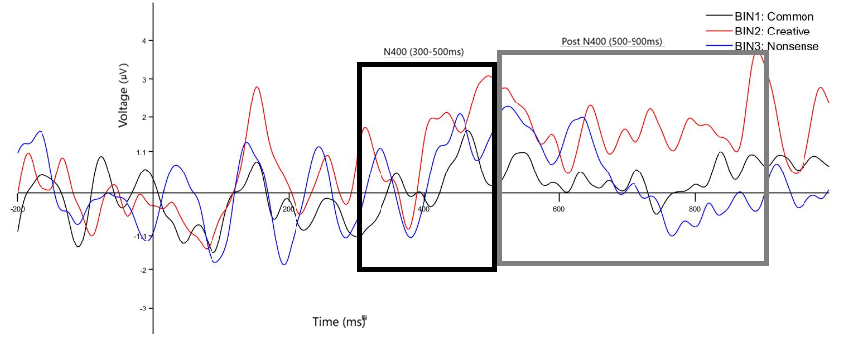
Figure 4.2 - Grand average signal of Cz, CPz, and Pz electrodes for All subjects.

The repeated measures ANOVA revealed significant main effects for the factor electrode (F(2,6) = 11.79; p = .033; η_{p}² = .797; ω_{p}² = .09), however main effects were not significant for the factor condition (F(2,6) = .392; p = .663; η_{p}² = .116; ω_{p}² = -.06) or the condition-electrode interaction (F(4,12) = 1.614; p = .234; η_{p}² = .35; ω_{p}² = .00). Size effects are reported, but all were small enough to be considered negligible.

4.3.1. The N400 component
Degree In Figure 4.3 the average mean amplitude during the N400 time window for the three electrodes for all participants is displayed.
The common condition had the least negative mean amplitude of 0.128μV, the mean amplitude for the creative condition was -0.677μV, and the nonsense condition had the greatest negative mean amplitude at -1.137μV. Although the differences in the means for all pairs were insignificant (common-creative: p = 1, d = .32; common-nonsense: p = 1, d = .42; creative-nonsense: p = 1, d = .16), this follows the trends in previous studies [12], [13], [21], [22]. A linear trend in the modulation of the N400 for the factor condition was reported in the Rutter et al. 2012 [12] study, but no significant linear trend (F (1,3) = 1.28; p = .339; η_{p}² = .3) for condition was observed in this study. These results show that the N400 ERP modulated similarly to previous studies with respect to the perceived novelty and appropriateness of a function associated with a given design problem.

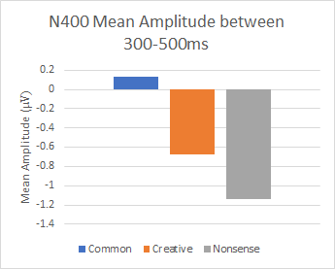
Figure 4.3 - Mean amplitudes for the N400 component.

4.3.2. The post-N400 component
No significant main effects for condition (F (2,6) = 1.08; p = .395; η_{p}² = .266; ω_{p}² = .01), electrode (F (2,6) = 3.286; p = .109; η_{p}² = .523; ω_{p}² = .02), or the condition-electrode interaction (F (4,12) = 3.02; p = .061; η_{p}² = .502; ω_{p}² = .00) were observed for the post-N400 component, and size effects were negligible. The average mean amplitude for the post N400 time window, for the three electrodes, for all participants is shown in Figure 4.4.
The common condition had the least negative mean amplitude of 0.264μV, the mean amplitude was -1.438μV for the creative condition, and the nonsense condition’s mean amplitude was most negative at-1.778μV. The differences in the means for all pairs were insignificant (common-creative: p = 1, d = .63; common-nonsense: p = .958, d = .76; creative-nonsense: p = 1, d = .15), and there was no significant linear trend for the factor condition. However, the overall responsiveness of the post-N400 component was similar to previous studies [12], [13]. Worth noting in Figure 4, the nonsense condition continued a more negative trend after 500ms, while the creative condition exhibited a more positive shift during the post- N400 time window. This could be the result of failing to integrate nonsense stimuli into existing semantic networks, but successfully being able to integrate creative stimuli [12], [13].
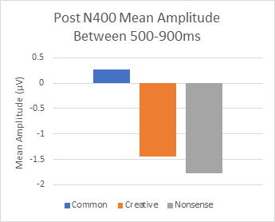
Figure 4.4 - Mean amplitudes for post N400 component.

4.3.3. Contour maps and alpha band power
Besides investigating the modulation of the N400 and post-N400 ERPs processed from the CPz, Pz, and POz electrodes, the data collected from this experiment was also used to create the contour maps in Figures 4.5 and 4.6. In this case, data for the designated time period was mapped from all electrodes to understand the relative neural activity across the brain.

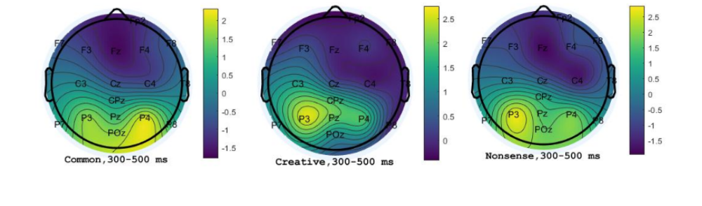Figure 4.5 - Contour maps of mean amplitude of N400 time window.
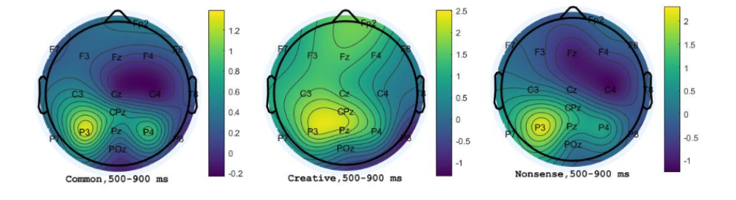
Figure 4.6 - Contour maps of mean amplitude of post-N400 time window.
For all conditions during the N400 time window, the most negative activity was located in a right frontocentral distribution. Positive activity was observed in the parietal-occipital area, in the right hemisphere for the common condition and the left for creative and nonsense conditions. Future studies could investigate an N400 in the fronto-central area and a P400 in the parietal-occipital region in relation to creativity. During the post-N400 time window, positive activity was observed in the left parietal area. In the future, this area could be studied in relation to the P600 component, which is known to relate to processing and syntactic structure in this area [11].

Additionally, the task-related power was calculated for the alpha-frequency band, which has been related to creative cognition [8]. A 9x2x3 ANOVA was performed to find any brain regions that experienced significant alpha task-related power (TRP), with results presented in Figures 4.7 and 4.8.

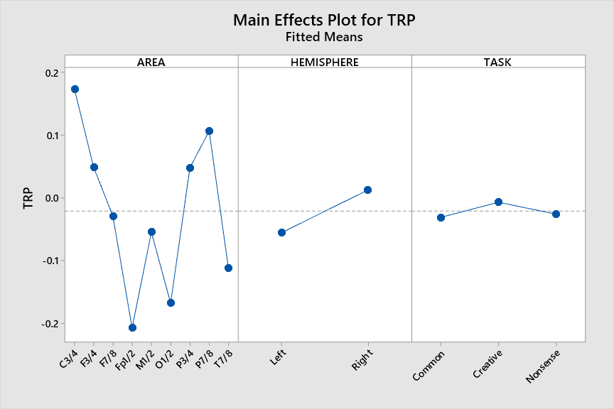
Figure 4.7 - General pattern of TRP for the task across electrodes.
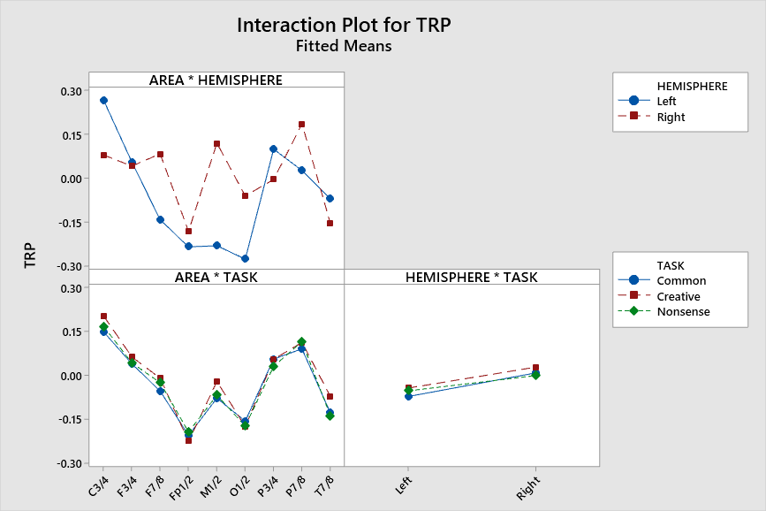
Figure 4.8 - General pattern of TRP interactions for the task across electrode locations.

This analysis showed a significant main effect for the factor AREA (F (8,162) = 2.30, p = .024, ηp2 =.102), indicating decreased alpha power over Anterio-frontal cortical sites and increased alpha power over Centro-temporal. A significant main effect was also observed for the factor HEMISPHERE (F (1,162) =1.48, p=.226, ηp2 =.009), which displayed greater alpha power decreases on left-hemispheric than right-hemispheric sites. Lastly, the interaction AREA × TASK had a significant main effect (F (16,162) = .02, p = 1.0, ηp2 = .002), revealing a notable decrease in alpha power on Anterio-frontal cortical sites and increased alpha power over Centro-temporal ones.

4.4. Conclusions and Future Work
The goal of this study was to investigate how creative processes can be measured in engineers during a design task, specifically using ERPs. Participants were presented with a design question, then asked to evaluate whether presented functions were “unusual” and “appropriate” within that context. It may be noted that this experimental design measures the creativity of the functions presented more so than the individual being monitored. To measure the creativity of the individual, previous studies have the individual’s N400 component related to creativity and this study starts using function though statistically not significant post-N400 components, would need to be compared to the grand-average ERP and the mean component amplitudes of the group. It is hypothesized that if an individual is creatively processing an idea, they will have a negative N400 amplitude similar to the group mean amplitude for that condition followed by a positive shift in the post-N400 component. As designed, proposed experiment shows promising results of using the N400 to evaluate the creativity of an engineering design solution. The result of this work shows the trend in the right direction as of the hypothesis of the study.

Though this study was small and the differences in ERPs found to be statistically insignificant, the general trends in the data support previous studies, showing the viability of this experiment. Future work would include gathering data from more participants to see if these preliminary results hold true. Furthermore, future research could also include processing data in relation to other specific brain regions and frequency bands during this time period, as well identifying other ERPs in relation to the creative process. In this study, contour maps of the brain were generated, and alpha band power calculated for the time windows of interest. More work could be done to understand the relationships between these different measures to develop a more holistic picture of the creative process. It is not one measure alone that will unlock the mysteries of creativity, but perhaps understanding the relationship between different measures will advance the path towards understanding how to measure creativity in engineers.

4.5. Acknowledgements
This material is based upon work supported by the National Science Foundation under Grant No. 1561660 and 1726358. Any opinions, findings, and conclusions or recommendations expressed in this material are those of the author(s) and do not necessarily reflect the views of the National Science Foundation.

4.6. References
[1] F. E. Jones, “Predictor variables for creativity in industrial science.,” Journal of Applied Psychology, vol. 48, no. 2, p. 134, 1964.
[2] C. D. McDermid, “Some correlates of creativity in engineering personnel.,” Journal of applied psychology, vol. 49, no. 1, p. 14, 1965.
[3] T. B. Sprecher, “A study of engineers’ criteria for creativity.,” Journal of Applied Psychology, vol. 43, no. 2, p. 141, 1959.
[4] M. A. Robinson, P. R. Sparrow, C. Clegg, and K. Birdi, “Design engineering competencies: future requirements and predicted changes in the forthcoming decade,” Design Studies, vol. 26, no. 2, pp. 123–153, 2005.
[5] B. Trilling and C. Fadel, “National Academy Of Engineering.(2004). The Engineer of 2020: Visions of Engineering in the New Century,” 21st century skills: learning for life in our times.
[6] S. Olson, Educating engineers: Preparing 21st century leaders in the context of new modes of learning: Summary of a forum. National Academies Press, 2013.
[7] P. Petrone, “Why creativity is the most important skill in the world,” LinkedIn, The Learning Blog, 2019.
[8] A. Abraham, The neuroscience of creativity. Cambridge University Press, 2018.
[9] M. T. Ahad et al., “Behavioral Pattern Analysis between Bilingual and Monolingual Listeners’ Natural Speech Perception on Foreign-Accented English Language Using Different Machine Learning Approaches,” Technologies, vol. 9, no. 3, Art. no. 3, Sep. 2021, doi: 10.3390/technologies9030051.
[10] M. T. Ahad, An EEG-based Comparative Analysis of Natural Speech Perception by Native Speakers of American English vs. Bilingual Individuals. Lamar University-Beaumont, 2018.
[11] S. J. Luck, An introduction to the event-related potential technique. MIT press, 2014.
[12] B. Rutter, S. Kröger, H. Hill, S. Windmann, C. Hermann, and A. Abraham, “Can clouds dance? Part 2: An ERP investigation of passive conceptual expansion,” Brain and Cognition, vol. 80, no. 3, pp. 301–310, 2012.
[13] S. Kröger, B. Rutter, H. Hill, S. Windmann, C. Hermann, and A. Abraham, “An ERP study of passive creative conceptual expansion using a modified alternate uses task,” Brain research, vol. 1527, pp. 189–198, 2013.
[14] M. Marshall, “An Investigation of the N400 Component as a Measure of Creativity in Engineering Design,” 2020.
[15] K. Goucher-Lambert, J. Moss, and J. Cagan, “A neuroimaging investigation of design ideation with and without inspirational stimuli—understanding the meaning of near and far stimuli,” Design Studies, vol. 60, pp. 1–38, 2019.
[16] J.-C. Rojas, M. Contero, J. D. Camba, M. C. Castellanos, E. García-González, and S. Gil-Macián, “Design perception: combining semantic priming with eye tracking and event-related potential (ERP) techniques to identify salient product visual attributes,” in ASME International Mechanical Engineering Congress and Exposition, 2015, vol. 57540, p. V011T14A035.
[17] A. Telpaz, R. Webb, and D. J. Levy, “Using EEG to predict consumers’ future choices,” Journal of Marketing Research, vol. 52, no. 4, pp. 511–529, 2015.
[18] C. Yang, F. An, C. Chen, and B. Zhu, “The effect of product characteristic familiarity on product recognition,” in IOP Conference Series: Materials Science and Engineering, 2017, vol. 231, no. 1, p. 012016.
[19] K. Goucher-Lambert and J. Cagan, “Using crowdsourcing to provide analogies for designer ideation in a cognitive study,” in DS 87-8 Proceedings of the 21st International Conference on Engineering Design (ICED 17) Vol 8: Human Behaviour in Design, Vancouver, Canada, 21-25.08. 2017, 2017, pp. 529–538.
[20] A. G. Alhashim and M. Marshall, “WIP: Assessing Creativity of Alternative Uses Task Responses: A Detailed Procedure,” 2020.
[21] T. Hartog, M. Marshall, A. G. Alhashim, M. T. Ahad, and Z. Siddique, “Work in Progress: Using Neuro-responses to Understand Creativity, the Engineering Design Process, and Concept Generation,” presented at the 2020 ASEE Virtual Annual Conference Content Access, Jun. 2020. Accessed: Sep. 17, 2020. [Online]. Available: https://peer.asee.org/work-in-progress-using-neuro-responses-to-understand-creativity-the-engineering-design-process-and-concept-generation
[22] T. Hartog et al., “Pilot Study: Investigating EEG Based Neuro-Responses Of Engineers via a Modified Alternative Uses Task to Understand Creativity,” 2020, pp. 1–10.

CHAPTER 5: ELECTROENCEPHALOGRAM EXPERIMENTATION TO UNDERSTAND CREATIVITY OF MECHANICAL ENGINEERING STUDENTS

5.1. Introduction
Defining creativity is challenging [1], and proposing a universal definition is nearly impossible [2]. One reason behind such difficulty is creativity is a multi-faceted and complex phenomenon [3–7]. Researchers have provided definitions of creativity from different perspectives, and in his booklet, Treffinger [8] collected 124 creativity-related definitions published between 1926 and 2011. Creativity definition varies based on discipline, for instance, creativity in music will have a different definition in science. Performance techniques, composition, novel use of rhythm, beat, pitch, improvisation, and expression may be some of the criteria of creativity in music domain. Groundbreaking ideas, discoveries, and theories are accepted criteria for creativity in the scientific field [9]. New, novel, or original are broadly used across diverse definitions of creativity.

In the twenty-first century, (“creativity”) has become an essential skill, not only in the fields of arts and humanities but also in the science, technology, engineering, and economic contexts of human life [10]. In engineering, creativity has both novelty and appropriateness as key components. Studies have revealed through utilizing behavioral and neurological approaches that, after using creativity enhancing exercises and techniques, changes in behavioral outcomes and brain activity happens [11,12]. To study the impact of these exercises and techniques on creativity by using behavioral approaches is useful, however, it is not possible to direct way to investigate the neural mechanisms that underlie creativity from behavioral approaches. To study these underlying processes Neurological approaches is a possible way. Researchers able to use neurological approaches which allows them to obtain visible, physical results. These results connect stimuli or prompts related to creativity to biological processes and structures. Also, whether or not methods claiming to improve creativity or aid in problem solving actually happening or not researchers are able to test through these approaches. Those methods which claim to aid in innovative design or problem solving could be hypercritically validated using neurological approaches that provide neurological and quantifiable measurements [13].

Several neuroscientific studies have been conducted to understand the underlying brain activations associated with creative idea generation [14]. Many aspects of cognitive activity are reflected by the changes in neural activity across different electroencephalogram (EEG) frequency bands [15–17]. EEG frequencies in the range of the alpha band (usually 8–13 Hz) have strong dominance during an individual’s creative ideation [18]. Alpha band power increase is tagged as synchronization of EEG response and alpha band power decreases is known as a desynchronization of the EEG response, which is generally associated with creative task. EEG desynchronization also indicates cortical activity or arousal. A cognitive task, during a reference interval, is usually assessed by alpha power in terms of changes in task-related power (TRP), event-related synchronization (ERS), or event-related desynchronization (ERD) [19].

Research has shown differences in alpha desynchronization for regions of the alpha band [19]. Klimesch et al. [20] first provided evidence that general task (e.g., attention processes) is associated with lower alpha ERD. On the other hand, the upper alpha frequency band ERD is associated with intelligence-related demands, like creative thinking and divergent thinking [21–23]. Starting from the pre-stimulus reference up to task activation, if the alpha power activity increases, it is indicative of ERS, which signifies active information processing in neuronal networks [24]. Klimesch et al. [25] found that alpha power is a functional correlate of creative cognitive task demands.

Creativity is a multiple-stage (e.g., generative and exploratory) process [6,19,26,27] and AUT is a standard method utilized by the researchers to assess divergent thinking. From EEG studies [28,29], AUT has been associated with TRP in the upper alpha band power. The process of idea generation to idea elaboration task related performance has been correlated with distinct patterns of upper alpha power in frontal areas and decreases in centro-temporal areas [30]. Jauk et al. [31] had participants generate either common solutions (convergent thinking) or uncommon/unusual solutions (divergent thinking) to tasks, which included an AUT and a word association task. The authors reported that divergent thinking (uncommon responses) showed synchronization of alpha power on frontal cortical areas, whereas convergent thinking (common solutions) showed more desynchronization of alpha power. Wang et al. [32] confirmed the serial order effect in divergent thinking alongside the use of an AUT. The article reports, similar to previous findings, either early or late increases in upper alpha synchronization for participants with lower inhibition across epochs. Other studies [29,33] identified alpha power increases at the beginning of creative idea generation for the AUT but decreases during task involvement over time with a final re-increase at the end. This U-shaped alpha phenomenon is not uncommon [34] for creative individuals.

Machine learning (ML)/deep learning (DL) techniques have been applied in recent years to understand the nature of EEG signals of human emotions. In addition to ML approaches used for brain-computer interface (BCI) applications, motor cortical activity has also been classified and could control physical objects [35–38]. Recently, machine learning methods have been applied to creativity research for feature collection and selection from EEG band and frequency associated with creativity. Several research studies have assessed individuals’ creativity, but it is not obvious and certain that everyone’s level of creativity will be in the same manner [19,29,31,39]. It is difficult to measure the level of creativity of different groups of professionals. However, having certain conditions and assumptions for EEG features, which are subject-specific, makes ML approach possible to identify creativity.

Predictions and trained ML models may be pivotal players in identifying the creativity level of individuals. Among the various ML algorithms, support vector machine (SVM), k-nearest neighbors (k-NN), artificial neural networks (ANN), and linear discriminant analysis (LDA) are widely used [40]. Accuracy of the algorithms varies during training of the datasets. A recent AUT study [41] achieved 80.08% accuracy using SVM to classify 30 objects and items for 2 conditions (common or uncommon) to classify more creative from less creative persons.
To the best of the authors’ knowledge, the use of ML techniques to classify divergent thinking (e.g., creativity) for engineering students via a modified AUT is new.
Contributions from this paper are:
- Experimental use of a modified AUT among engineering students, including 57 different objects with three use categories for each object (creative use, nonsense use, and common use), totaling 171 object/use pairs without any repetition (See Appendix A for a full list of object/use pairs). Additionally, there is an investigation of ERPs focusing on the N400 component.
- Use of ERP technique within the engineering disciple to understand creativity.
- Use of ERP techniques to understand nueroresponses during cognitive activities.
- Enhanced understanding of how alpha band power varies during processing demands for creative tasks.
- Using Statistical analyses to identify the significance of creative ideation based on hemispheres, temporal areas, and tasks.
- Successfully using kNN classifier to classify common, creative, and nonsense neuro- response for engineering students from multiple trials, and less possible temporal position data used to reduce the complexity.

The next section provides background on neuroimaging and combining neuroimaging with ML methods (Section 2), followed by the experimental setup and data acquisition procedure (Section 3). Section 4 discusses the EEG signal analysis, and the statistical analyses and results of this research are presented in Sections 4 and 5. Section 6 presents machine learning techniques used to classify creativity. Limitations (Section 7) are followed by conclusions, summary, and future work.

5.2. Background

5.2.1. Neuroimaging
Even though there are many different types of neuroimaging methods, functional magnetic resonance imaging (fMRI) and EEG are two techniques widely used for various reasons. When selecting these neuroimaging techniques, an important consideration is the trade-off between spatial and temporal resolution. We discuss fMRI and EEG in this section.
fMRI detects changes in blood oxygenation and blood flow in the brain. Therefore, different active brain areas require more oxygen and more blood flow to sustain neural processes. Consequently, fMRI has high spatial resolution and indicates which brain areas are active. However, the drawback of this is that the temporal resolution (detailing exactly when activation happened) is poor because of delayed hemodynamic responses.

Functional near infrared spectroscopy (fNIRs) is similar to fMRI, which uses differences in optical absorption and to detect the changes of hemoglobin species inside the brain. The portability and potential for long-term monitoring capability are advantages of fNIRs. For applications where spatial and temporal resolution is crucial, multichannel NIRs have already improved the spatial resolution of fNIRs for brain mapping. Limitations of fNIRs for clinical use include averaging and group analysis, along with the accuracy and precision [42]. One of the major disadvantages is oxygen absorption in blood takes time which makes fNIRs prohibitive to use in time-related neuroresponse experiments, such as ERPs. For fNIRs it is critical to establish a stable contact between source/detector and skin, also, the color and layering of hair attenuate the light of NIR. fNIRs is time consuming to use with participants because of setup time needed [43].

EEG works by using electrodes placed on the scalp to detect changes in electrical activity as neurons release neurotransmitter [44]. EEG provides excellent temporal resolution in the millisecond range but lacks spatial resolution. Voltage fluctuations are minimal, and the signals are sent to an amplifier for analysis later. EEG signals are analyzed based on frequency, amplitude, and electrode position. In general, the groups of frequency bands include delta δ (0.1- 4 Hz), theta θ (4 - 7 Hz), alpha α (8 -13 Hz), beta β (13-30 Hz), and gamma γ (30-45+ Hz). However, these classifications can differ slightly based on the source and demographic parameters such as gender and age [45].

EEG is utilized to examine time-locked activity called ERPs, which are voltage fluctuations from responses to specific events or stimuli at a given time (down to the millisecond) ERPs [46]. ERPs are labeled according to positive or negative signal amplitude peaks or fluctuations, and according to the time when the peak occurs. The N400 and post-N400 components, which are the negative-peaking potential around 300-500 ms and 500-900 ms post stimulus, respectively, have been tied to unusualness of stimuli and cognitive processes essential to creativity [47,48]. Previous research [48] indicates that the N400 is responsive to unusualness and novelty (two critical components of creativity [9]) stimuli presented during a modified AUT. Previous studies [49–51] have mainly focused on design, concept generation, and problem solving. Some new research focuses on studying divergent thinking, creativity, or novelty using ERP tasks. An approach using ERPs need to be evaluated to better understand the timing of specific components related to unusualness, novelty, or creative stimuli for engineering. More research is needed to understand how these two components can assist in measuring conceptual expansion in engineers.

5.2.2. Machine learning and neuroimaging
Research in neuroimaging techniques and machine learning or pattern classification has significantly increased since the early 2000s [52]. Majority of these research utilize fMRI alongside their machine learning method of choice to gather results. Many of the applications have been clinical up to this point, focusing on classifying patients with certain pathologies, like Alzheimer's disease [53], or classification of patients with disorders, like schizophrenia, mood disorders, or autism [54].

While there is an extensive amount of research related to fMRI and machine learning, only a few studies utilize EEG with machine learning methods. Some examples include classification of emotional states [55], left- or right-hand movements [56], and depressed patients from non-depressed patients [57]. In recent years, machine learning techniques have been used in creativity research to classify between more and less creative individuals [60]. Our study uses machine learning techniques to classify the participants' neuro responses (creative, common, nonsense) for the brain computer interface (BCI) applications.

5.3. Experimental Setup and Data Acquisition

5.3.1. Participants
This pilot study includes ten participants (n = 10). Nine participants were Mechanical Engineering students and one office administrator from mechanical Engineering. Participant’s age is between 22-32 years (mean age = 26.6, SD = 3.13). Eight of the 10 participants were male. Nine of the 10 participants were right-handed. All participants self-reported normal vision or corrected to normal vision, currently not feeling any discomfort, and were not taking any medication.

5.3.2. Experimental equipment and setup
A 24 channel EEG system from mBrainTrain was used to record data at 500 Hz with the corresponding SMARTING amplifier. M1/2 is the reference electrode of the EEG system. Appropriately sized caps were selected for participants and conductive gel was used to keep impedance low (5-10 kΩ). The placement of the 24 electrodes followed the 10/20 international placement system (see Figure 5.1). Neurobs Presentation (Neurobehavioral Systems, Inc., Albany, CA) was used to synchronize the EEG acquisition with the stimulus presentation.
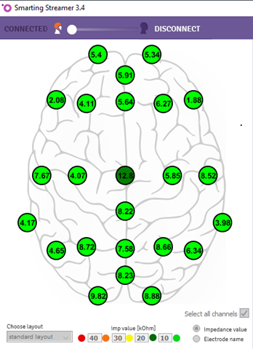
Figure 5.1 - Locations of electrodes on the scalp with lowest possible impedance level during experiment.

Participants were seated in a low-noise environment and fitted with the EEG cap. The experimental procedure was explained to the participants and what to expect, which buttons they would push, and any definitions they might need to complete the experiment. Participants then performed a practice experiment, followed by the actual experiment. The duration of the experiment including practice session was approximately 25 minutes.

5.3.3. Experimental tasks
This pilot study investigated conceptual expansion as a central component of creative thinking in engineering students. This study was based on work by Kröger et al. [47,48]. Using a modified AUT, Kröger et al. [48] related the N400 ERP component to varying levels of unusualness and/or novelty of stimuli. During the current study, participants were shown an object/function pairing as a stimulus, which differs from a traditional AUT, where participants are given an object and instructed to generate as many alternatives uses as possible for that object. The difference between the current study and Kröger et. al. [48] is that this study focuses on engineering participants to gain a better understanding of the neural responses of engineering student.

Each experimental stimuli started with a fixation cross (+) in the middle of the screen for 1000 ms. Participants then see a 500 ms blank screen, followed by the object/function presented for 2000 ms (object > function). Again, after a 500 ms blank screen, the participants are presented with the first question ("Unusual?") for 1700 ms. The participant would answer "yes" or "no" to this question by using the left and right mouse buttons. The second question ("Appropriate?") is presented after another 500 ms blank screen. Again, the participant answers "yes" or "no" using the mouse buttons. The trial ends with another 500 ms blank screen, and the cycle repeats for a new object/function pair. See Figure 5.2 for a pictorial of the experimental design.

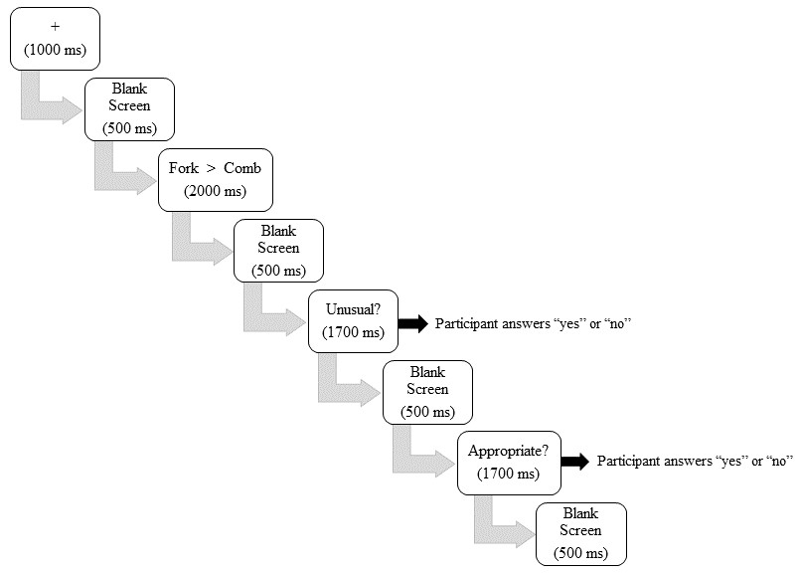
Figure 5.2 - Schematic showing the experimental tasks AUT with time intervals.

Each participant responded to 171 object/function pairs, 57 objects with three functions as stimuli (a creative function/use, common function/use, and nonsense function/use). Table 5.1 gives an example of what the participant might see. The participant ultimately decided function/use. To be categorized as common use, the participant would answer no-yes to the two questions, yes-yes to categorize it as a creative use, and yes-no for a nonsense use. There was no repetition on item-use pairs and pairs were presented randomly.

Table 5.1. Participant responses for an item with the three uses [13].
Item | Use | Type | Expected response for “Unusual?” and “Appropriate?” questions, respectively
Shoe | Pot Plant | Creative | Yes− Yes
Shoe | Easter Bunny | Nonsense | Yes− No
Shoe | Clothing | Common | No − Yes

5.4. EEG Signal Analysis

5.4.1. ERPs
EEGlab, a MATLAB plugin, was used to pre-process the EEG data collected from the participants. A broad filter (FIR filter) from 0.5 to 100 Hz was applied, followed by a notch filter from 58-62 Hz to remove electrical noise. An independent component analysis (ICA), using FastICA algorithm, was performed to remove artifacts not related to brain data. The EEG data was prepared for ERP analysis by segmenting into 1200 ms blocks based on time-stamps indicating the start of each object/function stimulus pair. Each segment, or epoch, was baseline corrected with the 200 ms time window before the presentation of the object/function pair and the remaining 1000 ms segment was used for analysis.

A 30 Hz low-pass filter, with a slope of 24 dB/Oct, was applied to each segment and amplitudes exceeding approximately +/-100 μV were removed. Grand averaged ERPs from all participants were calculated for the 300-500 ms post-stimulus region. To be included in the grand average, participants needed to have selected a minimum of 15 object-function pairs for each of the three categories (common, creative, and nonsense).

5.4.2. TRP
A set of MATLAB scripts (R2020b; The MathWorks, Inc.) were used for TRP EEG signal analysis. The collected raw EEG data was pre-processed using a broad filter (FIR filter) and a notch filter. DC offset voltages were removed by subtracting the temporal mean of the signal from each data sample and for all EEG channels. Due to the non-zero electrical conduction, the surface of the scalp between EEG electrodes is prone to conducting surface electrical currents from other artifacts. To lessen all the artifacts, a Common Average Reference (CAR) spatial filter was applied to the raw EEG data. Wavelet decomposition was then applied to the artifacts free data. There is a close association between the originality of the ideas or creative task demands and the EEG Alpha band power. A window size of 1000 ms of the EEG signal was notched from alpha band by squaring the values (µV²) to calculate the band power. From each trial and period, the artifact free time -intervals' alpha band power was averaged. Following previous studies [21,56], a mean TRP calculation quantified cortical activation changes. Power changes reference and activation phases for each electrode and trial were considered. The subtraction value of log - transformed power during pre-stimulus reference intervals (Powi, reference) 1000 ms with fixation from the log - transformed power 1000 ms window during AUT tasks (Powi, activation) serves as activation for an electrode i for TRP calculations (see Equation 1).

TRP_{i} = log (Pow_{i},activation)− log(Pow_{i},reference) …………………..(1)

From reference to activation, when there is negative values, it evinces decreases in power familiar with desynchronization. On the contrary, increased power with positive values is known as synchronization [24]. The electrodes were aggregated into the following temporal areas: Anteriofrontal (FP), frontal (F), centroparietal (CP), parietotemporal (P/T), occipital (O); odd numbers represent the left hemisphere and even numbers represent right hemisphere. The electrodes in the central positions (AFz, Fz, Cz, CPz, Pz, Poz) were not included for analysis because this study focused on potential hemispheric differences.

A 9×2×3 ANOVA with the within-subjects factors AREA (nine electrode positions in each hemisphere), HEMISPHERE (left, right), and Tasks (creative, nonsense and common) was statistically analyzed. Additionally, this study considers the continuous between subjects' ideas in the ANOVA design to evaluate the task performance. According to [59], considering the violations of sphericity assumptions, this study employed the multivariate approach. A significance level of p < .05 (two-tailed) was applied for all statistical analyses. Statistical analysis was performed using by Minitab: Data Analysis, Statistical & Process Improvement Tools.

5.5. Results

5.5.1. N400 results
Unlike A two-factor repeated-measures ANOVA was used for analysis. The two factors for this study were: condition (common, creative, nonsense) and electrodes Cz, CPz, Pz, and POz. These four electrodes of interest were chosen based on p identified in previous studies [43,44], in addition to the known centro-pariatel distribution of the N400 effect [60] was monitored. Mauchly's Test of Sphericity was first used to verify if the variances were equal. In this case, the sphericity assumption was not violated for the N400 time window for condition (Χ² (2) = 2.174; p = 0.337) but was violated for electrode (Χ² (5) = 14.820; p = 0.016). Therefore, degrees of freedom for the electrode factor were corrected using Greenhouse-Gesser estimates of sphericity (e = 0.354), and these corrected numbers are presented below.

The repeated measures ANOVA did not show significant main effects for the factor condition (F (1.320,5.279) = 0.664; p > 0.05; η_{p}² = 0.142)) or for the interaction of the factors condition*electrode (F (6,24) = 0.992; p > 0.05; η_{p}² = 0.199)). Main effects were significant for the factor electrode (F (1.063,4.253) = 7.392; p = 0.049 < .05; η_{p}² = 0.649)).

With more participants, it is probable that results similar to those presented here would be statistically significant. Even though not significant, results from the pilot study follow a similar pattern presented by a previous study [48]. The results indicate that stimuli classified as nonsensical or creative elicit larger N400 amplitudes (-1.107 mV and -0.755 mV, respectively) than common uses (0.0859 mV), as seen in Figure 5.3. Figure
5.3 shows the mean amplitudes for all participants for each type of stimulus on electrodes Cz, CPz, Pz, and POz. Analysis of the N400 may be an approach to understanding the creativity of engineers. The grand average waveforms for all participants for each electrode of interest are presented in Figure 5.4, with an outlined window of time where the N400 was examined. For more information on this study, see [13].

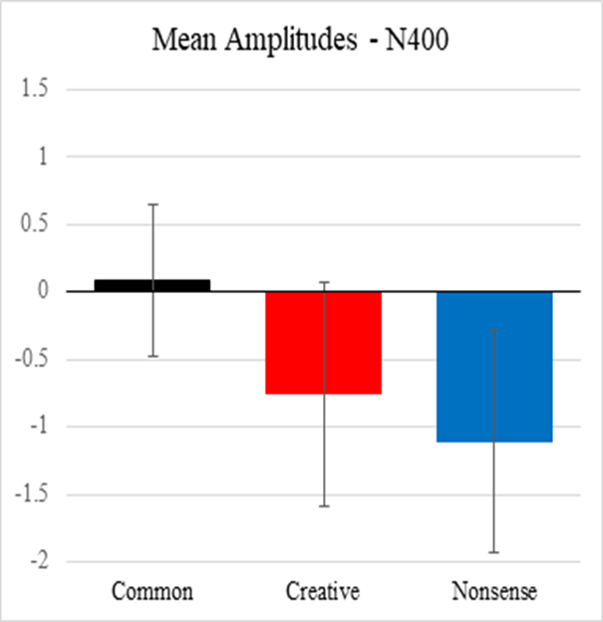
Figure 5.3 - Mean amplitudes of the four electrodes (Cz, CPz, Pz, and POz) for creative uses, nonsensical uses, and common uses investigating the N400 effect.

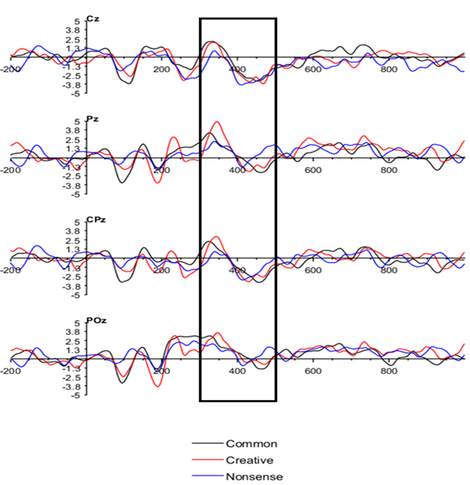

Figure 5.4 - Averaged ERPs from the five participants and the box indicates the 300- 500 ms window of investigation of the N400 effect.

5.5.2. Alpha task related power (TRP) results
Task-related changes in EEG alpha power during the generation of creative/original, nonsense and common uses in the modified AUT was calculated. Positive TRP indicates task-related alpha synchronization increases in alpha power relative to rest, negative values indicate desynchronization. Based on the originality of ideas, the individual participant's neuro response for both hemispheres are shown in figure 5.5. Except for participant 1, all other participants showed strong increases in alpha power (relative to a pre-stimulus reference interval) over anteriofrontal sites. All the participants showed strong decreases over parietooccipital temporal area.

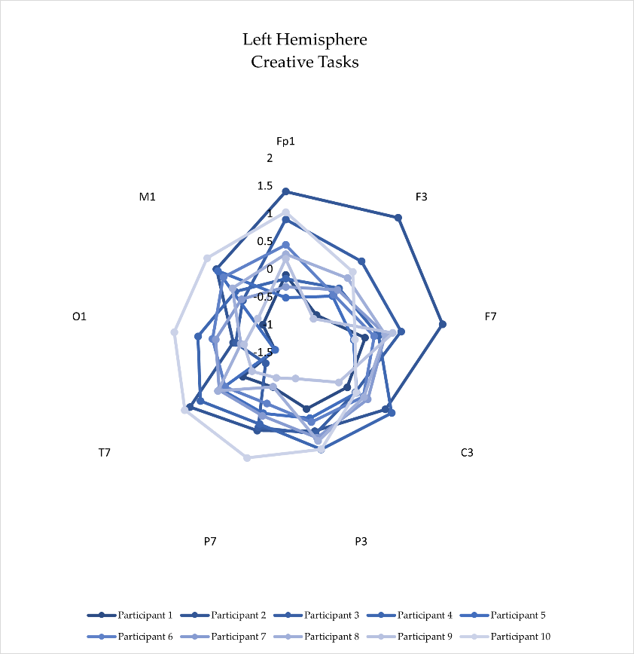
(a)
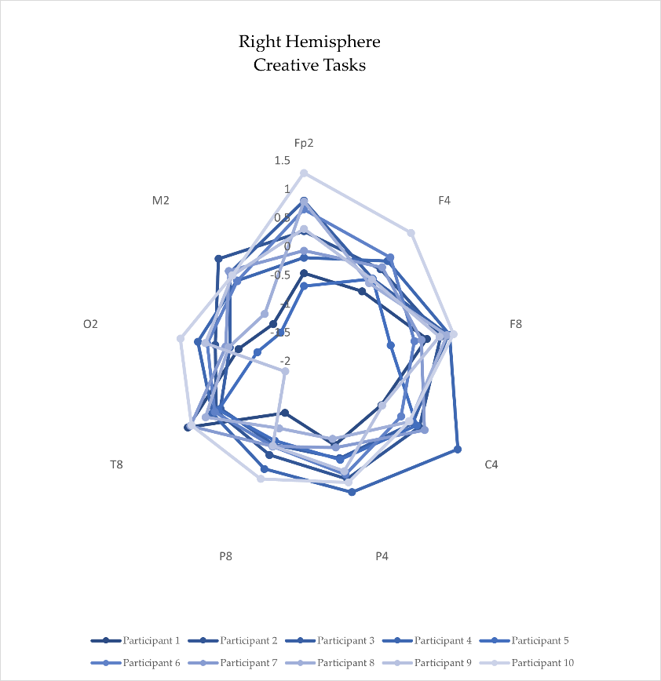
(b)
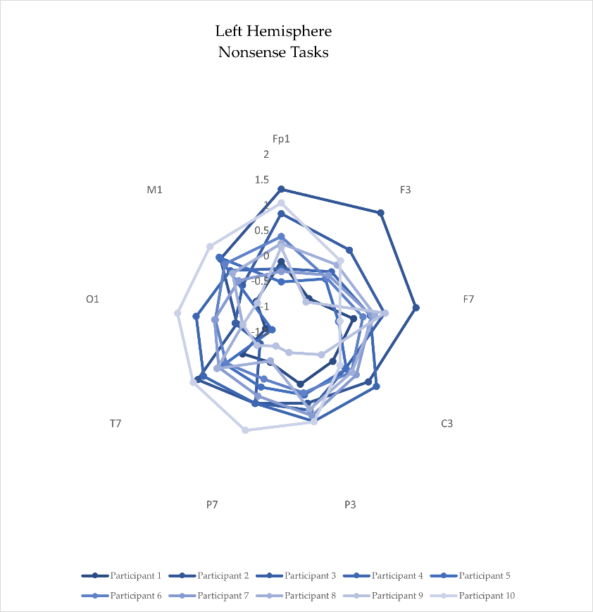
(c)
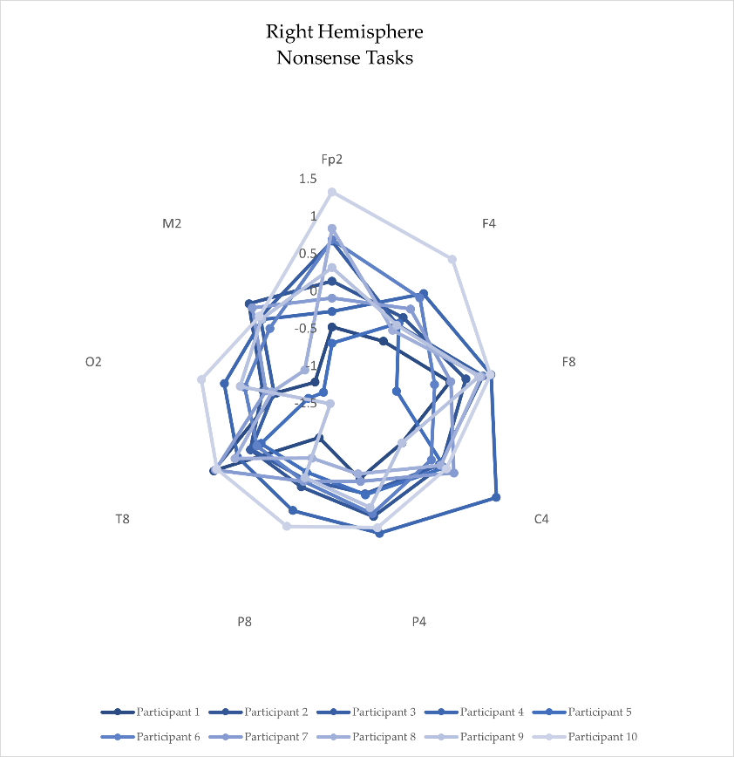
(d)
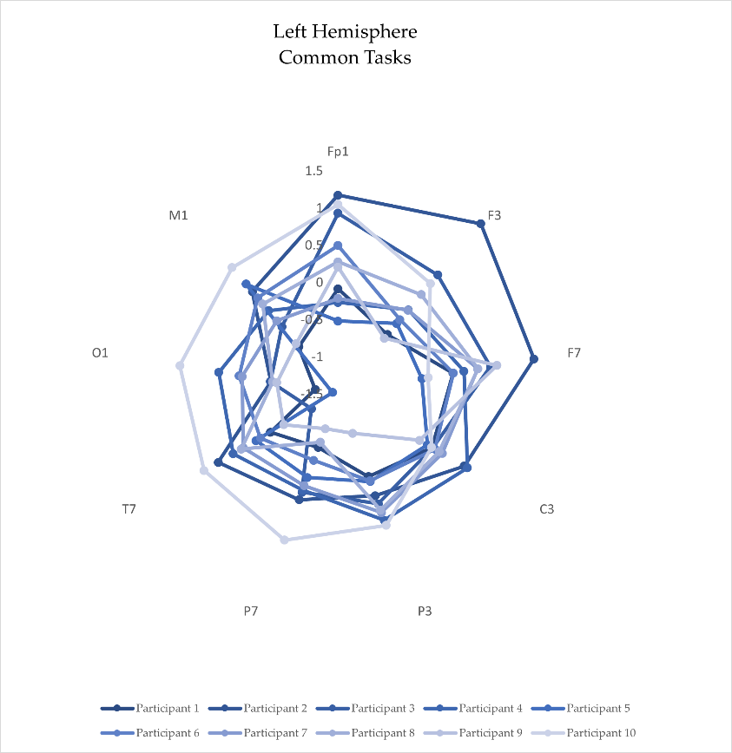
(e)
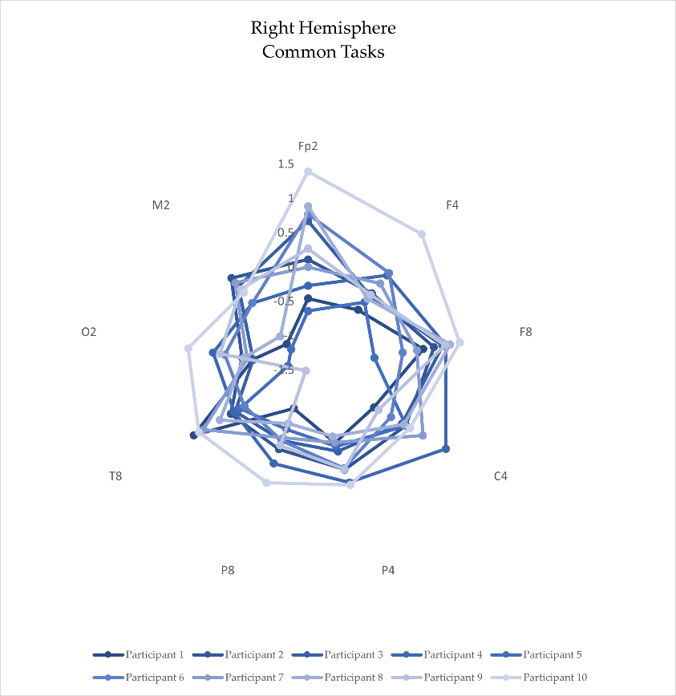
(f)
Figure 5.5 - Individual participants task-related power changes (log μV2) in EEG alpha power during the generation of creative/original uses (a) left hemisphere (b) right hemisphere; nonsense uses (c) left hemisphere (d) right hemisphere; common uses (e) left hemisphere (f) right hemisphere in the modified Alternative Uses (AU) task.

The 9×2×3 ANOVA revealed a significant main effect AREA (F (8,486) =18.22, p<.005, η_{p}² =.230), indicating decreased alpha power during creative ideation especially over (O1/2, P7/8,) area. The main effect HEMISPHERE (F (1, 486) =.266, p=.287, η_{p}² =.00233) indicated stronger alpha power decreases over right (SE =.0294) than left hemispheric sites. The interaction AREA × HEMISPHERE was not significant (F (8, 486) =.69, p=.701, η_{p}² =.0112). No significant main effect Task (F (2, 486) =.02, p= .984), creativity was associated with stronger alpha power decreases than common and nonsense task. The interaction AREA× Task (F (7, 486) =.02) revealed that strong power increases during three tasks at temporal sites (Tukey’s comparisons revealed significant task related differences only at T7/8). No other effect involving the within-subjects factor task was significant. General model prediction on O1/2 temporal area, right hemisphere, and main effect creative task predicted.

Statistical analysis revealed a distinct pattern of alpha power - positive value of participants' TRP shows ERS on the frontal and central cortical area, whereas the negative value of the TRP indicates ERD on the parietooccipital cortical area. The alpha power decrease indicates participants were task involved during the experiment, which is similar to results reported by Jauk et al. and Benedek et al. [19,31].

5.6. Classification of Neural Responses
A Time-frequency analysis of EEG is performed using Wavelet transform because of the non-stationary nature of EEG. Transient features of the signal can be accurately detected in time domains by wavelet transform [61,62].

The wavelet analysis band the EEG signal for Delta δ (0.1-4 Hz), Theta θ (4-8 Hz), Alpha α (8-13 Hz), Beta β (13-30 Hz) and Gamma γ (30-45+ Hz) bands. In this experiment, we analyze the Alpha band (8-13 Hz) as slow temporal modulations of (<16 Hz), aiming the classification of AUT neuro responses primarily focused on creative response. We applied statistical analysis techniques to the wavelet coefficients, which are decomposed EEG signals, for feature extraction. The following statistical features were selected for Alpha band (8-13 Hz) corresponding to each object category (Creative,
Nonsense, Common): 1. Min Value, 2. Max Value, 3. Mean value, 4. Standard deviation,
5. Skewness, 6. Kurtosis, and 7. Variance.
Task related alpha power showed significance area placed over parietooccipital (O1/2, P7/8,) area. Statistical result identified the temporal area electrode for classification. Figure 5.6 illustrates that creative task power has decreased more in O1/2 temporal position, which is the parietooccipital area of the brain. Furthermore, this study uses O1/2 temporal electrode position for kNN classifier to classify creative, nonsense and common response from AUT tasks. For each participant, 57 trials for three object categories summing to 171 trials were included for classification. All participants' data was included for the classification purpose from O1/2 area location.
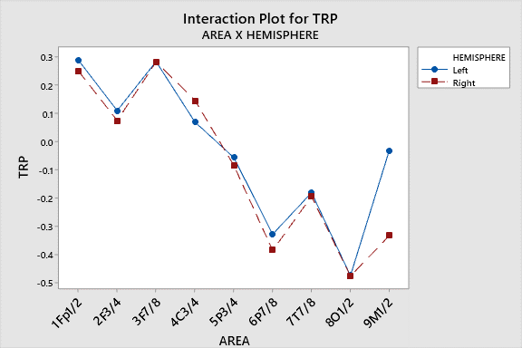
(a)
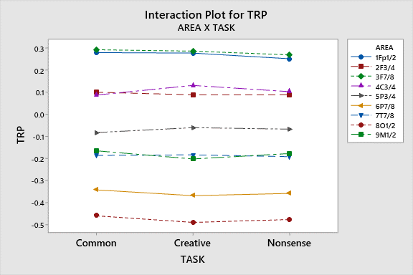
(b)
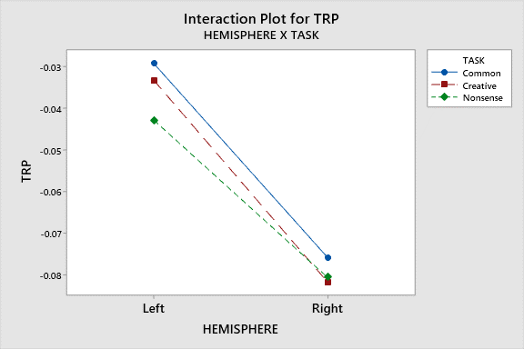
(c)
Figure 5.6 - ANOVA general pattern of Task-related changes of EEG alpha band power (TRP) during modified AUT: (a) Interaction plot between AREA and HEMISPHERE; (b) Interaction plot between AREA and TASK; (c) Interaction plot between HEMISPHERE and TASK.

From each trial, features were collected for the classification. kNN classifier was used to classify Creative, Nonsense, and Common uses of AUT task, aiming to achieve highest possible classification accuracy for creative, nonsense and common task usage. As commonly adopted in data mining techniques, this study used 80% data for training, whereas the remaining 20% was used for testing [63]. Table 5.2 illustrates the assignments of data used in this study for training and testing. Performance results are presented as model accuracy, precision, recall, and F-1 score.
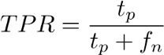 (2) 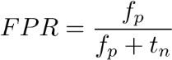 (3) 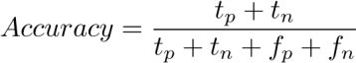 (4)
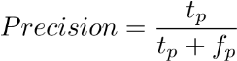 (5)
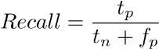 (6)
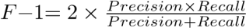 (7)
Where, True Positive Rate (TPR), False Positive Rate (FPR), True Positive (t_{p}),
False Positive (f_{p}), True Negative (t_{n}), False Negative (f_{n}).

Table 5.2. Assignment of Data Used for Training and Testing of ML Models.
Label | Training Dataset | Testing Dataset
Creative | 912 | 228
Nonsense | 912 | 228
Common | 912 | 228
Total | 2736 | 684

Table 5.3. Overall Model performance of the study.
Model | Accuracy | Precision | Recall | F-1 score | AUC
kNN | 99.92% | 99.93% | 99.93% | 99.93% | .9995

Table 3 presents performance of the models in terms of accuracy, precision, recall, and F-1 score. The accuracy of kNN classifier was 99.92%. At the same time, this study also explored other classification models like Support Vector Machines (SVM), Ensembles classifier and Naïve Bayes classifier. However, these models performed worse in terms of accuracy, precision, recall, and F-1 score. kNN classifier was able to achieve 100% accuracy to classify creative neuro response, 99.89% of nonsense neuro response and 99.89% of common neuro responses. Area under the curve (AUC) was .9995, which demonstrates that the classifier can probably distinguish the positive class values and negative class values. A recent study [41] presented that machine learning techniques (quadratic discriminant analysis (QDA) and Support Vector Machine (SVM)) can classify more and less creative individuals and also classify more or less creative brain states from EEG responses. Studies [64–66] have reported results for EEG emotion classification from the aggregation of 12 or more pairs of electrodes to achieve high classification accuracy. This study achieved an accuracy of 99.92% from statistically significant temporal area position analysis, which is a faster classification than that of complex methods.

5.7. Discussion
A The aim of this study was to investigate the neurological responses on creativity task in the engineering domain. N400 component and alpha task related power are analyzed to understand the cognitive process of creativity. The ERP results with highest negative values associated with nonsense functions and most positive values associated with common functions. These results support the main hypothesis of this study that novelty and appropriateness of a creative task will be exhibited in modulation of the N400 component, with highest negative values associated with unusual-inappropriate (nonsense) functions and most positive values associated with usual-appropriate (common) functions.

This is a pilot study to confirm modulation of the N400 with respect to novelty and appropriateness in engineering. The results show promise of this experimental design to further understand modulation of the N400 in an engineering creativity context. The findings allow for a more direct way to study the underlying cognitive process and help improve creativity training.

Considering the EEG results, task-related frontal alpha synchronization was observed which indicates high internal processing demands [19,67] during creative tasks. Low internal processing demands indicate strong desynchronization, especially in posterior brain regions (parietooccipital), which reflect stronger demands on the visual system during creative activity information processing [19,67]. Taken together, the results suggest that frontal brain regions may exert control by means of temporal synchrony of lower frequencies (especially alpha but also theta) with parietal brain regions. The findings of this study are in agreement with functional imaging and are also consistent with other studies [19,25,67,68].

Using the widely used Brodmann areas’ (BA), which relates cognitive functions to different scalp locations. Results from our study show EEG (de)activation in BA 09 and BA 10 areas in the right hemisphere. BA 09 and BA 10 areas are respectively associated with higher cognitive functions and decision-making [69]. Overall results from this study demonstrate that EEG is both a practical and relevant technique to study neurophysiological activity of creativity in engineering. This study also showed that ML techniques can classify the neural responses (common, creative, nonsense -responses) from modified-AUT experiments. This classification can be utilized to identify neuroresponses associated with more or less creative brain states.

5.8. Limitations
We present some limitations of our study to guide future works:
- Unbalanced male/female participants (80% male and 20% female) could be an issue in EEG response patterns for the classification of neural responses.
- This study did not consider categorical data such as age, gender etc. The participants’ age group was between 22 to 32.
- This study did not include functional connectivity and did not explore the classification of more or less creative individuals.
- This study considered the preliminary screening of the participants, however, didn’t use psycho behavioral questionnaires to profile the participants in terms of personality and attitude.

5.9. Conclusion and Future Directions
Although not statistically significant, our study found fundamental ERP effects for the N400 component of engineering students when modified AUT is used as stimuli. That is, larger negative responses for nonsense uses, followed by creative uses, and then common uses with a positive response.

An ANOVA analysis of task-related power shows a significant main effect for parietooccipital temporal area and the main effect HEMISPHERE. The results indicated larger alpha power decreases over right than left-hemispheric sites. The distinct pattern of alpha power and positive values of TRP neuro-responses show ERS on the frontal and central cortical areas. The negative value of participants’ TRP neuro-response indicates ERD on the parietooccipital cortical area. Participants were actively involved during AUT tasks, as the alpha power decreased during the modified AUT experiment, as suggested by several previous studies.

Machine learning kNN model outperformed in terms of accuracy, precision, recall, and F1- score. kNN classifier successfully achieved high 99.92% overall accuracy to classify creative, nonsense and common neuro responses of the participants using O1/O2 temporal area data. Other models like SVM, Ensembles classifier, and Naïve
Bayes classifier did not perform well.

A future extension of this study will explore the classification between the more and less creative individuals. Also, future works will investigate the real-time ML based neurofeedback and the possibilities of DL techniques for Human Computer Interaction (HCI).

5.10. Acknowledgement
This material is based upon work supported by the National Science Foundation under Grant No. 1561660 and 1726358. Any opinions, findings, and conclusions or recommendations expressed in this material are those of the author(s) and do not necessarily reflect the views of the National Science Foundation.

5.11. References
[1] Jordanous, A., 2012, “A Standardised Procedure for Evaluating Creative
Systems: Computational Creativity Evaluation Based on What It Is to Be Creative,” Cognitive Computation, 4(3), pp. 246–279.
- Silvia, P. J., 2018, “Creativity Is Undefinable, Controllable, and Everywhere,” The Nature of Human Creativity, R.J. Sternberg, and J.C. Kaufman, eds., Cambridge University Press, Cambridge, United Kingdom, pp. 291–301.
- Batey, M., 2012, “The Measurement of Creativity: From Definitional Consensus to the Introduction of a New Heuristic Framework,” Creativity Research Journal, 24(1), pp. 55–65.
- Riga, V., and Chronopoulou, E., 2014, “Applying MacKinnon’s 4Ps to Foster Creative Thinking and Creative Behaviours in Kindergarten Children,” Education 313, 42(3), pp. 330–345.
- Runco, M. A., and Jaeger, G. J., 2012, “The Standard Definition of Creativity,” Creativity Research Journal, 24(1), pp. 92–96.
- Hartog, T., Marshall, M., Alhashim, A., Ahad, M. T., & Siddique, Z. (2020, January). Work in Progress: Using Neuroresponses to Understand Creativity, the Engineering Design Process, and Concept Generation. In Paper presented at 2020 ASEE Virtual Annual Conference.
- Siddique, Z., Ahad, M. T., Mobaraki-Omoumi, M., Marshall, M., & Hartog, T. (2022, August). Event Related Potentials (ERP) Study to Understand Function to Object Mapping for Engineering Student. In 2022 ASEE Annual Conference & Exposition.
- Treffinger, D. J., 2011, Creativity, Creative Thinking, and Critical Thinking: In Search of Definitions, Center for Creative Learning, Inc., Sarasota, FL.
- Abraham, A., 2018, The Neuroscience of Creativity, Cambridge University Press.
- Dietrich, A., and Kanso, R., 2010, “A Review of EEG, ERP, and Neuroimaging Studies of Creativity and Insight.,” Psychological bulletin, 136(5), p. 822.
- Limb, C. J., and Braun, A. R., 2008, “Neural Substrates of Spontaneous Musical Performance: An FMRI Study of Jazz Improvisation,” PLoS one, 3(2), p. e1679.
- Gregory, E., Hardiman, M., Yarmolinskaya, J., Rinne, L., and Limb, C., 2013,
“Building Creative Thinking in the Classroom: From Research to Practice,” International Journal of Educational Research, 62, pp. 43–50.
- Hartog, T., Marshall, M., Ahad, M. T., Alhashim, A. G., Okudan Kremer, G., van Hell, J., & Siddique, Z. (2020, August). Pilot Study: Investigating EEG Based Neuro-Responses of Engineers via a Modified Alternative Uses Task to Understand Creativity. In International Design Engineering Technical Conferences and Computers and Information in Engineering Conference (Vol. 83921, p. V003T03A019). American Society of Mechanical Engineers.
- Shemyakina, N. V., and Nagornova, Z. V., 2020, “EEG ‘Signs’ of Verbal Creative Task Fulfillment with and without Overcoming Self-Induced Stereotypes,” Behavioral Sciences, 10(1), p. 17.
- Dehais, F., Duprès, A., Blum, S., Drougard, N., Scannella, S., Roy, R. N., and Lotte, F., 2019, “Monitoring Pilot’s Mental Workload Using ERPs and Spectral Power with a Six-Dry-Electrode EEG System in Real Flight Conditions,” Sensors, 19(6), p. 1324.
- Liu, N.-H., Chiang, C.-Y., and Chu, H.-C., 2013, “Recognizing the Degree of Human Attention Using EEG Signals from Mobile Sensors,” Sensors, 13(8), pp.
10273–10286.
- Pei, G., Wu, J., Chen, D., Guo, G., Liu, S., Hong, M., and Yan, T., 2018, “Effects of an Integrated Neurofeedback System with Dry Electrodes: EEG Acquisition and Cognition Assessment,” Sensors, 18(10), p. 3396.
- Neuper, C., and Klimesch, W., 2006, Event-Related Dynamics of Brain Oscillations, elsevier.
- Benedek, M., Bergner, S., Könen, T., Fink, A., and Neubauer, A. C., 2011, “EEG Alpha Synchronization Is Related to Top-down Processing in Convergent and Divergent Thinking,” Neuropsychologia, 49(12), pp. 3505–3511.
- Klimesch, W., 1999, “EEG Alpha and Theta Oscillations Reflect Cognitive and Memory Performance: A Review and Analysis,” Brain research reviews, 29(2–3), pp. 169–195.
- Fink, A., Grabner, R. H., Benedek, M., Reishofer, G., Hauswirth, V., Fally, M., Neuper, C., Ebner, F., and Neubauer, A. C., 2009, “The Creative Brain:
Investigation of Brain Activity during Creative Problem Solving by Means of EEG and FMRI,” Human brain mapping, 30(3), pp. 734–748.
- Gu, C., Wang, Y., Wu, C., Xie, X., Cui, C., Wang, Y., Wang, W., Hu, B., and Zhou, Z., 2015, “Brain Correlates Underlying Social Creative Thinking: EEG Alpha Activity in Trait vs. State Creativity,” Acta Psychologica Sinica, 47(6), pp. 765– 773.
- Berger, B., Omer, S., Minarik, T., Sterr, A., and Sauseng, P., 2015, “Interacting Memory Systems—Does EEG Alpha Activity Respond to Semantic Long-Term Memory Access in a Working Memory Task?,” Biology, 4(1), pp. 1–16.
- Pfurtscheller, G., and Da Silva, F. L., 1999, “Event-Related EEG/MEG Synchronization and Desynchronization: Basic Principles,” Clinical neurophysiology, 110(11), pp. 1842–1857.
- Klimesch, W., Sauseng, P., and Hanslmayr, S., 2007, “EEG Alpha Oscillations: The Inhibition–Timing Hypothesis,” Brain research reviews, 53(1), pp. 63–88.
- Rominger, C., Fink, A., Weiss, E. M., Bosch, J., and Papousek, I., 2017, “Allusive Thinking (Remote Associations) and Auditory Top-down Inhibition Skills Differentially Predict Creativity and Positive Schizotypy,” Cognitive Neuropsychiatry, 22(2), pp. 108–121.
- Gabora, L., and Kauffman, S., 2016, “Toward an Evolutionary-Predictive
Foundation for Creativity,” Psychonomic bulletin & review, 23(2), pp. 632–639.
- Jaarsveld, S., Fink, A., Rinner, M., Schwab, D., Benedek, M., and Lachmann, T.,
2015, “Intelligence in Creative Processes: An EEG Study,” Intelligence, 49, pp. 171–178.
- Schwab, D., Benedek, M., Papousek, I., Weiss, E. M., and Fink, A., 2014, “The Time-Course of EEG Alpha Power Changes in Creative Ideation,” Frontiers in human neuroscience, 8, p. 310.
- Rominger, C., Papousek, I., Perchtold, C. M., Weber, B., Weiss, E. M., and Fink,
A., 2018, “The Creative Brain in the Figural Domain: Distinct Patterns of EEG Alpha Power during Idea Generation and Idea Elaboration,” Neuropsychologia, 118, pp. 13–19.
- Jauk, E., Benedek, M., and Neubauer, A. C., 2012, “Tackling Creativity at Its Roots:
Evidence for Different Patterns of EEG Alpha Activity Related to Convergent and Divergent Modes of Task Processing,” International Journal of Psychophysiology, 84(2), pp. 219–225.
- Wang, M., Hao, N., Ku, Y., Grabner, R. H., and Fink, A., 2017, “Neural Correlates of Serial Order Effect in Verbal Divergent Thinking,” Neuropsychologia, 99, pp. 92–100.
- Zhou, S., Chen, S., Wang, S., Zhao, Q., Zhou, Z., and Lu, C., 2018, “Temporal and Spatial Patterns of Neural Activity Associated with Information Selection in OpenEnded Creativity,” Neuroscience, 371, pp. 268–276.
- Rominger, C., Papousek, I., Perchtold, C. M., Benedek, M., Weiss, E. M.,
Schwerdtfeger, A., and Fink, A., 2019, “Creativity Is Associated with a
Characteristic U-Shaped Function of Alpha Power Changes Accompanied by an Early Increase in Functional Coupling,” Cognitive, Affective, & Behavioral Neuroscience, 19(4), pp. 1012–1021.
- Di Flumeri, G., Aricò, P., Borghini, G., Sciaraffa, N., Di Florio, A., and Babiloni,
F., 2019, “The Dry Revolution: Evaluation of Three Different EEG Dry Electrode Types in Terms of Signal Spectral Features, Mental States Classification and Usability,” Sensors, 19(6), p. 1365.
- Ahad, M.T., Ahsan, M. M., Jahan, I., Nazim, R., Yazdan, M. M.S., Huebner, P.,and Siddique, Z., 2021, “Behavioral Pattern Analysis Between Bilingual and Monolingual Listeners’ Natural Speech Perception on Foreign-Accented English Language Using Different Machine Learning Approaches,” Technologies, 9(3), p. 51. 10.3390/technologies9030051.
- Torres, E. P., Torres, E. A., Hernández-Álvarez, M., and Yoo, S. G., 2020, “EEGBased BCI Emotion Recognition: A Survey,” Sensors, 20(18), p. 5083.
- Ahad, M. T., 2018, An EEG-Based Comparative Analysis of Natural Speech Perception by Native Speakers of American English vs. Bilingual Individuals, Lamar University-Beaumont.
- Ritter, S. M., Abbing, J., and van Schie, H. T., 2018, “Eye-Closure Enhances Creative Performance on Divergent and Convergent Creativity Tasks,” Front. Psychol., 9.
- Ayodele, T. O., 2010, “Types of Machine Learning Algorithms,” New advances in machine learning, 3, pp. 19–48.
- Stevens, C. E., and Zabelina, D. L., 2020, “Classifying Creativity: Applying Machine Learning Techniques to Divergent Thinking EEG Data,” NeuroImage, p. 116990.
- Chen, W.-L., Wagner, J., Heugel, N., Sugar, J., Lee, Y.-W., Conant, L., Malloy, M., Heffernan, J., Quirk, B., Zinos, A., Beardsley, S. A., Prost, R., and Whelan, H. T., 2020, “Functional Near-Infrared Spectroscopy and Its Clinical Application in the Field of Neuroscience: Advances and Future Directions,” Frontiers in Neuroscience, 14.
- Quaresima, V., and Ferrari, M., 2019, “Functional Near-Infrared Spectroscopy
(FNIRS) for Assessing Cerebral Cortex Function during Human Behavior in Natural/Social Situations: A Concise Review,” Organizational Research Methods, 22(1), pp. 46–68.
- Woodman, G. F., 2010, “A Brief Introduction to the Use of Event-Related Potentials in Studies of Perception and Attention,” Attention, Perception, & Psychophysics, 72(8), pp. 2031–2046.
- Klimesch, W., 2012, “Alpha-Band Oscillations, Attention, and Controlled Access to Stored Information,” Trends in Cognitive Sciences, 16(12), pp. 606–617.
- Luck, S. J., 2014, An Introduction to the Event-Related Potential Technique, MIT press.
- Rutter, B., Kröger, S., Hill, H., Windmann, S., Hermann, C., and Abraham, A.,
2012, “Can Clouds Dance? Part 2: An ERP Investigation of Passive Conceptual Expansion,” Brain and Cognition, 80(3), pp. 301–310.
- Kröger, S., Rutter, B., Hill, H., Windmann, S., Hermann, C., and Abraham, A.,
2013, “An ERP Study of Passive Creative Conceptual Expansion Using a Modified Alternate Uses Task,” Brain research, 1527, pp. 189–198.
- da Silva Vieira, S. L., Gero, J. S., Delmoral, J., Gattol, V., Fernandes, C., and Fernandes, A. A., 2019, “Comparing the Design Neurocognition of Mechanical Engineers and Architects: A Study of the Effect of Designer’s Domain,” Proceedings of the Design Society: International Conference on Engineering Design, Cambridge University Press, pp. 1853–1862.
- Fritz, K., Deschenes, L., and Pandey, V., 2018, “Effective Design Team Composition Using Individual and Group Cognitive Attributes,” ASME International Mechanical Engineering Congress and Exposition, American Society of Mechanical Engineers, p. V013T05A030.
- Liu, L., Nguyen, T. A., Zeng, Y., and Hamza, A. B., 2016, “Identification of Relationships between Electroencephalography (EEG) Bands and Design Activities,” International Design Engineering Technical Conferences and Computers and Information in Engineering Conference, American Society of Mechanical Engineers, p. V007T06A019.
- Davatzikos, C., 2019, “Machine Learning in Neuroimaging: Progress and Challenges,” NeuroImage, 197, p. 652.
- Klöppel, S., Stonnington, C. M., Chu, C., Draganski, B., Scahill, R. I., Rohrer, J. D., Fox, N. C., Jack Jr, C. R., Ashburner, J., and Frackowiak, R. S., 2008, “Automatic Classification of MR Scans in Alzheimer’s Disease,” Brain, 131(3), pp. 681–689.
- Koutsouleris, N., Meisenzahl, E. M., Borgwardt, S., Riecher-Rössler, A., Frodl, T., Kambeitz, J., Köhler, Y., Falkai, P., Möller, H.-J., and Reiser, M., 2015, “Individualized Differential Diagnosis of Schizophrenia and Mood Disorders Using Neuroanatomical Biomarkers,” Brain, 138(7), pp. 2059–2073.
- Wang, X.-W., Nie, D., and Lu, B.-L., 2014, “Emotional State Classification from EEG Data Using Machine Learning Approach,” Neurocomputing, 129, pp. 94–106.
- Alomari, M. H., Samaha, A., and AlKamha, K., 2013, “Automated Classification of L/R Hand Movement EEG Signals Using Advanced Feature Extraction and Machine Learning,” arXiv preprint arXiv:1312.2877.
- Hosseinifard, B., Moradi, M. H., and Rostami, R., 2013, “Classifying Depression Patients and Normal Subjects Using Machine Learning Techniques and Nonlinear Features from EEG Signal,” Computer methods and programs in biomedicine, 109(3), pp. 339–345.
- Gerloff, C., Richard, J., Hadley, J., Schulman, A. E., Honda, M., and Hallett, M., 1998, “Functional Coupling and Regional Activation of Human Cortical Motor Areas during Simple, Internally Paced and Externally Paced Finger Movements.,” Brain: a journal of neurology, 121(8), pp. 1513–1531.
- Vasey, M. W., and Thayer, J. F., 1987, “The Continuing Problem of False Positives in Repeated Measures ANOVA in Psychophysiology: A Multivariate Solution,” Psychophysiology, 24(4), pp. 479–486.
- Kutas, M., and Federmeier, K. D., 2011, “Thirty Years and Counting: Finding Meaning in the N400 Component of the Event-Related Brain Potential (ERP),” Annual review of psychology, 62, pp. 621–647.
- Al-Qazzaz, N. K., Hamid Bin Mohd Ali, S., Ahmad, S. A., Islam, M. S., and Escudero, J., 2015, “Selection of Mother Wavelet Functions for Multi-Channel EEG Signal Analysis during a Working Memory Task,” Sensors, 15(11), pp. 29015– 29035.
- Al-Qazzaz, N. K., Hamid Bin Mohd Ali, S., Ahmad, S. A., Islam, M. S., and Escudero, J., 2017, “Automatic Artifact Removal in EEG of Normal and Demented Individuals Using ICA–WT during Working Memory Tasks,” Sensors, 17(6), p. 1326.
- Ahsan, M. M., Ahad, M.T.,Soma, F. A., Paul,S., Chowdhury, A., Luna,S. A., Yazdan, M. M.S., Rahman, A.,Siddique, Z.,and Huebner, P., 2021, “Detecting SARS-CoV-2 From Chest X-Ray Using Artificial Intelligence,” IEEE Access, 9, pp. 35501–35513. 10.1109/ACCESS.2021.3061621.
- Duan, R.-N., Wang, X.-W., and Lu, B.-L., 2012, “EEG-Based Emotion Recognition in Listening Music by Using Support Vector Machine and Linear Dynamic System,” International Conference on Neural Information Processing, Springer, pp. 468–475.
- Avinash, T., Dikshant, L., and Seema, S., 2018, “Methods of Neuromarketing and Implication of the Frontal Theta Asymmetry Induced Due to Musical Stimulus as Choice Modeling,” Procedia computer science, 132, pp. 55–67.
- Boostani, R., Karimzadeh, F., and Nami, M., 2017, “A Comparative Review on Sleep Stage Classification Methods in Patients and Healthy Individuals,” Computer methods and programs in biomedicine, 140, pp. 77–91.
- Fink, A., and Benedek, M., 2014, “EEG Alpha Power and Creative Ideation,” Neuroscience & Biobehavioral Reviews, 44, pp. 111–123.
- Cooper, N. R., Croft, R. J., Dominey, S. J., Burgess, A. P., and Gruzelier, J. H., 2003, “Paradox Lost? Exploring the Role of Alpha Oscillations during Externally vs. Internally Directed Attention and the Implications for Idling and Inhibition Hypotheses,” International journal of psychophysiology, 47(1), pp. 65–74.
- “Brodmann Area - an Overview | ScienceDirect Topics” [Online]. Available:
https://www.sciencedirect.com/topics/neuroscience/brodmann-area. [Accessed: 30Sep-2022].

5.12. Appendix
Item-use pairs were presented randomly to the participants. Number in the first column is solely for count. Use category (common, creative, or nonsense) was for data keeping purposes only. Category was ultimately decided by the participant.
# | Item | Common Use | Creative Use | Nonsense Use | Status
1 | Billiard Ball | Billiards | Doorknob | Rocket | Practice
2 | Shoe | Clothing | Pot Plant | Easter Bunny | Practice
3 | Screwdriver | Screwing | Pry Bar | Dragon | Practice
4 | Toilet Seat | Seating | Picture Frame | Golf Club | Experimental
5 | Brick | Construction Material | Paper Weight | Electronic Device | Experimental
6 | Aluminum Foil | Cover Food | Hat | Pen | Experimental
7 | Hanger | Hang Clothing | Unlock Car Door | Telephone | Experimental
8 | Helmet | Protect Head | Basket | Bus | Experimental
9 | Pencil | Writing With | Stir Stick | Backpack | Experimental
10 | Pipe | Transfer Liquid | Weapon | Library | Experimental
11 | Cardboard Box | Storage | Play Fort | Car Engine | Experimental
12 | Shoe Lace | Tie Shoe | Belt | Sunglasses | Experimental
13 | Band-aid | Cover Wound | Tape | Chair | Experimental
14 | Rolling Pin | Cooking Tool | Muscle Massager | Hair | Experimental
15 | Rubber Band | Hold Items Together | Slingshot | Charger | Experimental
16 | Sock | Footwear | Sock Puppets | Time Machine | Experimental
17 | Mirror | Reflection | Signal For Help | Camel | Experimental
18 | Magnifying Glass | Magnify Image | Start Fire | Food | Experimental
19 | Sandpaper | Smooth Surface | Nail File | Trampoline | Experimental
20 | Paint Brush | Painting | Broom | Coffee Maker | Experimental
21 | Toothpick | Clean Teeth | Craft Item | Spring | Experimental
22 | Mason Jar | Preserve Food | Light Bulb Cover | Train | Experimental
23 | Lipstick | Makeup | Writing Utensil | Amplifier | Experimental
24 | School Bus | Transportation | Mobile Home | Sandals | Experimental
25 | Water | Drink | Generate Electricity | Baseball Bat | Experimental
26 | Safety Pin | Fastener | Earring | Fire Hydrant | Experimental
27 | Chewing Gum | Breath Freshener | Putty | Fertilizer | Experimental
28 | Scissors | Package Opener | Pizza Cutter | Toothbrush | Experimental
29 | Artificial Turf | Football Turf | Bath Mat | Newspaper | Experimental
30 | Coca-cola | Beverage | Toilet Cleaner | Typewriter | Experimental
31 | Cd-rom | Disk | Coaster | Gas Can | Experimental
32 | Scuba Flippers | Swim Aid | Fan Blades | Toaster | Experimental
33 | Coconut | Food | Bocce Ball | Keyboard | Experimental
34 | Ice Skate | Ice Skating | Cleaver | Extinguisher | Experimental
35 | Credit Card | Means Of Payment | Butter Knife | Monitor | Experimental
36 | Nail File | Manicure | Carrot Peeler | Duct Tape | Experimental
37 | Paddle | Rowing | Pizza Oven Slider | Cube | Experimental
38 | Nylon Stocking | Women's Clothing | Filter | Balloon | Experimental
39 | Toilet Paper | Hygiene Product | Padding | Punch | Experimental
40 | Tennis Racket | Sports Equipment | Colander | Shower Curtain | Experimental
41 | Knitting Needles | Knitting | Chopsticks | Cigar | Experimental
42 | Record Player | Music Player | Pottery Wheel | Horoscope | Experimental
43 | Trampoline | Gymnastic Apparatus | Bed | Scooter | Experimental
44 | Ironing Board | Ironing Pad | Shelf | Water Heater | Experimental
45 | Fork | Eat | Comb | Doghouse | Experimental
46 | Thermos | Coffee Warmer | Vase | Plastic Bag | Experimental
47 | Matches | Lighter | Cheese Skewers | Hubcap | Experimental
48 | Door | Passage | Ping Pong Table | Wheelbarrow | Experimental
49 | Surfboard | Surfing | Ironing Board | Cooking Pot | Experimental
50 | Watering Can | Gardening Equipment | Wine Decanter | Cap | Experimental
51 | Spatula | Kitchen Utensil | Putty Knife | Remote Control | Experimental
52 | Ruler | Measurement | Curtain Rod | Ball | Experimental
53 | Bottle Cap | Bottle Topper | Cookie Cutter | Hammock | Experimental
54 | Cotton Ball | Make-up Removal | Christmas Decorations | Lantern | Experimental
55 | Canoe | Boat | Bathtub | Razor | Experimental
56 | Spoon | Cutlery | Trowel | Wallet | Experimental
57 | Antlers | Wall Decorations | Coat Hook | Calculator | Experimental

CHAPTER 6: EVIDENCE OF INDOOR ENVIRONMENTAL SETTINGS PREFERENCE FOR THE TEMPORAL DYNAMICS OF CREATIVITY IN ENGINEERING

6.1. Introduction
Human progress and achievements depend on the ability to modify the existing thinking paradigm, apply prior knowledge in flexible ways, and create novel solutions. This remarkable characteristic of the human mind, called creativity, is one of the necessary skills in various fields, from art, economy, and humanities to science, technology, biology, etc. [1]. The importance of creativity is getting more prominent in the field of engineering. Engineers need to contain specific competencies like problem-solving abilities besides their theoretical knowledge and practical skills. The evolving technology and its effect on human life require more creative engineers to identify the problems, improve the designed products and address the challenges [2].

The definition of creativity is controversial based on its multi-dimensional feature. Different definitions have been suggested based on the creative person, creative product, and creativity process [3,4]. Furthermore, the definition needs some adjustments based on the field of application. In the engineering field, however, novelty and appropriateness are the key components of the definition in most literature [5]. The thinking process leading to a creative idea creation is the concept of much research. Divergent thinking, which is the ability to generate multiple solutions to an open-ended problem, is agreed as a process ending in creative ideas. Guilford first suggested this idea in 1967 [6,7]. However, convergent thinking, defined as deriving the single best answer to a clearly defined question, is controversially identified as a creative thinking process [8]. In their research, Arthur Cropley et al. describe that while novel ideas are generated by divergent thinking, the evaluation of the novelty of the idea is fulfilled via convergent thinking. He describes these two processes as thinking phases in generating creative products [8].

Several standardized psychometric tools of creativity were developed to evaluate creativity. For example, Torrance's (1974) Torrance Test of Creative Thinking and Alternative Uses Test (AUT) are based on divergent thinking [9,10,11]. AUT, designed by Guilford, 1967, asks participants to generate alternative uses for an ordinary object. The idea-generation process is called ideation. There are different ways to evaluate the ideation process in AUT. Oshin Vartanian et al. classify these ways into three different categories in their research. For example, in the traditional way, the participants' outcome is evaluated based on ideational fluency (the number of ideas), flexibility (the number of distinct categories of ideas), originality (statistical infrequency of generated uses), and elaboration (degree of detail in a response) of the ideas [6]. However, in Consensual Assessment Technique (CAT) created by Amabile's (1982), subjective scoring approaches have been used to evaluate creativity or related features such as idea quality [12]. In this method, several expert judges rate the outcome in different forms, such as a participant's overall output or averaging across responses of different participants. The third method is called the definitional approach, which rates the outcome of the task based on novelty and usefulness [13].

Besides psychological studies, there is a remarkable growing interest in investigating the underlying neurophysiological mechanism and correlates of creativity in recent years. Different neuroimaging techniques have been used to study the cognitive process of creativity [1]. However, the most popular ones are Electroencephalogram (EEG) and functional magnetic resonance (fMRI). They provide valuable illustrations of various aspects of brain activity during creative idea generation [1].

EEG is a noninvasive measure of brain activity. It represents the difference in electrical potential between different points on the scalp due to excitatory and inhibitory postsynaptic potential activities. EEG signals are analyzed based on frequency, amplitude, and electrode position. In the frequency domain, the lowest end is determined as delta activity with 1-5 HZ regular wave, shows low neural action potentials, and is associated with deep sleep. Theta band with 5-8HZ frequencies reflects sleepiness. Alpha band with 8-12 HZ frequency band is prominent when a person is relaxed but awake. Beta activity is an irregular pattern with 12 -30 Hz, which occurs mostly during active thinking. Finally, gamma activity with 30- 45 Hz is the fastest brain activity and represents the different cognitive performances such as information processing and working memory [1,14]

EEG power and synchrony are the terms to evaluate EEG records. EEG synchrony shows the simultaneous occurrence of signals in different electrodes. EEG power reflected the amount of activation of each frequency band and was obtained through spectral analysis. Power change in EEG is defined as Event-related synchronization (ERS) and event-related desynchronization (ERD), increase and decrease, respectively. Different researchers reported strong dominance of the Alpha band during an individual's creative ideation. Alpha band desynchronization of the EEG response is generally associated with arousal state, cortical activity, and creative thinking. In comparison, upper ERS signifies active information processing [15,16]. EEG also can be used as a stimulus-locked procedure which is called Event-related potential or ERP. ERPs are described based on their polarity, latency, amplitude, and scalp distribution. Different components of ERP provide information about several cognitive activities. For instance, a positive deflection occurring 300 ms after stimulus presentation, which is called P300, is thought to be related to attention. The N400 and post-N400 components, which are the negative deflection between 300–500 ms and 500–900 ms post-stimulus, respectively, have been related to creativity characteristics of ideation [17,18].

The engineering pedagogy goal is to educate knowledgeable problem solvers and creative engineers. Accordingly, investigating any factor that potentially impacts their educational process would be beneficial. Prior works suggest that there are two major factors affecting cognitive abilities. First, the students' personal characteristics, including physical and mental health conditions, personality profile, intellectual capacity, and motivation [19].
The second major factor is the educational environment. Indoor environmental qualities (IEQ) such as temperature, lighting, ventilation speed, CO₂ level, etc., can influence learning performance. All of us prefer a pleasant environment to study in. Several studies reported that satisfying IEQ enhances students' performance and consequently increases their academic achievements.

Among IEQ factors, the thermal condition is one of the most frequently studied. Thermal discomfort is a non-satisfactory thermal condition due to inappropriate temperature and humidity. Different physiological and psychological changes happen due to environmental thermal condition change. Various levels of cognitive abilities have been studied in relation to various thermal conditions. In their study, Hakpyeong Kim et al. reported that the student learning performance decreased by about 9.9% when the temperature decreased to 17 ◦C, and when the indoor temperature increased to 33 ◦C, the performance decreased by about 7.0% [20].

The current study investigated the effects of three thermal environments on engineering participants’ creativity task performance to identify the general pattern of thermal environment preference form engineering student to lay out the evidential foundation from neuroscience perspective. This study included mental workload index, mental stress index and Frontal asymmetry index (FAI) task engagement to illustrate the participants individual performance, additionally current study used Inverted U model to establish the evidence of individual preference with generating topo plots to validate the neural activity during the creativity (AUT) task. To the best of the authors knowledge, this would be a novel method to study creativity and indoor environmental preference to layout the foundation for the designers who practice indoor environment design for the workplace based on the work nature.

6.2. Experimental Design

6.2.1. Participants
Ten participants (n =10) took part in this study. Nine participants were mechanical engineering students, one of whom was an office administrator from the department. Participants ‘age range was between 22 and 32 years (mean age=26.6, SD=3.13). The male to female ratio was 8 to 2. Nine of the ten participants were right-handed. All participants self-reported normal vision or corrected to normal vision, currently not feeling any discomfort, and were not taking any medication.

6.2.2. Experimental equipment
In this study a 24-channel EEG system from mBrainTrain was used to record data at 500 Hz with the corresponding SMARTING amplifier. The reference electrode was M1/2 of the EEG system. Appropriately sized caps were selected for participants and conductive gel was used to keep impedance low (5–10 kΩ). The 10/20 international placement system was used to place the 24 electrodes. Neurobs Presentation (Neurobehavioral Systems, Inc., Albany, CA) was used to synchronize the EEG acquisition with the stimulus presentation.

6.2.3. Experimental chamber
The Specifically designed environmental chamber has been used in this study. It is a fully instrumented environmental chamber with an internal floor area of 270 sq. ft. (dimensions of 548.64 cm × 487.68 cm × 396.24 cm (W × L × H)) (Figure. 2). The chamber is placed in the School of Aerospace and Mechanical Engineering (AME) at the University of Oklahoma (OU). The chamber is equipped with air conditioning, ventilation and control systems that can reproduce desired indoor conditions with control accuracies of ±0.2˚C for dry-bulb temperature, ±0.5% for relative humidity and ±20ppm for CO₂ concentration. The chamber is built with polyurethane insulation panels having an overall R-value of 40, which create both thermal and acoustic barriers to the surrounding environment. A high-resolution environmental monitoring system is available that supplies real-time measurements of chamber temperature, humidity, air velocity and CO₂ concentrations. There are two workstations available in the chamber, one for the test subjects with EEG equipment and the other for the experimenter and data acquisition systems. Figure 6.1 illustrates the experimental chamber.

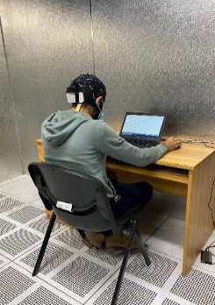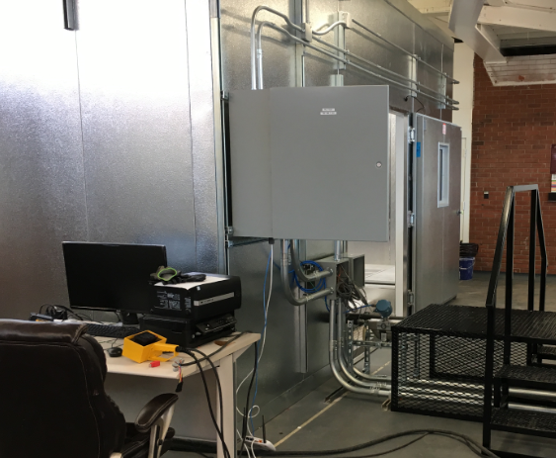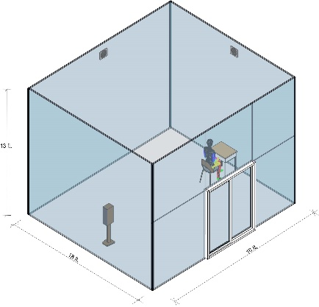

Figure 6.1 - OU environmental chamber: human subject inside the chamber; middle: chamber control and monitoring system right: Psychometric climate chamber showing experimental setup.

6.2.4. Experimental conditions
The IEQ parameter settings to be used in the experiments are presented in Table 6.1. The temperature in an office environment is usually controlled in a moderate range; therefore, we select the test thermal conditions to be PMV = −2/68 °F, PMV = 0/75.92 °F and PMV = 1/78.8 °F, which correspond to slightly cool, neutral, and slightly warm on the thermal sensation scale, respectively. The PMV model uses four environmental parameters including air temperature, mean radiant temperature, air velocity, and relative humidity, and two occupant-related parameters, including metabolic rate and cloth insulation, to predict occupants' thermal comfort level corresponding to a 7-point thermal sensation scale. The temperature settings were identified with the PMV model assuming nominal values for the other parameters (e.g., relatively humidity of 50%). The CO₂ level in an office space float within the range of 400 ppm to 1000 ppm, and three concentration settings will be tested, i.e., 500ppm, 700ppm and 900ppm. The illuminance level is selected as the index for visual comfort and will be controlled in the range of 200 to 1000 lux according to ISO 8995:2002(E) [21].

Table 6.1. Experiment environmental conditions on Psychrometric Chamber.
Thermal  Environment | Air Quality (CO₂ Level) | Lighting Environment (Illuminance and light color)
68 ˚F (PMV= -2),  75.92 ˚F (PMV= 0), 78.8 ˚F (PMV= +1) | 500 ppm, 700 ppm, 900 ppm | 200 lux, 1000 lux;

6.2.5. Experimental process
Participants were informed about the experimental procedure after their arrival at the chamber. This explanation included what to expect during performing the tasks, which buttons they would push, and any definitions they might need to complete the experiment. Then the EEG cap fitted. Participants then performed a practice experiment. All of this helps to provide enough time for participants to get used to the environment. The practice session was followed by the experiment, and it took approximately 25 minutes to finish it altogether.

6.2.6. Experimental tasks
This study aimed to investigate the conceptual expansion as core part of creativity by using the work by Kröger et al. In a traditional AUT (Alternative Uses Task), participants were given an object and instructed to generate as many alternatives uses as possible for that object. In his, Kröger et al, related the N400 ERP (Event Related Potentials) component to varying levels of unusualness and/or novelty of stimuli. However, in current study, participants were shown an object/function pairing as a stimulus to gain better understanding of the neural responses of engineering students.

Each experimental stimulus started with a fixation cross (+) in the middle of the screen for 1000 ms. Participants then see a 500 ms blank screen, followed by the object/function presented for 2000 ms (object > function). Again, after a 500 ms blank screen, the participants are presented with the first question (“Unusual?”) for 1700 ms. The participants would answer “yes” or “no” to this question by using the left and right mouse buttons. The second question (“Appropriate?”) is presented after another 500 ms blank screen. Again, the participants answer “yes” or “no” using the mouse buttons. The trial ends with another 500 ms blank screen, and the cycle repeats for a new object/function pair.

Each participant responded to 171 object/function pairs, 57 objects with three functions as stimuli (a creative function/use, common function/use, and nonsense function/use). The participant decided function/use. To be categorized as common use, the participant would answer no–yes to the two questions, yes–yes to categorize it as a creative use, and yes–no for a nonsense use. There was no repetition on item-use pairs and pairs were presented randomly.

6.2.7. EEG signal analysis
The collected raw EEG data was processed through EEGlab, a MATLAB plugin. Different filters were applied to prepare the data for being analyzed. First, a broad filter (finite impulse response (FIR) filter) from 0.5 Hz to 100 Hz was applied, followed by a notch filter from 58 Hz to 62 Hz to remove electrical noise. To remove the data not related to the brain, the researchers used FastICA, which is an independent component analysis.
Then the data is segmented into 1200 ms blocks so that the beginning of each block indicates the start of each object/function stimulus pair. Each segment, or epoch, corrected with the 200 ms time window before the presentation of the object/function pair and the remaining 1000 ms segment was used for analysis. Afterward for each segment, a 30 Hz low-pass filter, with a slope of 24 dB/Oct, was applied to each segment and amplitudes which were exceeding approximately +/−100 μV were removed. Then the scalp distribution of creative response for each participant in different temperatures were illustrated by topo plots demonstrating techniques.

The frequencies of the EEG are categorized into 5 different frequency bands: delta δ (0–4Hz), theta θ (4–8Hz), alpha α (8–13Hz), beta β (13–30Hz), and gamma γ (30–50Hz) [22-26]. As task demand increases, the theta band activity of frontal lobe increases significantly, while the alpha band activity of parietal lobe decreases [27]. Holm et al. [28] compared several indexes derived from EEG signal and found that the ratio of frontal theta and parietal alpha has a more accurate reflection on workload, fatigue, stress, and FAI [29-32]. Further, extant literature [33-35] established the task engagement aligned with the engagement definition by FAI, showing also higher FAI values indicate positive feelings, motivation, and engagement to tasks.
Using EEG recordings of participants in cognitive task settings for considered IEQ conditions, the following is calculated:
- Relative power (RP)= (Power of certain frequency band)/ ($⅀$all frequency bands power)
- Mental stress index= (RTFrontal) / (RAParietal)
- Cognitive workload index = (Relative frontal beta power) / (Relative frontal theta power) + (Relative frontal alpha power)
- Task engagement or FAI = ln (Alpha power of right frontal /Alpha power of left frontal)

where RB_{fromtal} is the average relative power from frontal lobe; RT_{Frontal} for the average relative θ power of the frontal lobe; RA_{Frontal} refers to the average relative α power from the frontal lobe; RA_{Parietal} denotes the average relative α power of the parietal lobe; RSMR_{Frontal} for the relative sensory motor rhythm power from frontal lobe; and RMB_{Frontal} represents the relative mid β power from the frontal lobe.

According to the literature this study calculated the metal workload index, mental stress index and FAI for each participant for further analysis. However, EEG pattern of different individuals could be different, which may not be comparable in some cases.

6.3. Results and Discussion

6.3.1. Psychophysiological response result
Literature supports the idea that, for indoor thermal environment different individuals have different preferences. To closely observe the effect of indoor thermal environments on participant’s mental workload, mental stress and FAI while they were performing creativity task, we compared the mental workload index, mental stress index and FAI of participants for AUT task under three different temperatures, as shown in Fig. 6 (a) (b) (c). Under the three different thermal experimental conditions mental workload index, mental stress index and FAI is represented by the colored boxes. Each participant has a different effect for the different temperature on their workload, stress and engagement. Figure 6.2 (a) illustrated that, most of the participants (e.g., participant 1, participant 3, participant 10) metal workload increases during the lower temperature 20º C environment as compared to neutral thermal environment 24.4º C. However, we also observed that a few participants 7 and 2 tend to show higher workload on slightly warm temperature 26º C during the experimental task. In spite of the individual differences, the mental workload under the cool (PMV = -2) condition was the highest among the three thermal conditions during the creativity task. An assumption supporting the literature suggests a generally increased mental workload when the room temperature was lower. It is indicated that, during the creativity task cool temperature (PMV = -2) conditions can cause considerably high mental workload among the engineering participants.

This study investigated the mental stress index across the participants during the AUT task performance. Figure 6.2 (b) shows the physiological responses to the mental stress index across the engineering participants. This study observed that the stress index varied a lot from person to person. Some participants feel more stress on cool (PMV= -2) condition compared to neutral condition (PMV= 0), for an example participant 1, participant 6 and participant 9. Other way, participant 3, participant 4 and participant 8 showed higher stress on slightly warmer (PMV= 1) condition compared to neutral condition (PMV= 0), connecting them to workload index from Figure 6.2 (a) illustrates that these participants have higher workload on cool (PMV= -2) condition. An assumption could be made that during creativity task if participants feel more mental stress during a creativity task than their workload for the task performance will be lower.

The study expanded to understand the participants task engagement behavior during the creativity task. Previous studies [34,35] made the conclusion that higher FAI indicates positive feelings, motivation, and engagement. The definition of engagement supports the assumption of the conclusion [36]. For instance, this study considered FAI as the ground truth of engagement. Figure 6.2 (c) illustrates the FAI across all engineering participants during AUT task performance. It is really hard to find out a general pattern for all the participants’ preferences for all the three thermal conditions. Individual pattern is the case this study consider for further analysis. We observed that, participant 1, 2, 3, 5, 6, 8 have higher FAI during the task performance. According to the theory these participants were more engaged, motivated and had more positive feelings during the slightly higher thermal (PMV= 1) condition on creative task. However, participants 9 and 10 have higher FAI during the task performance. Overall, it could be seen from the results that the effect of thermal environments varies a lot on different individuals.

(a)

(b)

(c)
Figure 6.2 - Comparison of the mental workload index (a), mental stress index (b), and Frontal asymmetry index (c) of Alternative Uses of Task (AUT) creativity task under the three thermal conditions.

6.3.2. Performance response under thermal stressors
This study focused on the creativity (AUT) task among the engineering students and would be interested to understand the neural mechanism effects from indoor thermal environment. Creativity requires design problems, design knowledge and design solutions which evolve simultaneously and, during the design process there is a great degree of uncertainty and unpredictability estimated [37,38]. Mental stresses triggered due to the uncertainty and unpredictability. This study leads to investigating the relationship between creative task performance and mental stress. This study adopted an inverted U model created by psychologists Robert Yerkes and John Dodson in 1908 [39]. According to Yerkes and Dodson, when a person receives appropriate pressure during the work, he/she doing, a peak performance is achievable at that time for that work. When we're under too much or too little pressure, performance declines, sometimes severely [39]. The importance of task type, exposure duration, and stressor intensity as key variables impacting how thermal conditions affect performance [40-42]. For the creativity task Figure 6.3 illustrates quantifying results of effect of thermal stressors on human performance across all participants individually for all the three thermal conditions. We understand from the model that participant preference for the thermal conditions during the task performance varied. Most of the engineering participants (e.g., participant 1, 3, 4, 8, 9, 10) preferred slightly warmer thermal condition (PMV= 1) /or the participants performance was peak on slightly warmer temperature. Among them participants 3 and 4 also have higher performance on neutral thermal (PMV= 0) condition. However, participant 7’s performance was lower among all three thermal conditions. We consider that participant’s preference as none to the result. The findings of the study represent table 6.2. The result of this study is consistent with the theory that stress forces the individual to allocate attentional resources to appraise and cope with the situation, which reduces the capacity to process task-relevant information. Also, the results from this study following our assumption made from the literature beginning of the study that, a moderately warm temperature (77°F) was associated with higher creativity compared to a cooler temperature (68°F). This quantitative estimation can be used to design indoor thermal environment which may help to achieve more creative performance from the engineering students during their course of learning and could potentially enhance more creativity from them.

Figure 6.3 - “Inverted-U model” (also known as the Yerkes-Dodson Law) illustrates the peak performance of Alternative Uses of Task (AUT) creativity task under the three thermal conditions for each participant.

Table 6.2 – Participant’s thermal preferences for the creativity task.
Participants | High (26C) | Neutral (24.4C) | Low (20C)
1 | 26
2 |  |  | 20
3 | 26 | 24.4 | 20
4 | 26 | 24.4
5 |  | 24.4
6 |  |  | 20
7
8 | 26
9 | 26
10 | 26

6.3.3. Temporal process of mental effort
Besides investigating the mental workload index, metal stress index, FAI and inverted U model to identify the participants thermal environment preference during the creativity task, the data collected from this experiment was also used to create the contour maps representing the energy during the task for each participant having significant result in Figures 6.4. In this case, data for the designated time period (300-500 ms) was mapped from all electrodes to understand the relative neural activity across the brain. Previous research suggests that alpha power can be related to inhibition of task-irrelevant information processing [43]. Fink et al. [44] claimed that higher alpha power associated with creative idea generation also, Sousa et al. [45] reported that, higher alpha power associated with more creative individuals than that of less creative individuals. In this study we observed the higher alpha power form participant 1, 2, 4, 5, 9, 10 on slightly warm thermal condition (PMV= 1) rather than other two thermal conditions. We also observed participant 7 have no alpha power showed in topo plot for during the task, this is because the participant’s response was wrong for the task, meaning the lower performance which was also reflected on the inverted U model for person 7 plot at Figure 6.3. Participant 9 and 10 also showed similar trends for cool (PMV= -2) thermal condition. Therefore, it is possible that at slightly warmer (PMV= 1) condition, the participants are likely to be more creative/high performance than at other two thermal conditions. We see that some participants have mental effort difference at cool (PMV= -2) and neutral (PMV=0) thermal conditions. This study assumes that participants perceive the workload differently and they have different motivations during the creative task performance.
 | 20⁰ C (PMV= -2) | 24.4⁰ C (PMV= 0) | 26⁰ C (PMV= 1)
Person one | 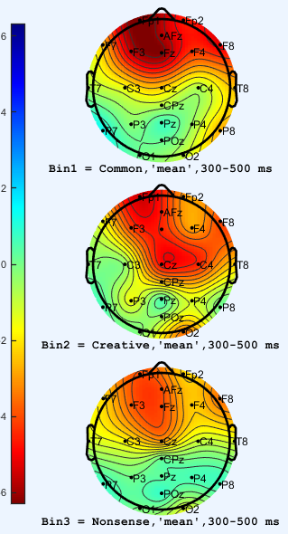 | 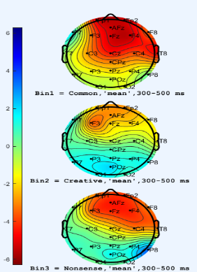 | 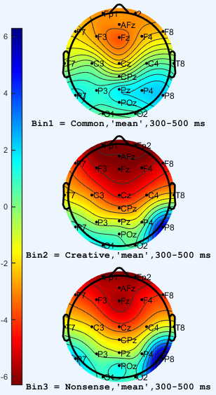
Person two | 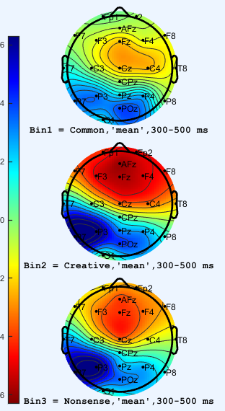 | 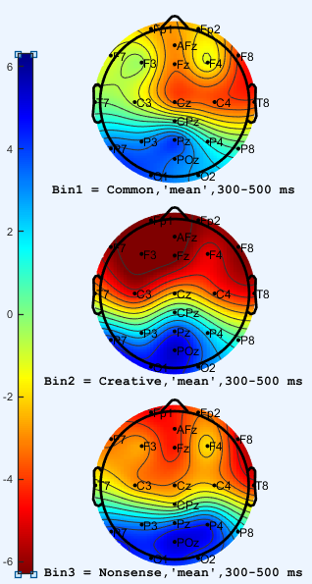 | 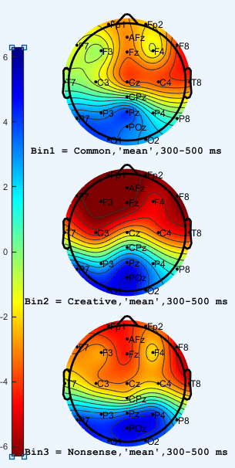
Person three | 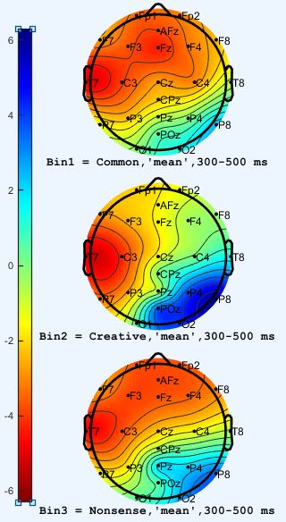 | 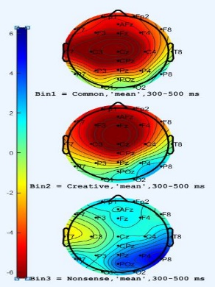 | 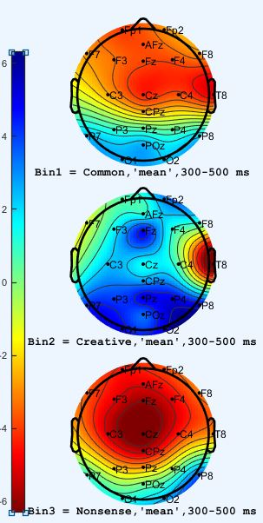
Person four | 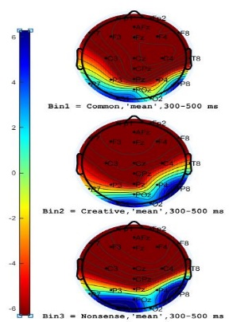 | 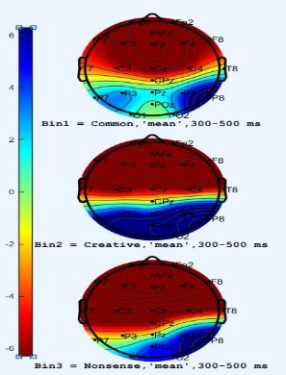 | 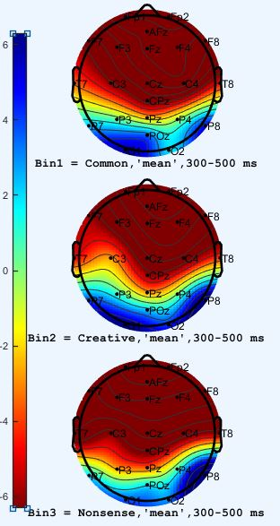
Person five | 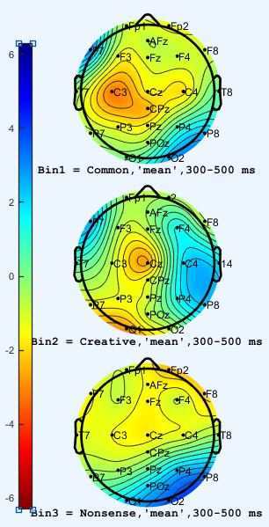 | 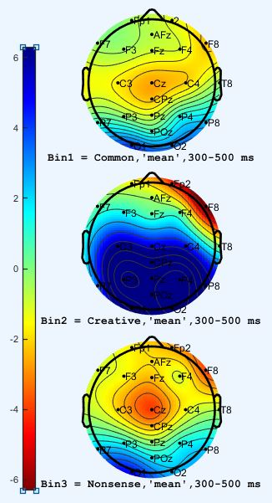 | 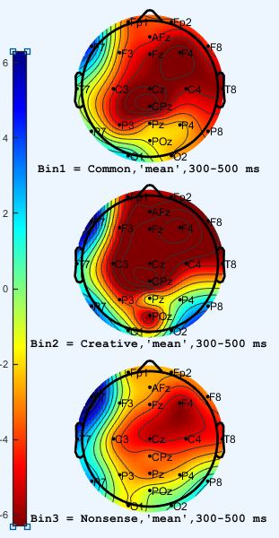
Person six | 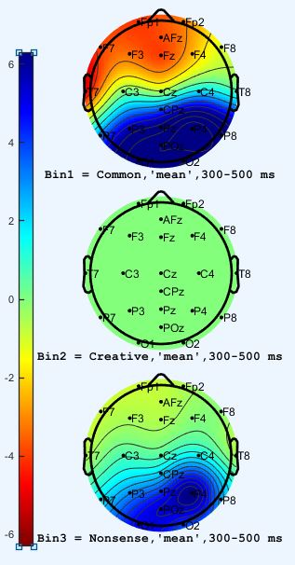 | 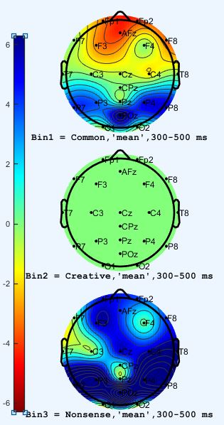 | 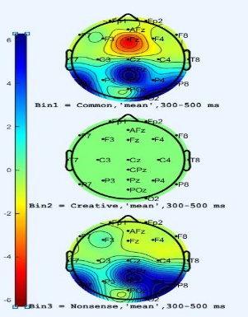
Person seven
Person eight | 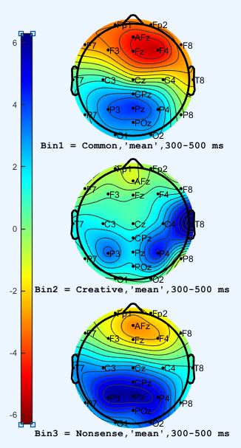 | 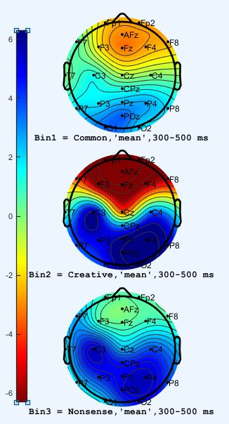 | 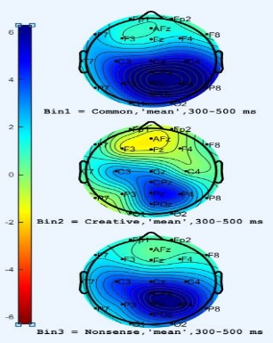
Person nine | 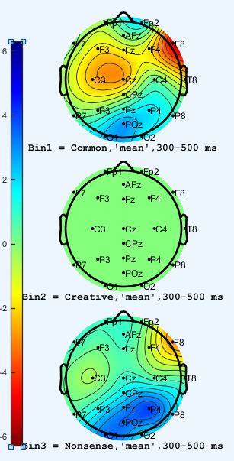 | 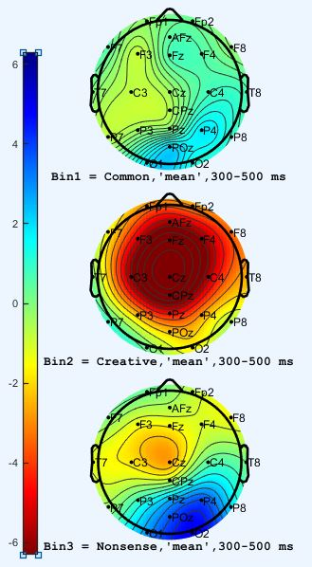 | 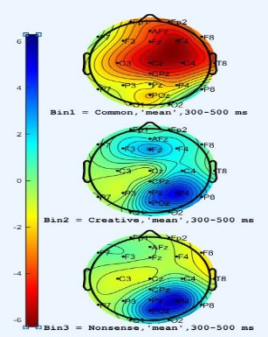
Person ten | 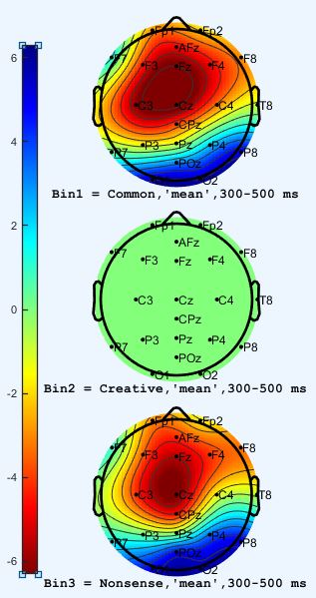 | 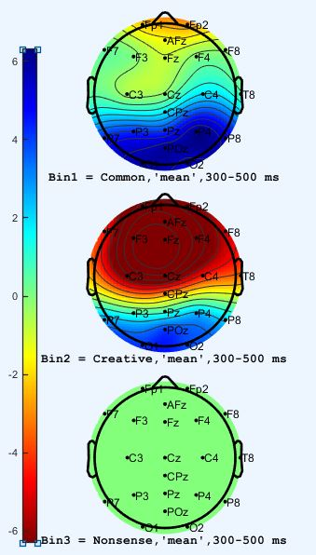 | 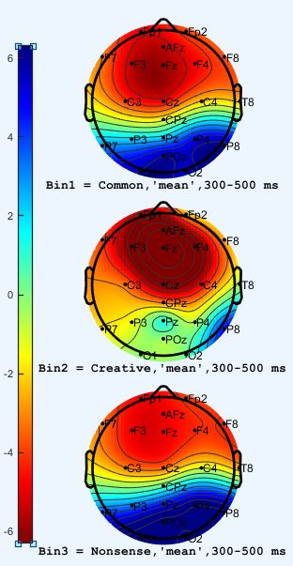

Figure 6.4 - Contour Maps of Alpha energy for three thermal conditions in (300 -500 ms) Time Window.

6.4. Conclusion
The assumptions of this study indicated that it is clearly possible to creativity (AUT) task as a dependent variable in indoor environmental quality intervention experiment from neuroscience point of view. The current study illustrated that the physical indoor environmental condition especially has significant effects on engineering participants creativity. It is possible to enhance cognitive performance of the participants in the temporal dynamics of creativity from neural and psychological results. This study proposed a novel method of using the EEG to examine the effect of thermal environment on engineering participants’ performance, which provides evidence of how thermal environments impact on mental workload, mental stress, FAI. This study includes an inverted U model to investigate the individual thermal environment preference during the creativity task performance to lay out the foundation of a general pattern for the designers who design indoor environment. This study also expanded the topo plots to study the participants neural activity during the task performance. The main contributions from this paper include: First, the method this study used would be useful to study the mental workload, mental stress and work engagement of participants. Instead of estimated from questionnaires this is a direct way of measurement. Second, the effect of thermal environment on creative tasks is analyzed and discussed briefly. Third, this paper proposes a new indication system for the individual thermal environment preferences for the creativity task which lead to identify the general pattern for the designers to design indoor environment based on the target work nature of the indoor spaces. A potential use could be from these quantitative estimates is to facilitate the designers to design thermal tolerance for different types of tasks. However, future studies are needed to investigate how the social and physical environments modulate creativity, as well as which environmental conditions are optimal for individual and group creativity. Nevertheless, the present study is showing an approach which is the first one illustrated multiple neural analysis to explain the thermal indoor environmental effects on the temporal dynamics of creativity.

6.5. References
- Dietrich, Arne, and Riam Kanso. "A review of EEG, ERP, and neuroimaging studies of creativity and insight." Psychological bulletin 136.5 (2010): 822.
- Cropley, David H. Creativity in engineering. Springer Singapore, 2016.
- Rhodes, M. (1961). An analysis of creativity. The Phi Delta Kappan, 42(7), pp. 305-310.
- Gregory, Emma, et al. "Building creative thinking in the classroom: From research to practice." International Journal of Educational Research 62 (2013): 43-50.
- Cropley, David H. Creativity in engineering. Springer Singapore, 2016.
- Vartanian, Oshin, et al. "The relationship between methods of scoring the alternate uses task and the neural correlates of divergent thinking: Evidence from voxel-based morphometry." NeuroImage 223 (2020): 117325.
- Guilford, Joy Paul. "The nature of human intelligence." (1967).
- Cropley, Arthur. "In praise of convergent thinking." Creativity research journal 18.3 (2006): 391-404.
- Torrance, E. R. "The Torrance tests of creative thinking." Norms-technical mannual (1966).
- Kim, Kyung Hee. "Can we trust creativity tests? A review of the Torrance Tests of Creative Thinking (TTCT)." Creativity research journal 18.1 (2006): 3-14.
- Reiter-Palmon, Roni, Boris Forthmann, and Baptiste Barbot. "Scoring divergent thinking tests: A review and systematic framework." Psychology of Aesthetics, Creativity, and the Arts 13.2 (2019): 144.
- Amabile, Teresa M. "Social psychology of creativity: A consensual assessment technique." Journal of personality and social psychology 43.5 (1982): 997.
- Diedrich, Jennifer, et al. "Are creative ideas novel and useful?." Psychology of Aesthetics, Creativity, and the Arts 9.1 (2015): 35.
- Rosahl, Steffen K., and Robert T. Knight. "Role of prefrontal cortex in generation of the contingent negative variation." Cerebral Cortex 5.2 (1995): 123-134.
- Klimesch, Wolfgang, Paul Sauseng, and Simon Hanslmayr. "EEG alpha oscillations: the inhibition–timing hypothesis." Brain research reviews 53.1 (2007): 63-88.
- Schwab, Daniela, et al. "The time-course of EEG alpha power changes in creative ideation." Frontiers in human neuroscience 8 (2014): 310.
- Kröger, Sören, et al. "An ERP study of passive creative conceptual expansion using a modified alternate uses task." Brain research 1527 (2013): 189-198.
- Donchin, Emanuel, and Michael GH Coles. "Is the P300 component a manifestation of context updating?." Behavioral and brain sciences 11.3 (1988): 357-374.
- Kjellstrom, Tord, Ingvar Holmer, and Bruno Lemke. "Workplace heat stress, health and productivity–an increasing challenge for low and middle-income countries during climate change." Global health action 2.1 (2009): 2047.
- Kim, Hakpyeong, et al. "A psychophysiological effect of indoor thermal condition on college students’ learning performance through EEG measurement." Building and Environment 184 (2020): 107223.
- “ISO 8995-1:2002(En), Lighting of Work Places — Part 1: Indoor” [Online]. Available: https://www.iso.org/obp/ui/#iso:std:iso:8995:-1:ed-1:v1:en. [Accessed: 15-Jan-2022].
- Hartog, T., & Marshall, M., & Alhashim, A. G., & Ahad, M. T., & Siddique, Z. (2020, June), Work in Progress: Using Neuro-responses to Understand Creativity, the Engineering Design Process, and Concept Generation Paper presented at 2020 ASEE Virtual Annual Conference Content Access, Virtual Online. 10.18260/1- 2-35701. https://peer.asee.org/work-in-progress-using-neuro-responses-to­ understand-creativity-the-engineering-design-process-and-concept-generation.
- Hartog, T, Marshall, M, Ahad, MT, Alhashim, AG, Okudan Kremer, G, van Hell, J, & Siddique, Z. "Pilot Study: Investigating EEG Based Neuro-Responses of Engineers via a Modified Alternative Uses Task to Understand Creativity." Proceedings of the ASME 2020 International Design Engineering Technical Conferences and Computers and Information in Engineering Conference. Volume 3: 17th International Conference on Design Education (DEC). Virtual, Online. August 17-19, 2020. V003T03A019. ASME. https://doi.org/10.l115/DETC2020- 22614
- Siddique, Z., Ahad, M. T., Mobaraki-Omoumi, M., Marshall, M., & Hartog, T. (2022, August). Event Related Potentials (ERP) Study to Understand Function to Object Mapping for Engineering Student. In 2022 ASEE Annual Conference & Exposition.
- Ahad, M. T., Hartog, T., Alhashim, A. G., Marshall, M., & Siddique, Z. (2023). Electroencephalogram Experimentation to Understand Creativity of Mechanical Engineering Students. ASME Open Journal of Engineering, 2.
- Ahad, M. T., Ahsan, M. M., Jahan, I., Nazim, R., Yazdan, M. M. S., Huebner, P., & Siddique, Z. (2021). Behavioral Pattern Analysis between Bilingual and Monolingual Listeners’ Natural Speech Perception on Foreign-Accented English Language Using Different Machine Learning Approaches. Technologies, 9(3), 51.
- Klimesch, W., 1999, “EEG Alpha and Theta Oscillations Reflect Cognitive and Memory Performance: A Review and Analysis,” Brain research reviews, 29(2–3), pp. 169–195.
- Holm, A., Lukander, K., Korpela, J., Sallinen, M., and Müller, K. M., 2009, “Estimating Brain Load from the EEG,” TheScientificWorldJOURNAL, 9, pp. 639–651.
- Rabbi, A. F., Zony, A., de Leon, P., and Fazel-Rezai, R., 2012, “Mental Workload and Task Engagement Evaluation Based on Changes in Electroencephalogram,” Biomed. Eng. Lett., 2(3), pp. 139–146.
- Sulaiman, N., Taib, M. N., Lias, S., Murat, Z. H., Aris, S. A. M., Mustafa, M., and Rashid, N. A., 2012, “Development of EEG-Based Stress Index,” 2012 International Conference on Biomedical Engineering (ICoBE), pp. 461–466.
- Cheng, S.-Y., and Hsu, H.-T., 2011, “Mental Fatigue Measurement Using EEG,” Risk Management Trends.
- Kamzanova, A. T., Kustubayeva, A. M., and Matthews, G., 2014, “Use of EEG Workload Indices for Diagnostic Monitoring of Vigilance Decrement,” Hum Factors, 56(6), pp. 1136–1149.
- Harmon-Jones, E., and Gable, P. A., 2018, “On the Role of Asymmetric Frontal Cortical Activity in Approach and Withdrawal Motivation: An Updated Review of the Evidence,” Psychophysiology, 55(1), p. e12879.
- Schaffer, C. E., Davidson, R. J., and Saron, C., 1983, “Frontal and Parietal Electroencephalogram Asymmetry in Depressed and Nondepressed Subjects.,” Biological psychiatry.
- Davidson, R. J., 2004, “What Does the Prefrontal Cortex ‘Do’ in Affect: Perspectives on Frontal EEG Asymmetry Research,” Biological Psychology, 67(1), pp. 219–234.
- W.B. Schaufeli, M. Salanova, V. Gonz´ alez-rom´ a, A.B. Bakker, The measurement of engagement and burnout: a two sample confirmatory factor Analytic approach, J. Happiness Stud. 3 (1) (2002) 71–92
- Nguyen, T. A. & Zeng, Y. 2012 A theoretical model of design creativity: nonlinear design dynamics and mental stress-creativity relation. Journal of Integrated Design and Process Science 16, 65–88; doi:10.3233/jid-2012-0007.
- Zeng, Y. 2016 One thing is certain in design: design is uncertain. Journal of Integrated Design and Process Science 20(4), 1–2; doi:10.3233/jid-2016-0029.
- Yerkes, R. (1908). M.. & Dodson, JD (1908). The relation of strength of stimulus to rapidity of habit forma, 149-160.
- Hancock, P. A., 1989, “A Dynamic Model of Stress and Sustained Attention,” Human factors, 31(5), pp. 519–537.
- Montani, F., Vandenberghe, C., Khedhaouria, A., and Courcy, F., 2020, “Examining the Inverted U-Shaped Relationship between Workload and Innovative Work Behavior: The Role of Work Engagement and Mindfulness,” Human Relations, 73(1), pp. 59–93.
- Hancock, P. A., and Ganey, H. C. N., 2003, “From the Inverted-U to the Extended-U: The Evolution of a Law of Psychology,” Journal of Human Performance in Extreme Environments, 7(1), pp. 5–14.
- Cooper NR, Croft RJ, Dominey SJJ, Burgess AP, Gruzelier JH. Paradox lost? Exploring the role of alpha oscillations during externally vs. internally directed attention and the implications for idling and inhibition hypotheses. International Journal of Psychophysiology 2003;47(1):65–74. http://dx.doi.org/10.1016/S0167-8760(02)00107-1.
- Fink A, Grabner RH, Benedek M, Reishofer G, Hauswirth V, Fally M, et al. The creative brain: investigation of brain activity during creative problem solving by means of EEG and FMRI. Human Brain Mapping 2009;30(3):734–48.
- Sousa DA. What is a gifted brain. In: Sousa DA, editor. How the gifted brain learns. 2nd ed. SAGE Publications; 2009. p. 9–44

