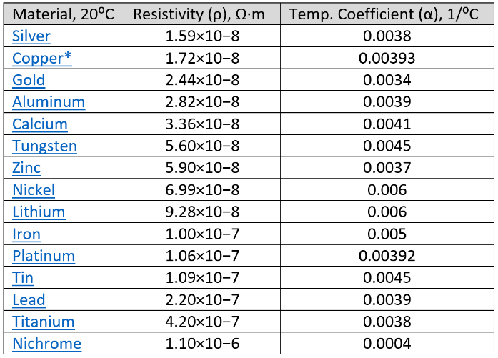
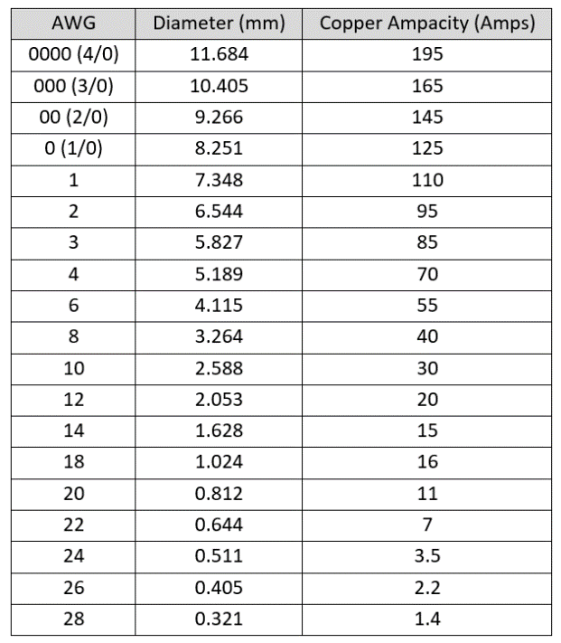
DC Circuits Cheat Sheet
Conversions and Constants
* 1 inch = 25.4 millimeters
* 1 foot = 0.3048 meters
* 1 Coulomb = 6.242x10¹⁸ electrons
* 1 Circular mil (CM) = (π/4) Square mils
* Permittivity of a vacuum = 8.84 x 10⁻¹² F/m
* Permeability of vacuum = 1.2566370614×10⁻⁶ kg∙m/A²∙s²
* Relative Permeability of Iron = 100
* The uF unit on the schematics means micro Farad (µF)

Module 1 Equations

[1.1] $\boxed{I= \frac{Q}{t}}$
[1.2] $\boxed{R= \frac{ρ L}{A}}$
[1.3] $\boxed{R_{x}=R_{{20}^{0}C}[1+ α \left(T_{x}- T_{{20}^{0}C}\right)]}$
[1.4] $\boxed{V= I ∙ R}$
[1.5] $\boxed{I= V ∙ G}$
[1.6] $\boxed{I_{R}=\frac{ΔV}{R}=\frac{V_{a} -V_{b} }{R} }$
[1.7] $\boxed{P=V ∙I }$
[1.8] $\boxed{P=\frac{V^{2}}{R} }$
[1.9] $\boxed{P=I^{2}∙R }$
[1.10] $\boxed{\sum{P_{supplied}}=\sum{P_{dissipated}} }$
[1.11] $\boxed{E=P ∙t }$ Units: E (J), P (W), t (s)
[1.12] $\boxed{R_{Total}=R_{1}+ R_{2}+ R_{3}+ ∙∙∙R_{N} }$
[1.13] $\boxed{R_{Total}=\frac{{(R}_{1}∙ R_{2})}{(R_{1}+ R_{2})} }$
[1.14] $\boxed{R_{Total}=\frac{1}{\frac{1}{R_{1} } + \frac{1}{R_{2} } + \frac{1}{R_{3} } +∙∙∙ \frac{1}{R_{N} }} }$
[1.15] $\boxed{\sum{V_{around a closed loop}}=0 }$
[1.16] $\boxed{V_{x}= \frac{{V_{s} ∙ R}_{x}}{R_{total}} }$
[1.17] $\boxed{\sum{I_{IN}}=\sum{I_{OUT}} }$ (works on nodes or branches)
[1.18] $\boxed{I_{x}= \frac{{I_{s} ∙ R}_{total}}{R_{x}} }$

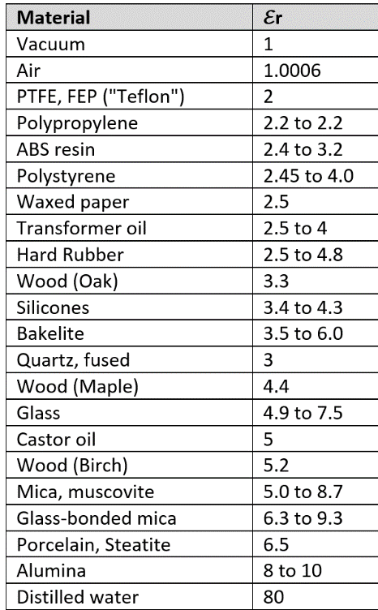
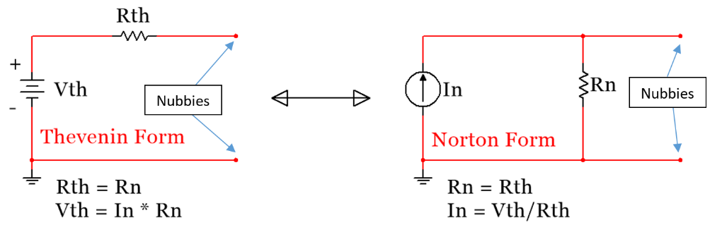

Module 3.1 and 3.2 Equations

[3.1] $\boxed{C= \frac{E_{r}E_{o}A}{d}}$
[3.2] $\boxed{C= \frac{Q}{V}}$
[3.3] $\boxed{E=\frac{1}{2} C V^{2}}$
[3.4] $\boxed{i_{C}\left(t\right)=C \frac{dv}{dt}}$
[3.5] $\boxed{v_{C}(t)=\frac{1}{C} \int_{t_{0}}^{t}{i_{c}}(t)∙ dτ+v_{c}(t_{0})}$
[3.6] $\boxed{L= \frac{N^{2}∙ {μ_{r} ∙ μ_{0}}^{ }∙ A}{l}}$
[3.7] $\boxed{E=\frac{1}{2} L ∙i^{2}}$
[3.8] $\boxed{v\left(t\right)=L \frac{di_{L}}{dt}}$
[3.9] $\boxed{i_{L}\left(t\right)=\frac{1}{L} \int_{t_{0}}^{t}{v_{L}}∙ dτ+i_{L}\left(t_{0}\right)}$

Module 3.3 to 3.5 Equations

[3.10] $\boxed{C_{Total}=C_{1}+ C_{2}+ C_{3}+ ∙∙∙C_{N} }$
[3.11] $\boxed{C_{Total}=\frac{{(C}_{1}∙ C_{2})}{(C_{1}+ C_{2})} }$ ONLY with 2 capacitors
[3.12] $\boxed{C_{Total}=\frac{1}{\frac{1}{C_{1} } + \frac{1}{C_{2} } + \frac{1}{C_{3} } +∙∙∙ \frac{1}{C_{N} }} }$
[3.13] $\boxed{Tau=τ=R_{eq}∙C_{total} }$
[3.14] $\boxed{Tau=τ=\frac{L_{total}}{R_{eq}}}$
[3.15] $\boxed{v_{C}(t)=V_{S }(1- e^{{-t}/τ}) }$
[3.16] $\boxed{v_{L}(t)=V_{S }(e^{{-t}/τ}) }$
[3.17] $\boxed{t=-\ln{(1-}\frac{v_{C}(t)}{V_{S}})∙τ }$
[3.18] $\boxed{t=-\ln{(}\frac{v_{L}\left(t\right)}{V_{S}})∙τ}$
[3.19] $\boxed{i_{R }\left(t\right)=i_{C }\left(t\right)=\frac{Δv}{R}=\frac{V_{S }-v_{C}(t)}{\sum_{i}^{N}{R_{i}}}}$
[3.20] $\boxed{i_{R }\left(t\right)=i_{L }\left(t\right)=\frac{Δv}{R}=\frac{V_{S }-v_{L}(t)}{\sum_{i}^{N}{R_{i}}}}$

