UNIVERSITY OF OKLAHOMA GRADUATE COLLEGE

MODELING THE DISTRIBUTION OF NATIVE AND INVASIVE SPECIES OF BUMBLE BEES (HYMENOPTERA: APIDAE) IN CHILE, USING CITIZEN SCIENCE DATA

A THESIS

SUBMITTED TO THE GRADUATE FACULTY

in partial fulfillment of the requirements for the Degree of
MASTER OF SCIENCE

By
JOSE MONTALVA
Norman, Oklahoma 2021

MODELING THE DISTRIBUTION OF NATIVE AND INVASIVE SPECIES OF BUMBLE BEES (HYMENOPTERA: APIDAE) IN CHILE, USING CITIZEN SCIENCE DATA

A THESIS APPROVED FOR THE

DEPARTMENT OF GEOGRAPHY AND ENVIRONMENTAL SUSTAINABILITY

BY THE COMMITTEE CONSISTING OF

Dr. Bruce Hoagland, Chair

Dr. Thomas Neeson Dr. Daniel Paiva Silva

© Copyright by JOSE MONTALVA 2021 All Rights Reserved.

Acknowledgements

First thanks to my supportive and amazing wife Dr. Leah S. Dudley. Thanks to my two daughters Ceil Millaray and Keira Rayen for making me happy every day. Thanks to my mom and siblings in Chile.
I wish to thank Dr. Bruce Hoagland, who took a chance on me and has been my advisor for the past three years.
Thanks to Dr. Luisa Ruz, my undergraduate advisor for guiding me on my first steps on the native bee knowledge. Also, thanks to my friends on the bee world, Dr. Vivallo, Dr. Packer, Dr. Lucia, Brian Dykstra.
I would also like to thank my committee members, Dr. Thomas Neeson and Dr. Daniel P. Silva, for their investment of time and advice. I am especially grateful to Dr. Silva who took the time to teach me the details of species distribution models.
Thank you to my friend Filo Martinez who help me throughout my time at DGES. Also, thanks to my friends at ECU, Dr. Wang, and Dr. Moring. Thanks to Dr. Vilela, Dr. Morales, Dr. Smith-Ramirez, Dr. Vieli, Dr. Aizen.
Finally, I would like to thank my friends Benjamin Castro, Jose Diaz Tavie and all the Salvemos Nuestro abejorro citizen scientists that help in many aspects of the data collection.

Table of Contents

Acknowledgements iv
List of Tables .vii
List of Figures viii
Abstract xi
Chapter 1: Literature review 1
1.1 References 6
Chapter 2: Use of Citizen Science on the data’s collection of the European bumble bees Bombus terrestris, Bombus ruderatus, and the endangered native species Bombus dahlbomii 28
  - Abstract 28
  - Introduction 29
  - Materials and Methods 31
  - Results and Discussion 32
  - Conclusion 35
  - References 36
Chapter 3: Modeling the distribution of native and invasive species of bumble bees (Hymenoptera: Apidae) in Chile, using citizen science data 48
  - Abstract 48
  - Introduction 48
  - Methods 50
  - Results 53
  - Discussion 53
  - References 55
Chapter 4: Conclusions 68
4.1 References 70

List of Tables

Table 1. Possible relation of interactions (+, -) between exotic pollinator/plants and the invaded areas. 30

Table 2. Main results of the multivariate analyses, considering Schoener’s D metric, and the p values obtained using the similarity test (I) of the climatic niche of the species. 74

Table 3. Summary of the species distribution models obtained for GAU, GLM, MLK, MAX, RDF, and SVM algorithms. 75

List of Figures
Figure 1. The general model of the invasion process 32
Figure 2. Plant–Pollinator webs during the Invasion Process 33
Figure 3. Different forms of interaction between invasive and native species in the pollination context 34
Figure 4. Global Bombus ruderatus distribution 36
Figure 5. Global B. terrestris distribution 37
Figure 6. Pictures of Bombus terrestris (European buff-tailed bumble bee) and Bombus dahlbomii (giant Patagonian bumble bee) 38
Figure 7. Number of colonies and queens of Bombus terrestris imported to Chile between 1997-2019.. 39
Figure 8. Diagram of the Citizen Science Model 53
Figure 9. Distribution of the bumble bees present in Chile based in Citizen science reports.. 54
Figure 10. Comparation between the museum data and the citizen science Bumble bee records.. 55
Figure 11. Mosaic plot comparing Citizen Science records vs Museum records for the 3 species of Bumble bees present in Chile.. 56
Figure 12. Salvemos Nuestro Abejorro at the first edition of “Dia de la Fauna Chilena” 2014.. 57
Figure 13. Bumble bee reports collected through Citizen Science between 2010-2020 58

Figure 14. Bumble bee Citizen science reports for the bumble bees present in Chile 59
Figure 15. Geographic occurrences of Bombus ruderatus, Bombus terrestris and B. dahlbomii in South America 76
Figure 16. Climatic conditions occupied by the species of bumble bees showing the niche overlapping. 77
Figure 17. Species distribution models current and future scenario for the three bumble bees species based on GAU, GLM, MLK, MAX, RDF, SVM 78
Figure 18. Summary of the species distribution models current, future and difference scenario for the three bumble bees species 79

"А bill preferd against a publique wrong,

the surely humble bee, who hath too long

Liv'd like an out-law and will neither pay

money or waxe, do service nor obey;

but like a fellon, coucht under a weed,

upon the top-branch blossomed, and by stealth

Makes dangerous inroads on your common-wealth;

robs the day-labourer of his golden prize

And sends him weeping home with emptie thighes.

And out-law-like doth challenge as his own

Your highnes due; nay, pyratick dataines

The waxen fleet sailing upon your plaines"

John Day, 1607

Abstract

There are around 260 species of bumble bees (Bombus) globally, many of them providing important pollination services. In fact, some species are bred and sold commercially to assure the successful pollination of crops. Bombus terrestris and B. impatiens are two species that are bred commercially. Since the 1980's some of these species have been imported to different countries worldwide, and these movements have created ecological problems, including (1) competition for resources with native pollinators, (2) importation of new diseases to the new environments, (3) hybridization with congeners, (4) disruption of the pollination of native plants, and (5) facilitation of invasion by introduced plants.
In this thesis, the utility and efficacy of citizen science data is analyzed and compared to the traditional use of distributional (museum data) records in Chile (chapter 2). Those data were then used to model the distribution of native and introduced bumble bees in Chile (chapter 3). Data provided by citizen scientists has become an important resource for conservation biologists. Between 2014-2020, Salvemos Nuestro Abejorro obtained over 4000 bumble bee records from citizen scientists in Chile. These data were significantly greater in number than museum data records for the introduced species. Thus, citizen science reports can have a broader impact on tracking the distribution of introduced species. In Chapter 3 we conducted multivariate bioclimatic niche analyses to evaluate the niche overlap of Bombus terrestris, Bombus ruderatus, and Bombus dahlbomii. The models indicated significant niche overlap between the invasive bumble bee species and the native species. B. terrestris had a high extent of suitable range in South America, meaning further invasion in the region is highly possible. Also, the models indicate that the distribution of B. dahlbomii will decrease due to future climate scenarios. Therefore, this comprehensive review and analysis of the consequences of these pollinator invasions on South America is both timely and necessary.

Chapter 1: Literature review:
Species introductions into new environments have occurred throughout evolutionary time. But humans have accelerated this process in recent centuries, enhancing the rate and distances of species dispersion across the globe (Cadotte, 2006). In many instances, the arrival and establishment of new species in a region have little or no ecological consequences (Cadotte, 2006). In other cases, however, the arrival of a new species can have profound ecological and economic consequences. These events are referred to as biological invasions and the new species as invasive. Invasive species can affect the composition and function of the invaded communities (Kolar & Lodge, 2001; Lodge, 1993; Mack et al., 2000; Moller, 1996; Mooney & Hobbs, 2000), which is often exacerbated by anthropic effects, and could trigger the extinction of native species, homogenization of the local biota, and disruption of ecological processes (Simberloff et al., 1997; Traveset & Richardson, 2006). Economic losses in agriculture and fisheries due to invasive species have cost billions, from both lost productivity and the expense of combating them (Diagne et al., 2021; Jackson, 2015; Lodge, 1993; Pimentel et al., 2000; Vitousek et al., 1997).
Conceptual models have identified the stages that lead to the successful invasion of an ecosystem, which often resembles models that describe the natural process of dispersal (Ni et al., 2021; Simberloff, 2009). Shea and Chesson (2002) proposed a three-stage model: 1) introduction of a species in a new geographical area or new habitat, 2) successful establishment and 3) eventual rapid expansion to new areas.
In the first stage, the success of an invasive species would be influenced by the initial abundance of propagules, as well as the degree of "biotic resistance" exerted by a community to an invader (Green, 1997; Lodge, 1993; Richardson et al., 2000; Simberloff, 2009), both of can be affected by human activity (Byers, 2002; Kolar & Lodge, 2001; Mack, 2003; Vitousek et al., 1997) (Figure 1). Biotic resistance is inherent to stable ecosystems. And the more biological connections (i.e., interspecific interactions), the greater the impediment to exotic species (Richardson et al., 2000; Traveset & Richardson, 2006). However anthropogenic activities can reduce biotic resistance (Thuiller et al., 2006). In the worst-case scenario, a high anthropic disturbance could cause a drop in the biotic resistance, and if the initial abundance of propagules is high, the situation is ideal for a successful invasion (Figure 1).
In stage 2 of the Shea and Chesson (2002) model, should an exotic species establish reproducing and expanding populations, and recall that this does not assure that an exotic species will become invasive, there are three potential outcomes for the recipient community; negative (competition, herbivory, parasitism, etc.), neutral, or positive (facilitation, commensalism, mutualism, etc.) (Richardson et al., 2000; Simberloff & Von Holle, 1999). Research has historically focused on the outcome of antagonistic relationships between invaders and the recipient ecosystems (Simberloff & Von Holle, 1999).
Neutral relationships are complicated and challenging to identify. They depend on the existence of an “empty niche” (Levine & D’Antonio, 1999; Richardson et al., 2000), meaning that an exotic species becomes established in an unoccupied ecological space. The existence of empty niche is hotly debated and seems highly unlikely in most ecosystems (Levine & D’Antonio, 1999; Richardson et al., 2000).
Positive relationships describe a situation in which the presence of an introduced species favors a native species, possibly even one that is imperiled. For example, an invasive species could present a new prey resource for a native predator. If the predator is facing low food resources, it could be favored by the arrival of a new prey species. A similar scenario involves plants that lack pollinators, or pollinators with insufficient host and/or nectar resources (Simberloff & Von Holle, 1999).
The existence of evolutionary anachronisms, or plants species that have lost their animals seed dispersers to extinction, represents another example of a positive relationship (Guimarães et al., 2008). After the massive extinction of the megafauna in the Americas, many plant species were left without dispersers. But horses returned to the Americas with the arrival of Europeans in the 16th century, which inadvertently assumed the role of disperser for plant species such as Crescentia alata (Guimarães et al., 2008). Still, these exotic/native positive interactions are considered isolated cases (Simberloff & Von Holle, 1999).
To understand how frequently negative, positive, and neutral relations have been reported in the literature, Simberloff and Von Holle (1999) conducted a meta-analysis of 254 articles published on invasion biology from 1993 and 1997. In 156 cases, there was a positive effect on the invader and a negative impact on native species (+, -) in a recipient ecosystem. In 30 cases, there was a positive interaction between two invasive species; there was facilitation in only 10 cases (+, +), in 12 cases interference or competition (-, -), and no cases of amensalism or neutral relations (Simberloff & Von Holle, 1999). The authors referred to a positive interaction between two or more invasive species as an “invasional meltdown”, defined as a mutualism between exotic species that facilitates the invasion process (Simberloff, 2006; Simberloff & Von Holle, 1999).
Invasional meltdowns could have considerable impacts on the structure of mutualistic networks of native species (Aizen et al., 2008; Bjerknes et al., 2007; Traveset & Richardson, 2014). For example, the invasive capacity of an exotic pollinator and an exotic plant could prove to be mutually beneficial; the success of one facilitates the success of the other. This relationship could modify and potentially interfere with the structure of the existing pollination network of native plants and native pollinators in the recipient ecosystem, resulting in weakened mutualisms (Figure 2)(Aizen et al., 2008; Traveset & Richardson, 2014; Tylianakis, 2008). A possible outcome of this process is an increased reliance of native generalist species on resources provided by a "supergeneralist" invasive species (Figure 2) (Aizen et al., 2008; Morales et al., 2017; Traveset & Richardson, 2014; Tylianakis, 2008). A classic example is adoption by Apis mellifera scutellata (Africanized honeybee) of native floral resources in the Americas that in turn facilitates its colonization and dispersion (Roubik & Villanueva-Gutierrez, 2009). Within most biological communities, however, these interactions are much more dynamic. The actuation of more than one relationship occurring at a given time has been documented in pollination – plant networks where both antagonistic and mutualistic interactions may occur (Figure 3, Table 1) (Simberloff & Von Holle, 1999; Traveset & Richardson, 2006).
In the context of pollination – plant networks specifically, exotic pollinators could compete with native pollinators for floral resources and/or nesting sites (Hingston, 2006; Inoue et al., 2008; Kato et al., 1999; Madjidian et al., 2008; Paini, 2004; Stout et al., 2002) or transmit pathogens to native pollinators (Cameron & Sadd, 2020; Colla et al., 2006; Goka et al., 2006; Meeus et al., 2011; Otti et al., 2008; Plischuk et al., 2020) (Figure 3, Table 1). There are three possible facilitation (+,+) scenarios that involve the geographic origin of the species; exotic plant-exotic pollinator or native plant-native pollinator, or exotic plants-native pollinators (Figure 1)(Table 1); competition or adverse effects (+,-) occurs, in most cases, will result when the species has a different origin (exotic plant-native plant or exotic pollinator-native pollinators [Figure 3]). And of course, exotic plants could have positive and/or negative impacts on the native ecosystems (Figure 3, Table 1).
Plants often compete for pollinators, and in some cases, exotic plants become more attractive than native plants. Thomson (1978) coined the term "magneto species" to describe this phenomenon (Laverty, 1992; Molina-Montenegro et al., 2008; Muñoz & Cavieres, 2008). A classic example is the invasive Taraxacum officinale, an apomictic plant that does not require pollinators (Muñoz & Cavieres, 2008). But pollinators are attracted to it nonetheless and are effectively kidnapped, thus depriving native plants of pollination services and negatively impacting plant populations (Bjerknes et al., 2007).
Bombus ruderatus and B. terrestris are two European bumble bees that were introduced for crop pollination in Chile (Aizen et al., 2019; Montalva et al., 2011; Smith-Ramírez et al., 2018). Bombus ruderatus was introduced to pollinate Trifolium pratense (red clover), a livestock forage crop. During the 1982/1983 growing season, approximately 400 queens were imported from New Zealand and released at two locations near Temuco (38ᵒS 72ᵒW), in the south of Chile (Arretz & Macfarlane, 1986). In 1993, B. ruderatus was first reported in Argentina, and likely originated from individuals who arrived precedent from Chile (Roig Alsina & Aizen, 1996) (Figure 4).
The European Bombus terrestris (buff-tailed bumble bee) is one of the leading commercially distributed species and has been introduced in several countries worldwide (Figure 5) (Dafni et al., 2010; Kadoya & Washitani, 2010; Matsumura et al., 2004; Naeem et al., 2018). It was first introduced to central Chile in 1997 (Montalva et al., 2011), and since that date, more than a million individuals have been imported into the country (Aizen et al., 2019; Smith-Ramírez et al., 2018) (Fig. 7). Its availability throughout Chile maximizes propagule introduction (Figure 7), and could affect other countries (Aizen et al., 2019; Smith-Ramírez et al., 2018). In fact, B. terrestris was reported from Argentina in 2006 (Torretta et al., 2006; Morales 2007).
For the reasons mentioned at the beginning of this review, the impact of these two invasive species on native South American ecosystems should be of concern to researchers and land managers alike. Both European bumble bee species are now feral in Chile and parts of Argentina and are blamed for the decrease in the native B. dahlbomii populations (Morales et al., 2016; Smith-Ramírez et al., 2018) (Fig. 6). They have also been observed pollinating invasive plants that negatively affect the native plants of Chile and Argentina (Morales & Aizen, 2002; Morales pers. com.; Valdivia et al., 2016).
Although there may be competition for flower resources between exotic species and native species, disease introduction is a current problem (Aizen et al., 2019; Smith-Ramírez et al., 2018). In 2013, two studies revealed the presence of European parasites in Chile, probably carried by the European bumble bees, and is contributing to the decline of B. dahlbomii populations (Arbetman et al, 2013; Arismendi et al, 2016; Schmid-Hempel et al., 2014). These parasites inhibit colony founding by inducing sterility in queens, increasing the mortality of workers, and causing other severe physical and behavioral effects (Meeus et al., 2011). In less than 20 years (or since the introduction of B. terrestris), the distribution of B. dahlbomii has shrunk considerably and it is now listed as endangered by both the International Union for the Conservation of Nature (IUCN) Red List and on the Chilean Ministerio de Medio Ambiente (MMA) (Montalva et al., 2015; Morales et al., 2016).

References

Aizen, M. A., Morales, C. L., & Morales, J. M. (2008). Invasive Mutualists Erode Native Pollination Webs. PLOS Biology, 6(2), 1–8. https://doi.org/10.1371/journal.pbio.0060031
Aizen, M. A., Morales, C. L., Vázquez, D. P., Garibaldi, L. A., Sáez, A., & Harder, L. D. (2014). When mutualism goes bad: Density-dependent impacts of introduced bees on plant reproduction. New Phytologist, 204(2), 322–328. https://doi.org/10.1111/nph.12924
Aizen, M. A., Smith‐Ramírez, C., Morales, C. L., Vieli, L., Sáez, A., Barahona‐Segovia, R. M., Arbetman, M. P., Montalva, J., Garibaldi, L. A., Inouye, S. W., & Harder, L. D. (2019). Coordinated species importation policies are needed to reduce serious invasions globally: The case of alien bumblebees in South America. Journal of Applied Ecology, 56(1), 100–106. https://doi.org/10.1111/1365-2664.13121
Arbetman, M. P., Meeus, I., Morales, C. L., Aizen, M. A., & Smagghe, G. (2013). Alien parasite hitchhikes to Patagonia on invasive bumblebee. Biological Invasions, 15(3), 489–494. https://doi.org/10.1007/s10530-012-0311-0
Arismendi, N., Bruna, A., Zapata, N., & Vargas, M. (2016). Molecular detection of the tracheal mite Locustacarus buchneri in native and non-native bumble bees in Chile. Insectes Sociaux, 63(4), 629–633. https://doi.org/10.1007/s00040-016-0502-2
Arretz, P. V., & Macfarlane, R. P. (1986). The introduction of bombus ruderatus to chile for red clover pollination. Bee World, 67(1), 15–22. https://doi.org/10.1080/0005772X.1986.11098855
Barthell, J. F., Randall, J. M., Thorp, R. W., & Wenner, A. M. (2001). Promotion of seed set in yellow star-thistle by honey bees: Evidence of an invasive mutualism. Ecological Applications, 11(6), 1870–1883. https://doi.org/10.1890/1051-0761(2001)011[1870:POSSIY]2.0.CO;2
Bjerknes, A.-L., Totland, Ø., Hegland, S. J., & Nielsen, A. (2007). Do alien plant invasions really affect pollination success in native plant species? Biological Conservation, 138(1), 1–12. https://doi.org/https://doi.org/10.1016/j.biocon.2007.04.015
Byers, J. E. (2002). Physical habitat attribute mediates biotic resistance to non-indigenous species invasion. Oecologia, 130(1), 146–156. https://doi.org/10.1007/s004420100777
Cadotte, M. W. (2006). Dispersal and Species Diversity: A Meta‐Analysis. The American Naturalist, 167(6), 913–924. https://doi.org/10.1086/504850
Callaway, R. M., & Aschehoug, E. T. (2000). Invasive Plants Versus Their New and Old Neighbors: A Mechanism for Exotic Invasion. Science, 290(5491), 521–523. https://doi.org/10.1126/science.290.5491.521
Cameron, S. A., & Sadd, B. M. (2020). Global trends in bumble bee health. Annual Review of Entomology, 65, 209–232. https://doi.org/10.1146/annurev-ento-011118-111847
Cariveau, D. P., & Norton, A. P. (2009). Spatially contingent interactions between an exotic and native plant mediated through flower visitors. Oikos, 118(1), 107–114. https://doi.org/https://doi.org/10.1111/j.1600-0706.2008.16705.x
Colla, S. R., Otterstatter, M. C., Gegear, R. J., & Thomson, J. D. (2006). Plight of the bumble bee: Pathogen spillover from commercial to wild populations. Biological Conservation, 129(4), 461–467. https://doi.org/10.1016/j.biocon.2005.11.013
Dafni, A., Kevan, P., Gross, C. L., & Goka, K. (2010). Bombus terrestris, pollinator, invasive and pest: An assessment of problems associated with its widespread introductions for commercial purposes. Applied Entomology and Zoology, 45(1), 101–113. https://doi.org/10.1303/aez.2010.101
Diagne, C., Leroy, B., Vaissière, A.-C., Gozlan, R. E., Roiz, D., Jarić, I., Salles, J., Bradshaw, C. J., & Courchamp, F. (2021). High and rising economic costs of biological invasions worldwide. Nature, In Press(March). https://doi.org/10.1038/s41586-021-03405-6
Goka, K., Okabe, K., & Yoneda, M. (2006). Worldwide migration of parasitic mites as a result of bumblebee commercialization. Population Ecology, 48(4), 285–291. https://doi.org/10.1007/s10144-006-0010-8
Goulson, D. (2005). Risks of increased weed problems associated with the introduction of non-native bee species. Journal of Food, Agriculture and Environment, 3(2), 11–13.
Goulson, D., & Derwent, L. C. (2004). Synergistic interactions between an exotic honeybee and an exotic weed: pollination of Lantana camara in Australia. Weed Research, 44(3), 195–202. https://doi.org/https://doi.org/10.1111/j.1365-3180.2004.00391.x
Green, R. E. (1997). The Influence of Numbers Released on the Outcome of Attempts to Introduce Exotic Bird Species to New Zealand. Journal of Animal Ecology, 66(1), 25–35. Retrieved from http://www.jstor.org/stable/5961
Guimarães, P. R., Galetti, M., & Jordano, P. (2008). Seed dispersal anachronisms: Rethinking the fruits extinct megafauna ate. PLoS ONE, 3(3). https://doi.org/10.1371/journal.pone.0001745
Hanley, M. E., & Goulson, D. (2003). Introduced weeds pollinated by introduced bees: Cause or effect? Weed Biology and Management, 3(4), 204–212. https://doi.org/https://doi.org/10.1046/j.1444-6162.2003.00108.x
Hingston, A. B. (2006). Is the introduced Bumblebee (Bombus terrestris) assisting the naturalization of Agapanthus praecox ssp. orientalis in Tasmania? Ecological Management & Restoration, 7(3), 236–240. https://doi.org/https://doi.org/10.1111/j.1442-8903.2006.312_7.x
Inoue, M. N., Yokoyama, J., & Washitani, I. (2008). Displacement of Japanese native bumblebees by the recently introduced Bombus terrestris (L.) (Hymenoptera: Apidae). Journal of Insect Conservation, 12(2), 135–146. https://doi.org/10.1007/s10841-007-9071-z
Jackson, T. (2015). Addressing the economic costs of invasive alien species: Some methodological and empirical issues. International Journal of Sustainable Society, 7(3), 221–240. https://doi.org/10.1504/IJSSOC.2015.071303
Kadoya, T., & Washitani, I. (2010). Predicting the rate of range expansion of an invasive alien bumblebee (Bombus terrestris) using a stochastic spatio-temporal model. Biological Conservation, 143(5), 1228–1235. https://doi.org/https://doi.org/10.1016/j.biocon.2010.02.030
Kanbe, Y., Okada, I., Yoneda, M., Goka, K., & Tsuchida, K. (2008). Interspecific mating of the introduced bumblebee Bombus terrestris and the native Japanese bumblebee Bombus hypocrita sapporoensis results in inviable hybrids. Die Naturwissenschaften, 95(10), 1003–1008. https://doi.org/10.1007/s00114-008-0415-7
Kato, M., Shibata, A., Yasui, T., & Nagamasu, H. (1999). Impact of introduced honeybees, Apis mellifera, upon native bee communities in the Bonin (Ogasawara) Islands. Researches on Population Ecology, 41(2), 217–228. https://doi.org/10.1007/s101440050025
Kenta, T., Inari, N., Nagamitsu, T., Goka, K., & Hiura, T. (2007). Commercialized European bumblebee can cause pollination disturbance: An experiment on seven native plant species in Japan. Biological Conservation, 134(3), 298–309. https://doi.org/https://doi.org/10.1016/j.biocon.2006.07.023
Kolar, C. S., & Lodge, D. M. (2001). Progress in invasion biology: predicting invaders. Trends in Ecology & Evolution, 16(4), 199–204. https://doi.org/10.1016/s0169-5347(01)02101-2
Kondo, N. I., Yamanaka, D., Kanbe, Y., Kunitake, Y. K., Yoneda, M., Tsuchida, K., & Goka, K. (2009). Reproductive disturbance of Japanese bumblebees by the introduced European bumblebee Bombus terrestris. Die Naturwissenschaften, 96(4), 467–475. https://doi.org/10.1007/s00114-008-0495-4
Laverty, T. M. (1992). Plant interactions for pollinator visits: a test of the magnet species effect. Oecologia, 89(4), 502–508. https://doi.org/10.1007/BF00317156
Levin, D. A., Francisco-Ortega, J., & Jansen, R. K. (1996). Hybridization and the Extinction of Rare Plant Species. Conservation Biology, 10(1), 10–16. https://doi.org/https://doi.org/10.1046/j.1523-1739.1996.10010010.x
Levine, J., & D’Antonio, C. (1999). Elton revisited: a review of evidence linking diversity and invasibility. Oikos, 87, 15–26.
Lodge, D. M. (1993). Biological invasions: Lessons for ecology. Trends in Ecology & Evolution, 8(4), 133–137. https://doi.org/https://doi.org/10.1016/0169-5347(93)90025-K
Mack, R. N. (2003). Plant Naturalizations and Invasions in the Eastern United States: 1634-1860. Annals of the Missouri Botanical Garden, 90(1), 77–90. https://doi.org/10.2307/3298528
Mack, R. N., Simberloff, D., Mark Lonsdale, W., Evans, H., Clout, M., & Bazzaz, F. A. (2000). Biotic Invasions: Causes, Epidemiology, global AUSES, EPIDEMIOLOGY, GLOBAL consequences, and control. Ecological Applications, 10(3), 689–710. https://doi.org/https://doi.org/10.1890/1051-0761(2000)010[0689:BICEGC]2.0.CO;2
Madjidian, J. A., Morales, C. L., & Smith, H. G. (2008). Displacement of a native by an alien bumblebee: lower pollinator efficiency overcome by overwhelmingly higher visitation frequency. Oecologia, 156(4), 835–845. https://doi.org/10.1007/s00442-008-1039-5
Maron, J. L., & Connors, P. G. (1996). A native nitrogen-fixing shrub facilitates weed invasion. Oecologia, 105(3), 302–312. https://doi.org/10.1007/BF00328732
Matsumura, C., Yokoyama, J., & Washitani, I. (2004). Invasion status and potential ecological impacts of an invasive alien bumblebee, Bombus terrestris L. (Hymenoptera: Apidae) naturalized in Southern Hokkaido, Japan. Global Environment Research, 8, 51–66.
Mciver, J., Thorp, R., & Erickson, K. (2009). Pollinators of the invasive plant, yellow starthistle (Centaurea solstitialis), in north-eastern Oregon, USA. Weed Biology and Management, 9, 137–145.
Medel, R., González-Browne, C., Salazar, D., Ferrer, P., & Ehrenfeld, M. (2018). The most effective pollinator principle applies to new invasive pollinators. Biology Letters, 14(6). https://doi.org/10.1098/rsbl.2018.0132
Meeus, I., Brown, M. J. F., De Graaf, D. C., & Smagghe, G. (2011). Effects of Invasive Parasites on Bumble Bee Declines. Conservation Biology, 25(4), 662–671. https://doi.org/10.1111/j.1523-1739.2011.01707.x
Mitchell, C. E., Agrawal, A. A., Bever, J. D., Gilbert, G. S., Hufbauer, R. A., Klironomos, J. N., Vázquez, D. P. (2006). Biotic interactions and plant invasions. Ecology Letters, 9(6), 726–740. https://doi.org/https://doi.org/10.1111/j.1461-0248.2006.00908.x
Molina-Montenegro, M. A., Badano, E. I., & Cavieres, L. A. (2008). Positive interactions among plant species for pollinator service: assessing the ‘magnet species’ concept with invasive species. Oikos, 117(12), 1833–1839. https://doi.org/https://doi.org/10.1111/j.0030-1299.2008.16896.x
Moller, H. (1996). Lessons for invasion theory from social insects. Biological Conservation
78, 125–142
Montalva, J., Dudley, L. S., Arroyo, M. K., Retamales, H., & Abrahamovich, A. H. (2011). Geographic distribution and associated flora of native and introduced bumble bees (Bombus spp.) in Chile. Journal of Apicultural Research, 50(1), 11–21. https://doi.org/10.3896/IBRA.1.50.1.02
Montalva, Jose, Vieli, L., Castro, B., Allendes, J. L., & Amigo, V. (2015). Status report on the chilean bumblebee, Bombus dahlbomii. Santiago.
Mooney, Harold A., Hobbs, R. J. (2000). Invasive species in a changing world. (Island press, Ed.). Washington, D.C.: Island Press.
Morales, C. L. (2007). Introducción de abejorros (Bombus) no nativos: causas, consecuencias ecológicas y perspectivas. Ecología Austral, 17, 51–65. Retrieved from https://www.biodiversitylibrary.org/part/113027
Morales, C. L., & Aizen, M. A. (2002). Does Invasion of Exotic Plants Promote Invasion of Exotic Flower Visitors? A Case Study from the Temperate Forests of the Southern Andes. Biological Invasions, 4(1), 87–100. https://doi.org/10.1023/A:1020513012689
Morales, C. L., Sáez, A., Garibaldi, L. A., & Aizen, M. A. (2017). Impact of Biological Invasions on Ecosystem Services. Impact of Biological Invasions on Ecosystem Services, (May 2018). https://doi.org/10.1007/978-3-319-45121-3
Morales, C., Montalva, J., Arbetman, M., Aizen, M., Smith-Ramírez, C., Vieli, L., & Hatfield, R. (2016). Bombus dahlbomii. The IUCN Red List of Threatened Species. The IUCN Red List of Threatened Species, 8235. Retrieved from http://dx.doi.org/10.2305/IUCN.UK.2016- 3.RLTS.T21215142A100240441.en%0ACopyright:
Muñoz, A. A., & Cavieres, L. A. (2008). The presence of a showy invasive plant disrupts pollinator service and reproductive output in native alpine species only at high densities. Journal of Ecology, 96(3), 459–467. https://doi.org/https://doi.org/10.1111/j.1365-2745.2008.01361.x
Nadel, H., Frank, J. H., & Knight, R. J. (1992). Escapees and Accomplices: The Naturalization of Exotic Ficus and Their Associated Faunas in Florida. The Florida Entomologist, 75(1), 29–38. https://doi.org/10.2307/3495478
Naeem, M., Yuan, X., Huang, J., & An, J. (2018). Habitat suitability for the invasion of Bombus terrestris in East Asian countries: A case study of spatial overlap with local Chinese bumblebees. Scientific Reports, 8(1), 1–10. https://doi.org/10.1038/s41598-018-29414-6
Ni, M., Deane, D. C., Li, S., Wu, Y., Sui, X., Xu, Chu, H., & Fang, S. (2021). Invasion success and impacts depend on different characteristics in non- ­ native plants, (May 2020), 1–14. https://doi.org/10.1111/ddi.13267
Otti, Oliver, Schmid-Hempel, P. (2008). A field experiment on the effect of Nosema bombi in colonies of the bumblebee Bombus terrestris. Ecological Entomology, 33(5), 577–582. https://doi.org/https://doi.org/10.1111/j.1365-2311.2008.00998.x
Paini, D. (2004). Impact of the introduced honey bee (Apis mellifera) (Hymenoptera: Apidae) on native bees: A review. Austral Ecology, 29(4), 399–407. https://doi.org/https://doi.org/10.1111/j.1442-9993.2004.01376.x
Pimentel, D., Lach, L., Zuniga, R., & Morrison, D. (2000). Environmental and Economic Costs of Nonindigenous Species in the United States. BioScience, 50(1), 53–65. https://doi.org/10.1641/0006-3568(2000)050[0053:EAECON]2.3.CO;2
Plischuk, S., Fernández de Landa, G., Revainera, P., Quintana, S., Pocco, M. E., Cigliano, M. M., & Lange, C. E. (2020). Parasites and pathogens associated with native bumble bees (Hymenoptera: Apidae: Bombus spp.) from highlands in Bolivia and Peru. Studies on Neotropical Fauna and Environment, 00(00), 1–6. https://doi.org/10.1080/01650521.2020.1743551
Plischuk, S., & Lange, C. E. (2009). Invasive Bombus terrestris (Hymenoptera: Apidae) parasitized by a flagellate (Euglenozoa: Kinetoplastea) and a neogregarine (Apicomplexa: Neogregarinorida). Journal of Invertebrate Pathology, 102(3), 263–265. https://doi.org/10.1016/j.jip.2009.08.005
Plischuk, S., Martín-Hernández, R., Prieto, L., Lucía, M., Botías, C., Meana, A., &Higes, M. (2009). South American native bumblebees (Hymenoptera: Apidae) infected by Nosema ceranae (Microsporidia), an emerging pathogen of honeybees (Apis mellifera). Environmental Microbiology Reports, 1(2), 131–135. https://doi.org/10.1111/j.1758-2229.2009.00018.x
Richardson, D. M., Allsopp, N., D’Antonio, C. M., Milton, S. J., & Rejmánek, M. (2000). Plant invasions--the role of mutualisms. Biological Reviews of the Cambridge Philosophical Society, 75(1), 65–93. https://doi.org/10.1017/s0006323199005435
Roig Alsina, A., & Aizen, M. (1996). Bombus ruderatus Fabricius, un nuevo Bombus para la Argentina (Hymenoptera: Apidae). Physis, 5, 49–50.
Roubik, D. (1994). The value of bees to the coffee harvest. Nature. Nature, 26(3), 347. https://doi.org/10.1080/00313029400169831
Roubik, D. W., & Villanueva-GutiÉrrez, R. (2009). Invasive Africanized honey bee impact on native solitary bees: A pollen resource and trap nest analysis. Biological Journal of the Linnean Society, 98(1), 152–160. https://doi.org/10.1111/j.1095-8312.2009.01275.x
Russo, L. (2016). Positive and Negative Impacts of Non-Native Bee Species around the World. Insects, 7(4), 69. https://doi.org/10.3390/insects7040069
Sanguinetti, A., & Bustos, R. (2014). Invasive bees promote high reproductive success in Andean orchids. Biological Conservation, 175, 10–20. https://doi.org/10.1016/j.biocon.2014.04.011
Schmid-Hempel, R., Eckhardt, M., Goulson, D., Heinzmann, D., Lange, C., Plischuk, S., & Schmid-Hempel, P. (2014). The invasion of southern South America by imported bumblebees and associated parasites. Journal of Animal Ecology, 83(4), 823–837. https://doi.org/https://doi.org/10.1111/1365-2656.12185
Shea, K., & Chesson, P. (2002). Community ecology theory as a framework for biological invasions. Trends in Ecology & Evolution, 17(4), 170–176. https://doi.org/https://doi.org/10.1016/S0169-5347(02)02495-3
Simberloff, D. (2006). Invasional meltdown 6 years later: important phenomenon, unfortunate metaphor, or both? Ecology Letters, 9(8), 912–919. https://doi.org/10.1111/j.1461-0248.2006.00939.x
Simberloff, D. (2009). The role of propagule pressure in biological invasions. Annual Review of Ecology, Evolution, and Systematics, 40, 81–102. https://doi.org/10.1146/annurev.ecolsys.110308.120304
Simberloff, D., Schmitz, D. C., & Brown, T. C. (1997). Strangers in paradise : impact and management of nonindigenous species in Florida. Washington, D.C.: Island Press. Retrieved from http://catalog.hathitrust.org/api/volumes/oclc/36126821.html
Simberloff, D., & Von Holle, B. (1999). Positive Interactions of Nonindigenous Species: Invasional Meltdown? Biological Invasions, 1(1), 21–32. https://doi.org/10.1023/A:1010086329619
Smith-Ramírez, C., Vieli, L., Barahona-Segovia, R. M., Montalva, J., Cianferoni, F., Ruz, L., Fonturbel, F. E., Valdivia, C. E., Medel, R., Pauchard, A., Celis-Diez, J.L., Riesco, V., Monzon, V., Vivallo, F., & Neira, M. (2018). Las razones de por qué Chile debe detener la importación del abejorro comercial Bombus terrestris (Linnaeus) y comenzar a controlarlo . Gayana (Concepción). 82(2): 118–127.
Stout, J. C., Kells, A. R., & Goulson, D. (2002). Pollination of the invasive exotic shrub Lupinus arboreus (Fabaceae) by introduced bees in Tasmania. Biological Conservation, 106, 425–434.
Thomson, J. D. (1978). Effects of Stand Composition on Insect Visitation in Two-Species Mixtures of Hieracium. American Midland Naturalist, 100(2), 431. https://doi.org/10.2307/2424843
Thuiller, W., Richardson, D. M., Rouget, M., Procheş, Ş., & Wilson, J. R. U. (2006). Interactions between environment, species traits, and human uses describe patterns of plant invasions. Ecology, 87(7), 1755–1769. https://doi.org/10.1890/0012-9658(2006)87[1755:IBESTA]2.0.CO;2
Torretta, J.P., Medan, D. & Arahamovich, A.H. (2006). First record of the invasive bumblebee Bombus terrestris (L.) (Hymenoptera, Apidae) in Argentina. Transactions of the American Entomological Society, 132, 285– 289.
Traveset, A., & Richardson, D. M. (2006). Biological invasions as disruptors of plant reproductive mutualisms. Trends in Ecology & Evolution, 21(4), 208–216. https://doi.org/10.1016/j.tree.2006.01.006
Traveset, A., & Richardson, D. M. (2014). Mutualistic interactions and biological invasions. Annual Review of Ecology, Evolution, and Systematics, 45, 89–113. https://doi.org/10.1146/annurev-ecolsys-120213-091857
Tylianakis, J. M. (2008). Understanding the Web of Life: The Birds, the Bees, and Sex with Aliens. PLOS Biology, 6(2), 1–5. https://doi.org/10.1371/journal.pbio.0060047
Valdivia, C. E., Carroza, J. P., & Orellana, J. I. (2016). Geographic distribution and trait-mediated causes of nectar robbing by the European bumblebee Bombus terrestris on the Patagonian shrub Fuchsia magellanica. Flora: Morphology, Distribution, Functional Ecology of Plants, 225, 30–36. https://doi.org/10.1016/j.flora.2016.09.010
Vitousek, P. M., D’Antonio, C. M., Loope, L. L., Rejmanek, M., & Westbrooks, R. G. (1997). Introduced species: A significant component of human-caused global change. New Zealand Journal of Ecology, 21(1), 1–16. Retrieved from http://pubs.er.usgs.gov/publication/70179328
Table 1. The possible relation of interactions (+, -) between exotic pollinators and plants and the invaded areas.

Organism type | Interaction | References
Exotic pollinator | (-) Compete with native pollinators for floral resources and nesting sites. | Hingston, 2006; Inoue et al., 2008; Kato et al., 1999; Madjidian et al., 2008; Morales, 2007; Paini, 2004; Russo, 2016, Stout et al., 2002
Exotic pollinator | (-) Transmit pathogens to native pollinators | Cameron & Sadd, 2020; Colla et al., 2006; Goka et al., 2006; Meeus et al., 2011; Otti et al., 2008; Plischuk et al., 2020, 2009; Plischuk & Lange, 2009; Schmid-Hempel et al., 2014
Exotic pollinator | (-) Hybridize with genetically related species | Kanbe et al., 2008; Kondo et al., 2009; Matsumura et al., 2004
Exotic pollinator | (+) Pollinating exotic plants increasing their invasion rate | Barthell et al., 2001; Cariveau & Norton, 2009; Goulson, 2005; Goulson & Derwent, 2004; Hanley & Goulson, 2003; Hingston, 2006; Mciver et al., 2009; Mitchell et al., 2006; Morales & Aizen, 2002
Exotic pollinator | (+) Provide pollination services when native pollinators are scarce | Bjerknes et al., 2007; Madjidian et al., 2008; Medel et al., 2018; Nadel, et al., 1992; Roubik, 1994; Sanguinetti & Bustos, 2014
Exotic pollinator | (-) disrupt pollination on native plants | Aizen et al., 2014; Kenta et al., 2007; Valdivia et al., 2016
Exotic plant | (-) Compete for various resources with native plants | Bjerknes et al., 2007
Exotic plant | (-) Have allelopathic effects, being able to significantly modify an ecosystem, and this may even indirectly facilitate other invaders | Bjerknes et al., 2007; Callaway & Aschehoug, 2000; Maron & Connors, 1996; Shea & Chesson, 2002
Exotic plant | (-) Alter pollination and reproduction services in native plants | Bjerknes et al., 2007
Exotic plant | (-) Hybridize with native plants | Levin et al., 1996
Exotic plant | (+) Be sources of resources for native pollinator populations when the resources of native plants are not sufficient | Bjerknes et al., 2007

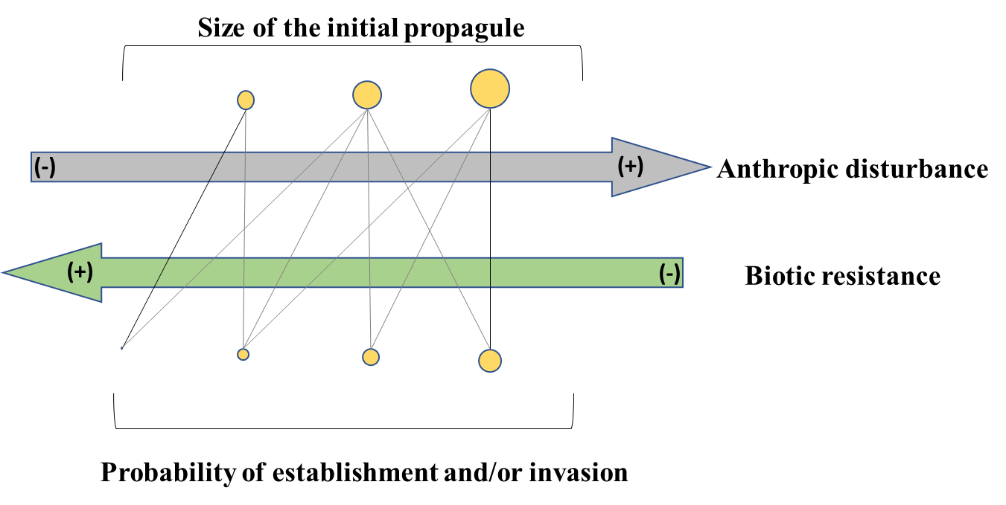
Figure 1. A general model of the invasion process. The probability of establishment or magnitude of invasion of the exotic species would depend on the initial size of the propagule, the anthropic disturbances, and the level of biotic resistance.

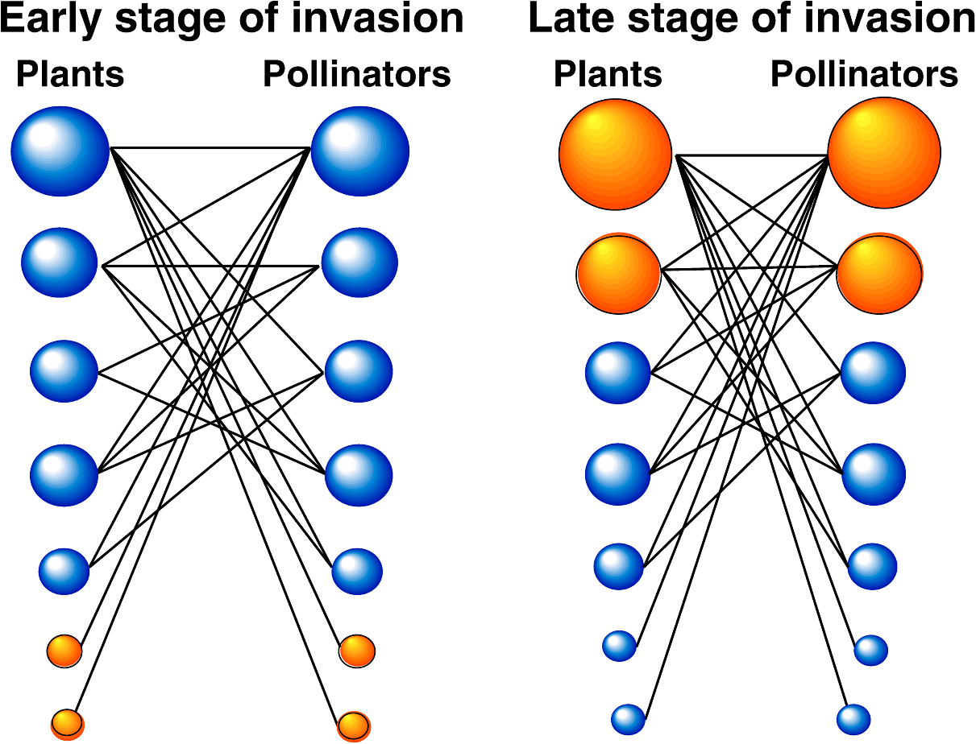
Figure 2. Plant–pollinator webs containing native (blue) and exotic (orange, dark outline) species, during the invasion process (Aizen et al., 2008; Tylianakis, 2008). The size of the circles is proportional to the interaction frequency of a species, which is highly influenced by its abundance. At the beginning of the invasion process (left web), exotic species are found in low abundance, interacting preferentially with native species. At the end of the invasion process (right web), the exotic species have become highly abundant. Exotic plants become highly attractive by virtue of their abundance, and exotic generalist pollinators are found to forage indiscriminately across plant species. Note that the “super-generalist” exotic species (top right) interact more frequently (have larger circles) than the native generalists (top left). (Figure courtesy of M. Aizen)
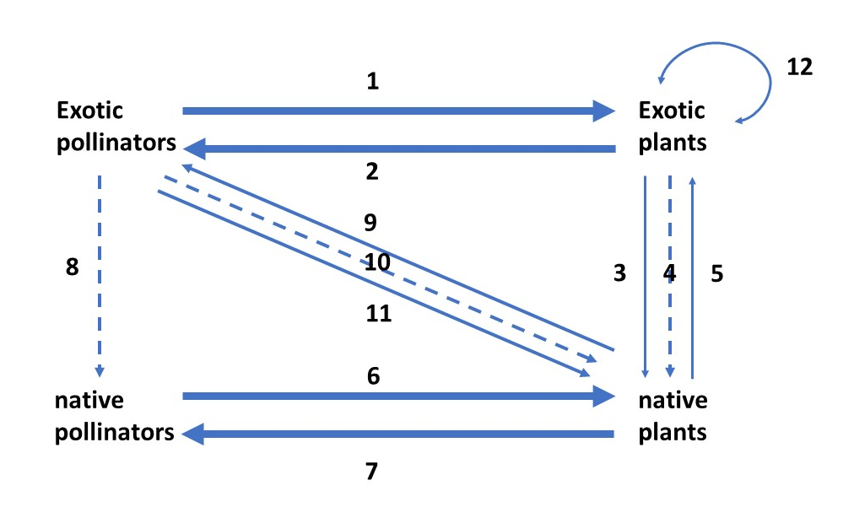
Figure 3. Different forms of interaction between invasive and native species in the pollination context, based on Simberloff & Von Holle1999 and Traveset and Richardson 2006. Arrows represent positive interactions while segmented arrows represent negative interactions. The thickness of an arrow indicates the magnitude of the action; 1and 2 is a mutual beneficial interaction between exotic pollinators and exotic plants, an invasional meltdown by Simberloff and Von Holle (1999), 3 and 5 is a beneficial mutualistic interaction between exotic plants and native plants, in some cases, some exotic plants could "maintain" several pollinators that at the community level would be beneficial for native plants; 4 is a negative interaction of an exotic plant species over native one, 6 and 7 is a mutually beneficial interaction between native pollinators and native plants, 8 is an interaction between exotic and native pollinators (documented only negative relationships), 9 and 11 is a beneficial interaction between exotic pollinators and native plants the outcome of which would be an exotic pollinators would replace the native pollinators, 10 is an antagonistic interaction of exotic pollinators towards native plants which could disrupt pollination of native plants due to a morphological mismatch or resource robbery, and 12 is a beneficial interaction of exotic plants with other exotic plants.

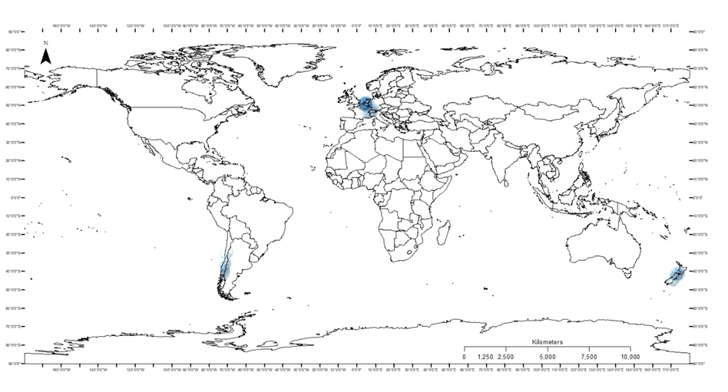Figure 4. Global Bombus ruderatus distribution based on GBIF (2021) and Salvemos Nuestro Abejorro citizen science data.

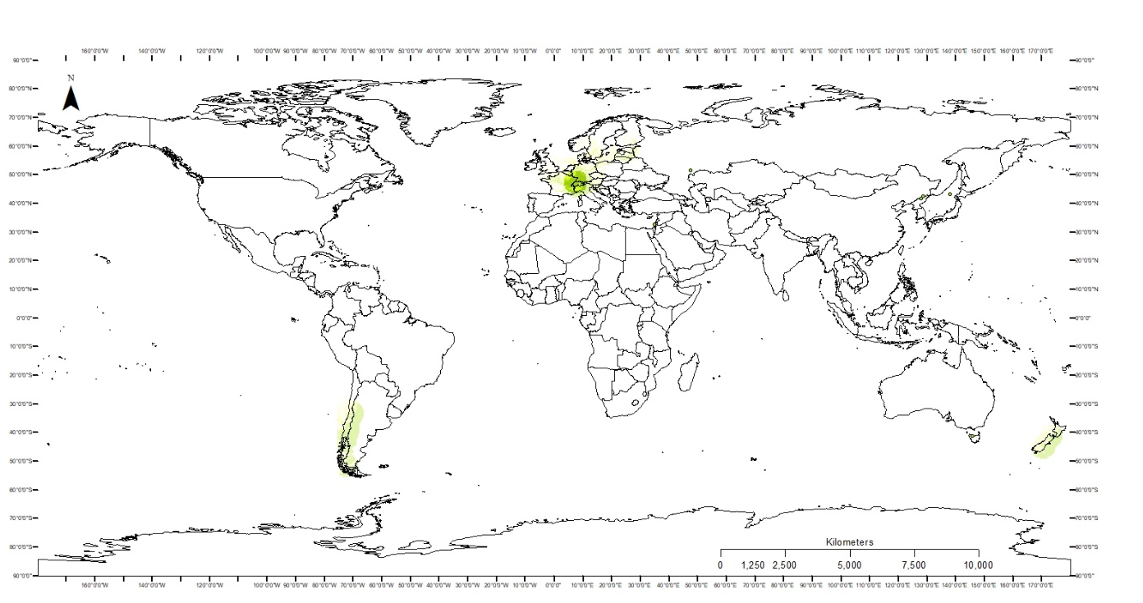Figure 5. Global B. terrestris distribution based on GBIF (2021) and Salvemos Nuestro Abejorro citizen science data.

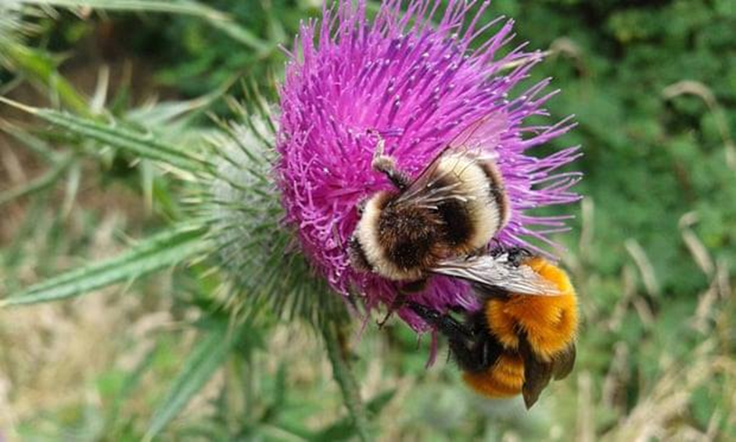
Figure 6. Left to right Bombus terrestris (European buff-tailed bumble bee) and Bombus dahlbomii (giant South American bumble bee). Picture Alvaro Becerra.

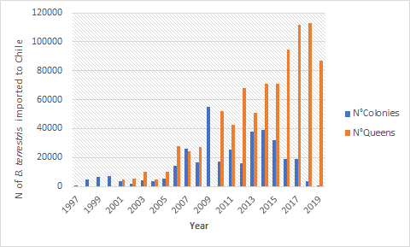
Figure 7. The number of colonies and queens of Bombus terrestris imported to Chile between 1997-2019. Edited from Aizen et al. 2019 and updated SAG 2019.

Chapter 2: Use of Citizen Science for data collection of the European bumble bees Bombus terrestris, Bombus ruderatus, and the endangered native species Bombus dahlbomii in Chile.

Abstract

In the past decade citizen science has become an essential tool for collecting data in research programs worldwide. Citizen scientists can collect significant quantities of data in a short period. Because citizen scientists are typically volunteers, this form of data collection is also cost-effective. And citizen scientists have proven effective in finding rare organisms, native or invasive species, and documenting declines in species populations. Although citizen science data can generate substantial quantities of data, it is not always quality data. Many online citizen science platforms accept photos as the primary data source, which requires careful vetting to assure accurate identification. Salvemos Nuestro Abejorro, is a citizen science project in Chile. Between 2014-2020 we collected over 5000 records of bumble bee species in Chile. Only 4302 were considered valid after vetting, but the result was 1875 records of the native bumble bee B. dahlbomii, and 2196 records and 231 records were for the introduced species B. terrestris and B. ruderatus respectively. Citizen science data was not consistently distributed geographically but trended to cluster in urbanized/highly populated areas. A drawback, however, is that the available citizen science records lacked density data, which is necessary for determining population trends. Our citizen science project is a successful tool for increasing collect data that will inform the conservation status of the native endangered species B. dahlbomii and the invasion rates of B. ruderatus and B. terrestris.

Keywords: Pollinators, community science, species distribution, invasion.

Introduction

Early ornithology and astronomy pioneered citizen science projects over a hundred years ago (Dickinson et al., 2010). In the last decade, however, the easy access to cameras, cellphones, apps, and social media, has helped numerous citizen science projects flourish (Conrad & Hilchey, 2011; MacPhail & Colla, 2020; Newman et al., 2012). These initiatives provide researchers data from locales that might not otherwise be accessible, such as private lands (Bonney et al., 2009; Chandler et al., 2017; Koffler et al., 2021; Olivier et al., 2016; Pocock et al., 2014; Tweddle et al., 2012), and potentially creates engagement between the public and professional scientists (Koffler et al., 2021; MacPhail & Colla, 2020; Pocock et al., 2014; Tweddle et al., 2012). Citizen science appears particularly effective at finding unique organisms such as previously unreported invasive species or rare native species (Chandler et al., 2017; Dickinson et al., 2010; MacPhail et al., 2020; Soroye et al., 2018; Tweddle et al., 2012). In general, a citizen science project follows a schema in which (1) citizen scientists take photographs and/or collects data for a target species, (2) images and data are uploaded to an online platform, (3) the identification of the photographed species is verified by a specialist, and (4) if the data are verifiable, they are uploaded into a database. Although this schema varies by project, each step presents unique challenges that require careful consideration.
For all citizen science projects, step one is the most limiting. Many projects fail because they do not engage enough people (MacPhail & Colla, 2020; Pocock et al., 2014; Viana et al., 2020). Project managers often develop activities to overcome a deficiency in the number of observers (Viana et al., 2020). The remaining steps, however, face challenges that can consume the time of researchers. The success of citizen science has led to the proliferation of online platforms for submitting data, which is arguably a byproduct of step two. Specialized platforms can be more time effective for data collection but may not be attractive to users or prove less cost-effective. In recent years, iNaturalist has become the dominant platform for citizen science data collection (Chandler et al., 2017), though some argue it is crowdsourcing more so than citizen science (Pocock et al., 2014; Tweddle et al., 2012). Nevertheless, iNaturalist is engaging people by providing well-curated data (i.e., numerous specialists are engaged in the vetting of identifications), cost-free, and informative. Global Biodiversity Information Facility (GBIF) now accepts vetted iNaturalist records (Chandler et al., 2017; Koffler et al., 2021).
Vetting data and verifying identifications, as noted in step three, presents several challenges. The number of records being submitted far outweighs the number of experts available to verify identification. This situation is exacerbated by the decreasing number of taxonomic specialists (Coleman & Radulovici, 2020; Drew, 2011; Mace, 2004). For some taxa such as insects, not only is a group specialist required, but photos may not feature the characteristics necessary to confirm an identification (Falk et al., 2019; Kadoya & Washitani, 2010; Kremen et al., 2011; MacPhail et al., 2020; Suzuki-Ohno et al., 2017). Artificial intelligence may help with the verification and processing of this issue (Spiesman et al., 2021; Suzuki-Ohno et al., 2017).
The products of these efforts yield baseline data and raw data for analysis by researchers. Often data are gathered from multiple platforms that may have disparate goals and assumptions. Although data assembled from multiple sources may appear to adhere to comparable data standards, this may not be the case, so further vetting and normalization are required. For example, some databases ingest or aggregate data from multiple sources. When using data from an aggregated source, it is necessary to determine if and how many duplicate records are present. Poorly conceived data-mining projects can lead to inaccurate or misleading results. And all results must be interpreted in the context of species biology (Dickinson et al 2010).
Salvemos Nuestro Abejorro was initiated in 2014 and is one of the first citizen science projects in Chile (Fundacion Ciencia Ciudadana, 2018; Grez et al., 2020; Roy et al., 2017). With over 9000 members across different platforms (Facebook, Twitter, Flickr), the prime objective of Salvemos Nuestro Abejorro is to collect distribution records for three bumble bee species in Chile: Bombus dahlbomii, B. ruderatus, and B. terrestris. The latter two are non-native. The program is similar to projects like Bumblebee Watch (USA), Bumblebee Conservation Trust (UK), Hanamaru-Muruhana (Japan), and others.
Here we will analyze data obtained by Salvemos Nuestro Abejorro to determine the utility of citizen science data for monitoring these three bumblebee species. We compare the records derived via citizen science with traditional museum records to determine how citizen science complements the work of professional ecologists and taxonomists.

Material and Methods
Data Platform
Since its inception, Salvemos Nuestro Abejorro has collected citizen science data in the form of photographs from the social media platforms Facebook (https://www.facebook.com/groups/456701147797736) and Twitter https://twitter.com/SNAbejorro?s=20), which are then uploaded to Flickr (https://www.flickr.com/groups/dahlbomii/). Prior to upload, the photos were carefully vetted for correct identification and the inclusion of relevant data (date, place, coordinates, caste, predators, floral association, etc.). Fortunately, Bombus dahbomii possesses bright, orange-colored hairs covering the whole body that permits easy recognition and distinguishes it from the invasive bumble bees B. terrestris and B. ruderatus. B. terrestris can be differentiated from B. ruderatus by the pattern of color bands, and a heart-shaped (as opposed to long) face (Montalva et al., 2011). Once the identification was verified, the record was reviewed for the presence and quality of spatial data. Only records that were accompanied with coordinates pairs or possessed a locality description from which coordinates could be derived using google maps, were retained for further analysis.
The vetted data were used to map the distribution of the three species of bumblebees using ArcMap10.7.1. We then analyzed whether the records were distributed equally throughout Chile or whether they were clustered spatially. We then analyzed differences within regions and by regional population per capita. Data were analyzed using sp, spatstat, raster, maptools, rgeos, GISTools in RStudio (R Development Core Team 2018). To determine whether citizen science data contributed significantly to our knowledge of bumblebee distributions, we pooled all museum records and citizen science) and performed a χ2 test using the package ggplot2 on RStudio. A χ2 test was used to test if the records were collected equally between sources and among species or if they differed.

Results and Discussion
Pros of citizen science on the bumble bee data collection.
The citizen science data provided new and updated location information for the distribution of the three bumble bee species. The records corresponded with the known, historical distribution for the native B. dahlbomii (Montalva et al., 2011). Records for the introduced species B. ruderatus and B. terrestris, however, demonstrated how the distribution of these species has changed over time, and illustrated their spread in Chile (Figure 2).
From 2014 to 2020 Salvemos Nuestro Abejorro collected over 5000 bumble bee records of which 4302 were determined to be valid. The leading cause for rejecting a record was the absence of coordinates and the lack of sufficient locality information to geocode the data. Of the 4302 valid records, 1875 were for the native bumble bee B. dahlbomii, and 2196 for B. terrestris, and 231 for B. ruderatus (Figure 3). A comparison of the Salvemos Nuestro Abejorro records with the museum data reveals the efficacy of citizen science; 1875 B. dahlbomii records were collected in only six years as opposed to 1817 records of museums collected over 200 years (Figure 3). Also, the citizen science records yielded many new localities (Montalva et al 2017; Rendoll-Carcamo et al 2017). The χ2 analysis of citizen science data and museum records for B. ruderatus (112 museum versus 231 citizen science records, Figure 3) and B. terrestris (43 museum versus 2196 citizen science records, figure 4) revealed these differences to be significant (χ2 = 1446.7, df = 2, p-value < 2.2e-16). The disproportionate number of exotic species recorded by citizen scientists could be the product of 1) the relatively recent introduction of these species and/or 2) an attitude among some scientists that since the species are not part of the native fauna, collections should not be deposited in official repositories.
Engaging citizen scientists in data collection to understand environmental problems (e.g., water quality, noise pollution, plastic contamination, etc.) has developed rapidly (MacPhail & Colla, 2020; Pocock et al., 2014; Tweddle et al., 2012). The perceived advantage is that scientists gain broader coverage for data collection and citizen scientists are exposed to research methodologies. The outcome is tangible and may result in an informed populace (Koffler et al., 2021; MacPhail & Colla, 2020). For example, Salvemos Nuestro Abejorro records were used to petition the Ministerio de Medio Ambiente of Chile for inclusion of B. dahlbomii on its Red List in 2015 (Montalva et al., 2015). A campaign was also initiated to collect signatures in support of the listing, resulting in 2868 signatures in one month. In 2019 a similar campaign was started requesting that the Chilean government stop importations of B. terrestris. 5673 signatures were collected. There is also a lawsuit pending to force the Chilean government to stop the importation of B. terrestris, which is led by the Chilean scientist Dr. Smith-Ramirez and is supported by the Chilean Society of Ecology.
As noted earlier, there is a reciprocal exchange of knowledge between citizen scientists and professional scientists (Koffler et al., 2021; Pocock et al., 2014; Tweddle et al., 2012). Dedicated amateurs can develop explicit knowledge of populations and the ecology of organisms in their surrounding (Dickinson et al., 2010). It was through such reciprocity that Salvemos Nuestro Abejorro learned of local use and consumption of bumble bee honey from people that collected bumble bee honey in the forest. At first, these stories were considered anecdotal, but as reports continued, further investigation revealed that the Native Chilean Mapuche people harvested and used bumble bee honey as a source of food, medicine, and sacred rituals (Montalva et al, 2020).

Cons of the citizen science on the bumble bee data collection.
For a better understanding of the patterns revealed by the citizen science collection, we only selected photographs from 2010-2020. Citizen scientists started to submit fewer pictures of the more abundant species, Bombus terrestris, but started to submit more pictures of the rare species B. dahlbomii over time. We attribute this behavior to the fact that B. dahlbomii is a native and charismatic bee that draws the attention of citizen scientists. On the other hand, sharp decline in records for B. terrestris, the more abundant species, was because it is not a native or charismatic species (Figure 6).
These analyses confirmed another shortcoming of citizen science: the number of bumble bee observations corresponded positively with the number of observers in an area (Tracy et al., 2019). Although the density of the human populace alone does not account for these relationships, the resources, and technologies available in urban areas facilitate the submission of occurrence reports to online platforms (Tracy et al., 2019). This technology bias can create misleading interpretations. For example, visually the mapped records imply there is a greater density of individual bumble bees in urban environments, however, the data demonstrate an even distribution of bumble bees from the central to southern Chile. A disjunct record from the Atacama Desert, however, suggests that bumble bee populations may extend further north than anticipated. Further investigation revealed that the record was from an agricultural facility where the bees had been imported (Montalva et al., 2017) (Figure 7A). When we review citizen science records on a per capita basis, records are still focused on the central and southern portions of Chile, even though the capital Santiago has fewer records proportionally (Figure 7 B). Overall, our data do not show the pattern “more people more data” by region (Figure 7 A, B).

Conclusion
Overall, Salvemos Nuestro Abejorro proved successful in collecting valuable species distribution data. Since citizen scientists were not required to identify the species (Falk et al., 2019; Kadoya et al., 2009; MacPhail et al., 2020; Suzuki-Ohno et al., 2017), a greater number of records over a shorter period of time were gathered than available from museums, particularly for the introduced species (Figure 4). Unlike other citizen science platforms, the data gathered by Salvemos Nuestro Abejorro did not exhibit a relationship between human population density (Figure 7 A, B), implying a uniform level of engagement in the project by citizen scientists. In the future, new techniques are needed to census bumble bee populations that are accessible to citizen scientists. Despite these results, the citizen science records lack species abundance data.

References

Bonney, R., Ballard, H., Jordan, R., McCallie, E., Phillips, T., Shirk, J., & Wilderman, C. C. (2009). Public Participation in Scientific Research Defining the Field and Assessing Its Potential for Informal Science Education. A CAISE Inquiry Group Report. Science Education.
Chandler, M., See, L., Copas, K., Bonde, A. M. Z., López, B. C., Danielsen, F., Legind, J. K., Masinde, S., Miller-Rushing, A.J, Newman, G., Rosemartin, A., & Turak, E. (2017). Contribution of citizen science towards international biodiversity monitoring. Biological Conservation, 213, 280–294. https://doi.org/10.1016/j.biocon.2016.09.004
Coleman, C. O., & Radulovici, A. E. (2020). Challenges for the future of taxonomy: talents, databases and knowledge growth. Megataxa, 1(1), 28–34. https://doi.org/10.11646/megataxa.1.1.5
Conrad, C. C., & Hilchey, K. G. (2011). A review of citizen science and community-based environmental monitoring: issues and opportunities. Environmental Monitoring and Assessment, 176(1), 273–291. https://doi.org/10.1007/s10661-010-1582-5
Dickinson, J. L., Zuckerberg, B., & Bonter, D. N. (2010). Citizen Science as an Ecological Research Tool: Challenges and Benefits. Annual Review of Ecology, Evolution, and Systematics, 41(1), 149–172. https://doi.org/10.1146/annurev-ecolsys-102209-144636
Drew, L. W. (2011). Are we losing the science of taxonomy? BioScience, 61(12), 942–946. https://doi.org/10.1525/bio.2011.61.12.4
Falk, S., Foster, G., Comont, R., Conroy, J., Bostock, H., Salisbury, A., … Smith, B. (2019). Evaluating the ability of citizen scientists to identify bumblebee (Bombus) species. PloS One, 14(6), e0218614. https://doi.org/10.1371/journal.pone.0218614
Fundacion Ciencia Ciudadana, ngo. (2018). Ciencia Ciudadana Principios Herramientas proyectos de Medio Ambiente. Santiago Chile: Fundacion Ciencia Ciudadana. Retrieved from http://cienciaciudadana.cl/wp-content/uploads/2018/04/libro-CC-OK.pdf
GBIF Secretariat (2021). GBIF Backbone Taxonomy. Checklist dataset https://doi.org/10.15468/39omei accessed via GBIF.org on 2021-07-31.
Grez, A., Acevedo, D., Repetto-Giavelli, F., Simonetti-Grez, G., Stipicić, G., Tejeda, I., Zaviezo, T. (2020). Manual de Ciencia Ciudadana para la Biodiversidad de Magallanes. (A. Grez, T. Zaviezo, & G. Simonetti-Grez, Eds.). Punta Arenas: Kauyeken.
Kadoya, T., Ishii, H. S., Kikuchi, R., Suda, S., & Washitani, I. (2009). Using monitoring data gathered by volunteers to predict the potential distribution of the invasive alien bumblebee Bombus terrestris. Biological Conservation, 142(5), 1011–1017. https://doi.org/https://doi.org/10.1016/j.biocon.2009.01.012
Kadoya, T., & Washitani, I. (2010). Predicting the rate of range expansion of an invasive alien bumblebee (Bombus terrestris) using a stochastic spatio-temporal model. Biological Conservation, 143(5), 1228–1235. https://doi.org/https://doi.org/10.1016/j.biocon.2010.02.030
Koffler, S., Barbiéri, C., Ghilardi-Lopes, N. P., Leocadio, J. N., Albertini, B., Francoy, T. M., & Saraiva, A. M. (2021). A Buzz for Sustainability and Conservation: The Growing Potential of Citizen Science Studies on Bees. Sustainability, 13(2). https://doi.org/10.3390/su13020959
Kremen, C., Ullman, K. S., & Thorp, R. W. (2011). Evaluating the Quality of Citizen-Scientist Data on Pollinator Communities. Conservation Biology, 25(3), 607–617. https://doi.org/10.1111/j.1523-1739.2011.01657.x
Mace, G. M. (2004). The role of taxonomy in species conservation. Philosophical Transactions of the Royal Society B: Biological Sciences, 359(1444), 711–719. https://doi.org/10.1098/rstb.2003.1454
MacPhail, V. J., & Colla, S. R. (2020). Power of the people: A review of citizen science programs for conservation. Biological Conservation, 249, 108739. https://doi.org/https://doi.org/10.1016/j.biocon.2020.108739
MacPhail, V. J., Gibson, S. D., Hatfield, R., & Colla, S. R. (2020). Using Bumble Bee Watch to investigate the accuracy and perception of bumble bee (Bombus spp.) identification by community scientists. PeerJ, 2020(6), 1–31. https://doi.org/10.7717/peerj.9412
Montalva, J., Dudley, L. S., Arroyo, M. K., Retamales, H., & Abrahamovich, A. H. (2011). Geographic distribution and associated flora of native and introduced bumble bees (Bombus spp.) in Chile. Journal of Apicultural Research, 50(1), 11–21. https://doi.org/10.3896/IBRA.1.50.1.02
Montalva, J., Dudley, L. S., Sepúlveda, J. E., & Smith-Ramírez, C. (2020). The Giant Bumble Bee (Bombus dahlbomii) in Mapuche Cosmovision. Ethnoentomology, 4(July), 1–11. Retrieved from www.ethnoentomology.cz
Montalva, J., Sepulveda, V., Vivallo, F., & Silva, D. P. (2017). New records of an invasive bumble bee in northern Chile: expansion of its range or new introduction events? Journal of Insect Conservation, 21(4), 657–666. https://doi.org/10.1007/s10841-017-0008-x
Montalva, Jose, Vieli, L., Castro, B., Allendes, J. L., & Amigo, V. (2015). Status report on the chilean bumblebee, Bombus dahlbomii. Santiago.
Newman, G., Wiggins, A., Crall, A., Graham, E., Newman, S., & Crowston, K. (2012). The future of citizen science: emerging technologies and shifting paradigms. Frontiers in Ecology and the Environment, 10(6), 298–304. https://doi.org/https://doi.org/10.1890/110294
Olivier, T., Schmucki, R., Fontaine, B., Villemey, A., & Archaux, F. (2016). Butterfly assemblages in residential gardens are driven by species’ habitat preference and mobility. Landscape Ecology, 31(4), 865–876. https://doi.org/10.1007/s10980-015-0299-9
Pocock, M. J. O., Chapman, D. S., Sheppard, L. J., & Roy, H. E. (2014). Choosing and using citizen science. Centre for Ecology & Hydrology. Retrieved from https://www.ceh.ac.uk/sites/default/files/sepa_choosingandusingcitizenscience_interactive_4web_final_amended-blue1.pdf
Rendoll-Carcamo, J. A., Contador, T. A., Saavedra, L., & Montalva, J. (2017). First record of the invasive bumblebee Bombus terrestris (Hymenoptera: Apidae) on Navarino Island, southern Chile (55°S). Journal of Melittology, (71), 1–5. https://doi.org/10.17161/jom.v0i71.6520
Roy, H. E., Grez, A., Zaviezo, T., & Brown, P. M. J. (2017). Exploring Citizen Science in Chile. BES Bulletin, 48(1), 62–65. https://doi.org/10.1097/00001888-192701000-00011
Soroye, P., Ahmed, N., & Kerr, J. T. (2018). Opportunistic citizen science data transform understanding of species distributions, phenology, and diversity gradients for global change research. Global Change Biology, 24(11), 5281–5291. https://doi.org/10.1111/gcb.14358
Spiesman, B. J., Gratton, C., Hatfield, R. G., Hsu, W. H., Jepsen, S., McCornack, B.,&Wang, G. (2021). Assessing the potential for deep learning and computer vision to identify bumble bee species from images. Scientific Reports, 11(1), 7580. https://doi.org/10.1038/s41598-021-87210-1
Suzuki-Ohno, Y., Yokoyama, J., Nakashizuka, T., & Kawata, M. (2017). Utilization of photographs taken by citizens for estimating bumblebee distributions. Scientific Reports, 7(1), 11215. https://doi.org/10.1038/s41598-017-10581-x
Tracy, J. L., Kantola, T., Baum, K. A., & Coulson, R. N. (2019). Modeling fall migration pathways and spatially identifying potential migratory hazards for the eastern monarch butterfly. Landscape Ecology, 34(2), 443–458. https://doi.org/10.1007/s10980-019-00776-0
Tweddle, J., Robinson, L., Roy, H., & Pocock, M. (2012). Guide to citizen science: developing, implementing and evaluating citizen science to study biodiversity and the environment in the UK. Natural History Museum and NERC Centre for Ecology & Hydrology for UK-EOF.
Viana, B. F., Souza, C. Q., & Moreira, E. F. (2020). Why the views of Latin American Scientists on Citizen Science as a Tool for Pollinator Monitoring and Conservation Matter? Neotropical Entomology, 49(4), 604–613. https://doi.org/10.1007/s13744-020-00793-8

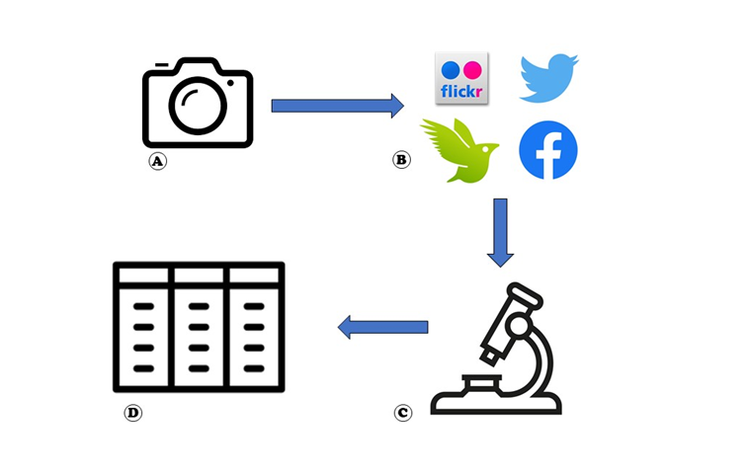
Figure 1. Diagram of the Citizen Science Model. A. Data collection by citizen scientists. B. Data upload to the different platforms. C. Data curation by experts. D. Data correctly curated are uploaded to the main database.
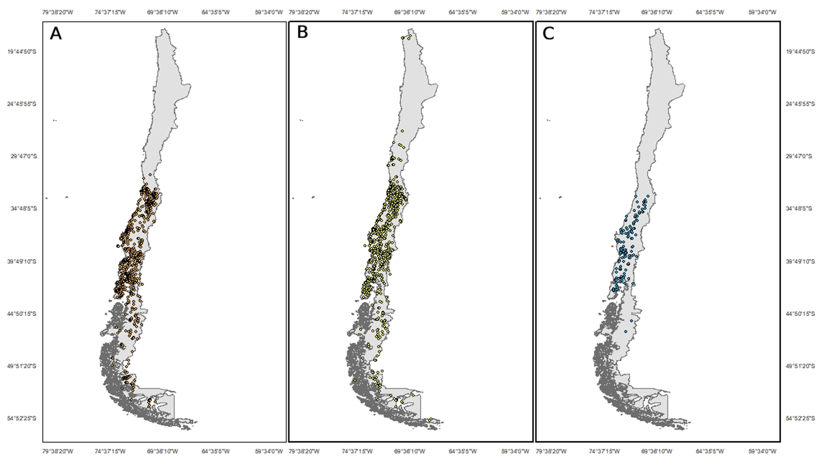
Figure 2. Distribution of the bumble bees present on Chile based in Citizen science reports. A.- B. dahlbomii B.- B. terrestris C.- B. ruderatus

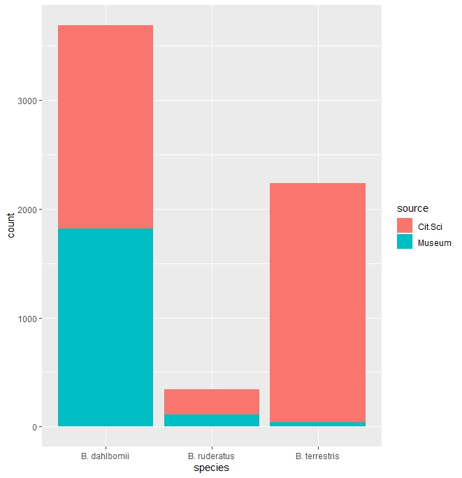
Figure 3. Comparison between the museum data and the bumble bee records from the citizen science project. B. dahlbomii 1875 citizen science records and 1817 museum records. B. ruderatus 231 citizen science records and 112 museum records. B. terrestris 2196 citizen science records and 43 museum records.

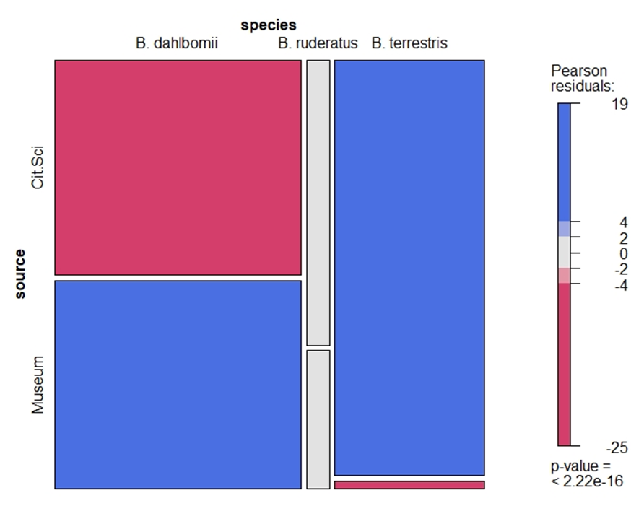
Figure 4. Mosaic plot comparing Citizen Science records vs Museum records for the three species of bumble bees present in Chile. The red cases mean that the observed frequencies are smaller than the expected frequencies, whereas the blue cases mean that the observed frequencies are more significant than the expected frequencies.

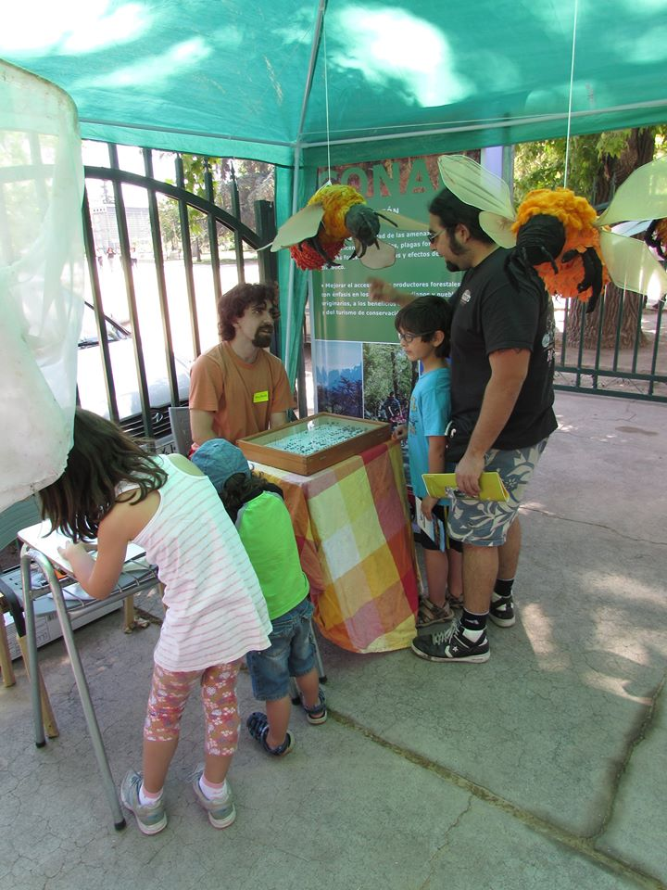
Figure 5. Salvemos Nuestro Abejorro at the first edition of “Dia de la Fauna Chilena” 2014.

Figure 6. Bumble bee reports collected through Citizen Science between 2010-2020. A total of 44% of the reports in orange represent the native bumble bee B. dahlbomii (1875 records), 5% of the reports in blue represent B. ruderatus (231 records) and 51% in yellow represent B. terrestris (2196 records).

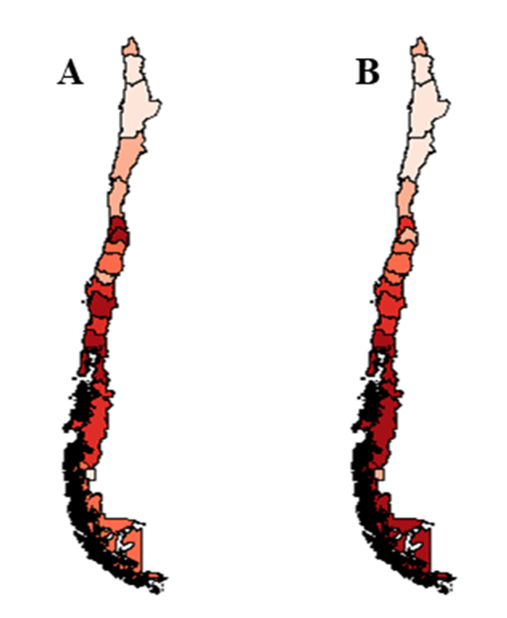
Figure 7. Bumble bee citizen science reports for the bumble bees present in Chile. A. by region. B. by region per capita.

Chapter 3: Modeling the distribution of native and invasive species of bumble bees (Hymenoptera: Apidae) in Chile, using citizen science data

Abstract

Bombus terrestris and Bombus ruderatus are invasive bumble bee species in South America. Several studies indicate that as a consequence of their introduction the populations of the Patagonian bumble bee Bombus dahlbomii are in sharp decline. Here, we gathered a comprehensive database of occurrence records from museum and citizen science sources. Multivariate bioclimatic niche analyses and species distribution models were used to determine if niche overlap occurred between the invasive and the native species. We also analyzed the potential effect of current and future climatic scenarios on the distribution of these bumble bees. From the results, we concluded that there was niche overlap between the three bumble bee species, and most significantly between B. terrestris and B. dahlbomii (61%). The current distribution for B. terrestris is extensive in South America but the models also show a shrinking distribution for B. ruderatus and B. dahlbomii in the pessimistic future scenario. We discuss the consequences of the niche overlap between the introduced bumble bee species and the endangered B. dahlbomii.
Keywords: Conservation biogeography, Distribution models, Pollinators, Niche overlapping.

Introduction

There are approximately 260 species of bumble bees (Bombus) globally (Michener, 2007). Although several provide essential pollination services (Cameron et al., 2011), most are experiencing declining populations (Arbetman et al., 2017; Cameron et al., 2011; Williams & Osborne, 2009; Goulson et al., 2008). One factor insinuated in the decline of bumble bees is the introduction of commercial congeners (Dafni et al., 2010; Williams et al., 2008). The worldwide trade in commercial bumble bee colonies for crop pollination has the potential for invasive, non-native bumble bees to adversely impact native pollinator populations (Dafni et al., 2010; Sutherland et al., 2017). Native bumble bees are biologically and ecologically more similar to introduced bumble bees than to non-Bombus native pollinators. Therefore, native Bombus species are expected to be more vulnerable to the potential negative impacts of the foreign species, either through disease transmission (Cameron & Sadd, 2020; Graystock et al., 2016; Meeus et al., 2011) or resource competition (Dafni et al., 2010; Morales et al., 2013).
In the past four decades, two European bumble bee species have been introduced in southern South America for crop pollination (Aizen et al., 2019; Montalva et al., 2011; Smith-Ramírez et al., 2018). Bombus ruderatus was introduced to pollinate Trifolium pratense (red clover), a livestock forage crop, during the 1982/1983 growing season. Approximately 400 queens were imported from New Zealand and released at two locations near Temuco (38ᵒS 72ᵒW), in southern Chile (Arretz & Macfarlane, 1986). In 1993, B. ruderatus was first reported in Argentina, and were likely the offspring of individuals in Chile (Roig Alsina & Aizen, 1996). Bombus terrestris is one of the leading commercially available species and has been introduced in several countries worldwide (Dafni et al., 2010; Kadoya & Washitani, 2010; Matsumura et al., 2004; Naeem et al., 2018). It was first introduced to central Chile in 1997 (Montalva et al., 2011), and more than a million individuals have been imported into the country since that time (Aizen et al., 2019; Smith-Ramírez et al., 2018). In 2006, it was reported as invading Argentina (Torretta et al., 2006). Both species now occupy an extensive territory in southern South American continent (Figure 1) and are associated with the sharp populational decline of the native and endangered bumble bee species B. dahlbomii (Montalva et al., 2015; Morales et al., 2013; Morales et al., 2016).
The objective of this research is to ascertain the ecological interactions of these three species over space and time. Specifically, we seek to answer the questions 1) is there extensive niche overlap among these Bombus species, 2) how might these relationships change based upon future climate scenarios, and 3) how might the results of these analyses inform us about the persistence of B. dahlbomii and the invasive behavior B. terrestris and B. ruderatus, To address these questions, we applied multivariate bioclimatic niche analyses (Broennimann et al., 2012) and species distribution models to evaluate the relationship between the distributions of the two European bumble bee species and the native B. dahlbomii and potential alteration of their ecological niche. Specifically, we calculated species pair-wise niche overlap in both geographic and climatic space to determine the threat posed by the European species on the native endangered species. Also, we used species distribution models to predict the current and future distribution for the three bumble bee species in South America.

Methods

Occurrence dataset

We gathered a comprehensive database of occurrence records for B. dahlbomii, B. ruderatus and B. terrestris from the Global Biodiversity Information Facility https://www.gbif.org/ (GBIF) and records from the Citizen Science initiative “Salvemos Nuestro Abejorro” (Save our Bumble bee; https://salvemosnuestroabejorro.wordpress.com/). From the GBIF dataset, we only used the museum records. We felt confident in adopting the citizen science data because the three species possess morphological characteristics that facilitate accurate identification by citizen scientists. For example, B. dahlbomii, the native species, is covered with bright orange-colored hairs, and can be recognized by Citizen Scientists with little or no training in bumble bee taxonomy (Falk et al., 2019; Montalva et al., 2011).
The existence of, or ability to attribute these to coordinate pairs is crucial for successful analysis. An occurrence record in our preliminary dataset was retained for further analysis if the record provided coordinates or if the locality string was sufficiently detailed to geocode a record using Google Earth. Dubious, unreliable, and duplicate occurrence records were discarded from the dataset. This process yielded 251 records for B. ruderatus, 885 for B. terrestris, and 321 for B. dahlbomii (Fig.1), for the preliminary dataset of 5307 records.

Data Analysis
Ecological niche overlap
To determine if and the extent to which similarities existed in the environmental space occupied by the three bumble bee species, we applied the analysis framework of Broennimann et al. (2012) to calculate potential niche overlap. The dataset for this analysis consisted of the 19 Wordclim bioclimatic variables (www.worldclim.org) for temperature and precipitation from 1950 to 2000 (Hijmans et al., 2005). We extracted a subset of these data by placing a buffer of ~ 100 km around the occurrence records for each species as a representation of their current bioclimatic setting. The data were compiled into a matrix and analyzed using a PCA to generate an environmental space (PCA-env in Broennimann et al. (2012)). For each species, we calculated the occurrence density within each cell of the environmental space grid. the occurrence density was then modeled using a smooth kernel density function that analyses the geographical conditions for each species (Broennimann et al., 2012). The species pair-wise niche overlap was then calculated using Schoener’s D metric between the modeled occurrence density in the PCA ordination space (Broennimann et al., 2012; Schoener, 1970; Warren al., 2008). We tested for the significance of D by calculating the niche equivalency and similarity between the pairs of species (Broennimann et al., 2012) using the ecospat package (Di Cola et al., 2017) in R (R Development Core Team 2018) with code modifications in Silva et al. (2016).

Species distribution modeling
We adopted the methodology of Silva et al. (2019) for the analysis of current and future distribution scenarios for the bumble bee species. We used six different models in an ensemble approach: Generalized Linear Model (GLM), Random Forest (RDF), Maximum Entropy (MAX), Gaussian Model (GAU), Support Vector Machines (SVM), and Maximum Likelihood (MLK) (Silva et al., 2019). Models were evaluated using the Jaccard similarity index metric (Leroy et al., 2018), which measures the similarity between predictions and observations on a scale of 0 to 1 (where a value of 1 indicates that the model predictions are perfectly matched with the known observations of the species, and a value of 0 indicates that the models do not correspond to actual observations; Leroy et al., 2018). We used a threshold that maximizes Jaccard values in relation to the sensitivity and specificity values. Since similarity indices do not include true negative values, they are not biased by a disproportionate number of pseudo-absences. Also, we calculated the Area under the Curve (AUC) and True Skills Statistics (TSS) (Table 2).

Results
The first two axes of the PCA captured 71.39% of the variation in the climate dataset. The first axis (43.5%) corresponded to temperature variables and the second (27.89%) to precipitation. Considering that B. terrestris and B. ruderatus are native to Europe (Michener, 2007), the high niche overlap between these species (D: 0.672, Table 1) was anticipated. European bumble bee species, however, also exhibited niche overlap with the native species B. dahlbomii; 46% (D: 0.46) overlap with B. ruderatus, and 61% with B. terrestris (Figure 2, Table 1).
The models for B. ruderatus, B. terrestris and B. dahlbomii reached mean Jaccard values of 0.8544 ± 0.048, 0.8936 + 0.03, and 0.9279 + 0.008 respectively (mean ± standard deviation). For B. ruderatus MAX had the highest Jaccard value (0.918 ± 0.07), and RDF for B. terrestris (0.906 ± 0.009, Table 2). For B. dahlbomii, GAU (0.94 ± 0.008), RDF (0.943 + 0.013) and SVM (0.943 + 0.004) had comparably high Jaccard values. MLK performed poorly for all three species (Table 2).
In the current climate scenario, considering the final ensemble for the three species, the distribution of B. ruderatus extends mainly in the Mediterranean zone of Chile and parts of Patagonia (Figure 3, 4). The distribution of B. terrestris in the current climate scenario almost reaches the southern tip of continental South American (Figure 4), which covers a significant portion of the Chilean Mediterranean and most Patagonia, Argentina and Chile. The model also indicates expansion into Peru and Bolivia (Figure 4). For the future distribution ranges the three species show a similar pattern; all species would move toward southern Chile and Argentina (Figures 3, 4).

Discussion
Here, we showed that the potential distribution for three bumble bee species (two introduced, B. ruderatus and B. terrestris, and one native species, B. dahlbomii). Specifically, we evaluated both the spatial and multivariate overlap of both introduced and native bumble bee species using species distribution models and multivariate analyses. Our results show a high niche overlap between B. ruderatus and B. terrestris (D: 0.672, Figure 2, Table 1) which was expected given their geographic origin (Michener, 2007). Of concern, however, was the niche overlap between each of these species and B. dahlbomii (Figure 2, Table 1). These values indicate possible competition for resources between these species and B. dahlbomii, with B. terrestris as the likeliest threat (Arbetman et al., 2013; Arismendi et al., 2016; Madjidian et al., 2008; Morales et al., 2013; Schmid-Hempel et al., 2014). In some areas where the species distributions are allopatric, populations of B. dahlbomii exhibited a sharp decline (Morales et al., 2013; Morales et al., 2016). For this reason, a high niche overlap signals an increased threat to the persistence of B. dahlbomii (Morales et al., 2016).
The distribution maps implied that both introduced species, in the current scenario, could potentially migrate to and occupy an extensive area in South American (Figure 3, 4). Although B. ruderatus was more restricted to Patagonia, the distribution of B. terrestris moved north into Peru and Bolivia. Should this scenario unfold, B. terrestris would come into contact with populations of B. funebris and other pollinators with possible adverse outcomes for natives (Morales et al., 2017; Vanbergen et al., 2018). The models indicated areas suitable in the Mediterranean region of Chile for B. terrestris (Figure 4), which Acosta (2016) reported as a low probability likelihood.
The future scenario shows a decrease in the area occupied by the bumble bee species (Figure 4), especially B. ruderatus and B. dahlbomii. The models indicated that B. ruderatus will probably move toward southern Patagonia, while B. dahlbomii will likely disappear near the northern Mediterranean region of South America. This is consistent with the trend of European and North American bumble bee species that have experienced northward or high elevation shifts in distribution (Kerr et al., 2015). Also, in South America, B. bellicosus has shown declines in distribution due to climatic conditions (Martins & Melo, 2010; Martins et al., 2015).
These movements could affect the abundance of these bumble bee species and cause pollination mismatches (Miller-Struttmann et al., 2015). Again, B. dahlbomii is already an endangered species facing competition for resources with their exotic congeners. For these reasons, B dahlbomii conservation programs and ban the importation of B. terrestris are essential.

References
Acosta, A. L., Giannini, T. C., Imperatriz-Fonseca, V. L., & Saraiva, A. M. (2016). Worldwide Alien Invasion: A Methodological Approach to Forecast the Potential Spread of a Highly Invasive Pollinator. PLOS ONE, 11(2), e0148295. Retrieved from https://doi.org/10.1371/journal.pone.0148295
Aizen, M. A., Smith‐Ramírez, C., Morales, C. L., Vieli, L., Sáez, A., Barahona‐Segovia, R. M., Arbetman, M. P., Montalva, J., Garibaldi, L. A., Inouye, S. W., &Harder, L. D. (2019). Coordinated species importation policies are needed to reduce serious invasions globally: The case of alien bumblebees in South America. Journal of Applied Ecology, 56(1), 100–106. https://doi.org/10.1111/1365-2664.13121
Arbetman, M. P., Gleiser, G., Morales, C. L., Williams, P., & Aizen, M. A. (2017). Global decline of bumblebees is phylogenetically structured and inversely related to species range size and pathogen incidence. Proceedings of the Royal Society B: Biological Sciences, 284(1859). https://doi.org/10.1098/rspb.2017.0204
Arbetman, M. P., Meeus, I., Morales, C. L., Aizen, M. A., & Smagghe, G. (2013). Alien parasite hitchhikes to Patagonia on invasive bumblebee. Biological Invasions, 15(3), 489–494. https://doi.org/10.1007/s10530-012-0311-0
Arismendi, N., Bruna, A., Zapata, N., & Vargas, M. (2016). Molecular detection of the tracheal mite Locustacarus buchneri in native and non-native bumble bees in Chile. Insectes Sociaux, 63(4), 629–633. https://doi.org/10.1007/s00040-016-0502-2
Arretz, P. V., & Macfarlane, R. P. (1986). The introduction of bombus ruderatus to chile for red clover pollination. Bee World, 67(1), 15–22. https://doi.org/10.1080/0005772X.1986.11098855
Broennimann, O., Fitzpatrick, M. C., Pearman, P. B., Petitpierre, B., Pellissier, L., Yoccoz, N. G., &Guisan, A. (2012). Measuring ecological niche overlap from occurrence and spatial environmental data. Global Ecology and Biogeography, 21(4), 481–497. https://doi.org/10.1111/j.1466-8238.2011.00698.x
Cameron, S. A., Lozier, J. D., Strange, J. P., Koch, J. B., Cordes, N., Solter, L. F., & Griswold, T. L. (2011). Patterns of widespread decline in North American bumble bees. Proceedings of the National Academy of Sciences of the United States of America, 108(2), 662–667. https://doi.org/10.1073/pnas.1014743108
Cameron, S. A., & Sadd, B. M. (2020). Global trends in bumble bee health. Annual Review of Entomology, 65, 209–232. https://doi.org/10.1146/annurev-ento-011118-111847
Dafni, A., Kevan, P., Gross, C. L., & Goka, K. (2010). Bombus terrestris, pollinator, invasive and pest: An assessment of problems associated with its widespread introductions for commercial purposes. Applied Entomology and Zoology, 45(1), 101–113. https://doi.org/10.1303/aez.2010.101
Di Cola, V., Broennimann, O., Petitpierre, B., Breiner, F. T., D’Amen, M., Randin, C., & Guisan, A. (2017). ecospat: an R package to support spatial analyses and modeling of species niches and distributions. Ecography, 40(6), 774–787. https://doi.org/10.1111/ecog.02671
Falk, S., Foster, G., Comont, R., Conroy, J., Bostock, H., Salisbury, A., & Smith, B. (2019). Evaluating the ability of citizen scientists to identify bumblebee (Bombus) species. PloS One, 14(6), e0218614. https://doi.org/10.1371/journal.pone.0218614
GBIF Secretariat (2021). GBIF Backbone Taxonomy. Checklist dataset https://doi.org/10.15468/39omei accessed via GBIF.org on 2021-07-31.
Goulson, D., Lye, G. C., & Darvill, B. (2008). Decline and conservation of bumble bees. Annual Review of Entomology, 53, 191–208. https://doi.org/10.1146/annurev.ento.53.103106.093454
Graystock, P., Blane, E. J., McFrederick, Q. S., Goulson, D., & Hughes, W. O. H. (2016). Do managed bees drive parasite spread and emergence in wild bees? International Journal for Parasitology: Parasites and Wildlife, 5(1), 64–75. https://doi.org/10.1016/j.ijppaw.2015.10.001
Hijmans, R. J., Cameron, S. E., Parra, J. L., Jones, P. G., & Jarvis, A. (2005). Very high resolution interpolated climate surfaces for global land areas. International Journal of Climatology, 25(15), 1965–1978. https://doi.org/10.1002/joc.1276
Kadoya, T., & Washitani, I. (2010). Predicting the rate of range expansion of an invasive alien bumblebee (Bombus terrestris) using a stochastic spatio-temporal model. Biological Conservation, 143(5), 1228–1235. https://doi.org/https://doi.org/10.1016/j.biocon.2010.02.030
Kerr, J. T., Pindar, A., Galpern, P., Packer, L., Potts, S. G., Roberts, S. M., & Pantoja, A. (2015). Climate change impacts on bumblebees converge across continents. Science, 349(6244), 177–180. https://doi.org/10.1126/science.aaa7031
Leroy, B., Delsol, R., Hugueny, B., Meynard, C. N., Barhoumi, C., Barbet-Massin, M., & Bellard, C. (2018). Without quality presence–absence data, discrimination metrics such as TSS can be misleading measures of model performance. Journal of Biogeography, 45(9), 1994–2002. https://doi.org/10.1111/jbi.13402
Madjidian, J. A., Morales, C. L., & Smith, H. G. (2008). Displacement of a native by an alien bumblebee: lower pollinator efficiency overcome by overwhelmingly higher visitation frequency. Oecologia, 156(4), 835–845. https://doi.org/10.1007/s00442-008-1039-5
Martins, A. C., & Melo, G. A. R. (2010). Has the bumblebee Bombus bellicosus gone extinct in the northern portion of its distribution range in Brazil? Journal of Insect Conservation, 14(2), 207–210. https://doi.org/10.1007/s10841-009-9237-y
Martins, A. C., Silva, D. P., De Marco, P., & Melo, G. A. R. (2015). Species conservation under future climate change: the case of Bombus bellicosus, a potentially threatened South American bumblebee species. Journal of Insect Conservation, 19(1), 33–43. https://doi.org/10.1007/s10841-014-9740-7
Matsumura, C., Yokoyama, J., & Washitani, I. (2004). Invasion status and potential ecological impacts of an invasive alien bumblebee, Bombus terrestris L. (Hymenoptera: Apidae) naturalized in Southern Hokkaido, Japan. Global Environment Research, 8, 51–66.
Meeus, I., Brown, M. J. F., De Graaf, D. C., & Smagghe, G. (2011). Effects of Invasive Parasites on Bumble Bee Declines. Conservation Biology, 25(4), 662–671. https://doi.org/10.1111/j.1523-1739.2011.01707.x
Michener, C. D. (2007). The Bees of the World (2nd ed.). Baltimore: Johns Hopkins University Press.
Miller-Struttmann, N. E., Geib, J. C., Franklin, J. D., Kevan, P. G., Holdo, R. M., Ebert-May, D., & Galen, C. (2015). Functional mismatch in a bumble bee pollination mutualism under climate change. Science, 349(6255), 1541–1544. https://doi.org/10.1126/science.aab0868
Montalva, J., Dudley, L. S., Arroyo, M. K., Retamales, H., & Abrahamovich, A. H. (2011). Geographic distribution and associated flora of native and introduced bumble bees (Bombus spp.) in Chile. Journal of Apicultural Research, 50(1), 11–21. https://doi.org/10.3896/IBRA.1.50.1.02
Montalva, Jose, Vieli, L., Castro, B., Allendes, J. L., & Amigo, V. (2015). Status report on the chilean bumblebee, Bombus dahlbomii. Santiago.
Morales, C. L., Arbetman, M. P., Cameron, S. A., & Aizen, M. A. (2013). Rapid ecological replacement of a native bumble bee by invasive species. Frontiers in Ecology and the Environment, 11(10), 529–534. https://doi.org/10.1890/120321
Morales, C. L., Sáez, A., Garibaldi, L. A., & Aizen, M. A. (2017). Impact of Biological Invasions on Ecosystem Services. Impact of Biological Invasions on Ecosystem Services, (May 2018). https://doi.org/10.1007/978-3-319-45121-3
Morales, C., Montalva, J., Arbetman, M., Aizen, M., Smith-Ramírez, C., Vieli, L., & Hatfield, R. (2016). Bombus dahlbomii. The IUCN Red List of Threatened Species. The IUCN Red List of Threatened Species, 8235. Retrieved from http://dx.doi.org/10.2305/IUCN.UK.2016- 3.RLTS.T21215142A100240441.en%0ACopyright:
Naeem, M., Yuan, X., Huang, J., & An, J. (2018). Habitat suitability for the invasion of Bombus terrestris in East Asian countries: A case study of spatial overlap with local Chinese bumblebees. Scientific Reports, 8(1), 1–10. https://doi.org/10.1038/s41598-018-29414-6
Roig Alsina, A., & Aizen, M. (1996). Bombus ruderatus Fabricius, un nuevo Bombus para la Argentina (Hymenoptera: Apidae). Physis, 5, 49–50.
Schmid-Hempel, R., Eckhardt, M., Goulson, D., Heinzmann, D., Lange, C., Plischuk, S., & Schmid-Hempel, P. (2014). The invasion of southern South America by imported bumblebees and associated parasites. Journal of Animal Ecology, 83(4), 823–837. https://doi.org/https://doi.org/10.1111/1365-2656.12185
Schoener, T. W. (1970). Nonsynchronous Spatial Overlap of Lizards in Patchy Habitats Author (s): Thomas W . Schoener Reviewed work ( s ): Published by : Ecological Society of America Stable URL : http://www.jstor.org/stable/1935376 . Ecology, 51(3), 408–418.
Silva, P. D., B. Vilela, B. A. Buzatto, A. P. Moczek, & Hortal, J.(2016). Contextualized niche shifts upon independent invasions by the dung beetle Onthophagus taurus. Biological Invasions, 18, 3137–3148 https://doi.org/10.1007/s10530-016-1204-4
Silva, D. P., Andrade, A. F. A., Oliveira, J. P. J., Morais, D. M., Vieira, J. E. A., & Engel, M. S. (2019). Current and future ranges of an elusive North American insect using species distribution models. Journal of Insect Conservation, 23(1), 175–186. https://doi.org/10.1007/s10841-019-00131-3
Smith-Ramírez, C., Vieli, L., Barahona-Segovia, R. M., Montalva, J., Cianferoni, F., Ruz, L., & Neira, M. (2018). Las razones de por qué Chile debe detener la importación del abejorro comercial Bombus terrestris (Linnaeus) y comenzar a controlarlo. Gayana (Concepción). 82(2): 118–127.
Sutherland, W. J., Barnard, P., Broad, S., Clout, M., Connor, B., Côté, I. M., & Ockendon, N. (2017). A 2017 Horizon Scan of Emerging Issues for Global Conservation and Biological Diversity. Trends in Ecology & Evolution, 32(1), 31–40. https://doi.org/https://doi.org/10.1016/j.tree.2016.11.005
Vanbergen, A. J., Espíndola, A., & Aizen, M. A. (2018). Risks to pollinators and pollination from invasive alien species. Nature Ecology and Evolution, 2(1), 16–25. https://doi.org/10.1038/s41559-017-0412-3
Warren, D. L., Glor, R. E., & Turelli, M. (2008). Environmental niche equivalency versus conservatism: Quantitative approaches to niche evolution. Evolution, 62(11), 2868–2883. https://doi.org/10.1111/j.1558-5646.2008.00482.x
Williams H., P., & Osborne L., J. (2009). Bumblebee vulnerability and conservation world-wide. Apidologie, 40(3), 367–387. Retrieved from https://doi.org/10.1051/apido/2009025

Table 1. Main results of the multivariate analyses, considering Schoener’s D metric, and the p values obtained using the similarity test (I) of the climatic niche of the species. Bold values are statistically significant.

Table 2. Summary of the species distribution models obtained for GAU, GLM, MLK, MAX, RDF, and SVM algorithms. Values has standard deviation.
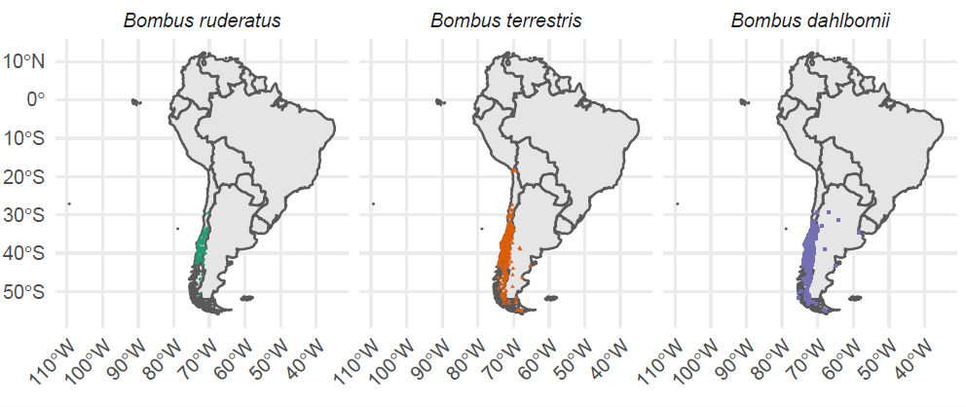Figure 1. Geographic occurrences of Bombus ruderatus, Bombus terrestris and B. dahlbomii in South America.

Figure 2. Climatic conditions occupied by A. B. ruderatus B. B. terrestris C. B. dahlbomii D. overlapping of all the three bumble bee species. Results obtained from the environmental niche analysis. The solid and the dashed lines illustrate, respectively, 100 and 50 % of the available (background) climate for each of the bumble bee species in each one of its ranges.

Figure 3. Species distribution models current and future scenario for the three bumble bees species based on GAU, GLM, MLK, MAX, RDF, SVM algorithms.

Figure 4. Summary of the species distribution models showing current, future and difference scenario for the three bumble bees species

Chapter 4: Conclusions

Despite decades of ecologic and biogeographic research, glaring gaps still exist in the types and quantity of data. Hortal et al. (2015) identified seven data “shortfalls” that challenge progress in ecologic and biogeographic research. This research has addressed two of those shortfalls. The Wallacean shortfall is the lack of data for the geographic distribution of a species or taxon (Whitaker 2005). Depending upon the extent of missing data, the repercussions for either species conservation or the detection of invasive species can affect the outcome of analyses and decision making (Lomolino and Heaney 2004; Whittaker et al. 2005). The Hutchisonian is a “lack of knowledge about the response and tolerances of species to abiotic conditions” (Hortal et al. 2015). This thesis addressed these two shortfalls as related to three species of bumblebees: Bombus terrestris and B. ruderatus, both introduced species in Chile, and B. dahlbomii, a native species in jeopardy.

The traditional data sources for describing species distributions have been museum records, scientific observations, and published literature. But as noted by Hortal et al. (2015), as valuable as these sources are, they alone have not or cannot provide sufficient data for comprehensive distribution mapping. This research evaluated the veracity of citizen science data and examined its utility for mapping the distribution of these species and the impact of environmental change. The first research chapter utilized citizen science data collected by Salvemos Nuestro Abejorro, and represented over 5000 records of bumble bee species at different localities throughout Chile. The number of citizen science records surpassed the quantity of the museum records (n= 1972). Although museum records cover a longer temporal extent, the Salvemos Nuestro Abejorro provided a greater number of interannual records. The number of reports for the B. terrestris and B. ruderatus, were 2196 and n=231 respectively. It was concluded that citizen science is particularly effective at documenting the occurrence in new or remote locales of both invasive organisms (in this case B. terrestris and B. ruderatus) or declining populations of the native species (B. dahlbomii), as reported in other studies (Chandler et al., 2017; Dickinson et al., 2010; MacPhail et al., 2020; Soroye et al., 2018; Tweddle et al., 2012).

The Hutchisonian shortfall can be addressed by experimental approaches or the use of multivariate tools to model the response of species to the abiotic environment. In the second research chapter, principal components analysis and species distribution models (SDMs) were employed to evaluate niche overlap and the impact of environmental change on B. dahlbomii, B. ruderatus, and B. terrestris). These models have proven effective for 1) spatial conservation prioritization (de Marco and Nóbrega 2011), 2) biogeographic analyzes (Siqueira and Durigan 2007), 3) measurement of Climatic change effects on biodiversity (Peterson et al. 2002; Martins et al. 2015; Silva et al. 2015), 4) conservation of rare and threatened species (Araujo & New 2007), and 5) the detection of areas suitable for occupation by exotic species (Silva et al. 2014; Acosta et al. 2016).

The results showed a high degree of niche overlap for the three species, with the implication that resource competition between the three species is intense and with the concern that B. dahlbomii could be displaced. Besides direct displacement for resources (e.g., nectar bearing plants, etc.) (Morales et al 2013; Smith-Ramírez et al 2018), exposure to pathogens due to the increased abundance of the invasive bumble bees is also a threat (Arbetman et al 2013; Schmid-Hempel et al 2014).

The SDMs revealed the likelihood that the three bumblebees could experience a decrease in range size and a shift southward in distribution due to warming conditions. In the worst case, populations of B. dahlbomii will be extirpated by environmental change, such as postulated for Bombus bellicosus, also a species of South American bumblebee (Martins & Melo, 2010; Martins et al., 2015). The shift in geographic range toward cooler conditions has been documented in North American and European bumble bees (Kerr et al., 2015).

The use of citizen science was highly effective in overcoming a dearth of distribution data and thereof proved to be of great utility in the analyses conducted in this thesis. In fact, the Salvemos Nuestro Abejorro approach is being expanded to track the distribution of Hylaeus euxanthus (Montalva et al 2019), Xylocopa augusti (Montalva et al 2013) and Anthidium manicatum (Montalva et al 2015), all recently introduced to Chile.

Citizen science in combination with SDMs were effective tools for tracking the distribution patterns of the endangered B. dahlbomii and the introduced species B. ruderatus and B. terrestris. The information gathered here could and should be used in future International Union for Conservation of Nature (IUCN) Red List assessments for the B. dahlbomii. In addition to contributing to the IUCN assessment, a GAP analysis of protected areas for B. dahlbomii based on citizen science data would assist in the identification and protection of crucial habitats.

References
Acosta, A. L., Giannini, T. C., Imperatriz-Fonseca, V. L., & Saraiva, A. M. (2016). Worldwide Alien Invasion: A Methodological Approach to Forecast the Potential Spread of a Highly Invasive Pollinator. PLOS ONE, 11(2), e0148295. Retrieved from https://doi.org/10.1371/journal.pone.0148295
Araújo MB, New M (2007). Ensemble forecasting of species distributions. Trends Ecol. Evol. 22:42–47
Arbetman, M. P., Gleiser, G., Morales, C. L., Williams, P., & Aizen, M. A. (2017). Global decline of bumblebees is phylogenetically structured and inversely related to species range size and pathogen incidence. Proceedings of the Royal Society B: Biological Sciences, 284(1859). https://doi.org/10.1098/rspb.2017.0204
Chandler, M., See, L., Copas, K., Bonde, A. M. Z., López, B. C., Danielsen, F., Legind, J. K., Masinde, S., Miller-Rushing, A.J, Newman, G., Rosemartin, A., & Turak, E. (2017). Contribution of citizen science towards international biodiversity monitoring. Biological Conservation, 213, 280–294. https://doi.org/10.1016/j.biocon.2016.09.004
De Marco P, Nóbrega CC. (2011). Unprotecting the rare species: a niche-based gap analysis for odonates in a core Cerrado area. Divers Distrib 17:491–505. https://doi.org/10.1111/j.1472-4642.2011.00749.x
Dickinson, J. L., Zuckerberg, B., & Bonter, D. N. (2010). Citizen Science as an Ecological Research Tool: Challenges and Benefits. Annual Review of Ecology, Evolution, and Systematics, 41(1), 149–172. https://doi.org/10.1146/annurev-ecolsys-102209-144636
Hortal, J., de Bello, F., Diniz-Filho, J. A. F., Lewinsohn, T. M. L., Lobo, J. M., & Ladle, R. J. (2015). Seven shortfalls that beset largescale knowledge on biodiversity. Annual Review of Ecology, Evolution, and Systematics, 46, 523–549. doi:10.1146/annurev-ecolsys-112414-054400.
Lomolino M V, Heaney LR. (2004). Conservation biogeography. Frontiers of Biogeography: new directions in the geography of nature. Oxford University Press, Incorporated 436 pp.
MacPhail, V. J., Gibson, S. D., Hatfield, R., & Colla, S. R. (2020). Using Bumble Bee Watch to investigate the accuracy and perception of bumble bee (Bombus spp.) identification by community scientists. PeerJ, 2020(6), 1–31. https://doi.org/10.7717/peerj.9412
Martins, A. C., & Melo, G. A. R. (2010). Has the bumblebee Bombus bellicosus gone extinct in the northern portion of its distribution range in Brazil? Journal of Insect Conservation, 14(2), 207–210. https://doi.org/10.1007/s10841-009-9237-y
Martins, A. C., Silva, D. P., De Marco, P., & Melo, G. A. R. (2015). Species conservation under future climate change: the case of Bombus bellicosus, a potentially threatened South American bumblebee species. Journal of Insect Conservation, 19(1), 33–43. https://doi.org/10.1007/s10841-014-9740-7
Montalva, J., Rios, M., & Vivallo F. (2015). First record of the invasive bee Anthidium manicatum (Hymenoptera: Megachilidae) in Chile. Journal of Melittology. 56: 1-5.
Montalva J., Allendes J.L. & Lucia M. 2013. The large carpenter bee Xylocopa augusti (Hymenoptera: Apidae): new record to Chile. Journal of Melittology. 12: 1-6.
Montalva J, L.S. Dudley & Houston T. (2019). First recordof Hylaeus (Gnathoprosopis) euxanthus (Hymenoptera: Colletidae) in Chile. Journal of Melittology 91: 1-4. https://doi.org/10.17161/jom.v0i91.7559
Morales, C. L., Arbetman, M. P., Cameron, S. A., & Aizen, M. A. (2013). Rapid ecological replacement of a native bumble bee by invasive species. Frontiers in Ecology and the Environment, 11(10), 529–534. https://doi.org/10.1890/120321
Peterson AT, Ortega-Huerta MA, Bartley J, et al (2002). Future projections for Mexican faunas under global climate change scenarios. Nature 416:164–166
Schmid-Hempel, R., Eckhardt, M., Goulson, D., Heinzmann, D., Lange, C., Plischuk, S., & Schmid-Hempel, P. (2014). The invasion of southern South America by imported bumblebees and associated parasites. Journal of Animal Ecology, 83(4), 823–837. https://doi.org/https://doi.org/10.1111/1365-2656.12185
Silva DP, Vilela B, De Marco P, Nemésio A. (2014). Using ecological niche models and niche analyses to understand speciation patterns: The case of sister neotropical orchid bees. PLoS One 9:. https://doi.org/10.1371/journal.pone.0113246
Silva DP, Macêdo ACBA, Ascher JS, de Marco P. (2015) Range increase of a Neotropical orchid bee under future scenarios of climate change. Insect Conserv Divers 19:901–910. https://doi.org/10.1007/s10841-015-9807-0
Siqueira MFDE, Durigan G (2007) Modelagem da distribuição geográfica de espécies lenhosas de cerrado no Estado de São Paulo. Rev Bras Bot 2:233–243
Smith-Ramírez, C., Vieli, L., Barahona-Segovia, R. M., Montalva, J., Cianferoni, F., Ruz, L., Fonturbel, F. E., Valdivia, C. E., Medel, R., Pauchard, A., Celis-Diez, J.L., Riesco, V., Monzon, V., Vivallo, F., & Neira, M. (2018). Las razones de por qué Chile debe detener la importación del abejorro comercial Bombus terrestris (Linnaeus) y comenzar a controlarlo. Gayana (Concepción). 82(2): 118–127.
Soroye, P., Ahmed, N., & Kerr, J. T. (2018). Opportunistic citizen science data transform understanding of species distributions, phenology, and diversity gradients for global change research. Global Change Biology, 24(11), 5281–5291. https://doi.org/10.1111/gcb.14358
Tweddle, J., Robinson, L., Roy, H., & Pocock, M. (2012). Guide to citizen science: developing, implementing and evaluating citizen science to study biodiversity and the environment in the UK. Natural History Museum and NERC Centre for Ecology & Hydrology for UK-EOF.
Whittaker RJ, Araújo MB, Jepson P, et al. (2005). Conservation biogeography: Assessment and prospect. Divers Distrib 11:3–23. https://doi.org/10.1111/j.1366-9516.2005.00143.x

