UNIVERSITY OF OKLAHOMA
GRADUATE COLLEGE

JACK TEAGARDEN, J.J. JOHNSON, AND BILL WATROUS:
A TRANSCRIPTION OF AN IMPROVISED SOLO FROM EACH THAT CHANGED THE STYLE OF JAZZ TROMBONE

A DOCUMENT
SUBMITTED TO THE GRADUATE FACULTY
in partial fulfillment of the requirements for the
Degree of
DOCTOR OF MUSICAL ARTS

By
BRET MICAH STEED
Norman, Oklahoma
2018

JACK TEAGARDEN, J.J. JOHNSON, AND BILL WATROUS:
A TRANSCRIPTION OF AN IMPROVISED SOLO FROM EACH THAT CHANGED THE STYLE OF JAZZ TROMBONE

A DOCUMENT APPROVED FOR THE
SCHOOL OF MUSIC

BY

________________________________
Dr. Irvin Wagner, Chair

________________________________
Dr. Karl Sievers

________________________________
Dr. Eugene Enrico

________________________________
Dr. Jeff Swinkin

________________________________
Dr. Judith Pender

© Copyright by BRET MICAH STEED 2018
All Rights Reserved
Table of Contents
List of Figures…………………………………………….…………………….………iv
Abstract…………………………………………………….………………………….viii
Chapter 1: Introduction……………………………..……………………………………1
Purpose of Study…..…………………………………………………………….3
Need for Study…..…….…………………………………………………….......3
Scope and Limitations….………………………………………………………..4
Methodology…….……….………………………………………………………6
Related Literature……………….……………………………………………….7
Chapter 2: Jazz Improvisation………………..………………………………………...10
Defined...………...……………..........................................................................10
Chapter 3: Transcription…………….………………………………………………….18
Defined……………….…...………...…………………………….…………...18
Process…..…...….…...…………………...……………………………………18
Importance…………………………….…………………..………...…………19
Chapter 4: Biographies…………………………………………………………………21
Miff Mole……………………………………………………………………...21
Jack Teagarden……………...…………………………………………………24
Bill Harris…………………………………………………...…………………31
J.J. Johnson……………………………………………...……………………..33
Urbie Green…………………………………………………...………………..38
Bill Watrous…………………………………...……………………………….43
Chapter 5: A Transcription of the Improvised Solo of Miff Mole ……..…………….49
Analysis - “You’re the Cream in my Coffee”
Harmonic………………..…………………………………….50
Local Harmony………………………………..………………51
Global Harmony………………………………………………53
Stylistic………………………………………………………..55
Technical……….……….....…………………………………..57
Chapter 6: A Transcription of the Improvised Solo of Jack Teagarden .………………59
Analysis – “She’s a Great Great Girl”
Introduction…………...……………………………………….60
Public Reaction………………………………………………..60
Local Harmony………………………………………………..61
Global Harmony………………………………………………64
Stylistic………………………………..………………………67
Technical…………………………...………………………….71
Conclusion and Comparison……..…….…………………………………….72
Chapter 7: A Transcription of the Improvised Solo of Bill Harris……………………75
Analysis – “Cross Country”
Local Harmony………………………………………………..76
Global Harmony.………………………………………………77
Stylistic…………………………………..……………………79
Technical………………………………………………………83
Chapter 8: A Transcription of the Improvised Solo of J.J. Johnson……..……………..85
Analysis – “Jay Bird”
Introduction……………………………………………………86
Public Reaction………………………………………………..86
Local Harmony………………………………………………..87
Global Harmony………………………..……………………..90
Stylistic……………………………………………………..…93
Technical………………………………………………………97
Conclusion and Comparison….……………………………………………….97
Chapter 9: A Transcription of the Improvised Solo of Urbie Green……………..…...100
Analysis – “Green Bee”
Local Harmony…………………………………………..…..102
Global Harmony………….…………………………………..104
Stylistic…………………….…………………………………106
Technical…………………..…………………………………108
Chapter 10: A Transcription of the Improvised Solo of Bill Watrous…….………….111
Analysis – “Fourth Floor Walkup”
Introduction…..………………………………………………113
Public Reaction……...……………………………………….113
Harmonic……………………………………………………..115
Stylistic………………………………………………………119
Technical……………………………………………………..122
Conclusion and Comparison………………….……………………………..131
Chapter 11: Conclusion……………………………………………………..………..133
Summary of Findings………………………………………………………..133
Appendix ………...……………………………………………………………….….134
Miff Mole Solo Transcription – “You’re the Cream in my Coffee”………..134
Jack Teagarden Solo Transcription – “She’s a Great Great Girl”…………...135
Bill Harris Solo Transcription – “Cross Country”…………………………...136
J.J. Johnson Solo Transcription – “Jay Bird”…………………………….….137 Urbie Green Solo Transcription – “Green Bee”………….………………….138
Bill Watrous Solo Transcription – “Fourth Floor Walkup”………………….140
References…………...………………………………………………………………..142

List of Figures
Figure
- C Blues Scale…………………………………………………….………...12
- Tools for Jazz Improvisation……………………………………….……...13
- Miff Mole, “You’re the Cream in my Coffee” solo transcription….……...49
- Common ii V I chord progression………………………………….……...50
- Miff Mole, “You’re the Cream in my Coffee, measures 1-6………….…..51
- Miff Mole, “You’re the Cream in my Coffee,” Target Note Example…....52
- Miff Mole, “You’re the Cream in my Coffee,” Arpeggiated, mm 7-9…....53
- Miff Mole, “You’re the Cream in my Coffee,” Measures 1-4………….....53
- Miff Mole, “You’re the Cream in my Coffee,” measure 8………………..54
- Miff Mole, “You’re the Cream in my Coffee,” measures 10-12….………54
- Miff Mole, “You’re the Cream in my Coffee,” Phrasing Example……….56
- Miff Mole, “You’re the Cream in my Coffee,” measures 3-4…………….57
- Jack Teagarden, “She’s a Great Great Girl,” solo transcription…………..59
- Jack Teagarden, “She’s a Great Great Girl,” local harmony example……62
- Jack Teagarden, “She’s a Great Great Girl,” measures 5-6………………63
- Jack Teagarden, “She’s a Great Great Girl,” measure 17………………...63
- Jack Teagarden, “She’s a Great Great Girl,” measure 23………………...64
- Jack Teagarden, “She’s a Great Great Girl,” global harmony example.….65
- Jack Teagarden, “She’s a Great Great Girl,” measures 3-4………………66
- Jack Teagarden, “She’s a Great Great Girl,” measure 7………………….66
- Jack Teagarden, “She’s a Great Great Girl,” measures 18-20…………....67
- Jack Teagarden, “She’s a Great Great Girl,” blues example 1……………68
- Jack Teagarden, “She’s a Great Great Girl,” blues example 2……………68
- Jack Teagarden, “She’s a Great Great Girl,” blues example 3……………69
- Jack Teagarden, “She’s a Great Great Girl,” phrase example…………….70
- Jack Teagarden, “She’s a Great Great Girl,” lip example………………...72
- Bill Harris, “Cross Country,” solo transcription…………………………..75
- Bill Harris, “Cross County,” local harmony example……………………..76
- Bill Harris, “Cross Country,” measures 4-5……………………………….77
- Bill Harris, “Cross Country,” measures 31-32…………………………….77
- Bill Harris, “Cross Country,” measures 1-12……………………………...78
- Bill Harris, “Cross Country,” measures 17-24…………………………….79
- Bill Harris, “Cross Country,” measures 25-28…………………………….80
- Bill Harris, “Cross Country,” measures 9-12……………………………...81
- Bill Harris, “Cross Country,” phrase example…………………………….82
- J.J. Johnson, “Jay Bird,” solo transcription………………….…………….85
- J.J. Johnson, “Jay Bird,” local harmony example…………………………88
- J.J. Johnson, “Jay Bird,” measure 1……………………………………….89
- J.J. Johnson, “Jay Bird,” measure 19……………………………………...89
- J.J. Johnson, “Jay Bird,” measures 9-10…………………………………..89
- J.J. Johnson, “Jay Bird,” measures 17-19…………………………………90
- J.J. Johnson, “Jay Bird,” measure 1……………………………………….90
- J.J. Johnson, “Jay Bird,” measure 4……………………………………….91
- J.J. Johnson, “Jay Bird,” measure 10……………………………………...91
- J.J. Johnson, “Jay Bird,” measure 31……………………………………...91
- J.J. Johnson, “Jay Bird,” measures 5-8……………………………………91
- J.J. Johnson, “Jay Bird,” measure 15-16…………………………………..92
- J.J. Johnson, “Jay Bird,” measures 17-24…………………………………92
- J.J. Johnson, “Jay Bird,” measures 25-32…………………………………93
- J.J. Johnson, “Jay Bird,” phrase example…………………………………96
- Urbie Green, “Green Bee,” solo transcription…………………………...100
- Urbie Green, “Green Bee,” local harmony………………………………102
- Urbie Green, “Green Bee,” measures 1-2………………………………..104
- Urbie Green, “Green Bee,” measure 11………………………………….104
- Urbie Green, “Green Bee,” measure 1-3…………………………………104
- Urbie Green, “Green Bee,” measure 11-12………………………………105
- Urbie Green, “Green Bee,” measure 18-21………………………………106
- Urbie Green, “Green Bee,” phrase example……………………………...107
- Urbie Green, “Green Bee,” measure 3…………………………………...108
- Urbie Green, “Green Bee,” measures 1-3………………………………..109
- Urbie Green, “Green Bee,” measures 11-13……………………………..109
- Urbie Green, “Green Bee,” measure 21………………………………….109
- Urbie Green, “Green Bee,” measures 56-61……………………………..109
- Bill Watrous, “Fourth Floor Walk-up,” solo transcription………………111
- Bill Watrous, “Fourth Floor Walk-up,” measures 2-7…………………...115
- Bill Watrous, “Fourth Floor Walk-up,” measures 7-10………………….116
- Bill Watrous, “Fourth Floor Walk-up,” measures 21-24………………...117
- Bill Watrous, “Fourth Floor Walk-up,” measures 37-38………………...117
- Bill Watrous, “Fourth Floor Walk-up,” measures 41-42………………...117
- Bill Watrous, “Fourth Floor Walk-up,” measures 43-49………………...118
- Bill Watrous, “Fourth Floor Walk-up,” measures 62-69………………...118
- Bill Watrous, “Fourth Floor Walk-up,” measure 73……………………..119
- Bill Watrous, “Fourth Floor Walk-up,” measure 82……………………..119
- Bill Watrous, “Fourth Floor Walk-up,” measures 22-24………………...121
- Bill Watrous, “Fourth Floor Walk-up,” measures 53-55………………...121
- Bill Watrous, “Fourth Floor Walk-up,” measure 1………………………123
- Lip Break………………………………………………………………...124
- Bill Watrous, “Fourth Floor Walk-up,” Lip Break Example……….……125
- Bill Watrous, “Fourth Floor Walk-up,” Doodle-Tongue Example………128
- Bill Watrous, “Fourth Floor Walk-up,” Eb4 Example…………………..130
- Bill Watrous, “Fourth Floor Walk-up,” Low Register…………………..130

Abstract
When discussing the art and history of jazz trombone improvisation, three names are invariably mentioned as being among the top of the heap: Jack Teagarden, J.J. Johnson, and Bill Watrous. According to Kurt Dietrich, Johnson and Teagarden are easily the most celebrated trombonists within the history of jazz. Later in his book, Dietrich also mentions that Watrous became the most prominent “new jazz trombonist” beginning in the 1970-’s and throughout much of the 1980-’s and 1990-’s as well. The primary argument, as presented within this document, is that these three men ultimately changed the course of jazz trombone style within their respective time periods more so than any of their contemporaries for a number of harmonic, stylistic, and technical reasons. As I discuss later in detail, each man’s debut recording was drastically different from recordings made by other trombonists during his particular time period. In effect, a “passing of the torch” took place because of their debut recordings. These recordings marked new and innovative styles that the next generation of jazz trombonists would emulate.
Delineated into three sections, the bulk of this document focuses on the analysis of solo transcriptions taken first from the debut recordings of Teagarden; (1928) Johnson; (1946) and Watrous (1974). Detailed analysis is also provided for solo transcriptions of three prominent trombonist within the realm of jazz during the same time periods prior to Teagarden’s, Johnson’s, and Watrous’ debut recordings: Miff Mole; (1928) Bill Harris; (1945) and Urbie Green (1968). Each analysis includes an in- depth look at each solo from harmonic, technical, and stylistic points of view.
This study also offers important and historical insights into how the public reacted upon hearing Teagarden, Johnson, and Watrous for the first time. At the end of each section, a conclusion is drawn detailing why Teagarden’s, Johnson’s, and Watrous’ debut solos were able to captivate audiences and in effect, how they transformed the course of jazz trombone style.

Chapter 1: Introduction
Jack Teagarden, J.J. Johnson, and Bill Watrous are among a select group of jazz trombonist who have survived history as crucial cornerstones within the jazz trombone style. In fact, countless interviews conducted by Julie Gendrich, detailed in her book Bonanza: Insights and Wisdom from Professional Jazz Trombonists, support the fact that these three men had an influence on nearly every jazz trombonist that proceeded them throughout history.
In general, Teagarden established the trombone firmly as a solo instrument on par with trumpets, clarinets, pianos…etc. Before him, the trombone was deemed more of a supporting instrument rather than a feature instrument. Jazz trombonist Bill Russo defined Teagarden’s influence as being “essentially responsible for a mature approach to trombone.” In other words, Teagarden’s “new” style of jazz trombone playing became the model that trombonists during his time would strive to emulate.
Johnson, on the other hand, was ultimately the first to bring the trombone into the world of bebop. According to Dizzy Gillespie, one of the two most important figures in regards to bebop, Johnson was the trombonist for the new style of bebop. In fact, Gillespie stated that, “I’ve always known that a trombone could be played different, that somebody’d catch on one of these day. Man, you’re elected.” The new genre of bebop demanded a vast expansion in technique and harmonic sophistication, which is both evident in Johnson’s playing style.
Finally, Watrous defied all of the technical handicaps the trombone presents. Speaking from a trombonist’s point of view (referring to myself), the trombone is the only instrument that must articulate every note. This greatly hinders the ability to play fast while maintaining a legato approach generally characteristic in the jazz style. So, how was Watrous able to overcome this issue? As discussed in much more detail later, Watrous utilized different techniques such as doodle-tonguing, lip flexibilities, and natural breaks to facilitate his rapid technique. It is generally known that Watrous’ technique, sound, control, and style defined him as one of the first jazz trombonist to be recognized as a true virtuoso. Having had the great fortune of being able to play along-side Mr. Watrous recently, I can attest that his musicianship remains just as virtuosic, impressive, and inspiring as it was 40 years ago.
Interestingly, numerous solos from all three of these men have been transcribed and are available in many different formats, but little-to-no focus has ever been placed on their debut album solos. In fact, Teagarden’s and Johnson’s debut solos have yet to be transcribed. Watrous’ solo on the other hand, has been transcribed. That being said, the transcription of Watrous’ solo proved exceedingly hard to find. After a bit of internet research, a conclusion was drawn that someone anonymously had transcribed and published the Watrous solo at some point during the 1980’s in an International Trombone Association Newsletter. As is the case with publications of this nature, most people simply threw them away, therefore and consequently losing the transcription. Quite remarkably though and thanks to Dr. Irvin Wagner, the original newsletter containing the Watrous solo transcription was found in his office.
Purpose of Study
The purpose of this study is to transcribe, analyze, and identify certain harmonic, stylistic, and technical aspects of the debut recorded solos by Teagarden, Johnson, and Watrous. These analysis’s will then be compared to certain harmonic, stylistic, and technical aspects evident in solo recordings by Mole, Harris, and Green. The comparisons will show how and why Teagarden’s, Johnson’s, and Watrous’ debut recordings paved the way for the “new” trombone style within their respective time periods.
Need for Study
As I mentioned earlier, numerous solos by Teagarden, Johnson, and Watrous have been transcribed in many different formats, but little to no attention has ever been given to their debut recordings. It is important to the jazz community and trombone world to provide this historical information and the reasons as to why all three men ultimately took over the jazz trombone world within their respective time periods. These debut recordings mark the end of stylistic trombone eras apparent in solos by Mole, Harris, and Green, and the beginning of new eras evident in solos by Teagarden, Johnson, and Watrous. In short, it is crucial to explore these debut recordings to locate the exact moment the torch was passed from one generation to the next within jazz trombone style.
Scope and Limitations
This study focuses on the analysis and comparison of six trombonists and their six individual solo transcriptions from harmonic, stylistic, and technical points of view. The solo transcription comparisons are broken up into individual units as follows:

-Miff Mole compared to Jack Teagarden
-Bill Harris compared to J.J. Johnson
-Urbie Green compared to Bill Watrous

I have carefully handpicked each transcribed solo in order to provide a consistency in time frame; (i.e. year of recording release date), musical format, harmonic progression, overall style, tempo, and mood. This, in effect, allows for each comparison to be on a level playing field.
Each comparison features one solo from each individual. For the comparison between Mole and Teagarden, the selected solo to demonstrate Mole’s playing comes from the tune “You’re the Cream in my Coffee.” In comparison, the debut recording for Teagarden is taken from the tune “She’s a Great, Great Girl.” Both of these recordings were recorded and released in the same year, 1928, and are similar in format, harmonic progression, overall style, tempo, and mood.
As for Harris and Johnson, the solo selected to showcase Harris’ playing is taken from a recording of the tune entitled, “Cross Country.” Johnson’s solo transcription, in comparison, comes from his debut “bebop” recording of his tune entitled, “Jay Bird.” The reasoning for denoting “Jay Bird” as Johnson’s debut “bebop” recording is that Johnson made a few recordings prior to this in the early 1940’s. However, it is my opinion, and supported by Kurt Dietrich as well, that these few recordings prior to the June 26th recording date in 1946 showed Johnson primarily as a swing-oriented soloist. Therefore, and for the purpose of this document, Johnson’s “Jay Bird” recording will be considered as a debut recording due to the fact that it ultimately showcased the trombone as a bebop instrument for the first time.
Harris’ and Johnson’s solo transcriptions come from the same time period, 1945 and 1946, and are both “Rhythm Changes” tunes. In other words, both of these tunes feature the same AABA format and the same harmonic chord progressions. Finally, both of these tunes are similar in overall style, tempo, and mood.
Finally, the comparison between Green and Watrous will be slightly different than the previous comparisons. The selected solo transcriptions for this section fail to share similar format and tempo. However, both solo transcriptions are similar in style, mood, and most notably, technical exploitation by both artists. The selected solo transcription that features Green’s playing is from a tune entitled, “Green Bee.” Watrous’ transcribed cadenza, taken from a tune entitled “Fourth Floor Walkup,” serves as an example of his playing from his debut album, Manhattan Wildlife Refuge.

Methodology
The first step within the process of comparing Mole, Teagarden, Harris, Johnson, Green, and Watrous will be to transcribe each of their individual solos. In order to facilitate this process, the computer program Transcribe! will be utilized. This program provides the ability for each tune to be slowed down drastically, which ultimately expedites the transcription process. Each transcription, with the exception of Watrous’, will be inputted into Finale 2014.
For each transcribed solo a detailed three-point analysis will be performed: Harmonic, Stylistic, and Technical.
1: Harmonic – This analysis includes an in-depth look at how each note of the selected solo transcription fits into the harmony on a local and global level. The local level of harmony addresses how each note fits in within the specific chord being played at the exact moment of sound. The global level of harmony addresses how each note fits within the entire harmonic context/key of the tune. In effect, this analysis points out, harmonically, why Teagarden, Johnson, and Watrous were viewed as superior to Mole, Harris, and Green within their respective time periods.
2: Stylistic – This portion of the analysis addresses certain stylistic aspects inherent in each individual player as pertains to their selected solo transcriptions. Characteristics such as tone, timbre, dynamic range, blues inflection, bebop language, phrasing, and note shape are all considered as defining features within their individual styles.
3: Technical – The final portion of the analysis focuses on the technical capabilities of each trombonist. As detailed later, Teagarden, Johnson, and Watrous greatly exploited the technical expectations of the trombone within their respective time periods. The ability to play faster, smoother, and with expanded range are all considered within this section.
After each analysis, a brief comparison between Mole and Teagarden, Harris and Johnson, and Green and Watrous, will showcase harmonically, stylistically, and technically why they were viewed as superior to their contemporaries and how their styles became the model for future generations.
Related Literature
Research materials utilized in this study include: sound recordings, liner notes, online interviews, biographies, periodicals, jazz history books, jazz encyclopedias, jazz theory texts, and dissertations. Most of these materials refer to Mole, Teagarden, Harris, Johnson, Green, and Watrous in passing; however, several are devoted to the careers and stylistic characteristics of the six trombonists.
Six sound recordings will be used throughout this study. Miff Mole and His Little Molers, Roger Wolfe Kahn and His Orchestra, Bill Harris and His Septet, New Trends in Jazz Volume 11, 21 Trombones Volume 2, and Manhattan Wildlife Refuge. Each one of these recordings provide the original solos played by Mole, Teagarden, Harris, Johnson, Green, and Watrous that will allow me to transcribe for the purpose of this study.
The book written by Kurt Dietrich entitled, Jazz Bones, provides important biographical information in regards to the selected trombone players. This book also provides some insight into the playing styles of Teagarden, Johnson, and Watrous.
Scott Yanow’s book entitled, Classic Jazz: The Musicians and Recordings that Shaped Jazz, 1895-1933 provides valuable biographical information in regards to Miff Mole and Jack Teagarden.
Stylistically speaking, Julie Gendrich’s book entitled, Bonanza: Insights and Wisdom from Professional Jazz Trombonists, details Bill Watrous’ playing style through an interview. He also comments his personal thoughts in regards to his debut recording. Finally, this book makes several passing comments from various trombonists in regards to Mole, Teagarden, Harris, Johnson, and Green.
The official biography of Jack Teagarden written by Jay Smith and Ken Guttridge, Jack Teagarden: The Story of a Jazz Maverick, contains concise information about Teagarden’s life and trombone playing, including illustrations and a selected discography.
An article published in the Trombone Journal by Rex Allen entitle Jack Teagarden: An Evaluation of his Style and Contribution to Jazz, provides a wealth of information in regards to Teagarden’s individual and innovative playing style. This article also touches upon the public reaction to Teagarden’s debut recording.
Joshua Berrett’s and Louis Bourgois’ book, The Musical World of J.J. Johnson, gives valuable biographical information in regards to J.J. Johnson.
An article published in the Trombone Journal by Tom Everett entitled, J.J. Johnson: The Architect of the Modern Jazz Trombone, offers important insight into the public reaction of Johnson’s early solo career.
Bill Watrous’ and Alan Raph’s book, Trombonisms, details some of the techniques utilized by Watrous in his debut recording.
An online interview entitled, Bone2Pick: Bill Watrous Interview, provides insight into his playing style, his influences, his thoughts on his debut recording, and the historical public reaction his “Fourth Floor Walkup” cadenza had on the world.
A dissertation by David Lambert entitled, “A Comparison of Three Divergent Jazz Trombone Styles from 1953: Jack Teagarden, J.J. Johnson, and Frank Rosolino,” provides biographical information in regards to Teagarden and Johnson, and also provides a model as to how one would go about comparing one trombonist to another.
Another dissertation, by Maryln Rickard entitled “Urbie Green: A Study of his Musical Career,” provides important biographical information and insights into his particular playing style.
The International Trombone Association Newsletter Volume VIII, Number 1 from September 1980, provides an anonymous transcription of Watrous’ “Fourth Floor Walkup” cadenza.

Chapter 2: Jazz Improvisation
Defined
Merriam-Webster’s Dictionary defines the term improvisation as “something that is performed, made, or done without preparation.”
In addition to this, the editors of the Encyclopedia Britannica define improvisation as “the extemporaneous composition or free performance of a musical passage, usually in a manner conforming to certain stylistic norms but unfettered by the prescriptive features of a specific musical text.”
Addressing Merriam-Webster’s definition of improvisation, to say that the process of improvisation is accomplished without preparation is completely false. At any rate, improvisation in jazz is a process of the performer creating new melodic lines over the existing chords of the tune being performed. To refine this process renowned jazz educator Jamey Abersold has suggested that the art of jazz improvisation is accomplished by the following these 5 steps:
1. Desire to improvise
2. Listening to jazz via recordings and live performances
3. A method of practice – what and how to practice!
4. A rhythm section with which to practice and improvise.
5. Self-esteem and discipline.
Breaking down these 5 steps one-by-one will create a better understanding of what jazz improvisation truly is as pertains to this document. To begin with, the desire to improvise must be present. This step is rather obvious in that no one can achieve anything without having the desire to do it first.
The second step, listening to jazz via recording and live performances, is absolutely crucial within the art of jazz improvisation. As a jazz musician myself, this is how we learn. Take a new-born baby, for example. The baby learns to communicate by listening, and then by implementing what they have heard into speech, they begin to practice the eloquence of the language. I can use myself as another example. My dialect changes depending on where I am at in Oklahoma. When attending graduate school in Edmond and Norman, my dialect is more proper, if you will. While living in South East Oklahoma, my dialect is infused with a real southern-draw. What I am trying to communicate here is that a jazz musician must listen to others for inspiration. The old adage “you are what you eat” is perfectly apt the art of jazz improvisation. What a musician puts into his mind through recordings and by those who surround him; will eventually be evident in his individual style. The following quote from Jamey Aebersold supports my argument:
Every good jazz soloist has listened to the jazz greats that came before.
It is very obvious in some peoples’ playing that they copy their idols sound, phrasing, articulation, note choice, solo development, dynamics, etc.

To conclude the break-down of step-two, I would like to present one final example. When an individual gives a speech, he or she normally utilizes quotes and references from the past, and also takes on a certain personality in his or her delivery of that speech. During the speech however, although one may use previous material and certain traits that hearken back to someone else, the speech is undeniably their own. This holds true in jazz improvisation. A musician hears, copies, manipulates, and therefore makes the art of jazz improvisation unique to them. Jazz educator Mark Levine sums this up nicely, “A great jazz solo consists of 1% magic and 99% of stuff that is Explainable, Analyzable, Categorizeable, and Doable.” The 1% magic is what a jazz musician does to make the things heard and practiced so special and expressive.
Step three, A method of practice – what and how to practice, again, directly contradicts Merriam Webster’s definition of improvisation as something that is accomplished without preparation. The level at which someone improvises not only reflects who they have been listening to, but also the evidence of hard work and practice. Many jazz musicians refer to this as “payin dues.”
A common tale-tale sign of a young improviser is the evident use of the blues scale as seen in Figure 1 below.
Figure 1. C Blues Scale
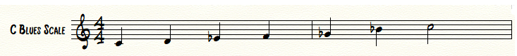
Most beginning improvisers are given this scale to play over a blues progression. On top of this, most have yet to sincerely listen to jazz. This would be the equivalent of sending a banker, equipped with a pair of plyers, to build a house. To begin with, the banker is going to need some experience in building a house. Also, he is probably going to need more tools than a simple pair of plyers to build a house, right? This is the same boat in which many young improvisers find themselves in. They have little-to-no experience, which comes through listening, doing, and practicing, and little to no tools, which are garnered from transcriptions, scales, arpeggios, harmonic knowledge, aural skills…etc. Jamey Aebersold sums this up quite nicely in Figure 2 below:
Figure 2. Tools for Jazz Improvisation

TOOLS
Scales, Chords, Arpeggios, Sound, Articulation, Imagination,
Intuition, Desire to Create, Rhythm, Feeling.

TOOLS PUT TO WORK GIVE YOU

Music, Enjoyment, Communication, Self-Esteem,
Harmony (in more ways than one!),
And channels for Creativity.

MIND

The mind was designed to be your friend.
Too often we act as though someone else controls our mind, not us.
Jazz improvisation, insists that YOU use you mind and consequently reap the rewards of creativity. It’s natural. Music complements the mind.
Music is a universal building block.

In conclusion, one without the other is futile. Anyone can listen to jazz improvisation and understand it, but without knowing how to use the “tools,” one will never be able to improvise. Conversely, anyone can learn how to use the tools, but without listening, the tools will be used incorrectly. Jamey Aebersold refers to this concept as the “Right Brain – Left Brain Approach.” The left portion of the brain contains the tools that a jazz musician must practice in order to play ideas that he or she has heard either by others or in their own mind. By contrast, the right portion of the brain contains the creativeness that desires to come out through one’s improvisation. For a successful jazz improvisation, an equal balance between the left and right brain is necessary.
Step four, A rhythm section with which to practice and improvise, addresses the communicative aspect of jazz improvisation. When improvising, the soloist and the accompaniment engage in a kind of dialogue. A good rhythm section listens to what the soloist is doing and does everything they can to enhance the performance. For example, if the soloist begins to play a repetitive pattern, the rhythm section should respond by playing the same pattern, or at least, a pattern that compliments the soloist. The rhythm section should also build or relax in tension, dynamics, mood,…etc. at the will of the soloist. Finally, if the soloist decides to go in a different/unexpected harmonic direction, an attentive rhythm section should faithfully follow in order to achieve a successful performance.
As with any conversation however, communication is a two-way street. The soloist should not feel that he or she is solely in charge of the performance. In reality, the soloist should respond to what the rhythm section is providing as well. With a healthy balance between the soloist and the rhythm section, great improvisation is likely. However, many musicians fall in to the trap of reading exactly what is on the page or playing something that they have committed to memory. The consequence and danger of this is that they become so absorbed in correctness that they fail to communicate. This results in a performance that is generic rather than spontaneous.
Playing with a rhythm section also pits different personalities together all at once. For example, let’s say that the drummer had a bad day at work and he is therefore fired up. Because of this, his playing style will likely be more aggressive as if to work off the frustrations of the day. This will in turn directly affect all other members of the group. It is important to keep in mind that jazz improvisation is all about personal expression. These expressions come out depending on a number of factors including but not limited to, recent events and total life experiences from the past.
In conclusion, when we add this dimension of differing personalities and expressions, the spontaneous aspect of improvisation occurs. Each member of the rhythm section brings a varied mood, musical ability level, style, life experience, and ultimately, their own unique creativeness. Such diversity can engender much musical creativity. When the ears are open and the mind has the desire to communicate, much is to be learned from those who surround you. All of a sudden, the soloist is not playing material that he or she has heard/worked on in the past, but instead, begins to create material that is in the present due to the communication with others.
The final step in Aebersold’s break-down of jazz improvisation, Self-esteem and discipline, is perhaps the most crucial step in the improvisational process. According to jazz educator Hal Crook,
Every musician who has seriously tried to improvise knows that, for an instrumentalist,
the art of improvising is no less than the ultimate musical challenge,
demanding one’s total musicianship in every moment of the act.
Because of this fact, improvisation can become easily overwhelming to anyone who desires to learn the process. One cannot be afraid of making mistakes. However, in order to minimize mistakes, one must have discipline to practice what needs to be addressed. Crook goes on to say,
Today the subject is so vast, so potentially complex, involving a myriad of topics,
aspects, techniques and materials, that even highly motivated students
with comprehensive musical backgrounds have difficulty deciding
where to begin or how to advance their study.

The simple fact of the matter is, if someone has the desire to improvise, they must practice. All of the jazz greats have been faced with the same fear, but they pushed through, practiced, and continued to practice throughout their entire musical careers. In other words, improvisation does not happen by chance. It is not a special gift that only a select few possess. It is an art form that is attainable to anyone with a burning desire to create.
So, with all of this information presented, what is a proper definition of jazz improvisation as pertains to this document? I would like to present the following definition:
Jazz improvisation is a culmination of an individual’s technical ability, personal expression, musical ideas collected from the past and developed in the present, and ultimately, is the defining factor of who a jazz musician truly is. In other words, when someone hears an individual’s improvisation, they hear the years of hard work that has gone into developing the technique they possess, they hear life experiences that come through expression, they hear musical ideas that are reminiscent of past musicians, which in turn shows who they have been listening to, they hear the communication with others that ultimately create the spontaneous aspects of the present, and finally, they hear and see a musician whose creativity inspires and motivates those who follow.

Chapter 3: Transcription
Jazz is an aural discipline, it depends upon the ear,
and the written page is a guide to unlocking the
musical puzzle, not an end in itself…Conrad Herwig

Defined
Merriam Webster’s dictionary defines the term transcribing as the process of making “a copy of (dictated or recorded matter) in longhand or on a machine.”
In the world of jazz improvisation, transcribing is exactly the same. It is the process of turning a recorded solo into a notated copy that one can visually see and read as opposed to only being able to digest aurally.
Process
The process of transcribing must utilize all of the following items:
1. The desired recording and a device to play that recording on.
2. An instrument. (Voice, piano, or any other various instrument)
3. A way of notation. (Pencil and paper, or notation software such as Finale)

If we break this process down step-by-step, the first step requires the musician to identify a recording that he or she has the desire to learn. Once this has been accomplished, the musician should listen to the given recording multiple times in order to familiarize his or herself with every minute detail presented within the given material. Some of these details might include but are not limited to addressing the following questions: What type of tune is this? Is this a blues or rhythm changes? What is the musical format? Is it in minor or major, or both? Answering these questions creates a roadmap that enables the musician to be better organized before ever putting pencil to paper.
Once some form of a roadmap has been constructed, the musician should then utilize an instrument to play back what he or she heard on the recording. For most, the transcription process is done either measure by measures, or in small phrases of 2-4 measures each. If the real-time playback is too fast, transcription software such as Transcibe! can be used that enables the original sound file to be slowed down to any desired speed without changing the pitch level.
Once a phrase or individual measure has been learned on the instrument, the musician then notates the melody and harmony either on staff paper or notation software. This process continues until the entire desired solo has been fully transcribed.
Importance
A wise musician once said: “The answers to all your
questions are in your living room.” Having a good
teacher is invaluable, and books can help you with
certain things, but your record collection contains
everything you need to know. Learn to transcribe
early and well…Mark Levine

As the above quote suggest, everything we need as jazz musicians is contained within recordings. In addressing the quote by Conrad Herwig that begins this chapter, he is right to say that transcriptions are not an end in themselves. However, transcriptions are absolutely crucial to all jazz musicians simply because they rescue recordings from a solely aural realm and place them into more tangible dimension that musicians can touch and see.
Transcriptions are also vital in that they drastically improve aural skills. This improvement in aural perception allows for jazz musicians to better play ideas that they hear in the present. For example, if a pianist plays a certain melody during a performance, the better aurally equipped the soloist is, the more likely he or she will pick up on the melody and play it back. This creates an intoxicating spontaneity within live performances.
In addition to this, solo transcriptions drastically expedite the process of learning any given musicians style. It combines the aural and visual aspects of learning music. The transcriber is able to see what the musician played, and in addition, he or she is also able to hear all of the miniscule nuances that musician played on the given recording. The transcriber will “learn not just the notes, but also the breathing, phrasing, and emotional content of the solo.”
Finally, perhaps the most important aspect of solo transcriptions is the fact that the visual luxury of seeing what a musician played allows for he or she to be totally dissected in multiple ways. The transcriber is therefore able to see exactly what the selected musician played over any given harmony, possible devices the musicians used in a technical passage, and or a visual representation of the musician’s stylistic inflections. This in turn teaches us what the jazz greats did, and ultimately why they survived history as important and influential cornerstones within the jazz realm.

Chapter 4: Biographies
Miff Mole (1898-1961)
There were a lot of fellows who never got the recognition they deserved. A trombone
man, Milfred “Miff” Mole, was, in my opinion, the most significant and at the same
time the most sadly neglected figure in the entire spectrum of jazz music. Many is the
time I stood in front of the Roseland where Miff was appearing with Sam Lanin and
heard older musicians say, “That Mole kid is impossible! Why, he plays the trombone
all wrong, jumping octaves, slurring when he should be sliding and ragging when he
should be playing background.” How wrong can you be? It was Miff’s eccentric style
that was copied and became the sound to try to duplicate. He was the man who actually
turned his instrument, the trombone, around!... Rex Stewart.

Then there was Miff Mole, the J.J. Johnson of that day. I call J.J. “Mr. Clean,” and Miff was “Mr. Clean” then. I used to hear him on Red Nichols records,
and his was one of the first, fine, technical trombones I heard…Dicky Wells.

Irving Millfred Mole was born in Roosevelt, Long Island on March 11, 1898. His musical career started at the early age of eleven when he began playing violin. Also, during this time, Mole began to study the piano. By the age of 14, Mole received his first professional music job playing piano for a local movie theater. It would not be until the following year, at age 15, that Mole would start to play the trombone.
Shortly after taking up the trombone, Mole began to play professionally all throughout New York, performing and recording with numerous bands including but not limited to; Jimmy Durante, the Original Memphis Five, Sam Lanin, Ray Miller, Ross Gorman, and Roger Wolfe Kahn. Perhaps the most important band that Mole performed with during his early career was the Original Memphis Five. During his tenure with the Original Memphis Five, Mole had the opportunity to perform all throughout New York and traveled all the way across the United States performing on the Orpheum theater circuit. Although the rest of the band returned back to New York, once in Los Angeles, Mole decided to stay in order to perform with numerous different theater companies. After a few months however, Mole returned to New York and to the band, which immediately launched a five-month tour in Montreal, Canada. Once the band returned back to the states however, Mole chose to leave the group once again in order to play with several other prominent New York bands. By the late 1920’s, Mole was arguably the “busiest freelance trombonist in the city.”
In 1927, Mole joined the staff orchestra of radio station WOR, and eventually switched to the NBC orchestra in 1929. While with NBC, Mole had several great opportunities, including working under Italian conductor Arturo Toscanini, and directing/accompanying a group for blues singer Bessie Smith.
In 1938, Mole decided to leave NBC and joined the Paul Whiteman orchestra. Interestingly, Mole’s once innovative jazz style had changed by this time and was strongly rooted in the dominating style of Jack Teagarden. A few short years later in 1942, Mole joined the Benny Goodman Orchestra. He did not stay with Goodman for long, as he favored leading his own Dixieland groups.
Due to the onset of various health issues, Mole’s playing career halted during the early 1950’s. He returned to the performance scene in 1956 and was sporadically active until his death in New York on April 29, 1961.
In conclusion, the late 1920’s was certainly Mole’s heyday as America’s jazz trombonists. As the quotes that begin this chapter suggest, he was so different and therefore innovative in the minds not only of young trombonists, but many jazz musicians in general. To put it mildly, Mole’s career was absolutely crucial to the history of jazz trombone.
Up until he emerged on the jazz scene in the early 1920’s, the jazz trombone, in general, remained strongly rooted in the traditional, New Orleans-based approach. In fact, some of Mole’s first recordings with the Original Memphis Five in 1922 showcased a technical prowess that far exceeded anything that any other trombonist during that time period was capable of. In the minds of most jazz fans during the early 1920’s, the trombone played an exceedingly limited musical role in that it was still marked as a “support” instrument rather than that of a “solo” instrument. In short, Mole was extremely crucial in freeing the trombone from this imprisoning fact. He was unquestionably the first “real technical master of the instrument.”
Considering that Mole was arguably the most recorded trombonist during his time, his innovative style easily captivated thousands of record buyers throughout the country. However, in March of 1928, a last-minute substitute for a recording date that Mole was originally booked to do, played a solo that mesmerized trombonists and jazz fans throughout the United States. This gentlemen’s solo has become recognized as the “symbolic indication of things to come” in the trombone world. Mole’s reign as the “king” of trombone began to quickly fade as a new heir to thrown took a dominating leadership; Jack Teagarden.
Jack Teagarden (1905-1964)
Teagardens approach and individuality were of such unusual quality and great importance that no one has ever captured or completely understood the indefinable
manner he had of handling musical ideas. From the moment he raised his horn to his lips, he established an instant and meaningful communication with everyone listening.
More profound than just another man playing a horn, Jack had a way of playing jazz that communicated things that had never been heard before.…Rex Allen.

Here is a jazzman with the facility, range and flexibility of any trombonist
of any idiom or any time. His influence was essentially responsible for a
mature approach to trombone.…Forest Mahannah.

The beginning of Teagarden’s legendary career did not start like most famous jazz musicians of his era. Most musicians were born in places such as New Orleans, Chicago, and New York, but oddly enough, in 1905 Weldon Leo Teagarden was born in Vernon, Texas. Teagarden grew up in a musical home with his father being an amateur cornetist and his mother being a rather accomplished pianist. Throughout the early 1900’s it was rather common for parents to hire European immigrants to teach their children the basics of music. The case was no different for young Teagarden when his parents hired Paul Goetze as a music lessons teacher. By the age of 5, Teagarden was playing tenor horn and piano proficiently.
At age 8, Teagarden received his first trombone as a Christmas gift. Most trombonist are unable to reach 7th position (the farthest position on trombone) until they are at least 14 years old. Drawing on his musical ear, Teagarden manipulated the trombone by playing in a higher tessitura. This allowed him to play any melody he wanted using only “short” positions, simply because he could reach no further than 4th position. On a side note and to break this concept down further, the higher a trombonist plays, the closer the slide positions and notes get to one another due to the harmonic nature of the instrument. In short, this allows for a smoother and increased rapid technique, one of the primary hallmarks of Teagarden’s playing style.
With the death of his father in 1918, Teagarden and his mother moved to Oklahoma City. The family attempted to run a restaurant but failed miserably. Later that same year, the family moved to Nebraska where Teagarden and his mother received a job playing for silent movies. After spending a few years in Nebraska, the family returned back to Oklahoma City where Teagarden got involved with members of the Ft. Sill Army base band. It did not take long however for Teagarden’s mother to disapprove of the foul language and crudities of his army friends. Therefore, Teagarden’s mother arranged for him to move to California to stay with a relative. However, instead of moving in with the relative that his mother arranged for him to live with, Teagarden moved in with another relative, a part-time “hillbilly” fiddler. Not hearing from her son for some time, his mother sent the police to find him. After being brought before a judge, Teagarden wrote his mother an apology letter. However, she did not hear back from him again for months, by which time he had already moved to San Antonio, Texas.
While in San Antonio, Teagarden began working for the Cotton Bailey Band. At this point, due to the forgetful nature of his band leader, Teagarden finally became known as “Jack.” In 1921, Teagarden joined Peck’s Bad Boys where he worked extended gigs in Houston and Galveston. Before he left the band in 1923, Teagarden worked with another rising stare, Clarinetist Pee Wee Russell. Russell greatly respected Jack’s talent and was humbled when he heard Jack play for the first time. Despite many offers to play elsewhere, the Peck band refused to record or perform anywhere other than Houston, Galveston, and San Antonio. Wanting a chance of more exposure, Jack decided to leave Peck’s Bad Boy’s in 1923, and joined the Doc Ross Jazz Bandits for a tenure of four years.
In 1927, Jack finally hit the New York scene where he worked extensively with the Ben Pollack Band. This band recorded fairly frequently, but according to Teagarden, only recorded “sweet tunes.” To stretch his wings, Jack, like all other musicians, played in speakeasies, rent parties, jam sessions, and other various venues that slowly earned him recognition throughout the music world. Coleman Hawkins reportedly said that “Jack must have never slept, playing his horn night and day.”
In March of 1928 Jack received his first big break with the recording of “She’s a Great, Great Girl.” Jack was a last-minute substitute for the famous trombonist Miff Mole, and because of this one session, a foreshadowing of things to come was birthed. Up until this point, Miff Mole was known as the “King” of trombone, but it would only be a short while before Jack’s more swinging style would overthrow Mole’s title and influence over aspiring trombonist. No one had ever heard a trombone solo such as this, thus Jack became a national sensation literally overnight when the recording was released.
On the morning of March 5, 1929, Teagarden, Eddie Lang, Joe Sullivan, Kaiser Marshall, Happy Caldwell, and Louis Armstrong all met at the Okeh recording studio around 9 a.m. for a historical recording. To begin with, this was the first time that Armstrong and Teagarden met. Secondly, half of the men on this album were black and the other half were white. Legend has it that Jack and Louis were both up from the night before, and that they “were not shy about warming up with whatever was in the jug!” Knockin’ a Jug was the only tune from this session that was released. Although this recording is not considered one of the great recordings of Louis or Teagarden, it is at least the beginning of two giants who were to become exceedingly important to each other’s career. Armstrong thought a great deal about Teagarden saying, “He was from Texas, but it was always, ‘You a spade and I’m an ofay. We got the same soul. Let’s blow’ – and that’s the way it was.”
Similar to many musicians during this time, Jack made a controversial move in 1934 when he signed a five-year contract with the Paul Whiteman Orchestra. Being in the midst of the Great Depression, Teagarden had to make a crucial decision. His decision to join Whiteman’s Orchestra offered steady pay and the guarantee of a constant gig. Teagardens playing suffered during this time period due to, in his opinion, the “cheesy” music he was required to play on a nightly basis.
Finally, free of his five-year contract with the Whitman Orchestra in 1939, Teagarden started his own big band. His band enjoyed two years of modest success before the outbreak of World War II. With the outbreak of the War, Teagarden’s big band was restricted to performing at airfields and military bases around the country. Work was steady, but pay was virtually non-existent. With no income, the band began to spiral further and further into debt. When Jack thought that things could not possibly get any worse, he was “taken” by a manager who furthered the debt of the band. After the War, Jack called it quits. The band produced a large body of forgettable work, enormous debt, and a broken marriage. In other words, Teagarden’s big band was a miserable failure. After his failure, Teagarden moved back to New York where the union banned him from work because of his debt. However, It did not take Teagarden long to convince the union that he would be unable to pay the money back unless they allowed him to work. Therefore, his ban was lifted, but Jack never paid a dime towards his debt.
On May 17, 1947 Jack was invited to play with Armstrong, Bobby Hackett, Peanuts Hucko, Sid Catlett, Bob Haggart, and Dick Cary to perform at Town Hall. This performance proved to be a turning point for both Teagarden and Armstrong. With the bepop movement coming to the fore, this performance reignited the popularity of Teagarden and Armstrong ultimately putting them both back on the nation’s radar. The two brought the house down with their duet on “Rockin’ Chair.” Another performance, on the same evening, has been deemed, by Kurt Dietrich, as “Jack’s finest recording on record. His performance of “St. James Infirmary” is all but perfect, demonstrating his vocals and trombone playing to the best of his ability.” The Town Hall event, luckily, was recorded by RCA, and ultimately led to the birth of the Armstrong All Stars.
In the mid 1950’s Teagarden left the Armstrong All Stars to return home, spend time with his wife and family, and quit his heavy drinking habit. After a bit of time off, Jack returned to playing and formed another big band that toured in the Far East and Great Britain. On these tours many recordings were made, but they were not released until 2003 by Mosaic Records. After his tours, Jack recorded with various groups and recorded his last session in 1962. By this time Jack was singing a lot more and playing trombone a lot less. A few short years later Teagarden played his last engagement at the Dream Room in New Orleans while battling with bronchial pneumonia. The following afternoon on January 15, 1964, Teagarden passed away at the age of 58 in his hotel room, just 3 blocks away from the infamous Basin Street.
In conclusion, there is arguably no doubt that Teagarden was the most innovative trombonist of the pre-bebop era within the idiom of jazz music. According to Kurt Dietrich, “Teagarden brought the trombone in terms of technique into a new era.” Teagarden’s extensive use of the upper register on the trombone not only expanded the trombone’s expected range, but also drastically enhanced the trombone’s technical capabilities. This is simply due to the fact that this technique allowed for slide positions and notes to be physically closer to one another. Another innovative hallmark of Teagarden’s style was his use of the “against-the-grain” technique. (Briefly, this technique takes advantage of the harmonic series on any brass instrument. It allows the embouchure to facilitate fast figures without the use of tongue, therefore adding increased velocity and various changes in articulation.) Teagarden was unquestionably the first trombonist to utilize this technique, which has since been used by such jazz trombone greats as, J.J. Johnson, Urbie Green, Frank Rosolino, Carl Fontana, and Bill Watrous.
Because of his increased technical abilities, Teagarden was able to bring a more swinging, enhanced, and polished style to the jazz trombone in comparison to his predecessors such as Miff Mole. The following quote from Richard Hadlock sums Teagarden’s technical innovativeness up quite well:
It may be that the jazz trombone would have evolved along similar line without Teagarden. There were, to be sure, trombonists like Jimmy Harrison and Lawrence Brown about to discover Some of the same principles of post-tailgate playing. It is unlikely though, that all aspects of Teagarden’s style could have been worked out by others in less than ten years, if at all. Advances come more quickly after a single man has proved their flexibility.
Bill Harris (1916-1973)
A typical Harris solo could be passionate, eccentric, quirky, suave, intensely lyrical, fantastical, and bop-ishly driving. Harris’s solos were like recitatives, based on some private scenario of his own invention, which at the same time provided his personal commentary – occasionally a mite garrulous – on the work in question…Gunther Schuller.
Bill Harris is commonly known as the most influential transitional trombonist between the early jazz styles displayed by artists such as Miff Mole and Jack Teagarden, and the be-bop trombone style that began firmly with J.J. Johnson. Born in Philadelphia on October 28, 1916, Harris lived a busy and influential life as a jazz musician. Before learning to play the trombone, Harris spent most of his early years as a musician playing the piano, tenor saxophone, and trumpet. Before gaining recognition as an upcoming and influential trombonist, Harris worked several non-musician jobs in Philadelphia, followed by a two-year stent in the merchant marine.
Harris’s trombone career began to take off when he met fellow Philadelphian, Charlie Ventura. Ventura eventually got Harris a job traveling the country with Gene Krupa’s big band. Legend has it however that Harris was reportedly fired from Krupa’s band due to his poor sight-reading abilities. This did not detour Harris’s career as he began to work numerous big band jobs throughout the New York scene in the early 1940’s. In 1943, Harris received his first major break as a musician when he was hired as a trombonist for the Benny Goodman big band. When the band broke up shortly after his arrival, Harris joined Wood Herman’s Herd in 1944. This move was the ultimate turning point in Harris’s career, as it firmly established him as one of the most influential trombonists throughout the mid-to-late 1940’s.
Harris remained in Herman’s band off and on until 1959. Throughout the mid-to-late 1940’s however, Herman’s band enjoyed an enormous amount of commercial success. Kurt Dietrich refers to this time period as “a smashing musical success.” In addition to trumpeter Pete Candoli and tenor saxophonist Flip Philips, Harris was considered among one of Herman’s top soloist. Throughout his tenure with the band, Harris recorded a large number of solos that inevitably attracted numerous trombonists and jazz musicians. This influence quickly began to fade, however, due to the onslaught of the be-bop movement that took the jazz world by storm during the late 1940’s.
He [Harris] also has most probably been left out of the highest rank of jazz trombonists by many simply because of the revolution of J.J. Johnson – which was a juggernaut in the development of the instrument, and overwhelmed any “opposition” – was going on just as Harris was at his peak…Kurt Dietrich

In conclusion, there is no doubt that Harris was absolutely crucial within the history of jazz trombone. However, it is important to realize that his influence was short lived due to the onset of the be-bop movement. When listening to recordings of Harris, one obviously notices that he possessed the speed and technique of most of the contemporary bop players. With this being said however, the jazz language used in Harris’s playing style is not be-bop. This would leave one to conclude that, past the mid-to-late 1940’s, Harris’s playing career was largely and sadly neglected in favor of one man, J.J. Johnson.
J.J. Johnson (1924-2001)
J.J. Johnson is the preeminent trombonist of modern jazz. His influence is pervasive. Virtually every contemporary trombonist, jazz or otherwise, has been affected by the innovations attributed to J.J. Johnson. Technical feats that were inconceivable prior to Johnson are now commonplace, and the attitude that the trombone is capable of doing anything that saxophones and trumpets can do is generally taken for granted. As with Charlie Parker and the saxophone, Johnson’s sound is measured. His complete command of the instrument from top to bottom, his pioneering efforts to adapt the language of Charlie Parker and Dizzy Gillespie for the trombone, his marvelous musicality, and his unfailing good taste all support the claim for J.J. as the most important trombonist of the Charlie Parker and post-Charlie Parker eras.
James Louis Johnson was born on January 22, 1924 in Indianapolis, Indiana. As with many young musicians, Johnson was introduced to music at an early age by way of formal piano lessons. While attending school at Crispus Attucks High School, Johnson became more enthralled by music, and after a brief period of playing the saxophone, Johnson permanently switched to the trombone in the high school band. Less than one year after graduating high school, Johnson joined his first big band, The Snookum Russell band.
Johnson toured with Snookum’s band for eight months during 1942. While with the band, Johnson was able to absorb the playing style of trumpeter Fats Navarro. After the disbandment of Snookum’s band Johnson had the opportunity to perform with numerous “big name” groups such as Benny Carter, (1942-1945) Count Basie, (1945-1946) and Illinois Jacquet. (1947-1949)
While with the Benny Carter Orchestra, Johnson recorded several short 4-6 measure solos, but nothing that truly showcased his playing abilities. Later in 1944, Johnson was invited by Norman Granz to appear on a Jazz at the Philharmonic concert. The recording of this concert is the first extended documentation of Johnson’s solo career. The recording however showcases Johnson to be a more swing-oriented soloist, not the be-bop soloist he would quickly become famous for.
After leaving Carter’s band in 1945 Johnson immediately joined the famous Count Basie Orchestra. However, due to not getting his desired amount of solo space with the band, Johnson decided to leave Basie in 1946. Following this time, Johnson became a regular “sitter-in” within the new realm of jazz music, be-bop. Johnson quickly made a name for himself as he was virtually the only trombonist playing the new music. Be-bop pioneer Dizzy Gillespie had the following statement in regards to Johnson’s playing abilities:
I’ve always know that a trombone could be played different, that somebody’d catch on one of these days. Man, you’re elected!
Due to his increased popularity among those in the new be-bop movement, Johnson received his first album recording date for the Savoy label on June 26, 1946. The album entitled, New Trends in Jazz, Volume 11 showcased the first instance of Johnson firmly rooted within the be-bop culture. Because of this record, Johnson was instantly recognized by his peers and the jazz public as “the” bebop trombonist. In fact, Johnson was voted a “New Star” for 1946 in the Jazz Critics Poll of Esquire magazine.
From 1946-1950, Johnson regularly played with be-bop giants Charlie Parker, recording with him in 1947, and the Dizzy Gillespie Big Band. Johnson, during this time, was also notably part of the earth shattering Miles Davis album, Birth of the Cool.
As with many jazz musicians, the 1950’s were not partial to Johnson’s playing career. Many famous bands such as Dizzy Gillespie’s big be-bop band and Count Basie’s orchestra folded. Also, many jazz venues closed their doors during this time. (One could speculate that the emergence of Rock and Roll had much to do with the sudden decline of jazz music.) However, in 1952, Johnson, arguably the most respected jazz trombonist to arrive on the scene since the emergence of Jack Teagarden, was forced to take a “regular job” in order to support his family. During this time Johnson worked at the Sperry Gyroscope plant. During his two-year stint at the plant, Johnson referred to this time as a “critical self-evaluation and personal stocktaking.” Despite the “real job” during these two years, Johnson remained musically active, recording two albums with Miles Davis in 1953 and 1954, and releasing arguably his most popular album on April 20, 1953, The Eminent J.J. Johnson, Volume 1.
Notably in 1954, after quitting his day job, Johnson partnered with trombonist Kai Winding to form their wildly successful trombone duo, “Jay and Kai.” Their quintet toured the world for two years and released three albums under the Savoy, Prestige, and Bethlehem recording labels. The success of the group was not only due to Johnson and Winding being stylistically vastly different players, but mainly due in part to their imaginative and innovative arranging abilities for two trombones and rhythm section. This ultimately inspired and gave birth to future trombone/rhythm section albums, most notably Urbie Green’s 21 Trombones Volumes 1 and 2, and Slide Hampton’s album World of Trombones.
After the disbandment of the Johnson’s and Winding’s group in 1956, Johnson led numerous different quartets and quintets of his own throughout the late 1950’s. During 1961 and 1962, Johnson joined and toured with Miles Davis’ group. It has been reported that Johnson joined Davis’ group because he had become frustrated at not having enough time to work on his compositions. Playing for someone else relieved the responsibilities inherent in leading one’s own group.
Throughout the mid-to-late 1960’s, Johnson took these arrangements that he had been working on and recorded various different albums under the RCA recording label. The recordings featured Johnson’s arrangements of works by well-known jazz artists such as Charlie Parker, George Russel, Miles Davis, and Thelonious Monk. Most of the recordings on these albums feature rather large instrumentation of twelve to thirteen-piece groups.
In 1970, Johnson moved to Hollywood as he decided to focus on writing music rather than playing trombone. Some of his initial works included orchestration for “The Adventurers” and composing music for “Barefoot in the Park.” He later arranged music for the television shows “Mayberry R.F.D.,” “The Danny Thomas Show,” “That Girl,” and “The Mod Squad.” His movie credits included “Man and Boy,” “Top of the Heap,” “Across 110th Street,” “Cleopatra Jones,” and “Shaft.”
After much compositional success throughout the 1970’s and 1980’s, Johnson decided to return back to the jazz scene in full force in 1987. Throughout the late 1980’s and early 1990’s Johnson toured extensively with his quintet. In the summer of 1997 however, Johnson officially stated that he was ready to give up trombone playing permanently. He claimed that he was ready to “give it a rest.” Johnson died, by a self-inflicted gun-shot wound, on February 4, 2001.
In conclusion, Johnson left this world, many would argue, as one of the most innovative trombonists to ever walk the earth. As Jack Teagarden brought the trombone firmly into the jazz world as a solo instrument on par with other instruments, Johnson was solely responsible for bringing the trombone into the world of be-bop. Without Johnson, the trombone could have easily fallen by the wayside as a jazz instrument with the onset of the be-bop era. Jazz trombone greats such as Bill Harris, Jack Teagarden, and Kai Winding chose to play in the traditional style. Had it not been for the innovations brought forward by Johnson, who knows where the trombone as a solo instrument would be today.
The place o f J. J. Johnson in jazz history parallels that of Dizzy Gillespie and Charlie Parker on their respective instruments. He was the first, and by all odds the foremost, of those who showed in the mid-1940s that it was possible to translate the rhythmic, melodic, and harmonic innovations of bop into terms of that cumbersome and not-too-easily manipulated instrument, the slide trombone.

Urbie Green (1926-Present)
I remember when I first got into New York and started doing studio work, the tremendous amount of respect that Urbie Green had in the studios. I remember walking into a recording studio, waiting for everyone to come, and finally Urbie walks in and the place used to part like the Red Sea…Bill Watrous

When I got this recording I thought, “Wow! I guess you have to do everything,” because Urbie could do everything. He could play lead. He could play high or low. He had a beautiful sound, and could play ballads or jazz, and either fast or slow. He could play loud, he could play soft, and everything was perfectly under control…John Fedchock
Urban Clifford Green, better known as Urbie Green, was born on August 8, 1926 in Mobile, Alabama. As with many musicians, Green received his first musical training at an early age playing the piano. "We all had piano lessons first. My mother started us when we were five or six. . . . She made sure that we practiced an hour a day and two hours a day in the summer." As the youngest child in the family, Green grew up listening to both of his brothers, Al and Jack Green, playing the trombone. At the age of 12, Green received his first trombone from his brother Jack who had received the trombone from his brother Al. Interestingly, this particular trombone was sold to Al in high school for 2 dollars. The classmate who sold Al the trombone was Earl Hagen, who is best known for his jazz tune, “Harlem Nocturne.”
A few years after receiving his first trombone, Green began playing local Dixieland jobs around his hometown, Mobile. By the age of sixteen, and due to the depression, Green’s family moved to California for one year. His family eventually moved back to Mobile, Alabama. Shortly after moving back to Alabama, Green decided to drop out of high school due to working many night jobs and quite frankly, feeling that he had outgrown high school band. Green would eventually finish high school in Los Angeles in 1943 during an extended engagement with the John Savitt band. During the mid-to-late 40’s, Green played and toured the country with band leaders including Tommy Reynolds, Bob Strong, John Savitt, Frankie Carle and Gene Krupa.
Green truly burst onto the jazz scene during his three-year stint playing lead and jazz trombone for Woody Herman. (1950-1953) Green describes his experience with Woody Herman below:
Actually, Woody’s band was kind of a goal I set for myself. I wanted to play Bill’s (Bill Harris) chair. I thought that it was a perfect spot for a trombone player, so when I was finally offered the job it was a real thrill for me. I stayed three years and for the first two years I played all of the lead as well as all of the jazz. Then, as I mentioned earlier, Carl (Carl Fontana) came on the band and we split up the jazz. We had a lot of fun then.
It was during this time that Green established himself on record as a fine jazz trombonist within the eyes of jazz listeners. His recorded solo’s on “Blue Flame,” “Dandy Lion,” “Skylark,” “You’re My Everything,” “Laura,” “Starlight Souvenirs,” “Moor Moon,” and “Leo the Lion” are all feature solos, recorded in the Woody Herman band, that put Green on the map during the early 1950’s.
In 1953 Green decided to retire from the touring world, and in efforts to make a more stable life for his family, moved to New York City. The move to New York also marked the beginning of Green’s illustrious career in the recording industry. Being credited with over 250 recordings, over 40 albums in his own name, numerous album recordings as a sideman, and countless movie soundtracks and commercial jingles, Green is arguably the most recorded trombonist in history. This was undoubtedly why he was so influential to many aspiring jazz trombonists.
Because of his extreme versatility as a trombonist, Green was able to fit into virtually any recording context, ones ranging from classical to be-bop. Within a year of moving to New York, at age 28, Green was the ‘first call” studio trombonist. In 1954, Green won the Down Beat Magazine International Critics Award for “New Star.”
Although he was known as the top studio trombonist in New York during the 1950’s, Green continued to play various jazz gigs, released four jazz albums, and eventually began teaching clinics and doing performances for high schools and colleges across the nation. In 1954, Green joined the CBS staff orchestra but decided to leave the orchestra during his second year in town as “it was too confining.”
Amongst the other various engagements Green did during the 1950’s, he also appeared in the 1955 film, The Benny Goodman Story, and in 1957, Green notably led the Benny Goodman band for a three-month tour.
During the 1960’s, Green’s popularity to the general record buying public reached an all-time high. Beginning with the release of his big band album entitled The Persuasive Trombone of Urbie Green in 1960, Green forged a successful partnership with Enoch Light who founded the record label, Command Records. The goal of this record company was to produce records that were state of the art in terms of sound. The partnership would eventually release Green’s most famous albums entitled Twenty-One Trombones and Twenty-One Trombones, Vol. II in 1967 and 1968. These albums presented Green as a soloist pitted against two trombone choirs of 10 players each. Although the jazz content on these albums is not regarded as particularly high, Green’s playing is at its peak. He astonished listeners with his beautiful lyrical playing, blazing technique, mellow tone, precision, and extended high and low range that trombonists before him could only dream of. These two albums undoubtedly influenced trombonists when they were released and continue to provide influence in the modern day.
During the late 1960’s, Green returned to teaching clinics and performing for various high schools and colleges throughout the nation. In 1969, Green was invited to perform at the White House in honor of Duke Ellington’s 70th birthday.
Green started the 1970’s off well when he received a Grammy Award for being the “Most Valuable Player” in 1972. He continued throughout the 1970’s much like before, traveling the country doing clinics and performances, working for recording studios, and releasing more albums.
During the 1980’s, Green partnered with the “Leblanc Martin” instrument company to design the Martin TR4501 Trombone and the Urbie Green Jet Tone mouthpiece. In 1995, amazingly enough, Green recorded his first “live” album entitled Sea Jam Blues. At the age of 70, Green’s playing is noticeably different on this album as he shy’s away from the smooth precision he once had in his heyday, in favor of a more boisterous and aggressive style. Two years after his final album release, Green recorded his final solo on Michael Davis’s album entitled Absolute Trombone in 1997. In 2017, at the age of 91, Green was invited to the International Trombone Festival hosted at the Redland’s University in Redland, California to receive a life-time achievement award. Green, although his health is rapidly declining, currently resides at his home in Delaware Water Gap, Pennsylvania.
Bill Watrous (1939-Present)
He astounds me with his emotional playing, especially in the upper register. He is so far ahead of anybody, living or not, and he has a beautiful sound that no one else has…Mike Fahn
Known for his seemingly effortless virtuosity and pioneering exploitations of the trombone’s technical capabilities, Bill Watrous was born in Middletown, Connecticut on June 8, 1939. Watrous grew up listening to his father, Ralph Watrous, playing trombone on a daily basis. Although Ralph never made it “big” as a jazz trombonist, his “sound and physically relaxed way of playing served as a model for his son.” Although Watrous’ father played trombone professionally, Bill never received formal lessons. In an interview, with Julie Gendrich, Watrous described how he learned to play the trombone:
I sort of learned by ear. I had a kind of curios nature when I was a young guy, when I first started to play. One of the things that I did, because we were not well-to-do people, my folks and I, and I didn’t have any study materials. So, what I did was play along with whatever I heard on the radio. Making up a part, fitting in and trying to have fun with it; sort of making a little performance of it for myself. And, since I didn’t have any music, everything was improvised. So, in essence, I learned to play by ear, to be very honest, from the very earliest time, which left my sight-reading in a great deal of disarray.
Although Watrous learned to play the trombone by ear, he was forced to learn how to read music in high school band. Directly following high school, Watrous spent a couple of years on the West Coast as an enlisted Navy band member. He was later transferred to the Brooklyn Navy Yard in New York. Watrous was reportedly reluctant to return back east, but this move ultimately allowed him to work his way into the active New York jazz scene. It was along this time that Watrous heard Urbie Green for the first time:
When I was in the service I was in a bar in Yacusca called The Crossroads. They had a record player in there, an early stereo system and they had records. And one of the records was an RCA Victor recording of Urbie’s called, “Lets Face the Music and Dance.” (Circa 1957) An incredible record, and some of the best trombone playing that’s ever, ever been done. And I made this poor girl play that thing over and over and over all night long. And Shore Patrol finally came and extracted me from the place. Later on I went and bought the record at the PX on the base. I was on an aircraft carrier at the time and we were docked in there. I sort of lived with that. Ant, that record made me take a whole different look at how I was supposed to play ballads, and the trombone in general, so that changed an awful lot of stuff.
Just prior to leaving the service, Watrous became a steady member of the Kai Winding Septet. In addition to this, and in order to pay the bills, Watrous took various other jobs, notably with Quincy Jones, Woody Herman and Maynard Ferguson. During the early 1960’s Watrous received his first “steady bill paying” job as a staff musician in the CBS television show, Merv Griffin. Watrous stayed with CBS for much of the mid 1960’s, but when the Griffin show decided to move to the West Coast, Watrous chose to leave CBS.
In 1971, Watrous began working for some of the jazz-rock “horn” bands that were proliferating the music industry. Some of the bands that he played with included Ten Wheel Drive and Eclipse. He described his time in these bands as an “interesting and fun time, but one that reflected the serendipitous nature of popular music.”
Playing in rock bands did not last long for Watrous as he moved back to the stability of television the following year, this time for the ABC network. While at ABC, Watrous played in the house band for the Dick Cavett show for two years. During this time Watrous continued to freelance throughout New York. Most notably during this time, Watrous became a regular substitute in the Thad Jones-Mel Lewis Orchestra. Playing in the band ultimately turned Watrous’ attention to playing in big bands once again.
During the early-mid 1970’s big bands were on a bit of an upswing. For example, Woody Herman’s band was experiencing a revival, and newly formed bands, such as the Buddy Rich band and Maynard Ferguson band, were becoming massively popular in the United Sates. Already recognized as one of the greatest virtuosos of the jazz trombone, Watrous was approached by legendary producer John Hammond, who was working for Columbia Records at the time. Hammond saw the success of the other various big bands and simply wanted to get in on their success. Through this, Hammond and Watrous formed a big band called the Manhattan Wildlife Refuge. In essence, the band was an accompaniment to Watrous’ trombone playing, as nearly every song on the album featured Watrous as soloist. The band released their first album in 1974 entitled Manhattan Wildlife Refuge. For many, this debut album of Watrous’ playing was the first time they had heard the trombone played at such a virtuosic level. Perhaps the most listened to number on the record, and the one that still mesmerizes trombonist to this day, was Watrous’ recording entitled “Fourth Floor Walkup .” This tune featured Watrous playing a rock ballad and an up-tempo rock piece that was separated by an extensive jazz cadenza that grossly exploited every aspect of trombone playing in general.
After the huge success of their first album, the Manhattan Wildlife Refuge released a second album the following year, The Tiger of San Pedro. This album ultimately garnered enough success to be nominated for a Grammy award in 1975. Although the band experienced a huge following during the mid-1970’s, getting enough work to support it financially became an issue. Therefore, the group soon disbanded.
Although Watrous was firmly rooted in the big band scene during the 1970’s, he did in fact make a series of small-group recordings during this time as well. An album entitled Bone Straight Ahead was recorded in late 1972 and early 1973 but was not released until 2001. In addition to this album, two more albums entitled Coronary Trombossa and La Zorra were recorded in 1980.
In 1976, Watrous finally left the New York scene and decided to move to the West Coast. Once he arrived on the Los Angeles scene, Watrous became frustrated. He knew that his reputation of being a great trombonist had circulated the United States, but despite this, Watrous found it exceedingly hard to make his way into the L.A. studio scene. In order to keep busy, Watrous decided to start another big band, The Refuge West, but despite some success, the band was short lived. Although Watrous’ move to the West Coast started off a bit rough, he did eventually work his way into the lucrative studio work scene.
In the 1980’s Watrous partnered with Patrick Williams, who was a composer and arranger of considerable success in the jazz, studio, television, and movie industries. Williams used Watrous on countless movie scores and other various studio recordings. In 1986, the partnership lead to an interesting album entitled Someplace Else. As the title suggests, this was not the typical jazz album. Williams pitted Watrous’ trombone playing against an orchestra of string players. Although there are several jazz tunes on this album, perhaps the most notable aspect of this album is the fact that it contained two non-jazz pieces. One of Williams’ arrangements portrayed Watrous’ trombone playing as an opera singer on an aria by French composer Jules Massenet. The other unique arrangement featured Watrous playing a variety of Claude Debussy’s better-known orchestra pieces.
During the 1990’s Watrous continued to release albums, work in studios, and freelance throughout the world. An album entitled Bone-ified was recorded and released in 1992. The following year, the same group recorded and released an album for GNP Crescendo and in 1996, another album was released for the jazz educator Jamey Aebersold’s Double Time Records. In 1997, Watrous, along with Urbie Green, was featured on Michael Davis’ album Absolute Trombone. The following year, Watrous released another big band album entitled Space Available that featured charts of various types written by Kris Berg, Tom Kubis, and Gordon Goodwin.
In conclusion, at 79 years of age, Bill Watrous still maintains an active career regularly appearing at jazz festivals, jazz education conferences, universities, and freelance venues throughout the world. Having the great privilege of performing with Mr. Watrous roughly one year ago, I can honestly say that his playing and influence as a trombonist is virtually undiminished. In other words, he can still dazzle audiences in a way that no trombonist before him could achieve, and very few after him have ever been able to do.

Chapter 5:
A Transcription of the Improvised Solo of Miff Mole on
“You’re The Cream In My Coffee”

Figure 3. Miff Mole, “You’re the Cream in my Coffee” solo transcription.
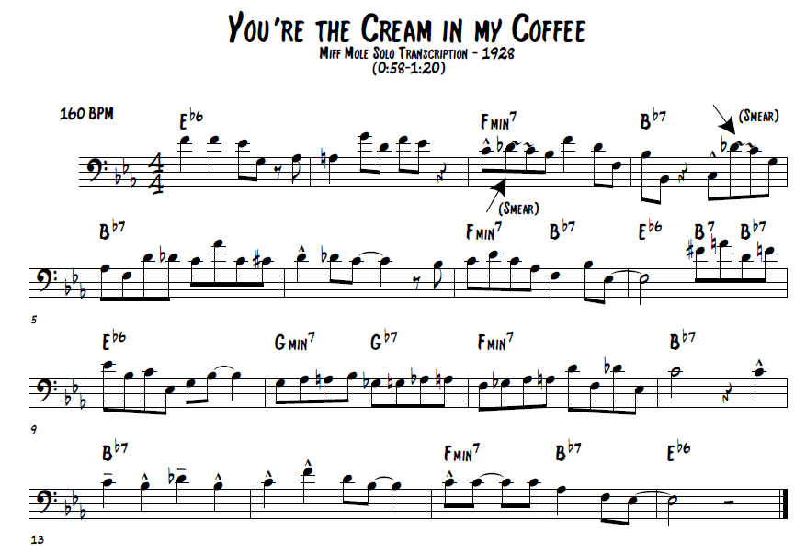

Harmonic
For the most part, Mole’s solo, as depicted in figure 3 above, remains harmonically stable throughout. Considering the recording date of 1928, this is generally viewed as common practice for the time period. It would not be until the mid-to-late 1940’s in which the exploitation of harmonic chord extensions and alterations, such as #9, b9, #11, b13…etc., would become prevalent due to the bebop movement. As evidenced in numerous recordings from this time period, 1928, harmony was primarily displayed at the local level. What this means is harmony was viewed in a more vertical way during this time rather than a more linear approach. For example, refer to figure 4 below;
Figure 4. Common ii V I chord progression.
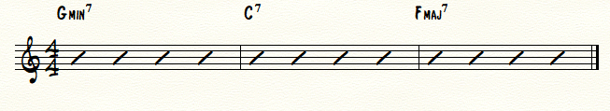
In this common ii V I chord progression in F major, a more “progressive” jazz musician would see the 3 individual chords and simply play a collection of notes from one scale, the F major scale. One can make this connection by simply realizing that all three distinct chords originate from the same global harmony, F major. In Mole’s day however, a jazz musician looked at these three chords not as an entire unit, but as what they indeed are, three individual and different chords. The result was a more vertical and harmonically local style of playing.
Let us break this down further for better understanding. If a musician played the F major scale over the first chord, Gmin7, the note E natural would serve as the 13th of the chord, a beautiful sonority on a minor 7th chord. This is not to say that a 1920’s musician would never play an E natural over a Gmin7 chord, but in most instances, the E natural would not be placed as a target note. (the note to which the melodic line aims for and/or notes that are emphasized more than others) A more vertical approach to playing places the emphasis on the target notes that define the chords quality. In most cases this would be the 1, 3, 5, and 7 scale degrees.
Local Harmony
Figure 5. Miff Mole, “You’re the Cream in my Coffee, measures 1-6.
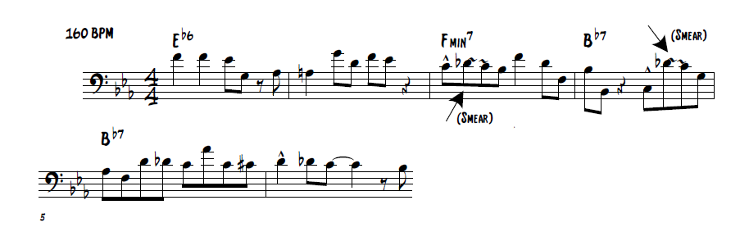
There are several instances of the “target note” approach in Mole’s solo as evidenced in figure 5 above. To begin with, Mole’s first melodic statement in m. 1, I contend, ends on the and-of-three. The G natural, the third of the Eb6 chord, serves as a point of stability in regards to the local harmonic level. Mole follows the initial melodic statement in m. 2 much the same that he did in m. 1, ending the phrase on the and-of-three. This time however, rather than ending the phrase on the third of the chord, Mole chooses to end the phrase on the root of the chord, Eb. For more instances of the target note approach in Mole’s solo, refer to figure 6 below. Notice that each circled note is the point to which virtually every phrase Mole played aims for and resolves. Also, take notice that each circled note happens to be the 1, 3, 5, and or 7 scale degree in respect to the local harmony. In listening to Mole’s recording of this solo, one will easily notice that these notes naturally have more emphasis placed upon them than the ones that surround them.
Figure 6. Miff Mole, “You’re the Cream in my Coffee,” Target Note Example.
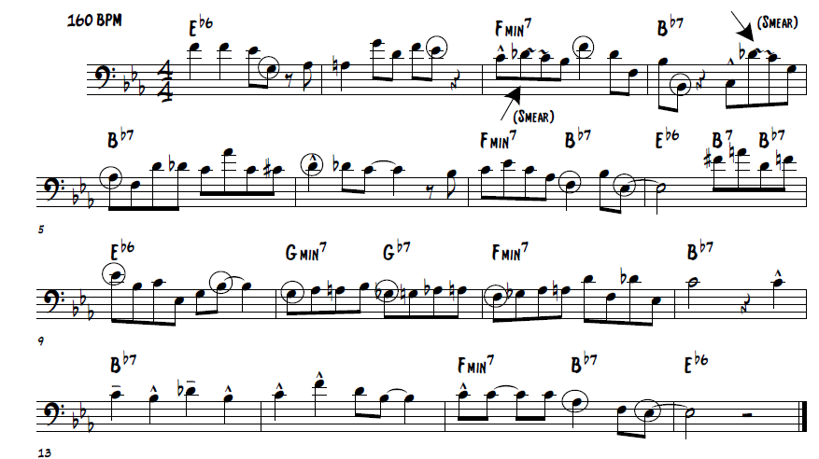
To add more to the discussion of local harmony, in regards to Mole’s solo, notice that Mole often implores the use of arpeggiated figures that outline the given chords.

Figure 7. Miff Mole, “You’re the Cream in my Coffee,” Arpeggiated Example, Measures 7-9.
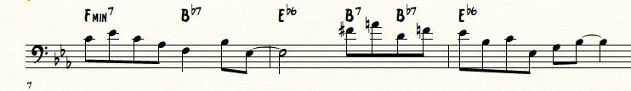
Mole outlines the complete Fmin7 chord in m.7, partially outlines the B7 and Bb7 chords in m. 8, and finally, completely outlines the Eb6 chord in m. 9.
Global Harmony
For the most part, Mole stays fairly grounded in regards to harmony on the local level. With this being said however, there are a few notable instances of global harmony in Mole’s improvised solo worth mentioning. To begin with notice Mole’s use of the #11 chord extension in figure 8 below.
Figure 8. Miff Mole, “You’re the Cream in my Coffee,” measures 1-4.
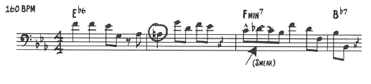
His use of the #11 in this Eb6 chord certainly causes the ear to take notice, especially considering that it lands directly on beat-one of m. 2. One could argue that Mole’s use of the #11 in m. 2 is prolonged throughout mm. 2 and 3 before resolving up a half-step to Bb on beat-one of m. 4.
The next instance of global harmony occurs in m. 8, as depicted in figure 9 below.
Figure 9. Miff Mole, “You’re the Cream in my Coffee,” measure 8.
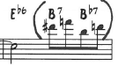
The B7 chord notated on beat 3 is ultimately serving as a tritone substitution. Under normal circumstances an F7 chord (V of V) would be in place of the B7 chord. This would then in turn tonicize the V7 chord (Bb7) to resolve back to the I chord (Eb6) in the following measure. The use of the B7 chord certainly adds a harmonic sophistication to Mole’s solo. This particular use of the tritone substitution temporarily removes the listener from the stable key of Eb major. Considering Mole’s note choice over the B7 chord (F# and A), one can safely say that the tritone substitution was either written on a chord chart or pre-planned by the band during the recording session. In other words, had the chord simply been an F7 or Bb7, Mole would not have played the chosen notes on beat 3 of m. 8.
The final use of global harmony, apparent in Mole’s solo, can be seen in m. 10 below.
Figure 10. Miff Mole, “You’re the Cream in my Coffee,” measures 10-12.
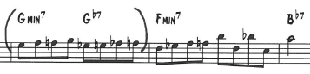
In this instance, Mole, again, makes use of the tritone substitution. Under normal circumstances the Gb7 chord on beat 3 of m. 10 would be a C7 chord that would then in turn tonicize the Fmin7 chord in the following measure. Considering the chromatic sequence that Mole plays during this measure it would be safe to say again that these chords were pre-planned prior to the recording session.
Stylistic
In regards to Mole’s overall style of trombone playing, as evidenced in his recorded solo, there is nothing stylistically innovative. To begin with, Mole’s tone quality is rather thin, brittle, and somewhat “nasally” in comparison to modern trombone approaches. This is not to be taken as an insult to his playing style as this was the norm for trombone players during Mole’s time. Mole also makes little to no use of dynamics in his solo, primarily residing in the mf-F dynamic ranges.
An important aspect of Mole’s solo that he neglected to capitalize on was his failure to utilize the blues language. In general, there are no instances of “the blues” in Mole’s solo. This was quite common among white musicians during the 1920’s and 1930’s. To most black musicians during this time period, white musicians where not considered true “jazz musicians,” as they failed to play the blues. On a side note, Jack Teagarden was considered to be one of the first white musicians to utilize the blues in his solos. As a result, he was widely accepted among the black musician population as a “true jazz musician.”
Mole’s musical phrasing is extremely consistent in this solo, creating a great sense of organization. This organization however leads to an extremely predictable solo style, a trait that is not necessarily innovative or desired among jazz musicians. Varied phrasing creates a sense of space, spontaneity, and organicism. Notice Mole’s phrasing in figure 11 on the following page. For nearly the entirety of the solo, Mole plays a two-measure statement followed by a two-measure answer. Together, these four measures complete a phrase/sentence. The only instance in which Mole breaks this patter occurs beginning in m. 9. Mole plays a one-measure statement followed by a two-measure answer. In addition to his phrasing, notice that Mole’s solo is virtually un-syncopated. The beginning of every measure has a note on beat one. Finally, notice that nearly every beat of this solo is filled with notes, leaving only 4 beats of rest during the entire solo.
Figure 11. Miff Mole, “You’re the Cream in my Coffee,” Phrasing Example.
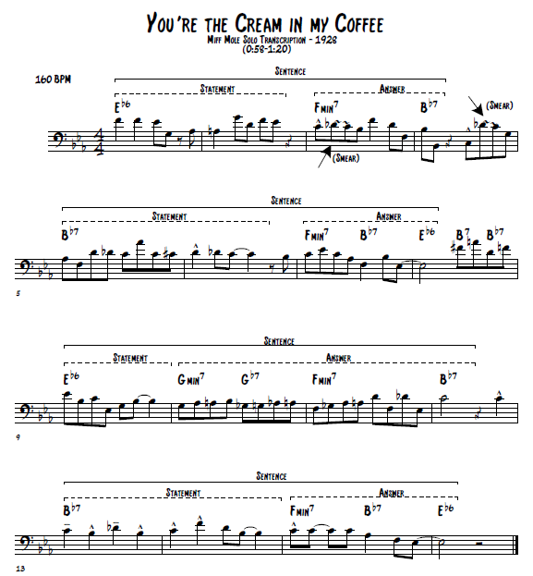
The final stylistic approach considered in defining Mole’s solo style lies within his choice of articulation. For the most part, jazz has become an increasingly legato art form throughout history. In the case of Mole’s playing however, he opted for a more staccato style of playing as is evidenced in his recorded solo and in the many examples of his solo transcription provided. This short/staccato style of jazz was somewhat defining of the Dixieland, traditional, and in some circles, the “white” way of playing jazz. One could argue that this short staccato style of playing was reminiscent of ragtime influence. Another notable articulation aspect of Mole’s solo style can be seen in figure 12 below.
Figure 12. Miff Mole, “You’re the Cream in my Coffee,” measures 3-4.
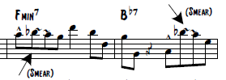
What I have labeled as a “smear” is a technique known as glissando. For a trombonist, a glissando is achieved by using no articulation between notes that lie within the same harmonic series. Again, this particular technique harkens back to the Dixieland, traditional, and or “white” way of playing jazz, and therefore creates a “dated” sound to modern listeners.
Technical
In regards to Mole’s technique as a trombonist, there is nothing earth shattering about this particular solo, at least by modern standards. At the time however, Mole was one of the few pioneering trombonists who actually improvised melodies, rather than only being a support to other instruments such as the trumpet and clarinet. Because of this, his technique as a trombonist during this time period was widely marveled at amongst the trombone community. For the purpose of this document, Mole’s solo will be technically analyzed from a modern point of view.
To begin with, the solo was in the key of Eb major and was recorded at 160 bpm. From a trombonist point of view, the key of Eb major is a relatively common key to improvise in, and a tempo of 160 bpm lies within what a typical trombonist might consider “comfortable.”
In regards to the harmonic range utilized within this solo, Bb3 to A4 (major 7th), this was considered, at least among trombonist during the time period, as a wide expansion of range. Most trombonist during this time rarely played above an F4.
The final point in regards to Mole’s technique that I would like to point out is that there are no instances in which he deploys extended techniques. For example, lip trills, lip turns, multiple tonguing…etc.

Chapter 6:
A Transcription of the Improvised Solo of Jack Teagarden on
“She’s a Great Great Girl”

Figure 13. Jack Teagarden, “She’s a Great Great Girl,” solo transcription.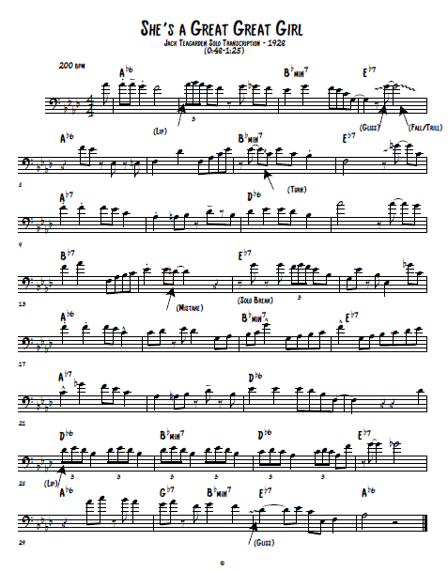
Introduction
In general, Teagarden’s solo on “She’s a Great Great Girl” demonstrates the exact moment jazz trombone style began to change. As will be discussed in detail in this chapter, Teagarden greatly expanded the harmonic expectations of the trombone, especially in regards to harmony at the global level. In addition to this, Teagarden innovated new technical possibilities with alternated positions, more rapid tonguing, and an expanded upper register. Finally, Teagarden’s unique method to musical phrasing ultimately made him stand out amongst his contemporaries who favored a highly formulaic approach. As a result of these factors, Teagarden was revered as the pioneer of a new jazz trombone style simply because his varying abilities where far more sophisticated than that of any other trombonist prior to him.
Public Reaction
Jack Teagarden’s improvised solo on “She’s a Great Great Girl,” recorded in 1928 with Roger Wolfe Kahn’s Orchestra, was the first solo Teagarden ever recorded. Interestingly, Kahn’s orchestra had originally booked Miff Mole for the recording date. In short, Mole backed out ultimately allowing young Teagarden to be called as a last-minute substitute. This debut solo of Teagarden’s immediately grabbed the attention of the public, and according to Kurt Dietrich, Teagarden’s more swinging style immediately eclipsed the style of Mole.
In support of Dietrich’s opinion, Rex Allen, author of the International Trombone Association article: Jack Teagarden: An Evaluation of His Style and Contribution to Jazz, had the following to say about Teagarden’s debut recording;
Through the leadership of Jack Teagarden, the contemporary New York trombonists of 1928 elevated the instrument from the strictly accompanist role of low-range glissandi and barnyard imitation (associated with Kid Ory, Honore Dutrey, and others). Prior to 1928, Miff Mole’s rapid-fire, complex and technical style, though lacking in expression, was the dominant influence before Teagarden, who brought it several steps further to where his melodic and harmonic lines not only ranked with the trumpet and clarinet, but the added expressive dimension in his playing allowed the trombone to stand alone in a featured role with only rhythm accompaniment.

Allen’s article supports this public claim further with a quote from a 1960 publication entitled Jack Teagarden’s Music, by Howard J. Watters as can be seen below;
Jack quickly became the darling of the jazz fraternity and everyone’s personal discovery. The Chicagoans admired his virile blues playing, the Nichols-(Glen) Miller-Dorsey Gang respected his musicianship, the Harlem insiders welcomed his modern outgoing musical ideas, and Paul Whiteman’s top jazz players (Bix, Trumbauer, et al.) looked for ways to draft the 22-year old wonder into their company.

The following analysis and comparison of Teagarden’s solo to Mole’s solo will answer the question as to why Teagarden’s solo style eclipsed that of Mole’s.
Local Harmony
Figure 14 on the following page depicts the local harmony utilizing the target-note approach discussed earlier. Notice the numerous instances in which Teagarden specifically emphasizes defining chord tones. (1,3,5,7…etc.)

Figure 14. Jack Teagarden, “She’s a Great Great Girl,” local harmony example.
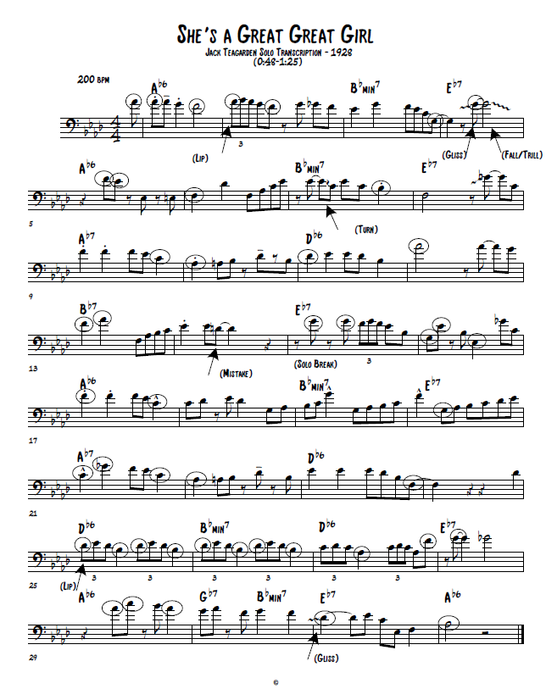
In addition to the target note approach, in regards to the local harmonic level, Teagarden also makes several uses of the arpeggiated approach.

Figure 15. Jack Teagarden, “She’s a Great Great Girl,” measures 5-6.
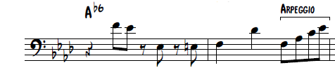
The first use of the arpeggiated approach can be seen in m. 6 on beats 3 and 4 as depicted above in figure 15. In this instance, Teagarden outlines an Ab6 chord, starting on the 6th scale degree F. This is immediately followed with the 1st, 3rd, and 5th scale degrees to which completes the chord.
Another use of the arpeggiated approach occurs in measure 17. In this instance, Teagarden descends an Ab6 chord playing every note with the exception of the root.
Figure 16. Jack Teagarden, “She’s a Great Great Girl,” measure 17.
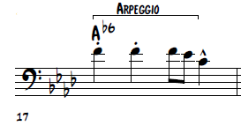
One final use of the arpeggiated approach occurs in measure 23 below. In this instance however, the arpeggio is not necessarily as cut-and-dried as in the previous examples. Teagarden opts to start the descending arpeggio on the 9th scale degree. This is immediately followed by the root and 6th scale degree before finally resolving to the 3rd of the chord on the and-of-four.
Figure 17. Jack Teagarden, “She’s a Great Great Girl,” measure 23.
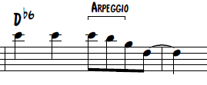
Global Harmony
For the most part, Teagarden’s solo demonstrates a nice balance of local and global harmony. Figure 18, on the following page, depicts the numerous uses of global harmony utilizing the target note approach. Notice in this example that nearly all of the circled target notes, with the exception of the Gb’s, are either 9th, 11th, or 13th chord extensions. What Teagarden achieved with the use of these chord extensions was ultimately a more sophisticated and colorful harmonic palette. Also, take notice that all of these chord extensions, again disregarding the Gb’s, are all members of the Ab major scale, or the overall global harmony of the solo. What this proves is that Teagarden was less concerned with local harmony, or the old vertical way of playing, and more concerned with the new linear/global approach to improvising. This in itself was quite innovative considering the time period in which the solo was recorded.
Teagarden did not allow the chord progression to dictate what he played, and therefore allowed his musical lines to dominate rather than the underlying harmony.

Figure 18. Jack Teagarden, “She’s a Great Great Girl,” global harmony example.

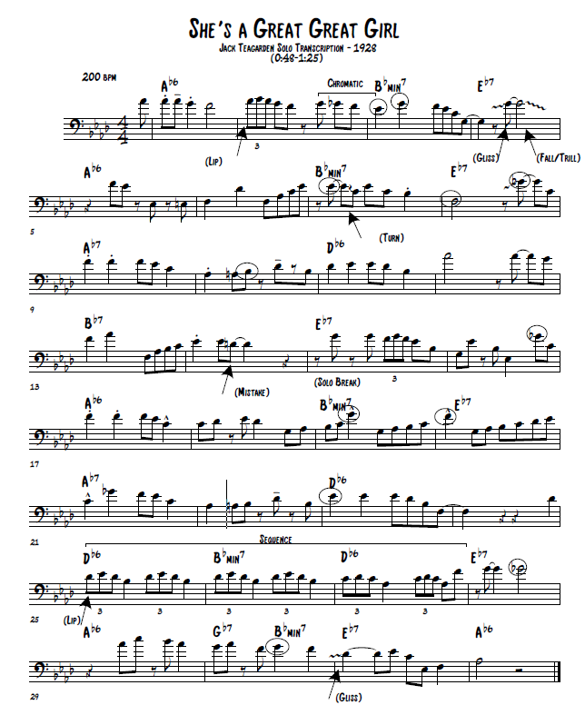
To support this idea of Teagarden’s global harmonic approach further, I would like to discuss a few specific examples that prove he was thinking more globally rather than locally. To begin, see figure 19 below. In this example, Teagarden’s chromatic descending line, beginning on the and-of-three in m. 3, deliberately leads to 11th chord extension in correlation to the Bbmin7 chord. This is directly followed by a G on beat two of m. 4 which is the 13th chord extension in the Bbmin7 chord. Globally speaking, the Eb and G serve as the 5th and major 7th scale degrees within the local key of Ab major. The fact that Teagarden was thinking globally rather than locally, ultimately allowed for more colorful note choices in this example.
Figure 19. Jack Teagarden, “She’s a Great Great Girl,” measures 3-4.
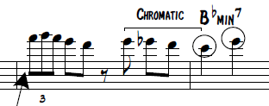
Another example of this technique can be viewed in figure 20 below. Notice that Teagarden’s primary note choice in this measure is Eb and C, or the 5th and 3rd scale degrees in respect to the overall key of Ab major. However, the Eb and C become more colorful in regards to the harmony as they are the 11th and 9th chord extensions in respect to Bbmin7 chord.
Figure 20. Jack Teagarden, “She’s a Great Great Girl,” measure 7.
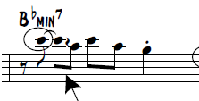
The final example of Teagarden’s deliberate use of global harmony occurs in mm. 18-20 below. This beautifully constructed line is a masterpiece in itself. Notice that all of the eighth-notes in these measures ascend a variant of the Ab major scale, although the harmony does not necessarily warrant such a scale. Also, notice that the quarter notes in measures 19 and 20, as well as the eighth note on the and-of-four in m. 20 are a variant of a descending Ab major scale. This back and forth motion creates the target notes of G and F which become colorful chord extensions that lead beautifully to the Ab7 chord in m. 21.
Figure 21. Jack Teagarden, “She’s a Great Great Girl,” measures 18-20.
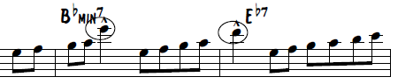
Stylistic
In respect to Teagarden’s stylistic approach to this solo, one immediately notices his big robust tone quality, especially considering the often nasal and small tone quality associated with trombonists during this time period. Also, Teagarden’s tone quality is exceedingly pure, each note being well centered and ringing true. On top of this, Teagarden’s approach to playing trombone in general was exponentially more legato than any other trombonists during his time, ultimately bringing the trombone more in line with other solo instruments such as the clarinet and trumpet.
Perhaps one of the most defining stylistic aspects of this particular solo, in respect to 1928, was Teagarden’s use of blues language. Rex Allen had the following to say about Teagarden’s use of the blues in his solo improvisations;
Teagarden’s interpretations lend a blues emphasis to each melody in a natural way, as opposed to the over-reliance on familiar blues techniques by many of today’s musicians.

The following figures depict how Teagarden infused this particular solo with the blues language. In every instance, the Gb serves as the blue note (lowered third scale degree) in respect to the Eb7 chord. This ultimately created the sensation of the blues in a tune that would otherwise not call for such associations in normal practice during that time period. The results were sensational and became defining for the rest of Teagarden’s career.
Figure 22. Jack Teagarden, “She’s a Great Great Girl,” blues example 1.
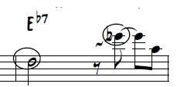
Figure 23. Jack Teagarden, “She’s a Great Great Girl,” blues example 2.
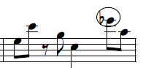

Figure 24. Jack Teagarden, “She’s a Great Great Girl,” blues example 3.
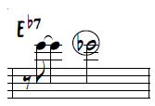

Another stylistic aspect of Teagarden’s solo lies within his innovative and varied choice of phrasing. Up until this point in jazz history, most musicians played phrases similar to that of Miff Mole. (two-measure statement + two-measure answer = four-measure phrase) This way of phrasing created an overall organized and predictable style that was somewhat formulaic. Teagarden’s phrasing, depicted in figure 25 on the following page, is quite different to the norm during this time period. Notice in mm. 1-12 and mm. 25-32 that Teagarden still plays four-measure phrases. However, each four-measure phrase is a complete sentence rather than the statement vs. answer approach. One could think of Teagarden’s phrase approach similar to that of writing in compound sentences. Compound sentences ultimately create smoother flowing thoughts. The same holds true in music.
Measures 13-16 harken back to the Miff Mole style of phrasing as Teagarden opted for the statement vs. answer approach. Measures 17-24 offer a unique twist in this particular solo as Teagarden extends the typical four-measure phrase into an eight-measure phrase. This longer phrase is connected together by way of the eighth-note sequence, beginning on beat-four of m. 18, that spills over into m. 21. When listening to Teagarden play this phrase, the result of this eighth-note sequence almost portrays an essence of a run-on sentence, if you will. However, frowned upon in the English language, Teagarden’s “run-on sentence” adds an interesting flavor to the solo overall.
Finally, the various combination of phrasing inherent in this particular solo all meld together to create a more polished and sophisticated solo than that of previous generations.
Figure 25. Jack Teagarden, “She’s a Great Great Girl,” phrase example.
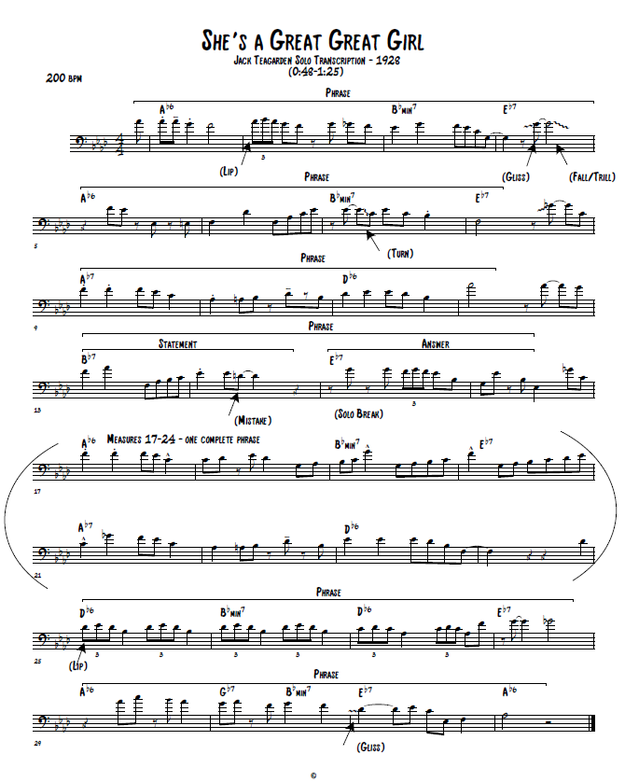
The final aspect of Teagarden’s stylistic inflection can be seen in his use of syncopation. Notice in the multiple examples provided in this chapter that Teagarden often time plays on the off-beats. In comparison to Mole’s solo, Teagarden’s solo has many more instances of rests. This ultimately allows the music to breath better, creating yet again, a more sophisticated and polished product.
Technical
Perhaps the most innovative aspect of this particular solo was Teagarden’s vast technical expansion of the trombone. In general, trombonists during this time period largely struggled with technique. This was the primary reason for the trombone being viewed only as a support instrument rather than a solo instrument.
The first technical feature of this solo presents itself in the tempo marking alone. For a trombonist, even to modern day standards, playing a great solo at a tempo marking of 200 bpm is quite astonishing. On top of this, the key of Ab major is generally known to trombonists as a key that presents great difficulty when improvising. To support this fact, I purposely wrote a tune in the key of Ab that featured four professional trombonists on my last album entitled Bring It! To my surprise, every trombonist involved in the recording session complained about the difficult key signature!
Just as Miff Mole expanded the expected upper register of the trombone, Teagarden exploited it much further. Again, trombonists during this time rarely ventured any higher than an F4. In the case of Teagarden on this particular solo, he showed off his range up to a C3. Also, in general, Teagarden’s entire solo primarily stayed in the upper register, rarely reached into the mid-register, and never opted for the low-register.
The final and perhaps most notable aspect in regards to Teagarden’s technical innovations lies within the use of his lip. Each and every occurrence of the triplet figures in this solo rely on the flexibility of Teagarden’s lip flipping through the harmonic partials on the trombone. At the time, this technique was rather novel and considered to be an extended technique. Prior to this technique, as Teagarden was the trombone’s inventor, trombonists simply glissed their way through figures. See figure 26 below.
Figure 26. Jack Teagarden, “She’s a Great Great Girl,” lip example.
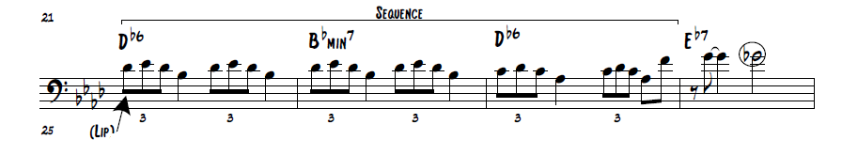
Rex Allen had the following to say about Teagarden’s use of the lip technique;
Teagarden’s use of the lip, rather than the slide, to play fast triplets and sixteenth-note clusters opened the way for new improvisational possibilities. The device permits playing a true legato line as it would sound if played on a valve instrument, without tonguing (excepting the first note) and without becoming what would otherwise be a confused glissandi.

Conclusion and Comparison
In conclusion, and considering the provided information above, there is no question that Jack Teagarden’s way of playing trombone was far superior to that of Miff Mole’s approach in regards to harmonic, stylistic, and technical innovations. Because of this, it should be clearly evident as to why Teagarden was able to assume the dominant jazz trombonist role beginning with his debut recording in 1928.
In regards to the harmonic aspects of these two gentlemen, Teagarden’s solo demonstrated more use of both local and global harmony. Locally speaking, this suggests that Teagarden was certainly aware of each and every chord in his solo. With this being said however, Teagarden did not allow the use of local harmony to dictate his musical lines. In other words, Teagarden placed more emphasis on a linear musical construction rather than that of a more vertical approach inherent in Mole’s solo style. Thinking on more global harmonic terms, Teagarden’s note choices, often chord extensions such as 9ths, 11ths, and 13ths, created a more colorfully complex and sophisticated dimension to the improvised solo.
Comparing the two men’s stylistic attributes, Teagarden stood out of many different levels. Firstly, Teagarden’s tone quality was far superior to that than Mole’s in that his tone was much larger/broader and simply purer/focused than that of Mole’s. Secondly, Teagarden’s frequent use of the blues language, in his improvised solo, added an attractive dimension to all jazz listeners, which would increasingly become the norm amongst the majority of jazz improvisers. The final stylistic attribute inherent in Teagarden’s playing, and possibly the most innovative, was his unique and varied approach to the musical phrasing. Mole’s approach was somewhat generic, almost formulaic if you will. Teagarden, by contrast, developed a variety of differing phrases that allowed the music to come across more naturally, rather than coming across as planned/practiced.
The final comparison between Teagarden and Mole lies within their technical capabilities on the trombone. Prior to Teagarden, Mole was certainly miles ahead of any other trombonist in regards to technique. He greatly expanded the upper range of the trombone, and also proved that the trombone could play rapid melodic lines similar to that of other instruments such as the trumpet and clarinet. This expansion in trombone technique was short lived however, as Teagarden’s debut recording in 1928 obliterated every aspect of Mole’s technique by drastically expanding it in all directions. To begin with, Teagarden’s upper-register capabilities shocked trombonists across the board. Also, Teagarden’s more legato style, as compared to the staccato style of Mole, immediately became the goal of every trombonist, as he ultimately proved that the trombone could sound just as articulately clear as other solo instruments. Finally, Teagarden’s development of his extended lip technique caused trombonists, and other brass players for that matter, to marvel at his superior flexibility.

Chapter 7:
A Transcription of the Improvised Solo of Bill Harris on
“Cross Country”

Figure 27. Bill Harris, “Cross Country,” solo transcription.
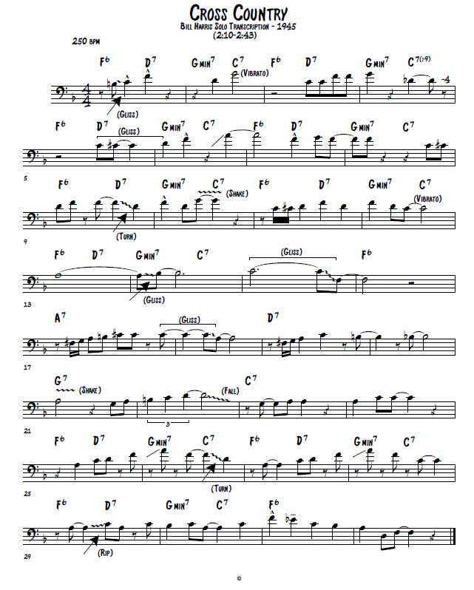
Local Harmony
Figure 28 below depicts the local harmony utilizing the target-note approach discussed earlier. Notice the numerous instances in which Harris specifically emphasizes defining chord tones. (1,3,5,7…etc.)
Figure 28. Bill Harris, “Cross County,” local harmony example.
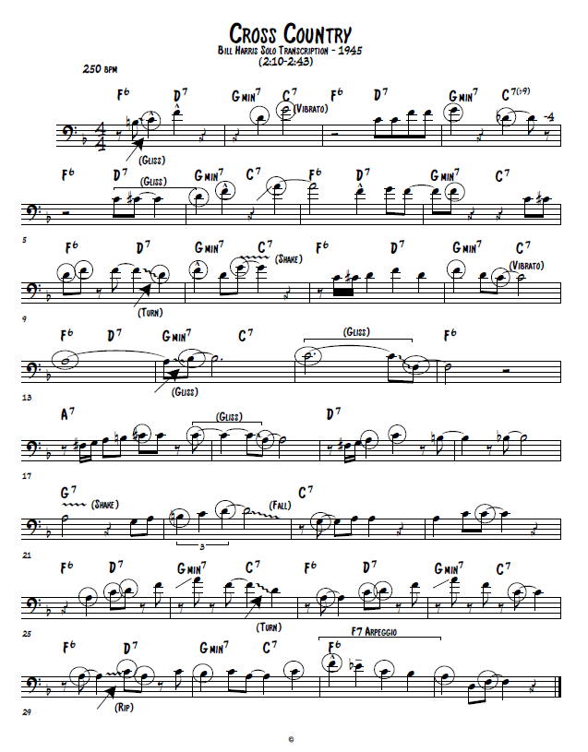
In one particular instance, Harris “targets” the chord extension (b9) notated in m. 4. The Db, (b9 of the C7b9 chord), voice leads smoothly to the C, (7th of the D7 chord), on beat 3 of m. 5.
Figure 29. Bill Harris, “Cross Country,” measures 4-5.
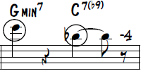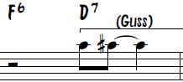

In his solo, Harris made at least one use of the arpeggio technique, in regards to the local harmony. In this instance, and with the exception of the Bb on beat 4, Harris descends an F7 chord.
Figure 30. Bill Harris, “Cross Country,” measures 31-32.
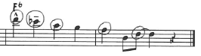
Global Harmony
Although not drastically extensive, Harris’ use of global harmony ultimately adds a “blues” dimension to a chord progression that would otherwise not necessarily warrant such an approach. Notice in figure 31 on the following page that Harris makes several uses of the note F over a D7 chord. The note F in turn becomes the chord extension #9.

Figure 31. Bill Harris, “Cross Country,” measures 1-12.
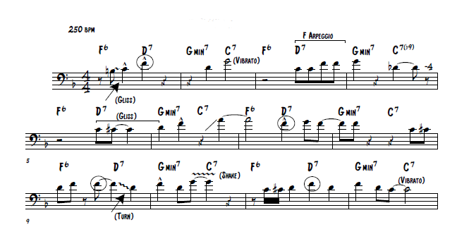

A more common chord progression, at least prior to the be-bop movement of the mid-forties, would have included Dmin7 chords rather than D7 chords. However, bebop musicians preferred the D7 chord as it created better voice leading and ultimately tonicized the Gmin7 chord that followed it. The fact that Harris chose to play F naturals over every D7 chord proves that he was thinking more of the global harmony of F major rather than the local harmony inherent in the individual chords. Also, take notice in the above example that Harris also arpeggiated somewhat of an F chord over the D7 chord, again proving that he was thinking more globally rather than locally in this instance. What this ultimately created was a strong sense of the blues language, rather than that of the bebop language throughout the entire solo. In other words, Harris allowed his blues vocabular to dominate the musical lines, rather than allowing the underlying harmony to influence his ideas.
As we move to the bridge section of this solo, Harris used a few interesting chord extensions that added a colorful dimension to the following eight measures depicted in figure 32 below.

Figure 32. Bill Harris, “Cross Country,” measures 17-24.
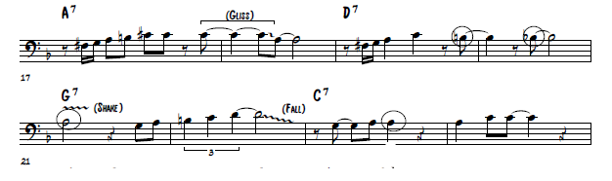
Over the D7 chord in mm. 19 and 20, Harris used the chord extensions 13 and b13 that resolved to the 9th in respect to the G7 chord in m. 21. In m. 23 Harris played the chord extension 13 over the C7 chord, which showcases that he was thinking more of the global key of F major two measures prior to resolving back to F.
Stylistic
In respect to Harris’ stylistic approach to this solo, one immediately notices his bombastic and aggressive tone quality that fills the solo with a tremendous sense of energy. In comparison to the emerging bebop players such as Dizzy Gillespie, Charlie Parker, and J.J. Johnson who all favored a more centered and precise tone quality in general, Harris, who was considered a bebop transitional figure, ultimately failed to fit in in this regard. However, this aspect of Harris’ style did not detract from his popularity but remains one of the reasons he was never considered a true bebop musician.
Another aspect of Harris’ style that was well received during his time period, yet not defining of a bebop musician, was his use of the blues language. In this particular solo, with the exception of the bridge (mm.17-24) Harris basically plays everything with some degree of blues inflection. For example, Harris’ multiple uses of glissandi, dips, rips, and lip turns all lend themselves directly to features inherent in the blues. These devices ultimately create a sense of un-refined emotion, and to some degree, look backwards to prior jazz players such as Teagarden and Mole, rather than looking forward to the new trends of the bebop movement which was more concerned with refined precision.
Another blues and stylistic aspect inherent in this solo lie within the short phrases played by Harris. These short four measure phrases lend themselves similar to the common four measure phrases often heard in the blues. For example, notice figure 33 below. In this example, Harris plays a four-measure phrase with a repetitive statement and answer. In this case, the melodic ideas that Harris played is somewhat similar to a “call and response” and “riff” often heard in the blues.
Figure 33. Bill Harris, “Cross Country,” measures 25-28.
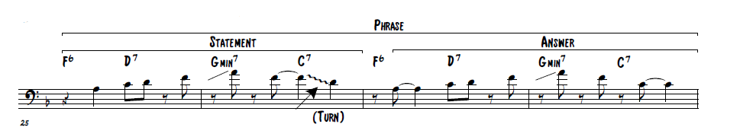
Figure 34 on the following page also shows this call and response/riff blues idea inherent in Harris’ solo.

Figure 34. Bill Harris, “Cross Country,” measures 9-12.
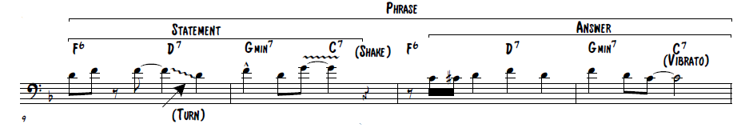 The final stylistic characteristic to be addressed in regards to Harris’ solo is his use of phrasing. For the most part, Harris utilized the “dated” phrasing technique heard in earlier players such as Miff Mole. As can be viewed on the following page in Figure 35, Harris often deploys the formulaic phrase combination of a two-measure statement with a two-measure answer all combined for one four-measure phrase. The only instances in which Harris varies from this technique can be seen in mm. 1-4 in which he plays two one-measure statements followed by a two-measure answer, and in mm. 13-16 in which he plays one entire four measure phrase. This phrase however, should not be considered innovative by any means as it is rather bland and lacking of any musical creativeness. Ultimately, Harris’ choice of phrasing looks backwards to previous styles in that his phrases are short, predictable, and formulaic in nature. In comparison, the new bebop movement called for varied phrases, and in general, longer phrases became the norm.

Figure 35. Bill Harris, “Cross Country,” phrase example.
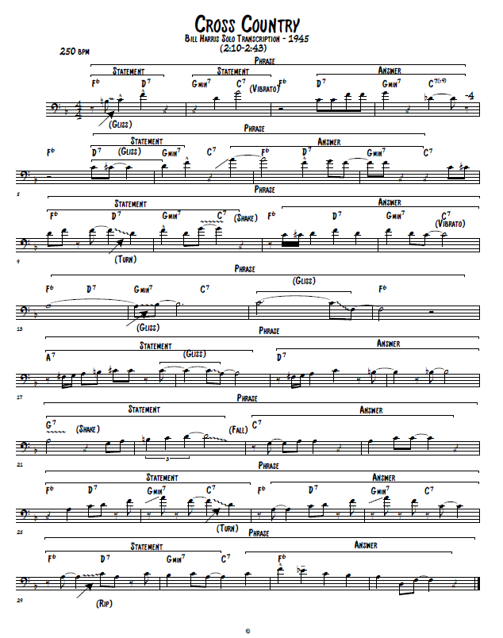

Technical
In regards to Harris’ technique as a trombonist, the first aspect to be addressed is the rather quick tempo of the recorded solo. At approximately 250 bpm this tempo remains, even by modern day standards, an extremely difficult tempo for trombonists. Considering that a trombonist must articulate virtually every note, whereas other instruments have the luxury of valves to facilitate rapid figures, playing at this quick of a tempo poses articulation issues for most trombonist. In all honesty, Harris handles this tempo quite well. However, due to the quick tempo, Harris’ phrasing became fragmented, leading to the overall formulaic phrase approach addressed previously. To put it simply, most trombonist inherently play shorter phrases at quicker tempos due to the fact that their tongue lacks the capability to articulate a long series of notes. This in turn creates shorter phrases and fragmented musical ideas.
Another characteristic of Harris’ technique that directly relates to the tempo of this solo is the fact that the harmonic range of his solo would be labeled as to what I would consider, “playing it safe.” In general, Harris does not venture into the low or high range, consistently focusing his attention to the mid register of the trombone. In most cases, and with most players, trombonists revert to comfort zones when tempos increase. This is certainly prevalent in Harris’ solo.
Finally, considering that this solo has a few instances of interesting chord substitutions, D7 rather that Dmin7 for example, Harris fails to capitalize on any harmonic inventions, ultimately favoring the blues on a global harmonic level rather than taking advantage of the intricacies inherent at the local harmonic level. For example, it would have been refreshing/interesting if Harris had played an F# on one of the D7 chords rather than constantly choosing F naturals.

Chapter 8:
A Transcription of the Improvised Solo of J.J. Johnson on
“Jay Bird”

Figure 36. J.J. Johnson, “Jay Bird,” solo transcription.
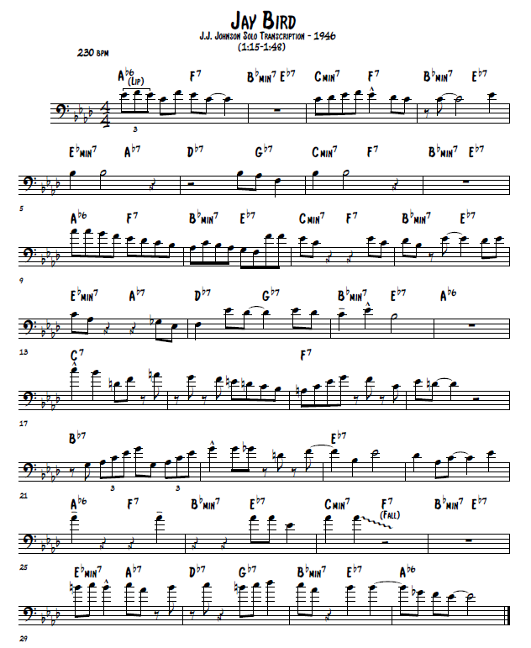
Introduction
Johnson’s solo on “Jay Bird” became an instant style defining moment for trombonists within the world of jazz. As the bebop movement was gaining more and more momentum in the mid-1940’s, trombonists began to fall behind in respect to the changing style. Trombonists in general were unable to keep up with the technical and harmonic demands inherent in the bebop style. As will be discussed in this chapter, Johnson’s solo on “Jay Bird” was ultimately the first trombone solo in history to fully embrace the bebop style. His innovative harmonic ability, particularly at the global level, directly emphasized colorful chord tones. His technical command of the instrument at quick tempos allowed for impressive elongated musical ideas that in turn lead to unique and varied phrasing. Finally, Johnson further expanded the upper register of the trombone and added an overall more legato approach to trombone playing. All of these aspects, inherent in this particular solo, are directly connected to the bebop movement that was vastly popular during the 1940’s and in to the 1960’s. Because of this, Johnson, through this one solo, became the visionary of a new trombone style.
Public Reaction
Johnson’s selected solo transcription comes from his debut “bebop” recording of his tune entitled, “Jay Bird.” The reasoning for denoting “Jay Bird” as Johnson’s debut “bebop” recording is due to the fact that Johnson made a few recordings prior to this in the early 1940’s. However, it is my opinion, and supported by Kurt Dietrich as well, that these few recordings prior to the June 26th recording date in 1946 showed Johnson primarily as a swing-oriented soloist. Therefore, and for the purpose of this document, Johnson’s “Jay Bird” recording will be considered as a debut recording due to the fact that it ultimately showcased the trombone as a bebop instrument for the first time.
As the evidence supports in the following sections of this chapter, Johnson’s solo on “Jay Bird” was far ahead of any other trombonist at the time in regards to harmonic, stylistic, and technical innovations. Because of this, Johnson developed a near instant “cult-like” following among the public that continues to persist in the modern-day era of trombone playing.
With the exception of the versatile and lyrical Urbie Green, J.J. was the main influence. Until the early ‘60s, it seemed that all trombonists were building their concepts on J.J.’s foundation…Tom Everett

The public reaction and fascination with Johnson’s playing style ultimately started with this initial bebop recording, in which laid the foundation of his entire playing career. In fact, because of this debut bebop recording, notably during the same year (1946), Johnson received the acclaim of both his peers and the jazz public when he was voted a “New Star” for 1946 in the Jazz Critics Poll of Esquire magazine.
Local Harmony
Figure 37 on the following page depicts the local harmony utilizing the target-note approach discussed earlier. Notice the numerous instances in which Johnson specifically emphasizes defining chord tones. (1,3,5,7…etc.)

Figure 37. J.J. Johnson, “Jay Bird,” local harmony example.
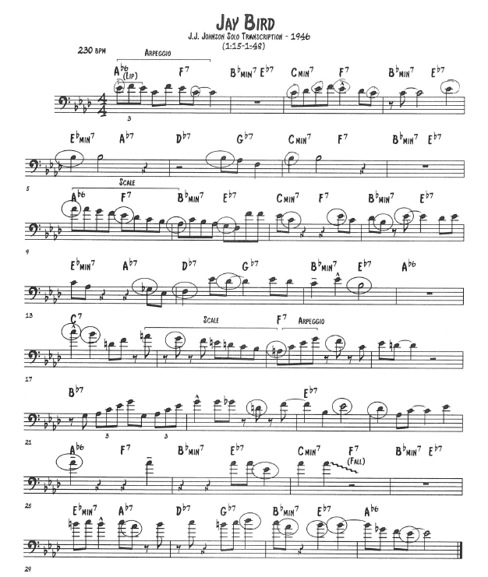
Johnson also made a few uses of the arpeggio approach as well, which can be seen in the figures on the following page. Figure 38 showcases, although not directly and completely, both an Ab6 and F7 arpeggio respectively. With the exception of the 9th scale degree, G natural, figure 39 below depicts a complete F7 chord in first inversion.
Figure 38. J.J. Johnson, “Jay Bird,” measure 1.
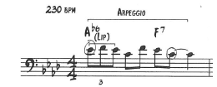
Figure 39. J.J. Johnson, “Jay Bird,” measure 19.
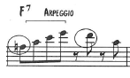
An important aspect of the bebop movement was the ever-increasing importance of scalular melodic lines. This particular solo showcases this harmonic technique demonstrated by Johnson rather well. Notice in the figure below that Johnson directly descends an Ab major scale, the local harmony, resolving first on the 7th scale degree of the F7 chord on beat three of m. 9, followed by resolving on the 7th scale degree of the Bbmin7 chord on beat one of the following measure.
Figure 40. J.J. Johnson, “Jay Bird,” measures 9-10.
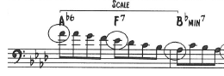
Another example of this scale technique is apparent in mm. 17-19 as well. In this instance, Johnson, with the exception of a few notes, directly descends a C dominant scale beginning on beat one of m. 17 before resolving to the third of the F7 chord in m. 19.

Figure 41. J.J. Johnson, “Jay Bird,” measures 17-19.
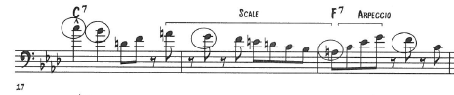
Global Harmony
Johnson’s use of global harmony in this particular solo is certainly more advanced than the previous trombonists discussed within this document. The first instance of global harmony appears in m. 1. In this example, notice that Johnson’s musical idea fits both the Ab6 chord and F7 chord. The only difference in these two chords are the Ab vs. the A natural. Avoiding those two notes allowed the idea to work in respect to both harmonies. Ultimately however, the fact that Johnson failed to play an A natural over the F7 chord shows that he was thinking more of the global harmony of Ab rather than the linear/local harmony of F7.
Figure 42. J.J. Johnson, “Jay Bird,” measure 1.
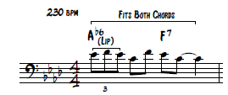
Johnson, within this solo, often emphasized the 9th chord extension on various chords. See the following figures as examples.

Figure 43. J.J. Johnson, “Jay Bird,” measure 4.
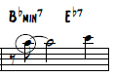
Figure 44. J.J. Johnson, “Jay Bird,” measure 10.
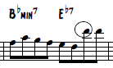
Figure 45. J.J. Johnson, “Jay Bird,” measure 31.
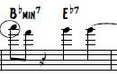
Another aspect defining of the bebop movement was the fact that most “beboppers” ended their musical ideas on the 9th scale degree, in regards to the global harmony rather than the local harmony. For example, in the key of Ab, bebop musicians would often end their ideas on Bb. The following figures on the following page showcase this attribute inherent in Johnson’s solo. By taking the time to listen to this particular recording, one would agree that this “idea ending” 9th scale degree phenomenon is quite different/innovative in comparison to how earlier musicians chose to end musical thoughts.
Figure 46. J.J. Johnson, “Jay Bird,” measures 5-8.
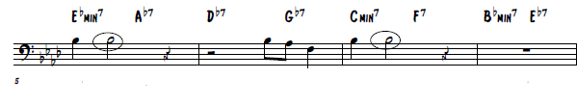
Figure 47. J.J. Johnson, “Jay Bird,” measure 15-16.
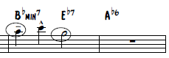
The bridge section of this solo, mm. 17-24, also provide a wealth of globally harmonic language worth mentioning. Throughout these 8 measures Johnson favors the chord extension 13 in respect to each individual chord. Notice that the 13th chord extensions, circled in figure 48 below, are somewhat of a “hint” as to the harmony that follows. For example, the A natural on the and-of-four in m. 17 serves as the 13th chord extension of the C7 chord and the 3rd of the F7 chord two measures later. This technique looks forward globally as Johnson anticipates the chord changes before they actually take place. This harmonic technique also adds a colorful and sophisticated dimension to the solo as a whole.
Figure 48. J.J. Johnson, “Jay Bird,” measures 17-24.
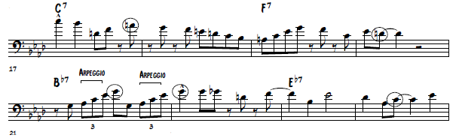
In addition to this, take notice to the labeled arpeggios in m. 21. These arpeggios, in essence, are Ab major arpeggios being played over the Bb7 chord. This adds, again, a color dimension to the solo, but also proves that Johnson was thinking more of the global key of Ab rather than the local key of Bb7 at the respective time in the solo.
The final eight measures of Johnson’s solo are quite similar to that of Harris’ entire solo. Johnson’s total disregard for the local harmony adds a sense of blues inflection. The repeated Ab’s in mm. 25-27 become somewhat of a “riff,” again, an inherent feature of the blues. Also, his deliberate choice of playing an Ab over the F7 chord in m. 25 proves that he was less focused on the local harmony, but rather that of the global harmony. Finally, the B naturals in m. 29 are locally considered as b5 chord extensions in regards to the Ebmin7 chord. However, globally speaking, and in support of the blues language, these B naturals are actually acting more like the flatted-third (blues note) in the global key of Ab.
Figure 49. J.J. Johnson, “Jay Bird,” measures 25-32.
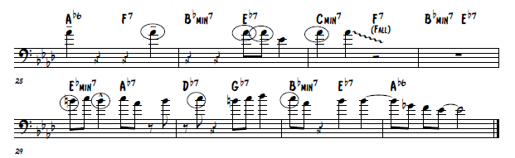
Stylistic
There are numerous stylistic innovations inherent in Johnson’s selected solo. To begin with, in comparison to the previous trombonists studied within this document, Johnson’s tone quality is exponentially larger, fuller, darker, and purer. Part of this can be attributed to the fact that trombones by this time period were slightly larger than trombones available to earlier players such as Teagarden and Mole. In addition to this, recording technology had drastically improved and therefore resulted in better record quality. What truly matters however is the fact that Johnson’s full tone became the norm to which the majority of jazz trombonist aspired to develop.
This solo, although firmly rooted within the bebop realm, does possess some influences of the blues language. (Refer back to the global harmony section of this chapter for more information.)
Johnson’s playing style, again in comparison to the previous trombonists studied within this document, is increasingly more legato. This is a trend that has become the norm for trombonists throughout the entire history of jazz as they strive for equivalence among instruments that do not have to articulate every note. In addition to this, Johnson’s disbandment of glissandi, smears, and rips ultimately pointed forward to a new and more refined way of playing the trombone. As players such as Teagarden, Mole, and Harris still favored these stylistic techniques in 1946, Johnson’s cleaner style ultimately labeled these techniques as “dated” in regards to modern jazz players involved in the bebop movement.
Another stylistic aspect of this solo lies in the fact that Johnson did not fill every single measure with notes. All of the other trombonists discussed up until this point of the document have filled every measure with notes. Johnson’s deliberate choice to not play in mm. 2,8, 16, and 28, ultimately gave the music a refreshing sense of space. In other words, these moments of rest allowed the music to breath.
The final stylistic innovation, and perhaps the most significant, was Johnson’s choice of phrasing. As we have seen in various other examples in this study, most trombonists chose to play in the highly formulaic two-measure statement + two-measure answer phase technique, rarely deviating from four measure phrases. Johnson however, provided a drastically differing phrase technique. Another defining aspect of the bebop was the development of elongated phrases that broke the formulaic and predictable phrasing of the past. This was certainly prevalent in Johnson’s solo.
Notice in figure 50, on the following page, the wide variety of phrases that Johnson played. To begin with, the first phrase, mm. 1-8, breaks the traditional four-measure phrase technique in favor of the elongated eight-measure phrase. Johnson plays a one-measure statement which is immediately followed by a three-measure answer. What happens next is quite interesting. Rather than beginning a new phrase, Johnson plays an afterthought to the initial answer, or to what I have labeled an “elaboration” of the answer. This simply extends the phrase and breaks the predictable nature of phrasing.
Johnson mixes it up again in mm. 9-16 with another eight-measure phrase. This time however, Johnson begins the phrase with an entire four-measure statement. This is directly followed by a two-measure answer in mm. 14-15. Again, this ultimately breaks the monotony of predictable phrasing.
Finally, the remainder of the solo features four-measure phrasing. However, Johnson drops the statement + answer technique in favor of complete uninterrupted phrases.

Figure 50. J.J. Johnson, “Jay Bird,” phrase example.
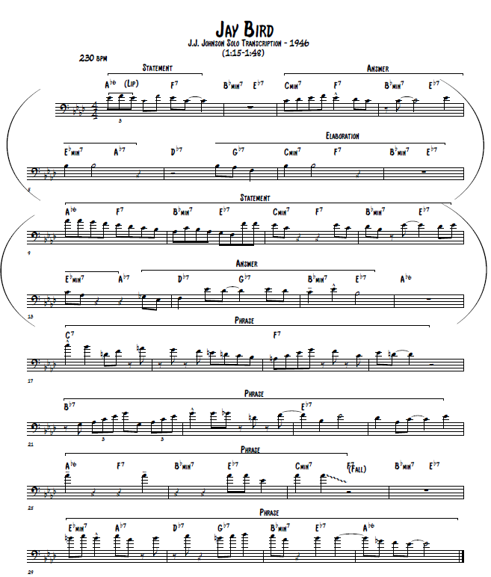
Technical
In regards to Johnson’s technique as a trombonist, the first aspect to be addressed is the rather quick tempo of the recorded solo. At approximately 230 bpm this tempo remains, even by modern day standards, an extremely difficult tempo for trombonists. On top of this, to which has already been addressed in this document, the key of Ab is not a favorable key among trombone players. The fact that Johnson was able to create long and extended musical lines, as well as elongated phrases at this tempo and harmonic center, is simply a feat in itself as a trombonist. Johnson also took full advantage of the harmonic range of the trombone extending the upper register beyond anyone previously discussed in the study. To put it simply, Johnson had enough technical ability that he did not have to “play it safe,” allowing for his full musicianship to be showcased in this solo.
Conclusion and Comparison
In conclusion, and considering the provided information above, there is no question that J.J. Johnson’s way of playing trombone was far superior to that of Bill Harris’ approach in regards to harmonic, stylistic, and technical innovations. Because of this, it should be clearly evident as to why Johnson was able to assume the dominant jazz trombonist role beginning with his debut bebop recording in 1946.
The first aspect of Johnson’s recorded solo transcription that stands out over that of Harris’ was his use of global harmony. For the most part, Harris’ use of global harmony created a strong sense of blues language throughout the entire solo, something that the new bebop movement was striving to get away from at the time. Johnson on the other hand, utilized harmony on the global level in order to create musical lines that featured chord extensions such as 9ths, 11ths, and 13ths. These chord extensions, as discussed earlier, added a more sophisticated and complex dimension to the solo.
In regards to local harmony, it is rather clear to see that Johnson’s focus was on a more linear approach, as evidenced by his various uses of descending scales. This ultimately created smoother, more connected melodic ideas. Harris, in comparison, utilized a vertical approach in his solo. By contrast, this resulted in musical ideas that were fragmented in comparison to Johnson.
Stylistically, Johnson’s more legato approach, in comparison to Harris, ultimately allowed him to fit in with other instruments that were at the forefront of the bebop movement such as the trumpet and saxophone. Because of his ability to play fast while maintaining a legato articulation, Johnson was considered somewhat of an anomaly in the bebop world as he was virtually the only trombonist at the time capable of truly playing the new style.
Perhaps the most notable aspect of Johnson’s style that places him over Harris was his unique way of creating phrases. In general, Johnson created a variety of differing phrases, whereas Harris played virtually the same formulaic phrase over and over again throughout his solo. This created a highly predictable style for Harris. In comparison, Johnson’s phrasing was unpredictable resulting in a more pleasant/refreshing listening experience as the monotony of the four-measure phrase was finally broken.
Technically speaking, Johnson was also well ahead of Harris at the time of the recorded solos in 1946. Although Johnson’s solo was recorded at 230 bpm, 20 bpm slower than that of Harris’ recording, Johnson’s technical command of the instrument allowed him to create longer phrases and musical lines. By contrast, and due to technical handicaps in Harris’ playing, Harris was unable to elongate musical lines and phrases. As a result, his solo was somewhat fragmented and highly predictable. Harris also played exceedingly safe during his solo as he failed to venture outside of his comfort zone in regards to the upper register of the trombone. As evidenced in Johnson’s solo, Johnson not only utilized the upper register of the trombone, but also extended the upper register, in comparison to the other trombonists in this study, as well.
In conclusion, most of Johnson’s innovations as a trombonist were directly tied to the bebop movement during the mid-to-late 1940’s. One reason that he was exceedingly well received during his time and beyond was due to the fact that for many years, Johnson was the only trombonist truly capable of the bebop language. His use of harmonic sophistication, stylistic inflections, and technical capabilities all created a trombonist that dominated the jazz scene for decades.

Chapter 9:
A Transcription of the Improvised Solo of Urbie Green on
“Green Bee”
Figure 51. Urbie Green, “Green Bee,” solo transcription.
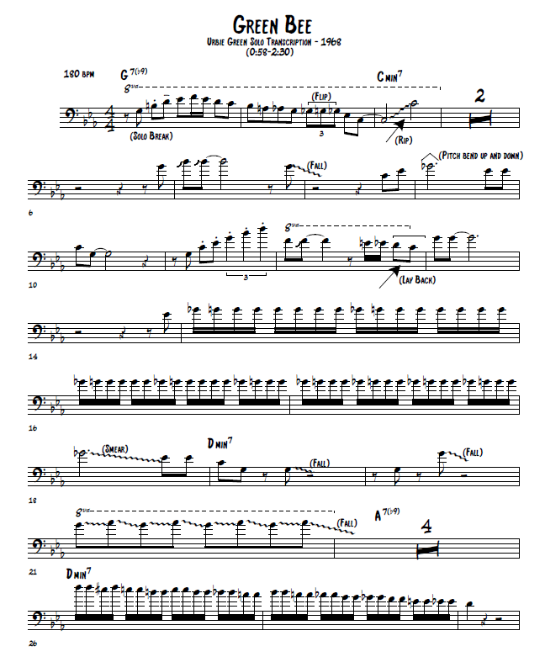
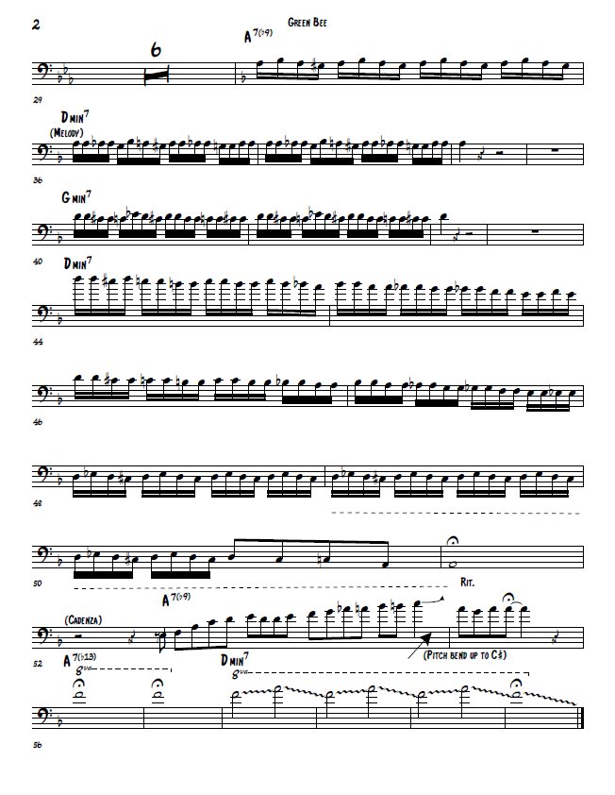
Local Harmony
In general, nearly all of Green’s solo fits into the category of local harmony. As can be viewed in figure 52 below, notice the numerous instances of Green focusing on the chord tones 1, 3, 5, and 7. (Circles and parentheses denote the use of local harmony)
Figure 52. Urbie Green, “Green Bee,” local harmony.
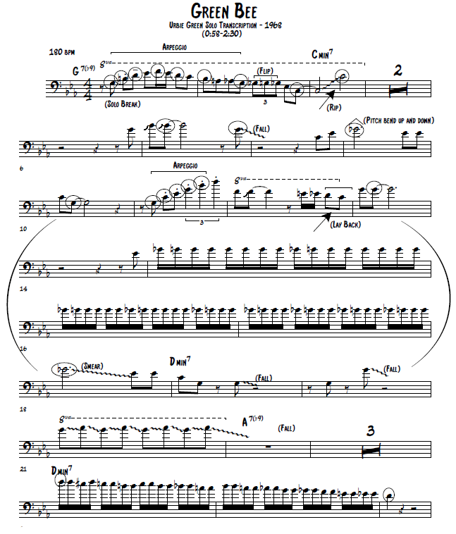
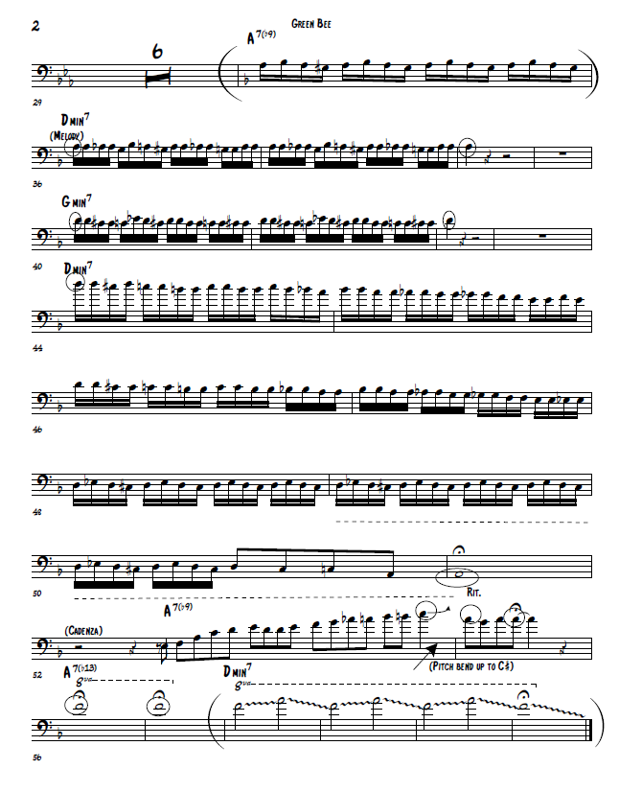
Green’s use of the Gb in m. 9 and mm. 15-18 are classified as local harmony in that they represent the “blue note,” or the flatted 5th scale degree in a minor key. Green also utilized the arpeggio approach, denoted in figures 53 and 54 below. Figure 53 showcases an outlined G7 chord. Figure 54 directly ascends a Cmin7 chord.
Figure 53. Urbie Green, “Green Bee,” measures 1-2.
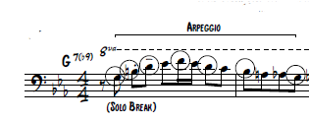
Figure 54. Urbie Green, “Green Bee,” measure 11.
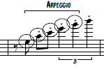
Global Harmony
As stated earlier, Green primarily utilized local harmony throughout his solo. However, there are a few uses of global harmony that are worth mentioning. The first instance of global harmony occurs in m. 2 below. In this instance, the triplet on beat two of m. 2 does not fit the harmony of G7(b9). Rather, the triplet figure is an anticipation of the Cmin7 chord in the following measure.
Figure 55. Urbie Green, “Green Bee,” measure 1-3.
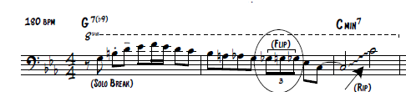
Figure 56 below shows Green’s brief use of chord extensions in regards to the Cmin7 chord. The D in m. 11 serves as the 9th chord extension, and the F’s that follow are the 11th’s of the Cmin7 chord.
Figure 56. Urbie Green, “Green Bee,” measure 11-12.
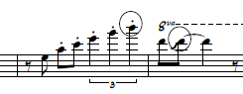
Green’s final use of harmony in regards to the global level occurs in mm. 18-21. Measure 18 remains firmly rooted in C minor. However, the Dmin chord in mm. 19-20 sounds, in real-time, as a minor two chord in the key of C minor. Green’s emphasis of the note G, or the 5th scale degree in relation to C minor, does not necessarily fit the Dmin chord, and therefore further holds on to the key of C minor. This is further supported as Green chose to play the notes G and Ab in m. 21. (This would be the root and b9 of an implied G7b9 chord, the V chord in C minor) Putting this all together, one could speculate that Green was thinking more of ii V i progression in C minor rather than a key change to D minor. In retrospect, we hear these measures as a transition to the new key. In the initial listening however, due to Green’s note choices, one perceives these measures as a ii V i progression in C minor. This proves that Green was thinking more of the global harmony of C minor rather that the local harmony that ultimately transitioned to the new key of D minor. See figure 57 below for further explanation.

Figure 57. Urbie Green, “Green Bee,” measure 18-21.
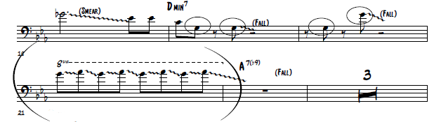
Stylistic
Green’s overall style as a jazz trombonist is simply impeccable. Although this solo is full of glissandi, falls, and rips, Green’s ability to precisely pinpoint each and every individual note is quite remarkable. Other trombonists during this time period did not possess this ability. In other words, musicians are not perfect. They crack/chip notes and produce notes that are not always perfectly centered. Green however, was known for his recording perfection. Every note from this recording is precisely placed and centered which created an intoxicatingly pure tone quality overall.
The overall atmosphere of this recording is quite aggressive in nature. Although the multiple uses of glissandi, falls, and rips all point back in time to an earlier stylistic period, I would argue that Green’s use of these devices do not necessarily warrant such a label. Intermixed with such impeccable playing and rapid technique, these devices simply add a brash “in your face” dimension to this solo. These devices are also often deployed as a way to show off Green’s ability to play exceedingly high. In other words, these devices in Green’s solo do not behave as they did in previous time periods.

The final stylistic aspect considered lies within Green’s choice of phrasing. In general, and partially due to the arrangement of the recording, Green’s phrasing is somewhat fragmented and disorganized. This is not harmful to the recording in any negative way however. This solo simply does not lend itself well to being dissected in regards to phrasing. The following figure depicts the phrasing inherent in Green’s solo. (parentheses denote one entire phrase)
Figure 58. Urbie Green, “Green Bee,” phrase example.
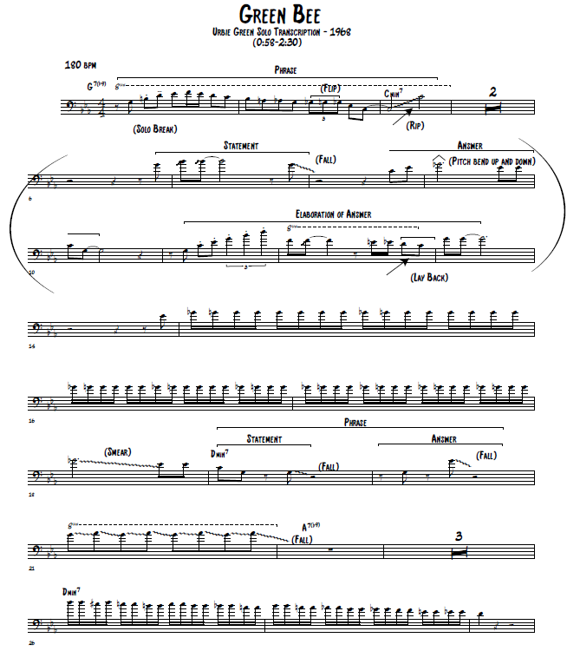
Technical
Perhaps the most impressive and innovative aspect of Green’s solo transpires in his technical ability. To this point in jazz trombone history, no other trombonist had ever recorded such a dazzling feat of trombone technique. Trombonists simply did not possess the ability to do so. The recording being at a relatively comfortable tempo of 180 bpm and in the easy keys C minor and D minor do not detract from the technical phenomena’ that occur in this solo.
To begin with, Green’s use of the upper register far exceeds anything that other trombonists had done prior to him. For example, m. 3 of Green’s solo soars an entire octave higher than any other trombonist studied up until this point of the document. (The note C on beat 2 of this measure is actually another octave higher than originally depicted)
Figure 59. Urbie Green, “Green Bee,” measure 3.
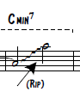
The following figures showcase Green’s extreme agility in the upper register of the trombone. This extreme range remains relevant and difficult even to modern day standards.

Figure 60. Urbie Green, “Green Bee,” measures 1-3.
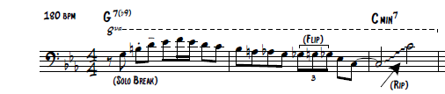

Figure 61. Urbie Green, “Green Bee,” measures 11-13.
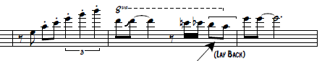
Figure 62. Urbie Green, “Green Bee,” measure 21.
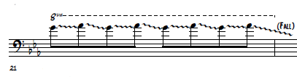
Figure 63. Urbie Green, “Green Bee,” measures 56-61.
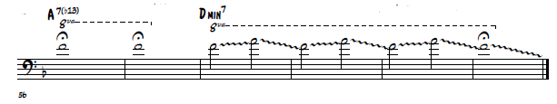
The final aspect of Green’s technical ability was his astonishing capability of playing fast. In order to play the long strings of 16th notes in this solo, Green utilized the technique known as double-tonguing. This technique was by no means “new” in 1968, but for a trombonist to be able to utilize it in such a legato way was quite the novelty. Again, up until Green, no other trombonist was capable of playing with this kind of rapid technique. Because of this exploitation of technique, Green expanded the expectations of what trombonists could really do.

Chapter 10:
A Transcription of the Improvised Solo of Bill Watrous on
“Fourth Floor Walk-up”
Figure 64. Bill Watrous, “Fourth Floor Walk-up,” solo transcription.
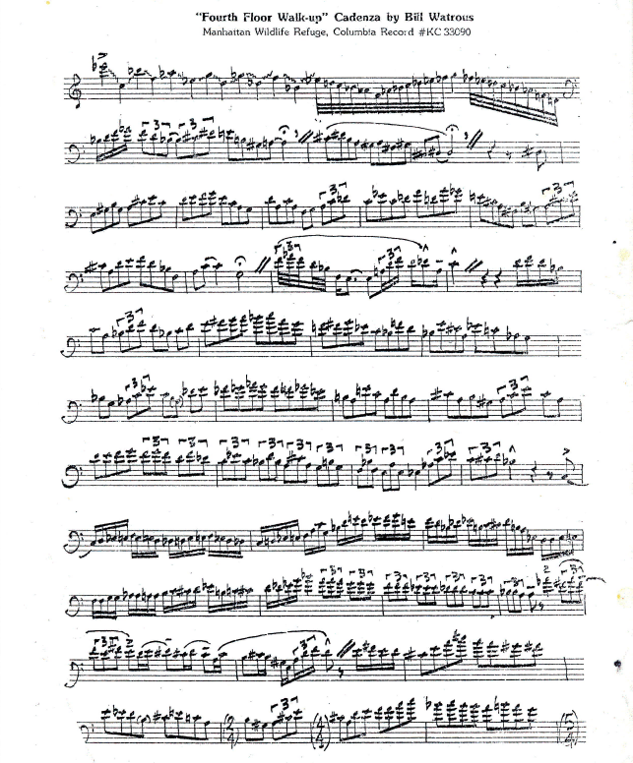
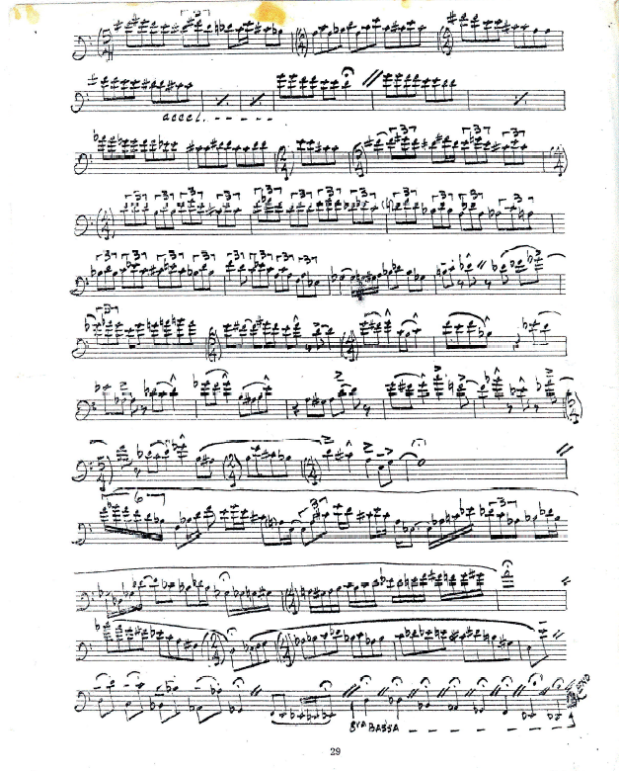
Introduction
Bill Watrous’ cadenza on his “Fourth Floor Walk-up” proved to the trombone community, and to the rest of the jazz community at large, that the trombone as an instrument could finally exceed the technical capabilities of other instruments. Up until this point in history, trombonists had been simply trying to “keep up” with other instruments such as trumpets, saxophones, and pianos. The first trombonist to every truly meet the technical capabilities of other instruments was that of Urbie Green. However, as will be discussed in detail within this chapter, Watrous’ cadenza demonstrates an onslaught of tremendous technique. Amongst this technique however, Watrous’ ability to create harmonic and stylistic sophistication is quite remarkable in its own right. Because of this recording, trombonists had a new “technical” style of playing to aim for.
Public Reaction
Bill Watrous’ selected solo transcription comes from his debut album recording of his tune entitled, “Fourth Floor Walk-up.” This particular recording has mesmerized trombonists for over 40 years. From the time I personally began playing the trombone 15 years ago, countless times have I heard the phrase from various mentors, in regards to this particular solo recording, “When I was your age, I absolutely wore this recording out!” As for me personally, I have as well. Even 40 years later this recorded solo remains at the forefront of jazz trombone innovation. The reasoning for this, in my opinion, is that no other trombonist has been able to match the technical capabilities inherent in Watrous’ playing.
In all honesty, Watrous was the first and arguably the only trombonist in jazz history who could technically out-perform other instruments such as saxophones, trumpets, and pianos. Up until this point in history, the trombone as an instrument was constantly battling its own technical barrier. As technique in the jazz world increased exponentially, the trombone fell further and further behind. However, this recording of Watrous showed the public for the first time that a trombone could actually exceed the technique of other instruments. No longer was the trombone trying to keep up in regards to technique, it was innovating technique. Watrous was simply a phenomenon in this regard.
To support my claims above, please consider the following quotes in regards to this recording.
His (Watrous) command of the instrument was very influential, so I wanted to learn about everything he could do…John Fedchock

I knew about Bill of course when I was starting the trombone and I got my driver’s license in San Jose California. The records that I went and bought that I drove myself to the record store, back when there record stores, was Bill Watrous’ Manhattan Wildlife Refuge and Maynard Ferguson’s Chameleon. I took them home and of course I put Bill’s on first because I was a budding trombone player, and I remember getting to his Fourth Floor Walk-up cadenza and my jaw just dropped and 40 years later is still drops when I hear it. It’s one of the most amazing cadenzas you’ve ever heard for you young folks out there. If you’re not familiar with it, go to youtube and check it out. It will blow your mind and it still does even all these years later…Michael Davis

It (Fourth Floor Walk-up recording) has made such an impact on all of us, so we appreciate the fact that you did it.

Harmonic
Although the entirety of this document has focused harmonically on the local and global levels, this particular solo transcription is not compatible with that type of analysis in that it is a cadenza with no specific set of chord changes. With that being said however, there are numerous instances of harmonic genius throughout this solo transcription that are worth study. In other words, Watrous’ solo is not simply a string of musical technique. There are certainly harmonic patterns that unify the solo together regardless of the absence of chord changes.
To begin with, notice figure 65 on the following page. In this example, Watrous directly arpeggiates a Bb7 chord on beat one of m. 2. This is immediately followed up a half-step to an implied B7 chord later in the measure and throughout mm. 3-4. The B7 chord, does exactly as it should in that it resolves in m. 5 to an E major chord. From this point Watrous, by way of melodic sequence, transposes the original idea stated at the beginning of m. 5 up a 4th to A major on beat 3. The A major chord then gives way, again up a 4th, to the implied D minor chord in m. 6.

Figure 65. Bill Watrous, “Fourth Floor Walk-up,” measures 2-7.
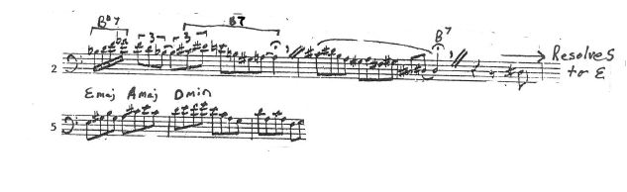
The next example of Watrous’ harmonic language occurs in mm. 7-11. In this instance, Watous utilizes the last triplet of beat four in m. 7 as a pivot note to the new temporary key of Ab major. Watrous could have easily resolved the Db up a half-step to D in order to stay in the key of D minor. However, Watrous obviously had different intentions as he immediately shifted to a key that has no relation to D minor whatsoever. The new key of Ab major is short lived as Watrous tonicizes Bb major on beat 3 of m. 8. This is temporary as well as he immediately resolves the Bb chord to an A7 chord on beat one of m. 9. The A7 chord continues into m. 10, resolving up a half-step to Bb major on beat 3 before resolving unexpectedly to F major in m. 11. Watrous also uses a bit of “bebop” language in that he ends the phrase on the 9th scale degree.

Figure 66. Bill Watrous, “Fourth Floor Walk-up,” measures 7-10.
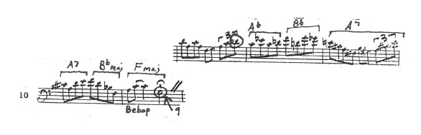
Watrous brings the A7 chord back in m. 21 that resolves to D minor in the following measure. Take notice in figure 67 below that Watrous, much like he did in m. 7, utilizes the Db on the last triplet of beat four as a pivot note into the new key of Ab major in m. 23. Interestingly, mm. 5-8 are harmonically the same as mm. 21-23. As we will see, the collection of the temporary tonal centers Ab, A, and Bb recur several times throughout Watrous’ solo.
Figure 67. Bill Watrous, “Fourth Floor Walk-up,” measures 21-24.
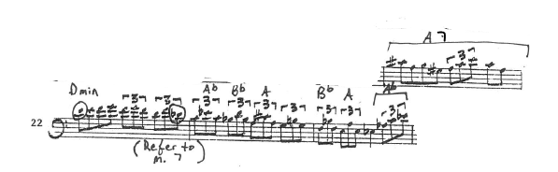
Measures 37-38 shows Watrous tonicizing the tonal center of D minor once again. See the figure below.

Figure 68. Bill Watrous, “Fourth Floor Walk-up,” measures 37-38.
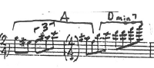
Figure 69 below suggests that Watrous was tonicizing an F chord by way of the C7 chord in m. 41. However, Watrous deploys the A7 chord once again giving the illusion of resolving to D minor. Rather than D minor however, Watrous resolves unexpectedly to D major in m. 42.

Figure 69. Bill Watrous, “Fourth Floor Walk-up,” measures 41-42.
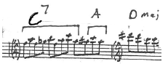

Figure 70 below is a melodic/harmonic sequence that ascends in half-steps.
Figure 70. Bill Watrous, “Fourth Floor Walk-up,” measures 43-49.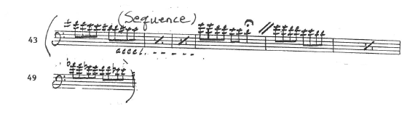
Measures 62-64 present some interesting harmonic activity in that Watrous’ musical line descends in whole-tones. This idea is repeated yet again in mm. 67-69. This time however, the original musical line is varied, but keeps the same descending whole-tone pattern.

Figure 71. Bill Watrous, “Fourth Floor Walk-up,” measures 62-69.
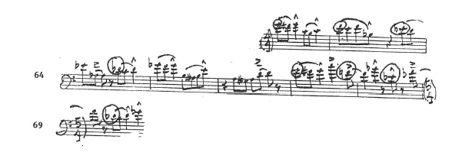
As mentioned earlier, Watrous seems to favor the temporary tonal centers of Ab, A, and Bb. Notice in figure 72 below the return of this pattern.
Figure 72. Bill Watrous, “Fourth Floor Walk-up,” measure 73. 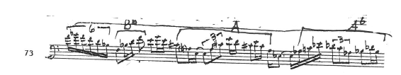

The final harmonic aspect of Watrous’ transcribed solo to be discussed occurs in mm. 81-82. Beat 3 of m. 81, to what I argue, is an implied B7 chord that resolves to an E chord in m. 82. Directly following this, Watrous launches into another descending whole-tone sequence.
Figure 73. Bill Watrous, “Fourth Floor Walk-up,” measure 82.
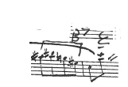
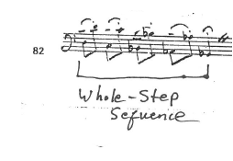
Stylistic
Watrous’ overall style in this solo transcription focuses primarily on technique rather than musical/melodic construction. If fact, Watrous had the following to say in regards to his cadenza;
I’ve been haunted by Fourth Floor Walkup for years. It has the biggest, most exhibitionist cadenza by me, flurries of notes, high and low, and all over the place. John Hammond’s idea was for me to do more melodic material rather than trying to be the Maynard Ferguson of the trombone, although I didn’t agree at the time. I almost totally disregarded the smokey ballads that I’d been doing for years.

With this being said however, this is ultimately an innovative aspect of Watrous’ style. He became known and remains known as a technical master of the instrument. This boisterous style, to which some may label as showing off, has become the norm for trombonists in the modern era who have the capability of pulling it off. Nearly every “popular” modern trombonist has some form of rapid technique that showcases their individual styles. If you have the technique, why not use it? As evidenced in Watrous’ playing, and numerous others who have been affected by his style, he not only demonstrated this rapid technique in isolated cadenza settings, but in all forms of music. Once Watrous recorded this cadenza, the rest of the trombone world recognized the fact that technique at such a level did exist for the trombone. In short, once the expectation was set, trombonists began to practice in order to attempt the techniques made famous by Watrous.
Amongst all of this technique, Watrous’ tone was much the same as his predecessor Urbie Green’s. Every note was perfectly centered and impeccably placed exactly where Watrous wanted it. Taking in account to how quickly this cadenza moves along, Watrous’ ability to maintain such an even/beautiful sound was quite remarkable.
In addition to this, Watrous opted for a variety of different articulations including single tongue, doodle-tongue, and lip breaks, which will be discussed in more detail in the technical section of this chapter below. Stylistically however, these varying articulations added different flavors to the total output of the solo. See figure 74 and 75 below. In figure 74 Watrous utilized the doodle-tongue technique that created a more legato string of triplets. In figure 75 Watrous opted to use the lip break technique in which created a more forceful and less legato result. This simply created stylistic variety amongst Watrous’ rapid technique. In other words, Watrous’ ability to play virtually the same figure in multiple different formats created a variety of stylistic inflection.
Figure 74. Bill Watrous, “Fourth Floor Walk-up,” measures 22-24.
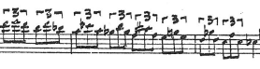
Figure 75. Bill Watrous, “Fourth Floor Walk-up,” measures 53-55.
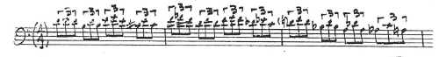
The final aspect of Watrous’ style to be discussed lies in the fact that he often created musical lines that seemed to never end. This was somewhat of the norm for other instruments such as saxophones and trumpets who possessed the technical capability of constructing such lines. For trombonists prior to Watrous however, this technical long demonstration of musical thought inherent in other instruments was only dreamed of. Once Watrous defined the “new” technical style of trombone playing, proving that it was indeed possible, technique became more and more important to the jazz trombone style.

Technical
There is no doubt that Watrous’ technical ability demonstrated in this solo transcription is the main component that makes this recording the innovative artwork that it is. The fact that Watrous was able to generate harmonic sophistication and stylistic innovations amongst his exasperating technical abilities is what makes this solo stand out. For example, Green’s recording of “Green Bee” was a technical work of art, however, there was arguably nothing harmonically or stylistically noteworthy in comparison to Watrous’ recording of “Fourth Floor Walk-up. In other words, Watrous’ technical exhibition did not hinder him from standing out on a harmonic and stylistic level. As a result, it simply made his technique more impressive!
To begin the discussion of Watrous’ technique, refer to figure 76 on the following page. During the lead-up to Watrous’ cadenza the lead trumpet player sustains an Eb4. Immediately after the trumpeter released the note Watrous repeated it in the exact same octave. To put it mildly, 99% of trombonists do not have access to this range. In fact, for most trombonist their usable range caps out at roughly an entire octave below Eb4. After hitting this note, Watrous began rapidly descending and ascending throughout the harmonic series of the trombone. What stands out as so remarkable in this passage is the fact that Watrous’ impressively precise lip flexibility, in combination of his extreme range, gives the illusion of a trumpet, not a trombone, using valves to facilitate the rapid and legato technique.

Figure 76. Bill Watrous, “Fourth Floor Walk-up,” measure 1.
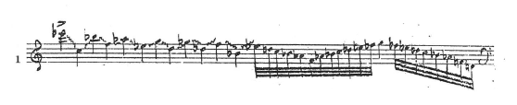
Another technical aspect of Watrous’ playing that was so creative was his use of lip breaks. See figure 75 on the following page for further explanation of this technique taken directly from Bill Watrous’ book entitled Trombonisms.

Figure 77. Lip Break
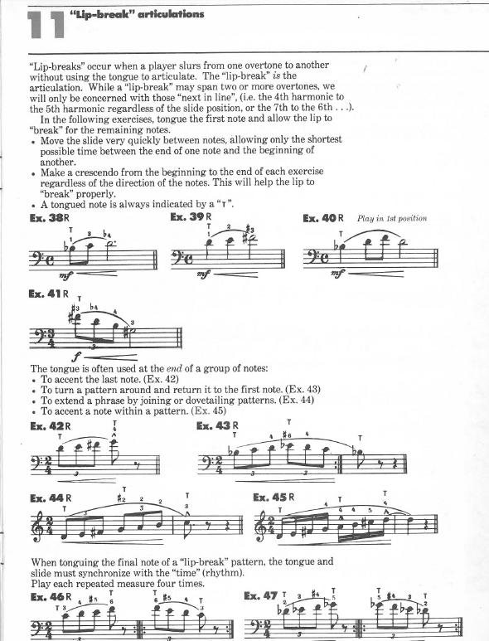
The following figure showcase Watrous’ multiple uses of this technique. (Circled passages denote lip breaks)
Figure 78. Bill Watrous, “Fourth Floor Walk-up,” Lip Break Example.
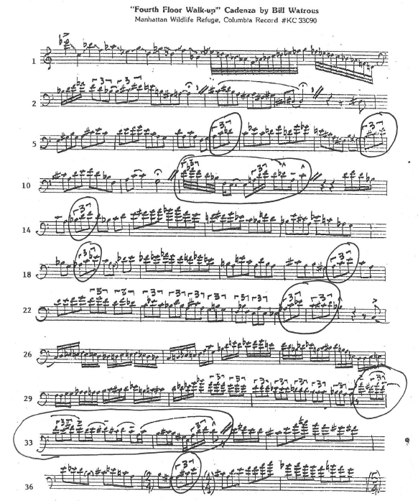

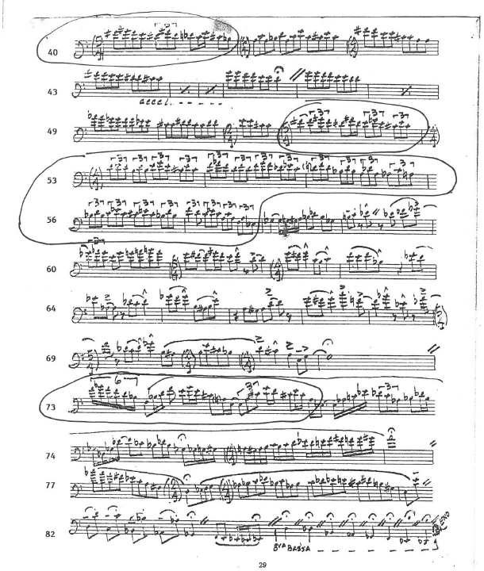

The next aspect of Watrous’ technical ability to be discussed is his impressive use of doodle-tongue. The doodle tongue technique is another form of multiple tonguing. Whereas double tonguing calls for the syllables TAKA, DAGA, TOOKOO, and triple tonguing calls for TATAKA to articulate notes, doodle tonguing literally uses the word doodle to articulate notes. For example, eighth notes would be articulated, “doodle-doodle-doodle,” and triplet figures would be articulated, “doodle-la - doodle-la.” Although one can achieve a rather legato double/triple tongue, as evidenced in Urbie Green’s recording of “Green Bee,” the doodle tongue technique has risen to be the multiple tongue technique of choice for the majority of jazz trombonist simply because it takes less effort and results in an increased legato style.
Figure 79 on the following page showcases the multiple uses of the doodle-tongue technique deployed in Watrous’ solo. (Circled passages denote the use of doodle-tongue) Also, referring back to figure 76 above and figure 77 on the following page, notice that Watrous varies between facilitating his rapid technique with lip breaks and doodle-tongue. In essence, this creates a variety of articulation differences as the doodle-tongue is more legato and the lip breaks come across more forceful.

Figure 79. Bill Watrous, “Fourth Floor Walk-up,” Doodle-Tongue Example.
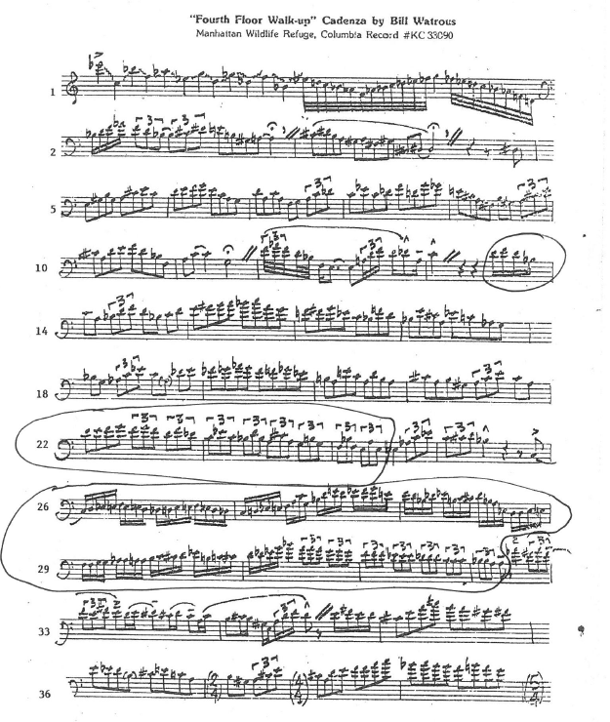
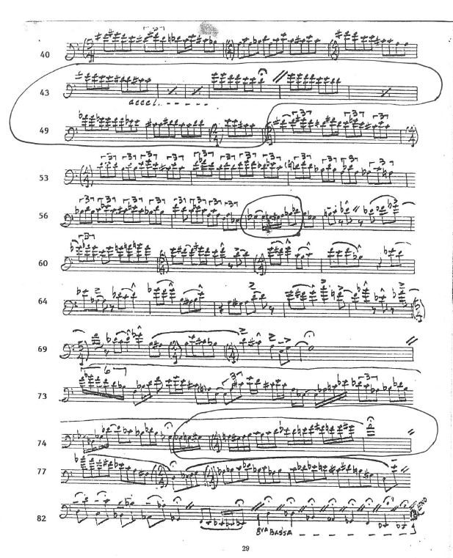
The final element of Watrous’ technique to be addressed is his extreme use of both the low and upper register. As stated earlier, Watrous’ entrance on an Eb4 is roughly an entire octave above the capability of 99% of trombone players in general. To support this further, and Eb4 is rather difficult for most trumpet players.

Figure 80. Bill Watrous, “Fourth Floor Walk-up,” Eb4 Example.
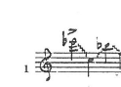
Going in the complete opposite direction, Watrous also utilized the extreme low range of the trombone towards the end of his cadenza. In this instance, Watrous descended down to a pedal Db. This range is even considered quite low for true bass trombonists who have the luxury of two f-attachment valves to make the range assessible. Watrous on the other hand, simply had a straight trombone with no f attachment and was still able to showcase this extreme range with no problem.

Figure 81. Bill Watrous, “Fourth Floor Walk-up,” Low Register.
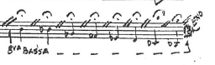

Conclusion and Comparison
In conclusion, considering the provided information in regards to Urbie Green and Bill Watrous above, there should be no argument as to why Watrous’ transcribed solo was far superior harmonically, stylistically, and most notably, technically than that of Green’s. Because of this, it should be clearly evident as to why Watrous was able to assume the dominant jazz trombonist role beginning with his debut album recording released in 1974.
Simply and obviously speaking, Watrous’ solo demonstrated an onslaught of extraordinary technique. Although Green’s solo transcription was impressive in its own right, any musical lay person would agree that Watrous’ solo demonstrated technical ability on a far superior level. In general, Green’s rapid technique was accomplished by way of the double-tongue technique. In comparison, Watrous chose to vary his rapid technique by switching back and forth between lip breaks and doodle-tongue. This ultimately created an additional dimension to Watrous’ solo in that the varied techniques created differing outcomes. For example, the doodle tongue passages were more legato and connected in comparison to the forceful aggressiveness inherent of the lip break technique.
In addition to this, technically speaking, Watrous extended the upper and lower register of the trombone much further than any other trombonist prior to him throughout jazz history. Green’s ability to play a C4 in his solo is nothing to neglect by any means as it is a note rarely attainable by modern day trombonists. However, there is no denying the fact that an Eb4, played by Watrous, was certainly higher and more impressive than the C4 played by Green. Drawing one final comparison in regards to range, Watrous’ solo extended down to a pedal Db, or well over an octave lower than Green’s low A.
Perhaps what was most impressive about Watrous’ solo, in comparison to Green’s, was Watrous’ ability to create harmonic and stylistic sophistication amongst his boundless technique. Generally speaking, there is honestly nothing harmonically innovative about Green’s transcribed solo. He failed/chose not to explore other harmonic avenues in that his solo focused solely on the local harmonies of C minor and D minor. Watrous, on the other hand, tonicized numerous tonal centers throughout his solo, and again, at lightning speed!
Finally, Watrous’ “new” technical style of trombone all but eclipsed that of Green’s. In all honesty, Green started this movement of trombone technique becoming the norm. His 1968 recording of “Green Bee” dazzled audiences. Because of this, Green essentially set the bar to which aspiring trombonists aimed for. When Watrous burst on to the scene however, he took technique to an exponentially higher level. This level of trombone playing, established in 1974, is rarely achieved by trombonists even 40 years later. In other words, we are all still trying to reach the level of Bill Watrous!

Chapter 11: Conclusion
Summary of Findings
What this study has proven is the fact that Jack Teagarden, J.J. Johnson, and Bill Watrous were all innovators harmonically, stylistically, and technically within their respective time periods. In fact, their initial debut solo recordings marked the exact moment the torch was passed from one generation to the next within jazz trombone style. These debut recordings in effect became the starting point to which aspiring trombonists began to aim for in their own individual styles.
Harmonically, these three men expanded the scope and limitations set by their predecessors. Stylistically, they were at the forefront of musical expression, as their predecessors were basically holding on to the past. Technically, these gentlemen did more for the instrument than any other trombonists in history. Within their generations, they set the bar for which all jazz trombonist became expected to reach. In short, Jack Teagarden, J.J. Johnson, and Bill Watrous, by way of their debut solo recordings, were able to change the course of jazz trombone style.

Appendix
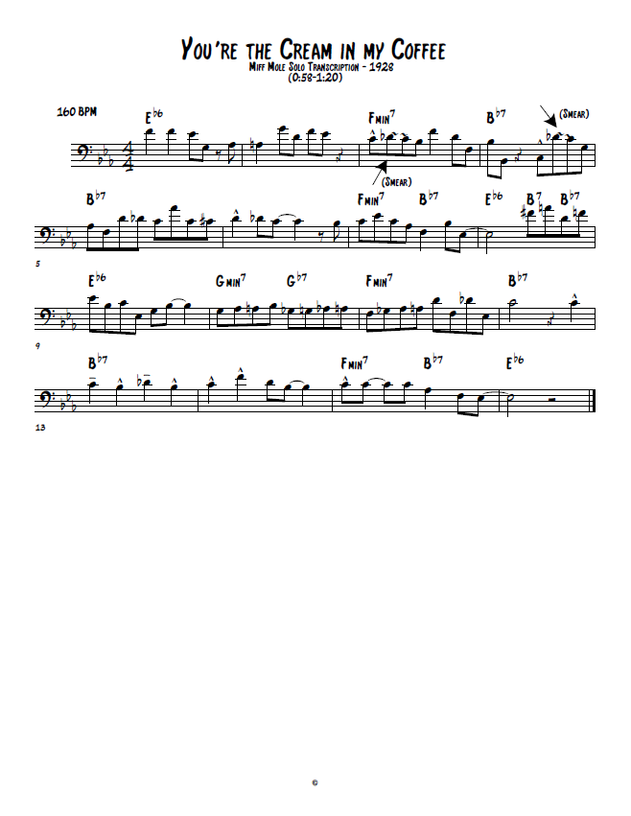
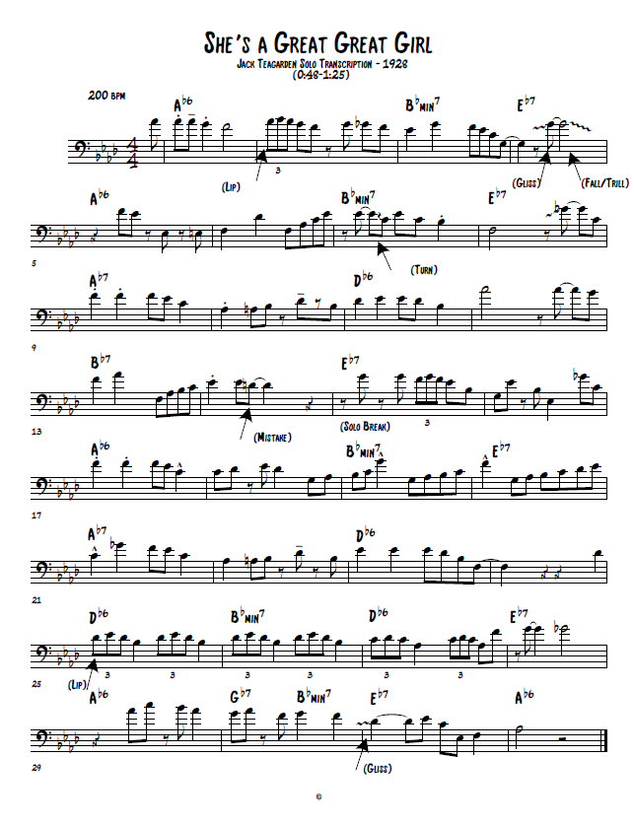

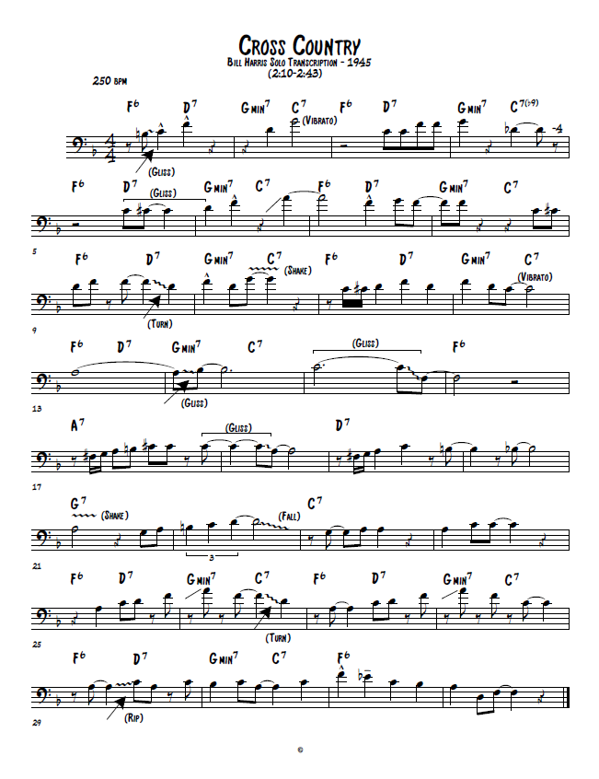

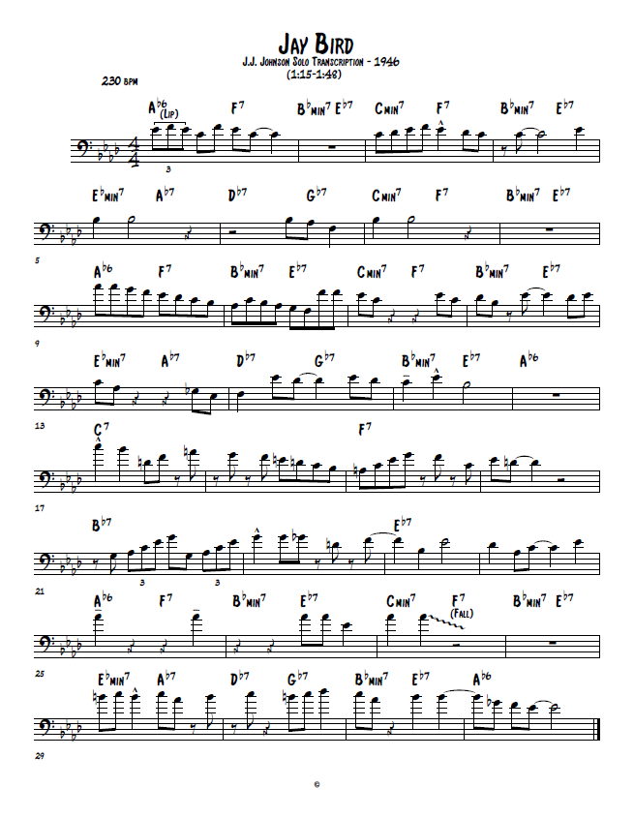
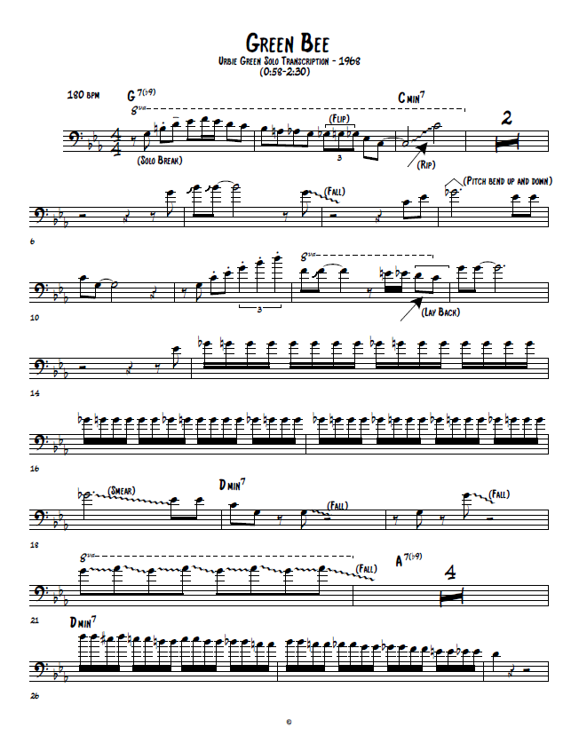
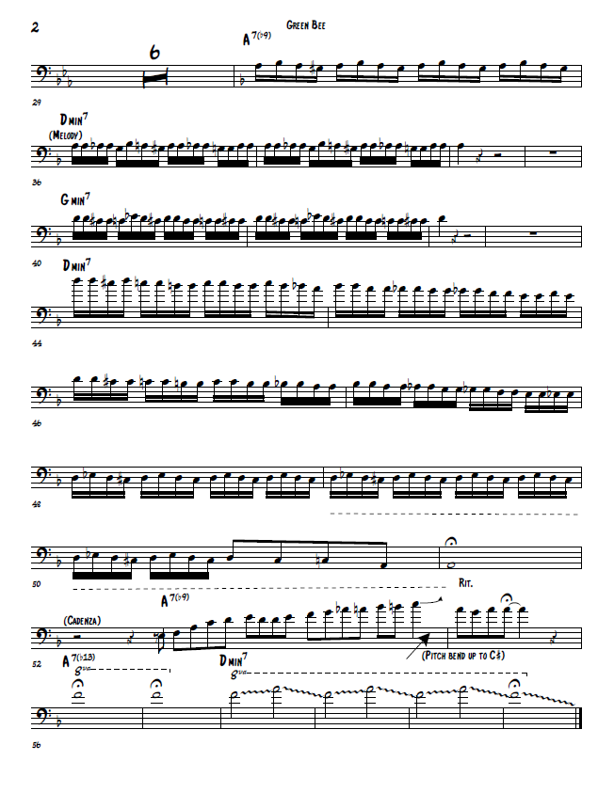

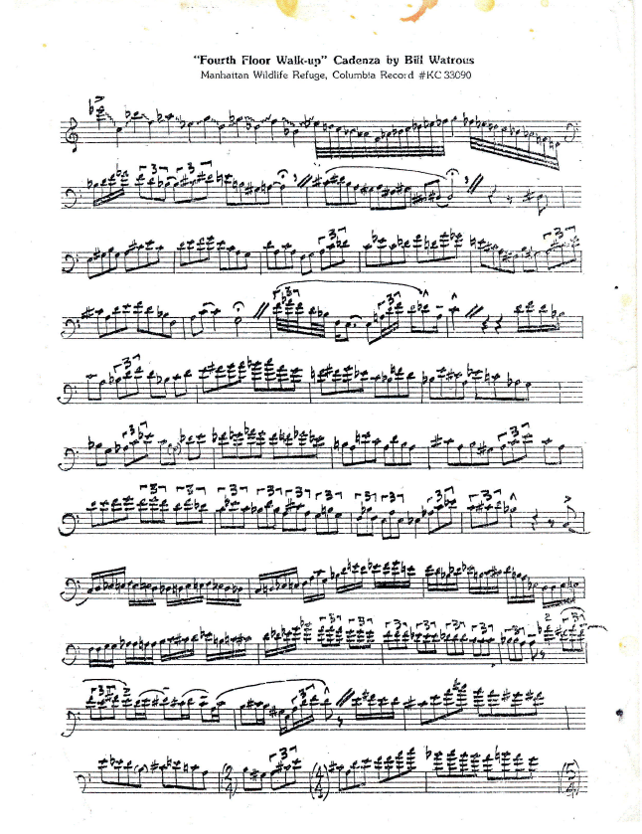

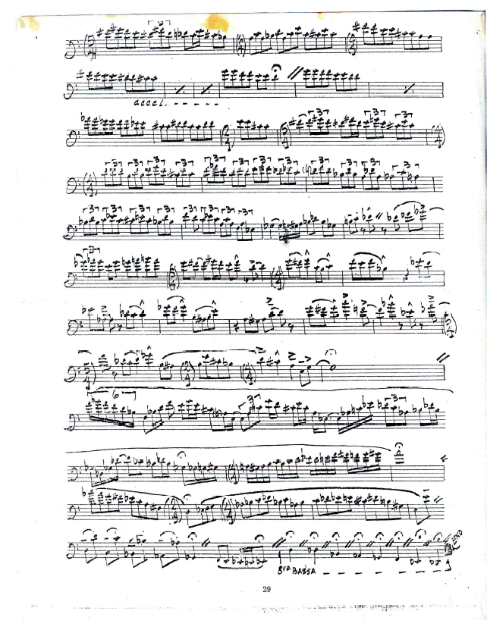

References
Aebersold, Jamey, How to Play Jazz and Improvise, Volume 1, Jamey Aebersold, INC., New Albany, IN, 1967.

Allen, Rex, “Jack Teagarden: An Evaluation of His Style and Contributions to Jazz,” International Trombone Association Journal, Volume 5, U.S.A, January 1977.

Anonymous, The International Trombone Association Newsletter Volume VIII, Number 1, September, 1980.

Berrett, Joshua and Louis Bourgois. The Music World of J.J. Johnson, The Scarecrow Press, The State University of New Jersey, 1999.

Chilton, John, “Bill Harris,” in The New Grove Dictionary of Jazz, St. Martin’s Press, New York, 1994.
Collier, James, The Making of Jazz, Houghton Mifflin Company, Boston, 1978.
Crook, Hal, How to Improvise: An Approach to Practicing Improvisation, Advance Music, Rottenburg, Germany, 1991.
Davis, Michael, Bone2Pick: Bill Watrous Interview, https://www.youtube.com/watch?v=uVNSj2OlgWc (Assessed on April 3, 2018).

Dietrich, Kurt, Jazz ‘Bones: The World of Jazz Trombone, Advance Music, Rottenburg N. Germany, 2005.

Everett, Tom, J.J. Johnson-The Architect of the Modern Jazz Trombone, International Trombone Journal, Vol XVI, Spring of 1988.
Feather, Leonard, liner notes to The Eminent Jay Jay Johnson, Volume 1 (Blue Note 81505, 1953).
Gendrich, Julie, Bonanza: Insights and Wisdom from Professional Jazz Trombonists, Advance Music, Rottenburg N. Germany, 2011.

Giddins, Gary, “The Best Trombone Player in the World,” originally published in The Village Voice, March 1977; reprinted in Riding on a Blue Note: Jazz & American Pop, Oxford University Press, 1981.
Giddins, Gary, Visions of Jazz, Oxford University Press, Inc, New York, 1998.
Gilter, Ira, Jazz Masters of the Forties, Macmillan, New York, 1966.
Hadlock, Richard, Jazz Masters of the Twenties, Macmillan Publishing Company, New York, 1965; Reprint, Collier Books, New York, 1974.
Herwig, Conrad, Fond Memories of Frank Rosolino: Historical Notes and Solo Transcriptions, Double-Time Records, New Albany, IN, 1996.

Levine, Mark, The Jazz Theory Book, Sher Music Company, Petaluma, CA, 1995.
McRae, Barry, The Jazz Handbook, G.K. Hall, Boston, 1987.
Schuller, Gunther, The Swing Era: The Development of Jazz, 1930-1945, Oxford University Press, Oxford and New York, 1989.
Simon, George T, The Big Band, 4th ed., Simon and Schuster Macmillan, New York, 1991.

Smith, Jay and Len Guttridge, Jack Teagarden: The Story of a Jazz Maverick, Cambridge: Da Capo Press, 1960.
Spilka, Bill, “An Interview with Urbie Green” (10/10/1975), International Trombone Association Newsletter, Volume V, No. 1, September, 1977.
Steed, Bret, Bring It!, “Genealogy Blues,” 2016.
Tanner, Paul, David Megill, and Maurice Gerow, Jazz: Eleventh Edition, McGraw Hill, New York, 2009.
Watrous, Bill and Alan Raph, Trombonisms, Carl Fischer, Inc., New York, 1983.
Wells, Dicky, The Night People: The Jazz Life of Dicky Wells, Smithsonian Institution Press, London, 1991.
Yanow, Scott, Jazz on Record: The First Sixty Years, Backbeat Books, New York, 2003.
Yanow, Scott, Classic Jazz: The Musicians and Recordings that Shaped Jazz, 1895 1933, Backbeat Books, New York, 2001.
“Cross Country,” Bill Harris and His Septet, Keynote Recordings, Inc., New York, April 5, 1945.

Finale 2014, Make Music Inc, 1987-2014.

“Fourth Floor Walkup,” Manhattan Wildlife Refuge, Columbia Records, New York, 1974.

“Geen Bee,” 21 Trombones Vol. 2, Project 3 Records, New York, 1969.

“Improvisation,” https://www.merriamwebster.com/dictionary/improvisation
(January 1, 2018)
“Improvisation,” https://www.britannica.com/art/improvisation-music
(January 7, 2018)
“Jay Bird,” New Trends in Jazz, Volume 11, Savoy Records, New Jersey, June 26, 1946.

Liner Notes for The Complete Columbia J.J. Johnson Small Group Sessions, Mosaic MD7-169.
“She’s a Great, Great Girl,” Roger Wolfe Kahn and His Orchestra, Victor Talking Machine Company, New Jersey, 1928.

“Transcribing,” https://www.merriam-webster.com/dictionary/transcribing (January 15, 2018)
Transcribe!, Version 8.40.0 for Windows, Seventh String Software, 1998-2014.

“You’re the Cream in my Coffee,” Miff Mole and His Little Molers, Okeh Phonograph Corporation, New York, 1928.

Dietrich, Kurt, Jazz ‘Bones: The World of Jazz Trombone, Advance Music, Rottenburg N. Germany, 2005, pg. 45.
Dietrich, pg. 353.
Gendrich, Julie, Bonanza: Insights and Wisdom from Professional Jazz Trombonists, Advance Music, Rottenburg N. Germany, 2011.
Dietrich, pg. 56-57.
Allen, Rex, Jack Teagarden: An Evaluation of His Style and Contributions to Jazz, International Trombone Association Journal, Volume 5, U.S.A, January 1977.
Dietrich, pg. 199-200.
Berrett, Joshua and Bourgois, Louis, The Music World of J.J. Johnson, The Scarecrow Press, The State University of New Jersey, 1999, pg. 44.
Dietrich, pg. 355.
“You’re the Cream in my Coffee,” Miff Mole and His Little Molers, Okeh Phonograph Corporation, New York, 1928.
“She’s a Great, Great Girl,” Roger Wolfe Kahn and His Orchestra, Victor Talking Machine Company, New Jersey, 1928.
“Cross Country,” Bill Harris and His Septet, Keynote Recordings, Inc., New York, April 5, 1945.
“Jay Bird,” New Trends in Jazz, Volume 11, Savoy Records, New Jersey, June 26, 1946.
Dietrich, pg. 199-200.
“Geen Bee,” 21 Trombones Vol. 2, Project 3 Records, New York, 1969.
“Fourth Floor Walkup,” Manhattan Wildlife Refuge, Columbia Records, New York, 1974.
Transcribe!, Version 8.40.0 for Windows, Seventh String Software, 1998-2014.
Finale 2014, Make Music Inc, 1987-2014.
“Improvisation,” Merriam Webster.com, 2018, https://www.merriam-webster.com/dictionary/improvisation, (January 1, 2018)
“Improvisation,” Britannica.com, 2018, https://www.britannica.com/art/improvisation-music, (January 7, 2018)
Aebersold, Jamey, How to Play Jazz and Improvise, Volume 1, Jamey Aebersold, INC., New Albany, IN, 1967, pg. 3.
Aebersold, pg. 23
Levine, Mark, The Jazz Theory Book, Sher Music Company, Petaluma, CA, 1995, pg. vii.
Aebersold, pg. 4.
Aebersold, pg. 2
Tanner, Paul, Megill, David, Gerow, Maurice, Jazz: Eleventh Edition, McGraw Hill, New York, 2009, pg. 4.
Crook, Hal, How to Improvise: An Approach to Practicing Improvisation, Advance Music, Rottenburg, Germany, 1991, pg. 10.
Crook, pg. 10.
Herwig, Conrad, Fond Memories of Frank Rosolino: Historical Notes and Solo Transcriptions, Double-Time Records, New Albany, IN, 1996, pg. 10.
“Transcribing,” Merriam Webster.com, 2018, https://www.merriam-webster.com/dictionary/transcribing, (January 15, 2018)
Levine, pg. 251-252.
Levine, pg. 251
Levine, pg. 252.
Dietrich, pg. 30.
Wells, Dicky, The Night People: The Jazz Life of Dicky Wells, Smithsonian Institution Press, London, 1991, pg. 8-9.
Yanow, Scott, Jazz on Record: The First Sixty Years, Backbeat Books, New York, 2003, pg. 90.
Dietrich, pg. 31.
Dietrich, pg. 31.
Dietrich, pg. 31.
Yanow, Scott, Classic Jazz: The Musicians and Recordings that Shaped Jazz, 1895-1933, Backbeat Books, New York, 2001, pg. 156.
Yanow, Scott, 2001, pg. 156.
Dietrich, pg. 31.
Dietrich, pg. 31.
Dietrich, pg. 31.
Dietrich, pg. 32.
Dietrich, pg. 31.
Dietrich, pg. 48.
Allen, Rex, Jack Teagarden: An Evaluation of His Style & Contribution to Jazz, Volume 5, January 1977, International Trombone Association, Hattiesburg, MS, 1977, pg. 35.
Allen, pg. 35, originally taped interview with Forest Mahannah, May, 1958.
Dietrich, pg. 45.
Dietrich, pg. 45.
Dietrich, pg. 46.
Smith, Jay and Guttridge, Len, Jack Teagarden The Story of a Jazz Maverick, Cambridge: Da Capo Press, 1960, pg. 21.
Dietrich, pg. 46.
Dietrich, pg. 46.
Collier, James, The Making of Jazz, Houghton Mifflin Company, Boston, 1978, pg. 134.
Collier, pg. 134.
Dietrich, pg. 48.
Dietrich, pg. 46.
Dietrich, pg. 48.
Smith and Guttridge, pg. 75.
Dietrich, pg. 49.
Giddins, Gary, Visions of Jazz, Oxford University Press, Inc, New York, 1998, pg. 163.
Dietrich, pg. 51.
Dietrich, pg. 52.
Dietrich, pg. 53.
Dietrich, pg. 53.
Dietrich, pg. 53.
Dietrich, pg. 54.
Dietrich, pg. 55.
Simon, George T, The Big Band,. 4th ed., Simon and Schuster Macmillan, New York, 1991, pg. 432.
Giddins, Gary, The Best Trombone Player in the World, originally published in The Village Voice, March 1977; reprinted in Riding on a Blue Note: Jazz & American Pop, Oxford University Press, 1981.
Dietrich, pg. 57.
Dietrich, pg. 57.
Hadlock, Richard, Jazz Masters of the Twenties, Macmillan Publishing Company, New York, 1965; Reprint, Collier Books, New York, 1974, pg. 191.
Schuller, Gunther, The Swing Era: The Development of Jazz, 1930-1945, Oxford University Press, Oxford and New York, 1989, pg. 738.
Dietrich, pg. 175.
Chilton, John, The New Grove Dictionary of Jazz, “Bill Harris,” St. Martin’s Press, New York, 1994, pg. 91.
Dietrich 175.
Chilton, pg. 91.
Dietrich, pg. 175.
Dietrich, pg. 175.
Dietrich, pg. 182.
Liner Notes for The Complete Columbia J.J. Johnson Small Group Sessions, Mosaic MD7-169.
Berrett, Joshua and Bourgois, Louis, The Music Word of J.J. Johnson, The Scarecrow Press and Institute of Jazz Studies, Rutgers – The State University of New Jersey, Lanham, Maryland, and London, 1999.
Dietrich, pg. 199.
Gilter, Ira, Jazz Masters of the Forties, Macmillan, New York, 1966, pg. 139-140.
Dietrich, pg. 199.
Dietrich, pg. 200.
Originally in Down Beat Magazine, quoted in Berrett and Bourgois, pg. 44.
Dietrich, pg. 200.
Gitler, pg. 146.
Berrett and Bourgois, pg. 80.
Dietrich, pg. 201.
Dietrich, pg. 202.
Berrett and Bourgois, pg. 136.
Dietrich, pg. 204.
McRae, Barry, The Jazz Handbook, G.K. Hall, Boston, 1987, pg. 114-115.
Dietrich, pg. 206.
Gitler, pg. 146.
Feather, Leonard, liner notes to The Eminent Jay Jay Johnson, Volume 1 (Blue Note 81505, 1953).
Interview with Bill Watrous, Gendrich, pg. 466.
Interview with John Fedchock, Gendrich, pg. 125.
Biographical information largely derived from Marlyn Rickard’s Thesis, Urbie Green: A Study of His Musical Career.
Spilka, Bill, An Interview with Urbie Green (10/10/1975), International Trombone Association Newsletter, Volume V, No. 1, September, 1977, pg. 22.
Spilka, pg. 22.
Spilka, pg. 22.
Spilka, pg. 24.
Dietrich, pg. 218.
Dietrich, pg. 219.
Spilka, pg. 25.
Dietrich, pg. 219.
Dietrich, pg. 219.
Dietrich, pg. 221.
Dietrich, pg. 222.
Interview with Mike Fahn, Gendrich, pg. 117.
Dietrich, pg. 353.
Gendrich, pg. 457.
Gendrich, pg. 463.
Gendrich, pg. 464.
Dietrich, pg. 355.
Dietrich, pg. 355.
Dietrich, pg. 355.
Dietrich, pg. 356.
Dietrich, pg. 356
Dietrich, pg. 356.
Dietrich, pg. 357.
Dietrich, pg. 53.
Dietrich, pg. 48.
Allen, International Trombone Association Journal, January 1977, pg. 37.
Allen, 37.
Allen, pg. 37.
Steed, Bret, Bring It!, “Genealogy Blues,” 2016.
Allen, pg. 37.
Allen, pg. 37.
Dietrich, pg. 199-200.
Everett, Tom, J.J. Johnson-The Architect of the Modern Jazz Trombone, International Trombone Journal, Vol XVI, Spring of 1988, pg. 31.
Dietrich, pg. 200.
Anonymous, The International Trombone Association Newsletter Volume VIII, Number 1, September, 1980, pg. 28-29.
Gendrich, Interview with John Fedchock, pg. 125.
Davis, Michael, Bone2Pick: Bill Watrous Interview, https://www.youtube.com/watch?v=uVNSj2OlgWc Assessed on April 3, 2018. (Michael Davis is a highly popular modern day jazz trombonist. He is most well-known as trombonist for the Rolling Stones.)
Davis, https://www.youtube.com/watch?v=uVNSj2OlgWc Assessed on April 4, 2018.
Dietrich, pg. 356.
Watrous, Bill, Raph, Alan, Trombonisms, Carl Fischer, Inc., New York, 1983, pg. 11.

