UNIVERSITY OF OKLAHOMA
GRADUATE COLLEGE

EXAMINING THE INFLUENCE OF SOCIAL COMPARISON ON PSYCHOLOGICAL REACTANCE

A THESIS
SUBMITTED TO THE GRADUATE FACULTY
in partial fulfillment of the requirements for the
Degree of
MASTER OF ARTS

By
DINGYI KANG
Norman, Oklahoma
2020

EXAMINING THE INFLUENCE OF SOCIAL COMPARISON ON PSYCHOLOGICAL REACTANCE

A THESIS APPROVED FOR THE
DEPARTMENT OF COMMUNICATION

BY THE COMMITTEE CONSISTING OF

Dr. John Banas, Chair
Dr. Elena Bessarabova
Dr. Patrick Meirick

© Copyright by DINGYI KANG 2020
All Rights Reserved

Acknowledgements
First, I’d like to thank my advisor, Dr. John Banas. You have a very warm and thoughtful heart. Before the first time I came to America, you had emailed me actively and were concerned about my international traveling, which not only alleviated my anxiety about the upcoming uncertainty but also gave me an excellent first impression of the people living in this great country. At the beginning of my first semester here, I had no idea about the local culture and norms, and it was you who helped me gradually adapt to academic life here. I greatly appreciate that you introduced your lovely family to me and invited me to your house every semester, which made me, an international student, much less lonely. Many international students are jealous of me because of this. I also appreciate the great patience you have shown to me. You helped me edit this thesis for six rounds, and you still thanked me for choosing you as advisor. You gave me so much moral support which made me confident and optimistic. You are a role model for me.
Thank you to my committee member, Dr. Elena Bessarabova. Thanks for being patient with me when we were discussing the research design of this project. I am a very stubborn person, and you communicated with me very well, showing that you truly care about me. You also have provided me much selfless technical support, and I do very much appreciate that! Last but not least, you are the role model for me in balancing academic pursuit and family. Every time I saw you and your lovely family, my hope of having a family as happy as yours was rekindled.
Thank you to my committee member, Dr. Patrick Meirick. Through conversations with you, I was impressed by your passion for academia. I will never forget, when I had a difficulty in finding an appropriate committee member for my thesis, it was you who readily gave me your consent. I do appreciate your kindness, your great patience, and your valuable advice. You are a role model in pursuing family happiness and academic success.
Moreover, I was very lucky to receive countless help from many people at Oklahoma since I came here. I want to give special thanks to all kind people living in this state. At the end, a special thank goes to my parents and grandparents. Different from other parents in my hometown, you always care and respect my opinions. I am very proud of our democratic family. Without your supports, I could not pursue my dream here. No words can express how grateful I am to you. Mom, Dad, and Grandmas, I love you. Your love to me is the most precious gift God gave me.

Table of Contents
Acknowledgements iv
Abstract ix
Chapter 1: Introduction 1
Chapter 2: Theoretical Rationale 2
Psychological Reactance Theory 2
Social Comparison Theory 3
Chapter 3: Study 1 9
Method 9
Participants 9
Design and Procedures 9
Instrumentation 12
Results 15
Covariate Effects 16
Hypotheses Tests 16
Discussion 20
Chapter 4: Study 2 22
Method 22
Participants 22
Design and Procedures 22
Instrumentation 24
Results 26
Covariate Effects 26
Hypotheses Tests 27
Discussion 29
Chapter 5: General Discussion 31
Limitations and Future Directions 33
Conclusion 35
References 36
Appendix A - Low Controlling-No Contrast-OSU Advocacy Message 39
Appendix B - High Controlling-No Contrast-OSU Advocacy Message 39
Appendix C - Low Controlling-Downward Contrast-OSU Advocacy Message 40
Appendix D - High Controlling-Downward Contrast-OSU Advocacy Message 41
Appendix E - Low Controlling-Upward Contrast-OSU Advocacy Message 41
Appendix F - High Controlling-Upward Contrast-OSU Advocacy Message 42
Appendix G - Low Controlling-No Contrast-UT Advocacy Message 43
Appendix H - High Controlling-No Contrast-UT Advocacy Message 44
Appendix I - Low Controlling-Downward Contrast-UT Advocacy Message 44
Appendix J - High Controlling-Downward Contrast-UT Advocacy Message 45
Appendix K - Low Controlling-Upward Contrast-UT Advocacy Message 46
Appendix L - High Controlling-Upward Contrast-UT Advocacy Message 46
Appendix M – Behavioral Intention and Reactance index 47
Appendix N –Attitude index 48
Appendix O – Social Comparison Orientation Index 48
Appendix P – Identification with OU Index 49

Abstract
This thesis integrates social comparison theory (Festinger, 1954) and psychological reactance theory (Brehm, 1966) to examine the effects of controlling language and comparison types on psychological reactance and attitudes. Two 3 (comparison types: upward contrast vs. no contrast vs. downward contrast) × 2 (controlling language: high vs. low) independent group experiments were conducted. Both studies revealed main effects of controlling language on perceived threat to personal freedom and anger in response to the message. The results also revealed the main effects of comparison types on anger to the messages and attitude to recycling. For anger to the message, there were no interaction effects between comparison types and controlling language on it in neither of these studies. However, for attitude to recycling, Study 1 revealed that the effect of controlling language on it could be overwhelmed and neutralized by the effects of both upward contrast and downward contrast on it.
Key words: psychological reactance theory, social comparison theory, comparison types, controlling language, persuasion

Chapter 1: Introduction
Modern lives are filled with various persuasive messages, such as commercials, political propaganda and health advocacy. Many of them attempt to change our minds without our awareness and reactance. According to psychological reactance theory (Brehm, 1966), people are supposed to feel reactance and thus resist advocacy when they perceive their personal freedoms are threatened by the advocacy. However, there are many factors that have the potential to reduce individuals’ reactance to persuasive appeals. For example, according to the original social comparison theory (Festinger, 1954), social comparison has the ability to shape people’s perception of their relative standing, which may make individuals have better feelings about themselves, thereby reducing the magnitude of their psychological reactance to the advocacy messages. For instance, by pointing out how much more housework other children have to do, parents may make some of their children have better feelings about their standing, thereby encouraging message acceptance regarding chores. Similarly, a university may also make its students perceive an upcoming recycling policy or energy-conservation policy less threatening to their personal freedom by pointing out how much stricter the policies of other universities are.
Although social comparison may play a critical role in shaping peoples’ perceptions of their relative standing and thus reducing psychological reactance, the impact of social comparison on psychological reactance has not drawn much scholarly attention. A primary goal of this study is to fill this theoretical gap by systematically examining the impact of different types of social comparison and the degree of controlling language on psychological reactance and attitude in persuasion.
This research is important not only because it attempts to integrate social comparison theory with psychological reactance theory, but also because it may inform us the mechanism of how social comparison works in persuasion and further offer insights about how we may defend our personal freedom from social comparison influence. Below is the theoretical rationale for the hypotheses of this study.

Chapter 2: Theoretical Rationale

Psychological Reactance Theory
The theory of psychological reactance proposes that individuals will experience psychological arousal when they perceive their personal freedoms are threatened (Brehm, 1966). Perceived threat to personal freedoms could result from forceful, controlling language being used in an advocacy, even if the appeal is consistent with the original attitude of individuals (Worchel & Brehm, 1970). Psychological reactance further motivates people to restore their threatened freedoms in various ways, including resistance to the advocated positions and derogation of the message source (Miller, Massey, & Ma, 2018).
When Brehm (1966) first developed psychological reactance theory, he described reactance as an aroused motivational state that was not measurable. However, more recent research (Dillard & Shen, 2005) has demonstrated reactance to be an experiential state and mapped anger and negative cognition as the critical factors to measure reactance. This model of reactance was further confirmed by follow-up studies (e.g., Rains et al., 2007; Rains, 2013). This progress in understanding the nature of reactance infused new life into research on psychological reactance and spurred numerous relevant studies. Among them is the impact of language on psychological reactance.
Controlling language. The language used in persuasive messages is known to impact individuals’ attitudes toward the advocated positions. There are many dimensions of language in persuasion, such as intensity, explicitness, and lexical concreteness (Miller, Massey, & Ma, 2018). One of the core independent variables that was tested in this study is controlling language. High-controlling language is characterized by high frequency of using imperatives, namely commands and orders, while low-controlling language is characterized by high frequency of propositions or polite suggestions (McLaughlin, Shutz, & White, 1980). Prior studies on psychological reactance theory continually demonstrate that high-controlling language induces more perceived threats to freedoms and thus arouses higher reactance compared to low-controlling language (Bessarabova, Fink, & Turner, 2013; Miller et al, 2007; Xu, 2017). Based on psychological reactance theory and prior studies, the following hypothesis is deduced:
H1: There is a main effect of controlling language on all outcomes such that, relative to low-controlling language, high-controlling language increases (a) perceived threats to personal freedom, (b) anger toward the message, (c) negative relevant thoughts, and decreases (d) positive attitudes and (e) behavioral intentions.
In addition to controlling language, another critical factor this study aims to investigate is the social comparison applied in persuasion.

Social Comparison Theory
Social comparison is defined as the process of evaluating one’s abilities or opinions by thinking about the information of one or more other people in relation to the self (Festinger, 1954). This means the comparers seek or notice the similarities or differences of the comparison targets on certain dimensions. Under the general framework of Festinger’s (1954) social comparison theory, there are multiple specific social comparison theories, such as downward comparison theory (Will, 1981), upward comparison theory (Collins, 1996, 2000), and self-evaluation theory (Tesser, 1988). These theories mainly focus on how individuals utilize different types of social comparison as strategies to maintain or restore their self-evaluation and how different social comparisons may influence individuals’ affect or behaviors. For instance, Collins (1996, 2000) proposed that people tend to maintain or boost their self-esteem by assimilating their self-evaluation upward to those who are better off. Nevertheless, no scholarly attention has been paid to how different types of social comparison may work in persuasion. To address this theoretical gap, the current study aims to explore social comparison from the perspective of psychological reactance theory.
Integration between social comparison and psychological reactance. Festinger (1954) notes comparisons only have impact when they serve self-evaluation or self-enhancement. According to Festinger (1954), self-evaluation refers to an individual’s motive to ascertain their capabilities of doing and to hold correct perceptions, beliefs, and values. On the contrary, self-enhancement refers to the motive to feel better and to avoid the negative effects from threatening information.
Compared to self-evaluation, which is driven by epistemic need, self-enhancement as a hedonic motive is more relevant in terms of integrating social comparison theory with psychological reactance theory. According to Dillard and Shen’s (2005) intertwined model of reactance, psychological reactance has two key components: anger and negative cognition. At the same time, social comparison theory (Festinger, 1954) points out the comparison serving self-enhancement can induce better feelings and protect subjects from the negative impacts of the threats to self-esteem. Hence, it is theoretically possible that the comparison serving self-enhancement may be able to lower the magnitude of psychological reactance by countering the anger of reactance. Specifically, strategic incorporation of the comparison serving self-enhancement in persuasion may boost positive feelings, countering the negative feelings associated with reactance, thus decreasing the magnitude of reactance and facilitating the formation of positive attitude to advocacy and the adoption of proposed behaviors. Conversely, incorporation of the comparison harming self-enhancement in persuasion may decrease positive feelings, aggravate the negative feelings associated with reactance, thus increasing the magnitude of reactance and impeding the formation of positive attitude to advocacy and the adoption of proposed behaviors.
Although comparisons serving self-enhancement may potentially counteract anger stemming from reactance, the remaining issues are what types of social comparison can serve or harm self-enhancement and how to induce social comparison as a message strategy in persuasion. Below, a brief discussion about these issues is provided.
Types of comparison. According to Gerber, Wheeler, and Suls (2018), there are generally three directions of social comparison: downward comparison, upward comparison, and peer comparison. In downward comparison, people compare themselves with a standard which is worse off than themselves; in upward comparison, people compare themselves with a standard which is better off; in peer comparison, people compare themselves with people who are similar with themselves. Additionally, there are also two types of general reactions to these comparisons in different directions, namely contrast and assimilation (Gerber, Wheeler, & Suls, 2018). Assimilation refers to that comparer’s self-evaluation moves toward the comparison standard while contrast refers to that comparer’s self-evaluation moves away from the comparison standard. Suls and Bruchmann (2013) notes that, when exposed to social comparisons, comparers can choose to either contrast or assimilate with the comparison targets on relevant attributes. If comparers in exposure of the downward comparison in the targeted dimension do contrast with the targets, their feelings will be displayed upward and the better feelings about their standing will be created. This specific comparison outcome is called upward contrast. If comparers in exposure of the downward comparison in the targeted dimension assimilate with the targets, their feelings will be displaced downward and the worse feeling about their standing will be created. This specific comparison outcome is called downward assimilation which, however, rarely occurs. Conversely, if comparers in exposure of the upward comparison in the targeted dimension do contrast with the targets, their feelings will be displayed downward and the worse feelings about their standing will be created. This specific comparison outcome is called downward contrast. If comparers in exposure of the upward comparison in the targeted dimension assimilate with the targets, their feelings will be displaced upward and the better feeling about their standing will be created. This specific comparison outcome is called upward assimilation. Hence, it is easily to deduct that upward contrast and upward assimilation can serve self-enhancement while downward contrast and down contrast and downward assimilation can harm self-enhancement.
As for how to induce social comparison as a message strategy, Suls and Bruchmann (2013) noted that social comparison can be integrated into persuasion if the audience’s relative standing with others on relevant attributes is salient in the communication. For example, community residents who were informed that they had more than the average number of risk factors of a group of 100 other people were more likely to undergo colorectal screening relative to the residents who did not receive such comparative risk information (Lipkus & Klein, 2006). Hence, by directly providing audience the information regarding their relative standing with others on relevant attributes, different types of social comparison can be induced into persuasion. This thesis tries to make subjects engage in different types of social comparison by directly providing them the information regarding their relative standing with others. Moreover, similar with the study of Lipkus and Klein (2006) which provide residents the comparative risk information with specific comparison reaction, namely higher risk than average (i.e., downward contrast), this thesis also adopted the specific comparison outcomes including downward contrast, no contrast, and upward contrast as the comparison types. Specifically, in this thesis, downward contrast corresponds with more limitations than targets, the no contrast corresponds with equal limitations with targets, and upward contrasts corresponds with less limitations than targets.
In addition to the types of comparison mentioned above, comparison targets also make a difference in the effect of social comparison. According to the target immediacy theory (Zell & Alicke, 2010), comparers tend to code the degree of closeness between the comparing targets with themselves when making social comparisons, and the comparison with a close target tends to have larger effects on comparers than a distant target. Moreover, Suls and Bruchmann (2013) also point out that social comparison tends to function optimally when it is with someone or entity who is similar to the comparer on related attributes. Hence, given this thesis does not aim to explore the effects of different comparison targets, this thesis uniformly adopts peers as the comparison targets in different comparison conditions.
As discussed above, strategic incorporation of the comparison serving self-enhancement in persuasion could boost positive feelings and counter the negative feelings associated with reactance, thus facilitating the formation of positive attitudes to the adoption of proposed behaviors. Conversely, incorporation of the comparison harming self-enhancement in persuasion could decrease positive feelings, aggravate the negative feelings accompanied with the reactance, and increase the magnitude of reactance, thus impeding the formation of positive attitudes to advocacy and the adoption of proposed behaviors. Considering that upward contrast is associated with better feelings about their standing while downward contrast is associated with worse feelings about their standing (Suls & Bruchmann, 2013), it is reasonable to deduct that, relative to no contrast, upward contrast can boost positive feelings, lower reactance to the appeals, and increase relevant positive attitudes and behavioral intention. Conversely, relative to no contrast, downward contrast can lower positive feelings, increase reactance to the appeals, and decrease relevant positive attitudes and behavioral intention.
Prior reactance studies, such as the study of Bessarabova, Fink, and Turner (2013), have successfully demonstrate that high-controlling language induces more perceived threats to freedoms and thus arouses higher reactance compared to low-controlling language. This present study followed Bessarabova et al.’ study. One the one hand, this study aims to replicate their findings regarding the main effects of controlling language on reactance and perceived threats to personal freedom. On the other hand, this study aims to further extend their study by adding types of social comparison as a new independent variable in reactance research. This study further examined the persuasiveness of recycling advocacy messages using different types of comparison. The three comparison conditions adopted in this study are upward contrast, no contrast, and downward contrast. Based on rationale discussed above, the following hypothesis is developed:
H2: There is a linear contrast of comparison types on the outcomes such that, relative to no contrast, downward contrast increases (a) anger toward the message, (b) negative relevant thoughts, and decreases (c) positive attitudes and (d) behavioral intention to recycle, whereas, relative to no contrast, upward contrast decreases (a) anger toward the message, (b) negative relevant thoughts, and increases (c) positive attitudes and (d) behavioral intentions.
Moreover, as discussed above, controlling language can influence psychological reactance and attitude through inducing more or less perceived threats to freedoms while types of comparison can influence these outcomes through arousing positive feeling from subjects. These two influences come from different sources and are supposed to independent. However, are these two influences equally strong in different conditions? If one influence could be overwhelmed and thus neutralized by the other influence in certain condition? Based on this uncertainty, the following research question is proposed:
RQ: Is there an interaction effect between comparison types and controlling language on anger to the message, negative cognition, attitude to recycling or behavioral intentions?
To test these hypotheses and examine the consistency of the results between the comparisons with different comparison targets, two experimental studies were conducted. These two studies used the same paradigm and scales, and they were conducted at the same location and at same time. The only difference between these two studies was the comparison targets they adopted.

Chapter 3: Study 1

Method

Participants
There were 147 students in total who voluntarily participated in this study 1. They all were the undergraduate students at a large public university in the south-central United States, namely the University of Oklahoma (OU). They were recruited during two mass lecture sessions at OU. Among these participants, 51.02% of them (n = 75) were female while 48.98% (n = 72) of participants were male. Participants’ age ranged from 18 to 37 (M = 19.50, SD = 1.90) and 55.78% of participants (n = 82) have only been an OU student less than half year. Among these participants, 73.47% of them (n = 108) were Caucasian, 6.12% of them (n = 9) were African American, 9.52% of them (n = 14) were Hispanic, 4.76% of them (n = 7) were Asian American, and 2.04% of them (n = 3) were Native American. All participants received extra course credit in their communication classes for their participation.

Design and Procedures
As for studying social comparison, there are three major paradigms in this field (Gerber, Wheeler, & Suls, 2018). In the narrative method, participants are asked to globally report their social comparisons or to complete diaries about their daily social comparisons. The second paradigm, the selection method, participants are presented with certain situations and the outcome of interest is what kind of social comparisons they make. The third paradigm, reaction method, does not allow participants to select comparing targets themselves but only provides them with certain type of social comparisons and then measures the change of their self-evaluation, affect or behavior.
This study adopted the reaction paradigm and provided participants with different types of comparison information, and then measured their psychological reactance, attitudes, and behavioral intentions. A 2 (controlling language: high vs. low) × 3 (comparison types: upward contrast vs. no contrast vs. downward contrast) independent groups design was employed. Study 1 chose a local rival university, which is known to most OU students, namely Oklahoma State University (OSU), as the comparison target in these experimental conditions. These six experimental conditions corresponded to six different advocacy messages adopted in this study.
The messages used in this current study were adopted and edited from the advocacy messages used in Bessarabova et al.’s (2017) study. Controlling language was manipulated by adopting imperative terms and phrases in messages, such as “must,” “have to,” and “There is no other choice,” or, alternatively, using noncontrolling terms and phrases, such as “can” “would,” and “The choice is yours.” The comparison information was added in the middle of these advocacy messages. As Klein (1997) points out, the comparison process is assumed to operate mainly when people do not have accessible objective information to evaluate their standing. Hence, to increase the probability that participants do engage in certain social comparisons, this study manipulated comparison types by only indicating the relative amount of recycling the participants were requested to do in comparison with OSU students. Specifically, in no contrast condition, participants, namely the OU students, were encouraged to “recycle as much as” the OSU students do; in downward contrast condition, participants were requested to “recycle more than” the OSU students do; in upward contrast condition, participants were allowed to “recycle less than” the OSU students do. As examples, two of the six advocacy messages are provided in Table 1.
Table 1
Experimental messages
Low-controlling language-upward contrast-OSU (154 words) | High-controlling language-downward contrast-OSU (150 words)
All OU students:  It is important to know about the benefits of recycling: Recycling works!  You have a choice when it comes to recycling: Please recycle whenever you can!  Below is some important information about the benefits of recycling that we would like you to think about:  The Environmental Protection Agency (EPA) has shown that carbon dioxide pollution has resulted in melting of the ice masses and the rising of the global temperatures. Based on EPA data, recycling works! Recycling significantly decreases carbon dioxide pollution: The EPA found that manufacturing from the recycled paper provides a considerable reduction in CO2 emissions.  In fact, many universities participate in recycling. Several universities in the region have recycling programs. The OU has one and so does OSU. Even if OU can recycle less than OSU per student, that will still be a great help!  The choice is yours! You can help!  Recycling is important!  Considering choosing recycling! | All OU students:  The information you must know the benefits of recycling: Recycling works!  There is really no choice when it comes to recycling: You simply have to do it!  The information about the importance of and benefits of recycling that you must know:  The Environmental Protection Agency (EPA) has shown that carbon dioxide pollution has resulted in melting of the ice masses and the rising of the global temperatures. Based on EPA data, recycling works! Recycling significantly decreases carbon dioxide pollution: The EPA found that manufacturing from the recycled paper provides a considerable reduction in CO2 emissions.  In fact, many universities participate in recycling. Several universities in the region have recycling programs. The OU has one and so does OSU. If OU can recycle more per student than OSU, that will be a great help!  There is no other choice! You must help!  Recycling is important!  You must recycle!
The data were collected during two mass lecture sessions at OU. Proper IRB approval had been obtained and procedures followed. All participation was voluntary. After giving verbal consent, participants were randomly assigned to conditions. When filling out the questionnaire, the participants first answered general demographic questions. Next, they responded to the measurement of their identification with OU and their involvement with recycling, after which they read one of the six different advocacy messages containing the experimental stimuli. After reading one of these advocacy messages, participants responded to items representing the dependent variables and control variables, specifically: psychological reactance, behavioral intention, and attitude to recycling, and social comparison orientation.

Instrumentation
The average score of each index with multiple items was obtained (after recoding the scores of the items with inverse values) and used in the analysis below. All items of all instruments were measured on a 10-point Likert-type scale (1 = strongly disagree and 10 = strongly agree). Given the requirements of the statistical analyses based on the general linear model include that residuals of the dependent variables should be approximately normal (Bauer & Fink, 1983; Fink, 2009), this study checked all the continuous dependent variables for violations of this assumption of normality. This study examined these dependent variables’ skewness and kurtosis. For those variables who appeared relative non-normal, namely those variables whose skewness or kurtosis were larger than 1.00, transformations were performed in them to making sure they meet the assumption of normality. If a variable needed to be transformed, the same transformation was used to transform all items of that specific index.
Perceptions of threats to freedom. For examining the role of threats in reactance and social comparison, it is necessary to check the induction of the threats to personal freedom from the message. The perception of threat to freedom index consisted of four items used by Dillard and Shen (2015), which separately asked participants how much they felt the message threatened their freedom to choose, made a decision for them, tried to manipulate them, or tried to pressure them (Cronbach’s α = .93). No transformation was required for this variable.
Psychological reactance. This study adopted the reactance scale developed by Dillard and Shen (2005). This measurement is based on the intertwined model of psychological reactance, which operationalizes reactance as the combination of anger and relevant negative thoughts. This study adopted five items from Dillard and Shen (2005) to measure participants’ level of anger after reading the messages, which separately asked them how much they felt the message bothered them, how irritated, angry, annoyed, or aggravated the message made them feel (Cronbach’s α = .95). Each item was transformed: item transformed = 1/ (original item).
Relevant negative thoughts were obtained by asking participants to list every thought they had while reading the message, which is also the approach used by Dillard and Shen (2005). Relevant negative thoughts are defined as the responses involving disagreement with the message, the intention not to comply, the derogation to message or source, or act contrary to the message. When total number of the negative thoughts was counted, the affective thoughts, such as “this message is annoying,” were excluded. Besides, 9.52% of responses (n = 14) on this item were missing. Each item was transformed: item transformed = ln (original item + 1.1).
Attitudes and behavioral intentions. Adopting the attitude scales used in the prior study examining the persuasive effects of certain recycling messages (Bessarabova et al., 2017), this study measured participants’ attitudes to recycling with six items, namely positive-negative, good-bad, favorable-unfavorable, acceptable-unacceptable, right-wrong, wise-foolish, and important-unimportant (Cronbach’s α = .96). Each item capturing attitude toward recycling was transformed using the following formula: item transformed = ln (10.2-original item). In addition, this study used a single item to measure participants’ behavioral intention. Participants were asked to estimate how likely they are to try to recycle. No transformation was required for this item.
Identification with OU. For measuring the identification with OU, this study adopted two relevant items used in prior study examining the psychological reactance to the threats to collective freedoms (Jonas et al., 2009). One item asked participants how much they identified with OU, while the other item asked participants how important it was for them to be an OU student. (Cronbach’s α = .85). As expected, the data of these two items clustered around the high scores in the scales. The mean score of identification with OU is 8.17 with a standard deviation of 1.79 and mean score of importance of being an OU student is 8.31 with a standard deviation of 1.95.
Issue involvement. According to Brehm and Brehm (1981), moderate issue involvement of individuals is necessary for inducing reactance from them. Hence, the effect of involvement was needed to be controlled as a covariate in the analysis of this study. Adopting the relevant scales used in the prior study examining the persuasiveness effects of certain recycling advocacy messages (Bessarabova et al., 2017), this study used a single item to measure participants’ involvement to recycling. Participants were asked how much they cared about recycling.
Social comparison orientation. The occurrence of social comparison is not only dependent on the situations or comparison messages, but it also varies based on individual differences in the tendency to obtain certainty about self by comparing oneself with others. This individual difference is called social comparison orientation (Gibbons & Buunk, 1999). Social comparison orientation was included as a covariate in the analysis below.
This study adopted the social comparison scale developed by Gibbons and Buunk (1999). This scale is named as Iowa–Netherlands comparison Orientation Measure (INCOM). This scale’s construct, discriminant, concurrent, and predictive validity have been confirmed with a series of studies (Gibbons & Buunk, 1999). This instrument contains 11 items which reflect the personality disposition of those people who highly build their self-evaluation on the performance of others, who tend to compare what happens to others with what happens to them, and who are interested in the accomplishments and performance of others in similar situations (Cronbach’s α = .80). Among its 11 items, the meanings of the values of item 6 and item 10 are inverse with those of the rest. After recoding the values of these two items, a higher score in this index represents a higher orientation in social comparison. When filling out this scale, participants were asked questions, such as “I often compare myself with others with respect to what I have accomplished in life” and “I never consider my situation in life relative to that of other people.”

Results
Before statistical tests were conducted, two cases containing identical responses over all items were excluded. Besides, given social comparison orientation scale contains two items which should be reverse-coded, eight sets of identical responses on this scale were excluded as well. Different with other items in the scale, the item 5 and 11 of social comparison orientation scale were reverse-coded so that a high score on social comparison orientation scale means a high tendency to engage in social comparison. Moreover, certain systematically missing data were found. There were 42 sets of missing data over the latter five items of the attitude scale. Based on the observation that the score of item 1 in the attitude scale has a high identification with the scores of the rest five items, these 42 sets of missing data over the latter five items were assigned with the scores of their first items. After recoding these missing data, the rest sets of missing data on this scale, whose first items’ scores were also missing, only accounted for 4.08% (n = 12) of the whole dataset.
To analyze the results, two-way Univariate Analyses of Covariance (ANCOVA) were conducted. Controlling language and comparison types were entered as the independent variables. Identification with OU, issue involvement, and social comparison orientation were entered as covariates. The perceived threats to personal freedom, anger toward the message, number of negative thoughts to the message, attitudes to recycling, and behavioral intentions to recycle were entered as the dependent variables. Levene’s test of the equality of the variance of perceived threats to freedom and anger toward the message were significant, which means the assumption of homogeneity of variance of these dependent variables was not met. Hence, the results related to anger toward the message and perceived threats to personal freedom should be interpreted with caution.

Covariate Effects
In the two-way ANCOVA, the covariate effect of the identification with OU was not significant. Hence, this variable was removed it from all models. When analyzing perceived threats to freedom, neither social comparison orientation nor issue involvement had significant covariate effects. Therefore, both of these variables were removed from this model. When analyzing anger to the message, only issue involvement had a significant covariate effect, F(1, 147) = 7.25, p < .05, η_{p}² =.05. Hence, social comparison orientation was removed from this model. Similarly, when analyzing the number of negative thoughts to the advocacy messages, only issue involvement had a significant covariate effect, F(1, 133) = 4.51, p < .05, η_{p}² =.04. Therefore, social comparison orientation was removed from this model. When analyzing the attitude to recycling, there were significant covariate effects on both issue involvement, F(1, 137) = 17.19, p < .05, η_{p}² =.12, and social comparison orientation, F(1, 137) = 4.25, p < .05, η_{p}² =.03. When analyzing the behavioral intention, only issue involvement had a significant covariate effect, F(1, 147) =122.45, p < .05, η_{p}² =.47, and thus social comparison orientation was removed from this model.

Hypotheses Tests
H1 predicted that, relative to low-controlling language, high-controlling language increases (a) perceived threats to personal freedom, (b) anger toward the message, (c) negative relevant thoughts, and decreases (d) positive attitudes and (e) behavioral intention to recycle. Most results from two-way ANCOVA offered support for H1. As predicted, relative to low-controlling language, high-controlling language significantly increased perceived threat to freedom (F[1, 147] = 57.21, p < .05, η_{p}² =.29, low-controlling language: M = 2.73, SD = .26, n = 76, vs. high-controlling language: M = 5.65, SD = .27, n = 71) and anger toward the message (F[1, 147] = 21.63, p < .05, η_{p}² =.13, low-controlling language: M = .82, SD = .04, n = 76, vs. high-controlling language: M = .59, SD = .04, n = 71), and number of negative thoughts (F[1, 133] = 11.66, p < .05, η_{p}² =.09, low-controlling language: M = 0.39, SD = .06, n = 73, vs. high-controlling language: M = 0.70, SD = .07, n = 60). However, controlling language had no significant influence on the positive attitude to recycling (F[1, 137] = .68, p = .41, η_{p}² =.01) and behavioral intention to recycle (F[1, 147] = 3.05, p = .08, η_{p}² =.02). Hence, H1 was only partially supported.
Unlike controlling language, the results from two-way ANOVA did not support H2, which predicts there is a linear contrast of comparison types on all outcomes such that, relative to no contrast, downward contrast increases (a) anger toward the message, (b) negative relevant thoughts, and decreases (c) positive attitudes and (d) behavioral intention to recycle, whereas, relative to no contrast, upward contrast decreases (a) anger toward the message, (b) negative relevant thoughts, and increases (c) positive attitudes and (d) behavioral intention to recycle. The results show there were no significant main effects of comparison types on perceived threats to personal freedom (F[2, 147] = .34, p = .71), anger to the message (F[2, 147] = 1.75, p = .18), number of negative thoughts (F[2, 133] = 1.08, p = .34), or behavioral intention to recycle (F[2, 147] = .25, p = .78). Although there was a significant main effect of comparison types on attitude to recycling (F[2, 137] = 3.51, p < .05, η_{p}² =.05, downward contrast: M = .53, SD = .08, n = 41, vs. no contrast: M = .77, SD = .07, n = 48, vs. upward contrast: M = .55, SD = .07, n = 48), the result of comparison types polynomial contrast showed it was not in the prediction of this study (linear model: p = .85; r = .01; quadratic model: p < 0.05; r = -.19). The relationship between attitude to recycling and comparison types is reflected in Figure 1 below. In summary, H2 was not supported by the results of Study 1.
Figure 1
Main effect of comparison types on attitude to recycling
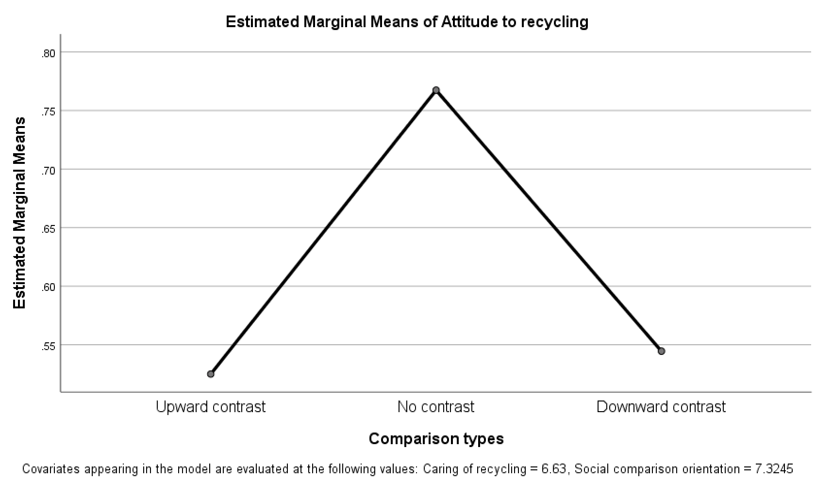
Moreover, a similar pattern was also shown in the relationship between comparison types and anger to the messages, even the significance of quadratic model was only close to.05 (quadratic model: p = .06; r = .08; downward contrast: M = .74, SD = .04, n = 49, vs. no contrast: M = .64, SD = .04, n = 53, vs. upward contrast: M = .74, SD = .05, n = 45). Figure 2 below reflects this relationship.
Figure 2
Main effect of comparison types on anger to the message
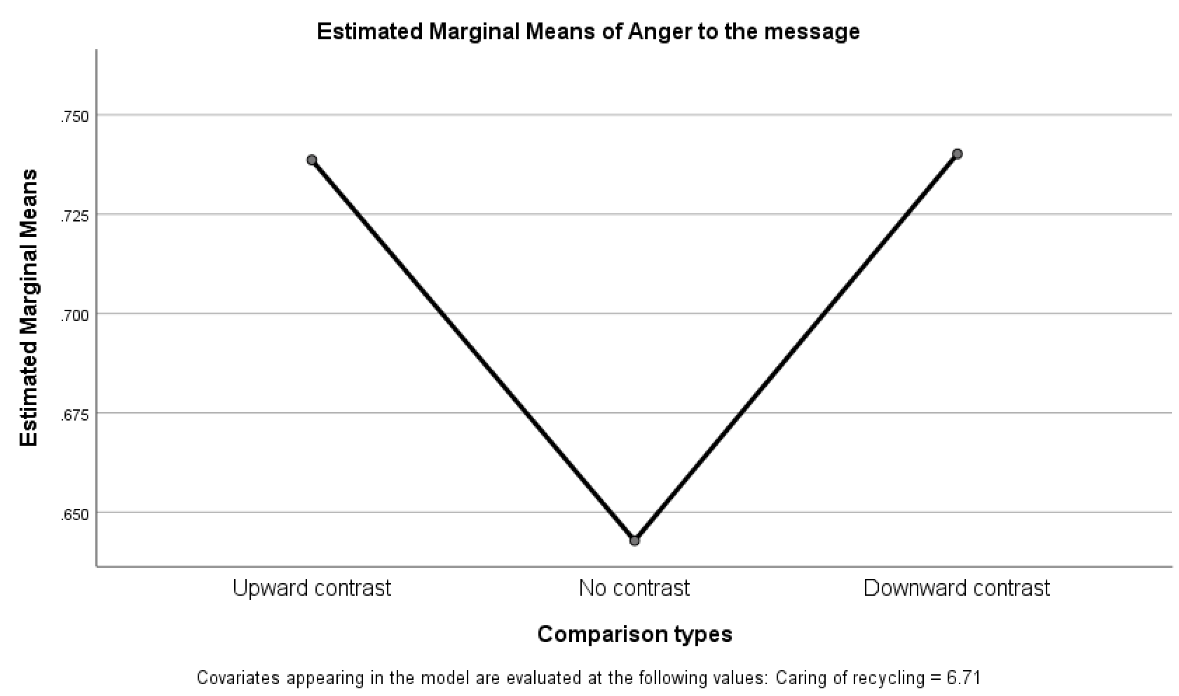
As for the research question, namely if there is any interaction effect between controlling language and comparison types on the outcomes, the results of this study indicated the answer was no. According to the results, there were no significant interaction effects between comparison types and controlling language on all dependent variables including perceived threats to personal freedom (F[2, 147] = .86, p = .43), anger to the message (F[2, 147] = .03, p = .98), number of negative thoughts (F[2, 133] = .21, p = .81), attitude to recycling (F[2, 137] = 2.28, p = .11), or behavioral intention to recycle (F[2, 145] = 1.25, p = .29).
However, as for attitude to recycling, the results showed high-controlling language only significantly decreased positive attitude to recycling than low-controlling language in no contrast, whereas, in both downward contrast and upward contrast, controlling language did not have a significant influence on attitude to recycling (in upward contrast, low controlling: M = 0.62, SD = .11, n = 21, vs. high controlling: M = 0.44, SD = .11, n = 20; in no contrast, low controlling: M = 0.64, SD = .10, n = 25, vs. high controlling: M = 0.89, SD = .10, n = 23; in downward contrast, low controlling: M = 0.47, SD = .10, n = 25, vs. high controlling: M = 0.62, SD = .10, n = 23). This interaction is reflected in Figure 3 below.
Figure 3
Interaction effect between controlling language and comparison types on attitudes
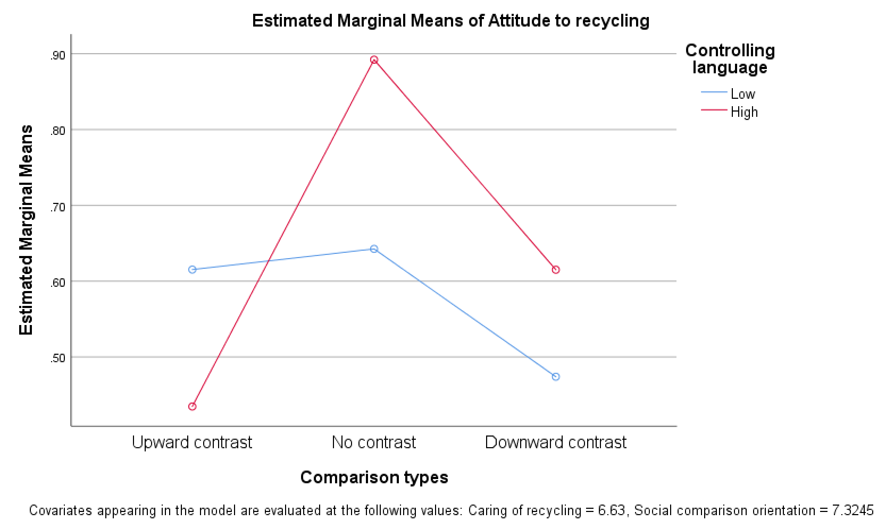

Discussion
In line with prior studies, the experiential results partially confirmed the main effects of controlling language. According to the results, relative to the persuasive message using low-controlling language, the recycling advocacy using high-controlling language significantly induced more perceived threats to personal freedom, more anger to the advocacy messages, and more negative thoughts to the advocacy messages. However, it did not have a significant influence on attitude to recycling or behavioral intention to recycle.
As for the effects of comparison type, only one significant main effect on attitude was found, but this effect was not in line with the predictions of this study. Specifically, the results showed that, on the one hand, the upward contrast did induce more positive attitude to recycling than no contrast while, on the other hand, the downward contrast surprisingly also induced more positive attitude than no contrast. Similarly, even the main effect was only close to the significance at .05 level, it was also revealed that, relative to no contrast, both downward contrast and upward contrast could decrease anger to the message. One possible explanation is that, different from upward contrast which can boost positive feeling and thus counteract anger, decrease reactance and increase positive attitudes, the downward contrast with potential rivals may make subjects perceive the limitations as a competition between them and their rivals, and further make them evaluate the limitations to their freedom as more favorable because more limitations than the rivals represent outperforming rivals, which thus could lower their reactance and increase their relevant positive attitudes.
The results also revealed was no interaction effects between controlling language and comparison types. However, as reflected in Figure 3, one interesting finding was that controlling language lost its effectiveness on attitude to recycling in both upward contrast and downward contrast, whereas, in no contrast, high-controlling language still significantly decreased positive attitude to recycling than low-controlling language. One possible explanation of this finding is that, as discussed above, both upward comparison and the downward comparison with potential rivals, even via different ways, can lower reactance and increase positive attitudes; moreover, these positive effects are strong enough to overwhelm and neutralize the effect of high-controlling language on the attitudes, thus making high-controlling language lose its effect on the attitudes in these two conditions.

Chapter 4: Study 2

Method

Participants
There were 145 students in total who voluntarily participated in Study 2. They all were the undergraduate students at OU. They were recruited during two mass lecture sessions at OU. 46.90% of participants (n = 68) were female while 53.10% (n = 77) of participants were male. Participants’ age ranged from 18 to 24 (M = 19.09, SD = 1.01) and 56.55% of participants (n = 82) have only been an OU student less than half year. Among these participants, 77.93% of them (n = 113) were Caucasian, 4.83% of them (n = 7) were African American, 6.21% of them (n = 9) were Hispanic, 6.90% of them (n = 10) were Asian American, and 1.38% of them (n = 2) were Native American. All participants received extra course credit in their communication classes for their participation.

Design and Procedures
As with Study 1, this study adopted the reaction paradigm and provided participants different types of comparison information, and then measured their psychological reactance, attitudes, and behavioral intentions. A 2 (controlling of language: high vs. low) × 3 (comparison types: upward contrast vs. no contrast vs. downward contrast) independent groups design was employed. Different with Study 1, Study 2 chose another traditional rival university which is known to most OU students, namely the University of Texas at Austin (UT), as the comparison target in these experimental conditions. These six experimental conditions corresponded to six different advocacy messages adopted in this study.
The messages used in this current study were also adopted and edited from the advocacy messages used in Bessarabova et al.’s (2017) study. Controlling language was manipulated by adopting imperative terms and phrases in messages, such as “must,” “have to,” and “There is no other choice,” or, alternatively, using noncontrolling terms and phrases, such as “can” “would,” and “The choice is yours.” The comparison information was added in the middle of these advocacy messages. Comparison types were manipulated by indicating the relative amount of recycling the participants were requested to do in comparison with UT students. Specifically, in no contrast condition, participants, namely the OU students, were encouraged to “recycle as much as” the UT students do; in downward contrast condition, participants were requested to “recycle more than” the UT students do; in upward contrast condition, participants were allowed to “recycle less than” the UT students do. Two advocacy messages are provided as examples in Table 2.
Table 2
Experimental messages
Low-controlling language-upward contrast-UT (154 words) | High-controlling language-downward contrast-UT (150 words)
All OU students:  It is important to know about the benefits of recycling: Recycling works!  You have a choice when it comes to recycling: Please recycle whenever you can!  Below is some important information about the benefits of recycling that we would like you to think about:  The Environmental Protection Agency (EPA) has shown that carbon dioxide pollution has resulted in melting of the ice masses and the rising of the global temperatures. Based on EPA data, recycling works! Recycling significantly decreases carbon dioxide pollution: The EPA found that manufacturing from the recycled paper provides a considerable reduction in CO2 emissions.  In fact, many universities participate in recycling. Several universities in the region have recycling programs. The OU has one and so does UT. Even if OU can recycle less than UT per student, that will still be a great help!  The choice is yours! You can help!  Recycling is important!  Considering choosing recycling! | All OU students:  The information you must know the benefits of recycling: Recycling works!  There is really no choice when it comes to recycling: You simply have to do it!  The information about the importance of and benefits of recycling that you must know:  The Environmental Protection Agency (EPA) has shown that carbon dioxide pollution has resulted in melting of the ice masses and the rising of the global temperatures. Based on EPA data, recycling works! Recycling significantly decreases carbon dioxide pollution: The EPA found that manufacturing from the recycled paper provides a considerable reduction in CO2 emissions.  In fact, many universities participate in recycling. Several universities in the region have recycling programs. The OU has one and so does UT. If OU can recycle more per student than UT, that will be a great help!  There is no other choice! You must help!  Recycling is important!  You must recycle!
The data were collected during two mass lecture sessions at OU. Proper IRB approval had been obtained and procedures followed. All participation was voluntary. After giving verbal consent, participants given one questionnaire which corresponded to one of the six different randomly ordered research conditions. When filling out the questionnaire, the participants first answered general demographic questions. Next, they responded to the measurement of their identification with OU and their involvement with recycling, after which they read one of the six different advocacy messages. After reading one of these advocacy messages containing experimental stimuli, participants responded to items representing the dependent variables and controlling variable, specifically: psychological reactance, behavioral intention, attitude to recycling, and social comparison orientation.

Instrumentation
The average score of each index with multiple items was obtained (after recoding the scores of the items with inverse values) and used in the analysis below. All items of all instruments were measured on a 10-point Likert-type scale (1 = strongly disagree and 10 = strongly agree). Given the requirements of the statistical analyses based on the general linear model include that residuals of the dependent variables should be approximately normal (Bauer & Fink, 1983; Fink, 2009), this study checked all the continuous dependent variables for violations of this assumption of normality. This study examined these dependent variables’ skewness and kurtosis. For those variables who appeared relative non-normal, namely those variables whose skewness or kurtosis were larger than 1.00, transformations were performed in them to making sure they meet the assumption of normality. If a variable needed to be transformed, the same transformation was used to transform all items of that specific index.
Perceptions of threats to freedom. Study 2 adopted the same scale used in Study 1 to measure the perception of threats to personal freedom, which contains 4 items (Cronbach’s α = .89). No transformation was required for this index.
Psychological reactance. As with Study 1, this study adopted the reactance scale developed by Dillard and Shen (2005). In measuring anger to the message, the five adopted items have a high reliability (Cronbach’s α = .95). Each item was transformed: item transformed = 1/ (original item - .5).
As with Study 1, relevant negative thoughts were also obtained by asking participants to list every thought they had while reading the message. Relevant negative thoughts are defined as the responses involving disagreement with the message, the intention not to comply, the derogation to message or source, or act contrary to the message. The affective thoughts, such as “this message is annoying”, were excluded. 8.28% (n = 12) of response on this item were missing. Each item was transformed: item transformed = ln (original item + .5).
Attitudes and behavioral intentions. Study 2 adopted the same scale used in Study 1 to measure participants’ positive attitude to recycling, which contains six items (Cronbach’s α = .96). 5.52% (n = 8) of sets of responses on these items were missing. Each item was transformed using the following formula: item transformed = ln (10.01-original item). Again, the same single item was used to measure participants’ behavioral intention in this study. No transformation was required for this item.
Identification with OU. The same two-item scale used in Study 1 was adopted in this study to measure participants’ identification with OU (Cronbach’s α = .87). As expected, the data of these two items clustered around the high scores in the scales. The mean score of identification with U0 is 8.25 with a standard deviation of 1.71 and mean score of importance of being an U0 student is 8.37 with a standard deviation of 1.70.
Issue involvement. The same one-item scale used in Study 1 for measuring participants’ involvement to recycling was used in Study 2. Participants were asked how much they cared about recycling. This variable was controlled as a covariate in the analysis of this study.
Social comparison orientation. As with Study 1, Study 2 adopted the INCOM scale to measure participants’ tendency in engaging in social comparison. This scale contains 11 items (Cronbach’s α = .84). Among its 11 items, the meanings of the values of item 6 and item 10 are inverse with those of the rest. After recoding the values of these two items, a higher score in this index represents a higher orientation in social comparison. This index was controlled as a covariate in the analysis below as well.

Results
To analyze the results, two-way Univariate Analyses of Covariance (ANCOVA) were conducted. Controlling language and comparison types were entered as the independent variables. Identification with OU, issue involvement, and social comparison orientation were entered as covariates. The perceived threats to personal freedom, anger toward the message, number of negative thoughts to the message, attitudes to recycling, and behavioral intentions to recycle were entered as the dependent variables. Levene’s test of the equality of the variance of perceived threats to freedom, anger toward the message, and number of negative thoughts were significant, which means the assumption of homogeneity of variance of these dependent variables were not met. Hence, the results related to anger toward the message, perceived threats to personal freedom, and number of negative thoughts should be interpreted with caution.

Covariate Effects
In running the two-way ANCOVA for analyzing different dependent variables, all results showed the covariate effect of the identification with OU was not significant. Hence, it was removed it from all models. When analyzing perceived threats to personal freedom, anger to the message and number of negative thoughts, neither social comparison orientation nor issue involvement had significant covariate effects. Therefore, both of them were removed from these models. When analyzing the attitude to recycling, only issue involvement had a significant covariate effect, F(1, 137) = 37.25, p < .05, η_{p}² =.22. Hence, social comparison orientation was removed from the model. When analyzing the behavioral intention to recycle, significant covariate effects were found on both issue involvement, F(1, 142) =108.64, p < .05, η_{p}² =.45, and social comparison orientation, F(1, 142) =5.26, p < .05, η_{p}² =.04.

Hypotheses Tests
H1 predicted that, relative to low-controlling language, high-controlling language increases (a) perceived threat to personal freedom, (b) anger toward the message, (c) negative relevant thoughts, and decreases (d) positive attitudes to recycling and (e) behavioral intention to recycle. The results from two-way ANCOVA offered partial support for H1. As predicted, relative to low-controlling language, high-controlling language significantly increased the perceived threats to freedom (F[1, 144] = 31.89, p < .05, η_{p}² =.19, low controlling: M = 2.97, SD = .25, n = 70, vs. high controlling: M = 4.95, SD = .25, n = 74) and anger toward the message (F[1, 145] = 14.77, p < .05, η_{p}² =.10, low controlling: M = 1.64, SD = .08, n = 71, vs. high controlling: M = 1.22, SD = .08, n = 74). The effect of controlling language on positive attitude to recycling was not significant, but its significance was close to .05 (F[1, 137] = 3.35, p = .07, η_{p}² =.03). The same result was found regarding the significance of the effect of controlling language on behavioral intention to recycle (F[1, 142] = 3.49, p = .06, η_{p}² =.03). In contrast, controlling language had no significant influence on number of negative thoughts (F[1, 133] = .51, p = .48, η_{p}² =.00). In summary, H1 was only partially supported.
Unlike controlling language, the results from two-way ANOVA did not support H2, which predicted a linear contrast of comparison types on all outcomes such that, relative to no contrast, downward contrast increases (a) anger toward the message, (b) negative relevant thoughts, and decreases (c) positive attitudes and (d) behavioral intention to recycle, whereas, relative to no contrast, upward contrast decreases (a) anger toward the message, (b) negative relevant thoughts, and increases (c) positive attitudes and (d) behavioral intention to recycle. The results showed there were no significant main effects of comparison types on perceived threats to personal freedom (F[2, 144] = .40, p = .67), anger to the message (F[2, 145] = 2.01, p = .14), number of negative thoughts (F[2, 133] = 1.78, p = .17), attitude to recycling (F[2, 137] = .72, p = .49), or behavioral intention to recycle (F[2, 142] = 1.88, p = .16). In summary, H2 was not supported.
Additionally, according to the result of comparison types polynomial contrast, the linear effect of comparison types on anger to the message was not significant (linear model: p= .93; r = .01), whereas the quadratic effect of comparison types on anger to the message was significant (quadratic model: p < .05; r = .19; downward contrast: M = 1.51, SD = .09, n = 49, vs. no contrast: M = 1.27, SD = .10, n = 47, vs. upward contrast: M = 1.50, SD = .09, n = 49). The relationship between attitude to recycling and comparison types is reflected in Figure 4 below.
Figure 4
Main effect of comparison types on anger to the message
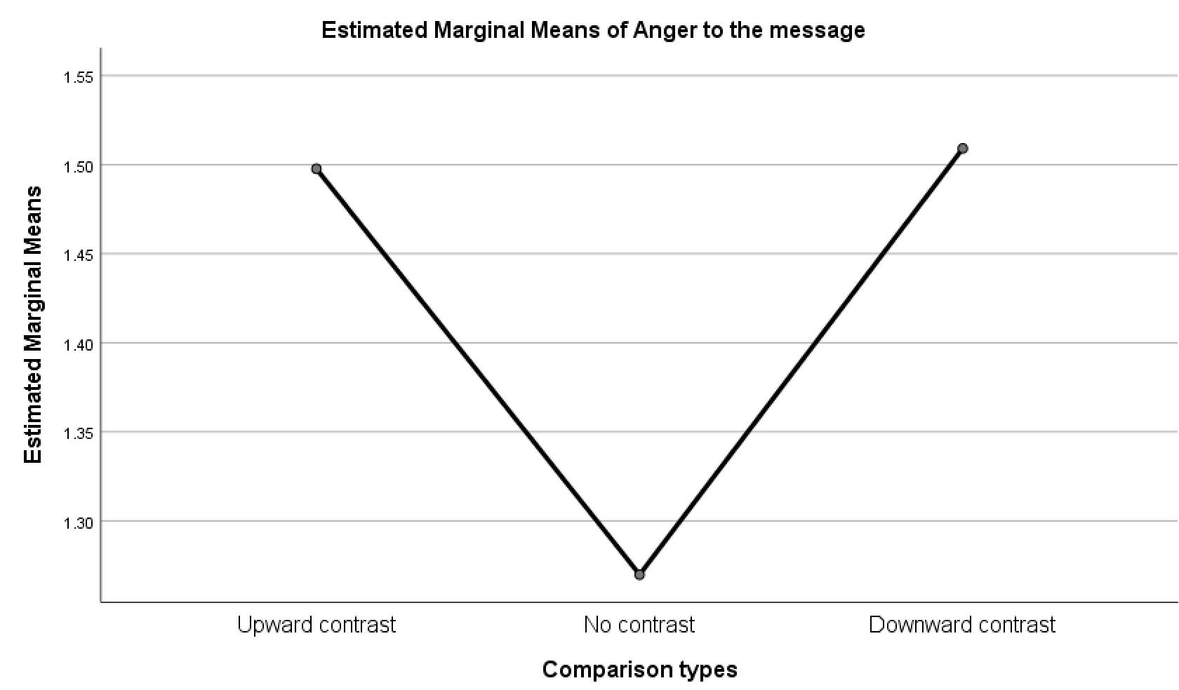
As for the research question, namely if there is any interaction effect between controlling language and comparison types on the outcomes, the results of this study indicated the answer was no. According to the results, there were no significant interaction effects between comparison types and controlling language on all dependent variables including perceived threats to personal freedom (F[2, 144] = 1.00, p = .37), anger to the message (F[2, 145] = .10, p = .90), number of negative thoughts (F[2, 133] = .34, p = .71), attitude to recycling (F[2, 137] = 1.18, p = .31), or behavioral intention to recycle (F[2, 142] = .30, p = .74).

Discussion
In line with prior studies, the experiential results partially confirmed the main effects of controlling language. According to the results, relative to the persuasive message using low-controlling language, the recycling advocacy using high-controlling language significantly induced more perceived threats to personal freedom, more anger to the advocacy messages. However, controlling language did not make a significant influence on negative cognition to the message, attitude to recycling, or behavioral intention to recycle.
As for the effects of comparison types, different from Study 1, the main effect on attitude to recycling was not found in this study. In contrast, only one significant main effect on anger to the message was revealed, but this effect was not in line with the prediction of this study. Specifically, the results showed that, on the one hand, the upward contrast did induce less anger to the message than no contrast while, on the other hand, the downward contrast surprisingly also induced less anger to the message than no contrast. One possible explanation is that, different from upward contrast which can boost positive feeling and thus counteract anger, decrease reactance and increase positive attitudes, the downward comparison with potential rivals could make subjects perceive the limitations to their freedom as a competition between them and their rivals, and further make them evaluate the limitations to their freedom as more favorable because more limitations than the rivals represent outperforming rivals, which thus could lower their reactance, such as anger to the messages.
Finally, as the results shown, there was no interaction effects between controlling language and comparison types on all outcomes. As reflected in Figure 5, the results indicated that the effect of controlling language on anger to the message was independent and parallel with the effect of comparison types on anger to the message.
Figure 5
Relationship between controlling language, comparison types and anger to the message
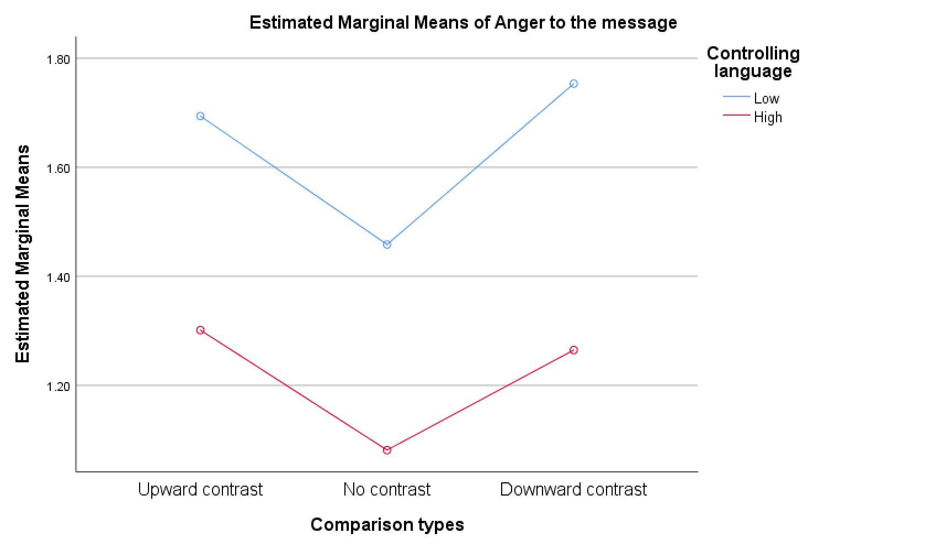

Chapter 5: General Discussion
Although increased research attention has clarified the nature of psychological reactance, the issue of how social comparison interacts with reactance remains unknown. Past theories, such as downward comparison theory (Will, 1981), upward comparison theory (Collins, 1996, 2000), and self-evaluation theory (Tesser, 1988), mainly focus on examining how individuals adopt different types of social comparison as strategies to maintain their self-evaluation. However, no scholarly study has examined how certain types of social comparison may be used in persuasion and how different social comparison works in changing people’s minds. The current studies explore the influences of social comparison in persuasion from the theoretical perspective of psychological reactance.
In line with prior studies, the results from both Study 1 and Study 2 partially confirmed the main effects of controlling language. Both Study 1 and Study 2 found, relative to the advocacy messages using low-controlling language, the recycling advocacy messages using high-controlling language significantly induced more perceived threats to personal freedom and more anger to the advocacy messages. However, only Study 1 found that high-controlling language also significantly induced more negative thoughts to the advocacy messages than low-controlling language. Neither of Study 1 or Study 2 found any significant main effect of controlling language on attitude to recycling or behavioral intention to recycle. Instead, issue involvement had significant covariate effects on attitude to recycling and behavioral intention to recycle. Given reactance is typically modeled as a process in prior studies, the discrepancies between the results of this thesis and the results of previous studies may be due to the fact that this research did not model reactance out.
As for the effects of comparison types, Study 1 revealed a significant main effect on attitude to recycling and a marginally significant main effect on anger to the message. Study 2 only uncovered a significant effect of comparison types on anger to the message. However, even these effects were significant, they were not in line with the prediction of this study. Nevertheless, the directions of these significant effects were identical with each other, which indicates that not only the related hypothesis of this study is wrong but also an alternative explanation is needed. This thesis proposes that the comparison targets adopted in the studies as potential rivals to OU may play a role in the emergence of these unexpected results. It is reasonable to think that the comparison with potential rivals could make subjects perceive the limitations to their freedom as a competition between them and their rivals, and therefore the downward comparison with rivals could make the limitations to freedom perceived by subjects as the outperformance to rivals instead of threats to freedom, thus lowering reactance and increasing positive attitude to the advocacy. At the same time, in the comparison with less rival targets, upward contrast is also acceptable and therefore can still boost positive feeling from subjects and counteract the anger, thus decreasing their reactance and increasing their positive attitudes. Therefore, both upward contrast and downward contrast can lower anger to the messages and increase positive attitude to recycling, compared to no contrast.
Neither Study 1 or Study 2 revealed any significant interaction effect between comparison types and controlling language. For anger to the message, both Study 1 and Study 2 confirmed that the effect of comparison types and the effect of controlling language are independent and parallel. However, for attitude to recycling, Study 1 revealed that the effects of comparison types on it could overwhelm and neutralize the effects of controlling language on it in both downward contrast and upward contrast.
Despite these effects of comparison types on anger to the message and attitude to recycling, the results did not reveal any main effect or interaction effect of comparison types on perceived threats to personal freedom, which may indicate the influences of different types of comparison on anger and attitude did not come through perceived threats to freedom.

Limitations and Future Directions
There are a number of limitations to address in the current study. The first limitation is related to the manipulations of comparison types. This study manipulated the comparison with different specific reactions in a general way. Namely, this study used “recycle more,” “recycle equally,” and “recycle less” to separately represent downward contrast, no contrast and upward contrast. However, the validity of this general manipulation should be doubted. It is fair to question that if these different descriptions can really be perceived by subjects as different social comparisons. In fact, the results regarding the effects of comparison types also confirmed our concerns about this. Especially, the nonsignificant main effects of comparison types on all dependent variables except anger are probably due to the weakness of this general manipulation. For future studies, one of the potential directions is to modify the manipulation of comparison types and make it more concrete. For instance, we can manipulate the comparison with different specific reactions used in recycling policies by changing the amount of required categories for sorting or the amount of fine for violations of the policies. By enlarging the concrete difference in the strictness of different policies and conducting relevant pilot study, we can make sure subjects perceive a real difference in those dimensions.
The second limitation involves the reliability and validity of some measurements used in this study. Certain variables, such as identification with OU, issue involvement and behavioral intention to recycle, only have one or two items for measuring, which puts their reliability at risks. Besides, certain variables, such as issue involvement and identification with OU, only ask subjective and general questions, such as “How much do you care about recycling” and “how much do you identify with OU”. The limited number and objectivity of the items in these scales seriously threatened the reliability and validities of these measurements. In future research, the improvements of the validities and reliabilities of these measurements should be conducted. The third limitation of the current study relates to the sample size of this study. Given this whole study had 12 different conditions, a sample of 295 participants was still not big enough. For instance, for examining the interaction effect between controlling language and comparison types, each group only had 21-25 participants. For future research, a larger research sample is needed.
There were some discrepancies in the results of Study 1 and Study 2, such as the absence of the main effect of comparison types on attitude in Study 2 and the absence of the main effect of controlling language on number of negative thoughts in Study 2, and these discrepancies could be due to the difference in the comparison targets adopted in these two studies. To fully understand these inconsistence findings, further research manipulating types of comparison targets are needed. For instance, future research can explore the roles of comparison targets in persuasion from the perspectives of social status, degree of identification, level of rivalry, or relational distance, etc.

Conclusion
In the light of psychological reactance theory, this current study explored how social comparison works in persuasion. This study explored the influences of social comparison from the perspective of comparison types. Two 3 (comparison types: upward contrast vs. no contrast vs. downward contrast) × 2 (controlling language: high vs. low) independent group experiments adopting different comparison targets (OSU vs UT) were conducted. The results confirmed the main effects of controlling language on perceived threats to personal freedom, anger to the message and negative cognition. The results also revealed the main effects of comparison types on anger to the messages and attitude to recycling. Moreover, for anger to the message, there were no interaction effects between comparison types and controlling language on it in neither of these studies. However, for attitude to recycling, Study 1 revealed that the effect of controlling language on it could be overwhelmed and neutralized by the effects of both upward contrast and downward contrast.

References
Bauer, C. L., & Fink, E. L. (1983). Fitting equations with power transformations: Examining variables with error. Annals of the International Communication Association, 7(1), 146-199.
Bessarabova, E., Fink, E. L., & Turner, M. (2013). Reactance, restoration, and cognitive structure: Comparative statics. Human Communication Research, 39, 339–364.
Bessarabova, E., Miller, C. H., & Russell, J. (2017). A further exploration of the effects of restoration postscripts on reactance. Western Journal of Communication, 81(3), 385-403.
Brehm, J. W. (1966). A theory of psychological reactance.
Collins, R. L. (1996). For better or worse: The impact of upward social comparison on self-evaluations. Psychological bulletin, 119(1), 51.
Collins, R. L. (2000). Among the better ones. In Handbook of social comparison (pp. 159-171). Springer, Boston, MA.
Dillard, J. P., & Shen, L. (2005). On the nature of reactance and its role in persuasive health communication. Communication Monographs, 72(2), 144-168.
Festinger, L. (1954). A theory of social comparison processes. Human relations, 7(2), 117-140.
Fink, E. L. (2009). The FAQs on data transformation. Communication Monographs, 76(4), 379-397.
Gerber, J. P., Wheeler, L., & Suls, J. (2018). A social comparison theory meta-analysis 60+ years on. Psychological bulletin, 144(2), 177.
Gibbons, F. X., & Buunk, B. P. (1999). Individual differences in social comparison: development of a scale of social comparison orientation. Journal of personality and social psychology, 76(1), 129.
Jonas, E., Graupmann, Kayser, Zanna, Traut-Mattausch, & Frey. (2009). Culture, self, and the emergence of reactance: Is there a “universal” freedom? Journal of Experimental Social Psychology, 45(5), 1068-1080.
Klein, W. M. (1997). Objective standards are not enough: affective, self-evaluative, and behavioral responses to social comparison information. Journal of personality and social psychology, 72(4), 763.
Lipkus, I. M., & Klein, W. M. (2006). Effects of communicating social comparison information on risk perceptions for colorectal cancer. Journal of health communication, 11(4), 391-407.
McLaughlin, B., Schutz, C., & White, D. (1980). Parental speech to five-year-old children in a game-playing situation. Child Development, 580-582.
Miller, C. H., Lane, L. T., Deatrick, L. M., Young, A. M., & Potts, K. A. (2007). Psychological reactance and promotional health messages: The effects of controlling language, lexical concreteness, and the restoration of freedom. Human Communication Research, 33, 219-240.
Miller, C. H., Massy, Z.B., & Ma, H. (2018). Psychological Reactance and Persuasive Message Design. Handbook of applied communication research, H. D. O’Hair and M. J. O’Hair (Eds.), NY: Wiley
Rains, S. A., & Turner, M. M. (2007). Psychological reactance and persuasive health communication: A test and extension of the intertwined model. Human Communication Research, 33(2), 241-269.
Rains, S. A. (2013). The nature of psychological reactance revisited: A meta-analytic review. Human Communication Research, 39(1), 47-73.
Suls, J., & Bruchmann, K. (2013). Social comparison and persuasion processes in health communications. In The Oxford handbook of health communication, behavior change, and treatment adherence (p. 251). Oxford University Press.
Tesser, A. (1988). Toward a self-evaluation maintenance model of social behavior. In Advances in experimental social psychology (Vol. 21, pp. 181-227). Academic Press.
Wills, T. A. (1981). Downward comparison principles in social psychology. Psychological bulletin, 90(2), 245.
Xu, J. (2017). The impact of locus of control and controlling language on psychological reactance and ad effectiveness in health communication. Health communication, 32(12), 1463-1471.
Zell, E., & Alicke, M. D. (2010). The local dominance effect in self-evaluation: Evidence and explanations. Personality and Social Psychology Review, 14(4), 368-384.

Appendix A - Low Controlling-No Contrast-OSU Advocacy Message
All OU students:

It is important to know about the benefits of recycling: Recycling works!
You have a choice when it comes to recycling:
Please recycle whenever you can!
Below is some important information about the benefits of recycling that we would like you to think about:

The Environmental Protection Agency (EPA) has shown that carbon dioxide pollution (CO2) has resulted in melting of the ice masses and the rising of the global temperatures. Based on EPA data, recycling works! Recycling significantly decreases carbon dioxide pollution: The EPA found that manufacturing from the recycled paper provides a considerable reduction in CO2 emissions.

In fact, many universities participate in recycling. Several universities in the region have recycling programs. The University of Oklahoma has one and so does Oklahoma State University. If OU can recycle as much as OSU per student, that will be a great help!

The choice is yours! You can help!
Recycling is important:
Consider choosing recycling!

Appendix B - High Controlling-No Contrast-OSU Advocacy Message
All OU students,

The information you must know about the benefits of recycling: Recycling works!
There’s really no choice when it comes to recycling:
You simply have to do it!
The information about the importance of and benefits of recycling that you must know:

The Environmental Protection Agency (EPA) has shown that carbon dioxide pollution (CO2) has resulted in melting of the ice masses and the rising of the global temperatures. Based on EPA data, recycling works! Recycling significantly decreases carbon dioxide pollution: The EPA found that manufacturing from the recycled paper provides a considerable reduction in CO2 emissions.

In fact, many universities participate in recycling. Several universities in the region have recycling programs. The University of Oklahoma has one and so does Oklahoma State University. If OU can recycle as much as OSU per student, that will be a great help!

There’s no other choice! You must recycle!
Recycling is important:
You must help!

Appendix C - Low Controlling-Downward Contrast-OSU Advocacy Message
All OU students:

It is important to know about the benefits of recycling: Recycling works!
You have a choice when it comes to recycling:
Please recycle whenever you can!
Below is some important information about the benefits of recycling that we would like you to think about:

The Environmental Protection Agency (EPA) has shown that carbon dioxide pollution (CO2) has resulted in melting of the ice masses and the rising of the global temperatures. Based on EPA data, recycling works! Recycling significantly decreases carbon dioxide pollution: The EPA found that manufacturing from the recycled paper provides a considerable reduction in CO2 emissions.

In fact, many universities participate in recycling. Several universities in the region have recycling programs. The University of Oklahoma has one and so does Oklahoma State University. If OU can recycle more per student than OSU, that will be a great help!

The choice is yours! You can help!
Recycling is important:
Consider choosing recycling!

Appendix D - High Controlling-Downward Contrast-OSU Advocacy Message
All OU students:

The information you must know about the benefits of recycling: Recycling works!
There’s really no choice when it comes to recycling:
You simply have to do it!
The information about the importance of and benefits of recycling that you must know:

The Environmental Protection Agency (EPA) has shown that carbon dioxide pollution (CO2) has resulted in melting of the ice masses and the rising of the global temperatures. Based on EPA data, recycling works! Recycling significantly decreases carbon dioxide pollution: The EPA found that manufacturing from the recycled paper provides a considerable reduction in CO2 emissions.

In fact, many universities participate in recycling. Several universities in the region have recycling programs. The University of Oklahoma has one and so does Oklahoma State University. If OU can recycle more per student than OSU, that will be a great help!

There’s no other choice! You must help!
Recycling is important:
You must recycle!

Appendix E - Low Controlling-Upward Contrast-OSU Advocacy Message
All OU students:

It is important to know about the benefits of recycling: Recycling works!
You have a choice when it comes to recycling:
Please recycle whenever you can!
Below is some important information about the benefits of recycling that we would like you to think about:

The Environmental Protection Agency (EPA) has shown that carbon dioxide pollution (CO2) has resulted in melting of the ice masses and the rising of the global temperatures. Based on EPA data, recycling works! Recycling significantly decreases carbon dioxide pollution: The EPA found that manufacturing from the recycled paper provides a considerable reduction in CO2 emissions.

In fact, many universities participate in recycling. Several universities in the region have recycling programs. The University of Oklahoma has one and so does Oklahoma State University. Even if OU recycles less than OSU per student, that will still be a great help!

The choice is yours! You can help!
Recycling is important:
Consider choosing recycling

Appendix F - High Controlling-Upward Contrast-OSU Advocacy Message
All OU students:

The information you must know about the benefits of recycling: Recycling works!
There’s really no choice when it comes to recycling:
You simply have to do it!
The information about the importance of and benefits of recycling that you must know:

The Environmental Protection Agency (EPA) has shown that carbon dioxide pollution (CO2) has resulted in melting of the ice masses and the rising of the global temperatures. Based on EPA data, recycling works! Recycling significantly decreases carbon dioxide pollution: The EPA found that manufacturing from the recycled paper provides a considerable reduction in CO2 emissions.

In fact, many universities participate in recycling. Several universities in the region have recycling programs. The University of Oklahoma has one and so does Oklahoma State University. Even if OU recycles less than OSU per student, that will still be a great help!

There’s no other choice! You must help!
Recycling is important:
You must recycle!

Appendix G - Low Controlling-No Contrast-UT Advocacy Message
All OU students:

It is important to know about the benefits of recycling: Recycling works!
You have a choice when it comes to recycling:
Please recycle whenever you can!
Below is some important information about the benefits of recycling that we would like you to think about:

The Environmental Protection Agency (EPA) has shown that carbon dioxide pollution (CO2) has resulted in melting of the ice masses and the rising of the global temperatures. Based on EPA data, recycling works! Recycling significantly decreases carbon dioxide pollution: The EPA found that manufacturing from the recycled paper provides a considerable reduction in CO2 emissions.

In fact, many universities participate in recycling. Several universities in the region have recycling programs. The University of Oklahoma has one and so does the University of Texas at Austin. If OU can recycle as much as UT per student, that will be a great help!

The choice is yours! You can help!
Recycling is important:
Consider choosing recycling!

Appendix H - High Controlling-No Contrast-UT Advocacy Message
All OU students:

The information you must know about the benefits of recycling: Recycling works!
There’s really no choice when it comes to recycling:
You simply have to do it!
The information about the importance of and benefits of recycling that you must know:

The Environmental Protection Agency (EPA) has shown that carbon dioxide pollution (CO2) has resulted in melting of the ice masses and the rising of the global temperatures. Based on EPA data, recycling works! Recycling significantly decreases carbon dioxide pollution: The EPA found that manufacturing from the recycled paper provides a considerable reduction in CO2 emissions.

In fact, many universities participate in recycling. Several universities in the region have recycling programs. The University of Oklahoma has one and so does the University of Texas at Austin. If OU can recycle as much as UT per student, that will be a great help!

There’s no other choice! You must help!
Recycling is important:
You must recycle!

Appendix I - Low Controlling-Downward Contrast-UT Advocacy Message
All OU students:

It is important to know about the benefits of recycling: Recycling works!
You have a choice when it comes to recycling:
Please recycle whenever you can!
Below is some important information about the benefits of recycling that we would like you to think about:

The Environmental Protection Agency (EPA) has shown that carbon dioxide pollution (CO2) has resulted in melting of the ice masses and the rising of the global temperatures. Based on EPA data, recycling works! Recycling significantly decreases carbon dioxide pollution: The EPA found that manufacturing from the recycled paper provides a considerable reduction in CO2 emissions.

In fact, many universities participate in recycling. Several universities in the region have recycling programs. The University of Oklahoma has one and so does the University of Texas at Austin. If OU can recycle more per student than UT, that will be a great help!

The choice is yours! You can help!
Recycling is important:
Consider choosing recycling!

Appendix J - High Controlling-Downward Contrast-UT Advocacy Message
All OU students:

The information you must know about the benefits of recycling: Recycling works!
There’s really no choice when it comes to recycling:
You simply have to do it!
The information about the importance of and benefits of recycling that you must know:

The Environmental Protection Agency (EPA) has shown that carbon dioxide pollution (CO2) has resulted in melting of the ice masses and the rising of the global temperatures. Based on EPA data, recycling works! Recycling significantly decreases carbon dioxide pollution: The EPA found that manufacturing from the recycled paper provides a considerable reduction in CO2 emissions.

In fact, many universities participate in recycling. Several universities in the region have recycling programs. The University of Oklahoma has one and so does the University of Texas at Austin. If OU can recycle more per student than UT, that will be a great help!

There’s no other choice! You must help!
Recycling is important:
You must recycle!

Appendix K - Low Controlling-Upward Contrast-UT Advocacy Message
All OU students:

It is important to know about the benefits of recycling: Recycling works!
You have a choice when it comes to recycling:
Please recycle whenever you can!
Below is some important information about the benefits of recycling that we would like you to think about:

The Environmental Protection Agency (EPA) has shown that carbon dioxide pollution (CO2) has resulted in melting of the ice masses and the rising of the global temperatures. Based on EPA data, recycling works! Recycling significantly decreases carbon dioxide pollution: The EPA found that manufacturing from the recycled paper provides a considerable reduction in CO2 emissions.

In fact, many universities participate in recycling. Several universities in the region have recycling programs. The University of Oklahoma has one and so does the University of Texas at Austin. Even if OU recycles less than UT per student, that will still be a great help!

The choice is yours! You can help!
Recycling is important:
Consider choosing recycling!

Appendix L - High Controlling-Upward Contrast-UT Advocacy Message
All OU students:

The information you must know about the benefits of recycling: Recycling works!
There’s really no choice when it comes to recycling:
You simply have to do it!
The information about the importance of and benefits of recycling that you must know:

The Environmental Protection Agency (EPA) has shown that carbon dioxide pollution (CO2) has resulted in melting of the ice masses and the rising of the global temperatures. Based on EPA data, recycling works! Recycling significantly decreases carbon dioxide pollution: The EPA found that manufacturing from the recycled paper provides a considerable reduction in CO2 emissions.

In fact, many universities participate in recycling. Several universities in the region have recycling programs. The University of Oklahoma has one and so does the University of Texas at Austin. Even if OU recycles less than UT per student, that will still be a great help!

There’s no other choice! You must help!
Recycling is important:
You must recycle!

Appendix M – Behavioral Intention and Reactance Index
Instructions: Please answer the questions below. There are no right or wrong answers: We are interested in your views.
a) How likely are you to try to recycle?
b) How much did you feel that the message threatened your freedom to choose?
c) How much did you feel that the message tried to make a decision for you?
d) How much did you feel that the message tried to manipulate you?
e) How much did you feel that the message tried to pressure you?
f) How much did the message bother you?
g) How irritated did the message make you feel?
h) How angry did the message make you feel?
i) How annoyed did the message make you feel?
j) How aggravated did the message make you feel?
Instructions: Please list every thought that you had while reading the message. List all your thoughts, even if they seem irrelevant or silly. List each thought separately.
____________________________________________________________________________________________________________________________________________________________________________________________________________________________________________________________________________________________________________________________________

Appendix N –Attitude Index
Instructions: Please circle the number that represents your feelings about recycling

negative 1 2 3 4 5 6 7 8 9 positive
bad 1 2 3 4 5 6 7 8 9 good
unfavorable 1 2 3 4 5 6 7 8 9 favorable
unacceptable 1 2 3 4 5 6 7 8 9 acceptable
wrong 1 2 3 4 5 6 7 8 9 right
foolish 1 2 3 4 5 6 7 8 9 wise
unimportant 1 2 3 4 5 6 7 8 9 important

Appendix O – Social Comparison Orientation Index
Instructions: Most people compare themselves from time to time with others. For example, they may compare the way they feel, their opinions, their abilities, and/or their situation with those of other people. There is nothing particularly “good” or “bad” about this type of comparison, and some people do it more than others. We would like to find out how often you compare yourself with other people. To do that we would like you to indicate how much you agree with each statement below.
- I often compare how my loved ones (boy or girlfriend, family members, etc.) are doing with how others are doing.
- I always pay a lot of attention to how I do things compared with how others do things.
- If I want to find out how well I have done something, I compare what I have done with how others have done.
- I often compare how I am doing socially (e.g., social skills, popularity) with other people.
- I am not the type of person who compares often with others.
- I often compare myself with others with respect to what I have accomplished in life.
- I often like to talk with others about mutual opinions and experiences.
- I often try to find out what others think who face similar problems as I face.
- I always like to know what others in a similar situation would do.
- If I want to learn more about something, I try to find out what others think about it.
- I never consider my situation in life relative to that of other people.

Appendix P – Identification with OU Index
Instructions: For the following questions, please circle the numbers in the scales that best matches your opinion.
1. How much do you identify with the University of Oklahoma?
2. How important is it to you to be an OU student?

