University of Oklahoma

Graduate College

Recovery patterns from high-intensity interval resistance exercise in male and female rotc cadets

A thesis

submitted to the Graduate Faculty

in partial fulfillment of the requirements for the

Degree of

Master of Science

By

Kellea nicole mcguire
Norman, Oklahoma
2018

recovery patterns from high-intensity interval resistance exercise in male and female rotc cadets

A thesis approved for the
Department of Health and Exercise Science

By

______________________________
Dr. Jason A. Campbell, Chair

______________________________
Dr. Christopher D. Black

______________________________
Dr. Rebecca D. Larson

© Copyright by kellea nicole mcguire 2018
All Rights Reserved.

Acknowledgements
First and foremost, I would like to thank all of my past teachers and professors that I have had throughout my entire academic years. Each of you played a cruicial part in my educational growth and I would not have been able to succeed in college or graduate school without everything you all taught me, not only as a student but also as a an adult.
Most importantly, my parents and my sisters have been my ultimate supporters and cheerleaders. You all have showed intelligence, kindness, strength and humility in everything you do and it has been something I have been able to look up to my entire life that has molded me into who I am today. I truly owe all my successes and acomplishments to you all. I love you with all my heart. Thank you!

Table of Contents
Acknowledgements iv
List of Tables ix
List of Figures x
Abstract xi
Chapter 1: Introduction 1
Introduction 1
Research Questions 4
Hypotheses 5
Significance 6
Assumptions 7
Delimitations 7
Limitations 7
Operational Definitions 8
Chapter 2: Literature Review 10
High-Intensity Training 10
Fatigue Following Resistance Exercise 12
Recovery Following Resistance Exercise 13
Fatigue and Recovery Sex Differences 14
Countermovement Jump to Assess Fatigue 15
Session RPE to Assess Exercise Intensity 16
ROTC Cadet Training 17
Summary 18
Chapter 3: Methodology 19
Participants 19
Experimental Design 19
Visit 1: Informed Consent and Familiarization 1 20
Visit 2: Familiarization 2 22
Visit 3: Baseline Measurements 22
Visit 4, 5, and 6: 24-, 48- or 72 hours post-exercise 23
Experimental Procedures 24
10 RM Determinations 24
Force Platform & CMJ 25
Resistance Exercise Protocol 26
sRPE… 28
Perceived Perfromance Score (PPS) 28
Pressure-Pain Threshold & Soreness Assessments 28
Perceived Recovery Status (PRS) Scale 29
Statistical Analysis 29
Chapter 4: Results 31
Subject Characteristics 31
Exercise Performance 32
CMJ Performance 35
Lower Body 35
Upper Body 31
sRPE… 32
Pressure-Pain Threshold and Muscle Soreness 33
PRS…. 36
Perceived Performance Score (PPS) 37
Sex Differences 38
10RM.. 38
Repetitions 39
CMJ…. 39
Soreness 40
sRPE, PRS, PPS 40
Chapter 5: Discussion 42
Exercise Performance 42
CMJ…. 43
sRPE… 45
Pressure-Pain Threshold and Soreness 46
PRS…. 47
Perceived Performance Score (PPS) 47
Sex Differences 48
Chapter 6: Conclusion 50
References 51
Appendix A: IRB Approval Letter 56
Appendix B: Informed Consent Form 59
Appendix C: HIPAA 63
Appendix D: Health Status Questionnaire 66
Appendix E: International Physical Activity Questionnaire 69
Appendix F: Physical Activity Readiness Questionnaire 75
Appendix G: Menstrual History Questionnaire 76

List of Tables
Table 1. Subject Characteristic 32
Table 2. Repetition Performance 33
Table 3. Mean Delta 33
Table 4. Lower Body CMJ Performance 30
Table 5. Upper Body CMJ Performance 31

List of Figures
Figure 1. Overview of experimental procedures 20
Figure 2. Randomized recovery scheme 24
Figure 3. Mean total repetition performance across baseline, 24 hour recovery (24H), 48 hour recovery (48H) and 72 hour recovery (72H). 34
Figure 4. Mean total repetition performance for individual male subjects across baseline, 24H, 48H and 72H. 34
Figure 5. Mean total repetition performance for individual female subjects across baseline, 24H, 48H and 72H. 35
Figure 6. Mean RPE for set 1, 2 and 3 across baseline, 24H, 48H and 72H. 33
Figure 7. Mean overall VAS soreness ratings across baseline, 24H, 48H and 72H. 34
Figure 8. Mean upper body VAS soreness ratings across baseline, 24H, 48H and 72H.. 36
Figure 9. Mean lower body VAS soreness ratings across baseline 24H, 48H and 72H. 36
Figure 10. Mean PRS across baseline, 24H, 48H and 72H. 37
Figure 11. Mean PPS across baseline, 24H, 48H and 72H. 38
Figure 12. Mean sRPE across baseline, 24H, 48H and 72H. 41

Abstract
Background: Army Reserve Officers’ Training Corps (ROTC) must meet military expectations mentally and physically. Training for ROTC cadets cadres around improving 2-mile run time, push-ups and sit ups which is primarily endurance focused. It is important for ROTC to incorporate resistance training into their normal training routine to improve military tasks and load carriage. Little evidence is presented in past literature covering the effect of high-intensity resistance exercise on ROTC cadets. Primary Aim: The primary aims of this study are 1) To determine the time-course for recovery in Army ROTC cadets following a bout of high-intensity interval resistance exercise, 2) To examine if there are any sex differences for recovery following high-intensity interval resistance exercise, and 3) To validate the use of CMJ as a measure of fatigue following a bout of high-intensity interval resistance exercise. Methods: 19 subjects, 10 male and 9 female ROTC cadets performed a bout of high-intensity interval resistance exercise using their 10RM load. The exercise consisted of a 3 circuit exercise using 8 exercise machines. Subjects provided soreness ratings and perceived recovery status (PRS) prior to performing upper and lower body counter-movement jumps (CMJ). Following CMJs, subjects performed the high-intensity resistance exercise by doing 3 rounds of the 8 exercises with 60 seconds of work at their 10RM and 60 seconds of rest between exercise machines. Subjects gave RPE after each round and once the exercise was complete, subjects performed another 5 upper and lower body CMJs. Thirty-minutes post exercise, subjects provided session RPE (sRPE) to rate the exercise as a whole. Subjects performed this protocol 4 different times; at baseline and 24, 48 and 72 hours post baseline. The last three experimental times were randomized and counterbalanced. Results: Exercise performance recovery was determined by the total repetitions performed for each of the 4 experimental trials. Male and female subjects did not differ in exercise performance recovery for all time points. Baseline performance was the lowest compared with 24H, 48H and 72H while 24H, 48H and 72H were not different from each other. CMJ performance was not significantly different from pre-to-post exercise for 24H, 48H and 72H. Baseline CMJ performance decreased from pre-to-post. Males had greater CMJ variables compared with women. Soreness ratings showed that 24H had the greatest soreness compared with baseline and 72H. Upper body soreness ratings were higher compared with lower body soreness for baseline, 24H and 48H. Males and females did not differ in soreness ratings. PRS was significantly lower at 24H compared with baseline and 72H. PRS was also highly correlated with soreness ratings for all time points. sRPE did not differ between time points or male and female subjects. RPE following each round of the exercise showed that set 1 had the lowest RPE compared with set 2 and 3 for all time points and set 2 was lower than set 3 for 24H and 72H. Males and females did not differ in RPE for all sets. Conclusion: ROTC cadets were able to recover 24H following a bout of high-intensity interval resistance exercise with no difference seen between male and female cadets. CMJ did not decrease from pre-to-post exercise and did not match the change in exercise performance as hypothesized. Soreness ratings were greatest at 24H indicating both male and female cadets were most sore 24H following a bout of high-intensity interval resistance exercise. PRS matched the pattern of soreness ratings which indicates that PRS is mainly associated with soreness and not exercise performance recovery. sRPE was unchanged between time points meaning subjects perceived similar exertion between time points. Overall, more investigating needs to be conducted to analyze recovery patterns following a bout of high-intensity interval resistance exercise in ROTC cadets while incorporating CMJs to validate the use of CMJ as a surrogate to measure performance. However, this resistance exercise could be a good initial exercise to improve performance in ROTC cadets.

Chapter 1: Introduction

Introduction
Army Reserve Officers’ Training Corps (ROTC) cadets must meet military expectations mentally and physically. It is critical that military men and women have the physical performance capacity that prepares them for military occupational duties. To help ensure that ROTC cadets attain the necessary physical competency, they traditionally undergo physical training (PT) 3 times per week¹. ROTC physical training typically consists of a dynamic warm-up, upper- and lower-body callisthenic exercises, and a 2-5 mile run. The Army Physical Fitness Test (APFT) is used to assess their fitness level by having the cadets perform a 2-minute sit-up and 2-minute push-up test for maximum repetitions and a 2-mile run for time. The main component of their PT is endurance training consisting of long periods of continuous exercise at moderate intensity². The Army ROTC has utilized traditional endurance training and more recently included high-intensity interval training (HIIT) to improve APFT performance in the 2-mile run. However, their military duties also require the ability to carry loads from 16-40 kg over long distances. This requirement highlights the need for a muscular strength and endurance PT component to help ensure military readiness and protection from injury. This requirement must be met in an expeditious manner, since time outside of military-specific job training is limited.
Consequently, ROTC command at various cadres around the country have also begun to implement various types of resistance training programs in an attempt to reduce injury rates resulting from load carriage. Additionally, due to time constraints, others have begun to experiment with the incorporation of high-intensity resistance training circuits. Strength circuits represent a time efficient mode for increasing muscular strength and endurance that also matches the operational tempo associated with field training exercises. These field training exercises often involve complex movements over uneven terrain where the risk of musculoskeletal injury is exacerbated. The increased interest in high-intensity interval training (HIIT) in the tactical athlete population is mainly due to its demonstrated capacity to elicit similar increases in physical performance while reducing the time needed to complete a training session. Gist et al. (2015) found similar APFT scores when Army ROTC cadets performed high-intensity training consisting of burpees compared with traditional PT. Investigations in other populations have demonstrated similar positive results between lower intensity, high-volume resistance training when compared to high intensity, low volume resistance training being under consideration by the military^{4,5,6,7}. Low-volume circuit training has also been shown to be an effective mode of exercise in women for maintaining strength when compared to high-volume, multiple set training⁴. Nevertheless, there has been little to no research done following high-intensity resistance exercise in ROTC cadets. Additional investigations are required to properly evaluate the safety and effectiveness of this mode of exercise in this population.
Adaptation, fatigue, and recovery patterns following traditional resistance training have been investigated previously^{8, 9,10,11,12, 13}. However, there is a minimal number of research investigations that have evaluated these attributes following high-intensity, low volume resistance training exercise. Fatiguing exercise may lead to increased muscle soreness, reduced power, decreased vertical jump performance, reduced sprint performance and diminished endurance performance¹⁰. Recovery may then be described as the ability to meet or exceed performance in an activity following fatigue¹¹. If a tactical athlete is fatigued and proceeds with physical activity or competition without being fully recovered, it can eventually result in injury from overtraining¹¹. Having an optimal recovery period between training sessions or competitions will allow the tactical athlete to train at greater intensities with reduced potential for injury⁹.
Recovery is often measured by physical performance. If an athlete is able to perform at the same maximal capacity following an intense exercise bout, they are considered to be recovered from fatigue. Recovery has more recently been measured by using changes in counter movement jump (CMJ) performance. The concept is related to the CMJ’s ability to measure ground reaction force and the resulting power and velocity associated with the jump. CMJ’s have been validated to assess fatigue by examining these ground reaction forces in previous studies following intense resistance training and sport training^{14, 15, 16}. The pre-stretch characteristic of a CMJ make it an optimal measure of power to assess fatigue and recovery from dynamic exercise¹⁵.
Lastly, there is evidence of fatigue and recovery differences in male and females following isometric contractions ^{17, 18, 19, 20} and dynamic contractions ^{12, 21, 22}. Males tend to fatigue faster and recover at a slower rate following isometric contractions compared to women^{18, 20}. Females also recovered faster following a bench-press exercise compared to males²². In contrast, females tended to have greater fatigue following eccentric exercise compared to males ²¹ and there were no differences seen in recovery following maximal velocity contractions for the elbow flexor and knee extensor muscles¹². There is strong evidence for sex differences following isometric contractions but there is still a sparse amount of evidence related to recovery following different types of dynamic resistance training.
Therefore, the aims for this study are as follows: 1) To determine the time-course for recovery in Army ROTC cadets following a bout of high-intensity interval resistance exercise, 2) To examine if there are any sex differences for recovery following high-intensity interval resistance exercise, and 3) To validate the use of CMJ as a measure of fatigue following a bout of high-intensity interval resistance exercise. The exercise session will be performed in a circuit-style fashion consisting of 8 upper and lower body resistance exercises performed in series. The exercises include the following: leg press, chest press, lat pull down, shoulder press, knee extension, knee flexion, and biceps curl and triceps extension. Fatigue and recovery will be assed using CMJ’s, session RPE, subjective soreness ratings, and a perceived recovery scale.

Research Questions
- What is the time-course for recovery in Army ROTC cadets following a bout of high-intensity interval resistance exercise?
  - What differences exist for recovery in male and female ROTC cadets, as measured by the number of repetitions performed, after completing a bout of all-body, high-intensity interval resistance exercise?
- Do the changes in counter-movement jump performance match the pattern of change in exercise performance following a bout of all-body, high-intensity interval resistance exercise?
  - What differences in counter-movement jump performance exist between male and female ROTC cadets following all-body, high-intensity interval resistance exercise?
- What is the time course and characteristics related to delayed onset muscle soreness (DOMS) related to exercise-induced muscle damage (EIMD) following a bout of all-body, high-intensity interval resistance exercise?
  - What are the sex differences in delayed onset muscle soreness (DOMS) related to exercise-induced muscle damage (EIMD) and subjective ratings for soreness on a 100-mm visual analog scale (VAS) and objective ratings using an algometer for body region and global soreness between male and female ROTC cadets following a bout of all-body, high-intensity interval resistance exercise?
- Will there be sex differences in the time course to reach peak soreness,
as well as, to return to baseline?

Hypotheses
- There will be differences in recovery between male and female ROTC cadets, as followed by the number of repetitions performed, after completing all-body, high-intensity resistance circuit exercise.
- Changes in counter-movement jump performance match the pattern of change in exercise performance in ROTC cadets following all-body, high-intensity resistance circuit exercise.
  - There will be differences in countermovement jump performance between male and female ROTC cadets following high-intensity interval resistance exercise.
- There will be differences in DOMS related to EIMD between male and female ROTC cadets following a bout of all-body, high-intensity resistance circuit exercise.
- There will be differences between male and female ROTC cadets in the subjective ratings for soreness on a 100-m VAS for body region and global soreness.
- There will be differences between male and female ROTC cadets in soreness measures using an algometer device for body region.
2. There will be differences in the time course to reach peak soreness, as well as, to return to baseline in male and female ROTC cadets.

Significance
This study will highlight the ability of a high-intensity resistance circuit protocol to stimulate fatigue and soreness in ROTC cadets that will allow for investigation of recovery patterns. This work will help clarify the relative value of utilizing of CMJ’s to quantify fatigue and recovery in male and female ROTC cadets compared to other objective and subjective performance measures. Lastly, this investigation will help identify any sex differences following a high-intensity resistance exercise and could provide evidence for the use of high-intensity resistance training protocols into ROTC PT.

Assumptions
The assumptions of this study include the following:
- Participants will give their maximal effort on all repetitions for each exercise.
- Participants will provide truthful answers for all soreness and recovery questions.
- Participants have received the same level of physical training through the ROTC.

Delimitations
The delimitations of this study include the following:
- Participants are male and female ROTC cadets enrolled at the University of Oklahoma.
- Participants will be between the ages of 18-35 years of age
- Participants are recreationally active and participate in ROTC physical training three days per week.
- Participants are free of musculoskeletal injuries that would prevent them from doing any form of resistance exercise.
- Participants will not be eligible to participate if they answered “yes” to any of the questions on the physical activity readiness questionnaire (PAR-Q).
- Female participants will be tested during the follicular phase to control for menstrual cycle related variations in exercise performance, fatigue, and recovery.

Limitations
The limitations of this study include the following:
- The cohort for this study will be a convenience sample of ROTC cadets and therefore does not incorporate random selection. The results of this study can only be applied to male and females in the Army ROTC.
- No direct measurement of changes related to force production will be investigated, such as; twitch interpolation via electromyography (EMG).
- No direct measurement of changes related to muscle damage will be assessed such as creatine kinase levels, lactate dehydrogenase levels, interleukin 6, etc.

Operational Definitions
- Army Physical Fitness Test (APFT): Test comprised of timed sit-ups, push-ups, two-mile run and sit-and-reach²³.
- Counter Movement Jump (CMJ): Performing a countermovement in the lower limbs prior to jumping and landing in the same spot as take-off while the hands remain on the hips throughout the jump¹⁵.
- Delayed Onset Muscle Soreness (DOMS): Muscle tenderness, pain on palpation, and mechanical stiffness in the muscle that results in pain when the muscle is passively stretched or activated¹⁰.
- Fatigue: Comprising sensations of tiredness and associated decrements in muscle performance and function²⁴.
- Exercise-Induced Muscle Damage (EIMD): Immediate and prolonged reductions in muscle function following dynamic exercise¹⁰.
- Recovery: Ability to meet or exceed performance in a particular activity¹¹.
- Reserve Officer Training Corps (ROTC): Program that exists on University campus across the United States that provide a source of reserve officers for the U.S. Army¹.
- Session RPE: Single global rating of the perceived intensity for the entire training session²⁵.
- Visual Analog Scale (VAS): Unidimensional pain rating scale that asks for the patient to make a mark on a 100-mm line with one end reading "least possible pain" and the other "worst possible pain"²⁶.

Chapter 2: Literature Review
The literature related to the effects of fatigue and recovery following high intensity resistance exercise, as well as, sex differences in fatigue and recovery is reported in this chapter. The literature is presented under the following topics: (1) High-Intensity Training, (2) Fatigue Following Resistance Exercise, (3) Recovery Following Resistance Exercise, (3) Fatigue and Recovery Sex Differences, (4) Countermovement Jump to Assess Fatigue, (5) Session RPE to Assess Exercise Intensity, (6) ROTC Cadet Training and (7) Summary. The search terms include Army Reserve Officer Training Corps (ROTC), Physical Readiness Test (PFT), High-intensity Interval Training (HIIT), resistance exercise, fatigue, recovery, sex differences, countermovement jump and session RPE.

High-Intensity Training
Low-volume high intensity exercise, such as high-intensity interval training (HIIT), has been shown to elicit similar results as high-volume training while utilizing a more time-efficient regimen^{4, 5, 6, 7}. HIIT has also been shown to increase skeletal muscle mitochondrial capacity and exercise performance^{5, 7}. Trapp et al., (2008) found that 20 minutes of HIIT on a cycle ergometer had similar significant reductions in body fat as 40 minutes of steady-state exercise in women. Gibala et al., (2006) found that men performing four to six repeats of 30-second maximal cycling bouts at 250% VO2max for six sessions over 14 days elicited similar results to cycling for 90-120 minutes at 65% VO2max. These results show how endurance based interval training can elicit similar responses as traditional endurance training. However, there has been sparse research done investigating high-intensity interval training with resistance exercise.
Resistance exercise puts mechanical stress on the body by lifting or pushing a load that ultimately causes muscle growth through multiple cellular mechanisms²⁷. The signaling responses that cause muscle growth are stimulated by resistance exercise choice, load, volume, rest periods and exercise order²⁷. Activating large muscle groups with high loads can evoke a greater hormonal response than activating smaller muscle groups with low loads. There is a dose-response for the number of sets per exercise to evoke strength gains²⁸. There are greater muscular adaptations with utilizing multiple-set exercises than with single-set exercises. A high-volume workout involves a great number of sets and repetitions with a lower resistance. The protein synthesis pathway has been shown to be stimulated with resistance training workouts consisting of low set and repetition ranges with a higher resistance and exercise intensity²⁷. Low-volume, single-set circuit training has been shown to be effective for maintaining strength but did not evoke greater strength gains than high-volume periodized training⁴. This could be due to the low volume training containing the same relative intensity as the high-volume training, resulting from the heavier loads used by the low volume group’s participants. Since high-intensity interval training has been shown to be a beneficial approach to endurance training, it seems rational that resistance exercise may reap similar benefits when utilizing a high-intensity interval format.

Fatigue Following Resistance Exercise
High-intensity resistance exercise has been shown to create a transient reduction in muscular strength ⁸ that is predominantly the result of eccentric contractions¹⁰. This change is a decrease in muscle function and performance and may be thought of as demonstrating some degree of neuromuscular fatigue or skeletal muscle fatigue^{8, 10, 29}. The decrease in muscle function could be due to central factors or peripheral factors. The central factors generally focus around a person’s motivation to complete a task or exercise. Peripheral factors generally relate to the motor unit where there is damage to the contractile components of the muscle fibers^{10, 29}. Fatigue and the accompanying characteristics related to fatigue following eccentric exercise have been assessed reliably and validly through changes in power, vertical jump performance, sprint performance, endurance performance, as well as, associated with changes to subjective soreness rating¹⁰.
Men and women both demonstrate decreases in maximal force and neuromuscular performance following high-intensity resistance exercise across various research investigations employing different testing methodologies^{8, 18, 20, and 21,24,30,31}. Performing one maximal squat-lift with 100% 1RM decreased maximal force significantly and lengthened force relaxation in male and females⁸. The maximal voluntary contraction (MVC) force was reduced following repeated static contractions of the adductor pollicis muscle in 5-s intervals until exhaustion in male and females¹⁸. Male and females demonstrated a decrease in MVC and motor unit activation following dynamic, submaximal contractions of the elbow flexor and knee extensors²⁰. Female handball players had reductions in voluntary isokinetic knee extensions, jump height and 20m sprint time following handball training sessions and matches³⁰. Rugby players had increased muscle soreness and decreased countermovement flight time following a rugby match^{24, 31}. However the presence of sex differences in fatigue and soreness patterns following high intensity resistance exercise require further evaluation.

Recovery Following Resistance Exercise
Recovery is the ability to meet or exceed performance in a particular activity following a training session¹¹. Recovery is measured mainly by physical performance^{9,22,30,32,33,34,44} which can be tested by performing a baseline exercise protocol and assessing the participant’s ability to replicate the same volume and intensity of work after a given time period has passed, by tracking daily variation in CMJ performance variables, the assessment of subjective muscle soreness, and perceived recovery, to name a few.
In an investigation by McLester et al. (2003), 10 recreationally trained males were recruited to perform 3 sets of 8 resistance exercises for the evaluation of recovery. Each exercise was performed with a 10 RM load. Subjects were unable to replicate their baseline performance with 24 hours of recovery. However, performance was not significantly different than baseline after 48 hours, and at that point, subjects were considered to be fully recovered. Judge & Burke (2010) tested male and females on their recovery following a bench press training session. Each subject went through a 3-week training period prior to strength testing. On the strength testing day, the subjects performed 5 sets of a percentage of their 1RM, starting at 50% and increasing to 70%, 85%, 95% and 100% for a bench-press exercise. The subjects rested for 4-, 24- or 48 hours in consecutive order for three weeks. Recovery was measured by the subjects repeating the strength protocol and their total weight lifted was recorded. They found that males were unable to perform their baseline measures after 4- and 24- hours but returned to their baseline performance 48- hours later. Females were able to replicate their baseline measures 4 hours later, demonstrating an enhanced recovery capacity among female participants. Ronglan et al. (2006) found that female handball players were unable to replicate their baseline measures during a 5-day training camp and during an international tournament. Leg strength and jump height were used to assess physical performance among the handball players and both were reduced after a high-intensity training session. Additionally, the group was unable to meet baseline measures 3 days after the high-intensity session. Radaelli et al. (2012) found that untrained women were unable to recover 72 hours post performing 4 sets of 10 repetitions of elbow flexion at 80% of 1RM. Muscle soreness was measured using the 100mm visual analog scale and soreness was found to be significantly greater 24-hours and 48-hours post in the participants’ dominant arm compared to their non-dominant arm. Howatson et al. (2016) found that elite track athletes were not recovered 24 hours after performing 12 sets of maximal strength resistance exercise, consisting of squats, split-squats and push presses. These results show that recovery may be task specific and thus must be evaluated based on the type of training stimulus endured.

Fatigue and Recovery Sex Differences
There is evidence of sex differences related to fatigue^{13, 17, 18, 19,20,21,35} and recovery^{18, 20, 22}. Albert, et al. (2006) conducted a study to review the sex differences of fatigue during upper and lower isometric contractions. They found that males had a greater loss of force, greater rate of fatigue and were unable to maintain 50% MVC for 30-seconds during the fatiguing contractions compared to females. However, Sewright et al. (2008) found that females had greater strength loss after eccentric exercise compared with male subjects. Females also tend to recover at a faster rate than males after isometric exercises^{18, 20}. There has been little research done regarding sex differences for fatigue and recovery following dynamic exercises. Sex differences in muscle fatigue of dynamic contractions coincide with the task being performed, including velocity of contraction and the muscle group involved³⁰. Senefeld et al. (2013) found that women did not have the same fatigue resistance during dynamic contractions as isometric contractions. There were no sex differences in fatigue during repeated maximal velocity contractions or recovery of elbow flexion and knee extension muscles. Currently, the literature is sparse regarding sex differences that may or may not exist following high-intensity circuit resistance training.

Countermovement Jump to Assess Fatigue
Madigan, et al. (2003) investigated fatigue on the lower extremities and its effect on ground impact force by examining landing kinematics and kinetics. Subjects performed a series of single-leg squats to initiate fatigue and followed that with two single-leg landings on a force plate. The force plate collected the ground reaction force and the kinematic data for each landing. They found that peak vertical ground reaction force decreased with fatigue and ankle and knee flexion increased with fatigue. Based on these findings, it can be concluded that using a force plate will show a decrease in ground reaction force with an increase in fatigue.
Jumping is a compound movement that requires both upper- and lower-body contractile components¹⁵. Its explosive action makes for a suitable measure of performance by the athlete needing to produce force quickly¹⁵. Many jumps have been used as field tests to assess explosive power but, Markovic, et al. (2004) determined the counter movement jump (CMJ) to be the most accurate measure of power based on its pre-stretch capabilities. The CMJ was validated as an accurate measure to assess fatigue with 1 or 5 CMJs³⁶, following an explosive effort sequence³⁷, comparing it with other popular jump tests such as Sargent's jump, standing long jump, and Abalakov’s jump¹⁵ and assessing intra/interday reliability for neuromuscular function following a fatiguing protocol¹⁶.

Session RPE to Assess Exercise Intensity
Foster et al. (2001) developed a method that integrates the rating of perceived exertion (RPE) with the training impulse known as session RPE. The session RPE is used as a “global rating” of intensity during an entire exercise bout instead of just a specific moment during that exercise³⁸. They investigated the relationship between session RPE and heart rate (HR) based methods of monitoring training while the subjects endured different types of exercise. They used an exercise score that was calculated by the time of completion multiplied by the session RPE. Session RPE and HR methods were found to be highly correlated and therefore can be used as a surrogate to HR to monitor internal training load³⁸. Session RPE has been used as an individual indicator of training response in soccer players due to the high correlation with minutes played³⁹.
Session RPE has been used for quantifying exercise intensity during resistance exercise as well^{25, 40, 41}. Single set resistance exercise showed a corresponding increase in session RPE with an increase in intensity²⁵. Session RPE was found to be greater for super-slow (55% 1RM) and traditional (80% 1RM) resistance exercise compared with maximal power⁴⁰. This difference was due to the two methods containing a higher load and volume. The super-slow method had the highest session RPE and Egan et al. (2006) suggested that was due to greater time under tension.

ROTC Cadet Training
Thomas et al. (2004) found that male and female cadets scored in the 55th percentile and 30th percentile for a bench press maximum while scoring in the 83rd percentile on push-ups, sit-ups and 2-mile run when compared with normative data from APFT data bank and from age- and sex-matched peers. ROTC cadet training does not include resistance training according to Thomas et al. (2004). They suggest that the addition of supplementing a resistance training program, especially for females, will improve their muscular strength^{1, 42, 43}.
To find improvements in ROTC cadets’ fitness, the effect of low-volume, high-intensity whole-body calisthenics³ and interval training² were studied. Gist et al. (2015) found that a low-volume, high-intensity protocol of burpees maintained metabolic capacities and physical performance that were similar to traditional cadet training. The cadets only exercised for a total of 33 minutes over the course of 12 sessions and stated the exercise was more difficult as measured by session RPE. Interval training is arguably more relevant to the tasks that cadets will need to perform². This training is linked with increased cardiorespiratory fitness and aerobic metabolism. However, Gibala et al. (2015) did not measure the effect of resistance interval training on muscular strength and this type of training’s ability to optimize maximal strength and power⁴². Currently, a gap exists in the literature surrounding the efficacy and utility of this training mode and its possible positive outcomes for ROTC cadets.

Summary
There has been a plethora of research related to fatigue and recovery patterns for males following resistance training and the sex differences associated with traditional, multiple set, high volume, low to moderate intensity resistance training. Males tend to show greater fatigue and slower recovery rates compared to females when comparing CMJ performance and session RPE to assess fatigue and recovery. However, little research related to high-intensity resistance circuit exercise training, its associated fatigue, and required recovery has been performed. ROTC cadet training mainly consists of endurance exercise with some calisthenics. Research is needed to further investigate the recovery patterns of male and female ROTC cadets following a high-intensity resistance exercise and its incorporation into their weekly training.

Chapter 3: Methodology

Participants
The participants came from a convenience sample consisting of male and female cadets from the University of Oklahoma Army ROTC. The sample size was chosen based on the findings of previous research ^{9, 45} incorporating a similar testing protocol and an apriori power analysis via G*Power software. A sample size of 19 was able to detect an effect size of 0.7 SD’s (a large effect size) and to have a statistical power of 0.8. Therefore, 19 participants (n₁ = 10 male cadets and n₂ = 9 female cadets) was able to provide significant statistical power and therefore recruited for the study. Each participant was be free of musculoskeletal injuries or had been released to exercise by their doctor at least 6 months prior to the study. The participants were asked to abstain from all other strenuous activities related to their participation in ROTC. The participants provided written consent which was approved by the University of Oklahoma Institutional Review Board.

Experimental Design
The ROTC cadets who voluntarily consent to participate in the study were randomized to a recovery scheme (e.g. 24, 48, 72 hrs. vs 72, 48, 24 hrs.). All recovery schemes were counter-balanced to minimize ordering effects. The study was a within and between-groups design with repeated measures. There were a total of 6 visits over a 21 day period. Briefly, the 6 visits consisted of the following; informed consent and familiarization 1, familiarization 2, baseline measures and counter-balanced recovery schemes consisting of 24-, 48-, 72 hours of recovery following resistance exercise. Additionally, visit 1 and visit 2 were separated by 3-5 days; visit 2 and visit 3 were separated by 10 days. The timing of visits 4, 5, and 6 depended on the recovery scheme participants were randomly assigned for their post-baseline measurements. An overview of the experimental design is presented in Figure 1.
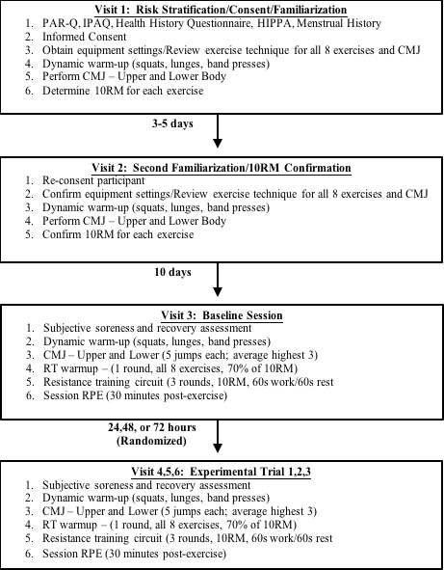
Figure 1. Overview of experimental procedures

Visit 1: Informed Consent and Familiarization 1
The first visit consisted of each participant providing written consent, HIPAA information, PAR-Q, IPAQ, health history questionnaire and menstrual cycle information for the female subjects. Each subject was given an overview of the protocol and once they gave consent, their height, weight, age and academic grade (Freshman, Sophomore, Junior or Senior) was recorded. Height was measured using a Stadi-O-Meter (Novel Products Inc., Rockton, IL) by having the subjects stand with shoes off and back against the Stadi-O-Meter. Height was recorded on their data sheet. Weight was measured using the ForceDecks software with independent, dual force platforms (FD4000, NMP ForceDecks Ltd., London, England). Each subject stepped onto the force plate and distributed their weight evenly on both sides. A video display was present to assist the subject with obtaining this even weight distribution between two force plates. The data collector saved the subject’s weight once the ForceDecks software showed a 50:50 distribution of force on each plate. Weight was recorded on the subject’s data sheet.
Each subject participated in a familiarization for the upper and lower body countermovement jump and with proper technique for each exercise and the exercise equipment itself. The subjects practiced performing the upper body countermovement jump by getting in the push-up position with arms straight, bending the elbows, rapidly pushing off the ground, landing on both hands simultaneously with elbows bent and then straightening the arms. The subjects practiced performing the lower body countermovement jumps by following the protocol provided by Markovic et al., (2004). Each subject stepped on the platform and when given the verbal signal “ready, set, go”, the subject bent at the knees, maximally jumped vertically in the air and landed in the spot that they took-off while keeping hands at the hips. Once the subjects were familiar and comfortable performing both countermovement jumps, 10 RM was recorded for each of the 8 exercise machines. The machines that were utilized for the investigation were Cybex selectorized machines (Cybex International, Inc., Medway, MA) except the leg press machine which was a plate loaded machine (Body-Solid Leg Press & Hack Squat GLPH1100, Body-Solid Inc., Forest Park, IL). For each exercise machine, the seat height and depth, as well as arm and leg positions was recorded to help ensure consistency of the subject’s technique across data collections.

Visit 2: Familiarization 2
Each participant entered the testing lab area and was re-familiarized with the CMJ’s and confirmed their 10RM from visit 1. The participant performed 5 upper body CMJ followed by 5 lower body CMJ’s. Each participant went through each of the 8 exercise machines and validated their 10RM. If, the subject’s 10RM changed, the highest 10RM was used for the remainder of testing.

Visit 3: Baseline Measurements
The subjects’ sensitivity to pain was examined by using an algometer (Force Dial FDK 20, Wagner Instruments, Greenwich, CT) to quantify pressure pain threshold at each of the main muscle sites; quadriceps, hamstrings, gluteus medius, pectoralis major, latissimus dorsi, deltoid, biceps and triceps. Participants also performed general range of motion techniques which consisted of having the subjects perform 5 unweighted squats to assess lower body soreness, 5 unweighted chest press motions to assess pectoralis soreness, 5 biceps curl and triceps extension to assess biceps and triceps soreness, 5 over head press motions to assess shoulder and latissimus dorsi soreness. Subjects rated soreness on a scale of 0 to 10 with 0 indicating no soreness and 10 indicating extreme soreness on a 100-mm visual analog scale (VAS) ²⁶. Subjects estimated recovery using the perceived recovery status (PRS) scale by stating what is believed to represent recovery with 0 signifying “very poorly recovered/ extremely tired” and 10 “very well recovered/ highly energetic” ⁴⁶. A dynamic warm-up was done before completing upper and lower countermovement jumps which consisted of performing 10 push-ups, 10 lunges and 10 unweighted squats lasting approximately 5 minutes prior to CMJ testing. The participants again performed 5 upper and 5 lower body CMJ’s. Five minutes following the countermovement jump tests, each participant performed a warm-up of the circuit exercise by performing 10 repetitions at 70% of their 10RM for each machine. Following the warm-up with 70% of their 10RM, they performed a resistance circuit exercise that contained the 8 resistance machine exercises performed at the 10 RM load for 3 rounds. The participants had 60 seconds to perform as many repetitions possible and 60 seconds of rest between exercise machines. After each set of 8 exercises, subjects provided rating of perceived exertion (RPE) using the 6-20 Borg scale, with 6 indicating “no exertion at all” and 20 indicating “maximal exertion”. Participants provided RPE after all 3 rounds of the resistance exercise circuit. There was 120 seconds of rest between each round. After completing all 3 rounds, subjects repeated upper and lower countermovement jumps. After a 30-minute wash-out period following completion of the exercise session, subjects were asked to give session RPE²⁵ using the Borg scale of 6-20, with 6 indicating “no exertion at all” and 20 indicating “maximal exertion” and was recorded on the subject’s data sheet.

Visit 4, 5, and 6: 24-, 48- or 72 hours post-exercise
The post-baseline recovery day scheme was randomized for each subject. Subjects were randomized to a different order of recovery days following baseline measures. For example, subject 1 had the following recovery scheme; 24-, 48, and 72-hours post baseline, and subject 2 had the following recovery scheme; 72-, 48, 24-hours post baseline. Figure 2 illustrates the timeline between the randomized recovery schemes following baseline measures. Subjects performed the same protocols as on the baseline measurement days; pressure pain threshold, soreness evaluation, PRS, CMJ warm-up, upper and lower countermovement jump, resistance circuit exercise warm-up, resistance circuit exercise, RPE between each set, upper and lower countermovement jump and session RPE.
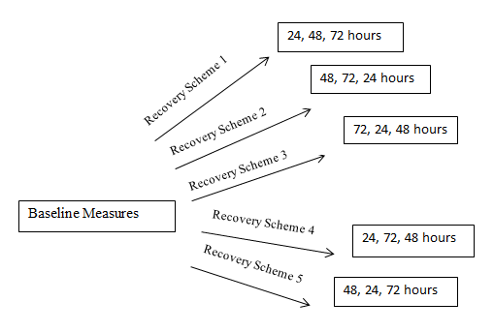
Figure 2. Randomized recovery scheme

Experimental Procedures

10 RM Determinations
A 10 RM was established for each of the 8 exercises. Subjects began with a light load that allowed them to perform about 15-18 repetitions. The load increased by 5-10 lbs. for upper body and 15-20 lbs. for lower body for the next set depending on the level of difficulty. If the subject was able to produce more than 10 repetitions with this load, it increased again by 5-10 lbs. or 15-20 lbs. until the subject could only produce 10 repetitions maximum. Between each set, the subject rested for 2-4 minutes to ensure recovery ⁹. The 10 RM for each exercise machine was recorded on the subject’s data sheet. If the subject 10RM increased between familiarization 1 and familiarization 2, the highest 10RM load was used for all resistance circuit exercises including both baseline measures and post-baseline recovery measures.

Force Platform & CMJ
The bilateral force plate system and accompanying software (ForceDecks v2.3, London, UK) was used to evaluate the subject’s fatigue and recovery before and after performing the resistance circuit exercise via repeated CMJ’s. The bilateral force plates were placed on a solid flat surface and plugged into a laptop computer loaded with the ForceDecks software. Once the station was set up, the data collector launched ForceDecks and a unique, anonymous alphanumeric code was created for the subject. The data collector zeroed the force plate scale and asked the subject to step onto the force plate by evenly distributing the subject’s weight on both the right and left force plate. Once weight was evenly distributed, the collector saved the subject’s weight. The data collector then instructed the subject to perform the CMJ’s by giving a verbal cue “ready, set, go”. Each participant performed 5 lower body CMJ’s with 3-5 seconds in between each jump followed by 5 upper body CMJ’s with 3-5 seconds in between each jump. The data collector zeroed the platform again following the lower body CMJ’s prior to the upper body CMJ’s. In each case, the 3 CMJ’s with the highest relative peak power was retained and averaged for statistical analysis. The subjects performed the lower body countermovement jumps by following the protocol provided by Markovic et al., (2004). The subject will begin standing with legs evenly distributed between the two force plates, with legs straight and hands placed on the hips. Upon hearing the “ready, set, go” verbal cue, the subject will quickly bend the knees, followed rapidly with a jump off of the force platform and a subsequent landing on both feet simultaneously while slowly decelerating the body and return to the initial standing position. A low density band of gauze was placed across the force plate and the height of the gauze band was adjusted for each subject in order to standardize a tactile position between subjects The upper body CMJ began with the subject in the prone position with arms and legs straight, head neutral, hips extended (standard military push-up) and hands split between the two force platforms. Upon hearing the “ready, set, go” verbal cue, the subject quickly bent the elbows to ~90⁰, followed rapidly with a maximal push off from the force platform and a subsequent landing on both hands simultaneously while slowly decelerating the body and returned to the initial pushup position. The data from each series of jumps was saved and was uploaded for data analysis. The metrics of interest for analysis included peak power (PP), concentric mean power (ConMP), eccentric mean power (EccMP), concentric peak force (ConPF), eccentric peak force (EccPF), concentric mean force (MF), eccentric mean force (EccMF), concentric rate of force development (ConRFD) and concentric impulse (ConIMP) (Gathercole et al., 2015). All variable were relative to the subject’s body weight except for ConMF and EccMF.

Resistance Exercise Protocol
The 8 exercises in the resistance circuit included the leg press, chest press, shoulder press, lat pulldown, knee extension, triceps extension, knee flexion and bicep curl ⁹. The order at which each subject performed these exercises was randomized. Each exercise was performed with Cybex selectorized machines and a Body-Solid leg press machine and was located in the Neuromuscular Laboratory in the S.J. Sarkeys Complex in the Department of Health and Exercise Science at the University of Oklahoma. The subject began the first set of exercises by sitting in the first assigned machine. The seat height was already positioned for the subject and the 10 RM load that was determined between the two familiarization days was set. The subject had 60 seconds to produce as many repetitions as possible. Once 60 seconds was complete, there was 60 seconds of rest until the next set of repetitions on the next machine. This was repeated until all 8 exercises were completed. The completion of the 8th exercise machine represented the first round of the circuit. There was 2 minutes of rest before starting the next round and the subjects stated their RPE for the first round and it was recorded during this 2-minute recovery period. This cycle continued for the second and third round of circuit exercise. Subjects were asked for session rating of perceived exertion (sRPE) of the entire exercise session following a 30-minute wash-out period, post-exercise. The main outcome variable used to determine recovery status was the mean delta score for total repetitions performed in one exercise session minus the repetitions performed in the preceding exercise session. Additionally, all time points were compared to the individual’s baseline session to observe effects of accumulated fatigue over the four exercise sessions, as well as, across similar recovery time points to understand the pattern of recovery when different rest intervals (i.e. 24, 48, or 72 hrs. in different combinations) are employed.

sRPE
Thirty-minutes post-exercise following the three recovery days, the participants were asked to provide the sRPE for that bout of exercise²⁵ by the data collector asking “how would you rate the exercise intensity and your exertion during the exercise using the scale from 6-20; with 6 indicating “no exertion” and 20 indicating “maximal exertion”. The scale used was the Borg scale which ranges from 6-20 where 6 indicates “no exertion at all” and 20 indicates “maximal exertion”. The sRPE was recorded on the subject’s data sheet.

Perceived Performance Score (PPS)
In order to show a blend of how hard the exercise bout was and how much work was actually done by the subject, a perceived performance score (PPS) was calculated by dividing the total number of reps the participant performed for that exercise bout by the respective sRPE. For example, if a subject performed 387 total reps and had a sRPE of 15, they would have a value of 25.8 for that session (387/ 15 = 25.8). However, if in the next session they performed 361 total reps and had a sRPE of 16, they would have a value of 22.5 (361/ 16 = 22.5). A higher value would represent either more work for the same absolute RPE value or the same work at a lower absolute RPE value. In both cases, this would seem to indicate increased recovery and/ or performance of the participant. A lower value would represent the opposite scenario and thus a lower level of participant performance or recovery.

Pressure-Pain Threshold & Soreness Assessments
To measure pressure-pain thresholds, an algometer was used on each major muscle. Each muscle was measured from its origin to insertion, based on body landmarks, and half the length was noted and recorded so the middle of the muscle was used for each measurement. The data collector instructed the participant to say “stop” when they first started to feel pain. The data collector pressed the end of the algometer on the surface of the participant’s muscle and pressed down progressively until the participant instructed the data collector to stop due to pain. The data collector will make note of the force reading, in kg, on the algometer and record that number on the participant’s data sheet. Soreness ratings were evaluated using a 100-mm VAS. The VAS was anchored at 0 and 10 with 0 relating to “no soreness” and 10 relating to “extreme soreness” ²⁶. Participants were asked to take each joint through a full range of motion. Once each participant went through the range of motion for each joint and each major muscle group, the participant marked on the VAS line to represent their soreness level for each muscle as well as, overall soreness.

Perceived Recovery Status (PRS) Scale
The PRS was used to investigate how well each participant perceived their recovery. The scale ranged from 0-10 with 0 indicating “very poorly recovered/ extremely tired” and 10 indicating “very well recovered/ highly energetic” ⁴⁶. The data collector asked the participant to provide their PRS by asking how they felt and how well did they think they would perform the exercise. The participants circled the PRS value on the PRS data sheet once they have arrived for the testing session.

Statistical Analysis
IBM SPSS version 24 was used to perform all analyses. A two-way repeated measures factorial analysis of variance (ANOVA) for GENDER x TIME was performed on all performance, CMJ, pain, and perceived recovery dependent variables. These analyses were observed across baseline and the 3 recovery periods between male and female ROTC cadets with the main performance variable being the mean delta change in total repetitions performed in one exercise session from the preceding exercise session. If there was a significant interaction effect found, then Bonferroni post hoc testing was performed to characterize any significant differences between the groups at various time points. If there was no significant interaction found, then main effects for gender and time were interpreted via one-way ANOVA. Statistical significance was set at p ≤ 0.05 and all data were expressed as mean ± SD.

Chapter 4: Results

Subject Characteristics
Twenty four subjects were recruited for this study; however 5 subjects, 3 males and 2 females, did not complete the study due to schedule conflicts. Nineteen subjects, 10 males and 9 females, completed the study. Descriptive data for all participants that completed the study (age, height, weight, and 10RM for each exercise) are presented as means ± SD in Table 1.
Paired-samples t-tests were conducted to compare 10RMs between familiarization days for male and females. There was a significant increase in 10RM for males from familiarization 1 to familiarization 2 for chest press (p=0.019), shoulder press (p=0.048), knee extension (p=0.030), knee flexion (p=0.007), bicep curl (p=0.018) and triceps extension (p=0.022). There was no significant difference seen for males between familiarization 1 and familiarization 2 10RMs for leg press (p=0.068) or lat pulldown (p=0.055). There was a significant increase in 10RM for females from familiarization 1 to familiarization 2 for knee extension (p=0.034) and triceps extension (p=0.030). Females showed no significant difference in 10RMs between familiarization 1 and familiarization 2 for leg press (p=0.290), chest press (p=0.276), lat pulldown (p=0.102), shoulder press (p=0.347), knee flexion (p=0.082) and bicep curl (p=0.347).
A one-way ANOVA by sex was conducted for 10RM loads and is shown in Table 1. Females showed a significantly lower 10RM compared with the males for leg press (p=0.006), chest press, lat pulldown, shoulder press, knee extension, knee flexion, bicep curl and triceps extension (p≤0.01).

Table 1. Subject Characteristic
Variable | Male | Female
n | 10 | 9
Age (years) | 20.5±2.2 | 20.2±1.6
Height (cm) | 178.3±8.6 | 164.9±5.5
Weight (kg) | 78.6±10.2 | 66.7±7.3
Leg Press 10RM (kg) | 230.9 ± 65.9 | 153.2 ± 34.8*
Chest Press 10RM (kg) | 72.1 ± 19.3 | 31.8 ± 6.8*
Lat Pulldown 10RM (kg) | 70.3 ± 15.6 | 36.9 ± 4.7*
Shoulder Press 10RM (kg) | 61.2 ± 13.7 | 31.8 ± 5.1*
Knee Extension 10RM (kg) | 82.8 ± 19.8 | 48.5± 7.1*
Knee Flexion 10RM (kg) | 83.3 ± 19.1 | 51.7 ± 10.7*
Bicep Curl 10RM (kg) | 38.2 ± 11.1 | 16.8 ± 4.3*
Triceps Extension 10RM (kg) | 41.2 ± 9.1 | 21.1 ± 4.7*
Values are mean ± SD
*indicates significant difference from male values (p≤ 0.05)

Exercise Performance
One-way ANOVA by sex was conducted to compare total reps for each time point between male and female subjects. There was no significant difference between male and females for baseline (p=0.110), 24 hours of recovery (24H) (p=0.209), 48 hours of recovery (48H) (p=0.099) and 72 hours of recovery (72H) (p=0.313). Since there were no significant differences found between male and female subjects, all subjects were collapsed and one-way repeated measures ANOVAs were conducted to compare total reps for the exercise and total reps for each set with-in and between each of the time points, along with mean delta scores between time points. Cohen’s d was used for effect sizes for comparisons between all time points.
A significant difference was found between the time points (p<0.001; Table 2). A Bonferroni pairwise comparison showed that baseline was significantly lower than 24H (p=0.001, Cohen’s d=0.799), 48H (p<0.001, Cohen’s d=1.126) and 72H (p<0.001, Cohen’s d=1.094). There was no significant difference between 24H and 48H (p=0.145, Cohen’s d=0.481) or 72H (p=0.117, Cohen’s d=0.412). Also there was no significant difference seen between 48H and 72H (p=1.000, Cohen’s d=0.081). The percent change in total reps between baseline and visit 1, regardless of recovery period was 11.1% increase; between 24H and 48H was 11.1% increase; between 24H and 72H was 9.0% increase; and between 48H and 72H was 1.9% decrease. Table 3 describes the mean delta scores for total repetitions for 24, 48 and 72 hours between the preceding exercise session. For example, 24H mean delta score was calculated using the previous visit, whether it be baseline, 48H or 72H. There was no significant difference in mean delta scores between 24H and 48H (p=0.246) or 24H and 72H (p=0.235). There was also no difference seen in mean delta scores between 48H and 72H (p=0.645).
A significant difference was found between sets for baseline (p<0.001), 24H (p=0.021), 48H (p=0.007) and 72H (p=0.002). For baseline, set 1 was significantly greater than set 2 (p<0.001) and set 3 (p<0.001) while set 2 and 3 were not significantly different (p=1.000). A significant difference was found between sets for 24H (p=0.021). At 24H, set 1 was significantly greater than set 2 (p=0.001) but not significantly different than set 3 (p=0.156) and set 2 and 3 were not significantly different (p=1.000). A significant difference was found between sets at 48H (p=0.007). At 48H, set 1 was significantly greater than set 2 (p=0.017) but not significantly different than set 3 (p=0.088) and set 2 and 3 were not significantly different (p=1.000). A significant difference was found between sets at 72H (p=0.002). At 72H, set 1 was significantly greater than set 2 (p<0.001) and set 3(p=0.030) but set 2 and 3 were not significantly different (p=1.000).
A significant difference was found for set 1 between the time points (p<0.001). Baseline set 1 was significantly lower than 24H set 1 (p=0.020), 48H set 1 (p<0.001) and 72H set 1 (p<0.001). Set 1 at 24H was not significantly different than 48H (p=0.197) or 72H (p=0.268). Set 1 was not significantly different between 48H and 72H (p=1.000). A significant difference was found for set 2 between the time points (p<0.001). Baseline set 2 was significantly lower than 24H (p<0.001), 48H (p<0.001) and 72H (p<0.001). Set 2 for 24H was not significantly different from 48H (p=0.139) or 72H (p=0.085). Set 2 for 48H was not significantly different from 72H (p=1.000). A significant difference was found for set 3 between the time points (p<0.001). Baseline set 3 was significantly lower than 24H (p=0.006), 48H (p<0.001) and 72H (p<0.001). Set 3 for 24H was not significantly different from 48H (p=0.177) or 72H (p=0.254). Set 3 was not significantly different between 48H and 72H (p=1.000).
Figure 3 describes performance recovery, in terms of total reps, for subjects during the resistance exercise for baseline, 24, 48 and 72H, as well as % change in total reps between time points. Figure 3 and 4 illustrate male and female individual performance recovery during baseline, 24, 48 and 72 hour recovery in reference to the group mean for male and female subjects.

Table 2. Repetition Performance
Variable | Baseline |  | 24H |  | 48H |  | 72H
n | 19 |  | 19 |  | 19 |  | 19
Total Reps | 331.89±62.31ª |  | 385.26±70.94 |  | 427.89±103.25 |  | 419.84±95.04
Set 1 Reps | 123.84±17.38^{a,b,c} |  | 135.74±20.75^{b} |  | 148.84±29.37^{b} |  | 146.79±28.84^{b,c}
Set 2 Reps | 104.95± 22.13ª |  | 124.26±22.33 |  | 139.26±34.90 |  | 136.37±29.80
Set 3 Reps | 103.11±25.95ª |  | 125.26±31.77 |  | 139.73±40.822 |  | 136.68±37.84
Values are mean ± SD
BL = baseline, 24H = 24 hour recovery, 48H = 48 hour recovery, 72H = 72 hour recovery
ª Indicates significant difference from 24, 48 and 72H values (p≤ 0.05)
^{b} Indicates significant difference from set 2 (p≤ 0.05)
^{c} Indicates significant difference from set 3 (p≤ 0.05)

Table 3. Mean Delta
Variable | 24H |  | 48H |  | 72H
Mean Delta | 28.7±37.7 |  | 40.3±41.05 |  | 48.2±41.4
Values are mean ± SD
ª indicates significant difference from 24H(p≤ 0.05)
^{b} indicates significant difference from 48H(p≤ 0.05)
^{c} indicates significant difference from 72H(p≤ 0.05)

Figure 3. Mean total repetition performance across baseline, 24 hour recovery (24H), 48 hour recovery (48H) and 72 hour recovery (72H).
ª indicates significant difference from 24, 48 and 72H values (p≤ 0.05)

Figure 4. Mean total repetition performance for individual male subjects across baseline, 24H, 48H and 72H. ª indicates significant difference from 24, 48 and 72H values (p≤ 0.05)

Figure 5. Mean total repetition performance for individual female subjects across baseline, 24H, 48H and 72H. ª indicates significant difference from 24, 48 and 72H values (p≤ 0.05)

CMJ Performance

Lower Body
One-way ANOVAs were conducted to compare the CMJ variables between men and women, paired-samples t-tests were performed to compare pre and post CMJ variables and one-way repeated measures ANOVA with a Bonferroni pairwise comparisons were done to compare CMJ variables between time points. All lower body CMJ variables are represented in Table 3 as means ± 1 SD and were taken from the three highest lower body CMJs based on relative Peak Power (PPr). The corresponding measures were then averaged, and expressed relative to each subject’s body weight except for Mean Force which was expressed as an absolute value.
Male performance during lower body CMJs showed a significant decrease from pre- to post-exercise variables at baseline for ConMP (p=0.023), EccMP (p=0.014), EccPF (p=0.007) and ConMF (p=0.013). There was no significant difference at baseline for males PPr (p=0.804), ConPF (p=0.243), EccMF (p=0.395), ConRFD (p=0.165) and ConIMP (p=0.277). There was a significant increase at 24H for males for ConRFD (p=0.042) while there was no significant difference for PPr (p=0.583), ConMP (p=0.947), EccMP (p=0.065), ConPF (p=0.104), EccPF (p=0.986), ConMF (p=0.674), EccMF (p=0.702) and ConIMP (p=0.377). There was a significant increase at 72H for males for ConPF (p<0.001) while there was no significant difference for PPr (p=0.843), ConMP (p=0.235), EccMP (p=0.325), EccPF (p=0.140), ConMF (p=0.105), EccMF (p=0.339), ConRFD (p=0.053) and ConIMP (p=0.352). There was no significant difference from pre to post at 48H for males for all variables; PPr (p=0.458), ConMP (p=1.000), EccMP (p=0.180), ConPF (p=0.367), EccPF (p=0.292), ConMF (p=0.808), EccMF (p=0.382), ConRFD (p=0.221) and ConIMP (p=0.861).
Female performance during lower body CMJs showed a significant increase in 72H EccMF (p=0.039) from pre to post while no significant difference was found for PPr (p=0.130), ConMP (p=0.183), EccMP (p=0.300), ConPF (p=0.404), EccPF (p=0.920), ConMF (p=0.238), ConRFD (p=0.358) and ConIMP (p=0.053). There was no significant difference between pre and post measures for baseline PPr (p=0.496), ConMP (p=0.232), EccMP (p=0.275), ConPF (p=0.611), EccPF (p=0.220), ConMF (p=0.569), EccMF (p=0.673), ConRFD (p=0.130) and ConIMP (p=0.201); 24H PPr (p=0.255), ConMP (p=0.308), EccMP (p=0.956), ConPF (p=0.787), EccPF (p=0.799), ConMF (p=0.629), EccMF (p=0.169), ConRFD (p=0.592) and ConIMP (p=0.621); or 48H PPr (p=0.654), ConMP (p=0.738), EccMP (p=0.454), ConPF (p=0.264), EccPF (p=0.906), ConMF (p=0.512), EccMF (p=0.544), ConRFD (p=0.683) and ConIMP (p=0.669).
Lastly, Males showed no significant mean differences at any time point between baseline, 24, 48, or 72 hours of recovery for pre PPr (p=0.280), post PPr (p=0.996), pre ConMP (p=0.234), post ConMP (p=0.218), pre EccMP (p=0.549), post EccMP (p=0.101), pre ConPF(p=0.053), post ConPF (p=0.505), pre EccPF(p=0.214), post EccPF (p=0.296), pre ConMF(p=0.254), post ConMF (p=0.202), pre EccMF (p=0.802), post EccMF (p=0.900), pre ConRFD (p=0.193), post ConRFD (p=0.332), pre ConIMP (p=0.070) and post ConIMP (p=0.928).
Females also showed no significant difference at any time point between baseline, 24, 48 and 72 hours of recovery for pre PPr (p=0..948), post PPr (p=0.156), pre ConMP (p=0.830), post ConMP (p=0.159), pre EccMP (p=0.514), post EccMP (p=0.071), pre ConPF (p=0.376), post ConPF (p=0.445), pre EccPF (p=0.956), post EccPF (p=0.380), pre ConMF (p=0.685), post ConMF (p=0.708), pre EccMF (p=0.834), post EccMF (p=0.349), pre ConRFD (p=0.776), post ConRFD (p=0.788), pre ConIMP (p=0.817) and post ConIMP (p=0.206)
Table 4. Lower Body CMJ Performance
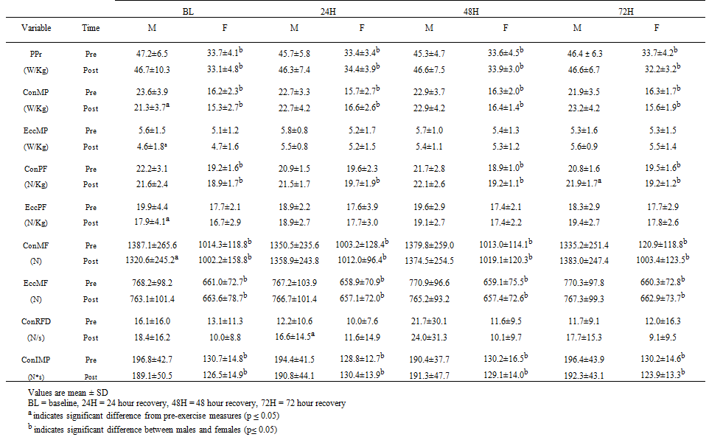

Upper Body
Upper body CMJ variable statistics were only conducted for the male subjects due to only one female being able to perform the task. Paired-samples t-tests were conducted to compare pre and post CMJ variables and one-way repeated measure ANOVAs with Bonferroni pairwise comparisons were done to compare CMJ variables between the time points. All upper body CMJ variables are represented in Table 4 as means ± SD and were taken from the three highest upper body CMJs based on relative Peak Power (PPr). Baseline, 24, 48 and 72 hour recovery upper body CMJ variables were not significantly different from pre to post exercise (p>0.05). EccPF significantly increased from 48 to 72 hour recovery (p=0.001). ConRFD significantly decreased from 24 hour recovery to 72 hour recovery (p=0.040). PPr (p=0.885), ConMP (p=0.227), EccMP (p=0.449), ConPF (p=0.063), ConMF (p=0.089), EccMF (p=0.106) and ConIMP (p=0.535) were not significantly different between baseline, 24, 48 and 72 hour recovery (p>0.05).
Table 5. Upper Body CMJ Performance
Variable | Time | BL | 24H | 48H | 72H
n (pre/post) |  | 8/7 | 9/9 | 9/9 | 9/8
PPr | Pre | 35.89±11.60 | 35.06±10.42 | 40.28±14.10 | 35.66±22.80
(W/Kg) | Post | 38.31±13.17 | 34.27±13.16 | 49.44±53.94 | 39.16±17.80
ConMP | Pre | 22.22±11.82 | 19.37±3.66 | 23.07±14.20 | 16.97±9.91
(W/Kg) | Post | 19.31±6.81 | 18.04±3.46 | 22.92±16.12 | 24.82±16.19
EccMP | Pre | 3.92±3.56 | 3.83±2.01 | 5.28±6.15 | 2.42±2.70
(W/Kg) | Post | 2.42±1.89 | 2.79±1.70 | 2.68±2.27 | 5.49±6.34
ConPF | Pre | 16.00±5.60 | 19.69±2.57 | 18.71±4.18 | 17.92±4.90
(N/Kg) | Post | 18.15±2.22 | 18.99±3.11 | 19.97±3.51 | 17.00±5.15
EccPF | Pre | 13.16±1.52 | 16.22±2.72 | 15.55±3.66ª | 14.18±3.03
(N/Kg) | Post | 13.20±2.22 | 14.47±2.26 | 15.57±3.77 | 14.77±2.96
ConMF | Pre | 530.63±192.65 | 642.92±90.43 | 602.55±154.29 | 549.64±169.38
(N) | Post | 624.52±75.72 | 614.37±77.38 | 618.81±107.69 | 538.08±158.08
EccMF | Pre | 443.02±85.22 | 474.25±72.04 | 465.40±88.64 | 507.00±118.13
(N) | Post | 489.14±48.73 | 482.40±65.26 | 488.62±63.06 | 444.25±86.07
ConRFD | Pre | 24.80±16.84 | 26.32±11.67ª | 21.81±14.33 | 17.60±13.92
(N/s) | Post | 19.70±14.23 | 24.05±11.67 | 24.95±15.25 | 22.84±11.55
ConIMP | Pre | 90.90±42.55 | 99.52±47.54 | 103.23±38.34 | 84.14±74.64
(N*s) | Post | 119.66±44.58 | 95.31±46.38 | 87.54±49.97 | 87.95±34.21
Values are mean ± SD
BL = baseline, 24H = 24 hour recovery, 48H = 48 hour recovery, 72H = 72 hour recovery
ª indicates significant difference from 72H value (p ≤ 0.05)

sRPE
One-way repeated measures ANOVA was conducted to compare sRPE between time points and RPE for set 1, 2 and 3 with-in and between time points with a Bonferroni pairwise comparison. sRPE was not significantly different between all time points (p=0.876). Figure 6 illustrates the mean RPE for set 1, 2 and 3 across all time points. RPE following set 1, 2 and 3 was not significantly different between all time points (p=0.645, p=0.146, p=0.288). Baseline RPE showed a significant difference between sets (p<0.001). RPE for set 1 was significantly lower than set 2 (p<0.001) and 3 (p=0.001) while set 2 and set 3 were not significantly (p=0.360). RPE between sets for 24H was significantly different (p<0.001). RPE for set 1 was significantly lower than set 2 (p=0.007) and set 3 (p=0.001) and set 2 was significantly lower than set 3 (p=0.008). RPE between sets for 48H was significantly different (p=0.001). RPE for set 1 was significantly lower than set 2 (p=0.002) and set 3 (p=0.006) while set 2 and 3 were not significantly different (p=0.529). For 72 hour recovery, RPE between sets was significantly different (p<0.001). RPE for set 1 was significantly lower than set 2 (p=0.004) and set 3 (p<0.001) and set 2 was significantly lower than set 3 (p=0.001).

Figure 6. Mean RPE for set 1, 2 and 3 across baseline, 24H, 48H and 72H. ª indicates significant difference from set 2 (p≤0.05). ^{b} indicates significant difference from set 3 (p≤0.05).

Pressure-Pain Threshold and Muscle Soreness
Pearson’s r correlation was conducted to compare algometer and VAS measures, one-way repeated measures ANOVA was done to compare algometer measures between time points and paired-samples t-tests were performed to compare upper and lower body algometer measures. Algometer measures did not correlate with VAS measures for upper body measures for baseline (r=-0.282, p=0.243), 24H (r=-0.450, p=0.053) and 48H (r=-0.358, p=0.133) while they did negatively correlate for 72H (r= -0.484, p=0.036). Algometer measures did not correlate with VAS for lower body for baseline (r=-0.414, p=0.078), 24H (r=-0.250, p=0.303), 48H (r=-0.189, p=0.438), 72H (r=-0.227, p=0.350). However, all measures did follow a negative linear correlation. Upper body algometer measures were significantly lower than lower body algometer measures for baseline, 24 hour recovery, 48 hour recovery and 72 hour recovery (p<0.001). Upper and lower body algometer measures were not significantly different between all time points (p=0.054, p=0.129).
One-way repeated measures ANOVAs with Bonferroni pairwise comparisons were performed to compare overall, upper and lower body soreness measures between the time points. Paired-samples t-tests were done to compare upper and lower body soreness measures. Figure 7 describes overall VAS soreness ratings for male and female across all time points. Overall VAS showed a significant difference between time points (p=0.001). Analysis showed that 24H was significantly higher than baseline (p<0.001) and 72 (p=0.002) and not significantly different from 48H (p=0.592). Baseline was not significantly different from 48 (p=0.301) or 72H (p=0.064) and 48H was not significantly different from 72H (p=1.000).

Figure 7. Mean overall VAS soreness ratings across baseline, 24H, 48H and 72H.
ª indicates significant difference from baseline and 72H (p≤0.05).

Figure 8 & 9 illustrate upper and lower body VAS across all time points. Upper body VAS measures were significantly greater than lower body VAS measures for baseline (p=0.011), 24H (p<0.001) and 48 hour recovery (p=0.001). Upper body VAS measures were not significantly different from lower body VAS for 72 hour recovery (p=0.174). Upper body was significantly different between time points (p=0.001). Twenty-four hour recovery was significantly greater than baseline (p<0.001) and 72H (p=0.003) and not significantly different from 48H (p=0.572). Baseline was not significantly different from 48H (p=0.157) or 72H (p=0.165) and 48H was not significantly different from 72h (p=1.000). There was a significant difference between time points for lower body VAS (p=0.028). Twenty-four hour recovery was significantly greater than baseline (p=0.005) and 72H (p=0.027) and was not significantly different from 48H (p=1.000). Baseline was not significantly different from 48H (p=1.000) or 72H (p=0.644) and 48H was not significantly different from 72H (p=1.000).

Figure 8. Mean upper body VAS soreness ratings across baseline, 24H, 48H and 72H. ª indicates significant difference from baseline and 72H (p≤0.05). ^{b} indicates significant difference from lower body VAS (p≤0.05).

Figure 9. Mean lower body VAS soreness ratings across baseline 24H, 48H and 72H. ª indicates significant difference from baseline and 72H (p≤0.05).

PRS
One-way repeated measures ANOVA with Bonferroni pairwise comparisons were performed to compare PRS between time points and Pearson’s r correlation was done to compare PRS with soreness ratings. There was a significant difference between time points for PRS (p=0.001). Twenty-four hour recovery PRS was significantly lower than baseline (p=0.002) and 72H (p=0.025 while 24H was not significantly different from 48H (p=0.633). Baseline was not significantly different from 48H (p=0.082) or 72H (p=0.662) and 48H was not significantly different from 72H (p=0.785).

Figure 10. Mean PRS across baseline, 24H, 48H and 72H. ª indicates significant difference from baseline and 72H (p≤0.05).

PRS had negative correlations with overall VAS for baseline (r=-0.484, p=0.036), 24 hour recovery (r=-0.682, p=0.001), 48 hour recovery (r=-0.503, p=0.023) and 72 hour recovery (r=-0.528, p=0.020).

Perceived Performance Score (PPS)
One-way repeated measures ANOVA was done to compare PPS between time points and Pearson’s r correlation was conducted to compare PPS and exercise performance. Figure 11 describes the mean PPS for male and female subjects across all time points. The PPS (total reps/ sRPE) showed significant differences between baseline, 24, 48 and 72H (p<0.001). Baseline PPS was significantly lower than 24 (p=0.006), 48 (p<0.001) and 72 hour recovery (p<0.001). Twenty-four hour recovery was not significantly different from 48H (p=0.206) or 72H (p=0.102) and 48H was not significantly different from 72H (p=1.000)
PPS was significantly correlated with exercise performance for baseline (r=0.870, p=0.000), 24H (r=0.863, p=0.000), 48H (r=0.895, p=0.000) and 72H (r=0.862, p=0.000).

Figure 11. Mean PPS across baseline, 24H, 48H and 72H. ª indicates significant difference from 24H, 48H and 72H (p≤0.05).

Sex Differences

10RM
One-way ANOVA was conducted to compare male and female 10RMs. Male and female subjects were significantly different for 10RM with males being significantly greater than females leg press (p=0.006), chest press (p<0.001), lat pulldown (p<0.001), shoulder press (p<0.001), knee extension (p<0.001), knee flexion (p<0.001), bicep curl (p<0.001) and triceps curl (p<0.001).

Repetitions
One-way ANOVA was performed to compare male and female exercise performance in terms of total repetitions. Male and females did not show a significant difference for total reps for baseline (p=0.110), 24H (p=0.209), 48H (p=0.099) or 72H (p=0.313).

CMJ
One-way ANOVAs were conducted to compare CMJ variables between male and females. Table 3 shows the differences between male and female CMJ variables for the lower body. Since only one female was able to do the upper body CMJ, there are no sex comparisons that were made. Overall, males were significantly greater than females for baseline PPr (p<0.001), ConMP (p<0.001), ConPF (p=0.018), ConMF (p=0.001), EccMF (p=0.016) and ConIMP (p<0.001) and did not differ for EccMP (p=0.469), EccPF (p=0.191) or ConRFD (p=0.639); 24H PPr (p<0.001), ConMP (p<0.001), ConMF (p=0.001), EccMF (p=0.018) and ConIMP (p<0.001) and no difference was seen for EccMP (p=0.347), ConPF (p=0.165), EccPF (p=0.345) or ConRFD (p=0.607); 48H PPr (p<0.001), ConMP (p<0.001), ConPF (p=0.011), ConMF (p=0.001), EccMF (p=0.013) and ConIMP (p<0.001) and no difference was seen for EccMP (p=0.560), EccPF (p=0.078) or ConRFD (p=0.350); 72H PPr (p<0.001), ConMP (p<0.001), ConMF (p=0.003), EccMF (p=0.014) and ConIMP (p<0.001) and no differences were seen for EccMP (p=0.921), ConPF (p=0.110), EccPF (p=0.662) or ConRFD (p=0.952).

Soreness
One-way ANOVA was done to compare male and female pressure pain thresholds with algometer and soreness ratings with VAS. Male and females were not significantly different for upper body algometer soreness measures during baseline (p=0.163), however males’ upper body algometer measures were significantly greater than females for 24H (p=0.016), 48H (p=0.043) and 72H (p=0.039). Males reported significantly greater lower body algometer measures compare with females for baseline (p=0.031) and 24H (0.005). Male and females were not significantly different for lower body algometer measures for 48H (p=0.053) or 72H (p=0.128). Male and females were not significantly different for overall VAS for baseline (p=0.457), 24H (p=0.423), 48H (p=0.061) or 72H (p=0.757); upper body VAS for baseline (p=0.498), 24H (p=0.655), 48H (p=0.145) or 72H (p=0.914); or lower body VAS for baseline (p=0.450), 24H (p=0.479), 48H (p=0.190) or 72H (p=0.365).

sRPE, PRS, PPS
One-way ANOVA was performed to compare sRPE, PRS and PPS between male and females. Figure 12 describes mean sRPE for male and female across all time points. Male and females were not significantly different in sRPE for baseline (p=0.801), 24H (p=0.965), 48H (p=0.164) or 72H (p=0.586); PRS for baseline (p=0.855), 24H (p=0.902), 48H (p=0.920) or 72H (p=0.943); PPS for baseline (p=0.144), 24H (p=0.316), 48H (p=0.426) or 72H (p=0.627).

Figure 12. Mean sRPE across baseline, 24H, 48H and 72H. ª indicates significant difference from male subjects (p≤0.05)

Chapter 5: Discussion
The purpose of this study was to determine the recovery pattern of ROTC cadets following a high intensity bout of resistance exercise while investigating any sex differences for measures related to recovery time, force production, soreness, perceived effort, and perceived recovery. It was hypothesized that 1) there would be a difference in recovery between male and female cadets, determined by the number of repetitions performed 2) changes in CMJ performance would match the pattern of change in exercise performance in ROTC cadets and 3) there would be differences in relative and absolute countermovement jump performance metrics between male and female ROTC cadets 4) there would be differences in DOMS related to EIMD between male and female ROTC cadets, 5) there would be a difference between male and female ROTC cadets in soreness ratings on a VAS and algometer measures and 6) there would be differences in the time course to reach peak soreness, as well as, to return to baseline in male and female ROTC cadets.

Exercise Performance
Results showed that mean delta scores for total repetitions were not significantly different between 24H, 48H and 72H regardless of the recovery scheme employed. Additionally, total repetitions during the initial exercise session (baseline) was lower than all time points (24, 48 and 72 hour recovery). This finding does not agree with past research^{9, 22, 34, 44}. McLester et al. (2003), Judge & Burke (2010), Radaelli et al (2012) and Howatson et al. (2016) showed that baseline was not significantly lower than the recovery days, rather 24-hour recovery showed the lowest performance compared with all other exercise trials following resistance exercise. Due to the subjects not being exposed to any type of muscle damage before the baseline exercise, it would not have been expected for total reps to be the lowest for baseline performance. This low baseline performance could have been due to the subjects not being exposed to a high intensity resistance workout prior to the study. The subjects may have experienced neural adaptations which could have aided in performance improvements throughout the study, despite 10RM being determined and verified on two separate occasions, respectively, prior to the start of baseline testing. In the current investigation, exercise performance, based on total reps performed, showed a gradual increase from baseline to 24 to 48-hour recovery followed by a slight decrease at 72 hour recovery. McLester et al (2003) found that healthy males were able to return to baseline performance within 48 hours of recovery while 24 hours of recovery was significantly lower than baseline performance. They also found a trend between 24, 48, 72 and 96-hour recovery that was similar to this study for baseline, 24, 48 and 72 hour recovery. Seventy-two hours of recovery was actually significantly greater than baseline total reps, similar to the relationship between 48 hour recovery and baseline performance in this study. They also found that 96 hour recovery was not significantly different from baseline, showing that total reps decreased following 72 hours. This is similar to our findings for 72-hour recovery. The subjects showed an improvement in performance over the course of the study indicating a training effect. These adaptations also suggest that this population was not as resistance trained as originally assumed.

CMJ
Lower body CMJ variables did not match the same pattern of change as exercise performance. The lower body CMJs were not different between baseline, 24, 48 or 72 hour recovery which does not match the pattern of baseline being the lowest performance and increasing performance in 24, 48 and 72 hour recovery. This unmatched pattern is similar to the findings of Howatson et al (2016). The authors found that CMJ jump height did not correlate with the decline in MVC performance. There was no difference in jump height between pre session, post session and 24-hour recovery. Baseline measures showed the only exercise trial where lower body CMJ variables declined was from pre to post exercise. The lack of decline from pre to post exercise during 24, 48 and 72-hour recovery may indicate that the exercise did not induce lower body muscle fatigue, this population of ROTC cadets was unable to generate a maximal force in CMJs which prevented a change from pre to post from being detected, or jump technique was altered in order to produce the same performance. Ronglan et al. (2006) and McLean et al. (2010) showed a decline in CMJ performance however, the CMJs were performed following high intensity handball and rugby matches, respectively, not a high intensity resistance exercise. This suggests that there still needs to be validation of using CMJ performance as an indicator of exercise performance following a bout high intensity resistance exercise.
Upper body CMJs did not decline from pre to post for baseline, 24, 48 or 72-hour recovery, again possibly indicating this exercise was unable to induce fatigue or this population was unable to produce a maximal force. The variables that increased between 24, 48 and 72-hour recovery indicate that the subjects were able to improve their upper body performance. Push up performance on a force plate following a resistance exercise has not been reported in previous literature. However, since lower body CMJ performance did not change from pre to post or between recovery days, it is difficult to discuss if the push up test is reliable in testing changes in force production following a bout of high intensity resistance exercise in the upper body.

sRPE
No differences in sRPE were observed between baseline, 24, 48 and 72 hour recovery, indicating the subjects perceived the intensity of the exercise to be relatively the same across exercise trials. RPE after sets 1, 2 and 3 for each exercise was not different between baseline, 24, 48 and 72 hour recovery again, indicating the subjects perceived the intensity of three sets the same between each exercise trial.
RPE of set 1 was lower than set 2 and set 3 for all exercise trials showing that the subjects perceived the first set to be less intense than the second and third set. RPE for set 2 and 3 were not different, except during 72-hour recovery, indicating the subjects perceived the intensity to be relatively the same between set 2 and set 3. The increase in RPE between sets during resistance exercise is supported by Egan et al. (2006). They found that set 1 RPE was lower than the other sets of each of the exercises, possibly indicating the ability of an exerciser to detect accumulating levels of fatigue.
Foster et al. (2011) discussed the use of sRPE following high intensity endurance exercise, cycling and basket training/ matches, and found that sRPE was a reliable measure and suggested that sRPE may be a valid approach to evaluating resistance exercise. They also discussed how resistance trained individuals were poor with rating aerobic exercise intensity due to them attending more to muscular tension rather than dyspnea. This may suggest that, since these cadets were endurance trained, they may lack sensitivity in perceiving different levels of discomfort and fatigue associated with resistance exercise.

Pressure-Pain Threshold and Soreness
Algometer and VAS measures did not demonstrate the expected correlation, meaning that as algometer readings went up, VAS measures did not go down, which indicates that the subject experienced no soreness; or as algometer measures went down, the VAS measures did not go up, which demonstrates the subject experienced soreness. This relationship could suggest that pressure-pain threshold and soreness do not correlate in this population following a high-intensity interval resistance exercise.
The algometer measures showed that the upper body was consistently greater than the lower body for baseline, 24, 48 and 72-hour recovery, indicating it had a lower pressure-pain threshold. However, no differences were shown for either upper or lower body pressure-pain threshold levels over time.
VAS measures demonstrated higher soreness levels in the upper body compared with the lower body for baseline, 24 and 48-hour recovery. Upper and lower body soreness was not different for 72-hour recovery. Contrary to algometer measures, 24-hour recovery showed increased overall, upper and lower body soreness levels compared with baseline and 72 hours.
VAS was able to demonstrate a significant change in soreness levels between exercise trials contrary to algometer measures. Either the use of a digital algometer device or VAS measurements would be recommended in future investigations to measure soreness levels.
Despite the subjects showing a change in soreness levels, this change did not follow the pattern of exercise performance. Recovery for 24 hours showed the greatest soreness levels, but performance was still greater than baseline. This indicates that these subjects were able to improve performance regardless of a significant increase in muscle soreness. However, soreness and decrements in force production are not as comparable as the relationship between muscle damage and force loss.

PRS
The PRS scale showed that subjects felt less recovered after 24-hour recovery following baseline. Even though the subjects felt less recovered for 24-hour recovery, they were able to improve performance from baseline. This shows that the PRS scale may not be as useful in determining performance in ROTC cadets for a resistance exercise.
The PRS scale did correlate with VAS which demonstrates that as soreness levels increased, perceived recovery went down. The PRS scale may be better at determining for soreness levels than performance. This further demonstrates that soreness does not equal loss of force or decreased performance.

Perceived Performance Score (PPS)
The PPS was used to represent a person’s performance capacity in regards to total repetitions and perceived exertion for the exercise. The greater the PPS, the higher the performance compared with perceived exertion and the lower the PPS, the lower performance compared with perceived exertion. The results showed that baseline had the lowest PPS when compared to 24, 48 and 72-hour recovery while there was no difference in PPS between 24, 48 and 72 hour recovery. This supports the findings that baseline had the lowest performance, in terms of total reps, compared with 24, 48, and 72-hour recovery and 24, 48 and 72-hour recovery had no difference in performance. However, since the sRPE was not different between exercise sessions, further investigations should be conducted when the sRPE is difference between sessions.

Sex Differences
Males had greater 10RM loads than the females, meaning they were able to lift a greater amount of weight compared with the female subjects. The 10RM loads were divided by the subjects’ body weight and the significant difference was still present for all exercise machines. Even though males were able to lift more, the performance did not differ between male and female, which opposes the findings in other studies that saw differences in performance²². Judge & Burke (2010) found that males were not able replicate baseline performance after 4 hours or 24 hours. However, the female participants in this study were able to repeat their baseline performance, indicating either an increased capacity to recover or a decreased level of muscle damage when performing similar exercise. There have been multiple studies that support the difference in performance between male and female following isometric exercises^{18, 20}. However, due to the findings of this study, there still needs to be further investigation on sex differences in performance following resistance exercise.
Males outperformed females on the lower body CMJ across all trials. Only one female was able to perform the upper body CMJ, which was surprising considering the amount of push-ups typically utilized for training in the ROTC population based on Army fitness standards. This shows the differences in upper body strength between male and female. Females should focus on increasing upper body exercise to improve upper body strength.
Males had greater algometer measures compared with females indicating that males were less sore than females. However, in regards to VAS measures, male and female subjects recorded similar soreness ratings for overall, upper and lower body, similar to the findings in Sewright et al. (2008). The VAS soreness measures match the pattern of exercise performance between male and female, unlike the algometer measures. Due to the discrepancy between algometer and VAS measures, these findings between male and female are not surprising. Males and females recorded similar sRPE, meaning the perceived exertion was similar for each group between baseline, 24, 48 and 72 hour recovery. PRS scale did not differ between male and female indicating both groups were similar in perceiving their recovery status between baseline, 24, 48 and 72 hour recovery. The fitness score also did not differ between male and female due to sRPE and repetitions not differing between the two groups.
This protocol was unable to show any differences in performance, recovery, soreness, sRPE, PRS or PPS between male and females. Even though males were lifting a greater amount of weight, they were able to recover the same as female and report soreness ratings similar to females. Future studies may want to consider incorporating a second baseline measure to eliminate the initial learning effect between baseline and 24 hour recovery, especially if those subjects are not resistance trained.

Chapter 6: Conclusion
Our findings indicate that ROTC cadets were able to complete a bout of high-intensity interval resistance exercise and maintain performance with as little as 24H of recovery. It was hypothesized that male and female cadets would differ in performance recovery; however they both recovered in the same pattern. It was hypothesized that CMJ variables would match the pattern of change of exercise performance; however CMJ variables did not match the pattern of change. This may have been due to the lack of fatigue from the resistance exercise. Regardless of the progression in performance, both male and female cadets showed an increase in soreness for 24H recovery. This shows that soreness does not affect performance in ROTC cadets following a bout of high-intensity interval resistance exercise. PRS may be more useful in determining soreness levels rather than performance in a high-intensity interval resistance exercise. More research needs to be done to investigate the utility of sRPE and PPS following a bout high intensity interval resistance exercise. The limitations of this study include 1) subjects were part of a convenience sample and therefore all findings can only be applied to male and female ROTC cadets, 2) there was no direct measure of changes in muscle force production and 3) there was no direct measure of changes in muscle damage. There needs to be further investigation over recovery patterns following a high-intensity interval resistance exercise in ROTC cadets and validating the CMJ as a surrogate in measuring fatigue and recovery. In conclusion, ROTC cadets recovered within 24H following a bout of high-intensity interval resistance exercise and this exercise protocol may be a good initial resistance program for cadets in order to improve performance in a short amount of time.

References
- Thomas, D.Q., Lumpp, S.A., Schreiber, J.A., Keith, J.A. (2004). Physical fitness profile of army ROTC cadets. Journal of Strength and Conditioning Association; 18(4), 904-907.

- Gibala, M.J., Gagnon, P.J., Nindl, B.C. (2015). Military applicability of interval training for health and performance. Journal of Strength and Conditioning Research; 29(11S), S40-S45.

- Gist, N.H., Freese, E.C., Ryan, T.E., Cureton, K.J. (2015). Effects of low-volume, high-intensity whole-body calisthenics on army ROTC cadets. Military Medicine; 180(5), 492-498.

- Marx, J.O., Ratamess, N.A., Nindle, B.C., Gotshalk, L.A., Volek, J.S., Dohi, K., Bush, J.A., Gomez, A.L., Mazzetti, S.A., Fleck, S.J., Hakkinen, K., Newton, R.U., Kraemer, W.J. (2001). Low-volume circuit versus high-volume periodized resistance training in women. Medicine & Science in Sports & Exercise; 33(4), 635-643.

- Gibala M.J.., Little, J.P., van Essen, M., Wilkin, G.P., Burgomaster, K.A., Safdar, A., Raha, S., Tarnopolsky, M.A. (2006). Short-term sprint interval versus traditional endurance training: similar initial adaptations in human skeletal muscle and exercise performance. Journal of Physiology; 573(3), 901-911.

- Trapp, E.G., Chisholm,D.J., Freund, J., Boutcher, S.H. (2008). The effects of high-intensity intermittent exercise training on fat loss and fasting insulin levels of young women. International Journal of Obesity; 32, 684-691.

- Little, J.P., Safdar, A., Wilkin, G.P., Tarnopolsky, M.A., Gibala, M.J. (2010). Apractical model of low-volume high-intensity interval training induces mitochondrial biogenesis in human skeletal muscle: potential mechanisms. Journal of Physiology; 588(6), 1011-1022.

- Hakkinen, K. (1993). Neuromuscular fatigue and recovery in male and female athletes during heavy resistance exercise. International Journal of Sports Medicine; 14(2), 53-59.

- McLester, J.R., Bishop, P.A., Smith, J., Wyer, L., Dale, B., Kozusko, J., Richardson, M., Nevett, M.E., Lomax, R. (2003). A series of studies—a practical protocol for testing muscular endurance recovery. Journal of Strength and Conditioning Research; 17(2), 259-273.
- Byrne, C., Twist, C., Eston, R. (2004). Neuromuscular function after exercise-induced muscle damage: theoretical and applied implications. Sports Medicine; 34(1), 49-69.

- Bishop, P.A., Jones, E., Woods, K. (2008). Recovery from training: a brief review. Journal of Strength and Conditioning Research; 22(3), 1015-1024.

- Senefeld, J., Yoon, T., Hoeger Bement, M., Hunter, S.K. (2013). Fatigue and recovery from dynamic contractions in men and women differ for arm and leg muscles. Muscle Nerve; 48, 436-439.

- Hunter, S.K. (2016). Sex differences in fatigability of dynamic contractions. Experimental Physiology; 101(2), 250-255.

- Madigen, M.L. & Pidcoe, P.E. (2003). Changes in landing biomechanics during a fatiguing landing activity. Journal of electromyography and kinesiology; 13, 491-498.

- Markovic, G., Dizdar, D., Jukic, I., Cardinale, M. (2004). Reliability and factorial validity of squat and countermovement jump tests. Journal of Strength and Conditioning Research; 18(3), 551-555.

- Gathercole, R., Sporter B., Stellingwerff, T., Sleivert, G. (2015). Alternative countermovement-jump analysis to quantify acute neuromuscular fatigue. International Journal of Sports Physiology and Performance; 10, 84-92.

- Semmler, J.G., Kutzscher, D.V., Enoka, R.M. (1999). Gender differences in fatigability of human skeletal muscle. Journal of Neurophysiology; 82, 3590-3593.

- Fulco, C.S., Rock, P.B., Muza, S.R., Lammi, E., Cyerman, A., Butterfield, G., Moore, L.G., Braun, B., Lewis, S.F. (1999). Slower fatigue and faster recovery of adductor pollicis muscle in women matched for strength with men. Acta Physiologica Scandinavica; 167, 233-239.

- Clark, B.C., Manini, T.M., The, D.J., Doldo, N.A., Ploutz-Snyder, L.L. (2003). Gender differences in skeletal muscle fatigability are related to contraction type and EMG spectral compression. Journal of Applied Physiology; 94, 2263-2272.

- Albert, W.J., Wrigley, A.T., McLean, R.B., Sleivert, G.G. (2006). Sex differences in the rate of fatigue development and recovery. Dynamic Medicine; 5(2), doi:10.1186/1476-5918-5-2

- Sewright, K.A., Hubal, M.J., Kearns, A., Holbrook, M.T., Clarkson, P.M. (2008). Sex differences in response to maximal eccentric exercise. Medicine & Science in Sports & Exercise; 40(2), 242-251.

- Judge, L.W. & Burke, J.R. (2010). The effect of recovery time on strength performance following a high-intensity bench press workout in males and females. International Journal of Sports Physiology and Performance; 5, 184-196.

- Jones, K., DeBeliso, T.G., Berning, J.M., Adams, K.J. (2012) Body mass index and army physical fitness test standards in ROTC cadets. International Journal of Science and Engineering Investigations; 1(10), 54-58.

- Twist, C. & Highton, J. (2013). Monitoring fatigue and recovery in rugby league players. International Journal of Sports Physiology and Performance; 8, 467-474.

- Day, M.L., McGuigan, M.R., Brice, G., Foster, C. (2004). Monitoring exercise intensity during resistance training using the session RPE. Journal of Strength and Conditioning Research; 18(2), 353-358.

- Gallagher, E.J., Liebman, M., Bijur, P.E. (2001). Prospective validation of clinically important changes in pain severity measure on a visual analog scale. Annals of Emergency Medicine; 38(6), 633-638.

- Spiering, B.A., Kraemer, W.J., Anderson, J.M., Artmstrong, L.E., Nindle, B.C., Volek, J.S., Maresh, C.M. (2008). Resistance exercise biology: manipulation of resistance exercise programme variables determines the responses of cellular and molecular signaling pathways. Sports Medicine; 38(7), 527-540.

- Radaelli, R., Fleck, S.J., Leite, T., Leite, R.D., Pinto, R.S., Fernandes, L., Simao, R. (2015). Dose-response of 1, 3, and 5 sets of resistance exercise on strength, local muscular endurance, and hypertrophy. Journal of Strength and Conditioning Research; 29(5), 1349-1358.

- Vollestad, N.K. (1997). Measurement of human muscle fatigue. Journal of Neuroscience Methods; 74, 219-227.

- Ronglan, L.T., Raastad, T., Borgesen, A. (2006). Neuromuscular fatigue and recovery in elite female handball players. Scandinavian Journal of Medicine & Science in Sports; 16, 267-273.

- McLean, B.D., Coutts, A.J., Kelly, V., McGuigan, M.R., Cormack, S.J (2010). Neuromuscular, endocrine, and perceptual fatigue response during difference length between-match microcycles in professional rugby players. International Journal of Sports Physiology and Performance; 5, 367-383.

- Nedelec, M., McCall, A., Carling, C., Legall, F., Berthoin, S., Dupont, G. (2012). Recovery in soccer: part I—post-match fatigue and time course recovery. Sports Medicine; 42(12), 997-1015.

- Nedelec, M., McCall, A., Carling, C., Legall, F., Bathoin, S., Dupont, G. (2013). Recovery in soccer: part II—recovery strategies. Sports Medicine; 43, 9-22.

- Howatson, G., Brandon, R., Hunter, A.M. (2016). The response to and recovery from maximum-strength and-power training in elite track and field athletes. International Journal of Sports Physiology and Performance; 11, 356-362.

- Hicks, A.L., Kent-Braun, J., Ditor, D.S. (2001). Sex differences in human skeletal muscle fatigue. Exercise and Sport Sciences Review; 29(3), 109-112.

- Cormack, S.J., Newton, R.U., McGuigan, M.R., Doyle, T.L.A (2008). Reliability of measures obtained during single and repeated countermovement jumps. International Journal of Sports Physiology and Performance; 3, 131-144.

- Buchheit, M., Spencer, M., Ahmaidi, S. (2010). Reliability, usefulness, and validity of a repeated jump ability test. International Journal of Sports Physiology and Performance; 5, 3-17.

- Foster, C., Florhaug, J.A., Franklin, J., Gottschall, L., Hrovatin, L.A., Parker, S., Doleshal, P., Dodge, C. (2001). A new approach to monitoring exercise training. Journal of Strnegth and Conditioning Research; 15(1), 109-115.

- Pustina, A.A., Sato, K., Liu, C., Kavanaugh, A.A., Sams, M.L., Liu, J., Uptmore, K.D., Stone, M.H. (2017). Establishing a duration standard for the calculation of session rating of perceived exertion in NCAA division I men’ soccer. Journal of Trainology; 6, 26-30.

- Egan, A.D., Winchester, J.B., Foster C., McGuigan, M.R. (2006). Using session RPE to monitor difference methods of resistance exercise. Journal of Sports Science and Medicine; 5. 289-295.

- Lambert, M.I. & Borreson, J. (2010). Measuring training load in sports. International Journal of Sports Physiology and Performance; 5, 406-411.

- Nindl, B.C. (2015). Physical training strategies for military women’s performance optimization in combat-centric occupations. Journal of Strength and Conditioning Research; 29(11S), S101-S106.
- Nindl, B.C., Jones, B.H., Van Arsdale, S.J., Kelly, K., Kraemer, W.J. (2016). Operational physical performance and fitness in military women: physiological, musculoskeletal injury, and optimized physical training considerations for successfully integrating women into combat-centric military occupations. Military Medicine; 181(1), 50-62.

- Radaelli, R., Bottaro, M., Wilhelm, E.N., Wagner, D.R., Pinto, R.S. (2012). Time course of strategies and echo intensity recovery after resistance exercise in women. Journal of Strength and Conditioning Research; 26(9), 2577-2584.

- Jones, E.J., Bishop, P.A., Richardson, M.T., Smith, J.F. (2006). Stability of a practical measure of recovery from resistance training. Journal of Strength Condioning Research; 20(4), 756-759.

- Laurent, C.M., Green, J.M., Bishop, P.A., Sjokvist, J., Schumacker, R.E., Richardson, M.T., Curtner-Smitch, M. (2011) A practical approach to monitoring recovery: development of a perceived recovery status scale. Journal of Strength Conditioning Research; 25(3), 620-628.

- Faul, F., Erdfelder, E., Lang, A.-G., & Buchner, A. (2007). G*Power 3: A flexible statistical power analysis program for the social, behavioral, and biomedical sciences. Behavior Research Methods, 39, 175-191.

Appendix A: IRB Approval Letter
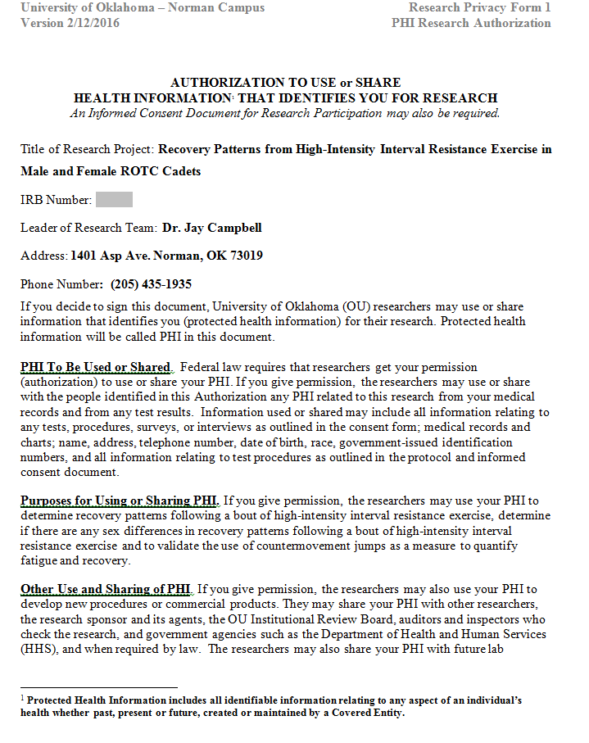

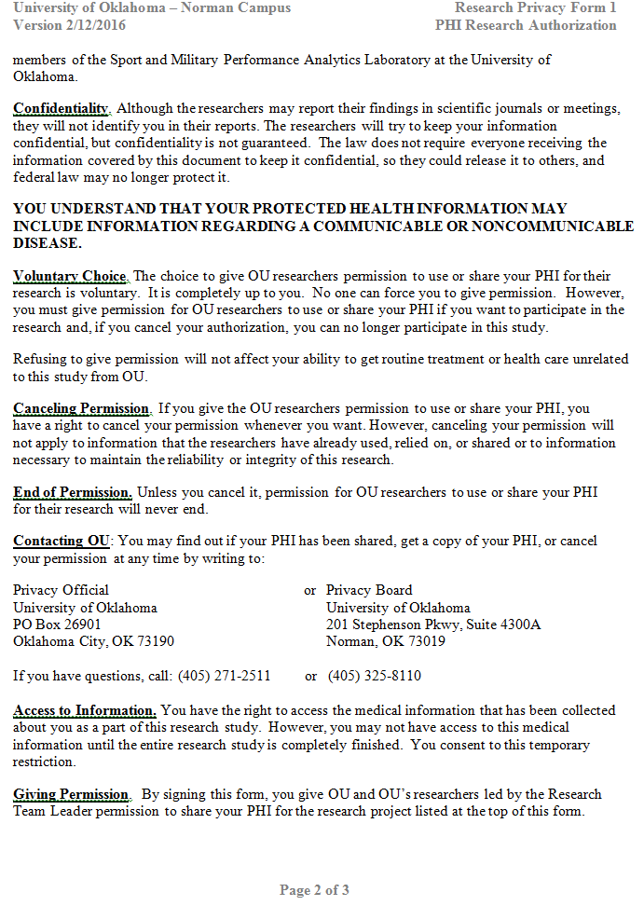

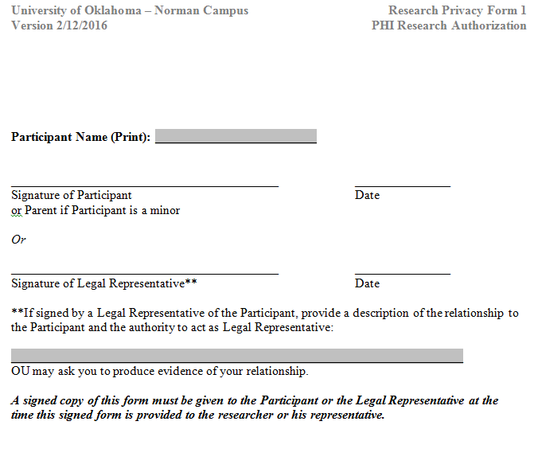

Appendix B: Informed Consent Form
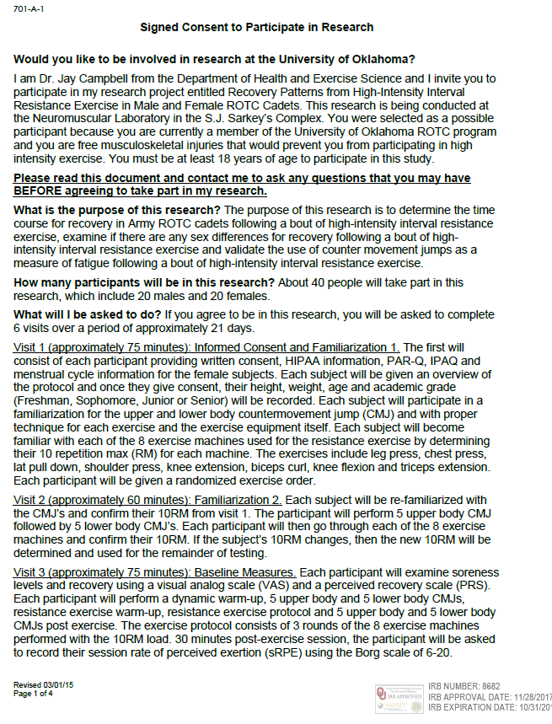

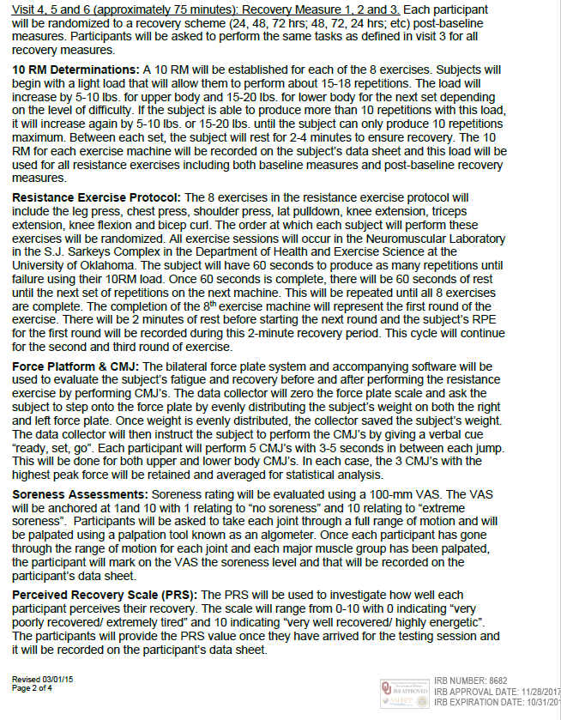



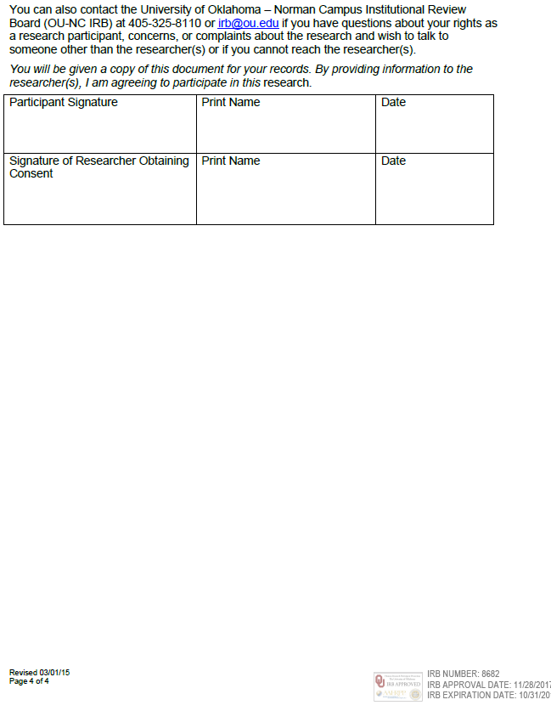

Appendix C: HIPAA
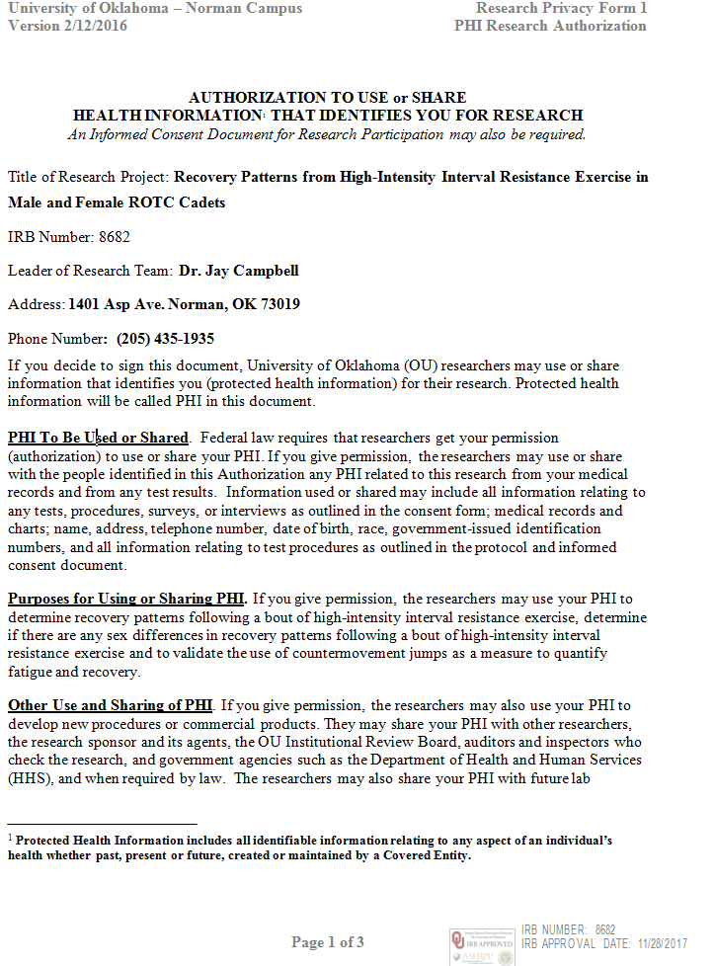

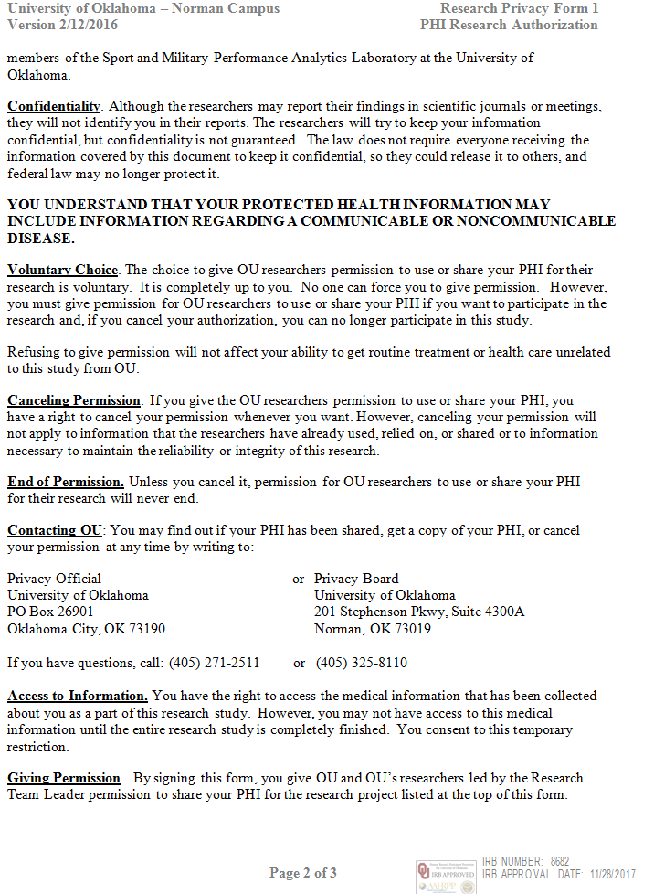

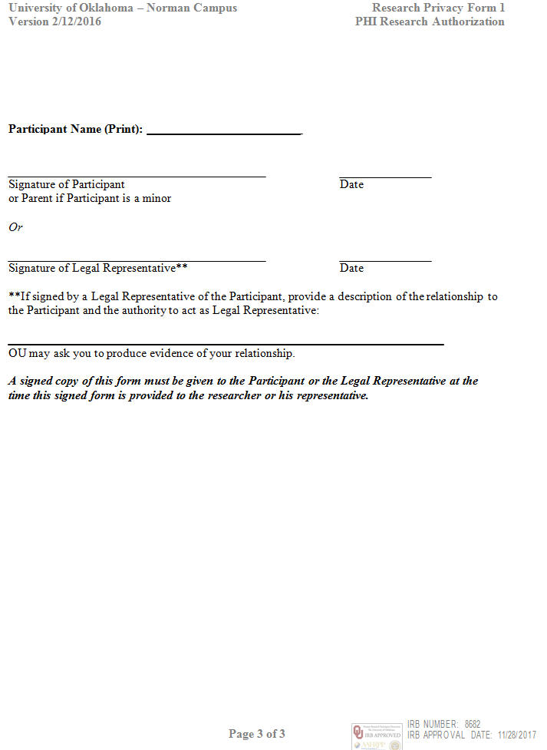

Appendix D: Health Status Questionnaire
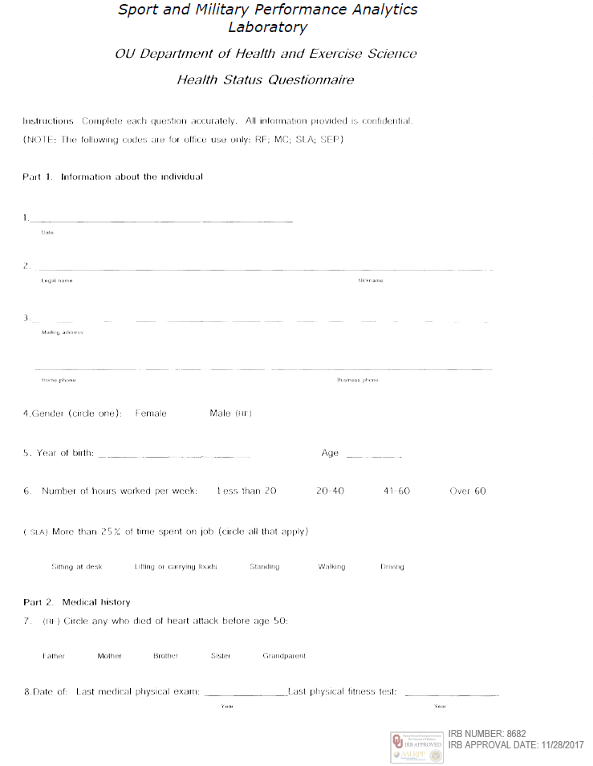

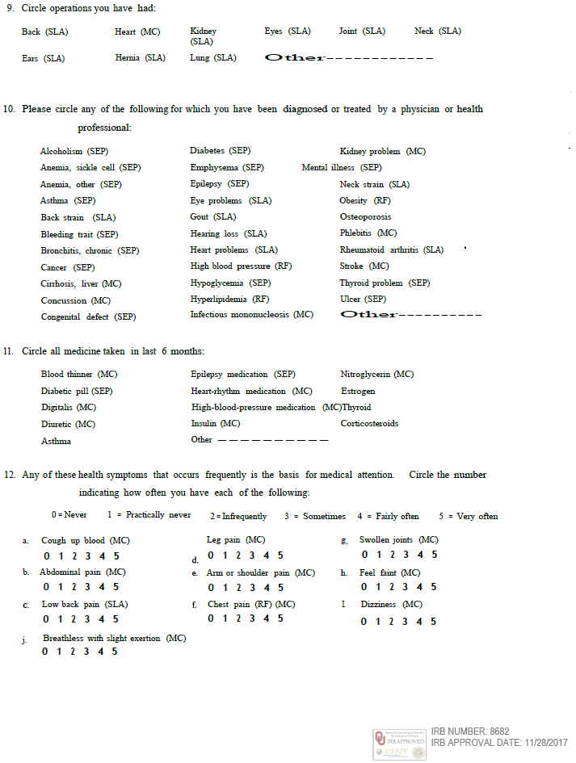
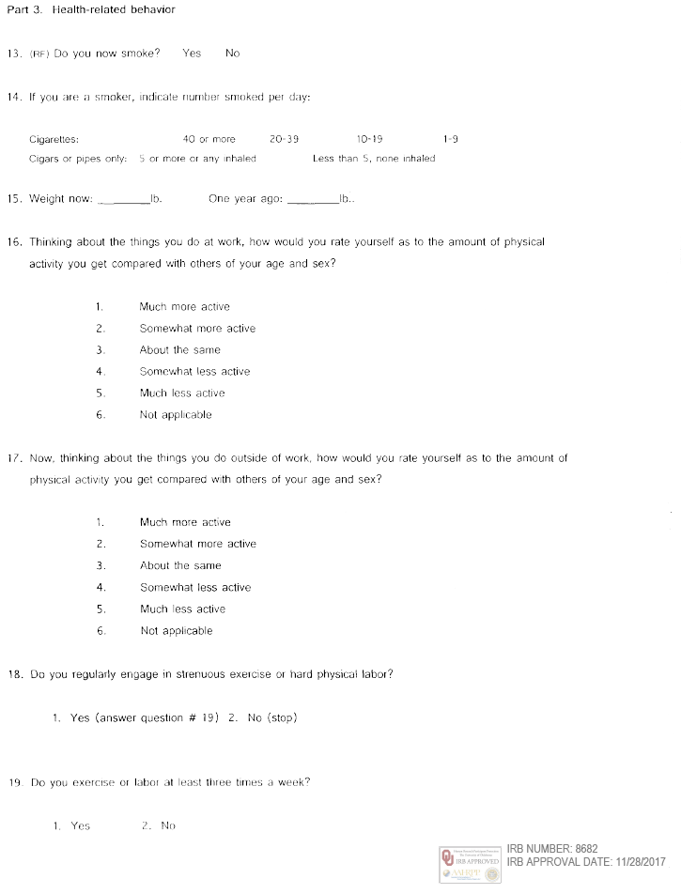

Appendix E: International Physical Activity Questionnaire
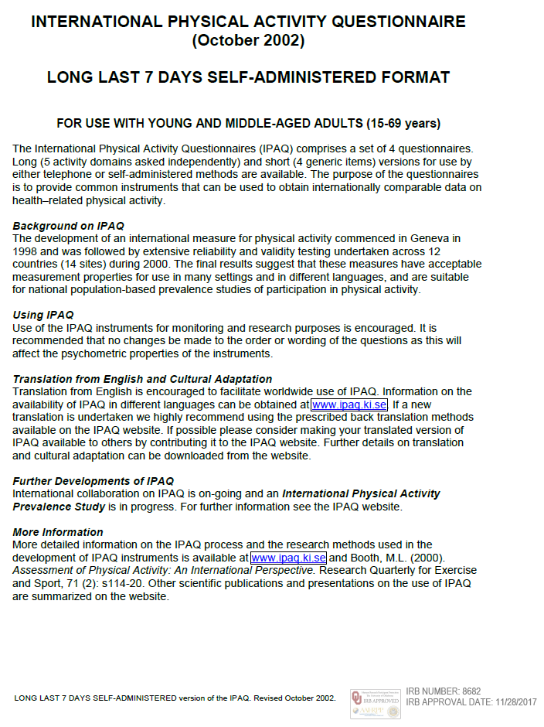
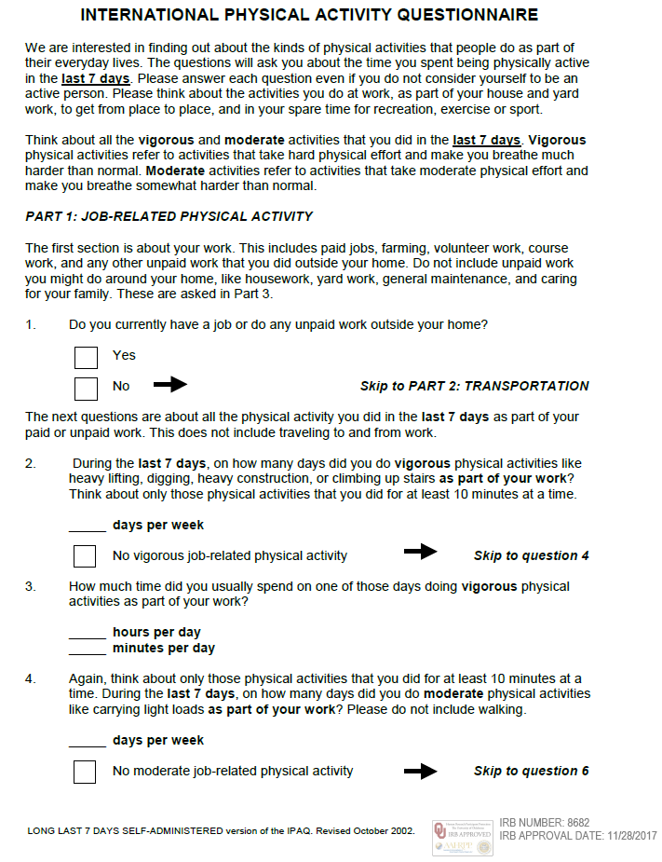
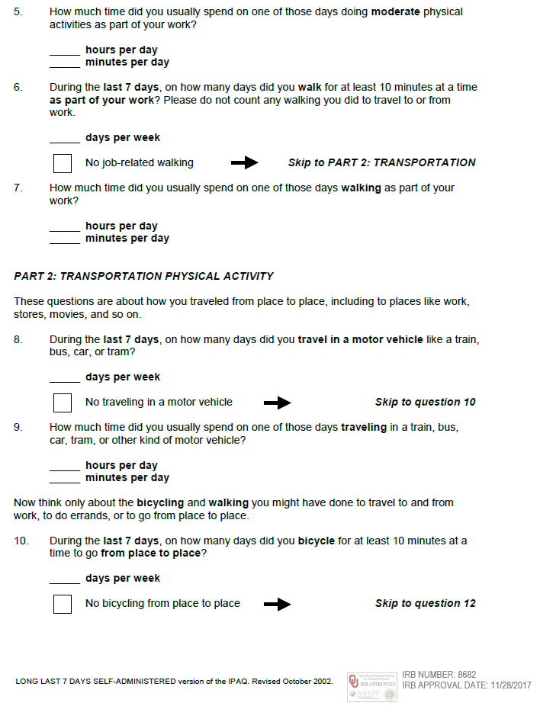
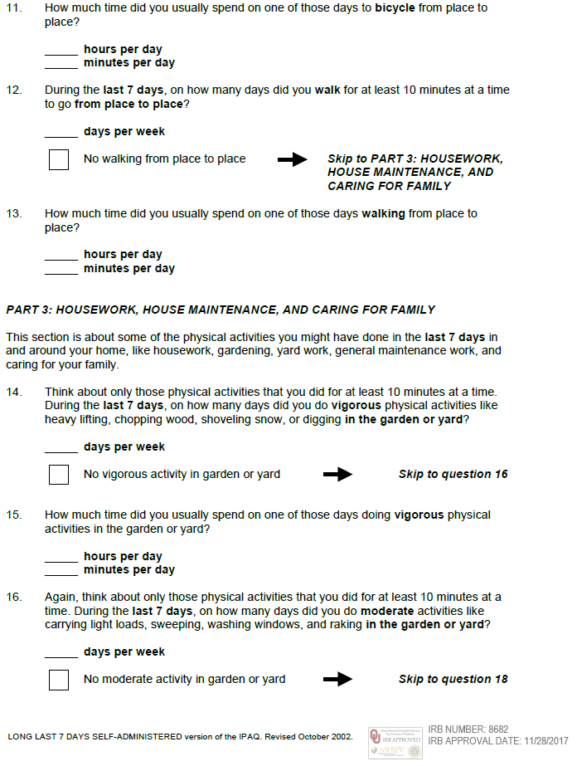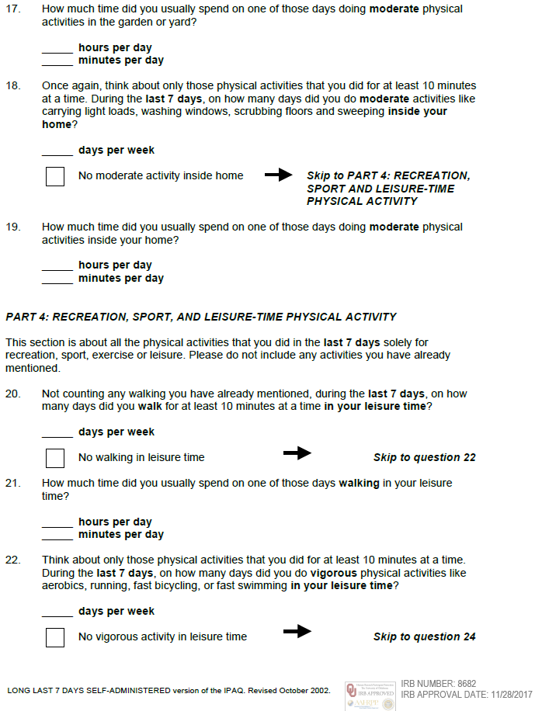
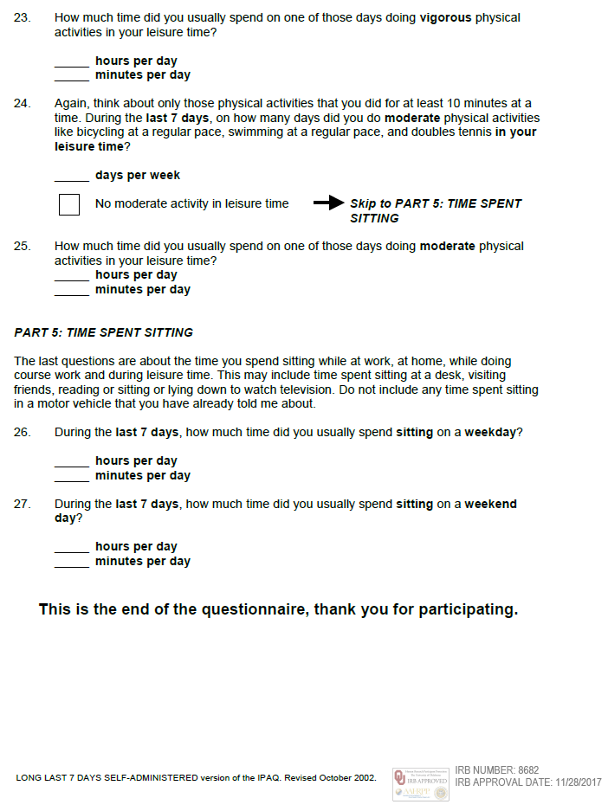

Appendix F: Physical Activity Readiness Questionnaire
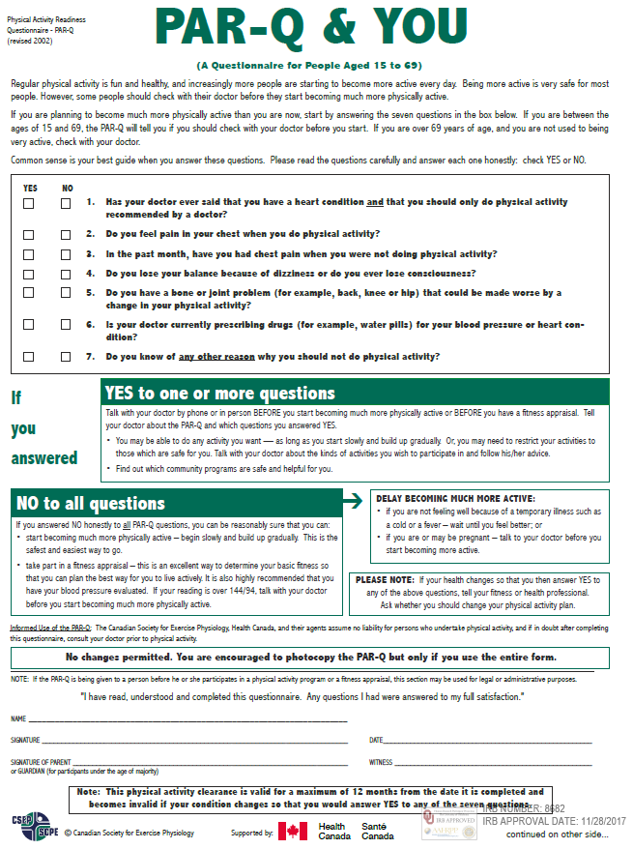

Appendix G: Menstrual History Questionnaire
