University of Oklahoma

Graduate College

MITIGATION OF BLAST-INDUCED HEARING DAMAGE ASSOCIATED WITH MILD-TBI IN CHINCHILLAS USING LIRAGLUTIDE

A thesis

submitted to the Graduate Faculty

in partial fulfillment of the requirements for the

Degree of

Master of Science

By

SARAH SANDERS
Norman, Oklahoma
2022

MITIGATION OF BLAST-INDUCED HEARING DAMAGE ASSOCIATED WITH MILD-TBI IN CHINCHILLAS USING LIRAGLUTIDE

A thesis approved for the
STEPHENSON school of biomedical engineering

By THE COMMITTEE CONSISTING OF

Dr. Rong Gan, Chair

Dr. Kash Barker

Dr. Chenkai Dai

© Copyright by SARAH SANDERS 2022
All Rights Reserved.

Acknowledgements
I would like to thank those who helped me throughout my academic career up to this point. First and foremost, I would like to thank Dr. Gan for her support and mentorship as my advisor. I would also like to thank Paige Welch for her guidance in animal studies. I am thankful for the tremendous amount of advice and assistance Shangyuan Jiang provided during my time in the lab these past few years. In addition, I would like to thank Dr. Alexander Bien for his expertise and insight during our lab meetings.
Furthermore, I would like to thank Dr. Clarissa Root and the veterinary staff for their work with the animals. Their help was invaluable.
This work would not be possible without the support of the Department of Defense grant W81XWH-19-1-0469.
Finally, I want to thank my family for their support and the strength they have provided me.
Table of Contents
Acknowledgements iv
List of Figures vii
Abstract xi
Chapter 1. Introduction 1
1.1 Motivation 1
1.2 Blast-Induced Hearing Loss in Animal Models 3
1.3 Liraglutide and Hearing Recovery from Low-Level BOPs 4
1.4 Objectives 6
Chapter 2. Methods 7
2.1 Chinchilla Animal Model 7
2.2 Experimental Design 7
2.3 Hearing Function Measurements 11
2.3.1 Auditory Brainstem Response (ABR) 12
2.3.2 Distortion Product Otoacoustic Emissions (DPOAE) 13
2.4 Immunofluorescence Study 13
2.5 Statistical Analysis 17
Chapter 3. Results 18
3.1 BOP Waveforms 18
3.2 ABR Waveform and Threshold Shift 19
3.3 ABR Wave I Amplitudes 23
3.4 DPOAE Level Shifts 24
3.5 Immunofluorescence Study 26
Chapter 4. Discussion 29
4.1 Amelioration of Hearing Damage Induced by Repeated High-Intensity BOPs 29
4.2 Effect of Number and Intensity of Blasts 31
4.3 Limitations and Future Studies 34
Chapter 5. Conclusion 36
References 37
Appendix A: List of Abbreviations 41

List of Figures
Figure 1. Comparison of volume in decibels of noise associated with combat (https://hearinghealthmatters.org/hearinprivatepractice/2013/hearing-loss-in-the-military-bigger-than-we-realize/). 2
Figure 2. ﻿Schematic diagram of the time course and experimental procedures showing the liraglutide treatment, blast exposures, and hearing function measurements (Jiang et al., 2021). 4
Figure 3. Typical low-intensity BOP waveform measured at the entrance of the ear canal. 5
Figure 4. Example of earplug inserted into chinchilla ear. 8
Figure 5. Timeline of experimental procedures. Key experimental procedures (e.g., drug administration, blasts, function tests, and euthanasia) are emphasized with arrows at the time points they occurred. 9
Figure 6. Schematic of animal experimental setup with blast apparatus. The animal was held in place in a specifically designed holder and exposed to 3 repeated high-level BOPs. BOP level was monitored by the pressure sensor near the animal ear canal entrance. 10
Figure 7. Coronal representation of the auditory cortical regions in the right hemisphere of a chinchilla brain. The anterior auditory field (AAF), primary auditory cortex (AI), secondary auditory field (AII), dorsoanterior field (DA), dorsomedial field (DM), and dorsoposterior field (DP) are highlighted (Tsukano et al., 2016). 16
Figure 8. A recorded BOP waveform at the entrance of the ear canal with a peak pressure of 18.0 psi. 18
Figure 9. Representative ABR waveforms at 8 kHz measured pre-blast exposure, post-blast exposure, and on Day 14: (A) blast control ear (21-1-19R); (B) post-blast treatment ear (21-1-16L) at the stimulus level ranging from 100 to 20 dB with a step size of 5 dB. Five ABR peaks were labeled on the top of the pre-blast exposure waveform (100 dB). 20
Figure 10. ABR threshold shifts (mean ± SEM) measured on Days 1, 4, 7, 14, and 28 from: (A) pre-blast treatment group (D14 n=22, D28 n=7); (B) post-blast treatment group (D14 n=21, D28 n=6); (C) blast control group (D14 n=14, D28 n=6). ABR threshold shifts from 3 chinchilla groups are plotted against time at 4 (D) and 8 (E) kHz. The statistically significant effect of drug treatment detected by an ANOVA test was labeled on the title and significant difference detected by a Tukey’s post-hoc test was highlighted by brackets between the groups. (*** P < 0.00; ** P < 0.05; * P < 0.10). 22
Figure 11. ABR threshold shifts (mean ± SEM) measured from pre-blast treatment group (D14 n=22, D28 n=7), post-blast treatment group (D14 n=21, D28 n=6), and blast control group (D14 n=14, D28 n=6) on (A) Day 1; (B) Day 4; (C) Day 7; (D) Day 14; (E) Day 28. 23
Figure 12. ABR wave I suprathreshold amplitude (mean ± SEM) in response to 8 kHz stimulus at levels of 80 to 100 dB measured from G2 chinchillas. Wave I amplitudes measured from (A) pre-blast treatment (n=20), (B) post-blast treatment (n=24), and (C) blast control (n=22) groups were plotted. Due to some of the chinchillas being euthanized on Day 14 for a histology study, the sample size for Day 28 results were n=10 in pre-blast treatment, and n=12 in post-blast treatment and blast control groups. 24
Figure 13. DPOAE level shift (mean ± SEM) measured after 3 blasts on Days 1, 14, and 28 in (A) pre-blast treatment group (D14 n=21, D28 n=10); (B) post-blast treatment group (D14 n=20, D28 n=10); (C) blast control group (D14 n=24, D28 n=10). DPOAE level shifts from 3 chinchilla groups are plotted against time at 2 (D) and 10 (E) kHz. The statistically significant effect of drug treatment detected by an ANOVA test and detected by a Tukey’s post-hoc test. No significance was found at individual frequencies (*** P < 0.00; ** P < 0.05). 26
Figure 14. (A) Caspase-3-stained chinchilla brain sections harvested from the auditory cortex of the pre-blast treated group (n=2), post-blast treated group (n=2), and blast control group (n=2). Nuclear counterstain is DAPI. (B) Quantification of fluorescence intensities of caspase-3 in treatment groups. Scale bar=150 μm. No statistical significance found with an ANOVA test and a Tukey’s post-hoc test. 27
Figure 15. (A) Caspase-3-stained chinchilla brain sections harvested from the inferior colliculus of the pre-blast treated group (n=2), post-blast treated group (n=2), and blast control group (n=2). Nuclear counterstain is DAPI. (B) Quantification of fluorescence intensities of caspase-3 in treatment groups. Scale bar=150 μm. No statistical significance found with an ANOVA test and a Tukey’s post-hoc test. 27
Figure 16. Negative control with omission of primary antibody in (A) auditory cortex section and (B) inferior colliculus section of chinchilla brain. 28
Figure 17. ABR threshold shifts (mean ± SEM) measured on Days 1, 4, 7, 14, and 28 after 6 low-level blasts from: (A) pre-blast treatment group (D14 n=22, D28 n=14); (B) post-blast treatment group (D14 n=27, D28 n=15); (C) blast control group (D14 n=17, D28 n=7). 32
Figure 18. DPOAE level shift (mean ± SEM) measured after 3 blasts on Days 1, 14, and 28 after 6 low-level blasts in (A) pre-blast treatment group (D14 n=30, D28 n=24); (B) post-blast treatment group (D14 n=28, D28 n=22); (C) blast control group (D14 n=18, D28 n=8). 34

Abstract
Even with the use of hearing protection devices (HPDs), hearing damage caused by blast exposure dominates service-related disabilities faced by active service members and Veterans. Epidemiology studies have revealed that this hearing damage is associated with traumatic brain injury (TBI). There is a need to further investigate the mechanisms of the formation and prevention of auditory hearing damage. Liraglutide, a GLP-1R agonist, has been found to be a potential treatment for TBI-induced memory deficits. Our previous studies have focused on the therapeutic effect of liraglutide in the prevention and recovery from repeated low-intensity blast exposure. This thesis focuses on the therapeutic function of liraglutide after exposure to higher-level blasts associated with TBI using the chinchilla animal model with HPDs.
In this study, chinchillas were separated into 3 groups: pre-blast treatment, post-blast treatment, and blast control. All groups were exposed to 3 blasts at the blast overpressure (BOP) level equivalent to mild-TBI (15-20 psi or 103-138 kPa) on Day 1 with their ears protected with HPDs (e.g., earplugs). Chinchillas were observed for either 14 or 28 days after blast. To determine the state of the auditory system, hearing function tests including auditory brainstem response (ABR) and distortion product otoacoustic emission (DPOAE) were conducted prior to blast exposure, after blast exposure, and on Days 4, 7, 14, and 28. Upon the completion of the experiment, the cochlea and brain tissues were collected for immunofluorescence studies.
The measurements collected from ABR and DPOAE recordings as well as immunofluorescence results indicated that liraglutide was able to significantly prevent acute blast-induced hearing damage and potentially aid in recovery post-blast exposure.
The work presented in this thesis improves our understanding of the effect of higher-level blast exposure on the auditory system and the therapeutic effect of liraglutide. Future work includes improving statistical analyses and investigation of the mechanisms by which liraglutide works in auditory injury prevention and restoration.

Chapter 1. Introduction

1.1 Motivation
Hearing loss and tinnitus are the two leading service-connected disabilities among active service members and Veterans. Both sensorineural hearing loss, which is caused by damage to the inner ear and auditory nerve, and auditory processing disorder, which is characterized by difficultly in understanding speech, are associated with blast exposure. Hearing loss affects the quality of life of over 1.3 million Veterans as of fiscal year 2020 (“VA Research on Hearing Loss,” 2021). Additionally, hearing loss and tinnitus are the two most prevalent service-connected disabilities of all compensation recipients, posing a large economic stress on the Veterans Health Administration (“Service-Connected Disability or Death Benefits,” 2020).
The hearing loss and auditory damage experienced by service members stems from exposure to blast overpressures (BOPs), most commonly causing inner or middle ear injury and tympanic membrane (TM) rupture. BOPs are high intensity disturbances in the ambient air pressure (Stuhmiller, Phillips, & Richmond, 1991). At higher-levels, BOPs can cause mild-traumatic brain injury (TBI) (Elder & Cristian, 2009). The ear is the most vulnerable organ to blast-induced injuries, even with the availability of hearing protection devices (HPDs). Additionally, some service members decline to use HPDs in fear of reduced situational awareness (Dougherty et al., 2013). Combat and work in industrial types of environments expose service members to hazardous noise levels that are difficult to control, and ultimately cause auditory damage. The noise created by tanks, chinook helicopter, and grenades are examples of volumes that exceed the recommended level for earplug use, as seen in Figure 1.
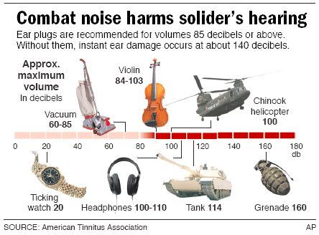
Figure 1. Comparison of volume in decibels of noise associated with combat (https://hearinghealthmatters.org/hearinprivatepractice/2013/hearing-loss-in-the-military-bigger-than-we-realize/).

A GLP-1R agonist, liraglutide, has been found to be both neurotrophic and neuroprotective in neuronal cultures and able to mitigate mild-TBI in mice (Li et al., 2015). Liraglutide reduced oxidative stress in neuronal cells and glutamate excitotoxicity-induced cell death. In our previous study, we demonstrated that liraglutide is a possible strategy to treat blast-induced hearing damage at low-level blasts (3-5 psi or 21-35 kPa) in the chinchilla animal model (Jiang, Welch, Sanders, & Gan, 2021). To better understand the therapeutic effect of liraglutide in protection and restoration from blast-induced hearing damage, investigation into higher-level blasts associated with mild-TBI is necessary.

1.2 Blast-Induced Hearing Loss in Animal Models
A viable animal model for studying the mechanisms and treatment of blast-induced hearing damage have the following qualities: the blast is clearly identified, reproducible, and quantifiable; the hearing injuries are reproducible, quantifiable, and mimic components of human blast induced neurotrauma; the injury outcomes are related to the conditions of the blast; and the mechanical properties of the blast can predict the outcome severity (Choi, 2012). The most common animal models used to study blast-induced hearing loss are the rat, guinea pig, non-human primate, and chinchilla (Le Prell, Hammill, & Murphy, 2019). Studies have shown that BOP induces damage to the peripheral and central auditory systems, including rupture of the TM, basilar membrane damage, ossicular damage, inner and outer hair cell loss, rupture of the round window, oxidative damage, and excitotoxicity (Choi, 2012). Furthermore, damage to the central auditory system results from shearing and stretching forces that can damage the brainstem and the auditory cortex (Fausti, Wilmington, Gallun, Myers, & Henry, 2009).
A recent study by Smith et al. investigated the effect of high-intensity (15-20 psi) blast exposure using the chinchilla animal model. Chinchillas exposed to 2 high-level blasts with HPDs (e.g., earplugs) were able to recover hearing function after 7 days (Smith, Chen, & Gan, 2020). Chinchillas in the same study, but exposed to 3 high-level blasts with HPDs, experienced hearing loss that did not recover after 14 days (Smith et al., 2020). Another study conducted by Chen et al. investigated the effect of low-intensity (3-5 psi) BOPs on hearing damage in the chinchilla animal model. This study found that after exposure to 3 low-intensity BOPs with the use of HPDs, chinchillas experienced temporary hearing damage; however, without the use of HPDs, chinchillas experienced permanent hearing damage 7 days after blast exposure (Chen, Smith, Jiang, Zhang, & Gan, 2019). In this thesis, the therapeutic function of liraglutide is investigated using chinchillas exposed to 3 high-level blasts associated with mild-TBI.

1.3 Liraglutide and Hearing Recovery from Low-Level BOPs
In previous studies conducted by our lab, the chinchilla animal model was utilized to investigate the therapeutic effect of liraglutide after exposure to 6 low-level BOPs, both with and without the use of HPDs. Jiang et al. presents the results of our study with the use of HPDs (Jiang et al., 2021). Chinchillas were divided into 3 groups: pre-blast treatment, post-blast treatment, and blast control. Hearing function tests including auditory brainstem response (ABR) and distortion product otoacoustic emissions (DPOAE) were conducted before blast exposure on Day 1, after blast exposure on Day 1, and on Days 4, 7, and 14. The experimental protocol for this study can be seen in Figure 2 (Jiang et al., 2021).
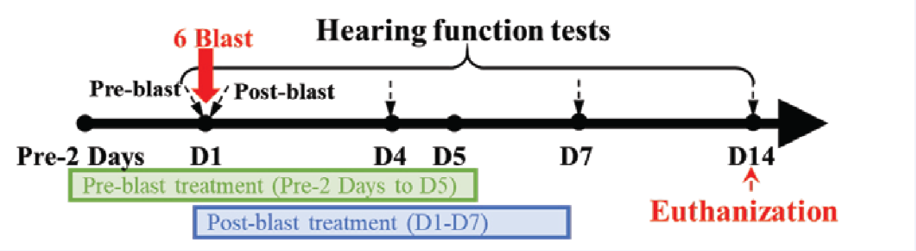
Figure 2. ﻿Schematic diagram of the time course and experimental procedures showing the liraglutide treatment, blast exposures, and hearing function measurements (Jiang et al., 2021).

For the pre-blast treatment group, liraglutide treatment began 2 days prior to blast exposure and continued for the next 7 days. In the post-blast treatment group, liraglutide treatment began 2 hours after blast exposure and continued for the next 7 days. On Day 1 of the study animals were placed inside an anechoic chamber and exposed to 6 low-level blasts with HPDs inserted in their ears. An example of a low-level BOP waveform with a peak of 4.0 psi can be seen in Figure 3. After the completion of the study on Day 14, animals were euthanized for the histology study (Jiang et al., 2021). The protocol used during this study was adapted for further investigation into high-level blast exposure described in this thesis.
Figure 3. Typical low-intensity BOP waveform measured at the entrance of the ear canal.

Jiang et al. reported that exposure to 6 low-level blasts with the use of HPDs induced temporary hearing damage that recovered over 14 days. The effect of liraglutide could not clearly be observed in ears protected by HPDs due to the insignificant amount of damage. Without sufficient damage, detecting the effect of liraglutide in ABR, DPOAE, and immunofluorescence results was difficult, and further investigation was necessary (Jiang et al., 2021).

1.4 Objectives
Due to the prevalence of blast-induced hearing damage among service members and Veterans, our understanding of the causes and mechanisms of hearing damage as well as potential treatments must be improved. Investigating the effect of blast intensity, quantity of blast, use of HPDs, and the therapeutic function of potential treatments such as liraglutide help to achieve this goal. Using an established chinchilla model, this study investigated the effect of liraglutide on blast-induced hearing damage in animals exposed to 3 high-level blasts. The results of this study can be used to provide insight into the effect of blast-intensity and HPDs compared to our previous studies investigating 6 low-level blasts, as well as evaluate the efficacy of liraglutide as a future treatment.

Chapter 2. Methods

2.1 Chinchilla Animal Model
This study included twenty-nine young, healthy chinchillas (Chinchilla lanigera) with mixed genders provided by Eddy Chinchilla (Kalamazoo, MI) and Buckeye Chinchilla (Louisville, OH). The study protocol was approved by the Institutional Animal Care and Use Committee (IACUC) of the University of Oklahoma and met the guidelines of the National Institutes of Health (NIH) and the United States Department of Agriculture (USDA). All animals underwent an extensive check upon arrival and were determined to be clear of disease in the ear.
The chinchilla animal model is well-established for use in the investigation of hearing loss and auditory function due to their similarity to humans’ ear anatomy and humans’ range of hearing, having an average hearing range of 50 Hz to 33 kHz (Giebink, 2009; Trevino, Lobarinas, Maulden, & Heinz, 2019). The chinchilla’s enlarged auditory bulla allows for ease of measurement and access to quantify sound transmission through the ear (Trevino et al., 2019). Furthermore, the chinchilla is naturally a relatively docile animal and easy to work with, making them one of the most widely used animals for hearing research.

2.2 Experimental Design
The chinchillas in this study were randomly divided into 3 groups: 11 chinchillas to the pre-blast treatment group, 11 chinchillas to the post-blast treatment group, and 7 chinchillas to the blast control group. Four chinchillas in the pre-blast treatment group and 3 chinchillas from both the post-blast treatment group and blast control group were randomly assigned to be euthanized on Day 28, with the remaining chinchillas euthanized on Day 14. All chinchillas had standard polyurethane earplugs (3M, Inc. St. Paul, MN) inserted deeply into the ear canal prior to blast. The bottom 1/3 of the earplugs were removed to ensure an optimal fit for the chinchilla’s ear canal. A typical earplug inserted into a chinchilla ear can be seen in Figure 4. Figure 5 is an overview of the experimental procedures described above.

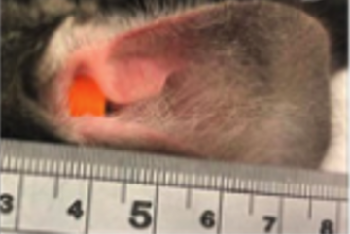
Figure 4. Example of earplug inserted into chinchilla ear.

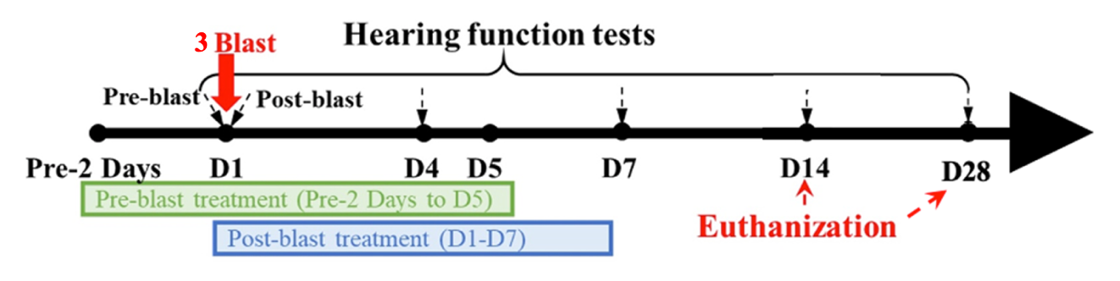
Figure 5. Timeline of experimental procedures. Key experimental procedures (e.g., drug administration, blasts, function tests, and euthanasia) are emphasized with arrows at the time points they occurred.

Liraglutide (Victoza, Novo Nordisk Inc., Plainsboro NJ) was injected subcutaneously in animals assigned to the pre-treatment and post-treatment groups. The injection was determined by the equivalent to the human dose (20 μg/kg/day) normalized to body surface area across species (Hakon, Ruscher, Romner, & Tomasevic, 2015; Li et al., 2015). Each chinchilla assigned to the treatment groups received a dose of 246.7 μg/kg/day for 7 consecutive days. Chinchillas assigned to the pre-treatment groups received the first of 7 liraglutide doses 2 days prior to blast exposure, and chinchillas assigned to the post-blast treatment group received the first liraglutide dose 2 hours after blast exposure on Day 1.
On Day 1, animals were anesthetized with 35 mg/kg ketamine (Henry Schein Animal Health) and 3 mg/kg xylazine (Akron Inc., Lake Forest, IL) to prepare for hearing function tests and blast exposure. An otoscope (ScopeAround) was utilized to examine both ears to determine if there were TM or middle ear abnormalities. Wide-band tympanometry (Titan, Interacoustics, Demark) was used to check the condition of the middle ear as well. Prior to blast, auditory brainstem response (ABR) and distortion product otoacoustic emissions (DPOAE) function tests were conducted to establish baseline measurements. Following pre-blast exposure function tests, the animal was placed in a custom designed L-shape animal holder using straps to ensure a fixed position. Figure 6 displays the animal experimental setup, in which the animal’s body is in an upward position so the top of the animal’s head faced the blast source. To monitor the BOP, a pressure sensor (Model 102B16, Piezotronics, Depew, NY) was fixed to the animal holder approximately 2 cm from the animal’s ear canal entrance. The earplugs were then inserted into both ears of the animal.
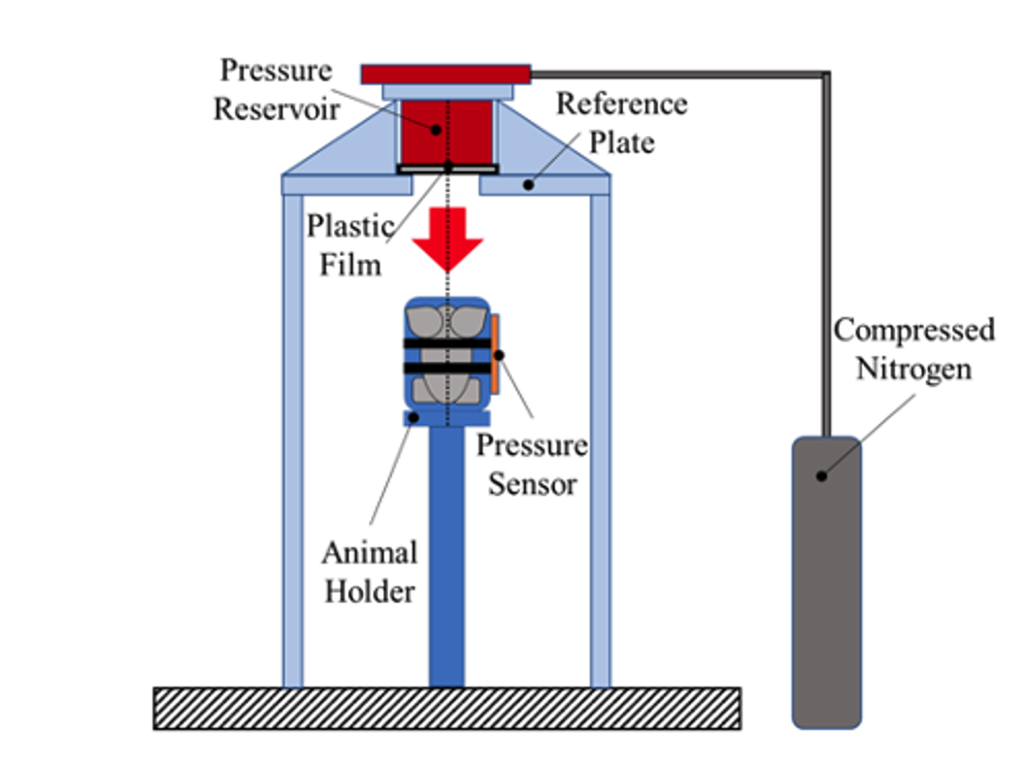
Figure 6. Schematic of animal experimental setup with blast apparatus. The animal was held in place in a specifically designed holder and exposed to 3 repeated high-level BOPs. BOP level was monitored by the pressure sensor near the animal ear canal entrance.

A well-controlled compressed nitrogen-driven blast apparatus located inside the anechoic chamber at the University of Oklahoma Biomedical Engineering Laboratory (Figure 6) was used to generate the BOPs. The intensity of the BOP was controlled by rupturing polycarbonate films (McMaster-Carr, Atlanta, GA). In this study, 3 polycarbonate films with thicknesses of 0.25 mm were used to generate BOP levels of 15-20 psi or 103-138 kPa. The animals were exposed to 3 repeated blasts at this level with approximately 5 minutes between each blast. A cDAO 7194 and A/D converter 9215 (National Instruments Inc., Austin, TX) was used to collect pressure sensor signals with a sampling rate of 100 k/s (10 ms dwell time). The LabVIEW software package (National Instruments Inc., Austin, TX) was used to acquire and analyze data. After exposure to 3 blasts, the otoscope and wide-band tympanometry were used to examine the status of the chinchilla TM, and post-blast exposure function tests were conducted to complete the Day 1 procedure. The animals were then kept under observation for the following 14 or 28 days.

2.3 Hearing Function Measurements
Auditory function measurements were conducted pre- and post-blast exposure on Day 1, and on Days 4, 7, 14, and 28. The function tests included auditory brainstem response (ABR) and distortion product otoacoustic emissions (DPOAE). On Day 1 the animals were sedated using ketamine and xylazine as described above. During the function testing on Days 4, 7, 14, and 28, the chinchillas were sedated using isoflurane (Covetrus, Dublin, OH) at a concentration of 1% - 3% with oxygen flow at 1 L/minute. Isoflurane is the preferred sedation method in this experiment as chinchillas are able to wake up easier; however, the sedation apparatus used to administer isoflurane is not able to work in the blast chamber for use on Day 1.

2.3.1 Auditory Brainstem Response (ABR)
ABR measurements consist of the early portion of the auditory evoked potential, which has been well-established to test auditory function and diagnose and localize pathologies affecting brainstem pathways. ABR threshold measurements provide information on hearing sensitivity before and after blast exposure. An increase in ABR threshold reflects hearing damage. A TDT system III (Tucker-Davis Technologies, Alachua, FL) was used to collect the ABR thresholds following the protocol established in previous studies (Jiang et al., 2021; Smith et al., 2020). After the animal was placed under anesthesia, stainless steel needle electrodes were placed subcutaneously at the vertex of the skull, ventrolateral surfaces of the ear, and a ground in the rear leg. Tone burst stimuli of 0.5 ms rise/fall time and 4-ms duration at frequencies of 1, 2, 4, 6, and 8 kHz were generated and delivered 21 times/second. This frequency range is widely used and accepted for chinchilla studies (Gan, Nakmali, Ji, Leckness, & Yokell, 2016; Zhong, Henry, & Heinz, 2014). A power amplifier TYPE 2718 (BRUEL & KJAER, Nærum, Denmanrk) was used to amplify the stimuli generated by an MF1 multi-field magnetic speaker (Tucker-Davis Technologies, Aluchua, FL). The stimuli were monitored by a probe microphone inside the chinchilla ear canal (ER-7C, Etymotic Research, Elk Grove Village, IL) and recorded for 10 ms, averaged 150 times, and filtered by a band-pass filter of 100-3000 Hz. ABR waveforms were recorded in 5 dB intervals descending from 100 dB to 20 dB. The ABR threshold shift was calculated by subtracting the threshold of the pre-blast exposure measurement from the post-blast (Day 1), Day 4, Day 7, Day 14, and Day 28 threshold measurements. If there was no ABR waveform detected at the maximum acoustic stimulation of 100 dB, the threshold was set at 100 dB.
ABR wave I amplitudes reflect the injuries in the ascending audatory pathway to the auditory nerve and can serve as indicators for damaged auditory nerves, inner ear cells, cochlear ribbon synapses, as well as conductive hearing loss from reduced input to the auditory nerve, seen in a decrease in the wave I amplitude (Liberman & Kujawa, 2017; Wan & Corfas, 2017). Amplitudes were measured at stimulus levels between 80 and 100 dB at 8 kHz.

2.3.2 Distortion Product Otoacoustic Emissions (DPOAE)
Using the same TDT system III as the ABR measurement and a probe-tipped microphone (ER-10B, Etymotic Research) sealed in the external ear canal, the DPOAE was measured to evaluate the cochlear outer hair cell function (Chen et al., 2019). Cubic 2f1-f2 (f2 = 1.22xf1) DPOAE levels were recorded using f1 and f2 primary tones and presented at tone levels of L1 = 70 dB SPL and L2 = 65 dB SPL (Daniel, Duval, Sahmkow, & Akache, 2007). DPOAE levels were calculated by subtracting the 2f1-f2 distortion product from the surrounding noise. The DPOAE level shift was calculated by subtracting the DPOAE level of the pre-blast exposure measurement from the post-blast exposure measurement (Day 1), and the level measurements on Days 4, 7, 14, and 28.

2.4 Immunofluorescence Study
Following the completion of the study, the animals were euthanized and prepared for the histology procedure. To start the procedure, animals were perfused transcardially with saline solution followed by a fixative (4% paraformaldehyde solution in 9.6 g/L phosphate-buffered saline (PBS)) for approximately 30 minutes via the left ventricle. Next, the chinchilla brains were harvested and kept in the fixative for 48-72 hours at 4 °C. The samples were then washed in PBS solution 3 times for 1 hour each and left in 30% sucrose solution 1X PBS in a sealed bottle at 4 °C for 3-6 days until the samples sank.
A Leica CM1950 cryostat (Leica Biosystems, Deer Park, IL) was used for embedding and sectioning the brain samples. The chamber temperature and sample temperatures were -18 °C and -14 °C, respectively. The brain samples were cut into coronal sections of approximately 5 mm using a microtome blade, focusing on the auditory cortex and inferior colliculus regions. The 55 mm-diameter specimen disc was precooled on the freeze shelf in the cryostat chamber and covered with freezing compound. The sample was then placed on the specimen disc and attached to the Peltier position on the freeze shelf for approximately 10 minutes. After the sample was completely frozen, the specimen disc and sample were installed onto the specimen head and allowed to warm to -14 °C. Sections of thickness 20 μm were obtained perpendicular to the front-posterior central axis of the brain. The sections were collected on microscope slides and the locations of the inferior colliculus and auditory cortex were determined based on chinchilla brain anatomy (Irimescu, Chende, Ghiurco, & Damian, 2014; Tsukano et al., 2016). An example of a coronal section of a chinchilla auditory cortex is displayed in Figure 7. The microscope slides were dried in 4 °C and stored in a freezer overnight.
The immunofluorescence staining procedure began with unfreezing the microscope slides and rinsing 3 times with PBS solution for 3 minutes each, then applying a 3% H₂O₂ solution for 15 minutes. The tissues were rinsed with PBS 3 times for 3 minutes each again and were blocked with 5% goat serum (Sigma-Aldrich, Saint Louis, MO) containing PBS with 0.4% Triton X-100 (PBS-T) and incubated overnight at 4 °C with caspase-3 primary antibody (1:200, #9661, Cell Signaling Technology Inc., Danvers, MA). Negative controls were made by omission of caspase-3 primary antibody. Tissues were then rinsed with 5% goat serum PBS-T and the goat anti-rabbit IgG secondary antibody (H+L) cross-absorbed secondary antibody (1:1000, Alexafluor 594, Thermo Fisher Scientific, Rockford, IL) was applied and allowed to incubate for 1 hour at room temperature. Tissues were then rinsed with PBS. Cell nuclei were stained using 4,6-diamidino-2-phenylindole (DAPI) (D9542, Sigma-Aldrich, Saint Louis, MO) and images were collected using an EVOS M7000 Imaging System (Thermo Fisher Scientific, Rockford, IL). Blue channel (405 nm, DAPI) and red channel (594 nm, caspase-3) fluorescence was collected for each section and images were processed using ImageJ software. The exposure time was fixed for all images collected and the brightness threshold for post processing remained consistent for all images.

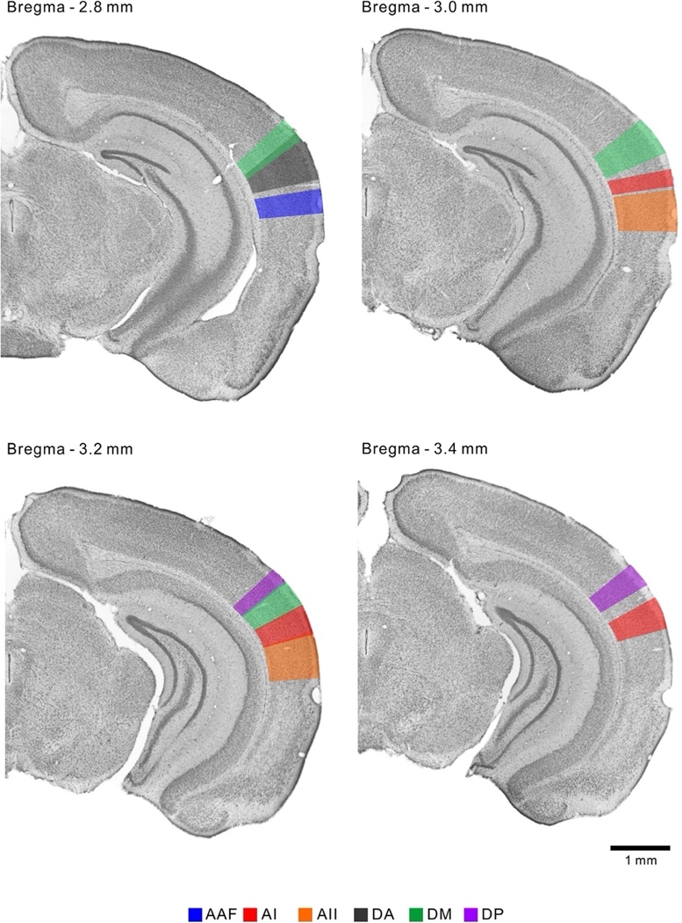
Figure 7. Coronal representation of the auditory cortical regions in the right hemisphere of a chinchilla brain. The anterior auditory field (AAF), primary auditory cortex (AI), secondary auditory field (AII), dorsoanterior field (DA), dorsomedial field (DM), and dorsoposterior field (DP) are highlighted (Tsukano et al., 2016).

2.5 Statistical Analysis
The mean and SEM of the ABR threshold shifts, DPOAE level shifts, and immunofluorescence integrated densities were plotted using GraphPad Prism (GraphPad Software Inc., Version 9). A two-way ANOVA and Tukey’s post-hoc test were conducted using R software (R Core Team, 2021) to analyze both the ABR threshold shift and DPOAE level shift. The ABR threshold shift values of the pre-blast treatment group, post-blast treatment group, and blast control group were compared at all individual frequencies at Days 1, 4, 7, 14, and 28. DPAOE level shift values of the pre-blast treatment group, post-blast treatment group, and blast control group were compared at all individual frequencies as well as across all frequencies at Days 1, 14, and 28. A one-way ANOVA was conducted to analyze the caspase-3 immunofluorescence integrated densities of the pre-blast treated sections, post-blast treated sections, and blast control sections.

Chapter 3. Results

3.1 BOP Waveforms
Animals were exposed to 3 high-intensity BOPs associated with mild-TBI. Figure 8 shows a typical BOP waveform with a peak pressure of 18 psi at 1 ms, followed by a negative peak at -3.8 psi occurring before 2 ms, then returning to 0 psi with minor fluctuations. A BOP waveform with peak pressure ranging from 15-20 psi was repeatable throughout the study.
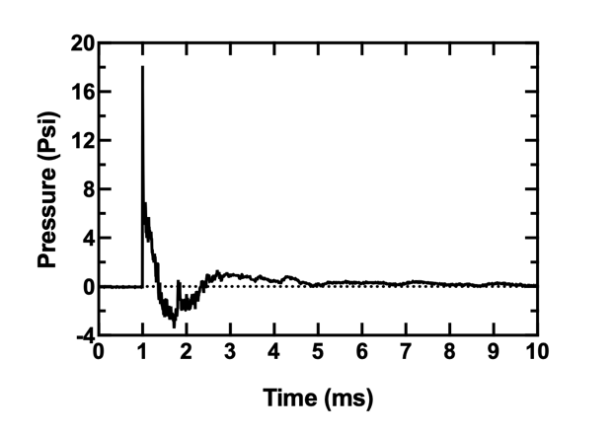
Figure 8. A recorded BOP waveform at the entrance of the ear canal with a peak pressure of 18.0 psi.

After the completion of blast exposure, otoscopic examination determined that no TMs were ruptured and there were no signs of infections or fluid throughout the experiment.

3.2 ABR Waveform and Threshold Shift
Figure 9 shows ABR waveform examples from a blast control ear (21-1-19R) and a post-blast treated ear (21-1-16L) recorded at 8 kHz. Waveforms were recorded for 10 ms and from the stimulus level 100 dB down to 20 dB with a step size of 5 dB. The ABR waveforms recorded pre-blast exposure, post-blast exposure, and on Day 14 are plotted to show both acute damage and recovery comparisons. The 5 major peaks typical of ABR waveforms are labeled on the pre-blast exposure waveforms at the stimulus level of 100 dB. At all timepoints, there is a clear decrease in amplitude and increase in latency as the stimulus level decreases.

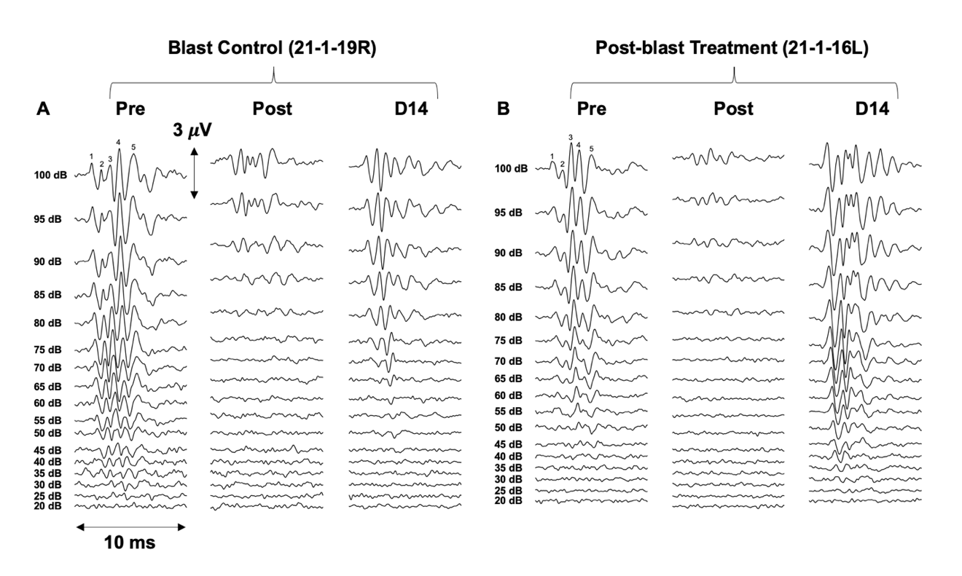
Figure 9. Representative ABR waveforms at 8 kHz measured pre-blast exposure, post-blast exposure, and on Day 14: (A) blast control ear (21-1-19R); (B) post-blast treatment ear (21-1-16L) at the stimulus level ranging from 100 to 20 dB with a step size of 5 dB. Five ABR peaks were labeled on the top of the pre-blast exposure waveform (100 dB).

The pre-blast exposure threshold for both the blast control and post-blast treated ears were approximately 30 dB, indicating that both ears started with the same hearing sensitivity. Severe hearing damage can be seen in the post-blast waveforms indicated by a decrease in amplitude and an increase in threshold to approximately 80 dB in both ears. By Day 14, the post-blast treated ear had a threshold of 30 dB compared to the blast control at 50 dB, indicating that the post-blast treated ear was able to recover to a greater degree than the blast control ear.
The mean and SEM of the ABR threshold shifts measured from pre-blast treatment, post-blast treatment, and blast control groups were plotted in Figures 10A, 10B, and 10C respectively. The threshold shifts on Days 1, 4, 7, 14, and 28 were plotted in each figure and represented by different colors. Furthermore, the threshold shifts are organized by Day in Figure 11, with each treatment represented by a different color.
On Day 1, the mean threshold shift ranged between 25 dB and 40 dB in the post-blast treatment and blast control groups and had a lower range of between 20 dB and 25 dB in the pre-blast treatment group, as seen in Figure 11A. A two-way ANOVA test followed by a Tukey’s post-hoc test was performed using R software (R core team 2021) comparing the mean threshold shift of each treatment group at each time point and each individual frequency. The analysis indicated that on Day 1, the mean ABR threshold shift of the pre-blast treatment group was significantly lower than the blast control and post-blast treatment groups at 4 kHz, 6 kHz, and 8 kHz. The frequencies 4 kHz and 8 kHz were selected to display this difference in Figures 10D and 10E, respectively. All treatment groups experienced a lower shift at 1 kHz and higher shifts at 4-8 kHz, and the threshold shifts gradually decreased with time from Day 1 to 28 with the amount of recovery between adjacent time points decreasing with time. On Days 14 and 28, the mean threshold shift in the blast control group averaged 5 dB over all frequencies, as seen in Figures 11D and 11E. The mean threshold shifts in the pre-blast treatment and post-blast treatment groups were approximately 0 dB to 5 dB, which was lower than that of the control group, but not significant according to the statistical analysis. The ABR threshold shift indicated the blast-induced acute damage on Day 1 was approximately the same in the blast-control and post-blast treated groups, and lower in the pre-blast treated group. Figures 11A through 11C show that the drug was able to mitigate acute hearing damage during Days 1, 4, and 7. It appears the drug continues to have an effect through Days 14 and 28, as seen in Figures 11D and 11E, in which the blast control group has a higher mean ABR threshold shift than both the treatment groups.

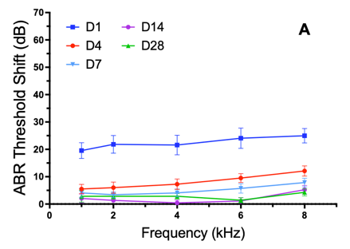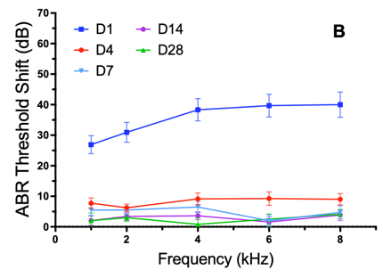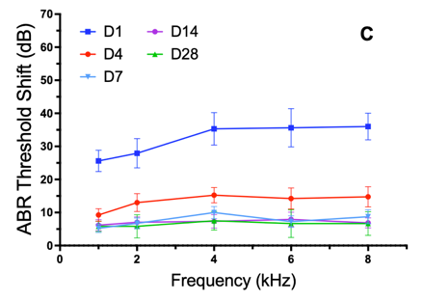

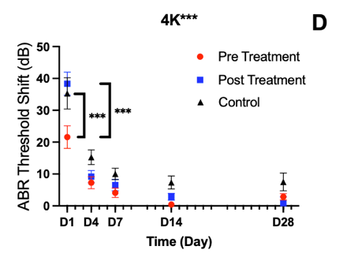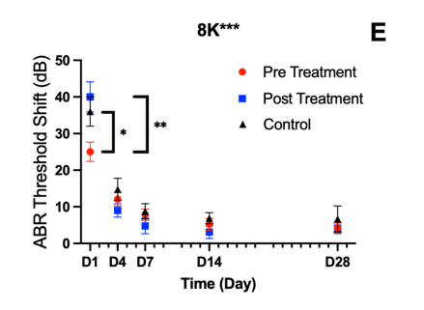

Figure 10. ABR threshold shifts (mean ± SEM) measured on Days 1, 4, 7, 14, and 28 from: (A) pre-blast treatment group (D14 n=22, D28 n=7); (B) post-blast treatment group (D14 n=21, D28 n=6); (C) blast control group (D14 n=14, D28 n=6). ABR threshold shifts from 3 chinchilla groups are plotted against time at 4 (D) and 8 (E) kHz. The statistically significant effect of drug treatment detected by an ANOVA test was labeled on the title and significant difference detected by a Tukey’s post-hoc test was highlighted by brackets between the groups. (*** P < 0.00; ** P < 0.05; * P < 0.10).

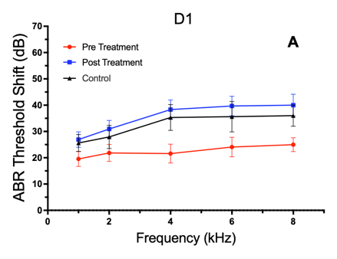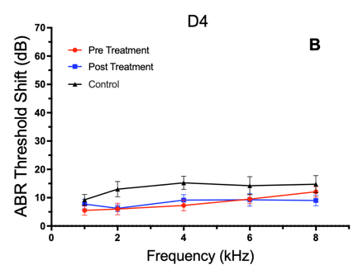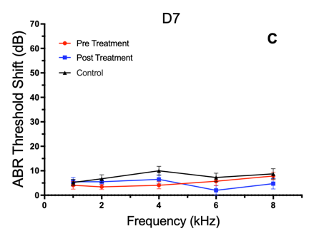

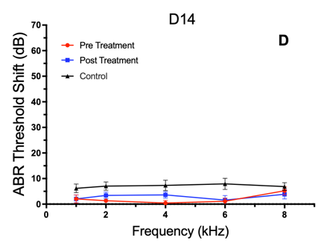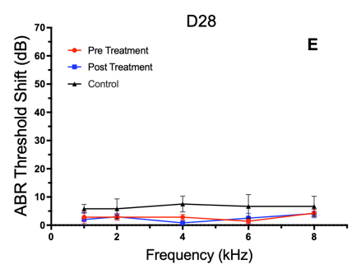

Figure 11. ABR threshold shifts (mean ± SEM) measured from pre-blast treatment group (D14 n=22, D28 n=7), post-blast treatment group (D14 n=21, D28 n=6), and blast control group (D14 n=14, D28 n=6) on (A) Day 1; (B) Day 4; (C) Day 7; (D) Day 14; (E) Day 28.

3.3 ABR Wave I Amplitudes
The mean and SEM of the ABR wave I amplitudes (peak-to-peak) measured from animals of pre-blast treatment, post-blast treatment, and blast control groups at 8 kHz are shown in Figures 12A, 12B, and 12C, respectively. The values of pre-blast exposure on Day 1, post-blast exposure on Day 1, Day 14, and Day 28 were plotted against the level of acoustic stimulus from 80 dB to 100 dB. The results measured at different time points were represented by different colors as shown in the legend of Figure 12C.
The pre-blast exposure ABR wave I amplitudes ranged from 1 to 2 $μV$ in all treatment groups. After blast exposure, each group experienced a decrease in amplitude; however, the pre-blast treatment group did not experience as substantial of a decrease as the other two groups. The pre-blast treatment group had post-blast exposure amplitudes of approximately 1 $μV$, whereas the post-blast treatment group and control group had lower amplitudes. By Days 14 and 28, the ABR wave I amplitude in all 3 groups appear to have recovered to the pre-blast amplitude, indicating no long-term permanent damage.
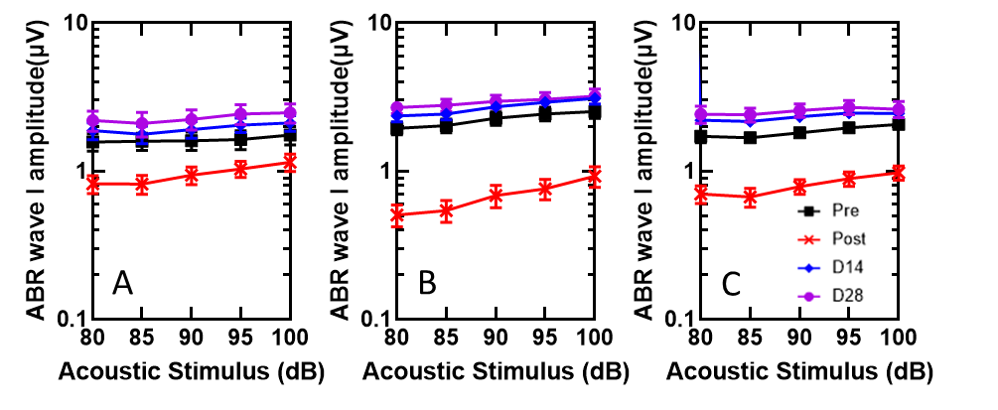
Figure 12. ABR wave I suprathreshold amplitude (mean ± SEM) in response to 8 kHz stimulus at levels of 80 to 100 dB measured from G2 chinchillas. Wave I amplitudes measured from (A) pre-blast treatment (D14 n=20, D28 n=7), (B) post-blast treatment (D14 n=24, D28 n=6), and (C) blast control (D14 n=22, D28 n=6) groups were plotted. Due to some of the chinchillas being euthanized on Day 14 for a histology study, the sample size for Day 28 results were n=10 in pre-blast treatment, and n=12 in post-blast treatment and blast control groups.

3.4 DPOAE Level Shifts
Figures 13A, 13B, and 13C display the mean and SEM of the DPOAE level shifts measured from pre-blast treatment, post-blast treatment, and blast control groups, respectively. The DPOAE level shift on Days 1, 14, and 28 were plotted in each figure and represented by different colors.
On Day 1, the mean DPOAE level shift of the pre-blast treatment group was significantly lower than the mean DPOAE level shift of both the post-blast treatment group and blast control group, ranging from 2 dB to 15 dB compared to approximately 10 dB to 20 dB. By Day 14, the mean DPOAE level shift in both the pre-blast treatment group and post-blast treatment group ranged from 0 dB to 7 dB, which was significantly lower than the 5 dB to 12 dB level shift of the blast control group. On Day 28, the DPOAE level shifts of the drug-treated groups average 0 dB to 5 dB and the DPOAE level shift of the blast control group averaged 0 dB to 10 dB; however, this difference was not significant.
A two-way ANOVA test followed by a Tukey’s post-hoc test was performed using R software (R core team 2021) comparing the mean DPOAE level shift of each treatment group at each time point. The average DPOAE level shift over all frequencies was used to investigate the interaction of time and treatment. The analysis indicated that on Day 1, the mean DPOAE level shift of the pre-blast treatment group was significantly lower than the blast control and post-blast treatment groups, and on Day 14, the DPOAE level shift of both drug-treated groups were lower than the blast control group. The frequencies 2 kHz and 10 kHz were selected to display this difference in Figures 13D and 13E, respectively; however, significant differences were not found at individual frequencies.

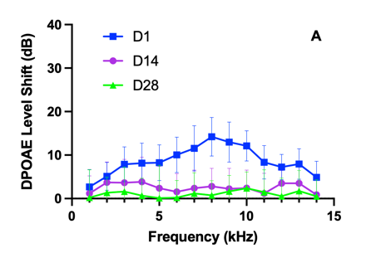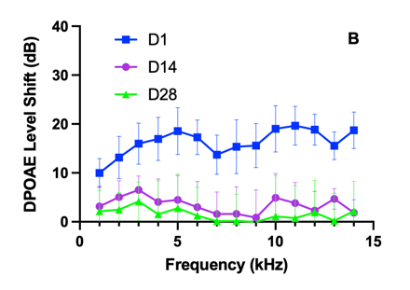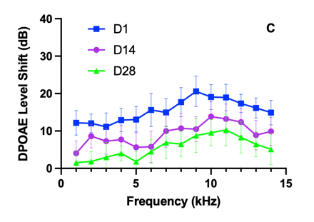
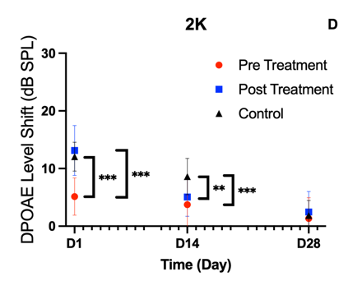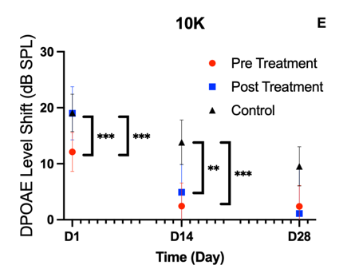

Figure 13. DPOAE level shift (mean ± SEM) measured after 3 blasts on Days 1, 14, and 28 in (A) pre-blast treatment group (D14 n=21, D28 n=10); (B) post-blast treatment group (D14 n=20, D28 n=10); (C) blast control group (D14 n=24, D28 n=10). DPOAE level shifts from 3 chinchilla groups are plotted against time at 2 (D) and 10 (E) kHz. The statistically significant effect of drug treatment detected by an ANOVA test and detected by a Tukey’s post-hoc test. No significance was found at individual frequencies (*** P < 0.00; ** P < 0.05).

3.5 Immunofluorescence Study
Figures 14 and 15 display the results of the immunofluorescence study on the auditory cortex and inferior colliculus, respectively. Pre-blast treated, post-blast treated, and blast control sections are labeled in Figures 14A and 15A. DAPI was used to highlight the cell nuclei in blue and caspase-3 staining was used to highlight the apoptotic cells in red in all sections. The negative control of both the AC and IC in which caspase-3 was omitted in the staining procedure are shown in Figure 16. The negative control sections showed no caspase-3 signal. Figures 14B and 15B show a quantitative analysis of the integrated densities of caspase-3 staining in the AC and IC, which was found by processing the imaged sections with ImageJ software. The one-way ANOVA analysis indicated there were no significant differences of the integrated densities between the 3 groups. These results suggest that liraglutide does not significantly impact long-term recovery reflected by caspase-3 staining.
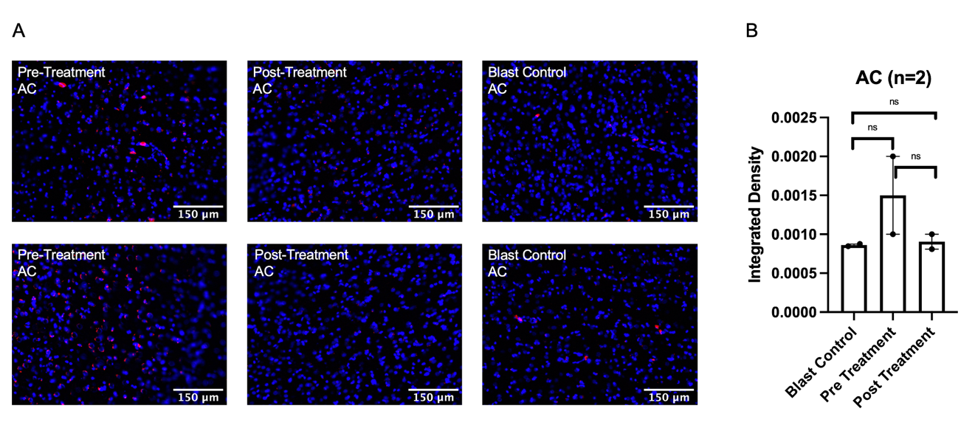
Figure 14. (A) Caspase-3-stained chinchilla brain sections harvested from the auditory cortex of the pre-blast treated group (n=2), post-blast treated group (n=2), and blast control group (n=2). Nuclear counterstain is DAPI. (B) Quantification of fluorescence intensities of caspase-3 in treatment groups. Scale bar=150 μm. No statistical significance found with an ANOVA test and a Tukey’s post-hoc test.
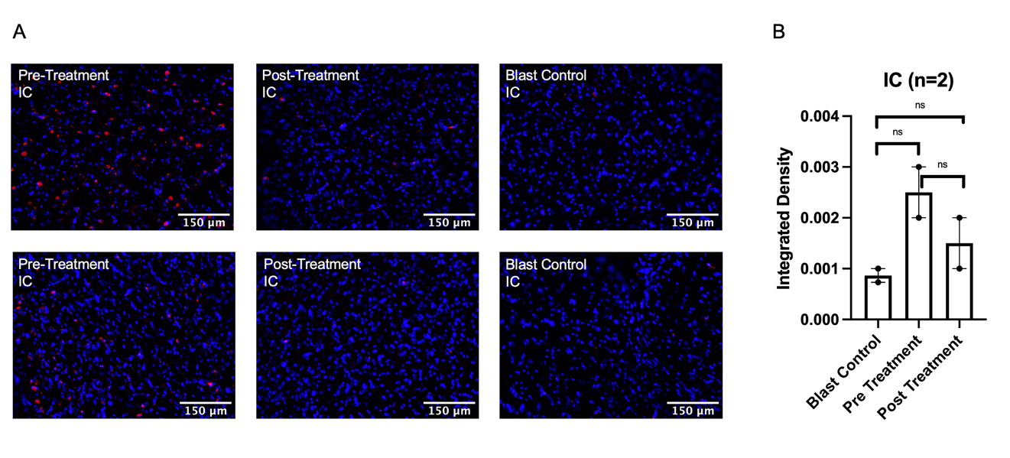
Figure 15. (A) Caspase-3-stained chinchilla brain sections harvested from the inferior colliculus of the pre-blast treated group (n=2), post-blast treated group (n=2), and blast control group (n=2). Nuclear counterstain is DAPI. (B) Quantification of fluorescence intensities of caspase-3 in treatment groups. Scale bar=150 μm. No statistical significance found with an ANOVA test and a Tukey’s post-hoc test.

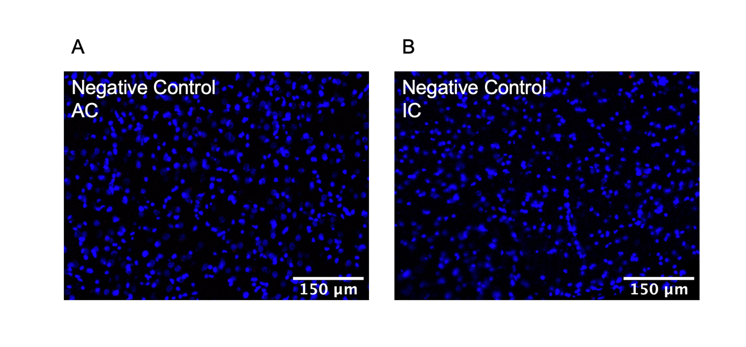
Figure 16. Negative control with omission of primary antibody in (A) auditory cortex section and (B) inferior colliculus section of chinchilla brain.

Chapter 4. Discussion

4.1 Amelioration of Hearing Damage Induced by Repeated High-Intensity BOPs
The results of this study were used to analyze the effect of the GLP-1R agonist, liraglutide, on the effect of hearing damage when administered pre-blast exposure and post-blast exposure. ABR threshold shift, ABR wave I amplitude, and DPOAE level shift measurements, paired with immunofluorescence studies, indicated that liraglutide could potentially serve to prevent hearing damage before blast exposure, as well as aid in recovery when administered after blast exposure.
The use of HPDs during blast exposure ensured that the integrity of the middle ear was maintained, and imitated blast exposure that military personnel are exposed to during combat and trainings. All of the TMs remained intact during the extent of the study; however, HPDs provide limited CAS and PAS protection during blast exposure (Race, Lai, Shi, & Bartlett, 2017). Investigating the effect of liraglutide before and after blast exposure with HPDs provides insight on the progression of hearing damage associated with mild-TBI and the efficacy of liraglutide in ameliorating the hearing damage resulting from these conditions often experienced by service members.
ABR threshold shift is an indicator of hearing sensitivity and reflects the function of the PAS and CAS. The results displayed in Figures 10 and 11 indicated that liraglutide treatment can potentially both prevent acute-hearing damage on Day 1, with the pre-blast treated group having a significantly lower Day 1 threshold shift than both the post-blast treated group and blast control group. Results also suggested that liraglutide can possibly aid in long-term hearing recovery, as both drug-treated groups had lower ABR threshold shifts than the blast control group on Days 14 and 28.
Figure 12 displayed the results of the ABR wave I amplitudes, which are an indicator of cochlear synaptopathy, myelination defects in the auditory nerve, conductive hearing loss, lesions, and damage to cochlear structures (Liberman & Kujawa, 2017; Wan & Corfas, 2017). The results showed that the pre-blast treated animals did not experience as substantial of a decrease in ABR wave I amplitude as the post-blast treated and blast control groups on Day 1. This suggests that the liraglutide treatment can potentially prevent hearing damage when administered prior to blast exposure.
DPOAE measurements reflect the function of the outer hair cells and are the response of the cochlea to two simultaneous tones. The DPOAE level shifts displayed in Figure 13 show a significantly lower pre-blast DPOAE level shift on Day 1 than the post-blast treatment and blast control groups. This indicates that liraglutide could potentially prevent damage when administered prior to blast. On Day 14, the DPOAE level shift is significantly lower in both the drug treatment groups than in the blast control group, indicating that liraglutide could potentially accelerate hearing recovery.
Immunofluorescence results in Figures 14 through 16 showed the activity of caspase-3 in auditory cortex and inferior colliculus sections of each treatment group. Caspase-3 staining reflects cell apoptosis activity and is an indicator of cell damage caused by TBI (Clark et al., 2000). The IF results supported the ABR threshold shift, ABR wave I, and DPOAE level shift results, showing no significant long-term difference in damage between the treatment and control groups.

4.2 Effect of Number and Intensity of Blasts
Previously, our lab conducted a study in which chinchillas were exposed to 6 blasts at 3-5 psi to investigate the effect of liraglutide when treating lower-level blasts (Jiang et al., 2021). The most recent ABR threshold shift data from this study is displayed in Figure 17. The same methods and experimental procedure were followed in both the low-level study and the present study. Comparing the ABR threshold shifts from the 6 low-level blast and 3 higher-level blast studies provides insight on the effect of the number and intensity of BOPs in ears protected by HPDs and either treated pre-blast exposure, treated post-blast exposure, and not treated.
The mean and SEM of the ABR threshold shifts of animals exposed to 6 low-level blasts (3-5 psi) with HPDs measured from pre-blast treatment, post-blast treatment, and blast control groups were plotted in Figures 17A, 17B, and 17C, respectively. The threshold shifts on Days 1, 4, 7, 14, and 28 were plotted in each figure and represented by different colors.
On Day 1, the mean threshold shift ranged between 15 dB and 25 dB in the pre-blast treatment and post-blast treatment groups and between 20 dB and 30 dB in the blast control group. All treatment groups experienced a lower shift at 1 kHz and higher shifts at 4-8 kHz, and the threshold shifts gradually decreased with time from Day 1 to Day 28 with the amount of recovery between adjacent time points decreasing with time. On Days 4, 7, and 14 the mean threshold shifts in the treatment groups were lower than the threshold shifts in the blast control group. On Day 28, the mean ABR threshold shift in all 3 groups ranged between 0 dB and 5 dB.
Compared to the ABR threshold shifts experienced by animals exposed to 3 blasts at the higher level of 15-20 psi, the shifts from our low-level study are lower on Day 1, indicating that animals experienced more hearing damage when exposed to 3 blasts at a higher level than 6 blasts at a lower level. Over the course of the study, the drug-treated groups in both the low-level and higher-level studies were able to recover to the same degree, with their Day 28 threshold shifts ranging from 0 dB to 5 dB; however, the high-level blast control group has a higher mean ABR threshold shift on Day 28, approximately 5 dB over all frequencies, than the low-level blast control group, which was approximately 0 dB over the frequencies 1 kHz to 4 kHz, and reaching 5 dB at 6 kHz and 8 kHz. These results suggest that ears exposed to the higher-level blasts are not able to recover as well as ears exposed to lower-level blasts when not treated with liraglutide.

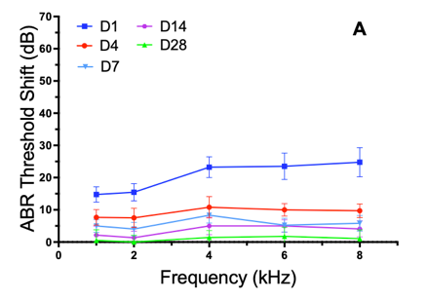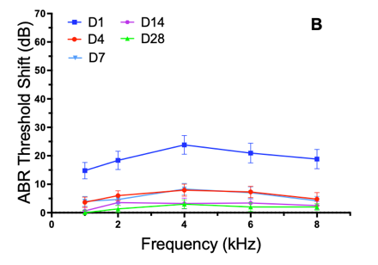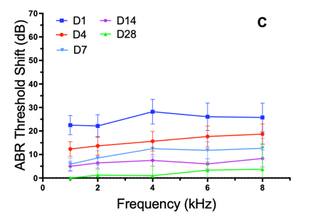

Figure 17. ABR threshold shifts (mean ± SEM) measured on Days 1, 4, 7, 14, and 28 after 6 low-level blasts from: (A) pre-blast treatment group (D14 n=22, D28 n=14); (B) post-blast treatment group (D14 n=27, D28 n=15); (C) blast control group (D14 n=17, D28 n=7).

The mean and SEM of the DPOAE level shifts of animals exposed to 6 low-level blasts with HPDs measured from pre-blast treatment, post-blast treatment, and blast control groups were plotted in Figures 17A, 17B, and 17C, respectively. The threshold shifts on Days 1, 14, and 28 were plotted in each figure and represented by different colors.
On Day 1, the DPOAE level shift ranged from 10 dB to 20 dB in the pre-blast treatment group, from 5 dB to 15 dB in the post-blast treatment group, and from 15 dB to 25 dB in the blast control group. Compared to the DPOAE level shift of animals exposed to 3 high-level blasts presented in Figure 13, the DPOAE level shifts on Day 1 are approximately the same. By Day 28, the DPOAE level shifts of animals exposed to 6 low-level blasts appear to return to within 0 dB and 5 dB of their original DPOAE level in all three treatment groups. In both the pre-blast treatment and post-blast treatment groups of the high-level blast study, the DPOAE level shifts return to approximately 0 dB to 5 dB as well; however, the high-level blast control group continues to have DPOAE level shifts of up to 10 dB on Day 28. These results suggest that exposure to both 6 low-level blasts and 3 high-level blasts with HPDs causes the same degree of damage to outer hair cells on Day 1, and liraglutide is potentially able to aid in the recovery process.
The DPOAE level shift results support the ABR threshold shift results which indicated that ears exposed to the higher-level blasts are not able to recover as well as ears exposed to lower-level blasts when not treated with liraglutide, as the blast control ears exposed to higher-level blasts have a higher DPOAE level shift on Day 28 than those exposed to 6 low-level blasts. The effect of liraglutide in treating hearing damage is more pronounced after exposure to 3 high-intensity blasts compared to 6 low-intensity blasts.

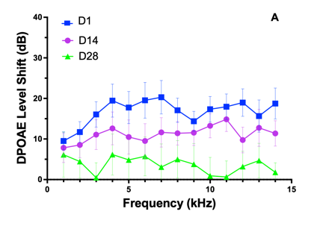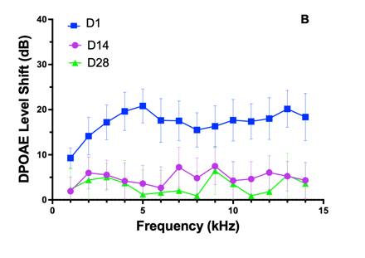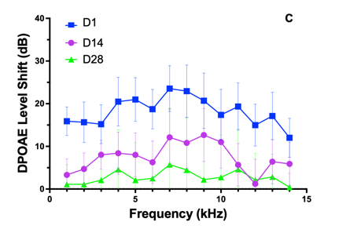
Figure 18. DPOAE level shift (mean ± SEM) measured after 3 blasts on Days 1, 14, and 28 after 6 low-level blasts in (A) pre-blast treatment group (D14 n=30, D28 n=24); (B) post-blast treatment group (D14 n=28, D28 n=22); (C) blast control group (D14 n=18, D28 n=8).

4.3 Limitations and Future Studies
Within the procedure of this study, there is a limitation stemming from the sedation method used during the collection of both ABR and DPOAE measurements. The isoflurane sedation apparatus was unable to be used in the blast chamber, therefore Day 1 measurements were conducted while the animals were sedated with ketamine and xylazine, while Day 4 through Day 28 measurements were conducted while the animals were sedated with isoflurane. The sedation method, however, should not affect the investigation into the effect of liraglutide, as the protocol between each experimental group remained consistent throughout each of our studies.
The second limitation of this study arises due to the limited understanding of the mechanisms of liraglutide to prevent or facilitate recovery from blast-induced hearing damage. Blast-induced hearing damage can result from a variety of complex mechanisms including loss of hair cells, excitotoxicity to neurons, damage to the auditory nerve, and damage to the CAS. The hearing function test results and data analyses cannot tell the full story of how liraglutide is able to potentially prevent acute hearing damage on Day 1 and facilitate hearing recovery after blast exposure. Statistical analyses and histology studies are ongoing, including analyses comparing the low-level and higher-level blast damage, and the effect of protection provided by HPDs paired with liraglutide treatment.

Chapter 5. Conclusion
The present study built upon our previous investigations into the effect of liraglutide on blast-induced hearing damage. As opposed to 6 low-level blasts, this study exposed animals with ears protected by HPDs to 3 high-level blasts associated with mild-TBI. Both ABR and DPOAE measurements were collected in pre-blast treated animals, post-blast treated animals, and blast control animals over a period of 14 or 28 days. The ABR threshold shift results and DPOAE level shift results indicated that liraglutide had a significant effect in preventing acute hearing damage on Day 1 and can potentially facilitate hearing recovery post blast. The ABR wave I results supported these observations, as the amplitude of pre-blast treated animals was not affected as drastically as the post-blast treated and blast-control animals after exposure to the blasts. Immunofluorescence results suggested that there were no significant long-term effects of the drug in the auditory cortex and inferior colliculus reflected by caspase-3 staining.
This study demonstrated that the GLP-1R agonist, liraglutide, is a potential method for hearing damage prevention and recovery for service members exposed to high-level blasts.

References
Chen, T., Smith, K., Jiang, S., Zhang, T., & Gan, R. Z. (2019). Progressive hearing damage after exposure to repeated low-intensity blasts in chinchillas. Hearing Research, 378, 33–42. https://doi.org/10.1016/j.heares.2019.01.010
Choi, C. H. (2012). Mechanisms and treatment of blast induced hearing loss. Korean Journal of Audiology, 16(3), 103–107. https://doi.org/10.7874/kja.2012.16.3.103
Clark, R. S. B., Kochanek, P. M., Watkins, S. C., Chen, M., Dixon, C. E., Seidberg, N. A., … Graham, S. H. (2000). Caspase-3 mediated neuronal death after traumatic brain injury in rats. Journal of Neurochemistry, 74(2), 740–753. https://doi.org/10.1046/j.1471-4159.2000.740740.x
Daniel, S. J., Duval, M., Sahmkow, S., & Akache, F. (2007). Ototoxicity of topical moxifloxacin in a chinchilla animal model. Laryngoscope, 117(12), 2201–2205. https://doi.org/10.1097/MLG.0b013e318148b275
Dougherty, A. L., MacGregor, A. J., Han, P. P., Viirre, E., Heltemes, K. J., & Galarneau, M. R. (2013). Blast-related ear injuries among U.S. military personnel. Journal of Rehabilitation Research and Development, 50(6), 893–904. https://doi.org/10.1682/JRRD.2012.02.0024
Elder, G. A., & Cristian, A. (2009). Blast-Related Mild Traumatic Brain Injury: Mechanisms of Injury and Impact on Clinical Care. Mount Sinai Jounral of Medicine, 111–118. https://doi.org/10.1002/MSJ
Fausti, S. A., Wilmington, D. J., Gallun, F. J., Myers, P. J., & Henry, J. A. (2009). Auditory and vestibular dysfunction associated with blast-related traumatic brain injury. Journal of Rehabilitation Research and Development, 46(6), 797–810. https://doi.org/10.1682/JRRD.2008.09.0118
Gan, R. Z., Nakmali, D., Ji, X. D., Leckness, K., & Yokell, Z. (2016). Mechanical damage of tympanic membrane in relation to impulse pressure waveform – A study in chinchillas. Hearing Research, 340, 25–34. https://doi.org/10.1016/j.heares.2016.01.004
Giebink, G. S. (2009). Otitis media: The chinchilla model. Microbial Drug Resistance, 5(1), 57–72. https://doi.org/10.1089/mdr.1999.5.57
Hakon, J., Ruscher, K., Romner, B., & Tomasevic, G. (2015). Preservation of the blood brain barrier and cortical neuronal tissue by Liraglutide, a long acting glucagon-like-1 analogue, after experimental traumatic brain injury. PLoS ONE, 10(3), 1–17. https://doi.org/10.1371/journal.pone.0120074
Irimescu, I., Chende, A., Ghiurco, F., & Damian, A. (2014). Anatomical Study of the Cerebral Hemispheres in the Chinchilla (Chinchilla lanigera). Bulletin of University of Agricultural Sciences and Veterinary Medicine Cluj-Napoca. Veterinary Medicine, 71(1), 130-136–136.
Jiang, S., Welch, P., Sanders, S., & Gan, R. Z. (2021). Mitigation of Blast-Induced Hearing Damage using Liraglutide in Animal Model of Chinchilla. Journal of the Association for Research in Otolaryngology, 8(Ic), 13–15. https://doi.org/10.47739/Otolaryngology.1266
Le Prell, C. G., Hammill, T. L., & Murphy, W. J. (2019). Noise-induced hearing loss: Translating risk from animal models to real-world environments. The Journal of the Acoustical Society of America, 146(5), 3646–3651. https://doi.org/10.1121/1.5133385
Li, Y., Bader, M., Tamargo, I., Rubovitch, V., Tweedie, D., Pick, C. G., & Greig, N. H. (2015). Liraglutide is neurotrophic and neuroprotective in neuronal cultures and mitigates mild traumatic brain injury in mice. Journal of Neurochemistry, 135(6), 1203–1217. https://doi.org/10.1111/jnc.13169
Liberman, M. C., & Kujawa, S. G. (2017). Cochlear synaptopathy in acquired sensorineural hearing loss: Manifestations and mechanisms. Hear Res., 349, 138–147. https://doi.org/10.1016/j.heares.2017.01.003
Race, N., Lai, J., Shi, R., & Bartlett, E. L. (2017). Differences in postinjury auditory system pathophysiology after mild blast and nonblast acute acoustic trauma. Journal of Neurophysiology, 118(2), 782–799. https://doi.org/10.1152/jn.00710.2016
Service-Connected Disability or Death Benefits. (2020). Veterans Benefits Administration Reports - Compensation.
Smith, K. D., Chen, T., & Gan, R. Z. (2020). Hearing Damage Induced by Blast Overpressure at Mild TBI Level in a Chinchilla Model. Military Medicine, 185, 248–255. https://doi.org/10.1093/milmed/usz309
Stuhmiller, J. H., Phillips, Y. Y., & Richmond, D. R. (1991). Chapter THE PHYSICS AND MECHANISMS OF PRIMARY BLAST INJURY.
Trevino, M., Lobarinas, E., Maulden, A. C., & Heinz, M. G. (2019). The chinchilla animal model for hearing science and noise-induced hearing loss. The Journal of the Acoustical Society of America, 146(5), 3710–3732. https://doi.org/10.1121/1.5132950
Tsukano, H., Horie, M., Hishida, R., Takahashi, K., Takebayashi, H., & Shibuki, K. (2016). Quantitative map of multiple auditory cortical regions with a stereotaxic fine-scale atlas of the mouse brain. Scientific Reports, 6(March). https://doi.org/10.1038/srep22315
VA Research on Hearing Loss. (2021).
Wan, G., & Corfas, G. (2017). Transient auditory nerve demyelination as a new mechanism for hidden hearing loss. Nature Communications, 8, 1–13. https://doi.org/10.1038/ncomms14487
Zhong, Z., Henry, K. S., & Heinz, M. G. (2014). Sensorineural hearing loss amplifies neural coding of envelope information in the central auditory system of chinchillas. Hearing Research, 309, 55–62. https://doi.org/10.1016/j.heares.2013.11.006

Appendix A: List of Abbreviations
AI Primary auditory cortex
AII Secondary auditory field
AAF Anterior auditory field
ABR Auditory brainstem response
BOP Blast overpressure
DA Dorsoanterior field
DAPI 4,6-diamidino-2-phenylindole
DPOAE Distortion product otoacoustic emission
DM Dorsomedial field
DP Dorsoposterior field
GLP-1R Glucagon-like peptide-1 receptor
HPDs Hearing protection devices
IACUC Institutional Animal Care and Use Committee
MLR Middle latency response
NIH National Institutes of Health
PBS Phosphate-buffered saline
PBS-T Phosphate-buffered saline with 0.4% Triton X-100
TBI Traumatic brain injury
TM Tympanic membrane
USDA United States Department of Agriculture

