University of Oklahoma

Graduate College

Exploration of the vinyl-4-reductase effector domain of the methanogen specific transcription regulator Msvr in methanosarcina acetivorans

A thesis

submitted to the graduate faculty

in partial fulfillment of the requirements for the

Degree of

Master of Science

By

KRISTEN KATHLEEN MUNDY-SHELTON
Norman, Oklahoma
2017

Exploration of the vinyl-4-reductase effector domain of the methanogen specific transcription regulator, msvr, in methanosarcina acetivorans

A thesis approved for the
Department of Microbiology and Plant Biology

By

______________________________
Dr. Elizabeth A. Karr, Chair

______________________________
Dr. Anne K. Dunn

______________________________
Dr. Michael J. McInerney

© Copyright by KRISTEN KATHLEEN Mundy-SHELTON 2017
All Rights Reserved.

Dedicated to

My amazing daughter and best friend, Savannah Adeline Shelton, who has shown the utmost patience with all of my late night studying and time away at the lab, whose understanding of the sacrifices that sometimes must be made in order to pursue ones goals showed maturity far beyond her years, and whose unconditional love kept my heart beating even in the hardest of times. I would also like to dedicate this to my family and friends who have supported me throughout this process; from being the village that has helped me raise my child, the listening ears and open minds that allowed me to vent my frustrations and offered comfort and meaningful advice during those trying times, to being there to share in the excitement of all of the wonderful successes that I was blessed to have during this process. To Clyde for all of the continued encouragement, laughs and fadge fuctors. Additionally, I would like to dedicate this to Dr. Karr, without whom I would not have had this opportunity nor the amazing and invaluable experiences at SSRL and at Cold Spring Harbor Laboratory. She showed me compassion and understanding when times were tough, she kept me on track when I needed it the most and she truly set the standard for what a great boss, mentor and teacher should be. Lastly, I would like to dedicate this to Cat for her tireless mentorship, for always being able to put a smile on my face amidst frustrating times in and outside of the lab, and mostly for her unwavering support and kindness.

Acknowledgements

This research was supported by National Institutes of Health award #P20GM1030640. I would like to thank committee chair, Dr. Elizabeth A. Karr, for her continued support, understanding and mentorship, my other committee members, Dr. Anne K. Dunn and Dr. Michael J. McInerney for all of their advice and guidance throughout this process and many thanks to my all of my lab mates, past and present for all of their support and contributions throughout this process. Thank you to Dr. Paul Sims, my undergraduate mentor who sparked my interest into the world of structural biology. I would like to express my gratitude to Dr. Ann West for all of her support and mentorship. Many thanks to all of the External Advisory Committee members of the Oklahoma COBRE in Structural Biology, who have engaged me in thought provoking conversation and offered invaluable feedback at the annual University of Oklahoma Symposiums on Structural Biology. Thank you to Dr. Leonard Thomas, director of the University of Oklahoma Macromolecular Crystallography lab, Dr. Phillip Bourne, director of the University of Oklahoma Protein Production Core (PPC) and Dr. Eliza Ruben (previous director of the University of Oklahoma PPC) for their countless hours in helping with everything from protein preparation to data collection. A very special thank you to all of the scientists, instructors and staff from the 2016 RapiData Course at SLAC as well as those from the 2016 X-ray Methods in Structural Biology Course at Cold Spring Harbor Laboratory. Additionally, I would like to thank Dr. Blaine Mooers at OUHSC for his guidance with interpreting my SAXS results. Lastly, I would like to give a special acknowledgement to Dr. Clyde Smith for all of the countless hours of thoughtful discussion and assistance with remote data collection at SSRL.

Table of Contents

Acknowledgements iv
List of Tables vii
List of Figures viii
Abstract xi
Chapter 1: Introduction 1
Chapter 2: Exploration of the Effector Domain of the Vinyl-4-Reductase Domain Containing Regulator, MsvR, a Redox Sensitive Transcriptional Regulator in Methanosarcina acetivorans 10
Introduction 10
Materials and Methods 11
Homology modeling and disorder prediction 11
Design and generation of MaMsvR variants 11
Protein expression and purification 15
DNA binding assays 19
Crystallization screening 19
Crystal optimization 20
X-ray data collection 21
Optimization of MaMsvR variants 21
Small angle X-ray scattering 22
Results. 29
Conclusions 64
References 67
Appendix A: Crystallographic Optimization Conditions for MaMsvR^{FL} 76
Appendix B: Crystallographic Optimization Conditions for MaMsvR V4R Constructs 90
Appendix C: MaMsvR variant Phyre alignment results 135

List of Tables

Table 1. Primers 24
Table 2. Plasmids 26
Table 3. Eschericia coli strains 27
Table 4. MaMsvR^{FL} homology model confidence 32
Table 5. MaMsvR^{V4R1} homology model confidence 32
Table 6. MaMsvR^{V4R2} homology model confidence 33
Table 7. MaMsvR^{V4R3} homology model confidence 33
Table 8. MaMsvR^{V4R4} homology model confidence 34

List of Figures

Figure 1. Alignment of MsvR binding boxes and genomic context for Ma msvR 6
Figure 2. Amino acid sequence alignment of MthMsvR and MaMsvR 7
Figure 3. Variations in domain architectures between PoxR and MsvR 9
Figure 4. MaMsvR^{V4R1-V4R4} Constructs 15
Figure 5. Homology Model of MaMsvR^{FL} 31
Figure 6. Homology Models of MaMsvR^{V4R1-V4R4} 34
Figure 7. Representative SDS-PAGE gels of MaMsvR^{V4R2-NStrep} and MaMsvR^{V4R3-NStrep} Strep-Tag® II affinity purification gel images MaMsvR^{V4R1-V4R4} Constructs 36
Figure 8. Representative SEC chromatogram of MaMsvR^{V4R1} 37
Figure 9. Representative SEC chromatogram of MaMsvR^{V4R2} 38
Figure 10. Representative SEC chromatogram of MaMsvR^{V4R3} 39
Figure 11. EMSA of Ma P_{msvR} with MaMsvR^{FL}, MaMsvR^{V4R1}, MaMsvR^{V4R2}, MaMsvR^{V4R3} under non-reduced and oxidized conditions 41
Figure 12. EMSA of Ma P_{msvR} with MaMsvR^{FL} and MaMsvR^{V4R2} under reduced conditions 42
Figure 13. EMSA of Ma P_{msvR} with MaMsvR^{FL} and MaMsvR^{V4R3} under reduced conditions 42
Figure 14. EMSA of Ma P_{msvR} with MaMsvR^{V4R2} and MaMsvR^{V4R3} without the addition of Ma P_{msvR} under oxidized conditions 43
Figure 15. EMSA of Ma P_{msvR} with MaMsvR^{FL} and MaMsvR^{V4R3} under oxidized conditions 44
Figure 16. EMSA of Ma P_{msvR} with MaMsvR^{FL} and MaMsvR^{DBD3} + MaMsvR^{V4R2} under reduced conditions 45
Figure 17. EMSA of Ma P_{msvR} with MaMsvR^{FL} and MaMsvR^{DBD3} + MaMsvR^{V4R3} under reduced conditions 46
Figure 18. EMSA of Ma P_{msvR} with MaMsvR^{FL} and MaMsvR^{DBD3} + MaMsvR^{V4R2} under oxidized conditions 47
Figure 19. EMSA of Ma P_{msvR} with MaMsvR^{FL} and MaMsvR^{DBD3} +MaMsvR^{V4R3} under oxidized conditions 48
Figure 20. Crystals of MaMsvR^{V4R3} from MCSG-1 (Microlytic) broadscreen crystallization tray well A09 from sitting-drop vapor diffusion Homology Model of MaMsvR^{FL} 50
Figure 21. Crystals of MaMsvR^{V4R3} from MCSG-1 (Microlytic) broadscreen crystallization tray well C09 from sitting-drop vapor diffusion 51
Figure 22. Room temperature diffraction pattern from MaMsvR^{V4R3-Red} crystals from MCSG-1 (Microlytic) broascreen tray well A09 52
Figure 23. Representative light microscope images of MaMsvR^{V4R3} crystals from optimization trials from MCSG-1 (Microlytic) broadscreen well A09 53
Figure 24. Representative light microscope images of MaMsvR^{V4R3} crystals from optimization trials from MCSG-1 (Microlytic) broadscreen well C09 54
Figure 25. Alignment of MaMsvR^{V4R3} crystal at SSRL BL12-1 56
Figure 26. X-Ray diffraction pattern from MaMsvR^{V4R3} crystal mounted on BL12-1 at SSRL 57
Figure 27. Representative secondary structure prediction 59
Figure 28. MaMsvR^{V4R5-V4R8} Constructs 59
Figure 29. MaMsvR^{V4R9-V4R12} Constructs 60
Figure 30. MaMsvR^{V4R13-V4R15} Constructs 61
Figure 31. Homology Model of MaMsvR^{V4R2-SERp2} 62
Figure 32. MaMsvR^{V4R2} protein envelope 64

Abstract
Global warming is one of the most pressing issues that this planet faces. Methane production by methanogenic archaea plays a crucial in not only climate change, but also in the global carbon cycle. Methanogenic archaea are strictly anaerobic microorganisms; however, it’s been shown that they have the ability to overcome brief exposure to oxygen. Understanding the systems that play a role in the ability of these methanogens to recover from transient oxygen exposure could lead to greater insight and development of strains that can be more readily engineered for purposes of renewable energy sources.
The methanogen specific vinyl-4-reductase domain-containing regulator (MsvR) is a transcription regulator exclusive to methanogenic archaea. This transcription regulator was first discovered in Methanothermobacter thermautotrophicus (Mth) and was shown to regulate its own expression, as well as regulate the expression of the fpaA-rlp-rub operon which has been implicated in response to oxidative stress. Unlike MthMsvR, MsvR homologue in Methanosarcina acetivorans (MaMsvR) was not found to regulate an fpaA-rlp-rub operon, which raised questions as to what other roles this multiple domain transcription regulator may play in regulating responses to environmental stress. This study attempted to look at the individual domains of MaMsvR utilizing MaMsvR truncations and to isolate the V4R effector domain to gain a better understanding of its role in regulating MaMsvR activity in addition to attempting to elucidate the structure of MaMsvR. The data obtained from this study suggested that the V4R domain of MaMsvR contains its own dimerization interface, however, it does not function independently from the DNA binding domain in order to facilitate transcription regulation.

Chapter 1: Introduction

According to information available from the Environmental Protection Agency (EPA), methane, a potent greenhouse gas is the second highest contributor to global warming. Methane ranks second behind carbon dioxide in abundance of greenhouse gases, however, it is known to trap twice as much heat within the atmosphere []. Methane emissions can be attributed to industry, such as oil and natural gas production as well as coal mining, or from biological sources mainly associated with agriculture and the decomposition of organic matter [1,]. Methane production from these biological sources including enteric fermentation, landfills and manure management make up over 50% of total methane production [,,]. An observed slight decreasing trend in overall methane production has been seen since 2009, however, according to the EPA, this decrease is due to a decline in methane production from industrial abiotic sources, while there has been a reported increase in methane production from biological sources [1,,,,]. Therefore, it is crucial to gain an understanding of biogenic methane production from a molecular level so as to aid in future predictions of methane contributions to global warming [].
The primary source of biogenic methane is methanogenic archaea. Methanococcus, Methanobacterium and Methanosarcina are three representative genera from the class Euryarchaeaota are all known to generate methane as the primary product of their metabolisms through various and species-specific methanogenic pathways [,]. Methanogenic pathways utilize different substrates, however, regardless the pathway, they all generate methane as an end product and methanogenesis is their sole metabolic pathway for the production of energy [,,]. Since methanogens play a major role in the global carbon cycle by producing methane gas, which is a final step of the decomposition of organic matter, they are central to all life.
Methanogens have been historically considered strict anaerobes, with an evolutionary history that likely precedes atmospheric oxygen. It is known that for much of earth’s history anaerobic organisms were dominant. As oxygen levels rose, life had to deal with not only the benefits, but also the toxic effects of oxygen. Methanogens live in highly reduced environments and employ low redox potential cofactors and enzymes that readily react with O₂ []. Interestingly, some methanogenic species are known to live in environments continuously exposed to oxygen and redox shifts [2,]. In the case of some Methanosarcina species, as soon as anoxic conditions are restored, they resume growth and methane production [].
The toxic effects from oxygen exposure arise from various reactive oxygen species (ROS). These reactive oxygen species are created through single electron reduction, or partial reduction of molecular oxygen. These species include superoxide, which is known to destroy iron-sulfur clusters, hydrogen peroxide, which oxidizes thiol groups, both important to the structure and functions of proteins, and hydroxyl radicals which can damage all biological molecules, before it is finally reduced to water [,,,]. Identifying and characterizing the antioxidant systems in methanogens will provide insight into the origins and evolution of mechanisms used to combat oxidative stress and/or redox shifts by this unique group of organisms.
Both aerobic and anaerobic organisms have evolved systems in which to combat oxidative stress, however it has been shown that many strict anaerobes contain oxidative stress response proteins that differ from those found in aerobes [,]. Aerobes contain anti-oxidant enzymes such as superoxide dismutase and catalase while anaerobes typically do not use these enzymes because they produce molecular oxygen as an end product [,,]. The genomes of methanogens do encode various enzymes, such as F₄₂₀H₂ oxidase, and rubrerythrin, or homologues of these enzymes that are involved in the detoxification of reactive oxygen species []. Regulation of F₄₂₀H₂ oxidase in response to oxygen exposure has been shown to play a role in the survival of various species of methanogenic archaea during oxidative stress []. Thauer’s group showed that some methanogens contain genomic sequences that encode homologues of oxidative stress response proteins such as F₄₂₀H₂ oxidase, which is able to use H₂ to reduce O₂ to generate water. F₄₂₀H₂ oxidase, an oxidative stress response protein found in Methanothermobacter thermautotrophicus (Mth) appears to be regulated by the methanogen-specific V4R domain containing regulator (MsvR) designated MthMsvR [,,]. Genes encoded in this operon include a flavoprotein (fpaA), a rubrerythrin-like protein (rlp) and a rubredoxin (rub). This operon is located downstream and transcribed divergently from msvR. Microarray studies showed differential expression of this operon when exposed to hydrogen peroxide. In addition to the fpaA-rlp-rub operon being upregulated, genes that encode for thioredoxin (Trx) and thioredoxin reductase (TrxR), both involved in oxidative stress response, were also upregulated. Initial studies of MthMsvR showed that it was responsible for regulation of the fpaA-rlp-rub operon, which encodes the flavoprotein homolog to F₄₂₀H₂ oxidase (FpaA), as well as being responsible for regulating transcription from its own promoter [31].
Archaeal transcription and its regulation share similarities to both the bacterial and eukaryotic domains of life. Archaeal general transcription factors and basal transcription machinery is more like that seen in eukaryotes, with the archaeal RNAP (aRNAP) closely resembling that of RNAPII, being composed of 11-13 subunits [,,,]. The archaeal transcription factors that have eukaryotic homologs are transcription factor II b (TFB) and the TATA-binding protein (TBP)[]. Initiation of archaeal transcription occurs when TBP binds to the adenine- and thymine-rich TATA box located approximately 25 base pairs upstream of the transcription start site (TSS)[]. Once TBP has been bound to the TATA box, TFB is recruited to the promoter by TBP and binds the B recognition element (BRE), a purine-rich element that is located immediately upstream of the TATA box [].
Archaeal transcription regulation is more notably like that seen in bacteria. Like bacterial transcription, archaeal transcription is regulated by activation or repression, in which an activator binds upstream or a repressor binds in close proximity of the promoter region. However, far less is known about archaeal transcription activators in the archaeal domain compared to bacteria []. Similarities with bacterial transcription lie in the structural domains used for DNA binding in archaeal transcription regulators having a classic helix-turn-helix (HTH) architecture [32,]. Transcription regulators that react to environmental stressors must have the ability to sense the stressed state of the cell in order to respond in accordance to the stress to which the cell is exposed. For regulators involved in oxidative stress, once a shift in the redox state is sensed, the regulator will either bind to or release from the promoter region so that transcription of specific genes involved in the oxidative stress response can be repressed or activated, respectively [,,].
Transcription regulators that act in response to oxidative stress have been well studied in bacteria. Two examples of oxidative stress regulators examined in bacteria are OxyR and the SoxRS system []. OxyR is identified as a dual regulator that responds to the presence of hydrogen peroxide. Genes in the OxyR regulon encode for glutaredoxin, glutathione reductase, NADPH-dependent alkyl hydroperoxide reductase HPI catalase and a DNA-binding protein (Dps), to name a few []. The SoxRS two-component system responds to superoxide species and its regulon contains genes that encode for proteins such as ferredoxin reductase, endonuclease IV, glucose-6-P dehydrogenase and Mn-SOD [,,]. While OxyR as well as SoxR have been shown to be present in cells that are not experiencing oxidative stress, their genetic responses and control over the aforementioned genes in times of such stress greatly contribute to the cells ability to resist and survive otherwise deleterious effects of oxidative agents [,].
The archaeal transcription factor MthMsvR has been shown to play a role in oxidative stress response. Unlike MthMsvR, MaMsvR is not divergently transcribed from the fpaA-rlp-rub operon and its biological role and regulon are not well understood (Figure 1) [522]. However, it has been shown that the thioredoxin system of M. acetivorans converts MaMsvR between its oxidized (non P_{msvR} binding) and reduced (P_{msvR} binding) states suggesting it also plays a biological role in oxidative stress []. MaMsvR, like all MsvR family proteins, has an ArsR protein family winged HTH (wHTH) DNA binding domain at the N-terminus. Additionally, it has a vinyl-4-reductase domain located at the C-terminus that contains 3 invariant cysteine residues [522]. Initial characterization and comparison were performed with MthMsvR and MaMsvR []. An alignment performed on full-length MthMsvR and MaMsvR proteins revealed a 33% sequence identity and conserved domain organization; both having an N-terminal DNA binding domain, a C-terminal V4R domain, and 3 conserved cysteine residues in the V4R domain, which may play a role in redox sensing (Figure 2). Two of the five cysteine residues located in the MthMsvR V4R domain have a CX₂CX₃H motif, which is characterized as a metal-binding motif of some redox-dependent transcription regulators [52]. This motif is absent from MaMsvR.
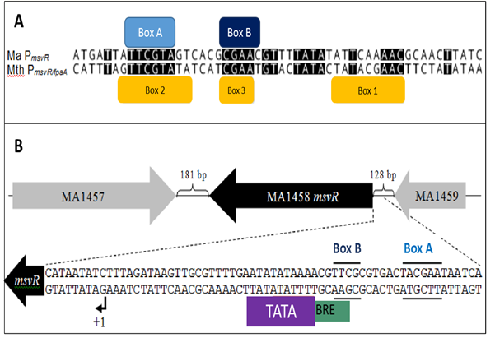
Figure 1. Alignment of MsvR binding boxes and genomic context for Ma msvR. This figure has been adapted from a previous study [522]. (A) Alignment of binding boxes on Ma P_{msvR} to those on Mth P_{msvR/fpaA}. The light blue box indicates MsvR binding box A. The dark blue box indicates MsvR binding box B on Ma P_{msvR} and the yellow boxes indicate binding boxes 1, 2 and 3 on Mth P_{msvR/fpaA}. Conserved nucleotides are shaded in black. (B) Genomic context for Ma msvR. Ma msvR is flanked by MA1457 and MA1459, with black brackets indicating the length of each intergenic region (181 bp and 128 bp). Arrows represent the direction of transcription for each gene. Dashed lines indicate the placement of the intergenic region just upstream of Ma msvR that is zoomed into below. MaMsvR binding boxes A and B are represented by solid black lines on each side the nucleotide sequence. The TATA box is indicated by a purple box and BRE is indicated by a green box. The black bent arrow and +1 indicate the TSS for Ma msvR.
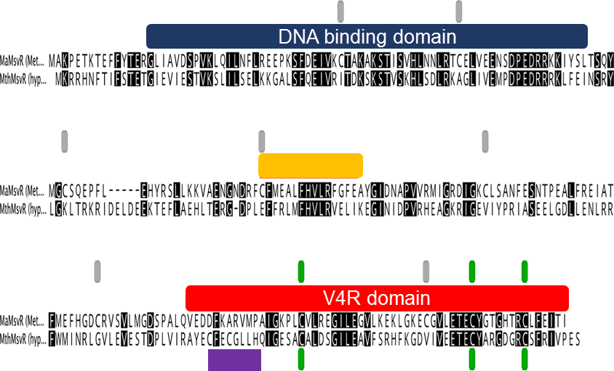
Figure 2. Amino acid sequence alignment of MthMsvR and MaMsvR. Identical amino acid residues are highlighted in black. The N-terminal DNA binding domain is indicated by the navy blue box above the sequence alignment. The C-terminal V4R domain is indicated by red box above the sequence alignment. Conserved cysteine residues are indicated by green boxes. The MthMsvR cysteine residues in the CX₂CX₃H motif are designated by a purple box. Non-conserved cysteine residues in MaMsvR are indicated by gray boxes. The MJ140, a V4R domain containing and structurally characterized protein, predicted dimerization interface is indicated by a gold box.
The V4R domain is present as a regulatory element in various proteins across all three domains of life [,]. The V4R domain has historically been classified as small molecule binding domains (SMBDs) that shows a variety of sensory functions as well as variable architectures []. In eukaryotes, V4R domains have been identified as playing a role in chlorophyll binding proteins that play a role in photosynthesis [,]. In bacteria, one such protein that contains a V4R domain is the dimethylphenol regulatory protein (DmpR). DmpR is a transcriptional regulator that plays a role in the degradation of hydrocarbons []. This transcriptional regulator acts as an activator in response to the presence of aromatic compounds, thought to be sensed by the V4R effector domain [,]. The positive phenol-degrading gene regulator (PoxR) is another example of a bacterial transcription regulator that has been found to contain a V4R domain that responds to the presence of hydrocarbons, namely phenols []. Unlike in eukaryotic and some bacterial proteins that contain the V4R at the N-terminus, and other two domain bacterial regulator proteins that contain the V4R domain flanked by other domains on the N- and C- terminus , the V4R domain of MsvR is located at the C-terminus (Figure 3). Additionally, the V4R domain of MsvR does not appear to play a role in photosynthesis nor has it been shown to participate in hydrocarbon degradation. Amino acid residues known to be important for phenol binding are not conserved in MsvR family proteins. Since MsvR has been shown to play a role in the oxidative stress response and it contains a number of cysteine residues that are often integral to redox-sensing proteins, it is of interest to elucidate the unique role that the V4R domain may play in archaeal transcription regulation.
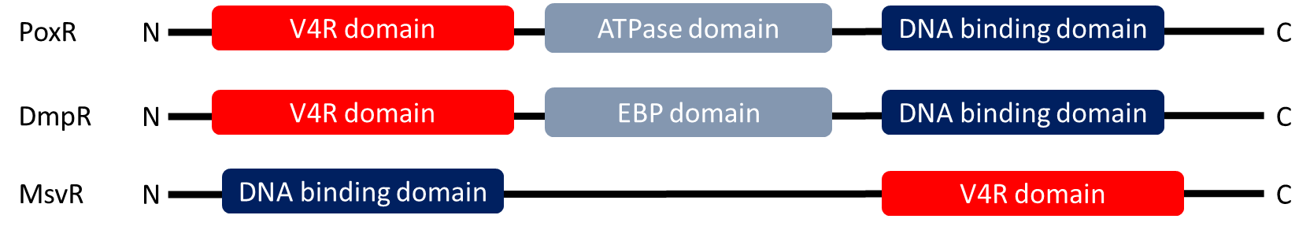
Figure 3. Variations in domain architectures between PoxR and DmpR versus MsvR. Red boxes indicate V4R domains. Dark blue boxes indicate the DNA binding domains. The light gray box in PoxR indicates an ATPase domain and in DmpR it represents an enhancer binding protein (EBP) domain. The solid black lines represent the polypeptide and the N- and C- termini are represented with an N and a C, respectively.

Chapter 2: Exploration of the Effector Domain of the Vinyl-4-Reductase Domain Containing Regulator, MsvR, a Redox Sensitive Transcriptional Regulator in Methanosarcina acetivorans

Introduction
MaMsvR was shown to share similarities in domain architecture with MthMsvR. Both MthMsvR and MaMsvR contain a C-terminal V4R domain containing three conserved cysteine residues and an N-terminal wHTH DNA binding domain. M. thermautotrophicus showed to be a difficult organism to work with in order to study this novel protein for a variety of reasons [522]. The use of a methanogen with a tractable genetic system that contained a homologue of MthMsvR, M. acetivorans, was necessary for studies of MsvR protein family function. Having a robust genetic system as well as containing a homologue of MthMsvR, M. acetivorans was an ideal model for detailed studies of MsvR family proteins and further investigations into the roles of its various structural and functional domains.
In previous studies that employed electrophoretic mobility shift assays (EMSAs), it was shown that MaMsvR demonstrated the ability to bind its own promoter (P_{msvR}) under reduced conditions, while in the presence of an oxidant no P_{msvR} binding was observed [52]. This is consistent with the notion that MaMsvR plays a role in redox-sensing and oxidative stress response. While there is a lack of experimental and structural information on MaMsvR, the DNA binding domain of MaMsvR is a well-characterized wHTH. Unlike the well characterized wHTH DNA binding domain, the V4R domain has been noted to have variable architecture as well variable functionality [55-5661]. This study aims to: investigate the role that the V4R domain plays in sensing redox changes, execute the use of truncated proteins in order to determine the oligomerization state of the V4R domain independent of the DNA binding domain under reduced and oxidized conditions as well as to employ structural studies to try to infer the overall structure of the V4R domain from MaMsvR.

Materials and Methods

Homology modeling and disorder prediction
The Protein Homology/analogY Recognition Engine v2.0 (Phyre2) was used to generate homology models from the primary amino acid sequence of full-length MaMsvR (MaMsvR^{FL}) utilizing default restraints and a 99% confidence in modelling cut-off []. Homology modeling was subsequently performed on MaMsvR V4R Constructs 1-4 utilizing the same aforementioned method with each respective amino acid sequence. The .pdb files that fell within the greater than 99% confidence cut-off were obtained from Phyre2 inquiries and were then subjected to visualization. Visualization of all homology models were viewed with the PyMOL software package [].

Design and generation of MaMsvR variants
Protein secondary structure information from homology models, as well as an amino acid sequence alignment of MaMsvR and MJ1460 (the first vinyl-4-reductase domain-containing protein to be structurally characterized, PDB IDs: 2OSO, 2OSD) from Methanocaldococcus jannaschii were used to design truncated MaMsvR constructs containing various portions of the C-terminal half of the protein which contain the V4R domain. Initially, four constructs were chosen arbitrarily so that two constructs (MaMsvR^{V4R1} and MaMsvR^{V4R2}) were upstream of the predicted dimerization interface of MJ1460 and two constructs (MaMsvR^{V4R3} and MaMsvR^{V4R4}) were downstream of the MJ1460 predicted dimerization interface.
The coding region for all constructs was amplified from pLK314 which encodes MaMsvR^{FL} in a modified pQE80L series vector also encoding an N-terminal Strep-tag® II (Qiagen) [522]. All primers (see Table 1) were designed to create a MaMsvR V4R constructs which encompassed the C-terminal V4R domain and contained an N-terminal BamHI restriction site (5’-GGATCC-3’). Images of MaMsvR^{V4R1-V4R4} aligned with MaMsvR^{FL} that include the polypeptide sequence and the putative MJ1460 V4R domain dimerization interface was rendered in Geneious v9.1.2 [] (Figure 4). The reverse primer utilized in all construct creations (LK589) annealed to the 3’ end of msvR from M. acetivorans as well as a C-terminal PstI restriction site (5’-CTGCAG -3’) present in pLK314. Restriction enzyme recognition sites were included in order to create sticky-end sites complimentary to the BamHI and PstI restriction sites on the backbone plasmid (pQE80L series vector, Qiagen) [31,522]. The corresponding coding regions were amplified via the polymerase chain reaction (PCR) in a thermal cycler using the following parameters: initial denaturation at 98ᵒC for 30 seconds, followed by 25 cycles of denaturation at 98ᵒC for 10 seconds, annealing at 65ᵒC for 30 seconds, and extension at 72ᵒC for 30 seconds and concluded with a final extension step at 72ᵒC for 5 minutes. All amplifications were completed with Phusion® High-Fidelity DNA polymerase (New England Biolabs®) according to the manufacturer’s reaction conditions. Amplicons were run on a 2.0% agarose gel that contained SYBR® Safe DNA Gel Stain (Thermo Fisher Scientific) alongside a 100 bp DNA ladder (Thermo Fisher Scientific) for 25 minutes at 120 V, 350 mA at room temperature in order to confirm amplification. The gels were visualized on a GelDocTM EZ-Imager (Bio-Rad). The amplified PCR products were cleaned and concentrated using the Clean & Concentrator-5TM kit (Zymo Research) according to manufacturer’s protocol, with a modification of 10 mM Tris buffer pH 8.0 used to elute DNA. Amplicons were cloned into pQE80LNS [522,], which contains an N-terminal BamHI restriction site and a C-terminal PstI restriction site and encodes an N-terminal Strep-tag® II (5’-WSHPQFEK-3’) [,]. Both amplicons and vectors were digested using FastDigest® BamHI and PstI (Thermo Fisher Scientific) according to manufacturer’s protocol. Digestions were incubated at 37ᵒC for one hour. Digested products were then cleaned and concentrated as described above for PCR products. Cleaned and concentrated digestion products were then ligated together using T4 DNA Ligase (New England Biolabs®) according to manufacturer’s protocol. Ligations were incubated at room temperature for 30 minutes. Ligation products were transformed into chemically competent Escherichia coli DH5α cells prepared via the Inoue method []. A 100 μL aliquot of E. coli DH5α cells was thawed on ice for 30 minutes. A 5 μL aliquot of the cleaned and concentrated ligation product was added to 100 μL of thawed competent cells on ice and they were gently stirred using the pipette tip, being careful not to introduce any air. The mixture was allowed to incubate on ice for 30 minutes. The mixture was heat shocked for 90 seconds in a 42ᵒC water bath and then transferred immediately back to ice to incubate for two minutes. A 900 μL aliquot of sterile room temperature Luria Burtani (LB) broth (per liter: 10 g tryptone, 5 g yeast extract, 5 g sodium chloride was added to reaction and stirred gently with pipette tip. The reactions were then incubated at 37ᵒC for one hour with shaking at 100 RPM. Cells were pelleted via centrifugation at 14,000 RPM for 90 seconds at room temperature. Then 800 μL of supernatant was removed and the pellet was re-suspended in the remaining 100 μL of supernatant via vortex. The suspension was the plated on pre-warmed (to 37ᵒC) LB agar plates that contained 100 μg mL ⁻¹ of ampicillin using the hockey stick method. The suspension liquid was allowed to absorb into the LB agar ampicillin plates for 10 minutes at room temperature and then the plates were incubated overnight at 37ᵒC in an inverted position. Colonies were chosen from successful transformation plates and subjected to colony PCR performed with GoTaq® Green DNA polymerase (Promega) according to manufacturer’s protocol and using respective forward primers and the reverse primer LK415 (Table 2). The PCR products were run on a 1 % agarose gel containing SYBR® Safe DNA Gel Stain (Thermo Fisher Scientific) for 25 minutes at 120 V, 350 mA at room temperature in order to confirm the plasmid contained an appropriately sized DNA insert. Colonies that contained the insert were inoculated into 5 mL sterile LB broth containing 100 μg mL ⁻¹ of ampicillin and incubated overnight at 37ᵒC with shaking at 250 RPM. Positive growth was assessed via visualization of turbidity. Glycerol stocks were created for each MaMsvR variant strain (300 μL overnight culture in 700 μL 50% glycerol, inverted to mix, stored at -80ᵒC). All plasmids and strains are listed in Table 2 and 3, respectively. Plasmid DNA was purified from 1 mL of the remaining overnight cultures using ZyppyTM Plasmid Miniprep kit (Zymo Research) according to manufacturer’s protocol, with a modification of 10 mM Tris buffer pH 8.0 to elute plasmid DNA. Purified plasmids were quantified using Qubit® dsDNA Broad Range Assay Kit and the Qubit® fluorometer (Thermo Fisher Scientific). Quantified plasmids were then sent to Oklahoma Medical Research Foundation (OMRF) DNA Sequencing Facility along with respective forward and reverse primers for sequence verification. Sequence results were aligned against the MaMsvR^{FL} DNA sequence in the biological sequence alignment editor, BioEdit V7.2.6 [].
Figure 4. MaMsvR^{V4R1-V4R4} Constructs. MaMsvR^{FL} amino acid sequence above the MaMsvR region indicated in light gray. The DNA binding domain is indicated by the navy blue bar above the amino acid sequence. The MJ1460 dimerization interface is indicated by the gold bar above the amino acid sequence. The predicted V4R domain is indicated by the dark red box above the amino acid sequence. MaMsvR^{V4R1} is indicated by the longest red bar below the MaMsvR region. MaMsvR^{V4R2} is indicated by red bar below MaMsvR^{V4R1}. MaMsvR^{V4R3} is indicated by the red bar below MaMsvR^{V4R2}. MaMsvR^{V4R4} is indicated by the red bar below MaMsvR^{V4R3}.

Protein expression and purification
Sequence confirmed plasmids were transformed as described above into lab strain E. coli RosettaTM cells (Novagen) which contained an inducible expression vector. E. coli RosettaTM (Novagen) can also accommodate expression of proteins that contain rare codons for which E. coli does not have sufficient tRNAs to decode [,,]. The transformations were performed as previously described with the addition of 100 μg mL ⁻¹ chloramphenicol and 100 μg mL ⁻¹ ampicillin to all growth medium. Transformants were incubated at 37ᵒC overnight with shaking at 250 RPM. Glycerol stocks were made for each strain as described above. A 10 mL aliquot of each culture was then pelleted in 2 mL aliquots via centrifugation at 14,000 RPM, for 90 seconds at room temperature. The supernatant was discarded and the pellets were then re-suspended in 10 mL (2 mL media per 2 mL pellet) of auto-inducing media (per liter: ~928 mL sterile ZY media (10 g tryptone, 5 g yeast extract, ~923 mL ddH₂O); remaining constituents all filter sterilized; 1 mL 1000X MgSO₄ (per 100 mL: 24.65 g MgSO₄ • 7H₂O), 1 mL 1000X trace metals (per 100 mL: 1.35 g FeCl₃, 0.294 g CaCl₂, 0.198 g MgCl₂, 0.2875 g ZnSO₄, 0.0476 g CoCl₂, 0.0341 g CuCl₂, 0.0475 g NiCl₂, 0.0484 g Na₂MoO₄ • 2H₂O, 0.0124 g H₃BO₃, 0.5 mL 12 M HCl), 20 mL 50X 5052 (per 100 mL: in order; 25 g glycerol, 73 mL ddH₂O, 2.5 g glucose, 10 g α-lactose), 50 mL 20X NPS (per 100 mL: in order; ~50 mL ddH₂O, 6.6 g (NH₄)₂SO₄ , 13.6 g KH₂PO₄, 28.61 g Na₃PO₄ • 7H₂O or 14.2 g Na₃PO₄ anhydrous, bring to volume with ddH₂O) with the addition of 100 μg mL ⁻¹ chloramphenicol and 100 μg mL ⁻¹ ampicillin. Re-suspended cells were added to ~1 L auto-inducing media and incubated at 37ᵒC for 5 hours then at 22ᵒC for 16 hours. Cultures were qualitatively tested for levels of expression via SDS-PAGE gel. A 1 mL sample from each induced culture was pelleted via centrifugation at 14,000 RPM for 90 seconds at room temperature and the supernatant was discarded. The pellets were re-suspended in 100 mL sterile ddH₂O and a 10 μL sample was added to 10 μL 2X Laemmli Sample Buffer (Bio-Rad) plus β-mercaptoethanol and boiled at 100ᵒC for 5 minutes. Boiled and reduced samples were run on Mini-PROTEAN® TGXTM AnyKDTM pre-cast gels (Bio-Rad) at 200 V, 350 mA, in 1X SDS running buffer (per liter: 30 g Tris base, 144 g glycine, 10 g SDS) at room temperature. Gels were then rinsed thoroughly in dH₂O three times for 5 minutes with gentle shaking, stained in GelCode Blue (Thermo Fisher Scientific) for 60 minutes at room temperature with gentle shaking and then de-stained in dH₂O for 60 minutes at room temperature with gentle shaking. The gels were visualized on a GelDocTM EZ-Imager (Bio-Rad). Strains that showed usable expression levels were pelleted via centrifugation at 4°C, 12,000 RPM for 20 minutes. Supernatant was discarded and like pellets were combined, weighed and stored at -80°C until ready for protein purification.
All protein constructs were purified as follows: Harvested cells were thawed on ice and thoroughly resuspended in 5 mL of cold NP buffer (50 mM sodium phosphate, 300 mM sodium chloride, pH 8.0) per gram of cell pellet. If the proteins were prepared under reduced conditions, 5 mM β-Mercaptoethanol was added. Resuspended cells were lysed via sonication on ice, for 10 seconds on, 30 seconds off; total on 2 minutes and 30 seconds, two times. Soluble and insoluble fractions were separated via centrifugation at 4°C, 12,000 RPM for 20 minutes and the soluble fraction (lysate) was carefully transferred to another container and stored on ice. Affinity chromatography purification using the Strep-tag® II was performed in order to obtain higher protein purity and avoid disruption of protein-bound metals that could occur with Ni(II) metal ion affinity chromatography [,]. High purity yields from Strep-tag® II affinity purification was possible due to the high affinity binding between the Strep-tag® II amino acid sequence and the composition of the Strep-Tactin Superflow Plus column resin (Qiagen) [66,67]. Lysate was loaded onto an NP buffer pre-equilibrated Strep-Tactin Superflow Plus column (Qiagen). The column flow through was collected in sterile 50 mL conical tubes. The column was washed three times with six column volumes of cold NP buffer. The column wash was collected in a sterile 15 mL conical tube. The column was eluted six times with ½ column volume of cold NPD buffer (NP buffer with 2.5 mM d-desthiobiotin). Elutions were collected in sterile 1.5 mL Eppendorf tubes. The column was stripped using cold NP buffer containing 2-[4 -hydroxy-benzeneazo]benzoic acid, (HABA) until translucent white with cold NP buffer, and capped and stored at 4ᵒC in ~5 mL NP buffer for later use. A 5 μL aliquot of each purification sample was subjected to an SDS-PAGE gel, stained and visualized as previously described. Fractions that contained the protein of interest were combined and concentrated to 600 μL in a primed (with sterile ddH₂O) Amicon® Ultra-15 PLGC Ultracel-PL 10 kDa centrifugal filter unit (Millipore) at room temperature and then stored on ice. Concentrated fractions were then subjected to a final clean-up step via size exclusion chromatography (SEC) on a SuperdexTM 200 Increase 10/300 GL column. Increased purity and species separation is possible due to the composition of the resin. The SuperdexTM 200 Increase 10/300 GL column is a porous resin that allows for proteins to be separated by size, with the larger proteins eluting first and smaller proteins eluting thereafter. This is accomplished due the longer migration time through the porous column for the smaller proteins []. The column was calibrated with a protein mixture containing conalbumin (75 kDa), ovalbumin (43 kDa), carbonic anyhydrase (29 kDa) and ribonuclease A (13.7 kDa) prepared in accordance with the manufacturer’s instructions (GE Healthcare). The column was then equilibrated in cold SEC buffer (150 mM NaCl, 20 mM Tris pH 8, 5 mM β-Mercaptoethanol) on an ÄKTA pure M1 FPLC (GE Healthcare, Piscataway, NJ) at the University of Oklahoma Protein Production Core Facility. Elutions were visualized using A₂₈₀ on UNICORN software (GE Healthcare) and fractions of interest were evaluated on SDS-PAGE gels as described above. Fractions containing the protein of interest were pooled and concentrated as previously described for affinity purification. Protein was quantified using the PierceTM Coomassie Plus (Bradford) Assay Kit (Thermo Fisher Scientific) using a bovine serum albumin standard curve.

DNA binding assays
DNA binding activity was assessed utilizing electrophoretic mobility shift assays (EMSA). Proteins were tested under reduced (Dithiothreitol (DTT)) and oxidized (H₂O₂) conditions. DNA binding reaction buffer contained 6.5 µl ddH₂O, 2 µl of 10x Txn buffer (200 mM Tris pH 8.0, 100 mM MgCl₂, 1.2 M KCl), 3 µl protein dialysis buffer (20 mM Tris pH 8.0 10 mM MgCl₂, 200 mM KCl, 50% (v/v) Glycerol), 0.5 µl heparin (125 mg ml⁻¹), and 2 µl of a 500 nM stock of a double-stranded 100-base pair (bp) fragment of P_{msvR}. For oxidized conditions, the protein was pretreated with 100X H₂O₂ per protein concentration for 15 minutes at room temperature and an additional 100 mM H₂O₂ was added to the reaction. For reduced conditions, no pretreatment of the protein was performed and DTT was added to the reaction to the final concentration of 10 mM. Reactions were incubated with appropriate protein at room temperature for 15 minutes and samples were run on a pre-run 8% tris-borate (TB) gel. The resulting gel was stained with SYBR GoldTM (Invitrogen) for 30 minutes at room temperature in the dark and visualized on a GelDocTM EZ-Imager (Bio-Rad). Images were inverted for display purposes.

Crystallization screening
Crystallization screening was performed using the sparse matrix method with a Mosquito dispenser (TTP Labtech, Melbourn, United Kingdom) with one or more of the following commercially available 96-well crystallization screens [] : MCSG-1, MCSG-2, MSCG-3, MCSG-4 (Microlytic), JCSG-plus, PACT premier (Molecular Dimensions), CSHT and/or Index (Hampton Research), each with the addition of 5 mM tris(2-carboxyethyl)phosphine (TCEP), a reducing agent. Initial trays were set-up as sitting-drop vapor-diffusion with drops containing a 1:1 ratio of protein to well solution. Broadscreen crystallization trays were incubated at either 4°C, 16°C or room temperature.

Crystal optimization
Conditions that were optimized around were from the MCSG-1 crystallization screen (Microlytic) wells A9 (0.2 M magnesium chloride, 25% (w/v) PEG3350, 0.1 M HEPES, pH 7.5, 5 mM TCEP) and C9 (0.8 M lithium chloride, 32% (w/v) PEG4000, 0.1 M Tris, pH 8.5, 5 mM TCEP) with protein construct, MaMsvR^{V4R3}. Optimization trays were set-up as hanging-drop vapor-diffusion in 24-well crystallization trays. One condition was finely adjusted per row in order to accomplish fine optimization. Conditions that were varied included salt concentration, precipitant concentration, protein concentration, pH, temperature and with or without micro-seeding (see Appendix A and Appendix B). Drops were mounted on plastic coverslips (Molecular Dimensions) by adding protein to a drop of well solution on the plastic coverslip carefully without the introduction of air bubbles. The coverslips with the well solution-protein mixture were then quickly inverted and placed over the respective well with vacuum grease lining the lip of the well. Gentle pressure was applied to secure the coverslip in place and ensure an airtight seal. An airtight seal was necessary in order to accomplish vapor diffusion that contributed to optimal crystallization conditions [,]. Trays were stored at 4°C, 16°C and/or room temperature in areas or incubators that were placed to avoid disruption, excessive motion or temperature fluctuation.

X-ray data collection
Initial MaMsvR^{V4R3} crystals were screened at room temperature at the University of Oklahoma Macromolecular Crystallography Laboratory using X-ray diffraction with an X-ray wavelength 1.54 Å and images were collected on the Pilatus 200K. Crystals from drops that exhibited diffraction patterns consistent with protein were then cryoprotected in 18% PEG400 and flash-frozen in liquid nitrogen. Crystals were sent to Stanford Synchrotron Radiation Lightsource (SSRL) and diffraction data was collected on BL12-2 with an X-ray wavelength 0.97945. Initial data was processed on AutoXDS []. Data was further processed utilizing the HKL3000 software package [].

Optimization of MaMsvR variants
Construct optimization incorporated the use of homology models and amino acid alignment from the initial construct design as well as amino acid sequence alignment and homology modeling information from the homolog PoxR from Cupriavidus necator (a phenol-responsive sensory domain of the transcription activator PoxR. PDB ID=5FRU). Several secondary structure prediction servers such as Jpred 4 (http://www.compbio.dundee.ac.uk/jpred/), CFSSP (http://www.biogem.org/tool/chou-fasman/) and NetSurfP (http://www.cbs.dtu.dk/services/NetSurfP/), and SWISS-MODEL (http://swissmodelexpasy.org), all of which are available through the ExPASy bioinformatics resource portal (https://www.expasy.org/resources) as well as PSIPRED (http://bioinf.cs.ucl.ac.uk/psipred/) and SABLE (http://sable.cchmc.org/) were used in order to contribute to the production of constructs of varying lengths without interrupting predicted secondary structures. The optimized constructs were MaMsvR^{V4R5} – MaMsvR^{V4R13}. Further predictions of protein disorder to optimize MaMsvR^{V4R3} were accomplished using the SERp server from the Molecular Biology Institute at the University of California, Los Angeles, which predicts regions of amino acids where surface entropy should be reduced in order to optimize crystallization conditions []. Primers were designed, strains were created, and proteins were subjected to subsequent testing as described previously.

Small angle X-ray scattering
MaMsvR^{FL} and MaMsvR^{V4R2} construct were each dialyzed for 15 h at 4 °C into buffer containing 20 mM Tris pH 8.0, 50 mM sodium chloride and 0.5 mM TCEP to rid any remaining contaminants. Prior to data collection samples were filtered through a 0.2 µm syringe filter and diluted to the working concentrations. Homogenous samples are imperative for SAXS, as well as post dialyzed dialysis buffer to be subjected to SAXS in order to subtract background effects. The samples and dialysis buffer were shipped on ice to SSRL BL4-2 and immediately stored at -80°C to avoid protein degradation. The protein samples were diluted on-site to give a range of concentrations. The dilutions are a necessary step for SAXS data processing. Samples and dialysis buffer were shipped on ice to SSRL BL4-2. Small-angle scattering data was collected on a Pilatus 300K. Initial data analysis was using SAXSPipe, which implements the SASTOOL program, all available through SSRL. Output files are further analyzed and data merged and indexed using the ATSAS 2.8.0 program suite []. The scattering intensity was obtained by subtracting the scattering of the buffer blank from the sample scattering using the PRIMUS software. All SAXS data was processed using GNOM, integrated in the PRIMUS software, to obtain the pair distance distribution function (PDDF). The GNOM output was used with DAMMIF to calculate 7 ab initio dummy atom models. Models were averaged using DAMAVER and aligned to X-ray crystal structures using SUPCOMB. Theoretical scattering curves for the MaMsvR^{V4R2} SAXS data were calculated using CRYSOL [,82]. DAMAVER models were visualized in PyMol. Superimposition of the MaMsvR^{V4R2} homology model and the protein envelope derived from DAMAVER program were accomplished utilizing SUPCOMB from the ATSAS software suite along with PyMOL [].

Table 1. Primers
Primer Number | Sequence (5' to 3') |  | Function | Construct Description
LK414 | CCCGAAAAGTGCCACCTG |  | Forward primer for pQE80LNS vector | N/A
LK415 | GTTCTGAGGTCATTACTG G |  | Reverse primer for pQE80LNS vector | N/A
LK588 | TTCAGGGATCCATGGCA AAACCTGAGACCA |  | M. acetivorans msvR cloning BamHI | N/A
LK589 | TTCAGCTGCAGTTATATT  GTAATCTCAAAAAGACA  G |  | M. acetivorans msvR cloning PstI | N/A
LK729 | TTCAGCTGCAGTTATATT GTAATCTCAAAAAG |  | Modified LK589-avoids C240 coding sequence | N/A
LK733 | TTCAGGGATCCTCCCAG TACATGGGCTGC |  | MaMsvR^{V4R1} forward BamHI site | S84-I246
LK734 | TTCAGGGATCCTGCTCTC AGGAGCCTTTTC |  | MaMsvR^{V4R2} forward BamHI site | C89-I246
LK735 | TTCAGGGATCCGCTCCT GTTGTCAGGATG |  | MaMsvR^{V4R3} forward BamHI site | A135-I246
LK736 | TTCAGGGATCCCGGGTC TCGGTCCTCATG |  | MaMsvR^{V4R4} forward BamHI site | R176-I246
KS1000 | TTCAAGGGATCCGTCTC GGTCCTCATG |  | MaMsvR^{V4R5} forward BamHI site | V177-I246
KS1001 | TTCAAGGGATCCGCCCT GTTCAGGGAAATTG |  | MaMsvR^{V4R6} forward BamHI site | A160-I246
KS1002 | TTCAAGGGATCCTGTCTT TCGGCTAATTTTG |  | MaMsvR^{V4R7} forward BamHI site | C148-I246
KS1003 | TTCAAGGGATCCCTCTGT GTGCTTAGAGAAGG |  | MaMsvR^{V4R8} forward BamHI site | L205-I246
KS1004 | TTCAAGGGATCCTCGGC  TAATTTTGAATCAAACA  C |  | MaMsvR^{V4R9} forward BamHI site | S150-I246
KS1005 | TTCAAGGGATCCCATTA CCGAAGCCTGTCG |  | MaMsvR^{V4R10} forward BamHI site | H97-I246
KS1006 | TTCAAGGGATCCTTCTGC TTTATGGAAGCCC |  | MaMsvR^{V4R12} forward BamHI site | F113-I246
KS1007 | TTCAAGGGATCCGAAGC ATACGGGATTG |  | MaMsvR^{V4R13} forward BamHI site | E128-I246
KS1008 | TTCAAGGGATCCTACCG AAGCCTGCTG |  | MaMsvR^{V4R14} forward BamHI site | Y98-I246
KS1009 | TTCAAGGGATCCAGGTT CTGCTTTATGGAAG |  | MaMsvR^{V4R15} forward BamHI site | R112-I246
KS1010 | TTCAAGGGATCCGGGAT TGATAATGC |  | MaMsvR^{V4R11} forward BamHI site | G131-I246
*restriction sites are underlined

Table 2. Plasmids
Plasmid | Backbone Vector |  | Function
pQE80LNS | N/A |  | Strep-tag® II labeling and expression vector (Qiagen)
pLK314 | pQE80LNS |  | Coding sequence for MaMsvR^{FL}
pLK371 | pQE80LNS |  | Coding sequence for MaMsvR^{V4R1}
pLK372 | pQE80LNS |  | Coding sequence for MaMsvR^{V4R2}
pLK373 | pQE80LNS |  | Coding sequence for MaMsvR^{V4R3}
pLK374 | pQE80LNS |  | Coding sequence for MaMsvR^{V4R4}
pLK439 | pQE80LNS |  | Coding sequence for MaMsvRV4R2-K223A, E224A
pLK444 | pZero Blunt TOPO |  | Coding sequence for MaMsvRV4R2-K223A, E224A
pLK463 | pZero Blunt TOPO |  | Coding sequence for MaMsvRV4R3-K223A, E224A
pLK464 | pQE80LNS |  | Coding sequence for MaMsvRV4R3-K223A, E224A
pLK467 | pZero Blunt TOPO |  | Coding sequence for MaMsvR^{V4R5}
pLK468 | pQE80LNS |  | Coding sequence for MaMsvR^{V4R5}
pLK469 | pZero Blunt TOPO |  | Coding sequence for MaMsvR^{V4R6}
pLK470 | pQE80LNS |  | Coding sequence for MaMsvR^{V4R6}
pLK471 | pQE80LNS |  | Coding sequence for MaMsvR^{V4R7}
pLK472 | pZero Blunt TOPO |  | Coding sequence for MaMsvR^{V4R8}
pLK473 | pQE80LNS |  | Coding sequence for MaMsvR^{V4R8}
pLK474 | pQE80LNS |  | Coding sequence for MaMsvR^{V4R9}
pLK497 | pQE80LNS |  | Coding sequence for MaMsvR^{V4R10}
pLK498 | PQE80LNS |  | Coding sequence for MaMsvR^{V4R11}

Table 3. Escherichia coli strains
Strain/  Reference | Plasmid Harbored |  | Cell Strain | Construct Description | Resistance
Invitrogen | None |  | DH5α | None | None
Novagen | ptRNA |  | Rosetta | None | Cam
LK1341 | pLK314 |  | DH5α | None | Amp
LK1354 | pLK314 |  | Rosetta | Ma msvR in pQE80LNS | Amp/ Cam
LK1410 | pLK371 |  | DH5α | Coding sequence for MaMsvR^{V4R1} | Amp
LK1411 | pLK372 |  | DH5α | Coding sequence for MaMsvR^{V4R2} | Amp
LK1412 | pLK373 |  | DH5α | Coding sequence for MaMsvR^{V4R3} | Amp
LK1413 | pLK374 |  | DH5α | Coding sequence for MaMsvR^{V4R4} | Amp
LK1414 | pLK371 |  | Rosetta | Coding sequence for MaMsvR^{V4R1} | Amp/ Cam
LK1415 | pLK372 |  | Rosetta | Coding sequence for MaMsvR^{V4R2} | Amp/ Cam
LK1416 | pLK373 |  | Rosetta | Coding sequence for MaMsvR^{V4R3} | Amp/ Cam
LK1417 | pLK374 |  | Rosetta | Coding sequence for MaMsvR^{V4R4} | Amp/ Cam
LK1542 | pLK444 |  | DH5α | Coding sequence for MaMsvR^{V4R2 -K223A, E224A} | Kan
LK1549 | pLK439 |  | Rosetta | Coding sequence for MaMsvR^{V4R2 -K223A, E224A} | Amp/  Cam
LK1568 | pLK463 |  | DH5α | Coding sequence for MaMsvR^{V4R3 -K223A, E224A} | Kan
LK1569 | pLK464 |  | DH5α | Coding sequence for MaMsvR^{V4R3 -K223A, E224A} | Amp
LK1572 | pLK467 |  | DH5α | Coding sequence for MaMsvR^{V4R5} | Kan
LK1573 | pLK468 |  | DH5α | Coding sequence for MaMsvR^{V4R5} | Amp
LK1574 | pLK469 |  | DH5α | Coding sequence for MaMsvR^{V4R6} | Kan
LK1575 | pLK470 |  | DH5α | Coding sequence for MaMsvR^{V4R6} | Amp
LK1576 | pLK471 |  | DH5α | Coding sequence for MaMsvR^{V4R7} | Amp
LK1577 | pLK472 |  | DH5α | Coding sequence for MaMsvR^{V4R8} | Kan

Results

Homology modeling and disorder prediction
Homology modeling results returned several versions of MaMsvR tertiary structure with slight differences based on model template utilized by Phyre2. The best model prediction was based off of the template associated with PDB ID 2OSO. This model covered 118 amino acid residues from MaMsvR^{FL} (48% sequence coverage) with a 26% sequence identity and was modelled with 99.9% confidence (Figure 5). There were 20 results that were modeled against different templates that all had a >99.5% confidence (Table 4). Additional results returned showed templates which could cover 276 amino acid residues (97% sequence coverage) with a >90% confidence. The overall secondary structure predictions remained relatively consistent based off of sequence alignment results and secondary structure predictions for templates with a >95% confidence. The N-terminal DNA binding domain is a winged helix-turn-helix, followed by a predicted approximate 90 residue flexible linker region that is comprised of several α-helices, loops and turns. The C-terminal V4R domain is predicted to contain a single α-helix and a few antiparallel β-sheets, as well as a region that contains flexible loops and turns. The sequence alignment and predicted secondary structure results obtained from Phyre2 with the highest percent confidence can be seen in Appendix C.
Results returned from Phyre2 for templates for homology models for the MaMsvR V4R domain constructs (MaMsvR^{V4R1}-MaMsvR^{V4R4}) showed less variability in the number of templates with a >95% confidence. The best model prediction for MaMsvR^{V4R1} was based off the template associated with PDB ID 2OSO. This model covered 137 amino acid residues from MaMsvR^{V4R1} (85% sequence coverage) with a 23% sequence identity and was modelled with 100.0% confidence. The best model prediction for MaMsvR^{V4R2} was based off of the template associated with PDB ID 2OSO. This model covered 118 amino acid residues from MaMsvR^{V4R2} (75% sequence coverage) with a 23% sequence identity and was modelled with 99.9% confidence. The best model prediction for MaMsvR^{V4R3} was based off of the template associated with PDB ID 2OSO. This model covered 100 amino acid residues from MaMsvR^{V4R3} (90% sequence coverage) with a 26% sequence identity and was modelled with 100.0% confidence. The best model prediction for MaMsvR^{V4R4} was based off of the template associated with PDB ID 2OSO. This model covered 63 amino acid residues from MaMsvR^{V4R4} (89% sequence coverage) with a 25% sequence identity and was modelled with 99.9% confidence. Additional results that were returned that were modeled against different templates with a confidence >90% were fewer compared to those returned for MaMsvR^{FL} (Tables 5-8). The homology models rendered in PyMOL showed variations in composition of α-helices and flexible loops (Figure 6). However, the singular antiparallel β-sheet in the V4R region remained consistent with slight variation in the overall number of amino acid residues that incorporated into each of the β-strands that make up the β-sheet. The sequence alignment and predicted secondary structure results obtained from Phyre2 for MaMsvR^{V4R1}-MaMsvR^{V4R4} with the highest percent confidence can be seen in Appendix C.
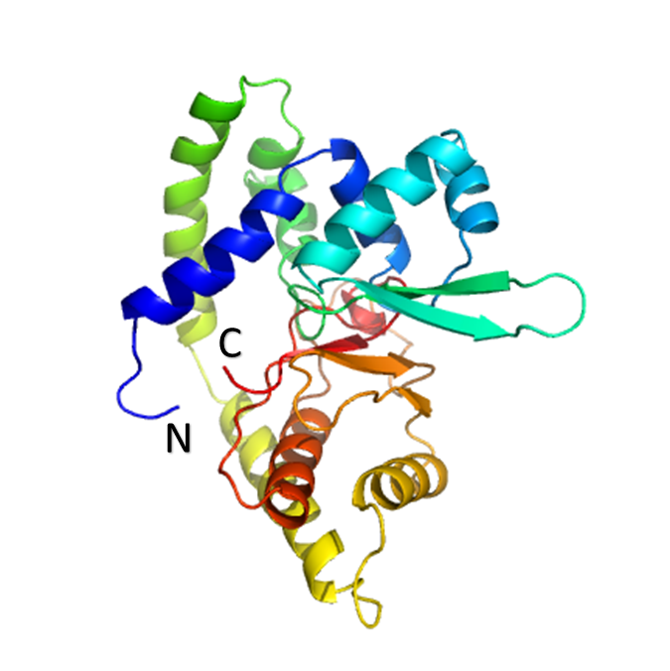
Figure 5. Homology Model of MaMsvR^{FL}. The homology model displayed shows MaMsvR^{FL} in its monomeric state. The N-terminus and the C-terminus are indicated with an N or C, respectively. The overall color scheme of the homology model of MaMsvR^{FL} follows an inverse modified rainbow pattern (blue, light blue, blue-green, green, light green, yellow, yellow-orange, orange, red).

Table 4. MaMsvR^{FL} Homology model confidence and coverage
Template (PDB ID) | Amino Acids Covered (#) | Amino Acids Covered (%) | Confidence (%) | % Identity
5KBH | 128 | 52 | 99.8 | 19
5FRU | 128 | 52 | 99.7 | 21
3BJ6 | 115 | 46 | 99.5 | 14
3G3Z | 113 | 46 | 99.5 | 22
5ERI | 110 | 44 | 99.5 | 15
1LNW | 107 | 43 | 99.5 | 11
2ETH | 99 | 40 | 99.5 | 23
1LJ9 | 114 | 46 | 99.5 | 8
4FHT | 112 | 45 | 99.5 | 13
1JGS | 111 | 45 | 99.5 | 13
1S3J | 110 | 44 | 99.5 | 14
3NRV | 106 | 43 | 99.5 | 15
3ZMD | 123 | 50 | 99.5 | 15
3BRO | 117 | 43 | 99.5 | 15
2GXG | 115 | 46 | 99.5 | 20
3ZPL | 107 | 43 | 99.5 | 12
3NQO | 104 | 42 | 99.5 | 14
3BPX | 114 | 46 | 99.5 | 21
3E6M | 117 | 47 | 99.5 | 12

Table 5. MaMsvR^{V4R1} Homology model confidence and coverage
Template (PDB ID) | Amino Acids Covered (#) | Amino Acids Covered (%) | Confidence (%) | % Identity
5KBH | 153 | 94 | 99.9 | 18
5FRU | 128 | 79 | 99.9 | 21
2KIL | 129 | 79 | 98.4 | 16
2NJC | 147 | 90 | 98.2 | 12
2O0C | 128 | 79 | 98.2 | 17
1U55 | 128 | 79 | 98.0 | 17
3CUE | 135 | 83 | 97.7 | 14
2J3T | 135 | 83 | 97.6 | 16
2CFH | 129 | 79 | 97.2 | 18
2Z9F | 103 | 63 | 96.5 | 21
1WC9 | 131 | 80 | 94.4 | 13
2J3W | 134 | 82 | 92.6 | 11

Table 6. MaMsvR^{V4R2} Homology model confidence and coverage
Template (PDB ID) | Amino Acids Covered (#) | Amino Acids Covered (%) | Confidence (%) | % Identity
5KBH | 153 | 97 | 99.9 | 19
5FRU | 146 | 92 | 99.9 | 22
2KIL | 148 | 94 | 98.8 | 17
2O0C | 148 | 94 | 98.7 | 14
1U55 | 148 | 94 | 98.4 | 18
3NJC | 147 | 93 | 98.4 | 14
2J3T | 135 | 85 | 97.8 | 19
3CUE | 134 | 85 | 97.6 | 14
2CFH | 129 | 82 | 97.5 | 18
1WC9 | 127 | 80 | 97.3 | 18
2Z9F | 105 | 66 | 97.1 | 21
2JWB | 134 | 85 | 93.9 | 14

Table 7. MaMsvR^{V4R3} Homology model confidence and coverage
Template (PDB ID) | Amino Acids Covered (#) | Amino Acids Covered (%) | Confidence (%) | % Identity
5KBH | 109 | 98 | 99.9 | 20
5FRU | 109 | 98 | 99.9 | 22
2NJC | 106 | 95 | 98.8 | 13
2KIL | 108 | 97 | 98.0 | 17
3CUE | 110 | 99 | 97.9 | 15
2J3T | 110 | 99 | 97.8 | 13
2O0C | 107 | 96 | 97.7 | 13
2CFH | 110 | 99 | 97.6 | 15
1U55 | 108 | 97 | 97.0 | 19
1WC9 | 110 | 99 | 96.9 | 16
2Z9F | 76 | 68 | 96.8 | 22
2JWB | 110 | 98 | 96.5 | 14

Table 8. MaMsvR^{V4R4} Homology model confidence and coverage
Template (PDB ID) | Amino Acids Covered (#) | Amino Acids Covered (%) | Confidence (%) | % Identity
5KBH | 69 | 97 | 99.8 | 24
5FRU | 60 | 84 | 99.7 | 28
2KIL | 44 | 61 | 97.1 | 25
2O0C | 44 | 61 | 96.7 | 25
1U55 | 44 | 61 | 95.3 | 23

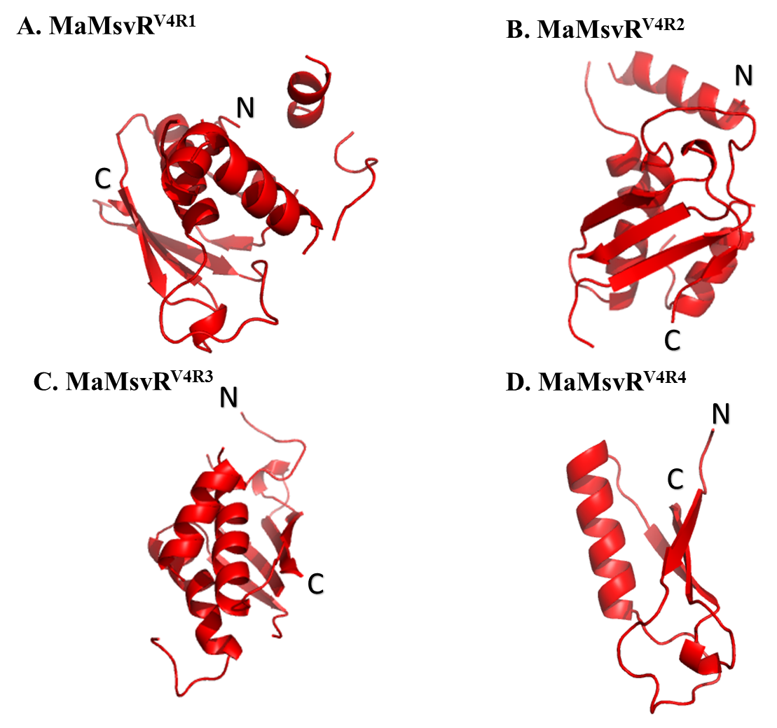
Figure 6. Homology Models of MaMsvR^{V4R1-V4R4}. The homology models displayed show the initial MaMsvR V4R domain constructs A) MaMsvR^{V4R1} B) MaMsvR^{V4R2} C) MaMsvR^{V4R3} D) MaMsvR^{V4R4}. The N-terminus and the C-terminus are indicated with an N or C, respectively, for each of the homology models. All homology models (MaMsvR^{V4R1} - MaMsvR^{V4R4}) are shown in red.

Protein expression and purification
Protein expression using the auto-induction method proved to be successful for E. coli RosettaTM (Novagen) strains LK1354, LK1414, LK1415 and LK1416 that encoded for MaMsvR^{FL}, MaMsvR^{V4R1}, MaMsvR^{V4R2} and MaMsvR^{V4R3}, respectively. Protein expression for E. coli RosettaTM (Novagen) strain LK1417 that produced MaMsvR^{V4R4} was not successful. The backbone of the plasmid that contained the recombinant gene of interest (GOI), also contained a lac operator in order to regulate gene expression. The lac operator allows for high levels of protein expression by taking advantage of the natural inducible system with the use of glucose and lactose in the auto-induction medium. The transcription of the GOI remains partially repressed in the presence of glucose. When lactose is present, LacI remains unbound to the promoter and weak expression can be detected. Once glucose is depleted from the auto-induction medium, cAMP is able to complex with CRP, lactose is able to bind LacI in order to inactivate it and allow for full activation of gene expression [,,].

Strep-tag® II affinity purification yielded large amounts of protein at >95% purity for MaMsvR^{FL}, MaMsvR^{V4R1} and MaMsvR^{V4R2}. Typical protein yields for MaMsvR^{FL}, MaMsvR^{V4R1} and MaMsvR^{V4R2} were consistently upwards of 15 mg ml⁻¹. For MaMsvR^{V4R3} the protein yield was much lower with a typical concentration being 3 mg ml⁻¹, yet still yielding high purity (Figure 7). In order to obtain even higher purity as well as assess the oligomerization state of MaMsvR^{V4R1}, MaMsvR^{V4R2} and MaMsvR^{V4R3} under reduced, non-reduced and/or oxidized conditions, SEC was performed on a SuperdexTM 200 Increase 10/300 GL column on an ÄKTA pure M1 FPLC (GE Healthcare, Piscataway, NJ). The chromatograms from SEC showed that MaMsvR^{V4R1}, MaMsvR ^{V4R2} and MaMsvR^{V4R3} all eluted as a dimer under reduced, non-reduced or oxidized conditions. Chromatograms for each MaMsvR^{V4R1} and MaMsvR^{V4R2} uniformly showed a sharper more intense peak at an elution that corresponded with the approximate molecular weight of a dimer than did that of the chromatograms for MaMsvR^{V4R3} (Figures 8-10). MaMsvR^{V4R3} appeared to have considerable aggregation in the sample which is illustrated by the significant peak at the column void volume. Results from repetitive iterations of size exclusion chromatography for both MaMsvR^{V4R2} and MaMsvR^{V4R3} yielded consistent results.
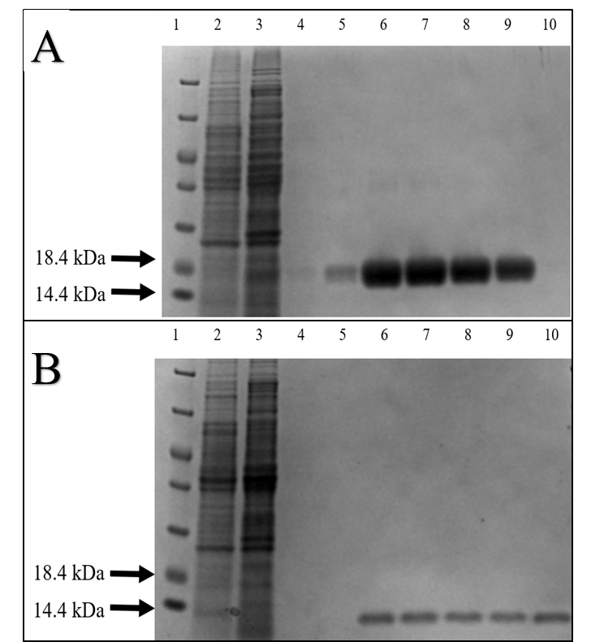
Figure 7. Representative SDS-PAGE gels of MaMsvR^{V4R2-NStrep} and MaMsvR^{V4R3-NStrep} Strep-Tag® II affinity purification gel images. MaMsvR^{V4R2-NStrep} is 19.7 kDa and MaMsvR^{V4R3-NStrep} is 14.3 kDa. (A) Representative image of MaMsvR^{V4R2} affinity purification. (B) Representative image of MaMsvR^{V4R3} affinity purification. Lanes for both gel images (A and B) are as follows: Lane 1 shows PierceTM Unstained Protein MW Marker (Thermo Fisher ScientificTM), Lane 2 contains cleared lysate that was loaded onto the column, Lane 3 contains column flow through, Lane 4 contains column wash and Lanes 5-10 show each individual elution.
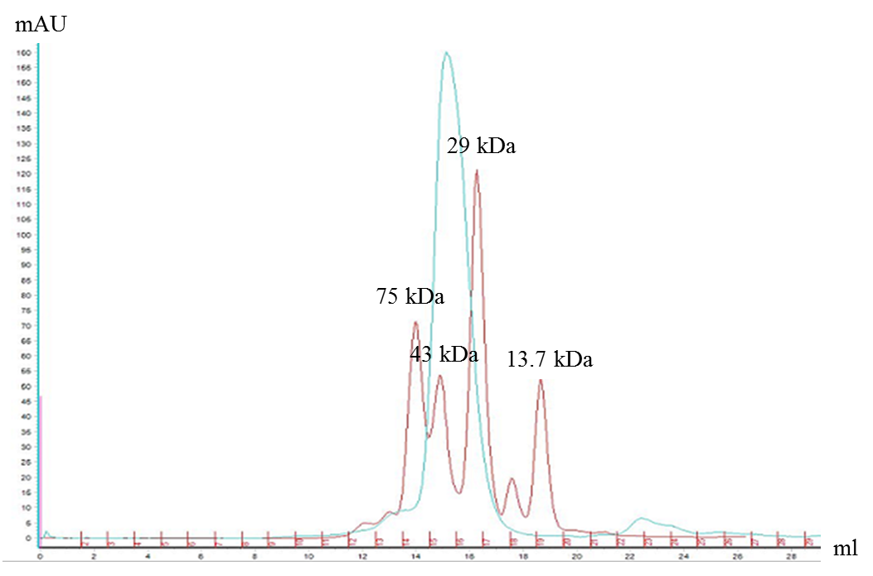Figure 8. Representative SEC chromatogram of MaMsvR^{V4R1}. The standards are indicated in red with the correlating molecular weights above each respective peak. The MaMsvR^{V4R1} sample that was loaded onto the column is represented in light blue. The y-axis indicates milli absorbance units (mAU) and the x-axis shows elution volume in milliliter (red) and fraction number (black).
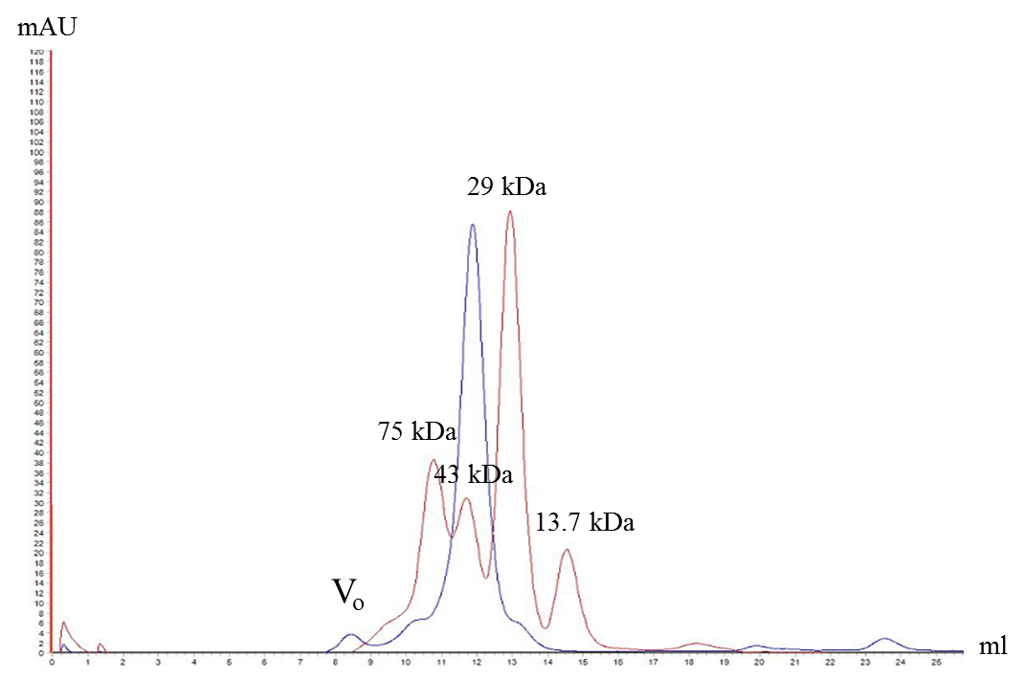Figure 9. Representative SEC chromatogram of MaMsvR^{V4R2}. The standards are indicated in red with the correlating molecular weights above each respective peak. The MaMsvR^{V4R2} sample that was loaded onto the column is represented in light blue. The void volume peak is labeled V_{o.} The y-axis indicates milli absorbance units (mAU) and the x-axis shows elution volume in milliliters.
10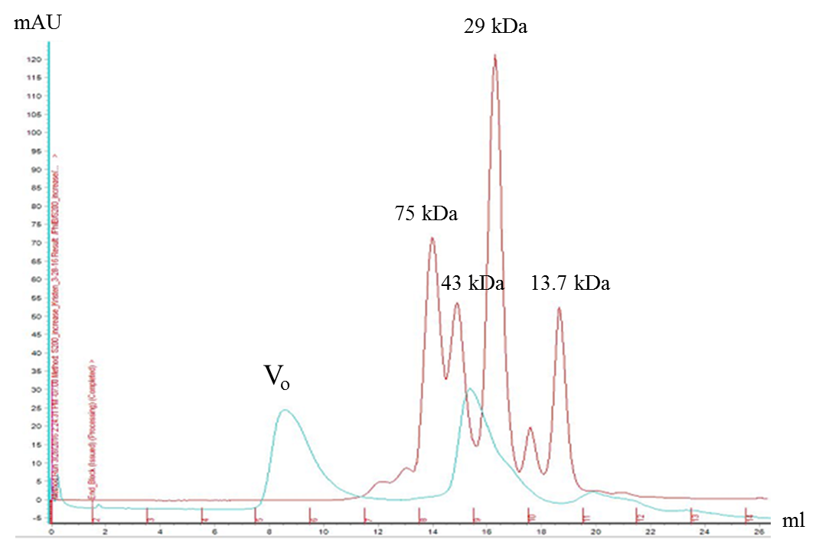Figure 10. Representative SEC chromatogram of MaMsvR^{V4R3}. The standards are indicated in red with the correlating molecular weights above each respective peak. The MaMsvR^{V4R3} sample that was loaded onto the column is represented in light blue. The void volume peak is labeled V_{o.} The y-axis indicates milli absorbance units (mAU) and the x-axis shows elution volume in milliliter (red) and fraction number (black).

DNA binding assays
In order to determine the ability of the various MaMsvR constructs (MaMsvR^{V4R1}, MaMsvR^{V4R2} and MaMsvR^{V4R3}) to bind P_{msvR}, EMSAs were performed []. Previous studies have shown that MaMsvR^{FL} exhibited P_{msvR} binding under reduced conditions, but did not show P_{msvR} binding under non-reduced or oxidized conditions [522]. The EMSAs were run under non-reduced conditions, reduced conditions (with the addition of DTT) and/or oxidized conditions (with the addition of H₂O₂) to assess possible differing P_{msvR} binding (shifting) behavior in vitro in response to reduced or oxidized environments. A 2015 study reported that a V4R protein isolated from Thermococcus onnurineus demonstrated the ability of the protein to contribute to DNA binding when in the presence of a DNA binding transcription regulator [,]. To test the ability of individual domains of MaMsvR to combine and demonstrate the ability to have DNA binding activity, an EMSA was also run with MaMsvR^{DBD3} in the presence of MaMsvR^{V4R2} or with MaMsvR^{DBD3} in the presence of MaMsvR^{V4R3}, with each protein construct added in equal amounts. MaMsvR^{DBD3} (MaMsvR residues 1-88) and MaMsvR^{V4R2} (MaMsvR residues 89-246) make up the MaMsvR polypeptide chain in its entirety. MaMsvR^{DBD3} (MaMsvR residues 1-88) and MaMsvR^{V4R3} (MaMsvR residues 135-246) which consist of each functional domain of MaMsvR but is lacking the majority of the flexible linker region which includes the putative dimerization interface from Methanococcus jannaschii MJ1460, a V4R family protein (PDB ID: 2OSO, 2OSD). Standalone MaMsvR^{DBD3} had not previously demonstrated DNA binding activity (not shown). No DNA binding activity was observed for any individual MaMsvR V4R construct, nor was DNA binding observed when MaMsvR^{DBD3} and MaMsvR^{V4R2} or MaMsvR^{DBD3} and MaMsvR^{V4R3} were combined (Figures 11-19).
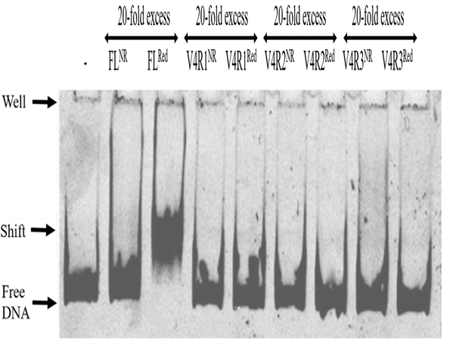
Figure 11. EMSA of Ma P_{msvR} with MaMsvR^{FL}, MaMsvR^{V4R1}, MaMsvR^{V4R2}, MaMsvR^{V4R3} under non-reduced and reduced conditions. Each reaction contained 50 nM Ma P_{msvR}. Reduced reactions contained 5 mM DTT. The DNA only control lane is indicated with an (–). All lanes with protein contained 1 µM of respective protein (20-fold over DNA.

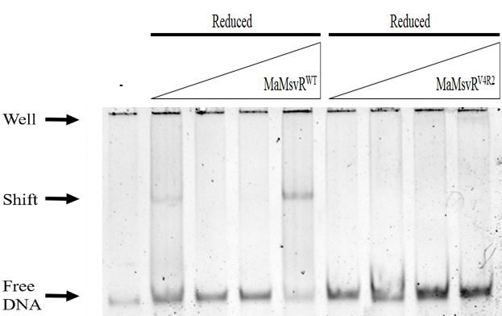
Figure 12. EMSA of Ma P_{msvR} with MaMsvR^{FL} and MaMsvR^{V4R2} under reduced conditions. Each reaction contained 50 nM Ma P_{msvR} and 5 mM DTT. The DNA only control lane is indicated with an (–). The lanes which contain protein are titrated at 1 µM, 2 µM, 4 µM and 8 µM of the indicated protein (20 to 160 fold over DNA).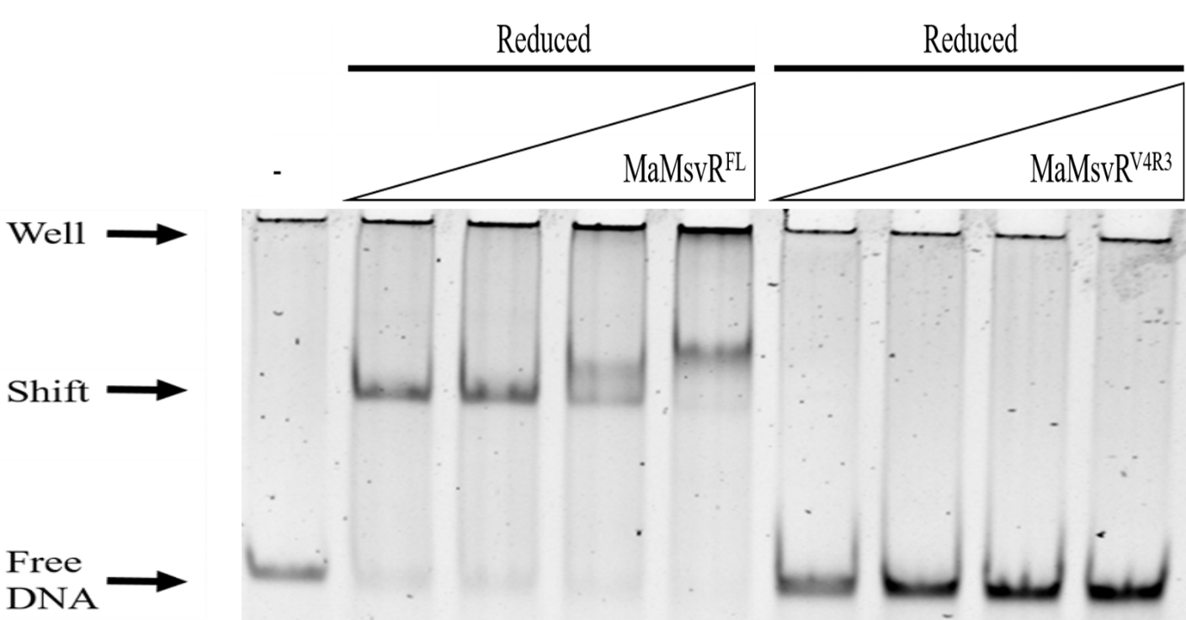Figure 13. EMSA of Ma P_{msvR} with MaMsvR^{FL} and MaMsvR^{V4R3} under reduced conditions. Each reaction contained 50 nM Ma P_{msvR} and 5 mM DTT. The DNA only control lane is indicated with an (–). The lanes which contain protein are titrated at 1 µM, 2 µM, 4 µM and 8 µM of the indicated protein (20 to 160 fold over DNA).
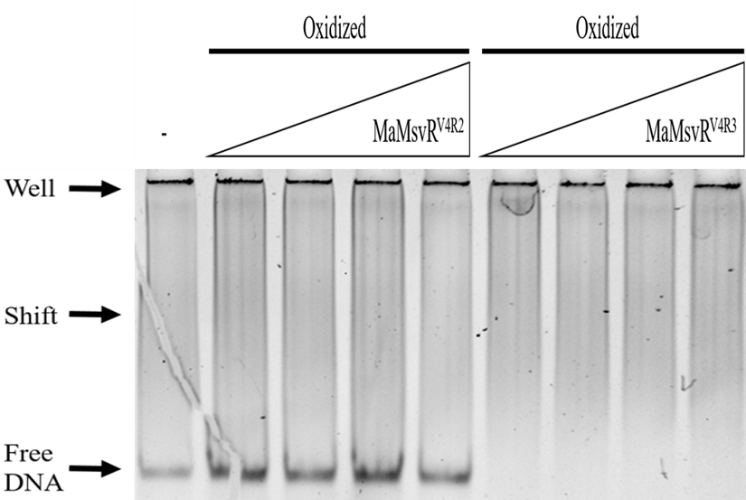Figure 14. EMSA of Ma P_{msvR} with MaMsvR^{V4R2} and MaMsvR^{V4R3} under oxidized conditions. Each reaction with MaMsvR^{V4R2} contained 50 nM Ma P_{msvR}. All reactions were performed with the addition of 2 µM H₂O₂. The DNA only control lane is indicated with an (–). The lanes containing MaMsvR^{V4R2} are titrated at 1 µM, 2 µM, 4 µM and 8 µM (20- to 160-fold over DNA). Due to protein concentration limitations, MaMsvR^{V4R3} was titrated at 1 µM, 2 µM, 4 µM and 5 µM and had no Ma P_{msvR} added to the lanes.
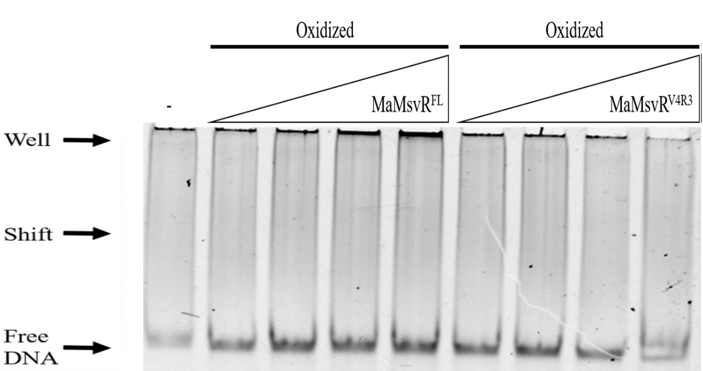Figure 15. EMSA of Ma P_{msvR} with MaMsvR^{FL} and MaMsvR^{V4R3} under oxidized conditions. Each reaction contained 50 nM Ma P_{msvR} and 2 µM H₂O₂. The DNA only control lane is indicated with an (–). The lanes which contain protein are titrated at 1 µM, 2 µM, 4 µM and 8 µM of the indicated protein (20 to 160 fold over DNA). Due to protein concentration limitations, MaMsvR^{V4R3} was titrated at 1 µM, 2 µM, 4 µM and 5 µM.
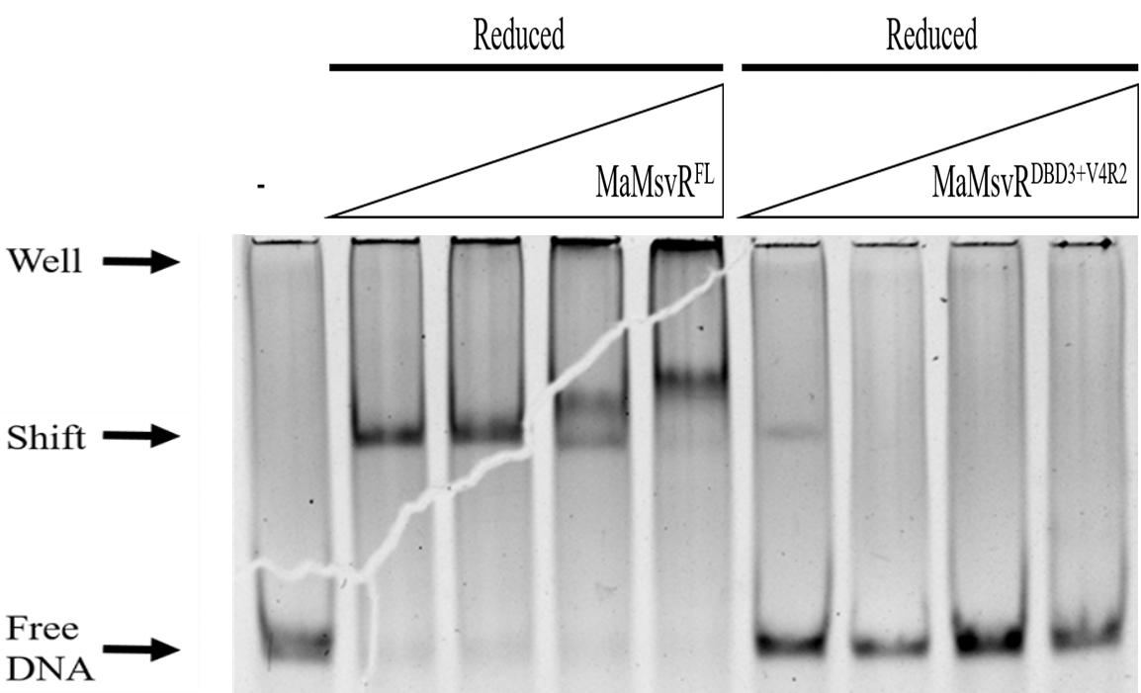Figure 16. EMSA of Ma P_{msvR} with MaMsvR^{FL} and MaMsvR^{DBD3} + MaMsvR^{V4R2} under reduced conditions. Each reaction contained 50 nM Ma P_{msvR} and 2 µM H₂O₂. The DNA only control lane is indicated with an (–). The lanes which contain protein are titrated at 1 µM, 2 µM, 4 µM and 8 µM of the indicated protein (20 to 160 fold over DNA). The lanes that have both MaMsvR^{DBD3} and MaMsvR^{V4R2} contain protein in equimolar concentrations for a total protein concentration to equate to aforementioned titration molarities.
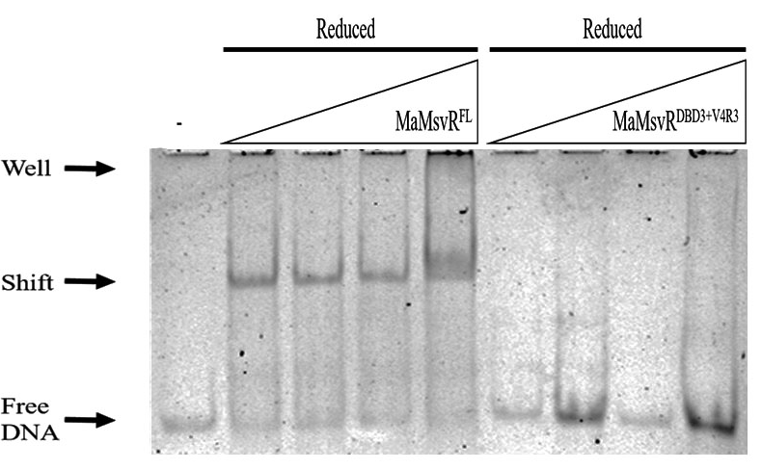Figure 17. EMSA of Ma P_{msvR} with MaMsvR^{FL} and MaMsvR^{DBD3} + MaMsvR^{V4R3} under reduced conditions. Each reaction contained 50 nM Ma P_{msvR} and 5 mM DTT. The DNA only control lane is indicated with an (–). The lanes which contain MaMsvR^{FL} are titrated at 1 µM, 2 µM, 4 µM and 8 µM of the indicated protein (20 to 160 fold over DNA). Due to protein concentration limitations, MaMsvR^{V4R3} was titrated at 1 µM, 2 µM, 4 µM and 5 µM. The lanes that have both MaMsvR^{DBD3} and MaMsvR^{V4R3} contain protein in equimolar concentrations for total protein concentration to equate to 1 µM, 2 µM, 4 µM and 5 µM.
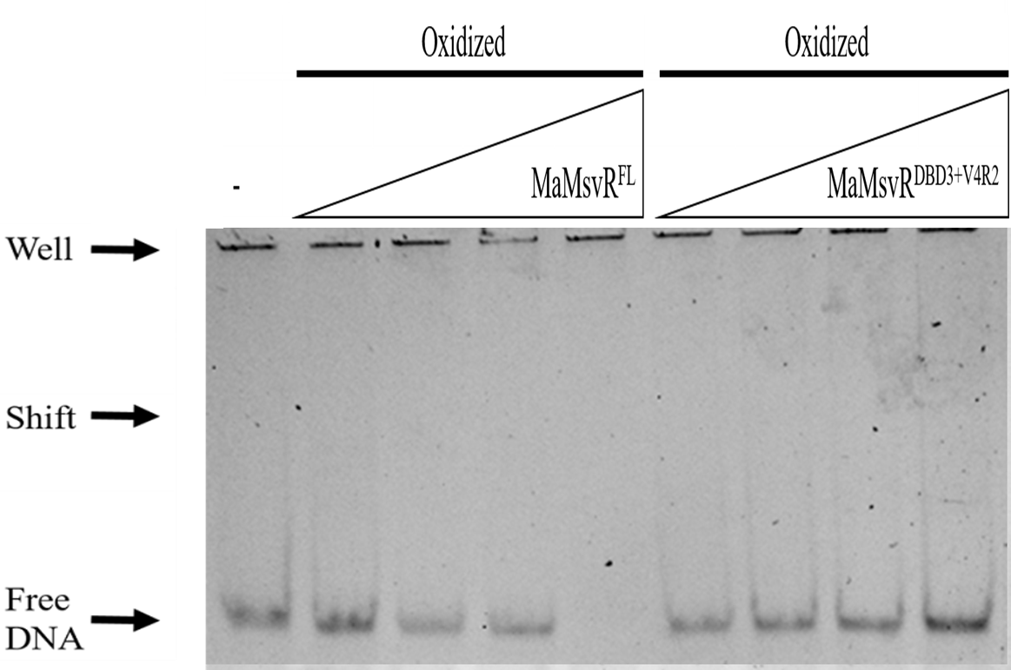Figure 18. EMSA of Ma P_{msvR} with MaMsvR^{FL} and MaMsvR^{DBD3} + MaMsvR^{V4R2} under oxidized conditions. Each reaction contained 50 nM Ma P_{msvR} and 2 µM H₂O₂. The DNA only control lane is indicated with an (–). The lanes which contain MaMsvR^{FL} are titrated at 1 µM, 2 µM, 4 µM and 8 µM of the indicated protein (20 to 160 fold over DNA). The lanes that have both MaMsvR^{DBD3} and MaMsvR^{V4R2} contain protein in equimolar concentrations for total protein concentration to equate to aforementioned titration molarities.
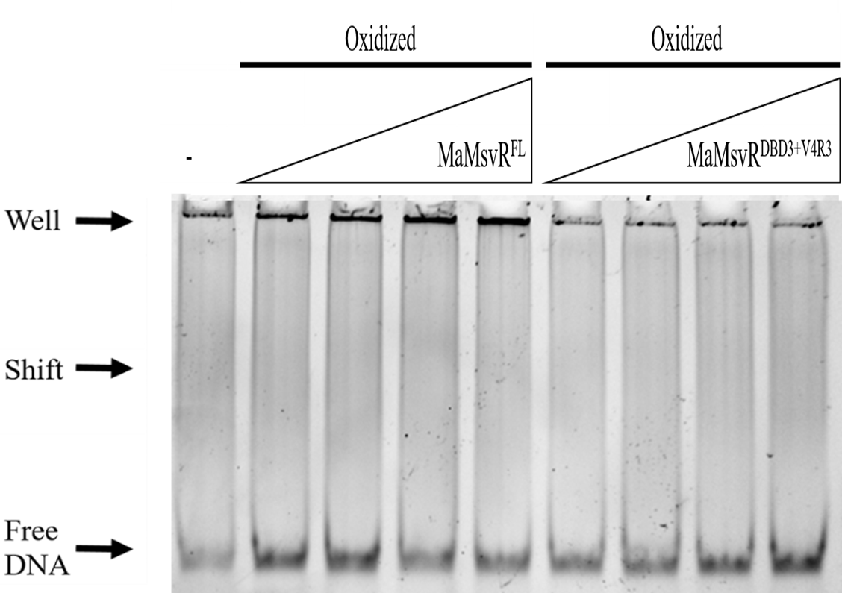Figure 19. EMSA of Ma P_{msvR} with MaMsvR^{FL} and MaMsvR^{DBD3} +MaMsvR^{V4R3} under oxidized conditions. Each reaction contained 50 nM Ma P_{msvR} and 2 µM H₂O₂. The DNA only control lane is indicated with an (–). The lanes which contain MaMsvR^{FL} are titrated at 1 µM, 2 µM, 4 µM and 8 µM of the indicated protein (20 to 160 fold over DNA). Due to protein concentration limitations, MaMsvR^{V4R3} was titrated at 1 µM, 2 µM, 4 µM and 5 µM. The lanes that have both MaMsvR^{DBD3} and MaMsvR^{V4R3} contain protein in equimolar concentrations for total protein concentration to equate to 1 µM, 2 µM, 4 µM and 5 µM.

Crystallization screening
To determine what conditions are able to give rise to MaMsvR crystallization, sparse matrix crystal screening was performed [76]. Commercially available 96-well crystallization broadscreens take advantage of previously known conditions that have given rise to protein crystal formation on a consistent basis. Additionally, the small volumes of well solution needed from the broadscreens and for the creation of drops and the numerous wells makes it a quick, easy and affordable way to screen many different conditions in order to find ones that give rise to “hits”, or formation of protein precipitation, phase separation or protein crystal forms that can be optimized around [,]. MCSG-1, MCSG-2, MSCG-3, MCSG-4 (Microlytic), JCSG-plus, PACT premier (Molecular Dimensions), CSHT and Index (Hampton Research) all have unique solutions for each broadscreen matrix. Various broadscreen crystal screening trays were set-up for MaMsvR^{FL}, MaMsvR^{V4R2} and MaMsvR^{V4R3}, each with the addition of 5 mM TCEP to maintain reducing conditions, and some using the microseeding method [,]. Microseeding involves the utilization of small crystalline material to seed new crystallization screens which eliminates the need for the formation of nucleation centers. Broadscreen trays for each protein were created in multiples for the purposes of incubating the crystal trays at different temperatures (4°C, 16°C and/or room temperature) as temperature can influence nucleation [,,]. Trays were set-up as sitting-drop vapor-diffusion with drops containing a 1:1 ratio of protein to well solution. MaMsvR^{V4R3} screen in MCSG-1 (Microlytic) at room temperature was the only broadscreen tray to produce crystals (Figures 20 and 21). In order to determine if the crystals were salt crystals or protein crystals, the MaMsvR^{V4R3} crystals were mounted on a nylon loop and subjected to room temperature X-ray diffraction. The X-ray diffraction data that was obtained from MCSG-1 (Microlytic) broadscreen crystallization tray well A09 showed very low resolution (~13 Å) with a diffraction pattern that was indicative of protein (Figure 22). Room temperature X-ray diffraction was performed on crystals from MCSG-1 (Microlytic) broadscreen crystallization tray well C09 and data collected showed resolution lower than that of crystals from well A09, but also with a definitive protein diffraction pattern (not shown).

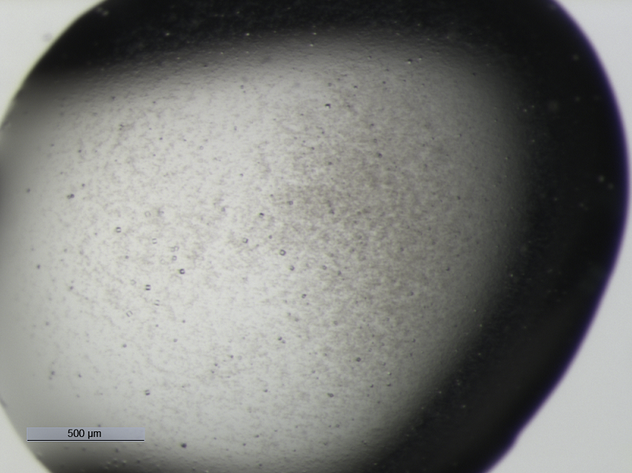
Figure 20. Crystals of MaMsvR^{V4R3} from MCSG-1 (Microlytic) broadscreen crystallization tray well A09 from sitting-drop vapor diffusion. Crystals were visible on Day 3 of incubation at room temperature. Well solution consisted of 0.2 M MgCl₂, 25% (w/v) PEG3350, 0.1 M HEPES, pH 7.5, 5 mM TCEP. Mother-liquor contained 1:1 well solution to protein.
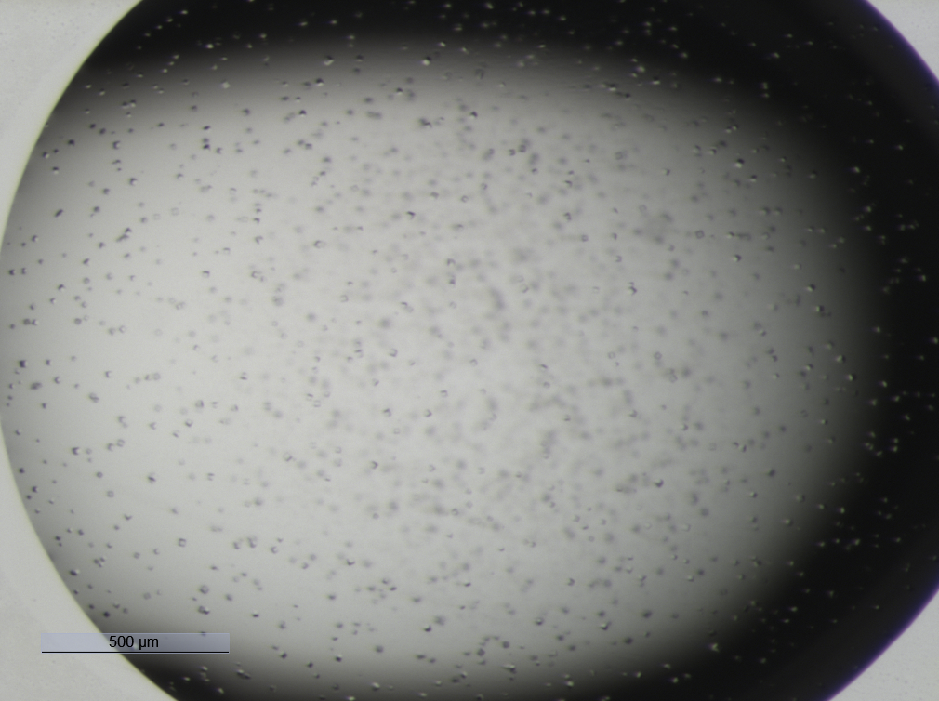
Figure 21. Crystals of MaMsvR^{V4R3} from MCSG-1 (Microlytic) broadscreen crystallization tray well C09 from sitting-drop vapor diffusion. Crystals were visible on Day 4 of incubation at room temperature. Well solution consisted of 0.8 M LiCl, 32% (w/v) PEG4000, 0.1 M Tris, pH 8.5, 5 mM TCEP. Mother-liquor contained 1:1 well solution to protein.

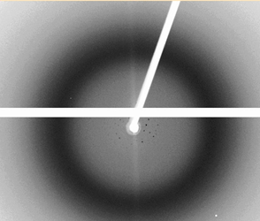
Figure 22. Room temperature diffraction pattern from MaMsvR^{V4R3-Red} crystals from MCSG-1 (Microlytic) broadscreen tray well A09. The X-ray beam was fixed at λ 1.54 Å. Exposure was set at 60 seconds with 2 frames per step. The horizontal and diagonal white lines are artifacts from the beam stop.

Crystal optimization

Optimization of crystallization conditions was imperative in order to obtain crystals that gave rise to higher resolution from X-ray diffraction data collection [,]. Optimization trays were set-up in 24-well plastic hanging drop trays. Each tray consisted of well solutions that were varied around the original solution from either MCSG-1 well A09 or MCSG-1 well C09. Only one constituent per row was varied, and the conditions optimized around were done so in a fine optimization manner (See Appendix A and Appendix B)[]. In some of the optimization trays, microseeding and macroseeding were employed MaMsvR^{V4R3} crystals appeared in most wells from both MCSG-1 A09 and MCSG-1 C09 optimization trays that were incubated at room temperature (Figures 21 and 22). The number of days before visible crystals were observed and the size of crystals differed, however, crystallization happened within one week consistently. No crystals appeared from trays incubated at 4°C or 16°C.
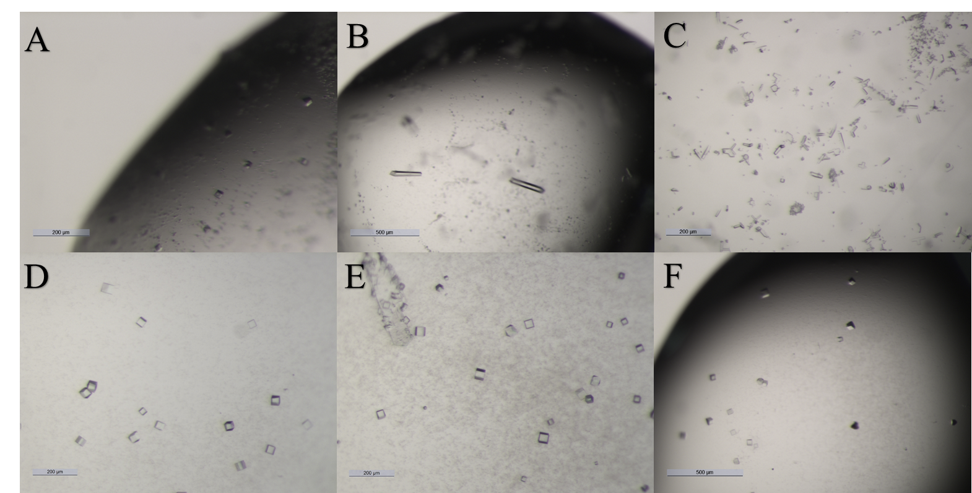
Figure 23. Representative light microscope images of MaMsvR^{V4R3} crystals from optimization trials from MCSG-1 (Microlytic) broadscreen well A09. Crystals were grown at room temperature in variable well solutions. A) 0.05 M MgCl₂, 25% (w/v) PEG3350, 0.1 M HEPES, pH 7.5, 5 mM TCEP. B) 0.15 M MgCl₂, 25% (w/v) PEG3350, 0.1 M HEPES, pH 7.5, 5 mM TCEP. C) 0.25 M MgCl₂, 25% (w/v) PEG3350, 0.1 M HEPES, pH 7.5, 5 mM TCEP. D) 0.2 M MgCl₂, 12.5% (w/v) PEG3350, 0.1 M HEPES, pH 7.5, 5 mM TCEP. E) 0.2 M MgCl₂, 16.5% (w/v) PEG3350, 0.1 M HEPES, pH 7.5, 5 mM TCEP. F) 0.2 M MgCl₂, 20% (w/v) PEG3350, 0.1 M HEPES, pH 7.5, 5 mM TCEP. All mother-liquors contained 1:1 well solution to protein and all drops were microseeded.
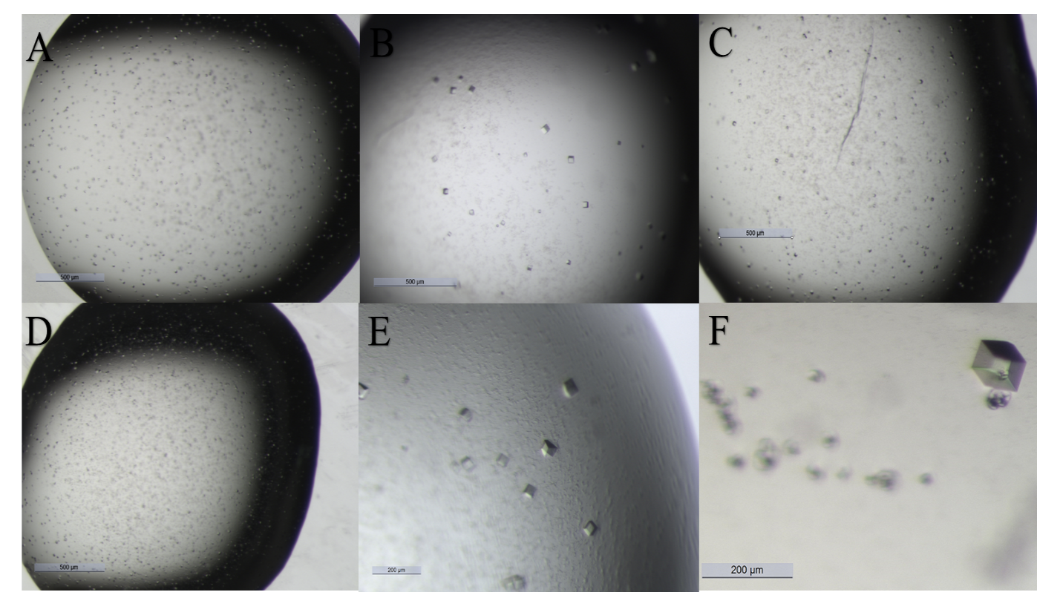
Figure 24. Representative light microscope images of MaMsvR^{V4R3} crystals from optimization trials from MCSG-1 (Microlytic) broadscreen well C09. Crystals were grown at room temperature in variable well solutions. A) 0.2 M LiCl, 32% (w/v) PEG4000, 0.1 M Tris, pH 8.4, 5 mM TCEP. B) 0.4 M LiCl, 32% (w/v) PEG4000, 0.1 M Tris, pH 8.4, 5 mM TCEP. C) 1.0 M LiCl, 32% (w/v) PEG4000, 0.1 M Tris, pH 8.4, 5 mM TCEP. D) 0.8 M LiCl, 22.5% (w/v) PEG4000, 0.1 M Tris, pH 8.4, 5 mM TCEP. E) 0.8 M LiCl, 25% (w/v) PEG4000, 0.1 M Tris, pH 8.4, 5 mM TCEP F) 0.8 M LiCl, 27.5% (w/v) PEG4000, 0.1 M Tris, pH 8.4, 5 mM TCEP. All mother-liquors contained 1:1 well solution to protein and all drops were microseeded.

X-Ray data collection

Attempts were made to collect better resolution X-ray diffraction data from various MaMsvR^{V4R3} crystals at the University of Oklahoma Macromolecular Crystallography Laboratory. In order to aid in preserving the integrity of the protein crystals, cryoprotectants were tested, crystals were flash frozen in liquid N₂ and the data was collected under a constant liquid N₂ stream. A suitable cryoprotectant and liquid N₂ was necessary in order to displace water within the protein solvent channels, thereby stabilizing the protein in its crystalline form, minimize radiation damage to the protein crystal, allow for longer exposures and maximize the number of images obtainable before the protein crystal became unusable [,]. The cryoprotectants tested were 5% (w/v) PEG400, 10% (w/v) PEG400, 15% (w/v) PEG400, 18% (w/v) PEG400, 5% (w/v) glycerol, 10% (w/v) glycerol, 15% (w/v) glycerol, 20% (w/v) glycerol as well as a saturated sucrose solution. Initially, the cryoprotectants were introduced to the protein crystal through a series of washes in which the protein crystal is slowly introduced into increasing concentrations of the cryoprotectant. This proved to dissolve the MaMsvR^{V4R3} protein crystals. The “dunk” method was then tested. The “dunk” method directly introduced the protein crystal to the cryoprotectant at the final concentration and was then immediately flash frozen. The “dunk” method in 18% (w/v) PEG400 proved successful for the cryoprotection of MaMsvR^{V4R3}. Data collection was unsuccessful at the OUMCL with the following parameters: X-ray beam was fixed at λ 1.54 Å, exposure set at 60 seconds with 2 frames per step. Adjustments to exposure time were made, but still yielded poor resolution. Subsequent MaMsvR^{V4R3} crystals were cryoprotected and flash frozen and shipped to SSRL in a cassette that is compatible with the Stanford Automated Mounting (SAM) robot. Crystals were transferred from the cassette onto the goniometer by SAM, all while remaining in cryo-conditions. The crystal was visualized and aligned using SSRL Web-ice software (Figure 25). Tunable wavelengths and easily adjustable beam size aided in achieving better resolution. The diffraction data collected on BL12-1 at SSRL at λ 0.97Å was able to be processed on autoXDS software as well as in HKL3000 which resulted in 4.24 Å resolution (Figure 26). Images collected were integrated and diffraction spots were indexed in HKL3000, however, the data was not able to be processed further in order to obtain a valid electron density map for use in molecular replacement and subsequent structure solution. The Phenix software suite was also utilized in order to try to obtain a useable electron density map and structure solution, but yielded an unsolvable solution as well.
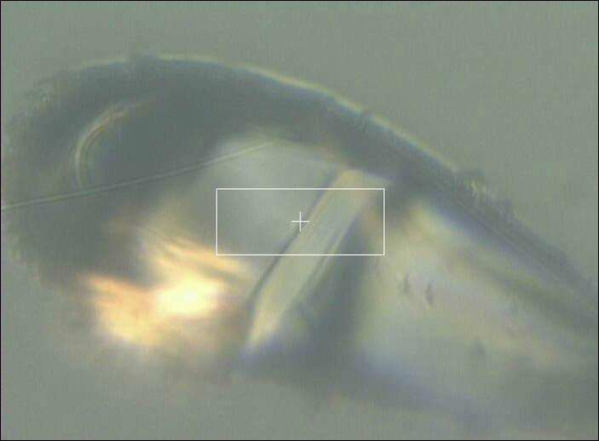
Figure 25. Alignment of MaMsvR^{V4R3} crystal at SSRL BL12-1. The protein crystal is centered in the nylon loop (Hampton Research) and does not show ice accumulation.

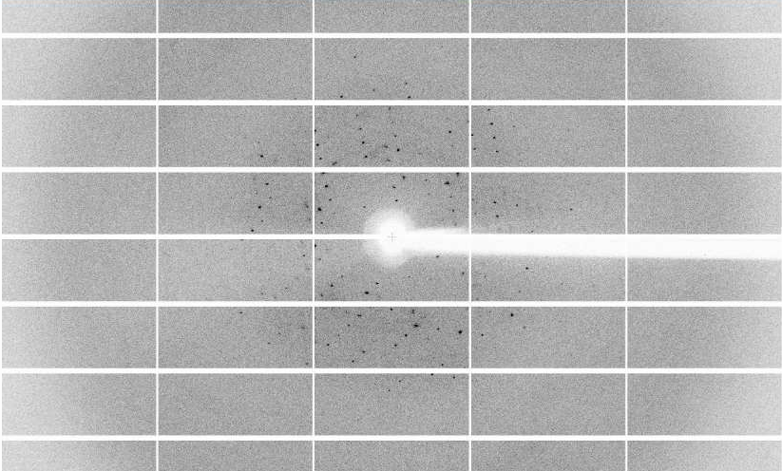
Figure 26. X-Ray diffraction pattern from MaMsvR^{V4R3} crystal mounted on BL12-1 at SSRL. The MaMsvR^{V4R3} crystal diffraction pattern showed the highest resolution to 4.24 Å.

Optimization of MaMsvR variants

Optimization of MaMsvR V4R variants was necessary to try to obtain more ordered protein crystals. Secondary structure prediction software and homology modeling were utilized in order to avoid interrupting predicted secondary structures (α- helices and β-strands) when designing new constructs (Figure 27). The focus of the new MaMsvR V4R constructs was to create variants that were between the sizes of MaMsvR^{V4R2} and MaMsvR^{V4R3} (Figure 28-30). Additionally, surface entropy reduction (SERp) was implemented in the creation of variants of MaMsvR^{V4R2} and MaMsvR^{V4R3} to incorporate mutations of residues predicted to contribute to high surface entropy [,,,]. The prediction from the SERp server from Molecular Biology Institute at the University of California, Los Angeles predicted high probability surface entropy residues K223 and E224 for both MaMsvR^{V4R2} and MaMsvR^{V4R3} (Figure 31). PCR amplification was used to create MaMsvR^{V4R5}-MaMsvR^{V4R11} constructs as well as to introduce the amino acid substitutions K223A and E224A into MaMsvR^{V4R2} and MaMsvR^{V4R3} as previously described with respective primers (Table 1) . E. coli DH5α strains were created, sequences were confirmed and E. coli Rosetta (Novagen) expression strains were created. MaMsvR^{V4R5} – MaMsvR^{V4R11}, MaMsvR^{V4R2-SERp2} and MaMsvR^{V4R3-SERp2} proteins were overexpressed via auto-induction. Overexpression trials for MaMsvR^{V4R5} – MaMsvR⁹ showed expression levels less than those of MaMsvR^{V4R3} or no observable expression at all when visualized on SDS-PAGE gels as described above (results not shown). MaMsvR^{V4R10} and MaMsvR^{V4R11} showed promising expression and were strains were stored as glycerol stocks at -80ᵒC for future trials as previously described (results not shown). Protein expression levels for MaMsvR^{V4R2-SERp2} were comparable to those reported for MaMsvR^{V4R2}, however protein expression levels for MaMsvR^{V4R3-SERp2} were lower than those for and MaMsvR^{V4R3}. Protein purification was accomplished by Strep-tag® II affinity chromatography and further purification by SEC as performed with initial constructs. The protein concentrations that resulted from SEC for both MaMsvR^{V4R2-SERp2} and MaMsvR^{V4R3-SERp2} were much lower than that of MaMsvR^{V4R3}, however, both proteins still eluted at the volume associated with dimers (chromatograms not shown). MCSG-1, MCSG-2, MCSG-3 and MCSG-4 (Microlytic) broadscreen crystallization trays with the addition of 5 mM TCEP were set-up for MaMsvR^{V4R2-SERp2} and MaMsvR^{V4R3-SERp2} and incubated at either 4ᵒC, 16ᵒC or room temperature. None of the initial crystallization screens gave rise to protein crystals.

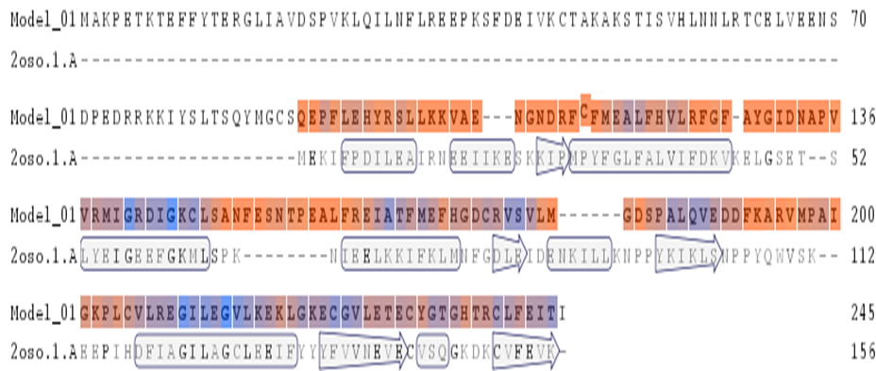
Figure 27. Representative secondary structure prediction. MaMsvR^{FL} aligned against MJ1460 (PDB ID 2OSO) shows predicted secondary structures for MaMsvR^{FL} rendered from Swiss Prot Prediction from the ExPASy software suite. All α-helices are represented by arrows and all β-strands are represented by rectangles.

Figure 28. MaMsvR^{V4R5-V4R8} Constructs. MaMsvR^{FL} polypeptide sequence above the MaMsvR region indicated in light gray. The DNA binding domain is indicated by the navy blue bar above the polypeptide sequence. The MJ1460 dimerization interface is indicated by the gold bar above the polypeptide sequence. The predicted V4R domain is indicated by the dark red box above the polypeptide sequence. MaMsvR^{V4R7} is indicated by the longest red bar below the MaMsvR region. MaMsvR^{V4R6} is indicated by red bar below MaMsvR^{V4R7}. MaMsvR^{V4R5} is indicated by the red bar below MaMsvR^{V4R6}. MaMsvR^{V4R8} is indicated by the red bar below MaMsvR^{V4R5}.
Figure 29. MaMsvR^{V4R9-V4R12} Constructs. MaMsvR^{FL} polypeptide sequence above the MaMsvR region indicated in light gray. The DNA binding domain is indicated by the navy blue bar above the polypeptide sequence. The MJ1460 dimerization interface is indicated by the gold bar above the polypeptide sequence. The predicted V4R domain is indicated by the dark red box above the polypeptide sequence. MaMsvR^{V4R10} is indicated by the longest red bar below the MaMsvR region. MaMsvR^{V4R12} is indicated by red bar below MaMsvR^{V4R10}. MaMsvR^{V4R11} is indicated by the red bar below MaMsvR^{V4R12}. MaMsvR^{V4R9} is indicated by the red bar below MaMsvR^{V4R11}.
Figure 30. MaMsvR^{V4R13-V4R15} Constructs. MaMsvR^{FL} polypeptide sequence above the MaMsvR region indicated in light gray. The DNA binding domain is indicated by the navy blue bar above the polypeptide sequence. The MJ1460 dimerization interface is indicated by the gold bar above the polypeptide sequence. The predicted V4R domain is indicated by the dark red box above the polypeptide sequence. MaMsvR^{V4R14} is indicated by the longest red bar below the MaMsvR region. MaMsvR^{V4R15} is indicated by red bar below MaMsvR^{V4R14}. MaMsvR^{V4R13} is indicated by the red bar below MaMsvR^{V4R15}.
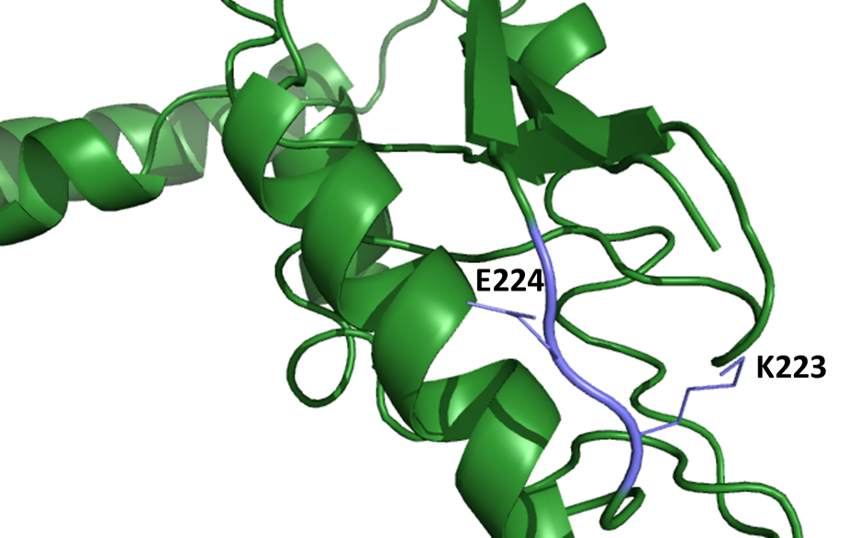
Figure 31. Homology Model of MaMsvR^{V4R2-SERp2}. The homology model displayed shows MaMsvR^{V4R2-SERp2} with the V4R2 portion shown in dark green and residues K223 and E224 depicted in slate and labelled, respectively.

Small angle X-Ray scattering
In order to obtain structural information for MaMsvR^{V4R2}, small angle X-ray scattering (SAXS) was employed. SAXS takes advantage of small angle diffraction patterns from a large number of protein molecules in solution (). It is, however, imperative that the molecules within the solution are invisible to each other. The protein samples that were prepared were purified via Strep-tag® II affinity chromatography and size exclusion chromatography as previously described. High protein concentrations and low protein concentrations both give rise to unique artifacts during data collection that can subsequently be visualized on the produced scattering curves and then averaged out during data processing. Output files that were generated with SAXSPipe further analyzed and data merged and indexed using the ATSAS 2.8.0 program suite [82]. After subtracting the dialysis buffer scattering factor from the sample scatter in PRIMUS, the scattering intensity was calculated. All SAXS data was processed using GNOM and then integrated in the PRIMUS software, to obtain the pair distance distribution function (PDDF). Atomic models were created with DAMMIF and then averaged together with DAMAVER. The averaged models were then aligned with known structures or homologues in SUPCOMB. This data was further analyzed in CRYSOL to generate the theoretical scattering curves [82]. After artifacts from high and low protein concentration data were subtracted from the average of all MaMsvR^{V4R2} theoretical scattering curves, subsequent DAMAVER models were created by repeating the aforementioned GNOM through DAMAVER processes. The damaver.pdb file that was generated in ATSAS was then opened in PyMoL to create protein envelope model. A monomeric homology model was then superimposed onto the protein envelope model using SUPCOMB and PyMoL (Figure 32).

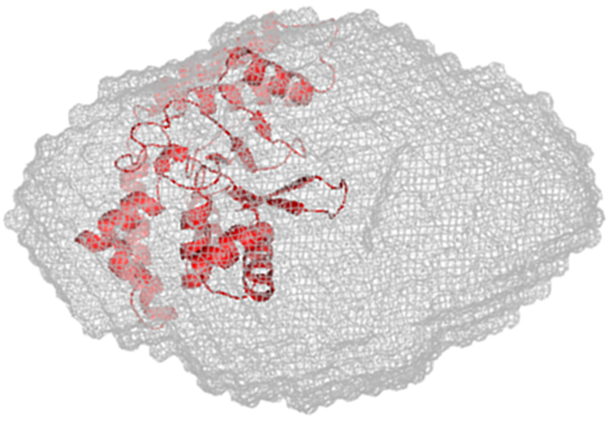
Figure 32. MaMsvR^{V4R2} monomeric homology model superimposed onto the MaMsvR^{V4R2} protein envelope. The protein envelope was rendered in PyMOL and visualized in mesh display and the monomeric MaMsvR^{V4R2} homology model was created with Phyre2. Results were then superimposed onto the protein envelope.
Discussion
MaMsvR consists of an N-terminal wHTH DNA-binding domain and a C-terminal V4R effector domain. Each domain had a predicted dimerization interface. Therefore, we utilized protein truncations to identify whether a dimerization interface was present in the V4R and linker region of MaMsvR. Size exclusion chromatography experiments infer that the V4R domain is a dimer in its oligomeric state under reduced, non-reduced and oxidized conditions. Additionally, these results showed that MaMsvR V4R does not contain the same dimerization interface as identified in the MJ1460 V4R structure (PDB ID: 2OSO, 2OSD). Had the dimerization interface for the V4R region of MaMsvR been the same that was identified for the MJ1460 V4R domain, it would be expected that MaMsvR^{V4R3} would not form a dimer under any of the conditions tested. However, MaMsvR^{V4R3} was able to dimerize indicating that additional residues, C-terminal to the region used for dimerization of MJ1460, are important for dimerization of MaMsvR. The lower protein yields observed for MaMsvR^{V4R3} are likely because the position of the truncation may have interrupted a critical secondary structure element that resulted in lower solubility and/or stability of the protein during expression.
Electrophoretic mobility shift assays with the V4R domain alone as well as when combined with the DNA binding domain did not result in DNA binding under reduced conditions. This differs from MaMsvR^{FL} which has been shown to bind P_{msvR} in previous studies [522]. Despite MaMsvR^{DBD3} and MaMsvR^{V4R2} constituting the entire length of the MaMsvR protein, our data indicates that these regions must be connected to obtain the proper protein configuration to achieve DNA binding. This is contrast to another transcription regulator that is able to interact with a free V4R domain protein to exercise transcriptional response [89].
While X-ray crystallography experiments were able to produce protein crystals as well as diffractions patterns, none were at a resolution high enough in order to solve the structure. Pursuing additional constructs designed in this study may be instrumental to obtaining a stabilized and well-diffracting crystal to use for protein structure determination. While many crystal trials were attempted, there are still parameters that could be tested. What is evident from the crystallization experiments is that the protein continues to maintain some disorder. As a putative effector domain of an oxidative stress protein, this could be attributed to slight variations in its oxidation state that may occur through not only the purification steps, but also, through fluctuation of the redox state during the crystallization process. Results from SAXS confirmed that MaMsvR^{V4R2} exists as a dimer and provided a protein envelope in which a dimerized homology model of MaMsvR^{V4R2} was able to be superimposed. This study concludes that MaMsvR V4R contains its own dimerization interface and is unable to contribute to DNA binding in response to the redox state of the cell unless it is as the complete, continuous MaMsvR^{FL}.
Concurrent work done investigating the cysteine residues in MaMsvR concluded that the only three cysteine residues that fall within the disulfide bond formation cutoff are the three conserved cysteine residues in the V4R domain (C206, C232 and C240) [52, Karr Lab unpublished]. This was important because it showed that those three cysteine residues may play a role in redox sensing; however, whether or not these disulfide bonds were inter- or intramolecular disulfide bonds has yet to be determined. Additional experiments not discussed in this thesis did show that zinc was present in MaMsvR^{V4R3} protein crystals. However, due to high-probability of zinc contamination, more-in depth analysis would have to be completed in order to identify conclusively if, in fact, zinc is bound in the V4R domain, under what conditions zinc binds in addition to mutagenesis experiments to identify what residues may play a role in zinc binding. Further experiments are necessary in order to detail the exact contributions of the V4R domain in response to oxidative stress and the way in which it senses the shift in the redox state of the cell and/or facilitates a conformational change in concert with the DNA binding domain in order to regulate transcription.

References [] IPCC. 2007. Climate Change 2007: The Physical Science Basis. Contribution of Working Group I to the Fourth Assessment Report of the IPCC. Cambridge, UK, Cambridge University Press.
[] Sowers KR, Baron SF, Ferry JG (1984) Isolated from Marine Sediments Acetotrophic Methane-Producing Bacterium sp. nov., an Methanosarcina acetivorans. Appl Environ Microbiol. 47:5.
[] Moss AR, Jouany JP, Newbold J (2000) Methane production by ruminants: its contribution to global warming. Ann Zootech. 49:231-253.
[] Wei M, Yu Z, Jiang Z, Zhang H (2014) Microbial diversity and biogenic methane potential of a thermogenic-gas coal mine. Int J Coal Geolog. 134:96-107.
[] Catling DC, Zahnle KJ, McKay CP (2001) Biogenic methane, hydrogen escape, and the irreversible oxidation of early earth. Nat Sci Coll. 293(5531)839-843.
[] Ortiz-Llorente MJ, Alvarez-Cobelas M (2012) Comparison of biogenic methane emissions from unmanaged estuaries, lakes, oceans, rivers and wetlands. Atmosph Environ. 59:328-337.
[] Aghdam EF, Scheutz C, Kjeldsen P (2017) Assessment of methane production from shredder waste in landfills: The influence of temperature, moisture and metals. Waste Manage. 63:226-237.
[] Castrillón L, Fernández-Nava Y, MaraNón E (2013) Methane production from cattle manure supplemented with crude glycerin from the biodiesel industry in CSTR and IBR. Biores Tech. 127:312-317.
[] Zhou J, Xue K, Xie J, Deng Y, Wu L, Cheng X, Fei S, Deng S, He Z, Nostrand J, Luo Y (2011) Microbial mediation of carbon-cycle feedbacks to climate warming. Nat Climate Change. 2:106-110.
[] Demirel B, Scherer P (2008) The roles of acetotrophic and hydrogenotrophic methanogens during anaerobic conversion of biomass to methane: A review. Rev Environ Sci Biotech. 7:173-190.
[] Lepp PW, Brinig MM, Ouverney CC, Palm K, Armitage GC, Relman DA (2004) Methanogenic Archaea and human periodontal disease. PNAS. 101(16):6176-6181.
[] Lessner DJ, Li L, Li Q, Rejtar T, Andreev VP, Reichlen M, Hill K, Moran JJ, Karger BL, Ferry JG (2006) An unconventional pathway for reduction of CO₂ to methane in CO-grown Methanosarcina acetivorans revealed. PNAS. 103(47):17921-17926.
[] Hawkins AS, Han Y, Bennet RK, Adams MWW, Kelly RM (2013) Role of 4-hydroxy buty rate-co a synthetase in the CO₂ fixation cycle in thermoacidophilic archaea. J Biologic Chem. 288(6):4012-4022.
[] Conway De Macario E, Macario AJL (2009) Methanogenic archaea in health and disease: A novel paradigm of microbial pathogenesis. Int J Med Microbiol. 299:99-108.
[] Horne AJ, Lessner DJ (2013) Assessment of the oxidant tolerance of Methanosarcina acetivorans. FEMS Microbiol Lett. 343(1):13-19.
[] Justice NB, Pan C, Mueller R, Spaulding SE, Shah V, Sun CL, Yelton AP, Miller CS, Thomas BC, Shah M, VerBerkmoes N, Hettich R, Banfield JF (2012) Heterotrophic archaea contribute to carbon cycling in low-pH, suboxic biofilm communities. Appl Environ Microbiol. 78(23):8321-8330.
[] Padmasiri SI, Zhang J, Fitch M, Norddahl B, Morenroth E, Raskin L (2007) Methanogenic population dynamics and performance of an anaerobic membrane bioreactor (AnMBR) treating swine manure under high shear conditions. Water Res. 41:134-144.
[] Mashino T, Fridovich I (1987) Superoxide radical initiates the autoxidation of dihydroxyacetone. Biochem Biophys. 254(2):547-551.
[] Lesser DJ, Ferry JG (2007) The archaeon Methanosarcina acetivorans contains a protein disulfide reductase with an iron-sulfur cluster. J Bacteriol. 189(20):7475-7484.
[] Dey S, Sidor A, O’Rourke B (2016) Compartment-specific control of reactive oxygen species scavenging by antioxidant pathway enzymes. J Biolog Chem. 291(21):11185-11197.
[] Wang X, Zhao X (2009) Contribution of oxidative damage to antimicrobial lethality. Antimicrob Agents Chemother. 53(4): 1395-1402.
[] You J, Das A, Dolan EM, Hu Z, (2009) Ammonia-oxidizing archaea involved in nitrogen removal. Wat Res. 43:1801-1809.
[] Zhang LM, Hu HW, Shen JP, He JZ (2012) Ammonia-oxidizing archaea have more important role than ammonia-oxidizing bacteria in ammonia oxidation of strongly acidic soils. ISME. 6:1032-1045.
[] Rajasekar, KV, et al (2016) The anti-sigma factor RsrA responds to oxidative stress by reburying its hydrophobic core. Nature Comm. 7:12194-12217.
[] Kunsch C, Medford RM (1999) Oxidative stress as a regulator of gene expression in the vasculature. Circ Res. 85:753-766.
[] Siegel D, Gustafson DL, Dehn KL, Han JY, Boonchoong P, Berliner LJ ,Ross D (2004) NAD(P)H:Quinone oxidoreductase 1: role as a superoxide scavenger. Mol Pharmacol. 65(5):1238-1247.
[] Nӧlling J, Ishii M, Kock J, Pihl TD, Reeve JN, Thauer RK, Hedderich R (1995) Characterization of a 45-kDA flavoprotein and evidence for a rubredoxin, two proteins that could participate in electron transport from H2 to CO2 in methanogenesis in Methanobacterium thermoautotrophicum. Eur J Biochem. 231:628-638.
[] Jenney FE, Verhagen MFJM, Cui X, Adams MWW (1999) Anaerobic microbes: oxygen detoxification without superoxide dismutase. Science. 286:306-309.
[] Seedorf H, Dreisbach A, Hedderich R, Shima S, Thauer RK (2004) F₄₂₀H₂ oxidase (FprA) from Methanobrevibacter arboriphilus, a coenzyme F₄₂₀-dependent enzyme involved in O₂ detoxification. Arch Microbiol. 182:126-137.
[] Podar A, Wall MA, Makarova KS, Koonin EV (2008) The prokaryotic V4R domain is the likely ancestor of a key component of the eukaryotic vesicle transport system. Biol Direct. 3:2.
[] Karr EA (2010) The methanogen-specific transcription factor MsvR regulates the fpaA-rlp-rub oxidative stress operon adjacent to msvR in Methanothermobactor thermautotrophicus. J Bacteriol. 192(22):5914-5922.
[] Langer D, Hain J, Thuriauxt P, Zillig W (1995) Transcription in Archaea: Similarity to that in Eucarya. Evolution. 92:5768-5772.
[] Bell SD, Kosa PL, Sigler PB, Jackson SP (1999) Orientation of the transcription preinitiation complex in Archaea. PNAS. 96(24):13662-13667.
[] Soppa J (2001) Basal and regulated transcription in Archaea. Adv Appl Microbiol. 50:171-217.
[] Weinzierl ROJ (2013) The RNA polymerase factory and archaeal transcription. Chem Rev. 113:8350-8376.
[] Reichlen MJ, Murakami KS, Ferry JG (2010) Functional analysis of the three TATA binding protein homologs in Methanosarcina acetivorans. J Bacteriol. 192(6):1511-1517.
[] Gohl H, Gröndahl B, Thomm M (1995) Promoter recognition in archaea is mediated by transcription factors: identification of transcription factor aTFB from Methanococcus thermolithotrophicus as archaeal TATA-binding protein. Nucl Acids Res. 23:3837-3841.
[] Hausner W, Wettach J, Hethke C Thomm M (1996) Two transcription factors related with the eucaryl transcription factors TATA-binding protein and transcription factor IIB direct promoter recognition by an archaeal RNA polymerase. J Biol Chem. 270:30144-30148.
[] Browning DF, Busby SJW (2004) The regulation of bacterial transcription initiation. Nat Rev Microbiol. 2:57-65.
[] Peeters E, Van Oeffelen L, Nadal M, Forterre P, Charlier D (2013) A thermodynamic model of the cooperative interaction between the archaeal transcription factor Ss-LrpB and its tripartite operator DNA. Gene.524:330-340.
[] Demple B (1997) Study of redox-regulated transcription factors in prokaryotes. Meth Enzym. 11:267-278.
[] Gaudu P, Weiss B (1996) SoxR, a [2Fe-2S] transcription factor, is active only in its oxidized form. PNAS. 93:10094-10098.
[] Hidalgo E, Demple B (1996) Activation of SoxR-dependent transcription in Vitro by noncatalytic or NifS-mediated assembly of [2Fe-2S] clusters into apo-SoxR. J Biolog Chem. 271(13):7269-7272.
[] Zheng M, Storz G (2000) Redox sensing by prokaryotic transcription factors. Biochem Pharmacol. 59:1-6.
[] Pomposiello PJ, Demple B (2001) Redox-operated genetic switches: the SoxR and OxyR transcription factors. Trends Biotech. 19(3):109-114.
[] Åslund F, Zheng M, Beckwith J, Storz G (1999) Regulation of the OxyR transcription factor by hydrogen peroxide and the cellular thiol-disulfide status. Proc Natl Acad Sci USA. 96:6161-6165.
[] Hidalgo E, Ding H, Demple B (1997) Redox signal transduction: mutation shifting [2Fe-2S] centers of the SoxR sensor-regulator to the oxidized form. Cell. 88:121-129.
[] Zheng, M, Åslund F, Storz G (1998) Activation of the OxyR transcription factor by reversible disulfide bond formation. Science. 279:1718-1721.
[] Seo SW, Kim D, Szubin R, Palsson BO (2015) Genome-wide reconstruction of OxyR and SoxRS transcriptional regulatory networks under oxidative stress in Escherichia coli K-12 MG1655. Cell. 12:1289-1299.
[] Tartaglia LA, Storz G, Ames BN (1989) Identification and molecular analysis of oxyR-regulated promoters important for the bacterial adaptation to oxidative stress. J Mol Biol. 210:709-719.
[] Sheehan R, McCarver AC, Isom CE, Karr EA, Lessner DJ (2015) The Methanosarcina acetivorans thioredoxin system activates DNA binding of the redox-sensitive transcriptional regulator MsvR. J Ind Microbiol Biotechnol. 42:965-969.
[] Isom CE, Turner JL, Lessner DJ, Karr EA (2013) Redox-sensitive DNA binding by homodimeric Methanosarcina acetivorans MsvR is modulated by cysteine residues. BMC Microbiol. 13:163.
[] Perez-Martin J, de Lorenzo V (1995) The amino-terminal domain of the prokaryotic enhancer-binding protein XylR is a specific intramolecular repressor. PNAS. 92:9392-9396.
[] Shingler V (1996) Signal sensing by sigma 54-dependent regulators: derepression as a control mechanism. Mol. Microbiol. 19:409–416.
[] Anantharaman V, Koonin EV, Aravind L (2001) Regulatory potential, phyletic distribution and evolution of ancient, intracellular small-molecule binding domains. J Mol Biol. 307: 1271-1292.
[] Singh AK, Li h, Sherman LA (2004) Microarray analysis and redox control of gene expression in the cyanobacterium Synechocystis sp. PCC 6803. Physiol Plant. 120:L27-35.
[] Wegener KM, Welsh EA, Thornton LE, Keren N, Jacobs JM, Hixson KK, Monroe ME, Camp II, DG, Smith RD, Pakrasi HB (2008) High sensitivity proteomics assisted discovery of a novel operon involved in the assembly of photosystem II, a membrane protein complex. J Biolog Chem. 283(41):27829-27837.
[] Gupta S, Saxena M, Saini N, Mahmooduzzafar, Kumar R, Kumar A (2012) An effective strategy for a whole-cell biosensor based on putative effector interaction site of the regulatory DmpR protein. PLOS ONE. 7(8):1-11.
[] Suresh PS, Kumar R, Kumar A (2010) Three dimensional model for N-terminal A domain of DmpR (2-dimethylphenol) protein based on secondary structure prediction and fold recognition. In Silico Biol. 10(5-6):223-233.
[] Saran I, Skӓrfstad E, Forsman M, Romantschuk M, Shingler V (2001) Role of the DmpR-mediated regulatory circuit in bacterial biodegradation properties in methylphenol-amended soils. Appl Environ Microbiol. 67(1):162-171.
[] Patil VV, Park K-H, Lee S-G, Woo E (2016) Structural analysis of the phenol-responsive sensory domain of the transcription activator PoxR. Structure. 24:624-630.
[] Kelley LA, Mezulis S, Yates CM, Wass MN, Sternberg MJE (2015) The Phyre2 web portal for protein modeling, prediction and analysis. Nat Protoc. 10:845-858.
[] The PyMOL Molecular Graphics System, Version 1.8 Schrödinger, LLC.
[] Kearse M, Moir R, Wilson A, Stones-Havas S, Cheung M, Sturrock S, Buxton S, Cooper A, Markowitz S, Duran C, Thierer T, Ashton B, Mentjies P, Drummond A (2012) Geneious Basic: an integrated and extendable desktop software platform for the organization and analysis of sequence data. Bioinformatics .28(12):1647-1649.
[] Sambrook J, Russell DW (2001) Molecular cloning: A laboratory manual. Third ed. Cold Spring Harbor Laboratory Press, New York. pp1.112-1.115.
[] Skerra A, Schmidt TGM (2000) Use of the Strep- tag and streptavidin for detection and purification of recombinant proteins. Meth Enzym. 326:271-304.
[] Schmidt TGM, Skerr A (2007) The Strep-tag system for one-step purification and high-affinity detection or capturing of proteins. Nat Protoc. 2:1528-1535.
[] Sambrook J, Russell DW (2001) Molecular cloning: A laboratory manual. Third ed. Cold Spring Harbor Laboratory Press, New York. pp1.112-1.115.
[] Hall TA (1999) BioEdit: a user-friendly biological sequence alignment editor and analysis program for Windows 95/98/NT. Nuc Acid Symp Ser. 41:95-98.
[] Kane JF (1995) Effects of rare codon clusters on high-level expression of heterologous proteins in Escherichia coli. Curr Op Biotech. 6(5):494-500.
[] Tegel H, Ottosson J, Hober S (2011) Enhancing the protein production levels in Escherichia coli with a strong promoter. FEBS 278:729-739.
[] Burgess-Brown NA, Sharma S, Sobott F, Loenarz C, Oppermann U, Gileadi O (2008) Codon optimization can improve expression of human genes in Escherichia coli: A multi-gene study. Prot Express Purif. 59(1):94-102.
[] Porath J, Birgit O (1983) Immobilized metal ion affinity adsorption and immobilized metal ion affinity chromatography of biomaterials. Serum protein affinities for gel-immobilized and nickel ions. Biochem. 22:1621-1630.
[] Hemadan ES, Porath J (1985) Development of immobilized metal affinity chromatography. Interaction of amino acids with immobilized nickel iminodiacetate. J Chrom. 323:255-264.
[] Barth HG, Boyes BE, Jackson C (1994) Size exclusion chromatography. Anal Chem. 66:595-620.
[] Jancarik J, Kim SH (1991) Sparse matrix sampling: a screening method for crystallization of proteins. J Appl Cryst 24:409-411.
[] Benvenuti M, Mangani S (2007) Crystallization of soluble proteins in vapor diffusion for X-ray crystallography. Nat Protoc. 2(7):1633-1651.
[] Mikol V, Rodeau JL, Giegé (1990) Experimental determination of water equilibration rates in the hanging drop method of protein crystallization. Anal Biochem. 186:332-339.
[] Kabsch W (2010) XDS. Acta Cryst. D66:125-132.
[] Otwinowski Z, Minor W (1997) Processing of X-ray diffraction data collected in oscillation mode. Meth Enzym. 276:307-326.
[] Goldschmidt L, Cooper DR, Derewenda ZS, Eisenberg D (2007) Toward rational protein crystallization: A Web server for the design of crystallizable protein variants. Protein Sci. 16(8):1569-1576.
[] Petoukhov MV, Franke D, Shkumatov AV, Tria G, Kikhney AG, Gajda M, Gorba C, Mertens HDT, Konarev PV, Svergun DI (2012) New developments in the ATSAS program package for small-angle scattering data analysis. J Appl Cryst. 45:342-350.
[] Svergun DI, Barberato C, Koch MHJ (1995) CRYSOL-a program to evaluate X-ray solution scattering of biological macromolecules from atomic coordinates. J Appl Cryst. 28:768-773.
[] Petoukhov MV, Franke D, Shkumatov AV, Tria G, Kikhney AG, Gajda M, Gorba C, Mertens HDT, Konarev PV Svergun DI (2012) New developments in the ATSAS program package for small-angle scattering data analysis. J. Appl. Cryst. 45:342-350.
[] Makrides SC (1996) Strategies for achieving high-level expression of genes in Escherchia coli. Microbiol. 60:512-538.
[] Chen WB, Nie Y, Mu XQ, Yan W, Xu Y, Xiao R (2014) Auto-induction-based rapid evaluation of extracellular enzyme expression from Lac operator-involved recombinant Escherichia coli. Appl Biochem Biotechnol. 174:2516-2526.
[] Rosan GL, Ceccarelli EA (2014) Recombinant protein expression in Escherichia coli: advances and changes. Front Microbiol. 5(172):1-17.
[] Hellman LM, Fried MG (2007) Electrophoretic mobility shift assay (EMSA) for detecting protein-nucleic acid interaction. Nat Protoc. 2(8):1849-1861.
[] Kim MS, Choi AR, Lee SH, Jung HC, Bae SS, Yang TJ, Jeon JH, Lim JK, Youn H, Kim TW, Lee HS, Kang SG (2015) A novel CO-responsive transcriptional regulator and enhanced H₂ production by an engineered Thermococcus onnurineus NA1 strain. Appl Environ Microbiol. 81:1708-1714.
[] Kim MS, Bae SS, Kin YJ, Kim TW, Lim JK, Lee SH, Choi AR, Jeon JHLee, JH, Lee HS, Kang SG (2013) CO-Dependent H₂ Production by Genetically Engineered Thermococcus onnuriens NA1. Appl Environ Microbiol. 79:2048-2053.
[] Rosenberger F (1996) Protein crystallization. J Cryst Growth. 166:40-54.
[] Luft JR, Wolfley JR, Snell EH (2011) What’s in a drop? Correlating observations and outcomes to guide macromolecular crystallization experiments. Cryst Growth Des 11(3):651-663.
[] Stura EA, Wilson IA (1991) Applications of the streak seeding technique in protein crystallization. J Cryst Growth. 110:270-282.
[] Begorfs, T (2003) Seeds to crystals. J Struc Biol. 142:66-76.
[] McPherson A (1976) Crystallization of proteins from polyethylene glycol. J Biologic Chem. 251(20):6300-6303.
[] McPherson A, Cudney B (2006) Searching for silver bullets: An alternative strategy for crystallizing macromolecules. J Struc Biol. 156:387-406.
[] Wode PRT, Fenkel, D (1997) Enhancement of protein crystal nucleation by critical density fluctuations, Science. 277:1975-1977.
[] Dessau Ma, Modis Y (2011) Protein crystallization for X-ray crystallography. JoVE. 47:1-6.
[] Garcia-Caballero A, et al (2011) Optimization of protein crystallization: The OptiCryst project. Cryst Growth Des. 11:2112-2121.
[] Chayen NE, Saridakis E (2008) Protein crystallization: from purified protein to diffraction-quality crystal. Nat Methods. 5(2):147-153.
[] Pflugrath JW (2004) Macromolecular cryocrystallography-methods for cooling and mounting protein crystals at cryogenic temperatures. Methods. 34:415-423.
[] Pflugrath JW (2015) Practical macromolecular cryocrystallography. Acta Cryst. F71:622-642.
[] Derewenda, ZS (2004) Rational protein crystallization by mutational surface engineering. Structure. 12: 529-535.
[] Baud F, Karlin S (1999). Measures of residue density in protein structures. Proc Natl Acad Sci USA. 96:12494-12499.
[] Conte LL, Chothia C, Janin J (1999) The atomic structure of protein-protein recognition sites. J Mol Biol 285:2177-2198.
[] Pickett S, Sternberg M (1993) Empirical Scale of Side-Chain Conformational Entropy in Protein Folding. J Mol Biol. 231(3):825-839.
[] Hura GL, Menon AL, Hammel M, Rambo RP, Poole II, FL, Tsutakawa SE, Jenney Jr, FE, Classen S, Frankel KA, Hopkins RC, Yan SJ, Scott JW, Dillard BD, Adams MWW, Rainer JA (2009) Robust, high-throughput solution structural analyses by small X-ray scattering (SAXS). Nat Meth. 6(8):606-612. Appendix A: Crystallographic Optimization Conditions for MaMsvR^{FL} Crystallographic Optimization Conditions for MaMsvR^{FL} Plate 1 MaMsvR^{FL} (2 mg/ml); Room Temperature Column A Column B Column C Column D Column E Column F Row 1 0.1M MES pH 5.65 0.0M MgCl₂ 10% (w/v) PEG4000 0.1M MES pH 5.65 0.2M MgCl₂ 10% (w/v) PEG4000 0.1M MES pH 5.65 0.4M MgCl₂ 10% (w/v) PEG4000 0.1M MES pH 5.65 0.0M MgCl₂ 20% (w/v) PEG4000 0.1M MES pH 5.65 0.2M MgCl₂ 20% (w/v) PEG4000 0.1M MES pH 5.65 0.4M MgCl₂ 20% (w/v) PEG4000 Row 2 0.1M MES pH 6.15 0.0M MgCl₂ 10% (w/v) PEG4000 0.1M MES pH 6.15 0.2M MgCl₂ 10% (w/v) PEG4000 0.1M MES pH 6.15 0.4M MgCl₂ 10% (w/v) PEG4000 0.1M MES pH 6.15 0.0M MgCl₂ 20% (w/v) PEG4000 0.1M MES pH 6.15 0.2M MgCl₂ 20% (w/v) PEG4000 0.1M MES pH 6.15 0.4M MgCl₂ 20% (w/v) PEG4000 Row 3 0.1M MES pH 6.65 0.0M MgCl₂ 10% (w/v) PEG4000 0.1M MES pH 6.65 0.2M MgCl₂ 10% (w/v) PEG4000 0.1M MES pH 6.65 0.4M MgCl₂ 10% (w/v) PEG4000 0.1M MES pH 6.65 0.0M MgCl₂ 20% (w/v) PEG4000 0.1M MES pH 6.65 0.2M MgCl₂ 20% (w/v) PEG4000 0.1M MES pH 6.65 0.4M MgCl₂ 20% (w/v) PEG4000 Row 4 0.1M MES pH 7.15 0.0M MgCl₂ 10% (w/v) PEG4000 0.1M MES pH 7.15 0.2M MgCl₂ 10% (w/v) PEG4000 0.1M MES pH 7.15 0.4M MgCl₂ 10% (w/v) PEG4000 0.1M MES pH 7.15 0.0M MgCl₂ 20% (w/v) PEG4000 0.1M MES pH 7.15 0.2M MgCl₂ 20% (w/v) PEG4000 0.1M MES pH 7.15 0.4M MgCl₂ 20% (w/v) PEG4000 Plate 2 MaMsvR^{FL} (2 mg/ml); Room Temperature Column A Column B Column C Column D Column E Column F Row 1 0.2M MgCl₂ 0% (w/v) PEG4000 0.2M MgCl₂ 8% (w/v) PEG4000 0.2M MgCl₂ 16% (w/v) PEG4000 0.2M MgCl₂ 24% (w/v) PEG4000 0.2M MgCl₂ 32% (w/v) PEG4000 0.2M MgCl₂ 40% (w/v) PEG4000 Row 2 0.133M MgCl₂ 0% (w/v) PEG4000 0.133M MgCl₂ 8% (w/v) PEG4000 0.133M MgCl₂ 16% (w/v) PEG4000 0.133M MgCl₂ 24% (w/v) PEG4000 0.133M MgCl₂ 32% (w/v) PEG4000 0.133M MgCl₂ 40% (w/v) PEG4000 Row 3 0.267M MgCl₂ 0% (w/v) PEG4000 0.267M MgCl₂ 8% (w/v) PEG4000 0.267M MgCl₂ 16% (w/v) PEG4000 0.267M MgCl₂ 24% (w/v) PEG4000 0.267M MgCl₂ 32% (w/v) PEG4000 0.267M MgCl₂ 40% (w/v) PEG4000 Row 4 0.4M MgCl₂ 0% (w/v) PEG4000 0.4M MgCl₂ 8% (w/v) PEG4000 0.4M MgCl₂ 16% (w/v) PEG4000 0.4M MgCl₂ 24% (w/v) PEG4000 0.4M MgCl₂ 32% (w/v) PEG4000 0.4M MgCl₂ 40% (w/v) PEG4000 Plate 3 MaMsvR^{FL} (2 mg/ml); Room Temperature Column A Column B Column C Column D Column E Column F Row 1 0.08M Tris pH 7.6 0.0M MgCl₂ 20% (v/v) Glycerol 24% (w/v) PEG4000 0.08M Tris pH 7.6 0.16M MgCl₂ 20% (v/v) Glycerol 24% (w/v) PEG4000 0.08M Tris pH 7.6 0.32M MgCl₂ 20% (v/v) Glycerol 24% (w/v) PEG4000 0.08M Tris pH 7.6 0.0M MgCl₂ 40% (v/v) Glycerol 24% (w/v) PEG4000 0.08M Tris pH 7.6 0.16M MgCl₂ 40% (v/v) Glycerol 24% (w/v) PEG4000 0.08M Tris pH 7.6 0.32M MgCl₂ 40% (v/v) Glycerol 24% (w/v) PEG4000 Row 2 0.08M Tris pH 8.1 0.0M MgCl₂ 20% (v/v) Glycerol 24% (w/v) PEG4000 0.08M Tris pH 8.1 0.16M MgCl₂ 20% (v/v) Glycerol 24% (w/v) PEG4000 0.08M Tris pH 8.1 0.32M MgCl₂ 20% (v/v) Glycerol 24% (w/v) PEG4000 0.08M Tris pH 8.1 0.0M MgCl₂ 40% (v/v) Glycerol 24% (w/v) PEG4000 0.08M Tris pH 8.1 0.16M MgCl₂ 40% (v/v) Glycerol 24% (w/v) PEG4000 0.08M Tris pH 8.1 0.32M MgCl₂ 40% (v/v) Glycerol 24% (w/v) PEG4000 Row 3 0.08M Tris pH 8.6 0.0M MgCl₂ 20% (v/v) Glycerol 24% (w/v) PEG4000 0.08M Tris pH 8.6 0.16M MgCl₂ 20% (v/v) Glycerol 24% (w/v) PEG4000 0.08M Tris pH 8.6 0.32M MgCl₂ 20% (v/v) Glycerol 24% (w/v) PEG4000 0.08M Tris pH 8.6 0.0M MgCl₂ 40% (v/v) Glycerol 24% (w/v) PEG4000 0.08M Tris pH 8.6 0.16M MgCl₂ 40% (v/v) Glycerol 24% (w/v) PEG4000 0.08M Tris pH 8.6 0.32M MgCl₂ 40% (v/v) Glycerol 24% (w/v) PEG4000 Row 4 0.08M Tris pH 9.1 0.0M MgCl₂ 20% (v/v) Glycerol 24% (w/v) PEG4000 0.08M Tris pH 9.1 0.16M MgCl₂ 20% (v/v) Glycerol 24% (w/v) PEG4000 0.08M Tris pH 9.1 0.32M MgCl₂ 20% (v/v) Glycerol 24% (w/v) PEG4000 0.08M Tris pH 9.1 0.0M MgCl₂ 40% (v/v) Glycerol 24% (w/v) PEG4000 0.08M Tris pH 9.1 0.16M MgCl₂ 40% (v/v) Glycerol 24% (w/v) PEG4000 0.08M Tris pH 9.1 0.32M MgCl₂ 40% (v/v) Glycerol 24% (w/v) PEG4000 Plate 4 MaMsvR^{FL} (2 mg/ml); Room Temperature Column A Column B Column C Column D Column E Column F Row 1 0.16M Malic Acid pH 7.0 0% (w/v) PEG3350 0.16M Malic Acid pH 7.0 8% (w/v) PEG3350 0.16M Malic Acid pH 7.0 16% (w/v) PEG3350 0.16M Malic Acid pH 7.0 24% (w/v) PEG3350 0.16M Malic Acid pH 7.0 32% (w/v) PEG3350 0.16M Malic Acid pH 7.0 40% (w/v) PEG3350 Row 2 0.1M Malic Acid pH 7.0 0% (w/v) PEG3350 0.1M Malic Acid pH 7.0 8% (w/v) PEG3350 0.1M Malic Acid pH 7.0 16% (w/v) PEG3350 0.1M Malic Acid pH 7.0 24% (w/v) PEG3350 0.1M Malic Acid pH 7.0 32% (w/v) PEG3350 0.1M Malic Acid pH 7.0 40% (w/v) PEG3350 Row 3 0.2M Malic Acid pH 7.0 0% (w/v) PEG3350 0.2M Malic Acid pH 7.0 8% (w/v) PEG3350 0.2M Malic Acid pH 7.0 16% (w/v) PEG3350 0.2M Malic Acid pH 7.0 24% (w/v) PEG3350 0.2M Malic Acid pH 7.0 32% (w/v) PEG3350 0.2M Malic Acid pH 7.0 40% (w/v) PEG3350 Row 4 0.3M Malic Acid pH 7 0% (w/v) PEG3350 0.3M Malic Acid pH 7.0 8% (w/v) PEG3350 0.3M Malic Acid pH 7.0 16% (w/v) PEG3350 0.3M Malic Acid pH 7.0 24% (w/v) PEG3350 0.3M Malic Acid pH 7.0 32% (w/v) PEG3350 0.3M Malic Acid pH 7.0 40% (w/v) PEG3350 Plate 5 MaMsvR^{FL} (2 mg/ml); Room Temperature Column A Column B Column C Column D Column E Column F Row 1 0.1M CHES pH 8.8 0.0M NaCl 1.26M (NH₄)₂SO₄ 0.1M CHES pH 8.8 0.2M NaCl 1.26M (NH₄)₂SO₄ 0.1M CHES pH 8.8 0.4M NaCl 1.26M (NH₄)₂SO₄ 0.1M CHES pH 8.8 0.0M NaCl 2.52M (NH₄)₂SO₄ 0.1M CHES pH 8.8 0.2M NaCl 2.52M (NH₄)₂SO₄ 0.1M CHES pH 8.8 0.4M NaCl 2.52M (NH₄)₂SO₄ Row 2 0.1M CHES pH 9.3 0.0M NaCl 1.26M (NH₄)₂SO₄ 0.1M CHES pH 9.3 0.2M NaCl 1.26M (NH₄)₂SO₄ 0.1M CHES pH 9.3 0.4M NaCl 1.26M (NH₄)₂SO₄ 0.1M CHES pH 9.3 0.0M NaCl 2.52M (NH₄)₂SO₄ 0.1M CHES pH 9.3 0.2M NaCl 2.52M (NH₄)₂SO₄ 0.1M CHES pH 9.3 0.4M NaCl 2.52M (NH₄)₂SO₄ Row 3 0.1M CHES pH 9.8 0.0M NaCl 1.26M (NH₄)₂SO₄ 0.1M CHES pH 9.8 0.2M NaCl 1.26M (NH₄)₂SO₄ 0.1M CHES pH 9.8 0.4M NaCl 1.26M (NH₄)₂SO₄ 0.1M CHES pH 9.8 0.0M NaCl 2.52M (NH₄)₂SO₄ 0.1M CHES pH 9.8 0.2M NaCl 2.52M (NH₄)₂SO₄ 0.1M CHES pH 9.8 0.4M NaCl 2.52M (NH₄)₂SO₄ Row 4 0.1M CHES pH 10.3 0.0M NaCl 1.26M (NH₄)₂SO₄ 0.1M CHES pH 10.3 0.2M NaCl 1.26M (NH₄)₂SO₄ 0.1M CHES pH 10.3 0.4M NaCl 1.26M (NH₄)₂SO₄ 0.1M CHES pH 10.3 0.0M NaCl 2.52M (NH₄)₂SO₄ 0.1M CHES pH 10.3 0.2M NaCl 2.52M (NH₄)₂SO₄ 0.1M CHES pH 10.3 0.4M NaCl 2.52M (NH₄)₂SO₄ Plate 6 MaMsvR^{FL} (2 mg/ml); Room Temperature Column A Column B Column C Column D Column E Column F Row 1 0.1M Imidazol pH 6.55 0.0M MgCl₂ 15% (v/v) Ethanol 0.1M Imidazol pH 6.55 0.2M MgCl₂ 15% (v/v) Ethanol 0.1M Imidazol pH 6.55 0.4M MgCl₂ 15% (v/v) Ethanol 0.1M Imidazol pH 6.55 0.0M MgCl₂ 30% (v/v) Ethanol 0.1M Imidazol pH 6.55 0.2M MgCl₂ 30% (v/v) Ethanol 0.1M Imidazol pH 6.55 0.4M MgCl₂ 30% (v/v) Ethanol Row 2 0.1M Imidazol pH 7.05 0.0M MgCl₂ 15% (v/v) Ethanol 0.1M Imidazol pH 7.05 0.2M MgCl₂ 15% (v/v) Ethanol 0.1M Imidazol pH 7.05 0.4M MgCl₂ 15% (v/v) Ethanol 0.1M Imidazol pH 7.05 0.0M MgCl₂ 30% (v/v) Ethanol 0.1M Imidazol pH 7.05 0.2M MgCl₂ 30% (v/v) Ethanol 0.1M Imidazol pH 7.05 0.4M MgCl₂ 30% (v/v) Ethanol Row 3 0.1M Imidazol pH 7.55 0.0M MgCl₂ 15% (v/v) Ethanol 0.1M Imidazol pH 7.55 0.2M MgCl₂ 15% (v/v) Ethanol 0.1M Imidazol pH 7.55 0.4M MgCl₂ 15% (v/v) Ethanol 0.1M Imidazol pH 7.55 0.0M MgCl₂ 30% (v/v) Ethanol 0.1M Imidazol pH 7.55 0.2M MgCl₂ 30% (v/v) Ethanol 0.1M Imidazol pH 7.55 0.4M MgCl₂ 30% (v/v) Ethanol Row 4 0.1M Imidazol pH 8.05 0.0M MgCl₂ 15% (v/v) Ethanol 0.1M Imidazol pH 8.05 0.2M MgCl₂ 15% (v/v) Ethanol 0.1M Imidazol pH 8.05 0.4M MgCl₂ 15% (v/v) Ethanol 0.1M Imidazol pH 8.05 0.0M MgCl₂ 30% (v/v) Ethanol 0.1M Imidazol pH 8.05 0.2M MgCl₂ 30% (v/v) Ethanol 0.1M Imidazol pH 8.05 0.4M MgCl₂ 30% (v/v) Ethanol Plate 7 MaMsvR^{FL} (2 mg/ml); Room Temperature Column A Column B Column C Column D Column E Column F Row 1 0.1M HEPES pH 7.0 0.0M (NH₄)₂SO₄ 0.5% (w/v) PEG8000 0.1M HEPES pH 7.0 1.0M (NH₄)₂SO₄ 0.5% (w/v) PEG8000 0.1M HEPES pH 7.0 2.0M (NH₄)₂SO₄ 0.5% (w/v) PEG8000 0.1M HEPES pH 7.0 0.0M (NH₄)₂SO₄ 1.0% (w/v) PEG8000 0.1M HEPES pH 7.0 1.0M (NH₄)₂SO₄ 1.0% (w/v) PEG8000 0.1M HEPES pH 7.0 2.0M (NH₄)₂SO₄ 1.0% (w/v) PEG8000 Row 2 0.1M HEPES pH 7.5 0.0M (NH₄)₂SO₄ 0.5% (w/v) PEG8000 0.1M HEPES pH 7.5 1.0M (NH₄)₂SO₄ 0.5% (w/v) PEG8000 0.1M HEPES pH 7.5 2.0M (NH₄)₂SO₄ 0.5% (w/v) PEG8000 0.1M HEPES pH 7.5 0.0M (NH₄)₂SO₄ 1.0% (w/v) PEG8000 0.1M HEPES pH 7.5 1.0M (NH₄)₂SO₄ 1.0% (w/v) PEG8000 0.1M HEPES pH 7.5 2.0M (NH₄)₂SO₄ 1.0% (w/v) PEG8000 Row 3 0.1M HEPES pH 8.0 0.0M (NH₄)₂SO₄ 0.5% (w/v) PEG8000 0.1M HEPES pH 8.0 1.0M (NH₄)₂SO₄ 0.5% (w/v) PEG8000 0.1M HEPES pH 8.0 2.0M (NH₄)₂SO₄ 0.5% (w/v) PEG8000 0.1M HEPES pH 8.0 0.0M (NH₄)₂SO₄ 1.0% (w/v) PEG8000 0.1M HEPES pH 8.0 1.0M (NH₄)₂SO₄ 1.0% (w/v) PEG8000 0.1M HEPES pH 8.0 2.0M (NH₄)₂SO₄ 1.0% (w/v) PEG8000 Row 4 0.1M HEPES pH 8.5 0.0M (NH₄)₂SO₄ 0.5% (w/v) PEG8000 0.1M HEPES pH 8.5 1.0M (NH₄)₂SO₄ 0.5% (w/v) PEG8000 0.1M HEPES pH 8.5 2.0M (NH₄)₂SO₄ 0.5% (w/v) PEG8000 0.1M HEPES pH 8.5 0.0M (NH₄)₂SO₄ 1.0% (w/v) PEG8000 0.1M HEPES pH 8.5 0.1M (NH₄)₂SO₄ 1.0% (w/v) PEG8000 0.1M HEPES pH 8.5 2.0M (NH₄)₂SO₄ 1.0% (w/v) PEG8000 Plate 8 MaMsvR^{FL} (2 mg/ml); Room Temperature Column A Column B Column C Column D Column E Column F Row 1 0.1M HEPES pH 7.0 0.0M MgCl₂ 15% (v/v) Ethanol 0.1M HEPES pH 7.0 0.2M MgCl₂ 15% (v/v) Ethanol 0.1M HEPES pH 7.0 0.4M MgCl₂ 15% (v/v) Ethanol 0.1M HEPES pH 7.0 0.0M MgCl₂ 30% (v/v) Ethanol 0.1M HEPES pH 7.0 0.2M MgCl₂ 30% (v/v) Ethanol 0.1M HEPES pH 7.0 0.4M MgCl₂ 30% (v/v) Ethanol Row 2 0.1M HEPES pH 7.5 0.0M MgCl₂ 15% (v/v) Ethanol 0.1M HEPES pH 7.5 0.2M MgCl₂ 15% (v/v) Ethanol 0.1M HEPES pH 7.5 0.4M MgCl₂ 15% (v/v) Ethanol 0.1M HEPES pH 7.5 0.0M MgCl₂ 30% (v/v) Ethanol 0.1M HEPES pH 7.5 0.2M MgCl₂ 30% (v/v) Ethanol 0.1M HEPES pH 7.5 0.4M MgCl₂ 30% (v/v) Ethanol Row 3 0.1M HEPES pH 8.0 0.0M MgCl₂ 15% (v/v) Ethanol 0.1M HEPES pH 8.0 0.2M MgCl₂ 15% (v/v) Ethanol 0.1M HEPES pH 8.0 0.4M MgCl₂ 15% (v/v) Ethanol 0.1M HEPES pH 8.0 0.0M MgCl₂ 30% (v/v) Ethanol 0.1M HEPES pH 8.0 0.2M MgCl₂ 30% (v/v) Ethanol 0.1M HEPES pH 8.0 0.4M MgCl₂ 30% (v/v) Ethanol Row 4 0.1M HEPES pH 8.5 0.0M MgCl₂ 15% (v/v) Ethanol 0.1M HEPES pH 8.5 0.2M MgCl₂ 15% (v/v) Ethanol 0.1M HEPES pH 8.5 0.4M MgCl₂ 15% (v/v) Ethanol 0.1M HEPES pH 8.5 0.0M MgCl₂ 30% (v/v) Ethanol 0.1M HEPES pH 8.5 0.2M MgCl₂ 30% (v/v) Ethanol 0.1M HEPES pH 8.5 0.4M MgCl₂ 30% (v/v) Ethanol Plate 9 MaMsvR^{FL} (2 mg/ml); Room Temperature Column A Column B Column C Column D Column E Column F Row 1 0.1M Tris pH 7.6 0.0M Magnesium Formate 0.1M Tris pH 7.6 0.16M Magnesium Formate 0.1M Tris pH 7.6 0.32M Magnesium Formate 0.1M Tris pH 7.6 0.48M Magnesium Formate 0.1M Tris pH 7.6 0.64M Magnesium Formate 0.1M Tris pH 7.6 0.8M Magnesium Formate Row 2 0.1M Tris pH 8.1 0.0M Magnesium Formate 0.1M Tris pH 8.1 0.16M Magnesium Formate 0.1M Tris pH 8.1 0.32M Magnesium Formate 0.1M Tris pH 8.1 0.48M Magnesium Formate 0.1M Tris pH 8.1 0.64M Magnesium Formate 0.1M Tris pH 8.1 0.8M Magnesium Formate Row 3 0.1M Tris pH 8.6 0.0M Magnesium Formate 0.1M Tris pH 8.6 0.16M Magnesium Formate 0.1M Tris pH 8.6 0.32M Magnesium Formate 0.1M Tris pH 8.6 0.48M Magnesium Formate 0.1M Tris pH 8.6 0.64M Magnesium Formate 0.1M Tris pH 8.6 0.8M Magnesium Formate Row 4 0.1M Tris pH 9.1 0.0M Magnesium Formate 0.1M Tris pH 9.1 0.16M Magnesium Formate 0.1M Tris pH 9.1 0.32M Magnesium Formate 0.1M Tris pH 9.1 0.48M Magnesium Formate 0.1M Tris pH 9.1 0.64M Magnesium Formate 0.1M Tris pH 9.1 0.8M Magnesium Formate Plate 10 MaMsvR^{FL} (2 mg/ml); Room Temperature Column A Column B Column C Column D Column E Column F Row 1 0.1M Tris pH 4.26 0.2M MgCl₂ 24% (w/v) PEG4000 0.1M Tris pH 4.26 0.2M MgCl₂ 28.5% (w/v) PEG4000 0.1M Tris pH 4.26 0.2M MgCl₂ 33% (w/v) PEG4000 0.1M Tris pH 4.26 0.04M MgCl₂ 24% (w/v) PEG4000 0.1M Tris pH 4.26 0.04M MgCl₂ 28.5% (w/v) PEG4000 0.1M Tris pH 4.26 0.04M MgCl₂ 33% (w/v) PEG4000 Row 2 0.1M Tris pH 4.76 0.2M MgCl₂ 24% (w/v) PEG4000 0.1M Tris pH 4.76 0.2M MgCl₂ 28.5% (w/v) PEG4000 0.1M Tris pH 4.76 0.2M MgCl₂ 33% (w/v) PEG4000 0.1M Tris pH 4.76 0.04M MgCl₂ 24% (w/v) PEG4000 0.1M Tris pH 4.76 0.04M MgCl₂ 28.5% (w/v) PEG4000 0.1M Tris pH 4.76 0.04M MgCl₂ 33% (w/v) PEG4000 Row 3 0.1M Tris pH 5.26 0.2M MgCl₂ 24% (w/v) PEG4000 0.1M Tris pH 5.26 0.2M MgCl₂ 28.5% (w/v) PEG4000 0.1M Tris pH 5.26 0.2M MgCl₂ 33% (w/v) PEG4000 0.1M Tris pH 5.26 0.2M MgCl₂ 24% (w/v) PEG4000 0.1M Tris pH 5.26 0.2M MgCl₂ 28.5% (w/v) PEG4000 0.1M Tris pH 5.26 0.04M MgCl₂ 33% (w/v) PEG4000 Row 4 0.1M Tris pH 5.76 0.2M MgCl₂ 24% (w/v) PEG4000 0.1M Tris pH 5.76 0.2M MgCl₂ 28.5% (w/v) PEG4000 0.1M Tris pH 5.76 0.2M MgCl₂ 33% (w/v) PEG4000 0.1M Tris pH 5.76 0.04M MgCl₂ 24% (w/v) PEG4000 0.1M Tris pH 5.76 0.04M MgCl₂ 28.5% (w/v) PEG4000 0.1M Tris pH 5.76 0.04M MgCl₂ 33% (w/v) PEG4000 Plate 11 MaMsvR^{FL} (2 mg/ml); Room Temperature Column A Column B Column C Column D Column E Column F Row 1 0.1M Sodium HEPES pH 7.05 0.2M MgCl₂ 24% (v/v) 2-Propanol 0.1M Sodium HEPES pH 7.05 0.2M MgCl₂ 28.5% (v/v) 2-Propanol 0.1M Sodium HEPES pH 7.05 0.2M MgCl₂ 33% (v/v) 2-Propanol 0.1M Sodium HEPES pH 7.05 0.4M MgCl₂ 24% (v/v) 2-Propanol 0.1M Sodium HEPES pH 7.05 0.4M MgCl₂ 28.5% (v/v) 2-Propanol 0.1M Sodium HEPES pH 7.05 0.4M MgCl₂ 33% (v/v) 2-Propanol Row 2 0.1M Sodium HEPES pH 7.55 0.2M MgCl₂ 24% (v/v) 2-Propanol 0.1M Sodium HEPES pH 7.55 0.2M MgCl₂ 28.5% (v/v) 2-Propanol 0.1M Sodium HEPES pH 7.55 0.2M MgCl₂ 33% (v/v) 2-Propanol 0.1M Sodium HEPES pH 7.55 0.4M MgCl₂ 24% (v/v) 2-Propanol 0.1M Sodium HEPES pH 7.55 0.4M MgCl₂ 28.5% (v/v) 2-Propanol 0.1M Sodium HEPES pH 7.55 0.4M MgCl₂ 33% (v/v) 2-Propanol Row 3 0.1M Sodium HEPES pH 8.05 0.2M MgCl₂ 24% (v/v) 2-Propanol 0.1M Sodium HEPES pH 8.05 0.2M MgCl₂ 28.5% (v/v) 2-Propanol 0.1M Sodium HEPES pH 8.05 0.2M MgCl₂ 33% (v/v) 2-Propanol 0.1M Sodium HEPES pH 8.05 0.4M MgCl₂ 24% (v/v) 2-Propanol 0.1M Sodium HEPES pH 8.05 0.4M MgCl₂ 28.5% (v/v) 2-Propanol 0.1M Sodium HEPES pH 8.05 0.4M MgCl₂ 33% (v/v) 2-Propanol Row 4 0.1M Sodium HEPES pH 8.55 0.2M MgCl₂ 24% (v/v) 2-Propanol 0.1M Sodium HEPES pH 8.55 0.2M MgCl₂ 28.5% (v/v) 2-Propanol 0.1M Sodium HEPES pH 8.55 0.2M MgCl₂ 33% (v/v) 2-Propanol 0.1M Sodium HEPES pH 8.55 0.4M MgCl₂ 24% (v/v) 2-Propanol 0.1M Sodium HEPES pH 8.55 0.4M MgCl₂ 28.5% (v/v) 2-Propanol 0.1M Sodium HEPES pH 8.55 0.4M MgCl₂ 33% (v/v) 2-Propanol Plate 12 MaMsvR^{FL} (2 mg/ml); Room Temperature Column A Column B Column C Column D Column E Column F Row 1 0.1M Sodium cacodylate pH 5.77 0.2M Magnesium acetate 24% (v/v) 2-methyl-2,4-pentanediol 0.1M Sodium cacodylate pH 5.77 0.2M Magnesium acetate 28.5% (v/v) 2-methyl-2,4-pentanediol 0.1M Sodium cacodylate pH 5.77 0.2M Magnesium acetate 33% (v/v) 2-methyl-2,4-pentanediol 0.1M Sodium cacodylate pH 5.77 0.4M Magnesium acetate 24% (v/v) 2-methyl-2,4-pentanediol 0.1M Sodium cacodylate pH 5.77 0.4M Magnesium acetate 28.5% (v/v) 2-methyl-2,4-pentanediol 0.1M Sodium cacodylate pH 5.77 0.4M Magnesium acetate 33% (v/v) 2-methyl-2,4-pentanediol Row 2 0.1M Sodium cacodylate pH 6.27 0.2M Magnesium acetate 24% (v/v) 2-methyl-2,4-pentanediol 0.1M Sodium cacodylate pH 6.27 0.2M Magnesium acetate 28.5% (v/v) 2-methyl-2,4-pentanediol 0.1M Sodium cacodylate pH 6.27 0.2M Magnesium acetate 33% (v/v) 2-methyl-2,4-pentanediol 0.1M Sodium cacodylate pH 6.27 0.4M Magnesium acetate 24% (v/v) 2-methyl-2,4-pentanediol 0.1M Sodium cacodylate pH 6.27 0.4M Magnesium acetate 28.5% (v/v) 2-methyl-2,4-pentanediol 0.1M Sodium cacodylate pH 6.27 0.4M Magnesium acetate 33% (v/v) 2-methyl-2,4-pentanediol Row 3 0.1M Sodium cacodylate pH 6.77 0.2M Magnesium acetate 24% (v/v) 2-methyl-2,4-pentanediol 0.1M Sodium cacodylate pH 6.77 0.2M Magnesium acetate 28.5% (v/v) 2-methyl-2,4-pentanediol 0.1M Sodium cacodylate pH 6.77 0.2M Magnesium acetate 33% (v/v) 2-methyl-2,4-pentanediol 0.1M Sodium cacodylate pH 6.77 0.4M Magnesium acetate 24% (v/v) 2-methyl-2,4-pentanediol 0.1M Sodium cacodylate pH 6.77 0.4M Magnesium acetate 28.5% (v/v) 2-methyl-2,4-pentanediol 0.1M Sodium cacodylate pH 6.77 0.4M Magnesium acetate 33% (v/v) 2-methyl-2,4-pentanediol Row 4 0.1M Sodium cacodylate pH 7.27 0.2M Magnesium acetate 24% (v/v) 2-methyl-2,4-pentanediol 0.1M Sodium cacodylate pH 7.27 0.2M Magnesium acetate 28.5% (v/v) 2-methyl-2,4-pentanediol 0.1M Sodium cacodylate pH 7.27 0.2M Magnesium acetate 33% (v/v) 2-methyl-2,4-pentanediol 0.1M Sodium cacodylate pH 7.27 0.4M Magnesium acetate 24% (v/v) 2-methyl-2,4-pentanediol 0.1M Sodium cacodylate pH 7.27 0.4M Magnesium acetate 28.5% (v/v) 2-methyl-2,4-pentanediol 0.1M Sodium cacodylate pH 7.27 0.4M Magnesium acetate 33% (v/v) 2-methyl-2,4-pentanediol Plate 13 MaMsvR^{FL} (2 mg/ml); Room Temperature Column A Column B Column C Column D Column E Column F Row 1 0.1M MES pH 5.65 0.01M CoCl₂ 1.44M (NH₄)₂SO₄ 0.1M MES pH 5.65 0.01M CoCl₂ 1.71M (NH₄)₂SO₄ 0.1M MES pH 5.65 0.01M CoCl₂ 1.98M (NH₄)₂SO₄ 0.1M MES pH 5.65 0.02M CoCl₂ 1.44M (NH₄)₂SO₄ 0.1M MES pH 5.65 0.02M CoCl₂ 1.71M (NH₄)₂SO₄ 0.1M MES pH 5.65 0.02M CoCl₂ 1.98M (NH₄)₂SO₄ Row 2 0.1M MES pH 6.15 0.01M CoCl₂ 1.44M (NH₄)₂SO₄ 0.1M MES pH 6.15 0.01M CoCl₂ 1.71M (NH₄)₂SO₄ 0.1M MES pH 6.15 0.01M CoCl₂ 1.98M (NH₄)₂SO₄ 0.1M MES pH 6.15 0.02M CoCl₂ 1.44M (NH₄)₂SO₄ 0.1M MES pH 6.15 0.02M CoCl₂ 1.71M (NH₄)₂SO₄ 0.1M MES pH 6.15 0.02M CoCl₂ 1.98M (NH₄)₂SO₄ Row 3 0.1M MES pH 6.65 0.01M CoCl₂ 1.44M (NH₄)₂SO₄ 0.1M MES pH 6.65 0.01M CoCl₂ 1.71M (NH₄)₂SO₄ 0.1M MES pH 6.65 0.01M CoCl₂ 1.98M (NH₄)₂SO₄ 0.1M MES pH 6.65 0.02M CoCl₂ 1.44M (NH₄)₂SO₄ 0.1M MES pH 6.65 0.02M CoCl₂ 1.71M (NH₄)₂SO₄ 0.1M MES pH 6.65 0.01M CoCl₂ 1.98M (NH₄)₂SO₄ Row 4 0.1M MES pH 7.15 0.01M CoCl₂ 1.44M (NH₄)₂SO₄ 0.1M MES pH 7.15 0.01M CoCl₂ 1.71M (NH₄)₂SO₄ 0.1M MES pH 7.15 0.01M CoCl₂ 1.98M (NH₄)₂SO₄ 0.1M MES pH 7.15 0.02M CoCl₂ 1.44M (NH₄)₂SO₄ 0.1M MES pH 7.15 0.02M CoCl₂ 1.71M (NH₄)₂SO₄ 0.1M MES pH 7.15 0.02M CoCl₂ 1.98M (NH₄)₂SO₄ Plate 14 MaMsvR^{FL} (2 mg/ml); Room Temperature Column A Column B Column C Column D Column E Column F Row 1 0.1M HEPES pH 7.0 0.1M NaCl 1.28M (NH₄)₂SO₄ 0.1M HEPES pH 7.0 0.1M NaCl 1.52M (NH₄)₂SO₄ 0.1M HEPES pH 7.0 0.1M NaCl 1.76M (NH₄)₂SO₄ 0.1M HEPES pH 7.0 0.2M NaCl 1.28M (NH₄)₂SO₄ 0.1M HEPES pH 7.0 0.2M NaCl 1.52M (NH₄)₂SO₄ 0.1M HEPES pH 7.0 0.2M NaCl 1.76M (NH₄)₂SO₄ Row 2 0.1M HEPES pH 7.5 0.1M NaCl 1.28M (NH₄)₂SO₄ 0.1M HEPES pH 7.5 0.1M NaCl 1.52M (NH₄)₂SO₄ 0.1M HEPES pH 7.5 0.1M NaCl 1.76M (NH₄)₂SO₄ 0.1M HEPES pH 7.5 0.2M NaCl 1.28M (NH₄)₂SO₄ 0.1M HEPES pH 7.5 0.2M NaCl 1.52M (NH₄)₂SO₄ 0.1M HEPES pH 7.5 0.2M NaCl 1.76M (NH₄)₂SO₄ Row 3 0.1M HEPES pH 8.0 0.1M NaCl 1.28M (NH₄)₂SO₄ 0.1M HEPES pH 8.0 0.1M NaCl 1.52M (NH₄)₂SO₄ 0.1M HEPES pH 8.0 0.1M NaCl 1.76M (NH₄)₂SO₄ 0.1M HEPES pH 8.0 0.2M NaCl 1.28M (NH₄)₂SO₄ 0.1M HEPES pH 8.0 0.2M NaCl 1.52M (NH₄)₂SO₄ 0.1M HEPES pH 8.0 0.2M NaCl 1.76M (NH₄)₂SO₄ Row 4 0.1M HEPES pH 8.5 0.1M NaCl 1.28M (NH₄)₂SO₄ 0.1M HEPES pH 8.5 0.1M NaCl 1.52M (NH₄)₂SO₄ 0.1M HEPES pH 8.5 0.1M NaCl 1.76M (NH₄)₂SO₄ 0.1M HEPES pH 8.5 0.2M NaCl 1.28M (NH₄)₂SO₄ 0.1M HEPES pH 8.5 0.2M NaCl 1.52M (NH₄)₂SO₄ 0.1M HEPES pH 8.5 0.2M NaCl 1.76M (NH₄)₂SO₄ Plate 15 MaMsvR^{FL} (2 mg/ml); Room Temperature Column A Column B Column C Column D Column E Column F Row 1 0.1M Tris pH 7.6 20% (v/v) Tert-butanol 0.1M Tris pH 7.6 21.5% (v/v) Tert-butanol 0.1M Tris pH 7.6 23% (v/v) Tert-butanol 0.1M Tris pH 7.6 24.5% (v/v) Tert-butanol 0.1M Tris pH 7.6 26% (v/v) Tert-butanol 0.1M Tris pH 7.6 27.5% (v/v) Tert-butanol Row 2 0.1M Tris pH 8.1 20% (v/v) Tert-butanol 0.1M Tris pH 8.1 21.5% (v/v) Tert-butanol 0.1M Tris pH 8.1 23% (v/v) Tert-butanol 0.1M Tris pH 8.1 24.5% (v/v) Tert-butanol 0.1M Tris pH 8.1 26% (v/v) Tert-butanol 0.1M Tris pH 8.1 27.5% (v/v) Tert-butanol Row 3 0.1M Tris pH 8.6 20% (v/v) Tert-butanol 0.1M Tris pH 8.6 21.5% (v/v) Tert-butanol 0.1M Tris pH 8.6 23% (v/v) Tert-butanol 0.1M Tris pH 8.6 24.5% (v/v) Tert-butanol 0.1M Tris pH 8.6 26% (v/v) Tert-butanol 0.1M Tris pH 8.6 27.5% (v/v) Tert-butanol Row 4 0.1M Tris pH 9.1 20% (v/v) Tert-butanol 0.1M Tris pH 9.1 21.5% (v/v) Tert-butanol 0.1M Tris pH 9.1 23% (v/v) Tert-butanol 0.1M Tris pH 9.1 24.5% (v/v) Tert-butanol 0.1M Tris pH 9.1 26% (v/v) Tert-butanol 0.1M Tris pH 9.1 27.5% (v/v) Tert-butanol Plate 16 MaMsvR^{FL} (2 mg/ml); Room Temperature Column A Column B Column C Column D Column E Column F Row 1 0.1M Tris pH 7.6 0.8M Li₂SO₄ 0.01M NiCl₂ 0.1M Tris pH 7.6 0.95M Li₂SO₄ 0.01M NiCl₂ 0.1M Tris pH 7.6 1.1M Li₂SO₄ 0.01M NiCl₂ 0.1M Tris pH 7.6 0.8M Li₂SO₄ 0.02M NiCl₂ 0.1M Tris pH 7.6 0.95M Li₂SO₄ 0.02M NiCl₂ 0.1M Tris pH 7.6 1.1M Li₂SO₄ 0.02M NiCl₂ Row 2 0.1M Tris pH 8.1 0.8M Li₂SO₄ 0.01M NiCl₂ 0.1M Tris pH 8.1 0.95M Li₂SO₄ 0.01M NiCl₂ 0.1M Tris pH 8.1 1.1M Li₂SO₄ 0.01M NiCl₂ 0.1M Tris pH 8.1 0.8M Li₂SO₄ 0.02M NiCl₂ 0.1M Tris pH 8.1 0.95M Li₂SO₄ 0.02M NiCl₂ 0.1M Tris pH 8.1 1.1M Li₂SO₄ 0.02M NiCl₂ Row 3 0.1M Tris pH 8.6 0.8M Li₂SO₄ 0.01M NiCl₂ 0.1M Tris pH 8.6 0.95M Li₂SO₄ 0.01M NiCl₂ 0.1M Tris pH 8.6 1.1M Li₂SO₄ 0.01M NiCl₂ 0.1M Tris pH 8.6 0.8M Li₂SO₄ 0.02M NiCl₂ 0.1M Tris pH 8.6 0.95M Li₂SO₄ 0.02M NiCl₂ 0.1M Tris pH 8.6 1.1M Li₂SO₄ 0.02M NiCl₂ Row 4 0.1M Tris pH 9.1 0.8M Li₂SO₄ 0.01M NiCl₂ 0.1M Tris pH 9.1 0.95M Li₂SO₄ 0.01M NiCl₂ 0.1M Tris pH 9.1 1.1M Li₂SO₄ 0.01M NiCl₂ 0.1M Tris pH 9.1 0.8M Li₂SO₄ 0.02M NiCl₂ 0.1M Tris pH 9.1 0.95M Li₂SO₄ 0.02M NiCl₂ 0.1M Tris pH 9.1 1.1M Li₂SO₄ 0.02M NiCl₂ Plate 17 MaMsvR^{FL} (2 mg/ml); Room Temperature Column A Column B Column C Column D Column E Column F Row 1 0.1M Tris pH 7.6 16% (v/v) Ethanol 0.1M Tris pH 7.6 17.2% (v/v) Ethanol 0.1M Tris pH 7.6 18.4% (v/v) Ethanol 0.1M Tris pH 7.6 19.6% (v/v) Ethanol 0.1M Tris pH 7.6 20.8% (v/v) Ethanol 0.1M Tris pH 7.6 22% (v/v) Ethanol Row 2 0.1M Tris pH 8.1 16% (v/v) Ethanol 0.1M Tris pH 8.1 17.2% (v/v) Ethanol 0.1M Tris pH 8.1 18.4% (v/v) Ethanol 0.1M Tris pH 8.1 19.6% (v/v) Ethanol 0.1M Tris pH 8.1 20.8% (v/v) Ethanol 0.1M Tris pH 8.1 22% (v/v) Ethanol Row 3 0.1M Tris pH 8.6 16% (v/v) Ethanol 0.1M Tris pH 8.6 17.2% (v/v) Ethanol 0.1M Tris pH 8.6 18.4% (v/v) Ethanol 0.1M Tris pH 8.6 19.6% (v/v) Ethanol 0.1M Tris pH 8.6 20.8% (v/v) Ethanol 0.1M Tris pH 8.6 22% (v/v) Ethanol Row 4 0.1M Tris pH 9.1 16% (v/v) Ethanol 0.1M Tris pH 9.1 17.2% (v/v) Ethanol 0.1M Tris pH 9.1 18.4% (v/v) Ethanol 0.1M Tris pH 9.1 19.6% (v/v) Ethanol 0.1M Tris pH 9.1 20.8% (v/v) Ethanol 0.1M Tris pH 9.1 22% (v/v) Ethanol Plate 18 MaMsvR^{FL} (2 mg/ml); Room Temperature Column A Column B Column C Column D Column E Column F Row 1 0.1M Tris pH 7.6 0.01M NiCl₂ 16% (w/v) PEG monomethyl ether 2000 0.1M Tris pH 7.6 0.01M NiCl₂ 19% (w/v) PEG monomethyl ether 2000 0.1M Tris pH 7.6 0.01M NiCl₂ 22% (w/v) PEG monomethyl ether 2000 0.1M Tris pH 7.6 0.02M NiCl₂ 16% (w/v) PEG monomethyl ether 2000 0.1M Tris pH 7.6 0.02M NiCl₂ 19% (w/v) PEG monomethyl ether 2000 0.1M Tris pH 7.6 0.02M NiCl₂ 22% (w/v) PEG monomethyl ether 2000 Row 2 0.1M Tris pH 8.1 0.01M NiCl₂ 16% (w/v) PEG monomethyl ether 2000 0.1M Tris pH 8.1 0.01M NiCl₂ 19% (w/v) PEG monomethyl ether 2000 0.1M Tris pH 8.1 0.01M NiCl₂ 22% (w/v) PEG monomethyl ether 2000 0.1M Tris pH 8.1 0.02M NiCl₂ 16% (w/v) PEG monomethyl ether 2000 0.1M Tris pH 8.1 0.02M NiCl₂ 19% (w/v) PEG monomethyl ether 2000 0.1M Tris pH 8.1 0.02M NiCl₂ 22% (w/v) PEG monomethyl ether 2000 Row 3 0.1M Tris pH 8.6 0.01M NiCl₂ 16% (w/v) PEG monomethyl ether 2000 0.1M Tris pH 8.6 0.01M NiCl₂ 19% (w/v) PEG monomethyl ether 2000 0.1M Tris pH 8.6 0.01M NiCl₂ 22% (w/v) PEG monomethyl ether 2000 0.1M Tris pH 8.6 0.02M NiCl₂ 16% (w/v) PEG monomethyl ether 2000 0.1M Tris pH 8.6 0.02M NiCl₂ 19% (w/v) PEG monomethyl ether 2000 0.1M Tris pH 8.6 0.02M NiCl₂ 22% (w/v) PEG monomethyl ether 2000 Row 4 0.1M Tris pH 9.1 0.01M NiCl₂ 16% (w/v) PEG monomethyl ether 2000 0.1M Tris pH 9.1 0.01M NiCl₂ 19% (w/v) PEG monomethyl ether 2000 0.1M Tris pH 9.1 0.01M NiCl₂ 22% (w/v) PEG monomethyl ether 2000 0.1M Tris pH 9.1 0.02M NiCl₂ 16% (w/v) PEG monomethyl ether 2000 0.1M Tris pH 9.1 0.02M NiCl₂ 19% (w/v) PEG monomethyl ether 2000 0.1M Tris pH 9.1 0.02M NiCl₂ 22% (w/v) PEG monomethyl ether 2000 Appendix B: Crystallographic Optimization Conditions for MaMsvR V4R Constructs Crystallographic Optimization Conditions for MaMsvR V4R Constructs Plate 19 MaMsvR^{V4R2} (18 mg/ml); Room Temperature Column A Column B Column C Column D Column E Column F Row 1 0.1M HEPES pH 7.5 0.05M MgCl₂ 25% (w/v) PEG3350 5mM TCEP 0.1M HEPES pH 7.5 0.1M MgCl₂ 25% (w/v) PEG3350 5mM TCEP 0.1M HEPES pH 7.5 0.15M MgCl₂ 25% (w/v) PEG3350 5mM TCEP 0.1M HEPES pH 7.5 0.2M MgCl₂ 25% (w/v) PEG3350 5mM TCEP 0.1M HEPES pH 7.5 0.25M MgCl₂ 25% (w/v) PEG3350 5mM TCEP 0.1M HEPES pH 7.5 0.3M MgCl₂ 25% (w/v) PEG3350 5mM TCEP Row 2 0.1M HEPES pH 7.5 0.2M MgCl₂ 12.5% (w/v) PEG3350 5mM TCEP 0.1M HEPES pH 7.5 0.2M MgCl₂ 16.5% (w/v) PEG3350 5mM TCEP 0.1M HEPES pH 7.5 0.2M MgCl₂ 20% (w/v) PEG3350 5mM TCEP 0.1M HEPES pH 7.5 0.2M MgCl₂ 25% (w/v) PEG3350 5mM TCEP 0.1M HEPES pH 7.5 0.2M MgCl₂ 27.5% (w/v) PEG3350 5mM TCEP 0.1M HEPES pH 7.5 0.2M MgCl₂ 32% (w/v) PEG3350 5mM TCEP Row 3 0.1M HEPES pH 7.5 0.05M MgCl₂ 25% (w/v) PEG3350 5mM TCEP Microseeded 0.1M HEPES pH 7.5 0.1M MgCl₂ 25% (w/v) PEG3350 5mM TCEP Microseeded 0.1M HEPES pH 7.5 0.15M MgCl₂ 25% (w/v) PEG3350 5mM TCEP Microseeded 0.1M HEPES pH 7.5 0.2M MgCl₂ 25% (w/v) PEG3350 5mM TCEP Microseeded 0.1M HEPES pH 7.5 0.25M MgCl₂ 25% (w/v) PEG3350 5mM TCEP Microseeded 0.1M HEPES pH 7.5 0.3M MgCl₂ 25% (w/v) PEG3350 5mM TCEP Microseeded Row 4 0.1M HEPES pH 7.5 0.2M MgCl₂ 12.5% (w/v) PEG3350 5mM TCEP Microseeded 0.1M HEPES pH 7.5 0.2M MgCl₂ 16.5% (w/v) PEG3350 5mM TCEP Microseeded 0.1M HEPES pH 7.5 0.2M MgCl₂ 20% (w/v) PEG3350 5mM TCEP Microseeded 0.1M HEPES pH 7.5 0.2M MgCl₂ 25% (w/v) PEG3350 5mM TCEP Microseeded 0.1M HEPES pH 7.5 0.2M MgCl₂ 27.5% (w/v) PEG3350 5mM TCEP Microseeded 0.1M HEPES pH 7.5 0.2M MgCl₂ 32% (w/v) PEG3350 5mM TCEP Microseeded Plate 20 MaMsvR^{V4R2} (18 mg/ml); 4ᵒC Column A Column B Column C Column D Column E Column F Row 1 0.1M HEPES pH 7.5 0.05M MgCl₂ 25% (w/v) PEG3350 5mM TCEP 0.1M HEPES pH 7.5 0.1M MgCl₂ 25% (w/v) PEG3350 5mM TCEP 0.1M HEPES pH 7.5 0.15M MgCl₂ 25% (w/v) PEG3350 5mM TCEP 0.1M HEPES pH 7.5 0.2M MgCl₂ 25% (w/v) PEG3350 5mM TCEP 0.1M HEPES pH 7.5 0.25M MgCl₂ 25% (w/v) PEG3350 5mM TCEP 0.1M HEPES pH 7.5 0.3M MgCl₂ 25% (w/v) PEG3350 5mM TCEP Row 2 0.1M HEPES pH 7.5 0.2M MgCl₂ 12.5% (w/v) PEG3350 5mM TCEP 0.1M HEPES pH 7.5 0.2M MgCl₂ 16.5% (w/v) PEG3350 5mM TCEP 0.1M HEPES pH 7.5 0.2M MgCl₂ 20% (w/v) PEG3350 5mM TCEP 0.1M HEPES pH 7.5 0.2M MgCl₂ 25% (w/v) PEG3350 5mM TCEP 0.1M HEPES pH 7.5 0.2M MgCl₂ 27.5% (w/v) PEG3350 5mM TCEP 0.1M HEPES pH 7.5 0.2M MgCl₂ 32% (w/v) PEG3350 5mM TCEP Row 3 0.1M HEPES pH 7.5 0.05M MgCl₂ 25% (w/v) PEG3350 5mM TCEP Microseeded 0.1M HEPES pH 7.5 0.1M MgCl₂ 25% (w/v) PEG3350 5mM TCEP Microseeded 0.1M HEPES pH 7.5 0.15M MgCl₂ 25% (w/v) PEG3350 5mM TCEP Microseeded 0.1M HEPES pH 7.5 0.2M MgCl₂ 25% (w/v) PEG3350 5mM TCEP Microseeded 0.1M HEPES pH 7.5 0.25M MgCl₂ 25% (w/v) PEG3350 5mM TCEP Microseeded 0.1M HEPES pH 7.5 0.3M MgCl₂ 25% (w/v) PEG3350 5mM TCEP Microseeded Row 4 0.1M HEPES pH 7.5 0.2M MgCl₂ 12.5% (w/v) PEG3350 5mM TCEP Microseeded 0.1M HEPES pH 7.5 0.2M MgCl₂ 16.5% (w/v) PEG3350 5mM TCEP Microseeded 0.1M HEPES pH 7.5 0.2M MgCl₂ 20% (w/v) PEG3350 5mM TCEP Microseeded 0.1M HEPES pH 7.5 0.2M MgCl₂ 25% (w/v) PEG3350 5mM TCEP Microseeded 0.1M HEPES pH 7.5 0.2M MgCl₂ 27.5% (w/v) PEG3350 5mM TCEP Microseeded 0.1M HEPES pH 7.5 0.2M MgCl₂ 32% (w/v) PEG3350 5mM TCEP Microseeded Plate 21 MaMsvR^{V4R2} (18 mg/ml); Room Temperature Column A Column B Column C Column D Column E Column F Row 1 0.1M Tris pH 8.4 0.2M LiCl 32% (w/v) PEG4000 5mM TCEP 0.1M Tris pH 8.4 0.4M LiCl 32% (w/v) PEG4000 5mM TCEP 0.1M Tris pH 8.4 0.6M LiCl 32% (w/v) PEG4000 5mM TCEP 0.1M Tris pH 8.4 0.8M LiCl 32% (w/v) PEG4000 5mM TCEP 0.1M Tris pH 8.4 1.0M LiCl 32% (w/v) PEG4000 5mM TCEP 0.1M Tris pH 8.4 1.2M LiCl 32% (w/v) PEG4000 5mM TCEP Row 2 0.1M Tris pH 8.4 0.8M LiCl 22.5% (w/v) PEG4000 5mM TCEP 0.1M Tris pH 8.4 0.8M LiCl 25% (w/v) PEG4000 5mM TCEP 0.1M Tris pH 8.4 0.8M LiCl 27.5% (w/v) PEG4000 5mM TCEP 0.1M Tris pH 8.4 0.8M LiCl 32% (w/v) PEG4000 5mM TCEP 0.1M Tris pH 8.4 0.8M LiCl 34.5% (w/v) PEG4000 5mM TCEP 0.1M Tris pH 8.4 0.8M LiCl 38% (w/v) PEG4000 5mM TCEP Row 3 0.1M Tris pH 8.4 0.2M LiCl 32% (w/v) PEG4000 5mM TCEP Microseeded 0.1M Tris pH 8.4 0.4M LiCl 32% (w/v) PEG4000 5mM TCEP Microseeded 0.1M Tris pH 8.4 0.6M LiCl 32% (w/v) PEG4000 5mM TCEP Microseeded 0.1M Tris pH 8.4 0.8M LiCl 32% (w/v) PEG4000 5mM TCEP Microseeded 0.1M Tris pH 8.4 1.0M LiCl 32% (w/v) PEG4000 5mM TCEP Microseeded 0.1M Tris pH 8.4 1.2M LiCl 32% (w/v) PEG4000 5mM TCEP Microseeded Row 4 0.1M Tris pH 8.4 0.8M LiCl 22.5% (w/v) PEG4000 5mM TCEP Microseeded 0.1M Tris pH 8.4 0.8M LiCl 25% (w/v) PEG4000 5mM TCEP Microseeded 0.1M Tris pH 8.4 0.8M LiCl 27.5% (w/v) PEG4000 5mM TCEP Microseeded 0.1M Tris pH 8.4 0.8M LiCl 27.5% (w/v) PEG4000 5mM TCEP Microseeded 0.1M Tris pH 8.4 0.8M LiCl 34.5% (w/v) PEG4000 5mM TCEP Microseeded 0.1M Tris pH 8.4 0.8M LiCl 38% (w/v) PEG4000 5mM TCEP Microseeded Plate 22 MaMsvR^{V4R2} (18 mg/ml); 4ᵒC Column A Column B Column C Column D Column E Column F Row 1 0.1M Tris pH 8.4 0.2M LiCl 32% (w/v) PEG4000 5mM TCEP 0.1M Tris pH 8.4 0.4M LiCl 32% (w/v) PEG4000 5mM TCEP 0.1M Tris pH 8.4 0.6M LiCl 32% (w/v) PEG4000 5mM TCEP 0.1M Tris pH 8.4 0.8M LiCl 32% (w/v) PEG4000 5mM TCEP 0.1M Tris pH 8.4 1.0M LiCl 32% (w/v) PEG4000 5mM TCEP 0.1M Tris pH 8.4 1.2M LiCl 32% (w/v) PEG4000 5mM TCEP Row 2 0.1M Tris pH 8.4 0.8M LiCl 22.5% (w/v) PEG4000 5mM TCEP 0.1M Tris pH 8.4 0.8M LiCl 25% (w/v) PEG4000 5mM TCEP 0.1M Tris pH 8.4 0.8M LiCl 27.5% (w/v) PEG4000 5mM TCEP 0.1M Tris pH 8.4 0.8M LiCl 32% (w/v) PEG4000 5mM TCEP 0.1M Tris pH 8.4 0.8M LiCl 34.5% (w/v) PEG4000 5mM TCEP 0.1M Tris pH 8.4 0.8M LiCl 38% (w/v) PEG4000 5mM TCEP Row 3 0.1M Tris pH 8.4 0.2M LiCl 32% (w/v) PEG4000 5mM TCEP Microseeded 0.1M Tris pH 8.4 0.4M LiCl 32% (w/v) PEG4000 5mM TCEP Microseeded 0.1M Tris pH 8.4 0.6M LiCl 32% (w/v) PEG4000 5mM TCEP Microseeded 0.1M Tris pH 8.4 0.8M LiCl 32% (w/v) PEG4000 5mM TCEP Microseeded 0.1M Tris pH 8.4 1.0M LiCl 32% (w/v) PEG4000 5mM TCEP Microseeded 0.1M Tris pH 8.4 1.2M LiCl 32% (w/v) PEG4000 5mM TCEP Microseeded Row 4 0.1M Tris pH 8.4 0.8M LiCl 22.5% (w/v) PEG4000 5mM TCEP Microseeded 0.1M Tris pH 8.4 0.8M LiCl 25% (w/v) PEG4000 5mM TCEP Microseeded 0.1M Tris pH 8.4 0.8M LiCl 27.5% (w/v) PEG4000 5mM TCEP Microseeded 0.1M Tris pH 8.4 0.8M LiCl 27.5% (w/v) PEG4000 5mM TCEP Microseeded 0.1M Tris pH 8.4 0.8M LiCl 34.5% (w/v) PEG4000 5mM TCEP Microseeded 0.1M Tris pH 8.4 0.8M LiCl 38% (w/v) PEG4000 5mM TCEP Microseeded Plate 23 MaMsvR^{V4R2} (10 mg/ml); Room Temperature Column A Column B Column C Column D Column E Column F Row 1 0.1M HEPES pH 7.5 0.05M MgCl₂ 25% (w/v) PEG3350 5mM TCEP 0.1M HEPES pH 7.5 0.1M MgCl₂ 25% (w/v) PEG3350 5mM TCEP 0.1M HEPES pH 7.5 0.15M MgCl₂ 25% (w/v) PEG3350 5mM TCEP 0.1M HEPES pH 7.5 0.2M MgCl₂ 25% (w/v) PEG3350 5mM TCEP 0.1M HEPES pH 7.5 0.25M MgCl₂ 25% (w/v) PEG3350 5mM TCEP 0.1M HEPES pH 7.5 0.3M MgCl₂ 25% (w/v) PEG3350 5mM TCEP Row 2 0.1M HEPES pH 7.5 0.2M MgCl₂ 12.5% (w/v) PEG3350 5mM TCEP 0.1M HEPES pH 7.5 0.2M MgCl₂ 16.5% (w/v) PEG3350 5mM TCEP 0.1M HEPES pH 7.5 0.2M MgCl₂ 20% (w/v) PEG3350 5mM TCEP 0.1M HEPES pH 7.5 0.2M MgCl₂ 25% (w/v) PEG3350 5mM TCEP 0.1M HEPES pH 7.5 0.2M MgCl₂ 27.5% (w/v) PEG3350 5mM TCEP 0.1M HEPES pH 7.5 0.2M MgCl₂ 32% (w/v) PEG3350 5mM TCEP Row 3 0.1M HEPES pH 7.5 0.05M MgCl₂ 25% (w/v) PEG3350 5mM TCEP Microseeded 0.1M HEPES pH 7.5 0.1M MgCl₂ 25% (w/v) PEG3350 5mM TCEP Microseeded 0.1M HEPES pH 7.5 0.15M MgCl₂ 25% (w/v) PEG3350 5mM TCEP Microseeded 0.1M HEPES pH 7.5 0.2M MgCl₂ 25% (w/v) PEG3350 5mM TCEP Microseeded 0.1M HEPES pH 7.5 0.25M MgCl₂ 25% (w/v) PEG3350 5mM TCEP Microseeded 0.1M HEPES pH 7.5 0.3M MgCl₂ 25% (w/v) PEG3350 5mM TCEP Microseeded Row 4 0.1M HEPES pH 7.5 0.2M MgCl₂ 12.5% (w/v) PEG3350 5mM TCEP Microseeded 0.1M HEPES pH 7.5 0.2M MgCl₂ 16.5% (w/v) PEG3350 5mM TCEP Microseeded 0.1M HEPES pH 7.5 0.2M MgCl₂ 20% (w/v) PEG3350 5mM TCEP Microseeded 0.1M HEPES pH 7.5 0.2M MgCl₂ 25% (w/v) PEG3350 5mM TCEP Microseeded 0.1M HEPES pH 7.5 0.2M MgCl₂ 27.5% (w/v) PEG3350 5mM TCEP Microseeded 0.1M HEPES pH 7.5 0.2M MgCl₂ 32% (w/v) PEG3350 5mM TCEP Microseeded Plate 24 MaMsvR^{V4R2} (10 mg/ml); 4ᵒC Column A Column B Column C Column D Column E Column F Row 1 0.1M HEPES pH 7.5 0.05M MgCl₂ 25% (w/v) PEG3350 5mM TCEP 0.1M HEPES pH 7.5 0.1M MgCl₂ 25% (w/v) PEG3350 5mM TCEP 0.1M HEPES pH 7.5 0.15M MgCl₂ 25% (w/v) PEG3350 5mM TCEP 0.1M HEPES pH 7.5 0.2M MgCl₂ 25% (w/v) PEG3350 5mM TCEP 0.1M HEPES pH 7.5 0.25M MgCl₂ 25% (w/v) PEG3350 5mM TCEP 0.1M HEPES pH 7.5 0.3M MgCl₂ 25% (w/v) PEG3350 5mM TCEP Row 2 0.1M HEPES pH 7.5 0.2M MgCl₂ 12.5% (w/v) PEG3350 5mM TCEP 0.1M HEPES pH 7.5 0.2M MgCl₂ 16.5% (w/v) PEG3350 5mM TCEP 0.1M HEPES pH 7.5 0.2M MgCl₂ 20% (w/v) PEG3350 5mM TCEP 0.1M HEPES pH 7.5 0.2M MgCl₂ 25% (w/v) PEG3350 5mM TCEP 0.1M HEPES pH 7.5 0.2M MgCl₂ 27.5% (w/v) PEG3350 5mM TCEP 0.1M HEPES pH 7.5 0.2M MgCl₂ 32% (w/v) PEG3350 5mM TCEP Row 3 0.1M HEPES pH 7.5 0.05M MgCl₂ 25% (w/v) PEG3350 5mM TCEP Microseeded 0.1M HEPES pH 7.5 0.1M MgCl₂ 25% (w/v) PEG3350 5mM TCEP Microseeded 0.1M HEPES pH 7.5 0.15M MgCl₂ 25% (w/v) PEG3350 5mM TCEP Microseeded 0.1M HEPES pH 7.5 0.2M MgCl₂ 25% (w/v) PEG3350 5mM TCEP Microseeded 0.1M HEPES pH 7.5 0.25M MgCl₂ 25% (w/v) PEG3350 5mM TCEP Microseeded 0.1M HEPES pH 7.5 0.3M MgCl₂ 25% (w/v) PEG3350 5mM TCEP Microseeded Row 4 0.1M HEPES pH 7.5 0.2M MgCl₂ 12.5% (w/v) PEG3350 5mM TCEP Microseeded 0.1M HEPES pH 7.5 0.2M MgCl₂ 16.5% (w/v) PEG3350 5mM TCEP Microseeded 0.1M HEPES pH 7.5 0.2M MgCl₂ 20% (w/v) PEG3350 5mM TCEP Microseeded 0.1M HEPES pH 7.5 0.2M MgCl₂ 25% (w/v) PEG3350 5mM TCEP Microseeded 0.1M HEPES pH 7.5 0.2M MgCl₂ 27.5% (w/v) PEG3350 5mM TCEP Microseeded 0.1M HEPES pH 7.5 0.2M MgCl₂ 32% (w/v) PEG3350 5mM TCEP Microseeded Plate 25 MaMsvR^{V4R2} (10 mg/ml); Room Temperature Column A Column B Column C Column D Column E Column F Row 1 0.1M Tris pH 8.4 0.2M LiCl 32% (w/v) PEG4000 5mM TCEP 0.1M Tris pH 8.4 0.4M LiCl 32% (w/v) PEG4000 5mM TCEP 0.1M Tris pH 8.4 0.6M LiCl 32% (w/v) PEG4000 5mM TCEP 0.1M Tris pH 8.4 0.8M LiCl 32% (w/v) PEG4000 5mM TCEP 0.1M Tris pH 8.4 1.0M LiCl 32% (w/v) PEG4000 5mM TCEP 0.1M Tris pH 8.4 1.2M LiCl 32% (w/v) PEG4000 5mM TCEP Row 2 0.1M Tris pH 8.4 0.8M LiCl 22.5% (w/v) PEG4000 5mM TCEP 0.1M Tris pH 8.4 0.8M LiCl 25% (w/v) PEG4000 5mM TCEP 0.1M Tris pH 8.4 0.8M LiCl 27.5% (w/v) PEG4000 5mM TCEP 0.1M Tris pH 8.4 0.8M LiCl 32% (w/v) PEG4000 5mM TCEP 0.1M Tris pH 8.4 0.8M LiCl 34.5% (w/v) PEG4000 5mM TCEP 0.1M Tris pH 8.4 0.8M LiCl 38% (w/v) PEG4000 5mM TCEP Row 3 0.1M Tris pH 8.4 0.2M LiCl 32% (w/v) PEG4000 5mM TCEP Microseeded 0.1M Tris pH 8.4 0.4M LiCl 32% (w/v) PEG4000 5mM TCEP Microseeded 0.1M Tris pH 8.4 0.6M LiCl 32% (w/v) PEG4000 5mM TCEP Microseeded 0.1M Tris pH 8.4 0.8M LiCl 32% (w/v) PEG4000 5mM TCEP Microseeded 0.1M Tris pH 8.4 1.0M LiCl 32% (w/v) PEG4000 5mM TCEP Microseeded 0.1M Tris pH 8.4 1.2M LiCl 32% (w/v) PEG4000 5mM TCEP Microseeded Row 4 0.1M Tris pH 8.4 0.8M LiCl 22.5% (w/v) PEG4000 5mM TCEP Microseeded 0.1M Tris pH 8.4 0.8M LiCl 25% (w/v) PEG4000 5mM TCEP Microseeded 0.1M Tris pH 8.4 0.8M LiCl 27.5% (w/v) PEG4000 5mM TCEP Microseeded 0.1M Tris pH 8.4 0.8M LiCl 27.5% (w/v) PEG4000 5mM TCEP Microseeded 0.1M Tris pH 8.4 0.8M LiCl 34.5% (w/v) PEG4000 5mM TCEP Microseeded 0.1M Tris pH 8.4 0.8M LiCl 38% (w/v) PEG4000 5mM TCEP Microseeded Plate 26 MaMsvR^{V4R2} (10 mg/ml); 4ᵒC Column A Column B Column C Column D Column E Column F Row 1 0.1M Tris pH 8.4 0.2M LiCl 32% (w/v) PEG4000 5mM TCEP 0.1M Tris pH 8.4 0.4M LiCl 32% (w/v) PEG4000 5mM TCEP 0.1M Tris pH 8.4 0.6M LiCl 32% (w/v) PEG4000 5mM TCEP 0.1M Tris pH 8.4 0.8M LiCl 32% (w/v) PEG4000 5mM TCEP 0.1M Tris pH 8.4 1.0M LiCl 32% (w/v) PEG4000 5mM TCEP 0.1M Tris pH 8.4 1.2M LiCl 32% (w/v) PEG4000 5mM TCEP Row 2 0.1M Tris pH 8.4 0.8M LiCl 22.5% (w/v) PEG4000 5mM TCEP 0.1M Tris pH 8.4 0.8M LiCl 25% (w/v) PEG4000 5mM TCEP 0.1M Tris pH 8.4 0.8M LiCl 27.5% (w/v) PEG4000 5mM TCEP 0.1M Tris pH 8.4 0.8M LiCl 32% (w/v) PEG4000 5mM TCEP 0.1M Tris pH 8.4 0.8M LiCl 34.5% (w/v) PEG4000 5mM TCEP 0.1M Tris pH 8.4 0.8M LiCl 38% (w/v) PEG4000 5mM TCEP Row 3 0.1M Tris pH 8.4 0.2M LiCl 32% (w/v) PEG4000 5mM TCEP Microseeded 0.1M Tris pH 8.4 0.4M LiCl 32% (w/v) PEG4000 5mM TCEP Microseeded 0.1M Tris pH 8.4 0.6M LiCl 32% (w/v) PEG4000 5mM TCEP Microseeded 0.1M Tris pH 8.4 0.8M LiCl 32% (w/v) PEG4000 5mM TCEP Microseeded 0.1M Tris pH 8.4 1.0M LiCl 32% (w/v) PEG4000 5mM TCEP Microseeded 0.1M Tris pH 8.4 1.2M LiCl 32% (w/v) PEG4000 5mM TCEP Microseeded Row 4 0.1M Tris pH 8.4 0.8M LiCl 22.5% (w/v) PEG4000 5mM TCEP Microseeded 0.1M Tris pH 8.4 0.8M LiCl 25% (w/v) PEG4000 5mM TCEP Microseeded 0.1M Tris pH 8.4 0.8M LiCl 27.5% (w/v) PEG4000 5mM TCEP Microseeded 0.1M Tris pH 8.4 0.8M LiCl 27.5% (w/v) PEG4000 5mM TCEP Microseeded 0.1M Tris pH 8.4 0.8M LiCl 34.5% (w/v) PEG4000 5mM TCEP Microseeded 0.1M Tris pH 8.4 0.8M LiCl 38% (w/v) PEG4000 5mM TCEP Microseeded Plate 27 MaMsvR^{V4R3} (3 mg/ml); Room Temperature Column A Column B Column C Column D Column E Column F Row 1 0.1M HEPES pH 7.5 0.05M MgCl₂ 25% (w/v) PEG3350 5mM TCEP 0.1M HEPES pH 7.5 0.1M MgCl₂ 25% (w/v) PEG3350 5mM TCEP 0.1M HEPES pH 7.5 0.15M MgCl₂ 25% (w/v) PEG3350 5mM TCEP 0.1M HEPES pH 7.5 0.2M MgCl₂ 25% (w/v) PEG3350 5mM TCEP 0.1M HEPES pH 7.5 0.25M MgCl₂ 25% (w/v) PEG3350 5mM TCEP 0.1M HEPES pH 7.5 0.3M MgCl₂ 25% (w/v) PEG3350 5mM TCEP Row 2 0.1M HEPES pH 7.5 0.2M MgCl₂ 12.5% (w/v) PEG3350 5mM TCEP 0.1M HEPES pH 7.5 0.2M MgCl₂ 16.5% (w/v) PEG3350 5mM TCEP 0.1M HEPES pH 7.5 0.2M MgCl₂ 20% (w/v) PEG3350 5mM TCEP 0.1M HEPES pH 7.5 0.2M MgCl₂ 25% (w/v) PEG3350 5mM TCEP 0.1M HEPES pH 7.5 0.2M MgCl₂ 27.5% (w/v) PEG3350 5mM TCEP 0.1M HEPES pH 7.5 0.2M MgCl₂ 32% (w/v) PEG3350 5mM TCEP Row 3 0.1M HEPES pH 7.5 0.05M MgCl₂ 25% (w/v) PEG3350 5mM TCEP Microseeded 0.1M HEPES pH 7.5 0.1M MgCl₂ 25% (w/v) PEG3350 5mM TCEP Microseeded 0.1M HEPES pH 7.5 0.15M MgCl₂ 25% (w/v) PEG3350 5mM TCEP Microseeded 0.1M HEPES pH 7.5 0.2M MgCl₂ 25% (w/v) PEG3350 5mM TCEP Microseeded 0.1M HEPES pH 7.5 0.25M MgCl₂ 25% (w/v) PEG3350 5mM TCEP Microseeded 0.1M HEPES pH 7.5 0.3M MgCl₂ 25% (w/v) PEG3350 5mM TCEP Microseeded Row 4 0.1M HEPES pH 7.5 0.2M MgCl₂ 12.5% (w/v) PEG3350 5mM TCEP Microseeded 0.1M HEPES pH 7.5 0.2M MgCl₂ 16.5% (w/v) PEG3350 5mM TCEP Microseeded 0.1M HEPES pH 7.5 0.2M MgCl₂ 20% (w/v) PEG3350 5mM TCEP Microseeded 0.1M HEPES pH 7.5 0.2M MgCl₂ 25% (w/v) PEG3350 5mM TCEP Microseeded 0.1M HEPES pH 7.5 0.2M MgCl₂ 27.5% (w/v) PEG3350 5mM TCEP Microseeded 0.1M HEPES pH 7.5 0.2M MgCl₂ 32% (w/v) PEG3350 5mM TCEP Microseeded Plate 28 MaMsvR^{V4R3} (3 mg/ml); 16ᵒC Column A Column B Column C Column D Column E Column F Row 1 0.1M HEPES pH 7.5 0.05M MgCl₂ 25% (w/v) PEG3350 5mM TCEP 0.1M HEPES pH 7.5 0.1M MgCl₂ 25% (w/v) PEG3350 5mM TCEP 0.1M HEPES pH 7.5 0.15M MgCl₂ 25% (w/v) PEG3350 5mM TCEP 0.1M HEPES pH 7.5 0.2M MgCl₂ 25% (w/v) PEG3350 5mM TCEP 0.1M HEPES pH 7.5 0.25M MgCl₂ 25% (w/v) PEG3350 5mM TCEP 0.1M HEPES pH 7.5 0.3M MgCl₂ 25% (w/v) PEG3350 5mM TCEP Row 2 0.1M HEPES pH 7.5 0.2M MgCl₂ 12.5% (w/v) PEG3350 5mM TCEP 0.1M HEPES pH 7.5 0.2M MgCl₂ 16.5% (w/v) PEG3350 5mM TCEP 0.1M HEPES pH 7.5 0.2M MgCl₂ 20% (w/v) PEG3350 5mM TCEP 0.1M HEPES pH 7.5 0.2M MgCl₂ MgCl₂25% (w/v) PEG3350 5mM TCEP 0.1M HEPES pH 7.5 0.2M MgCl₂ 27.5% (w/v) PEG3350 5mM TCEP 0.1M HEPES pH 7.5 0.2M MgCl₂ 32% (w/v) PEG3350 5mM TCEP Row 3 0.1M HEPES pH 7.5 0.05M MgCl₂ 25% (w/v) PEG3350 5mM TCEP Microseeded 0.1M HEPES pH 7.5 0.1M MgCl₂ 25% (w/v) PEG3350 5mM TCEP Microseeded 0.1M HEPES pH 7.5 0.15M MgCl₂ 25% (w/v) PEG3350 5mM TCEP Microseeded 0.1M HEPES pH 7.5 0.2M MgCl₂ 25% (w/v) PEG3350 5mM TCEP Microseeded 0.1M HEPES pH 7.5 0.25M MgCl₂ 25% (w/v) PEG3350 5mM TCEP Microseeded 0.1M HEPES pH 7.5 0.3M MgCl₂ 25% (w/v) PEG3350 5mM TCEP Microseeded Row 4 0.1M HEPES pH 7.5 0.2M MgCl₂ 12.5% (w/v) PEG3350 5mM TCEP Microseeded 0.1M HEPES pH 7.5 0.2M MgCl₂ 16.5% (w/v) PEG3350 5mM TCEP Microseeded 0.1M HEPES pH 7.5 0.2M MgCl₂ 20% (w/v) PEG3350 5mM TCEP Microseeded 0.1M HEPES pH 7.5 0.2M MgCl₂ 25% (w/v) PEG3350 5mM TCEP Microseeded 0.1M HEPES pH 7.5 0.2M MgCl₂ 27.5% (w/v) PEG3350 5mM TCEP Microseeded 0.1M HEPES pH 7.5 0.2M MgCl₂ 32% (w/v) PEG3350 5mM TCEP Microseeded Plate 29 MaMsvR^{V4R3} (3 mg/ml); 4ᵒC Column A Column B Column C Column D Column E Column F Row 1 0.1M HEPES pH 7.5 0.05M MgCl₂ 25% (w/v) PEG3350 5mM TCEP 0.1M HEPES pH 7.5 0.1M MgCl₂ 25% (w/v) PEG3350 5mM TCEP 0.1M HEPES pH 7.5 0.15M MgCl₂ 25% (w/v) PEG3350 5mM TCEP 0.1M HEPES pH 7.5 0.2M MgCl₂ 25% (w/v) PEG3350 5mM TCEP 0.1M HEPES pH 7.5 0.25M MgCl₂ 25% (w/v) PEG3350 5mM TCEP 0.1M HEPES pH 7.5 0.3M MgCl₂ 25% (w/v) PEG3350 5mM TCEP Row 2 0.1M HEPES pH 7.5 0.2M MgCl₂ 12.5% (w/v) PEG3350 5mM TCEP 0.1M HEPES pH 7.5 0.2M MgCl₂ 16.5% (w/v) PEG3350 5mM TCEP 0.1M HEPES pH 7.5 0.2M MgCl₂ 20% (w/v) PEG3350 5mM TCEP 0.1M HEPES pH 7.5 0.2M MgCl₂ 25% (w/v) PEG3350 5mM TCEP 0.1M HEPES pH 7.5 0.2M MgCl₂ 27.5% (w/v) PEG3350 5mM TCEP 0.1M HEPES pH 7.5 0.2M MgCl₂ 32% (w/v) PEG3350 5mM TCEP Row 3 0.1M HEPES pH 7.5 0.05M MgCl₂ 25% (w/v) PEG3350 5mM TCEP Microseeded 0.1M HEPES pH 7.5 0.1M MgCl₂ 25% (w/v) PEG3350 5mM TCEP Microseeded 0.1M HEPES pH 7.5 0.15M MgCl₂ 25% (w/v) PEG3350 5mM TCEP Microseeded 0.1M HEPES pH 7.5 0.2M MgCl₂ 25% (w/v) PEG3350 5mM TCEP Microseeded 0.1M HEPES pH 7.5 0.25M MgCl₂ 25% (w/v) PEG3350 5mM TCEP Microseeded 0.1M HEPES pH 7.5 0.3M MgCl₂ 25% (w/v) PEG3350 5mM TCEP Microseeded Row 4 0.1M HEPES pH 7.5 0.2M MgCl₂ 12.5% (w/v) PEG3350 5mM TCEP Microseeded 0.1M HEPES pH 7.5 0.2M MgCl₂ 16.5% (w/v) PEG3350 5mM TCEP Microseeded 0.1M HEPES pH 7.5 0.2M MgCl₂ 20% (w/v) PEG3350 5mM TCEP Microseeded 0.1M HEPES pH 7.5 0.2M MgCl₂ 25% (w/v) PEG3350 5mM TCEP Microseeded 0.1M HEPES pH 7.5 0.2M MgCl₂ 27.5% (w/v) PEG3350 5mM TCEP Microseeded 0.1M HEPES pH 7.5 0.2M MgCl₂ 32% (w/v) PEG3350 5mM TCEP Microseeded Plate 30 MaMsvR^{V4R3} (3 mg/ml); Room Temperature Column A Column B Column C Column D Column E Column F Row 1 0.1M Tris pH 8.4 0.2M LiCl 32% (w/v) PEG4000 5mM TCEP 0.1M Tris pH 8.4 0.4M LiCl 32% (w/v) PEG4000 5mM TCEP 0.1M Tris pH 8.4 0.6M LiCl 32% (w/v) PEG4000 5mM TCEP 0.1M Tris pH 8.4 0.8M LiCl 32% (w/v) PEG4000 5mM TCEP 0.1M Tris pH 8.4 1.0M LiCl 32% (w/v) PEG4000 5mM TCEP 0.1M Tris pH 8.4 1.2M LiCl 32% (w/v) PEG4000 5mM TCEP Row 2 0.1M Tris pH 8.4 0.8M LiCl 22.5% (w/v) PEG4000 5mM TCEP 0.1M Tris pH 8.4 0.8M LiCl 25% (w/v) PEG4000 5mM TCEP 0.1M Tris pH 8.4 0.8M LiCl 27.5% (w/v) PEG4000 5mM TCEP 0.1M Tris pH 8.4 0.8M LiCl 32% (w/v) PEG4000 5mM TCEP 0.1M Tris pH 8.4 0.8M LiCl 34.5% (w/v) PEG4000 5mM TCEP 0.1M Tris pH 8.4 0.8M LiCl 38% (w/v) PEG4000 5mM TCEP Row 3 0.1M Tris pH 8.4 0.2M LiCl 32% (w/v) PEG4000 5mM TCEP Microseeded 0.1M Tris pH 8.4 0.4M LiCl 32% (w/v) PEG4000 5mM TCEP Microseeded 0.1M Tris pH 8.4 0.6M LiCl 32% (w/v) PEG4000 5mM TCEP Microseeded 0.1M Tris pH 8.4 0.8M LiCl 32% (w/v) PEG4000 5mM TCEP Microseeded 0.1M Tris pH 8.4 1.0M LiCl 32% (w/v) PEG4000 5mM TCEP Microseeded 0.1M Tris pH 8.4 1.2M LiCl 32% (w/v) PEG4000 5mM TCEP Microseeded Row 4 0.1M Tris pH 8.4 0.8M LiCl 22.5% (w/v) PEG4000 5mM TCEP Microseeded 0.1M Tris pH 8.4 0.8M LiCl 25% (w/v) PEG4000 5mM TCEP Microseeded 0.1M Tris pH 8.4 0.8M LiCl 27.5% (w/v) PEG4000 5mM TCEP Microseeded 0.1M Tris pH 8.4 0.8M LiCl 27.5% (w/v) PEG4000 5mM TCEP Microseeded 0.1M Tris pH 8.4 0.8M LiCl 34.5% (w/v) PEG4000 5mM TCEP Microseeded 0.1M Tris pH 8.4 0.8M LiCl 38% (w/v) PEG4000 5mM TCEP Microseeded Plate 31 MaMsvR^{V4R3} (3 mg/ml); 16ᵒC Column A Column B Column C Column D Column E Column F Row 1 0.1M Tris pH 8.4 0.2M LiCl 32% (w/v) PEG4000 5mM TCEP 0.1M Tris pH 8.4 0.4M LiCl 32% (w/v) PEG4000 5mM TCEP 0.1M Tris pH 8.4 0.6M LiCl 32% (w/v) PEG4000 5mM TCEP 0.1M Tris pH 8.4 0.8M LiCl 32% (w/v) PEG4000 5mM TCEP 0.1M Tris pH 8.4 1.0M LiCl 32% (w/v) PEG4000 5mM TCEP 0.1M Tris pH 8.4 1.2M LiCl 32% (w/v) PEG4000 5mM TCEP Row 2 0.1M Tris pH 8.4 0.8M LiCl 22.5% (w/v) PEG4000 5mM TCEP 0.1M Tris pH 8.4 0.8M LiCl 25% (w/v) PEG4000 5mM TCEP 0.1M Tris pH 8.4 0.8M LiCl 27.5% (w/v) PEG4000 5mM TCEP 0.1M Tris pH 8.4 0.8M LiCl 32% (w/v) PEG4000 5mM TCEP 0.1M Tris pH 8.4 0.8M LiCl 34.5% (w/v) PEG4000 5mM TCEP 0.1M Tris pH 8.4 0.8M LiCl 38% (w/v) PEG4000 5mM TCEP Row 3 0.1M Tris pH 8.4 0.2M LiCl 32% (w/v) PEG4000 5mM TCEP Microseeded 0.1M Tris pH 8.4 0.4M LiCl 32% (w/v) PEG4000 5mM TCEP Microseeded 0.1M Tris pH 8.4 0.6M LiCl 32% (w/v) PEG4000 5mM TCEP Microseeded 0.1M Tris pH 8.4 0.8M LiCl 32% (w/v) PEG4000 5mM TCEP Microseeded 0.1M Tris pH 8.4 1.0M LiCl 32% (w/v) PEG4000 5mM TCEP Microseeded 0.1M Tris pH 8.4 1.2M LiCl 32% (w/v) PEG4000 5mM TCEP Microseeded Row 4 0.1M Tris pH 8.4 0.8M LiCl 22.5% (w/v) PEG4000 5mM TCEP Microseeded 0.1M Tris pH 8.4 0.8M LiCl 25% (w/v) PEG4000 5mM TCEP Microseeded 0.1M Tris pH 8.4 0.8M LiCl 27.5% (w/v) PEG4000 5mM TCEP Microseeded 0.1M Tris pH 8.4 0.8M LiCl 27.5% (w/v) PEG4000 5mM TCEP Microseeded 0.1M Tris pH 8.4 0.8M LiCl 34.5% (w/v) PEG4000 5mM TCEP Microseeded 0.1M Tris pH 8.4 0.8M LiCl 38% (w/v) PEG4000 5mM TCEP Microseeded Plate 32 MaMsvR^{V4R3} (3 mg/ml); 4ᵒC Column A Column B Column C Column D Column E Column F Row 1 0.1M Tris pH 8.4 0.2M LiCl 32% (w/v) PEG4000 5mM TCEP 0.1M Tris pH 8.4 0.4M LiCl 32% (w/v) PEG4000 5mM TCEP 0.1M Tris pH 8.4 0.6M LiCl 32% (w/v) PEG4000 5mM TCEP 0.1M Tris pH 8.4 0.8M LiCl 32% (w/v) PEG4000 5mM TCEP 0.1M Tris pH 8.4 1.0M LiCl 32% (w/v) PEG4000 5mM TCEP 0.1M Tris pH 8.4 1.2M LiCl 32% (w/v) PEG4000 5mM TCEP Row 2 0.1M Tris pH 8.4 0.8M LiCl 22.5% (w/v) PEG4000 5mM TCEP 0.1M Tris pH 8.4 0.8M LiCl 25% (w/v) PEG4000 5mM TCEP 0.1M Tris pH 8.4 0.8M LiCl 27.5% (w/v) PEG4000 5mM TCEP 0.1M Tris pH 8.4 0.8M LiCl 32% (w/v) PEG4000 5mM TCEP 0.1M Tris pH 8.4 0.8M LiCl 34.5% (w/v) PEG4000 5mM TCEP 0.1M Tris pH 8.4 0.8M LiCl 38% (w/v) PEG4000 5mM TCEP Row 3 0.1M Tris pH 8.4 0.2M LiCl 32% (w/v) PEG4000 5mM TCEP Microseeded 0.1M Tris pH 8.4 0.4M LiCl 32% (w/v) PEG4000 5mM TCEP Microseeded 0.1M Tris pH 8.4 0.6M LiCl 32% (w/v) PEG4000 5mM TCEP Microseeded 0.1M Tris pH 8.4 0.8M LiCl 32% (w/v) PEG4000 5mM TCEP Microseeded 0.1M Tris pH 8.4 1.0M LiCl 32% (w/v) PEG4000 5mM TCEP Microseeded 0.1M Tris pH 8.4 1.2M LiCl 32% (w/v) PEG4000 5mM TCEP Microseeded Row 4 0.1M Tris pH 8.4 0.8M LiCl 22.5% (w/v) PEG4000 5mM TCEP Microseeded 0.1M Tris pH 8.4 0.8M LiCl 25% (w/v) PEG4000 5mM TCEP Microseeded 0.1M Tris pH 8.4 0.8M LiCl 27.5% (w/v) PEG4000 5mM TCEP Microseeded 0.1M Tris pH 8.4 0.8M LiCl 27.5% (w/v) PEG4000 5mM TCEP Microseeded 0.1M Tris pH 8.4 0.8M LiCl 34.5% (w/v) PEG4000 5mM TCEP Microseeded 0.1M Tris pH 8.4 0.8M LiCl 38% (w/v) PEG4000 5mM TCEP Microseeded Plate 33 MaMsvR^{V4R3} (1.5 mg/ml); Room Temperature Column A Column B Column C Column D Column E Column F Row 1 0.1M HEPES pH 7.5 0.05M MgCl₂ 25% (w/v) PEG3350 5mM TCEP 0.1M HEPES pH 7.5 0.1M MgCl₂ 25% (w/v) PEG3350 5mM TCEP 0.1M HEPES pH 7.5 0.15M MgCl₂ 25% (w/v) PEG3350 5mM TCEP 0.1M HEPES pH 7.5 0.2M MgCl₂ 25% (w/v) PEG3350 5mM TCEP 0.1M HEPES pH 7.5 0.25M MgCl₂ 25% (w/v) PEG3350 5mM TCEP 0.1M HEPES pH 7.5 0.3M MgCl₂ 25% (w/v) PEG3350 5mM TCEP Row 2 0.1M HEPES pH 7.5 0.2M MgCl₂ 12.5% (w/v) PEG3350 5mM TCEP 0.1M HEPES pH 7.5 0.2M MgCl₂ 16.5% (w/v) PEG3350 5mM TCEP 0.1M HEPES pH 7.5 0.2M MgCl₂ 20% (w/v) PEG3350 5mM TCEP 0.1M HEPES pH 7.5 0.2M MgCl₂ 25% (w/v) PEG3350 5mM TCEP 0.1M HEPES pH 7.5 0.2M MgCl₂ 27.5% (w/v) PEG3350 5mM TCEP 0.1M HEPES pH 7.5 0.2M MgCl₂ 32% (w/v) PEG3350 5mM TCEP Row 3 0.1M HEPES pH 7.5 0.05M MgCl₂ 25% (w/v) PEG3350 5mM TCEP Microseeded 0.1M HEPES pH 7.5 0.1M MgCl₂ 25% (w/v) PEG3350 5mM TCEP Microseeded 0.1M HEPES pH 7.5 0.15M MgCl₂ 25% (w/v) PEG3350 5mM TCEP Microseeded 0.1M HEPES pH 7.5 0.2M MgCl₂ 25% (w/v) PEG3350 5mM TCEP Microseeded 0.1M HEPES pH 7.5 0.25M MgCl₂ 25% (w/v) PEG3350 5mM TCEP Microseeded 0.1M HEPES pH 7.5 0.3M MgCl₂ 25% (w/v) PEG3350 5mM TCEP Microseeded Row 4 0.1M HEPES pH 7.5 0.2M MgCl₂ 12.5% (w/v) PEG3350 5mM TCEP Microseeded 0.1M HEPES pH 7.5 0.2M MgCl₂ 16.5% (w/v) PEG3350 5mM TCEP Microseeded 0.1M HEPES pH 7.5 0.2M MgCl₂ 20% (w/v) PEG3350 5mM TCEP Microseeded 0.1M HEPES pH 7.5 0.2M MgCl₂ 25% (w/v) PEG3350 5mM TCEP Microseeded 0.1M HEPES pH 7.5 0.2M MgCl₂ 27.5% (w/v) PEG3350 5mM TCEP Microseeded 0.1M HEPES pH 7.5 0.2M MgCl₂ 32% (w/v) PEG3350 5mM TCEP Microseeded Plate 34 MaMsvR^{V4R3} (1.5 mg/ml); 16ᵒC Column A Column B Column C Column D Column E Column F Row 1 0.1M HEPES pH 7.5 0.05M MgCl₂ 25% (w/v) PEG3350 5mM TCEP 0.1M HEPES pH 7.5 0.1M MgCl₂ 25% (w/v) PEG3350 5mM TCEP 0.1M HEPES pH 7.5 0.15M MgCl₂ 25% (w/v) PEG3350 5mM TCEP 0.1M HEPES pH 7.5 0.2M MgCl₂ 25% (w/v) PEG3350 5mM TCEP 0.1M HEPES pH 7.5 0.25M MgCl₂ 25% (w/v) PEG3350 5mM TCEP 0.1M HEPES pH 7.5 0.3M MgCl₂ 25% (w/v) PEG3350 5mM TCEP Row 2 0.1M HEPES pH 7.5 0.2M MgCl₂ 12.5% (w/v) PEG3350 5mM TCEP 0.1M HEPES pH 7.5 0.2M MgCl₂ 16.5% (w/v) PEG3350 5mM TCEP 0.1M HEPES pH 7.5 0.2M MgCl₂ 20% (w/v) PEG3350 5mM TCEP 0.1M HEPES pH 7.5 0.2M MgCl₂ 25% (w/v) PEG3350 5mM TCEP 0.1M HEPES pH 7.5 0.2M MgCl₂ 27.5% (w/v) PEG3350 5mM TCEP 0.1M HEPES pH 7.5 0.2M MgCl₂ 32% (w/v) PEG3350 5mM TCEP Row 3 0.1M HEPES pH 7.5 0.05M MgCl₂ 25% (w/v) PEG3350 5mM TCEP Microseeded 0.1M HEPES pH 7.5 0.1M MgCl₂ 25% (w/v) PEG3350 5mM TCEP Microseeded 0.1M HEPES pH 7.5 0.15M MgCl₂ 25% (w/v) PEG3350 5mM TCEP Microseeded 0.1M HEPES pH 7.5 0.2M MgCl₂ 25% (w/v) PEG3350 5mM TCEP Microseeded 0.1M HEPES pH 7.5 0.25M MgCl₂ 25% (w/v) PEG3350 5mM TCEP Microseeded 0.1M HEPES pH 7.5 0.3M MgCl₂ 25% (w/v) PEG3350 5mM TCEP Microseeded Row 4 0.1M HEPES pH 7.5 0.2M MgCl₂ 12.5% (w/v) PEG3350 5mM TCEP Microseeded 0.1M HEPES pH 7.5 0.2M MgCl₂ 16.5% (w/v) PEG3350 5mM TCEP Microseeded 0.1M HEPES pH 7.5 0.2M MgCl₂ 20% (w/v) PEG3350 5mM TCEP Microseeded 0.1M HEPES pH 7.5 0.2M MgCl₂ 25% (w/v) PEG3350 5mM TCEP Microseeded 0.1M HEPES pH 7.5 0.2M MgCl₂ 27.5% (w/v) PEG3350 5mM TCEP Microseeded 0.1M HEPES pH 7.5 0.2M MgCl₂ 32% (w/v) PEG3350 5mM TCEP Microseeded Plate 35 MaMsvR^{V4R3} (1.5 mg/ml); 4ᵒC Column A Column B Column C Column D Column E Column F Row 1 0.1M HEPES pH 7.5 0.05M MgCl₂ 25% (w/v) PEG3350 5mM TCEP 0.1M HEPES pH 7.5 0.1M MgCl₂ 25% (w/v) PEG3350 5mM TCEP 0.1M HEPES pH 7.5 0.15M MgCl₂ 25% (w/v) PEG3350 5mM TCEP 0.1M HEPES pH 7.5 0.2M MgCl₂ 25% (w/v) PEG3350 5mM TCEP 0.1M HEPES pH 7.5 0.25M MgCl₂ 25% (w/v) PEG3350 5mM TCEP 0.1M HEPES pH 7.5 0.3M MgCl₂ 25% (w/v) PEG3350 5mM TCEP Row 2 0.1M HEPES pH 7.5 0.2M MgCl₂ 12.5% (w/v) PEG3350 5mM TCEP 0.1M HEPES pH 7.5 0.2M MgCl₂ 16.5%₂ (w/v) PEG3350 5mM TCEP 0.1M HEPES pH 7.5 0.2M MgCl₂ 20% (w/v) PEG3350 5mM TCEP 0.1M HEPES pH 7.5 0.2M MgCl₂ 25% (w/v) PEG3350 5mM TCEP 0.1M HEPES pH 7.5 0.2M MgCl₂ 27.5% (w/v) PEG3350 5mM TCEP 0.1M HEPES pH 7.5 0.2M MgCl₂ 32% (w/v) PEG3350 5mM TCEP Row 3 0.1M HEPES pH 7.5 0.05M MgCl₂ 25% (w/v) PEG3350 5mM TCEP Microseeded 0.1M HEPES pH 7.5 0.1M MgCl₂ 25% (w/v) PEG3350 5mM TCEP Microseeded 0.1M HEPES pH 7.5 0.15M MgCl₂ 25% (w/v) PEG3350 5mM TCEP Microseeded 0.1M HEPES pH 7.5 0.2M MgCl₂ 25% (w/v) PEG3350 5mM TCEP Microseeded 0.1M HEPES pH 7.5 0.25M MgCl₂ 25% (w/v) PEG3350 5mM TCEP Microseeded 0.1M HEPES pH 7.5 0.3M MgCl₂ 25% (w/v) PEG3350 5mM TCEP Microseeded Row 4 0.1M HEPES pH 7.5 0.2M MgCl₂ 12.5% (w/v) PEG3350 5mM TCEP Microseeded 0.1M HEPES pH 7.5 0.2M MgCl₂ 16.5% (w/v) PEG3350 5mM TCEP Microseeded 0.1M HEPES pH 7.5 0.2M MgCl₂ 20% (w/v) PEG3350 5mM TCEP Microseeded 0.1M HEPES pH 7.5 0.2M MgCl₂ 25% (w/v) PEG3350 5mM TCEP Microseeded 0.1M HEPES pH 7.5 0.2M MgCl₂ 27.5% (w/v) PEG3350 5mM TCEP Microseeded 0.1M HEPES pH 7.5 0.2M MgCl₂ 32% (w/v) PEG3350 5mM TCEP Microseeded Plate 36 MaMsvR^{V4R3} (1.5 mg/ml); Room Temperature Column A Column B Column C Column D Column E Column F Row 1 0.1M Tris pH 8.4 0.2M LiCl 32% (w/v) PEG4000 5mM TCEP 0.1M Tris pH 8.4 0.4M LiCl 32% (w/v) PEG4000 5mM TCEP 0.1M Tris pH 8.4 0.6M LiCl 32% (w/v) PEG4000 5mM TCEP 0.1M Tris pH 8.4 0.8M LiCl 32% (w/v) PEG4000 5mM TCEP 0.1M Tris pH 8.4 1.0M LiCl 32% (w/v) PEG4000 5mM TCEP 0.1M Tris pH 8.4 1.2M LiCl 32% (w/v) PEG4000 5mM TCEP Row 2 0.1M Tris pH 8.4 0.8M LiCl 22.5% (w/v) PEG4000 5mM TCEP 0.1M Tris pH 8.4 0.8M LiCl 25% (w/v) PEG4000 5mM TCEP 0.1M Tris pH 8.4 0.8M LiCl 27.5% (w/v) PEG4000 5mM TCEP 0.1M Tris pH 8.4 0.8M LiCl 32% (w/v) PEG4000 5mM TCEP 0.1M Tris pH 8.4 0.8M LiCl 34.5% (w/v) PEG4000 5mM TCEP 0.1M Tris pH 8.4 0.8M LiCl 38% (w/v) PEG4000 5mM TCEP Row 3 0.1M Tris pH 8.4 0.2M LiCl 32% (w/v) PEG4000 5mM TCEP Microseeded 0.1M Tris pH 8.4 0.4M LiCl 32% (w/v) PEG4000 5mM TCEP Microseeded 0.1M Tris pH 8.4 0.6M LiCl 32% (w/v) PEG4000 5mM TCEP Microseeded 0.1M Tris pH 8.4 0.8M LiCl 32% (w/v) PEG4000 5mM TCEP Microseeded 0.1M Tris pH 8.4 1.0M LiCl 32% (w/v) PEG4000 5mM TCEP Microseeded 0.1M Tris pH 8.4 1.2M LiCl 32% (w/v) PEG4000 5mM TCEP Microseeded Row 4 0.1M Tris pH 8.4 0.8M LiCl 22.5% (w/v) PEG4000 5mM TCEP Microseeded 0.1M Tris pH 8.4 0.8M LiCl 25% (w/v) PEG4000 5mM TCEP Microseeded 0.1M Tris pH 8.4 0.8M LiCl 27.5% (w/v) PEG4000 5mM TCEP Microseeded 0.1M Tris pH 8.4 0.8M LiCl 27.5% (w/v) PEG4000 5mM TCEP Microseeded 0.1M Tris pH 8.4 0.8M LiCl 34.5% (w/v) PEG4000 5mM TCEP Microseeded 0.1M Tris pH 8.4 0.8M LiCl 38% (w/v) PEG4000 5mM TCEP Microseeded Plate 37 MaMsvR^{V4R3} (1.5 mg/ml); 16ᵒC Column A Column B Column C Column D Column E Column F Row 1 0.1M Tris pH 8.4 0.2M LiCl 32% (w/v) PEG4000 5mM TCEP 0.1M Tris pH 8.4 0.4M LiCl 32% (w/v) PEG4000 5mM TCEP 0.1M Tris pH 8.4 0.6M LiCl 32% (w/v) PEG4000 5mM TCEP 0.1M Tris pH 8.4 0.8M LiCl 32% (w/v) PEG4000 5mM TCEP 0.1M Tris pH 8.4 1.0M LiCl 32% (w/v) PEG4000 5mM TCEP 0.1M Tris pH 8.4 1.2M LiCl 32% (w/v) PEG4000 5mM TCEP Row 2 0.1M Tris pH 8.4 0.8M LiCl 22.5% (w/v) PEG4000 5mM TCEP 0.1M Tris pH 8.4 0.8M LiCl 25% (w/v) PEG4000 5mM TCEP 0.1M Tris pH 8.4 0.8M LiCl 27.5% (w/v) PEG4000 5mM TCEP 0.1M Tris pH 8.4 0.8M LiCl 32% (w/v) PEG4000 5mM TCEP 0.1M Tris pH 8.4 0.8M LiCl 34.5% (w/v) PEG4000 5mM TCEP 0.1M Tris pH 8.4 0.8M LiCl 38% (w/v) PEG4000 5mM TCEP Row 3 0.1M Tris pH 8.4 0.2M LiCl 32% (w/v) PEG4000 5mM TCEP Microseeded 0.1M Tris pH 8.4 0.4M LiCl 32% (w/v) PEG4000 5mM TCEP Microseeded 0.1M Tris pH 8.4 0.6M LiCl 32% (w/v) PEG4000 5mM TCEP Microseeded 0.1M Tris pH 8.4 0.8M LiCl 32% (w/v) PEG4000 5mM TCEP Microseeded 0.1M Tris pH 8.4 1.0M LiCl 32% (w/v) PEG4000 5mM TCEP Microseeded 0.1M Tris pH 8.4 1.2M LiCl 32% (w/v) PEG4000 5mM TCEP Microseeded Row 4 0.1M Tris pH 8.4 0.8M LiCl 22.5% (w/v) PEG4000 5mM TCEP Microseeded 0.1M Tris pH 8.4 0.8M LiCl 25% (w/v) PEG4000 5mM TCEP Microseeded 0.1M Tris pH 8.4 0.8M LiCl 27.5% (w/v) PEG4000 5mM TCEP Microseeded 0.1M Tris pH 8.4 0.8M LiCl 27.5% (w/v) PEG4000 5mM TCEP Microseeded 0.1M Tris pH 8.4 0.8M LiCl 34.5% (w/v) PEG4000 5mM TCEP Microseeded 0.1M Tris pH 8.4 0.8M LiCl 38% (w/v) PEG4000 5mM TCEP Microseeded Plate 38 MaMsvR^{V4R3} (1.5 mg/ml); 4ᵒC Column A Column B Column C Column D Column E Column F Row 1 0.1M Tris pH 8.4 0.2M LiCl 32% (w/v) PEG4000 5mM TCEP 0.1M Tris pH 8.4 0.4M LiCl 32% (w/v) PEG4000 5mM TCEP 0.1M Tris pH 8.4 0.6M LiCl 32% (w/v) PEG4000 5mM TCEP 0.1M Tris pH 8.4 0.8M LiCl 32% (w/v) PEG4000 5mM TCEP 0.1M Tris pH 8.4 1.0M LiCl 32% (w/v) PEG4000 5mM TCEP 0.1M Tris pH 8.4 1.2M LiCl 32% (w/v) PEG4000 5mM TCEP Row 2 0.1M Tris pH 8.4 0.8M LiCl 22.5% (w/v) PEG4000 5mM TCEP 0.1M Tris pH 8.4 0.8M LiCl 25% (w/v) PEG4000 5mM TCEP 0.1M Tris pH 8.4 0.8M LiCl 27.5% (w/v) PEG4000 5mM TCEP 0.1M Tris pH 8.4 0.8M LiCl 32% (w/v) PEG4000 5mM TCEP 0.1M Tris pH 8.4 0.8M LiCl 34.5% (w/v) PEG4000 5mM TCEP 0.1M Tris pH 8.4 0.8M LiCl 38% (w/v) PEG4000 5mM TCEP Row 3 0.1M Tris pH 8.4 0.2M LiCl 32% (w/v) PEG4000 5mM TCEP Microseeded 0.1M Tris pH 8.4 0.4M LiCl 32% (w/v) PEG4000 5mM TCEP Microseeded 0.1M Tris pH 8.4 0.6M LiCl 32% (w/v) PEG4000 5mM TCEP Microseeded 0.1M Tris pH 8.4 0.8M LiCl 32% (w/v) PEG4000 5mM TCEP Microseeded 0.1M Tris pH 8.4 1.0M LiCl 32% (w/v) PEG4000 5mM TCEP Microseeded 0.1M Tris pH 8.4 1.2M LiCl 32% (w/v) PEG4000 5mM TCEP Microseeded Row 4 0.1M Tris pH 8.4 0.8M LiCl 22.5% (w/v) PEG4000 5mM TCEP Microseeded 0.1M Tris pH 8.4 0.8M LiCl 25% (w/v) PEG4000 5mM TCEP Microseeded 0.1M Tris pH 8.4 0.8M LiCl 27.5% (w/v) PEG4000 5mM TCEP Microseeded 0.1M Tris pH 8.4 0.8M LiCl 27.5% (w/v) PEG4000 5mM TCEP Microseeded 0.1M Tris pH 8.4 0.8M LiCl 34.5% (w/v) PEG4000 5mM TCEP Microseeded 0.1M Tris pH 8.4 0.8M LiCl 38% (w/v) PEG4000 5mM TCEP Microseeded Plate 39 MaMsvR^{V4R3} (0.85 mg/ml); Room Temperature Column A Column B Column C Column D Column E Column F Row 1 0.1M HEPES pH 7.5 0.05M MgCl₂ 25% (w/v) PEG3350 5mM TCEP 0.1M HEPES pH 7.5 0.1M MgCl₂ 25% (w/v) PEG3350 5mM TCEP 0.1M HEPES pH 7.5 0.15M MgCl₂ 25% (w/v) PEG3350 5mM TCEP 0.1M HEPES pH 7.5 0.2M MgCl₂ 25% (w/v) PEG3350 5mM TCEP 0.1M HEPES pH 7.5 0.25M MgCl₂ 25% (w/v) PEG3350 5mM TCEP 0.1M HEPES pH 7.5 0.3M MgCl₂ 25% (w/v) PEG3350 5mM TCEP Row 2 0.1M HEPES pH 7.5 0.2M MgCl₂ 12.5% (w/v) PEG3350 5mM TCEP 0.1M HEPES pH 7.5 0.2M MgCl₂ 16.5% (w/v) PEG3350 5mM TCEP 0.1M HEPES pH 7.5 0.2M MgCl₂ 20% (w/v) PEG3350 5mM TCEP 0.1M HEPES pH 7.5 0.2M MgCl₂ 25% (w/v) PEG3350 5mM TCEP 0.1M HEPES pH 7.5 0.2M MgCl₂ 27.5% (w/v) PEG3350 5mM TCEP 0.1M HEPES pH 7.5 0.2M MgCl₂ 32% (w/v) PEG3350 5mM TCEP Row 3 0.1M HEPES pH 7.5 0.05M MgCl₂ 25% (w/v) PEG3350 5mM TCEP Microseeded 0.1M HEPES pH 7.5 0.1M MgCl₂ 25% (w/v) PEG3350 5mM TCEP Microseeded 0.1M HEPES pH 7.5 0.15M MgCl₂ 25% (w/v) PEG3350 5mM TCEP Microseeded 0.1M HEPES pH 7.5 0.2M MgCl₂ 25% (w/v) PEG3350 5mM TCEP Microseeded 0.1M HEPES pH 7.5 0.25M MgCl₂ 25% (w/v) PEG3350 5mM TCEP Microseeded 0.1M HEPES pH 7.5 0.3M MgCl₂ 25% (w/v) PEG3350 5mM TCEP Microseeded Row 4 0.1M HEPES pH 7.5 0.2M MgCl₂ 12.5% (w/v) PEG3350 5mM TCEP Microseeded 0.1M HEPES pH 7.5 0.2M MgCl₂ 16.5% (w/v) PEG3350 5mM TCEP Microseeded 0.1M HEPES pH 7.5 0.2M MgCl₂ 20% (w/v) PEG3350 5mM TCEP Microseeded 0.1M HEPES pH 7.5 0.2M MgCl₂ 25% (w/v) PEG3350 5mM TCEP Microseeded 0.1M HEPES pH 7.5 0.2M MgCl₂ 27.5% (w/v) PEG3350 5mM TCEP Microseeded 0.1M HEPES pH 7.5 0.2M MgCl₂ 32% (w/v) PEG3350 5mM TCEP Microseeded Plate 40 MaMsvR^{V4R3} (0.85 mg/ml); 16ᵒC Column A Column B Column C Column D Column E Column F Row 1 0.1M HEPES pH 7.5 0.05M MgCl₂ 25% (w/v) PEG3350 5mM TCEP 0.1M HEPES pH 7.5 0.1M MgCl₂ 25% (w/v) PEG3350 5mM TCEP 0.1M HEPES pH 7.5 0.15M MgCl₂ 25% (w/v) PEG3350 5mM TCEP 0.1M HEPES pH 7.5 0.2M MgCl₂ 25% (w/v) PEG3350 5mM TCEP 0.1M HEPES pH 7.5 0.25M MgCl₂ 25% (w/v) PEG3350 5mM TCEP 0.1M HEPES pH 7.5 0.3M MgCl₂ 25% (w/v) PEG3350 5mM TCEP Row 2 0.1M HEPES pH 7.5 0.2M MgCl₂ 12.5% (w/v) PEG3350 5mM TCEP 0.1M HEPES pH 7.5 0.2M MgCl₂ 16.5% (w/v) PEG3350 5mM TCEP 0.1M HEPES pH 7.5 0.2M MgCl₂ 20% (w/v) PEG3350 5mM TCEP 0.1M HEPES pH 7.5 0.2M MgCl₂ 25% (w/v) PEG3350 5mM TCEP 0.1M HEPES pH 7.5 0.2M MgCl₂ 27.5% (w/v) PEG3350 5mM TCEP 0.1M HEPES pH 7.5 0.2M MgCl₂ 32% (w/v) PEG3350 5mM TCEP Row 3 0.1M HEPES pH 7.5 0.05M MgCl₂ 25% (w/v) PEG3350 5mM TCEP Microseeded 0.1M HEPES pH 7.5 0.1M MgCl₂ 25% (w/v) PEG3350 5mM TCEP Microseeded 0.1M HEPES pH 7.5 0.15M MgCl₂ 25% (w/v) PEG3350 5mM TCEP Microseeded 0.1M HEPES pH 7.5 0.2M MgCl₂ 25% (w/v) PEG3350 5mM TCEP Microseeded 0.1M HEPES pH 7.5 0.25M MgCl₂ 25% (w/v) PEG3350 5mM TCEP Microseeded 0.1M HEPES pH 7.5 0.3M MgCl₂ 25% (w/v) PEG3350 5mM TCEP Microseeded Row 4 0.1M HEPES pH 7.5 0.2M MgCl₂ 12.5% (w/v) PEG3350 5mM TCEP Microseeded 0.1M HEPES pH 7.5 0.2M MgCl₂ 16.5% (w/v) PEG3350 5mM TCEP Microseeded 0.1M HEPES pH 7.5 0.2M MgCl₂ 20% (w/v) PEG3350 5mM TCEP Microseeded 0.1M HEPES pH 7.5 0.2M MgCl₂ 25% (w/v) PEG3350 5mM TCEP Microseeded 0.1M HEPES pH 7.5 0.2M MgCl₂ 27.5% (w/v) PEG3350 5mM TCEP Microseeded 0.1M HEPES pH 7.5 0.2M MgCl₂ 32% (w/v) PEG3350 5mM TCEP Microseeded Plate 41 MaMsvR^{V4R3} (0.85 mg/ml); 4ᵒC Column A Column B Column C Column D Column E Column F Row 1 0.1M HEPES pH 7.5 0.05M MgCl₂ 25% (w/v) PEG3350 5mM TCEP 0.1M HEPES pH 7.5 0.1M MgCl₂ 25% (w/v) PEG3350 5mM TCEP 0.1M HEPES pH 7.5 0.15M MgCl₂ 25% (w/v) PEG3350 5mM TCEP 0.1M HEPES pH 7.5 0.2M MgCl₂ 25% (w/v) PEG3350 5mM TCEP 0.1M HEPES pH 7.5 0.25M MgCl₂ 25% (w/v) PEG3350 5mM TCEP 0.1M HEPES pH 7.5 0.3M MgCl₂ 25% (w/v) PEG3350 5mM TCEP Row 2 0.1M HEPES pH 7.5 0.2M MgCl₂ 12.5% (w/v) PEG3350 5mM TCEP 0.1M HEPES pH 7.5 0.2M MgCl₂ 16.5% (w/v) PEG3350 5mM TCEP 0.1M HEPES pH 7.5 0.2M MgCl₂ 20% (w/v) PEG3350 5mM TCEP 0.1M HEPES pH 7.5 0.2M MgCl₂ 25% (w/v) PEG3350 5mM TCEP 0.1M HEPES pH 7.5 0.2M MgCl₂ 27.5% (w/v) PEG3350 5mM TCEP 0.1M HEPES pH 7.5 0.2M MgCl₂ 32% (w/v) PEG3350 5mM TCEP Row 3 0.1M HEPES pH 7.5 0.05M MgCl₂ 25% (w/v) PEG3350 5mM TCEP Microseeded 0.1M HEPES pH 7.5 0.1M MgCl₂ 25% (w/v) PEG3350 5mM TCEP Microseeded 0.1M HEPES pH 7.5 0.15M MgCl₂ 25% (w/v) PEG3350 5mM TCEP Microseeded 0.1M HEPES pH 7.5 0.2M MgCl₂ 25% (w/v) PEG3350 5mM TCEP Microseeded 0.1M HEPES pH 7.5 0.25M MgCl₂ 25% (w/v) PEG3350 5mM TCEP Microseeded 0.1M HEPES pH 7.5 0.3M MgCl₂ 25% (w/v) PEG3350 5mM TCEP Microseeded Row 4 0.1M HEPES pH 7.5 0.2M MgCl₂ 12.5% (w/v) PEG3350 5mM TCEP Microseeded 0.1M HEPES pH 7.5 0.2M MgCl₂ 16.5% (w/v) PEG3350 5mM TCEP Microseeded 0.1M HEPES pH 7.5 0.2M MgCl₂ 20% (w/v) PEG3350 5mM TCEP Microseeded 0.1M HEPES pH 7.5 0.2M MgCl₂ 25% (w/v) PEG3350 5mM TCEP Microseeded 0.1M HEPES pH 7.5 0.2M MgCl₂ 27.5% (w/v) PEG3350 5mM TCEP Microseeded 0.1M HEPES pH 7.5 0.2M MgCl₂ 32% (w/v) PEG3350 5mM TCEP Microseeded Plate 42 MaMsvR^{V4R3} (0.85 mg/ml); Room Temperature Column A Column B Column C Column D Column E Column F Row 1 0.1M Tris pH 8.4 0.2M LiCl 32% (w/v) PEG4000 5mM TCEP 0.1M Tris pH 8.4 0.4M LiCl 32% (w/v) PEG4000 5mM TCEP 0.1M Tris pH 8.4 0.6M LiCl 32% (w/v) PEG4000 5mM TCEP 0.1M Tris pH 8.4 0.8M LiCl 32% (w/v) PEG4000 5mM TCEP 0.1M Tris pH 8.4 1.0M LiCl 32% (w/v) PEG4000 5mM TCEP 0.1M Tris pH 8.4 1.2M LiCl 32% (w/v) PEG4000 5mM TCEP Row 2 0.1M Tris pH 8.4 0.8M LiCl 22.5% (w/v) PEG4000 5mM TCEP 0.1M Tris pH 8.4 0.8M LiCl 25% (w/v) PEG4000 5mM TCEP 0.1M Tris pH 8.4 0.8M LiCl 27.5% (w/v) PEG4000 5mM TCEP 0.1M Tris pH 8.4 0.8M LiCl 32% (w/v) PEG4000 5mM TCEP 0.1M Tris pH 8.4 0.8M LiCl 34.5% (w/v) PEG4000 5mM TCEP 0.1M Tris pH 8.4 0.8M LiCl 38% (w/v) PEG4000 5mM TCEP Row 3 0.1M Tris pH 8.4 0.2M LiCl 32% (w/v) PEG4000 5mM TCEP Microseeded 0.1M Tris pH 8.4 0.4M LiCl 32% (w/v) PEG4000 5mM TCEP Microseeded 0.1M Tris pH 8.4 0.6M LiCl 32% (w/v) PEG4000 5mM TCEP Microseeded 0.1M Tris pH 8.4 0.8M LiCl 32% (w/v) PEG4000 5mM TCEP Microseeded 0.1M Tris pH 8.4 1.0M LiCl 32% (w/v) PEG4000 5mM TCEP Microseeded 0.1M Tris pH 8.4 1.2M LiCl 32% (w/v) PEG4000 5mM TCEP Microseeded Row 4 0.1M Tris pH 8.4 0.8M LiCl 22.5% (w/v) PEG4000 5mM TCEP Microseeded 0.1M Tris pH 8.4 0.8M LiCl 25% (w/v) PEG4000 5mM TCEP Microseeded 0.1M Tris pH 8.4 0.8M LiCl 27.5% (w/v) PEG4000 5mM TCEP Microseeded 0.1M Tris pH 8.4 0.8M LiCl 27.5% (w/v) PEG4000 5mM TCEP Microseeded 0.1M Tris pH 8.4 0.8M LiCl 34.5% (w/v) PEG4000 5mM TCEP Microseeded 0.1M Tris pH 8.4 0.8M LiCl 38% (w/v) PEG4000 5mM TCEP Microseeded Plate 43 MaMsvR^{V4R3} (0.85 mg/ml); 16ᵒC Column A Column B Column C Column D Column E Column F Row 1 0.1M Tris pH 8.4 0.2M LiCl 32% (w/v) PEG4000 5mM TCEP 0.1M Tris pH 8.4 0.4M LiCl 32% (w/v) PEG4000 5mM TCEP 0.1M Tris pH 8.4 0.6M LiCl 32% (w/v) PEG4000 5mM TCEP 0.1M Tris pH 8.4 0.8M LiCl 32% (w/v) PEG4000 5mM TCEP 0.1M Tris pH 8.4 1.0M LiCl 32% (w/v) PEG4000 5mM TCEP 0.1M Tris pH 8.4 1.2M LiCl 32% (w/v) PEG4000 5mM TCEP Row 2 0.1M Tris pH 8.4 0.8M LiCl 22.5% (w/v) PEG4000 5mM TCEP 0.1M Tris pH 8.4 0.8M LiCl 25% (w/v) PEG4000 5mM TCEP 0.1M Tris pH 8.4 0.8M LiCl 27.5% (w/v) PEG4000 5mM TCEP 0.1M Tris pH 8.4 0.8M LiCl 32% (w/v) PEG4000 5mM TCEP 0.1M Tris pH 8.4 0.8M LiCl 34.5% (w/v) PEG4000 5mM TCEP 0.1M Tris pH 8.4 0.8M LiCl 38% (w/v) PEG4000 5mM TCEP Row 3 0.1M Tris pH 8.4 0.2M LiCl 32% (w/v) PEG4000 5mM TCEP Microseeded 0.1M Tris pH 8.4 0.4M LiCl 32% (w/v) PEG4000 5mM TCEP Microseeded 0.1M Tris pH 8.4 0.6M LiCl 32% (w/v) PEG4000 5mM TCEP Microseeded 0.1M Tris pH 8.4 0.8M LiCl 32% (w/v) PEG4000 5mM TCEP Microseeded 0.1M Tris pH 8.4 1.0M LiCl 32% (w/v) PEG4000 5mM TCEP Microseeded 0.1M Tris pH 8.4 1.2M LiCl 32% (w/v) PEG4000 5mM TCEP Microseeded Row 4 0.1M Tris pH 8.4 0.8M LiCl 22.5% (w/v) PEG4000 5mM TCEP Microseeded 0.1M Tris pH 8.4 0.8M LiCl 25% (w/v) PEG4000 5mM TCEP Microseeded 0.1M Tris pH 8.4 0.8M LiCl 27.5% (w/v) PEG4000 5mM TCEP Microseeded 0.1M Tris pH 8.4 0.8M LiCl 27.5% (w/v) PEG4000 5mM TCEP Microseeded 0.1M Tris pH 8.4 0.8M LiCl 34.5% (w/v) PEG4000 5mM TCEP Microseeded 0.1M Tris pH 8.4 0.8M LiCl 38% (w/v) PEG4000 5mM TCEP Microseeded Plate 44 MaMsvR^{V4R3} (0.85 mg/ml); 4ᵒC Column A Column B Column C Column D Column E Column F Row 1 0.1M Tris pH 8.4 0.2M LiCl 32% (w/v) PEG4000 5mM TCEP 0.1M Tris pH 8.4 0.4M LiCl 32% (w/v) PEG4000 5mM TCEP 0.1M Tris pH 8.4 0.6M LiCl 32% (w/v) PEG4000 5mM TCEP 0.1M Tris pH 8.4 0.8M LiCl 32% (w/v) PEG4000 5mM TCEP 0.1M Tris pH 8.4 1.0M LiCl 32% (w/v) PEG4000 5mM TCEP 0.1M Tris pH 8.4 1.2M LiCl 32% (w/v) PEG4000 5mM TCEP Row 2 0.1M Tris pH 8.4 0.8M LiCl 22.5% (w/v) PEG4000 5mM TCEP 0.1M Tris pH 8.4 0.8M LiCl 25% (w/v) PEG4000 5mM TCEP 0.1M Tris pH 8.4 0.8M LiCl 27.5% (w/v) PEG4000 5mM TCEP 0.1M Tris pH 8.4 0.8M LiCl 32% (w/v) PEG4000 5mM TCEP 0.1M Tris pH 8.4 0.8M LiCl 34.5% (w/v) PEG4000 5mM TCEP 0.1M Tris pH 8.4 0.8M LiCl 38% (w/v) PEG4000 5mM TCEP Row 3 0.1M Tris pH 8.4 0.2M LiCl 32% (w/v) PEG4000 5mM TCEP Microseeded 0.1M Tris pH 8.4 0.4M LiCl 32% (w/v) PEG4000 5mM TCEP Microseeded 0.1M Tris pH 8.4 0.6M LiCl 32% (w/v) PEG4000 5mM TCEP Microseeded 0.1M Tris pH 8.4 0.8M LiCl 32% (w/v) PEG4000 5mM TCEP Microseeded 0.1M Tris pH 8.4 1.0M LiCl 32% (w/v) PEG4000 5mM TCEP Microseeded 0.1M Tris pH 8.4 1.2M LiCl 32% (w/v) PEG4000 5mM TCEP Microseeded Row 4 0.1M Tris pH 8.4 0.8M LiCl 22.5% (w/v) PEG4000 5mM TCEP Microseeded 0.1M Tris pH 8.4 0.8M LiCl 25% (w/v) PEG4000 5mM TCEP Microseeded 0.1M Tris pH 8.4 0.8M LiCl 27.5% (w/v) PEG4000 5mM TCEP Microseeded 0.1M Tris pH 8.4 0.8M LiCl 27.5% (w/v) PEG4000 5mM TCEP Microseeded 0.1M Tris pH 8.4 0.8M LiCl 34.5% (w/v) PEG4000 5mM TCEP Microseeded 0.1M Tris pH 8.4 0.8M LiCl 38% (w/v) PEG4000 5mM TCEP Microseeded Plate 45 MaMsvR^{V4R2 SERp2} (1.05 mg/ml); Room Temperature Column A Column B Column C Column D Column E Column F Row 1 0.1M HEPES pH 7.5 0.05M MgCl₂ 25% (w/v) PEG3350 5mM TCEP 0.1M HEPES pH 7.5 0.1M MgCl₂ 25% (w/v) PEG3350 5mM TCEP 0.1M HEPES pH 7.5 0.15M MgCl₂ 25% (w/v) PEG3350 5mM TCEP 0.1M HEPES pH 7.5 0.2M MgCl₂ 25% (w/v) PEG3350 5mM TCEP 0.1M HEPES pH 7.5 0.25M MgCl₂ 25% (w/v) PEG3350 5mM TCEP 0.1M HEPES pH 7.5 0.3M MgCl₂ 25% (w/v) PEG3350 5mM TCEP Row 2 0.1M HEPES pH 7.5 0.2M MgCl₂ 12.5% (w/v) PEG3350 5mM TCEP 0.1M HEPES pH 7.5 0.2M MgCl₂ 16.5% (w/v) PEG3350 5mM TCEP 0.1M HEPES pH 7.5 0.2M MgCl₂ 20% (w/v) PEG3350 5mM TCEP 0.1M HEPES pH 7.5 0.2M MgCl₂ 25% (w/v) PEG3350 5mM TCEP 0.1M HEPES pH 7.5 0.2M MgCl₂ 27.5% (w/v) PEG3350 5mM TCEP 0.1M HEPES pH 7.5 0.2M MgCl₂ 32% (w/v) PEG3350 5mM TCEP Row 3 0.1M HEPES pH 7.5 0.05M MgCl₂ 25% (w/v) PEG3350 5mM TCEP Microseeded 0.1M HEPES pH 7.5 0.1M MgCl₂ 25% (w/v) PEG3350 5mM TCEP Microseeded 0.1M HEPES pH 7.5 0.15M MgCl₂ 25% (w/v) PEG3350 5mM TCEP Microseeded 0.1M HEPES pH 7.5 0.2M MgCl₂ 25% (w/v) PEG3350 5mM TCEP Microseeded 0.1M HEPES pH 7.5 0.25M MgCl₂ 25% (w/v) PEG3350 5mM TCEP Microseeded 0.1M HEPES pH 7.5 0.3M MgCl₂ 25% (w/v) PEG3350 5mM TCEP Microseeded Row 4 0.1M HEPES pH 7.5 0.2M MgCl₂ 12.5% (w/v) PEG3350 5mM TCEP Microseeded 0.1M HEPES pH 7.5 0.2M MgCl₂ 16.5% (w/v) PEG3350 5mM TCEP Microseeded 0.1M HEPES pH 7.5 0.2M MgCl₂ 20% (w/v) PEG3350 5mM TCEP Microseeded 0.1M HEPES pH 7.5 0.2M MgCl₂ 25% (w/v) PEG3350 5mM TCEP Microseeded 0.1M HEPES pH 7.5 0.2M MgCl₂ 27.5% (w/v) PEG3350 5mM TCEP Microseeded 0.1M HEPES pH 7.5 0.2M MgCl₂ 32% (w/v) PEG3350 5mM TCEP Microseeded Plate 46 MaMsvR^{V4R2 SERp2} (1.05 mg/ml); 16ᵒC Column A Column B Column C Column D Column E Column F Row 1 0.1M HEPES pH 7.5 0.05M MgCl₂ 25% (w/v) PEG3350 5mM TCEP 0.1M HEPES pH 7.5 0.1M MgCl₂ 25% (w/v) PEG3350 5mM TCEP 0.1M HEPES pH 7.5 0.15M MgCl₂ 25% (w/v) PEG3350 5mM TCEP 0.1M HEPES pH 7.5 0.2M MgCl₂ 25% (w/v) PEG3350 5mM TCEP 0.1M HEPES pH 7.5 0.25M MgCl₂ 25% (w/v) PEG3350 5mM TCEP 0.1M HEPES pH 7.5 0.3M MgCl₂ 25% (w/v) PEG3350 5mM TCEP Row 2 0.1M HEPES pH 7.5 0.2M MgCl₂ 12.5% (w/v) PEG3350 5mM TCEP 0.1M HEPES pH 7.5 0.2M MgCl₂ 16.5% (w/v) PEG3350 5mM TCEP 0.1M HEPES pH 7.5 0.2M MgCl₂ 20% (w/v) PEG3350 5mM TCEP 0.1M HEPES pH 7.5 0.2M MgCl₂ 25% (w/v) PEG3350 5mM TCEP 0.1M HEPES pH 7.5 0.2M MgCl₂ 27.5% (w/v) PEG3350 5mM TCEP 0.1M HEPES pH 7.5 0.2M MgCl₂ 32% (w/v) PEG3350 5mM TCEP Row 3 0.1M HEPES pH 7.5 0.05M MgCl₂ 25% (w/v) PEG3350 5mM TCEP Microseeded 0.1M HEPES pH 7.5 0.1M MgCl₂ 25% (w/v) PEG3350 5mM TCEP Microseeded 0.1M HEPES pH 7.5 0.15M MgCl₂ 25% (w/v) PEG3350 5mM TCEP Microseeded 0.1M HEPES pH 7.5 0.2M MgCl₂ 25% (w/v) PEG3350 5mM TCEP Microseeded 0.1M HEPES pH 7.5 0.25M MgCl₂ 25% (w/v) PEG3350 5mM TCEP Microseeded 0.1M HEPES pH 7.5 0.3M MgCl₂ 25% (w/v) PEG3350 5mM TCEP Microseeded Row 4 0.1M HEPES pH 7.5 0.2M MgCl₂ 12.5% (w/v) PEG3350 5mM TCEP Microseeded 0.1M HEPES pH 7.5 0.2M MgCl₂ 16.5% (w/v) PEG3350 5mM TCEP Microseeded 0.1M HEPES pH 7.5 0.2M MgCl₂ 20% (w/v) PEG3350 5mM TCEP Microseeded 0.1M HEPES pH 7.5 0.2M MgCl₂ 25% (w/v) PEG3350 5mM TCEP Microseeded 0.1M HEPES pH 7.5 0.2M MgCl₂ 27.5% (w/v) PEG3350 5mM TCEP Microseeded 0.1M HEPES pH 7.5 0.2M MgCl₂ 32% (w/v) PEG3350 5mM TCEP Microseeded Plate 47 MaMsvR^{V4R2 SERp2} (1.05 mg/ml); 4ᵒC Column A Column B Column C Column D Column E Column F Row 1 0.1M HEPES pH 7.5 0.05M MgCl₂ 25% (w/v) PEG3350 5mM TCEP 0.1M HEPES pH 7.5 0.1M MgCl₂ 25% (w/v) PEG3350 5mM TCEP 0.1M HEPES pH 7.5 0.15M MgCl₂ 25% (w/v) PEG3350 5mM TCEP 0.1M HEPES pH 7.5 0.2M MgCl₂ 25% (w/v) PEG3350 5mM TCEP 0.1M HEPES pH 7.5 0.25M MgCl₂ 25% (w/v) PEG3350 5mM TCEP 0.1M HEPES pH 7.5 0.3M MgCl₂ 25% (w/v) PEG3350 5mM TCEP Row 2 0.1M HEPES pH 7.5 0.2M MgCl₂ 12.5% (w/v) PEG3350 5mM TCEP 0.1M HEPES pH 7.5 0.2M MgCl₂ 16.5% (w/v) PEG3350 5mM TCEP 0.1M HEPES pH 7.5 0.2M MgCl₂ 20% (w/v) PEG3350 5mM TCEP 0.1M HEPES pH 7.5 0.2M MgCl₂ 25% (w/v) PEG3350 5mM TCEP 0.1M HEPES pH 7.5 0.2M MgCl₂ 27.5% (w/v) PEG3350 5mM TCEP 0.1M HEPES pH 7.5 0.2M MgCl₂ 32% (w/v) PEG3350 5mM TCEP Row 3 0.1M HEPES pH 7.5 0.05M MgCl₂ 25% (w/v) PEG3350 5mM TCEP Microseeded 0.1M HEPES pH 7.5 0.1M MgCl₂ 25% (w/v) PEG3350 5mM TCEP Microseeded 0.1M HEPES pH 7.5 0.15M MgCl₂ 25% (w/v) PEG3350 5mM TCEP Microseeded 0.1M HEPES pH 7.5 0.2M MgCl₂ 25% (w/v) PEG3350 5mM TCEP Microseeded 0.1M HEPES pH 7.5 0.25M MgCl₂ 25% (w/v) PEG3350 5mM TCEP Microseeded 0.1M HEPES pH 7.5 0.3M MgCl₂ 25% (w/v) PEG3350 5mM TCEP Microseeded Row 4 0.1M HEPES pH 7.5 0.2M MgCl₂ 12.5% (w/v) PEG3350 5mM TCEP Microseeded 0.1M HEPES pH 7.5 0.2M MgCl₂ 16.5% (w/v) PEG3350 5mM TCEP Microseeded 0.1M HEPES pH 7.5 0.2M MgCl₂ 20% (w/v) PEG3350 5mM TCEP Microseeded 0.1M HEPES pH 7.5 0.2M MgCl₂ 25% (w/v) PEG3350 5mM TCEP Microseeded 0.1M HEPES pH 7.5 0.2M MgCl₂ 27.5% (w/v) PEG3350 5mM TCEP Microseeded 0.1M HEP+A174:G175ES pH 7.5 0.2M MgCl₂ 32% (w/v) PEG3350 5mM TCEP Microseeded Plate 48 MaMsvR^{V4R2 SERp2} (1.05 mg/ml); Room Temperature Column A Column B Column C Column D Column E Column F Row 1 0.1M Tris pH 8.4 0.2M LiCl 32% (w/v) PEG4000 5mM TCEP 0.1M Tris pH 8.4 0.4M LiCl 32% (w/v) PEG4000 5mM TCEP 0.1M Tris pH 8.4 0.6M LiCl 32% (w/v) PEG4000 5mM TCEP 0.1M Tris pH 8.4 0.8M LiCl 32% (w/v) PEG4000 5mM TCEP 0.1M Tris pH 8.4 1.0M LiCl 32% (w/v) PEG4000 5mM TCEP 0.1M Tris pH 8.4 1.2M LiCl 32% (w/v) PEG4000 5mM TCEP Row 2 0.1M Tris pH 8.4 0.8M LiCl 22.5% (w/v) PEG4000 5mM TCEP 0.1M Tris pH 8.4 0.8M LiCl 25% (w/v) PEG4000 5mM TCEP 0.1M Tris pH 8.4 0.8M LiCl 27.5% (w/v) PEG4000 5mM TCEP 0.1M Tris pH 8.4 0.8M LiCl 32% (w/v) PEG4000 5mM TCEP 0.1M Tris pH 8.4 0.8M LiCl 34.5% (w/v) PEG4000 5mM TCEP 0.1M Tris pH 8.4 0.8M LiCl 38% (w/v) PEG4000 5mM TCEP Row 3 0.1M Tris pH 8.4 0.2M LiCl 32% (w/v) PEG4000 5mM TCEP Microseeded 0.1M Tris pH 8.4 0.4M LiCl 32% (w/v) PEG4000 5mM TCEP Microseeded 0.1M Tris pH 8.4 0.6M LiCl 32% (w/v) PEG4000 5mM TCEP Microseeded 0.1M Tris pH 8.4 0.8M LiCl 32% (w/v) PEG4000 5mM TCEP Microseeded 0.1M Tris pH 8.4 1.0M LiCl 32% (w/v) PEG4000 5mM TCEP Microseeded 0.1M Tris pH 8.4 1.2M LiCl 32% (w/v) PEG4000 5mM TCEP Microseeded Row 4 0.1M Tris pH 8.4 0.8M LiCl 22.5% (w/v) PEG4000 5mM TCEP Microseeded 0.1M Tris pH 8.4 0.8M LiCl 25% (w/v) PEG4000 5mM TCEP Microseeded 0.1M Tris pH 8.4 0.8M LiCl 27.5% (w/v) PEG4000 5mM TCEP Microseeded 0.1M Tris pH 8.4 0.8M LiCl 27.5% (w/v) PEG4000 5mM TCEP Microseeded 0.1M Tris pH 8.4 0.8M LiCl 34.5% (w/v) PEG4000 5mM TCEP Microseeded 0.1M Tris pH 8.4 0.8M LiCl 38% (w/v) PEG4000 5mM TCEP Microseeded Plate 49 MaMsvR^{V4R2 SERp2} (1.05 mg/ml); 16ᵒC Column A Column B Column C Column D Column E Column F Row 1 0.1M Tris pH 8.4 0.2M LiCl 32% (w/v) PEG4000 5mM TCEP 0.1M Tris pH 8.4 0.4M LiCl 32% (w/v) PEG4000 5mM TCEP 0.1M Tris pH 8.4 0.6M LiCl 32% (w/v) PEG4000 5mM TCEP 0.1M Tris pH 8.4 0.8M LiCl 32% (w/v) PEG4000 5mM TCEP 0.1M Tris pH 8.4 1.0M LiCl 32% (w/v) PEG4000 5mM TCEP 0.1M Tris pH 8.4 1.2M LiCl 32% (w/v) PEG4000 5mM TCEP Row 2 0.1M Tris pH 8.4 0.8M LiCl 22.5% (w/v) PEG4000 5mM TCEP 0.1M Tris pH 8.4 0.8M LiCl 25% (w/v) PEG4000 5mM TCEP 0.1M Tris pH 8.4 0.8M LiCl 27.5% (w/v) PEG4000 5mM TCEP 0.1M Tris pH 8.4 0.8M LiCl 32% (w/v) PEG4000 5mM TCEP 0.1M Tris pH 8.4 0.8M LiCl 34.5% (w/v) PEG4000 5mM TCEP 0.1M Tris pH 8.4 0.8M LiCl 38% (w/v) PEG4000 5mM TCEP Row 3 0.1M Tris pH 8.4 0.2M LiCl 32% (w/v) PEG4000 5mM TCEP Microseeded 0.1M Tris pH 8.4 0.4M LiCl 32% (w/v) PEG4000 5mM TCEP Microseeded 0.1M Tris pH 8.4 0.6M LiCl 32% (w/v) PEG4000 5mM TCEP Microseeded 0.1M Tris pH 8.4 0.8M LiCl 32% (w/v) PEG4000 5mM TCEP Microseeded 0.1M Tris pH 8.4 1.0M LiCl 32% (w/v) PEG4000 5mM TCEP Microseeded 0.1M Tris pH 8.4 1.2M LiCl 32% (w/v) PEG4000 5mM TCEP Microseeded Row 4 0.1M Tris pH 8.4 0.8M LiCl 22.5% (w/v) PEG4000 5mM TCEP Microseeded 0.1M Tris pH 8.4 0.8M LiCl 25% (w/v) PEG4000 5mM TCEP Microseeded 0.1M Tris pH 8.4 0.8M LiCl 27.5% (w/v) PEG4000 5mM TCEP Microseeded 0.1M Tris pH 8.4 0.8M LiCl 27.5% (w/v) PEG4000 5mM TCEP Microseeded 0.1M Tris pH 8.4 0.8M LiCl 34.5% (w/v) PEG4000 5mM TCEP Microseeded 0.1M Tris pH 8.4 0.8M LiCl 38% (w/v) PEG4000 5mM TCEP Microseeded Plate 50 MaMsvR^{V4R2 SERp2} (1.05 mg/ml); 4ᵒC Column A Column B Column C Column D Column E Column F Row 1 0.1M Tris pH 8.4 0.2M LiCl 32% (w/v) PEG4000 5mM TCEP 0.1M Tris pH 8.4 0.4M LiCl 32% (w/v) PEG4000 5mM TCEP 0.1M Tris pH 8.4 0.6M LiCl 32% (w/v) PEG4000 5mM TCEP 0.1M Tris pH 8.4 0.8M LiCl 32% (w/v) PEG4000 5mM TCEP 0.1M Tris pH 8.4 1.0M LiCl 32% (w/v) PEG4000 5mM TCEP 0.1M Tris pH 8.4 1.2M LiCl 32% (w/v) PEG4000 5mM TCEP Row 2 0.1M Tris pH 8.4 0.8M LiCl 22.5% (w/v) PEG4000 5mM TCEP 0.1M Tris pH 8.4 0.8M LiCl 25% (w/v) PEG4000 5mM TCEP 0.1M Tris pH 8.4 0.8M LiCl 27.5% (w/v) PEG4000 5mM TCEP 0.1M Tris pH 8.4 0.8M LiCl 32% (w/v) PEG4000 5mM TCEP 0.1M Tris pH 8.4 0.8M LiCl 34.5% (w/v) PEG4000 5mM TCEP 0.1M Tris pH 8.4 0.8M LiCl 38% (w/v) PEG4000 5mM TCEP Row 3 0.1M Tris pH 8.4 0.2M LiCl 32% (w/v) PEG4000 5mM TCEP Microseeded 0.1M Tris pH 8.4 0.4M LiCl 32% (w/v) PEG4000 5mM TCEP Microseeded 0.1M Tris pH 8.4 0.6M LiCl 32% (w/v) PEG4000 5mM TCEP Microseeded 0.1M Tris pH 8.4 0.8M LiCl 32% (w/v) PEG4000 5mM TCEP Microseeded 0.1M Tris pH 8.4 1.0M LiCl 32% (w/v) PEG4000 5mM TCEP Microseeded 0.1M Tris pH 8.4 1.2M LiCl 32% (w/v) PEG4000 5mM TCEP Microseeded Row 4 0.1M Tris pH 8.4 0.8M LiCl 22.5% (w/v) PEG4000 5mM TCEP Microseeded 0.1M Tris pH 8.4 0.8M LiCl 25% (w/v) PEG4000 5mM TCEP Microseeded 0.1M Tris pH 8.4 0.8M LiCl 27.5% (w/v) PEG4000 5mM TCEP Microseeded 0.1M Tris pH 8.4 0.8M LiCl 27.5% (w/v) PEG4000 5mM TCEP Microseeded 0.1M Tris pH 8.4 0.8M LiCl 34.5% (w/v) PEG4000 5mM TCEP Microseeded 0.1M Tris pH 8.4 0.8M LiCl 38% (w/v) PEG4000 5mM TCEP Microseeded Plate 51 MaMsvR^{V4R3 SERp2} (0.5 mg/ml); Room Temperature Column A Column B Column C Column D Column E Column F Row 1 0.1M HEPES pH 7.5 0.05M MgCl₂ 25% (w/v) PEG3350 5mM TCEP 0.1M HEPES pH 7.5 0.1M MgCl₂ 25% (w/v) PEG3350 5mM TCEP 0.1M HEPES pH 7.5 0.15M MgCl₂ 25% (w/v) PEG3350 5mM TCEP 0.1M HEPES pH 7.5 0.2M MgCl₂ 25% (w/v) PEG3350 5mM TCEP 0.1M HEPES pH 7.5 0.25M MgCl₂ MgCl₂25% (w/v) PEG3350 5mM TCEP 0.1M HEPES pH 7.5 0.3M MgCl₂ 25% (w/v) PEG3350 5mM TCEP Row 2 0.1M HEPES pH 7.5 0.2M MgCl₂ 12.5% (w/v) PEG3350 5mM TCEP 0.1M HEPES pH 7.5 0.2M MgCl₂ 16.5% (w/v) PEG3350 5mM TCEP 0.1M HEPES pH 7.5 0.2M MgCl₂ 20% (w/v) PEG3350 5mM TCEP 0.1M HEPES pH 7.5 0.2M MgCl₂ 25% (w/v) PEG3350 5mM TCEP 0.1M HEPES pH 7.5 0.2M MgCl₂ 27.5% (w/v) PEG3350 5mM TCEP 0.1M HEPES pH 7.5 0.2M MgCl₂ 32% (w/v) PEG3350 5mM TCEP Row 3 0.1M HEPES pH 7.5 0.05M MgCl₂ 25% (w/v) PEG3350 5mM TCEP Microseeded 0.1M HEPES pH 7.5 0.1M MgCl₂ 25% (w/v) PEG3350 5mM TCEP Microseeded 0.1M HEPES pH 7.5 0.15M MgCl₂ 25% (w/v) PEG3350 5mM TCEP Microseeded 0.1M HEPES pH 7.5 0.2M MgCl₂ 25% (w/v) PEG3350 5mM TCEP Microseeded 0.1M HEPES pH 7.5 0.25M MgCl₂ 25% (w/v) PEG3350 5mM TCEP Microseeded 0.1M HEPES pH 7.5 0.3M MgCl₂ 25% (w/v) PEG3350 5mM TCEP Microseeded Row 4 0.1M HEPES pH 7.5 0.2M MgCl₂ 12.5% (w/v) PEG3350 5mM TCEP Microseeded 0.1M HEPES pH 7.5 0.2M MgCl₂ 16.5% (w/v) PEG3350 5mM TCEP Microseeded 0.1M HEPES pH 7.5 0.2M MgCl₂ 20% (w/v) PEG3350 5mM TCEP Microseeded 0.1M HEPES pH 7.5 0.2M MgCl₂ 25% (w/v) PEG3350 5mM TCEP Microseeded 0.1M HEPES pH 7.5 0.2M MgCl₂ 27.5% (w/v) PEG3350 5mM TCEP Microseeded 0.1M HEPES pH 7.5 0.2M MgCl₂ 32% (w/v) PEG3350 5mM TCEP Microseeded Plate 52 MaMsvR^{V4R3 SERp2} (0.5 mg/ml); 16ᵒC Column A Column B Column C Column D Column E Column F Row 1 0.1M HEPES pH 7.5 0.05M MgCl₂ 25% (w/v) PEG3350 5mM TCEP 0.1M HEPES pH 7.5 0.1M MgCl₂ 25% (w/v) PEG3350 5mM TCEP 0.1M HEPES pH 7.5 0.15M MgCl₂ 25% (w/v) PEG3350 5mM TCEP 0.1M HEPES pH 7.5 0.2M MgCl₂ 25% (w/v) PEG3350 5mM TCEP 0.1M HEPES pH 7.5 0.25M MgCl₂ 25% (w/v) PEG3350 5mM TCEP 0.1M HEPES pH 7.5 0.3M MgCl₂ 25% (w/v) PEG3350 5mM TCEP Row 2 0.1M HEPES pH 7.5 0.2M MgCl₂ 12.5% (w/v) PEG3350 5mM TCEP 0.1M HEPES pH 7.5 0.2M MgCl₂ 16.5% (w/v) PEG3350 5mM TCEP 0.1M HEPES pH 7.5 0.2M MgCl₂ 20% (w/v) PEG3350 5mM TCEP 0.1M HEPES pH 7.5 0.2M MgCl₂ 25% (w/v) PEG3350 5mM TCEP 0.1M HEPES pH 7.5 0.2M MgCl₂ 27.5% (w/v) PEG3350 5mM TCEP 0.1M HEPES pH 7.5 0.2M MgCl₂ 32% (w/v) PEG3350 5mM TCEP Row 3 0.1M HEPES pH 7.5 0.05M MgCl₂ 25% (w/v) PEG3350 5mM TCEP Microseeded 0.1M HEPES pH 7.5 0.1M MgCl₂ 25% (w/v) PEG3350 5mM TCEP Microseeded 0.1M HEPES pH 7.5 0.15M MgCl₂ 25% (w/v) PEG3350 5mM TCEP Microseeded 0.1M HEPES pH 7.5 0.2M MgCl₂ 25% (w/v) PEG3350 5mM TCEP Microseeded 0.1M HEPES pH 7.5 0.25M MgCl₂ 25% (w/v) PEG3350 5mM TCEP Microseeded 0.1M HEPES pH 7.5 0.3M MgCl₂ 25% (w/v) PEG3350 5mM TCEP Microseeded Row 4 0.1M HEPES pH 7.5 0.2M MgCl₂ 12.5% (w/v) PEG3350 5mM TCEP Microseeded 0.1M HEPES pH 7.5 0.2M MgCl₂ 16.5% (w/v) PEG3350 5mM TCEP Microseeded 0.1M HEPES pH 7.5 0.2M MgCl₂ 20% (w/v) PEG3350 5mM TCEP Microseeded 0.1M HEPES pH 7.5 0.2M MgCl₂ 25% (w/v) PEG3350 5mM TCEP Microseeded 0.1M HEPES pH 7.5 0.2M MgCl₂ 27.5% (w/v) PEG3350 5mM TCEP Microseeded 0.1M HEPES pH 7.5 0.2M MgCl₂ 32% (w/v) PEG3350 5mM TCEP Microseeded Plate 53 MaMsvR^{V4R3 SERp2} (0.5 mg/ml); 4ᵒC Column A Column B Column C Column D Column E Column F Row 1 0.1M HEPES pH 7.5 0.05M MgCl₂ 25% (w/v) PEG3350 5mM TCEP 0.1M HEPES pH 7.5 0.1M MgCl₂ 25% (w/v) PEG3350 5mM TCEP 0.1M HEPES pH 7.5 0.15M MgCl₂ 25% (w/v) PEG3350 5mM TCEP 0.1M HEPES pH 7.5 0.2M MgCl₂ 25% (w/v) PEG3350 5mM TCEP 0.1M HEPES pH 7.5 0.25M MgCl₂ 25% (w/v) PEG3350 5mM TCEP 0.1M HEPES pH 7.5 0.3M MgCl₂ 25% (w/v) PEG3350 5mM TCEP Row 2 0.1M HEPES pH 7.5 0.2M MgCl₂ 12.5% (w/v) PEG3350 5mM TCEP 0.1M HEPES pH 7.5 0.2M MgCl₂ 16.5% (w/v) PEG3350 5mM TCEP 0.1M HEPES pH 7.5 0.2M MgCl₂ 20% (w/v) PEG3350 5mM TCEP 0.1M HEPES pH 7.5 0.2M MgCl₂ 25% (w/v) PEG3350 5mM TCEP 0.1M HEPES pH 7.5 0.2M MgCl₂ 27.5% (w/v) PEG3350 5mM TCEP 0.1M HEPES pH 7.5 0.2M MgCl₂ 32% (w/v) PEG3350 5mM TCEP Row 3 0.1M HEPES pH 7.5 0.05M MgCl₂ 25% (w/v) PEG3350 5mM TCEP Microseeded 0.1M HEPES pH 7.5 0.1M MgCl₂ 25% (w/v) PEG3350 5mM TCEP Microseeded 0.1M HEPES pH 7.5 0.15M MgCl₂ 25% (w/v) PEG3350 5mM TCEP Microseeded 0.1M HEPES pH 7.5 0.2M MgCl₂ 25% (w/v) PEG3350 5mM TCEP Microseeded 0.1M HEPES pH 7.5 0.25M MgCl₂ 25% (w/v) PEG3350 5mM TCEP Microseeded 0.1M HEPES pH 7.5 0.3M MgCl₂ 25% (w/v) PEG3350 5mM TCEP Microseeded Row 4 0.1M HEPES pH 7.5 0.2M MgCl₂ 12.5% (w/v) PEG3350 5mM TCEP Microseeded 0.1M HEPES pH 7.5 0.2M MgCl₂ 16.5% (w/v) PEG3350 5mM TCEP Microseeded 0.1M HEPES pH 7.5 0.2M MgCl₂ 20% (w/v) PEG3350 5mM TCEP Microseeded 0.1M HEPES pH 7.5 0.2M MgCl₂ 25% (w/v) PEG3350 5mM TCEP Microseeded 0.1M HEPES pH 7.5 0.2M MgCl₂ 27.5% (w/v) PEG3350 5mM TCEP Microseeded 0.1M HEPES pH 7.5 0.2M MgCl₂ 32% (w/v) PEG3350 5mM TCEP Microseeded Plate 54 MaMsvR^{V4R3 SERp2} (0.5 mg/ml); Room Temperature Column A Column B Column C Column D Column E Column F Row 1 0.1M Tris pH 8.4 0.2M LiCl 32% (w/v) PEG4000 5mM TCEP 0.1M Tris pH 8.4 0.4M LiCl 32% (w/v) PEG4000 5mM TCEP 0.1M Tris pH 8.4 0.6M LiCl 32% (w/v) PEG4000 5mM TCEP 0.1M Tris pH 8.4 0.8M LiCl 32% (w/v) PEG4000 5mM TCEP 0.1M Tris pH 8.4 1.0M LiCl 32% (w/v) PEG4000 5mM TCEP 0.1M Tris pH 8.4 1.2M LiCl 32% (w/v) PEG4000 5mM TCEP Row 2 0.1M Tris pH 8.4 0.8M LiCl 22.5% (w/v) PEG4000 5mM TCEP 0.1M Tris pH 8.4 0.8M LiCl 25% (w/v) PEG4000 5mM TCEP 0.1M Tris pH 8.4 0.8M LiCl 27.5% (w/v) PEG4000 5mM TCEP 0.1M Tris pH 8.4 0.8M LiCl 32% (w/v) PEG4000 5mM TCEP 0.1M Tris pH 8.4 0.8M LiCl 34.5% (w/v) PEG4000 5mM TCEP 0.1M Tris pH 8.4 0.8M LiCl 38% (w/v) PEG4000 5mM TCEP Row 3 0.1M Tris pH 8.4 0.2M LiCl 32% (w/v) PEG4000 5mM TCEP Microseeded 0.1M Tris pH 8.4 0.4M LiCl 32% (w/v) PEG4000 5mM TCEP Microseeded 0.1M Tris pH 8.4 0.6M LiCl 32% (w/v) PEG4000 5mM TCEP Microseeded 0.1M Tris pH 8.4 0.8M LiCl 32% (w/v) PEG4000 5mM TCEP Microseeded 0.1M Tris pH 8.4 1.0M LiCl 32% (w/v) PEG4000 5mM TCEP Microseeded 0.1M Tris pH 8.4 1.2M LiCl 32% (w/v) PEG4000 5mM TCEP Microseeded Row 4 0.1M Tris pH 8.4 0.8M LiCl 22.5% (w/v) PEG4000 5mM TCEP Microseeded 0.1M Tris pH 8.4 0.8M LiCl 25% (w/v) PEG4000 5mM TCEP Microseeded 0.1M Tris pH 8.4 0.8M LiCl 27.5% (w/v) PEG4000 5mM TCEP Microseeded 0.1M Tris pH 8.4 0.8M LiCl 27.5% (w/v) PEG4000 5mM TCEP Microseeded 0.1M Tris pH 8.4 0.8M LiCl 34.5% (w/v) PEG4000 5mM TCEP Microseeded 0.1M Tris pH 8.4 0.8M LiCl 38% (w/v) PEG4000 5mM TCEP Microseeded Plate 55 MaMsvR^{V4R3 SERp2} (0.5 mg/ml); 16ᵒC Column A Column B Column C Column D Column E Column F Row 1 0.1M Tris pH 8.4 0.2M LiCl 32% (w/v) PEG4000 5mM TCEP 0.1M Tris pH 8.4 0.4M LiCl 32% (w/v) PEG4000 5mM TCEP 0.1M Tris pH 8.4 0.6M LiCl 32% (w/v) PEG4000 5mM TCEP 0.1M Tris pH 8.4 0.8M LiCl 32% (w/v) PEG4000 5mM TCEP 0.1M Tris pH 8.4 1.0M LiCl 32% (w/v) PEG4000 5mM TCEP 0.1M Tris pH 8.4 1.2M LiCl 32% (w/v) PEG4000 5mM TCEP Row 2 0.1M Tris pH 8.4 0.8M LiCl 22.5% (w/v) PEG4000 5mM TCEP 0.1M Tris pH 8.4 0.8M LiCl 25% (w/v) PEG4000 5mM TCEP 0.1M Tris pH 8.4 0.8M LiCl 27.5% (w/v) PEG4000 5mM TCEP 0.1M Tris pH 8.4 0.8M LiCl 32% (w/v) PEG4000 5mM TCEP 0.1M Tris pH 8.4 0.8M LiCl 34.5% (w/v) PEG4000 5mM TCEP 0.1M Tris pH 8.4 0.8M LiCl 38% (w/v) PEG4000 5mM TCEP Row 3 0.1M Tris pH 8.4 0.2M LiCl 32% (w/v) PEG4000 5mM TCEP Microseeded 0.1M Tris pH 8.4 0.4M LiCl 32% (w/v) PEG4000 5mM TCEP Microseeded 0.1M Tris pH 8.4 0.6M LiCl 32% (w/v) PEG4000 5mM TCEP Microseeded 0.1M Tris pH 8.4 0.8M LiCl 32% (w/v) PEG4000 5mM TCEP Microseeded 0.1M Tris pH 8.4 1.0M LiCl 32% (w/v) PEG4000 5mM TCEP Microseeded 0.1M Tris pH 8.4 1.2M LiCl 32% (w/v) PEG4000 5mM TCEP Microseeded Row 4 0.1M Tris pH 8.4 0.8M LiCl 22.5% (w/v) PEG4000 5mM TCEP Microseeded 0.1M Tris pH 8.4 0.8M LiCl 25% (w/v) PEG4000 5mM TCEP Microseeded 0.1M Tris pH 8.4 0.8M LiCl 27.5% (w/v) PEG4000 5mM TCEP Microseeded 0.1M Tris pH 8.4 0.8M LiCl 27.5% (w/v) PEG4000 5mM TCEP Microseeded 0.1M Tris pH 8.4 0.8M LiCl 34.5% (w/v) PEG4000 5mM TCEP Microseeded 0.1M Tris pH 8.4 0.8M LiCl 38% (w/v) PEG4000 5mM TCEP Microseeded Plate 56 MaMsvR^{V4R3 SERp2} (0.5 mg/ml); 4ᵒC Column A Column B Column C Column D Column E Column F Row 1 0.1M Tris pH 8.4 0.2M LiCl 32% (w/v) PEG4000 5mM TCEP 0.1M Tris pH 8.4 0.4M LiCl 32% (w/v) PEG4000 5mM TCEP 0.1M Tris pH 8.4 0.6M LiCl 32% (w/v) PEG4000 5mM TCEP 0.1M Tris pH 8.4 0.8M LiCl 32% (w/v) PEG4000 5mM TCEP 0.1M Tris pH 8.4 1.0M LiCl 32% (w/v) PEG4000 5mM TCEP 0.1M Tris pH 8.4 1.2M LiCl 32% (w/v) PEG4000 5mM TCEP Row 2 0.1M Tris pH 8.4 0.8M LiCl 22.5% (w/v) PEG4000 5mM TCEP 0.1M Tris pH 8.4 0.8M LiCl 25% (w/v) PEG4000 5mM TCEP 0.1M Tris pH 8.4 0.8M LiCl 27.5% (w/v) PEG4000 5mM TCEP 0.1M Tris pH 8.4 0.8M LiCl 32% (w/v) PEG4000 5mM TCEP 0.1M Tris pH 8.4 0.8M LiCl 34.5% (w/v) PEG4000 5mM TCEP 0.1M Tris pH 8.4 0.8M LiCl 38% (w/v) PEG4000 5mM TCEP Row 3 0.1M Tris pH 8.4 0.2M LiCl 32% (w/v) PEG4000 5mM TCEP Microseeded 0.1M Tris pH 8.4 0.4M LiCl 32% (w/v) PEG4000 5mM TCEP Microseeded 0.1M Tris pH 8.4 0.6M LiCl 32% (w/v) PEG4000 5mM TCEP Microseeded 0.1M Tris pH 8.4 0.8M LiCl 32% (w/v) PEG4000 5mM TCEP Microseeded 0.1M Tris pH 8.4 1.0M LiCl 32% (w/v) PEG4000 5mM TCEP Microseeded 0.1M Tris pH 8.4 1.2M LiCl 32% (w/v) PEG4000 5mM TCEP Microseeded Row 4 0.1M Tris pH 8.4 0.8M LiCl 22.5% (w/v) PEG4000 5mM TCEP Microseeded 0.1M Tris pH 8.4 0.8M LiCl 25% (w/v) PEG4000 5mM TCEP Microseeded 0.1M Tris pH 8.4 0.8M LiCl 27.5% (w/v) PEG4000 5mM TCEP Microseeded 0.1M Tris pH 8.4 0.8M LiCl 27.5% (w/v) PEG4000 5mM TCEP Microseeded 0.1M Tris pH 8.4 0.8M LiCl 34.5% (w/v) PEG4000 5mM TCEP Microseeded 0.1M Tris pH 8.4 0.8M LiCl 38% (w/v) PEG4000 5mM TCEP Microseeded Appendix C. MaMsvR variants Phyre2 alignment results and secondary structure predictions MaMsvR^{FL} and PDB ID 2OSO 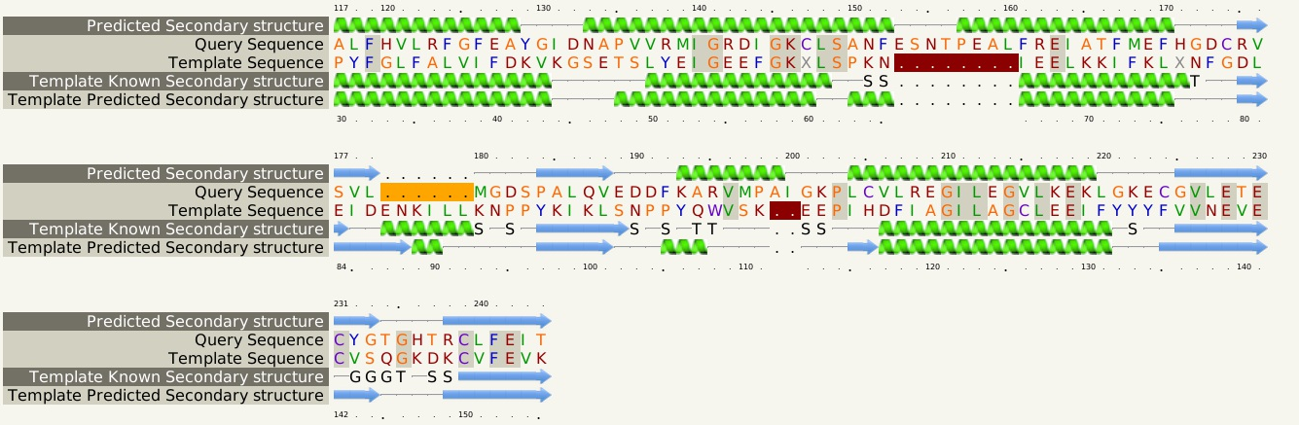 MaMsvR^{V4R1} and PDB ID 2OSO 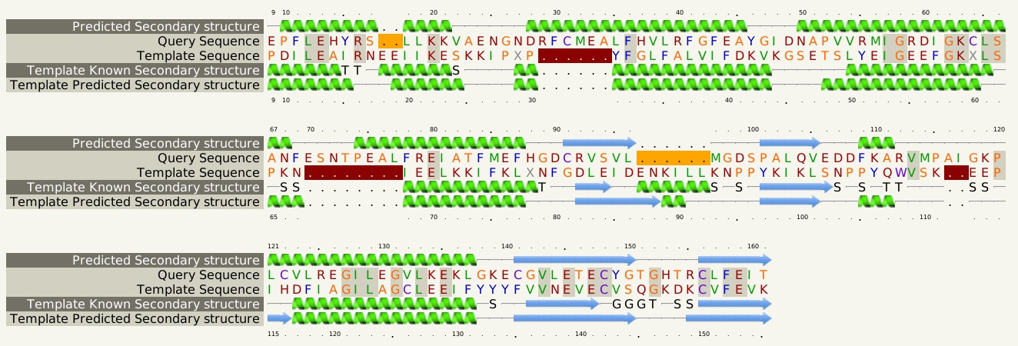 MaMsvR^{V4R2} and PDB ID 2OSO 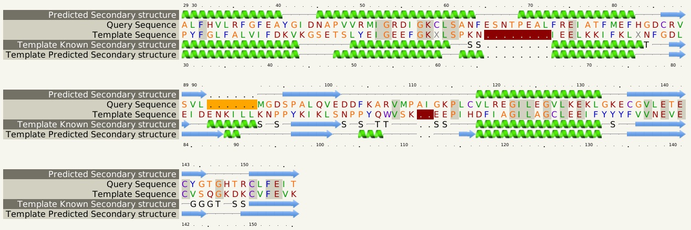 MaMsvR^{V4R3} and PDB ID 2OSO 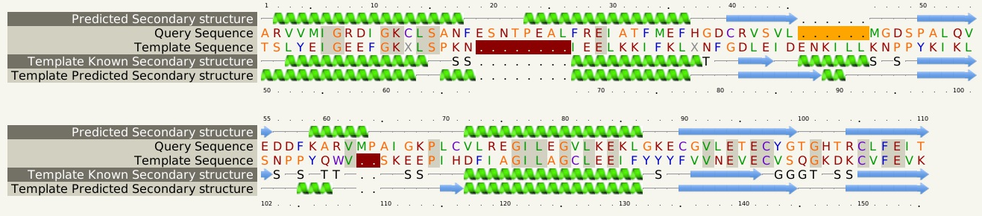 MaMsvR^{V4R4} and PDB ID 2OSO sequence alignmnt

