UNIVERSITY OF OKLAHOMA

GRADUATE COLLEGE

VARIABLES AFFECTING MOTIVATION FOR FATHER INVOLVEMENT: A SELF-DETERMINATION APPROACH

A DISSERTATION

SUBMITTED TO THE GRADUATE FACULTY

in partial fulfillment of the requirements for the

Degree of

DOCTOR OF PHILOSOPHY

By

BRYAN J. RAY
Norman, Oklahoma
2016

VARIABLES AFFECTING MOTIVATION FOR FATHER INVOLVEMENT: A SELF-DETERMINATION APPROACH

A DISSERTATION APPROVED FOR THE
DEPARTMENT OF EDUCATIONAL PSYCHOLOGY

BY

Dr. Cal Stoltenberg, Chair

Dr. Robert Terry

Dr. Barbara Greene

Dr. Paula McWhirter

Dr. Rockey Robbins

© Copyright by BRYAN J. RAY 2016
All Rights Reserved.

Dedication
To my loving wife, Allison Jean Ray:
I can never express how deeply grateful I am for you. You know how to love me and others so well. You are the most selfless person I know. This study, and the countless hours, weekends, and nights that go with it, is dedicated to you.
“You are all my reasons.”

To my children: Millie, Owen, and Evelyn,
The hypocrisy of this work did not escape me. A project on father involvement yet I was often away working on it instead of laughing, playing, and holding you. If this study has taught me anything, it’s that I love you and want to be available to you both now and forever.

“He will turn the hearts of fathers to their children, and the hearts of the children to their fathers.” Malachi 4:6

Acknowledgements
There are many people I would like to thank for their unending support and encouragement. First, thank you to my wife, Allison. You are the one that deserves all of the credit for this project. You spent countless hours rearing our children while I was working on this paper and in school in general. You sacrificed your own time and have been through a stressful season over the last several years. Second, I would like to thank my parents, Billy and Kathy Ray. The greatest gift you ever gave me was unconditional love and support. You are amazing models of loving parents. You always told me I could do anything and you have provided untold amounts of support and encouragement along the way. Thank you to my siblings and their spouses for always supporting me on this journey. Thank you to the Ross family for loving and serving my family while I’ve been in school. We felt so loved by you.
Professionally, there are many people to thank as well. In particular, the work of my committee was invaluable in the completion of this project. I want to thank you for your support, interest in the topic, and your helpful feedback. I would also like to express my extreme gratitude to Will Beasley for assisting me with my statistical analysis. Thanks for the late nights of analysis at your place and for helping me make sense of it all. I couldn’t have done it without you.
I would like to acknowledge my former advisor and professor, Jody Newman. You were very helpful in assisting me in clarifying my research topics and always finding the heart behind what I was trying to say. You were a wonderful professor, mentor, and friend. Thanks for your interpersonal feedback along the way.
I would like to express special appreciation to my advisor, Cal Stoltenberg. You were always available to me and always willing to help. You are a wealth of knowledge and your desire to help your students was always evident. You had an amazing career and impacted thousands of lives through your mentorship. Thanks for being available to me and the rest of your students. I will always consider you a friend.

Table of Contents

List of Tables…………………………………………………………………………………………………..………….vii
List of Figures……………………………………………………………………………………………………,,……..viii
Abstract…………………………………………………………………………………………………………………..….ix
Introduction………………………………………………………………………………………………………………..1
Literature Review………………………………………………………………………………………………………..3
Statement of Problem………………………………………………………………………………………………..41
Hypotheses, Research Question, and Analyses………………….……………………………………...43
Method………………………………………………………………………………………………………………………46
Results……………………………………………………………………………………………………………………….63
Discussion………………………………………………………………………………………………………………….79
References………………………………………………………………………………………………………………...92
Appendix A: Measures……………………………………………………………………………….……….…..106
Appendix B: IRB Approval Letter……………………………………………………………………………..126

List of Tables

Table 1………………………………………………………………….………………………….49
Table 2………………………………………………………………….………………………….63
Table 3………………………………………………………………….………………………….66
Table 4………………………………………………………………….………………………….68
Table 5………………………………………………………………….………………………….71
Table 6………………………………………………………………….………………………….74

List of Figures

Figure 1…………………………………………………………………………………………………………38
Figure 2…………………………………………………………………………………………………………44
Figure 3…………………………………………………………………………………………………………48
Figure 4…………………………………………………………………………………………………………49
Figure 5…………………………………………………………………………………………………………50
Figure 6…………………………………………………………………………………………………………51
Figure 7…………………………………………………………………………………………………………52
Figure 8…………………………………………………………………………………………………………53
Figure 9…………………………………………………………………………………………………………54
Figure 10……………………………………………………………………………………………….………54
Figure 11……………………………………………………………………………………………..……..…67
Figure 12…………………………………………………………………………………………………..…..69
Figure 13………………………………………………………………………………………………….……72
Figure 14………………………………………………………………………………………………….……75
Figure 15………………………………………………………………………..…………………………..…76
Figure 16………………………………………………………………………..…………………………..…78

Abstract

The present study was designed to assess the predictive relationships between motivation and father involvement from the perspective of Self-Determination Theory (Ryan & Deci, 2000) for married fathers with at least one elementary-aged child. A sample (N=260) composed primarily of Caucasian and middle-class fathers provided information regarding their motivation to be involved in various fathering tasks and their perceived involvement with their child(ren). Path analysis was used to assess predictive relationships between the innate needs in Self-Determination Theory (Autonomy, Competence, and Relatedness) with the Motivation for Father Involvement Scale (MFIS) (Bouchard & Lee, 2007) as well as the relationship between motivation and father involvement and parental satisfaction. An ad hoc path model revealed predictive relationships between relatedness and competence with internalized motivation. In addition, scores of internalized motivation were predictive of perceived father involvement and parental satisfaction.

Introduction
The role of a father in a child’s life is important for child development. Fathers play a role in the direct and indirect care of their children. Fathers play a direct role by expanding the language abilities of their children and typically specializing in play when compared to mothers. They contribute indirectly through their effect on social circumstances that aid in child development, such as introducing their child to community resources and supporting the child’s mother (Lamb, 2010). Despite understanding the importance of the father’s role in a child’s life, some men are less involved with their children than others. What makes men involved with their child? What does it mean to be an involved father and how has it changed over time? Qualitative studies have shown that most men want to be involved with their children, but they cannot always follow through with these desires due to other variables limiting their access to their child, such as maternal gatekeeping and conflict with work demands. Based on viewing how demographic variables are correlated with perceived father involvement, much of the research in the area of father involvement makes assumptions about what motivates fathers to be involved with their children
Self-Determination Theory (SDT) provides a conceptual framework to view motivation for father involvement in a more comprehensive way by assessing how many of the previously researched factors (e.g. marital satisfaction, characteristics of the child, parenting self-efficacy, etc.) contribute to the innate needs a father must have to feel motivated in his paternal role with his children. SDT adds to the father involvement research by expanding the areas, both direct and indirect, which may contribute to how a father is motivated to do specific parenting tasks. In addition, many studies look at father involvement as one global concept without looking at how father involvement differs across specific tasks and domains. Perhaps fathers could be differentially motivated to be involved in some parenting tasks when compared to other tasks.
While past studies have examined SDT and its effect on father motivation (Bouchard, 2000; Bouchard et al, 2007;), this present study seeks to extend the current research by expanding the variables that may contribute to motivation for fathers to be involved with their children across specific fathering tasks, both directly and indirectly. In addition to looking at spousal support in the areas of competency, relatedness, and autonomy as done in Bouchard et al. (2007), the present study will look at variables outside of the marital relationship that may contribute to each of these areas as they pertain to the fathering role. In addition to expanding research on father motivation, the present study will also provide research in many other areas of father involvement, including maternal gatekeeping and how a father’s relationship with his child may serve as motivation in itself for fathers to be involved.
Previous research on father involvement makes assumptions about what motivates men to be involved with their children by examining socio-demographic variables and exploring their relationship with father involvement. This study seeks to expand on these assumptions by asking men directly why and if they provide direct and indirect care for their child.

Literature Review
This study examined what motivates American fathers to be involved with their children by examining developmental and social factors that may contribute to internalized extrinsic motivation in men in their fathering role. Self-Determination Theory provides a conceptual framework to understand factors that may contribute to men’s motivation to be involved with their children.
History of American Father Involvement
To fully understand what factors currently contribute to father involvement, we must consider how the role of fathers has changed in the United States and how those influences have shaped the behavior and roles of current fathers within their families. Griswold (1993) and Pleck (2004) detail the evolution of fatherhood in America along with historical and cultural factors that played a role. Griswold describes changes in family expectations and parental roles in America dating back to colonialism when attitudes about family life and children began to change. He attributes this to the “emergence of individualism and the enlightened religious, political, and economic ideas that gave rise to individualism” (Griswold, 1993, p. 11). This differed considerably from the Calvinist visions of family life in the 17th century that included paternal dominance and evangelical authority. There were also societal changes that coincided with the change in ideologies, such as the nature of homes changing to include individual rooms for their children. “Hierarchy and order, the watchwords of older forms of paternal dominance, gave way to a growing emphasis on mutuality, companionship, and personal happiness” (page 11). Children were no longer referred to as “infant fiends” and the focus of parenting shifted away from “will-crushing” (page 11). The Protestant Reformation encouraged fathers to be involved as well as remain the authority in the home (Pleck, 2004). Fathers were expected to serve as the moral guide but were encouraged to be involved with their families in caregiving of their children (Pleck, 2004). This stemmed from the protestant view of God as father as men were expected to represent God to their families and be the patriarch of the home. According to Pleck (2004), Martin Luther “equated godliness with fatherhood and fatherhood with masculinity” (p. 35). Luther was quoted as saying “when a father washes diapers and performs some other mean task for his child and someone ridicules him as an effeminate fool…God with all his angels and creatures is smiling” (Gillis, 1996, p. 186). While not all fathers were involved in the daily care of their children, many were involved in other tasks, including the observation of child rearing by tracking the child’s growth and documenting the weaning of the child from breastfeeding (Pleck, 2004). Fathers were also encouraged to be involved in a child’s life from infancy to adulthood. Even though a child might have entered the workforce at the age of 7, fathers were still their authority, disciplinarian, and guide (Pleck, 2004).
In the 18th century, fathers’ roles were much broader as they were encouraged to share their emotions more openly. Pleck (2004) reported this stemmed from the American Revolution at which time fathers rejected the tyranny from both the King of England and the tyrannical nature of the patriarchal father.
Industrialization also shaped fathers’ influence on their sons as more men were working outside of the home, whereas previously fathers had worked at or close to the family farm and sons had begun work at an early age. As men worked away from home, they would be gone most of the day. This subsequently led to changes in fatherhood. Fathers’ role as breadwinner started to take shape as they began to lack land or a trade to pass directly to their sons. It left fathers offering money and advice (Griswold, p. 16). The role of fathering started to shift from moral leadership to economic support of the family (Lamb, 2010). During this time, men and women were relegated to different spheres, with women at home taking care of the children and men involved in business and politics (Pleck, 2004). The role of fathers focused on helping sons with their vocation, being the disciplinarian, and making financial decisions (Pleck, 2004).
While this description explains broad societal trends occurring during the 19th century, some fathers were also very involved with their children and with household tasks. Pleck (2004) points out that the Abolitionist William Lloyd Garrison cooked and sang to his children at bedtime. Some wives even wanted men to be at their bedside during labor. Some fathers shopped for food at the market during this time due to unsanitary and unsafe conditions (Pleck, 2004). The call for more father involvement during this era was largely based on Christian ideals of being nurturing to children and others. However, towards the end of the 19th century, society became more secular, and the religious focus on fatherhood declined. Scientists emphasized biological differences between men and women and pushed for masculinity in raising sons (Pleck, 2004).
With these changes taking place, the end of the 19th century led to a new conception of masculinity by urging men to spend more time at home and to engage in child-rearing activities. This call stemmed partly “out of concern that boys needed a manly presence to escape being overly feminized” (Griswold, p. 90). Roles that had been assigned to the family, such as religious training, health, and economic support, began to shift to society, which many thought weakened the family overall. Parental functions continued to shrink, and it left fathers with a diminished role (Griswold, p. 92). Because of the changing roles of fathers, psychologists and sociologists claimed fathers were needed as role models to ensure healthy psychological adjustment in their children (Pleck, 2004). During this time, men started writing parenting guides for other men and were involved in female parenting organizations (LaRossa, 1997). As a result, fathers were encouraged to cook and to participate in housework (Marsh 1990; Pleck, 2004). Other societal changes also encouraged fathers to be involved as seen in the further development of suburban single-family homes. These homes included spaces for fathers to play with their children, such as backyards and a den (Pleck, 2004). During this era, fathers were expected to be a companion to their wives and children (Pleck, 2004).
During The Great Depression of the 1930s, men’s identities and sense of manhood dwindled as they struggled to provide for their families. During this time, some researchers found that “economic hardship in some cases actually prompted fathers to become closer to their children” (Griswold, p. 145). On the other hand, this time period increased marital separation and more adolescents left home so there was “one less mouth to feed” (Griswold, p. 151).
Attitudes about parental roles were already changing before World War II, but they changed rapidly after the war. Mothers entered the workforce at increased rates as they were serving an increasing role in financially supporting their families. Griswold states this was “propelled by desires for self-fulfillment, economic need, expansive consumer wants, and a better life for their children” (p. 5). As men went to war, women took on roles and jobs typically assigned to men. Post-war, there was a public outcry for women to return to their pre-war roles so men could do the breadwinning, but women resisted because they wanted to stay in their jobs. There was a fear during this time that as fathers went to war and mothers entered the work force, there children would have higher rates of juvenile delinquency (Pleck, 2004). As a result, after the war, fathers were encouraged to be involved to reduce the potential delinquency and homosexuality that may have resulted from the father’s absence (Pleck, 2004). Fatherhood became the center of a man’s identity (Griswold, p. 189). “In the postwar era, to be a man was to be a father and to be a father required providing a world of goods for wife and children” (page 196). However, with more women in the workforce also contributing to the household income, the specific functions fathers provided became confusing.
In the 1950s, fathers were encouraged to be involved with their children from infancy to adulthood. This was primarily so they would have healthy relationships with their adult children and to promote gender roles to their children (Pleck, 2004). Quality time with children was encouraged and was typically spent on weekends, evenings, or vacations when the father was not at work (Pleck, 2004). Marriages were occurring at an earlier age, and children were being born closer together. Mothers encouraged fathers to be involved with household tasks and child rearing in order to meet these new demands (Pleck, 2004).
As social expectations began to change regarding the role of women in the 1960s and 1970s, new expectations regarding the role of fathers emerged. Schwartz and Finley (2004) suggested the following: “From the mid-1970s to present, society increasingly has expected fathers to become more involved in the lives of their children in a nurturant and caregiving capacity” (p. 144). There was a cultural shift in viewing the role of a nurturing father who was directly engaged with his children, instead of the father who was primarily a breadwinner (Milkie & Denny, 2012). Fathers were also encouraged to be even more involved with their children during the 1980’s as the divorce rate increased. There was more focus on the potential consequences of fathers being absent from their children or not being engaged with their children (Pleck, 2004).
The history of protestant fathers in America is not descriptive of every father in America. While an exhaustive history is needed to explore the history of fatherhood from various perspectives, only a brief overview from other cultures and experiences will be given in this study. American Indian fathers experienced a very different history from those of the European, protestant tradition. Coming from a collectivist society, American Indian culture emphasizes the family circle incorporating the extended family, community, and tribe (Cross et al, 2000). Extended family members all play a role in child rearing, which may decrease specific roles and tasks of fathers. American Indian fatherhood is also shaped, in part, by historical trauma. While the U.S. Government tried to assimilate American Indians into mainstream U.S. culture and relocate many Indian children into boarding schools, it left many Indian children with no adequate adult role models to observe as they developed parenting practices of their own (Cross et al., 2009).
Families were uprooted and relocated, and American Indian men had to adjust to these changes. Men were forced into lower positions in society as their land, families, and ranking in society started to fall (Johnson, 2014). American Indian fathers differed from their European counterparts in many ways, but one predominant one was the focus on passing down their cultural inheritance, instead of their physical heritance as the European American fathers did (Johnson, 2010). Fathers focused on teaching their children resilience as a result of the historical trauma they had suffered and taught strategies to adapt to society (Brokenleg, 2012).
While there are general themes across all American Indian families, it is impossible to make conclusions regarding every tribe and their experiences from this brief overview. Even within tribes, there were many differences in terms of how families view the father role and involvement.
Just as the history of American Indian fathers differed from European, protestant fathers, so did the experience of black fathers in America. In 1965, The Moynihan report attributed the deterioration of black society to the breakdown of the black family, which he concluded stemmed from slavery and the reconstruction period. Griswold (1993) suggested the real breakdown was the racist and economic hardship that was caused by discrimination, racism, and poor occupational conditions and the significant strain it put on relationships within black families. Many men had to leave their families to find work, and many black families became matriarchal as a result. Moynihan (1965) referred to this breakdown as a “tangle of pathology” that needed to be corrected since it differed with mainstream white society. Griswold (1993) points out this report was widely criticized because it placed the problem on the black family and not on societal issues of poverty, discrimination, and unemployment. Black fathers taught their sons how to make it on their own and emphasized personal achievement and education whereas European American fathers taught their children how to find jobs to benefit the family (Griswold, 1993). Although the Moynihan report painted black families and specifically black fathers in a negative light, Gutman (1975) reported many southern blacks after the civil war lived in two parent households. Most slaves lived with both of their parents.
Father involvement and the role of the father must be considered from each person’s sociocultural perspective and its history. Although many of the cultures mentioned here often get stereotyped, causing a problem leading to a breakdown of their family structure, they were often shaped by economic and discriminatory factors. It is also not appropriate to say all fathers and families from the same culture have the same experience. Each family, culture, and individual are unique and have adapted cultural demands and expectations in different ways.
Throughout American history, the roles fathers play in the lives of their children have largely been shaped by societal factors, including the economy and societal expectations. There are a number of significant roles fathers currently play that include “companions, care providers, spouses, protectors, models, moral guides, teachers, and breadwinners” (Lamb, 2010, p. 3). In order to understand father involvement in present times and what motivates fathers to be involved with their children, one must explored a current definition of how father involvement is defined in the research literature and its evolution.
Defining Father Involvement
As the role of fathers has evolved over time, so has the definition of what the term “involvement” means and how it is measured. Father involvement has also been referred to as “participation, engagement, investment, child care, and child rearing” (Palkovitz, 1997). “Even when there is agreement of terminology across theoretical or empirical papers, there is little consensus concerning just what involvement is, how to conceptualize it, how to measure it, and how to compare different people’s engagement in it” (Palkovitz, 1997, p. 200).
Lamb, Pleck, Charnov, and Levine (1985) proposed the most widely researched and accepted construct of father involvement, which included three component constructs: (1) interaction (later relabeled “engagement” in Lamb (1987)); (2) accessibility; and (3) responsibility. The authors attempted to identify constructs that had previously not been identified in counseling research but which reflected social changes in fathering roles. Prior to this development, research on father involvement focused almost exclusively on the father’s presence in the child’s household (i.e. how often the father was at home). Looking solely at whether or not the father was at home was too simplistic as it did not measure what he was actually doing when he was at home or if his interactions with his children were positive, negative, or non-existent. The engagement construct included the father’s direct interaction with the child in the form of play, leisure, or caretaking. Accessibility referred to how available the father was to the child both in terms of location and psychologically. Responsibility looked at the extent to which the father took care of the child and ensuring resources were arranged for the child.
Lamb’s three-part construct on father involvement became an almost unitary construct used by researchers on father involvement; however, Pleck (2012) also expanded the definition of father involvement by expanding on Lamb’s original model and adding dimensions from the current involvement research. His model included the following dimensions: (1) positive engagement activities; (2) warmth and responsiveness; and (3) control. In addition, he outlined two auxiliary domains: (1) indirect care and (2) process responsibility.
Positive engagement reflects the shift in concepts to reflect not just the amount of time a father spends with a child, but how that time is spent. While previous research focused on the amount of total time a father is with a child, Pleck conceptualized it as “interactive activities that potentially promote child development.” This includes activities such as play, reading, and having conversations with children (Pleck & Masciadrelli, 2004). The original formulation of this construct by Lamb et al. (1985) was relatively content free. It did not include a positive dimension to the construct. Pleck and Masciadrelli (2004) indicated father involvement research used the original Lamb (1985) construct but often included items that implied not just engagement but positive engagement. Pleck added warmth and responsiveness as a qualitative dimension to positive engagement and indicated this had been included in previous research studies (Carlson, 2006; Hofferth, 2003;). Control is defined as “knowing the child’s whereabouts” and “participation in decision making about the children” (Pleck 2012). This construct is analogous to the Lamb et al. (1985) component of responsibility.
Pleck (2012) included two auxiliary domains within the “responsibility” component of father involvement outlined by Lamb (1985). This included indirect care of the child and process responsibility. “Indirect care refers to activities undertaken for the child, but not involving interaction with the child, with exception of providing economic support.” Pleck outlines two subcategories of this construct: material indirect care and social indirect care. Material indirect care includes “purchasing and arranging goods and services for the child,” whereas social indirect care refers to “promoting the child’s community connections” (Pleck, 2012, pg. 66). The other auxiliary domain is process responsibility, which “involves taking initiative and monitoring what is needed.” Doucet (2006) defined this as a father’s ability to see the need, not just fill the need. Pleck’s reconceptualization of father involvement reflects the changes in research on father involvement and child outcomes. The original constructs outlined by Lamb et al. (1985) did not include the qualitative dimensions of warmth and responsiveness although many researchers expanded it to be included.
Other expanded definitions of father involvement were developed to include more complex elements of father involvement than those outlined by Lamb (1985). Palkotivz (1997) pointed out these constructs, and others seem to directly compare men and women in the areas of direct child care and related housework, with men often showing less involvement in these areas than women. He asks, “Is this all there is to involvement in parenting? Don’t men make significant contributions to the raising of children in other ways beyond the purview of hands-on child care and housework?” (Palkovitz, 1997, p.201). He goes on to point out several misconceptions about father involvement that have derived using these constructs (e.g. more involvement is better, involvement requires proximity, involvement can always be observed or counted, involvement levels are static and therefore concurrently and prospectively predictive, patterns of involvement should look the same regardless of culture, subculture, or social class, and women are more involved with their children than are men). Palkovitz (1997) points out 15 areas of involvement, many of which do not often get studied in involvement or parenting research. This includes affective, cognitive, and behavioral domains and encompasses 15 categories: communication, teaching, monitoring, thought processes, errands, caregiving, child-related maintenance, shared interests, availability, planning, shared activities, providing, affection, protection, and supporting emotionally.
It appears the specific domains and tasks outlined in Palkovitz (1997) can be incorporated into Pleck’s re-conceptualized model of father involvement. Both of these approaches recognize that father involvement and how it is assessed is more complex than previous models. This approach to the father involvement construct draws from historical use of the involvement constructs while adapting to include more tasks that can be considered involvement, such as the indirect-care of the child.
Antecedents to Father Involvement
While there are expanding definitions of what it means to be an involved father, there are also environmental and social factors that encourage or thwart involvement of fathers with their children. What motivates some fathers to be more involved with their children than others? What factors are related to their ability to be involved? Belsky (1984) developed a model for understanding determinants of parenting behavior by outlining the inter-play of three distinct areas of fathers: (1) personal characteristics of the parent, (2) social influences of stress and support, and (3) personal characteristics of the child. Under each of these areas, research has contributed to a clearer picture of what motivates and affects fathers’ involvement with their children.
Characteristics of the Father
Socio-demographic Variables of Fathers
Mixed results have been found when looking at the associations between various socioeconomic factors of fathers (e.g. residential status, income level, education level of the father, race/ethnicity, and age of father) and involvement with their children. “While some studies find no association between father involvement and fathers’ race and ethnicity, educational attainment, employment and income status, and residential status, others find clear associations” (Castillo, 2010, p. 1343). One example of mixed findings is the father’s residential status. Fathers who live with their children tend to be more involved (Castillo, Welch, & Sarver, 2011) and over time non-residential fathers may become even less involved over time in the lives of their children (Furstenberg, 1990). However, other studies have shown that non-residential fathers are more involved with their adolescent children when fathers find the father role at least moderately salient (Bruce & Litton Fox, 1999).
The relationship between father involvement and socioeconomic status has also provided mixed results. Blair et al. (1994) found higher paternal income was associated with more positive father-child engagement among children ages 5-18. In contrast, fathers in poverty who used the welfare system showed reduced levels of behavioral and emotional involvement with their children (Harris & Marmer, 1996). Despite these discrepancies, Hofferth (2003) found that links with socioeconomic status and father involvement are weak and concluded the father’s own income was unrelated to total engagement with children. In a summary of the research in this area, Pleck (1997) also found no consistent associations between paternal involvement and socioeconomic variables or race and ethnicity.
The educational level of the father and how it affects involvement with his children has also produced mixed results. Education may provide fathers with resources and skills they can pass on to their children. More educated fathers tend to be more highly involved with their children across various types of living arrangements (Coley & Hernandez, 2006). Fathers with a higher education (more than high school and college graduates) are expected to be more involved with their children when compared to those with less education (Johnson, 2001). In contrast, however, links between paternal engagement and both education and income are weak and inconsistent when considering larger sample sizes (NICHD Early Child Care Research Network, 2000).
There are also not clear connections between race and ethnicity and father involvement. Several studies have found no clear associations between engagement with children and race and ethnicity of the father (Hofferth, 2003; Pleck, 1997). One socio-demographic area that seems to be more clearly associated with father involvement is the age of the father. Older fathers tend to be more involved with their children (Castillo, 2010), and this increases with age (Johnson, 2001). Age has been associated with increased commitment by the father and also his improved capacity to take on his paternal obligations (Johnson, 2001).
Overall, socio-demographic characteristics of fathers have shown mixed results in how they affect fathers’ motivation to be involved with their children. While variables such as level of education, income, residential status, and race/ethnicity found mixed results, men who become fathers at an older age tend to be more involved with their children when compared to younger fathers.

Fathering Self-Efficacy
Another characteristic of fathers related to levels of involvement is the extent to which they believe they can complete the necessary tasks and demands of being a father, often referred to as parenting or fathering self-efficacy. Parenting self-efficacy is one area that has been shown to motivate fathers to be involved (Johnston & Mash, 1989; Salonen et al., 2009) and is a major determinant of competent parenting behaviors (Jones & Prinz, 2005). Parenting Self-Efficacy is defined as “a set of beliefs held by the parent regarding his/her capabilities to organize or execute the tasks of child-rearing” (Salonen et al., 2009) and includes their perceived confidence in their ability to positively influence their children’s development (Coleman & Karraker, 1998). This stems from Bandura’s (1997) Self-Efficacy Theory that indicates the level of an individual’s self-efficacy in a given area determines how much effort he or she is willing to exert when confronting a situation. Not only are fathers with higher parenting self-efficacy more willing to engage in child-rearing, but they tend to gain more parenting satisfaction and improve their overall well-being as a result (Reece & Harkless, 1998.) Self-efficacy is largely determined by the father’s experience in specific parenting tasks (Murdock, 2013).
One barrier to father involvement is that fathers may believe they lack the skills necessary for responding to their children’s needs and these perceptions are affected by the mother’s expression of her beliefs about the father’s parenting skills (Lamb & Oppenheim, 1989). Fathering self-efficacy can be influenced by receiving education and support in areas of weakness (McBride, 1991). Fathers who participated in a 10-week father education and support program had higher levels of parenting competence and were associated with self-reports of more responsibility for the care of their children (McBride, 1991). Low parenting self-efficacy has been linked to coercive parenting practices and maladjustment among children (Coleman & Karraker, 2003; Shumow & Lomax, 2002).
Fathers’ motivation to be involved parents may be affected by their perceptions of their ability to complete tasks related to rearing children. In summary, fathers are more involved when they are more confident to do parenting tasks and this confidence is affected by their experience in doing the tasks and the mothers’ beliefs in their ability to do those tasks.
Intergenerational Fathering
Research is also mixed on how paternal involvement with one’s own children is related to the level of fathering they received. With their own children, many men model the fathering they received, while others rework the father model they were given. Both of these viewpoints are shown in the research literature and will be explored here.
In regards to the modeling viewpoint, Parke (1995) viewed this from a social learning perspective, which asserts that men learn to be fathers by observing a father. Many studies have found a connection between the amount and type of involvement with one’s own father and how it affects the fathering men provide their own children, both positively and negatively. Guzzo (2011) found men tend to hold attitudes towards fathering that reflect their own father’s involvement. Low-income fathers’ relationships with their fathers predicted patterns of engagement with their infants (Shannon, Tamis-Lemonda, & Margolin, 2005), and early relationships with one’s own parents affect how a parent interacts with his/her children (Cox et al. 1985). Parents and their adult children showed similarities in their adult relationships primarily in divorce and marital aggression (Diaz, 2014). In addition, they found that those parents who experienced repeated harsh parenting practices from their own parents were likely to use a similar form of parenting with their children (Diaz, 2014). Black fathers who had limited contact with their own fathers also had lower levels of paternal involvement with their children, and this was found to persist across generations despite motivations from the fathers to be involved in their children’s lives (Coates, & Phares, 2014). Men who were involved in decision-making and child-care were more likely to have sons who engaged in warm fathering towards their own children (Hofferth et al., 2012). Furstenberg and Weiss (2000) found that young men whose fathers were absent from the home were significantly more likely to have their first child in their teen years. Furthermore, fathers growing up without a father in the home were more likely to have a child with more than one partner (Guzzo & Furstenberg, 2007). Sons of adolescent fathers were found to be 1.8 times more likely to become adolescent fathers as opposed to older fathers.
While there is research that seems to predict fathers will repeat or model their own fathering after that which they received, there is also research that provides another hypothesis to consider. Diaz (2014) and Guzzo (2011) conclude adult men either model their parenting after the model they were given by their own fathers or they “rework” or “compensate” for the model they were given. Daly (1993) suggests many men feel the need to be a role model to their own children despite not having a positive role model in their own father. In other words, these men feel a need to “compensate” for the lack of positive father involvement they received. The reworking and compensatory hypotheses have received mixed results in previous studies (Guzzo, 2011).
Within the intergenerational fathering research, it appears current circumstances matter significantly more than fathering received in regards to the engagement and involvement a father has with his own children. Shannon, Tamis-Lemonda, and Margolin (2006) found that fathering received predicted engagement with infants in low-income fathers, but this engagement was moderated by the quality of the mother-father relationship, father’s mental health, education, age, and income. In another study, current life circumstances were the predicting factor in fathers’ involvement with their children despite the level of involvement one had with one’s own father (McFadden et al., 2009). In other words, men who reported positive relationships with their fathers and positive current relationships, income, and current life circumstances were highly involved with their children. However, if one had a positive relationship with his father, but poor current circumstances he was more likely to be less involved in the areas of time spent with a child, social involvement, and financial provision with that child. Men who had both low involvement with their own fathers and poor current circumstances displayed low involvement with their children. Men who had poor relationships with their own fathers but had positive current relationships resulted in being highly involved with their children. This research appears to support the “reworking hypothesis” as mentioned by Guzzo (2011). Men with ambivalent fathers appear to struggle the most as parents while those receiving positive fathering tend to model what they received and those receiving overtly negative parenting appear to rework their own fathering to be more positive. Those with ambivalent fathers were not given either a positive or negative model to adjust to (Guzzo, 2011). Parental functioning may be determined, in part, by the personality and psychological well-being of the father primarily for the role these factors play in recruiting contextual support (Belsky, 1984). Belsky concluded the degree of support mattered most in present circumstances such as the support from marriage, work, and social networks, not just if they are present or not.
Research is mixed on whether men model the parenting they received or rework the model received. The assumption has long been that men that received highly involved fathering as a child will also be involved as fathers, and men who received poor fathering have to rework the model they received to be more involved. However, Masciadrelli et al. (2006) explored fathers’ perceptions of their own fathers and others as influential role models and found that highly involved fathers were more likely to cite peer parents than to specifically cite their own fathers as influential role models. In addition, low involvement fathers often attributed a positive affective evaluation to their models than highly involved fathers. They concluded that “Modeling may occur with low involvement models as well as high-involvement. Compensation (e.g. reworking) may occur for high involvement as well.” In summary, the fathering men receive does appear to impact their own parenting, but it is hardly a direct, positive correlation. Men may model or rework the fathering they received, but they also may incorporate models they have observed from other family members, peer parents, or other male models in society.
Psychological Factors related to Father Involvement
Father involvement is also related to many psychological factors within fathers themselves. Paternal depression may lead to lower father involvement for its effects on marital conflict (Cummings & Davis, 1994). Other factors such as alcoholism, antisocial behavior, anxiety, and depression are significantly correlated with parenting quality (Hipke, 2002). “Fathers with multiple psychological risk factors appear to be less supportive in the parenting role in part due to the lack of supportive adult social network” (Hipke, 2002, p. iv). A study by Waller and Swisher (2006) found risk factors, such as physical abuse, problematic substance use, and incarceration among unmarried fathers were negatively associated with paternal involvement. They concluded, “Fathers with risk factors are less likely to have romantic relationships with mothers and relationships between parents mediate associations between risk factors and father’s involvement” (Waller & Swisher, 2006, p. 392). Non-resident fathers have been shown to have much higher psychological distress than married parents with rates similar or higher than those of single mothers (Yuan, 2014). In contrast, the improvement in psychological symptoms in fathers is positively associated with increased involvement and more positive child outcomes. “When mother’s and father’s psychological symptoms decrease because of their own treatment, their children’s behavior improves” (Phares et al., 2010, p. 461). Fathers who are involved with their children are more likely to display greater psychosocial maturity (Pleck, 1997).
Beliefs about Paternal Role
The way men view their role as fathers may also influence their level of motivation to be involved with their children. More egalitarian beliefs by fathers regarding gender norms were associated with more active fathers in younger children (Schoppe-Sullivan et al., 2008), and fathers’ beliefs about masculinity and the role of fathers were identified as significant predictors of the amount of paternal involvement in child-care activities (Bonney, Kelley, & Levant, 1999). Fathers are involved in the specific areas that are associated with their perceived role. For instance, a father who endorsed a stronger identification with being a provider to his children tended to work longer hours than fathers endorsing an involved fatherhood role (Kaufman & Uhlenberg, 2000).
Pleck (2004) points out that many studies in this area of father involvement research are too general in nature. They often ask fathers about the importance of being a father without defining the specific tasks and domains that may comprise the fathering role (Pleck, 2004). However, Pleck adds, when research does look at specific domains along with how fathers identify in those domains, there are greater links to involvement (Maurer et al., 2003; Rane & McBride, 2000). Overall, paternal identity and involvement is disconfirmed more than it is confirmed (Pleck, 2004).
Perhaps more telling than how fathers view their roles is the way the mothers view the paternal role. Maurer et al. (2001) found that paternal caregiving is related to the expectations for caregiving that fathers perceive from their wives but not to their own paternal identity. Mother’s perceptions of the paternal role were the single best predictor of father involvement in a study completed by Palkovitz (1984). In addition to being shaped by the mother of the child, the role of the father may also be shaped by changing societal expectations of fatherhood stemming from parents’ interactions with other parents, institutions, and the media (McGillicuddy-DeLisi & Sigel, 1995).
Social Influences of Stress and Support
Relational Satisfaction
The role of the relationship between the father and mother appears to also affect father involvement with his children. The quality of the relationship with the child’s mother is strongly connected to paternal involvement among married resident fathers (Erel & Burman, 1995) and among non-resident fathers (Carlson, McLanahan, & Brooks-Gunn, 2008; Seltzer, 1991). Men tend to be more involved with their children when they are romantically involved with the child’s mother (Coley & Hernandez, 2006). Several studies found that once the couple relationship has ended and fathers find new partners or have new children, involvement tends to decrease (Manning & Smock, 1999; Stewart, 2003). “Both the type of relationship after a non-marital birth (i.e. cohabitating, romantic but living apart, friends, or no relationship), as well as the quality of relationship (i.e. supportiveness and ability to communicate effectively), are linked to greater involvement by unmarried fathers in fragile families” (Carlson & McClanahan, 2010). Increased marital conflict is related to less engaged and supportive and more hostile parenting by fathers (Cummings & Davies, 1994).
When fathers are more engaged with their partners, they are more consistently involved in interactions with their children (Belsky, Gilstrap, & Rovine, 1984). Relationship satisfaction affects father involvement even before the child is born. Fathers with higher pre-natal marital satisfaction were more involved in father behaviors, both in quantity of time and quality of interaction (Belsky et al., 1989). Marital quality in the first year predicted the amount of appropriate stimulation they gave their 4 and 12 month olds. Higher marital satisfaction has been associated with more participation in common childcare activities (Bonney, Kelley, & Levant, 1999). Greater emotional intimacy in the marital relationship was significantly predictive of fathering competence (Bradford & Hawkins, 2006). Parental conflict has a strong negative relation with father involvement (Coley & Hernandez, 2006). Marital quality contributes to changes in parenting behavior and appears to be a stronger predictor of father behavior as opposed to the behavior of the mother (Leve at al., 2001). When fathers perceive a negative marital relationship, they tend to withdraw from their partners and may also distance themselves from their children (Coiro & Emery, 1998). This has been referred to as the “spillover” effect (Katz & Gottman, 1996). Other studies did not find a significant relationship between marital satisfaction and mother involvement (McBride & Mills, 1993), suggesting lower levels of marital quality impact fathers more than mothers. Clements, Lim, and Chaplin (2002) reported that lower marital quality was associated with poor parenting by the father both in the mother’s presence and in her absence.
Maternal Gatekeeping
Another aspect of the marital relationship that affects motivation for fathers to be involved with their children appears to be the level of maternal gatekeeping. Allen and Hawkins (1999) define maternal gatekeeping as “a collection of beliefs and behaviors that ultimately inhibit a collaborative effort between men and women in family work by limiting men’s opportunities for learning and growing through caring for home and children” (p. 200). It has also been defined as mothers’ attempts to encourage or discourage fathers’ interaction with their infants (Tu, Chang, & Kao, 2014,). Level of gatekeeping has predicted paternal involvement in child-care (Gaunt, 2008; Tu, Chang, & Kao, 2014) and limits the possibilities of father involvement in taking care of the child in the developmental phase of the family (Ivana, 2010).
Men’s motivation to be involved with their children appears to be affected by how mothers view the role of a father with their children. Fathers’ perceived investments in their parental roles and actual levels of paternal involvement are moderated by the mother’s beliefs about the role of the father (McBride, Brown, Bost, Shin, Vaughn, & Korth, 2005). Fathers displayed more direct involvement with child health care when mothers held nontraditional beliefs about gender roles and when mothers were more encouraging to fathers to be involved in child-rearing (Zvara, Schoppe-Sullivan, & Dush, 2013). Father involvement is differentially affected by how much criticism or encouragement the mother engaged in depending on the father’s belief about the fatherhood role (Schoppe-Sullivan et al., 2008). Progressive fathers who were criticized were less active with their children, and fathers with more traditional beliefs became more active when encouraged by the mother (Schoppe-Sullivan et al., 2008).
Work-to-Family Conflict
The conflict men experience between their work and family demands may also affect their motivation for involvement. Work-to-Family Conflict is a form of inter-role conflict a father experiences when his role at work conflicts with his role within his family. It has been viewed as a form of conflict in which “role pressures associated with membership in one organization are in conflict with pressures stemming from membership in other groups” (Kahn et al., 1964, p.20). In other words, it refers to the extent in which role responsibilities from work and family domains are incompatible. In this case, participation in the family role is more difficult because of participation in the work role (Netemeyer, Boles, & McMurrian, 1996).
Matthews, Swody, & Barnes-Farrell (2012) suggest the extent to which fathers identify with either a work or family role predicts the areas in which strain is experienced. The more time an individual is invested in the work role, the more strain was added and the more work was perceived to interfere with family. This conflict represents an investment of energy and time, and fathers who feel strained because of work may feel too tired to participate in family. The work to family conflict is caused in part because of longer working hours. As a father works longer hours, his overall available time to spend with his family is depleted (Matthews et al., 2011), and longer work hours predict lower involvement in father tasks (Yeung, Sandberg, Davis-Kean, & Hofferth, 2001). This conflict has been found to lead to distress and dissatisfaction as it causes role overload and makes it difficult to fulfill the necessary requirements in each role (Greenhaus & Beutell, 1985).
Work stress significantly impacts the quality of fathers’ relationships with their children. “Previous research indicates that a variety of occupational stressors predict lower quality parent-child interactions, including long hours at work, nonstandard work schedules, high levels of job pressure, and low level of workplace support” (Bolger, Delongis, Kessler, & Wethington, 1989). Longer work hours are associated with a reduction in marital quality and less father-child interaction. Staines and Pleck (1984) found that this contributes to less time in family roles, higher levels of specific types of conflict between work and family life, and lower levels of family adjustment. It places more of an emphasis on other family roles such as housework. Longer work hours by fathers have contributed to less time spent with wives and predicted less positive marital relationships, both factors that contributed to less positive father-adolescent relationships (Crouter, Bumpus, Head, & McHale, 2001). In a study by Baxter (2007), fathers who worked 55 hours or more per week spent the least amount of time playing indoor and outdoor games with their children and involving their children in everyday activities. A father’s working conditions and the family’s economic stress affects the father’s parenting behaviors (Whitbeck et al., 1997). Job stress in large companies reduces men’s childcare involvement whereas men in more autonomous small to medium size companies have a greater childcare involvement (Ishii-Kuntz, 2012). Work-to-family conflict is related to poor psychological health and depression in men and also leads to greater stress-related illnesses (Allen, Herst, Bruck, & Sutton, 2000). These variables have a negative influence on paternal involvement (Bolger et al., 1989). Fathers have also been shown to be more emotionally and practically invested in infant care when paternal leave is given (Obrien, Brandth, & Kvande, 2007).
Fathers work to family conflicts affect the quality of father-child interactions which, in turn, have significant effects on child development. It has been shown to harm a child’s self-esteem (Lau, 2009). Infants with at least one parent who works nonstandard hours have significantly more behavior problems than do infants with parents who work regular shifts (Rosebaum & Morett, 2009). This is partly accounted for by the reduction in father-child interaction, strain on marital quality and a reduction in shared family dinners, along with paternal depression (Rosenbaum & Morett, 2009). There is a direct and negative relationship between job inflexibility and father-child quality (Minnotee, Pedersen, & Mannon, 2013). Work to family conflict, sometimes called negative spillover, influences perceptions of stress and well-being, which in turn impact a father’s relationships with his children. Negative work to family conflict predicts paternal knowledge of children’s daily activities, and lower levels of paternal knowledge have been linked to negative child and adolescent outcomes (Bumpus, Crouter, & McHale, 2006).
Overall, greater work to family conflict negatively influences father involvement. It increases the strain it puts on the parental relationship and increases the likelihood of negative psychological outcomes for men and their children. These areas both impact the amount and type of father involvement given and leads to negative outcomes in children by reducing the amount of time a father spends with his children and by depleting both his time and his emotional resources to invest in his children’s well-being.
Financial Stress
Father motivation appears to be greatly impacted by personal financial stress as well. This stress leads to more stress in the parental relationship and causes more strain psychologically for fathers. Cabrera, Shannon, and Tamis-MeMonda (2007) found that “human capital” is positively linked to greater involvement from fathers. Human capital includes higher education, income, and employment status. These variables are positively linked with supportive parenting and more engagement from both parents. When fathers have less human capital, it appears they are at-risk for greater financial stress, which has been associated with less involvement from fathers and is negatively related to child outcomes. While stress in parenting, in general, has been associated with lower levels of father engagement and with less supportive inter-parental relationships, there is a more negative relationship for fathers with household incomes below the poverty line (Bronte-Tinkew et al., 2009). Lower socio-economic status along with child behavior problems was negatively related to father involvement in children at the age of seven (Flouri & Buchanan, 2003).
The link between financial stress and father involvement appears to be mediated by greater psychological distress, which contributes to an increase in marital conflict in the mother-father relationship. Financial strain has been associated with more strain in the marital relationship, which impacts the parent-child relationship (Conger et al., 1994; Lempers & Clark-Lempers, 1997). Financial stress is related to greater psychological distress in parents, which in turn is related to more negative parent-child relations (Morrison Gutman, McLoyd, & Tokoyawa, 2005). This stress has been related to an increase in depressive symptoms in both parents, which seems to impact parenting stress and parenting quality (Gyamfi, Brooks-Gunn, & Jackson, 2001). Financial stress was associated with less supportive parenting within father-son and father-daughter dyads. Patt (2011) found that financial hardship can create stress in the family by increasing marital discord between parents. This discord has been shown to lead to more antisocial behavior in children. Economic hardship was found to increase depressive symptoms, which were linked to marital problems and more hostile parenting techniques. These techniques were related to child adjustment problems (Parke et al., 2004).
Family income and financial stress are related to negative child outcomes. Nievar, Moske, Johnson, and Chen (2014) found that income was the most important predictor of children’s cognitive development. Child behavior problems and pre-school ability were related to financial strain in the family. Jackson et al. (2000) found that financial strain increased depression and lowered the overall quality of parenting in this population. Financial hardship was related to less nurturance from both parents and more inconsistent discipline among adolescents (Lemps, Clark-Lempers, & Simons, 1989). In black adolescents, financial stress contributed to psychological distress and was related to more negative parent-adolescent relationships. This fact predicted a higher level of negative adjustment in these adolescents (Morrison et al., 2005). Economic pressure is related to increased punitive parenting techniques and workload was related to less authoritative parenting in single fathers (Leinonen et al., 2003).
Studies differ on the perceived impact of financial stress on fathers compared to mothers. Conger et al. (1993) found economic pressures led to depression and demoralization for both parents through greater marital discord. While there is evidence that financial strain impacts both parents, there is some research that it impacts fathers more than mothers (Ponnet et al., 2013). When economic stress is present, fathers tend to be less engaged with child activities and have greater frustration in the parenting process (Bronte-Tinkew, 2007). This stress may impact how fathers view their role as a parent. “Fathers who are unable to live up to the breadwinner ideal are less likely to find the father role rewarding and more likely to withdraw from their children” (Carlson & McClanahan, 2010, p.255).
Characteristics of the Child
Father involvement and the motivation to be involved is also largely associated with characteristics of the child in the areas of gender, age, temperament of the child, and/or behavioral/developmental issues the child presents. With regard to gender, several studies found fathers more engaged with their male children (Cabrera, Fagan, & Farrie, 2008; Hofferth & Anderson, 2003). This may be due to fathers having a greater confidence in interacting with their sons by having increased fathering self-efficacy (Elek, Hudson, & Bouffard, 2003). Father motivation for involvement is often thought to be greater for sons than for daughters; however more recently father involvement was found to be unrelated to child gender (Hofferth, 2003). Smaller studies have also found no effect on child’s gender and father involvement (Fagan, 1996).
Involvement also varies based on the age of the child. Father involvement tends to increase after infancy and into the preschool years but declines during elementary age and into adolescence (Bruce & Fox, 1999). Non-residential fathers tend to be more involved with older children than they are with younger children (Hetherington & Stanley-Hagan, 1997). This is primarily related to the level of access the father has to the child. For instance, as children enter elementary school, they are not home as often and fathers have less time to engage with them.
Motivation to be involved may also be impacted by behavioral and developmental issues the child displays. As Bates (1980) noted, more difficult child temperament can undermine parental functioning, and perceptions of child temperament were associated with less involvement by fathers (McBride, Schoppe, & Rane, 2002). These factors are also affected by the time available, with fathers and mothers spending more time with temperamentally challenging children than easier children on weekdays, but fathers spent less time with challenging children on non-work days (Brown, McBride, Bost, & Shin, 2011). In addition, there is vast research noting the association of rearing a child with intellectual disabilities and its negative effects on father involvement due to the increase of father stress (Olsson & Hwang, 2001).
Interactions of Father Involvement Variables
The variables described are not always directly related to father involvement in a bivariate relationship. Most often, there are complex relationships between the variables themselves that make assessment of the relationships between variables difficult. For instance, there is evidence that suggests a child’s temperament plays a role in marital quality. Children who exhibit high negative emotionality may require more time and energy from parents, leaving less time and attention to give to the marital relationship (Leve et al., 2001). Conversely, positive child temperament (i.e. higher levels of emotional and physiological regulation) has been linked to higher levels of marital quality (Porter, Wouden-Miller, Silva, & Porter, 2003).
In addition, the quality of the marital relationship and the subsequent effects to fathers’ psychological functioning appear to impact father involvement. “Marital satisfaction and happiness, on the other hand, may have an impact on the general well-being of the father and thereby on the competence manifested in father-infant interaction” (Levy-Shiff & Ishraelashvili, 1988, p. 435). Parental depression may lead to marital conflict and subsequently to lower father involvement in married families (Cummings & Davies, 1994).
Motivation
What motivates men to become the fathers they are? As noted in the father involvement research described previously, a number of factors affect father motivation including characteristics of fathers (i.e. socio-demographic variables, fathering self-efficacy, psychological factors and beliefs about the paternal role), social influences of stress and support on fathers to be involved (i.e. relational satisfaction, maternal gatekeeping, work and family conflict, and financial stress), and characteristics of the child (i.e. gender, age, temperament, developmental, and behavioral issues of the child). Diaz (2014) speculated that the majority of fathers become the type of father they are “for the sake of their offspring and his/her life chances” but concluded the analysis could not definitively say what motivated men to be involved. Self-Determination Theory provides a framework to understand motivation in general, which may apply to our understanding of what motivates men to be involved with their children.
Self-Determination Theory
Self-Determination Theory (SDT) is a theory of motivation that may expand the father involvement literature on factors contributing to motivation for fathers to be involved with their children. SDT researchers have studied motivation as it pertains to many different domains, including education, healthcare, relationships, psychotherapy, sports, goals, etc. SDT defines motivation as concerning “energy, direction, persistence, and equifinality–all aspects of activation and intention” (Ryan & Deci, 2000, p.69). Motivation, within this theory, is divided into two primary categories: intrinsic motivation and extrinsic motivation. Intrinsic motivation includes learning, seeking out novel challenges, and engaging in behaviors primarily for the inherent interest in the activity. Extrinsic motivation refers to “the performance of an activity in order to attain some separable outcome” (p. 71). When a person is intrinsically motivated, he or she tends to have more interest and confidence in tasks, which contributes to better performance, creativity, and persistence in that task (Ryan & Deci, 2000). According to SDT, these values can be facilitated or thwarted based on the social and contextual conditions surrounding each individual.
SDT suggests there are three universal human needs: competence, relatedness, and autonomy. These are innate psychological needs that when satisfied can lead to increased internal motivation. Higher levels of self-determined motivation are presumed to result when the individual experiences satisfaction of these needs by feeling effective, connected to others, and autonomous. “The theory argues, first, that social-contextual events (e.g. feedback, communications, rewards) that conduce toward feelings of competence during action can enhance intrinsic motivation for that action” (Ryan & Deci, 2000, p.70). However, the authors also note that feelings of competence will not enhance intrinsic motivation unless they are accompanied by a sense of autonomy (Ryan & Deci, 2000). Relatedness must also be present for intrinsic motivation to occur, and this occurs in interpersonal relationships over the life span. Essentially, Ryan and Deci (2000) concluded “that social environments can facilitate or forestall intrinsic motivation by supporting versus thwarting people’s innate psychological needs” (p. 71).
SDT expands a singular view of motivation (i.e. whether an individual is motivated or not) into types of motivation based on the individual’s ability to internally integrate the external pressure and demands placed on them. It divides extrinsic motivation into four categories (i.e. external, introjected, identified, integrated) based on regulatory style, perceived locus of causality, and relevant regulatory processes.

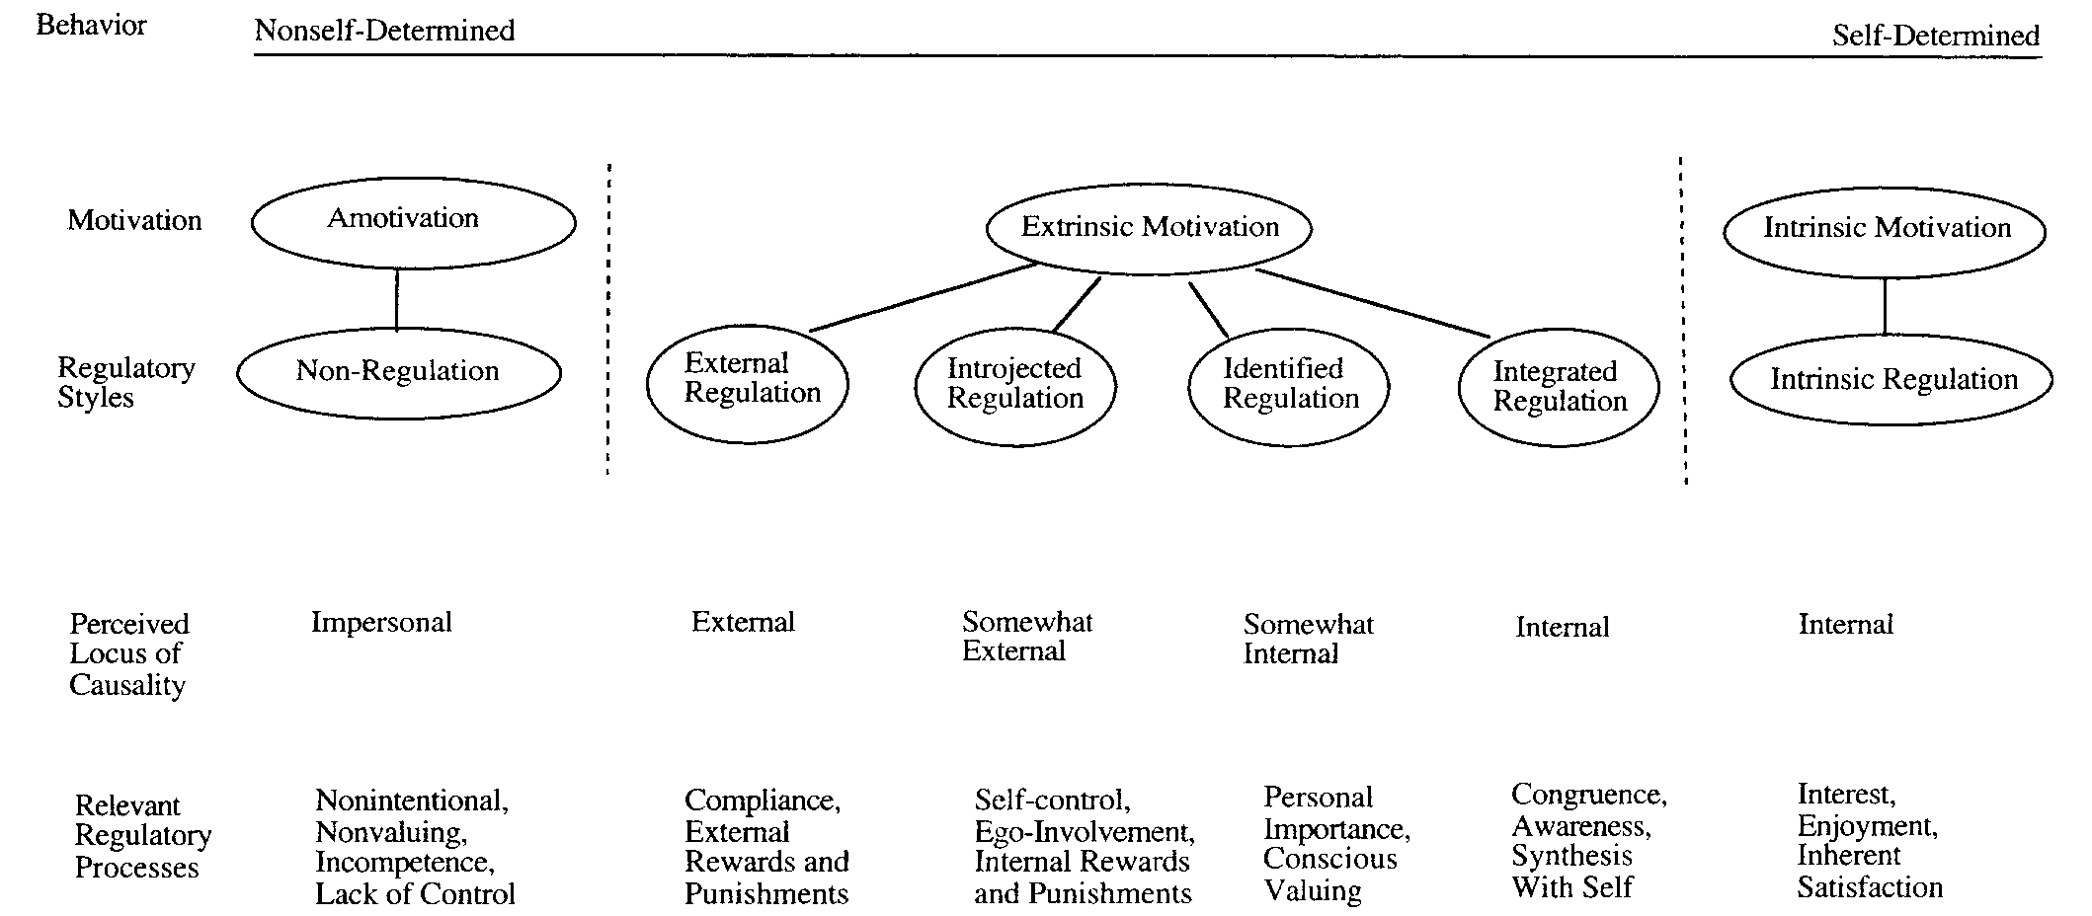
Figure 1. Self-Regulation Continuum Showing Types of Motivation With Their Regulatory Styles, Loci of Causality, and Corresponding Processes.

On the far left of Figure 1 is Amotivation. This refers to lacking an intention to act at all. Amotivation occurs when the activity is not valued, when the person does not feel competent to do the activity, or when a desired outcome is not expected (Ryan & Deci, 2000). External regulation is the least autonomous of the extrinsic motivation styles and refers to behaviors performed to meet an external demand. Introjected regulation does include the incorporation of external demands, but tasks may be completed to avoid feeling guilty or anxious for not doing the activity. As the perceived locus of causality becomes more internal, Identified Regulation occurs when the behavior is accepted as personally important to the individual. The most autonomous type of extrinsic motivation is called Integrated Regulation. This occurs “when identified regulations are fully assimilated to the self” (Ryan & Deci, 2000, p.73).
The internalization of the locus of causality and higher levels of self-determined motivation occur when the individual has higher levels of the innate psychological needs of competency, relatedness, and autonomy met. Examples of this are found in many areas of research including education, health care, parenting, and father involvement. In contrast, when these needs are thwarted, greater levels of controlled motivation or amotivation are present, which have negative effects on performance and well-being (Deci & Ryan, 2000). Thwarting these needs has led to more introjected regulations (Deci, Eghrari et al., 1994). In addition, the meeting of the innate psychological needs is related to overall well-being and life satisfaction (Deci & Ryan, 2000).
The type of motivation an individual exhibits is “highly valued because of its consequence: Motivation produces” (Ryan & Deci, 2000, p. 69). They found that people with chronic illnesses are more likely to adhere to their medication regimen when they have greater internalization (Ryan & Deci, 2000), improved glucose control among diabetic patients (Williams, Freedman, & Deci, 1998), and greater attendance and involvement in an addiction-treatment program (Ryan, Plant, & O’Malley, 1995). When people are more motivated to complete a task, they are more likely to engage in behaviors associated with that task and gain more satisfaction from doing it.
SDT and Father Involvement
Using SDT as a theoretical framework, father motivation may be related to the extent to which the three universal human needs of competence, relatedness, and autonomy are fulfilled as related to the fathering role itself. Previous studies (Bouchard et al., 2007) looked at how partner support in each of these areas impact paternal competence and eventually motivation. However, there are other variables that may provide these needs and increase motivation for the fathering role and parental satisfaction. By looking at the antecedents of father involvement mentioned above, there are areas that impact the competence, relatedness, and autonomy of fathers in the paternal role.
Competence
The competence of fathers in completing tasks related to their father role appear to be described in the parenting self-efficacy literature. The literature clearly defines an association between a sense of competence in the fathering role and increased father involvement.
Relatedness
For relatedness to the fathering role itself, the literature outlines several areas that may contribute to a sense of relatedness to the fathering role as well as interpersonal relationships affecting the fathering role. With regard to the interpersonal relationships affecting the father role, the primary variables appear to be a father’s relationship with the mother of the child and the sense of relatedness from positive effects they received from their children in being a father. The need of relatedness also applies to the father’s sense of connection with the fathering role itself. As noted previously, how a father views his role with his children predicts his level of involvement. Fathering received, as explored in the intergenerational fathering literature, appears to conclude with mixed results as some men model the fathering received and some men rework or “compensate” for the fathering they received. While this may affect men’s motivation in the fathering of their own children, this relationship is complex and is mediated by other factors.
Autonomy
According to SDT, one of the basic psychological needs for all human beings to have internalized external regulation or intrinsic motivation is a sense that their behavior is self-determined (Ryan & Deci, 2000). This requires either contextual supports for autonomy or inner resources within the person. With regard to the fathering role, there are a number of variables related to the contextual support for autonomy, including maternal gatekeeping, work and family conflict, and financial stress. Each of these areas appears to affect a father’s ability to be self-determined in his role as a father as they limit or encourage his ability to be as involved with his children as he really wants to be. Other factors may contribute to levels of autonomy, such as psychological factors of fathers and characteristics of the child; however, they were not included in this study because of the number of variables already included and the desire to focus on the role of financial stress and work and family conflict.
Statement of Problem
Research in the area of father involvement has increased significantly over the past few decades, in part, because of the changing societal expectations for fathers in their parenting role. While there is extensive research about the impact fathers have on their children and the importance of fathers in their children’s development, there are broad conclusions made about what factors contribute to father involvement. Qualitative studies have shown that most men want to be involved with their children, but they cannot always follow through with these desires due to other variables limiting their access to their child, such as maternal gatekeeping and conflict with work demands. Research has started to expand how father involvement is defined by making it more comprehensive and including direct and indirect care of the child (Pleck, 2012), however, much of the research in the area of father involvement has concluded with mixed results and often makes assumptions about what motivates fathers to be involved with their children based on viewing how demographic variables are correlated with perceived father involvement.
Self-Determination Theory provides a conceptual framework to view motivation for father involvement in a more comprehensive way by assessing how many of the previously researched factors (e.g. marital satisfaction, characteristics of the child, parenting self-efficacy, etc.) contribute to the innate needs a father must have to feel motivated in his paternal role with his children. SDT adds to the father involvement research by expanding the areas, both direct and indirect, which may contribute to how a father is motivated to do specific parenting tasks. In addition, many studies look at father involvement as one global concept without looking at how father involvement differs across specific tasks and domains. Perhaps fathers could be differentially motivated to be involved in some parenting tasks when compared to others.
While past studies have examined SDT and its effect on father motivation (Bouchard, 2000; Bouchard et al., 2007), this present study seeks to extend the current research by expanding the variables that may contribute to motivation for fathers to be involved with their children across specific fathering tasks, both directly and indirectly with their children. In addition to looking at spousal support in the areas of competency, relatedness, and autonomy as done in Bouchard et al. (2007), the present study will look at variables outside of the marital relationship that may contribute to each of these areas as they pertain to the fathering role. To further expand research on father motivation, the present study will also provide research in many other areas of father involvement, including maternal gatekeeping, how a father’s relationship with his child may serve as motivation in itself for fathers to be involved, and directly asking men what motivates them to do specific tasks within the fathering role.
Hypotheses, Research Question, and Analyses
The following figure displays the predicted model of relationship between the variables to be observed in the present study. As stated previously, the present study seeks to integrate and expand research in the areas of father involvement by looking at variables that contribute to different types of motivation for fathers to be involved with their children. The model shown below is related to previous models of father involvement and motivation as outlined by Bouchard et al. (2007); however, there are notable differences. First, this model expands the factors that may be related to the areas of autonomy, relatedness, and competency to also include current factors that may contribute to a father’s motivation. Second, it assesses motivation by asking men directly what motivates them to engage in fathering tasks that have also been found in expanded definitions of father involvement (Hawkins et al., 2002). Thirdly, it examines the relationship between motivation and actual involvement in fathering tasks and father satisfaction.
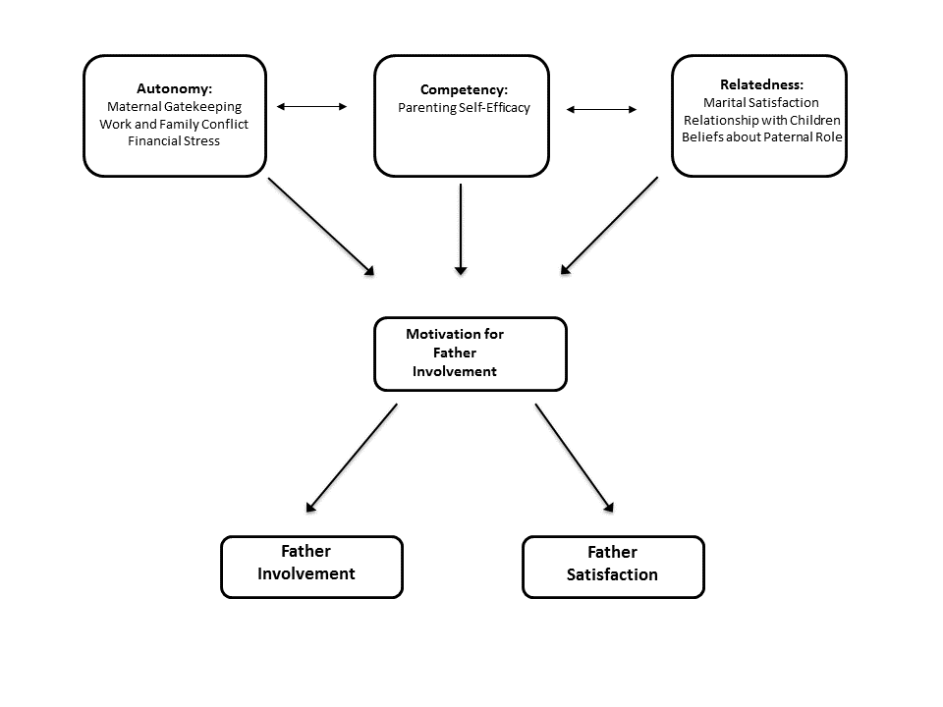
Figure 2. Path Diagram of Hypothesized Model.
Hypothesis 1 (H₁): Higher reported combined levels of competence, relatedness, and autonomy as measured in this model will be related to greater levels of internalized motivation for father involvement as measured by the Motivation for Father Involvement Scale (MFIS). Ryan and Deci (2000) found that when the need for competence, autonomy, and relatedness for specific roles or tasks are satisfied, it will lead to increased motivation for that role or task. In this study, men reporting greater overall levels in each of these areas (competence, relatedness, and autonomy) should report higher levels of internalized motivation for the fathering role.

Hypothesis 2 (H₂): Higher scores on levels of internalized extrinsic motivation on the Motivation for Father Involvement Scale (MFIS) will be related to higher scores on the Inventory of Father Involvement (IFI-26). Those reporting lower scores that reflect less internalized extrinsic motivation should report less involvement with their children. According to SDT Theory, individuals are more confident and motivated in tasks when they have more internalized motivation for that task (Deci & Ryan, 2000). In this case, men who report a greater internalized motivation specific to their role as a father will report greater involvement because their motivation is higher than those reporting lower scores on motivation. In addition, previous research has demonstrated that when men identify strongly with specific aspects of the fathering role, they are more motivated to be involved in that role. For instance, fathers who endorse a stronger identification with being a provider for their children tend to work longer hours than fathers endorsing an involved father role (Kaufman & Uhlenberg, 2000).

Research Question 1 (RQ₁): How are the needs of competence, relatedness, and autonomy specific to the father role related to each other?

Method
Participants
Participants were recruited through a variety of means including posting an electronic link to the survey on social media (i.e. Twitter, Facebook), through Parent-Teacher Association email lists, social media pages of several local elementary schools, and via email to graduate students on one campus at a Southern Plains university whose contact information was made publicly available. In addition, they were recruited through social media pages for various groups interested in men’s issues, marriage and family issues, and issues related to specific sociocultural groups. Additional participants were recruited by using snowball-sampling techniques. Each time the link was posted, participants were asked to send the survey to five fathers they knew that met the research criteria. Criteria for participation in the study required participants to be married men with at least one child in elementary school. Fathers who are single parents or are living separately from their partner or children were not included in the current study. The primary reason for excluding these fathers in the present study is due to the content of some of the measures used in the study. For instance, measures for marital satisfaction, maternal gatekeeping, and father involvement assume the participant is a married man. The items on the father involvement measure are targeted at tasks related to elementary-aged children. Participants who completed the online survey were offered the opportunity to enter a drawing to win an Amazon gift card in the amount of $50 after completion in exchange for their participation.
A total of 429 individuals responded to the recruitment message and proceeded to the Qualtrics survey. All of those individuals consented to participate. Those consenting to participate were asked a series of demographic questions to determine if they were eligible for participation in this study since many fathers agreed to participate but did not fully meet the criteria for the study. Of the 429 individuals completing the study, 57 were removed because they did not have at least one child in elementary school, 9 were removed because they did not live with their elementary-aged child, and 11 were removed because they reported they were not married. Ninety-Two (92) other participants were removed because they did not complete an adequate number of responses in the survey. The response patterns of those participants that did not answer an adequate number of responses were examined to identify any trends in those that didn’t complete the survey entirely. The majority of these participants (62%) dropped out of the survey while completing the demographics section. A higher percentage of participants with lower education levels dropped out when compared to the percentage level of those completing the survey (High school diploma or GED 13%, Vocational-Technical Training 5%, and Associates Degree 7%). No other significant patterns in responses were identified in those participants that did not answer an adequate number of responses. According to Twitter analytics, the use of Twitter was not a valuable means to encourage participation as the survey link was posted several times and roughly 1% of those that saw the tweet clicked on the link to participate in the survey. After all of these criteria were considered, 260 participants were found to meet all criteria and were used for data analysis.
Demographics. Married men who lived with at least one elementary-aged child varied in age with the majority of respondents being between 26 and 40 years old (64%) or between 41 and 55 years old (34%). Only 2% respondents reported being at least 56 years old. There were no participants younger than 26 years old. See a visual breakdown of the age of participants in Figure 3 below.
The majority of fathers participating in this study were educated with the majority reporting the completion of graduate school (43%) or an undergraduate degree (40%). The remaining participants comprised the other 17% as shown in Figure 4.

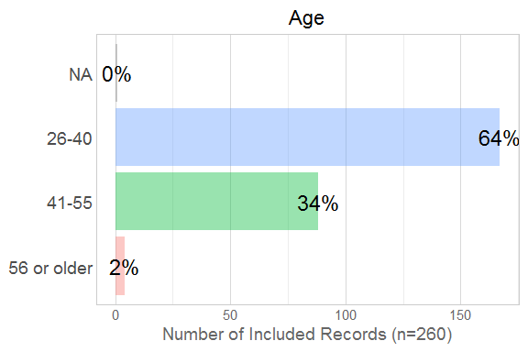

Figure 3. Participant Age.
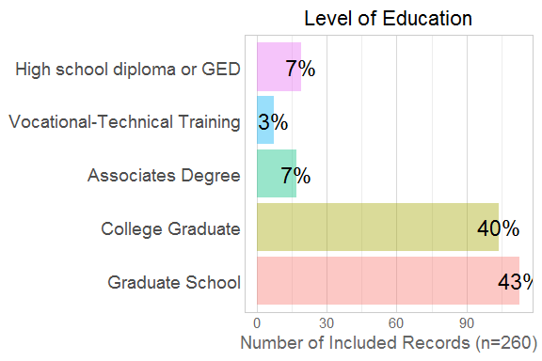

Figure 4. Participant Level of Education.
The ethnic background of the sample was predominately Caucasian (88%). Other American ethnic minority groups and individuals identifying as belonging to other groups made up the remaining 12% of the sample. A detailed description of reported participant ethnicity for can be found in Table 1.
Table 1
Ethnicity of Sample
 | Percentage of Sample
Black | 2.0
Caucasian | 88.0
Asian-American | 2.0
American Indian | 4.0
Hispanic | 2.0
Other | 3.0

Being married was required to take part in this study. The largest percentage of participants were married between 11-15 years (42%), 6-10 years (24%), and 16-20 years (21%) respectively. Only 8% were married over 20 years, 3 % were married between 1 and 5 years, and 1% were married less than a year as shown in Figure 5.
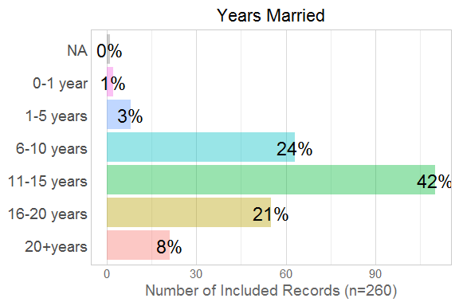
Figure 5. Participant Years Married.

One requirement of this study was that participants must had at least one elementary-aged child with whom they lived. Additional information was gathered about the total number of children living in the home (two children 48%, three children 28%, four or more children 15%, and one child 10%). Figure 6 below displays this in visual form.
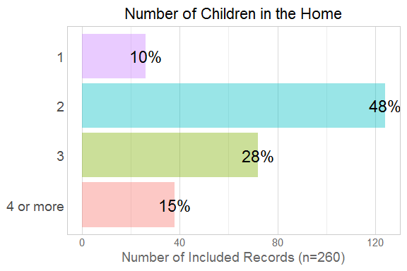
Figure 6. Number of Children Living with Participant
A specific sexual orientation was not required to this study although the vast majority of participants identified as heterosexual (99%) and the remaining 1% identified as homosexual. Religion also did not preclude any participant from this study, but the majority of participants identified as Christian (87%). See Figure 7.
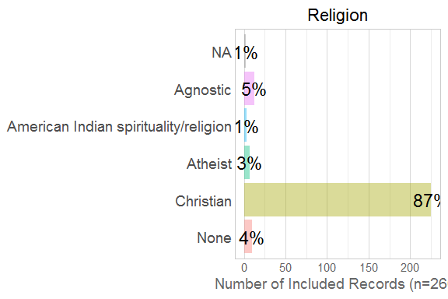
Figure 7. Participant Religious Affiliation
Fathers participating in this study responded that they were predominately upper-middle class with regard to their socio-economic status with the majority of participants reporting their household annual income as $100,000 or more (56%). A detailed breakdown of the reported household income levels is shown in Figure 8.
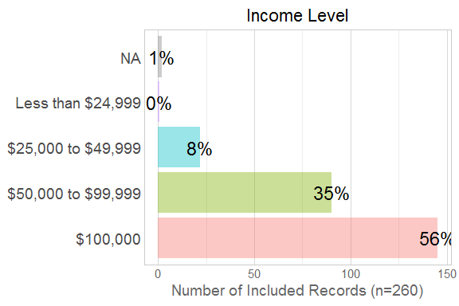

Figure 8. Participant Income Level
Participants indicated the average number of hours they worked each week with the majority of fathers indicating they worked more than 40 hours per week outside of the home (More than 40 hours 65%, 21-40 hours 28%, 1-20 hours 6%, and 0 hours 4%). In addition, participants indicated the amount of time their partner spent working outside of the home with the majority or fathers indicating their spouses did not work outside of the home (30%) or worked between 21-40 hours outside of the home (30%). A visual depiction of this information is shown in Figures 9 and 10 below.
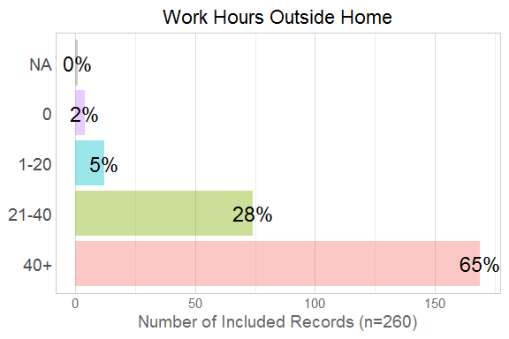
Figure 9. Participant Weekly Work Hours

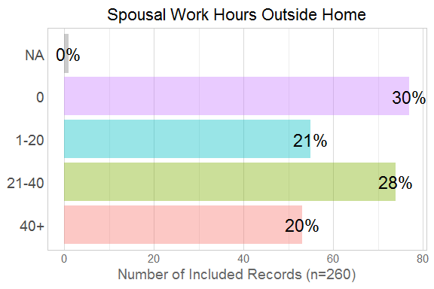
Figure 10. Spousal Weekly Outside Hours

Measures
Many of the instruments used in this study were modified, which means previous research on these instruments is not as applicable. Modifications were made in order to reduce social desirability and to make the instruments more applicable to American culture in the case of the Motivation for Father Involvement Scale (MFIS).
Competency
Fathering Self-Efficacy. The Parental Self-Agency Measure (PSAM; Dumka, Stoerzinger, Jackson, & Roosa, 1996) was used to measure fathers’ perceptions of their self-efficacy in their fathering role. This measure uses a five point Likert-type scale ranging from 1 to 5 (1 = never and 5 = always). The measure was slightly altered for this study to include a six-point Likert scale (1=never and 6=always). Example items include these: “I feel sure of myself as a father” and “I think I know things about being a father that would be helpful to other parents.” Lower scores indicate lower parental self-efficacy (Whittaker & Cowley, 2012). The PSAM has good construct reliability, which has been supported through correlations of parenting self-efficacy. In the original UK pilot sample, the reliability was acceptable (α = .76) and it was also found reliable in this sample (α=.86).
Relatedness
Kansas Marital Satisfaction Scale (KMSS). The KMSS is a three-item measure that assesses the level of satisfaction in a marital relationship (Schumm et al., 1986). A six-point Likert-type scale was used for this study (1=Extremely Dissatisfied and 6=Extremely Satisfied). Typically, this scale uses a 7-point Likert-Scale (1 = Extremely Dissatisfied and 7 = Extremely Satisfied). One of the sample items asked this question: “How satisfied are you with your marriage?” The KMSS has been shown to discriminate distressed and non-distressed couples (Calahan, 1997). The original study reported good reliability (α = .91) and found evidence for validity. The KMSS was also found reliable in this study (α=.96).
Relationship with Children. To assess the influence children have on their fathers, participants were asked two items using a Likert-type scale from 1 to 6 (1 = Disagree and 6 = Agree). Higher scores on these items reflected more positive perceived influence of children on their fathers in the fathering role. The two items included these: “I have a rewarding relationship with my children” and “Overall, I have a positive relationship with my children.” These items are designed to assess levels of relatedness between children and fathers. This measure was reliable in the present study (α=.93).
Beliefs about Paternal Role. The Role of the Father Questionnaire (ROFQ) was used to assess the extent to which the father believes his role is important to child development (Palkovitz, 1984). The ROFQ is comprised of 15 items that are scored using a Likert-type scale (ranging from a=agree strongly to e=disagree strongly). This scale was slightly altered to use a six-point Likert-type scale (1=Very Strongly Disagree and 6=Very Strongly Agree). Total scores on this measure range from 15 to 75 with higher scores reflecting attitudes that fathers should be involved with and sensitive to their children as well as believing fathers are capable of doing so. This measure has been found to have good internal consistency (Christiansen, 1997; McBride & Rane, 1997) and good construct validity (Christiansen, 1997). Sample items include these: “The most important thing a man can invest time and energy into is his family” and “A father should be as heavily involved in the care of a baby as the mother is.” This measure was reliable in the present study (α=.75).
Autonomy
Parental Regulation Inventory (PRI). To measure maternal gatekeeping, the PRI was used (Van Egeren, 2000). This is a self-report measure assessing the behaviors of spouses that encourage or inhibit father’s involvement with his children. It uses a Likert-type scale ranging from 1 to 6 (1 = Never and 6 = Several times a day). Section 1 of this measure was removed for the purposes of this study as it asks about how men perceive their own involvement. This was removed since this construct is measured elsewhere in this study. Section 2 focuses primarily on the frequency with which a spouse or partner asks fathers to be involved with child care. Section 3 asks men to rate how the spouse or partner reacts when fathers do something their partners don’t approve of with regard to child care. Other studies have found this to be reliable (Schoppe-Sullivan, 2008; Van Egeren & Hawkins, 2004). This instrument has two subscales: (1) encouragement and (2) criticism that measure the extent to which fathers perceive their spouse as encouraging their role with their children and their perceptions on the level of criticism received from their spouse in their parental role. The PRI was found reliable in the present study (α=0.91).
Work-to-Family Conflict. This construct was assessed by using the Work and Family Conflict Scale (WAFCS) developed by Haslam et al. (2015). This is a measure developed for parents of young children to assess the conflict created between their jobs and their family life. This measure is composed of ten items that measure two distinct but related subscales: family-to-work conflict and work-to-family conflict. For the purposes of this study, participants answered questions only for the work-to-family conflict scale, which reduced the measure to five questions. Participants are asked to rate their level of agreement on each item on a Likert-type scale from 1 to 7 (1 = Very strongly disagree to 7 = Very strongly agree). Items are summed on the subscale (from 7-35) to provide a total conflict score in each area. Higher scores indicate a higher level of conflict between work and family domains. For this study, a six-point Likert-type scale was used (1=Very Strongly Disagree and 6=Very Strongly Agree). An example from the WAFCS asks participants to rate their level of agreement on this statement: “My work prevents me from spending sufficient quality time with my family.” The original study used to validate this scale concluded it is internally consistent, has good construct validity, and has good concurrent and predictive validity (Haslam et al., 2015). The WAFCS was found reliable in the present study as well (α=.86).
Financial Stress. To assess levels of financial stress, the InCharge Financial Distress/Financial Well-Being Scale (Prawitz et al., 2006) was used. This is an eight-item self-report measure of financial distress and well-being. On each item, respondents rate their answers on a scale of 1 to 10 with the qualitative answers for those rankings changing to fit each question. The scale was slightly adjusted for use in this study by using a six-point Likert-type scale for each item. A total score is calculated which measures overall perceived financial distress and financial well-being. Higher scores on this measure indicate lower levels of financial stress and higher levels of financial well-being. This measure has been found to be internally consistent (α = .956) and was reliable in the present study (α=.94).
Motivation
Motivation for Father Involvement Scale (MFIS; Bouchard, 2000). The MFIS is an instrument that measures levels of different types of motivation in fathers for specific parenting tasks. This includes four sub-scales representing the different types of motivation outlined in Self-Determination Theory: external regulation, introjection, identification, and intrinsic. These four subscales are correlated with one another with adjacent subscales having higher correlations and negative correlations between as the subscales are further apart on the SDT continuum (Bouchard et al, 2007). Strong internal consistency for each subscale has been established (Bouchard, 2000; Bouchard et al., 2007). Cronbach’s alpha for each subscale in a recent study found the following: External regulation .81, Introjection .89, Identification .89, and Intrinsic .90 (Bouchard et al., 2007). In addition to the four subscales, a response for each prompt is included to assess for amotivation in each area. This response is, “I don’t do this activity.” Cronbach’s alpha for the ad hoc model used in this study found good reliability for external motivation (α=.93) and internalized motivation (α=.94).
For the purposes of this study, this instrument was modified to reflect the first-order factors found in the Inventory of Father Involvement (Hawkins et al., 2002) as it provides a more comprehensive outline of both direct and indirect fathering tasks. The scale has been adapted to uses a 6 point Likert-type scale (1 = Very Strongly Disagree and 6 = Very Strongly Agree). Sample fathering tasks include these: “Why do you support your child’s mother?” and “Why do you provide for your children?” To determine the level of internalized motivation for father involvement scales, scores from each subscale were weighed according to their position on the self-determination continuum just as a previous study by Bouchard et al. (2007) did. Subscales that had an internalized locus of causality on the self-regulation continuum, such as intrinsic motivation and identified regulation, were assigned weights of +2 and +1 respectively. Subscales with an external locus of causality, such as external regulation and introjected regulation were assigned weights of -2 and -1 respectively. A latent construct representing the level of internalized motivation for father involvement was contrived after computing the items within each subscale. Positive coefficients indicated more internalized motivation whereas negative coefficients from this scale indicated more externalized motivation.
Father Involvement
Inventory of Father Involvement (IFI-26). The IFI is a self-report measure developed by Hawkins et al. (2002) in response to the need to develop a broader construct of father involvement and to look at both direct and indirect aspects of involvement across cognitive and affective domains. This instrument is a 26-item measure that uses a Likert-type scale (ranging from 1=very dissatisfied to 6 = very satisfied) that asks fathers how effective they think they are across a number of domains. In the original study (Hawkins et al, 2002), nine first-order factors were found, which include the following: Discipline and Teaching Responsibility (α = .85), School Encouragement (α = .82), Giving Support to the Mother (α = .87), Providing (α = .69), Time and Talking Together (α = .80), Giving Praise and Affection (α = .79), Developing Talents and Future Concerns (α = .75), Reading and Homework Support (α = .83), and Attentiveness (α = .69). Higher scores indicate greater perceived involvement in these areas. In addition, the original study found a single global factor of father involvement that includes each of these areas. Sample items from this instrument include “attending events your children participate in,” “providing your children’s basic needs,” “praising your children for being good or doing the right thing,” and “encouraging your children for something they have well.”
Face and construct validity were found in the original study although the dimension measuring School Encouragement had poor construct validity (Hawkins et al., 2002). The present study found the IFI-26 to be reliable (α=.95). For the purposes of this study, the Likert-type scale was slightly adjusted to ask fathers to what extent they agree with their motivations to do the fathering tasks instead of how satisfied they perceived themselves. The focus of this study is on perceptions of involvement instead of “how good of a job” fathers believe they are doing. The items were changed into statements instead of questions in order to reduce social desirability.
Father Satisfaction. The Kansas Parental Satisfaction Scale (KPS) was be used to measure how satisfied a father is in his parenting role. The KPS is a three-item measure that uses a Likert-type scale measure (ranging from 1= Extremely Dissatisfied to 7=Extremely Satisfied) that asks fathers how satisfied they are with their children’s behavior, with themselves as a parent, and how satisfied they are in their relationship with their children. For this study, a six-point Likert-type scale was used. The KPS has been found to have good reliability and validity (James, Schumm, Kennedy, Grisby, & Shectman, 1985; Watkins, Farrell, Suvak, Murphy, & Taft, 2009) and was reliable in this study (α =.80).

Results
Descriptive Analyses
Means, standard deviations, and bivariate correlations for all variables in this study are reported in Table 2.
Table 2
Descriptive Statistics and Correlations
Variable | 1 | 2 | 3 | 4 | 5 | 6 | 7
1. Autonomy | -
2. Competence | .35** | - | .
3. Relatedness | .40** | .52** | -
4. Internal Motivation | .24** | .52** | .62** | -
5. External Motivation | .052 | .19** | .13* | .25** | -
6. Father Involvement | .25** | .47** | .58** | .73** | .28** | -
7. Parental Satisfaction | .31** | .60** | .51** | .46** | .15* | .48** | -
Means | 3.67 | 4.89 | 4.81 | 5.24 | 4.29 | 5.41 | 4.86
SD | 0.352 | 0.60 | 0.474 | 0.574 | 0.787 | 0.50 | 0.61
Skew | -.398 | -.654 | -.287 | -.659 | -.298 | -1.11 | -.806
Kurtosis | .262 | 1.66 | -.361 | -0.331 | .756 | 1.049 | 2.97
*Correlation is significant at the .05 level (2-tailed).
** Correlation is significant at the .01 level (2-tailed).

The bivariate correlational data yielded several significant positive relationships among the variables within the study. Relatedness was related to internal motivation (r=.62), external motivation (r=.19), father involvement (r-.58) and parental satisfaction (r=.51). Relatedness showed a moderately strong positive relationship with internal motivation, father involvement, and parental satisfaction. Competence also revealed positive correlations among all variables and they were statistically significant. Competence and internal motivation represented a moderately strong relationship (r=.52, p<.01) and a moderately strong relationship with parental satisfaction (r=.60, p<.01). Internal motivation was positively related with father involved (r=.73, p<.01) and with parental satisfaction (r=.46, p<.01). The only relationship among the variables in this study that was not statistically significant was between autonomy and external motivation (r=.052, p=.40).
In addition, the data were checked for multicollinearity. According to Mertler and Vanatta (2005), multicollinearity is reflected in correlations of .80 or higher. An examination of the correlation matrix reveals multicollinearity is not a concern as the predictor variables where al under .55. Almost all of the skew values were within an acceptable range (between -1 and 1). One exception was father involvement (skew = -1.11), which displayed a noticeable ceiling effect; the median score was a 5.5. on a scale of 1 to 6. Kurtosis indicates the peak of a distribution. Positive kurtosis indicates a pointed and heavy-tailed distribution and negative kurtosis indicates a flat and light tailed distribution. Kurtosis should fall between a range of -2 and +2 in a normal distribution (Tabachnick and Fidell, 1996). The kurtosis scores all fall within this range, with the exception of parental satisfaction (2.97).
The items comprising each of the predictor variables (autonomy, competence, and relatedness) were compared to each other within each of these constructs to assess to what extent they were correlated with one another. This study made the assumption the items within each predictor variable represented a single factor, and correlation analysis was used to test the relatedness of these items within each variable. Each of the predictor variables showed adequate reliability and were highly correlated. The items comprising Autonomy, Competence, and Relatedness constructs had Cronbach’s alphas of .88, .84, and .82 respectively. These results suggest the items comprising each predictor variable were highly related to the other items within the construct.
Hypothesis 1: Proposed Model Testing. Path analysis was performed to assess the predictive value of autonomy, competence, and relatedness on internalized motivation. It was hypothesized that greater levels of autonomy, competence, and relatedness would be related to greater levels of internalized motivation for father involvement as measured by the Motivation for Father Involvement Scale (MFIS). To examine the overall fit of the proposed model, motivation was weighted to determine the level that motivation was internalized by each participant (as described in Measures section).
The model was estimated by consulting the following fit indices: Comparative Fit Index (CFI), Non-Normed Fit Index (NNFI), Standardized Root Mean Square (SRMR), and the Root Mean Square Error of Approximation (RMSEA), along with its 90% confidence interval. “CFI and NNFI values around.95 or greater, SRMR values less than .08, and RMSEA values at or less than .05 are considered indicative of close fit (Byrne, 2005). According to Kline (2005), SRMR less than .10 and RMSEA values up to .08 can be considered favorable.
The fit of the hypothesized model was poor (X² (6, N = 260) = 291.32, p<.001; CFI = .337, AIC = 2116, NNFI = -.326, SRMR = .234) given the parameters outlined by Hu and Bentler (1999). The RMSEA value was .344 (90% CI = .303 < .344 < .387).
Table 3 shows the standardized regression weights for path analysis in the proposed model.

Table 3
Regression Weights for Path Analysis of Hypothesized Model
 |  | β | SE | Z | p
Motivation:
 | Autonomy | 0.008 | 0.066 | 0.116 | .907
 | Competence | 0.028 | 0.071 | 0.393 | .694
 | Relatedness | 0.252 | 0.070 | 3.602 | .000
Involvement:
 | Motivation | 0.178 | 0.060 | 2.965 | .003
Satisfaction:
 | Motivation | 0.168 | 0.060 | 2.792 | 0.005

The relationship between Relatedness and Motivation was statistically significant and correlated indicating a significant predictive relationship (β=0.252, p,.001). The relationship between Autonomy (β=0.008, p=.907) and Competence (β=0.028, p=.694) and Involvement was not statistically significant. Involvement and Motivation had a significant relationship (β=0.178, p=.003) as did the relationship between Motivation and Satisfaction (β=0.168, p=.005). Given these results, the first hypothesis was not supported. Figure 11 displays the hypothesized model with the standardized coefficients displayed between variables.
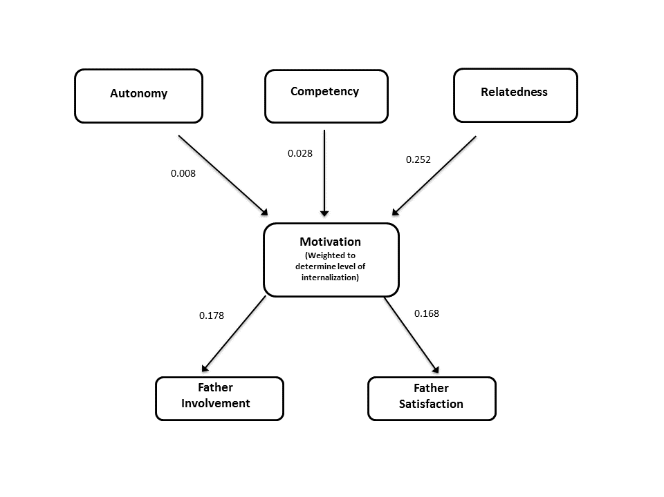
Figure 11. Path Diagram of Hypothesized Model
Model 2. Ad hoc model modifications were performed in an attempt to develop a better fitting model. The motivation variable was changed to be a single motivation construct measuring overall level of motivation without considering whether the motivation was internally or externally regulated. The fit of the model was poor (X² (6 N = 260) = 394, p<.001; CFI = .639, AIC = 2273, NNFI=.278, SRMR = .167.). The RMSEA value was .297 (90% CI = .256 < .297 < .340). Table 4 shows the standardized regression weights for path analysis in the proposed model with motivation as a single construct, and Figure 12 shows the standardized regression weights for the revised model.

Table 4
Standardized Regression Weights of Model with Global Motivation Score.
 |  | β | SE | Z-value | p
Motivation:
 | Autonomy | -0.053 | 0.060 | -0.881 | .378
 | Competence | 0.267 | 0.062 | 4.279 | .000
 | Relatedness | 0.308 | 0.063 | 4.898 | .000
Involvement:
 | Motivation | 0.592 | 0.040 | 14.741 | .000
Satisfaction:
 | Motivation | 0.352 | 0.054 | 6.489 | .000

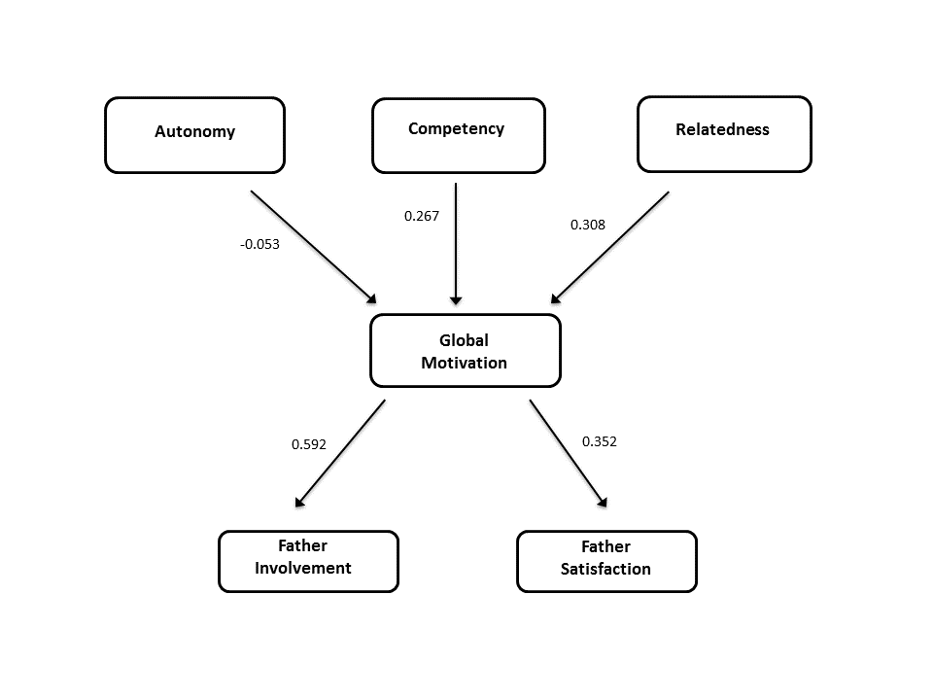
Figure 12. Path Diagram of Ad Hoc Model With Motivation Construct Not Including Internalization of Motivation.

Model 3. Further ad hoc model modifications were performed in an attempt to develop a better fitting and more parsimonious model. Duncan (1975) suggested refining the overall model to produce a better fitting model and other studies on father involvement have used this method of model refinement (Fagan & Barnett, 2003). Specifically, changes were made to the model based on Self-Determination Theory (SDT) to distinguish between internalized and externalized motivation. Changes were made as they were more theoretically consistent with SDT and did not change the general approach behind the proposed model. In the updated model, the motivation variable was separated into internal and external motivation, based on the locus of causality as outlined in SDT. Items from the Motivation for Father Involvement Scale (MFIS) that represented internalized motivation were grouped together. This includes the items assessing intrinsic motivation and identified regulation. The External Motivation variable was comprised of items assessing extrinsic motivation and introjected regulation. These groups have a theoretical basis in SDT based on the locus of causality for motivation.
This revised model provided a better fit than the previous models Χ² (6, N = 260) = 536.28, p<.001; CFI = .838, AIC = 2372, NNFI = .515, SRMR = .095. The RMSEA value was 0.232 (90% CI = .191 < .232 < .275). The CFI and AIC indicated a better fit for the revised model. The pathways between the predictor variables and internal motivation were significant at the .05 level with the exception of autonomy. The pathways between autonomy and relatedness and external motivation were not found to be significant at the .05 level. These comparisons are all shown in Table 5, below.

Table 5
Standardized Regression Weights of Modified Model Including Internal and External Motivation as Separate Constructs
 |  | β | SE | z | p
Internal Motivation:
 | Autonomy | -0.058 | 0.052 | -1.128 | .259
 | Competence | 0.279 | 0.053 | 5.233 | .000
 | Relatedness | 0.497 | 0.050 | 9.935 | .000
External Motivation:
 | Autonomy | -0.031 | 0.068 | -0.454 | .650
 | Competence | 0.164 | 0.071 | 2.298 | .022
 | Relatedness | 0.062 | 0.074 | 0.844 | .399
Involvement:
 | Internal Motivation | 0.699 | 0.032 | 21.997 | .000
 | External Motivation | 0.111 | 0.043 | 2.541 | .011
Satisfaction:
 | Internal Motivation | 0.456 | 0.050 | 9.033 | .000
 | External Motivation | 0.033 | 0.057 | 0.576 | .564

Predictive relationships exist between many of the variables with internal motivation. Figure 13 displays the revised model with the standardized regression coefficient displayed between variables.

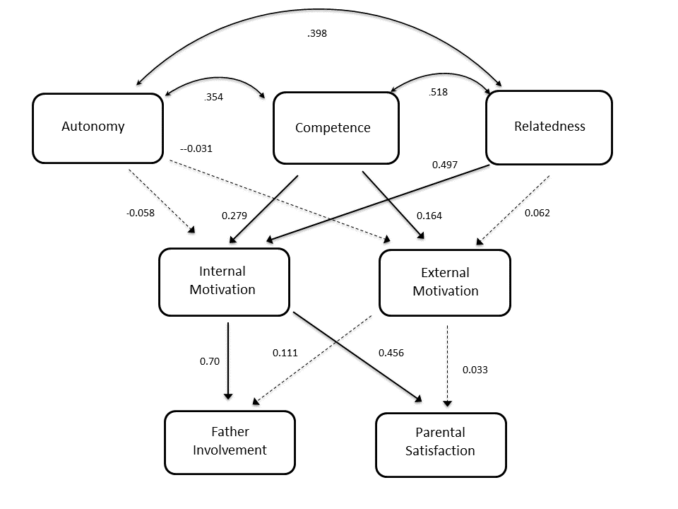
Figure 13. Path Diagram for Ad Hoc Model with Internal and External Motivation Separated
Model 3 provided partial support for the first hypothesis given the following results. Since the relationship between relatedness and internal motivation was statistically significant and correlated indicating a significant predictive relationship (β=0.497, p=.000) whereas the relationship between relatedness and external motivation was not statistically significant (p=.399) and represents a much weaker relationship (β=.062). Competence had a statistically significant relationship with both internal and external motivation and had predictive value that was similar for each with β=0.279 for internal motivation and β=0.164 for external motivation. Autonomy did not have a statistically significant relationship with either internal or external motivation and was not predictive of scores on either variable.
Model 4. Further modifcations were made to the model to account for partial mediation of the motivation construct instead of a full mediation model. The fit of this model was better than the other models Χ² (1, N = 260) = 36.279, p<.05; CFI = .985, AIC = 2302, NNFI = .730, SRMR = 0.029. The RMSEA value was 0.173 (90% CI = .082 < .173 < 0.286). Standardized path coefficients for this model are provided in Figure 14. Several paths in this model were not statistically significant (i.e., the path from autonomy to motivation, involvement, and satisfaction, the path from competency to involvement, the path from relatedness and external motivation, and the path from external motivation to satisfaction.
This model was respecified in order to find a better fitting model that was more parsimonius. This model was better than any of the other models, but still failed to reach conventional levels of acceptability. Table 6 shows the standardized regression weights for path analysis in the proposed model with motivation as a single construct, and Figure 14 shows the standardized regression weights for the revised model.
Table 6
Standardized Regression Weights for Path Analysis of Modified Model Showing Partial Mediation
 |  | β | SE | z | p
Internal Motivation:
 | Autonomy | -0.058 | 0.052 | -1.128 | .259
 | Competence | 0.279 | 0.053 | 5.233 | .000
 | Relatedness | 0.497 | 0.050 | 9.935 | .000
External Motivation:
 | Autonomy | -0.031 | 0.068 | -0.454 | .650
 | Competence | 0.164 | 0.071 | 2.298 | .022
 | Relatedness | 0.062 | 0.074 | 0.844 | .399
Involvement:
 | Autonomy | 0.019 | 0.045 | 0.422 | .673
 | Competence | 0.070 | 0.055 | 1.362 | .173
 | Relatedness | 0.195 | 0.056 | 3.484 | .000
 | Internal Motivation | 0.699 | 0.032 | 21.997 | .000
 | External Motivation | 0.111 | 0.043 | 2.541 | .011
Satisfaction:
 | Autonomy | 0.049 | 0.052 | 0.941 | .347
 | Competence | 0.417 | 0.055 | 7.572 | .000
 | Relatedness | 0.207 | 0.064 | 3.219 | .001
 | Internal Motivation | 0.456 | 0.050 | 9.033 | .000
 | External Motivation | 0.033 | 0.057 | 0.576 | .564

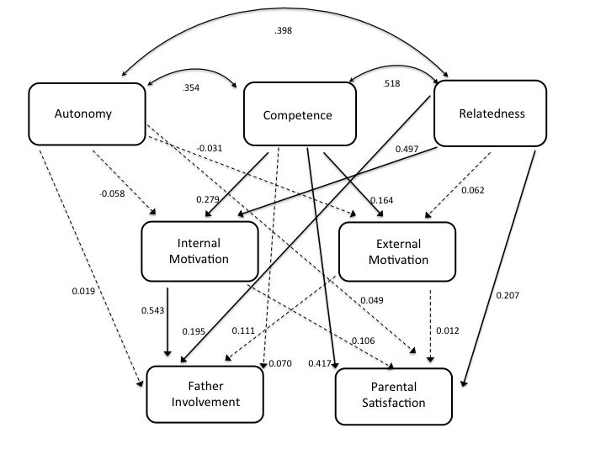
Figure 14. Path Diagram for Partial Mediation Model.
Research Question 1: Relationship Between Predictor Variables. The predictor variables of autonomy, competence, and relatedness were compared to each other. Each pair showed a positive correlation. Autonomy and competence (r=.35), relatedness and autonomy (r=.40), and competency and relatedness (r=.52) all appeared related to each other. Figure 15 displays these relationships as well as the relationships between the predictor variables and the criterion variables of internal and external motivation.

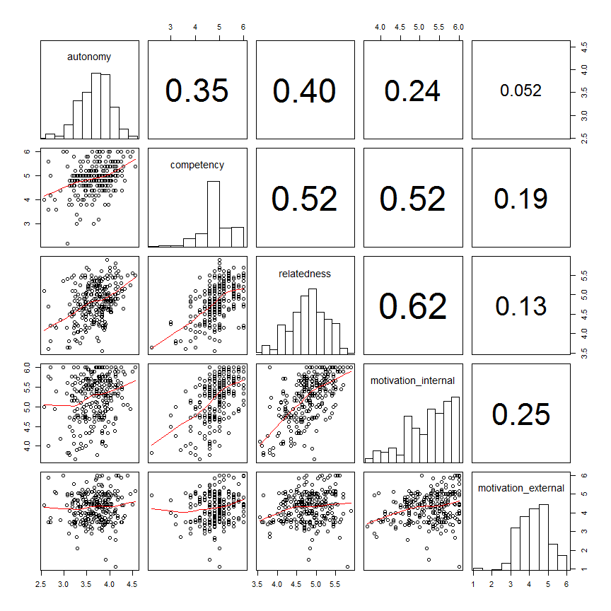
Figure 15. Scatter plots are in the lower triangle, histograms are in the diagonal, and Pearson bivariate correlations are in the upper triangle.

Hypothesis 2: Internalized Motivation Predicting Involvement. It was hypothesized that higher scores on internalized motivation as measured by the MFIS would be related to higher scores on the Inventory of Father Involvement (IFI-26). The path analysis of Model 3 was performed to assess the predictive relationships between internalized motivation and perceived father involvement and the results support the second hypothesis. The relationship between internalized motivation and father involvement was strong (β=0.70, p<.001). External Motivation was a weaker, but still significant predictive relationship with involvement (β=0.111, p=.011). Internal motivation also had a predictive relationship with parental satisfaction (β=0.456, p=.000) whereas external motivation did not (β=0.033, p=.564). Figures 13 and 14 display the standardized regression coefficients in the path diagram, and Figure 16 shows a scatterplot of these variables and their correlations.

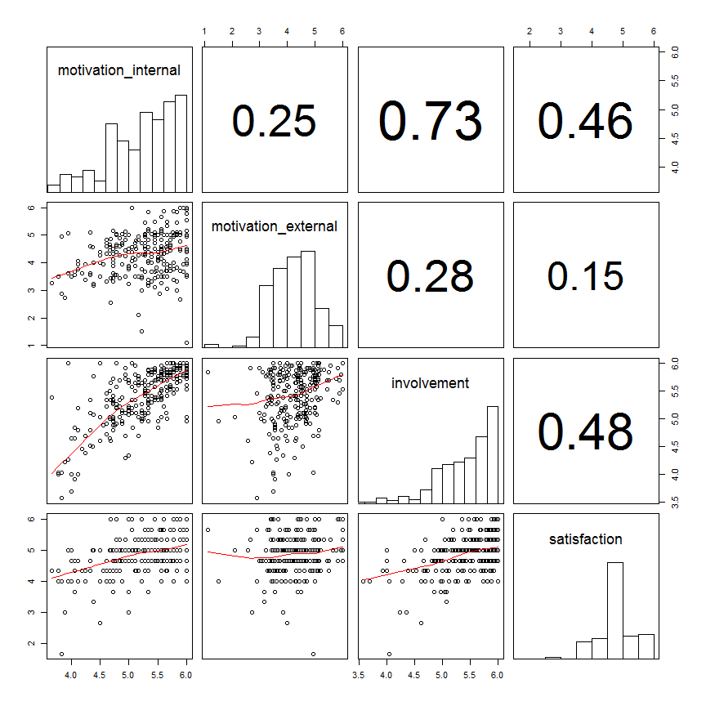

Figure 16. Relationships Between Internal Motivation, External Motivation, Involvement, and Satisfaction.

Discussion
The Proposed Model
The first goal of the present study was to expand the model presented by Bouchard et al. (2007) by assessing how the areas of competency, relatedness, and autonomy predict motivation for father involvement when other contributing factors to these areas are considered. In addition, the model proposed that higher levels of internalized motivation would significantly predict perceived father involvement and parental satisfaction. Results from the hypothesized model showed a poor fit for the model. Relatedness was significantly related to Motivation whereas Autonomy and Competency were not. Adjustments made to the Motivation for Father Involvement Scale (MFIS) affected the ability of the instrument to truly capture external motivation. To assess external motivation, participants were asked to answer why they did certain fathering tasks by answering to what extent they agree or disagree with the statement “Because that is what a father is supposed to do.” In the original study (Bouchard et al., 2007), this item was assessed with the statement “Because I feel forced to.” The latter represents a stronger representation of external motivation whereas the item in this study lends itself to social desirability for those participants that identify with the father role.
Model 2. This model did not differentiate between internal and external motivation but used motivation as a single construct. Results from the preliminary model do support some of the general findings in SDT that higher scores on competency and relatedness are predictive of overall motivation, with relatedness and competency being a moderately strong predictor of overall motivation for father involvement (Relatedness β=.705; Competence β=.483). Autonomy did not appear to be related to overall father motivation. These findings partially support Self-Determination Theory’s conclusions that higher levels of Competency, Relatedness, and Autonomy for a specific role or tasks leads to increased motivation for that task.
This revised model also partially supported the notion that higher levels of motivation, regardless of the locus of causality, are predictive of perceived father involvement and parental satisfaction although those relationships appear to be small.
Model 3. This ad hoc model was developed to distinguish between internalized and externalized motivation. This model (shown in Figure 13) partially supported the hypotheses in this study as evidenced by the predictive relationships between internalized motivation and father involvement and parental satisfaction.
One of the threats to the proposed model occurred with the lack of significant main effects for predictive relationships between autonomy, as measured in this study, with motivation for father involvement (both internal and external). This may have been due to the participants represented in this sample as they were highly educated and reported high incomes. The autonomy construct looked at financial stress and work and family conflict in addition to maternal gatekeeping. Perhaps these areas weren’t significant because the current sample reported lower levels of financial stress and work and family conflict than a less educated sample might.
Path analysis supported this ad hoc model in a variety of ways as predictive pathways were found between variables. Notably, the areas of competency and relatedness provided predictive pathways with internal motivation for father involvement. Furthermore, internal motivation provided moderate predictive pathways with father involvement and parental satisfaction.
Given this ad hoc model, the first and second hypotheses were partially supported. Results from this path model demonstrated that higher scores on the innate psychological needs, with the exception of autonomy, are predictive of higher scores on internalized motivation for father involvement. In addition, higher scores on internalized motivation for father involvement were predictive of both perceived father involvement and parental satisfaction.
Model 4. This model was designed to test for partial mediation instead of full mediation as the previous models had. Results indicated that motivation accounted for some, but not all, of the relationship between autonomy, competence, and relatedness and father involvement. The relationship between relatedness and father involvement was expanded when considering the strong relationship between internal motivation and father involvement. Relatedness appeared to have a direct effect on parental satisfaction, with internal motivation revealing a relationship that was not significant with parental satisfaction. These findings reiterate the findings of the previous models and suggests the relationships fathers have with the child’s mother, their children, and to the fathering role itself are most predictive of involvement.
Additional Research Questions
Results of analyses conducted to assess the relationships between predictor variables regarding the extent to which the measures comprising the three psychological needs (competence, relatedness, and autonomy) modeled these concepts suggest the items are positively related. This fits with Self-Determination Theory (SDT) as the innate psychological needs are related but different needs. Deci & Ryan (2000) suggested feelings of competence, unless enhanced by autonomy and relatedness, will not lead to intrinsic motivation.
Results of analyses conducted to assess Research Question 1 regarding the extent to which the measures compromising each of the variables representing three innate psychological needs (competence, relatedness, and autonomy) are related suggest they are correlated with small to medium effect sizes. While the weakest of these relationships was found between autonomy and competency, the most significant relationship was found between competency and relatedness. These findings support SDT.
These results support the tenets of Self-Determination Theory (SDT) in several ways. Ryan and Deci (2000) suggested when people are intrinsically motivated or have greater levels of internalized motivation, they tend to have more interest and confidence in tasks, which lead to better performance. In other words, “motivation produces.” In addition, SDT expands on a singular view of motivation. Results from this study suggest there is a clear difference between motivation that is internally-driven versus externally-driven.
When considering the hypothesized model and the three ad hoc models, it is clear that relatedness is the most predictive of motivation for father involvement. This implies the stronger the relationship a father has with his partner, his child, and to the father role itself may be predictive of how motivated he feels to be involved with his child(ren).
Path analysis also suggested that increased internalized motivation is predictive of perceived father involvement and parental satisfaction whereas external motivation shares a much weaker relationship. This may, in part, be attributed to the current sample as they were highly educated, fairly wealthy men. Blair et al. (1994) found that paternal incomes was associated with increased father involvement and more positive parent-child interactions. A sample of fathers reporting lower socioeconomic status may find a predictive relationship between external motivation and involvement. These findings do support the findings of previous SDT research as increased internalized motivation is predictive of father involvement. When fathers internalize the importance of the fathering role, they are more likely to be involved. Previous studies have also made this determination that fathers’ beliefs about their parenting role is a significant predictor of their actual engagement (Bonney, Kelley, & Levant, 1999; Schoppe-Sullivan et al., 2008).
Limitations
This study has several limitations with regard to the methodology and generalizability of the findings that should be noted. The study used an electronic survey that was comprised entirely of self-report measures. This did not allow for any direct observations of fathers and their involvement with their children nor did it ask their partners or children for more objective information regarding their involvement. This lends itself to a social desirability bias as men agreeing to take a survey on father involvement are likely to report themselves as an involved parent regardless of the fact the study was anonymous and confidential. It also fails to assess what involvement means and which aspects are important to the child and mother instead of the father.
In addition, the survey was 162 questions long after the demographics information and study instruments were considered. This took participants approximately 15 minutes to complete. These factors led to a considerable elimination rate when you consider 429 participants gave their electronic consent to take the survey, but only 260 participants were used in the final analysis after eliminating those that did not complete 85% of the items for each construct and eliminating those that did not meet the criteria for the study.
Another methodological limitation is in regard to the assumption that the measures comprising the constructs of autonomy, competence, and relatedness actually reflected those constructs. Further analysis is needed to assess whether this is actually the case. Latent variable analysis would assist in determining how well these measures reflect the constructs outlined in this study.
Other instruments used in this study implied participants were in traditional heterosexual marriages. For example, the Inventory of Father Involvement (IFI-26) includes the item “I let my children know that their mother is an important and special person” and asks participants the extent to which they agree or disagree with this statement. This statement would not apply to those in homosexual relationships or those fathers that have remarried after divorce.
Another limitation to the methodology was the inability to capture valuable information about amotivation. This was an aspect outlined in Self-Determination Theory as those that are not motivated in any form to do the tasks. By sending out surveys and asking for men to report on their involvement, it is likely only those fathers that are involved and want to answer questions about it would complete the survey. Fathers that are amotivated for involvement are more likely to be those that would not voluntarily complete a survey on father involvement.
There were several variables that may be related to father motivation that were not explored in this study, namely, psychological factors of the father and characteristics of the child. These are areas noted earlier in the study that do play a role in a father’s ability to be involved with his child(ren). For example, paternal depression may lead to lower involvement because of its effects on marital conflict (Cummings & Davis, 1994) and its overall effect on parenting quality (Hipke, 2002).
In addition to methodological issues, there are also limitations in the generalizability of the findings. First, the participants in this study were primarily Caucasian (87%), heterosexual (99%), and reported higher socioeconomic status. There were a minimal number of participants found in this study from lower socioeconomic status or minority ethnic groups. As a result, these findings should not be generalized to those groups. Bouchard et al. (2007) also reported a sample of fathers with an above average income and who were highly educated. Those in lower socioeconomic status remain under-researched and are most at-risk to be uninvolved fathers. Autonomy in this study may not have been as related to father motivation because the vast majority of participants were married white men who have high-paying jobs. Fathers that live in poverty may be less available as their work schedules, financial stress, and available time may impact their availability to be autonomous in their involvement with their children. This is also of interest to policy makers, researchers, and those in charge of public programs who care about inequality and the family (Carlson & Mclanahan, 2010).
Another limitation of having a convenient sample is it does not address the complexities of fatherhood, child relationships, and diverse families that are found in the general population. For instance, there are many types of fathers that were not included in this study, such as divorced fathers, fathers not cohabitating with their children, and fathers that lived with their children and partners that were not married. In addition, this study does not address or acknowledge those family members that may serve a fatherly role when a father is not present. For example, there are many families that have other family members or mentors that are involved in a child’s life that are valuable and important. Many grandfathers, uncles, and other family members serve a fatherly role for a child.
Potential Implications for Clinical Practice. There are several findings from this study that are noteworthy for clinical practice for counseling and social programs. To encourage more father involvement with children, other familial relationships and factors must be considered. Given the strong predictive relationship between relatedness and internalized motivation, clinicians should focus on working with clients to improve the relationships in other aspects of the family. This includes focusing on the marital/partner relationship in addition to the father-child relationship. Results from this study indicate there is a strong connection between those reporting satisfaction in their marriage with those that are motivated internally to be involved with their children. Social programs to increase father involvement should focus on improving the family and parental relationship, not just encouraging fathers to be involved in a vacuum without considering these relationships. Social initiatives like this can be seen in social programs like the Oklahoma Marriage Initiative, which was designed to strengthen marriages in order to strengthen the family and to increase father involvement (Dion, Avellar, Zaveri, Strong, Hershey, Silman, & Santos, 2008). Many European countries have placed emphasis on father involvement by introducing paternity leave so men can be involved with their partner and child directly after childbirth (Cabrera, 2012).
Exploring how men view their fatherly role within their family appears to be predictive of internalized motivation for fathering tasks. Perhaps programs could be developed to assist men and their families in the exploration of roles once they have a child, similar to the way couples go through pre-marital counseling prior to marriage. By exploring expectations for the father role, it would allow the father to explore what his role will be once the child arrives and to feel more confident in his ability to enact that role. These are both areas that appear to be predictive of internal motivation and eventual involvement with the child(ren).
Although it was not directly assessed in this study, father involvement should also be viewed from a family systems perspective as reciprocal relationships theoretically exist between motivation, involvement, and parental satisfaction. Just as internalized motivation in this study was predictive of perceived involvement and parental satisfaction, the reverse is true as well with these variables as well as other variables in the study. For instance, the more involved a father is in his child’s life and the more satisfied he is in his role as a parent surely increase his satisfaction with his child(ren) and partner. It also would theoretically increase his competency to complete tasks related to fathering and energize a cycle of being a motivated and involved parent. Considering these reciprocal relationships, fathers should be encouraged to be involved with their children doing fathering tasks as it will likely improve other areas of his life.
There are many factors that contribute to a father’s ability to be involved with his child(ren), such as time available, proximity to children, and financial resources. Fathers should be encouraged to be involved in ways they can, given those limitations. As Palkovitz (1997) outlined, father involvement is a multi-faceted construct that no one measure can truly assess. Fathers that do not live with their children can still be involved, just like those whose time is limited (Amato & Dorius, 2012). Fathers can be involved both directly and indirectly with their children, and each is needed at different times during the child’s development and circumstances within the family (Pleck, 2012).
This study suggests fathers should also be included in child and family therapy. Given the importance of the relationship of the father-child relationship on fathers’ motivation for involvement, fathers should be encouraged to be involved in their child’s therapy as it will indicate to their children they want to be involved and will likely improve their relational satisfaction. Having fathers more involved in their child’s therapy will improve other parts of the family system. It has been shown to be effective in addressing interparental conflict, coparenting issues, and marital issues that are related to child functioning (Duhig, Phares, & Birkeland, 2002). Fathers are often encouraged to participate in family therapy to benefit their children, but this study suggests fathers should be also encouraged to participate to feel more satisfied in their parenting role. Carr (1998) suggested fathers should be provided with a rationale for their involvement in therapy that emphasizes what they might gain from participation. Many therapists often assume fathers are more resistant to involvement in therapy without verifying with the fathers themselves (Hecker, 1991). Practically, fathers should be encouraged to attend the initial session with the child and reassured about his role in the family (Hecker, 1991).
There are also implications that should be considered within the family system in regards to maternal gatekeeping. This has been explained by many scholars as a result of women’s relative power and autonomy in the home and the lack of alternative sources of power in other places (Gaunt, 2008). Others have suggested that the home is the only domain in which women enjoy power, authority, and status, leaving many women reluctant to share control over the home domain (Hawkins & Roberts, 1992). Women may also engage in maternal gatekeeping to affirm social role expectations. Gaunt (2008) suggested women will often do most of the family work to demonstrate to herself and others she is a competence member of her sex category. From this perspective, fathers may be viewed as a threat to maternal identity and roles (Allen & Hawkins, 1999). Given the complex nature of maternal gatekeeping within the family system, therapists should explore the family roles and expectations with the family to determine factors that may contribute to the level of parental involvement by both parents. It should also not be assumed that low levels of father involvement stem from maternal gatekeeping, but perhaps maternal gatekeeping is a result of low father involvement (Allen & Hawkins, 1999). While fathers are more involved in areas of child involvement they identify with (Kaufman & Uhlenberg, 2000), the same is true of mothers. How the motherly role is perceived by mothers determines their level of involvement in that role. Therapy focused on the family system must consider the role society plays in shaping the parental roles within the family.
Future Research
Future research is warranted in the area of father motivation and father involvement in several areas. This study assessed the relationship between many variables and their relationship with perceived involvement and parental satisfaction. Additional exploration is needed in the reciprocal relationships that exist between father involvement and how it predicts relational satisfaction and competence to complete parenting tasks.
Research on father involvement using approaches other than self-report measures would be valuable. This includes reports from partners/spouses and children as they would provide a unique perspective in how involved they perceive fathers and also what they find meaningful in involvement. Directly observing fathers in a variety of settings, ideally in the natural environment, would provide further insight into actual involvement, not perceived involvement.
More research is needed on father involvement and motivation from diverse perspectives including participants that represent diversity in regards to race, ethnicity, sexual orientation, religion, and various types of father relationships (i.e. adoptive fathers, non-residential fathers, blended families, divorced fathers, etc.).
Research on father involvement has greatly focused only on families with younger children as did the present study’s focus on elementary-aged children. During this phase of a child’s development, parenting requires more direct involvement with the physical care and needs of the child, but further research is needed to assess involvement across various stages of child development. Specifically, more research is needed to determine how father involvement changes as children develop, including research with father involvement and adolescents or even adult children.

References
Ahmeduzzaman, M. & Roopnarine, J.L. (1992). Sociodemographic factors, functioning
style, social support, and fathers’ involvement with preschoolers in African-American families. Journal of Marriage and the Family, 54, 699-708.

Allen, S. M., & Hawkins, A.J. (1999). Maternal gatekeeping: Mothers’ beliefs and
behaviors that inhibit greater father involvement in family work. Journal of
Marriage and the Family, 61, 199-212.

Allen, T.D., Herst, D.E., Bruck, C.S., & Sutton, M. (2000). Consequences Associated With
Work-to-Family Conflict: A Review and Agenda for Future Research. In J. Barlind
(Ed.) Journal of Occupational Health Psychology, 5, 278-308.

Amato, P.R., & Dorius, C. (2012). Fathers, Children, and Divorce. In M.E. Lamb (Ed.),
The role of the father in child development (5th ed., pp.177-200). New York: Wiley.

Bandura, A. (1986). Social foundations of thought and action: A social cognitive theory.
Cliffs, NJ: Prentice-Hall Inc.

Bandura, A. (1997). Self-efficacy: The exercise of control. New York, NY: W.H. Freeman
and Company.

Bates, J. (1980). The concept of difficult temperament. Merrill-Palmer Quarterly, 26,
299-319.

Baxter, J. (2007). When Dad Works Long Hours: How Work Hours are associated with
fathering 4-5-year-old Children. Family Matters, 77, 60-69.

Belsky, J. (1984). The Determinants of Parenting: A Process Model. Child Development,
55, 83-96.

Belsky, J., Gilstrap, B., & Rovine, M. (1984). The Pennsylvania Infant and Family
Development Project, I: Stability and change in mother-infant and father-infant
interaction in a family setting at one, three, and nine months. Child Development, 55, 692-705.

Belsky, J., Rovine, M., & Fish, M. (1989). The developing system. In M. R. Gunnar & E.
Thelen (Eds.), Systems and development: The Minnesota symposia and child psychology (Vol. 22; pp. 119-166). Hillsdale, NJ: Lawrence Erlbaum Associates.

Blair, S.L., Wenk, D. & Hardesty, C. (1994). Marital quality and paternal involvement:
Interconnections of men’s spousal and parental roles. Journal of Men’s Studies, 2, 221-237.

Brokenleg, M. (2012). Transforming Cultural Trauma into Resilience. Reclaiming
Children and Youth, 21(3), 9-13.

Bouchard, G. (2000). Etude de la perception qu’ont les peres de leur participation aux
soins de leurs enfants d’age prescolaire, selon une perspective motivationnelle [Father’s perceptions of their involvement with their pre-school age children: A motivational perspective]. Unpublished dissertation. University of Ottawa.

Bouchard, G., Lee, C.M., Asgary, V., & Pelletier, L. (2007). Fathers’ Motivation for
Involvement with Their Children: A Self-Determination Theory Perspective.
Fathering, 5, 25-35.

Bolger, N., DeLongis, A., Kessler, R. C., & Wethington, E. (1989b). The microstructure of
daily role-related stress in married couples. In J. Eckenrode & S. Gore, Crossing the boundaries: The transmission of stress between work and family (pp. 95-115). New York: Plenum Press.

Bonney, J.F., Kelley, M.L., & Levant, R.F. (1999). A Model of Fathers’ Behavioral
Involvement in Child Care in Dual-Earner Families. In R.D. Parke (Ed.), Journal of
Family Psychology, 13, 401-415.

Bronte-Tinkew, J., Horowitz, A., & Carrano, J. (2009). Aggravation and Stress in
Parenting: Associations with Coparenting and Father Engagement Among Resident Fathers. Journal of Family Issues, 31(4), 525-555.

Bronte-Tinkew, J., Moore, K.A., Matthews, G., & Carrano, J. (2007). Symptoms of Major
Depression in a Sample of Fathers of Infants: Sociodemographic Correlates and Links to Father Involvement. Journal of Family Issues, 28(1), 61-99.

Brown, G.L., McBride, B.A., Bost, K.K., & Shin, N. (2011). Parental Involvement, Child
Temperament, and Parents’ Work Hours: Differential Relations for Mothers and
Fathers. Journal of Applied Developmental Psychology, 32, 313-322.

Bruce, C., & Litton Fox, G. (1999). Accounting for Patterns of Father Involvement: Age
of Child, Father-Child Coresidence, and Father Role Salience. Sociologial Inquiry, 69, 458-476.

Bumpus, M.F., Crouter, A.C., & McHale, S.M. (2006). Linkages between Negative Work-
to-Family Spillover and Mothers’ and Fathers’ Knowledge of Their Young Adolescents Daily Lives. Journal of Early Adolescence, 26 (1), 46-59.
Cabrera, N. (2012). Father Involvement and Public Policies. In M.E. Lamb (Ed.), The role
of the father in child development (5th ed., pp.517-550). New York: Wiley.

Cabrera, N.J., Fagan, J., & Farrie, D. (2008). Explaining the Long Reach of Fathers’
Prenatal Involvement on Later Paternal Engagement. Journal of Marriage and
Family, 70, 1094-1107.

Cabrera, N.J., Shannon, J.D., & Tamis-LeMonda, C. (2007). Fathers’ influence on their
children’s cognitive and emotional development: From toddlers to pre-K. Applied Developmental Science, 11 (4), 208-213.

Calahan, C.A. (1997). Internal consistency, reliability, and construct validity of the
Kansas Marital Satisfaction Scale and the Quality Marriage Index. Psychological Reports, 80, 49-50.

Carlson, M. J. (2006). Family Structure, Father Involvement, and Adolescent Behavioral
Outcomes. Journal of Marriage and Family, 68, 137-154.

Carlson, M.J., & McClanahan, S.S. (2010). Fathers in Fragile Families. In M.E. Lamb
(Ed.), The role of the father in child development (5th ed., pp.241-269). New York: Wiley.

Carlson, M.J., Mclanahan, S., Brooks-Gunn, J. (2008). Coparenting and Nonresident
Fathers’ Involvement with Young Children After a Nonmarital Birth. Demography, 45, 461-488.

Carr, A. (1998). The inclusion of fathers in family therapy: A research based
perspective. Contemporary Family Therapy: An International Journal, 20, 371-383.

Castillo, J. (2010). The relationship between non-resident fathers’ social networks and
social capital and the establishment of paternity. Child and Adolescent Social Work Journal, 27(3), 193-211.

Castillo, J., Welch, G., & Sarver, C. (2011). Fathering: The Relationship Between
Fathers’ Residence, Fathers’ Sociodemographic Characteristics, and Father Involvement. Maternal and Child Health Journal, 15, 1342-1349.

Christiansen, S.L. (1997). The relationships between fathers’ involvement in childcare,
identity, and intimacy and fathers’ adult development. (Doctoral dissertation, University of Delaware, 1997). Dissertation Abstracts International, 58 (5-A), pp. 1938.

Clark-Lempers, D.S., Lempers, J.D. (1997). Economic Hardship: Family Relationships,
and Adolescent Distress: An Evaluation of a Stress-Distress Mediation Model in Mother-Daughter and Mother-Son Dyads. Adolescence, 32, 339-356.
Clements, M. L., Lim, K. G., & Chaplin, T. M. (2002, November). Marriage, parenting, and co-parenting: Effects of context, parent gender, and child gender on interactions. Paper presented at the Annual Convention of the Association for the Advancement of Behavior Therapy, Reno, NV.
Coates, E.E. & Phares, V. (2014). Predictors of Paternal Involvement Among
Nonresidential, Black Fathers from Low-Income Neighborhoods. Psychology of Men & Masculinity, 15, 138-151.

Coiro, M. & Emery, R. (1998). Do Marriage Problems Affect Fathering More than
Mothering? A Quantitative and Qualitative Review. Clinical Child and Family Psychology, 1, 23-40.

Coleman, P.K. & Karraker, K.H. (2003). Maternal self-efficacy beliefs, competence in
parenting, and toddler’s behavior and developmental status. Infant Mental Health Journal, 24, 126-148.

Coleman, P.K. & Karraker, K.H. (1998). Self-efficacy and parenting quality: Findings and
future applications. Developmental Review, 18, 30-46.

Coley, R.L. & Hernandez, D.C. (2006). Predictors of Paternal Involvement for Resident
and Nonresident Low-Income Fathers. Developmental Psychology, 42, 1041-1056.

Conger, R.D., Ge, X., Elder, Jr., G.H., Lorenz, F.O., & Simons, R.L. (1994). Economic
Stress, Coercive Family Process, and Developmental Problems of Adolescents. Child Development, 65 (2), 541-561.

Cox, M.J., Owen, M.T., Lewis, J.M., Riedel, C., Scalf-Michler, L., & Suster, A. (1985).
Intergenerational influences on the parent-infant relationship in the transmission to parenthood. Journal of Family Issues, 6, 543-564.

Crouter, A.C., Bumpus, M.F., Head, M.R., & Mchale, S.M. (2001). Implications of
Overwork and Overload for the Quality of Men’s Family Relationships. Journal of Marriage and Family, 63, 404-416.

Cummings, E.M., & Davies, P. (1994). Children and marital conflict: The impact of
family dispute and resolution. New York: Guilford Press.

Daly, K. (1993). Reshaping fatherhood: finding the models. Journal of Family Issues, 14, 510-531.

Deci, E.L., Eghrari, H., Patrick, B.C., & Leone D.R. (1994). Facilitating internalization: The
self-determination theory perspective. Journal of Personality, 62, 119-142.

Deci, E.L. & Ryan, R.M. (2000). The “What” and “Why” of Goal Pursuits: Human Needs
and the Self-Determination of Behavior. Psychological Inquiry, 11, pp. 227-268.

Diaz, C. J. (2014). Social mobility in the context of fathering: The intergenerational link
in parenting among co-resident fathers. Social Science Research, 47, 1-15.

Dion, R.M., Avellar, S.A., Zaveri, H.H., Strong, D.A., Hershey, A.M., & Silman, T.J. (2008).
The Oklahoma Marriage Initiative: A Process Evaluation. Paper Series from RePEc.

Doucet, A. (2006). Do men mother? Fathering, care, and domestic responsibility.
Toronto: University of Toronto Press.

Duhig, A.M., Phares, V., & Birkeland, R.W. (2002). Involvement of Fathers in Therapy: A
Survey of Clinicians. Professional Psychology: Research and Practice, 33(4), 389-395.

Dumka, L.E., Stoerzinger, H.D., Jackson, K.M., & Roosa, M.W. (1996). Examination of
the cross-cultural and cross-language equivalence of the parenting self-agency measure. Family Relations, 45, 216-222.

Dyer, J.D., Day, Randal D., & Harper, J.M. (2014). Father Involvement: Identifying and
Predicting Family Members’ Shared and Unique Perceptions. Journal of Family Psychology, 28, 516-528.

Elek, S.M., Hudson, D.B., & Bouffard, C. (2003). Marital and parenting satisfaction and
infant care self-efficacy during the transition to parenthood: the effect of infant
sex. Issues in Comprehensive Pediatric Nursing, 26, 45-57.

Erel, O. & Burman, B. (1995). Interrelatedness of marital relations and parent-child
relations: A meta-analytic review. Psychological Bulletin, 118, 108-132.

Fagan, J. (1996). The comparative advantage of juvenile versus criminal court sanctions
on recidivism among adolescent felony offenders. Law & Policy, 18, 77-112.

Fagan, J., & Barnett, M. (2003). The Relationship Between Maternal Gatekeeping,
Paternal Competence, Mothers’ Attitudes About the Father Role, and Father Involvement. Journal of Family Issues, 24(8), 1020-1043.

Finely, G. E., & Schwartz, S.J. (2004). The Father Involvement and Nurturant Fathering
Scales: Retrospective Measures for Adolescent and adult children. Educational
and Psychological Measurement, 64, 143-164.

Flouri, E. & Buchanan, A. (2003). The role of father involvement in children’s later
mental health. Journal of Adolescence, 26, 63-78.

Fox, G.T. & Bruce, C. (2001). Conditional fatherhood: Identity theory and parental
investment theory as alternative sources of explanation of fathering. Journal of Marriage and Family, 63, 394-403.

Furstenberg, F.F. (1990). Divorce and the American Family. In W.R. Scott and J. Blake
(Eds.). Annual Review of Psychology (pp. 379-403). Palo Alto, CA: Annual Reviews.

Furstenberg, F.F., & Weiss, C. (2000). Intergenerational transmission of fathering roles
in at risk families. Marriage and Family Review, 29, 181-200.

Galovan, A.M., Holmes, E.K., Schramm, D.G., & Lee, T.R. (2013). Father Involvement,
Father-Child Relationship Quality, and Satisfaction With Family Work: Actor and Partner Influences on Marital Quality. Journal of Family Issues, 35(13), 1-24.

Gaunt, R. (2008). Maternal gatekeeping: antecedents and consequences. Journal of
Family Issues, 29, 373-395.

Greenhaus, J.H., & Beutell, N.J. (1985). Sources of Conflict between Work and Family
Roles. The Academy of Management Review, 10 (1), 76-88.

Griswold, R. L. (1993). Fatherhood in America: A history. New York: BasicBooks.

Guzzo, K.B. (2011). New Fathers’ Experiences with Their Own Fathers and Attitudes
toward Fathering. Fathering, 9, 268-290.

Guzzo, K. B. & Furstenberg, F.F. (2007). Multipartnered Fertility Among Young Women
with a Nonmarital First Birth: Prevalence and Risk Factors. Perspectives on Sexual and Reproductive Health, 39, 29-38.

Gyamfi, P., Brooks-Gunn, J., Jackson, A.P. (2001). Associations between employment
and financial and parental stress in low-income single black mothers. Women Health, 32 (1-2), 119-135.

Gutman, L.M., McCloyd, V.C., & Tokoyawa, T. (2005). Financial Strain, Neighborhood
Stress, Parenting Behaviors, and Adolescent Adjustment in Urban African American Families. Journal of Research on Adolescence, 15, 425-449.

Hawkins, A.J., & Roberts, T. (1992). Designing a primary intervention to help dual-
earner couples share housework and child care. Family Relations, 41, 169-177.

Harris, K., & Marmer, J. (1996). Poverty, Paternal Involvement, and Adolescent Well-
Being. Journal of Family Issues, 17(5), 614-640.

Haslam, D. Filus, A., Morawska, A., Sanders, M.R., & Fletcher, R. (2015). The Work-
Family Conflict Scale (WAFCS): Development and Initial Validation of a Self-report Measure of Work-Family Conflict for Use with Parents. Child Psychiatry & Human Development, 46, 346-357.

Hawkins, A.J., Bradford, K.P, Palkovitz, R., Christiansen, S.L., Day, R.D., & Call, V.R.A.
(2002). The Inventory of Father Involvement: a pilot study of a new measure of father involvement. The Journal of Men’s Studies. 10, 183-197.

Hawkins, A.J., & Palkovitz, R. (1999). Beyond ticks and clicks: The need for more
diverse and broader conceptualizations and measures of father involvement. The Journal of Men’s Studies, 8, 11-32.

Hecker, L.L. (1991). Where is Dad? 21 ways to involve fathers in family therapy. Journal
of Family Psychotherapy, 2, 31-45.

Hetherington, E.M. & Stanley-Hagan, M.M. (1997). The effects of divorce on fathers
and their children. In M.E. Lamb (Ed.), The role of the father in child development (3rd ed., pp. 191-211). New York: John Wiley & Sons, Inc.

Hipke, K. (2002). The mediating role of social support between psychological factors
and fathers’ parenting quality. Unpublished dissertation. Arizona State University.

Hofferth, S. L. (2003). Race/ethnic differences in father involvement in two-parent
families: Culture, context, or economy? Journal of Family Issues, 24, 185-216.

Hofferth, S.L., & Anderson, K. (2003). Are all dads equal? Biology vs. marriage as basis
for paternal investment. Journal of Marriage and Family, 65, 213-232.

Hofferth, S.L., Pleck, J.H., & Vesley, C.K. (2012). The transmission of parenting from
fathers to sons. Parenting, 12, 282-283.

Hu, L., & Bentler, P.M. (2009). Cutoff criteria for fit indexes in covariance structure
analysis: Conventional criteria versus new alternatives. Structural Equation Modeling: A Multidisciplinary Journal, 6:1, 1-55.

Ishii-Kuntz, M. (2013). Work Environment and Japanese Fathers’ Involvement in Child c
Care. Journal of Family Issues, 34 (2), 250-269.

Ivana, M. (2010). Effects of maternal gate-keeping behavior on father involvement in
care of a pre-school child. Zbornik Instituta za pedagoska istrazivania, 42(2), 277-291 .

James, D.E., Schumm, W.R., Kenedy, C.C., & Shectman, K.L. (1985). Parenting
satisfaction among fathers with alcoholism. Psychological Reports, 57, 163-169.

Johnson, R. (2014). A World without Fathers: Patriarchy, Colonialism, and the Male
Creator in Northwest Tribal Narratives. The American Indian Quarterly, 38, 342-373.

Johnson, W.E. (2001). Paternal involvement among unwed fathers. Children and Youth
Services Review, 6, 513-536.

Jones, T.L., & Prinz, R.J. (2005). Potential roles of parental self-efficacy in parent and
child adjustment: A review. Clinical Psychology Review, 25, 341-363.

Kahn, R.L., Wolfe, D.M., Quinn, R.P., Snoek, J.D., & Rosenthal, R.A. (1964).
Organizational Stress: Studies in Role Conflict and Ambiguity. New York: Wiley and Sons.

Katz, L.F. & Gottman, J.M. (1996). Spillover effects of marital conflict: In search of
parenting and coparenting mechanisms. New Directions for Child and Adolescent Development, 74, 57-76.

Kaufman, G. & Uhlenberg, P. (2000). The Influence of Parenthood on the Work Effort
on Married Men and Women. Social Forces, 78, 931-947.

Lamb, M.E. (1987). Introduction: The emergent American father. In M.E. Lamb (Ed.),
The father’s role: Cross-cultural perspectives (pp. 3-25). Hillsdale, NJ: Lawrence Erlbaum.

Lamb, M.E. (2010). How do Fathers Influence Children’s Development? Let Me Count
the Ways. In M.E. Lamb (Ed.), The role of the father in child development (5th ed., pp.1-26). New York: Wiley.

Lamb, M.E. & Oppenheim, D. (1989). Fatherhood and father-child relationships: Five
years of research. In S. Cath, A. Gurwitt, and L. Gunsberg (Eds.). Fathers and their families (pp. 11-26). Hillsdale, NJ: Analytic Press.

Lamb, M.E., Pleck, J.H., Charnov, E.L., & Levine, J.A. (1985), Paternal behavior in
humans. American Zoologist, 25, 883-894.

Lau, Y.K. (2009). The Impact of Fathers’ Work and Family Conflicts on Children’s Self-
Esteem: The Hong Kong Case. Social Indicators Research, 95, 363-376.

Leinonen, J.A., Solantaus, T.S., Punamaki, R., & Parke, R.D. (2003). Social Support and
the Quality of Parenting Under Economic Pressure and Workload in Finland: The Role of Family Structure and Parental Gender. Journal of Family Psychology, 17, 409-418.

Lempers, J.D., Clark-Lempers, D., & Simons, R.L. (1989). Economic Hardship, Parenting,
and Distress in Adolescence. Child Development, 60(1), 25-39.

Lempers, J.D., & Clark-Lempers, D.S. (1997). Economic hardship, family relationships,
and adolescent distress: an evaluation of a stress-distress mediation model in
mother-daughter and mother-son dyads. Adolescence, 32, 339.

Leve, L.D., Scaramella, L.V., & Fagot, B.I. (2001). Infant temperament, pleasure in
parenting, and marital happiness in adoptive families. Infant Mental Health Journal, 22, 545-558.

Levy-Shiff, R., & Israelashvili, R. (1988). Antecedents of fathering: Some further
exploration. Developmental Psychology, 24, 434-440.

Manning, W.D., & Smock, P.J. (1999). New families and nonresident father-child
visitation. Social Forces, 78, 87-116.

Masciadrelli, B.P., Pleck, J.H., & Stueve, J.L. (2006). Fathers’ Role Model Perceptions:
Themes and Linkages with Involvement. Men and Masculinities, 9, 23-34.

Matthews, R.A., Swody, C.A., & Barnes-Farrell, J.L. (2012). Work hours and work-family
conflict: the double-edged sword of involvement in work and family. Stress and
Health, 28, 234-247.

Mauer, T.W., Pleck, J.H., & Rane, T.R. (2001). Parental Identity and Reflected-
Appraisals: Measurement and Gender Dynamics. Journal of Marriage and Family, 63, 309-321.

McBride, B.A., Brown, G.L., Bost, K.K., Shin, N., Vaughn, B., & Korth, B. (2005). Paternal
Identity, Maternal Gatekeeping, and Father Involvement. Family Relations, 54, 360-372.

McBride, B.A. & Mills, G. (1993). A comparison of mother and father involvement with
their preschool age children. Early Childhood Research Quarterly, 8, 457-477.

McBride, B.A. & Rane, T.R. (1997). Role identify, role investments, and paternal
involvement: Implications for parenting programs for men. Early Childhood Research Quarterly, 12, 173-197.

McBride, B.A., Schoppe, S.J., & Rane, T.R. (2002). Child Characteristics, Parenting
Stress, and Parental Involvement: Fathers Versus Mothers. Journal of Marriage
and Family, 64, 998-1011.

McFadden, K., Tamis-LeMonda, C.S., Howard, K. Shannon, J.D., & Cabrera, N. (2009,
April). Old roads, new paths: Men’s childhood relationships with their fathers
and their current parenting. Presentation accepted to the Society for Research in Child Development conference.

McGillicuddy-DeLisi, A.V. & Sigel, I.E. (1995). Parental beliefs. In M.H. Bornstein (ed.),
Handbook of parenting, Vol. 3, 333-358. Hillsdale, NJ: Lawrence Erlbaum Associates.

Mertler, C.A., & Vanatta, R.A. (2005). Advanced and multivariate statistical methods
(3rd ed.) Glendale, CA; Pyrzcak Publishing.

Milkie, M.A. & Denny, K.E. (2014). Changes in the Cultural Model of Father
Involvement. Journal of Family Issues, 35, 223-253.

Minnotte, K,L., Pedersen, D.E., & Mannon, S.E. (2013). Work and Family Stressors and
the Quality of Father-Child Relationships: Do Neighborhood Resources Matter? Sociological Focus, 46 (1), 68-84.

Morrison Gutman, L., Mcloyd, V.C., & Tokoyawa, T. (2005). Financial Strain,
Neighborhood Stress, Parenting Behaviors, and Adolescent Adjustment in Urban African American Families. Journal of Research on Adolescence, 15, 425-449.

Murdock, K.W. (2013). An examination of parental self-efficacy among mothers and
fathers. Psychology of Men & Masculinity, 14(3), 314-323.

Netemeyer, R.G., Boles, J.S., & McMurrian, R. (1996). Development and Validation of
Work-Family Conflict and Family-Work Conflict Scales. Journal of Applied Psychology, 81, 400-410.

Nievar, M.A., Moske, A.K., Johnson, D.J., & Chen, Q. (2014). Parenting Practices in
Preschool Leading to Later Cognitive Competence: A Family Stress Model. Early
Education and Development, 25, 318-337.

O’Brien, M., Brandth, B., & Kvande, E. (2007). Fathers, Work, and Family Life: Global
perspectives and new insights. Community, Work & Family, 10, 375-386.

Olsson, M.B., & Hwang, C.P. (2001). Depression in mothers and fathers of children with
intellectual disability. Journal of Intellectual Disability Research, 45, 535-543.

Palkovitz, R. (1984). Parental attitudes and fathers’ interactions with their 5-month-old
infants. Developmental Psychology, 20, 1054-1060.

Palkovitz, R. (1997). Reconstructing “involvement”: Expanding conceptualizations of
men’s caring in contemporary families. In A.J. Hawkins & D.C. Dollahite (Eds.),
Generative fathering: Beyond deficit perspectives (pp. 200-216). Thousand Oaks, CA: Sage.

Parke, R.D. (1995). Fathers and families. In M.H. Bornstein (Ed.), Handbook of
parenting: Status and social conditions of parenting, Vol. 3 (pp. 27-63). Hillsdale, NJ: Lawrence Erlbaum Associates.

Parke, R.D., Coltrane, S., Duffy, S., Buriel, S., Dennis, J., Powers, J., French, S., Widaman,
K.F. (2004). Economic stress, parenting, and child adjustment in Mexican American and European American families. Child Development, 75(6), 1632-1656.

Patt, Y.F. (2011). The Link Between Financial Strain, Interparental Discord and
Children’s Antisocial Behaviors. Journal of Family Violence, 26, 195-210.

Phares, V., Rojas, A., Thurston, I.B., & Hankinson, J.C. (2010). Including Fathers in
Clinical Interventions for Children and Adolescents. In M.E. Lamb (Ed.), The role of the father in child development (5th ed., pp.459-485). New York: Wiley.

Pleck, E. (2004). Two dimensions of fatherhood: A history of the good dad-bad dad
complex. In M.E. Lamb (Ed.), The role of the father in child development (4th ed., pp. 32-57). Hoboken, NJ: Wiley.

Pleck, J.H. (2012). Paternal Involvement: Revised Conceptualization and Theoretical
Linkages with Child Outcomes. In M.E. Lamb (Ed.), The role of the father in child
development (5th ed., pp.58-93). New York: Wiley.

Pleck, J. H. (1997). Paternal involvement: Levels, sources, and consequences. In M.E.
Lamb (Ed.), The role of the father in child development (pp. 66-103). New York:
Wiley.

Pleck, J.H., & Masciadrelli, B. (2004). Paternal involvement in U.S. residential fathers:
Levels, sources and consequences. In M.E. Lamb (Ed.), The role of the father in
child development (4th ed., pp. 222-271). New York: Wiley.

Ponnet, K., Wouters, E., Goedeme, T., Mortelmans, D. (2013). Family Financial Stress,
Parenting, and Problem Behavior in Adolescents: An Actor-Partner Interdependence Approach. Journal of Family Issues, 20(1), 1-24.

Porter, C.L., Wouden-miller, M. Silva, S.S., & Porter, A.E. (2003). Marital Harmony and
Conflict: Links to Infants’ Emotional Regulation and Cardiac Vagal Tone. Infancy, 4, 297-307.

Prawitz, A.D., Garman, E.T., Sorhaindo, B., O’Neil, B., Kim, J. & Drentea, P. (2006)
InCharge Financial Distress/Financial Well-Being Scale: Development, Administration, and Score Interpretation. Association for Financial Counseling and Planning Education, 17, 34-50.

Rane, T.R. & McBride, B.A. (2000). Identity Theory as a Guide to Understanding
Fathers’ Involvement With Their Children. Journal of Family Issues, 21, 347-367.

Reece, S.M., & Harkless, G. (1998). Self-efficacy, stress, and parental adaptation:
Applications to the care of childbearing families. Journal of Family Nursing, 4, 198-215.

Rosenbaum, E. & Morett, C.R. (2009). The Effect of Parents’ Joint Work Schedules on
Infants’ Behavior Over the First Two Years of Life: Evidence from the ECLSB. Matern Child Health, 13, 732-744.

Ryan, R.M. (1995). Psychological needs and the facilitation of integrative processes.
Journal of Personality, 63, 397-427.

Ryan, R.M., & Deci, E.L. (2000). Self-Determination Theory and the Facilitation of
Intrinsic Motivation, Social Development, and Well-Being. American
Psychologist, 55, 68-78.

Ryan, R.M., Plant, R.W., & O’Malley (1995). Initial motivations for alcohol treatment:
Relations with patient characteristics, treatment involvement and dropout. Addictive Behaviors, 20, 279-297.

Salonen, A. Kaunonen, M. Aastedt-Kurki, P., Jaervenpaeae, A., Isoaho, H., & Tarkka, M.
(2009). Parenting self-efficacy after childbirth. Journal of Advanced Nursing, 65, 2324-2336.

Schoppe-Sullivan, S.J., Brown, G.L., Cannon, E.A., Mangelsdorf, S.C., & Szewczyk, M.
(2008). Maternal Gatekeeping, Coparenting Quality, and Fathering Behavior in Families With Infants. Journal of Family Psychology, 22, 389-398.

Schumm, W.R., Paff-Bergen, L.A., Hatch, R.C., Obiorah, F.C., Copeland, J.M., & Meens,
L.D. (1986). Concurrent and discriminant validity of the Kansas Marital Satisfaction Scale. Journal of Marriage and the Family, 48(2), 381-387.

Seligman, M.E.P. (1975). Helplessness. San Francisco: Freeman.

Seltzer, J.A. (1991). Relationships Between Fathers and Children Who Live Apart: The
Father’s Role After Separation. Journal of Marriage and Family, 53, 79-101.

Shannon, J.D., Tamis-Lemonda, C.S., & Margolin, A. (2005). Father Involvement in
Infancy: Influences of Past and Current Relationships. Infancy, 8, 21-41.

Staines, G.L., & Pleck, J.H. (1984). Non-Standard Work Schedules and Family Life.
Journal of Applied Psychology, 69 (3), 515-523.

Stewart, S.D. (2003). Nonresident parenting and adolescent adjustment: The quality of
nonresident father-child interaction. Journal of Family Issues, 24, 217-244.

Tabachnick, B.G., & Fidell, L.S. (1996). Using multivariate statistics (3rd ed.). New York:
HarperCollins.

Tu, Y., Chang, J., & Kao, T. (2014). A Study on the Relationships between Maternal
Gatekeeping and Paternal Involvement in Taiwan. Procedia – Social and Behavioral Sciences, 122, 319-328.

Van Egeren, L.A. (2000). The Parental Regulation Inventory. Unpublished manuscript,
Michigan State University, East Lansing.

Van Egeren, L.A., & Hawkins, D.P. (2004). Coming to Terms With Coparenting:
Implications of Definition and Measurement. Journal of Adult Development, 11(3), 165- 178.

Waller, M.R., & Swisher, R. (2006). Fathers’ Risk Factors in Fragile Families:
Implications for “Healthy” Relationships and Father Involvement. Social Problems, 53, 392-420.

Watkins, L.E., O’Farrell, T.J., Suvak, M.K., Murphy, C.M., & Taft, C.T. (2009). Parenting
satisfaction among fathers with alcoholism. Addictive Behaviors, 34, 610-612.

Whitbeck, L.B., Simons, R.L., Conger, R.D. Wickrama, K.A.S., Ackley, K.A., & Elder, Jr.,
G.H. (1997). The Effects of Parents’ Working Conditions and Family Economic Hardship on Parenting Behaviors and Children’s Self-Efficacy. Social Psychology Quarterly, 60 (4), 291-303.

Whittaker, K., & Cowely, S.A. (2012). A survey of parental self-efficacy experiences:
Maximising potential through health visiting and universal parenting support. Journal of Clinical Nursing, 21, 3276-3286.

Williams, G.C., Freedman, Z.R., & Deci, E.L. (1998). Supporting autonomy to motivate
patients with diabetes for glucose control. Diabetes Care, 21, 1644-51.

Yuan, A.S.V. (2014). Father-Child Relationships and Nonresident Fathers’ Psychological
Distress: What Helps and What Hurts? Journal of Family Issues, 20, 1-19.

Yeung, W.J., Sandberg, J.F., Davis-Kean, P.E., & Hofferth, S.L. (2001). Children’s Time
With Fathers in Intact Families. Journal of Marriage and Family, 63, 136-154.

Zvara, B.J., Schoppe-Sullivan, S.J., & Dush, C.K. (2013). Fathers’ Involvement in Child
Health Care: Associations with Prenatal Involvement, Parents’ Beliefs, and Maternal Gatekeeping. Family Relations, 62, 649-661.
Appendix A: Measures

Demographic Section

- Are you a father with at least one child in elementary school?
Yes
No

- Do you live with your child that is in elementary school?
Yes
No

- What is your sexual orientation?
Heterosexual
Homosexual
Bisexual

- Do you live with the mother of the children?
Yes
No

- Are you married?
Yes
No

- How long have you been married to your spouse?
  - year
1-5 years
6-10 years
11-15 years
16-20 years
20 + years

- What is the highest level of education you have completed?
High school diploma
Vocational-Technical Training (Vo-Tech)
Associate’s Degree
College Graduate
Graduate School

- Age:
18-25
26-40
42-55
56 or older

- What is your current household annual income? (Gross income)
Less than $24,999
$25,000 to $49,999
$50,000 to $99,999
$100,000 or more

- How many children are living in the home?
1
2
3
4 or more

- Which Race/Ethnicity best describes you?

Black
Caucasian
Asian-American
American Indian
Hispanic
Other: _____________

- Religious preference:
Christian
Buddhist
Muslim
Hindu
American Indian Spirituality/Religion
Agnostic
Atheist
None

- Describe your relationship to the elementary-aged children living in your home (Check all that apply):
Biological father
Stepfather
Adoptive father
Other:____________

- How many hours per week do you spend working outside of the home?
0
1-20
21-40
40+

- How many hours per week does your partner spend working outside of the home?
0
1-20
21-40
40+

InCharge Financial Distress/Financial Well-Being Scale, adapted from (Prawitz et al., 2006).

Check the responses that are most appropriate for your situation.

 |  |  | Overwhelming Stress - 1 | 2 | 3 | 4 | 5 | No Stress At All -6
What do you feel is the
Level of your financial
Stress today?

Check the responses that are most appropriate for your situation.

 |  |  | Extremely Dissatisfied | Very Dissatisfied | Somewhat Dissatisfied | Somewhat Satisfied | Very Satisfied | Extremely Satisfied
How Satisfied are you with your present financial situation?

Check the responses that are most appropriate for your situation.

 |  |  | Feel Overwhelmed - 1 | 2 | 3 | 4 | 5 |  | Feel Comfortable - 6
How you feel about your current financial situation?

Check the responses that are most appropriate for your situation.

 |  |  | Worry all the time- 1 | 2 | 3 | 4 | 5 | Never Worry - 6
How often do you worry about being able to meet normal monthly living expenses?

Check the responses that are most appropriate for your situation.

 |  |  | No Confidence- 1 | 2 | 3 | 4 | 5 | High Confidence - 6
How confident are you that you could find the money to pay for a financial emergency that costs about $1000?

Check the responses that are most appropriate for your situation.

 |  |  | All the Time - 1 | 2 | 3 | 4 | 5 | Never-6
How often does this
Happen to you? You
Want to go to a movie or do
Something else and don’t
Go because you can’t afford
It?

Check the responses that are most appropriate for your situation.

 |  |  | All the Time - 1 | 2 | 3 | 4 | 5 | Never-6
How frequently do you find yourself getting by financially and living paycheck to paycheck?

Check the responses that are most appropriate for your situation.

 |  |  | Overwhelming Stress - 1 | 2 | 3 | 4 | 5 | No Stress at All-6
How stressed do you feel about your personal finances in general?

Work and Family Conflict Scale (WAFCS)
For the following scale please rate how much you agree with the following statements by circling the appropriate number.
Very Strongly Disagree
Very Strongly Agree
1 | My work prevents me spending sufficient quality time with my family | 1 | 2 | 3 | 4 | 5 | 6
2 | There is no time left at the end of the day to do the things I’d like at home (e.g., chores and leisure activities) | 1 | 2 | 3 | 4 | 5 | 6
3 | My family misses out because of my work commitments | 1 | 2 | 3 | 4 | 5 | 6
4 | My work has a negative impact on my family life | 1 | 2 | 3 | 4 | 5 | 6
5 | Working often makes me irritable or short tempered at home | 1 | 2 | 3 | 4 | 5 | 6

Parental Regulation Inventory (PRI) adapted from (Van Egeren, 2000).

Section 2: How often does YOUR SPOUSE/PARTNER do the following things to encourage you to be involved in child care and with your child, including feeding, play, discipline, and emotional support?

How often does YOUR SPOUSE/PARTNER:
Never Several times a day
1. Tell you to do a child care task
Tyler’s (“Go wash face.”) 1 2 3 4 5 6
2. Ask you politely to help
(“Can you wash Tyler’s face please?”) 1 2 3 4 5 6

3. Compliment you
(You’re able to calm Tyler down
better than I can.”) 1 2 3 4 5 6
4. Invite you to help
(“Wouldn’t you like to read to Tyler?”) 1 2 3 4 5 6

5. Refuse to do it him/herself
(I’m not giving Tyler a bath. It’s your turn.”) 1 2 3 4 5 6

6. Give you a serious look that means,
“You need to deal with Tyler now!” 1 2 3 4 5 6
7. Let you know he/she appreciates your
contributions
(“It really helps when you take
Tyler with you.”) 1 2 3 4 5 6
8. Give you an irritated or exasperated look. 1 2 3 4 5 6
9. Hint that work needs to be done
(“Boy, Tyler sure is dirty!”) 1 2 3 4 5 6

10. Wait until you do child care
tasks on your own. 1 2 3 4 5 6

11. Leave the house so you don’t
have a choice. 1 2 3 4 5 6
12. Tell your child to go ask for help
(Go tell Mommy/Daddy you want lunch.”) 1 2 3 4 5 6
13. Tell you what a good parent you are. 1 2 3 4 5 6
14. Ask your opinion
(“Do you think Tyler should wear a sweater
today?”) 1 2 3 4 5 6
15. Tell other people about what a good parent
are at a time when you can hear him/her. 1 2 3 4 5 6
16. Tell you how happy you make your child
(“Tyler really loves to play with you.”) 1 2 3 4 5 6
17. Encourage you to spend time alone with
your child. 1 2 3 4 5 6
18. Arrange activities for you and your child
to do together. 1 2 3 4 5 6

Section 3: When you do something that YOUR SPOUSE/PARTNER doesn’t approve of regarding child care or with your child, how often does he/she do the following?
How often does YOUR SPOUSE/PARTNER:
Never Every time
1. Tell you the right way to handle the situation
(“You need to leave him alone till
he calms down.”) 1 2 3 4 5 6
2. Show you that he/she is angry or irritated. 1 2 3 4 5 6
3. Keep quiet, let you handle it anyway. 1 2 3 4 5 6
4. Tell you what he/she thinks you did wrong
(“The bath water is too hot, you’ll burn him.”) 1 2 3 4 5 6

5. Explain his/her concerns to you
(“I’m worried because Tyler might hurt himself
if you do that.”) 1 2 3 4 5 6
6. Criticize you 1 2 3 4 5 6
7. Ask if you would like his/her help. 1 2 3 4 5 6
8. Look exasperated and roll his/her eyes. 1 2 3 4 5 6
9. Try to discuss his/her feelings
about it with you. 1 2 3 4 5 6
10. Tell you how he/she has learned to handle
similar situations. 1 2 3 4 5 6
11. Tell other people about the things he/she
Doesn’t like (“He/she puts winter clothes on
them and it’s 70 degrees out!”) 1 2 3 4 5 6

12. Take over and do it his/her way. 1 2 3 4 5 6
13. Let you make your own mistakes. 1 2 3 4 5 6
14. Instruct you
(“Tyler likes to have his sandwich cut like this.) 1 2 3 4 5 6
15. Not mention anything, but redo things after
You are gone. 1 2 3 4 5 6
16. Tell your child what he/she thinks you did
Wrong (“Mommy/Daddy makes your food
too hot, huh?”) 1 2 3 4 5 6
17. Let you do it your own way. 1 2 3 4 5 6

Kansas Marital Satisfaction Scale, adapted from (KMSS; Schumm et al., 1986).
The following questions have to do with your relationship with your romantic partner. Though these questions use the words marriage, spouse, and husband/wife, please answer these questions with respect to relationship with your partner, regardless of your marital status.
Rate the following items using a score of 1-6 as follows:
1= Extremely Dissatisfied
2= Very Dissatisfied
3= Somewhat dissatisfied
4=Somewhat satisfied
5=Very Satisfied
6=Extremely satisfied
__________________________

1. How satisfied are you with your marriage?
2. How satisfied are you with your relationship with your husband/wife
3. How satisfied are you with your husband/wife as a spouse?

Relationship with your children

1. I have a rewarding relationship with my children.

- 6

Disagree Agree

2. Overall, I have a positive relationship with my children.

1 6

Disagree Agree

Role of the Father Questionnaire (ROFQ)

For the following items, select your feelings on a scale of 1-6 (Disagree to Agree).

Very Strongly Strongly Disagree Agree Strongly Very Strongly
Agree Agree Agree Agree

1 2 3 4 5 6

- It is essential for the child’s well-being that fathers spend time interacting and playing with their children.
- It is difficult for men to express tender and affectionate feelings towards babies.
- Fathers play a central role in the child’s personality development.
- The responsibilities of fatherhood never overshadow the joys.
- Fathers are able to enjoy children more when the children are older and don’t require so much care.
- Very young babies are generally able to sense an adult’s moods and feelings. For example, a baby can tell when you are angry.
- Very young babies are affected by adults’ moods and feelings. For example, if you are angry with a baby he/she may feel hurt.
- The most important thing a man can invest time and energy into is his family.
- A father should be as heavily involved in the care of a baby as the mother is.
- Mothers are naturally more sensitive caregivers than fathers are.
- Even when a baby is very young it is important for a father to set a good example for his baby.
- It is as important for a father to meet a baby’s psychological needs as it for the mother to do so.
- It is important to respond quickly to a young baby each time it cries.
- The way a father treats his baby in the first six months has important life-long effects on the child.
- All things considered; fatherhood is a highly rewarding experience.

Parental Self-Agency Measure (PSAM; Dumka, Stoerzinger, Jackson, & Roosa, 1996)

I feel sure of myself as a mother/father.
1 2 3 4 5 6
Never rarely once in a while sometimes a lot of the time always

I know I am doing a good job as a mother/father.
1 2 3 4 5 6
Never rarely once in a while sometimes a lot of the time always

I think I know things about being a mother/father that would be helpful to other parents.
1 2 3 4 5 6
Never rarely once in a while sometimes a lot of the time always

I feel I can solve most problems between my child(ren) and me.
1 2 3 4 5 6
Never rarely once in a while sometimes a lot of the time always

When things are going badly between my child(ren) and me, I keep trying until things begin to change.
1 2 3 4 5 6
Never rarely once in a while sometimes a lot of the time always

Inventory of Father Involvement (Short Form)
Now think of your experience as a father currently. Please rate how involved you think you are on each of the items listed below.

Disagree Agree

1a. I attend events my children participate in
(sports, school, church events). . . . . . . . . . . . . . . . . . . . . . . . . . . . 0 1 2 3 4 5 6

2b. I encourage my children to read. . . . . . . . . . . . . . . . 0 1 2 3 4 5 6

3c. I provide for my children’s basic needs (food, clothing,
shelter, and health care). . . . . . . . . . . . . . . . . . . . . . . . . . . . . . . . 0 1 2 3 4 5 6

4d. I praise my children for being good or doing the
right thing. . . . . . . . . . . . . . . . . . . . . . . . . . . . . . . . . . . . . . 0 1 2 3 4 5 6

5e. I give my children’s mother encouragement and
emotional support. . . . . . . . . . . . . . . . . . . . . . . . . . . . . . . . 0 1 2 3 4 5 6

6f. I am involved in the daily or regular routine of taking
care of my children’s basic needs or activities.
(feeding, driving them places, etc.). . . . . . . . . . . . . . . . . . . . . . . . . 0 1 2 3 4 5 6

7g. I let my children know that their mother is an
important and special person. . . . . . . . . . . . . . . . . . . . . . . 0 1 2 3 4 5 6

8h. I praise my children for something they
have done well. . . . . . . . . . . . . . . . . . . . . . . . . . . . . . . . . . 0 1 2 3 4 5 6

9i. I encourage my children to succeed in school. . . . . . 0 1 2 3 4 5 6

10j. I am a pal or friend to my children. . . . . . . . . . . . . 0 1 2 3 4 5 6

11k. I accept responsibility for the financial support
of the children I have fathered. . . . . . . . . . . . . . . . . . . . 0 1 2 3 4 5 6

12l. I encourage my children to do their homework. . . . 0 1 2 3 4 5 6

13m. I tell my children that I love them. . . . . . . . . . … 0 1 2 3 4 5 6

14n. I know where my children go and what they do
with their friends. . . . . . . . . . . . . . . . . . . . . . . . . . . . . . . . . 0 1 2 3 4 5 6

15o. I spend time just talking with my children when
they want to talk about something. . . . . . . . . . . . . . . . . . . 0 1 2 3 4 5 6

16p. I cooperate with my children’s mother in the
rearing of my children. . . . . . . . . . . . . . . . . . . . . . . . . . . 0 1 2 3 4 5 6

17q. I read to my younger children. . . . . . . . . . . . . . . . 0 1 2 3 4 5 6

18r. I teach my children to follow rules at school. . . . . 0 1 2 3 4 5 6

19s. I encourage my children to continue their
schooling beyond high school. . . . . . . . . . . . . . . . . . . . . . . 0 1 2 3 4 5 6

20t. I discipline my children. . . . . . . . . . . . . . . . . . . . . . . 0 1 2 3 4 5 6

21u. I help my older children with their homework. . . . 0 1 2 3 4 5 6

22v. I plan for my children’s future (education, training). . ... 0 1 2 3 4 5 6

23w. I encourage my children to develop their talents
(music, athletics, art, etc.). . . . . . . . . . . . . . . . . . . . . . . . . . . . . . . . 0 1 2 3 4 5 6

24x. I spend time with my children doing things they
like to do. . . . . . . . . . . . . . . . . . . . . . . . . . . . . . . . . . . . . . . . 0 1 2 3 4 5 6

25y. I encourage my children to do their chores. . . . . . . . 0 1 2 3 4 5 6

26z. I set rules and limits for my children’s behavior. . . 0 1 2 3 4 5 6

Kansas Parental Satisfaction Scale (KPS)

Use the scale provided to answer the questions below:
Extremely Dissatisfied | Very Dissatisfied | Somewhat Dissatisfied | Somewhat Satisfied | Very Satisfied | Extremely Satisfied
1 | 2 | 3 | 4 | 5 | 6

- How satisfied are you with your children’s behavior?

- How satisfied are you with yourself as a parent?

- How satisfied are you with your relationship(s) with your children?

Motivation for Father Involvement Scale (MFIS) (Adapted from Bouchard & Lee, 2007)

In the following questions, you are asked why you do different family activities. For each of the activities, we present 4 types of reasons. These four types of reasons are repeated for each question. Read the 4 types of reasons and notice the difference between them. It is important that you answer each of the 4 types of reasons.
The 4 types of reasons are as follows:
- Because I enjoy it.
- Because it’s important to me.
- Because I want others to think I’m a good father.
- Because that’s what I’m supposed to do as a father.

In addition, another potential response is included to capture when fathers do not do the activity at all. This is the item labeled “I do not do this activity.”
Please indicate up to how each type of reason corresponds to what you feel when you accomplish personally asked the family activity.
1 2 3 4 5 6
Very Strongly Disagree Very strongly Agree

- Why do you participate in teaching your child responsibility?
I do not do this activity
Because I enjoy it. 1 2 3 4 5 6
Because it’s important to me. 1 2 3 4 5 6
Because I want others to think I’m a good father. 1 2 3 4 5 6
Because that’s what I’m supposed to do as a father. 1 2 3 4 5 6

- Why do you participate in encouraging your child with school?

I do not do this activity
Because I enjoy it. 1 2 3 4 5 6
Because it’s important to me. 1 2 3 4 5 6
Because I want others to think I’m a good father. 1 2 3 4 5 6
Because that’s what I’m supposed to do as a father. 1 2 3 4 5 6

- Why do you support your child’s mother?

I do not do this activity
Because I enjoy it. 1 2 3 4 5 6
Because it’s important to me. 1 2 3 4 5 6
Because I want others to think I’m a good father. 1 2 3 4 5 6
Because that’s what I’m supposed to do as a father. 1 2 3 4 5 6

- Why do you provide for your children?
I do not do this activity
Because I enjoy it. 1 2 3 4 5 6
Because it’s important to me. 1 2 3 4 5 6
Because I want others to think I’m a good father. 1 2 3 4 5 6
Because that’s what I’m supposed to do as a father. 1 2 3 4 5 6

- Why do you spend time with your children talking and getting to know them?

I do not do this activity
Because I enjoy it. 1 2 3 4 5 6
Because it’s important to me. 1 2 3 4 5 6
Because I want others to think I’m a good father. 1 2 3 4 5 6
Because that’s what I’m supposed to do as a father. 1 2 3 4 5 6

- Why do you give your kids praise and affection?
I do not do this activity
Because I enjoy it. 1 2 3 4 5 6
Because it’s important to me. 1 2 3 4 5 6
Because I want others to think I’m a good father. 1 2 3 4 5 6
Because that’s what I’m supposed to do as a father. 1 2 3 4 5 6

- Why do you spend time helping your child(ren) develop their talents and prepare for future concerns?
I do not do this activity
Because I enjoy it. 1 2 3 4 5 6
Because it’s important to me. 1 2 3 4 5 6
Because I want others to think I’m a good father. 1 2 3 4 5 6
Because that’s what I’m supposed to do as a father. 1 2 3 4 5 6

- Why do you engage in homework and reading support with your child?

I do not do this activity
Because I enjoy it. 1 2 3 4 5 6
Because it’s important to me. 1 2 3 4 5 6
Because I want others to think I’m a good father. 1 2 3 4 5 6
Because that’s what I’m supposed to do as a father. 1 2 3 4 5 6

I) Why do you give your child attention?

I do not do this activity
Because I enjoy it. 1 2 3 4 5 6
Because it’s important to me. 1 2 3 4 5 6
Because I want others to think I’m a good father. 1 2 3 4 5 6
Because that’s what I’m supposed to do as a father. 1 2 3 4 5 6

Appendix B:

Approval by University of Oklahoma Institutional Review Board

