University of Oklahoma

Graduate College

COLLEGE IN THE HIGH SCHOOL: AN ALTERNATIVE REMEDIATION MODEL

A dissertation

submitted to the Graduate Faculty

in partial fulfillment of the requirements for the

Degree of

DOCTOR OF PHILOSOPHY

By

MELISSA DONNE GUNTER
Norman, Oklahoma
2018

COLLEGE IN THE HIGH SCHOOL: AN ALTERNATIVE REMEDIATION MODEL

A dissertation approved for the
DEPARTMENT OF INSTRUCTIONAL LEADERSHIP AND ACADEMIC CURRICULUM

By

Dr. Stacy Reeder, Chair

Dr. Sara Ann (Sally) Beach

Dr. Neil Houser

Dr. Heidi Torres

Dr. Maeghan Hennessey

© Copyright by MELISSA DONNE GUNTER 2018
All Rights Reserved.

For our children. You are always my reason why.
“Keep exploring. Keep dreaming.
Keep asking why.
Don’t settle for what you already know.
Never stop believing in the power
of your ideas, your imagination,
your hard work to change the world.”
-Barack Obama

Acknowledgements
First, to my husband, partner, and best friend, Devon. What an amazing ride this has been, love. Thank you for the immeasurable and unceasing grace, patience, late night talks about research, laughs, and support as we undertook this crazy adventure together that we call life. Here’s to many more years; we are truly better together.
To my parents. Thank you for fostering my instincts to be curious, to investigate things I didn’t understand, and to care deeply. I am the woman I am today because of you both, and I am so grateful for the lifelong lessons you have taught me.
To my committee. Thank you for pushing me to be better, always better, through coursework, conversation, and support. Particularly, to my advisor, friend, and mentor, Stacy Reeder. I will never be able to list every way that you have helped me become the woman, teacher, and researcher that I am, but I firmly believe that the day we talked in 2006 when I was curious about changing my undergraduate major to mathematics education guided my life to its current path, and for that I will forever be grateful.
To my students from Fall 2018. To you, I was maybe that one weird teacher, who made you think about stuff. To me, you were inspiration. Thank you for your willingness to play along with my weird approach to learning mathematics, and thank you for helping me to become a better teacher.
You all, and many others, have made up the cheering section for this stage in my adventure, which required a lot of advice, babysitting, house cleaning, chaos wrangling, and other support. I will never forget all of those that have their fingerprints on this particular chapter of my life. Thank you.

Table of Contents
Acknowledgements v
List of Tables x
List of Figures xi
Abstract xiii
Chapter 1: Introduction 1
Issues to Consider 2
Efficacy of Remediation 3
Modifications to Consider 5
Purpose of the Study 7
Setting and Participants 9
Data Collection 12
Trustworthiness 14
Position as Researcher 15
Significance of the Study 18
Chapter 2: Classroom as Mathematical Community 19
Classroom Community 20
Communities of Practice 21
Communities of Practice in the Mathematics Classroom 23
Methodology 25
Setting and Participants 28
Data Collection and Analysis 32
Data Analysis 33
Findings 33
Teacher Reflections 33
Course Documents 34
Student Work 39
Student Interviews 40
Discussion 41
Our Mathematical Community 41
Implications 43
Chapter 3: Problem-Centered Learning 45
Perspectives on Learning 45
Objectivism and Constructivism 45
Problem-Centered Learning 49
Methodology 51
Setting and Participants 54
Data Collection and Analysis 56
Data Analysis 57
Findings 58
Teacher Reflections 58
Course Documents 59
Student Work 60
Student Interviews 62
Discussion 63
Implications 65
Chapter 4: Learning to Write Mathematics 66
Writing in the Mathematics Classroom 66
Learning to Write Mathematics 68
Methodology 69
Setting and Participants 72
Data Collection and Analysis 74
Data Analysis 75
Findings 76
Writing without Revision 77
Writing with Revision 82
Discussion 86
Some Reflections 87
Implications 88
Chapter 5: Understanding the Model 89
The Big Picture 90
The Classroom Model 93
Final Thoughts 94
An Honest Reflection 97
Limitations of the Study 98
Implications and Future Research 99
References 102
Appendix A. Course Schedule 115
Appendix B. Semi-Structured Interview Protocol 118
Appendix C. Student Task Handouts 119
Appendix D. Student Handouts for Writing without Revision 130
Appendix E. Student Handouts for Writing with Revision 134
Appendix F. Student Chapter Samples 137

List of Tables
Table 1. Mathematics Background of Students 10
Table 2. Mathematics background of students 29
Table 3. Key word counts 34
Table 4. Individual versus Group work in each unit 35
Table 5. Key word counts 59
Table 6. Number of tasks planned for each unit of study 59
Table 7. Task characteristics 60
Table 8. Tasks cross-referenced with Wheatley's (1991) characteristics of meaningful educational tasks 63
Table 9. Key word counts 76
Table 10. Writing opportunities in tasks that were not writing centric. 80

List of Figures
Figure 1. Our Classroom 11
Figure 2. Wenger (1998) communities of practice 21
Figure 3. Our Classroom 30
Figure 4. One group's sorting of their number cards 37
Figure 5. Word cloud of peer review text from Number System projects 37
Figure 6. Wheatley's model for PCL 49
Figure 7. Student work samples 61
Figure 8. Class consensus samples 61
Figure 9. Our Classroom 72
Figure 10. Student responses to My Math Autobiography 77
Figure 11. Student work from Math History: Person of Interest 78
Figure 12. A sample of compiled peer reviews for Math History: Person of Interest presentations 79
Figure 13. Some examples of student responses to writing prompts in non-writing centric tasks 81
Figure 14. Student work samples for the Number System Project. Left side is the brainstorming sheet, right side is final product. 82
Figure 15. Word cloud of peer review text from Number System projects 83
Figure 16. Co-constructed guidelines for constructive peer 84
Figure 17. Co-constructed guidelines for textbooks. 85
Figure 18. First draft of textbook chapter sections. 85
Figure 19. Wheatley's model for PCL 91
Figure 20. The cooperation of our classroom's essential characteristics 92

Abstract
Students entering post-secondary education in the United States are required to enroll in remedial mathematics courses at alarming rates (Chen, 2016), and only 1 in 4 complete these required courses that act as “gatekeeper” to college-level mathematics (Bahr, 2008). In an effort to close a perceived “gap” between secondary and post-secondary education as well as remove the systematic barrier that traditional mathematics remediation has become for students transitioning to post-secondary education, an alternative model is proposed. The course that is the subject of this instrumental case study was offered as a preparatory semester before students completed College Algebra as a concurrent course at their large suburban high school in a southern plains state. Data collection included the teacher’s reflection journal, course documents, student work, and student interviews. Analysis of these data revealed the course to have three defining characteristics, which were a mathematical community of practice, problem-centered learning, and writing, and describes the impact each had on the class itself and the perceptions students had about how these characteristics impacted their learning.

Keywords: mathematics remediation, secondary mathematics, community of practice, problem-centered learning, content-specific writing, writing with revision
Chapter 1: Introduction
According to some estimations, more than two-thirds of high school students in the United States will not have met minimal requirements for applying to a four-year college or university by graduation, which imposes a “lifelong barrier to higher incomes and greater opportunities,” (Greene & Forster, 2003, “Executive Summary”). One proposed solution to this apparent inequity has been for universities and other institutions of higher education to provide so-called “remedial” instruction in critical content areas such as mathematics and English at the post-secondary level in order to adequately prepare their students for the rigors of post-secondary study. While an attempt to rectify disparities generated in prior schooling by allowing students to gain skills considered to be developmental (e.g. Bahr, 2008) is perhaps necessary, the data analyzed from such implementations are hardly reassuring. The focus in this overview of post-secondary remediation will be primarily on students who seek entrance to public, four-year institutions, due to recent policies adopted by those institutions that make transferring credit from a two-year institution and continuing in a course sequence increasingly difficult (e.g., University College, 2017). It should be noted, though, that there is evidence that the remediation data obtained from public two-year institutions is markedly worse (Chen, 2016; Kurlaender & Howell, 2012).
Forty percent of U.S. students entering public four-year institutions in the years 2003-2004 enrolled in least one remedial course. Over the next six years, 15% of students in four-year institutions who required remediation never completed the remedial courses they attempted; 44% of these students had dropped out of university by 2009. Furthermore, 25% of the remaining students who required remediation failed to complete subsequent remedial courses they attempted and 34% of them dropped out of university by 2009 (Chen, 2016).
Given this alarming information, it appears that remedial coursework is not serving the purpose for which it was intended. If that is true, it will be important to consider what might be done instead to ensure students are acquiring the skills necessary to succeed if university education is their preferred post-secondary pathway. In order to give proper consideration to this issue, a review of the relevant literature is necessary. To conduct a review that provides an accurate depiction of this issue, a strategic search was conducted using appropriate search engines and terms. The analysis naturally resulted in additional works to be read and synthesized, with a final total of 23 works in the full literature review. The contents of these articles addressed three main facets regarding remediation at the post-secondary level: issues to consider, the efficacy of current remediation, and potential modifications to the current structure of remediation.

Issues to Consider
First, the very necessity of these courses must be examined as it might point toward other more sinister issues in schooling that deserve a critical review in their own regard. Remediation rates are disproportionately higher for some groups of students, particularly those who are Black, Hispanic, or from lower socioeconomic backgrounds (Chen, 2016), which reinforces existing questions of the quality of education provided in areas that serve these populations (Martinez & Klopott, 2005). Furthermore, there is concern over a perceived “gap” in the level of preparation students receive in the PK-12 schooling system and the level of preparation required by institutions of higher education. Greene and Forster (2003) used data from the US graduating cohort of 1998 and three basic criteria to determine the proportion of that cohort that might be considered “college-ready.” Using these criteria – high school graduation, completion of requisite preparatory courses, and basic reading skills – as “screens”, it was determined that only 32% of students from this cohort could be considered ready to enter college upon their graduation from high school. Whether this is due to a gross misalignment between coursework in the PK-12 and post-secondary schooling, the effect of the predominant “accountability regime”, what is perceived as a “wasted” final year in the PK-12 experience which may include rather less than more rigor (Kurlaender & Howell, 2012), or some combination of these factors, is still unclear.
Regardless of how, or why, the need for remediation exists, it is still necessary to offer an opportunity for students who seem to be ill-prepared for postsecondary education to participate. Furthermore, when implementing any kind of educational intervention or program there are many factors to consider, which become more crucial in a remediation intervention. These issues may include, for example, procedures used to identify students in need of remediation, the criteria used to determine whether or not the remediation has been successful, mode of pedagogy used in the remedial courses, and other, more social and emotional aspects of being in need of remediation. George (2010) reminds us that the instructor in these remediation efforts becomes a “gatekeeper” of sorts, “entrusted with students whose academic and social advancement has been put in jeopardy because they failed a mathematics placement examination” (p. 83). It is with this in mind, then, that the remaining two facets of remediation from the literature must be examined.

Efficacy of Remediation
It has been observed by other researchers that “we have comparatively little dependable information about whether remediation is accomplishing the purpose for which it is intended,” (Bahr, 2008). Some program reviews have been completed, but most have limited scope and/or questionable methods of analysis which contributed to an effort on the part of current researchers to more rigorously investigate how effective the traditional methods of remediation are for students who need them (e.g. Attewell, Lavin, Domina, & Levey, 2006; Bahr, 2008; Bettinger & Long, 2009). It should be noted, however, that many efforts to determine the efficacy of remediation has been focused on students in 2-year institutions (e.g. Bahr, 2007, 2008, 2010, 2013; Cullinane & Treisman, 2010), as it has been argued that community colleges are the primary venue for this kind of remediation (Bahr, 2007). Despite this, there is still an interesting story to be told about remediation efforts at any kind of postsecondary institution.
First, let us consider the relative success of remediation. In a study of students in California’s community college system, Bahr (2008) determined that “students who remediate successfully in mathematics exhibit attainment that is comparable to that of students who achieve college mathematics skill without the need for remediation” (p. 442). Other studies seem to agree that outcomes are favorable for so-called “skill-deficient” students who complete their required remediation courses when compared to students who do not participate in or successfully complete the remediation process (Attewell et al., 2006; Bahr, 2010; Bettinger & Long, 2009). Bahr (2010) specifically demonstrates that “postsecondary remediation is highly efficacious with respect to ameliorating both moderate and severe skill deficiencies, and both single and dual skill deficiencies, for those skill-deficient students who proceed successfully through the remedial sequence” (p. 199). Evidence of students who complete their recommended (or required) remediation sequence attain at about the same level as students who did not need remediation is a great success indeed in the name of this opportunity for potential equity.
Unfortunately, the same study from Bahr (2008) also indicated that only a dismal one of four (24.6%) students who require remediation were able to complete the sequence successfully. The study by Attewell et al (2006) revealed that enrolling in a remedial course at a 4-year institution resulted in a 6-7% lower chance of matriculation. Results from studies outside the United States show either no positive effect of remediation for students (Di Pietro, 2014) or benefit only for those students considered to be in the “strongest” group needing remediation (Lagerlöf & Seltzer, 2009).
Remembering that these data are a glimpse at a larger, national picture in the United States, data on a more particular scale are still dismal. In Oklahoma, 48% of college freshmen require remediation in mathematics at the university level. This remediation is not adequately preparing students for “gateway” courses in mathematics, which are the first credit-bearing course students take after remediation; almost always College Algebra. Less than 25% of remediated students successfully complete the gateway course within two years (Complete College America, "Oklahoma", 2013). The matriculation rates for students in remedial classes are much lower than those for students who do not require remediation (Brock, 2010).

Modifications to Consider
As a consequence of these results, it seems clear that more study is required to “disentangle the relative efficacy of particular methods of remedial instruction and of particular operational structures of remedial services and coursework” (Bahr, 2010). Brock (2010) and Cooper (2014) both detailed several alternatives to the “outmoded teaching methods” (Brock, 2010, p. 116) and social isolation of traditional remediation, which include ways to enhance services offered to remedial students, grouping students into cohorts to build community, changing the pace and/or order in which remediation courses are completed, and/or adoption of pedagogical practices that emphasize more challenge and structure. This review included works that described some alternative structuring of remediation courses as well as some that provided guidance regarding pedagogical practice.
Alternative structuring included a study that compared web-, hybrid-, and lecture-based courses at a multi-campus community college in Florida (Zavarella & Ignash, 2009), a co-requisite model adopted by many US community colleges (Stuart, 2013a) and an extra service provided to nursing students in the United Kingdom after failing a mathematics assessment (Gooding, 2004). The results from Zavarella and Ignash (2009) revealed that withdrawal from a web- or hybrid-based remedial course is twice as likely as withdrawal from a more traditionally lecture-based course. On the other hand, the success of the co-requisite model described by Stuart (2013), where students are enrolled in a course for college credit at the same time as completing remediation coursework, led to it being deemed a “best practice” (p. 13) for community college students. Twenty-seven nursing students used the service described in Gooding (2004) to remediate themselves while enrolled in their nursing courses. Only fourteen of them attained a Level 1 accreditation which showed improvement in their mathematical skills, but was still below the level preferred by their program.
Some research provides guidance for pedagogical practices appropriate for remediation courses (Cullinane & Treisman, 2010; Ironsmith, Marva, Harju, & Eppler, 2003). Ironsmith et al. (2003) compared groups of students in self-paced and lecture-based remediation courses and determined that students endorsing learning-based goals on the inventory used in the study received higher grades than those prescribing to achievement-based goals and were also less anxious about mathematics. Similarly, Cullinane and Treisman (2010) described a framework for instructional design which they considered to be “improvement-focused” (p. 19), based upon “now well-established principles of mathematics teaching and learning” (p. 11), and anticipated that it would increase the demand on instructors’ pedagogical skills.

Purpose of the Study
This study is focused on the implementation of an alternative to the traditional remediation options not yet described in the available literature. This course in preparation for College Algebra was negotiated with a nearby four-year research institution, Central University (pseudonym), for two primary purposes. First, to eliminate any possible “gap” (Greene & Forster, 2003; Kurlaender & Howell, 2012), whether real or perceived, in coursework between secondary school and university; and second, to remove a systematic barrier for many students’ future matriculation in post-secondary education, which was achieved by a modification of the institutional requirement for concurrent enrollment into College Algebra. The concurrent enrollment office agreed to waive the institutional requirement of an ACT mathematics subscore of 23 to take College Algebra as a concurrent student if students participated in the remedial semester, opening the door wide to students who otherwise would not have this opportunity. In addition, the course was offered on the high school campus which allowed students who either lacked transportation or a free two-hour block to also consider the course.
The dually credited College Algebra preparatory course that I designed and taught was offered to high schoolers in one suburban district in Oklahoma and deviates from other examples of remedial classes in a few key ways. It was offered on the high school campus and taught in a very student-centered manner, contrary to the more traditional pedagogies generally provided at universities (Brock, 2010). In addition, the material was not approached with the more deficit-model focus (Brock, 2010) of most remedial courses; instead instruction centered around solidifying the students’ conceptual understanding of key mathematical ideas in preparation for their college-level mathematics experience the following semester.
It was advertised primarily for college-bound 12th graders who were enrolled in Algebra 2 as 11th graders; the assumption being that many of them would declare academic majors at university requiring minimal general education credits in mathematics and this course offered at their high school may fulfill it entirely. Furthermore, for those students who may need one course in addition to College Algebra to fulfill their major’s requirements in mathematics, they will have secured credit from a reputable four-year institution, which should transfer directly to any other institution, helping them avoid the potential trap of placement testing.
The primary goal of this study, then, is to provide a rich description of this course for others seeking to implement alternate paths to college credit; this course was chosen specifically for its potential to illuminate this issue through detailing ordinary events and studying it in depth. By providing this detailed account, I hope to provide beneficial learning opportunities for others seeking to develop courses similar to the one that is the subject of this study. Additionally, I hope to create literature regarding this experience wherein other practitioners may find images of themselves, and prompt their own reflection which will impact their own course development so we may develop rigorous and meaningful courses that allow every student to succeed. This study began by using the following questions to frame the study:
- What were the defining characteristics of a College Algebra preparatory semester course offered in a suburban high school in the west south central United States?
- What were student perceptions of those defining characteristics?
- What were the student perceptions of their learning during this course?

Setting and Participants
The district in which the course was taught is in a suburban town in the west south central United States with a population of greater than 100,000. The majority of the district’s patrons identify as Caucasian (74%), with those that identify as Hispanic being the next largest category (13%). Despite about half of its population qualifying for free and reduced lunch, the average household income in this town is nearly $8,000 above the state average. Additionally, an overwhelming majority (94%) of parents in this district have at least completed their high school education, which is 7% higher than state average (Office of Educational Quality & Accountability, 2015). The particular high school at which the course was held reported that its population is 77% Caucasian, 4% Black, 4% Asian, 10% Hispanic, and 5% Native American; only 34% of students there qualify for free and reduced lunch (Office of Educational Quality & Accountability, 2015).
There were twenty-one students enrolled in the class, fourteen females and seven males. Seventeen were classified as seniors and two as juniors. All planned to be college-bound after high school. Fourteen of them identify as Caucasian; two as American Indian; one as Hispanic/Latino; and four as two races. While the course was conceived as being for college-bound seniors who had completed Algebra 2, there was more diversity in the mathematical background of the students than originally anticipated; due to this diversity, a summary of the last mathematics course completed with a grade of D or better by the enrolled students is in Table 1, below. I, the teacher/researcher, identify as a Caucasian woman, and am in my ninth year in public education. I have taught a range of students, from elementary school to undergraduates, and am now primarily a mathematics curriculum coordinator for the district in which these students were enrolled. This was the first time I taught a preliminary, remedial course for College Algebra; the proposal for the format adopted was my own.
Table 1. Mathematics Background of Students
 | Algebra 2 | Algebra 3/Trigonometry | Pre-Calculus | Calculus
Number of Students | 3 | 6 | 9 | 3

This preparatory semester was used to build up from Algebra 2 to College Algebra content and emphasized understanding of mathematics concepts rather than just memorizing procedures in order to solidify the student’s foundational understanding of mathematical topics, including number and operations, graphing, functions, and algebraic reasoning. In particular, three units were developed during the summer of 2017 in anticipation of the course in the fall semester of that same year [see schedule in Appendix A]. The first addressed the essential questions of the nature of mathematics, the previous experiences of students with mathematics, and the purpose of studying mathematics; it was during this unit that I anticipated creating social norms with my students and acclimating them to a more active learning environment than is typically experienced. Unit two centered on our number system, addressing number theory, the modeling of different sets of numbers, the modeling of algebraic relationships, and the manipulation of algebraic expressions. This topic was perhaps tangential to our final goal, but its purpose was to allow the students time and space to think about mathematics in a more holistic way and begin to scaffold problem-solving tools that they would need in our last unit of study. The last unit pertained specifically to functions and was intended to be the bulk of study for the semester and considered the very definition of function, the many different ways to represent functions, function families, and important aspects of functions and the reasons we might want to know them (e.g. function zeroes or asymptotes). The idea of a mathematical “function” is central to College Algebra, and my desire was to fill any gaps in understanding that my students had in order to solidify this foundational concept before proceeding to college-level study.
Our class adopted a college-like schedule, and took place on Mondays, Wednesday, and Fridays during the period directly before lunch. The classroom we used was in a new wing of the high school, considered to be the College and Career Center of the building [see Figure 1 below]. It was used for two hours every day for the school’s Chinese language courses and as such became increasingly decorated with items relevant to their curriculum; we did not in general add to the décor out of respect for the teacher and students that used our classroom more frequently than us. Since it was centrally located in the wing the only windows were to the hallway, forcing us to depend upon the fluorescent lighting from the ceiling fixtures, and there was only one door for entrance or exit.
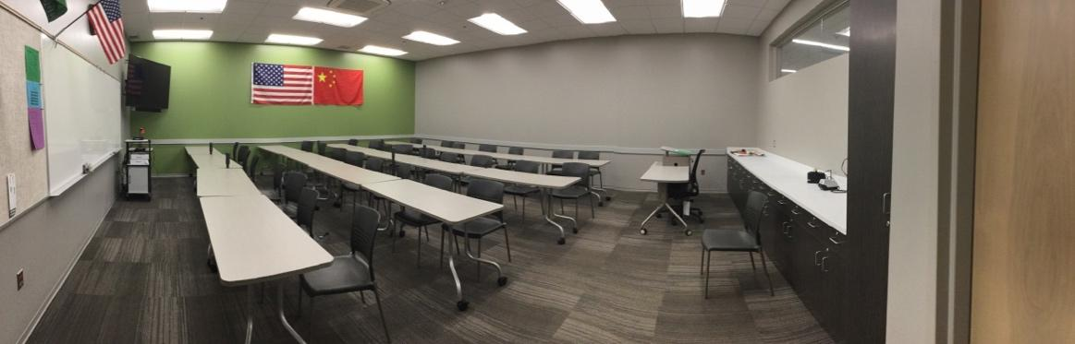
Figure 1. Our Classroom

The furniture was quite flexible; long, light gray rectangular tables with wheels seated two students comfortably to a side and were placed next to each other to create four long rows of four tables. Black, hard plastic chairs were provided for each student separate from the table, which allowed us to move around the classroom. For example, students frequently turned their chairs to work with classmates behind them. Tall plug-in stations for student devices were also included at regular intervals in the rows. The actual spacing between rows was usually ample enough to allow me to walk between them to engage in conversations with students, although the rows tended to “creep” forward toward the front, and we had to scoot them back again every few weeks. The industrial carpet was varied shades of gray in a sort of striped pattern, and was firm enough to allow easy movement of any of the furniture.
A teacher station was provided at what I considered to be the front of the room, where I could dock my school-issued laptop and utilize a TV monitor in a corner for projecting information for the class from my laptop or a document camera. Beside this docking station was the only dry-erase board in the classroom, which stretched along most of the light gray front wall before ending in a bulletin board, displaying maps for emergency procedures, the bell schedule, and the hall pass. A long, white countertop dominated one light gray side wall, with black cabinets underneath, and a tall cabinet at the end beside the door. The teacher desk, which I hardly ever used, sat in a back corner. The back wall was plainly painted light gray, with no decoration; the other side wall was painted green, a school color, and prominently displayed two flags – one of the United States and one of the People’s Republic of China. It was against this green wall that our rows sat, so the only possibility for moving between the rows was to walk around one end.

Data Collection
In order to create a thick description (Merriam, 2009) of this remediation course, multiple modes of data collection were utilized. This study was necessarily centered around my own reflection-action-reflection cycle meant to improve teaching practice, student learning, and my understanding of the specific context in which my teaching occurred; therefore, my reflective journal was a main source of data. This reflective journal included reflection on the development of curricular materials, instructional decisions made day-to-day, and observations of the classroom’s happenings in order to illuminate the course’s major characteristics. To provide robustness to that data set, copies of curricular materials were also retained, including but not limited to the lesson planning documents, presentation files, and handouts for students. Student work items created during the regular proceeding of the course as it developed were also collected as artifacts to provide vital triangulation (Merriam, 2009; Schwandt, 2015) of events in the classroom; only items from the thirteen students who completed the appropriate consent procedure were utilized in this analysis.
In addition, three students who consented were interviewed using a semi-structured interview protocol [see Appendix B]. Interviews are semi-structured when a combination of more and less structured questions are used at the researcher’s discretion, with a list of potential questions available to explore with no predetermined wording or order (Merriam, 2009). A concerted effort was made to make these interviews conversational, but intensive (Charmaz, 2006, p. 32), in order to elicit the participant’s own interpretation of the defining characteristics of their course experience. Each consenting student was interviewed one-on-one after the completion of the course; these interviews were audio recorded with permission and transcribed verbatim by the researcher. Follow-up questions determined after initial analysis were posed by email.
Through data analysis, which will be described in detail in the following chapters, three specific characteristics of this course were determined to be so central to its creation and enactment as to be considered “defining”: a sense of community, problem-centered learning, and learning to write mathematics. Chapter 2 details the Classroom as Mathematical Community, which I will argue is the central feature of this course; Chapter 3 explains the role that problem-centered learning had in our classroom and how we used it to achieve our learning goals; and Chapter 4 makes a case for using writing in the mathematics classroom both as an instructional tool and as an end-product, for and of itself. Each of the chapters 2-4 describe in detail the methodology, setting, data collection and analysis, and findings necessary to provide an enriched description of the course. Chapter 5 presents the implications of these findings together as a whole and describes directions for future research regarding college in the high school.

Trustworthiness
The trustworthiness of a qualitative inquiry is approached necessarily differently than that of a study accomplished through the carefully-defined parameters of the more procedural quantitative inquiry. Because the focus of qualitative inquiry is on “process, understanding, and meaning” (Merriam, 2009, p. 14) and the researcher is primarily utilized as the research instrument, the validity of each qualitative inquiry must be determined in relationship with the inquiry itself through careful consideration of reliability and transferability (Merriam, 2009).
The reliability of any study is determined by how well the findings align with the reality of the participants (Merriam, 2009). The researcher must reflect and self-monitor as analysis is conducted to ensure that the participant perspective is adequately addressed. In addition, the researcher must engage in rigorous collection of data; that is, data must be collected and analyzed until no further findings emerge (Merriam, 2009). The creation of an audit trail (Schwandt, 2015) helped me maintain constant self-reflection as I collected and analyzed data throughout the study and accounts for how the study evolved over time through the recording of my own thoughts, questions, and ideas during this process; it will also help others follow the development of this study’s findings.
Reliability must also be addressed in the actual process of writing about the study. As such, it was my goal to create a rich and thick description (Merriam, 2009) of the conception, execution, and evolution of the preparatory course being studied throughout the findings. In addition, because the conception of a case study is most reliant on the description of the case itself, rather than the particular method of data analysis, triangulation was also utilized to ensure the disciplined subjectivity and credibility of the case described herein. Triangulation is often achieved in qualitative analysis by the cross-comparison of data in multiple ways (Merriam, 2009). In this particular study, multiple data sources (interviews, document analysis, teacher reflection) were utilized as well as multiples sources of data (various participants). Another measure of triangulation was the utilization of a peer review during the analysis process to ensure that the findings were consistent with the data.
Transferability, or the ability to generalize the findings of a study, should also be carefully considered by the qualitative researcher. This cannot be done in the statistical sense, of course, but the researcher may allow a person to make their own generalization based on a sufficient description; as mentioned above, that is the goal of this study. This is achieved through the detailed description and analysis of this alternative course found in later chapters of this dissertation.

Position as Researcher
It is further a vital measure of trustworthiness for a qualitative researcher to be aware of one’s own positionality. As such, I will attempt here to explain my “biases, dispositions, and assumptions” (Merriam, 2009, p. 219) regarding this research. I am, by background, a secondary mathematics teacher. As a teacher, then administrator, I have been witness to a period of a shift in perspective about mathematics learning over the last several years. This shift in perspective has begun to emphasize not only the rote, procedural aspect of mathematics, but now seems to include a deeper, conceptual aspect as well. Additionally, mathematics educators advocate for the teaching of mathematics through “an active process, in which each student builds his or her own mathematical knowledge from personal experiences, coupled with feedback from peers, teachers and other adults, and themselves” (National Council of Teachers of Mathematics, 2014, p. 9). My own viewpoint most closely aligns with the Learner Centered ideology described in Schiro (2013), with some aspects of the Social Reconstructionist ideology as well. Namely, I believe that knowledge is constructed through experience and the goal of education should be to grow adults who contribute to the progressive betterment of their society (Schiro, 2013).
The conception of this course began during a conference call with a colleague regarding a different possible pathway of remediating our high school students in preparation for university-level mathematics. It was a deep-seated desire to help eliminate the “lifelong barrier to…greater opportunities” described by Greene & Forster (2003, “Executive Summary”) that led me to suggest to a district assistant superintendent that if we truly wanted to remove remedial mathematics coursework as “gatekeeper” we would need to conceive of some way to allow our students to achieve college credit in mathematics in our own schools, where we still had some control over the execution of the course. Furthermore, it was decided that we would need to seek partnership with a nearby 4-year institution to achieve this because of the new and stricter requirements some institutions were imposing on honoring credits received from 2-year institutions or through standardized testing.
As we negotiated the College Algebra preparatory semester with Central University, I insisted upon our autonomy in creating its curriculum because the idea that learners construct knowledge from experience as an “inevitable by-product of learning,” (Schiro, 2013) aligns with our district’s position on teaching and learning. Wheatley (1991) argued that, based on this constructivist idea, “viewing mathematical and scientific knowledge as a learner activity rather than an independent body of ‘knowns’ leads to quite different educational considerations” (p. 12). The constructivist classroom then, Wheatley asserted, is a place where students negotiate consensus about knowledge and the end goal is learning, not task completion. As such, he recommended that instead of memorizing facts and procedures, students should be provided tasks that help them construct meaningful knowledge about the concepts at hand.
It is with this perspective that I began developing the curriculum for the preparatory course. A significant amount of professional time was invested in curating and creating curriculum materials for the course, including unit and lesson planning and supporting student and teacher documents. Since it was acting as a preparatory course, the topics were chosen to ensure that students had firm foundational understanding of the concepts expanded upon in College Algebra, specifically functions, with an emphasis in understanding the concept of function rather than just memorizing procedures.
As I taught the class, I considered myself to be a “participant as observer”; that is, my role as observer was subordinate to my role as participant (Merriam, 2009). In addition, my secondary role as observer was known to the students in the course as I believed this to be vital to the trust required in the creation of our student-centered classroom. Participating in the course as the teacher allowed me to gain valuable insight into how the students interacted with each concept and reflecting on it as a researcher gave me a unique perspective on how my focus on the course’s central characteristics allowed us all to gain significant knowledge of mathematics and each other.

Significance of the Study
Hagedorn, Siadat, Fogel, Nora, and Pascarella (1999) remind us that “it is the duty of educators to direct all students to success” and as such, “students enrolled in remedial courses deserve the best instruction and curriculum we know how to deliver” (p. 281). The transition to postsecondary education can be difficult for any student, but especially for those that require remediation given the alarmingly dismal chances for their attainment of college-credited courses, much less matriculation (Attewell et al., 2006; Bahr, 2008, 2010; Bettinger & Long, 2009; Chen, 2016).
This study aims to describe one alternative path for students, created to help remove the “gate” that remedial coursework can become before it becomes an impossible hurdle. I believe that the results of this study will provide beneficial learning opportunities for others seeking to develop courses similar to the one that is the subject of this study and it is my hope to create literature regarding this experience wherein other practitioners may find images of themselves, and prompt their own reflection which will impact their own course development so that we may develop rigorous and meaningful courses that allow every student to succeed.
Chapter 2: Classroom as Mathematical Community
I guess what I just appreciated the most from it was that it was like one of my only classes in high school where we really actually got to know each other and … we became comfortable enough with each other to, now that we’re like, actually doing college algebra, that we feel… I just think the bond that we made in that class is really important because in high school you don’t get to do that anymore (Margaret, interview transcript)
Nearly 30 years ago Wheatley (1991) argued that “viewing mathematical and scientific knowledge as a learner activity rather than an independent body of ‘knowns’ leads to quite different educational considerations” (p. 12). As such, the mathematics classroom based on constructivist theories is different than a traditional mathematics classroom. Rather than a sterile room with desks in rows and a strict embargo on neighbor talk, the classroom described here is a place where students negotiate consensus about knowledge and the end goal is learning, not task completion. Instead of memorizing facts and procedures, teachers who ascribe to constructivist theories facilitate meaningful experiences through which students not only construct meaningful knowledge about the concepts at hand but a more meaningful relationship with mathematics itself (Boaler, 2002).
This becomes possible as a direct extension of the environment established in the classroom. Leach and Moon (2008) prompt us to ask the ultimate question: “What does this environment teach?” (p. 78), because that environment - implicitly or explicitly - is a reflection of the ontological and epistemological beliefs of the teacher at its heart and is comprised of not only the physical aspects of the classroom, but also its social and emotional aspects. Therefore, it is essential that students are allowed and encouraged to collaborate in the classroom, where meaning-making is predicated on experience and validated by one’s own understanding and that of one’s peers. Furthermore, “working together, communicating on a variety of tasks and interests, generates community and common values” (Noddings, 2013, p. 30).

Classroom Community
Not only is the community generated by collaboration essential to the classroom, it has been a topic of significant research and discussion in the educational community (e.g., Boaler, 1999; Burke, 2012; Goos, 2004; Hendrix, 1996; Hufferd-Ackles, Fuson, & Sherin, 2004; Philip, Way, Garcia, Schuler-Brown, & Navarro, 2013; Staples, 2007). Deeper than a relational viewing of community, where the central focus may be the relationships built among members of the community, others have discussed what might happen if the work undertaken by the community was carefully cultivated, as well (e.g., Palmer, 1998; Wenger, 1998; Wenger, McDermott, & Snyder, 2002).
Palmer (1998), for example, describes a “community of truth” in which “reality is a web of communal relationships, and we can know reality only by being in community with it” (p. 97). At the center of the web is a subject, and a relationship is built with it as it becomes the center of attention. The subject being the center of attention of the community prompts complex patterns of communication among them, as they work to make sense of the subject and one another, gaining knowledge as conflicts in understanding arise and are negotiated.
Wenger (1998) describes a ‘community of practice’ where participation is the central focus of the community; Wenger, McDermott, and Snyder (2002) define a community of practice as a group “of people who share a concern, a set of problems, or a passion about a topic, and who deepen their knowledge and expertise in this area by interacting on an ongoing basis” (p. 4). Similar to Palmer’s community of truth, Wenger’s community of practice requires the negotiation of meaning among community members, but the participation necessitated by doing so is how practice is connected to the formation of the community. While either might work for the framework of the community built in a classroom based on constructivist theories of learning, Wenger’s focus on participation and reification in the community prompts me to adopt community of practice as the way to discuss community in my own classroom.

Communities of Practice
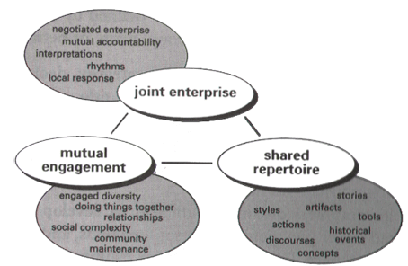
While it is obvious that every person is a member of any number of “communities” and this is certainly true, Wenger (1998) describes three specific dimensions “by which practice is the source of coherence of a community” (p. 72), which are: mutual engagement; a joint enterprise; and a shared repertoire (see Figure 2). Mutual engagement ensures that participants of the community of practice “are engaged in actions whose meanings they negotiate with one another” (Wenger, 1998, p. 73). Other important factors of this mutual engagement are the constant work of “community maintenance” which ensures that all members of the community of practice are able to engage mutually and the inclusion of a diverse membership, as the work
Figure 2. Wenger (1998) communities of practice

of the community of practice creates differences as much as it creates similarities as members establish their own identity within it. The joint enterprise of a community of practice, then, must reflect the complexity of its mutual engagement as it is created and negotiated among participants. This is negotiated through the work of the community of practice, where agreement and disagreement both contribute to its evolution and naturally allows participants to feel a sense of mutual accountability. Finally, a shared repertoire is developed over time within a community of practice. These shared resources are both reificiative and participative aspects of the community, which enable participants to make shared meaning as a collective.
The application of communities of practice is natural for the classroom, as the negotiation of shared meaning is central to both a community of practice and the classroom centered around constructivist theories. Because of the paradigm shift in mathematics education toward constructivism, which now encourages the sharing and valuation of one another’s knowledge in mathematics teaching and learning, it is essential for constructivist mathematics teachers to be purposeful in cultivating a community of practice in their classroom as it sets the tone for all learning activity that occurs among its participants. “Learning happens, design or no design,” Wenger (1998) warns, so we must “design social infrastructures that foster learning” (p. 225) that is meaningful within our classrooms.
Wenger’s (1998) three dimensions are explained in a slightly different way by Wenger et al (2002), as three fundamental elements: “a domain of knowledge, which defines a set of issues; a community of people who care about this domain; and the shared practice that they are developing to be effective in their domain” (p. 27, emphasis in original). The domain, similar to the joint enterprise, is truly the purpose of the community. For a classroom, this may encompass its learning goals and objectives. This can be purely content-based, or a mixture of content knowledge and broader knowledge; these goals are important to outline from the beginning of course conception, so that they guide learning activities undertaken by the community.
Similar to mutual engagement, here the community aspect “creates the social fabric of learning” (Wenger et al., 2002, p. 28). This social fabric is like a social contract among members of the community, where a set of social norms is negotiated to “foster interactions and relationships based on mutual respect and trust” (Wenger et al., 2002, p. 28). Knight (2012) defines “norms” as “suggested behavior that should occur in all situations,” (p. 305) and “invisible forces that shape behavior within a culture,” (p. 251) and recommends that a teacher co-construct these with students, and then reinforce the classroom norms by not only spreading “learner-friendly” emotions but also abiding by the classroom norms themselves.
Finally, the practice is “a set of frameworks, ideas, tools, information, styles, language, stories, and documents that community members share” (Wenger et al., 2002, p. 29); similar to the aforementioned shared repertoire. For many classrooms, this is the “work” that is undertaken there, the processes and products of negotiating meanings within their domain. Together, these three elements make a group of people into a true community of practice, “a social structure that can assume responsibility for developing and sharing knowledge” (Wenger et al., 2002, p. 29).

Communities of Practice in the Mathematics Classroom
It is possible for a teacher to purposefully plan for cultivating a community of practice in their classroom through a “systematic, planned, and reflexive colonization of time and space” (Wenger, 1998, p. 228) regarding the potential domain, community, and practice within it. To do so, constructivist mathematics teachers require comprehensive descriptions of the successful development of classroom communities of practice “that may be useful … for generating a new vision of the possibilities for their own classes and instruction” (Staples, 2007, p. 212).
One example of teachers planning purposefully to cultivate their classroom communities is the math-talk learning community in an elementary classroom described by Hufferd-Ackles, Fuson, and Sherin (2004). The third-grade teachers described in their study developed a community of practice with the explicit objective of being able to “understand and extend one’s own thinking as well as the thinking of others in the classroom” in order to achieve their broader goal of being a classroom community “in which the teacher and students use discourse to support the mathematical learning of all participants” (Hufferd-Ackles et al., 2004, p. 82). This defines and describes the domain of their community of practice. Their practice was supported through the usage of a particular curriculum, Children’s Math Worlds, which contained “key conceptual supports” to make mathematics meaningful for the students, as well as the vehicle for meaning-making to become the work of the students (Hufferd-Ackles et al., 2004, p. 84). The community was built here as participants adopted the belief that “all members of the community [were] constructing their own knowledge and reflecting on and discussing this knowledge” (Hufferd-Ackles et al., 2004, p. 83) and constructed social norms in their classrooms to support this belief (Hufferd-Ackles et al., 2004, p. 99).
Goos (2004) considered “what specific actions a teacher might take to create a culture of inquiry in a secondary school mathematics classroom” (p. 258). In the study of two classes, one in grade 11 and one in grade 12, Goos observed the classroom communities of practice as they were already established by considering both teaching practices used by the teacher and the “changing nature of students’ participation over time” (p. 276). Staples (2007) illuminated how in a particular case, that of Ms. Nelson’s prealgebra classroom, certain pedagogical strategies organized and supported collaborative inquiry practices among its students. The classrooms of both Goos (2004) and Staples (2007) are also communities of practice with the fundamental elements of domain, community, and practice, cultivated by their teachers as the students expanded their “shared repertoire over time under [their teachers’] guidance” (Staples, 2007, p. 206).
Further research is needed, however, to expand the scope beyond these particular classrooms to “other conceptualizations and analyses” (Staples, 2007, p. 213) of cultivating mathematical communities of practice, particularly as they relate to progressive mathematics classrooms that “foster mindful, strategic learning” (Goos, 2004, p. 281). One such other conceptualization is offered here, in the intensive study and description of a dually credited College Algebra preparatory course offered in one suburban district in central Oklahoma that I designed and taught.

Methodology
This study utilized instrumental case study methodology to provide a thick description of one instance of a semester long College Algebra preparatory course. Broadly defined, a case study is a “complicated arena [of qualitative inquiry] involving methodological choices directly related to goals or purposes of conducted case-based research, research traditions in different disciplines, and the ways in which investigators define a case,” (Schwandt, 2015, p. 26). This is considered an instrumental case study, which Stake (2003) describes as a case that is studied “mainly to provide insight into an issue” (p. 137), due to the case being somewhat secondary to the phenomenon of interest but “still looked at in depth, its contexts scrutinized, its ordinary activities detailed,” (Stake, 2003, p. 137) as a means to explore the issue of interest. In a case study, the “case” must be well-defined (Merriam, 2009) so this study is focused on the implementation of a dually credited College Algebra preparatory course offered in one suburban district in central Oklahoma that I designed and taught; an alternative to current, more traditional paths for mathematics remediation not yet described in the available literature.
The course in preparation for College Algebra was negotiated with a nearby four-year research institution, Central University (pseudonym; all student and school names have been replaced by pseudonyms), for two primary purposes. First, to eliminate any possible “gap” (Greene & Forster, 2003; Kurlaender & Howell, 2012), whether real or perceived, in coursework between secondary school and university; and second, to remove a systematic barrier for many students’ future matriculation in post-secondary education, which was achieved by a modification of the institutional requirement for concurrent enrollment into College Algebra. The concurrent enrollment office agreed to waive the institutional requirement of an ACT mathematics subscore of 23 to take College Algebra as a concurrent student if students participated in the remedial semester, opening the door wide to students who otherwise would not have this opportunity. In addition, the course was offered on the high school campus which allowed students who either lacked transportation or a free two-hour block necessary for taking a concurrent course on the college campus to also consider the course.
The dually credited College Algebra preparatory course that I designed and taught was offered to high schoolers in one suburban district in Oklahoma and deviates from other examples of remedial classes in a few key ways. It was offered on the high school campus and taught in a learner-centered manner, contrary to the more traditional pedagogies generally provided at universities (Brock, 2010). In addition, the material was not approached with the primarily deficit-model focus that is the case with (Brock, 2010) most remedial courses; instead instruction centered around solidifying the students’ conceptual understanding of key mathematical ideas in preparation for their college-level mathematics experience the following semester.
The course was advertised primarily for college-bound 12th graders who were enrolled in Algebra 2 as 11th graders; the assumption being that many of them would declare academic majors at university requiring minimal general education credits in mathematics and this course offered at their high school may fulfill it entirely. Furthermore, for those students who may need one course in addition to College Algebra to fulfill their major’s requirements in mathematics, they will have secured credit from a reputable four-year institution, which should transfer directly to any other institution, helping them avoid the potential trap of placement testing.
The primary goal of this study was to provide a rich description of the course for others seeking to implement alternate paths to college credit; this course was chosen specifically for its potential to illuminate the reconceptualization of college mathematics remediation through detailing ordinary events and studying it in depth. By providing this detailed account, I hope to provide beneficial learning opportunities for others seeking to develop courses similar to the one that is the subject of this study. Additionally, I hope to create literature regarding this experience wherein other practitioners identify opportunities or experiences they can implement with their own students and in their own course development so rigorous and meaningful courses can be developed that allow every student to succeed. This study began by using the following questions to frame the study:
- What were the defining characteristics of a College Algebra preparatory semester course offered in a suburban high school in the west south central United States?
- What were student perceptions of those defining characteristics?
- What were the student perceptions of their learning during this course?

Setting and Participants
The district in which the course was taught is in a suburban town in the west south central United States with a population greater than 100,000. The majority of the district’s patrons identify as Caucasian (74%), with those that identify as Hispanic being the next largest category (13%). Despite about half of its population qualifying for free and reduced lunch, the average household income in this town is nearly $8,000 above the state average. Additionally, an overwhelming majority (94%) of parents in this district have at least completed their high school education, which is 7% higher than state average (Office of Educational Quality & Accountability, 2015). The particular high school, Central High, at which the course was held reported that its population is 77% Caucasian, 4% Black, 4% Asian, 10% Hispanic, and 5% Native American; only 34% of students there qualify for free and reduced lunch (Office of Educational Quality & Accountability, 2015).
There were twenty-one students enrolled in the class, fourteen females and seven males. Nineteen were classified as seniors and two as juniors. All planned to be college-bound after high school. Fourteen of them identify as Caucasian; two as American Indian; one as Hispanic/Latino; and four as two races. While the course was conceived as being for college-bound seniors who had completed Algebra 2, there was more diversity in the mathematical background of the students than originally anticipated; due to this diversity, a summary of the last mathematics course completed with a grade of D or better by the enrolled students is in Table 2, below. I, the teacher/researcher, identify as a Caucasian woman, and was in my ninth year in public education at the time of the study. I have taught a range of students, from elementary school to undergraduates, and am now primarily a mathematics curriculum coordinator for the district in which these students were enrolled. This was the first time I taught a preliminary, remedial course for College Algebra; the proposal for the format adopted was my own.
Table 2. Mathematics background of students
 | Algebra 2 | Algebra 3/Trigonometry | Pre-Calculus | Calculus
Number of Students | 3 | 6 | 9 | 3

This preparatory semester was planned as a build up from Algebra 2 to College Algebra content and emphasized understanding of mathematics concepts rather than just memorizing procedures in order to solidify the student’s foundational understanding of mathematics, including number and operations, graphing, functions, and algebraic reasoning. In particular, three units were developed during the summer of 2017 in anticipation of the course in the fall semester of that same year [see schedule in Appendix A]. The first addressed the essential questions of the nature of mathematics, the previous experiences of students with mathematics, and the purpose of studying mathematics; it was during this unit that I anticipated creating social norms with my students and acclimating them to a more active learning environment than is typically experienced. Unit two centered on our number system, addressing number theory, the modeling of different sets of numbers, the modeling of algebraic relationships, and the manipulation of algebraic expressions. This topic was perhaps tangential to our final goal, but its purpose was to allow students the time and space to think about mathematics in a more holistic way and begin to scaffold problem-solving tools that they would need in our last unit of study. The last unit pertained specifically to functions and was intended to be the bulk of study for the semester and considered the very definition of function, the many different ways to represent functions, function families, and important aspects of functions and the reasons we might want to know them (e.g. function zeroes or asymptotes). The idea of a mathematical “function” is central to College Algebra, and my desire was to fill any gaps in understanding that my students had in order to solidify this foundational concept before proceeding to college-level study.
Our class at Central High adopted a college-like schedule, and took place on Mondays, Wednesday, and Fridays during the period directly before lunch. The classroom we used was in a new wing of the school, considered to be the College and Career Center of the building [see Figure 3 below]. It was used for two hours every day for the school’s Chinese language courses and as such became increasingly decorated with items relevant to their curriculum; we did not in general add to the décor out of respect for the teacher and students that used our classroom more frequently than we did. Since it was centrally located in the wing the only windows were to the hallway, forcing us to depend upon the fluorescent lighting from the ceiling fixtures, and there was only one door for entrance or exit.
Figure 3. Our Classroom

The furniture was quite flexible; long, light gray rectangular tables with wheels seated two students comfortably to a side and were placed next to each other to create four long rows of four tables. Black, hard plastic chairs were provided for each student separate from the table, which allowed us to move around the classroom. For example, students frequently turned their chairs to work with classmates behind them. Tall plug-in stations for student devices were also included at regular intervals in the rows. The actual spacing between rows was usually ample enough to allow me to walk between them to engage in conversations with students, although the rows tended to “creep” forward toward the front, and we had to scoot them back again every few weeks. The industrial carpet was varied shades of gray in a sort of striped pattern and was firm enough to allow easy movement of any of the furniture.
A teacher station was provided at what I considered to be the front of the room, where I could dock my school-issued laptop and utilize a TV monitor in a corner for projecting information for the class from my laptop or a document camera. Beside this docking station was the only dry-erase board in the classroom, which stretched along most of the light gray front wall before ending in a bulletin board, displaying maps for emergency procedures, the bell schedule, and the hall pass. A long, white countertop dominated one light gray side wall, with black cabinets underneath, and a tall cabinet at the end beside the door. The teacher desk, which I rarely used, sat in a back corner. The back wall was plainly painted light gray, with no decoration; the other side wall was painted green, a school color, and prominently displayed two flags – one of the United States and one of the People’s Republic of China. It was against this green wall that our rows sat, so the only possibility for moving between the rows was to walk around one end.

Data Collection and Analysis
In order to create a thick description (Merriam, 2009) of this remediation course, multiple modes of data collection were utilized. This study was necessarily centered around my own reflection-action-reflection cycle meant to improve teaching practice, student learning, and my understanding of the specific context in which my teaching occurred; therefore, my reflective journal was a main source of data. This reflective journal included comments on the development of curricular materials, instructional decisions made day-to-day, and observations of the classroom’s happenings in order to illuminate the course’s major characteristics. To provide robustness to that data set, copies of curricular materials were also retained, including but not limited to the lesson planning documents, presentation files, and handouts for students. Student work items created during the regular proceeding of the course as it developed were also collected as artifacts to provide vital triangulation (Merriam, 2009; Schwandt, 2015) of events in the classroom; only items from the thirteen students who completed the appropriate consent procedure were utilized in this analysis.
Three students who consented to be interviewed were interviewed using a semi-structured interview protocol [see Appendix B]. Interviews are semi-structured when a combination of more and less structured questions are used at the researcher’s discretion, with a list of potential questions available to explore with no predetermined wording or order (Merriam, 2009). A concerted effort was made to make these interviews conversational, but intensive (Charmaz, 2006, p. 32), in order to elicit the participant’s own interpretation of the defining characteristics of their course experience. Each consenting student was interviewed one-on-one after the completion of the course; these interviews were audio recorded with permission and transcribed verbatim by the researcher using pseudonyms.

Data Analysis
Data analysis was undertaken using a constant comparative method (Charmaz, 2014; Glaser & Strauss, 1967), which required an iterative process that mirrors the iterative reflection-action model of teaching. As part of this process, all researcher/teacher reflections and interview transcripts were transcribed and coded. Curriculum materials and student work artifacts also underwent a coding process, which began by using open codes, a type of initial code that are similar to what is found in the data, and led to category codes of broader, more conceptual elements (Merriam, 2009). Finally, the category codes were analyzed, and more overarching themes were generated as necessary. These themes were analyzed and subsequently guided my construction of the responses to the research questions.

Findings

Teacher Reflections
On the first day of the course, the planned introduction activity had to be altered because the classroom technology was unavailable. However, it is noted that “we still talked a lot about how this class would be a unique experience” and “we created class norms after we discussed the idea of our class being a lot about collaboration,” (Teacher Reflection Journal, August 18, 2017) in an effort to promote mutual engagement. Additionally, I shared my own three goals for them, which were to: “make them self-advocates in their own education”; “help them ‘experience’ math”; and “solidify their foundational and conceptual understanding” (Teacher Reflection Journal, August 18, 2017).
Several comments were made in my reflections specifically pertaining to a feeling of community throughout the entire semester, as we continued to build mutual engagement and develop shared practices. In the first weeks, I wrote “Building that community” (Teacher Reflection Journal, August 24, 2017) in reference to replying to student responses on the syllabus quiz; an appreciation for students already being comfortable expressing opinions and beliefs they thought might be contrary to my own (Teacher Reflection Journal, August 25, 2017); randomizing groups “until I know [the students] a little better” (Teacher Reflection Journal, August 28, 2017); and the goal of referencing class constructed materials, like the list we created to help us provide more constructive feedback to our peers (Teacher Reflection Journal, September 8, 2017). Later in the semester, I wrote a note that “it’s funny how we work to build relationships so purposefully and then it’s sometimes things we do without planning them that gives [our relationships] a boost” (Teacher Reflection Journal, October 16, 2017) regarding a discussion about why our class is different. Near the end of the semester, there was a reference to reminding them we are learning this mathematics for a purpose (Teacher Reflection Journal, December 1, 2017).

Course Documents
The term course documents, for the purpose of this study, refers to lesson plans, prepared presentations, and student handouts. Through the process of data analysis, some key words that illustrated the aspects of our class that made it different became clear. These key words and the number of times they were utilized in course documents in each unit is in Table 3. While a simple word count does not necessarily prove the existence of one over-arching characteristic of our class it does provide weight to the significance of the actions valued therein.
Table 3. Key word counts
Keyword | Unit 1 | Unit 2 | Unit 3
Discuss | 13 | 3 | 16
Explain | 7 | 6 | 16
Group | 19 | 12 | 27
Share | 7 | 3 | 8

Similarly, I became interested in the number of times throughout the course that students were asked to work on an assignment or task alone and the number of times they were asked to work in a small group; this time in small groups encouraged students to develop shared practices and challenged them to explore new mathematical ideas together. These counts are found in Table 4.
Table 4. Individual versus Group work in each unit
 | Assignments Completed: |  | Class Time Spent Working:
 | Individually | As a Group | Individually | As a Group
Unit 1 | 2 | 1 | 0 | 3 (100%)
Unit 2 | 3 | 5 | 1 | 12 (92%)
Unit 3 | 5 | 7 | 4 | 24 (86%)

The syllabus clearly states the purpose for the class to “emphasize understanding of mathematics concepts rather than just memorizing procedures in order to solidify the student’s foundational understanding of mathematical topics, including number and operations, graphing, functions, and algebraic reasoning” (Course Syllabus 2017). On the schedule, time is set aside specifically for “procedures”, which had been intended to involve a “Setting the Stage” activity (adapted from Ernst, 2015) wherein students discussed the following questions:
- What is the goal of a high school education?
- How does a person learn something new?
- What do you reasonably expect to remember from your courses in 10 years?
- What is the value of making mistakes in the learning process?
- How do we create a safe environment where risk taking is encouraged and productive failure is valued? (Unit 1 Slides)

Despite the unavailability of the classroom technology, the students discussed some of these questions before moving on to what our own class goals should be. The students discussed in groups and then co-constructed a list:
- Be on time.
- Give effort.
- Do your homework.
- Be accepting of each others’ mistakes.
- Be respectful
- Be willing to take risks (photo of whiteboard, August 18, 2017)

Unit 1 persisted for three class periods. The students were asked to work in small groups during each of these periods, which reinforced mutual engagement and allowed students to really begin developing shared practices regarding mathematics. Unit 1 included the course co-construction of a definition of mathematics and determination of whether we believed it to be discovered or invented by humans. After observing a word cloud of their group brainstorming notes, it was decided that mathematics is “a universal language that uses quantity, theories, shapes, numbers, and variables in order for humans to solve naturally occurring problems” (photo of whiteboard, August 23, 2017). Students were also asked to write their “Math Autobiography”, wherein they might “describe [their] experience so far with mathematics” as well as “explain how the procedures and goals we have made for our class will help you be successful in this experience” (Student Handout). It was also during this time that students were introduced to the “Math History: Person of Interest” assignment and its grading rubric. This assignment asked them to look outside of traditional stories of mathematics for those that are less told and answer questions regarding that person’s life and the impact their contribution had on mathematics as a discipline (Student Handout).
Unit 2 spanned thirteen class periods, during which students worked on concepts of number and representation. After a short primer in set theory (photo of whiteboard, August 28, 2017), they began to determine a logical presentation of our number system in small groups by first using a Card Sort (Keeley & Tobey, 2011). Each group sorted a set of number cards into identifiable groups and then presented their sort to the class (Unit 2 Presentation) [see Figure 4].
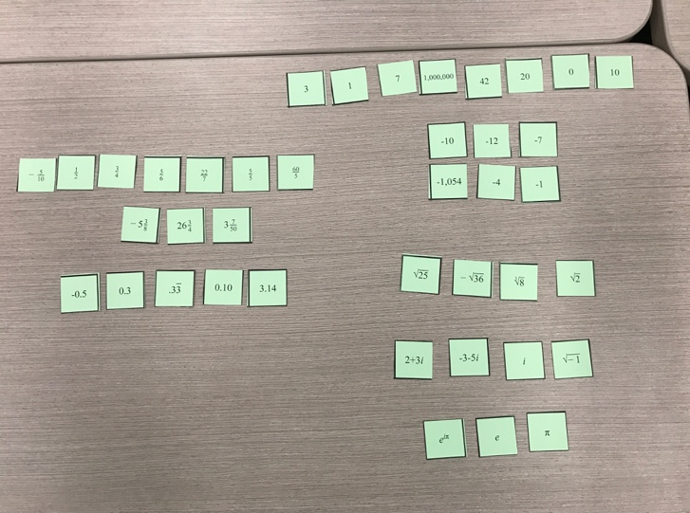
Figure 4. One group's sorting of their number cards

After a discussion, students worked in groups to create their Number System Project, which asked each group to “create a representation of our number system” (Student Handout). The first draft of that representation inspired a class co-construction of a list of ways to provide constructive feedback (photo of whiteboard, September 8, 2017), since the summary of their peer reviews for each group poster resulted in the word cloud in Figure 5.
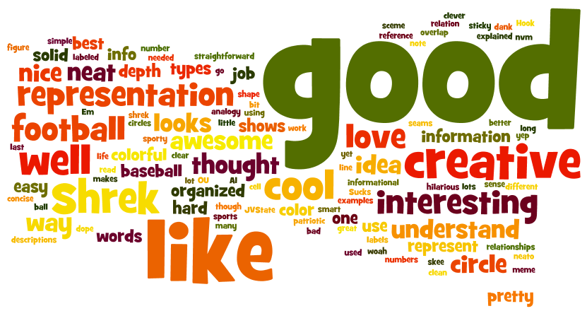
Figure 5. Word cloud of peer review text from Number System projects

Also in small groups, they modeled arithmetic operations (Unit 2 Lesson 2), algebraic expressions (Unit 2 Lesson 3), and polynomial operations (Unit 2 Lesson 4). Unit 2 included their first homework assignment, which was to complete some pre-existing Math Two-Ways (Wheatley & Abshire, 2002) for integers and algebraic expressions and then create some of their own; the created ones were traded and completed by a partner in class. The last major project in Unit 2 (Unit 2 Lesson 5) before the assessment was to critique a set of textbook sections which focused on this topic in preparation for the course Final Project in Unit 3. Doing this critique led to a co-constructed set of “Textbook Dos” and “Textbook Don’ts” (photos of whiteboard, September 25, 2017) of characteristics we found helpful – or not – in each of the textbook sections we analyzed.
Unit 3 centered on the concept of mathematical function and was the focus of the majority of the course time, with 28 class periods. To begin the unit, small groups worked to determine the definition of function before a class definition was co-constructed (Unit 3 Lesson 1; photo of whiteboard, October 2, 2017). Once this was more firmly established through an exploration of function representations (Unit 3 Lesson 2), several class periods were spent on the analysis of function families and transformations of those functions (Unit 3 Lesson 3). After each part of this lesson, conjectures were discussed as a class and summarized as we worked on a generalization of our observations about parent functions and their movement around the coordinate plane as a result of a change in their equations (photos of whiteboard, October 16, 18, and 23, 2017); this led to a discussion of function notation, where we made an attempt at creating our own improvised notation (photo of whiteboard, October 23, 2017).
The students’ improvised notation gave way to the standard notation as we continued working with ideas regarding functions, like using operations on or composing functions (Unit 3 Lesson 4) and using functions to model data (Unit 3 Presentation; Student Handout). Throughout this unit, students were working on their Final Project, which was to write a textbook chapter about functions. Early in the unit, we sorted questions we had about functions into themes (Unit 3 Presentation) and established these themes as the sections for the chapter (photo of whiteboard, October 9, 2017). Deadlines were set for drafts of each section and a rubric for the assessment of each section was co-constructed (photo of whiteboard, November 6, 2017). This rubric was utilized in the peer reviews students completed in class for other groups’ work as well as in my assessment (Student Handout).

Student Work
Students commented frequently about the unusual structure of our class. For example, Jack noted that “…from what I can tell already [our class is] not going to be the normal classroom math, this is going to be intriguing and actually entertaining which I am looking forward to” (Student work, Math Autobiography). On her Final Exam, Annie said, “this class was so intresting [sic] to me because it was so different from my past classes . . . I’m glad it challenged me because math is normally easy for me” (Student work). Another Final Exam note said, “This was a really fun class that I enjoyed. It was a different perspective of math that I wasn’t familiar with so it brought me out of my comfort zone” (Casey).
Another frequent reference in student work was our shared practices regarding being respectful and willing to make mistakes. In her Math Autobiography, Chloe said that “stepping outside of my comfort zone and being respectful will help me not be ashamed when I make a mistake” (Student work). Casey noted that she believes “the math goals we made for our class will help me . . . because I think that we will all respect each other and learn from each others [sic] mistakes” (Student work, Math Autobiography). In her Final Exam, she reflected that “doing the peer reviews for the different sections in our textbook really helped” her to learn from her own mistakes and those of her classmates.

Student Interviews
Three students were interviewed: Rose, Emma, and Margaret. Each of them mentioned how our class had been different from traditional mathematics classes in some ways. Margaret specifically said that “a major thing that we did was . . . we did group work . . . we all worked together to do things,” (Interview transcript). Rose said that she thought the amount of group work “got [the students] to talk to each other” (Interview transcript) and Emma reflected on how the process of talking things through in a group discussion made sense in other content classes but she had never experienced in a mathematics course before ours, noting that it “seems like a good way to do things aside from the normal way” (Interview transcript).
For Margaret, the group work aspect of our class was a major factor in “strengthen[-ing] our class bond” because “we actually got to know each other and … became comfortable enough with each other” to ask questions and work together in a meaningful way (Interview transcript). Margaret felt that this helped reinforce our class norms of being respectful and willing to take risks, which “is really important because in high school you don’t get to do that anymore, that was like kind of an elementary school thing where you actually get to hang out with the people and learn together” (Interview transcript). This bond lasted into the next semester, as the students participated in College Algebra with another instructor, as Margaret explained that they do study groups for assessments and have “a big group text where we all help each other all the time” (Interview transcript), evidence of the long-term commitment that had developed among them.

Discussion
A particular sense of community was carefully cultivated in our class. Obvious in the planning was a desire to co-construct that sense of community in our classroom, as we began with a forthright discussion about our goals and purpose in which my students and I participated in as equals. Communities of practice have three fundamental elements: a joint enterprise, mutual engagement, and a shared repertoire (Wenger, 1998). Our class not only had each of these fundamental elements, but also demonstrated these characteristics that Wenger (1998) requires of communities of practice in an educational setting such as our own:
- Activities requiring mutual engagement, both among students and with other people involved
- Challenges and responsibilities that call upon the knowledgeability of students yet encourage them to explore new territories
- Enough continuity for participants to develop shared practices and a long-term commitment to their enterprise and each other (p. 272)

Our Mathematical Community
In order to encourage the requisite participation and reification in our classroom, I knew that it was necessary to build an environment of trust and openness among us all. Because of this, I chose to participate in this study as a “participant as observer”; that is, my role as observer was subordinate to my role as participant (Merriam, 2009). In addition, my secondary role as observer was known to the students in the course as I believed this to be vital to the trust required in the creation of our student-centered classroom.
Even though our joint enterprise was originally determined by the conception of the course itself as one in preparation for College Algebra for students who had taken at least Algebra 2, some aspects were determined collectively. For example, I determined that the majority of the semester would be spent exploring mathematical functions and the final project would be developing a textbook chapter over that topic; however, it was the collective that determined the specific questions and scope each section of their written chapters would attempt to address (Unit 3 Presentation; photos of whiteboard, October 9 and November 6, 2017; Student Handout). Also, I asked the students to create presentations about a mathematician of interest from history, but students chose the mathematicians and stories that were interwoven throughout our semester. I purposefully sought ways to allow meaningful participation on the students’ part to support the formation of our learning community as we made sense of our domain; as evidenced by the number of class periods in which they were working on mathematical tasks in groups, students were able to build their identity of active participant in our class.
Working on group projects or in small groups were not the only “opportunities for engagement” for my students. I also sought to purposefully engage them in the crafting of our community. When we co-constructed classroom norms (photo of whiteboard, August 18, 2017), guidelines for meaningful peer review (photo of whiteboard, September 8, 2017), lists of textbook dos and don’ts (photos of whiteboard, September 25, 2017), and assessment criteria for our final project (photo of whiteboard, November 6, 2017), this required the mutual engagement of all students and called upon their knowledgeability of and about what they wanted from their class and community. Each of these opportunities served to further “foster interactions and relationships based on mutual respect and trust” (Wenger et al., 2002, p. 28) in our classroom. Additionally, we varied groupings with each new task in our class to help students practice our norms and build relationships with a larger group than they might otherwise have (Margaret, Interview transcript). This continuity enabled students to “develop shared practices and a long-term commitment to [our] enterprise and each other” (Wenger, 1998, p. 272). This commitment to learning and to one another continued beyond the temporal scope of our class and into the next semester, when Margaret said they utilized study groups for assessments and have “a big group text where [the students] all help each other all the time” (Interview transcript).
Finally, I ensured that the development of our practice was also undertaken collectively. For every topic we covered, we co-constructed the meanings on which we would build the rest of the concept. In Unit 1, we co-constructed the definition of mathematics (photo of whiteboard, August 23, 2017). For Unit 2, students developed their own representation of the number system and subjected it to peer reviews (Number System Project Student Handout). In Unit 3, we co-constructed our definition of mathematical function and developed our own notation for describing transformations of functions on the coordinate plane (Unit 3 Lesson 1; photo of whiteboard, October 2, 2017; photo of whiteboard, October 23, 2017). These tasks provided students with “challenges and responsibilities that call[ed] upon [their] knowledge” and “encourage[d] them to explore new territories” (Wenger, 1998, p. 272).
Together, these three elements make a group of people into a true community of practice, “a social structure that can assume responsibility for developing and sharing knowledge” (Wenger et al., 2002, p. 29) and it is clear that while demonstrating domain, community, and practice, our class further demanded a level of participation and reification to such a degree that our mathematical community of practice was one of its defining characteristics.

Implications
Purposefully cultivating our community of practice encouraged collaboration, respect, and engagement in my classroom. This allowed my curriculum to become more an “itinerary of transformative experiences of participation” than a “list of subject matter” (Wenger, 1998, p. 272), which empowered students to negotiate consensus about knowledge as I facilitated meaningful experiences about the concepts at hand and inducing a pivot from the traditionally behavioristic approach to teaching and learning mathematics to one constructivist in nature. Furthermore, our community of practice enabled us to “sanction natural instincts to construct meaning” and prompted students to “come to believe that learning is a process of meaning-making rather than the sterile academic game of figuring out what the teacher wants” (Wheatley, 1991, p. 15). This experience of mutually constructing our joint enterprise and shared repertoire allowed us to make sense of mathematics in a way that encouraged us all to participate. It is my hope that in this conceptualization and analysis of our community of practice, others may see possibilities for cultivating their own so that eventually, all students might experience mathematics learning in a way that revolutionizes their thinking about what is possible within the walls of their mathematics classroom.
Chapter 3: Problem-Centered Learning
“There were different, like more creative assignments in [our class] and group projects a lot, which generally in [traditional] math classes are basically unheard of” (Rose, interview data)

Perspectives on Learning

Objectivism and Constructivism
For many decades, school mathematics in the United States was informed only by the underlying epistemology of objectivism, which generally asserts that that there is one essential “Truth” of the world that every person is striving to learn. Having only one reality as the major tenet of knowing necessitates that the goals of any learning be described in behavioral terms, as “demonstrable things people can do,” (Schiro, 2013). As such, educational pursuits under this epistemology were consequently described as ways to change a person’s behavior in order to reflect the essential “truth.” Heavy emphasis was placed on rote practice and the interpretation of learning experiences into pieces of information that could be used in the same way that had been practiced, and it followed logically then, that the teacher would impart the knowledge of some concept, demonstrate the requisite procedures, and then students would practice until they learned the “right” way (Schiro, 2013).
The idea of “one reality”, however, was insufficient for some. Many philosophers, psychologists and other academics had threads of another way of thinking weaved into their work before Piaget, but it was Piaget’s research into development that led to Vygotsky’s (1978) claim that, “the most significant moment in the course of intellectual development… occurs when speech and practical activity. . .converge” (p. 24). As such, Vygotsky determined that a child’s conception of self and reality is built and honed through interaction. It was not difficult to extend the belief that children learn to build up multiple perspectives of their social world through play and activity to humans of all ages, and this extension led Vygotsky to claim that “knowing is the building of coherent networks by assembling conceptual structures and models that are mutually compatible” (Von Glasersfeld, 1989, p. 116). The compatibility of new understanding, then, is determined in one’s social group and experiences; contradictions to what one has previously constructed encourages revision of those constructions and this process continues for one’s entire life. The main tenet of constructivism, then, was that knowledge is socially constructed – in other words, a person and their understandings are shaped from birth by their experiences in a social group (Ernest, 1998). Hence, Vygotsky’s constructivism became known as “social” constructivism.
Social constructivism began to gain epistemological credence in the mid-twentieth century, when educational researchers began to notice the faults of behaviorist theories of learning, known as behaviorism, in their work (Brownell, 1956; Commission on Mathematics, 1959; Horn, 1951). Through this research, it was becoming clear that many students in mathematics presented the ability to solve mathematical problems using a specific formulaic approach, which reflected the prescriptive way that they had been taught; those same students, though, had alarming trouble solving problems that were outside of the scope of “regular” textbook or testing questions (Von Glasersfeld, 1995). In other words, the focus on rote memorization and procedural fluency as a result of behaviorist principles in the classroom were not providing the desired long-term results; only after this was the meaning of Piaget’s and Vygotsky’s works intertwined into educational research.
Unfortunately, mathematics educators adapted more slowly than the educational community at large due in part to the marked decline in results from standardized testing in the mid-1970s, which brought the country “back to basics” (Usiskin, 1985). This period of public education is unique in that public outcries prompted changes in schooling, thus making it difficult for some period afterward to gain public funding for curriculum research (Usiskin, 1985) as opposed to the well-funded previous decade of educational research (Woodward, 2004). Further, discovery learning, made popular with “new math”, was rejected in favor of more behavioristic approaches that emphasized practical skills in mathematics, leading to the establishment of minimal competencies for promotion. This return to a more traditional approach to mathematics teaching and learning—often termed “direct instruction”—also allowed for more standardized testing to measure these competencies (Woodward, 2004).
Despite a swing back to more traditional mathematics teaching and learning that persisted into the 1980s, cognitive research dominated mathematics education research. By the end of the decade, “a number of cognitively oriented mathematics researchers were moving in the direction of constructivist theory” (Woodward, 2004, p. 20), which were based on the work from Piaget, Dewey, and others from previous decades (Stanic & Kilpatrick, 1988; Von Glasersfeld, 1989). The cognitive research focus of mathematics education researchers was supported by a number of other factors, including the A Nation at Risk report by the National Commission on Excellence in Education in 1983 which was critical of the “back to basics” reform, as well as strong support from the National Council of Teachers of Mathematics (e.g., 1980, 1989a, 1989b, 1989c, 1989d) and the National Research Council (1989). The combined efforts of these respected entities served to “reinvigorate the mathematics reform” regarding constructivist theory into the 1990s (Woodward, 2004, p. 20).
The reform of the 1990s sought to show that “mathematics, like all disciplines, is a social product” and to make that view a focal point of school mathematics (Romberg, 1992, p. 752). Problem-centered learning (PCL) in mathematics made a debut around this time (e.g., Roth, 1993; Wheatley, 1989), strengthened then by the concept of radical constructivism shortly thereafter (e.g., Steffe & Kieren, 1995; Von Glasersfeld, 1995, 1998). By the turn of the 21st century, a number of studies showed positive results for this reform movement (Woodward, 2004), but yet another reform would threaten its momentum with the introduction of the No Child Left Behind Act of 2001 (NCLB) as the Bush administration began “quietly fund[ing] individuals who were instrumental in the back-to-basics movement” with a focus on scientifically based research (Woodward, 2004, p. 25).
Despite many constraints, like federally mandated standardized assessments that measure progress under state-adopted content standards (e.g., Common Core State Standards Initiative, 2016; Oklahoma State Department of Education, 2016), teachers who hold constructivist beliefs are more prevalent than ever. The broader adoption of constructivism has given rise and power to learner-centered reformers in mathematics education in the years since NCLB. A learning-and-teaching theory that empowers, truly, all students to learn mathematics meaningfully is essential in the 21st century school. However, a number of issues, including a lack of training for teachers in progressive teaching methods and adequate collaboration among all stakeholders, particularly parents, (Woodward, 2004) further complicates their acceptance.
The crisis for educators is not only one of helping create a better society, but to do it amid the numerous bids for their time and attention in the 21st century school. Mathematics educators must continue to advocate for meaningful mathematics, for each and every student, in the best way that research shows us how. Progressive pedagogies like Gutstein’s (2003) math for social justice, Ladson-Billings’ (1995) culturally relevant pedagogy, and Wheatley’s (1991) PCL are now garnering attention in response to this need for meaningful mathematics teaching and learning, for if students “are to enrich their own lives and the society in which they live [they] need to know not just facts and procedures, but how to think mathematically, to interpret their world through a mathematical lens” and in order for them “…to do this they need to experience mathematics learning as a sense making activity” (Reynolds, 2010, p. vii).

Problem-Centered Learning
Much of past curricula and classroom practice in mathematics has taught students to be “passive receivers of preordained ‘truths’ not active creators of knowledge” (Wheatley, 2010, p. 7). PCL, as a teaching model based on constructivism (Wheatley, 1991; Wheatley, Blumsack, & Jakubowski, 1995), instead centers the student as the constructors of mathematical knowledge with the intent of a teacher “creating the conditions for learning to occur and guiding that learning through the choice of tasks and negotiating social norms” (Wheatley, 2010, p. 9) and utilizes three basic components: tasks, groups, and sharing (Wheatley, 1991) [see Figure 6]. The teacher’s role, then, becomes to choose “tasks that have the potential of being problematic” and “facilitating interactions” in small groups and in the large group during presentations rather than the “explaining or validating” of student solutions (Wheatley, 2010, p. 11).

Figure 6. Wheatley's model for PCL

Problematic tasks should be the heart of class time, in order to “focus attention on the key concepts of the discipline that will guide students to construct effective ways of thinking about that subject” (Wheatley, 1991, p. 16). Furthermore, tasks to be considered as rich educational experiences should:
- Be accessible to everyone at the start.
- Invite students to make decisions.
- Encourage “what if” questions.
- Encourage students to use their own methods.
- Promote discussion and communication.
- Be replete with patterns.
- Lead somewhere.
- Have an element of surprise.
- Be enjoyable.
- Be extendable. (Wheatley, 1991, p. 16).

Once the task is determined, according to this model, students should then work in small groups to make sense of the task since working collaboratively allows each student to be “stimulated by challenges to their ideas and thus recognize the need to reorganize and reconceptualize” (Wheatley, 1991, p. 18). It is generally recommended for PCL that students are organized into like-ability groups to promote effective communication among group members (Wheatley, 2010). As students work on the provided task, the teacher facilitates their work by “making a conscious effort to be nonjudgmental and nonevaluative, encouraging a variety of methods and elaborations of answers” (Wheatley, 1991, p. 18). This allows the students look to one another for agreement, rather than the sanctioned approval of the teacher.
Finally, time should be utilized during each working period for students in the whole class to discuss their work. The goal here is for “the class to come to a consensus without the teacher implying ‘the’ way” (Wheatley, 2010, p. 8). The teacher facilitates this conversation but remains nonjudgmental as students work to resolve any perturbations that arise in the sharing of one another’s work. Wheatley (1991) argues that it is this process of resolution to consensus that allows students to direct the same process inward, and “by continuing this conversation within ourselves we begin to act mathematically” (p. 19), allowing them to “learn to wrestle with problem interpretations, explore problems from a variety of perspectives, listen to alternative interpretations and solution methods, explain and justify their thinking to others, and attempt to make sense of others’ explanations and justifications” (Yackel, 2010, p. 19); each of these actions are related to goals for the learning of mathematics determined by the National Council of Teachers of Mathematics (NCTM) (e.g., 2000, 2014).
It would be difficult for any teacher to determine a wealth of appropriate tasks which might reasonably accomplish the mathematical learning to be undertaken in any mathematics course, even before the facilitation of group work and presentations are taken into consideration. Perhaps because of this, research on problem solving like that proposed by PCL “has helped increase our understanding about how students solve mathematics problems” but “…its implementation in the school mathematics curriculum has not been fully achieved” (Cifarelli, 2010, p. 149). It is reasonable to consider that if constructivist-based models have not been fully implemented in school mathematics curriculum that more opportunities for teachers to envision such a practice in their own classrooms is necessary. While there are some examples for teachers to reference in the current body of literature (e.g., Abshire, 2010; Clements, 2000; Reeder, Cassel, Reynolds, & Fleener, 2006; Trowell & Wheatley, 2010), this study aims to deepen the available literature by providing an example of a secondary mathematics course which had PCL as a defining characteristic.

Methodology
This study utilized instrumental case study methodology to provide a thick description of one instance of a semester long College Algebra preparatory course. Broadly defined, a case study is a “complicated arena [of qualitative inquiry] involving methodological choices directly related to goals or purposes of conducted case-based research, research traditions in different disciplines, and the ways in which investigators define a case,” (Schwandt, 2015, p. 26). This is considered an instrumental case study, which Stake describes as a case that is studied “mainly to provide insight into an issue” (2003, p. 137), due to the case being somewhat secondary to the phenomenon of interest but “still looked at in depth, its contexts scrutinized, its ordinary activities detailed,” (Stake, 2003, p. 137) as a means to explore the issue of interest. In a case study, the “case” must be well-defined (Merriam, 2009) so this study is focused on the implementation of a dually credited College Algebra preparatory course offered in one suburban district in central Oklahoma that I designed and taught; an alternative to current, more traditional paths for mathematics remediation not yet described in the available literature.
The course in preparation for College Algebra was negotiated with a nearby four-year research institution, Central University (pseudonym; all student and school names have been replaced by pseudonyms), for two primary purposes. First, to eliminate any possible “gap” (Greene & Forster, 2003; Kurlaender & Howell, 2012), whether real or perceived, in coursework between secondary school and university; and second, to remove a systematic barrier for many students’ future matriculation in post-secondary education, which was achieved by a modification of the institutional requirement for concurrent enrollment into College Algebra. The concurrent enrollment office agreed to waive the institutional requirement of an ACT mathematics subscore of 23 to take College Algebra as a concurrent student if students participated in the remedial semester, opening the door wide to students who otherwise would not have this opportunity. In addition, the course was offered on the high school campus which allowed students who either lacked transportation or a free two-hour block necessary for taking a concurrent course on the college campus to also consider the course.
The dually credited College Algebra preparatory course that I designed and taught was offered to high schoolers at Central High in one suburban district in Oklahoma and deviates from other examples of remedial classes in a few key ways. It was offered on the high school campus and taught in a learner-centered manner, contrary to the more traditional pedagogies generally provided at universities (Brock, 2010). In addition, the material was not approached with the primarily deficit-model focus that is the case with (Brock, 2010) most remedial courses; instead instruction centered around solidifying the students’ conceptual understanding of key mathematical ideas in preparation for their college-level mathematics experience the following semester.
The course was advertised primarily for college-bound 12th graders who were enrolled in Algebra 2 as 11th graders; the assumption being that many of them would declare academic majors at university requiring minimal general education credits in mathematics and this course offered at their high school may fulfill it entirely. Furthermore, for those students who may need one course in addition to College Algebra to fulfill their major’s requirements in mathematics, they will have secured credit from a reputable four-year institution, which should transfer directly to any other institution, helping them avoid the potential trap of placement testing.
The primary goal of this study was to provide a rich description of the course for others seeking to implement alternate paths to college credit; this course was chosen specifically for its potential to illuminate an alternative to traditional remediation through detailing ordinary events and studying it in depth. By providing this detailed account, I hope to provide beneficial learning opportunities for others seeking to develop courses similar to the one that is the subject of this study. Additionally, I hope to create literature regarding this experience wherein other practitioners may identify opportunities or experiences they can implement with their own students and their own course development so rigorous and meaningful courses can be developed that allow every student to succeed. This study began by using the following questions to frame the study:
- What were the defining characteristics of a College Algebra preparatory semester course offered in a suburban high school in the west south central United States?
- What were student perceptions of those defining characteristics?
- What were the student perceptions of their learning during this course?

Setting and Participants
The district in which the course was taught is an a suburban area of Oklahoma with a population greater than 100,000. Similar to that of Oklahoma, the majority of patrons in the district identify as Caucasian (74%); the next largest self-identified group is Hispanic (13%). Other notable demographic information about this district are that the average household income in the surrounding township is nearly $8,000 above state average and that an overwhelming majority (94%) of its parents have at least completed their high school education, 7% higher than the state average (Office of Educational Quality & Accountability, 2015). Central High, the high school in which the course was held reported its population as 77% Caucasian, 4% Black, 4% Asian, 10% Hispanic, and 5% Native American and only 34% of its students qualify for free and reduced lunch (Office of Educational Quality and Accountability, 2015).
Twenty-one students enrolled in and completed the semester-long preparatory course, nineteen seniors and two juniors, all of whom planned to attend college after high school. There was diversity in the mathematics background of students, despite the vision of the course being meant for students who had only completed Algebra 2. Of the twenty-one, eighteen of them had completed a course beyond Algebra 2 with at least a D.
Our preparatory semester was meant to build student understanding from Algebra 2 to College Algebra by emphasizing conceptual ideas in mathematics rather than simply memorizing procedures. Even though many of the students had some experience with mathematics that would be considered beyond the scope of the course that was the focus of this study, the conceptual approach forced many of them to grapple with the understanding of mathematical ideas they had previously constructed. Particularly, three units were developed [see schedule in Appendix A], which addressed broadly the nature of mathematics and the purpose of studying it, the structure and modeling of our number system, and how numerical and algebraic relationships are modeled, before focusing for the majority of the semester on the mathematical concept of function. The mathematical idea of “function” is central to any course in College Algebra and it was my purpose to bridge any gaps in conceptual understanding that my students had in order for them to build upon this foundational understanding in college-level studies.
Because it was offered in conjunction with a concurrent course at a local university, our class adopted the same college-like schedule, meeting three days a week for 50 minutes. Our classroom was located in a newly opened wing of Central High, built with the purpose of being the College and Career Center of the high school. There were a few windows and one door in our classroom, but no natural lighting since it was in an interior hallway. Furthermore, since we only used the classroom for approximately three hours a week, it increasingly began to bear decorations more relevant to the Chinese language and culture courses held more frequently in the classroom, which prevented us from adding our own work to the walls in any permanent way.
Our one door for entering and exiting was located in the southwest corner of the room, near what I considered to be the front of the room. Along the west wall, there was a long dry-erase board and a TV monitor, where I could display information from my school-issued laptop at a docking station. A teacher desk sat in the southeast corner, but I rarely utilized it, choosing instead to walk among the students as they worked. A long gray counter and black lower cabinets lined the south wall behind the desk. The only wall that wasn’t painted light gray was the prominent wall across from the door, which was painted green, a school color, and the flags of the United State and the People’s Republic of China hung side-by-side in the center.
Long rows of light gray, rectangular tables with wheels stretched from north to south in the room, one end against the green wall. These tables would comfortably seat two students each, and black chairs were provided for students to sit in. Additionally, to accommodate a district initiative in one-to-one technology, tall plug-in stations were provided at regular intervals for the students to use with their district-provided laptops. Gray industrial carpet ensured that the furniture was moved easily, and this flexibility allowed us to move around the classroom. For example, students frequently would turn to the row behind them to work collaboratively and I would walk between rows to engage in conversations with them.

Data Collection and Analysis
In order to create a thick description (Merriam, 2009) of this remediation course, multiple modes of data collection were utilized. This study was necessarily centered around my own reflection-action-reflection cycle meant to improve teaching practice, student learning, and my understanding of the specific context in which my teaching occurred; therefore, my reflective journal was a main source of data. This reflective journal included reflection on the development of curricular materials, instructional decisions made day-to-day, and observations of the classroom’s happenings in order to illuminate the course’s major characteristics. To provide robustness to that data set, copies of curricular materials were also retained, including but not limited to the lesson planning documents, presentation files, and handouts for students. Student work items created during the regular proceeding of the course as it develops were also collected as artifacts to provide vital triangulation (Merriam, 2009; Schwandt, 2015) of events in the classroom; only items from the thirteen students who completed the appropriate consent procedure were utilized in this analysis.
The three students who consented to be interviewed were interviewed using a semi-structured interview protocol [see Appendix B]. Interviews are semi-structured when a combination of more and less structured questions are used at the researcher’s discretion, with a list of potential questions available to explore with no predetermined wording or order (Merriam, 2009). A concerted effort was made to make these interviews conversational, but intensive (Charmaz, 2006, p. 32), in order to elicit the participant’s own interpretation of the defining characteristics of their course experience. Each consenting student was interviewed one-on-one after the completion of the course; these interviews were audio recorded with permission and transcribed verbatim by the researcher using pseudonyms.

Data Analysis
Data analysis was undertaken using a constant comparative method (Charmaz, 2014; Glaser & Strauss, 1967), which required an iterative process that mirrors the iterative reflection-action model of teaching. As part of this process, all researcher/teacher reflections and interview transcripts were transcribed and coded. Curriculum materials and student work artifacts also underwent a coding process, which began by using open codes, a type of initial code that are similar to what is found in the data, and led to category codes of broader, more conceptual elements (Merriam, 2009). Finally, the category codes were analyzed, and more overarching themes were generated as necessary. These themes were analyzed and subsequently guided my construction of the responses to the research questions.

Findings

Teacher Reflections
On the first day of class, our discussion centered around how our class would be “a lot about collaboration” (Teacher Reflection Journal, August 18, 2017) and I purposefully anchored it to how I believe people learn. One student delineated what she believed about learning, stating that “learning” and “memorizing” were different, though she felt like what a lot of previous mathematics classes had required of her was only “memorizing” (Teacher Reflection Journal, August 18, 2017); I assured her that our focus would be mostly on the problem solving and critical thinking aspects of mathematics.
During class work the same week, I noted that while discussing whether or not they believed mathematics to be invented or discovered, two groups asked me specifically what I believed and I declined to answer. Other groups were observed to be negotiating how broadly to define mathematics (Teacher Reflection Journal, August 21, 2017). Group negotiation of key terms or concepts such as this, first in small groups before in a whole group, is noted several times throughout the semester (e.g., August 23; September 8; October 23; November 21), as are reflections on how to group students meaningfully (e.g., August 28; September 8; September 13; October 16; December 1).

Course Documents
Course documents, for the purpose of this study, refers to lesson plans, prepared presentations, and student handouts. Through the process of data analysis, some key words that illustrated the aspects of our class that made it different became clear. These key words and the number of times they were utilized in course documents in each unit is in Table 5. While a simple word count does not necessarily prove the existence of one over-arching characteristic of our class it does provide weight to the significance of the actions valued therein.
Table 5. Key word counts
Keyword | Unit 1 | Unit 2 | Unit 3
Discuss | 13 | 3 | 16
Explain | 7 | 6 | 16
Group | 19 | 12 | 27
Share | 7 | 3 | 8
Model | 0 | 33 | 29

The syllabus clearly states the purpose for the class to “emphasize understanding of mathematics concepts rather than just memorizing procedures in order to solidify the student’s foundational understanding of mathematical topics, including number and operations, graphing, functions, and algebraic reasoning” (Course Syllabus 2017). Each unit of study was primarily comprised of major tasks to be completed for this purpose (see Table 6) [student handouts for some tasks can be found in Appendix C].
Table 6. Number of tasks planned for each unit of study
 | Unit 1 | Unit 2 | Unit 3
Number of Tasks | 2 | 4 | 6
Duration of Tasks (days) | 3 | 9 | 26

The tasks that made up the focus of the course utilized 38 of 45 class periods. The major components of each of these tasks were: students worked in groups for the majority of the time, which were sometimes determined by me and sometimes determined by the students; presentations were made where students discussed, shared, or presented their work and gave feedback to other students; and tasks required the extension of the mathematical concept to which it pertained (see Table 7).
Table 7. Task characteristics
Task | Duration in days (% completed as a group) | Presentation | Extension
What is Mathematics? | 3 (100%) | “groups will share their definitions”  “reaching a class consensus”
Number System Project | 4 (100%) | “students will display their Number System projects”  Peer feedback on drafts | Number card sort
Number/Operation Modeling | 1 (100%) | “students present about each model explored” | Operation Two-Ways
Algebraic Modeling | 1 (100%) | “Groups should share their results” | Create Two-Ways with rational numbers and algebraic expressions
Polynomial Farm | 3 (100%) | “Groups should share their results” | Create problems requiring variable manipulation
What the Function? | 2 (100%) | “Students should share their responses”  “develop a class definition of function” | Textbook Chapter
Graphing Stories | 2 (100%) | “Students share their results” | Create equivalent representations of functions  Textbook Chapter
Transformers | 9 (100%) | “Have [the students] compare their results with another group”  “Summarize their observations in a class discussion”  Consensus built regarding observations | Textbook Chapter  Create representation of function notation
Oil Slick Task | 3 (100%) | “Have students share their results”  “Discuss their results” | Textbook Chapter  Modeling with Mathematics
Mathematical Modeling | 2 (100%) | “Discuss as a whole group” | Textbook Chapter
Textbook Chapter | 8 (63%) | Peer Reviews of drafts | Creation of mathematical text

Student Work
Within each task, students were often asked to analyze some representation of mathematics and draw their own conclusions. The questions posed in each task, while directed toward analysis of a particular topic, were mostly complex and open-ended which invited students to reason mathematically (see Figure 7). After students worked in their groups to
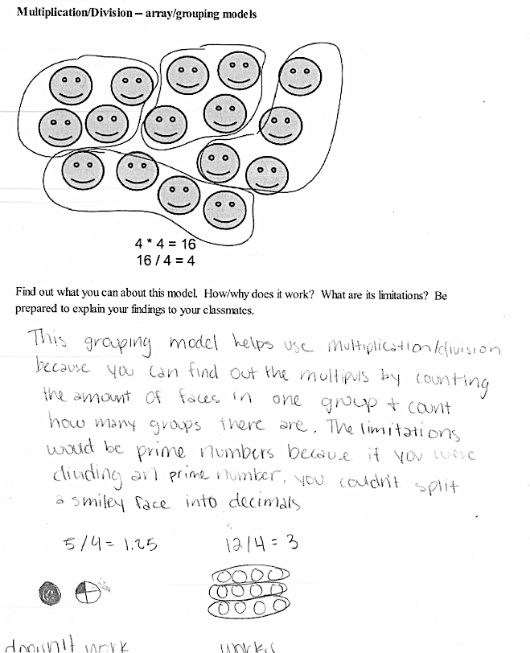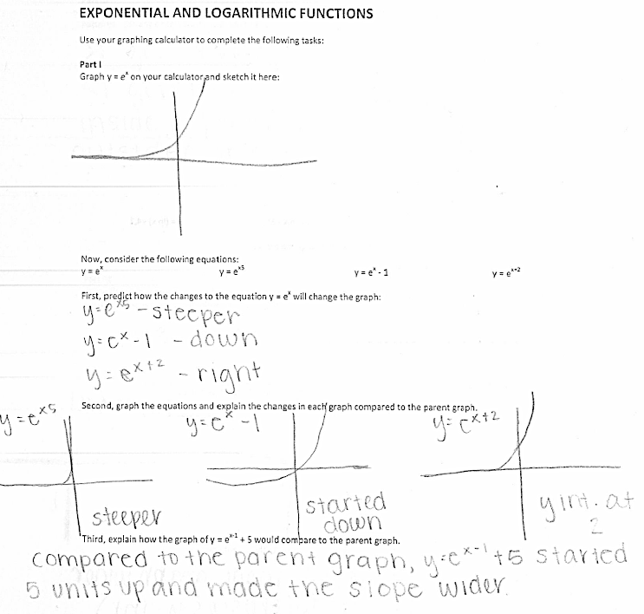
Figure 7. Student work samples
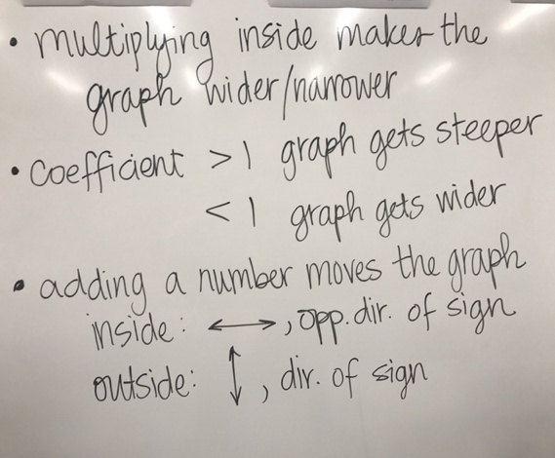
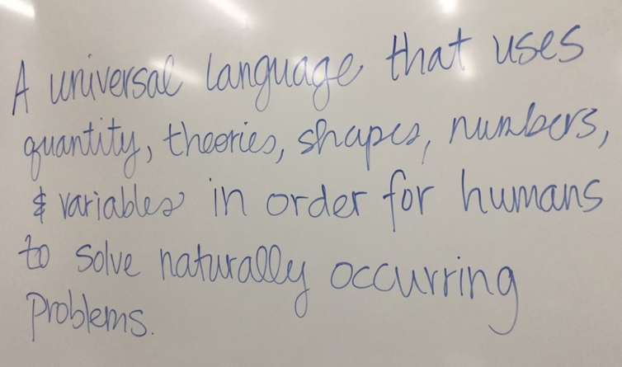
build consensus, our whole group discussions often moved to the board as each group shared their work, where I would act as recorder. Here, we would build consensus as a whole group, negotiating meanings of key concepts or summarizing observations regarding the day’s task (see Figure 8).

Figure 8. Class consensus samples

Student Interviews
Each of the three students interviewed mentioned our departure from the traditional mathematics class when I asked them to describe our course’s major characteristics. Specifically, Margaret said “we all worked together to do things . . . like understanding what math actually is and just like understanding the deeper meaning where math comes from … as opposed to like learning just like math that we learned in other classes” (Interview transcript). Furthermore, she said that this focus on what she perceived to be the “deeper meaning” of mathematics “gave us a better appreciation for it” (Interview transcript) and demystified for her what had seemed like “a second language” in previous experiences.
Emma noted something similar, that “we did a lot of stuff in class … with less homework [and] more discussion in class” rather than the more traditional model of having to “sit in math classes and take notes and then they give us homework to do” (Interview transcript). Furthermore, she felt that discussing things in class like we did really helped each student “get [their] questions answered” as they worked together and that primarily what I did as the teacher was “a whole lot of building [a concept] off of what we said” which enabled her to “adapt the way [she] thinks into learning new ways” (Interview transcript).
Rose felt like our class “was really just about learning and making sure that everyone could understand what was happening” by “having us explain ourselves and why certain math works the way it does” (Interview transcript). She appreciated the collaborative aspect of our class and the presentation of the tasks during class time was not “a traditional way of math assignments” so her “brain [didn’t] always register, ‘hey this is math’” which helped her realize that mathematics is “way more than … doing a set of problems according to rules” (Interview transcript).

Discussion
The evidence provides insight about how our class was designed around the three-part model of PCL of tasks, group work, and presentation (Wheatley, 1991). Nearly every class period in the duration of the semester was spent working in groups on the tasks described. As illustrated in Table 7, each task finished with a group presentation, collaboration with another group, or a whole group discussion to reach consensus about our findings. We used this process to build understanding of concepts, extending them to enrich that understanding through application or creation of our own mathematical text. Further, Wheatley (1991) described several characteristics that the teacher should consider for designing or curating tasks that would be considered educationally rich. Each characteristic was cross-referenced systematically with each of the tasks we completed as seen in Table 8 to provide further evidence of PCL in our class.
Table 8. Tasks cross-referenced with Wheatley's (1991) characteristics of meaningful educational tasks
 | What is Mathematics? | Number System Project | Number/Operation Modeling | Algebraic Modeling | Polynomial Farm | What the Function? | Graphing Stories | Transformers | Oil Slick Task | Mathematical Modeling | Textbook Chapter
Be accessible to everyone at the start | X | X | X | X | X | X | X | X | X | X | X
Invite students to make decisions | X | X | X | X | X | X | X | X | X | X | X
Encourage “what if” questions | X | X | X | X | X | X | X | X | X | X | X
Encourage students to use their own methods |  | X | X | X | X |  | X | X | X | X | X
Promote discussion and communication | X | X | X | X | X | X | X | X | X | X | X
Be replete with patterns |  | X | X | X | X | X |  | X |  |  | X
Lead somewhere | X | X | X | X | X | X | X | X | X | X | X
Have an element of surprise | X | X | X | X | X | X | X | X | X | X | X
Be enjoyable | X | X | X | X | X | X | X | X | X | X | X
Be extendable |  | X | X | X | X | X | X | X | X | X | X

Because of the demonstrated centrality of problem solving and task-oriented learning in our class, PCL is considered to be a defining characteristic of it.
Furthermore, students perceived PCL as a major characteristic of our course, setting it apart from the traditional math classroom through collaboration and a broader perspective about the nature of mathematics. Rose, Margaret, and Emma all noted how they appreciated our approach to learning mathematics, providing a positive experience in school mathematics where it is understood that mathematics is “way more than … doing a set of problems according to rules” (Rose, Interview transcript). Expecting my students to be at the center of sense-making in my classroom helped them to “develop intellectual autonomy” (Wheatley, 1991, p. 19), which as Emma pointed out was the most challenging part of our classroom for her: “I had to take in the information on my own and…if I [didn’t] understand it, I [had] to figure out how to change it…figure out how I was going to use what I was given, to learn what I needed to know” (Interview transcript). I hope the experience of this semester allowed my students to develop as mathematical thinkers, so they may “enrich their own lives and the society in which they live” (Reynolds, 2010, p. vii).
Finally, there is some evidence that our course may have been a factor in the success of my students in the following semester of college-level mathematics. According to a report from the Mathematical Association of America (2007), fewer than 50% of students enrolled in College Algebra are expected to make a final grade of C or above. Of the 20 of my 21 students that completed College Algebra in the Spring of 2018, 90% completed with a C or better. While it would be foolish to contribute this solely to the format of our course, it is clear that it did not hinder my students in their success.

Implications
Because constructivist-minded models have not been fully implemented in school mathematics curriculum (Cifarelli, 2010) more opportunities for teachers to envision such a practice in their own classrooms is necessary. While there are some examples of tasks or problems for teachers to use in the current body of literature (e.g., Abshire, 2010; Clements, 2000; Trowell & Wheatley, 2010), this study aimed to provide an example of a semester long College Algebra preparatory course at a suburban high school with eleventh and twelfth graders that had PCL as a central characteristic.
The PCL model of teaching for mathematics teachers who embrace constructivist beliefs holds promise, both in supporting student achievement and for the improvement of student experience with mathematics (Yackel, 2010) as the mathematics education community collectively envisions more meaningful experiences (National Council of Teachers of Mathematics, 2014) in secondary mathematics classrooms. The example provided here, I hope, inspires others on their journey to enacting constructivist-based teaching practices in their own classrooms.
Chapter 4: Learning to Write Mathematics
[When writing in our class] you understand the reasoning behind [your solution] and then writing it out, it just kind of lets your thoughts not just be scrambled all over the place and for me, it helped just to like solidify [my understanding] (Rose, interview transcript)

And rewriting the stuff we learned like in our own terms actually helped like encode it for our learning (Margaret, interview transcript)

Writing in the Mathematics Classroom
Despite some dispute regarding the precise definition of content-specific literacy, it is undoubtedly an important part of the 21st century classroom (Moje, Overby, Tysvaer, & Morris, 2008). Recent mathematics standards of practice adopted across the United States have highlighted the need for our students to read, speak, and write about their mathematical understanding with meaning—to communicate their ideas and knowledge to one another in order to elucidate their thinking for others, to themselves, and perhaps even deepen that knowledge to a greater degree (e.g., Common Core State Standards Initiative, 2016; Oklahoma State Department of Education, 2016). Considering this, I will adopt here the broadest definition of content-specific literacy, whereby it is considered the “ability to read, interpret, critique, and produce the discourse of a disciplinary area,” which necessitates that students must have “access to the conventions of disciplinary knowledge production and communication” to learn in that content area (Moje, Overby, Tysvaer, & Morris, 2008, p. 109).
Writing is a key piece of discourse production in any classroom, and there is some evidence that students of mathematics benefit more from writing than talking with one another about the discipline (Pugalee, 2004). Furthermore, writing promotes helpful metacognitive behaviors (Pugalee, 2001), provides teachers with invaluable insight into student thinking (Carter, 2009; Freiman, Vézina, & Gandaho, 2005; Yang, 2005), and the cognition required to “create, consume, and critique certain types of text” (Draper & Siebert, 2004) promotes interpersonal communication (Freiman et al., 2005; Linhart, 2014; Yang, 2005). As such this chapter will focus on this essential facet of literacy.
Given this evidence, it seems obvious that the mathematics education community would encourage the use of writing in the mathematics classroom. The National Council of Teachers of Mathematics (NCTM) first emphasized the importance of communication broadly in the classroom in Principles and Standards for School Mathematics (2000), which states, “communication is an essential feature [of a challenging mathematics classroom] as students express the results of their thinking orally and in writing,” (p. 268) and that “communication is a fundamental element of mathematics learning” (p. 348). In 2014, NCTM reemphasized that “effective teaching engages students in discourse to advance the mathematical learning of the whole class,” and defines discourse as the “purposeful exchange of ideas through… verbal, visual, and written communication” (p. 29). It is also clear, however, that there still may be those that dismiss writing as an activity of value in the mathematics classroom (see Spitler, 2011), causing one to wonder what kind of support has been provided to sustain the ready endorsement of the larger community.
The emphasis in current literature is primarily on how frequently teachers are asking students to write during mathematics learning (e.g., Bakewell, 2008; Ntenza, 2004, 2006; Pearce & Davison, 1988; Swinson, 1992) or broadly about the kinds of writing being done in the mathematics classroom (e.g., Bell & Bell, 1985; Cross, 2008; Kosko, 2016). Despite the guidance provided on the utilization of writing strategies found within this literature, there is still an alarming lack of critical guidance regarding how exactly writing is to be managed (Draper & Siebert, 2004; Friedland et al., 2011; Wilcox & Monroe, 2011). Information regarding management issues like how to choose one specific strategy over another, when to utilize writing in the learning process, and/or how to scaffold students into writing in the mathematics classroom is necessary to guide teachers in this area. Furthermore, as the definition of content specific literacy expands to include broadening conceptions of text and what it means to interact with it (Spitler, 2011), teachers will need to expand their own idea of literacy in their content accordingly (Orr et al., 2014).
Unfortunately, a dichotomy of sorts has arisen in the field of content literacy, between those using ‘reading and writing to learn’ and those promoting ‘learning to read and write’ content-specific information (Draper & Siebert, 2004). Literacy strategies are obviously important to building content knowledge, but equally important is learning to actually create mathematical texts, with an aim to “build an understanding of how knowledge is constructed within the discipline, rather than transmitting knowledge about the discipline” (Johnson, Watson, Delahunty, McSwiggen, & Smith, 2011, p. 107). “Learning to read and write” in a content area allows the focus to be on the process of writing in addition to the content, rather than solely on the content.

Learning to Write Mathematics
Even less guidance exists on how to support learning to read and write mathematically—the ‘create’ and ‘critique’ aspects of literacy (Draper & Siebert, 2004); this review only uncovered one such example, which only described the experience in an undergraduate mathematical modeling course (Linhart, 2014). This process of creation and critique, where students are asked to do so “as an end goal in and of itself” (Draper & Siebert, 2004, p. 957), will require students to spend time revisiting writing assignments repeatedly. It is possible that students may be able to do so by utilizing writing that was used initially to enhance understanding of content.
This potential revision process may have dual results. By expanding upon, revising, and polishing writing completed for the purpose of learning mathematics, students will increase both their understanding of mathematics and their ability to write mathematically (Wilcox & Monroe, 2011) as a member of the mathematical community (Draper & Siebert, 2004). Because secondary mathematics teachers are rarely trained writing teachers and were unlikely to have been exposed to writing to learn and learning to write mathematics as students themselves, they are understandably hesitant to include this vital facet of literacy in their own classrooms. Writing mathematically in this manner is an essential part of being mathematically literate; therefore, further understanding and exploration of this revision process is essential. Teachers of mathematics at all levels of education require detailed accounts and models of this being used in order to implement it in their own classrooms. This study aims to demonstrate the utilization of writing in a secondary mathematics course which had writing as a defining characteristic.

Methodology
This study utilized instrumental case study methodology to provide a thick description of one instance of a semester long College Algebra preparatory course. Broadly defined, a case study is a “complicated arena [of qualitative inquiry] involving methodological choices directly related to goals or purposes of conducted case-based research, research traditions in different disciplines, and the ways in which investigators define a case,” (Schwandt, 2015, p. 26). This is considered an instrumental case study, which Stake describes as a case that is studied “mainly to provide insight into an issue” (2003, p. 137), due to the case being somewhat secondary to the phenomenon of interest but “still looked at in depth, its contexts scrutinized, its ordinary activities detailed,” (Stake, 2003, p. 137) as a means to explore the issue of interest. In a case study, the “case” must be well-defined (Merriam, 2009) so this study is focused on the implementation of a dually credited College Algebra preparatory course offered in one suburban district in central Oklahoma that I designed and taught; an alternative to current, more traditional paths for mathematics remediation not yet described in the available literature.
The course in preparation for College Algebra was negotiated with a nearby four-year research institution, Central University (pseudonym; all student and school names have been replaced by pseudonyms), for two primary purposes. First, to eliminate any possible “gap” (Greene & Forster, 2003; Kurlaender & Howell, 2012), whether real or perceived, in coursework between secondary school and university; and second, to remove a systematic barrier for many students’ future matriculation in post-secondary education, which was achieved by a modification of the institutional requirement for concurrent enrollment into College Algebra. The concurrent enrollment office agreed to waive the institutional requirement of an ACT mathematics subscore of 23 to take College Algebra as a concurrent student if students participated in the remedial semester, opening the door wide to students who otherwise would not have this opportunity. In addition, the course was offered on campus at Central High which allowed students who either lacked transportation or a free two-hour block to also consider the course.
The dually credited College Algebra preparatory course that I designed and taught was offered to high schoolers in one suburban district in Oklahoma and deviates from other examples of remedial classes in a few key ways. It was offered on the high school campus and taught in a very learner-centered manner, contrary to the more traditional pedagogies generally provided at universities (Brock, 2010). In addition, the material was not approached with the primarily deficit-model focus (Brock, 2010) of most remedial courses; instead instruction centered around solidifying the students’ conceptual understanding of key mathematical ideas in preparation for their college-level mathematics experience the following semester.
It was advertised primarily for college-bound 12th graders who were enrolled in Algebra 2 as 11th graders; the assumption being that many of them would declare academic majors at university requiring minimal general education credits in mathematics and this course offered at their high school may fulfill it entirely. Furthermore, for those students who may need one course in addition to College Algebra to fulfill their major’s requirements in mathematics, they will have secured credit from a reputable four-year institution, which should transfer directly to any other institution, helping them avoid the potential trap of placement testing.
The primary goal of this study, then, is to provide a rich description of this course for others seeking to implement alternate paths to college credit; this course was chosen specifically for its potential to illuminate this issue through detailing ordinary events and studying it in depth. By providing this detailed account, I hope to provide beneficial learning opportunities for others seeking to develop courses similar to the one that is the subject of this study. Additionally, I hope to create literature regarding this experience wherein other practitioners may find images of themselves and prompt their own reflection which will impact their own course development so we may develop rigorous and meaningful courses that allow every student to succeed. This research began by using the following questions to frame the study:
- What were the defining characteristics of a College Algebra preparatory semester course offered in a suburban high school in the west south central United States?
- What were student perceptions of those defining characteristics?
- What were the student perceptions of their learning during this course?

Setting and Participants
Our classroom was located in the newly added College and Career Center of Central High (see Figure 9). The room had one door for entering and exiting, located in the southwest corner of the room near the front. Our hallway was completely interior, so the windows that ran along the top of the south wall added no natural light. The west wall was what I considered to be the front of the room, where the long dry-erase board and large TV monitor were located. The north wall was the only one that boasted any decoration, and it was painted green, a school color, and a flag of the United States and a flag of the People’s Republic of China hung side-by-side in the center.
Figure 9. Our Classroom

We adopted a college-like schedule because our course was offered in conjunction with the college-level course in the spring, so we only met three times a week for 50 minutes. As a result, the classroom’s décor was mostly determined by the classes that met there more frequently – elective courses in Chinese language and culture. We did make the classroom our own while we were using it, though, by making the most of the flexible furniture. Long, gray tables that seated two students could be rolled, and the industrial gray carpet allowed us to move the furniture as needed. For example, students often turned their chairs to the row behind them or pushed two tables together to collaborate with others. In addition, tall black plug-in stations ensured that students could utilize their school-issued devices from anywhere in the classroom.
A teacher station sat in the front, northwest corner, where I could plug in my school-issued laptop to display on the large TV monitor. I frequently used this as a reference point, presenting information to guide the students’ work. There was also a teacher desk in the opposite corner, but I rarely used it, choosing instead to walk among the students as they collaborated on and discussed their work during class time.
The preparatory semester was intended to build up from Algebra 2 to College Algebra, based on the assumption that students would have taken Algebra 2 in the previous academic year. The students in our class, however, had a wider variety of experience with academic mathematics, and the majority of them had already spent time studying in a course beyond Algebra 2; eighteen of them had completed a course beyond Algebra 2 with a D or better. Furthermore, due to our intensive focus on conceptual ideas rather than procedural fluency, many of my students were forced to grapple with misconceptions or gaps in the understanding they had previously constructed. Particularly, we focused on foundational concepts in mathematics, including number and operations, graphing, functions, and algebraic reasoning across three thematic units.
These three units [see schedule in Appendix A] addressed broadly the nature of mathematics and the purpose of studying it, the structure and modeling of our number system, and how numerical and algebraic relationships are modeled, before focusing for the majority of the semester on the mathematical concept of function. The mathematical idea of “function” is central to any course in College Algebra and it was my purpose to bridge any gaps in conceptual understanding that my students had in order for them to build upon this foundational understanding in college-level studies.
More broadly, our class at Central High consisted of 21 students, nineteen seniors and two juniors. All planned to be college-bound after high school. Fourteen students were denoted as female, seven as male. In addition, Fourteen of them identified as Caucasian; two as American Indian; one as Hispanic/Latino; and four as two races. As a whole, Central High reported its population as 77% Caucasian, 4% Black, 4% Asian, 10% Hispanic, and 5% Native American; only 34% of students there qualify for free and reduced lunch (Office of Educational Quality & Accountability, 2015).

Data Collection and Analysis
In order to create a thick description (Merriam, 2009) of this remediation course, multiple modes of data collection were utilized. This study was necessarily centered around my own reflection-action-reflection cycle meant to improve teaching practice, student learning, and my understanding of the specific context in which my teaching occurred; therefore, my reflective journal was a main source of data. This reflective journal included reflection on the development of curricular materials, instructional decisions made day-to-day, and observations of the classroom’s happenings in order to illuminate the course’s major characteristics. To provide robustness to that data set, copies of curricular materials were also retained, including but not limited to the lesson planning documents, presentation files, and handouts for students. Student work items created during the regular proceeding of the course as it develops were also collected as artifacts to provide vital triangulation (Merriam, 2009; Schwandt, 2015) of events in the classroom; only items from the thirteen students who completed the appropriate consent procedure were utilized in this analysis.
In addition, three students who consented were interviewed using a semi-structured interview protocol [see Appendix B]. Interviews are semi-structured when a combination of more and less structured questions are used at the researcher’s discretion, with a list of potential questions available to explore with no predetermined wording or order (Merriam, 2009). A concerted effort was made to make these interviews conversational, but intensive (Charmaz, 2006, p. 32), in order to elicit the participant’s own interpretation of the defining characteristics of their course experience. Each consenting student was interviewed one-on-one after the completion of the course; these interviews were audio recorded with permission and transcribed verbatim by the researcher using pseudonyms.

Data Analysis
Data analysis was undertaken using a constant comparative method (Charmaz, 2014; Glaser & Strauss, 1967), which required an iterative process that mirrors the iterative reflection-action model of teaching. As part of this process, all researcher/teacher reflections and interview transcripts were transcribed and coded. Curriculum materials and student work artifacts also underwent a coding process, which began by using open codes, a type of initial code that are similar to what is found in the data, and led to category codes of broader, more conceptual elements (Merriam, 2009). Finally, the category codes were analyzed, and more overarching themes were generated as necessary. These themes were analyzed and subsequently guided my construction of the responses to the research questions.

Findings
Through the process of data analysis, some key words that illustrated the aspects of our class that made it different became clear. Some key words and the number of times they were utilized in course documents in each unit is in Table 9. While a simple word count does not necessarily prove the existence of one over-arching characteristic of our class it does provide weight to the significance of the actions valued therein.
Table 9. Key word counts
Keyword | Unit 1 | Unit 2 | Unit 3
Explain | 7 | 6 | 16
Group | 19 | 12 | 27
Write | 9 | 8 | 28

Because our course was centered around Wheatley’s (1991) constructivist teaching model, problem-centered learning, as explored in Chapter 3 of this dissertation, most of our class time was spent working in small groups on mathematical tasks—38 of 45 days. Tasks that were centered around writing utilized twelve of these class periods and other, additional writing assignments were completed outside of class time [see student handouts in Appendix D (without revision) and E (with revision)]. There were opportunities for students to write both with and without revision.

Writing without Revision
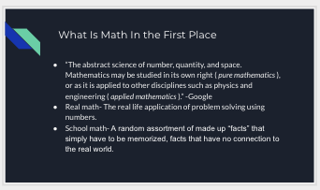
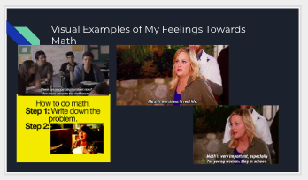
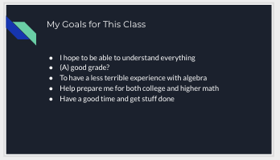
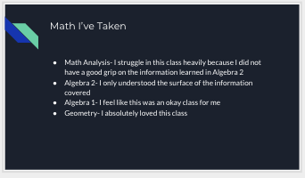
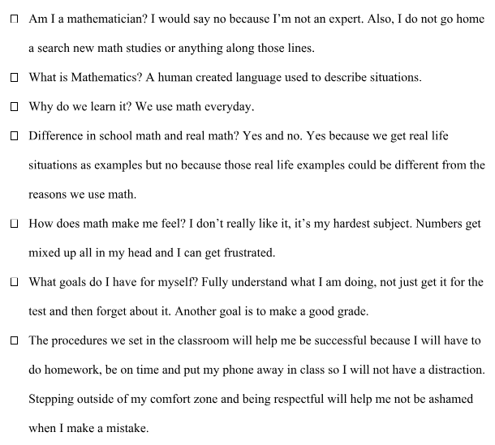
Writing without revision throughout our semester included reflexive and explanatory kinds of writing, as well as some opportunities for students to create items which might demonstrate their understanding of a particular mathematical concept. The first writing assignment that students completed in our course was their Math Autobiography, which asked students to explain their past experiences with mathematics and reflect on the purpose and meaning of mathematics as well as the goals we co-constructed in class. When I planned this assignment, my hope was to use it to help build rapport among the students and myself in addition to prompting my students to think more deeply about mathematics and the purpose of learning it. Despite the guidance that they “may include illustrations or non-text material, but also include some text description of what is included” in their instructions, most student opted to write out their responses in text. See Figure 10 for some samples of student responses.
Figure 10. Student responses to My Math Autobiography
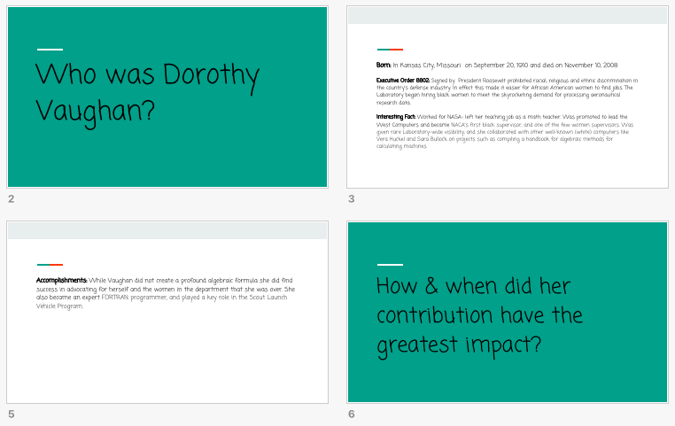
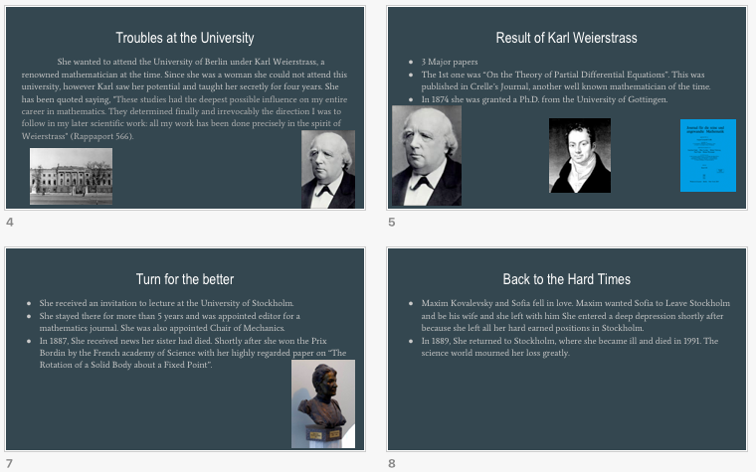
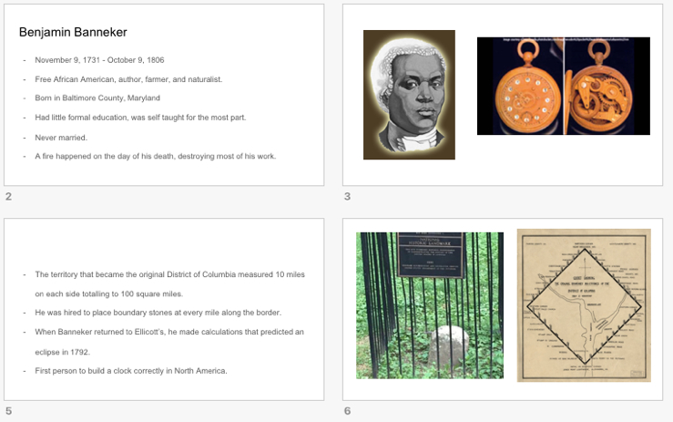
Students also completed a presentation about a person of interest from the history of mathematics, where they chose a mathematician and reported on their contribution to the field of mathematics (some student work provided in Figure 11). Planned primarily as a venue to
Figure 11. Student work from Math History: Person of Interest

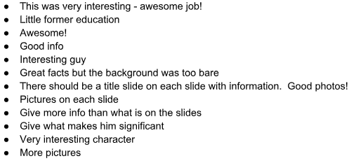
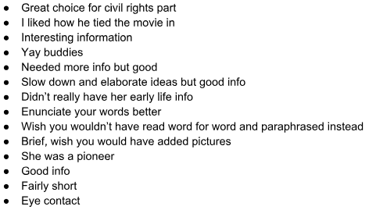
induce deeper student thinking about mathematics and how it came to be accepted as it is in our society, this assignment also provided opportunity for students to have some autonomy in the work they were completing and valuable practice in providing peer reviews to their classmates which I compiled for each student (see Figure 12).
Figure 12. A sample of compiled peer reviews for Math History: Person of Interest presentations

The three students interviewed each spoke about this assignment without specific prompting and its contribution to their broadening idea of mathematics. “I thought it was really interesting to learn about…how hard people worked to figure stuff out,” Margaret said. Emma said something similar, that she “[thought] it was kind of interesting that … there was a lot about [the mathematicians] that wasn’t just this math thing they did and I liked that part ‘cause it was like hey, math people who do more than just math, who knew?” Rose pointed out that that she “enjoyed going in and doing that research and being able to find cool things about why her math was important and why it, like, math is more worldly [sic] than just in a classroom setting” which helped her realize that “math can be used in a variety of ways and not just in a classroom”.
We used Math Two-Ways (Wheatley & Abshire, 2002) for exercises during our second unit, completing them for addition and multiplication (and therefore subtraction and division) of rational numbers and algebraic expressions. While these puzzle-like exercises were developed mostly for the improvement of fraction fluency in 5th-8th graders, they can be utilized with any mathematical concept involving arithmetic operations. Completing one requires at least five computations, with a built-in self-check (Abshire, 2010). After using them as a homework exercise as we developed representations of numerical and algebraic expressions with arithmetic operations, I asked the students to create a few of their own which they swapped with a neighbor in class to complete.
Within the tasks that constituted the other 27 of 38 class periods of our semester, there were a multitude of opportunities for students to write as well. As demonstrated in Table 10,
Table 10. Writing opportunities in tasks that were not writing centric.
Task | Writing Opportunity
What is Mathematics? | “write a definition of mathematics”
Number/Operation Modeling | “Find out what you can about this model. How/why does it work? What are its limitations?”
Algebraic Modeling | “Please investigate how we might model the following”
Polynomial Farm | “…is x a variable or an unknown quantity? If it is a variable, explain”
What the Function? | “What does it mean for y to be a function of x?”
Graphing Stories | “For each question, provide a story that matches the graph or draw a graph that matches the given story”  “Can you write a story for a non-function? Why or why not?”
Transformers | “…predict how the changes to the equation …will change the graph”  “…explain the changes in each graph compared to the parent graph”  “…see if you can find any patterns. List any observations you make here”
Oil Slick Task | “Looking at your data this way, which function do you think most closely models it? Why?”  “…how might we determine the area of the oil slick at any given time?”
Mathematical Modeling | “…please determine and justify the best mathematical for each [set of data] by completing the following:  - Which parent graph will you use to model this data? Why?  - Find a specific function that you feel ‘fits’ this data and write it down with the dataset.  - Use the function to predict a point within your data (called interpolation). Does this fit the rest of the data?  - Do these functions have zeros? If so, what is the meaning of f(x) = 0 in each context?  - Do these functions have asymptotes? What is the meaning of that in each context?”

most of these writing prompts were expository in nature. Some student work samples can be seen in Figure 13.

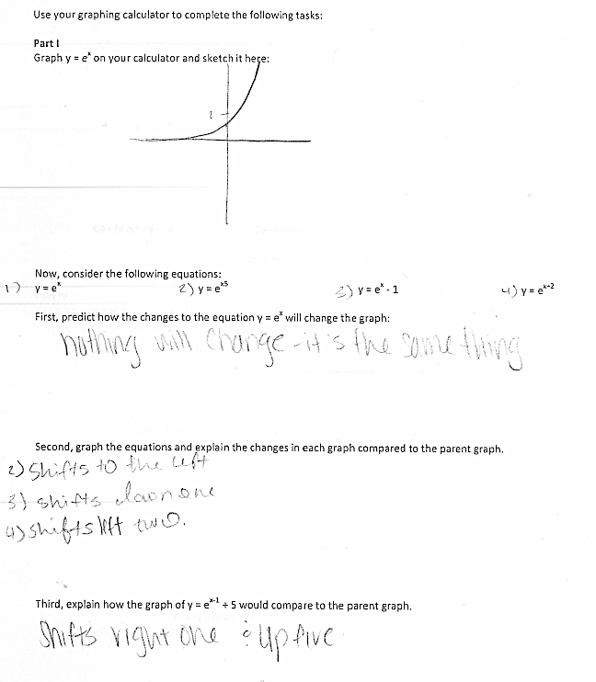
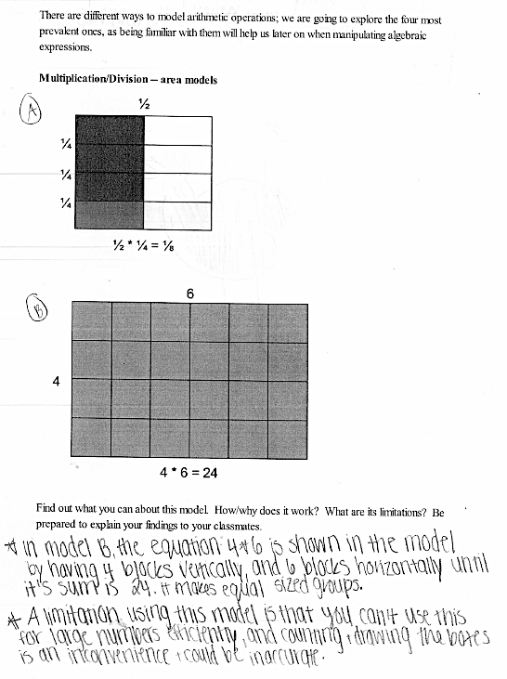
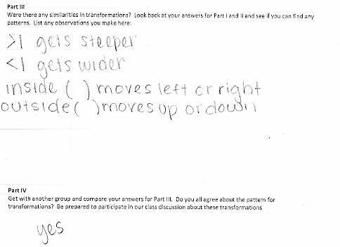
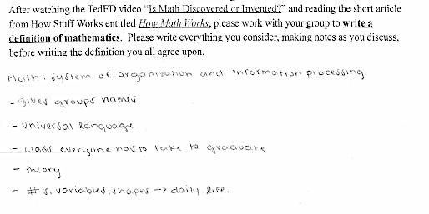
Figure 13. Some examples of student responses to writing prompts in non-writing centric tasks

Writing with Revision
Figure 14. Student work samples for the Number System Project. Left side is the brainstorming sheet, right side is final product.
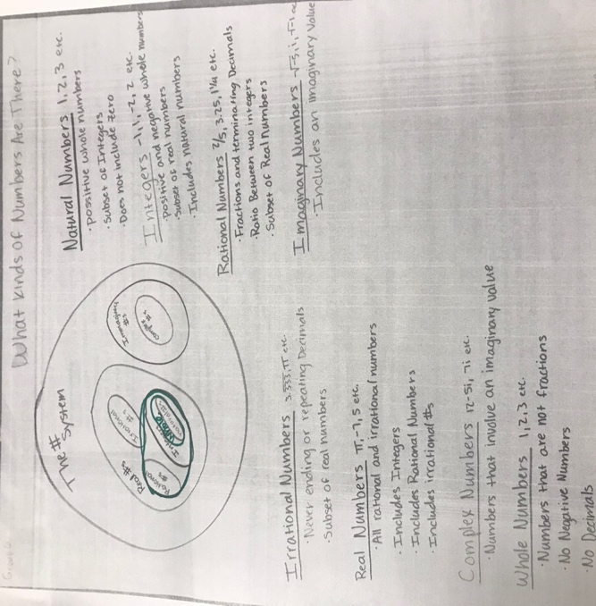
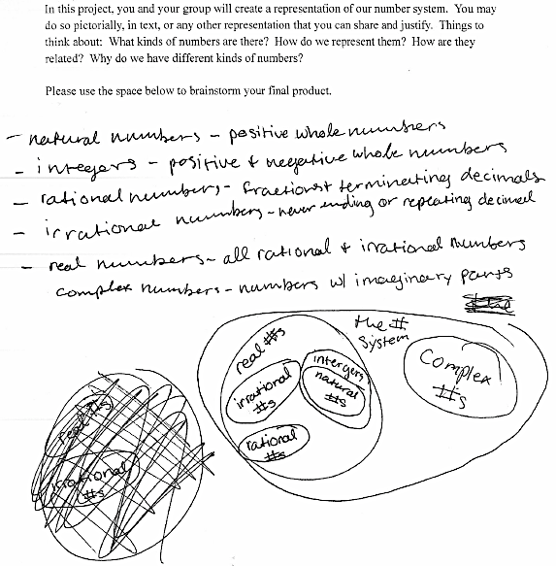
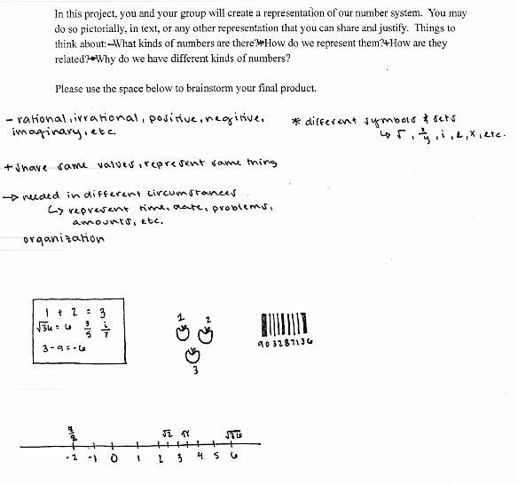
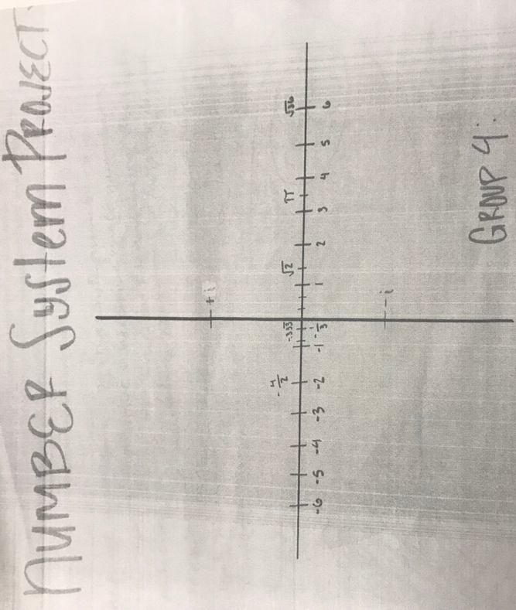
There were two major projects that my students completed which planned for and expected at least one round of revisions. First, during unit two, students completed a Number System Project. This project asked students to “create a representation of our number system” with the guiding questions, “What kinds of numbers are there?” “How do we represent them?” “How are they related?” and “Why do we have different kinds of numbers?” Regardless of the prompt that they “may do so pictorially, in text, or any other representation that you can share and justify” (Student handout), most students created a poster (samples in Figure 14).
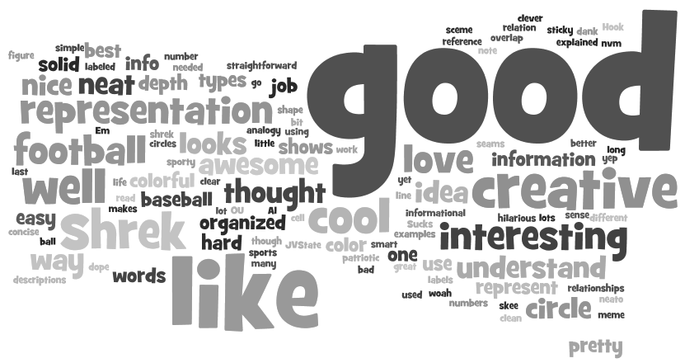
A first draft of these posters was shared in a Gallery Walk, in which students were asked to provide feedback for one another on sticky notes. This was done in consideration for the rounds of peer reviews I had planned for their Final Project, the other writing with revision project. As expected, students provided feedback for one another that I remarked in my reflections as being “lackluster,” and reminded me that “students must be trained to provide constructive feedback.” I created a word cloud (Figure 15) of their feedback in order to facilitate a class discussion about constructive feedback. This discussion resulted in a co-constructed list of things to think about when providing feedback to our peers (Figure 16), which we referenced each time we provided feedback for the remainder of the semester.
Figure 15. Word cloud of peer review text from Number System projects
Figure 16. Co-constructed guidelines for constructive peer
feedback.
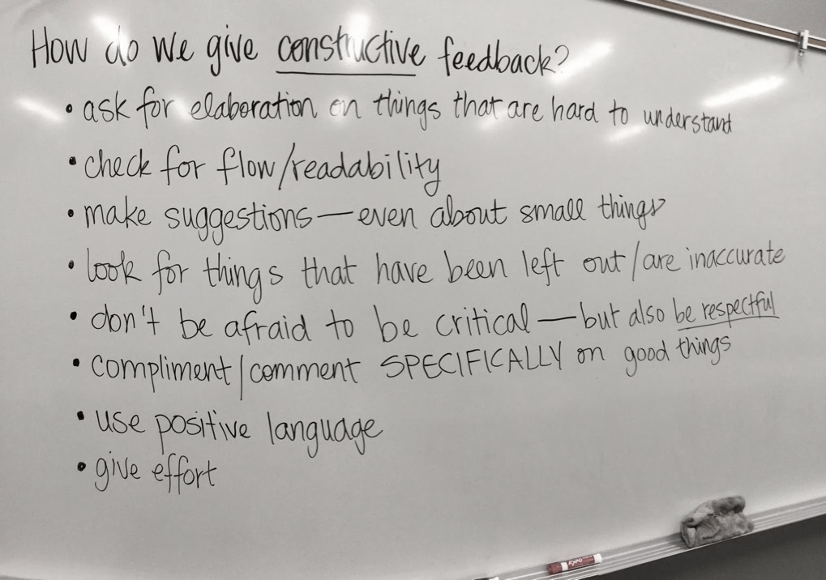
The other major writing with revision project we completed was the final project for Unit 3, a written textbook chapter about mathematical functions. As mentioned previously, preparation for this project had begun early in the semester, as I scaffolded my students’ thinking about providing constructive feedback on a classmate’s mathematical text. We practiced giving feedback frequently, as students presented their history of mathematics research nearly every Friday through the semester and their peers were asked to provide feedback for each one. In addition, at the end of Unit 2, small groups analyzed existing textbook sections about our number system. Through this analysis, we co-constructed lists of Dos and Don’ts—things we felt were helpful, or less than helpful, in the examples I provided (see Figure 17).

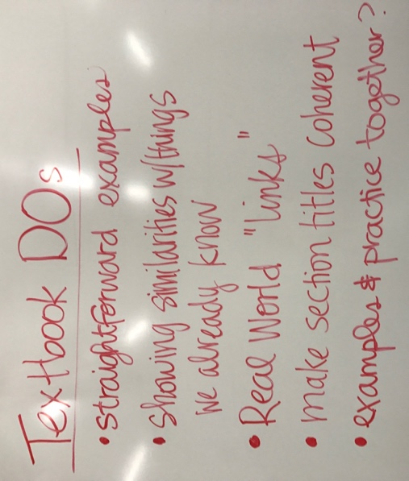
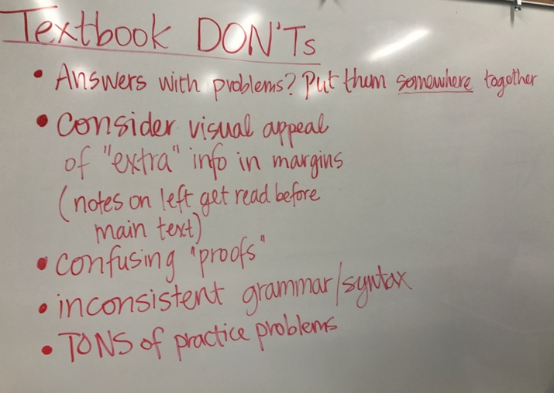

Figure 17. Co-constructed guidelines for textbooks.

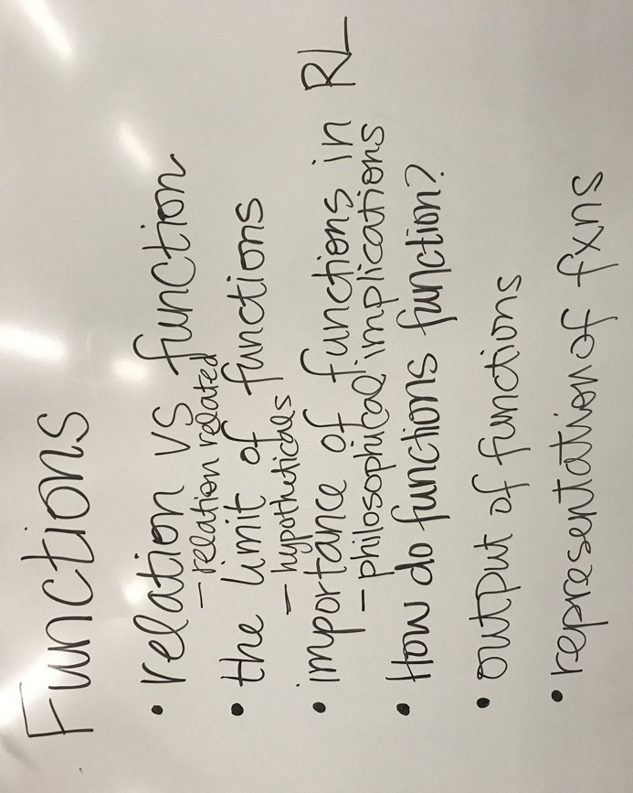
As we began unit three, we utilized a task to help us co-construct a definition for function. At the end of that lesson, I had students write down three questions they still had about functions and used these questions to frame the rest of our unit. Additionally, the students sorted these questions and created themes for our textbook chapter sections (Figure 18). During this unit, eight of the twenty-eight days were spent working on the textbook chapter in class. For each section there were two deadlines, one for the first draft and one for a

Figure 18. First draft of textbook chapter sections.
final draft. Students were asked to provide a peer review for at least four of the other groups on peer review days, where I provided a copy of each group’s work (only labeled with their group number) for each student and copies of our co-constructed rubric. Then, reviews were collated for each group and provided to them in the next class period so they could make changes. Some samples of final drafts are provided in Appendix F.

Discussion
So many benefits have been cited when using writing in the mathematics classroom (e.g., Carter, 2009; Freiman et al., 2005; Linhart, 2014; Pugalee, 2001, 2004; Yang, 2005) that I knew from the inception of this course I would ask students to participate in the writing; because of this it was not a surprise that it was a defining characteristic of our course. Additionally, I wanted to expand their experience with mathematics to include the writing of mathematical text in order to emphasize the need for students to “create and consume texts as an end goal in and of itself” (Draper & Siebert, 2004, p. 957). To do this, I asked them to create a kind of mathematical text with which they already had a level of familiarity, a textbook, in order to avoid pushing too hard on the boundaries of what they might consider to be mathematics.
One student in particular, Emma, talked for several minutes about the textbook chapter during our interview, and how it had impacted her learning in our class. She said it felt like the “biggest thing we focused on all semester” and that it was the assignment from which she learned the most. Similarly, in her interview, Margaret stated that the peer review process “helped encode it for our learning”. Rose also discussed some benefits of writing in our class, namely that “it instills faster learning” because writing it helps you “understand the reasoning behind it”. This perspective from students only confirms what research has already shown to be benefits of writing as an important facet of the mathematics classroom.
There is some evidence that our course may have been a factor in the success of my students in the following semester of college-level mathematics. According to a report from the Mathematical Association of America (Haver et al., 2007), fewer than 50% of students enrolled in College Algebra are expected to make a final grade of C or above. Of the 20 of my 21 students that completed College Algebra in the Spring of 2018, 90% completed with a C or better. While it would be foolish to contribute this solely to the format of our course, it is clear that it did not hinder my students in their success.

Some Reflections
Like any first implementation of anything, there were bumps in the road along the way. For example, Emma also talked about some weak points of being asked to write the textbook chapter in her interview. She wished that there had been more time to complete it and also commented that the combination of being asked to do an assignment like this and adapting to the different format of our course was difficult for her. I have no doubts that this was true for most of the students and worked diligently to scaffold my expectations throughout the semester. The scheduling of this particular class was problematic in a sense, and I found myself often wishing that we were scheduled for five classes a week rather than three. For future implementations, I will be sure to be more diligent about the timeline leading up to an assignment like this or introduce it from the beginning of the semester.
Additionally, despite my intentional way of leading up to this assignment throughout the semester, there was still some confusion on the part of my students about its true purpose. For example, Emma stated that at times she felt “very annoyed…like why is she doing this, this is driving me nuts.” Margaret echoed this sentiment, that sometimes “we [the students] didn’t really understand why we were doing it like that but then towards the end of the [semester] we kind of understood.” It is important to remember that any time we ask our students to learn in a way that they perceive is different, that patience, persistence, and care is necessary on our part (Noddings, 2013).

Implications
This accounting of our course demonstrates that my conception of students creating mathematical text – writing with revision – is possible, even under our shortened schedule limitation. It is my hope that through this accounting, other practitioners may feel emboldened to include similar projects or activities in their classes in order to grow content-specific literacy among their students. Furthermore, as more examples of mathematics activities that require students to learn to write mathematics enter the body of existing literature, additional research will be required to support this practice in secondary mathematics.
Chapter 5: Understanding the Model
This study began as a detailed account of one alternative to traditional mathematics remediation in a suburban high school in central Oklahoma motivated by the evidence that current models are not broadly effective (Attewell et al., 2006; Bahr, 2008; Complete College America, 2013; Di Pietro, 2014; Lagerlöf & Seltzer, 2009). Some logistical modifications to the traditional path have been considered (Bahr, 2010b; Cooper, 2014; Gooding, 2004; Stuart, 2013b; Zavarella & Ignash, 2009), as well as pedagogical modifications (Cullinane & Treisman, 2010; Ironsmith et al., 2003), but there were no ready accounts of remediation offered as a preparatory course preceding a course for college credit on the high school campus in the extant literature. Because remediation courses in mathematics are sometimes perceived as a systematic barrier for student matriculation in post-secondary education (George, 2010), Central High’s school district had an interest in eliminating the necessity of remediation for its students. Furthermore, this course arrangement was intended to eliminate any possible “gap” (Greene & Forster, 2003; Kurlaender & Howell, 2012), whether real or perceived, in coursework between secondary school and university, allowing students to achieve credit in both high school and college-level mathematics with the completion of both semesters.
Because the college-level course was moderated and taught by university staff and the school district had little agency in how it proceeded beyond selecting the classroom and arranging the hour it was offered during the school day, this study particularly examined the preparatory semester. The examination of this course revealed it to have three major characteristics; a mathematical community of practice, problem-centered learning (PCL) as a primary teaching model, and the use of writing in our mathematics classroom. Chapter two describes the cultivation of our mathematical community of practice, which allowed our curriculum to become more an “itinerary of transformative experiences of participation” than a “list of subject matter” (Wenger, 1998, p. 272) and empowered students to negotiate consensus about knowledge as I facilitated meaningful experiences about the concepts at hand. Chapter three depicts the use of PCL as a teaching model to empower other constructivist-minded practitioners to fully implement constructivist-minded models in school mathematics curriculum (Cifarelli, 2010). Finally, chapter four portrays our use of writing as a tool to promote content-specific literacy in order to provide a road-map of sorts for others wanting to implement complexity in the writing required of their students, in order to equip them with the ability to “read, interpret, critique, and produce the discourse of” mathematics (Moje, Overby, Tysvaer, & Morris, 2008, p. 109). While each of the three previous chapters of this dissertation details these characteristics separately, it is also important to examine the course more holistically.

The Big Picture
An essential improvement in college remediation would be to improve upon their pedagogical foundations; to forego the “outmoded teaching methods” (Brock, 2010, p. 116) they so often employ and base them instead upon “now well-established principles of mathematics teaching and learning” (Cullinane & Treisman, 2010, p. 11). The National Council of Teachers of Mathematics (2014) provides guidance regarding these principles of effective mathematics teaching and learning. Namely, effective mathematics teaching and learning “engages students… through individual and collaborative experiences that promote their ability to make sense of mathematical ideas and reason mathematically” and includes a curriculum that “develops important mathematics along coherent learning progressions and develops connections among areas of mathematical study and between mathematics and the real world” (p. 5).
The central pedagogical structure of this course was described in Chapter 3; I chose to utilize the model of PCL (e.g., Reynolds, 2010; Wheatley, 1991) in my classroom. This choice was intentional on my part and related to several factors. First, I consider myself to be a constructivist educator, and PCL was developed as a constructivist model of mathematics teaching and learning (Wheatley et al., 1995). Additionally, there is evidence of increased student achievement when learning by this model, as well as potential for allowing for students to construct more than a “set of isolated rules and procedures…devoid of…mathematical understanding” (Yackel, 2010, p. 19). Furthermore, because “for many students, school mathematics has not been a positive, confidence-instilling, nor empowering experience” (Harter, 2010, p. 186), it was essential to me that I provided my students with the sense of ‘intellectual autonomy’ that can be found in a PCL mathematics classroom (Wheatley, 1991).
Once armed with this determination, it would have possibly been sufficient to create the curriculum with the framework for PCL (see Figure 19) in mind. However, if a mathematics classroom is based upon an inquiry mathematics tradition—and PCL is such a model—then the ‘social character’ of the classroom must also be taken into account (Yackel, 2010). In order to maintain an atmosphere that promotes the collaboration and argumentation required by PCL, a community of practice that values these actions must be cultivated.
Figure 19. Wheatley's model for PCL
Chapter two delineated many pieces of the mathematical community of practice which my students and I co-constructed. This would not have been possible without purposeful and careful dedication to planning for:
- Activities requiring mutual engagement, both among students and with other people involved
- Challenges and responsibilities that call upon the knowledgeability of students yet encourage them to explore new territories
- Enough continuity for participants to develop shared practices and a long-term commitment to their enterprise and each other (Wenger, 1998, p. 272)

Doing so enabled us to construct meaningful social and sociomathematical norms (Yackel & Cobb, 1996) in our classroom that governed our interactions. Without these accepted ways of interacting with one another and mathematics in our classroom, I do not believe that we could have harnessed the true benefits of PCL and through this experience, now consider that the community established within the classroom is perhaps its most important characteristic (see Figure 20).

Figure 20. The cooperation of our classroom's essential characteristics

Furthermore, I believe it was through the sociomathematical and social norms that we established that I was able to provide some perturbation for my students regarding the work of mathematics by introducing writing as a viable activity in our mathematics classroom. As described in Chapter 4, my students were expected to ‘publish’ a draft of each section of their Final Project and then revise and improve it based on the feedback of their peers in order to ensure that the text they created conveyed the message that they intended—about functions, in our case. I asked my students to participate in writing mathematics and by doing so, they became active participants in the ‘mathematical discourse community’ to prepare them for participation in the “larger disciplinary discourse that transcends the immediate classroom”—something that is often found in other school disciplines, but rarely found in mathematics classrooms (Draper & Siebert, 2004, p. 957).

The Classroom Model
What can be concluded, then, from this holistic vision of our course is two things in particular. First, that the synergy of our community of practice and PCL was key to the success of this course. The social and sociomathematical norms that we established and fostered were both instigated and refined by the practice of PCL. While it would perhaps have been possible to have utilized a different pedagogical model, I believe that the utilization of PCL in our course helped foster the practice that we built as a community. With only one or the other, the community built may not have been robust enough to last into the next semester and/or my students may not have persisted through the perturbations resulting from an experience practically antithetical to what they had been socialized to expect from a course in mathematics.
Secondly, this very synergy enabled me to enact more rigorous writing activities in our course. Without our social norms of trust and openness or our sociomathematical norms of justifying mathematics, the process of writing with revisions based on peer reviews would have been nearly impossible to accomplish. This, in turn, also contributed to our sense of a community of “doers” of mathematics, rather than only “receivers” of mathematics.

Final Thoughts
I think, if my previous math classes had been more like you built yours, with the less homework, more discussion in class, then that wouldn’t have been as odd to me…I think if that started at an earlier level that would be really cool because it seems like a good way to do things (Emma, Interview Transcript)
While it is important to note that 20 of my 21 students completed College Algebra in the Spring of 2018 and 90% completed with a C or better, a rate much better than the expected C or above rate cited by the Mathematical Association of America (Haver et al., 2007), I believe that the success of our course should be merited more on less standardized measures. I told my students at the beginning of our semester together that I had three goals for them: to make them self-advocates in their education; to help them truly experience mathematics; and to solidify their foundational and conceptual understanding (Reflection Journal, August 18, 2017).
Perhaps their continued success in the next mathematics course speaks to how we improved upon their foundational and conceptual understanding; evidence of this can be found, too, in the products they created for me, where they demonstrated their understanding, and I feel confident in saying that our course had some impact on their understanding of some foundational concepts in mathematics, like number and function. Self-advocacy bloomed as a product of our community of practice, where speaking up when you didn’t understand or had a question became normal. Rose said in her interview that, “even though it was a challenge to adapt [to how our class worked]…[she] felt like [she] could come into [our] class and was like, ‘yes, I’m going to learn things today!’” which she appreciated because she knows that “in the real world you’re…just going to be expected to learn how to do something in who knows what way”, which to me demonstrates an awareness of her own role in her success. Additionally, Emma said that the most valuable thing she learned in our class was “how to adapt the way [she] think[s] into learning new ways” as well as “figure[-ing] out how [she] was going to use what [she] was given, to learn what [she] needed to know,” remarking that both of those things were “really helpful.” Again, this seems to be evidence of Emma beginning to understand how she is in charge of her learning.
Additionally, each of the three students interviewed talked about how our course helped them to broaden their understanding of mathematics, and they all interestingly talked about how the math history presentation I had each of them do had specifically contributed to that. In my goal of helping them ‘experience’ mathematics, I wanted them to understand it as an accessible, human endeavor. Emma talked specifically about learning more about the human aspects of mathematics, how “it was kind of interesting being able to like, … there was a lot about [the mathematicians] that wasn’t just this math thing they did and…it was like, ‘hey! Math people who do more than just math, who knew?’” This problematized the idea of mathematics for her, and she said further that:
if math is supposed to be math…like math is like something that has a right answer and a wrong answer but at the same time, it’s like the way we see and process math is just a way of understanding something that’s already true, so you know you could show it in 16 different ways but it doesn’t change the fact that it is what it is, so that’s really weird… (interview transcript)
Even in the conversation we were having a few months after our course had ended, Emma was still reconciling what she’d learned about mathematics with the ideas about it she had formed over her previous 11 years of schooling.
When Rose spoke about her math history project, she said that she “enjoyed going in and doing that research and being able to find cool things about why [her mathematician’s] math was important and why it…math is more worldly than just in a classroom setting…[it] can be used in a variety of ways and not just in a classroom setting, which I mean we get told all the time, but like it’s different researching it and seeing it for yourself” (Interview transcript). Margaret said in her interview that watching everyone’s presentations and researching her own mathematician made her “kind of appreciate how hard people worked to figure stuff out” in the field of mathematics, and on her Final Exam, noted that “the people who made the most significant contributions [to mathematics] are commonly names who we’ve never heard, because their place in society prevented them from getting recognition” (Student work).
A few other students made similar remarks on their Final Exams. Alex stated bluntly that, “at first [he] wasn’t a fan of [the history assignment], but once [he] did [his own] and watched others, [he] became [sic] to like it because it is very interesting seeing how all these geniuses made math what it is today” (Student work). Chloe answered that “[she] learned a lot about who started what in math and all the struggles the mathematicians endured when they were different from society” (Student work). Jack said that “[he] learned that ground breaking math is still happening today, not just a million years ago. I also learned that math happens in every corner of the world and is truly global” (Student work). And finally, Annie wrote that “it was empower [sic] to see women making a difference in the math world. It made me feel like I can be successful in the math world” (Student work).
I believe that, as a whole, the experience of our course humanized mathematics for these students. Not only were they able to see themselves being successful in this context, but they also began to believe in the power of mathematics outside of the classroom—that it’s “way more…than doing sets of problems according to rules” (Rose, Interview transcript)—they were able to build an appreciation for how we take for granted the mathematics we wield at this time in history. I also believe that these student reactions are evidence of an underlying desire to connect to mathematics in ways that they connect to other content areas, through debate and discussion, where “a whole lot of building [a concept] off of what [the students] said” (Emma, Interview transcript) and the student’s role as knowledge contributor is valued.

An Honest Reflection
It is tempting to skim over the conflicts that sometimes arose in our class, but I believe it is just as valuable to discuss that aspect. There is no denying that my students, just like those anywhere else, have been socialized to believe that mathematics is about “doing sets of problems according to rules” as Rose put it so nicely, and that there were—not infrequent—moments of questioning our goals and purposes by the students. I wrote in my reflection journal several times about needing to take a few minutes of class time to provide the big picture for my students, the ‘why’ of our straying so far from the traditional model. Some remarked in reflections mid-semester that these conversations helped them continue to be active participants in our class. On the Final Exam, though, some students still had reservations: “I would’ve felt more prepared [for College Algebra] by doing math problems than projects” (Janie); “I do…wish we did more actual math things and took notes and reviewed what we learned from past years to feel prepared for [College Algebra]” (Chloe); “I do not feel as if I have a better understanding. Because we only really focused on functions, I feel as though it limited us from other subjects + aspects of math” (Margaret).
However, “time spent developing relations of care and trust is not time wasted…Telling stories, listening to complaints, deliberating on social problems all have a place in good teaching” (Noddings, 2013, pp. 52–53). As our classroom community hinged on respect and openness, I demonstrated frequently that I valued their opinions about how our class operated by listening. Furthermore, I explained my rationale for teaching the way I do. Even though they were clearly not all convinced, I believe that it is an important step on the way to re-envisioning mathematics education.

Limitations of the Study
As is true with any case study, nothing can be generalized from the intensive study of our course. However, the purpose of this study was to provide a rich description of a course that demonstrated the possibilities of a reimagining of traditional mathematics remediation for others seeking to implement alternate paths to college credit; this course was chosen specifically for its potential to illuminate this issue through detailing ordinary events and studying it in depth and so it “is the reader, not the researcher, who determines what can apply to his or her context” (Merriam, 2009, p. 51). And so, by providing this detailed account, I hoped to provide beneficial learning opportunities for others seeking to develop courses similar to the one that is the subject of this study.
Another limitation to my study is how my position as an administrator with a limited teaching load enabled me to devote an immense amount of professional time to developing and delivering the course. It is likely that another secondary mathematics educator would not have this privilege, and the constraints on teacher professional time are not a matter to be dismissed. However, I hope to create literature regarding this experience wherein other practitioners may find images of themselves, and prompt their own reflection which will impact their own course development so we may develop rigorous and meaningful courses that allow every student to succeed, even if it is incrementally rather than all at once as it was in my case.

Implications and Future Research
As evidenced in each of the previous chapters, detailed accounts like this one are necessary. Not only does this provide other practitioners an opportunity to envision themselves and their own practice through the examination of my own, but it also a necessary existence proof of sorts that can empower like-minded practice for those holding similar ontological and epistemological beliefs. Specifically, this study provides: a comprehensive description of the successful development of classroom communities of practice “that may be useful … for generating a new vision of the possibilities for their own classes and instruction” (Staples, 2007, p. 212); an example of a secondary mathematics course which had PCL as a defining characteristic to expand upon the extant literature (e.g., Abshire, 2010; Clements, 2000; Trowell & Wheatley, 2010) in order to improve the implementation of constructivist-minded models in practice (Cifarelli, 2010); and critical guidance regarding how exactly writing is to be managed (Draper & Siebert, 2004; Friedland et al., 2011; Wilcox & Monroe, 2011) by demonstrating the utilization of writing in a secondary mathematics course.
Recall that this study focused first on the implementation of an alternative to the traditional remediation options in order to eliminate any possible “gap” (Greene & Forster, 2003; Kurlaender & Howell, 2012), whether real or perceived, in coursework between secondary school and university and secondly, on removing a systematic barrier for many students’ future matriculation in post-secondary education, with a goal to provide a rich description of this course for others seeking to implement alternate paths to college credit. While this study can certainly be examined as an alternative model to mathematics remediation as it was originally framed, I believe it can also be utilized as a model for reform in mathematics courses at any level.
Furthermore, I believe it makes a strong case for the improvement of student experience in mathematics. It is true that my students were successful in their next math course at a rate higher than expected, as it is also true that this cannot be directly contributed to our course. However, my benchmark for success in my own pedagogical endeavors extends beyond such a standardized measure. Through their own words, my students convinced me that our class allowed them to experience mathematics in a new way and this is a reward far greater than a low so-called DFW (scores of D, F, or Withdraw) rate.
Additionally, the experience of our course and this study has brought to mind related areas for further research in three specific areas. First, a more robust account of student reflection, growth, and change as they experience mathematics courses that deviate from traditional pedagogical models would allow teachers considering such changes to anticipate and prepare for student reactions, similar to how we try to anticipate questions regarding mathematics content. Secondly, as Cifarelli (2010) noted regarding the lack of implementation of constructivist-minded teaching models, one must wonder exactly the extent of this implementation especially as the mathematics education community seems ever more connected through social media and the internet presence of notable practitioners. Related to this is my third area of wondering, which is a question of what exactly prompts practitioners who have implemented reform mathematics pedagogies in their classrooms to do so. Are there ways that we can utilize any similarities among them to prompt further implementation? As mathematics educators continue to grapple with the many—and sometimes contradicting—calls for their professional time and energy, it is essential for the mathematics education community to continue to support progressive envisionings of what it means to do mathematics in the classroom.

References
Abshire, G. (2010). Two ways: Conceptual frameworks that promote the development of mathematics fluency. In A. Reynolds (Ed.), Problem-centered Learning in Mathematics: Reaching all Students (pp. 38–58). Lambert Academic Publishing.
Attewell, P. A., Lavin, D. E., Domina, T., & Levey, T. (2006). New Evidence on College Remediation. The Journal of Higher Education, 77(5), 886–924. https://doi.org/10.1353/jhe.2006.0037
Bahr, P. R. (2007). Double jeopardy: Testing the effects of multiple basic skill deficiencies on successful remediation. Research in Higher Education, 48(6), 695–725. https://doi.org/10.1007/s11162-006-9047-y
Bahr, P. R. (2008). Does mathematics remediation work?: A comparative analysis of academic attainment among community college students. Research in Higher Education, 49(5), 420–450. https://doi.org/10.1007/s11162-008-9089-4
Bahr, P. R. (2010a). Revisiting the Efficacy of Postsecondary Remediation: The Moderating Effects of Depth/Breadth of Deficiency. The Review of Higher Education, 33(2), 177–205. https://doi.org/10.1353/rhe.0.0128
Bahr, P. R. (2010b). Revisiting the Efficacy of Postsecondary Remediation: The Moderating Effects of Depth/Breadth of Deficiency. The Review of Higher Education, 33(2), 177–205. https://doi.org/10.1353/rhe.0.0128
Bahr, P. R. (2013). The Aftermath of Remedial Math: Investigating the Low Rate of Certificate Completion among Remedial Math Students. Research in Higher Education, 54(2), 171–200. https://doi.org/10.1007/s11162-012-9281-4
Bakewell, L. L. (2008). Writing Use in the Mathematics Classroom. In Studies in Teaching 2008 Research Digest (pp. 7–12). Wake Forest University Department of Education.
Bell, E. S., & Bell, R. N. (1985). Writing and Mathematical Problem Solving: Arguments in Favor of Synthesis. School Science and Mathematics, 85(3), 210–221. https://doi.org/10.1111/j.1949-8594.1985.tb09614.x
Bettinger, E. P., & Long, B. T. (2009). Addressing the Needs of Underprepared Students in Higher Education: Does College Remediation Work? Journal of Human Resources, 44(3), 736–771. https://doi.org/10.3368/jhr.44.3.736
Boaler, J. (1999). Participation, Knowledge, and Beliefs: A Community Perspective on Mathematics Learning. Educational Studies in Mathematics, 40, 259–281.
Boaler, J. (2002). The development of disciplinary relationships: knowledge, practice, and identity in mathematics classrooms. For the Learning of Mathematics, 22(1), 42–47. https://doi.org/10.2307/40248383
Brock, T. (2010). Young Adults and Higher Education: Barriers and Breakthroughs to Success. The Future of Children, 20(1), 109–132.
Brownell, W. (1956). Meaning and Skill- Maintaining the Balance. The Arithmetic Teacher, 3(4), 129–136. https://doi.org/10.1017/CBO9781107415324.004
Burke, J. (2012). Connecting the Classroom, Community, and Curriculum. The English Journal, 101(4), 17–28.
Carter, S. (2009). Connecting Mathematics and Writing Workshop: It’s Kinda like Ice Skating. Reading Teacher, 62(7), 606–610. https://doi.org/10.1598/RT.62.7.7
Charmaz, K. (2006). Constructing grounded theory: a practical guide through qualitative analysis. Book. Thousand Oaks, CA: Sage Publications, Inc. https://doi.org/10.1016/j.lisr.2007.11.003
Charmaz, K. (2014). Constructing Grounded Theory (2nd ed.). Thousand Oaks, CA: Sage Publications, Inc.
Chen, X. (2016). Remedial Coursetaking at U.S. Public 2- and 4- Year Institutions: Scope, Experiences, and Outcomes. Washington D.C. Retrieved from http://nces.ed.gov/pubsearch
Cifarelli, V. (2010). Mathematical problem solving and problem-centered learning: Old promises and new challenges. In A. Reynolds (Ed.), Problem-centered Learning in Mathematics: Reaching all Students (pp. 149–168). Lambert Academic Publishing.
Clements, D. H. (2000). From exercises and tasks to problems and projects. The Journal of Mathematical Behavior, 19(1), 9–47. https://doi.org/10.1016/S0732-3123(00)00036-5
Commission on Mathematics. (1959). Program for College Preparatory Mathematics. New York, NY: College Entrance Examination Board.
Common Core State Standards Initiative. (2016). Common Core State Standards.
Complete College America. (2013). Oklahoma. Retrieved from http://completecollege.org/state-data-loader/?state=Oklahoma
Cooper, K. J. (2014). Remedial Rescue. Diverse Issues in Higher Education, 31(18), 14–15.
Cross, D. I. (2008). Creating optimal mathematics learning environments: Combining argumentation and writing to enhance achievement. International Journal of Science and Mathematics Education, 7(5), 905–930. https://doi.org/10.1007/s10763-008-9144-9
Cullinane, J., & Treisman, P. U. (2010). Improving Developmental Mathematics Education in Community Colleges: A Prospectus and Early Progress Report on the Statway Initiative. Retrieved from http://libezproxy.open.ac.uk/login?url=http://search.ebscohost.com/login.aspx?direct=true&db=eric&AN=ED533871&site=ehost-live&scope=site
Di Pietro, G. (2014). The short-term effectiveness of a remedial mathematics course: Evidence from a UK university. Manchester School, 82(3), 363–384. https://doi.org/10.1111/manc.12013
Draper, R. J., & Siebert, D. (2004). Different Goals, Similar Practices: Making Sense of the Mathematics and Literacy Instruction in a Standards-Based Mathematics Classroom. American Educational Research Journal, 41(4), 927–962. https://doi.org/10.3102/00028312041004927
Ernest, P. (1998). Social constructivism as a philosophy of mathematics. State University of New York Press, Albany, NY.
Ernst, D. C. (2015). Setting the stage.
Freiman, V., Vézina, N., & Gandaho, I. (2005). New Brunswick pre-service teachers communicate with schoolchildren about mathematical problems: CAMI project. ZDM - International Journal on Mathematics Education, 37(3), 178–189. https://doi.org/10.1007/s11858-005-0007-3
George, M. (2010). Ethics and Motivation in Remedial Mathematics Education. Community College Review, 38(1), 82–92. https://doi.org/10.1080/10511970.2010.497958
Glaser, B. G., & Strauss, A. L. (1967). The Discovery of Grounded Theory. Chicago: Aldine.
Gooding, L. (2004). First Years Offered Help to Get Their Sums Right. Nursing Standard, 18(24), 7.
Goos, M. (2004). Learning Mathematics in a Classroom Community of Inquiry. Journal for Research in Mathematics Education, 35(4), 258–291.
Greene, J. P., & Forster, G. (2003). Public High School Graduation and College Readiness Rates in the United States. Education Working Paper No. 3. (Education Working Paper No. 3). Center for Civic Innovation. Retrieved from http://eric.ed.gov/?id=ED498138%5Cnhttp://files.eric.ed.gov/fulltext/ED498138.pdf
Hagedorn, L. S., Siadat, M. V., Fogel, S. F., Nora, A., & Pascarella, E. T. (1999). Success in College Mathematics: Comparisons between Remedial and Nonremedial First-Year College Students. Research in Higher Education, 40(3), 261–284.
Harter, R. (2010). Problem centered learning from an administrative perspective. In A. Reynolds (Ed.), Problem-centered Learning in Mathematics: Reaching all Students (pp. 184–199). Lambert Academic Publishing.
Haver, W., Small, D., Ellington, A., Edwards, B., Kays, V. M., Haddock, J., & Kimball, R. (2007). College Algebra. In V. J. Katz (Ed.), Algebra: Gateway to a Technological Future (pp. 33–40).
Hendrix, J. C. (1996). Cooperative Learning: Building a Democratic Community. The Clearing House: A Journal of Educational Strategies, Issues and Ideas, 69(6), 333–336. https://doi.org/10.1080/00098655.1996.10114333
Horn, E. (1951). Arithmetic in the elementary school curriculum. In N. B. Henry (Ed.), Fiftieth yearbook of the National Society for the Study of Education, part II, The Teaching of Aritmetic (pp. 6–21). Chicago: University of Chicago Press.
Hufferd-Ackles, K., Fuson, K. C., & Sherin, M. G. (2004). Describing Levels and Components of a Math-Talk Learning Community. Journal for Research in Mathematics Education, 35(2), 81–116.
Ironsmith, M., Marva, J., Harju, B., & Eppler, M. (2003). Motivation and Performance in College Students Enrolled in Self-Paced Versus Lecture-Format Remedial Mathematics Courses. Journal of Instructional Psychology, 30(4), 276–284.
Johnson, H., Watson, P. A., Delahunty, T., McSwiggen, P., & Smith, T. (2011). What it is they do: Differentiating knowledge and literacy practices across content disciplines. Journal of Adolescent and Adult Literacy, 55(2), 100–109. https://doi.org/10.1002/JAAL.00013
Keeley, P., & Tobey, C. R. (2011). Mathematics Formative Assessment: 75 Practical Strategies for Linking Assessment, Instruction, and Learning. Thousand Oaks, CA: Corwin Press.
Knight, J. (2012). High-impact instruction: A framework for great teaching. Thousand Oaks, CA: Corwin Press.
Kosko, K. W. (2016). Writing in Mathematics: A Survey of K-12 Teachers’ Reported Frequency in the Classroom. School Science and Mathematics, 116(5), 276–285. https://doi.org/10.1111/ssm.12177
Kurlaender, M., & Howell, J. S. (2012). Collegiate Remediation : A Review of the Causes and Consequences.
Ladson-Billings, G. (1995). But That ’ s Just Good Teaching ! The Case for Culturally Relevant Pedagogy Gloria Ladson-Billings. Theory Into Practice, 34(3), 159–165. https://doi.org/10.1080/00405849509543675
Lagerlöf, J., & Seltzer, A. (2009). The effects of remedial mathematics on the learning of economics: Evidence from a natural experiment. Journal of Economic Education, 40(2), 115–136. https://doi.org/10.3200/JECE.40.2.115-137
Leach, J., & Moon, B. (2008). The Power of Pedagogy. Thousand Oaks, CA: Sage Publications, Inc.
Linhart, J. M. (2014). Teaching Writing and Communication in a Mathematical Modeling Course. Primus, 24(7), 594–607. https://doi.org/10.1080/10511970.2014.895459
Martinez, M., & Klopott, S. (2005). The Link Between High School Reform and College Access and Success for Low-Income and Minority Youth. Washington D.C.
Merriam, S. B. (2009). Qualitative Research: A Guide to Design and Implementation (2nd ed.). San Francisco, CA: Jossey-Bass.
Moje, E. B., Overby, M., Tysvaer, N., & Morris, K. (2008). The Complex World of Adolescent Literacy: Myths, Motivations, and Mysteries. Harvard Educational Review, 78(1), 107–154. https://doi.org/10.1016/j.cmet.2012.08.002.
National Council of Teachers of Mathematics. (1980). An Agenda for Action: Recommendations for School Mathematics of the 1980s. Reston, VA.
National Council of Teachers of Mathematics. (1989a). Curriculum and Evaluation Standards for School Mathematics: Curriculum Standards for Grades 5-8. In Principles and Standards for School Mathematics. Reston, VA: National Council of Teachers of Mathematics.
National Council of Teachers of Mathematics. (1989b). Curriculum and Evaluation Standards for School Mathematics: Curriculum Standards for Grades 9-12. In Princ. Reston, VA: National Council of Teachers of Mathematics.
National Council of Teachers of Mathematics. (1989c). Curriculum and Evaluation Standards for School Mathematics: Curriculum Standards for Grades K-4. In Principles and Standards for School Mathematics. Reston, VA: National Council of Teachers of Mathematics.
National Council of Teachers of Mathematics. (1989d). Curriculum and Evaluation Standards for School Mathematics: Next Steps. In Principles and Standards for School Mathematics (pp. 1–8). Reston, VA: National Council of Teachers of Mathematics.
National Council of Teachers of Mathematics. (2000). Principles and Standards for School Mathematics. Reston, VA: National Council of Teachers of Mathematics.
National Council of Teachers of Mathematics. (2014). Principles to actions: Ensuring mathematical success for all. Reston, VA: National Council of Teachers of Mathematics.
National Research Council. (1989). Everybody Counts: A report to the nation on the future of mathematics education. Washington D.C.
Noddings, N. (2013). Education and Democracy in the 21st Century. New York: Teachers College Press.
Ntenza, S. P. (2004). Teachers’ Perceptions of the Benefits of Children Writing in Mathematics Classrooms. For the Learning of Mathematics, 24(1), 13–19. https://doi.org/10.2307/40248440
Ntenza, S. P. (2006). Investigating Forms of Children ’ s Writing in Grade 7 Mathematics Classrooms. Educational Studies in Mathematics, 61(3), 321–345. https://doi.org/10.1007/sl0649-006-5891-0
Office of Educational Quality & Accountability. (2015). Oklahoma School Profiles. Retrieved September 12, 2016, from http://www.schoolreportcard.org/report-card/district#n
Oklahoma State Department of Education. Oklahoma Academic Standards Mathematics (2016). Retrieved from http://sde.ok.gov/sde/sites/ok.gov.sde/files/OAS-Math-Final Version_3.pdf
Palmer, P. J. (1998). The Courage to Teach. San Francisco, CA: Jossey-Bass Publishers.
Pearce, D. L., & Davison, D. M. (1988). Teacher Use of Writing in the Junior High Mathematics Classroom, 88(January).
Philip, T. M., Way, W., Garcia, A. D., Schuler-Brown, S., & Navarro, O. (2013). When educators attempt to make “community” a part of classroom learning: Thedangers of (mis)appropriating students’ communities into schools. Teaching and Teacher Education, 34, 174–183. https://doi.org/10.1016/j.tate.2013.04.011
Pugalee, D. K. (2001). Writing, mathematics, and metacognition: Looking for connections through students’ work in mathematical problem solving. School Science and Mathematics, 101(5), 236–245. https://doi.org/10.1111/j.1949-8594.2001.tb18026.x
Pugalee, D. K. (2004). A Comparison of Verbal and Written Descriptions of Students’ Problem Solving Processes. Source: Educational Studies in Mathematics, 553(1), 27–47. https://doi.org/10.1023/B:EDUC.0000017666.11367.c7
Reeder, S., Cassel, D., Reynolds, A. M., & Fleener, M. J. (2006). Doing Something Different: Envisioning and Enacting Mathematics Curriculum Alternatives. In B. S. Stern (Ed.), Curriculum and Teaching Dialogue (pp. 51–68). Greenwich, CT: Information Age Publishing.
Reynolds, A. (Ed.). (2010). Problem-centered Learning in Mathematics: Reaching all Students. Lambert Academic Publishing.
Romberg, T. (1992). Problematic features of the school mathematics curriculum. Handbook of Research on Curriculum, 749–787. Retrieved from http://scholar.google.com/scholar?hl=en&btnG=Search&q=intitle:Problematic+features+of+the+school+mathematics+curriculum#0
Roth, W.-M. (1993). Problem-Centered Learning for the Integration of Mathematics and Science in a Constructivist Laboratory: A Case Study. School Science and Mathematics, 93(3), 113–122. Retrieved from http://search.proquest.com/docview/62875177?accountid=14771%5Cnhttp://bf4dv7zn3u.search.serialssolutions.com/?ctx_ver=Z39.88-2004&ctx_enc=info:ofi/enc:UTF-8&rfr_id=info:sid/ProQ&rft_val_fmt=info:ofi/fmt:kev:mtx:journal&rft.genre=article&rft.jtitle=School+
Schiro, M. S. (2013). Curriculum Theory: Conflicting Visions and Enduring Concerns (2nd ed.). Los Angeles: Sage Publications, Inc.
Schwandt, T. A. (2015). The SAGE Dictionary of Qualitative Inquiry (4th ed.). Thousand Oaks, CA: Sage Publications, Inc.
Spitler, E. (2011). From resistance to advocacy for math literacy: One teacher’s literacy identity transformation. Journal of Adolescent and Adult Literacy, 55(4), 306–315. https://doi.org/10.1002/JAAL.00037
Stake, R. E. (2003). Case Studies. In Strategies of Qualitative Inquiry (pp. 134–164). Thousand Oaks, CA: Sage Publications, Inc.
Stanic, G. M. A., & Kilpatrick, J. (1988). Historical perspectives on problem solving in the mathematics curriculum. In R. Charles & E. A. Silver (Eds.), The teaching and assessing of mathematical problem solving: Research agenda for mathematics education (pp. 1–22). Reston, VA: National Council of Teachers of Mathematics.
Staples, M. (2007). Supporting Whole-class Collaborative Inquiry in a Secondary Mathematics Classroom. Cognition and Instruction, 25(2/3), 161–217. https://doi.org/10.1080/07370000701301125
Steffe, L. P., & Kieren, T. (1995). Radical Constructivism and Mathematics Education. Journal for Research in Mathematics Education, 25(6), 711–733.
Stuart, R. (2013a). Fostering Futures. Diverse Issues in Higher Education, 30(10), 12–13. Retrieved from http://search.proquest.com.ezproxy.apollolibrary.com/docview/1445180978?pq-origsite=summon
Stuart, R. (2013b). Fostering Futures. Diverse Issues in Higher Education, 30(10), 12–13.
Swinson, K. (1992). An investigation of the extent to which writing activities are used in mathematics classes. Mathematics Education Research Journal, 4(2), 38–49. https://doi.org/10.1007/BF03217238
Trowell, S. D., & Wheatley, G. H. (2010). The negotiation of social norms in a university problem solving math class. In A. Reynolds (Ed.), Problem-centered Learning in Mathematics: Reaching all Students (pp. 59–77). Lambert Academic Publishing.
Usiskin, Z. (1985). We need another revolution in secondary school mathematics. The Secondary School Mathematics Curriculum: 1985 Yearbook of the National Council of Teachers of Mathematics, 1–21. https://doi.org/10.1017/CBO9781107415324.004
Von Glasersfeld, E. (1989). Cognition, Construction of Knowledge, And Teaching. Synthese, 80, 121–140. https://doi.org/10.1007/BF00869951
Von Glasersfeld, E. (1995). Radical Constructivism: A Way of Knowing and Learning. Falmer Press, Bristol, PA.
Von Glasersfeld, E. (1998). Why Constructivism Must be Radical. Constructivism in Education, 23–28. https://doi.org/10.1017/CBO9780511752865.003
Vygotsky, L. S. (1978). Mind in society: The development of higher psychological processes. Mind in Society The Development of Higher Psychological Processes, Mind in So, 159. https://doi.org/10.1007/978-3-540-92784-6
Wenger, E. (1998). Communities of Practice: Learning, Meaning, and Identity. New York, NY: Cambridge University Press.
Wenger, E., McDermott, R., & Snyder, W. M. (2002). Cultivating Communities of Practice. Boston, MA: Harvard Business School Press.
Wheatley, G. H. (1989). Instruction for the gifted: Methods and materials. In J. Feldheusen, J. Van Tassel-Baska, & K. Seeley (Eds.), Excellence in gifted education. Denver: Love Publishing Co.
Wheatley, G. H. (1991). Constructivist perspectives on science and mathematics learning. Science Education, 75(1), 9–21. https://doi.org/10.1002/sce.3730750103
Wheatley, G. H. (2010). Mathematics Learning from a Philosophic and Psycholocial Perspective. In A. Reynolds (Ed.), Problem-centered Learning in Mathematics: Reaching all Students (pp. 1–13). Lambert Academic Publishing.
Wheatley, G. H., & Abshire, G. (2002). Developing mathematical fluency: activities for grades 5-8. Bethany Beach, DE: Mathematics Learning.
Wheatley, G. H., Blumsack, S., & Jakubowski, E. (1995). Radical Constructivism as a Basis for Mathematics Reform.
Woodward, J. (2004). Mathematics Education in United States: Past to Present. Journal of Learning Disabilities, 37(1), 16–31.
Yackel, E. (2010). Social Norms, Sociomathematical Norms, Argumentation and Mathematical Problem Solving. In A. Reynolds (Ed.), Problem-centered Learning in Mathematics: Reaching all Students (pp. 14–37). Lambert Academic Publishing.
Yackel, E., & Cobb, P. (1996). Sociomathematical Norms, Argumentation, and Autonomy in Mathematics. Journal for Research in Mathematics Education, 27(4), 458–477.
Yang, D.-C. (2005). Developing Number Sense through Mathematical Diary Writing. Austrailian Primary Mathematics Classroom, 10(4), 9–14.
Zavarella, C. A., & Ignash, J. M. (2009). Instructional Delivery in Developmental Mathematics: Impact on Retention. Journal of Developmental Education, 32(3), 6–13.

Appendix A. Course Schedule
Week | Dates | Topics/Assignments | Assignments DUE
1 | Aug 18 | Procedures
2 | Aug 21 | Procedures, continued
2 | Aug 23 | What is Mathematics?
2 | Aug 25 |  | My Math Autobiography
3 | Aug 28 | Our Number System
3 | Aug 30
3 | Sep 1 | No School
4 | Sep 4 | Labor Day – No School
4 | Sep 6
4 | Sep 8
5 | Sep 11 | Number Models
5 | Sep 13 | Algebraic Models
5 | Sep 15 | Literal Equations | Math Two-Ways
6 | Sep 18 | Polynomial Farm
6 | Sep 20 | Textbook Critique
6 | Sep 22
7 | Sep 25 | Textbook DOs/DONTs | Math Two-Ways
7 | Sep 27
7 | Sep 29 | Unit 2 Assessment
8 | Oct 2 | Functions
8 | Oct 4
8 | Oct 6 | Graphing Stories
9 | Oct 9 |  | HW 3.1
9 | Oct 11 | No School - Fall Break
9 | Oct 13 | No School - Fall Break
10 | Oct 16 | Transformers
10 | Oct 18
10 | Oct 20
11 | Oct 23 | Function Notation
11 | Oct 25
11 | Oct 27
12 | Oct 30 |  | HW 3.2
12 | Nov 1
12 | Nov 3
13 | Nov 6 | Writing S1
13 | Nov 8
13 | Nov 10 | Oil Slick Task
14 | Nov 13 | Peer Reviews S1
14 | Nov 15
14 | Nov 17
15 | Nov 20 | Composition of Functions | Section 1
15 | Nov 22 | No School - Thanksgiving Break
15 | Nov 24 | No School - Thanksgiving Break
16 | Nov 27 | Writing S2
16 | Nov 29 | Peer Reviews S2
16 | Dec 1 | Function Characteristics
17 | Dec 4 |  | HW 3.3/Section 2
17 | Dec 6 | Mathematical Modeling
17 | Dec 8
18 | Dec 11 | Peer Reviews S3
18 | Dec 13 | No Class - Finals
18 | Dec 15 |  | Section 3/Final Exam

Appendix B. Semi-Structured Interview Protocol
This protocol is intended to be semi-structured, so these prompts are provided to act as a guide for the conversation between researcher and participant.
- What would you say were the major characteristics of our class? Why?
- How do you feel these characteristics impacted your learning during our class?
- What was the most valuable thing you learned during our class? Why?
- What was the assignment we did that you learned the most from? Why?
- What was the most challenging aspect of our class for you? Why?
- How was our class different than what you were expecting?
- What does it mean to “do” mathematics?
- What is mathematics?

Appendix C. Student Task Handouts
What is Mathematics? Group Work
After watching the TedED video “Is Math Discovered or Invented?” and reading the short article from How Stuff Works entitled How Math Works, please work with your group to write a definition of mathematics. Please write everything you consider, making notes as you discuss, before writing the definition you all agree upon.

Modeling Arithmetic Operations
There are different ways to model arithmetic operations; we are going to explore the four most prevalent ones, as being familiar with them will help us later on when manipulating algebraic expressions.

Addition/Subtraction -- on the number line

Examples:
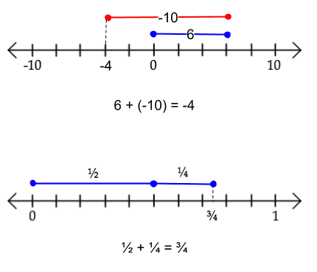
Find out what you can about this model. How/why does it work? What are its limitations? Be prepared to explain your findings to your classmates.

Modeling Arithmetic Operations
There are different ways to model arithmetic operations; we are going to explore the four most prevalent ones, as being familiar with them will help us later on when manipulating algebraic expressions.

Addition/Subtraction -- two-sided counters
Examples:
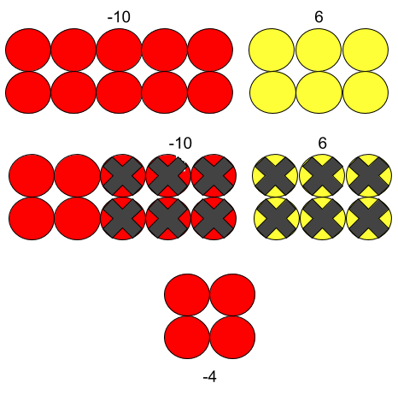
Find out what you can about this model. How/why does it work? What are its limitations? Be prepared to explain your findings to your classmates.

Modeling Arithmetic Operations
There are different ways to model arithmetic operations; we are going to explore the four most prevalent ones, as being familiar with them will help us later on when manipulating algebraic expressions.

Multiplication/Division -- area models
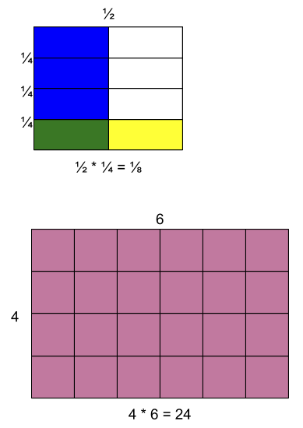

Find out what you can about this model. How/why does it work? What are its limitations? Be prepared to explain your findings to your classmates.
Modeling Arithmetic Operations
There are different ways to model arithmetic operations; we are going to explore the four most prevalent ones, as being familiar with them will help us later on when manipulating algebraic expressions.

Multiplication/Division -- array/grouping models

4 * 4 = 16
16 / 4 = 4
Find out what you can about this model. How/why does it work? What are its limitations? Be prepared to explain your findings to your classmates.

Number System Project
In this project, you and your group will create a representation of our number system. You may do so pictorially, in text, or any other representation that you can share and justify. Things to think about: What kinds of numbers are there? How do we represent them? How are they related? Why do we have different kinds of numbers?

Please use the space below to brainstorm your final product.

Feedback form

Group: ________________________________________________ Grade: ___________

Comments:

College Algebra Fall Semester
Oil Slick Task

When an oil spill happens in the ocean, many questions arise about the extent of the damage it will cause. Today, we will look at modeling a (simplified) case of one of these tragedies, to determine how we might analyze it mathematically.

Required Materials:
- Petri dish
- Water, to fill the dish halfway
- Colored oil, one dropper bottle
- Ruler
- Paper, or other suitable place to record data
- Writing utensil
- Access to a graphing calculator (www.desmos.com/calculator)

Step 1: Collect Data
Set up an experiment to determine how the radius of an oil slick changes over time. Once you’ve determined how to do it, double check with Mrs. Gunter before conducting the experiment. Then, collect your data and record it in a table below. Please note: It may be easier to measure the diameter of your oil slick.

Step 2: Model Data
Using Desmos, enter your data table into the coordinate plane. Looking at your data this way, which function do you think most closely models it? Why?

Now, use what you know about parent functions and their transformations to model your data with a function in Desmos. Write the equation you determine to be the best fit here.

Step 3: Expand
Now consider - if the diameter of your oil slick is expanding as modeled in Step 2, how might we determine the area of the oil slick at any given time?

Functions Unit Project
For our unit project, we will be writing a textbook chapter in groups. We will accomplish this through several revisions of our writing with peer reviews.

Below is the list of sections we proposed. Each group will be responsible for writing all sections. Please keep these due dates in mind.

Sections | First Draft DUE | Final Draft DUE
- What is a Function?  - Function vs. Relation  - Historical necessity | November 13 | November 20
- How do Functions function?  - Representations  - Kinds of functions  - Limitations  - Output | November 28 | December 4
- Why do we care about Functions?  - Modeling RL with functions | December 8 | December 15
Whole Chapter | December 1 | December 15

Peer Review/Grading Rubric
Group: ________________________________________________

Expectation | Full Credit | Half Credit | No Credit
Accuracy of Content: Content included in the writing is accurate and demonstrates conceptual understanding. (8 points) | Writing is completely accurate and demonstrates a depth of conceptual understanding. | The writing has one or two inaccuracies OR does not demonstrate adequate conceptual understanding. | The writing has numerous inaccuracies AND/OR does not demonstrate adequate conceptual understanding.
Necessary Parts: The section includes necessary verbiage, examples, definitions, images that contribute to the meaning of the text, a practice set (of at least 7 problems) and the solutions. (8 points) | All necessary parts are included. | Some parts are left out, but the writing does include essential pieces like the necessary verbiage, examples, and a practice set. | Essential parts are left out.
Answers Questions Completely: Questions were posed for each section (see page 1). The writing for each section answers these questions completely with supporting information. (2 points) | Questions are answered thoroughly and the writers have anticipated possible questions from the reader and addressed them as well. | Questions are partially answered OR questions are answered without supporting information and nothing was anticipated about the reader. | Questions are partially answered AND questions are answered without supporting information with nothing was anticipated about the reader.
Writing Quality: The writing in the section is readable and free from grammatical/syntax errors. (2 points) | The section is well-written, with clear planning and time invested in the flow of reading it. | There are a few grammatical/syntax errors, but the section is still overall readable OR writers should have worked more carefully on the flow of the section. | Numerous grammatical/syntax errors AND/OR poor planning makes the section nearly impossible to read for meaning.
Total Points |  |  | /20

Notes (feel free to write on the copy of the section provided to you as well as on any extra paper necessary):

Appendix D. Student Handouts for Writing without Revision
My Math Autobiography
Describe your experience so far with mathematics below. You may include illustrations or non-text material, but also include some text description of what is included. Some questions to think about are: Am I a mathematician? What is mathematics? Why do we learn it? Is there a difference between real math and school math? How does math make me feel? Why?

Then, explain how the procedures and goals we have made for our class will help you be successful in this experience. What goals do you have for yourself? Describe one or two.

Math History :: Person of Interest
Determine a person of interest from math history, taking into account diversity of gender and country of origin (aka look outside the normal realm of Dead White Guys). Answer the following questions about them in an appropriate format of your choice:

- Who are they?
  - Where were they born? When? How did the history of that time affect their life and/or work? Was there something unusual or interesting about them?

- What contribution did they make to mathematics?
  - What was their defining piece of work? Explain it to the best of your ability.

- How/when did their contribution have the greatest impact?
  - Was it years and years later after lots of controversy? Was it hotly contested? Did it get them executed?! Did someone else take credit for it?

Math History :: Person of Interest
Grading Rubric
Student:
Requirement | Full Credit | Half Credit | No Credit
Who Are They? | Robust accounting of Person of Interest, to include their background and some historical context. | Partial accounting of Person of Interest; background information is vague and/or no historical context is provided. | Severely lacking accounting of Person of Interest. No real information provided about their background or historical context.
Mathematical Contribution | Full description of the defining piece of work, with an attempt to explain what it means mathematically. | Partial description of the defining piece of work and/or no attempt to explain it mathematically. | Poor description of the defining piece of work. No attempt to explain it mathematically.
Impact of their Mathematical Contribution | The impact of the defining work is described fully. | Only a partial description of the defining work’s impact is described. | A poor description is provided of the defining work’s impact, or no description at all.
Presentation | Presentation is well-organized and is the appropriate length. | Presentation is poorly organized or does not follow the time parameters set. | Poorly organized presentation AND time parameters are not followed.

Math Two-Way Templates

Appendix E. Student Handouts for Writing with Revision
Number System Project
In this project, you and your group will create a representation of our number system. You may do so pictorially, in text, or any other representation that you can share and justify. Things to think about: What kinds of numbers are there? How do we represent them? How are they related? Why do we have different kinds of numbers?

Please use the space below to brainstorm your final product.

Functions Unit Project – Textbook Chapter

For our unit project, we will be writing a textbook chapter in groups. We will accomplish this through several revisions of our writing with peer reviews.

Below is the list of sections we proposed. Each group will be responsible for writing all sections. Please keep these due dates in mind.

Sections | First Draft DUE | Final Draft DUE
- What is a Function?  - Function vs. Relation  - Historical necessity | November 13 | November 20
- How do Functions function?  - Representations  - Kinds of functions  - Limitations  - Output | November 28 | December 4
- Why do we care about Functions?  - Modeling RL with functions | December 8 | December 15
Whole Chapter | December 1 | December 15

Functions Unit Project – Textbook Chapter
Peer Review/Grading Rubric

Group: ________________________________________________

Expectation | Full Credit | Half Credit | No Credit
Accuracy of Content: Content included in the writing is accurate and demonstrates conceptual understanding. (8 points) | Writing is completely accurate and demonstrates a depth of conceptual understanding. | The writing has one or two inaccuracies OR does not demonstrate adequate conceptual understanding. | The writing has numerous inaccuracies AND/OR does not demonstrate adequate conceptual understanding.
Necessary Parts: The section includes necessary verbiage, examples, definitions, images that contribute to the meaning of the text, a practice set (of at least 7 problems) and the solutions. (8 points) | All necessary parts are included. | Some parts are left out, but the writing does include essential pieces like the necessary verbiage, examples, and a practice set. | Essential parts are left out.
Answers Questions Completely: Questions were posed for each section (see page 1). The writing for each section answers these questions completely with supporting information. (2 points) | Questions are answered thoroughly and the writers have anticipated possible questions from the reader and addressed them as well. | Questions are partially answered OR questions are answered without supporting information and nothing was anticipated about the reader. | Questions are partially answered AND questions are answered without supporting information with nothing was anticipated about the reader.
Writing Quality: The writing in the section is readable and free from grammatical/syntax errors. (2 points) | The section is well-written, with clear planning and time invested in the flow of reading it. | There are a few grammatical/syntax errors, but the section is still overall readable OR writers should have worked more carefully on the flow of the section. | Numerous grammatical/syntax errors AND/OR poor planning makes the section nearly impossible to read for meaning.
Total Points |  |  | /20

Notes (feel free to write on the copy of the section provided to you as well as on any extra paper necessary):

Appendix F. Student Chapter Samples
Section 1
Functions

Function- a relationship where each input has a single output
Relation- a collection of ordered pairs containing one object from each set

History
We use functions because once it is defined, we can reuse it over and over again. Functions were discovered in the 17th century as a result of the development analytic geometry

Ways to identify a function:
- Graph function
- Vertical Line test- drawing a vertical line on a graph, if the line hits more than one point on a graph at the same time, then it is not a function
- One input= one output or multiple inputs= one output

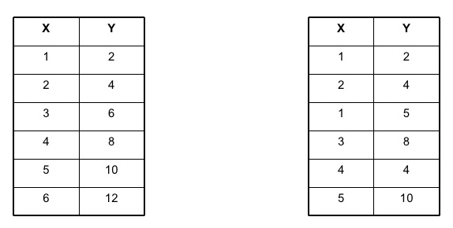
Function Non-function

Word problems
Determine whether the story is a function or not.
- A kid playing baseball throws his baseball up and then it comes back down and he catches it.
- A teacher went around the class and asked the students name and to tell her the 10 numbers they rolled on the die.
- A business is declining in sales over a course of 3 years, after 3 years the sales increase again.

Graphing
Graph these and determine whether they are functions or not.

- y=3x+5 2. x=y²+3 3. 2x+y²=1 4. y=x³+7x+6

SOLUTIONS
Word problems
- Function- If we were to graph this, there is not more than one output for every input
- Non function- Each student would have the same number on a dice more than once so there would be multiple outputs
- Function- Like question 1, on a graph, there would be only one output for every input

Graphing
- Function- passes vertical line test
- Non function- does not pass vertical line test
- Non function- does not pass vertical line test
- Function- passes vertical line test

Section 2

F U N C T I O N S
(Discovering the FUN in Functions)

Chapter 2- How do Functions function?

Section I: Representations
There are innumerable ways to represent a function. However, the 4 most common ways are as follows:
-A function can be represented verbally.
Ex) The amount of chips is 2 times as plentiful as the number of students.
-A function can be represented algebraically.
Ex) y=3x+2
-A function can be represented numerically.
Ex) (4, 17) The graph goes through the points 4 and 14.
-A function can be represented graphically.
Ex) This is a Quadratic function.

Now you try! Write a different way to express a function NOT listed above.

Section II: Kinds of Functions
There are many different types of functions. Functions range from a simple line to integral calculus. For this textbook, we will look at 4 different types of functions.

- Linear
y = mx + b
Definition: A linear function is any function that graphs to a straight line. What this means mathematically is that the function has either one or two variables with no exponents or powers. If the function has more variables, the variables must be constants or known variables for the function to remain a linear function.

- Quadratic
y = a + b x + c
Definition: The graph of a quadratic function is a curve called a parabola. Parabolas may open upward or downward and vary in "width" or "steepness", but they all have the same basic "U" shape.
- Exponential
y = a x
Definition: Simply, an exponential function is a constant raised to a power.

- Logarithmic
y = a ln (x) + b
Definition: Logarithmic functions are the inverses of exponential functions. For a function to be a logarithmic function, there must be a “ln” or a “log” in the equation.

Parent Graphs

LINEAR | QUADRATIC | EXPONENTIAL | LOGARITHMIC

Section III: Limitations
The way functions are modeled is not always suitable. For example, a simple line is easy to model by graphing on a coordinate plane. Reversely, function compositions in Calculus, are more difficult to model easily.

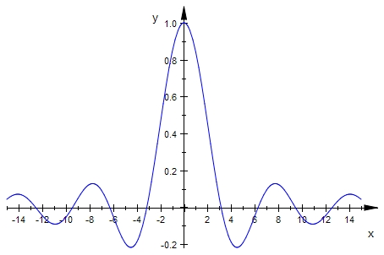
A more complicated function is showed above.

Sections IV: Output
The output of a function is a helpful way to see the functionality and also to be able to tell if a function is a function. Consider what you know from the last unit, and consider the following examples. Pay close attention to the effects outputs have on determining whether or not table is a function.
4

8

12
6

10

14
Input
Output
4

8

12
6

10

14
Input
Output

Function: each input has only one output Not a Function: 8 has two outputs
A1

D3

F5
Ice Cream

Candy

Chips
Input
Output
Ice Cream

Candy

Chips
A1

D3

F5
Output
Input

Function: each input has only one output Not a Function: F5 has two outputs

CREATE a diagram that represents a Function and Not a Function

Section 3
Why do we care about
Functions?

Functions are used everyday and are very important for real life situations. Without functions, we would not have the knowledge for graphs and everyday problems. The inputs and outputs of functions play an important role in how we recognize to different types of functions, and how we represent them.

Real life situation with a function:

- A company's sales have increased over the course of 3 years, but after this time they suddenly drop.

Real life situation that is not a function:
- A teacher has 20 students and calls out a name randomly. She does this 27 times.

Use what you have learned about functions throughout this chapter to identify whether these are considered a function or not.

- The temperature in a city started at 47 degrees fahrenheit and increases 1 degree every hour throughout the day.
- A student is studying the height of all of the students at her school by age ranging from 14-16 years old.
- A student puts a dollar into a vending machine and presses the button to get chips buts gets chips and candy.
- A student rolls a dice 6 times and gets a different number each time.

Solution:
- Function, there is a different output for each hour.
- Non-Function, 26 students that are 14 could have the same height.
- Non-Function, there are 2 outputs for the one button they pressed.
- Function, each time they role there is a different output.

