University of Oklahoma

Graduate College

BUDS, LEAVES, SHOOTS, AND FLOWERS:
ANALYSIS OF PLANT PHENOLOGY ACROSS AN
ENVIRONMENTAL GRADIENT

A Dissertation

submitted to the Graduate Faculty

in partial fulfillment of the requirements for the

Degree of

Doctor of Philosophy

By

Jennifer A. Messick
Norman, Oklahoma
2017
BUDS, LEAVES, SHOOTS, AND FLOWERS:
analysis of PLANT PHENOLOGY across an
environmental Gradient

A Dissertation approved for the
Department of Geography and Environmental Sustainability

By

______________________________
Dr. Bruce Hoagland, Chair

______________________________
Dr. Lara Souza

______________________________
Dr. Kirsten de Beurs

______________________________
Dr. Scott Greene

______________________________
Dr. Darren Purcell

© Copyright by Jennifer A. Messick 2017
All Rights Reserved.
This dissertation is dedicated to my grandmother who began teaching me about plants from a very young age.

Acknowledgements
I would like to thank all of the people who helped with field data collection for the oak trees: Kayti Ewing, Carol Butler, Emily Grimes, Daryn Hardwick, Austin Griffin, and all the many others. I would also like to thank Amy Buthod for helping me out when I had questions on the taxonomy of the herbarium specimens and for letting me spend hours collecting data in the herbarium.

Table of Contents

Acknowledgements iv
List of Tables viii
List of Figures x
CHAPTER 1 1
Introduction 1
Phenology Data Collection 3
Phenological Classification System 4
Phenological Data Sampling 6
Phenology Data Presentation & Analysis 8
Conclusion 10
Literature Cited 11
CHAPTER 2 16
Abstract 16
Introduction 16
Methods 23
Results ………………………………………………………………………….29
Discussion 35
Conclusion 38
Acknowledgements 40
Literature Cited 41
Appendix – Tables 46
Appendix – Figures 53
Supplemental Appendix – Map 71
CHAPTER 3 72
Abstract 72
Introduction 72
Methods 75
Results ………………………………………………………………………….79
Discussion 81
Conclusion 84
Acknowledgements 86
Literature Cited 87
Appendix – Tables 91
Appendix – Figures 98
Supplemental Appendix – Map 104
CHAPTER 4 105
Abstract 105
Introduction 105
Methods 108
Results ………………………………………………………………………...114
Discussion 125
Conclusion 132
Literature Cited 134
Appendix A – Tables 140
Appendix B – Figures 149
Appendix S1 – Supplemental Tables 181
Appendix S2 – Supplemental Figures 190
CHAPTER 5 202
Potential Future Research Directions 202
Why care about potential plant phenological response changes? 203

List of Tables

Table 2.1 46
Table 2.2 47
Table 2.3 48
Table 2.4 49
Table 2.5 50
Table 2.6 51
Table 2.7 52
Table 3.1 91
Table 3.2 92
Table 3.3 93
Table 3.4 94
Table 3.5 95
Table 3.6 96
Table 3.7 97
Table 4.1 140
Table 4.2 141
Table 4.3 143
Table 4.4 144
Table 4.5 145
Table 4.6 146
Table 4.7 147
Table 4.8 148
Table 4.9 142
Table 4.S1……………………………………………………………………………..181
Table 4.S2……………………………………………………………………………..183
Table 4.S3……………………………………………………………………………..184
Table 4.S4……………………………………………………………………………..187
Table 4.S5……………………………………………………………………………..189

List of Figures

Figure 2.1 53
Figure 2.2 54
Figure 2.3 55
Figure 2.4 56
Figure 2.5 57
Figure 2.6 58
Figure 2.7 59
Figure 2.8 60
Figure 2.9 61
Figure 2.10 62
Figure 2.11 63
Figure 2.12 64
Figure 2.13 65
Figure 2.14 66
Figure 2.15 67
Figure 2.16 68
Figure 2.17 69
Figure 2.18 70
Figure 2.S1 71
Figure 3.1 98
Figure 3.2. 99
Figure 3.3 100
Figure 3.4 101
Figure 3.5 102
Figure 3.6 103
Figure 3.S1……………………………………………………………………………104
Figure 4.1 149
Figure 4.2 150
Figure 4.3 151
Figure 4.4 152
Figure 4.5 153
Figure 4.6 154
Figure 4.7 155
Figure 4.8 156
Figure 4.9 157
Figure 4.10 158
Figure 4.11 159
Figure 4.12 160
Figure 4.13 161
Figure 4.14 162
Figure 4.15 163
Figure 4.16 164
Figure 4.17 165
Figure 4.18 166
Figure 4.19 167
Figure 4.20 168
Figure 4.21 169
Figure 4.22 170
Figure 4.23 171
Figure 4.24 172
Figure 4.25 173
Figure 4.26 174
Figure 4.27 175
Figure 4.28 176
Figure 4.29 177
Figure 4.30 178
Figure 4.31 179
Figure 4.32 180
Figure 4.S1……………………………………………………………………………190
Figure 4.S2……………………………………………………………………………191
Figure 4.S3……………………………………………………………………………192
Figure 4.S4……………………………………………………………………………193
Figure 4.S5……………………………………………………………………………194
Figure 4.S6……………………………………………………………………………195
Figure 4.S7……………………………………………………………………………196
Figure 4.S8……………………………………………………………………………197
Figure 4.S9……………………………………………………………………………198
Figure 4.S10…………………………………………………………………………..199
Figure 4.S11…………………………………………………………………………..200
Figure 4.S12…………………………………………………………………………..201

CHAPTER 1

A Brief History of Plant Phenology

Introduction
Phenology has evolved from an exercise of observations to a multifaceted science. The recurring biological events studied range from one particular event to multiple events within a year and vary widely depending on the organism studied. These events can be the first emergence of leaves for a species of tree, the onset of flowering of a forb, the emergence of adult insects from their larval stage, or the beginning of an annual migratory departure of birds or other animals. These recurring biological events are not limited to plant species, but phenology is rooted in agricultural practices, especially those of food crops. Phenological events have been noted in agricultural calendars dating as far back as 1700 BC and there is even a long term record of flowering dates in Japan from 705 AD (Keatley & Hudson 2010; Schwartz 2013).
Phenological studies vary in the number of species included, ranging from one single species to entire ecosystems. Additionally, studies have varied in both temporal and spatial extent. Many studies have focused on a species in a local environment (Ne’eman 1993; Matsumoto et al. 2003; Gaira et al. 2011; Diskin et al. 2012; Vitasse and Basler 2013) while other studies have focused on an entire population within a region and still others have focused on the entire geographic range of a species or community (Murray et al. 1989; Newstrom et al. 1994; Keatley & Hudson 2010; Polgar and Primack 2011; Basler and Korner 2012; Diez et al. 2012; Li et al. 2013) and bioclimatic regions (Schwartz 2013).
Due to their seasonal environments, plants found in the mid-latitudes have been studied more frequently than plants in other regions of the globe resulting in a regional bias in phenological studies (Schwartz 2013). Plant phenology studies have mainly focused on native species, but understanding the phenology of non-native species has also grown in importance (Bertin 2008; Henebry 2013). Typically, phenological studies of plants have focused on a few specific phenophases: mainly budburst, flowering times, or first leaf-out times as these relate to temperature and/or photoperiod (Basler and Korner 2012; Caffarra and Donnelly 2011; Kuster et al. 2014; Murray et al. 1989; Ne’eman 1993; Polgar and Primack 2011; Tooke and Battey 2010; Vitasse and Basler 2013). Less frequently, fruiting and leaf senescence have been the focus of or included in a study (Diskin et al. 2012; Matsumoto et al. 2003). Additionally, the phenology of tree shoot elongation, an important part of annual biomass production, has relatively few studies in the literature (Buech 1976; Brown and Sommer 1992; Dhaila et al. 1995; Fukui 2005; Pinto et al. 2011; Devi and Garkoti 2013; Swidrak et al. 2013; Cole and Sheldon 2017). Although few in number, there have also been studies investigating the seed germination phenology of a plant species (Donohue et al. 2010; Forbis 2010; Hudson et al. 2015; Kondo et al. 2006).
Interest in phenology has steadily increased over the past few decades, especially in light of concerns with climate change. Phenology has become an important part of climate change research (Morellato et al. 2013). Advances in computing and mathematical modeling have brought phenology from an observational exercise to a burgeoning science. The statistical analysis of phenological data has moved from simple correlation analysis to complex multivariate models. Additionally, collection of phenological data has progressed from human observation on the ground and studies of natural history collections (Calinger et al. 2013; Diskin et al. 2012; Lachance 2013; Lavoie and Lachance 2006; Li et al. 2013; Lister et al. 2011; Miller-Rushing and Primack 2008; Robbirt et al. 2011; and others) to the use of remotely sensed satellite data (Cleland et al. 2006; Henebry and de Beurs 2013; Jentsch et al. 2009; Keatley & Hudson 2010; Park 2012; and others).

Phenology Data Collection
Collection of phenological data varies from observations noting of the beginning, peak, and/or end of seasonal events to the direct measurement of quantities of the event observed. Quantitative studies have gone beyond determining when an event occurs such as date of first leaf, flower, or fruit. These are aimed to determine the rate of leaf growth, how many flowers produced, and even how many fruits are produced as related to the timing, duration, and seasonality of such events. Studies of this type may focus on one to many plant species (Morellato et al. 2010a). The geographic scale of phenology studies varies from the local level up to the global networks that have been created. The temporal scale varies as well, from within-year studies to several years even as long as a couple decades (Menzel 2013).
Plant phenological studies can focus on reproductive events and/or leaf-out and senescence. Efforts to standardize data methods and terminology have been ongoing (Morellato et al. 2010a). For example, budburst has been defined in two ways: the time at which separation between the bud scales is first apparent and the time when the bud is open just enough so that the proto-leaves are visible but still within the bud. Each definition impacts the results of a study differently as these events can be separated in time by days or even weeks. Additionally, some species flower before the leaves emerge from the bud, thus a knowledge of the general order of these events as well as the specific morphology of the study species is necessary before embarking into the field. There are many plant species that are dioecious, where the female and male flowers are found on separate individual trees. This is one trait of the Lauraceae family for example. Other species are monoecious, having the female and male flowers separated but still in the same individual. Members of the genus Quercus are monoecious with the male flowers found at the end of the stem where the new year’s leaves emerge and the female flowers found further back on the stem. Still other plant species have both the female and male reproductive parts all in each individual flower.
For a study analyzing the budburst, flowering, and leaf-out phenophases, the stages must be defined precisely in the context of each study, otherwise there is the potential for observer error (Bertin 2008). Newstrom et al. (1994) proposed a classification system for describing plant phenophases. Although this system came from studies of tropical plant phenology, it can be applied to plant phenological events anywhere in the world, as it provides a basic frame from which to build a study (Morellato et al. 2010a; Newstrom et al. 1994). Sample size and sampling frequency are important and linked to pattern interpretation, as results have been found to vary based on both (Morellato et al. 2010a).

Phenological Classification System
The proposed classification system and conceptual framework from Newstrom et al. (1994) describes phenological events in a way to standardize terms for the field of phenology. The system is hierarchical in nature building off of descriptive terms for the different aspects of phenological events which occur in cycles or phases. First, overall patterns are described. Frequency describes the number of cycles of events per year while regularity describes variability in the length of the event cycle or phase. The total time length of a cycle or phase is described as the duration and date is attributed to the month or season of the year in which the event occurs. Synchrony is used to describe a simultaneous occurrence of an event or phase with another event which can be climatic in nature. Amplitude describes the intensity or quality of an event such as flowering or fruiting (Newstrom et al. 1994).
The next level of the classification system involves describing and grouping flowering patterns observed in plants and is denoted as a class. Plants that are almost always flowering, but may have very brief gaps in the duration, are classed as continual. One major flowering event equates to the annual class while irregular flowering within a year plants are classed as sub-annual. Plants with multi-year cycles of flowering are classed as supra-annual which is further broken down into three subclasses; brief (flowering for a month), intermediate (one to five months of flowering), and extended (flowering for more than five months) (Newstrom et al. 1994).
A progressively encompassing analysis level system is also proposed within the classification system. The smallest and most basic analysis level is the individual flower that can be increased to include the entire inflorescence. Multiple inflorescences can be included to have the level of whole branches and multiple branches can form a branch complex. The next encompassing level is the whole plant which can be further grouped up the whole population level. The final two analysis levels are the guild made up of more than one plant population and the community level with more than one guild (Newstrom et al. 1994).
Differences in some phenological patterns can be seen depending on the analysis level used and the bioclimatic region, making analysis level decisions important for assessing annual patterns. For example, high variability in tropical flowering patterns at the individual plant level may be seen as regular or even as extended flowering at the population level. Additionally, geographic variation within the tropics can influence phenology patterns for separate populations of the same species. Patterns in amplitude can also have these same differences. Whereas, phenology patterns in temperate regions tend to be similar at all analysis levels (Newstrom et al. 1994).
Plant functional traits and environmental factors may affect observations and pattern inference. The male and female individuals of dioecious tree species may have different flowering patterns. Specific branch architecture many contribute to sub-annual patterns. Some species undergo manifold flowering where different branches flower at different times on the same individual tree. Wet and dry seasonal cycles may contribute to supra-annual patterns and may differentiate into continual or annual pattern for the same species in different regions of the tropics. Variations in the light integral as well as interactions of light, cloud cover, and precipitation may also influence flowering patterns. The light integral is length of time multiplied by the amount of irradiance received (Newstrom et al. 1994).

Phenological Data Sampling
Further efforts to standardize phenology studies have been extended to sampling methods, sample sizes, and observation frequencies. Standardization of methodologies will allow for direct comparison across sites and regions. Two common methods of sampling for plant reproductive events are direct observations along transects and litter traps. If timing and duration of the event is the primary goal, then direct observation produces more accurate results. There is a lag time between the onset of an event, such as flowering, and the period when the flowers begin to fall. Litter traps are good when the goal is to quantify the amplitude or intensity of an event after the event has begun to wane. The one event that litter traps cannot capture is leaf flushing (Morellato et al. 2010a).
Sampling frequency can have effects on the interpretation of phenological events, or phenophases. Monthly observations have been found to overestimate the length of flowering and small fluctuations in intensity are not usually detected. Flowering events observed weekly were found to define peak flowering and duration precisely. Additionally, observations made fortnightly produced results similar to those of weekly observations, as flowering duration was interpreted as lasting slightly longer than when observations were made weekly (Morellato et al. 2010a).
Sample size can also have an effect on event interpretation. A minimum sample size of 15 individuals per species is recommended, as the variation in the phenophase pattern increases with smaller sample sizes. Sample size is also dependent on sampling frequency. If using the above minimum number of individuals for a study, the recommended sampling frequency is fortnightly to approximate a phenological event accurately. If the sample size is 25 or greater, a once monthly sampling frequency can produce an accurate portrayal of the event timing (Morellato et al. 2010a). However, if the phenophase of interest includes the intensity of the event, i.e. the amount of fruits or flowers produced during the event, the minimum sample size and sampling frequency recommendations vary. A minimum of three individuals of a species (USA NPN 2015) to at least 15 individuals have been recommended for phenophase observations at one site (Morellato et al. 2010a).

Phenology Data Presentation & Analysis
Data presentation and analysis of phenological data has increased in its complexity. The early data presentations consisted of presenting long time series bar graphs of multiple years in a row. Time in months was typically shown along the x-axis. These graphs would have varying bar heights representing either direct observation numbers of intensity or intensity indices of the phenophase. Included in the above phenology classification, idealized graphs of this type were presented to further describe the classification system. This type of graphic is useful for displaying and identifying patterns for individual plants and for proportions of a community undergoing the phenophase (Newstrom et al. 1994). However, these do not lead to statistically examining the variation in timing, duration, or intensity of phenophases from year to year or longer time periods (Morellato et al. 2010b). Climatic variables were typically plotted as scatterplots with trend lines or as line graphs. Correlation and regression analysis are the usual statistical tests used when climatic variables are incorporated (Hudson et al. 2009; Pounds et al. 1999).
Simple linear regression models have been the most common statistics used to analyze phenology data. More recently, linear mixed-effects models (Calinger et al. 2013) and models in the generalized additive model (GAM) family have been put forward as more appropriate models over linear models (Gaira et al. 2011; Hudson et al. 2009; Hudson 2010) because flowering responses are not always linear (Iler et al. 2013). Less commonly, circular statistics have been applied to phenology data. Circular histograms effectively display the recurring phenomena of phenophases where 0º on the circle typically represents January 1 of the study year (Hamann 2004; Morellato et al. 2010b). However, using Julian days does not equate to a whole degree on a circle and requires mathematical adjustments. Bertin (2008) claims that the use of Julian days results in a bias that overestimates potential advancement in spring phenophases and calls for the vernal equinox as day one, as it is “a more meaningful point of reference” for earth and sun relationships (Bertin 2008). Additionally, rose diagrams can efficiently show similar data as in a circular histogram with the addition of time duration (Mardia and Jupp 2000; Morellato et al. 2010b; Pewsey et al. 2013).
Other descriptive circular statistics can be calculated such as mean direction, circular variance, and circular standard deviation. There are several analyses to compare the data against the idealized von Mises distribution, which is similar to classical statistical tests that compare against the normal distribution, or against a uniform distribution. Circular ANOVA analysis to compare means of sample groups can be performed. Correlation of phenological events with climatic variables and circular regression analysis of the data as either a linear-circular association or circular-circular association can also be performed (Fisher 1993; Mardia and Jupp 2000; Pewsey et al. 2013). Also, recently introduced to the literature is the application of survival analysis to budburst data to estimate the time a bud survives as bud until budburst occurs (Laube et al. 2014; London and Johnson 2014).

Conclusion
Phenology has evolved from observational records to a technical science utilizing both on the ground observations and remotely sensed data with advanced statistics and models to analyze the data. Determining baseline patterns of phenological events and understanding the mechanisms that trigger these events are critical to further investigations of how plants are and will respond to climate change in the future. Additionally, these patterns need to be investigated at multiple spatial scales and for multiple plant life history stages. A drastic change in the seed germination life stage could have implications further down the chain, as the change could alter regeneration timing and patterns of a species. This in turn could have implications not just at the population level but also at the community and even landscape levels.
Here I present the following studies to investigate plant phenology in three parts. Each part focuses on different plant species at different spatial scales: local and regional. Additionally, each investigated different plant life history stages. The first study investigated the interspecific differences and the inter-annual variation of adult Quercus marilandica and Q. stellata phenophases of budburst and leaf-out at a small local scale. The second assessed whether position on the tree crown played a role in the budburst and leaf-out dates for Q. marilandica and Q. stellata. This study also included shoot elongation phenology of these species. While the third, utilized the herbarium specimens of twenty species found in two plant families, Brassicaceae and Lamiaceae. This study assessed first flowering times and peak flowering times across the state of Oklahoma for the last 100 years.

Literature Cited
Basler, D., and C. Korner. 2012. Photoperiod Sensitivity of Bud Burst in 14 Temperate Forest Tree Species. 2012. Agricultural and Forest Meteorology, 165: 73-81.

Bertin, R.I. 2008. Plant Phenology and Distribution in Relation to Recent Climate Change. Journal of the Torrey Botanical Society, 135: 126-146.

Brown, C.L., and H.E. Sommer. 1992. Shoot Growth and Histogenesis of Trees Possessing Diverse Patterns of Shoot Development. American Journal of Botany, 79: 335-346.

Buech, R.R. 1976. Tree Shoot Elongation in Northern Wisconsin and Relationships with Temperature and Precipitation. Canadian Journal of Forest Research, 6: 487-498.

Caffarra, A., and A. Donnelly. 2011. The Ecological Significance of Phenology in Four Different Tree Species: Effects of Light and Temperature on Bud Burst. International Journal of Biometeorology, 55: 711-721.

Calinger, K.M., Queensborough, S., and P.S. Curtis. 2013. Herbarium Specimens Reveal Footprint of Climate Change on Flowering Trends Across North-Central North America. Ecology Letters, 16: 1037-1044.

Cleland, E.E., Chiariello, N.R., Loarie, S.R., Mooney, H.A., and C.B. Field. 2006. Diverse Responses of Phenology to Global Changes in a Grassland Ecosystem. Proceedings of the National Academy of Sciences, 103: 13740-13744.

Cole, E.F., and B.C. Sheldon. 2017. The Shifting Phenological Landscape: Within- and Between- Species Variation in Leaf Emergence in a Mixed-Deciduous Woodland. Ecology and Evolution, 00: 1-13.

Devi, A.F., and S.C. Garkoti. 2013. Variation in Evergreen and Deciduous Species Leaf Phenology in Assam, India. Trees, 27: 985-997.

Dhaila, S., Singh, S.P., Negi, G.C.S, and Y.S. Rawat. 1995. Shoot Growth Phenology of Co-existing Evergreen and Deciduous Species in an Oak Forest. Ecological Research, 10: 151-159.

Diez, J.M., Ibanez, I., Miller-Rushing, A.J., Mazer, S.J., Crimmins, T.M., Crimmins, M.A., Bertelsen, C.D., and D.W. Inouye. 2012. Forecasting Phenology: From Species Variability to Community Patterns. Ecology Letters, 15: 545-553.

Diskin, E., Proctor, H., Jebb, M., Sparks, T., and A. Donnelly. 2012. The Phenology of Rubus fruticosus in Ireland: Herbarium Specimens Provide Evidence for the Response of Phenophases to Temperature, with Implications for Climatic Warming. International Journal of Biometeorology, 56: 1103-1111.

Donohue, K., Rubio de Casas, R., Burghardt, L., Kovach, K., and C.G. Willis. 2010. Germination, Postgermination Adaptation, and Species Ecological Ranges. Annual Review of Ecology, Evolution, and Systematics, 41: 293-319.

Fisher, NI. 1993. Statistical Analysis of Circular Data. Cambridge University Press, Great Britain. 277 p.

Forbis, T.A. 2010. Germination Phenology of Some Great Basin Native Annual Forb Species. Plant Species Biology, 25: 221-230.

Fukui, K. 2005. Modeling of Mulberry Shoot Elongation and Leaf Appearance in Field Conditions. Plant Production Science, 8: 115-121.

Gaira, K.S., Dhar, U., and O.K. Belwal. 2011. Potential of Herbarium Records to Sequence Phenological Pattern: A Case Study of Aconitum heterophyllum in the Himalaya. Biodiversity and Conservation, 20: 2201-2210.

Hamann, A. 2004. Flowering and Fruiting Phenology of a Philippine Submontane Rain Forest: Climatic Factors as Proximate and Ultimate Causes. Journal of Ecology, 92: 24-31.

Henebry, G.M. 2013. Phenologies of North American Grasslands and Grasses. In Phenology: An Integrative Environmental Science, 2nd Ed., MD Schwartz (Ed). Springer, Netherlands. 610 p.

Henebry, G.M., and K.M. de Beurs. 2013. Remote Sensing of Land Surface Phenology: A Prospectus. In Phenology: An Integrative Environmental Science, 2nd Ed., MD Schwartz (Ed). Springer, Netherlands. 610 p.

Hudson, A.R., Ayre, D.J., and M.K.J. Ooi. 2015. Physical Dormancy in a Changing Climate. Seed Science Research, 25: 66-81.

Hudson, I.L., Kim, S.W., and M.R. Keatley. 2009. Climatic Influences on the Flowering Phenology of Four Eucalypts: A GAMLSS Approach. 18th World IMACS/MODSIM Congress, Cairns, Australia 13-17 July 2009. Available online: http://mssanz.org.au/modsim09/G2/hudson_il.pdf. Last accessed on [29 Jan 2015].

Hudson, I.L. 2010. Interdisciplinary Approaches: Towards New Statistical Methods for Phenological Studies. Climate Change, 100: 143-171.
Iler, A.M., Hoye, T.T., Inouye, D.W., and N.M. Schmidt. 2013. Nonlinear Flowering Responses to Climate: Are Species Approaching Their Limits of Phenological Change? Philosophical Transactions of the Royal Society, 368: 1-10.

Jeannerete, F, and T Rutishauser. 2010. Seasonality as a Core Business of Phenology. In Phenological Research: Methods for Environmental and Climate Change Analysis, IL Hudson and MR Keatley (Eds). Springer, Netherlands. 521 p.

Jentsch, A., Kreyling, J., Boettcher-Treschkow, J., and C. Beierkuhnlein. 2009. Beyond Gradual Warming: Extreme Weather Events Alter Flower Phenology of European Grassland and Heath Species. Global Change Biology, 15: 837-849.

Keatley, MR, and IL Hudson. 2010. Introduction and Overview. In Phenological Research: Methods for Environmental and Climate Change Analysis, IL Hudson and MR Keatley (Eds). Springer, Netherlands. 521 p.

Kondo, T., Sato, C., Baskin, J.M., and C.C. Baskin. 2006. Post-Dispersal Embryo Development, Germination Phenology, and Seed Dormancy in Cardiocrinum cordatum var. glehnii (Liliaceae S. Str.), A Perennial Herb of the Broadleaved Deciduous Forest in Japan. American Journal of Botany, 93: 849-859.

Kuster, T.M., Dobbertin, M., Gunthardt-Goerg, M., Schaub, M., and M. Arend. 2014. A Phenological Timetable of Oak Growth Under Experimental Drought and Air Warming. PLOS One, 9: e89724.

Laube, J., Sparks, T.H., Estrella, N., Hofler, J., Ankerst, D.P., and A. Menzel. 2014. Chilling Outweighs Photoperiod in Preventing Precocious Spring Development. Global Change Biology, 20: 170-182.

Lavoie, C. 2013. Biological Collections in an Ever Changing World: Herbaria as Tools for Biogeographical and Environmental Studies. Perspectives in Plant Ecology, Evolution and Systematics, 15: 68-76.

Lavoie, C., and D. Lachance. 2006. A New Herbarium-Based Method for Reconstructing the Phenology of Plant Species Across Large Areas. American Journal of Botany, 93: 512-516.

Li, Z., Wu, N., Gao, X., Wu, Y., and K.P. Oli. 2013. Species-level Phenological Responses to ‘Global Warming’ as Evidenced by Herbarium Collections in the Tibetan Autonomous Region. Biodiversity and Conservation, 22: 141-152.

Lister, A.M., and Climate Change Research Group. 2011. Natural History Collections as Sources of Long-Term Datasets. Trends in Ecology and Evolution, 26: 153-154.
Londo, J.P., and L.M. Johnson. 2014. Variation in the Chilling Requirement and Budburst Rate of Wild Vitis Species. Environmental and Experimental Botany, 106: 138-147.

Mardia, K.V., and P.E. Jupp. 2000. Directional Statistics. John Wiley & Sons Ltd., West Sussex. 429 p.

Matsumoto, K., Ohta, T., Irasawa, M., and T. Nakamura. 2003. Climate Change and Extension of the Ginkgo biloba L. Growing Season in Japan. Global Change Biology, 9: 1634-1642.

Menzel, A. 2013. Plant Phenological “Fingerprints.” In Phenology: An Integrative Environmental Science, 2nd Ed., MD Schwartz (Ed). Springer, Netherlands. 610 p.

Miller-Rushing, A.J., and R.B. Primack. 2008. Global Warming and Flowering Times in Thoreau’s Concord: A Community Perspective. Ecology, 89: 332-341.

Morellato, LPC, Camargo, MGG, D’Eca Neves, FF, Luize, BG, Mantovani, A, and IL Hudson. 2010a. The Influence of Sampling Method, Sample Size, and Frequency of Observations on Plant Phenological Patterns and Interpretation in Tropical Forest Trees. In Phenological Research: Methods for Environmental and Climate Change Analysis, IL Hudson and MR Keatley (Eds). Springer, Netherlands. 521 p.

Morellato, LPC, Alberti, LF, and IL Hudson. 2010b. Applications of Circular Statistics in Plant Phenology: A Case Studies Approach. In Phenological Research: Methods for Environmental and Climate Change Analysis, IL Hudson and MR Keatley (Eds). Springer, Netherlands. 521 p.

Murray, M.B., Cannell, M.G.R., and R.I. Smith. 1989. Date of Budburst of Fifteen Tree Species in Britain Following Climatic Warming. Journal of Applied Ecology, 26: 693-700.

Ne’eman, G. 1993. Variation in Leaf Phenology and Habit in Quercus ithaburensis, a Mediterranean Deciduous Tree. Journal of Ecology, 81: 627-634.

Newstrom, LE, Frankie, GW, Baker, HG, and RK Colwell. 1994. Diversity of Long-Term Flowering Patterns. In La Selva: Ecology and Natural History of a Neotropical Rain Forest. University of Chicago Press, Chicago, USA. 486 p.

Park, I.W. 2012. Digital Herbarium Archives as a Spatially Extensive, Taxonomically Discriminate Phenological Record; A Comparison to MODIS Satellite Imagery. International Journal of Biometeorology, 56: 1179-1182.

Pinto, C.A., Henriques, M.O., Figueiredo, J.P., David, J.S., Abreu, F.G., Pereira, J.S., Correia, I., and T.S. David. 2011. Phenology and Growth Dynamics in Mediterranean Evergreen Oaks: Effects of Environmental Conditions and Water Relations. Forest Ecology and Management, 262: 500-508.

Polgar, C.A., and R.B. Primack. 2011. Leaf-out Phenology of Temperate Woody Plants: From Trees to Ecosystems. New Phytologist, 191: 926-941.

Robbirt, K.M., Davy, A.J., Hutchings, M.J., and D.L. Roberts. 2011. Validation of Biological Collections as a Source of Phenological Data for Use in Climate Change Studies: A Case Study with the Orchid Ophrys sphegodes. Journal of Ecology, 99: 235-241.

Pewsey, A., Neuhauser, M., and G.D. Ruxton. 2013. Circular Statistics in R. Oxford University Press, Oxford. 183 p.

Pounds, JA, Fogden, MPL, and JH Campbell. 1999. Biological Response to Climate Change on a Tropical Mountain. Nature, 398: 611-615.

Schwartz, M.D. 2013. Introduction. In Phenology: An Integrative Environmental Science, 2nd Ed., MD Schwartz (Ed). Springer, Netherlands. 610 p.

Swidrak, I., Schuster, R., and W. Oberhuber. 2013. Comparing Growth Phenology of Co-occurring Deciduous and Evergreen Conifers Exposed to Drought. Flora, 208: 609-617.

Tooke, F., and N.H. Battey. 2010. Temperate Flowering Phenology. Journal of Experimental Botany, 61: 2853-2862.

USA National Phenology Network (USA NPN). 2015. Phenology Monitoring Protocol. Available online: www.usanpn.org. Last accessed on [22 Feb 2015].
Vitasse, Y., and D. Basler. 2013. What Role for Photoperiod in the Bud Burst Phenology of European Beech. European Journal of Forest Restoration, 132: 1-8.
Vitasse, Y., and D. Basler. 2013. What Role for Photoperiod in the Bud Burst Phenology of European Beech. European Journal of Forest Restoration, 132: 1-8.

CHAPTER 2
Inter-annual Variation in Spring Budburst and Leaf-out in
Quercus marilandica and Q. stellata

Abstract
Survival analysis was used to investigate the potential roles of temperature, precipitation, and photoperiod in triggering budburst and leaf-out for Quercus marilandica and Q. stellata. We found a high degree of inter-annual and interspecific variation in budburst and leaf-out dates for both species. Our results indicate that the interaction of temperature, precipitation, and photoperiod had significant influence on the budburst and leaf-out events for both species but in different combinations. A threshold temperature of 5ºC was found to be significant in the budburst survival models whereas a threshold temperature of 10ºC was not significant. Chilling and warming units of five minute intervals were significant in the budburst models while one hour intervals were not significant. Temperature, precipitation, and photoperiod also all played a significant role in leaf-out models.

Introduction
In light of global climate change, understanding the process of spring budburst as it relates to both the physiological and environmental processes is of great importance to future land management and conservation. Forests are considered a valuable asset in climate mitigation because of the capacity of trees to sequester carbon as wood (Dunn et al. 2007; Polgar and Primack 2011). If spring budburst and flowering times become progressively earlier in the year, ecosystem properties and biodiversity could be jeopardized. For example, if flowering is initiated in a population of plants prior to the emergence (i.e., insects) or arrival (i.e., migratory birds) of pollinators, pollination may not occur and reproductive output diminished (Polgar and Primack 2011).
In order to survive harsh winter conditions, temperate trees have adapted the trait of bud dormancy (Cooke et al. 2012). The mechanisms that induce dormancy are fairly well understood: however, the mechanisms that release buds from dormancy are less understood (Cooke et al. 2012). The release from dormancy is referred to as budburst and is one of the most easily observed phenological events among plants (Polgar and Primack 2011). As a result, there has been an increase in the study of the timing of budburst (Caffarra and Donnelly 2011; Polgar and Primack 2011; Basler and Korner 2012; Vitasse and Basler 2013; Laube et al. 2014; Guo et al. 2015; Cole and Sheldon 2017). Nevertheless, the number of temperate tree species studied is limited in the total number of species. Some example tree genera studied to date include: Acer (Morin et al. 2009; Basler and Korner 2012), Betula, Fagus (Murray et al. 1989; Caffarra and Donnelly 2011; Basler and Korner 2012), Fraxinus (Morin et al. 2009; Basler and Korner 2012), Quercus (Ne’eman 1993; Morin et al. 2009; Basler and Korner 2012; Kuster et al. 2014), and Tilia (Caffarra and Donnelly 2011; Basler and Korner 2012), however, not all species within these genera have been studied.
Budburst is initiated by changes in temperature, photoperiod, or a combination of the two for some tree species (Polgar and Primack 2011; Cooke et al. 2012). Several previous studies have focused only on the role of temperature in the initiation of budburst (Murray et al. 1989; Ne’eman 1993; Morin et al. 2009), but more recent studies have also investigated the role of photoperiod (Caffarra and Donnelly 2011; Basler and Korner 2012; Kuster et al. 2014).
Temperature or photoperiod or some combination of the two are the environmental cues that trigger budburst in temperate zone tree species (Cooke et al. 2012). Typically, temperate zone trees must be exposed to temperatures below a threshold value for a length of time, known as the chilling period (Murray et al. 1989; Ne’eman 1993; Caffarra and Donnelly 2011; Polgar and Primack 2011; Basler and Korner 2012; Cooke et al. 2012; Kuster et al. 2014). The chilling period is needed to break bud endodormancy, a type of dormancy regulated by internal mechanisms or signals (i.e. genetics and phytohormones), typically located within the meristematic tissue of the plant (Lang et al. 1985; Cooke et al. 2012). Following the chilling period, a minimum time of exposure to warmer temperatures is usually needed to release the buds from ecodormancy and is known as either the thermal time, forcing period, or the accumulated warming degrees. Ecodormancy is regulated by environmental cues (Lang et al. 1985, Caffarra et al. 2011b; Cooke et al. 2012). The length of exposure time varies from days to hours. Historically, the use of accumulated time of warming temperatures as a concept comes from agricultural practices and dates back to 1735 (Chuine et al. 2013). Many phenology studies have used days as the unit of time for chilling and warming requirements (Hunter and Lechowicz 1992; Polgar and Primack 2011; Chuine et al. 2013; Dantec et al. 2014; Laube et al. 2014; Lange et al. 2016; Yu et al. 2016) but fewer have used hours as the unit of time (Londo and Johnson 2014; Chuine et al. 2016; Gu 2016). The chilling period temperature threshold has been found to be ≤ 5ºC for some species (Murray et al. 1989) and less than or equal to 10ºC for others (Polgar and Primack 2011). Temperature is not the only environmental cue, however, increasing day length, or photoperiod, is also important (Caffarra and Donnelly 2011; Polgar and Primack 2011; Basler and Korner 2012; Kuster et al. 2014).
The genus Quercus (oaks) are among the most abundant trees in the eastern deciduous forest of North America and they play a significant role in ecosystem structure and function (Delcourt and Delcourt 2000). Despite this, few studies of North American Quercus species have been published (Morin et al. 2009; Burner et al. 2014; Gerst et al. 2016; Yu et al. 2016).
A study of a population of Quercus alba in Booneville, Arkansas, USA, found a high degree of inter-annual variation in budburst dates over the course of a three year observation period (Burner et al. 2014). This study site was at the same latitude as our study site and also found that budburst dates occurred in a similar time frame as our study (March - April). They found that budburst dates were influenced by air temperature with a chilling period followed by a warming period (Burner et al. 2014). A five year study of Q. alba and Q. rubra in Wisconsin, USA, also reported that temperature as accumulated growing degree days and photoperiod played a significant role in budburst (Yu et al. 2016). This study did not investigate whether there was a change in budburst dates but did report that budburst occurred between Julian days 101 – 112.
Utilizing observation datasets from Ohio, Massachusetts, and Illinois, USA, Morin et al. (2009), modeled leaf unfolding under different future climate scenarios. This study used 22 temperate tree species, including five species of Quercus (Q. alba, Q. bicolor, Q. macrocarpa, Q. rubra, Q. velutina). Under a scenario of a mean global increase of 3.2ºC, Q. bicolor and Q. velutina were predicted to have an earlier budburst date while Q. alba, Q. macrocarpa, and Q. rubra were predicted to have slightly later budburst dates. With a mean global increase of only 1.0ºC, all five species were predicted to have earlier budburst dates.
In a broad latitudinal study of eleven temperate trees across much of the eastern deciduous forest, the general trend was that mean start date for budburst advanced with increased latitude (Gerst et al. 2016). This study included Quercus alba and Q. rubra, as well as one study site in central Oklahoma. Only a moderate relationship between mean onset date and latitude was found for Q. alba and a weak relationship was found for Q. rubra, showing that these species were not responding as strongly to changes in climate as were the other tree species in the study.
Numerous phenology studies have been conducted on European species of Quercus (Crawley and Akhteruzzaman 1988; Ne’eman 1993; Rotzer et al. 2004; Wesolowski and Rowinski 2006; Sanz-Perez and Castro-Diez 2010; Basler and Korner 2012; Dantec et al. 2014; Kuster et al. 2014; Laube et al. 2014; Roberts et al. 2015; Lange et al. 2016; Cole and Sheldon 2017). A study of Quercus robur adult trees in the UK over three seasons found a high degree on variation in budburst dates between individual trees of the same population but budburst dates were consistent between years (Crawley and Akhteruzzamana 1988). In a separate study of Q. robur in Poland, two to three week inter-annual variation was found for budburst over nine seasons. This study only made observations on the southern portion of the tree crowns (Wesolowski and Rowinski 2006). Rotzer et al. (2004) simulated leaf-out for Q. robur in Germany from 441 observations and found that increased temperature resulted in later leaf-out dates. A low but significant trend of advancing budburst dates for Q. robur in Germany has been predicted by a model that used observational data for the time period 1951 – 2009 (Lange et al. 2016).
Saplings of Quercus robur, Q. petraea, and Q. pubescens from central Europe were observed for three seasons under experiemental drought and warming conditions. All three species showed significant inter-annual variation for budburst dates within each species. Increased temperature did not significantly advance budburst but did advance leaf unfolding. The warming combined with drought conditions did also advance budburst date (Kuster et al. 2014).
In the Pyrenees Mountains of France, two populations of Quercus petraea were found to have strong linear responses to warming spring temperatures and a high degree of inter-annual variation for budburst dates. Here the populations at low elevation that were exposed to short chilling periods had higher warming requirements prior to budburst. Additionally, this study tested both a 5ºC and 10ºC temperature threshold for breaking bud dormancy and found that 5ºC performed better in the analysis (Dantec at al. 2014). A light manipulation study, of Q. petraea cuttings from two populations in the Swiss Alps, showed there was a “significant interaction between photoperiod and either region or elevation” (Basler and Korner 2012). This study found shorter day lengths did delay budburst while longer day lengths accelerated budburst while reducing the number of warming days needed. The eastern population’s budburst was delayed compared to the western population and higher elevations were delayed compared to low elevations (Basler and Korner 2012).
A four year study of four Quercus ithabuensis populations in Israel also found a high degree of inter-annual variation for leaf-out dates. In this study, the population closest to the Mediterranean Sea had the earliest leaf-out dates compared to the other populations to the east at higher elevations (Ne’eman 1993). Sanz-Perez and Castro-Diez (2010) performed a light and water stress manipulation experiment on seedlings of Q. faginea, Q. ilex, and Q. coccifer from the Iberian Peninsula. This study found that buds of Q. ilex and Q. coccifer burst earlier under water stress. There was no delay or advance for Q. faginea under water stress but fewer buds opened. Medium and low light conditions delayed budburst for all three species (Sanz-Perez and Castro-Diez 2010).
In the Marsham phenology dataset (Marsham 1789; Margary 1926) that spans 141 years of observations in the UK, there are observations of an oak tree only identified to genus. Roberts et al. (2015) analyzed and modeled the dataset and found that oak would advance median leaf-out date by 14.3 days between 2010 and 2039 with further advancement during 2040 – 2069. This analysis also found that oak leafed-out earlier after warmer winters but high temperatures the previous summer would delay spring leaf-out (Roberts et al. 2015).
Quercus stellata (post oak) and Q. marilandica (blackjack oak) are important species on the western fringe of the eastern deciduous forest in North America. Although both species occupy a range extending from the eastern seaboard to the 100th meridian, it is mostly in the western extent of their range that they become the predominant oak species (Delcourt and Delcourt 2000). This is particularly true in the Cross Timbers ecoregion (Omernick 1987) of Oklahoma, Texas, and Kansas. In Oklahoma, for example, these two species represent approximately 70% of the basal area in most Oklahoma forests and up to 90% of the canopy cover (Rice and Penfound 1959). Thus changes in the phenology of these two species could have ecological consequences. Interestingly, to the best of our knowledge, there are no published studies investigating the phenology of these two tree species.
The objective of this research was to determine inter and intra-specific variation in the role of temperature and photoperiod in spring budburst and leaf-out for Quercus stellata and Q. marilandica species. Since previous studies have shown variability in budburst, it is important to discern intra- and interspecific patterns, as well as inter-annual patterns for these species as the climate warms and the region experiences shorter and warmer winters (IPCC 2014). Specifically, we addressed the following questions. 1) Do spring budburst and leaf-out dates vary inter-annually for Q. marilandica and Q. stellata? 2) Does temperature or photoperiod or a combination of the two play a role in spring budburst and leaf-out for either species? 3) Do these species have a chilling and/or warming requirement that must be met before budburst and leaf-out occur? 4) Does a threshold temperature of 5ºC or 10ºC play a role in budburst and leaf-out in these species? 5) Is there interspecific variation in response to these environmental triggers?

Methods
Study Area
The research site was located near Lake Thunderbird, Cleveland County, Oklahoma, approximately 15 km east of Norman, OK (35.229ºN 97.276ºW; Figure 2.S1). The site lies within the western edge of the Cross Timbers ecoregion, a transition zone from the Eastern Deciduous Forest to the prairie biome (Delcourt and Delcourt 2000; Stransky 1990). The study site has mild winters and hot summers. The winter mean minimum air temperature is -1.11ºC and the summer mean maximum air temperature is 33.33ºC. Mean annual precipitation is 863 mm (Mesonet 2016). Individuals of Quercus stellata and Q. marilandica occur in an open woodland setting at the site. The site was located on the north side of the lake with a south-facing slope, which decreases 100 m from the highest point to the lake edge (Shapiro et al. 2014). The soils consist of loam and sand derived from sandstone except at the lake edge where the soil is mainly tight clay (USDA NRCS 2017).
In February 2010, adult trees of Quercus marilandica (n = 12) and Q. stellata (n = 18) were identified and tagged for a long-term budburst phenology study. Trees were selected haphazardly at random (Quinn and Keough 2002), starting at the north end of the site to the southern edge. Adult trees were selected because seedlings and saplings of some temperate forest species reach budburst times significantly earlier than adults of the same species (Vitasse and Basler 2014). An adult tree is defined as an individual with a DBH greater than or equal to 5 cm. Once identified, DBH was first recorded. Then, on each tree, four branches were selected and tagged for bud measurement. The ten most distal buds on each stem, were measured for diameter and length using electronic calipers, and measurements were repeated once weekly until leaf-out occurred. During each visit, the extent of separation between bud scales was recorded. When scales had visible separation but leaves were not visible, the bud was considered to have burst. Measurements of the buds diameter and length were recorded and continued until the first leaves began to emerge.
Over the course of this study, five trees were lost due to mortality. In 2011, one new Quercus marilandica individual was located and tagged to replace one that had been toppled by a tornado in May 2010. The replacement tree was of similar DBH and within 5 m of the destroyed tree. In 2012, another Q. marilandica individual died and had to be replaced. Again, a tree was selected with similar DBH and within 2 m of the original tree. In 2015, one Q. stellata and two Q. marilandica trees were replaced due to tree removal. Each was replaced with another of the same species and similar DBH. This study represents a total of seven of consecutive years (2010 - 2016) of budburst and leaf-out phenology data.
Climate data was collected from the Oklahoma Mesonet tower near Norman and located approximately 21 km west of the study site. The Oklahoma Mesonet is a statewide data collection system that records observations every five minutes. For analysis of budburst, temperature and precipitation data were acquired (Mesonet 2016). Photoperiod data was acquired from Daymet (Thorton et al. 2016). From the Mesonet temperature data, chilling and warming units were calculated in five minute and one hour units. Both chilling and warming units were calculated with 5ºC and 10ºC cutoffs. Specifically, if a five minute interval was 5ºC or less it was counted as one chilling unit and conversely if a five minute interval was 5ºC or more it was counted as one warming unit. Chilling units were counted from 1 Sep the year prior to data collection thru 30 Apr of the collection year. Warming units were counted starting 1 Jan thru 30 Apr of the data collection year. The five minute units for either chilling or warming were then aggregated in one hour units and used in the analysis separately from the five minute units. This procedure was repeated using a cutoff of 10ºC to determine which temperature best represents the chilling threshold for these species. The chilling and warming units were only calculated for the years 2010 through 2015.
The Mesonet data for the Norman tower in 2016 had too many missing values for temperature and precipitation to reliably calculate both chilling and warming units. Therefore, the 2016 observation year was only analyzed based on time to event for budburst and leaf-out. The mean daily temperature and daily precipitation from the Norman Mesonet were summarized for general patterns for September the year prior to observations through the end of April (Figure 2.1). In addition to temperature and precipitation, some deciduous trees need a critical photoperiod length to break dormancy (Korner and Basler 2010). To capture the maximum photoperiod exposure before budburst occurred, the day length for the day preceding the day of budburst was recorded in seconds of daylight per day (Thorton et al. 2016).
Statistical Analysis
Budburst patterns over time (n=7 years) were analyzed first, to determine patterns and inter-annual variation for each species and second, to compare these patterns between species. The application of survival analysis, also known as time-to-event analysis, for budburst data is a recent introduction to phenology. The technique calculates the probability of budburst not occurring. In other words, the bud “survives” for that time period until it bursts at which point it does not “survive” as a bud (Laube et al. 2014; Londo and Johnson 2014). Survival analysis is a set of statistical procedures with two products of survival analysis: 1) is an estimation of survival time until the event of interest occurs (i.e., budburst) and 2) the ability to compare survival times between groups (budburst in Q. marilandica vs. Q. stellata).
Survival analysis has the advantage over typical regression models in that it can use censored data. Censored data arises when a subject enters a study late; this is called left-censoring. Right censoring occurs when a subject leaves a study early and the information of whether or not the event of interest occurs for that subject is unknown. Termination of a study prior to all subjects having the event of interest is also known as right censoring. A third type of censoring, interval censoring, occurs when observations for the event are made at intervals where the event could occur between observations (Kleinbaum and Klein 2012). The bud data in this study represent all three censoring types due to the nature of the trees growth and the replacement of trees that died during the study with new individuals. When a tree was replaced, the bud measurements of the new trees represent left censored data. Buds measured in one year become branches with new buds which are measured the following year, thus, these bud measurements can be considered right censored data. Additionally, the once weekly observation times make the data interval censored.
There are three stages in Survival Analysis, beginning with Kaplan-Meier (KM) survival curves, which estimate the survival of a sample group over time. To determine if two KM curves are statistically different, a log-rank test is performed. The log-rank test is a nonparametric chi-square test and can be used to compare differences between two or more KM curves. Next the Cox Proportional Hazard (PH) model is used to estimate the proportional hazard for an event to not occur over a span of time adjusted for one or more explanatory variables and interactions between variables, such as temperature or photoperiod. The Cox PH model is semi-parametric in that no underlying distribution is specified and it assumes the hazard rate is constant and that each subject has the same proportional hazard ratio. The hazard rate is the instantaneous potential for event occurrence for each unit of time, while the hazard ratio describes the relationship between the variable and time to the event. This assumption is tested graphically by plotting the log-log of the survival estimates obtained in KM survival curves against time. If the lines in the resulting plot are not parallel, the assumption is violated, in which case a Stratified Cox model is used (Kleinbaum and Klein 2012).
In the Stratified Cox model, a modification of the Cox PH model, the data is stratified on the explanatory variable that causes the proportional hazard assumption violation. Essentially, the data are split into groups based on this variable. Both categorical and continuous data can be used in either the Cox PH or the Stratified Cox model (Kleinbaum and Klein 2012; McNair et al. 2012). The Cox PH model does not calculate the baseline hazard for the model, but this can be easily obtained using the basehaz function within the Survival R package v. 2.39-2 (Therneau 2016). However, the Cox PH model does calculate the hazard ratio as part of the output in the analysis. The hazard ratio describes the amount of hazard between one unit of change for the variable and the event. For example a hazard ratio of 0.1 means that for one unit change in the variable the event is 1/10 as likely to happen as from the previous unit. A hazard ratio of 10 means that for every unit of change in the variable the hazard is a 10 times higher in the probability of the event occurring. A hazard ratio of exactly equal to one means that there is not a relationship present and the events have similar probabilities of occurrence (Kleinbaum and Klein 2012).
For both species, Kaplan-Meier (KM) survival estimates were calculated for both budburst and leaf-out for each year of the study. These curves were then compared for equality in budburst timing and in leaf-out timing using a nonparametric log-rank test. Then the assumption of proportional hazard was graphically tested for budburst and leaf-out. This assumption was violated, and a Stratified Cox model was fitted instead using the explanatory variables of chill units, warm units, cumulative precipitation, and photoperiod (Kleinbaum and Klein 2012; McNair et al. 2012; Laube et al. 2014; Londo and Johnson 2014).
An unpublished data (hereafter referred to as the “Johnson data”) set containing similar phenological observations of these two species of Quercus was obtained for the springs of 1983 and 1984 (Johnson 1984). The observations were from ten trees of each species at a site 2 km to the east of our study site and degree of budburst and leaf-out were recorded once weekly. Although the Johnson data set is small in size, it does give a snapshot of budburst and leaf-out times for these two species in the mid-1980s, 26 years before we began our study. It also allows us to compare the timing of these events with our current data set. The dates from these observations were converted to Julian dates and survival analysis was run on the data as described previously. Since the Oklahoma Mesonet was not established until 1991 (Mesonet 2016), climate data for this time period and location was not available, therefore the survival analysis was run on time to event only.

Results
Survival Analysis
The budburst and leaf-out event timings were found to be significantly different between Quercus marilandica and Q. stellata. During years 2010, 2011, 2012, and 2015, some buds of both species began to burst on the same day. These dates were not the same from year to year. Quercus marilandica began budburst ten days earlier than Q. stellata in 2013 and seven days earlier in 2014. During 2016, Q. stellata began budburst nine days earlier than Q. marilandica. In three of the years (2010, 2012, 2015), Q. marilandica completed budburst and commenced with leaf-out within two weeks. During 2011, Q. marilandica took 29 days to complete budburst. For the years, 2013, 2014, and 2016, Q. marilandica had buds that did not burst, thus extending the budburst period until the end of observations for the respective years. Q. stellata completed budburst within two weeks only in two of the years; 2010 and 2013. Q. stellata took 29 days to complete budburst in 2011 (Figure 2.2). In 2015 and 2016, Q. stellata also had buds that did not burst (Table 2.1).
Generally, when a bud did burst, this was followed by the leaf-out event, however, in a few instances, leaf-out did not occur during the observation period. Quercus marilandica had one branch where six of the ten buds did not burst in 2013 and one branch where all ten buds also did not burst in 2014. These branches were on different trees. In 2015, Q. stellata had one branch of ten buds that did not burst. Quercus marilandica leafed-out either on the same day as or earlier than Q. stellata. Buds of either species that burst earlier in the budburst period leafed out earlier than buds that burst later (Table 2.1).
Pooling years 2010 through 2015 of the study, Quercus marilandica and Q. stellata were found to have significantly different Kaplan-Meier survival estimates (Figures 2.3 & 2.4) for both budburst (p < 0.001) and leaf-out timing (p < 0.001) at the interspecific level for time to event only (Table 2.2). Survival estimates for each species and each year of the study were tested for differences based on time. The Kaplan-Meier survival curve estimates for each species’ budburst dates were significantly different for all years in the study except for 2011; the Kaplan-Meier estimates were not significantly different for this one year (Table 2.3). For Quercus marilandica, the Cox PH model stratified by year, found that year was significant (p < 0.001) and that the hazard ratio was 0.92, meaning that based on year alone there was a 1% decrease in the probability of budburst occurring at the same time as the previous year. The Cox PH model for Q. stellata also found year significant (p < 0.001) with a hazard ratio of 0.87, or a 1% decrease in the probability of budburst occurring on the same day as the previous year. Quercus marilandica had a 1% lower probability of leafing out earlier than the previous years with a hazard ratio of 0.89. A hazard ratio of 0.81 showed that Q. stellata also had a 1% lower probability of leaf-out occurring on the same day as the previous years.
From these Cox PH models, the baseline hazard functions were calculated and plotted for each species (Figure 2.5). The budburst hazard rates were similar between species up to day 102 at which point the hazard rate increased as indicated by the steep incline in the plots. Quercus stellata had the greater increase in hazard compared to Q. marilandica. The hazard rate for both species then leveled off at day 104. Indicating an approximately two day window of time where the hazard, or potential for budburst to occur, was at its highest. Following this same pattern, leaf-out hazard rates were similar between species up to day 107 where Q. stellata had a sharper slope increase than Q. marilandica (Figure 2.6).
Kaplan-Meier survival curves created to assess the probability of budburst and leaf-out for each species for individual years in the study showed there was a sharp increase in the probability slope as time progressed during each study year. For all years except 2012, this increase occurred between days 80 and 90 for Quercus marilandica budburst (Figures 2.7, 2.8, 2.10, 2.11, 2.12, and 2.13). In 2012, the budburst probability increase occurred between days 70 and 80 (Figure 2.9). The shape and slope for the probability of leaf-out for Q. marilandica closely followed that of budburst but at later dates (Figures 2.7 – 2.13). Q. stellata budburst probability showed the same pattern, with the sharp increase between days 80 and 90, in all but two of the study years (Figures 2.7, 2.8, 2.11, 2.12, and 2.13). In 2012, the increase was between days 70 and 80 (Figure 2.9), and in 2013, the increase in probability occurred between days 90 and 100 (Figure 2.10). As with Q. marilandica, Q. stellata leaf-out probability curve shapes followed that of budburst just at later dates (Figures 2.7 – 2.13).
The baseline hazard functions for each species and year in the study showed similar patterns to that of the probability of budburst and leaf-out to occur. Again, Quercus marilandica’s 2012 budburst baseline hazard was earlier in the season than other years of the study. The budburst baseline hazard for Q. stellata was also earlier in the season for 2012 and later in the season for 2013. The budburst baseline hazards for both species in 2016 were lower than all the other years even though the probability of budburst occurring was similar in the Kaplan-Meier survival estimates (Figure 2.14). The leaf-out baseline hazard functions were found to have similar patterns as with leaf-out probability from the Kaplan-Meier estimates. Both species showed lower baseline hazards for leaf-out in 2016 when compared to the other years (Figure 2.15).
The minimum number of five minute 5ºC chilling units in the study was 15,369 units which equated to 76,845 min or 1,280.75 hr or 53.36 days. The maximum was 23,583 units and 23,322 units for Q. marilandica and Q. stellata respectively (Table 2.4). Cox PH models at the species level, stratified on study year, found that only the interaction between five minute 5ºC chilling units, cumulative precipitation, and photoperiod were significant (p < 0.001) climate variables that contributed to budburst occurring for Quercus marilandica (Table 2.5). Using five minute 10ºC chilling units instead of 5ºC found no interactions or individual variables to be significant. Running the same Cox PH models for Q. stellata budburst found similar results. The difference between species was that five minute 5ºC warming units interacting with the other climate variables was significant for Q. stellata (p < 0.001). Again, testing five minute 10ºC chilling and warming units found no significant interactions or individual variables for Q. stellata. Aggregating the chilling and warming units from five minute intervals to one hour intervals, found no significant individual variables or variable interactions in the Cox PH models for Q. marilandica and Q. stellata budburst for both 5ºC and 10ºC.
Repeating the above Cox PH models on the leaf-out date found slightly different results. For Quercus marilandica leaf-out, the interaction between 5ºC chilling units (five minute intervals), cumulative precipitation, and photoperiod was significant as it was for budburst; however, for leaf-out these same variables each alone and in various interaction combinations were also significant. Interestingly, five minute 5ºC warming units were not significant alone or in combination with any other variables. With the exception of five minute 5ºC warming units alone and the interaction of warming and chilling units, all other variables and interaction combinations were significant for Q. stellata (Table 2.6). Running the model again using one hour intervals instead of five minute intervals for 5ºC chilling and 5ºC warming units found chilling time, cumulative precipitation, and photoperiod to be significant as individual variables for Q. marilandica leaf-out. The interaction of these variables plus warming units was also significant. Using the 10ºC chilling and warming one hour units found all variables, including warming units, and all interactions between the variables to be significant as well for Q. marilandica leaf-out. Just as with Q. marilandica, the Q. stellata leaf-out Cox PH model found chilling time, cumulative precipitation, and photoperiod to be significant individually when using 5ºC and one hour intervals for chilling and warming units. The interaction of all four variables was also significant for Q. stellata. However, when using 10ºC chilling and warming one hour units, only the variables of warming units and cumulative precipitation were significant individually while the interaction of all four variables was significant for Q. stellata leaf-out.
Johnson Dataset
Both Quercus marilandica and Q. stellata reached budburst earlier in 1983 than in 1984. However, the two species did begin budburst at the same time as one another in each of these years. Q. marilandica had a budburst range of 21 days in 1983 and of 14 days in 1984. The budburst range for Q. stellata was eight days in 1983 and all buds were recorded to have burst on the same day in 1984. Q. marilandica leafed-out earlier than Q. stellata in both years (Table 2.7).
Between 1983 and 1984, the Kaplan-Meier survival curve estimates (Figure 2.16) for Quercus marilandica were significantly different (Chi-sq = 9.3, p-value = 0.002). The Kaplan-Meier survival estimates (Figure 2.16) for Q. stellata were also significantly different between these years (Chi-sq = 18.10, p-value < 0.001). From the Cox PH models, the hazard ratio for Q. marilandica was 0.18, or 6% lower probability of budburst on the same day as in 1984 compared to 1983. Conversely, Q. stellata had a hazard ratio of -21.50 meaning buds in 1984 were 21 times less likely to burst at the same time as buds in 1983.
The leaf-out survival estimates between years for Q. marilandica were not significantly different (Chi-sq = 0.20, p-value = 0.69) and the hazard ratio between years was 0.81, where trees in 1984 were only 1% less likely to leaf-out on the same day as the previous year. The leaf-out time estimates for Q. stellata were significantly different between years (Chi-sq = 10.70, p-value = 0.001). The Cox PH model found a hazard ratio of 12.87, meaning in 1984 leaf-out was 12 times less likely to occur on the same day as in 1983.

Discussion
During the course of our study, there was inter-annual variability in the start dates for budburst for both Quercus marilandica and Q. stellata. The earliest that budburst first occurred for Q. marilandica was day 72 and the latest budburst first occurred was day 85. For Q. stellata, the earliest budburst was at day 67 and the latest budburst first occurred was day 95. There was no apparent trend in the variability of day of first budburst for either species. Budburst dates showed no advance or delay in the start of the event. There was also inter-annual variation in the start dates for leaf-out for both species with no trend toward advancing or delaying leaf-out timing. Comparing our observations with those from the Johnson dataset, our results were similar for the dates of budburst and leaf-out (Figure 2.18). The only difference was in the Johnson dataset where the buds of all ten individual trees of Q. stellata were recorded to have burst on the same day in 1984 rather than over a range of days (Table 2.7). This phenomenon was not observed during the course of the present study.
The survival curve difference comparisons showed that within a species, each year’s survival estimate was significantly different from each of the other years. This comparison also showed that the two species’ have different survival estimates from each other (Table 2.2). The baseline hazard rates based solely on time for budburst were different for each year for both species. While different, generally, all baseline hazard rates for both budburst and leaf-out did show a steep slope increase at some point. This appears to indicate a time window where the individual trees of each species tends to synch up with one another. As these differences were based on time and found to be significant, the differences between species and between years within each species are due to varying responses to the environment. The other survival analyses of budburst did not investigate the hazard rate as we did here. We speculate that there is an underlying mechanism, either environmental or internal such as phytohormones, to which these trees may be responding to for this window of potential synchronicity and this should be investigated in the future. Also, all the observed buds on each tree did not always burst or leaf-out on the same day, there was variability on individual trees or even on the same branch. The individual buds may be responding to their microclimatic conditions on different branches and trees.
At the species level (combining data for years 2010 - 2015), each species was influenced by the climate variables in different combinations. Quercus marilandica budburst probability was influenced by the interaction of chilling temperatures, photoperiod, and precipitation while Q. stellata was influenced by the interaction chilling and warming temperatures, photoperiod, and precipitation. Alone each climate variable did not significantly influence the probability of budburst to occur for either species (Table 2.5). This finding is consistent with the findings of other species studied that a combination of temperature and photoperiod play a role in triggering budburst for temperate trees (Polgar and Primack 2011; Cooke et al. 2012). Previous studies have not included the possibility of precipitation playing a role in initiating budburst. Here we found that cumulative precipitation does play a role as an interaction with temperature and photoperiod; however, precipitation alone did not have significant influence on the probability of budburst occurring. Warming units as a single variable were not significant for either species, which is contradictory to the idea that temperate trees need a period of warming after their chilling requirement is met in order for budburst to occur (Murray et. al 1989; Ne’eman 1993; Morin et al. 2009).
Contrary to Polgar and Primack’s (2011) proposed 10ºC temperature threshold for chilling requirements of many temperate tree species, our results were comparable with the findings of Murray et. al (1989) that a 5ºC temperature threshold for temperate tree species is appropriate. In the Cox PH models results, we found that only five minute 5ºC chilling units to play a role in budburst for both species as an interaction between chilling, precipitation, and photoperiod. An interaction between chilling and warming units was not significant for either species with the five minute units. Using a 10ºC threshold in our models found none of the variables to have significant influence alone or in combination. This 5ºC threshold may have a considerable impact on the future budburst dates for these species as the climate warms and the region experiences shorter and warmer winters. One hour units for chilling and warming were found to not be significantly influential in the Cox PH models, this time interval was not fine enough to capture a relationship between the budburst and leaf-out events since the five minute intervals were influential.
As with the budburst Cox PH models, the leaf-out models at the species level, found the interaction of temperature, cumulative precipitation, and photoperiod to be influential in leaf-out date for both species (Table 2.6). Again, temperature (i.e. five minute 5ºC chilling units) was significant in the interaction. Chilling units, precipitation, and photoperiod each alone were also significant in these models for both species. Five minute 5ºC warming units were significant in the leaf-out date when in the interaction between chilling units, cumulative precipitation, and photoperiod for Quercus stellata only.
In these populations of Quercus marilandica and Q. stellata, we found no significant trend in advancement or delay for mean budburst or leaf-out dates. We found significant interactions between budburst and leaf-out dates with temperature, precipitation, and photoperiod. Our findings were similar to studies of budburst for other species of Quercus in North America, where there was inter-annual variation in budburst date with no strong trend toward earlier or later budburst or leaf-out and that temperature and/or photoperiod influenced the events.

Conclusion
While we found a high degree of inter-specific and inter-annual variation with no significant trend toward earlier or later budburst in these populations, this is most likely due to the relatively short time span of the study. Advances in budburst dates have been found for species of Quercus in longer term studies in Europe. This population of Quercus marilandica and Q. stellata may be responding too slowly at this latitude for a trend to be captured over the time of our study. Additionally, these populations may have not yet experienced enough of a warming trend to advance budburst and leaf-out dates. Another possibility could be the small spatial scale of the study as other studies over large spatial extents have found a trend toward earlier budburst as latitude increased (Gerst et al. 2016) and as elevation increased (Cole and Sheldon 2017).
The interaction of all our environmental variables were important in initiating budburst in these populations of Quercus marilandica and Q. stellata. While our 5ºC chilling unit variable was consistent with previous findings for other temperate tree species in North America (Murray et al. 1989) and France (Dantec et al. 2014), our warming unit variable was not significant on its own at either the 5ºC or 10ºC cut-off. In the models, we paired 5ºC chilling with 5ºC warming or 10ºC chilling with 10ºC warming. It may be possible that these variables should be paired differently. A pairing of 5ºC chilling with 10ºC warming would produce different results but still not find the pairing significant as the 10ºC warming variable alone was not significant in the models. Our time interval of five minutes appeared to be a fine enough temporal resolution to capture how these trees were responding to temperatures prior to budburst since the one hour interval models were not significant.
Leaf-out generally followed budburst, although in a few instants, both Quercus marilandica and Q. stellata had some buds not burst during the observation period in a few years. Just as with budburst, there was a high degree of inter-specific and inter-annual variation for leaf-out for both species. We found that the interaction between chilling time, cumulative precipitation, and photoperiod were the most significant for both species in regard to leaf-out date. The interactions of these environmental variables plus warming time was only significant for Q. stellata.
This population of Quercus marilandica and Q. stellata should be continued to be monitored in the future; however, annual observations may not be necessary as we did not find a significant change in the timing of budburst or leaf-out. An every other year approach for a longer time period may be sufficient to capture any potential changes in budburst and leaf-out as the climate changes. Additionally, other populations of these two species should be studied, preferably populations at other latitudes, so that comparisons can be made. These two species are some of the most abundant tree species in the eastern deciduous forest which spans most of the eastern half of the country. Other study sites would be relatively easy to establish due to this abundance.

Acknowledgements
We would like to thank the land owner Ed Jessup for allowing us to conduct this multi-year study on his property. We also thank all of the volunteers that helped collect data over the course of the study: Kayti Ewing, Carol Butler, Emily Grimes, Daryn Hardwick, Austin Griffin, Toni Klemm, Emily Windahl, and several others.

Literature Cited
Basler, D., and C. Korner. 2012. Photoperiod Sensitivity of Bud Burst in 14 Temperate Forest Tree Species. 2012. Agricultural and Forest Meteorology, 165: 73-81.

Burner, D.M., Brauer, D.K., Snider, J.L., Harrington, C.A., and P.A. Moore Jr. 2014. Phenological Responses of Juvenile Pecan and White Oak on an Upland Site. Agroforestry Systems, 88: 141-155.

Caffarra, A., and A. Donnelly. 2011. The Ecological Significance of Phenology in Four Different Tree Species: Effects of Light and Temperature on Bud Burst. International Journal of Biometeorology, 55: 711-721.

Caffarra, A., Donnelly, A., Chuine, I., and M.B. Jones. 2011b. Modelling the Timing of Betula pubescens budburst. I. Temperature and Photoperiod: A Conceptual Model. Climate Research, 46: 159-170.

Chuine, I., de Cortazar-Atauri, I.G., Kramer, K., and H. Hanninen. 2013. Plant Development Models. In Phenology: An Integrative Environmental Science, 2nd Ed., MD Schwartz (Ed). Springer, Netherlands. 610 p.

Chuine, I., Bonhomme, M., Legave, J.M., de Cortazar-Atauri, I.G., Charrier, G., Lacointe, A., and T. Ameglio. 2016. Can Phenological Models Predict Tree Phenology Accurately in the Future? The Unrevealed Hurdle of Endodormancy Break. Global Change Biology, 22: 3444-3460.

Cleland, E.E., Chiariello, N.R., Loarie, S.R., Mooney, H.A., and C.B. Field. 2006. Diverse Responses of Phenology to Global Changes in a Grassland Ecosystem. Proceedings of the National Academy of Sciences, 103: 13740-13744.

Cole, E.F., and B.C. Sheldon. 2017. The Shifting Phenological Landscape: Within- and Between- Species Variation in Leaf Emergence in a Mixed-Deciduous Woodland. Ecology and Evolution, 00: 1-13.

Cooke, J.E.K., Eriksson, M.E., and O. Junittila. 2012. The Dynamic Nature of Bud Dormancy in Trees: Environmental Control and Molecular Mechanisms. Plant, Cell, and Environment, 35: 1707-1728.

Crawley, M.J., and M. Akhteruzzaman. 1988. Individual Variation in the Phenology of Oak Trees and Its Consequences for Herbivorous Insects. Functional Ecology, 2: 409-415.

Dantec, C.F., Vitasse, Y., Bonhomme, M., Louvet, J.M., Kremer, A., and S. Delzon. 2014. Chilling and Heat Requirements for Leaf Unfolding in European Beech and Sessile Oak Populations at the Southern Limit of Their Distribution Range. International Journal of Biometeorology, 58: 1853-64.
Delcourt, H.R., and P.A. Delcourt 2000. Eastern Deciduous Forests. In North American Terrestrial Vegetation, 2nd Ed. Barbour, M.G., and W.D. Billings Eds. Cambridge University Press, Cambridge. 708 p.

Dunn, A.L., Barford, C.C., Wofsy, S.C., Goulden, M.L., and B.C. Daube. 2007. A Long-Term Record of Carbon Exchange in a Boreal Black Spruce Forest: Means, Responses to Interannual Variability, and Decadal Trends. Global Change Biology, 13: 577-590.

Gerst, K.L., Kellermann, J.L., Enquist, C.A.F., Rosemartin, A.H., and E.G. Denny. 2016. Estimating the Onset of Spring from a Complex Phenology Database: Trade-Offs Across Geographic Scales. International Journal of Biometeorology, 60: 391-400.

Gu, S. 2016. Growing Degree Hours – A Simple, Accurate, and Precise Protocol to Approximate Growing Heat Summation for Grapevines. International Journal of Biometeorology, 60: 1123-34.

Guo, L., J. Dai, M. Wang, J.Xu, and E. Luedeling. 2015. Responses of Spring Phenology in Temperate Zone Trees to Climate Warming: A Case Study of Apricot Flowering in China. Journal of Agricultural and Forest Meteorology, 201: 1-7.

Hamann, A. 2004. Flowering and Fruiting Phenology of a Philippine Submontane Rain Forest: Climatic Factors as Proximate and Ultimate Causes. Journal of Ecology, 92: 24-31.

Hoagland, B.W., Butler, I., Johnson, F.L., and S.M. Glenn. 1999. The Cross Timbers. In The Savanna, Barren, and Rock Outcrop Communities of North America, Anderson, R.C., Fralish, J.S., and J.M. Baskins (Eds.). Cambridge University Press, Cambridge. 484 p.

Hunter, A.F., and M.J. Lechowicz. 1992. Predicting the Timing of Budburst in Temperate Trees. Journal of Applied Ecology, 29: 597-604.

Johnson, F. 1984. Previously unpublished data. Phenological observations of trees in the Norman, OK area.

Keatley, MR, and IL Hudson. 2010. Introduction and Overview. In Phenological Research: Methods for Environmental and Climate Change Analysis, IL Hudson and MR Keatley (Eds). Springer, Netherlands. 521 p.

Kleinbaum, D.G., and M. Klein. 2012. Survival Analysis: A Self-Learning Text, 3rd Ed. Springer, NY, NY. 700 p.

Korner, C., and D. Basler. 2010. Phenology Under Global Warming. Science, 327: 1461-1462.

Kuster, T.M., Dobbertin, M., Gunthardt-Goerg, M., Schaub, M., and M. Arend. 2014. A Phenological Timetable of Oak Growth Under Experimental Drought and Air Warming. PLOS One, 9: e89724.

Lang, G.A., Early, J.D., Arroyave, N.J., Darnell, R.L., Martin, G.C., and G.W. Stutte. 1985. Dormancy: Toward a Reduced, Universal Terminology. Hortscience, 20: 809-812.

Lange, M., Schaber, J., Marx, A., Jackel, G., Badeck, F.W., Seppelt, R., and D. Doktor. 2016. Simulation of Forest Tree Species’ Bud Burst Dates for Different Climate Scenarios: Chilling Requirements and Photo-period May Limit Bud Burst Advancement. International Journal of Biometeorology, 60: 1711-1726.

Laube, J., Sparks, T.H., Estrella, N., Hofler, J., Ankerst, D.P., and A. Menzel. 2014. Chilling Outweighs Photoperiod in Preventing Precocious Spring Development. Global Change Biology, 20: 170-182.

Londo, J.P., and L.M. Johnson. 2014. Variation in the Chilling Requirement and Budburst Rate of Wild Vitis Species. Environmental and Experimental Botany, 106: 138-147.

McNair, J.N., Sunkara, A., and D. Frobish. 2012. How to Analyse Seed Germination Data Using Statistical Time-to-Event Analysis: Non-Parametric and Semi-Parametric Methods. Seed Science Research, 22: 77-95.

Margary, I.D. 1926. The Marsham Phenological Record in Norfolk, 1736-1925, and Some Others. Quarterly Journal of the Royal Meteorological Society, 22: 27-54.

Marsham, R.A. 1789. Indications of Spring. Philosophical Transactions of the Royal Society of London. Series B, Biological Sciences, 79: 154-156.

Mesonent. 2016. Oklahoma Mesonet. Available online: https://www.mesonet.org/. Last accessed on [15 May 2016].

Morellato, LPC, Camargo, MGG, D’Eca Neves, FF, Luize, BG, Mantovani, A, and IL Hudson. 2010a. The Influence of Sampling Method, Sample Size, and Frequency of Observations on Plant Phenological Patterns and Interpretation in Tropical Forest Trees. In Phenological Research: Methods for Environmental and Climate Change Analysis, IL Hudson and MR Keatley (Eds). Springer; Netherlands. 521 p.

Morrin, X., Lechowicz, M.J., Augspurger, C., O’Keefes, J., Viner, D., and I. Chuine. 2009. Leaf Phenology in 22 North American Tree Species During the 21st Century. Global Change Biology, 15: 961-975.

Murray, M.B., Cannell, M.G.R., and R.I. Smith. 1989. Date of Budburst of Fifteen Tree Species in Britain Following Climatic Warming. Journal of Applied Ecology, 26: 693-700.

Ne’eman, G. 1993. Variation in Leaf Phenology and Habit in Quercus ithaburensis, a Mediterranean Deciduous Tree. Journal of Ecology, 81: 627-634.

Omernik, J.M. 1987. Ecoregions of the Conterminous United States. Map (scale 1:7,500,000). Annuals of the Association of American Geographers, 77: 118-125.

Polgar, C.A., and R.B. Primack. 2011. Leaf-out Phenology of Temperate Woody Plants: From Trees to Ecosystems. New Phytologist, 191: 926-941.

Polgar, C.A., Primack, R.B., Dukes, J.S., Schaaf, C., Wang, Z., and S.S. Hoeppner. 2014. Tree Leaf Out Response to Temperature: Comparing Field Observations, Remote Sensing, and a Warming Experiment. International Journal of Biometeorology, 58: 1251-1257.

Quinn, G.P., and M.J. Keough. 2002. Experimental Design and Data Analysis for Biologists. Cambridge University Press; Cambridge. 537 p.

R Development Core Team. 2016. R: A Language and Environment for Statistical Computer, version 3.3.1. R Foundation for Statistical Computing, Vienna, Austria. Available online: http://www.R-project.org.

Rice, E.L., and W.T. Penfound. 1959. The Upland Forests of Oklahoma. Ecology, 40: 593-608.

Roberts, A.M.I., Tansey, C., Smithers, R.J., and A.B. Phillimore. 2015. Predicting a Change in the Order of Spring Phenology in Temperate Forests. Global Change Biology, 21: 2603-2611.

Rotzer, T., Grote, R., and H. Pretzsch. 2004. The Timing of Bud Burst and its Effect on Tree Growth. International Journal of Biometeorology, 48: 109-118.

Sanz-Perez, V., and P. Castro-Diez. 2010. Summer Water Stress and Shade Alter Bud Size and Budburst Date in Three Mediterranean Quercus Species. Trees, 24: 89-97.

Shapiro, A., Klein, P.M., Arms, S., Bodine, D., and M. Carney. 2014. Lake Thunderbird Micronet. Available online: http://micronet.ou.edu/. Last accessed on [9 Nov 2014].

Stransky, J.J. 1990. Quercus stellata. In Silvics of North America: Volume 2 Hardwoods. Burns, R.M., and B.H. Honkala Eds. United States Department of Agriculture, Forest Service. Available online: http://na.fs.fed.us/spfo/pubs/silvics_manual/table_of_contents.htm. Last accessed on [9 Nov 2014].

Therneau, T.M. 2016. Survival Package 2.39-2. Available online: http://cran.r-project.org/.

Thornton, P.E., M.M. Thornton, B.W. Mayer, Y. Wei, R. Devarakonda, R.S. Vose, and R.B. Cook. 2016. Daymet: Daily Surface Weather Data on a 1-km Grid for North America, Version 3. ORNL DAAC, Oak Ridge, Tennessee, USA. Accessed Aug 17, 2016. Time period: 2010-01-01 to 2016-04-30. http://dx.doi.org/10.3334/ORNLDAAC/1328.

Ting, S., Hartley, S., and K.C. Burns. 2008. Global Patterns in Fruiting Seasons. Global Ecology and Biogeography, 17: 648-657.

Vitasse, Y., and D. Basler. 2013. What Role for Photoperiod in the Bud Burst Phenology of European Beech. European Journal of Forest Restoration, 132: 1-8.

USDA NRCS. 2017. Soil Survey Geographic (SSURGO) Database for Cleveland County, OK. Available online: https://websoilsurvey.sc.egov.usda.gov/. Last accessed on [28 Feb 2017].

Vitasse, Y., and D. Basler. 2014. Is the Use of Cuttings a Good Proxy to Explore Phenological Responses of Temperate Forests in Warming and Photoperiod Experiments? Tree Physiology, 34: 174-183.

Wesolowski, T., and P. Rowinski. 2006. Timing of Bud Burst and Tree-leaf Development in a Multispecies Temperate Forest. Forest Ecology and Management, 237: 387-393.

Yu, R., Schwartz, M.D., Donnelly, A., and L. Liang. 2016. An Observation-based Progression Modeling Approach to Spring and Autumn Deciduous Tree Phenology. International Journal of Biometeorology, 60: 335-349.

Appendix – Tables
Table 2.1. Summary of budburst and leaf-out days for Quercus marilandica and Q. stellata.

 | Year | Median Budburst | Range Budburst | Median Leaf-out | Range Leaf-out
Quercus marilandica | 2010 | 90 | 85 - 97 | 97 | 90 - 118
Quercus marilandica | 2011 | 93 | 72 - 101 | 101 | 87 - 115
Quercus marilandica | 2012 | 81 | 72 - 86 | 93 | 81 - 100
Quercus marilandica | 2013 | 95 | 85 - 116 | 102 | 95 - 116
Quercus marilandica | 2014 | 92 | 78 - 118 | 104 | 92 - 118
Quercus marilandica | 2015 | 89 | 82 - 96 | 96 | 89 - 105
Quercus marilandica | 2016 | 95 | 76 - 103 | 103 | 88 - 103
Quercus stellata | 2010 | 90 | 85 - 97 | 97 | 90 - 104
Quercus stellata | 2011 | 93 | 72 - 101 | 101 | 93 - 115
Quercus stellata | 2012 | 86 | 72 - 93 | 93 | 81 - 100
Quercus stellata | 2013 | 95 | 95 - 109 | 109 | 102 - 116
Quercus stellata | 2014 | 92 | 85 - 104 | 104 | 97 - 118
Quercus stellata | 2015 | 89 | 82 - 119 | 96 | 96 - 119
Quercus stellata | 2016 | 88 | 67 - 103 | 103 | 88 - 103

Table 2.2. Survival curve differences of budburst for Quercus marilandica (QM) and Q. stellata (QS). O = observed, E = expected, V = variance.
 | Year | n | Observed | Expected | (O-E)^2/E | (O-E)^2/V
Quercus marilandica | 2010 | 480 | 276 | 249 | 2.94 | 5.33
Quercus marilandica | 2011 | 480 | 219 | 295 | 19.48 | 41.13
Quercus marilandica | 2012 | 480 | 405 | 105 | 862.66 | 1198.89
Quercus marilandica | 2013 | 480 | 105 | 420 | 235.55 | 616.07
Quercus marilandica | 2014 | 480 | 238 | 255 | 1.11 | 2.23
Quercus marilandica | 2015 | 480 | 300 | 221 | 28.56 | 49.71
Quercus marilandica |  |  |  | Chisq = 1697 |  | p < 0.001
Quercus stellata | 2010 | 720 | 441 | 353 | 21.99 | 39.50
Quercus stellata | 2011 | 720 | 360 | 413 | 6.85 | 13.70
Quercus stellata | 2012 | 720 | 618 | 157 | 13.46 | 1904.90
Quercus stellata | 2013 | 720 | 155 | 626 | 353.75 | 910.90
Quercus stellata | 2014 | 720 | 319 | 447 | 36.91 | 78.30
Quercus stellata | 2015 | 720 | 438 | 334 | 32.10 | 57.30
Quercus stellata |  |  |  | Chisq = 2665 |  | p < 0.001
 | All QM | 2880 | 1649 | 1434 | 32.10 | 82.30
 | All QS | 4320 | 2219 | 2434 | 18.90 | 82.30
 |  |  |  | Chisq = 82.30 |  | p < 0.001

Table 2.3. Survival difference p-values for each study year of differences between species.
Survival Curve Differences
Year | p-value
2010 | 0.002
2011 | 0.790
2012 | < 0.001
2013 | < 0.001
2014 | < 0.001
2015 | < 0.001
2016 | < 0.001

Table 2.4. Summary of 5ºC Chilling Units. Values are number of 5 min intervals.
 | Year | Min | Mean | Max
Quercus marilandica | All | 15,369 | 19,796.35 | 23,583
Quercus marilandica | 2010 | 22,405 | 22,479.58 | 22,519
Quercus marilandica | 2011 | 18,376 | 19,258.65 | 19,561
Quercus marilandica | 2012 | 15,369 | 15,375.40 | 15,385
Quercus marilandica | 2013 | 17,902 | 18,910.23 | 20,004
Quercus marilandica | 2014 | 22,434 | 22,989.85 | 23,583
Quercus marilandica | 2015 | 19,742 | 19,764.37 | 19,817
Quercus stellata | All | 15,369 | 19,851.82 | 23,322
Quercus stellata | 2010 | 22,405 | 22,485.40 | 22,519
Quercus stellata | 2011 | 18,376 | 19,287.79 | 19,561
Quercus stellata | 2012 | 15,369 | 15,378.56 | 15,385
Quercus stellata | 2013 | 18,801 | 19,023.04 | 19,539
Quercus stellata | 2014 | 23,020 | 23,162.57 | 23,322
Quercus stellata | 2015 | 19,742 | 19,773.58 | 19,870

Table 2.5. P-values from Cox Proportional Hazard Budburst models. QM = Quercus marilandica, QS = Q. stellata. Significant p-values in bold.
Variable/Interaction | QM | QS
5ºC Chill Units | 0.97 | 0.94
5ºC Warm Units | 0.98 | 0.95
Cumumlative Precipitation | 0.94 | 0.97
Photoperiod | 0.98 | 0.95
5ºC Chill:5ºC Warm | 0.98 | 0.88
5ºC Chill:Cum. Precip. | 0.84 | 0.93
5ºC Warm:Cum. Precip. | 0.99 | 0.93
5ºC Chill:Photo | 0.97 | 0.95
5ºC Warm:Photo | 0.98 | 0.9
Cum. Precip.:Photo | 0.92 | 0.96
5ºC Chill:5ºC Warm:Cum. Precip. | 0.99 | < 0.001
5ºC Chill:5ºC Warm:Photo | 0.97 | < 0.001
5ºC Chill:Cum. Precip.:Photo | < 0.001 | < 0.001
5ºC Warm:Cum. Precip.:Photo | 0.98 | 0.89
5ºC Chill:5ºC Warm:Cum. Precip.:Photo | 0.98 | < 0.001

Table 2.6. P-values from Cox Proportional Hazard Leaf-out models. QM = Quercus marilandica, QS = Q. stellata. Significant p-values in bold.
Variable/Interaction | QM | QS
5ºC Chill Units | < 0.001 | < 0.001
5ºC Warm Units | 0.58 | 0.12
Cumumlative Precipitation | < 0.001 | 0.01
Photoperiod | < 0.001 | 0.001
5ºC Chill:5ºC Warm | 0.48 | 0.16
5ºC Chill:Cum. Precip. | < 0.001 | 0.003
5ºC Warm:Cum. Precip. | 0.04 | 0.03
5ºC Chill:Photo | < 0.001 | < 0.001
5ºC Warm:Photo | 0.35 | 0.04
Cum. Precip.:Photo | < 0.001 | 0.01
5ºC Chill:5ºC Warm:Cum. Precip. | 0.03 | 0.03
5ºC Chill:5ºC Warm:Photo | 0.39 | 0.04
5ºC Chill:Cum. Precip.:Photo | < 0.001 | 0.002
5ºC Warm:Cum. Precip.:Photo | 0.39 | 0.02
5ºC Chill:5ºC Warm:Cum. Precip.:Photo | 0.5 | 0.01

Table 2.7. Summary of Johnson phenology observation data (Johnson 1984).
 | Year | Median Budburst | Range Budburst | Median Leaf-out | Range Leaf-out
Quercus marilandica | 1983 | 83 | 69 - 90 | 110.5 | 97 - 118
Quercus marilandica | 1984 | 96 | 89 - 103 | 106.5 | 103 - 110
Quercus stellata | 1983 | 69 | 69 - 76 | 118 | 103 - 118
Quercus stellata | 1984 | 89 | 89 | 110 | 110 - 117

Appendix – Figures
Figure 2.1. Mean daily temperature and daily precipitation for the study site, years 2010 – 2015. Day 1 = Sep the year prior to observations.

Figure 2.2. Budburst (top row) and leaf-out (bottom row) ranges for Quercus marilandica and Q. stellata.

Figure 2.3. Inverted Kaplan-Meier survival curves with 95% confidence intervals for Quercus marilandica 2010 – 2015 budburst and leaf-out.

Figure 2.4. Inverted Kaplan-Meier survival curves with 95% confidence intervals for Quercus stellata 2010 – 2015 budburst and leaf-out.

Figure 2.5. Budburst baseline hazard functions for Quercus marilandica and Q. stellata years 2010 – 2015.

Figure 2.6. Leaf-out baseline hazard functions for Quercus marilandica and Q. stellata years 2010 – 2015.

Figure 2.7. Inverted Kaplan-Meier survival curves with 95% confidence intervals for 2010. a) Quercus marilandica, b) Quercus stellata.

Figure 2.8. Inverted Kaplan-Meier survival curves with 95% confidence intervals for 2011.

Figure 2.9. Inverted Kaplan-Meier survival curves with 95% confidence intervals for 2012.

Figure 2.10. Inverted Kaplan-Meier survival curves with 95% confidence intervals for 2013.

Figure 2.11. Inverted Kaplan-Meier survival curves with 95% confidence intervals for 2014.

Figure 2.12. Inverted Kaplan-Meier survival curves with 95% confidence intervals for 2015.

Figure 2.13. Inverted Kaplan-Meier survival curves with 95% confidence intervals for 2016.

Figure 2.14. Budburst baseline hazard functions for years 2010 – 2016 by species. X-axis is Julian day of year.

Figure 2.15. Leaf-out baseline hazard functions for years 2010 – 2016 by species. X-axis is Julian day of year.

Figure 2.16. Johnson dataset inverted Kaplan-Meier survival curves with 95% confidence intervals. a) Quercus marilandica, b) Quercus stellate.

Figure 2.17. Johnson dataset baseline hazard functions for budburst and leaf-out. Left column = Quercus marilandica, right column = Q. stellata.

Figure 2.18. Trend lines of mean budburst dates for Quercus marilandica and Q. stellata; includes the Johnson dataset. X-axis = year, Y-axis = Julian Day.

Supplemental Appendix – Map

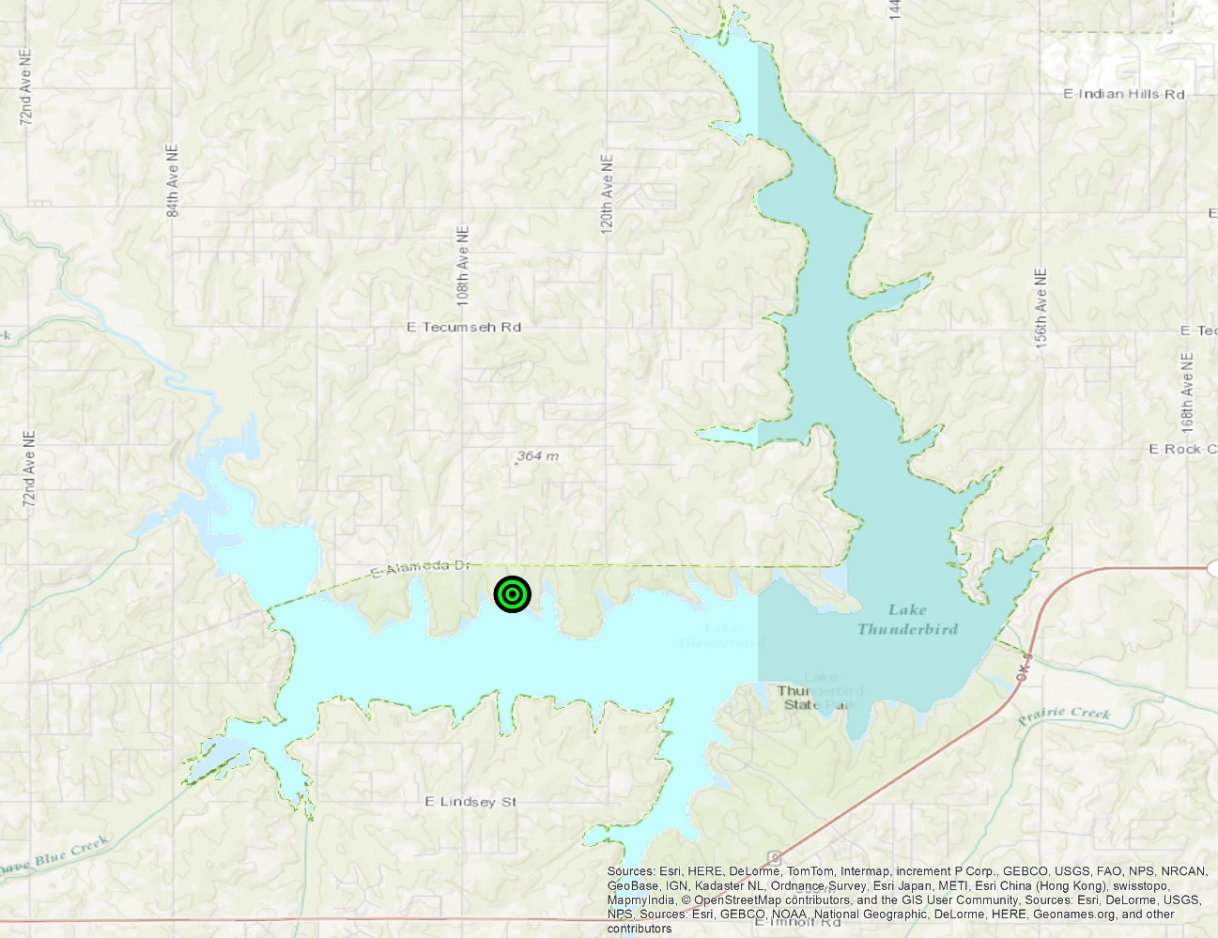
Figure 2.S19. Map of study site location.

CHAPTER 3
Does Position on the Tree Crown Affect Branch Growth Phenology? An Analysis of Budburst, Leaf-out, and Shoot Elongation for
Quercus marilandica and Quercus stellata

Abstract
Branch position around the tree crown was investigated to determine if position had an influence on budburst and leaf-out times. Branch position around the crown was also assessed for influence on the rate of shoot elongation after budburst occurred. Budburst date was not found to be influenced by branch position for either species while it did for leaf-out date. Shoot elongation rate also was not influenced by branch position on the tree crown nor was this influenced by precipitation or temperature.

Introduction
Bud dormancy, a temperate tree trait that has evolved to protect sensitive meristematic tissue during winter conditions (Cooke et al. 2012), ceases when tree species are exposed to chilling temperatures followed by warming temperatures prior to budburst. Air temperature during the period of chilling, when the air temperature is below a certain threshold, ranging from 5ºC to 10ºC (Murray et al. 1989; Ne’eman 1993; Caffarra and Donnelly 2011; Polgar and Primack 2011; Cooke et al. 2012; Kuster et al. 2014; Laube et al. 2014). Following budburst, in the temperate zone woody plants experience leaf-out and shoot elongation during the spring months. Although several studies have investigated budburst and the timing of leaf-out, few have addressed shoot elongation, an important part of annual tree growth and biomass production (Brown and Sommer 1992). In addition to temperature, a few studies have analyzed the role of photoperiod and precipitation in budburst initiation, and though results have been variable, photoperiod is a significant factor in combination with temperature (Caffarra and Donnelly 2011; Polgar and Primack 2011; Basler and Korner 2012; Cooke et al. 2012; Yu et al. 2016).
Understanding the relationship between budburst and temperature has taken on a new expediency in the wake of climate change. With documented increases of global temperature, changes in plant phenology have been confirmed (IPCC 2014). Such alteration in phenology will likewise affect the timing and possible duration of shoot elongation. It has been demonstrated that the rates of shoot growth and leaf expansion are mediated by temperature, with warmer temperatures accelerating biomass development (Fukui 2004; Pinto et al. 2011; Swidrak et al. 2013). Likewise, the increase in global atmospheric carbon could be mitigated by sequestration in woody plant tissues (Dunn et al. 2007; Polgar and Primack 2011; Devi and Garkoti 2013). During leaf-out and shoot elongation, nutrients are drawn from storage to supplement the growth of the new tissues in the canopy. Essentially, the leaves and shoots become metabolic sinks until the leaves become photosynthetically active and distribute photosynthates, at which the leaves become atmospheric carbon sinks and metabolic sources (Brown and Sommer 1992; Lambers et al. 2008).
Recent climate models also forecast a change in the distribution of precipitation. While the distribution of precipitation has not been found to play a significant role in initiating budburst, it is important for shoot growth (Buech 1976; Pinto et al. 2011). In water stressed environments or during drought conditions, shoot elongation is slowed, but where water is not limiting, shoot elongation is restricted by nutrient availability (Lambers et al. 2008; Pinto et al. 2011).
While there have been studies of temperate deciduous tree shoot phenology most have been conducted for to evergreen species (Dhaila et al. 1995; Devi and Garkoti 2013) or comparisons between species at a study site or between sites (Buech 1976; Brown and Sommer 1992; Dhaila et al. 1995; Pinto et al. 2011; Devi and Garkoti 2013; Swidrak et al. 2013; Cole and Sheldon 2017). Deciduous tree species have greater shoot elongation rates than evergreen tree species (Dhaila et al. 1995; Devi and Garkoti 2013) and larger diameters of this new growth (Devi and Garkoti 2013). Increased air temperature increases shoot elongation rates and lengths in some tree species (Fukui 2004; Swidrak et al. 2013) but not in others, such as Betula ermanii (Nakamura 2016).
One study of Quercus ilex and Q. suber investigated branch height on the tree in relation to number of buds present and shoot elongation where upper branches were found to have more buds and longer shoots. However, in this study all branches were in a south-west facing direction (Picolo and Terradas 1989). A crown architecture study of Q. petraea and Q. robur found intra- and inter-specific variation in shoot lengths but all branches were either south or south-east facing (Buck-Sorlin and Bell 2000). Not found in the literature is the role that branch position, in all cardinal directions, may play in budburst, leaf-out, and shoot elongation. Branch position on the tree may be an important factor in shoot elongation in the Northern Hemisphere due to the angle of the sun. Although the photoperiod increases each day in the spring, the solar angle moves from the south to the north resulting in an uneven sun exposure on the tree crown.
Within the eastern deciduous forest of North America, the genus Quercus (oaks) are one of the most abundant genera and are significant in ecosystem structure (Delcourt and Delcourt 2000). At the western edge of the eastern deciduous forest, Quercus marilandica and Q. stellata become important and dominant tree species. Between them, these species make up approximately 70% of the basal area and up to 90% of the canopy cover in Oklahoma forests (Rice and Penfound 1959).
In this study, we examined whether the branch position had any influence on budburst, leaf-out, and shoot phenology for two common trees in Oklahoma; Quercus marilandica and Q. stellata. We aimed to address the following questions: 1) Does branch orientation affect budburst and leaf-out timing? 2) Is the rate of shoot elongation affected by branch position on the tree crown? 3) Is the rate of shoot elongation after budburst a product of precipitation or temperature?

Methods
Study Area
The study site (35.229ºN 97.276ºW; Figure 3.S1) is located near Lake Thunderbird, Cleveland County, Oklahoma, a Bureau of Reclamation facility constructed between 1962 and 1965, approximately 15 km east of Norman, OK. The site lies within the western edge of the Cross Timbers ecoregion a transition zone between the Eastern Deciduous Forest and the prairie biome (Delcourt and Delcourt 2000; Stransky 1990). The climate in this region consists of mild winters (mean minimum air temperature -1.11ºC) and hot summers (mean maximum air temperature 33.33ºC) with mean annual precipitation of 863 mm (Mesonet 2016). At the study site, individuals of Quercus marilandica and Q. stellata occur in an open woodland setting on the north side of the lake with a south-facing slope that decreases 100 m from north to south (Shapiro et al. 2014).
In February 2010, adult trees of Quercus marilandica (n = 12) and Q. stellata (n = 18) were identified and tagged for a long-term budburst phenology study. Trees were selected haphazardly at random (Quinn and Keough 2002), starting at the north end of the site to the southern edge. Then, on each tree, four branches were selected and tagged for bud measurement. In order to determine if there was an influence of position of a branch on the crown of a tree, one branch was sampled from each cardinal direction where possible. Branch height ranged from 1 to 5 m from the ground and easily reachable from the ground or with an eight foot ladder.
Using an aerial image of the study site in ArcMap (ESRI 2015), the angle, from due North as zero, of each tagged branch was measured using the COGO report tool and the angles were then converted to radians. Once leaf-out occurred, shoot elongation was measured weekly until all 10 buds on the branch had leafed-out or until the newly emerged leaves reached 50% of full size, whichever occurred first. Weekly shoot elongation measurements were averaged for each branch and the mean shoot elongation rate per day was calculated from these measurements.
One Quercus marilandica individual was replaced in 2011 because the original tree from 2010 was toppled by a tornado. The replacement tree was within 5 m of the original. Between the 2011 and 2012 observation seasons, a different individual Q. marilandica tree died and was replaced with a tree 2 m away. Then in 2015, two other Q. marilandica and one Q. stellata trees were replaced due to tree removal from the site. Whenever a tree was replaced, every effort was made to tag branches in the same directions as the original trees. If this was not possible, the new branch directions were noted and measured in ArcMap as described above. Figures 3.1 and 3.2 show the distribution of branches for each species and each year of the study.
The Oklahoma Mesonet records temperature and precipitation variables in five minute intervals (Mesonet 2016). Climate data was obtained from Mesonet for the Norman tower for the time period of Sep 2009 through Apr 2016 (Figure 3.3). Using the Mesonet climate data, chilling and warming units were calculated in five minute intervals with a 5ºC cutoff. Chilling units were counted as one unit if the five minute interval had a temperature equal to or less than 5ºC. Warming units were counted in the same manner but if the temperature was equal to or greater than 5ºC. Chilling and warming units could only be calculated for the 2009 through 2015 data, as the 2016 data had too many missing data points to be considered reliable. Therefore, the 2016 observation data was only analyzed using date of budburst and leaf-out events with branch position. In addition to temperature and precipitation, some deciduous trees need a critical photoperiod length to break dormancy (Korner and Basler 2010). To capture the maximum photoperiod exposure before budburst occurred, the day length for the day preceding the day of budburst was recorded in seconds of daylight per day (Thorton et al. 2016).
Statistical Analysis
Phenological studies have recently begun to employ circular statistics because of the cyclical nature of budburst events (Hamann 2004; Morellato et al 2010b; Ting et al. 2008). For this study, however, a combination of circular statistics and linear regression was used to determine if there was a directional pattern (i.e., buds on south-facing stems swell and burst first or more rapidly than those on north facing stems) of budburst on the crown of the trees with due north representing 0º on the circle. Circular correlation and circular ANOVA were used to analyze observational data (budburst and leaf-out timing) with chilling units, and warming units for individual years and pooling all years in the study, with the exception of the 2016 observations. Inter-annual variation within each species for budburst and leaf-out dates were tested for differences using circular ANOVA (Fisher 1993). The circular statistical analysis was implemented in the Circular Package 0.4-7 (Lund and Agostinelli 2014) in R 3.3.1 (Cran R Project 2016).
As there is not an available function for multiple circular regression in either of the circular statistics packages for R, at this time; the angle of each branch was transformed into a linear variable using the following formula: $A_{lin}=cos⁡(180-A)$ (Eq. 1)
where A_{lin} is the linearized angle and A is the branch angle in radians. This results in values between -1 and 1, where -1 represents North and 1 represents South. This is a slight variation on the Beers transformation where the transformed values are between 0 and 2 and follow a NE to SW line rather than an N to S line that results from our transformation (Beers et al 1966). Separate multiple linear regression models were run for budburst and leaf-out dates using the explanatory climate variables and the linearized branch positions. An additional multiple linear regression model was run to test shoot elongation rate with leaf-out date, climate, and branch position. All analyses were conducted in R 3.3.1 (Cran R Project 2016).

Results
Budburst & Leaf-out
Budburst and leaf-out times were different between Quercus marilandica and Q. stellata. In four of the study years, some buds of both species began to burst on the same day; however, these dates were not the same from year to year. Quercus marilandica began budburst earlier than Q. stellata in 2013 and seven days earlier in 2014. During 2016, Q. stellata began budburst nine days earlier than Q. marilandica. In three of the years, Q. marilandica completed budburst and commenced with leaf-out within two weeks. During 2011, Q. marilandica took 29 days to complete budburst. Q. stellata completed budburst within two weeks generally but took 29 days to complete budburst in 2011 (Figure 3.4).
Combining years 2010 through 2015, circular ANOVA revealed there was a significant interspecific difference between Quercus marilandica and Q. stellata for branch position on the tree crown for the day of budburst, day of leaf-out, five minute 5ºC chilling units, and five minute 5ºC warming units. Analysis of the species by year, indicated several of the variables and combinations of the variables to differ between the two species (Table 3.1). There was a consistent inter-annual difference for each species in regard to the five minute 5ºC chilling and warming units. The branch position on the day of budburst was different between these species in only three of the years (2012, 2013, and 2015). Branch position on day of leaf-out was different in all but two years (2010 and 2014). In 2016, there were also significant differences for branch position for day of budburst and day of leaf-out between these species. Environmental variables were not assessed for 2016 due to the lack of Mesonet data for that year.
Inter-annual branch position on the tree crown was not statistically significant for either species of Quercus in regard to budburst for the years 2010 through 2015. All climate variables and photoperiod were significant across years and within each year for these same years (Table 3.2). In 2010, 2012, and 2015, the linear models for Quercus marilandica could not define the coefficients for cumulative precipitation up to budburst or for photoperiod. This was because of high correlation present in the data (Table 3.3). Quercus stellata also had high correlation that resulted in undefined coefficients for cumulative precipitation up to day of budburst and photoperiod for all years except 2011 (Table 3.3). Due to the lack of reliable Mesonet data close to the study site for 2016, this year was analyzed for branch position on the tree crown only. Branch position on the crown was significant for both species when analyzed for date of event only.
Branch position for leaf-out on the crown was significant for Quercus stellata but not for Q. marilandica when years 2010 through 2015 were pooled. All climate variables and photoperiod had significant influence on leaf-out for Q. marilandica. All climate variables except five minute 5ºC warming units were significant for Q. stellata leaf-out (Table 3.4). In 2016, branch position for leaf-out was only significant for Q. marilandica.
Shoot Elongation
When shoot elongation began, there were a few short shoots on some branches of each species. At the end of each observation season, final shoot lengths varied with the longest shoots occurring in 2011 and the shortest in 2014 (Figure 3.5). Quercus marilandica most often began shoot elongation before Q. stellata; typically one week earlier. Initial shoot elongation rates increased rapidly before leveling off for both Q. marilandica and Q. stellata (Figure 3.6). Mean shoot rate ranged from 0.03 mm/day to 2.96 mm/day for Q. marilandica while mean shoot rate ranged from 0.02 mm/day to 3.07 mm/day for Q. stellata. Regression analysis of shoot elongation rates was variable for both species. For Q. marilandica, only five minute 5ºC warming units had a significant effect on shoot elongation in 2010. For years 2011 and 2012, no variables were significant in regard to shoot elongation. However, the day of leaf-out and precipitation were significant in 2013. Five minute 5ºC chilling units were significant in 2014 and 2015 while five minute 5ºC warming units were only significant in 2014. Precipitation was also significant in 2015. Photoperiod was found to be significant only in 2014 (Table 3.5). In years 2010, 2012, and 2014, the photoperiod coefficient could not be defined in the model due to its high correlation with two or more of the other variables (Table 3.6). Q. stellata only had significant variables in two of the study years. In 2013, only five minute 5ºC chilling units were significant. Day of leaf-out, five minute 5ºC chilling units, five minute 5ºC warming units, and photoperiod were significant in 2014 (Table 3.5). As with Q. marilandica, the photoperiod coefficient for the Q. stellata linear model could not be defined in 2010 and in 2013 due to high correlation with both five minute 5ºC chilling and warming units. Additionally, in the linear model for 2013, the coefficient for precipitation could not be defined. Here, precipitation was highly correlated with day of leaf-out (Table 3.6).

Discussion
Although there were differences in branch position for dates of budburst between Quercus marilandica and Q. stellata, the position on the tree crown was not a significant inter-annual factor for each species. From the circular ANOVA budburst date analysis, we found that position on the crown was only significantly different between species in four of the study years while in five of the years crown position was different for leaf-out date.
The linear regression models found that crown position was not a significant budburst factor for either species, whether data was pooled across years or between individual years. Five minute 5ºC chilling and warming units were consistently significant across all the budburst models for both species. Cumulative precipitation and photoperiod were only significant in three of the study years for Q. marilandica. Both cumulative precipitation and photoperiod were significant for Q. stellata in 2011 while only precipitation was significant in 2014 and 2015.
Crown position was a significant factor in some of the leaf-out linear models. Position was significant in three years for Quercus marilandica and four years for Q. stellata. When the years were pooled, position was significant only for Q. stellata. Five minute 5ºC chilling and warming units were the most frequent variables found to be significant in the linear models. Cumulative precipitation and photoperiod were also significant in most of the models except when these variables were highly correlated with other variables.
The mean weekly shoot length was variable between each year of the study. Quercus marilandica generally reached budburst date first and thus began shoot elongation first. Final mean shoot length was similar between the species. Crown position did not have significant influence on shoot elongation rates or lengths. This result is contrary to the results of Picolo and Terradas (1989) who found that shoots in the upper part of the crown were longer than those in the lower portion of the tree crown. However, in that study, only branches with a southwest aspect where measured while we assessed positon in all cardinal directions.
Shoot elongation was influenced by five minute 5ºC chilling units in only two years for Quercus marilandica and 5ºC warming units in one year. For Q. stellata, this pattern was repeated. In 2014, the warming units were significant for both species. Non-significant influence of warming is consistent with other findings. Under experimental warming of adult trees, Nakamura et al. (2016) found that shoot elongation only slightly increased for warmed branches of Betula ermanii (birch) compared to non-warmed branches. Fukui (2004) found that for Morus alba (mulberry), shoot elongation increased with increasing temperature. A study of Q. suber, found that shoot elongation was influenced by mean temperature at their Mediterranean study site (Pinto et al. 2011).
Other studies have reported the importance of precipitation for shoot elongation (Buech 1976; Sharifi et al. 1983; Oliveira et al. 1994; Pinto et al. 2011), but we found that precipitation was not a consistently significant variable in our shoot elongation models. It was a significant variable only for Quercus marilandica in two of the study years. The second year of the study, 2011, had the second longest mean shoot lengths for Q. marilandica and the longest mean shoot lengths for Q. stellata. At the time when shoot growth was initiated in 2011, the region was experiencing extreme drought conditions (US Drought Monitor 2017) that extended through to the end of observations for the season. The shortest shoot lengths for both species were in 2014, during which the region was not under drought conditions. Even though the site was under drought conditions in 2011, there were a few more short bursts of precipitation prior to shoot elongation than in 2014 (Figure 3.3) which may explain the difference in mean shoot length between years. This is similar to Oliveira et al.’s (1994) observation of the shortest shoot lengths for Quercus suber during the wettest year of their study.

Conclusion
We found inter-annual variation of budburst and leaf-out patterns around the lower portion of the crown. Interspecific variation in budburst was also present in these populations. While position on the crown did not have significant influence on initiation of budburst, buds bursting in various positions on an individual tree could help mitigate against potential damage and loss of new growth in the event of a late freeze.
Air temperature played the most important role in budburst initiation and our findings were consistent with studies of other species of Quercus. These species require a chilling period that induces bud dormancy followed by a warming period to release the buds from dormancy. As global temperatures rise, this chilling requirement may or may not be met in the future which would alter budburst timing. If the chilling requirement is met and budburst occurs earlier then the growing season would be extended allowing for more biomass accumulation in these species. Conversely, if the chilling requirement is not met a longer warming period would be needed to break dormancy, then budburst would be delayed and the growing season shortened. We found mixed results in regard to the roles of precipitation and photoperiod for budburst initiation.
Crown position was significant for leaf-out in some years with interspecific variation. Not having all the leaves emerge at the same time and in various positions around the crown may reduce loss of photosynthetic capacity thru loss of leaves to late freezes or insect and animal foraging. Air temperature as well as precipitation and photoperiod played important roles in leaf-out. Sufficient warming temperatures, precipitation, and sunlight allow for faster leaf emergence and development. If air temperature increases as predicted, leaf emergence and development rates may also increase which in turn would allow for faster uptake of atmospheric carbon. This would not happen, however, should sufficient precipitation not occur in conjunction with leaf-out and leaf development.
Shoot elongation was not influenced by position around the crown. One caveat is that we only measured buds and shoots on branches that are considered “lower” branches. There may have been a shading effect from other nearby trees that was not accounted for in this study. All of the branches we measured could be reached safely using an eight foot ladder; the highest branch we measured was approximately 5 m from the ground and lowest branch was 1 m from the ground. There was a mix of branches that were shaded and not shaded at various points during the day. Shading effect could be included in a future study. While we can say that position around the crown was not a significant factor in our study, we cannot say that this holds true for the upper portion of the crown without further study. Additionally, the environmental variables we tested were not consistently influential in regard to shoot elongation, indicating that some other variable or variables are driving shoot elongation in Q. marilandica and Q. stellata. It may be that the environment of these particular populations are nutrient limiting (Lambers et al. 2008; Pinto et al. 2011) and this could be incorporated in a future study.
Growth was relatively consistent in the lower branches of these tree species, as shoot elongation rates were not significantly different for any direction on the crown. Air temperature was not a significant factor in shoot elongation for these species. Warmer temperatures did not correlate with longer shoots. Precipitation was only significant for Quercus marilandica in two of the study years and both species produced their longest shoots in a drought year. This response during drought conditions is contrary to other findings where the typical response is to slow shoot growth. At this time we cannot explain this anomalous year but postulate that soil and nutrient conditions at the site may be a factor since the shortest shoot lengths were recorded in a year with relatively normal precipitation. Soils at the site range from sandy to tight clay thus resulting in a potentially nutrient limiting environment. A full soil analysis including the available water content and cation exchange capacity should be conducted in the future.

Acknowledgements
We would like to thank the land owner Ed Jessup for allowing us to conduct this multi-year study on his property. We also thank all of the volunteers that helped collect data over the course of the study: Kayti Ewing, Carol Butler, Emily Grimes, Daryn Hardwick, Austin Griffin, Toni Klemm, Emily Windahl, and several others.

Literature Cited
Basler, D., and C. Korner. 2012. Photoperiod Sensitivity of Bud Burst in 14 Temperate Forest Tree Species. 2012. Agricultural and Forest Meteorology, 165: 73-81.

Beers, T.W., Dress, P.E., and L.C. Wensel. 1966. Aspect Transformation in Site Productivity Research. Journal of Forestry, 64; 691-692.

Brown, C.L., and H.E. Sommer. 1992. Shoot Growth and Histogenesis of Trees Possessing Diverse Patterns of Shoot Development. American Journal of Botany, 79: 335-346.

Buck-Sorlin, G.H., and A.D. Bell. 2000. Models of Crown Architecture in Quercus petraea and Q. robur: Shoot Lengths and Bud Numbers. Forestry, 73: 1-19.

Buech, R.R. 1976. Tree Shoot Elongation in Northern Wisconsin and Relationships with Temperature and Precipitation. Canadian Journal of Forest Research, 6: 487-498.

Caffarra, A., and A. Donnelly. 2011. The Ecological Significance of Phenology in Four Different Tree Species: Effects of Light and Temperature on Bud Burst. International Journal of Biometeorology, 55: 711-721.

Cole, E.F., and B.C. Sheldon. 2017. The Shifting Phenological Landscape: Within- and Between- Species Variation in Leaf Emergence in a Mixed-Deciduous Woodland. Ecology and Evolution, 00: 1-13.

Cooke, J.E.K., Eriksson, M.E., and O. Junittila. 2012. The Dynamic Nature of Bud Dormancy in Trees: Environmental Control and Molecular Mechanisms. Plant, Cell, and Environment, 35: 1707-1728.

Delcourt, H.R., and P.A. Delcourt 2000. Eastern Deciduous Forests. In North American Terrestrial Vegetation, 2nd Ed. Barbour, M.G., and W.D. Billings Eds. Cambridge University Press, Cambridge. 708 p.

Devi, A.F., and S.C. Garkoti. 2013. Variation in Evergreen and Deciduous Species Leaf Phenology in Assam, India. Trees, 27: 985-997.

Dhaila, S., Singh, S.P., Negi, G.C.S, and Y.S. Rawat. 1995. Shoot Growth Phenology of Co-existing Evergreen and Deciduous Species in an Oak Forest. Ecological Research, 10: 151-159.

Dunn, A.L., Barford, C.C., Wofsy, S.C., Goulden, M.L., and B.C. Daube. 2007. A Long-Term Record of Carbon Exchange in a Boreal Black Spruce Forest: Means, Responses to Interannual Variability, and Decadal Trends. Global Change Biology, 13: 577-590.
ESRI. 2015. ArcGIS for Desktop 10.4.1. Redlands, CA, USA.

Fisher, NI. 1993. Statistical Analysis of Circular Data. Cambridge University Press; Great Britain. 277 p.

Fukui, K. 2004. Modeling the Interactive Effect of the Photoperiod and Temperature on Shoot Elongation of Mulberry. Plant Production Science, 2: 224-229.

Hamann, A. 2004. Flowering and Fruiting Phenology of a Philippine Submontane Rain Forest: Climatic Factors as Proximate and Ultimate Causes. Journal of Ecology, 92: 24-31.

IPCC. 2014. Climate Change 2014: Synthesis Report. Contribution of Working Groups I, II and III to the Fifth Assessment Report of the Intergovernmental Panel of Climate Change [Core Writing Team, R.K. Pachauri and L.A. Meyer (eds.)]. IPCC, Geneva, Switzerland, 151 p.

Korner, C., and D. Basler. 2010. Phenology Under Global Warming. Science, 327: 1461-1462.

Kuster, T.M., Dobbertin, M., Gunthardt-Goerg, M., Schaub, M., and M. Arend. 2014. A Phenological Timetable of Oak Growth Under Experimental Drought and Air Warming. PLOS One, 9: e89724.

Lambers, H., Chapin III, F.S., and T.L. Pons (Eds.). 2008. Plant Physiological Ecology, 2nd Ed. Springer; New York. 604 p.

Laube, J., Sparks, T.H., Estrella, N., Hofler, J., Ankerst, D.P., and A. Menzel. 2014. Chilling Outweighs Photoperiod in Preventing Precocious Spring Development. Global Change Biology, 20: 170-182.

Lund, U., and C. Agostinelli. 2014. Circular Package 0.4-7. Available online: http://cran.r-project.org/.

Mesonent. 2016. Oklahoma Mesonet. Available online: https://www.mesonet.org/.

Morellato, LPC, Alberti, LF, and IL Hudson. 2010b. Applications of Circular Statistics in Plant Phenology: A Case Studies Approach. In Phenological Research: Methods for Environmental and Climate Change Analysis, IL Hudson and MR Keatley (Eds). Springer; Netherlands. 521 p.

Murray, M.B., Cannell, M.G.R., and R.I. Smith. 1989. Date of Budburst of Fifteen Tree Species in Britain Following Climatic Warming. Journal of Applied Ecology, 26: 693-700.

Nakamura, M., Makoto, K., Tanaka, M., Inoue, T., Son, Y., and T. Hiura. 2016. Leaf Flushing and Shedding, Bud and Flower Production, and Stem Elongation in Tall Birch Trees Subjected to Increases in Aboveground Temperature. Trees, 30: 1535-1541.

Ne’eman, G. 1993. Variation in Leaf Phenology and Habit in Quercus ithaburensis, a Mediterranean Deciduous Tree. Journal of Ecology, 81: 627-634.

Oliveira, G., Correia, O., Martins-Loucao, M.A., and F.M. Catarino. 1994. Phenological and Growth Patterns of the Mediterranean Oak Quercus suber L. Trees, 9: 41-46.

Picolo, R., and J. Terradas. 1989. Aspects of Crown Reconstruction and Leaf Morphology in Quercus ilex L. and Quercus suber L. after Defoliation by Lymantria dispar L. Acta OEcologica, 10: 69-78.

Pinto, C.A., Henriques, M.O., Figueiredo, J.P., David, J.S., Abreu, F.G., Pereira, J.S., Correia, I., and T.S. David. 2011. Phenology and Growth Dynamics in Mediterranean Evergreen Oaks: Effects of Environmental Conditions and Water Relations. Forest Ecology and Management, 262: 500-508.

Polgar, C.A., and R.B. Primack. 2011. Leaf-out Phenology of Temperate Woody Plants: From Trees to Ecosystems. New Phytologist, 191: 926-941.

Quinn, G.P., and M.J. Keough. 2002. Experimental Design and Data Analysis for Biologists. Cambridge University Press; Cambridge. 537 p.

R Development Core Team. 2016. R: A Language and Environment for Statistical Computer, version 3.3.1. R Foundation for Statistical Computing, Vienna, Austria. Available online: http://www.R-project.org.

Rice, E.L., and W.T. Penfound. 1959. The Upland Forests of Oklahoma. Ecology, 40: 593-608.

Shapiro, A., Klein, P.M., Arms, S., Bodine, D., and M. Carney. 2014. Lake Thunderbird Micronet. Available online: http://micronet.ou.edu/. Last accessed on [9 Nov 2014].

Sharifi, M.R., Nilsen, E.T., Virginia, R., Rundel, P.W., and W.M. Jarrell. 1983. Phenological Patterns of Current Season Shoots of Prosopis glandulosa var. torreyana in the Sonoran Desert of Southern California. Flora, 173: 265-277.

Stransky, J.J. 1990. Quercus stellata. In Silvics of North America: Volume 2 Hardwoods. Burns, R.M., and B.H. Honkala Eds. United States Department of Agriculture, Forest Service. Available online: http://na.fs.fed.us/spfo/pubs/silvics_manual/table_of_contents.htm. Last accessed on [9 Nov 2014].

Swidrak, I., Schuster, R., and W. Oberhuber. 2013. Comparing Growth Phenology of Co-occurring Deciduous and Evergreen Conifers Exposed to Drought. Flora, 208: 609-617.

Thornton, P.E., M.M. Thornton, B.W. Mayer, Y. Wei, R. Devarakonda, R.S. Vose, and R.B. Cook. 2016. Daymet: Daily Surface Weather Data on a 1-km Grid for North America, Version 3. ORNL DAAC, Oak Ridge, Tennessee, USA. Accessed Aug 17, 2016. Time period: 2010-01-01 to 2016-04-30. http://dx.doi.org/10.3334/ORNLDAAC/1328.

Ting, S., Hartley, S., and K.C. Burns. 2008. Global Patterns in Fruiting Seasons. Global Ecology and Biogeography, 17: 648-657.

US Drought Monitor. 2017. United States Drought Monitor. Available online: http://droughtmonitor.unl.edu. Last accessed on Feb 7, 2017.

Yu, R., Schwartz, M.D., Donnelly, A., and L. Liang. 2016. An Observation-based Progression Modeling Approach to Spring and Autumn Deciduous Tree Phenology. International Journal of Biometeorology, 60: 335-349.

Appendix – Tables
Table 3.1. Circular ANOVA results comparing Quercus marilandica and Q. stellata branch position for budburst and leaf-out. Significant p-values in bold.
 | Budburst |  | Leafout
Year | F | p-value | F | p-value
2010 | 0.03 | 0.87 | 2.64 | 0.10
2011 | 1.84 | 0.18 | 22.89 | < 0.001
2012 | 4.21 | 0.04 | 14.07 | < 0.001
2013 | 7.98 | 0.004 | 93.01 | < 0.001
2014 | 0.48 | 0.49 | 2.16 | 0.14
2015 | 19.78 | < 0.001 | 27.96 | < 0.001
2016 | 61.36 | < 0.001 | 10.63 | 0.001

Table 3.2. Circular ANOVA results comparing Quercus marilandica and Q. stellata. Chill and warm units are five minute 5ºC units. Significant p-values in bold.
Year | Variable | F value | p-value
All | Day Burst | 6.78 | 0.01
 | Day Leaf | 46.92 | < 0.001
 | Chill Units | 64.09 | < 0.001
 | Warm Units | 16.89 | < 0.001
2010 | Day Burst | 0.03 | 0.87
 | Day Leaf | 2.64 | 0.10
 | Chill Units | 0.43 | 0.51
 | Warm Units | 16.20 | < 0.001
2011 | Day Burst | 1.84 | 0.18
 | Day Leaf | 22.89 | < 0.001
 | Chill Units | 1.01 | 0.32
 | Warm Units | 5.39 | 0.02
2012 | Day Burst | 4.21 | 0.04
 | Day Leaf | 14.07 | < 0.001
 | Chill Units | 329.10 | < 0.001
 | Warm Units | 1.81 | 0.18
2013 | Day Burst | 7.98 | 0.005
 | Day Leaf | 93.10 | < 0.001
 | Chill Units | 22.88 | < 0.001
 | Warm Units | 49.95 | < 0.001
2014 | Day Burst | 0.48 | 0.49
 | Day Leaf | 2.16 | 0.14
 | Chill Units | 8.73 | 0.003
 | Warm Units | 96.93 | < 0.001
2015 | Day Burst | 19.78 | < 0.001
 | Day Leaf | 27.96 | < 0.001
 | Chill Units | 4.03 | 0.04
 | Warm Units | 0.05 | 0.82
2016 | Day Burst | 61.36 | < 0.001
 | Day Leaf | 10.63 | 0.001

Table 3.3. Linear regression output for budburst. Significant p-values in bold.
Quercus marilandica
Variable | All Years | 2010 | 2011 | 2012 | 2013 | 2014 | 2015
Position | 0.31 | 0.24 | 0.40 | 0.29 | 0.41 | 0.97 | 0.21
Chill 5 | < 0.001 | < 0.001 | < 0.001 | < 0.001 | < 0.001 | < 0.001 | < 0.001
Warm 5 | < 0.001 | < 0.001 | < 0.001 | < 0.001 | < 0.001 | < 0.001 | < 0.001
Precipitation | < 0.001 | NA | < 0.001 | NA | < 0.001 | < 0.001 | NA
Photoperiod | < 0.001 | NA | < 0.001 | NA | < 0.001 | < 0.001 | NA
Quercus stellata
Variable | All Years | 2010 | 2011 | 2012 | 2013 | 2014 | 2015
Position | 0.18 | 0.48 | 0.95 | 0.61 | 0.64 | 0.60 | 0.64
Chill 5 | 0.03 | < 0.001 | < 0.001 | < 0.001 | < 0.001 | < 0.001 | < 0.001
Warm 5 | < 0.001 | < 0.001 | < 0.001 | < 0.001 | < 0.001 | < 0.001 | < 0.001
Precipitation | < 0.001 | NA | < 0.001 | 0.77 | NA | < 0.001 | < 0.001
Photoperiod | < 0.001 | NA | < 0.001 | NA | NA | NA | NA

Table 3.4. Pearson correlation coefficients and p-values for correlation between cumulative precipitation up to budburst date, photoperiod, and other variables in branch position regression models, only significant correlations shown.
Quercus marilandica |  |  |  | Quercus stellata
Precipitation |  |  |  | Precipitation
 |  | Pearson | p-value |  |  | Pearson | p-value
2010 | Chill 5 | 0.24 | > 0.001 | 2010 | Chill 5 | 0.29 | > 0.001
2010 | Warm 5 | 0.56 | > 0.001 | 2010 | Warm 5 | 0.80 | > 0.001
2010 | Photo | 0.56 | > 0.001 | 2010 | Photo | 0.80 | > 0.001
2012 | Chill 5 | 0.48 | > 0.001 | 2013 | Chill 5 | 1.00 | > 0.001
2012 | Warm 5 | 0.93 | > 0.001 | 2013 | Warm 5 | 1.00 | > 0.001
2012 | Photo | 0.94 | > 0.001 | 2013 | Photo
2013 | Position | 0.10 | 0.01
2013 | Chill 5 | 1.00 | > 0.001 | Photoperiod
2013 | Warm 5 | 1.00 | > 0.001 | 2010 | Chill 5 | 0.8 | > 0.001
2013 | Photo | 1.00 | > 0.001 | 2010 | Warm 5 | 1 | > 0.001
2015 | Chill 5 | 0.93 | > 0.001 | 2012 | Position | -0.08 | 0.02
2015 | Warm 5 | 1.00 | > 0.001 | 2012 | Chill 5 | 0.8 | > 0.001
2015 | Photo | 1.00 | > 0.001 | 2012 | Warm 5 | 1 | > 0.001
 |  |  |  | 2013 | Position | 0.09 | 0.01
Photoperiod |  |  |  | 2013 | Chill 5 | 1 | > 0.001
2010 | Chill 5 | 0.94 | > 0.001 | 2013 | Warm 5 | 1 | > 0.001
2010 | Warm 5 | 1.00 | > 0.001 | 2014 | Position | 0.09 | 0.02
2012 | Chill 5 | 0.75 | > 0.001 | 2014 | Chill 5 | 0.99 | > 0.001
2012 | Warm 5 | 1.00 | > 0.001 | 2014 | Warm 5 | 1 | > 0.001
2015 | Chill 5 | 0.94 | > 0.001 | 2014 | Precipitation | 0.95 | > 0.001
2015 | Warm 5 | 1.00 | > 0.001 | 2015 | Chill 5 | 0.95 | > 0.001
 |  |  |  | 2015 | Warm 5 | 1 | > 0.001
 |  |  |  | 2015 | Precipitation | 0.99 | > 0.001

Table 3.5. Linear regression output for leaf-out. Significant p-values in bold.
Quercus marilandica
Variable | All Years | 2010 | 2011 | 2012 | 2013 | 2014 | 2015
Position | 0.62 | 0.41 | 0.02 | 0.01 | 0.85 | < 0.001 | 0.07
Chill 5 | < 0.001 | 0.95 | < 0.001 | 0.01 | 0.01 | 0.14 | < 0.001
Warm 5 | < 0.001 | < 0.001 | < 0.001 | < 0.001 | 0.03 | 0.65 | < 0.001
Precipitation | < 0.001 | NA | < 0.001 | NA | < 0.001 | < 0.001 | NA
Photoperiod | < 0.001 | NA | < 0.001 | NA | 0.003 | 0.46 | NA
Quercus stellata
Variable | All Years | 2010 | 2011 | 2012 | 2013 | 2014 | 2015
Position | 0.02 | 0.06 | 0.01 | 0.14 | 0.09 | 0.01 | 0.02
Chill 5 | 0.01 | < 0.001 | < 0.001 | < 0.001 | 0.41 | < 0.001 | < 0.001
Warm 5 | 0.14 | < 0.001 | < 0.001 | < 0.001 | 0.06 | < 0.001 | < 0.001
Precipitation | < 0.001 | NA | < 0.001 | < 0.001 | NA | < 0.001 | < 0.001
Photoperiod | < 0.001 | NA | < 0.001 | NA | NA | NA | NA

Table 3.6. P-values from shoot elongation regression models.
Quercus marilandica
Variable | 2010 | 2011 | 2012 | 2013 | 2014 | 2015
Position | 0.82 | 0.35 | 0.74 | 0.44 | 0.30 | 0.38
Day Leaf | 0.40 | 0.22 | 0.67 | 0.02 | 0.57 | 0.13
Chill 5 | 0.41 | 0.40 | 0.08 | 0.72 | 0.01 | 0.02
Warm 5 | 0.01 | 0.67 | 0.16 | 0.12 | 0.02 | 0.28
Precipitation | 0.43 | 0.72 | 0.08 | 0.05 | 0.64 | 0.01
Photoperiod | NA | 0.56 | NA | 0.46 | 0.01 | NA
Quercus stellata
Variable | 2010 | 2011 | 2012 | 2013 | 2014 | 2015
Position | 0.70 | 0.61 | 0.55 | 0.27 | 0.64 | 0.33
Day Leaf | 0.90 | 0.69 | 0.75 | 0.10 | 0.01 | 0.51
Chill 5 | 0.82 | 0.24 | 0.41 | 0.01 | > 0.001 | 0.21
Warm 5 | 0.14 | 0.88 | 0.42 | 0.32 | > 0.001 | 0.20
Precipitation | 0.76 | 0.44 | 0.87 | NA | 0.10 | 0.52
Photoperiod | NA | 0.32 | 0.32 | NA | > 0.001 | 0.20

Table 3.7. Pearson correlation coefficients and p-values for correlation between photoperiod and other variables in shoot elongation regression models, only significant correlations shown.
Quercus marilandica |  |  |  | Quercus stellata
Photoperiod |  |  |  | Photoperiod
 |  | Pearson | p-value |  |  | Pearson | p-value
2010 | Chill 5 | 1.00 | > 0.001 | 2010 | Chill 5 | 0.94 | > 0.001
2010 | Warm 5 | 1.00 | > 0.001 | 2010 | Warm 5 | 1.00 | > 0.001
2012 | Chill 5 | 0.74 | > 0.001 | 2013 | Chill 5 | 1.00 | > 0.001
2012 | Warm 5 | 1.00 | > 0.001 | 2013 | Warm 5 | 1.00 | > 0.001
2012 | Precipitation | 0.94 | > 0.001 | 2013 | Precipitation
2012 | Day Leaf | 0.92 | > 0.001 | 2013 | Day Leaf | 1.00 | > 0.001
2015 | Chill 5 | 0.94 | > 0.001
2015 | Warm 5 | 1.00 | > 0.001
2015 | Precipitation | 0.81 | > 0.001
2015 | Day Leaf | 0.90 | > 0.001

Appendix – Figures
Figure 3.1. Branch distributions for Quercus marilandica in each year of the study.

Figure 3.2. Branch distributions for Quercus stellata in each year of the study.

Figure 3.3. Mean daily temperature and daily precipitation for the study site. Day 1 = Sep the year prior to observations; x-axis. Shoot elongation typically began around day 200 in most years.

Figure 3.4. Budburst (top row) and leaf-out (bottom row) ranges for Quercus marilandica and Q. stellata.

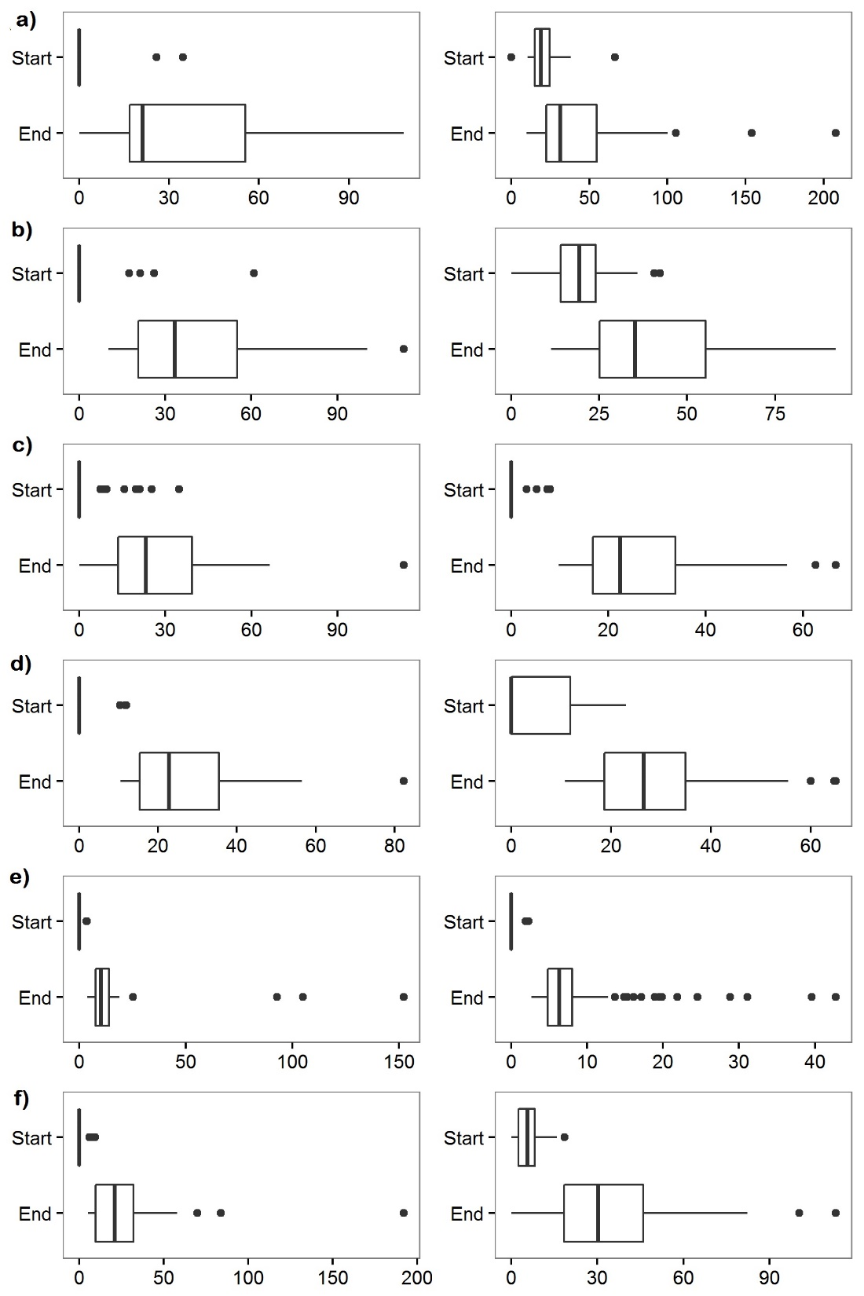
Figure 3.5. Boxplots of shoot lengths for the start and end of the observation period. Start times are not the same for each year. X-axis is shoot length in mm. Left column: Quercus marilandica. Right column: Quercus stellata. a) 2010, b) 2011, c) 2012, d) 2013, e) 2014, f) 2015.
Figure 3.6. Mean weekly shoot length for each year, top: Quercus marilandica, bottom: Q. stellata. ▲ = 2010, ○ = 2011, □ =2012, ♦ = 2013, x = 2014, and ● = 2015.

Supplemental Appendix – Map

Figure 3.S1. Map of study site location.

CHAPTER 4
AN HERBARIUM BASED ANALYSIS IN SPATIAL AND TEMPORAL CHANGES IN FLOWERING OF THE BRASSICACEAE AND LAMIACEAE

Abstract
We used herbarium specimens to investigate potential changes in the flowering times for members of the Brassicaceae and Lamiaceae across Oklahoma. We used generalized additive models to assess the influence of climatic variables on flowering across the state and within provisional seed zones. Directional spatial autocorrelation was tested as a measure of flowering synchronicity using the Mantel bearing correlogram. Twenty species, ten in each family, met our criteria to be included in the study. Significant trends in flowering were found for ten species, five in each family. These trends were most often delays in flowering time. The models found varying climatic variables were influential in flowering. The climate variables three months prior to specimen collection were most frequently the significant variables for many of the species. Several species showed some directionality in spatial autocorrelation for flowering then had no apparent directional autocorrelation when subset into seed zone. The directional autocorrelation from the seed zones best represents the direction and relative synchronicity of flowering for these species.

Introduction
Due to growing concerns regarding the impact of climate change on ecosystems and biomes, interest in phenology has increased over the past several decades. The IPCC (2014) predicts that global temperatures will rise. Climate and phenology are intrinsically linked and phenological studies are a “key component for climate change research” (Morellato et al. 2013). Although phenological events have been recorded in agricultural calendars as far back as 1700 BC, long-term and complete records are sparse for many regions of the globe (Keatley and Hudson 2010). In order to resolve this problem, researchers have turned to herbaria as potential sources of long-term data for biogeographical and climate change studies (Lavoie 2013; Lister et al. 2011; Miller-Rushing et al. 2006; Neil et al. 2010; Davis et al. 2015; Rawal et al. 2015). Herbaria have always been important resources for systematics studies, but the wealth of information contained in these institutions has been employed in analyses of regional biodiversity, current and changing species distributions, distribution of non-native species, plant disease spread, and over the last decade plant phenological events as they relate to climate change (Lavoie 2013; Davis et al. 2015; Spellman and Mulder 2016).
Attempts to detect departures from “typical” flowering season, however, have yielded mixed results (Zalamea et al. 2011; Calinger et al. 2013; Brown et al. 2016). For example, it has been demonstrated that some spring flowering herbaceous plant species are flowering earlier with increased spring temperatures (Calinger et al. 2013; Diskin et al. 2012; Lavoie and Lachance 2006; Li et al. 2013; Miller-Rushing and Primack 2008; Robbirt et al. 2011; Rawal et al. 2015) while summer flowering species remain relatively unaffected in their flowering times by increased spring temperatures (Calinger et al. 2013). Conversely, Neil et al. (2010) found delayed flowering times of spring flowering ephemeral species in southern Arizona while fall flowering ephemeral species had no significant change in flowering times. Gallagher et al. (2009) detected delays in flowering due to increased temperatures, as did Park and Schwartz (2015). Although not a herbarium-based phenology study, Jentsch et al. (2009) found that summer flowering species may be responding to precipitation changes rather that temperature changes based on an analysis of remotely sensed data. One study reported that some species within a genus are responding to a changing climate while other species in the same genus were not responding (Hart et al. 2014).
Not only do increased temperatures influence the onset of flowering and changes in, but the timing of the temperature increase has been found to be influential. Analyses examined temperatures one, two, and three months prior to flowering (Calinger et al. 20123; Rawal et al. 2015; Matthews and Mazer 2016) and seasonal climate means (Mohandass et al. 2015). Rawal et al. (2015) found that the strongest predictor of flowering was an increase in the mean temperature three months prior. They also noted that for one of their study species, an increase in mean temperature advanced flowering while an increase in mean minimum temperature during the same time period could delay flowering.
Responses to changes in precipitation have been much less studied and the findings have been inconsistent (Matthews and Mazer 2016). Abu-Asab et al. (2001) and Matthews and Mazer (2016) both found that precipitation had no effect on flowering times. Others have found that increased precipitation resulted in a delay in flowering (Von Holle et al. 2010; Mazer et al. 2013) while others found increased precipitation resulted in earlier flowering (Crimmins et al. 2010; Lambert et al. 2010).
Additionally, it has been found that non-native herbaceous annual species will flower earlier with increased spring temperatures compared to native early flowering species in North America (Calinger et al. 2013; Lavoie and Lachance 2006). Latitude has also been found to be important in phenology studies where species at high latitudes have been found to be responding faster to climatic changes compared to species at mid-latitudes (Brown et al. 2016). Robbirt et al. (2011) also found a longitudinal increase in flowering times, where flowering times increased from east to west in Europe for Ophyrs sphegodes, a mycotrophic species of orchid.
As shown above, herbarium phenology studies are varied in the number of species studied, as well as the region of the world. The main objective of this study was to assess flowering trends and patterns, both temporally and spatially, across Oklahoma for the members of the plant families Brassicaceae (the Mustard family) and Lamiaceae (the Mint family) using herbarium specimens. Both families include native and non-native species and early flowering and late flowering species (Hoagland et al. 2015).We investigated whether or not climate variables were associated with any potential changes in flowering times. Finally, we assessed the relative flowering directionality and spatial synchronicity of flowering for selected species across the state.

Methods
Study Area
The study area is bounded by the political boundaries of the state of Oklahoma. We chose this extent because: 1) distinct climatic gradients exist because of the mid-continental location of Oklahoma, 2) Provisional Seed Zones have been mapped within which provides a framework for the analysis of regional patterns, and 3) there exists a readily available data source for herbarium specimens. Spanning 6.5 degrees of longitude (94º30’W to 103ºW) and 3.25 degrees latitude (33º30’N to 37ºN), Oklahoma has two important environmental gradients, precipitation and elevation. The climate is continental with temperature extremes. Mean annual precipitation increases from the north-west (142 cm) to the south-east (432 cm) inversely following the elevation gradient. In the north-west, the elevation at Black Mesa is 1,516 m and decreases to 110 m in the south-east corner of the state. Additionally, the state has a weak temperature gradient from north to south, increasing from 13.3ºC in the north-west to 16.7ºC in the south-east. The growing season along the southern border ranges 225 days and along the northern border is approximately 175 days (Johnson and Duchon 1995).
Since Oklahoma is not climatically homogeneous, the state was subset geographically using provisional seed zones, a schema devised by the US Forest Service to facilitate ecological restoration efforts by improving seeding success rates and is based on the assumption that seeds sourced from and planted in climatically similar regions are better adapted to the local climate and thus resulting in higher success rates of germination and establishment. The “zones represent areas of relative climatic similarity” based on a combination of Omernik Level III ecoregions and an aridity index calculated from temperature and precipitation data. Eleven provisional seed zones occur in Oklahoma (Figure 4.1; Bower et al. 2014). Since the primary goal of this study was to assess the flowering trends within Oklahoma, sub-setting the state into the provisional seed zones allowed us to investigate more closely how these species were responding to their local climates. Previous herbarium studies have used climatic divisions within a state (Calinger et al. 2013) or bioclimatic regions of a continent (Zalamea et al. 2011) to assess flowering patterns.
Data Collection
Collection date and geographic location data were downloaded from the Oklahoma Vascular Plants Database, a centralized database repository for the vouchered collections in Oklahoma herbaria (OVPD; Hoagland et al. 2016), for specimens in the Brassicaceae and Lamiaceae housed in the Robert Bebb Herbarium (OKL) at the University of Oklahoma, Norman, OK. The query was restricted to accessions housed within the Robert Bebb Herbarium located at the University of Oklahoma, Norman, OK. Before a specimen record was selected for analysis, it was evaluated to determine if collection date and or location information were complete. Those lacking complete data (i.e., date recorded as “summer 1959” or location attribution to the county level only) were excluded from further analysis. Likewise, accessions only identified to the level of genus were excluded. Taxonomy follows the Integrated Taxonomic Information System (ITIS 2016). The resultant lists of species were then assessed for sample size, with a requisite of 100 accessions for a species to be included in the analysis. The resulting list of species for analysis included 10 species of Brassicaceae and 10 species of Lamiaceae (Table 4.1).
The vouchers of each species selected were then examined at the Robert Bebb Herbarium to 1) determine if the collection was damaged or missing reproductive parts and 2) assign a phenophase following Haggerty et al. (2013a; Table 4.2). Specimens that were damaged and/or were missing reproductive parts were excluded from the study. Occasionally multiple individuals of a species are mounted on one sheet. In this situation, the phenophase of each individual on the sheet was recorded. Once a phenophase was assigned, the location information (i.e., driving directions, etc.) was used to georeferenced each voucher with decimal degrees coordinates. If only driving directions were included, the web application GEOLocate (2015) was used in combination with Google Earth Pro (2016) to obtain coordinates. If GPS coordinates were available, they were converted to decimal degrees. The specimens were then mapped in ArcMap 10.4 (ESRI 2016). During the course of data collection from the herbarium specimens, the opportunity arose to include specimens housed in the Lawrence Magrath Herbarium at the University of Science and Arts of Oklahoma, Chickasha, OK. These specimens were examined in the same manner as above and included in the final dataset for analysis.
Monthly precipitation, mean monthly temperature, and mean monthly minimum temperature (Coleman and Brawley 2005; Miller-Rushing and Primack 2008) was obtained from PRISM Climate Group (2015) for the years 1895 through 2015. Elevation data of 30 m resolution was obtained from the USGS (2015). The climate and elevation data were loaded into ArcMap with the mapped specimens (one species at a time) and the data was extracted to each specimen point. A spatial join was performed which Provisional Seed Zone map to assign each point to the appropriate seed zone. Once exported, the climate data was then reduced so that each specimen only retained the monthly values with which it was associated based on collection date. For example, a specimen collected on 6 Jun 1938, retained the monthly climate data for Dec 1937 through Nov 1938. These monthly climate data were then used to calculate the value for the month of collection, the value of one month prior to collection, the mean value for the two months prior to collection, and the mean value for the three months prior to collection.
Statistical Analysis
Data analysis was conducted with a multi-scale approach. First, each species was included in a region-wide analysis to determine regional patterns of flowering and influential climate variables. Second, when a sufficient number of specimens were available, an ecoregional scale analysis was conducted using the Provisional Seed Zone map to determine the directionality and synchronization of flowering and which climate variables influenced flowering. The analysis of region wide patterns consisted of simple linear regression as a trend analysis with Julian day as the dependent variable and year as the independent variable on the statewide dataset for each species; using the R-squared and p-values to determine if there were any significant relationships between collection day and year for each species' flowering phenophases. Species found to have significant relationships for at least one statewide phenophase were then subset by the seed zones they resided in and were retained for further analysis. Linear regression was run again on these reduced seed zone data sets. The species that had significant trends within a seed zone subset and 30 or more specimens were further analyzed using generalized additive modeling (GAM) with the addition of latitude, longitude, elevation, and climate variables to determine which variables played an important role in flowering times. In all GAM models, a cubic spline smoother was applied to only the climate variables. Year, latitude, longitude, and elevation were not smoothed. The GAMs were run using the GAMLSS R package v. 1.5 (Stasinopoulos 2006).
Hudson et al. (2009) promotes GAMLSS as better suited for phenological data than generalized linear models (GLM) because phenological data often violate assumptions of parametric statistics and are more flexible than generalized additive models (GAM). GAMLSS differs from GAM in that GAMLSS are semi-parametric (Stasinopoulos and Rigby 2007) while GAM are non-parametric. GAM allows for the use of non-linear predictors but does require a defined probability distribution (Quinn and Keough 2002). Additionally, GAMLSS can analyze response variable distributions with highly skewed or kurtotic distributions that can be either discrete or continuous. The location, scale, and shape parameters of GAMLSS come into play when the response distribution is non-parametric and/or heterogeneous. Location refers to the central tendency of a distribution and is most commonly the mean (Stasinopoulos and Rigby 2007). The scale parameter refers to how stretched the distribution is along the x-axis; variation about the central tendency. In a normal distribution, this is the standard deviation (NIST 2015). The shape parameter(s) are characterized by one or two parameters and refer to the skewedness and/or kurtosis of the distribution. Should the explanatory variables follow a homogeneous or parametric distribution, the resulting GAMLSS is simply a GAM (Stasinopoulos and Rigby 2007).
For each species, a full variable GAM was run first for the whole dataset across the state (statewide models). A reduced GAM was then run retaining only the variables from the full model that had a p-value of 0.05 or less (reduced models). Next each seed zone datasets’ (Table 4.4) full and reduced GAMs were run. The models with the lowest AIC values were retained as the best models for each respective species and within each seed zone. Term plots for year and the mean temperature, mean minimum temperature, and precipitation variables with the lowest p-value were plotted for the seed zone datasets that had significant trends from the previous linear models. Term plots for latitude, longitude, and elevation were also plotted. Where small sample size caused the full statewide GAM to not converge for some of the seed zones, the reduced statewide GAM model was run instead. Draba reptans, Lepidium virginicum, and Monarda clinopodioides each had one reduced seed zone model that failed to converge due to small sample sizes, therefore, a further reduced model was run that included year and the mean temperature, mean minimum temperature, and precipitation variables with the lowest p-values from the full statewide models.
Spatial Analysis
Moran’s I was calculated in ArcMap to test for spatial autocorrelation for each of the 10 species with significant linear trends in flowering, first for the range of flowering; the flowering ended phenophase specimens were excluded (Park and Schwartz 2015). Next each species was subset into first flowers, peak flowering, and last flowers phenophases and Moran’s I was tested again. Across the range of flowering, all 10 species had significant spatial autocorrelation. Sub-setting each species into the three flowering phenophases also found a high degree of spatial autocorrelation (Table 4.3).
Mantel bearing correlograms were then computed in the PASSAGE (Pattern Analysis, Spatial Statistics and Geographic Exegesis; Rosenberg 2001) software environment to test the flowering directionality of each of the ten species statewide and the seed zones found to have significant trends in the linear regression analysis. This analysis is a cross between Mantel correlation and bearing correlation (Rosenberg 2000). Ten distance classes were selected to reduce the amount of multiple testing when alpha was calculated for the Mantel statistics. The software was allowed to automatically select the size of the distance classes for each individual species. The number of bearings was set to 18, resulting in bearings of 10º intervals. As permutations are necessary to calculate the significance value for the Mantel tests, 999 permutations were run. The result of this type of analysis is the Mantel Bearing Correlogram that visualizes both the spatial autocorrelation between the distances classes and the directionality (bearing in degrees North of due East) of any spatial autocorrelation present (Rosenberg 2000).

Results
A total of 5,537 specimens met our criteria for analysis. Dimorphocarpa candicans had the fewest with 88 specimens while Draba reptans had the most with 512 specimens. Most frequently the collection years ranged from 1913 to 2012; the years were not consecutive. The oldest specimen included in the study was collected in 1902. The Julian dates of collection varied between the species but generally specimens were collected throughout their respective flowering times. The earliest Julian day a species was collected was on January first for Capsella bursa-pastoris and Lamium amplexicaule, both of which are non-native. The median date for most collections was in April (Table 4.4). Boxplots were created for each species to visualize the range of each phenophase observed along with how the phenophases overlapped in time (Figure 4.2 and 4.3). Most species had distinct flowering ranges with few outliers; i.e. D. reptans and Monarda citriodora. Many species did have outliers in their flowering ranges. C. bursa-pastoris, one of the non-native species, had the widest flowering range along with the highest number of outliers.
The linear regression trend analysis found only ten (five species in each family) of the 20 species had significant relationships between Julian date of collection and year indicating changes over time in at least one of the different phenophases (Table 4.6). Of the Brassicaceae all had significant changes in the first flowers phenophase. Three of the five had changes in last flowers while the other two species had changes in peak flowering. Of the Lamiaceae, three had changes in flowering ended, two for peak flowering, and one first flowering. Each of these ten species were subset into their respective seed zones and Julian date was regressed against year by phenophase. Small sample sizes were again problematic; therefore, each species’ seed zone datasets were analyzed using simple linear regression for Julian date against year for only specimens in any flowering phenophase; pooling first flowers, peak flowering, and last flowers. The phenophase of flowering ended was excluded.
Brassicaceae with Non-Significant Trends
Five species of Brassicaceae were found to not have significant changes in their flowering ranges or times. Capsella bursa-pastoris trend analysis showed first flowers and peak flowering to be relatively flat with no changes to these flowering phenophases (Figure 4.S1c). There was a non-significant trend for the last flowers ending earlier and the flowering ending later (Table 4.6). There was no trend for Dimorphocarpa candicans in the first flowers, peak flowering, or last flowers phenophases (Figure 4.S2c). Flowering ended had a slight non-significant trend of ending earlier (Table 4.6), however, the result may have been affected by a very small sample size (n = 6). Draba brachycarpa had no significant trend (Table 4.6) for any of the four phenophases (Figure 4.S3c). Lepidium densiflorum appeared to slightly shift toward both a later first flowers and later flowering ending (Figure 4.S4c) but neither was significant (Table 4.6). Physaria gordonii initially showed a potential trend toward a shorter flowering range with flowering ending slightly earlier (Figure 4.S5c) but this trend was not significant (Table 4.6).
Lamiaceae with Non-Significant Trends
The family Lamiaceae also had five species for which there were no significant changes in flowering ranges. Lamium amplexicaule had no trends for any of the phenophases (Table 4.6, Figure 4.S6c). Monarda citriodora was the only species of Monarda in our study that did not exhibit any significant trends (Table 4.6) among phenophases (Figure 4.S7c). Prunella vulgaris showed a non-significant trend (Table 4.6) toward an earlier peak flowering, but no trend for any of the other phenophases (Figure 4.S8c). There was a non-significant trend (Table 4.6) toward an earlier ending flowering for Pycanthemum tenuifolium (Figure 4.S9c). Teucrium canadense showed no significant trends (Table 4.6) in any of the phenophases (Figure 4.S10c).
Brassicaceae with Significant Trends
Initial trend analysis of Descurainia pinnata (Figure 4.4c) found that first flowers and peak flowering were significant and showed a slight delay for these phenophases (Table 4.6). This species showed a NNE – SSW directionality for flowering in the Mantel bearing correlogram statewide (Figure 4.4b). The AIC (2980.46) was lower than the reduced model AIC when the full GAM was conducted at the state level (Table 4.8). Most of the climate variables were significant (Table 4.S1). Additionally, the GAM found the phenophases of last flowers and flowering ended to be significant (Table 4.S3). Only three seed zones had greater than 30 specimens. Of these three seed zones, only two showed a significant trend (Table 4.7). Specimens in seed zone 20 – 25 Deg. F. / 3 – 6 (Figure 4.5a) showed a NE – SW spatially autocorrelated trend toward flowering earlier. The full GAM model for this seed zone had an AIC of 309.80 (Table 4.8). Term plots from the seed zone 20 – 25 Deg. F. / 3 – 6 model showed that flowering was delayed over the time period that specimens were collected. The plots also showed that increase in mean temperatures three months before collection and increased precipitation one month prior to collection delayed flowering while increasing mean minimum temperatures three months prior to collection advanced flowering. Term plots for latitude, longitude, and elevation (Figure 4.6) showed the same pattern as found in the Mantel bearing correlogram for this seed zone but indicates a flowering directionality from SW to NE in this region of the state. Seed zone 25 – 30 Deg. F. / 3 – 6 specimens had no directional spatial autocorrelation in flowering and were flowering later (Figure 4.5b). An AIC of 1568.74 resulted from the full GAM model in this seed zone (Table 4.8). Here the term plots for year, mean temperature three months prior, and mean minimum temperature showed delays in flowering as each increased while increased precipitation one month prior advanced flowering. The latitude term plot showed a south to north direction in flowering while there was no directionality in longitude. As elevation increased, flowering was delayed (Figure 4.7).
For Draba reptans (Figure 4.8c) the initial trend analysis found first flowers, peak flowering, and flowering ended were significant (Table 4.6). A NNE – SSW spatial autocorrelation pattern in flowering was found in the Mantel bearing correlogram across its range in the state (Figure 4.8b). The full GAM for this species found an AIC of 3563.58 which was lower than the reduced model AIC at the statewide level (Table 4.8). Many of the climate variables were significant, as were latitude, longitude, and elevation (Table 4.S1). The GAM also found last flowers was significant (Table 4.S3). Three seed zones had sufficient samples sizes for further analysis. Of these three, two showed significant trends (Table 4.7). Seed zone 20 – 25 Deg. F. / 3 – 6 had no directional spatial autocorrelation while flowering earlier (Figure 4.9a). The full GAM for this seed zone had an AIC of 359.57 (Table 4.8). Term plots from this model showed that as time, mean temperature three months prior, and precipitation one month prior increased flowering advanced in this seed zone while increased mean minimum temperature one month prior delayed flowering. The latitude term plot showed a north to south direction in flowering while longitude and elevation showed a delay in flowering moving from east to west (Figure 4.10). Seed zone 25 – 30 Deg. F. / 2 – 3 had NNE – SSW spatial autocorrelation (Figure 4.9b) and the reduced GAM had an AIC of 77.50 (Table 4.8). As year and mean temperature three months prior increased flowering was delayed as seen in the term plots while as mean minimum temperature and precipitation one month prior increased flowering was advanced. Latitude had a south to north directionality while longitude had east to west. As elevation increased flowering advanced (Figure 4.11).
Trend analysis for Lepidium virginicum (Figure 4.12c) was significant for first flowers and last flowering (Table 4.6). An overall N - S spatial autocorrelation flowering pattern was found in the Mantel bearing correlogram (Figure 4.12b). The statewide GAM had an AIC for the full model of 3047.28 which was lower than the reduced model AIC (Table 4.8). Again, most of the climate variables were significant (Table 4.S1). Latitude was also significant as well as elevation. Only flowering ended was found to be significant in this model (Table 4.S3). Three seed zones had more than 30 specimens and two of these three had significant trends (Table 4.8). In seed zone 25 – 30 Deg. F. / 2 – 3, specimens were not spatially autocorrelated in any particular direction (Figure 4.13a). The reduced GAM had an AIC of 681.16 (Table 4.8). The term plots showed a very weak delay in flowering over time and a stronger delay in flowering as mean temperature two months prior increased. As mean minimum temperature two months prior and precipitation three months prior increased, flowering day advanced. Additionally, as latitude, longitude, and elevation increased flowering was delayed resulting in a south to north and east to west directionality (Figure 4.14). Seed zone 30 – 35 Deg. F. / 3 – 6 also had a slight directional spatial autocorrelation pattern of E – W (Figure 4.13b). The reduced GAM for this seed zone had an AIC of -60.29 (Table 4.8). The term plots showed that over time and as precipitation one month prior increased flowering was advanced but as mean temperature three months prior and mean minimum temperature one month prior increased flowering was delayed. Latitude and longitude showed that flowering was delayed to the north and to the east while increasing elevation advanced flowering (Figure 4.15).
First flowers and last flowering were significant in the initial trend analysis for Physaria engelmannii (Table 4.6; Figure 4.16c). There was no apparent directional spatial autocorrelation in flowering for Physaria englemannii (Figure 4.16b). The statewide GAM found an AIC of 2710.85, again lower than the reduced model AIC (Table 4.8. Significant variables (Table 4.S1) were year and most of the climate variables. Latitude, longitude (Table 4.S1), and peak flowers, last flowers, and flowering ended were also significant (Table 4.S3). Four seed zones had samples sizes greater than 30 but only one had a significant trend in flowering and more than 30 specimens flowering. The trend in seed zone 15 – 20 Deg. F. / 6 – 12 had a significant p-value but the flowering sample size was only 18 specimens (Table 4.7). Seed zone 25 – 30 Deg. F. / 3 – 6 did not have strong directional spatial autocorrelation in flowering (Figure 4.17). The AIC for the full model was 1660.55 (Table 4.8). From the term plots, over time there was an advance in flowering; however, as mean temperature two months prior, mean minimum temperature three months prior, and precipitation one month prior all increased there was a delay in flowering. Latitude showed flowering to be earlier going from south to north while longitude showed flowering to be earlier going from east to west. An increase in elevation only slightly advanced flowering (Figure 4.18).
Planodes virginica (Figure 4.19c) initial trend analysis found that first and last flowering phenophases were significant (Table 4.6). Planodes virginica had a NE – SW flowering pattern (Figure 4.19b). The statewide full GAM had an AIC of 2532.32 (Table 4.8) which was lower than the reduced model. Significant variables (Table 4.S1) were precipitation two and three months prior, mean temperature one and three months prior, minimum mean temperature at three months prior, and minimum temperature month of collection. Also significant were minimum mean temperature and mean temperature month of collection, latitude, longitude and the phenophases of peak flowering, last flowers, and flowering ended (Table 4.S3). Splitting this species’ dataset into seed zones resulted in two seed zones with greater than 30 specimens but neither were found to have significant trends in flowering (Table 4.7). Seed zone 25 – 30 Deg. F. / 3 – 6 (Figure 4.S11a) had no strong directional spatial autocorrelation in flowering and seed zone 25 – 30 Deg. F. / 2 – 3 had spatial autocorrelation in the directions of NE – SW (Figure 4.S11b).
Lamiaceae with Significant Trends
Trend analysis for Hedeoma drummondii (Figure 4.19c) found peak and last flowers phenophases to be significant (Table 4.6). Hedeoma drummondii also showed a NE – SW spatially autocorrelated flowering pattern (Figure 4.20b). The GAM at the state level had an AIC of 1236.40 which was only slightly lower than the reduced model AIC of 1237.90 (Table 4.9). From the statewide GAM, year, precipitation one month prior, mean temperature two and three months prior, minimum mean temperature two and three months prior, minimum temperature month of collection, and mean temperature month of collection were significant (Table 4.S2). Peak flowers, last flowers, and flowering ended were also significant (Table 4.S3). Only seed zone 25 – 30 Deg. F. / 3 – 6 showed a significant trend (Table 4.7) and did not have any apparent directionality in the Mantel bearing correlogram (Figure 4.21). The full GAM for this seed zone had an AIC of 1082.27 (Table 4.9). Term plots for year mean minimum temperature three months prior, and precipitation one month prior all showed a delay in flowering as each increased. Mean temperature three months prior showed that as temperature increased flowering advanced. Flowering only slightly advanced as latitude showing a north to south pattern. Flowering was slightly delayed as elevation and longitude increased, giving an east to west direction. (Figure 4.23).
Flowering ended for Hedeoma hispida (Figure 4.23c) was significant in the trend analysis (Table 4.6 and there was NNW – SSE flowering directionality (Figure 4.23b). The GAM at the statewide level had an AIC of 2804.46 which was lower than the reduced model AIC (Table 4.9). Significant variables (Table 4.S2) were year, precipitation three months prior, mean temperature two and three months prior, mean minimum temperature two and three months prior, precipitation month of collection, and elevation. Peak flowering, last flowers, and flowering ended were also significant (Table 4.S3). Three seed zones had sample sizes larger than 30 specimens but only one had a significant flowering trend (Table 4.7). Specimens in seed zone 25 – 30 Deg. F. / 2 – 3 did not show a strong directional spatial autocorrelation pattern in the Mantel bearing correlogram (Figure 4.24). An AIC of 588.72 was found for the full GAM (Table 4.9). In the term plots, year, mean temperature three months prior, mean minimum temperature one month prior, and precipitation one month prior all showed a delay in flowering. Latitude and longitude term plots showed flowering moving from south to north and east to west respectively while flowering was delayed as elevation increased (Figure 4.26).
Only flowering ended was significant for Monarda clinopodioides (Table 4.6; Figure 4.26c) and there was a N - S flowering directionality (Figure 4.26b). The statewide GAM had an AIC of 1522.93 (Table 4.9). The variables found to be significant (Table 4.S2) from the full model were precipitation three months prior, mean temperature three months prior, and mean minimum temperature three months prior. Additionally, the model found last flowers and flowering ended to be significant (Table 4.S3). Two seed zones had more than 30 specimens, however, only one had a significant trend, but a smaller sample size (Table 4.7). Seed zone 20 – 25 Deg. F. / 3 – 6 had N – S directional spatial autocorrelation (Figure 4.27). Due to the small sample size (n = 33), only a reduced model could be fitted with an AIC of 141.71 (Table 4.9). The term plot for year showed that over time flowering was delayed. Mean temperature three months prior showed two inflection points in the term plot where flowering was advanced as temperature increased up to 9ºC then was delayed between 9ºC and 16ºC at which point flowering began to advance again with increasing temperature. For mean minimum temperature, flowering advanced up approximately 4ºC then was delayed with further increased temperature. Precipitation three months prior also had two inflection points showing that flowering was delayed at lower precipitation amounts then began to advance when precipitation was between 150 mm and 225 mm. Beyond this, flowering was delayed as precipitation further increased. Latitude and longitude showed flowering going from south to north and from west to east while increased elevation delayed flowering (Figure 4.28).
End of flowering was significant for Monarda russeliana (Table 4.6; Figure 4.29c) with a NE – SW flowering directionality (Figure 4.29b). The full statewide GAM had an AIC of 1871.26 which was lower than the reduced model (Table 4.9). The only significant variables (Table 4.S2) from the model where latitude, longitude, and peak flowering, last flowers, and flowering ended (Table 4.S3). The two seed zones for this species had no significant trends in flowering (Table 4.7). Seed zone 25 – 30 Deg. F. / 2 – 3 (Figure 4.S12a) had no strong directional spatial autocorrelation in flowering as did seed zone 30 – 35 Deg. F. / 2 – 3 (Figure 4.S12b).
Only peak flowering was significant for Salvia azurea var. grandiflora (Table 4.6; Figure 4.31c), but there was no apparent flowering directionality (Figure 4.31b). The reduced statewide GAM had an AIC of 1232.28 (Table 4.9). The variables found to be significant in the reduced model were minimum mean temperature two and three months prior, and precipitation and mean minimum temperature month of collection (Table 4.S2). Although two seed zones had sufficient sample sizes for analysis, only one had a significant trend in flowering (Table 4.7). Seed zone 25 – 30 Deg. F. / 3 – 6 showed no flowering directionality (Figure 4.31). The full GAM had an AIC of 824.28 (Table 4.9). The term plots for year and mean minimum temperature one month prior showed that flowering was advancing while increased mean temperature one month prior and precipitation one month prior showed a delay in flowering. Latitude showed a south to north flowering direction while longitude showed an east to west direction. As elevation increased, flowering was slightly delayed (Figure 4.34).

Discussion
In this study, we found various trends for species of the Brassicaceae and Lamiaceae across Oklahoma. Only ten species (five from each family) of the 20 species analyzed exhibited significant phenological trends across the region. All ten species are native to North America. No significant change in flowering times was detectable for the two non-native species, Capsella bursa-pastoris and Lamium amplexicaule, this is contrary to Callinger et al. (2013) who found that non-native herbaceous species (20 species and did not include C. bursa-pastoris or L. amplexicaule) were flowering earlier with increased temperatures. Of the five species in the Brassicaceae, one was a perennial and four were annuals, and in the Lamiaceae two species were perennial and three were annuals. For the ten species, although many climatic variables were statistically significant, there was little consistency as to which variable was significant between species, although at least one climate variable three months prior to collection was significant for 9 species. This trend has been found in previous herbarium studies of other species (Calinger et al. 2013; Rawal et al. 2015; Matthews and Mazer 2016). Calinger et al. (2013) found that flowering was more strongly correlated with mean temperature three months prior to flowering for 141 species (a mix of native and non-native species) than the mean temperature one or two months prior. Increased mean temperature three months prior to flowering was the strongest predictor of flowering for five species of Eucalypts in Australia (Rawal et al. 2015). Matthews and Mazer (2016) also found mean temperature three months prior to be the strongest predictor of flowering for Trillium ovatum.
The spatial synchronicity of flowering also varied among these ten species. When the datasets were subset into the provisional seed zones, similar but not identical patterns were found for flowering trends, climate variable importance, and flowering directionality and synchronicity. Our results of the subset analysis were similar to that of Zalamea et al.’s (2011) investigation of the phenological changes for members of the genus Cecropia using herbarium specimens within the bioclimatic regions from Central and South America. They found that the flowering phenology of annual species was influenced by mean temperatures and precipitation within the bioclimatic regions. Most importantly, they found that analysis at the distribution wide level falsely made the phenology appear to be uniform when there was strong variation between the bioclimatic regions.
The trends or lack of trends found for the species in the present study are not just of interest on the topic of flowering for flowering’s sake. It raises questions and guides hypothesis for future studies of these species’ total reproductive biology and how it may be affected as the climate changes. Except for the two non-native species, these plants are adapted to their local climates. The majority of the species in our study are annuals and their seeds may or may not have specific temperature and precipitation requirements in order to germinate. The seedling is the most vulnerable of the plant life cycle and thus the timing of germination and seedling emergence is critical to successful growth and reproduction. If environmental conditions are not ideal for germination to occur at the typical time, germination can be delayed which in turn delays flowering and future seed set simply because the plant needs time to grow and mature. One species in the study is either an annual or biennial in Oklahoma. Biennial plants will complete their life cycle usually in two years, where primary growth occurs in the first year and reproduction in the second year. Several of the species are perennials that live for many years and can reproduce during any year; however, some perennial species do not reproduce until the second year or later. Biennial and perennial species typically need a vernalization period before flowering occurs. Vernalization requirements consist of cold temperatures and shortened day length. If a species with a vernalization requirement does not encounter these requirements, flowering can be delayed which also would delay seed set for the next generation. In this study we found delayed shifts in flowering times and contraction of the flowering period, these changes have the potential to alter the reproductive timing for these species.
The trend found for Desurainia pinnata showed that flowering was beginning slightly later while also ending later, this indicates a general shift of its flowering time to later in the season across the state. Contrary to this statewide pattern, in seed zone 20 – 25 Deg. F. / 3 – 6, D. pinnata had a trend toward flowering earlier (Figure 4.5a). The term plots from this seed zone followed the known requirements for seed germination in this species. Descurainia pinnata reproduces annually from seed that needs a period of cold temperatures for the seeds to germinate (FEIS 2017; RNGR 2017). The earlier trend found in the more northerly seed zone 20 – 25 Deg. F. / 3 – 6 may indicate that seeds in this region are receiving enough of a cold period for seeds to germinate even though temperatures are increasing globally. For the other seed zone, the seeds may not be receiving cold temperatures long enough which would result in delayed germination followed by delayed flowering.
Draba reptans showed a contraction of the flowering season starting and ending earlier statewide. In both seed zones 20 – 25 Deg. F. / 3 – 6 (Figure 4.9a) and 25 – 30 Deg. F. / 2 – 3 (Figure 4.9b), the trend was toward flowering later. Draba reptans also reproduces annually from seed. There are no known studies investigating the seed germination requirements of D. reptans specifically but studies of other members of the genus Draba indicate a period of cold temperatures is required for germination (RNGR 2017). Germination requirements for this species may be taking longer to be met as temperatures increase resulting in the flowering delay seen here.
The flowering season for Lepidium virginicum was also contracted where flowering was starting later and ending earlier statewide. Both seed zones 25 – 30 Deg. F. / 2 – 3 (Figure 4.13a) and 30 – 35 Deg. F. / 3 – 6 (Figure 4.13b) showed that flowering was occurring later. Lepidium virginicum is an annual or biennial in Oklahoma. There is no way to determine if our specimens were one or the other. Further study into the reproductive biology utilizing seed germination trials and controlled vernalization experiments for L. virginicum within Oklahoma is warranted.
Physaria engelmannii showed that flowering was starting later and ending around its typical time. This is interpreted with some caution as there were no specimens collected in the first flowers, last flowers, or flowering ended phenophase after 1975, only a few specimens in peak flowering were collected after this time. Specimens in seed zone 20 – 25 Deg. F. / 3 – 6 (Figure 4.17a) showed a trend toward flowering later. Physaria engelmannii is a perennial that does not flower in its first year (Clark 1975). The delay in flowering effect of increased temperature seen in the GAM may be the result of a vernalization requirement prior to flowering. The delay in flowering seen with increased precipitation may stem from the xeric environment in which this species is found (Clark 1975).
Statewide Hedeoma drummondii showed a trend to shifting its flowering time to later in the season with flowering starting and ending later. In seed zone 25 – 30 Deg. F. / 3 – 6 flowering was also later (Figure 4.21). Hedeoma drummondii is an annual or perennial depending on its geography; in Oklahoma it is a perennial. This species has been studied for its terpenoid chemical compounds (Firmage 1981) but has not been studied for flowering or seed germination requirements. The delayed flowering trend we found may indicate that this species has a vernalization requirement prior to flowering in Oklahoma that is not met by the warming temperatures prior to flowering.
Hedeoma hispida showed a statewide trend of an extended flowering season where flowering was ending later without a change to the start of flowering. Seed zone 25 – 30 Deg. F. / 2 – 3 also showed this same pattern (Figure 4.24). This species is an annual that reproduces from seed. Iverson and Wali (1982) found that H. hispida formed a persistent seed bank in several grassland study sites and that these seeds were viable and germinated. This is typical of seeds that have a cold stratification requirement before germination can occur. A delay in flowering times as found in our study would be expected if this cold stratification period was not met.
Monarda clinopodioides had a statewide trend of flowering starting later and ending earlier resulting in a shorter flowering season. Within seed zone 20 – 25 Deg. F. / 3 – 6, this pattern was also found (Figure 4.27). The term plots from this GAM were the most complex with inflection points that were not found for any of the other species. Increasing mean temperature three months prior advanced flowering time at lower temperatures and at higher temperatures while delaying flowering at temperatures in between. Similarly, mean minimum temperature increases during the same time advanced flowering at lower temperatures and delayed flowering at higher temperatures. Also, precipitation had influences like that of mean temperature. Increasing precipitation from low precipitation amounts delayed flowering as it did for increased higher precipitation amounts while mid-range precipitation amount increases advanced flowering. It appears that there may be an optimum temperature and precipitation range for this species. M. clinopodioides reproduces from seed annually. Although this species specifically has not had its seed germination requirements studied, other members of the genus Monarda do have moist cold stratification requirements for germination (RNGR 2017). The overall trend of delayed flowering may be a result of a warming environment.
Across the state, Salvia azurea var. grandifolia was found to have a shortened flowering season with flowering starting later and with little change in end of flowering. Again, this is interpreted some caution as after 1980 only specimens in the peak flowering phenophase were collected. The trend for the peak flowering phenophase did show that this species was reaching peak flowering later. Specimens in seed zone 25 – 30 Deg. F. / 3 – 6 showed the same trend of flowering later (Figure 4.31). Seeds of the perennial S. azurea var. grandiflora are known to germinate without any pretreatment but germination rates are increased if the seeds are cold stratified (USDA 2017). To the best of our knowledge there are no studies that have investigated the potential for a vernalization requirement for this species. The trend toward delayed flowering we found is supported by the delay seen when mean temperatures increase but contradicted by the mean minimum temperature increase. This species warrants further investigation into the effects of temperature on flowering.
The general trend for Planodes virginica across the state was to start flowering later while ending flowering slightly earlier. Within the seed zones no significant flowering trends were found but two did show flowering happening later in the flowering season (Figure 4.S11a and 4.S11b). Monarda russeliana showed a trend that flowering was starting earlier and ending later which gives a longer flowering season. For this species, the trends for the seed zones were not statistically significant but showed that in the northern part of its range M. russeliana was flowering later while in the southern part it was flowering earlier (Figure 4.S12).
The Mantel bearing analysis we performed shows that the various plant species are responding to the heterogenic climate accordingly. In the statewide analyses, several species showed some directionality in spatial autocorrelation for flowering then had no apparent directional autocorrelation when subset into seed zone. Conversely, some species showed the opposite where there was no directional autocorrelation at the state level but did show it in the seed zones. The directional autocorrelation from the seed zones best represents the direction and relative synchronicity of flowering for these species as the differences in climate between the seed zones can give a false directionality. Within the seed zones each species was fairly well synchronized in flowering times with the exception of Draba reptans in seed zone 25 – 30 Deg. F. / 2 – 3. The directionality seen may be due to the smaller sample size and the specimens were spread further apart than in the other seed zones. A reanalysis of the Mantel bearing correlograms could be run for each individual phenophase in a seed zone, but issues of small sample size may become a factor.

Conclusion
Overall, we found a mix of flowering responses across the state of Oklahoma for the species we assessed. Some species showed trends toward flowering later while others shifted their flowering time ranges. Still others showed no trends at this time. Although there was no trend toward earlier or later flowering for ten of the species, it is still of interest to note that all of these species also had no directional spatial autocorrelation in flowering in their respective ranges across Oklahoma. As we did not further investigate these ten species with GAMs, we cannot ascertain the role of climate for their flowering patterns but this could be investigated in a future study. Additionally, sub-setting these species into the provisional seed zones followed by a re-analysis as we performed above could be done at such time. The relative synchronicity of flowering within the seed zones for each species is a sign that effective pollination still has the potential to occur.
Our findings show that herbarium specimens can be used to detect trends in flowering over time. Also, the findings of delayed or shifted flowering times can generate hypotheses for future studies into the reproductive biology of under studied plant species. For those species’ whose reproductive biology has been studied, an analysis such as ours can aid in future management of these species by understanding how a changing climate will affect their reproductive biology. Finally, as herbaria around the world digitize their plant specimens, phenological data such as we have collected and used here, will become easier to gather and analyze globally.
Acknowledgements
We would like to thank Amy Buthod for graciously assisting with taxonomy questions and facilitating our use of the Robert Bebb Herbarium.

Literature Cited
Abu-Asab, M.S., Peterson, P.M., Shetler, S.G., and S.S. Orli. 2001. Earlier Plant Flowering in Spring as a Response to Global Warming in the Washington, DC, area. Biodiversity and Conservation, 10: 597-612.

Bolmgren, K., and K. Lonnberg. 2005. Herbarium Data Reveal an Association Between Fleshy Fruit Type and Earlier Flowering Time. International Journal of Plant Science, 166: 663-670.

Borcard, D., Legendre, P., and F. Gillet, Eds. 2011. Numerical Ecology with R. Springer, NY, NY. 315 p.

Borcard, D., and P. Legendre. 2012. Is the Mantel Correlogram Powerful Enough to be Useful in Ecological Analysis? A Simulation Study. Ecology, 93: 1473-1481.

Borchert, R. 1996. Phenology and Flowering Periodicity of Neotropical Dry Forest Species: Evidence from Herbarium Collections. Journal of Tropical Ecology, 12: 65-80.

Bower, A.D., St. Clair, J.B., and V. Erickson. 2014. Generalized Provisional Seed Zones for Native Plants. Ecological Applications, 24: 913-919.

Brown, C.J., O’Conner, M.I., Poloczanska, E.S., Schoeman, D.S., Buckley, L.B., Burrows, M.T., Duarte, C.M., Halpern, B.S., Pandolfi, J.M., Parmesan, C., and A.J. Richardson. 2016. Ecological and Methodological Drivers of Species’ Distribution and Phenology Responses to Climate Change. Global Change Biology, 22: 1548-1560.

Calinger, K.M., Queensborough, S., and P.S. Curtis. 2013. Herbarium Specimens Reveal Footprint of Climate Change on Flowering Trends Across North-Central North America. Ecology Letters, 16: 1037-1044.

Clark, C. 1975. Ecogeographic Races of Lesquerella engelmannii (Cruciferae): Distribution, Chromosome Numbers, and Taxonomy. Brittonia, 27: 263-278.

Coleman, M.A., and S.H. Brawley. 2005. Variability in Temperature and Historical Patterns in Reproduction in the Fucus distichus complex (Heterokontophyta; Phaeophyceae): Implications for Speciation and the Collection of Herbarium Specimens. Journal of Phycology, 41: 1110-1119.

Cran R Project. 2014. Available online: http://cran.r-project.org/.

Crimmins, T.M., Crimmins, M.A., and C.D. Bertelsen. 2010. Complex Responses to Climate Drivers in Onset of Spring Flowering Across a Semi-Arid Elevation Gradient. Journal of Ecology, 98: 1042-1051.
Davis, C.C., Willis, C.G., Connolly, B., Kelly, C., and A.M. Ellison. 2015. Herbarium Records are Reliable Sources of Phenological Change Driven by Climate and Provide Novel Insights into Species’ Phenological Cueing Mechanisms. American Journal of Botany, 102: 1599-1609.

Diskin, E., Proctor, H., Jebb, M., Sparks, T., and A. Donnelly. 2012. The Phenology of Rubus fruticosus in Ireland: Herbarium Specimens Provide Evidence for the Response of Phenophases to Temperature, with Implications for Climatic Warming. International Journal of Biometeorology, 56: 1103-1111.

ESRI. 2015. ArcGIS for Desktop. Redlands, CA, USA.

Fire Effects Information System (FEIS). 2017. USDA Fire Effects Information System. Available online: https://www.feis-crs.org/feis/. Last accessed on [15 Feb 2017].

Firmage, D.H. 1981. Environmental Influences on the Monoterpene Variation in Hedeoma drummondii. Biochemical Systematics and Ecology, 9: 53-58.

Gallagher, R.V., Hughes, L., and M.R. Leishman. 2009. Phenological Trends among Australian Alpine Species, Using Herbarium Records to Identify Climate-Change Indicators. Australian Journal of Botany, 57: 1-9.

GEOLocate. 2015. A Platform for Georeferencing Natural History Collections Data. Available online: http://www.museum.tulane.edu/geolocate/default.html. Last accessed on [27 Jan 2015].

Google Earth Pro (Version 7.1.2.2041). 2016. Google Inc. Mountain View, CA, USA.

Haggerty, B., Hove, A., and S. Mazer. 2013a. A Primer on Herbarium-based Phenological Research. Available online: https://www.usanpn.org/cpp/. Last accessed on [27 Jan 2015].

Haggerty, B., Hove, A., and S. Mazer. 2013b. Skeletons in the Closet: Preserved Plants Reveal Phenological Responses to Climate Change. Available online: http://www.usanpn.org/cpp/. Last accessed on [27 Jan 2015].

Hart, R., Salick, J., Ranjitkar, S., and J. Xu. 2014. Herbarium Specimens Show Contrasting Phenological Responses to Himalayan Climate. Proceedings of the National Academy of Sciences, 111: 10615-10619.

Hoagland, B.W., Buthod, A., Butler, I., Callahan-Crawford, P., Elisens, W., Udasi, A., and R. Tyrl. 2016. Oklahoma Vascular Plants Database. Available online: http://www.oklahomaplantdatabase.org/. Last accessed on [15 Nov 2016].

Hudson, I.L., Kim, S.W., and M.R. Keatley. 2009. Climatic Influences on the Flowering Phenology of Four Eucalypts: A GAMLSS Approach. 18th World IMACS/MODSIM Congress, Cairns, Australia 13-17 July 2009. Available online: http://mssanz.org.au/modsim09/G2/hudson_il.pdf. Last accessed on [29 Jan 2015].

Integrated Taxonomy Information System (ITIS). 2016. On-line Database. Available online: http://www.itis.gov. Last accessed on [4 Oct 2016].

IPCC. 2014. Climate Change 2014: Synthesis Report. Contribution of Working Groups I, II and III to the Fifth Assessment Report of the Intergovernmental Panel of Climate Change [Core Writing Team, R.K. Pachauri and L.A. Meyer (eds.)]. IPCC, Geneva, Switzerland, 151 p.

Iverson, L.R., and M.K. Wali. 1982. Buried, Viable Seeds and Their Relation to Revegetation after Surface Mining. Journal of Range Management, 35: 648-652.

Jentsch, A., Kreyling, J., Boettcher-Treschkow, J., and C. Beierkuhnlein. 2009. Beyond Gradual Warming: Extreme Weather Events Alter Flower Phenology of European Grassland and Heath Species. Global Change Biology, 15: 837-849.

Johnson, H.L, and C.E. Duchon. 1995. Atlas of Oklahoma Climate. Norman, OK. University of Oklahoma Press. 104 p.

Keatley, M.R., and I.L. Hudson. 2010. Introduction and Overview. In Phenological Research: Methods for Environmental and Climate Change Analysis, I.L. Hudson and M.R. Keatley (Eds). Springer; Netherlands. 521 p.

Lambert, A.M., Miller-Rushing, A.J., and D.W. Inouye. 2010. Changes in Snowmelt Date and Summer Precipitation Affect the Flowering Phenology of Erythronium grandiflorum (Glacier Lily; Liliaceae). American Journal of Botany, 97: 1431-1437.

Lavoie, C. 2013. Biological Collections in an Ever Changing World: Herbaria as Tools for Biogeographical and Environmental Studies. Perspectives in Plant Ecology, Evolution and Systematics, 15: 68-76.

Lavoie, C., and D. Lachance. 2006. A New Herbarium-Based Method for Reconstructing the Phenology of Plant Species Across Large Areas. American Journal of Botany, 93: 512-516.

Li, Z., Wu, N., Gao, X., Wu, Y., and K.P. Oli. 2013. Species-level Phenological Responses to ‘Global Warming’ as Evidenced by Herbarium Collections in the Tibetan Autonomous Region. Biodiversity Conservation, 22: 141-152.
Lister, A.M., and Climate Change Research Group. 2011. Natural History Collections as Sources of Long-Term Datasets. Trends in Ecology and Evolution, 26: 153-154.

Matthews, E.R., and S.J. Mazer. 2016. Historical Changes in Flowering Phenology are Governed by Temperature x Precipitation Interactions in a Widespread Perennial Herb in Western North America. New Phytologist, 210: 157-167.

Mazer, S.J., Travers, S.E., Cook, B.I., Davies, T.J., Bolmgren, K., Kraft, N.J.B., Solmin, N., and D.W. Inouye. 2013. Flowering Date of Taxonomic Families Predicts Phenological Sensitivity to Temperature: Implications for Forecasting the Effects of Climate Change on Unstudied Taxa. American Journal of Botany, 100: 1381-1397.

Miller-Rushing, A.J., and R.B. Primack. 2008. Global Warming and Flowering Times in Thoreau’s Concord: A Community Perspective. Ecology, 89: 332-341.

Miller-Rushing, A.J., Primack, R.B., Primack, D., and S. Mukunda. 2006. Photographs and Herbarium Specimens as Tools to Document Phenological Changes in Response to Global Warming. American Journal of Botany, 93: 1667-1674.

Mohandass, D., Zhao, J.L., Xia, Y.M., and M.J. Campbell. 2015. Increasing Temperature causes Flowering Onset Time Changes of Alpine Ginger Roscoea in the Central Himalayas. Journal of Asia-Pacific Biodiversity, 8: 191-198.

Morellato, L.P.C., Camargo, M.G.G., and E. Gressler. 2013. A Review of Plant Phenology in South and Central America. In Phenology: An Integrative Environmental Science, 2nd Ed., M.D. Schwartz (Ed). Springer; Netherlands. 610 p.

National Institute of Standards and Technology (NIST). 2015. Engineering Statistics Handbook. Available online: http://www.itl.nist.gov/div898/handbook/. Last accessed on [25 Feb 2015].

Neil, K.L., Landrum, L., and J. Wu. 2010. Effects of Urbanization on Flowering Phenology in the Metropolitan Phoenix Region of USA: Findings from Herbarium Records. Journal of Arid Environments, 74: 440-444.

Oden, N.L., and R.R. Sokal. 1986. Directional Autocorrelation: An Extension of Spatial Correlograms to Two Dimensions. Systematic Zoology, 35: 608-617.

Oklahoma Natural Heritage Inventory (ONHI). 2015. The Oklahoma Natural Heritage Inventory Plant Tracking List. Available online: http://www.biosurvey.ou.edu/download/publications/onhi_plants_tracking_52012.pdf. Last accessed on [27 Jan 2015].
Park, I.W., and M.D. Schwartz. 2015. Long-term Herbarium Records Reveal Temperature-Dependent Changes in Flowering Phenology in the Southeastern USA. International Journal of Biometeorology, 59: 347-355.

PRISM Climate Group, Oregon State University. 2015. PRISM Climate Data, 800 m. Available online: http://www.prism.oregonstate.edu/. Last accessed on [1 Jun 2015].

Quinn, G.P., and M.J. Keough. 2002. Experimental Design and Analysis for Biologists. Cambridge University Press; Cambridge. 537 p.

Rawal, D.S., Kasel, S., Keatley, M.R., and C.R. Nitschke. 2015. Herbarium Records Identify Sensitivity of Flowering Phenology of Eucalypts to Climate: Implications for Species Response to Climate Change. Austral Ecology, 40: 117-125.

Reforestation, Nurseries, and Genetics Resources (RNGR). 2017. Available online: https://npn.rngr.net/. Last accessed on [18 Feb 2017].

Robbirt, K.M., Davy, A.J., Hutchings, M.J., and D.L. Roberts. 2011. Validation of Biological Collections as a Source of Phenological Data for Use in Climate Change Studies: A Case Study with the Orchid Ophrys sphegodes. Journal of Ecology, 99: 235-241.

Rosenberg, M.S. 2000. The Bearing Correlogram: A New Method of Analyzing Directional Spatial Autocorrelation. Geographical Analysis, 32: 267-278.

Rosenberg, M.S. 2001. PASSAGE. Pattern Analysis, Spatial Statistics and Geographic Exegesis. Version 2. Department of Biology, Arizona State University, Tempe, AZ, USA.

Spellman, K.V., and C.P.H. Mulder. 2016. Validating Herbarium-Based Phenology Models Using Citizen-Science Data. BioScience, 66: 897-906.

Stasinopoulos, D.M. 2006. GAMLSS R package v. 1.5.

Stasinopoulos, D.M., and R.A. Rigby. 2007. Generalized Additive Models for Location Scale and Shape (GAMLSS) in R. Journal of Statistical Software, 23: 1-46.

USDA, NRCS. 2017. The PLANTS Database. [online]. National Plant Data Team, Greensboro, NC, USA. Available online: http://www.plants.usda.gov. Last accessed on [15 Feb 2017].

US Geological Survey (USGS). 2015. National Elevation Dataset, 30 m.

Von Holle, B., Wei, Y., and D. Nickerson. 2010. Climatic Variability Leads to Later Seasonal Flowering of Floridian Plants. PLoS ONE, 5: e11500.

Zalamea, P.C., Munoz, F., Stevenson, P.R., Paine, C.E.T., Sarmiento, C., Sabatier, D., and P. Heuret. 2011. Continental-scale Patterns of Cecropis Reproductive Phenology: Evidence from Herbarium Specimens. Proceedings of the Royal Botanical Society, 278: 2437-2445.

Appendix A – Tables
Table 4.1. List of species included in this study with codes used during analysis. Life history: A = annual, B = biennial, and P = perennial (USDA 2017).
BRASSICACEAE | Species Name | Species Code | Native Status | Life History
BRASSICACEAE | Capsella bursa-pastoris | CABU2 | Not Native | A
BRASSICACEAE | Descurainia pinnata | DEPI | Native | A/B/P
BRASSICACEAE | Dimorphocarpa candicans | DICA31 | Native | A/B
BRASSICACEAE | Draba brachycarpa | DRBR | Native | A
BRASSICACEAE | Draba reptans | DRRE2 | Native | A
BRASSICACEAE | Lepidium densiflorum | LEDE | Native | A/B
BRASSICACEAE | Lepidium virginicum | LEVI3 | Native | A/B/P
BRASSICACEAE | Physaria engelmannii | PHEN | Native | P
BRASSICACEAE | Physaria gordonii | PHGO | Native | A/B/P
BRASSICACEAE | Planodes virginica | PLVI | Native | A/B
LAMIACEAE | Hedeoma drummondii | HEDR | Native | A/B/P
LAMIACEAE | Hedeoma hispida | HEHI | Native | A
LAMIACEAE | Lamium amplexicaule | LAAM | Not Native | A/B
LAMIACEAE | Monarda citriodora | MOCI | Native | A/B/P
LAMIACEAE | Monarda clinopodioides | MOCL2 | Native | A
LAMIACEAE | Monarda russeliana | MORU | Native | P
LAMIACEAE | Prunella vulgaris | PRVU | Native | P
LAMIACEAE | Pycnanthemum tenuifolium | PYTE | Native | P
LAMIACEAE | Salvia azurea var. grandiflora | SAAZG | Native | P
LAMIACEAE | Teucrium canadense | TECA3 | Native | P

Table 4.2. Phenophase descriptions assigned to herbarium specimens. Modified from Haggerty et al. 2013a to include a category for damaged specimens and those with no reproductive parts present.
Phenophase | Description
First Flowers | less than 25% of buds open, no fruits present
Peak Flowering | 25 - 75% of buds open, no fruits to few fruits present
Last Flowers | less than 25% of buds open, many fruits present
Flowering Ended | no flowers present, only fruits present
NA | specimen damaged, or no reproductive parts present

Table 4.3. Moran’s I output for specimens flowering and the three flowering phenophases. Moran’s I value followed by p-value.
 | Species | Flowering |  | First Flowers |  | Peak Flowers |  | Last Flowers
Brassicaceae | Descurainia pinnata | 0.15 | < 0.001 | 0.23 | 0.01 | 0.42 | < 0.001 | 0.63 | < 0.001
Brassicaceae | Draba reptans | 0.65 | < 0.001 | 0.74 | < 0.001 | 0.71 | < 0.001 | 0.20 | 0.01
Brassicaceae | Lepidium virginicum | 0.16 | < 0.001 | 0.38 | 0.003 | 0.15 | < 0.001 | 0.36 | < 0.001
Brassicaceae | Physaria engelmannii | 0.38 | < 0.001 | 0.39 | < 0.001 | 0.49 | < 0.001 | 1.02 | < 0.001
Brassicaceae | Physaria gordonii | 0.57 | < 0.001 | 0.59 | < 0.001 | 0.22 | < 0.001 | 1.29 | < 0.001
Lamiaceae | Hedeoma drummondii | 0.66 | < 0.001 | 0.34 | 0.04 | 0.31 | 0.02 | 0.61 | < 0.001
Lamiaceae | Hedeoma hispida | 0.76 | < 0.001 | 0.63 | < 0.001 | 0.34 | < 0.001 | 0.80 | < 0.001
Lamiaceae | Monarda clinopodioides | 0.64 | < 0.001 | 1.28 | < 0.001 | 0.47 | < 0.001 | 0.80 | < 0.001
Lamiaceae | Monarda russeliana | 0.74 | < 0.001 | 0.96 | < 0.001 | 0.91 | < 0.001 | 0.80 | < 0.001
Lamiaceae | Salvia azurea var. grandiflora | 0.53 | < 0.001 | 1.66 | 0.01 | 0.45 | 0.03 | 0.50 | 0.05

Table 4.4. Summary of all herbarium specimens used in the analysis. Year ranges are not consecutive.
Species Code | n | Year Range | Median Collection Month | Collection Month Range | Mean JDOY | JDOY Range
CABU2 | 268 | 1913 - 2012 | Apr | Jan - Dec | 104 | 1 - 343
DEPI | 411 | 1902 - 2012 | Apr | Mar - Oct | 109 | 77 - 278
DICA31 | 88 | 1913 - 2012 | Jun | Mar - Oct | 184 | 89 - 298
DRBR | 512 | 1910 - 2012 | Mar | Feb - May | 90 | 23 - 136
DRRE2 | 350 | 1912 - 2012 | Mar | Feb - Jun | 88 | 55 - 152
HEDR | 170 | 1913 - 2009 | Jun | May - Nov | 186 | 130 - 305
HEHI | 444 | 1913 - 2012 | May | Apr - Sep | 142 | 97 - 271
LAAM | 249 | 1916 - 2014 | Apr | Jan - Jul | 92 | 1 - 183
LEDE | 284 | 1913 - 2011 | May | Mar - Oct | 140 | 75 - 282
LEVI3 | 432 | 1911 - 2013 | Apr | Mar - Dec | 122 | 65 - 341
MOCI | 195 | 1913 - 2010 | Jun | May - Jul | 163 | 119 - 210
MOCL2 | 220 | 1913 - 2012 | Jun | May - Aug | 156 | 125 - 216
MORU | 258 | 1913 - 2014 | May | Apr - Jun | 141 | 105 - 178
PRVU | 156 | 1905 - 2010 | Jun | Apr - Aug | 163 | 106 - 239
PYTE | 140 | 1905 - 2014 | Jul | May - Oct | 192 | 147 - 294
SAAZG | 165 | 1905 - 2003 | Sep | Apr - Oct | 245 | 97 - 304
TECA3 | 242 | 1903 - 2011 | Jul | May - Oct | 190 | 136 - 278
PHEN | 391 | 1913 - 1994 | Apr | Feb - Aug | 115 | 57 - 217
PHGO | 379 | 1913 - 2012 | Apr | Mar - Jun | 115 | 61 - 166
PLVI | 183 | 1913 - 2004 | Apr | Feb - Jun | 97 | 52 - 165

Table 4.5. Counts of number of specimens per Seed Zone.

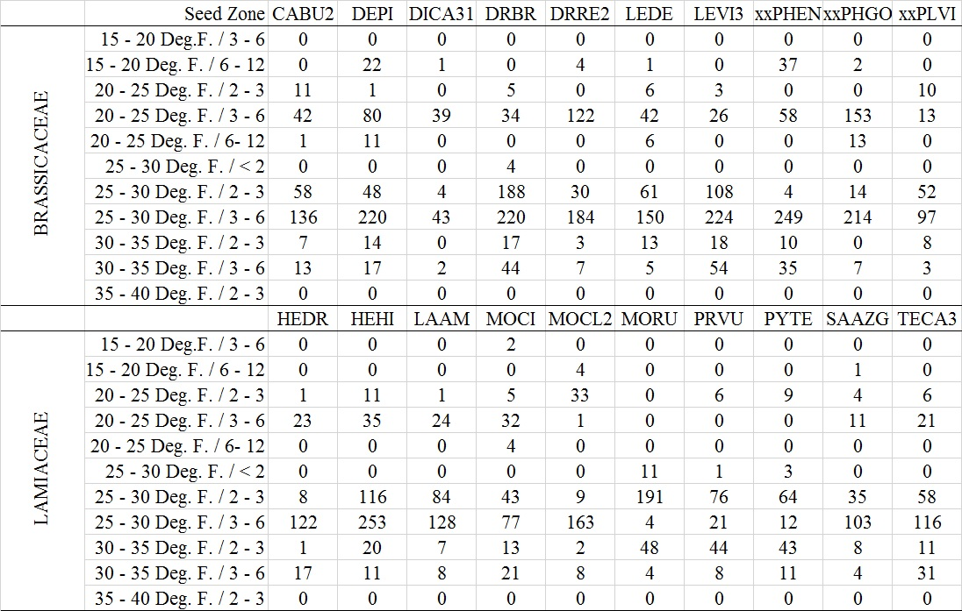

Table 4.6. Trend analysis output. Statistically significant species and phenophases in bold.
Brassicaceae |  |  |  |  | Lamiaceae
Species | Phenophase | n | R-sq | p-value | Species | Phenophase | n | R-sq | p-value
CABU2 | First | 59 | 0.001 | 0.8 | HEDR | First | 20 | 0.01 | 0.72
 | Peak | 121 | < 0.001 | 0.87 |  | Peak | 59 | 0.11 | 0.01
 | Last | 66 | 0.001 | 0.84 |  | Last | 72 | 0.12 | 0.003
 | Ended | 22 | 0.08 | 0.2 |  | Ended | 19 | 0.01 | 0.63
DEPI | First | 50 | 0.11 | 0.02 | HEHI | First | 89 | 0.02 | 0.18
 | Peak | 194 | 0.05 | 0.002 |  | Peak | 96 | 0.001 | 0.77
 | Last | 117 | 0.01 | 0.22 |  | Last | 148 | 0.02 | 0.12
 | Ended | 50 | 0.03 | 0.22 |  | Ended | 111 | 0.05 | 0.02
DICA31 | First | 20 | 0.02 | 0.57 | LAAM | First | 107 | 0.002 | 0.62
 | Peak | 34 | 0.002 | 0.82 |  | Peak | 121 | 0.001 | 0.79
 | Last | 28 | 0.002 | 0.81 |  | Last | 13 | 0.03 | 0.59
 | Ended | 6 | 0.08 | 0.58 |  | Ended | 8 | 0.01 | 0.84
DRBR | First | 31 | 0.01 | 0.6 | MOCI | First | 38 | 0.002 | 0.8
 | Peak | 152 | 0.003 | 0.48 |  | Peak | 96 | 0.01 | 0.32
 | Last | 136 | < 0.001 | 0.97 |  | Last | 45 | 0.01 | 0.65
 | Ended | 193 | 0.001 | 0.64 |  | Ended | 16 | 0.02 | 0.61
DRRE2 | First | 36 | 0.2 | 0.01 | MOCL2 | First | 67 | 0.14 | 0.002
 | Peak | 169 | 0.03 | 0.02 |  | Peak | 111 | 0.02 | 0.13
 | Last | 69 | 0.01 | 0.32 |  | Last | 35 | 0.17 | 0.01
 | Ended | 76 | 0.12 | 0.003 |  | Ended | 7 | 0.64 | 0.03
LEDE | First | 20 | 0.11 | 0.15 | MORU | First | 59 | 0.02 | 0.26
 | Peak | 72 | 0.04 | 0.1 |  | Peak | 105 | 0.01 | 0.33
 | Last | 116 | < 0.001 | 0.85 |  | Last | 41 | 0.01 | 0.49
 | Ended | 76 | < 0.001 | 0.91 |  | Ended | 53 | 0.07 | 0.05
LEVI3 | First | 32 | 0.12 | 0.05 | PRVU | First | 33 | < 0.001 | 0.92
 | Peak | 214 | 0.01 | 0.11 |  | Peak | 62 | 0.02 | 0.24
 | Last | 141 | 0.03 | 0.03 |  | Last | 30 | < 0.001 | 0.92
 | Ended | 45 | 0.02 | 0.32 |  | Ended | 31 | 0.04 | 0.27
PHEN | First | 101 | 0.38 | < 0.001 | PYTE | First | 12 | 0.23 | 0.12
 | Peak | 158 | 0.01 | 0.22 |  | Peak | 75 | < 0.001 | 0.86
 | Last | 46 | 0.3 | < 0.001 |  | Last | 34 | 0.01 | 0.62
 | Ended | 86 | < 0.001 | 0.9 |  | Ended | 19 | 0.13 | 0.14
PHGO | First | 66 | < 0.001 | 0.81 | SAAZG | First | 40 | 0.02 | 0.36
 | Peak | 141 | < 0.001 | 0.93 |  | Peak | 74 | 0.08 | 0.01
 | Last | 126 | 0.02 | 0.16 |  | Last | 40 | 0.01 | 0.54
 | Ended | 46 | 0.04 | 0.16 |  | Ended | 11 | < 0.001 | 0.97
PLVI | First | 27 | 0.23 | 0.01 | TECA3 | First | 40 | 0.01 | 0.63
 | Peak | 59 | 0.002 | 0.75 |  | Peak | 159 | 0.004 | 0.42
 | Last | 59 | 0.07 | 0.04 |  | Last | 38 | 0.02 | 0.42
 | Ended | 38 | 0.01 | 0.51 |  | Ended | 5 | 0.002 | 0.94
Table 4.7. Trend analysis output for all flowering phenophases. Statistically significant species and phenophases in bold.
Brassicaceae
Species | Seedzone | n | R-sq | p-value
DEPI | 20 - 25 Deg. F. / 3 - 6 | 69 | 0.09 | 0.01
 | 25 - 30 Deg. F. / 2 - 3 | 40 | < 0.001 | 0.92
 | 25 - 30 Deg. F. / 3 - 6 | 192 | 0.02 | 0.04
DRRE2 | 20 - 25 Deg. F. / 3 - 6 | 103 | 0.12 | < 0.001
 | 25 - 30 Deg. F. / 2 - 3 | 22 | 0.22 | 0.03
 | 25 - 30 Deg. F. / 3 - 6 | 148 | < 0.001 | 0.94
LEVI3 | 25 - 30 Deg. F. / 2 - 3 | 96 | 0.08 | 0.01
 | 25 - 30 Deg. F. / 3 - 6 | 200 | 0.01 | 0.30
 | 30 - 35 Deg. F. / 3 - 6 | 47 | 0.08 | 0.06
PHEN | 15 - 20 Deg. F. / 6 - 12 | 18 | 0.33 | 0.01
 | 20 - 25 Deg. F. / 3 - 6 | 29 | 0.13 | 0.06
 | 25 - 30 Deg. F. / 3 - 6 | 218 | 0.04 | 0.002
 | 30 - 35 Deg. F. / 3 - 6 | 32 | 0.09 | 0.10
PLVI | 25 - 30 Deg. F. / 2 - 3 | 30 | 0.01 | 0.59
 | 25 - 30 Deg. F. / 3 - 6 | 85 | < 0.001 | 0.95
Lamiaceae
Species | Seedzone | n | R-sq | p-value
HEDR | 25 - 30 Deg. F. / 3 - 6 | 113 | 0.03 | 0.05
HEHI | 20 - 25 Deg. F. / 3 - 6 | 20 | 0.02 | 0.57
 | 25 - 30 Deg. F. / 2 - 3 | 88 | 0.09 | 0.004
 | 25 - 30 Deg. F. / 3 - 6 | 193 | < 0.001 | 0.71
MOCL2 | 20 - 25 Deg. F. / 3 - 6 | 33 | 0.18 | 0.01
 | 25 - 30 Deg. F. / 3 - 6 | 157 | 0.003 | 0.46
MORU | 25 - 30 Deg. F. / 2 - 3 | 156 | 0.01 | 0.22
 | 30 - 35 Deg. F. / 2 - 3 | 36 | 0.08 | 0.10
SAAZG | 25 - 30 Deg. F. / 2 - 3 | 30 | < 0.001 | 0.94
 | 25 - 30 Deg. F. / 3 - 6 | 98 | 0.04 | 0.04

Table 4.8. Brassicaceae statewide and seed zone GAMLSS output for full and reduced models. n = sample size, GD = global deviance, AIC = Akaike information criterion. Lowest AIC in bold. *Full model could not converge due to small sample size.
 |  |  | Full |  | Reduced
Species | Model Description | n | GD | AIC | GD | AIC
Descurainia pinnata | Statewide | 411 | 2866.46 | 2980.46 | 2933.20 | 3007.20
 | 20 - 25 Deg F / 3 - 6 | 78 | 195.80 | 309.80 | 212.39 | 316.39
 | 25 - 30 Deg F / 2 - 3 | 48 | 149.48 | 263.48 | 179.11 | 253.12
 | 25 - 30 Deg F / 3 - 6 | 220 | 1454.74 | 1568.74 | 1985.23 | 2001.23
Draba reptans | Statewide | 350 | 2241.84 | 2355.84 | 2382.89 | 2448.89
 | 20 - 25 Deg F / 3 - 6 | 122 | 245.58 | 359.57 | 273.27 | 379.27
 | 25 - 30 Deg F / 2 - 3 | 30 |  |  | 37.50 | 77.50*
 | 25 - 30 Deg F / 3 - 6 | 184 | 1102.64 | 1216.63 | 1152.58 | 1226.58
Lepidium virginicum | Statewide | 432 | 2933.27 | 3047.28 | 3074.97 | 3138.97
 | 25 - 30 Deg F / 2 - 3 | 108 | 571.34 | 685.34 | 583.16 | 681.16
 | 25 - 30 Deg F / 3 - 6 | 224 | 1674.23 | 1788.23 | 2027.2 | 2057.2
 | 30 - 35 Deg F / 3 - 6 | 54 |  |  | -126.29 | -60.29*
Physaria engelmannii | Statewide | 391 | 2596.85 | 2710.85 | 2648.88 | 2728.89
 | 15 - 20 Deg F / 6 - 12 | 37 |  |  | 59.45 | 99.45*
 | 25 - 30 Deg F / 2 - 3 | 58 |  |  | 182.78 | 262.77
 | 25 - 30 Deg F / 3 - 6 | 249 | 1546.55 | 1660.55 | 1609.83 | 1681.82
 | 30 - 35 Deg F / 3 - 6 | 35 |  |  | 18.3 | 98.3*
Planodes virginica | Statewide | 183 | 1105.67 | 1219.67 | 1148.30 | 1220.29
 | 25 - 30 Deg F / 2 - 3 | 52 | 30.28 | 144.29 | 144.12 | 216.12
 | 25 - 30 Deg F / 3 - 6 | 97 | 501.27 | 615.27 | 514.66 | 608.66

Table 4.9. Lamiaceae statewide and seed zone GAMLSS output for full and reduced models. n = sample size, GD = global deviance, AIC = Akaike information criterion. Lowest AIC in bold. *Full model could not converge due to small sample size.
 |  |  | Full |  | Reduced
Species | Model Description | n | GD | AIC | GD | AIC
Hedeoma drummondii | Statewide | 170 | 1122.41 | 1236.40 | 1169.90 | 1237.90
 | 25 - 30 Deg F / 3 - 6 | 122 | 968.26 | 1082.27 | 1043.68 | 1087.69
Hedeoma hispida | Statewide | 444 | 2690.45 | 2804.46 | 2809.12 | 2871.12
 | 20 - 25 Deg F / 3 - 6 | 35 | * | * | -33.10 | 0.90*
 | 25 - 30 Deg F / 2 - 3 | 116 | 474.72 | 588.72 | 516.71 | 612.71
 | 25 - 30 Deg F / 3 - 6 | 253 | 1585.35 | 1699.34 | 1641.09 | 1717.08
Monarda clinopodioides | Statewide | 220 | 1408.93 | 1522.93 | 1504.82 | 1538.83
 | 20 - 25 Deg F / 3 - 6 | 33 | * | * | 101.70 | 141.71*
 | 25 - 30 Deg F / 3 - 6 | 163 | 1018.74 | 1132.74 | 1086.14 | 1126.14
Monarda russeliana | Statewide | 258 | 1757.26 | 1871.26 | 1986.38 | 2000.38
 | 25 - 30 Deg F / 2 - 3 | 191 | 1127.79 | 1241.79 | 1194.80 | 1258.80
 | 30 - 35 Deg F / 2 - 3 | 48 | 293.37 | 407.38 | 379.42 | 393.42*
Salvia azurea var. grandiflora | Statewide | 165 | 1161.18 | 1275.18 | 1190.28 | 1232.28
 | 25 - 30 Deg F / 2 - 3 | 35 | 109.31 | 223.31* | 208.83 | 250.83
 | 25 - 30 Deg F / 3 - 6 | 103 | 710.28 | 824.28 | 845.05 | 873.05

Appendix B – Figures
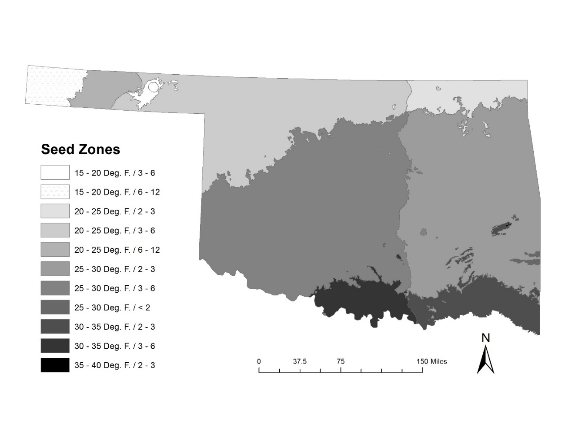
Figure 4.1. Provisional Seed Zones within Oklahoma (Bower et al. 2014).

Figure 4.2. Boxplots for species of Brassicaceae. Y-axis is phenophase where 2 = first flowers, 5 = peak flowering, 8 = last flowers, and 10 = flowering ended. X-axis is Julian day of year the specimen was collected.

Figure 4.3. Boxplots for species of Lamiaceae. Y-axis is phenophase where 2 = first flowers, 5 = peak flowering, 8 = last flowers, and 10 = flowering ended. X-axis is Julian day of year the specimen was collected.

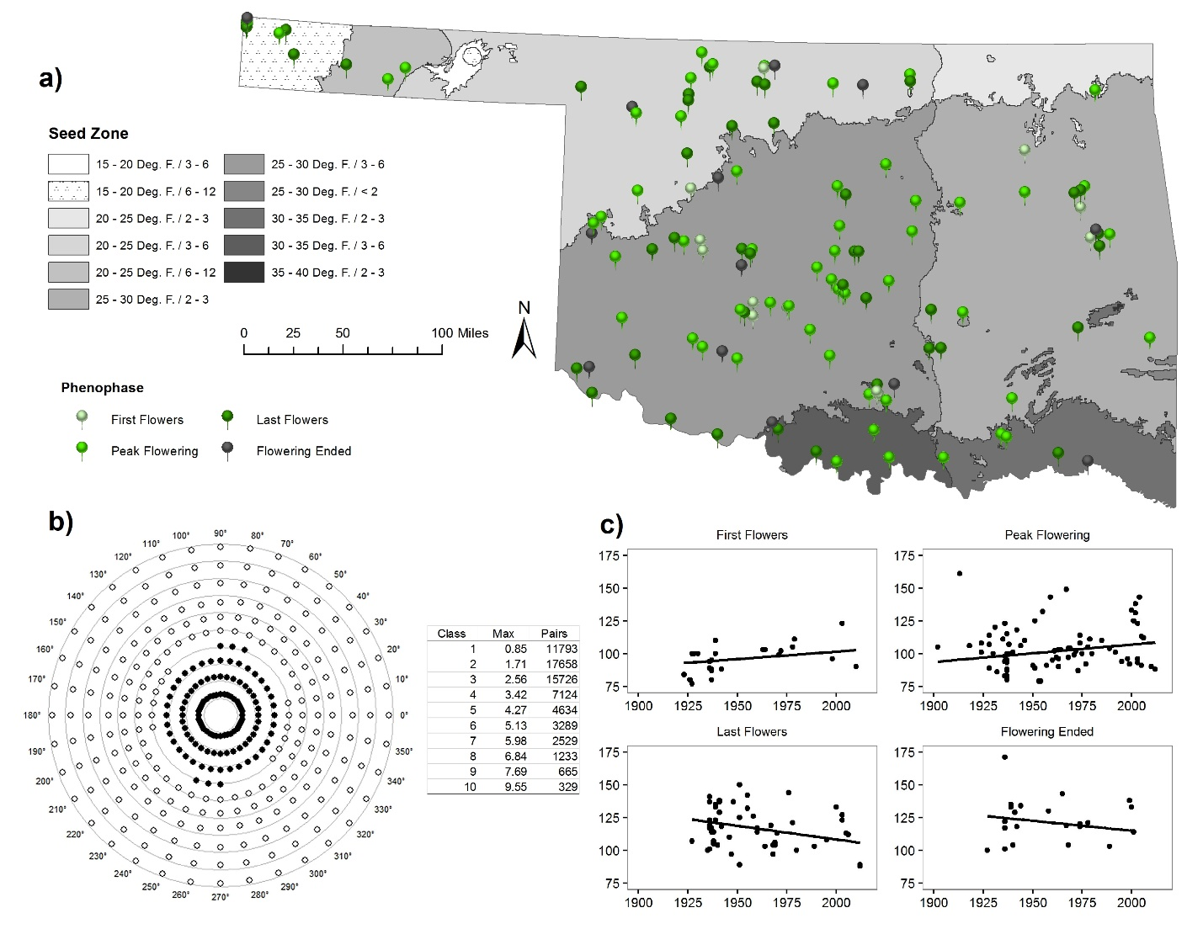
Figure 4.4. Descurainia pinnata a) Distribution of specimen points used. b) Mantel Bearing Correlogram with table of distance classes, maximum distances (km), and number of pairs. Filled circles represent positive spatial autocorrelation while empty circles represent negative spatial autocorrelation. Distance off of the distance class line indicates degree of magnitude in either positive or negative direction. c) Scatterplots with trend line, split by phenophase. X-axis is year and y-axis is Julian day.

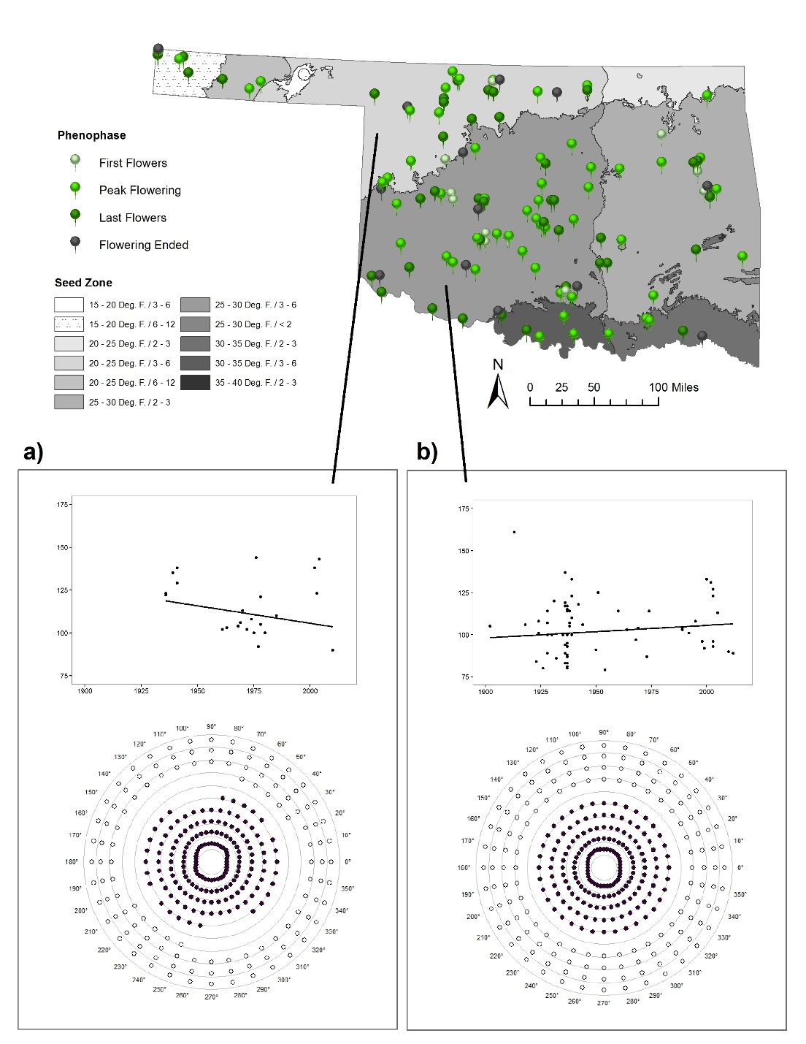
Figure 4.5. Descurainia pinnata Mantel Bearing Correlogram and scatterplot with trend line of specimens in any flowering phenophase, Flowering Ended not included. a) Seed Zone 20 - 25 Deg. F. / 3 – 6, b) Seed Zone 25 - 30 Deg. F. / 3 – 6.

Figure 4.6. Descurainia pinnata Seed Zone 20 – 25 Deg. F. / 3 – 6 GAMLSS term plots for year and most significant climate variables.

Figure 4.7. Descurainia pinnata Seed Zone 25 – 30 Deg. F. / 3 – 6 GAMLSS term plots for year and most significant climate variables.

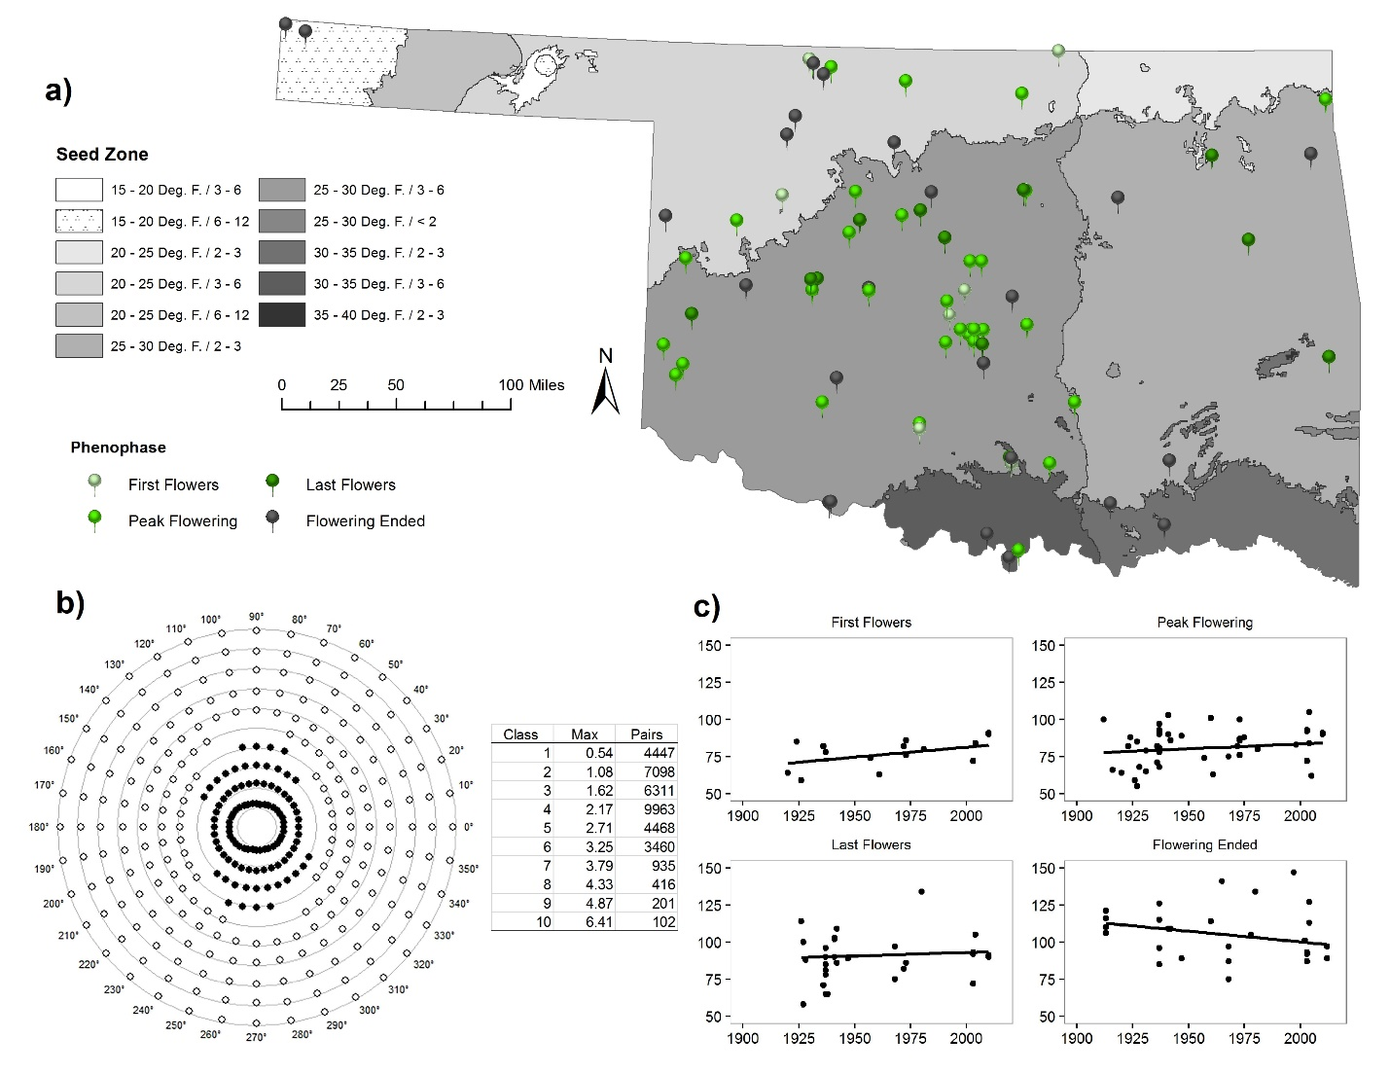
Figure 4.8. Draba reptans a) Distribution of specimen points used. b) Mantel Bearing Correlogram with table of distance classes, maximum distances (km), and number of pairs. Filled circles represent positive spatial autocorrelation while empty circles represent negative spatial autocorrelation. Distance off of the distance class line indicates degree of magnitude in either positive or negative direction. c) Scatterplots with trend line, split by phenophase. X-axis is year and y-axis is Julian day.

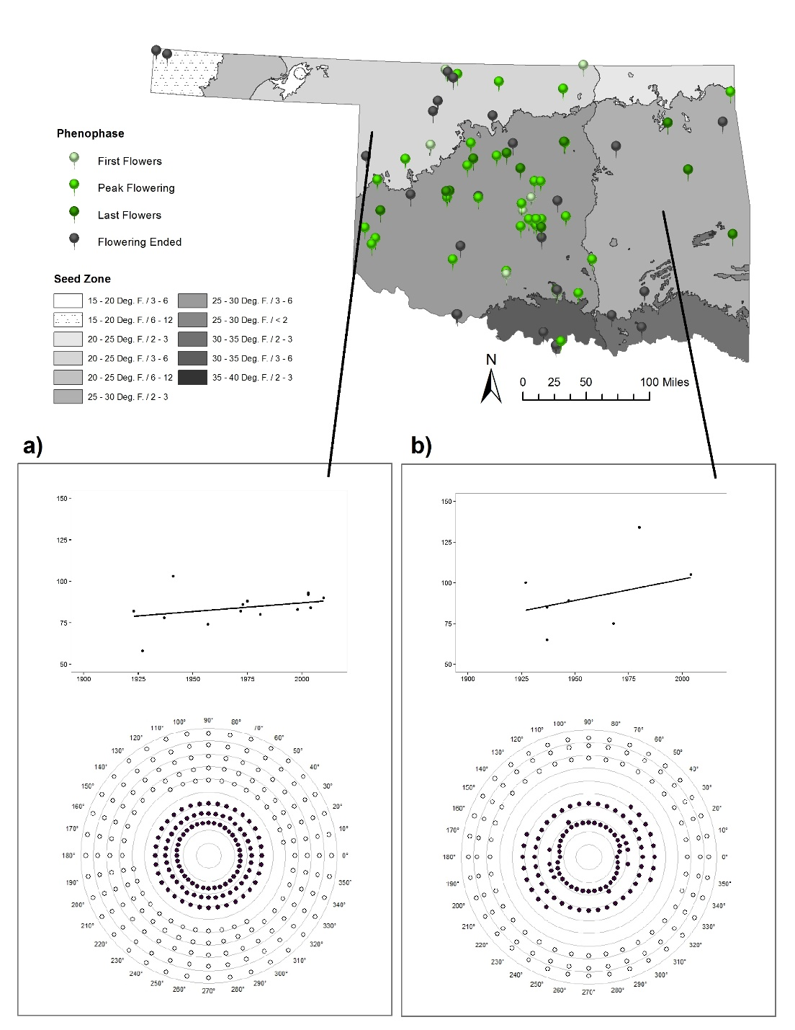
Figure 4.9. Draba reptans Mantel Bearing Correlogram and scatterplot with trend line of specimens in any flowering phenophase, Flowering Ended not included. a) Seed Zone 20 - 25 Deg. F. / 3 – 6, b) Seed Zone 25 - 30 Deg. F. / 2 – 3.

Figure 4.10. Draba reptans Seed Zone 20 – 25 Deg. F. / 3 – 6 GAMLSS term plots for year and most significant climate variables.

Figure 4.11. Draba reptans Seed Zone 25 – 30 Deg. F. / 2 – 3 GAMLSS term plots for year and most significant climate variables.

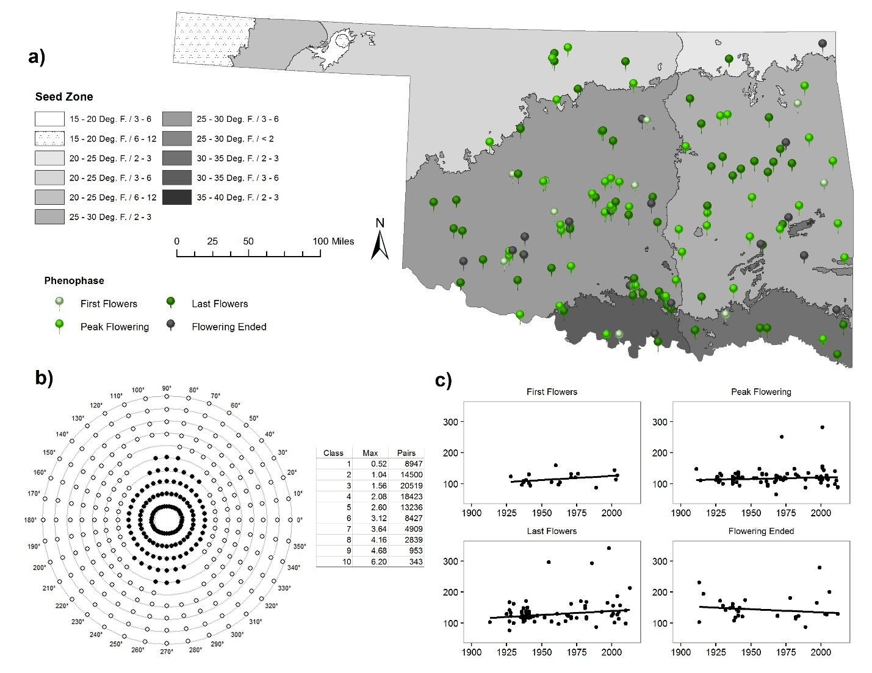
Figure 4.12. Lepidium virginicum a) Distribution of specimen points used. b) Mantel Bearing Correlogram with table of distance classes, maximum distances (km), and number of pairs. Filled circles represent positive spatial autocorrelation while empty circles represent negative spatial autocorrelation. Distance off of the distance class line indicates degree of magnitude in either positive or negative direction. c) Scatterplots with trend line, split by phenophase. X-axis is year and y-axis is Julian day.

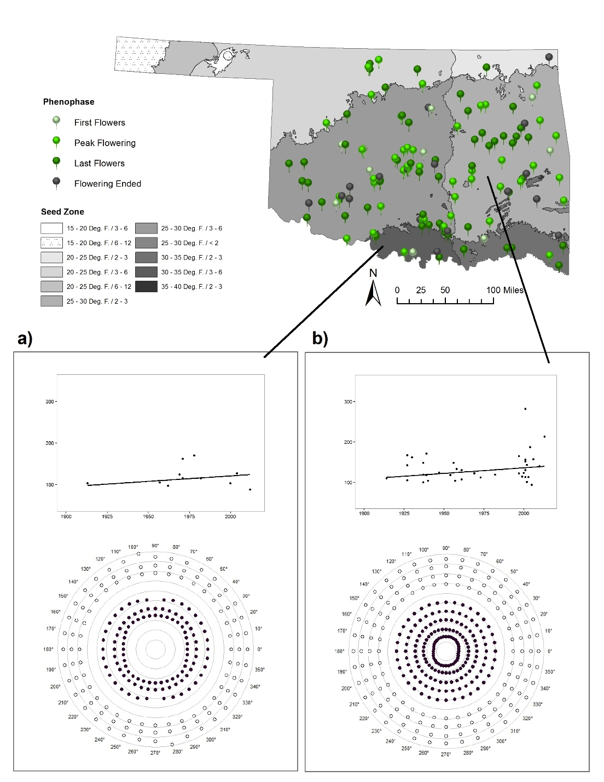
Figure 4.13. Lepidium virginicum Mantel Bearing Correlogram and scatterplot with trend line of specimens in any flowering phenophase, Flowering Ended not included. a) Seed Zone 30 - 35 Deg. F. / 3 – 6, b) Seed Zone 25 - 30 Deg. F. / 2 – 3.

Figure 4.14. Lepidium virginicum Seed Zone 25 – 30 Deg. F. / 2 – 3 GAMLSS term plots for year and most significant climate variables.

Figure 4.15. Lepidium virginicum Seed Zone 30 – 35 Deg. F. / 3 – 6 GAMLSS term plots for year and most significant climate variables.

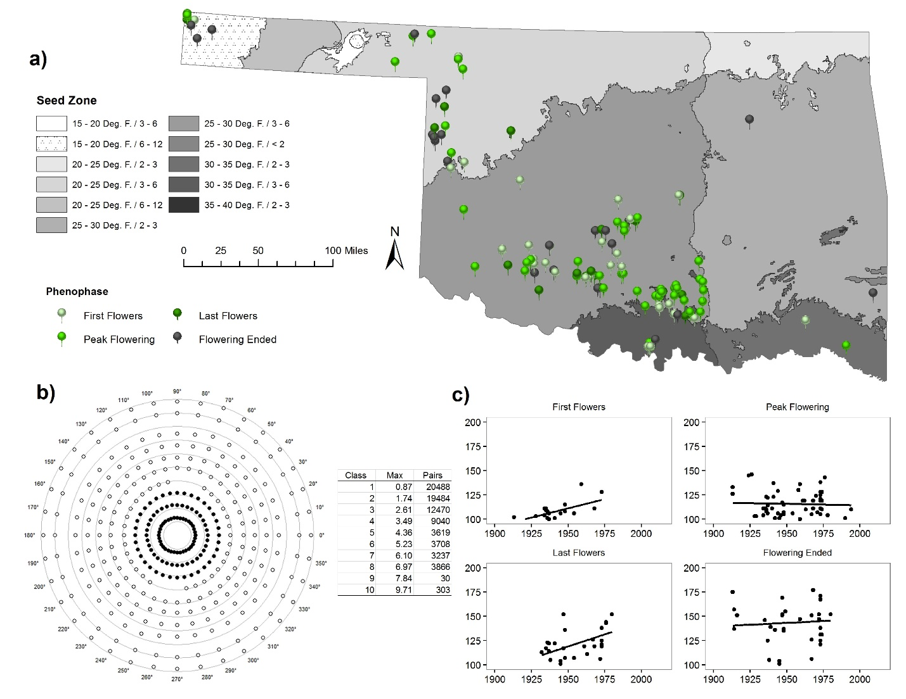
Figure 4.16. Physaria engelmannii a) Distribution of specimen points used. b) Mantel Bearing Correlogram with table of distance classes, maximum distances (km), and number of pairs. Filled circles represent positive spatial autocorrelation while empty circles represent negative spatial autocorrelation. Distance off of the distance class line indicates degree of magnitude in either positive or negative direction. c) Scatterplots with trend line, split by phenophase. X-axis is year and y-axis is Julian day.

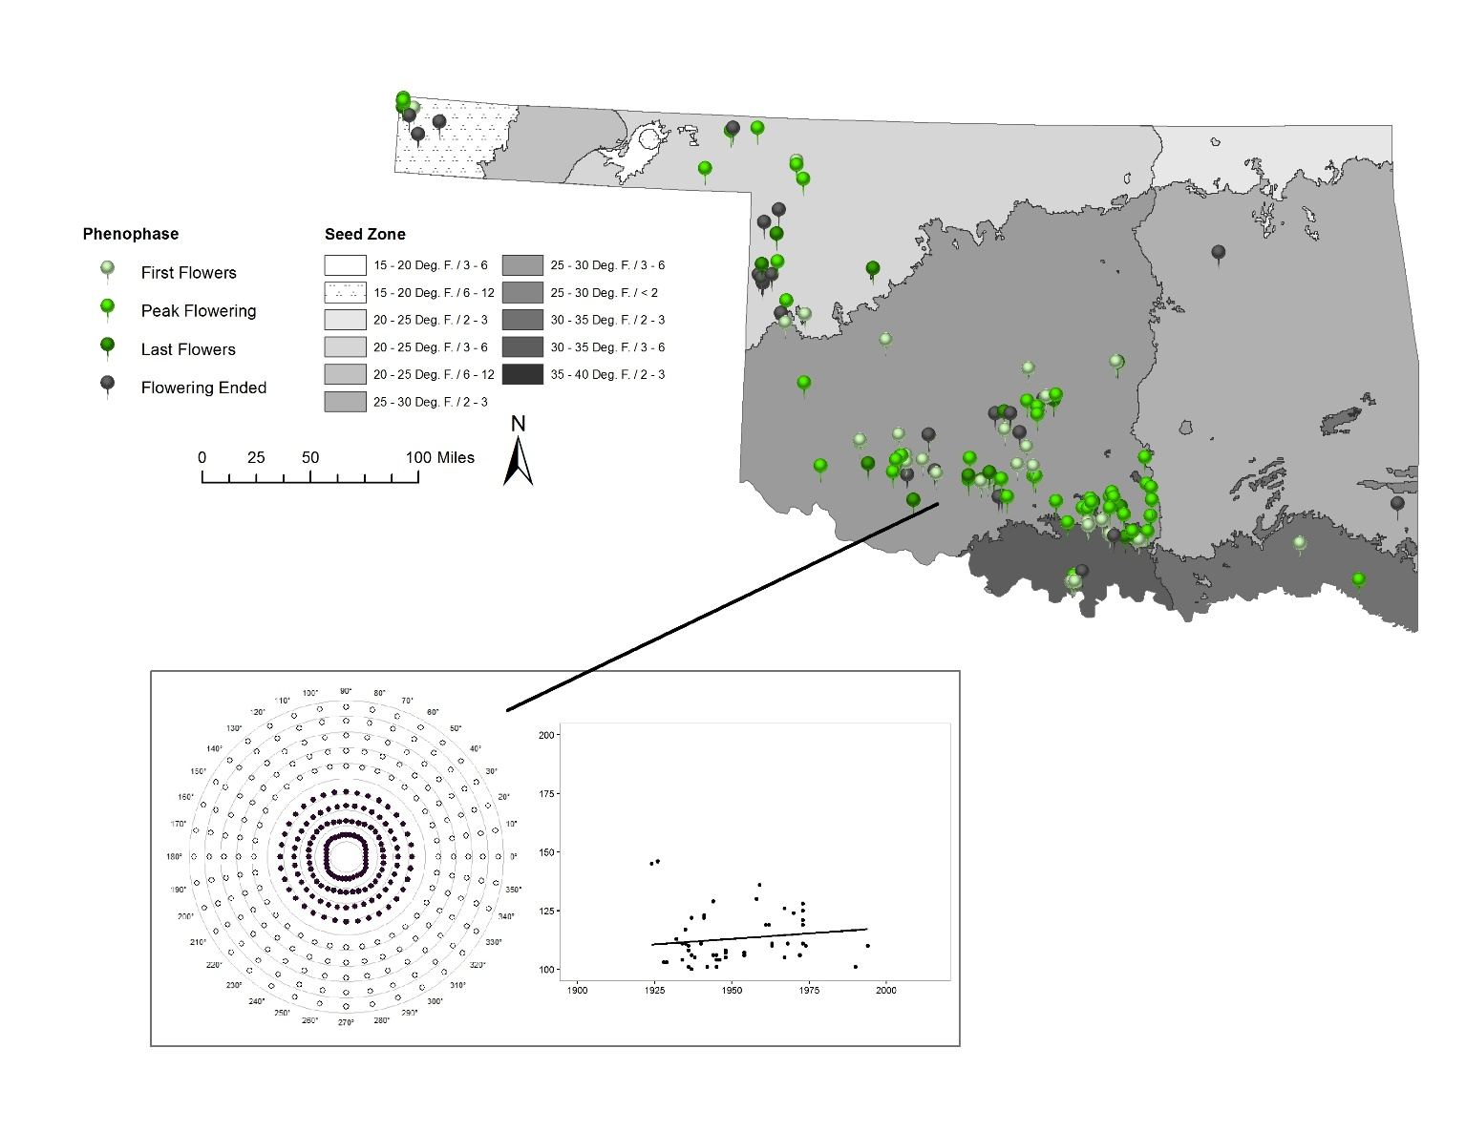
Figure 4.17. Physaria engelmannii Mantel Bearing Correlogram and scatterplot with trend line of specimens in any flowering phenophase, Flowering Ended not included. Seed Zone 25 - 30 Deg. F. / 3 – 6.

Figure 4.18. Physaria engelmannii Seed Zone 25 – 30 Deg. F. / 3 – 6 GAMLSS term plots for year and most significant climate variables.

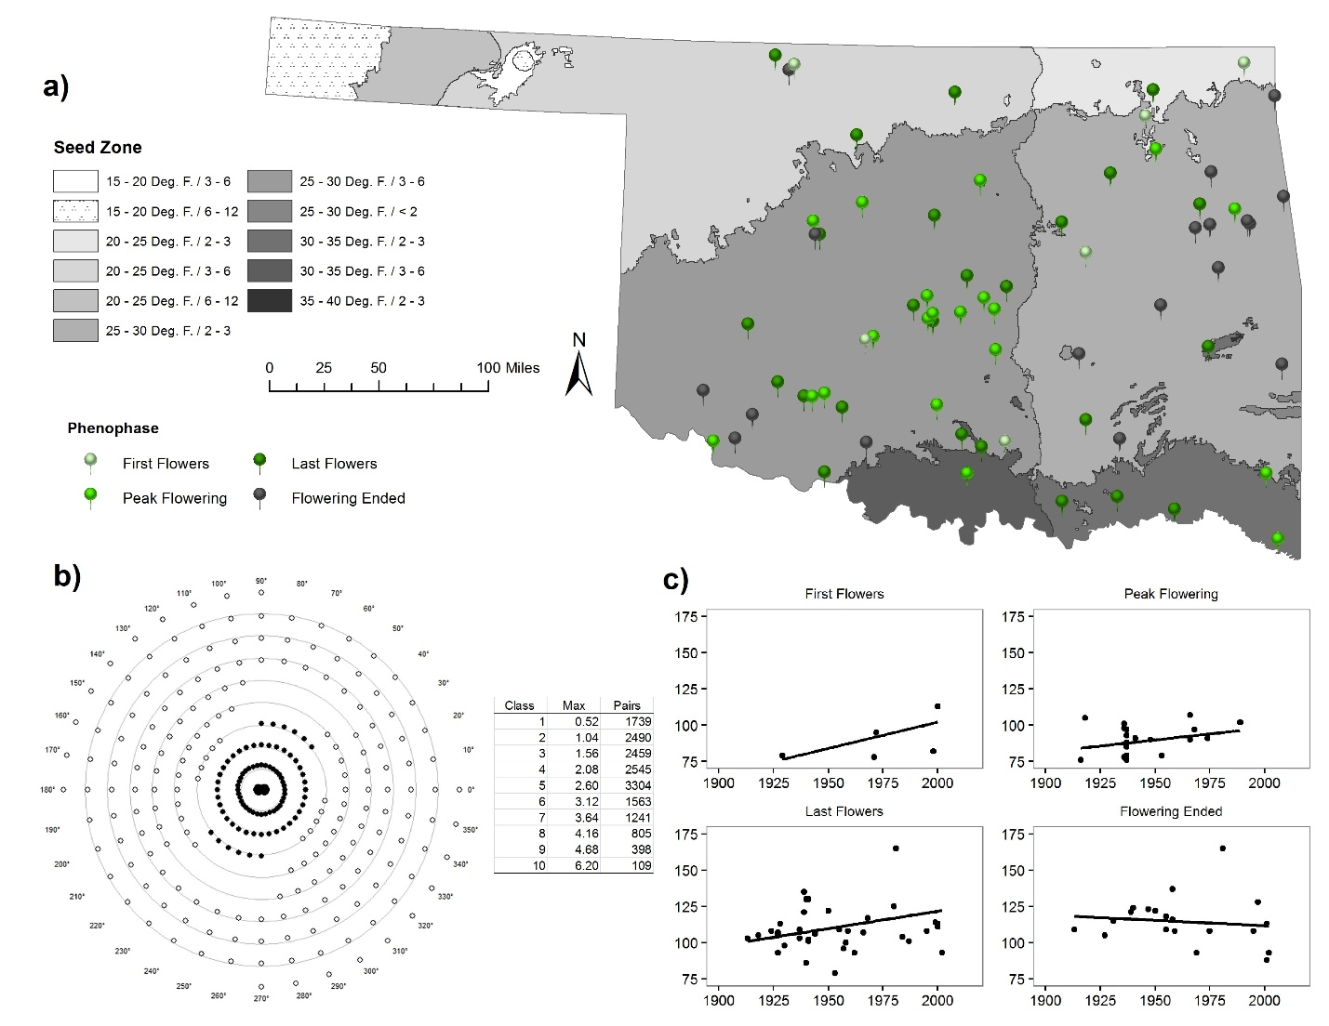
Figure 4.19. Planodes virginica a) Distribution of specimen points used. b) Mantel Bearing Correlogram with table of distance classes, maximum distances (km), and number of pairs. Filled circles represent positive spatial autocorrelation while empty circles represent negative spatial autocorrelation. Distance off of the distance class line indicates degree of magnitude in either positive or negative direction. c) Scatterplots with trend line, split by phenophase. X-axis is year and y-axis is Julian day.

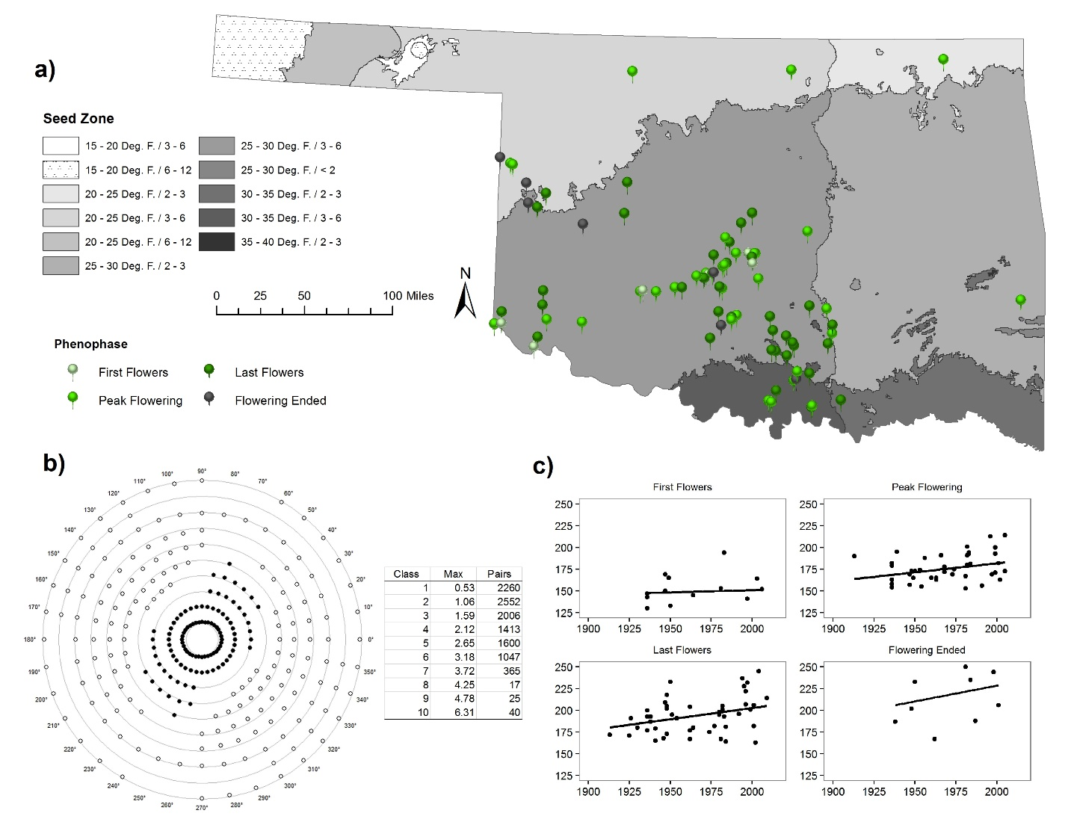
Figure 4.20. Hedeoma drummondii a) Distribution of specimen points used. b) Mantel Bearing Correlogram with table of distance classes, maximum distances (km), and number of pairs. Filled circles represent positive spatial autocorrelation while empty circles represent negative spatial autocorrelation. Distance off of the distance class line indicates degree of magnitude in either positive or negative direction. c) Scatterplots with trend line, split by phenophase. X-axis is year and y-axis is Julian day.

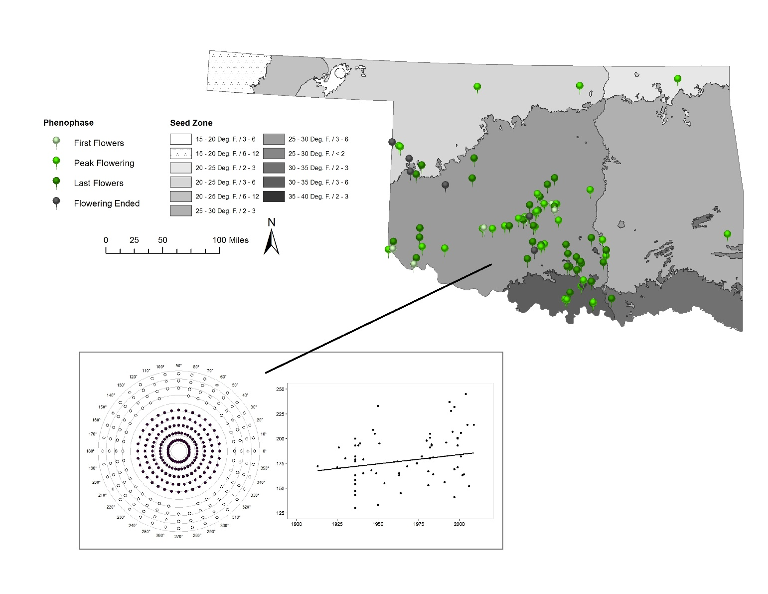
Figure 4.21. Hedeoma drummondii Mantel Bearing Correlogram and scatterplot with trend line of specimens in any flowering phenophase, Flowering Ended not included. a) Seed Zone 25 - 30 Deg. F. / 3 – 6.

Figure 4.22. Hedeoma drummondii Seed Zone 25 – 30 Deg. F. / 3 – 6 GAMLSS term plots for year and most significant climate variables.

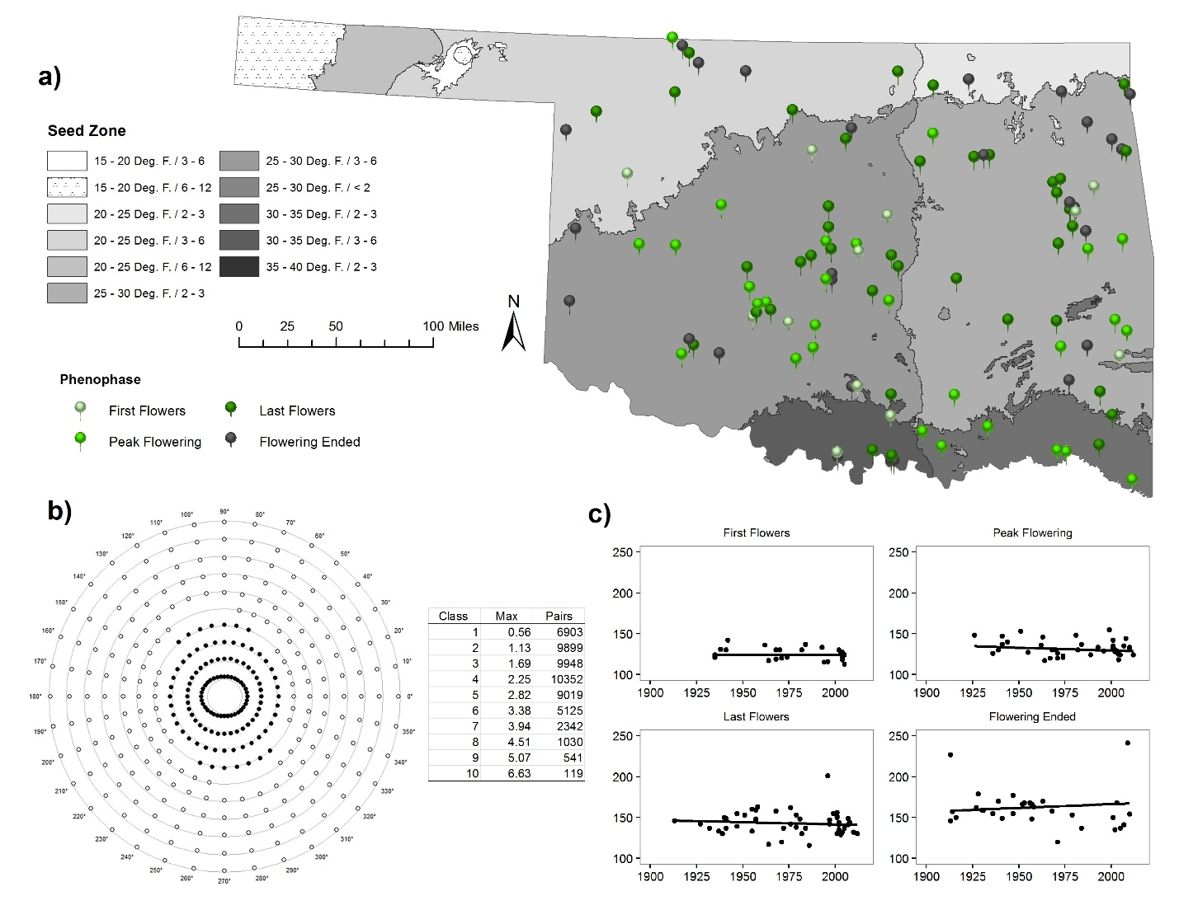
Figure 4.23. Hedeoma hispida a) Distribution of specimen points used. b) Mantel Bearing Correlogram with table of distance classes, maximum distances (km), and number of pairs. Filled circles represent positive spatial autocorrelation while empty circles represent negative spatial autocorrelation. Distance off of the distance class line indicates degree of magnitude in either positive or negative direction. c) Scatterplots with trend line, split by phenophase. X-axis is year and y-axis is Julian day.

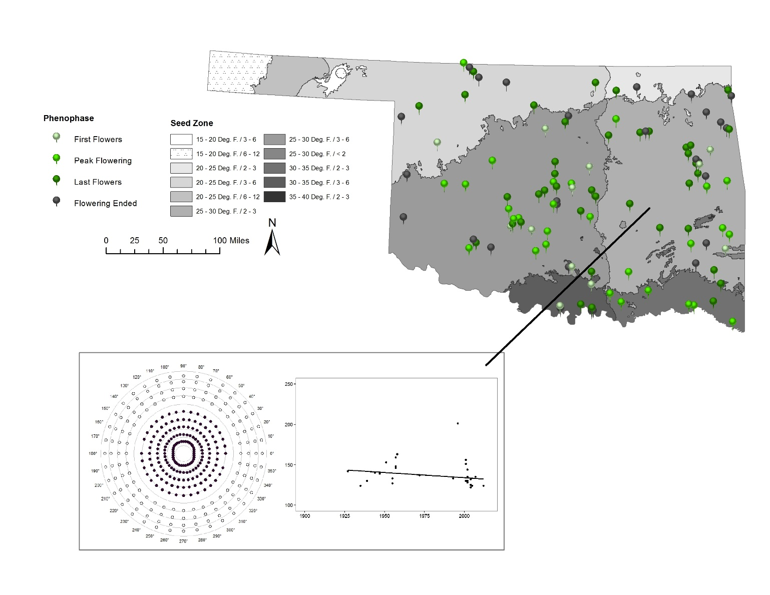
Figure 4.24. Hedeoma hispida Mantel Bearing Correlogram and scatterplot with trend line of specimens in any flowering phenophase, Flowering Ended not included. a) Seed Zone 25 - 30 Deg. F. / 2 – 3.

Figure 4.25. Hedeoma hispida Seed Zone 25 – 30 Deg. F. / 2 – 3 GAMLSS term plots for year and most significant climate variables.

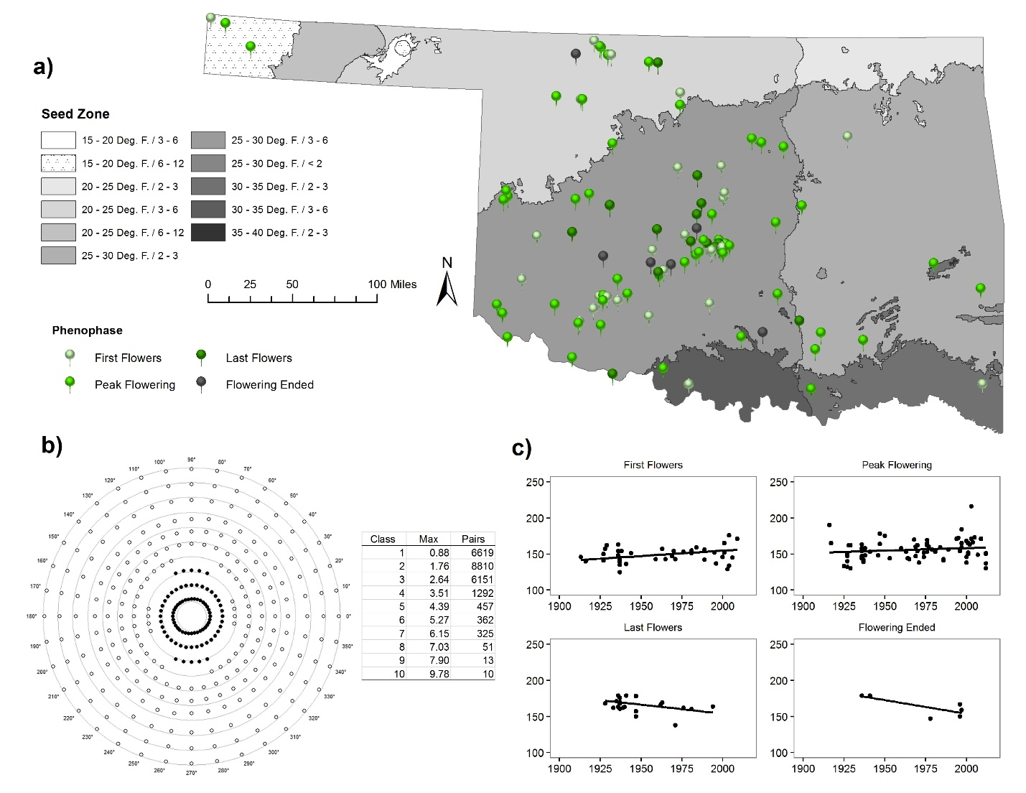
Figure 4.26. Monarda clinopodioides a) Distribution of specimen points used. b) Mantel Bearing Correlogram with table of distance classes, maximum distances (km), and number of pairs. Filled circles represent positive spatial autocorrelation while empty circles represent negative spatial autocorrelation. Distance off of the distance class line indicates degree of magnitude in either positive or negative direction. c) Scatterplots with trend line, split by phenophase. X-axis is year and y-axis is Julian day.

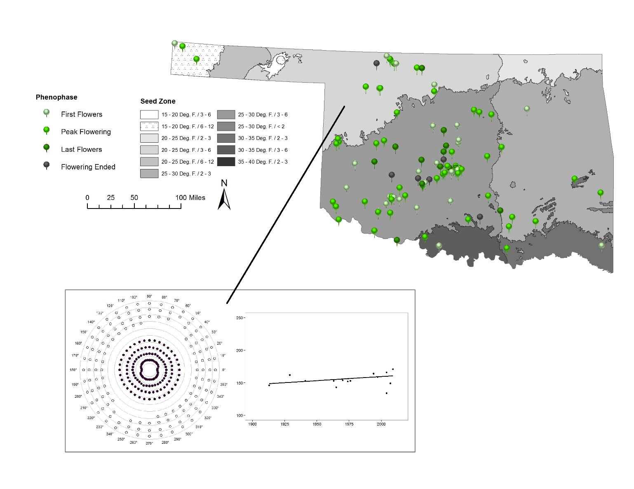
Figure 4.27. Monarda clinopodioides Mantel Bearing Correlogram and scatterplot with trend line of specimens in any flowering phenophase, Flowering Ended not included. Seed Zone 25 - 30 Deg. F. / 3 – 6.

Figure 4.28. Monarda clinopodioides Seed Zone 20 – 25 Deg. F. / 3 – 6 GAMLSS term plots for year and most significant climate variables.

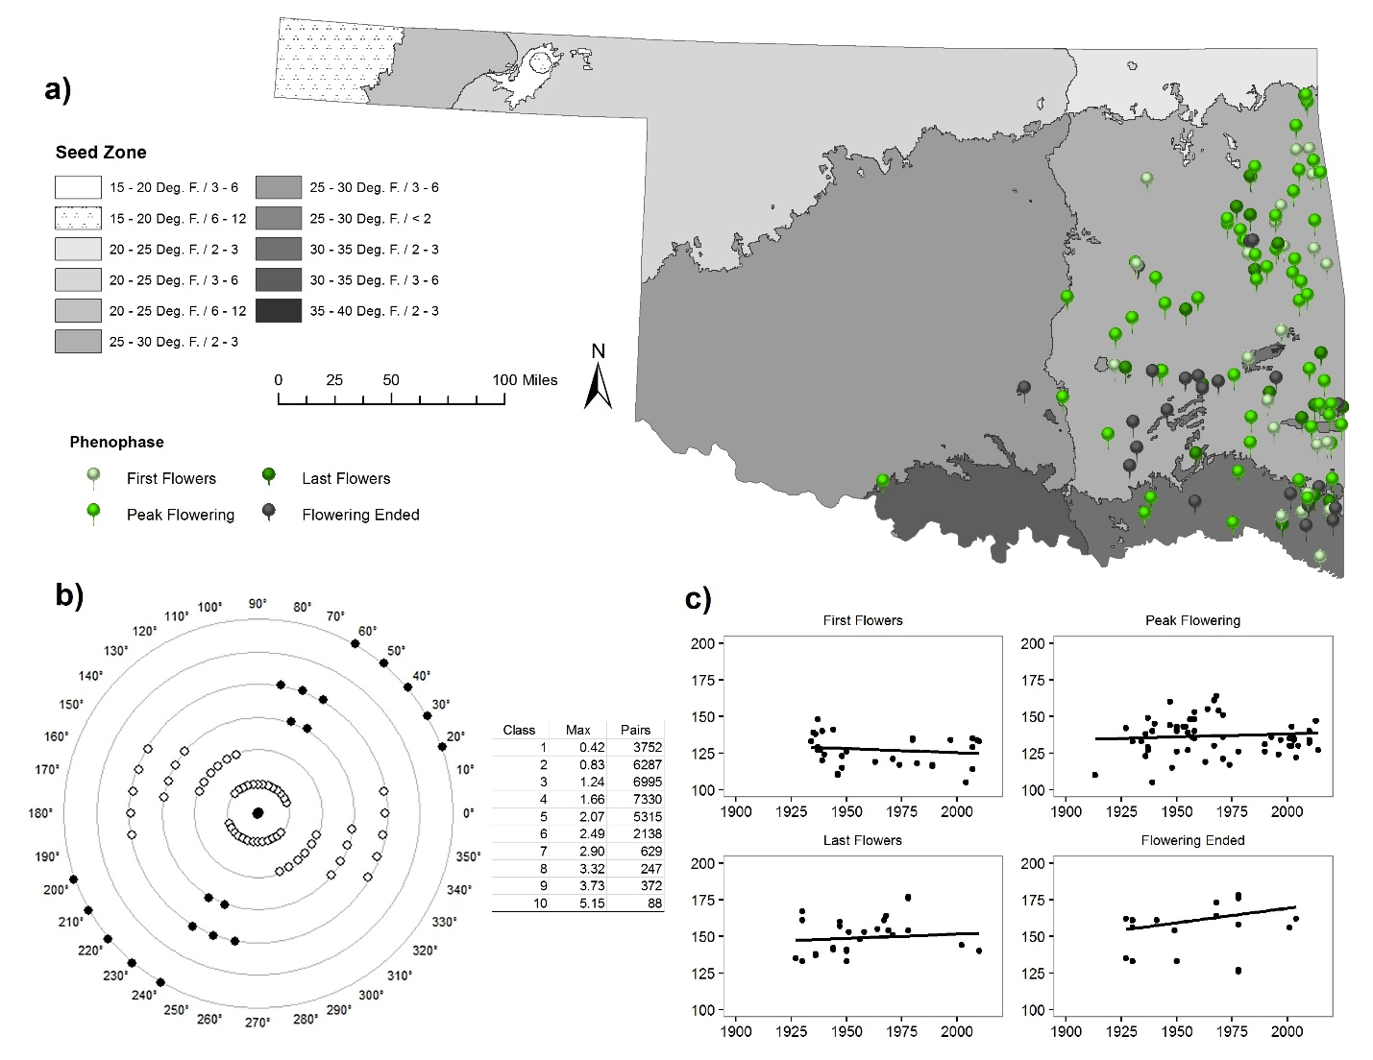
Figure 4.29. Monarda russeliana a) Distribution of specimen points used. b) Mantel Bearing Correlogram with table of distance classes, maximum distances (km), and number of pairs. Filled circles represent positive spatial autocorrelation while empty circles represent negative spatial autocorrelation. Distance off of the distance class line indicates degree of magnitude in either positive or negative direction. c) Scatterplots with trend line, split by phenophase. X-axis is year and y-axis is Julian day.

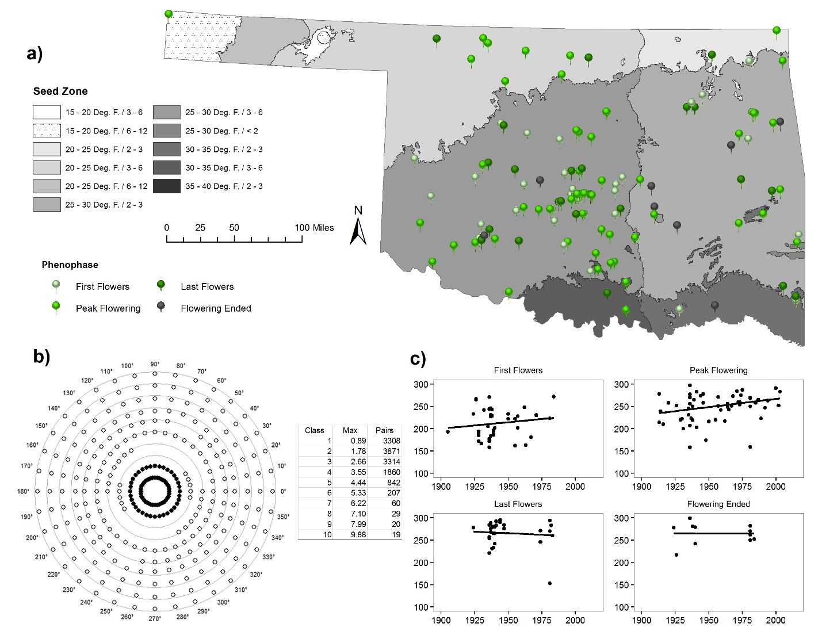
Figure 4.30. Salvia azurea var. grandiflora a) Distribution of specimen points used. b) Mantel Bearing Correlogram with table of distance classes, maximum distances (km), and number of pairs. Filled circles represent positive spatial autocorrelation while empty circles represent negative spatial autocorrelation. Distance off of the distance class line indicates degree of magnitude in either positive or negative direction. c) Scatterplots with trend line, split by phenophase. X-axis is year and y-axis is Julian day.

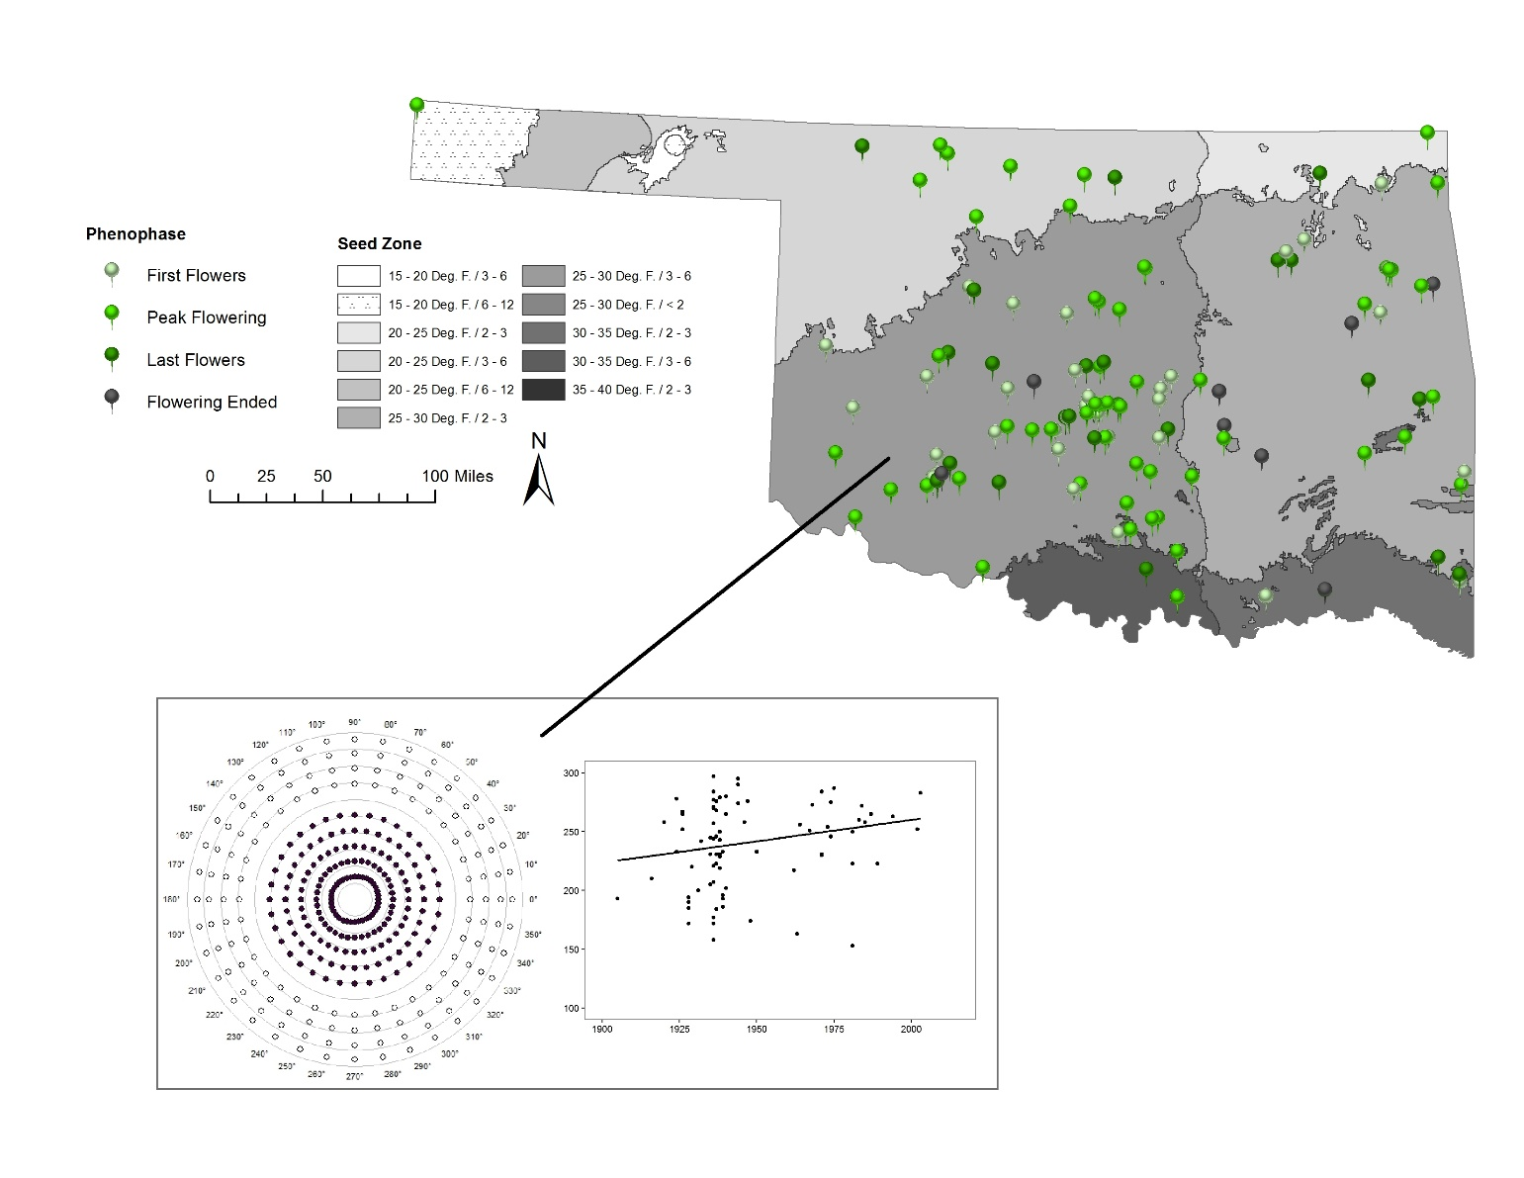
Figure 4.31. Salvia azurea var. grandiflora Mantel Bearing Correlogram and scatterplot with trend line of specimens in any flowering phenophase, Flowering Ended not included. Seed Zone 25 - 30 Deg. F. / 3 – 6.

Figure 4.32. Salvia azurea var. grandiflora Seed Zone 25 – 30 Deg. F. / 3 – 6 GAMLSS term plots for year and most significant climate variables.

Appendix S1 – Supplemental Tables
Table 4.S1. Trend analysis output split by seed zone and phenophase for Brassicaceae. Statistically significant species, seed zones, and phenophases in bold.
Species | Seed Zone | Phenophase | n | R-sq | p-value
DEPI | 20 - 25 Deg. F. / 3 - 6 | First | 9 | 0.04 | 0.62
 |  | Peak | 32 | 0.27 | 0.002
 |  | Last | 28 | 0.32 | 0.002
 |  | Ended | 9 | 0.31 | 0.12
 | 25 - 30 Deg. F. / 2 - 3 | First | 3 | NA | NA
 |  | Peak | 21 | 0.04 | 0.36
 |  | Last | 16 | 0.01 | 0.76
 |  | Ended | 8 | 0.91 | < 0.001
 | 25 - 30 Deg. F. / 3 - 6 | First | 35 | 0.06 | 0.17
 |  | Peak | 104 | 0.06 | 0.01
 |  | Last | 53 | < 0.001 | 0.89
 |  | Ended | 28 | < 0.001 | 0.90
DRRE2 | 20 - 25 Deg. F. / 3 - 6 | First | 16 | 0.65 | < 0.001
 |  | Peak | 67 | 0.06 | 0.05
 |  | Last | 20 | 0.17 | 0.07
 |  | Ended | 19 | 0.31 | 0.01
 | 25 - 30 Deg. F. / 2 - 3 | First | 0 | NA | NA
 |  | Peak | 4 | 0.34 | 0.41
 |  | Last | 18 | 0.23 | 0.05
 |  | Ended | 8 | 0.39 | 0.10
 | 25 - 30 Deg. F. / 3 - 6 | First | 20 | 0.10 | 0.17
 |  | Peak | 97 | < 0.001 | 0.99
 |  | Last | 31 | 0.02 | 0.48
 |  | Ended | 36 | 0.73 | < 0.001
LEVI3 | 25 - 30 Deg. F. / 2 - 3 | First | 2 | NA | NA
 |  | Peak | 56 | 0.14 | 0.004
 |  | Last | 38 | 0.06 | 0.16
 |  | Ended | 12 | 0.35 | 0.04
 | 25 - 30 Deg. F. / 3 - 6 | First | 25 | 0.05 | 0.31
 |  | Peak | 115 | 0.01 | 0.45
 |  | Last | 60 | 0.06 | 0.05
 |  | Ended | 24 | 0.43 | < 0.001
 | 30 - 35 Deg. F. / 3 - 6 | First | 2 | NA | NA
 |  | Peak | 21 | 0.01 | 0.74
 |  | Last | 24 | 0.16 | 0.05
 |  | Ended | 10 | 0.33 | 0.17
PHEN | 15 - 20 Deg. F. / 6 - 12 | First | 3 | NA | NA
 |  | Peak | 11 | 0.61 | 0.004
 |  | Last | 4 | NA | NA
 |  | Ended | 19 | 0.06 | 0.31
 | 20 - 25 Deg. F. / 3 - 6 | First | 4 | NA | NA
 |  | Peak | 16 | 0.03 | 0.49
 |  | Last | 9 | 1.00 | < 0.001
 |  | Ended | 29 | 0.25 | 0.01
 | 25 - 30 Deg. F. / 3 - 6 | First | 76 | 0.36 | < 0.001
 |  | Peak | 113 | 0.02 | 0.20
 |  | Last | 29 | 0.21 | 0.01
 |  | Ended | 31 | 0.05 | 0.23
 | 30 - 35 Deg. F. / 3 - 6 | First | 16 | 0.53 | 0.001
 |  | Peak | 13 | 0.12 | 0.25
 |  | Last | 3 | NA | NA
 |  | Ended | 3 | NA | NA
PLVI | 25 - 30 Deg. F. / 2 - 3 | First | 6 | 0.41 | 0.17
 |  | Peak | 7 | 0.37 | 0.15
 |  | Last | 17 | 0.05 | 0.37
 |  | Ended | 22 | 0.001 | 0.86
 | 25 - 30 Deg. F. / 3 - 6 | First | 17 | 0.01 | 0.74
 |  | Peak | 40 | 0.03 | 0.25
 |  | Last | 28 | 0.01 | 0.54
 |  | Ended | 12 | 0.43 | 0.02

Table 4.S2. Trend analysis output split by seed zone and phenophase for Lamiaceae. Statistically significant species, seed zones, and phenophases in bold.
Species | Seed Zone | Phenophase | n | R-sq | p-value
HEDR | 25 - 30 Deg. F. / 3 - 6 | First | 18 | 0.03 | 0.51
 |  | Peak | 43 | 0.05 | 0.17
 |  | Last | 52 | 0.17 | 0.002
 |  | Ended | 9 | 0.01 | 0.79
HEHI | 20 - 25 Deg. F. / 3 - 6 | First | 2 | NA | NA
 |  | Peak | 9 | NA | NA
 |  | Last | 9 | 0.16 | 0.29
 |  | Ended | 14 | 0.95 | < 0.001
 | 25 - 30 Deg. F. / 2 - 3 | First | 20 | 0.05 | 0.35
 |  | Peak | 28 | 0.24 | 0.01
 |  | Last | 40 | 0.001 | 0.89
 |  | Ended | 28 | 0.04 | 0.29
 | 25 - 30 Deg. F. / 3 - 6 | First | 58 | 0.14 | 0.004
 |  | Peak | 51 | 0.01 | 0.47
 |  | Last | 84 | 0.002 | 0.64
 |  | Ended | 60 | 0.18 | < 0.001
MOCL2 | 20 - 25 Deg. F. / 3 - 6 | First | 12 | 0.27 | 0.08
 |  | Peak | 20 | 0.05 | 0.36
 |  | Last | 1 | NA | NA
 |  | Ended | 0 | NA | NA
 | 25 - 30 Deg. F. / 3 - 6 | First | 45 | 0.07 | 0.07
 |  | Peak | 79 | 0.001 | 0.83
 |  | Last | 33 | 0.21 | 0.01
 |  | Ended | 6 | 0.65 | 0.05
MORU | 25 - 30 Deg. F. / 2 - 3 | First | 42 | 0.01 | 0.62
 |  | Peak | 86 | 0.03 | 0.10
 |  | Last | 28 | < 0.001 | 0.96
 |  | Ended | 35 | 0.18 | 0.01
 | 30 - 35 Deg. F. / 2 - 3 | First | 15 | 0.16 | 0.14
 |  | Peak | 11 | 0.06 | 0.46
 |  | Last | 10 | 0.25 | 0.14
 |  | Ended | 12 | 0.02 | 0.69
SAAZG | 25 - 30 Deg. F. / 2 - 3 | First | 6 | 0.17 | 0.41
 |  | Peak | 18 | 0.003 | 0.82
 |  | Last | 6 | 0.03 | 0.73
 |  | Ended | 5 | 0.29 | 0.35
 | 25 - 30 Deg. F. / 3 - 6 | First | 31 | 0.03 | 0.37
 |  | Peak | 42 | 0.15 | 0.01
 |  | Last | 25 | 0.21 | 0.02
 |  | Ended | 5 | 0.74 | 0.06

Table 4.S3. Significant variables from the Brassicaceae statewide GAMLSS.

Species | Predictors | β estimate | Std error | T value | P value
Capsella bursa-pastoris | p2moprior | 0.20 | 0.03 | 6.27 | < 0.001
 | p3moprior | -0.15 | 0.03 | -5.82 | < 0.001
 | tm3moprior | 7.83 | 2.38 | 3.29 | 0.001
 | X | 4.47 | 1.45 | 3.08 | 0.002
 | elevation | 0.05 | 0.01 | 3.17 | 0.002
Descurainia pinnata | year | 0.10 | 0.00 | 5.88 | < 0.001
 | p1moprior | -0.07 | 0.02 | -3.02 | 0.003
 | t2moprior | -5.48 | 1.91 | -2.86 | 0.004
 | t3moprior | 8.83 | 1.73 | 5.12 | < 0.001
 | tm2moprior | 4.95 | 2.16 | 2.29 | 0.02
 | tm3moprior | -5.05 | 1.88 | -2.68 | 0.01
 | pcollect | -0.02 | 0.01 | -2.29 | 0.02
 | tcollect | 1.55 | 0.74 | 2.09 | 0.04
 | Y | 4.25 | 0.68 | 6.20 | < 0.001
 | X | 1.77 | 0.77 | 2.31 | 0.02
 | elevation | 0.03 | 0.01 | 6.13 | < 0.001
Dimorphocarpa candicans | Y | 5.41 | 1.65 | 3.27 | 0.002
Draba brachycarpa | year | -0.04 | 0.02 | -2.44 | 0.01
 | p1moprior | 0.07 | 0.02 | 4.19 | < 0.001
 | p2moprior | 0.06 | 0.02 | 3.76 | < 0.001
 | p3moprior | -0.07 | 0.01 | -5.96 | < 0.001
 | t2moprior | 7.01 | 1.67 | 4.20 | < 0.001
 | t3moprior | -9.22 | 1.59 | -5.80 | < 0.001
 | tm2moprior | -6.86 | 1.82 | -3.77 | < 0.001
 | tm3moprior | 7.59 | 1.77 | 4.28 | < 0.001
 | tmcollect | 2.89 | 0.68 | 4.24 | < 0.001
 | Y | 3.12 | 0.46 | 6.76 | < 0.001
Draba reptans | year | -0.03 | 0.01 | -2.56 | 0.01
 | p1moprior | 0.06 | 0.03 | 2.16 | 0.03
 | t1moprior | 2.70 | 0.81 | 3.34 | 0.001
 | t2moprior | 4.13 | 1.32 | 3.12 | 0.002
 | t3moprior | -6.46 | 1.35 | -4.78 | < 0.001
 | tm1moprior | -4.81 | 0.94 | -5.12 | < 0.001
 | tm2moprior | 2.46 | 1.28 | 1.93 | 0.05
 | Y | 3.00 | 0.50 | 5.95 | < 0.001
 | X | 3.22 | 0.67 | 4.79 | < 0.001
 | elevation | 0.04 | 0.00 | 7.41 | < 0.001
Lepidium densiflorum | year | 0.04 | 0.02 | 2.29 | 0.02
 | p1moprior | -0.04 | 0.02 | -2.44 | 0.02
 | p2moprior | 0.07 | 0.02 | 3.97 | < 0.001
 | p3moprior | -0.04 | 0.01 | -2.55 | 0.01
 | t2moprior | 5.19 | 1.82 | 2.85 | 0.005
 | tm2moprior | -5.49 | 2.08 | -2.65 | 0.01
 | tm3moprior | 6.96 | 1.60 | 4.35 | < 0.001
 | tcollect | 1.09 | 0.56 | 1.96 | 0.05
 | Y | 3.93 | 0.62 | 6.38 | < 0.001
 | X | 1.37 | 0.69 | 1.99 | 0.05
 | elevation | 0.03 | 0.01 | 4.85 | < 0.001
Lepidium virginicum | p1moprior | -0.03 | 0.02 | -1.95 | 0.05
 | t3moprior | 3.09 | 1.50 | 2.05 | 0.04
 | tm3moprior | 4.69 | 1.67 | 2.82 | 0.01
 | pcollect | -0.04 | 0.01 | -4.70 | < 0.001
 | tmcollect | -2.27 | 0.67 | -3.37 | < 0.001
 | tcollect | 1.64 | 0.69 | 2.37 | 0.02
 | Y | 6.53 | 0.53 | 12.22 | < 0.001
 | elevation | 0.01 | 0.01 | 2.33 | 0.02
Physaria engelmannii | year | -0.06 | 0.02 | -2.47 | 0.01
 | p1moprior | 0.08 | 0.02 | 4.25 | < 0.001
 | p3moprior | -0.04 | 0.02 | -2.76 | 0.01
 | t2moprior | 9.19 | 1.87 | 4.91 | < 0.001
 | t3moprior | -10.70 | 1.90 | -5.63 | < 0.001
 | tm2moprior | -9.24 | 2.04 | -4.53 | < 0.001
 | tm3moprior | 1.45 | 2.02 | 7.19 | < 0.001
 | pcollect | 0.02 | 0.01 | 2.09 | 0.04
 | tcollect | 1.45 | 0.67 | 2.15 | 0.03
 | Y | 9.58 | 0.86 | 11.14 | < 0.001
 | X | -2.98 | 0.76 | -3.92 | < 0.001
Physaria gordonii | year | -0.08 | 0.01 | -5.22 | < 0.001
 | p1moprior | 0.11 | 0.02 | 5.37 | < 0.001
 | p2moprior | 0.05 | 0.02 | 2.05 | 0.04
 | p3moprior | -0.04 | 0.01 | -3.04 | 0.002
 | t1moprior | 2.88 | 0.75 | 3.84 | < 0.001
 | t3moprior | -3.42 | 1.56 | -2.19 | 0.03
 | tm1moprior | -3.38 | 0.98 | -3.44 | < 0.001
 | tm3moprior | 5.98 | 1.83 | 3.28 | 0.001
 | tcollect | 1.25 | 0.60 | 2.08 | 0.04
 | Y | 3.08 | 0.58 | 5.32 | < 0.001
 | X | -4.22 | 0.65 | -6.53 | < 0.001
Planodes virginica | p2moprior | 0.15 | 0.02 | 6.25 | < 0.001
 | p3moprior | -0.09 | 0.02 | -4.84 | < 0.001
 | t1moprior | 3.45 | 1.11 | 3.10 | 0.002
 | t3moprior | -5.54 | 2.27 | -2.44 | 0.02
 | tm3moprior | 6.49 | 2.60 | 2.50 | 0.01
 | tmcollect | -2.59 | 0.80 | -3.23 | 0.002
 | tcollect | 4.73 | 0.77 | 6.18 | < 0.001
 | Y | 4.69 | 0.57 | 8.23 | < 0.001
 | X | -2.39 | 0.58 | -4.13 | < 0.001

Table 4.S4. Significant variables from the Lamiaceae statewide GAMLSS.
Species | Predictors | β estimate | Std error | T value | P value
Hedeoma drummondii | year | 0.11 | 0.03 | 4.16 | < 0.001
 | p1moprior | 0.03 | 0.02 | 2.05 | 0.04
 | t2moprior | 10.27 | 3.37 | 3.05 | 0.003
 | t3moprior | -9.86 | 3.15 | -3.13 | 0.002
 | tm2moprior | -8.33 | 3.16 | -2.64 | 0.01
 | tm3moprior | 12.55 | 3.00 | 4.18 | < 0.001
 | tmcollect | -7.22 | 1.19 | -6.05 | < 0.001
 | tcollect | 2.96 | 1.27 | 2.34 | 0.02
Hedeoma hispida | year | -0.05 | 0.01 | -4.74 | < 0.001
 | p3moprior | 0.02 | 0.01 | 2.48 | 0.01
 | t2moprior | -1.43 | 0.50 | -2.85 | 0.004
 | t3moprior | 2.38 | 4.00 | 5.98 | < 0.001
 | tm2moprior | 3.37 | 0.48 | 7.22 | < 0.001
 | tm3moprior | -1.34 | 0.27 | -4.96 | < 0.001
 | pcollect | -0.06 | 0.01 | -11.03 | < 0.001
 | tcollect | -1.05 | 0.54 | -1.96 | 0.05
 | elevation | 0.02 | 0.01 | 3.87 | < 0.001
Lamium amplexicaule | t3moprior | -2.58 | 1.27 | -2.03 | 0.04
 | tmcollect | 1.52 | 0.77 | 1.98 | 0.05
 | tcollect | 1.92 | 0.76 | 2.54 | 0.01
 | X | 2.84 | 0.86 | 3.32 | 0.001
Monarda citriodora | p3moprior | 0.03 | 0.01 | 2.63 | 0.01
 | t1moprior | 4.12 | 1.44 | 2.87 | 0.005
 | tm1moprior | -3.40 | 1.24 | -2.73 | 0.01
 | pcollect | -0.03 | 0.01 | -2.46 | 0.02
 | tmcollect | 2.60 | 1.08 | 2.42 | 0.02
 | tcollect | -2.70 | 1.10 | -2.45 | 0.02
 | Y | 2.00 | 0.61 | 3.27 | 0.001
 | X | 1.58 | 0.76 | 2.06 | 0.04
 | elevation | 0.03 | 0.01 | 4.09 | < 0.001
Monarda clinopodioides | p3moprior | 0.07 | 0.02 | 4.36 | < 0.001
 | t3moprior | 4.81 | 1.36 | 3.53 | < 0.001
 | tm3moprior | -3.58 | 1.68 | -2.14 | 0.03
Monarda russeliana | Y | 3.24 | 0.85 | 3.81 | < 0.001
 | X | -1.84 | 0.85 | -2.16 | 0.03
Prunella vulgaris | p2moprior | -0.04 | 0.02 | -2.13 | 0.04
 | p3moprior | 0.03 | 0.01 | 2.42 | 0.02
 | pcollect | -0.07 | 0.01 | -6.35 | < 0.001
 | tmcollect | 3.63 | 1.14 | 3.17 | 0.002
 | Y | 5.04 | 0.66 | 7.62 | < 0.001
 | elevation | 0.05 | 0.01 | 6.23 | < 0.001
Pycanthemum tenuifolium | t2moprior | 14.87 | 4.14 | 3.60 | < 0.001
 | t3moprior | -8.69 | 3.53 | -2.46 | 0.02
 | tm2moprior | -14.92 | 4.13 | -3.62 | < 0.001
 | tm3moprior | 12.94 | 3.60 | 3.59 | < 0.001
 | tcollect | -2.34 | 0.58 | -4.04 | < 0.001
 | Y | 5.09 | 0.73 | 6.95 | < 0.001
 | elevation | 0.02 | 0.01 | 2.28 | 0.03
Salvia azurea var. grandiflora | tm2moprior | -11.28 | 5.15 | -2.19 | 0.03
 | tm3moprior | 19.37 | 4.37 | 4.43 | < 0.001
 | pcollect | 0.03 | 0.02 | 2.01 | 0.05
 | tmcollect | -3.13 | 1.30 | -2.41 | 0.02
Teucrium canadense | tm3moprior | 5.91 | 2.22 | 2.66 | 0.01
 | tmcollect | -4.43 | 0.97 | -4.56 | < 0.001
 | X | 1.42 | 0.67 | 2.10 | 0.04
 | elevation | 0.03 | 0.01 | 4.40 | < 0.001

Table 4.S5. P-values from statewide GAMLSSs showing whether the listed phenophases were different from the phenophase First Flowers.
Species | Phenophase | p-value | Species | Phenophase | p-value
Capsella bursa-pastoris | Peak | 0.89 | Hedeoma drummondii | Peak | < 0.001
 | Last | 0.49 |  | Last | < 0.001
 | Ended | 0.23 |  | Ended | < 0.001
Descurainia pinnata | Peak | 0.64 | Hedeoma hispida | Peak | < 0.001
 | Last | 0.01 |  | Last | < 0.001
 | Ended | 0.003 |  | Ended | < 0.001
Dimorphocarpa candicans | Peak | 0.53 | Lamium amplexicaule | Peak | < 0.001
 | Last | 0.17 |  | Last | 0.001
 | Ended | 0.16 |  | Ended | 0.04
Draba brachycarpa | Peak | 0.03 | Monarda citriodora | Peak | < 0.001
 | Last | 0.11 |  | Last | < 0.001
 | Ended | 0.06 |  | Ended | < 0.001
Draba reptans | Peak | 0.53 | Monarda clinopodioides | Peak | 0.12
 | Last | < 0.001 |  | Last | < 0.001
 | Ended | < 0.001 |  | Ended | < 0.001
Lepidium densiflorum | Peak | 0.26 | Monarda russeliana | Peak | < 0.001
 | Last | 0.03 |  | Last | < 0.001
 | Ended | < 0.001 |  | Ended | < 0.001
Lepidium virginicum | Peak | 0.37 | Prunella vulgaris | Peak | 0.002
 | Last | 0.08 |  | Last | < 0.001
 | Ended | 0.03 |  | Ended | < 0.001
Physaria engelmannii | Peak | < 0.001 | Pycanthemum tenuifolium | Peak | 0.23
 | Last | < 0.001 |  | Last | 0.02
 | Ended | < 0.001 |  | Ended | < 0.001
Physaria gordonii | Peak | 0.13 | Salvia azurea var. grandiflora | Peak | 0.30
 | Last | < 0.001 |  | Last | 0.82
 | Ended | < 0.001 |  | Ended | 0.45
Planodes virginica | Peak | 0.01 | Teucrium canadense | Peak | 0.12
 | Last | < 0.001 |  | Last | < 0.001
 | Ended | < 0.001 |  | Ended | < 0.001

Appendix S2 – Supplemental Figures
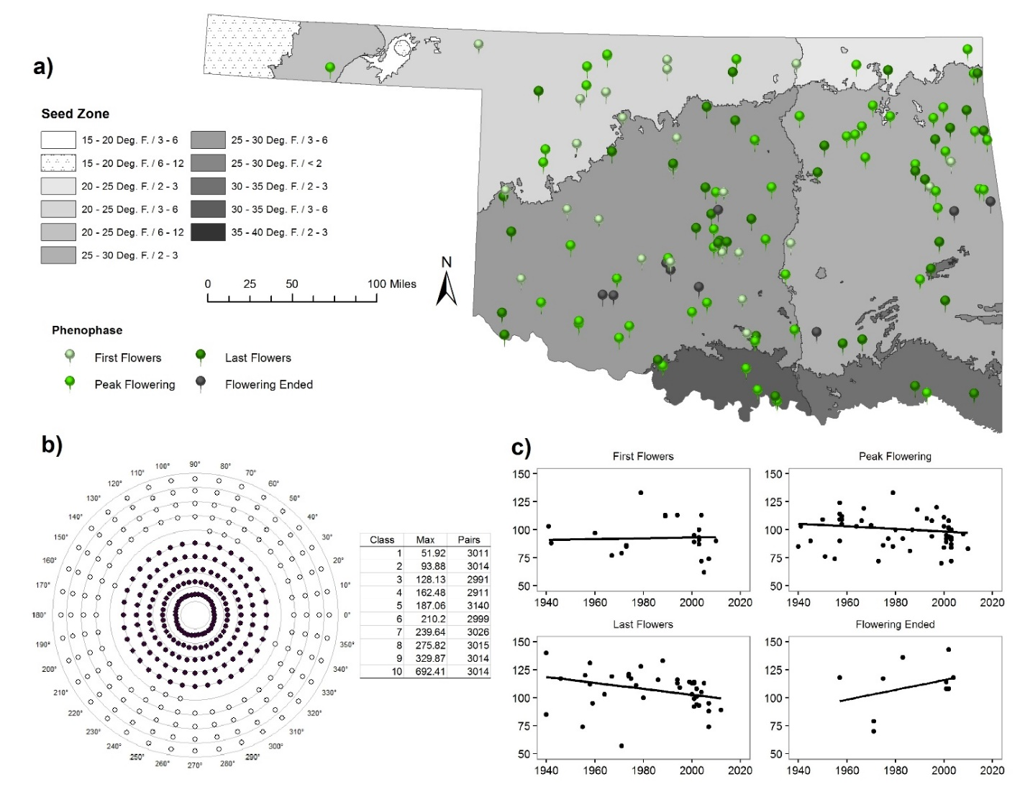
Figure 4.S1. Capsella bursa-pastoris a) Distribution of specimen points used. b) Mantel Bearing Correlogram with table of distance classes, maximum distances (km), and number of pairs. Filled circles represent positive spatial autocorrelation while empty circles represent negative spatial autocorrelation. Distance off of the distance class line indicates degree of magnitude in either positive or negative direction. c) Scatterplots with trend line, split by phenophase. X-axis is year and y-axis is Julian day.

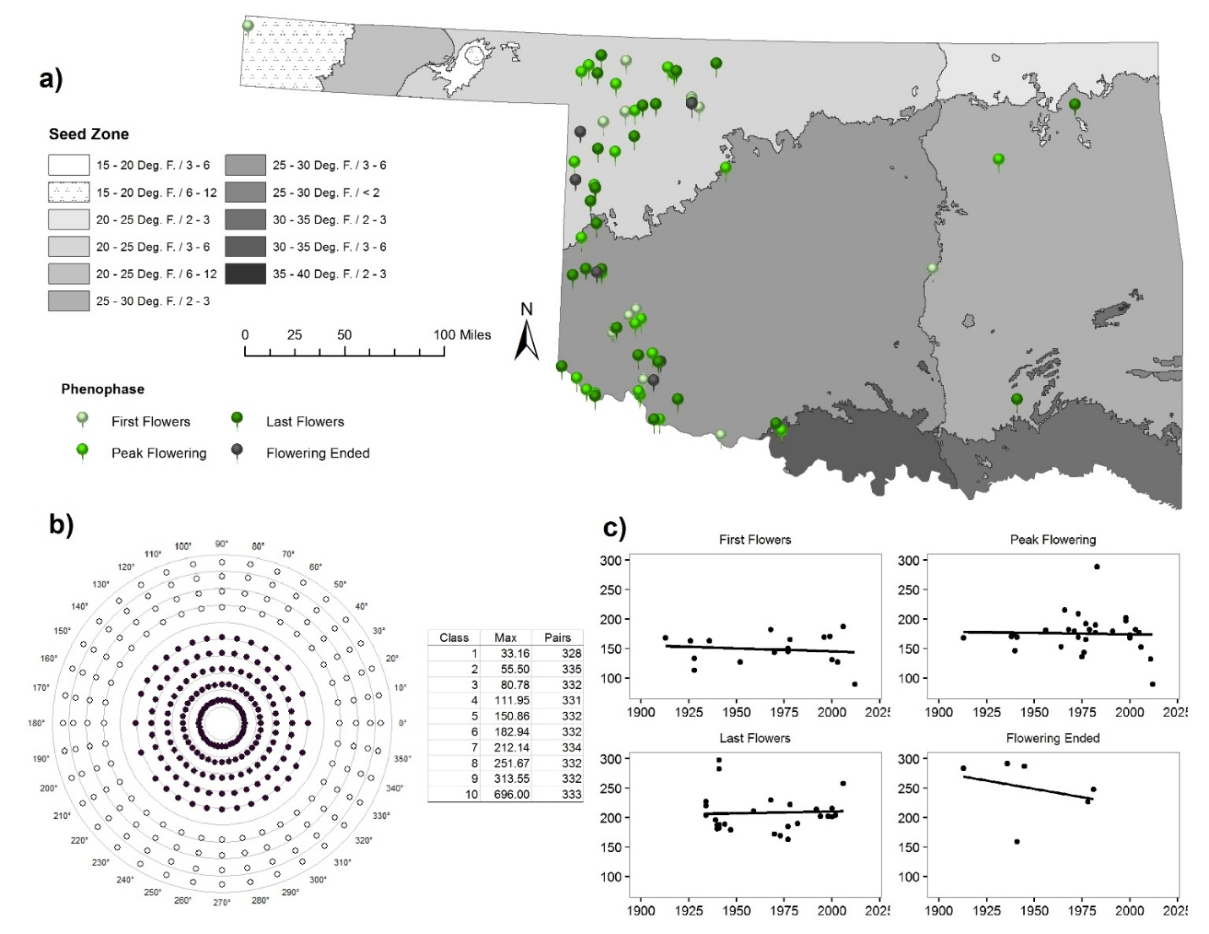
Figure 4.S2. Dimorphocarpa candicans a) Distribution of specimen points used. b) Mantel Bearing Correlogram with table of distance classes, maximum distances (km), and number of pairs. Filled circles represent positive spatial autocorrelation while empty circles represent negative spatial autocorrelation. Distance off of the distance class line indicates degree of magnitude in either positive or negative direction. c) Scatterplots with trend line, split by phenophase. X-axis is year and y-axis is Julian day.

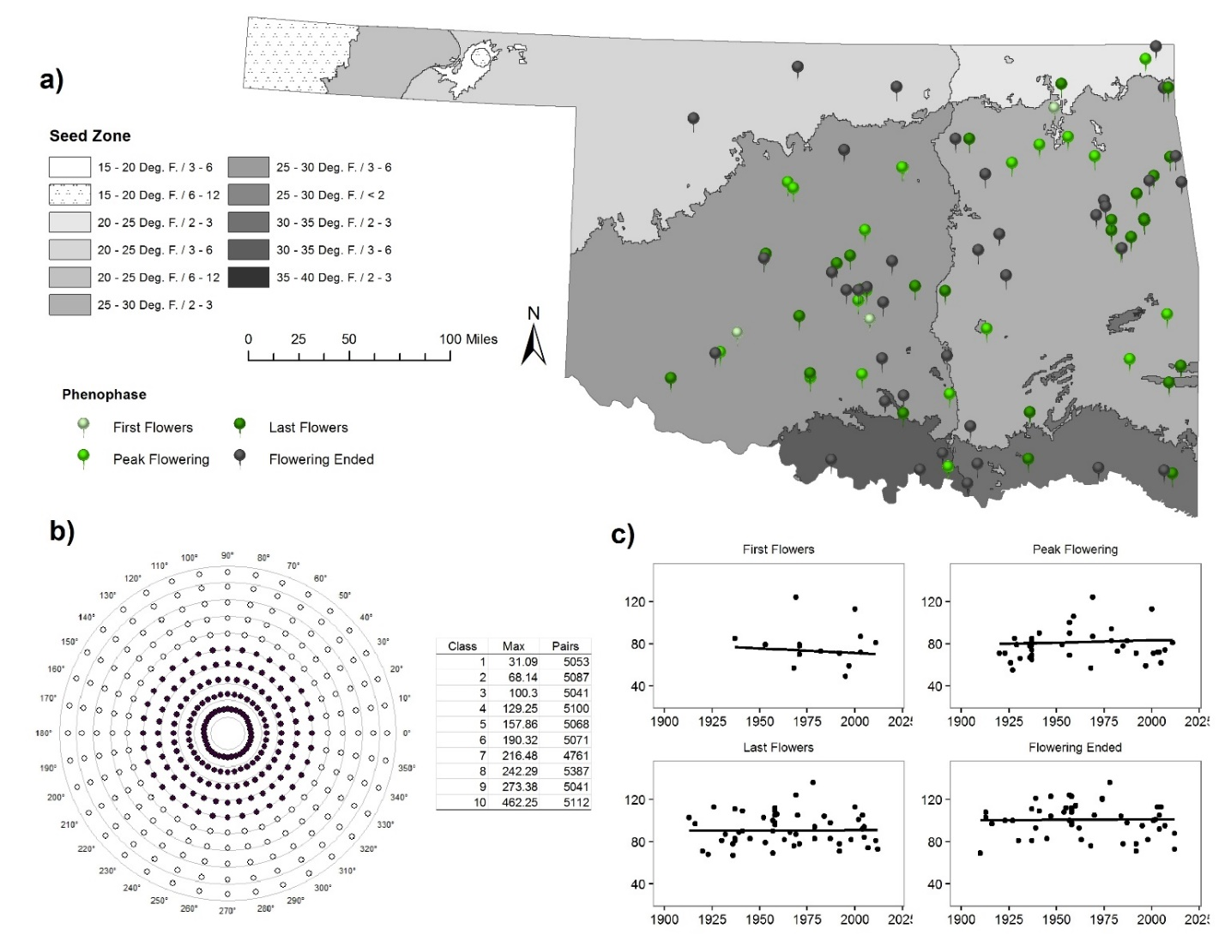
Figure 4.S3. Draba brachycarpa a) Distribution of specimen points used. b) Mantel Bearing Correlogram with table of distance classes, maximum distances (km), and number of pairs. Filled circles represent positive spatial autocorrelation while empty circles represent negative spatial autocorrelation. Distance off of the distance class line indicates degree of magnitude in either positive or negative direction. c) Scatterplots with trend line, split by phenophase. X-axis is year and y-axis is Julian day.

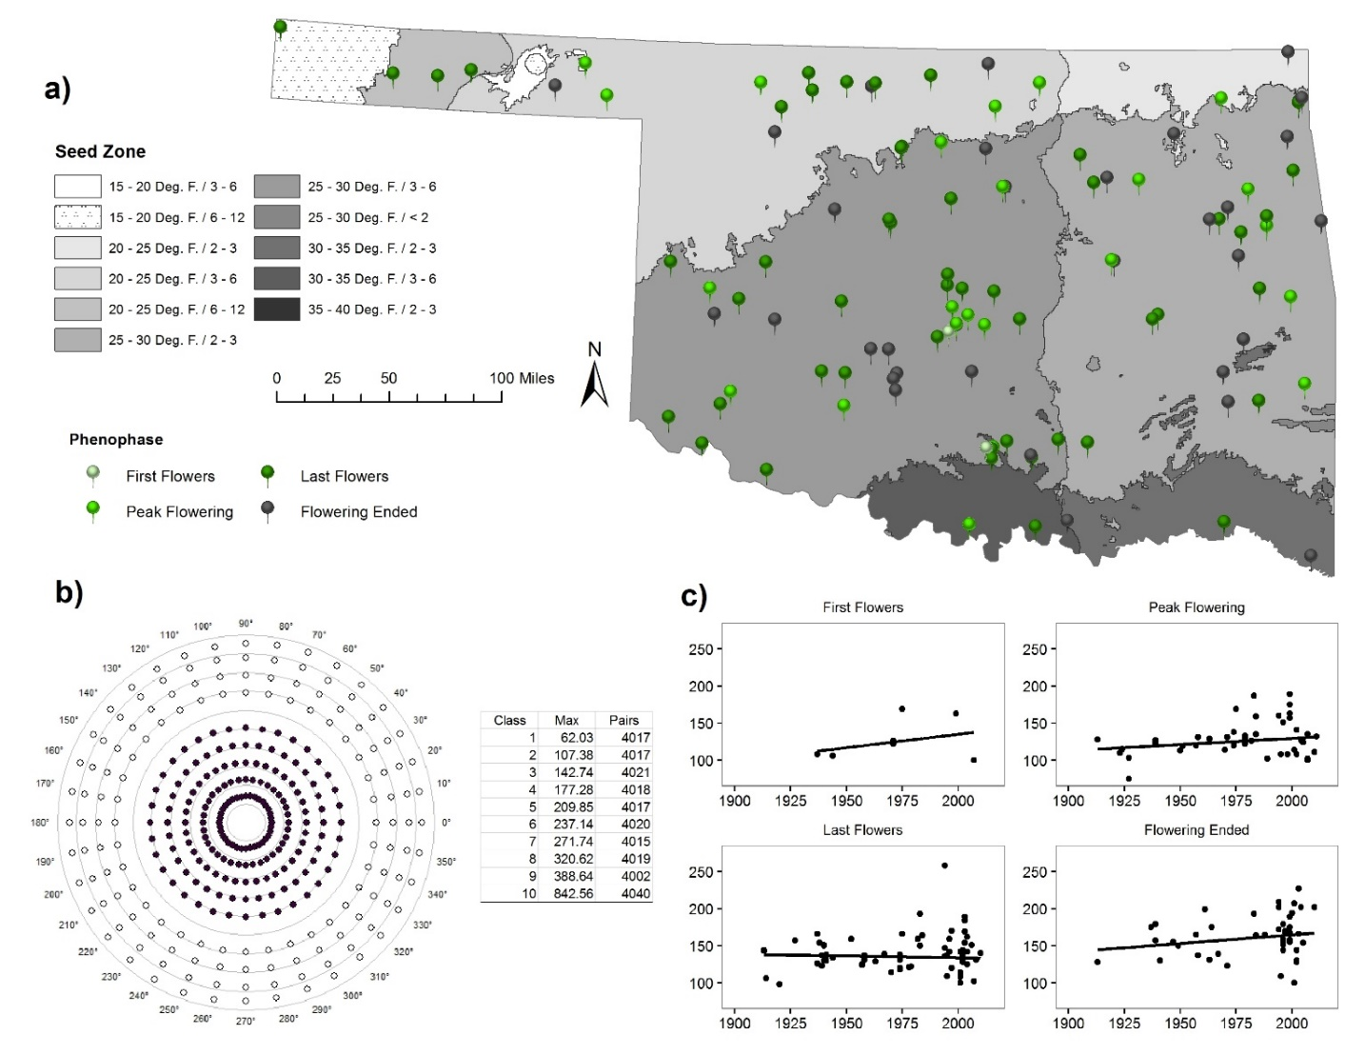
Figure 4.S4. Lepidium densiflorum a) Distribution of specimen points used. b) Mantel Bearing Correlogram with table of distance classes, maximum distances (km), and number of pairs. Filled circles represent positive spatial autocorrelation while empty circles represent negative spatial autocorrelation. Distance off of the distance class line indicates degree of magnitude in either positive or negative direction. c) Scatterplots with trend line, split by phenophase. X-axis is year and y-axis is Julian day.

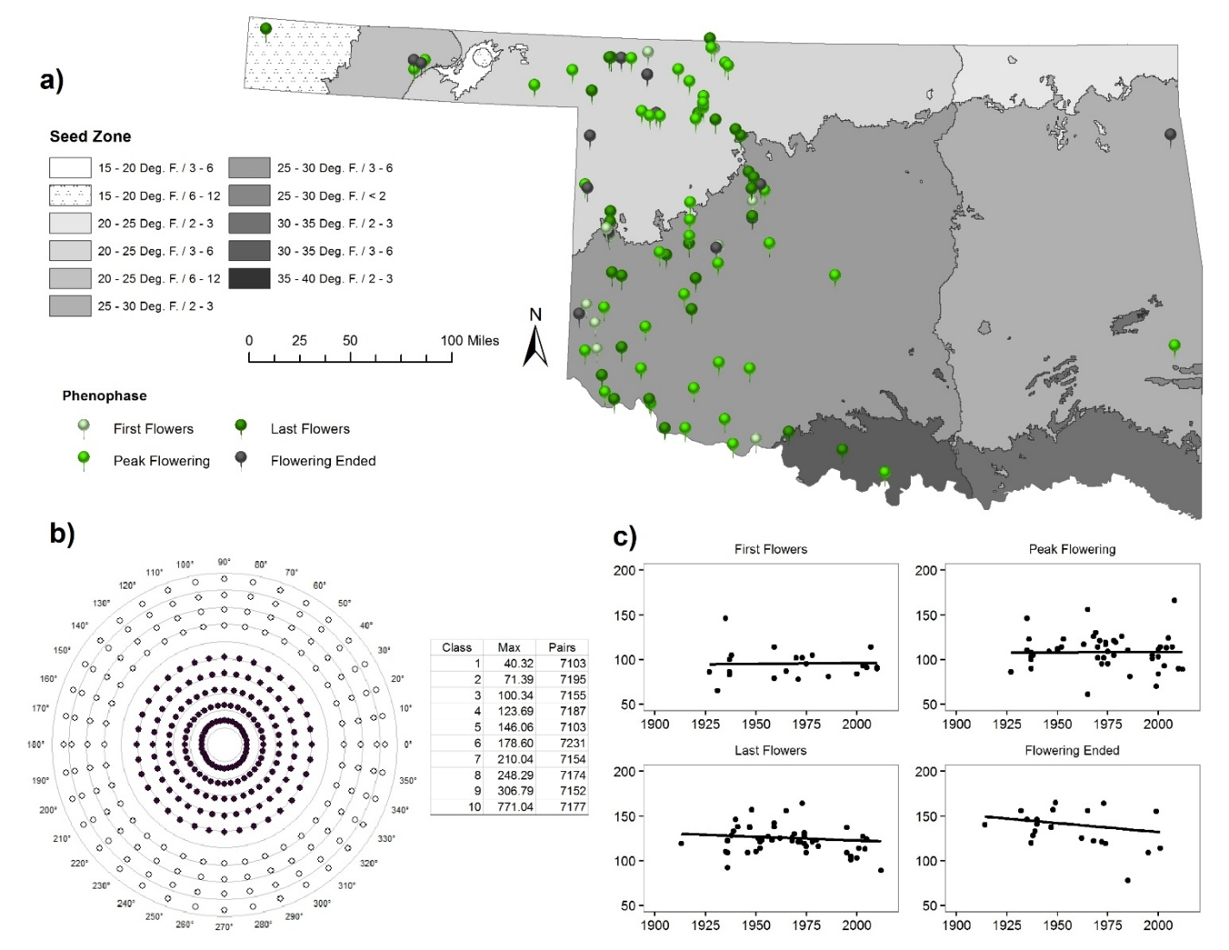
Figure 4.S5. Physaria gordonii a) Distribution of specimen points used. b) Mantel Bearing Correlogram with table of distance classes, maximum distances (km), and number of pairs. Filled circles represent positive spatial autocorrelation while empty circles represent negative spatial autocorrelation. Distance off of the distance class line indicates degree of magnitude in either positive or negative direction. c) Scatterplots with trend line, split by phenophase. X-axis is year and y-axis is Julian day.
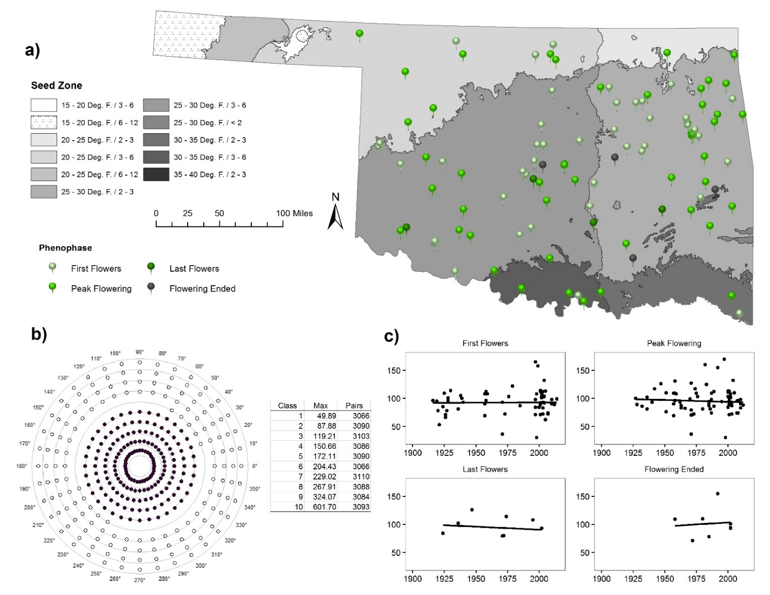
Figure 4.S6. Lamium amplexicaule a) Distribution of specimen points used. b) Mantel Bearing Correlogram with table of distance classes, maximum distances (km), and number of pairs. Filled circles represent positive spatial autocorrelation while empty circles represent negative spatial autocorrelation. Distance off of the distance class line indicates degree of magnitude in either positive or negative direction. c) Scatterplots with trend line, split by phenophase. X-axis is year and y-axis is Julian day.

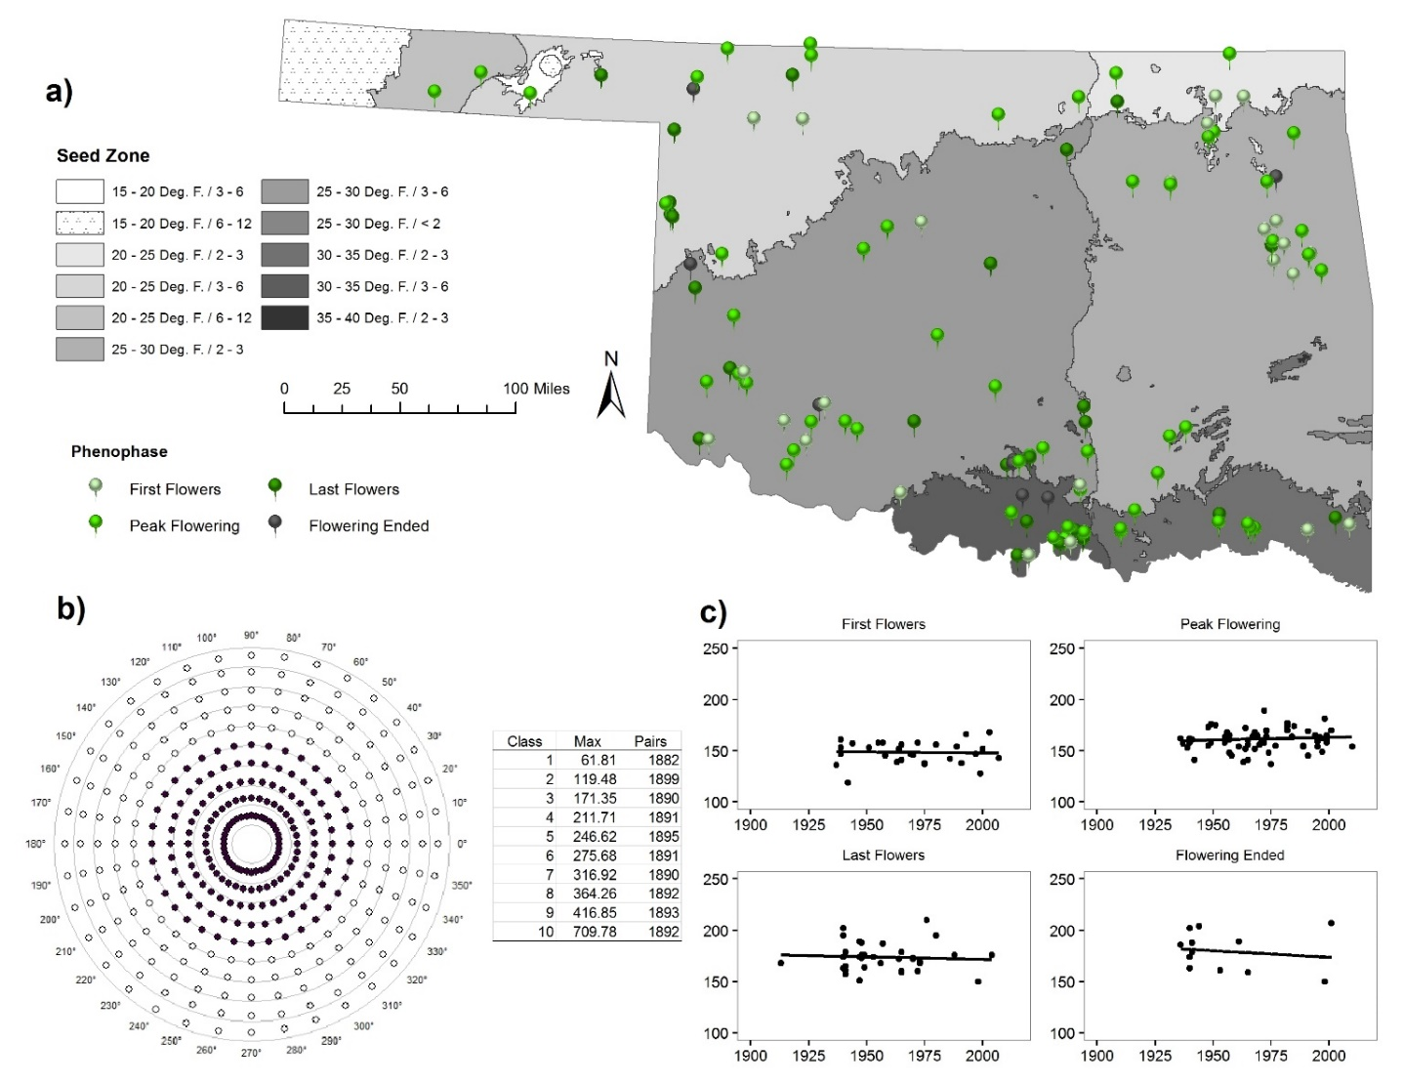
Figure 4.S7. Monarda citriodora a) Distribution of specimen points used. b) Mantel Bearing Correlogram with table of distance classes, maximum distances (km), and number of pairs. Filled circles represent positive spatial autocorrelation while empty circles represent negative spatial autocorrelation. Distance off of the distance class line indicates degree of magnitude in either positive or negative direction. c) Scatterplots with trend line, split by phenophase. X-axis is year and y-axis is Julian day.

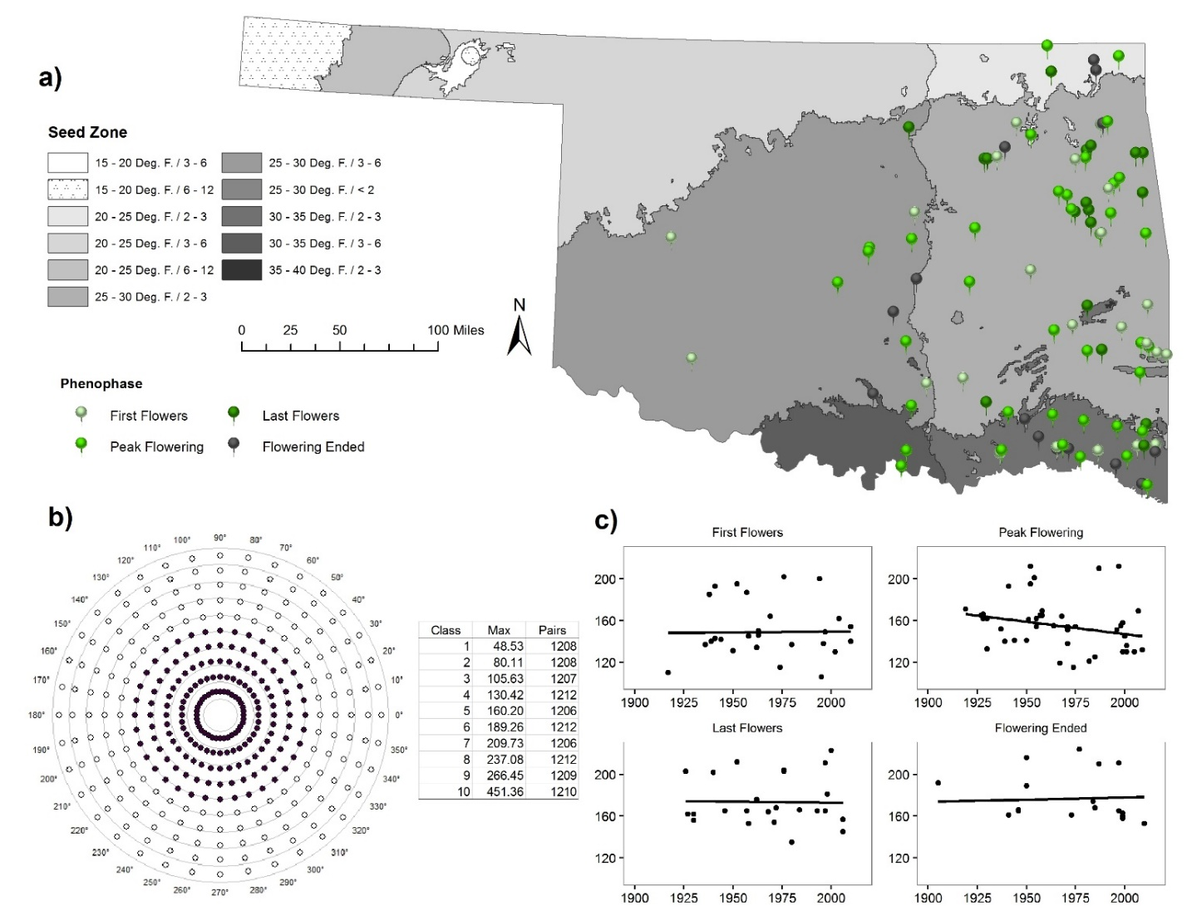
Figure 4.S8. Prunella vulgaris a) Distribution of specimen points used. b) Mantel Bearing Correlogram with table of distance classes, maximum distances (km), and number of pairs. Filled circles represent positive spatial autocorrelation while empty circles represent negative spatial autocorrelation. Distance off of the distance class line indicates degree of magnitude in either positive or negative direction. c) Scatterplots with trend line, split by phenophase. X-axis is year and y-axis is Julian day.

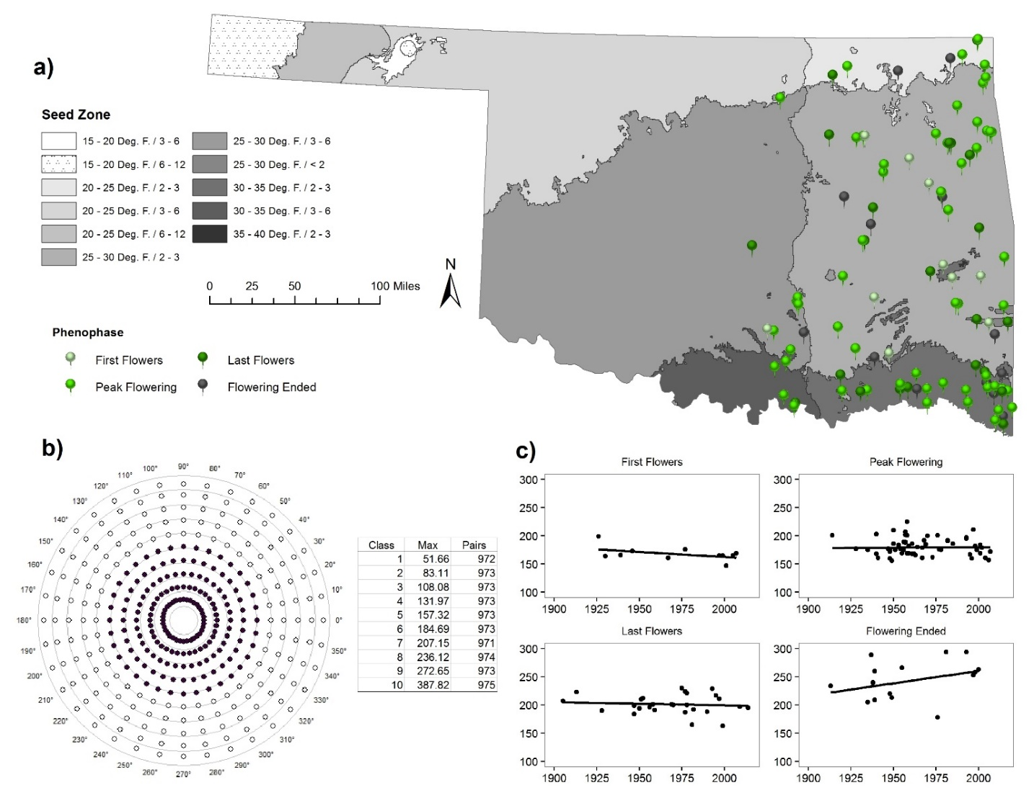
Figure 4.S9. Pycanthemum tenuifolium a) Distribution of specimen points used. b) Mantel Bearing Correlogram with table of distance classes, maximum distances (km), and number of pairs. Filled circles represent positive spatial autocorrelation while empty circles represent negative spatial autocorrelation. Distance off of the distance class line indicates degree of magnitude in either positive or negative direction. c) Scatterplots with trend line, split by phenophase. X-axis is year and y-axis is Julian day.

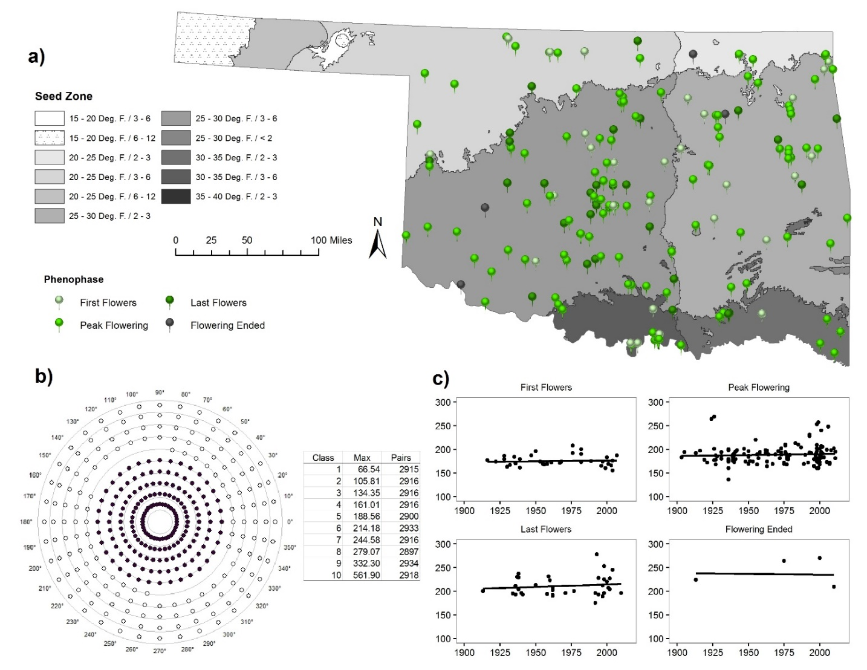
Figure 4.S10. Teucrium canadense a) Distribution of specimen points used. b) Mantel Bearing Correlogram with table of distance classes, maximum distances (km), and number of pairs. Filled circles represent positive spatial autocorrelation while empty circles represent negative spatial autocorrelation. Distance off of the distance class line indicates degree of magnitude in either positive or negative direction. c) Scatterplots with trend line, split by phenophase. X-axis is year and y-axis is Julian day.

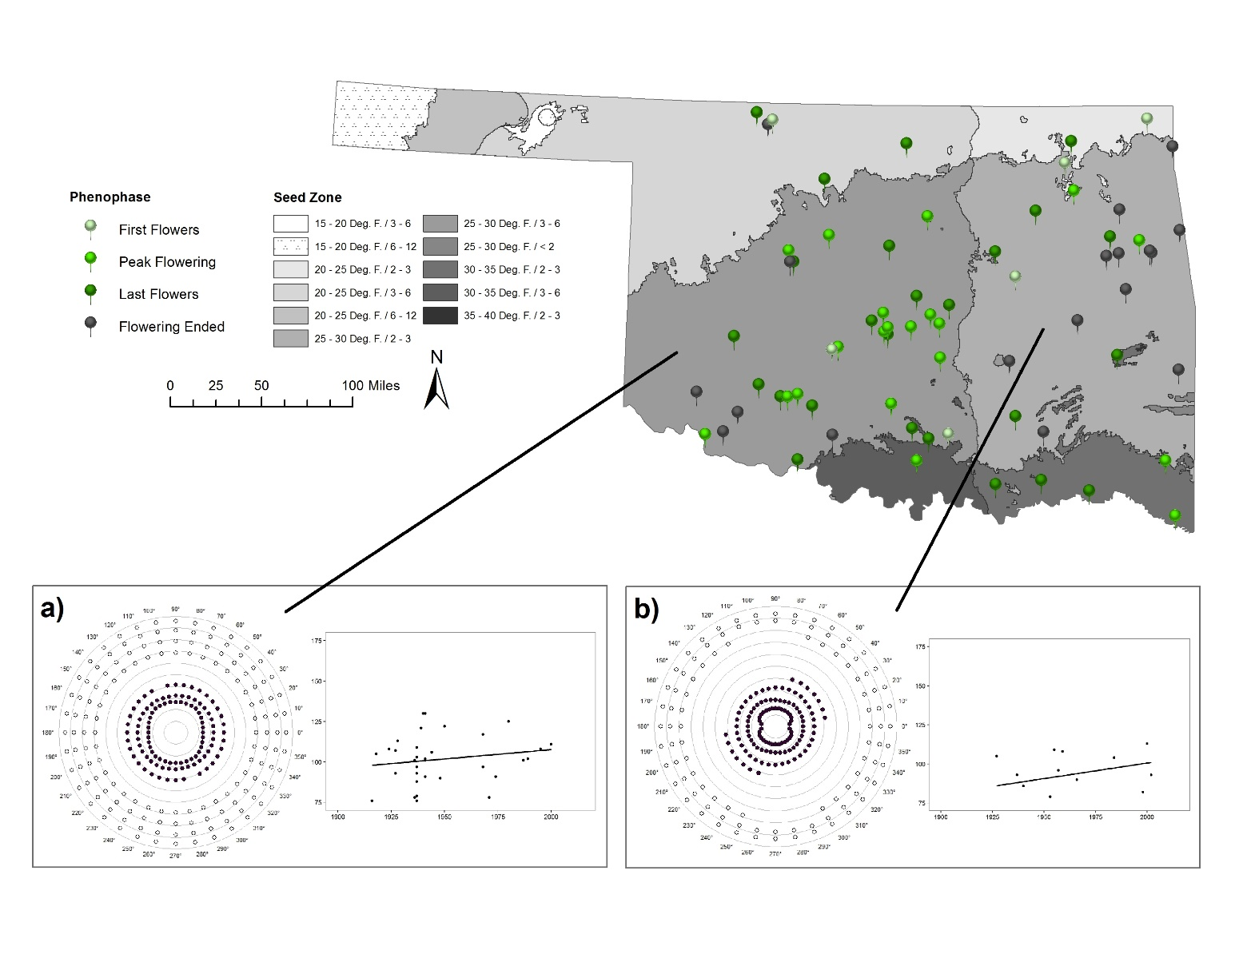
Figure 4.S11. Planodes virginica Mantel Bearing Correlogram and scatterplot with trend line of specimens in any flowering phenophase, Flowering Ended not included. a) Seed Zone 25 - 30 Deg. F. / 3 – 6, b) Seed Zone 25 - 30 Deg. F. / 2 – 3.

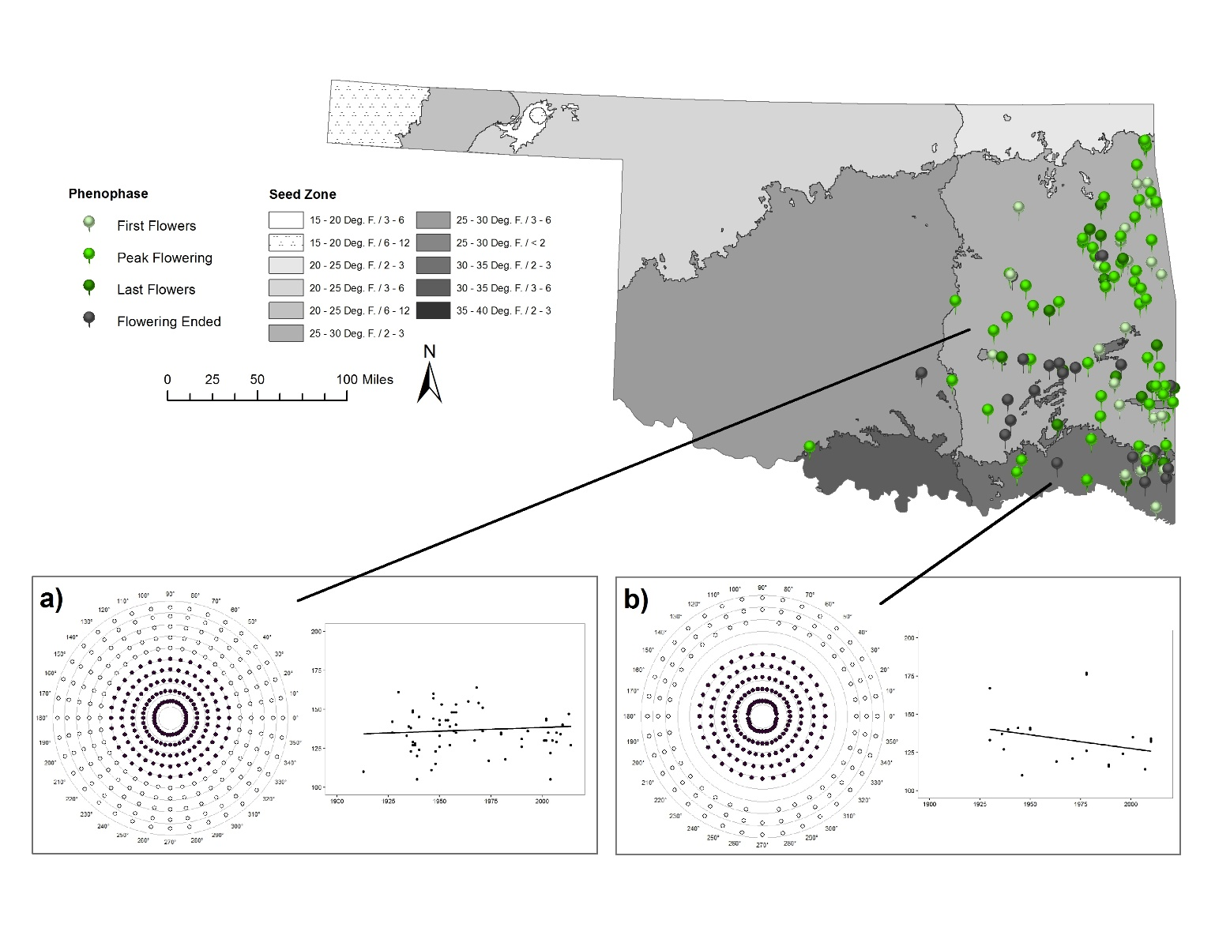
Figure 4.S12. Monarda russeliana Mantel Bearing Correlogram and scatterplot with trend line of specimens in any flowering phenophase, Flowering Ended not included. a) Seed Zone 25 - 30 Deg. F. / 2 – 3, b) Seed Zone 30 - 35 Deg. F. / 2 – 3.

CHAPTER 5
Future Research Directions and
Concluding Remarks on Plant Phenology

Potential Future Research Directions
As one can attest this current spring is coming on early and continued observations should be conducted at the Thunderbird study site. Although these populations of Quercus marilandica and Q. stellata may just be slow in their responses to environmental change, they may reach a tipping point and a more pronounced response in the future. If possible, the study could be expanded to include other populations across the range of these two species. For example, there may be latitudinal patterns of budburst and leaf-out for these species, as demonstrated in other studies. Such an expanded study could include and compare green up dates from MODIS datasets with our on the ground observations to determine how closely the satellite data detects leaf-out for this site.
Since we found that position on the tree crown was not influential on budburst, leaf-out, or shoot elongation, observations could be made at varying heights on the tree crown to determine if height is influential. Shoot elongation measurements coupled with soil water content could be studied at another time. Water availability may be an important factor in shoot elongation and the soils at the study site range from sandy loam at the north end of the site to clay at the lake edge.
As herbaria around the globe continue to digitize their specimens and make them available online, such studies could be expanded to include specimens housed in non-local herbaria so that a more complete dataset, both spatially and temporally, could be utilized. These online resources could allow for the analysis across a species’ range, however, accounting for the spatial heterogeneity of climate across the range would be a challenge. Use of the provisional seed zones for the continental US could help stratify the analysis.
One other possible future use of the herbarium data collection and analysis is targeted species distribution modeling where flowering time is taken into account. A flowering day variable layer can be created in ArcGIS from the collection points where their associated phenophase and Julian day are used in a simple Kriging procedure where the Julian day of collection is weighted by the phenophase. For example, specimens in the peak flowering phenophase would be weighted higher than those in the first or last flowers phenophase. Specimens in the flowering ended phenophase would be weighted the lowest. This layer then would be used in conjunction with a probability of occurrence layer from a modeling technique, such as the output from MaxEnt, to direct searches or monitoring of a species during flowering or once flowering as commenced if seed collection is a goal. Species that have not been studied for their seed germination and/or flower vernalization could be targeted with the results of our analysis. Experiments could be conducted for the species found to have significant changes in flowering times.

Why care about potential plant phenological response changes?
Plant phenology is important. Plants help mitigate climate change by taking in carbon dioxide from the atmosphere and giving back the oxygen needed to breathe. Plants stabilize soil. Plants structure ecosystems. Plants form the base of the food chain. Plants clothe humans and provide products to put roofs over their heads. Some plants can even remove heavy metals from soil and water, after humans have polluted it. These amazing abilities of plants have limits, especially limits in how fast the processes occur. These abilities are the results of millions of years of evolutionary adaptation.
Plants are responding to the changing climate in various ways; some are budding, flowering, and/or leafing out earlier while others are doing these later. Even others are not yet showing any sort of observable change now, but these most likely will in the future. Understanding how plants respond phenologically to the climate in the past and now will be critical to understanding how they respond in the future. Phenological changes are essentially reproductive and growth timing changes. Humans consume the final product of plant reproduction in its various forms: leaves, fruits, seeds, etc. Humans also consume the product of plant growth, especially that of trees.
While the species in these studies are not all major food sources for humans, some are food sources for animals and insects. Deer browse the new shoots of oaks and other tree species. Squirrels eat acorns. Oak leaves contain tannins which are used in wine making to give flavor and body to the wine. Seeds from Descurainia pinnata can be ground and used to flavor food or used as a meal to cakes. The young leaves of D. pinnata can be eaten as salad greens, as can those of Lepidium densiflorum and L. virginicum seeds and leaves or the whole plant can be eaten. Hedeoma drummondii and Prunella vulgaris leaves can also be eaten.
Some of the species in these analyses, are crucial for insects in completion of their reproductive phenology. Oak leaves and twigs are where gall wasps lay their eggs. The oak leaf roller moth and oak leaf miner also lay their eggs on the leaves. Several species of spiders inhabit oak flowers. Various insects that eat pollen or gather nectar pollinate all species of Brassicaceae and Lamiaceae. Oak leaf tannins are used to tan hides for clothing and leather accessories. Wood from oaks is used to make fine furniture and can be used for housing materials. The wood is also used as a fuel source for cooking and heating. Children’s toys used to be made of wood before plastic.
Knowing when certain plants are going to flower is extremely important to people who suffer from pollen allergies. Different pollens are more irritating than others. Cedar, pine, and oak pollen are the worst offenders, while ragweed is the worst for herbaceous plants. Allergy sufferers used to be able to plan ahead for certain pollen seasons, and the changes in flowering and pollen release are directly affecting such people. Cedar and pine have been releasing pollen slightly earlier than historically while oak pollen release has remained relatively consistent in Oklahoma for the past few years.
One small population of two species of Quercus in Oklahoma have provided a glimpse into how these trees are responding to their local climate, which appears to be slower than their northern counterparts. Half of the species examined in the herbarium study are showing signs of changing their flowering times over the last 100 years in Oklahoma, while the others are not yet showing changes. Even within the provisional seed zones in the state, these species are showing the changes in flowering time. None of these species are restricted to the political boundaries of the state, so this type of analysis should be conducted across the complete geographic ranges of each species to complete the puzzle.
Plants, from the little weedy species to the large trees, all play important roles in the global ecosystem. An understanding of baseline patterns of phenological events and the environmental mechanisms that trigger these events future investigations of how plants are and will respond to climate change in the future will become vital to adapting to life on the planet. These patterns need to be investigated for multiple plant life history stages and many more species than those presented here. Multiple scale studies, both spatially and temporally, need to be conducted so that we can have a better understanding of the whole picture.

