UNIVERSITY OF OKLAHOMA
GRADUATE COLLEGE

FURTHER EXPLORATION OF HEAT OF IMMERSION AS A
METHOD TO QUANTIFY WETTABILITY FOR PARTICULATES:
EFFECT OF TEMPERATURE

A THESIS
SUBMITTED TO THE GRADUATE FACULTY
in partial fulfillment of the requirements for the
Degree of
MASTER OF SCIENCE

By
BOSHEN XU
Norman, Oklahoma
2023

FURTHER EXPLORATION OF HEAT OF IMMERSION AS A
METHOD TO QUANTIFY WETTABILITY FOR PARTICULATES:
EFFECT OF TEMPERATURE

A THESIS APPROVED FOR THE
SCHOOL OF CHEMICAL, BIOLOGICAL
AND MATERIALS ENGINEERING

BY THE COMMITTEE CONSISTING OF

Dr. Brian Grady, Chair

Dr. Liangliang Huang

Dr. Sepideh Razavi

©Copyright by BOSHEN XU 2023
All Rights Reserved.

ACKNOWLEDGEMENTS

Time flies, two years of study in the University of Oklahoma is coming to an end. Looking back on this study experience, I am full of gratitude to those who guided me, helped me, and inspired me.
First, I can’t thank my advisor, Dr. Brian Grady, enough. Dr. Grady gave me a great help during these two years. He personally taught me how to use instrument when I started doing research. And he always patiently helped me figure out the problems in the research. With his support, I presented at national conference and broadened my horizons in my research field. These greatly improved my scientific research ability. Dr. Grady also devoted a lot of effort to this thesis. During the writing process, whenever I had any questions, he always answered me tirelessly. I sincerely appreciate his help to me.
Second, I would like to express my gratitude to Dr. Liangliang Huang. I can’t participate in this “3+2” program without the help of Dr. Huang. During studying at OU, he gave me a lot of help like course selection and graduate student status transition, which ensured the smooth progress of this program. I’m very thankful to him providing me with the opportunity to study in the United States.
Finally, I want to say “thank you” to my parents for supporting me financially. They are my strong backing on my way to study. Their selfless love and care are the driving force for me to keep moving forward.

TABLE OF CONTENTS
1. Introduction 1
2. Experiments 7
3. Results and Discussion 11
3.1 Water with no surfactant 11
3.2 Effect of Surfactant 14
4. Conclusion and Recommendations 18
REFERENCES 19

LIST OF TABLES
1.1. Derivative of surface energy with temperature value for various silicas. 5
3.1.1. Contact angle for various silicas changing with temperature. 13
3.2.1. Concentrations after adsorption of surfactant. Concentrations above the CMC would be expected to have the same heat of immersion. 15

LIST OF FIGURES
3.1.1. Heat of wetting for various silicas with water; data is identical to that shown in Figure 3.1.1. Symbols (*, # or +) represent statistically significant differences at the 95% confidence level. 11
3.1.2. Calculated contact angle for the three silicas using data from Figure 3 and Equation 9. Symbols (*, # or +) represent statistically significant differences at the 95% confidence level. 12
3.2.1. Heat of immersion for the three silicas with added surfactant. From top to bottom R974, R300 and R380. The amounts correspond to the added surfactant. 14
3.2.2. Adsorption isotherm of CTAB adsorbed by (a) R380, (b) R300, and (c) R974 silicas at 40℃. 16
3.2.3. Adsorption isotherm of SDS adsorbed by (a) R380, (b) R300, and (c) R974 silicas at 40℃. 16
3.2.4. Adsorption isotherm of C12E6 adsorbed by (a) R380, (b) R300, and (c) R974 silicas at 40℃. 17

ABSTRACT
A previous paper by our group[1] concluded that to distinguish between the wettability of different particles, heat of immersion is the best method as opposed to the Washburn or sessile drop method. In this paper, heats of immersion of three different particles with three different wettabilities are measured at different temperatures to examine one critical assumption concerning the temperature dependence of the heat of immersion. In addition, surfactants are added to the water and the effect of surfactant concentration on the heat of wetting is measured. One particularly noteworthy aspect of the current study is that some measurements were made at pressures higher than atmospheric with no more difficulty than measurements made at atmospheric pressure.

The previous paper showed that, for certain particles, the relationship used by us and others between heat of wetting and contact angle gave impossible values for certain surfaces. In this thesis, the derivation of that expression is re-examined and certain assumptions are highlighted. Because of issues with the assumptions, we conclude that using heat of immersion to quantify wetting is perfectly appropriate, but without measurement of the values of liquid-solid interfacial energy with temperature, conversion to the contact angle is likely not appropriate.

Keywords – nanoparticles, wettability, silica, heat of immersion, contact angle

Chapter 1. Introduction
The ability of a surface to be wet by a liquid is key to many important applications, including coatings, detergency and cleaning and printing. The most common parameter used to quantify wetting is the contact angle, represented by the diagram in Figure 1. In words, the contact angle is the angle between the liquid and the solid at the three phase (liquid, solid, vapor) contact line. The fundamental expression for the contact angle is given by Young’s equation:
$γ_{LV}cosθ=γ_{SV}-γ_{SL}$ (1)
where γ_{SL} is the interfacial energy (also termed the surface free energy or surface energy) between the liquid and the solid, γ_{LV} is the liquid-vapor interfacial energy (i.e. surface tension) with the vapor saturated with liquid, and γ_{SV} is the interfacial energy of the solid in air saturated with the liquid vapor (note that interfacial energies are not usually the same as interfacial tension or surface tension in the case of the expressions that involve solids.[2]) In principle the contact angle is a single value as Equation 1 results from a mechanics balance and all phases are required to be in thermodynamic equilibrium with one another. In practice surface roughness and compositional variations along the surface of the solid cause the measured contact angle to vary as described in various tomes and review articles on the topic.[3-6] The advancing and receding contact angles are another complication with the latter being different than the former if a thin liquid film remains on the solid surface or the liquid induces some change in the solid surface by chemical changes. Regardless, contact angle is the single most important parameter typically used to quantify wetting.
Measurement of a powder creates a great number of challenges, as described well in review articles on the subject.[7, 8] A sessile drop method can be used, but the way in which the surface is prepared is different. The sessile drop method works by placing the liquid droplet on the solid surface, then a high-resolution camera is used to take image and determine the shape of droplet. One method involves coating the powder on a second flat surface and the second involves compressing the powder; combinations of the two methods are possible. The measurement of contact angle can be done using a sessile drop technique on a powder-coated surface, or via a Wilhelmy plate if the powder is adhered to the surface. In either case, surface roughness inherently creates significant issues for measurements of contact angle. If compression is used, most methods of compression can cause changes in surface chemistry especially for the powder that contacts the compressing surface. The sessile drop method doesn’t work since the rough and easily contaminated surface of powder and the powder clumps together sometimes leading to affect the shape and size of the droplet.[9] The main challenge for optical goniometry is the uneven surface of the powder, which will lead to inaccurate measurement.[10]
The Washburn method involves putting the powder into a vessel and measuring the rate of capillary rise; however, significant experimental difficulties are found with this technique as described in the review articles. However, even in a perfectly performed experiment, the Washburn method will not work for contact angles greater than 90° and not all surfaces with contact angle of 0° wet the same. Further, our experience in this area has indicated that the differences between 0°-10° and 80°-90° are too small to distinguish reliably.[1, 11]
In the captive bubble method, bubbles of air are injected beneath a solid immersed in a liquid. The contact angle is measured in a similar way used for the sessile drop. The data measured by this method is somewhat subjective because the contact angle is dependent on the analytical model selected. Also, bubbles tend to be unstable and will fluctuate. [12]
The heat of immersion method involves measuring the heat evolved or required during mixing of water with a powder and was the subject of our previous paper. By changing the type of surface and controlling the amount of grafted hydrophilic and hydrophobic material, we were able to manufacture surfaces with a wide range of wetting behavior.[1] Our results clearly show that the heat of immersion is superior to the other methods in capturing differences in wetting in the order expected based on the type and coverage of the surface coating. The only caveat to this statement was that for non-wetting surfaces, the method was not appropriate and, in that case, a sessile drop method offered the best option. However, the calculation of contact angles from the heat of immersion method according to the standard formula was suspect, in some cases values less than 0° are the result. The key value in this previous treatment that deserves question is the variation of interfacial energies with temperature as described more fully below.
Two equations, shown below, for the heat of immersion are given in the paper of Masliyah[13] which in turn are identical to Equations X-6 and X-39 the book of Adamson and Gast[14]. The expression on the right also appears in the paper by Adamson and Ling[15].
$h_{i}=γ_{SL}-γ_{S}-T{\left(\frac{dγ_{SL}}{dT}-\frac{dγ_{S}}{dT}\right)}_{P}={-E}_{LV}cosθ+Tγ_{LV}{\left(\frac{dcosθ}{dT}\right)}_{P}$ (2)
γ_{SL} and γ_{LV} were defined in Equation 1, γ_{S} is the interfacial energy of the solid in dry air, T is absolute temperature and P is absolute pressure. E_{LV} (E_{LV} in the paper by Adamson and Ling, E_{L} in the book by Adamson and Gast, and incorrectly γ in the paper of Masliyah) is defined as the total surface free energy of the liquid:
$E_{LV}=γ_{LV}-T\frac{dγ_{LV}}{dT}$ (3)
The total surface free energy differs from the surface free energy because of the latter entropic term; this term accounts for the reduction in the movement of atoms or molecules at the liquid surface vs. that in the bulk. Substituting Equations (1) and (3) into the middle term of Equation 2 gives the term on the right of Equation 2 with the restriction that γ_{S} and γ_{SV} must be the same. In fact, the expression on the right side of Equation 2 is actually the opposite sign of the expression in Ref [15]; the difference is a result of the sign of the heat of wetting. The sign of this term is correct for the experiment being performed in this paper; heat is positive if energy input is required to maintain constant temperature during an isothermal mixing experiment, i.e. the mixing is endothermic.
Continuing the examination of the left-hand side of Equation 2:
$h_{i}=γ_{SL}-γ_{S}-T{\left(\frac{dγ_{SL}}{dT}-\frac{dγ_{S}}{dT}\right)}_{P}$ (4)
Equation 4 is derived from the expressions for the free energy change of immersion per unit area of solid and heat of immersion respectively [13, 15]
$g_{i}=γ_{SL}-γ_{S}$ (5)
$h_{i}=g_{i}-T\frac{{dg}_{i}}{dT}$ (6)
The differential expression in Equation 6 implies that:
${\left(\frac{∂g_{i}}{∂T}\right)}_{P}=-S$ (7)
which is only true if the enthalpy is temperature independent. Of course, the enthalpy of mixing is almost certainly not temperature independent.
To determine the final expression that relates the heat of immersion to the contact angle requires substitution of Young’s Equation (Equation 1) into Equation 4 (again assuming γ_{S}=γ_{SV}) to give
$h_{i}={-γ}_{LV}cosθ-T{\left(\frac{dγ_{SL}}{dT}-\frac{dγ_{S}}{dT}\right)}_{P}$ (8)
The derivative of the solid surface energy γ_{S} with temperature has been shown low energy surfaces to be equal to -7 × 10 ⁻⁵ J/(m²*K)[16] which is the value used previously. However, the value has been measured for various silicas, as detailed in Table 1.1. Note that all of these values are for the dispersive/Van der Waals component only; however the temperature dependence of the other components is small.[17] The variability in this value is quite large; in fact the variability of the dispersive component of the surface energy at room temperature is quite large for silica; values vary between 50 and 100 mJ/m².[18-20] The average of the bottom four values is -45.15 × 10 ⁻⁵ J/(m²*K), which is used in the expression below. The average of the silica presumably without silanol groups is lower as expected and is similar to that of glass; the authors of this paper suggest that the pore structure is responsible for the non-linear behavior.[19] Finally, assuming that $\frac{dγ_{SL}}{dT}$₌ 0 gives the final expression for low energy and high energy materials respectively
Silica | Temperature ($℃$) | $\frac{dγ_{s}^{D}}{dT}$ (mJ/m²$K$)
silica xerogel heated at 1000°C | 25-65 | -0.345[19]
silica xerogel heated at 1000°C | 65-90 | -0.155[19]
silica xerogel heated at 1000°C | 100-150 | -0.227[19]
Aerosil 130 | 70-150 | -0.362[21]
Aerosil 200 | 70-150 | -0.49 [21]
Ultrasil VN 2 | 70-150 | -0.392[21]
Ultrasil VN 3 | 70-150 | -0.562[21]
Table 1.1. Derivative of surface energy with temperature value for various silicas
$cosθ=\frac{{-h}_{i}-7 x {10}^{-5}T}{γ_{LV}}$ (low energy surfaces) (9)
$cosθ=\frac{{-h}_{i}-45.15× {10}^{-5}T}{γ_{LV}}$ (hydrophilic silica) (10)
Restating, previous work showed that the heat of immersion method was excellent for measuring wetting of powders with a more negative heat corresponding to better wetting. In this thesis, this work is extended experimentally in two ways. First, can heat of immersion be used to quantify how wetting is affected if a surfactant is added to the solution? Anionic, cationic and nonionic surfactants are used to study this question. Second, how does the heat of immersion change with temperature? One advantage of heat of immersion is that measuring at pressure above atmospheric was straightforward, so the temperature range investigated was quite large.

Chapter 2. Experimental
Three different silicas, R974, R380 and R300, were used, all supplied by Evonik. R974 is a hydrophobic silica based on a hydrophilic fumed silica with a specific surface area of 200 m²/g, as reported by the manufacturer, treated with dimethyldichlorosilane. R380 and R300 are both hydrophilic silicas, with specific surface areas of 380 and 300 m²/g respectively as reported by the manufacturer. Hydrophilic and hydrophobic silicas were used to be compared in this work. Two kinds of hydrophilic silicas were to check the effect of surface area. As will be shown, the surface area available for surfactant adsorption is smaller because reported surface areas are based on nitrogen adsorption. Surfactant with different charges were also compared here. Sodium dodecyl sulfate (SDS), cetyl trimethyl ammonium bromide (CTAB) and hexaethylene glycol monododecyl ether (C12E6) were purchased from Aldrich and used as received. The reason that these three surfactants were chosen is because they are anionic, cationic, and nonionic surfactant, respectively.
Heat of immersion was measured using a Setaram C80 calorimeter. Measurement was done in a procedure similar to that used previously[1], with some changes described below. The homemade powder cells consisted of a stainless-steel cylinder and a pair of brass sealing rings that held nitrile membranes in place, see Figure 2. Between 95 and 130 mg of powder was added to the cell before sealing; controls were run at each temperature which consisted of a cell having no powder but with the nitrile membranes in place. All powders were stored at ~80°C in a vacuum oven to remove adsorbed water; the powders were measured into the cell at room conditions (relative humidity ~40%); the total atmospheric exposure time was 30-60 sec although the cells upon sealing also contained room air.
The powder cell, after sealing, were placed in a stainless outside steel cell supplied by Setaram. 7.0 ± 0.05 g of water, or water containing surfactant, was added to the outside cell (the inside cell was not contacted by water until the nitrile seals were punctured) and the cell was sealed. The rod, instead of a roughly flat surface used at the end for the Setaram glass ampoule mixing cell, was specially fabricated with an arrow at the end having maximum width to create the biggest hole possible in the nitrile membrane. After placing the rod-stainless steel outside cell-powder cell inside the calorimeter, the system was allowed to equilibrate at the given temperature. Sometime after equilibration had occurred (a minimum of 2-3 hours was required, with longer times required for higher temperatures) one rod was pushed through both nitrile seals. The distance that the rod was pushed was enough to break the bottom seal, but not enough to touch the bottom eliminate the significant conductive heat transfer from the bottom of the outside cell along the rod. The measured heat evolved or required to maintain constant temperature (positive means energy input was necessary to maintain constant temperature) was measured assuming a linear baseline and from this value the average value from the control experiments was subtracted. After the cell had reached equilibrium, the other rod was pushed through the nitrile seals. At least 14 different trials were used for the control (no sample in cell) to determine the average, while the data presented represents the results from at least 5 trials. Not all trials were used; those trials where the baseline drift was too high, or the shape of the curve was clearly not correct were not used. Roughly 1 in 10 trials was unusable based on this criterion, and this failure rate did not depend on temperature. No evidence in the signal was ever found of the nitrile seals failing (gasket that sealed the outside sell did occasionally not seal correctly and the consequences were obvious in the signal). The highest temperature tested was 145°C (pressure=4.2 bar); higher temperatures were not tested because catastrophic failures of the gasket seal sometimes occurred if we attempted to remove the device at that temperature. In fact, we believe with a simple design change, e.g., replacing the o-ring compression seal shown in Figure 2 with something that is threaded, would allow very high pressures (and hence temperatures) to be reached.
Surfactant concentration was determined using the silica surface area, the volume of water and CMC of the surfactant. The high concentration of surfactant solution was set at the CMC after adsorption assuming 120 mg of silica, all silica surface area (as measured by N₂ adsorption) was covered by surfactant and using the areas/headgroup of adsorbed surfactant at the air-water interface found elsewhere.[22] As expected and will be shown by the data, in all cases this concentration was significantly higher than the CMC. At least two other lower concentrations were measured, with the idea that at least one of these was above the CMC (i.e., the adsorption was the same) and one was sufficiently below the CMC so that adsorption was less but also that adsorption was greater than zero (e.g., the heat of immersion measured was different than that with no surfactant in the liquid). For a given surfactant, the concentrations were identical for all temperatures but obviously surfactant concentrations for different surfactants were different, so we used qualitative descriptions for the different surfactant. Even if the added amounts were identical, the amount in solution after adsorption, which is the important concentration in the adsorbed surfactant-surfactant in solution equilibrium, would be different.
One important issue that must be addressed is the heat required to cause micelles to breakup must be determined to be sure that the heat measured truly corresponds to wetting and not micelle dissociation. Literature values for heat of micellization for SDS, CTAB and C12E6 are -4 kJ/mol,[23] -13 kJ/mol,[23] and 1 kJ/mol[24]. Using the value for CTAB, the amount of heat that would need to be added is 16 mJ; the absolute value of the average heat required for the control at 40°C was 79.1± 45.6 mJ. Just to be sure, we also did an experiment where the high concentration (7000 ppm, approximately 19 times the CMC for CTAB) was encased in the sample cell and then diluted below the CMC with 7 g of water. The heat of this experiment (run twice) relative to the control were statistically indistinguishable. Therefore, the heat of demicellization can be safely ignored.
Another issue involves the vaporization of the water into the unoccupied volume within the cell. The outer cell was ~full with water, however gas space exists in the powder cell. As expected, the endothermic heat associated with this phenomenon increased with increasing temperature and the increase in endothermic heat in the control measurements was consistent with this effect. The unoccupied volume is larger in the control then in the sample. The total volume of the cell that held the powder was ~3.5 cm³. With a maximum of 130 mg of powder having a density ~2.5 g/cm³, the difference in volume between an empty cell and a cell filled with powder was approximately 1.5%. The relative error in the blank measurement was ~50%, so it is safe to assume that the control measures this effect accurately for the samples and hence this effect can be ignored in the data.
Because some confirmation was desired that the changes in heat of immersion correlated with adsorbed surfactant amount, after doing the heat of immersion experiments adsorption isotherms were measured for the three surfactants on the three different silicas. A measured amount of silica was added to a glass vial and then surfactant at a given concentration and known amount was added and the vial was sealed and the solution was allowed to equilibrate for 24 hours at 40°C. Some supernatant was removed and filtered through a 2mM syringe filter during injection into a high performance liquid chromatograph (HPLC) with a flowrate of 1mL/min, a mobile phase of 25% water and 75% acetonitrile and a Hypersil GOLD, 150 mm length and 4.6 mm diameter column. For the ionic surfactants, UV detector and conductivity detector was used to quantify concentration while an evaporative light scattering detector (ELSD) was used to quantify the nonionic concentration in solution. Calibration curves were developed by injecting solutions with known surfactant concentration.

Chapter 3. Results and Discussion
3.1 Water with no surfactant
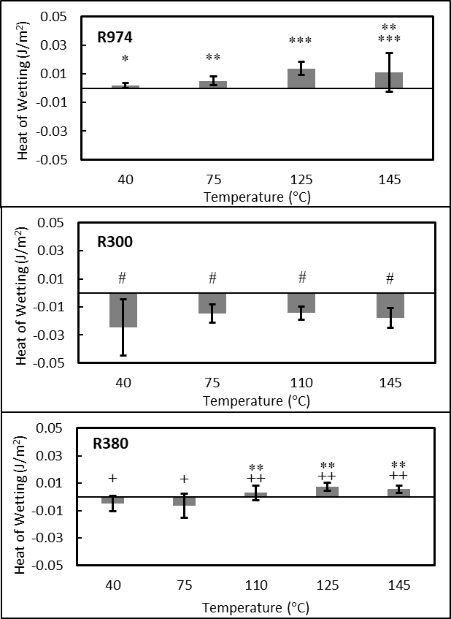
Figure 3.1.1. Heat of wetting for various silicas with water; surface areas provided by the silica manufacturer were used. Symbols (*, # or +) represent statistically significant differences at the 95% confidence level.
Figures 3.1.1 and 3.1.2 show heats of immersion and the calculated contact angle respectively according to Equation 9 for all surfactants using surface tension $(γ_{LV})$ values for water as a function of temperature[25]. R974 is the most hydrophobic as expected, but all silicas would be considered as hydrophobic given the calculated contact angle. The order of hydrophobicity from most to least is R974 > R380 > R300 and this order does not change with increasing temperature. For the hydrophilic silicas, the magnitude of the heats of immersion are significantly smaller (in an absolute value sense) than those found previously.[1, 13] In fact, all silicas would be rightly considered hydrophobic based on the contact angles shown in Figure 3.1.2.
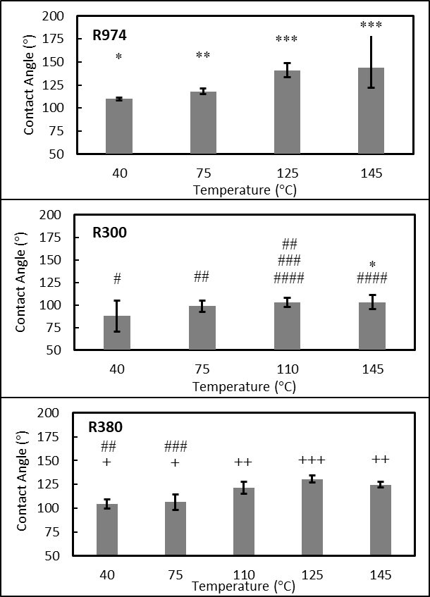
Figure 3.1.2. Calculated contact angle for the three silicas using data from Figure 3.1.1 and Equation 9. Symbols (*, # or +) represent statistically significant differences at the 95% confidence level.
One possible reason for the less exothermic heats of wetting is that the hydrophilic silicas studied previously had surface areas 1.5-3 times less than the silicas studied here and hence one explanation could be that more of the N₂ measured surface area is not accessible to the larger water molecules. Unfortunately, the average surface area calculated from adsorption isotherm data of CTAB and C12E6 was of little use; assuming bilayer adsorption for all silicas and the areas per headgroup at the air-water interface for these surfactants found in Rosen[22] gives average values of R974=271 m²/g, R380=310 m²/g and R300=272 m²/g. SDS was not used in this calculation because the adsorbed amount was ~1/2 that of these other two surfactants which is attributed to the fact that both SDS and the silica surface are negatively charged. The error in these values is quite large. The determination of the adsorbed amount at the plateau above the CMC is not very accurate as Figures 3.2.2 to 3.2.4 show and each 0.1 mmoles/g change in the adsorbed amount causes a 5-10% change in the surface area/weight. In terms of Figure 3.1.1, the only value that would change substantially is the R380 if the surfactant surface area were used. Also, the actual surface for water adsorption is equal to a linear interpolation of the molecular volumes of the surfactant, water and nitrogen relative to the two surface areas of the silicas, e.g., the nitrogen and surfactant average, then the values in Figure 3.1.1 would remain essentially unchanged.
Silica | Temperature ($℃$) | Contact Angle ($°$) | Method
quartz [26] | 25 | 0 | Washburn method
quartz [26] | 200 | 0
quartz [26] | 400 | 0
quartz [27] | 25 | 0 | Wilhelmy balance method
quartz [27] | 200 | 4 | Wilhelmy balance method
quartz [27] | 400 | 6 | Wilhelmy balance method
clay [28] | 20 | 15 | Sessile drop method
clay [28] | 80 | 47
silica sand [29] | 40 | 27 | Heat of Immersion method
silica sand [29] | 60 | 40 | Heat of Immersion method
silica sand [29] | 80 | 48 | Heat of Immersion method
Table 3.1.1. Contact angle for various silicas changing with temperature.
Table 3.1.1 shows how the contact angle increases with temperature for a variety of silicas and quartz, which agrees qualitatively with the behavior of all the silicas in this study. A larger contact angle with increasing temperature is expected because the entropic penalty associated with confinement at the surface increases. Comparing Figures 3.1.1 and Figure 3.1.2 indicate that this increase is due to the decrease in surface tension. Examining only Figure 3.1.1 is also instructive. A less exothermic of wetting with increasing temperature, at least for a hydrophilic silica, is also expected given that hydrogen bonding likely plays a role in the released heat. A hydrophobic surface would be expected to have an endothermic heat of mixing with water given that the enthalpy required to remove water from the bulk and go to a hydrophobic environment would be positive which should reduce with temperature. Figure 3.1.1 shows t-test results for the heat of wetting; within statistical error R300 does not change with temperature while the other two silicas become less exothermic with increasing temperature, although a plateau is reached ~above the normal water boiling point. Only one data point (R974 at 125°C) appears clearly endothermic, whether this data point is actually endothermic requires more experimentation.
3.2 Effect of Surfactant
Figure 3.2.1 shows the heat of immersion for the various silicas with varying amounts of surfactant. 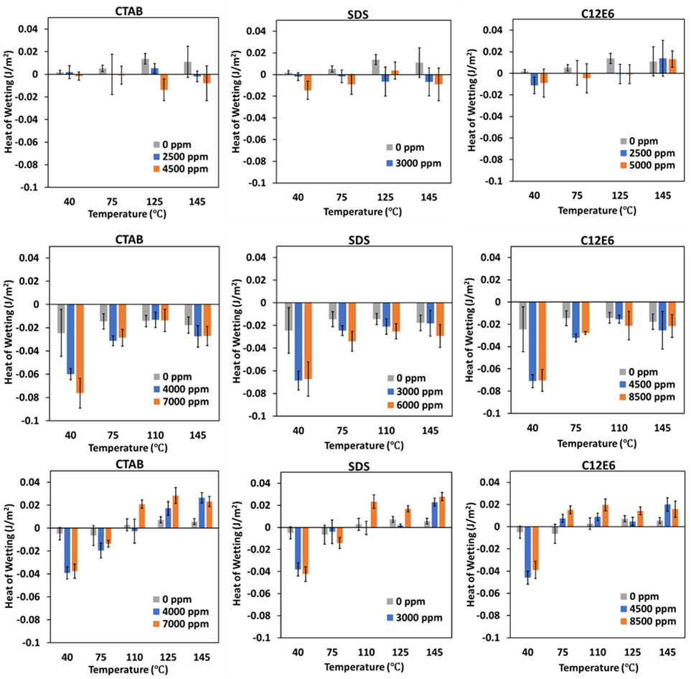
Figure 3.2.1. Heat of immersion for the three silicas with added surfactant. From top to bottom R974, R300 and R380. The amounts correspond to the added surfactant.
Using the average values of the silica and water amounts, plus the known maximum adsorption from the measured adsorption isotherms, the concentration in solution at 40°C after adsorption appears in Table 3.2.1. The ones less than CMC are calculated by an iterative approach. The concentration in solution after adsorption was guessed, then the moles of surfactant adsorbed per unit weight assuming this concentration in solution was read from the graph. Using the amount adsorbed, the weight of solid and the volume of water, the added surfactant concentration was calculated and iteration was complete when the added concentration matched the value in Table 3.2.1.
Silica | Surfactant/Added Concentration | Concentration after adsorption (mM) | Concentration after adsorption (xCMC)
R974 | SDS/3000 ppm | 4.73 | 0.59
R974 | SDS/6000 ppm | 15.22 | 1.90
R974 | CTAB/2500 ppm | 2.05 | 2.05
R974 | CTAB/4500 ppm | 7.54 | 7.54
R974 | C12E6/2500 ppm | 0.0395 | 0.44
R974 | C12E6/5000 ppm | 5.18 | 57.56
R300 | SDS/3000 ppm | 6.86 | 0.86
R300 | SDS/6000 ppm | 14.94 | 1.87
R300 | CTAB/4000 ppm | 5.93 | 5.93
R300 | CTAB/7000 ppm | 14.16 | 14.16
R300 | C12E6/4500 ppm | 3.86 | 42.89
R300 | C12E6/8500 ppm | 12.65 | 140.56
R380 | SDS/3000 ppm | 6.61 | 0.83
R380 | SDS/6000 ppm | 14.74 | 1.84
R380 | CTAB/4000 ppm | 5.76 | 5.76
R380 | CTAB/7000 ppm | 13.99 | 13.99
R380 | C12E6/4500 ppm | 3.64 | 40.44
R380 | C12E6/8500 ppm | 12.44 | 138.22
Table 3.2.1. Concentrations after adsorption of surfactant. Concentrations above the CMC would be expected to have the same heat of immersion.
For R380 silica, the enthalpy of immersion goes from exothermic to endothermic as temperature increases for all three surfactants; at high temperatures the heat of immersion is approximately constant. As opposed to water, at low temperatures the heat of immersion is more exothermic than water and becomes more endothermic than water at high temperatures. For R300 silica, the heat of immersion goes from exothermic to less exothermic as temperature increases for all three surfactants; the enthalpy of immersion is approximately constant at all temperatures except for 40°C. As opposed to water, the heat of immersion is more exothermic than water at low temperatures and becomes similar to water at high temperatures. Comparing R300 to R380, both show the same qualitative behavior of a ~0.06 J/m² increase in endothermicity as the temperature increases with a plateau at high temperatures, but the magnitude of the exothermicity at 40°C for R300 is much larger (about -0.040 J/m² vs. -0.075 J/m²) with added surfactant. The constant qualitative changes suggests that the amount of surfactant as well as the type of adsorption (e.g., monolayer vs. bilayer). For R974 silica, the enthalpy of immersion is approximately equal to zero regardless of the surfactant concentration or the temperature. Hence, the data seems to suggest bilayer adsorption for the two hydrophilic silica and monolayer adsorption for the hydrophobic silica.
Figures 3.2.2 to 3.2.4 shows adsorption isotherm for three surfactant solutions. For CTAB, R380 adsorbs the same amount of molecules as R300 and less than R974. Three silicas adsorb similar amounts in SDS solutions. For C12E6, the order of adsorbed molecule amount from most to least is R300>R380>R974. As noted earlier, CTAB has significantly more adsorption on a given silica vs. SDS which we attribute to the like charge of the SDS and silica surface. Also, because R974 is hydrophobic monolayer adsorption was expected, but the calculated surface area for all three surface areas, especially for CTAB are much too high vs. the manufacture reported 200m²/g measured by N₂ adsorption.
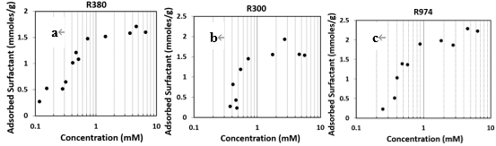
Figure 3.2.2. Adsorption isotherm of CTAB adsorbed by (a) R380, (b) R300, and (c) R974 silicas at 40℃.
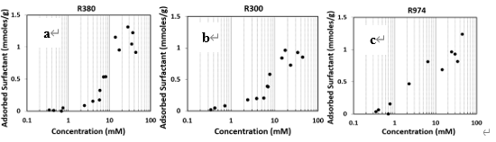
Figure 3.2.3. Adsorption isotherm of SDS adsorbed by (a) R380, (b) R300, and (c) R974 silicas at 40℃.
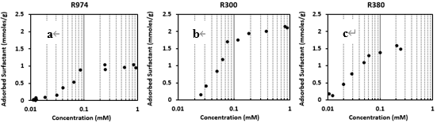
Figure 3.2.4. Adsorption isotherm of C12E6 adsorbed by (a) R380, (b) R300, and (c) R974 silicas at 40℃.

Chapter 4. Conclusion and Recommendations
We have shown that the heat of immersion method works at elevated temperatures and pressures. Qualitatively a more negative heat of immersion at a given temperature equals smaller contact angle; however the quantitative agreement is lacking. No justification exists for using a value for the change in solid surface energy with temperature that was found for very hydrophobic surfaces; however using the correct value and ignoring the change in solid-liquid interfacial energy with temperature gives contact angle values that are clearly incorrect. Qualitatively, we do believe that using the heat of immersion as a measure of wetting is appropriate.
Increasing temperature makes the heat of immersion less exothermic if the heat of immersion is exothermic. The addition of anionic, cationic and nonionic surfactants make the heat of wetting more exothermic in the case of the more hydrophilic surfaces, with very little effect on the hydrophobic surface. As with pure water, increasing the temperature causes the heat of immersion to become less exothermic, however in one case the heat of immersion clearly becomes endothermic with surfactant.
According to Equation 9, contact angle value can’t be calculated without the derivative of silica/water surface tension with temperature. However, nobody reported for three silicas before. The previous paper[1] in our group shows $\frac{dγ_{SL}}{dT}$ =0 because of the low energy surface. But whether $\frac{dγ_{SL}}{dT}$ is still equal to zero when silica in surfactant solutions can’t be verified. So, $γ_{SL}$for silica in surfactant solutions need to be measured. Then three silicas contact angle can be calculated by Equations 9 and 10.

REFERENCES
1. Weston, J.S., et al., Silica Nanoparticle Wettability: Characterization and Effects on the Emulsion Properties. Industrial & Engineering Chemistry Research, 2015. 54(16): p. 4274-4284.

2. Mondal, S., M. Phukan, and A. Ghatak, Estimation of solid–liquid interfacial tension using curved surface of a soft solid. Proceedings of the National Academy of Sciences, 2015. 112(41): p. 12563-12568.

3. Law, K.Y., Zhao, H., Surface Wetting: Characterization, Contact Angle, and Fundamentals. 1st ed. 2016, New York: Springer.

4. Erbil, H.Y., The debate on the dependence of apparent contact angles on drop contact area or three-phase contact line: A review. Surface Science Reports, 2014. 69(4): p. 325-365.

5. Chau, T.T., A review of techniques for measurement of contact angles and their applicability on mineral surfaces. Minerals Engineering, 2009. 22(3): p. 213-219.

6. Kwok, D.Y. and A.W. Neumann, Contact angle measurement and contact angle interpretation. Advances in Colloid and Interface Science, 1999. 81(3): p. 167-249.

7. Alghunaim, A., S. Kirdponpattara, and B.M.Z. Newby, Techniques for determining contact angle and wettability of powders. Powder Technology, 2016. 287: p. 201-215.

8. Chibowski, E. and R. Perea-Carpio, Problems of contact angle and solid surface free energy determination. Advances in Colloid and Interface Science, 2002. 98(2): p. 245-264.

9. Kadyrov, R., I. Mukhamatdinov, and E. Statsenko, Determination of Sessile Drop Wetting Angle Based on μCT without the Direct Angle Measurement. Langmuir, 2023.

10. Tyowua, A.T. and S.G. Yiase, Contact angle hysteresis–advantages and disadvantages: a critical review. Progress in Adhesion and Adhesives, 2021. 6: p. 47-67.

11. Marquez, M., B.P. Grady, and I. Robb, Different methods for surface modification of hydrophilic particulates with polymers. Colloids and Surfaces a-Physicochemical and Engineering Aspects, 2005. 266(1-3): p. 18-31.

12. Campbell, D., S.M. Carnell, and R.J. Eden, Applicability of Contact Angle Techniques Used in the Analysis of Contact Lenses, Part 1: Comparative Methodologies. Eye & Contact Lens, 2013. 39(3): p. 254-262.

13. Yan, N.X., et al., Measurement of contact angles for fumed silica nanospheres using enthalpy of immersion data. Journal of Colloid and Interface Science, 2000. 228(1): p. 1-6.

14. Adamson, A.W. and A.P. Gast, Physical Chemistry of Surfaces. sixth ed. 1997, New York: Wiley-Interscience.
15. Adamson, A.W.L.I., The status of contact angle as a thermodynamic property. Advances in Chemistry Series, 1964. 43: p. 57-73.

16. Neumann, A.W., Contact angles and their temperature dependence: thermodynamic status, measurement, interpretation and application. Advances in Colloid and Interface Science, 1974. 4(2): p. 105-191.

17. Grajek, H., J. Paciura-Zadrożna, and Z. Witkiewicz, Chromatographic characterisation of ordered mesoporous silicas: Part I. Surface free energy of adsorption. Journal of Chromatography A, 2010. 1217(18): p. 3105-3115.

18. Holysz, L., The effect of thermal treatment of silica gel on its surface free energy components. Colloids and Surfaces a-Physicochemical and Engineering Aspects, 1998. 134(3): p. 321-329.

19. Rubio, F., J. Rubio, and J.L. Oteo, Effect of the measurement temperature on the dispersive component of the surface free energy of a heat treated SiO2 xerogel. Journal of Sol-Gel Science and Technology, 2000. 18(2): p. 115-118.

20. Wang, M.J., S. Wolff, and J.B. Donnet, Filler elastomer interactions. 1. Silica surface energies and interactions with model compounds. Rubber Chemistry and Technology, 1991. 64(4): p. 559-576.

21. Wang, M.-J., S. Wolff, and J.-B. Donnet, Filler-elastomer interactions. Part I: Silica surface energies and interactions with model compounds. Rubber chemistry and technology, 1991. 64(4): p. 559-576.

22. Rosen, M.J., Surfactants and Interfacial Phenomena. 3rd ed. 2004, Hoboken, New Jersey: John Wiley & Sons.

23. Gu, G.X., et al., Observation of micelle formation and micellar structural transition from sphere to rod by microcalorimetry. Journal of Colloid and Interface Science, 1996. 178(2): p. 614-619.

24. Corkill, J.M., J.F. Goodman, and S.P. Harrold, Thermodynamics of micellization of non-ionic detergents Transactions of the Faraday Society, 1964. 60(4931): p. 202-207.

25. Vargaftik, N., B. Volkov, and L. Voljak, International tables of the surface tension of water. Journal of Physical and Chemical Reference Data, 1983. 12(3): p. 817-820.

26. Muster, T.H., C.A. Prestidge, and R.A. Hayes, Water adsorption kinetics and contact angles of silica particles. Colloids and Surfaces A: Physicochemical and Engineering Aspects, 2001. 176(2-3): p. 253-266.

27. Peri, J. and A. Hensley Jr, The surface structure of silica gel. The Journal of Physical Chemistry, 1968. 72(8): p. 2926-2933.

28. Siddiqui, M.A.Q., et al., Current understanding of shale wettability: A review on contact angle measurements. Earth-Science Reviews, 2018. 181: p. 1-11.
29. She, H.Y. and B.E. Sleep, The effect of temperature on capillary pressure‐saturation relationships for air‐water and perchloroethylene‐water systems. Water Resources Research, 1998. 34(10): p. 2587-2597.

