UNIVERSITY OF OKLAHOMA
GRADUATE COLLEGE

EEG INVESTIGATIONS OF CREATIVITY IN ENGINEERING AND ENGINEERING DESIGN

A THESIS
SUBMITTED TO THE GRADUATE FACULTY
in partial fulfillment of the requirements for the
Degree of
MASTER OF SCIENCE

By
TESS HARTOG
Norman, Oklahoma
2021

EEG INVESTIGATIONS OF CREATIVITY IN ENGINEERING AND ENGINEERING DESIGN

A THESIS APPROVED FOR THE
SCHOOL OF AEROSPACE AND MECHANICAL ENGINEERING

BY THE COMMITTEE CONSISTING OF

Dr. Zahed Siddique, Chair
Dr. Chung-Hao Lee
Dr. D. Keith Walters

© Copyright by TESS HARTOG 2021
All Rights Reserved.

ACKNOWLEDGEMENTS
This material is based upon work supported by the National Science Foundation under Grant No. 1561660 and 1726358, 1726811, and 1726884. Any opinions, findings, and conclusions or recommendations expressed in this material are those of the author(s) and do not necessarily reflect the views of the National Science Foundation.

I would also like to thank my advisor and committee chair, Dr. Zahed Siddique, as well as my lab partners Amin G. Alhashim, Md Tanvir Ahad, and Megan Marshall for their assistance, feedback, and overall help in conducting these experiments. Additionally, I thank the other members of my committee Dr. Chung-Hao Lee and Dr. Keith Walters. A special thank you goes out to Dr. Rafał Jończyk for his assistance.

I am grateful to have had the opportunity to combine many of the subjects that I am passionate about (engineering, mathematics, psychology, and neuroscience) during the extent of my Master’s program, both in the classes I’ve taken and the research I’ve conducted.

Lastly, I especially want to thank my family, specifically my dad. His hard work throughout life and his support has allowed me to be where I am today. I am very grateful for all he has done.

ABSTRACT
Creativity has been in steady decline since the 1990s. This is an area of significant concern because creative ability is considered to be among the most important skills for national prosperity in the 21st century. Action needs to be taken to reverse this decline in creativity and engineers in particular should be included in these efforts because they are often faced with coming up with innovative solutions to many of our modern-day problems, such as addressing climate change through green engineering and improving global health and well-being via nanotechnologies and bioengineering. The National Academy of Engineering has specifically noted that there is a need for training creative, as well as competent, engineers. But, students graduating from engineering fields are lacking creative ability even though creativity and innovation are hallmarks of engineering.
Some neuroimaging studies have been conducted to investigate the neurological side of creativity in engineers. Many of these studies focus on areas of the brain that are active during design tasks, ideation, or concept generation. Another way of investigating creativity is through the use electroencephalography (EEG). EEG is a temporal, rather than spatial technique, so it is often used to examine different bands of brain activity, such as alpha band (8-13 Hz), during different tasks. However, there is another EEG technique known as event-related potential (ERP) that has not been utilized extensively. ERPs are useful signals that are time-locked to a stimulus and provide a step-by-step visualization of brain processes at each electrode during a trial while also providing high, millisecond-scale temporal resolution of brain activity.
Given these shortcomings, this research poses two primary research questions: 1) “Is the N400 component of engineers modulated when assessing the novelty and appropriateness of an item function?” and 2) “How does exposure to ideas via an Object-Function Relationship Task (OFRT) impact alpha band activity during design problem ideation?” From these two questions, there were two corresponding experiments conducted to answer them. One utilizes the methodology of a previous study and, because research in the area is limited, narrows down the general focus to investigate results from individuals solely in engineering. This experiment will examine the N400 and post-N400 ERP components of engineers – these are the negative peaking potentials around 300-500ms and 500-900ms post-stimulus, respectively. These ERPs are investigated via OFRTs, which is similar to an alternative usage task (AUT) but with specific differences. While recording EEG, the participant is shown a word of an object in conjunction with a potential function for that object. The participant then decides if the given function is novel and appropriate by pressing corresponding buttons. By doing this, they are selecting which of three categories (common, creative, or nonsense) they believe the item/function pair belongs in.
The second is a design problem and design ideation experiment that consists of a two-part trial entailing design problems and the OFRT as an intervention. That is, OFRT will be presented either before or after the design problem. Then, because this is a two-part design, the order of presentation is switched later on. This experiment will examine the alpha band activity of participants while coming up with solutions to design problems. Participants will be given a design problem and, while EEG is recorded, will ideate solutions to a given situation. After fully ideating a design, the participant then sketches the design and will move on to the next ideation phase for a different solution, if they have another.
After experimentation, conclusions about the primary questions were drawn. With respect to Question 1), the N400 component of engineers is not significantly modulated when assessing novelty and appropriateness of an item function. Even though these results are not significant, the averaged N400 potentials followed similar trends to those found in literature. With respect to the Question 2), there were significant increases in alpha band activity and power when the OFRT was presented before a design task.
Overall, the aim of this research is to investigate the neuro-responses of engineers via the OFRT and during design ideation. The proposed research, in terms of the OFRT study, will be the first of its kind with respect to engineering. The other half of this research is also unique and will provide insight in to creativity to better understand the neuro-responses of engineers. However, it is important to note that these experiments can be thought of as pilot studies rather than full-scale experiments due to the small number of participants. This limitation and inability to recruit a larger number of participants was due to the conditions, most notably the pandemic. In the future, there is potential to conduct a large-scale study as well as different type of experiments concerning creativity in engineering.

TABLE OF CONTENTS

CHAPTER 1: CREATIVITY, NEUROSCIENCE, AND THEIR RELEVANCE TO ENGINEERING 1
1.1: NEED FOR CREATIVITY IN ENGINEERING 1
1.2: RESEARCH QUESTIONS AND HYPOTHESES 3
1.3: THESIS OVERVIEW 5
1.4: CHAPTER 1 SUMMARY 7

CHAPTER 2: UNDERSTANDING CREATIVITY, NEUROSCIENCE, AND THE CURRENT SITUATION OF THE TWO IN ENGINEERING 9
2.1: DEFINING CREATIVITY 9
2.2: ASSESSING CREATIVITY 11
2.3: DEFINING CREATIVITY FOR THIS RESEARCH 16
2.4: NEUROIMAGING AND NEURO-SCIENTIFIC APROACHES 17
2.4.1: FUNCTIONAL MAGNETIC RESONANCE IMAGING (fMRI) 18
2.4.2: ELECTROENCEPHALOGRAPHY (EEG) AND EVENT-RELATED POTENTIALS (ERPs) 18
2.5: LITERATURE REVIEW: HOW NEUROIMAGING HAS BEEN USED ALONGSIDE ENGINEERING-TYPE PROBLEMS 21
2.5.1: fMRI 21
2.5.2: EEG and ERP 22
2.6: GAPS IN NEUROSCIENFITIC STUDIES OF CREATIVITY IN ENGINEERING 25
2.7: CHAPTER 2 SUMMARY 26

CHAPTER 3: PILOT STUDIES TO INVESTIGATE EEG BASED NEURO-RESPONSES OF ENGINEERS 27
3.1: EQUIPMENT 27
3.2: EXPERIMENTAL PROCEDURE 29
3.3: PARTICIPANTS 29
3.4: STUDY 1: ERP INVESTIGATIONS OF THE OFRT 30
3.4.1: RATIONALE 30
3.4.2: PROCEDURE 31
3.4.3: SIGNAL ANALYSIS TECHNIQUES 34
3.5: STUDY 2: EFFECTS OF EXPOSURE TO IDEAS VIA THE OFRT 35
3.5.1: RATIONALE 35
3.5.2: PROCEDURE 37
3.5.3: DESIGN SCORING 40
3.5.4: SIGNAL ANALYSIS TECHNIQUES 41
3.6: CHAPTER 3 SUMMARY 42

CHAPTER 4: RESULTS AND DISCUSSION 43
4.1: STUDY 1 RESULTS 43
4.1.1: N400 45
4.1.2: Post-N400 46
4.2: STUDY 2 RESULTS 47
4.4 CHAPTER 4 SUMMARY 52

CHAPTER 5: CONCLUSIONS AND FUTURE DIRECTIONS 53
5.1: SUMMARY OF RESEARCH 53
5.1.1: CRITICAL EVALUATION OF HYPOTHESES 54
5.2 ADVANTAGES AND LIMITATIONS 55
5.3: FUTURE WORKS 57
5.4: CHAPTER 5 SUMMARY 58

REFERENCES 60
ACRONYMS 71
APPENDIX 72
Dataset used in Study 1 72
A Design Problem Used in Study 2 74
A Design Problem Used in Study 2 75

LIST OF TABLES
Table 1 - Stimulus presentation order in Kröger et al. (2013) versus the current study 32
Table 2 - Example of item and the three function types with expected participant responses 34
Table 3 - Design problem presentation order and condition order 39
Table 4 - Summary of evaluator ratings 41

LIST OF FIGURES
Figure 1 - Thesis Map 6
Figure 2 - Rhode's Four P's 12
Figure 3 - Measures of creativity using the process-based approach 15
Figure 4 - Mobile EEG cap with 24 channels. 19
Figure 5 - Electrode Layout 28
Figure 6 - Study 1 Experiment Design 33
Figure 7 - Study 2 Experiment Design 37
Figure 8 - Depiction of epoch window 42
Figure 9 - Grand Average ERP images for selected electrodes (Cz, CPz, Pz, and POz). 44
Figure 10 -Mean amplitudes from four electrodes (Cz, CPz, Pz, and POz) of all three conditions (Common, Creative, and Nonsense) in the 300-500ms time window. 45
Figure 11 - Mean amplitudes from four electrodes (Cz, CPz, Pz, and POz) of all three conditions (Common, Creative, and Nonsense) in the 500-900ms time window 46
Figure 12 - Individual time-frequency analyses for both conditions. 48
Figure 13 – Averaged time-frequency analysis for both conditions. 49
Figure 14 - Statistical analysis of averaged time-frequency data between conditions 51
Figure 15 - Time frequency analysis and statistical analysis limited to the 8 to 13 Hz range. 51

CHAPTER 1: CREATIVITY, NEUROSCIENCE, AND THEIR RELEVANCE TO ENGINEERING

1.1: NEED FOR CREATIVITY IN ENGINEERING
Even though intelligence has been on the rise since the 1990s (as measured by IQ and SAT scores), creativity has been in steady decline (Kim, 2011; Kim & Pierce, 2013). This is an area of significant concern because creative ability is considered to be among the most important skills for national prosperity in the 21st century (Florida, 2014; IBM News Room, 2010). Action needs to be taken to reverse this decline in creativity. Engineers in particular should be included in these efforts because they are often faced with generating innovative solutions to many of our modern-day problems, such as addressing climate change through green engineering and improving global health and well-being via nanotechnologies and bioengineering (Cropley, 2015; Career Explorer, 2018). In fact, the National Academy of Engineering has noted that there is a need for creative, as well as competent, engineers (National Academy of Engineering, 2004; Olson, 2013). This desire for creative engineers has been around since before the 1960s (Sprecher, 1959; Jones, 1964; McDernid, 1965) and has continued to be a desirable aspect (Bleedorn, 1986; Parkhurst, 1999).
In spite of this demand, it appears that higher education is not adequately preparing students for this type of thinking and students graduating from engineering fields are lacking creative ability (Foley & Kazerounian, 2007; Cropley, 2016). Surveys from the University of Connecticut found that students believed instructors focus too much on the use of conventional solutions to problems rather than novel solutions and found that the curriculum taught lacks creativity (Foley & Kazerounian, 2007). Similarly, another study reported that as students moved further down their engineering paths, they believed there was little value placed on creativity (Masters, Hunter, & Okudan, 2009). A multitude of other studies and investigations found that the engineering discipline has become more focused on rote memorization and learning as well as convergent thinking as opposed to other, more innovative approaches (Olson, 2013; Adams, Kaczmarczyk, Picton & Demian, 2007; Cropley, 2015; Duderstadt, 2007; Dym et al. 2005; Felder, 1988; Plucker, Beghetto & Dow, 2004; Santamarina, 2003; Stratton, Mann & Otterson, 2000; Törnkvist, 1998). Creativity and innovation are trademarks of engineering and creativity is considered to be an imperative prerequisite to innovation, which means that a decline in creative ability will correspond to a decline in the number of innovative engineers (Rhodes & Donaldson, 2008; Richards, 1998).
Creativity is a cornerstone of engineering disciplines, so understanding creativity and how to enhance creative abilities through engineering education has received substantial attention. More information is needed, though, and this supplemental information can be provided by neuroscience. Using neurological approaches, researchers can gain a better understanding of creativity since they can link physiological aspects to stimuli or prompts related to creativity. Fields outside of engineering are no stranger to neuro-investigations of creativity and, although some neuro-response studies have been conducted to understand creativity in engineering, there are more avenues that need to be explored. Specifically, there are gaps in research with respect to temporal methodologies and the different temporal techniques that can be used. Presented with these gaps, this research will utilize neuroscientific based approaches to explore underrepresented techniques to gain a better understanding of creativity in engineering.

1.2: RESEARCH QUESTIONS AND HYPOTHESES
In order to develop neuroscientific techniques to measure creativity, more research is needed to understand brain processes and components related to creativity, especially in an engineering context. Previous research has been conducted to explore the connection between the creative process of conceptual expansion and the N400 (an electrical signal in the brain with a negative amplitude occurring between 300-500ms post-stimulus) and post-N400 (an electrical signal in the brain with a negative amplitude occurring between 500-900ms post stimulus) components using a modified Alternative Uses Task (AUT) in a general population of undergraduate students (Kröger et al., 2013). However, the connection between conceptual expansion and the N400 event-related potential (ERP) has not been explored exclusively in engineers. Determining mapping of functions and objects is a key step in the conceptual design phase of engineering design process. This leads to the first primary question addressed in this research.

Primary Question 1: Is the N400 component of engineers modulated when assessing the novelty and appropriateness of an item function via an Object-Function Relationship Task (OFRT)?
Primary Hypothesis 1: The perceived novelty and appropriateness of an item function will significantly modulate the N400 component with the largest negative values associated with unusual-inappropriate (nonsense) functions and the least negative values associated with the usual-appropriate (common) function.

Additionally, there is much interest in improving creativity. Some studies have shown that a simple presentation of a high number of ideas positively impacts the number of ideas generated and the uniqueness of ideas generated (Dugosh, Paulus, Roland & Yang, 2000; Dugosh & Paulus, 2005). But, the previous research results about exposure to ideas before ideation are generally scattered and non-consistent. Furthermore, neuroimaging has not been used alongside these studies. Given this seperation, it is of interest to examine the neurological changes that occur when engineers are exposed to ideas before or after a design problem. This leads to the second primary question of this research.

Primary Question 2: How does exposure to ideas via the Object-Function Relationship Task (OFRT) impact alpha band activity during design problem ideation?
Primary Hypothesis 2: Exposure to the OFRT before a design task will lead to increased alpha band activity and power during design ideation.

To test the first hypothesis, an experiment utilizing ERP was implemented. The experimental procedure was replicated from a previous scholarly article that employed a modified AUT. In order to avoid confusion with a typical AUT, this task is referred to as the Object-Function Relationship Task (OFRT) through this thesis. The current study narrows the general focus of the previous work to investigate results of individuals solely from the field of engineering. The main focus here is investigation of the N400 component, but the post-N400 components will be analyzed due to its links to interpretation, comprehension, and cognitive computations. By assessing the type of function (common, creative, or nonsense), the N400 ERP is impacted. This research is important because essentially no work has been done to understand the ERPs of engineers, especially with its relatedness to creativity or novelty. More about previous works and the current study at hand are discussed in Section 2.5.2 and throughout Chapter 3 (known as Study 1), correspondingly.
In order to test the second hypothesis, a multi-part, within-subjects experiment was designed. This experiment includes ideating and sketching designs either before or after being exposed to various ideas via the OFRT. The main focus here is to examine alpha band activity and investigate any changes in alpha power during design ideation for two conditions. More details about the two conditions (control and experimental) are found in Chapter 3, Section 3.5. This experiment, later referred to as Study 2, and ones similar to it are also discussed in detail in Chapter 3.
The main outcome of this thesis is to answer the two primary questions in order to further understand the cognitive processes and components related to creativity in an engineering context. The generated hypotheses are based upon substantiated literature and are critically evaluated at the end of this thesis. Secondary outcomes include successfully testing an ERP experiment on engineers and relating those ERPs to creativity and novelty as well as understanding how exposure to creative ideas either before or after a design problem influences alpha band activity and design creativity.

1.3: THESIS OVERVIEW
As this thesis follows the steps of the scientific method, the scientific method can be used as a map to provide a guide to the overall organization of this thesis. In Figure 1 is presented this map, along with the key objectives of each chapter and section.
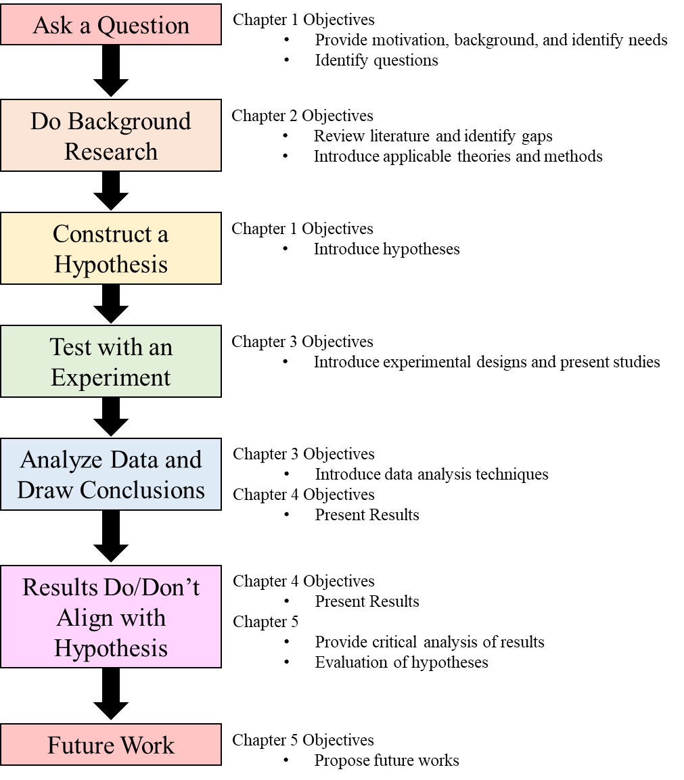
Figure 1 - Thesis Map

In Figure 1, Chapter 1 maps to two steps of the scientific methods: “Ask a Question,” and “Construct a Hypothesis.” This chapter includes a brief introduction to creativity and the need for it in engineering. This is presented to identify the needs for neuroscientific approaches in creativity research, particularly in the field of engineering, and provide motivation for this research. By the end of this chapter, specific questions for investigation are posed and hypotheses theorized.
Chapter 2 maps to “Do Background Research”. This chapter consists of many topics essential for this research. This includes creativity definitions, assessments, neuroimaging methods, and a literature review. This review lays the foundation for this research, providing scope, boundaries, and detailing the identification of gaps in knowledge.
Chapter 3 details the experiments’ designs. This maps mainly to step four of the scientific method: “Test with an Experiment.” The participants, methodologies, and analysis techniques are thoroughly described for each study. The information here is also useful to the next step that involves analysis.
In Chapter 4, the results of the experiment are presented and discussed. This maps to step five. The statistical methods for examining each of the studies is presented as well as all relevant statistical data.
Chapter 5 presents a discussion of the results. In Figure 1, this maps to steps six and seven: “Results Do/Don’t Align with Hypothesis” and “Future works” A critical evaluation of the hypotheses is provided and a final look at the overall contributions and outcomes of this research is also included. Finally, future work is proposed.

1.4: CHAPTER 1 SUMMARY
Chapter 1 was an introduction to creativity and the need for it in engineering. There is a need to utilize neuroscientific techniques alongside experiments related to creativity in order to quantify it and better understand it. While there are many gaps and potential investigations, two research questions were posed in Section 1.2. This research has focused on understanding the N400 component of engineers as well as the presenting ideas to engineers via an OFRT to engineers and its impact on engineering design. It is hypothesized that, with respect to the N400, modulation would occur with largest negative values associated with unusual-inappropriate (nonsensical) stimuli and smallest negative or positive values associated with usual-appropriate (common) stimuli. For the other research question, it is hypothesized that presentation of the OFRT before a design task will lead to increased alpha band activity and power during design ideation. Section 1.3 presented a layout of this thesis. The overall objective of this chapter was to present enough details to sufficiently motivate and explain the purpose of this research. The following chapters provide more detail on previous works, neuroscientific methods, and creativity itself.

CHAPTER 2: UNDERSTANDING CREATIVITY, NEUROSCIENCE, AND THE CURRENT SITUATION OF THE TWO IN ENGINEERING
How is creativity defined and how is it measured? What is electroencephalography (EEG)? What has previous research in this area found? In this chapter, these questions and more are explored. In Section 2.1, creativity and its definitions are examined. Specifically, the necessary components for creativity are pointed out. Next, Section 2.2 details various types of creativity and the ways to measure them. After creativity and creativity measures have been discussed, it is then appropriate to set a definition for creativity as it pertains to this research (Section 2.3). Sections 2.4 then introduces neuroscientific techniques and how previous studies have utilized them in the past, with an emphasis on studies related to engineering or design (Section 2.5). The chapter will then conclude with an evaluation and reiteration of gaps in the literature (Section 2.6) and a chapter summary (Section 2.7).

2.1: DEFINING CREATIVITY
Understanding creativity is not an easy task – in fact, it is extremely complex. Part of this is due to years of redefining and refining the definition, different types of creativity, and the many ways of evaluating it. Additionally, creativity is contingent on multiple variables and assumptions. These complexities and intricacies have not stopped researchers form exploring it, though. Because creativity is essential to engineering disciplines, knowing how to enhance creative abilities through engineering education has been a topic of interest. However, before these measures can be implemented in a classroom setting, the basics of creativity must be understood.
The definition of creativity itself is still up for debate. An early definition from Gilford (1950) characterized creativity as the “sensitivity to problems, fluency and flexibility of thinking, originality, ability to analyze and synthesize, and the ability to redefine things”. A relatively well-known definition from Amabile (1988) states that creativity is “the production of a novel and useful ideas by an individual or small group of individuals working together”, focusing on the ideas as the main creative product. On the other hand, Plucker, Beghetto, and Dow (2004) defined creativity as “the interaction among aptitude, process, and environment by which an individual or group produces a perceptible product that is both novel and useful as defined within a social context”. Plucker, Beghetto, and Dow (2004) take things like the environment and group interactions in to consideration with this definition, making things even more complicated. While an entire paper could be written just about different definitions of creativity, these are just a few of the many of definitions given for creativity. In fact, papers have been written only looking at creativity definitions. See Puryear and Lamb (2020) for a review of creativity definitions from 600 articles and an older review from Plucker, Beghetto, and Dow (2004) evaluating the term “creativity” across peer-reviewed journal articles.
Alongside a plethora of definitions, there are different types of creativity. It might be overlooked, but it is quite obvious that something considered creative in art or music is not going to be equivalent to something that is considered creative in science of technology. This is an important aspect to consider when trying to understand or measure creativity. For instance, in the music realm, creativity can be tied to performance techniques, composition, novel use of rhythm, beat, or pitch, improvisation, and expression. On the other hand, scientific creativity is tied to ground-breaking ideas, discoveries, and theories (Abraham, 2018).
Given the types of creativity and diverse definitions, one commonality throughout is novelty. Generally speaking, when something is said to be creative it is new, novel, or original. Indeed, this is the main factor of in defining creativity (Runco & Jaeger, 2012). But, this aspect alone is not enough to sufficiently define creativity. There is another important factor that must be taken in to consideration – appropriateness. This aspect is not always present in definitions, as seen above, but it is imperative. After all, what use is a novelty if it cannot be utilized in an appropriate way? Given this, a solution or idea must be appropriate. That is, it must be relevant, fitting, and valuable, in order for it to be useful, effective, or feasible (Abraham, 2018). This definition proposed by Abraham (2018) and its two key aspects are important to keep in mind for later as it is imperative to define “creativity” as it pertains to this thesis and forms the basis for creativity for this research.

2.2: ASSESSING CREATIVITY
Given some definitions for creativity, it is also important to understand how it is assessed. This is another task in itself to narrow down exactly which factor is being evaluated. Rhode’s four P’s of creativity lays our four different approaches that can be taken when investigating creativity (1961). This includes person, product, process, and press/place, as seen in Figure 2.

Figure 2 - Rhode's Four P's

The person approach involves studying the creativity of the person generating ideas and focuses on individual factors that impact creative ability. This involves analyzing specific characteristics of a person, like personality, intelligence, values, behavior, and habits. The process approach aims at uncovering the mental operations that are involved when coming up with creative ideas. This can be evaluated from two ways: stages of the creative process or components of the creative process. The product approach evaluates creativity via the output from a creative engagement. Usually this output is measured in terms of quantitative or qualitative levels of creativity. The last of the Four P’s is press/place, which focuses on the environment and environmental factors that influence creative ability.
Each P, except for press/place, has its own way of evaluating creativity. For the person approach, typically divergent thinking tests or self-report measures are used. Divergent thinking tasks aim to give an overall creativity score and/or sub-scores that measure specific creativity-related factors, like fluency (the number of ideas) or originality (uniqueness of ideas). These tasks are called divergent thinking tasks because they are open-ended, have no correct answer, and can have a variety of possible responses. Quantitative information is then derived from the qualitative, subjective responses.
The most popular of these tasks is the Torrance Tests of Creative Thinking (TTCT). Stemming from Guilford (1950) who proposed factors like fluency, originality, and flexibility (category shifts in ideas) were crucial to divergent production and creativity, Torrance (1974) developed a series of verbal and non-verbal tasks and assess four levels similar to Guilford: fluency, originality, flexibility, and elaboration (details in the idea). Beyond Guilford, though, later versions of the TTCT also judges creative qualities like expressiveness, synthesis, fantasy, humor, and visualization. Examples of tasks include the Unusual Uses task, where participants are asked to generate the most interesting and most unusual uses of the given toy other than as a plaything and the Product Improvement Task, where participants are asked how they would improve a toy.
There are several self-report measures for measuring creativity in the person approach. The Creativity Domain Questionnaire (Kaufman et al. 2010) measures an individual’s subjective belief about their level of creativity in different domains, like math/science, artistic domains, and problem solving/interaction. Another is the Creative Behavior Inventory (Hocevar, 1979). This provides an inventory of a person’s creative behavior and accomplishments. It asks participants to indicate their involvement in various creative activities, e.g. made a sculpture or made a leather craft, using a four-point scale (“never did this” to “did this more than five times”). The most popular self-report measure, though, is the Creative Achievement Questionnaire (Carson, Peterson & Higgins, 2005). In this measure, creative achievement is self-appraised across 10 domains, such as visual art, music, architectural design, and inventions. Each domain has questions weighted with a score from zero to seven. Depending upon the question, the score is multiplied by the number of times the task has been accomplished. Overall, this questionnaire provides a domain score and an individual creative achievement score.
Assessing creativity at the process level requires utilizing a different set of tests and tasks. Unlike divergent thinking tasks, convergent thinking tasks have a correct answer and require some sort of problem-solving strategies. One such test is the Remote Associations Test (RAT), where participants are given three unrelated words (e.g., print, berry, bird) and asked to identify a fourth word (e.g., blue) that relates to each of the three words individually (e.g., blueprint, blueberry, bluebird). Convergent thinking tasks also take the form of riddles, mathematical and geometrical problems, and manipulative problems, like the Tower of Hanoi which asks participants to move three rings in as few moves as possible from one tower to another following a set of rules (Abraham, 2018).
Other methods for calculating process level creativity involves process-general and process-specific divergent thinking tasks. Here, “process-general” means general creative capacity or creative potential of an individual. An example of a task here is the Alternate Uses Task (AUT). Here, participants are asked to generate as many alternative uses as possible for a common object such as a pen. On the other hand, “process-specific” is related to gauging different components of the creative process, like conceptual expansion, creative imagery, and overcoming constraints. Tasks here include things like drawing an animal that lives on a different planet, creating a vehicle out of 3D cones, spheres, and crosses, as well as designing something novel after being shown examples, respectively. See Figure 3 for summary of the process-based measures.
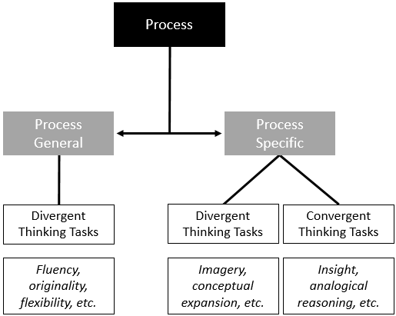
Figure 3 - Measures of creativity using the process-based approach. From Abraham (2018).

Lastly, for the product approach, there is one dominant method for judging creativity. Known as the Consensual Assessment Technique (CAT), it evaluates products based on expert observers/raters and their agreement/consensus (Amabile, 1982). Expert rating can be done in a variety of ways due to its ability to be adopted in to any field or any context, from stories to mathematical equations to musical compositions. This also means that the scoring procedure is not consistent throughout. Scoring could be done via ranking designs from most to least creative, the Guilford method of evaluating fluency, flexibility, originality, and elaboration, the first impression of how creative the output is based on a scale, and many more since the CAT is not reliant on any protocol (Amabile, 1982; Madore et al., 2016; Kim, 2011; Park, 2016; Silvia, 2008; Plucker et al., 2019).
Even though these methods for assessing creativity are commonly used in research and are well established in literature, they do not provide insights in to the physiological or neurological processes that underlie creativity. Instead, many of these tasks measure a product or output and use that score to describe the individual. By using neuroscientific approaches, researchers are able to monitor brain activity while an individual is preforming a creative task or evaluating products. This allows for a more direct, objective way to study and understand creativity. By applying EEG to the current research, some of the guesswork related to creativity research is removed. A benefit of this research, and neuroimaging studies like it, is that neuro-responses collected from experiments can be analyzed and conclusions from the physiological data as they relate to creativity can be drawn.

2.3: DEFINING CREATIVITY FOR THIS RESEARCH
Creativity for this research must be defined. Since the different types of creativity and approaches for assessing it have already been discussed, it is appropriate lay out a definition of creativity for this paper. For this research person, product, and process approaches are investigated. There is a specific focus engineers and engineering creativity. Finally, there is a focus on understanding the creative potential of engineers by studying creative processes in the brain. This supports the current goal of gaining a better understanding of the neuro-responses and processes of engineers and indirectly supports the future goal of understanding how to increase engineers’ creative abilities.
With this in mind, it is important to recall that creativity involves both unusualness (novelty or unfamiliarity) and appropriateness (fittingness or relevancy). With the context described above and the necessary components for creativity the following specific definition of creativity for this research is as follows:
Creativity is the ability and potential of an engineer to produce novel and appropriate solutions to unique problems based on individual characteristics and mental processes.

2.4: NEUROIMAGING AND NEURO-SCIENTIFIC APROACHES
There are many different neuroimaging techniques that have been used to investigate creativity: positron emission tomography (PET), single-photon emission computed tomography (SPECT), near-infrared spectroscopy (NIRS), and diffusion tensor imaging (DTI) are just a few (Bechtereva et al., 2004; Chavez-Eakle et al., 2007; Folley & Park, 2005; Gibson, Folley, & Park, 2009; Takeuchi et al., 2010). The most used neuroscience technique to investigate creativity is the functional magnetic resonance imaging (fMRI) technique (Dietrich & Kanso, 2010). Another commonly used method is EEG. Here, only fMRI and EEG will be discussed due to their widespread use and relevance to this paper. For more comprehensive reviews of both fMRI and EEG techniques, see Pidgeon et al. (2016), Fink & Benedek (2014), Arden, Chavez, Grazioplene, & Jung (2010), Abraham (2018), and Dietrich & Kanso (2010).
It is important to note that fMRI focuses on spatial resolution as opposed to temporal resolution. Spatial resolution allows researchers to investigate which areas of the brain are most active during specific processes. EEG, on the other hand, has high temporal resolution which makes it ideal for providing data about the neural processes that occur between stimulus presentation and neural response. More specifically, temporal resolution refers to the granularity of time detail obtained when brain activation is occurring. Due to the high temporal resolution of EEG, ERPs are able to be measured down to the millisecond. Even though the spatial resolution of EEG is poor, very general conclusions about spatial location can be drawn due to the electrode locations.

2.4.1: FUNCTIONAL MAGNETIC RESONANCE IMAGING (fMRI)
fMRI works by applying a strong magnetic field to measure the changes in the ratio of oxygenated to deoxygenated blood in the brain. As brain activity occurs, blood is transported to the active parts of the brain to deliver oxygen to sustain brain processes. Measuring this change in ratio allows brain activity to be physically mapped with a high spatial resolution. Unfortunately, as delivery of oxygenated blood is an after effect of brain activity meant to replenish and sustain processes, temporal resolution is low, with a built-in time lag (Abraham, 2018). Though the low temporal resolution is a drawback of this method, its high spatial resolution capabilities have made it a popular choice for studies focusing on what physical areas of the brain are most active during specific processes.
Though this method is noninvasive, it does require the patient to lay inside an fMRI machine with as little movement as possible. This limits the types and duration of tasks that can be studied as well as the responses a subject can give to a task. fMRI trials tend to only last about forty minutes, including trial blocks of stimulation tasks, response times, and pauses. Compared to other methods, though, fMRI does allow for longer trial periods, which allows researchers to obtain more statistically significant data.

2.4.2: ELECTROENCEPHALOGRAPHY (EEG) AND EVENT-RELATED POTENTIALS (ERPs)
An EEG is a device used to measure and record the electrical potential created when neurons release neurotransmitters and other ions. These electrical signals are collected through electrodes placed on scalp, as shown attached to a cap in Figure 4. From these signals, responses to stimuli can be extracted and analyzed, providing high temporal resolution of brain activity. In the majority of studies, EEG signals are analyzed based on frequency, amplitude, and electrode position. Frequency bands such as delta (0.1-4 Hz), theta (4-8 Hz), alpha (8-13 Hz), beta (13-30 Hz), and gamma (30-100 Hz) relate to specific states of brain activity, and these states can be mapped to various areas of the brain with high temporal accuracy.
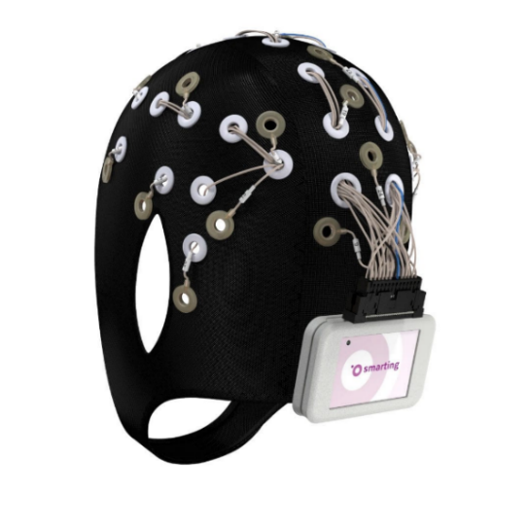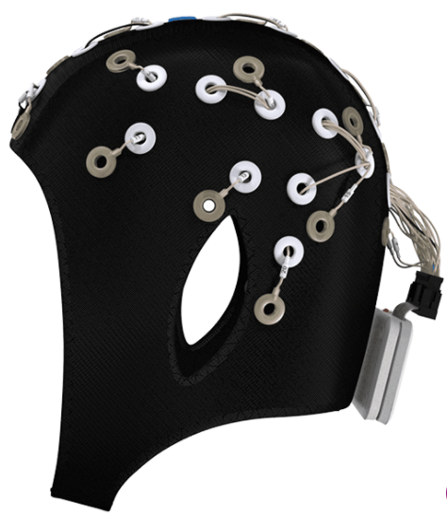
Figure 4 - Mobile EEG cap with 24 channels (taken from MBrainTrain)‎.

Most EEG research surrounding creative ideation focuses around alpha waves, since alpha waves have been noted in various studies to correlate to tasks requiring creative responses (Abraham, 2018). Majority of these studies have examined a phenomenon called alpha synchronization, a period when alpha frequency (activity around the alpha band of 8-13 Hz) increases in power. The synchronization period is associated with periods of cognitive idling or rest. Alpha desynchronization, on the other hand, is related to a loss of power in the alpha frequency band and typically presents when cognition is actively engaged. Increased alpha synchronization has been linked to greater creative ability (Fink et al., 2009; Jauk, Benedek, & Neubauer, 2012) as well as more original ideas (Fink, Grabner, Benedek, & Neubauer, 2006; Grabner, Fink, & Neubauer, 2007; Schwab et al., 2014). Higher alpha activity has also been related to creativity training tasks, thus indicating the possibility that creative ability can be enhanced (Fink et al., 2006; Fink, Schwab, & Papousek, 2011).
Though studies regarding alpha activity have greatly contributed to useful knowledge in the field of creativity research, there is another technique using EEG that could be used to understand the creative process: ERPs. ERPs are useful signals that are time-locked to a stimulus and provide a step by step visualization of the brain processes at each electrode during a trial while providing high millisecond-scale temporal resolution of brain activity (Luck, 2014). Several components, noted as positive or negative signal amplitude peaks or fluctuations are correlated to specific times and have been discovered that relate to specific brain processes.
Specifically, the N400 and post-N400 components have been related to cognitive processes essential to creativity – these are the negative peaking potentials (signified by the “N”) around 300-500ms and 500-900ms post-stimulus, respectively. Though it is typically related to the processing of semantic mismatches and violations of prior knowledge, Rutter et al. (2012) linked the N400 component to conceptual expansion and noticed it responds to unusual stimuli. Similarly, Kröger et al. (2013) reported the N400 as responsive as a function of unusualness or novelty to their experimental stimuli while investigating conceptual expansion through the use of a modified AUT. Additionally, while not significant in Kröger et al. (2013) the post-N400 reflects the processing of the appropriateness (not novelty/unusualness). This rationale behind this post-N400 analysis is based on numerous findings that show slow wave effects long after stimulus presentation, up to 1000 ms post stimulus (Rhodes & Donaldson, 2008; Pijnacker et al. 2011; Coulson & Wu, 2008; Baggio et al., 2010). This late processing was mostly linked to interpretation, comprehension, and cognitive computations.
Because of the high temporal precision, the use of EEG and ERP in studies are ideal for providing data about the neural processes that occur between stimulus presentation and neural response. For example, ERP has been used to understand language processing and Alternative Uses Task experiments (such as in Kröger et al.). Overall, measuring the temporal variation of neuro-responses during idea generation can provide a better understanding of creative thinking and a way to measure creative ideas and relate them directly to neuro-responses.

2.5: LITERATURE REVIEW: HOW NEUROIMAGING HAS BEEN USED ALONGSIDE ENGINEERING-TYPE PROBLEMS
Before the current research is presented, it is important to include a literature review of past studies. As noted before, while there are many different types of techniques and their corresponding studies, only fMRI and EEG will be discussed here – starting off with fMRI and then moving on to EEG and ERP studies.

2.5.1: fMRI
fMRI is the most common technique used to investigate creativity (Dietrich & Kanso, 2010), yet its use of studying solely engineers, engineering-based problems, or design is limited. One of the first investigations of design and fMRI was an investigation of cognitive processes used for design versus non-design tasks (Alexiou & Zamenopoulos, 2009). While this paper was not a study of creativity, the authors found that different cognitive processes were employed for design tasks and non-design tasks. The cognitive processes pointed out here were linked to different regions of the brain, where there was extensive activation when solving the design tasks compared to the non-design tasks. A 2013 study utilized fMRI to determine which areas of the brain were activated when participants were asked about products that varied in product form, product function, or both (Sylcott, Cagan & Tabibnia, 2013). This form-function tradeoff investigation revealed that choices based on products that vary in both aspects (form and function) involve not only unique, but also common, brain networks as compared to choices that were based only on form or only on function. Specifically, the activated regions were those related to emotion when form and function conflicted with one another. Specifically, the activated regions were those related to emotion when form and function conflicted with one another.
In a more recent fMRI paper related to engineering and design, Hay et al. sought to investigate which regions of the brain were activated in product design engineers with professional experience (2019). In this study, brain activation patterns of open-ended and constrained tasks were compared. The key findings were that product design engineer ideation was associated with greater activity in left cingulate gyrus, but no significant differences were observed between constrained or open-ended tasks. Furthermore, there was preliminary association with activity in the right superior temporal gyrus for concept generation during ideation tasks. Finally, a 2019 fMRI study tested graduate-level students specializing in engineering, design, or product development to investigate design ideation and concept generation with and without the support of inspirational stimuli (e.g., analogies). Here, brain activation differed for participants that were able to successfully use the inspiration to generate an insightful design and those that were unsuccessful, most of which did not receive inspirational stimuli (Goucher-Lambert, Moss & Cagan, 2019).

2.5.2: EEG and ERP
Moving on to EEG, researchers at Concordia University have done several EEG studies of design activities. In one of their case studies, a participant was asked to arrange a room based on a set of parameters while EEG was recorded (Nguyen & Zeng, 2010). They reported that the participant showed more efforts in the prefrontal lobe in solution evaluation and high visual high visual thinking effort in solution generation compared to solution evaluation. In one of their follow-up studies, EEG was recorded while engineering students were asked to design a house that could fly (Nguyen & Zeng, 2012). This experiment used a technique called clustering that examined the power spectral density in the different halves of the brain, but there were no significant results. A third study recorded EEG as well as heart rate while engineering students worked on a design problem of their choice, however most picked the same house design problem as listed before. Results here indicated that mental effort (which was an indirect measure of creativity and measured via EEG) was lowest when mental stress is highest, as indicated by the heart rate monitor (Nguyen & Zeng, 2014).
A study by Liu et al. (2018) attempted to investigate the influence of different problem statements on designers’ cognitive behaviors from three perspectives, namely divergent thinking, convergent thinking, and mental workload. This task-related alpha power investigation found higher alpha power in the temporal and occipital regions with open-ended problem statements compared to decision-making or constrained statements. Activity in the left hemisphere was stronger for decision-making and constrained statements. Moreover, designer's mental workload was the highest for constrained problem statements.
Others have looked at open design tasks that included free-hand sketching (Vieira et. al. 2019). Testing 18 mechanical engineering students and 18 architects, findings indicated that design neurocognition differed when comparing problem-solving versus designing, particularly in the sketching task, as indicated by transformed power and task-related power within the EEG readings. Fritz, Deschenes, Pandey (2018) used EEG to evaluate an individual’s performance in a group setting. EEG data revealed a correlation between raw amplitude and level of team contribution, a higher variation in the channel power spectral density during individual versus team tasks, and a degradation of alpha activity moving from individual to group work. Results from another EEG data set point out that design activities were associated with beta-2, gamma-1, and gamma-2 bands between 20-40Hz while resting is mostly associated with alpha band (8-14Hz) (Liu, Nguyen, Zeng, & Hamza, 2016).
As for ERPs, there is limited research in this area. At this time, only one work was found applying ERP to an engineering design type problem, so more research is needed. This work presented design problems to participants first and then provided possible functions (considered either a near/common, creative/middle, or far/nonsense function) as a solution for the design task (Marshall, 2020). For instance, if the design problem was “Design a way to make drinking fountains accessible for all people”, a possible near/common function was “lift”, a creative/middle function was “shrink”, while a far/nonsense function was “flash”. While the results from this study were not significant, there were indications of N400 modulation based on function type.
Other ERP search results showed a few studies related to package design and products preference. For instance, Rojas and colleagues (2015) used EEG and eye tracking to explore the combination of ERPs, eye-tracking techniques, and visual product perception. No significant differences were found. A 2015 inquiry was able to predict participants’ choice of two products based on ERPs (Telpaz, Webb, & Levy, 2015). They found and increase in the N200 component of a mid-frontal electrode and a weaker theta band power that correlates with a more preferred product. Finally, a third paper examined EEG and ERPs, but did not list a specific ERP for their investigation (Yang, An, Chen, & Zhu, 2017). Instead, they list times in which there were positive or negative going waveforms during their experimentation and mention that the activation they find around 400ms might be the P3 component. They also mention the possibility of the FN400 component, but no definite ERP conclusions were drawn.

2.6: GAPS IN NEUROSCIENFITIC STUDIES OF CREATIVITY IN ENGINEERING
From this literature review, some gaps have been observed. Many neuroscientific studies of creativity focus on spatial locations and regions with the highest amount of activity and then tie this to creative processes. Few EEG studies have drawn definite conclusions from their research and even less has been discovered about ERPs. This is understandable as ERPs are reactions to stimuli and typically simplistic in nature. Creativity tasks, on the other hand, generally require more than just a reaction to something and involve multiple cognitive processes. But, a first-take evaluation response can be recorded. Because of this, it is possible to implement an experiment like the OFRT. An approach using ERPs is taken to better understand the timing of specific components related to creativity in engineers. Though previous studies have examined the connection between the creative process of conceptual expansion and the N400 and post-N400 components using metaphors and a modified AUT, this was in the general population – not specific to engineers (Kröger et. al. 2013).
Furthermore, previous EEG research with engineers has looked at mental effort, hemisphere activity, differences in problem-solving versus designing, and channel power but have not investigated the effects of idea presentation on alpha band activity during design tasks. While much is known about alpha band activity, more research is needed to understand the alpha band in engineers and what affects it. Other research has shown promising results related to presentation of ideas on uniqueness of ideas generated and number of ideas generated. More on this is presented in Section 3.1.2. Because of these reasons, it is possible to run a design-type experiment that investigates the effects of idea presentation on alpha band activity while solving design problems.

2.7: CHAPTER 2 SUMMARY
In this chapter, the dilemma of defining creativity was presented. Attention was drawn to the two necessary components for creativity: novelty/originality and appropriateness. Next, Section 2.2 described the four different approaches that can be taken when investigating creativity and their corresponding measurement techniques. It was also noted that these methods are not direct, quantitative ways to assess creativity and include subjectivity. After discussions of creativity and approaches to it, a definition of creativity for this research was presented in Section 2.3. As a way to address the shortcomings of the methodologies presented beforehand (from Section 2.2), neuroscientific techniques were introduces in Section 2.4. In section 2.5, fMRI, EEG, and a detailed literature review of these two methods were presented. Gaps in this literature review were presented in Section 2.6, which allowed for the focus of this research to be selected.

CHAPTER 3: PILOT STUDIES TO INVESTIGATE EEG BASED NEURO-RESPONSES OF ENGINEERS
This research was designed to collect two different types of data – ERP data and time-frequency data. Because of this, the OFRT portion will be referred to as Study 1. In order to test the second hypothesis related to alpha band activity, a pre/post-test design was implemented with the OFRT as an intervention. This will be referred to as Study 2. More information about the experiments is provided in the following sections.
This chapter presents the experimental approaches of this research. Commonalties between the two experiments are presented first, such as the equipment used (Section 3.1) and some procedures (Section 3.2), and then the remainder of the chapter is split in to two parts to detail each of the studies in detail. Section 3.4 and Section 3.5 detail the rationale, procedure, and signal analysis procedure of Study 1 and Study 2, respectively. The chapter wraps up with a summary in Section 3.6.

3.1: EQUIPMENT
A wireless SMARTING amplifier (mBrainTrain) with a 24 channel EEG acquisition system and the company’s corresponding recording software was used for these experiments. EEG caps of appropriate sizes were selected to fit the participant’s head. Conductive gel was used for proper electrical conduction between the scalp surface and cap electrodes. Low impedance around 5-10kΩ was kept during the experiment. The recording was sampled at 500 Hz and recorded from 24 electrodes positioned according to the international 10/20 placement map, as shown in Figure 5. Boxed electrodes in this figure are referenced later.

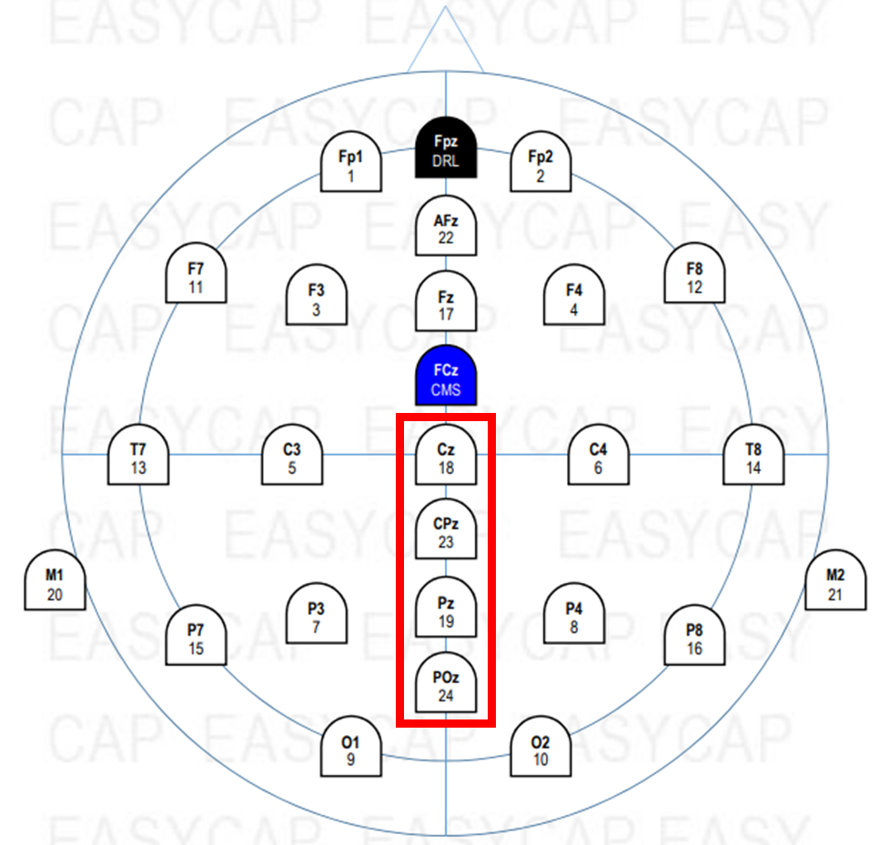
Figure 5 - Electrode Layout

Stimulus presentation was synchronized with EEG acquisition via Neurobs Presentation software (Neurobehavioral Systems, Inc., Albany, CA). Neurobs Presentation was also used to code the experiments. While both experiments required different code, they are similar. To present the experiments to the participants, a 64-bit Dell Latitude laptop with i5-8250U CPU 1.8 GHz with 8 GB RAM (7.86 GB usable) was used to present stimuli and record responses via the left and right touchpad buttons as well as specific keyboard keys. A second monitor was connected to the laptop in order for lab personnel to monitor EEG signals in real time and to assure that the EEG was running properly.

3.2: EXPERIMENTAL PROCEDURE
The experiments were coordinated in a low noise environment. Participants were seated in a chair in front of the computer where participants’ head was measured and the EEG Cap was fitted. Before both of the experiments, participants were given a brief description of what they would see during the experiments and instructed on the corresponding buttons they would push to record responses. These descriptions and prompts are described in more detail later (Section 3.4.2 and 3.5.2). The experiments on the computer would further go over these buttons as a reminder. To reduce EEG artifacts participants were asked to avoid uncontrolled body movements.

3.3: PARTICIPANTS
A total of six participants participated in Study 1. Four participants participated in Study 2. All participants were from the field of engineering, including four from mechanical engineering, one from civil engineering, and one from aerospace engineering. Five of the six participants were right-handed. All participants had normal or corrected to normal vision, no history of neurological or psychiatric illness, and were not taking any drugs, according to a self-report. This study followed the University of Oklahoma Institutional Review Board guidelines and was approved by the responsible committee (IRB #13189). No identifiable personal information was kept in the research data.

3.4: STUDY 1: ERP INVESTIGATIONS OF THE OFRT

3.4.1: RATIONALE
The ORFT experimental design used in this research is based off of a 2013 study by Kröger et al. This study utilized an ERP experimental design in order to investigate conceptual expansion. Their team investigated cognitive expansion as a central component of creative thinking based off a 2012 study by Rutter et al., which found that conceptual expansion was linked to the N400 component. The study in Kröger et al. (2013) used ERP to relate the N400 component to unusualness or novelty of stimuli. They utilized 24 students from their university with unspecified majors and implemented a modified AUT. Traditionally for the AUT, participants generate as many alternative uses as possible for a common object, such as a pen. This task may be repeated for several objects, one object at a time, with each object recorded as a separate trial. Instead of generating uses for a given item, though, participants were shown a word of an object in conjunction with a potential function for that object as a stimulus from an engineering design context of function-object mapping. Because of this difference and in order to avoid confusion, the modified AUT is referred to as the ORFT.
Participants were then asked to decide if the given function was unusual and if it was appropriate and would answer these questions by pushing buttons. They found that the N400 component was modulated depending on whether the stimulus was perceived as common (low novelty, high appropriateness), creative (high novelty, high appropriateness), or nonsense (high novelty, low appropriateness). Stimuli perceived as common evoked the most positive N400 responses, while stimuli perceived as creative evoked more negative N400 responses, and nonsense stimuli evoked the most negative responses, though only differences between creative-common and nonsense-common were statistically significant. This study narrows the general focus of Kröger et al. (2013) to investigate the results of individuals solely from the field of engineering.
Furthermore, it is important to notice that the studies mentioned in Section 2.5 mainly focus on design, concept generation, and problem solving. Even though a few of the papers listed above mention divergent thinking or creativity, none of the studies put a particular emphasis on creativity or novelty. Additionally, none of them were ERP tasks. Given that, it is necessary to utilize ERP and understand how the brain reacts to unusualness, novelty, or creative stimuli. This is one of the aims of the reserach. Furthermore, it is of great importance to research solely engineers in order to build up research in this area.

3.4.2: PROCEDURE
This study followed a similar procedure to Kröger et al. (2013) with a few minor differences. These changes were made in order to simplify the experiment, reduce the programming and written code behind the experiment, and ensure a shorter experiment time. Unlike in Kröger’s paper, the item alone was not presented by itself before the presentation of the object-function pair. Furthermore, there was no self-paced pause after the stimulus presentation. See Table 1 for the experimental time differences.

Table 1 - Stimulus presentation order in Kröger et al. (2013) versus the current study. Time is in milliseconds (ms).

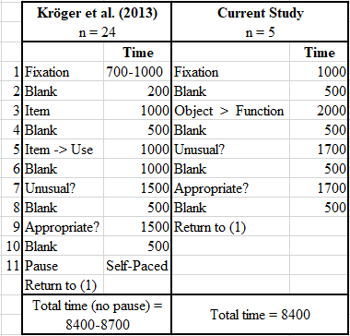

Each trial started with a fixation cross (+) presented in the middle of the screen for 1000 ms. After a 500 ms blank screen, the participant would see an object-function pair (“object > function”) for 2000 ms followed by another blank screen for 500 ms. Participant would see the first question (“Unusual?”) for 1700 ms. During this 1700 ms, the participant will respond “yes” or “no” by pushing either the left or right mouse buttons, respectively. This was followed by another blank screen for 500 ms. After this, the second question (“Appropriate?”) appears for 1700 ms. Again, the participant will respond “yes” or “no”. This is followed by another blank screen for 500 ms. The cycle would then repeat, but individual stimulus pairs would not. Unlike in Kröger et al. (2013), the object alone was not presented by itself before the presentation of the object-function pair. Furthermore, there was no self-paced pause after the stimulus presentation. Like Kröger et al, (2013), there was a short practice segment presented before the start of the experiment on the computer. After the practice session, participants could start the experiment at their own pace. See Figure 6 for a picture of the experiment design.
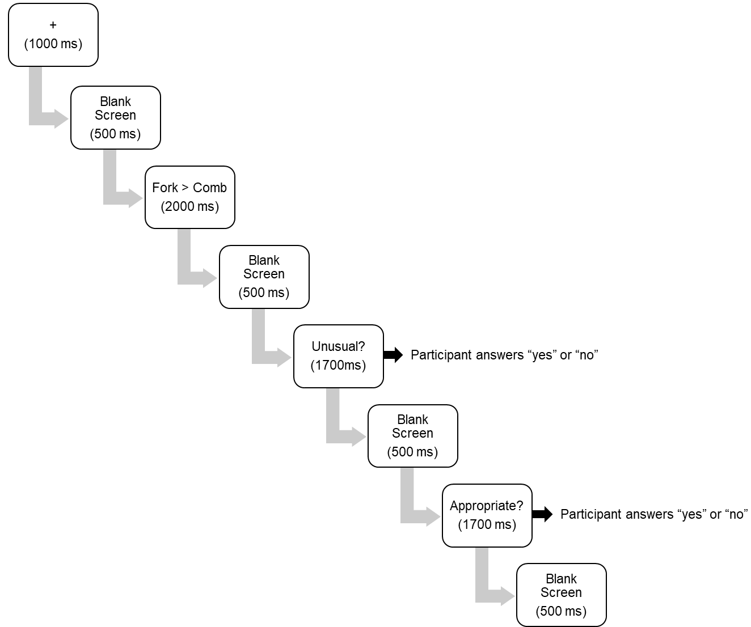
Figure 6 - Study 1 Experiment Design

Before the experiment began, participants were asked to read a prompt that briefly explained what they would be seeing, which buttons to push, and definitions. Specifically, the definitions were related to “Unusual” and “Appropriate”. For a function to be unusual (and therefore receive a “yes” response), it must be novel or unfamiliar. Otherwise the function is not unusual and is known or familiar (receives a “no” response). A function was said to be appropriate if it was fitting or relevant. If not, the function was not appropriate and was neither relevant nor appropriate.
Many of the object-function pairs were taken from Kröger et al. (2013) but some were discarded due to unclear translations from German to English. Additionally, some object-function pairs were created by our lab, but were not tested for word length or frequency of occurrence in the English language as was mentioned in Kröger. Overall, stimuli consisted of 162 object-function pairs as compared to 135 stimuli in the Kröger paper. Object-function pairs were presented randomly but did not repeat. To be clear, object-function pairs shown to the participant never repeated and were unique even though each item has one function of each type (each item has its own creative, common, and nonsense function), as seen in Table 2. See the Appendix for a full list of object-function pairs.

Table 2 - Example of an object and the three function types with expected participant responses. Expected responses were for keeping track of data only. Type was ultimately decided by the participant.

Object |  | Function | Type | Expected response for “Unusual?” and “Appropriate?” questions, respectively
Magnifying Glass | > | Magnify Image | Common | No – Yes
Magnifying Glass | > | Start Fire | Creative | Yes – Yes
Magnifying Glass | > | Food | Nonsense | Yes – No

3.4.3: SIGNAL ANALYSIS TECHNIQUES
EEG data was processed using EEGlab plugin on Matlab. Raw data was filtered from 0.5-100 Hz in order for the experimenter to visually inspect data and reject any messy parts. A notch filter of 58-62 Hz was applied to remove electrical noise. An independent component analysis (ICA) was then performed in order to investigate components and remove the ones not related to brain data, i.e. eye and muscle movements. Data was then processed via ERPlab in Matlab to obtain ERP segments. Data was epoched into 1200 ms segments, with each segment starting 200 ms before presentation of object-function pair. Segments were baseline-corrected using the 200 ms time window before the onset of the object-function pair. A 30 Hz low-pass filter with a slope of 24 dB/Oct was applied and additional artifacts were removed with amplitude exceeding approximately +/-100 μV. ERP waveforms were averaged for each participant and each condition. Subsequently grand-averaged ERPs of all participants were calculated in time windows of interest. Participants needed to have selected a minimum of 15 object-function pairs for each of the three categories (common, creative, and nonsense) in order to be included in the overall grand average. Only five of the six participants met this criteria. Thus, analyzed data only consists of five datasets with a minimum of 15 common, creative, and nonsense functions.
Electrodes of interest included Cz, CPz, Pz, and POz based on electrodes identified in Kröger et al. (2013) and Rutter et al. (2012) in addition to the known centro-parietal distribution of the N400 effect (Kutas & Federmeier, 2011). These electrodes are highlighted in Figure 5. The number of electrodes examined in this study differ from Rutter et al. (2012) and Kröger et al. (2013) due to differences in the total number of electrodes utilized; 24 total channels in this study versus 64 or more total channels in Rutter et al. (2012) and Kröger et al. (2013), which is simply due to the fact that different EEGs were used.

3.5: STUDY 2: EFFECTS OF EXPOSURE TO IDEAS VIA THE OFRT

3.5.1: RATIONALE
The second experiment in this research aimed at investigating the effects of exposure to ideas via the OFRT on participants’ designs and its impact on alpha band of activity. There is evidence that exposure to high number of ideas positively impacts the number of ideas generated during later tasks and the uniqueness of ideas generated (Dugosh, Paulus, Roland & Yang, 2000; Dugosh & Paulus, 2005). Additionally, Dugosh & Paulus (2005) found that exposure to common ideas, rather than unique ideas, actually leads to an increase in ideas generated. The authors noted that exposure to a high amount of ideas may stimulate more associations and that common ideas are more stimulating than unique ones because they may be more 'valid' to the participants. It is important to note, however, that this research was conducted in group brainstorming sessions and required memorization of the ideas presented beforehand.
Other research has come from a design-by-analogy practice in which designers use solutions from other domains (considered either near or far) to gain inspiration or insight for the design problem at hand. Here, analogies are either near-field or far-field. This means near analogies are ones that are found in the same or a similar domain. On the other hand, far analogies are found in a different domain. There is a handful of research that indicates far analogies are promising for creative insights, original ideas, and idea novelty (Gentner & Markman, 1997; Dahl & Moreau, 2002; Wilson, Rosen, Nelson & Yen, 2010). But, analogies should not be too far as this can be harmful to the design process (Fu et al. 2013). It is reasonable to suggest that the same can be said for creative stimuli rather than far-field ones.
Though sometimes conflicting, there is evidence that the amount and type of stimuli are related to the effects of that stimuli, such as the number of ideas generated or type of ideas generated. It is important to draw attention to the fact that only one of these studies (Fu et al. 2013) puts an emphasis on engineers or designers. While not broken up in to high and low and/or creative and non-creative stimulus types, the aim is to investigate the effects of presenting ideas either before or after a design problem and analyze the results. From here, it is expected that exposure to ideas via the OFRT before a design problem will positively impact the unusualness or novelty of the designs to that problem. From the neurological standpoint, it is hypothesized that alpha band activity will be greater during the design ideation when the OFRT is presented beforehand, as opposed to after the design problem.

3.5.2: PROCEDURE
For this study, there were four participants. Participants were either exposed to the OFRT before or after completion of a design problem. The OFRT portion of this experiment was the same as the above description. The only difference was the addition of the design problem. See Figure 7 for a pictorial of the experiment design. On their first visit, half of the participants did Condition A and the remaining half did Condition B. On their second visit, the order of delivery was switched and a different design problem was given. Because the aim of this experiment is to test the effect of exposure of ideas before a design problem, Condition A can be thought of as the experimental condition while Condition B is the control condition.

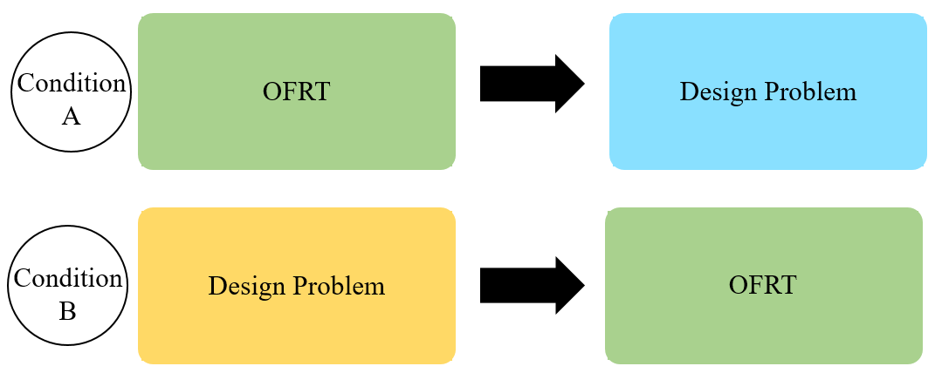
Figure 7 - Study 2 Experiment Design. Condition A is the experimental condition while Condition B is the control condition.

Both design problem prompts can be found in the Appendix. One of the design problems was taken from Hernandez, Schmidt, and Okudan (2013) due to its prior documentation. This design problem is a newspaper article about a traffic light problem stating that traffic lights using LED lights instead of an incandescent bulb create snow accumulation and cause accidents in colder climates. Here, ideas generated must address the barred vision due to accumulation of snow. The other design problem was created by the researcher. This problem followed the same format as the traffic light problem but presents a different issue. This prompt details an airdrop problem stating that in remote areas or places impacted by natural disaster, supplies need to be delivered by airplane or drone due to rough terrain, bad weather, or blocked roads. However, this is a less than ideal option when it comes delicate cargo like glass medicine vials and sensitive electronic equipment to relief workers. Thus, ideas generated must address ways to protect airdropped cargo.
Design prompts alternated. That is, half of the participants saw the traffic light problem on their first visit and the airdrop problem on their second visit. Similarly, half of the participants saw the airdrop problem on their first visit and the traffic light problem on their second visit. See Table 3 for the order of design problem presentation and condition assignments.

Table 3 - Design problem presentation order and condition order. Condition A is the experimental condition while Condition B is the control.
Participant | Visit Number | Design Problem | Condition
1 | 1 | Traffic Light | B
1 | 2 | Airdrop | A
2 | 1 | Traffic Light | A
2 | 2 | Airdrop | B
3 | 1 | Airdrop | B
3 | 2 | Traffic Light | A
4 | 1 | Airdrop | A
4 | 2 | Traffic Light | B

Before the design problem portion of each visit, participants were instructed to read the given design prompt and notify the experimenters when they were done reading. The experimenter would enter the room, read a script describing the task, and explain the computer instructions, i.e. pressing “Enter” to move from one screen to the next. During this time, participants were instructed to come up with as many ideas as they could (up to ten ideas) to solve the given problem. Participants were told to spend the first part of their time ideating. That is, simply thinking of an idea to solve the design problem and constructing a detailed design in their mind. After the design was fully developed in their mind, they would press “Enter” on the computer for data tracking purposes and provide a sketch on a piece of paper with a short explanation alongside of it. It was made clear that the actual sketch would not be evaluated, but rather the idea it represents. This was to ensure the participant would not worry about their drawing ability. This process of ideating and then sketching would be repeated until the participant was done coming up with designs. After reading the script and clarifying any questions, the experimenter would leave the room and the actual experiment would being. The participant would notify the experimenters that they were finished and, depending on the Condition, the experimenters would either start the OFRT portion or instruct the participant to take off the cap if they had completed the OFRT task first.

3.5.3: DESIGN SCORING
Overall, there were 36 total designs generated across the four participants. There were 16 designs generated during Condition A and 20 designs generated during Condition B. Similarly, there were 18 designs for each of the design prompts. Participants’ sketches were given to four outside evaluators. The evaluators were asked to rate the designs on a scale of one to five, with one being the lowest and five being the highest on both unusualness and appropriateness following the definitions for “unusualness” and “appropriateness” that were given in the OFRT prompt (i.e. a 1 corresponding to very usual/unfitting and a 5 corresponding to very unusual/appropriate). The evaluators could not see each other’s scores to avoid bias or influence.
Intra-class correlations (ICCs) were used to calculate inter-rater reliability for both the unusualness and appropriateness of the 36 participant designs. For the four raters, the ICC for unusualness was 0.788 and for appropriateness was 0.774. This averages out to an ICC of 0.781. These are classified as an excellent values since they exceed a value of 0.75. Because a Likert scale was used to score designs, it is not appropriate to present the mean of evaluator ratings. However, the median and mode can be presented. See Table 4 for a summary of the evaluator ratings. The median ratings from all four evaluators for Condition A was four for both aspects. This was the same for Condition B. The mode for both Condition A and B was five for unusualness and four for appropriateness.

Table 4 - Summary of evaluator ratings.

Median by Condition |  |  |  | Mode by Condition
 | Cond. A | Cond. B |  |  | Cond. A | Cond. B
Unusualness | 4 | 4 |  | Unusualness | 5 | 5
Appropriateness | 4 | 4 |  | Appropriateness | 4 | 4

3.5.4: SIGNAL ANALYSIS TECHNIQUES
EEG data was processed using EEGlab plugin on Matlab. Raw data was filtered from 0.5-100 Hz in order for the experimenter to visually inspect data and reject any messy parts. A notch filter of 58-62 Hz was applied to remove electrical noise. An ICA was run in order to investigate components and remove the ones not related to brain data, i.e. eye and muscle movements. Data was epoched in to 15 second time frames at the end of the ideation phase, just before the sketching phase. A two second window before the participant pressed the ‘Enter’ key on the keyboard to indicate moving to the sketching phase was not included. See Figure 8 as a clarification. The 15 second window was picked based on the smallest ideation phase across all datasets. Data was epoched towards the end of the ideation phase following previous methodologies in literature (Fink & Neubauer, 2006; Fink, Graif, & Neubauer, 2009) and due to evidence of more creative ideation happening towards the end of ideation (Fink & Benedek, 2014; Jung-Beeman et al., 2004). Data was then grouped and analyzed according to the two conditions. Time-frequency data was limited to 3-30 Hz, with an emphasis on alpha band (8-13 Hz).

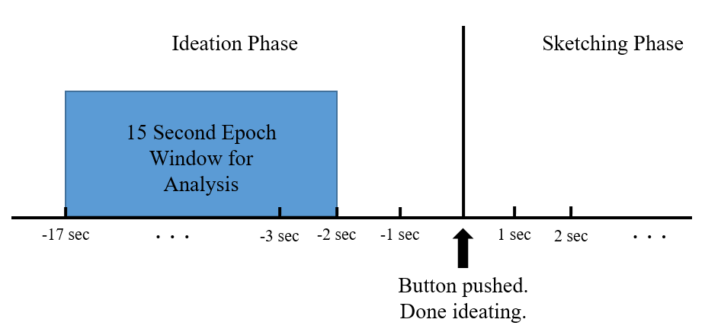
Figure 8 - Depiction of epoch window.

Even though there were 36 designs, there were only 29 data epochs included in the frequency analysis. This was due to issues with recorded data resulting in the deletion of epochs as well as incorrectly recorded time labels because participants forgot to press ‘Enter’ when moving between ideation and sketching phases. Thus, only 12 epochs were included for analysis in Condition A and 17 epochs were analyzed for Condition B.

3.6: CHAPTER 3 SUMMARY
This chapter discussed the experimental procedures for both Study 1 and Study 2. Commonalities between the studies (e.g., equipment and participants) were discussed in Sections 3.1 to 3.3. The particularities of each study were presented in Section 3.4 and 3.5 for Study 1 and 2, respectively. Within these sections, the rationale behind each experiment, experimental procedure, and signal analyses were presented.

CHAPTER 4: RESULTS AND DISCUSSION
In this chapter, the results from each of the pilot studies are presented. Statistical analysis techniques are also presented for each study. Results regarding Study 1 are presented in Section 4.1 with the N400 and Post-N400 components being discussed separately, while results for Study 2 are presented in Section 4.2. The chapter closes with a straightforward summary of the results in Section 4.3.

4.1: STUDY 1 RESULTS
To study the N400 and post N400 components, a two-factor repeated measures ANOVA was used to analyze results. The two factors for this experiment were: condition (common, creative, nonsense) and electrode (Cz, CPz, Pz, POz). Only the Cz, CPz, Pz, and POz electrodes were examined for reasons mentioned earlier.
First, Mauchly’s Test of Sphericity was used to verify if the variances were equal, i.e. if it was correct to assume sphericity of the data, which is required for this type of analysis. In this case, the sphericity assumption was not violated for the N400 time window for condition (Χ² (2) = 2.174; p = 0.337) but was violated for electrode (Χ² (5) = 14.820; p = 0.016). Therefore, degrees of freedom for electrode were corrected using Greenhouse-Gesser estimates of sphericity (ε = 0.354) and these corrected numbers are presented in below in Section 4.1.1. Similarly, for the post-N400 time window, sphericity was not violated for condition (Χ² (2) = 2.643; p = 0.267) but was violated for electrode (Χ² (5) = 19.800; p = 0.002). Again, degrees of freedom for electrode were corrected using Greenhouse-Gesser estimates of sphericity (ε = 0.341) and the corrected data are presented below in Section 4.1.2. Effects sizes including Cohen’s d and partial eta squared (η_{p}²) are reported with all significance levels.
Figure 9 show the grand average ERPs from all participants for each of the electrodes of interest. The origin represents the time the object-function pair was presented to the participant. The 300-500ms range where the N400 was investigated is highlighted by the solid line black box. The 500-900ms range where the Post-N400 was investigated is indicated by the dashed line black box.
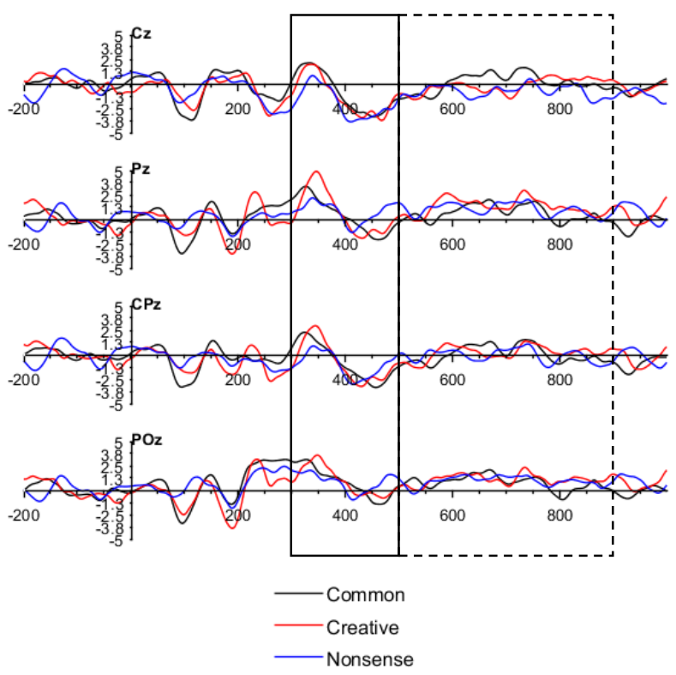
Figure 9 - Grand Average ERP images for selected electrodes (Cz, CPz, Pz, and POz).

4.1.1: N400
The repeated measures ANOVA did not show significant main effects for the factor condition (F(1.320,5.279) = 0.664; p > 0.05; η_{p}² = 0.142)) or for the interaction of the factors condition*electrode (F(6,24) = 0.992; p > 0.05; η_{p}² = 0.199)). Main effects were significant for the factor electrode (F(1.063,4.253) = 7.392; p = 0.049 < .05; η_{p}² = 0.649)).
Mean amplitudes from the four electrodes of all three conditions from all participants are presented in Figure 10. That is, the individual mean amplitudes from each participant for the 300-500ms window for each of the four electrodes were averaged together to obtain the data presented in Figure 10. As predicted, nonsenses functions elicited the largest negative mean amplitude (-1.107 μV) followed by creative functions (-0.755 μV) and then common functions (0.0859 μV). However, none of these differences are significant as indicated by the ANOVA main effects values for condition and it is not appropriate to run a post-hoc analysis.

Figure 10 -Mean amplitudes from four electrodes (Cz, CPz, Pz, and POz) of all three conditions (Common, Creative, and Nonsense) for the N400 (300-500ms time window). Error bars represent standard error of the mean.

4.1.2: Post-N400
As for the Post-N400 time window, repeated measures ANOVA did not show significant main effects for any of the factors: condition (F(2,8) = 0.370, p > 0.05, η_{p}² = 0.085)), electrode (F(1.022, 4.088) = 1.819, p > 0.05, η_{p}² = 0.313)), and condition*electrode (F(6,24) = 1.513, p > 0.05, η_{p}² = 0.274)). Figure 11 shows the Post-N400 average for all electrodes across all conditions for all participants. Again, this figure was created by averaging the individual mean amplitudes for the 500-900ms window for each of the four electrodes. This data followed a similar pattern to the N400 data, with nonsense functions having the largest negative amplitude (-0.581 μV), followed by creative functions (-0.121 μV) and common functions (0. 4508 μV). Again, none of these differences are significant as indicated by the ANOVA main effects values for condition and post-hoc analysis is not appropriate.

Figure 11 - Mean amplitudes from four electrodes (Cz, CPz, Pz, and POz) of all three conditions (Common, Creative, and Nonsense) for the Post-N400 (500-900ms time window). Error bars represent standard error of the mean.

4.2: STUDY 2 RESULTS
Figure 13 shows the individual time-frequency analyses for each participant for both conditions. Condition A, the experimental condition, where the OFRT task was presented before the design problem, is on the left. Condition B, the control condition where the design problem was presented before the OFRT, is on the right. For these graphs, time is on the x-axis and frequency (between 3-30 Hz) is on the y-axis. Thus, each “point” on the graph is the power (in dB) for each frequency at a given time point. Time is negative simply because is the period before the sketching phase, as indicated in Figure 8. Increases in power are indicated by areas in red, orange, and yellow. Decreases in power are indicated by shades of blue.
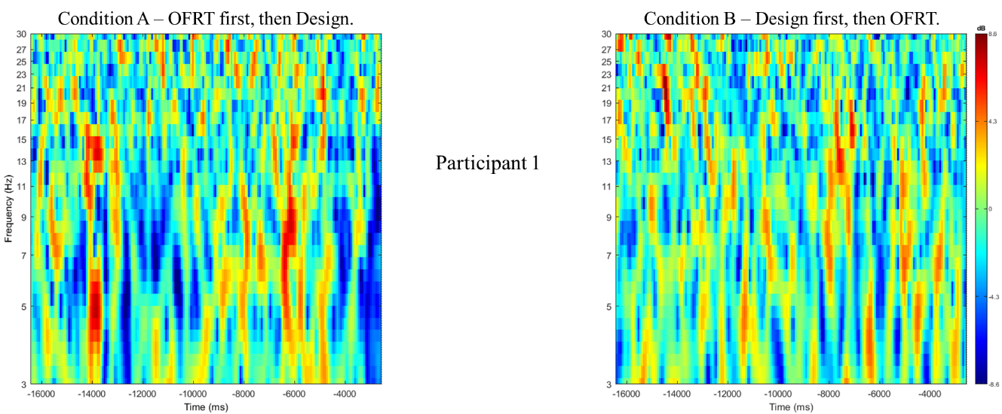
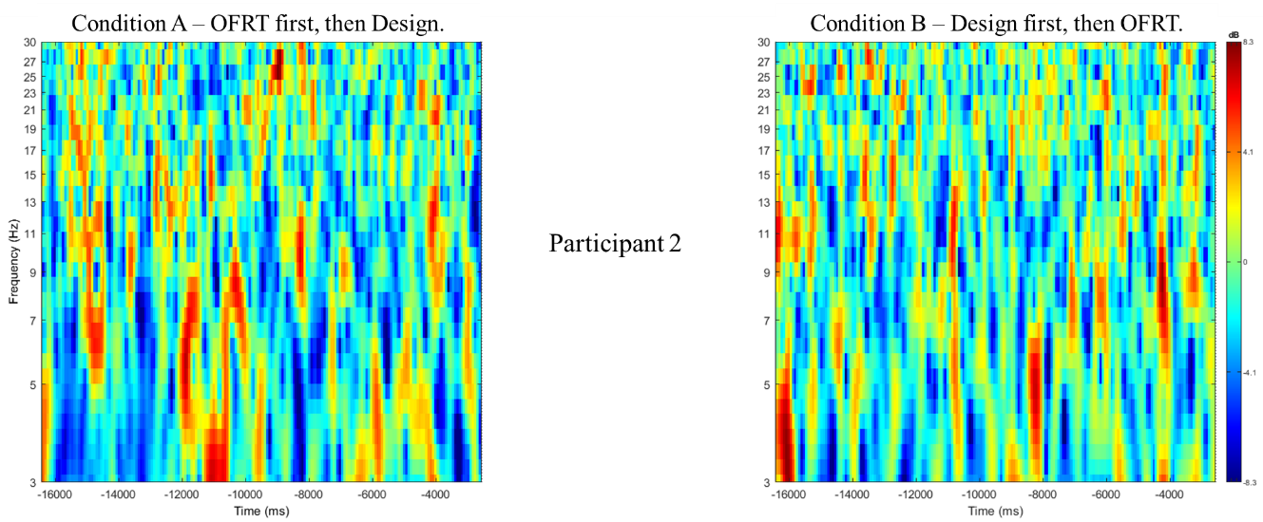
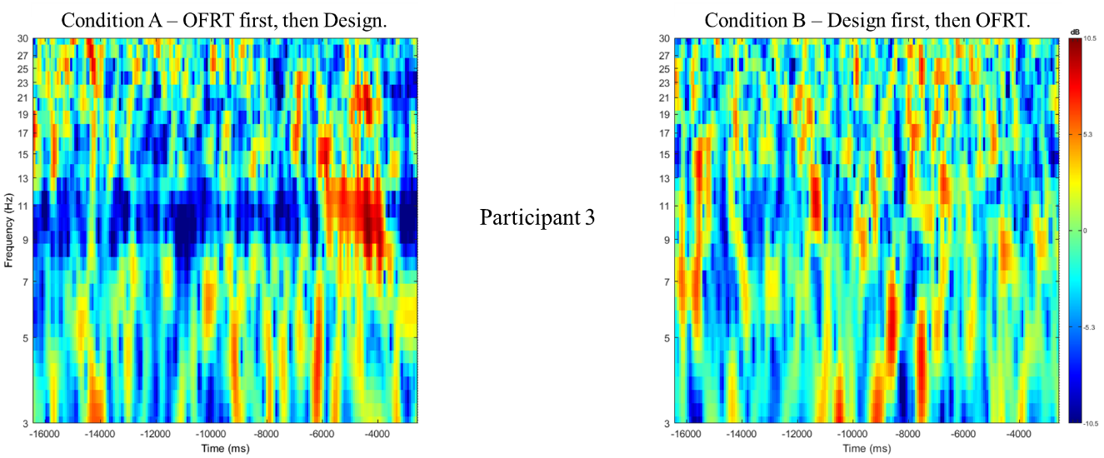
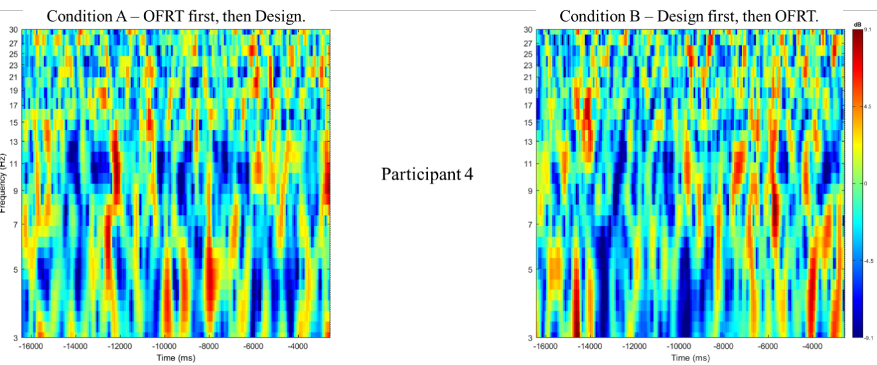
Figure 12 - Individual time-frequency analyses for both conditions.

The grand average for each condition for all participants is shown in Figure 13. This data was used for statistical analyses. The alpha band range from 8-13 Hz is outlined and a specific focus on this band is presented below. An area of interest is the increased power (indicated by yellow, orange, and red hues) at the end of the ideation phase, around four to six seconds before the sketching phase (i.e., from -6000ms to -4000ms), for Condition A.
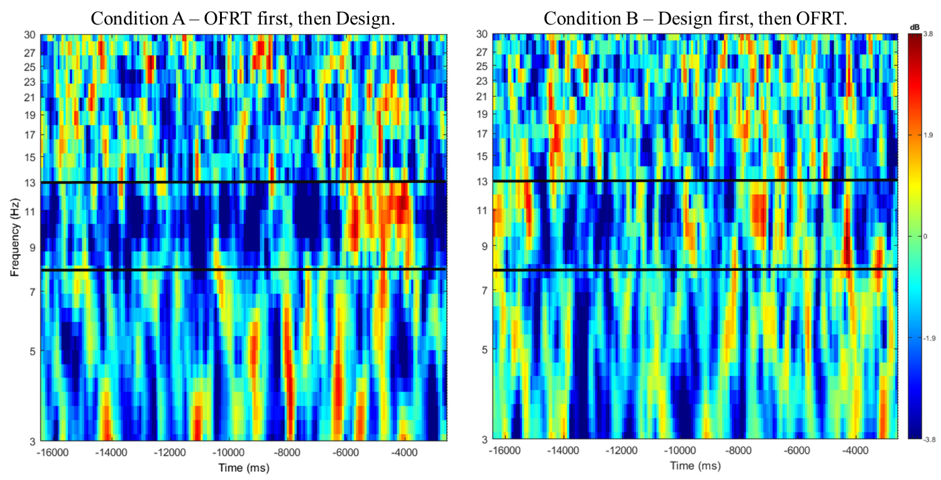
Figure 13 – Averaged time-frequency analysis for both conditions.

A paired samples t-test was used to compare the two conditions. Permutation-based statistics were used alongside the false discovery rate (FDR) method for correcting for multiple comparisons. Permutation-based statistics are better for providing exact, strong control of Type-I error rates than parametric methods and was subsequently selected. Eight hundred permutations were auto generated. FDR is defined as the expected proportion of false discoveries, i.e., incorrectly rejected null hypothesis, among all discoveries (Benjamini & Hochberg, 1995). Because this is a pilot study and in order to be able to identify as many significant comparisons as possible while still maintaining a low false positive rate, FDR was selected. Additionally, this method provides a set of “candidate points” that can be more rigorously tested in future studies. Other corrections for multiple comparisons, like the Bonferroni method, are too strict for this type of analysis and were not used. A p-value of 0.05 was selected as a threshold. Furthermore, this statistical methodology is suggested in “STUDY Statistics” by the Swartz Center for Computational Neuroscience, which can be found in the References.
The statistical analysis can be seen in Figure 14. Here, green represents areas of non-significance. Therefore, only yellow points are significant. The alpha band is again outlined. A zoomed in analysis of this data limited to the 8 to 13 Hz range (alpha band) is presented in Figure 15. Again, the increases in alpha power in the experimental condition (Figure 15A) are shown by the red, orange, and yellow hues and are located towards the end of the ideation phase, about four to six seconds before the start of the sketching phase (i.e., the time from -6000ms to -4000ms). This increase in power is not seen in the control condition (Figure 15B). These areas of increased alpha band activity and power between the conditions are statistically significant, as shown in Figure 15C. In Figure 15C, green denotes non-significance while yellow represents significance. Thus, the areas of increased alpha power located at the end of ideation, around four to six seconds before sketching, are significant.
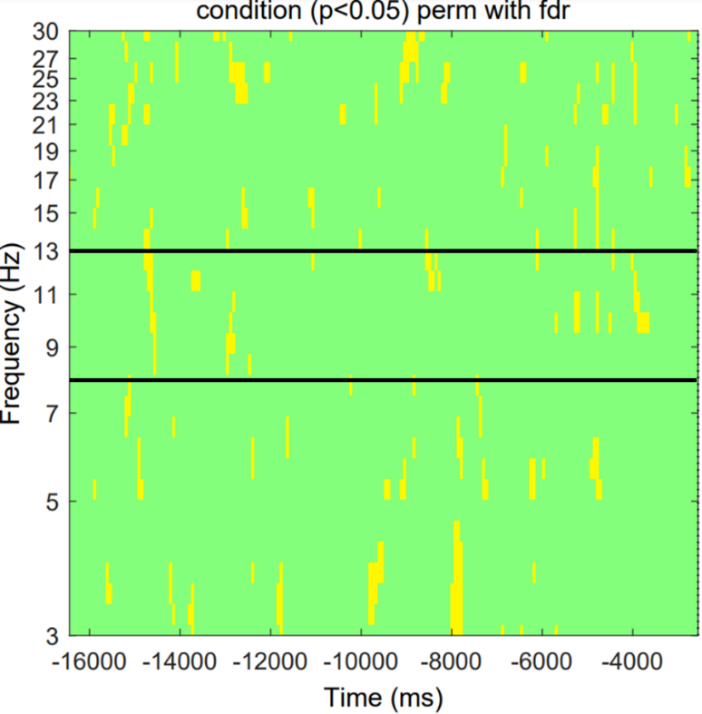
Figure 14 - Statistical analysis of averaged time-frequency data between conditions. Permutation statistics with FDR correction was used. Yellow points indicate areas of significance (p < 0.05).

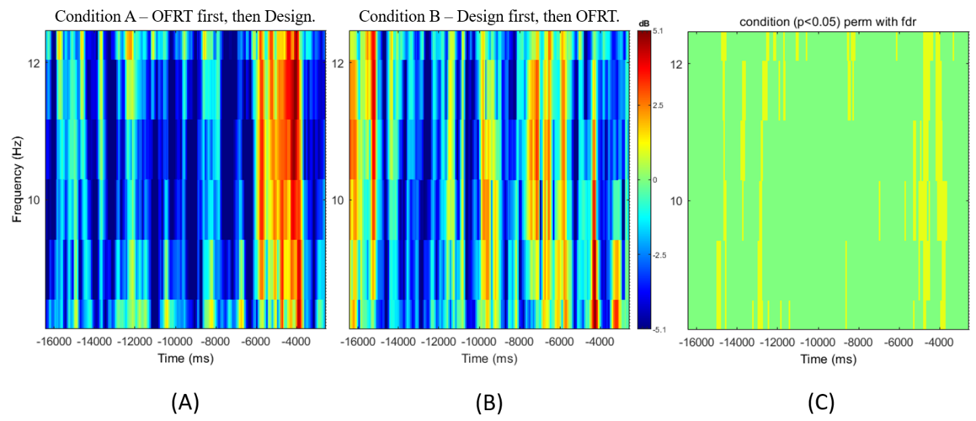
Figure 15 - Time frequency analysis and statistical analysis limited to the 8 to 13 Hz range for the (A) experimental condition and (B) control condition. (C) is the statistical analysis where yellow indicates areas of significance (p < 0.05).

4.4 CHAPTER 4 SUMMARY
In Sections 4.1-4.2, the results of these case studies were presented and discussed. The N400 and post-N400 mean amplitudes were also presented for each condition, and their conditions’ respective differences analyzed via a two factor repeated measures ANOVA. The grand average ERPs for Study 1 were presented in Figure 9. This figure followed the hypothesized trends with respect to the N400 component modulation, with nonsense functions having the largest negative amplitude and common functions having a slightly positive amplitude. However, these results were not significant.
Grand average activity for both conditions between 3-30 HZ is presented in Figure 13. Figure 15 shows only the alpha band analysis. The largest number of significant increases in alpha band activity and power occurred around four to six seconds before the sketching phase, as seen in image in Figure 15-C. This indicates significantly increased alpha band activity and power during design ideation when the OFRT is presented before a design task.

CHAPTER 5: CONCLUSIONS AND FUTURE DIRECTIONS
This chapter summarizes the research and the results of the investigations conducted. It is necessary to provide a critical evaluation of the hypotheses that were presented at the beginning of the thesis. This is discussed in Section 5.1.1. The advantages and limitations regarding this research is presented in Section 5.2. Future works are suggested in Section 5.3. Lastly, Section 5.4 summarizes the chapter and concludes this thesis.

5.1: SUMMARY OF RESEARCH
Creative and innovative engineers have been in demand for a long time. However, these two competencies are not readily or easily taught in current engineering curriculum. Additionally, creativity can be ambiguous and difficult to accurately measure, especially using human-based metrics. Neuroimaging methods can be used to take some of the subjectivity out of creativity research. Given these pieces of information, this thesis presented a unique experimental design to study the neuroscientific technique known as ERP as well as time-frequency analysis of the alpha band can be used to analyze creativity in engineering and engineering design.
Corresponding goals were to investigate possible modulations of the N400 ERP component in engineers alongside later potential ERP components by the creative cognitive processes when compared to the information processing of mere novelty or appropriateness. The other goal of the research was to investigate the effects of presenting ideas (via the OFRT) before design problems on alpha band activity.

5.1.1: CRITICAL EVALUATION OF HYPOTHESES
The hypotheses for this research were constructed based upon earlier works and the gaps that were identified in previous literature. From the results presented in Chapter 4, critical evaluations of the research can be drawn. There were two main questions and two main hypotheses constructed for this research as follows:

Primary Question 1: Is the N400 component of engineers modulated when assessing the novelty and appropriateness of an item function via an Object-Function Relationship Task (OFRT)?
Primary Hypothesis 1: The perceived novelty and appropriateness of an item function will significantly modulate the N400 component with the largest negative values associated with unusual-inappropriate (nonsense) functions and the least negative values associated with the usual-appropriate (common) function.

Based on these results, it is suitable to reject the hypothesis presented to Primary Question 1. While the data follows the hypothesized trend with the most negative mean amplitude belonging to nonsensical functions (-1.107 μV) and common functions having the least negative mean amplitudes (0.0859 μV), the results were not significant. With more participants, it is very probable that results similar to these would be statistically significant.

Primary Question 2: How does exposure to ideas via the Object-Function Relationship Task (OFRT) impact alpha band activity during design problem ideation?
Primary Hypothesis 2: Exposure to the OFRT before a design task will lead to increased alpha band activity and power during design ideation.
Based on the results for Study 2, it is reasonable to accept the hypothesis. Areas of significant difference were found in alpha band activity and power approximately four to six seconds before the end of ideation. Thus, there is evidence to suggest that exposure to the OFRT before a design task significantly increased alpha band activity and power during design ideation. Relying only on the evaluators’ design scores alone, it would be concluded that there is no difference in either unusualness or appropriateness, and therefore creativity, between the two conditions. However, the neurological data seems to indicate otherwise. Given the evidence in Section 2.4.2 that increases in alpha band power are linked to greater creative ability, there are neurological indications of more novel ideas/ideation occurring during Condition A (OFRT first, then Design Problem). This is further indication that neuroimaging should be used alongside creativity studies to gather more information instead of drawing conclusions solely based on human-based metrics or scoring.

5.2 ADVANTAGES AND LIMITATIONS
The advantage of this research, specifically Study 1, was the use of ERP technique within the engineering realm. This provides a direct link to study components related to creativity, such as the N400, to engineers. Through this research, the ERP technique was applied to evaluate creativity in an engineering context, which had not previously been done. This is a key step in understanding how this technique can be used in the future to measure creativity in engineering, products and processes, and by extension, the engineers who created them. Even though results were not significant, the hypothesized trends were followed. Furthermore, results from Study 2 add to the growing amount of research designated to engineering design and potential impacts on creativity or novelty during design tasks.
Disadvantages include lack of female participation. With no female participants, the results and the conclusions drawn are limited to males and therefore do not completely represent the general population of engineers. Due to the underrepresentation of females in these studies, it is possible that results could differ when there is an even number of both males and females. In the future, more attention should be drawn to this in order to assure even representation.
Another limitation was the overall number of participants. More participants are needed to obtain statistically significant results and more definitive results, especially with ERPs since larger group analyses are much more informative than small-scale studies. With a greater number of participants, preferably 20 or more, it is likely that results would be statistically significant. Also with so few participants, individual differences in neural processes are much more apparent. This problem was minimized in Study 1 by measuring mean peak amplitude, as opposed to simply peak amplitude, but it is not a silver bullet for solving all problems. The use of mean peak amplitude was also useful for eliminating latency jitter. Neural processes have some variability from person to person and even trial to trial, especially for late occurring components like the N400. Therefore, the use of mean peak amplitude for Study 1 is appropriate.
As for Study 2, there were only four participants. There were only 12 usable data epochs for the experimental condition and only 17 usable epochs for the control condition. Even though there were statistically significant results among the averaged data, individual differences are also much more apparent. However, another potential issue with this experiment was clearly understanding the design problems, in particular the airdrop design problem. Even though participants stated they did not have questions related to the design problem, they sometimes came up with design solutions that did not directly address the problem (i.e. address barred vision due to snow or address protection of airdropped cargo). With a simple rewording of the design prompts, the problem would be made clearer.

5.3: FUTURE WORKS
Even though there is a relatively small number of investigations between neuroimaging and the field of engineering, interest is starting to bud. Expanding the current studies to include more participants as well as female participants is one possibility. However, more basic research can be conducted. Once the basics are covered, there are many different possibilities for creativity in a neurological fashion in engineering. Potential experiments include studying creativity at different stages of the engineering design process, researching the effects of different models and techniques (such as Energy-Material-System models, Theory of Inventive Problem Solving (TRIZ), etc.) on ideation, studying creative responses and idea generation within teams, investigating the effects of diversity within teams on the engineering design process, and examining the effect of experience on creative responses and idea generation. The neuro-responses during concept generation and steps of the engineering design process could also be used to understand how the brain operates during these activities.
While these investigations are considered pilot studies, the hope is that down the line, as the data from future investigations becomes available, results can be used to improve engineering education. Furthermore, this data will aid researchers in understanding what cognitive processes are used in the engineering design process. Additionally, creativity improving techniques could be measured using neuroscientific means. These techniques could then be incorporated into engineering education curriculum to promote creativity in engineers. Overall, there are a plethora of uses for neuro-scientific research in the field of engineering that would have profound impacts on engineering design and education.
The main problem standing in the way of all of this potential research is the fact that it is not a straightforward task to design experiments to study the neurological responses on engineering design, creativity, and concept generation, especially for ERPs. Because ERPs are responses to stimuli, it is important to have experiments broken up into small, manageable parts, as suggested above. Methods like function structure diagrams and Energy-Material-Systems (EMS) models are useful in breaking down engineering problems into smaller chunks and thus could be used to design short and simple experiments appropriate for ERP analysis. Also in designing ERP experiments, it is important to identify components of interest (i.e., N400). As mentioned throughout, the N400 or post-N400 components would be a good place to start since studies have shown there is some relation to novelty, unusualness, and conceptual expansion.

5.4: CHAPTER 5 SUMMARY
This chapter began with a brief summary of the research conducted for this thesis. In Section 5.1.1 the main hypotheses of this study was critically evaluated, and it was concluded that the initial results of this research partially support the hypotheses. More data is needed, though, to obtain significant results to fully accept or reject Primary Hypothesis 1. There is statistically significant evidence to support Primary Hypothesis 2. The main contributions of this research include applying the ERP technique to investigate creativity in the engineering realm as well as building up research about alpha band activity and how it pertains to engineering design. Various avenues for future work were discussed in Section 5.3 with an emphasis on the engineering design process. Though these were case studies, this experimental design shows promise for future investigations. It is hoped that others build on this research to further understand creativity in engineering design from a neuroscientific perspective, as well as to investigate the possibility of using neuroscientific techniques to measure creativity in engineers in order to develop their creative ability.

REFERENCES
Abraham, A. (2018). The Neuroscience of Creativity. Cambridge: Cambridge University Press.
Adams, J.P., Kaczmarczyk, S., Picton, P. and Demian, P. (2007). Improving problem solving and encouraging creativity in engineering undergraduates. Development, 3, pp.1-6.
Amabile, T.M. (1982). Social psychology of creativity: A consensual assessment technique. Journal of Personality and Social Psychology, 43(5), pp.997 –1013.
Amabile, T.M. (1988). A Model of creativity and innovation in organizations. Research in Organizational Behavior, 10(1), pp.123-167.
Alexiou, K., Zamenopoulos, T., Johnson, J.H., and Gilbert, S.J. (2009). Exploring the neurological basis of design cognition using brain imaging: some preliminary results. Design Studies, 30(6), pp.623-647.
Arden, R., Chavez, R.S., Grazioplene, R. and Jung, R.E. (2010). Neuroimaging creativity: A psychometric view. Behavioural Brain Research, 214(2), pp.143-156.
Baggio, G., Choma, T., Van Lambalgen, M. and Hagoort, P. (2010). Coercion and compositionality. Journal of Cognitive Neuroscience, 22(9), pp.2131-2140.
Bechtereva, N.P., Korotkov, A.D., Pakhomov, S., Roudas, M.S., Starchenko, M.G. and Medvedev, S.V. (2004). PET study of brain maintenance of verbal creative activity. International Journal of Psychophysiology, 53(1), pp.11-20.
Benjamini, Y., & Hochberg, Y. (1995). Controlling the false discovery rate: a practical and powerful approach to multiple testing. Journal of the Royal Statistical Society: Series B (Methodological), 57(1), pp.289-300.
Bleedorn, B.D. (1986). Creativity: Number one leadership talent for global futures. Journal of Creative Behavior, 20(4), pp.276-82.
Carson, S.H., Peterson, J.B. and Higgins, D.M. (2005). Reliability, validity, and factor structure of the creative achievement questionnaire. Creativity Research Journal, 17(1), pp.37-50.
Charyton, C. (2013). Creative Engineering Design Assessment: Background, Directions, Manual, Scoring Guide and Uses. Springer Science & Business Media.
Chávez-Eakle, R.A., Graff-Guerrero, A., García-Reyna, J.C., Vaugier, V. and Cruz-Fuentes, C. (2007). Cerebral blood flow associated with creative performance: A comparative study. Neuroimage, 38(3), pp.519-528.
Coulson, S. and Wu, Y.C. (2005). Right hemisphere activation of joke-related information: An event-related brain potential study. Journal of Cognitive Neuroscience, 17(3), pp.494-506.
Cropley, D.H. (2015). Promoting creativity and innovation in engineering education. Psychology of Aesthetics, Creativity, and the Arts, 9(2), pp.161-171.
Cropley, D.H. (2016). Creativity in engineering. In Multidisciplinary Contributions to the Science of Creative Thinking, Springer, Singapore, pp.155-173
Dahl, D.W. and Moreau, P. (2002). The influence and value of analogical thinking during new product ideation. Journal of Marketing Research, 39(1), pp.47-60.
Dietrich, A. and Kanso, R. (2010). A review of EEG, ERP, and neuroimaging studies of creativity and insight. Psychological Bulletin, 136(5), pp.822-848.
Duderstadt, J.J. (2007). “Engineering for a changing road, a roadmap to the future of engineering practice, research, and education”. The University of Michigan. Working Paper. pp.1-108.
Dugosh, K.L., Paulus, P.B., Roland, E.J. and Yang, H.C. (2000). Cognitive stimulation in brainstorming. Journal of Personality and Social Psychology, 79(5), pp.722-735.
Dugosh, K.L. and Paulus, P.B. (2005). Cognitive and social comparison processes in brainstorming. Journal of Experimental Social Psychology, 41(3), pp.313-320.
Dym, C.L., Agogino, A.M., Eris, O., Frey, D.D. and Leifer, L.J. (2005). Engineering design thinking, teaching, and learning. Journal of Engineering Education, 94(1), pp.103-120.
Felder, R.M. (1988). Creativity in engineering education. Chemical Engineering Education, 22(3), pp.120-125.
Fink, A. and Benedek, M. (2014). EEG alpha power and creative ideation. Neuroscience & Biobehavioral Reviews, 44, pp.111-123.
Fink, A., Grabner, R.H., Benedek, M. and Neubauer, A.C. (2006). Divergent thinking training is related to frontal electroencephalogram alpha synchronization. European Journal of Neuroscience, 23(8), pp.2241-2246.
Fink, A., Grabner, R.H., Benedek, M., Reishofer, G., Hauswirth, V., Fally, M., Neuper, C., Ebner, F. and Neubauer, A.C. (2009). The creative brain: Investigation of brain activity during creative problem solving by means of EEG and fMRI. Human Brain Mapping, 30(3), pp.734-748.
Fink, A., Graif, B., and Neubauer, A. C. (2009). Brain correlates underlying creative thinking: EEG alpha activity in professional vs. novice dancers. NeuroImage, 46(3), pp.854-862.
Fink, A., and Neubauer, A. C. (2006). EEG alpha oscillations during the performance of verbal creativity tasks: Differential effects of sex and verbal intelligence. International Journal of Psychophysiology, 62(1), pp.46-53.
Florida, R. (2014). The Rise of the Creative Class--Revisited: Revised and Expanded. Basic Books (AZ)
Foley, S. and Kazerounian, K. (2007). Barriers to Creativity in Engineering Education: A Study of Instructors and Students Perceptions. In International Design Engineering Technical Conferences and Computers and Information in Engineering Conference, 48051, pp. 539-555.
Folley, B.S. and Park, S. (2005). Verbal creativity and schizotypal personality in relation to prefrontal hemispheric laterality: A behavioral and near-infrared optical imaging study. Schizophrenia Research, 80(2-3), pp.271-282.
Fritz, K., Deschenes, L. and Pandey, V. (2018). Effective design team composition using individual and group cognitive attributes. In ASME International Mechanical Engineering Congress and Exposition (Vol. 52187, p. V013T05A030). American Society of Mechanical Engineers.
Fu, K., Chan, J., Cagan, J., Kotovsky, K., Schunn, C. and Wood, K. (2013). The meaning of “near” and “far”: the impact of structuring design databases and the effect of distance of analogy on design output. Journal of Mechanical Design, 135(2), pp.1-12.
Gentner, D. and Markman, A.B. (1997). Structure mapping in analogy and similarity. American Psychologist, 52(1), pp.45-56.
Gibson, C., Folley, B.S. and Park, S. (2009). Enhanced divergent thinking and creativity in musicians: A behavioral and near-infrared spectroscopy study. Brain and Cognition, 69(1), pp.162-169.
Goucher-Lambert, K., Moss, J., and Cagan, J. (2019). A neuroimaging investigation of design ideation with and without inspirational stimuli—understanding the meaning of near and far stimuli. Design Studies, 60, pp.1-38.
Grabner, R.H., Fink, A. and Neubauer, A.C. (2007). Brain correlates of self-rated originality of ideas: Evidence from event-related power and phase-locking changes in the EEG. Behavioral Neuroscience, 121(1), p.224-230.
Guilford, J. P. (1950). Creativity. American Psychologist, 5(9), 444-454.
Hay, L., Duffy, A.H., Gilbert, S.J., Lyall, L., Campbell, G., Coyle, D., and Grealy, M.A. (2019). The neural correlates of ideation in product design engineering practitioners. Design Science, 5, pp.1-23.
Hernandez, N. V., Schmidt, L. C., and Okudan, G. E. (2013). Systematic ideation effectiveness study of TRIZ. Journal of Mechanical Design, 135(10), pp.1-10.
Hocevar, D. (1979). The development of the Creative Behavior Inventory (CBI). Presented at the Annual Meeting of the Rocky Mountain Psychological Association.
“IBM (2010) Global CEO Study: Creativity Selected as Most Crucial Factor for Future Success,” IBM News room - (2010)-05-18 IBM (2010) Global CEO Study: Creativity Selected as Most Crucial Factor for Future Success - United States, 18-May-(2010). https://www-03.ibm.com/press/us/en/pressrelease/31670.wss.
Jauk, E., Benedek, M. and Neubauer, A.C. (2012). Tackling creativity at its roots: Evidence for different patterns of EEG alpha activity related to convergent and divergent modes of task processing. International Journal of Psychophysiology, 84(2), pp.219-225.
Jones, F.E. (1964). Predictor variables for creativity in industrial science. Journal of Applied Psychology, 48(2), pp.134-136.
Jung-Beeman, M., Bowden, E.M., Haberman, J., Frymiare, J.L., Arambel-Liu, S., Greenblatt, R., Reber, P.J. and Kounios, J. (2004). Neural activity when people solve verbal problems with insight. PLoS Biology, 2(4), pp.410-419.
Kaufman, J.C., Waterstreet, M.A., Ailabouni, H.S., Whitcomb, H.J., Roe, A.K. and Riggs, M. (2010). Personality and self-perceptions of creativity across domains. Imagination, Cognition and Personality, 29(3), pp.193-209.
Kim, K.H., (2011). The creativity crisis: The decrease in creative thinking scores on the Torrance Tests of Creative Thinking. Creativity Research Journal, 23(4), pp.285-295.
Kim, K.H. and Pierce, R.A. (2013). Torrance’s innovator meter and the decline of creativity in America. In The Routledge International Handbook of Innovation Education (pp. 183-197). Routledge.
Kröger, S., Rutter, B., Hill, H., Windmann, S., Hermann, C. and Abraham, A. (2013). An ERP study of passive creative conceptual expansion using a modified alternate uses task. Brain Research, 1527, pp.189-198.
Kutas, M., & Federmeier, K. D. (2011). Thirty years and counting: Finding meaning in the N400 component of the event-related brain potential (ERP). Annual Review of Psychology, 62, pp.621-647.
Liu, L., Li, Y., Xiong, Y., Cao, J. and Yuan, P. (2018). An EEG study of the relationship between design problem statements and cognitive behaviors during conceptual design. Artificial Intelligence for Engineering Design, Analysis and Manufacturing: AI EDAM, 32(3), pp.351-362.
Liu, L., Nguyen, T.A., Zeng, Y. and Hamza, A.B. (2016), August. Identification of relationships between electroencephalography (EEG) bands and design activities. In International Design Engineering Technical Conferences and Computers and Information in Engineering Conference (Vol. 50190, p. V007T06A019). American Society of Mechanical Engineers.
Luck, S. (2014). An Introduction to the Event-Related Potential Technique. Second edition. Cambridge, Massachusetts: The MIT Press.
Madore, K.P., Jing, H.G., and Schacter, D.L. (2016). Divergent creative thinking in young and older adults: Extending the effects of an episodic specificity induction. Memory & Cognition, 44(6), pp.974-988.
Marshall, Megan. (2020). An investigation of the N400 component as a measure of creativity in engineering design. Master’s Thesis, University of Oklahoma, Norman.
Masters, C., Hunter, S. and Okudan, G. (2009). Design Process Learning and Creative Processing: Is There a Synergy. In ASEE Conference Proceedings.
MBrainTrain. (2018). Fully Mobile EEG Devices. Retrieved February 3, 2020, from https://mbraintrain.com/‎
McDermid, C.D. (1965). Some correlates of creativity in engineering personnel. Journal of Applied Psychology, 49(1), pp.14-19.
National Academy of Engineering, U.S. (2004). The Engineer of 2020: Visions of Engineering in the New Century. Washington, DC: National Academies Press.
Nguyen, T.A. and Zeng, Y. (2010), January. Analysis of design activities using EEG signals. In International Design Engineering Technical Conferences and Computers and Information in Engineering Conference, 44137, pp. 277-286.
Nguyen, T.A. and Zeng, Y. (2012). Clustering designers’ mental activities based on EEG power. Tools and Methods of Competitive Engineering. Karlsruhe, Germany.
Nguyen, T.A. and Zeng, Y. (2014). A physiological study of relationship between designer’s mental effort and mental stress during conceptual design. Computer-Aided Design, 54, pp.3-18.
Olson, S. ed. (2013). Educating Engineers: Preparing 21st Century Leaders in the Context of New Modes of Learning: Summary of a Forum. National Academies Press.
Park, N.K., Chun, M.Y., and Lee, J. (2016). Revisiting individual creativity assessment: Triangulation in subjective and objective assessment methods. Creativity Research Journal, 28(1), pp.1–10.
Parkhurst, H.B. (1999). Confusion, lack of consensus, and the definition of creativity as a construct. The Journal of Creative Behavior, 33(1), pp.1-21.
Pidgeon, L.M., Grealy, M., Duffy, A.H., Hay, L., McTeague, C., Vuletic, T., Coyle, D. and Gilbert, S.J. (2016). Functional neuroimaging of visual creativity: A systematic review and meta‐analysis. Brain and Behavior, 6(10), pp.1-26.
Pijnacker, J., Geurts, B., Van Lambalgen, M., Buitelaar, J. and Hagoort, P. (2011). Reasoning with exceptions: An event-related brain potentials study. Journal of Cognitive Neuroscience, 23(2), pp.471-480.
Plucker, J.A., Beghetto, R.A., and Dow, G.T. (2004). Why isn't creativity more important to educational psychologists? Potentials, pitfalls, and future directions in creativity research. Educational Psychologist, 39(2), pp.83-96.
Plucker, J.A., and Makel, M.C. (2010). Assessment of creativity. In J. C. Kaufman and R. J. Sternberg (Eds.), The Cambridge Handbook of Creativity. Cambridge University Press. pp. 48–73.
Puryear, J.S., and Lamb, K. N. (2020). Defining creativity: How far have we come since Plucker, Beghetto, and Dow?. Creativity Research Journal, 32(3), pp.206-214.
Rhodes, M. (1961). An analysis of creativity. The Phi Delta Kappan, 42(7), pp.305–310.
Rhodes, S.M. and Donaldson, D.I. (2008). Association and not semantic relationships elicit the N400 effect: Electrophysiological evidence from an explicit language comprehension task. Psychophysiology, 45(1), pp.50-59.
Richards, L.G. (1998). Stimulating creativity: teaching engineers to be innovators. In FIE'98. 28th Annual Frontiers in Education Conference. Moving from 'Teacher-Centered' to 'Learner-Centered' Education. Conference Proceedings (Cat. No. 98CH36214) (Vol. 3, pp. 1034-1039). IEEE.
Rojas, J.C., Contero, M., Camba, J.D., Castellanos, M.C., García-González, E. and Gil-Macián, S. (2015). Design perception: combining semantic priming with eye tracking and event-related potential (ERP) techniques to identify salient product visual attributes. In ASME (2015) International Mechanical Engineering Congress and Exposition. American Society of Mechanical Engineers Digital Collection.
Runco, M.A. and Jaeger, G.J. (2012). The standard definition of creativity. Creativity Research Journal, 24(1), pp.92-96.
Rutter, B., Kröger, S., Hill, H., Windmann, S., Hermann, C. and Abraham, A. (2012). Can clouds dance? Part 2: An ERP investigation of passive conceptual expansion. Brain and Cognition, 80(3), pp.301-310.
Santamarina, J.C. (2003), February. Creativity and Engineering-Education Strategies. In Proc. Int. Conference on Engineering Education in Honor of JTP Yao, Texas A&M, pp. 91-108.
Schwab, D., Benedek, M., Papousek, I., Weiss, E.M. and Fink, A. (2014). The time-course of EEG alpha power changes in creative ideation. Frontiers in Human Neuroscience, 8, pp.310.
Silvia, P.J., Winterstein, B.P., Willse, J. T., Barona, C.M., Cram, J.T., Hess, K. I., Martinez, J.L. and Richard, C.A. (2008). Assessing creativity with divergent thinking tasks: Exploring the reliability and validity of new subjective scoring methods. Psychology of Aesthetics, Creativity, and the Arts, 2(2), pp.68-85.
Sprecher, T.B. (1959). A study of engineers' criteria for creativity. Journal of Applied Psychology, 43(2), pp.141-148.
Stratton, R., Mann, D. and Otterson, P. (2000). The Theory of Inventive Problem Solving (TRIZ) and systematic innovation - a missing link in engineering education?. TRIZ Journal, pp.1-14.
“STUDY Statistics.” EEGLAB Wiki, Swartz Center for Computational Neuroscience, 12 Jan. 2021, eeglab.org/tutorials/10_Group_analysis/study_statistics.html#statistics-on-spectra-itc-and-ersp.
Sylcott, B., Cagan, J., and Tabibnia, G. (2013). Understanding consumer tradeoffs between form and function through metaconjoint and cognitive neuroscience analyses. Journal of Mechanical Design, 135(10), pp.1-13
Takeuchi, H., Taki, Y., Sassa, Y., Hashizume, H., Sekiguchi, A., Fukushima, A. and Kawashima, R. (2010). Regional gray matter volume of dopaminergic system associate with creativity: evidence from voxel-based morphometry. Neuroimage, 51(2), pp.578-585.
Telpaz, A., Webb, R. and Levy, D.J. (2015). Using EEG to predict consumers’ future choices. Journal of Marketing Research, 52(4), pp.511-529.
Törnkvist, S. (1998). Creativity: Can it be taught? The case of engineering education. European Journal of Engineering Education, 23(1), pp.5-12.
Torrance, E. P. (1974). The Torrance Tests of Creative Thinking – norms; Technical Manual Research Edition – verbal tests, forms A and B – figural tests, forms A and B. Princeton, NJ: Personal Press.
Vieira, S.L.D.S, Gero, J.S., Delmoral, J., Gattol, V., Fernandes, C. and Fernandes, A.A. (2019), July. Comparing the design neurocognition of mechanical engineers and architects: A study of the effect of designer’s domain. In Proceedings of the Design Society: International Conference on Engineering Design, 1(1), pp. 1853-1862. Cambridge University Press.
Wilson, J.O., Rosen, D., Nelson, B.A. and Yen, J. (2010). The effects of biological examples in idea generation. Design Studies, 31(2), pp.169-186.
Yang, C., An, F., Chen, C. and Zhu, B. (2017). The effect of product characteristic familiarity on product recognition. In IOP Conference Series: Materials Science and Engineering, 231(1), pp.1-10.

ACRONYMS
ANOVA – Analysis Of Variance
AUT – Alternate Uses Task
CAT – Consensual Assessment Technique
EEG – Electroencephalography
ERP – Event-Related Potential
FDR – False Discovery Rate
fMRI – Functional Magnetic Resonance Imaging
ICA – Independent Component Analysis
ICC – Intra-Class Correlations
NIRS – Near-Infrared Spectroscopy
OFRT – Object-Function Relationship Task
PET – Positron Emission Tomography
RAT – Remote Associations Test
SPECT – Single-Photon Emission Computed Tomography
TTCT – Torrance Tests of Creative Thinking

APPENDIX

Dataset used in Study 1
Item-use pairs were presented randomly to the participants. Number in the first column is solely for count. Function category is labeled here for data keeping purposes only. Function is ultimately decided by the participant based on their yes/no responses to the two questions: “unusual?” and “appropriate?”

# | Item | Common Function | Creative function | Nonsense function | Status
1 | Billiard Ball | Billiards | Doorknob | Rocket | Practice
2 | Shoe | Clothing | Pot Plant | Easter Bunny | Practice
3 | Screwdriver | Screwing | Pry Bar | Dragon | Practice
4 | Toilet Seat | Seating | Picture Frame | Golf Club | Experimental
5 | Brick | Construction Material | Paper Weight | Electronic Device | Experimental
6 | Aluminum Foil | Cover Food | Hat | Pen | Experimental
7 | Hanger | Hang Clothing | Unlock Car Door | Telephone | Experimental
8 | Helmet | Protect Head | Basket | Bus | Experimental
9 | Pencil | Writing With | Stir Stick | Backpack | Experimental
10 | Pipe | Transfer Liquid | Weapon | Library | Experimental
11 | Cardboard Box | Storage | Play Fort | Car Engine | Experimental
12 | Shoe Lace | Tie Shoe | Belt | Sunglasses | Experimental
13 | Band-aid | Cover Wound | Tape | Chair | Experimental
14 | Rolling Pin | Cooking Tool | Muscle Massager | Hair | Experimental
15 | Rubber Band | Hold Items Together | Slingshot | Charger | Experimental
16 | Sock | Footwear | Sock Puppets | Time Machine | Experimental
17 | Mirror | Reflection | Signal For Help | Camel | Experimental
18 | Magnifying Glass | Magnify Image | Start Fire | Food | Experimental
19 | Sandpaper | Smooth Surface | Nail File | Trampoline | Experimental
20 | Paint Brush | Painting | Broom | Coffee Maker | Experimental
21 | Toothpick | Clean Teeth | Craft Item | Spring | Experimental
22 | Mason Jar | Preserve Food | Light Bulb Cover | Train | Experimental
23 | Lipstick | Makeup | Writing Utensil | Amplifier | Experimental
24 | School Bus | Transportation | Mobile Home | Sandals | Experimental
25 | Water | Drink | Generate Electricity | Baseball Bat | Experimental
26 | Safety Pin | Fastener | Earring | Fire Hydrant | Experimental
27 | Chewing Gum | Breath Freshener | Putty | Fertilizer | Experimental
28 | Scissors | Package Opener | Pizza Cutter | Toothbrush | Experimental
29 | Artificial Turf | Football Turf | Bath Mat | Newspaper | Experimental
30 | Coca-cola | Beverage | Toilet Cleaner | Typewriter | Experimental
31 | Cd-rom | Disk | Coaster | Gas Can | Experimental
32 | Scuba Flippers | Swim Aid | Fan Blades | Toaster | Experimental
33 | Coconut | Food | Bocce Ball | Keyboard | Experimental
34 | Ice Skate | Ice Skating | Cleaver | Extinguisher | Experimental
35 | Credit Card | Means Of Payment | Butter Knife | Monitor | Experimental
36 | Nail File | Manicure | Carrot Peeler | Duct Tape | Experimental
37 | Paddle | Rowing | Pizza Oven Slider | Cube | Experimental
38 | Nylon Stocking | Women's Clothing | Filter | Balloon | Experimental
39 | Toilet Paper | Hygiene Product | Padding | Punch | Experimental
40 | Tennis Racket | Sports Equipment | Colander | Shower Curtain | Experimental
41 | Knitting Needles | Knitting | Chopsticks | Cigar | Experimental
42 | Record Player | Music Player | Pottery Wheel | Horoscope | Experimental
43 | Trampoline | Gymnastic Apparatus | Bed | Scooter | Experimental
44 | Ironing Board | Ironing Pad | Shelf | Water Heater | Experimental
45 | Fork | Eat | Comb | Doghouse | Experimental
46 | Thermos | Coffee Warmer | Vase | Plastic Bag | Experimental
47 | Matches | Lighter | Cheese Skewers | Hubcap | Experimental
48 | Door | Passage | Ping Pong Table | Wheelbarrow | Experimental
49 | Surfboard | Surfing | Ironing Board | Cooking Pot | Experimental
50 | Watering Can | Gardening Equipment | Wine Decanter | Cap | Experimental
51 | Spatula | Kitchen Utensil | Putty Knife | Remote Control | Experimental
52 | Ruler | Measurement | Curtain Rod | Ball | Experimental
53 | Bottle Cap | Bottle Topper | Cookie Cutter | Hammock | Experimental
54 | Cotton Ball | Make-up Removal | Christmas Decorations | Lantern | Experimental
55 | Canoe | Boat | Bathtub | Razor | Experimental
56 | Spoon | Cutlery | Trowel | Wallet | Experimental
57 | Antlers | Wall Decorations | Coat Hook | Calculator | Experimental

A Design Problem Used in Study 2
Energy-Efficient Traffic Lights Can't Melt Snow
Traffic accidents are blamed on energy-efficient traffic lights getting covered with snow
By DlNESH RAMDE

This Dec. 2009 image made from video provided by WLUK-TV Green Bay (AP)

The Associated Press

Cities around the country that have installed energy-efficient traffic lights are discovering a hazardous downside: The bulbs don't burn hot enough to melt snow and can become crusted over in a storm - a problem blamed for dozens of accidents and at least one death.
"I've never had to put up with this in the past," said Duane Kassens, a driver from West Bend who got into a fender-bender recently because he couldn't see the lights. "The police officer told me the new lights weren't melting the snow. How is that safe?"

Many communities have switched to LED bulbs in their traffic lights because they use 90 percent less energy than the old incandescent variety, last far longer and save money. Their great advantage is also their drawback: They do not waste energy by producing heat.

Short of some kind of technological fix, "as far as I'm aware, all that can be done is to have crews clean off the snow by hand," said Green Bay, Wis., police Lt. Jim Runge. "It's a bit labor-intensive."
Illinois authorities said that during a storm in April, 34-year-old Lisa Richter could see she had a green light and began making a left turn. A driver coming from the opposite direction did not realize the stoplight was obscured by snow and plowed into Richter's vehicle, killing her.

Authorities said dozens of similar collisions have been reported in other cold-weather states, including Iowa and Minnesota.
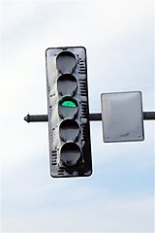
This photo provided by the Oswego Police, was taken after a fatal crash in Oswego, Ill. (AP)
Not every storm causes snow to stick to the lights, but when the wind is right and the snow is wet, drivers should beware, said Gary Fox, a traffic engineer for the city of Des Moines, Iowa.

Exactly how much a technological fix will cost is unclear, but it will surely cut into the savings and the energy efficiency many cities are enjoying.
Wisconsin, which has put LED bulbs at hundreds of intersections, saves about $750,000 per year in energy costs, said Dave Vieth of the state Transportation Department. LEDs installed seven years ago are still burning, while most incandescent bulbs have to be replaced every 12 to 18 months, he said.
One reason there have been so few deaths is that drivers know they should treat a traffic signal with obstructed lights as a stop sign, traffic experts say. "It's the same as if the power is out," said Dave Hansen, a traffic engineer with the Green Bay Department of Public Works. "If there's any question, you err on the side of caution."

A Design Problem Used in Study 2

In rural or remote areas, it is often difficult to deliver medical supplies and essential goods. Rough terrain, poor weather, and sparse populations lead to mobility challenges and airplane or drone drops are the only viable delivery option. Additionally, during a natural disaster, debris or wreckage can prevent supplies from being transported and must also be delivered by airdrops.
The aftermath of an earthquake in Indonesia.

However, this is a less than ideal option when it comes delicate cargo. Airdropping things like glass medicine vials and sensitive electronic equipment to emergency relief workers can prove to be challenging. Transporting these goods by hand would be too labor intensive and, more importantly, take too long since time is an important factor in urgent situations like these.
A rural village in a mountainous region of southwest China where it might be difficult to deliver supplies.
It is not known how much it will cost to produce technology to protect the supplies being airdropped, but it will surely help save the valuable equipment in the long run.

