University of Oklahoma
Graduate College

Road Culvert Impacts on Stream Fish Community Structure in Eastern Oklahoma

A THESIS
SUBMITTED TO THE GRADUATE FACULTY
In partial fulfillment of the requirements for the
Degree of
MASTER OF SCIENCE IN GEOGRAPHY

By
Parker Fleming
Norman, Oklahoma
2019

ROAD CULVERT IMPACTS ON STREAM FISH COMMUNITY STRUCTURE IN EASTERN OKLAHOMA

A THESIS APPROVED FOR THE
DEPARTMENT OF GEOGRAPHY AND ENVIRONMENTAL SUSTAINABILITY

BY

Dr. Thomas M. Neeson, Chair

Dr. Bruce Hoagland

Dr. Rebecca Loraamm

© Copyright by PARKER FLEMING 2019
All Rights Reserved

Acknowledgements
I would like to thank Kevin Neal and Brandon Day for their help out in the field. I would also like to thank Bill Matthews and Edie Marsh-Matthews for their guidance and help. Thank you to Kurt Kuklinski and the Oklahoma Dept. of Wildlife Conservation for funding this project from a State Wildlife Grant. Lastly, thank you to Dr. Thomas M. Neeson for allowing me the opportunity to work on this project.

Table of Contents
Acknowledgements……………………………………………………………………….............iv
List of Figures.…………………………………………………………………………................vi
Abstract…………………………………………………………………………………..............vii
Literature Review…………………………………………………………………………………1
Effects of Fragmentation on Stream Fish Community Structure ……………………....................4
Introduction……………………………………………………………………………......4
Methods……………………………………………………………………………............8
Data Collection…….……………………………………………………...............8
Culvert Measurements……………………………………………………….........8
Stream Measurements………………………………………………………..........9
Fish Collection……………………………………………………………….........9
Mark-Recapture……………………………………………………………….....10
Data Analysis………………………………………………………………….....10
Results................................................................................................................................12
Discussion..........................................................................................................................16
Conclusions....................................................................................................................................22
References......................................................................................................................................40

List of Figures
Figure 1..........................................................................................................................................24
Figure 2..........................................................................................................................................25
Figure 3..........................................................................................................................................26
Figure 4..........................................................................................................................................26
Figure 5..........................................................................................................................................27
Figure 6..........................................................................................................................................27
Figure 7..........................................................................................................................................28
Figure 8..........................................................................................................................................28
Figure 9..........................................................................................................................................29
Figure 10........................................................................................................................................29
Figure 11........................................................................................................................................30
Figure 12........................................................................................................................................30
Figure 13........................................................................................................................................31
Figure 14........................................................................................................................................32
Figure 15........................................................................................................................................33
Figure 16........................................................................................................................................34
Figure 17........................................................................................................................................35
Figure 18........................................................................................................................................36
Figure 19........................................................................................................................................36
Table 1...........................................................................................................................................37
Table 2...........................................................................................................................................38
Table 3...........................................................................................................................................39

Abstract
Road culverts threaten the Ozarks and Ouachita Mountains regions of Oklahoma with habitat fragmentation and loss of aquatic biodiversity. This region of Oklahoma is understudied when it comes to this issue. Fishes within the pelagic spawning reproductive guild are highly impacted by fragmentation because they need long segments of free-flowing river to reproduce. Here, we explore how stream fish community composition varies with the presence of a stream crossing structure such as a culvert. We sampled 29 sites that contained a physical structure and 39 random sites that did not contain a physical structure. At each site, we measured a suite of physical and hydrological attributes of the stream system and sampled the fish community; in sites with a road-stream crossing, we also measured a suite of physical attributes of the structure, and sampled the fish community upstream and downstream of the structure. The presence of a stream crossing structure resulted in significant differences in species richness and abundance compared to unfragmented sites. We also discovered that vertical outlet drops negatively affect species richness and abundance from the upstream to downstream stream segments. Exploring the Bray-Curtis Dissimilarity, we saw that at our fragmented sites there had large differences in stream fish community composition. We also encountered Species of Greatest Conservation Need: Wedgespot Shiner (Notropis greenei), Cardinal Shiner (Luxilus cardinalis), and Black Buffalo (Ictiobus niger). This study presents new data on the effects of fragmentation on stream fishes in this region of Oklahoma. This data could be used to create a framework for conservation of stream fishes in this region and the methodology to undertake projects such as this. With many Ozark and Ouachita Mountain streams fragmented by stream crossing structures, the need for renovation of these structures to ones more suitable for fish passage would be a first step in conservation of these stream fishes
Literature Review
Freshwater ecosystems are highly imperiled worldwide and are experiencing biodiversity loss at a faster rate than terrestrial systems (Dudgeon et al., 2006). Stressors such as pollution, alteration of natural flow regimes, dewatering, and habitat change are some of the reasons for declining freshwater biodiversity (Palmer et al., 2007; Perkin et al., 2015). But attention has recently focused on the fragmentation of riverine ecosystems and biodiversity loss. Fragmentation occurs when a human-made structure disrupts ecological processes, blocks movement of aquatic organisms, and isolates stream segments from one another (Lindenmayer and Fischer, 2006; Gido et al., 2010; Hoagstrom et al., 2011). The restoration of ecological connectivity among river and stream segments is widely recognized as a key step in the conservation of these ecosystems (Power et al., 1996).
Certain physical characteristics of road culverts tend to make them impassable to aquatic organisms. When culverts are undersized relative to the stream width, water flows are concentrated into a smaller cross-sectional area, increasing the velocity of the water within the culvert. As a result, undersized culverts often constitute a flow velocity barrier for native fishes (Schaefer et al., 2003). Outlet drops where the water level at the plunge pool is unequal to the downstream ends of culverts impede species’ distributions because stream fish in the Great Plains are generally weak leapers and are often unable to traverse a vertical outlet drop. As a result, community composition often differs between the upstream and downstream sides of a road-stream crossing (Ficke, Myrick, and Jud, 2011; Mueller et al., 2008). Longer culverts also tend to have lower passability for stream fishes because they force stream fishes to swim at higher speeds for longer distances in order to pass underneath the roadway (Bouska and Paukert, 2010).
River restoration projects that restore connectivity by removal of aging dams and retrofitting impassable road-stream crossings is a challenge for conservation (Perkin et al., 2015; Worthington et al., 2017). These restoration projects have the potential to enhance connectivity and boost freshwater biodiversity, as long as there are no other stressors that constrain ecosystem responses to connectivity restoration projects (Palmer et al., 2005). The main restoration strategy is to replace culverts with ones more suitable for connectivity and fish passage and that provides conditions that resemble natural flow velocity and that natural stream bed conditions (Warren and Pardew, 1998; Bouska and Paukert, 2010).
Because conservation practitioners lack the resources to retrofit all impassable road culverts, they rely on prioritization approaches for choosing among the thousands of candidate projects that exist in most river networks. Most prioritization approaches consistent of a cost-benefit analysis or return on investment analysis, in which conservation practitioners aim to identify projects that would result in a large increase in length of habitat reconnected per dollar spent (O’Hanley and Tomberlin, 2005; Januchowski-Hartley et al., 2014; Worthington et al., 2017; Moody et al., 2017). One of the challenges of applying prioritization approaches to a specific region is the general lack of location data for stream crossings and measures of their passability (Sleight and Neeson, 2018). In many regions, there is also a lack region-specific of data on the effects of these structures on stream fish communities. By combining stream fish composition data and analyzing the passability of culverts, conservation practitioners and construction engineers may be able to better prioritize which crossings should be replaced or renovated.
Despite the growing understanding of the effects of road culverts on stream fishes, the location and effects of physical structures in eastern Oklahoma remains poorly understood. Many of the stream ecosystems in this region are ranked as of high conservation value: small river systems in the Ozarks and Ouachita Mountains regions in Oklahoma are considered “very high conservation priority” by the Oklahoma Comprehensive Wildlife Conservation Strategy (OCWCS, 2016). In this thesis, we explore the effects of road culverts and other stream crossing structures on fish community composition in eastern Oklahoma. We also provide an updated inventory of stream fish community structure in the region, with an emphasis on quantifying the population status of species identified by the Oklahoma Department of Wildlife Conservation as Species of Greatest Conservation Need (ODWC). During the summer of 2018, we sampled 29 sites that possessed a structure that could potentially block fish movement, as well as 39 control sites that did not contain a physical structure. At each site, attributes measured fell in to three categories: physical characteristics of the stream, physical characteristics of the structure, and stream fish community composition. Statistical analysis addressed questions of stream fish richness and abundance regarding position upstream of the structure, downstream of the structure, and unfragmented sites. Next, we analyzed how species richness and abundance might be affected by physical and hydrological attributes of the stream crossing structures. Lastly, Bray-Curtis Dissimilarity Index was used to determine how stream fish community composition differs between the upstream and downstream segments of fragmented sites. The intent of this study is to enhance the understating of the effects of road culverts in stream fishes in eastern Oklahoma, and provide conservation practitioners with an updated understanding of the population status of Species of Greatest Conservation Need (OCWCS, 2016).

Effects of Road Culverts on Stream Fish Community Structure
Introduction
Anthropogenic effects are accelerating biodiversity loss in freshwater environments more rapidly than in terrestrial systems (Dudgeon et al. 2006). Loss of biodiversity is being driven by a wide range of stressors, including pollution, flow changes, dewatering, habitat change, and fragmentation (Palmer et al., 2007, Perkin et al., 2015). Fragmentation is when the presence of a man-made or natural structure alters natural flow regime, disrupts ecological processes, potentially blocks fish movement, and isolates formerly connected stream segments (Lindenmayer and Fischer, 2006; Gido et al., 2010; Hoagstrom et al., 2011). Fragmentation affects the persistence of species and the ecosystem services they provide (Perkin and Gido, 2012). With loss of free-flowing riverine habitat, there is increased extinction, and loss of genetic diversity (Jager et al., 2001). Compounding this issue, freshwater fish species as a group are the most affected by climate change and anthropogenic stressors. (Branco et al., 2016).
Habitat fragmentation in the Great Plains has had drastic effects on stream fishes in this region. With over 19,000 anthropogenic structures in this region affecting flow regimes, there are large effects of fragmentation on stream fish community structure (Costigan and Daniels, 2012; Perkin et al., 2015). Alteration of the habitats surrounding stream systems in this region from native grasslands to row crops that have more dependence on groundwater have had significant effects on stream fish populations (Perkin et al., 2015).
In the Great Plains region of North America streams are primarily affected by water depletion and fragmentation (Perkin et al., 2015). Streams in this region are heavily dominated by pelagic spawning cyprinids. These cyprinids spawn within the water column and depend on flow to carry male and female genetic material downstream so it may fertilize (Perkin and Gido, 2011). Genetic material that flows downstream outside of the parent stream segment in a disturbed stream will create spawn that are unable to return dwindling population size of these pelagic-spawning cyprinids and shrinking their native range and habitats (Perkin et al. 2015). Pelagic spawning cyprinids need long uninterrupted stream reaches ranging from 80km to 217km to be reproductively successful (Perkin and Gido, 2011). But structures downstream inhibit fish from full development while drifting downstream, while structures upstream prevent migration of adults (Perkin and Gido, 2011). Structures also reduce diversity by blocking dispersal between fragments (Perkin et al., 2015). During winters months or drought conditions where the chance to recolonize upstream stream reaches would be more difficult extinction and extirpation would be the results (Worthington et al., 2017). Fish abundance is generally lowest in stream reaches that are artificially constrained channels due to habitat homogenization and/or reduced stream flow (Worthington et al., 2017). The alteration of flow can disrupt the spawning cycles of these pelagic broadcast spawners (Worthington et al., 2017), which usually happens when there is an increase in discharge even though some individuals will spawn no matter the abiotic factors (Worthington et al., 2017).
The interactive effects of declining water availability and habitat fragmentation create an ecological ratchet effect (Perkin et al., 2015). The ratchet concept states that a change in each response variable through space or time in response to natural or human disturbances decreases reciprocal movement, thus creating a negative feedback loop. During periods of drought in the Great Plains as well as the Ozarks and Ouachita’s there is less flow in these stream systems. With climate change, human water use, fragmentation, and dewatering affecting connectivity the fish that depend on flow for survival are facing range shrinkage and extinction. The response variable in this framework would be the ability for pelagic spawning fishes to migrate upstream and spawn. Because passage is blocked, we start to see more extirpation of pelagic spawning fishes occurring during periods of drought and when flows return these fish are gone from their previous stream reaches due to fragmentation (Perkin et al., 2015). Climate change is project to cause decreased water flow in prairie streams with reoccurring summer droughts, and therefore pelagic spawning cyprinids will be further hindered from traversing structures to spawn and/or isolated in stream segments they cannot be reproductively successful in or extirpated from stream segments (Perkin et al., 2015; Worthington et al., 2017).
Alteration of flow in culverts is one of the proposed reasons fish are unable to migrate upstream to spawn (Warren and Pardew, 1998). Road crossings and other structures are constructed to concentrate the discharge and narrow the overall cross section of the stream that fish would normally be able to move or migrate in (Schaefer at al., 2003). Most structures are considered semi-permeable and at full flow and may be less effective as impediments to fish movement (Perkin and Gido, 2011). Fish community composition depends on abiotic and biotic factors of the stream environment, but connectivity issues are an abiotic constraint that drives community compositions (Labonne et al., 2008). Low or intermittent flow forces pelagic broadcast spawning species into isolated stream segments (Worthington et al., 2017). When there are no pelagic spawning species in an isolated stream segment the effects of structures aren’t as heightened (Worthington et al., 2017).
Outlet drop is a factor hindering fish movement. Native fishes are weak leapers, so vertical outlet drops block their movements. Over time, this can lead to differences in species richness and abundance between upstream vs downstream sides of structures. (Mueller et al., 2008; Ficke, Myrick, and Jud, 2011). Culvert length is also known to have an effect on fish passage, as culvert length increases so does the length the fish has to swim against higher water velocities, dependent on the construction of the culvert (Schaefer et al., 2003; Bouska and Paukert, 2010). Deeper plunge pools below the culverts will also hold more species richness and abundance than upstream segments due to deeper water and more habitat throughout the year (MacPherson et al., 2012).
Understanding the effects of stream crossing structures and their spatial impacts on stream fish populations is imperative for conservation of Great Plains minnows. With drastic impacts on native fish diversity, including 41 regional endemic species (which is 84% of all endemic fish in this region) there should be more research on the conservation of these species (Hoagstrom et al. 2011).
We conducted a regional field survey of streams with structures (pipe culverts, box culverts, low-water fords, arch culverts) that could potentially hinder longitudinal connectivity for upstream and downstream fish populations. We surveyed physical and hydrological aspects of the structures to determine if measured variables could identify the degree of obstruction to fish movements. A total of 68 sites surveyed; 29 with structures that could potentially block fish movement and 39 were without. To determine how road-stream crossing structures might affect fish community structure we sampled fish by seining the adjacent upstream and downstream segments surrounding these structures and took a suite of physical and hydrological attributes of the stream environment and road-stream crossing structures. We also used VIE (Visible Implant Elastomer) at five sites to potentially see fish movement upon recapture at a later date. Lastly, we did a fish community analysis showing how fish communities differ based upon their proximity to a physical barrier and what physical attributes of the structure produce these differences. We hypothesize that we will see similar effects of fragmentation on fish community structures in the Ozarks and Ouachita regions as there are in the Great Plains. We hypothesize that species richness and abundance at each of fragmented sites would be subject to the same confounding factors. With little literature and data on fragmentation on stream fish communities in the Ozark and Ouachita region of Oklahoma, this study will give us insight on how physical characteristics of structures affect stream fish communities in this region. This project could potentially be a framework for further knowledge on the issue of fragmentation in this region and could potentially lead to more studies and conservation planning for Species of Greatest Conservation Need and culvert restoration in this region.
Methods
Data collection
During the summer of 2018, field surveys were conducted at a total of 68 across the Ouachita and Ozark Mountain regions of eastern Oklahoma. We examined 29 sites with physical structure (road culvert, low-water ford, etc.) that potentially block fish movements, and 39 unfragmented stream segments that contained no physical structure (Fig. 2). For each location, we recorded physical and hydrological measurements of the stream upstream and downstream of the physical structure, and measured physical characteristics of the structures themselves. We then sampled the fish community upstream and downstream of the structures to assess the fish community structure on either side of the barrier.
Culvert measurements
We measured the physical and hydrological characteristics of the structures using a small barrier assessment data sheet from Bain and Stevenson (1999). Specifically, we measured the outlet drop height (i.e., distance from the bottom of the structure outlet to the water surface below the structure), structure length, width, type of structure, structure condition, road condition, average velocity of water going through the structure (cm/s), pool depth (cm), and structure height (Bouska and Paukert, 2010). We used a Hach FH 950 flow meter to determine average velocity of the water flowing through the culverts.
Stream measurements
Following Bain and Stevenson (1999), we measured a suite of physical and hydrological stream variables. Using a flow meter, the cross sectional width of the stream (defined the bank full width) was divided into 20 equal intervals. At each interval, the flow meter was set at 60% of the stream depth. Other physical characteristics record from the stream were water temperature, percentage canopy cover, percentage of certain substrates (bedrock, gravel, mud, sand, cobble), stream width, stream depth at thalweg, flow velocity, and discharge (Bouska and Paukert, 2010; Zbinden and Matthews, 2017). We replicated these measurements for our control (unfragmented) sites, upstream segments of our fragmented sites, and downstream segments of our fragmented sites.
Fish collection
At each study site, we used seine nets to sample the fish community. Following the approach using in Perkin et al. (2015), a team of two people would seine the available habitat within the stream reach. Once sampling the reach, we would sometimes make another pass to ensure we sampled the most we possibly could. Fish were collected and stored in a Frabill three-gallon minnow bucket with an aerator attached. Sampling time ranged from approximately 40-100 minutes depending on the size of the reach and how many fish were being collected (Zhibden and Matthews, 2017). After our seining efforts, we identified individuals to the species level and recorded their length. All fish were released back into the stream segment they were sampled in as quickly as possibly once identified, counted, and measured; as a result, mortality was minimal and typically less than 10 individuals per site. This process was replicated in the upstream, downstream, and control segments. Effort-time differed between our sites, control sites were seined once, while upstream and downstream sites were seined once as well. We spent more effort-time at our fragmented sites than our control sites.
Mark-recapture
Visible Implant Elastomer (VIE) tags were used to test whether physical structures hindered fish movement. For our first five sites with physical structures we marked all fish captured on both sides of the structure. We used two different VIE tag colors to differentiate which side of the barrier the fish were captured (Bouska and Paukert, 2015). We injected the elastomer close to the dorsal fin. Streams were resampled monthly. Recaptured fish were again tagged and previously non-tagged fish were marked with a color noting it was captured the second round of sampling. The third field visit was the final sample and no fish caught were marked or remarked.
Data analysis
To assess whether and how stream structures affect stream fishes in our study sites, we performed a series of statistical analyses on community structure and barrier attributes. All statistical tests were conducted using R.
To test whether mean species richness and abundance differed among upstream, downstream, and control (i.e., unfragmented) sites, we performed one-way ANOVA’s. We then ran paired t-tests to determine whether mean abundance and richness differed between upstream and downstream segments. We chose to use a paired t-test because we hypothesized that abundance and richness at each paired site would be subject to the same set of confounding factors.
Tests were then performed to determine how differences in species richness and abundance between fragmented vs. unfragmented sites might be related to physical and hydrological characteristics of the barriers and stream sites. First, we hypothesized that differences in species richness and abundance upstream vs. downstream of a structure would be greater in locations where the structure contained a sufficient vertical drop that would block fish movements, those without drops would have similar species richness and abundance (Mueller et al., 2008). To test this hypothesis, we first calculated the difference in species richness upstream vs. downstream of each structure. We then performed a paired t-test to compare mean difference in species richness between sites with a vertical outlet drop vs. sites without a vertical outlet drop. To test whether differences in species richness and abundance were related to the type of structure, we first separated our sites with structures into two groups: those with a pipe culvert (n = 11 sites) and those with any other type of structure (n = 18 sites; structures included box culverts, arch culverts, and low water dams). We then conducted separate paired t-tests for each of those groups (sites w/ pipe culverts, and sites without) to determine whether species richness and total abundance differed between upstream and downstream stream segments.
We then fit two linear regression models to determine how the difference in species richness between upstream and downstream stream reaches, and the differences in abundance between upstream vs. downstream reaches, might be related to four physical dimensions of the structure: vertical drop height, structure length, plunge pool depth, and structure condition (how deteriorated it is). We included vertical drop height in this model because it is known to hinder fish movement and therefore should drive differences in abundance and richness between upstream and downstream segments (Mueller et al., 2008). We included culvert length in this model because there is evidence that the length of the culvert can impede fish movement (Bouska and Paukert, 2010). Plunge pool depth was also included because the deeper the plunge pool the more species richness and abundance it can hold but also has the most dissolved oxygen in the deepest parts (MacPherson et al., 2012). Lastly, structure condition was included because if the interior condition of the structure contains debris or broken road material it could hinder fish movement (Cahoon, 2002; Sleight and Neeson, 2018).
Finally, The Bray-Curtis Dissimilarity Index was for two analyses to determine how stream barriers might affect fish community structure. First, we calculated the Bray-Curtis Dissimilarity index for all possible pairs of upstream sites; all possible pairs of downstream sites; and for all possible pairs of control sites. The Bray-Curtis Dissimilarity Index depicts how dissimilar a species community composition (species richness and abundance) is between a pair of sites. A value between zero and one is calculated for each pair, zero being complete similarity and one complete dissimilarity (Brown et al., 2007). In this analysis, our objective was to determine how similar community structure was among all upstream sites; among all downstream sites; and among all control sites.
Our second community structure analysis was to assess community dissimilarity between upstream vs. downstream sites; and between upstream and control, and downstream and control sites. To do this, we first created pairs of fragmented and control sites by identifying pairs of sites that were as similar as possible to each other in terms of physical characteristics of the stream (e.g., flow, depth, and width). We then calculated the BCI between each pair of sites and used an ANOVA to compare mean community dissimilarity among upstream vs. downstream pairs; upstream vs. control pairs; and downstream vs. control pairs. All Bray-Curtis analysis were used with the vegan package in R.
Results
We recorded 8,370 individuals across 55 species (Table 1). We collected 1,570 fish in stream segments above physical structure, 2,731 fish in stream segments below physical structures, and 4,069 fish throughout our control sites. All sites were wadeable streams with velocities ranging from 0 to 33.13 cm/s.
We found that both mean species richness and mean abundance differed between control sites, upstream of the physical structure at fragmented sites, and downstream of the physical structure at fragmented sites. We observed large and statistically significant differences in abundance between upstream segments (mean = 54.14 individuals, n = 29 sites), downstream segments (mean = 94.17, n = 29), and control segments (mean = 104.33, n = 39) as determined by our ANOVA (p < 0.05; Fig. 3). We also saw differences in mean species richness among upstream segments (mean = 4.79 species), downstream segments (mean = 5.86 species), and control segments (mean = 6.36 species). Even though we did not see significance, our ANOVA approached it (p = 0.07; Fig. 4). We also found statistically significant differences in upstream species richness (mean = 4.79 species) and downstream species richness (mean = 5.86 species; paired t-test; p < 0.05; Fig. 5); and between upstream abundance (mean = 54.14 individuals) and downstream abundance (mean = 94.17 individuals; paired t-test, p < 0.05; Fig. 6).
We found that differences in species richness and abundance between fragmented and unfragmented sites were related with a variety of physical attributes of structures. Of the 29 sites with potential barriers, 20 sites had no vertical outlet drop and 9 sites had a vertical outlet drop. For sites with a structure without a vertical drop, we observed a large difference in mean abundance between upstream segments (mean = 57.55 individuals) vs. downstream segments (mean = 78.7 individuals), but the difference only approached statistical significance (paired t-test; p < 0.06; Fig. 7). For perched sites, we saw large differences in abundance between upstream segments (mean: 46.56) vs. downstream segments (mean: 128.56) than non-perched sites, still only approaching statistical significance (paired t-test; p = 0.06; Fig. 8). Of our 29 sites that included potential barriers, 11 were pipe culverts and 18 consisted of other types of structures (box culvert, low water dam, arch culvert). At sites with pipe culverts, we saw large differences in mean abundance but only approached significance between upstream segments (mean = 54.14 individuals) vs. downstream segments (mean = 94.17 individuals; paired t-test, p = 0.06; Fig. 9). For other types of structures, we also saw large differences in mean abundance between upstream segments (mean = 64.17 individuals) vs. downstream segments (mean = 102.13 individuals), but a paired t-test only approached significance (paired t-test; p = 0.06; Fig. 10). For sites with pipe culverts saw a statistically significant relationship in mean species richness between upstream segments (mean = 4.79 species) vs. downstream segments (mean = 5.86 species; paired t-test; p < 0.05); Fig. 11). With our field season being heavily dominated by cyprinids, we ran similar tests to see if cyprinids constituted most of the change in species abundance and richness. When excluding cyprinids, did not find a statistically significant difference between species richness at upstream sites (mean = 2.69 species) and downstream species richness (mean = 3.28 species; paired t-test; p > 0.05; Fig. 12). Similarly, we did not find a statistically significant difference between abundance at upstream sites (mean = 15.45 individuals) and downstream sites (mean = 20.55 individuals; paired t-test, p > 0.05; Fig. 13).
We found a negative relationship between vertical drop height and both stream fish abundance (linear regression; p < 0.05) and richness (linear regression; p < 0.05; Fig. 14). When we included the entire fish community in our analyses, we did not find a statistically significant relationship between the length of the barrier and species abundance (linear regression; p > 0.05) nor species richness (linear regression; p > 0.05) (Fig. 15). When we excluded cyprinids from our analysis, however, we did not find a statistically significant relationship between the length of the barrier and species abundance (linear regression; p > 0.05; Fig. 15). We did not find a statistically significant relationship between the plunge pool depth and species abundance (linear regression; p > 0.05) but species richness approached significance (linear regression; p = 0.08; Fig. 16). We did not find a statistically significant relationship between structure condition and species abundance (linear regression; p > 0.05) but we found a statically significant relationship on species richness (linear regression; p < 0.05; Fig. 17). When excluding cyprinids, we saw a statistically significant relationship between structure condition and species abundance (linear regression; p < 0.05) and only approaching significance with species richness (linear regression; p = 0.08; Fig. 17).
Exploration of the Bray-Curtis Dissimilarity Index values revealed differences fish community structure among upstream, downstream, and unfragmented sites. On average, the upstream had pairs of sites that were almost similar in composition, but most pairs of sites were very different in species composition as measured by the Bray-Curtis Dissimilarity Index (min = 0.16, µ = 0.9, max = 1). We saw similar results for our downstream pairs of sites (min = 0.16, µ = 0.9, max = 1). Lastly, for our control sites we recorded similar results (min = 0.11, µ = 0.85, max = 1; Fig. 18).
We also found that upstream and downstream segments at fragmented sites were more similar to each other than to control sites. For our upstream and downstream segment pairs, we had an average BCI of 0.59. For our upstream segments and their corresponding control site segments we had an average BCI of 0.79. For our downstream segments and corresponding control site segment we had an average BCI of 0.78. Lastly, we saw statistical significance between the means of the groups (ANOVA; p < 0.05) (Fig. 19).
Discussion
From our field survey efforts, we found that structures that block fish movement tend to impact fish communities adjacent to those structures. At sites with an impassable structure, we saw an average Bray-Curtis similarity coefficient of 0.41 between upstream vs downstream segments, meaning that the fish communities were very dissimilar (Fig. 19). We saw effects of vertical outlet drops on species composition from the upstream segments vs the downstream segments (Fig. 8, 13). We also saw difference in species richness and abundance depending on the type of structure present in that stream system (Fig. 9-12). Thus, our study adds to the growing body of evidence on the effects of fragmentation on stream fish communities in the Great Plains (Bouska and Paukert, 2010; Perkin and Gido, 2012; Worthington et al., 2017) and other regions around the world (Nislow et al., 2011; Macpherson et al., 2012; Maitland and et al., 2016).
We also found that effects of culverts on fish communities varied with both culvert type and the physical characteristics of the culvert. At sites with a vertical drop at the outlet of the culvert, there was a noticeable difference in species richness and abundance between the upstream vs downstream habitat (Fig. 14). For the fish in this region the presence of a vertical drop can be challenging since these species can rarely jump over a drop greater than 5cm (Ficke, Myrick, and Jud, 2011). Thus, we hypothesize that the larger differences in richness and abundance at sites with perched culverts reflects native fishes’ inability to leap past this vertical drop.
We did not find any significant effect of culvert length on fish communities (Fig. 15). Specifically, we did not find significant relationships between culvert lengths and differences in species abundance and richness between upstream vs downstream sites. This finding differs from the results of Bouska and Paukert in Kansas (2010), who found that culvert length did affect fish passability. Since culverts concentrate water flow-resulting in higher water velocities-the length of the culvert obviously impacts swimming distances and potentially fish passage because fish are unable to swim against higher water velocities for long lengths (Toepher et al., 1999; Adams et al., 2000; Bouska and Paukert, 2010). While we did measure water velocity through the culverts, we found that it did not have an effect on differences in stream fish composition on either side of the structure.
The differences in species richness and abundance between the upstream and downstream sites with the presence of pipe culverts (Fig 9,11-13), suggest that the type of road-stream crossing community structure. Species abundance also differed between upstream and downstream sites with the presence of other styles of structures (Fig. 10). In both natural and artificial barriers, different species have different rates of movement across them (Warren and Pardew, 1998; Lonzarich et al., 2000; Schaefer et al., 2003). In both natural and artificial settings, riffle length, current velocity, and thalweg depth affect fish movement (Schaefer 1999, 2001; Schaefer et al., 2003). Implementing culvert designs that are shorter in length, maintain natural flow velocity, and have enough depth for fish to migrate through them would be a solution that would decrease the challenges fish face.
The mean dissimilarity between pairs of sites from each group (i.e., between pairs of sites that are both upstream of physical structures; pairs of sites that are both downstream of physical structures; and between pairs of unfragmented sites) had very dissimilar fish community compositions (Fig. 18). We saw an average Bray-Curtis dissimilarity coefficient of 0.9 for our upstream sites suggesting that our upstream sites were very dissimilar in species composition. We saw a similar dissimilarity coefficient of 0.9 for our downstream pairs of sites. Lastly, we saw a dissimilarity coefficient of 0.85 for our unfragmented sites. More importantly, when looking at our fragmented sites we had a Bray-Curtis coefficient of 0.59 suggesting that the difference in species composition from the upstream sites to our downstream sites was large. Our results coincide with Perkin and Gido (2012) who also found lower species richness and higher species dissimilarity at fragmented streams than unfragmented stream reaches.
Most stream crossing structures are starting to reach the end of their lifespan (Alkhrdaji 1999; Doyle et al., 2008; Sleight and Neeson, 2018) and the need for renovation and replacement is in the near future. These aging structures are a shared priority for both conservation groups and transportation agencies, because culverts in poor physical condition have both a high risk of catastrophic failure and are often the most impassable for stream fishes (Cahoon 2002). During our field season our fish collections were very cyprinid dominant. After removing cyprinids from our analysis, we found that both species richness and species abundance were significantly correlated with culvert condition (Fig. 17). Thus, culverts in poor condition tended to be least passable for stream fishes and should be priority projects for both conservation groups and transportation agencies (Neeson and Sleight, 2018).
Despite our results, our field work had its limitations. Towards the end of the summer finding perennial streams proved difficult. With the lack of perennial streams, we also saw a lack of road-stream crossing structures that had water flowing through them. Sampling more sites without physical structures gave us larger differences in species richness and abundance when compared to our upstream and downstream sites. In this study we were focused primarily on fish community structure, so we did not give passability ratings for each of our fragmented sites to quantify the degree of fragmentation on the stream network (Cahoon, 2002; Januchowski-Hartley et al., 2014). While we used seines for sampling fish communities instead of electroshocking backpacks, there is potential for failing to detect all fish within a given stream reach.
Restoring connectivity and flow is imperative for the survival of pelagic broadcast spawning species (Perkin and Gido, 2011; Worthington et al., 2017). One potential solution is to create free-flowing sections of river systems by the removing dams and retrofitting road crossings to facilitate fish movements. Renovating stream crossing structures with open bottoms that closely resemble the surrounding stream system would be the most ideal option (Bouska and Paukert, 2010) Creating a structure designed for fish movement would be ideal because it would result in normal flow velocities in stream reaches, allow dispersal of stream fish, and minimize geomorphic changes within the stream itself (Angermeier and Schlosser, 1995; Warren and Pardew, 1998; Bouska and Paukert, 2010). The restoration of connectivity has been shown to help reestablish or increase dispersal of fishes that are affected by habitat fragmentation (Catalano et al., 2007; Walters et al., 2014). Restoring connectivity with passable structures would be significantly helpful for regions that often have periods of drought and low-flow conditions during the summer, because it would reduce the incident of the ecological ratchet effect (Perkin et al., 2014, Perkin et al., 2015) that occurs from the interactive effects of drought and fragmentation.
In addition to describing the effects of fragmentation on stream fish communities, a second aim of this thesis was to provide an update on the population status of stream fishes in the Ozarks and Ouachita Mountains regions of Oklahoma. Overall, we detected 8,370 individuals across 55 species (Table 1). Three species listed as federally endangered are believe to occur (or have historically occurred) in our study region: Arkansas River Shiner (Notropis Girardi), Leopard Darter (Percina pantherina), and Neosho Madtom (Noturus placidus). However, we did not detect any of these three species. Our analysis also provides an update on the population status of species considered as Species of Greatest Conservation Need by the Oklahoma Department of Wildlife Conservation. Species are then placed within tiers one through three (one being the highest). We did not find any Tier 1 species. However, we did encounter four several Tier II species and two Tier III species (Table 3).
Overall, this study provides a first assessment of the effects of road culverts on stream fish communities in the Ozarks and Ouachita Mountains of Oklahoma, and an update on the population status of stream fishes of conservation need in this region. These findings can enhance on-the-ground efforts to restore aquatic ecosystem connectivity in the region by retrofitting impassable road culverts. Conservation practitioners could use these data to create a cost-benefit analysis for identifying the road culvert mitigation projects that might reconnect the most habitat for the stream system (O’Hanley and Tomberlin, 2005; Neeson et al., 2018). The ODWC Streams Team would be a great resource for doing these surveys. Creating another facet of the streams program for sampling these smaller order streams and assessing the road-stream crossing structures would be a start for future conservation efforts. The methodology of this study could create a framework for sampling these smaller stream systems not only in the Ozarks and Ouachita’s but other smaller riverine networks. We saw the biggest differences in species abundance and richness with our structures that contained vertical outlet drops; thus, structures with a vertical outlet drop should be prioritized higher for culvert renovation. Pipe culverts on average had a larger difference in species abundance from the upstream segment vs downstream segment than the other types of culverts we sampled; thus, pipe culverts in particular should be prioritized for replacement. Our finding that culverts in poor physical condition also have low passability suggests a potential for shared project priorities between conservation practitioners and transportation agencies. Going forward, efforts to restore aquatic ecosystem connectivity will need to occur alongside a broader suite of conservation actions: understanding flow variations, small barrier removal, experimental population reintroduction, and large-scale riverscape coordinated research between conservation agencies, road managers, and NGOs (Worthington et al. 2017). Thus, future work must focus on spatial patterning and interactions of a diverse set of stressors and strategies for prioritizing conservation actions in these ecosystems.

Conclusions
From our field surveys, it is evident the effects of road crossings and fragmentation have on fish populations in the Ozark and Ouachita regions of Oklahoma. The locations visited in this field season are definitely not all of the stream crossing structures in this region. With the effects of climate change and stream fragmentation it is imperative we allocate resources for the further study of these streams in this region. The data collected above will be a stepping stone for future road impact projects for this region and the state of Oklahoma. Not only is there a lack of data collection on stream fish species in Oklahoma but there are very little road crossing impact studies on fish in the region. With additional information on fish populations and the locations of potentially problematic stream crossing structures conservation agencies can make informed decisions for restoration projects.
The need for culvert restoration projections is apparent throughout the Ozarks and Ouachita’s. With the upper echelon of culverts facing the end of their lifespan road managers and conservation agencies are facing opportunities for renovating culverts to create more free-flowing stream segments. This would result in restored connectivity of these stream systems. Restored connectivity would help restore migratory patterns of the stream fishes and their ability to be reproductively successful.
Being able to prioritize which stream crossings would require a two-pronged approach. One would be assessing the physical condition of the culvert and how it affects the adjacent stream segments. Second would be to assess the fish communities on either side of the structure. If we see disparities between the downstream community vs the upstream community, road managers and conservation agencies could create a guideline for fish passability and prioritize certain structures for renovation. Implementing stream crossing that resemble the natural stream bed would be the most ideal to maintain free-flowing connectivity. Although an issue with renovating these structures would be the cost. Prioritization of culverts would be a cost-benefit analysis of opening up the most amount of free-flowing stream segments for the least amount of monetary involvement. There are initiatives to where county level government agencies can apply to have structures removed or renovated and the US Fish and Wildlife Service will match the amount of money allotted for renovation to implement a crossing that would be better for fish movement.
We see the effects of fragmentation in our streams in Oklahoma and these effects are replicated along large-scale regional studies. Implementing large-scale regional studies for watersheds in the Ozark and Ouachita Mountain regions by creating renovation prioritization protocols in conjunction with fish community structure surveys will help conservation practitioners create free-flowing stream segments. With this they could look at a species level for restoring range of endangered or species of greatest conservation need.

Figures
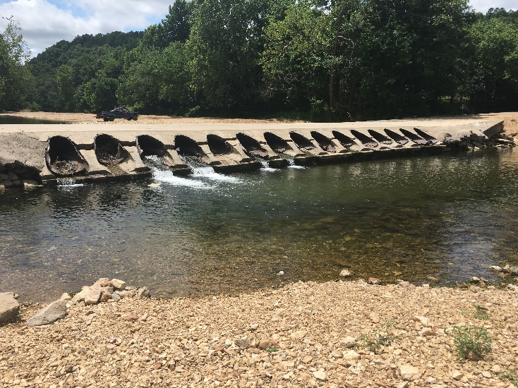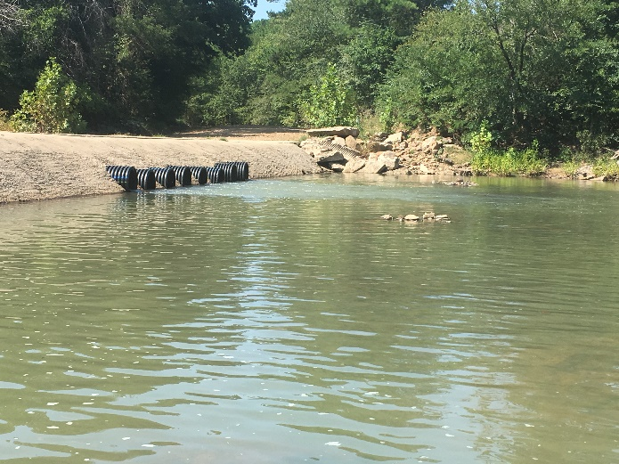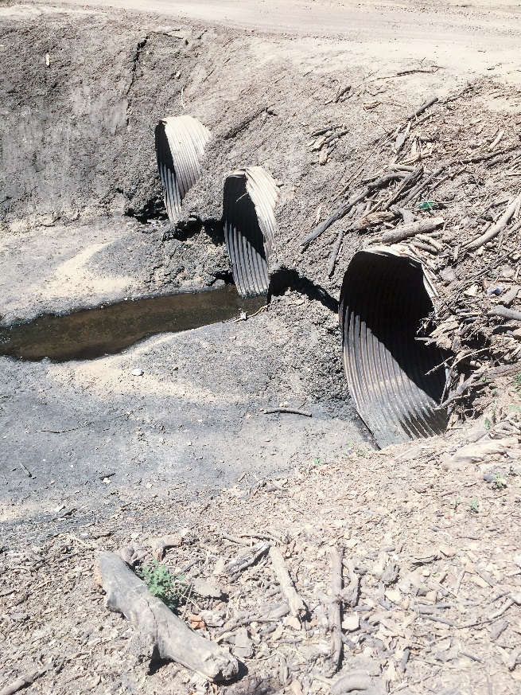
Figure 1. Culvert sampled during our field season. Upper Left is in Sequoyah Co. along Fourmile Creek. Upper Right is Hodge Creek in Le Flore Co. Bottom Left is Garrison Creek in Sequoyah Co.

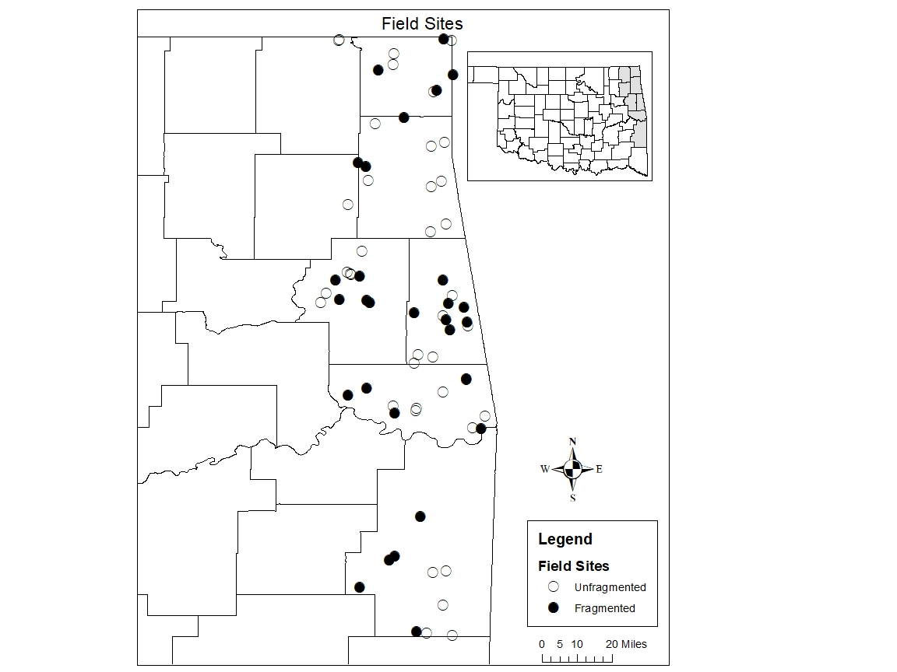
Figure 2. Our field site locations in Eastern Oklahoma. This shows whether each site was fragmented (possessed a physical structure) and unfragmented (did not possess a physical structure)

Figure 3. Mean abundance (based on 8370 individuals and 68 sites) at each of three types of stream survey sites: upstream of structures at fragmented sites (mean = 54.14); downstream of structures at fragmented sites (mean = 94.17); and at free-flowing, unfragmented control sites (mean = 104.33). Frequency is number of individuals.

Figure 4. Mean richness (based on 55 species total) at each of three types of stream survey sites: upstream of structures at fragmented sites (mean = 4.79); downstream of structures at fragmented sites (mean = 5.86); and at free-flowing, unfragmented control sites (mean = 6.36). Frequency is number of species.

Figure 5. Mean richness between downstream of structures at fragmented sites (mean = 5.86) and upstream of structures at fragmented sites (mean = 4.79).

Figure 6. Mean abundance between downstream of structures at fragmented sites (mean = 94.17) and upstream of structures at fragmented sites (mean = 54.14).

Figure 7. Mean abundance between downstream of structures at fragmented sites (mean = 78.7) and upstream of structures at fragmented sites (mean = 57.55) without vertical outlet drops.

Figure 8. Mean abundance between downstream of structures at fragmented sites (mean = 128.56) and upstream of structures at fragmented sites (mean = 46.56) with vertical outlet drops.

Figure 9. Mean abundance between downstream of structures at fragmented sites (mean = 94.17) and upstream of structures at fragmented sites (mean = 54.14) with pipe culverts.

Figure 10. Mean abundance between downstream of structures at fragmented sites (mean = 102.13) and upstream of structures at fragmented sites (mean = 64.17) with other structures (Box culvert, arch culvert, low water dam).

Figure 11. Mean richness between downstream of structures at fragmented sites (mean = 5.86) and upstream of structures at fragmented sites (mean = 4.79) with pipe culverts.

Figure 12. Mean richness between downstream of structures at fragmented sites (mean = 3.28) and upstream of structures at fragmented sites (mean = 2.69) with pipe culverts excluding cyprinids.

Figure 13. Mean abundance between downstream of structures at fragmented sites (mean = 20.55) and upstream of structures at fragmented sites (mean = 15.45) with pipe culverts excluding cyprinids.
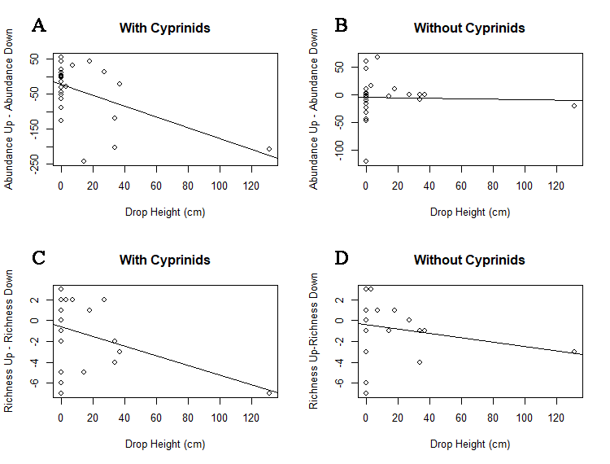
Figure 14. Relationships between the vertical distance between the water surface and the culvert outlet (drop height; x-axis) and fish abundance and species richness. Panels A and B give the difference in abundance between sites upstream and downstream of the structures for the entire fish community (A), and the same relationships without cyprinids (B). Panels C and D give the difference in species richness between sites upstream and downstream of structures as determined for the entire fish community (C) and without cyprinids (D). Lines give the best-fit linear regression to each set of points.

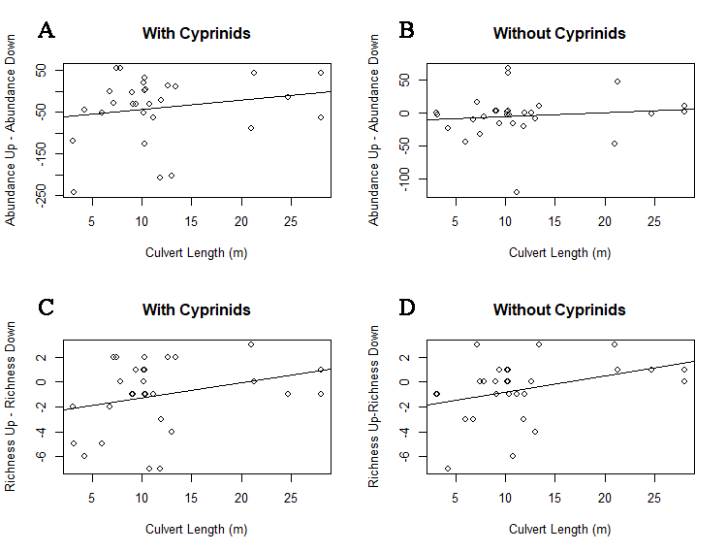

Figure 15. Relationships between the length of the culvert (culvert length; x-axis) and fish abundance and species richness. Panels A and B give the difference in abundance between sites upstream and downstream of the structures for the entire fish community (A), and the same relationships without cyprinids (B). Panels C and D give the difference in species richness between sites upstream and downstream of structures as determined for the entire fish community (C) and without cyprinids (D). Lines give the best-fit linear regression to each set of points.

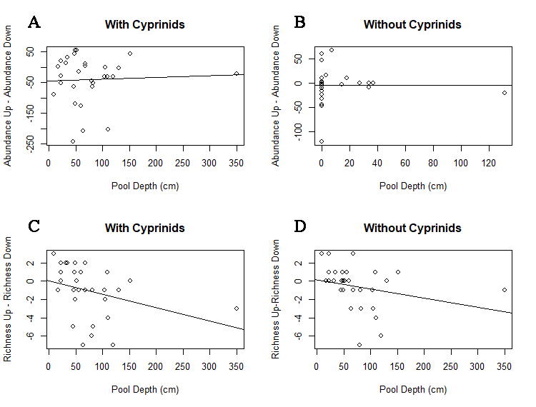
Figure 16. Relationships between the depth of the plunge pool (plunge pool; x-axis) and fish abundance and species richness. Panels A and B give the difference in abundance between sites upstream and downstream of the structures for the entire fish community (A), and the same relationships without cyprinids (B). Panels C and D give the difference in species richness between sites upstream and downstream of structures as determined for the entire fish community (C) and without cyprinids (D). Lines give the best-fit linear regression to each set of points.

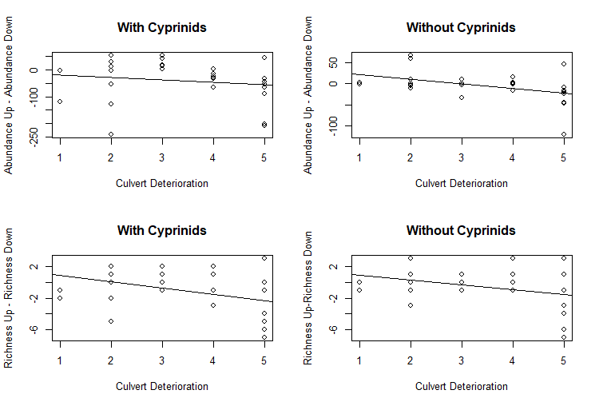
Figure 17. Relationships between the deterioration level of the culvert (culvert deterioration level; x-axis) and fish abundance and species richness. Panels A and B give the difference in abundance between sites upstream and downstream of the structures for the entire fish community (A), and the same relationships without cyprinids (B). Panels C and D give the difference in species richness between sites upstream and downstream of structures as determined for the entire fish community (C) and without cyprinids (D). Lines give the best-fit linear regression to each set of points.

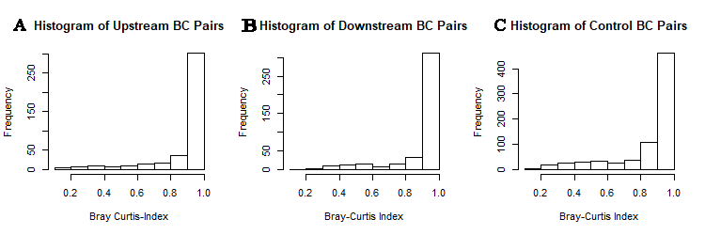
Figure 18. Histograms of fish community dissimilarity (as measured by the Bray-Curtis Index) for all pairwise combinations of all upstream sites (A), all downstream sites (B), and all non-fragmented control sites (C). BCI values of 1 indicate maximum dissimilarity in species composition.

Figure 19. Mean Bray-Curtis Indices between groups of sites (Upstream and Downstream sites [Fragmented] (mean = 0.59), Upstream and Control Sites (mean = 0.79), Downstream and Control Sites (mean = 0.78).
Figure 20. Overview of all species and their abundances caught during our field surveys.
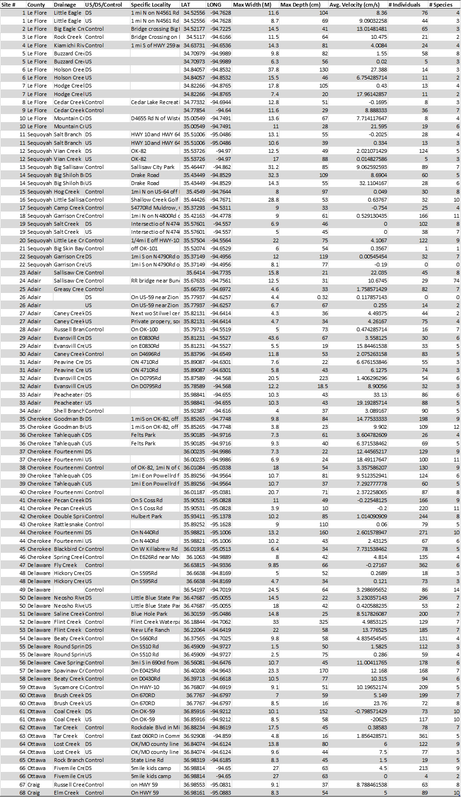
Figure 21. Overview of our field sites with total abundance and richness per site.
Figure 22. Species of Greatest Conservation Need sample and at how many sites they were present at.

References
Adams, S. R., Hoover, J. J., & Killgore, K. J. (2000). Swimming performance of the Topeka shiner (Notropis topeka) an endangered Midwestern minnow. The American Midland Naturalist, 144(1), 178-187.
Alkhrdaji, T., Nanni, A., Chen, G., & Barker, M. (1999). Upgrading the transportation infrastructure: solid RC decks strengthened with FRP. Concrete International, 21(10), 37-41.
Angermeier, P. L., & Schlosser, I. J. (1995). Conserving aquatic biodiversity: beyond species and populations. In American Fisheries Society Symposium [AM. FISH. SOC. SYMP.]. 1995..
Bain MB, and Stevenson NJ. (1999). Aquatic habitat assessment. Asian Fisheries Society, Bethesda
Bouska, W. W., & Paukert, C. P. (2010). Road crossing designs and their impact on fish assemblages of Great Plains streams. Transactions of the American Fisheries Society, 139(1), 214-222.
Branco, P., Amaral, S. D., Ferreira, M. T., & Santos, J. M. (2017). Do small barriers affect the movement of freshwater fish by increasing residency? Science of the Total Environment, 581, 486-494.
Brown, L. E., Hannah, D. M., & Milner, A. M. (2007). Vulnerability of alpine stream biodiversity to shrinking glaciers and snowpacks. Global Change Biology, 13(5), 958-966.
Cahoon, J. E., Baker, D., & Carson, J. (2002). Factors for rating condition of culverts for repair or replacement needs. Transportation research record, 1814(1), 197-202.
Catalano, M. J., Bozek, M. A., & Pellett, T. D. (2007). Effects of dam removal on fish assemblage structure and spatial distributions in the Baraboo River, Wisconsin. North American Journal of Fisheries Management, 27(2), 519-530.
Costigan, K. H., & Daniels, M. D. (2012). Damming the prairie: human alteration of Great Plains river regimes. Journal of Hydrology, 444, 90-99.
Cote D, Kehler DG, Bourne C, Wiersma YF. (2009). A new measure of longitudinal connectivity for stream networks. Landscape Ecology 24:101–113.
Dudgeon D, Arthington AH, Gesser MO, Kawabata ZI, Knowler DJ, Leveque C, Naiman RJ, Prieur-Richard AH, Soto D, Stiassny MLJ, and Sullivan CA. (2006). Freshwater biodiversity: importance, threats, status and conservation challenges. Biological Reviews 81: 163-182
Ficke, A. D., Myrick, C. A., & Jud, N. (2011). The swimming and jumping ability of three small Great Plains fishes: implications for fishway design. Transactions of the American Fisheries Society, 140(6), 1521-1531.
Gido, K. B., Dodds, W. K., & Eberle, M. E. (2010). Retrospective analysis of fish community change during a half-century of landuse and streamflow changes. Journal of the North American Benthological Society, 29(3), 970-987
Hoagstrom CW, Brooks JE, and Davenport SR. (2011). A large-scale conservation perspective considering endemic fishes of the North American plains. Biological Conservation 144:21-34
Jager, H. I., Chandler, J. A., Lepla, K. B., & Van Winkle, W. (2001). A theoretical study of river fragmentation by dams and its effects on white sturgeon populations. Environmental Biology of Fishes, 60(4), 347-361.
Januchowski‐Hartley, S. R., Diebel, M., Doran, P. J., & McIntyre, P. B. (2014). Predicting road culvert passability for migratory fishes. Diversity and Distributions, 20(12), 1414-1424.
Labonne, J., Ravigné, V., Parisi, B., & Gaucherel, C. (2008). Linking dendritic network structures to population demogenetics: the downside of connectivity. Oikos, 117(10), 1479-1490.
Lindenmayer, D., & Fischer, J. (2006). Landscape change and habitat fragmentation: an ecological and conservation synthesis.
Lonzarich, D. G., Lonzarich, M. R., & Warren Jr, M. L. (2000). Effects of riffle length on the short-term movement of fishes among stream pools. Canadian Journal of Fisheries and Aquatic Sciences, 57(7), 1508-1514.
MacPherson, L. M., Sullivan, M. G., Foote, A. L., & Stevens, C. E. (2012). Effects of culverts on stream fish assemblages in the Alberta foothills. North American Journal of Fisheries Management, 32(3), 480-490.
Maitland, B. M., Poesch, M., Anderson, A. E., & Pandit, S. N. (2016). Industrial road crossings drive changes in community structure and instream habitat for freshwater fishes in the boreal forest. Freshwater biology, 61(1), 1-18.
Moody, A. T., Neeson, T. M., Wangen, S., Dischler, J., Diebel, M. W., Milt, A., ... & Ferris, M. C. (2017). Pet project or best project? Online decision support tools for prioritizing barrier removals in the Great Lakes and beyond. Fisheries, 42(1), 57-65.
Mueller, R. P., Southard, S. S., May, C. W., Pearson, W. H., & Cullinan, V. I. (2008). Juvenile coho salmon leaping ability and behavior in an experimental culvert test bed. Transactions of the American Fisheries Society, 137(4), 941-950.
Nislow, K. H., Hudy, M., Letcher, B. H., & Smith, E. P. (2011). Variation in local abundance and species richness of stream fishes in relation to dispersal barriers: implications for management and conservation. Freshwater Biology, 56(10), 2135-2144.
O’Hanley JR., and Tomberlin D. (2005). Optimizing the removal of small fish passage barriers. Environmental Modeling and Assessment, 10(2):85-98.
Oklahoma Comprehensive Wildlife Conservation Strategy. (2016)
Palmer, M. A., Bernhardt, E. S., Allan, J. D., Lake, P. S., Alexander, G., Brooks, S., ... & Galat, D. L. (2005). Standards for ecologically successful river restoration. Journal of applied ecology, 42(2), 208-217.
Perkin, J. S., & Gido, K. B. (2011). Stream fragmentation thresholds for a reproductive guild of Great Plains fishes. Fisheries, 36(8), 371-383.
Perkin, J. S., & Gido, K. B. (2012). Fragmentation alters stream fish community structure in dendritic ecological networks. Ecological Applications, 22(8), 2176-2187.
Perkin, J. S., Gido, K. B., Cooper, A. R., Turner, T. F., Osborne, M. J., Johnson, E. R., & Mayes, K. B. (2015). Fragmentation and dewatering transform Great Plains stream fish communities. Ecological Monographs, 85(1), 73-92.
Perkin, J. S., Gido, K. B., Costigan, K. H., Daniels, M. D., & Johnson, E. R. (2015). Fragmentation and drying ratchet down Great Plains stream fish diversity. Aquatic Conservation: Marine and Freshwater Ecosystems, 25(5), 639-655.
Power, M. E., Dietrich, W. E., & Finlay, J. C. (1996). Dams and downstream aquatic biodiversity: potential food web consequences of hydrologic and geomorphic change. Environmental management, 20(6), 887-895.
Schaefer, J.F. (1999). Movement by three stream-dwelling cyprinids (Campostoma anomalum, Cyprinella venusta and Notropis boops). Ph.D. Dissertation. University of Oklahoma, Norman. 96 pp
Schaefer, J. (2001). Riffles as barriers to interpool movement by three cyprinids (Notropis boops, Campostoma anomalum and Cyprinella venusta). Freshwater Biology, 46(3), 379-388.
Schaefer, J. F., Marsh-Matthews, E., Spooner, D. E., Gido, K. B., & Matthews, W. J. (2003). Effects of barriers and thermal refugia on local movement of the threatened leopard darter, Percina pantherina. Environmental Biology of Fishes, 66(4), 391-400.
Sleight, N., & Neeson, T. M. (2018). Opportunities for collaboration between infrastructure agencies and conservation groups: road-stream crossings in Oklahoma. Transportation research part D: transport and environment, 63, 622-631.
Toepfer, C. S., Fisher, W. L., & Haubelt, J. A. (1999). Swimming performance of the threatened leopard darter in relation to road culverts. Transactions of the American Fisheries Society, 128(1), 155-161.
Walters, D. M., Zuellig, R. E., Crockett, H. J., Bruce, J. F., Lukacs, P. M., & Fitzpatrick, R. M. (2014). Barriers impede upstream spawning migration of flathead chub. Transactions of the American Fisheries Society, 143(1), 17-25.
Warren Jr, M. L., & Pardew, M. G. (1998). Road crossings as barriers to small‐stream fish movement. Transactions of the American Fisheries Society, 127(4), 637-644.
Worthington, T. A., Echelle, A. A., Perkin, J. S., Mollenhauer, R., Farless, N., Dyer, J. J., ... & Brewer, S. K. (2018). The emblematic minnows of the North American Great Plains: A synthesis of threats and conservation opportunities. Fish and fisheries, 19(2), 271-307.
Zbinden, Z. D., & Matthews, W. J. (2017). Beta diversity of stream fish assemblages: partitioning variation between spatial and environmental factors. Freshwater biology, 62(8), 1460-1471.

