University of Oklahoma

Graduate College

A Systematic Upscaling Approach to Predict Production Performance of Tight Shale Formations

A thesis

submitted to the Graduate Faculty

in partial fulfillment of the requirements for the

Degree of

Master of Science

By

Wesley Herron
Norman, Oklahoma
2017

A Systematic Upscaling Approach to Predict Production Performance of Tight Shale Formations

A thesis approved for the
Mewbourne School of Petroleum and Geological Engineering

By

______________________________
Dr. Rouzbeh G. Moghanloo, Chair

______________________________
Dr. Chandra S. Rai

______________________________
Dr. Deepak Devegowda

© Copyright by WESLEY HERRON 2017
All Rights Reserved.

Acknowledgements
I would like to express my sincere gratitude for the patience and dedication of Dr. Moghanloo, without whom this work would not have been possible. I would like to thank Dr. Rai, who has always been there for students in our department, and who helped me not get derailed by the unexpected. I would also like to thank the University of Oklahoma, the resources of which helped every step of the way.

Table of Contents
Acknowledgements iv
List of Tables ix
List of Figures x
List of Function xiii
Abstract xiv
Chapter 1: Introduction 1
The Shale Oil Boom 1
Decline Curve Analysis 2
Current Usage 3
Limitations 3
Limitations of existing models 4
Additional Considerations for more accurate Predictions 5
Minimize the chance of Human Error 5
Overfitting of models 7
Beyond the production itself 8
Thesis Organization 9
Chapter 2: Methodology 11
Simplified Model 11
Modeling Hydrocarbon Dispersion 13
Fourier Series Solution to Diffusion in a heated bar 14
Steady State Solution 14
Transient Solution 15
Bar with both ends kept at 0 degrees 16
Assumptions 21
Formation Compaction 21
Dispersion dominated fluid flow 22
Residual Water Saturation 22
Shared Volume Model 22
Pore size affecting fluid properties 23
Computer Program Workflow 23
The Program Controller 24
The Dispersion Code 25
Known Instabilities and Optimization Targets 27
Chapter 3: Possible Model Variations 29
Polynomial Approximation 29
Capillary Pressure 30
Basic Theory 31
The Approach Itself 32
Potential Cause of Failure 38
Unstimulated Volume Support 39
Cluster Efficacy and Fracture Efficiency 40
Three Dimensional Clusters 41
Time Offset cluster production 42
Initial Gas Saturation 42
Shut-in wells 43
EOR applications 43
Chapter 4: Results and Discussion 45
Full Run 45
Full Output 46
Summary of collection of runs 54
Recovery Factor 57
Sensitivity Analysis 58
Solution Gas Content 58
Timestep Resolution 59
Length Resolution 61
Dispersion Coefficient 63
Dispersion Decline Coefficient 64
Fracture Length 67
Bottom Hole Pressure 68
Total Runtime 70
Advantages of this model 71
Advantages over complex simulations 71
Advantages over Graphical Methods 72
Advantages over Type-Curve Matching 72
Limitations of this model 73
Chapter 5: Conclusion 74
Recommendations and Future Research 74
References 76
Appendix A: Nomenclature 79
Appendix B: Tables 81
Appendix C: Figures 90
Appendix D: Codes 97

List of Tables
Table 1: Shared Values 45
Table 2: Solution Gas Values 45
Table 3: Well Specific Information 45
Table 4: Runtimes 70
Table 5: Example Production data from well M47L6HRJ47 81

List of Figures
Figure 1: Predictions vs Results for drilled wells 6
Figure 2: Simplified Model schematic 11
Figure 3: Reciprocal Rate vs. Cumulative Production graph for Sample Well 10 12
Figure 4: Process Workflow 23
Figure 5: Oil Concentration with in-solution gas Boost vs. Pressure relationship 26
Figure 6: P_{cap}(S_{oil},P_{oil}) 34
Figure 7: C_{gas}(S_{oil},C_{oil}) 35
Figure 8: M_{gas}(S_{oil},P_{oil}) 36
Figure 9: S_{oil}(C_{gas},C_{oil}) 37
Figure 10: Sample Well 1's Production, with an initial dispersion start time, following convection dominated flow, that may need to be adjusted on a well by well basis 46
Figure 11: Sample Well 2’s Production, with an initial dispersion start time, following convection dominated flow, that may need to be adjusted on a well by well basis 47
Figure 12: Sample Well 3's Production, with an initial dispersion start time, following convection dominated flow, that may need to be adjusted on a well by well basis 47
Figure 13: Sample Well 4's Production, with an initial dispersion start time, following convection dominated flow, that may need to be adjusted on a well by well basis 48
Figure 14: Sample Well 5's Production, with an initial dispersion start time, following convection dominated flow, that may need to be adjusted on a well by well basis 48
Figure 15: Sample Well 6's Production, with an initial dispersion start time, following convection dominated flow, that may need to be adjusted on a well by well basis 49
Figure 16: Sample Well 7's Production, with an initial dispersion start time, following convection dominated flow, that may need to be adjusted on a well by well basis 49
Figure 17: Sample Well 8's Production, with an initial dispersion start time, following convection dominated flow, that may need to be adjusted on a well by well basis 50
Figure 18: Sample Well 9's Production, with an initial dispersion start time, following convection dominated flow, that may need to be adjusted on a well by well basis 50
Figure 19: Sample Well 10's Production, with an initial dispersion start time, following convection dominated flow, that may need to be adjusted on a well by well basis 51
Figure 20: Sample Well 10 Oil Concentration over time 52
Figure 21: Sample Well 10 Oil Pressure over time 53
Figure 22: Sample Well 10 Gas Concentration over time 54
Figure 23: Permeability vs. Dispersion 55
Figure 24: Viscous Flow production dominates at higher permeability values 56
Figure 25: Dispersion Coefficients across the 10 sample well area 57
Figure 26: Sensitivity to increased Gas Content 58
Figure 27: Sensitivity to decreased Gas Content 59
Figure 28: Sensitivity to shorter timesteps 60
Figure 29: Sensitivity to longer timesteps 60
Figure 30: Sensitivity to much longer timesteps 61
Figure 31: Sensitivity to lower length resolution 62
Figure 32: Sensitivity to higher length resolution 62
Figure 33: Sensitivity to higher dispersion coefficient 63
Figure 34: Sensitivity to lower dispersion coefficient 64
Figure 35: Sensitivity to high dispersion exponent 65
Figure 36: Sensitivity to moderate dispersion exponent 65
Figure 37: Sensitivity to moderate negative dispersion exponent 66
Figure 38: Sensitivity to high negative dispersion exponent 66
Figure 39: Sensitivity to smaller fracture length 67
Figure 40: Sensitivity to larger fracture length 68
Figure 41: Sensitivity to lower BHP 68
Figure 42: Sensitivity to higher BHP 69
Figure 43: Sensitivity to much higher BHP 70
Figure C 1: Pore Size Distribution from IC^3 MICP Data 90
Figure C 2: Oil molarity beginning to destabilize 91
Figure C 3: Oil Pressure behaving as expected 91
Figure C 4: Oil Concentration behaving as expected 92
Figure C 5: Reasonable Gas Concentration behavior 92
Figure C 6: Increasingly unstable saturation behavior 93
Figure C 7: Saturation behavior has destabilized molar values entirely 93
Figure C 8: Oil Pressure still behaving perfectly 94
Figure C 9: Oil Concentration still behaving as expected 94
Figure C 10: Gas Concentration behaving as expected 95
Figure C 11: Gas Saturation has destabilized entirely, beyond any reasonable result 95
Figure C 12: Bulk Saving Output 96

List of Function
Function 1: FVF Controller 97
Function 2: FVF of saturated oil 97
Function 3: FVF of unsaturated oil 97
Function 4: Saturated Oil Compressibility 98
Function 5: Z Factor Calculation 98
Function 6: Efficient Function Controller 99

Abstract
This thesis presents a novel method to predict fluid flow in tight shale formations. Conventional Darcy models have proven valuable when working with conventional reservoirs, but cannot reliably relate microscopic dispersion behavior to field-scale production in tight shale formations. The aim of this paper is to provide an analytical method that allows for the effective upscaling of lab-scale results to the field-scale, and provides predictive power when working with additional wells in the same formation.
We develop a microscopic mathematical model relating core and formation fluid properties to resulting production curves. The underlying calculations for this new approach are based on the Fourier transform solution of the Heat Conduction Equation. The release of gas from solution, the different rates of dispersion between the gas and liquid phases, and the effects of both on the pressure of the system are considered. An iterative numerical method is used, with the results from the previous time step acting as the initial condition for the current time step’s Fourier solution, with boundary conditions being variable as bottom hole pressure data suggests. Underlying equations and assumptions are stated and explained. Results are compared and verified with a previously created macroscopic approach (Moghanloo et al, 2015).
A modeling tool using the above described microscopic method is developed for field applications. Production data from shale oil wells in the Niobrara formation are used to test and validate the simulation results. The advantages and limitations of this model are discussed, as well as the potential for further investigation and improvement.
The advantage of this method is that standard, readily available lab-scale data can be used to predict field production using analytical scaling techniques, allowing for effective and realistic predictions to be made of well performance, using standard engineering level computer hardware.

Chapter 1: Introduction
The Oil and Gas industry is one of constant innovation, and constant uncertainty. Be it predicting new regulations, the price of oil, or even where the oil is in the first place, the winners and losers in our industry are often decided by the accuracy and precision of our predictions. Even when the regulations have been met, the price is good, the oil is found, and the well is drilled, we’re still left with the simple uncertainty of how much oil we’ll be able to produce. For nearly a century Decline Curve Analysis, in one form or another, has dominated this field of prediction. But despite the illusion of objectivity, given by decline coefficients and cumulative equations, not to mention precision to several decimal places of accuracy if we so wish, Decline Curve Analysis is little better than eyeballing what you’ve got, and hoping you know what you’ll get. Without the ability to meaningfully ground existing production to laboratory and field data, we’re left with little more than hopeful guesswork. What we’re looking for in this thesis is a better way of doing things.

The Shale Oil Boom
The United States was once the oil production capital of the world. Yet after nearly a century of production, the US’s oil throne was usurped by Saudi Arabia and a new generation of giant fields in the Middle East such as the Ghawar and Ahwaz fields. As the demand for gasoline and oil products continued to increase, and as fewer and fewer new fields were discovered throughout the US, the former king of oil found itself as the largest oil importer in the world, with a declining domestic industry.
Enter Shale. Once thought of as nothing more useful than a caprock for conventional reservoirs, the technological revolutions of horizontal drilling and water fracturing turned massive formations, once thought of as unproducible, into the backbone of a new wave of domestic production, one significant enough to push the United States back up to accounting for 10% of global production (EIA, 2014). The great decline of US oil had come to an end, and the possibility of not only becoming a net producer, but a net producer of significance, had returned.

Decline Curve Analysis
Decline Curve Analysis began as the method by which future production was empirically or visually predicted using past data, and sometimes the performance of neighboring wells. Throughout time attempts were made to improve on this method, with different equations and declines being used to predict the long-term behavior, and reserves, of a given well. Much of this investigation culminated in the work of Arps (1945), who formalized the process, and cemented the place of hyperbolic and exponential declines in most common methods of decline curve analysis. The process and equations defined by Arps became the gold standard of decline curve analysis for decades to come.
Yet even then, the majority of Arp’s work focused on graphical and empirical methods. Decline curve analysis itself remained, at its core, a solely empirical method, without a real basis in our scientific understanding of a reservoir and its behaviors. Eventually, Fektovich (1980) was able to unify decline curve analysis with an understanding of material balance and type curves, and present methods by which, in many cases, a unique and optimal solution could be found using objective methods, rather than the highly subjective graphical or type-curve based methods that had previously dominated the field. Fektovich’s work finally grounded Decline Curve Analysis in a scientific basis, but still depended on a host of assumptions about the characteristics and behaviors of wells, as well as simplifications to ensure the validity of the related models and comparisons.

Current Usage
To this day Decline Curve Analysis remains one of the most consistently used method of predicting production performance and ultimate reserves. Even with the advances made by Fektovich and many others towards a more consistent and objective approach to Decline Curve Analysis, actual implementation is often incomplete or incorrect, with modern methods mirroring those of engineers more than a half century ago, only with newer and faster computers to handle the calculations. A well’s production may be viewed independently of its neighbors, missing out on valuable information, or real-world well behavior may be misunderstood or ignored, resulting in forecasts that don’t properly take into account the diverse factors that may affect an individual well’s behavior (Purvis, 2016).

Limitations
Wells regularly experience “unexpected” interruptions for which neither Arps nor Fektovich’s models are well suited to handle. With Arp’s model being primarily a graphical method, wells with interrupted production or that are experiencing changing conditions, such as due to nearby waterflooding, cannot be updated or tweaked to correct for changing circumstances in a consistent fashion. Even Fektovich’s improvements still rely on a whole host of simplifications and assumptions, and result in a model that is not prepared to deal with interruptions or changes in production or wellbore characteristics.

Limitations of existing models
Over the decades a host of different models have been developed in order to predict the performance of oil and gas wells. Some the earliest of these were the decline and type curves developed by Arps (1945), which suffered from the basic issues of being graphical methods without a strong basis in scientific reality. But with rapid improvements in computing power have come new innovations with regards to models requiring mountains of calculations that far exceeded reason before modern computing. Models with thousands of gridblocks and hundreds or thousands of timesteps have now become a common part of many companies attempts to understand their assets. Each of these models, despite their improvements on previous iterations or methods, come with their own limitations or issues.
Modern graphical methods are the simplest example of this, where wells no longer need to be manually fit to a type-curve, but can be automatically fit using a number of different approaches (Kanfar and Wattenbarger, 2012). This approach has many advantages, namely its speed and the minimal amount of well information required, and the introduction of computers and standardized models certainly limits both the time requirements and subjectivity of this approach, yet it is still essentially an empirical method, and it can’t automatically respond to known changes in reservoir behavior. Some modern versions of what are still essentially graphical models can even account for their own uncertainty ranges (Rotondi et al., 2006).
Other models use vast arrays of gridblocks, sophisticated numerical modeling, and sizeable amounts of computing time (Wang et al., 1993), but are still limited by their inability to gather enough input data, or to meaningfully take into account existing production. Even when values of a sort are present, many models do not meaningfully quantify their own uncertainty, leaving the user unsure of how sensitive the program might be to their different inputs, which each have their own ranges of certainty. More recent research has attempted to mitigate some of these issues, and to quantify the uncertainty resulting from 3D modeling (Yemez et al., 2014). Still other models attempt to incorporate the best of both worlds, taking into account existing production data and using it to supplement 3D information to form more comprehensive gridblock based models, all the while taking into account uncertainties inherent in their information (Portellaand and Prais, 1999).
The model presented in this thesis cannot hope to account so thoroughly for spatial differences and for all the precise heterogeneity that some 3D models are capable of. Nor is it quite as fast as a simple matching program. But by attempting to take into account key reservoir and fluid parameters, while also not performing a full 3D analysis, this model can hopefully make sizeable improvements on the accuracy and scientific grounding of production matching methods, while improving significantly on the speed of standard gridblock based models.

Additional Considerations for more accurate Predictions
It is important to understand that even models that are based on sound science can easily be used to produce inaccurate predictions. These different biases and mistakes need to be understood in order for their effects to be minimized or prevented entirely.

Minimize the chance of Human Error
It is said that many skills are more art than science. While there certainly seems to be a case for this when interpreting geological data, it has become clear that production forecasting can generally benefit from a bit more science. Despite the importance of production forecasts, which affect not just our understanding of the economic viability of an individual well, but also long-term company decision making, a company’s ability to meet contract requirements, and our reputation as engineers, production forecasts regularly overshoot the actual performance of a well (Boomer, 1995). It should be noted that almost any analysis of the quality of well production predictions in practical applications will likely be similar to Boomer’s results in 1995, as shown below:
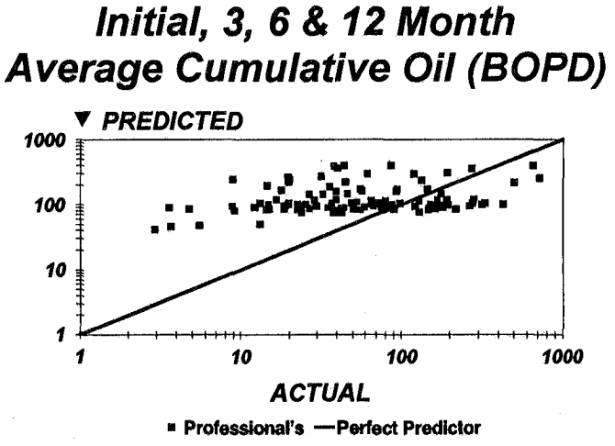
Figure 1: Predictions vs Results for drilled wells
These results are seen throughout the industry, as wells whose production is overpredicted are drilled, while those that are underpredicted are not, so their “actual” production is never found. As such solving this issue, the issue of poor production prediction, is not simply one of assuming our wells won’t produce as much as we think they will, which would be a reasonable solution if we were simply overpredicting. The solution instead is that we must improve the accuracy of our predictions, as the wells that we overpredict cost us money, and the wells we under predict cost us opportunity.
Causes of this are as diverse as our capacity for making mistakes. From unconscious over-optimism about a project’s potential, to pressure from management to produce exciting prospects, to losing sight of variables that affected the performance of previous wells, production forecasting often suffers from a host of oft-repeated mistakes and errors (Rajvanshi et al, 2012). To minimize these mistakes, and to apply a level of consistency that will make identifying errors easier, we must minimize human interaction with production forecasting.
There will always be intricacies that cannot be easily pre-programmed into a model. Be it allocation errors in the production data of neighboring wells, or downtime, or changes in geology, or changes in our understanding of the reservoir, there will always be a need for someone to keep an eye on things and apply changes where necessary. These changes need to be standardized and quantified whenever possible. By making use of production models, like the one proposed here, we can do away with personal fudge factors, and begin working with more controlled methods that can be improved over time as our understanding of our models and the physical realities that we’re working with improves.

Overfitting of models
The concept of overfitting generally pertains to statistical models, but is a relevant concern in any situation where a collection of input parameters is being used to predict or correlate with some outcome. In the case of production models such as the one discussed in this thesis, there are a whole host of variables and parameters that can act as inputs or assumptions for the model. Every additional factor that is taken into account can improve a match, which makes considering additional parameters tempting. Yet in cases where additional parameters take the form of assumed values that are determined primarily by whether they improve the quality of a match, overfitting is almost guaranteed. Each additional factor will improve the match with the given data, while often providing no meaningful predictive power, and possibly sabotaging what may have actually been a more accurate model when less parameters were included (Cook and Ranstam, 2016).

Beyond the production itself
Any discussion of production prediction needs to also consider the real world limitations that surround the production of hydrocarbons. Even a model that could perfectly predict the production capabilities of a well won’t prevent a project from underperforming those predictions if additional factors are not considered.
Beyond the human bias that often directly affects the production forecast itself, production forecasts, which should be representing the production potential of a well, are often taken to represent the actual, realistic production of that well. The implicit assumption here is that no downtime, slipups, or execution errors of any kind will occur, an assumption that regularly proves itself to be a poor one. Therefore any model, such as the one presented here, must be understood as the performance of a well under ideal circumstances. There should be a number of a wells in a field that perform at the level predicted by the model, if the drilling, completion, and production of those wells are executed perfectly.
However, the chance of slipups during any of those operations, as well as the production or economic ramifications of those mistakes must be considered in any model that seeks to accurately predict the average production of new wells. Therefore, it is recommended that any program outputs be tempered with data on the success rate of different well operations, so that the resulting economic predictions are as accurate as possible. Fortunately, due to the speed of the program presented in this thesis, sensitivity analysis can be performed in a relatively short period of time, allowing for the multiple possible scenarios to be run on each individual well, or type of wells, without significant computing costs.

Thesis Organization
This thesis was designed in such a manner as to try to walk the reader through the intent, approach, and results of this research in a clear, logical manner. So far we have already explored the background of production prediction, as well as discussed the necessity of more consistent methods that have a strong grounding in the physical, and ideally measurable, world. The following chapters seek to clarify what was done, what limitations exist in the model’s predictive power, the methods that were employed, and what steps need to be taken to further the research or to implement it in a working scenario.
- Chapter 2 discusses methodology of the model generated during the course of this research, the mathematics underlying that model, as well as many of the assumptions used. There is also a discussion of the structure of the MATLAB program that runs the model.
- Chapter 3 discusses a number of model variations. As discussed previously in this introduction, overfitting is a serious concern when generating models that are meant to have predictive power, especially when real data is limited, but potential factors and adjustable terms are numerous. The model variations discussed in Chapter 3 could significantly improve the accuracy of the model, if reliable, well-specific data is available, but are essentially an exercise in overfitting without it.
- Chapter 4 discusses the results of the research and includes a sensitivity analysis of many of the programs options. It also discusses some of the advantages of the model when compared to other approaches at predicting production.
- Chapter 5 includes the primary conclusions of this thesis, as well as recommendations for future research.

Chapter 2: Methodology

Simplified Model
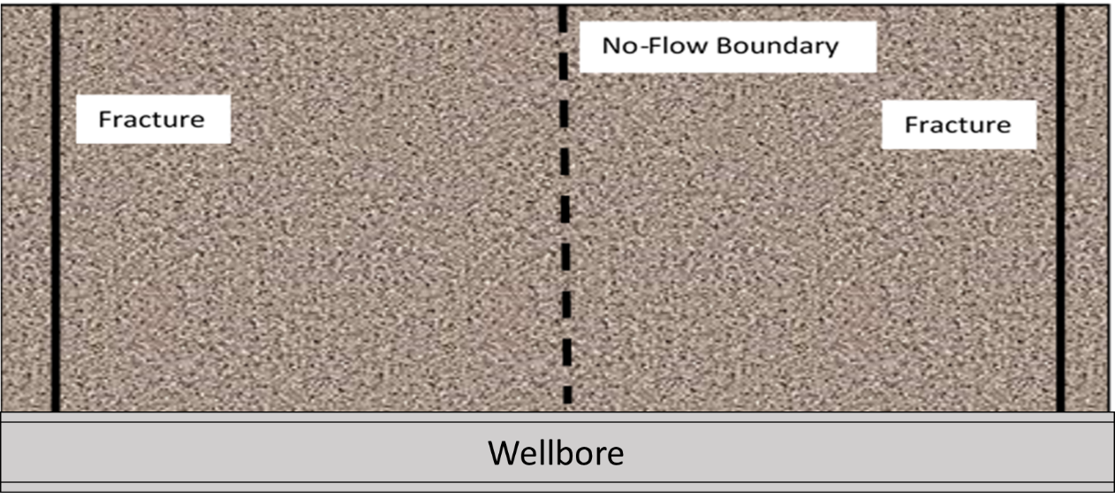
Figure 2: Simplified Model schematic
Our model focuses on the volume between two identical, perfectly thin, circular fractures in a homogenous section of a fractured shale reservoir. The left and right fractures, acting as our boundaries, are assumed to have infinite conductivity. The No-Flow Boundary is defined as the point of symmetry between the two fractures, across which no flow or transfer occurs. The No-Flow Boundary is assumed to be a flat surface, equidistant from and parallel to the two fractures.
Our model begins with initial reservoir conditions existing between the two fractures. As the fractures are produced and reach a pseudo-steady state, the reservoir matrix experiences a concentration drawdown at its boundaries, which are assumed to maintain a specific oil and gas concentration resulting from fluid properties and the well’s specific BHP. This concentration drawdown becomes the primary driver of production after initial fracture production has ended.
If adequate BHP data is available, the matrix contribution towards production can be found from the first day of production. In that case, initial matrix production volumes would be quite small, as during the early days of production the well would be producing primarily from the fractures. Initial and early production is viscous flow dominated, and while the reservoir matrix would be contributing to this early production, the contribution would be minimal. Once the hydraulic fractures reach a pseudo-steady state, after a duration of two hundred days or so, varying from well to well, the matrix contribution to production becomes dominant, and should begin matching existing production values. The onset of pseudo-steady state in the fractures can be approximated by observing the change in behavior of the well’s production on a reciprocal rate vs. cumulative graph, as shown below.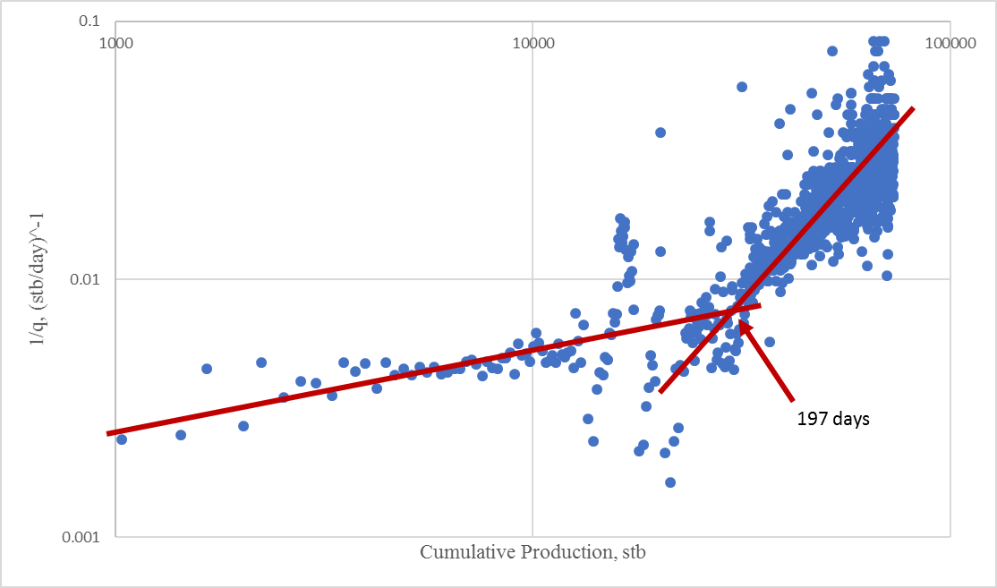
Figure 3: Reciprocal Rate vs. Cumulative Production graph for Sample Well 10
The BHP data available for this thesis was calculated using production data. The resulting BHP’s were below 1000psi from the first day of production, for each of the ten test wells. While completely unreasonable, these were the values that were available, and as such are the ones that have been used throughout the results and sensitivity analysis sections.

Modeling Hydrocarbon Dispersion
Dispersion, for the purposes of this thesis, is defined as the rate at which a substance disperses, encapsulating the effects of permeability, as well as other effects on fluid flow such as diffusion, while not taking the form of a conventional convection based mass-transport (Warren and Skiba, 1964). In particular numerous papers have explored the ways in which Darcy flow assumptions no longer hold in nanoscale pores, underestimating actual production behavior by a significant margin (Wang and Marongiu-Porcu, 2015). Factors such as diffusion, Knudsen number, gas pressure, and a long list of others have all been been explored, and all limit the applicability of the Darcy flow equation at this scale (Swami et al., 2012). In this thesis the Dispersion Coefficient “$D$” is assumed to encapsulate the majority of these effects, with the remaining effects being minor enough to not drastically affect results.
The dispersion coefficient “$D$” is related to diffusivity and convection based flow by the following equation:
$$D=\frac{D_{diff}}{τ}+\frac{D_{disp}u^{1.2}}{φS}$$ | eqn. 1
At higher permeability values the second term dominates fluid flow, allowing Darcy flow to adequately explain production, but at lower permeability values, such as those in the nano-Darcy range, the first term becomes significant enough that it must be taken into account to accurately predict production (Lake, 1989),
The dispersion of hydrocarbons is modeled using a variation of the Heat Diffusion equation “$αu_{xx}=u_{t}$”, which is commonly used to describe the temperature change of a thin rod with both ends kept at arbitrary temperatures. For a given timestep the dispersion of the oil and gas are assumed to be constant and uniform, with the dispersion of the gas set to five times that of the oil. Across timesteps the solution to the diffusion equation is re-solved with the new initial and boundary conditions, allowing for changes in boundary conditions, changes in dispersion of the oil and gas phases, and for simulating equilibrium between the two phases.
It is assumed that at initial reservoir conditions the reservoir is fully saturated with oil, and that the oil is fully saturated with in-solution gas. As the concentration of oil drops each timestep, its pressure is recalculated and gas is released from solution and begins dispersing.

Fourier Series Solution to Diffusion in a heated bar
For the case of a metal bar with two ends kept at arbitrary temperatures, the solution can be found by employing the Fourier Series Solution, which takes the form of a steady state solution $v(x)$, which describes the solution without respect to time, as well as a transient solution $w(x,t)$, which incorporates the effects of time.

Steady State Solution
Differential Equation:

$αu_{xx}=u_{t}$ with $0<x<L$and$t>0$ | eqn. 2
Boundary Conditions:
$u\left(0,t\right)=T_{1}$ and $u\left(L,t\right)=T_{2}$ | eqn. 3
Initial Condition:
$$u\left(x,0\right)=f(x)$$ | eqn. 4
To begin the problem, we will break the final solution into two parts, the steady state $v(x)$ and transient $w(x,t)$ solutions:
$$u(x,t)=w(x,t)+v(x)$$ | eqn. 5
The steady state solution $v(x)$ is not a function of time, therefore using the heat conduction equation we note that,
$$αv_{xx}=0$$ | eqn. 6
The solution of which can be quickly found using integration with respect to x to be:
$$v\left(x\right)=Ax+B$$ | eqn. 7
By rewriting the boundary conditions using v we find that:
$$u\left(0,t\right)=v\left(0\right)=A×0+B=B$$ | eqn. 8

$u\left(L,t\right)=v\left(L\right)=A×L+B$ | eqn. 9
The first of which implies that $B=T_{1}$ which can then be used with the second equation to show that $A=\frac{T_{2}-T_{1}}{L}$, which can then be used to show that:
$$v\left(x\right)=Ax+B=\frac{T_{2}-T_{1}}{L}x+T_{1}$$ | eqn. 10

Transient Solution
For the transient solution, recall that our final solution $u(x,t)=v(x)+w(x,t)$ will describe the entirety of the model, including the boundaries, and as such the boundaries can be rewritten in the form of our steady state and boundary conditions like so:
$$u\left(0,t\right)=v\left(0\right)+w\left(0,t\right)=T_{1}$$ | eqn. 11
$$u\left(L,t\right)=v\left(L\right)+w\left(L,t\right)=T_{2}$$ | eqn. 12

Which tells us that:
$$w\left(0,t\right)=T_{1}-v\left(0\right)$$ | eqn. 13
$$w\left(L,t\right)=T_{2}-v(L)$$ |  | eqn. 14
Since our boundary conditions for the transient solution are constants with respect to time and the steady state solution v(x) describes the portion of the final solution that is constant with respect to time by definition, we know that:
$$w(0,t)=0=w(L,t)$$ | eqn. 15
Therefore the initial condition $u\left(x,0\right)=f\left(x\right)$ can be converted to the form:
$w\left(x,0\right)=f\left(x\right)-v\left(x\right)$ | eqn. 16
Using the heat conduction equation, eqn. 2, our new boundary conditions eqn. 15, and our new initial condition eqn. 16, we have a simpler problem when solving $w(x,t)$; that of a bar with both ends kept at a temperature of 0.

Bar with both ends kept at 0 degrees
This solution is quite a bit more straightforward. In summary our current problem for solving the transient solution $w(x,t)$ depends on the following conditions:
$$w(0,t)=0=w(L,t)$$
$$αw_{xx}=w_{t}$$
$$w\left(x,0\right)=f\left(x\right)-v(x)$$
Now we’ll apply separation of variables, and assume that the solution takes the form:
$$w(x,t)=φ\left(x\right)G(t)$$ | eqn. 17
Plugging this into our IC we get:

$αφ_{xx}\left(x\right)G\left(t\right)=φ\left(x\right)G_{t}(t)$ | eqn. 18
$$w\left(0,t\right)=φ\left(0\right)G\left(t\right)=0$$ | eqn. 19
$$w\left(L,t\right)=φ\left(L\right)G\left(t\right)=0$$ | eqn. 20
Noting that $G(t)=0$ for all t is the trivial solution, we look for a non-trivial solution using the boundary conditions:

$$φ\left(0\right)=φ\left(L\right)=0$$ | eqn. 21
By reorganizing the IC:
$$\frac{φ_{xx}\left(x\right)}{φ\left(x\right)}=\frac{G_{t}\left(t\right)}{α×G\left(t\right)}$$ | eqn. 22
We then note that the left and right sides of the equation must be equal to a constant, since they are dependent on separate variables yet remain equivalent. For ease of notation, we will assume that this constant is “$-λ$”. From there our two equations can be reorganized to:
$$G_{t}\left(t\right)=-αλG\left(t\right)$$ | eqn. 23
And
$$\frac{φ_{xx}\left(x\right)}{φ\left(x\right)}+λφ\left(x\right)=0$$ | eqn. 24
Knowing this we can limit our possible solutions for $φ\left(x\right)$ to three potential scenarios, depending on the value the eigenvalue “$λ$” takes:
$λ>0$ case
It can be shown (Haberman, 2004) that the eigenfunction in this case takes the form:
$$φ\left(x\right)=c_{1}\cos\left(\sqrt{λ}x\right)+c_{2}\sin\left(\sqrt{λ}x\right)$$ | eqn. 25
And by applying eqn. 21 we find that:
$$φ\left(0\right)=c_{1}\cos\left(\sqrt{λ}×0\right)+c_{2}\sin\left(\sqrt{λ}×0\right)=0$$ | eqn. 26
Which suggests that $φ\left(0\right)=c_{1}\cos\left(\sqrt{λ}×0\right)=0$, thus $c_{1}=0$, which tells us that
$$φ\left(L\right)=0*\cos\left(\sqrt{λ}×L\right)+c_{2}\sin\left(\sqrt{λ}×L\right)=0$$ | eqn. 27
And therefore $φ\left(L\right)=c_{2}\sin\left(\sqrt{λ}×L\right)=0$, meaning that $\sqrt{λ}×L=n×π$ where n is a positive integer. Reassembling this solution we find that:
$$λ_{n}={\left(\frac{n×π}{L}\right)}^{2}, φ_{n}\left(x\right)=c_{2}\sin\left(\frac{n×π×x}{L}\right), n=1,2,3…$$ | eqn. 28
$$λ<0 case$$
It has been shown (Haberman, 2004) that for negative eigenvalues in our case the solution takes the form:
$φ\left(x\right)=c_{1}\cosh\left(\sqrt{-λ}×x\right)+c_{2}\sinh\left(\sqrt{-λ}×x\right)$ | eqn. 29
By applying the boundary condition eqn. 21 we can show that:
$$φ\left(0\right)=c_{1}\cosh\left(\sqrt{-λ}×0\right)+c_{2}\sinh\left(\sqrt{-λ}×0\right)=0$$ | eqn. 30
therefore $c_{1}=0$, as well as that:
$$φ\left(L\right)=0*\cosh\left(\sqrt{-λ}×L\right)+c_{2}\sinh\left(\sqrt{-λ}×L\right)$$ | eqn. 31
and since we are assuming $λ<0$for this case,
$$\sinh\left(\sqrt{-λ}×L\right)≠0$$ | eqn. 32
So $c_{2}=0$, which is the trivial solution, so the eigenvalue for this problem is not $λ<0$.
$$λ=0 case$$
This solution is fortunately fairly short. It is known (Haberman, 2004) that the solution for this eigenvalue takes the form $φ\left(x\right)=c_{1}+c_{2}×x$, and by applying the boundary conditions in eqn. 21 we find that,
$$φ\left(0\right)=c_{1}+c_{2}×0=0$$ | eqn. 33
thus $c_{1}=0$, and that,
$$φ\left(L\right)=0+c_{2}×L=0$$ | eqn. 34
thus $c_{2}=0$, which is the trivial solution, so $λ=0$ is not an eigenvalue in our case.
Eigenfunction for $φ\left(x\right)$
As we now know that $λ>0$ and that our eigenvalue takes the form:
$$λ_{n}={\left(\frac{n×π}{L}\right)}^{2}, n=1,2,3…$$ | eqn. 35
And that our eigenfunction takes the form:
$$φ_{n}\left(x\right)=c_{2}\sin\left(\frac{n×π×x}{L}\right), n=1,2,3…$$ | eqn. 36
Going back to the time equation eqn. 23,
$$G_{t}\left(t\right)=-αλG\left(t\right)$$
After noting that the equation is separable, it is fairly easy to find the solution in the exponential form:
$$G\left(t\right)=c_{1}*exp⁡(-αλt)$$ | eqn. 37
Therefore:
$$w\left(x,t\right)=c_{2}\sin\left(\frac{n×π×x}{L}\right)*c_{1}*\exp\left(-α{\left(\frac{n×π}{L}\right)}^{2}×t\right),n=1,2,3…$$ | eqn. 38
Though it should be noted that the constants vary with each n, and that any linear combination of solutions will themselves be solutions, so the full solution should be written as:
$$w\left(x,t\right)=\sum_{n=1}^{∞}{B_{n}×\sin\left(\frac{n×π×x}{L}\right)×\exp\left(-α{\left(\frac{n×π}{L}\right)}^{2}×t\right)}$$ | eqn. 39
Combining the Steady State and Transient Solutions
By combining the steady state solution eqn. 10, and the transient solution eqn. 39, we can solve the initial equation eqn. 5, resulting in our final solution:
$$u\left(x,t\right)= \sum_{n=1}^{∞}{\left[B_{n}×\sin\left(\frac{n×π×x}{L}\right)\exp\left(-α{\left(\frac{n×π}{L}\right)}^{2}t\right)\right]}+\frac{T_{2}-T_{1}}{L}x+T_{1}, n=1,2,3…$$ | eqn. 40
Using the initial condition eqn. 4 we know that
$$u\left(x,0\right)= \sum_{n=1}^{∞}{B_{n}×\sin\left(\frac{n×π×x}{L}\right)×1}+\frac{T_{2}-T_{1}}{L}×x+T_{1}=f(x)$$ | eqn. 41

Fourier Sine Series Coefficients
To determine the coefficients $B_{n}$ we’ll want to simplify eqn. 41 to:
$$\sum_{n=1}^{∞}{B_{n}×\sin\left(\frac{n×π×x}{L}\right)}=f\left(x\right)-v\left(x\right)$$ | eqn. 42
And then multiply both sides of the equation by $\sin\left(\frac{m×π×x}{L}\right)$, where $m$ is a fixed, arbitrary positive integer, resulting in:
$$\sum_{n=1}^{∞}{B_{n}×\sin\left(\frac{n×π×x}{L}\right)}\sin\left(\frac{m×π×x}{L}\right)=\left(f\left(x\right)-v\left(x\right)\right)×\sin\left(\frac{m×π×x}{L}\right)$$ | eqn. 43
Then integrate both sides from $x=-L$ to $x=L$ and factor B_n out of the integral:
$$\sum_{n=1}^{∞}{B_{n}\int_{-L}^{L}{\sin\left(\frac{n×π×x}{L}\right)}×\sin\left(\frac{m×π×x}{L}\right)dx}=\int_{-L}^{L}{\left(f\left(x\right)-v\left(x\right)\right)×\sin\left(\frac{m×π×x}{L}\right)}dx$$ | eqn. 44
It has been shown (Haberman, 2004) that $\int_{-L}^{L}{\sin\left(\frac{n×π×x}{L}\right)}×\sin\left(\frac{m×π×x}{L}\right)dx=\left\{\begin{matrix}L if n=m \\ 0 if n≠m\end{matrix}\right\}$, therefore for the left side the only integral from the summation that will not equal 0 occurs when $m=n$, therefore the result of the single non-zero integral throughout the entire infinite summation must be $L$:
$$B_{n}L=\int_{-L}^{L}{\left(f\left(x\right)-v\left(x\right)\right)×\sin\left(\frac{m×π×x}{L}\right)}dx$$ | eqn. 45
And after dividing both sides by L, and noting that we’re integrating by two odd functions, making the integral itself even, we have solved for all the terms of our Fourier Sine series:
$B_{n}=\frac{2}{L}\int_{0}^{L}{\left(f\left(x\right)-v\left(x\right)\right)×\sin\left(\frac{m×π×x}{L}\right)}dx$ ,$m=1,2,3…$ | eqn. 46
Giving us a final solution, using concentrations $C$ in place of Temperatures $T$ and a dispersion factor “$D$” instead of the diffusivity constant $α$, of:
$$u(x,t)=\sum_{n=1}^{∞}{\left[B_{n}×\sin\left(\frac{n×π×x}{L}\right)\exp\left(-D{\left(\frac{n×π}{L}\right)}^{2}t\right)\right]}+\frac{C_{2}-C_{1}}{L}x+C_{1}$$ | eqn. 47
Where,
$$B_{n}=\frac{2}{L}\int_{0}^{L}{\left(f\left(x\right)-v\left(x\right)\right)×\sin\left(\frac{n×π×x}{L}\right)}dx, n=1,2,3…$$ | eqn. 48

Assumptions

Formation Compaction
For the purposes of the model it was assumed that formation compaction occurred at the exact required to maintain a single fluid phase during the entire course of production. No considerations were made for how this compaction would affect dispersion or production. The works of Davudov et al. (2017) and Lan et al. (in press) discuss the effects of formation compressibility throughout the productive life of a shale oil well, both in terms of the initial improvements to production as well as the long-term conductivity effects of accessible pore closure.

Dispersion dominated fluid flow
We hypothesize that the flow of oil and gas in shale reservoirs is dominated by dispersion, rather than the more traditional flow regimes and convection displayed in conventional reservoirs. Gas and oil flow in fractures is assumed to be essentially instantaneous, with any dispersion into the fractures resulting in immediate production, with the exception of residual concentrations of oil and gas that act as boundary conditions for the dispersion equation, as calculated using the BHP.

Residual Water Saturation
It is assumed that the only water existing in the system is irrevocably bound to the surface of the grains within the formation, and at no point will participate in, or influence, fluid flow within the model. It is assumed that any effects of this residual water saturation are accounted for with the dispersion coefficient “D”. Residual water is treated as a uniform decrease in porosity, such that 25% water saturation results in a 25% decrease in porosity. No water production is calculated, and no diffusion of water takes place in this model.

Shared Volume Model
For the purposes of this model gas released from solution at pressures below bubble-point pressure is assumed to be generated uniformly throughout the oil volume, and to disperse following the same model that governs the oil dispersion. It is assumed that no distinct gas saturation develops, and that the gas is perfectly miscible with the oil phase. This assumption is much more reasonable at higher pressures, such as those above 4,000 psi, and if assuming a gas composition with larger, reasonably high percentages of C₂₊, such as values in excess of 30% (Rao and Lee, 2003)

Pore size affecting fluid properties
It is understood that at very small pore sizes, such as those common in the sort of reservoirs this model focuses on, that many fluid properties are affected by the pore sizes and pore size distributions (Zhang, 2016). For the sake of simplicity in this model, an idealized case, in which fluid properties mirror their lab values, has been assumed. The Vasquez and Beggs method for calculating FVF has been used throughout the program, and gas is assumed to release from solution fully upon the completion of each timestep. No consideration is given for how the pore size distribution might affect the Dispersivity constant, the FVF calculations, or the release of gas from solution. The FVF is calculated using Function 1, located in the Appendix.

Computer Program Workflow
The general behavior of the model follows the below flowchart:
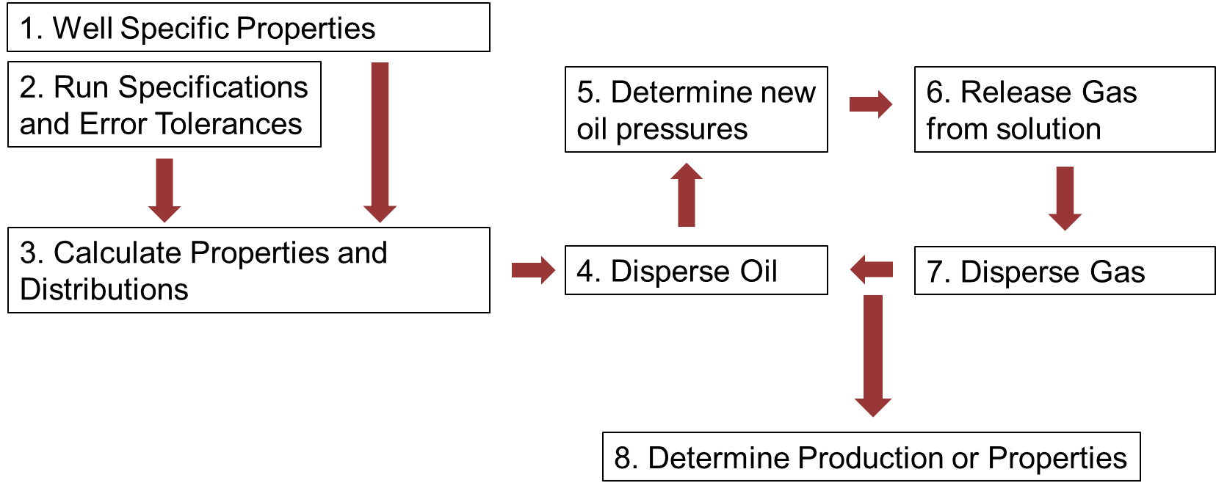
Figure 4: Process Workflow
This process may need to be adjusted or expanded to implement additional or different functionality. The below sections discuss the actual implementation of the process. The program controller handles the process of iterating through the different collections of inputs and handles program outputs, while the dispersion code itself performs the primary calculations, and can be called any number of times by the controller, depending on the wells and values being tested.

The Program Controller
- Initiate User Settings and constants
Well or field specific rock and fluid properties, as well as run settings and potential sensitivity analysis values, are defined by the user.
- Initiate Primary Loop
The Dispersion Code is run with the prescribed settings. A detailed explanation is provided in the following section.
- Perform Production fit check
Production values resulting from the Dispersion Code are automatically matched to the well’s production data. If an efficiency value is provided no scaling will occur, and only an error value will be returned. If no efficiency value is provided, or if an upper and lower bound value are provided, the program will determine the best match between the Dispersion Code’s output and the actual production data, accounting for both the oil and gas match simultaneously. An error scaling value can be provided to give additional weight to errors where theoretical production is below actual production, and an initial window of half weighted errors can be provided so that initial decline behavior from the Dispersion Code does not overly influence the matching process.
- Bulk Saving
In the event of a sensitivity analysis or range of tested values, the production results of each individaul run will be labeled and saved in auto-generated, labeled folders for the well that was run. Once all test values have been run the program will save a file containing all run outputs, as well as scaling values and errors. The filename will indicate which of the runs resulted in the best match, as shown in Figure C 12.

The Dispersion Code
- Define Run Specifications and calculated values
Additional run specifications are defined, as well as internal constants. Properties are converted to metric units, and property distributions are calculated where relevant.
- Solve the Dispersion Equation for oil
Following the description of the Dispersion Equation’s solution provided on page 21, and using the boundary concentration derived from the bottomhole pressure data provided for the well, dispersion for the oil section occurs.
- Determine the new oil pressure
Oil pressure is then determined using the new oil concentrations. The calculation is accomplished by interpolating from a Pressure vs. Concentration distribution that was generated by a taking a distribution of pressures, determining the in-solution molar gas content of a given mole of oil, and dividing this “boosted” oil concentration by the volume of the oil at that pressure, which is found using the molar volume of the oil at standard conditions and the oil’s FVF (formation volume factor) at the given pressures. The FVF was determined using Vasquez and Beggs correlations for FVF. An example distribution is provided below, with the distribution for a given well depending on its specific fluid properties.
Figure 5: Oil Concentration with in-solution gas Boost vs. Pressure relationship
- Add released gas to existing, dispersed gas
The pressure drop resulting from concentration drops near the boundary fractures results in gas release from solution found using RS data for the well. This is summed with the gas that has previously been released and experienced dispersion.
- Disperse the gas concentrations
Using the same algorithm as the one used for the oil concentrations, gas concentrations are dispersed using a dispersion factor five times that of the oil dispersion factor.
- Determine production
The difference in the integral of the initial and final concentrations for gas and oil give us the amount of gas and oil produced, once we account for the volume of gas that comes out of solution from the oil as it is produced, assuming a dry gas.
- Convert output values to STB, MSCF, and days
Program calculations are all handled in SI units, notably moles/m³ for concentrations of oil and gas, and seconds for time. The final step of the Dispersion Code is to convert all related values to surface conditions and to days, for ease of comparison with conventional production data.

Known Instabilities and Optimization Targets
The primary sources of instability in the program are also ideal locations for optimization. The first potential instability is due to the calculation of the integral in eqn. 48 in the dispersion solution. This is done using Simpson’s Rule and is the by far the most called function in the program, as it must be run “Approximately Infinity” times, twice every timestep. For a standard run, such as the default with 500 x-values and a dispersion constant of 10⁻⁶, this runs just fine. But as the dispersion constant drops orders of magnitude the error inherent in the approximation begins to exceed the amount of dispersion that occurs in an individual timestep by a significant margin, and anomalous behavior begins to occur.
In particular the program has produced dispersion in the wrong direction and several orders of magnitude too large. This problem can always be remedied by increasing the number of x-values, but a linear increase in runtime should be expected, so being able to relate the number of x-values with the dispersion constant would be ideal.
The second primary source of instability is inherent in the Fourier transform method itself, which by definition should involve the summation of an infinite series of sines. Using too few terms results in diffused data that has visible waves, as well as completely inaccurate boundary values, while using too many terms linearly increases runtimes and becomes meaningless due to rounding error. “Too many” or “too few” depends on the values given to equations eqn. 47 and eqn. 48, as the exponential term in the infinite series will cause additional terms to gradually drop orders of magnitude. By reorganizing the equations that define the additional terms, and setting an upper bound on the value of the last summed term, an optimized value for “Approximate Infinity” can be dynamically calculated with any set of inputs and any arbitrarily chosen accuracy value. For all simulation runs an accuracy, or maximum final term, value of 10⁻²⁰ was used, with the equation shown below:
$ApproxInfinity=\frac{L}{π}×\sqrt{\frac{ln\left(\frac{MaxError}{2}×\frac{L}{\int_{0}^{L}{f\left(x\right)-v\left(x\right)}dx}\right)}{-D×t}}$ | eqn. 49
It should be noted that changes in the dispersion constant, affecting both the value of approximate infinity as note above, and the required number of x-values through some less explicit relationship, have a rather significant impact on runtimes. In particular order of magnitude decreases in the dispersion constant result in nearly order of magnitude increases in runtimes.

Chapter 3: Possible Model Variations
In the course of this research a large number of alternate methods and improvements were attempted. Many methods were successful, and have been implemented in the final version of the program discussed throughout this thesis. A number of modifications were not successful, and some of those are discussed here.

Polynomial Approximation
In order to bypass the need for an approximate integral function, such as by using Simpson’s rule, the instability of which was previously discussed, and to potentially improve runtimes by removing the need for repeated solving of the Dispersion equation, a polynomial approximation approach was attempted. Rather than using a numerical solution to the Dispersion equation using Simpson’s Rule to approximate the integral of $f(x)$ using a collection of points, a high order polynomial was used to attempt and approximate all solutions to the Dispersion equation. Using this method the constants to the polynomial approximation, as well as any changed conditions, would act as inputs for a function generated by applying the matlabFunction command to the symbolic solution of the Dispersivity equation where all input values had been replaced with symbolic placeholders. This would prevent the need for constant recalculation of the solution, while also providing an integral as accurate as the polynomial approximation itself.
This approach was eventually abandoned. While this method did provide a speed benefit, as the solution could be derived a single time and then reloaded across different simulations, or rerun within the same simulation, it was determined that the polynomial approximation itself ventured between inadequate and unstable. Approximation orders exceeding 16th order or so displayed increasingly unstable behavior, especially near the boundaries. Approximation orders that displayed a greater deal of stability all suffered from an inability to adequately approximate a straight line, namely the concentrations of the unaffected regions of the reservoir. Especially when dealing with smaller time steps or smaller dispersivity constants the inaccuracies in the approximation became significant when compared to the dispersion occurring during a single timestep, and anomalous results became a regularity. In particular gas or oil concentrations shifting earlier than reasonable, such as before dispersion effects had even reached them, occurred regularly. Smoothing functions, manual corrections of unreasonable behavior, and a number of other methods were experimented with in order to correct this behavior, but eventually it was determined that any potential runtime or integral accuracy benefits were far outweighed by the instability issues, and the approach was abandoned.

Capillary Pressure
The ability to accurately calculate capillary pressure within the system is required in order to determine volumetric changes between the gas and oil phase over time. The theory discussed here was used in multiple attempts to implement a volumetric calculation section in order to better model oil and gas concentrations, as well as their dispersion. After several months we were unable to create any stable solutions, but this section includes a discussion of the underlying science of the attempt, as well as how the problem was approached. In particular, reasonable oil and gas volumes could be found upon each timestep, but if those volumes were used in the iterative calculations to act as inputs for the following timesteps, instability would inevitably arise.

Basic Theory
In order to properly understand the conditions of the oil and gas phases in the reservoir a capillary pressure must be determined. This Capillary Pressure represents the pressure offset between the two fluids in the form $P_{cap}=P_{gas}-P_{oil}$. MICP (Mercury Injection Capillary Pressure) data provided by the University of Oklahoma’s Integrated Core Characterization Center (IC³) lab was used to determine a pore throat size distribution, dependent on the oil saturation of the well, as shown in Figure C 1 in the Appendix. The pore throat sizes are then used to calculate the capillary pressure experienced at the oil-gas interfaces using the Young-Laplace equation:
$$P_{cap}=\frac{2×σ×\cos\left(θ\right)}{r_{cap}}×.1\frac{Pa}{dyne/cm^{2}}$$ | eqn. 50
With the surface tension in dyne/cm being determined by the Ramey (1973) correlation:
$$σ={\left[{Par}_{o}×\left(x_{o}\frac{ρ_{o}}{M_{og}}-y_{o}\frac{ρ_{g}}{M_{go}}\right)-{Par}_{g}×\left(x_{g}\frac{ρ_{o}}{M_{og}}-y_{g}\frac{ρ_{g}}{M_{go}}\right)\right]}^{4}$$ | eqn. 51
With,
$$x_{o}=\frac{RS_{moles}}{1+RS_{moles}}, y_{o}=\frac{1}{1+RS_{moles}},$$
$$M_{og}=x_{o}M_{o}+x_{g}M_{g}, M_{go}=y_{o}M_{o}+y_{g}M_{g}$$
$$ρ_{g}=\frac{C_{gas}×M_{go}}{{10}^{6}}, ρ_{o}=\frac{C_{oil}×M_{og}}{{10}^{6}}$$
$$C_{gas}=\frac{P_{gas}}{Z×R×T}, C_{oil}=\frac{1+RS_{moles}}{V_{oilmolar_{STP}}×FVF}$$

With the Parachors being calculated using equations designed by Whitson and Brulé (2000),
$${Par}_{o}=\left(2.376+.0102γ_{API}\right)×M_{o}$$ | eqn. 52
$$Par_{g}=25.2+2.86M_{g}$$ |  | eqn. 53

The Approach Itself
This final model uses a “Shared Volume” approach to calculating oil and gas concentrations. The concentration of any existing amount of oil or gas, measured in gmol/m³, is found by dividing the number of moles of that substance by the total volume. In essence, no distinct saturation is being recognized. Oil and gas are free to intermingle and disperse past one another, without them being relegated to specific areas, zones, or flowpaths.
This is a rather significant simplification of real phenomena, and as such a great deal of effort was put into bypassing this assumption, and meaningfully tracking the oil and gas saturations throughout the course of production. The attempts were ultimately unsuccessful, but hopefully this discussion of the final approach will aid future attempts.
Step 1: Disperse the Oil Phase and calculate oil pressure
Dispersion of the oil phase results in a new set of oil concentrations (including in-solution gas support). This distribution can then be used to calculate oil pressures at any concentration, as shown in Chapter 2.
Step 2: Diffuse Gas and then determine the number of Moles of Gas in the system
Gas is diffused using the same methodology as the oil phase, and then this new concentration and the old gas volume are used to determine the number of moles of gas post diffusion. This amount is then summed with gas released from solution using the new and old oil pressures, as well as the old oil volumes to find the number of moles of gas for the new timestep.
Step 3: Determine the Oil Saturation
Using the pore size to oil saturation distribution included in Figure C 1 and the equations for calculating capillary pressure, a distribution of capillary pressures can be found across the full range of oil saturations and possible oil pressures. Generating this distribution requires testing different assumed capillary pressures with the provided oil pressure and oil saturation information, in order to find the related gas pressure and gas density, which is required for the capillary pressure calculation. Once this process has occurred with any of a number of root finding methods, a stable distribution, where the assumed capillary pressure is equivalent to the resulting one, can be found. This only needs to be done at the beginning of the program once fluid properties are known. An example is shown below:
Figure 6: P_{cap}(S_{oil},P_{oil})
Since capillary pressure and oil pressure values are known throughout the distribution, gas pressure can be found, and from that a gas concentration distribution with respect to oil pressure and saturation, as shown below:
Figure 7: C_{gas}(S_{oil},C_{oil})
Then with the gas concentration information, knowing the total volume of the system, and noting the oil saturation in the y-axis, we can generate a surface describing the number of moles of gas present in the system for any oil saturation and oil pressure, as shown below:
Figure 8: M_{gas}(S_{oil},P_{oil})
Then using MATLAB’s scatteredInterpolant function with the information from the above figure, we can generate a function that will determine the oil saturation at any given combination of oil and gas concentrations:

Figure 9: S_{oil}(C_{gas},C_{oil})
Knowing the oil saturation from step 1, and the moles of gas due to step 2, we then test values of oil saturation until we reach one that stabilizes with a correct gas concentration/oil saturation combination using Figure 9.
Step 4: Calculate the Gas Concentration
Knowing the oil saturation and the moles of gas, we can then determine the gas concentration.
Step 5: Continue to the next timestep
In the standard approach, after calculating the new gas concentration, production volumes were found, and the next timestep began.
Alternate Method
An alternate method was attempted, where the last timestep’s number of moles of gas was used to calculate oil saturation, the gas release was determined with this new oil saturation, then gas was diffused. A distribution from the scatteredInterpolant function was then used to find the new oil concentration, which was used in the following timestep after production volumes had been found.
Smoothing functions were tested in order to handle any anomalous results, iterative processes were used to test a result before it was accepted in order to try to find a more stable solution, and different calculation direction and dependencies were explored. The end results were all more or less the same; the gas or oil saturations would destabilize resulting in 100% saturation in an unrealistic area. In addition the oil production volumes resulting from this method far exceeded those of actual production data, even more than the current method which often requires efficiency factors from 5-15% to justify. Figure C 2 through Figure C 11 in the appendix follow this destabilization process. Of note is that the oil concentrations and pressures behaved in a perfectly reasonable manner, consistent with the final model. This suggests that the instability must be in the calculation process for the saturations, rather than anything to do with the concentrations or pressure, but I was unable to find a solution.

Potential Cause of Failure
The inability of the program to stabilize at any reasonable equilibrium using the capillary pressure and density based approach discussed above is likely due to many of the same characteristics that make this dispersion based model necessary in the first place. In particular the inaccuracy of many conventional models and theories in the nanoscale, as well as this model’s limited approach with regards to pressure based flow, likely contributed to destabilization of the simulation. Theories and methodologies more accurate than those presented here would likely be required to approach this problem, as many of the basic equilibrium requirements don’t hold true at the nanoscale (Sigal et al., 2015).

Unstimulated Volume Support
Despite the majority of production in a fractured reservoir resulting from the fractures themselves, early on, and followed by the matrix between the fractures later on, a third contributor to reservoir production exists. While certainly a small contributor during initial production, the unstimulated portion of the reservoir will invariably contribute an ever more significant amount of production to a stimulated well. This tri-linear flow model, follows many of the same basic assumptions as the model used for the dispersion model discussed in this thesis, and helps explain the long-term decline plateau experienced by shale wells (Zheng et al., 2016). The basic theory behind this unstimulated volume support is that a slowly expanding "tank" of oil, the result of the pressure disturbance caused by production expanding into the fractured reservoir, provides support for the stimulated region (Moghanloo et al., 2015).
From an implementation perspective there are two primary routes to modeling the unstimulated zone support. The first is using a combination of the dispersion model discussed here, as well as the work of Zheng et al. (2016), to account for the current size of the dynamic drainage volume (DDV). With this approach the DDV, found using Zheng et al.’s methodology, provides the length in a false symmetrical system, which expands each timestep, allows the differential equations that govern the fluid flow in the stimulated zone to model the fluid flow in the unstimulated zone. Production from the unstimulated zone is assumed to enter the stimulated zone in such a way as for the increase in concentration to be linearly related to the missing concentration in that area. Ie, areas near the fractures get more unstimulated support than areas near the center due to the lower concentration and pressure in that area. The unstimulated region is assumed to have fluid properties identical to the initial properties of the stimulated region, as well as a dispersion coefficient 1/10th of that seen in the stimulated region, and the boundary conditions used for the unstimulated region are the mean concentrations of oil and gas in the stimulated zone.
The second possible approach is to use the work of Yuan et al. (2016) to both control the expansion of the DDV over time, as well as to account for the production of that volume. The second approach benefits from internally consistent assumptions between the size of the DDV, and its production rates. While the first approach both accounts for the DDV, but also maintains the production mechanisms and assumptions of the core dispersion model.
In either case, after flow from the unstimulated region joins with the existing volumes and concentrations in the stimulated region, their properties, such as sGOR, are reconciled appropriately, and the next timestep begins. Dispersion into specific areas of the stimulated zone is determined by linearly distributing new fluids wherever existing concentrations are lowest.

Cluster Efficacy and Fracture Efficiency
Any fractured reservoir experiences a degree of underperformance depending on the difference between the ideal cluster behavior and the reality. Not only are some clusters physically smaller than would be expected, but there is also the risk that overly close clusters will inhibit the production performance of neighboring clusters, decreasing their cluster efficacy (Ran and Kelkar, 2015). This model does not differentiate between any cluster pair, with equal performance being assumed from any given pair. The model itself assumes perfectly circular, 2D clusters, or fractures, with each pair being evenly spaced throughout the lateral length of the well, and the reality. Final production values from the model use an assumed “Fracture Efficiency” scaling factor, which acts as a corrective factor between the ideal model and reality. This scaling factor, which was set to 10% for all wells, encapsulates both the effects of cluster efficacy as well as differences between real cluster shape and the circular shape that has been assumed.
If additional information were available with regards to cluster efficacy on a well by well basis that information could be easily incorporated into the dispersion model. This variation of the current model would treat cluster efficacy and shape information as a program input on a well or field basis, and an assumed fracture efficiency value would not be necessary. Mean fracture dimensions could be used, with a single cluster efficiency multiplier scaling the simulation outputs to find the production of the system. As this information was not available, and any values used would have to be assumed or determined by viewing their effect on the production match, the Fracture Efficiency term was used to act as a crude, but uniform assumption, which would minimize the risk of overfitting.

Three Dimensional Clusters
In the existing models fracture clusters are treated as circular surfaces of infinite conductivity. This causes an overestimation of the distance between fracture clusters that is dispersion dominated. If detailed cluster information is available, the model can be easily modified such that only the volume outside of the clusters is dispersion dominated. Separate modeling would then be required to account for production from within each individual cluster, but this change would improve the accuracy of early predictions.

Time Offset cluster production
The current model assumes that all production throughout the well occurs simultaneously. In particular it assumes that the pressure in all fractures are equivalent. This results in an excessively large spike of initial production. By analyzing information on the delays between different fractures beginning to produce, and their individual BHP, would allow the model to bring individual fracture pairs online at the correct time, or even assume unequal boundary conditions for a given fracture pair. This would more accurately model the behavior of an actual reservoir, and would also result in a more realistic early production phase.

Initial Gas Saturation
The current model takes a “Shared Volume” approach to oil and gas saturations, essentially assuming miscibility between oil and gas at all pressures. From that perspective the existing model is actually perfectly capable of using an initial concentration of gas to represent existing free gas. But in order to model an actual gas saturation the issues with the capillary pressure and oil saturations discussed earlier in this chapter must be resolved. In addition any approach that generates an actual gas saturation needs to account for how additional gas joins the gas phase. One possible form this could take would be a sort of vapor pressure approach where any gas that is released instantly joins the gas phase, as if it were coming out of solution at the oil-gas boundary. A second possible approach would make use of the miscibility assumption used in the existing model, but with dispersion occurring in the direction of the fractures and in the direction of the gas phase. This would require a dispersion coefficient for the miscible gas as well as a separate coefficient for the gas phase.

Shut-in wells
Well production is almost never as easy as “complete the hole, make money.” Interruptions to production take many forms, but one form of interruption this model is particularly well suited for is a shut-in well. While the existing model only employs the constant boundary condition version of the heat diffusion equation, the insulated boundary form of the equation is actually even simpler to solve. If a well was shut-in, and the timing of that shut-in was known, the model could take that process into account when determining its production estimates. The shut-in period would give the concentrations in the reservoir matrix time to equalize, resulting in a sizeable increase in near-boundary concentrations, which would result in a production spike when production resumed. This change has value both in determining dispersion coefficients of existing production wells, as it can account for the spikes they experience post shut-in, as well as in predicting the effects of a shut-in on future production.

EOR applications
As this model is focused on concentration driven production, as well as how in-solution gas helps drive oil production by boosting oil concentrations, it has several potential applications in relation to CO₂ or ethane based EOR. Not only does the model relate oil pressures and concentrations to distance from fractures, but it also has mechanisms by which the presence of gas can improve or generate production of oil. That being said, the existing model only uses in-solution gas to boost oil concentrations, not miscible gas, and adjustments may need to be made in order to predict how the presence of injected gas affects the production of gas through dispersion. A number of analytical solutions are available for understanding the behavior of CO₂ based EOR, through the work of Moghanloo (2012), which would allow for this dispersion model to interpret the effects of CO₂ injection program.

Chapter 4: Results and Discussion

Full Run
Table 1: Shared Values
Res. Temp. (F) | 118
API Gravity | 46
Gas Gravity | 0.8377
Porosity (fraction) | 0.075
Initial Press. (psia) | 7010
Initial Sw (fraction) | .26
Fracture Efficiency (fraction) | .1

Table 2: Solution Gas Values
Pressure | RS
psia | SCF/STB
14.7 | 0
400 | 90
600 | 150
980 | 265
1400 | 380
1800 | 500
2400 | 625
2600 | 760

Table 3: Well Specific Information
Sample Well | Fracture Half Length | Fracture Spacing | Number of Fractures | Gas Multiplier | Dispersion Coefficient
- | ft | ft | - | - | m²/s
1 | 223 | 83.40 | 48 | 2.5 | 1.05E-06
2 | 201 | 64.86 | 69 | 1.75 | 1.78E-06
3 | 236 | 54.42 | 74 | 1.75 | 4.05E-07
4 | 234 | 39.68 | 157 | 1.75 | 1.50E-07
5 | 224 | 60.95 | 57 | 1.75 | 4.05E-07
6 | 243 | 80.00 | 80 | 2.25 | 7.11E-07
7 | 247 | 28.57 | 140 | 2.5 | 1.50E-07
8 | 214 | 59.19 | 74 | 1.5 | 8.63E-07
9 | 212 | 72.84 | 57 | 2 | 8.63E-07
10 | 233.2 | 65.52 | 75 | 1.5 | 1.02E-06

Fracture Half Length was calculated using the OU Well Evaluation Software (2017). Number of clusters and number of fractures is used interchangeably, as in this model a cluster is modeled as a single, two dimensional circle with infinite conductivity, or essentially as single super fracture. Gas Multiplier values were found on a well by well basis by determining the multiplier on the base distribution that resulted in the correct GOR.

Full Output
Using the shared values and sample values listed above, the following production matches were found for the 10 Niobrara wells used in this research. It should be noted that the match for the first 200 days of production may not accurately represent the initiation of matrix dominated flow, and may need to be adjusted on a well by well basis:
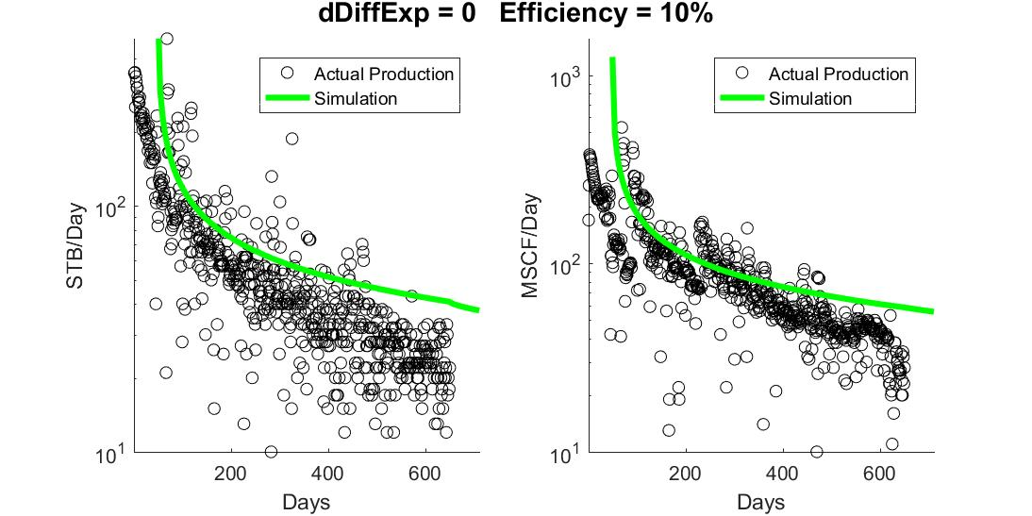
Figure 10: Sample Well 1's Production, with an initial dispersion start time, following convection dominated flow, that may need to be adjusted on a well by well basis
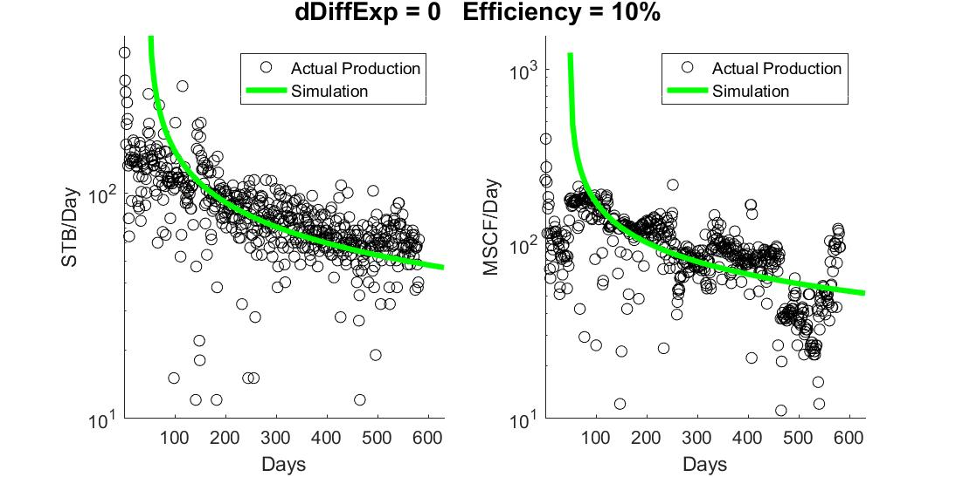
Figure 11: Sample Well 2’s Production, with an initial dispersion start time, following convection dominated flow, that may need to be adjusted on a well by well basis

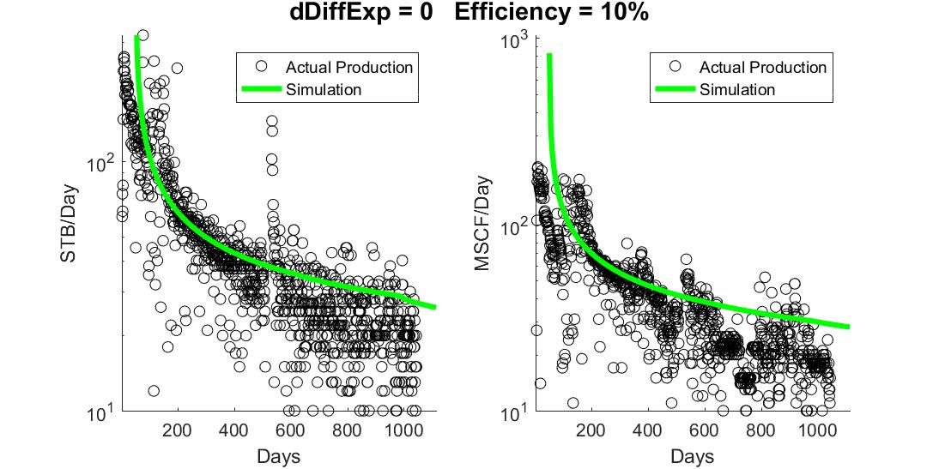
Figure 12: Sample Well 3's Production, with an initial dispersion start time, following convection dominated flow, that may need to be adjusted on a well by well basis
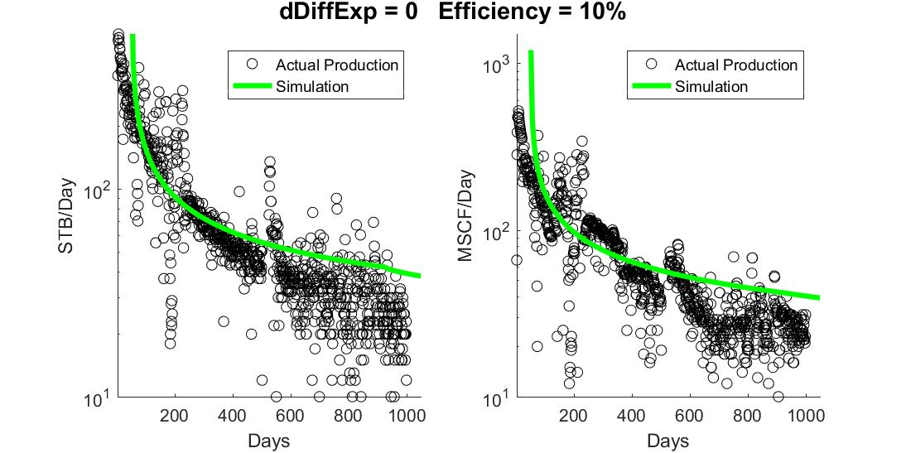
Figure 13: Sample Well 4's Production, with an initial dispersion start time, following convection dominated flow, that may need to be adjusted on a well by well basis

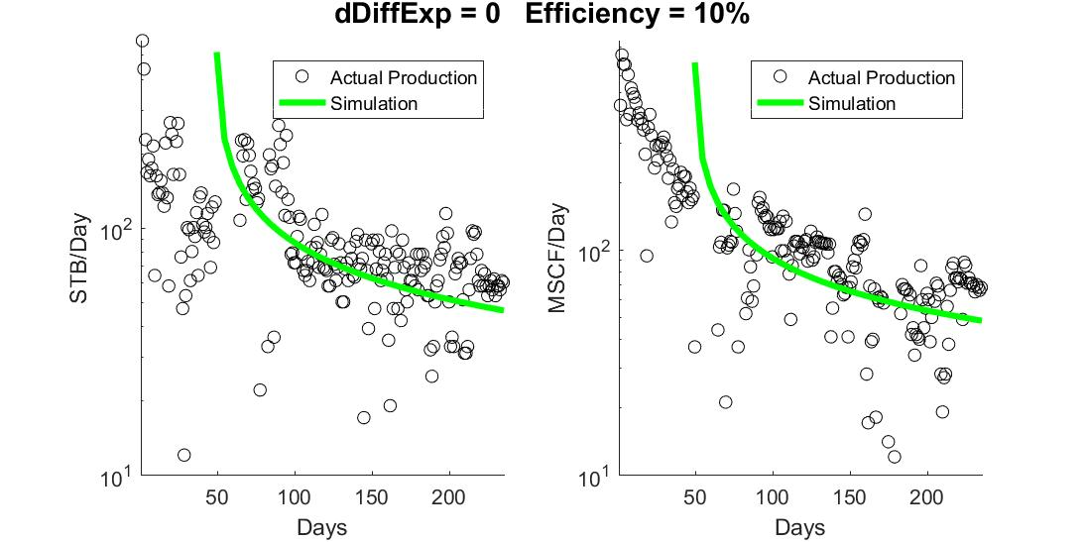
Figure 14: Sample Well 5's Production, with an initial dispersion start time, following convection dominated flow, that may need to be adjusted on a well by well basis

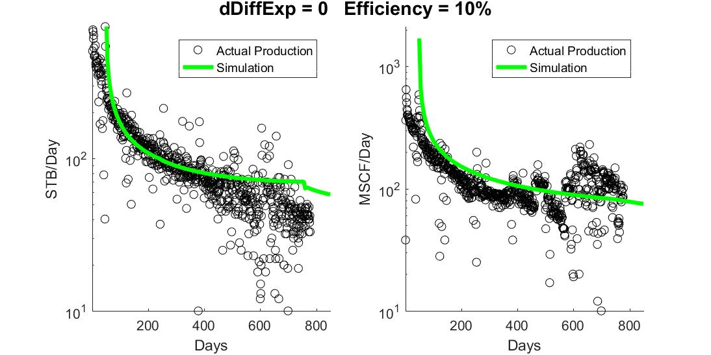
Figure 15: Sample Well 6's Production, with an initial dispersion start time, following convection dominated flow, that may need to be adjusted on a well by well basis

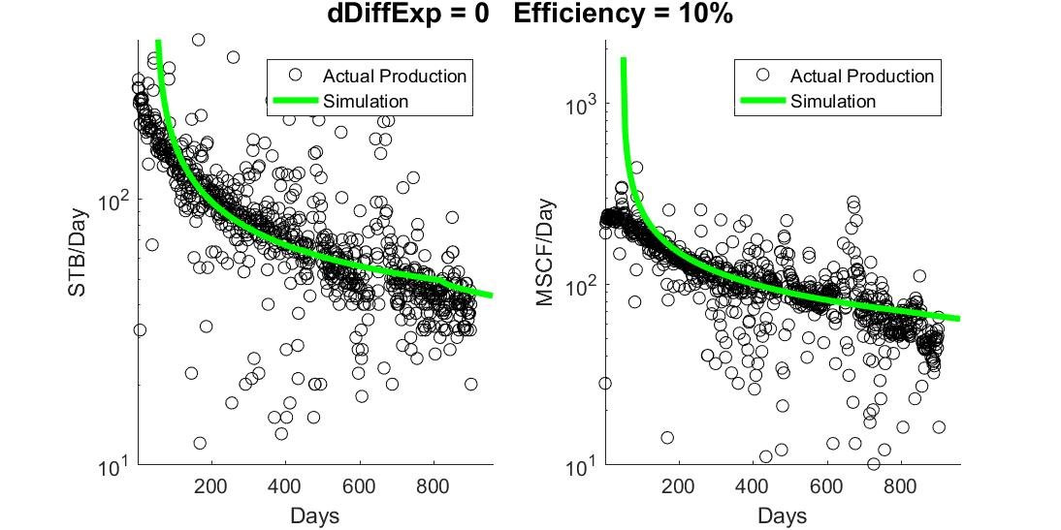
Figure 16: Sample Well 7's Production, with an initial dispersion start time, following convection dominated flow, that may need to be adjusted on a well by well basis
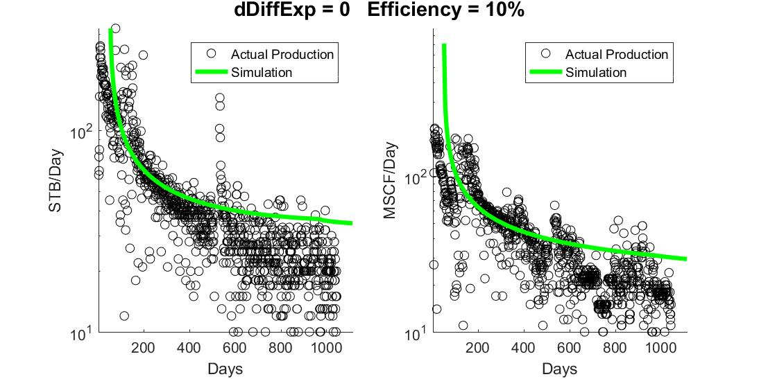
Figure 17: Sample Well 8's Production, with an initial dispersion start time, following convection dominated flow, that may need to be adjusted on a well by well basis

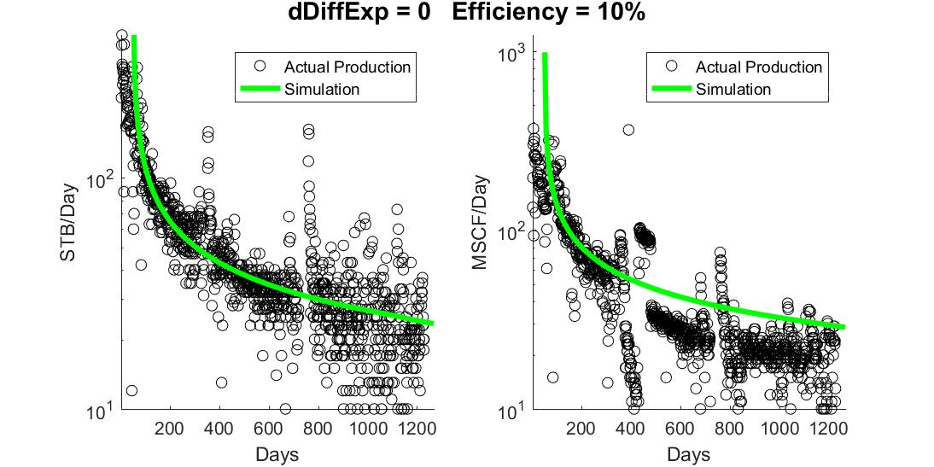
Figure 18: Sample Well 9's Production, with an initial dispersion start time, following convection dominated flow, that may need to be adjusted on a well by well basis

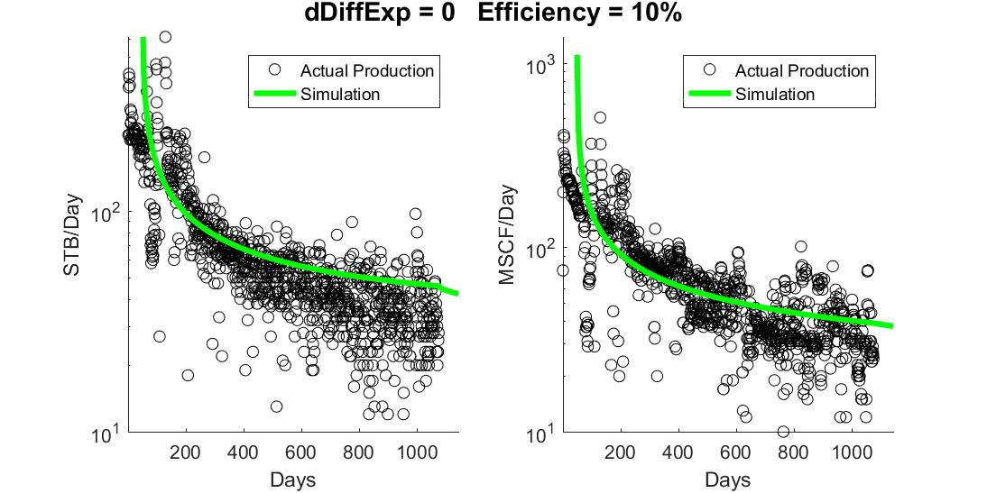
Figure 19: Sample Well 10's Production, with an initial dispersion start time, following convection dominated flow, that may need to be adjusted on a well by well basis
Each of the 10 sample wells shown above has its own gas concentration, oil concentration, and oil pressure distributions. While they do very from well to well depending on the related dispersion rates, cluster spacing, and fluid compositions, their general behavior is the same, and as such only a single example of each is shown below.
Oil Concentration over time, accounting for the moles of in-solution gas as a “boost” to concentration, behaves as expected, with the boundaries experiencing a rapid dropoff in concentration due to the low boundary concentrations at the fractures, with a more gradual decline experienced near the central No-Flow boundary:
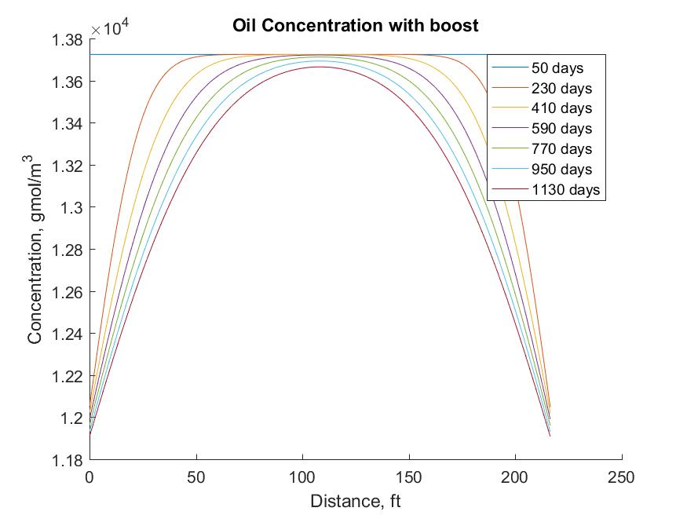
Figure 20: Sample Well 10 Oil Concentration over time
Oil pressures also behave as expected, dropping with the concentrations of oil. These drops are more pronounced above bubblepoint pressure, and the seemingly anomalous behavior at approximately 2500psi is due to the bubblepoint pressure being passed, and gas being subsequently released from solution.
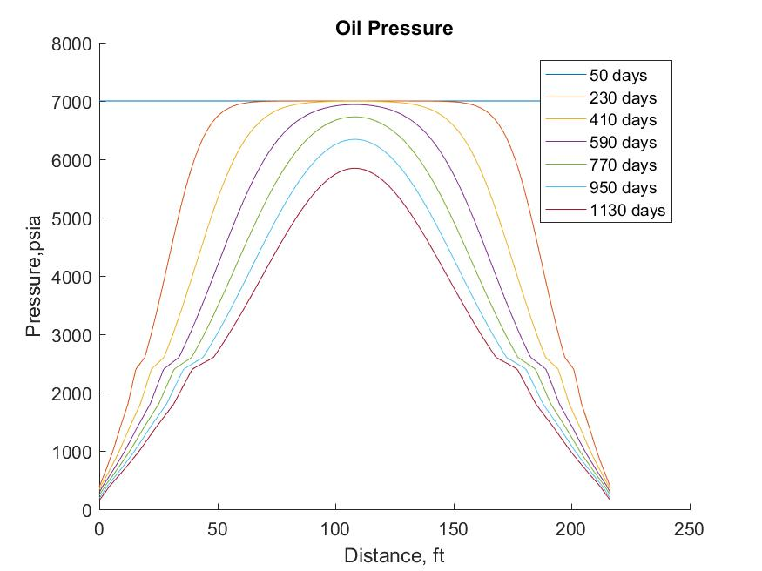
Figure 21: Sample Well 10 Oil Pressure over time
Gas concentrations originate in areas where the oil has dropped below bubble-point, but using our Shared Volume model they are able to disperse into above bubble-point regions:
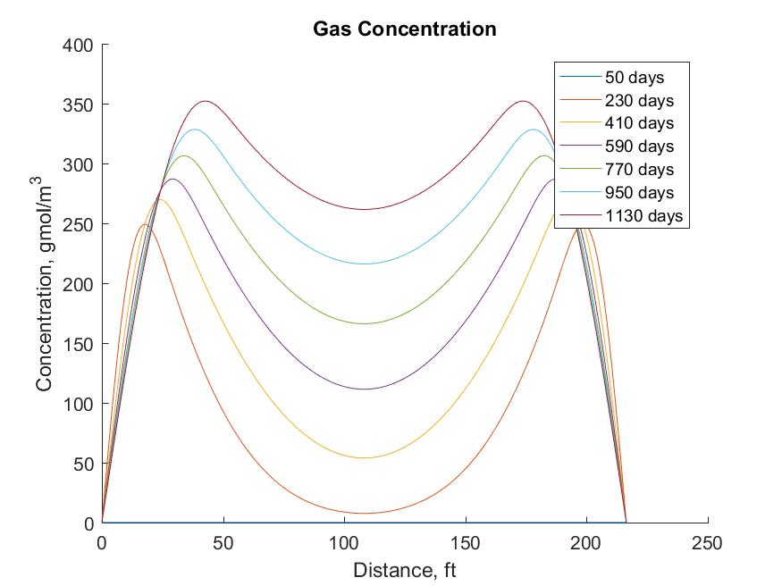
Figure 22: Sample Well 10 Gas Concentration over time
A false No-Flow boundary model was generated where areas above bubble-point could be insulated from gas diffusion without causing unreasonable behavior on the part of the gas, but it was decided that when assuming miscibility and a Shared Volume it was more reasonable for the gas to be able to disperse into high pressure areas, as shown above.

Summary of collection of runs
The simulation was run, and an ideal dispersivity constant found, for 10 wells in the Niobrara formation. Their production results were shown in the previous section, and the relationship between their dispersion coefficient and effective permeability, as calculated by the OU Well Evaluation Software (2017), is below:
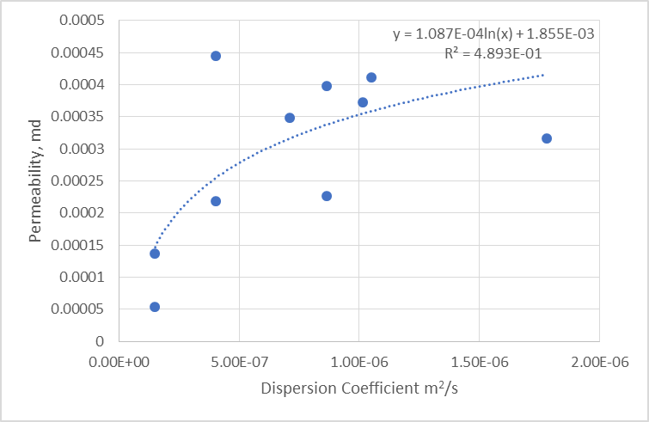
Figure 23: Permeability vs. Dispersion
This suggests that in order to justify the production rates seen at higher permeability values, an absurdly large dispersion coefficient would be required. As fluid flow at higher permeability’s are convection dominated rather than dispersion dominated, this makes sense, as dispersion alone can no longer account for the fluid flow seen at those rates, as represented in the figure below.
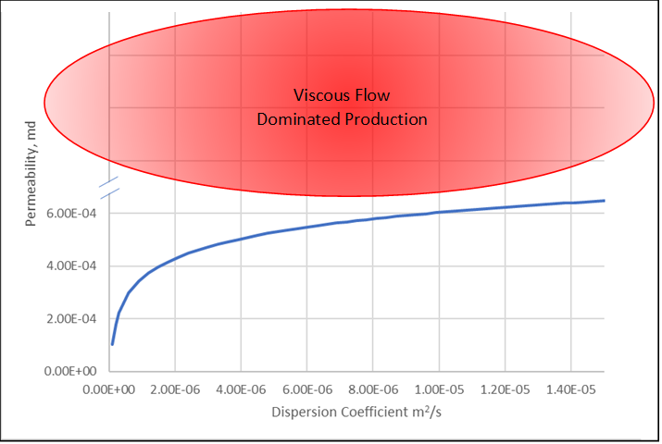
Figure 24: Viscous Flow production dominates at higher permeability values
An additional potential application of this method is determining geologic distributions of reservoir rock quality, as measured by the dispersion coefficient. In areas that already have existing production dispersion coefficients can be found for all existing wells, allowing an aerial map of reservoir quality to be determined:

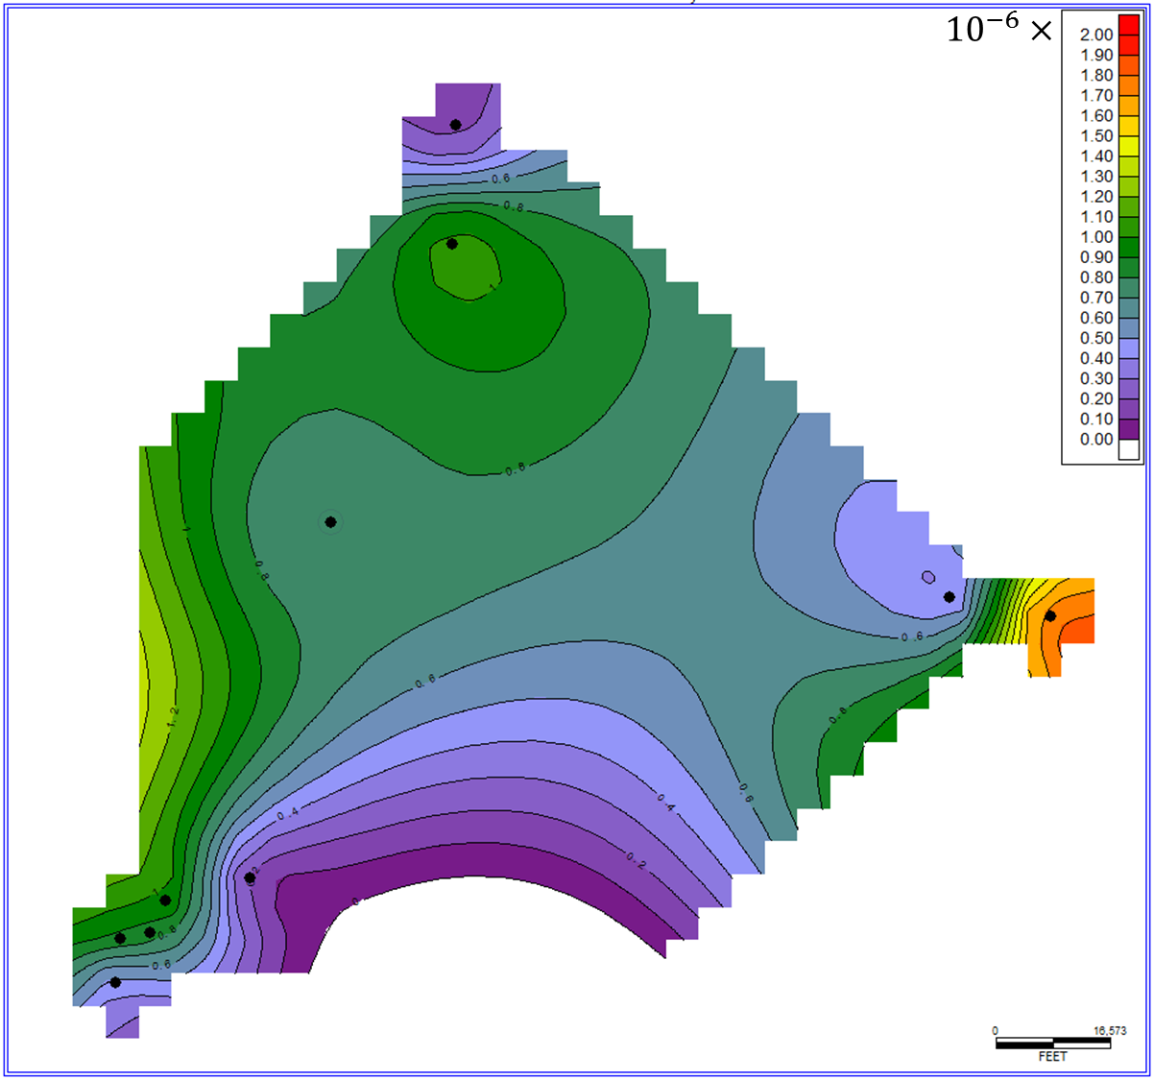
Figure 25: Dispersion Coefficients across the 10 sample well area

Recovery Factor
An additional point of interest that results from this model is a theoretical limit on the recovery factor. The maximum recovery factor for each well is limited by the possible concentration change. For the wells in the sample, maximum possible recovery factors ranged from 12-18%, assuming perfect cluster efficacy. This value would be decreased to real cluster efficacy values, but increased by corrections to the dimensions of the cluster itself, where dispersion flow would not be dominant.

Sensitivity Analysis
The measure of any new model can often be found in observing how it behaves under different conditions. In particular observing whether changes to input parameters create reasonable changes in outputs is a strong indication of a potentially useful model, and helps limit the risk of relationships and behaviors that were developed due to overfitting, rather than due to sound scientific principles. The following discussions on the programs sensitivity to different inputs and controls were all performed using Sample Well 10.

Solution Gas Content
Using the multiplier for the solution gas content discussed in the “Full Run” section earlier in this chapter, multipliers in addition to these values were applied to check sensitivity to increases or decreases in gas content.
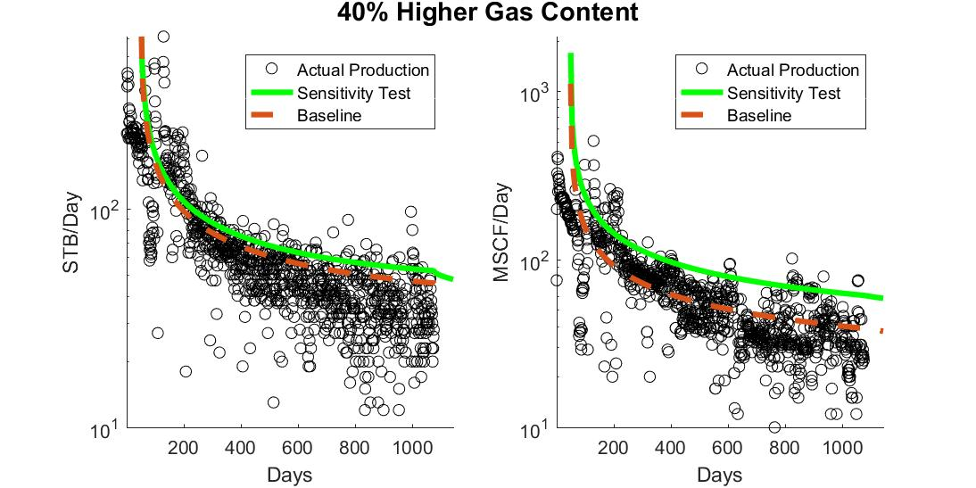
Figure 26: Sensitivity to increased Gas Content

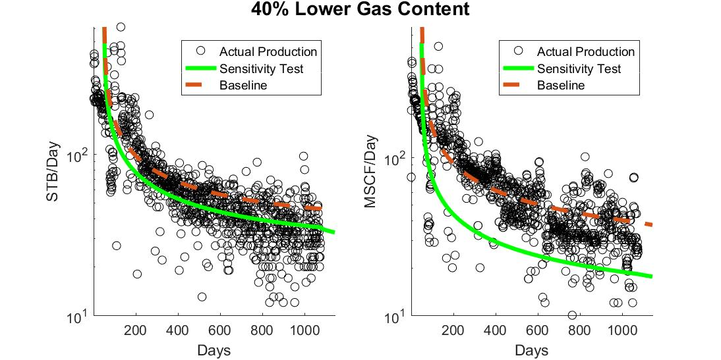
Figure 27: Sensitivity to decreased Gas Content
As expected changes to gas content have a sizeable impact on the amount of gas produced by the system. In addition, as in-solution gas content acts as a boost the oil concentration for dispersion purposes, changes to the gas content actually decrease both the oil production rate, and the ultimate recoverable reserves under dispersion based flow.

Timestep Resolution
Changing the number of timesteps is a significant contributor to overall runtimes, as discussed later in this section. Significantly higher numbers of timesteps also risk estimation errors and imperfect approximations. As such a sweetspot of runtime efficiency, minimal errors, and accurate simulation results is desired. For the purposes of applying BHP data or shut-in information a timestep resolution similar to the resolution of input data is ideal, while resolution exceeding that is unnecessary unless additional, time dependent terms are added to the simulation. By default the simulation uses a timestep of five days.
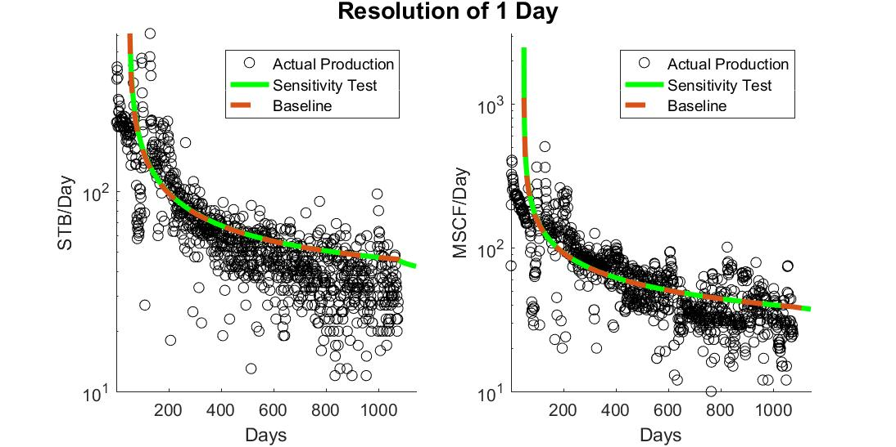
Figure 28: Sensitivity to shorter timesteps

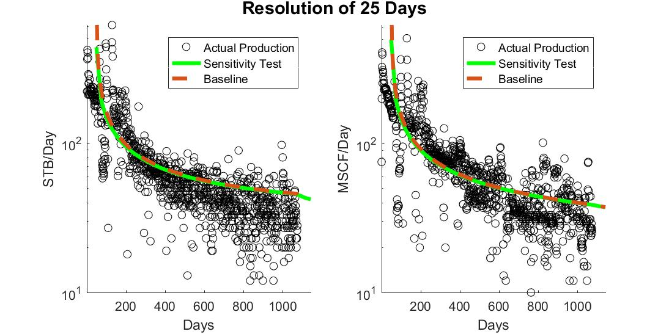
Figure 29: Sensitivity to longer timesteps

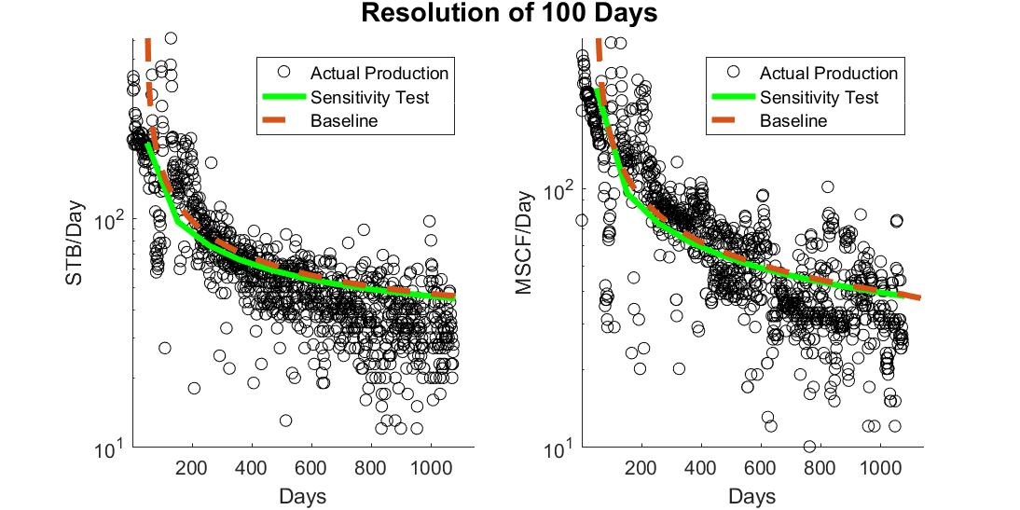
Figure 30: Sensitivity to much longer timesteps
Increasing the resolution of the simulation with respect to time simply increases runtimes, while decreasing resolution limits sensitivity to BHP changes, and eventually makes it difficult to generate a reasonable match with daily production data. The default time resolution of 5 days seems to be an ideal mix of decreasing runtimes while providing adequate resolution with respect to time. A time resolution of 1 day or lower would necessary in the event of well shut-in.

Length Resolution
As discussed later in this section, changes to the length resolution of the simulation have a noticeable, but manageable, effect on runtimes. They, however, has surprisingly little impact on the quality of results.
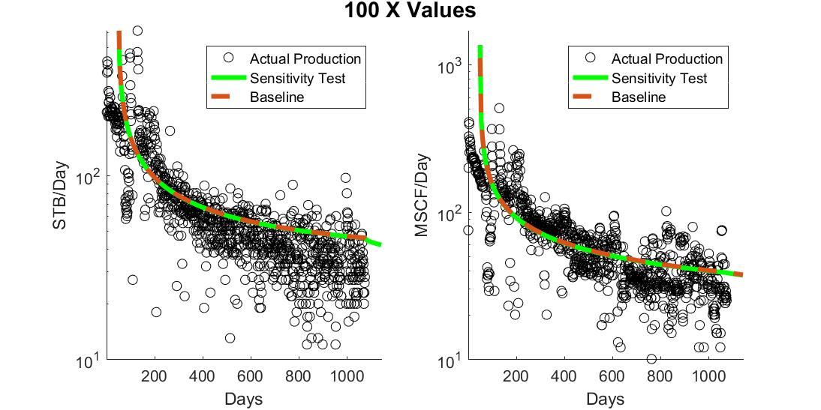
Figure 31: Sensitivity to lower length resolution

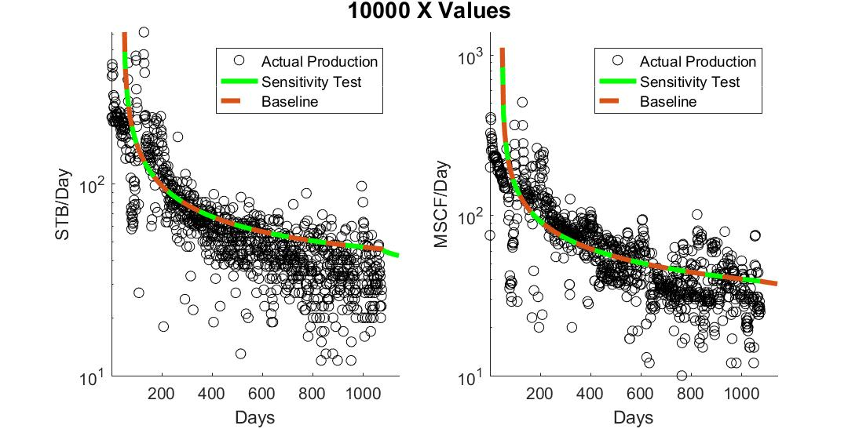
Figure 32: Sensitivity to higher length resolution
The default value actually used in the simulation is a length resolution of 2000 points. This value was chosen so that runs with significantly lower dispersion coefficients would be stable. In this case, with Sample Well 10’s dispersion coefficient of 1.02E-6 m²/s allows the simulation to remain stable until somewhere between fifty and one hundred points, where the dispersion behavior collapses. Usage of Simpson’s Rule is effective enough that the change from a length resolution of 100 to 10,000 points creates no appreciable difference in results with the current settings.

Dispersion Coefficient
The dispersion coefficient itself is the driving factor for the rate of production. While it has no effect on the ultimately recoverable reserves, as it primarily stretches production out with time, it is nonetheless very important for economic purposes.
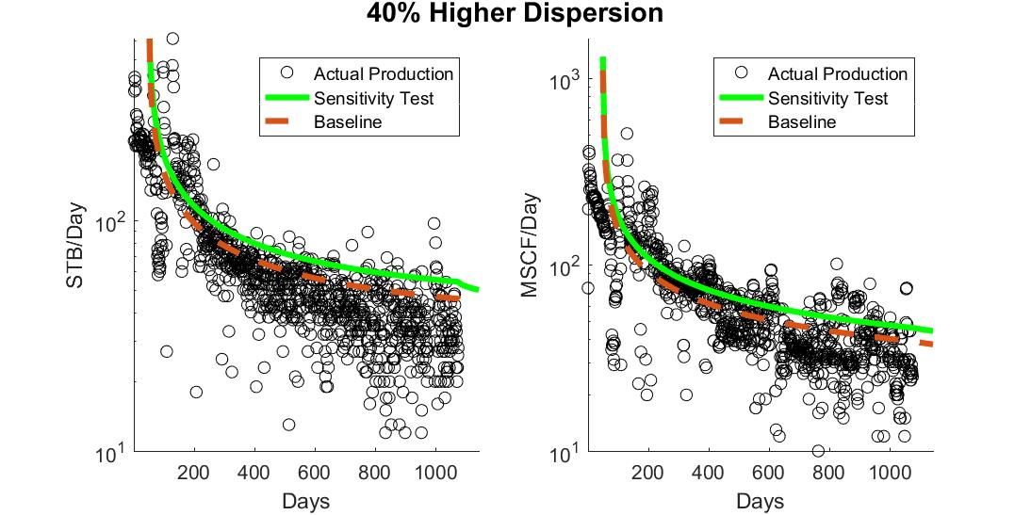
Figure 33: Sensitivity to higher dispersion coefficient
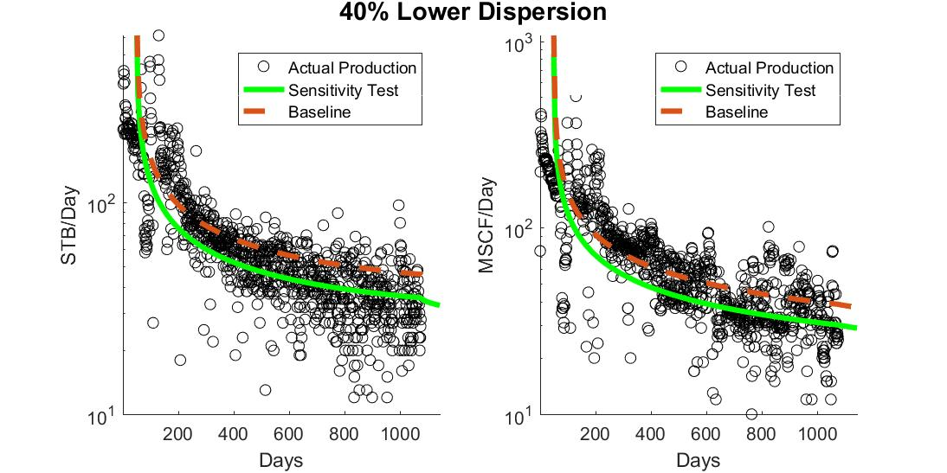
Figure 34: Sensitivity to lower dispersion coefficient
As would be expected, higher dispersion coefficients result in greater production rates, while smaller coefficients result in smaller production rates.

Dispersion Decline Coefficient
In the course of a simulation run, the dispersion coefficient is assumed to be constant. This is likely not true, due to pore throat closures and fluctuations in fluid properties that occur with declining pore pressure. In addition compression of the formation could result in increased production, that is currently being accounted for with the dispersion coefficient. A pressure dependent dispersion coefficient was experimented with, which would use the mean oil pressure of the system to change the dispersion coefficient on each timestep using the following equation:
$$D=D_{base}*exp(-D_{exponent}*(1-\frac{P_{mean}}{P_{base}}))$$ | eqn. 54
Resulting in a gradual decrease in the dispersion coefficient as pressure drops, assuming a positive dispersion decline exponent. This change affects the entire production decline, and additional research will need to be done in order to use it correctly, and to prevent overfitting. In the base simulation this dispersion decline exponent is set to 0, resulting in a constant dispersion coefficient value.
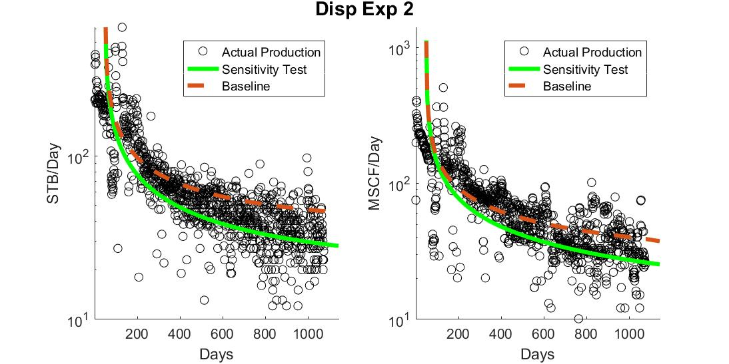
Figure 35: Sensitivity to high dispersion exponent
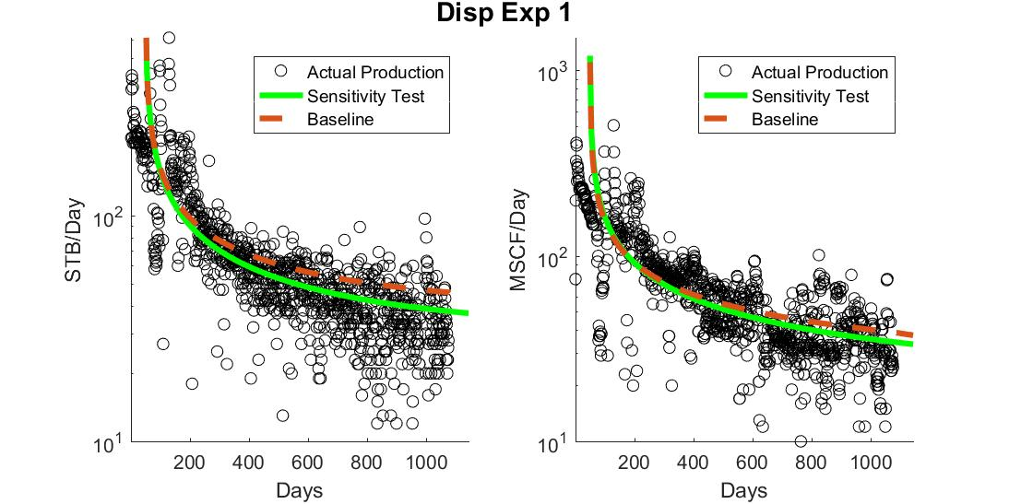
Figure 36: Sensitivity to moderate dispersion exponent

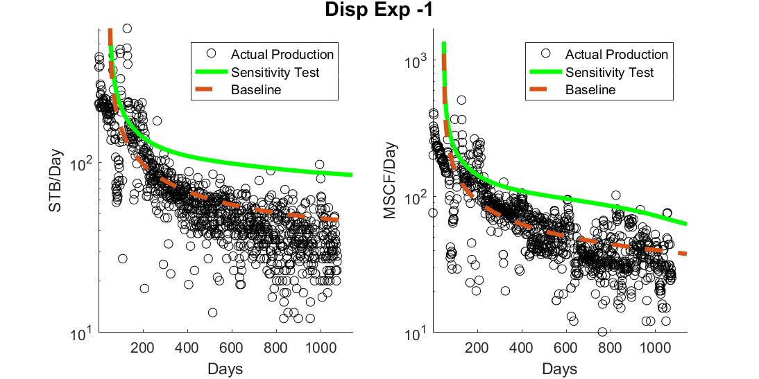
Figure 37: Sensitivity to moderate negative dispersion exponent
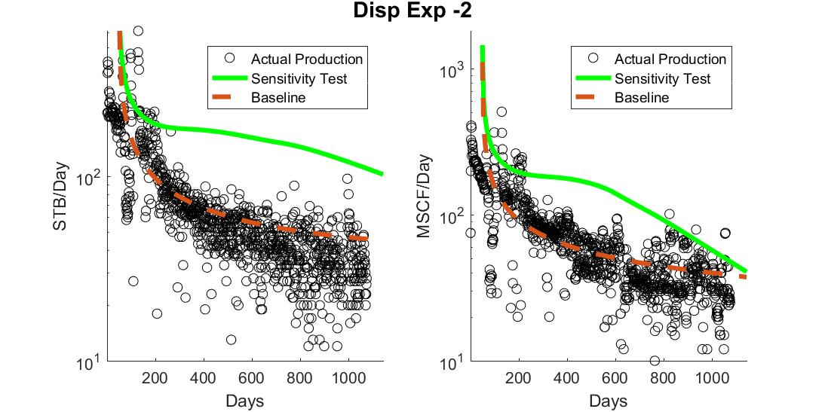
Figure 38: Sensitivity to high negative dispersion exponent
As the dispersion decline exponent just affects the dispersion coefficient it doesn’t actually result in changes to the amount of oil and gas that can be produced, it instead affects how rapidly that production. In the case of positive decline exponents production results in ever lower amounts of production, simply slowing the production process. In the case of negative decline exponents there is a significant increase in production as the reservoir pressure drops, reaching the point where the formation rapidly becomes depleted, and despite the larger dispersion coefficients, there simply isn’t enough concentration remaining in the formation matrix to support such high production rates, and the production rates begin to collapse.

Fracture Length
Fracture length acts only as a means to calculate the cross-sectional area of the production zone. This value was calculated on a well by well basis using the OU Well Evaluation Software (2017). As expected, higher and lower lengths simply scale production accordingly:
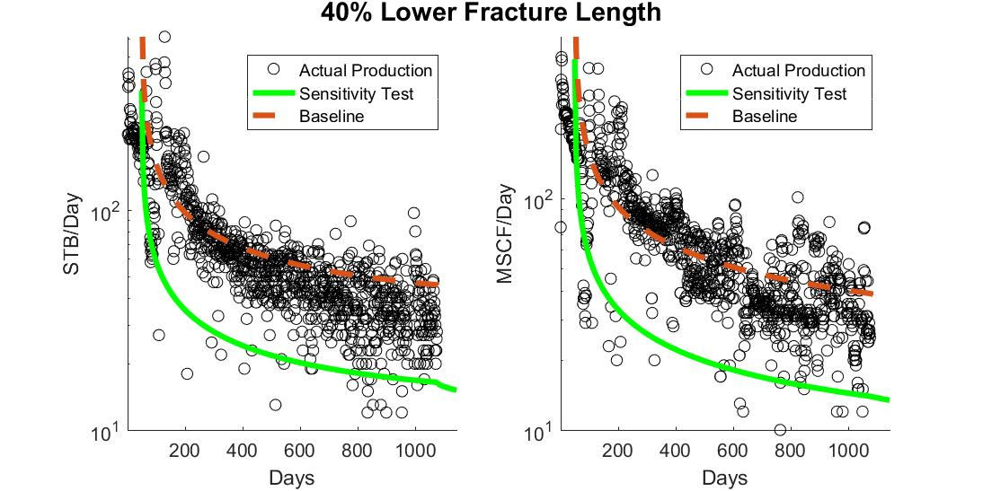
Figure 39: Sensitivity to smaller fracture length

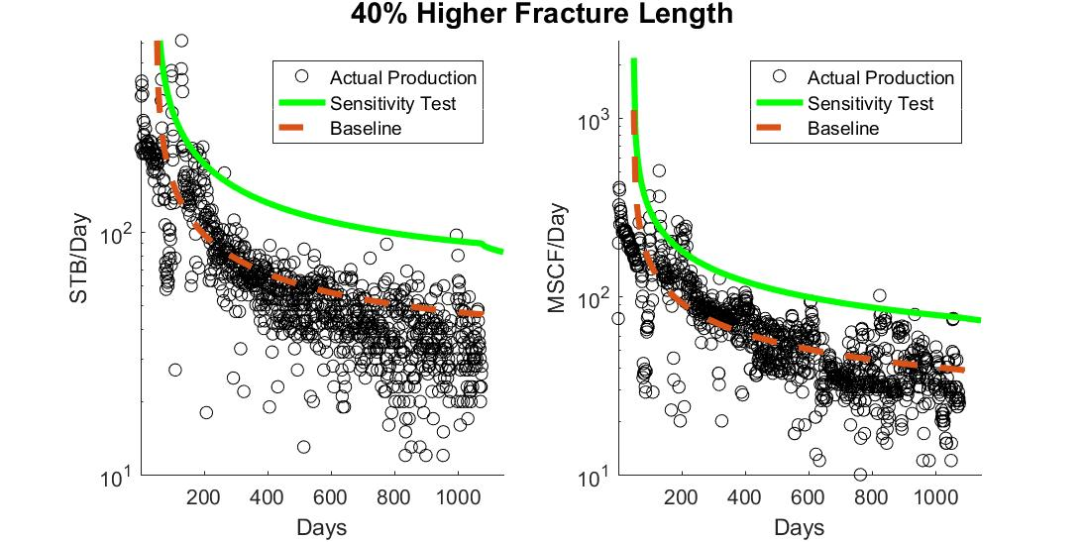
Figure 40: Sensitivity to larger fracture length

Bottom Hole Pressure
BHP is one of the driving forces of production. In situations where BHP is equivalent to formation pressure, no production is expected. For this dispersion based model, BHP primarily determines the boundary concentrations the drive production.
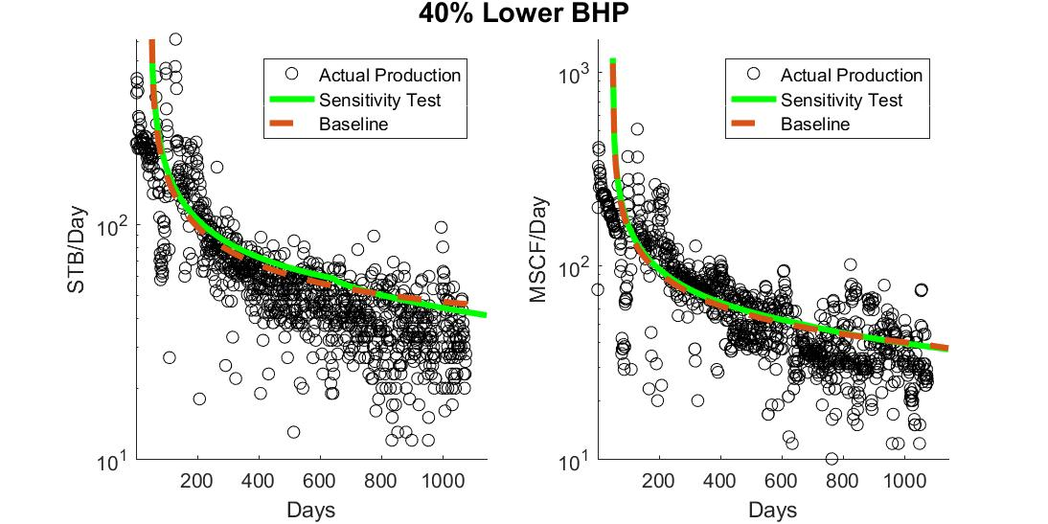
Figure 41: Sensitivity to lower BHP
As there is no support from unstimulated regions to provide additional production, a lower BHP results in draining the formation more quickly. In addition, lower BHP values increase the volume of gas that is released inside of rock matrix, no longer providing a boost to oil concentrations.
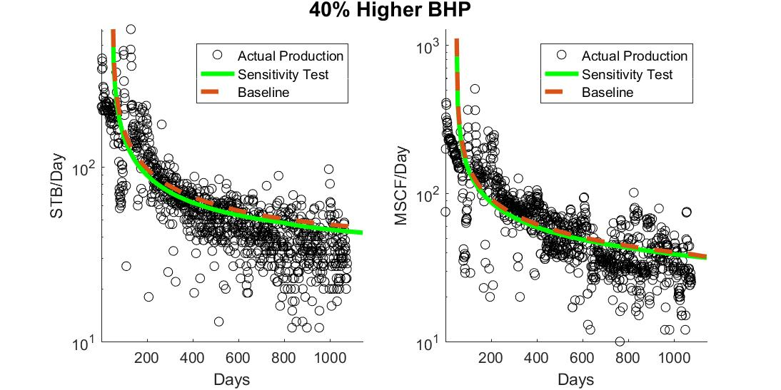
Figure 42: Sensitivity to higher BHP
Slightly higher BHP increase the concentration of oil at the boundary conditions, resulting in a weaker pull from the central regions, and decreased production.

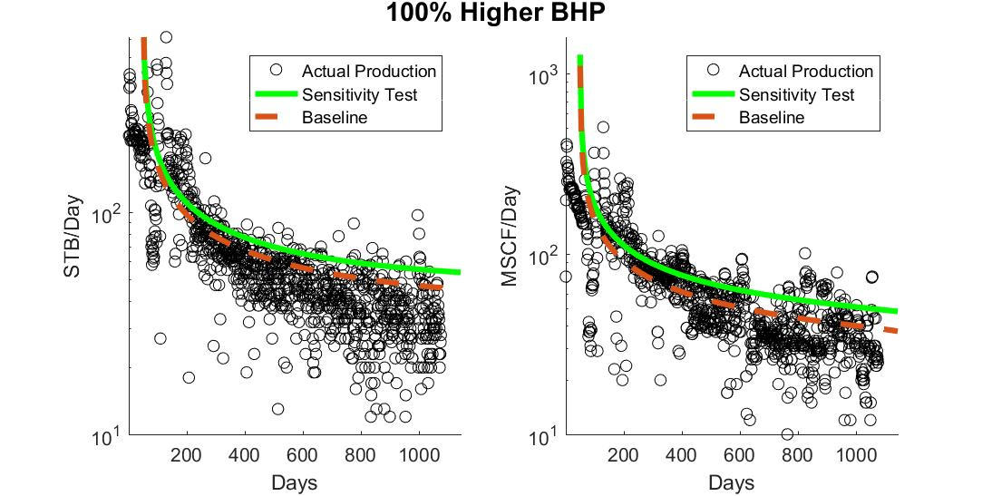
Figure 43: Sensitivity to much higher BHP
Much higher BHP’s, which for this well normally range from 440 to 150psi, but in this sensitivity analysis range from 880 to 300 psi, result in less oil production being lost due to the release of gas in the reservoir. As this gas still comes out of solution in the wellbore the net effect is actually higher oil and gas production, despite the higher BHP.

Total Runtime
For any simulation or prediction algorithm runtimes become particularly important as they grow large. A simulation with perfect predictive power that takes a supercomputer a day to run per well, while intellectually interesting, is not particularly useful. While a rather coarse approximation can be more than adequate in certain applications if the computations involved are quick and simple enough. The following runtimes are for running all ten sample wells with their unique well-specific information, using a standard engineering quality desktop computer.
Table 4: Runtimes
X Values | Infinite term size | Time step | Dispersion multiplier | Run Duration
# of points | - | days | - | seconds
2000 | 10^-20 | 5 | 1 | 86.4
500 | 10^-20 | 5 | 1 | 64
6000 | 10^-20 | 5 | 1 | 137.4
2000 | 10^-25 | 5 | 1 | 84.3
2000 | 10^-15 | 5 | 1 | 84.4
2000 | 10^-20 | 1 | 1 | 476.4
2000 | 10^-20 | 25 | 1 | 44.5
2000 | 10^-20 | 5 | 0.5 | 100.9
2000 | 10^-20 | 5 | 2 | 75.5

Advantages of this model
Adopting any new modeling system requires the time of busy professionals, who must learn the intricacies of the given model, as well as its interface. In many cases licenses must also be purchased, software changes must be made, and other tasks must be temporarily set aside. Comparisons must be made between the new model and previous models the company may have employed, and in many cases information must be converted to a new format. In short, there is a burden associated with adopting a new model, so it is important that the change is worthwhile.

Advantages over complex simulations
This model, at its core based on a single dispersivity equation, runs far faster than complex reservoir models. Individual wells can be simulated fast enough for entire sets of different input variables to be explored in a reasonable time, without the need for engineering level hardware. Changes to a simulation can be made essentially “on-the-fly”, in the course of a meeting, or in bulk to consider a whole host of different possibilities, such as to perform a Monte-Carlo analysis. This adds flexibility, and makes it much easier to consider alternate possible scenarios.

Advantages over Graphical Methods
Graphical methods, especially graphical Decline Curve Analysis, while a valuable tool before computers became dominant, is lacking in many areas. The manual adjustment of decline parameters in order to generate a curve that seems to match existing production, or even to predict the performance of new wells, makes it impossible to generate an objective or unique solution, especially when the process is approached by different engineers. It also becomes very difficult to incorporate gradual changes and differences between wells, such as those that may be gleaned by understanding changes in the local geology, or through core analysis.
This method not only allows for the incorporation of additional, well-specific data, such as from a field gradient or core data, but also generates unique, repeatable solutions from a given set of inputs.

Advantages over Type-Curve Matching
Many computer models for generating type curves exist. By allowing a computer to perform matching calculations, a unique, repeatable solution can often be found, and found in a rapid, automated fashion, without the need for direct engineer intervention and regular, manual updating. Yet since these models are, at their core, graphical models, they do not have the ability to accurately predict the effects of changes in reservoir parameters. A temporary shut-in, a better understanding of the reservoir’s dimensions or characteristics, or adjustments made to the drilling or fracturing of the well cannot be used to improve a type-curve model, especially when any changes do not match situations for which previous type curves exist.
This model, if implemented correctly, allows for a prediction that is responsive to changes in your understanding of the reservoir, as well as changes in the completion regime of the well. Additionally, due to the model’s iterative nature, changes in reservoir parameters can be scheduled into the simulation itself, allowing for a model that accounts for expected occurrences, such as a shut-in.

Limitations of this model
Several limitations exist for this model. While its speed of calculation is exceptional, this is made possible by not accounting for the effects of 3D geometry and reservoir heterogeneity, which many modern simulators consider. While standard decline curve analysis is limited by being a primarily graphical approach, this dispersion model considers both production information, as well as BHP, formation, and fluid information. Any inaccuracy or incorrect assumptions in these inputs will result in inaccuracies in the final result any derived dispersion coefficients. Many effects on fluid properties in the nanoscale are also not accounted for in this model.

Chapter 5: Conclusion
The outcome of this thesis is a new approach for predicting fluid flow in shales. This novel approach for predicting fluid flow in tight shale formations moves beyond many of the limitations of conventional Darcy flow models, and relates microscopic dispersion behavior to field-scale production. The model relates core and fluid properties to resulting production curves, and can account for BHP information when determining either production or the dispersion coefficient associated with the well. The developed modeling tool uses readily available lab-scale data to predict field production using analytical scaling techniques, allowing for realistic predictions to be made of well performance. A simple collection of inputs are required, and the physics of the problem and of shale reservoirs is taken into account. The resulting production information is useful for economic forecasts, while the concentration profiles generated by the model could prove invaluable when considering different EOR applications, as long as the applied BHP information is accurate.

Recommendations and Future Research
This research, and the computer code that explored it, were designed to act as a proof of concept. On multiple occasions changes that would be valuable for a field implementation, when adequate data would be available, were set aside to avoid the risk of overfitting, which would likely be the result of the matching that would be required to pick many of these values. Future research should focus on exploring EOR applications, and how the concentration distribution generated by the program can inform the viability of a well as a potential EOR project. The relationship between permeability and the dispersion coefficient used in the program should also be investigated, as well as a way to separately account for the effects of Darcy and diffusion based flow.

References
Arps, J. J. (1945, December 1). Analysis of Decline Curves. Society of Petroleum Engineers. doi:10.2118/945228-G
Boomer, R. J. (1995, January 1). Predicting Production Using a Neural Network (Artificial Intelligence Beats Human Intelligence). Society of Petroleum Engineers. doi:10.2118/30202-MS
Cook, J. A. and Ranstam, J. (2016), Overfitting. Br J Surg, 103: 1814. doi:10.1002/bjs.10244
Davudov, D., Moghanloo, R. G., Lan, Y., & Vice, D. (2017, February 15). Investigation of Shale Pore Compressibility Impact on Production with Reservoir Simulation. Society of Petroleum Engineers. doi:10.2118/185059-MS
EIA (2014, March) Tight oil production pushes U.S. crude supply to over 10% of world total, https://www.eia.gov/todayinenergy/detail.php?id=15571
Fetkovich, M. J. (1980, June 1). Decline Curve Analysis Using Type Curves. Society of Petroleum Engineers. doi:10.2118/4629-PA
Haberman, R. (2004). Heat Equation with Zero Temperatures at Finite Ends. In Applied partial differential equations: With Fourier series and boundary value problems. 5th edition, Chap. 2.3.4., 38-43. Upper Saddle River, N.J: Pearson Prentice Hall.
Kanfar, M., & Wattenbarger, R. (2012, January 1). Comparison of Empirical Decline Curve Methods for Shale Wells. Society of Petroleum Engineers. doi:10.2118/162648-MS
Lan, Y., Moghanloo, R. G., & Davudov, D.. Pore Compressibility of Shale Formations. SPE Journal (In Press)
Lake, Larry W. (1989) Enhanced oil recovery. Englewood Cliffs, N.J.: Prentice Hall.
Moghanloo, R.G., Yuan, B., Ingraham, N., Krampf, E., Arrowooda, J., Dadmohammadi, Y. (2015, November). Applying macroscopic material balance to evaluate interplay between dynamic drainage volume and well performance in tight formations, Journal of Natural Gas Science and Engineering, Volume 27, Part 2, Pages 466-478, ISSN 1875-5100, http://doi.org/10.1016/j.jngse.2015.07.047.
Moghanloo, R.G. (2012). Modeling the Fluid Flow of Carbon Dioxide through Permeable Media (Doctoral Dissertation). Retrieved from https://repositories.lib.utexas.edu/handle/2152/ETD-UT-2012-05-4813
OU Well Evaluation Software. (2017), OTD Invention No. 2017-043, University of Okalhoma
Portellaand, R. C. M., & Prais, F. (1999, January 1). Use of Automatic History Matching and Geostatistical Simulation to Improve Production Forecast. Society of Petroleum Engineers. doi:10.2118/53976-MS
Purvis, D. C. (2016, May 10). The Practice of Decline Curve Analysis. Society of Petroleum Engineers. doi:10.2118/179979-MS
Rajvanshi, A. K., Gmelig Meyling, R., & Ten Haaf, D. (2012, January 1). Instilling Realism in Production Forecasts: Dos and Don. Society of Petroleum Engineers. doi:10.2118/155443-MS
Ramey, H.J. Jr. 1973. Correlations of Surface and Interfacial Tensions of Reservoir Fluids. Paper SPE-4429-MS available from SPE, Richardson, Texas.
Ran, B., & Kelkar, M. (2015, July 20). Fracture Stages Optimization in Bakken Shale Formation. Unconventional Resources Technology Conference. doi:10.15530/URTEC-2015-2154796
Rao, D., & Lee, J., Determination of gas–oil miscibility conditions by interfacial tension measurements, Journal of Colloid and Interface Science, Volume 262, Issue 2, 15 June 2003, Pages 474-482, ISSN 0021-9797, http://doi.org/10.1016/S0021-9797(03)00175-9.
Rotondi, M., Nicotra, G., Godi, A., Contento, F. M., Blunt, M. J., & Christie, M. (2006, January 1). Hydrocarbon Production Forecast and Uncertainty Quantification: A Field Application. Society of Petroleum Engineers. doi:10.2118/102135-MS
Sigal, R. F., Devegowda, D., & Civan, F. (2015, August 10). On the Equilibrium State of Shale Gas Reservoirs. Society of Petrophysicists and Well-Log Analysts.
Swami, V., Clarkson, C. R., & Settari, A. (2012, January 1). Non-Darcy Flow in Shale Nanopores: Do We Have a Final Answer? Society of Petroleum Engineers. doi:10.2118/162665-MS
Wang, B., Markitell, B. N., & Huang, W. S. (1993, January 1). Case Studies of Horizontal Well Design and Production Forecast. Society of Petroleum Engineers. doi:10.2118/25567-MS
Wang, H., & Marongiu-Porcu, M. (2015, November 1). Impact of Shale-Gas Apparent Permeability on Production: Combined Effects of Non-Darcy Flow/Gas-Slippage, Desorption, and Geomechanics. Society of Petroleum Engineers. doi:10.2118/173196-PA
Warren, J. E., & Skiba, F. F. (1964, September 1). Macroscopic Dispersion. Society of Petroleum Engineers. doi:10.2118/648-PA
Whitson, C.H. and Brulé, M.R. 2000. Phase Behavior, No. 20, Chap. 3. Richardson, Texas: Henry L. Doherty Monograph Series, Society of Petroleum Engineers.
Yemez, I., Singh, V., Orellana, N. H., & Izaguirre, E. (2014, December 10). Factors Contributing to Uncertain Production Forecasts: 3D Reservoir Modelling Perspectives. International Petroleum Technology Conference. doi:10.2523/IPTC-18196-MS
Yuan, B., Zheng, D., & Ghanbarnezhad Moghanloo, R. (2016, August 24). Integrated Production Analysis Using the Concept of Dynamic Drainage Volume: Modelling, Simulation and Field Applications. Society of Petroleum Engineers. doi:10.2118/181781-MS
Zhang, K., Dong, X., Li, J., Lv, J., Wu, K., Kusalik, P., & Chen, Z. (2016, August 1). Effect of Nanoscale Pore Confinement on Multi-Component Phase Equilibrium. Unconventional Resources Technology Conference.
Zheng, D., Moghanloo, R. G., Yuan, B., & Dong, X. (2016, August 24). Modeling Dynamic Drainage Volume for Multi-Stage Fractured Wells in Composite Shale Systems: New Analytical Solution for Transient Linear Flow. Society of Petroleum Engineers. doi:10.2118/181875-MS

Appendix A: Nomenclature
$C_{gas}$ | Concentration of gas, gmol/m³
$C_{oil}$ | Concentration of oil with in-solution gas contribution, gmol/m³
$D_{diff}$ | Diffusion coefficient, m²/s
$D_{disp}$ | Dispersivity, m²/s
D_{lab} | Dispersion coefficient at the lab-scale, m²/s
D_{SRV} | Dispersion coefficient of the SRV, m²/s
F_{t} | Time scaling factor, s/s
FVF | Formation Volume Factor (res vol/standard vol)
IC³ | Integrated Core Characterization Center
L_{REV} | Length of the REV, m
L_{SRV} | Length of the SRV, m
MICP | Mercury Injection Capillary Pressure
$M_{og}$ | Molecular weight of oil with in-solution gas, g/gmol
$M_{og}$ | Molecular weight of gas with in-solution oil, g/gmol
$σ$ | Interfacial Tension, dynes/cm
$φ$ | Porosity, p.u.
S | Fluid Saturation
$τ$ | Tortuosity coefficient
u | Fluid velocity, m/s
$x_{g}$ | Mole fraction of gas in the oil phase
$x_{o}$ | Mole fraction of oil in the oil phase
$y_{g}$ | Mole fraction of gas in the gas phase
$y_{o}$ | Mole fraction of oil in the gas phase

Appendix B: Tables
Table 5: Example Production data from well M47L6HRJ47
Headers are Time (day), Oil Production (stb/day), and Gas Production (Mscf/day)
Time | Q_oil | Q_gas | BHP | Time | Q_oil | Q_gas | BHP | Time | Q_oil | Q_gas | BHP
Days | STB | MSCF | psia | Days | STB | MSCF | psia | Days | STB | MSCF | psia
1 | 0 | 14 | 440.8 | 360 | 63 | 68 | 343.9 | 719 | 43 | 28 | 247.0
2 | 31 | 75 | 440.6 | 361 | 66 | 77 | 343.6 | 720 | 35 | 33 | 246.7
3 | 221 | 199 | 440.3 | 362 | 63 | 72 | 343.4 | 721 | 43 | 32 | 246.4
4 | 363 | 325 | 440.0 | 363 | 80 | 74 | 343.1 | 722 | 45 | 31 | 246.2
5 | 418 | 407 | 439.8 | 364 | 73 | 96 | 342.8 | 723 | 33 | 27 | 245.9
6 | 402 | 394 | 439.5 | 365 | 50 | 104 | 342.6 | 724 | 38 | 39 | 245.6
7 | 222 | 253 | 439.2 | 366 | 57 | 66 | 342.3 | 725 | 78 | 36 | 245.4
8 | 370 | 310 | 439.0 | 367 | 58 | 75 | 342.0 | 726 | 32 | 38 | 245.1
9 | 210 | 301 | 438.7 | 368 | 65 | 75 | 341.8 | 727 | 47 | 36 | 244.8
10 | 288 | 298 | 438.4 | 369 | 60 | 90 | 341.5 | 728 | 45 | 55 | 244.6
11 | 249 | 279 | 438.1 | 370 | 63 | 68 | 341.2 | 729 | 40 | 35 | 244.3
12 | 252 | 265 | 437.9 | 371 | 69 | 79 | 340.9 | 730 | 42 | 41 | 244.0
13 | 282 | 255 | 437.6 | 372 | 63 | 95 | 340.7 | 731 | 27 | 45 | 243.7
14 | 210 | 253 | 437.3 | 373 | 67 | 66 | 340.4 | 732 | 40 | 34 | 243.5
15 | 228 | 229 | 437.1 | 374 | 50 | 81 | 340.1 | 733 | 0 | 28 | 243.2
16 | 212 | 227 | 436.8 | 375 | 63 | 91 | 339.9 | 734 | 45 | 19 | 242.9
17 | 266 | 235 | 436.5 | 376 | 80 | 57 | 339.6 | 735 | 50 | 29 | 242.7
18 | 210 | 236 | 436.3 | 377 | 47 | 89 | 339.3 | 736 | 58 | 31 | 242.4
19 | 235 | 232 | 436.0 | 378 | 77 | 56 | 339.1 | 737 | 35 | 63 | 242.1
20 | 223 | 229 | 435.7 | 379 | 43 | 81 | 338.8 | 738 | 33 | 32 | 241.9
21 | 236 | 227 | 435.4 | 380 | 67 | 89 | 338.5 | 739 | 52 | 30 | 241.6
22 | 219 | 233 | 435.2 | 381 | 65 | 56 | 338.2 | 740 | 37 | 48 | 241.3
23 | 230 | 230 | 434.9 | 382 | 50 | 66 | 338.0 | 741 | 39 | 34 | 241.0
24 | 219 | 235 | 434.6 | 383 | 73 | 74 | 337.7 | 742 | 56 | 31 | 240.8
25 | 233 | 234 | 434.4 | 384 | 53 | 76 | 337.4 | 743 | 30 | 53 | 240.5
26 | 229 | 233 | 434.1 | 385 | 62 | 87 | 337.2 | 744 | 33 | 42 | 240.2
27 | 222 | 231 | 433.8 | 386 | 67 | 54 | 336.9 | 745 | 50 | 38 | 240.0
28 | 222 | 222 | 433.6 | 387 | 55 | 79 | 336.6 | 746 | 32 | 45 | 239.7
29 | 209 | 215 | 433.3 | 388 | 67 | 60 | 336.4 | 747 | 33 | 27 | 239.4
30 | 205 | 206 | 433.0 | 389 | 48 | 77 | 336.1 | 748 | 27 | 38 | 239.2
31 | 213 | 203 | 432.7 | 390 | 40 | 29 | 335.8 | 749 | 48 | 44 | 238.9
32 | 237 | 214 | 432.5 | 391 | 72 | 74 | 335.5 | 750 | 40 | 25 | 238.6
33 | 208 | 188 | 432.2 | 392 | 68 | 85 | 335.3 | 751 | 40 | 32 | 238.3
34 | 221 | 215 | 431.9 | 393 | 43 | 56 | 335.0 | 752 | 43 | 36 | 238.1
35 | 223 | 216 | 431.7 | 394 | 72 | 28 | 334.7 | 753 | 43 | 43 | 237.8
36 | 202 | 203 | 431.4 | 395 | 72 | 83 | 334.5 | 754 | 33 | 43 | 237.5
37 | 202 | 204 | 431.1 | 396 | 50 | 83 | 334.2 | 755 | 33 | 31 | 237.3
38 | 192 | 200 | 430.9 | 397 | 76 | 68 | 333.9 | 756 | 35 | 23 | 237.0
39 | 233 | 199 | 430.6 | 398 | 71 | 88 | 333.7 | 757 | 41 | 30 | 236.7
40 | 178 | 190 | 430.3 | 399 | 55 | 94 | 333.4 | 758 | 42 | 38 | 236.5
41 | 198 | 180 | 430.0 | 400 | 62 | 83 | 333.1 | 759 | 27 | 33 | 236.2
42 | 194 | 179 | 429.8 | 401 | 63 | 86 | 332.8 | 760 | 48 | 29 | 235.9
43 | 208 | 183 | 429.5 | 402 | 60 | 105 | 332.6 | 761 | 23 | 32 | 235.6
44 | 182 | 184 | 429.2 | 403 | 69 | 95 | 332.3 | 762 | 39 | 33 | 235.4
45 | 162 | 180 | 429.0 | 404 | 53 | 100 | 332.0 | 763 | 41 | 26 | 235.1
46 | 176 | 178 | 428.7 | 405 | 55 | 94 | 331.8 | 764 | 35 | 26 | 234.8
47 | 190 | 184 | 428.4 | 406 | 65 | 91 | 331.5 | 765 | 35 | 10 | 234.6
48 | 210 | 187 | 428.2 | 407 | 54 | 98 | 331.2 | 766 | 40 | 16 | 234.3
49 | 207 | 182 | 427.9 | 408 | 19 | 83 | 331.0 | 767 | 38 | 36 | 234.0
50 | 198 | 169 | 427.6 | 409 | 88 | 78 | 330.7 | 768 | 60 | 51 | 233.8
51 | 210 | 165 | 427.3 | 410 | 55 | 85 | 330.4 | 769 | 35 | 65 | 233.5
52 | 178 | 163 | 427.1 | 411 | 63 | 85 | 330.1 | 770 | 22 | 66 | 233.2
53 | 196 | 172 | 426.8 | 412 | 53 | 75 | 329.9 | 771 | 47 | 0 | 232.9
54 | 200 | 165 | 426.5 | 413 | 65 | 83 | 329.6 | 772 | 62 | 61 | 232.7
55 | 192 | 161 | 426.3 | 414 | 60 | 85 | 329.3 | 773 | 50 | 59 | 232.4
56 | 190 | 159 | 426.0 | 415 | 48 | 57 | 329.1 | 774 | 22 | 32 | 232.1
57 | 220 | 159 | 425.7 | 416 | 32 | 64 | 328.8 | 775 | 30 | 23 | 231.9
58 | 135 | 153 | 425.5 | 417 | 53 | 67 | 328.5 | 776 | 0 | 23 | 231.6
59 | 174 | 148 | 425.2 | 418 | 38 | 39 | 328.3 | 777 | 89 | 33 | 231.3
60 | 211 | 148 | 424.9 | 419 | 42 | 39 | 328.0 | 778 | 30 | 17 | 231.1
61 | 150 | 148 | 424.6 | 420 | 70 | 62 | 327.7 | 779 | 25 | 26 | 230.8
62 | 2 | 148 | 424.4 | 421 | 63 | 52 | 327.4 | 780 | 26 | 26 | 230.5
63 | 0 | 148 | 424.1 | 422 | 58 | 74 | 327.2 | 781 | 64 | 45 | 230.2
64 | 0 | 148 | 423.8 | 423 | 75 | 55 | 326.9 | 782 | 28 | 32 | 230.0
65 | 0 | 148 | 423.6 | 424 | 53 | 67 | 326.6 | 783 | 40 | 41 | 229.7
66 | 0 | 0 | 423.3 | 425 | 67 | 79 | 326.4 | 784 | 16 | 32 | 229.4
67 | 348 | 161 | 423.0 | 426 | 67 | 52 | 326.1 | 785 | 53 | 31 | 229.2
68 | 425 | 259 | 422.8 | 427 | 50 | 70 | 325.8 | 786 | 35 | 31 | 228.9
69 | 268 | 211 | 422.5 | 428 | 57 | 58 | 325.6 | 787 | 28 | 42 | 228.6
70 | 229 | 207 | 422.2 | 429 | 62 | 82 | 325.3 | 788 | 37 | 33 | 228.4
71 | 235 | 199 | 421.9 | 430 | 67 | 63 | 325.0 | 789 | 55 | 61 | 228.1
72 | 201 | 178 | 421.7 | 431 | 45 | 73 | 324.7 | 790 | 32 | 30 | 227.8
73 | 205 | 169 | 421.4 | 432 | 62 | 79 | 324.5 | 791 | 37 | 30 | 227.5
74 | 162 | 146 | 421.1 | 433 | 72 | 54 | 324.2 | 792 | 50 | 31 | 227.3
75 | 164 | 129 | 420.9 | 434 | 23 | 73 | 323.9 | 793 | 18 | 32 | 227.0
76 | 136 | 93 | 420.6 | 435 | 41 | 37 | 323.7 | 794 | 52 | 45 | 226.7
77 | 147 | 121 | 420.3 | 436 | 47 | 36 | 323.4 | 795 | 35 | 32 | 226.5
78 | 137 | 131 | 420.1 | 437 | 57 | 66 | 323.1 | 796 | 47 | 38 | 226.2
79 | 107 | 100 | 419.8 | 438 | 58 | 36 | 322.9 | 797 | 23 | 33 | 225.9
80 | 70 | 35 | 419.5 | 439 | 43 | 63 | 322.6 | 798 | 35 | 33 | 225.7
81 | 75 | 42 | 419.2 | 440 | 45 | 38 | 322.3 | 799 | 38 | 34 | 225.4
82 | 58 | 37 | 419.0 | 441 | 60 | 52 | 322.0 | 800 | 35 | 39 | 225.1
83 | 65 | 37 | 418.7 | 442 | 53 | 57 | 321.8 | 801 | 37 | 46 | 224.8
84 | 72 | 37 | 418.4 | 443 | 57 | 44 | 321.5 | 802 | 58 | 50 | 224.6
85 | 67 | 37 | 418.2 | 444 | 62 | 68 | 321.2 | 803 | 30 | 49 | 224.3
86 | 68 | 39 | 417.9 | 445 | 42 | 42 | 321.0 | 804 | 20 | 31 | 224.0
87 | 62 | 31 | 417.6 | 446 | 57 | 46 | 320.7 | 805 | 47 | 38 | 223.8
88 | 60 | 29 | 417.4 | 447 | 62 | 68 | 320.4 | 806 | 55 | 60 | 223.5
89 | 63 | 38 | 417.1 | 448 | 38 | 42 | 320.2 | 807 | 25 | 33 | 223.2
90 | 77 | 38 | 416.8 | 449 | 81 | 48 | 319.9 | 808 | 50 | 38 | 223.0
91 | 103 | 65 | 416.5 | 450 | 38 | 65 | 319.6 | 809 | 2 | 32 | 222.7
92 | 82 | 63 | 416.3 | 451 | 50 | 44 | 319.3 | 810 | 35 | 42 | 222.4
93 | 97 | 67 | 416.0 | 452 | 67 | 61 | 319.1 | 811 | 46 | 28 | 222.1
94 | 102 | 76 | 415.7 | 453 | 44 | 48 | 318.8 | 812 | 45 | 23 | 221.9
95 | 78 | 68 | 415.5 | 454 | 73 | 46 | 318.5 | 813 | 28 | 31 | 221.6
96 | 93 | 67 | 415.2 | 455 | 42 | 66 | 318.3 | 814 | 23 | 41 | 221.3
97 | 131 | 78 | 414.9 | 456 | 67 | 41 | 318.0 | 815 | 40 | 32 | 221.1
98 | 73 | 87 | 414.7 | 457 | 58 | 54 | 317.7 | 816 | 35 | 48 | 220.8
99 | 462 | 204 | 414.4 | 458 | 42 | 71 | 317.5 | 817 | 20 | 30 | 220.5
100 | 438 | 365 | 414.1 | 459 | 50 | 43 | 317.2 | 818 | 48 | 31 | 220.3
101 | 310 | 278 | 413.8 | 460 | 62 | 61 | 316.9 | 819 | 55 | 22 | 220.0
102 | 264 | 239 | 413.6 | 461 | 52 | 49 | 316.6 | 820 | 30 | 31 | 219.7
103 | 198 | 207 | 413.3 | 462 | 66 | 47 | 316.4 | 821 | 33 | 36 | 219.4
104 | 215 | 184 | 413.0 | 463 | 43 | 66 | 316.1 | 822 | 32 | 49 | 219.2
105 | 248 | 167 | 412.8 | 464 | 55 | 44 | 315.8 | 823 | 25 | 31 | 218.9
106 | 143 | 152 | 412.5 | 465 | 60 | 75 | 315.6 | 824 | 37 | 35 | 218.6
107 | 138 | 142 | 412.2 | 466 | 42 | 39 | 315.3 | 825 | 48 | 35 | 218.4
108 | 138 | 131 | 412.0 | 467 | 45 | 45 | 315.0 | 826 | 54 | 101 | 218.1
109 | 132 | 116 | 411.7 | 468 | 52 | 49 | 314.8 | 827 | 48 | 78 | 217.8
110 | 78 | 95 | 411.4 | 469 | 52 | 50 | 314.5 | 828 | 32 | 70 | 217.6
111 | 27 | 29 | 411.1 | 470 | 57 | 40 | 314.2 | 829 | 57 | 71 | 217.3
112 | 0 | 0 | 410.9 | 471 | 57 | 72 | 313.9 | 830 | 42 | 80 | 217.0
113 | 0 | 0 | 410.6 | 472 | 39 | 41 | 313.7 | 831 | 20 | 65 | 216.7
114 | 0 | 0 | 410.3 | 473 | 73 | 70 | 313.4 | 832 | 32 | 33 | 216.5
115 | 0 | 0 | 410.1 | 474 | 45 | 40 | 313.1 | 833 | 58 | 67 | 216.2
116 | 0 | 0 | 409.8 | 475 | 65 | 48 | 312.9 | 834 | 3 | 33 | 215.9
117 | 0 | 0 | 409.5 | 476 | 40 | 59 | 312.6 | 835 | 58 | 16 | 215.7
118 | 0 | 0 | 409.3 | 477 | 48 | 42 | 312.3 | 836 | 12 | 17 | 215.4
119 | 0 | 0 | 409.0 | 478 | 59 | 68 | 312.1 | 837 | 15 | 31 | 215.1
120 | 0 | 0 | 408.7 | 479 | 52 | 41 | 311.8 | 838 | 17 | 22 | 214.9
121 | 0 | 0 | 408.4 | 480 | 62 | 43 | 311.5 | 839 | 23 | 29 | 214.6
122 | 0 | 0 | 408.2 | 481 | 45 | 70 | 311.2 | 840 | 45 | 32 | 214.3
123 | 0 | 0 | 407.9 | 482 | 53 | 41 | 311.0 | 841 | 69 | 73 | 214.0
124 | 0 | 0 | 407.6 | 483 | 50 | 69 | 310.7 | 842 | 52 | 51 | 213.8
125 | 0 | 0 | 407.4 | 484 | 43 | 39 | 310.4 | 843 | 50 | 73 | 213.5
126 | 0 | 0 | 407.1 | 485 | 75 | 47 | 310.2 | 844 | 47 | 76 | 213.2
127 | 0 | 0 | 406.8 | 486 | 51 | 61 | 309.9 | 845 | 45 | 70 | 213.0
128 | 0 | 0 | 406.6 | 487 | 33 | 48 | 309.6 | 846 | 23 | 45 | 212.7
129 | 0 | 0 | 406.3 | 488 | 63 | 68 | 309.4 | 847 | 3 | 27 | 212.4
130 | 470 | 153 | 406.0 | 489 | 38 | 37 | 309.1 | 848 | 17 | 15 | 212.2
131 | 614 | 506 | 405.7 | 490 | 43 | 43 | 308.8 | 849 | 20 | 18 | 211.9
132 | 424 | 363 | 405.5 | 491 | 62 | 65 | 308.5 | 850 | 28 | 20 | 211.6
133 | 223 | 164 | 405.2 | 492 | 47 | 39 | 308.3 | 851 | 27 | 22 | 211.3
134 | 378 | 280 | 404.9 | 493 | 58 | 49 | 308.0 | 852 | 47 | 32 | 211.1
135 | 216 | 247 | 404.7 | 494 | 55 | 65 | 307.7 | 853 | 34 | 50 | 210.8
136 | 225 | 218 | 404.4 | 495 | 57 | 42 | 307.5 | 854 | 43 | 26 | 210.5
137 | 227 | 192 | 404.1 | 496 | 27 | 61 | 307.2 | 855 | 13 | 24 | 210.3
138 | 162 | 171 | 403.9 | 497 | 37 | 5 | 306.9 | 856 | 60 | 21 | 210.0
139 | 170 | 157 | 403.6 | 498 | 59 | 47 | 306.7 | 857 | 30 | 29 | 209.7
140 | 167 | 147 | 403.3 | 499 | 60 | 64 | 306.4 | 858 | 30 | 29 | 209.5
141 | 155 | 138 | 403.0 | 500 | 50 | 44 | 306.1 | 859 | 37 | 33 | 209.2
142 | 132 | 130 | 402.8 | 501 | 53 | 55 | 305.8 | 860 | 25 | 32 | 208.9
143 | 140 | 122 | 402.5 | 502 | 62 | 63 | 305.6 | 861 | 38 | 32 | 208.6
144 | 176 | 133 | 402.2 | 503 | 42 | 41 | 305.3 | 862 | 25 | 30 | 208.4
145 | 207 | 181 | 402.0 | 504 | 63 | 68 | 305.0 | 863 | 25 | 32 | 208.1
146 | 137 | 154 | 401.7 | 505 | 38 | 38 | 304.8 | 864 | 42 | 27 | 207.8
147 | 162 | 144 | 401.4 | 506 | 58 | 48 | 304.5 | 865 | 43 | 29 | 207.6
148 | 147 | 137 | 401.2 | 507 | 48 | 61 | 304.2 | 866 | 23 | 30 | 207.3
149 | 153 | 132 | 400.9 | 508 | 58 | 59 | 304.0 | 867 | 25 | 29 | 207.0
150 | 136 | 127 | 400.6 | 509 | 40 | 48 | 303.7 | 868 | 50 | 39 | 206.8
151 | 171 | 128 | 400.3 | 510 | 50 | 42 | 303.4 | 869 | 30 | 33 | 206.5
152 | 123 | 135 | 400.1 | 511 | 53 | 70 | 303.1 | 870 | 30 | 32 | 206.2
153 | 142 | 128 | 399.8 | 512 | 43 | 38 | 302.9 | 871 | 38 | 29 | 205.9
154 | 141 | 128 | 399.5 | 513 | 60 | 44 | 302.6 | 872 | 35 | 31 | 205.7
155 | 133 | 128 | 399.3 | 514 | 50 | 64 | 302.3 | 873 | 38 | 29 | 205.4
156 | 129 | 118 | 399.0 | 515 | 53 | 38 | 302.1 | 874 | 32 | 29 | 205.1
157 | 117 | 108 | 398.7 | 516 | 13 | 56 | 301.8 | 875 | 52 | 29 | 204.9
158 | 150 | 119 | 398.5 | 517 | 85 | 42 | 301.5 | 876 | 65 | 30 | 204.6
159 | 137 | 141 | 398.2 | 518 | 50 | 61 | 301.3 | 877 | 60 | 30 | 204.3
160 | 128 | 127 | 397.9 | 519 | 43 | 37 | 301.0 | 878 | 40 | 29 | 204.1
161 | 60 | 97 | 397.6 | 520 | 58 | 56 | 300.7 | 879 | 40 | 30 | 203.8
162 | 2 | 0 | 397.4 | 521 | 43 | 47 | 300.4 | 880 | 38 | 28 | 203.5
163 | 65 | 0 | 397.1 | 522 | 62 | 61 | 300.2 | 881 | 33 | 28 | 203.2
164 | 221 | 199 | 396.8 | 523 | 40 | 45 | 299.9 | 882 | 13 | 46 | 203.0
165 | 170 | 159 | 396.6 | 524 | 57 | 63 | 299.6 | 883 | 20 | 67 | 202.7
166 | 155 | 126 | 396.3 | 525 | 38 | 39 | 299.4 | 884 | 33 | 66 | 202.4
167 | 137 | 127 | 396.0 | 526 | 43 | 41 | 299.1 | 885 | 48 | 59 | 202.2
168 | 109 | 114 | 395.8 | 527 | 53 | 53 | 298.8 | 886 | 42 | 62 | 201.9
169 | 4 | 23 | 395.5 | 528 | 62 | 51 | 298.6 | 887 | 40 | 62 | 201.6
170 | 0 | 0 | 395.2 | 529 | 37 | 53 | 298.3 | 888 | 45 | 64 | 201.4
171 | 205 | 88 | 394.9 | 530 | 59 | 49 | 298.0 | 889 | 34 | 63 | 201.1
172 | 192 | 203 | 394.7 | 531 | 38 | 52 | 297.7 | 890 | 6 | 40 | 200.8
173 | 148 | 134 | 394.4 | 532 | 58 | 48 | 297.5 | 891 | 28 | 39 | 200.5
174 | 150 | 128 | 394.1 | 533 | 38 | 54 | 297.2 | 892 | 33 | 32 | 200.3
175 | 98 | 118 | 393.9 | 534 | 60 | 43 | 296.9 | 893 | 48 | 32 | 200.0
176 | 75 | 45 | 393.6 | 535 | 62 | 52 | 296.7 | 894 | 18 | 19 | 199.7
177 | 0 | 34 | 393.3 | 536 | 50 | 42 | 296.4 | 895 | 43 | 20 | 199.5
178 | 0 | 0 | 393.1 | 537 | 21 | 54 | 296.1 | 896 | 34 | 18 | 199.2
179 | 212 | 140 | 392.8 | 538 | 45 | 37 | 295.9 | 897 | 46 | 68 | 198.9
180 | 112 | 151 | 392.5 | 539 | 64 | 68 | 295.6 | 898 | 43 | 65 | 198.7
181 | 0 | 0 | 392.2 | 540 | 38 | 39 | 295.3 | 899 | 40 | 64 | 198.4
182 | 218 | 0 | 392.0 | 541 | 55 | 39 | 295.0 | 900 | 27 | 59 | 198.1
183 | 184 | 202 | 391.7 | 542 | 48 | 61 | 294.8 | 901 | 12 | 35 | 197.8
184 | 142 | 130 | 391.4 | 543 | 40 | 36 | 294.5 | 902 | 35 | 42 | 197.6
185 | 71 | 102 | 391.2 | 544 | 60 | 54 | 294.2 | 903 | 38 | 43 | 197.3
186 | 0 | 0 | 390.9 | 545 | 37 | 49 | 294.0 | 904 | 33 | 39 | 197.0
187 | 0 | 0 | 390.6 | 546 | 20 | 31 | 293.7 | 905 | 35 | 46 | 196.8
188 | 148 | 3 | 390.4 | 547 | 0 | 0 | 293.4 | 906 | 35 | 67 | 196.5
189 | 207 | 262 | 390.1 | 548 | 75 | 6 | 293.2 | 907 | 26 | 31 | 196.2
190 | 163 | 143 | 389.8 | 549 | 65 | 78 | 292.9 | 908 | 44 | 26 | 196.0
191 | 132 | 119 | 389.5 | 550 | 80 | 77 | 292.6 | 909 | 28 | 33 | 195.7
192 | 107 | 101 | 389.3 | 551 | 45 | 74 | 292.3 | 910 | 29 | 40 | 195.4
193 | 0 | 31 | 389.0 | 552 | 42 | 39 | 292.1 | 911 | 33 | 6 | 195.1
194 | 0 | 0 | 388.7 | 553 | 50 | 40 | 291.8 | 912 | 28 | 30 | 194.9
195 | 3 | 3 | 388.5 | 554 | 51 | 45 | 291.5 | 913 | 32 | 28 | 194.6
196 | 0 | 0 | 388.2 | 555 | 45 | 49 | 291.3 | 914 | 30 | 28 | 194.3
197 | 110 | 20 | 387.9 | 556 | 34 | 54 | 291.0 | 915 | 40 | 30 | 194.1
198 | 224 | 234 | 387.7 | 557 | 0 | 17 | 290.7 | 916 | 45 | 31 | 193.8
199 | 186 | 171 | 387.4 | 558 | 63 | 17 | 290.5 | 917 | 53 | 40 | 193.5
200 | 190 | 171 | 387.1 | 559 | 63 | 63 | 290.2 | 918 | 33 | 44 | 193.3
201 | 163 | 154 | 386.8 | 560 | 50 | 55 | 289.9 | 919 | 31 | 44 | 193.0
202 | 127 | 119 | 386.6 | 561 | 60 | 60 | 289.6 | 920 | 22 | 42 | 192.7
203 | 177 | 211 | 386.3 | 562 | 41 | 49 | 289.4 | 921 | 33 | 33 | 192.4
204 | 157 | 239 | 386.0 | 563 | 55 | 63 | 289.1 | 922 | 40 | 43 | 192.2
205 | 117 | 208 | 385.8 | 564 | 57 | 39 | 288.8 | 923 | 35 | 37 | 191.9
206 | 114 | 202 | 385.5 | 565 | 33 | 45 | 288.6 | 924 | 17 | 7 | 191.6
207 | 103 | 144 | 385.2 | 566 | 58 | 67 | 288.3 | 925 | 42 | 48 | 191.4
208 | 118 | 182 | 385.0 | 567 | 8 | 34 | 288.0 | 926 | 33 | 48 | 191.1
209 | 18 | 132 | 384.7 | 568 | 0 | 0 | 287.8 | 927 | 33 | 42 | 190.8
210 | 103 | 24 | 384.4 | 569 | 69 | 19 | 287.5 | 928 | 27 | 22 | 190.6
211 | 148 | 171 | 384.1 | 570 | 63 | 60 | 287.2 | 929 | 2 | 3 | 190.3
212 | 137 | 93 | 383.9 | 571 | 60 | 58 | 286.9 | 930 | 0 | 0 | 190.0
213 | 120 | 237 | 383.6 | 572 | 61 | 59 | 286.7 | 931 | 0 | 0 | 189.7
214 | 95 | 221 | 383.3 | 573 | 50 | 64 | 286.4 | 932 | 57 | 9 | 189.5
215 | 101 | 247 | 383.1 | 574 | 58 | 56 | 286.1 | 933 | 42 | 50 | 189.2
216 | 100 | 131 | 382.8 | 575 | 42 | 56 | 285.9 | 934 | 58 | 50 | 188.9
217 | 114 | 131 | 382.5 | 576 | 45 | 40 | 285.6 | 935 | 45 | 44 | 188.7
218 | 63 | 191 | 382.3 | 577 | 48 | 62 | 285.3 | 936 | 43 | 79 | 188.4
219 | 123 | 115 | 382.0 | 578 | 58 | 35 | 285.1 | 937 | 40 | 41 | 188.1
220 | 106 | 115 | 381.7 | 579 | 27 | 51 | 284.8 | 938 | 38 | 43 | 187.9
221 | 90 | 115 | 381.4 | 580 | 68 | 55 | 284.5 | 939 | 40 | 37 | 187.6
222 | 67 | 96 | 381.2 | 581 | 45 | 43 | 284.2 | 940 | 48 | 36 | 187.3
223 | 70 | 90 | 380.9 | 582 | 35 | 49 | 284.0 | 941 | 22 | 44 | 187.0
224 | 115 | 122 | 380.6 | 583 | 45 | 29 | 283.7 | 942 | 33 | 39 | 186.8
225 | 100 | 110 | 380.4 | 584 | 44 | 43 | 283.4 | 943 | 30 | 35 | 186.5
226 | 63 | 113 | 380.1 | 585 | 50 | 48 | 283.2 | 944 | 38 | 37 | 186.2
227 | 123 | 123 | 379.8 | 586 | 38 | 38 | 282.9 | 945 | 25 | 27 | 186.0
228 | 93 | 122 | 379.6 | 587 | 56 | 48 | 282.6 | 946 | 40 | 59 | 185.7
229 | 105 | 128 | 379.3 | 588 | 32 | 42 | 282.4 | 947 | 33 | 54 | 185.4
230 | 82 | 102 | 379.0 | 589 | 42 | 38 | 282.1 | 948 | 37 | 50 | 185.2
231 | 110 | 138 | 378.7 | 590 | 3 | 19 | 281.8 | 949 | 30 | 35 | 184.9
232 | 76 | 111 | 378.5 | 591 | 0 | 0 | 281.5 | 950 | 32 | 31 | 184.6
233 | 103 | 93 | 378.2 | 592 | 62 | 6 | 281.3 | 951 | 28 | 49 | 184.3
234 | 80 | 126 | 377.9 | 593 | 68 | 64 | 281.0 | 952 | 40 | 35 | 184.1
235 | 84 | 125 | 377.7 | 594 | 65 | 65 | 280.7 | 953 | 40 | 31 | 183.8
236 | 70 | 88 | 377.4 | 595 | 62 | 51 | 280.5 | 954 | 23 | 39 | 183.5
237 | 95 | 74 | 377.1 | 596 | 58 | 54 | 280.2 | 955 | 12 | 37 | 183.3
238 | 82 | 115 | 376.9 | 597 | 55 | 58 | 279.9 | 956 | 15 | 3 | 183.0
239 | 89 | 83 | 376.6 | 598 | 45 | 70 | 279.7 | 957 | 60 | 49 | 182.7
240 | 105 | 92 | 376.3 | 599 | 46 | 37 | 279.4 | 958 | 45 | 53 | 182.5
241 | 75 | 103 | 376.0 | 600 | 55 | 58 | 279.1 | 959 | 34 | 40 | 182.2
242 | 85 | 91 | 375.8 | 601 | 43 | 42 | 278.8 | 960 | 25 | 35 | 181.9
243 | 77 | 85 | 375.5 | 602 | 48 | 47 | 278.6 | 961 | 32 | 24 | 181.6
244 | 95 | 82 | 375.2 | 603 | 47 | 67 | 278.3 | 962 | 33 | 12 | 181.4
245 | 97 | 114 | 375.0 | 604 | 41 | 37 | 278.0 | 963 | 35 | 56 | 181.1
246 | 98 | 118 | 374.7 | 605 | 60 | 0 | 277.8 | 964 | 27 | 47 | 180.8
247 | 77 | 101 | 374.4 | 606 | 0 | 0 | 277.5 | 965 | 23 | 17 | 180.6
248 | 79 | 97 | 374.2 | 607 | 0 | 93 | 277.2 | 966 | 41 | 45 | 180.3
249 | 86 | 91 | 373.9 | 608 | 28 | 0 | 277.0 | 967 | 38 | 45 | 180.0
250 | 81 | 101 | 373.6 | 609 | 55 | 94 | 276.7 | 968 | 33 | 40 | 179.8
251 | 88 | 100 | 373.3 | 610 | 42 | 64 | 276.4 | 969 | 25 | 25 | 179.5
252 | 61 | 100 | 373.1 | 611 | 23 | 82 | 276.1 | 970 | 28 | 40 | 179.2
253 | 95 | 93 | 372.8 | 612 | 50 | 79 | 275.9 | 971 | 53 | 44 | 178.9
254 | 78 | 84 | 372.5 | 613 | 47 | 74 | 275.6 | 972 | 30 | 43 | 178.7
255 | 89 | 88 | 372.3 | 614 | 38 | 66 | 275.3 | 973 | 28 | 45 | 178.4
256 | 82 | 84 | 372.0 | 615 | 45 | 60 | 275.1 | 974 | 20 | 44 | 178.1
257 | 93 | 92 | 371.7 | 616 | 48 | 50 | 274.8 | 975 | 27 | 44 | 177.9
258 | 67 | 74 | 371.5 | 617 | 55 | 72 | 274.5 | 976 | 40 | 34 | 177.6
259 | 78 | 79 | 371.2 | 618 | 37 | 60 | 274.3 | 977 | 27 | 34 | 177.3
260 | 57 | 71 | 370.9 | 619 | 42 | 59 | 274.0 | 978 | 22 | 30 | 177.1
261 | 102 | 69 | 370.6 | 620 | 55 | 60 | 273.7 | 979 | 22 | 32 | 176.8
262 | 102 | 121 | 370.4 | 621 | 57 | 56 | 273.4 | 980 | 35 | 1 | 176.5
263 | 52 | 108 | 370.1 | 622 | 45 | 45 | 273.2 | 981 | 43 | 25 | 176.2
264 | 83 | 55 | 369.8 | 623 | 43 | 21 | 272.9 | 982 | 0 | 12 | 176.0
265 | 92 | 98 | 369.6 | 624 | 50 | 21 | 272.6 | 983 | 0 | 0 | 175.7
266 | 175 | 85 | 369.3 | 625 | 43 | 13 | 272.4 | 984 | 0 | 0 | 175.4
267 | 0 | 81 | 369.0 | 626 | 43 | 5 | 272.1 | 985 | 0 | 0 | 175.2
268 | 65 | 83 | 368.8 | 627 | 5 | 1 | 271.8 | 986 | 0 | 0 | 174.9
269 | 83 | 88 | 368.5 | 628 | 65 | 1 | 271.6 | 987 | 0 | 0 | 174.6
270 | 78 | 82 | 368.2 | 629 | 40 | 5 | 271.3 | 988 | 0 | 0 | 174.4
271 | 80 | 82 | 367.9 | 630 | 50 | 1 | 271.0 | 989 | 0 | 0 | 174.1
272 | 85 | 66 | 367.7 | 631 | 32 | 0 | 270.7 | 990 | 0 | 0 | 173.8
273 | 50 | 66 | 367.4 | 632 | 37 | 0 | 270.5 | 991 | 0 | 0 | 173.5
274 | 85 | 76 | 367.1 | 633 | 47 | 0 | 270.2 | 992 | 0 | 0 | 173.3
275 | 92 | 86 | 366.9 | 634 | 55 | 0 | 269.9 | 993 | 0 | 0 | 173.0
276 | 68 | 94 | 366.6 | 635 | 52 | 0 | 269.7 | 994 | 0 | 0 | 172.7
277 | 85 | 87 | 366.3 | 636 | 27 | 12 | 269.4 | 995 | 0 | 0 | 172.5
278 | 72 | 86 | 366.1 | 637 | 21 | 58 | 269.1 | 996 | 7 | 0 | 172.2
279 | 82 | 85 | 365.8 | 638 | 42 | 41 | 268.9 | 997 | 97 | 32 | 171.9
280 | 76 | 91 | 365.5 | 639 | 19 | 32 | 268.6 | 998 | 53 | 31 | 171.7
281 | 67 | 83 | 365.2 | 640 | 32 | 3 | 268.3 | 999 | 30 | 32 | 171.4
282 | 82 | 80 | 365.0 | 641 | 33 | 23 | 268.0 | 1000 | 20 | 35 | 171.1
283 | 55 | 86 | 364.7 | 642 | 25 | 26 | 267.8 | 1001 | 33 | 34 | 170.8
284 | 102 | 70 | 364.4 | 643 | 52 | 28 | 267.5 | 1002 | 80 | 30 | 170.6
285 | 77 | 91 | 364.2 | 644 | 19 | 32 | 267.2 | 1003 | 63 | 52 | 170.3
286 | 68 | 82 | 363.9 | 645 | 64 | 36 | 267.0 | 1004 | 50 | 32 | 170.0
287 | 78 | 83 | 363.6 | 646 | 52 | 58 | 266.7 | 1005 | 58 | 46 | 169.8
288 | 78 | 82 | 363.4 | 647 | 23 | 27 | 266.4 | 1006 | 62 | 46 | 169.5
289 | 75 | 83 | 363.1 | 648 | 37 | 30 | 266.2 | 1007 | 53 | 43 | 169.2
290 | 80 | 83 | 362.8 | 649 | 37 | 32 | 265.9 | 1008 | 37 | 43 | 169.0
291 | 77 | 80 | 362.5 | 650 | 65 | 50 | 265.6 | 1009 | 16 | 42 | 168.7
292 | 65 | 87 | 362.3 | 651 | 40 | 27 | 265.3 | 1010 | 27 | 40 | 168.4
293 | 65 | 81 | 362.0 | 652 | 43 | 33 | 265.1 | 1011 | 20 | 35 | 168.1
294 | 25 | 81 | 361.7 | 653 | 48 | 40 | 264.8 | 1012 | 48 | 27 | 167.9
295 | 68 | 54 | 361.5 | 654 | 38 | 43 | 264.5 | 1013 | 42 | 29 | 167.6
296 | 112 | 96 | 361.2 | 655 | 39 | 36 | 264.3 | 1014 | 43 | 41 | 167.3
297 | 92 | 85 | 360.9 | 656 | 37 | 32 | 264.0 | 1015 | 37 | 40 | 167.1
298 | 87 | 67 | 360.7 | 657 | 32 | 26 | 263.7 | 1016 | 47 | 34 | 166.8
299 | 73 | 101 | 360.4 | 658 | 38 | 27 | 263.5 | 1017 | 28 | 34 | 166.5
300 | 73 | 90 | 360.1 | 659 | 28 | 27 | 263.2 | 1018 | 30 | 28 | 166.3
301 | 47 | 75 | 359.8 | 660 | 0 | 3 | 262.9 | 1019 | 20 | 30 | 166.0
302 | 103 | 86 | 359.6 | 661 | 0 | 0 | 262.6 | 1020 | 35 | 20 | 165.7
303 | 67 | 79 | 359.3 | 662 | 0 | 0 | 262.4 | 1021 | 47 | 23 | 165.4
304 | 72 | 82 | 359.0 | 663 | 0 | 0 | 262.1 | 1022 | 53 | 21 | 165.2
305 | 90 | 88 | 358.8 | 664 | 70 | 7 | 261.8 | 1023 | 47 | 22 | 164.9
306 | 57 | 81 | 358.5 | 665 | 64 | 41 | 261.6 | 1024 | 33 | 22 | 164.6
307 | 65 | 79 | 358.2 | 666 | 65 | 40 | 261.3 | 1025 | 27 | 21 | 164.4
308 | 63 | 77 | 358.0 | 667 | 63 | 46 | 261.0 | 1026 | 28 | 20 | 164.1
309 | 78 | 79 | 357.7 | 668 | 55 | 47 | 260.8 | 1027 | 38 | 22 | 163.8
310 | 80 | 76 | 357.4 | 669 | 43 | 45 | 260.5 | 1028 | 43 | 19 | 163.6
311 | 63 | 77 | 357.1 | 670 | 42 | 43 | 260.2 | 1029 | 28 | 20 | 163.3
312 | 81 | 63 | 356.9 | 671 | 53 | 40 | 259.9 | 1030 | 40 | 32 | 163.0
313 | 47 | 78 | 356.6 | 672 | 40 | 39 | 259.7 | 1031 | 23 | 31 | 162.7
314 | 86 | 81 | 356.3 | 673 | 50 | 33 | 259.4 | 1032 | 20 | 30 | 162.5
315 | 62 | 80 | 356.1 | 674 | 47 | 40 | 259.1 | 1033 | 17 | 23 | 162.2
316 | 75 | 80 | 355.8 | 675 | 47 | 39 | 258.9 | 1034 | 27 | 16 | 161.9
317 | 33 | 73 | 355.5 | 676 | 38 | 38 | 258.6 | 1035 | 35 | 15 | 161.7
318 | 87 | 37 | 355.3 | 677 | 40 | 35 | 258.3 | 1036 | 43 | 15 | 161.4
319 | 55 | 37 | 355.0 | 678 | 42 | 37 | 258.1 | 1037 | 54 | 15 | 161.1
320 | 99 | 32 | 354.7 | 679 | 42 | 35 | 257.8 | 1038 | 28 | 40 | 160.9
321 | 75 | 126 | 354.4 | 680 | 48 | 36 | 257.5 | 1039 | 22 | 35 | 160.6
322 | 64 | 76 | 354.2 | 681 | 47 | 33 | 257.2 | 1040 | 30 | 43 | 160.3
323 | 78 | 78 | 353.9 | 682 | 32 | 40 | 257.0 | 1041 | 23 | 40 | 160.0
324 | 73 | 81 | 353.6 | 683 | 38 | 36 | 256.7 | 1042 | 22 | 43 | 159.8
325 | 62 | 78 | 353.4 | 684 | 48 | 36 | 256.4 | 1043 | 20 | 43 | 159.5
326 | 65 | 65 | 353.1 | 685 | 44 | 35 | 256.2 | 1044 | 33 | 31 | 159.2
327 | 22 | 60 | 352.8 | 686 | 45 | 28 | 255.9 | 1045 | 36 | 30 | 159.0
328 | 87 | 20 | 352.6 | 687 | 45 | 42 | 255.6 | 1046 | 33 | 30 | 158.7
329 | 83 | 99 | 352.3 | 688 | 33 | 35 | 255.4 | 1047 | 32 | 29 | 158.4
330 | 86 | 82 | 352.0 | 689 | 52 | 35 | 255.1 | 1048 | 23 | 30 | 158.2
331 | 60 | 80 | 351.7 | 690 | 40 | 36 | 254.8 | 1049 | 27 | 29 | 157.9
332 | 70 | 83 | 351.5 | 691 | 55 | 36 | 254.5 | 1050 | 30 | 30 | 157.6
333 | 72 | 77 | 351.2 | 692 | 47 | 34 | 254.3 | 1051 | 37 | 12 | 157.3
334 | 67 | 77 | 350.9 | 693 | 37 | 32 | 254.0 | 1052 | 44 | 15 | 157.1
335 | 68 | 76 | 350.7 | 694 | 27 | 36 | 253.7 | 1053 | 30 | 31 | 156.8
336 | 72 | 78 | 350.4 | 695 | 53 | 34 | 253.5 | 1054 | 28 | 27 | 156.5
337 | 66 | 74 | 350.1 | 696 | 37 | 34 | 253.2 | 1055 | 30 | 49 | 156.3
338 | 63 | 76 | 349.9 | 697 | 30 | 34 | 252.9 | 1056 | 37 | 74 | 156.0
339 | 73 | 71 | 349.6 | 698 | 52 | 34 | 252.7 | 1057 | 40 | 75 | 155.7
340 | 70 | 69 | 349.3 | 699 | 28 | 35 | 252.4 | 1058 | 32 | 75 | 155.5
341 | 55 | 84 | 349.0 | 700 | 60 | 35 | 252.1 | 1059 | 33 | 48 | 155.2
342 | 65 | 73 | 348.8 | 701 | 40 | 35 | 251.8 | 1060 | 28 | 30 | 154.9
343 | 67 | 76 | 348.5 | 702 | 43 | 39 | 251.6 | 1061 | 30 | 25 | 154.6
344 | 80 | 74 | 348.2 | 703 | 38 | 35 | 251.3 | 1062 | 0 | 0 | 154.4
345 | 63 | 76 | 348.0 | 704 | 37 | 36 | 251.0 | 1063 | 47 | 44 | 154.1
346 | 62 | 76 | 347.7 | 705 | 29 | 36 | 250.8 | 1064 | 48 | 31 | 153.8
347 | 70 | 71 | 347.4 | 706 | 40 | 33 | 250.5 | 1065 | 48 | 26 | 153.6
348 | 62 | 76 | 347.2 | 707 | 53 | 34 | 250.2 | 1066 | 43 | 27 | 153.3
349 | 62 | 73 | 346.9 | 708 | 42 | 29 | 250.0 | 1067 | 34 | 27 | 153.0
350 | 68 | 71 | 346.6 | 709 | 42 | 36 | 249.7 | 1068 | 38 | 31 | 152.7
351 | 64 | 73 | 346.3 | 710 | 25 | 36 | 249.4 | 1069 | 35 | 44 | 152.5
352 | 60 | 91 | 346.1 | 711 | 53 | 37 | 249.1 | 1070 | 23 | 24 | 152.2
353 | 70 | 61 | 345.8 | 712 | 42 | 34 | 248.9 | 1071 | 33 | 27 | 151.9
354 | 64 | 82 | 345.5 | 713 | 30 | 35 | 248.6 | 1072 | 30 | 24 | 151.7
355 | 62 | 74 | 345.3 | 714 | 47 | 32 | 248.3 | 1073 | 20 | 26 | 151.4
356 | 62 | 79 | 345.0 | 715 | 45 | 26 | 248.1 | 1074 | 23 | 29 | 151.1
357 | 65 | 69 | 344.7 | 716 | 40 | 36 | 247.8 | 1075 | 23 | 27 | 150.9
358 | 60 | 70 | 344.5 | 717 | 35 | 37 | 247.5 | 1076 | 26 | 26 | 150.6
359 | 74 | 70 | 344.2 | 718 | 43 | 33 | 247.3 | 1077 | 28 | 25 | 150.3

Appendix C: Figures
[If your thesis includes supplemental information not included in the previous sections, append it here. Create more appendices if necessary. If you are not including an appendix/appendices, delete this page.]

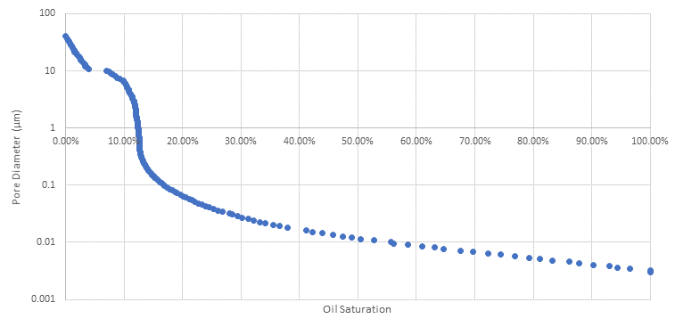
Figure C 1: Pore Size Distribution from IC^3 MICP Data

Figure C 2: Oil molarity beginning to destabilize
Figure C 3: Oil Pressure behaving as expected
Figure C 4: Oil Concentration behaving as expected
Figure C 5: Reasonable Gas Concentration behavior
Figure C 6: Increasingly unstable saturation behavior
Figure C 7: Saturation behavior has destabilized molar values entirely
Figure C 8: Oil Pressure still behaving perfectly
Figure C 9: Oil Concentration still behaving as expected
Figure C 10: Gas Concentration behaving as expected
Figure C 11: Gas Saturation has destabilized entirely, beyond any reasonable result

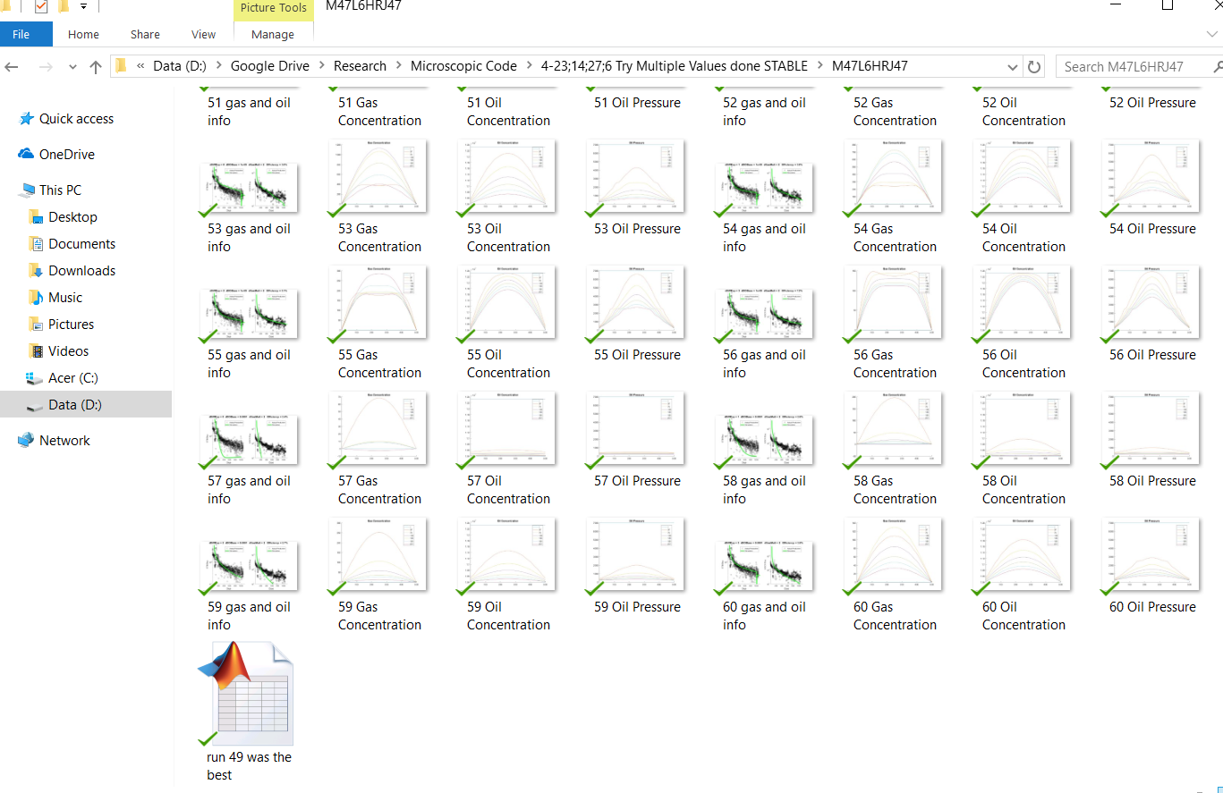
Figure C 12: Bulk Saving Output

Appendix D: Codes
Function 1: FVF Controller
function dFVF=FVF_Finder(dAPI,dGasSG,dTempK,adRSP,adRS,adP)
%adRSP and adRS values must be at p_bp
%adRSP and adP must be in psi, adRS must be scf/stb
%results in res volume/standard volume

dTempF=dTempK*9/5-459.67;

dFVF=zeros(1,length(adP));
dP_BP=adRSP(end-1); %I add an additional value for interpolation reasons. The second to last pressure is the bubblepoint pressure
dFVF(adP<=dP_BP)=VB_Bo_sat(interp1(adRSP,adRS,adP(adP<=dP_BP)),dGasSG,dTempF,dAPI);
c_o=VB_c_o(adRS(end),dTempF,dGasSG,dAPI,0,0,adP(adP>dP_BP));
dFVF(adP>dP_BP)=VB_Bo_unsat(VB_Bo_sat(adRS(end),dGasSG,dTempK*9/5-459.67,dAPI),c_o,dP_BP,adP(adP>dP_BP));

%figure
%plot(adP,dFVF)
end

Function 2: FVF of saturated oil
function B_o=VB_Bo_sat(R_s,SG_g,T,API)
%FVF for saturated oil Reservoir Bbl/STB
%T in Farenheit, Rs in scf/stb, p in psia
if API<=30
A1=4.677E-4;
A2=1.751E-5;
A3=-1.811E-8;
C1=.0362;
C2=1.0937;
C3=25.7240;
elseif API>30
A1=4.670E-4;
A2=1.100E-5;
A3=1.337E-9;
C1=.0178;
C2=1.187;
C3=23.9310;
end

B_o=1+A1*R_s+A2*(T-60).*(API/SG_g)+A3.*R_s.*(T-60).*(API/SG_g);

end

Function 3: FVF of unsaturated oil
function B_o=VB_Bo_unsat(B_ob,c_o,p_b,p)
%FVF for undersaturated oil

B_o=B_ob.*exp(c_o.*(p_b-p));

end

Function 4: Saturated Oil Compressibility
function c_o=VB_c_o(R_sb,T,SG_g,API,Bg_Bo,dRs_Dp,p)
%compressibility of saturated oil. For undersaturated case, simply set B_g,
%B_o, dR_s, or dp to 0.
if API<=30
A1=4.677E-4;
A2=1.751E-5;
A3=-1.811E-8;
C1=.0362;
C2=1.0937;
C3=25.7240;
elseif API>30
A1=4.670E-4;
A2=1.100E-5;
A3=1.337E-9;
C1=.0178;
C2=1.187;
C3=23.9310;
end

c_o=(-1433+5*R_sb+17.2*T-1180*SG_g+12.61*API)./(10^5*p)+(Bg_Bo).*(dRs_Dp)./5.6145835;

end

Function 5: Z Factor Calculation
function Z=Z_Hall_Yarborough(P,T,spec_g,N2_frac,CO2_frac,H2S_frac)

num_ps=length(P);
num_ts=length(T);

%Solution and equations
T_pc=326+315.7*(spec_g-.5)-240*N2_frac-83.3*CO2_frac+133.3*H2S_frac;
P_pc=678-50*(spec_g-.5)-206.7*N2_frac+440*CO2_frac+606.7*H2S_frac;
T_pr=(T+459.67)./T_pc;
t_r=1./T_pr;
p_pr=P./P_pc;
A=.06125.*t_r.*exp(-1.2.*(1-t_r).^2);
B=t_r.*(14.76-9.76.*t_r+4.58.*t_r.^2);
C=t_r.*(90.7-242.2.*t_r+42.4.*t_r.^2);
D=2.18+2.82.*t_r;
syms Y
Z=zeros(num_ps,num_ts);
for cur_p=1:num_ps
for cur_t=1:num_ts
y_solved=vpasolve(0==(Y+Y.^2+Y.^3-Y.^4)./(1-Y).^3-A(cur_t).*p_pr(cur_p)-B(cur_t).*Y.^2+C(cur_t).*Y.^D(cur_t),Y,[0,5]);
Z(cur_p,cur_t)=A(cur_t).*p_pr(cur_p)./y_solved;
end
end
end

Function 6: Efficient Function Controller
function dOutputs = EfficientFunction(sFunc,varargin)

sMasterPath=pwd;
sSavedRunsPath=[sMasterPath '\SavedFuncRuns'];

if ~isdir(sSavedRunsPath) %if the folder does not exist make it, else continue
mkdir(sSavedRunsPath)
end

sFileName = [sFunc '_outputs']; % Pattern for well files
sFullFilePath=[sSavedRunsPath '\' sFileName '.mat'];

if exist(sFullFilePath,'file') %if the file exists, check it for our exact run

load(sFullFilePath,'FuncRuns')

[iNumRow,~]=size(FuncRuns);
iNumCol=nargin;
for iCurRow=1:iNumRow
for iCurCol=2:iNumCol
if ~isequal(varargin{iCurCol-1},FuncRuns{iCurRow,iCurCol}{:})
break %found an inconsistency, move to next row
elseif iCurCol==iNumCol-1 %No match has failed, including the last one
%display(['The exact run of the ' sFunc ' function was found, originally saved on ' datestr(FuncRuns{iCurRow,1})])
dOutputs=FuncRuns{iCurRow,iNumCol}{:};
return
end
end
end
%check for exact run
%if exact run is here, return it and note timestamp in message
else
FuncRuns=cell(0); %if the file does not exist create a blank variable to add to
iNumRow=0;
end
%if the file does not exist, or if it exists but the exact solution is not
%found and returned, run the function, and save a copy of this exact solution

fCurFun=str2func(sFunc);
dOutputs=fCurFun(varargin{:});

FuncRuns{iNumRow+1,nargin}={dOutputs};
for iCurCol=2:nargin-1 %note that one argument is just the function name
FuncRuns{iNumRow+1,iCurCol}=varargin(iCurCol-1);
end
FuncRuns{iNumRow+1,1}=clock;

save(sFullFilePath,'FuncRuns')
%everything below is unrelated, just having code around, likely delete

end

