University of Oklahoma

Graduate College

A Review of the application of databases in freshwater fisheries management and the effect of water quality on the mean relative weight of largemouth bass, crappie, and channel catfish in oklahoma lakes

A THESIS

submitted to the Graduate Faculty

in partial fulfillment of the requirements for the

Degree of

Master of science in geography

By

austin griffin
Norman, Oklahoma
2018

A Review of the application of databases in freshwater fisheries management and the effect of water quality on the mean relative weight of largemouth bass, crappie, and channel catfish in oklahoma lakes

A Thesis approved for the
Department of Geography and Environmental Sustainability

By

______________________________
Dr. Bruce Hoagland, Chair

______________________________
Dr. Rebecca Loraamm

______________________________
Dr. Thomas Neeson

© Copyright by Austin griffin 2018
All Rights Reserved.

Acknowledgements
I would like to thank my advisor Dr. Bruce Hoagland for his advice and guidance throughout my time at OU. His willingness to educate and work with someone who had little to no experience in database development is much appreciated. I would also like to thank Kurt Kuklinski of the Oklahoma Department of Wildlife Conservation (ODWC) as well as everyone else who works at the Oklahoma Fisheries Research Lab. Not only for their help and guidance in the development of this project, but also for their willingness to get me out in the field. I would also like to say thank you to everyone at the Oklahoma Biological Survey as well as my other committee members, Dr. Rebecca Loraamm and Dr. Thomas Neeson, for their advice and input in the development of this project.
I would like to let my wife Courtney know how much her patience and support has been appreciated throughout this entire process, as well as for giving me a wonderful baby girl right in the middle of it! Lastly, I’d like to thank my parents for their unfailing love and support, and my father in particular for exposing me to the outdoors and putting me on the career path that I have chosen.

Table of Contents

Acknowledgements iv
List of Tables vii
List of Figures viii
Abstract ix
Chapter 1: Introduction 1
Legacy Data Sources 2
The Value of Databases in Fisheries 3
International Databases 3
National and Interstate Databases 5
State Databases 7
Local Knowledge 8
Database Creation, Manipulation, and Maintenance 9
Geospatial Databases 9
Issues to Address 11
Quality Assurance and Quality Control 12
SSP Database Creation 14
Conclusion 17
References 19
Chapter 2: Introduction 33
Methods 37
Study Area 37
Data Sources and Analysis 38
Results and Discussion 42
Conclusion 46
References 48
Appendices 69
Appendix A 69
Appendix B 72

List of Tables
Chapter 1
Table 1. State agency and university websites that provide fisheries information 26
Table 2. Metadata information regarding the Standard Sampling Protocol database 28
Chapter 2
Table 1. Water body name, code, and the most recent year in which it was sampled for the Oklahoma Water Resources Board’s lakes Beneficial Use Monitoring Program 54
Table 2. Confusion and cross-validation matrix totals showing the percent correct classified observations for each type of Discriminant Analysis by class 57
Table 3. Summary statistics for the relative weights of each study species according to the discriminant analysis classifications for 108 water bodies 58
Table 4. Summary statistics for each water quality parameter according to the discriminant analysis classifications for 108 water bodies 59
Table 5. Type III Sum of Squares p-values for each water quality parameter by species. Significant values are listed bold 60

List of Figures
Chapter 1

Figure 1. Standard Sampling Protocol Database schema 32
Chapter 2
Figure 1. Salinity (a) and pH (b) range and location of study lakes adapted from the Beneficial Use Monitoring Program Nutrient Status figure in Lakes of Oklahoma
61
Figure 2. Scree plot showing the k-means clustering within-class variance and illustrating the elbow at 6 classes 62
Figure 3. Ordination diagrams depicting results for the standard, forward stepwise, and backward stepwise discriminant analysis of water quality variables 63
Figure 4a. Box and whisker plots for each water quality parameter according to discriminant analysis classes 64
Figure 4b. Box and whisker plots for each water quality parameter according to discriminant analysis classes 65
Figure 5. Water body class centroids and clusters with respect to axes 1 and 2
66
Figure 6. Discriminant analysis classification of 108 Oklahoma water bodies
67
Figure 7. Predicted relative weights of each fish compared to the observed relative weights 68

Abstract
The subject of this thesis is the development and use of databases for use in fisheries management. The thesis consists of two chapters. The first is a literature review of fisheries databases and an overview of my work as a graduate research assistant with the Oklahoma Biological Survey and Oklahoma Fisheries Research Laboratory (OFRL) of the Oklahoma Department of Wildlife Conservation.
The Standard Sampling Protocol (SSP) is at the core of both chapters. In chapter 1, I reviewed the fisheries database literature to aid in the development of the SSP Database and emphasize some of the issues that commonly occur with database development and application. This information guided me in the development of a relational database for the SSP data. The resulting database includes approximately 1.6 million records for 150 fish species in Oklahoma. The database schema consists of five tables: Abiotic, Biotic, SSP Species List, OBIS Taxonomy, and OWRB Lake Data.
Chapter 2 employed the SSP database to determine if water quality parameters in 108 Oklahoma lakes influenced the relative weights of largemouth bass (Micropterus salmoides), crappie (Pomoxis annularis and Pomoxis nigromaculatus), and channel catfish (Ictalurus punctatus). Discriminant analysis of eight water quality parameters resulted in the classification of said lakes into six classes. Mean relative weights for largemouth bass, crappie, and catfish ranged from 89.84-99.17, 91.99-98.17, and 86.90-94.01 respectively. Salinity, which was the most important explanatory variable in lake classification, ranged from 0.04-0.63 ppt among the six classes. This information could prove useful to the fisheries managers of Oklahoma by reclassifying similar lakes regardless of management region, allowing for a different perspective on management practices.

Chapter 1: A Review of the Application of Databases in Freshwater Fisheries Management

Introduction

A database is “a collection of related data”, or records that have a shared meaning (Elmasri and Navathe 2011), while a data product consists of “a large data set in a format that requires little or no processing or programming” (TechTarget 2018). The collection of data alone does not prove to be very useful without some sort of structure and accessibility. If structure and accessibility are absent, the acquisition and manipulation of the information contained within a database becomes very tedious at best. The Integrated Database System was designed by Charles W. Bachman in 1960 and was the first data management system (Neufeld and Cornog 1986, DATAVERSITY 2017). Advances in technology have paved the way for the use of relational databases, or a collection of relations that link multiple tables together (Elmasri and Navathe 2011). This allows for the increased manipulation of varying types of data through Structured Query Language (SQL). The inception of the internet and the creation of the online platforms greatly increased the capabilities of database management and accessibility.
Relational databases are a standard tool in fish and wildlife management (adfg.alaska.gov, in.gov/dnr 2018). This literature review addresses the application of databases in fisheries management, with an emphasis on lentic systems. First, I will discuss existing fisheries databases followed by a review of how those systems have been used in fisheries management, data analyses, and as a public resource.

Legacy Data Sources
The following section discusses database examples that contain historical information regarding fisheries. By historical, I mean data that encompass multiple decades. FishBase (fishbase.org 2018) is one of the first online fisheries databases, providing global biodiversity information for all known fish species including museum records and observation records reported in the literature. There are approximately 33,000 species currently in Fishbase, compared to just 15,000 records in 1996 (Crawford 1997). Initially, the intent of FishBase was to monitor population dynamics for major commercial species. However, it now contains all known taxa of finfishes (no shellfish), including taxonomy, biology, trophic ecology, life history, commercial uses, and 250 years of historical data (presence/absence). This database provides vital information for the management, conservation, and protection of sustainable fisheries. These data are often used in meta-analyses, such as the work of Zaki et al. 2017 on the first observation of Pacific bluefin tuna (11 May 2017), Thunnus orientalis, off the coast of Sur, Sultanate of Oman. The authors were able to use Fishbase to determine the previously known range and environmental tolerances of the bluefin tuna.
The Clodia Database (dx.doi.org/10.6084/m9.figshare.1015506 2018) includes historical landing data from the Adriatic Sea dating from 1945-2013. Instead of providing presence/absence and location information, like FishBase, this database provides a long-term measurement of species abundance in the form of the weights of each species brought to market. This provides a record of change in abundance in specific communities with response to climate change, anthropogenic influence, and the modification of trophic relationships (Mazzoldi et al. 2014). These types of data provide for the evaluation of a particular region or even specific communities of fish.
IchthyMaps (dx.doi.org/10.5066/F7M32ST8 2018) is a USGS database comprised of historical stream fish distribution data for the conterminous USA. It contains a total of 606,550 presence/absence occurrence records from the years 1950-1990 for 1,038 species and subspecies. IchthyMaps is a publicly accessible tool. Data retrieved from this database have been used to address questions in conservation, biogeography, land use impacts, the tracking of invasive species, and climate change. It was created on the principles of metacommunity ecology, or the ecological interactions of a set of interacting communities. This database was developed with the creation of species distribution and habitat suitability models in mind (Frimpong et al. 2015).

The Value of Databases in Fisheries
International Databases
The geographic representation of a database affects the scope and scale of the questions researchers can address. Resources such as FishBase allow for the analysis and detection of changes in species abundance and distribution. Tedesco et al. (2017) and (Brosse et al. 2012) are two examples of global freshwater databases. Tedesco et al. (2017) created a database that describes the high diversity of freshwater fish species in relation to the total area of fresh water. They utilized over 1400 data sources (books, published papers, grey-literature, and web-based sources) and included species lists for 3119 drainage basins, representing over eighty percent of the Earth’s surface.
The second article provides a similar example in that they applied a macroecological (large-scale patterns) approach to freshwater fish species richness at a larger drainage basin level (Brosse et al. 2012). The Fish-SPRICH database contains species richness data at a larger level than the previously mentioned article described by the authors as river basin grain. It is available as part of the Global Freshwater Biodiversity Atlas (atlas.freshwaterbiodiversity.eu 2018). It is comprised of 1054 river basins that cover a similar percentage (>80%) of the earth’s land surface (Brosse et al. 2012). Essentially, Tedesco et al. (2017) continued the work of Brosse et al. (2012) by enhancing the quantity of data for smaller drainage basins. Both examples resulted in the creation of a database that facilitates macro scale research related to the ecology, biogeography, and conservation of freshwater fish species.
Global scale fisheries databases are also applied for detection and warning of fish diseases and toxic accumulation. Some examples include tracking mercury concentrations, the bioaccumulation of toxic substances in fishes, and methods for disease diagnosis in domestic fish stock (EPA 1999, Li et al. 2002, Weisbrod et al. 2007). The EPA’s national survey of mercury concentrations in fish combines tissue samples from freshwater fish from 40 states and the District of Columbia. The database consists of data sources for each of these states, the EPA’s STORET (STOrage and RETrieval) data, or a combination of the two. The information contained in this database includes location (usually coordinates), common and scientific names, total mercury concentrations, and weighted mercury concentrations (the number of fish in a sample) (EPA 1999). The Fish-Expert disease diagnosis system is a web-based system used by fish farmers in the North China region. The system is comprised of a database, knowledge base, and image base that allows for the diagnosis of 126 disease types for nine widely produced freshwater fish species (Li et al. 2002).
Sportfishing groups such as the International Game Fish Association (IGFA) maintain weight data for highly sought after recreational fish species and track world records (igfa.org 2018). The IGFA facilitates education and enables the exchange of information between recreational anglers and fisheries professionals (IGFA 2018). The IGFA sponsored the work of Friedlander et al. (2008), a project that collected catch and effort data of bonefish, movement patterns, recruitment dynamics, and ecology of nearshore fishes, as well as passive acoustic tracking of fishes in the northern Line Islands and the Palmyra Atoll. Most state fish and game agencies keep track of state and water body records for sought after sportfish species as well. The publication of record caliber fish can help promote interest in fishing and fisheries.
A final example, the Global Biodiversity Information Facility (GBIF), provides data for many lifeforms on earth (gbif.org 2018). Common standards and open-sourced tools allow users across the globe to share temporal and spatial information. Sources include museum specimens, traditional biological collections, and geotagged photographs. GBIF uses the Darwin Core standard for all of its data holdings (GBIF 2018). The Fish-AMAZBOL database was created in part using GBIF and an intensive literature survey of all fishes that reside in the major sub drainages of the Bolivian Amazon. The resulting database includes 802 species, 12 of which are non-native, that represent six percent of the freshwater fish species in the world (Carvajal-Vallejos et al. 2014).

National and Interstate Databases
This section covers databases that focus on fisheries at the national level. An example of a national level database for species ranges is the NatureServe Explorer (2010) database (explorer.natureserve.org 2018). It is comprised of distribution maps for freshwater fish by watershed, providing historical and present-day distributions that are more comprehensive than previously mentioned databases. The taxonomic reference is the Integrated Taxonomic Information System (ITIS) and each taxon is denoted as either native or introduced. Occurrence data are derived from regional ichthyologists, state heritage programs, and the published literature. These data provide valuable information to ichthyologists and conservation biologists in the lower 48 states.
The USFWS maintains the National Wild Fish Health Survey (NWFHS), which was developed in response to the Salmonid Whirling Disease outbreak of 1996. Prior to this outbreak, no national system existed for the detection of fish pathogens. To allow for the comparison of data collected in different regions, the NWFHS laboratory procedures manual was created to ensure standardization. Data is provided through an interactive map that is searchable by pathogen, species, water body, and state. Beneficiaries of this database include fisheries managers, anglers, the aquaculture industry, and even state and national economy, through sustained income from recreational angling (NWFHS 2018).
The Great Lakes Fish Stocking Database (GLFSD) is an interstate data system that does not operate within the premise of state boundaries but provides information for the entire Great Lakes system (GLFSD 2018). This aids in the management of an entire freshwater system, regardless of political boundaries.

State Databases
State level databases and data products typically provide information such as species identification and ranges, fishery access points, lakes information, sampling records, and stocking reports. Every state has accessible fisheries databases provided by state agency and/or university websites (Table 1). Although many of the examples listed qualify as data products rather than databases, they are accessible to the public and provide information such as fishing access and stocking reports, taxonomy and species ranges, and even consumption warnings. State agencies from Kansas, New Hampshire, New Jersey and Rhode Island report data in a simple tabular format, while states like Georgia and Indiana provide access to a fully searchable database. The Alaska Department of Fish and Game (adfg.alaska.gov 2018) provides data for freshwater fish inventory, lake locations, sport fishing surveys, migratory fish counts, fish passage/stream crossings, and subsistence use information among other topics. The Washington Department of Fish and Wildlife Conservation (wdfw.wa.gov 2018) also provides regularly updated salmon population information, distribution, fish passage barrier locations, and priority habitats and species. Data access differs according to user groups, masking sensitive information, such as the location of a threatened species.
A final category of state level fisheries databases is stocking records. The Missouri Department of Conservation tracks stocking orders and information about fish production activities through the Hatchery Information Management System (HIMS). HIMS combines hatchery recordkeeping, lake manager fish requests, and stocking reports that allow hatchery personnel and fishery professionals access to historical data (Valentine 2015). The Alaska Lake Database (ALDAT), developed by the Alaska Department of Fish and Game (adfg.alaska.gov 2018), incorporates maps, pictures, sampling data, stocking records, and historical information (associated historical documents) of water bodies into an easily accessed interface for the interested angler or recreationist (Sportfish Staff 2013). The Indiana Department of Natural Resources provides a fish stocking database (in.gov/dnr 2018) with search capabilities of stocking records going back four years by county, species, and/or water body. The Wisconsin Department of Natural Resources Bureau of Fisheries Management produces fish stocking summaries for 141 lakes and streams at the county level (dnr.wi.gov 2018). The usability, defined by Petrie and Bevan (2009) as “the extent to which a product can be used… with effectiveness, efficiency and satisfaction in a specified context of use”, of the Wisconsin system is not quite as straightforward as the ALDAT system. However, it still provides the public and resource managers alike with stocking information, both current and historical.

Local Knowledge
The utility and application of local knowledge, particularly of native peoples, has increasing value in fisheries management and conservation. Local Ecological Knowledge (LEK) is defined as “a set of perceptions and experiences of traditional communities regarding its surrounding natural environment” (Bender et al. 2014). The NOAA Fisheries Alaska Native Traditional Environmental Knowledge Database emphasizes Traditional Environmental Knowledge (TEK), which is similar to LEK, but includes “detailed, empirically grounded knowledge of local plants, animals, and places” (Hunn et al. 2005). NOAA Fisheries Alaska Native Traditional Environmental Knowledge Database emphasizes the relationship between local/native communities and fisheries and provides historical perspective on environmental phenomena, such as climate change. The TEK data also brings to light issues that may not be apparent through the regular process of scientific inquiry, such as an increased historical perspective that could pre-date scientific records (Lazrus and Sepez 2005). The LEK of fishermen can contribute additional information about the ecology, behavior, and abundance of fish in their local area, as well as enhance the results of fisheries surveys (Silvano and Valbo-Jørgensen 2008).

Database Creation, Manipulation, and Maintenance
Geospatial Databases
Global positioning systems (GPS), Geographic Information Systems (GIS), and remote sensing technologies have enhanced the efficiency of spatial analysis but rely significantly on biological databases (USFWS 2018). Kaeser and Litts (2010) used GIS with side scan sonar images to map instream habitat in order to be able to assess amounts of desirable habitat (for spawning, escape cover, nursery cover, etc.) during varying fluctuations in water level. These results allow for the collection of watershed level habitat data, to aid in management and research of freshwater ecosystems (Kaeser, Litts, and Tracy, 2013).
The organization and manipulation of spatial data can be very complex. In order to combine multiple locations, attributes, and metadata into one relational structure, Shaw et al. (2004) patented the Method and Apparatus for building and maintaining an object-oriented geospatial database. They emphasize that a properly designed database allows for updates that preserve spatial linkage between objects. Proper design of the schema is of the utmost importance, not only for spatial linkage preservation, but also for the broad application of a particular design across multiple fields (querying multiple tables), as well as across multiple professional fields. These key points hold true regardless of the field of work, allowing for widespread application. A schema design that uses meta-concepts (ontologies, models, and concepts), rather than concepts with the potential to fluctuate in the domain, allows for this broad scale application (Brodaric and Gahegan 2002).
Nanson (1997) provides an early example of the appeal for the importance of online geospatial databases for information acquisition. The Ordnance Survey of the UK required a system that would link, combine, and allow easy access to the various geospatial datasets held by different organizations across the country. This would provide the user with a single location to access geospatial data, improve accuracy, make statistical analysis easier, and reduce data costs by eliminating duplication. These early discussions provided a basis for the creation and publication of geospatial databases online.
British Columbia Fisheries and Fisheries and Oceans Canada created the Fisheries Information Summary System (FISS) (env.gov.bc.ca/fish/fiss/background.htm 2018). It is a relational system that incorporates fish and fish habitat data, lake classification data (water quality and types of resource use), a digital stream network of British Columbia and the Yukon, and is fully accessible through website queries, maps, and reports. Attributes include species distribution, land use, water use, resource use, flow, and harvest, where many of the previously mentioned examples focus on recreational fishing opportunities (FISS 2018). This system is accessible to a variety of users, including public and private interests, and is continually growing, fulfilling the goals of an online geospatial database.

Issues to Address
Many issues can potentially affect the functionality and effectiveness of a database such as inclusion of species characteristics and traits, differences in standards for taxonomic classification, availability and accessibility of the data, and the integration and consolidation of multiple databases. These issues can be addressed in the database design phase to minimize their impact. Functional characteristics and species traits such as life-history, habitat preference, reproductive strategy, and the ecology, morphology, behavior, and physiology of a species can greatly enhance the value of a database by providing complementary information beyond the basic biological measurements of length, weight, age, etc. (Vieira et al. 2006).
Even today, some data that are stored digitally are not accessible through a web interface, limiting a majority of potential users (Ivanova and Shashkov 2016). As mentioned above, species traits data that are readily available enhance the effectiveness of a database (Frimpong and Angermeier 2009). The ability to access these data along with length and weight records increases the power of a relational fisheries database. In some cases, the compilation of large amounts of available information is necessary for meta-analyses. These “metatdata databases” include information from a large number, in some cases hundreds, of sources that span multiple disciplines, allowing for the simple navigation of related data (Cisneros-Montemayor et al. 2016). On this same note, flexibility in database development with regards to the design and composition of other data sets leads to the opportunity for multiple applications (Homer et al. 2004). In other words, databases that do not confine themselves to one professional field or application can prove to be applicable to a larger audience.

Quality Assurance and Quality Control
Quality assurance (QA) is process oriented and ensures that protocols are implemented to keep inaccuracies in the data at a minimum. Quality control (QC) is product oriented and is the process of verifying the quality of the output. Both QA and QC are continually considered by a database manager (Arthur 2018, Campbell et al. 2013). Quality data, and more specifically quality data entry results in a database that will provide the ability for more accurate and complete analyses. Examples of poor quality data include data measured using incorrect units or data that was recorded in the wrong column. An efficient storage system, double checking entries, and statistical summaries help ensure quality database content (USGS 2018a). Querying the data for values that exceed acceptable ranges, checking for blank cells or missing values, and copy/pasting/appending information with as little manual input as possible can speed up the QA/QC process. With the application of sensor networks, such as the Oklahoma Mesonet, large quantities of data can now be accessed almost instantaneously. QA/QC strategies for these networks have not kept up with the technology, revealing the importance of precise data collection and entry, as well as the need for automated QA/QC methods that can adequately keep up with new sensing technologies. In order to address this, the development of QA/QC standards across multiple disciplines could benefit the time it takes to perform checks, as well as improve operations between sensor networks (Campbell et al. 2013). As a final note, to ensure high quality, a consistent format and completeness are important when combining multiple datasets (EPA 2016). As I will illustrate in the methods section, this process can be extensive and time consuming.
When it comes to freshwater fisheries data collection, the standardization of collection methods to increase consistency in the data is critical. These guidelines became available in 2009 with the release of Standard Methods for Sampling North American Freshwater Fishes by the American Fisheries Society (Bonar et al. 2009). When sampling warm water species in reservoirs and lakes, specific techniques must be utilized to capture species associated with littoral and pelagic zones. Standard methods include the use of boat electrofishing in the littoral zone, fyke nets to bridge the gap between littoral and pelagic, and gill nets for pelagic species (Miranda and Boxrucker 2009). Miranda and Boxrucker (2009) also note that other gears, such as shoreline seine, toxicants, and trawls exist, but are more selective of habitat preference and do not necessarily provide as adequate a picture of fish groupings for a water body.
Water quality data is often used in conjunction with fish data in freshwater fisheries management. The collection of water quality data is also standardized, with examples spanning international to state and local levels. The USGS website offers several resources that monitor the water quality of rivers, streams, and various other resources that allow for public use of these data (USGS 2018b). The Oklahoma Water Resources Board’s (OWRB) Beneficial Use Monitoring Program (BUMP) measures and publishes water quality parameters for lakes and streams across the state. The OWRB ensures the standardization of data collection with QA/QC methods that ensure proper collection methods and utilize blank, duplicate, and replicate samples at several steps throughout the sampling process. Examples include the creation of a QA manual that includes a policy statement, organizational structure, staff responsibilities, laboratory tests, sample handling procedures, and procedures for calibration, verification, and maintenance of equipment. QC methods include an initial and ongoing demonstration of capability, a method blank, a blank spike, a matrix spike and duplicate, calibration, control charts, QC acceptance criteria, and the definitions of a batch (OWRB 2016).

SSP Database Creation
The Standard Sampling Protocol (SSP) dataset, which was provided by Kurt Kuklinski of the Oklahoma Fisheries Research Lab of the Oklahoma Department of Wildlife Conservation (ODWC) served as a basis for the relational database we have created. This dataset contained abiotic, biotic, and descriptive data for all lakes and species sampled and managed by the ODWC. The original dataset included a species code designation, an individual count for the sample, length, and weight measurements, lake name, station, date, time, pool elevation, temperature, Secchi disk, conductivity, a gear type, gear length, habitat designation, a measurement of effort, serial number, and management region. Use of the SSP began in 1977 at a select number of lakes in Oklahoma, was adopted state-wide in 1980, and has been continuous to this day. Following each field season, ODWC personnel entered and saved the SSP data as a text file for analysis using SAS software (SAS Institute Inc., Cary, NC, USA). Therefore, prior to this project, the SSP data were contained in 36 individual text files. To facilitate the use of SSP data by ODWC biologists, fisheries professionals, and anglers, it was decided to combine these files into a relational database. The SSP database consists of five tables encompassing fish parameters, taxonomy, water bodies, water quality parameters, and geographic location.
Lessons learned from the literature review include the importance of schema design and the standardization of data entry and editing with regards to the original SSP data files. In the case of schema design, a relational data structure was selected to facilitate data entry and editing while maintaining table relations and limiting data entry errors. The creation of code columns containing a unique identifier for each record and the correct selection of primary keys ensured proper linkage.
In its original format (36 individual files), the SSP data were highly inaccessible and could not be manipulated for the analysis of trends overtime or spatial analysis. We addressed this issue by appending all the original files into Excel spreadsheets. Due to the volume of data, one spreadsheet was created for the temporal periods of 1980-89, 1990-99, and 2000-2015, respectively. After completing the initial editing and quality control procedures, all the data were appended in Microsoft Access. This presented challenges involving column alignment, blank rows, missing data, data standardization, and the creation of metadata.
Standardization issues in the 36 existing data files included inconsistent date and time formats and temperature. All data recording the year of sample collection was converted to a four-digit format. If not already recorded in this way, records of time were converted to 24-hour clock format. Temperature data were recorded in degrees Celsius some years and in degrees Fahrenheit in others, so all temperature values were standardized to degrees Celsius. The original SSP data files provided cells with serial numbers for each row in the text file, but this cell was not populated consistently and was missing for some years. Because the serial numbers were not referenced to other relevant data in the original files, the serial numbers were excluded and a new unique identifier was provided for each when appended into the new SSP database. Also, the ODWC fisheries region column was dropped because the region in which a lake occurs could be determined by a spatial join in the new database.
Preliminary quality control (QC) focused on the identification of records with unrealistic length or weight measurements by setting a cap for a range of values for each species and filtering out any value that exceeded it. Although this corrected many errors, further QC action will be necessary to ensure the quality of the data.
Finally, the original SSP files lacked metadata. Therefore, a metadata table was created for the new SSP database (Table 2). The metadata table includes definitions for each column heading, a summary of totals (i.e., lakes, species, etc.) in the database, and notes describing irregularities in the data.
The final component I contributed to this project was the initial schema for the database itself. This was created in Microsoft Access. Figure 1 illustrates the individual tables and the relationships between them. Currently, the database consists of five relational tables that include the Abiotic and Biotic features of the SSP data, a species code list for SSP data, taxonomic information for all species represented in the SSP data from the Oklahoma Biological Information System (OBIS) database (biosurvey.ou.edu 2018), and OWRB lake information for each water body represented in the SSP data. Code columns were created and added to facilitate the connections between each table.
The target audience for the SSP database includes fisheries professionals, students, recreational anglers, and anyone else interested in Oklahoma fisheries. The intent for future development is a user-friendly web based system available through the ODWC that will allow the recreational user quick, simple access to general information about each water body and species in the database. Increased access will be available to researchers or professionals with the potential for the development of a hierarchy of access, although this database does not contain sensitive information regarding species of concern.

Conclusion
In summary, the use of databases in fisheries management has and will continue to serve an important role. Data accessibility and usability are crucial for the timely application of statistical methods and their resulting contributions to the field. The web-based database serves a purpose for multiple user groups from research professionals to the public angler, providing the ability to the interested angler or wildlife enthusiast to access information on his or her favourite lake or species, while allowing the professional restricted access to more sensitive information.
Regarding our project, future requirements include additional quality control procedures and programming that will eventually result in a web interface comprised of a user friendly, spatially enabled map layer as well as a tool for the analysis of freshwater fish in Oklahoma’s reservoirs.
References

Alaska Department of Fish and Game. 2018. e-Library Databases, Alaska Department of Fish and Game. <www.adfg.alaska.gov/index.cfm?adfg=library.databases>. Accessed 23 January 2018.
Arthur, B. 2018. Dialog Information Technology: the difference between quality assurance and quality control. <www.dialog.com.au/open-dialog/the-difference-between-quality-assurance-and-quality-control/>. Accesed 1 February 2018.
Bender, M. G., G. R. Machado, P.J. Silva, S. R. Floeter, C. Monteiro-Netto, O. J. Luiz, and C. E. L. Ferreira. 2014. Local ecological knowledge and scientific data reveal overexploitation by multigear artisanal fisheries in the southwestern Atlantic. PLOS ONE 9.
Bonar, S. A., W. A. Hubert, and D. W. Willis, editors. 2009. Standard methods for sampling North American freshwater fishes. American Fisheries Society, Bethesda, Maryland.
Brodaric, B., and M. Gahegan. 2002. Distinguishing instances and evidence of geographical concepts for geospatial database design. Pages 23-37 in M. J. Egenhofer and D. M. Mark, editors. Geographic Information Science. Springer, Berlin, Heidelberg, Germany.
Brosse, S., O. Beauchard, S. Blanchet, H. Dürr, G. Grenouillet, B. Hugueny, C. Lauzeral, F. Leprieur, P. A. Tedesco, S. Villéger, and T. Oderdorff. 2012. Fish-SPRICH: a database of freshwater fish species richness throughout the World. Hydrobiologia 700: 343-349.
Campbell, J. L., L. E. Rustad, J. H. Porter, J. R. Taylor, E. W. Dereszynski, J. B. Shanley, C. Gries, D. L. Henshaw, M. E. Martin, W. M. Sheldon, and E. R. Boose. 2013. Quantity is nothing without quality: automated QA/QC for streaming environmental sensor data. BioScience 63: 574-585.
Carvajal-Vallejos, F. M., R. Bigorne, A. J. Fernández, J. Sarmiento, S. Barrera, T. Yunoki, M. Pouilly, J. Zubieta, E. De La Barra, M. Jegú, M. Maldonado, P. V. Damme, R. Céspedes, and T. Oberdoff. 2014. Fish-AMAZBOL: a database on freshwater fishes of the Bolivian Amazon. Hydrobiologia 732: 19-27.
Cisneros-Montemayor, A. M., W. W. L. Cheung, K. Bodtker, L. Teh, N. Steiner, M. Bailey, C. Hoover, and U. R. Sumaila. 2016. Towards an integrated database on Canadian ocean resources: benefits, current states, and research gaps. Canadian Journal of Fisheries and Aquatic Sciences 74: 65-74.
Crawford, S. S. 1997. Development of a global fish database. Environmental Biology of Fishes 50: 231-234.
Elmasri, R. and S. Navathe. 2011. Fundamentals of database systems. 6th ed. Addison-Wesley. Boston, MA.
Environmental Protection Agency (EPA). 1999. The national survey of mercury concentrations in fish: data base summary 1990-1995. United States Environmental Protection Agency: Office of Water.
Environmental Protection Agency (EPA). 2016. The data management and quality assurance/quality control process for the third six-year review information collection rule dataset. United States Environmental Protection Agency: Office of Water.
FISS. 2018. Fisheries Inventory: FISS background and further information. <www.env.gov.bc.ca/fish/fiss/background.htm>. Accessed 29 January 2018.
Foote, K. D. 2018. A brief history of database management. DATAVERSITY. <www.dataversity.net/brief-history-database-management>. Accessed 29 January 2018.
Friedlander, A., J. Caselle, C. Lowe, and Y. Papastamatiou. 2008. Ecology and predator-prey dynamics of fishes at Palmyra and Kingman Atolls NWR. <http://www.igfa.org/PDF/PANGAEA_EXPEDITION_REPORT_DEC08.pdf>. Accessed 15 June 2018.
Frimpong, E. A., J. Huang, and Y. Liang. 2015. Historical stream fish distribution database for the conterminous United States (1950-1990): IchthyMaps: U.S. Geological Survey data release. < http://dx.doi.org/10.5066/F7M32ST8>. Accessed 16 June 2018.
Frimpong, E. A., and P. L. Angermeier. 2009. Fish Traits: a database of ecological and life-history traits of freshwater fishes of the United States. Fisheries 34: 10, 487-495.
Froese, R. and D. Pauly. Editors. 2018. FishBase. World Wide Web electronic publication. <www.fishbase.org>, Accessed on 7 February 2018.
GBIF. 2018. Global Biodiversity Information Facility. <www.gbig.org>. Accessed on 16 June 2018.
GLFSD. 2018. Great lakes fish stocking database. <www.glfc.org/fishstocking/index.htm>. Accessed 7 February 2018.
Homer, C., C. Huang, L. Yang, B. Wylie, and M. Coan. 2004. Development of a 2001 national land-cover database for the United States. Photogrammetric Engineering & Remote Sensing 70: 829-840.
Hunn, E.S., D. R. Johnson, P. N. Russell, and T. F. Thornton. 2005. Huna Tlingit gull egg harvests in Glacier Bay National Park. Practicing Anthropology 27: 6-10.
IGFA. 2018. International Game Fish Association: fish species database. <www.igfa.org/Fish/Fish-Database.aspx>. Accessed 23 January 2018.
Integrated Taxonomic Information System. Integrated Taxonomic Information System: Biological Names. <www.itis.gov>. Accessed 16 June 2018.
Ivanova N. V. and M. P. Shashkov. 2016. Biodiversity databases in Russia: towards a national portal. Arctic Science 3: 560-576.
Kaeser, A. J., and T. L. Litts. 2010. A novel technique for mapping habitat in navigable streams using low-cost side scan sonar. Fisheries 35: 163–74.
Kaeser, A. J., T. L. Litts, and T. W. Tracy. 2013. Using low-cost side-scan sonar for benthic mapping throughout the lower Flint River, Georgia, USA. River Research and Applications 29: 634–44.
Lazrus, H. and J. Sepez. 2005. The NOAA fisheries Alaska Native traditional environmental knowledge database. Practicing Anthropology 27: 33-37.
Li, D., Z. Fu, and Y. Duan. 2002. Fish-Expert: a web-based expert system for fish disease diagnosis. Expert Systems with Applications 23: 311-320.
Mazzoldi, C., A. Sambo, and E. Riginella. 2014. The Clodia database: a long time series of fishery data from the Adriatic Sea. Scientific Data 1: 140018.
Merriam-Webster. Definition of quality assurance. < www.merriam-webster.com/dictionary/quality%20assurance>. Accessed 15 June 2018.
Miranda, L. E. and J. Boxrucker. 2009. Warmwater fish in large standing waters. Pages 29-42 in S.A. Bonar, W. A. Hubert, and D. W. Willis, editors. Standard methods for sampling North American freshwater fishes. American Fisheries Society, Bethesda, Maryland.
Nanson, B. 1997. Editorial: Towards a National geospatial data framework. Journal of the Royal Statistical society. Series A 160: 165-167.
NatureServe. 2010. Digital distribution maps of the freshwater fishes in the conterminous United States. Version 3.0. Arlington, VA. U.S.A.
Neufeld, M. L. and M. Cornog. 1986. Database history: from dinosaurs to compact discs. Journal of the American Society for Information Science 37: 183.
Oklahoma Department of Wildlife Conservation (ODWC). 2016. Standard sampling protocol (SSP) database. Excel File.
Oklahoma Water Resources Board (OWRB). 2016 Oklahoma Lakes Report: Beneficial Use Monitoring Program (BUMP). <www.owrb.ok.gov/quality/monitoring/bump/pdf_bump/Reports/2015-2016BUMPLakesReport.pdf.>. Accessed 13 November 2017.
Shaw, K. B., M. J. Chung, and M. A. Cobb. 2004. United States Patent: method and apparatus for building and maintaining an object-oriented geospatial database. Patent No.: US 6,684,219 B1.
Silvano, R. A. M. and J. Valbo-Jørgensen. 2008. Beyond fishermen’s tales: contributions of fishers’ local ecological knowledge to fish ecology and fisheries management. Environment, Development and Sustainability. 10: 657-675.
Sportfish Staff. 2013. Alaska Fish and Wildlife News: introducing ALDAT-the Alaska lake database. June 2013 Issue. <www.adfg.alaska.gov/index.cfm?adfg=wildlifenews.view_article&articles_id=609>. Accessed 11 January 2018.
TechTarget. 2018. Definition of data products. <www.searchcio.techtarget.com/definition/Data-products>. Accessed 18 June 2018.
Tedesco, P. A., O. Beauchard, R. Bigorne, S. Blanchet, L. Buisson, L. Conti, J. Cornu, M. S. Dias, G. Grenouillet, B. Hugueny, C. Jézéquel, F. Leprieur, S. Brosse, and T. Oberdorff. 2017. Data Descriptor: A global database on freshwater fish species occurrence in drainage basins. Scientific Data 4: 170141.
USFWS. 2018. U.S. Fish and Wildlife geospatial services home. <https://www.fws.gov/GIS/>. Accessed 11 January 2018.
USFWS. 2018. U.S. Fish and Wildlife Service: National wild fish health survey. <www.fws.gov/wildfishsurvey/collection.htm>. Accessed 18 June 2018.
U.S. Geological Survey (USGS). 2018. Data management: manage quality. <www2.usgs.gov/datamanagement/qaqc.php>. Accessed 1 February 2018.
U.S. Geological Survey (USGS). 2018. USGS water-quality data. <water.usgs.gov/owq/data.html>. Accessed 1 February 2018.
Valentine, K. 2015. The development of the hatchery information management system: HIMS. Missouri Department of Conservation. Presentation.
Vieira, N., N. L. Poff, D. M. Carlisle, S. R. Moulton II, M. L. Koski, and B. C. Kondratieff. 2006. A database of lotic invertebrate traits for North America. U.S. Geological Survey Data Series 187. <//pubs.water.usgs.gov/ds187>.
Washington Department of Fish and Wildlife. 2018. Maps & data products: Washington Department of Fish & Wildlife. <wdfw.wa.gov/mapping/>. Accessed 23 January 2018.
Weisbrod, A. V., L. P. Burkhard, J. Arnot, O. Mekenyan, P. H. Howard, C. Russom, R. Boethling, Y. Sakuratani, T. Traas, T. Bridges, C. Lutz, M. Bonnell, K. Woodburn, and T. Parkerton. 2007. Workgroup report: review of fish bioaccumulation databases used to identify persistent, bioaccumulative, toxic substances. Environmental Health Perspectives 115: 255-261.
Zaki, S., J. Al-Mamary, A.A. Al-Marzouqi, and L. Al-Kharusi. 2017. First record of the Pacific bluefin tuna Thunnus orientalis (Temminck & Schlegel, 1844) from the coast off Sur, Sultanate of Oman. International Journal of Environment, Agriculture and Biotechnology 4: 1752-1757.

Chapter 1 Tables
Table 1. State agency and university websites that provide fisheries information.
State | Freshwater | Marine | URL
Alabama |  |  | outdooralabama.com
Alaska |  |  | adfg.alaska.gov
Arizona |  |  | azgfd.com
Arkanasas |  |  | agfc.com
California |  |  | pisces.ucdavis.edu, wildlife.ca.gov
Colorado |  |  | ndismaps.nrel.colostate.edu
Connecticut |  |  | cteco.uconn.edu, ct.gov
Deleware |  |  | dnrec.delaware.gov
Georgia |  |  | fishesofgeorgia.uga.edu, marinefishesofgeorgia.org
Florida |  |  | myfwc.com
Hawaii |  |  | cramp.wcc.hawaii.edu, dlnr.hawaii.gov
Idaho |  |  | idfg.idaho.gov
Illinois |  |  | inhs.illinois.edu
Indiana |  |  | in.gov/dnr
Iowa |  |  | iowadnr.gov
Kansas |  |  | ksoutdoors.com
Kentucky |  |  | app.fw.ky.gov
Louisiana |  |  | wlf.louisiana.gov, fishesoflouisiana.org
Maine |  |  | maine.gov/ifw, digitalcommons.library.umaine.edu/fisheries
Maryland |  |  | dnr.maryland.gov/Fisheries, gisapps.dnr.state.md.us
Massachusetts |  |  | mass.gov
Michigan |  |  | michigandnr.com
Minnesota |  |  | dnr.state.mn.us
Mississippi |  |  | cfr.msstate.edu/wildlife/fisheries, gsmfc.org/fin
Missouri |  |  | mdc7.mdc.mo.gov/applications/mofwis
Montana |  |  | fwp.mt.gov
Nebraska |  |  | outdoornebraska.gov
Nevada |  |  | ndow.org
New Hampshire |  |  | wildlife.state.nh.us
New Jersey |  |  | state.nj.us/dep/fgw/index
New Mexico |  |  | bison-m.org
New York |  |  | dec.ny.gov
North Carolina |  |  | deq.nc.gov
North Dakota |  |  | gf.nd.gov
Ohio |  |  | wildlife.ohiodnr.gov
Oklahoma |  |  | wildlifedepartment.com
Oregon |  |  | dfw.state.or.us
Pennsylvania |  |  | pasda.psu.edu, fishandboat.com
Rhode Island |  |  | dem.ri.gov/programs/fish-wildlife
South Carolina |  |  | dnr.sc.gov
South Dakota |  |  | gfp.sd.gov
Tennessee |  |  | tn.gov
Texas |  |  | fishesoftexas.org
Utah |  |  | dwrcdc.nr.utah.gov
Vermont |  |  | geodata.vermont.gov
Virginia |  |  | dgif.virginia.gov, vims.edu
Washington |  |  | wdfw.wa.gov
West Virginia |  |  | wvdnr.gov
Wisconsin |  |  | seagrant.wisc.edu
Wyoming |  |  | wgfd.wyo.gov

Table 2. Metadata information regarding the Standard Sampling Protocol database.
Table | Column Name | Description
Abiotic | LAKE_NAME | name of water body in Oklahoma Water Resources Board database
 | AB_ObsCode | unique code created from concatenating AB, Water_Body, and an ID number
 | ObsYr | code created from concatenating Water_Body, Station, and YYYY columns
 | Water_Body | ODWC code for each lake
 | Station | identifier of each sample (random)
 | M | month of sample taken
 | DD | day of sample taken
 | YYYY | four digit year
 | T | record of time for each sample
 | Pool_Elev | lake elevation at time of sampling
 | C | temperature recorded in or converted to Celsius
 | Secchi | gauge of water transparency by use of a Secchi disk
 | Conductivity | measurement of the water's ability to conduct an electrical current
 | Gear | number assigned to a specific sampling technique
 |  | 40-44: Bass focused spring electrofishing
 |  | 49: Saugeye focused fall electrofishing (sample could be skewed due to preference for age 0 fish)
 |  | 23: Fall experimental gill net
 |  | 31: Crappie focused Fall trap net
 |  | 10: Summer seine (1980s-1990s)
 |  | 36: Channel Catfish focused hoop net (3 net tandem set)
 |  | 98: Blue and Flathead Catfish focused low frequency electrofishing
 | Gear_Length | measurement of various gear types
 |  | electrofishing: minutes of pedal time at each location
 |  | gill net: length of net used
 |  | trap net: length of lead and trap net together
 |  | hoop net: number of units with 3 sections per unit
 | Habitat | only used for seine and electrofishing
 |  | 2 columns representing Substrate and Shoreline Cover
 |  | Substrate codes: Sand=0, Gravel=1, Rock=2, Clay=3, Mud=4, Unknown=5
 |  | Shoreline Cover codes: Vegetation=6, Rock=7, Brush/Timber=8, No Cover=9
 |  | code number is assigned for Substrate and Shoreline Cover at each site (ex. 18 = Gravel Substrate (1) and Brush/Timber Shoreline Cover (8)
 | Effort | measure of effort by gear type
 |  | electrofishing is recorded as a standard unit of effort (5, 10, or 15 minutes of petal time) and always equals 1
 |  | for netting gears, effort is equal to hours of fishing time
Biotic | LAKE_NAME | name of water body in Oklahoma Water Resources Board database
 | B_ObsCode | code created from concatenating Water_Body and and unique ID number
 | AB_ObsCode | unique code created from concatenating AB, Water_Body, and an ID number
 | ObsYr | code created from concatenating Water_Body, Station, and YYYY columns
 | aCode | Heritage defined unique identifier for each taxon
 | OFRL_Code | number assigned to each species sampled
 | Individual_# | number of fish per sample
 | Length | length of sample in millimeters
 | Weight | weight of sample in grams
OWRB Lake Data | Water_Body | ODWC code for each lake
 | Region | ODWC management region that the water body is located in
 | FID | identifier of each sample (random)
 | LAKE_NAME | name of water body in Oklahoma Water Resources Board database
 | ALT_NAME | alternate waterbody name
 | SHORT_NAME | short form waterbody name
 | SIZE_TYPE | size type
 | NIDID | National Inventory of Dams ID number
 | WBID | OK WQS Waterbody ID number
 | IR_WBID | Integrated Report Waterbody ID number
 | WR_CODE | Water Rights Database ID code
 | WQS_NAME | Water Quality Standards Name of Stream Segment
 | WATERSUPP | water supply
 | FWPROP | Fish and Wildlife Propagation beneficial use
 | AG | agriculture beneficial use
 | REC | recreation beneficial use
 | NAV | navigation beneficial use
 | AES | aesthetics beneficial use
 | LIMIT | limitations for additional protection
 | REMARK | Remarks
 | INC | included watersheds
 | ACRES | waterbody area
 | TYPE | water type - NOT UP-TO-DATE
 | SHAPE_AREA | area of feature in internal units squared
 | SHAPE_LEN | length of feature in internal units
 | ORIG_FID | original identifier
 | Lat | lake coordinates
 | Long | lake coordinates
 | BUMP_URL | link to the Beneficial Use Monitoring Program (BUMP) report for a lake
 | Status | BUMP trophic status designation
OBIS Taxonomy | aCode | Heritage defined unique identifier for each taxon
 | OFRL_Code | number assigned to each species sampled
 | sName | scientific name
 | scientificNameAuthorship | Authority
 | family | Family
 | genus | Genus
 | species | Species
 | subspecies | Subspecies
 | variety | not applicable (plants)
 | forma | not applicable (plants)
 | elCode | Element Code: a NatureServe created unique identifier for each taxon
 | gelode | Global Element Code: another NatureServe created unique identifier for each taxon
 | iucncode | IUCN red list code
 | g_rank | a NatureServe global element rank that assigns rarity throughout the world
 | s_rank | a rarity rank on the state level assigned by Heritage biologists
 | nativity | native or invasive status
 | source | source of taxonomic information
 | usda_code | not applicable (plants)
 | itis_code | Integrated Taxonomic Information System code
 | fed_status_id | ESA federal ranking
 | st_status_id | ESA state ranking
 | swap_id | State Wildlife Action Plan (ODWC rank)
 | name | full scientific name and authorship
 | sspscientificnameauthorship | not applicable (plants)
 | varscientificnameauthorship | not applicable (plants)
 | formascientificnameauthorship | not applicable (plants)
 | tracked | indication of tracking by Heritage program
SSP Species List | OFRL_Code | number assigned to each species sampled
 | Species | fish species or category
Totals | Years | 36 (1980-2015)
 | Records | 1,597,202
 | Species | 150 (176 in state)
 | Lakes | 288 (206 OWRB)
 | Surface Acreage | 601,149.41 (OWRB)
 | *Eufala | Records for Eufala arms (NorCan, SouCan, DPFork, Gaines Creek, Central Pool) also recorded under Eufala
 | *Texoma | Records for Texoma arms (TexRed, TexWas, TexRR, TexWR) also recorded under Texoma
 | *Dates | could be multiple years of data contained in one year (file) from original data (ex. 2012 file contains some data from 2011)
 | *Saugeye | Saugeye data could be skewed due to fall electrofishing sampling (Gear 49) targeting year 0 fish

Chapter 1 Figure
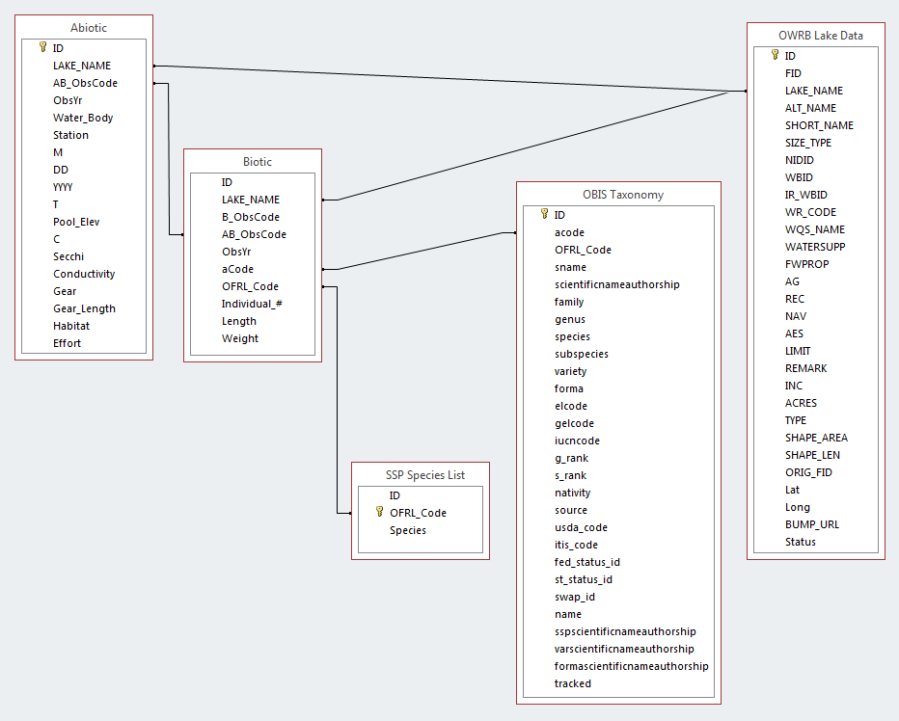
Figure 1. Standard Sampling Protocol Database schema.

Chapter 2: The effect of water quality on the mean relative weight of largemouth bass, crappie, and channel catfish in Oklahoma lakes

Introduction
A major goal for fisheries biologists is to have fast growing, healthy sportfish populations. One tool used to determine this is the relative weight (W_{r}) metric. The mean W_{r}, or body condition, is a measure of an individual fish’s health. It is determined by comparing the relative weight of an individual fish to an index that gives typical W_{r} (by length class) for fish of the same species. It is assumed that a healthy fish will have a high ratio of actual weight to standard weight. This value is given as a percentage of an individual fish’s actual weight compared to its normal weight (Bolger and Connolly 1989). Essentially, a high value for W_{r} equates to a fat, healthy fish, while a low W_{r} equates to a thin, malnourished fish (Wright 2000). Geographic variability and the factors associated with it can affect the W_{r} of fish in a particular system. Other physiological based indices, such as lipid content, exist to determine fish body condition. However, these analyses are expensive and require an advanced level of expertise to perform. For most applications, length and weight data provide adequate results for fish condition (Quist et al. 2009).
Abiotic and climatic factors can impact the growth rate and W_{r} of a fish. Dicenzo et al. (1995) noted that the W_{r} for Alabama spotted bass in ten reservoirs had a positive correlation to parameters including chlorophyll-a, drainage area, alkalinity, conductivity, and the morphoedaphic index, while having a negative correlation with Secchi disk transparency. Ecological (e.g., lake surface area, pH, Secchi depth) and anthropogenic variables (e.g., watershed stress and angling pressure), can impact a fishery. However, ecological variables had a larger impact on fish condition when compared to anthropogenic variables when assessing 693 Ontario lakes (Chu et al. 2015). Our project investigates ecological (water quality parameters) factors to describe resulting W_{r}.
In their 2015 study, Chu et al. noted that higher W_{r} was recorded for fish (anywhere from 2-24 species depending on the species richness in the lake) in eutrophic reservoirs than fish from oligotrophic and mesotrophic reservoirs, although these correlations were not seen across all length groups. It is also important to note that ecological and anthropogenic variables, such as pH, Secchi depth, and stresses on the watershed, can influence fish communities as a whole, including mean W_{r} for a particular species. However, both at the regional and local level, the influence of ecological variables had a greater significance (Chu et al. 2015). Although eutrophication of a particular water body can initially result in increased W_{r} for a given species, there is a threshold for this affect (lower for cool water species such as salmonids as compared to warm water species) that results in the “inhibition of natural reproduction” and the eventual replacement of existing taxa by “others that can survive” (Colby et al. 1972). This process has been observed within the Percidae family as well, where an initial increase in growth rate and production was followed by a similarly negative response (Leach et al. 1977). Mean W_{r} indices are established for sport fish species that are managed throughout Oklahoma, but do not consider a regional or more localized approach. The establishment of a target mean W_{r} for classes of lakes grouped according to water quality could provide additional information for biologists to utilize in the management of their lakes.
In order to examine the results of spatial variation between water bodies, multivariate techniques were utilized in our study. The use of multivariate techniques, including cluster analysis (CA) and discriminant analysis (DA), to analyze water-quality data has proven to be effective (Wunderlin et al. 2001, Singh et al. 2004, Shrestha and Kazama 2007, Shrestha et al. 2008). Both spatial and temporal variations in water quality were considered, as each of these previous studies worked with large river systems. This project takes the spatial variation of individual water bodies into consideration. A multivariate approach to the analysis of water-quality data is used extensively to determine freshwater quality and can also aid in the determination of spatial differences due to natural and anthropogenic factors (Singh et al. 2004).
Cluster analysis can group water bodies into classes based on similarities and differences of factors that relate to those objects (Singh et al. 2004). Clustering is an exploratory exercise and K-means is one of the most widely used examples (Jain 2010). DA allows for the statistical classification of the data. In order to use DA, it is necessary to perform an initial clustering analysis to determine the correct number of groups (Wunderlin et al. 2001). DA also reassigns objects into the correct group according to like properties and has been successfully utilized with multiple water quality data sets (Wunderlin et al. 2001, Singh et al. 2004, Shrestha and Kazama 2007, Shrestha et al. 2008).
We investigated the potential effect of water quality parameters for 108 water bodies across the state of Oklahoma on the mean W_{r} averages for largemouth bass (Micropterus salmoides), black and white crappie (Pomoxis nigromaculatus and Pomoxis annularis), and channel catfish (Ictalurus punctatus). These species were chosen due to their wide distribution across the state and their popularity among recreational anglers. This resulted in larger amounts of data availability when compared to other sportfish species. Black and white crappie were combined into one “crappie” category according to current management practices which commonly consider each species as one taxon (Kuklinski pers.comm. 2016). First, we try to determine if spatial variation exists for mean W_{r} among Oklahoma lakes. Secondly, if variation in the mean W_{r} was detected, lake water quality variables were analyzed to determine which variable(s) might explain the differences. ANOVA was then used to determine that a significant effect existed between each taxon and the water quality parameters. K-means clustering and DA were used to determine the spatial variations in the water quality parameters of Oklahoma lakes while retaining those parameters that have significant influence. These same parameters were then used in a multiple regression analysis with each fish taxon to determine which, if any of the parameters directly correlated with relative weight.
The objective of this project is to determine if a correlation exists between the mean W_{r} of largemouth bass, black and white crappie, and channel catfish and eight different measures used to determine the water quality of 108 Oklahoma lakes, as well as spatially group said water bodies according to their water chemistry. In other words, though many environmental factors exhibit an east-to-west gradient or turnover, this may not be true for water quality. If a correlation is demonstrated between water quality and mean relative weight (an indicator of body condition), fisheries managers could evaluate the parameters in a given lake and utilize these results to aid management decisions.

Methods
Study Area
The study area for this project encompasses the state of Oklahoma. Lakes with the largest surface areas are concentrated in the eastern portion of the state, with several smaller bodies of water located in the central and southwestern regions, decreasing in abundance moving northwest into the panhandle (Figure 1). This is in large part due to a significant variation in annual precipitation, which decreases from east to west across the state. Increased precipitation has been correlated to decreased salinity in some western Oklahoma streams (Pionke and Nicks 1970). Oklahoma’s annual precipitation can vary from over 139 centimeters in the far southeast, to less than fifty centimeters at the western end of the Oklahoma panhandle (Mesonet 2017). As a result of this, the dominant vegetation cover transitions from heavily timbered areas in the East, to semiarid plains and Rocky Mountain foothill vegetation in the West. With a large portion of the state situated in the Southern Plains, Oklahoma experiences all seasons and can have large daily temperature swings. Costa et al. (2007) further illustrate the longitudinal gradient of multiple climatic and environmental parameters in addition to the previously mentioned variables. These include elevation, precipitation of the driest quarter, precipitation seasonality, minimum temperature of the coldest month, and temperature seasonality.
Ranching and agricultural land use is common throughout the state, particularly in the western half, while forestry is common in the southeast. Some lakes, such as Arcadia, Hefner, and Keystone are located adjacent to or within major population centers. Geologic factors, such as the contribution of salts to many western Oklahoma streams (the Cimarron River and Elm Fork of the Red River in particular) that drain the eastern edge of the Permian Basin likely contribute to high salinity levels in certain water bodies (Johnson 1981). Lastly, the ranges of the values for lake water quality parameters across the state (chlorophyll-a, average turbidity, average Secchi, salinity, and specific conductivity in particular [Appendix A]) are vast (as illustrated by salinity (ppt) and pH [Figures 1a and 1b]).

Data Sources and Analysis
This project utilized three data sources. Geospatial data for the Lakes of Oklahoma were acquired from the Oklahoma Water Resources Board (OWRB). Water quality data came from the Beneficial Use Monitoring Program (BUMP) of the OWRB. Length, weight, and water body data for each taxon of fish were taken from the Standard Sampling Protocol (SSP) dataset, which was provided by Kurt Kuklinski of the Oklahoma Fisheries Research Lab of the ODWC. This dataset contains abiotic and biotic data for all lakes and species sampled and managed by the ODWC. The biotic data includes a species code designation, an individual count for the sample, length, and weight measurements, as well as four code columns created to link additional tables. The abiotic variables include lake name, station, date, time, pool elevation, temperature (Celsius), Secchi disk, conductivity, a gear type, gear length, habitat designation, and a measurement of effort, as well as three additional columns created to link additional tables.
To determine if geographic variation exists for mean W_{r}, first the W_{r} were calculated for each taxon by lake. Length, weight, number of individuals (n), and lake location data for each taxon were acquired from the SSP Dataset for the years 2000-2015 to provide a sufficient sample size for the calculation of W_{r}. It is also important to note that largemouth bass are primarily sampled in the spring, while crappie and channel catfish are primarily sample in the late summer and fall. This could result in higher W_{r} means for largemouth bass due to the presence of enlarged gonads during the spawning season. Few publications address sample-size requirements for calculating W_{r} estimates (Quist et al. 2009). Wege and Anderson (1978) recommend a sample size of ten to twenty largemouth bass in lakes with densities larger than 50 bass per hectare, and a sample size greater than twenty for lakes with lower densities. Quist et al. (2009), acknowledging the work of Wege and Anderson (1978), suggested a sample size of at least 100 individuals for the calculation of the W_{r} when density data are not available. Recommended minimum sample sizes for populations range from 5 to 50 (Brown and Murphy 1996; Brouder et al. 2009). For the Oklahoma SSP dataset, the sample size for some taxa were low for particular lakes (Appendix B).
Mean relative weights (W_{r}) were calculated according to the following formulas, which are based on the range wide distribution of each taxon and serve as a North American standard (Appendix B). Also, minimum length limits exist for each taxon including ≥ 150, 100, and 70 millimetres for largemouth bass, crappie, and channel catfish respectively.
Largemouth Bass (Murphy et al. 1991)
$$Relative Weight=Weight/(10^{(-5.528+3.273*LOG10\left(Length\right))})*100$$
Crappie (Neumann and Murphy 1991)
$$Relative Weight=Weight/(10^{(-5.642+3.332*LOG10\left(Length\right))})*100$$
Channel Catfish (Brown et al. 1995)
$$Relative Weight=Weight/(10^{(-5.800+3.294*LOG10\left(Length\right))})*100$$
Each taxon was individually analyzed using ANOVA to determine if a significant difference existed between water bodies for W_{r}.
The Oklahoma Water Resources Board (OWRB) annually samples water quality in Oklahoma lakes through the Beneficial Use Monitoring Program (BUMP). A multiparameter instrument, or sonde (either the Y.S.I. ® 6-series or the EXO²), was used to collect data for parameters including, temperature, barometric pressure, dissolved oxygen (DO), dissolved oxygen percent saturation, pH, specific conductivity, salinity, depth, oxidation-reduction potential (ORP), total dissolved solids, and resistivity. Turbidity values were measured with a HACH portable turbidimeter. Secchi depth measurements were taken using a Secchi disk. To determine chlorophyll-a concentrations, surface samples were collected, filtered and ground at the OWRB laboratory according to their standard methods, and sent to a contract laboratory for analysis (OWRB 2016). Chlorophyll-a, average turbidity, average Secchi, salinity, specific conductivity, pH, oxidation-reduction potential, and dissolved oxygen values were used for the purposes of this project. Acceptable ranges for the survival of most fish species include > 2 mg/L for dissolved oxygen and an optimal pH between 6.5 and 8.2 (MTU 2018). Turbidity and Secchi measurements can vary greatly between water bodies and seasons and can affect species differently depending upon a species reliance on sight versus other senses. Maximum salinity tolerance for largemouth bass, crappie, and channel catfish adults is approximately 12, 5, and 10 ppt respectively (Stuber et al. 1982, Edwards et al. 1982, and McMahon and Terrell 1982).
Although the BUMP program monitors water quality at many of the study lakes annually, some are not sampled as often. It was determined that BUMP data were available for each lake in the study in the date range of 2006-2016 (Table 1). Appendix A lists the water quality parameters, units, and values from each project water body. When multiple sampling sites existed for a water body, as in the case of large lakes, the station furthest downstream (or dam adjacent) was used.
A combination of k-means clustering (utilized due to its simplicity, efficiency, and long history of success [Jain 2010]) and discriminant analysis (DA) techniques following Singh et al. (2004) was used to classify lakes based on the BUMP data. Multiple water quality studies have demonstrated the utility of DA for data reduction and the description of primary parameters (Wunderlin et al. 2001, Singh et al. 2004, Shrestha and Kazama 2007, Shrestha et al. 2008). A k-means cluster analysis was used to classify lakes based on water quality parameters. It uses a nearest neighbors approach to clustering that, when run multiple times (in this case 50), results in a corrected classification.
DA was performed using standard, forward, and backward stepwise modes. With forward stepwise DA, variables are added according to the largest contribution to the model in descending order as long as its entry probability is greater than the entry threshold value. Backward stepwise DA works the same way, but in the opposite order (Singh et al. 2004). The analysis creates a discriminant function for each group, using this equation:
f(C_{i}) = k_{i} + $\sum_{j=1}^{n}{w_{ij}}p_{ij}$
i is the number of classes (C), the constant for each group is k_{i}, the number of parameters used to classify a data set into a class is n, and $w_{j}$ is the weight coefficient that DA assigns to the parameter ${(p}_{j}$) (Singh et al. 2004).
Multiple regression was used to identify one or more explanatory variables from the DA that might facilitate the prediction of fish W_{r} between water bodies. This analysis utilizes multiple explanatory variables, in our case water quality parameters, in order to model a quantitative dependent variable (fish W_{r}), which allowed for the measurement of the explanatory power of the water quality parameters, as well as the determination of whether that influence was negative or positive (Sliva and Williams 2001, XLSTAT 2018).
Results and Discussion
Based on an outlier analysis, Great Salt Plains, Chickasha, Sooner, Foss, Lugert-Altus, Canton, and Vanderwork were removed from subsequent analyses. Each of these water bodies had high values for salinity and specific conductivity that contributed to their outlier status. Also, Foss recorded an uncharacteristically low mean W_{r} for crappie and channel catfish while Great Salt Plains recorded a mean W_{r} of only 13.00 for channel catfish.
Largemouth bass, crappie, and channel catfish exhibit a high range of relative weights across the study lakes. Ranges were 77.63-129.43, 65.50-139.00, and 66.00-147.00 for each taxon respectively. Means for largemouth bass and crappie were approximately 94.00 and 89.00 for channel catfish. Standard deviations were ±7.31, ±10.39, and ±10.15 for each taxon respectively. The means for each taxon seemed relatively normal and fit well with the assumption that a fish with ≥90.00 W_{r} is a healthy fish (Stahl and Harper, 2008). However, the wide range in W_{r} standard deviation further illustrate the differences among Oklahoma lakes with regards to fish condition. Also, each species did not have the same number of observations due to a lack of data for some water bodies. Largemouth bass data was present for 97 lakes, crappie for 85 lakes, and channel catfish for 77 lakes.
Individual ANOVAs for each taxon resulted in the rejection of the null hypothesis, indicating a significant difference between water bodies for each taxon’s W_{r} and the water quality parameters. The use of k-means clustering resulted in the assignment of each of the remaining lakes into one of six classes (Figure 2). The group structure of the data is determined by the elbow in the plot that corresponds to the correct number of classes, in this case 6. These classes were then utilized in a DA to determine which parameters most heavily influenced the establishment of classes. In all three DA modes (standard, forward, and backward stepwise), specific conductivity (µS/cm) and salinity (ppt) were highly positively correlated with the first axis. Oxidation-reduction potential (ORP units in mV) was positively correlated with the second axis (Figure 3). Bartlett’s test for eigenvalue significance resulted in significant p-values (<0.000) for the first two axes across all modes and the percentage of variance explained by those axes was 94.83% for the standard DA, 95.39% for the forward stepwise, and 95.45% for the backward stepwise. The first axis explained 87.07% of the classifications with salinity and specific conductivity correlated at 99.60% and 99.70% respectively (Figure 3). The resulting lake classifications are listed in Appendix B.
There was minimal variation in the reclassification of the water bodies and the percent correct of well classified water bodies (Table 2), with the same percent correct assignation regardless of forward or backward stepwise DA. Cross-validation resulted in 86.11% correct assignations for the standard mode, 92.59% correct for forward stepwise, and 92.59% correct for backward stepwise (15 of 108 lakes were reclassified). All modes again indicate the importance of salinity and specific conductivity in reclassifying water bodies into the correct classes.
Summary statistics for the mean W_{r} of largemouth bass, crappie, and channel catfish with regards to the classes determined from the DA (Table 3) and water quality parameters were calculated (Table 4). The degree of standard deviation in largemouth bass is small (3.29-8.54) between the six classes when compared with crappie (7.49-14.89) and channel catfish (6.16-17.19). Class 2 water bodies in particular record the highest and lowest mean W_{r} for channel catfish and largemouth bass respectively. These water bodies are located primarily in southeastern Oklahoma and have some of the lowest salinities and pH values in the dataset. In class 6 water bodies, with high salinity and pH values, the opposite tendency occurs. This class is primarily comprised of western water bodies or main stem impoundments with western Oklahoma influence. A wide variation in salinity and specific conductivity between the six classes was observed, with chlorophyll-a, average turbidity, and average Secchi measurement showing a high range in standard deviations as well (Table 5). Dissolved oxygen and pH remained relatively constant with small variations in standard deviation between the six classes (0.66-1.40 and 0.16-0.42 respectively). The box plots show a high degree of variability between classes for salinity and specific conductivity (Figures 4a and 4b).
Water bodies clustered on the factor axes illustrated the discrimination between classes that were taken from the original explanatory variables. Classes 4-6 were separated along the axis, whereas classes 1-3 were clustered (Figure 5). When lakes are mapped by cluster, the geographic location of the lakes in each class is somewhat misleading (Figure 6). Class 2 represents most of the southeastern lakes while class 1 contains many northeast and central Oklahoma lakes. Class 6, with the highest salinity values, primarily represents western lakes and main stem impoundments situated on large drainages with a western Oklahoma influence. The remaining clusters are erratic (Figure 6).
The multiple regression analysis resulted in low R² values for each taxon, indicating that the water quality parameters used do not explain variation in W_{r} very well on their own. In other words, there are additional explanatory variables, possibly drainage area or anthropogenic variables, that could aid in the explanation of the model (Dicenzo et al. 1995, Chu et al. 2015). As can be seen by the low p-values (Figure 7), the largemouth bass and channel catfish results were significant, but the water quality parameters only accounted for 24-25 % of the variation in relative weight for these taxa. The results for crappie were not significant, which could be the result of lumping the two crappie species into one category. The single most influential variable for both largemouth bass and channel catfish was pH, although the correlation was not statistically significant for largemouth bass (Table 5). pH was positively correlated with largemouth bass W_{r} at 0.39 and negatively with channel catfish at 0.33. Largemouth bass favor a slightly basic environment over slightly acidic when acclimated to a neutral pH, resulting in less stress and a potentially healthier fish (www.bassresource.com 2018). Largemouth bass W_{r} was also positively correlated to a lesser degree with chlorophyll-a, salinity, and specific conductivity, which is consistent with the results of Dicenzo et al. (1995) in Alabama spotted bass, which showed a positive correlation to chlorophyll-a and specific conductivity. Channel catfish W_{r} was negatively correlated with average turbidity at 24%.
The potential impact of interaction among the taxa studied, and/or other species is recognized. Largemouth bass and crappie are both primarily piscivorous, and potentially prey on each other, impacting the mean length (and potential mean W_{r}) of crappie in small water bodies (Boxrucker 1987). The primary food sources of largemouth include sunfish, frogs, crayfish, minnows, and shad (Garvey et al. 2002 and www.wildlifedepartment.com/fishing/species 2018). Crappie are highly prolific, which can lead to stunted growth and low W_{r}, particularly in small water bodies (Miller and Robison 2004 and Boxrucker 1987). Channel catfish are omnivorous and feed on a large array of organic matter, dead or alive (Miller and Robison 2004). This includes plant materials, filamentous algae, as well as invertebrate and vertebrate animals (Hubert 1999).

Conclusion
Water quality parameters can have an effect on the mean W_{r} of fish (Chu et al. 2015). For this project, k-means clustering classified 108 water bodies in Oklahoma into six classes based on the similarities of eight water quality parameters. Subsequent discriminant analysis resulted in reclassification with 95% correct assignations, and identified salinity and specific conductivity as the two primary parameters used in classification.
A correlation between water quality, and mean relative weight could assist with decision-making for fisheries managers based on the water quality parameters rather than geographic location alone. For example, Lake Etling, located in far northwestern Oklahoma, clustered with lakes in eastern Oklahoma based on water quality parameters, rather than other lakes in western Oklahoma. This similarity is likely the result of geologic substrate; Lake Etling is located on Paleozoic sandstones that lack halide deposits. Therefore, should this lake be managed with the expectation of fish achieving a W_{r} akin to nearby lakes or eastern lakes? The explanatory power of the multiple regression model could potentially be strengthened, however, with the inclusion of additional variables such as: land use/land cover, surface geology, drainage basin size, and variation in lake surface area.

References
Bolger T and PL Connolly. 1989. The selection of suitable indices for the measurement and analysis of fish condition. Journal of Fish Biology 34: 171-182.
Boxrucker J. 1987. Largemouth bass influence on size structure of crappie populations in small Oklahoma impoundments. North American Journal of Fisheries Management 7: 273-278.
Brouder MJ, AC Iles, and SA Bonar. 2009. Length, frequency, condition, growth, and catch per effort indices for common North American fishes. Pages 231-282 in SA Bonar, WA Hubert, and DW Willis, editors. Standard methods for sampling North American freshwater fishes. American Fisheries Society, Bethesda Maryland.
Brown ML and BR Murphy. 1996. Selection of a minimum sample size for application of the regression-line-percentile technique. North American Journal of Fisheries Management 16: 427-432.
Brown ML, F Jaramillo, DM Gatlin, and BR Murphy. 1995. A Revised Standard Weight (Ws) Equation for Channel Catfish. Journal of Freshwater Ecology 10: 295-302.
Chu C, NP Lester, HC Giacomini, BJ Shuter, and DA Jackson. 2015. Catch-per-unit-effort and size spectra of lake fish assemblages reflect underlying patterns in ecological conditions and anthropogenic activities across regional and local scales. Canadian Journal of Fisheries and Aquatic Sciences 73: 535-546.
Colby PJ, GR Spangler, DA Hurley, and AM McCombie. 1972. Effects of eutrophication on salmonid communities in oligotrophic lakes. Journal of the Fisheries Research Board of Canada 29: 975-983.
Costa GC, C Wolfe, DB Shepard, JP Caldwell, and LJ Vitt. 2007. Detecting the influence of climatic variables on species distributions: a test using GIS niche-based models along a steep longitudinal environmental gradient. Journal of Biogeography 35: 637-646.
Dicenzo VJ, MJ Maceina, and WC Reeves. 1995. Factors related to growth and condition of the Alabama subspecies of spotted bass in reservoirs. North American Journal of Fisheries Management 15: 794-798.
Edwards EA, DA Krieger, M Bacteller, and OE Maughan. 1982. Habitat suitability index models: black crappie. USDI Fish and Wildlife Service. <www.nwrc.usgs.gov/wdb/pub/hsi/hsi-006.pdf>. Accessed on 25 July 2018.
Hubert WA. 1999. Biology and management of channel catfish. American Fisheries Society Symposium 24: 3-22.
Jain AK. 2010. Data clustering: 50 years beyond K-means. Pattern Recognition Letters 31: 651-666.
Johnson KS. 1981. Dissolution of salt on the east flank of the Permian Basin in the southwestern U.S.A. Developments in Water Science 16: 75-93.
Jones K. 2018. Understanding pH: The invisible side of bass angling. <www.bassresource.com/fish_biology/ph_levels.html>. Accessed on 22 July 2018.
Leach JH, MG Johnson, JRM Kelso, J Hartmann, W Numann, and B Entz. 1977. Responses of percid fishes and their habitats to eutrophication. Journal of the Fisheries Research Board of Canada 34: 1964-1971.
McMahon TE and JW Terrell. 1982. Habitat suitability index models: channel catfish. USDI Fish and Wildlife Service. <www.nwrc.usgs.gov/wdb/pub/hsi/hsi-002.pdf>. Accessed on 25 July 2018.
Mesonet: 365-day Rainfall Accumulation. 2017. Oklahoma Mesonet. <www.mesonet.org/index.php/weather/map/365_day_rainfall_accumulation/rainfall>. Accessed on 16 November 2017.
Miller RJ and HW Robison. 2004. Fishes of Oklahoma. University of Oklahoma Press, Norman, Oklahoma.
MTU. 2018. Michigan Technological University: Water chemistry – data interpretation and standards. <wupcenter.mtu.edu/education/stream/watercheminfo.htm>. Accessed on 25 July 2018.
Murphy BR, DW Willis, and TA Springer. 1991. The relative weight index in fisheries management: status and needs. Fisheries 16: 30-38.
Neumann RM and BR Murphy. 1991. Evaluation of the relative weight (Wr) index for assessment of white crappie and black crappie populations. North American Journal of Fisheries Management 11: 543-555.
Oklahoma Department of Wildlife Conservation. 2018. Fishing species. <www.wildlifedepartment.com/fishing/species>. Accessed on 25 July 2018.
Oklahoma Department of Wildlife Conservation. “Standard Sampling Protocol (SSP) Database”. 2016. Excel File.
Oklahoma Water Resources Board. 2016 Oklahoma Lakes Report: Beneficial Use Monitoring Program (BUMP). <www.owrb.ok.gov/quality/monitoring/bump/pdf_bump/Reports/2015-2016BUMPLakesReport.pdf>. Accessed on 13 November 2017.
Oklahoma Water Resources Board. 2016. Lakes of Oklahoma. <www.owrb.ok.gov>. Accessed on 7 July 2016.
Oklahoma Water Resources Board and Oklahoma Department of Wildlife Conservation. 2015. Lakes of Oklahoma: Third Edition.
Pionke HB and AD Nicks. 1970. The effect of selected hydrologic variables on stream salinity. Hydrological Sciences Journal 15: 13-21.
Quist MC, KI Bonvechio, and MS Allen. 2009. Statistical analysis and data management. In: SA Bonar, WA Hubert, and DW Willis, editors. Standard methods for sampling North American freshwater fishes. American Fisheries Society, Bethesda, Maryland.
Shrestha S and F Kazama. 2006. Assessment of surface water quality using multivariate statistical techniques: a case study of the Fuji river basin, Japan. Environmental Modelling and Software 22: 464-475.
Shrestha S, F Kazama, and T Nakamura. 2008. Use of principal components analysis, factor analysis, and discriminant analysis to evaluate spatial and temporal variations in water quality of the Mekong River. Journal of Hydroinformatics 10: 43-56.
Singh KP, A Malik, D Mohan, and S Sinha. 2004. Multivariate statistical techniques for the evaluation of spatial and temporal variations in water quality of Gomti River (India)-a case study. Water Research 38: 3980-3992.
Sliva L and DD Williams. 2001. Buffer zone versus whole catchment approaches to studying land use impact on river water quality. Water Research 35: 3462-3472.
Stahl J and T Harper. 2008. Canton reservoir 5-year fisheries management plan. Oklahoma Department of Wildlife Conservation. <www.wildlifedepartment.com/fishing-old/Canton%20Lake%20Management%20Plan%202008.pdf>. Accessed on 25 July 2018.
Stuber RJ, G Gebhart, and OE Maughan. 1982. Habitat suitability index models: largemouth bass. U.S. Dept. Int. Fish Wildl. Serv. <www.nwrc.usgs.gov/wdb/pub/hsi/hsi-016.pdf>. Accessed on 25 July 2018.
Wege GJ and RO Anderson. 1978. Relative Weight (W_{r}): a new index of condition for largemouth bass. In: GD Novinger and JG Dillard, editors. New approaches to the management of small impoundments. American Fisheries Society, North Central Division, Special Publication 5, Bethesda, Maryland.
Wright RA. 2000. Alabama Cooperative Extension System. <fisheries.tamu.edu/files/2013/09/Relative-Weight-An-Easy-to-Measure-Index-of-Fish-Condition.pdf>. Accessed on 11 January 2017.
Wunderlin DA, MP Diaz, MV Ame, SF Pesce, AC Hued, and MA Bistoni. 2001. Pattern recognition techniques for the evaluation of spatial and temporal variations in water quality. A case study: Suquia river basin (Cordoba-Argentina). Water Research 35: 2881-2894.
XLSTAT. 2018. Premium statistical analysis package. <www.xlstat.com/en/>. Accessed on 4 April 2018.

Chapter 2 Tables
Table 1. Water body name, code, and the most recent year in which it was sampled for the Oklahoma Water Resources Board’s lakes Beneficial Use Monitoring Program.
NAME | Water Body | BUMP Year
American Horse Lake | AMHORS | 2008
Ardmore City Lake | ARDCIT | 2007
Atoka Reservoir | ATOBLU | 2015
Bell Cow Lake | BELLCO | 2015
Birch Reservoir | BIRCH | 2016
Bixhoma Lake | BIXHOM | 2015
Bluestem Lake | BLUEST | 2014
Boomer Lake | BOOMER | 2015
Broken Bow Lake | BRBOW | 2016
Brown Lake | BROWN | 2016
Brushy Creek Reservoir | BRUSHY | 2015
Canton Lake | CANTON | 2014
Carl Blackwell Lake | CARLBL | 2016
Carter Lake | CARTER | 2008
Cedar Lake | CEDAR | 2016
Chandler Lake | CHANDL | 2008
Cleveland Lake | CLEVEL | 2016
Comanche Lake | COMANC | 2011
Copan Lake | COPAN | 2015
Crowder | CROWDE | 2015
Cushing Lake | CUSHIN | 2012
Dripping Springs Lake | DRSPGS | 2015
Elk City Reservoir | ELKCIT | 2006
Elmer Thomas Lake | ELMERT | 2016
Eufaula Lake | EUFAUL | 2015
Fairfax City Lake | FAIRFA | 2016
Fort Cobb Reservoir | FTCOBB | 2014
Fort Gibson Lake | FTGIBS | 2015
Fort Supply Reservoir | FTSUPP | 2016
Foss Reservoir | FOSS | 2016
Grand Lake O' the Cherokees | GRAND | 2015
Great Salt Plains Reservoir | GRSALT | 2014
Greenleaf Lake | GREENL | 2014
Guthrie Lake | GUTHRI | 2016
Healdton Lake | HEALDT | 2006
Heyburn Lake | HEYBUR | 2016
Hugo Lake | HUGO | 2015
Hulah Lake | HULAH | 2014
Kaw Lake | KAW | 2015
Keystone Lake | KEYSTO | 2014
Lake Arcadia | ARCADI | 2015
Lake Carl Albert | CARLAL | 2008
Lake Carl Etling | ETLING | 2013
Lake Chickasha | CHICKA | 2016
Lake Claremore | CLAREM | 2014
Lake El Reno | ELRENO | 2012
Lake Ellsworth | ELLSWO | 2014
Lake Eucha | EUCHA | 2015
Lake Frederick | FREDER | 2015
Lake Fuqua | FUQUA | 2016
Lake Hefner | HEFNER | 2016
Lake Henryetta | HENRY | 2012
Lake Holdenville | HOLDEN | 2013
Lake Hominy | HOMINY | 2007
Lake Hudson | HUDSON | 2014
Lake Jean Neustadt | JNEUST | 2012
Lake Konawa | KONAWA | 2014
Lake Lawtonka | LAWTON | 2016
Lake Lloyd Vincent | VINCENT | 2011
Lake Louis Burtschi | BURTSC | 2006
Lake McMurtry | MCMURT | 2014
Lake Murray | MURRAY | 2014
Lake Nanih Waiya | NWAIYA | 2008
Lake of the Arbuckles | ARBUCK | 2016
Lake Overholser | OVERHO | 2014
Lake Ozzie Cobb | OZCOBB | 2008
Lake Ponca | PONCA | 2016
Lake Raymond Gary | RAYGAR | 2009
Lake Texoma | TEXOMA | 2016
Lake Thunderbird | THBIRD | 2015
Lake Vanderwork | VANDER | 2008
Lake Wayne Wallace | WAYWAL | 2012
Lake Wetumka | WETUMK | 2007
Langston Lake | LANGST | 2016
Liberty Lake | LIBERT | 2016
Lone Chimney Lake | LONECH | 2016
Lugert-Altus Reservoir | ALTUSL | 2016
McGee Creek Reservoir | MCGEE | 2015
Meeker Lake | MEEKER | 2009
Okemah Lake | OKEMAH | 2014
Okmulgee Lake | OKMULG | 2016
Oologah Lake | OOLOGA | 2014
Pauls Valley Lake | PVALLY | 2015
Pawhuska Lake | PAWHUS | 2008
Pawnee Lake | PAWNEE | 2007
Perry Lake | PERRYC | 2015
Pine Creek Lake | PCREEK | 2016
Prague Lake | PRAGUE | 2008
Purcell Lake | PURCEL | 2008
R.C. Longmire Lake | LONGMI | 2014
Robert S. Kerr Reservoir | RSKERR | 2016
Sahoma Lake | SAHOMA | 2015
Sardis Lake | SARDIS | 2016
Shawnee Twin Lakes #1 | SHAWN1 | 2016
Shawnee Twin Lakes #2 | SHAWN2 | 2016
Shell Lake | SHELLC | 2013
Skiatook Lake | SKIATO | 2015
Sooner Lake | SOONER | 2015
Spavinaw Lake | SPAVIN | 2014
Sportsman Lake | SPORTS | 2014
Stanley Draper Lake | DRAPER | 2016
Stilwell City Lake | STILWE | 2016
Stroud Lake | STROUD | 2014
Talawanda Lake #1 | TALAW1 | 2016
Talawanda Lake #2 | TALAW2 | 2016
Taylor Lake | TAYLOR | 2014
Tecumseh Lake | TECUMS | 2008
Tenkiller Lake | TENKIL | 2015
Tom Steed Reservoir | STEED | 2015
Waurika Lake | WAURIK | 2015
Webbers Falls Reservoir | WFALLS | 2016
Wes Watkins Reservoir | WESWAT | 2016
Wewoka Lake | WEWOKA | 2015
Wiley Post Memorial Lake | WIPOST | 2013
Wister Lake | WISTER | 2016

Table 2. Confusion and cross-validation matrix totals showing the percent correct classified observations for each type of Discriminant Analysis by class.
Confusion Matrix
 | Classes | 1 | 2 | 3 | 4 | 5 | 6 | Total | % correct
Standard DA mode
 | 1 | 35 | 0 | 0 | 0 | 0 | 0 | 35 | 100.00%
 | 2 | 3 | 22 | 0 | 0 | 0 | 0 | 25 | 88.00%
 | 3 | 1 | 0 | 16 | 0 | 0 | 0 | 17 | 94.12%
 | 4 | 1 | 0 | 0 | 11 | 0 | 0 | 12 | 91.67%
 | 5 | 0 | 0 | 0 | 0 | 8 | 0 | 8 | 100.00%
 | 6 | 0 | 0 | 1 | 0 | 0 | 10 | 11 | 90.91%
 | Total | 40 | 22 | 17 | 11 | 8 | 10 | 108 | 94.44%
Stepwise (forward) DA mode
 | 1 | 35 | 0 | 0 | 0 | 0 | 0 | 35 | 100.00%
 | 2 | 2 | 23 | 0 | 0 | 0 | 0 | 25 | 92.00%
 | 3 | 1 | 0 | 16 | 0 | 0 | 0 | 17 | 94.12%
 | 4 | 1 | 0 | 0 | 11 | 0 | 0 | 12 | 91.67%
 | 5 | 0 | 0 | 0 | 0 | 7 | 1 | 8 | 87.50%
 | 6 | 0 | 0 | 0 | 0 | 0 | 11 | 11 | 100.00%
 | Total | 39 | 23 | 16 | 11 | 7 | 12 | 108 | 95.37%
Stepwise (backward) DA mode
 | 1 | 35 | 0 | 0 | 0 | 0 | 0 | 35 | 100.00%
 | 2 | 2 | 23 | 0 | 0 | 0 | 0 | 25 | 92.00%
 | 3 | 1 | 0 | 16 | 0 | 0 | 0 | 17 | 94.12%
 | 4 | 1 | 0 | 0 | 11 | 0 | 0 | 12 | 91.67%
 | 5 | 0 | 0 | 0 | 0 | 8 | 0 | 8 | 100.00%
 | 6 | 0 | 0 | 1 | 0 | 0 | 10 | 11 | 90.91%
 | Total | 39 | 23 | 17 | 11 | 8 | 10 | 108 | 95.37%

Table 3. Summary statistics for the relative weights of each study species according to the discriminant analysis classifications for 108 water bodies.
Class | # of lakes | Bass Wr |  |  |  | Crappie Wr |  |  |  | Channel Catfish Wr
Class | # of lakes | Mean | Median | Range | StDev | Mean | Median | Range | StDev | Mean | Median | Range | StDev
1 | 40 | 95.36 | 95.30 | 49.14 | 8.54 | 92.63 | 91.59 | 41.33 | 8.25 | 88.44 | 88.00 | 27.00 | 6.87
2 | 22 | 89.84 | 89.39 | 23.86 | 5.47 | 94.75 | 93.55 | 39.00 | 9.70 | 94.01 | 88.50 | 67.25 | 17.19
3 | 17 | 98.36 | 98.00 | 20.09 | 5.43 | 98.17 | 93.33 | 57.00 | 14.89 | 87.10 | 86.75 | 22.67 | 6.16
4 | 11 | 94.27 | 95.92 | 21.87 | 6.40 | 92.44 | 89.20 | 33.07 | 9.84 | 88.75 | 87.25 | 39.00 | 11.62
5 | 8 | 96.89 | 96.26 | 9.81 | 3.29 | 91.99 | 96.00 | 39.33 | 13.97 | 86.90 | 88.75 | 17.75 | 7.00
6 | 10 | 99.17 | 98.77 | 17.42 | 6.14 | 97.66 | 96.40 | 22.00 | 7.49 | 88.46 | 90.75 | 20.50 | 7.00

Table 4. Summary statistics for each water quality parameter according to the discriminant analysis classifications for 108 water bodies.
Class | # of Lakes | Mean | Median | Range | StDev | Mean | Median | Range | StDev
Class | # of Lakes | Chlorophyll-a (mg/m³) |  |  |  | Average Turbididty (NTU)
1 | 40 | 9.87 | 8.80 | 26.01 | 8.12 | 19.43 | 9.50 | 141.00 | 28.43
2 | 22 | 6.49 | 6.00 | 25.20 | 6.94 | 17.68 | 10.00 | 132.00 | 5.86
3 | 17 | 13.17 | 12.31 | 31.00 | 8.48 | 28.35 | 19.00 | 75.00 | 21.39
4 | 11 | 19.11 | 17.80 | 42.00 | 11.79 | 32.55 | 17.00 | 126.00 | 42.07
5 | 8 | 24.31 | 21.20 | 52.50 | 17.77 | 19.63 | 13.50 | 49.00 | 16.96
6 | 10 | 23.74 | 14.80 | 60.60 | 22.27 | 15.80 | 13.00 | 28.00 | 8.77
 |  | Average Secchi (cm) |  |  |  | Salinity (ppt)
1 | 40 | 86.65 | 79.50 | 230.00 | 55.14 | 0.12 | 0.13 | 0.14 | 0.00
2 | 22 | 78.64 | 72.50 | 228.00 | 50.26 | 0.04 | 0.04 | 0.07 | 0.02
3 | 17 | 50.65 | 48.00 | 103.00 | 29.43 | 0.20 | 0.20 | 0.10 | 0.03
4 | 11 | 60.73 | 62.00 | 107.00 | 30.79 | 0.10 | 0.09 | 0.16 | 0.06
5 | 8 | 60.38 | 62.00 | 98.00 | 35.44 | 0.63 | 0.62 | 0.26 | 0.09
6 | 10 | 54.20 | 49.50 | 79.00 | 22.59 | 0.34 | 0.33 | 0.16 | 0.06
 |  | Specific Conductivity (µS/cm) |  |  |  | pH
1 | 40 | 258.76 | 264.87 | 257.32 | 53.15 | 7.80 | 7.82 | 0.77 | 0.19
2 | 22 | 96.71 | 88.01 | 146.97 | 42.08 | 7.10 | 7.18 | 1.19 | 0.29
3 | 17 | 422.18 | 338.74 | 247.53 | 61.32 | 7.99 | 8.02 | 0.64 | 0.16
4 | 11 | 204.42 | 195.09 | 321.30 | 115.81 | 7.39 | 7.47 | 1.53 | 0.42
5 | 8 | 1251.74 | 1236.67 | 505.19 | 172.81 | 8.21 | 8.31 | 0.78 | 0.29
6 | 10 | 687.92 | 656.13 | 322.91 | 115.42 | 8.17 | 8.20 | 0.53 | 0.20
 |  | Oxidation Reduction Potential (mV) |  |  |  | Dissolved Oxygen (mg/L)
1 | 40 | 338.32 | 346.88 | 272.85 | 54.69 | 7.40 | 7.37 | 4.36 | 0.97
2 | 22 | 368.82 | 365.39 | 175.34 | 51.91 | 6.92 | 7.10 | 5.68 | 1.36
3 | 17 | 332.57 | 338.74 | 247.53 | 61.32 | 7.96 | 8.21 | 3.35 | 0.94
4 | 11 | 135.62 | 153.36 | 163.34 | 60.01 | 6.58 | 6.60 | 3.98 | 1.40
5 | 8 | 295.63 | 298.17 | 272.36 | 83.30 | 8.02 | 7.69 | 3.80 | 1.39
6 | 10 | 310.81 | 327.97 | 245.94 | 81.17 | 8.15 | 7.89 | 1.96 | 0.66

Table 5. Type III Sum of Squares p-values for each water quality parameter by species. Significant values are listed bold.
 | Bass | Crappie | Catfish
Chlorophyll-a | 0.197 | 0.877 | 0.786
Avg. Turbidity | 0.287 | 0.473 | 0.170
Avg. Secchi | 0.329 | 0.798 | 0.657
Salinity | 0.372 | 0.885 | 0.009
Spec. Conductivity | 0.345 | 0.853 | 0.008
pH | 0.069 | 0.196 | 0.002
ORP | 0.408 | 0.670 | 0.726
DO | 0.506 | 0.095 | 0.916

Chapter 2 Figures

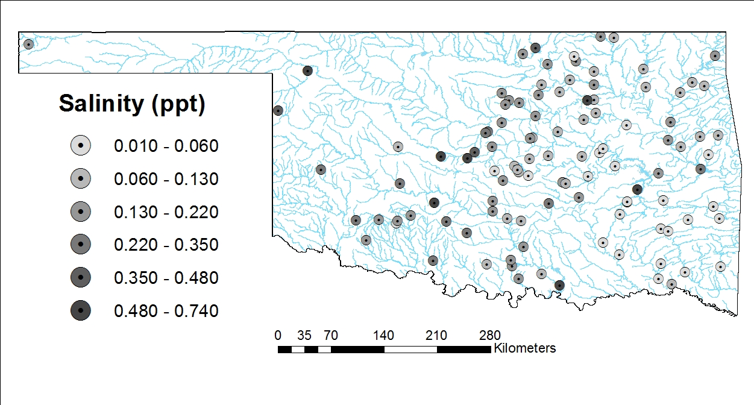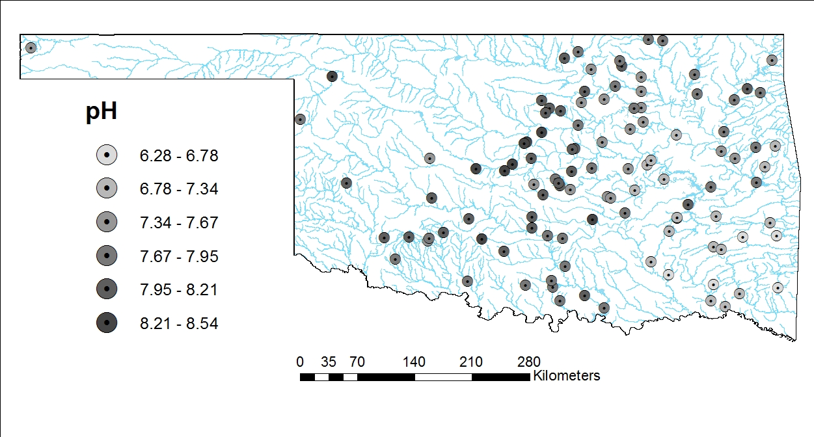
a.
b.
Figure 1. Salinity (a) and pH (b) range and location of study lakes adapted from the Beneficial Use Monitoring Program Nutrient Status figure in Lakes of Oklahoma.
Figure 1. Salinity (a) and pH (b) range and location of study lakes adapted from the Beneficial Use Monitoring Program Nutrient Status figure in Lakes of Oklahoma
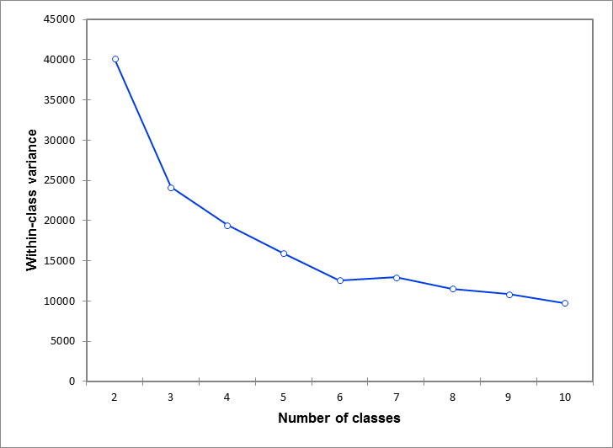
Figure 2. Scree plot showing the k-means clustering within-class variance and illustrating the elbow at 6 classes.

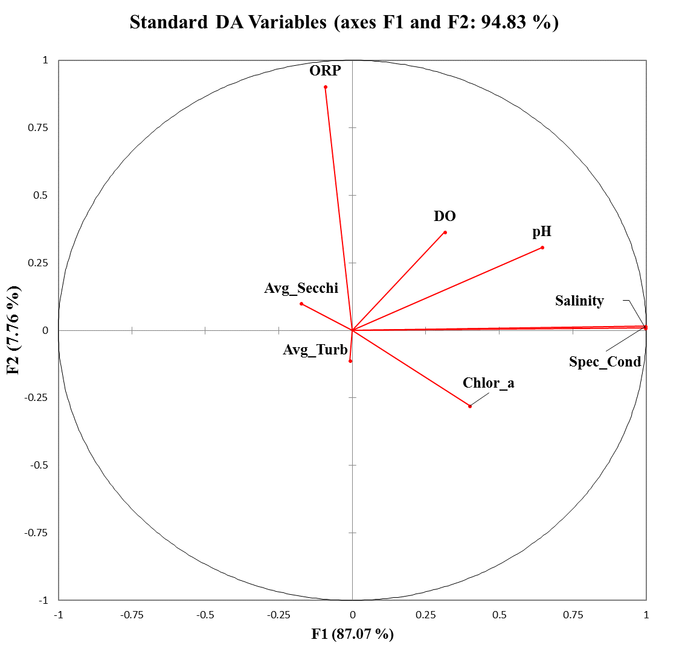
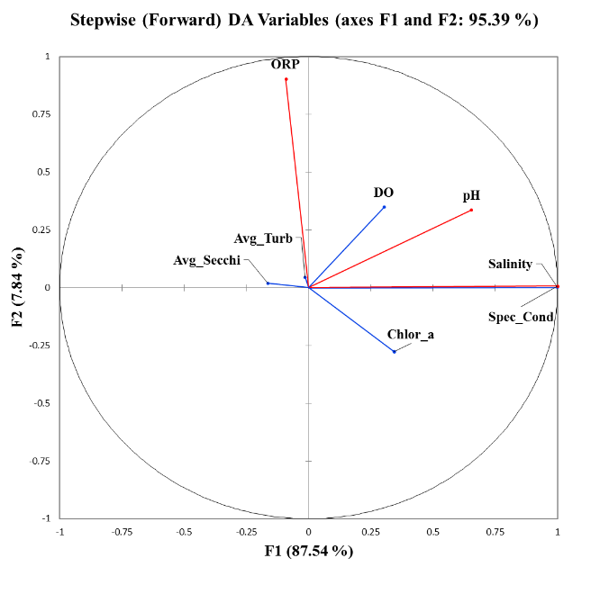
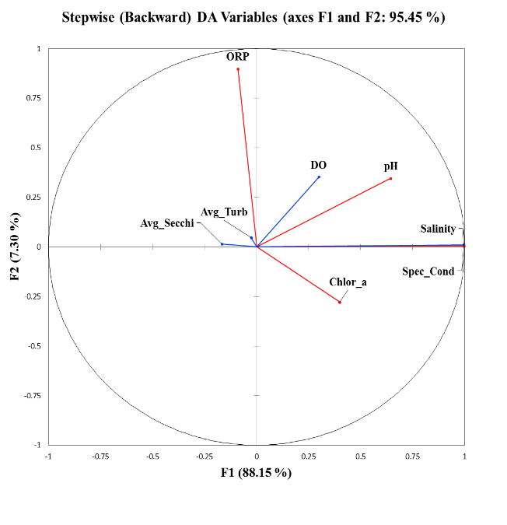
Figure 3. Ordination diagrams depicting results for the standard, forward stepwise, and backward stepwise discriminant analysis of water quality variables.

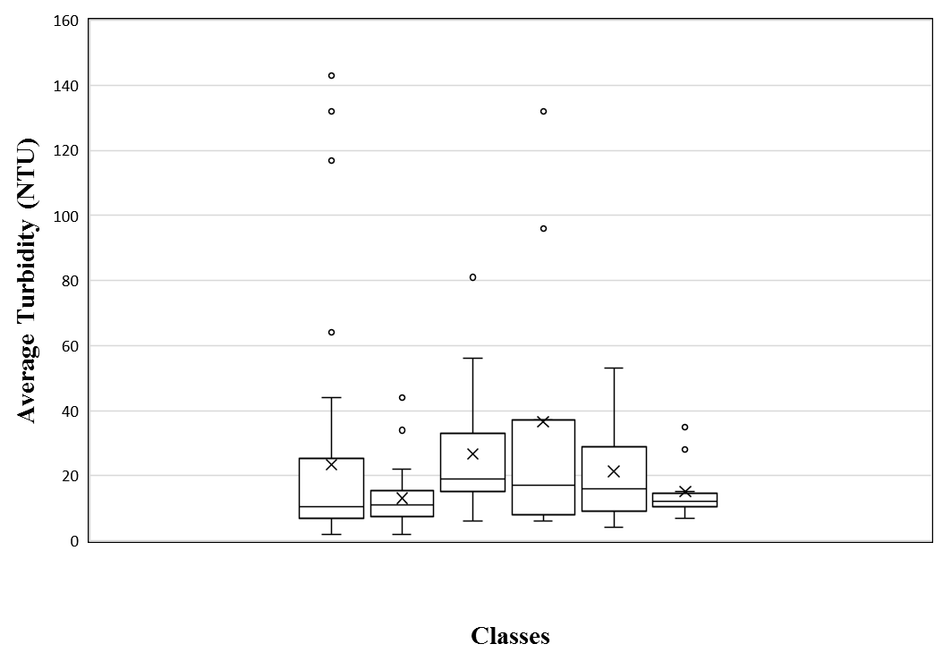
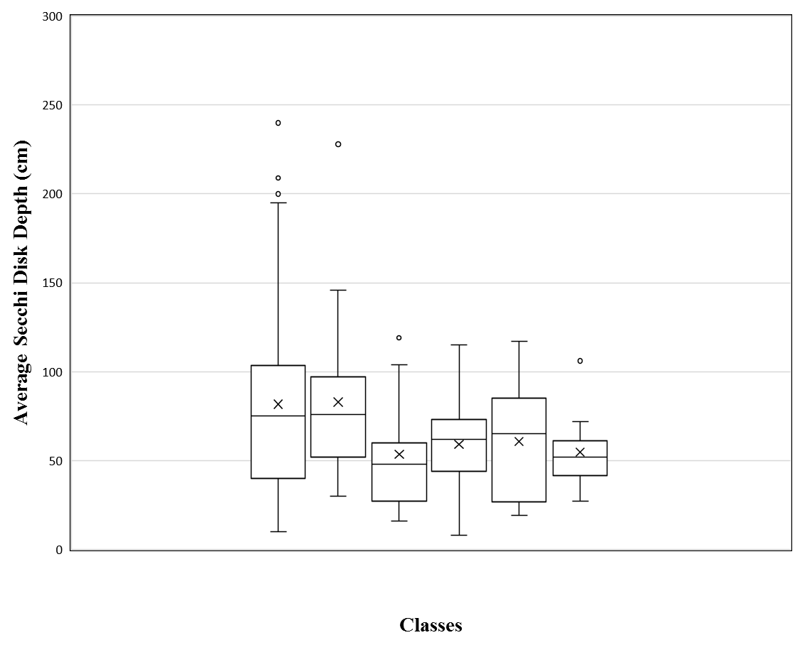
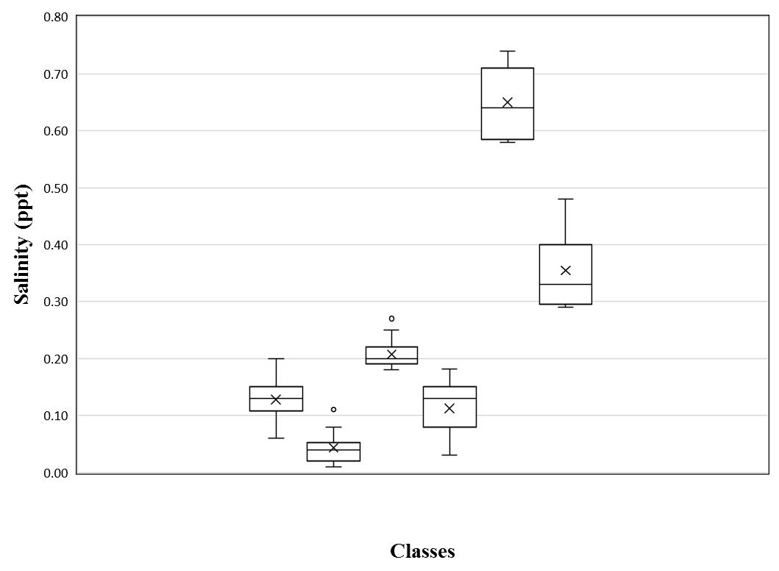
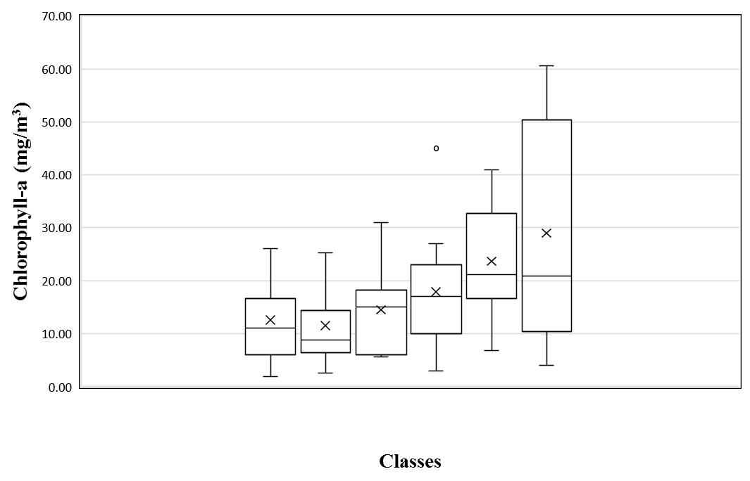
1(n=44) 2(n=24) 3(n=13) 4(n=9) 5(n=7) 6(n=11)
1(n=44) 2(n=24) 3(n=13) 4(n=9) 5(n=7) 6(n=11)
1(n=44) 2(n=24) 3(n=13) 4(n=9) 5(n=7) 6(n=11)
1(n=44) 2(n=24) 3(n=13) 4(n=9) 5(n=7) 6(n=11)
1(n=44) 2(n=24) 3(n=13) 4(n=9) 5(n=7) 6(n=11)
Figure 4a. Box and whisker plots for each water quality parameter according to discriminant analysis classes. The number (n) of water bodies in each class is listed next to the class number.
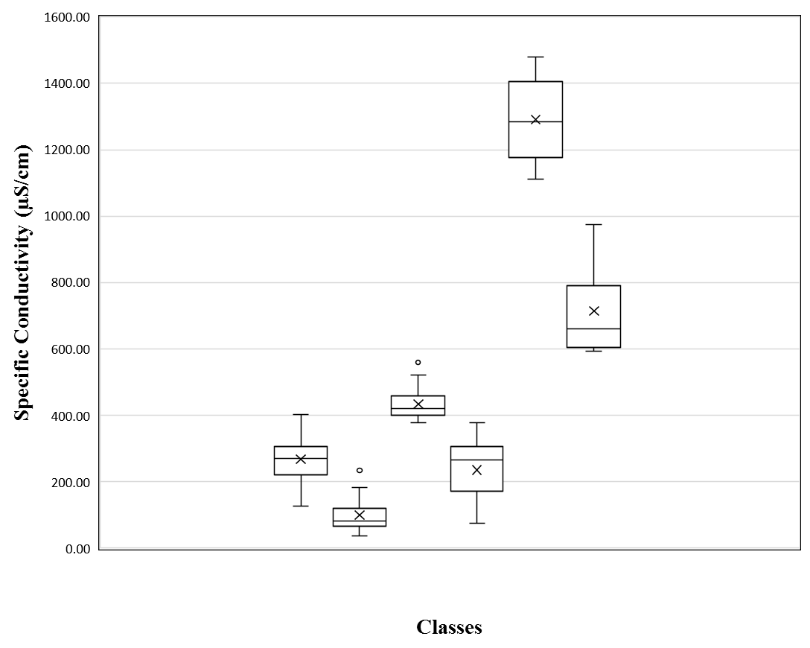
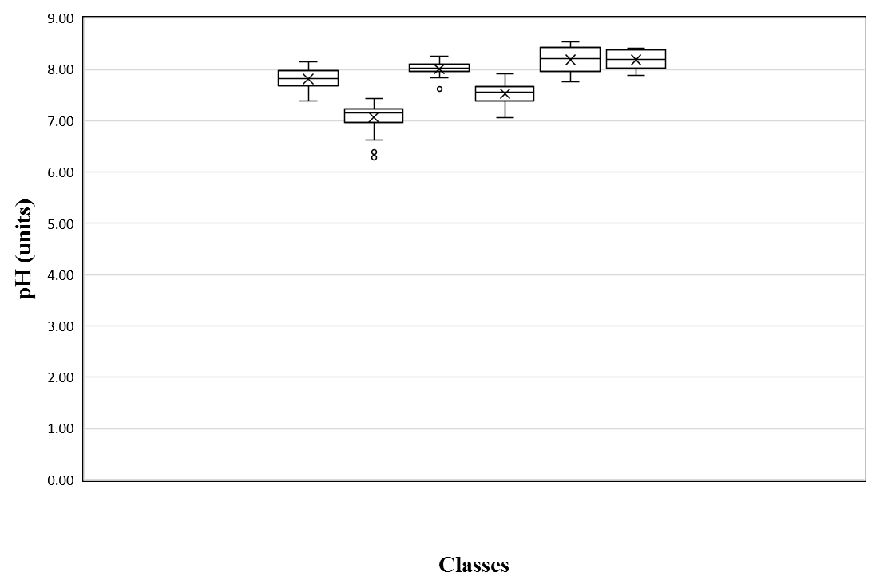
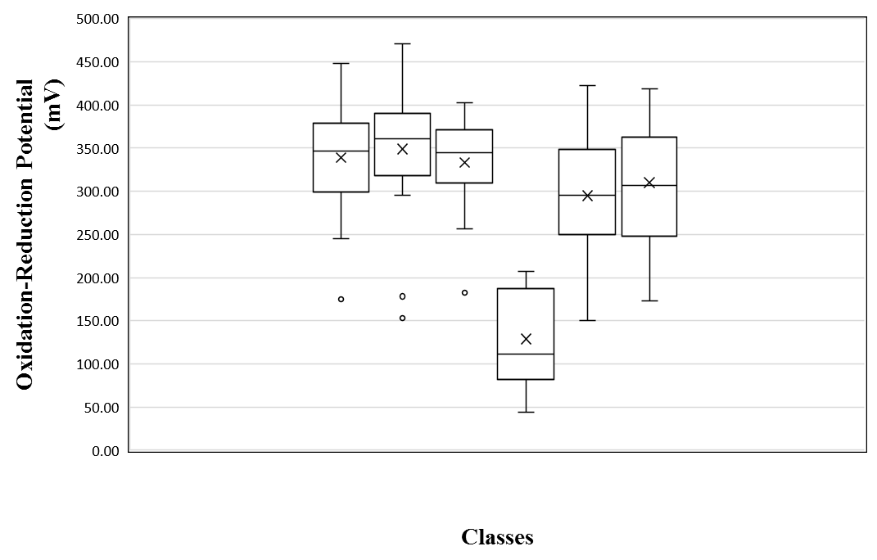
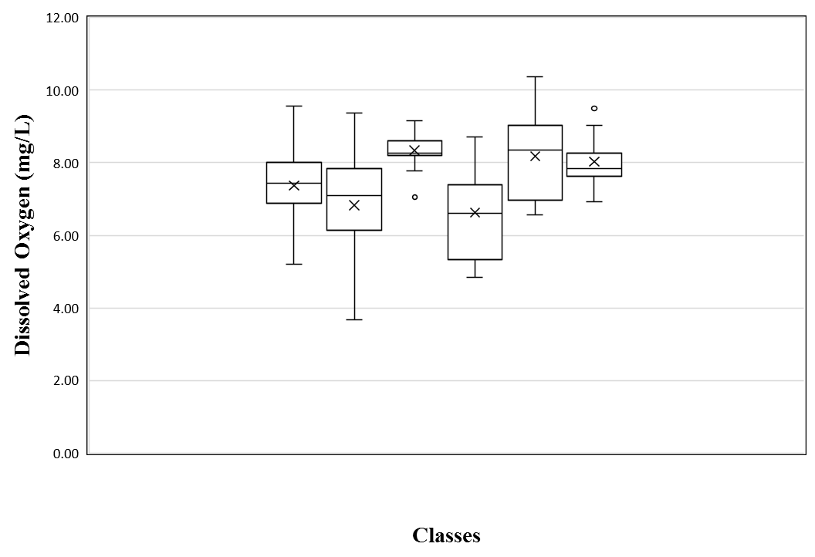
Figure 4b. Box and whisker plots for each water quality parameter according to discriminant analysis classes. The number (n) of water bodies in each class is listed next to the class number.
1(n=44) 2(n=24) 3(n=13) 4(n=9) 5(n=7) 6(n=11)
1(n=44) 2(n=24) 3(n=13) 4(n=9) 5(n=7) 6(n=11)
1(n=44) 2(n=24) 3(n=13) 4(n=9) 5(n=7) 6(n=11)
1(n=44) 2(n=24) 3(n=13) 4(n=9) 5(n=7) 6(n=11)

Figure 5. Water body class centroids and clusters with respect to axes 1 and 2.

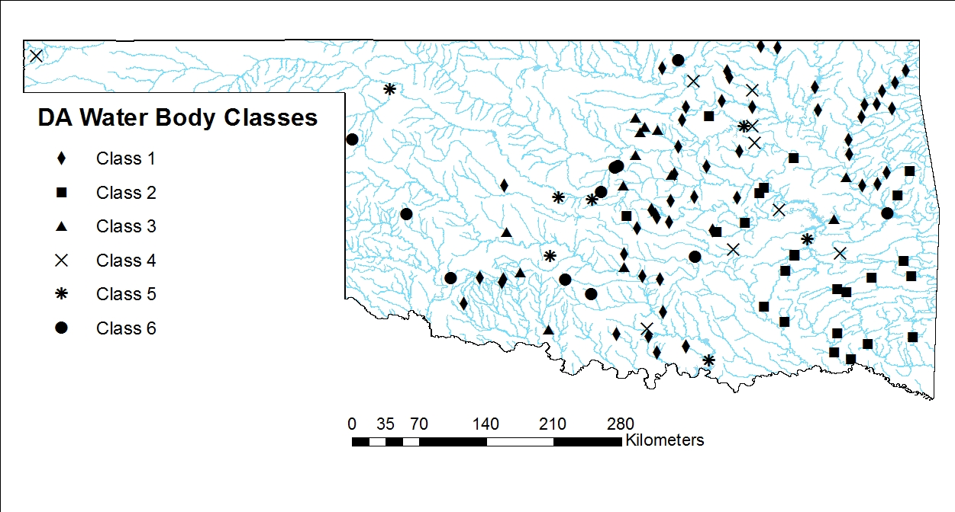
Figure 6. Discriminant analysis classification of 108 Oklahoma water bodies.

Figure 7. Predicted relative weights of each fish compared to the observed relative weights.
R² = 0.237
Adj. R² = 0.168
p = 0.002
R² = 0.064
Adj. R² = -0.035
p = 0.736
R² = 0.251
Adj. R² = 0.163
p = 0.009
Appendix A. Water quality categories, units, and values for 115 Oklahoma water bodies. Data and collection methodology available from the Oklahoma Water Resource Board (www.owrb.ok.gov/quality/monitoring/monitoring.php).
Water Body | Chlor a | Avg Turb | Avg Secchi | Salinity | Spec Cond | pH | ORP | DO
 | mg/m³ | NTU | cm | ppt | µS/cm | Units | mV | mg/L
AMHORS |  | 13 | 118 | 0.11 | 233.20 | 7.57 | 365.00 | 6.38
ARDCIT |  | 10 | 106 | 0.15 | 304.40 | 7.88 | 341.00 | 7.19
ATOBLU | 9.00 | 44 | 30 | 0.05 | 95.51 | 7.23 | 314.83 | 8.01
BELLCO | 23.00 | 14 | 58 | 0.18 | 386.96 | 8.02 | 338.74 | 7.78
BIRCH | 17.80 | 8 | 62 | 0.09 | 195.09 | 7.39 | 186.85 | 5.34
BIXHOM | 7.00 | 4 | 146 | 0.05 | 111.12 | 7.21 | 397.16 | 7.78
BLUEST | 4.70 | 25 | 54 | 0.12 | 256.08 | 7.81 | 376.44 | 6.96
BOOMER | 31.00 | 15 | 37 | 0.21 | 434.07 | 8.10 | 306.16 | 8.53
BRBOW | 5.00 | 2 | 228 | 0.02 | 36.11 | 6.28 | 393.26 | 3.68
BROWN |  |  |  | 0.04 | 78.38 | 7.34 | 389.00 | 8.30
BRUSHY | 13.00 | 8 | 79 | 0.03 | 73.79 | 7.13 | 322.10 | 7.12
CANTON | 50.01 | 39 | 25 | 0.90 | 1764.41 | 8.19 | 421.06 | 9.30
CARLBL | 15.40 | 25 | 39 | 0.18 | 382.42 | 8.07 | 344.52 | 8.85
CARTER |  | 7 | 121 | 0.11 | 230.70 | 7.98 | 448.00 | 7.93
CEDAR | 25.30 | 7 | 92 | 0.02 | 56.86 | 6.39 | 153.36 | 4.73
CHANDL |  | 29 | 39 | 0.12 | 291.40 | 8.04 | 383.00 | 7.68
CLEVEL | 14.90 | 14 | 49 | 0.11 | 234.38 | 7.39 | 378.00 | 7.13
COMANC | 8.00 | 12 | 86 | 0.15 | 307.86 | 8.01 | 346.00 | 8.84
COPAN | 10.00 | 117 | 14 | 0.12 | 253.29 | 7.70 | 380.63 | 8.21
CROWDE | 41.00 | 16 | 65 | 0.58 | 1164.13 | 8.07 | 337.43 | 9.39
CUSHIN | 7.00 | 44 | 25 | 0.17 | 356.58 | 7.86 | 260.35 | 7.51
DRSPGS | 7.00 | 9 | 76 | 0.06 | 126.19 | 7.23 | 364.33 | 6.95
ELKCIT |  | 15 | 56 | 0.35 | 676.80 | 8.20 | 419.00 | 8.47
ELMERT | 5.10 | 2 | 209 | 0.06 | 135.88 | 7.38 | 312.62 | 5.20
EUFAUL | 6.00 | 19 | 86 | 0.20 | 420.63 | 7.88 | 402.19 | 7.97
FAIRFA | 12.90 | 8 | 71 | 0.14 | 296.10 | 7.67 | 185.29 | 4.84
FTCOBB | 18.26 | 15 | 60 | 0.25 | 521.98 | 8.21 | 386.62 | 8.53
FTGIBS | 22.00 | 7 | 76 | 0.15 | 308.41 | 7.79 | 347.06 | 8.04
FTSUPP | 36.20 | 53 | 19 | 0.74 | 1479.19 | 8.41 | 359.81 | 8.34
FOSS | 11.80 | 11 | 88 | 1.20 | 2339.69 | 8.01 | 346.69 | 6.19
GRAND | 6.00 | 3 | 191 | 0.14 | 288.84 | 7.60 | 281.34 | 6.99
GRSALT | 308.25 | 198 | 8 | 4.26 | 7099.36 | 8.46 | 411.99 | 10.72
GREENL | 16.60 | 4 | 103 | 0.08 | 161.31 | 7.56 | 332.16 | 6.87
GUTHRI | 60.60 | 14 | 47 | 0.29 | 594.46 | 8.35 | 250.02 | 7.94
HEALDT | 14.80 | 29 | 31 | 0.10 | 204.02 | 7.76 | 289.56 | 7.03
HEYBUR | 14.60 | 32 | 31 | 0.13 | 275.74 | 7.63 | 255.60 | 7.01
HUGO | 22.00 | 34 | 32 | 0.03 | 73.15 | 7.16 | 366.45 | 9.36
HULAH | 16.30 | 65 | 24 | 0.14 | 299.93 | 7.90 | 375.72 | 8.07
KAW | 4.00 | 9 | 106 | 0.45 | 915.08 | 7.90 | 358.25 | 7.84
KEYSTO | 15.60 | 7 | 98 | 0.71 | 1402.84 | 7.76 | 422.21 | 6.90
ARCADI | 25.00 | 7 | 119 | 0.20 | 411.28 | 7.97 | 315.12 | 8.21
CARLAL |  | 14 | 90 | 0.01 | 45.10 | 6.69 | 450.00 | 7.31
ETLING | 45.00 | 37 | 26 | 0.18 | 378.16 | 7.47 | 44.06 | 5.07
CHICKA | 54.60 | 13 | 35 | 1.33 | 2568.52 | 8.22 | 403.22 | 8.56
CLAREM | 26.01 | 9 | 46 | 0.13 | 264.63 | 7.84 | 326.72 | 9.56
ELRENO | 20.00 | 36 | 25 | 0.64 | 1284.21 | 8.54 | 149.85 | 10.37
ELLSWO | 12.31 | 33 | 26 | 0.22 | 462.94 | 8.04 | 395.76 | 8.60
EUCHA | 21.00 | 3 | 104 | 0.12 | 254.84 | 7.82 | 346.69 | 7.93
FREDER | 7.00 | 64 | 25 | 0.19 | 397.57 | 7.78 | 322.02 | 5.81
FUQUA | 11.70 | 12 | 47 | 0.30 | 613.61 | 8.19 | 306.93 | 7.73
HEFNER | 52.50 | 8 | 59 | 0.48 | 974.00 | 8.41 | 301.33 | 6.92
HENRY | 3.00 | 132 | 8 | 0.05 | 98.76 | 7.33 | 207.40 | 8.71
HOLDEN | 17.00 | 17 | 48 | 0.16 | 328.00 | 7.73 | 91.56 | 7.33
HOMINY |  | 9 | 101 | 0.12 | 251.14 | 7.93 | 267.00 | 5.25
HUDSON | 13.40 | 8 | 84 | 0.12 | 248.40 | 7.75 | 417.82 | 8.21
JNEUST | 23.00 | 17 | 44 | 0.15 | 305.14 | 7.92 | 111.45 | 6.55
KONAWA | 23.90 | 7 | 72 | 0.33 | 660.82 | 8.27 | 401.64 | 7.54
LAWTON | 25.70 | 7 | 68 | 0.16 | 335.27 | 7.86 | 378.43 | 6.54
VINCENT | 8.00 | 14 | 63 | 0.45 | 869.61 | 7.88 | 349.00 | 9.04
BURTSC |  | 11 | 72 | 0.58 | 1111.00 | 8.21 | 295.00 | 7.03
MCMURT | 5.70 | 19 | 48 | 0.19 | 399.20 | 8.14 | 353.37 | 8.26
MURRAY | 1.90 | 8 | 200 | 0.14 | 291.42 | 7.83 | 404.53 | 7.38
NWAIYA |  | 9 | 98 | 0.02 | 82.70 | 7.20 | 471.00 | 8.08
ARBUCK | 14.40 | 4 | 108 | 0.15 | 312.71 | 7.81 | 301.12 | 6.15
OVERHO | 22.40 | 22 | 28 | 0.59 | 1189.12 | 8.45 | 273.96 | 8.66
OZCOBB |  | 12 | 56 | 0.01 | 65.20 | 6.78 | 444.00 | 7.56
PONCA | 20.00 | 8 | 71 | 0.16 | 327.71 | 8.15 | 175.15 | 5.49
RAYGAR |  | 11 | 55 | 0.08 | 175.82 | 7.13 | 356.81 | 6.21
TEXOMA | 6.80 | 4 | 117 | 0.71 | 1409.46 | 7.86 | 225.43 | 6.57
THBIRD | 21.00 | 14 | 59 | 0.18 | 377.40 | 7.99 | 311.25 | 6.00
VANDER |  | 9 | 59 | 0.93 | 1748.70 | 7.87 | 388.00 | 7.66
WAYWAL | 27.00 | 6 | 115 | 0.03 | 73.63 | 7.06 | 81.55 | 6.60
WETUMK |  | 18 | 59 | 0.05 | 118.10 | 7.21 | 335.00 | 5.99
LANGST | 5.60 | 6 | 104 | 0.18 | 378.36 | 8.26 | 256.77 | 8.20
LIBERT | 57.30 | 12 | 52 | 0.29 | 592.17 | 8.40 | 237.00 | 7.80
LONECH | 10.70 | 10 | 78 | 0.14 | 294.23 | 7.55 | 306.77 | 6.23
ALTUSL | 18.70 | 10 | 53 | 1.10 | 2155.46 | 8.10 | 434.00 | 8.04
MCGEE | 7.00 | 6 | 96 | 0.03 | 66.08 | 6.63 | 309.30 | 5.71
MEEKER |  | 143 | 10 | 0.10 | 216.54 | 8.00 | 395.02 | 9.02
OKEMAH | 4.50 | 8 | 81 | 0.08 | 172.00 | 7.57 | 348.88 | 7.79
OKMULG | 6.20 | 8 | 94 | 0.05 | 101.24 | 7.07 | 299.59 | 7.07
OOLOGA | 9.60 | 20 | 40 | 0.13 | 282.97 | 7.83 | 395.05 | 8.00
PVALLY | 11.00 | 32 | 31 | 0.13 | 265.11 | 7.80 | 277.84 | 7.97
PAWHUS |  | 3 | 195 | 0.20 | 393.20 | 8.07 | 373.00 | 8.70
PAWNEE |  | 22 | 44 | 0.13 | 274.30 | 8.11 | 337.00 | 7.35
PERRYC | 6.00 | 56 | 22 | 0.20 | 407.23 | 8.03 | 309.75 | 9.16
PCREEK | 25.20 | 13 | 47 | 0.02 | 52.15 | 6.91 | 319.02 | 4.28
PRAGUE |  | 12 | 74 | 0.11 | 222.40 | 7.76 | 380.00 | 7.02
PURCEL |  | 14 | 57 | 0.20 | 403.30 | 8.11 | 430.00 | 7.67
LONGMI | 21.50 | 17 | 45 | 0.13 | 265.88 | 7.93 | 369.81 | 6.74
RSKERR | 17.90 | 28 | 36 | 0.32 | 651.44 | 7.93 | 173.06 | 8.08
SAHOMA | 5.20 | 96 | 85 | 0.08 | 171.58 | 7.56 | 195.38 | 7.40
SARDIS | 8.70 | 17 | 63 | 0.02 | 48.99 | 6.99 | 400.38 | 7.07
SHAWN1 | 5.50 | 9 | 86 | 0.09 | 187.81 | 7.97 | 293.78 | 8.01
SHAWN2 | 5.70 | 11 | 73 | 0.10 | 198.85 | 8.02 | 274.29 | 7.93
SHELLC | 10.00 | 8 | 73 | 0.13 | 264.57 | 7.64 | 56.67 | 7.79
SKIATO | 8.00 | 14 | 103 | 0.15 | 316.29 | 7.67 | 326.55 | 7.16
SOONER | 3.00 | 3 | 194 | 1.24 | 2412.41 | 8.21 | 354.11 | 9.45
SPAVIN | 16.20 | 5 | 96 | 0.09 | 193.05 | 8.04 | 381.65 | 7.91
SPORTS | 5.44 | 8 | 90 | 0.15 | 306.41 | 7.54 | 245.39 | 8.43
DRAPER | 2.70 | 8 | 104 | 0.06 | 121.72 | 7.44 | 380.68 | 5.11
STILWE | 9.60 | 14 | 69 | 0.08 | 173.85 | 7.27 | 295.66 | 6.18
STROUD | 4.70 | 5 | 108 | 0.09 | 199.23 | 7.62 | 370.61 | 6.88
TALAW1 | 5.80 | 4 | 120 | 0.04 | 79.45 | 7.14 | 330.49 | 7.29
TALAW2 | 2.60 | 4 | 136 | 0.04 | 93.31 | 7.23 | 346.30 | 6.93
TAYLOR | 44.00 | 12 | 36 | 0.29 | 592.70 | 8.41 | 245.51 | 9.50
TECUMS |  | 132 | 11 | 0.06 | 126.50 | 7.47 | 448.00 | 8.26
TENKIL | 13.00 | 7 | 240 | 0.13 | 272.52 | 7.69 | 350.37 | 7.63
STEED | 10.00 | 35 | 27 | 0.35 | 712.46 | 8.12 | 367.73 | 7.54
WAURIK | 15.00 | 20 | 53 | 0.27 | 558.61 | 7.84 | 370.82 | 7.06
WFALLS | 8.60 | 81 | 16 | 22.00 | 459.29 | 7.62 | 367.84 | 8.95
WESWAT | 23.40 | 26 | 38 | 0.10 | 217.90 | 7.95 | 277.25 | 7.26
WEWOKA | 12.00 | 18 | 41 | 0.08 | 183.08 | 7.44 | 380.66 | 8.00
WIPOST | 17.00 | 36 | 27 | 0.20 | 419.24 | 7.96 | 182.47 | 8.26
WISTER | 24.00 | 22 | 44 | 0.04 | 80.75 | 7.10 | 178.21 | 8.01

Appendix B. Sample sizes for each water body by species as well as discriminant analysis classifications. Sample sizes under twenty individuals are listed in bold text.
Water Body | Bass |  | Crappie |  | Catfish |  | DA  Class
 | W_{r} | n | W_{r} | n | W_{r} | n
ALTUSL | 102.00 | 14 | 94.50 | 19 | 90.25 | 57
AMHORS | 98.83 | 168 |  |  |  |  | 1
ARBUCK | 92.57 | 548 | 95.60 | 180 |  |  | 1
ARCADI | 102.00 | 88 | 98.83 | 87 | 91.75 | 54 | 3
ARDCIT | 92.43 | 102 | 87.20 | 32 |  |  | 1
ATOBLU | 89.14 | 58 | 93.20 | 35 | 83.00 | 11 | 1
BELLCO | 98.00 | 106 | 92.33 | 378 | 83.50 | 95 | 3
BIRCH | 92.57 | 102 | 91.80 | 30 | 87.25 | 23 | 4
BIXHOM | 88.00 | 148 | 91.00 | 4 | 105.00 | 7 | 2
BLUEST | 89.33 | 91 | 88.00 | 65 | 83.00 | 24 | 1
BOOMER | 95.63 | 154 | 87.67 | 103 | 98.00 | 40 | 3
BRBOW | 93.67 | 169 | 100.00 | 4 | 96.00 | 1 | 2
BROWN | 85.50 | 196 |  |  |  |  | 2
BRUSHY |  |  | 103.17 | 48 |  |  | 2
BURTSC | 92.33 | 194 |  |  |  |  | 5
CANTON |  |  | 97.33 | 11 | 101.00 | 102
CARLAL | 80.67 | 112 | 95.00 | 2 | 147.00 | 19 | 2
CARLBL |  |  | 88.50 | 209 | 87.00 | 75 | 3
CARTER | 80.29 | 98 |  |  |  |  | 1
CEDAR | 94.43 | 122 | 88.67 | 5 | 105.00 | 1 | 2
CHANDL | 102.17 | 80 | 85.80 | 295 | 104.00 | 6 | 1
CHICKA |  |  | 86.20 | 23 | 107.75 | 204
CLAREM | 100.63 | 71 |  |  |  |  | 1
CLEVEL | 97.00 | 101 | 93.00 | 314 | 88.00 | 35 | 2
COMANC | 94.63 | 61 |  |  |  |  | 1
COPAN |  |  | 98.00 | 46 | 77.00 | 8 | 1
CROWDE | 96.38 | 93 |  |  |  |  | 5
CUSHIN | 100.86 | 56 |  |  |  |  | 1
DRAPER | 93.00 | 69 | 83.67 | 112 | 83.00 | 26 | 2
DRSPGS | 90.63 | 513 | 83.80 | 11 | 82.67 | 34 | 2
ELKCIT | 96.13 | 30 |  |  |  |  | 6
ELLSWO | 101.00 | 103 | 113.33 | 368 | 75.33 | 3 | 3
ELMERT | 90.25 | 164 |  |  |  |  | 1
ELRENO | 95.67 | 29 | 104.83 | 282 |  |  | 5
ETLING | 98.00 | 46 |  |  |  |  | 4
EUCHA |  |  | 101.50 | 11 | 93.75 | 15 | 1
EUFAUL | 94.75 | 881 | 103.83 | 1053 | 86.75 | 165 | 3
FAIRFA | 93.00 | 103 | 89.00 | 84 | 86.00 | 34 | 4
FOSS |  |  | 67.60 | 2 | 55.25 | 90
FREDER |  |  | 82.00 | 146 | 85.00 | 26 | 1
FTCOBB | 107.29 | 149 | 116.33 | 197 | 84.00 | 67 | 3
FTGIBS | 101.50 | 502 | 123.33 | 93 | 93.00 | 50 | 1
FTSUPP |  |  | 92.75 | 7 | 84.50 | 44 | 5
FUQUA | 98.25 | 112 |  |  |  |  | 6
GRAND | 96.89 | 497 | 104.00 | 96 | 82.75 | 67 | 1
GREENL | 96.00 | 245 | 86.80 | 26 | 90.50 | 17 | 1
GRSALT |  |  | 112.00 | 6 | 13.00 | 1
GUTHRI | 91.83 | 23 | 92.67 | 127 | 87.50 | 40 | 6
HEALDT | 99.50 | 44 | 99.67 | 125 | 95.50 | 40 | 1
HEFNER | 98.71 | 162 | 65.50 | 14 | 91.50 | 73 | 6
HENRY |  |  | 85.00 | 5 | 66.00 | 1 | 4
HEYBUR | 81.00 | 73 | 83.00 | 37 | 83.75 | 30 | 1
HOLDEN | 99.00 | 311 | 79.60 | 82 | 91.00 | 77 | 4
HOMINY | 82.86 | 69 | 86.50 | 35 | 89.33 | 9 | 1
HUDSON | 97.25 | 629 | 102.75 | 13 | 88.00 | 55 | 1
HUGO | 86.14 | 135 | 98.83 | 256 | 83.00 | 33 | 2
HULAH | 103.38 | 35 |  |  |  |  | 1
JNEUST | 97.88 | 69 | 93.17 | 322 | 84.50 | 78 | 4
KAW | 106.71 | 197 | 103.83 | 70 | 93.75 | 19 | 6
KEYSTO | 102.14 | 230 | 90.33 | 71 | 88.75 | 45 | 5
KONAWA | 89.75 | 834 | 111.00 | 3 | 82.75 | 199 | 6
LANGST | 100.33 | 19 | 87.00 | 48 | 82.00 | 162 | 3
LAWTON | 100.13 | 245 | 88.20 | 29 | 87.00 | 39 | 1
LIBERT | 99.71 | 21 | 89.00 | 112 | 90.75 | 160 | 6
LONECH | 99.14 | 23 | 100.50 | 194 | 94.33 | 16 | 1
LONGMI | 129.43 | 17 | 86.67 | 126 |  |  | 1
MCGEE | 86.71 | 232 | 104.00 | 11 | 114.00 | 4 | 2
MCMURT | 93.25 | 257 | 86.60 | 55 | 86.75 | 66 | 3
MEEKER |  |  | 92.33 | 244 | 80.75 | 15 | 1
MURRAY | 94.75 | 151 | 90.20 | 4 | 81.25 | 31 | 1
NWAIYA | 94.33 | 66 |  |  |  |  | 2
OKEMAH | 95.00 | 401 | 83.33 | 172 | 84.25 | 85 | 1
OKMULG | 92.63 | 448 | 91.20 | 14 | 88.50 | 12 | 2
OOLOGA | 101.14 | 79 | 94.50 | 88 | 90.50 | 37 | 1
OVERHO |  |  | 99.25 | 10 | 76.00 | 96 | 5
OZCOBB | 93.14 | 36 |  |  |  |  | 2
PAWHUS | 85.57 | 93 |  |  |  |  | 1
PAWNEE | 103.83 | 99 |  |  |  |  | 1
PCREEK | 88.14 | 253 | 92.60 | 78 | 89.75 | 22 | 2
PERRYC | 91.63 | 83 |  |  |  |  | 3
PONCA | 95.60 | 51 | 93.67 | 78 | 89.75 | 44 | 1
PRAGUE | 94.38 | 171 | 95.00 | 28 | 81.75 | 43 | 1
PURCEL | 87.20 | 17 | 93.33 | 177 |  |  | 1
PVALLY | 94.57 | 31 | 91.67 | 618 |  |  | 1
RAYGAR | 93.86 | 65 |  |  |  |  | 2
RSKERR | 96.14 | 182 | 97.50 | 28 | 91.50 | 58 | 6
SAHOMA | 97.40 | 10 | 89.20 | 79 | 97.50 | 43 | 4
SARDIS | 93.14 | 103 | 92.00 | 96 | 87.00 | 58 | 2
SHAWN1 | 91.00 | 65 | 91.50 | 29 | 83.00 | 64 | 1
SHAWN2 | 93.00 | 95 | 84.80 | 33 | 91.75 | 67 | 1
SHELLC | 93.29 | 60 | 112.67 | 25 | 100.25 | 67 | 4
SKIATO | 89.67 | 222 | 89.50 | 38 | 81.00 | 46 | 1
SOONER | 85.71 | 102 | 91.00 | 1 | 93.75 | 48
SPAVIN |  |  | 95.00 | 16 | 100.00 | 4 | 1
SPORTS | 99.63 | 54 | 82.00 | 22 | 91.00 | 3 | 1
STEED | 107.17 | 26 | 96.40 | 41 | 96.75 | 15 | 6
STILWE | 86.83 | 140 | 120.00 | 10 | 91.00 | 24 | 2
STROUD | 81.86 | 42 | 85.50 | 44 | 81.00 | 23 | 1
TALAW1 | 87.86 | 33 |  |  |  |  | 2
TALAW2 | 78.14 | 56 |  |  |  |  | 2
TAYLOR | 106.67 | 65 | 93.25 | 16 | 76.25 | 28 | 6
TECUMS |  |  | 99.50 | 134 | 86.00 | 13 | 1
TENKIL | 92.00 | 370 | 97.25 | 12 | 87.75 | 35 | 1
TEXOMA | 96.13 | 366 | 99.25 | 28 | 93.75 | 49 | 5
THBIRD | 97.63 | 72 | 95.50 | 169 | 96.50 | 80 | 1
VANDER | 100.43 | 96
VINCENT | 99.29 | 28 |  |  |  |  | 6
WAURIK | 101.50 | 17 | 139.00 | 77 | 83.75 | 20 | 3
WAYWAL | 77.63 | 98 |  |  |  |  | 4
WESWAT | 95.75 | 184 | 87.50 | 149 | 102.75 | 71 | 1
WETUMK | 86.50 | 250 | 81.00 | 14 | 87.25 | 31 | 2
WEWOKA | 95.86 | 27 | 85.75 | 769 | 79.75 | 31 | 2
WFALLS | 97.33 | 177 | 90.83 | 59 | 92.00 | 51 | 3
WIPOST | 107.00 | 4 | 97.50 | 475 |  |  | 3
WISTER | 99.50 | 42 | 102.83 | 143 | 81.25 | 79 | 2

