University of Oklahoma

Graduate College

An Examination of FLEX SCORING AS A MEANS TO provide quality literature to SMALL BANDs WITH limited INSTRUMENTATION

A Document

submitted to the Graduate Faculty

in partial fulfillment of the requirements for the

Degree of

Doctor of Musical Arts

By

TIMOTHY JAY PARDUE
Norman, Oklahoma
2021

AN EXAMINATION OF flex scoring as a means to provide quality literature to small bands with limited instrumentation

A Document approved for the
School of Music

By
THE COMMITTEE CONSISTING OF

Dr. Marvin Lamb, Chair

Dr. Shanti Simon, co-chair

Dr. Eugene Enrico

Dr. Allison Palmer

© Copyright by TIMOTHY JAY PARDUE, 2021
All Rights Reserved.

Acknowledgements
I would like to thank the members of my committee for their time and help preparing for the qualifying exams and supporting me through this project: Dr. Shanti Simon, Dr. Michael Hancock, Dr. Marvin Lamb, Dr. Eugene Enrico, and Dr. Allison Palmer.
I would like to especially thank Dr. Simon and Dr. Hancock for having the highest musical expectations of their ensembles, never compromising their art, and pushing me to do the same. I would like to also thank Professor Brian Britt and Dr. Brian Wolfe for the opportunities they provided me through the athletic bands. I am grateful for Dr. Christopher Knighten, Dr. Ben Lorenzo, and Dr. Jamal Duncan for taking a chance on me, allowing me to begin my graduate studies, and for supporting my goals. I am forever grateful to Mr. Kevin Williams and Mr. Jim Robken for instilling in me a love of music and inspiring me to pursue this path.
I want to thank my wonderful colleagues, dear friends, and soon to be Doctors of Music Hannah Rudy and Cody Hutchison for their comradery, collaboration, and for the inspiration you both are to me.
I am thankful to my parents for supporting me through all the late practicing, rehearsals, game days, competitions, and concerts. I am most grateful to my wonderful wife Nicole and my children Jack and Elena for their love, relentless support, and the sacrifices they have made through this journey.

Table of Contents

Acknowledgements iv
List of Tables vii
List of Figures viii
Abstract ix
Chapter 1 1
Purpose 1
Need for Study 10
Procedures 10
Limitations 13
Chapter 2 15
Survey of Related Literature 15
Chapter 3 28
Adaptable Scoring Terminology and Models 28
Introduction 28
Flex Scoring 30
Full-Flex Scoring 36
Modular/Cellular Pieces 39
Improvisatory Pieces 40
Chapter 4 41
Analyses of Selected Flex Score Works 41
English Folksong Suite 41
First Suite in E-flat for Military Band 52
Dancing Fire 71
Two Movements from Lincolnshire Posy 83
Pictures at an Exhibition 95
Lichtweg/Lightway 110
This Cruel Moon 117
Chapter 5 124
Suggested Works for Adaptation to a Flex Score Model 124
Chapter 6 128
Conclusions 128
Suggestions for Further Research 130
References 132
Appendix A: Copyright Permissions 137
Appendix B: Creative Repertoire Initiative 144

List of Tables

Table 1. English Folk Song Instrumentation 42
Table 2. First Suite in E-flat for Military Band Instrumentation 53
Table 3. Dancing Fire Instrumentation 72
Table 4. Lincolnshire Posy Instrumentation 84
Table 5. Pictures at an Exhibition Instrumentation 96
Table 6. Lichtweg/Lightway Instrumentation 111
Table 7. This Cruel Moon Instrumentation 117

List of Figures

Figure 1. Five-Part Flex Score Example. 33
Figure 2. Four-Part Flex Score Example. 34
Figure 3. Seven-Part Flex Score Example. 35
Figure 4. Four-Part Full Flex Score Example. 38

Abstract
AN EXAMINATION OF flex scoring as a means to provide quality literature to small bands with limited Instrumentation

Small bands are limited in terms of repertoire. Incomplete or unbalanced instrumentation prevents small bands from accessing quality repertoire and or music of higher-grade levels. This in turn can have an effect on student growth in these programs. This project will explore various models of flexible scoring of quality repertoire as a means to fill the need for quality repertoire in small band programs. Published flexible arrangements, marketed to small band programs, have existed for over a decade. These arrangements take a piece of music and condense it down to its basic four to five-part voicings and provide parts for all instruments in all keys. This scoring allows directors to make substitutions without having to rewrite parts or have students transpose or seek out special permissions from composers and publishers if significant substitutions need to be made to adapt a work. This is done while striving to maintain the composer’s intent and essential features of the piece. Flexible scoring has recently come to the forefront in the wind band world due rehearsal size limitations many band programs faced during the 2020 Covid-19 pandemic. As a response to this pandemic a group of wind band composers started the Creative Repertoire Initiative to promote this style of scoring to fill the need for adaptable works that can be performed by bands much smaller than the traditional large wind ensemble. Post pandemic, most band programs will return to the standard repertoire and scoring; small band programs, however, will continue to have the same challenges of instrumentation when selecting repertoire. This project will compare categories of adaptable music as defined by the Creative Repertoire Initiative, focusing on music in the flexible category and variations within that category. The quality and grade levels of selected pieces will be determined by comparing various state music educator association prescribed music lists (PML) and previous studies to determine wind band repertoire of high artistic merit. This project will select eight flexible arrangements that meet the criteria and make a comparative performance analysis of the flexible scoring and original score. This project will also seek to identify other quality works for wind band that are suitable for adapting to the flexible score model.

Chapter 1

Purpose
Small bands are limited in terms of repertoire. Incomplete or unbalanced instrumentation prevents small bands from accessing quality repertoire and or music of higher-grade levels. This in turn can have an effect on student growth in these programs. This project will explore various models of flexible scoring of quality repertoire as a means to fill the need for quality repertoire in small band programs.
Repertoire selection is arguably the most important decision a band director makes. H. Robert Reynolds asserts, “while it may be an overstatement to say that repertoire is the curriculum, we can call agree that a well-planned repertoire creates the framework for an excellent music curriculum that fosters the musical growth of our students.” In 2014 the National Coalition for Core Arts Standards created a set of National Music Standards for ensembles. The first standards in the performing category apply to repertoire selection: Develop and apply criteria to select varied repertoire/programs to study and perform based on an understanding of theoretical and structural characteristics and expressive challenges in the music, the technical skill of the individual or ensemble, and the purpose and context of the performance. Selecting quality repertoire is in the best interest of the individuals in the ensemble as well as in its collective musical growth, “for only through immersion in music of lasting quality can we engage in aesthetic experiences of breadth and depth.” The process of selecting repertoire for an ensemble is no easy task because it must consider students’ current abilities compared to the difficulty of the music, and the amount of rehearsal time available. The potential for musical growth, and striking a balance of styles, aesthetics, and depth are also important. The process of repertoire selection never becomes easier, as no two ensembles are the same; personnel may change, abilities change with growth, instrumentation may change. H. Robert Reynolds speaks to the continuing challenge of repertoire selection:
It might be assumed that the more experience one has, the easier the task of repertoire selection becomes. As one who has several decades of this experience, I am here to tell you that it gets no easier. It is one of the most difficult aspects of the entire profession. The difficulty occurs because you not only choose a particular piece or set of pieces, but, in making this decision, you determine that all other pieces will not be chosen.

The challenges for repertoire selection are compounded for band directors of small band programs with limited or incomplete instrumentation.
To fully understand the plight of the small band director, a broad overview and understanding of the evolution of the wind band from the classical era to modern times and the effects it has had on scoring is necessary. The size and instrumentation of the modern wind band has evolved greatly over the last two hundred and fifty years. Its evolution is linked to function of the ensemble and to the invention and refinement of instruments through new mechanical (crooks, valves, and key) systems. Handel’s Music for the Royal Fireworks, written in 1748, called for expanded proportions for the wind section of the orchestra, with forty trumpets, twenty horns, sixteen oboes, sixteen bassoons, eight pair of kettledrums, twelve side drums, and fifes, flutes, and serpents, expanding the prominence of wind instruments while diminishing the role of strings. This massive band of 100 musicians was necessary for the audience of over 12,000 at Vauxhall Gardens. Later in the 18th century, the harmoniemusik ensemble was established. This ensemble consisted of a pair of oboes, clarinets, bassoons, and horns, with clarinets as the newest addition. This ensemble grew out of orchestra, its name referring to the harmonic support and timbral contrast that these pairs of wind instruments gave to the string section. Major composers, including Haydn, Mozart, Beethoven, and Schubert, wrote for this medium. Mozart wrote three serenades for harmoniemusik. His Serenade No. 10 in B-flat, K 361 (1782), expanded this ensemble to include a pair of basset horns, second pair of French horns, and a double bass.
In the early 19th century Wilhelm Wieprecht, a Prussian army bandmaster, adopted the use of valved brass instruments, abandoning the use of keyed bugles, creating a brass cavalry band with cornets, trumpets, horns, bass horns, and trombones. Wieprecht’s position in the Prussian military bands, during a time with significant advances in instrument technology with changes in key systems and advent of the valve, allowed him to standardize military band units with the best instruments available. He wrote a series of articles to generate support for the idea of standardized instrumentation. He advocated for bands of twenty-one parts, grouped in “piercing register,” to be played lightly, middle register, to be played stronger, and low register, to be played very strongly. Each of these sections included doubling for balance and texture considerations. Wieprecht added to the repertoire, composing and arranging numerous works for military band. By the mid-19th century, large Prussian concert bands of fifty to sixty were common, the standard instrumentation at this point calling for at least forty-seven players including flute, oboe, clarinets in A-flat, B-flat, and E-flat, bassoon, contrabassoon, trumpet, cornet, horn, trombone, baritone tuba, bass tuba, and percussion. This would have a lasting influence on the European military band tradition and instrumentation.
Professional bands in America in the late 19th century added the new family of instruments after the invention of Adolph Sax’s saxophone. Patrick Gilmore’s Gilmore Band added saxophones in the 1870s, but still included various Civil War era brass instruments including alto and tenor horns. John Philip Sousa formed the Sousa Band days after the death of Gilmore, hiring nineteen of the Gilmore Band musicians. Sousa eliminated the use of outdated brass instruments and consolidated his instrumentation to include two flutes, two oboes, two E-flat clarinets, fourteen B-flat clarinets, alto and bass clarinets, two bassoons, three saxophones, four cornets, two trumpets, four horns, three trombones, two euphoniums, four basses, and percussion. This instrumentation is similar to modern standards and would remain the standard until the mid-20th century. Sousa’s band toured the country and its influence spurred the creation of many local community bands and school band programs. Much of the music played by these professional bands consisted of original marches and transcriptions of orchestral and operatic works.
English composers of military band music in the early 20th century recognized the fluctuations and changes in instrumentation, with new instruments coming in and others out of use. The score for Gustav Holst’s First Suite in E-flat for Military Band (1909) included the designation of “ad Lib” for sixteen of the thirty-eight parts that were doubled or optional parts. The practice of having these doubled or optional parts was standard until mid-century.
Frederick Fennell created the Eastman Wind Ensemble in 1952 with mostly one player per part. The idea was to have a more balanced and flexible instrumentation that would allow for playing wind music written for orchestral winds, while still being able to perform typical wind band literature. Fennell was an advocate for this instrumentation and wrote to composers to request works for this lighter wind ensemble. Current trends in scoring and instrumentation can be traced directly to Frederick Fennell’s influence and drive to commission works for this streamlined instrumentation.
In 2012 composer David Avshalomov conducted a survey to determine typical core instrumentation of American community bands, and released his findings through the Association of Concert Bands as “An Approach to Scoring Guidelines for Composers and Arrangers.” This survey defines the typical band of having forty players. Unfortunately, small bands (bands with less than forty players) are often left unable to make use of music written and published with these or similar guidelines due to having limited or incomplete instrumentation.
Often specific limitations are directly tied to schools’ instrument inventory and level of funding. Instruments such as bassoons, double horns, or large melodic percussion instruments are often not available due to the high cost. With these limitations in mind, two articles in a music education journal and in a trade magazine have been written to directly address instrumentation issues and offer guidelines on how to adapt and rescore works to fit small ensembles. Stacy Dziuk argues that repertoire selection should be based on the ensemble’s musical potential or understanding, not its size, admonishing to not mistake small band size for lack of skill. Her article provides excellent and sound resources and considerations for rescoring works for small band. however, many directors in small band programs may find time and resources to adapt works for their ensemble limited due to the greater number of responsibilities. A high percentage of band directors in small band programs teach a wider range of grades and classes. Another factor that may affect a director’s willingness to adapt works for their ensemble is lack of experience. A high percentage of small band program directors are also likely to be relatively inexperienced, only in their first five years of teaching. In their lecture, “Rescoring for the small or incomplete band” at the 2019 Midwest, Karen Gregg and Kirk Vogel emphasize the need to obtain composer and publisher permissions before rescoring, especially for contests. This is one more potential hurdle that may discourage band directors of small bands to adapt works for their band.
In the last decade, publishers have started publishing series of flexible scored arrangements of works marketed to small band programs. The Hal Leonard Flex-Band series and Barnhouse Build-A-Band series both feature flex scoring. Flex scoring generally condenses the scoring to five wind parts and percussion. Each of the five parts are assigned to the appropriate instruments by range and tone color. Parts are provided in the appropriate keys and transpositions. This allows the director to easily assign parts and make needed scoring substitutions for their ensembles without the need to rewrite parts or obtain special permissions.
During the summer of 2020 a group of wind band composers began the Creative Repertoire Initiative in response to the Covid-19 pandemic and the uncertainty all ensemble directors face with ensemble personnel. This non-profit coalition of prominent wind band composers has brought flexible large ensemble music into the mainstream through their website and social media presence and has been widely shared and promoted by the National Association for Music Education and the College Band Directors National Association. The Creative Repertoire Initiative has defined four categories under their umbrella term of adaptable music: flex pieces, full-flex pieces, modular/cellular pieces, and improvisatory pieces. The latter three categories were added to the preexisting flex scoring that has been available for a decade and marketed to directors of small bands with limited or incomplete instrumentation. The Creative Repertoire Initiative website serves as a hub, linking to the websites of the individual composers who are writing adaptable music in response to the pandemic and provides resources to composers to write adaptable music. This coalition makes a distinct designation between flex and full-flex pieces:
Flex pieces have instruments assigned to specific voice parts based on range/registration. Flex pieces have been in existence for many years. They are very suitable for smaller bands where certain instruments are not represented; however, they do require a minimum of one musician to be available for each part in order to be fully realized. So, for instance, if there is no bass-range player in the room, then that bass part isn’t performed.

The full-flex model is geared towards maximum adaptability. This approach was created in “direct response to the need for radically adaptable pieces in the wake of the COVID-19 pandemic.”
Full-flex pieces offer maximum flexibility by which any voice is playable by any instrument, making a fully-realized performance possible with any combination of instruments. These pieces are useful in situations where, for example, only flutes are present for rehearsal on one day, trombones, on another day, and a mix of instruments on still another day.

Adaptable scoring is not a new concept. In the 1930s Percy Grainger’s writing for wind band were known for being “practical scores, adaptable to the varied demands of amateur and school groups.” Grainger referred to this type of adaptability in his writing as “elastic scoring.”
For [Grainger], the interval is the basic fact, tone color a secondary consideration. As a result, he has been led to the system of elastic scoring, which is the subject of a later paragraph. Yet he shows, paradoxically enough, a marked feeling for tone color. It is true that his compositions often admit of many different instrumental color-schemes. Most of them, in fact, exist in several versions, and the later scores are specially constructed to allow the conductor considerable freedom in his choice of instruments.

As a composer of wind music, Grainger had tone colors in mind but was keenly aware of limitations in instrumentation various groups might encounter. Grainer
My “elastic scoring” grows naturally out of two roots:

1. That my music tells its story mainly by means of intervals and the liveliness of the part-writing, rather than by means of tone-color, and is therefore well fitted to be played by almost any small, large or medium-sized combination of instruments, provided a proper balance of tone is kept.

2. That I wish to play my part in the radical experimentation with orchestral and chamber-music blends that seems bound to happen as a result of the ever wider spreading democratization of all forms of music.

As long as a really satisfactory balance of tone is preserved (so that the voices that make up the musical texture are clearly heard, one against the other, in the intended proportions) I do not care whether one of my “elastically scored” pieces is played by 4 or 40 or 400 players, or any number in between; whether trumpet parts are played on trumpets or soprano saxophones, French horn parts played on French horns or E flat altos or alto saxophones, trombone parts played on trombones or tenor saxophones or C Melody saxophones…

This “elastic scoring” is naturally fitted to musical conditions in small and out-of-the-way communities and to the needs of amateur orchestras and school, high school, college and music school orchestras everywhere, in that it can accommodate almost any combination of players on almost any instruments. It is intended to encourage music-loves of all kinds to play together in groups, large or small, and to promote a more hospitable attitude towards inexperienced music-makers. It is intended to play its part in weaning music students away from too much useless, goalless, soulless, selfish, inartistic soloistic technical study, intended to coax them into happier, richer musical fields – for music should be essentially an art of self-forgetful, soul-expanding communistic cooperation in harmony and many-voicedness.

As mentioned earlier, composers such as Holst featured many doubled or optional parts because of the unsettled state of standard instrumentation.

Need for Study
Though the Creative Repertoire Initiative has brought adaptable scoring into the mainstream, no curated list for flexible works exists. The Wind Repertory Project has created categories in their database for the Creative Repertoire Initiative, listing adaptable works by composer. The Small Band category lists non-adaptable works that are naturally scored for smaller ensembles. The Adaptable works category lists nearly 1000 adaptable works. The Creative Repertoire and Adaptable work categories do not differentiate works by adaptable scoring type or grade level. There is a need to identify flex score transcriptions of quality repertoire that fill the needs of ensembles with limited instrumentation. There is also a need to identify which flex score models are most effective in retaining the fundamental characteristics of the original work.

Procedures
This document will select and examine eight of the published flex score settings listed in the broader adaptable and Creative Repertoire Initiative categories in the Wind Repertory Project of at least a grade three level and perform a comparative performance analysis with the original scored settings. The analyses will compare instrumentation to identify any missing information and needed scoring considerations to achieve a timbral blend as close to the original settings as possible. Each analysis will examine and compare orchestration to determine the effectiveness of the flex score model employed for each piece and whether the product is closer to that of a transcription versus an arrangement. This paper will reference the following aspects for examination of transcriptions outlined in Russel J. Houser’s 2008 master’s thesis, “An Examination of Wind Band Transcriptions”:
I. Fundamentals:
a. Does the transcriber retain the original dimensions of the work, e.g., form, key, meter, tempi, modulations, meter changes and dynamics?
b. Are there omissions from or additions to the work regarding its content?
c. Is there an apparent attempt to recreate the work exactly in a new medium with minimal impact or are the fingerprints of the transcriber evident?
II. Orchestration:
a. What is the original medium and what is the new medium?
b. Is the shift between similar media or different media, i.e., from chamber orchestra or solo piano to full wind ensemble?
c. Are there effects in the original work such as extreme ranges or composite tone colors which may not exactly translate and how has the transcriber accomplished this challenge?
d. Do any deviations from the Fundamentals in part I affect practical instrumental capabilities? (What is the impact on the clarinets of switching from clarinet in A to clarinet in B‐flat? What is the impact on the saxophones of modulating a work from A to A‐flat?)
e. Are textures, e.g., unisons, arpeggiation, numbers of parts and densities preserved?
f. Linear integrity
i. Does the transcriber retain lines in their original voices when possible?
ii. Does the transcriber rewrite parts, whether instrumental or vocal, for instruments of a similar range in the work?
iii. Does the transcriber fragment material as a result of the previous two considerations?
III. Other Issues
a. Are there other transcriptions of the same work for comparative evaluation?
b. Would a specific transcription be satisfactory for all ensembles or would it favor one particularly sized group?
c. Do any external factors, such as those in the editing process, affect the transcription?

This document will also seek to identify other works for wind band from the PML and other published repertoire lists that are suitable for adapting to the flex score models. Works selected for this project will meet the criteria of quality repertoire by appearing in one or more of the following sources:
- The University Interscholastic League’s Prescribed Music List (UIL PML)
- Any State Music Educator Association or State Association of Band Directors prescribed music list(s)
- “An Evaluation of Compositions for Wind Band According to Specific Criteria of Serious Artistic Merit” (1978 Thesis) – Acton Eric Ostling, Jr.
- “An Evaluation of Compositions for Wind Band According to Specific Criteria of Serious Artistic Merit: An Update” (1993 Thesis) – Jay Warren Gilbert
- “An Evaluation of Compositions for Wind Band According to Specific Criteria of Serious Artistic Merit: A Second Update” (2011 Thesis) – Clifford Neil Towner
- The New Winds of Change by Frank Battisti
- A Guide to the Top 100 Works in Grade IV, V, VI by Chad Nicholson, et al
- Any works written in the last five years not included in any of the above lists but have multiple documented performances at major conferences.

For all criteria, except for the newest works that have only been performed at major conference, the works have been vetted by a panel of individuals for inclusion in their respective lists. The Ostling and subsequent studies, A Guide to the Top 100 works in Grades IV, V, VI, and The New Winds of Change detail the individuals surveyed for their respective lists. The Ostling and subsequent studies list specific criterion for being a work of artistic merit. Those sources hold more weight than just the inclusion on a state list or documented performance at a major conference. The University Interscholastic League’s prescribed music list has been in use and updated every four years since 1991 and has, since 2010, been updated annually by a seven-member panel who reviews new literature submitted by composers, arrangers, publishers, or by any individual UIL member. There is public documentation within their organization on current panel members.

Limitations
This document will focus on adaptable music in the flex score category as defined by the Creative Repertoire Initiative. Full-flex arrangements have their uses in various settings, but do not lend themselves to the goal of staying as true as possible to the tone colors, balance, and sometimes formal and harmonic structure of the original work, therefore, full-flex will not be included in this project. The works chosen for analysis are limited to grade three or higher, works typically considered out of reach of small bands. The majority of published small band repertoire is geared to under grade 2.5. Published chamber works for winds remain an option for directors of small band programs to explore, however many pieces will remain inaccessible without adaptation due to frequent and multiple double reed requirements. Therefore, this document will not include chamber works unless they have been scored in a flex model. The comparative analysis portion of the document will only include transcriptions or arrangements of existing and previously vetted wind band repertoire.

Chapter 2

Survey of Related Literature
This survey of the literature examines articles, documents, and projects on repertoire selection, repertoire for small bands, adapting repertoire for small bands with limited or incomplete instrumentation, and causes for limitations in instrumentation. Few academic articles and master’s theses have directly referenced flexible or adaptable scoring; no doctoral dissertations have been published on this topic. This survey will also examine select dissertations on wind band transcription process that establish historical precedence in adapting a wide variety of preexisting literature from a variety of original sources.
Stacy Dziuk’s article, “Choosing and Altering Repertoire for the Small Band” in Music Educator’s Journal, addresses the issues small bands face when trying to access standard repertoire when limited by instrumentation. Dziuk emphasizes that small in size does not equate lack of skill and that repertoire selection should be based on the skill and needs of musician, not the ensemble instrumentation. Dziuk mentions the availability of flex scores but does not see them as viable for anything beyond grade 2.5. Bassoon, Oboe, Soprano Saxophone, and French Horn are identified as instruments that are commonly missing in smaller bands. She gives examples of how to analyze and rescore works for incomplete instrumentation, providing a list of common and best practice substitutions. Dziuk mentions that not all pieces can be adapted with limited instrumentation due to the number of voicings in the scoring; however, some of the examples provided as pieces that will not work for small band adaptation were overlooked and had been previously adapted and published as flex arrangements.
Jean Flaherty’s master project “Literature for a Pandemic (and Beyond)” through the American Band College of Central Washington University provides an analysis of seventeen adaptable works for wind band. The works analyzed span all levels of difficulty, grade one to five, but are not organized by grade level. This project also does not attempt to organize pieces by adaptability model. The analyses are well done and informative, similar to the analyses featured in the Teaching Music Through Performance in Band book series. This project has similarities to this proposal but lacks the organization and focus on flex pieces.
A recent VanderCook University master thesis, “One Size DOES NOT Fit All: Strategies for the Small Band Director,” addresses issues faced by small band directors. Author Lindsay Guiand surveyed band directors of programs with limited students and/or instrumentation to explore teaching strategies used to overcome these limitations. This project identifies some tools, including flexible scoring, to help band directors of small bands teach confidently. This paper is recent enough to have mentioned the Creative Repertoire Initiative. Responses to the survey about repertoire performed with and without adaptation yielded a list of commonly programmed works. Most of the surveyed repertoire is graded at 2.5 or lower and is therefore outside the scope of this project.
The Creative Repertoire Initiative website features a webpage with compiled resources for composers. Well-known, published composers have provided sample scores and instructional and descriptive texts on adaptable works. Composer Julie Giroux’s contribution to this repository is a document detailing the various Japanese flex band models. Giroux notes that the Japanese flex model does not have a set instrumentation and may employ three to nine parts, with some going up to eleven, not including percussion Flexible music is used for contest performances. Giroux provides links to the All-Japan Band Association and to Bravo Music, a Japanese publisher of flex band arrangements. This document provides sample instrumentation of Japanese flex pieces with representative examples from grades two through five and includes links to sample scores and audio recordings for each.
Dr. Patrick Dunnigan, director of bands at Florida State University, publicly shared through Facebook a document on flex score models and included templates of each model compatible with music notation software (Finale, Sibelius, and Muse Score). These documents have been shared as a Dropbox link on the Creative Repertoire Initiative’s Facebook page. Dunnigan makes a clear distinction between flex and full flex scoring models. He refers to the full flex model as the ‘Ticheli Model’, named for composer Frank Ticheli. This model arranges music in four parts with percussion and provides, “absolute, total, 100% flexibility. Dunnigan refers to the flex model as the ‘Bocook Model’ named for composer Jay Bocook, a model with five parts plus percussion. He describes this model as having “good flexibility but restrictions on ‘what kid plays what part.’” He further provides a breakdown of instrumentation for each part in both models. These templates were created and distributed freely to encourage arrangers and composers to write adaptable works for band during the Covid-19 pandemic.
The Japanese company Bravo Music of the Brain Co. ltd. published a series of band director training videos. In 2009 a workshop video entitled Teaching Smaller Bands: Limited Instrumentation? You Can Still Succeed! clinician Yasutaka Kaneda addresses the topic of selecting works for small band with considerations for adapting works written for large bands for small bands. Kaneda advises not to choose music with more parts or players than a band can support. An example score is used to illustrate the process of determining the number of required instruments, determining optional parts, and determining which parts are doubled across various voicings to come up with a minimum number of players needed to successfully perform the work. Kaneda advises to not imitate the sound of a larger group but to take advantage of small band quality which he describes as being “more sensitive and pure.” He acknowledges that parts may need to be arranged and permissions obtained from the composer, arranger, and or publisher. The clinic further explores this topic with examples for bands of various sizes and instrumentation (thirty, twenty-five, and twenty ensemble members) adapting and performing an example work. Kaneda shares three main points when adapting works for smaller bands:
1. Know which melody line you want the most.
2. Have the sound match each music scene.
3. Have a variety of tone colors.
The example rehearsals with smaller band sizes toggles between a performance with a band with complete instrumentation (fifty ensemble members). Each of the model small ensembles in the clinic maintain relatively balanced instrumentation for each example; small bands programs may find their instrumentation and balance more challenging that those of the examples in the clinic.
In the 2018 workshop DVD from Bravo Music, The Well-Blended Ensemble: Focusing on Intonation, Balance and Tone Color Method for Band, clinician Hayato Hirose addresses balance issues with small bands using flex score works. The first examples for creating a balanced sound feature selections from Cotswald Pictures written by Hayato Hirose for flexible quintet. Hirose uses what he deems a “tricky instrumentation” with live student ensembles. The first demonstration ensemble features clarinet, trumpet, alto saxophone, euphonium, and baritone saxophone. With this first ensemble he demonstrates three basic points:
- Defining the roles of melody and accompaniment parts.
- Determining “comfortable” and “uncomfortable” ranges.
- Blending.

Performance examples of this ensemble playing with and without consideration to the aforementioned points are played one after another to demonstrate the differences each makes. The second portion of the DVD specifically addresses sound balance for small band and uses an 8-part flexible work, My Hometown written by Hayato Hirose. The work is written for six wind parts and two optional percussion parts. The demonstration ensemble for this portion is made up of one flute, two clarinets, one alto saxophone, two trumpets, bass clarinet, tenor saxophone, one French horn, one trombone, one euphonium, one tuba, and four percussionists. Hirose discusses how to assign each voice for a flexible work to achieve optimal volume balance, taking in consideration the comfortable and uncomfortable ranges for each instrument. Pros and cons for doubling parts are discussed. The ensemble demonstrates increasing and/or decreasing players in certain points based on range to assist with balance. Hirose suggests reducing the number of players when softer dynamics are needed, when the same melody or patterns are repeated, and when solo playing should be heard more. He uses the ensemble to demonstrate how he organizes roles of each instrument and balances the volume, including by adjusting the number of players. The ensemble also demonstrates playing with attention to the use of appropriate timbre to aid in the blending of the ensemble and production of more tone colors for variety in the performance. Included with the DVD are supplemental materials. The included Instrumentation Guide for Smaller Band chart gives a suggested instrumentation for bands of five members all the way to bands of thirty members. The Pitch Range Chart displays the uncomfortable ranges for all wind instruments. The chart outlines where in each instrument’s range difficult tone quality appears and where the instrument may produce too strong of a sound. Scores are also included for “Sound Balance Training” and an excerpt of Quartet in the Forest for flexible quartet, both by Hayato Hirose.
Lourinda Crochet’s dissertation through the University of Miami, “Repertoire Selection Practices of Band Directors as a Function of Teaching Experience, Training, Instructional Level, and Degree of Success,” surveyed over two hundred band directors to compare repertoire selection practices of successful and less successful band directors. Participating directors answered a twenty-one-question survey and were identified as being successful and less successful based on a series of benchmarks including ensemble performance opportunities, solo and ensemble participation, professional organization affiliations, workshop and professional development attendance, etc. The study also examined how repertoire selection practices are shaped as a result of experience, training, instructional level, and success achieved. Top results included listening to recordings of repertoire and colleague recommendations. The distribution of band director participants was tracked by school enrollment in the demographic breakdown, although the final results and tables do not reference the school/ensemble size. The premise for this repertoire selection study could be repeated with the specific small ensemble/limited instrumentation demographic as the target of the study, a category the author suggests for further study.
Emily Dawn Slaton’s article, “Music Education Budget Crisis” in the Music Educators Journal cites the frequent budget cuts to education at state and local levels. With budget crises, these cuts often first affect fine arts programs. On budget problems faced by music programs in urban schools Slaton cites Boston Conservatory’s Rhoda Bernard, describing how increasingly teachers must host fundraisers to support the purchase, repair, and maintenance of instrument inventory. Slaton references fees some teachers require for participation in a music program that can preclude students. She shares oppositional views of those who support cutting funding to fine art program and proposes solutions for advocacy in support of increasing music budgets.
In 2012 composer David Avshalomov conducted a survey to determine typical core instrumentation of American community bands and released his findings through the Association of Concert Bands as “An Approach to Scoring Guidelines for Composers and Arrangers.” This survey defines the typical band of having forty players. Avshalomov’s rough scoring guidelines identify instruments that the typical community band does not have access to including Alto Flute, English Horn, E-flat Clarinet, E-flat Alto Clarinet, E-flat Contra-Alto Clarinet, BB-flat Contra-Bass Clarinet, Contra Bassoon, Soprano Saxophone, Alto Horn, and Harp. The findings suggest including one bassoon or oboe part with cross-cues to any non-doubled parts and writing only two required Horn parts. Other guidelines suggest using limited or no divisi writing for many of the sections. Bands smaller than the typical forty players determined by this study will have further limitations than those listed in the scoring guidelines.
Chris Sharp’s 2011 doctoral dissertation, “A Study of Orchestration Techniques for the Wind Ensemble/Wind Band as Demonstrated in Seminal Works,” references the flexibility composers used in scoring for wind band in early 20th century works through the use of ‘ad lib’ part doubling. Comparisons between early and modern editions of works such as Gustav Holst’s First Suite in E-flat for Military Band and Florent Schmitt’s Dionysiaques reveal the flexible nature of scoring for a medium whose instrumentation was not standard.
Timothy Wiggins’ 2013 doctoral dissertation, “Analytical Research of Wind Band Core Repertoire,” discusses the search for quality wind band repertoire and compares repertoire lists created by individuals, committees, state and professional organizations, and through empirical scholarship. Wiggins outlines the history of such lists, citing early published lists such as the Band Music Guide of the 1950s, “New Music Reviews” in The Instrumentalist of the 1960s-70s, and The Heritage Encyclopedia of Band Music. Early lists did not specify any measurement of purpose of quality. Organizations and individuals began to establish criteria for works included on their lists. Wiggins asserts that personal preference, committee vote, and audience were all influences on established criteria. State lists that publish their criteria center around perceived educational value. Organizations such as the Texas University Interscholastic League and the National Band Association stated specific goals and criteria beginning in the late 1980s. Wiggins also outlines the history of empirical scholarship on determining quality repertoire. He outlines Acton Ostling’s 1978 dissertation, “An Evaluation of Compositions for Wind Band According to Specific Criteria of Serious Artistic Merit,” the established criteria, and the replication studies and various studies inspired by Ostling’s method. Wiggins’ dissertation also outlines research done on programming practices of college band directors and analytical research of valued wind band literature.
Charles Wilson’s 2003 dissertation, “The Status of the Small College Band: A National Survey of the Factors that Interfere with the Administration of Small College Band Programs,” identifies characteristics, factors, and the extent that those factors interfere with the administration of small college band programs. Surveys were sent out to members of the College Band Directors National Association, CCCU, and CIC. Wilson’s survey found that over 79% of surveyed participants perceived instrumentation gaps as a factor that interfered with the administration of small college band programs. Of the 79% of respondents, nearly 100% considered the perceived instrumentation to be moderate to significant. Surveyed directors reported significant budget restraints for equipment purchases and maintenance.
Collette Jeanine Rockley’s 1997 doctoral dissertation, “Guidelines for Effective Transcription for Wind Band: An Analysis of the Orchestration Techniques Used in Keith Wilson’s Transcriptions of Hindemith’s Symphonic Metamorphosis,” provides a brief historical overview to wind band transcription and guidelines for the orchestral to wind band transcription process. Rockley’s historical overview outlines how much of the early repertoire for wind band consisted of transcriptions of opera arias, overtures, and of other mediums and how the modern wind ensemble literature continues to include orchestral and operatic transcriptions. Rockley defines transcription as re-scoring a piece of music so it may be performed by voices that were not originally intended to render the piece and notes that some transcriptions undergo a dramatic change from the original work while others shift from one large genre to another. Rockley identifies that though the wind band has become somewhat consistent in instrumentation may incarnations of the wind band exist with slight variation between wind ensemble, wind symphony, symphonic band, and concert band that vary from ensemble to ensemble and institution to institution. Rockley asserts that consistency remains in that certain families of instruments are always represented. An important distinction is made between the somewhat interchangeable terms of arrangement and transcription. Rockley cites Frank Battisti’s clarification that arrangements are usually considered amended versions of the original by changing the overall structure and altering or simplifying musical gestures.
Russel J. Houser’s 2008 master’s thesis, “An Examination of Wind Band Transcriptions,” specifically examines various types of transcriptions for wind band including transcriptions derived from orchestral works, opera, keyboard literature, and choral compositions. Houser’s stated goal is to provide qualitative, and where possible quantitative assessments to determine if a transcription is “good.” Houser abides by the Oxford Dictionary of Music definition for a transcription, with the note that the term ‘arrangement’ tends to refer to free treatment of the source material and ‘transcription’ is a more faithful treatment of source material. Houser lists three quantitative aspects for transcription examination: fundamentals, orchestration, and other issues. The fundamental aspect includes examining a transcription for the retention of form, key, meter, tempi, modulations, meter changes, dynamics, omissions or additions to the work, and the effort to recreate the work exactly in a new medium with minimal impact. The orchestration aspect examines the original medium, new medium, shifts between similar or different media, effects in the original work that may not exactly translate and how the transcriber accomplishes those effects, deviations from the fundamentals that affect practical instrument capabilities, the preservation of textures, and linear integrity. Finally, Houser’s other issues aspect looks for other transcriptions of the same work for comparative evaluation, asks whether specific transcriptions would be satisfactory for ensembles or one particularly sized group, and asks if any external factors, such as those in the editing process, would affect the transcription. Houser’s project does not include transcriptions which are lowered in degree of difficulty. Houser’s quantitative aspects for examining transcriptions can be applied directly to examining flex scores as transcriptions to determine their efficacy.
Timothy Shade’s 2016 doctoral dissertation, “A Process for Transcribing Orchestral Works for Wind Band: Andre Preven’s Sallie Chisum Remembers Billy the Kid,” provides a set of guidelines for the process of transcribing orchestral works for wind band. Shade’s guidelines encompass repertoire selection, accuracy and fidelity considerations, instrumentation, and scoring. Shade first guideline asserts that repertoire selection for transcriptions requires consideration of aesthetics, adaptability, and original instrumentation. Shade’s second guideline focuses on the research after repertoire selection. Thorough research on the background of the composition, composer, and compositional style needs to be undertaken. Shade asserts that only after repertoire selection and research should instrumentation be determined. Shade states that to maintain fidelity and authenticity as many specific colors should be retained. This can be achieved in part by retaining original parts in the transcription. The next of Shade’s guideline is a rescoring plan in four steps: tutti passages, string dominant passages, challenging orchestration passages, and the completion of remaining material. His remaining guidelines include editing and part preparation, a read-through, and final editing. Many of these guidelines and considerations can directly apply to the creation of Flex Scoring inasmuch as the goal of a Flex Scored work is to create an authentic transcription accessible to small bands with limited instrumentation rather than an arrangement.
Philip Lang’s book, Scoring for Band (1950), provides guidelines for band transcriptions of orchestral works. Lang outlines five characteristics of an original score that should deter someone from transcribing an orchestral work for band:
- Independent activity of woodwinds and strings in the upper register.
- Intricate and delicate passages for violas, cellos, and basses.
- Passages for strings of a “violinistic” character with rapid skips, changes of register, double stops, spiccato bowing, etc.
- String phrases of unusually long duration and sustained intensity.
- Passages for harp and piano.
Lang states that if an original orchestral score contains all or many of these listed characteristics it is not suitable for band transcription. Similar characteristics should be considered when deciding to transcribe or arrange an existing work for an adaptable model.
Richard Wyman’s 2014 doctoral dissertation, “A Wind Ensemble Transcription of Part 1 (the First Movement) of Harmonielehre by John Adams with Commentary,” poses three questions in determining the success of a transcription.
- Is the goal to create a “new” work that is inspired by the original?
- Is the goal to adapt the work to a different instrumentation such that it resembles the original as closely as possible?
- Is the wish to create some sort of combination of the two?

Wyman notes that the term arrangement and transcription are used interchangeably, but for the purposes of his study defines the characteristics of each that set them apart from one another. Wyman states the primary goal of transcription is adapting a work so that a different instrument can perform it while preserving as many aspects of the original work as possible including aesthetic, colors, densities, form, keys, instrumentation/orchestration, etc. Wyman further posits that the goal of an arrangement is to create a new work based on the original.

Chapter 3

Adaptable Scoring Terminology and Models

Introduction
Hal Leonard’s Flex-Band series, C.L. Barnhouse Company’s Build-A-Band and Flexible Ensemble Series, and Bravo Music’s Flexible series began publishing music for small bands with limited instrumentation in the early 2010s. Each of these published series included transcriptions of existing wind band literature, excerpts from the orchestral and classical repertoire, and popular and film music. These series are all marketed as solutions for bands and groups with limited or unbalanced instrumentation.
With the onset of the Covid-19 pandemic during the spring of 2020, directors and composers identified the potential usefulness of flex scored repertoire because of the uncertainty of how pandemic safety protocols would affect ensemble personnel and rehearsal procedures. In June 2020, a group of wind band composers including Robert Ambrose, Brian Balmages, Steven Bryant, Michael Daugherty, Julie Giroux, Jennifer Jolley, John Mackey, Pete Meechan, Alex Shapiro, Omar Thomas, Frank Ticheli, and Eric Whitacre formed the Creative Repertoire Initiative (CRI) to encourage composers to adapt existing works as well as write new adaptable music for wind band. The Creative Repertoire Initiative launched a Facebook group, a website, and spawned a CRI category in the Wind Repertory Project. This coalition of composers has sought to codify the terminology for adaptable music. The CRI defines adaptable music as:
an umbrella term created by the members of the CRI that include various types of pieces that can be realized by ensembles faced with limited, fluctuating, or unpredictable personnel. The word adaptable refers both to the music and the situation. Types of adaptable music include: flex pieces, full-flex pieces, modular/cellular pieces, and improvisatory pieces.

Not all composers and publishers have adopted common terminology for adaptable music and its subcategories as defined by the Creative Repertoire Initiative and may choose to not do so with so many published adaptable works or series predating the pandemic and this initiative. There are instances of differences of terminology used even among individual members of the Creative Repertoire Initiative.
Whether as a direct result of the efforts of the Creative Repertoire Initiative, a natural response to the challenges many band programs faced with the pandemic, or as a business decision reacting to current market demands, other music publishers have recently created their own adaptable series of wind music such as Alfred Music’s Alfred Flex and Belwin Flex, C. Alan Music’s MaxFlex Series, SpectraFlex Series, and Compact Band Series, Carl Fischer’s Flexible Band Performance Series, Murphy Music Press’s Flex Band and FJH Music’s FJH Flex series and The Reimagine Initiative. Many composers who independently publish their music have also offered flex or adaptable arrangements of their works.
Though this document is focused on Flex Scoring, each category of adaptable music as defined by the Creative Repertoire Initiative and the subsequent terminology will be explored to define characteristic differences and the need for further clarification of terminology of adaptable music, especially within the Flex Scoring and Full-Flex categories.

Flex Scoring
The Creative Repertoire Initiative’s overview of flex scoring describes basic considerations and limitations:
Flex pieces have instruments assigned to specific voice parts based on range/registration. Flex pieces have been in existence for many years. They are very suitable for smaller bands where certain instruments are not represented; however, they do require a minimum of one musician to be available for each part in order to be fully realized. So, for instance, if there is no bass-range player in the room, then that bass part isn’t performed. Flex pieces are abundant and include those published by Hal Leonard in their [Flex-Band] series as well as by Bravo Music and its Japanese parent company, Brain Music. Flex pieces by Creative Repertoire Composers (CRI) include Julie Giroux’s transcription of her Hymn for the Innocent, Eric Whitacre’s transcription of his Sing Gently, Steven Bryant’s transcription for his Dusk, John Mackey’s Let Me Be Frank With You, and Michael Daugherty’s Made for You and Me.

The creation of flex scoring of existing works is analogous to creating a transcription versus an arrangement of the work. The primary goal of a transcription is to “adapt the work so that a different instrument (or instruments or voice/voices) can perform it while preserving… as many aspects of the original as possible: aesthetics, colors, densities, form, keys, instrumentation/orchestration, etc.” The approach to flex scoring varies greatly between publishers and arrangers, but most appear to preserve many aspects of the original work.
The Frank Ticheli home page on the Manhattan Beach Music website notes that flex [scoring] results in a fuller sound closer to an original arrangement for full band. The publisher’s description of flex scoring notes that it is more suited to bands that are more “reasonably arrayed” and that if a band has a “weird assortment of instruments (e.g., 10 clarinets, 1 trombone, and so on)”, that adaptable [full-flex] is more appropriate.
Some composers and publishers provide excellent notes and at times very detailed suggestions for instrumentation choices, while others only provide the skeleton framework of instruments that could be used for each part with no further suggestion. The Build-A-Band Series and Flexible Ensemble Series from C.L. Barnhouse provide general notes about how to use each series and special notes about distributing parts applicable to all flex score models:
[This piece] should be approached by giving careful consideration to the distribution of parts within your group to attain the best possible blend. You should also feel free to adjust dynamic levels, and to instruct any instruments to adjust octaves at your discretion. In many cases, reducing or adding to the number of players playing a part can greatly help with balance, and make for a much more musical performance. Remember, the flexibility in scoring allows you to be creative to enhance the sound of your group.

The most common approach to flex scoring used by publishing companies and independent composers and arrangers in the United States is the five-part flex score model as seen in Figure 1. This model reduces an existing work to five parts, assigning instrumentation based on tessitura and timbre while maintaining original scoring. The five-part flex score model often utilizes cross cuing between parts with some flex score transcriptions detailing preferred instrumentation within the score and individual parts to maintain the integrity of the original scoring as much as possible. Some publishers list parts by key, listing preferred instrumentation in the score notes to the conductor, while other publishers specify each acceptable instrument for each individual part in the score.
Not as common in flex scoring is the four-part flex model as seen in Figure 2. This approach reduces an existing work to essentially SATB parts. While this may be possible with some works that are originally comprised of basic SATB scoring, reducing a work to four parts may leave out important counter melodies, significant harmonies, or color parts of the original work, rendering the final product more of an arrangement rather than a transcription. This approach more closely aligns with the output of full-flex scoring to be discussed.
The Japanese approach to flex scoring, as exemplified by flexible arrangements published by Bravo Music and its parent company Brain Music, is much more flexible in the number of parts employed to realize the piece, utilizing five to as many as eleven separate parts not including percussion. Figure 3 is an example of a seven-part flex scoring model with two optional percussion parts. This approach of utilizing a variable number of parts beyond five wind parts maintains the integrity of the transcription, ensuring that all countermelodies, fully realized harmonies, and as many color parts as possible are present, while still maintaining the flexibility in instrumentation needed for a smaller band with limited instrumentation.

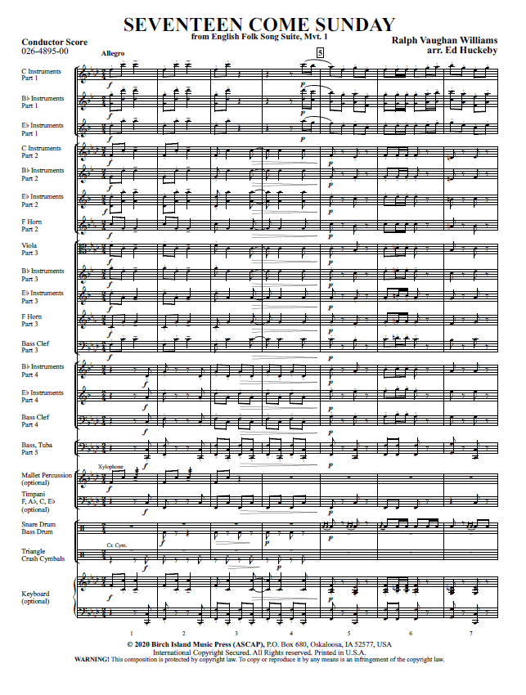
Figure 1. Five-Part Flex Score: M. 1-M. 7: Full Score: Mvt. I, Seventeen Come Sunday, Ralph Vaughan Williams’ English Folk Song Suite, arranged by Ed Huckaby, 2020. Used with permission of Birch Island Music Press.
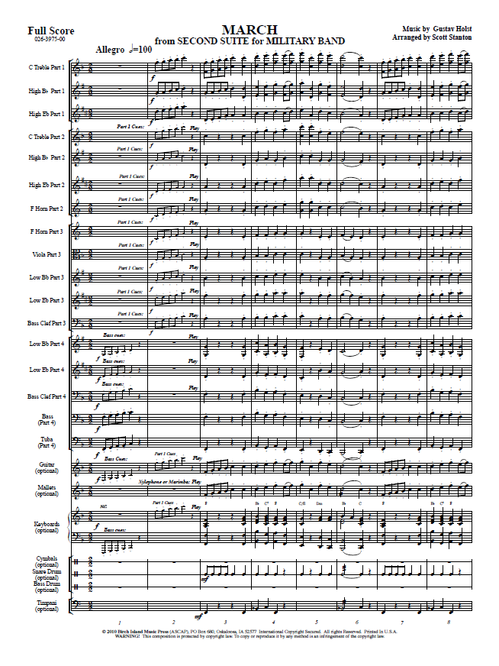
Figure 2. Four-Part Flex Score: M. 1-M. 8: Full Score: Gustav Holst’s March from Second Suite in F for Military Band, arranged by Scott Stanton, 2010. Used with permission of Birch Island Music Press.
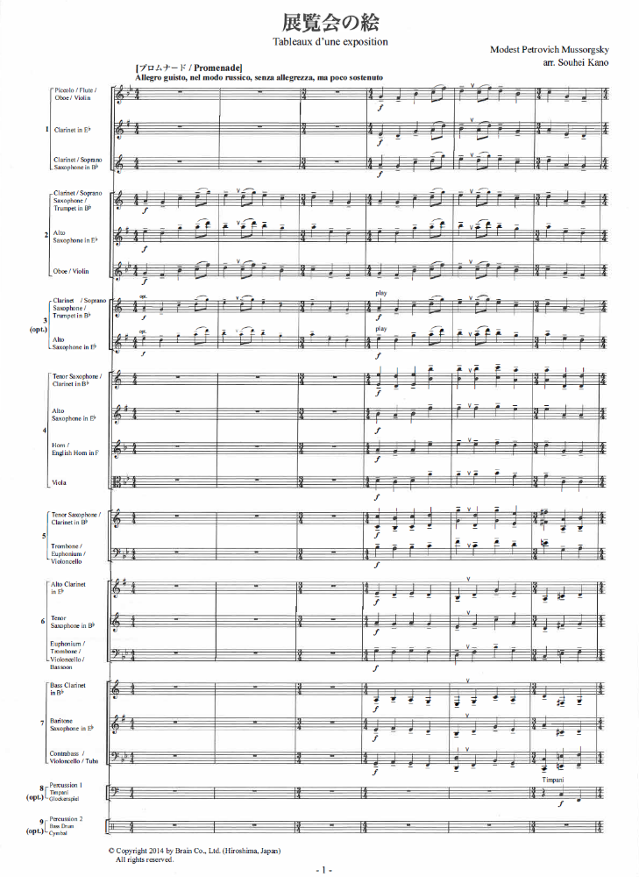
Figure 3. Seven-Part Flex Score: M. 1-M. 6: Full Score: Modest Mussorgsky’s Tableaux d’une exposition [Pictures at an Exhibition], arranged by Souhei Kano, 2014. Used with permission.

Full-Flex Scoring
The Creative Repertoire Initiative’s description of full-flex scoring indicates situations where this model of scoring could be preferred:
Full-flex pieces offer maximum flexibility by which any voice is playable by any instrument, making a fully-realized performance possible with any combination of instruments. These pieces are useful in situations where, for example, only flutes are present for rehearsal on one day, trombones on another day, and a mix of instruments on still another day. The full-flex approach was created in direct response to the need for radically adaptable pieces in the wake of the COVID-19 pandemic. Full-flex pieces by CRI composers include Pete Meechan’s Taking the Fifth, as well as Brian Balmage’s transcription of his Blude Ridge Reel, and Frank Ticheli’s transcription of his Simple Gifts.

Manhattan Beach Music, publisher for Frank Ticheli, a member of the CRI, uses the term ‘adaptable music’ to refer to full-flex scoring as seen in Figure 4. The Manhattan Beach Music website describes adaptable arrangements as quartets for any four or more instruments with the ability to mix and match. The publisher’s website also notes that adaptable music [full-flex scoring] is especially useful if a band’s instrumentation varies or is uncertain.
Reducing a full work for wind band to four parts will likely leave out many elements from the original work such as countermelodies and extended harmonies. The allowance for any instrument to play any of the four parts completely alters the sound colors of the original work. Thus full-flex scoring is more analogous to an arrangement. The goal of an arrangement is more or less creating a new work based on the original. An arrangement can have a wide scope of possibility ranging from “arrangements that perhaps match the original only in harmonic foundation and melodic inspiration, to projects that resemble their sources quite well, yet with intentional alterations in forms, keys, or other fundamental elements.” Depending on the original work, a full-flex setting may only match the original work in basic formal structure with basic melody and pared down harmonies. The full-flex model does not maintain the integrity of the original source material and as such is outside the scope of this project.

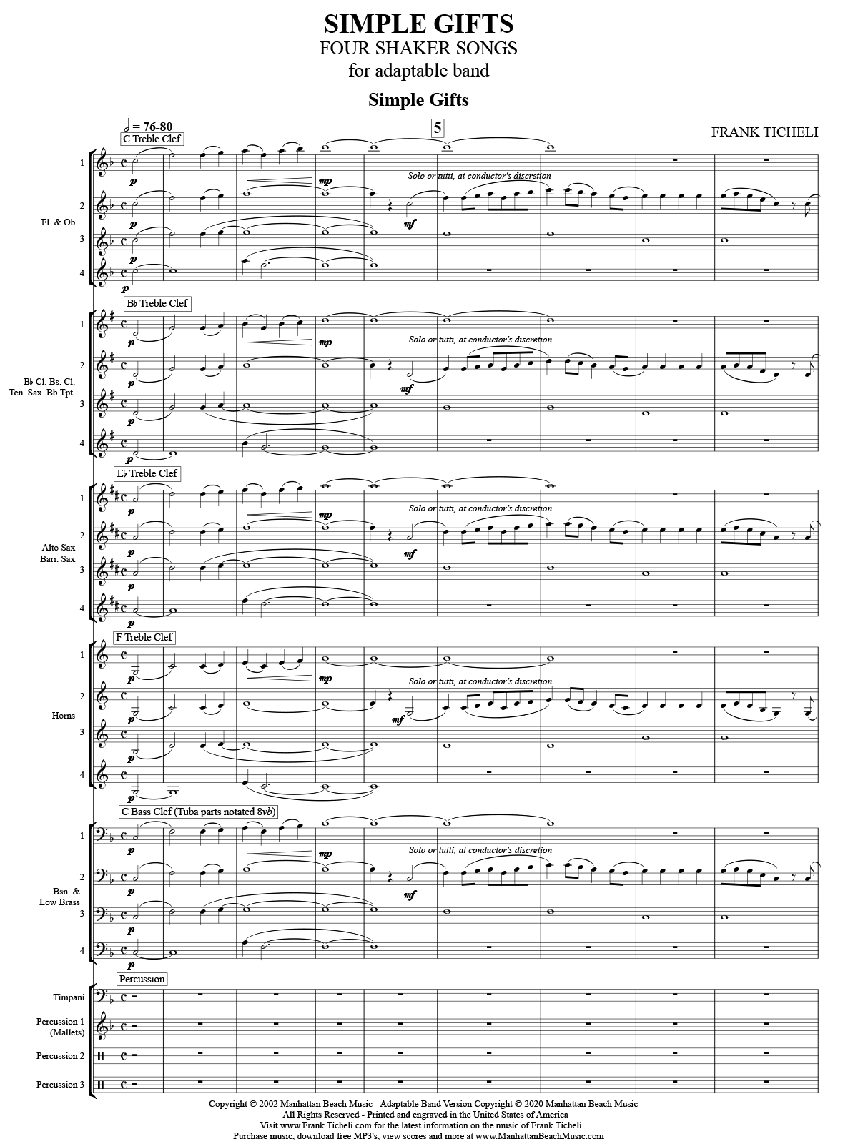
Figure 4. M. 1-M. 8: Full Score: Frank Ticheli’s Simple Gifts, Four Shaker Songs for adaptable band, 2020. Used by permission.

Modular/Cellular Pieces
The Creative Repertoire Initiative created a category of adaptable music for Modular/Cellular Pieces:
Modular/Cellular pieces are adaptable works written using motivic cells. Modular/cellular pieces may or may not contain elements of aleatory and/or improvisation, and may be played by ensembles of any size and makeup. Examples include Frank Ticheli’s In C Dorian (inspired by Terry Riley’s In C, and dedicated to that composer), Jennifer Jolley’s Sounds from the Gray Goo Sars-CoV-2, and Alex Shapiro’s electroacoustic Passages.

Few works beyond examples provided by the Creative Repertoire Initiative have been written since the beginning of the Covid-19 global pandemic. These works are highly adaptable for most combinations of instruments and often require only as many players as parts.
Composer Jordan Nobles wrote a series of works predating the Modular/Cellular Pieces category mentioned by the Creative Repertoire Initiative. Nobles’ Open Score Collection is a collection of open scores for variable or open instrumentation that fit within this category. Though these types of works are accessible for smaller bands with limited instrumentation, many of these works are indeterminate and not based on preexisting compositions. Modular/Cellular pieces are therefore outside the scope of this paper.

Improvisatory Pieces
Improvisatory Pieces are the final category within the Creative Repertoire Initiative’s umbrella of adaptable music. Fewer works have been written for this category than any of the previous. The Creative Repertoire defines these works as adaptable works based primarily on improvisation with the lone example of CRI composer Omar Thomas’s piece for young musicians, Sharp 9.” A search of the Wind Repertory Project’s database identifies five other works in the adaptable improvisatory category, some of which also qualify for inclusion in the Cellular/Modular category. Though accessible to small bands with limited instrumentation, this category of adaptable music is also outside the scope of this paper.

Chapter 4

Analyses of Selected Flex Score Works

English Folksong Suite
Introduction
English Folksong Suite by Ralph Vaughan Williams was composed in 1923. It was published in 1924 by Boosey and Hawkes and revised in 2008 by the publisher, fixing errata, adding rehearsal mark measure numbers, adding titles to each of the folk songs where they appear in the music, and replacing E-flat horns with F horns. This work is one of the earliest pieces written for wind band by a composer of international prominence. English Folksong Suite is considered by many to be part of the core wind band repertoire. It appears in the Ostling, Gilbert, and Towner studies on wind band compositions of high artistic merit, over twenty different state music educator association prescribed music lists, A Guide to the Top 100 Works in Grade IV, V, VI, and is regularly programmed by high school and university ensembles.
The five-part flex score setting of English Folk Song Suite was arranged by composer Ed Huckeby and published through C.L. Barnhouse Company’s Build-A-Band Series in the Fall of 2020. This setting published the original three movements separately:
- Seventeen Come Sunday from English Folk Song Suite, Mvt. 1
- My Bonny Boy from English Folk Song Suite, Mvt. 2
- Folk Songs from Somerset from English Folk Song Suite, Mvt. 3
Instrumentation
Table 1. English Folk Song Instrumentation
Setting: | Instrumentation:
Original Setting (2008 edition) | Piccolo  Flute  Oboe  E-flat Clarinet  B-flat Solo Clarinet  1st B-flat Clarinet  2nd B-flat Clarinet  3rd B-flat Clarinet  E-flat Alto Clarinet  B-flat Bass Clarinet  1st Bassoon  2nd Bassoon  E-flat Alto Saxophone  B-flat Tenor Saxophone  E-flat Baritone Saxophone  B-flat Bass Saxophone  B-flat Contra Bass Clarinet  Solo and 1st B-flat Cornet  2nd B-flat Cornet  B-flat Trumpet 1  B-flat Trumpet 2  1st & 2nd F Horn  3rd & 4th F Horn  1st Trombone  2nd Trombone  Bass Trombone  Euphonium  Tuba  String Bass  Percussion 1 – Snare Drum, Bass Drum  Percussion 2 – Crash Cymbals, Triangle, Timpani
Five-Part Flex Setting (2020) | Part 1  C Instruments – Piccolo, Flute, Violin, Guitar  B-flat Instruments – B-flat Clarinet, B-flat Soprano Saxophone, B-flat Trumpet  E-flat Instruments – E-flat Clarinet, E-flat Alto Saxophone  Part 2  C Instruments – Flute, Oboe, Violin  B-flat Instruments – B-flat Clarinet, B-flat Trumpet  E-flat Instruments – E-flat Alto Saxophone, E-flat Horn  F Horn  Part 3  Viola  B-flat Instruments – B-flat Bass Clarinet, B-flat Tenor Saxophone, Euphonium T.C.  E-flat Instruments – E-flat Alto Clarinet, E-flat Baritone Saxophone, E-flat Horn  F Horn  Bass Clef Instruments – Bassoon, Trombone, Euphonium, Cello  Part 4  B-flat Instruments – B-flat Bass Clarinet, B-flat Tenor Saxophone, Euphonium T.C.  E-flat Instruments Part 4 – E-flat Alto Clarinet, E-flat Baritone Saxophone  Bass Clef Instruments Part 4 – Bassoon, Trombone, Euphonium, Cello  Part 5  Tuba  Bass – String Bass, Electric Bass, Keyboard Bass  B-flat Bass T.C. – B-flat Bass Clarinet, B-flat Contrabass Clarinet, B-flat Tuba E-flat Bass T.C. – E-flat Contra Alto Clarinet, E-flat Baritone Saxophone, E-flat Tuba  Mallet Percussion (optional) – Bells, Xylophone, Marimba, Vibraphone  Timpani (optional)  Percussion – Snare Drum, Bass Drum, Triangle, Crash Cymbals  Keyboard (optional) – Piano, Electric Piano, Synthesizer, Accordion, Organ

The original instrumentation includes several instruments likely to be missing in smaller bands including oboe, E-flat clarinet, E-flat alto clarinet, B-flat bass saxophone, B-flat contrabass clarinet, bassoons, and multiple horns. The five-part flex score setting has specific options to cover all those instruments with the exception of bass saxophone, which, if available, could read the B-flat Treble Clef Part 5. Additional instruments not in the original setting, including mallet percussion, timpani, and keyboard (piano, electric piano, synthesizer, accordion, and organ), are listed as optional in the score. Additional instrumentation options within the five wind parts include guitar, violin, viola, and cello, instruments not in the original score or typical of wind band instrumentation.
Fundamentals
An examination of fundamentals of the five-part flex score setting of the first movement, “Seventeen Come Sunday,” reveals that the key signature, meter, and tempi are unchanged from the original. The overall form is slightly different in that the D.C. al Coda and Coda from the original have been written out through the addition of measures 130-162. Rehearsal suggestions by Ed Huckeby in the score reference the Coda, indicating the decision to write out the coda may have been made by the publisher.
The dynamics have been adjusted slightly throughout the first movement. The original dynamics throughout are almost always block dynamics for the winds with percussion playing at a dynamic level or two softer. After the four-bar introduction the dynamics decrease to piano instead of pianissimo at the start of the “Seventeen Come Sunday” melody. This change is likely a conscious decision with the thinner scoring of flex score settings. In measure sixteen of the original score, the dynamics drop to piano before the fortissimo at the pickup to measure eighteen. This change is not included in the flex score setting and may be an inadvertent omission. Dynamics at measure eighteen in the original score are fortissimo throughout the winds and forte for percussion. Here the flex score setting strives for balance, with the melody line retaining the fortissimo dynamic level and all other parts reduced to forte. The flex score setting retains the original dynamics throughout the “Pretty Caroline” section, beginning in measure thirty-one. Dynamics are adjusted for balance at the “Dives and Lazarus” section, beginning a measure before measure sixty-five. The upper woodwind part and low brass melody retain the original fortissimo dynamics while the rest of the wind parts are adjusted down a dynamic level. The return of the “Pretty Caroline” melody at measure ninety-eight retains the same dynamics. The dynamics of the written-out coda are adjusted with the same changes as discussed with the first appearance of the “Seventeen Come Sunday” melody. A poco ritardando not found in the original score is added to the last three measures, at what would have been the original coda.
The second movement, “My Bonny Boy,” retains the original key signatures, meters, tempi, and form. The dynamics remain the same with slight adjustments for balance at the Poco Allegro (Scherzando) “Green Bushes” section beginning in measure forty-three; the sustained dotted quarter notes are changed from pianissimo to piano. A ritardando not found in the original score appears before measure forty-three and another at measure ninety-four. The ritardando originally notated two bars before measure seventy-eight is moved three measures earlier to measure seventy-three.
The third movement, “Folk Songs from Sommerset,” retains the original key signatures, meters, tempi, and form. The block dynamics in the flex score setting remain the same as the original. Not notated in the original score is a ritardando added in measure sixty-seven, one measure before the Fine with the designation on “D.C. repeat only.” Unlike the first two movements of the flex setting, this movement retains the titles of each of the folk songs where they occur in the music as they appear in the 2008 Boosey & Hawkes edition of the score.

Orchestration
The original scoring is thick, doubling many parts throughout, lending itself better to transcription for a smaller ensemble. The four-measure introduction of the first movement begins with two ideas, one for high voices and the other for low, that are unison across the score save for octave displacements. This is captured in the flex score setting. The “Seventeen Come Sunday” section beginning in measure five features slurred quarter notes and sustained half notes tied to a quarter note in a legato style in the horns, bass clarinet, first bassoon, and tenor saxophone in contrast to the staccato melody and separated eighth notes of the lower saxophones, tuba, and string bass. The slurred quarter notes are retained in the flex score setting; however, in every instance the half notes tied to quarter notes are omitted through measure thirty-one, the end of the “Seventeen Come Sunday” section. In the “Pretty Caroline” section of the first movement the sustained harmonies provided by the alto saxophone and joined by trombones between measures thirty-three and forty-nine are omitted. In this section the tuba part is integrated into the second bassoon, bass saxophone, contrabass clarinet, and euphonium parts. The rest of the original wind parts with accompaniment figures are reduced into parts three and four. In the original setting those instruments have triadic harmony in the accompaniment played by B-flat clarinets, bass clarinet, first bassoon, and horns. In the flex score setting, the accompaniment is reduced to two parts. The choice of notes for the accompaniment here considers the part five bass line and melody in the first part to ensure that the full harmonies are present. The original melody designated in solo parts for solo clarinet and solo cornet are combined into a single part at measure thirty-three. The “Dives and Lazarus” section at measure sixty-five sees similar adjustments to the triadic harmony as played by the cornets and trumpets. The original four parts are reduced into parts two and three. The omitted note of each triad is accounted for in the melody in the low winds and upper woodwind countermelody. The sustained harmonic accompaniment of the horns is not present through this section. The return of “Pretty Caroline” in measure ninety-eight and of “Seventeen Come Sunday” in measure 130 retain the same orchestrational differences as previously discussed.
The second movement “My Bonny Boy” combines the oboe and first cornet solo into part two without a solo designation. The sustained accompaniment is split between parts three through five. The texture of the staggered entrances of the accompaniment in the trombone and horn parts is lost in the reduction to flex score beginning in measure seven. The same thinning of texture occurs in the sustained accompaniment beginning in measure twenty-four. The solo clarinet in measure forty that transitions to the “Green Bushes” section is split between the first and second parts without a solo designation. The piccolo and oboe solos are notated in the first and second parts without solo designation. The omission of solo markings in this movement can affect the density depending on the size of the ensemble and distribution of parts. In an effort to preserve some of the texture and color beginning in measure sixty-eight, the second and third parts have an optional divisi split to represent both the moving eighth note line and the sustained, tied dotted half notes in the accompanying parts. This change is carried through to the return of “My Bonny Boy” at measure seventy-eight. Another element missing in the texture of the accompaniment is the quarter note downbeats originally played by low saxophones, trombones, and tuba. Those parts are instead represented in the sustained tied dotted half notes of part five and the lower divisi of parts two and three.
The third movement “Folk Songs from Somerset” opens with a four-measure introduction beginning with unison woodwinds that are joined by horns, tuba, and bass in measures three and four. The unison woodwind parts are condensed into the first three parts with the horns, tuba, and bass combined into parts four and five. The folk song “Blow Away the Morning Dew” begins at measure five with the melody played by a solo cornet. This is not notated as a solo in the flex score setting but is represented in part two. The accompanying voices are represented in parts three through five. The alternation between solo writing with minimal accompaniment writing until the full ensemble tutti writing in measure twenty of the original score is less evident in the flex score setting. The folk song “High Germany” at measure twenty-nine is scored for tutti writing. Here the flex score captures all original parts but those of the alto saxophone and E-flat alto clarinet which should be doubling the melody played by the trombones and euphonium represented in part four. The return of the “Blow Away the Morning Dew” melody at measure forty-five is scored the same as it appears in the beginning of the movement. The transition to the next folk song, “The Tree So High,” begins in measure sixty-nine. All textures and parts are represented in the orchestration of this section. The unison melody is present in part one. The counter melody that appears in the trumpet parts in measure eighty-one is represented in part two. The staccato eighth note accompaniment is represented in parts three through five. The last section of the movement, “John Barleycorn,” begins at measure eighty-nine and features the saxophones, second trumpet, and low winds playing the melody while all other winds play a countermelody accompaniment. The melody is scored in parts four and five and the accompaniment in parts one through three. This mostly preserves the original orchestration with the exception of trumpets and alto saxophones not able to be included with the melody in parts four and five.

Other Issues
Another adaptation of English Folk Song Suite marketed as a grade 2.5 piece for “young band” as an “ideal choice for smaller and/or less experienced Middle School and High School ensembles” was arranged by Douglas Wagner. No cuts were made to the form of the piece; however, instrumentation, ranges, rhythms, key signatures, meters, and tempi are changed for accessibility of “less experienced” ensembles. Instruments likely to not be present in a small band with limited instrumentation are reduced to single parts and are doubled by other voices. Although the original form was retained, the Wagner setting is more of an arrangement in that it is a simplification based on the original score.
The flex score setting is much more faithful to the original score and qualifies as being a transcription rather than an arrangement in that it strives for authenticity. The four-to-five-part parameters of the Build-A-Band series is limiting for some textures of the original. The creative use of optional divisi in certain sections as discussed helps overcome some of those limitations. Careful consideration when assigning parts can also help offset remaining limitations of the condensed orchestration.

Performance Suggestions
In the first movement if trumpet is available to play part one, have the trumpet drop out at measure five and rejoin at measure eighteen to capture the original addition of cornets and trumpets. Depending on the number of players per part, it may be advisable to reduce the number of players per part from measures five to eighteen. The piano dynamic marking in measure seventeen present in the original score should be added. The solo at “Pretty Caroline” in measure thirty-three should be played by clarinet or trumpet if available; if ensemble numbers allow it could be played as a trumpet and clarinet duet as originally scored. The same is true for the solo at measure sixty and the subsequent solo at the return of “Pretty Caroline” at measure ninety-eight. The final “Pretty Caroline” solo is not designated as such in measure 125 but should be marked and played as such. At “Dives and Lazarus” in measure sixty-five, part one should be played by woodwinds with any clarinets taking the upper octave in the printed part.
The second movement does not designate solos for part two but should be treated as such. The melody is originally scored as a combined oboe and trumpet solo. Using either or both is appropriate and should be used if available. The original orchestration of accompaniment is very thin and exposed. Avoid doubling parts three through five at the start of the solo. If personnel allow for doubled brass and woodwinds on parts three through five consider alternating brass and woodwinds to better match the original accompaniment with brass playing from measures three through ten, woodwinds from measures ten through thirteen, brass in measures fourteen and fifteen, tutti for measures sixteen and seventeen, and brass for measures eighteen to twenty-two. With the fuller scoring at measure twenty-three, all could play through measure forty. The melody at measure twenty-three is best played by euphonium and any low reeds assigned to part four. The clarinet solo at measure forty that transitions to “Green Bushes” at measure forty-three is fragmented between parts one and two. This should ideally be played as a solo by clarinet. This can be achieved by giving both parts two a single clarinet player. If the solo is left split across parts, rehearse so the transition between clarinet players is seamless. “Green Bushes” from measures forty-three to measure fifty-eight is originally played by solo piccolo, oboe, and E-flat clarinet. If possible, this should remain with woodwind voices in a combination of piccolo and clarinet. A trumpet with straight mute may work to substitute the oboe voice but not at the expense of the balance of the ensemble. The eighth note accompaniment beginning in measure fifty-eight in parts two and three should be played by woodwinds with brass taking the lower sustained optional divisi. A voice left out of the melody at measure sixty is solo cornet. If available and ensemble size allows, a trumpet could be given the part four B-flat part to join the melody from measure sixty through measure seventy-seven.
The third movement does not indicate the original cornet solos present in part two. Part two should be treated as a trumpet solo in the “Blow Away the Mourning Dew” sections from the pick up to measure five through measure thirteen, the pick up to measure seventeen through measure nineteen, and the reprise of those solos at measures forty-five and fifty-seven. At the trio, the melody in part one should be played by woodwinds only. The final folk song “John Barleycorn” is thickly scored with tutti writing in the original score; no changes to the flex scoring are needed.

First Suite in E-flat for Military Band
Introduction
First Suite in E-flat for Military Band by Gustav Holst was written in 1909, premiered in 1920, and was first published in 1921. Wind band instrumentation was not standardized during this time, so parts exist for many instruments that are not in wide use today. The first full score was printed in 1948 with many more parts added by the publisher Boosey and Co. The 1984 Colin Matthews edition of the score “achieves a nice balance between the original version of Holst’s parts (playable by nineteen musicians) and the needs of the modern band by including the indication ad lib. on parts that are doubled and/or unnecessary.” First Suite in E-flat is considered the cornerstone of the wind band repertoire and appears in the Ostling, Gilbert, and Towner studies on wind band compositions of high artistic merit, state music educator association prescribed music lists, A Guide to the Top 100 Works in Grade IV, V, VI, and is frequently programmed by high school and university ensembles.
The four-part flex scoring of First Suite in E-Flat was arranged by composer Scott Stanton through C.L. Barnhouse Publication’s Build-A-Band Series released in separate movements between 2015 and 2017:
- Chaconne from First Suite in E-flat (2016)
- Intermezzo from First Suite in E-flat (2017)
- March from First Suite in E-flat (2015)

Instrumentation

Table 2. First Suite in E-flat for Military Band Instrumentation
Setting: | Instrumentation:
Original Setting (1984 Colin Matthews edition) | Piccolo  Flute  1st & 2nd Oboe  E-flat Clarinet  Solo B-flat Clarinet  1st B-flat Clarinet  2nd B-flat Clarinet  3rd B-flat Clarinet  B-flat Bass Clarinet  1st & 2nd Bassoon*  E-flat Alto Saxophone  B-flat Tenor Saxophone  E-flat Baritone Saxophone  B-flat Bass Saxophone  B-flat Contra Bass Clarinet  1st B-flat Cornet  2nd B-flat Cornet  B-flat Trumpet 1  B-flat Trumpet 2  1st & 2nd F Horn  3rd & 4th F Horn  1st Trombone  2nd Trombone  3rd Trombone  Euphonium  Basses  String Bass  Timpani  Percussion 1 – Side Drum, Bass Drum, Cymbal, Triangle, Tambourine
Four-Part Flex Setting (2015-2017) | Part 1  C Instruments – Flute, Piccolo, Violin  B-flat Instruments – B-flat Clarinet, B-flat Trumpet, B-flat Soprano Saxophone  E-flat Instruments – E-flat Alto Saxophone, E-flat Clarinet  Part 2  C Instruments – Flute, Oboe, Violin  B-flat Instruments – B-flat Clarinet, B-flat Trumpet  E-flat Instruments – E-flat Alto Saxophone, E-flat Horn  F Horn  Part 3  Viola  B-flat Instruments – B-flat Tenor Saxophone, B-flat Baritone T.C., Trombone T.C.  E-flat Instruments – E-flat Alto Clarinet, E-flat Baritone Saxophone, E-flat Horn  F Horn  Bass Clef Instruments – Trombone, Euphonium B.C., Cello, Bassoon  Part 4  B-flat Instruments – B-flat Bass Clarinet, B-flat Baritone T.C., B-flat Contrabass Clarinet, B-flat Tuba T.C.  E-flat Instruments Part 4 – E-flat Baritone Saxophone, E-flat Alto Clarinet, E-flat Tuba T.C.  Bass Clef Instruments Part 4 – Trombone, Euphonium B.C., Cello, Bassoon, String Bass, Electric Bass, Keyboard Bass  Tuba  Guitar  Keyboard – Piano, Electric Piano, Synthesizer, Accordion, Organ  Timpani, Triangle  Mallet Percussion – Marimba, Xylophone, Vibraphone, Orchestra Bells  Timpani (optional)  Percussion – Cymbals, Snare Drum, Bass Drum (or Drum Set)

The original instrumentation of First Suite in E-flat includes several instruments likely to be missing in smaller bands: oboes, E-flat clarinet, B-flat bass saxophone, B-flat contrabass clarinet, bassoons, and multiple horns. The four-part flex score setting has specific options to cover all those instruments with the exception of bass saxophone, which, if available, could read the B-flat Treble Clef Part 5. Additional instruments not in the original score including guitar, keyboard (piano, electric piano, synthesizer, accordion, and organ), and mallet percussion are listed as optional in the score. Additional instrumentation options within the four wind parts include violin, viola, and cello, instruments not in the original score or typical of wind band instrumentation.

Fundamentals
An examination of fundamentals of the four-part flex score setting of the first movement “Chaconne” reveals that the key signature, meters, tempi, and form are unchanged from the original. Numerous omissions and changes are apparent throughout the reduction to four parts which will be discussed in more detail in the examination of orchestration. The dynamics leading into measure thirty-three have been changed for balance; all parts crescendo to forte but the accompaniment immediately drops back to mezzo forte. A similar change is made at the end of the fourth variation leading into measure forty-one, the brillante section. The ensemble does not crescendo to a fortissimo, but to forte. At measure forty-one, the fifth variation, the entire ensemble dynamics are altered to mezzo forte. The running sixteenth note accompaniment over the eighth note ‘brass hits’ in the brillante variation of the chaconne melody is omitted. The change of dynamics for reasons other than balance, omission of the sixteenth note line in the brillante section, and change of orchestration to be discussed later, greatly impact the integrity of this flex score setting as a transcription. The original fortissimo dynamics of the fifth and sixth variations represent one of the two major climaxes for the entire movement and is lost with the change of dynamics and orchestration. The ninth variation at measure seventy-three loses the texture change of the original orchestration by retaining the same instrumentation from the previous variation at measure sixty-five. The eleventh variation in measure eighty-nine is played by the third and fourth part, completely omitting the sustained horn accompaniment line. The thirteenth variation in measure 105 omits the eighth note ascending and descending lines of the clarinets and saxophones in the wind parts.
The second movement “Intermezzo” retains the original key signatures, meters, tempi, and form. As in discussed with the first movement “Chaconne,” numerous omissions and changes are present in the reduction to four parts. The orchestration in the first twenty-four measures maintains the thinner texture of soloists with light accompaniment and will be discussed later. The opening tutti downbeat is originally marked pianissimo but is changed to piano. This may be to help achieve better balance in a smaller ensemble. Changes and omissions are more noticeable beginning at measure twenty-five with simplified rhythms and omitted lines. The composite eighth note ostinato accompaniment of the low reeds, euphonium, tuba, string bass, and timpani beginning at measure twenty-five are combined into a single part as quarter notes with an optional eighth note divisi. A repeated rhythm of four sixteenths followed by two eighth notes in the clarinets from measure twenty-nine through thirty-eight has been simplified to a dotted eighth sixteenth followed by two eighth notes in part one, an unnecessary change. The ascending sixteenth note run through the woodwinds in measure thirty-nine through forty-two is omitted; the reduction to four parts does not allow representation of all lines when the variety of textures is too numerous. At measure forty-three the texture is like that of the beginning however the flex score setting changes orchestration of which parts now covers the melody. Here the dynamic level of the melody is adjusted from piano to mezzo forte. The descending eighth note line in the low winds at measure forty-five is represented in part four but does not encompass the full three octaves spanned in the original score. The upper octave is eliminated. At the L’istesso tempo the solo bass clarinet counter melody figure in measure seventy-one is not represented in its entirety and is instead partially split between the third and fourth parts. The dynamic level of the solo melody at measure eighty-three has been adjusted from mezzo forte to piano. The moving eighth note accompaniment at measure eighty-three in the clarinets and saxophones is omitted from the wind parts, another instance where a four-part reduction does not allow representation all parts. The return to the first theme of “Intermezzo” at measure ninety-nine changes the orchestration of the melody and omits the sustained accompanimental harmonies in the oboes and horns. The second L’istesso tempo at measure 123 layers the opening theme and the sixteenth note woodwind figures found at measure twenty-nine. The sixteenth note woodwind figures remain simplified as discussed. The final four measures of the movement feature a motif consisting of the opening three notes of the “Intermezzo” theme that is passed from trombones, to horn, to cornet, oboe, and E-flat clarinet. The passing of this motif throughout the texture is not present in the flex score setting. The pianississimo dynamics in the last five measures have all been adjusted to pianissimo.
The fourth movement “March” retains the original key signatures, meter, tempi, and form. Dynamics are adjusted throughout, most noticeably reducing the extreme fortissississimo dynamics at the end of the movement to fortissimo. The homophonic textures throughout the march are better suited for flex score adaptation. To better preserve harmonies in the parts, optional divisi parts are written in the first, second, and third parts when needed. In the first three measures parts one and two have the sustained trill for woodwinds only in the C and B-flat parts along with the notated descending quarter note line underneath. Aside from instrumentation suggestions to be discussed in orchestration, every part is represented until measure seventy-one. The whole note found in the third clarinet, bass clarinet, tenor saxophone, and horns is omitted in the reduction to four parts. This whole note acts as a bridge from the previous phrase through the entrance of the oboes and E-flat clarinets leading the next phrase of the melody. Part two has optional divisi at measure ninety-seven to help realize the original harmonies. The reduction to four parts does not capture the added dissonances in the horns at measures 103-106. The extended harmony in these measures is only present in the keyboard part, an instrument not found in the original score. The three-note motif played by horns in measure ninety-five and ninety is omitted in the flex score setting as well as the subsequent iterations of the motif by the euphoniums and baritone saxophone at measures 100 and 104. The second and third iteration of the motif is represented in the mallet percussion part, an instrument not in the original score. The fourth iteration of the three-note motif in measure 106 is notated in part three. At measure 111 the descending quarter note line originally split between horn, trombones, euphonium, tuba, and strings bass is combined and notated in the fourth part. The crescendo beginning at measure 119 is notated in the first and second parts but is not found in parts three or four. The notated fortissimo dynamic at measure 123 is omitted and only part one has a notated forte dynamic marking. At measure 168, the upper octave E-flat and F notated in the piccolo, first cornet, and first trumpet have been omitted in the first part. In measures 177-178 the ascending eighth note triplet line in the woodwinds has been omitted from the wind parts but is represented in the mallet percussion and keyboard parts, instruments not in the original score.

Orchestration
As discussed in fundamentals, the first movement “Chaconne” displays numerous changes and omissions in the orchestration of the four-part flex score setting. The original chaconne theme is presented by euphonium, tubas, and string bass. The flex score setting notes “brass preferred” in the third and fourth parts, maintaining the integrity of the original score. In the second variation at measure nine, the addition of the second and third parts also denote “brass preferred” but are transposed down an octave from where it appears in the original score. As noted in measure twenty-five at the start of the third variation, the original rising arpeggiated accompaniment in the upper woodwinds has been reduced to static dyads in parts one and two with the designation “woodwinds preferred.” The rising arpeggiated accompaniment as it appears in the original upper woodwind parts is preserved in the mallet and keyboard parts; however, neither are instruments present in the original score. The cornet and first trombone solos in this section are represented in part three with both tutti and “woodwinds preferred” designations, losing the original timbres and textures. At measure forty-one, the fifth variation, the running woodwind sixteenth note accompaniment over the eighth note ‘brass hits’ variation of the chaconne melody is omitted. Measure forty-one indicates “woodwinds preferred” instead of tutti brass in the original score. The change of dynamics, omission of the sixteenth note line, and change of orchestration greatly impact the integrity of this flex setting as a transcription. The pesante section, the fifth variation at measure forty-nine, indicates “brass preferred” in parts one through three but does not indicate a change for parts four and five from the “woodwinds preferred” indicated previously at measure forty-one. Originally scored for clarinets and solo horn, variation seven at measure fifty-seven designates “solo woodwind preferred” in parts one through three with no other suggestions for instrumentation. The “solo woodwind preferred” marking is repeated for parts two and three at the start of the eighth variation at measure sixty-five with “solo flute preferred” in part one. The original scoring for variation eight is for solo flute, solo oboe, solo E-flat saxophone, and solo E-flat clarinet. The ninth variation at measure seventy-three does not specify preferred instruments, but a later tutti markings suggest the intent is for the solo preferred flute and solo preferred woodwinds markings to continue through this variation. The original scoring of the ninth variation is for solo flute, oboes, clarinets, E-flat alto saxophone, and horns. The change of texture is absent in the ninth variation by keeping the instrumentation as three solo instruments. The tenth variation in measure eighty-one specifies “solo brass preferred” in parts one and two and “brass preferred” in parts three and four, better preserving the original instrumentation of cornets and euphonium with the chaconne theme and low winds playing the quarter note ostinato. In the tenth variation the bass clarinet and tenor saxophone sustained harmonic accompaniment is omitted. The eleventh variation in measure eighty-nine is played by the third and fourth part with “brass preferred” designation, omitting the original sustained horn accompaniment line. The twelfth variation at measure ninety-seven reverts to tutti in all parts. In the original score the chaconne theme is played by solo cornet and solo euphonium with low winds sustaining a dominant pedal while second clarinet, alto saxophone, and second cornet play accompaniment and trombones provide sustained harmonic support. Without the nuance of the original scoring in the twelfth variation, the color change of the tutti of the thirteenth variation is lost. The thirteenth variation in measure 105 originally scores an eighth note ascending and descending line in the clarinets and saxophones over the chaconne theme. This eighth note line is not present in the wind parts of the flex score setting but is instead represented in the mallet percussion, keyboard, and guitar parts, none of which are found in the original score. The continued tutti scoring for variations fourteen and fifteen beginning at measure 114 is represented in the four-part reduction.
In the original score “Intermezzo” begins with a tutti brass downbeat followed by an immediate reduction of scoring to an eighth note accompaniment played by the E-flat clarinets with melody in the oboes, solo clarinet, and muted solo cornet. In the flex score setting, this texture is maintained with a tutti downbeat followed by a reduction of scoring with parts two and three designating “woodwinds preferred.” Part one designates solo “brass preferred, con sordino” in measure three. At measure nineteen, part one instructs to “add woodwinds” mirroring the original scoring with the addition of flutes, clarinets, and E-flat clarinets to the melody. Parts two and three designate “brass preferred” a change from the original scoring where second and third clarinets originally played the eighth note accompaniment. The original colors and texture at measure twenty-five are not well represented with tutti designations on all wind parts. The additive texture and color of the trumpets and trombones playing on the upbeat of beat two from measures twenty-eight to thirty-eight are not present because the parts are a combination of the cornet and horn parts represented in parts two and three. The return of the opening “Intermezzo” theme at measure forty-three is scored as it appears in the beginning with the addition of descending B-flat octave eighth notes in the low winds. In the flex score setting, the melody is moved to part three with tutti designation. The accompanying eighth notes are shifted to parts one and two while retaining the “woodwinds preferred” designation. At measure fifty-one, the accompaniment in parts one and two designates “brass preferred,” this time accurately mirroring the color change of the addition of first and second cornets to the eighth note accompaniment in the second and third clarinets. The L’istesso tempo at measure sixty-seven originally scores the new melody for the solo B-flat clarinet and is accurately represented in part one with solo “woodwind preferred” designation. The accompanying second and third B-flat clarinets are represented in parts two and three with “woodwinds preferred” designation. The addition of the first and second horns that join and mirror the clarinet accompaniment is not present in the flex score setting. As discussed in fundamentals, the solo bass clarinet line at measure seventy-one is split between the third and fourth parts. The solo bass clarinet line appears unbroken in the guitar and keyboard parts; however, those instruments are not present in the original score. The first part has instructions for all to play at measure seventy-six reflecting the addition of solo flute to the solo clarinet melody. At measure eighty-three the orchestration changes to solo cornet and euphonium taking over the L’istesso tempo melody. Part one has a solo “brass preferred” designation reflecting the solo cornet, but no lower part has the melody, omitting the original euphonium solo. The accompanying third through fourth parts are marked “brass preferred” reflecting the horn addition to the chordal accompaniment but leaves out the tenor and baritone saxophones as well as bass clarinet and bassoons. As discussed in fundamentals, the moving eighth note line in the B-flat clarinets is omitted. At measure ninety-nine the opening “Intermezzo” theme returns. The scoring is changed here with solo euphonium playing the melody, second and third clarinets playing the eighth note accompaniment, and oboes and horn playing sustained harmonies. The flex score setting places the melody in the third part with the designation “woodwinds preferred,” fundamentally changing this section. The first and second parts covering the eighth note accompaniment designate “woodwinds preferred.” As discussed in fundamentals, the sustained oboe and horn parts are omitted. At measure 109, all parts have a tutti indication however oboe, baritone saxophone, trumpets, and low brass are not present in the original score. At measure 117 designates solo “brass preferred” in part one playing the last six measures of the opening “Intermezzo” theme and “woodwinds preferred” in parts two and three playing the accompanying eighth notes. The original scoring in measure 117 features oboes, solo clarinet, and solo cornet playing the melody with E-flat clarinets playing the eighth note accompaniment. The second L’istesso tempo at measure 123 places the melody in bass clarinet, tenor saxophone, baritone saxophone, and euphonium. The flex score setting places the melody here in part three with “woodwinds preferred” designation. The original sustained harmonic accompaniment played by horns in this section is placed in the first and second parts with a “woodwinds” indication, combining at times with the original clarinet lines. The interjections of the opening “Intermezzo” theme in measures 128 and 132 are originally scored for oboes, E-flat clarinets, and solo cornet; in the flex score setting these interjections are notated in part one with a “brass” designation. The piccolo solo in measure 140 is notated in part one with “piccolo preferred” and “woodwinds preferred” for the B-flat and E-flat parts. In measures 141-142 the ascending eighth note line in the euphonium, bassoons, and clarinets is split between parts two, three, and four with no instructions for instrumentation in parts three and four and “woodwinds preferred” in part two. The final note, originally played by flutes, oboes, clarinets, euphonium, and tuba, is notated in all four parts with a tutti in part one and “woodwinds preferred” from the previous measure in part two. Parts three and four have no further suggestions for instrumentation.
As discussed in fundamentals, the fourth movement “March” is better suited for flex score adaptation due to the predominant homophonic textures throughout. In the first three measures the flutes, oboes, and clarinet have a sustained trill represented in parts one and two as “trill for woodwinds only” in addition to the original descending quarter notes originally in the brass. Measures four through thirty-nine are originally scored for only brass and battery percussion; however, the flex score setting does not indicate “brass preferred” at measure four in any of the wind parts. At measure thirty-seven, part two indicates “brass preferred.” The second theme beginning in measure forty is played by clarinets, low reeds, alto and tenor saxophones, and horns and is represented in parts one and two with a “woodwinds preferred” designation. The baritone saxophone and euphonium harmonic accompaniment in this section is represented in part three. The addition of cornets, trumpets, and trombones at measure seventy-eight is not represented in the flex score setting, losing the change of color and texture. Measure eighty-nine is scored in primarily in the woodwinds with addition of the horns; here the flex score setting designates “woodwinds preferred.” At measure ninety-seven the original scoring shifts back primarily to brass with melodic material and woodwinds sustaining under the moving quarter note line of the first cornet. This section is notated as “brass preferred – optional divisi” in the flex score setting. Starting at measure 109 the dialog between the brass and woodwinds is notated in the flex score with “brass preferred” at measure 109, “woodwinds trill (optional)” at measure 111, “brass preferred” at measure 113, and “add woodwinds trill (optional)” at measure 115. In measures 111-112, the descending quarter note line is originally split between the horns and first and second trombone in measure 111 and continues in measure 112 with third trombone, euphonium, tubas, and string bass. As mentioned in fundamentals this descending line is combined in part four. At measure 117, the flex score setting designates “woodwinds preferred” in part one two bars earlier than necessary; in the original score the change to a woodwind dominated color begins in measure 119. From measures 123 to the end, the original scoring is for full band with brass and woodwinds playing the two layered themes of the march according to their respective ranges. The flex score setting make some scoring suggestions of “woodwinds preferred” at measure 147, “brass preferred” at measure 154, “woodwinds preferred” at measure 163, and then “all play” at measure 169. As discussed in fundamentals, the ascending eighth note triplet run beginning in measure 177 from tenor saxophones up to piccolo in the score has been omitted from the wind parts but is represented in the mallet percussion and keyboard parts, instruments not in the original score.

Other Issues
No other published settings of the First Suite in E-flat exist in an adaptable model. Themes from First Suite in E-flat was arranged by Michael Sweeney 2006 for young band. This arrangement changes the formal structure of “Chaconne,” omitting several of the variations. The second movement is also omitted. First Suite in E-flat has been transcribed numerous for brass quintet. Transcribing for the five parts of a brass quintet is not unlike reducing the scoring for a flex score model. Brass quintet transcriptions by Kenneth Abeling, David Bussick, and Geoffrey Bergler maintain several important lines such as the sixteenth note woodwind counterpoint in the brillante section of “Chaconne” omitted in this setting.
This four-part flex score setting omits several key parts and changes figures and instrumentation throughout for simplification. This setting qualifies as being an arrangement rather than a transcription in that changes are made to the structure and musical gestures for simplification. The four-part parameter of this setting is limiting for many of the lines, textures, and colors found in the original. The creative use of optional divisi in some parts as discussed helps overcome some of limitations for harmonic depth; however, other limitations are at times too great to be overcome with only four parts.

Performance Suggestions
In the first movement utilize tuba and euphonium, if possible, for the first statement of the chaconne theme. Trumpets should join in at measure eight in parts one and two; trombone should join in or take over part three. At measure seventeen the two quarter notes in part two should be slurred. At measure seventeen, if enough B-flat clarinets are available have them play parts one, two, and three. Alto saxophone should play part three and bass clarinet and baritone saxophone can cover part four. At measure twenty-five have only trombone or euphonium play part three instead of adhering to the tutti designation. Any available flutes assigned to part one could play the mallet part from measure twenty-five through measure thirty, transposing up the octave in the last two measures, to help retain the original arpeggiation not present in the wind parts. Keep parts one and two limited to woodwinds until measure thirty-one before reverting to tutti. At measure forty-one change the dynamics to fortissimo and have brass join the woodwinds in parts one through four. Omit the snare drum playing on the rim and have the snare double the bass drum rhythm. To fix the brillante section at measure forty-one, a couple of strong B-flat clarinet players and an alto saxophone player could be given original parts in the public domain and freely available the Petrucci Music Library online to cover the sixteenth note counterpoint omitted in this setting. Dynamics in the pesante section at measure forty-nine should be adjusted back to fortissimo with a diminuendo two measures before fifty-seven. At measure fifty-seven, clarinets should play parts one, two, and three if available; a horn could also double the chaconne theme in part two as in the original if available. At measure sixty-five, flute should play part one and alto saxophone should play part three. Part two could be played by either oboe or B-flat clarinet adjusting the octave upward where necessary. At measure seventy-three, add B-flat clarinet to part one. Here horn and an alto or tenor saxophone should play the inverted chaconne theme in part three. At measure eighty-one, trumpets should cover parts one and two. Part three is marked “brass preferred” but would be more authentic to the original score if bass clarinet and or tenor saxophone play here. Measure eighty-nine should have trombone and or horns take over part three. In the twelfth variation at measure ninety-seven, have cornets cover the chaconne theme in part one reverting to tutti at measure 105. At measure 105, the omitted eighth note clarinet and saxophone line could be covered by a B-flat clarinet and alto saxophone players with the original parts employed earlier in the brillante section. The ritardando at measure 122 should be notated and performed ritardando al fine.
In the second movement, all brass should play the downbeat regardless of part. Parts two and three should be covered by clarinets if possible. The solo in part one should be played by trumpet with mute but could be doubled by a clarinet as in the original score. At measure nineteen, ignore the “brass preferred” designation in parts two and three and keep clarinets until the tutti at measure twenty-seven. In part one, the dotted eighth sixteenth rhythm at measure twenty-nine can be altered to match the original four sixteenth note arpeggiation by changing the dotted eighth to a descending arpeggio of G, E-flat, and C. Similar changes can be made from measures thirty-three to thirty-eight. As discussed in fundamentals, the ascending sixteenth notes at measure thirty-nine through forty-two in the original score are omitted from the flex setting. This sweeping gesture is not able to be covered because of the multiple instrument changes as the line ascends in register. At measure forty-three, the melody in part three should be played by a trumpet and could be doubled by a B-flat clarinet; parts one and two should be played by clarinet. In measure forty-three descending eighth note figures in part four could be split to match the original scoring with euphonium playing the first two notes and tuba playing the last two of these figures. At measure fifty-eight, parts one and two designate “woodwinds preferred.” Trumpets can softly double B-flat clarinets here to match the original scoring of the cornets. The melody is now in part three and should follow the tutti designation. The part one “solo woodwind” at the L’istesso tempo at measure sixty-seven should be played by clarinet. Parts two and three would be best played by clarinets to maintain the integrity of the original scoring. At measure seventy-six, part one is marked “play.” Have a flute join the clarinet soloist here. The melody in the first part at measure eighty-three should be played by solo trumpet. Originally, it is scored for both solo cornet and euphonium. If a euphonium player is available and can read the B-flat treble clef part one, then consider doubling the euphonium for this solo section. Parts two, three, and four are marked “brass preferred” but could have bass clarinet, bassoon, tenor saxophone, or baritone saxophone double any of those parts. The moving eighth note line originally in the B-flat clarinets and joined by saxophones could be covered by a strong clarinet player and saxophone player switching to the original parts here. If not possible, this moving line is covered in the mallet percussion part. Though the marimba is not in the original scoring, it is not a bad choice to replace this clarinet line through measure ninety-eight with soft mallets. At measure 100, the melody in part three is marked “woodwinds preferred” but should be played by euphonium; parts one and two should again be played by clarinets. At measure 117, the solo “brass preferred” in part one should be played by muted trumpet. The L’istesso tempo theme beginning in measure 123 is marked “woodwinds preferred” but could be doubled by euphonium here. The “brass” designation in part one at measures 128 and 132 should be trumpets adding to the woodwinds in those measures. The dotted eighth note rhythms in measures 127, 131, and 136-138 in part one could be adjusted to play the original arpeggiated figures as discussed in measure twenty-nine.
In the beginning of the third movement, the descending quarter notes should be played by brass while as many woodwinds as available on parts one and two play the woodwind trill. The movement should continue with brass only on all wind parts until measure forty where “woodwinds preferred” is notated in parts one and two. If available, a horn could double the melody on part two at measure forty. Measure eighty-one designates tutti in parts one and two but could remain as woodwinds and horn. At measure ninety-seven, the wind parts indicate “brass preferred – optional divisi.” This should be adhered to. Woodwinds on parts two and three can play all the tied whole notes beginning in measure ninety-nine. At measure 109, follow the marked instrumentation suggestions. At measure 117, the flex score setting indicates “woodwinds preferred.” This should only be applied to part one. Part three here should be played by trumpets taking the upper octave split. From measure 123 to 153, have the full ensemble play tutti, ignoring the “woodwind preferred” suggestion at measure 147. The “brass preferred” at measure 154 can be altered to omit only flutes until measure 162. The “woodwinds preferred” at measure 163 can be changed to retain the tutti scoring with the addition of flutes. The last two notes of measure 168 in part one can be taken up an octave by piccolo, flute, and trumpets, all others doubling part one should remain as written. To capture some of the ascending eighth note triplet line omitted from the woodwinds in the last three measures any flutes and oboes available can be given the mallet keyboard part for measures 178-179.

Dancing Fire
Introduction
Dancing Fire by Kevin Day was written in 2016. As a work written in the last five years, this work appears on only one state festival list, the Washington WIBC top 100 list from 2018. Dancing Fire has a documented performance at the 2020 CBDNA Southwest Division conference and over eighteen performances by university ensembles in the last two years. Not only does this piece represent a new work of the last five years that meets the criteria for inclusion of a quality work adapted for flexible scoring, but it also represents a work by a composer of color, a historically underrepresented category of composers in the wind band genre. The flex score setting of Dancing Fire was arranged by Josh Trentadue in 2020 and has nine documented performances by university ensembles in the spring of 2021. Both the original and flex score settings are published through Murphy Music Press.

Instrumentation
Table 3. Dancing Fire Instrumentation
Setting: | Instrumentation:
Original Setting (2016) | Piccolo  Flutes 1, 2, 3, 4  Oboes 1, 2  E-flat Clarinet  B-flat Clarinet 1, 2, 3  Bass Clarinet  B-flat Contra Bass Clarinet  Bassoon  Contrabassoon  B-flat Soprano Saxophone  E-flat Alto Saxophone  B-flat Tenor Saxophone  E-flat Baritone Saxophone  B-flat Trumpet 1, 2, 3, 4  Horn 1, 2, 3, 4  Trombone 1, 2, 3  Bass Trombone  Euphonium  Tuba  Double Bass  Harp  Piano  Percussion - Marimba, Timpani, Glockenspiel, Xylophone, Vibraphone, Bass Drum, Suspended Cymbal, Drum set and Auxiliary (Bongos, Triangle, Cabasa, Claves, Conga)
Five-Part Flex Setting (2020) | Part I  Piccolo 1  Flute 1 + 2  Oboe 1  E-flat Clarinet  B-flat Clarinet 1  Soprano Saxophone  B-flat Trumpet  Violin 1 (optional)  Part II  Piccolo 2  Flute 3 + 4  Oboe 2  B-flat Clarinet 2  Alto Saxophone 1  B-flat Trumpet 2  Violin 2 (optional)  Part III  B-flat Clarinet 3  Alto Saxophone 2  Horn 1  B-flat Trumpet 3  Violin 3 (optional)  Viola (optional)  Part IV  English Horn  Bassoon 1  Tenor Saxophone  Horn 2  Trombone 1  Euphonium 1  Violoncello (optional)  Part V  Bassoon 2  Contrabassoon  Bass Clarinet  Contrabass Clarinet  Baritone Saxophone  Bass Saxophone  Trombone 2  Bass Trombone  Euphonium 2  Tuba  Double Bass (optional)  Bass Guitar  ADDITIONAL INSTRUMENTS IF AVAILABLE  Piano  Harp  Keyboard Synthesizer  PERCUSSION LIST  All percussion is entirely optional. If parts can be assigned, preference should be given to timpani and auxiliary percussion.  Timpani, Marimba, Glockenspiel, Xylophone, Vibraphone, Bass Drum, Suspended Cymbal, Drum Set (snare, kick, hi-hat), Auxiliary Percussion (ONE PLAYER: Bongos, Triangle, Cabasa, Claves, Conga)  A Keyboard Synthesizer can also cover any of the mallet parts at your discretion. Backing tracks for the percussion/additional instruments, and click tracks, are available upon request.

The original score features several instruments likely to be absent in smaller band programs including oboes, E-flat clarinet, contra bass clarinet, bassoon, contra bassoon, soprano saxophone, multiple horns, bass trombone, double bass, harp, and piano. The five-part flex score setting has specific options to cover all those instruments. Instruments not in the original setting, including violins, viola, and cello, are listed as optional in the score. The string parts mirror the five wind parts. Piano, harp, and keyboard synthesizer parts are included with the note “if available.” Additional instrumentation options not in the original setting within the five wind parts include bass saxophone and bass guitar. All percussion is listed as optional with the note that preference be given to timpani and auxiliary percussion. The publisher offers backing tracks with percussion and additional instruments if needed. The flex score setting provides suggestions for the instrumentation list by the arranger:
The following suggested instrumentation list is…divided into the five parts each of these instruments has been assigned. Any combination of instruments at your discretion, as long as they each fulfill the five different parts, can be used to perform this work. Additional parts fulfilling another role are available upon request (ex: Bass Clarinet on Part IV instead of V).

Experimentation with this piece’s orchestration is highly recommended. Use what available resources you have and get creative with color and texture...These experimentations can be used as a learning tool for your rehearsals and performances in how color and texture can change with even the smallest difference in orchestration…To that end, this version of the piece can be used as an endless sea of experimentation and creative possibilities for you and your students, no matter what the performance situation or instrumentation may be.

The notes on suggested instrumentation in the score suggest this setting is more aligned with that of an arrangement rather than a transcription; however, the program notes provide more insight from Trentadue on his goal for adapting Dancing Fire for five-part flex score.
The integrity of Kevin’s original composition has been preserved as much as possible, with the passages deemed most important arranged into each of the five parts. Meanwhile, the palette of colors and textures has been expanded to bring this piece into a new realm of opportunities and experimentation (including optional parts for strings and synthesizers, if available). Finally, the piano, harp, and mallet percussion parts have also been expanded to preserve many of the accentuations and harmonic textures guiding the original version of this piece.

The extent to which this flex score setting woks as an authentic transcription of the original setting, and suggestions to help make it so, will be explored further in fundamentals, orchestration, and performance suggestions.

Fundamentals
An examination of the fundamentals of the five-part flex setting of Dancing Fire reveals that the form, key, meter, tempi, and meter changes remain unchanged from the original setting. Few changes and additions were made to dynamics. The low reed figure in measures four and five is standardized to mezzo piano in parts four and five. In the original setting, bassoon and contra bassoon have a mezzo forte dynamic while baritone saxophone and piano doubling the figure are marked mezzo piano. The only other dynamic changes are the addition of dynamics defining the ends of crescendos. In the original setting, some crescendos, such as those found in measure 117, do not define the ending dynamic.
As stated in the program notes, Trentadue expands piano, harp, and melodic percussion parts into the five wind parts. Piano, harp, and xylophone parts are doubled and split between parts one through four in the first sixteen measures. Newly composed material in the harp at measure 130 and doubled by synthesizer with brass patch at measure 133 helps to fill out some of the harmonic texture of the section. The euphonium eighth note ostinato in measures 137-144 is omitted and not represented in any of the wind, percussion, or string parts. This is the only part from the original setting not represented in some way in the flex score setting. In the original setting piccolo, flutes, and E-flat clarinet double the piano, xylophone, and vibraphone at measure 161. This doubling is omitted from the wind parts in the flex score setting. All other original parts are represented in a combination of the five wind parts, optional keyboard parts, and percussion.

Orchestration
Performance notes in the score provide insight to the detailed instructions present in the wind parts throughout the piece.
References are given in the five parts for octave transpositions (optional or otherwise), omissions (based on the suggested instrumentation provided), and cued passages (ex: if a part is doubled, the cues should not be played if possible). Certain passages have been cued in individual instrumental parts if necessitated for performance and omitted in others if absolutely necessary (ex: if ultimately too high or low for a specific instrument).

The opening figure originally scored for flutes, oboes, B-flat clarinets, alto saxophones, and trumpets is scored in parts one through four. Part four includes an instruction to omit trombone one. The xylophone line in measure five is doubled in part one. The harp in measure six is doubled in part four with parts two and three filling out the harmony on beat. The xylophone quadruplet accompaniment is doubled in part one from measure seven to sixteen with a brief interjection of the piano line in measure eight. The harp and piano figures are passed between parts three through five until measure seventeen. At measure seventeen, the melody is played by flutes and the saxophone section; in the flex setting the melody is represented in parts one through four with octave doublings in part one. Part five covers the bassoon counter melodic material at measure nineteen. Orchestration at measure twenty-three changes to a tutti brass texture in the original score; no change of instrumentation is specified in the flex score setting. At measure twenty-seven, the original scoring reverts to the saxophone section with euphonium doubling instead of flute. Euphonium drops out of the texture at measure thirty-one. No specific instrumentation suggestions are given to account for the euphonium or changes of woodwind texture through measure forty-three. Part four indicates “trombone 1 gliss.” at measure forty-three. Additional trombone glissandos are specified at measure forty-six in parts four and five. In measure fifty the E-flat clarinet line is represented in part one with the instructions “if doubled, solo.” The ascending and descending sixteenth note line in the flutes, oboes, E-flat and B-flat clarinets, and saxophones at measures fifty-seven and fifty-eight are represented in parts one and four. Part four clarifies “trombone 1, no slurs.” The trombones all play the descending eighth note line represented in parts two, three, and five. At measure sixty-one parts one and two instruct to use muted trumpets. The triplet figures in the flutes from measures sixty-one to sixty-eight are not represented separately from the muted trumpet figures in parts one and two. The sustained harmonies of the trombones, tuba, and double bass in this section are only fully represented through the use of divisi; parts four and five instruct “if doubled, split.” The horn melody in measure sixty-eight is represented in part three. In measure seventy-nine the descending sixteenth note figure in marimba and xylophone is doubled and split between the first and second wind parts as well as doubled in the synthesizer part. At measure eighty, the piano ostinato is doubled in part five. Solo lines in oboe and tenor and baritone saxophones in measure eighty-two through eighty-four are represented in parts two through four with the indication “if doubled, solo.” The soprano saxophone solo beginning in measure eighty-seven has the same “if doubled, solo” designation and notes senza sordino for trumpet. Low reeds join the piano ostinato in measure eighty-six. This texture change is represented in parts three and four beginning two measures later in measure eighty-eight. Part three instructs “horn 1 stopped” while part four instructs “trombone 1 mute” possibly in an attempt to loosely imitate the timbre of bassoons in the absence of low reeds. Parts two through four have an open marking for horn and senza sordino markings for trumpet and trombone at measure 100 just before the end of the part one solo in measure 103. In the next section beginning at measure 104, the flute solo is represented in part two with the woodwind accompaniment represented in parts one, three, four, and five. Measure 113 has notes to omit the trumpet in part three if needed for a mute change; the same marking is made for the end of the part two solo at measure 115. The solo flute melody is joined by oboe in measure 118 in the original score. In the flex score setting, the joint flute and oboe melody is moved to part one. At measure 118 the muted trumpet figures split between trumpet parts are combined into part two. The stopped horn crescendos are represented in part three with markings for “horn 1 stopped” and “trumpet 3 mute.” Flutter tonguing notation not found in the original score is added to each of the half note crescendos in part three through measure 126. The scoring moves to tutti brass texture at measure 130. The flex score directs “senza sordino” for parts two and three and the synthesizer part marks “+ brass patch, if possible.” Piano is added doubling the trombone accompaniment while the harp is given new material that plays the same trombone harmonies with a simplified rhythm. As mentioned in fundamentals the eighth note euphonium line at measure 137 has been eliminated. The running sixteenth note line in the saxophones is represented in part two. At measure 117 the texture returns to full ensemble with part one representing the piccolo, E-flat clarinet, and trombones. Part two covers the main melody now played by flutes, oboes, B-flat clarinets, soprano and alto saxophones, and trumpets. The tenor and baritone saxophones and horns are represented in part three, the euphonium and bassoon line in part four, and the contra bassoon, contra bass clarinet, tuba, and string bass in part five. This tutti scoring continues until measure 161. As discussed in fundamentals, the doubling of the piano by flutes and E-flat clarinet has been omitted. The whole notes originally in the trumpet parts are placed in parts one and two. The horn melody is represented in part three. The “horn calls” in the horn, soprano saxophone, and alto saxophone parts in measures 165 to the end are represented in part four. The final sixteenth note triplet runs in the woodwinds are placed in parts one and two.
Overall, the densities and textures are preserved in this flex setting with the exception of two points previously discussed. Expanded melodic percussion, synthesizer, and harp parts add to the texture without detracting from the original scoring. The fragmented doubling of piano and xylophone parts in the upper winds preserves some of the important textures. This is especially important if the original harp, piano, and xylophone parts cannot be otherwise played. The scoring and added instructions are flexible enough that the majority of the original tone colors can be preserved. None of the original material transcribed into the five wind parts has been simplified or altered significantly. This five-part flex setting can accurately be classified as a transcription based on its ability to maintain the integrity of the original scoring. Instrumentation choices made by the conductor or as constraints of the ensemble can change the performance from that of a transcription to an arrangement.
Other Issues
There are no other transcriptions of this work. A great reference for this flex score setting of Dancing Fire is a multi-track YouTube performance by the combined Seraph Brass and WindSync ensembles uploaded in May 2021. The instrumentation for this combined ensemble is made up of one flute, one oboe, one B-flat clarinet, one bassoon, three B-flat trumpets, two horns, one trombone, one tuba, and a percussion backing track. This digital performance illustrates how effective this flex setting can be with as few as two wind players per part.

Performance Suggestions
The suggested instrumentation thoroughly accounts for the original scoring. If ensemble instrumentation allows assign flutes to parts one and two (give priority to part one), B-flat clarinets and trumpets to parts one through three, alto saxophone to parts two and three, horns to part three and four (give priority to part three), tenor saxophone, euphonium, and trombone to part four, and any low reeds, trombone, and tuba to part five. Follow the percussion suggestion giving priority to timpani and auxiliary percussion. If more percussionists are available give priority to xylophone and drum set. A mallet midi controller such as the malletKat might be considered to switch between xylophone, marimba, and the additional keyboard synthesizer part.
In the beginning, have all play in parts one through three and only tenor saxophone in part four. In measure four, have tenor saxophone in part four and any low reeds play, omitting brass. The xylophone figure placed in part one should be played by woodwinds as well as the harp figure in part four at measure six. Assign the quarter notes beginning at measure seven in parts three through four to brass while keeping the interjecting sixteenth note figures transcribed from piano and harp assigned to woodwinds. At measure seventeen, have flutes and saxophones play the melody in parts one through four. Measure twenty-three through twenty-six should be played by brass only. At measure twenty-seven, revert to saxophones in parts two through four, adding a euphonium in part four if available. Here part five can be played tutti. As part one adds into the texture at measure thirty, have flutes and clarinets play. Brass should take over the texture at measure forty-two with clarinet or flute playing the solo lines in part one. The sixteenth note runs beginning in measure fifty-seven in parts one and four should be played by woodwinds; all other parts here should be played by brass and low reeds. At measure sixty-one, parts one and two have a note for muted trumpets. Adhere to this marking; however, any eighth note triplet figure in part one should be doubled by flute and clarinet through measure seventy-five. Assign the melody in part three at measure sixty-eight to horn if available. Through this section parts four and five can remain tutti. The xylophone figure fragmented in measure seventy-nine across parts one and two can be assigned to woodwinds. Beginning at measure eighty-two, there are three measures of solos split between parts three, two, and four. Have alto saxophone, muted trumpet, and tenor saxophone play those respectively. The extended soprano saxophone solo beginning at measure eighty-seven could be played by B-flat clarinet if soprano saxophone is not available. This will allow for the color change of the solo melodic line at measure 105. Take care to balance the accompaniment underneath these solos, limiting parts one to three to one on a part with preference given to woodwinds. Have only brass play measures 102-103 and then only woodwinds at measure 104. As discussed, the melody moves to part two in measure 105 and should be played by flute with muted trumpet joining at measure 118. Follow the suggestions for muted trumpet and stopped horn in parts two and three. At measure 130, have brass only play. At measure 137, have B-flat clarinet and alto saxophone play the running sixteenth note line in part two. Have low reeds join in with the rest of the brass in parts four and five. B-flat Trumpet should play part one in measure 141. All should play at measure 145 to the end. Horn should play the “horn calls” in measures 165-171 in part four. If only one horn is available to play, that horn should switch from part three to part four from measure 161 to the end.

Two Movements from Lincolnshire Posy
Introduction
Lincolnshire Posy by Percy Grainger was written in 1937 and is considered a masterwork from the early wind band repertoire. This work appears in the Ostling, Gilbert, and Towner studies on wind band compositions of high artistic merit, state music educator association prescribed music lists, A Guide to the Top 100 Works in Grade IV, V, VI, and is frequently programmed by university ensembles with numerous documented performances at major conferences. The original work consists of six movements based on English folk songs collected and arranged by Percy Grainger for military band:
“Lisbon” (Sailor’s Song)
“Horkstow Grange” (The Miser and his Man – a local Tragedy)
“Rufford Park Poachers” (A Poaching Song)
“The Brisk Young Sailor” (who returned to wed his True Love)
“Lord Melbourne” (War Song)
“The Lost Lady Found” (Dance Song)

The five-part flex scoring of Two Movements from Lincolnshire Posy was adapted by composer Michael Sweeney and published through Hal Leonard’s Flex-Band series in 2019. This adaptation features two of the most popular movements from Lincolnshire Posy, forming a mini suite comprised of “Horkstow Grange” and “The Lost Lady Found.”

Instrumentation
Table 4. Lincolnshire Posy Instrumentation
Setting: | Instrumentation:
Original Setting (2010 Frederick Fennell edition) | 1st & 2nd Flute  Piccolo  1st & 2nd Oboe  English Horn  1st & 2nd Bassoon  Double Bassoon  E-flat Clarinet  1st B-flat Clarinet  2nd B-flat Clarinet  3rd B-flat Clarinet  E-flat Alto Clarinet  B-flat Bass Clarinet  B-flat Soprano Saxophone  E-flat Alto Saxophone  B-flat Tenor Saxophone  E-flat Baritone Saxophone  B-flat Bass Saxophone  B-flat Contra Bass Clarinet  1st B-flat Trumpet  2nd B-flat Trumpet  3rd B-flat Trumpet  1st & 2nd F Horn  3rd & 4th F Horn  1st Trombone  2nd Trombone  Bass Trombone  B-flat Baritone  Euphonium  Tuba  String Bass  Kettle Drums  Side Drum  Suspended Cybal  Crash Cymbal  Bass Drum  Tuneful Percussion (Xylophone, Glockenspiel, Tubular Chimes, Handbells)
Five-Part Flex Setting (2019) | Part 1  Flute/Oboe, B-flat Clarinet/B-flat Trumpet, Violin  Part 2  B-flat Clarinet/B-flat Trumpet, E-flat Alto Saxophone, Violin  Part 3  B-flat Clarinet/B-flat Tenor Saxophone, E-flat Alto Saxophone/E-flat Alto Clarinet, F Horn, Violin, Viola  Part 4  B-flat Tenor Saxophone/B-flat Baritone T.C., F Horn, Cello/Trombone/Baritone/Bassoon  Part 5  B-flat Bass Clarinet, E-flat Baritone Saxophone, Cello/Trombone/Baritone/Bassoon, Tuba/Bass  Percussion 1 – Snare Drum, Bass Drum  Percussion 2 – Suspended Cymbal  Mallet Percussion – Bells, Xylophone, Chimes, Crotales  Timpani

The original scoring for Lincolnshire Posy includes many instruments likely to be missing in smaller bands: oboes, English horn, bassoons, contrabassoon, E-flat clarinet, E-flat alto clarinet, soprano saxophone, bass saxophone, multiple horns, bass trombone, and B-flat baritone. The five-part flex score setting has specific options for oboe, bassoons, and E-flat alto clarinet. No option is given for English horn or E-flat clarinet in the flex scoring. Soprano saxophone, if available, could read the B-flat part for part one or two. Additional instrumentation options within the five wind parts include violin, viola, and cello, instruments not found in the original score or typical of wind band instrumentation.

Fundamentals
An examination of fundamentals of the flex score setting of the first movement “Horkstow Grange” reveals that the tempi and form are the only unchanged aspects from the original work. The first major change is the key from D-flat major to B-flat major, a change to appeal to “young bands.” Every 3/2 measure from the original score has been changed to a combination of 2/4 and 4/4 or 4/4 and 2/4. This simplification of meter does not cause the change to the overall form of the piece however the omission of a measure eighteen of the original score does alter the form. Measure eighteen is a 4/4 bar that extends the sustained supporting harmony in the saxophones and low reeds for another four beats. Rhythms have been altered slightly in some parts. The pickup to measure thirty (thirty-two in the flex score) has been changed from a sixteenth note to an eighth note. The grace notes before measure ten in the upper woodwinds have been omitted entirely from the flex score. In measure thirty-three (thirty-six in the flex score), the grace notes before the whole note in the upper woodwinds and first trumpet have been changed to be metrically notated as a dotted eighth sixteenth note replacing the preceding quarter note. The same is true in the trumpet solo at measure twenty-six (twenty-seven in the flex score). The grace note before the second quarter note is notated as a dotted eighth sixteenth replacing the preceding quarter note. The double-dotted quarter sixteenth note rhythm in the first horn at measure thirty-four has been changed to a dotted quarter with two sixteenth notes in part two. Dynamics have been altered throughout the first movement, both lowering loud dynamics and raising soft dynamics, reducing the original dynamic range. The opening dynamic is mezzo forte in the original score and is reduced to mezzo piano. The end of the crescendo to measure six (five in the flex score) is lowered from forte to mezzo forte. The flex score assigns mezzo forte to part one while parts two through five are set at mezzo piano. Measure fourteen should extend the range to fortissimo but is scored as forte. The sustained dynamics under the trumpet solo are originally marked as pianissimo; in the flex setting the dynamics for parts two through five are raised to piano, lessoning the impact of the “huge” crescendo to measure twenty-five (twenty-six in the flex score) to a fortissimo which has been reduced to a forte dynamic. At measure thirty-seven (thirty-six in the original score), the dynamic level is set at fortissimo where in the original the dynamic is marked fortississimo. A bell part marked optional is added to the score beginning at measure fifteen; melodic percussion is not utilized in the original score for this movement. Based on the multitude of changes including key, meter, and form, this movement is best categorized as an arrangement rather than a transcription.
The flex score setting of “The Lost Lady Found” similarly sees changes from the original score. The meter and form remain unchanged from the original score. The key is changed from no accidentals (D Dorian) to two flats (C Dorian), an unnecessary change. The original tempo is based off the dotted half note. The tempo in the flex score setting is notated as quarter note equals 172-188 beats per minute. This change affects the metric feel of the piece for both the conductor and player. Dynamics have also been altered in a similar fashion to “Horkstow Grange.” The opening forte dynamic is preserved in parts two and three. When the rest of the wind parts join at measure eighteen, the dynamic level is lowered to mezzo forte where the original score notates all winds at forte. The dynamics at rehearsal mark thirty-four remain true to the original score. At measure fifty, the dynamics have been altered in parts one and two for balance. The piano dynamic for the solo lines is changed from piano to mezzo forte. In measure sixty-six the dynamics for accompaniment in parts two through five have been raised from pianissimo to piano. The flex score setting remains true to the original dynamics at measure ninety with a crescendo to fortissimo. Beginning at measure ninety-eight, the dynamics return to a level lower than originally written. The dynamics stay true to the original score from measure 126 until the crescendo in the last measure where the flex score setting notates a fortississimo, a dynamic lower than written. The rhythm of the horn and euphonium at measure thirty-four, represented in part four, has been altered to add an eighth note on the downbeat, originally an eighth rest. Optional xylophone, snare, and bass drum parts have been added at measure thirty-four as well as optional bells at measure sixty-five. Snare drum is not used in the original setting until measure 114. Xylophone and bells are not used until measure 122. In the original score the last two measures for trumpets, second alto saxophone, and baritone have the following note from Grainger:
These players should play this bar with individualistic freedom of speed, without indication from the conductor. The high notes should not be reached by all at the same moment.

This note is retained in the flex score setting in the first, second, and fourth parts, but does not note instrumentation preference. Overall, the changes to this movement are considerably less than those made in “Horkstow Grange” however the changes are enough that this movement is also best categorized as an arrangement.

Orchestration
In “Horkstow Grange,” the opening melody is scored in soprano saxophone, alto saxophone, horns, and baritone. In the flex setting, the melody is placed in parts one and two with the note “clarinet/saxophone preferred.” The accompanying harmony and countermelodies in the original score are provided by second clarinet and low reeds. No note of preference is given to parts three through five. The texture changes at measure ten to tutti scoring with the melody taken over by flute, oboe, English horn, E-flat and B-flat clarinets, and tenor saxophone. Parts one and two indicate “all” at measure ten. The trumpet solo at measure twenty-one (twenty in the original score), is represented in part one with the indications for “optional solo” and “trumpet preferred.” The sustained harmony under trumpet solo is placed in parts two through five with the note “woodwinds/strings preferred” and “stagger breathing/bow changes as needed.” These the same notes of preference are present in measure twenty-seven. Parts three through five note “all” at measure thirty (twenty-eight in the original score) while parts one and two notate “all” at measure thirty-one. The melody at measure thirty-two is originally played by flutes, piccolo, oboes, English horn, E-flat and B-flat clarinets, soprano saxophone, first trumpet, and baritone. In the flex score setting the melody is represented in part one with optional divisi octaves. At measure thirty-seven (thirty-four in the original score) the second trumpet, second alto saxophone, and first horn parts are represented in part three omitting the availability for trumpet from the scoring. The second trumpet is arguably the most important voice in measures thirty-five and thirty-six. Given the constraints of five-part flex scoring, this setting makes attempts at preserving the original textures, densities, and colors when possible. Specific assigning of parts and more detailed notes for individual players are needed to better preserve the integrity of the original orchestration.
“The Lost Lady Found” begins with unison melody scored in oboe, English horn, E-flat and B-flat clarinets, and soprano and alto saxophones. In the flex score setting, the melody is placed in parts two and three with the note “woodwinds preferred.” The quarter note accompaniment in measure eighteen is played by brass and low reeds and is represented in parts one, three, four, and five. No indication is given for the change of color other than “all” in parts two and three. At measure thirty-four, the flute joins the melody while saxophone drop out of the texture. Here the flex score setting places the melody in part one with no instrumentation preference. The accompaniment in this section is played by bassoons, bass saxophone, and tubas on the quarter note downbeats while the horns and euphoniums play the rest of the accompanying figure. The quarter notes are placed in part five while the horn and euphonium figures are split between parts two through four with the note “woodwinds preferred” in parts two and three. At measure fifty, the melody is played by solo piccolo and alto clarinet. This is placed in parts one and two with the note “optional solo” in both parts and “flute or piccolo preferred” and “clarinet preferred” respectively. The bassoons and bass clarinet sustain their harmonic accompaniment under the soloists in this section. In the flex score, this is notated in part five with an optional divisi. The countermelody at measure fifty is played by solo alto and tenor saxophones. This is represented in parts three and four with the note “woodwinds preferred.” In measure sixty-six the texture returns to woodwinds with trumpet one doubling the melody played by the flutes, oboes, and English horn. In the flex scoring the melody remains in part one with the note “all.” The counter melody played by all other woodwinds are placed in parts two through five but carry the same note “all.” At measure eighty-two, the melody taken over by flutes and B-flat and E-flat clarinets. The countermelody is taken over by saxophones, horns, baritone, and euphonium and is represented in part three. Low reeds, bass trombone, and tuba provide accompaniment that compliments the countermelody; this is represented in part five. Part four represents a line only present in the second alto saxophone part, similar to part five. In measure ninety-eight, the melody moves to the saxophones and euphonium with bassoons, horns, and tuba playing the accompaniment as previously seen in measure thirty-four. Parts one through three note “brass preferred” while the melody is placed in part four with no preference for instrumentation noted. At measure 114, the melody is joined by oboe, English horn, soprano saxophone, alto saxophones, and first trumpet. This is represented in the addition of part two to the melody. Flutes and clarinets join the accompaniment figures played by the horns, represented in part one joining the figures in part three; both parts indicate “woodwinds preferred.” At measure 122, the melody played by the soprano and alto saxophones and first trumpet is still represented in part two. Parts one and three notate “all” while the fifth part drops out of the texture, representing the addition of piccolo, English Horn, E-flat clarinet, and second and third trumpets and the departure of low winds from the texture. Measure 133 sees the return of part five and tutti texture with optional divisi in the first part to capture the complete harmony of the counter melody through the end of the movement. Textures and densities are preserved where noted but more consideration is needed in assigning parts to better preserve the linear integrity throughout.
Though this project aims to analyze the effectiveness of flex score setting as a transcription in adapting the original score’s orchestration, changes to the instrumentation of works by Percy Grainger are not inherently inauthentic. Of scoring Grainger stated:
As long as a really satisfactory balance of tone is preserved (so that the voices that make up the musical texture are clearly heard, one against the other, in the intended proportions) I do not care whether one of my “elastically scored” pieces is played by 4 or 40 or 400 players, or any number in between; whether trumpet parts are played on trumpets or soprano saxophones, French horn parts played on French horns or E flat altos or alto saxophones, trombone parts played on trombones or tenor saxophones or C Melody saxophones…

Other Issues
There are no other flex score settings of movements from Lincolnshire Posy. Other arrangements have been made of “Lisbon,” “Horkstow Grange,” and “The Lost Lady Found” for concert band. These arrangements feature similar changes to key signature, meter, and rhythms. Transcriptions have been made for woodwind quintet and wind septets. The woodwind quintet setting of Lincolnshire Posy published by Oriole Music sets all six movements. The wind septet setting by Matthew Osika also sets all six movements and is arranged for flute, oboe, clarinet, bassoon, trumpet, horn, and euphonium.

Performance Suggestions
Performance suggestions for this setting of Lincolnshire Posy will be given based on common performance practice with full instrumentation. In “Horkstow Grange,” adhere to the opening suggestions of clarinets and saxophones playing parts one and two. If a euphonium player is available that can read a B-flat treble clef part, have them double part one through measure ten. The euphonium can return to part three or four based on ensemble needs. For parts three through five, if possible, have only woodwinds play at the beginning. At measure ten, have all parts note tutti. In part one, a concert F grace note can be added before the concert B-flat on the downbeat of measure ten. Do not add the optional bell part at measure fifteen or thirty-two. In measure twenty, follow the noted preference omitting any brass from parts two through five. The solo at measure twenty-one should be played by trumpet. At measure twenty-six, any available horns or trombones in parts three through five can join the texture through beat three. In parts three through five have all brass except for horns wait until measure thirty-one to rejoin the texture. From measures thirty-three through thirty-six, bring out every change of note in part five, ensuring the low voices capture the ‘heavy’ marking from the original score. If available, place a trumpet on part three at measure thirty-seven playing the clarinet upper octave, bringing the concert F to the front of the texture.
In “The Lost Lady Found” follow the “woodwinds preferred” note with only clarinets and saxophones starting parts two and three. At measure eighteen, continue with clarinets and alto saxophone playing the melody in part two. In parts one, three, four, and five have only brass and low reeds play the quarter note accompaniment to match the original texture and color. At measure thirty-four, the melody is placed in part one with the note “woodwinds preferred.” Have flute, clarinet, and oboe, if available, cover the melody; omit the optional xylophone part. Disregard the “woodwinds preferred” in parts two and three and have brass and low reeds cover parts two through five until measure fifty. At measure fifty, follow the optional solo suggestions for piccolo and clarinet in parts one and two. Consider having solo alto saxophone and tenor saxophone cover parts three and four. Have only woodwinds cover part five through this section. At measure sixty-six, instead of following the note “all” have only woodwinds play with an added trumpet to part one; omit the optional bells part here. In measure eighty-two, omit trumpet from part one and have all brass join the texture in parts three through five until measure ninety-four. In measure ninety-four, disregard the optional snare drum, bass, drum, bells, and xylophone parts. Follow the instrumentation note “brass preferred” in measure ninety-eight for parts one through three. Consider having only tenor saxophone play the melody here in part four until measure 114. At measure 114, follow the “woodwinds preferred” designation in part one. In part three, any available horns should play with the woodwinds. Have alto saxophone, trumpet, trombones, and euphonium join the melody in parts two and four. Snare drum should join the texture at measure 113. At measure 122 follow the “all” marking in parts one and three. Xylophone and bells can join in at measure 122. Chimes should be used beginning in measure 130.

Pictures at an Exhibition
(Five and Seven-Part Flex Settings)
Introduction
Pictures at an Exhibition was composed by Modest Petrovich Mussorgsky for piano in 1874. The work was transcribed for orchestra by Maurice Ravel and has since been transcribed for band numerous times. Merlin Patterson’s wind band transcription of Pictures at an Exhibition was completed in 2010 and premiered by the University of Texas Wind Ensemble. Unlike most other band transcriptions of this work, the Patterson transcription is not based on the Ravel orchestral transcription. Patterson sought to showcase the “wide spectrum of tonal colors and textures as well as the inherent grandeur and power that are unique to the modern symphonic wind ensemble.” The Patterson transcription appears on the Texas UIL prescribed music list as a grade four work. The Paul Lavender transcription of Pictures at an Exhibition for wind band is based on the Ravel orchestration and has been performed at TMEA and CBDNA conferences as well as the Midwest Clinic. Pictures at an Exhibition is made up of a suite of ten works with a recurring promenade:
Promenade
The Gnome
Promenade
The Old Castle
Tuileries
Cattle
Promenade
Ballet of the Unhatched Chicks
“Samuel” Goldberg and “Schumüyle”
Promenade
Limoges
Catacombs
The Hut on Fowl’s Legs (Baba Yaga)
The Great Gate of Kiev
Pictures at an Exhibition was adapted for five-part flex scoring by Michael Sweeney and published by Hal Leonard as part of the Flex-Band series in 2012. This adaptation includes three movements in a mini suite:
Promenade
The Hut of Baba Yaga
The Great Gate of Kiev

Pictures at an Exhibition of was later adapted for seven-part flex scoring by Souhei Kano in 2014. It is published by Bravo Music as part of their Flexible Ensemble and Band Series with the French translation of the title as Tableaux d’une exposition. This adaptation includes four movements in a suite:
Promenade
Bydlo
The Hut on Hen’s Legs (Baba Yaga)
The Great Gate of Kiev

Instrumentation
Table 5. Pictures at an Exhibition Instrumentation
Setting: | Instrumentation:
Merlin Patterson Transcription (2010) | Flutes 1/Piccolo  Flute 2, 3  Oboes 1, 2  English Horn  B-flat Clarinet 1, 2, 3, 4  B-flat Bass Clarinet  B-flat Contra Clarinet  Bassoon 1, 2  Contrabassoon  E-flat Alto Saxophone 1, 2  B-flat Tenor Saxophone  E-flat Baritone Saxophone  Harp  Celeste  Organ  C Trumpet 1/B-flat Flugelhorn  C Trumpet 2, 3, 4, 5  (Transposed parts for B-flat Trumpet provided)  F Horn 1, 2, 3, 4  Trombone 1, 2  Bass Trombone  Euphonium  Tuba  Double Bass  Timpani  Percussion – Chimes, Xylophone, Cymbals, Bass Drum, Snare Drum, Vibraphone, Marimba, Large Gong, Whip, Suspended Cymbals, Rachet, Orchestra Bells, Triangle, Piccolo Snare Drum, Temple Blocks, Splash Cymbal, Wood Block, Tambourine, Deep Tam-tam, Crotales, Bowed Crotales
Paul Lavender Transcription (2011) | Flutes 1, 2  Piccolo/Flute 3  Oboes 1, 2  English Horn  Bassoon 1, 2  Contrabassoon  E-flat Clarinet  B-flat Clarinet 1/A Clarinet  B-flat Clarinet 2, 3, 4  E-flat Alto Clarinet  B-flat Bass Clarinet  E-flat Alto Saxophone 1, 2  B-flat Tenor Saxophone  E-flat Baritone Saxophone  C Trumpet 1, 2, 3  (Transposed parts for B-flat Trumpet available)  F Horn 1, 2, 3, 4  Trombone 1, 2, 3  Euphonium  Tuba  String Bass  Timpani  Percussion – Gran Cassa, Whip, Triangle, Piatti, Field Drum, Tam-Tam, Snare Drum, Suspended Cymbal, Rachet, Xylophone, Vibraphone, Glockenspiel, Chimes, Marimba  Harp  Piano/Celeste
Five-Part Flex Setting (2012) | Part 1  Flute/Oboe  B-flat Clarinet/B-flat Trumpet  Violin  Part 2  B-flat Clarinet/B-flat Trumpet  E-flat Alto Saxophone  Violin  Part 3  B-flat Clarinet/B-flat Tenor Saxophone  E-flat Alto Saxophone/E-flat Alto Clarinet  F Horn  Violin  Viola  Part 4  B-flat Tenor Saxophone  F Horn  Cello/Trombone/Baritone/Bassoon  Part 5  B-flat Bass Clarinet  E-flat Baritone Saxophone  Cello/Trombone/Baritone/Bassoon  Tuba (Bass)  Percussion 1 – Snare Drum, Bass Drum  Percussion 2 – Triangle, Low Tom, Crash Cymbal, Whip, Tambourine, Suspended Cymbal, Gong  Mallet Percussion – Bells, Xylophone, Chimes  Timpani
Seven-Part Flex Setting (2014) | Part 1  Piccolo/Flute/Oboe/Violin, Clarinet in E-flat, Clarinet/Soprano Saxophone in B-flat  Part 2  Clarinet/Soprano Saxophone/Trumpet in B-flat, Alto Saxophone in E-flat, Oboe/Violin  Part 3 (Optional)  Clarinet/Soprano Saxophone/Trumpet in B-flat  Part 4  Tenor Saxophone/Clarinet in B-flat, Alto Saxophone in E-flat, Horn/English Horn in F, Viola  Part 5  Tenor Saxophone/Clarinet in B-flat, Trombone/Euphonium/Violoncello  Part 6  Alto Clarinet in E-flat, Tenor Saxophone in B-flat, Euphonium/Trombone/Violoncello/Bassoon  Part 7  Bass Clarinet in B-flat, Baritone Saxophone in E-flat, Contrabass/Violoncello/Tuba  Part 8 (Optional Percussion)  Percussion 1 – Timpani, Glockenspiel  Part 9 (Optional Percussion)  Percussion 2 – Bass Drum, Cymbal

The instrumentation of the Patterson and Lavender transcriptions for wind band includes several instruments likely to be missing in smaller bands: oboes, English horn, E-flat clarinet, E-flat alto clarinet, B-flat contra bass clarinet, bassoons, contrabassoon, soprano saxophone, C trumpets, flugelhorns, multiple horns, piano, harp, celeste, and organ. The extended needs for melodic doubled percussion in the four percussion parts may be inaccessible to small bands. Both the five-part and seven-part flex settings appear to align with the Ravel orchestration, opening with a trumpet solo in “Promenade.”
The five-part flex score setting has specific options to cover E-flat alto clarinet. Soprano saxophone, if available, could double a B-flat clarinet or trumpet part. This setting accounts for battery percussion as well as a number of melodic and auxiliary percussion instruments including xylophone, bells, chimes, triangle, whip, and gong. The seven-part flex score has specific options for E-flat clarinet, soprano saxophone, English horn, and E-flat Alto Clarinet. Percussion in the seven-part setting is sparse compared to that of either wind band transcription or the Ravel transcription for orchestra. The seven-part flex score setting has optional parts for timpani, glockenspiel, bass drum, and cymbal. Both flex score settings include optional parts for violin, viola, cello, and double bass. Neither setting have options to cover harp, celeste, piano, or organ parts.

Fundamentals
The five-part flex score setting of “Promenade” retains the original tempo but changes the key signature, dynamics, meters, and overall form of the movement. The key is changed from B-flat major to F-major, differing from both the Patterson and Lavender transcriptions for wind band and the Ravel transcription for orchestra. All 5/4 measures have been split into a measure of 3/4 followed by a 2/4 measure. All 6/4 measures have been written as two measures of 3/4. The form, with the aforementioned meter changes, remains true to the original settings until measure twenty-four (measure twelve in the original settings). Measures fourteen through nineteen are omitted, skipping to closing statements of “Promenade” at measure twenty. From measure seventeen through the end of the movement, all dynamics have been lowered one level.
The five-part flex score setting of “The Hut of Baba Yaga” has substantial changes and omissions. The key signature remains in F-major, where it changes to C-major in the original settings. The notated tempo is Allegro con brio but has a tempo marking of 132 bpm: a metronome marking significantly slower than most interpretations of the Allegro con brio of this movement (160 bpm +). The meter remains unchanged, but the form is altered to greatly shorten the movement. Measures twenty-five through thirty-two have been omitted. Measure fifty-nine (twenty-five of the original settings of this movement) skips to material in measure thirty-three. Measures forty-one through sixty-four of the original setting are also omitted, skipping ahead to material found in measure sixty-five. Measures seventy-three through eighty-four of the original setting are also omitted. Measures seventy-seven and seventy-eight consist of newly composed material for xylophone and snare drum not found in the original. Measure seventy-nine skips ahead to material found in measure eighty-five of the original settings. The entire andante section at measure ninety-five has been omitted as well as the return of the tempo primo until the ascending chromatic line in the woodwinds found in the last four measures leading into the final movement. The original accelerando notation of the last four measures has been changed to “Rallentando e Crescendo.” The rhythm of this chromatic line is also different, notated as quarter notes instead of eighth notes.
The five-part flex score setting of “The Great Gate of Kiev” has substantial changes from the original setting. The key signature is changed from E-flat to B-flat. The form is greatly reduced with measures thirty to 132 of the original setting being omitted. At measure 118 (measure 132 of the original setting), the eighth note sextuplets in the clarinets and saxophones have been omitted. The quarter note triplet figures in the brass have been altered as well. The meter at measure 126 has been changed from 4/2 to 4/4 with all rhythmic values decreased by half. Dynamics throughout have all been lowered one level. The substantial changes throughout the three movements of the five-part flex score setting indicate that it is better categorized as an arrangement rather than transcription.
An examination of the fundamentals of the seven-part flex score setting of “Promenade” reveals that the key signature and tempi are unchanged from the original, however meters are changed throughout. Pairings of 5/4 and 6/4 measures are changed to a combination of two measures of 4/4 followed by a measure of 3/4. Single measures of 6/4 are changed to a pair of 3/4 measures. The form of “Promenade” has been altered with the omission of measures seventeen through beat four of measure twenty-one. The changes of dynamics in this setting take a more nuanced approach. The full dynamic range is preserved with some of the softer dynamics, such as found in measure thirteen (measure eleven in the original setting), being reduced to account for balance needs in a smaller ensemble.
The seven-part flex score setting of “Bydlo” retains the original tempo, meter, and dynamics of the Lavender and Ravel transcriptions. The key has been changed from G-sharp minor to G-minor. The form is slightly altered with the omission of sixteen measures: measures twenty-eight through thirty-five, measures forty-nine through fifty-four, and measures fifty-seven through fifty-eight. The melody is fragmented between parts six and four instead of remaining with a single instrument as in the original wind transcriptions.
The seven-part flex score setting of “The Hut on Hen’s Legs (Baba Yaga)” retains the original key, tempo markings, meter, and dynamics. The form has been altered by being substantially shortened with the omission of measures fifty-seven through 174. The ascending chromatic transition into the final movement has been preserved with the original rhythmic values.
The “Great Gate of Kiev” preserves the original key, meter, tempo markings, and dynamics. The form for this movement has also been abbreviated. Measures twenty-two through twenty-nine and measures fifty-five through 143 have been omitted. The meno mosso section at measure thirty is rewritten a half step lower than the original settings, possibly to avoid the use of double flat accidentals.
Both the five and seven-part flex score settings make substantial changes to the form in an effort to abbreviate the length of movements. This is arguably unnecessary in movements where sixteen or fewer measures were omitted. Both settings are better categorized as arrangements rather than transcriptions due to the change of form.

Orchestration
The five-part flex score setting of “Promenade” notates the opening phrase in part one as a trumpet solo as found in the Lavender wind transcription and original Ravel orchestral transcription. The first part trumpet solo is cross cued in the part two. Measure five indicates “all.” In the original settings, only brass join the texture here. The five-part flex score setting does not continue the alternation between trumpet and tutti brass and instead reduces the thickness of the texture to only parts two and three at measures nine and thirteen (measures five and seven of the original settings) in order to approximate those solo measures. The arranger offers no other suggestions for instrumentation for this movement. At measure seventeen (measure nine in the original settings), parts two through five play at the piu mosso with part one entering two measures later to approximate the addition of upper woodwinds and trumpets to the texture.
The five-part flex score setting of “The Hut of Baba Yaga” is scored in parts three through five beginning at measure thirty-five. This aligns with the orchestration of the original wind transcriptions with clarinets, saxophones, horns, and low winds playing the opening material of the movement. At measure fifty-nine, the addition of parts one and two represent the new theme played by the trumpet section in the original settings. No preference for instrumentation is notated until measure eighty-nine where part two indicates “trumpet straight mute.” At measure ninety-one, part one indicates “- trumpet.” Four measures later part two notes “trumpet open (-trumpet if possible).” This is consistent with the original woodwind scoring of the rising chromatic eighth note line that transitions into the last movement.
“The Great Gate of Kiev” five-part flex score setting features tutti scoring throughout the movement with no indication of instrumentation preference. The original settings begin with a statement of the theme by the brass with the woodwinds entering at the restatement of the theme at measure nine. Further changes of color and texture in the original orchestration found in the meno mosso sections are not present due to the abbreviated form of this movement.
The seven-part flex score setting of “Promenade” notates the opening statement in part two and is cross cued in part three. There is no explicit solo notation. Parts two and three of the seven-part setting contain the option for trumpet, aligning with the orchestration of the Patterson transcription. The seven-part flex score setting continues the alternation between soli and tutti scoring, reducing the thickness of the texture to only part three at measures seven and part two at measure nine (measures five and seven of the original settings). The instrument assignments for the seven wind parts allows for the ability to recreate the orchestration of the original settings. The change of texture between the clarinets and low winds along with the addition of flutes and trumpets in measures nine through fourteen of the Patterson transcription is captured through the alternation of parts five through seven and tutti scoring at measure thirteen of the flex score setting. The alternation of brass and tutti scoring in measure twenty-two of the original transcriptions is represented by the reduction to parts two, three, four, five, and seven before returning to tutti scoring in thirty-three of the flex score setting.
In the seven-part flex score setting of “Bydlo,” the main theme is split between parts six and four. In the Ravel orchestral transcription, tuba plays the main theme. The Lavender wind band transcription places the main theme in euphonium with cues in the tuba part while the Patterson wind transcription places the theme in the horns. In the seven-part flex score setting, part six has options for euphonium or trombone while part four has an option for horn, creating a hybrid orchestration from the original settings. At measure fifty-six (twenty-two in the original settings), all parts play with tutti scoring. In the original settings, flutes and trumpets do not join the texture until measure twenty-six. Tutti scoring prevails until measure seventy-seven where the texture is reduced to only parts five, six, and seven. Here the melody is placed in part six and can be played by euphonium as in the Lavender transcription.
The seven-part flex score setting of “The Hut on Hen’s Legs (Baba Yaga)” begins with tutti scoring in parts one through seven. The Patterson and Lavender transcriptions begin the movement with all winds except flutes and trumpets. This can be maintained in the flex score setting with the available instrumentation options in parts one through three. The change of texture and color at measure seventeen is represented with parts one and two leaving the texture. In the original settings, trombones and oboes leave the texture. At measure twenty-seven, the descending eighth note with grace notes gesture that descends from flutes to oboes, to trumpets, and then horns is represented at measure 107 with the line descending from part one to part two and then part four. The orchestration of the wind transcriptions is maintained. The change of texture and new theme in the trumpets at measure thirty-three of the original settings is represented at measure 117 with part one leaving the texture and the new theme placed in parts two through four. Measure fifty-seven features an alternation of tutti downbeats followed by three measures of woodwind melody. The seven-part flex score setting places the downbeat hits in all parts with parts one through four continuing the woodwind melody. The descending and ascending chromatic eighth note line in the woodwinds originally found at measure 193 is represented in measure 151 of this flex score setting. The score does not explicitly assign woodwinds only, but provided the appropriate suggested woodwinds are available for every wind part the line can be kept within the woodwinds.
The seven-part flex score setting of “The Great Gate of Kiev” begins with tutti scoring. The original settings begin with a statement of the theme by the brass with the woodwinds entering at the restatement of the theme at measure nine. Like the five-part flex score setting no instrumentation suggestions are given to achieve this; however, the original orchestration can be maintained with careful assignments. The texture thins at the meno mosso section at measure thirty with oboes, bassoons, and saxophones playing the new theme. This thinning is represented by parts one, three and seven leaving the texture. If available, the original orchestration can be maintained here. At measure forty-seven, the main theme is repeated by the brass with running woodwind counterpoint above. The eighth note line is represented in parts one through three with the note “without trumpet play” to achieve the original orchestration. At measure 217, part three notes “trumpet play” to return to full tutti scoring through the end of the piece.

Other Issues
Though both settings of are better categorized as arrangements due to the liberal changes to abbreviate the form, the seven-part flex score setting of Pictures at an Exhibition has more characteristics that better align with those of a transcription than the five-part setting. The seven-part flex score setting better retains original orchestration, dynamic range, tempi, rhythms, and keys except where previously noted.

Performance Suggestions
In the five-part setting of “Promenade,” follow the suggestion for optional trumpet solo whether in part one or using cues in part two. At measures nine and thirteen, consider keeping the melodic line as a trumpet solo in part two to preserve the original texture and scoring of the Lavender and Ravel transcriptions. If possible, have the tutti sections until measure seventeen be played by only brass; at measure seventeen have only woodwinds play. Brass can join the texture at measure twenty-one and all parts can remain tutti until the end of the movement.
The five-part flex score setting of “The Hut of Baba Yaga” can be played by the suggested wind instrumentation in parts three through five to match the orchestration of the Patterson and Lavender wind transcriptions. At measure fifty-one, any tenor saxophone or euphoniums on part three should play the optional upper eighth notes split to preserve the original rhythm and texture. At measure fifty-nine, trumpets and horns should dominate the texture of parts one through three. Parts four and five should be played by the suggested brass instrumentation beginning at measure sixty-seven through the end of the movement. Follow the note to omit trumpet at measure ninety-one; if possible, keep parts one through three as woodwinds only until the downbeat of the final movement at measure ninety-nine.
Consider beginning the five-part setting of “The Great Gate of Kiev” with only brass and percussion until measure 107 and then have the woodwinds join. The significant reduction of the form does not capture the reduced texture of the meno mosso section nor the texture of the moving eighth note woodwind counterpoint over the low brass restatement of the theme. Tutti scoring is therefore appropriate from measure 107 to the end.
In the seven-part flex score setting of “Promenade,” have trumpet in part two or optional part three play the first three measures as a solo. At measures seven and ten between the tutti scoring, consider keeping the melody as a trumpet solo in part three. If possible, at measure thirteen have clarinets and tenor saxophone play part five to maintain the clarinet and saxophone scoring of the melody of the Patterson and Lavender transcriptions. Measure fifteen should be played tutti in all parts. Measure nineteen should be played by only woodwinds if possible until the downbeat of measure twenty-one where all parts should return to tutti. From measures twenty-three to twenty-nine, consider using only woodwinds in the wind parts. At measure thirty, the trumpets should play the theme in part two. All parts should revert to tutti at measure thirty-three.
In the beginning of the seven-part flex score setting of “Bydlo,” the melody split between parts six and four should be played by euphonium and horn respectively. Following the suggested instrumentation for parts five and seven as written is appropriate. At measure fifty-six, have only woodwinds play parts one through three. At measure sixty-six, have trumpets rejoin the texture in parts two and three at the sforzando quarter note on beat two. Have the euphonium play the last fragment of the melody in part six at measure seventy-seven. If possible, have only woodwinds play parts five and seven here through the end of the movement.
In the seven-part flex score setting of “The Hut on Hen’s Legs (Baba Yaga),” consider having only clarinets and saxophones play parts one through three with tutti scoring in parts four through seven until measure 109. Have piccolo, flutes, oboe, and trumpets join the texture of parts one through three at measure 109. Omit trumpets from parts two and three at measure 125 until the downbeat of measure 133. Have trumpets only play the downbeat of measures 133 and 137. Have trumpets play the rip at measure 150 and then omit trumpet through the rest of the movement. At measure 151, have only woodwinds play the descending eighth note line in parts one through five; euphonium and tuba can remain in the texture of parts six and seven respectively.
In the seven-part flex score setting of “The Great Gate of Kiev,” consider having only brass playing the opening theme with woodwinds joining at the optional bars at measure 179. At measure 192 have only woodwinds play until measure 209. Have the brass join in parts four through seven at measure 192 while following the “without trumpet” note for parts two and three. From measure 217 to the end of the movement, return to tutti scoring in all parts.

Lichtweg/Lightway
Introduction
Based on the Keigh Sonnier light installation in the Munich Airport, Lichtweg/Lightway is a minimalist work for wind band written by Jennifer Jolley in 2017 as a commission for the Georgia Tech Concert Band. This work appears on the Indiana State School Music Association High School Band Required List and the Minnesota State High School League Approved Music List. Lichtweg/Lightway has a documented performance at the CASMEC Conference and over seventeen performances by university ensembles in the last four years. Not only does this piece represent a new work of the last five years that meets the criteria for inclusion of a quality work adapted for flexible scoring, but it also represents a work by a woman composer, another historically underrepresented category of composers in the wind band genre. The flex score setting of Lichtweg/Lightway was arranged by Kaitlin Bove in 2020 and has fourteen documented performances by university ensembles in the last year. Both the original and flex score settings are published directly by the composer.

Instrumentation
Table 6. Lichtweg/Lightway Instrumentation
Setting: | Instrumentation:
Original Setting (2017) | Flute 1, 2  Oboe 1, 2  B-flat Clarinet 1, 2, 3  B-flat Bass Clarinet  Bassoon 1, 2  Alto Saxophone  Tenor Saxophone  Baritone Saxophone  Trumpet 1, 2, 3  Horn in F 1, 2, 3, 4  Trombone 1, 2  Bass Trombone  Euphonium  Tuba  Timpani  Percussion 1 – Marimba  Percussion 2 – Vibraphone  Percussion 3 – Snare Drum, Tubular Bells, Triangle, Suspended Cymbal
Five-Part Flex Setting (2020) | Part 1  Flute & Oboe, Clarinet, Alto Saxophone  Part 2  Clarinet & Trumpet, Alto Saxophone, Horn  Part 3  Clarinet & Trumpet, Tenor Saxophone, Horn  Part 4  Bass Clarinet, Tenor Saxophone, Bassoon & Euphonium, Baritone Saxophone  Part 5  Bassoon, Trombone, & Euphonium, Tuba  Percussion – Marimba/Synthesizer, Vibraphone/Synthesizer, Drum Set + Triangle  Timpani (optional)
The original instrumentation includes several instruments likely to be missing in smaller bands: oboes, bassoons, multiple horns, and bass trombone. The five-part flex score setting has specific options to cover all those instruments. Timpani is listed as optional in the flex score setting. Marimba and vibraphone list synthesizer as an additional option to realize those parts. The percussion three part, which includes the original snare drum, triangle, and suspended cymbal, has been reduced to a single drum set part playable by one person in the flex score setting. Tubular bells have been omitted in the flex score setting.

Fundamentals
An examination of the fundamentals of the five-part flex score setting of Lichtweg/Lightway reveals that the key signature, meter, dynamics, tempi, and form are unchanged from the original setting. As mentioned in instrumentation, tubular bells have been omitted from the percussion three part while bass drum has been added in the drum set part, aligning with existing snare drum and timpani parts. A few notational changes are made in the timpani part of the flex score setting, updating notation for timpani rolls. None of the original material transcribed into the five wind parts has been simplified or altered significantly. This setting can be categorized as being more aligned with a transcription rather than an arrangement in that the fundamentals of the piece remain unchanged. A few minor changes of orchestration are made in the reduction to five wind parts and will be discussed in orchestration.

Orchestration
The opening walkway theme is scored in marimba, bass clarinet, saxophones, and bassoons. This is represented in part four which is accessible to all the original instruments but alto saxophone. In measure nine, vibraphone and part two take over the walkway theme played by the clarinets while parts three through five cover the sustained accompaniment originally played by horns, euphonium, and tuba. In order to preserve the full harmony and dissonances of the sustained accompaniment, the use of divisi is employed as needed in parts two through four. At measure seventeen, the walkway theme is played by all woodwinds while brass play sustained harmonic accompaniment. The walkway theme is represented in parts one and three, while the sustained accompaniment is represented in parts two, four, and five. The original instrumentation can be maintained with careful assigning of parts. Measures twenty-five through seventy-three feature brass chords over the walkway ostinato played by melodic percussion. These chords are represented in parts two through four played over the vibraphone and marimba parts. Beginning at measure seventy-three, small melodic figures are echoed down through first and second flutes, first and second oboe, and first, second, and third clarinets, with each entrance offset by one beat. Each melodic figure is echoed a total of six times before each of the successive melodic figures are introduced by the first flute part. In the flex score setting, the echo section is condensed into parts one through three with appropriate accents and slurring to represent each of the original echo entrances. Instrumentation options in parts one through three allow the ability to recreate the original scoring with careful assignments. Measure 108 through 182 is a section of quarter note triplet figures played by two groups within the band that are offset by a measure to create a doppler effect. When the doppler effect occurs in the flex score setting it is split with parts four and five against parts one through three. This pairing makes an unavoidable change from the original scoring, taking the trumpets and alto saxophone out of the first doppler group with low winds and pairing them with the upper woodwinds in the second doppler group through this section. An echo section similar to that of measure seventy-five follows in measure 182 with the same configuration in the flex score setting as previously discussed. Measure 217 sees the return of the original walkway theme as seen in the beginning of the work with an additional shift of the theme to clarinets at measure 225. Here the flex score setting uses the same treatment of parts as previously discussed in the beginning and accounts for the shift of melody to the clarinets by the walkway theme moving into part two. At measure 233, the walkway theme moves to tutti woodwinds represented in parts one, three, and four while the brass sustain chords represented in parts two and five with divisi.
Jennifer Jolley describes her compositional goal of creating an aural representation of a visual work of art in the program notes:
In this piece I musically portray the rhythmic placement of red and blue light emanating from this neon installation by creating a constant eighth-note ostinato that is heard throughout the piece. Just as the panes of glass, mirrors, and aluminum sheets refract and scatter the colorful neon light, this ostinato is diffused amongst the different colors in the ensemble.

The slight changes to the orchestration do not drastically alter the diffusion of the ostinato through different colors. The effectiveness of this work as a transcription from an orchestrational standpoint are determined by instrumentation assignments that utilize contrasting colors and textures.

Other Issues
There are no other transcriptions or arrangements of Lichtweg/Lightway. Performances of the flex score setting of this work by the Michigan State University Concert Band Chamber Players, Calvin University Wind Ensemble, and University of Dubuque Concert Band can be found on YouTube, each with a very different ensemble size and distinct instrumentation. These performances are a valuable reference to both see and hear what combinations of winds are effective, and at times ineffective, in realizing this work.

Performance Suggestions
If possible, have only woodwinds play part three in the beginning, ideally tenor saxophone, baritone saxophone, and bass clarinet. At measure nine, have clarinet(s) play part two and only brass play parts three through five. At measure seventeen, have woodwinds play parts one and three and brass play parts two, four, and five. Have only brass play parts two through five at measure thirty-three until the echo section at measure seventy-three. Have only woodwinds play parts one through three at the echo section. Consider having individuals that are doubling each part stagger the entrances of each melodic figure a beat apart to recreate the effect of both the echo and thickening of texture. This effect should be repeated at measures seventy-three, seventy-six, seventy-nine, eighty-two, eighty-five, eighty-eight, ninety-one, ninety-four, ninety-six, ninety-nine, and one hundred and two. For the doppler section beginning at measure 119, it is appropriate to have all parts revert to tutti scoring. At measure 182, have trumpets join the upper woodwinds for echo effects with the same consideration discussed previously, offsetting each doubled part’s entrance a beat. At the return of the walkway theme, utilize the same scoring considerations discussed at the beginning of the piece. Measure 225 is played by clarinets in the original score. If numbers permit, consider having only clarinets play the walkway theme here until measure 233. The same scoring considerations at measure seventeen can be used in measure 233. Have part two return to tutti scoring for the last two measures.

This Cruel Moon
Introduction
This Cruel Moon by John Mackey was adapted in 2017 from the second movement, “Immortal Thread So Weak,” of his Wine-Dark Sea: Symphony for Band (2014). The original work Wine-Dark Sea was the co-winner of the National Band Association/William D. Revelli Memorial Band Composition Contest in 2015 and appears on the Indiana State School Music Association prescribed music list. Wine-Dark Sea has been recommended by members of the World Association of Symphonic Bands and Ensembles as “interesting, serious, and distinctive.” This Cruel Moon appears on seven different state music association prescribed music lists and has documented performances at the American Bandmasters Association National Convention and CBDNA Southern Division Conference. This Cruel Moon was arranged for five-part flex scoring by Dr. Patrick Dunnigan in 2020 and has six documented performances by university ensembles in the spring of 2021.

Instrumentation
Table 7. This Cruel Moon Instrumentation
Setting: | Instrumentation:
Original Setting (2017) | 2 Flutes  Oboe (A soprano saxophone part is included to cover the oboe part)  Bassoon  3 B-flat Clarinets  Bass Clarinet  Contrabass clarinet (optional but preferred – E-flat contra-alto part also provided)  2 Alto Saxophones  Tenor Saxophone  Baritone Saxophone  3 B-flat Trumpets  2 Horns  3 Trombones  Euphonium  Tuba  Double Bass  Timpani  Marimba (2 players, but playable on a single shared instrument)  Vibraphone  Bass Drum
Five-Part Flex Setting (2020) | Part 1  Flute  Oboe  B-flat Clarinet  B-flat Trumpet  Part 2  B-flat Clarinet  B-flat Trumpet  E-flat Alto Saxophone  Part 3  B-flat Clarinet  B-flat Trumpet  E-flat Alto Saxophone  French Horn  Part 4  B-flat Tenor Saxophone  French Horn  Trombone  Euphonium  Bassoon  Part 5  Bass Clarinet  E-flat Baritone Saxophone  Trombone  Euphonium  Bassoon  Tuba  Timpani  Marimba 1, 2  Vibraphone  Bass Drum

The original instrumentation includes several instruments likely to be missing in smaller bands including oboe, bassoon, contrabass clarinet, and multiple horns. It should be noted that the original horn scoring is for two horns, not the traditional four horn orchestration. Some smaller bands may be able to cover two horn parts. An optional soprano saxophone part is also provided to cover the oboe if unavailable. The five-part flex score setting has specific options to cover all of the instruments likely to be missing in a small band except for contrabass clarinet, though if available could easily utilize part five. The percussion parts are optional but the scoring in the provided parts remain unchanged from the original score. Optional slightly simplified vibraphone and marimba parts are included in both the original and flex score settings.

Fundamentals
An examination of the fundamentals of the five-part flex score setting of This Cruel Moon reveals that the key signature, meter, dynamics, tempi, and form are unchanged from the original setting. Some doublings of individual lines have been omitted in the reduction to five parts, but none of the original material transcribed into the five wind parts has been simplified or altered significantly. This setting can be categorized as being more aligned with a transcription rather than an arrangement in that the fundamentals of the piece remain unchanged. The omission of some doublings in the reduction to five wind parts will be discussed in orchestration.

Orchestration
The opening clarinet solo is notated in part one. Parts two through five have solo designation at the beginning to account for the thin texture and soft dynamics of the opening which is originally scored primarily in the clarinet section. The solo bassoon that joins the solo clarinet in measure four is not represented in the reduction to five wind parts. At measure six, all parts return to tutti scoring. In the original setting, the ensemble moves to full tutti scoring at measure ten, except for trumpets. Trumpets join at measure sixteen in the original score. This orchestration can be maintained with additional assignments beyond the written solo and tutti notations. At measure thirty, the flex score setting reverts to the solo designation as in the beginning for parts two through five, again to capture the thinner texture of the clarinet section. All five parts return to tutti at measure thirty-nine, similar to the original scoring. The trumpet and trombone parts are a little more nuanced, returning to the texture in measures forty-two and forty-three respectively. Oboes, bassoons, and low brass leave the texture at measure forty-six. This change of color and texture is not represented in the flex score setting but is still achievable. The thinning of texture to flutes, clarinets, and alto and tenor saxophones at measure fifty is represented through the solo notation in all five parts. The scoring returns to tutti at measure fifty-three as in the original scoring. The muted trumpet solo, doubled by euphonium, at measure fifty-five is placed in part two but has no solo notation; the euphonium doubling is not represented. The original and flex score settings maintain tutti scoring through measure eighty. At measure seventy-seven, the solo bassoon and solo muted first trumpet line is fragmented across parts one and three without solo notation or the ability for bassoon to double the part. Measure eighty-one notates the first alto saxophone and clarinet accompaniment as solos in parts two through five. The low concert E-natural whole note in the third clarinet is not represented in the flex score. The solo clarinets and saxophones at measure eighty-six are not represented as such in the flex score; all parts return to tutti scoring but could be assigned to the original instrumentation. Measure ninety-two is notated as solo for all wind parts. Here, the melody is originally played by tutti first clarinets with flute, clarinet, and alto saxophone playing a sustained harmonic accompaniment. At measure ninety-four, the second part return to tutti scoring, representing the addition of oboe, bassoon, and first trumpet. All other parts return to tutti scoring at measure ninety-six. The final clarinet solo at measure 102 is notated as solo for part one. Measure 103 departs from the original scoring by placing the solo flute one and two parts into parts three and four with initial instructions for “two or three players” until notating “solo” for the last two measures. At measure 103, part two has solo cues for marimba if no marimba is available.

Other Issues
There are no other arrangements or transcriptions of This Cruel Moon. Performances of the flex score setting by the Eastern Carolina University Wind Ensemble, University of Louisiana at Lafayette Wind Ensemble, Indiana University of Pennsylvania Wind Ensemble, Binghamton University Wind Symphony, and Hikarigaoka Girls’ High School are available to view on YouTube. Each ensemble has a different size and instrumentation. These performances are an excellent resource to see and hear the level of effectiveness of various combinations of instrumentation possible with the flex score model.

Performance Suggestions
If possible, assign the opening solos for parts one through three to clarinets, tenor saxophone for part four, and bass clarinet for part five. At the tutti marking, keep the five parts in woodwinds with the exception of adding any horns or euphoniums that may be doubling in parts three through five. At measure ten, have all parts revert to a true tutti adding any other brass doublings of the five parts. At measure nineteen, any trumpets on part one should take the lower octave as in the original score as long as the part is doubled by woodwinds. Consider having trumpet in part two use straight mute at measure twenty-six; the trumpet player can use measures twenty-four and twenty-five to get ready. At measure thirty, use the same instrumentation as discussed for the beginning the solos for parts two through five. At measure thirty-five, consider having alto saxophone take over the solo for part three and tenor saxophone take over the solo for part four. At the tutti designation at measure thirty-nine, have trombones and trumpets sit out if doubling allows. Have trumpet rejoin part one at measure forty-two with straight mute. Trombones can rejoin at measure forty-three. At measure forty-six, have parts one, two, and three return to tutti scoring and woodwinds only play parts four and five. Clarinets should take the solos in parts one through three in measures fifty-one and fifty-two. Tenor saxophone can play the solo in part four to provide the saxophone color originally played by alto saxophone. The tutti notation should be followed in measure fifty-three in all but part four. Omit trombone from part four until measure fifty-five. Maintain tutti scoring in all parts until measure eighty-one. Have alto saxophone take the part three solo and tenor saxophone the part four solo at measure eighty-one while clarinet and bass clarinet take the part two and five solos respectively. At the tutti in measure eighty-six, keep all parts woodwinds only with the exception of trumpet joining part one. At measure ninety-two, have all solo parts be played by clarinets, alto and tenor saxophones, and bass clarinet. Follow the tutti designation at measure ninety-six. Clarinet should play the solo in part one at measure 102. From measure 103 to the end, have only tuba and low reeds play part five. The final solo in part five should be played by bass clarinet. Parts two and three may be played by alto and tenor saxophones, if only to keep the line in two parts with similar timbre. The parts could be played by two clarinets by giving a second clarinet player part four with the instructions to play the concert C down an octave. Alternately, parts three and four could be given to two flutes with the instructions to transpose in order to recreate the original scoring.

Chapter 5

Suggested Works for Adaptation to a Flex Score Model
The following list of works for consideration for adaptation to a flex score model follow the same guidelines used to select for analysis in this project. Works included in this list appear in one or more of the following sources:
- The University Interscholastic League’s Prescribed Music List (UIL PML)
- Any State Music Educator Association or State Association of Band Directors prescribed music list(s)
- “An Evaluation of Compositions for Wind Band According to Specific Criteria of Serious Artistic Merit” (1978 Thesis) – Acton Eric Ostling, Jr.
- “An Evaluation of Compositions for Wind Band According to Specific Criteria of Serious Artistic Merit: An Update” (1993 Thesis) – Jay Warren Gilbert
- “An Evaluation of Compositions for Wind Band According to Specific Criteria of Serious Artistic Merit: A Second Update” (2011 Thesis) – Clifford Neil Towner
- The New Winds of Change by Frank Battisti
- A Guide to the Top 100 Works in Grade IV, V, VI by Chad Nicholson, et al

The following list of works is in no way meant to serve as a comprehensive list of all works that may be suitable to adaptation to a flex score model or that warrant consideration. Works selected for this list represent pieces that are considered part of standard wind band repertoire or that are frequently programmed by collegiate and high school ensembles. This list of suggested works also represents pieces the author was familiar with and had access to scores for brief orchestrational analysis. Based on the brief analysis of the works included on the list, the orchestration of the suggested works or select movements of suggested works could be suitable based on the number of independent parts and the ability of a particular flex model to capture complete harmonies and intended textures. The list includes works previously adapted to a flex score or full flex model that may benefit from adaptation to another expanded flex score model (five-part flex if four-part flex or was previously used or Japanese flex model) or adaptation without changes to the work’s fundamentals.
Suggested Works
Arnold, Malcolm/John Paynter – Four Scottish Dances
Five-part flex – This work is a transcription of Malcolm Arnold’s original orchestral work. The numerous doublings and thick scoring may lend well to adaptation to a five-part flex score model.
Bennett, Robert Russell – Suite of Old American Dances
Japanese flex – An expanded flex score model may effectively adapt select movements of this work.
Byrd, William/Gordon Jacob – William Byrd Suite, movements 1, 3, 4, 5
Japanese flex – Numerous doublings in select movements may translate well in a flex score setting.
Chance, John Barnes – Variations on a Korean Folk Song
Five-part flex or Japanese flex – Multiple unison and octave doublings may lend this work for effective adaptation to flex scoring.

Grainger, Percy – Irish Tune from County Derry
Five-part flex or Japanese flex – This work has been previously adapted for chamber groups and could work in a flex score model keeping in spirit with Grainger’s elastic scoring theory.
Grainger, Percy - Lincolnshire Posy, movements 1, 2, 4, 6
Japanese flex without changes to form – Not all movements are suitable for adaptation to flex scoring due to the incredibly complex textures and harmonies.
Holst, Gustav - First Suite in E-flat for Military Band
Five-part flex or Japanese flex – This work has previously been adapted to four-part flex. Adaptation to five-part flex would allow for representation of missing fundamental elements in the Chaconne. Japanese flex would allow for more nuance in the orchestration.
Holst, Gustav - Second Suite in F for Military Band
Five-part flex or Japanese flex – This work has previously been adapted to four-part flex. Adaptation to five-part flex or Japanese flex would allow for more nuance in orchestration.
Lauridsen, Morten/H. Robert Reynolds - O Magnum Mysterium
Five-part flex or Japanese flex – This work is a transcription from a well-known choral work and has been previously adapted for various wind chamber groups and may effectively translate well to a flex model.

Mussorgsky, Modeste - Pictures at an Exhibition – additional movements and without changes to form
Japanese flex – Movements of this work have previously been adapted to the Japanese flex score model with success in terms of orchestration. The previously adapted movements could be revisited to reflect the original form and meters. Further movements could be adapted.
Schuman, William – New England Triptych: “Be Glad Then America,” “Chester,” “When Jesus Wept”
Japanese Flex – This work may lend itself well to the Japanese flex score model to preserve extended harmonies throughout and the colors of opposing woodwind and brass choirs.
Ticheli, Frank – Simple Gifts
Five-part flex or Japanese flex – This work has previously been adapted for full flex scoring and may work in a five-part score or Japanese flex score model to preserve much of the original orchestration.
Ticheli, Frank – Shenandoah
Five-part flex or Japanese flex – This well-known setting of Shenandoah may work for a five or six-part flex score model with numerous doublings in sections of thinner texture and in tutti sections.
Vaughan Williams, Ralph – Flourish for Wind Band
Five-part flex – Unison and homophonic textures in this work may translate well to a five-part flex score adaptation.

Chapter 6

Conclusions
Flex scoring is an effective means of providing quality literature to small bands with incomplete instrumentation inasmuch as the flex score setting does not alter the fundamentals of the original work. Each flex score model has its own advantages and limitations with some models being more effective than others. The merit of any flex score model is negated if the arranger or transcriber, in an attempt to simplify the work, makes changes to the meter or form, simplifies rhythmic elements, or omits essential elements present in the original setting. Of the flex score settings analyzed in this project, those that are the most practicable were contemporary works of living composers. Timothy Shade’s recommendations for the transcription process from orchestra to wind band are applicable to the process of creating a flex score adaptation of an existing work for wind band:
“The adaptation of a composer’s work to another medium demands a carefully designed process to ensure that the end result is comparable to the original. This process is a combination of a preliminary investigative procedure and the actual transcription of the work. The preliminary process will ensure the transcriber has obtained all necessary information regarding the piece and composer before beginning the transcription, allowing for decisions more aligned with the style of the composer.”
Contemporary works that are adapted to a flex score model by the composer or by a transcriber or arranger that have consulted with the composer will be much more authentic. Preferred instrumentation notations in the score or in the conductor’s notes are useful inasmuch as the notations allow a conductor to accurately reproduce the colors and textures intended by the composer.
The four-part flex score model is ineffective as a transcription for any works with complex or extended harmonies, complex admixtures of colors across the band, or works with additional counterpoint beyond the melody and harmonic accompaniment. The four-part flex score model is best used for chorales with limited harmonies unless divisi is used. Attempts to use the four-part flex score model for advanced literature, including much of the core wind band repertoire, will be largely ineffective as seen in the numerous omissions of essential harmonies, colors, textures, and counterpoint in the four-part flex score setting of Holst’s First Suite in E-flat for Military Band.
The five-part flex score model is a viable transcription model to provide small bands access to quality repertoire. The five-part flex score model is able to reproduce many of the colors and textures of the original settings as seen in the five-part flex score adaptations analyzed in this project: English Folk Song Suite, Dancing Fire, Lichtweg/Lightway, and This Cruel Moon. With the use of optional divisi in complex sections of music most of the textures, colors, harmonies, and counterpoint of the original settings can be preserved. The five-part model is limited in its ability to recreate overly complex sections of music. Complex admixtures or doublings across the ensemble cannot be accurately notated with only five wind parts.
The Japanese flex score model shows the most promise in terms of orchestration and accessibility for the small band. This model provides as many wind parts as necessary with optional instrumentation to recreate the color and textures of complex orchestration. Optional wind parts and divisi are also included for maximum flexibility for small bands. In a side-by-side comparison, the Japanese seven-part flex score setting of Pictures at an Exhibition was better able to reproduce the intended orchestration with a wider color and texture palette than that of the five-part flex score setting.
Not all works can or arguably should be adapted to a flex score model, however, if a work can reasonably be adapted using this model to be accessible for a smaller band, then it deserves consideration. Works adapted to the flex score model should be done with integrity. Echoing the words of Stacey Dziuk, “small [ensemble] size does not equate lack of skill.” Musicians in smaller band programs with limited instrumentation need access to authentic, quality repertoire, not simplified, watered-down arrangements. In his doctoral dissertation, respected music editor Mark Rodgers asserts that the purpose creating a transcription should be to be to make an important addition to the band repertoire, however “such a goal...may be unattainable for any setting of a composition which has the misfortune to be an arrangement and is therefore less than totally authentic.”

Suggestions for Further Research
This document examines only eight works that have been adapted to the flexible model that fit within narrow parameters for inclusion as a quality work. Since the start of the global Covid-19 pandemic hundreds of flex score pieces have been published. Composers have written original works for flexible scoring, not just arrangements or transcriptions. An examination of original works for flex scoring is warranted.
The Wind Repertory Project currently lists over 1,000 adaptable works in their online database. There is a need to organize the pieces listed in this database further. The categories for Adaptable Music, Creative Repertoire Initiative, and Flex do not differentiate between individual flex models, full flex, or other adaptable models. The creation of a published searchable resource such as an online website, database, or book with categorization by flex model, grade level, genre, and performance suggestions based on the original scores would be extremely useful to band directors of small band programs.
Further research post pandemic is needed to determine if flex scoring will be embraced by state music education associations in their prescribed music lists for concert assessment. Additional study is recommended to determine whether composers, arrangers, and publishers continue to output adaptable works at the same rate post pandemic when demand from established programs declines. It is recommended that further study be undertaken of the use of flex score settings in music education programs for conducting courses and music education courses that include repertoire selection. The effectiveness of flex scoring can be explored further through the creation of new and more effective transcriptions of works from the core wind band repertoire and contemporary works, utilizing the Japanese flex model with five or more wind parts.

References
“2014 Music Standards.” NAfME, 2014. https://nafme.org/my-classroom/standards/core-music-standards/.
“2020-2021 Prescribed Music List.” UIL Prescribed Music List 2020-21. University Interscholastic League, September 1, 2020. https://www.uiltexas.org/pml/.
Abramo, J., & Bernard, C. (2020). Barriers to Access and University Schools of Music: A Collective Case Study of Urban High School Students of Color and Their Teachers. Bulletin of the Council for Research in Music Education, (226), 7-26. doi:10.5406/bulcouresmusedu.226.0007
Ambrose, Robert. “Adaptable Music: Creative Repertoire Initiative.” Creative Repertoire Initiative. Accessed September 23, 2020. https://www.creativerepertoire.com/.
Avshalomov, David, and Sarah McElfresh. “Core Instrumentation Concert Band.” Association of Concert Bands. Association of Concert Bands, October 2012. https://www.acbands.org/core-instrumentation-concert-band.
Battisti, Frank L. The New Winds of Change: The Evolution of the Contemporary American Wind Band/Ensemble and Its Music. Delray Beach, FL: Meredith Music Publications, 2018.
Crochet, Lourinda S. “Repertoire Selection Practices of Band Directors as a Function of Teaching Experience, Training, Instructional Level, and Degree of Success.” PhD dissertation, University of Miami, 2006.
Day, Kevin. Dancing Fire. Murphy Music Press, 2016.
Day, Kevin. Dancing Fire for 5-part adaptable ensemble. Arranged by Josh Trentadue. Murphy Music Press, 2020.
Dziuk, Stacy. “Choosing and Altering Repertoire for the Small Band.” Music Educators Journal 104, no. 4 (2018): 32-38.
Fennell, Frederick. Time and the Winds: A Short History of the Use of Wind Instruments in the Orchestra, Band and the Wind Ensemble. Kenosha, WI: G. Leblanc, 1954.
Flaherty, Jean. “Literature for a Pandemic (and Beyond).” Lit for Pandemic. Accessed September 23, 2020. https://litforpandemic.wixsite.com/literature.
Giroux, Julie. “Giroux - Japanese Flex Model Basics.” Creative Repertoire Initiative, May 2, 2020. https://www.creativerepertoire.com/post/giroux-japanese-flex-model-basics.
Guinand, Lindsay. “One Size DOES NOT Fit All: Strategies for the Small Band Director.” Master thesis, VanderCook College of Music, 2020.
Grainger, Percy. Lincolnshire Posy. Edited by Frederick Fennell. Boca Raton, Fl: Ludwig Masters Publications, 2010.
Grainger, Percy. Two Movements from Lincolnshire Posy. Arranged by Michael Sweeney. Milwaukee, WI: Hal Leonard, 2019.
Gregg, Karen, and Kirk Vogel. “Rescoring for the Small or Incomplete Band.” Lecture, The Midwest Band Clinic International Band and Orchestra Conference, Chicago, IL, December 18, 2019.
Hirose, Hayato. The Well-Blended Ensemble: Focusing on Intonation, Balance, and Tone Color Methods for Band. DVD. Japan: Brain Music Co., ltd., 2018.
Holst, Gustav. First Suite in E-Flat for Military Band. Edited by Collin Matthews. New York, NY: Boosey & Hawkes, 1984.
Houser, Russell John. “An Examination of Wind Band Transcriptions.” Thesis, University of Texas - El Paso, 2008.
Huckeby, Ed. Folk Songs from Somerset from English Folk Song Suite, Mvt. 3. Oskaloosa, IA: Birch Island Music, 2020.
Huckeby, Ed. My Bonny Boy from English Folk Song Suite, Mvt. 2. Oskaloosa, IA: Birch Island Music, 2020.
Huckeby, Ed. Seventeen Come Sunday from English Folk Song Suite, Mvt. 1. Oskaloosa, IA: Birch Island Music, 2020.
Hughes, Charles W. “Percy Grainger, Cosmopolitan Composer.” The Musical Quarterly 23, no. 2 (1937): 127-36. Accessed November 8, 2020. http://www.jstor.org.ezproxy.lib.ou.edu/stable/738671.
Jenkins, Neil. “Music Lists.” Florida Bandmasters Association Music Lists. Florida Bandmasters Association, December 2019. https://fba.flmusiced.org/for-directors/music-lists/.
Jolley, Jennifer. Lichtweg/Lightway. Jennifer Jolley (BMI), 2017.
Jolley, Jennifer. Lichtweg/Lightway for flex band. Arranged by Kaitlin Bove. Jennifer Jolley (BMI), 2020.
Jones, J. Derek. “Directing the Small-School Concert Band.” The Instrumentalist 55, no. 12 (July 2001): 12.
“Key Differences Between Adaptable and Flex.” Frank Ticheli Home Page. Manhattan Beach Music. Accessed May 16, 2021. https://www.manhattanbeachmusiconline.com/frank_ticheli/index.html.
Lang, Philip J. Scoring for the Band. New York, NY: Mills Music, 1950.
Lasko, Richard. “THE CBDNA: A STUDY OF BAND INSTRUMENTATION.” Contributions to Music Education, no. 1 (1972): 46-55. Accessed August 23, 2021. http://www.jstor.org/stable/24127366.
Lewis, Thomas P. “A Source Guide to the Music of Percy Grainger.” International Percy Grainger Society, January 25, 2021. http://www.minervaclassics.com/grainger/progno11.htm.
Mackey, John. This Cruel Moon. San Fransico, CA: Osti Music, 2017.
Mackey, John. This Cruel Moon for 5 Part Adaptable Ensemble. Arranged by Patrick Dunnigan. San Fransico, CA: Osti Music, 2020.
Miles, Richard B., and Larry Blocher. Teaching Music Through Performance in Band. 12 vols. Chicago, IL: GIA Publications, 1998-2018.
Murakami, Ken. Teaching Smaller Bands: Limited Instrumentation? You Can Still Succeed! DVD. Japan: Brain Music Co., ltd., 2009.
Mussorgsky, Modeste. Pictures at an Exhibition. Transcribed for wind ensemble by Merlin Patterson. Merlin Patterson Music. 2010.
Nicholson, Chad. Great Music for Wind Band: A Guide to the Top 100 Works in Grades IV, V, VI. Galesville, MD: Meredith Music Publ., 2009.
Nobles, Jordan. “Open Score Collection.” Jordan Nobles - Composer, November 14, 2020. https://jordannobles.com/music/open/.
Pilato, Nikk. “Adaptable.” Wind Repertory Project, June 22, 2020. https://www.windrep.org/Category:Adaptable.
Pilato, Nikk. “First Suite in E-flat.” Wind Repertory Project. Wind Repertory Project, February 6, 2008. https://www.windrep.org/First_Suite_in_E-flat.
Pilato, Nikk. “Folk Song Suite.” Wind Repertory Project. Wind Repertory Project, February 8, 2008. https://www.windrep.org/Folk_Song_Suite.
Pilato, Nikk. “Initiatives: Small Band Repertoire.” Wind Repertory Project, February 3, 2017. https://www.windrep.org/Initiatives:Small_Band_Repertoire.
Reynish, Tim, and Leroy Osmon. “Chamber Music Repertoire List.” Tim Reynish, June 25, 2004. http://www.timreynish.com/repertoire/chamber-music/chamber2.php.
Reynolds, H. Robert. “Repertoire Is the Curriculum.” Music Educators Journal 87, no. 1 (July 2000): 31–33. https://doi.org/10.2307/3399675.
Rhodes, Stephen L. “Harmoniemusik and the Classical Wind Band.” A History of the Wind Band. Lipscomb University, 2007. https://ww2.lipscomb.edu/windbandhistory/rhodeswindband_04_classical.htm.
Rhodes, Stephen L. “Instrumentation.” A History of the Wind Band. Lipscomb University, 2007. https://ww2.lipscomb.edu/windbandhistory/rhodeswindband_11_instrumentation.htm.
Rhodes, Stephen L. “Revolution and Nineteenth-Century Europe.” A History of the Wind Band. Lipscomb University, 2007. https://ww2.lipscomb.edu/windbandhistory/rhodeswindband_05_19thcenturyeurope.htm.
Rickels, David A. “Nonperformance Variables as Predictors of Marching Band Contest Results.” Bulletin of the Council for Research in Music Education, no. 194 (2012): 53-72. Accessed November 10, 2020. doi:10.5406/bulcouresmusedu.194.0053.
Rogers, Robert Mark. “The “Hill-Songs” of Percy Aldridge Grainger: An Historical and Analytic Study with a New Performance Edition. (Volumes I and II)” Order No. 8728692, The University of Texas at Austin, 1987.
Shade, Timothy M. “A Process for Transcribing Orchestral Works for Wind Band: Andre Previn’s Sallie Chisum Remembers Billy the Kid.” Order No. 10110419, University of Miami, 2016.
Sharp, Chris. “A Study of Orchestration Techniques for the Wind Ensemble/Wind Band as Demonstrated in Seminal Works.” Dissertation, University of Florida, 2011.
Slaton, Emily Dawn. “Music Education Budget Crisis.” Music Educators Journal 99, no. 1 (2012): 33-35. Accessed November 10, 2020. http://www.jstor.org/stable/41692693.
Stanton, Scott. Chaconne from First Suite in E-Flat. Okaloosa, IA: Birch Island Music Press, 2016.
Stanton, Scott. Intermezzo from First Suite in E-Flat. Oskaloosa, IA: Birch Island Music Press, 2017.
Stanton, Scott. March from First Suite in E-Flat. Oskaloosa, IA: Birch Island Music Press, 2015.
Strickler, Dave. “Dancing Fire.” Wind Repertory Project, May 16, 2016. https://www.windrep.org/Dancing_Fire.
Strickler, Dave. “Dancing Fire (flex).” Wind Repertory Project, December 16, 2020. https://www.windrep.org/Dancing_Fire_(flex).
Strickler, Dave. “Initiatives: Creative Repertoire Initiative.” Wind Repertory Project, August 10, 2020. http://www.windrep.org/Initiatives:Creative_Repertoire_Initiative.
Strickler, Dave. “Lichtweg/Lightway.” Wind Repertory Project, December 31, 2017. https://www.windrep.org/Lichtweg/Lightway.
Strickler, Dave. “Lichtweg/Lightway (flex).” Wind Repertory Project, August 14, 2020. https://www.windrep.org/Lichtweg/Lightway_(flex).
Strickler, Dave. “Pictures at an Exhibition.” Wind Repertory Project, December 26, 2013. https://www.windrep.org/Pictures_at_an_Exhibition.
Strickler, Dave. “Susato Dance Suite.” Wind Repertory Project, September 4, 2016. https://www.windrep.org/Susato_Dance_Suite.
Towner, Clifford N. “An Evaluation of Compositions for Wind Band According to Specific Criteria of Serious Artistic Merit: A Second Update.” University of Nebraska - Lincoln, 2011.
Vaughan Williams, Ralph. English Folk Song Suite. London: Boosey & Hawkes, 1924.
Wiggins, Timothy D. “Analytical Research of Wind Band Core Repertoire.” Dissertation, Florida State University, 2013.
Wilson, Charles Dwayne. “The Status of the Small College Band: A National Survey of the Factors that Interfere with the Administration of Small College Band Programs.” Dissertation, The University of North Carolina at Greensboro, 2003.
Wyman, Richard E., “A Wind Ensemble Transcription of Part 1 (the First Movement) of Harmonielehre by John Adams with Commentary.” Dissertation, University of Connecticut, 2014.

Appendix A: Copyright Permissions
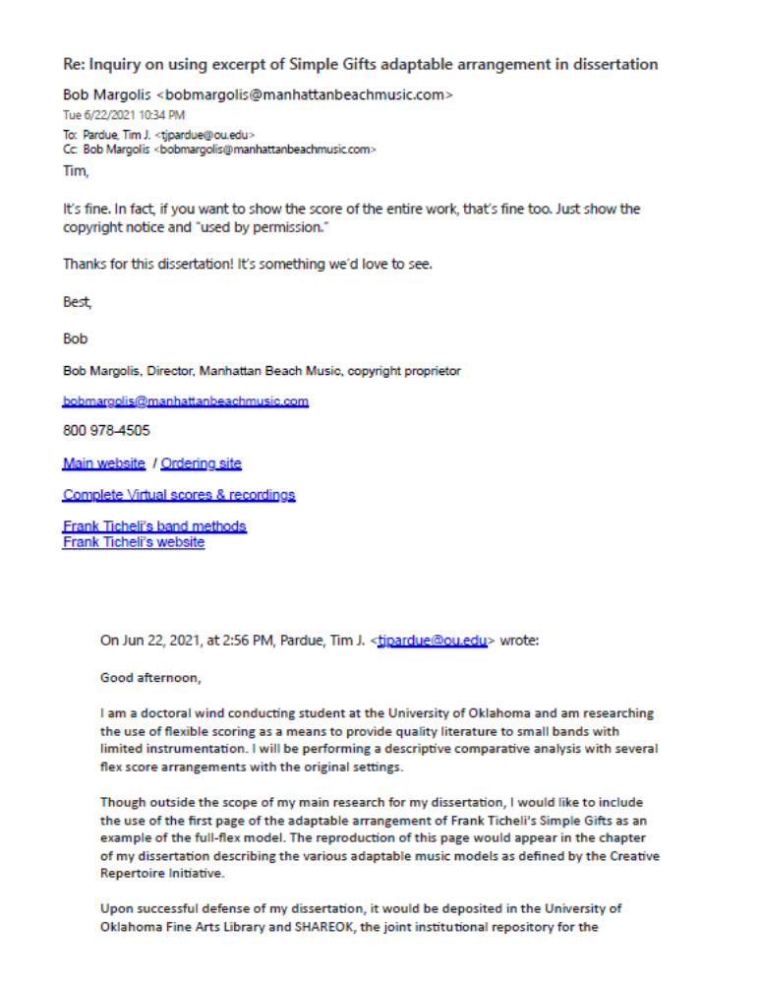
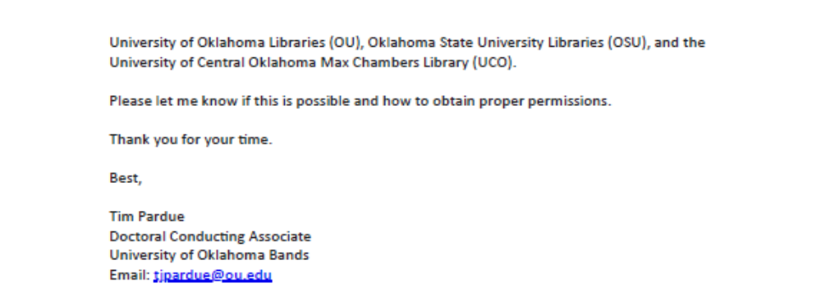
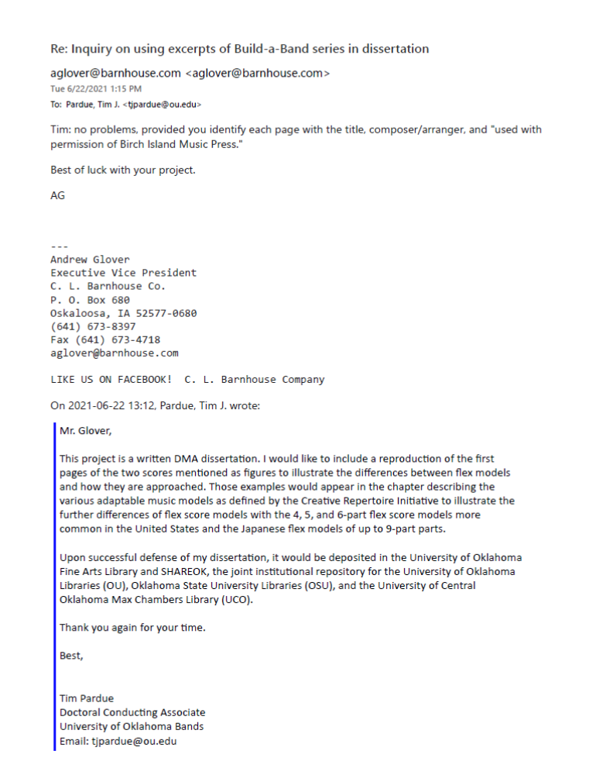
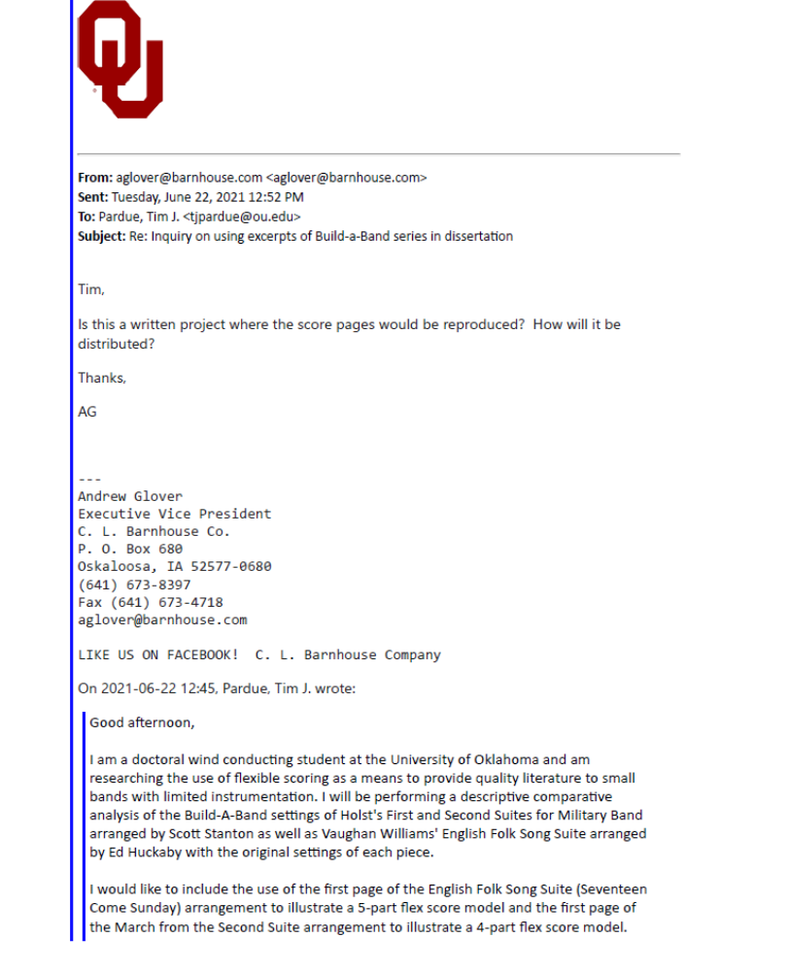
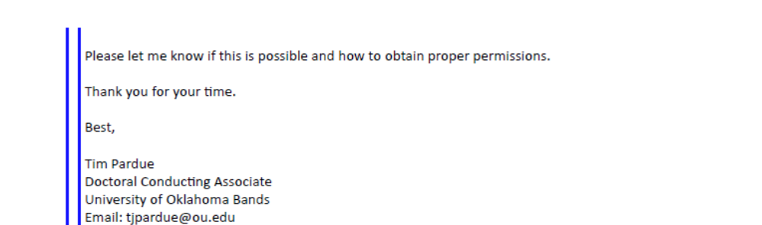
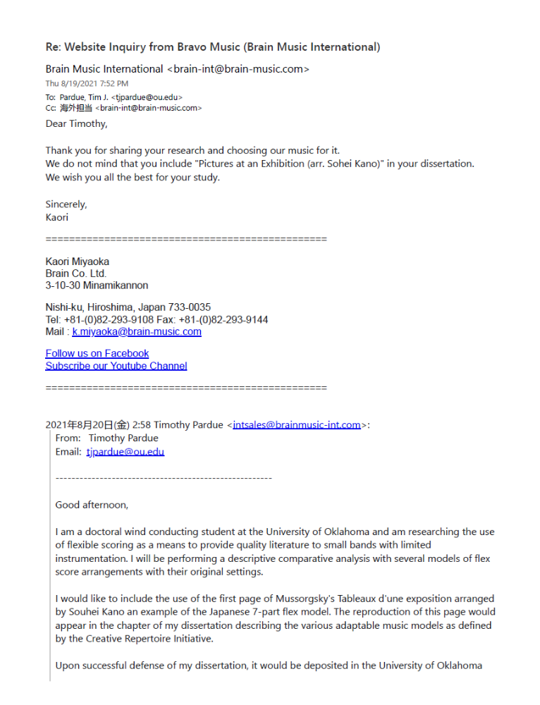
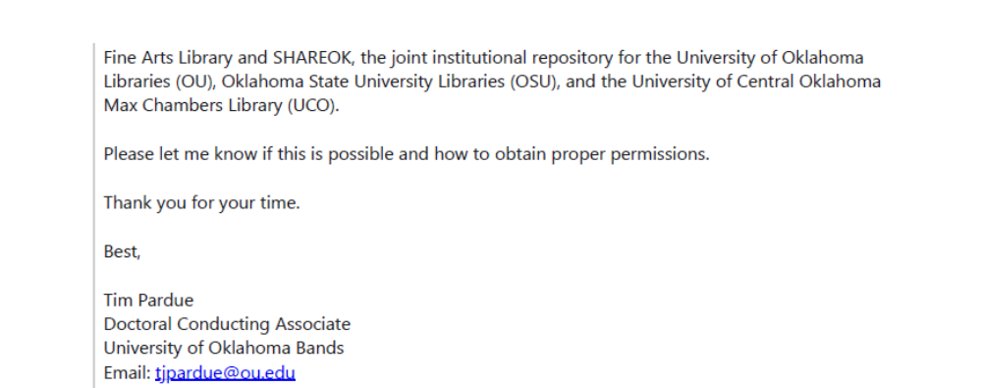

Appendix B: Creative Repertoire Initiative
The founding members of the Creative Repertoire Initiative include:
Robert Ambrose
https://www.robertjambrose.com/
Brian Balmages
https://www.brianbalmages.com/
Steven Bryant
https://www.stevenbryant.com/
Michael Daugherty
https://michaeldaugherty.net/
Julie Giroux
https://www.juliegiroux.org/
Jennifer Jolley
https://www.jenniferjolley.com/
John Mackey
https://www.johnmackey.com/
Pete Meechan
http://meechanmusic.com/
Alex Shapiro
https://www.alexshapiro.org/
Frank Ticheli
https://www.manhattanbeachmusiconline.com/frank_ticheli/index.html

Omar Thomas
https://www.omarthomas.com/
Eric Whitacre
https://ericwhitacre.com/

H. Robert Reynolds, “Repertoire Is the Curriculum,” Music Educators Journal 87, no. 1 (July 2000): pp. 31, https://doi.org/10.2307/3399675.
“2014 Music Standards,” NAfME, 2014, https://nafme.org/my-classroom/standards/core-music-standards/.
Reynolds, 32.
Ibid.
Reynolds, 31.
Frederick Fennell, Time and the Winds: a Short History of the Use of Wind Instruments in the Orchestra, Band and the Wind Ensemble (Kenosha, WI: G. Leblanc, 1954), 8.
Stephen L. Rhodes, “Harmoniemusik and the Classical Wind Band,” A History of the Wind Band (Lipscomb University, July 7, 2007), https://ww2.lipscomb.edu/windbandhistory/rhodeswindband_04_classical.htm.
Fennell, Time and the Winds, 6.
Stephen L. Rhodes, “Harmoniemusik and the Classical Wind Band.”
Stephen L. Rhodes, “Harmoniemusik and the Classical Wind Band.”
Stephen L. Rhodes, “Revolution and Nineteenth-Century Europe,” A History of the Wind Band (Lipscomb University, July 7, 2007), https://ww2.lipscomb.edu/windbandhistory/rhodeswindband_05_19thcenturyeurope.htm.
Frank L. Battisti, The New Winds of Change: The Evolution of the Contemporary American Wind Band/Ensemble and Its Music (Delray Beach, FL: Meredith Music Publications, 2018), 17.
Stephen L. Rhodes, “Instrumentation,” A History of the Wind Band (Lipscomb University, July 7, 2007), https://ww2.lipscomb.edu/windbandhistory/rhodeswindband_11_instrumentation.htm.
David Avshalomov and Sarah McElfresh, “Core Instrumentation Concert Band,” Association of Concert Bands (Association of Concert Bands, October 2012), https://www.acbands.org/core-instrumentation-concert-band.
Stacy Dziuk, “Choosing and Altering Repertoire for the Small Band,” Music Educators Journal 104, no. 4 (2018): 33, https://doi.org/10.1177/0027432118757020.
Lindsay Guinand (VanderCook College of Music, 2020), 42.
Guinand, 40.
Robert Ambrose, “Adaptable Music: Creative Repertoire Initiative,” Creative Repertoire Initiative, 2020, https://www.creativerepertoire.com/.
Ambrose, “Adaptable Music: Creative Repertoire Initiative.”
Ibid.
Charles W. Hughes, “Percy Grainger, Cosmopolitan Composer,” The Musical Quarterly XXIII, no. 2 (1937): 128, https://doi.org/10.1093/mq/xxiii.2.127.
Hughes, 133.
Thomas P Lewis, “A Source Guide to the Music of Percy Grainger” (International Percy Grainger Society, January 25, 2021), http://www.minervaclassics.com/grainger/progno11.htm.
Russel J. Houser, “An Examination of Wind Band Transcriptions,” (thesis, 2008), 3-4.
Stacy Dziuk, “Choosing and Altering Repertoire for the Small Band,” Music Educators Journal 104, no. 4 (2018): 33, https://doi.org/10.1177/0027432118757020.
Tim Reynish and Leroy Osmon, “Chamber Music Repertoire List,” Tim Reynish, June 25, 2004, http://www.timreynish.com/repertoire/chamber-music/chamber2.php.
Ambrose, “Adaptable Music: Creative Repertoire Initiative.”
Ambrose, “Adaptable Music: Creative Repertoire Initiative.”
Richard E. Wyman, “A Wind Ensemble Transcription of Part 1 (the First Movement) of Harmonielehre by John Adams with Commentary” (dissertation, 2014), 24-25.
“Key Differences Between Adaptable and Flex,” Frank Ticheli Home Page (Manhattan Beach Music), accessed May 16, 2021, https://www.manhattanbeachmusiconline.com/frank_ticheli/index.html.
Ed Huckeby, Seventeen Come Sunday from English Folk Song Suite, Mvt. 1, (Oskaloosa, IA: Birch Island Music, 2020), 2.
Julie Giroux, “Giroux - Japanese Flex Model Basics,” Creative Repertoire Initiative (Creative Repertoire Initiative, May 2, 2020), https://www.creativerepertoire.com/post/giroux-japanese-flex-model-basics.
Ambrose, “Adaptable Music: Creative Repertoire Initiative.”
“Key Differences Between Adaptable and Flex,” Frank Ticheli Home Page (Manhattan Beach Music), accessed May 16, 2021, https://www.manhattanbeachmusiconline.com/frank_ticheli/index.html.
Wyman, 25.
Ambrose, “Adaptable Music: Creative Repertoire Initiative.”
Jordan Nobles, “Open Score Collection,” Jordan Nobles - Composer, November 14, 2020, https://jordannobles.com/music/open/.
Ambrose, “Adaptable Music: Creative Repertoire Initiative.”
Richard B. Miles and Robert Grechesky, Teaching Music Through Performance in Band, 2nd ed., vol. 1 (Chicago, IL: GIA Publications, 2000), 468.
Nikk Pilato, “Folk Song Suite,” Wind Repertory Project (Wind Repertory Project, February 8, 2008), https://www.windrep.org/Folk_Song_Suite.
Richard B. Miles and Jeffrey Emge, Teaching Music Through Performance in Band, 2nd ed., vol. 1 (Chicago, IL: GIA Publications, 2000), 489.
Frederick Fennell, Time and the Winds: A Short History of the Use of Wind Instruments in the Orchestra, Band and the Wind Ensemble (Kenosha, WI: G. Leblanc, 1954), 35.
Nikk Pilato, “First Suite in E-flat,” Wind Repertory Project (Wind Repertory Project, February 6, 2008), https://www.windrep.org/First_Suite_in_E-flat.
https://imslp.org/wiki/First_Suite_for_Military_Band%2C_Op.28_No.1_(Holst%2C_Gustav)
Dave Strickler, “Dancing Fire,” Wind Repertory Project (Wind Repertory Project, May 16, 2016), https://www.windrep.org/Dancing_Fire.
Dave Strickler, “Dancing Fire (flex),” Wind Repertory Project (Wind Repertory Project, December 16, 2020), https://www.windrep.org/Dancing_Fire_(flex).
Kevin Day, Dancing Fire, arranged by Josh Trentadue (Murphy Music Press, 2020), 3.
Kevin Day, Dancing Fire, arranged by Josh Trentadue, 4.
Kevin Day, Dancing Fire, arranged by Josh Trentadue, 3.
https://youtu.be/rmRBCChJX2Q
Nikk Pilato, “Lincolnshire Posy,” Wind Repertory Project (Wind Repertory Project, January 21, 2010), https://www.windrep.org/Lincolnshire_Posy.
Dave Strickler, “Two Movements from “Lincolnshire Posy” (flex),” Wind Repertory Project, June 2, 2020), https://www.windrep.org/Two_Movements_from_%22Lincolnshire_Posy%22_(flex).
Percy Grainger, Lincolnshire Posy, ed. Frederick Fennell (Boca Raton, Fl: Ludwig Masters Publications, 2010), 57.
Thomas P. Lewis, “A Source Guide to the Music of Percy Grainger” (International Percy Grainger Society, January 25, 2021), http://www.minervaclassics.com/grainger/progno11.htm.
Modeste Mussorgsky, Pictures at an Exhibition, arranged for wind ensemble by Merlin Patterson, (Merlin Patterson Music, 2010), iii.
Dave Strickler, “Pictures at an Exhibition,” (Wind Repertory Project, December 26, 2013), https://www.windrep.org/Pictures_at_an_Exhibition.
Mick Bridgewater, “Required Lists,” (Indiana State School Music Association, 2021), https://www.issma.net/required.php
Minnesota State High School League, “Activity Resources,” (Minnesota State High School League, 2021), https://www.mshsl.org/sports-and-activities/music
Dave Strickler, “Lichtweg/Lightway,” (Wind Repertory Project, December 31, 2017), https://www.windrep.org/Lichtweg/Lightway.
Dave Strickler, “Lichtweg/Lightway (flex),” Wind Repertory Project (Wind Repertory Project, August 14, 2020), https://www.windrep.org/Lichtweg/Lightway_(flex).
Jennifer Jolley, Lichtweg/Lightway (Jennifer Jolley (BMI), 2017), iv.
Dave Strickler, “This Cruel Moon,” (Wind Repertory Project, March 7, 2017), https://www.windrep.org/This_Cruel_Moon.
Ibid.
Dave Strickler, “This Cruel Moon (flex)” (Wind Repertory Project, September 29, 2020), https://www.windrep.org/This_Cruel_Moon_(flex).
Timothy M. Shade, “A Process for Transcribing Orchestral Works for Wind Band: Andre Previn’s Sallie Chisum Remembers Billy the Kid” (dissertation, 2016), 38.
Stacey Dziuk, 33.
Robert Mark Rogers, “The “Hill-Songs” of Percy Aldridge Grainger: An Historical and Analytic Study with a New Performance Edition (Volumes I and II),” (dissertation, 1987), 184.
Nikk Pilato, “Category: Adaptable,” Wind Repertory Project (Wind Repertory Project, June 22, 2020), https://www.windrep.org/Category:Adaptable.

