UNIVERSITY OF OKLAHOMA
GRADUATE COLLEGE

“It Takes a Village”:
A Re-examination of Black-Interest Advocacy, Collective Representation,
& the Modern Congressional Black Caucus

A DISSERTATION SUBMITTED TO THE GRADUATE FACULTY
in partial fulfillment of the requirements for the
Degree of

DOCTOR OF PHILOSOPHY

By
PERILOUX C. PEAY
Norman, Oklahoma
2020

“It Takes a Village”:
A Re-examination of Black-Interest Advocacy, Collective Representation,
& the Modern Congressional Black Caucus

A DISSERTATION APPROVED FOR DEPARTMENT OF POLITICAL SCIENCE
BY THE COMMITTEE CONSISTING OF

Dr. Samuel Workman, Chair
Dr. Karlos Hill
Dr. Scott Robinson
Dr. Charles Finocchiaro
Dr. Michael Crespin

© Copyright by Periloux C. Peay 2020
All Rights Reserved.

To those that matter the most:

To the carpenters who made the table…
We hardly appreciate the first laborers
The creators,
with the foresight to create space
for faceless company
The table at which I sit
This space
Is an heirloom
Passed down and passed around
Nicks, dings, and wobbled legs
Its abuse and flaws
Give it undeniable character.
I promise to sure the foundation
And preserve this space
for more to assume

To those who set the table…
Blessed are the hands
That prepare this meal
Slaved in hell’s kitchen
To nourish mouths not their own
For those who stray from the recipe
And season with no measurements
To transform scraps into artful cuisines
To feed the soul

To those who are at the table…
We were the darker brothers
Sent to the kitchen
We return well-nourished and stronger
than they could ever envision
We are no longer company
At other folks’ home
We the future carpenters
Builders of our own

- Untitled
Peay

To those who kept me…

We’ve shared meal seasoned by shared trauma
Broke bread over broken systems
But yet we have endured

We’ve formed life-long bonds
with former strangers
we are family, rest assured.

To the Camarillos, JD, David, Dan…
To Ajia, Brittany, and Jasmine, Clint…
To Sam, Karlos, and Alisa…
To my extended academic family…

I love you all, dearly.

Peay

To the Academy

I look at the world
From awakening eyes in a black face—
And this is what I see:
This fenced-off narrow space
Assigned to me.

I look then at the silly walls
Through dark eyes in a dark face—
And this is what I know:
That all these walls oppression builds
Will have to go!

I look at my own body
With eyes no longer blind—
And I see that my own hands can make
The world that's in my mind.
Then let us hurry, comrades,
The road to find

- I look at the world
Langston Hughes

My days are not their days.
My ways are not their ways.
I would not think of them,
one way or the other,
did not they so grotesquely
block the view
between me and my brother.

- From:
Staggerlee Wonders
James Baldwin

To my mother…

Well, son, I’ll tell you:
Life for me ain’t been no crystal stair.
It’s had tacks in it,
And splinters,
And boards torn up,
And places with no carpet on the floor—
Bare.
But all the time
I’se been a-climbin’ on,
And reachin’ landin’s,
And turnin’ corners,
And sometimes goin’ in the dark
Where there ain’t been no light.
So boy, don’t you turn back.
Don’t you set down on the steps
’Cause you finds it’s kinder hard.
Don’t you fall now—
For I’se still goin’, honey,
I’se still climbin’,
And life for me ain’t been no crystal stair.

- Mother to Son
Langston Hughes

Momma… We made it!

Table of Contents
Abstract xii
Introduction: “It Takes a Village” 1
Scholarly Critique of the Early Congressional Black Caucus 3
Scope of Analysis 5
A Collective Agenda 5
The Collective Behavior of the Congressional Black Caucus 6
Collective Agenda Setting in the House of Representatives 8
A Study of the Evolution of the Congressional Black Caucus 11
Institutional Change and the Evolution of Extra-party Behaviors 11
Learning and Extra-Party Activity 13
Progression 15
Collective Messaging for Shaping Policy Priorities and Images 15
In-Group Support of Black Interests 17
Venue Shopping in the House of Representatives 18
References: 19
Chapter 2: From Complexity to Clarity 28
Introduction 28
Identifying and Defining Issues on a Black-interest Agenda 30
Discourse as a Means of Identifying Issues on Black-interest Agenda 33
Hours of Power: CBC Special Order Speeches 35
A Network Approach to Approximating an Expressed Collective Agenda 36
An Issue-centric Approach to Examining an Expressed Agenda 38
Coding and Analyzing CBC Special Order Hour Speeches 40
The Utility of a Network Modeling of a Collective Expressed Agenda 43
Advantage 1: Accounting for the Interconnected Nature of Black-Interests 45
Advantage 2: Organizing Issues on a Black-interest Agenda 46
Advantage 3: Assessing a Collective Expressed Agenda 48
Discussion 51
References: 54
Chapter 3: Legislative Venue Shopping and the Strategic Pursuit of Black Interests in the U.S. House of Representatives 62
Introduction 62
Inefficiencies and Inequality in Committee Politics 64
Black Interests and Multidimensional Legislation 66
Multiple Referrals and the Pursuit of Black Interests 67
Multidimensional Policy Images and Policy Success 70
Circumventing Institutional Marginalization 71
Capitalizing on Institutional Instability 72
Mitigating Institutional Costs 76
Design and Methodology 77
Dependent Variables and Model Selection 78
Independent Variables of Interest 80
Additional Considerations 81
The Effects of Multiple Referrals on Bill Prospects 82
CBC Interest Bills 85
Multiple Referrals in the House of Representatives 87
Discussion and Conclusion 90
References 93
Chapter 4: A Bridge Over Troubled Waters 101
Introduction 101
Building Coalitions around Racialized Policy Issues 103
Coalitional Support of Black Interests 105
In-Group Support 106
Out-group Support 108
Diversity Infrastructure Hypotheses 111
A Network Modeling of Black-interest Support 114
Data and Network Formation 117
Model Selection for Temporal Network Analysis 118
Variables of Interest 120
CBC Cohesion 121
Ideological Concordance 121
Diversity Infrastructures 121
Additional Considerations 122
Results 123
In-Group Support 123
Out-Group Support of Black-interest Policies 129
Ideological Concordance and Coalition Building 129
Diversity Infrastructures and Coalition Building 130
Additional Findings 132
Discussion 132
References 134
Conclusion: (Re)Evaluating Collective Agenda-Setting in Black-interest Policy Areas 142
Allow for the evolution of issues, preferences, and collective behaviors over time. 144
Examine all phases of the legislative process. 145
Expand conversations of legislative agenda-setting beyond parties, leadership, and pivots. 146
Be deliberate about incorporating policy process theories into congressional studies. 148
Conclusion 149
References: 150

Abstract
This project has three explicit goals in mind. First, I aim to uncover how the CBC constructs and communicates their collective worldview to the institution. Existing literature has been essential to improving our understanding of how Black lawmakers behave in legislative bodies. However, it often falls short in considering, empirically, the contexts and commitments that are wrapped up in their agenda. Second, I seek to move beyond studying individualized legislative behaviors to examine how collective strategies are employed to promote their preferences onto the institution’s agenda. Finally, by working at the intersection of institutional and policy process literature and drawing on seldom-used methodological tools, I hoped to build on theoretical and empirical explorations into the representations of Black America in the House of Representatives.
Chapter 2 examines the potential of evaluating floor speeches delivered with the intent of defining issues on their agenda. By defining policies according to their underlying attributes, Black lawmakers are able to shape policy images and shape – and potentially reshape – existing frames of policy issues that plague the communities that they represent. I also uncover that there is a decided utility in engaging in problem definition from a scholarly, organizational, and institutional perspective. A better understanding of issues provides policy actors a bit of clarity in taking on problems faced by Black Americans. In Chapter 3, I attempt to apply a theoretical explanation to changes in bill sponsorship trends in recent congressional sessions. I argue that the CBC a striking increase in legislation that receives multiple committee referrals is tied to an effort to broaden the reach of legislation within the chamber. Doing so increases the likelihood that these bills clear the committee stage. Chapter 4 set out to explore how the Black Caucus responded to institutional adversity. I find that the organization consolidated its messaging efforts through bill cosponsorship in the midst of a long-term stent in the minority party. This can potentially free up committee chairs to do the work of the party while rank and file members can invest their time and effort into issue advocacy.
Taken together, it is my hope that the preceding chapters serve as a first step in re-examining the collective representation of Black interest in Congress. In doing so, I find it essential that we invest in updating our understanding of the modern Congressional Black Caucus as they increase in numbers, influence, and outcomes. This is much different than investigating the behavior Black lawmakers. Examining the Caucus means, first, examining the caucus in a way that distinguishes the organization from the preferences and behaviors of individual Black lawmakers. This also means that there should be a considerable amount of effort devoted to bringing to light organizational features and strategies that shape the collective behavior within the chamber. To this end, I prescribe four avenues that researchers should consider to broaden the examination of Black representation.

Introduction: “It Takes a Village”
A Re-examination of Black-Interest Advocacy, Collective Representation, & the Modern Congressional Black Caucus

“[…] except for civil rights issues, blacks in Congress are frequently an isolated, invisible, inconsequential minority unable to enact (or even get serious debate and deliberation on) proposals it deems minimally necessary to meliorate the problems of joblessness, crime and dispossession that plague its core constituency”.

- Robert C. Smith in We Have No Leaders (1996, 222)

“The sooner we become organized for group action, the more effective we can become.”

- Former CBC Chairman, Rep. Charles Diggs (D – MI)

“It takes a village...”: an adage that has long been codified in the lexicon of the Black community. The idea that advancement is the product of a collective influence - through socialization, monitoring, education, protection, discipline, mentoring, and a comprehensive long-term investment - is one that is not only firmly held within the African American community, it is also reinforced and reciprocated in everyday interactions. In a sense, it is second nature for Blacks in America to feel a certain responsibility to the well-being of your own and work towards its collective advancement.
For most Blacks in America, the village is not an option, it is usually a necessity. Operating in spaces defined by whiteness means that individuals seldom achieve their goals without the assistance of a community - a tribe of their own with a collective investment in their success. The village is a sense of communal belonging and collective activity - driven by the desire to form cohesive units from like-minded and homophilous backgrounds - that often branches out to racially hostile institutions of higher learning and industries that have displayed a historical propensity to actively work to oppress the racial progress. In the absence of a designated space, it provides an arena to operate, organize, and strategize.
The Congressional Black Caucus (CBC) was established in 1971 to provide Black lawmakers with its own village - a space for the original thirteen founding members to organize, strategize, and coordinate activities within the chambers of Congress (Barnett 1977; 1975; Swain 1993; Singh 1998; Owens 2011; Canon 1995; Tate 2003; 2014). Over time, the caucus established extra-party behaviors to account for and adapt to institutional neglect. Simply put, minority lawmakers sought to remedy the deprivation of information brought on by the denial of access to key committees. They looked to revive the voices of those that had been silenced as a result of interpersonal marginalization. They needed a safe space to deliberate, strategize, and evaluate the status quo. Most importantly, they saw the need for a collective body with the force, influence, and desire to challenge centuries of agenda denial in areas designed to advance Black communities.
Stevens and colleagues add to the desires of groups, like the Black Caucus, arguing they often form due to perceived structural and motivational deficiencies in Congress’ ability or desire to adequately address their policy concerns. They find, caucuses organize – out of necessity – in order to satisfy their fiduciary responsibilities to pursue issues where (1) “there is no single place within the formal congressional structure in which the leadership functions are performed”, (2) “there is no assurance that Congress will recognize or deal with the relatedness of the various aspects of a problem”, and (3) “there is no effective institutional source of initiative for overcoming the disputes over jurisdictional turf or for working with interest groups, administration spokesmen, and other members to build winning floor coalitions” (Stevens, Mulhollan, and Rundquist 1981, 428). In doing so, the caucus also needs a means to account for change within the institution that had tremendous effects on their ability to successfully advocate for change in Black interest.

Scholarly Critique of the Early Congressional Black Caucus
For Black lawmakers – and those that study them – the glaring question that remained unanswered in early explorations of collective behavior is that of the disconnect between an increase in Black membership in the chamber and a noticeable lack in substantive, positive outcomes in Black-interest areas (Jones and Baumgartner 2005, 44). For the near entirety of the twentieth century and first decade of the twenty-first, Black issues struggled to gain traction in federal policy-making institutions. In his comprehensive analysis of the CBC, Robert Singh (1998, 201) settles on a raw assessment of their effectiveness through the 103rd Congress. He argues, “The organization of Black legislators in a caucus has not altered the fundamentally unequal and inferior position of many Blacks in the post-civil rights era, nor has it undermined the continued existence of ‘two nations’ in America: separate, unequal, mutually hostile, suspicious, and antagonistic”. This is not to say that advances had not been achieved. However, policies rarely deviated from the status quo in a meaningful way, and incremental change was not been a palatable consequence for onlookers and constituencies hoping that increased congressional representation would translate into sweeping policy success. As Singh and others note, “modest advances represented an inadequate substitute for rapid and comprehensive alterations in economic and social policy (Singh 1998, 104).”.
Black lawmakers in American political institutions have always been faced with two very specific burdens when seeking out policy change for their constituencies. On one hand, they must fulfil the role of cogs in a well-oiled political institution with long-established traditions, practices, and mechanism for control. The two-party system that has dominated electoral and institutional aspects of American politics has all but assured access to the larger is agenda is limited. A multitude of institutional forces are products of institutional arrangements of power, and those arrangements are constantly working against the collective advancement of Black constituencies. On the other hand, the advocacy for racial advancement means minority representative s engage in collective behaviors that may not be facilitated by the traditional party structure. The advancement of the Black community required either (1) change the culture of the institution, (2) change the image of policy issues, or (3) change the collective practices of the caucus. This duality presented very real challenges for Black lawmakers – and for those that study them.
Robert C. Smith (1996, 222) painted a rather bleak picture of the legislative influence of the Congressional Black Caucus in its first twenty years of existence in We Have No Leaders, arguing their relegation to “an isolated, invisible, inconsequential minority” extended beyond their inability to achieve non-incremental policy change. However, as the organization rapidly approaches its fiftieth year in existence, the CBC had morphed into one of the more influential legislative organizations with a fifty-five-member roster that occupies chairmanships of five full committees and twenty-eight subcommittees in the House of Representatives. Additionally, among its membership is the Majority Whip - James Clyburn (D-SC) - and the Chair of the House Democratic Caucus - Hakeem Jefferies (D-NY). The village has certainly evolved in size, collective influence, and strategy. One thing has remained consistent: the organization remains the collective body tasked with improving conditions for the national Black constituency that they represent.
If we are to understand how – if at all – conditions Black lawmakers have changed from an organization with “relatively little leverage or influence in congressional decision making” (Smith 1996, 221) to “major players in the Democratic Party” (Tate 2014, 149), one must first engage conditions that create the former conditions and behaviors that could lead to the latter. I dedicate the remainder of this project posing two questions. First, I ask how the Congressional Black Caucus works collectively from within the institution to shift and maintain attention on Black interests in the House of Representatives? In the process, I seek to determine how these processes differ from previous tactics taken by earlier iterations of the CBC.

Scope of Analysis

There are three explicit goals of this analysis. First, I seek to shed light on the collective worldview that shape the policy pursuits of the Congressional Black Caucus. Second, I aim to evaluate how strategies employed by the Congressional Black Caucus to promote their collective policy preferences onto the institutional agenda have evolved. Finally, I hope to advance the empirical and theoretical examination of Black representation in American political institutions. As a function of these goals, the articles presented in this collection will take on two major re-occurring themes.

A Collective Agenda
This study takes a significant departure from the two dominant practices in studying the representation of Black interests in Congress – practices that have shaped both the scope of inquiry and products of those scholarly examinations. One common means of exploring Black-interest representation comes in selecting issue areas with real and perceived inequalities and discrepancies in outcomes – i.e. civil rights, education, criminal justice, healthcare, etc. – and evaluating legislative behaviors around those issues (Swain 1993; Tate 2003; 2014; Bratton and Haynie 1999). This approach has a number of effects on how we perceive the nature of racialized issues and the results of efforts in those areas, as presumptions of a “narrow’, “racialized”, and “contentious” agenda may be the function of the selection of the researcher. This process also results in a static understanding of Black interest and the resulting behaviors around them. Others explore the dyadic relationships between districts and their representatives’ behaviors (Cameron, Epstein, and O’Halloran 1996; Canon 1999; Whitby 2000, for example). Here, researchers rest on the assumption that the demographic makeup and median preferences of their districts will shape issue support in legislative bodies. This decision moves the scope of inquiry further away from the collective preferences of the caucus and how their preferences and worldview shape their activities.
While these practices have certainly made tremendous contributions to our understanding of the representation of Black interests in legislative bodies, they leave several key questions left fundamentally unanswered. First, these practices place little emphasis on the collective preferences of the CBC. We are left with little insight into how the caucus identifies, defines, and prioritizes policy issues that plague both the constituencies that they represent and nearly half of the African American population that is not represented by someone that shares their identity. It also limits our ability to speak to how the organization communicates those collective preferences to the institution. This study seeks to fill this void by placing and explicit focus on the nature of policy issues, as defined by the caucus. It views the caucus as an organization that is more than capable of building a diverse, complex agenda and identifying the multiple dimensions that construct these problems in ways that reflect the collective will of the organization.
Second, in attempting to speak to the collective actions of the Congressional Black Caucus, the propensity to examine individualized behaviors – or utilize measures that rely on individualized behaviors – place a great deal of faith in the powers of aggregation. Rather than treating the organization as an entity within itself, findings that result from the aggregation of voting behaviors and bill sponsorships may be two or three degrees removed from the will of the organization. To remedy this, I explore the collective actions that result from the establishment of organizational features and mechanism or the products of collective action conducted at the behest of the caucus with the intent o promote the collective agenda of the caucus onto the institution’s larger legislative agenda.

The Collective Behavior of the Congressional Black Caucus
Although they are seemingly few in number, nearly every successful story of marginalized groups achieving non-incremental policy change in is one that starts with a collective decision to accomplish three goals: they organize, strategize, and engage in collective activities to advocate for change. The story of the emergence of the Congressional Black Caucus is no different. Any long-term solution to legislative inactivity in Black interest issues would require a collective effort to challenge the institution-wide conditions that contribute to a strong status quo bias as well as the forces that target marginalized groups within the chamber. Such a solution would, in all likelihood, require a comprehensive approach to changing the culture of the institution, challenge institutional arrangements of power, reshape the perception of the issues, and build support for their legislative pursuits. As you will see, today’s caucus is a story of cohesion, evolution, and collective action aimed at driving attention towards issues that shape the lives of their constituencies at home and nationally.
The ability to organize provides “lawmakers who find themselves unable to exercise power through traditional channels” with “a unique source of institutional authority that does not first require members to control majoritarian institutions”(Rubin 2017, 299). Through a thorough historical analysis, Ruth Bloch Rubin (2017) explores the emergence of intraparty organizations in Building the Bloc. She examines how a number of insurgent groups – like the Freedom Caucus, the Tea Party, the Blue Dog Coalition, the Republican Progressive Insurgency in the early 1900s – were able to use cohesive voting and manipulate procedures to shape legislative outcomes. She convincingly argues:

“Provided they can resolve members’ collective action and coordination problems, organized blocs of dissident lawmakers can durably reshape their institutional environment by forcing changes to Congress’s internal rules and procedures. They can also disrupt and reconfigure national politics by championing or resisting policies that may in turn create new political constituencies and sites of political contestation. Intraparty organizations thus provide a previously unrecognized stronghold from which legislators – working outside of the party cartel, and unsure of whether they are indeed pivotal – may influence legislative outcomes”. (Rubin 2017, 299)

Most queries into the impact of increased diversity take an individualized approach to assessing the effectiveness of inclusion on the ability to seek out and obtain substantive policy gains for marginalized communities. Others explore dyadic relationships between the preferences of those communities and the individual legislative behavior of their elected official (Whitby 2000). However, the modern Congress is often characterized by decentralized committee power (Aldrich and Rohde 1997), cartelized leadership (Cox and McCubbins 2005; 2007), and decreased individual power among its rank and file members. Additionally, minority members often face structural and interpersonal barriers that work against their efforts (Hawkesworth 2003; Rocca and Sanchez 2008; Griffin and Keane 2011; Craig et al. 2015). The current institutional setting has proven to be unconducive to individual members - of color or otherwise - influencing legislative agendas(Sinclair 2011). This work shares the sentiment that, in Congress, collective action - and thus, organization - has become a more effective “means by which individuals can more fully realize their individual values” (Arrow 1974, 16). Therefore, I place an explicit emphasis on the collective actions and strategies adopted by the Congressional Black Caucus.

Collective Agenda Setting in the House of Representatives
Agenda authority is not as cut-and-dry as dominant theories of the legislative process suggests it would be, as blocs of lawmakers have been successful in capturing legislative agendas. As Republican Paul Ryan (R-WI) discovered in his brief tenure as Speaker, a relatively small bloc of legislators can have a dramatic impact on the party’s legislative agenda. Political parties in the twenty-first century are coalitions of coalitions, Positive agenda change will likely be the result of inter-coalitional cooperation in shared interests. It has also been shown – through actions on the part of the Freedom Caucus and progressive Democrats – that this fragmentation can result in the cooptation of the legislative agenda by influential groups. With party fragmentation becoming increasingly pronounced in the post-reform era, majoritarian mandates at an institutional or party level are becoming decreasingly critical to influencing legislative agendas. Minoritarian influence is becoming increasingly possible in the modern congressional environment.
In any case, policy change, first, requires a degree of commitment on the part of policymakers and institutions. The most basic measure of commitment is that of attention; scholars argue, in order to partake in any activity, one must first devote some level of attention to it (Kahneman 1973; 2003; Simon 1994; Spaulding and Simon 1994; B. D. Jones 1994; B. D. Jones and Baumgartner 2005). Sinclair (1986) argues, “the political agenda is probably best conceptualized as roughly pyramidal with very few hot issues at the top and an increasing number of less salient issues as one approaches the base”. In determining a legislative agenda, policymakers are faced with a series of calculations that shape which issues receive their attention - and which ones do not - as well as how much attention should be devoted to each issue. Institutional agendas are defined as much by what fails to receive attention as which issues are dominant at a given time (Kingdon 2011; Cobb and Elder 1971; Baumgartner and Jones 1993; Cobb and Ross 1997; Krutz 2005). I argue throughout this project that an institutionalized and perpetual inattentiveness to uniquely-Black issues and conditions lies at the root of this lack of substantive gains in these areas. It is inattention that works against policy change and preserves the status quo in Black-interest issue areas.
Institutional inattention to Black interests – brought on by ideological, partisan, and racially-motivated access problems – remains a persistent barrier to change in Black issues, the next logical question is how can Black lawmakers overcome these circumstances to drive attention and initiate positive policy change? Successfully challenging the status quo in a non-incremental fashion means groups have likely avoided snares throughout the cycle of attention – including in drawing attention to societal problems, navigating preventative cost considerations that disrupt the cycle, and preventing the eventual decline in attention that typically follows (Downs 1972). It means that advocates have built enough coalitional support and consensus to demand action, have overcome institutional inefficiencies in design and operation, and is robust to various arrangements of institutional control. Finally, and especially for Black lawmakers in American political institutions, substantive change means institutional biases that impact access, processes and outcomes have been challenged or changed (Guinier 1991; Hawkesworth 2003; Tate 2014; Tyson 2016).
Early exploration of the emergence of informal congressional organizations from Susan Webb Hammond and colleagues differentiated between national interest – or identity caucuses – and other forms of ideological or special interest groups. Identity caucuses, by design, seek to achieve three goals that serve their operational purposes within the chamber: (1) to facilitate the gathering of and streamline the flow of information to its members, the institution, and their constituencies, (2) to develop and forward catered agendas through the formulation of group-specific policy, and (3) to examine policy and its potential impact on the constituencies they serve (Hammond, Mulhollan and Stevens 1985). It is no surprise then that survey analysis Arturo Vega (1993) confirms the propositions of Hammond, et al., finding groups that represent the national interests of shared-identity constituents report that their top three primary interests are (1) information gathering, (2) agenda setting, and (3) representation.
I look to reorient the focus of scholarship concerning minority representation to questions that ask how issues get voted on. I concentrate on the collective efforts of the Black Caucus to reshape an institutional agenda that may be biased against - and deprioritize - racialized policy areas (Schattschneider 1975; Polsby 1968; Frymer 2010). In doing so, I engage key processes of agenda setting that have been largely absent from minority representation scholarship. This includes questions of problem definition (Rochefort and Cobb 1994; B. D. Jones and Baumgartner 2005; Baumgartner and Jones 2015), venue shopping (Schattschneider 1975; Baumgartner and Jones 1993; Pralle 2003), division of labor (Arrow 1974), and other forms of collective action with the purpose of driving legislative attention (B. D. Jones and Baumgartner 2005; Minta and Sinclair-Chapman 2013).

A Study of the Evolution of the Congressional Black Caucus
In examining the collective efforts of the CBC to shape legislative attention, it becomes quite evident that the modern iterations of the caucus would be almost unrecognizable to those who penned scholarly examinations of the group prior to the 104th Congress. Aside from member turnover and the addition of a new generation of more pragmatic, progressive Black lawmakers (Canon 1995; Gillespie 2010), the organization underwent a tremendous evolution in their structures, strategies, and legislative pursuits. This study views the collective actions of the collective actions of the caucus as a product of interactions between changes in majority control of the House of Representatives and the institutional change that followed, political learning, and policy learning.

Institutional Change and the Evolution of Extra-party Behaviors
The Congressional Black Caucus “enjoyed” Democratic rule for the entirety of the group's existence. However, the transition out of a sustained Democratic majority in the House to a durable, six-term dominance of House Republicans ultimately reshaped lawmaking within the institution and for the Black Caucus. Singh (Singh 1998, 194) chronicles the challenges - and shock - directly associated with the new Republican majority in the 104th Congress. Not only were Black members relegated to a minority within the minority party for the first time, the organizational agenda, itself, appears to have been negatively impacted by the disruptive nature of the reforms associated with the Republican's “Contract” reforms. He comments, “the CBC seemed unable to come to a collective view of what Blacks' permanent interests were, much less on how best to realize them”. As a result, the caucus was faced with a need to revisit its legislative strategy.
On the first day of the 104th Congress, the House - led by newly appointed Speaker Newt Gingrich - passed sweeping rules changes aimed at increasing transparency, reducing operating costs, and reducing legislative inefficiencies perceived to exist prior to the shift in majority control of the House. Scholars point to a number of reforms over the years that have directly contributed to the a general decline in analytic capacity and decentralization of the House of Representatives (Aldrich and Rohde 1997; Schickler 2001; Adler 2002; Rohde 2010; Adler and Wilkerson 2011; Baumgartner and Jones 2015). Committee reform had direct and indirect impacts on Black lawmakers that reshaped the way the members operate within the chamber. The Gingrich reforms in the 104th, first, eliminated several committees-- the Post Office, Merchant and Marine Fisheries, and District of Columbia Committees – that here populated by Black lawmakers. Abolishing three committees also means that these members - and their demands - would be shuffled to new committees. Following the structural changes, the reduction of committees also resulted in a necessary reshuffling of jurisdictions to account for the reduction in committee force. In eliminating three committees, Gingrich created somewhat of a mess of the jurisdictional arrangement of the House.
Extra-party activities became even more important after Gingrich-era reforms initiated a decline in the analytic capacity of Congress (Baumgartner and Jones 2015). Reform ultimately reduced committee staff, defunded external research operations, and destabilized the committee structure. Most impactful for the Congressional Black Caucus was the decision to defund and dismantle the system of Legislative Service Organizations (LSOs). Analysis from Andrew Clarke found that the abolishment greatly decreased the legislative capacity of LSO members and destabilized legislative networks (Clarke 2018). “Republican leadership abruptly dismantled a system of directly funded political institutions in the 104th Congress, and LSO chairs, accustomed to directing considerable resources towards their organization’s legislative agenda, were sent scrambling for alternative financial arrangements” (Clarke 2018, 19).
This action prompted one of three responses from existing LSO organization that were consequentially “demoted” to caucus status. Many organizations collapsed outright. Clarke (2018, 4) argues some “organised blocs of lawmakers have deemphasized their role as research operations and constructed new institutions that more effectively appeal to donors and outside groups”. The Congressional Black Caucus, on the other hand, remained resilient in the face of reform. According to Rep. Owens’ view from the inside, “Instead of destroying the CBC, Gingrich’ decrees had only crippled it, forced a creative mutation” (Owens 2011, 207). The caucus devised creative means to maintain and fund organizational staff to conform with Gingrich’s mandates. The organization redirected their efforts to internalizing many of the practices that were facilitated by institutional funding.
While some organizations outsourced their research operations, the Congressional Black Caucus chose to evolve. The caucus shifted their attention towards bolstering their pre-existing taskforces and working groups and engaging policy experts and a community of scholars. While institutional change disrupted much of the legislative activity in the House of Representatives, these reforms ultimately led to an increase in extra-party activity on the part of the Congressional Black Caucus. The articles that follow reveal several products of organizational and strategic changes that came as a direct result of institutional change.

Learning and Extra-Party Activity
Evolution can also come as political actors undergo “a form of learning that consists of the use of experience, or other feedback, either to reaffirm or revise causal reasoning about policies, targets, and outcomes” (May 1992, 334). According to public policy literature, learning manifests itself in two ways – political and policy learning (Wildavsky 1979; Sabatier 1988; 1991; May 1992; Bennett and Howlett 1992; Sabatier and Jenkins-Smith 1993; Soss 1999; Dunlop 2017). The caucus has developed and reinforce multiple mechanism to facilitate both policy and political learning for Black Caucus members.
Political learning, according to Peter May (1992, 339) “entails policy advocates learning about strategies for advocating policy ideas or drawing attention to policy problems.” This entails an actor or group of actors making “feasibility assessments” of their current advocacy strategies, their likelihood of success given their current strategy, and the obstacles that impede their success. The information derived from political learning often “provides a basis for formulating new tactics for advocating a particular proposal or problem” (May 1992, 339). Wildavsky (1979) argues, trial and error can lead to eventual success as long as that a change in behavior results from the failure. Additionally, the division of labor into these different committees allows members with either specialization, direct interests, or advantageous committee placements in relevant policy areas to use their access and expertise to reshape tactics, inform other members, and take the lead in issue advocacy. Policy learning, on the other hand, is when policy actors develop a new or reaffirmed understanding of a policy domain. This can come as the result of a shift or competition in an advocacy group’s core belief system (Sabatier 1988) or a changes in the social construction of policy problems (Wildavsky 1979; May 1992)
Since their inception in the 1970's, the Caucus has formalized its presence over time by organizing into taskforces and working groups that serve as policy laboratories and sources of information gathering. The system of taskforces and working groups aid in both political and policy learning. First, organizations with the longevity of the CBC - who's members are often characterized as electorally secure, increasingly senior, and gaining in institutional influence - have certainly improved their understanding of social and political forces impeding their success. In addition, the external policy research foundation conducts similar tasks in outreach and engagement with policy experts in the various fields of interest. Through these two wings of the organization, the CBC engages a community of academics and specialists to provide expert-based information that has the potential to aid in the identification and definition of policy problems and solutions, to fortify the arguments of the group, and to reinforce policy images within and across policy coalitions (Weible 2008). Scholars argue that representatives of color now rely on the development their extra-party infrastructure designed to aid in the search for collective policy victories in targeted interests (Minta 2011; Minta and Sinclair-Chapman 2013; Hammond, Mulhollan, and Stevens 1985). Additionally, as policymakers learn - either through trial and error or through policy learning - they constantly look to readjust their strategy in search of more favorable outcomes.

Progression
I look to determine (1) what avenues are available for Black lawmakers to overcome inattentiveness to Black issues, and (2) how the Congressional Black Caucus works collectively to shift and maintain attention on Black interests in the House of Representatives? I theorize that the employment of a village approach has improved collective prospects of Black members of Congress. Given this expectation, I examine the following three behaviors:

Collective Messaging for Shaping Policy Priorities and Images
In order to solve problems, the institution must first be made aware of the problem through environmental signals and information (Cobb and Elder 1971; B. D. Jones and Baumgartner 2005; Baumgartner and Jones 2015; Workman, D. Jones, and E. Jochim 2009). What complicates this process is that problem definitions are the product of varying and competing perspectives of the event and priorities of those perceiving the event. Dawson and Cohen (2002, 495) note, differences in racial identity can be at the root in variations in problem definitions and lead to the undermining of political communication:
“...separate racial groups might have different meanings attached to the same political concepts and events. Different racial groups may very well have different rules (or “grammars”) for interpreting how political and social phenomena are interpreted and understood. When meanings and interpretations of politics are unstable across racial groups, the foundations for meaningful political communication is undermined”

We know that those invested in policy outcomes spend a significant portion of their time working to expose cleavages within existing structures (Schattschneider 1975) and creating new narratives around policies to influence institutional actors and even the mass public (McBeth Mark K. et al. 2007; M. D. Jones and McBeth 2010; Shanahan Elizabeth A., Jones Michael D., and McBeth Mark K. 2011; M. Jones, Shanahan, and McBeth 2014; Jones Michael D. et al. 2015; Yang 2016). In fact, William Riker (1986) argues in the Art of Political Manipulation that a key difference in political winners and losers is the ability for actors to combine rhetoric, persuasion, and strategy to shape images around particular issue to create more advantageous outcomes. Political winners, Riker argues, identify relevant - and potentially manipulatable - actors, invent new actions, orchestrate frames or dimensions around potential outcomes, and invent political processes to favor preferred outcomes (see also Shepsle 2003). The Congressional Black Caucus has transformed into an organization that concentrates its efforts on reshaping the legislative priorities of the Democratic Party by reconfiguring how they frame and communicate policy images in order to break through and break down barriers of institutional inattention.
The first of three articles will be dedicated to understanding how the Congressional Black Caucus identifies policy problems, defines the conditions that contribute to the problem, and employs collective actions to relay messages to the institution. To accomplish this, I will analyze 99 Special Order Hour speeches delivered from the 111th through the 114th Congresses. These speeches represent more than ten years of collective attempts to communicate the plight of Black Americans and advocate for policy change in a broad range of issues. The Black Caucus has developed practice of conducting special order speeches – with the approval of party leadership – as a collective effort to bring attention to issues, introduce new information on policy problems gained from internal and external expert engagement, and propose policy solutions. It becomes clear that the Congressional Black Caucus has come to use Special Order floor speeches to engage in a collective messaging campaign designed to advocate for Black interests.
Scholars interested in the Congressional Black Caucus also point to the notion that the contentiousness that surrounds Black issues causes the Democratic Party to shy away from addressing them. I find the CBC to use special order speeches to (1) expand the number of issues the caucus seeks to draw attention to, (2) expand the dimensions considered for each policy issues, and (3) connect dimensions from seeming unrelated dimensions to the problems of Black America to provide structure for a complex agenda.

In-Group Support of Black Interests
While the first article examines how the CBC identifies, defines and advocates for change in Black-interest areas, the second article of this analysis will focus how the organization’s members have coalesced around the caucus agenda. Scholars present two competing perspectives of the CBC and its members. On one hand, many have pointed out the impressive degree of cohesion that often results from their voting behavior (Gile and Jones 1995; Mixon and Ressler 2001; Mixon and Pagels 2007; Tate 2014). However, voting as a bloc does not necessarily mean that caucus members are always on one accord in all parts of the legislative process. Ideological, generational, and strategic differences within the ranks of the caucus could threaten to break down cohesion in messaging and collective action designed to promote the caucus agenda (Canon 1995; Gillespie 2010; Tate 2014).
To examine in-group support, I apply common tools of social network analysis to explore cosponsorship by CBC members from the 103rd to the 110th Congress. I focus exclusively on bills sponsored by CBC members in areas targeted by the Black Caucus to determine if – and ultimately how – cohesion has varied over time. I posit, the cohesion of the caucus will be subject to ebbs and flows over time. It may very well be the case that the organization resembled more along the lines of a “loosely-tied” collective that some have suggested (Barnett 1977; Singh 1998). I find, however, that as the organization formalized and crystallized its processes, extra-party behaviors, and agenda, Congressional Black Caucus cohesion improved over time.
In addition, I expect cohesion to be inversely related to the amount of resources available to the caucus. More particularly, I find that in Republican majorities, the CBC engaged in a collective messaging campaign through bill sponsorship and cosponsorship. As negative agenda-setting sets in, and progressive racialized policies are (at best) silenced or (worst) threatened, one of the few tools at the Caucus’ disposal will be to make a collective effort to relay messages of cohesion within the institution. I find clear evidence that Congressional Black Caucus cohesion improves during Republican majorities.

Venue Shopping in the House of Representatives
The third article is dedicated to examining how the adoption of multidimensional policy definitions impacts the prospects of bill success in the House of Representatives. Multidimensional legislation is increasingly becoming a new norm in congressional lawmaking (Davidson, Oleszek, and Kephart 1988; Krutz 2000; 2001b; 2001a; Krutz and Cullison 2008). I predict that the Congressional Black Caucus will change their sponsorship practices to match this new trend. For members of the Congressional Black Caucus, shifting to multidimensional policy definitions lead to an increase in the sponsorship of multidimensional proposals.
Scholars point to a number of advantages associated with sponsoring multidimensional legislation. In designing bills in a way that assures that they land in multiple committees, members may be able to build coalitions, circumvent gridlock, and increase attention to Black interests (Krutz 2000; 2001b; 2001a). Sponsoring cross-cutting legislation may also allow members to take part in deliberate actions aimed at capitalizing on jurisdictional instability that resulted from Gingrich era reforms. King (King 1994; 2008) argues, members of Congress seek to exploit instability using bill sponsorships to challenge jurisdictional boundaries and take advantage of periods where committees may be more susceptible to efforts to expand the reach of the committee (see also Adler 2002; Adler and Wilkerson 2011). I find it possible that members of the Black Caucus will look to take part in these “turf wars” with some degree of success. If this does occur, there may be tangible benefits associated with sponsoring multidimensional legislation. I find the Sponsorship of multidimensional legislation increased the likelihood that CBC-sponsored bills navigated the legislative process.

References:

Adler, E. Scott. 2002. Why Congressional Reforms Fail: Reelection and the House Committee System. University of Chicago Press.
Adler, E. Scott, and John D. Wilkerson. 2011. “Intended Consequences: Jurisdictional Reform and Issue Control In the U.S. House of Representatives.” Legislative Studies Quarterly 33 (1): 85–112. https://doi.org/10.3162/036298008783743318.
Aldrich, John H., and David W. Rohde. 1997. “The Transition to Republican Rule in the House: Implications for Theories of Congressional Politics.” Political Science Quarterly 112 (4): 541–67. https://doi.org/10.2307/2657691.
Arrow, Kenneth J. 1974. The Limits of Organization. W. W. Norton & Company.
Barnett, Marguerite Ross. 1975. “The Congressional Black Caucus.” Proceedings of the Academy of Political Science 32 (1): 34–50. https://doi.org/10.2307/1173616.
———. 1977. “The Congressional Black Caucus: Symbol, Myth, and Reality.” The Black Scholar 8 (4): 17–26.
Baumgartner, Frank R., and Bryan D. Jones. 1993. Agendas and Instability in American Politics, Second Edition. University of Chicago Press.
———. 2015. The Politics of Information: Problem Definition and the Course of Public Policy in America. University of Chicago Press.
Bennett, Colin J., and Michael Howlett. 1992. “The Lessons of Learning: Reconciling Theories of Policy Learning and Policy Change.” Policy Sciences 25 (3): 275–94. https://doi.org/10.1007/BF00138786.
Bratton, Kathleen A., and Kerry L. Haynie. 1999. “Agenda Setting and Legislative Success in State Legislatures: The Effects of Gender and Race.” The Journal of Politics 61 (3): 658–79. https://doi.org/10.2307/2647822.
Cameron, Charles, David Epstein, and Sharyn O’Halloran. 1996. “Do Majority-Minority Districts Maximize Substantive Black Representation in Congress?” The American Political Science Review 90 (4): 794–812. https://doi.org/10.2307/2945843.
Canon, David T. 1995. “Redistricting and the Congressional Black Caucus.” American Politics Quarterly 23 (2): 159–89. https://doi.org/10.1177/1532673X9502300203.
———. 1999. Race, Redistricting, and Representation: The Unintended Consequences of Black Majority Districts. University of Chicago Press.
Clarke, Andrew J. 2018. “Congressional Capacity and the Abolition of Legislative Service Organizations.” Journal of Public Policy, 1–22. https://doi.org/10.1017/S0143814X1800034X.
Cobb, Roger W., and Charles D. Elder. 1971. “The Politics of Agenda-Building: An Alternative Perspective for Modern Democratic Theory.” The Journal of Politics 33 (4): 892–915. https://doi.org/10.2307/2128415.
Cobb, Roger W., and Marc Howard Ross. 1997. Cultural Strategies of Agenda Denial: Avoidance, Attack, and Redefinition. University Press of Kansas.
Cox, Gary W., and Mathew D. McCubbins. 2005. Setting the Agenda: Responsible Party Government in the U.S. House of Representatives. Cambridge University Press.
———. 2007. Legislative Leviathan: Party Government in the House. Cambridge University Press.
Craig, Alison, Skyler J. Cranmer, Bruce A. Desmarais, Christopher J. Clark, and Vincent G. Moscardelli. 2015. “The Role of Race, Ethnicity, and Gender in the Congressional Cosponsorship Network.” ArXiv:1512.06141 [Physics, Stat], December. http://arxiv.org/abs/1512.06141.
Davidson, Roger H., Walter J. Oleszek, and Thomas Kephart. 1988. “One Bill, Many Committees: Multiple Referrals in the U. S. House of Representatives.” Legislative Studies Quarterly 13 (1): 3–28. https://doi.org/10.2307/439942.
Dawson, Michael C, and Cathy Cohen. 2002. “Problems in the Study of the Politics of Race.” Political Science: The State of the Discipline, 488–510.
Downs, Anthony. 1972. “Up and Down With Ecology: The Issue Attention Cycle.” Public Interest 28 (January).
Dunlop, Claire A. 2017. “Policy Learning and Policy Failure: Definitions, Dimensions and Intersections.” Text. January 2017. https://doi.org/info:doi/10.1332/030557316X14824871742750.
Frymer, Paul. 2010. Uneasy Alliances: Race and Party Competition in America. Princeton University Press.
Gile, Roxanne L., and Charles E. Jones. 1995. “Congressional Racial Solidarity: Exploring Congressional Black Caucus Voting Cohesion, 1971-1990.” Journal of Black Studies 25 (5): 622–41.
Gillespie, Andra. 2010. Whose Black Politics?: Cases in Post-Racial Black Leadership. Routledge.
Griffin, John D., and Michael Keane. 2011. “Are African Americans Effectively Represented in Congress?” Political Research Quarterly 64 (1): 145–56.
Guinier, Lani. 1991. “The Triumph of Tokenism: The Voting Rights Act and the Theory of Black Electoral Success.” Michigan Law Review 89 (5): 1077–1154. https://doi.org/10.2307/1289550.
Hammond, Susan Webb, Daniel P. Mulhollan, and Arthur G. Stevens. 1985. “Informal Congressional Caucuses and Agenda Setting.” The Western Political Quarterly 38 (4): 583–605. https://doi.org/10.2307/448614.
Hawkesworth, Mary. 2003. “Congressional Enactments of Race-Gender: Toward a Theory of Raced-Gendered Institutions.” The American Political Science Review 97 (4): 529–50.
Jones, Bryan D. 1994. Reconceiving Decision-Making in Democratic Politics: Attention, Choice, and Public Policy. University of Chicago Press.
Jones, Bryan D., and Frank R. Baumgartner. 2005. The Politics of Attention: How Government Prioritizes Problems. University of Chicago Press.
Jones, M., E. Shanahan, and M. McBeth. 2014. The Science of Stories: Applications of the Narrative Policy Framework in Public Policy Analysis. Springer.
Jones, Michael D., and Mark K. McBeth. 2010. “A Narrative Policy Framework: Clear Enough to Be Wrong?” Policy Studies Journal 38 (2): 329–53. https://doi.org/10.1111/j.1541-0072.2010.00364.x.
Jones Michael D., Peterson Holly L., Pierce Jonathan J., Herweg Nicole, Bernal Amiel, Lamberta Raney Holly, and Zahariadis Nikolaos. 2015. “A River Runs Through It: A Multiple Streams Meta-Review.” Policy Studies Journal 44 (1): 13–36. https://doi.org/10.1111/psj.12115.
Kahneman, Daniel. 1973. Attention and Effort. Prentice-Hall.
———. 2003. “Maps of Bounded Rationality: Psychology for Behavioral Economics.” The American Economic Review 93 (5): 1449–75.
King, David C. 1994. “The Nature of Congressional Committee Jurisdictions.” The American Political Science Review 88 (1): 48–62. https://doi.org/10.2307/2944881.
———. 2008. Turf Wars: How Congressional Committees Claim Jurisdiction. University of Chicago Press.
Kingdon, John W. 2011. Agendas, Alternatives, and Public Policies. Longman.
Krutz, Glen S. 2000. “Getting around Gridlock: The Effect of Omnibus Utilization on Legislative Productivity.” Legislative Studies Quarterly 25 (4): 533–49. https://doi.org/10.2307/440433.
———. 2001a. Hitching a Ride: Omnibus Legislating in the U.S. Congress. Ohio State University Press.
———. 2001b. “Tactical Maneuvering on Omnibus Bills in Congress.” American Journal of Political Science 45 (1): 210–23. https://doi.org/10.2307/2669368.
———. 2005. “Issues and Institutions: ‘Winnowing’ in the U.S. Congress.” American Journal of Political Science 49 (2): 313–26. https://doi.org/10.1111/j.0092-5853.2005.00125.x.
Krutz, Glen S., and Courtney L. Cullison. 2008. “Multiple Referral and U.S. House Legislative Success in the 1990s.” American Review of Politics 29 (Spring): 65–81.
May, Peter J. 1992. “Policy Learning and Failure.” Journal of Public Policy 12 (4): 331–54.
McBeth Mark K., Shanahan Elizabeth A., Arnell Ruth J., and Hathaway Paul L. 2007. “The Intersection of Narrative Policy Analysis and Policy Change Theory.” Policy Studies Journal 35 (1): 87–108. https://doi.org/10.1111/j.1541-0072.2007.00208.x.
Minta, Michael D. 2011. Oversight: Representing the Interests of Blacks and Latinos in Congress. Princeton University Press.
Minta, Michael D., and Valeria Sinclair-Chapman. 2013. “Diversity in Political Institutions and Congressional Responsiveness to Minority Interests.” Political Research Quarterly 66 (1): 127–40.
Mixon, Franklin G., and Amanda C. Pagels. 2007. “Are Congressional Black Caucus Members More Reliable? Loyalty Screening and Committee Assignments of Newly Elected Legislators.” The American Journal of Economics and Sociology 66 (2): 413–32.
Mixon, Franklin G., and Rand W. Ressler. 2001. “Loyal Political Cartels and Committee Assignments in Congress: Evidence from the Congressional Black Caucus.” Public Choice 108 (3/4): 313–30.
Owens, Major. 2011. The Peacock Elite: A Subjective Case Study of the Congressional Black Caucus and Its Impact on National Politics. GrantHouse Publishers.
Polsby, Nelson W. 1968. “The Institutionalization of the U.S. House of Representatives.” The American Political Science Review 62 (1): 144–68. https://doi.org/10.2307/1953331.
Pralle, Sarah B. 2003. “Venue Shopping, Political Strategy, and Policy Change: The Internationalization of Canadian Forest Advocacy.” Journal of Public Policy 23 (3): 233–60. https://doi.org/10.1017/S0143814X03003118.
Riker, William H. 1986. The Art of Political Manipulation. Yale University Press.
Rocca, Michael S., and Gabriel R. Sanchez. 2008. “The Effect of Race and Ethnicity on Bill Sponsorship and Cosponsorship in Congress.” American Politics Research 36 (1): 130–52. https://doi.org/10.1177/1532673X07306357.
Rochefort, David A., and Roger W. Cobb. 1994. The Politics of Problem Definition: Shaping the Policy Agenda. University Press of Kansas.
Rohde, David W. 2010. Parties and Leaders in the Postreform House. University of Chicago Press.
Rubin, Ruth Bloch. 2017. Building the Bloc: Intraparty Organization in the US Congress. Cambridge University Press.
Sabatier, Paul A. 1988. “An Advocacy Coalition Framework of Policy Change and the Role of Policy-Oriented Learning Therein.” Policy Sciences 21 (2/3): 129–68.
———. 1991. “Toward Better Theories of the Policy Process.” PS: Political Science and Politics 24 (2): 147–56. https://doi.org/10.2307/419923.
Sabatier, Paul A., and Hank C. Jenkins-Smith. 1993. Policy Change and Learning: An Advocacy Coalition Approach. Westview Press.
Schattschneider, Elmer. 1975. The Semi-Sovereign People: A Realist’s View of Democracy in America. Wadsworth Publishing. http://www.amazon.ca/exec/obidos/redirect?tag=citeulike09-20&path=ASIN/0030133661.
Schickler, Eric. 2001. Disjointed Pluralism: Institutional Innovation and the Development of the U.S. Congress. Princeton University Press. https://www.jstor.org/stable/j.ctt7rr34.
Shanahan Elizabeth A., Jones Michael D., and McBeth Mark K. 2011. “Policy Narratives and Policy Processes.” Policy Studies Journal 39 (3): 535–61. https://doi.org/10.1111/j.1541-0072.2011.00420.x.
Shepsle, Kennet A. 2003. “Losers in Politics (and How They Sometimes Become Winners): William Riker’s Heresthetic.” Perspectives on Politics 1 (2): 307–15. https://doi.org/10.1017/S1537592703000227.
Simon, Herbert A. 1994. “The Bottleneck of Attention: Connecting Thought and Motivation.” In Integrative Views of Motivation, Cognition, and Emotion, edited by William D. Spaulding and Herbert A. Simon. U of Nebraska Press.
Sinclair, Barbara. 2011. Unorthodox Lawmaking: New Legislative Processes in the U.S. Congress. SAGE.
Singh, Robert S. 1998. The Congressional Black Caucus: Racial Politics in the United States Congress. London, UK: Sage. https://us.sagepub.com/en-us/nam/the-congressional-black-caucus/book6666.
Smith, Robert C. 1996. We Have No Leaders: African Americans in the Post-Civil Rights Era. SUNY Press.
Soss, Joe. 1999. “Lessons of Welfare: Policy Design, Political Learning, and Political Action.” American Political Science Review 93 (2): 363–80. https://doi.org/10.2307/2585401.
Spaulding, William D., and Herbert Alexander Simon. 1994. Integrative Views of Motivation, Cognition, and Emotion. U of Nebraska Press.
Stevens, Arthur G., Daniel P. Mulhollan, and Paul S. Rundquist. 1981. “U. S. Congressional Structure and Representation: The Role of Informal Groups.” Legislative Studies Quarterly 6 (3): 415–37. https://doi.org/10.2307/439483.
Swain, Carol M. 1993. Black Faces, Black Interests: The Representation of African Americans in Congress. Enlarged Edition edition. Lanham, Md: UPA.
Tate, Katherine. 2003. Black Faces in the Mirror: African Americans and Their Representatives in the U.S. Congress. Princeton University Press.
———. 2014. Concordance: Black Lawmaking in the U.S. Congress from Carter to Obama. University of Michigan Press.
Tyson, Vanessa. 2016. Twists of Fate: Multiracial Coalitions and Minority Representation in the US House of Representatives. Oxford, New York: Oxford University Press.
Vega, Arturo. 1993. “Congressional Informal Groups as Representative Responsiveness.” American Review of Politics 14. https://journals.shareok.org/arp/article/view/702.
Weible, Christopher M. 2008. “Expert-Based Information and Policy Subsystems: A Review and Synthesis.” Policy Studies Journal 36 (4): 615–35. https://doi.org/10.1111/j.1541-0072.2008.00287.x.
Whitby, Kenny J. 2000. The Color of Representation: Congressional Behavior and Black Interests. University of Michigan Press.
Wildavsky, Aaron. 1979. “Strategic Retreat on Objectives: Learning from Failure in American Public Policy.” In The Art and Craft of Policy Analysis, edited by Aaron Wildavsky, 41–61. London: Palgrave Macmillan UK. https://doi.org/10.1007/978-1-349-04955-4_3.
Workman, Samuel, Bryan D. Jones, and Ashley E. Jochim. 2009. “Information Processing and Policy Dynamics.” Policy Studies Journal 37 (February): 75–92. https://doi.org/10.1111/j.1541-0072.2008.00296.x.
Yang, Guobin. 2016. “Narrative Agency in Hashtag Activism: The Case Of# BlackLivesMatter.” Media and Communication 4 (4): 13.

Chapter 2: From Complexity to Clarity
A Network Approach to Better Understanding a Collective Black-Interest Agenda
Periloux C. Peay and John D. Rackey

Introduction
Seminal scholarship on the representation and advancement of Black interests in legislative bodies emphasizes the role that descriptive representatives play in shaping discourse surrounding group-specific issues. Throughout her classic exploration of the impacts of descriptive representation, Jane Mansbridge (1999, 628) asserted that the presence of representatives that share identities with marginalized groups “enhances the substantive representation of interests by improving the quality of deliberation.” Remedying inequalities rooted in racial and gender differences, she argues, may rely on the ability of group members to communicate “uncrystallized issues” to the larger institution. Indeed, much of the responsibility to construct definitions of problems that plague Black Americans and articulate their policy needs and desires rests on the shoulders of those that share their identity in the halls of Congress. The issues that they elect to speak about and the ways that they speak about them sheds light on their attention lies and communicates their understanding of their constituency’s desires. More importantly, Grimmer displays how members’ communicated – or expressed – agenda is closely tied to other legislative behaviors including floor votes and committee placements. Despite advancement in understanding of how Black lawmakers behave in legislative bodies, questions of how Black lawmakers “speak for” Black America remain largely absent from scholarly discussions surrounding Black representation.
Many will acknowledge that the plight of Black America represents a complex, entangled web of interrelated policy problems. However, the dominant perception of the collective agenda of Black-interests in the House of Representatives is that it is narrow, racialized, and conflict-inducing (Swain 1993; Singh 1998; Tate 2003; 2014). The nature of the policy issues that they pursue, some argue, plays a part in their perceived ineffectiveness in achieving wholesale policy change. However, those that levy these critiques do so with a static, limited concern the nature of policy issues – problems that are dynamic, multidimensional, and connected. More importantly, many who study the representation of Black interests in Congress do so with little consideration of how the nature of problems in the Black community is defined by those charged with promoting those issues.
The goals of this exploration are two-fold. First, this study seeks to center the value of political discourse by drawing on theoretical presumptions from public policy literature and foundational contributions from scholars of descriptive representation to evaluate (1) how Black-interest policy problems are constructed by those charged with promoting and representing those interests within political institutions, (2) how Black-interest policy problems are connected, and (3) how discourse around Black-interest policy problems can shape efforts to solve these issues. We examine the content and context of efforts taken by the Congressional Black Caucus (CBC) to establish lines of communication designed to identify, define, and promote problems in the Black community onto the larger institutional agenda. This discourse is both a window into the nature of the complex problems that make up their collective expressed agenda in the House and a means to clarify complex issues by organizing shared attributes at the core of these problems.
Along the way, we hope to expand the empirical exploration into the representation of marginalized interest in political institutions by drawing on an underutilized methodological approach – Social Network Analysis (SNA) – to uncover the examine the nature of the CBC’s collective expressed agenda. To accomplish this, we employ a qualitative application of SNA to perform a textual analysis of 99 CBC Special Order Hour Speeches delivered from the 111th – 114th Congress. We argue throughout, the network model provides several distinct advantages over traditional modeling: (1) network models are designed to account for interconnected issues on the caucus’ agenda, (2) a network approach provides a means to organize an otherwise messy agenda, and (3) a network approach is designed specifically to evaluate agendas that are comprised of interrelated issues. Given these findings, there is an opportunity to shift scholarly discussions towards more direct considerations of how discourse shapes our theories and analysis of Black representation.

Identifying and Defining Issues on a Black-interest Agenda
Questions centering on the value of racial inclusivity in political institutions have proved essential to understanding how the preferences of underrepresented and marginalized communities are represented (Pitkin 1967; Barnett 1977; Barnett and Hefner 1976; Canon 1995; 2005; Swain 1993; Mansbridge 1999; Whitby 2000; Tate 2003; 2014; Broockman 2013; Tyson 2016, among others). Black representatives draw on intrinsic motivation to work to improve the lives of those with “shared experiences” in institutions that have shown themselves, at times, to be indifferent and even hostile towards the advancement of Black interests (Carmines and Stimson 1989; Carmines, Huckfeldt, and McCurley 1995; Frymer 2010; Hawkesworth 2003; Rocca, Sanchez, and Morin 2011). At their core, they have taken on the responsibilities of communicating the needs of their constituencies and acting in their best interests through individual and collective action.
Mansbridge’s (1999) work highlights one importance of Black representation in deliberative spaces, arguing descriptive representatives work to improve deliberation surrounding Black interests by developing horizontal lines of communication from their positions of political influence. Horizontal communication is said to improve the substantive representation of Black interests by articulating “uncrystallized” issues – those that “have not been on the political agenda long, candidates have not taken public positions on them, and political parties are not organized around” (Mansbridge 1999, 643)– to the larger institution. Horizontal communication, according to Mansbridge (1999), differs from vertical lines of communication – those that emerge from contacts between constituencies and their representatives and shape legislative behaviors such as bill sponsorships, cosponsorship, and voting tendencies (Swain 1993; Whitby 2000; Tate 2001; 2003; Pinney and Serra 2002; Rocca and Sanchez 2008; Tate 2014). While both modes of communication are essential to the representation of Black interests, tendencies in the scholarly examination of Black legislative behavior suggests the discipline has invested far more into the of understanding the former than the latter.
National and group-interest caucuses – like the Congressional Black Caucus – typically operate in two spaces: agenda-setting – promoting issues onto the institutional agenda – and agenda maintenance – keeping issues on the legislative agenda (Hammond, Mulhollan, and Stevens 1985; Stevens, Mulhollan, and Rundquist 1981). Given this, a major responsibility of the caucus must be to take on an active role in organizing and defining – or redefining – issues shared amongst members and their communities that are otherwise inadequately communicated by out-group representatives (Mansbridge 1999; Fenno 1978). Daniel Gillion (2016, 19) contends, “a dialogue on race that takes place in government draws attention to racial inequality on the political agenda and informs governmental officials and the American public alike of the continuing inequities that persist”. When politicians discuss race it has the potential to shape political processes, institutional agendas, policy outcomes, and the public response to questions centered on racial inequality in American (Gillion 2016). However, we know very little about what these conversations actually look like.
Katrina Gamble’s examination of participation in committee procedures reveal Black lawmakers are more active in than nonwhites in both Black interest areas and – surprisingly – nonracial areas. She posits, this increased activity at the committee level suggests Black members “have stronger preference intensities towards black interest bills than do white legislators”, and these differences in preferences “translate into significant differences in the representation of policies that disproportionately affect black communities” (Gamble 2007, 435). Michael Minta finds (2011, 124) minority lawmakers “play an instrumental role in ensuring that federal officials as well as fellow congresspersons are enforcing civil rights laws as well as implementing policies that benefit the poor.” Relatedly, Black lawmakers are able to shape discourse towards Black interests in committee procedures even more when they are in positions of power. Ellis and Wilson (2013, 1214) find, “[t]he odds that hearings addressed minority interest policy issues were nearly three times greater when African-American, compared to white representatives, chaired committee hearings”.
Discourse is particularly important for Black lawmakers who are subject interpersonal and structural marginalization in other phases of the legislative process (Hawkesworth 2003; Griffin and Keane 2011; Frisch and Kelly 2006). Floor speeches provide Black lawmakers with an outlet to circumvent access and interpersonal barriers that exist and becomes a platform to articulate to the broader institution the Black condition that is free from attempts to silence or marginalize their voices. It is clear that Black representatives see a great deal of value in their role in shaping the discourse surrounding issues that directly impact communities that share their identity. It is also clear that Black lawmakers utilize spaces, such as committee processes, to promote Black interest through deliberative means. However, it is less-clear exactly how Black representatives speak about and for Black interests when provided the opportunity. This article seeks to build on Mansbridge’s idea of “horizontal communication” and Gillion’s theory of Discursive Governance and uncover trends in how Black legislators use collective action to discuss, define, and prioritize issues on their agenda. Discourse becomes a tool for CBC to promote and pursue the interests of Black America and work to challenge dominant images that engulf potentially racialized policy areas.

Discourse as a Means of Identifying Issues on Black-interest Agenda
While an important role of minority representatives is to communicate and promote uncrystallized issues, Black lawmakers have traditionally struggled to come to a consensus on how those issues should be communicated. The debate concerning how the “Black agenda” should look (what issues should take priority, how broad should the agenda be, etc.) and how the agenda should be pursued (pragmatic or militant, racialized or deracialized, etc.) is one that has been at the forefront of much of the scholarship, criticism, and intrigue surrounding the Congressional Black Caucus (Barnett 1977; Canon 1995; Smith 1996; Johnson and Secret 1996; Singh 1998; Gillespie 2010; Owens 2011; Tate 2014). For most of their existence, the CBC has wrestled both internally and externally with these questions, potentially to their detriment.
Scholars also grapple with concerns over what constitutes a “Black issue”; these practices consistently resurface in traditional approaches to measuring the representation of Black interests. Some aim to select an appropriate sample of problems by focusing on known areas of inequity that typically results in a consideration of a “usual suspects” lineup of policy issues – education, healthcare, criminal justice, civil rights, etc. This process results in analysis that – based on the sheer nature of these issues – will result in contentious, racialized politics and will likely yield contentious, racialized results, based on a narrow selection of policy issues. Others examine dyadic relationships between a member and their constituency. While this approach fulfils one of Mansbridge’s core functions of descriptive representation, vertical communication, it does little to satisfy the horizontal communicative mode of representation. Dyadic relationships also fail to adequately capture a policy environment where Blacks in Congress endure a sort of institutional triple-consciousness. Black representatives advocate not only for their respective districts, they also the more than 50 million Black Americans that aren’t represented by someone that shares their identity.
Discourse provides Black lawmakers the opportunity to take part in attention-shifting behaviors – an activity Baumgartner and Jones call “issue intrusion” (Jones and Baumgartner 2005). Black representatives are tasked with promoting issues that “not been on the political agenda long, candidates have not taken public positions on them, and political parties are not organized around them” (Mansbridge 1999, 643). The first step of issue promotion is to identify the central problems on their agenda and communicate to the institution. In doing so, we expect the Caucus to expand the scope of problems that could – and should – be considered tied to the condition of Black America. We anticipate the organization to concert a considerable amount of time – and collective effort – to discussing issues that are routinely included among “Black issues” and less conventional policy problems.
Problem definition plays an essential role in influencing agenda setting and policy solution adoption (Rochefort and Cobb 1994; Baumgartner and Jones 1993; 2002; Jones and Baumgartner 2005; Workman, Shafran, and Bark 2017, among others). The ways in which problems are defined also provides policy actors the means to broaden or constrict the scope of conflict in order to build interest in problems that persist for Black America (Schattschneider 1975; Workman, Shafran, and Bark 2017). We also expect Black lawmakers to see the value in defining policy issues in a way that communicates their preferred issue constructs by defining the issues according to their underlying attributes. Finally, we expect to uncover that discourse provides information that could prove useful to policy actors and scholars interested in the representation of Black interests. First, discourse becomes a tool for policymakers and researchers to organize a vast and complex agenda according to their shared attributes. Discourse is also a source of information that can be used to assess the complexity of current state of Black-interest policy problems. Lastly, political discourse has the potential to shed light on various plans of action to best solve problems in the Black community.

Hours of Power: CBC Special Order Speeches
Over the past two decades, the Congressional Black Caucus has engaged in a messaging campaign designed to reshape images of problems that plague the Black community and the nation. As Figure 1 reveals, two trends are immediately uncovered when evaluating the frequency and substance of these speeches. First, the CBC has become increasingly reliant on these speeches as a messaging tool. The bulk of special order speeches have been delivered in the most recent decade, with 113 of the 139 speeches coming after the 110th Congress. Effectively, the caucus shifted from delivering one to two speeches per congressional term to delivering one to two speeches per month. More importantly, the caucus appears to have adopted a new purpose for these speeches. Originally, these speeches were largely used as a means to discuss the CBC’s alternative budget. For example, in the 106th Congress, three of the Caucus’ five special order speeches were centered around the group’s budget proposals. However, increasingly these speeches have become a means and opportunity to discuss, at great detail, the wide range of policy problems facing Black America and the American people, broadly. This brings us to our second departure from the Bayesian hierarchical approach to extracting an expressed agenda.
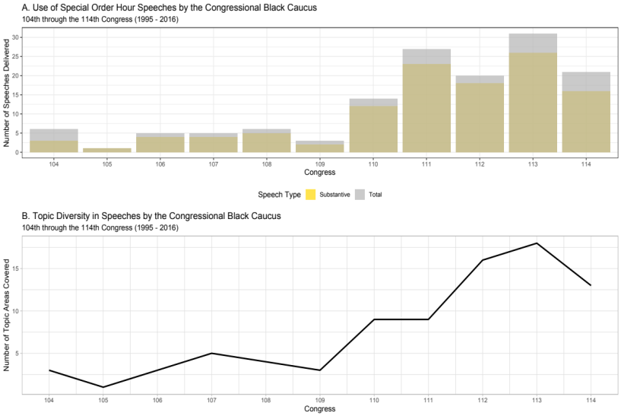
Figure 1: The figure above depicts the number of speeches delivered in each of the congressional terms of interest.
To examine the Congressional Black Caucus’ collective effort to use discourse to shape constructs around Black interests, we use a qualitative form of social network analysis to explore the contents of 99 speeches delivered on the floor of the U.S. House of Representatives from the 111th through the 114th Congresses (2009 – 2016). We focus our attention on those four terms for two primary reasons. The first reason is recency; we are primarily interested in how the Black Caucus identifies and defines issues that are currently on their legislative agenda. The second motivation (and advantage) of this sample is the fact that this period happens to cover the widest breadth of policy topics.

A Network Approach to Approximating an Expressed Collective Agenda
Grimmer’s (2010) efforts in using text to unveil the legislative priorities of Senators resulted in a Bayesian hierarchical model that ties lawmaker to statements made in press releases. He then validates this approximation of their priorities by tying their individuals expressed agenda to a number of legislative behaviors. He convincingly highlights how lawmakers’ dialogue (in this instance written texts) can reveal their priorities and serve as windows into their individual home styles. This article attempts to provide an alternative approach to arrive a similar concept of an expressed agenda. The CBC special order speeches provide insight into the policy priorities of the caucus in ways that may not be visible in other phases of the legislative process.
A network analysis approach to constructing an expressed agenda provides a number of similar benefits to Grimmer’s hierarchical model. Ultimately, they both seek to connect actors (or groups, in this instance) to statements, positions, or issues. An actor-based network approach has the potential to provide the added benefit of revealing how actors are connected to other actors by shared interests (Leifeld and Haunss 2012; Leifeld 2013; 2016; Ingold, Fischer, and Cairney 2017). In this analysis, specifically, the network approach takes two key departures from Grimmer’s work. First, this analysis looks to move beyond making connections between individuals and their expressed agenda and, instead, looks to approximate a collective expressed agenda. The second departure comes in the fact that this is an issue-based analysis as opposed to an actor-based exploration.
It is necessary that we expand on each of these departures and how this analysis seeks to accomplish both goals. While Grimmer and others (Mayhew 1974; Fenno 1978; Sulkin 2005) sought to reveal where lawmakers elect to dedicate their attention through various forms of communication, few have ventured into studying how collections of lawmakers outside of the traditional party apparatus communicate their legislative priorities; this is especially the case for collections of lawmakers from marginalized and minoritized populations. Many attempts to gauge the effects of Black representation – while convincing – often do so by resting on the powers of aggregation of individualized behaviors (Gile and Jones 1995; Levy and Stoudinger 1976; Singh 1998; Pinney and Serra 1999; Mixon and Pagels 2007; Tate 2014). Floor votes, ideology scores, interest group ratings, and even bill sponsorships become convoluted proxies for many of the important – yet empirically evasive – concepts they seek to capture like “coordination”, “cohesion”, and “messaging”. CBC Special Order speeches represent a consensus-driven, collective effort to identify, construct, and promote issues onto a legislative agenda. It is crucial that there exists a means to separate the individual preferences of lawmakers from those of a collection of lawmakers that aren’t entirely dependent on the powers of aggregation.
CBC Special Order speeches are true measures of the organization’s collective agenda evident in both delivery and in the organizational structure that birthed the practice. First, the special order speeches are delivered as a collective as opposed to those delivered by individual lawmakers – with many of the more recent speeches calling on the presence of a half-dozen or more of its members working in tandem within the one-hour time allotment. In fact, there are a number of occasions where individual members of the Black Caucus will deliver an individual floor speech and, in the same legislative session, will return later to join the collective efforts of the caucus in delivering their speech of the day.
Not only are these speeches delivered as a collective unit, these speeches are delivered on behalf of the caucus (as opposed to individual members). This is an important distinction, considering the fact that the organization’s bylaws forbid its members from speaking for the caucus without prior authorization. This is a privilege typically reserved for the CBC chairperson. This means when members gather during CBC Special Order speeches, they are doing so at the behest of the organization with the intent relay to the institution and the American people their collective legislative priorities and preferences. Additionally, the speeches are often guided or reinforced by other organizational features of the caucus. For example, the speakers often reference and draw on work performed in the organizations’ taskforces and working groups – a system designed to supplement the institutions committee structure as a source of policy-relevant information (Hammond, Mulhollan, and Stevens 1985; Owens 2011; Minta and Sinclair-Chapman 2013). Also, the speeches can be linked to the short form agenda that the caucus publishes on their organizational website before each term. While the organization’s written agenda provides an outline for their legislative priorities, if falls short in explaining how the organization constructs these issues. It is these features that reinforce our assertion that these are not speeches delivered by individual lawmakers – a significant departure from Grimmer’s work dedicated to uncovering expressed agendas. These are an expression of the organization’s collective preferences and priorities, and thus they should not be treated as such.

An Issue-centric Approach to Examining an Expressed Agenda
While previous efforts succeeded in identifying the issues that individual lawmakers communicate to their constituency. It falls just short in addressing a more interesting – and potentially, more important question. How do members perceive the issues that they choose to promote? A network approach provides added dimension in that it may come closer to answering not only how member (or in this case, organizations) prioritize issues on their agenda but, also, how they construct the issues that they devote their attention to. Moreover, it provides insight into how problems on an agenda are related to one another. If policy problems are a sum of their many underlying attributes, the reality is that many issues share attributes – a process visualized in Figure 2. This idea of issue interconnectedness is captured in the ways members discuss policy problems in the speeches, themselves. For example, in the 114th Congress, Rep. Donald Payne (D-NJ) argues the multiplicity and interconnected nature of health care to related issue areas complicates problems solving:

“There are numerous factors that contribute to the health disparities throughout New Jersey’s 10th Congressional District and throughout our Nation as well - poverty, environmental threats, inadequate access to health care, and educational inequities. These are such interconnected issues that a piecemeal plan to fixing the problem will not work. A comprehensive approach - one that focuses on providing access to quality care for all, creating good jobs that provide a decent living, and increasing educational opportunities for low income communities - is only one way to eliminate the health disparities once and for all.”

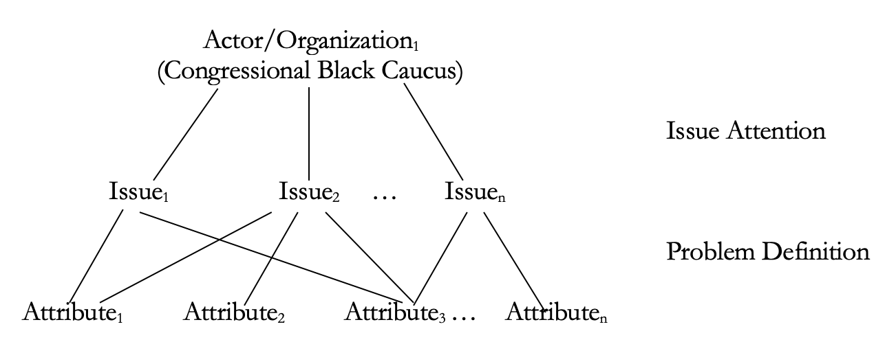
Figure 2: A visualization of the issue based network model

Coding and Analyzing CBC Special Order Hour Speeches
Given the aim of this study, we employ a qualitative approach to Social Network Analysis to uncover how Black lawmakers use collectively organized floor speeches to define Black interests. Discourse Network Analysis (DNA) is a tool created by Philip Leifeld (2013) to facilitate the transformation of textual data into networks. Once constructed, these networks can then be used to examine agreement or disagreement between actors in a given policy space and trace conceptual trends that emerge in policy debates (Leifeld and Haunss 2012; Leifeld 2013; 2016). To capture the ways in which the CBC discusses and defines policy issues, we draw upon a coding scheme devised by the Comparative Agendas Project (CAP) (2017). This scheme has been utilized to examine the contexts of bill sponsorships, congressional hearings, executive actions, judicial activities and numerous other political behaviors in the United States and internationally. The coding scheme organizes these behaviors by establishing twenty (20) well-articulated, mutually exclusive major policy topics areas and 220 minor topic areas that are encapsulated within their respective main topic areas. This approach provides for both a broad categorization as well as a more granular classification of policy contexts in a given text. We adhere to this coding scheme throughout our coding of the Special Order speeches.
We acquired official transcripts of each speech delivered during our time period of study directly from the Congressional Record. Speeches were then uploaded into Leifeld’s Discourse Network Analyzer software and hand-coded by the authors. As Figure 1 indicates, the Caucus delivered 28 speeches that were less about substantive policy and more about symbolic and ceremonial gestures. Examples such speeches include those delivered to honor a deceased member of the caucus or civil rights icons or others, i.e. in the 114th Congress, where the CBC delivered a speech on “The History of the Congressional Black Caucus” and another on “Confederate Monuments”. From this point, we focus our attention on the remaining 71 speeches. In nearly every case, the speeches aligned with the following description: (1) speeches were organized to bring attention to a substantive policy problem (voting rights, criminal justice, poverty, etc.), (2) the topics of the speech aligned with a specific major and minor topic code in the CAP coding scheme, (3) in each case, multiple lawmakers collaborated in the delivery of the speech, and (4) the speeches were organized by the Congressional Black Caucus and sanctioned by Speaker of the House according to the rules governing special order speeches.
We begin by identifying the overarching theme of the speech in question according to the CAP major and minor coding scheme. These themes represent a set of policy problems P as outlined by the caucus across the entirety of the corpus of speeches where P = {p₁, p_{2,} … p_{m}}. In most cases, this process was straightforward. In each case, the overarching theme of the speech remained constant throughout the coding of that particular transcript. From there, we proceeded with coding the spoken text found in the transcript. To accomplish this, we focused our attention on the attributes used to define a particular policy issues by establishing causal relationships with the policy theme. In this analysis causal relationships can be drawn by a speaker’s effort to connect a problem to a root cause or through the advocacy for a particular solution in a manner that infers a causal relationship between the dimension and the overarching problem. We only include attributes that were mentioned at least twice in conjunction with a particular policy area to limit the inclusion of attributes that may be the result of casual mentions of unrelated policy areas. These attributes in across the breath of speeches can be denoted as A = {a₁, a₂, … a_{m}}.
Analysis of special order speeches delivered by the Congressional Black Caucus reveal a complex agenda comprised of multidimensional and interconnected problems. The discourse that emerges from these speeches reveal the Congressional Black Caucus spends a considerable amount of time constructing issues on their legislative agenda by identifying problems in the Black community (and nationally) and defining these issues according to their underlying attributes, As Table 1 reveals, CBC members covered twenty-seven unique core policy problems in their 71 policy-centered speeches over 4 years. Contrary to suggestions that the Black Caucus agenda is narrow, the Black Caucus discussed broad range of diverse policy interests. Not only does the Caucus use collective action to discover and dissect an impressive range of policy issues on the House floor, by defining they also illuminate the complexities of the issues that plague the Black community.
Table 1 presents a count of the total undirected connections created in the network of core policy problems and the policy attributes used to define those problems. The twenty-seven core problems were connected to 115 unique policy-related subtopics. Examiners of Black representation often contend that the legislative pursuits of take on unidimensional qualities (Swain 1993; Singh 1998; Tate 2003; Canon 1995; 2005, among others). However, Special Order speeches reveal more of a network of issues that are connected by their underlying attributes.
Table 1: Contents of CBC Special Order Hour Speeches Delivered from the 111th through the 114th Congress (2009 – 2018)
Policy Domain | Major Topic Area (CAP) | Speeches |  | Attributes
National Budget | Macroeconomics |  | 4 | 38
Macroeconomics | Macroeconomics |  | 7 | 25
Unemployment Rate | Macroeconomics |  | 4 | 19
Gender & Sexual Orientation Discrimination | Civil Rights and Liberties |  | 4 | 20
Voting Rights | Civil Rights and Liberties |  | 10 | 16
Minority Issues | Civil Rights and Liberties |  | 1 | 9
Civil Rights and Liberties | Civil Rights and Liberties |  | 1 | 12
General Health | Health |  | 3 | 20
Health Care Reform | Health |  | 7 | 24
Labor and Employment | Labor and Employment |  | 2 | 17
Employee Benefits | Labor and Employment |  | 2 | 10
Employment Training & Workforce Development | Labor and Employment |  | 1 | 7
General Education | Education |  | 1 | 3
Higher Education | Education |  | 1 | 5
Air Pollution | Environment |  | 1 | 5
Immigration & Refugee Issues | Immigration |  | 2 | 5
General Law, Crime, Family Issues | Law, Crime, Family Issues |  | 2 | 15
Police, Fire, & Weapons Control | Law, Crime, Family Issues |  | 5 | 12
Poverty Assistance | Social Welfare |  | 3 | 27
Elderly Issues | Social Welfare |  | 1 | 4
Food Assistance Programs | Social Welfare |  | 1 | 3
Small Business | Banking, Finance, and Domestic Commerce |  | 1 | 5
Financial Institution Regulation | Banking, Finance, and Domestic Commerce |  | 1 | 2
Mortgages | Banking, Finance, and Domestic Commerce |  | 1 | 3
Nominations & Appointments | Government Operations |  | 2 | 10
U. S. Foreign Aid | Int. Affairs & Foreign Aid |  | 2 | 6
Int. Affairs & Foreign Aid | Int. Affairs & Foreign Aid |  | 1 | 4

The Utility of a Network Modeling of a Collective Expressed Agenda
What, if anything, is there to be gained from the efforts on the part of Black lawmakers to identify and define issues on their legislative agenda? We argue, there are palpable benefits to engaging in, consuming, and considering political discourse for both policymakers and observers interested in the representation of Black-interest policies. The preceding section revealed a modern Black-interest agenda that is far more broad, multidimensional, and interconnected than most early examinations of Black representation would suggest. Outside of providing a better understanding of the nature of the issues on the Black Caucus agenda as constructed by the organization, we find that speeches could yield strategic information to assist in representing and studying Black-interests. In line with much of the policy literature, we view an overarching policy problem as a sum of its underlying attributes. While our corpus includes speeches from the 111th to the 114th Congresses, we are not particularly interested in the change of definitions over time. Therefore, we elect to treat this series of speeches as a pooled cross-section of collective behavior captured in the affiliation matrix where edges are established between core policy problems P and their attributes A (Figure 2).
Using three common tools of social network analysis – community detection, network robustness assessments, and node-removal - we find that information derived from political discourse provides (1) a means to provide structure to an otherwise disjointed agenda, (2) a means to organize an agenda according to shared issue attributes, and (3) a means to assess the complexity of the CBC agenda. Before we proceed, we must address the bipartite nature of the graph represented in Figure 2. To date, bipartite networks have proven to be restrictive in terms of the types of analysis that can be run. Given this, we elect to use a monopartite problem-to-problem projection of the underlying bipartite network where nodes represent the core problems P discussed in Special Order Hour speeches and edges are created when two problems share attributes. The resulting graph is presented in Figure 3.

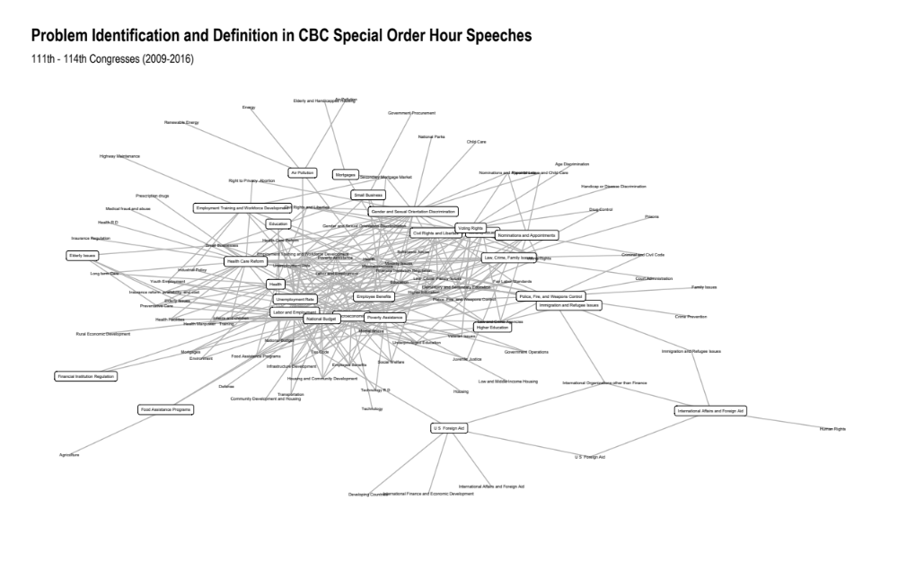

Advantage 1: Accounting for the Interconnected Nature of Black-Interests
One of the greatest shortfalls of more traditional approaches that engage the representation of Black-interest is that they often fail to account for the interconnected nature of problems that plague Black America. Educational inequality contributes to a lack of job opportunities. Joblessness perpetuates poverty in those same communities, and poverty exacerbates educational inequalities. Problems in Black communities are transitive, cyclical, and self-reinforcing. The discourse that arises from special order speeches suggest that the collective expressed agenda of the CBC is cultivated with that in mind. Unfortunately, existing scholarship struggles to account for this reality. This is not to say that scholars that have taken on the challenge of chronicling the struggles associated with representing Black interests fail to understand and acknowledge the interconnectivity associated with Black-interests – most certainly do. However, dominant empirical (quantitative) methods are not necessarily designed to account for relational data that would emerge if the context from their collective agenda was incorporated into their modeling.
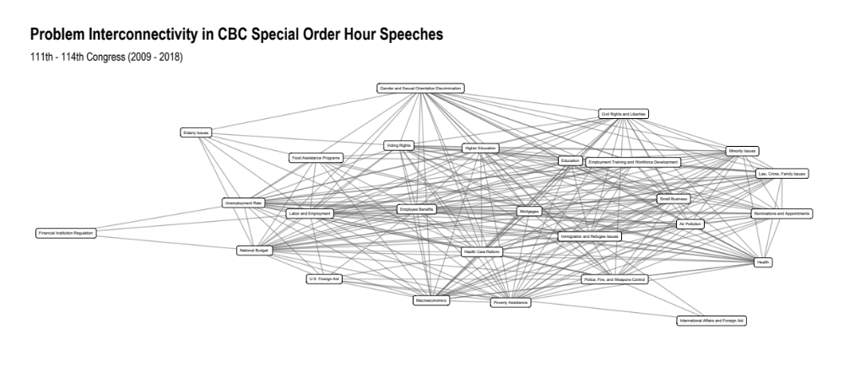
Figure 3: A monopartite projection of the CBC-interest network where nodes represent core problems and edges represent shared attributes.

An interconnected collective expressed agenda means that not only means that the problems they seek to eradicate are inseparable, but the potential solutions to those problems are also interrelated. Just as education inequality has direct linkages to unemployment and poverty, efforts to improve access to a quality education can not only break the chain but actually improve employment and income for those that need it the most. Statistical modeling, however, often requires us to treat these conditions as independent of one another. Endogeneity is problematic in the world of traditional models. However, network models are designed, specifically, to account for and even explain endogenous effects. Our understanding of the collective efforts to advance the Black American condition would be improved greatly by the ability to both provide structure to the web of related issues and draw on models designed with the intent of factoring in that interconnectedness – conditions only met with a network application.

Advantage 2: Organizing Issues on a Black-interest Agenda
If taken on their own, the issues on the CBC agenda appear to be rather disjointed. However, as we have discussed, and as discourse has pointed out, issues on the CBC agenda share underlying attributes in a way that could create families, or clusters, of interrelated issues. We present a community detection algorithm – Optimal Community Structure – to detect if such a clustering exists and what the nature of that clustering is. Optimal Community Structure is a hierarchical detection algorithm that seeks to optimize modularity in a given network. The interpretation of the community detection algorithm presented in Figure 4 is straightforward: those nodes that are included in a respective community are considered to be more closely related than those in other communities. The results of the community detection analysis reinforce the notion that issues can be organized accorded to their shared attributes.
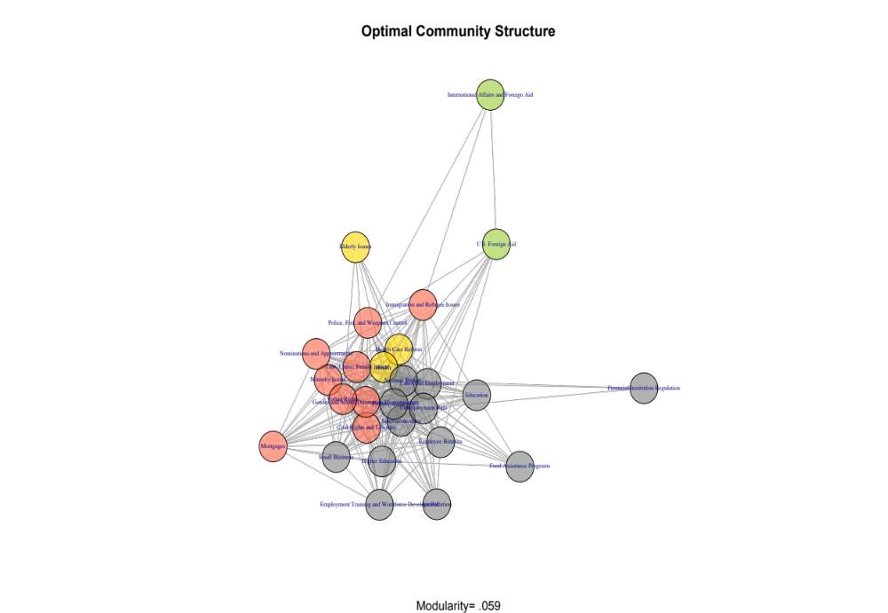
Figure 4: Issue clustering as determined by the Optimal Community Structure algorithm

The issues discussed in Special Order Speeches can be categorized into four distinct groups. The two largest clusters can be categorized as issues dealing with economic issues – where macroeconomic, education, labor and employment, commerce, and social welfare issues tend to have shared attributes – and problems that are rooted in social justice – i.e. civil rights, criminal justice, and governmental operation issues. The remaining two groups consist of policies associated with health care and international affairs and aid. The clustering of these issues also suggests that the type and targets of the policies discussed tend to create grouping effects. Issues that are constructed in a way that suggests they have broad, national impacts tend to cluster together according to their shared attributes while issues that require institutional change or impact targeted racial, ethnic, or gender groups are similarly constructed. While not as clear-cut as the clustering around policy targets, issues also tend to cluster together according to their respective policy types.

Advantage 3: Assessing a Collective Expressed Agenda
A network approach is also a means to provide different ways to evaluate the collective expressed agenda in ways that traditional models fall short. First, there are avenues to test the degree of complexity – or robustness – of the collection problems outlined by the Black Caucus. Simple systems tend to fragment as nodes are removed from the network, while complex systems are less to prone to disruption (Barabási 2016). Discourse becomes a means to assess the complexity of an agenda by determining how vulnerable it is to problem-solving efforts. Here, we examine the robustness of the CBC problem network by determining the number of nodes that could be removed at random before the network collapses.
The monopartite projection of the CBC issue network is an impressively dense (connected) one. The 241 edges between each of the 27 nodes constitute 68.7% of all potential connections. One determinant of a network’s complexity comes with the presence of a “giant component”. A verified Malloy-Reed criterion indicates giant component exists in the case that each node (in this instance, problem) is connected to at least two other nodes on average. In other terms:

$K=\frac{<k^{2}>}{<k>} > 2$ ( 1 )

In the case of the CBC issue network, the average node degree 17.85 certainly meets the Malloy-Reed criterion. From there, we are able to move forward with determining the critical threshold $f_{c}$ of nodes that can be removed before the structure collapses. This threshold can be calculated:

$f_{ c} = 1- \frac{1}{\frac{<k^{2}>}{<k>}-1}$ ( 2 )

More importantly, a network approach can provide insights into if – and how much – progress has been made in dismantling the network of policy problems that make up their collective expressed agenda. To further illuminate this, I offer a thought experiment motivated by the Caucus’ expressed agenda. Network scientists have devised a means to evaluating how vulnerable the network is to changes in the structure (Barabási 2016). Interconnectedness has the potential to lead to vulnerabilities in some networks – i.e. power grids, the internet, the stock market – or reinforce structures in other networks– like social groups. A networks robustness – or complexity – can often be the difference between the two. Imagine, for example, a government’s targeting of a terrorist network. A network modeling of the actors in that network - and a mapping of their connections to other actors in the same network (or, even other networks) – is often the tool of choice to predict network collapse. In other words, network model are designed to identify central figures in a network and determine what the impact of the node elimination would be on the remaining structure.
In regards to the expressed CBC agenda, if node removal simulates problem solving, and network failure would suggest that each of these interconnected problems have been remedied, failure could actually yield positive outcomes for the communities that they represent. However, the critical threshold of node removal suggests that the network of problems on the CBC agenda are reinforced by their shared attributes. The resulting critical threshold of the issue network suggests random problem-solving require that 94% of the issues (nodes) would need to be removed before the structure is no longer viable. While solving problems at random would yield very little impact to the overall condition of Black America, how would the network fare against a more targeted attack of issues on their agenda? As seen with certain terrorist organization, robust networks are often able to absorb significant random losses with little impact on the larger structure of the group. However, targeting key figures in the organization – leadership, brokers, etc. – can often cause even the most robust networks to collapse at a significantly faster rate.
To that point, Figure 5 presents the CBC’s expressed agenda network’s response to two different types of attacks. We, first, perform 100 simulations of the effects of attacks based on randomized node-removal. The second simulated attack would target the most connected issues according to their degree centrality measure. Figure 5 suggest that a better understanding of issues, their underlying attributes, and their relationship to other issues – brought on only by a network modeling of the collective discourse found in special order speeches – has the potential to illuminate a path towards solving problems in Black America. Solving the most connected issues according to their degree centrality score would result in issue-network decay much sooner than if issues were selected at random. Admittedly the loss of connectivity that comes as a result of various attacks is not very impressive. This is a function of the robustness of the problem network. However, if the problem network collapses after the random removal of 94% of nodes, targeting nodes with the highest degree centrality reduces the estimated point of total collapse to just over 81% when nodes are targeted in am more systematic fashion.
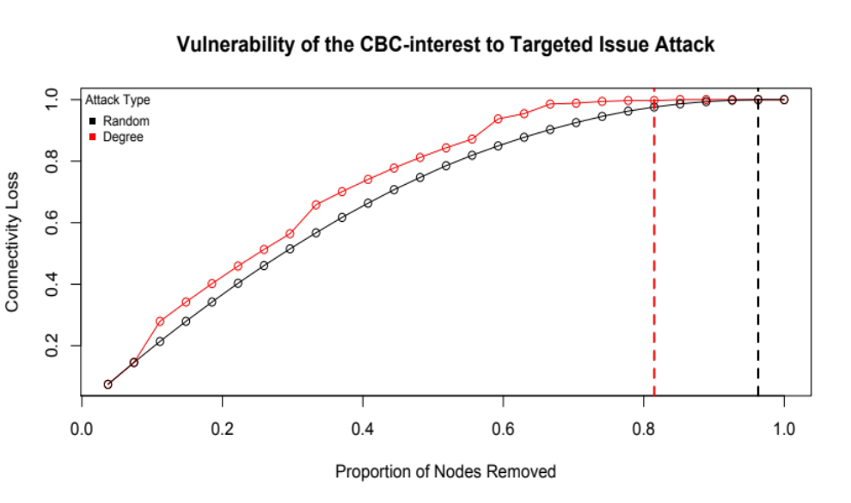
Figure 5: Assessment of network vulnerability to various forms of attack

To put this in context, the most connected issues are labor and employment, budgetary spending, and the unemployment rate. Each of these issues share attributes with twenty-five other issues discussed in special order speeches. Solving those three issues would result in the loss of nearly 28% of the connectivity of the CBC-issue network. Solving three issues at random would result in a connectivity loss of 24%. Solving the next most connected issues – income inequality and poverty – would result in a disconnect of 40% of the network (compared to 34% connectivity loss for the next two randomly selected issues. The robustness of the CBC problem network presents challenges for those attempting to solve problems on their agenda. However, using discourse to gain an understanding of the nature of problems on the CBC agenda, we find that network analysis can provide useful information to illuminate a clearer path for policymakers.

Discussion
Scholarly examinations of the representative functions of Black lawmakers have certainly been fruitful in framing their behaviors in the halls of Congress. However, by leaning into behaviors such as voting and bill sponsorship, we have undersold the importance of politicians engaging in an informative dialogue on race-centric policies. In fact, some demote these conversations as performative or merely a symbolic form of representation (May 1991; May, Sapotichne, and Workman 2006). Legislative speech, in this case Special Order speeches, often gets characterized as “cheap talk” by scholars because it is often unclear who is listening and what the purpose of this aspect of congressional business contributes to outcomes. Meanwhile, other legislative behaviors are seen as more tangible measures of representation despite the fact that most, too, routinely fall on deaf ears. For example, while bill sponsorships could certainly be viewed as an attempt on the part of lawmakers to relay messages to the institution (Schiller 1995; Pinney and Serra 2002; Talbert and Potoski 2002), an overwhelming majority – in most congresses, nearly ninety-percent – of bills never receive attention in a meaningful way (Krutz 2005). However, just as with bill sponsorship, legislative speech has palpable benefits that extend well beyond their more obvious functions.
Many of the predominant approaches to examining the behavior of lawmakers from underrepresented populations result in a limited understanding of agenda- setting behavior that may not properly reflect the true breadth of policy interests. Additionally, in many instances, the analysis lacks the necessary systematic consideration of the members’ construction of the issues in question. More importantly, common approaches result in a static conception of Black interests – one that does not account for the evolution of Black representatives, evolutions in the policy environment, or an evolution in the collective strategy to promote and solve those problems at an institutional level. Finally, the dominant methods of examining issues fall short in revealing the complexity of the Black legislative agenda in Congress.
As Gillion (2016, 154) convincingly argues, “the dialogue on race emerges not as a symbolic gesture but rather a substantive form of governance that constantly enriches the political debate among politicians, shapes the creation and reception of public policy, and influences public deliberation and cultural norms in the minority community”. In this instance and others, “talking about it” is actually “being about it”. In the absence of these conversations, the responsibility of shaping policy in Black-interest areas falls on an uninformed, uninterested, and uninspired institution. Floor speeches play an essential role in allowing leadership to assess the mood of the rank-and-file, create signals to administrative agencies and the courts about legislative intent, and allow members to position take and credit claim to serve their reelection goals (Oleszek et al. 2016; Fenno 1973; Mayhew 1974). Legislative speechmaking allows members to effectively communicate to other elites, particularly interest groups, that a member is credibly committed to the interests of that group (Ray 2018). Additionally, a legislator’s speechmaking behavior is tied to their representation (home) style (Hill and Hurley 2002, 219-220).
Gillion’s (2016, 14) theory of discursive governance contends, “the path to ameliorating these inequalities begin with politicians’ willingness to engage in a conversation”. It is our hope that, through the examination of these CBC Special Order Hour Speeches, we have illuminated the value of engaging with the content and context of these conversations around race and their potential value for both researchers and policymakers, alike. Political discourse assists defining policy interests in a way that highlights breadth and complexity of the organization’s agenda while providing structure and organization to such a complex collective of issues. This collective effort to bring issues of race to the forefront of discussions in political institutions – through issue promotion and problem definition – facilitate their roles as agenda-setters, information brokers, and coalition builders (Stevens, Mulhollan, and Rundquist 1981; Hammond, Mulhollan, and Stevens 1985; Vega 1993). It is crucial that those interested in expanding the understanding of Black representation consider the contexts surrounding how Black politicians talk about race. Relatedly, it would be prudent to revisit evaluations of the Congressional Black Caucus that paint the group as largely ineffective. To the contrary, their role in shaping the informative discourse is essential to both forwarding race-centric policies in political institutions and shaping public perceptions of the Black experience in America. Further, speeches like these shed light on the legislative priorities of the caucus, how they frame the problems that lie at the core of the Black-American condition, and the collective strategy that they employ to draw attention to and overcome the conditions that create racial inequality.
The second motivation of this essay was to, hopefully, broaden the consideration of an otherwise underutilized method – Social Network Analysis – as a viable and potentially exciting means to examine the representation of marginalized interests in political institutions. The CBC special order speeches served as an ideal medium to reveal the potential of a network application. However, it is certainly not the only means to either examining the legislative behavior of marginalized groups or approximating an expressed legislative agenda. Several scholars have employed actor-based modes network analysis to examine bill cosponsorship (Fowler 2006; Bratton and Rouse 2011; 2011; Craig et al. 2015) and collaborations in writing “dear colleague” letters in the House (Box‐Steffensmeier, Christenson, and Craig 2019). However, few have drawn on this form of modeling to examine the impacts of racial identity or racialized groups within the institution. It is our hope that this venture serves as a steppingstone for those seeking to build on the collective understanding of group representation.
Further, this issue-based approach is unique in the sense that it departs from the more traditional actor-based models. Using the Congressional Black Caucus special order speeches as a empirical backdrop, we hope that we have revealed that issues can become the center of examination as we look to improve our understanding and contextualization of policy problems in American politics. This exercise could certainly be extended to examine the differences and overlap between various collectives of lawmakers, given the conditions of exclusivity are met. In the case of special order speeches, there is little evidence that other groups participate in a similar fashion, especially not to the degree that the Black Caucus has relied on floor speeches as a central means of communicating their collective agenda. However there are other means of collective communication that could serve as a well-reasoned platform to examine expressed agendas. This could also provide a means of examining the differences between the expressed collective agendas and the expressed agendas of the individual members that comprise the organizations.

References:
Barabási, Albert-László. 2016. Network Science. Cambridge University Press.
Barnett, Marguerite Ross. 1977. “The Congressional Black Caucus: Symbol, Myth, and Reality.” The Black Scholar 8 (4): 17–26.
Barnett, Marguerite Ross, and James A. Hefner. 1976. “Public Policy for the Black Community; Strategies and Perspectives.”
Baumgartner, Frank R., and Bryan D. Jones. 1993. Agendas and Instability in American Politics, Second Edition. University of Chicago Press.
———. 2002. Policy Dynamics. University of Chicago Press.
Box‐Steffensmeier, Janet M., Dino P. Christenson, and Alison W. Craig. 2019. “Cue-Taking in Congress: Interest Group Signals from Dear Colleague Letters.” American Journal of Political Science 63 (1): 163–80. https://doi.org/10.1111/ajps.12399.
Bratton, Kathleen A., and Stella M. Rouse. 2011. “Networks in the Legislative Arena: How Group Dynamics Affect Cosponsorship.” Legislative Studies Quarterly 36 (3): 423–60.
Broockman, David E. 2013. “Black Politicians Are More Intrinsically Motivated to Advance Blacks’ Interests: A Field Experiment Manipulating Political Incentives.” American Journal of Political Science 57 (3): 521–36. https://doi.org/10.1111/ajps.12018.
Canon, David T. 1995. “Redistricting and the Congressional Black Caucus.” American Politics Quarterly 23 (2): 159–89. https://doi.org/10.1177/1532673X9502300203.
Canon, David T. 2005. “The Representation of Racial Interests in the US Congress.” In The Politics of Democratic Inclusion, 281.
Carmines, Edward G., Robert Huckfeldt, and Carl McCurley. 1995. “Mobilization, Counter-Mobilization and the Politics of Race.” Political Geography 14 (6): 601–19. https://doi.org/10.1016/0962-6298(95)00056-G.
Carmines, Edward G., and James A. Stimson. 1989. Issue Evolution: Race and the Transformation of American Politics. Princeton University Press.
Craig, Alison, Skyler J. Cranmer, Bruce A. Desmarais, Christopher J. Clark, and Vincent G. Moscardelli. 2015. “The Role of Race, Ethnicity, and Gender in the Congressional Cosponsorship Network.” ArXiv:1512.06141 [Physics, Stat], December. http://arxiv.org/abs/1512.06141.
Ellis, William Curtis, and Walter Clark Wilson. 2013. “Minority Chairs and Congressional Attention to Minority Issues: The Effect of Descriptive Representation in Positions of Institutional Power.” Social Science Quarterly 94 (5): 1207–21. https://doi.org/10.1111/ssqu.12023.
Fenno, Richard F. 1978. Home Style: House Members in Their Districts. Longman.
Fowler, James H. 2006. “Connecting the Congress: A Study of Cosponsorship Networks.” Political Analysis 14 (4): 456–87. https://doi.org/10.1093/pan/mpl002.
Frisch, Scott A., and Sean Q. Kelly. 2006. Committee Assignment Politics in the U.S. House of Representatives. University of Oklahoma Press.
Frymer, Paul. 2010. Uneasy Alliances: Race and Party Competition in America. Princeton University Press.
Gamble, Katrina L. 2007. “Black Political Representation: An Examination of Legislative Activity within U. S. House Committees.” Legislative Studies Quarterly 32 (3): 421–47.
Gile, Roxanne L., and Charles E. Jones. 1995. “Congressional Racial Solidarity: Exploring Congressional Black Caucus Voting Cohesion, 1971-1990.” Journal of Black Studies 25 (5): 622–41.
Gillespie, Andra. 2010. Whose Black Politics?: Cases in Post-Racial Black Leadership. Routledge.
Gillion, Daniel Q. 2016. Governing with Words: The Political Dialogue on Race, Public Policy, and Inequality in America. Cambridge University Press.
Griffin, John D., and Michael Keane. 2011. “Are African Americans Effectively Represented in Congress?” Political Research Quarterly 64 (1): 145–56.
Grimmer, Justin. 2010. “A Bayesian Hierarchical Topic Model for Political Texts: Measuring Expressed Agendas in Senate Press Releases.” Political Analysis 18 (1): 1–35. https://doi.org/10.1093/pan/mpp034.
Hammond, Susan Webb, Daniel P. Mulhollan, and Arthur G. Stevens. 1985. “Informal Congressional Caucuses and Agenda Setting.” The Western Political Quarterly 38 (4): 583–605. https://doi.org/10.2307/448614.
Hawkesworth, Mary. 2003. “Congressional Enactments of Race-Gender: Toward a Theory of Raced-Gendered Institutions.” The American Political Science Review 97 (4): 529–50.
Ingold, Karin, Manuel Fischer, and Paul Cairney. 2017. “Drivers for Policy Agreement in Nascent Subsystems: An Application of the Advocacy Coalition Framework to Fracking Policy in Switzerland and the UK.” Policy Studies Journal 45 (3): 442–63. https://doi.org/10.1111/psj.12173.
Johnson, James B., and Philip E. Secret. 1996. “Focus and Style Representational Roles of Congressional Black and Hispanic Caucus Members.” Journal of Black Studies 26 (3): 245–73. https://doi.org/10.1177/002193479602600302.
Jones, Bryan D., and Frank R. Baumgartner. 2005. The Politics of Attention: How Government Prioritizes Problems. University of Chicago Press.
Krutz, Glen S. 2005. “Issues and Institutions: ‘Winnowing’ in the U.S. Congress.” American Journal of Political Science 49 (2): 313–26. https://doi.org/10.1111/j.0092-5853.2005.00125.x.
Leifeld, Philip. 2013. “Reconceptualizing Major Policy Change in the Advocacy Coalition Framework: A Discourse Network Analysis of German Pension Politics.” Policy Studies Journal 41 (1): 169–98. https://doi.org/10.1111/psj.12007.
———. 2016. Policy Debates as Dynamic Networks: German Pension Politics and Privatization Discourse. Campus Verlag.
Leifeld, Philip, Johannes Gruber, and Felix Rolf Bossner. 2013. “Discourse Network Analyzer Manual,” 65.
Leifeld, Philip, and Sebastian Haunss. 2012. “Political Discourse Networks and the Conflict over Software Patents in Europe.” European Journal of Political Research 51 (3): 382–409. https://doi.org/10.1111/j.1475-6765.2011.02003.x.
Levy, Arthur B., and Susan Stoudinger. 1976. “Sources of Voting Cues for the Congressional Black Caucus.” Journal of Black Studies 7 (1): 29–46. https://doi.org/10.1177/002193477600700103.
Mansbridge, Jane. 1999. “Should Blacks Represent Blacks and Women Represent Women? A Contingent ‘Yes.’” The Journal of Politics 61 (3): 628–57. https://doi.org/10.2307/2647821.
Mayhew, David R. 1974. Congress: The Electoral Connection. Yale University Press.
Minta, Michael D. 2011. Oversight: Representing the Interests of Blacks and Latinos in Congress. Princeton University Press.
Minta, Michael D., and Valeria Sinclair-Chapman. 2013. “Diversity in Political Institutions and Congressional Responsiveness to Minority Interests.” Political Research Quarterly 66 (1): 127–40.
Mixon, Franklin G., and Amanda C. Pagels. 2007. “Are Congressional Black Caucus Members More Reliable? Loyalty Screening and Committee Assignments of Newly Elected Legislators.” The American Journal of Economics and Sociology 66 (2): 413–32.
Owens, Major. 2011. The Peacock Elite: A Subjective Case Study of the Congressional Black Caucus and Its Impact on National Politics. GrantHouse Publishers.
Pinney, Neil, and George Serra. 1999. “The Congressional Black Caucus and Vote Cohesion:Placing the Caucus Within House Voting Patterns.” Political Research Quarterly 52 (3): 583–607. https://doi.org/10.1177/106591299905200306.
———. 2002. “A Voice for Black Interests: Congressional Black Caucus Cohesion and Bill Cosponsorship.” Congress & the Presidency 29 (1): 69–86. https://doi.org/10.1080/07343460209507850.
Pitkin, Hanna F. 1967. The Concept of Representation. University of California Press.
Polletta, Francesca. 2012. Freedom Is an Endless Meeting: Democracy in American Social Movements. University of Chicago Press.
Rocca, Michael S., and Gabriel R. Sanchez. 2008. “The Effect of Race and Ethnicity on Bill Sponsorship and Cosponsorship in Congress.” American Politics Research 36 (1): 130–52. https://doi.org/10.1177/1532673X07306357.
Rocca, Michael S., Gabriel R. Sanchez, and Jason L. Morin. 2011. “The Institutional Mobility of Minority Members of Congress.” Political Research Quarterly 64 (4): 897–909. https://doi.org/10.1177/1065912910379225.
Rochefort, David A., and Roger W. Cobb. 1994. The Politics of Problem Definition: Shaping the Policy Agenda. University Press of Kansas.
Schattschneider, Elmer. 1975. The Semi-Sovereign People: A Realist’s View of Democracy in America. Wadsworth Publishing. http://www.amazon.ca/exec/obidos/redirect?tag=citeulike09-20&path=ASIN/0030133661.
Schiller, Wendy J. 1995. “Senators as Political Entrepreneurs: Using Bill Sponsorship to Shape Legislative Agendas.” American Journal of Political Science 39 (1): 186–203. https://doi.org/10.2307/2111763.
Singh, Robert S. 1998. The Congressional Black Caucus: Racial Politics in the United States Congress. London, UK: Sage. https://us.sagepub.com/en-us/nam/the-congressional-black-caucus/book6666.
Smith, Robert C. 1996. We Have No Leaders: African Americans in the Post-Civil Rights Era. SUNY Press.
Stevens, Arthur G., Daniel P. Mulhollan, and Paul S. Rundquist. 1981. “U. S. Congressional Structure and Representation: The Role of Informal Groups.” Legislative Studies Quarterly 6 (3): 415–37. https://doi.org/10.2307/439483.
Sulkin, Tracy. 2005. Issue Politics in Congress. Cambridge University Press.
Swain, Carol M. 1993. Black Faces, Black Interests: The Representation of African Americans in Congress. Enlarged Edition edition. Lanham, Md: UPA.
Talbert, Jeffery C., and Matthew Potoski. 2002. “Setting the Legislative Agenda: The Dimensional Structure of Bill Cosponsoring and Floor Voting.” The Journal of Politics 64 (3): 864–91. https://doi.org/10.1111/0022-3816.00150.
Tate, Katherine. 2001. “The Political Representation of Blacks in Congress: Does Race Matter?” Legislative Studies Quarterly 26 (4): 623–38. https://doi.org/10.2307/440272.
———. 2003. Black Faces in the Mirror: African Americans and Their Representatives in the U.S. Congress. Princeton University Press.
———. 2014. Concordance: Black Lawmaking in the U.S. Congress from Carter to Obama. University of Michigan Press.
The Policy Agendas Project at the University of Texas at Austin. 2017. “Comparative Agendas Project.” 2017. https://www.comparativeagendas.net/pages/master-codebook.
Tyson, Vanessa. 2016. Twists of Fate: Multiracial Coalitions and Minority Representation in the US House of Representatives. Oxford, New York: Oxford University Press.
Vega, Arturo. 1993. “Congressional Informal Groups as Representative Responsiveness.” American Review of Politics 14. https://journals.shareok.org/arp/article/view/702.
Whitby, Kenny J. 2000. The Color of Representation: Congressional Behavior and Black Interests. University of Michigan Press.
Workman, Samuel, JoBeth Shafran, and Tracey Bark. 2017. “Problem Definition and Information Provision by Federal Bureaucrats.” Cognitive Systems Research 43 (Supplement C): 140–52. https://doi.org/10.1016/j.cogsys.2016.11.002.

Chapter 3: Legislative Venue Shopping and the Strategic Pursuit of Black Interests in the U.S. House of Representatives

Introduction
“When legislation is actually considered by a number of committees, multiple perspectives are brought to bear on complex problems. More interests have a voice and a more diverse group of members a say at the committee stage, where it matters the most.” - Barbara Sinclair in Unorthodox Lawmaking, 2016
In May of 2018, the Congressional Black Caucus (CBC) introduced a 1,300-page omnibus package to the House of Representatives. This complex, cross-cutting piece of legislation titled the Jobs and Justice Act - spanned more than a half-dozen major policy topic areas and, if taken up, would have demanded, and likely garnered, the attention of nearly every committee in the chamber. Understandably, in a Republican-controlled Congress, the bill stalled almost immediately after introduction. However, their efforts speak to a larger and increasingly relevant trend among black legislators - and within the House as a whole - of sponsoring multidimensional legislation (Hammond, Mulhollan, and Stevens 1985; Krutz 2001b; Krutz 2005; Krutz 2000; Sinclair 2011). This study proposes that such efforts are the product of an institutional evolution in rules and structure that facilitates such actions and that Black members have adapted their tactics in hopes of increasing their success within the chamber.
The success of actors within lawmaking bodies often rests in their ability to adapt to, and capitalize on, ever-changing political and institutional conditions (Sabatier 1988; Bennett and Howlett 1992; May 1992; Pralle 2003). The U.S. House has certainly undergone a great deal of changes in recent decades that have fundamentally altered the structure and functional capacity of the chamber. Moreover, as Carol Swain (1993; 44) noted more than two decades ago, Black representatives are far removed from the days when the approach to legislating was to “simply drop their bills into the hopper [...] and pray for action”; instead, they call on a multitude of strategies to seek out success in their collective and individual goals. In the years since, this is becoming increasingly true; however, scholarly attention to the strategic nature of Black legislative activities remains scarce and underdeveloped. While a new generation of scholars have taken up the mantel of examining minority representation in lawmaking bodies, there remains unanswered questions concerning (1) not if, but how Black representatives pursue their agenda in Congress and (2) if and how circumstances have improved since the the late twentieth century. Inspired by the likes of Minta, Gamble, Sinclair-Chapman, and others that have devoted attention to the process, I build on their advancements of the literature by, too, looking beyond voting behavior by focusing on how a shift in legislative strategy can alter outcomes in the chamber.
Key studies of the bill referral process in the House of Representatives generally settle on the idea that simplicity is advantageous - that bills that are referred to multiple committees fare worse when it comes to navigating the legislative process (Davidson, Oleszek, and Kephart 1988; Young and Cooper 1993; Davidson 1989; Krutz and Cullison 2008). Multiple referrals are thought to increase the number of potential veto points, contribute to the decentralized nature of House decision making, and induce conflict between committees. However, as Davidson, Oleszek, and Kephart (1988; 25) point out, the prospects for such a strategy “vary widely according to the subject matter and the committees involved”. Through venue shopping, Black lawmakers may be able to capitalize on ever-evolving committee jurisdictions, institutional restructuring, and increasingly favorable committee assignments in the chamber and leverage them into more favorable outcomes. Black issues, in particular, may require multiple referrals to provide more opportunities for bill advancement, break down inherent institutional biases, and build support among potential allies.
With that in mind, I seek to determine if, for Black members of Congress, sponsoring legislation that receives multiple committee referrals results in more favorable outcomes. In doing so, I draw on elements of institutional and policy process research to further explore the relationship between their efforts to sponsor multidimensional legislation and the institution’s capacity to process cross-cutting proposals. I examine substantive bills sponsored by Black members of the House of Representatives in the 103rd, 110th, and 111th Congress in an effort to gain insight as to the ramifications of creating policy proposals that span across multiple committee jurisdictions. I find that when Black lawmakers propose multidimensional legislation - both broadly and in areas targeted by the Congressional Black Caucus - the likelihood that a bill progresses through the legislative process increases dramatically; this is especially true during the most recent period of Democratic majority control.
I begin with a brief survey of the literature concerning the pursuit of Black issues and transition immediately into a conversation focused on how the nature of these issues can - and likely do - spawn cross-cutting legislation. I, then, examine the concerted effort on the part of Black lawmakers to design and propose multidimensional laws that cut across committee jurisdictions. This includes the role and motivations of collective organizations of marginalized representatives - or caucuses - in the strategic development of these multidimensional policy proposals. This conversation prompts the proposal and testing hypotheses concerning the progress of bills sponsored by Black representatives in the 103rd, 110th, and 111th Congresses. Following a discussion of the data and methodology, I report and discuss the findings of the analysis. Finally, I conclude with a discussion of the implications on future research.

Inefficiencies and Inequality in Committee Politics
Committees function as mechanisms that facilitate the pursuit of personal, constituent, and institutional goals. Stewart III (2012) summarizes the evolution of literature concerning the role of the congressional committee in the House of Representatives nicely. He argues, the post-war committee can be characterized by six distinct roles: the literature sees committees as groups, as election facilitators, as stability inducers, as rent-seekers, as party agents, and as information providers. At an individual level, membership on a particular committee provides, or indicates a previous existence of, a certain level of expertise or knowledge in that particular policy area. Membership on a committee also provides some members the opportunity to exert a degree of leverage over policy areas that concern them that arise either as a function of personal expertise or from constituency demands (see Bullock 1973; Shepsle and Weingast 1987 Leighton and Lopez 2002; Frisch and Kelly 2006; Adler and Lapinski 1997 among countless others). From an institutional perspective, congressional committees serve three key organizational functions. First, they create a system where the labor of the institution is divided among engaged and interested members (Gamm and Shepsle 1989). It serves as a filtration agent in an effort to identify which problems deserve attention - and which do not (Krutz 2005; Krutz and Cullison 2008). Lastly, it serves as a means to seek out, acquire, and process information on policy problems and potential solutions (Krehbiel, Shepsle, and Weingast 1987; Gilligan and Krehbiel 1990; May, Sapotichne, and Workman 2006; Workman, Jones, and Jochim 2009; Workman, Shafran, and Bark 2017).
For Black lawmakers, committee politics play out in a number of ways. On one hand, Black members are increasing their influence in a number of committees - including several thought of at the top of the committee hierarchy. Once there, members are able to draw attention towards key issues on their collective agenda through hearings (Ellis and Wilson 2013; Minta 2011). However when it comes to passing actual legislation, their influence is less evident, particularly when it comes to forwarding more racialized proposals beyond the committee phase. Scholars have found structural barriers that exist within the chamber. Congressional committees are “clearly stratified” (Matthews 1960, 152), with a pecking order that provides select members the chance to “gain the power and prestige it offers, in order to serve his constituency. However, while minority members do not request placements on lower committees (Frisch and Kelly 2006), Griffin and Keane (2011) found that, on average, minority MCs consistently receive less valuable committee assignments (findings supported by Rocca, Sanchez, and Morin 2011). In their committee interactions, Black lawmakers face interpersonal marginalization, silencing, and topic extinction - conditions that have “palpable consequences for their identities and their policy priorities” (Hawkesworth 2003, 546).
Ultimately, committees work to induce institutional stability in the lawkmaking process
(Polsby 1968). This desire for stability - both in legislative outcomes and between actors ultimately places Black lawmakers at a disadvantage when seeking to make non-incremental changes to a rigid status quo that has long plagued Black Americans. Substantive policy change will likely require a collective effort designed to create, expose, or capitalize on vulnerabilities in the institutional design in order to achieve their legislative goals. In theory, this structure should facilitate an efficient legislative process. However, this is not always the case - even under periods of consensus. A contributing factor to this inefficiency may be the fact that the division of labor, itself is imperfect; congressional committees are marred by poorly-defined, overlapping jurisdictions that threaten to further complicate the problemsolving functions of the legislative process (Jones and Baumgartner 2005; Lewallen 2018). Policy jurisdictions are neither stable nor permanent; they constantly evolve through formal and informal modifications and procedural adjustments (King 1994; Adler and Wilkerson 2011). This article is an attempt to uncover how Black lawmakers can use strategic policy design to improve their prospects in the House of Representatives.

Black Interests and Multidimensional Legislation
Despite an abundance of literature suggesting Black lawmakers partake in policymaking that is driven by their identity and the unique experiences that are associated with it, the jury is still out as to their ability to translate such efforts into substantive policy gains. Early measures of minority representation and responsiveness were largely framed through voting behavior on a constricted set of bills in policy areas that members of color should care about - with mixed results (Whitby 2000; Swain 1993; Gay 2007; Tate 2001). These disjointed findings may be the product of individualized approaches and late stage processes. Increasingly scholars are reaching beyond voting behavior for evidence of substantive representation. At the state level, Black representatives sponsor significantly more bill in Black interest areas (Bratton and Haynie 1999; Miller 1989). At the federal level, scholars have begun to engage the process of lawmaking to find examples of Black representatives championing racialized policy issues (Canon 1995; Canon 1999). An emerging line of research concerning Black representatives examines the role of increasingly sophisticated infrastructures created to routinely shape the discourse around and attempt to draw attention to Black interests in debate, deliberation, and oversight (Minta 2011; Minta and Sinclair-Chapman 2013; Tyson 2016). It is through these caucuses where members organize, strategize, and pool resources in an effort to forward their collective goals (Hammond, Mulhollan, and Stevens 1985; Hammond 1991; Stevens, Mulhollan, and Rundquist 1981).
At their core, Black lawmakers are tasked with solving complex, multidimensional issues that plague the lives of Black communities throughout the country. Multidimensional - also referred to as cross-cutting or boundary-spanning - policies are multifaceted, complex proposals that becoming increasingly prevalent in the House of representatives. Multidimensionality can be the product of an effort to solve problems for multiple target populations, across a broad spectrum of ideological preferences, or - for Black lawmakers - through an attempt at addressing inequality through racialized and de-recialized means. On the other hand, these types of policies may emerge due to the complex nature of issues that are ill-fit to current jurisdictional arrangements. Those tasked with addressing these issues must, first, categorize the multiple components tied to the particular issue (Workman, Shafran, and Bark 2017). An earnest attempt at problem-solving in issue areas that concern marginalized groups may result in the realization that the problems are layered and interwoven. For example, poverty in Black constituencies goes well beyond job creation - it can be traced to inequality in educational opportunities, the development of communities and infrastructure, the availability of affordable childcare, access to cost-saving and preventative healthcare services, and a number of other conditions that span across several committee jurisdictions (Ogbu 1979; Fleming 1985; Shapiro 2004). The “Jobs and Justice Act” is merely an example of what a holistic approach to solving issues in the Black community would resemble. This was not always a strategy of choice for the Congressional Black Caucus; until recently, CBC members’ legislative pursuits were thought of as narrow, unidimensional, as well as ideologically and racially radical (Swain 1993; Singh 1998; Tate 2014). The question remains, what impact does a shift towards multidimensional legislation have on their legislative fortunes?

Multiple Referrals and the Pursuit of Black Interests
As policymakers learn - either through trial and error or through policy learning - they constantly look to readjust their strategy in search of more favorable outcomes (Sabatier 1991; May 1992; Pralle 2003; Tate 2014; Tyson 2016). Changes in strategy can be prompted by improved understanding of the legislative environment, an improved understanding of policy problems or potential solutions, or even by perpetual losing in the political arena (May 1992; Wildavsky 1979). The Congressional Black Caucus is unique in their need for a sophisticated, institutionalized means to devise a plan of action that is distinct from the larger party apparatus as they seek to advance issues that have yet to be adopted onto the Democratic agenda (Frymer 2010. Black lawmakers have established - and rely heavily on - an extra-party infrastructure of taskforces and working groups that serve as policy laboratories, vessels for strategic planning, and sources of information gathering and dissemination (Minta and Sinclair-Chapman 2013; Hammond, Mulhollan, and Stevens 1985). It is here where the Caucus looks to take advantage of member expertise, interests, or advantageous committee placements in relevant policy areas to formulate a plan of attack. Additionally, organizations with the longevity of the CBC - who’s members are often characterized as electorally secure, increasingly senior, and gaining in institutional influence - are able to draw on accumulated institutional knowledge to shape their collective behaviors.
It is through these mechanisms that members of the Caucus become acutely aware of the constraints associated with their respective political systems and will alter their strategy to circumvent barriers to policy change by seeking out more favorable arenas to achieve their goals (Schattschneider 1975; Baumgartner and Jones 1991; Pralle 2003). In this instance, I point to a shift in strategy on the part of Congressional Black Caucus members to sponsor bills that result in multiple committee referrals - a process that greatly resembles the concept of venue shopping. Venue shopping in the House means actors display (1) an understanding of the institutional features that determine how those bills are disseminated to various committees, and (2) a deliberate shift in the designing of policies that allows them to seek out favorable venues (committees) within the institution in order to drive attention toward those issues.
Sarah Pralle (2003, 240) argues, “policy entrepreneurs and advocacy groups might abstain from venue shopping altogether when an institution has firm jurisdictional control over an issue control that is uncontested and perhaps uncontestable”. Figure 1 suggest this was the case in the 103rd Congress. In fact, prior to the 109th, Black lawmakers lagged behind the House average in both average sponsorship of bills resulting in multiple referral and the average number of committees to which their bills are referred to. In the 109th, however, the sponsorship of cross-cutting legislation increased from 24% to 35% of all bills. This sudden shift is a stark difference from the gradual increase experienced by the remaining House members. In addition, while most political institutions await “windows of opportunity” to arise in order to seek out policy change (Kingdon 2011), this change in tactics predates the most commonly-associated window available in Congress - majority control. If committee jurisdictions evolve “informally and incrementally”, as scholars suggest (Adler and Wilkerson 2011, 88; see also King 1994; King 2008), one could expect very moderate increases in bills resulting in multiple referrals. The abrupt, collective nature of the shift in such activities in the 109th Congress suggest two important notions: this shift in trends was both abnormal and absent favorable partisan conditions. Scholars often point to a number of reforms - both formal and informal - over the years that have directly contributed to the decentralization of the House of Representatives (Aldrich and Rohde 1997; Schickler 2001; Rohde 2010; Adler and Wilkerson 2011). One consequence this destabilization has been a shift towards omnibus and minibus proposals (Krutz 2000; Krutz 2001b; Krutz 2001a; Sinclair 2011; Davidson 1988; Hanson 2014).
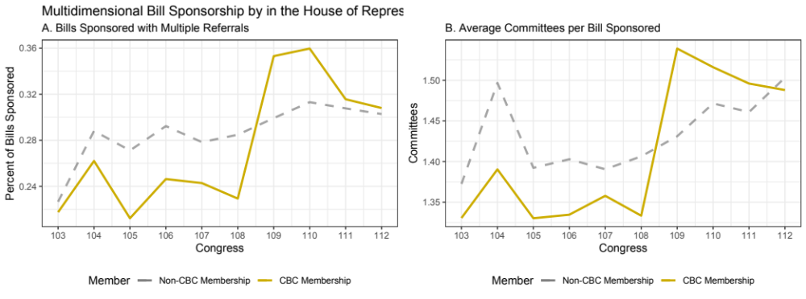
Figure 1: Depicts trends in multiple referrals from the 103rd - 112th Congress.
Scholars are mixed on the effects of such a trend on the prospects of legislation. Some argue that bills that span multiple committees introduce more veto points into the process (Davidson, Oleszek, and Kephart 1988; Krutz and Cullison 2008). Others find that omnibus legislation can be effective in building support for elements of the bill and breaking down institutional costs that often lead to gridlock (Krutz 2000; Krutz 2001a; Sinclair 2011). The Jobs and Justice Act of 2018 and others like it provides evidence that the Black Caucus understands the shift in trends towards multidimensional legislation and has decided that the sponsorship of such legislation is a feasible alternative.
What impact could this surge in multidimensional bill sponsorship have on Black members’ quest for success in their targeted policy agenda? Multiple referrals could serve as mechanisms to mitigate institutional costs and cut through the layers of friction that exist in American political institutions that work against change in Black policy areas. Researchers of identity caucuses - like the Congressional Black Caucus - argue there may be some validity to venue-shopping as a legislative strategy; “the groups perform an integrative role, developing legislative programs which cut across committee boundaries [and] take the lead in drafting legislative proposals, monitoring developments throughout Congress and the executive branch, and persuading to their viewpoint members of the various committees” dealing in relevant policy areas (Hammond, Mulhollan, and Stevens 1985, 429; see also Stevens,Mulhollan, and Rundquist 1981). I offer four arguments as to why the sponsorship of bills that result in multiple referrals may prove effective - and potentially necessary - for Black lawmakers attempting to navigatae the legislative process.

Multidimensional Policy Images and Policy Success
Frank Baumgartner and Bryan Jones assert unidimensionality can often lead to institutional inattention. A dominant public policy image is often unidimensional even while the underlying issue is multidimensional. In decision-making institutions, attention is often directed at only one aspect or dimension, while others are suppressed or ignored (Baumgartner and Jones 2002, 21). Because Black lawmakers adopted unidimensional definitions to policy problems, this often simplified the larger institutional responses to any proposals by allowing key decision makers to paint a dominant policy image that were likely perceived as ideologically radical, racially contentious, and out of touch with the demands of the larger party apparatus. As a result, the concerns of Blacks were largely ignored for most of the twentieth century. (Singh 1998; Tate 2014; Swain 1993). However, as Baumgartner and Jones (2002, 21) point out, adopting embracing the complexity of Black interest could work to their advantage in seeking more favorable outcomes in their proposals:
“As a practical matter, most decision makers pay attention to only a few of the underlying dimensions. At times, however, they may be forced to pay greater attention to one of the elements that they had been ignoring, as when dimensions force themselves onto the agenda because of a crisis or because of the actions of another decision maker. When this occurs, people can change their views on the issue even without changing their minds on the underlying dimension of choice; they simply give greater weight to a dimension that they had been previously ignoring.” (Italics added by author for emphasis)
By highlighting multidimensionality in their bill design, Black lawmakers could shift attention away from the more contentious, racialized, and narrow aspects of their proposals - dimensions that frequently lead to inactivity - and towards different dimensions that may be more “palatable” to decision makers. By defining issues in a different fashion, and designing proposals that reflect this shift in strategy, Black members could ease bills through the legislative process without diminishing the proposal’s intended effects on their constituencies.

Circumventing Institutional Marginalization
For Black lawmakers, it may be necessary to look deeper to uncover an additional layer of friction that may impede their success - a condition that those in office are certainly aware of. Some point to marginalization in the institution that could work to thwart or mask substantive progress in the chamber. Moreover, American politics have long been plagued with racialized ordering that has undoubtedly bled into institutions and shaped preferences, processes, and policy outcomes (King and Smith 2005; Dawson and Cohen 2002; Holt 2009). Thus, Cobb and Elder (1997) add that there are often cultural components to decisions of which issues arrive on the institution’s legislative agenda. Black lawmakers have been found to receive less favorable committee assignments (Griffin and Keane 2011). Further, Hawkesworth (2003, 546) points to interpersonal marginalization where “in committee operations, floor debates, and interpersonal interactions, they are treated as less than equal in various ways that carry palpable consequences for their identities and their policy priorities”. Frymer (2010, 2011) along with Griffin and Keane (2011) forward claims that inter-party dynamics work against the substantive pursuit of Black interests. Venue shopping could be a means to overcome institutional marginalization.
As the membership of Black representatives increases within the chamber, as members broaden their coverage across committees, and as members become more incorporated into the institutional power structure, designing policy proposals with multiple dimensions may increase the likelihood that the bill is referred to a committee where more favorable outcomes are possible. Reaching multiple committees could mean landing in committees with higher concentrations of Black lawmakers or, better, with control over the committee or relevant subcommittees and means - like the ability to schedule hearings and other committee procedures - to draw attention to these proposals (Ellis and Wilson 2013). Venue shopping also increases the likelihood that bills will surface in committees that have conducted oversight over Black-interest policies, have frequently engaged bureaucratic agents, and are privy to vital policy information (Workman, Shafran, and Bark 2017; Minta 2011).

Capitalizing on Institutional Instability
Scholars point to a number of reforms over the years that have directly contributed to the destabilization of the House of Representatives (Aldrich and Rohde 1997; Schickler 2001; Rohde 2010; Adler and Wilkerson 2011). Political institutions are the result of layers of innovations; not all of which are comparable to and compatible with one another (Schickler 2001). In the case of Republican era legislative reforms, these layers of were accrued in a relatively short period of time and decidedly reshaped the priorities and functioning of House of Representatives. This series of restructuring further entrenched many of these conditions by reaffirming legislative control in the hands of majority party leadership, sparking and playing on inter-party conflict, and further reducing the role of committees by encouraging the packaging of legislation into minibus and omnibus bills.
On the first day of the 104th Congress, the House - led by newly appointed Speaker Newt Gingrich - passed sweeping rules changes aimed at increasing transparency, reducing operating costs, and reducing legislative inefficiencies perceived to exist prior to the shift in majority control of the House. Relevant to this study are two decisions that restructured the process of legislative referrals. First, the Gingrich reforms eliminated three committees altogether - the Post Office, Merchant and Marine Fisheries, and District of Columbia Committees. This decision, combined placing limits on the number of committee assignments (2) and subcommittee appointments (4), resulted in an overall reduction of 484 committee and subcommittee seats (Deering and Smith 1997). In addition to the structural changes, the reduction of committees also resulted in a necessary reshuffling of jurisdictions to account for the reduction in committee force.
The second formal rule change concerning legislative jurisdictions was the complete elimination of joint referrals. Prior to “Contract” reforms, as a product of 1974 committee reform, bills were able to acquire referrals to multiple committees through either joint, split, or sequential jurisdictions. Eliminating joint referrals - and the decision to continue to allow split and sequential referrals - was justified by a need to reduce policy fragmentation and overlap many attributed to the Speakers ability to provide multiple committees equal ownership over pieces of legislation. However, this decision was revisited in the 108th Congress with a minor, informal, adjustment that allowed for such referrals under a vaguely defined “exceptional circumstances” (Congressional Research Service 2014). It is likely that such impreciseness may have lead to some degree of uncertainty and to what qualified for joint referrals. Another period of adjustment to the “Contract” reforms came as a result of suggestions from the 9/11 Commission. The creation of the Department of Homeland Security came with it conflicts over policy and administrative jurisdictions that would have be sorted out as well as new jurisdictional responsibilities that had yet to be defined. This period of reform was highly contentious, and a strategy took much longer to devise and implement then the one-day turnaround of the initial “contract” (Reese 2013).
While formal reforms seek to stabilize and codify committee practices (Adler and Wilkerson 2011), informal adjustment to committee jurisdictions - or “common law advances” breeds uncertainty over existing and future jurisdictional arrangements (King 2008). Such informal practices induce reaction of competing interests and turf wars between committees who compete for jurisdiction over areas of interest (King 1994; Evans 1999; King 2008; Adler and Wilkerson 2011). Often, efforts to construct narrow jurisdictional definitions can lead to further uncertainty as committees struggle to parse out or coordinate complex policies with several moving parts (Baumgartner, Jones, and MacLeod 2000). Adler and Wilkerson argue, members recognize the problems associated with stagnant committee jurisdictions “issue fragmentation, conflicting policies, and insufficient information sharing” - and work to counteract them (Adler and Wilkerson 2011, 107). These jurisdictional battles often result in bill sponsorships, hearings, and other forms of engagement with issues in an effort to set precedents for future jurisdictional considerations.
If committee jurisdictions evolve “informally and incrementally”, as scholars suggest (Adler and Wilkerson 2011, 88; see also King 1994; King 2008), one could expect very moderate increases in bills resulting in multiple referrals. As precedent sets in, certainty should take hold and referral practices should stabilize. This appears not to be the case following reforms in the 104th Congress. Figure 4 reveals noticeable increase in bills resulting in multiple referrals that is consistent and proportionate to the total output of the chamber. Periods of uncertainty could be indicated by punctuations in multiple referrals as parliamentarians respond to efforts to redefine jurisdictions. Such punctuations are evident in the disproportionate increases in multiple referrals following the minor adjustments to the “Contract” in the 106th and a more prolonged punctuation following informal changes resulting from the 9/11 Commission recommendations and the subsequent shift in partisan control in the 109th and 110th Congress. Multiple referrals eventually declined - returning to its long-run trend - as Republicans retook the chamber in 2010.
Multiple Committee Referrals and Reform in the House of Representatives
Contract
Contract Adjustments
9
/11 Reform
Democratic Majority
0.24
0.26
0.28
0.30
0.32
103
104
105
106
107
108
109
110
111
112
Congress
Proportion of Bills w/ Multiple Referrals
Bills Sponsored in the 103rd - 112th Congress
Figure 2: Depicts trends in multiple referrals from the 103rd - 112th Congress.
The inefficiencies in jurisdictional overlap and redundancy that routinely plague Congress were exacerbated by a series of formal and informal restructuring of congressional committees during the Republican rule of the House of Representatives. This analysis seeks to further explore the evolution of the modern congressional committee and what could be political ramifications that directly impact members of color within the chamber. Adler and Wilkerson (2011, 107) argue “informal practices such as these can set in motion a path dependent process that can undermine other policy objectives”. Can they also bolster some policy objectives by providing opportunities for entrepreneurial legislators to exploit ambiguous committee boundaries during times of uncertainty, as Evans (1999) suggest? How does the reorganization of jurisdictional arrangements alter the pursuit of Black issues in the House?
Venue shopping requires policymakers to be aware of jurisdictional constraints of particular venues as well as potential vulnerabilities in those constraints and acting in a way that exposes those vulnerabilities (Schattschneider 1975; Baumgartner and Jones 1993; Pralle 2003). Black lawmakers could have a substantial impact on the legislative agenda through multiple referrals by capitalizing on legislative instability, competition, and uncertainty that is often associated with periods of institutional reform. If reform breeds institutional uncertainty, then that uncertainty breeds opportunity for Black lawmakers to pursue those interests that are typically undermined by the rigidity of political institutions.
Multiple referrals induce - or are the result of - competition among committees as they struggle to gain jurisdiction over relevant issues. Also, as King (1994; 2008) notes, Black members could seek to sway jurisdictional battles by sponsoring bills from within committees in hopes of establishing or stretching parliamentary precedents. The jurisdictional battles that emerge during periods of reform often result in bill sponsorships, hearings, and other processes in an effort to set precedents for future jurisdictional considerations (King 2008). Additionally, committees may preempt these jurisdictional battles with hearings in broad topic areas, providing avenues for Black committee members to take a more active role in shaping policy action. Therefore, multidimensional legislation becomes the mechanism through which representatives of color seek to drive attention from both inside and outside of relevant committees.

Mitigating Institutional Costs
Multidimensional legislation can cut through institutional costs that have become barriers of inattention for Black interests. First, due to the complexity of Black issues, it may be necessary for multiple committees to take on the role of information gatherers in their particular substantive jurisdictions. Allowing for several committees to divide the labor involved with recognizing and defining problems as well as weighing the proposed solution against alternatives would certainly reduce the informational burden that would be incurred by a single committee taking on such complex issues. Boundary-spanning proposals also create opportunities for committees with broader jurisdictions to take on new issues that may have previously been ignored by the institution (Sheingate 2006), and for members across the multiple committees or through the agencies under their jurisdiction to apply their perceived expertise to deliberating and reshaping the legislation (Workman, Shafran, and Bark 2017). Sponsoring bills that receive multiple referrals could reduce transaction costs through increased exposure and the potential of coalition building that comes along with distributing bills to multiple committees. As bills progress through several committees, it creates opportunities to acquire additional cosponsors from out-group allies in chamber.
This reduction in transaction costs may have carryover effects on bill prospects on the floor. Those bills have potentially garnered at the attention of leadership on multiple committees, been exposed to multiple members from both parties providing opportunities to build coaltitions within the chamber, and possibly rewritten to maximize the bill’s chances on the floor. In a modern Congress, characterized by a strong hand in the process on the part of leadership, the fact that a bill has navigated a committee may be a function of approval by party higher-ups and may already have assurances from leadership of future scheduling (Cox and McCubbins 2005; Stewart III 2012). Thus, there is reason to believe sponsorship will have positive effects of multiple committee referrals on the prospects of success in floor votes. These things in mind, I propose two hypotheses concerning the impact of Black lawmakers sponsoring cross-cutting legislation in general and in Black-interest areas:

Hypothesis 1 For Black lawmakers, sponsoring bills that result in multiple committee referrals will improve the bill’s likelihood of successfully navigating the legislative process.
Hypothesis 2 Sponsoring Black-interest bills that result in multiple committee referrals will improve the bill’s likelihood of successfully navigating the legislative process.

Design and Methodology
To determine how the sponsorship of multidimensional legislation impacts the pursuit of Black interests in the House of Representatives, I employ bill-level analysis of sponsorship by Black lawmakers. Scholars acknowledge the political fortunes of Black lawmakers are constrained by the electoral fortunes of the Democratic party (Swain 1993; Tate 2003; Canon 1995). The fact that the caucus is nearly uniformly comprised of Democrats, periods of Republican control have proven to greatly diminish the effectiveness of Black lawmakers across all policy areas, racialized or otherwise. Driven by this reality, I opt to constrain the general focus of this query so that it reflects outcomes of only substantive bills sponsored in Democratic majorities by examining sponsorship in the 103rd in comparison to the 110th and 111th Congress. Later, I extend the sample to include bills sponsored by all members from the 103rd - 110th Congress to place the results within the broader institutional context.
I concentrate my attention on both trends in the broader sponsorship patterns of Black lawmakers as well as in policy areas that are a part of their collective interests. To accomplish this, I subset the 1,595 bills produced by Black Caucus members in Democratic majorities to highlight policy topics that fall with the Congressional Black Caucus’ expressed agenda. Each year, the CBC publishes their public agenda to the Congressional Record and on their website. From this agenda, I identify 662 bills forty-four well-articulated policy areas that also fall within the policy jurisdictions of their taskforces and working groups during the period in question (see Table 1). Figure 3A visualizes the productivity of Black members in both general sponsorship as well as in targeted areas. There are noticeable increases in output during times of Democratic majority control of the House - particularly in the most recent period in the 110th and 111th Congresses. There is also a steady increase in CBC-Interest bills; the caucus nearly doubled its output from the 103rd to the 110th Congress.¹

Dependent Variables and Model Selection
The hypotheses proposed focus on two particular benchmarks in the legislative process: clearing the committee stage and receiving a favorable vote on the House floor. These two checkpoints represent two of the most significant - and most difficult - hurdles to clear in the House. Thus, the first dependent variable of interest is a dichotomous indicator that a bill has received a report out of at least one committee. Committee reports are one of the better identifiers that a bill has fully navigated a committee that it was referred to. It is often accompanied by the history of the bill, signals that the bill has been thoroughly considered and rewritten, and can also recommend action to the floor. Committee reports are also a good indicator of the discriminant nature of legislative winnowing - where proposals are filtered before they are ever considered for action (Krutz 2005). The multitude of proposals that emerge at any given time, only a fraction of bills that are introduced will receive formal attention. On average, only ten-percent of sponsored bills in any given term actually receive a report from a committee of referral.
If only a fraction of bills clear the committee stage, even fewer make it to an official roll-call vote. Doing so means - in most cases - that you have successfully navigated the committee stage, avoided any major pitfalls during debate and deliberation, have received approval from party leadership, and have acquired enough of a consensus - by at least a majority of the majority party - to ensure that a vote can be both scheduled and see a favorable outcome.² The failure to achieve any one of these conditions could prove to impede the progress of a bill. Thus, bills that have navigated the slew of informal obstacles are in rarefied air; only eight-percent of bills sponsored in the House passed a floor vote in between the 103rd and 112th Congress.

This table identifies issues of interest for the Congressional Black Caucus. Comparative Agendas Project (CAP) minor topics codes are included for reference.
Task Force | Policy Area (CAP Code)
Education and Labor | Employment Training (502)  Fair Labor Standards (505)  Youth Employment, Youth Job Corps Programs, and Child Labor (506)  Migrant and Seasonal workers, Farm Labor Issues (529)  Immigration Reform (530)  General Education Education (601)  Higher Education (601)  Elementary & Secondary Education (602)  Education of Underprivileged Students (603)  Educational Excellence (607)
Criminal Justice Reform | General Criminal Justice Reform (1200)  Court Administration (1204)  Prisons (1205)  Juvenile Crime and Justice System (1206)  Police (1209)  Criminal and Civil Code (1210)  Riots, Crime Prevention, and Crime Control (1211)
Healthcare | Healthcare Reform (301)  Insurance (302)  Facilities construction, regulation, and payments (322)  Health Manpower & Training (325)  Prevention, communicable diseases and health promotion (331)  Infants and Children (332)  Alcohol & Drug Abuse, Treatment, and Education (342)
Economic Development and Wealth Creation | Consumer Finance (1504)  Small Business (1521)  Consumer Safety and Consumer Fraud (1525)
Civil &Voting Rights | General Civil Rights (200)  Minority Discrimination (201)  Voting Rights (206)
Poverty Reduction | General Social Welfare (1300)  Food Assistance & Nutrition Monitoring Programs (1301)  Low Income Assistance (1302)  Low Income Housing (1406)  Housing Assistance for Homeless and Homeless Issues (1406)
Technology & Infrastructure | Community Development (1401)  Urban Development (1403)  Infrastructure (1010)  Drinking Water Safety (701)
Symbolic | Currency, Commemorative Coins, Medals, U.S. Mint (2006)  Federal Holidays (2030)  National Parks, Memorials, Historic Sites, (2101)  Domestic Disaster Relief (1523)

Figure 3C reveals two realities. First, success at the committee level and on the floor is largely dependent on Democratic control. This is not a surprise, especially when one considers the overwhelming majority of Black representatives are members of the Democratic Party. The CBC is even more exclusively Democratic. The second reality is that winnowing is just as unkind to Black members as it is their non-black counterparts. An overwhelming majority of bills sponsored never see action in the chamber. Of the 1,495 bills in the sample, only 173 bills received a committee report - of those, 50 were in Black-interest areas. 208 Black-sponsored bills passed a House floor vote in that same time span with 58 being in areas targeted by the CBC. In both cases, a need arises for a model that is designed specifically to handle the dichotomous nature of both dependent variables of interest. In this instance, I opt for a Bayesian variant of the Probit model.

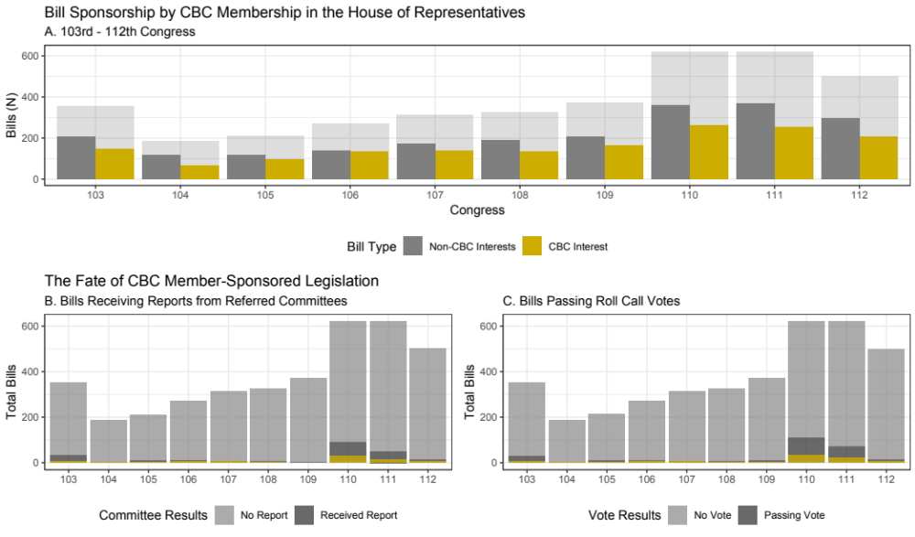

Figure 3: The figure above represents the number of bills sponsored by members of the Congressional Black Caucus from the 103rd - 112th Congress.

Independent Variables of Interest
The two key independent variables of interest in this analysis are both indicators of multiple referrals of an individual bill sponsored by Black members in the House. Formally, Rule X defines committee jurisdictions as well as the process surrounding the referral of bills that is carried out by the parliamentarian working in conjuction with the Speaker of the House. The current arrangement of committee jurisdictions is the product of competition and power grabs at the committee level that has resulted in disjointed, overlapping jurisdictions (King 1994; King 2008; Jones and Baumgartner 2005). The first is a dichotomous variable that represents the 1,093 bills that received multiple committee referrals over the span of the sample. The second covariate of interests is designed to measure the additive impact of bill referrals. I, therefore include a count of the total number of committees that a bill was referred to.
These variables are drawn directly from the Comparative Agendas’ congressional bill dataset (Adler and Wilkerson 2018). The nature of the CAP dataset comes with its advantages - primarily, their extensive efforts to catalogue the topical concentration of each bill along with comprehensive sponsor and process-level variables. However, there are several drawbacks that are directly related to this study. Ideally, I would account for the various forms of bill sponsorship (joint, split, and sequential). The data also does not clarify which committees have jurisdiction over which element of a given bill. Unfortunately, due to data limitations, I do not attempt to distinguish between the different forms of bill referral in this analysis as it is just beyond the scope of this inquiry. I am more concerned with exposure to multiple committees rather than the chain of command when it comes to individual bills.
Of those bills, 398 were in areas targeted by the Congressional Black Caucus. Figure 4A reveals that multiple referrals nearly tripled for Black members in the time between Democratic majorities. In total, 77 bills in the sample were referred to multiple committees in the 103rd Congress - 32 of which were in CBC interest areas; that number increased to 223 bills (77 CBC-interest bills) in the 110th. As seen in Figure 1, by the 110th Congress, more than one-third of all bills sponsored by Black lawmakers were referred to multiple committees - well above the chamber average. Panel B in Figure 4 highlights a steady increase in average committees per bill.

Additional Considerations
To facilitate my analysis of the impact of multiple referrals on bill success for Black lawmakers, I incorporate a number of control variables that are most often associated with a bill’s prospects in the House. I include a count-level control variable that notes the number of cosponsors a particular bill has garnered. In addition, I account for the ideological extremity of the primary sponsor by including the absolute value of DW-Nominate with the expectation that more extreme members will experience less favorable outcomes resulting from their sponsorship. I also consider the length of a member’s service within the chamber with a measure of seniority. Of course, some members are simply more effective at forwarding legislation than others. To control for this variation, I include Volden and Wiseman’s (2014) measure of legislative effectiveness for each primary sponsor. Finally, those with access and influence in respective committees are expected to have an insider’s advantage (Krutz 2005). Thus, I take account of bills that are sponsored by members of a committee that the bill was referred to, and those that occupied chairmanships of committees or sub-committees of referred committees.
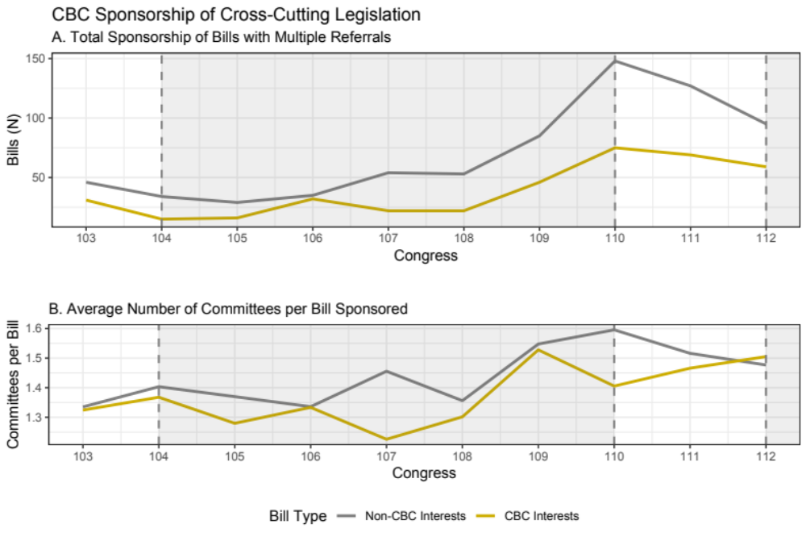Figure 4: The figures above represents the number of bills sponsored from the 103rd - 112th Congress. Shaded regions indicate periods during Republican majority control.

The Effects of Multiple Referrals on Bill Prospects
Analysis reveals significant effects of multiple referrals on bill progress and passage for bills sponsored by Black Lawmakers. When it comes to navigating the committee stage, both the dichotomous (coef = 1.123; p < 0.001) and additive (coef = 0.241; p < 0.05) measures exerted positive influence on the likelihood of receiving a committee report in the 103rd Congress (Models 1 and 2 in Table 2, respectively). This trend continued in the next Democratic majority. Coefficients in Model 5 and 6 in Table 2 further support the hypothesis that, at the committee stage, designing proposals in a manner that ensures they receive referrals to multiple committees increases the likelihood that bills progress through the process.
Figure 5A and B reveals the substantive impact of multiple referrals on prospects at the committee level. In the 103rd Congress, the dichotomous indication that a bill had received multiple referrals results in an increase of receiving a committee report by 9.2%. The additive measure indicates a bill that is referred to three committees experiences, on average, a twopercent increase in predicted probability over those referred to only two committees and a 3.2% increase over those referred to a single committee. In the 110th the effects were similar in the dichotomous measure - with a 9.2% increase in probability - and slightly better in with the additive measure. Just over nine-percent of bills referred to three committees received committee reports compared to just 4.2% of those referred to a single committee.
103
rdCongress
110
th-111thCongress
Committee Report Floor Vote Committee Report Floor Vote
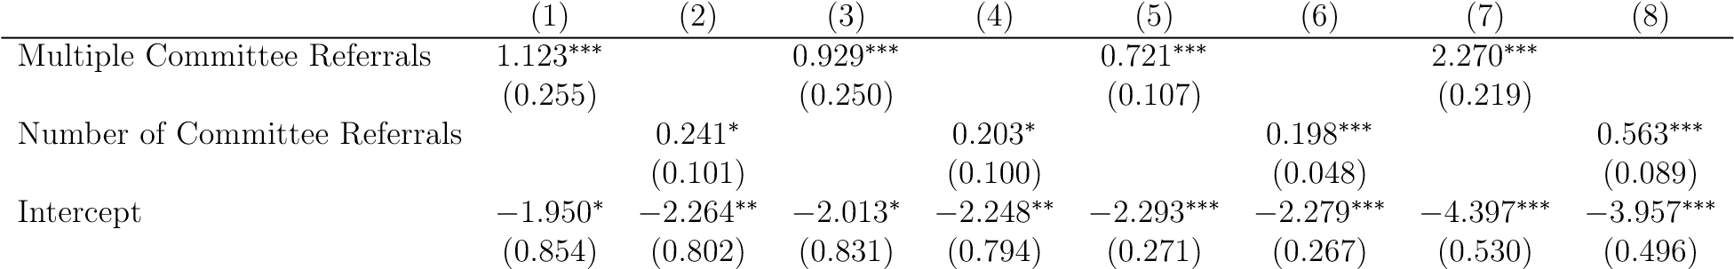

Sponsor Level Controls Y Y Y Y Y Y Y Y
Bill Level Controls Y Y Y Y Y Y Y Y
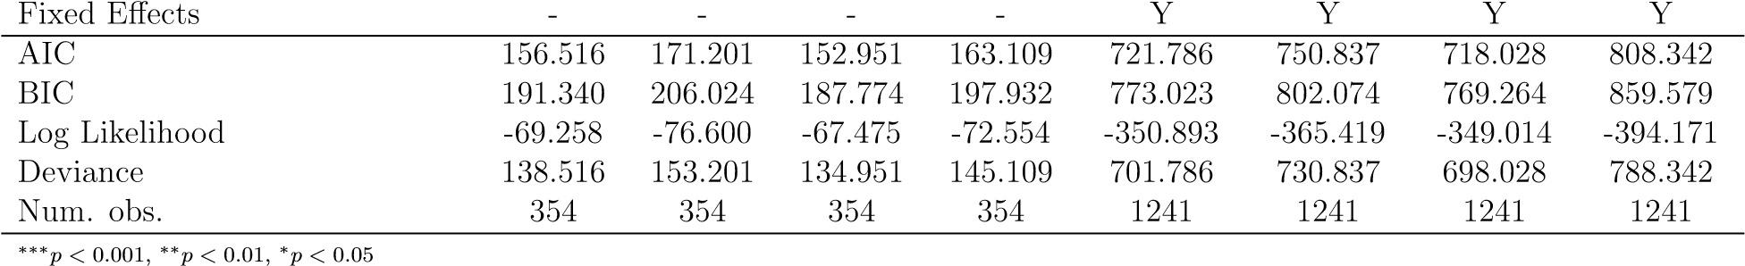
Table 2: Probit Coefficients of the impact of multiple referrals on the on bill prospects during
Democratic majorities in the 103rd Congress along with the 110th and 111th Congresses
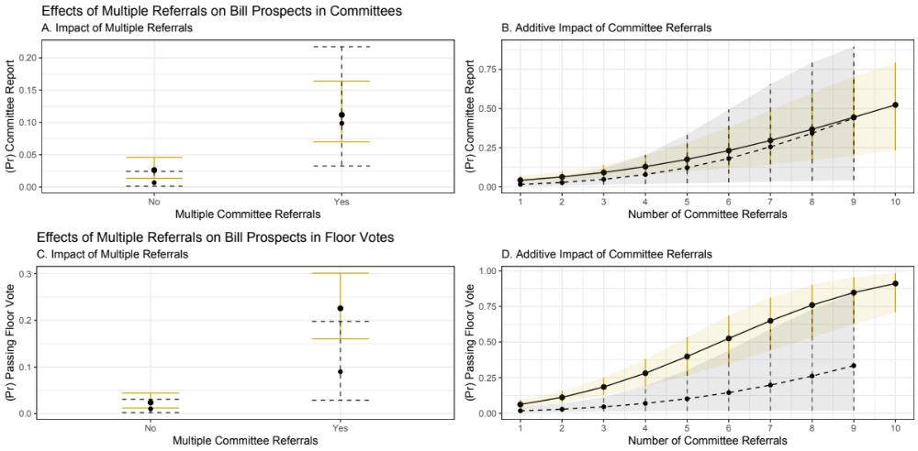
Figure 5: This figure depicts changes in coefficient impact of multiple referrals on progress and passage for all bills from the 103rd (Grey) and the 110th and 111th Congresses (Gold) holding all else constant. Point estimates displayed are the result of 11,000 Bayesian simulations. Confidence intervals are the distribution of 1,000 simulations of each point estimate across the span of each measure.
The most noticeable effects of multiple referrals in bills sponsored by Black lawmakers are present in models concerning success on the House floor in both Democratic majorities. The measures perform as expected in models concerning the likelihood of receiving a favorable floor vote in the 103rd Congress (Models 3 and 4) as well as the subsequent majority (Models 7 and 8). In the 103rd Congress, receiving multiple referrals (Model 3) increased the probability of receiving a favorable floor vote by twenty-two percent over bills referred to a single committee (coef = 0.929; p < 0.001). In the 110th to the 111th Congress (Model 7), that difference was 19.% (coef = 0.563; p < 0.001). The additive effects were also clearly stronger in the models predicting floor success. Two committee referrals increased the probability of a bill passing a floor vote by 5% in the 103rd with an additional increase of 7.3% for those referred to three committees. In the next Democratic majority (Model 8), two referrals resulted in an increase of 4.8% when adding a second committee and an additional increase of 8.1% for a third (Figure 5C and D).

CBC Interest Bills
The second hypothesis in this study predicts that multiple referrals will improve the prospects of Black-interest bills in the House. Results from Table 3 suggest that this was not the case in the 103rd Congress. Multiple referrals had no significant impact on prospects of receiving a committee report (Models 1 and 2) or bill passage (Models 3 and 4). It was not until after an extended period under Republican control and finally retaking control in the 110th that multiple referrals became advantageous for those seeking to forward Black-interest bills through the legislative process. As predicted, in the most recent Democratic majority, Blackinterest bills benefited from being packaged in a way that resulted in multiple referrals even when controlling for member leadership, seniority, and effectiveness.
In measuring the impact of multiple referrals on the likelihood of receiving a committee report, the dichotomous variable yielded an average log-odds coefficient effect of 0.717 and the additive resulted in an impact of 0.279 (both significant at p < 0.001). A less than one-percent chance in passing the floor in the 103rd increase to an average probability 10% - a five to thirty% probability across the range of Bayesian simulations - for bills sponsored with multiple referrals (Figure 6A). The additive effect in the 110th and 111th was significantly greater than in the 103rd as well. Increasing the bill referrals from one committees to two increased the probability of receiving a report from a 3.2% to 5.9%, and a third committee increases the probability of receiving a committee referral to 10.1% (Figure 6B). As with the broader sample of bills, multiple referrals was a much stronger predictor of a CBC-interest bill passing a floor vote (Table 3, Models 7 and 8). The dichotomous measure resulted in a statistically significant, 19.3% increase (from 1.6 to 20.9%) in predicted probability of receiving a receiving a favorable floor vote. Going from two committee referrals to three increases the median predicted probability from 8.8 to 16.9% (Figure 6). These findings allow me to confidently reject the null hypotheses for H4 in Black-interest bills at both the committee stage as well as on the house floor. Ultimately, when comparing prereform Democratic majorities to post-reform control, the difference of additive impact of multiple referrals in CBC-interest areas is significantly greater in bills that obtain up to four committee referrals.

103
rdCongress
110
th-111thCongress
Committee Report Floor Vote Committee Report Floor Vote
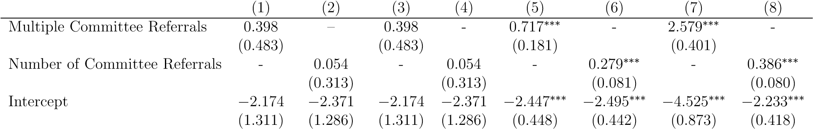

Sponsor Level Controls Y Y Y Y Y Y Y Y
Bill Level Controls Y Y Y Y Y Y Y Y
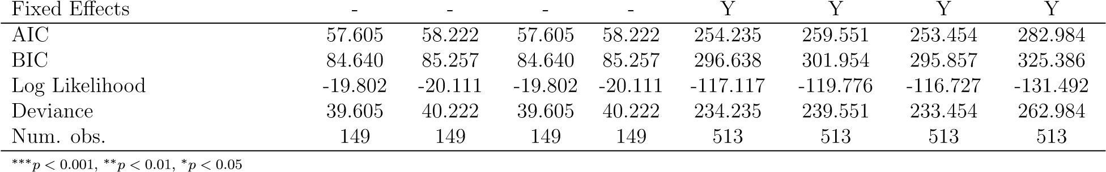
Table 3: Probit Coefficients of the impact of multiple referrals on the on CBC-interest bill prospects during Democratic majorities in the 103rd Congress along with the 110th and
111th Congresses
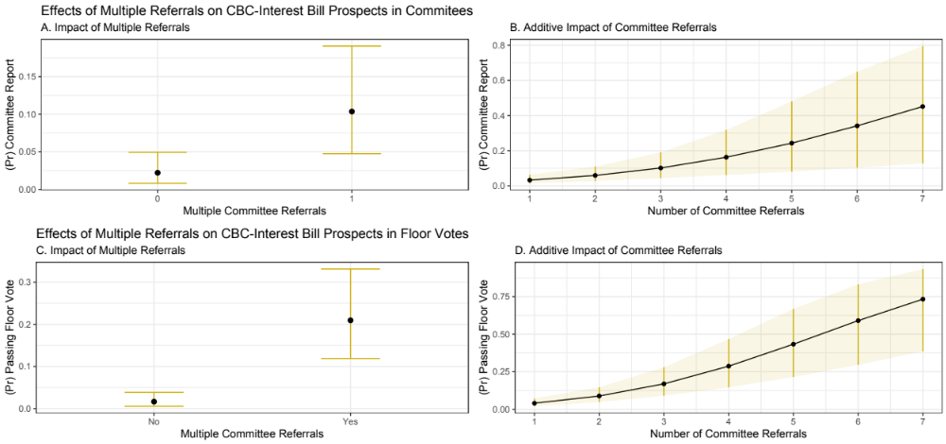
Figure 6: This figure depicts changes in coefficient impact of multiple referrals on progress and passage for CBC-Interest bills in the 110th and 111th Congress. Point estimates displayed are the result of 11,000 Bayesian simulations holding all else constant. Confidence intervals are the distribution of 1,000 simulations of each point estimate across the span of each measure.

Multiple Referrals in the House of Representatives
The previous section explored if crafting legislation in a way that ensures that it crosses committee jurisdictions could be advantageous to Black lawmakers. I transition from the organization’s behavior to place those results within the context of the institution. Earlier studies find multiple referrals have little to no substantive impacts on a bill’s likelihood of success (Krutz and Cullison 2008; Davidson, Oleszek, and Kephart 1988; Davidson, Oleszek, and Kephart 1988). Are the findings associated with the Congressional Black Caucus reflective of a much broader trend, or are they unique to the caucus? Figures 4 and 1 reveal a relatively steady increase in the volume of multiply-referred bills. How does this shape the fortune of those bills? Table 4 presents four fixed-effects models that test interactive effects of multiple referrals on the prospects of bills from the 103rd through the 112th Congress.
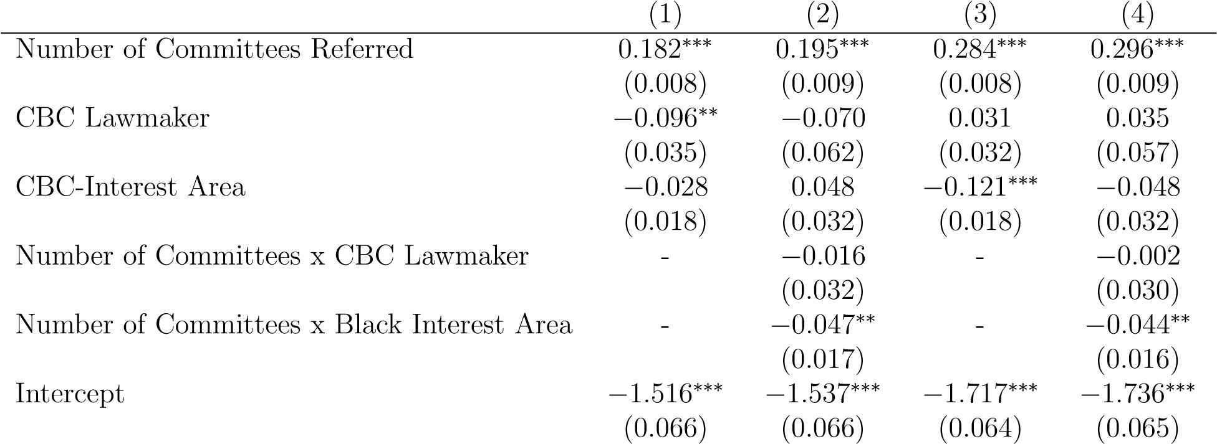 | Committee Re | port | Floor Vote
Sponsor Level Controls | Y | Y | Y | Y
Bill Level Controls | Y | Y | Y | Y
Fixed Effects | Y | Y | Y | Y
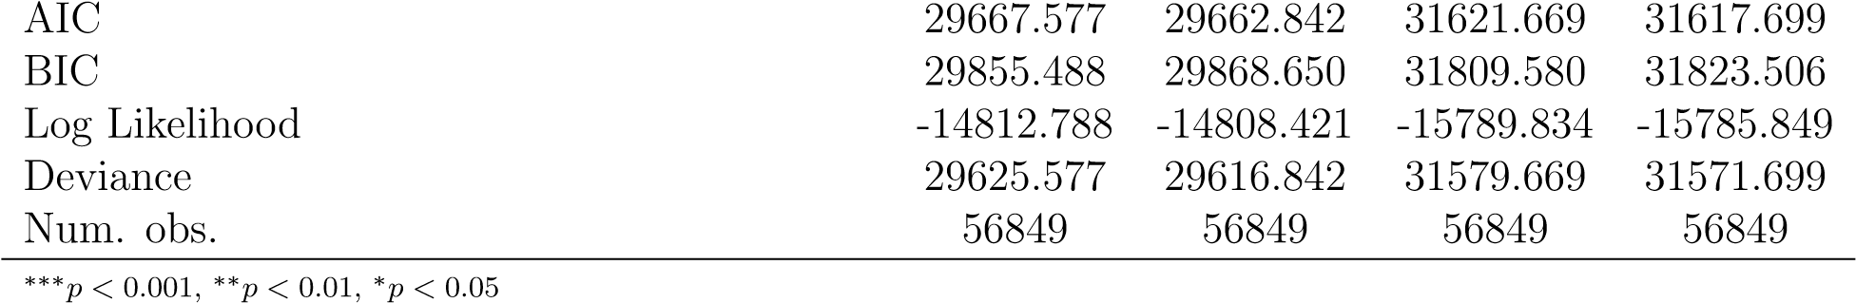
Table 4: Probit Coefficients of the interactive effects of multiple referrals on bills sponsored by House members from the 103rd to the 112th Congresses

The findings suggest that the additive, positive impact of reaching multiple committees extends to the chamber as a whole, contradicting previous studies. While this article does not directly forward causal assumptions about the reasoning for these findings in the larger institution, it does offer theory that could certainly extend beyond the organization and to the chamber as a whole. This may the function of the various ”turf wars” that play out between committees during times of reform and institutional uncertainty (King 2008). As committees seek to capture issues within that may be beyond their jurisdictions, it is reasonable to expect them to not only sponsor bill from within the committee (King 1994; Evans 1999; King 2008; Adler and Wilkerson 2011) but to also be more likely to advance those bills through the full committee process. This provides an opportunity forward for scholars interested in a broader understanding of the evolution of lawmaking in the chamber.
The focus of this article, however, is in determining if a collective shift in bill-sponsorship trends (visualized in Figure 4) can provide a means to improving their fortunes in the chamber. Scholars have pointed to a particular racialized marginalization that exists within the chamber (Hawkesworth 2003; Tyson 2016). As Hawkesworth points out, this often manifests in the form of legislative topic extinction, silencing, and other forms of interpersonal and structural marginalization. The findings from Table 4 suggests this is certainly the case. Bills sponsored by CBC lawmakers are about 17% less likely to see their bills reported out of any committee that they are referred than their non-Black counterparts in the chamber (coef = 0.182; p ¡0.01). In a legislative environment where members are fighting for precious agenda space where only about ten-percent of bills receive committee reports, that difference is certainly substantive one. This article proposed that multiple referrals may provide them with a means to circumvent this form of marginalization. The interaction in Table 4, Model 2 suggests this is not the case. While cross-cutting legislation improves the prospects of CBC-sponsored legislation, designing proposals in a way that results in multiple referrals is not a strategy that alters the trajectory of Black-sponsored bills in a significant fashion in relation to the rest of the chamber.

Primary Sponsor | Bills Passed (N) | Committee Chair | Subcommittee Chair
Maxine Waters | 6 | N | Y
Hank Johnson | 5 | N | Y
Bobby Scott | 5 | N | Y
Charlie Rangel | 4 | Y | N
Edolphus Towns | 3 | N | Y
John Conyers | 2 | Y | N
John Lewis | 1 | N | Y
Bobby Rush | 1 | N | Y
Elijah Cummings | 1 | N | Y
Danny Davis | 1 | N | Y
Stephanie Jones | 1 | Y | N
Gwen Moore | 1 | N | N
G.K. Butterfield | 1 | N | N
David Scott | 1 | N | N
Kendrick Meek | 1 | N | N
Emanuel Cleaver | 1 | N | N
Al Green | 1 | N | N
William Jefferson | 1 | N | N
Table 5: A descriptive summary of CBC sponsors that have succesfully passed legislation from the 110th and 111th Congresses
These models tell a slightly different story when it comes to a final vote on legislation. CBC membership has no bearing on one’s bills likelihood of passing a floor vote. The topical focus of the bills, however, do have a substantive bearing on the prospects of bills on the floor (Model 3 in Table 4). The interaction effects found in Model 4 of Table 4 suggest that that margin actually increases when referred to multiple committees. This result is consistent with literature that argues institutions shy away from considering potentially contentious policy issues (Polsby 1968; Cox and McCubbins 2007; Cox and McCubbins 2005, among others). Party leaders have been found to place their thumbs on the scale in an effort to preserve power, protect vulnerable members from potentially damaging votes, and maintain institutional stability. This becomes increasingly evident when examining whose bills successfully navigate the legislative process. Table 5 presents a descriptive summary of CBC-interest bills that passed a floor vote during the 110th and 111th Congresses.
This table reveals the problematic reality for Black lawmakers - particularly rank and file members seeking to pass substantive legislation in CBC-interest areas. In sum, only 37 of the 459 CBC member-sponsored bills that fall at least in-part in line with the CBC agenda received a favorable outcomes on the House floor. Success was almost exclusively reserved for the more influential members - thirty of the thirty-seven bills were sponsored by members who were either chairs of full committees or subcommittees, and twenty-nine of the bills emerged from within a committee with jurisdiction over the bill. Even then, few of the bills that cleared the house floor were explicitly race-based in nature. Others are more de-racialized attempts to address problems that have broader impacts in addition to those experienced by the Black community. This includes bills aimed at providing and protecting low-income housing, protections for consumers, and regulations on policing practices around the nation. This may be further evidence of a CBC that is looking to moderate its policy positions (Tate 2014; Gillespie 2010; Canon 1995). Or, this could be a function of the Party’s selection of only tolerable legislation. The findings suggest either, or both, could certainly be the case.

Discussion and Conclusion
In this analysis, I look to examine how changing legislative tactics can improve success rates for a subset of lawmakers that have been plagued by less-than-modest success in an institution where the odds are clearly stacked against them. These findings suggest two things, both with major implications on policymaking on the part of lawmakers from traditionally marginalized groups. First, for Black lawmakers, sponsorship of cross-cutting legislation certainly has its payoffs. Doing so increases the probability that Black legislators will achieve both their collective goals - evident in significant findings from bills sponsored in policy areas targeted by the Congressional Black Caucus - and in their broader individual legislative agenda. Second, it appears that there is a significant additive effect when it comes to the success of multidimensional legislation. In an institution where an overwhelming majority of bills receive no attention, complexity - in terms of covered policy areas - seems to be key in garnering attention. In fact, these effect appear to carry beyond the committee stage and into roll-call voting where exposure to multiple committees seems to weigh heavily on a bill’s likelihood of success. For Black members, this may be the key for breaking through barriers that may work against substantive policy change.
Their approach to bill design appears to be a noticeable shift from their previous strategy. Multiple referrals have increased significantly for both Black representatives and among the larger institution, as has the average number of committees to which bills are referred. Sponsoring multidimensional allows for Black lawmakers to initiate and take part in jurisdictional battles between committees, engage in the problem recognition and definition stage of policy making, and activity may soften up the institution until moments of opportunity arise (Kingdon 2011). Doing so, also, fits in with current trends in alternative legislating in the House (Krutz 2001b; Sinclair 2011). Multiple referrals also allows for the caucus to capitalize on its strength in numbers and a surge in committee influence.
This analysis is also a cautionary tale of the problems of aggregation across groups of political actors in political institutions. Black lawmakers face unique challenges within the legislative chambers. For decades, their success has been limited by institutional inattention and marginalization. Consequentially, the explicit focus on Black lawmakers here is intentional. Despite temptations and the tendency among others in the discipline to do so, the goal of this study is not to compare the behaviors - or success rates - of Black lawmakers to their white counterparts. Haynes Walton (1985) cautions against the practice of simply adding a variable to account for the race of lawmaker. While such an approach accounts for racial differences among actors, it often fails to capture the underlying experience of marginalized members as well as the unique constraints that accompany those racial differences. At an aggregate level, some argue that sponsoring bills in a manner that demands attention from multiple committees has little impact on success. These findings suggest otherwise, highlighting the importance of digging deeper and understanding that conditions, practices, and outcomes vary across groups and issues. If a primary goal of lawmakers is to sponsor bills that navigate through the legislative process, I find - for Black lawmakers, at least - venue shopping as a viable strategy to gaining attention in congressional committees and receiving more favorable outcomes in floor votes.
This work provides an intriguing path forward for those interested in how Black lawmakers navigate the minefield of the House of Representatives in search of substantive policy change. Hopefully, this study will serve as a conversation starter for those seeking to build upon scholarship concerning the role of the Black lawmaker. While earlier works established a solid foundation, times have certainly changed since the penning of many of those essential pieces of scholarship, especially in there strategy, mobilization, and influence within the chamber. The institution, itself, has also undergone a great deal of evolution since the work of Pitkin (1967), Swain (1993), Canon (1999), and Tate (2001) - many of which struggled to link increased proportional representation by Black lawmakers and legislative wins in substantive policy areas.
Additionally, previous findings - or the lack thereof - may be relics of a tendency for congressional scholarship to concentrate solely on late-stage differences and roll-call voting. Although, recent scholarship has shown that exploration into the lawmaking process - especially at the committee level - could prove fruitful (Gamble 2007; Gamble 2011; Minta and Sinclair-Chapman 2013). Addressing this may mean that scholars must dedicate effort to identifying and examining political phenomenon where the politics happen. This work is an attempt to connect each stage of the process in an effort to determine the how tactics can influence outcomes for Black members of Congress. While there exists a growing consensus that the congressional committee’s legislative importance has diminished in recent years (Krutz 2001b; Sinclair 2011 ;Stewart III 2012), this may not be the case for all members and their pursuits. When combined with previous studies from the like of Gamble (2007) and Minta (2011), the preceding analysis suggests that the committee structure, the rules that define the structure, and the consequences of those structures are increasingly central to Black representatives when pursuing their legislative agendas. This is especially true as they seek to capitalize on the ever-evolving political and structural arrangements of Congress. There should be a concerted effort explore and explain not just if Black lawmakers pursue policy change in key issues but how they go about doing so. Moving forward, more attention should be directed towards how members actions have evolved to keep up with the ever-changing political dynamics within the chamber, how they strategize to overcome institutional barriers to their success, and how institutions respond to their increased influence on the legislative process.

References
Adler, E. Scott, and John S. Lapinski. 1997. “Demand-Side Theory and Congressional Committee Composition: A Constituency Characteristics Approach”. American Journal of Political Science 41 (3): 895–918.
Adler, E. Scott, and John D. Wilkerson. 2011. “Intended Consequences: Jurisdictional Reform and Issue Control In the U.S. House of Representatives”. Legislative Studies Quarterly 33 (1): 85–112.
— . 2018. “Congressional Bills Project”. http://congressionalbills.org/index.html.
Aldrich, John H., and David W. Rohde. 1997. “The Transition to Republican Rule in the
House: Implications for Theories of Congressional Politics”. Political Science Quarterly 112 (4): 541–567.
Baumgartner, Frank R., and Bryan D. Jones. 1991. “Agenda Dynamics and Policy Subsystems”. The Journal of Politics 53 (4): 1044–1074.
— . 1993. Agendas and Instability in American Politics, Second Edition. University of Chicago
Press.
— . 2002. Policy Dynamics. University of Chicago Press.
Baumgartner, Frank R., Bryan D. Jones, and Michael C. MacLeod. 2000. “The Evolution of Legislative Jurisdictions”. The Journal of Politics 62 (2): 321–349.
Bennett, Colin J., and Michael Howlett. 1992. “The lessons of learning: Reconciling theories of policy learning and policy change”. Policy Sciences 25 (3): 275–294.
Bratton, Kathleen A., and Kerry L. Haynie. 1999. “Agenda Setting and Legislative Success in State Legislatures: The Effects of Gender and Race”. The Journal of Politics 61 (3): 658–679.
Bullock, Charles S. 1973. “Committee Transfers in the United States House of Representatives”. The Journal of Politics 35 (1): 85–120.
Canon, David T. 1995. “Redistricting and the Congressional Black Caucus”. American Politics Quarterly 23, no. 2 (): 159–189.
— . 1999. Race, Redistricting, and Representation: The Unintended Consequences of Black Majority Districts. University of Chicago Press.
Cobb, Roger W., and Marc Howard Ross. 1997. Cultural strategies of agenda denial: avoidance, attack, and redefinition. University Press of Kansas.
Congressional Research Service. 2014. House Committee Jurisdiction and Referral: Rules and Practice.
Cox, Gary W., and Mathew D. McCubbins. 2005. Setting the Agenda: Responsible Party Government in the U.S. House of Representatives. Cambridge University Press.
— . 2007. Legislative Leviathan: Party Government in the House. Cambridge University
Press.
Davidson, Roger H. 1988. “The New Centralization on Capitol Hill”. The Review of Politics 50 (3): 345–364.
— . 1989. “Multiple Referral of Legislation in the U. S. Senate”. Legislative Studies Quarterly 14 (3): 375–392.
Davidson, Roger H., Walter J. Oleszek, and Thomas Kephart. 1988. “One Bill, Many Committees: Multiple Referrals in the U. S. House of Representatives”. Legislative Studies Quarterly 13 (1): 3–28.
Dawson, Michael C, and Cathy Cohen. 2002. “Problems in the Study of the Politics of Race”.
Political science: The state of the discipline: 488–510.
Deering, Christopher J., and Steven S. Smith. 1997. Committees in Congress. SAGE.
Ellis, William Curtis, and Walter Clark Wilson. 2013. “Minority Chairs and Congressional
Attention to Minority Issues: The Effect of Descriptive Representation in Positions of Institutional Power”. Social Science Quarterly 94 (5): 1207–1221.
Evans, C. Lawrence. 1999. “Legislative Structure: Rules, Precedents, and Jurisdictions”. Legislative Studies Quarterly 24 (4): 605–642.
Fleming, Jacqueline. 1985. Blacks in College. A Comparative Study of Students’ Success in Black and in White Institutions. Jossey-Bass Inc.
Frisch, Scott A., and Sean Q. Kelly. 2006. Committee Assignment Politics in the U.S. House of Representatives. University of Oklahoma Press.
Frymer, Paul. 2010. Uneasy Alliances: Race and Party Competition in America. Princeton
University Press.
— . 2011. Black and Blue: African Americans, the Labor Movement, and the Decline of the Democratic Party. Princeton University Press.
Gamble, Katrina L. 2007. “Black Political Representation: An Examination of Legislative Activity within U. S. House Committees”. Legislative Studies Quarterly 32 (3): 421–447.
— . 2011. “Invisible Black Politics: An Analysis of Black Congressional Leadership from the Inside”. PS: Political Science and Politics 44 (2): 463–467.
Gamm, Gerald, and Kenneth Shepsle. 1989. “Emergence of Legislative Institutions: Standing Committees in the House and Senate, 1810-1825”. Legislative Studies Quarterly 14 (1): 39–66.
Gay, Claudine. 2007. “Legislating Without Constraints: The Effect of Minority Districting on Legislators’ Responsiveness to Constituency Preferences”. The Journal of Politics 69 (2): 442–456.
Gillespie, Andra. 2010. Whose Black Politics?: Cases in Post-Racial Black Leadership. Routledge.
Gilligan, Thomas W., and Keith Krehbiel. 1990. “Organization of Informative Committees by a Rational Legislature”. American Journal of Political Science 34 (2): 531–564.
Griffin, John D., and Michael Keane. 2011. “Are African Americans Effectively Represented in Congress?” Political Research Quarterly 64 (1): 145–156.
Hammond, Susan Webb. 1991. “Congressional Caucuses and Party Leaders in the House of Representatives”. Political Science Quarterly 106 (2): 277–294.
Hammond, Susan Webb, Daniel P. Mulhollan, and Arthur G. Stevens. 1985. “Informal Congressional Caucuses and Agenda Setting”. The Western Political Quarterly 38 (4): 583– 605.
Hanson, Peter C. 2014. “Abandoning the Regular Order: Majority Party Influence on Appropriations in the U.S. Senate”. Political Research Quarterly 67 (3): 519–532.
Hawkesworth, Mary. 2003. “Congressional Enactments of Race-Gender: Toward a Theory of Raced-Gendered Institutions”. The American Political Science Review 97 (4): 529–550.
Holt, Thomas C. 2009. The Problem of Race in the Twenty-first Century. Harvard University
Press.
Jones, Bryan D., and Frank R. Baumgartner. 2005. The Politics of Attention: How Government Prioritizes Problems. University of Chicago Press.
King, David C. 1994. “The Nature of Congressional Committee Jurisdictions”. The American Political Science Review 88 (1): 48–62.
— . 2008. Turf Wars: How Congressional Committees Claim Jurisdiction. University of Chicago Press.
King, Desmond S., and Rogers M. Smith. 2005. “Racial Orders in American Political Development”. The American Political Science Review 99 (1): 75–92.
Kingdon, John W. 2011. Agendas, Alternatives, and Public Policies. Longman.
Krehbiel, Keith, Kenneth A. Shepsle, and Barry R. Weingast. 1987. “Why Are Congressional Committees Powerful?” The American Political Science Review 81 (3): 929–945.
Krutz, Glen S. 2000. “Getting around Gridlock: The Effect of Omnibus Utilization on Legislative Productivity”. Legislative Studies Quarterly 25 (4): 533–549.
— . 2001a. Hitching a Ride: Omnibus Legislating in the U.S. Congress. Ohio State University
Press.
— . 2001b. “Tactical Maneuvering on Omnibus Bills in Congress”. American Journal of Political Science 45 (1): 210–223.
— . 2005. “Issues and Institutions: Winnowing in the U.S. Congress”. American Journal of Political Science 49 (2): 313–326.
Krutz, Glen S., and Courtney L. Cullison. 2008. “Multiple Referral and U.S. House Legislative Success in the 1990s”. American Review of Politics 29 (Spring): 65–81.
Leighton, Wayne A., and Edward J. Lopez. 2002. “Committee Assignments and the Cost of Party Loyalty”. Political Research Quarterly 55, no. 1 (): 59–90.
Lewallen, Jonathan. 2018. “Congressional Attention and Opportunity Structures: The Select Energy Independence and Global Warming Committee”. Review of Policy Research 35 (1): 153–169.
Matthews, Donald R. 1960. United States Senators and Their World. University of North Carolina Press.
May, Peter J. 1992. “Policy Learning and Failure”. Journal of Public Policy 12 (4): 331–354.
May, Peter J., Joshua Sapotichne, and Samuel Workman. 2006. “Policy Coherence and Policy Domains”. Policy Studies Journal 34, no. 3 (): 381–403.
Miller, Cheryl M. 1989. “Agenda-Setting by State Legislative Black Caucuses: Policy Priorities and Factors of Success”. Review of Policy Research 9 (2): 339–354.
Minta, Michael D. 2011. Oversight: Representing the Interests of Blacks and Latinos in Congress. Princeton University Press.
Minta, Michael D., and Valeria Sinclair-Chapman. 2013. “Diversity in Political Institutions and Congressional Responsiveness to Minority Interests”. Political Research Quarterly 66 (1): 127–140.
Ogbu, John U. 1979. “Minority Education and Caste: The American System in CrossCultural Perspective”. Crisis 86 (1): 17–21.
Pitkin, Hanna F. 1967. The Concept of Representation. University of California Press.
Polsby, Nelson W. 1968. “The Institutionalization of the U.S. House of Representatives”. The American Political Science Review 62 (1): 144–168.
Pralle, Sarah B. 2003. “Venue Shopping, Political Strategy, and Policy Change: The Internationalization of Canadian Forest Advocacy”. Journal of Public Policy 23 (3): 233–260.
Reese, Shawn. 2013. Defining Homeland Security: Analysis and Congressional Considerations 7-5700.
Rocca, Michael S., Gabriel R. Sanchez, and Jason L. Morin. 2011. “The Institutional Mobility of Minority Members of Congress”. Political Research Quarterly 64, no. 4 (): 897–909.
Rohde, David W. 2010. Parties and leaders in the postreform House. University of Chicago
Press.
Sabatier, Paul A. 1988. “An Advocacy Coalition Framework of Policy Change and the Role of Policy-Oriented Learning Therein”. Policy Sciences 21 (2): 129–168.
— . 1991. “Toward Better Theories of the Policy Process”. PS: Political Science and Politics 24 (2): 147–156.
Schattschneider, Elmer. 1975. The Semi-Sovereign People: A Realist’s View of Democracy in America. Wadsworth Publishing.
Schickler, Eric. 2001. Disjointed Pluralism: Institutional Innovation and the Development of the U.S. Congress. Princeton University Press.
Shapiro, Thomas M. 2004. The Hidden Cost of Being African American: How Wealth Perpetuates Inequality. Oxford University Press.
Sheingate, Adam D. 2006. “Structure and Opportunity: Committee Jurisdiction and Issue Attention in Congress”. American Journal of Political Science 50 (4): 844–859.
Shepsle, Kenneth A., and Barry R. Weingast. 1987. “The Institutional Foundations of Committee Power”. The American Political Science Review 81 (1): 85–104.
Sinclair, Barbara. 2011. Unorthodox Lawmaking: New Legislative Processes in the U.S. Congress.
SAGE.
Singh, Robert S. 1998. The Congressional Black Caucus: racial politics in the United States
Congress. London, UK: Sage.
Stevens, Arthur G., Daniel P. Mulhollan, and Paul S. Rundquist. 1981. “U. S. Congressional Structure and Representation: The Role of Informal Groups”. Legislative Studies Quarterly 6 (3): 415–437.
Stewart III, Charles. 2012. “Congressional Committees in a Partisan Era”. New Directions in Congressional Politics: 85.
Swain, Carol M. 1993. Black Faces, Black Interests: The Representation of African Americans in Congress. Enlarged Edition edition. Lanham, Md: UPA.
Tate, Katherine. 2001. “The Political Representation of Blacks in Congress: Does Race Matter?” Legislative Studies Quarterly 26 (4): 623–638.
— . 2003. Black Faces in the Mirror: African Americans and Their Representatives in the U.S. Congress. Princeton University Press.
— . 2014. Concordance: Black Lawmaking in the U.S. Congress from Carter to Obama. University of Michigan Press.
Tyson, Vanessa. 2016. Twists of Fate: Multiracial Coalitions and Minority Representation in the US House of Representatives. Oxford, New York: Oxford University Press.
Volden, Craig, and Alan E. Wiseman. 2014. Legislative Effectiveness in the United States Congress: The Lawmakers. Cambridge University Press.
Walton, Hanes. 1985. Invisible politics: Black political behavior. Suny Press.
Whitby, Kenny J. 2000. The Color of Representation: Congressional Behavior and Black Interests. University of Michigan Press.
Wildavsky, Aaron. 1979. “Strategic Retreat on Objectives: Learning from Failure in American Public Policy”. In The Art and Craft of Policy Analysis, ed. by Aaron Wildavsky, 41–61. London: Palgrave Macmillan UK.
Workman, Samuel, Bryan Jones, and Ashley Jochim. 2009. “Information Processing and
Policy Dynamics”. Policy Studies Journal 37, no. 1 (): 75–92.

Workman, Samuel, JoBeth Shafran, and Tracey Bark. 2017. “Problem definition and information provision by federal bureaucrats”. Cognitive Systems Research 43 (Supplement C): 140–152.
Young, Garry, and Joseph Cooper. 1993. “Multiple referral and the transformation of house decision making”. In Congress reconsidered, 5:211–233. Congressional Quarterly.

Chapter 4: A Bridge Over Troubled Waters
Cohesion, Concordance, and Congressional Coalition Building in Racialized Policy Areas

Introduction
For members of color in Congress, coalitions are a necessity for achieving policy gains. Despite their increases in proportionality, no one minority group has amassed enough membership to invoke their will on the general body. Therefor, it is necessary for underrepresented members to form coalition networks to achieve their collective goals, to overcome entrenched interests that work against substantive policy change, and drive institutional attention towards the issues that plague the communities that they represent. Diversity within a coalition - both in terms of partisanship and identity - sends positive messages to leadership as to the prospects of success and the breadth of support within the chamber. Thus, it is necessary for members to reach out to build upon their coalition by appealing to other actors.
For more than four decades, the Congressional Black Caucus (CBC) has been central to the collective representation of traditionally marginalized populations while also serving as an organizational tool to navigate an institution that may be hostile towards the particular policies they seek to advance. The organization is tasked with “calling attention to problems which need to be addressed, developing substantive and procedural expertise among members, and promoting the integrated consideration of policy proposals” (Hammond, Mulhollan, and Stevens 1985; 428). However, little scholarship exists that is designed to examine how organizations comprised of marginalized groups - like the CBC - employ collective strategies to drive institutional attention towards targeted interest.
Generally, as a starting point, legislative actors can rely on co-members of their political party to build support. However, for the Congressional Black Caucus, some argue that a racialized agenda may be working against their legislative success; because of the nature of many of their policy aims, they have long struggled to gain substantive support from those members who have traditionally held the most leverage over the political process even within their own party structure (Bratton and Haynie 1999; Mansbridge 1999; Pitkin 1967; Wilson 2010; Frymer 2010; Frymer 2010; Singh 1998; Tate 2014; Swain 1993). Tate (2014) contends, as a product of organizational, ideological and generational transformations within the chamber, it may be the case that times have changed - that non-minority members within the party may be more responsive to the pursuits of Black lawmakers in the House of Representatives than in years past. However, she concedes, her methodology and data could not support any tests to the second presumption of this theory - that non-minority Democrats may be increasingly accommodating to Black interests (Tate 2014, 140).
The Black Caucus has certainly improved its positioning within the chamber in the modern Congress. Following an extended period of Republican control, the CBC emerged with new-found leverage over lawmaking in the House of Representatives. I look to expand the discipline’s understanding of how the most formal mobilizations of marginalized representatives work to influence the legislative agenda and promote group-specific issues. Here, I employ useful tools of social network analysis to examine how coalitions built on racialized elements on the CBC’s agenda have changed from the 103rd through the 110th congresses and find evidence that supports Tate’s presumption that non-minority Democrats are becoming increasingly supportive of Black issue proposals. These results suggest that chamber conditions shifted during the extended stint in the minority; the Congressional Black Caucus has certainly improved in its ability to recruit reliable support for legislation sponsored in areas specifically targeted by the organization over time, presenting a path forward for increased effectiveness in achieving the organization’s substantive policy goals. Not only had caucus members increased their influence within the party and chamber by the 110th, there appears to have been new-found support from their in-party colleagues that did not exist in past Democratic majorities.

Building Coalitions around Racialized Policy Issues
The ability to set agendas in Congress is largely dependent on an entity’s ability to relay signals to the institution and key decision makers about both relevant problems to be addressed as well as the preferred solutions to those problems and drive Congressional attention (Baumgartner and Jones 1991; Baumgartner and Jones 1993; (Krehbiel 1995; Jones and Baumgartner 2005). A considerable amount of scholarship has been dedicated to decoding cosponsorship patterns in legislative bodies, most of which has concentrated on individual characteristics and partisan affiliation as determining factors. In general, ideology, tenure, committee membership and positioning, expertise, and electoral prospects all shape cosponsorship patterns in the House of Representatives (Krehbiel 1995; Wilson and Young 1997; Campbell 1982; Bratton and Rouse 2011; Koger 2003; Fowler 2006a; Fowler 2006b). It is important, however, to re-engage the conversation surrounding the collective value of coasponsorship and coalition building, particularly as a signalling mechanism for the promotion of racialized policy issues. As Mintrom and Norman (2009, 653)argue, the signals relayed by coalitions serve to cut through institutional barriers that exist within the chamber:
“The size of a coalition can be crucial for demonstrating the degree of support a proposal for policy change enjoys. Just as importantly, the composition of a coalition can convey the breadth of support for a proposal [and] help to deflect the arguments of opponents of change.”

American political institutions have developed a centuries-long rigidity to racial advancement that has, at the very least, remained a steady undercurrent in a number of policy areas and, at most, a codified and institutionally reinforced reality in our nation’s darkest times. As a result, the quest for policy change in minority interest areas is likely to induce conflict - reducing the likelihood that these issues will be taken up in a serious fashion (Lowi 1964; Polsby 1968; Schattschneider 1975; Peterson 2012; Dawson and Cohen 2002). Congress is also plagued with limited attention, limited time, and a multitude of issues that compete for congressional attention (Jones 2003; Jones and Baumgartner 2005; Baumgartner and Jones 2015). The complexity of minority issues - and the institutional costs associated with identifying, attending to, and solving such problems - may reinforce inattentiveness to minority issue areas (Baumgartner et al. 2009). To accommodate, the institution routinely de-prioritizes minority issues to address what they perceive to be more pressing issues or those that are less demanding (Carmines and Stimson 1989; Frymer 2010; Frymer 2011).
For minority members of Congress, the task of driving legislative attention towards racialized policy issues may ultimately require collective action to overcome institutional friction associated with competing interests as well as institutional limitations - like time, resources, information, attention, and influence - that are constantly at play (Baumgartner and Jones 1991; Jones and Baumgartner 2005; Rohde 1994; Rohde 2010). A diverse coalition of cosponsors conveys to a number of messages. First, a bipartisan coalition suggest that a particular bill will face little resistance as it progresses through each stage of the process. The same could be said about a diverse set of endorsers that span the spectrum of ideology; a bill that satisfies both the moderate and extreme members of the chamber is likely see limited opposition. Primary sponsors not only seek out diverse support in terms of party affiliation, some proposals depend on the recruitment of support from individuals with influence within the chamber. One way to bolster the chances of success is to gain approval from members with a perceived expertise in a relevant area (Koger 2003). Another means rests in the ability to garner support directly from the most influential members, themselves. However, it has been shown across a number of studies that both leadership and the most seasoned members are routinely stingy with their selection of bills that they lend support to (Wilson and Young 1997, Rocca and Sanchez 2008). Koger (2003) found in interviews with staff and membership that both of these factors can influence scheduling, deliberation, and the leadership’s perspective on a particular proposal.

Coalitional Support of Black Interests
Political and social climates can shape a member’s ability to gain coalitional support. Compound that reality with the notion that core beliefs often serve as a foundation upon which coalitions are built, and that these core beliefs permeate across virtually all policy areas (Sabatier 1988; Sabatier and Weible 2014). These core policy beliefs are often driven by cultural components that “underpin the policy core beliefs around which advocacy coalitions form and fracture” (Ripberger et al. 2014; 524). The very nature of the Congressional Black Caucus suggests that they are charged with tackling policy issues that are, by definition, coated in racial and ethnic overtones. Therefore, it is likely the makeup of these coalitions will vary from issue to issue. For Black representatives, the inability to forge diverse coalitions has long impeded the group’s success (Swain 1993; Singh 1998; Tate 2014)
In a political environment that is characterized by limited agenda access and, consequentially, low political incentives to defect, group members are able to coalesce around collective ideas more so than on concrete, structured proposals. The notion of “collective ideas” has been discussed among various scholars over the years. Sabatier’s (1988; 1993) Advocacy Coalition framework proposes policy-centered coalitions converge on a value-dependent hierarchical “deep core” belief system that is then encapsulated in and transformed into specific policy demands. Hall (1993) engages “policy paradigms” - frameworks of policy-specific goals, instruments for attaining those goals, and collective efforts to define the nature of policy problems. Legro (2000) defines “collective ideas” as a “self-confirming” and “enduring dominant mode of societal thought on appropriate action in a particular issue domain”. However, the pursuit of collective ideas of traditionally marginalized populations face an uphill battle in institutions designed to mitigate conflict and preserve structures of institutionalized power (Schattschneider 1975; Polsby 1968).

In-Group Support
Like most coalitions, the caucus identifies and prioritizes policy proposals that align with their “normative and ontological axioms” (Sabatier 1988, 145). On a structural level, The CBC is organized in a manner to facilitate the promotion of targeted issues onto the larger agenda. To accomplish this, they establish policy-specific working groups and taskforces manned by representatives that have particular interests or advantageous assignments within institution which increase their ability to gain favorable outcomes. They also have at their disposal externally funded institutes tasked with research responsibilities, community outreach, and information dissemination in their areas of interest. From a more strategic perspective, the caucus openly lobbies leadership for committee placements,¹ develops direct lines of communication with the executive branch, and operate and maintain connections to the mass public through network and social media as well as publishing their legislative agenda on the Congressional Record (Stevens, Mulhollan, and Rundquist 1981; Hammond, Mulhollan, and Stevens 1985). As the caucus formalizes many of these features, it is reasonable to expect that increased cohesion in support of key issues should follow.
Members of color work to increase the visibility of conditions that plague the constituencies they represent and translate their long-held grievances into substantive policy change. While some issues actively work to constrict the scope of conflict, “ideas concerning equality, consistency, equal protection of the laws, justice, liberty, freedom of movement, freedom of speech and association, and civil rights tend to socialize conflict” and appeal to new actors (Schattschneider 1975, 7). While in the minority party, a collective messaging campaign can also serve to establish a clear distinction between the disadvantaged group of legislators and those with control over the legislative agenda (Green 2015). By coalescing around a “clean, simple, and emotional” message while in the minority party, the Black Caucus may be able to force the majority party - and even unsupportive members of the Democratic party to take potentially difficult positions on racialized policies, even in the absence of formal institutional action on those policies (Green 2015; 80).
In-group cohesion comes with very distinct advantages. In addition to previously-mentioned impacts on messaging, in-group solidarity provides for efficient and trustworthy information sharing, builds a psychological support system and aids in the development of camaraderie, and provides a show of force within the institution (Pinney and Serra 2002; Gile and Jones 1995; Kingdon 2011; Victor 2018). At its core, the Black Caucus is understood to be a cohesive organization. In floor procedures, much of that influence rests in their propensity to make up a reliable, unified voting block; the caucus routinely uses in-group cohesion to endorse policy proposals, gain leverage over vote outcomes, and relay messages to key decision-makers in the chambers of Congress (Pinney and Serra 1999; Mixon and Pagels 2007; Mixon and Ressler 2001; Jones 1987; Gile and Jones 1995; Canon 1995; Tate 2003; Tate 2014). It is not unlikely that the caucus employs strategies that play on such a cohesiveness in procedures other than floor votes to relay similar messages. Therefore, I anticipate:

Hypothesis 1 In-group cohesion will be a dominant feature in cosponsorship networks of Black-interest bills sponsored by Congressional Black Caucus members.

Out-group Support
Until recently, a number of scholars have chronicled the propensity for out-group Democrats to avoid entangling themselves in core issues that uniquely plague the Black community (Frymer 2010; Frymer 2011; Carmines and Stimson 1989; Griffin and Keane 2011). As previously mentioned, this response - or lack thereof - to minority issues is institutionalized even within the political party that has, for more than seventy years, enjoyed the near unfailing political support for their party’s candidates at local, state, and federal levels. Such a lag in responsiveness has become routine in Congress and is evident within interparty dynamics. A difference in committee assignments of racial-minority members may be the product of Democratic leadership’s fear of electoral backlash from white voters (Griffin and Keane 2011). Frymer (2011, 2) attributes the decline of the labor movement that, for decades, fueled Democratic coalitions at local and federal levels to “a political system that, in its efforts to appeal to civil rights opponents, created a bifurcated system of power that assigned race and class problems to different spheres of government”. However, scholars point to potential paths forward for breaking down barriers in party support for their racialized agenda.

Concordance and Coalition Building
Leading into the 104th Congress, Robert Singh (1998) identified two primary challenges to the CBC’s ability to obtain support from within Democratic allies. First, the radical and racialized “Black Agenda” of the caucus made political collaboration unappealing to their in-party colleagues. Second, he argues limited popular support for the CBC’s proposals provide little incentive to lend their formal support to the caucus’ proposals. As a result, “Embracing the CBC’s agenda is hence strategically unappealing” (Singh 1998; 204). However, through an examination of voting behavior, Tate (2014) found that by the next Democratic majority, two phenomena may have occurred; as Black members seek out a more pragmatic approach to policy solutions and the non-minority members of the Democratic Party become more embracing of a progressive agenda, the two groups may be converging in their support of racialized policy areas.
The liberalization of the Democratic party is not a new phenomenon. For decades, scholars have pointed to increasing levels of polarization within Congress that often leads to legislative impasse - especially when it comes to racialized policy issues (Butler 2009; Hacker and Pierson 2006; Jones 2001; Neal 2018). Most have identified asymmetric trends in polarization largely characterized by Republicans moving towards the conservative extremes. However, the increased liberalization of the Democratic party - as slight as it may be could have bearings on the direction of the party’s responsiveness to Black issues. Strong polarization found in the most recent congressional terms have led to an increase in cohesive in-group tie formation in cosponsorship networks (Neal 2018). As a result, non-minority Democrats may be moving closer to developing an ideological consensus in racialized policy areas with their inter-party counterparts.
If a lack of minority issue salience and preferences served as barriers to coalition building among elected officials, as Singh (1998) suggests, things have also changed significantly over time. Racialized issues are becoming increasingly salient, and new generations of voters are increasingly adopting more racially progressive preferences (Maxwell and Schulte 2018). Ignoring racial inequality could result in changes in partisan attachment and result in long-term consequences (Carmines and Stimson 1989; Bowler, Nicholson, and Segura 2006). Additionally, congressional districts are rapidly changing. Redistricting in the 2000’s has altered district compositions - and likely the aims of those seeking to satisfy the electoral motivation commonly associated with elected officials (Mayhew 1974). In addition, black mobility, rapid suburbanization and gentrification have drastically altered the political landscape - and likely district demands - for the foreseeable future (Rogers 2018; McGowen 2018). If legislators take cues from the voting public, an increased support for racialized issues could be the by-product of changing tides among a liberalized Democratic base.
An emerging line of scholarship argues new generations of Black representatives are moving away from racially contentious policy areas and, instead, are pursuing “policies of commonality” (Canon 1995; Gillespie 2010; Gillespie 2012). This line of research contends a shift in substantive goals towards a more de-racialized policy agenda may be well underway. This evolution may be rooted in a number of factors including a progressive tilt in within the Democratic party, shifting demographics within their respective congressional districts, or just a general shift in personal preferences. Canon (1995) identified trends shaping within the Caucus in the early 1990’s that signaled a change in tactics was near. He predicted divergent paths emerging between first generation members of the CBC - who rose to legislative power from the Civil Rights Movement and the black church - and the (then) incoming class of lawmakers who got their starts in city and state governments. Those freshmen lawmakers - two decades later - are now the old guard, and a third generation of Black Caucus members appear to be following that trend.
Since Canon’s work, a number of scholars have traced the emergence of black elected officials from local and state offices to federal positions and the impact of their experience on the progressive, universalized policy pursuits. Gillespie (2010; 2012) argues generational progress any of the new generation of Black lawmakers are Ivy League-educated (compared to the products of Historically Black Colleges), suburban (rather than urban) raised, and socialized in the age of modern technology and inclusivity (in comparison to those brought up in the contentiousness of the Civil Rights era). Along with these differences, the new generation brings with them a new style of political leadership that appears to de-emphasize racial and ethnic difference in lieu of a more pragmatic agenda.
A moderation of the Congressional Black Caucus away from a racially radical ”Black Agenda” and towards one driven by commonality combined with a liberalization of the remaining Democratic caucus may result in increased collaboration in CBC proposals and initiatives. This study looks to step in to provide empirical support to an otherwise well-founded theory of concordance. While examinations of voting behavior may not be sufficient, a methodological approach designed to test supportive ties over time is better suited to gauge shifts in support for racialized policy proposals. Support for Tate’s theory would be provided by a simultaneous increase in (1) of out-group Democratic support and (2) an ideological similarity within the network. To test these propositions, I offer the following hypotheses:

Hypothesis 2 Members who are ideologically similar will be more likely to share support in CBC-sponsored legislation in targeted areas.

Diversity Infrastructure Hypotheses
In their advocacy of racialized policy issues, the Black Caucus faces two realities. First, their relatively small proportionality virtually mandates a need to expand the scope to potential allies within the chamber or face certain defeat (Schattschneider 1975; Guinier 1991). Second, the nature of the caucuses policy concerns is drenched in potentially contentious and divisive subject matter that threatens to break down party-line coalitions. With this in mind, one must assume that the pursuit of racialized policy issues could cause partisan cohesion to deteriorate, thus, making it necessary to devise a targeted strategy of coalition building that reaches beyond party labels and looks to take advantage of racial and gender identity within the chamber (Browning, Marshall, and Tabb 1986). The fate of their coalitions may rest on the ability to draw support from extra-party organizations that are similarly aligned around racial or gender identity.
The idea that marginalized groups are inclined to share a consensus around normative ideals like social justice, equality, and fairness is certainly not a novel one. Scholars have long examined the notion that political perception of marginalized groups center around the concept of a “linked fate” that is often shared within and across different racial and gender identity groups (Dawson 1995; Dawson 2003; Tyson 2016). Members of underrepresented groups routinely perceive a degree of connectedness in their political conditions and a shared marginalized experience in the representation of their interests and influence on political processes. Additionally, the marginalization of identity groups are routinely the product of political decisions in policy areas that cut across the interest multiple racial and gender such as healthcare, social welfare, and education (Bratton and Haynie 1999; Swers 2002; Swers 2005). While several studies have identified how such a perception of linked fate may shape mass political behavior, considerations of how this interconnectivity can influence behavior and motivations by actors within political institutions are less plentiful. Bratton and Haynie (1999 as well as Bratton and Rouse 2011) tackle this question by examining how overlapping policy interest shape member behavior in state legislatures. They find that racial and gender identity can not only shape bill sponsorship activity - where Black members sponsor bills commonly associated with women’s policy issues and vice versa - but their identities can drive collaboration through legislative cosponsorship.
Minta and Sinclair-Chapman (2013) point to the formalization not just of the Congressional Black Caucus, but a system of interconnected racial and gender identity caucuses designed to promote underrepresented issues onto the congressional agenda. These organizations - complete with crafted legislative agendas, strategic organizational features like taskforces and working groups, and increasing memberships - have developed into formidable legislative forces, particularly in the lower chamber where their presence as reliable voting blocs, growing committee coverage, and increasing political incorporation into committee and party leadership have provided these otherwise marginalized members with resources that could be used to leverage the legislative process. Additionally, concurrent memberships highlight intersectional policy issues and provide an outlet for potential collaboration and coalition building. Tyson’s extensive elite interviewing provides a great deal of support for the idea that linked political fate drives a more formal collaboration between congressional organizations comprised of representatives from marginalized identity groups who find “a decided utility in building alliances between and among marginalized groups as a means to amass critical numbers in the majority rule system” (Tyson 2016, 51). It is not unreasonable to expect Black Caucus members to seek more co-sponsorship opportunities with lawmakers from other racial and gender groups on issues where their interests align. With this in mind, I offer a hypothesis that focuses on the relationship between these marginalized groups, the interests they pursue, and their cosponsorship interactions:

Hypothesis 3 Members of racial and gender-identity caucuses will be more active in cosponsorship networks formed around racialized policy areas than noncaucus members.

A Network Modeling of Black-interest Support
To examine issue support for Black-interest policies, I employ social network analysis techniques on cosponsorship patterns from the 103rd through the 110th Congress. A network approach provides a unique perspective into factors that drive caucus collaboration. At the state level, Bratton and Rouse (2011) expand on our understanding of racial drivers of cosponsorship by calling on a small-world network analysis application to behavior at the state level. While they find that homophily and transitivity shape tendencies for minority members to form cosponsorship ties (Bratton and Rouse 2011), it is likely that those dyadic ties fail to fully capture the entire story. In addition to the numerous disadvantages that exist within the institution, Black members are disproportionately impacted by race-based assortative mixing (Craig et al. 2015). The pursuit of core issues is further complicated by the potential that that those tasked with seeking out substantive policy change may be going at it alone. If this is indeed the case, it is important to understand the collective strategies employed to maximize their effectiveness.
I am particularly interested in the degree of support for key issues on the CBC agenda. I identify seven distinct domestic policy areas of interest targeted by the CBC taskforce system: the Economic Development, Civil and Voting Rights, Criminal Justice Reform, Education and Labor, the Healthcare, Poverty Reduction, and the Technology taskforces². I then turn to expressed agenda of the caucus - published both through their official website and in the Congressional record - and extrapolate fourty-four unique minor policy areas that have been explicitly communicated by the caucus as areas of interest and categorize them according to the Comparative Agendas Project coding scheme. Table 1 organizes the most clearly defined targeted policy areas of interest by their respective taskforce jurisdictions and aims.
I identify a total of 1,031 individual bills that fall within the purview of the fourty-four minor topic areas explicitly targeted in CBC agenda that were sponsored by Black Caucus members from the 103rd through 110th Congress. Figure 1 reveals these two trends in bill activity surrounding targeted policy areas. Black Caucus members to decrease their overall output in the number of bills sponsored. This could likely be the result of a number of factors including a cost-benefit analysis associated with sponsoring bills in the minority party (Schiller 1995; Rocca and Gordon 2010), the disruptive nature of Gingrich-era reforms (Aldrich and Rohde 1997; Singh 1998), or the depletion of institutional resources allocated to the caucus as it transitioned from LSO to a more informal organization (Clarke 2018). However, those bills remained a significant portion of the overall sponsorship. While Black members decrease primary sponsorship in key areas of interest, those issues account for a slightly larger proportion of their legislative focus. In addition, the number of average cosponsors increased following the transition into Republican control.
Among the twenty most supported bills associated with the caucus’ agenda include a bill “to provide Federal assistance to States and local jurisdictions to prosecute hate crimes” in the 108th (178 Cosponsors), legislation in the 107th Congress designed to protect voting rights (168), and a bill sponsored “to prohibit racial profiling” in the 108th (127). There were also seven bills directly related to either public K-12 or higher education included in the twenty-most cosponsored bills. Aside from a sharp decline in the 104th Congress - likely a product of the disruptive nature of Gingrich era reforms - cosponsorship was relatively stable across the sample (Figure 1C). When it comes to promoting black issues while in the minority, it is also expected that Black members, then, consolidate their cosponsorship efforts.
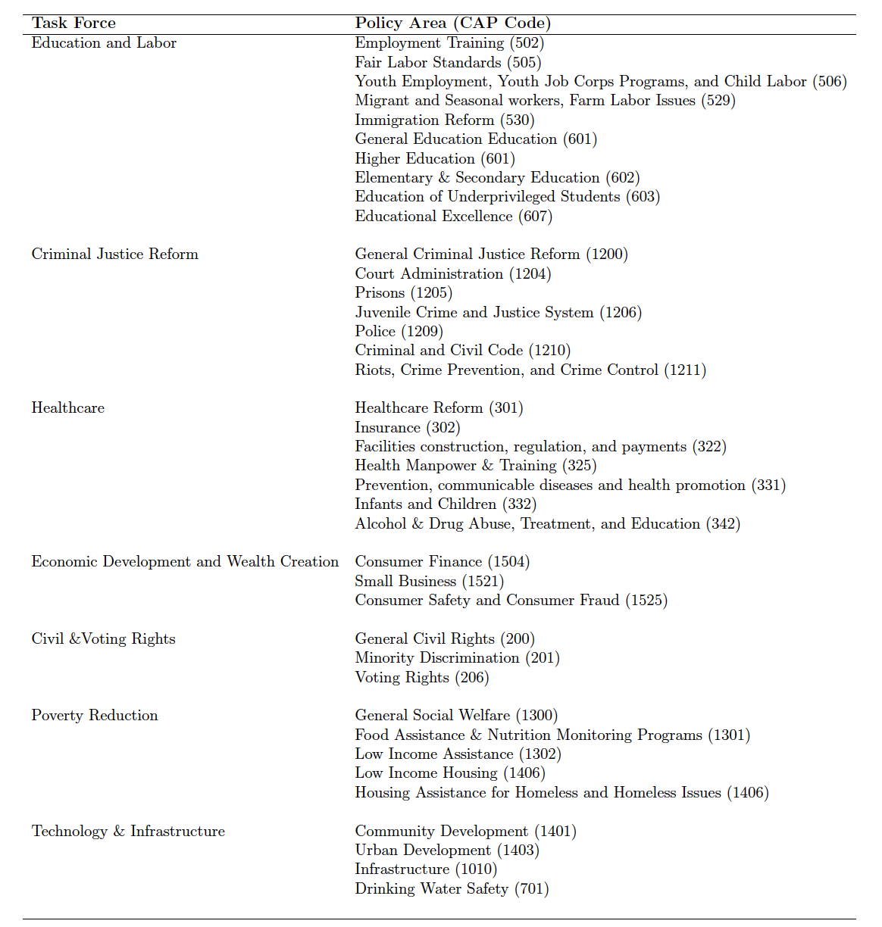
Table 1: This table identifies issues of interest for the Congressional Black Caucus. Comparative Agendas Project (CAP) minor topics codes are included for reference.

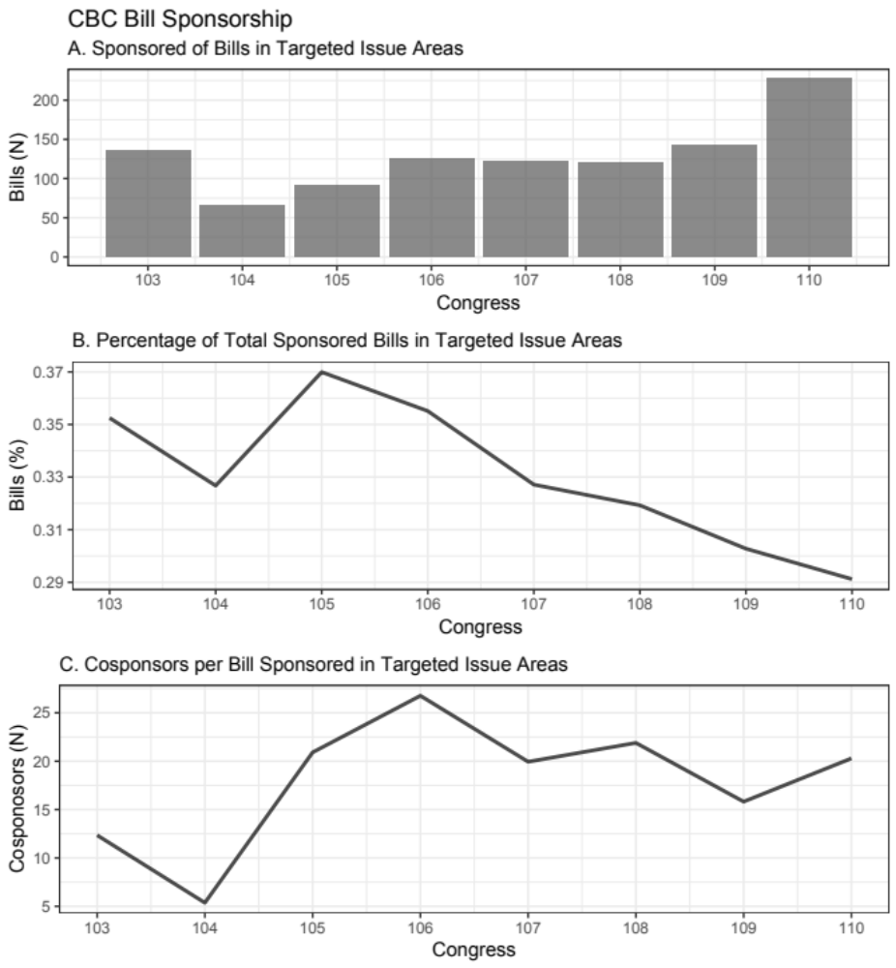
Figure 1: Descriptive statistics of bill sponsorships and cosponsorships from the 103rd - 110th Congress.

Data and Network Formation
To identify each of the unique cosponsors that engage within a particular policy area, I call upon GovTrack cosponsorship data. I construct an undirected affiliation matrix where House members j are associated with CBC-member-sponsored bills i within that policy topic. A solitary act of cosponsorship does not say much about coalitions within the chamber; this is especially true when these bills are in potentially contentious, racialized policy areas. There exists a need to move beyond the casual ties that routinely form within the chamber. To tease out trends that resemble a more firm commitment to the respective policy area and the efforts of the Black Caucus and its membership, I elect to include a set of models of cosponsorship that restricts network formation to include only those that have formed ties in at least five-percent and ten-percent (rounding up) of the total bills sponsored in the given policy area.
Thresholding is a common practice when analyzing cosponsorship networks (Fowler 2006a; Cranmer and Desmarais 2011). The decision to set the threshold at five and tenpercent is not an arbitrary one - Cranmer and Desmarais (2011, 78) find thinning thresholds up to 10% “produce reasonably dense networks capturing between 20% and 50% of all possible ties”. With the aim of creating the most rigorous threshold possible while preserving enough ties to conduct empirical analysis, I tested thresholds from five to fifteen-percent. At the levels above 10 percent threshold, sparsity in the 104th Congress rendered any temporal analysis impossible.

Model Selection for Temporal Network Analysis
Given the aim of this study to identify relational ties that drive these specific issue coalitions over time, I employ a temporal exponential random graph model with bootstrapped confidence intervals (BTERGM) to account for the interdependent nature of cosponsorship within the chamber (Leifeld, Cranmer, and Desmarais 2018). The pooled, cross-sectional BTERGM accounts for the impact of exogenous factors while measuring the impact of endogenous factors across multiple networks. The dependent variables in this instance are the observed networks across targeted policy areas, and the estimation predicts the probability of observing this configuration across all possible configuration given the variables of interest.
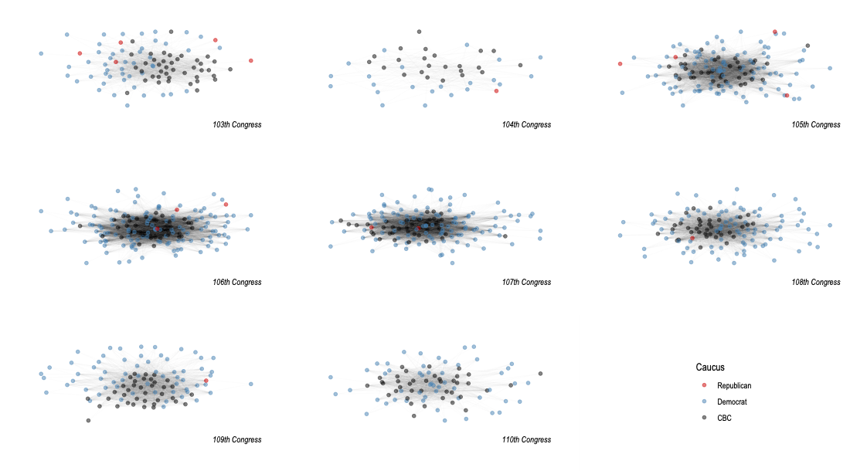
Figure 2: Moderate Cooperation - The figure above displays cosponsorship networks formed from CBC-Member sponsored bills in racialized policy areas at the five-percent threshold.
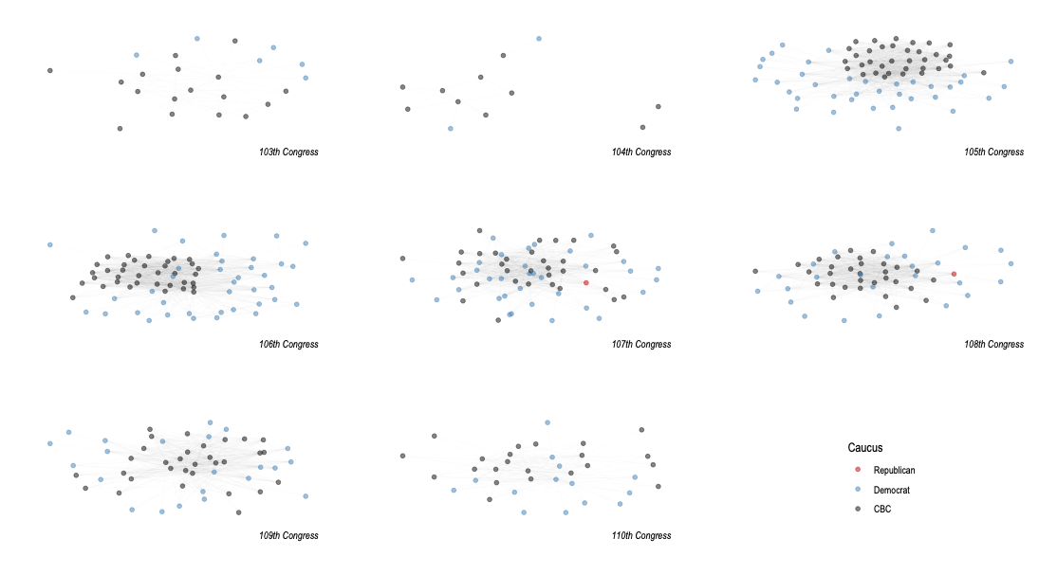
Figure 3: Frequent Cooperation - The figure above displays cosponsorship networks formed from CBC-Member sponsored bills in racialized policy areas at the ten-percent threshold.
The BTERGM employs maximum pseudolikelihood estimation (MPLE) of each model for four specific reasons. The first is capability. While the use of Monte Carlo maximum likelihood (MCMLE) estimates are traditionally used in the estimation of ERGM models, they become computationally challenging when attempting to handle larger and/or denser networks. The act of cosponsorship is a process that can easily produce tens of thousands of ties within a given policy area and session, rendering the standard MCMLE modeling relatively insufficient (Fowler 2006b). The second advantage comes in its efficiency: MPLE models are able to handle what would be arduous tasks for MCMLE in a fraction of the time. The third factor is the model’s flexibility. The BTERGM model is designed specifically to handle nodes entering and exiting the cosponsorship network (Leifeld, Cranmer, and Desmarais 2018). Therefore any breakdowns in relational ties resulting from turnover or an expansion, for example, would be accounted for in this analysis. Finally, there is a potential advantage with MPLE when it comes to accuracy. The psuedolikelihood model produces estimates on par - if not better - than those produced by Monte Carlo simulations, especially as node sizes increase (Schmid and Desmarais 2017). On the surface, the MPLE rendition of the ERGM model ultimately reduces nicely to a Logistic Regression. However, one disadvantage of the MPLE ERGM and its temporal extensions is that it tends to underestimate corresponding confidence intervals (Schmid and Desmarais 2017).

Variables of Interest
The BTERGM is designed to identify structural and exogenous characteristics of multiple networks. I leverage this capability to examine the three features expected to contribute to support in Black-interest areas. I employ three sets of network analysis functions to determine the nature of collaboration in CBC interest areas.

CBC Cohesion
Group cohesion is measured through the use of common applications of network analysis that have escaped similar questions concerning in-group issue support. The first measure is one of in-group cohesion. While various dyadic relational ties certainly influence the cosponsorship trends, I argue the ability to close those ties and form cohesive units around core policy issues that is expected to be the difference in sophisticated coalitions. Triadic formation is one way to examine cohesion within networks (Neal 2018). Bratton and Rousse (2011) find that group transitivity drives collaboration at the state level. To identify such relationships in the House of Representatives, I include a simple measure of this concept -triangles - to determine what extent that CBC members share collaborators based on existing in-group ties with other members of the organization.

Ideological Concordance
Tate argues that an ideological convergence between the CBC and non-CBC members of the Democratic part could lead to increased collaboration in Black-interest areas. This two-stage process that she labels concordance - characterized by an ideological moderation of the Black Caucus and a simultaneous liberalization of non-CBC Democrats - would likely provide an opportunity for the caucus “to knit together the broad coalitions necessary to win passage of liberal social and economic policies” (Tate 2014, 148). To test this theory, I include a measure of the influence of difference between two lawmakers’ ideology according to Poole and Rosenthal’s (2000) DW-Nominate score.

Diversity Infrastructures
Scholars contend the presence of identity-based caucuses may provide CBC members with an additional avenue to build coalitions within the chamber. While there are several types of legislative caucuses – including those associated with party, shared issue interests, and geographic location (see Hammond, et al. (1985) for complete typology) – the type most relevant to this study are those that are formed to promote interests of specific identity groups. I focus on two identity-centric caucuses that could potentially serve as reliable allies for the CBC in their pursuit of racialized issues: the Congressional Hispanic Caucus (CHC) and the Congressional Caucus for Women’s Issues (CCWI). These groups have grown to constitute a significant portion of the representative body within the House and can shed light on the collective, potentially coordinated action of similar members. These groups also serve as the collective voice of their respective racial and gender identities within the chamber. Finally, over time, these groups have amassed a great deal of influence and visibility in the legislative process. Thus, it seems likely that these groups would see a great deal of opportunity to collaborate in search of shared policy goals. The nodefactor function of SNA is a means of determining influence of caucus membership on their connectedness. To test this assumption, I include variables designed to measure the activity levels of both CHC and CWI members in cosponsorship networks around CBC-intrest bills.

Additional Considerations
In addition to the key variables of interest, I include a number of variables widely believed to influence cosponsorship behavior. Across numerous studies, homophily, and tenure all shape cosponsorship patterns in the House of Representatives (Krehbiel 1995; Wilson and Young
1997; Campbell 1982; Bratton and Rouse 2011; Koger 2003; Fowler 2006a; Fowler 2006b). In an effort to address the potential that social and general homophily shape ties between actors, I consider node matches where edge-ties are driven by similarities in members’ gender, home state, and party affiliation and seniority. Finally, I also account for several endogenous, network-level statistics designed to identify underlying trends in cosponsorship. I include two measures of triadic closure to serve both as a general measure of tendencies within the broader network and to control for such a propensity to further highlight the in-group support on the part of the caucus. The first two are a measure of geometrically weighted edgewise shared partners (GWESP) and dyad-wise shared partners (GWDSP) designed to account for global clustering and closure in the broader network. I also include a commonly-utilized measure designed to capture the degree distribution of the network (GWDEGREE). Finally, the Edges term is a count of the number of ties found across the different networks.

Results
What factors shape support through cospsonsorship in Black-interest areas? Table 2 reveals coefficient measures across the sample of House cosponsorship activity, conditional on the remaining network endogenous and exogenous coefficients, along with 95% confidence intervals that surround the estimates. In each model, confidence intervals are the product of 1,000 bootstrapped replications. Estimates are considered to be statistically significant if zero (0) falls outside of those intervals. Presented models are subject to standard degeneracy and goodness-of-fit tests associated with social network analysis, and perform admirably in each.

In-Group Support
Findings from the models presented in Table 2 suggest that a combination of endogenous and exogenous factors shape cosponsorship pattern in bills sponsored by Congressional Black Caucus members in the organizations prioritized policy areas. First, as expected, caucus members utilize their strength in numbers to relay messages to key institutional decision makers. In-group cohesion - measured by the transitive nature of connections between CBC members - in both the moderate and frequent collaboration models suggest reveals cohesion and triadic closure prove to be dominant characteristics of these support networks. The positive coefficient associated with this measure allows me to confidently reject the null hypothesis. However, these findings appear to be driven by extraordinary levels of cohesion following the 104th Congress - a period of significant change for the caucus and the institution broadly.

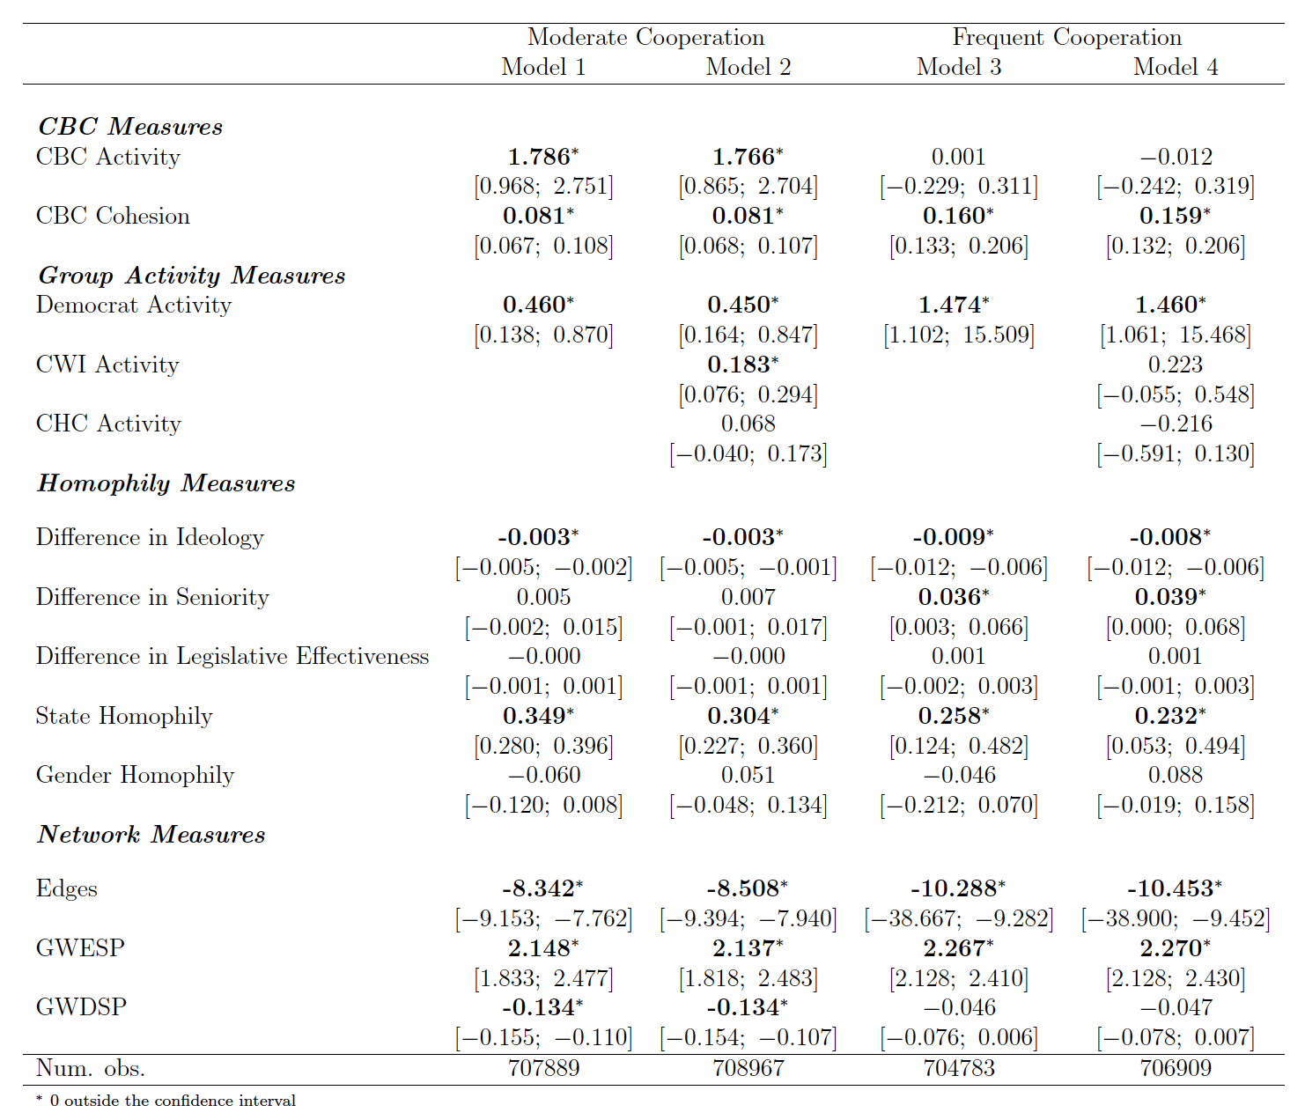
Table 2: Results from the Bootstrapped Temporal Exponential Random Graph Model (BTERGM)

Until the 104th Congress, the Congressional Black Caucus “enjoyed” Democratic rule for the entirety of the group’s existence. It was during this period that onlookers described the caucus as a loosely-tied, relatively invisible, and often combative organization (Singh 1998; Smith 1996). However, the transition out of a sustained Democratic majority in the House to a six term dominance of House Republicans that ultimately reshaped lawmaking within the institution and for the Black Caucus. Figure 4 suggests that the level of cohesion that scholars often point to in their voting patterns (Pinney and Serra 1999; Mixon and Pagels 2007; Mixon and Ressler 2001; Jones 1987; Gile and Jones 1995; Canon 1995; Tate 2003; Tate 2014) was not evident in their cosponsorship behavior from the 103rd and 104th Congresses. In fact, only 72 and 9 of the potential ties, respectively, were formed at the frequent cosponsorship threshold. The 104th Congress appears to be especially disruptive to collective behavior - likely as a product of large scale institutional reform following the first shift in partisan control of the House of Representatives in decades. Consequentially, and unsurprisingly, cosponsorship in the 104th reflected a caucus in disarray - characterized by very little cohesion.
On the first day of the 104th Congress, the House - led by newly appointed Speaker Newt Gingrich - passed sweeping rules changes aimed at increasing transparency, reducing operating costs, and reducing legislative inefficiencies perceived to exist prior to the shift in majority control of the House. Scholars point to a number of reforms over the years that have directly contributed to the a general decline in analytic capacity and decentralization of the House of Representatives (Aldrich and Rohde 1997; Schickler 2001; Adler 2002; Rohde 2010; Adler and Wilkerson2011; Baumgartner and Jones 2015). Those impacts reverberate even after a transition back into Democratic control in the 110th, especially for the Black Caucus
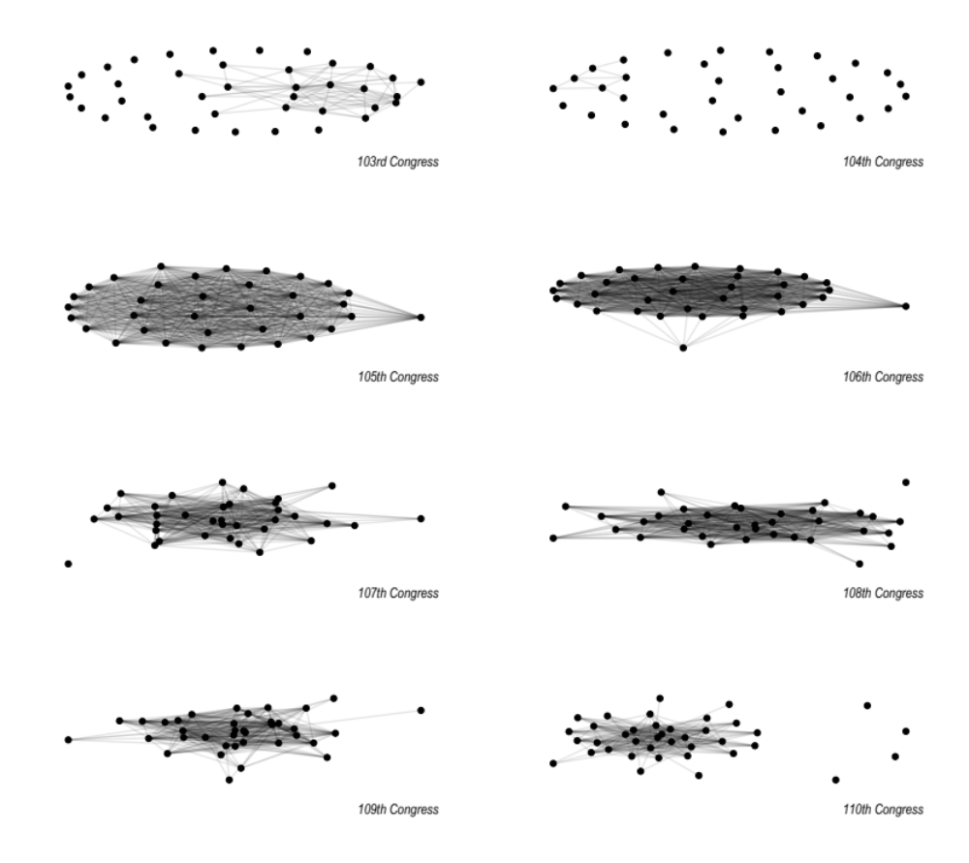
Figure 4: The figure above displays cosponsorship networks formed from CBC-Member sponsored bills in racialized policy areas at the ten-percent threshold.
Analysis from Andrew Clarke found that the abolishment greatly decreased the legislative capacity of LSO members and destabilized legislative networks (Clarke 2018). “Republican leadership abruptly dismantled a system of directly funded political institutions in the 104th Congress, and LSO chairs, accustomed to directing considerable resources towards their organization’s legislative agenda, were sent scrambling for alternative financial arrangements” (Clarke 2018, 19). Abolishing LSOs in the 104th Congress had a distinct impact on the Congressional Black Caucus, an organization that appeared to finally hit its stride after just over 20 years in existence. In Peacock Elite, Black Caucus workhorse, Rep. Major Owens (D-NY) asserted the decision to dismantle the LSO network in the House was motivated – at least in part – by Gingrich’s personal hostility towards the caucus and a fear of the organization reaching its potential (Owens 2011, 207):
“ While the CBC interference with traditional power manipulation was viewed as a nuisance by the Democratic leadership, the Republican Speaker elected in 1995 surmised that the CBC was for other reasons a major threat to his agenda. Newt Gingrich clearly saw the CBC as a mobilizing force with far greater potential than it had yet realized. Of still greater importance he saw it as a highly visible model with considerable embryonic replication already germinating. Having utilized a special, though less visible, caucus process to elevate himself to power, Speaker Gingrich understood the threats of the caucus format to his ambitious agenda and moved to destroy it.”

Singh (1998) chronicles the challenges directly associated with the 104th Congress. The caucus struggled to regain resources (funding, staff, and information) that came as a result of organizational restructuring and a diminished overall legislative capacity (Owens 2011; Clarke 2018).The organizational agenda, itself, appears to have been negatively impacted by the disruptive nature of the reforms associated with the Republican’s “Contract” reforms. Singh (1998, 194) comments, “the CBC seemed unable to come to a collective view of what Blacks’ permanent interests were, much less on how best to realize them”. As a result, the caucus was faced with a need to revisit its legislative strategy. However, the caucus devised creative means to respond to Gingrich’s mandates. According to Rep. Owens’ view from the inside, “Instead of destroying the CBC, Gingrich’ decrees had only crippled it, forced a creative mutation” (Owens 2011, 207). These findings suggest, one such way that the caucus responded to Gingrich era reforms was to employ a cohesive collective messaging strategy through legislative cosponsorship when sponsoring legislation in key policy areas.
A brief glance networks’ graph density - a measure of the total number of observed edges divided by the total number of edges possible based on the number of nodes in a network over the time span in question, cosponsorship networks at the ten-percent threshold were far more dense in the 105th Congress (0.823) compared to the previous session (0.019). Although the density of in-group support networks experienced a decline in the following years, they still remained relatively high in comparison to both the 104th Congress and the bracketing periods of Democratic majorities. This could signal a period of strategic evolution within the organization that took place once the initial shock of minority party status resided. First, this could be the product the re-emergence of a legislative agenda - something the organization seemed to lack in the 104th. Second, the lag in activity could be the product of a more formalized messaging strategy that came in response to the shock of settling into a Republican majority. Additional data would be needed to determine if this cohesion revealed in the network is merely a function of sampling or a more significant, long-term trend.

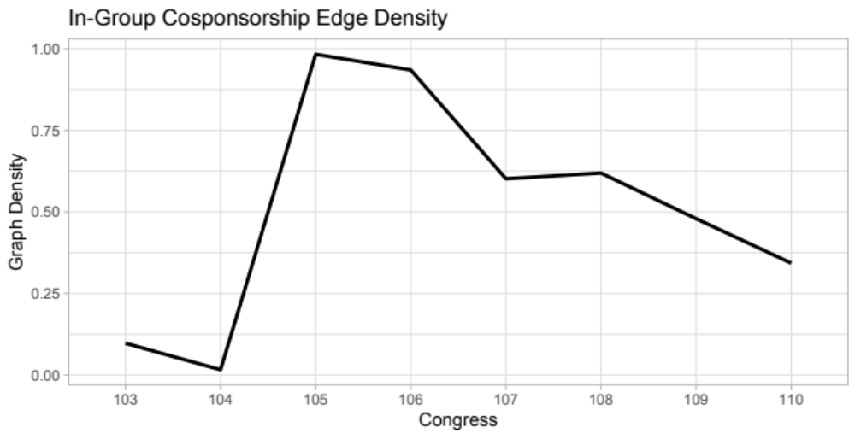
Figure 5: In-group graph density as measured by the number of observed ties out of the total number of potential ties.

Out-Group Support of Black-interest Policies
The CBC has increased in numbers since its inception. However, even at their most populous, the caucus lacks the ability to drive issue attention without the support of at least some of their colleagues in the chamber. Table 2 as well as Figures 2 and 3 reveal that support for CBC proposals in key areas is almost uniformly Democrat. This is especially true when examining the more frequent supporters of CBC issues. This is expected considering that the CBC is, in large part, an organization of Black Democrats.³ What, then, besides partisan affiliation contributes to support for Black-interest policies?

Ideological Concordance and Coalition Building
Katherine Tate (2014) posited that and ideological convergence between the Black Caucus and the remaining Democrats in the House would provide an opportunity to build supportive relationships that may bleed over into Black-interest policy areas. Figure 6 visualizes this process that she calls concordance - characterized by a gradual moderation of Black Caucus members and a more asymmetric liberalization of the rest of the Democratic Party. Hypothesis 2 supposes that this meeting of the ideological minds would become a dominant predictor in edge formation in this sample of cosponsorship networks. As Table 2 reveals, ideological homophily is significant predictor of coalitional support for bills sponsored by Congressional Black Caucus members. The negative coefficient associate with the absolute difference of members’ DW-Nominate score indicates that edge formation is more prevalent when two members are closer in ideology. This finding holds across both the five and ten-percent thresholds. These finding provide a great deal of support for Tate’s theory and should prove promising for Black lawmakers seeking a broader, more diverse coalition.

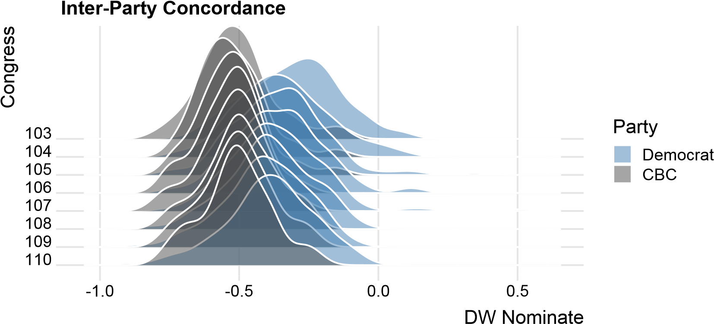
Figure 6: Ideological convergence of CBC members and the remaining Democratic Party members from the 103rd - 110th Congress.

Diversity Infrastructures and Coalition Building
Scholars also point to a potential cooperation between identity caucuses that could lead to an increased level of support in Black-interest legislation (Minta and Sinclair-Chapman 2013; Tyson 2016). To test this theory, I examine the degree to which members of the Congressional Hispanic Caucus (CHC) and the Caucus for Womens’ Issues (CWI) are connected in the CBC bill cosponsorship networks. Contrary to expectations, analysis of the cosponsorship patterns indicate that these relationships do not necessarily drive tie formation. In their state-level analysis, Bratton and Haynie (1999) find that their is a great deal of overlap in the policy interests that impact Black and Women communities. There is also a great deal of overlap in the memberships of the two caucuses, as Black women (and women, in general) are in creasing their presence within the chamber. This could have the potential to spawn collaboration between the two caucus designed to promote those issues in the House of Representatives. However, Table 2 indicates that that bond may not be as strong as some would presume when it comes to supporting a Black-interest agenda. The coefficient designed to measure the connectedness of CWI members only reaches traditional measures of statistical significance in the moderate cosponsorship model (Model 2). That influence on the cosponsorship vanishes when increasing the threshold of tie formation from five to ten-percent of bills sponsored in Black-interest areas by CBC members (Model 4).
The models provide even less support for the idea that Black and Latinx members of Congress will create reliable bonds when sponsoring racialized legislation. Although it would appear on the surface that there would be a great deal of overlap in their legislative agendas, CHC influence does not appear to have a significant impact on the cosponsorship networks at either threshold. This comes despite being a member of the Tri-Caucus - a coalition with the CBC and the Asian and Pacific Americans Caucus. Previous scholarship from authors such as Rodney Hero (2013) and Vanessa C. Tyson (2016) propose that this relationship between Black and Latinx representatives may be much more contingent. Which brings me to ponder on some of the reasons that this data may produce these somewhat surprising outcomes with respect to cross-caucus support.
While these models do not necessarily test this presumption, it may be the case that crosscaucus support may be more dependent on particular issues where there is a more direct correlation between the groups’ interests. There may also be more of an interplay between the caucus that considers a more strategic relationship where this cooperation across identity caucuses only plays out when a member in a more advantaged position within the chamber hierarchy. These two ideas could prove fruitful ground for future studies.

Additional Findings
The structural variables presented in Table 2 provide additional context around the cosponsorship networks in Black sponsored Black-interest legislation. The negative, significant coefficients associated Edges term indicate that each of the networks are less dense than a graph drawn at random given the number of nodes present. This shows one reality of Blackinterest advocacy in the House of Representatives: members of Congress are overwhelmingly reluctant to support proposals on the CBC agenda. However, on the other hand, the positive coefficient associated with the GWESP term suggests those that do sign on to these bills are likely to form strong, transitive bonds with other cosponsors. Finally, geographic similarity also proves to predict edge formation. Members that share a home state are likely to cosponsor in the CBC-interest network.

Discussion
Ultimately, this analysis sought to achieve two goals. This work aspires to build upon scholarship that advocates moving beyond the dyadic model of representation and progress towards the collective representation of group interests. As Congress, and particularly the House of Representatives, becomes increasingly hostile to individual members impacting legislative outcomes - rather it be through the changing of rules, power-grabs by leadership, or the rise of ideological and partisan factions within the chamber - we must begin to sharpen our focus on actions taken by groups to achieve collective goals. Second, this project set out to expand our scholarly consideration of policy support beyond late-stage processes and identify trends in the legislative process that can contribute to our understanding of how groups pursue those collective interests, not just if they do. While studies that reveal cohesion among members in roll-call votes certainly benefit our overall knowledge concerning the Black Caucus - and other groups like them - those findings do not relay the entire story.
This article builds upon our knowledge of how identity caucuses - like the Congressional Black Caucus - work as a collective in an effort to promote key issues onto the legislative agenda. One means to forward issues onto an agenda is to relay messages that a subset of members possess intense preferences for (or against) a particular proposal. Another mode is to show that a proposal has broad and diverse support within the chamber. Thus, examining how caucus members form supportive ties in support of issues targeted by the organization is one of many ways to accomplish the two goals mentioned above.
As Black lawmakers become increasingly creative in seeking out ways to break through institutional barriers of inattention, it will become necessary to move our scholarship towards examining these processes. Additionally, new empirical approaches to examining minority representation are also necessary to identify underlying trends, diagnose long-term phenomenon, and determine if and how conditions change for representatives of color and the institutions that house them. Network analysis provides a means to answer questions we may not have thought possible until now. Scholars interested in advancing our understanding of the behavior those who represent marginalized interests should invest in seeking out innovative ways to explore old and new questions.
Cohesion is expected within and groups that are subject to marginalization both within and outside of political institutions (Dawson 1995; Neil Pinney and George Serra 1999; Tyson 2016). These findings suggest, when the odds are stacked against them and institutional resources are denied, the Congressional Black Caucus relies on cohesive messaging as a primary mode of agenda-setting from the minority. However, out-group support is still hard to come by. I examine two potential pathways to build coalitions around CBC-interest proposals, with mixed findings. As predicted, an ideological convergence between the Democratic Party and the CBC has shown to be a fruitful avenue to build bonds between members. Cross-caucus coalition building, however, does not appear to influence cosponsorship behavior in bills sponsored by Black Caucus members in targeted areas.
This serves as just one of multiple means to examine issue support around policies that have the potential to change the lives of marginalized groups. Moving forward, additional attention should be devoted to determining if support is more contingent on a more granular consideration of policy area. There is also the possibility that support may fluctuate as members enter and exit the chamber majority. Additionally, special attention should be paid to a more strategic form of cross-caucus collaboration that may operate on member positioning within the chamber. Finally, interested scholars should consider a diverse set of methodological tools to gain leverage on these questions and possible answers.

References
Aldrich, John H., and David W. Rohde. 1997. “The Transition to Republican Rule in the House: Implications for Theories of Congressional Politics”. Political Science Quarterly 112 (4): 541–567.
Baumgartner, Frank R., and Bryan D. Jones. 1991. “Agenda Dynamics and Policy Subsystems”. The Journal of Politics 53 (4): 1044–1074.
— . 1993. Agendas and Instability in American Politics, Second Edition. University of Chicago
Press.
— . 2015. The Politics of Information: Problem Definition and the Course of Public Policy in America. University of Chicago Press.
Baumgartner, Frank R., et al. 2009. “Punctuated Equilibrium in Comparative Perspective”. American Journal of Political Science 53, no. 3 (): 603–620.
Bowler, Shaun, Stephen P. Nicholson, and Gary M. Segura. 2006. “Earthquakes and Aftershocks: Race, Direct Democracy, and Partisan Change”. American Journal of Political Science 50 (1): 146–159.
Bratton, Kathleen A., and Kerry L. Haynie. 1999. “Agenda Setting and Legislative Success in State Legislatures: The Effects of Gender and Race”. The Journal of Politics 61 (3):
658–679.
Bratton, Kathleen A., and Stella M. Rouse. 2011. “Networks in the Legislative Arena: How Group Dynamics Affect Cosponsorship”. Legislative Studies Quarterly 36 (3): 423–460.
Browning, Rufus P., Dale Rogers Marshall, and David H. Tabb. 1986. “Protest Is Not Enough: A Theory of Political Incorporation”. PS 19 (3): 576–581.
Butler, Daniel M. 2009. “The Effect of the Size of Voting Blocs on Incumbents’ Roll-Call Voting and the Asymmetric Polarization of Congress”. Legislative Studies Quarterly 34 (3): 297–318.
Campbell, James E. 1982. “Cosponsoring Legislation in the U. S. Congress”. Legislative Studies Quarterly 7 (3): 415–422.
Canon, David T. 1995. “Redistricting and the Congressional Black Caucus”. American Politics Quarterly 23, no. 2 (): 159–189.
Carmines, Edward G., and James A. Stimson. 1989. Issue Evolution: Race and the Transformation of American Politics. Princeton University Press.
Clarke, Andrew J. 2018. “Congressional capacity and the abolition of legislative service organizations”. Journal of Public Policy: 1–22.
Craig, Alison, et al. 2015. “The Role of Race, Ethnicity, and Gender in the Congressional Cosponsorship Network”. arXiv:1512.06141 [physics, stat] (). arXiv: 1512.06141.
Cranmer, Skyler J., and Bruce A. Desmarais. 2011. “Inferential Network Analysis with Exponential Random Graph Models”. Political Analysis 19 (1): 66–86.
Dawson, Michael C. 1995. Behind the mule: Race and class in African-American politics.
Princeton University Press.
— . 2003. Black Visions: The Roots of Contemporary African-American Political Ideologies.
University of Chicago Press.
Dawson, Michael C, and Cathy Cohen. 2002. “Problems in the Study of the Politics of Race”.
Political science: The state of the discipline: 488–510.
Fowler, James H. 2006a. “Connecting the Congress: A Study of Cosponsorship Networks”. Political Analysis 14, no. 4 (): 456–487.
— . 2006b. “Legislative cosponsorship networks in the US House and Senate”. Social Networks 28, no. 4 (): 454–465.
Frymer, Paul. 2010. Uneasy Alliances: Race and Party Competition in America. Princeton University Press.
— . 2011. Black and Blue: African Americans, the Labor Movement, and the Decline of the Democratic Party. Princeton University Press.
Gile, Roxanne L., and Charles E. Jones. 1995. “Congressional Racial Solidarity: Exploring Congressional Black Caucus Voting Cohesion, 1971-1990”. Journal of Black Studies 25 (5): 622–641.
Gillespie, Andra. 2010. Whose Black Politics?: Cases in Post-Racial Black Leadership. Routledge.
— . 2012. The New Black Politician: Cory Booker, Newark, and Post-Racial America. NYU
Press.
Green, Matthew N. 2015. Underdog Politics: The Minority Party in the U.S. House of Representatives. Yale University Press.
Griffin, John D., and Michael Keane. 2011. “Are African Americans Effectively Represented in Congress?” Political Research Quarterly 64 (1): 145–156.
Guinier, Lani. 1991. “The Triumph of Tokenism: The Voting Rights Act and the Theory of Black Electoral Success”. Michigan Law Review 89 (5): 1077–1154.
Hacker, Jacob S, and Paul Pierson. 2006. Off Center: The Republican revolution and the erosion of American democracy. Yale University Press.
Hall, Peter A. 1993. “Policy Paradigms, Social Learning, and the State: The Case of Economic
Policymaking in Britain”. Comparative Politics 25 (3): 275–296.
Hammond, Susan Webb, Daniel P. Mulhollan, and Arthur G. Stevens. 1985. “Informal Congressional Caucuses and Agenda Setting”. The Western Political Quarterly 38 (4): 583– 605.
Hero, Rodney E., and Robert R. Preuhs. 2013. Black-Latino Relations in U.S. National Politics: Beyond Conflict Or Cooperation. Cambridge University Press.
Jones, Bryan D. 2003. “Bounded Rationality and Political Science: Lessons from Public Administration and Public Policy”. Journal of Public Administration Research and Theory: J-PART 13 (4): 395–412.
Jones, Bryan D., and Frank R. Baumgartner. 2005. The Politics of Attention: How Government Prioritizes Problems. University of Chicago Press.
Jones, Charles E. 1987. “United We Stand, Divided We Fall: An Analysis of the Congressional Black Caucus’ Voting Behavior, 1975-1980”. Phylon (1960-) 48 (1): 26–37.
Jones, David R. 2001. “Party Polarization and Legislative Gridlock”. Political Research Quarterly 54, no. 1 (): 125–141.
Kingdon, John W. 2011. Agendas, Alternatives, and Public Policies. Longman.
Koger, Gregory. 2003. “Position Taking and Cosponsorship in the U.S. House”. Legislative Studies Quarterly 28 (2): 225–246.
Krehbiel, Keith. 1995. “Cosponsors and Wafflers from A to Z”. American Journal of Political Science 39 (4): 906–923.
Legro, Jeffrey W. 2000. “The Transformation of Policy Ideas”. American Journal of Political Science 44 (3): 419–432.
Leifeld, Philip, Skyler J. Cranmer, and Bruce A. Desmarais. 2018. “Temporal Exponential Random Graph Models with btergm: Estimation and Bootstrap Confidence Intervals”.
Journal of Statistical Software 83, no. 1 (): 1–36.
Lowi, Theodore J. 1964. “American Business, Public Policy, Case-Studies, and Political
Theory”. Ed. by Raymond A. Bauer, Lewis A. Dexter, and Ithiel de Sola Pool. World Politics 16 (4): 677–715.
Mansbridge, Jane. 1999. “Should Blacks Represent Blacks and Women Represent Women? A Contingent ”Yes””. The Journal of Politics 61 (3): 628–657.
Maxwell, Angie, and Stephanie R. Schulte. 2018. “Racial Resentment Attitudes Among White Millennial Youth: The Influence of Parents and Media*”. Social Science Quarterly 99 (3): 1183–1199.
Mayhew, David R. 1974. Congress: The Electoral Connection. Yale University Press.
McGowen, Ernest B. 2018. “The Needles in the Haystack: Assessing the Effects of Time, Place, and Class on Blacks in Majority-White Suburbs”. In Black Politics in Transition, 141–164. Routledge.
Minta, Michael D., and Valeria Sinclair-Chapman. 2013. “Diversity in Political Institutions and Congressional Responsiveness to Minority Interests”. Political Research Quarterly 66 (1): 127–140.
Mintrom, Michael, and Phillipa Norman. 2009. “Policy Entrepreneurship and Policy Change”. Policy Studies Journal 37, no. 4 (): 649–667.
Mixon, Franklin G., and Amanda C. Pagels. 2007. “Are Congressional Black Caucus Members More Reliable? Loyalty Screening and Committee Assignments of Newly Elected Legislators”. The American Journal of Economics and Sociology 66 (2): 413–432.
Mixon, Franklin G., and Rand W. Ressler. 2001. “Loyal Political Cartels and Committee
Assignments in Congress: Evidence from the Congressional Black Caucus”. Public Choice 108 (3): 313–330.
Neal, Zachary P. 2018. “A sign of the times? Weak and strong polarization in the U.S.
Congress, 1973–2016”. Social Networks ().
Neil Pinney and George Serra. 1999. “The Congressional Black Caucus and Vote Cohesion:Placing the Caucus Within House Voting Patterns”. Political Research Quarterly 52, no. 3 (): 583–607.
Owens, Major. 2011. The Peacock Elite: A Subjective Case Study of the Congressional Black Caucus and Its Impact on National Politics. GrantHouse Publishers.
Peterson, Paul E. 2012. City Limits. University of Chicago Press.
Pinney, Neil, and George Serra. 1999. “The Congressional Black Caucus and Vote Cohesion: Placing the Caucus within House Voting Patterns”. Political Research Quarterly 52 (3): 583–608.
— . 2002. “A Voice for Black Interests: Congressional Black Caucus Cohesion and Bill Cosponsorship”. Congress & the Presidency 29, no. 1 (): 69–86.
Pitkin, Hanna F. 1967. The Concept of Representation. University of California Press.
Polsby, Nelson W. 1968. “The Institutionalization of the U.S. House of Representatives”. The American Political Science Review 62 (1): 144–168.
Poole, Keith T., and Howard Rosenthal. 2000. Congress: A Political-economic History of Roll Call Voting. Oxford University Press.
Ripberger, Joseph T., et al. 2014. “Cultural Theory and the Measurement of Deep Core Beliefs Within the Advocacy Coalition Framework”. Policy Studies Journal 42, no. 4 (): 509–527.
Rocca, Michael S., and Stacy B. Gordon. 2010. “The Position-taking Value of Bill Sponsorship in Congress”. Political Research Quarterly 63, no. 2 (): 387–397.
Rocca, Michael S., and Gabriel R. Sanchez. 2008. “The Effect of Race and Ethnicity on Bill Sponsorship and Cosponsorship in Congress”. American Politics Research 36, no. 1 ():
130–152.
Rogers, Reuel R. 2018. “Black Come-Outers and the Counterpublic: How Suburbanization Is Diversifying Black Attitudes”. In Black Politics in Transition, 165–201. Routledge.
Rohde, David W. 2010. Parties and leaders in the postreform House. University of Chicago
Press.
— . 1994. “Parties and Committees in the House: Member Motivations, Issues, and Institutional Arrangements”. Legislative Studies Quarterly 19 (3): 341–359.
Sabatier, Paul A. 1988. “An Advocacy Coalition Framework of Policy Change and the Role of Policy-Oriented Learning Therein”. Policy Sciences 21 (2): 129–168.
Sabatier, Paul A., and Hank C. Jenkins-Smith. 1993. Policy change and learning: an advocacy coalition approach. Westview Press.
Sabatier, Paul A., and Christopher M. Weible. 2014. Theories of the Policy Process. Avalon Publishing.
Schattschneider, Elmer. 1975. The Semi-Sovereign People: A Realist’s View of Democracy in America. Wadsworth Publishing.
Schiller, Wendy J. 1995. “Senators as Political Entrepreneurs: Using Bill Sponsorship to Shape Legislative Agendas”. American Journal of Political Science 39 (1): 186–203.
Schmid, Christian S, and Bruce A Desmarais. 2017. “Exponential random graph models with big networks: Maximum pseudolikelihood estimation and the parametric bootstrap”. In Big Data (Big Data), 2017 IEEE International Conference on, 116–121. IEEE.
Singh, Robert S. 1998. The Congressional Black Caucus: racial politics in the United States Congress. London, UK: Sage.
Smith, Robert C. 1996. We Have No Leaders: African Americans in the Post-Civil Rights
Era. SUNY Press.
Stevens, Arthur G., Daniel P. Mulhollan, and Paul S. Rundquist. 1981. “U. S. Congressional Structure and Representation: The Role of Informal Groups”. Legislative Studies Quarterly 6 (3): 415–437.
Swain, Carol M. 1993. Black Faces, Black Interests: The Representation of African Americans in Congress. Enlarged Edition edition. Lanham, Md: UPA.
Swers, Michele L. 2002. The Difference Women Make: The Policy Impact of Women in
Congress. University of Chicago Press.
— . 2005. “Connecting Descriptive and Substantive Representation: An Analysis of Sex
Differences in Cosponsorship Activity”. Legislative Studies Quarterly 30 (3): 407–433.
Tate, Katherine. 2003. Black Faces in the Mirror: African Americans and Their Representatives in the U.S. Congress. Princeton University Press.
— . 2014. Concordance: Black Lawmaking in the U.S. Congress from Carter to Obama. University of Michigan Press.
Tyson, Vanessa. 2016. Twists of Fate: Multiracial Coalitions and Minority Representation in the US House of Representatives. Oxford, New York: Oxford University Press.
Victor, Jennifer N. 2018. “Caucus Membership. Data available for scholarly use from http://jvictor.gmu.edu download/ Accessed October 2016.””. Data Download. http://jvictor.gmu.edu/ index.php/data-download/.
Wilson, Rick K., and Cheryl D. Young. 1997. “Cosponsorship in the U. S. Congress”. Legislative Studies Quarterly 22 (1): 25–43.
Wilson, Walter Clark. 2010. “Descriptive Representation and Latino Interest Bill Sponsorship in Congress*”. Social Science Quarterly 91, no. 4 (): 1043–1062.

Conclusion: (Re)Evaluating Collective Agenda-Setting in Black-interest Policy Areas
Towards a Better Understanding of the Modern Congressional Black Caucus

This project began with three explicit goals in mind. First, I aimed to uncover how the CBC constructs and communicates their collective worldview to the institution. Existing literature has been essential to improving our understanding of how Black lawmakers behave in legislative bodies. However, it often falls short in considering, empirically, the contexts and commitments that are wrapped up in their agenda. Second, I sought to move beyond studying individualized legislative behaviors to examine how collective strategies are employed to promote their preferences onto the institution’s agenda. Finally, by working at the intersection of institutional and policy process literature and drawing on seldom-used methodological tools, I hoped to build on theoretical and empirical explorations into the representations of Black America in the House of Representatives.
Chapter 2 examines the potential of evaluating floor speeches delivered with the intent of defining issues on their agenda. By defining policies according to their underlying attributes, Black lawmakers are able to shape policy images and shape – and potentially reshape – existing frames of policy issues that plague the communities that they represent. I also uncover that there is a decided utility in engaging in problem definition from a scholarly, organizational, and institutional perspective. A better understanding of issues provides policy actors a bit of clarity in taking on problems faced by Black Americans.
In Chapter 3, I attempt to apply a theoretical explanation to changes in bill sponsorship trends in recent congressional sessions. I argue that the CBC a striking increase in legislation that receives multiple committee referrals is tied to an effort to broaden the reach of legislation within the chamber. Through designing bills in a way that capitalizes on the multidimensional nature of Black interests, CBC lawmakers are able to seek out more favorable committees. Doing so increases the likelihood that these bills clear the committee stage. More importantly, CBC-sponsored bills that receive multiple referrals are more likely to receive favorable floor votes.
Chapter 4 set out to explore how the Black Caucus responded to institutional adversity by building coalitions in the chamber. I find that the organization consolidated its messaging efforts through bill cosponsorship in the midst of a long-term stent in the minority party. The shift to Republican control and the subsequent, Gingrich-era institutional reforms, certainly proved disruptive to the practices of the caucus. However, in response, the caucus increased their cohesion around bills sponsored in CBC-interest policy areas sponsored by Black lawmakers. Caucus members also reconfigured who they formed cosponsorship bonds with. Prior to Republican control in the 104th Congress, the caucus was heavily reliant on CBC members that set atop committees. This can potentially free up committee chairs to do the work of the party while rank and file members can invest their time and effort into issue advocacy. I also trace patterns that shape outgroup support in CBC-interest areas. Increasing ideological homopholy provides the most certain pathway to coalition building in the House of Representatives.
Taken together, it is my hope that the preceding chapters serve as a first step in re-examining the collective representation of Black interest in Congress. In doing so, I find it essential that we invest in updating our understanding of the modern Congressional Black Caucus as they increase in numbers, influence, and outcomes. This is much different than investigating the behavior Black lawmakers. Examining the Caucus means, first, examining the caucus in a way that distinguishes the organization from the preferences and behaviors of individual Black lawmakers. This also means that there should be a considerable amount of effort devoted to bringing to light organizational features and strategies that shape the collective behavior within the chamber. To this end, I prescribe four avenues that researchers should consider.

Allow for the evolution of issues, preferences, and collective behaviors over time.
Haynes Walton argues evolution is in the nature of Black political actors. He points out Black political behavior “undergoes cycles of stagnation, deviation, and regeneration. The flux of social growth and decay affects the black political milieu as it does any sociopolitical milieu. In short, the current realities of black political patterns might not be the same tomorrow.” (Walton 1985, 8). As previously discussed, institutional change has had tremendous effects on the Congressional Black Caucus. Black lawmakers must also allow for their behavior to evolve to account for and adapt to ever-changing political climates. Therefore, we should expect to find over-time variations in the actions and pursuits of the caucus that are directly related to the institutional and policy environment that they are forced to operate under.
The reality is, Black lawmakers are subject to internal and external forces that almost demand and dictate an evolution in behaviors over time. First, members must undergo political and policy learning that come either through trial and error or through other processes of engagement. Change is promoted internally, as the organization is constantly the subject of a number of slow-moving extra-party processes that all have a substantial impact on their policy goals and pursuits. Trial and error can be beneficial if there is a learning process that comes as a consequence of failure (Wildavsky 1979; May 1992). Moreover, adjustments in behavior that are rooted in learning often take time and, likely, additional rounds of learning to lead to success. Additionally, the caucus is constantly undergoing internal changes of membership. While Black lawmakers occupy generally safe seats, turnover is inevitable. However, the change associated with turnover is likely to be moderated – in large part – by the electoral security of its current members. Larger shocks may be the result of large-scale generational restructuring among its members, as younger members take a more pragmatic, deracialized approach to Black-interest advocacy (Canon 1995; Gillespie 2010).
There are also external factors that promote incremental alterations in member behavior. The advocacy of Black issues in the House of Representatives is the product of – and a victim to – a number of slow-moving processes. First and foremost, the caucus is invested in breaking down centuries worth of institutional barriers to participation, access, and attention to Black-interest areas. Doing so means the Congressional Black Caucus is faced with the daunting task of changing the culture of the institution from within. Second, a major theoretical assumption presented in this work is that the CBC will concentrate its efforts on redefining policy images. Effectiveness in this venture will require to chip away, slowly, at the pre-existing dominant policy image and replace it with a less contentious, more palatable one.

Examine all phases of the legislative process.
The examination of Black legislative behavior has had a tendency to bracket the legislative process. An overwhelming emphasis on voting behavior and bill sponsorship – either directly or through the use of proxies like ideological scores or interest group ratings – has created a limited understanding of the behavior of Black representatives. While floor behaviors can be informative, this approach omits a significant portion of the actual collective activities of the Congressional Black Caucus. More importantly roll-call voting behavior is not necessarily indicative of decision making that considers the issue and solution in question and all possible alternatives. It is the product of a binary choice between the status quo (which is likely problematic for marginalized communities) and the proposed alternative to the status quo (which is likely derived without the consideration of perspectives from marginalized communities). Examinations of bill sponsorship can become similarly problematic if discussions of context, design, and strategy do not accompany the analysis.
Our understanding of Black-interest representation in Congress would be vastly improved by considering all phases of the legislative process. We have, unfortunately, developed a habit of downplaying the less tangible, measurable activities within the chamber. Each chapter in this project engaged different stages of congressional activity to, hopefully, illuminate the value of expanding the scope of inquiry. Some have taken on the task of evaluating the activities of African American congresspersons beyond voting and sponsorship. Such ventures have yielded valuable – and arguably, more interesting – insights and perspectives that have certainly advanced an otherwise stagnant conception of racial representation. It is my hope that others continue in the line of Mary Hawkesworth (2003), Katrina Gamble (2007; 2011), and Michael Minta (2011) in building a more comprehensive understanding of Black legislative behavior by considering debate and deliberation, committee activities, amendment procedures, coalition building, and other forms of communication within the chamber.

Expand conversations of legislative agenda-setting beyond parties, leadership, and pivots.
Scholarly conversations surrounding legislative agenda setting in the House of Representatives have been largely shaped by majoritarian or partisan considerations. There is also a concentration on the manipulation of rules, structures, and assignments to better achieve party goals. However, some would argue there exists a need to “move beyond our static conception of a single, identifiably pivotal, legislator to consider the institutional structures that enable groups of lawmakers to shape political outcomes in the House and Senate” (Rubin 2017, 298) . For this reason, I find it important to explain the possibility that minoritarian influence can be achieved in lawmaking institutions. Here, the term minoritarian influence takes on dual meanings. Both are quite literal; both are also understudied in congressional scholarship. The first mode of majoritarian influence centers on questions of how those in the numerical minority in a political institution can shape processes and outcomes. The second concentrates on how underrepresented groups can reshape processes and outcomes in an institution shaped by racialized and gendered ordering.
While access to institutional features is important, I present a perspective that argues minoritarian influence can be less about gaining access to parts of the policy process that have long been denied and more about shaping parts of the process that they can. It emphasizes, agendas are shaped by shifts in attention. More importantly, it is becoming increasingly possible to draw attention to particular problems in the modern congress than in previous iterations. For Black lawmakers, there are new pathways to shaping legislative agendas, new avenues to acquiring vital information, and new actors to partner with in search of substantive policy change. A minoritarian theory could also fill in admirably where dominant theories struggle to account for ever-changing dynamics within the chamber.
Agenda authority is not as cut-and-dry as dominant theories of the legislative process suggests it would be, as blocs of lawmakers have been successful in capturing legislative agendas. As Republican Paul Ryan (R-WI) discovered in his brief tenure as Speaker, a relatively small bloc of legislators can have a dramatic impact on the party’s legislative agenda. Political parties in the twenty-first century are coalitions of coalitions, Positive agenda change will likely be the result of inter-coalitional cooperation in shared interests. It has also been shown – through actions on the part of the Freedom Caucus and progressive Democrats – that this fragmentation can result in the cooptation of the legislative agenda by influential groups. With party fragmentation becoming increasingly pronounced in the post-reform era, majoritarian mandates at an institutional or party level are becoming decreasingly critical to influencing legislative agendas. Minoritarian influence is becoming increasingly possible in the modern congressional environment.
A groups-focused theory of positive agenda setting in the House must come to grips with several realities. For example, agenda control is now characterized as a tug-of-war between rank and file members and congressional leadership; leadership currently has the upper-hand (Sinclair 2011; Curry 2015). It must acknowledge the struggles of shaping attention while working from a position of disadvantage – rather it be through the denial of vital information pertinent to lawmaking (Curry 2015), the denial of access to avenues of lawmaking (Hawkesworth 2003; Griffin and Keane 2011), or through a denial of institutional resources (Owens 2011; Clarke 2018). However, as researchers work through these concerns, a theory of group influence could prove valuable for a better understanding of congressional politics.

Be deliberate about incorporating policy process theories into congressional studies.
The Congressional Black Caucus has transformed into an organization that concentrates its efforts on reshaping the legislative priorities of the Democratic Party by reconfiguring how they frame, communicate, and coalesce around policy. The caucus seeks to engage in positive agenda-setting despite occupying positions of disadvantage within the chambers of Congress by working collectively to (1) shift institutional attention towards more favorable dimensions of policy issues of interest, (2) process and broker information, and (3) build reliable coalitions around shared policy interests. Unfortunately, I have found that traditional congressional approaches fall short in explaining many of these behaviors – both in relation to the CBC and more broadly in the institution.
Throughout this project I have discovered that engaging with presumptions more commonly associated with theories of the policy process has a number of distinct advantages that could prove useful for those looking to expand our knowledge of Black representative behavior. First, doing so allows for scholars take part in more issue-driven discussions that are shockingly absent in more mainline congressional studies. Policy process literature provides me with a theoretical platform to engage with questions concerning the nature of policy issues that face Black America – including how these issue are defined (Rochefort and Cobb 1994; Baumgartner and Jones 2015) and how policy actors construct issues (Schneider and Ingram 1993; 2019; Barbehön 2020).
Policy process literature also allows researchers to engage with questions of how systems (and subsystems) respond to the nature of issues. Early contributions of process theories provides insights into how different policies create different politics (Lowi 1964). Since generations of scholars have devoted careers to exploring how issues are prioritized (Cobb and Elder 1971; Kingdon 2011; Baumgartner and Jones 1991; Jones and Baumgartner 2005), how groups coalesce around core beliefs and policy interests (i.e. Jenkins-Smith et al. 2018; Sabatier 1988; 1991), how policy actors and elites improve their understanding of the policy and political environment (for example Wildavsky 1979; May 1992; Bennett and Howlett 1992; Albright Elizabeth A. 2011; Weible 2008), and how institutions react to strategic policy action (Adler and Wilkerson 2012). Most importantly, policy process is better equipped to investigating if, how, and why policy change happens (Lindblom 1959; Baumgartner and Jones 1993; Baumgartner, Jones, and Mortensen 2017; Pierson 2011).
I hope that this work serves as a window into the vast potential of working at the intersection of traditional institutional and policy process literatures. These perspectives have proven to be complementary and has the potential to fill voids where mainstream legislative studies have proven to be insufficient. It illuminates the benefits of drawing on policy process literatures to enhance our understanding of congressional behavior and provide a more robust theoretical foundation to stand on.

Conclusion
Those invested in building knowledge around the representation of Black interest must embrace the evolution of the organization, their preferences, and their collective strategy. This may require rethinking how we engage and evaluate the representation of Black interests. This means, first, drawing on methodologies and treatments that allow for such a change. If our considerations of issues, measures, and modes of representation are stagnant in nature, are we effectively capturing the true value of diversity within political institutions. We may also need to revisit – and update – many of the foundational works concerning Black representation to account for changes over time.

References:
Adler, E. Scott, and John D. Wilkerson. 2012. Congress and the Politics of Problem Solving. Cambridge University Press.
Albright Elizabeth A. 2011. “Policy Change and Learning in Response to Extreme Flood Events in Hungary: An Advocacy Coalition Approach.” Policy Studies Journal 39 (3): 485–511. https://doi.org/10.1111/j.1541-0072.2011.00418.x.
Barbehön, Marlon. 2020. “Reclaiming Constructivism: Towards an Interpretive Reading of the ‘Social Construction Framework.’” Policy Sciences, February. https://doi.org/10.1007/s11077-020-09370-7.
Baumgartner, Frank R., and Bryan D. Jones. 1991. “Agenda Dynamics and Policy Subsystems.” The Journal of Politics 53 (4): 1044–74. https://doi.org/10.2307/2131866.
———. 1993. Agendas and Instability in American Politics, Second Edition. University of Chicago Press.
———. 2015. The Politics of Information: Problem Definition and the Course of Public Policy in America. University of Chicago Press.
Baumgartner, Frank R., Bryan D. Jones, and Peter B. Mortensen. 2017. “Punctuated Equilibrium Theory: Explaining Change and Stability in Public Policymaking.” In Theories of the Policy Process, edited by Paul A. Sabatier, 4th Edition, 55–101. New York: Westview Publishing.
Bennett, Colin J., and Michael Howlett. 1992. “The Lessons of Learning: Reconciling Theories of Policy Learning and Policy Change.” Policy Sciences 25 (3): 275–94.
Canon, David T. 1995. “Redistricting and the Congressional Black Caucus.” American Politics Quarterly 23 (2): 159–89. https://doi.org/10.1177/1532673X9502300203.
Clarke, Andrew J. 2018. “Congressional Capacity and the Abolition of Legislative Service Organizations.” Journal of Public Policy, 1–22. https://doi.org/10.1017/S0143814X1800034X.
Cobb, Roger W., and Charles D. Elder. 1971. “The Politics of Agenda-Building: An Alternative Perspective for Modern Democratic Theory.” The Journal of Politics 33 (4): 892–915. https://doi.org/10.2307/2128415.
Curry, James M. 2015. Legislating in the Dark: Information and Power in the House of Representatives. University of Chicago Press.
Gamble, Katrina L. 2007. “Black Political Representation: An Examination of Legislative Activity within U. S. House Committees.” Legislative Studies Quarterly 32 (3): 421–47.
———. 2011. “Invisible Black Politics: An Analysis of Black Congressional Leadership from the Inside.” PS: Political Science and Politics 44 (2): 463–67.
Gillespie, Andra. 2010. Whose Black Politics?: Cases in Post-Racial Black Leadership. Routledge.
Griffin, John D., and Michael Keane. 2011. “Are African Americans Effectively Represented in Congress?” Political Research Quarterly 64 (1): 145–56.
Hawkesworth, Mary. 2003. “Congressional Enactments of Race-Gender: Toward a Theory of Raced-Gendered Institutions.” The American Political Science Review 97 (4): 529–50.
Jenkins-Smith, Hank C, Daniel Nohrstedt, Christopher M Weible, Karin Ingold, and others. 2018. “The Advocacy Coalition Framework: An Overview of the Research Program.” In Theories of the Policy Process, 145–182. Routledge.
Jones, Bryan D., and Frank R. Baumgartner. 2005. The Politics of Attention: How Government Prioritizes Problems. University of Chicago Press.
Kingdon, John W. 2011. Agendas, Alternatives, and Public Policies. Longman.
Lindblom, Charles E. 1959. “The Science of ‘Muddling Through.’” Public Administration Review 19 (2): 79–88. https://doi.org/10.2307/973677.
Lowi, Theodore J. 1964. “American Business, Public Policy, Case-Studies, and Political Theory.” Edited by Raymond A. Bauer, Lewis A. Dexter, and Ithiel de Sola Pool. World Politics 16 (4): 677–715. https://doi.org/10.2307/2009452.
May, Peter J. 1992. “Policy Learning and Failure.” Journal of Public Policy 12 (4): 331–54.
Minta, Michael D. 2011. Oversight: Representing the Interests of Blacks and Latinos in Congress. Princeton University Press.
Owens, Major. 2011. The Peacock Elite: A Subjective Case Study of the Congressional Black Caucus and Its Impact on National Politics. GrantHouse Publishers.
Pierson, Paul. 2011. Politics in Time: History, Institutions, and Social Analysis. Princeton University Press.
Rochefort, David A., and Roger W. Cobb. 1994. The Politics of Problem Definition: Shaping the Policy Agenda. University Press of Kansas.
Rubin, Ruth Bloch. 2017. Building the Bloc: Intraparty Organization in the US Congress. Cambridge University Press.
Sabatier, Paul A. 1988. “An Advocacy Coalition Framework of Policy Change and the Role of Policy-Oriented Learning Therein.” Policy Sciences 21 (2/3): 129–68.
———. 1991. “Toward Better Theories of the Policy Process.” PS: Political Science and Politics 24 (2): 147–56. https://doi.org/10.2307/419923.
Schneider, Anne, and Helen Ingram. 1993. “Social Construction of Target Populations: Implications for Politics and Policy.” The American Political Science Review 87 (2): 334–47. https://doi.org/10.2307/2939044.
———. 2019. “Social Constructions, Anticipatory Feedback Strategies, and Deceptive Public Policy.” Policy Studies Journal 47 (2): 206–36. https://doi.org/10.1111/psj.12281.
Sinclair, Barbara. 2011. Unorthodox Lawmaking: New Legislative Processes in the U.S. Congress. SAGE.
Walton, Hanes. 1985. Invisible Politics: Black Political Behavior. SUNY Press.
Weible, Christopher M. 2008. “Expert-Based Information and Policy Subsystems: A Review and Synthesis.” Policy Studies Journal 36 (4): 615–35. https://doi.org/10.1111/j.1541-0072.2008.00287.x.
Wildavsky, Aaron. 1979. “Strategic Retreat on Objectives: Learning from Failure in American Public Policy.” In The Art and Craft of Policy Analysis, edited by Aaron Wildavsky, 41–61. London: Palgrave Macmillan UK. https://doi.org/10.1007/978-1-349-04955-4_3.

Endnotes: Chapter 2 For example, a speech given in the 113th Congress entitle “CBC Hour: Voting Rights Act, Section 5” would be categorized under major topic area “Civil Rights, Minority Issues, and Civil Liberties” and the minor topic “Voting Rights, Participation, and Related Issues” according to the CAP coding scheme. In some instances, speech titles were assigned by the Congressional Record. In these cases, we confirmed the veracity of the Record’s categorization and coded speeches themes accordingly.
Generally, transitions were organized conveniently in the Congressional Record transcript. Speeches were well organized and orated, and our identification of the dimension shifts was aided by obvious transitions. In the case that representatives made clear and intentional dimension shifts mid-sentence, we coded each dimension accordingly.
The selection of the Optimal community detection algorithm was not an arbitrary one. We compared the results from the Optimal community detection algorithm to six other modes of community detection. The modal number of communities was four (in Optimal, Spinglass, Multi-level, and Louvain). These four groupings also resulted in identical cluster memberships. Edge-betweeness produced a similar number of groups (3) as Fast-greedy with a lower modularity score. Other modes of community detection were either abnormally fragmented (Walktrap) or were unable to detect distinct communities (Infomap).
While the categorization of issues is relatively consistent, the two models do disagree when attempting to place general health, healthcare reform, and elderly issues. The Fast-Greedy algorithm clusters these issues in with economic policies while the most other models finds their shared attributes distinct enough to establish a completely separate cluster. Chapter 3 ¹This is likely a product of an increase in the number of Black representatives in the chamber during that time. ²Scholars have pointed out that certain steps can be fast-tracked, or bypassed altogether, at the will of leadership.

