Supplementary Materials

Figure S1 Phylogeny of six fish groups based on Bayesian and maximum likelihood methods. Maximum liklihood analyses were partitioned by codon position; Bayesian analyses were not partitioned. Values above each branch are from analyses of 13 mitochondrial protein genes. Values below each branch are from analyses of a subset of taxa for which 7 nuclear genes plus 13 mitochondrial genes were available. Bayesian posterior probabilities are listed on the left of the /with bootstrap percentages on the right.
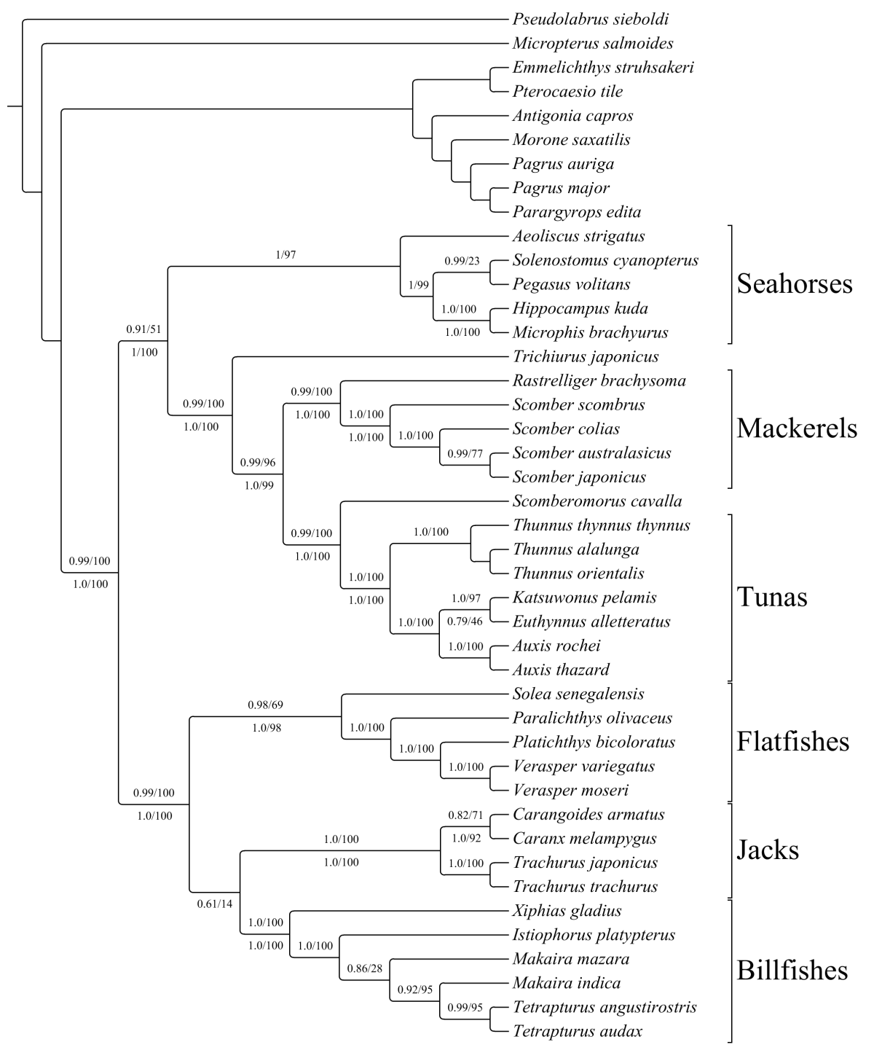

Figure S2 Summary of selection on all mitochondrial genes. Filled circles represent positively selected sites (p < 0.001) by TreeSAAP analysis. The dataset was analyzed for significance for the 31 physicochemical properties using a sliding window with size of 20 amino acid sites. The y-axis represents the number of properties for which that site was determined to be subject to positive natural selection.

ND6
ND4
ND3
COX2
ATP6
ND2
ATP8
CYTB
ND5
ND4L
COX3
ND1
COX1
Table S1 Species list with mitochondrial genome accession number from NCBI.

Species | NCBI Accession
Aeoliscus_strigatus | NC_010270
Antigonia_capros | NC_003191
Auxis_rochei | NC_005313
Auxis_thazard | NC_005318
Carangoides_armatus | NC_004405
Caranx_melampygus | NC_004406
Emmelichthys_struhsakeri | NC_004407
Euthynnus_alletteratus | NC_004530
Hippocampus_kuda | NC_010272
Istiophorus_platypterus | NC_012676
Katsuwonus_pelamis | NC_005316
Makaira_indica | NC_012675
Makaira_mazara | NC_012680
Microphis_brachyurus | NC_010273
Micropterus_salmoides | NC_014686
Morone_saxatilis | NC_014353
Pagrus_auriga | NC_005146
Pagrus_major | NC_003196
Paralichthys_olivaceus | NC_002386
Parargyrops_edita | NC_008616
Pegasus_volitans | NC_010271
Platichthys_bicoloratus | NC_003176.1
Pseudolabrus_sieboldi | NC_009067
Pterocaesio_tile | NC_004408
Rastrelliger_brachysoma | NC_013485
Scomber_australasicus | NC_013725
Scomber_colias | NC_013724
Scomber_japonicus | NC_013723
Scomber_scombrus | NC_006398
Scomberomorus_cavalla | NC_008109
Solea_senegalensis | NC_008327
Solenostomus_cyanopterus | NC_010267
Tetrapturus_angustirostris | NC_012679
Tetrapturus_audax | NC_012678
Thunnus_alalunga | NC_005317
Thunnus_orientalis | NC_008455
Thunnus_thynnus_thynnus | NC_004901
Trachurus_japonicus | NC_002813
Trachurus_trachurus | NC_006818
Trichiurus_japonicus | NC_011719
Verasper_moseri | NC_008461
Verasper_variegatus | NC_007939
Xiphias_gladius | NC_012677
Table S2 PCR primers used for nuclear markers used in this study.

Locus | Primer names | Primers (5’~3’)
rag1 | rag1f1 | GAGCTTCTCCCHGGHTTTCA
rag1 | rag1r1 | AAGTGRAAGCGGAAGGAGCG
rag1 | rag1f2 | ATGAAAGAGAGCAGGCTYATC
rag1 | rag1r2 | AGGGCTGCCCTCCAGCTGCG
rag1 | rag1f3 | TCTSAAAACATGGTGCTDCA
rag1 | rag1r3 | CCATCTYTCTCKATGATTTC
rag2 | rag2f1 | TTCCAGAGAGYTAYCTCATC
rag2 | rag2r1 | AGCAARGGRCTGCCCTGCAG
rag2 | rag2f2 | GGACAGTCYTTCCATBTGGC
rag2 | rag2r2 | GGCARCATTTGATCCARTAGCC
tmo-4c4 | tmo4c4f1 | AAGAARAGAGTGTTTGAAAATG
tmo-4c4 | tmo4c4r1 | ACAGCWCCCTCCTCRTAAAT
tmo-4c4 | tmo4c4r2 | ATRATCATRCTCTTRTTGTC
zic1 | zic1f1 | ATGCTCTTGGACGCAGGACCGCA
zic1 | zic1r1 | CCACAGCGGGGAACGGACA
zic1 | zic1f2 | CATCACTCAACAGGCGAAG
zic1 | zic1r2 | TTGGCTTTGAACGGYTTYCCTTC
myh6 | myh6f1 | ATGCYTAYCARTACATGCTGAC
myh6 | myh6r1 | GGTTRATYCTVACCACCATCCA
myh6 | myh6f2 | GAGAACCARTCBGTSCTCATCAC
myh6 | myh6r2 | CCAGTTGAACATYTTYTCRTA
btbd7 | btbd7f145 | CCAGTCGCTCAGCTGATCATGC
btbd7 | btbd7r1093 | ATGTGGTANAGCTCCATNGCCTC
Table S3 GenBank accession number of nuclear gene (rag1, rag2, tmo4c4, zic1, myh6, and btbd7) sequences of studied species.

 | rag1 | rag2 | tmo4c4 | zic1 | myh6 | btbd7
Abudefduf_vaigiensis |  |  | KP866724 | KP866740
Acanthocybium_solandri | KP866741
Aphanopus_carbo | KP866742 | KP866761 | KP866710
Auxis rochei | KP866743 | KP866762 | KP866703 |  | KP137552
Brama brama |  | KP866763 | KP866725 | KP866734 | KP137555
Carangoides_ferdau | KP866744 | KP866764
Caranx_ruber |  | KP866765 | KP866704
Centrolophus_sp. |  | KP866766 | KP866719 | KP866739 | KP137558 | KP121466
Centropomus undecimalis |  |  |  | KP866730 | KP137554
Centropomus_ensiferus |  |  | KP866709 | KP866731
Elassoma_evergladei |  | KP866767
Etheostoma_vitreum |  | KP866768 | KP866722
Euthynnus_affinis | KP866745 |  |  |  |  | KP121462
Gempylus_serpens | KP866746 | KP866769 | KP866712
Gomphosus_varius |  |  | KP866721
Gymnosarda_unicolor |  | KP866770 | KP866717
Icichthys_lockingtoni | KP866747 | KP866771 | KP866718 | KP866738 | KP137557 | KP121465
Katsuwonus_pelamis | KP866748
Lepidopus_altifrons | KP866749 | KP866772 | KP866713
Lycodes terraenovae |  | KP866773 | KP866708 |  | KP137553
Micropterus_salmoides |  | KP866774 |  | KP866737 |  | KP121464
Neoepinnula_americana | KP866750 |  | KP866711
Paralichthys_californicus | KP866751 |  |  | KP866729
Peprilus simillimus | KP866752 | KP866775 | KP866716 |  | KP137556
Perca_flavescens |  | KP866776 | KP866723
Platax_orbicularis |  |  | KP866720 |  | KP137559
Pterycombus_brama |  | KP866777 | KP866715 | KP866735
Ruvettus_pretiosus | KP866753 |  |  | KP866732
Schedophilus_medusophagus | KP866754 | KP866778
Scomber combrus |  |  |  | KP866726 |  | KP121459
Scomber japonicus | KP866755 | KP866779 | KP866702 | KP866727 | KP137551 | KP121460
Scomberomorus maculatus |  |  |  | KP866728 |  | KP121461
Sphyraena_argentea |  |  | KP866707
Sphyraena_barracuda | KP866756 |  |  |  |  | KP121463
Sphyraena_putnamae | KP866757 |  | KP866706
Taractichthys_longipinnis |  | KP866780 | KP866714 | KP866733
Tetrapturus_albidus | KP866758 | KP866781 | KP866705
Thunnus_albacares | KP866759
Trachurus_lathami |  | KP866782
Trichiurus_lepturus |  |  |  | KP866736
Xiphias_gladius | KP866760

Table S4 Number of amino acid sites showing positive selection signals in each mitochondrial gene on relevant branches. The top number for each branch represents the number of amino acids having Bayes empirical Bayes (BEB) posterior probability higher than 0.95 identified in PAML; the bottom number represents the number of amino acids having BEB posterior probability higher than 0.80 and lower than 0.95 identified in PAML. The last row lists the total number of amino acid sites identified as positively selected by TreeSAAP. See supplementary table S4 for additional details.

Branch | ND1 | ND2 | CO1 | CO2 | ATP8 | ATP6 | CO3 | ND3 | ND4L | ND4 | ND5 | ND6 | CYTB
b2 | 0 | 1 | 0 | 0 | 0 | 1 | 0 | 0 | 0 | 0 | 0 | 0 | 0
 | 0 | 0 | 0 | 0 | 0 | 0 | 0 | 0 | 0 | 0 | 0 | 0 | 1
b3 | 0 | 1 | 0 | 0 | 0 | 2 | 1 | 0 | 0 | 0 | 0 | 0 | 1
 | 0 | 0 | 0 | 0 | 0 | 0 | 0 | 0 | 0 | 0 | 0 | 0 | 0
b4 | 0 | 0 | 1 | 2 | 0 | 0 | 1 | 0 | 1 | 0 | 2 | 2 | 0
 | 0 | 0 | 0 | 0 | 0 | 0 | 0 | 0 | 0 | 0 | 0 | 1 | 0
b6 | 1 | 0 | 0 | 0 | 0 | 1 | 0 | 0 | 0 | 0 | 1 | 0 | 0
 | 0 | 0 | 0 | 0 | 0 | 0 | 0 | 0 | 0 | 0 | 0 | 1 | 0
b11 | 0 | 0 | 0 | 0 | 0 | 1 | 0 | 0 | 0 | 1 | 0 | 1 | 0
 | 0 | 0 | 0 | 0 | 0 | 0 | 0 | 1 | 1 | 0 | 2 | 0 | 0
b12 | 0 | 0 | 0 | 0 | 0 | 0 | 0 | 0 | 0 | 0 | 0 | 0 | 0
 | 0 | 0 | 0 | 0 | 0 | 1 | 0 | 0 | 0 | 0 | 0 | 0 | 0
b13 | 0 | 0 | 0 | 0 | 0 | 0 | 0 | 0 | 0 | 0 | 1 | 0 | 0
 | 0 | 2 | 0 | 0 | 0 | 1 | 1 | 1 | 0 | 1 | 1 | 0 | 3
b16 | 0 | 0 | 0 | 0 | 0 | 0 | 0 | 0 | 0 | 0 | 0 | 0 | 0
 | 0 | 1 | 0 | 0 | 0 | 0 | 0 | 0 | 0 | 1 | 1 | 0 | 0
b17 | 0 | 0 | 0 | 0 | 0 | 0 | 0 | 0 | 0 | 1 | 1 | 0 | 0
 | 1 | 0 | 0 | 0 | 0 | 0 | 0 | 0 | 0 | 0 | 0 | 0 | 0
b23 | 0 | 0 | 0 | 0 | 0 | 0 | 0 | 0 | 0 | 0 | 0 | 0 | 0
 | 0 | 0 | 0 | 0 | 0 | 0 | 0 | 0 | 0 | 0 | 0 | 0 | 0
b24 | 0 | 0 | 0 | 0 | 0 | 0 | 0 | 0 | 0 | 0 | 0 | 0 | 0
 | 0 | 0 | 0 | 0 | 0 | 0 | 0 | 0 | 0 | 0 | 0 | 0 | 0
b25 | 1  0 | 2  1 | 0  0 | 0  0 | 0  1 | 0  0 | 0  0 | 0  0 | 0  1 | 2  2 | 1  1 | 0  2 | 0  0
Total in  PAML (>0.95) | 2 | 4 | 1 | 2 | 0 | 5 | 2 | 0 | 1 | 4 | 6 | 3 | 1
Total in  PAML (<0.95 >0.8) | 1 | 4 | 0 | 0 | 1 | 2 | 1 | 2 | 2 | 4 | 5 | 4 | 4
Total in TreeSAAP | 183 | 77 | 25 | 32 | 26 | 44 | 24 | 20 | 11 | 82 | 152 | 46 | 42

Table S5 Positively selected amino acid sites for each gene on various branches. Each site lists the ordinal number of this site in the aligned sequence matrix, and the amino acid (based on the top sequence in the alignment). Symbols indicate bayes empirical bayes (BEB) probabilities as follows: ** >0.99, * 0.95 - 0.98, # 0.80 - 0.94, no symbol 0.5 - 0.79. If the site is also identified as having at least one property significant in TreeSAAP, the number of such properties is shown in square brackets. Sites of each gene in the same color indicate they occur on multiple branches.

 | ND1 | ND2 | COI | COII | ATP8 | ATP6 | COIII | ND3 | ND4L | ND4 | ND5 | ND6 | CYTB
b2 | 10 I | 419 L [9]  475 Q  602 L* [2] | 1074 T | 1343 V |  | 1596 N* [6] |  | 2007 S |  | 2306 I  2363 S  2404 V [3]  2423 I  2472 A  2525 I | 3172 I [3] |  | 3627 A#
b3 | 3 S  29 V [2]  159 I [3]  177 T  274 L | 371 N  595 T  652 I  654 S* | 847 P  1005 I  1185 Q |  | 1441 T [2]  1466 S [6] | 1520 G [7]  1524 M*[7]  1527 T  1529 Q  1531 L  1534 L  1536 L  1596 N* [6]  1652 F [10] | 1854 E*  1857 Q |  | 2111 G  2122 L | 2224 C [2]  2556 I [2] | 2643 S [2]  3078 P  3176 L | 3330 W  3346 A  3347 L [1]  3364 E [1]  3365 V  3415 L | 3475 S  3477 I [2]  3478 A  3479 T  3482 S  3500 M  3576 N [9]  3580 Q  3613 L [2]  3632 D  3652 G*[1]  3655 T  3680 L  3724 I  3739 T [1]  3761 V  3763 P  3784 T [5]
b4 | 181 I | 435 L [2]  517 V [3]  559 T [1]  563 A [1]  602 L [2]  641 L [4]  658 I | 849 I  851Q** [4]  854 T  1187 Q | 1205 V  1236 S  1237 T  1241 N  1243L**[3]  1333 V  1361 M  1372 T  1375 T  1376L**[8]  1416 L [4] |  | 1550 I | 1706 A  1750 L [3]  1760 I  1791 F  1870 F* [9]  1924 Y |  | 2100 T  2205 F | 2278 A [7]  2530 A  2611 I | 2656 I  2697 S [5]  3214 I [3]  3220 A [4]  3239 V**[14] | 3248 Y  3251 I  3253 L  3256 S**  3390 V | 3460 I[6]  3482 S  3627 A[2]
b6 | 7 T# [7]  259 E [9] |  |  | 1238 K  1244 L |  | 1483S* | 1746 I [6]  1922 I |  |  |  | 2635 H*[8] | 3249 V [1]
b11 |  |  |  |  |  | 1483S* |  | 2050 F# [2] | 2080 V# [9] | 2192 P* [3] | 2710 L# [3]  2722# I [11] | 3336 M*[3]
b12 |  |  | 891 T  1133 I [1] | 1239 L | 1433 L [1] | 1503 F [2] | 1740 I [1] |  | 2100 T | 2612 A [6] |  |  | 3421 S [8]
b13 | 9 I | 332# I [1]  601# M |  |  |  | 1483# S  1543 L [3] | 1740 I [1]  1746 I [6]  1750 L [3]  1754 Y [2] | 2054 S [3] |  | 2228 K#[11] | 2656 I  2661 S [2]  3070 S# [2]  3152 F* [9]  3240 L [1] |  | 3543 A [9]  3611 T# [3]  3714 S# [10]  3794 M [4]
b16 |  | 411 D# [2] |  |  | 1451 K |  |  |  |  | 2568 L# | 2690 F [8]  2846 M# |  | 3627 A [2]  3714 S [10]
b17 | 177 T# | 411 D [2]  470 P [2] | 935 A [4] | 1289 L |  |  |  | 1980 F |  | 2564 P* | 2915 L* [7]
b23 |  | 475 Q  633 I [6] |  |  | 1467 K [12] | 1544 M |  |  |  | 2473 A [2] | 2657 I [1]  2910 P [5]  3208 T [0]
b24 |  | 398 S |  |  |  | 1500 W |  | 2042 L | 2124 T  2167 Q | 2318 N | 2702 T [7]  2717 S [6]  3214 I [3] |  | 3464 L  3609 A
b25 | 158 A* [7] | 417 T [2]  585 G* [6]  592 S* [10]  600 N# [2]  656 M [11]  670 T [1] |  |  | 1440 A# [7]  1459 V [2] | 1663 L |  |  | 2168 A# [6] | 2217 W**  2305 L  2364 T#  2572 L* [2]  2633 F# [10] | 2654 T# [6]  2823 S [16]  3148 S* [2]  3153 T [1]  3161 L [13] | 3291 F# [2]  3330 W  3347 L [1]  3370 L [9]  3411 E# [19] | 3543 A [9]

