UNIVERSITY OF OKLAHOMA
GRADUATE COLLEGE

QUANTIFYING COSTS AND BENEFITS OF SUSTAINABLE PROJECTS

IN THE CITY OF OKLAHOMA CITY

A DISSERTATION
SUBMITTED TO THE GRADUATE FACULTY
in partial fulfillment of the requirements for the
Degree of
DOCTOR OF PHILOSOPHY

By
  - RACHEL MOSIER
Norman, Oklahoma
2013

QUANTIFYING COSTS AND BENEFITS OF SUSTAINABLE PROJECTS

IN THE CITY OF OKLAHOMA CITY

A DISSERTATION APPROVED FOR THE
DEPARTMENT OF ENGINEERING

BY

Dr. Christopher Ramseyer, Chair

Dr. Douglas Gransberg, Co-Chair

Ms. Tamera McCuen

Dr. Musharraf Zaman

Dr. Jeffrey Volz

© Copyright by RACHEL MOSIER 2013
All Rights Reserved.

DEDICATION

To my husband, James, who has held my hand through many of my difficult times and choices. He has allowed me to complete two degrees and become a professional engineer spending many late nights studying. And to our daughter, Tyann, who joined our family halfway through my dissertation and found out what college life would have in store for her.
To my supportive family, my sister Becky, my niece Ana, my parents Daryl, Dixie, Joe, and Liz, for putting up with my incessant studying and writing.
I especially want to note all of the academic achievements of my family and friends. My husband, sister and niece are all currently advancing their education. My parents have advanced degrees. My friends and mentors, Carisa and Gina, are faculty. It is in this atmosphere that I was not only able, but strongly encouraged to continue on in the pursuit of knowledge.
To my friends and coworkers who have also supported me during difficult times. To everyone who kept realigning my direction back to why I began this process.

ACKNOWLEDGEMENTS

Dr. Douglas Gransberg is my biggest cheerleader, a constant positive motivator, the reason I started my doctorate and the reason I have finished it. I admire his enthusiasm in mentoring students across country and finding time to do it while keeping a difficult schedule.
Dr. Christopher Ramseyer agreed to take on the challenge of co-chair. Accepting the role of co-chair allowed me to continue my program and added to my knowledge and to the depth of my dissertation.
Dr. Musharraf Zaman provided thoughtful insight to my work. I appreciate the interdisciplinary degree he created for students like myself to follow our hearts into research that may not be mainstream but has value.
Ms. Tamera McCuen has been an excellent role model. My career path changed because of her Facilities Acquisition Planning class.
Dr. Jeffrey Volz is greatly appreciated for taking on a doctoral student who needed a little help at the end.
I acknowledge the contribution of the panel members: Dr. Douglas Gransberg and Dr. Christopher Ramseyer, who have co-chaired my committee. Dr. Musharraf Zaman, Tamera McCuen, and Dr. Jeffrey Volz, who have participated and provided valuable input. I also want to acknowledge Karen Horne, College of Engineering, for all of the times that she helped me. My trip was that much shorter thanks to her.
I acknowledge my co-authors on published papers that have been produced from this research, Dr. Douglas Gransberg and Dr. Dominique Pittenger.

TABLE OF CONTENTS

LIST OF TABLES vii
LIST OF FIGURES viii
1.0 INTRODUCTION 1
1.1 Background 1
1.2 Research Objective 2
1.3 Research Question 4
1.4 Research Motivation 7
1.5 Location of the Research 8
1.6 Organization of the Thesis 10
2.0 LITERATURE REVIEW 11
2.1 Sustainable Construction Historical Context 12
2.2 Sustainable Design Implications on Project Delivery Methods 16
2.3 Project Delivery Methods 17
2.4 Project Responsibilities and Their Impact on Cost 20
3.0 RESEARCH METHODOLOGY 24
3.1 Research Instruments 24
3.1.1 Content Analysis Protocol 24
3.1.2 Case Study Protocol 27
3.1.3 Qualitative Comparative Analysis 29
3.1.4 Research Approach 31
3.2 Research Outline 31
3.3 Building Construction Costs 33
3.4 Life Cycle Benefits and Budgets 37
3.5 Cost Metrics 38
3.6 Decision Theory 39
3.7 Cost Basis 43
4.0 CRITCAL REVIEW OF CURRENT SUSTAINABILITY RATING
SYSTEMS 45
4.1 A Review of Rating Systems 45
4.2 LEED Rating System 47
4.3 Sustainable Sites Initiative 50
4.4 Greenroads Rating System 55
4.5 GreenLITES (Leadership in Transportation and
Environmental Sustainability) Rating System 57
4.6 INVEST 1.0 Sustainability Tool 59
4.7 Review and Comparison of Rating Systems 60
4.8 Benchmark Credit Review 63
4.9 Carbon Footprint Goal Analysis 80
5.0 ANALYSIS 82
5.1 Sustainable Streets and Connectivity 82
5.2 Case Studies 85
5.3 Cost Metric Airport Paving Case Study 86
5.4 Cost Metric COKC Paving Case Study 98
5.5 Cost Metric COKC Building Case Study 110
5.6 Integrating the Case Studies 115
6.0 CONCLUSIONS 116
6.1 Conclusions 116
6.2 Limitations of the Research 118
6.3 Recommended Research 119
6.4 Contributions 120
7.0 REFERENCES 123
8.0 BIBLIOGRAPHY 130
APPENDIX 1: LIST OF EQUATIONS 132
APPENDIX 2: LIST OF CARBON FOOTPRINT CONVERSIONS 133
APPENDIX 3: DATA 135
APPENDIX 4: DATA 146
APPENDIX 5: DATA 149
APPENDIX 6: DATA 153
APPENDIX 7: DATA 156
APPENDIX 8: LEED RATING SYSTEM CREDITS 180
APPENDIX 9: Sustainable Sites Initiative Rating System 182
APPENDIX 10: Greenroads Rating System Credits 185
APPENDIX 11: GreenLITES Rating System Credits 187
APPENDIX 12: INVEST Rating System Credits 195
APPENDIX 13: Framework of Credits with Cost per Square Foot 197

LIST OF TABLES
Table 3.1 Sustainable Goals Compared to Project Type 26
Table 3.2 Example of a Decision Matrix 41
Table 3.3 Example of an Analytical Hierarchical Process 42
Table 3.4 Example of Priority Values 43
Table 3.5 COKC Bid Item Average Costs 44
Table 4.1 Abbreviated LEED Rating System Credits (USGBC 2005) 50
Table 4.2 Abbreviated Sustainable Sites Initiative Rating System Credits 54
Table 4.3 Abbreviated Greenroads Rating System Credits 57
Table 4.4 Abbreviated GreenLITES Rating System Credits (NYSDOT 2010) 59
Table 4.5 Abbreviated INVEST Rating System Credits 60
Table 4.6 Rating System Review 61
Table 4.7.1 Rating System Credit Comparison 64
Table 4.8 Carbon Footprint Goals 81
Table 5.1 Airport Sustainable Pavement Practices 89
Table 5.2 Airport Pavement Preservation Types, Carbon Footprint and
Life Extension 90
Table 5.3 Airport Pavement Bid Items and Carbon Footprint 92
Table 5.4 Airport Preservation Costs with Index Adjustment 93
Table 5.5 Airport Pavement Preservation Bid Items and Carbon Footprint 94
Table 5.6 Airport Pavement Bid Items and Carbon Footprint 96
Table 5.7 Pavement Preservation Types, Carbon Footprint and Life
Extension 102
Table 5.8 Pavement Bid Items 104
Table 5.9 Sustainable Treatment Costs 105
Table 5.10 Sustainable Treatment Net Present Value 106
Table 5.11 Paving Case Study Analytical Hierarchical Process 107
Table 5.12 Paving Case Study Priority Values 107
Table 5.13 Paving Case Study Analytical Hierarchical Process 110

LIST OF FIGURES
Figure 1.1 COKC Project Types (COKC 2011b) 5
Figure 1.2 COKC Infrastructure (COKC 2011b) 7
Figure 1.3 Extents of Oklahoma City (COKC 2011b) 9
Figure 2.1 Sustainability Calls for a New Paradigm 16
Figure 2.2 The Three Pillars of Sustainable Development (SD) 17
Figure 2.3 Project Delivery Methods – Contracts and Communications 18
Figure 2.4 Categorization of LEED credits as “major,” “moderate,” and
“some” impacts 22
Figure 3.1 Sustainable Goals Compared to Project Type 27
Figure 3.2 Research Steps 32
Figure 4.1 Common Rating System Credits 63
Figure 5.1 Street Project Improvement Methodology 84
Figure 5.2 Airport Pavement Preservation Framework 97
Figure 5.3 Decision Tool 103
Figure 5.4 Pavement Preservation Framework 109
Figure 5.5 Framework for Sustainable Buildings 113

ABSTRACT

Advocates of sustainable design and construction have asserted for years that sustainability can be designed and built without additional expense, however this premise has not been proven. For public projects, potential accrued savings does not offset budget shortfalls. Design and construction capital costs must be estimated and obtained in an amount sufficient to deliver the entire project, as the funding is often determined years in advance of the project and cannot be changed due to future savings.

Metrics for determining sustainability and the associated costs is provided. A review of the known sustainability benchmarks was performed. For comparison of benchmarks to costs, the percent of sustainability goals that have a cost component have been identified. For each of the five benchmarks approximately half of the credits affect the construction cost.

The research performs both qualitative and quantitative analyses. A Qualitative Comparative Analysis is performed for the case studies. A database was created from the case study projects. Initial costs are used to provide values for sustainable goals.

Quantitative analyses included Net Present Value (NPV), Decision Theory, Analytical Hierarchical Process, Cost Basis and Life Cycle Cost Analysis. Net present value is used to determine pavement preservation type. A carbon footprint cost index illustrates the cost and provides a tangible metric for sustainability. Carbon footprints have been calculated where needed. Frameworks are established as a tool to quantify the cost of sustainability integration in municipal streetscape projects. Decision making tools are provided that allow owners to adjust scope and sustainability while remaining in budget.

Using a cost index for comparison will provide the owner with an easily identifiable difference in the NPV and carbon footprints. This information aids the decision to add sustainable pavement preservation into projects. Since pavement preservation can provide additional life, the additional costs need to be weighed against the benefits. The required features of work are segregated from the proposed preservation options. This allows owners to identify costs of sustainable options to justify additional funding.

INTRODUCTION
Although advocates of sustainable design and construction have asserted for years that sustainability can be designed and built into a building project without additional expense, this premise has not been proven. Rather the basis of the assertion is the potential accrued savings due to reduced life cycle costs (Lapinski et al. 2006). For public projects, potential accrued savings due to reduced life cycle costs must be proven in advance of project funding. Design and construction capital costs must be estimated and obtained in an amount sufficient to deliver the entire project, as the funding is often determined years in advance of the project and cannot be changed due to future savings. Offsetting life cycle savings may furnish justification but it does not reduce the amount of funding necessary to deliver a green building. This Chapter will provide background information about research methods for determining project costs and rating systems that provide a metric to determine additional costs.

Background
Given the above limitations, public agencies must have an ability to compare options for sustainability. Life cycle cost analysis (LCCA) and net present value provide owners assistance in comparing sustainable options. LCCA is one method and is defined as the “sum of one-time and recurring costs over the full life span” of the built project (FHWA 1998). Evaluation methods like Net Present Value (NPV) for determining costs, provides a value at a base year and can be utilized for comparison of projects started in multiple years (Sinha and Labi 2007). This allows owners to compare costs for one year when the life of a more sustainable option may be different from the original construction method. Utilizing an Analytical Hierarchical Process (AHP) can guide the decision as well by allowing the user to add preferences to data (Saaty 1987). With an AHP, the user can apply a preference to cost over carbon or vice versa. This allows the agency to choose which data quantify the preferences that exist through existing policy.

In addition to being able to evaluate the costs, the owner must be able to justify the changes. One way to justify the changes is to determine if an option can reduce the initial cost and/or the long-term cost. A metric that could also be used is to determine the different carbon footprints of the options. Combining sustainability criteria with cost provides an objective method for comparing sustainability options. In addition, a framework would facilitate the owner in pre-project planning by providing an illustration for duplicating these processes. The framework acts as the structure for the cost database, and the sustainability criteria with its ranking or preference.

Research Objective
The objective of this study is to develop a framework for evaluating urban municipality projects on a basis of sustainability in Oklahoma City. The research includes an in-depth analysis of the following five current sustainability metrics:
- Leadership in Energy and Environmental Design (LEED) (USGBC 2005)
- Sustainable Sites Initiative (SITES) (SITES 2009a),
- Greenroads (Muench et al, 2010),
- Green Leadership In Transportation Environmental Sustainability, termed “GreenLITES” (NYSDOT 2010),
- Federal Highway Administration’s (FHWA) INVEST 1.0 (Bevan et al. 2012)
These five metrics are limited to buildings, landscapes and highways and the research seeks to create a framework that can bring the three major elements together and guide sustainable planning, design and construction for urban streetscapes. For purposes of this research, the term “streetscape” is defined as the entirety of the technical features of work that connect the highway with the buildings in an urban area.

The proposed framework will utilize input from all five metrics, focusing on credits that are specific to municipal projects that interact with buildings, infrastructure, pedestrian pathways, and landscaping. The research will review the roadway projects from the owner’s perspective and propose a decision framework to make design choices that would encourage a more sustainable municipal project design and construction, specifically in the area of roadway projects. Areas of research include; pavement design, life cycle cost analysis of roadway projects, minimizing street light electricity usage, pedestrian and access prescribed by the American with Disabilities Act (ADA), landscaping and investing in concept that reduce in long-term maintenance. All of the items incorporated into the framework impact construction capital costs. The framework will also evaluate the construction costs as a basis for integration of sustainability into future projects.

Research Question
Advocates of sustainable design and construction assert sustainability can be designed and built into a building project without additional expense (Lapinski et al. 2006). They base the assertion on the potential accrued savings due to life cycle cost reductions in utility bills and maintenance. Although this argument may apply in the private sector where the focus is on return on investment (Coelho and Vilares 2010), public sector owners must estimate the capital costs of design and construction and obtain bond funding in an amount sufficient to deliver the entire project. Offsetting life cycle savings may furnish justification for implementing sustainable design but they do not reduce the initial amount of funding necessary to deliver a green project.

A rational methodology for evaluating the additional costs of sustainable design and construction is required and is presented as a decision-making framework based on actual projects with their cost and sustainability issues. Municipalities often work with state departments of transportation (DOTs), but larger municipalities fund their own public works projects. Since these municipal projects tend to be at a different scale than a typical DOT project, the same metric may not provide sufficient justification for sustainable design choices. A framework is needed to focus on issues occurring on municipal street projects, similar to the design standard Seattle has created in their Right-of-Way Improvements Manual (Seattle 2005). The proposed framework encompasses the street right-of-way, sidewalks, intersections, medians, infrastructure and betterments that may enhance the quality of life like lighting, benches and trash receptacles. These types of projects are found at Lake Overholser Park in COKC and pictured in Figure 1.1.

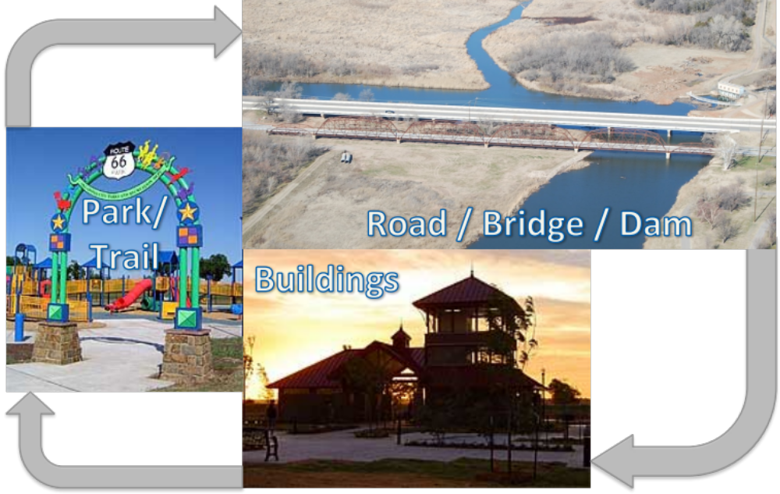
Figure 1.1 COKC Project Types (COKC 2011b)

An extension of the framework would be to provide connectivity between buildings, parks and streets. Therefore this research seeks to answer the following question:
Can a framework be established as a tool to quantify both the level of sustainability and the construction cost of integrating sustainability in municipal streetscape projects?
The research will seek to answer this question through a comparative analysis of existing projects in the City of Oklahoma City (COKC), including beautification projects, full depth pavement replacement, road widening and micro-resurfacing, and trail projects were also incorporated for cost data. The specific item of interest is the impact of sustainable design on capital design/construction budget as compared with a typical project.

A traditional definition of a streetscape is the “landscapes consisting of road paving, street furniture, vegetation and roadside buildings” (Fukahori and
Kubota 2002). Streetscape projects are illustrated in Figure 1.2. The streetscape should more accurately be described as all of those municipal infrastructure projects between buildings and highway transportation projects. Both buildings and highways have sustainable metrics, which include those identified in this research. The cost of adding sustainability to public buildings has been previously identified (Mosier and Gransberg 2013). The cost of pavements and their associated carbon footprint has been identified for

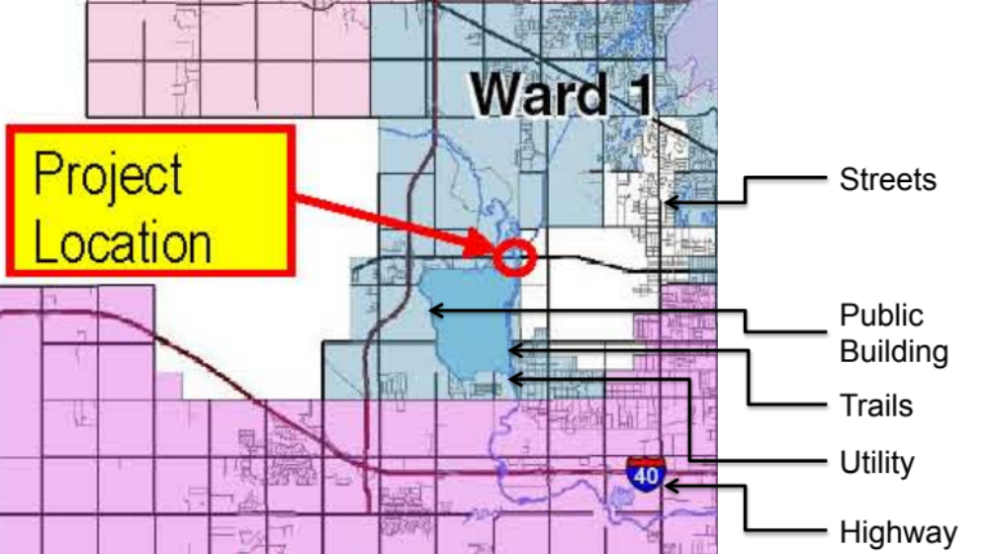
Figure 1.2 COKC Infrastructure (COKC 2011b)

highways (Chehovits and Galehouse 2010). This research provides the cost of sustainability for the streetscape, which is the infrastructure that connects the buildings and highways.

Research Motivation
In 2009, COKC established an Office of Sustainability, and began work on sustainable construction projects at approximately the same time. COKC has two projects in construction with the goal of attaining Leadership in Energy and Environmental Design (LEED) certification, a third party program for sustainable design in building construction (USGBC 2008). Although the sustainable benefit is appreciated by COKC, it is just as important to define the “green premium” (Molenaar et al. 2009) that must be paid for green projects.

Existing research lacks meaningful information on the cost of sustainability in both vertical and horizontal construction types. Owners require an objective method to permit the comparison on of sustainable design and construction alternatives. There is a need to furnish municipalities with same tools to make connection between sustainable highways and green buildings. This connection is the municipal funded streetscape or the infrastructure of the City. Sustainability costs, potential savings and sustainable features justify the cost of utilizing sustainable infrastructure techniques. Similarly sustainability costs, potential savings and sustainable features must justify the additional cost for sustainable options in vertical construction types.

Location of the Research
Oklahoma City is the most populated city in the Oklahoma with a population of approximately 540,000 based on 2006 estimates (U.S. Census 2009). At 621.2 square miles, Oklahoma City is in the top five largest cities in the country in terms of geographic area. Due to the physical size of the city, the amount of streets is 14,000 lane miles (OKC 2011a). The City provides maintenance for these streets through property and sales tax revenues.

There are various types of road projects within COKC including; streetscapes (beautification projects), full depth pavement replacement, road widening and micro-resurfacing. All types of street projects discussed will include data available through the COKC website There are over 150 parks, 3 lakes and 76 miles of trails (COKC 2011). Parks are located in all geographical locations of the city. Highlighted areas in Figure 1.3 indicate areas that include parks.
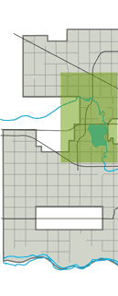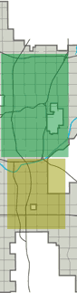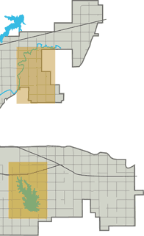
Figure 1.3 Extents of Oklahoma City (COKC 2011b)

Besides roads, parks and trails, the vertical construction includes buildings of all types for typical municipal entities, such as libraries, fire stations, police buildings, fairgrounds arenas and maintenance barns. COKC has started two projects seeking LEED certification, a library and a fire station. To date, the fire station has received LEED Silver Certification.

Organization of the Thesis
Chapter 1 provides the context for the dissertation. Chapter 2 is the output from the comprehensive literature review and provides the background information for the reader to understand both the methodology and the output of the research. Chapter 3 details the research methodology and the plan for validation. Chapter 4 contains the the output from the analysis and synthesis of current sustainability rating programs and feeds its output into the Chapter 5 presentation of a proposed framework to measure the sustainability of urban streetscapes. Finally Chapter 6 presents the consists of overall conclusions, recommendations for future research and the research’s contributions to the field.

LITERATURE REVIEW
Environmental concerns are not new. In Timaeus by Plato; “There have been, and will be again, many destructions of mankind arising out of many causes; the greatest have been brought about by the agencies of fire and water, and other lesser ones by innumerable other causes” (1888). Although Plato was not calling for change, he recognized that the earth was reacting to farming and urban areas changing the landscape. From Plato’s time, about 400 B.C. to now, there have been other crises of the environment. At the beginning of the 20th century, after the industrial revolution, Theodore Roosevelt recognized the changes in his lifetime and said,

…the time has come to inquire seriously what will happen when our forests are gone, when the coal, the iron, the oil, and the gas are exhausted, when the soils have still further impoverished and washed into the streams, polluting the rivers, denuding the fields and obstructing navigation.

During his lifetime, Roosevelt saw the end of the wild herds of bison, other big game species, and the loss of habitats for songbirds and other small mammals. As President, Roosevelt created the National Park system as a way of preserving nature for future generations (Sullivan 2006).

Sustainable Construction Historical Context
“The Tragedy of the Commons” (Hardin 1968) discusses the theory that when many share a particular thing, there is no ownership or accountability. This can be seen especially in municipalities, when litter is deposited on the side of the road or in any shared space where resources are not refilled for the next user. Government is often responsible for these common spaces. In his article, Garrett Hardin states,

Picture a pasture open to all. It is to be expected that each herdsman will try to keep as many cattle as possible on the commons. Such an arrangement may work reasonably satisfactorily for centuries because tribal wars, poaching, and disease keep the numbers of both man and beast well below the carrying capacity of the land (Hardin 1968).

The point of the “The Tragedy of the Commons” is that humankind is now seeing this tragedy on a global scale. The current tragedy is no longer a local pasture shared by townsfolk. To compare the pasture to more current issues includes the responsibility for cleaning highway litter, the responsibility for ice melt of the glaciers, the ownership of the oil below the oceans, and the number of animals allowed to become extinct without affecting the overall system. The level of the tribal wars can be seen on a much greater scale, as now these are international events with one country entering another for oil, diamonds or other commodities of value.

In the 1970’s the United States witnessed its’ first major energy crisis. Teddy Roosevelt had already noted the overuse or misuse of our resources not only in the loss of animal species, but that the fossil fuels had the same limits. Once resources are gone, the resources cannot be replaced. During the energy crisis of the 1970’s, the results of overuse became apparent. Not only were there long lines at the gas stations, citizens started paying more for resources that had previously been inexpensive in the U.S. The effects of the energy crisis of the 1970’s were varied, but can be attributed to the beginning of an environmental movement. People were looking to save money on energy costs, but also were looking for a way to eliminate waste and reduce dependence on fossil fuels.

During the Clinton presidency (1992-2000), the federal government began “greening” many buildings and parks. The greening of the federal buildings included the White House, the Pentagon, the U.S. Department of Energy Headquarters, as well as building at the Grand Canyon, and Yellowstone National Park (BDC 2003). Because of the events following Hurricane Katrina, the use of formaldehyde in homes became headline news (Brunker 2006). Trailers used to house victims of Hurricane Katrina had concentrations of formaldehyde at levels that can lead to unwanted health side effects (EPA 2008). Prior to the hurricane, the effects of formaldehyde may not have been known; the public has now been exposed to the effects of its use in an enclosed space. This product is used in a variety of building materials including plywood and composite wood, which is often used in cabinetry (Brunker 2006). The public awareness of environmental issues over time like Hurricane Katrina’s Federal Emergency Management Agency (FEMA) trailers provide the opportunity for dialog and to learn more about the interaction between humans and their environment.

The need for reducing our impact on the environment and reusing materials is not a new theme. As early as Plato, mankind could see their effect on their surroundings. Since this is really a shared issue, as illustrated by “The Tragedy of the Commons”, in some ways the nation must look to the government for direction. As early as last century in the United States, the government saw changes were necessary in order to preserve natural areas. As recently as the beginning of 2009, the government set aside three marine areas to be national monuments (Harris 2009). The government’s role as a leader in the environment is evident.

In the 1970’s the environmental movement acted in response to higher energy prices. However as many of the ideas were outside the mainstream and energy prices fell, the change was not incorporated into the construction industry or society as a whole. During the 1990’s, systematic rating systems of sustainability began to arise to assist owners in measuring sustainability (BDC 2003). In 2008 energy prices again rose (U.S. Energy Information Administration 2009). Although this increase in energy prices was not considered a crisis, it did serve as a reminder that energy can be a large amount of an individual’s disposable income. A new view on sustainability revolves around saving money as much as saving the non-renewable resources.

The Environmental Protection Agency (EPA) has produced a “Green Building Toolkit” in conjunction with the Department of Transportation (DOT) and U.S. Department of Housing and Urban Development (HUD) (EPA 2010a). The focus of the toolkit is to help local governments “in identifying and removing barriers to sustainable design and green building…” (EPA 2010a). The EPA assessment tool identifies sustainability goals as its focus. The toolkit uses a red light/green light approach to determining when local code is actually in opposition to sustainable methods. Currently goals like stormwater quantity and quality are codified and required (Oklahoma City Municipal Code 2007) providing a “green light,” because all projects must include these goals. Therefore meeting these sustainability goals adds no additional cost to a project, although it has a cost. Conversely items like reducing heat island effect, which is not a code requirement (Oklahoma City Municipal Code 2007) would be a “red light” and add cost to complete this sustainability goal.

Sustainable Design Implications on Project Delivery Methods
It has been suggested that sustainable design could cause a paradigm shift in construction to look beyond the traditional construction triangle of time, cost and quality and instead the design intent will be toward human satisfaction, minimal environmental impact and minimal consumption (Augenbroe 1998), as shown in Figure 2.1. A change in paradigm would not only require change from the construction industry, but also a change in the public perception.

This paradigm shift affects all participants in the project. Looking at the paradigm shift is from the owner’s point of view yields the “Three Pillars of Sustainable Development, shown in the Figure 2.2 (BSC 2006). This triangle describes incorporating lean design principles into sustainable design decisions. To achieve sustainable design within social and ecological objectives demands a consistent system to compare sustainable design

Time
Cost
Quality
Human Satisfaction
Minimal Consumption
Minimal Environmental Impact

Figure 2.1 Sustainability Calls for a New Paradigm
(after Augenbroe 1998)
alternatives, which found in systems, like LEED that describe and rate sustainable design requirements.

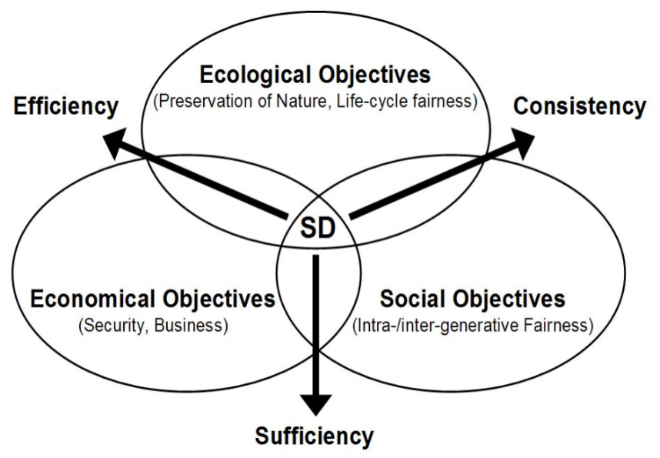
Figure 2.2 The Three Pillars of Sustainable Development (SD)
(BSC 2006)

Project Delivery Methods
There are three basic project delivery methods; design-bid-build (DBB), design-build (DB) and construction manager at risk (CMR). These project delivery methods are shown in Figure 2.3.
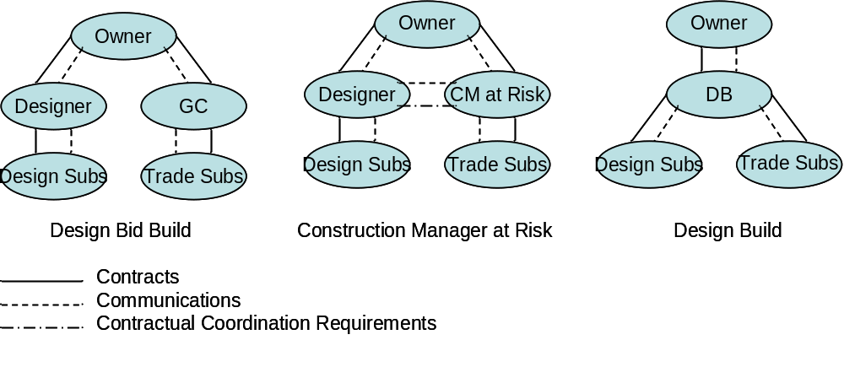
Figure 2.3 Project Delivery Methods – Contracts and Communications
(Molenaar et al. 2009)

DBB is the basis for the cost databases attached in the appendices. The owner has a separate contract with both the designer and builder. Research as found that DBB project delivery often evolves into an adversarial relationship between the designer and builder (Konchar and Sanvido 1998), With no economic incentive to willingly cooperate to achieve project sustainability objectives can destroy the potential to enhance overall project sustainability in the post-award construction process. Molenaar et al. (2009) defined a point in the contract process where a green guarantee is implied. This “green guarantee is defined as the contractual responsibility to deliver a building that will receive the owner’s designated level of LEED certification” (Molenaar et al. 2009). This is applicable for all project delivery methods, not just DBB.

Molenaar et al. (2009) investigated the state of the practice for project delivery methods in sustainable buildings. Their research sought to determine if there was a relationship between project delivery method and ability to achieve the owner’s sustainable design objectives. The study found a connection between the point at which the “green guarantee” is established and the point when the project’s construction contract cost is fixed. . In Molenaar’s research CMR to be the most effective delivery method as 92% of the projects in the study achieved or exceeded the owner’s initial level of sustainability as rated by LEED certification. The study attributed the correlation to the fact that in CMR the project’s final construction cost is not fixed until after the construction contractor is allowed to collaboratively make substantive input to the sustainable design during preconstruction (Molenaar et al. 2009). In other words, both the designer and the owner are allowed to learn the cost of sustainable design decisions and literally negotiate the level of sustainability in conjunction with the construction costs.

In DBB, the design is complete before the construction contract is advertised. Thus, it is the designer’s to ensure that the sustainable design features can be built without exceeding the available funding. Issuing public revenue bonds is not a speedy process (Oklahoma Constitution 1988), because the indebtedness must be approved through an election. Thus, a public owner whose projects are bond-funded must know the cost of the green premium to avoid delays due to the need to secure additional funding if the designer’s estimate does not accurately account for the costs associated with enhancing a building’s sustainability.

Project Responsibilities and Their Impact on Cost
Another way to review sustainable project checklists is to determine where the responsibility for implementation lies, whether it is the owner, designer or contractor who will incorporate the sustainability goals. In DBB projects, the contractor does not participate in choosing the credits needed to achieve the owner’s desired level of certification. Credits the owner and consultant can perform may be preferred to ensure a goal is implemented. However, many of the goals are construction based and will require the contractor to perform. For pollution prevention the contractor is tasked. This item includes an erosion control plan, which is already required by some localities including the City of Oklahoma City. In this case, there would be no appreciable increase in cost as the permitting authority mandates the requirement for the credit. Water efficient landscaping may task the contractor with using landscape materials with which they are not familiar. A substitution is often required from traditional turf lawns to regional planting materials that will not require irrigation. Although these items can be associated with additional cost from the contractor, they are a shared task with the consultant.

Through the specifications the contractor will be tasked to provide non-traditional demolition methods or to purchase used product. In product reuse, the contractor may be unwilling to warranty the product or will increase the cost to cover the risk. For Recycled Content, Regional Materials, Rapidly Renewable Materials and Certified Wood, the consultant specifies the items, but the contractor must still find and install the products. In areas where Certified Wood is not typically used, this may cause an increase in cost.

Low-Emitting Materials is another area where the contractor is tasked with finding and installing non-traditional products. Little information is available on the actual costs of LEED certification. Although some research has provided a percentage cost increases, very few have tried to find a price per credit (Tatari and Kucukvar 2011). There is some limited research in the cost per credit, including EarlyEco software (Haxton and Beckstead 2008). Syal et al. (2007) have highlighted the tasks that they determined would impact the contractor. This information is illustrated in Figure 2.4.

Ramkrishnan et al. (2007) also identifies contractor impacts from sustainability. The innovation and design credit is a project specific task and may impose additional requirements for the owner, consultants and contractor. For example, a credit is available for having a LEED accredited professional on the project team. Unless the owner already has an employee with the credential,
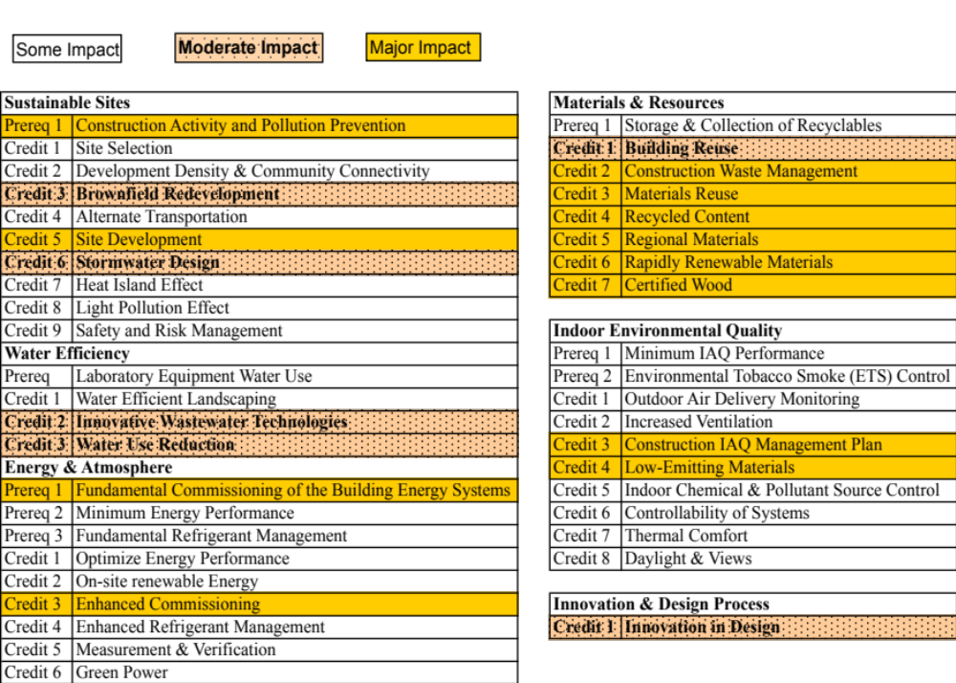
Figure 2.4 Categorization of LEED credits
(Adapted from Syal et al. 2007)
there will be an additional cost associated with achieving this credit.

This research focuses entirely on DBB projects; the COKC only authorized project delivery method. COKC maintains records of current unit price bids for all types of projects. The bids are provided online as public record. To date COKC has not constructed projects under other benchmarks like Greenroads or SITES. Although some research has been performed on the ability to construct projects to the higher ratings under LEED (Molenaar et al. 2009), no such research exists for the other benchmarks.

RESEARCH METHODOLOGY
This section provides the general research methodology for the research effort. This research is the synthesis of three independent sources of information:
- Comprehensive literature review
- COKC project cost information
- COKC building codes and design criteria

Research Instruments
This research employed the following research instruments:
- Content analysis of existing sustainability metrics
- Case study analyses of COKC horizontal and vertical projects
- Qualitative comparative analysis

Content Analysis Protocol
This research relied on formal content analysis to develop a base from which quantitative measurements of five existing sustainability rating systems and metrics. The result was a set of common credits that could be applied to the framework for quantifying the costs and benefits of sustainable street projects. This type of analysis can be used to develop “valid inferences from a message, written or visual, using a set of procedures” (Neuendorf 2002). The primary approach is to develop a set of standard categories into which words that appear in the text of a written document, in this case a sustainability rating system, can be placed and then the method utilizes the frequency of their appearance as a means to infer the content of the document (Weber 1985). Thus, in this study, the content analysis consisted of two stages. The first task was to classify the rating systems into one of three categories based on the feature of work each was developed to measure. The rating systems were classified into the following categories:
- Green building project
- Green road project
- Green site project

Each system’s credits were further coded as one of the following types as described in Chapter 2.
1. Hard cost credits
2. Soft cost credits and
3. Non-cost credits.
The result was a matrix, which provided the researcher the ability to differentiate between those credits that were most common to more than one project type and those credits that were solely applicable to a single project type. Table 3.1 is the output from the content analysis.

One can see that the goals overlap between the three project types that COKC regularly constructs. At the core of the three project types is an opportunity to be more sustainable. As illustrated in Figure 3.1, COKC had three projects at
Table 3.1 Sustainable Goals Compared to Project Type
Sustainable Goal | Road | Building | Site
Brownfield / Reduce Hazardous Materials | Yes | Yes | Yes
Bicycle | Yes | Yes | Yes
Pedestrian | Yes | No | Yes
Fuel Efficient | Yes | Yes | Yes
Transit / HOV | Yes | Yes | Yes
Wetlands | Yes | Yes | Yes
Stormwater | Yes | Yes | Yes
Soil Management | Yes | Yes | Yes
Soil Balance | Yes | Yes | Yes
Vegetation Management | Yes | Yes | Yes
Turf Management | Yes | Yes | Yes
Tree Management / Wood Waste | Yes | Yes | Yes
Wildlife | Yes | Yes | Yes
Potable Water Reduction | Yes | Yes | Yes
Pavements | Yes | Yes | Yes
Heat Island | Yes | Yes | Yes
HVAC / Refrigerants | No | Yes | No
Waste / Recycling Plan | Yes | Yes | Yes
Reuse of Architectural Materials | No | Yes | Yes
Reuse of Civil Materials | Yes | Yes | Yes
Specifying Used Materials | Yes | Yes | Yes
Specifying Recycled Pavement | Yes | Yes | Yes
Regional Material | Yes | Yes | Yes
Sustainable Procurement Practices | Yes | Yes | Yes
Indoor Air Quality / Minimize Pollutants | Yes | Yes | Yes
Lighting Efficiency | Yes | Yes | Yes
Sustainable Construction Practices | Yes | Yes | Yes
Reduce Noise | Yes | Yes | Yes
Intelligent Traffic System | Yes | No | No
Context Sensitive Solutions | Yes | Yes | Yes

this lakeside park, a roadway (bridge), building and a trail (park). One appropriate sustainability goal could be soil balance. Soils could be shared through these closely related projects. This ability for a municipality to integrate projects provides a unique opportunity for sustainability.
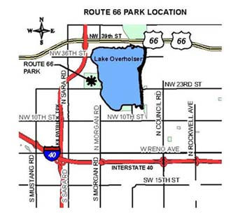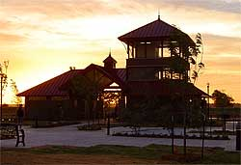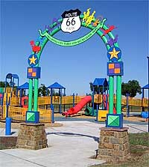

Trails
Building
Roadway

Figure 3.1 Sustainable Goals Compared to Project Type

Case Study Protocol
The primary objective of the case study research is to supplement the knowledge framework created through the literature reviews and content analysis with a series of in-depth case studies. The choice of projects to further investigate as in-depth case studies was determined through the literature review and the records of available COKC building, street, and landscape projects, as well as discussions with the COKC public works personnel. In-depth case studies serve as a critical source of information in this research. The analysis is conducted on the following three levels:
- Analysis of green projects of different sizes, different types, and different levels of success as identified in the agency records.
- Interviews of COKC personnel, contractors, and consultants with green project management experience.
- Published reports of green case study projects from the highway, airport, and building sectors.

The case studies were collected using Yin’s methodology (Yin, 2004). The use of these instruments in conjunction with the comprehensive review of the literature allows the researcher to not only maintain a high level of technical rigor in the research but also follow Yin’s three principles in the process of research data collection:
- Use of multiple sources,
- Creation of a database, and
- Maintaining a chain of evidence (Yin, 2004).

Therefore, the information gleaned from the case studies is coupled with information collected in the rating system content analysis and the literature review to validate any conclusion drawn from the case studies. Additionally, the body of data that is already available to the research from COKC permitted the research to leverage the existing data and personal contacts.

At all levels of analysis, the case studies will identify both challenges to implementing green design and construction principles as well as the strategies that were used to meet these challenges in each case. The case studies incorporated in level 1 analysis were essentially completed during the literature review and rating system content analysis tasks. Summaries of existing published reports of green building, road, and site cases (level three analysis) were incorporated with appropriate referencing and citation of the original report. The majority of the work is the preparation of original case studies at analysis level 2. Inclusion of cases from level 1 and level 3 analyses also takes into consideration project attributes, agency function, and geographic locale to ensure a comprehensive and representative collection of case studies.

Qualitative Comparative Analysis
Qualitative comparative analysis (QCA) is an analytical technique that satisfies the need for an analytical comparative case study protocol that permits researchers to generalize findings across a relatively limited number of cases in a rigorous manner. First used in studies of comparative politics and historical sociology, it been applied extensively in management, economics, engineering and construction (Jordan et al. 2011). QCA was selected for this work specifically due to the limited amount of green projects that were available from the COKC. The benefits of QCA “are particularly relevant in the project-based construction field when researchers are investigating the pathways leading to a given outcome… [because], the magnitude and expense of large construction projects often limits the sample size available for study” (Jordan et al. 2011). Green construction projects involve complex relationships among the variables of interest. For example, sustainable design criteria, such as mandated recycled content of construction materials, cause a change in the estimated costs of those materials. On the other hand, the in-place recycling of existing pavement might in fact reduce the overall costs while enhancing project sustainability. Since COKC is a relative newcomer to sustainable design and construction, the available datasets are small and thus difficult to investigate using conventional quantitative methods.

QCA was also selected because it permits a direct cross-case comparison between each of the three project types as well as the three types of sustainability credits. This flexibility permitted the researcher to literally treat the five rating systems in the same manner as a menu of options, selecting those credits that appeared to be best suited to measure the sustainability of the full range of COKC projects. Additionally, QCA provides a conduit through which relative costs and benefits for similar credits in different project types can be assessed to determine which system best reflects the COKC project environment. For instance, LEED, SITES, GreenRoads, GreenLITES and INVEST all provide credit for storm water retention and reuse. Since LEED applies to vertical projects, the object of storm water reuse is centered on usage in the building. Greenroads’s credit is aimed at reducing turbidity due to erosion and SITES looks to utilize storm water to reduce the required amount of irrigation. For a street rehabilitation project in COKC, recycling storm water for building usage does not apply, but the aims of the credit in the other two systems do. Using QCA, one can determine the most appropriate option of the remaining two for use in the final framework. QCA protocol would also permit the analyst to combine the salient factors of the two and define a new, stricter credit for achieving enhanced project sustainability.

Research Approach
Research objectives were met through completion of tasks described in this section. Life Cycle Cost Analysis methodology was demonstrated using data from recent field trials of pavement preservation treatments (Pittenger at al. 2012), case study projects (Bescher et al. 2012) and cost data collected from numerous COKC projects. Results are reported in subsequent chapters. The final deliverable is a Decision Making Framework developed specifically for streetscape sustainability evaluation. Figure 3.2 illustrates this approach and is followed by a detailed discussion of the associated research tasks.

Research Outline
To begin the research, a database of construction costs was gathered including buildings, trails, street beautification projects, full depth pavement replacement, road widening and micro-resurfacing paving projects. Cost metrics for lump sum and unit price type contracts were established. Five rating systems were reviewed as benchmarks for sustainability. The benchmark rating systems
Phase 1 Evaluate Current Decision Making Processes
Task 1 - Evaluate Costs from Streetscape Projects | Task 2 - Creation of a Database | Task 3 - Critical Review of Current Sustainability Rating Systems
Research Methods |  | Key Outcomes
Literature Review |  | Use Determination
Document Content Analysis |  | Method Selection
Phase 2 Strategies, Methods & Framework Development
Task 4 - Find Credits for Sustainable Streetscapes | Task 5 - Compare Case Study Costs per Credit | Task 6 - Calculate Carbon Footprint
Research Methods |  | Key Outcomes
Analysis |  | Framework
 |  | Cost Data
Phase 3 Application and Verification
Task 7 - Calculate NPV for Construction Activities | Task 8 - Find Cost Metric for Green Premium | Task 9 - Validate Framework with Case Studies
Research Methods |  | Key Outcomes
Case Study |  | Decision Making
Output Analyses |  | Framework

Figure 3.2 Research Steps

include; LEED (USGBC 2005), SITES (SITES 2009a), Greenroads, (Muench et al, 2010), GreenLITES (NYSDOT 2010), and the INVEST 1.0 (Bevan et al. 2012) in detail. Cost indexes were created to match the cost database with sustainability benchmarks.

Building Construction Costs
From a cost standpoint, the cost of sustainable construction concepts must be compared to traditional construction. There are claims LEED certification has been achieved at no additional cost including the Gold Certified Toyota Plant (Lapinski et al. 2006). As previously discussed, LEED is only one possible scale of the sustainability of a building. As sustainable building construction gains acceptance contractors will have little choice in transforming traditional construction methods to include sustainable practices. Currently, the choice for sustainable design remains owner and consultant driven (Syal et al. 2007). Bringing the contractor on board early by using a design-build or construction manager-at-risk project delivery method allows the contractor to provide feedback on which credits would be the least amount of increase in cost to the owner. However, in a design-bid-build project, the contractor is the last member joining the project team.

Design decisions are made early in the process and determine which sustainable design practices will be utilized. During the design process, decisions for sustainability may include reuse and recycling materials. These decisions directly affect cost and the construction schedule. From a construction cost estimation standpoint, the cost of the individual items that are sustainable must be identified in order to maintain a profit. The contractor is then left to determine the costs associated with local recycling, construction IAQ management plans and other necessary credits (Syal et al. 2007). The contractor may also be required to provide documentation of recycling and a construction IAQ management plan.

From an owner’s standpoint, there are the additional costs of the architectural and engineering services for providing a LEED Accredited Professional and other required documentation for certification. In public projects, all of these additional costs become public record and part of the dialog about how the government is spending the public’s monies. Although these costs vary, for LEED projects they can be “in the range of $30,000-$60,000” (Howard and Watson 2002). Currently the U.S. Green Building Council (USGBC) is trying to reduce these costs for users (Howard and Watson 2002), by streamlining the processes including adding online registration and certification (Starzee 2009).

From the contactor’s standpoint, there are some credits where the contractor is able to have more of an effect on the cost of sustainability. As indicated in Tables 6-10, items marked “yes” have an effect on construction cost. These are items where the contractor can provide added value or can seek to make additional profit. These items from the INVEST criteria include; Construction Environmental Training, Equipment Emission Reduction, Noise Mitigation, Quality Control Plan, and Quality Control Plan (Bevan et al. 2012).

Within the project cost, a comparison of the cost of individual credits for sustainable construction is important. There are credits with little or no cost. An example of a no cost credit is one already required by a local building code, like storm water quality. Silt fence and rock dams reduce run-off into streams limiting infiltration of silt into streams and meets this requirement. The cost is already incorporated into a typical construction budget. Some of the low cost credits do not provide an obvious environmental benefit, for example LEED allows one credit for installing a bicycle rack as a means to encourage commuters to cycle to the building. However, the presence of that appurtenance does not guarantee commuting habits will change. In this case the benefit derived from the added cost is difficult, if not impossible, to quantify and may be regarded as a “feel-good” nature or social value (Nalewaik and Venters 2009). Having a metric to evaluate the additional cost per square foot or per mile will be beneficial for budgeting future projects. The focus of a publicly funded project has to be the appropriated funds, but return on the capital expenditures for the additional incremental costs due to sustainability needs to be realized.

Some studies have evaluated the added costs of LEED buildings in the public sector to determine if sustainability is affordable and justifiable to the taxpayers (Xenergy 2000). This study reviewed existing buildings to determine how much additional cost during design would have been required to achieve LEED certification. Combining this sort of design cost analysis with life cycle cost analysis and environmental life cycle assessment (Augenbroe 1998) will be required to prove that real benefits can be accrued by the additional cost of sustainable design features, including those costs associated with obtaining programmatic certification. Public buildings not only count on the tax revenues for construction financing, but also for the operation and maintenance funding. The voting public may see a time when they want to know why the government is not pursuing designs to reduce long term costs, like energy. Efficient energy design is one of the operation and maintenance cost savings that can be quantified in a sustainable design program (Augenbroe 1998). The Federal Government is on the forefront of providing energy efficient buildings and has produced design guides like the Field Guide for Sustainable Construction (Horman et al. 2004).

One of the issues with publicly funded projects is correlating the capital budget and the operating budget. A cost savings over the lifetime of a building cannot be subtracted from the initial capital cost because one has to purchase and install the more efficient systems before they can begin reducing operational utility bills. This is especially true in projects with specific voter authorized dollar amount. Once the voting public has authorized the stipulated amount, then no matter what the long term operating cost savings are, the initial budget cannot increase to furnish the upfront capital to purchase and install the technology that will generate the savings. The benefits of sustainable design can be found in pursuing many of the LEED credits. Some benefits are harder to quantify solely on the basis of initial cost. For a public entity to consider including sustainability goals, the additional benefit must be identified. If the life cycle truly provides a savings, the public entity may be able to justify additional initial first costs. This process may include changing the scope to include sustainability while limiting project scope as the budget cannot increase. Life cycle benefits are discussed in the Life Cycle Benefits and Budgets section.

Life Cycle Benefits and Budgets
There is more than one-way to determine the whole life cost of a product or in this case a construction project. One report used the “life cycle costing (LCC) approach to evaluate and integrate the benefits and costs associated with sustainable buildings” (Kats et al. 2003). A construction project’s life cycle cost analysis should be based on the expected service life of the building. For public buildings this may be over thirty years (General Accounting Office 2003). For longer life spans in buildings, material choices should be more durable. Concrete as a floor finish is considered a more durable option, with life spans of twenty years (AASHTO 1993) and is used in many aspects of the construction; including slabs and foundations. In mechanical rooms and storage areas aesthetic floor finishes may not be required and a cost reduction cab be achieved by not installing a floor finish over the concrete slab. A sealed concrete slab requires no more maintenance than other floor finishes, so the maintenance costs are no more than other flooring types.

Alternatively for roadway projects, Asphalt roads are considered to have a ten-year life span (Pittenger et al. 2012) and concrete roads are considered to have a twenty-year life span (AASHTO 1993). Bridges are considered to have a fifty-year life span (FHWA 2011). Pavement maintenance however is based on equipment available to the agency. The maintenance costs are based on the type of equipment owned or having to contract out the service. For an agency that owns asphalt equipment, asphalt may be considered simpler to maintain.

Life cycle benefit analyses can be influenced by user biases. As previously stated, when the owner has no concrete pavement maintenance equipment there is an inherent bias toward continuing to place asphalt pavement because no new equipment is required. Because life cycle benefits do not affect initial project cost, these benefits cannot change construction budgets that have been established by public vote. As part of future building programs, the public has to be educated not only as to why the upfront costs have changed, but why making the upfront investment to achieve the long-term savings is in the public’s best interest.

Cost Metrics
There are several types of cost metrics, specifically a cost index. “Cost indices are common in all types of construction. Fundamentally, they are used to transform a known cost at one locale or time reference to an estimated cost at the required locale or time reference” (Diekmann 1983). Cost indexing will be used to compare case study projects to determine a reference for future projects. Cost indices can also be used to transform a non-monetary item like a carbon footprint into a cost. Identifying a cost and associating it to the carbon footprint value creates a cost index for sustainability.

This relationship is used a part of a decision making tool to determine which goals should be implemented. Once a goal has been identified, the cost for the traditional bid item is identified. The additional cost for the rehabilitation is also identified. The Net Present Value (NPV) is evaluated on life expectancies for the identified bid item or as part of constructed system. The NPV is evaluated using the following equation:

NPV = initial cost + rehab cost*[1/(1+i)^{n}] Equation 1
(Pittenger et al. 2012)

The NPV is only part of the cost index. A comparison or ratio is provided for the index. This cost index is simply the ratio of NPV to Carbon Footprint. In the Analysis chapter, the cost metric case study illustrates how a cost or NPV and a carbon footprint can be related in additional detail.

Decision Theory
In considering the requirements of a decision-making framework, investigation into decision theory and statistics has been performed. Finding an average cost for any individual product or credit is straightforward. However the average cost alone is not enough information for a decision. It is anticipated that there are multiple options to incorporate sustainable goals into any project requirement. Asphalt pavement preservation allows for warm mix asphalt, hot mix overlay, micro-surfacing, slurry seal and many more options. Due to all of the options, decision theory maintains a low probability that any one item will be required on all projects (Chernoff and Moses 1959). However, the unit price for all of these options is required for a database. Utilizing a decision-making framework, the best alternative is chosen and only that cost is included in the project.

Adding to the cost database are additional factors for sustainability goals. For some projects using a methodology to determine if the sustainability goals have an actual project cost or benefit is helpful. Some benchmarks like LEED (USGBC 2005) require items that may have no direct benefit to the project. Identifying these sustainability goals and evaluating them based on their quantifiable return on investments is one objective method. Another metric, the carbon footprint is added to the decision-making framework. A cost index for the carbon footprint is tabulated.

A decision matrix is used to illustrate the options in using sustainable design. The decision matrix really illustrates the “state of nature” or “laws of randomness” (Chernoff and Moses 1959). There is an assumption that by using a decision matrix that a “rational choice” will be made (Shaffer 2009). In public works construction policy, the rationality of the final decision may not be easy to understand. One project decision may be strongly influenced by the neighborhood in which the project is being built, whereas financial issues may drive other project decisions. Table 3.2 illustrates a typical example of this decision matrix.

Table 3.2 Example of a Decision Matrix
Act | State
 | Neighborhood | Finance
Sustainable | Interest | Interest
Traditional | No Interest | Interest
Non-Traditional / Non-Sustainable | No Interest | No Interest

The matrix illustrated in Table 3.2 the interest state of the neighborhood in sustainability. Evaluating the project from the standpoint of the neighborhood leads one to anticipate a preference for sustainable construction methods. From a financial standpoint, the project interest changes. Another state could be added to include maintenance, which has interested a different set of sustainability issues. Time of completion is another state that could be considered.

For project is early completion concerns, sustainability goals must be evaluated against the time constraints. For LEED (USGBC 2005), the contractor must separate waste as a minimum requirement. If this requirement will add to much time to the project, then LEED (USGBC 2005) may not be attainable. However other sustainable goals could be met without seeking certifications. This is also true for the LEED Construction IAQ Management Plan. The building flush –out required is based on square footage and can take weeks of time prior to occupancy (USGBC 2005). For a user trying to utilize the completed project, this credit may be too time-consuming to achieve.

Using an Analytical Hierarchical Process (AHP) shown in Table 3, the alternatives are defined and then the values are prioritized. For the example shown in Table 3.3, performance and cost are a higher priority than sustainability. Performance and cost are set to be equal, since higher performance products can cost more. Likewise, lower cost items may reduce the performance.

Table 3.3 Example of an Analytical Hierarchical Process
 | Cost | Sustainability | Performance
Cost | 2/2 | 2/4 | 1/2
Sustainability | 4/2 | 4/4 | 1/4
Performance | 2/1 | 4/1 | 1/1

Assuming the performance reduces cost through net present value, priorities can be set. Performance is 4, cost is 2 and sustainability is 1, with importance doubling the priority. Based on the matrix shown, priority values are calculated by squaring the matrix and computing the eigenvectors.

The eigenvectors have been computed and are shown in Table 3.4. Using these priority values with alternatives of performance, cost and sustainability a
Table 3.4 Example of Priority Values
Cost | 0.34
Sustainability | 0.24
Performance | 0.42

preference for performance is shown. This method can be used to discriminate between two products and provide a tool, which does not make cost the only factor.

This research evaluates the cost of sustainability of the project based on benchmarks of the five rating systems. Further a presentation of the costs per credit, mile and/or carbon footprint are presented for budgeting purposes. If a sustainable construction practice is at no additional cost to COKC it can be automatically incorporated into all future projects. This research will assist municipalities in determining when a low cost reduced carbon footprint is worth the additional expenditure.

Cost Basis
A group of twenty-four projects for which hard bids were received between 2007 and 2010 are included as the basis for costs of completing street projects for COKC. The average costs for all of the items used for all twenty-four projects are included in Appendix 3. Table 3.5 shows a representative sample of pavement items and their average costs based on units bid by COKC.

Table 3.5 COKC Bid Item Average Costs
Item description | Units | Average cost
Cold milling asphalt pavement (1 ¾” | sy | $1.04
Bituminous surface course | ton | $76.30
Bituminous surface course (3") | sy | $72.99
Portland cement concrete pavement (8") | sy | $47.94
Portland cement concrete pavement (10") (dowel jointed) | sy | $38.55
Structural portland cement concrete | cy | $451.79
Reinforcing steel | lb | $1.12
6" p.c. concrete drive | sy | $55.73

Using the Engineering News-Record (ENR) Cost Index (Grogan 2011), the bid items were indexed to March 2011 from the actual bid month and year. The conversion factor varies from 0.992 for June 2011 to 1.16 for June 2006. Costs for goals must be converted to the same month and year for comparison.

CRITCAL REVIEW OF CURRENT SUSTAINABILITY RATING SYSTEMS
LEED is a third party certification program for sustainable design in building construction (USGBC 2008). Other vertical construction sustainable design rating systems in the United States include Green Globes (GBI 2008) and international options include Building Research Establishment Environmental Assessment Method (BREEAM) in the United Kingdom and Green Star in Australia and New Zealand (Sustain 2008). LEED was developed as an alternative rating system to American Society of Testing and Materials (ASTM) (BDC 2003).

A Review of Rating Systems
There are a number of rating systems with unique individual focuses and implementation methods. There is some controversy about the effectiveness of the different rating systems (Sustain 2008). Each approach also has different costs for participation. For example, “…LEED gives slightly more importance to the occupant’s health and comfort, while BREEAM UK and Bespoke Checklists would tend to be more focused around environmental impacts.“ (Sustain 2008) As sustainable design becomes an integrated part of the construction industry, other rating systems may become part of a standard building code or a specific public owner’s requirements.

There are a variety of benchmarks for heavy civil construction as well. These include Greenroads (Muench et al, 2010), GreenLITES (NYSDOT 2010), and the INVEST 1.0 (Bevan et al. 2012). Heavy civil projects are not limited to transportation projects. The airport industry has not come to consensus on a standard for sustainability although some airports have tried to compile a standard. Chicago Department of Aviation published the Sustainable Airport Manual (SAM). The SAM focuses on planning, design & construction, operations and maintenance as well as concessions or tenants (CDA 2011).

A detailed review of five metrics including LEED (USGBC 2005), SITES (SITES 2009a), Greenroads, (Muench et al, 2010), GreenLITES (NYSDOT 2010), and the INVEST 1.0 (Bevan et al. 2012) follows. The credits are identified and compared to construction cost. Construction code requirements and construction standards are not considered to affect cost. Items required by the plans and specifications that do not affect construction activity; like purchase of materials with traditional installation methods are not considered to affect construction cost. Credits that affect project cost like the purchase of property are not considered a construction cost. Items that change the project scope like park access are not considered as construction costs, as these choices happen early in the design process. Custom credits change by project and so are not considered.

LEED Rating System
The LEED checklist is broken into 6 categories:
- Sustainable Sites,
- Water Efficiency,
- Energy and Atmosphere,
- Materials & and Resources,
- Indoor Environmental Quality, and
- Innovation & Design.
With the exception of Innovation and Design, each section has specific requirements in order to achieve credits for products and methods (USGBC 2005). These requirements include prerequisites and provide the scale for the rating system.

Under LEED, the Sustainable Sites category gives credits for site selection, brownfield redevelopment, development density and community connectivity, and site development (USGBC 2005). Sustainable Site credits require the owner to consider sustainability as a part of the initial real estate procurement process. For a public building, this connection is essential for public access. Although finding a site near public transportation is preferable, in cities with an existing bus or light rail network this credit can be achieved incidentally.

Water Efficiency provides credits for water efficient landscaping, innovative wastewater technologies, and water use reduction (USGBC 2005). Water efficient landscaping promotes the elimination of the use of irrigation. Water use reduction can provide a life cycle cost savings, especially in areas where there are already water shortages. These credits can be accrued incidentally if the building has virtually no landscaping and includes low-flow fixtures.

The Energy and Atmosphere section includes three prerequisites including; fundamental building commissioning, minimum energy performance, and fundamental refrigerant management. Optional credits include; enhanced refrigerant management, optimize energy performance, on-site renewable energy, enhanced commissioning, enhanced refrigerant management, measurement & verification, and green power. If the prerequisites are not code required, this may add cost to the project. However minimum energy management and fundamental refrigerant management are required in COKC (Oklahoma City Municipal Code 2007).

The Materials and Resources category includes; storage and collection of recyclables, building reuse, construction waste management, materials reuse, recycled content, regional materials, rapidly renewable materials and certified wood. The incidental costs of these credits can be seen during varying stages of the project life. Construction waste management tasks the contractor with recycling materials during construction. Storage and collection of recyclables requires the project to include space to hold recyclables and a recycling program post-occupancy. These costs will reflect the level of recycling currently in the community.

Indoor Environmental Quality, IEQ, has a minimum performance prerequisite and also requires Environmental Tobacco Smoke, ETS, control as a prerequisite (USGBC 2005). Optional checklist items for IEQ include outdoor air delivery monitoring, increased ventilation, construction IAQ (Indoor Air Quality) management plan, low-emitting materials, indoor chemical and pollutant source control, controllability of systems, thermal comfort, and daylight and views (USGBC 2005). Daylight and views may add no cost to a building that includes a large amount of glazing for aesthetics. Controllability of systems may not affect the incremental cost to the building when it is a standard requirement for energy savings.

Innovation and Design Process items include credits for innovation in design and LEED accredited professional (USGBC 2005). Many design firms offer the LEED accredited professional as a part of their services. This cost is passed on directly to the owner and is not typically tied to the construction portion of the project. For agencies with a LEED accredited professional (USGBC 2005), this credit would be available at no cost.

The credits are illustrated in Appendix 8. Those LEED credits adding construction cost are also identified in Appendix 8. Table 4.1 illustrates a limited number of the credits and their associated costs.

Table 4.1 Abbreviated LEED Rating System Credits (USGBC 2005)
SS | Sustainable Sites | Cost
4.1 | Alternative transportation—Public transportation access | No
WE | Water Efficiency
1 | Water Efficient Landscaping | No
EA | Energy and Atmosphere
PR2 | Minimum Energy Performance | Yes
PR3 | Fundamental Refrigerant Management | No
MR | Materials & Resources
PR1 | Storage and Collection of Recyclables | No
2 | Construction waste Management | Yes
IEQ | Indoor Environmental Quality
6.1 | Controllability of systems—Lighting | Yes
8.1 | Daylight and views—Daylight | No
8.2 | Daylight and views—views | No
ID | Innovation in Design
2 | LEED Accredited Professional | No

Sustainable Sites Initiative
The Sustainable Sites Initiative (SITES) includes a set of overarching guiding principles, which partially includes; do no harm, design with nature and culture, use a systems-thinking approach and foster environmental stewardship (SITES 2009a). These guiding principles establish the basis for their benchmarks. The benchmarks are grouped into the nine sections listed below (SITES 2009a).

There are prerequisites for each section. Site selection prerequisites include protecting wetlands and floodplains, limited green-field or farmland development and preservation of endangered species. Credits for site selection include brownfield and grey-field sites, siting in existing communities and in areas that encourage alternate modes of transportation (SITES 2009a). The incidental costs associated with acquiring green-field sites versus brownfield and grey-field sites may be offset by the costs associated with remediating the brownfield and grey-field sites. Limiting the acquisition of green-field sites by siting in existing communities may include existing building demolition costs.

Site Design-Water includes a prerequisite for reducing irrigation. Credits include protecting, rehabilitating and restoring wetlands and shorelines and managing storm water. With the focus on water, protecting and preserving on site water resources and quality, and maintaining and utilizing site water for on-site amenities are also credits (SITES 2009a). Managing storm water is a construction requirement (Oklahoma City Municipal Code 2007) so there is no additional cost.

Site Design-Soil and Vegetation includes prerequisites for controlling known invasive plants on site, adding non-invasive plants and creating a soil management plan. Additionally credits include minimizing soil disturbance using native plants, preserving and restoring plant communities native to the ecoregion. Also included is a credit for reducing urban heat island effects (SITES 2009a). Heat island effects can be limited in multiple ways, including using light colored paving. Where concrete paving is a requirement, this would be at no additional cost.

Site Design-Materials Selection focuses on the materials used in the project. The only prerequisite is elimination of use of wood from threatened tree species. Credits include utilizing on-site structures, reusing salvaged materials, utilizing materials with recycled contents, using certified wood, regional materials and materials with reduced VOC emissions. Additional credits focus on sustainable practices in plant production and materials manufacturing (SITES 2009a). Materials with recycled contents are available so the incremental cost of this item may be quite small.

Site Design-Human Health and Well-Being has no prerequisites. Credits include equitable site use and development, sustainability education, preservation of cultural and historic places and reduction of light pollution. Other credits include providing opportunities for outdoor activity, quiet outdoor places, spaces for social interaction, and site accessibility and way-finding (SITES 2009a). These credits have little connection to the actual construction of the project. Reducing light pollution may require bollards instead of light poles or shrouds on light poles to keep the light from projecting outside of the project area. These items do have an incremental cost associated with them.

The Construction section includes prerequisites for control and retention of construction pollutants and restoring construction soil disturbances. Credits include restoring soils disturbed by previous development, diverting construction waste from disposal, reuse or recycling vegetation, rocks and soil. Lastly is a credit for minimizing generation of greenhouse gas emissions during construction (SITES 2009a). Retention of construction pollutants is required by code and is not considered an additional cost to the project (Oklahoma City Municipal Code 2007).

Operations and Maintenance prerequisites include a plan for sustainable site maintenance and to provide for storage and collection of recyclables. Credits include recycling organic matter; reduce outdoor energy consumption and renewable electrical sources. Other credits include minimizing exposure to tobacco smoke, greenhouse gases and emissions (SITES 2009a). Minimizing exposure to tobacco smoke includes a requirement to post signs, which adds cost to the project (SITES 2009a).

The last two section types are Pre-Design Assessment and Planning, and Monitoring and Innovation. These prerequisites and credits focus on the designer and include an assessment for site sustainability, integrated site development process and engaging users in the design. Other credits include monitoring the performance of the sustainable design and providing innovation in design (SITES 2009a). Incorporating pre-design services into a project can add cost; it is not generally considered part of the construction portion of the project.

Example credits determined to affect construction costs in the SITES rating system are identified in Table 4.2, and the examples of which credits add cost are listed above including the credit to minimize exposure to environmental tobacco smoke, which adds the cost of signage. When using the decision-making framework, knowing which credits add no cost allows the agency to add that credit first. Credits that add cost may not be chosen through the decision making process. Appendix 9 includes all of the SITES credits with their cost determination indicated.

Table 4.2 Abbreviated Sustainable Sites Initiative Rating System Credits
(SITES 2009a)
1 | Site Selection | Cost
1.7 | Sites to encourage alternate modes of transportation | No
3 | Site Design - Water
PR3.1 | Reduce potable water use for landscape irrigation by 50% | Yes
4 | Site Design - Soil & Vegetation
4.12 | Reduce urban heat island effects | Yes
5 | Site Design - Materials Selection
5.5 | Use recycled content materials | No
6 | Site Design - Human Health and Well-Being
6.9 | Reduce light pollution | No
7 | Construction
PR7.1 | Control/retain construction pollutants | No
8 | Operations & maintenance
8.6 | Minimize exposure to environmental tobacco smoke | Yes

Greenroads Rating System
Similar to other sustainable construction metrics, Greenroads is a certification program but the focus is paving infrastructure projects. There are seven sustainability components; Ecology, Economy, Equity, Extent, Expectations, Experience and Exposure that are incorporated into all of the credits as an overarching goal. These goals are expressed in two kinds of credits; Voluntary Categories (VC) credits in addition to the mandatory best practices called Project Requirements (PR), which are required credits. The voluntary credit categories are as follows; Pavement Technologies, Materials & Resources, Access & Equity, Construction Activities, and Environment & Water (Muench et al, 2010).

Project Requirements includes required credits focusing on planning the project. The planning credits include quality control, noise mitigation, waste management, pollution prevention and site maintenance. Additional required credits include the environmental review process, lifecycle cost analysis, lifecycle inventory, low-impact development, pavement management system and educational outreach. (Muench et al, 2010). Although project planning is a project cost, it is not considered a construction cost.

Environment and Water includes water credits like runoff flow control and quality, and storm water cost analysis. Additional credits include an environmental management system, site vegetation and ecological connectivity. Other credits include habitat restoration and light pollution (Muench et al, 2010). Access and Equity credits include pedestrian, bicycle, and transit and high occupancy vehicle access. Other credits include a safety audit, intelligent transportation systems, context sensitive solutions, and traffic emissions reduction. Also in this category are credits for cultural outreach and scenic views (Muench et al, 2010). Intelligent transportation systems have a cost, which is identified in the COKC Bid Item Average Costs table.

Construction activities credits include quality management system, environmental training and contractor warranty. Other credits include fossil fuel reduction, equipment emission reduction and paving emission reduction. Lastly are site recycling plan and water use tracking in this category (Muench et al, 2010). In the Materials and Resources category, credits include lifecycle assessment, pavement reuse, earthwork balance, recycled and regional materials and energy efficiency. The pavement technologies category includes pavement performance tracking, warm mix asphalt, and long-life, permeable, cool and quiet pavements. There is a custom credit category where additional credits can be achieved. Water use tracking requires additional administration, which will add cost. Credits that affect construction cost are identified in Table 4.3.

Table 4.3 Abbreviated Greenroads Rating System Credits
(Muench et al, 2010)
PR | Project Requirements
EW | Environment & Water
AE | Access & Equity
AE-2 | Intelligent Transportation Systems (ITS) | Cost
CA | Construction Activities
CA-7 | Water Use Tracking | Cost
MR | Materials & Resources
PT | Pavement Technologies

GreenLITES (Leadership in Transportation and Environmental Sustainability) Rating System
GreenLITES recognizes that although it is preceded by LEED, there was no similar highway standard published when they began creating a standard for New York State Department of Transportation (NYSDOT). The design philosophy includes the following six statements;
- “Protect and enhance the environment.
- Conserve energy and natural resources.
- Preserve or enhance the historic, scenic, and aesthetic project setting
characteristics.
- Encourage public involvement in the transportation planning process.
- Integrate smart growth and other sound land-use practices.
- Encourage new and innovative approaches to sustainable design.” (NYSDOT 2010)

The philosophies are incorporated into five certification categories, which are Sustainable Sites, Water Quality, Materials and Resources, Energy and Atmosphere, and Innovation/Unlisted. Each of these categories is broken into additional subcategories (NYSDOT 2010).

Sustainable Sites includes five subcategories, which are Alignment Selection, Context Sensitive Solutions, Land Use/Community Planning, Protect, Enhance, or Restore Wildlife Habitat, Protect, Plant, or Mitigate for Removal of Trees and Plant Communities. Water Quality has two subcategories; Stormwater management (volume and quality) and Reduce runoff and associated pollutants by treating stormwater runoff through Best Management Practices (BMP) (NYSDOT 2010). Context Sensitive Solutions is hard to define as a cost item, as it is based solely on location. However, there could be aesthetics added to the construction for the purpose of Context Sensitive Solutions. If the cost cannot be quantified then this should be considered a “feel-good” factor (Nalewaik and Venters 2009).

The Materials and Resources categories include the following five subcategories; Reuse of Materials, Recycled Content, Locally Provided Material, Bioengineering Techniques, and Hazardous Material Minimization. With a credit like the reuse of materials on paving projects the cost of hauling materials to be reused must be considered. This cost must be compared to the savings available for reusing materials. Additionally comparing the reuse and hauling to the carbon footprint of new materials should be performed.

Energy and Atmosphere has six subcategories which include; Improve Traffic Flow, Reduce Electrical Consumption, Reduce Petroleum Consumption, Improve Bicycle and Pedestrian Facilities, Noise Abatement, and Stray Light Reduction. The final category is Innovation/Unlisted, which provides credits for innovation in sustainability above and beyond what has been identified as a credit (NYSDOT 2010). An abbreviated list of the GreenLITES rating system credits are identified in Table 4.4.

Table 4.4 Abbreviated GreenLITES Rating System Credits (NYSDOT 2010)
S | Sustainable Sites
S-2: | Context Sensitive Solutions
W | Water Quality
MR | Materials and Resources
M-1e | Reuse of previous pavement as subbase | Cost
EA | Energy and Atmosphere
I/U | Innovation/Unlisted

The GreenLITES program includes the complete description of each credit, so the names have been edited for length and to present the basic requirements of each credit. GreenLITES rating system credits determined to affect construction costs are identified in Appendix 10.

INVEST 1.0 Sustainability Tool
The Federal Highways Administration (FHWA) developed Infrastructure Voluntary Evaluation Sustainability Tool (INVEST) as a collection of best practices in transportation. The INVEST tool looks at projects in three modules which include system planning, project development and Operations and Maintenance. FHWA proposed these modules for a life cycle approach to projects (Bevan et al. 2012). Credits including; Reduce and Reuse Materials, Contractor Warranty and Construction Waste Management will add cost to the project.

Although operations and maintenance are important to the owner, this module is not relevant to the construction cost. Likewise the system planning module is focused in pre-project planning and does not affect construction cost. All of the modules criteria is presented in Table 4.5 for completeness. INVEST rating system credits determined to affect construction costs are identified in Appendix 11.

Table 4.5 Abbreviated INVEST Rating System Credits
(Bevan et al. 2012)
 | System Planning
 | Project Development Criteria
PD‐19: | Reduce and Reuse Materials | Cost
PD‐24: | Contractor Warranty | Cost
PD‐29: | Construction Waste Management | Cost
 | Operations and Maintenance Criteria

Review and Comparison of Rating Systems
In reviewing and comparing the rating systems, it is apparent that there are overlaps. Many of the overlaps are due to LEED being the basis for other benchmarks. Site selection with a focus on brownfields receives credits from both LEED and SITES. It is this duplication of effort that will be highlighted as a strategy for future COKC construction projects. During previous LEED projects, COKC determined costs that are integral to any project built in its municipality. All projects are subject to storm water quality and quantity regulations. Therefore these credits are considered to be automatic for COKC projects and at no additional cost. Table 11 identifies the number of automatic credits in each of the benchmarks.

Table 11 also demonstrates the number of different credits per rating system. *Some rating systems offer additional points per credit type, this review deals with each credit as a singular point for simplicity. Costs are the increase or decrease in construction cost only. Based on Table 4.6, it is easy to see that of the rating systems reviewed almost half the credits have a cost associated with them.

Table 4.6 Rating System Review
Benchmark  Rating System | Total Credits* | Credits with Cost | % Cost Credits | Automatic COKC Credits | % Automatic
LEED | 58 | 33 | 57 | 3 | 5
SITES | 66 | 31 | 47 | 5 | 8
GreenRoads | 50 | 32 | 64 | 5 | 10
GreenLITES | 185 | 121 | 65 | 9 | 5
INVEST | 60 | 18 | 30** | 3 | 5

**Twenty-three percent of the INVEST credits are operations and maintenance and are not construction costs, which skews the data to appear that it has the least amount of cost credits. Similarly SITES has twelve percent operations and maintenance credits, which are not applicable to the construction portion. All five rating systems include pre-design, construction and maintenance requirements and make decisions during design for credits directly affect the contractor, including the materials and recycling credits. The rating systems should not be considered a design consideration benchmark only, but also a total project requirement.

Noise Mitigation Plan and Life Cycle Cost Analysis (LCCA) are currently required in COKC for federally funded road projects. These metrics encourage decision-making tools to look beyond the present values most economical design. Additionally COKC is utilizing LCCA to determine if asphalt or concrete is the better value for all full-depth replacement road projects. Intrinsic in the Greenroads certification is LCCA as this is required for certification.

There are often trade-offs in the design and installation that are determined with life cycle costs. In infrastructure trade-offs are seen in construction cycles where haul distances and labor can be as expensive as the actual materials. Looking even closer, haul distances equate to fuel costs. Construction equipment has not been regulated in the past but the Environmental Protection Agency (EPA) has more stringent regulations as of 2011.

Another trade-off for using these systems is the requirement to add items at a cost to the project like noise mitigation. Although the FHWA and some State DOTs have noise mitigation minimum requirements, municipalities are not required to provide noise mitigation. This item will be at an additional cost to COKC for most projects.

Benchmark Credit Review
All five rating systems have been reviewed to determine which credits apply across the board as shown in Figure 4.1. As Greenroads, GreenLITES, IINVEST and SITES are newer rating systems, they have turned to LEED as a benchmark. It is anticipated that in the future, SITES may be incorporated into the LEED rating system (SITES 2009b).

Greenroads
GreenLITES
INVEST
LEED
SITES
Credits applying to all metrics

Figure 4.1 Common Rating System Credits

A review of existing COKC projects to determine which credits could be incorporated is performed. Credits required to make projects more sustainable will be identified. Further, the construction costs have been identified as a potential for contractors to provide added value or take additional profit. By incorporating credits that will apply to multiple rating systems, COKC can start to link projects from the horizontal to vertical construction.

In Tables 4.7.1 through 4.7.29, the five benchmarks have been distilled into a single group of ideals. Since several items overlap exactly, those have been removed. The individual tables illustrate where groupings of criteria change focus. Using this as a basis, the benchmarks can be reduced further.

Table 4.7.1 includes the brownfield ideal. This includes certain hazardous materials, minimizing them and how to dispose of them properly. These hazardous wastes can be existing conditions as in a brownfield or are associated with the construction project.

Table 4.7.1 Rating System Credit Comparison
Brownfield / Reduce Hazardous Materials Ideal
Brownfield redevelopment
Substantially minimizes hazardous materials, or increases the interval, or improves durability of hazardous substances
Removing and disposing of contaminated soils beyond what is necessary for project construction

Certain themes became apparent for all of the benchmarks. One of these themes was bicycle use. Protecting bicyclists from traffic and encouraging the use of bicycles are both identified in bicycle ideal, which is illustrated in Table 4.7.2.

Table 4.7.2 Rating System Credit Comparison
Bicycle Ideal
Encourage Bicycle use
Separate bike lane at intersection
New separated bike path or shoulder widening to provide for on-road bike lane
Installation of bikeway signs, "Share the Road" signs, and/or Sharrow (shared lane) pavement markings

Similar to bicycles, pedestrian use is an overwhelming theme. Protecting the pedestrian from traffic and encouraging walking are identified in the sustainable pedestrian ideal. Accessibility or Americans with Disabilities Act (ADA) compliance is also a focus of this ideal. ADA compliance is illustrated in crosswalks, refuge islands and pedestrian signals. These sustainable ideals are shown in Table 4.7.3.

Table 4.7.3 Rating System Credit Comparison
Pedestrian Ideal
Pedestrian Access
New crosswalks
Apply “Walkable Communities” (Sandt 2008) and/or “Complete Streets” (Smith et al. 2010) concepts
Provide for optimum site accessibility, safety & wayfinding
Inclusion of visually-contrasting pedestrian crosswalk treatments.
Create new or extend existing sidewalks
New pedestrian signals
Sidewalk or bikeway rehabilitation, widening, realignment or repair
Upgrading pedestrian signals, inclusion of pedestrian buttons and/or adding audible signal, countdown timers
New grade-separated (bridge or underpass) bike/pedestrian crossing structure
Permanent digital “Your Speed is XX” radar speed reader signs
New curb bulb-outs
New raised medians/pedestrian refuge islands
New speed hump/speed table/raised intersection
New curbing, to better define the edge of a roadway and to provide vertical separation of pedestrian facilities
Highway barrier or repeating vertical elements between roadway and walk/bikeway to better separate/delineate travel ways
Overhead flashing beacon, lighted “Crosswalk” sign, half-signal or pedestrian hybrid “hawk” signal at pedestrian crossing
Advanced warning of crosswalk with signs and yield pavement markings (white triangles)
In-street plastic pylon “State Law — Yield to Pedestrians within Crosswalk” signs and/or Pedestrian Self-Serve Crosswalk Flags
Use of durable cast iron detectible warning units embedded in concrete
Add/replace crosswalks with high visibility, reduced wear, staggered ladder bar crosswalks

It is apparent that encouraging bicycles and walking will reduce fuel. The next ideal is fuel efficiency for both during construction and after completion. Costs are associated with both and are shown in Table 4.7.4.

Table 4.7.4 Rating System Credit Comparison
Fuel Efficient Ideal
Fuel-Efficient vehicles
Work Zone Traffic Control scheme chosen is the alternative that overall requires the least amount of petroleum
Fossil Fuel Use Reduction
Minimize generation of greenhouse gas emissions/exposure to localized air pollutants during construction
Paving Emission Reduction
Construction Equipment Emission Reduction

A complementary ideal to fuel efficiency is transit and high occupancy vehicle (HOV) lane use. The fuel savings is post-construction. This ideal is considered separate, as it is a separate mode of transportation. These ideals are shown in Table 4.7.5.

Table 4.7.5 Rating System Credit Comparison
Transit / HOV
Transit & HOV Access
Operational improvements of an existing Park & Ride lot
Improve an existing intermodal connection

The wetlands ideal includes protecting, preserving, and repairing wetlands. Portions of this ideal may happen before and after construction, however they are all associated with the construction project and cost. To preserve wetlands, property might be purchased, bridges may be installed and signage provided to notify the public. These ideals are identified in Table 4.7.6.

Table 4.7.6 Rating System Credit Comparison
Wetlands Ideal
Preserve wetlands
Protect/restore riparian, wetland and shorelines
Rehabilitate lost streams, wetlands and shorelines
Protect/enhance on-site water resources and water quality
Wetland restoration, enhancement, or establishment above and beyond a wetland-related permit
Stream restoration/enhancement
Improve water quality/habitat by stream restoration, additional wetlands protection, and permanent stormwater management practices

The stormwater ideal is currently a cost associated with all construction projects. However, using best management practices may have a higher cost than the minimum requirements. Permeable pavement is still a new product, which can affect the cost and is illustrated in Table 4.7.7.

Table 4.7.7 Rating System Credit Comparison
Stormwater Ideal
Stormwater Design—Quantity Control
Stormwater Design—Quality Control
Use of natural-bottomed culverts
Reduction in overall impervious area
Staged construction for less than five acres of bare soil exposed and site runoff is controlled
Use of highly permeable soils for infiltration trenches or basins, bioretention cells or rain gardens, grass buffers
Use of other structural BMPs including wet or dry swales, sand filters, filter bag, stormwater treatment systems
Inclusion of “permeable pavement” such as grid pavers
Include grass channels
Use of Porous Pavement Systems in light duty use situations

Soil management is intended to minimize soil disturbance on site. This is a complementary credit to the stormwater credit as it also minimizes erosion. These credits are illustrated in Table 4.7.8.

Table 4.7.8 Rating System Credit Comparison
Soil Management Ideal
Create a soil management plan
Minimize soil disturbance in design/construction
Restore soils disturbed during construction
Restore soils disturbed by previous development
Soil nails to stabilize a slope
Utilize soil biotechnical engineering treatments NOT along water bodies/wetlands
Utilize soil bioengineering treatments or soil biotechnical engineering treatments in upland areas
Utilize soil bioengineering treatments along water bodies/wetlands.
Utilize soil biotechnical engineering treatments along water bodies/wetlands

Minimizing hauling distance can reduce costs. Soil balance can limit hauling in soil from off site. Designing a site to minimize cuts and fills can also limit hauling excess soil off site, which is shown in Table 4.7.9.

Table 4.7.9 Rating System Credit Comparison
Soil Balance Ideal
Earthwork Balance
Specify that 50% or more of topsoil removed for grading is reused on site
Design the project so that cut and fills are balanced to within 25 percent
75% or more of topsoil removed for grading is reused on site
Design the project so that “cut-and-fills” are balanced to within 10 percent
Reuse of excess fill (“spoil”) within the project corridor
Vertical alignments to minimize earthwork

Vegetation management is a landscape oriented ideal. It seeks to minimize invasive species and utilize local plants that require less maintenance. Re-establishing native species can add cost to a project and shown in 4.7.10.

Table 4.7.10 Rating System Credit Comparison
Vegetation Management Ideal
Support sustainable practices in plant production
Control/Manage know invasive plants found on site
Use targeted biological control to reduce invasive species
Reuse/recycle vegetation, rocks, and soil generated during construction
Preserve all vegetation designated as special status
Preserve/restore appropriate plan biomass on site
Preserve plant communities native to the ecoregion
Re-establishment/expansion of native vegetation into reclaimed work areas or abandoned roadway alignments.

The turf management ideal is to minimize mowing and installation of turf grasses. Using native plants in lieu of grasses can also save maintenance costs. These credits are identified in Table 4.7.11.

Table 4.7.11 Rating System Credit Comparison
Turf Management Ideal
Imprinting/tinting concrete/asphalt mow strips, gores and/or snow storage areas
Installation of mowing markers to protect natural areas and wetlands
Planting trees, shrubs and/or plant material in lieu of traditional turf grass

Tree management is focused on retaining existing trees. When trees are unsuitable, the ideal is to keep the chipped wood disposal on site. Again this minimizes hauling distance, which affects cost and is shown in Table 4.7.12.

Table 4.7.12 Rating System Credit Comparison
Tree Management / Wood Waste Ideal
Use of trees, large shrubs or other suitable vegetation
Avoidance/protection of individual significant trees and localized areas of established desirable vegetation
No ultimate net loss of tree canopy within the project limits or mitigation with trees to the extent possible for trees lost
Designing an on-site location for chipped wood waste disposal from clearing and grubbing operations
Specifying the recycling of chipped untreated wood waste for use as mulch and/or ground cover
Salvaging removed trees for lumber or similar uses other than standard wood-chipping

The wildlife ideal is more focused outside of construction. However, some items like sizing culverts for wildlife passage do affect construction cost. There are also construction measures to protect wildlife during work which is shown in Table 4.7.13.

Table 4.7.13 Rating System Credit Comparison
Wildlife Ideal
Habitat Restoration
Ecological Connectivity
Preserve species
Enhancements to existing wildlife habitat
Partial mitigation of habitat fragmentation by over-sizing culverts for wildlife passage
Wildlife crossing structures for safe passage of wildlife across highways
Use of wildlife mortality reduction measures such as right-of-way fence, moose signs, etc.
Scheduling/logistic requirements to avoid disrupting wildlife nesting/breeding activities

Reducing potable water is achieved through minimizing irrigation. This is a complementary credit to Turf and Tree Management. Using native species can mean drought tolerant. These credits are identified in Table 4.7.14.

Table 4.7.14 Rating System Credit Comparison
Potable Water Reduction Ideal
Innovative wastewater technologies
Water use reduction
Reduce potable water use for landscape irrigation by 50%
Reduce potable water use for landscape irrigation by 75%
Design rain/stormwater features to provide landscape amenity
Water Use Tracking

The pavement ideal includes pavement types that promote sustainability. All of the pavement types affect cost. Pavement performance tracking is a maintenance item, which would not be expected to affect construction cost and is shown in Table 4.7.15.

Table 4.7.15 Rating System Credit Comparison
Pavements Ideal
Heat island Effect—Paving
Long-Life Pavement
Warm Mix Asphalt (WMA)
Cool Pavement
Quiet Pavement
Pavement Performance Tracking

The heat island ideal is to reduce dark pavements, roofs, etc. The heat island effect – paving is not included here as it is a paving material specification. Adding trees can also reduce the heat island effect. All of these affect cost and are illustrated in Table 4.7.16.

Table 4.7.16 Rating System Credit Comparison
Heat Island Ideal
Heat island Effect—Buildings
Shading through vegetation at Park & Ride to cut down on heat island effect and automotive air conditioning by waiting motorists

The ideal for HVAC and Refrigerants is building focused. Much of this is code driven and is already included in most construction projects. These ideals are shown in Table 4.7.17.

Table 4.7.17 Rating System Credit Comparison
HVAC / Refrigerants Ideal
Fundamental Commissioning of Building Energy systems
Minimum Energy Performance
On-site Renewable Energy
Enhanced Commissioning
Enhanced Refrigerant Management
Controllability of systems—Thermal Comfort

Waste and recycling is an ideal that goes throughout a project’s life span. During construction, the contractor is responsible for disposal. This can be at an additional cost to the project. This is a complementary to the brownfield ideal. The credits are illustrated in Table 4.7.18.

Table 4.7.18 Rating System Credit Comparison
Waste / Recycling Plan Ideal
Site Recycling Plan
Identify approved, environmentally acceptable and permitted sites for disposal of surplus excavated material
Implement a project specific DEC Beneficial Use Determination for re-use of otherwise waste material from New York State
Construction waste Management
Waste Management Plan
Divert construction/demolition materials from disposal

Reuse of architectural materials is not limited to buildings. This includes reusing major structural bridge elements as well. Paving and granite curbs can also be reused in horizontal construction projects and are illustrated in Table 4.7.19.

Table 4.7.19 Rating System Credit Comparison
Reuse of Architectural Materials Ideal
Building reuse—Maintain Existing walls, floors and roof
Building reuse—Maintain Existing interior Nonstructural Elements
Maintain on-site structures, hardscape, and landscape amenities
Design for deconstruction and disassembly
Pavement Reuse including granite curbing
Reuse of elements of the previous structure
Make scrap metals available for reuse or recycling
Reuse of major structural elements such as bridge piers, bridge structure
Specify rubblizing or crack seating of Portland Cement Concrete pavement
Reuse of previous pavement as subbase during full-depth reconstruction
Reuse of excess excavated material, asphalt pavement millings, or demolished concrete
Demolish concrete processing to reclaim scrap metals for usable aggregate
Surplus excavated material on nearby highways for slope flattening/eliminate guide rail or fill
Surplus excavated material, concrete, or millings at nearby abandoned quarries for approved DEC reclamation plan

Reuse of civil materials is focused on the non-aesthetic items for recycling. Much of this is recycled as part of the landscaping. These credits are illustrated in Table 4.7.20.

Table 4.7.20 Rating System Credit Comparison
Reuse of Civil Materials Ideal
Materials Reuse
Reuse salvaged materials and plants
Specify the salvage and/or moving of houses rather than demolition for disposal in landfills
Use tire shreds in embankments
Use recycled plastic extruded lumber or recycled tire rubber
Use crumb rubber or recycled plastic for noise barrier material

Specifying used materials can be the reuse of existing concrete paving through the diamond grinding process. It would also include in-place recycling of asphalt paving. These credits are shown in Table 4.7.21.

Table 4.7.21 Rating System Credit Comparison
Specifying Used Materials Ideal
Specifying Recycled Pavement
Specify hot-in-place or cold-in-place recycling of hot mix asphalt pavements
Recycled glass pavements and embankments as drainage material or filter media
Specify asphalt pavement mixes containing Recycled Asphalt Pavement (RAP)
Specify Portland cement pavement mixes containing Recycled Concrete Aggregate (RCA)
Diamond grinding of existing Portland Cement Concrete (PCC) pavement

Using regional materials reduces shipping. It is also the intention that by specifying native species of plants, that they would be grown nearby for use. The credits are indicated in Table 4.7.22.

Table 4.7.22 Rating System Credit Comparison
Regional Materials Ideal
Specify locally available natural light weight fill; Geotechnical staff to help in locating
Specify local seed stock and plants

Sustainable procurement practices are to ensure that not just the construction is sustainable. This focuses on the manufacturing process. This can add cost to the project and is illustrated in Table 4.7.23.

Table 4.7.23 Rating System Credit Comparison
Sustainable Procurement Practices Ideal
Rapidly Renewable Materials
Support sustainable practices in materials manufacturing
Energy Efficiency in Manufacturing and Production
Certified wood
Reduced Energy and Emissions in Pavement Materials

Indoor Air Quality and Minimize Pollutants is also a complementary ideal to brownfield and waste recycling plan. By focusing on the materials that enter the building, the contractor can minimize the off-gas that occurs after installation. The credits are shown in Table 4.7.24.

Table 4.7.24 Rating System Credit Comparison
Indoor Air Quality / Minimize Pollutants Ideal
Minimum indoor air Quality Performance
Environmental Tobacco Smoke (Ets) Control
Construction indoor air Quality Management Plan—During Construction
Construction indoor air Quality Management Plan—Before occupancy
Indoor Chemical and Pollutant source Control
Low-Emitting Materials—adhesives and sealants
Low-Emitting Materials—Paints and Coatings
Low-Emitting Materials—flooring systems
Low-Emitting Materials—Composite wood and agrifiber Products

Light efficiency is not a building only ideal. As much of the light pollution in the environment occurs in parking, streets and open areas like parks. The ideal would require minimizing light pollution in all of these types of construction and are shown in Table 4.7.25.

Table 4.7.25 Rating System Credit Comparison
Lighting Efficiency Ideal
Controllability of systems—Lighting
Retrofit existing light heads with full cut-offs
Use cut-offs on new light heads
Solar/battery powered street lighting or warning signs
Replace overhead sign lighting with higher type retro-reflective sign panels
Retrofit existing street/sign lighting with high efficiency types

Sustainable construction practices involve the contractor directly. Most of the items in this ideal put additional responsibility on the contractor to be more aware even provide a warranty for his sustainable practice. There would be a cost for this value added item and it is shown in Table 4.7.26.

Table 4.7.26 Rating System Credit Comparison
Sustainable Construction Practices Ideal
Quality Control Plan
Quality Management System
Environmental Training
Contractor Warranty
Construction Environmental Training
Construction Waste Management

Reduce noise ideal was generated by horizontal construction types. However, limiting construction noise is beneficial on all projects. Insulating for sound is a cost item and is shown in Table 4.7.27.

Table 4.7.27 Rating System Credit Comparison
Reduce Noise Ideal
Noise Mitigation Plan
Construction Noise Mitigation
Rehabilitation of an existing noise wall
Berms designed to reduce noise
Provide planting to improve perceived noise impacts
Provide sound insulation to public schools

Intelligent traffic systems are to minimize idling time at signals for drivers. This is a complementary ideal to fuel efficiency. This also included signage to reroute traffic from accidents or construction back-ups. These credits are shown in Table 4.7.28.

Table 4.7.28 Rating System Credit Comparison
Intelligent Traffic System Ideal
Intelligent Transportation Systems (ITS)
Installation of a closed-loop coordinated signal system
Expansion of a Traffic Management/Traveler Information System operation
Improving a coordinated signal system and other signal timing and detection systems
Infill of and/or preparation within existing system coverage to increase or improve future Traffic Management/Traveler Information
Traffic/incident management/traveler information systems/strategies to manage traffic during construction
Installation of isolated systems to provide for spot warning

Creating scenic views can be a construction cost, like adding decorative railing on a bridge or an overlook to a highway. Concrete form liner adds construction cost. However, standard project requirement are not considered an added cost of sustainability. Table 4.7.29 illustrates these credits.

Table 4.7.29 Rating System Credit Comparison
Context Sensitive Solutions Ideal
Scenic Views
Incorporate local/natural materials for substantial visual elements
Provide a depressed roadway alignment
Color anodizing of aluminum elements
Decorative bridge fencing
Use of concrete form liners
Period street furniture/lighting/appurtenances

The shared credits are then combined into a single table for determining the sustainability of municipal projects. The thirty different themes are reduced in Table 4.8.

Carbon Footprint Goal Analysis
Cost and Carbon footprint are quantifiable sustainability metrics. Direct and indirect benefits are identified and can be separated into three categories;
1. Affects Carbon footprint (C)
2. No effect on carbon footprint (N) and
3. Undefined benefits (U).

Carbon footprint goals have a quantifiable change in energy. The benefits “Affects Carbon footprint” will indicate an effect directly related to the construction of the project. This would include the “Heat Island” goal, which is based on the products placed during construction; roof and road construction can be asphalt based which has a high carbon footprint.

“No effect on carbon footprint” goals fall within the “feel-good” factor (Nalewaik and Venters 2009). Goals indicated as having “No affect on carbon footprint”, are defined as no carbon footprint directly related to the construction project. Goals to protect or provide for wildlife may affect the carbon footprint in construction, but do not have a quantifiable repeatable carbon footprint due to their undefined nature. Another type of “No effect on carbon footprint” goal would be Context Sensitive Solutions, which is quite similar to the wildlife goal. These credits are incidental to the project and are random in nature.

“Undefined benefits” may or may not affect the carbon footprint, but like noise reduction cannot be tied directly to a quantifiable benefit. This would include an intelligent traffic control system, which can reduce idling time. Reducing idling time reduces gas consumption, which reduces the carbon footprint of the traffic. However there would also be an offsetting carbon footprint or an increase in the carbon footprint due to the manufacture and installation of the equipment.

Table 4.8 Carbon Footprint Goals

Brownfield / Reduce Hazardous Materials | U
Bicycle | C
Pedestrian | C
Fuel Efficient | C
Transit / HOV | C
Wetlands | U
Stormwater | U
Soil Management | N
Soil Balance | C
Vegetation Management | U
Turf Management | U
Tree Management / Wood Waste | U
Wildlife | N
Potable Water Reduction | C
Pavements | U

Heat Island | C
HVAC / Refrigerants | C
Waste / Recycling Plan | C
Reuse of Architectural Materials | C
Reuse of Civil Materials | C
Specifying Used Materials | C
Specifying Recycled Pavement | C
Regional Material | C
Sustainable Procurement Practices | U
Indoor Air Quality / Minimize Pollutants | U
Lighting Efficiency | C
Sustainable Construction Practices | U
Reduce Noise | U
Intelligent Traffic System | U
Context Sensitive Solutions | N

ANALYSIS
This section provides the analysis utilizing the methodology and applying it to case study projects.

Sustainable Streets and Connectivity
Since City of Oklahoma City (COKC) has many types of projects, there is an opportunity to assess the connection in between sustainable vertical construction and sustainable horizontal projects. Project types include parks, trails, buildings, streets with sub-categories including beautification projects titles streetscapes and maintenance projects. The previously introduced sustainable design criteria will be used to benchmark construction project sustainability. These benchmarks include LEED, Leadership in Energy and Environmental Design, Greenroads, GreenLITES, INVEST, and the Sustainable Sites Initiative (SITES). LEED focuses exclusively on vertical construction or buildings. Conversely Greenroads, GreenLITES and INVEST focus entirely on horizontal or road construction. Lastly, the SITES program focuses on landscapes and ecosystems. These five benchmarks mirror the types of projects that COKC constructs.

There is an opportunity to review how street projects could be improved by utilizing these benchmarks to create a connection between landscape, buildings and horizontal infrastructure. This research will synthesize these benchmarks, case study projects and costs. Through this analysis, a determination of what COKC provides as a minimum standard for construction projects. Additionally the construction cost review will reveal what the least expensive sustainable additions to typical projects will be. This construction cost review will determine which credits most affect the contractor. A methodology to determine a correlation between costs due to sustainable benchmarks and the direct or indirect benefits is required to justify additional costs due to sustainable design and construction methods. This is illustrated in Figure 5.1.

An example of a typical construction requirement is the “Pedestrian” goal. Sidewalks are currently a focus of COKC roadway construction projects and are not an additional cost. However, there is a cost associated with adding sidewalks to any project. A decision making tool is provided for the agency to utilize and determine if additional pedestrian amenities are worth additional cost for additional sustainability. The decision making tool is illustrated in the following case studies.

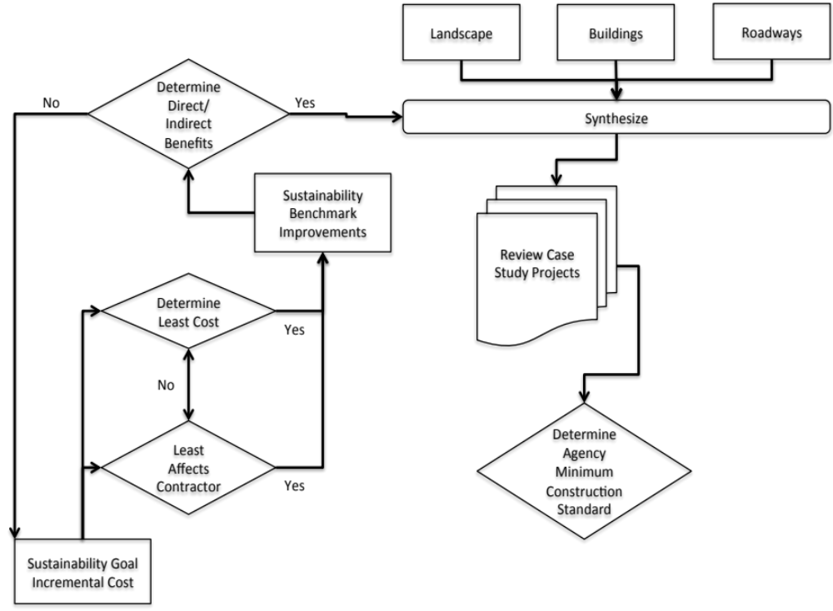
Figure 5.1 Street Project Improvement Methodology

Case Studies
Projects from COKC were chosen based on their potential for sustainable concept integration. These COKC projects include vertical and horizontal construction types. The road projects include streetscapes (beautification projects), full depth pavement replacement and road widening. A decision tool will be used to determine the appropriateness of integrating sustainability benchmarks into COKC projects.

The decision making tool uses a cost index and the Carbon Footprint Goals identified in Table 4.8. From this cost index, a determination of cost for other projects not in the study can be made. These additional projects are used as a verification of the decision tool.

Case study research was a primary instrument used for interpretation of data. The case studies were collected using Yin’s methodology and the following three principles of case study research data collection.
- Use of multiple sources,
- Creation of a database, and
- Maintaining a chain of evidence (Yin 2002).
The information gleaned from the case studies is coupled with information collected in the literature review to validate any conclusion drawn from the case studies. The documents (plans, specifications, solicitations, etc.) associated with each case study were also reviewed to determine the costs of sustainable design using content analysis methodology (Neuendorf 2002). Content analysis can be used to develop “valid inferences from a message, written or visual, using a set of procedures”.

Cost Metric Airport Paving Case Study
To illustrate the cost metrics used on an airport project, a case study is included. The financial analysis of airport pavement construction and maintenance projects is typically based solely on minimizing initial cost. Pavement preservation is a sustainable alternative that uses life cycle cost analysis to compare alternatives using minimize life cost as the decision criterion. An additional decision criterion is required for owners such as a cost index that incudes each alternative's carbon footprint and to its net present value. The index provides a mechanism for owners to evaluate sustainability as well as project economics.

Utilizing an Analytical Hierarchical Process (AHP) can guide the decision as well. The AHP allows weighting of cost, performance and sustainability. Additionally, a framework for determining when to increase the budget for pavement preservation and sustainability requirements is presented to assist owners in the decision making process, using initial cost, life cycle cost, and carbon footprint.

There is currently a wide variety of research on sustainability for airports and aviation; including operations, maintenance, and even a strong focus on tenants. However, the existing research is lacking in the cost of sustainability through preservation practices for the taxiway, runway and landside pavement.

An objective comparison on sustainable alternates for pavement preservation to justify the cost of pavement preservation is needed for owners. Sustainable pavement options in aviation are the same as those in other heavy civil construction projects. Airports must be able to estimate the cost of sustainability in addition to understanding the alternates. The airport industry has not come to consensus on a standard for sustainability although some airports have tried to compile a standard. Chicago Department of Aviation published the Sustainable Airport Manual (SAM). The SAM focuses on Planning, Design & Construction, Operations & Maintenance and Concessions/Tenants (CDA 2011).

Two sustainable benchmarks may be applicable for comparison of airport criteria. Although these benchmarks are not specifically indicated for airports, they will provide a basis for determining what sustainability should include. The benchmarks are Leadership in Environmental and Energy Design for New Development (LEED-ND) (USGBC 2009) and Greenroads (Muench et al. 2010). LEED-ND is one of a family of sustainable benchmarks but is the only one with any focus on paving. Greenroads conversely is focused primarily on paving. Neither of these benchmarks includes a focus on airports, but do provide an outline of sustainable practices for pavement.

The aviation industry is interested in goals across operations, not just construction (Berry et al. 2008). These goals do not focus on paving materials or design. Airports worldwide are at different levels of sustainability (SAGA 2012), so a decision making tool for exceeding minimum cost to increase sustainability is necessary. A framework is required to determine when a pavement maintenance project should exceed the minimum cost while increasing sustainability goals.

The Oklahoma City Airport (OCAT) constructs projects with both types of paving with project types including: asphalt sealing, pavement strengthening, and taxiway reconstruction. The OCAT specification called for a concrete with portland cement and flyash comprising 564 pounds. Airports use both asphalt and concrete, however their uses are separated.

Although asphalt is not often used for taxiways, Superpave asphalt mixes can carry aircraft 60,000 lb. gross weight (Rushing et al. 2012). Based on the specifications, sustainable alternatives like Recycled Asphalt Pavement and Warm Mix Asphalt were not allowed. More research, industry pressure and the need for more sustainable methods will influence the aviation industry to incorporate these alternates.

Hajek et al. describes state of the practice in pavement maintenance (2011). Types of paving maintenance for runways and taxiways include controlled shot blasting, slurry seal, micro-surfacing and hot mix overlay. Airport sustainability and pavement practices found during the literature review were incorporated into one list to determine the current state of practice. In order to increase sustainable pavement practices, the cost of the sustainability portion must be determined. There are several areas on which airports have started their focus including; recycling/reusing existing materials, reflectance and heat island effect, maintenance and Life Cycle Cost Analysis and Life Cycle Assessment, Pervious Pavements and Alternate Materials and Designs. See Table 5.1 for specific practices.

Table 5.1 Airport Sustainable Pavement Practices
Sustainable Pavement Practices
Postconsumer recycled content (ISO/IEC 14021) (USGBC 2005), in-place reclaimed materials, and one-half of the pre-consumer recycled content is at least 50% of the total mass of material
Portland cement with supplementary cementitious material (SCM)
Meet long life pavement design criteria
Stone Matrix Asphalt
Half-Warm Mix Asphalt
Shotblasting / Lithium Hardener
Hot Mix Overlay
Micro Surfacing
Slurry Seal

The sustainable pavement practices identified in Table 5.1 are not exhaustive, but a representative group of the state of the industry. Pavement preservation options were compared to the pavement items only for cost comparisons. Pavement preservation types identified include: shot-blasting with lithium hardener, slurry seal, micro resurfacing, and 2” hot mix asphalt overlay. These pavement preservations, their expected life and carbon footprint were entered into Table 5.2 for comparison.

Table 5.2 Airport Pavement Preservation Types, Carbon Footprint and Life Extension
(after Chehovits and Galehouse 2010)
Pavement Preservation Type | Life Extension | Carbon Footprint BTU/yd²
Shotblasting / Lithium Hardener* | 6.3 – 7.1 years  (Riemer et al. 2012) | 1,290
2” HMA Overlay | 5 – 10 years | 61,500
Micro – Surfacing | 3 – 5 years | 3,870-5,130
Slurry Seal | 3 – 7 years | 3,870-5,130
SCM For 18” Unreinf. Concrete** | 20 years | 3,500
SCM For 18” Reinforced Concrete** | 20 years | 5,800

*Lithium Hardener energy use was calculated for this paper and has been added to Table 5.2 Pavement Preservation Types, Carbon Footprint and Life Extension for comparison. The shotblasting itself has a negligible impact on the carbon footprint (Rippman 2012), but has been added to the lithium hardener for comparison. **SCM was added to the table with the life extension of 20 years and a carbon footprint of 5% less than the specified portland cement with flyash based on calculations performed for this research.

The pavement preservation types are defined as;
- Shotblasting / Lithium Hardener – Lithium silicate is used as a hardener on the surface of Portland Cement Concrete pavement (Nasvik 2008). Shotblasting allows for deeper penetration of the hardener to create a concrete surface that is resistant to deterioration (Stokes 2010). The shotblasting process retextures pavement surface a process that relies on a machine that propels some form of abrasive particle onto the pavement surface (Gransberg 2009).
- 2” HMA Overlay: A mixture of asphalt binder and graded mineral aggregate, mixed at an elevated temperature and compacted to form a relatively dense overlay, or surface layer over existing pavement (Galehouse et al. 2003).
- Micro Surfacing: A mixture of high-quality fine aggregates, which makes it cleaner and harder relative to slurry seal in addition to a polymer-modified emulsion for high-performance (ISSA 2011).
- Slurry Seal: A mixture of well-graded, fine aggregate and unmodified asphalt emulsion (ISSA 2011) providing a seven-year extension of life of pavement (Chen et al. 2003).
- SCM: This product is not a surface treatment, but an alternative to traditional portland cement or can be used with traditional portland cement which is also known as Type K. SCM has increased the lifespan in airport pavements up to 60 times (Bescher et al. 2012). For this comparison, a twenty-year life extension will be used. For Type K, a 5% reduction in carbon footprint over typical cement can be expected (Bescher et al. 2012).

For comparison the pavement bid items are included in Table 5.3. The carbon footprint for the bid item is also included for comparison to the preservation techniques.

Table 5.3 Airport Pavement Bid Items and Carbon Footprint
Pavement | Price per Unit | Units | BTU/yd²
Bituminous Surface Course | $77.21 | sy | 61,500
18” P.C. Concrete Pavement (Plain) | $53.10 | sy | 25,500
18” P.C. Concrete Pavement (Reinforced) | $65.00 | sy | 42,200

The pavement preservation options were compared to the pavement items only for cost comparisons. During the period from 2008 to 2011, the COKC Airport has advertised for bids on the following types of projects; Sealing Asphalt, Strengthening Pavement and Taxiway Reconstruction. Each of these types of projects has the potential for more sustainable construction. Even though asphalt sealing is already a preservation project and therefore sustainable, there is additional room for more sustainable practices.

For the case study project, bids were opened in 2011. Bid tabulations are published on the COKC website with a low bid of $5,840,687.52. This Taxiway Reconstruction and Realignment project utilizes both asphalt and concrete paving. Pavement preservation types that can be utilized for this project include: shot-blasting with lithium hardener, slurry seal, micro resurfacing, and 2” hot mix asphalt overlay.

For the purposes of reviewing pavement preservation costs only, the bids were reduced to the paving items only. At $3,296,272.44, the paving portion is significant and highlights why pavement preservation methods are so important. For comparison the pavement bid items are included in the table below. The carbon footprint for the bid item is also included for comparison to the preservation techniques.

Cost data for the sustainable treatment options were obtained in 2008 (Riemer et al. 2012). Using the ENR Cost Index (Grogan 2011), the full lane cost per square yard was converted to 2011 to match the bid year. The conversion factor is approximately 1.05. Costs with index adjustment are illustrated in the following Table 5.4.

Table 5.4 Airport Preservation Costs with Index Adjustment
Sustainable Treatment Type | Additional Cost | Percent Increase
Shotblasting / Lithium Hardener | $22,034 | 0.67%
2” HMA Overlay | $346,269 | 4.44%
Micro - Surfacing | $38,396 | 1.16%
Slurry Seal | $18,266 | 0.55%
SCM For Unreinf. Concrete | $849,600 | 25.77%
SCM For Reinforced Concrete | $51,200 | 1.55%

Since the case study project includes both types of paving, it is assumed that both types will be installed even if pavement preservation is utilized. However, only one preservation type is compared at a time. The additional costs and the expected life are illustrated in Table 5.5.

Table 5.5 Airport Pavement Preservation Bid Items and Carbon Footprint
Pavement Preservation Type | Additional Initial Cost | Ave. NPV / Life
Shotblasting / Lithium Hardener | $22,034 | 1.48% / 6.7 years
2” HMA Overlay | $346,269 | 14.77% / 7.5 years
Micro - Surfacing | $38,396 | 4.33% / 4 years
Slurry Seal | $18,266 | 1.65% / 5 years
SCM For Unreinforced Concrete | $849,600 | 25.77% / 20 years
SCM For Reinforced Concrete | $51,200 | 1.55% / 20 years

The Equivalent Uniform Annual Cost (EUAC) approach is not applicable when the dollar amounts are annualized over the same period. In this case, the period assumed for all alternatives was 20 years. Evaluating with a Net Present Value (NPV) approach using a 20 year life based on Federal Aviation Administration pavement life recommendations (Navneet et al. 2004). The Net Present Value (NPV) is evaluated on life expectancies for the identified bid item or as part of constructed system. The NPV is evaluated using the following equation:

NPV = initial cost + rehab cost*[1/(1+i)^{n}] Equation 1
(Pittenger et al. 2012)

The additional costs of sustainable treatments are compared to project low bid of $3,296,272. Based on net present value, Lithium Hardener adds 1.58% or is $3,348,306 at the minimum life of 6.3 years, 1.48% or $3,345,200 at the average life of 6.7 years and 1.40% or $3,342,443 at a maximum life of 7.1 years.

Evaluating 2” HMA Overlay using net present value is an additional 25.19% or $4,126,621 at the minimum life of 5 years, 14.77% or $3,783,180 at an average life of 7.5 years and 9.56% or $3,611,460 at a maximum life of 10 years.

Using net present value, Slurry Seal adds 2.75% or $3,386,858 at a minimum life of 3 years, 1.65% or $3,350,624 at the average life of 5 years and 1.18% or $3,335,095 at maximum life of 7 years.

Micro-Surfacing would add 5.78% or $3,486,687 at a minimum of 3 years, 4.33% or $3,439,083 at an average life of 4 years and 3.47% or $3,410,521 at a maximum life of 5 years.

SCM for unreinforced concrete and reinforced concrete both have an assumed additional average life of 20 years. The additional cost of SCM to the base bid items for unreinforced and reinforced concrete is $849,600 and $51,200, respectively.

A cost index to simplify comparisons can be used. Using the average NPV and the carbon footprint, a cost index can be created. The carbon footprint number is multiplied by the percent increase of the average NPV. By creating this index, a valuation is created for the carbon footprint. As illustrated in Table 5.6 below, the Shotblasting / Lithium Hardener alternative has the lowest footprint and percent increase in NPV. By using this index, a difference arises between in the percent increase in NPV. It is quite obvious that the micro – surfacing has both a higher cost and higher carbon footprint.

Table 5.6 Airport Pavement Bid Items and Carbon Footprint
Pavement Preservation Type | Carbon Footprint BTU/yd² | Ave. NPV% | Carbon Footprint * %NPV Increase
Shotblasting / Lithium Hardener | 1,290 | 1.48% | 19.14
2” HMA Overlay | 61,500 | 14.77% | 9,084.46
Micro - Surfacing | 3,870-5,130 | 4.33% | 194.96
Slurry Seal | 3,870-5,130 | 1.65% | 74.20
SCM For Unreinf. Concrete | 3,500 | 25.77% | 1,122.36
SCM For Reinforced Concrete | 5,800 | 1.55% | 574.89

With this simple case study a decision making tool is not necessary, however for more complex decisions a tool would be provide direction. Below is a decision making tool for a simple problem of budget, pavement preservation and sustainability requirements. This tool is illustrated in Figure 5.2.

For a public owner like a municipal airport, being able to justify spending additional funding is often necessary. As airports move towards integrating sustainability into all facets of their business models, it is quite imperative that these costs are known. The costs of sustainable options are comparable to the less sustainable options, giving the owner the ability to construct more sustainable for an equivalent price. Using a cost index for comparison will provide the owner with an easily identifiable difference in the NPV and carbon
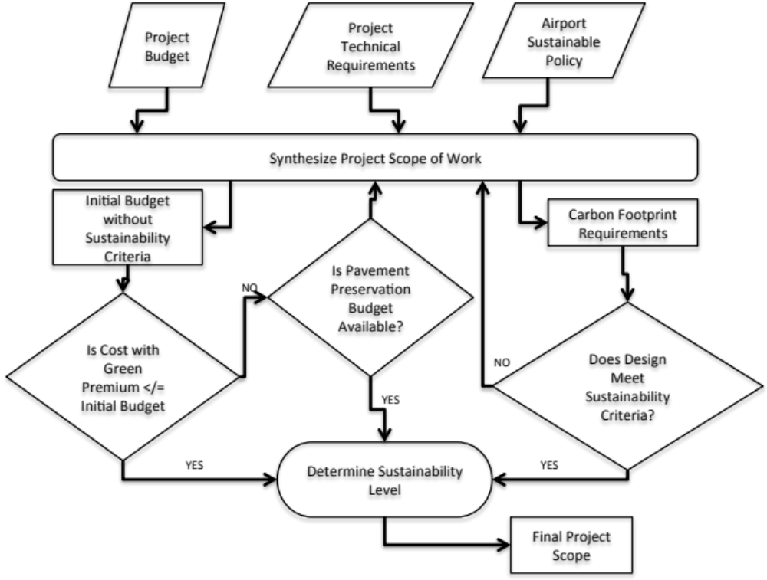
Figure 5.2 Airport Pavement Preservation Framework

footprints. This information will aid in making the decision to add sustainable pavement preservation into projects.

Cost Metric COKC Paving Case Study
Public projects for pavement and pavement maintenance are often based on budgets set by availability of funds. This causes an issue where the owner must construct projects with a focus solely on initial cost and cannot include sustainability requirements due to the perceived additional cost. A framework is required to assist owner’s in the decision making process for justifying spending additional funding for sustainable goals based on future savings. Some of the variables in a maintenance program are cost, life cycle, and sustainability requirements.

Pavement preservation and maintenance techniques are sustainable by increasing the lifespan of existing roadways through a variety of factors. For instance, Reclaimed Asphalt Pavement (RAP) “reduces production cost and conserves diminishing resources of aggregates and petroleum products” (Hajj et al. 2008). The existing research includes RAP, warm mix asphalt (WMA), slurry seal, micro – surfacing, hot mix asphalt overlays, and shotblasting to name a few. A comparison of the cost factors and sustainability for pavement construction projects is required.

Owners require an objective comparison on sustainable alternates for pavement preservation to justify the cost of sustainable pavement practices and to estimate the cost of sustainability in addition to understanding the alternates. Currently there are multiple benchmarks for sustainability including Leadership in Environmental and Energy Design for New Development (LEED-ND) (USGBC 2009) and Greenroads (Muench et al. 2010). Missing from the industry is a standard for arterial streets which are not likely to be private development and do not have highway standards.

The City of Oklahoma City (COKC) constructs a variety of paving projects including: asphalt mill and overlay, micro – resurfacing, full depth replacement and street widening, streetscapes and even trails.

All of the sustainability and pavement practices found during the literature review were incorporated into one list to determine the current state of practice. In order to increase sustainable pavement practices, the cost of the sustainability portion must be determined. There are several areas for sustainable paving upon which a municipality can focus.
  - Stormwater Goal which includes;
    - Permeable / Porous Paving
  - Fuel Efficient Goal which includes;
    - Reduced emissions in Construction Equipment
    - Minimize greenhouse gas emissions and construction air pollutants
  - Pavements Goal which includes;
    - Heat Island Effect
    - Warm Mix Asphalt (WMA)
  - Specifying Recycled Pavement Goal which includes;
    - Recycled Content
  - Waste / Recycling Plan Goal which includes;
    - Construction Waste Plan
  - Soil Management Goal which includes;
    - Restore soils disturbed in construction
    - Balance Earthwork

Three different sustainable benchmarks can be utilized for comparison of sustainable streets criteria. Although none of these benchmarks are specifically indicated for arterial streets, they will provide a basis for determining what sustainability requirements should include. The benchmarks are Greenroads (Muench et al. 2010), Leadership in Environmental and Energy Design for New Development (LEED-ND) (USGBC 2009) and the Sustainable Sites Initiative (SITES 2009). LEED-ND is one of a family of sustainable benchmarks but is the only one with any focus on paving. Greenroads is also focused primarily on paving. SITES is focused on the landscaping, but a municipality also has the responsibility for park spaces and trail. Although these benchmarks include a variety of viewpoints, they provide an outline of sustainable practices for paving arterial roads.

The Pavements Goal can also include the following sustainable pavement preservation types: reclaimed asphalt pavement, warm mix asphalt, slurry seal, micro-surfacing, hot mix asphalt overlay and shot-blasting with lithium hardener which are the focus of this case study. The research evaluates the following pavement preservation methods for cost and life extension for the base pavement course.

- RAP: Reclaimed Asphalt Pavement (RAP) produced by cold milling existing pavement and adding back into the production process. This corresponds to the goal of Specifying Recycled Pavement and Utilizing a Construction Waste Plan.
- 2” HMA Overlay: A mixture of asphalt binder and graded mineral aggregate, mixed at an elevated temperature and compacted to form a relatively dense overlay, or surface layer over existing pavement (Galehouse et al. 2003). Adding life to an existing pavement corresponds to the goal of being Fuel Efficient by minimizing greenhouse gas emissions and construction air pollutants through a reduction in the construction cycle.
- Micro Surfacing: A mixture of high-quality fine aggregates, which makes it cleaner and harder relative to slurry seal in addition to a polymer-modified emulsion for high-performance (ISSA 2011).
- Slurry Seal: A mixture of well-graded, fine aggregate and unmodified asphalt emulsion (ISSA 2011) providing a seven-year extension of life of pavement (Chen et al. 2003).
- Cleaning and Filling Joints and Cracks: Crack sealing with sealant (Galehouse 2003).
- Reduce Hauling: Limit haul distance. This corresponds to both Balancing Earthwork and Fuel Efficient – Minimize Emissions in Construction Equipment.

Chehovits and Galehouse (2010) provide a list of the energy usage of several types of pavement preservation materials and also provide estimations of pavement preservation life extensions. An adaption of their table is illustrated in Table 5.7.

Table 5.7 Pavement Preservation Types, Carbon Footprint and Life Extension
(after Chehovits and Galehouse 2010)
Sustainable Treatment Type | Life Extension | Carbon Footprint BTU/yd²
*RAP (12”) | 0 years | -4,400
2” HMA Overlay | 5 – 10 years | 61,500
Micro – Surfacing | 3 – 5 years | 3,870-5,130
Slurry Seal | 3 – 5 years | 3,870-5,130
Cleaning / Filling Joints / Cracks | 1 – 3 years | 290-870
*Reduce Hauling | 0 years | -1250
Shotblasting / Lithium Hardener | 6.3 – 7.1 years | 1,290

Table 5.7 includes only items applicable to the case study location. RAP is defined here as 50% aggregate replacement and for a 12” deep section of asphalt. *RAP and Reduce Hauling do not increase lifespan, but can reduce the carbon footprint. COKC project construction bid items identified for Carbon Footprint Goals are included in Table 5.8.

A variety of example projects dating from 2006 through 2012 were used for cost data. Bid tabulations are posted on the COKC website. Twenty-three projects were used for cost data from all types of paving construction, including trails, resurfacing, streetscapes and road widening projects, which include full depth replacement. Each of these types of projects has the potential for more sustainable construction. Even though asphalt resurfacing is already a preservation project and therefore sustainable, there is additional room for more sustainable practices.

Act | State
 | Neighborhood | Finance
Sustainable | Interest | Interest
Traditional | No Interest | Interest
Non-Traditional / Non-Sustainable | No Interest | No Interest

Figure 5.3 Decision Tool

Using a decision tool, like the one shown in Figure 5.3 allows the owner to identify what is most important. The interest states identified are for Sustainable, Traditional or Non-Tradition/Non-Sustainable construction types. By verifying the interest categories, the neighborhood and the financial, it can be seen that sustainability affects both groups.

This Taxiway Reconstruction and Realignment project utilizes both asphalt and concrete paving. Pavement preservation types that can be utilized for this project include: shot-blasting with lithium hardener, slurry seal, micro resurfacing, and 2” hot mix asphalt overlay.

For the purposes of reviewing pavement preservation costs only, the bids were reduced to the paving items only. At $3,296,272.44, the paving portion is significant and highlights why pavement preservation methods are so important. Items identified are included in Table 5.8.

Table 5.8 Pavement Bid Items
Item Description | Units
Cold Milling Asphalt Pavement | sy
Bituminous Surface Course | ton
Bituminous Surface Course (2") | sy
18" P.C. Concrete Pavement (Plain) | sy
18" P.C. Concrete Pavement (Reinforced) | sy
Structural Portland Cement Concrete | cy
Reinforcing Steel | lb
8" P.C. Concrete Drive | sy

The sustainable treatment options were compared to the pavement items only for cost comparisons. Since the case study project includes both types of paving, it is assumed that both types will be installed even if pavement preservation is utilized. However, only one preservation type is compared at a time.

Cost data for the sustainable treatment options were obtained in 2008 (Riemer et al. 2012). Using the ENR Cost Index (Grogan 2011), the full lane cost per square yard was converted to 2011 to match the bid year. The conversion factor is approximately 1.05. Index adjusted costs are illustrated in Table 5.9.

Table 5.9 Sustainable Treatment Costs
Sustainable Treatment Type | Additional Cost | Percent Increase
Shotblasting / Lithium Hardener | $22,034 | 0.67%
2” HMA Overlay | $346,269 | 4.44%
Micro - Surfacing | $38,396 | 1.16%
Slurry Seal | $18,266 | 0.55%

The Net Present Value (NPV) is evaluated on life expectancies for the identified bid item or as part of constructed system. The additional costs of sustainable treatments are compared to project low bid of $3,296,272. Based on net present value, Shotblasting / Lithium Hardener adds 1.58% or is $3,348,306 at the minimum life of 6.3 years, 1.48% or $3,345,200 at the average life of 6.7 years and 1.40% or $3,342,443 at a maximum life of 7.1 years.

Evaluating 2” HMA Overlay using net present value is an additional 25.19% or $4,126,621 at the minimum life of 5 years, 14.77% or $3,783,180 at an average life of 7.5 years and 9.56% or $3,611,460 at a maximum life of 10 years.

Using net present value, Slurry Seal adds 2.75% or $3,386,858 at a minimum life of 3 years, 1.65% or $3,350,624 at the average life of 5 years and 1.18% or $3,335,095 at maximum life of 7 years.

Micro-Surfacing would add 5.78% or $3,486,687 at a minimum of 3 years, 4.33% or $3,439,083 at an average life of 4 years and 3.47% or $3,410,521 at a maximum life of 5 years. The additional costs and the expected life are illustrated in Table 5.10.

Table 5.10 Sustainable Treatment Net Present Value
Sustainable Treatment Type | Additional Initial Cost | Ave. NPV / Life
Shotblasting / Lithium Hardener | $22,034 | 1.48% / 6.7 years
2” HMA Overlay | $346,269 | 14.77% / 7.5 years
Micro - Surfacing | $38,396 | 1.65% / 5 years
Slurry Seal | $18,266 | 4.33% / 4 years

Using this information, the owner can see that even though Slurry Seal has the least additional initial cost, the expected life causes the NPV to be higher. The Shotblasting / Lithium Hardener alternative has the higher initial cost, but has a longer life span. The 2” HMA Overlay has the highest initial cost even though it is illustrated with the longest expected life.

Comparing the carbon footprint, the Micro – Surfacing and Slurry Seal are very similar. When comparing to the other sustainable treatment options, constructing a 2” HMA Overlay has at least one order of magnitude greater carbon footprint. Shotblasting / Lithium Hardener has the smallest carbon footprint.

Using an Analytical Hierarchical Process (AHP), the alternatives are defined and the values prioritized. Performance and cost are set as a higher priority than sustainability for COKC as illustrated in Table 5.11.

Table 5.11 Paving Case Study Analytical Hierarchical Process
 | Cost | Sustainability | Performance
Cost | 2/2 | 2/4 | 1/2
Sustainability | 4/2 | 4/4 | 1/4
Performance | 2/1 | 4/1 | 1/1

Assuming the performance reduces cost through net present value, priorities can be set. Performance is 4, cost is 2 and sustainability is 1, with importance doubling the priority. Based on the matrix shown, priority values are calculated by squaring the matrix and computing the eigenvectors. This is illustrated in Table 5.12.

Table 5.12 Paving Case Study Priority Values
Cost | 0.34
Sustainability | 0.24
Performance | 0.42

Using these priority values with alternatives of performance, cost and sustainability a preference for performance is shown. This method can be used to discriminate between products and provide a tool, which does not make cost the only factor.

With this simple case study a decision making tool is not necessary, however for more complex decisions a tool would be provide direction. Figure 5.4 is a decision making tool for a simple problem of budget, pavement preservation and sustainability requirements.

The AHP can be used to process the information identified by the Cost Index or NPV. All the data must be consistent with low or high as the positive result. In this case, since both the Sustainability and Cost measures of the AHP are low for positive, only Performance would need to be converted. The Performance was evaluated against a 20-year life, so the Performance will be calculated as 20 years – the additional life in years.

Using the lowest value of the sum of priority values alternatives of performance, cost and sustainability, we find that Shotblasting / Lithium Hardener is the best option. Even though it does not have the longest performance, with the lowest NPV and Carbon Footprint, the AHP gives it the best rating as shown in Table 5.13.

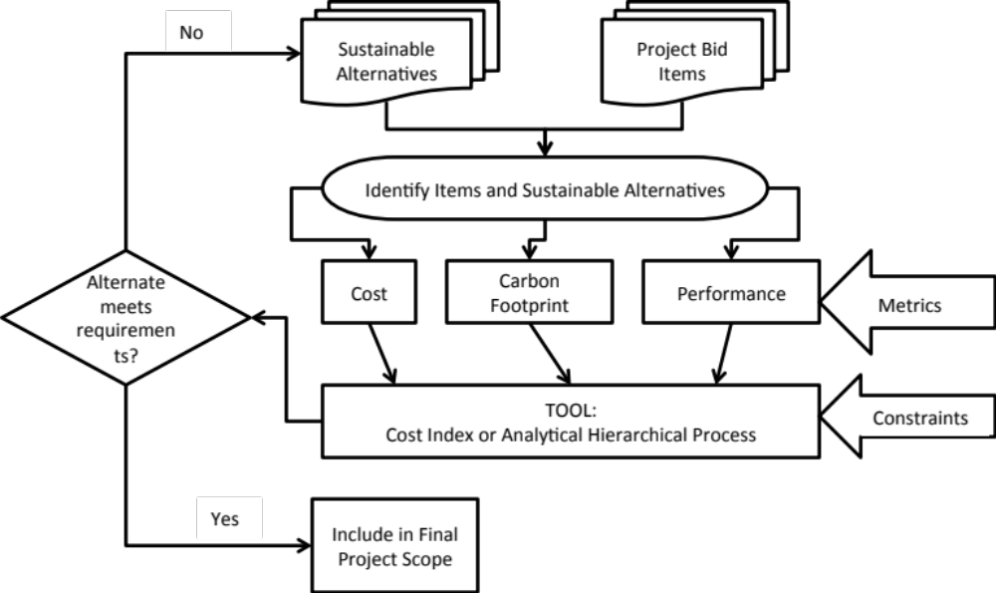
Figure 5.4 Pavement Preservation Framework

Table 5.13 Paving Case Study Analytical Hierarchical Process
Sustainable Treatment Type | Cost (NPV) | Performance (20 - Additional Life in Years) | Sustainability (Carbon Footprint BTU/yd2) | AHP Value
Shotblasting / Lithium Hardener | 1.48% | 13.3 | 1290 | 319
2” HMA Overlay | 14.77% | 12.5 | 61500 | 14905
Micro - Surfacing | 1.65% | 15 | 4500 | 1097
Slurry Seal | 4.33% | 16 | 4500 | 1098

For public owner like a municipality, being able to justify spending additional funding is often necessary. As agencies move towards integrating sustainability into all facets of public works construction projects, it is quite imperative that these costs are known. The costs of sustainable options can be comparable to the less sustainable options, giving the owner the ability to construct more sustainable for an equivalent price. Pavement preservation can provide additional life, so the additional costs need to be weighed against the benefits.

Cost Metric COKC Building Case Study
Categories for sustainability were identified. The categories are:
1. Hard cost credits
2. Soft cost credits and
3. Non-cost credits.
Hard cost credits have a quantifiable return on investments, such as utility savings. Soft cost credits appear to have an impact on the environment, but may not have an obvious cost benefit like recycling. Non-cost credits are considered difficult to attribute to a long-term benefit like having a LEED AP on the project team.

There are credits integral to any project and are considered non-cost credits in COKC. Credits required to complete any project in COKC are considered to be at no additional cost to case study projects. Several of these credits are required by local, state or federal codes. These credits include:
- SS Prereq1, Construction Activity and Pollution Prevention credit is required to reduce loss of topsoil and increased run-off.
- EA Prereq2, Minimum Energy Performance is required by code.
- EA Prereq3, Fundamental Refrigerant Management is the current industry standard.
- EA EQ Prereq1, Minimum IAQ Performance is required by code.
- SS6.2, Storm water Design - Quantity Control is also required by code to decrease storm water run-off.
There are other Non-cost credits that have no cost, like Development Density & Community Connectivity, which is based on location and not in the construction budget. As the definition of the Non-cost credits states the costs have no long-term benefit, these credits may still affect the construction cost. It is important to quantify all the credits that add construction costs, even when the benefit is not identified.

Four COKC building costs were used as a basis to determine the green premium. Two buildings were designed and constructed without any sustainable design requirements. These existing building designs were analyzed to determine which LEED credits could have been achieved by COKC. Two buildings were designed and constructed with sustainable design requirements based on LEED. These designs included a list of projected credits. The consultant provided costs estimates with the LEED credit costs identified.

The average cost of the sustainable credits for the case study buildings was found with the cost per square foot tabulated per credit and is illustrated in Appendix 13. Although these costs are presented for case study data, it is important to state that the dollar values shown in Appendix 13 apply only to the COKC case study projects and should not be generalized. The analysis clearly proved that sustainable design and construction has a quantifiable initial cost. The actual value of the green premium is highly dependent on the project itself as well as its location. The methodology shown in Figure 5.5 is proposed to add structure to the sustainability decision-making process.

To use the framework, first evaluate its current design criteria and construction practices to identify those that already promote sustainability. An example would be the geothermal heating to optimize energy performance. If the owner uses this technology on all new projects, the cost of the system should be assigned to the baseline not the green premium. However, if the owner decides to add green power or measurement and verification to the geothermal system, the cost of the additional credits should rightly be assigned to the green premium until such time that the owner changes its policy and/or specifications. The output of the

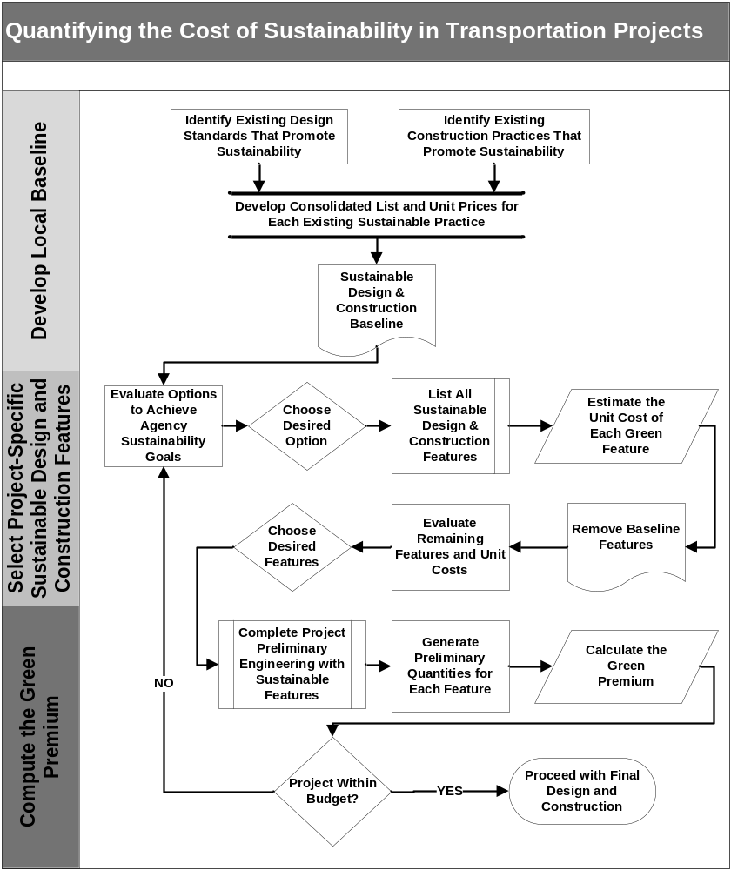
Figure 5.5 Framework for Sustainable Buildings

evaluation is the consolidated list of baseline features of green design and construction.

The next step is to evaluate the potential for adding sustainable features to the project and select the ones that are desired. The unit price for each green feature is then estimated and the cost of the baseline features is removed. The remaining features are then assessed knowing their costs and a value judgment is made as to which ones will be included in the preliminary design. Once preliminary engineering is completed, the engineer’s estimate for the green premium is made based on the quantities associated with each green feature. After the estimate for entire project including the green features is completed and compared with the budget. If the project is within budget, it can proceed with the selected suite of sustainable design and construction elements. If not, a reevaluation of the additional green features must be made and the green premium estimating process will be conducted until the scope of work matches the budget.

One advantage to the proposed process is that it segregates required features of work from the discretionary ones. This methodology is an objective tool so pre-project planning decisions are solely based on cost. If the sustainability goals for the project cannot be met within the existing budget, the owner has the information necessary to request additional funding and justification for the costs of achieving those goals.

Integrating the Case Studies
The case studies each start with the goal of adding sustainable goals to the project with little or no additional cost. By utilizing existing benchmarks for sustainability, the added sustainable goals are identified. Using the bid prices for recent projects for comparison illustrates the cost of sustainability when added to these municipal projects. For the pavement case studies, an additional metric of the carbon footprint was added. The carbon footprint gives the owner an objective metric to justify adding sustainability when there is a cost involved. The three case studies further illustrate how an owner can build a database, use the sustainability benchmarks and make the case for more sustainable projects.

CONCLUSIONS

Summary
The major factor in developing a conclusion was the intersection of trends found in two or more research instruments. The intersection of more than two lines of converging information adds authority to the given conclusion. The research was able to arrive at 6 conclusions that are discussed in the next section. The limitations of the research are discussed, including those previously identified in the case studies. Recommended research would add to the existing research, specifically in the area of additional cost data. The contributions are identified and include the dissemination of this research through various publications and future titles.

Conclusions
Typically enhancing the sustainability of public projects requires additional capital improvement funding. The COKC case study projects demonstrated that the actual impact on projects costs of various sustainable design approach can range from nothing for credits that are already required in the COKC building codes to as much as $10/SF for those that are new or exceed current design criteria. The five sustainability benchmarks were used as a convenient way to measure the sustainability of the COKC case study projects, however the concepts for quantifying the cost of sustainable design and construction can be applied to any project.

To compare costs, the initial cost only is used for determining the value of a sustainable goal. There is also a societal impact; this may be enough incentive to overcome additional costs. The credits are identified as those with solely with construction costs and those that just “feel-good” (Nalewaik and Venters 2009). Typical construction costs like those required by code are not considered to have a cost for sustainability. This gives the user the ability to project budget for future projects above and beyond the typical construction costs.

Previous studies have focused on overall project cost for sustainable construction. No algorithm has been found in any of this previous research to forecast costs of future projects and is not currently found in any other similar research. An algorithm in the form of a framework has been provided for pre-project planning by owners.

A group of five benchmarks were reviewed. These benchmarks were cross-referenced and reduced to one group of 30 Carbon Footprint or Sustainability Goals. These goals illustrate how the different benchmarks find the same project goals to be sustainable in nature. A municipality could implement any of these goals into their pre-project planning and construction standards as part of a sustainable policy.

As owners move towards integrating sustainability into all facets of their business models, it is quite imperative that these costs are known to justify additional funding. When the costs of sustainable options are comparable to the less sustainable options, the owner has the ability to construct more sustainable for an equivalent price. Using a cost index for comparison will provide the owner with an easily identifiable difference in the NPV and carbon footprints. This information will aid in making the decision to add sustainable pavement preservation into projects.

One advantage to the proposed process is that it segregates required features of work from the proposed preservation options. While owners should consider more sustainable paving types, it can be also be at minimal additional cost. However since pavement preservation can provide additional life, the additional costs need to be weighed against the benefits. Sustainable options should be investigated and can also be used for decision-making.

For owners to compare benchmarks to costs, the percent of sustainability goals that have a cost component have been identified. For each of the five benchmarks approximately half of the credits affect the construction cost. It was also illustrated that post-construction operations and maintenance can be a requirement of any sustainable construction program.

Limitations of the Research
As this research looks to determine costs to one specific municipality and all of the case studies are from the same location, this research cannot be applied directly to another location. New cost data will have to be inserted that is specific to the project location. This tool is specifically for use to determine how to incorporate sustainable design concepts into municipal projects and how to budget for future projects.

It is anticipated that for any decision tool, the user will have to provide some input. For COKC projects, initial costs are a strong determining factor. In other locations, there may be other factors that are weighted more heavily. The framework can be utilized as a decision-making tool once local specific data has been collected and introduced into the framework.

Recommended Research
Additional research should be performed, specifically about utilizing asphalt and recycled products in airport paving. In the past airports have been reluctant to consider asphalt products, however consideration should be given to the pavement preservation aspects. The carbon footprint for various materials is being compiled in other research. Adding it to the cost database will increase the usefulness of the cost index approach.

Recycled asphalt shingles are not yet specified by COKC. There is little cost data available. As the cost data becomes available and the specifications are approved, this will be a viable alternative. The additional carbon footprint for reusing the shingles would be considered additive to the carbon footprint cost index.

The data in the research is limited to COKC projects. The next step would be to add other localities and state information to the database. As the benchmarks change and new benchmarks appear, the sustainable goals also change. Adding cost data for new benchmarks and new products will help owners to make better decisions on applying sustainability.

Contributions
The sustainable benefit the “green premium” (Molenaar et al. 2009) was required to be defined for green projects. The existing research lacks information on the true cost of sustainability for both vertical and horizontal construction types. An objective comparison technique for sustainable alternates has been needed to justify sustainability costs, potential savings and sustainable features.

At this point, there is no objective methodology or rating system that applies across the environmental spectrum in which a city engineer must work. The proposed research seeks to remedy that by bringing together for the first time the three available metrics and creating a single structure which permits the design engineer to make sustainability decision that comprehensively apply to all the parts of an urban area: buildings, streets, and streetscapes. The research cross-referenced multiple rating systems and determined how the ratings systems incorporate into COKC projects. The decision tool created measures the cost effectiveness of future COKC sustainable street projects, especially for the development phase of budget determinations. As this research is solely focused on Design-Bid-Build projects, it provides insight that can eventually be extended to alternative project delivery methods once additional research is done to adapt the final framework to accommodate the faster delivery pace and alteration in quality assurance roles and responsibilities.

The published research from this dissertation includes four articles. These are: “Carbon Footprint Cost Index: Measuring the Cost of Airport Pavement Sustainability” (Mosier, R.D., Pittenger, D. and D.D. Gransberg 2014), “A Framework to Reconcile Green Goals with Budget Reality” (Mosier and Gransberg 2013), “Estimating the Green Premium: An Oklahoma City Case Study” (Mosier and Gransberg 2012), and "Estimating Sustainability" (Mosier 2012). Additional publications to be submitted include “Determining Pavement Sustainability with a Carbon Footprint Cost Index,” “Using Net Present Value as a Metric for Sustainability,” And “A Carbon Footprint Cost Index for Sustainable Construction.”

As stated previously, this research will have to be modified for use for locations outside COKC. New cost data will have to be inserted that is specific to the project location. It is anticipated that for any decision tool, the user will have to provide some input. For COKC projects, initial costs are a strong determining factor. In other locations, there may be other factors that are weighted more heavily.

REFERENCES
American Association of State Highway and Transportation Officials (AASHTO), (1993). “Guide for Design of Pavement Structures.”

The Athena Institute (2005). Road rehabilitation energy reduction guide for Canadian road builders. Canadian Industry Program for Energy Conservation.

Augenbroe, G., Pearce, A. R. Guy, B., Kibert, C. J. (1998). “Sustainable Construction in the United States of America: A perspective to the year 2010,” CIB-W82 Report, Georgia Institute of Technology College of Architecture Construction Research Center, pp. 1-32.

Berry, F., Gillhespy, S., Rogers, J. (2008), Airport Cooperative Research Program Synthesis 10 Project 11-03, Topic S02-02; Airport Sustainability Practices.

Bescher, E., Stremfel, J., Ramseyer, C. Rice, E. K. (2012). “The role of calcium sulfoaluminate in concrete sustainability.”

Bevan, T., Reid, L., Davis, A., Neuman, T., Penney, K., Seskin, S., VanZerr, M., Anderson, J., Muench, S., Weiland, C., Ramani, T., Zietsman, J., Crossett, J., Crocker, C., Schulz, J. (2012). INVEST (Infrastructure Voluntary Evaluation Sustainability Tool) 1.0 Compendium. Federal Highway Administration.

Breakthrough Strategy Committee (BSC) (2006). “Sustainability and CII,” Strategic Objective 1-6BSC-R Report to CII Leadership, Construction Industry Institute, (2006, January 26), 1-13.

Brunker, M. (2006). “Are FEMA trailers ‘toxic tin cans’?” MSNBC, <http://www.msnbc.msn.com/id/14011193/> (January 4, 2009).

Building Design & Construction (BDC) (2003). White Paper on Sustainability, (2003, November), Oak Brook, IL, 1-47.

Chehovits, J., Galehouse, L. (2010). “Energy Usage and Greenhouse Gas Emissions of Pavement Preservation Processes for Asphalt Concrete Pavements,” First International Conference on Pavement Preservation, pp.27-42.

Chen, D., Lin, D., Luo, H. (2003). “Effectiveness of Preventative Maintenance Treatments Using Fourteen SPS-3 Sites in Texas.” Journal Of Performance Of Constructed Facilities, 17(3): 136.

Chernoff, H., Moses, L. (1959). Elementary Decision Theory. Wiley, New York.

City of Chicago (CDA). (2011). Chicago Department of Aviation: Sustainable Airport Manual.

City of Oklahoma City Website (COKC) (2011a). “About OKC”, <http://www.okc.gov/about/index.html> (January 24, 2011)

COKC (2011b). “Parks Locations”, <http://www.okc.gov/parks/parks_maps/index.html> (January 30, 2011)

Oklahoma City Municipal Code. (2007)

City of Seattle (2005). “Seattle Right-of-Way Improvements Manual”, <http://www.seattle.gov/transportation/rowmanual/manual> (December 20, 2010)

Coelho, P. Vilares, M. (2010). “Measuring the Return of Quality Investments,” Total Quality Management. V. 21, No. 1, 21-42.

Diekmann, J. E. (1983). “Probabilistic Estimating: Mathematics and Applications,” J. Constr. Engrg. Mgmt, 109(3), 297–308.

Environmental Protection Agency (EPA) (2007). “Nonroad Diesel Technical Amendments and Tier 3 Technical Relief Provision,” Federal Register. EPA–HQ–OAR–2007–0652; FRL–8467–2.

EPA (2008). Formaldehyde, <http://www.epa.gov/iris/subst/0419.htm>, (January 4, 2009).

EPA (2010a). Sustainable Design and Green Building Toolkit for Local Governments, EPA 904B10001.

EPA (2010b). Partnership for Sustainable Communities, EPA-231-F-10-002

EPA (2012). “Asphalt Concrete”. Solid Waste Management and Greenhouse Gases Report WARM Version 12.

Federal Highway Administration (FHWA). (1998). Life Cycle Cost Analysis in Pavement Design, Interim Technical Bulletin. FHWA, US Department of Transportation, Washington, D.C. 1-107.

FHWA. (2011). Bridge Preservation Guide; Maintaining State of Good Repair Using Cost Effective Investment Strategies. FHWA, US Department of Transportation, Washington, D.C. Publication No. FHWA-HIF-11-042, 1-28.

Fukahori, K., Kubota, Y. (2002). “The role of design elements on the cost-effectiveness of streetscape improvement,” Landscape And Urban Planning; 6375-91.

Galehouse, L., Moulthrop, J. and Hicks. R. (2003.) “Principles for Pavement Preservation: Definitions, Benefits, Issues and Barriers,” TR News, Transportation Research Board, 4-9.

Garg, N., Guo, E., McQueen, R.. 2004. Operational Life of Airport Pavements. National Technical Information Service (NTIS), Springfield, Virginia.

Gransberg D. (2009.) “Life-Cycle Cost Analysis of Surface Retexturing with Shotblasting as an Asphalt Pavement Preservation Tool,” Transportation Research Record: Journal of the Transportation Research Board, No. 2108, Transportation Research Board of the National Academies, Washington, D.C., 2009, 46–52.

Government Accounting Office (GAO). (1991). Using Structured Interviewing Techniques, GAO/PEMD-10.1.5, Government Accounting Office, Washington, D.C., June 1991, 1-191.

General Accounting Office, (2003). Major management challenges and program risks, U.S. Department of Energy. Rpt. # GAO-03-100.
Green Building Initiative (GBI). (2008). “History of the Green Globes System”, <http://www.thegbi.org/commercial/about-green-globes/>, (December 16, 2008).

Grogan T. (2011). “How To Use ENR's Cost Indexes.” ENR: Engineering News-Record. 266(9): 32

Hajek, J., Hall, J., Hein, D. (2011). “Common Airport Pavement Maintenance Practices.” Airport Cooperative Research Program.

Hajj, E.Y., Sebaaly, P. E., Kandiah, P. (2008.) “Use of Reclaimed Asphalt Pavements (RAP) in Airfields HMA Pavements,” Final Report, Airfield Asphalt Pavement Technology Program (AAPTP), Project 05-06.

Hardin, G. (1968). “The Tragedy of the Commons,” Science, 162, 1243-1248.

Harris, R. (2009). “Bush Declares Marine Preserves In Pacific” <http://www.npr.org/templates/story/story.php?storyId=99036156>, (January 10, 2009).

Haxton B., Beckstead, G. (2008). “A Conceptual Cost Estimating System for LEED Facilities.” R&D Magazine, Vol. 50, 26-27.

Horman, M., Riley, D. Dahl, P., Hickey, A., Lapinski, A. Magent, C., Shaltes, N. (2004). “Field Guide for Sustainable Construction.” Partnership for Achieving Construction Excellence, University Park, PA and Pentagon Renovation and Construction Program Office Arlington, VA. 1-311.

International Slurry Seal Association (ISSA) (2013). “What is Slurry?“ <http://www.slurry.org/index.php/education/issa-disciplines-guidelines/what-is-slurry>, (February 28, 2013).

IVL Swedish Environmental Research Institute: Life Cycle Assessment of Road. March 2001. Study conducted for the Swedish National Road Administration.

Jordan, E., Gross, M., Javernick, A., Garvin, W. and Garvin, M. (2011). “Use and misuse of qualitative comparative analysis,” Construction Management and Economics, 29:11, 1159-1173

Kats, G., Alevantis, L., Berman, A., Mills, E., Perlman, J. (2003). “The Costs and Financial Benefits of Green Buildings,” A Report to California’s Sustainable Building Task Force.

Konchar, M., Sanvido, V. (1998). “Comparison of U.S. Project Delivery Systems,” J. Constr. Engrg. and Mgmt., 124, 435.

Lapinski, A. R., Horman, M. J., Riley, D. R. (2006). “Lean Processes for Sustainable Project Delivery.” J. Constr. Engrg. and Mgmt., ASCE, Vol. 132, Page 1083.

Mansdorf, Z. (2010). “Sustainability and Return on Investments – Without the Spin.” EHS Today, Penton Publishing.

Molenaar, K.R., Sobin, N., Gransberg, D.D., McCuen, T.L., Korkmaz, S. Horman, M., Riley, D. (2009), Sustainable, High Performance Projects and Project Delivery Methods: A State-of the Practice Report, White Paper, Charles Pankow Foundation, Ontario, California, 1-30.

Mosier, R.D. and Gransberg, D.D. (2013). “A Framework to Reconcile Green Goals with Budget Reality,” International Journal of Construction Engineering, IRSN, Vol. 1 (1), 1-10.

Muench, S.T., Anderson, J.L., Hatfield, J.P., Koester, J.R., & Söderlund, M. et al. (2010). Greenroads Rating System v1.0. (J.L. Anderson and S.T. Muench, Eds.). Seattle, WA: University of Washington.

Nalewaik, A. and V. Venters (2009), “Cost Benefits of Building Green,” Cost Engineering, Vol. 51/No. 1, pp. 28-34.

Nasvik, J. (2008). “Lithium Silicate Densifiers,” Concrete Construction, December 2008, 1-5.

National Ready Mixed Concrete Association (NRMCA). (2008). Concrete CO₂ Fact Sheet. NRMCA Publication Number 2PCO2.

Neuendorf, K.A. (2002). The Content Analysis Guidebook. Sage Publications, Thousand Oaks, California. 300.

New York State Department of Transportation (NYSDOT). (2010). GreenLITES Project Design Certification Program (version 2.1.0).

Oklahoma Constitution (1988), Indebtedness for purchase, construction or repair of public utilities, § Article 10 section 27 Oklahoma Constitution.

Oppenheim, A. N., (1992). Questionnaire Design, Interviewing and Attitude Measurement. Continuum, London.

Pittenger, D.M., Gransberg, D.D., Zaman, M., Riemer, C., (2012). “Stochastic Life Cycle Cost Analysis for Pavement Preservation Treatments,” Transportation Research Record, Journal of the Transportation Research Board, National Academies, Washington, D.C., in press.

Plato (1888). Timaeus, R. D. Archer-Hind, translator, Forgotten Books Charleston, South Carolina, 1-90.

Ramkrishnan, K., Roper, K., Castro-Lacouture, D. (2007). “Green Building Rating And Delivery Systems In Building Construction: Toward Aec+P+F Integration,” Proceedings IGLC-15, Michigan, 332-342.

Renewable Energy Corporation (REC). (2011) “Delivering Sustainable Solar Solutions.”

Riemer, C., Pittenger, D., Gransberg, D., Zaman, M.. (2012) "Preservation of Concrete Pavement Using a Lithium Densifier and Shotblasting: A Life Cycle Cost Analysis." 2012 Transportation Research Record, Journal of the Transportation Research Board Paper #12-0531 National Academies January, 2012

Rippman, J. (2012). “Shotblasting Roads and Bridges.” Construction Business Owner Magazine.

Rushing, J., White, T. E. R. Brown, N. Garg. 2012. “Criteria for using the Superpave gyratory compactor to design airport HMA mixtures.” International Journal Of Pavement Engineering; 13(2): 126-136.

Saaty, R. (1987). “The Analytical Hierarchy Process – What It Is and How It Is Used,” Mathematical Modeling, V.9 Issue 3-5, 161-176.

Sandt, L. (2008). A resident's guide for creating safe and walkable communities. Washington, DC : U.S. Dept. of Transportation, Federal Highway Administration.

Shaffer M. (2009). “Decision Theory, Intelligent Planning and Counterfactuals.” Minds & Machines. 19(1): 61-92.

Sinha, K., Labi, S., (2007), Transportation Decision Making: Principles of Project Evaluation and Programming, John Wiley & Sons, 1-544.

Smith, R., Reed, S., Baker, S. (2010). Street Design: Part 1—Complete Streets. Public Roads. Vol. 74,· No. 1. Publication Number: FHWA-HRT-10-004.

Sullivan, J. (2006). “Time Magazine Profiles Teddy Roosevelt”, National Parks Traveler, http://www.nationalparkstraveler.com/item/140, (October 27, 2009).

Sustain Magazine. (2008). “Assessing the assessor BREEAM VS LEED”, <www.breeam.org/filelibrary/BREEAM_v_LEED_Sustain_Magazine.pdf>, (December 16, 2008), 30-33.

Sustainable Sites Initiative (SITES) (2009a). The Case for Sustainable Landscapes.

SITES (2009b). “The Sustainable Sites Initiative: Guidelines and Performance Benchmarks 2009”. Available at http://www.sustainablesites.org/report.

Stokes, D. (2010). Lithium Ion Penetration in the Route 113 Treatment Site, Letter Report, FMC Corporation, Lithium Division, Bessemer City, North Carolina, July 28, 2010, 1-2.

Sustainable Aviation Guidance Alliance (SAGA). (2012.) http://www.airportsustainability.org/

Syal, M. G., Mago, S., Moody, D. (2007). Impact of LEED-NC Credits on Contractors, J. Arch. Engrg., 13, 174.

Tatari, O., Kucukvar, M. (2011). “Cost Premium Prediction of certified green building: A neural network approach.” Building and Environment, Vol. 46, 1081-1086.

U.S. Census (2009). “Oklahoma City (city), Oklahoma, State & County QuickFacts”, <http://quickfacts.census.gov/qfd/states/40/4055000.html>, (January 30, 2011).

U.S. Energy Information Administration (2009). “Crude Oil Domestic First Purchase Prices, 1949-2009 Table 5.18”, <http://www.eia.gov/aer/petro.html> (February 2, 2011).

U.S. Green Building Council (USGBC) (2005). LEED for New Construction & Major Renovations v2.2.

USGBC (2008), “Registration”, <http://www.usgbc.org/DisplayPage.aspx?CMSPageID=65>, (January 2, 2009).

USGBC (2009), LEED 2009 for Neighborhood Development Rating System.

U.S. Environmental Protection Agency INVENTORY OF U.S. GREENHOUSE GAS EMISSIONS AND SINKS: 1990 – 2009, (2011) 1200 Pennsylvania Ave., N.W.

Xenergy Inc. and SERA Architects (Xenergy) (2000), “Green City Buildings: Applying the LEED Rating System,” Portland Energy Office, pp. 1-144.

Yin, R. K. (1994). Case Study Research: Design and Methods, Sage Publications.

Yin, R. (2002). Case Study Research: Design and Methods. Page(s) 128. Sage Publications, Thousand Oaks, California

Yin, R. (2004). “Conducting Case Studies: Collecting the Evidence” [WWW document]. URL http://72.14.203.104/search?q=cache:jHb6y55UFJ8J:
www.idt.mdh.se/phd/courses/fallstudie/slides%2520-%2520seminarie
%25202/Yin%2520-%2520kapitel%25204%2520Rev%25203.ppt
+conducting+case+studies&hl=en&gl=us&ct=clnk&cd=1 (visited 2006, March 13).

BIBLIOGRAPHY

Association for the Advancement of Cost Engineering International (AACEI) (2008), Implementing Constructability Programs, Recommended Practice Publication RP-30R-03, AACE, International, Morgantown, West Virginia, (July 2008).

Athena Institute, The (2005), Road rehabilitation energy reduction guide for Canadian road builders. Canadian Industry Program for Energy Conservation.

Buildings Editors (2005), “America’s Cities ‘LEED’ the Way,“ http://www.buildings.com/ArticleDetails/tabid/3321/ArticleID/2475/Default.aspx (September 14, 2009).

City of Chicago (2004), The Chicago Standard, Construction Standards for Public Buildings, City of Chicago, Illinois, pp. 1-4.

Darren R. , Shrestha, P. , Gibson, Jr., G., Migliaccio, G. (2009), “Empirical Comparison of Design/Build and Design/Bid/Build Project Delivery Methods,” J. Constr. Engrg. and Mgmt., ASCE, Vol. 135(7), pp. 579-587.

Davis Langdon, Australia (2007), “The Cost and Benefit of Achieving Green Buildings,” Davis, Langdon & Seah International, http://www.davislangdon.us/ANZ/Research/Research-Finder/Info-Data-Publications/Info-Data-Green-Buildings, (September 14, 2008), pp. 1-8.

Ellicott, M. (1994), “Best-value Contracting,” Proceedings, Area Engineers Conference, TransAtlantic Division, U. S. Army Corps of Engineers, Winchester, Virginia, p. 7.

Gransberg, D., Koch, J., Molenaar, K. (2006), Preparing for Design-Build Projects: A Primer for Owners, Engineers, and Contractors., ASCE Press, Reston, Virginia, 296 pp.

Gransberg, D. Reimer, C.. (2009) “Impact of Inaccurate Engineer's Estimated Quantities on Unit Price Contracts.” Journal of Construction Engineering and Management. Page(s) 1138-1145. ASCE, Vol. 135 (11).

Green Building Certification Institute (2008), LEED Project Registration and Certification Fees, https://www.gbci.org/DisplayPage.aspx?CMSPageID=127, (August 9, 2009)

Howard, N. Watson, R. (2002), “Special LEED™ Section: An Update on LEED™ 2.1,” Environmental Design and Construction, http://www.edcmag.com/Articles/Feature_Article/4b8435f1c9697010VgnVCM100000f932a8c0, (December 20, 2008).

JDL Surface Innovations (No Date), “Shotblasting for Roadways and Bridges,” http://jdlsurfaceinnovations.com/shot-blasting/shot-blasting-roadways-bridges/

Kwong, B. (2004), “Risk.10: Quantifying the Benefits of Sustainable Buildings,” 2004 AACE International Transactions, pp. 1-6.

L&M Construction Chemicals, Inc. (2011) TECDATA: LiONHARD Lithium Silicate Concrete Densifier, Hardener and Sealer with Water Saver Technology. http://lmcc.com/products/techdata/LiONHARD.pdf

Matthiessen, L. Morris, P. (2004), Costing Green: A Comprehensive Cost Database and Budgeting Methodology, Davis Langdon, pp. 1-27.

Matthiessen, L. (2004), Costing Examining the Cost of Green, Davis Langdon, pp. 1-6.

Oklahoma Public Competitive Bidding Act (1974), 61 O.S. § 101 et seq., (OSCN 2011).

Roberts, M. Spencer, N. (2008), “Carbon Counts: Incorporating the Benefits of Climate Protection into Federal Rulemaking,” Environmental Defense Fund, pp. 1-22.

Steven Winters Associates, Inc. (2004), GSA LEED Cost Study, Final Report, U. S. General Services Administration, Norwalk, Connecticut, pp. 1-191.

Tyagi, P. (2005), “Factors Causing Variation between the LEED Pilot and Final Checklists in Green Health-Care Projects,” Thesis, Texas A&M University.

West, T.M. and Riggs, J.L. (1986). Engineering Economics. Third Edition, McGraw-Hill Inc. New York, New York, pp.781-789.

APPENDIX 1: LIST OF EQUATIONS

Equation 1: Net Present Value………………………………………………...……86

APPENDIX 2: LIST OF CARBON FOOTPRINT CONVERSIONS

Lithium Silicate Hardener/Densifier
Using silicon as a basis for the carbon footprint, the silicon is 18-21 g CO₂-eq/kWh (REC 2011). Kilowatts are converted to Btu and grams are converted to pounds. Pounds are then converted to square yards to match units. The result is 1,290 btu/square yard.
Recycled Asphalt Content (RAP)
Per The Athena Institute, Hot Mix Asphalt Concrete has a carbon footprint of 680 MJ/Tonne and a mix with 50% RAP and a carbon footprint of 454 MJ/Tonne (2005). MegaJoules per tonne was converted into Btu/square yard for consistency with the bid item units.
Shotblasting
Shotblasting has only .543 tons per road mile of carbon emissions (JDL Surface Innovations, No Date). Tons were converted to pounds and lane-mile was converted to square yard.
Supplementary Cementitious Materials (SCM)
A cubic yard of concrete (about 3900 lbs) is responsible for emitting about 400 lbs of carbon dioxide (CO₂). When comparing concrete to steel or timber, steel has 12 times the carbon footprint of concrete. Concrete has 1.25 times the carbon footprint of timber (NRMCA 2008).
Using calcium sulfoaluminate as an SCM reduces the carbon footprint. CSA cement only generates about 600 kg (1323 lb) of CO₂ per 1000 kg of cement compared to traditional cement, which is 900 kg (1984 lb) of CO₂ produced for every 1000 kg (Bescher et al. 2012).

APPENDIX 3: DATA
COKC Bid Item Average Costs
A group of twenty-four projects for which hard bids were received between 2007 and 2010 are included as the basis for costs of completing street projects for COKC.

DESCRIPTION | UNIT | AVERAGE COST
OWNER/CONTRACTOR PROTECTIVE POLICY (NO LONGER USED) | L.SUM | $1,910.08
OWNER/CONTRACTOR PROTECTIVE POLICY-RAILROAD CONSTRUCTION (SP) | L.SUM | $1,701.40
UNCLASSIFIED EXCAVATION | C.Y. | $8.57
UNSUITABLE MATERIAL EXCAVATION | C.Y. | $6.31
EXCESS EXCAVATION | C.Y. | $5.21
EMBANKMENT | C.Y. | $10.18
BORROW | C.Y. | $25.11
SELECT BACKFILL (SP) | C.Y. | $13.51
DEWATERING | L.SUM | $10,000.98
TRENCH EXCAVATION AND BACKFILL - ZERO (0') FT TO TEN (10') FT | L.F. | $4.44
TRENCH EXCAVATION AND BACKFILL - ZERO (0') FT TO FIFTEEN (15') FT | L.F. | $2.39
TRENCH EXCAVATION AND BACKFILL - ZERO (0') FT TO TWENTY (20') FT | L.F. | $65.00
STRUCTURAL EXCAVATION | C.Y. | $5.61
CRUSHED ROCK FOUNDATION | C.Y. | $33.31
CRUSHED ROCK FOUNDATION (CRUSHER RUN) (1.5") | C.Y. | $20.84
EMBEDMENT MATERIAL | C.Y. | $12.60
EMBEDMENT MATERIAL | TON | $20.99
SAND BACKFILL | C.Y. | $19.46
CRUSHED ROCK | TON | $27.27
CRUSHED ROCK (1.5") | TON | $36.95
SUBGRADE | S.Y. | $0.63
SUBGRADE (6" COMPACTED) | S.Y. | $1.10
NATURAL SOIL BASE | S.Y. | $58.35
FLY ASH | TON | $59.70
LIME | TON | $131.14
CEMENT KILN DUST | TON | $48.41
CEMENTITIOUS STABILIZED SUBGRADE | S.Y. | $2.64
LIME STABILIZED SUBGRADE | S.Y. | $2.24
FLY ASH MODIFIED SUBGRADE (8 INCHES) | S.Y. | $2.34
FLY ASH MODIFIED SUBGRADE (12 INCHES) | S.Y. | $2.70
FLY ASH MODIFIED SUBGRADE (6 INCHES) | S.Y. | $11.99
LIME STABILIZED SUBGRADE (8 INCHES) | S.Y. | $2.31
AGGREGATE BASE (TYPE A) | C.Y. | $61.77
AGGREGATE BASE (TYPE A) | TON | $27.13
BORING - CASING (SIZE) | L.F. | $280.00
BORING (20") | L.F. | $208.39
BORING (24") | L.F. | $10.00
BORING (2") | L.F. | $25.47
BORING - CASING (18") | L.F. | $405.00
ASPHALT CONCRETE TYPE D LEVELING COURSE | TON | $67.62
ASPHALT CONCRETE TYPE A | TON | $356.78
ASPHALT CONCRETE TYPE B | TON | $1,419.01
ASPHALT CONCRETE TYPE C (2") | S.F. | $19.68
ASPHALT CONCRETE TYPE A | TON | $56.94
ADDITIONAL COST FOR PG 76-28 OK LIQUID ASPHALT (TYPE B) | TON | $61.06
ASPHALTIC CONCRETE TYPE (B) (3 INCHES) | S.Y. | $72.99
ADDITIONAL COST FOR PG 70-28 OK LIQUID ASPHALT (TYPE B) | TON | $9.64
ASPHALT CONCRETE TYPE A (3 INCHES) | S.Y. | $10.40
ASPHALT CONCRETE TYPE A (PG 64-22) | TON | $49.96
ADDITIONAL COST FOR PG 70-28 OK LIQUID ASPHALT (TYPE A) | TON | $7.55
ASPHALT CONCRETE TYPE A (PG 70-28) | TON | $68.18
ASPHALT CONCRETE TYPE B (PG 64-22) | TON | $63.03
ASPHALT CONCRETE TYPE B (PG 70-28) | TON | $76.30
PORTLAND CEMENT CONCRETE PAVEMENT | S.Y. | $50.03
APPROACH SLABS | S.Y. | $180.13
PORTLAND CEMENT CONCRETE PAVEMENT (6") | S.Y. | $38.57
PORTLAND CEMENT CONCRETE PAVEMENT (8") | S.Y. | $47.94
PORTLAND CEMENT CONCRETE PAVEMENT (10") (DOWELL JOINTED) | S.Y. | $38.55
PORTLAND CEMENT CONCRETE PAVEMENT (4") | S.Y. | $32.45
PORTLAND CEMENT CONCRETE PAVEMENT (BATCHED COLOR) | S.Y. | $47.29
CURB AND GUTTER (2'-8") (6" BARRIER) | L.F. | $15.95
CURB AND GUTTER (2'-8") (8"BARRIER) | L.F. | $15.32
INTEGRAL CURB (6 INCHES) | L.F. | $5.73
MOUNTABLE CURB | L.F. | $27.46
INTEGRAL CURB (BARRIER) (8 INCHES) | L.F. | $5.47
CONCRETE PLAYGROUND CURB (BARRIER) (5 INCHES) | L.F. | $4.28
HIGH-EARLY-STRENGTH CONCRETE PAVEMENT | S.Y. | $34.38
HIGH-EARLY-STRENGTH CONCRETE PAVEMENT (6") | S.Y. | $37.85
COLD MILLING PAVEMENT | S.Y. | $2.67
COLD MILLING PAVEMENT (ASPHALT 1 3/4 INCHES) | S.Y. | $1.04
HAUL OUT MILLED PAVEMENT | S.Y. | $1.56
COLD MILLING PAVEMENT (CONCRETE 1 3/4 INCHES) | S.Y. | $3.12
COLD MILLING PAVEMENT (ASPHALT & CONCRETE 2 ¼” | S.Y. | $2.08
CONCRETE JOINT REHABILITATION | L.F. | $2.68
CLEANING AND FILLING JOINTS AND CRACKS | L.F. | $1.74
FABRIC REINFORCMENT | S.Y. | $3.21
TACK COAT | GAL | $2.28
PRIME COAT | GAL | $2.39
CITY SERIES PAVERS (SP) | S.F. | $15.05
CARRIAGE STONE PAVER (SP) | S.F. | $16.21
STRUCTURAL EXCAVATION | C.Y. | $21.53
CHANNEL LINER | S.Y. | $88.57
CHANNEL LINER (TRANSITION) | S.Y. | $135.32
CONCRETE FLUME | S.Y. | $100.99
STRUCTURAL CONCRETE | C.Y. | $451.79
CONCRETE CLASS C | C.Y. | $124.60
CONCRETE (FLOWABLE FILL) | C.Y. | $69.43
STRUCTURAL CONCRETE (RETAINING WALL) | L.F. | $101.92
STRUCTURAL CONCRETE (RETAINING WALL) (TYPE I B) | L.F. | $48.93
STRUCTURAL CONCRETE (RETAINING WALL) (TYPE II C) | L.F. | $48.93
STRUCTURAL CONCRETE (RETAINING WALL) (TYPE III C) | L.F. | $455.00
CONCRETE CLASS AA | C.Y. | $550.39
RETAINING WALL-SPECIAL (SP) | L.F. | $331.14
PRE-STRESSED CONCRETE BEAM (TYPE III) | L.F. | $195.90
STRUCTURAL STEEL | LBS. | $4.04
(PL) FIXED BEARING ASSEMBLY | EA. | $464.97
(PL) EXPANSION BEARING ASSEMBLY | EA. | $495.37
REINFORCING STEEL | LBS. | $1.12
(CGMP) STORM SEWER (18 IN) | L.F. | $12.93
(CGMP) PREFAB END SECTION (18 IN) | EA. | $413.75
(CGMP) STORM SEWER (48 IN) | L.F. | $49.14
(CGMP) PREFAB END SECTION (48 IN) | EA. | $1,197.15
(CGMP) STORM SEWER (24 IN) | L.F. | $33.79
(CGMP) PREFAB END SECTION (24 IN) | EA. | $344.67
(CGMP) PREFAB END SECTION (15 IN) | EA. | $109.79
(CGMP) STORM SEWER (42 IN) | L.F. | $48.58
(CGMP) STORM SEWER (72 IN) | L.F. | $54.89
(CGMP) STORM SEWER (60 IN) | L.F. | $87.00
PRE-CAST BOX CULVERT | L.F. | $760.64
REINFORCED CONCRETE BOX CULVERT (6' X 3' )(RCB) | L.F. | $604.34
REINFORCED CONCRETE PIPE (18 INCHES) | L.F. | $55.51
REINFORCED CONCRETE PIPE (24 INCHES) | L.F. | $69.33
REINFORCED CONCRETE PIPE (36 INCHES) | L.F. | $91.49
REINFORCED CONCRETE PIPE (42 INCHES) | L.F. | $126.41
REINFORCED CONCRETE PIPE (48 INCHES) | L.F. | $135.40
REINFORCED CONCRETE PIPE (54 INCHES) | L.F. | $171.92
HEADWALL FOR 24" R.C.P. COMPLETE IN PLACE | EA. | $1,225.01
HEADWALL FOR 48 INCHES | EA. | $2,339.95
REINFORCED CONCRETE PIPE 18 INCHES "O" RING | L.F. | $72.72
REINFORCED CONCRETE PIPE 24 INCHES "O" RING | L.F. | $84.18
REINFORCED CONCRETE PIPE 36 INCHES "O" RING | L.F. | $118.73
REINFORCED CONCRETE PIPE 48 INCHES "O" RING | L.F. | $168.88
REINFORCED CONCRETE PIPE END SECTION (18 INCHES) | EA. | $959.54
REINFORCED CONCRETE PIPE (30 INCHES) | L.F. | $68.28
REINFORCED CONCRETE PIPE (45"X 29") | L.F. | $160.05
REINFORCED CONCRETE PIPE END SECTION (24 INCHES) | EA. | $627.95
REINFORCED CONCRETE PIPE (30 INCHES) "O" RING | L.F. | $100.69
HORIZONTAL ELLIPTICAL CONCRETE PIPE (51 1/8" X 31 5/16") | L.F. | $142.73
HORIZONTAL ELLIPTICAL CONCRETE PIPE END SECTION (51 1/8" X 31 5/16") | EA. | $1,756.64
REINFORCED CONCRETE PIPE END SECTION (36 INCHES) | EA. | $2,355.02
HEADWALL FOR 36" RCP (COMPLETE IN PLACE) | EA. | $2,600.92
STD. HEADWALL (18") (COMPLETE IN PLACE) | EA. | $1,096.69
HORIZONTAL ELLIPTICAL CONCRETE PIPE (36" X 58 1/2") | L.F. | $226.11
HORIZONTAL ELLIPTICAL CONCRETE PIPE END SECTION (36" X 58 1/2") | EA. | $3,146.74
REINFORCED CONCRETE PIPE (42 INCHES) "O" RING | L.F. | $165.50
REINFORCED CONCRETE PIPE ARCH (28"X 18) | L.F. | $66.00
REINFORCED CONCRETE PIPE ARCH (43"X 28) | L.F. | $82.00
REINFORCED CONCRETE PIPE ARCH (51"X 31) | L.F. | $90.00
REINFORCED CONCRETE PIPE END SECTION (54 INCHES) | EA. | $3,646.89
MANHOLE (4' DIA) | EA. | $1,944.71
MANHOLE ADDED DEPTH | V.F. | $164.62
MANHOLE (6' DIA) | EA. | $2,604.92
MANHOLE (5' DIA) | EA. | $2,552.46
JUNCTION BOX (6'X 6') | EA. | $2,498.39
BOX TYPE INLET (6'X 6') | EA. | $5,204.98
DESIGN 2-0 INLET COMPLETE IN PLACE | EA. | $2,178.56
DESIGN 2-1 INLET COMPLETE IN PLACE | EA. | $3,308.50
DESIGN 2-2 INLET COMPLETE IN PLACE | EA. | $3,625.45
5' X 5' STD REINF. CONCRETE JUNCTION BOX | EA. | $2,674.38
DESIGN 2-3 INLET COMPLETE IN PLACE | EA. | $4,570.17
DES NO. 5 BOX TYPE INLET | EA. | $2,500.00
STANDARD MEDIAN DRAIN | EA. | $2,541.97
JUNCTION BOX (6'-0" X 4'-0") | EA. | $2,761.21
SPECIAL DRAINAGE INLET NO.3 | L.SUM | $3,018.89
JUNCTION BOX (4.5' X 3'') | EA. | $855.63
GRATED STREET INLET | EA. | $1,526.67
JUNCTION BOX (4' X 4' ') | EA. | $3,188.88
BOX TYPE INLET (4' X 4' ) | EA. | $1,094.19
DESIGN 2-4 INLET COMPLETE IN PLACE | EA. | $7,449.69
JUNCTION BOX (8' X 8') | EA. | $590.14
RESETTING EXISTING MANHOLE RING AND COVER | EA. | $173.58
ADJUST MANHOLE TO GRADE | EA. | $402.23
SETTING NEW MANHOLE RING AND COVER | EA. | $327.28
(SIZE) (TYPE) WATERLINE PIPE (JOINT TYPE) (NOM WALL THICK) | L.F. | $110.00
(12") (DIP) WATERLINE | L.F. | $155.35
(6") (DIP) WATERLINE (PUSH-ON) NOM WALL THICK 0.28) | L.F. | $35.29
(8") (DIP) WATERLINE PIPE (PUSH-ON) NOM WALL THICK 0.30) | L.F. | $39.72
12"X 45° BEND | EA. | $572.94
FITTINGS (DIP) COMPACT (MJ) | LBS. | $263.46
FITTINGS (MEGA-LUG SERIES 1108) | EA. | $82.86
FITTINGS (MEGA-LUG SERIES 1112) | EA. | $108.33
FITTINGS (MEGA-LUG SERIES 1106) | EA. | $67.93
12"X 90° BEND | EA. | $544.26
12"X 12" TEE | EA. | $364.69
12" PLUG (DIP) | EA. | $257.81
(8") (DIP) WATERLINE PIPE (SOLID SLEEVE) | EA. | $241.92
8"X 8" X 6" TEE | EA. | $192.76
8" PLUG (DIP) | EA. | $349.06
WATER SERVICE LINE SHORT(SIZE) | EA. | $104.10
WATER SERVICE LINE LONG (SIZE) | EA. | $208.20
WATER SERVICE LINE SHORT(1") | EA. | $328.22
WATER SERVICE LINE LONG(1") | EA. | $1,104.49
WATER SERVICE LINE SHORT (1") (W/METER RELOCATION) | EA. | $446.35
WATER SERVICE LINE LONG (1") (W/METER RELOCATION) | EA. | $1,190.28
WATER SERVICE LINE EXTRA LONG (1") (W/METER RELOCATION) | EA. | $1,587.04
METER RELOCATION (SIZE) | EA. | $530.92
METER RELOCATION (1") | EA. | $328.22
WET CONNECTION (8") | EA. | $309.52
WET CONNECTION (12") | EA. | $299.53
WET CONNECTION (24") | EA. | $2,200.00
(8") TAP | EA. | $218.81
(12") TAP | EA. | $265.56
FIRE HYDRANT | EA. | $1,875.54
12" FIRE HYDRANT RISER | EA. | $442.09
RELOCATE FIRE HYDRANT | EA. | $911.49
FIRE HYDRANT (4.5' BURY) | EA. | $2,244.07
ADJUST FIRE HYDRANT | EA. | $1,023.97
REMOVAL OF FIRE HYDRANT | EA. | $573.52
2" BLOWOFF | EA. | $695.17
(SIZE) (TYPE) VALVE AND VAULT | EA. | $4.63
VALVE BOX ADJUST TO GRADE | EA. | $180.31
12" GATE VALVE & VALVE BOX | EA. | $2,270.49
6" GATE VALVE & VALVE BOX | EA. | $889.75
(8") (TAPPING) VALVE AND VALVE BOX | EA. | $1,302.46
(12") (TAPPING) VALVE AND VALVE BOX | EA. | $2,447.41
8" GATE VALVE & VALVE BOX | EA. | $1,100.00
24" GATE VALVE & VALVE BOX | EA. | $18,000.00
6" TAPPING VALVE & VALVE BOX | EA. | $833.57
8" TAPPING VALVE & VALVE BOX | EA. | $1,041.97
12" TAPPING VALVE & VALVE BOX | EA. | $1,615.05
WATER VALVE BOX | EA. | $347.16
WATER METER BOX | EA. | $173.58
HYDROSTATIC PRESSURE TESTING AND DISINFECTION | L.SUM | $702.93
(SIZE) POLYETHYLENE ENCASEMENT | L.F. | $366.44
(8") POLYETHYLENE ENCASEMENT | L.F. | $1.67
(12") POLYETHYLENE ENCASEMENT | L.F. | $0.83
(6") POLYETHYLENE ENCASEMENT | L.F. | $1.67
CLASS 200 PVC PIPE (1") | L.F. | $1.76
STEEL CASING PIPE (12") | L.F. | $55.00
STEEL CASING PIPE (20") | L.F. | $72.94
(8" X 8") TAPPING SLEEVE | EA. | $1,354.56
(12" X 12") TAPPING SLEEVE | EA. | $3,122.99
(12" X 12") TAPPING SLEEVE (MJ) | EA. | $2,266.28
(6" X 6") TAPPING SLEEVE (MJ) | EA. | $2,175.11
(8" X 8") TAPPING SLEEVE (MJ) | EA. | $1,771.35
(16" X 8") TAPPING SLEEVE (MJ) | EA. | $2,839.36
(12" X 6") TAPPING SLEEVE (MJ) | EA. | $2,005.79
(12" X 8") TAPPING SLEEVE (MJ) | EA. | $218.81
SANITARY SEWER PIPE (SIZE) | L.F. | $43.55
ABANDONING SEWER | C.Y. | $400.00
SEWER FLOW CONTROL | L.SUM | $3,000.00
DEFLECTION TEST (SIZE) (<24") | L.SUM | $250.00
SEWER LEAKAGE TEST (SIZE) (<24") | L.SUM | $650.00
EXTRA DEPTH MANHOLE WALL (SIZE) | V.F. | $125.00
(4') SANITARY SEWER MANHOLE (0'-6') | EA. | $2,625.18
EXTRA DEPTH MANHOLE WALL (6') | V.F. | $125.04
REMOVING MANHOLE | EA. | $744.16
DUCTILE IRON PIPE, (DIP) (8 INCHES) PUSH ON JOINT, NOMINAL WALL THICKNESS 0.30 | L.F. | $25.27
DUCTILE IRON PIPE, (DIP) (6 INCHES) PUSH ON JOINT, NOMINAL WALL THICKNESS 0.28 | L.F. | $21.36
STEEL CASING PIPE (20") | L.F. | $71.37
STEEL CASING PIPE (18") | L.F. | $67.73
VEHICLE ACTUATED TRAFFIC SIGNAL CONTROL ASSEMBLY | EA. | $12,824.23
SOLID STATE DIGITAL INDUCTIVE LOOP VEHICLE DETECTOR | EA. | $152.15
E.P.S. OPTICAL DETECTOR | EA. | $440.38
E.P.S. 2 CHANNEL PHASE SELECTOR | EA. | $1,950.71
1 ½" TRAFFIC SIGNAL CONDUIT TRENCHED | L.F. | $4.63
1 ½" TRAFFIC SIGNAL CONDUIT (BORED) | L.F. | $15.55
1" TRAFFIC SIGNAL CONDUIT (TRENCHED) | L.F. | $3.59
1" TRAFFIC SIGNAL CONDUIT (BORED) | L.F. | $12.04
2" TRAFFIC SIGNAL CONDUIT (TRENCHED) | L.F. | $4.76
2" TRAFFIC SIGNAL CONDUIT (BORED) | L.F. | $14.21
3" TRAFFIC SIGNAL CONDUIT (TRENCHED) | L.F. | $6.02
3" TRAFFIC SIGNAL CONDUIT (BORED) | L.F. | $17.10
( NO. OF CONDUCTORS ) CONDUCTOR TRAFFIC SIGNAL ELECTRICAL CABLE | L.F. | $3.60
TWO CONDUCTOR SHIELDED LOOP DETECTOR LEAD-IN CABLE | L.F. | $1.42
LOOP DETECTOR WIRE(AWG NO.)(WIRE TYPE) | L.F. | $3.41
( NO. OF CONDUCTORS )(AWG NO.) ELECTRICAL CONDUCTOR | L.F. | $0.79
( 5 ) CONDUCTOR TRAFFIC SIGNAL ELECTRICAL CABLE | L.F. | $1.48
( 15 ) CONDUCTOR TRAFFIC SIGNAL ELECTRICAL CABLE | L.F. | $3.11
( 2 ) CONDUCTOR TRAFFIC SIGNAL ELECTRICAL CABLE | L.F. | $0.88
( 7 ) CONDUCTOR TRAFFIC SIGNAL ELECTRICAL CABLE | L.F. | $1.58
( 9 ) CONDUCTOR TRAFFIC SIGNAL ELECTRICAL CABLE | L.F. | $1.96
( 12 ) CONDUCTOR TRAFFIC SIGNAL ELECTRICAL CABLE | L.F. | $2.39
( 1 CONDUCTOR )(AWG NO. 6) ELECTRICAL CONDUCTOR | L.F. | $1.73
( 1 CONDUCTOR )(AWG NO. 10) ELECTRICAL CONDUCTOR | L.F. | $0.88
LOOP WIRE 14 AWG (TYPE XHHW) | L.F. | $2.64
UNDERGROUND COMMUNICATION CABLE | L.F. | $3.87
THREE (3) SECTION ONE WAY TRAFFIC SIGNAL HEAD | EA. | $579.10
FOUR (4) SECTION ONE WAY TRAFFIC SIGNAL HEAD | EA. | $830.76
FIVE (5) SECTION ONE WAY TRAFFIC SIGNAL HEAD | EA. | $1,072.14
PEDESTRIAN SIGNAL HEAD | EA. | $525.88
PEDESTRIAN SIGNAL HEAD (1 WAY, 5 SEC.ADJ, SIG.HD. (S-19)) | EA. | $1,321.22
PEDESTRIAN SIGNAL HEAD (1 WAY, 2 SEC.ADJ, SIG.HD. (S-20)) | EA. | $719.13
PEDESTRIAN SIGNAL HEAD (1 WAY, 3 SEC.ADJ, SIG.HD. (S-9)) | EA. | $833.73
MODULAR PEDESTRIAN SIGNAL HEAD | EA. | $518.51
PEDESTRIAN PUSH BUTTON AND SIGN | EA. | $1,023.83
PEDESTRIAN PUSH BUTTON AND POLE | EA. | $1,441.76
PEDESTRIAN PUSH BUTTON STATION | EA. | $1,480.52
POLE AND SPECIFIED NO. OF MAST ARM (S) AND LUMINAIRE ARM | EA. | $9,898.69
PEDESTAL POLE WITH SPECIFIED MOUNTING HEIGHT | EA. | $3,289.45
POLE AND SPECIFIED 30' MAST ARM(S) (INSTALLED) | EA. | $4,244.08
POLE AND SPECIFIED 35' MAST ARM(S) (INSTALLED) | EA. | $4,000.00
POLE AND SPECIFIED 45' MAST ARM(S) (INSTALLED) | EA. | $6,657.73
POLE AND SPECIFIED 50' MAST ARM(S) (INSTALLED) | EA. | $7,698.00
POLE AND SPECIFIED 25' MAST ARM (S) AND LUMINAIRE ARM (INSTALLED) | EA. | $5,066.26
POLE AND SPECIFIED 30' MAST ARM (S) AND LUMINAIRE ARM (INSTALLED) | EA. | $6,231.59
POLE AND SPECIFIED 35' MAST ARM (S) AND LUMINAIRE ARM (INSTALLED) | EA. | $6,178.24
POLE AND SPECIFIED 40' MAST ARM (S) AND LUMINAIRE ARM (INSTALLED) | EA. | $6,966.94
POLE AND SPECIFIED 45' MAST ARM (S) AND LUMINAIRE ARM (INSTALLED) | EA. | $7,819.09
POLE AND SPECIFIED 50' MAST ARM (S) AND LUMINAIRE ARM (INSTALLED) | EA. | $8,868.79
POLE AND SPECIFIED 55' MAST ARM (S) AND LUMINAIRE ARM (INSTALLED) | EA. | $8,965.10
POLE AND SPECIFIED 35' MAST ARM (S) AND LUMINAIRE ARM POWDER COATED (DELIVERED) | EA. | $6,147.61
PEDESTAL POLE WITH 8' MOUNTING HEIGHT | EA. | $4,599.95
PEDESTAL POLE WITH 10' MOUNTING HEIGHT | EA. | $1,570.55
STRUCTURAL CONCRETE | C.Y. | $543.44
REINFORCING STEEL | LBS. | $1.72
PULL BOX TYPE I | EA. | $259.06
PULL BOX TYPE II | EA. | $403.91
ROADWAY LUMINAIRE (250 WATT HPS) | EA. | $394.04
SHEET ALUMINUM SIGNS | S.F. | $24.03
MAST ARM MOUNTED SIGNS | S.F. | $32.08
SIGNS | EA. | $260.49
REMOVE AND RELOCATE SIGN | EA. | $139.64
REMOVE EXISTING SIGN | EA. | $119.38
GALVANIZED STEEL SIGN POST | L.F. | $7.75
SQUARE STEEL SIGN POST | L.F. | $10.10
TRAFFIC STRIPE (PAINT) | L.F. | $0.11
TRAFFIC STRIPE (PLASTIC) (4 INCH WIDE) | L.F. | $0.85
TRAFFIC STRIPE (PLASTIC) (ARROWS)(SINGLE) | EA. | $84.34
TRAFFIC STRIPE (PLASTIC) (ARROW)(DOUBLE) | EA. | $105.12
TRAFFIC STRIPE (PLASTIC) (WORDS) | EA. | $156.29
TRAFFIC STRIPE (PLASTIC) (SYMBOLS) | EA. | $213.71
TRAFFIC STRIPE (PLASTIC TAPE) (4 INCH WIDE) | L.F. | $0.70
12" WIDE CROSSWALK STRIPING | L.F. | $1.77
REMOVE TRAFFIC STRIPE (4 INCH WIDE) (SP) | L.F. | $0.43
REMOVE TRAFFIC STRIPE (ARROWS)(SINGLE) (SP) | EA. | $50.20
REMOVE TRAFFIC STRIPE (ARROWS)(DOUBLE) (SP) | EA. | $68.16
REMOVE TRAFFIC STRIPE (WORDS) (SP) | EA. | $88.00
REMOVE TRAFFIC STRIPE (SYMBOLS) (SP) | EA. | $123.99
CONSTRUCTION STAKING (CONSTRUCTION SURVEY) | L.SUM | $21,150.70
GPS "AS-BUILT" SURVEY | L.SUM | $4,715.11
PRE-CONSTRUCTION VIDEO (SP) | L.SUM | $4,215.13
COLOR AUDIO/VIDEO RECORDING, PRE AND POST CONSTRUCTION (RECORDED DIGITALLY ON DVD) (SP) | L.SUM | $1,160.60
CONSTRUCTION SIGNING AND TRAFFIC CONTROL | L.SUM | $27,810.75
PORTABLE CONCRETE MEDIAN BARRIER | L.F. | $5,238.95
CONSTRUCTION SIGNING &TRAFFIC CONTROL (ARTERIAL STREETS) (PER DAY) | EA. | $102,273.34
WORK-ZONE PERMIT | EA. | $268.74
MOBILIZATION (SP) | L.SUM | $52,675.52
CLEARING AND GRUBBING | L.SUM | $63,721.67
STRUCTURE REMOVAL (TYPE) | L.SUM | $5,330.47
REMOVE EXIST. HEADWALL | EA. | $1,897.39
REMOVE EXIST. END SECTION | EA. | $520.98
REMOVE STORM SEWER (CGMP) | L.F. | $7.35
REMOVE STORM SEWER (RCP) | L.F. | $10.41
STRUCTURE REMOVAL (INLET) | EA. | $534.07
STRUCTURE REMOVAL (TRAFFIC SIGNAL) | L.SUM | $4,548.64
STRUCTURE REMOVAL (CHANNEL LINER) | S.Y. | $13.53
STRUCTURE REMOVAL (RCB) | EA. | $676.18
STRUCTURE REMOVAL (GUARDRAIL) | L.F. | $5.96
STRUCTURE REMOVAL (RETAINING WALL) | L.F. | $14.57
STRUCTURE REMOVAL (CONCRETE FLUME) | S.Y. | $48.68
REMOVE EXIST. HEADWALL & WINGWALLS | EA. | $1,040.27
REMOVE AND INSTALL EXISTING STORM SEWER (RCP) | L.F. | $72.82
REMOVE PAVEMENT (TYPE) (THICKNESS) | S.Y. | $3.72
REMOVE SIDEWALK (WIDTH) | S.Y. | $9.42
REMOVE CURB AND GUTTER | L.F. | $6.19
CONCRETE PAVEMENT REMOVAL | S.Y. | $8.97
ASPHALT PAVMENT REMOVAL | S.Y. | $11.38
STREET PAVMENT REMOVAL | S.Y. | $4.35
REMOVE POURED IN PLACE SAFETY SURFACE (PARKS) | S.F. | $1,091.09
REMOVE DRIVEWAY | S.Y. | $8.04
REMOVE AND REPLACE DRIVEWAY | S.Y. | $31.03
REMOVE DRIVEWAY (6"PC CONC) | S.Y. | $8.19
REMOVE AND REPLACE DRIVEWAY (GRAVEL) | S.Y. | $198.38
PAVEMENT CUT AND REPAIR (CONCRETE)) | S.Y. | $123.99
REPLACE SIDEWALK (WIDTH) | S.Y. | $41.64
REMOVE CONC. SIDEWALK (5') | C.Y. | $10.00
BASE REPAIR | S.Y. | $31.63
REMOVE PAVEMENT MARKING (SP) | L.F. | $0.58
PAVEMENT REPAIR (6-INCHES) | S.Y. | $20.82
PAVEMENT REPAIR (8-INCHES) | S.Y. | $33.32
PAVEMENT REPAIR (10-INCHES) | S.Y. | $45.63
LIGHT POLE BASE (CONCRETE) COMPLETE | EA. | $1,171.35
ADJUST EXISTING STRUCTURE (WATER VALVE) | EA. | $109.41
ADJUST EXISTING STRUCTURE (WATER METER) | EA. | $1,014.57
ADJUST EXISTING STRUCTURE (VALVE BOX) | EA. | $325.98
STORM SEWER HOOD REPLACEMENT | EA. | $343.85
REMOVE AND REPLACE LIGHT POLE | EA. | $1,667.93
REMOVE AND REPLACE FLAG POLE | EA. | $208.39
REMOVE AND RELOCATE PEDESTRIAN PUSH BUTTON AND POLE | L.SUM | $654.65
ADJUST EXISTING STRUCTURE (2-2 INLET REPAIR) | EA. | $1,497.65
STORM SEWER CAST GRATE REPLACEMENT | EA. | $173.58
SAWCUT PAVEMENT (LOOPS) | L.F. | $480.69
SAWCUT PAVEMENT | L.F. | $95.74
GEO-COMPOSITE FABRIC MEMBRANE (2' WIDTH) | L.F. | $1.33
SIDEWALK (5') | S.Y. | $39.18
DRIVEWAY (WIDTH) | S.Y. | $97.83
6" P.C. CONC. DRIVEWAY (HES) | S.Y. | $55.73
CONCRETE EDGING (SP) | L.F. | $18.52
PORTLAND CEMENT CONCRETE PAVEMENT 8" STAMPED | S.Y. | $492.04
TRIP HAZARD REMOVAL (SP) |  | $43.64
TEMPORARY SURFACE COURSE (TBSC) | TON | $25.50
2" TEMP. TYPE "B" ASPHALT | S.Y. | $46.37
TEMPORARY SURFACING (ASPHALT) | TON | $51.92
(TYPE 1) PLAIN RIPRAP | C.Y. | $65.40
(18" DIA) PLAIN RIPRAP | TON | $45.34
(TYPE) FILTER BLANKET | C.Y. | $44.93
(TYPE) FILTER BLANKET | TON | $32.65
(RIP RAP) FILTER BLANKET | S.Y. | $12.25
(TYPE 1-A) SPECIAL PLAIN RIPRAP | TON | $37.15
(TYPE) GROUTED RIPRAP | S.Y. | $72.87
BOULDERS (5' X 3' X 2') (SP) | EA. | $1,033.04
FILTER FABRIC (RIPRAP) | S.Y. | $2.07
HANDRAIL (STEEL) (3") | L.F. | $94.02
HANDRAIL (STEEL) (2") | L.F. | $78.43
PERFORATED UNDERDRAIN PIPE (8") | L.F. | $8.27
PERFORATED UNDERDRAIN PIPE (6") | L.F. | $17.24
NON-PERFORATED UNDERDRAIN PIPE (6") | L.F. | $17.24
NON-PERFORATED UNDERDRAIN PIPE (8") | L.F. | $8.27
BEAM-TYPE GUARDRAIL (SINGLE) | L.F. | $19.76
GUARDRAIL ANCHOR UNIT, TYPE "B" (SEE STD. GRAU-1-1) | EA. | $658.74
NEW GUARDRAIL EXTRUDER TERMINAL | EA. | $3,293.70
ATTENUATOR (UP TO 42" WIDE) | EA. | $24,156.76
FENCE - TYPE II | L.F. | $18.91
FENCE - TYPE III | L.F. | $4.39
4' VINYL-CLAD CHAIN LINK FENCE | L.F. | $22.69
FIXED BOLLARD/TRAIL MARKERS | EA. | $6,413.44
REMOVE AND REPLACE FENCE - TYPE II (4' CHAIN LINK) | L.F. | $11.34
REMOVE AND RESET PIPE FENCE - (3") | L.F. | $4,167.87
REMOVE EXISTING FENCE | L.F. | $3.73
METAL BOLLARD | EA. | $521.23
REMOVE AND REPLACE FENCE - TYPE III | L.F. | $2.27
FENCE - 6' CHAIN LINK (9 GAUGE GALVANIZED) (SP) | L.F. | $28.15
WHEELCHAIR RAMP | EA. | $478.12
TACTILE MARKERS/TRUNCATED DOMES | EA. | $167.22
ADA CURB RAMP | S.Y. | $83.75
REMOVE AND REPLACE CONCRETE ADA RAMP | S.Y. | $525.28
TACTILE MARKERS/TRUNCATED DOMES | S.F. | $34.44
SOLID SLAB SODDING | S.Y. | $2.25
TREE REPLACEMENT (SIZE) | EA. | $547.51
TREE REMOVAL | EA. | $467.88
CHINESE PISTACHA (2" CALIPER) | EA. | $1,091.09
TREES (SAFETY FENCE) | EA. | $5.21
GREEN VELVET BOXWOOD | EA. | $47.67
WINTER GREEN BOXWOOD | EA. | $71.49
BLUE CHIP JUNIPER | EA. | $53.08
YOUNGSTOWN JUNIPER | EA. | $53.59
PETITE SNOW CRAPEMYRTLE | EA. | $48.85
APALACHE CRAPEMYRTLE | EA. | $207.31
CHOCTAW CRAPEMYRTLE | EA. | $320.64
MOONBAY NANDINA | EA. | $66.19
BLUE WONDER NANDINA | EA. | $47.28
DWARF FOUNTAIN GRASS | EA. | $36.25
FURMAN'S RED SAGE | EA. | $27.02
BLUEBERRY MUFFIN HAWTHORNE | EA. | $59.63
COLOR GUARD YUCCA | EA. | $53.59
IRRIGATION SYSTEM-COMPLETE IN PLACE | EA. | $89,577.76
REMOVE & REPLACE LAWN IRRIGATION PIPE (1/2" TO 2" DIA. PVC) | L.F. | $7.36
REMOVE & REPLACE LAWN IRRIGATION HEAD | EA. | $101.15
1" CONTROL VALVE (SP) | EA. | $212.43
SPRAY HEADS (SP) | EA. | $46.30
WEATHERMATIC SL12 CONTROLLER (SP) | EA. | $3,676.90
MAINLINE EXTENSION (1 1/2") | L.F.1 | $6.47
CYPRESS MULCH (SP) | C.Y. | $89.14
REMOVE AND REPLACE EXISTING STRUCTURE (PULL BOX) | EA. | $471.39
TRASH RECEPTACLES | EA. | $640.80
PEDESTRIAN BRIDGE INCLUDING ABUTMENT COMPLETE IN PLACE | EA. | $289,237.31
PARK BENCH (SP) | EA. | $1,171.11
EROSION CONTROL BARRIER | L.F. | $2.20
ROCK BAG INLET BARRIER | EA. | $159.89
FILTER FABRIC SILT FENCE-COMPLETE IN PLACE | L.F. | $1.99
SILT DIKE | L.F. | $7.39
SILTATION SCREEN | L.F. | $3.13
SEDIMENT AND EROSION CONTROL | L.SUM | $9,725.67
TEMPORARY EROSION CONTROL (STONE DAM) | EA. | $562.92
PIPE RAIL (GALVANIZED STEEL) (3") | L.F. | $62.46
ALL CONCRETE PAVING/SIDEWALKS/PLAZAS/RISERS/RAMPS/MISC. (SP) | L.SUM | $1,006.84
LANDSCAPING COMPLETE IN PLACE (SP) | L.SUM | $148,045.98
MAILBOX (SP) | EA. | $144.93

APPENDIX 4: DATA
Trail Project Bid Items
* Using the Engineering News-Record (ENR) Cost Index (Grogan 2011), the bid items were converted using the value of 8938 for March 2011 from the actual bid month and year. The conversion factor for each project is indicated below. The cost data includes the conversion. Items not used on these projects are not shown here.
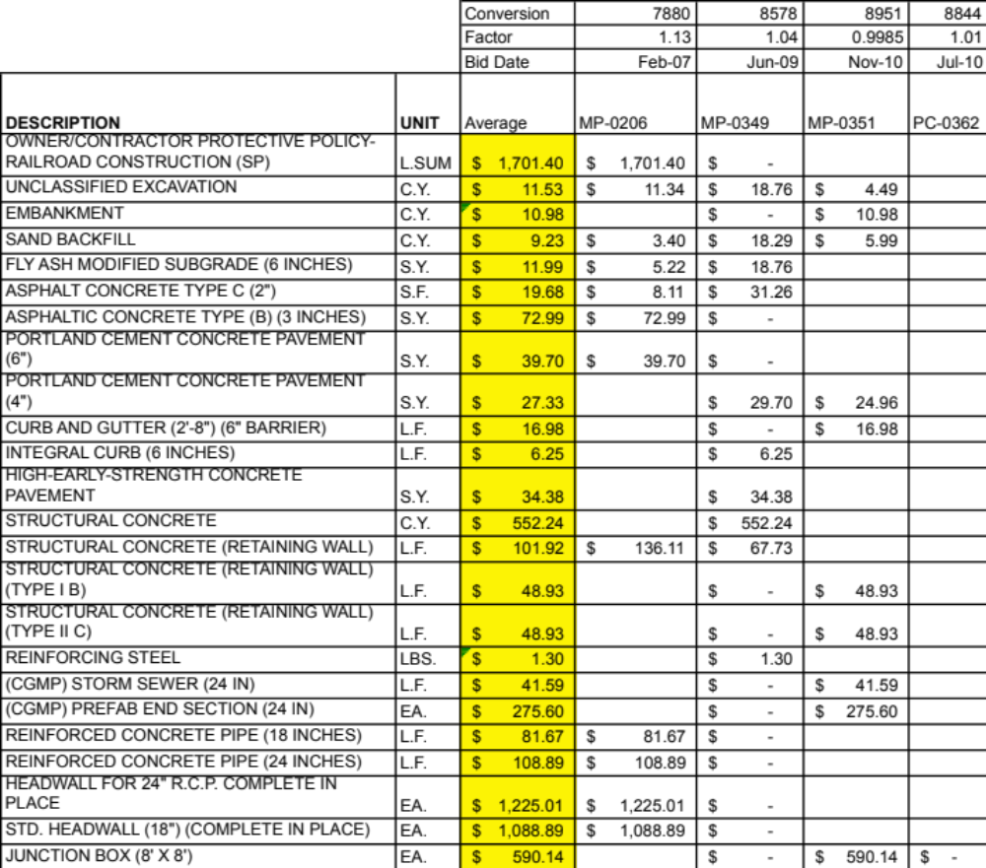

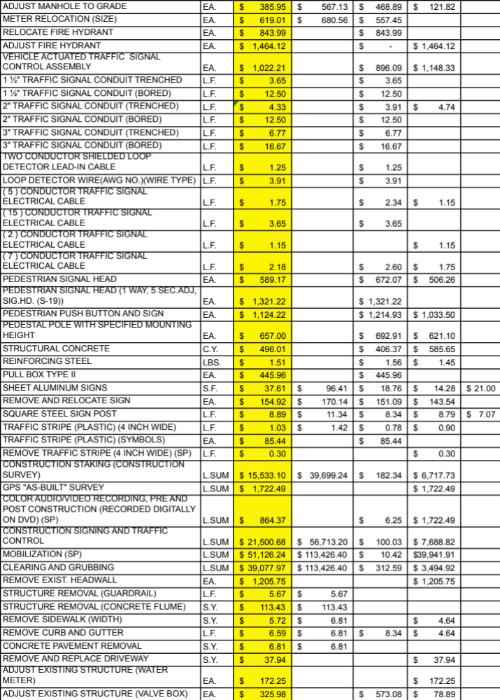

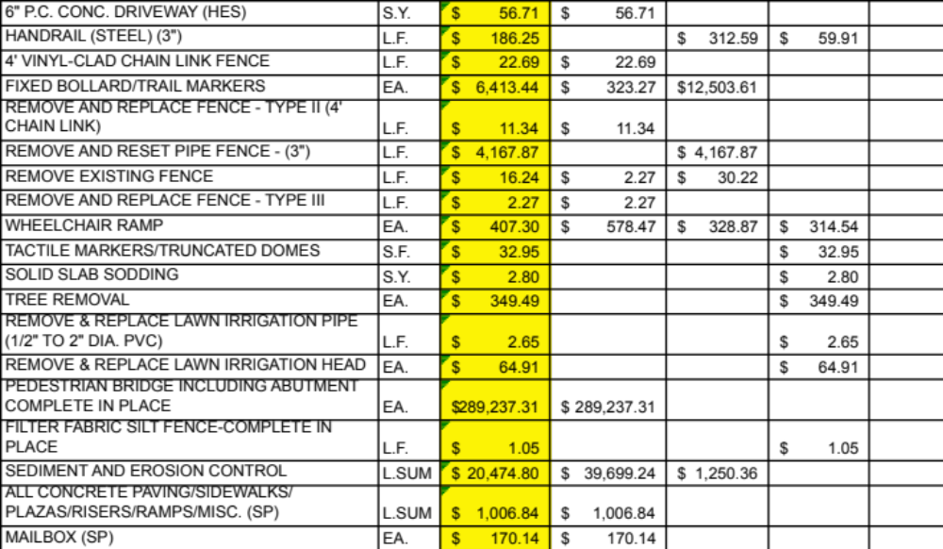

APPENDIX 5: DATA
Streetscape Project Bid Items
* Using the Engineering News-Record (ENR) Cost Index (Grogan 2011), the bid items were converted using the value of 8938 for March 2011 from the actual bid month and year. The conversion factor for each project is indicated below. The cost data includes the conversion. Items not used on these projects are not shown here.
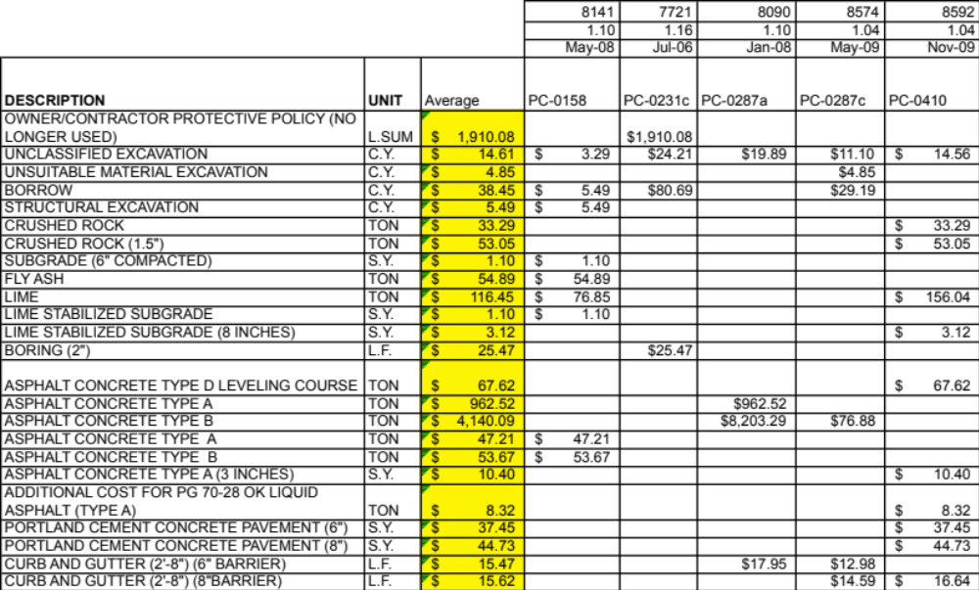

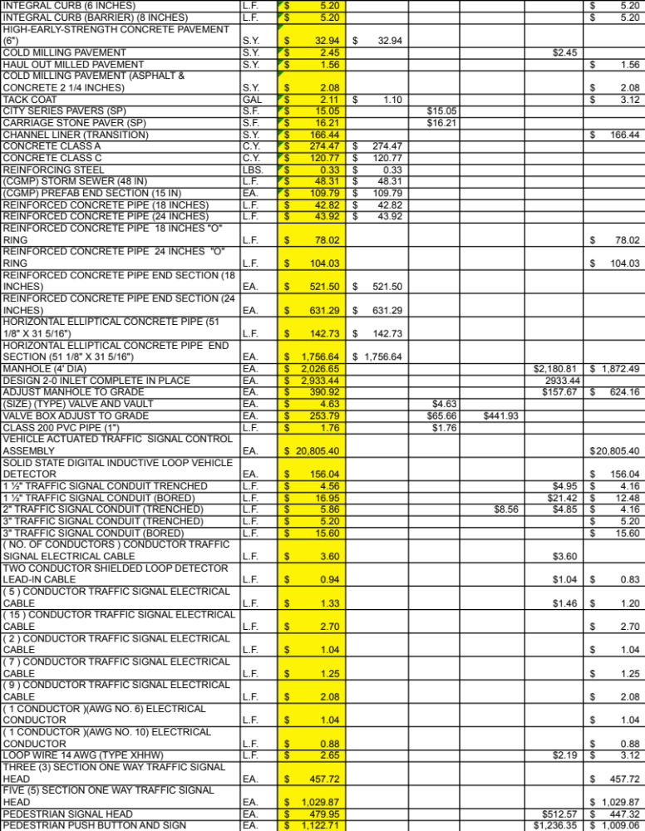

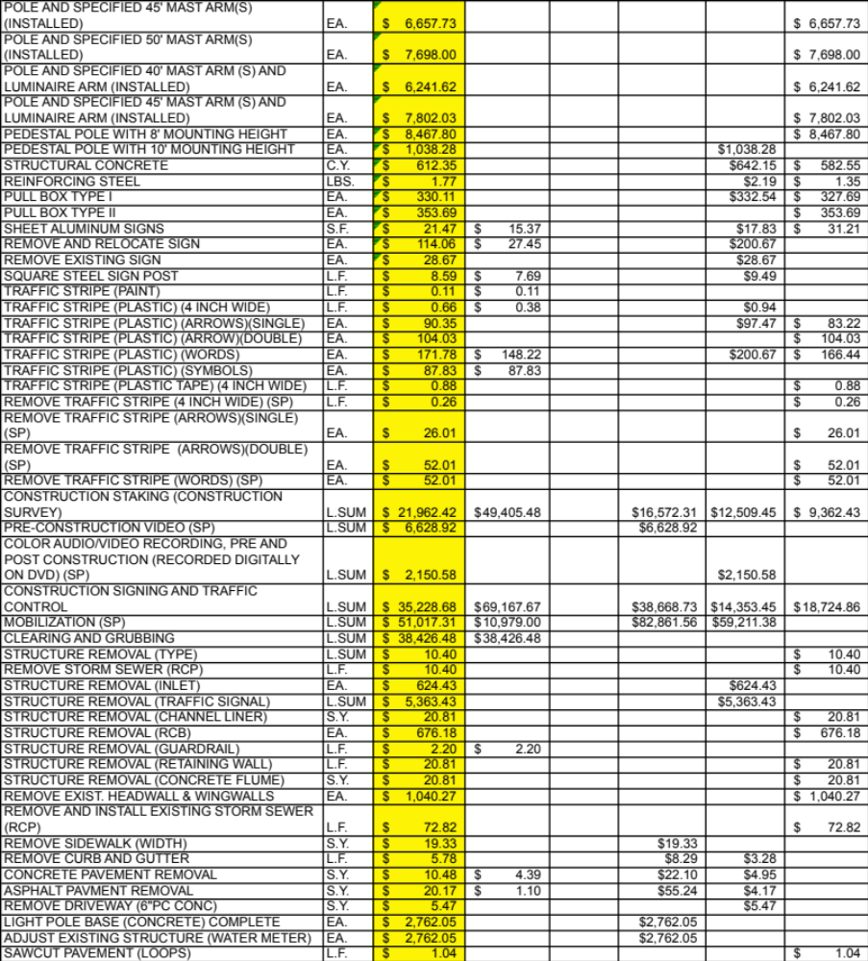

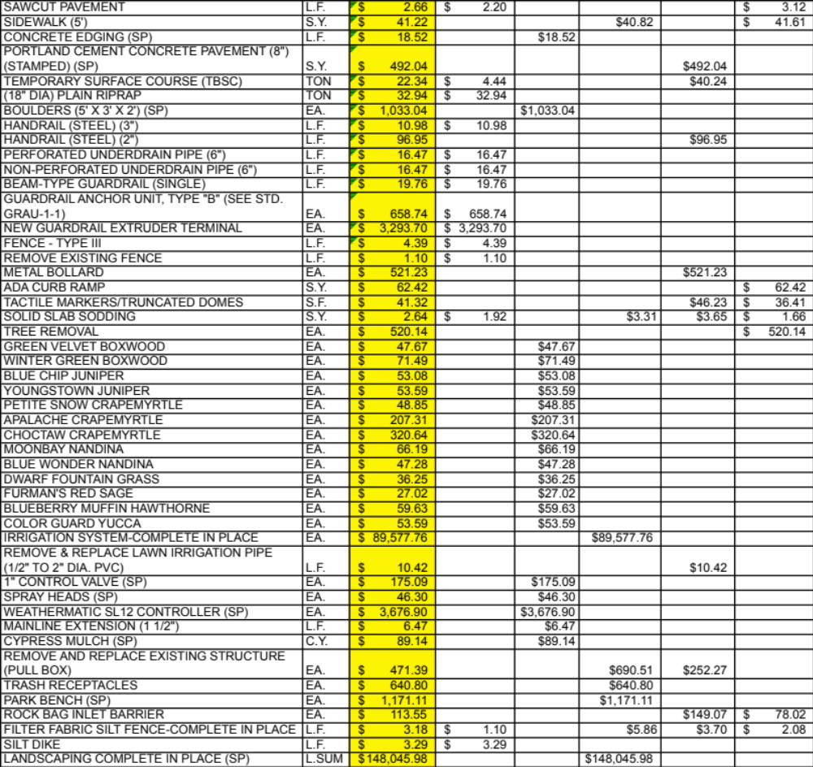

APPENDIX 6: DATA
Resurfacing Project Bid Items
* Using the Engineering News-Record (ENR) Cost Index (Grogan 2011), the bid items were converted using the value of 8938 for March 2011 from the actual bid month and year. The conversion factor for each project is indicated below. The cost data includes the conversion. Items not used on these projects are not shown here.
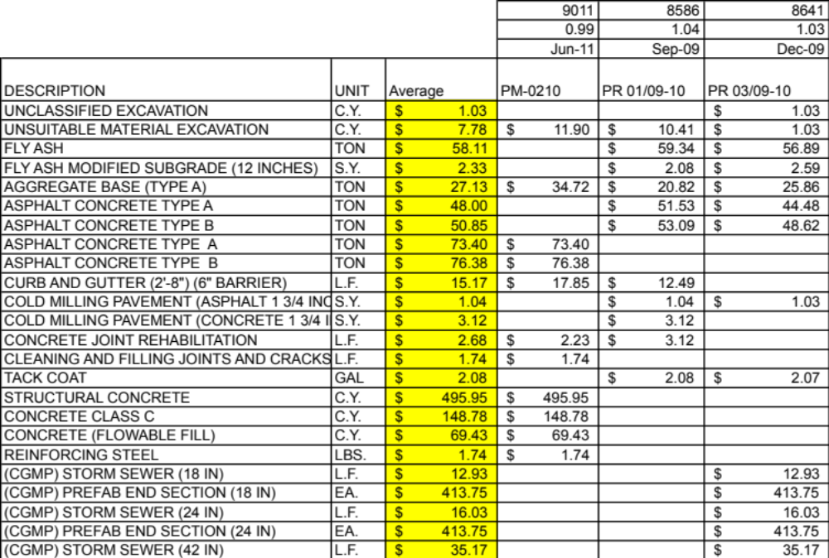

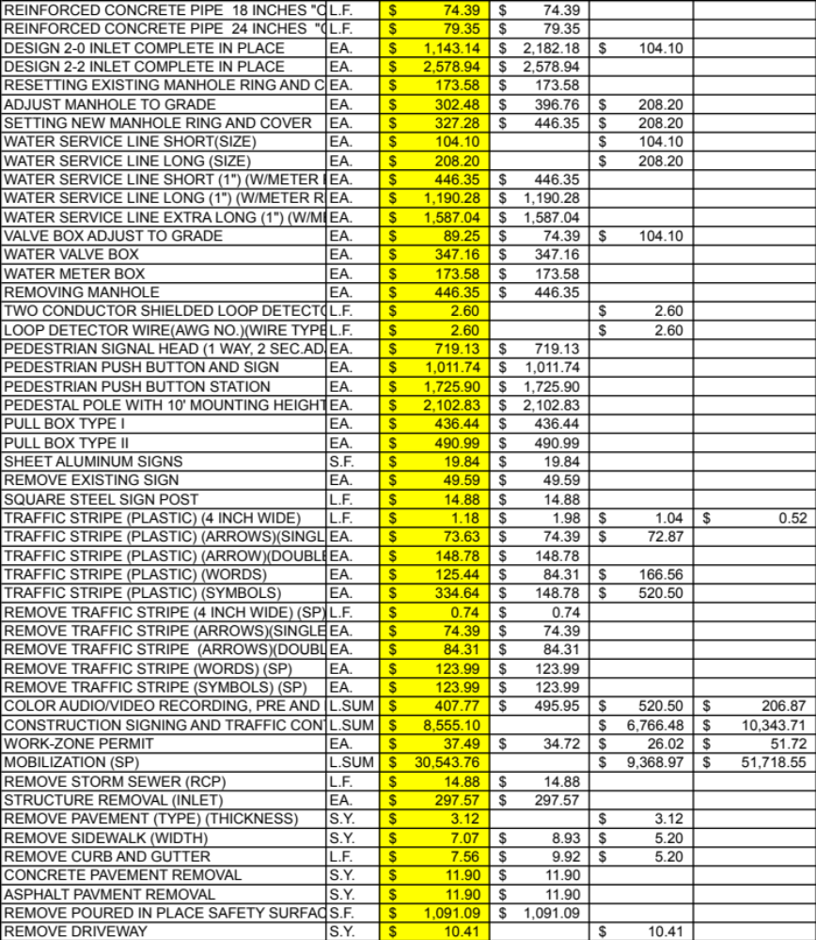

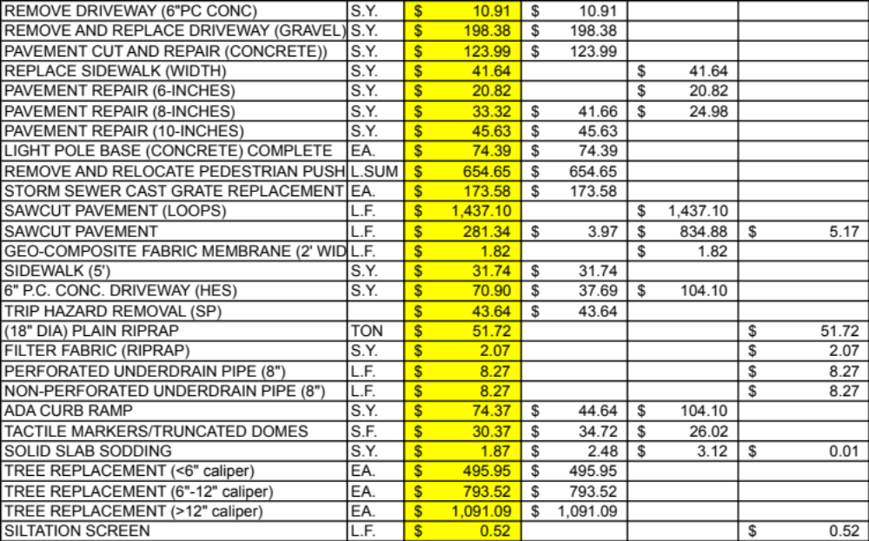

APPENDIX 7: DATA
Road Widening Project Bid Items
* Using the Engineering News-Record (ENR) Cost Index (Grogan 2011), the bid items were converted using the value of 8938 for March 2011 from the actual bid month and year. The conversion factor for each project is indicated below. The cost data includes the conversion. Items not used on these projects are not shown here.
The average shown is for all twelve road widening projects. It is shown on each page for simplicity. The first four are listed below.

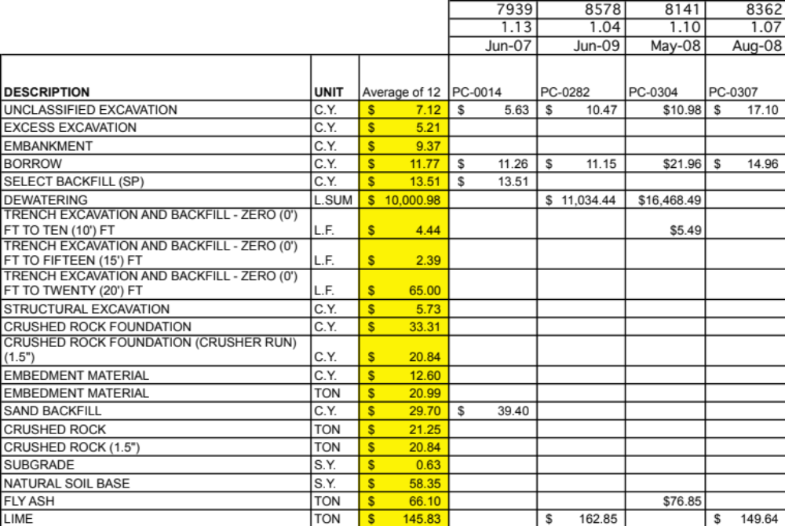
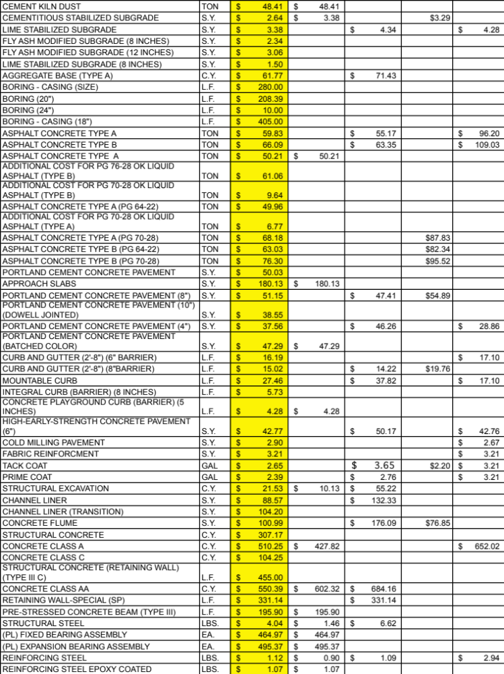

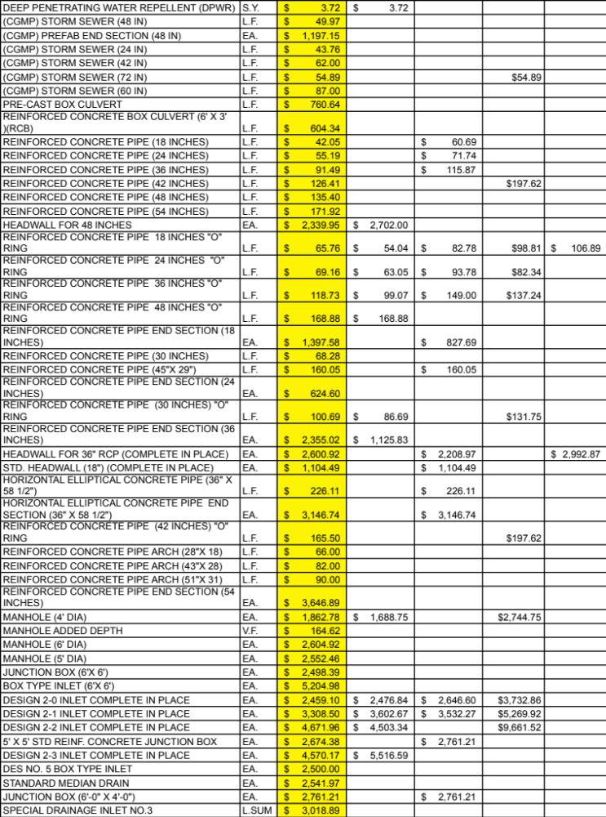

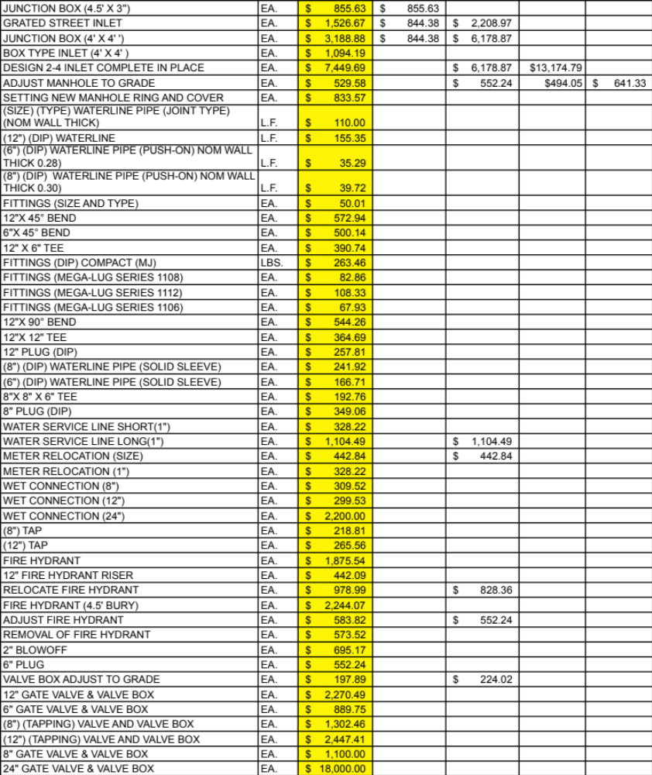
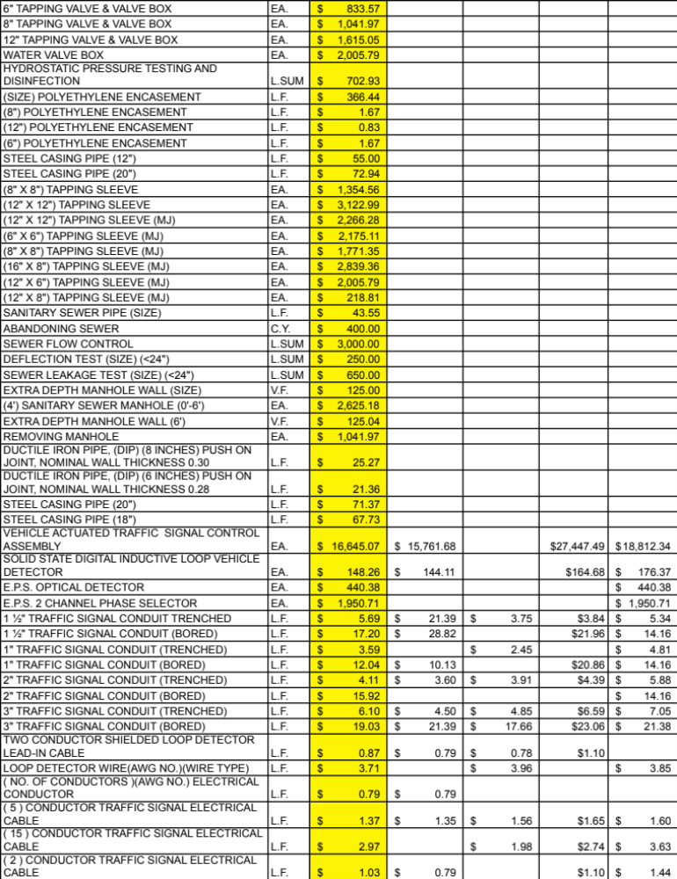

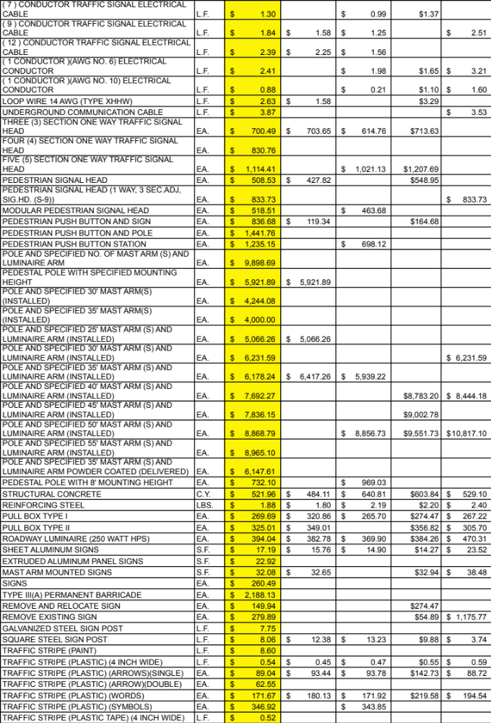
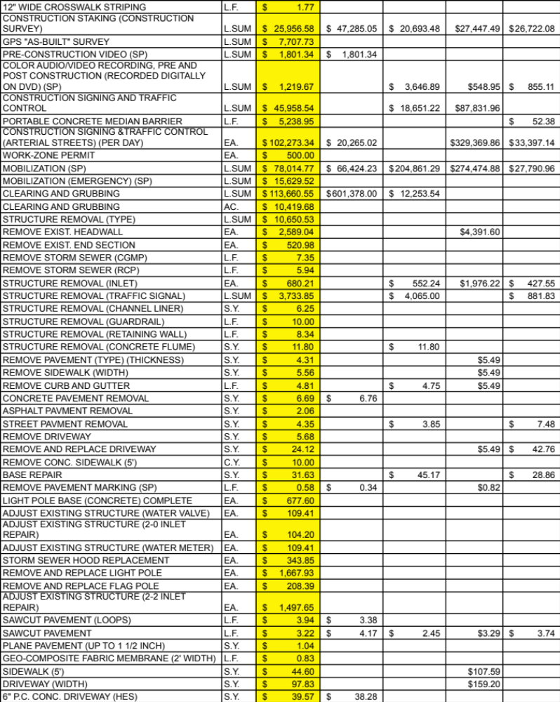
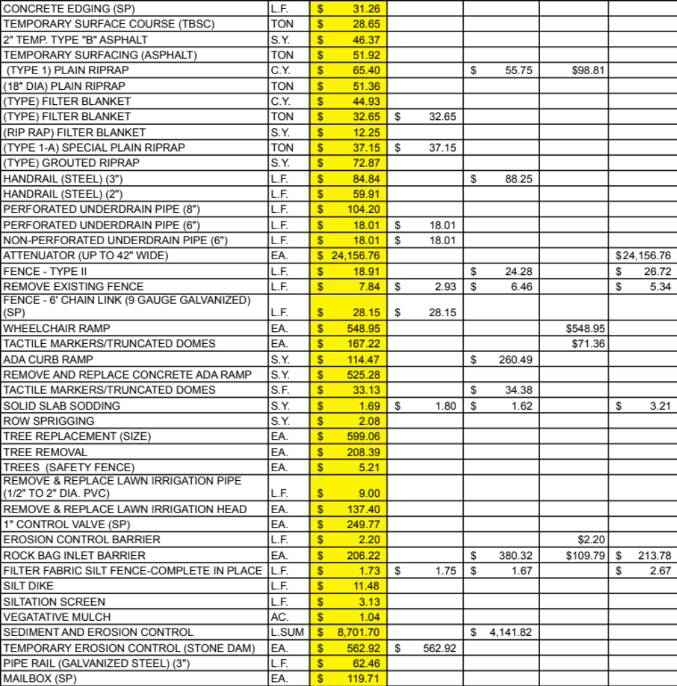

The average shown is for all twelve road widening projects. It is shown on each page for simplicity. The second group of four is listed below.
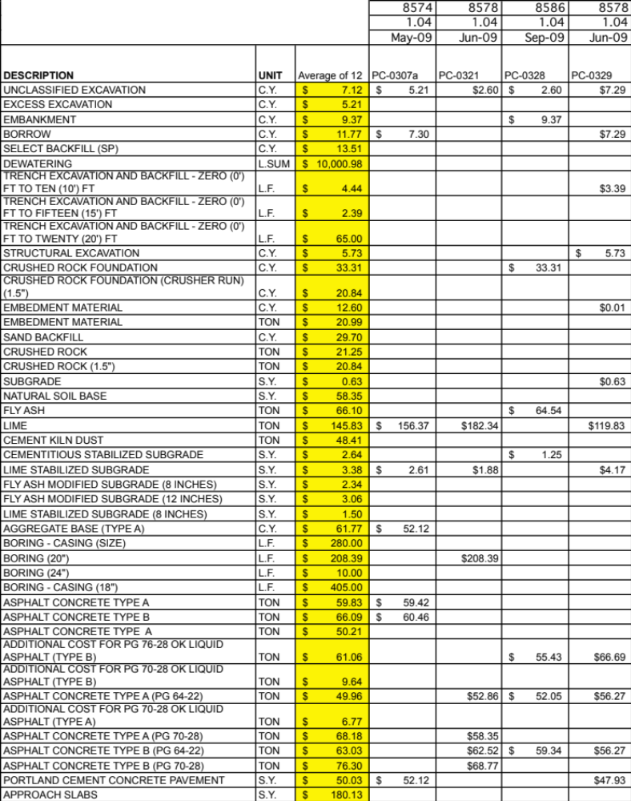
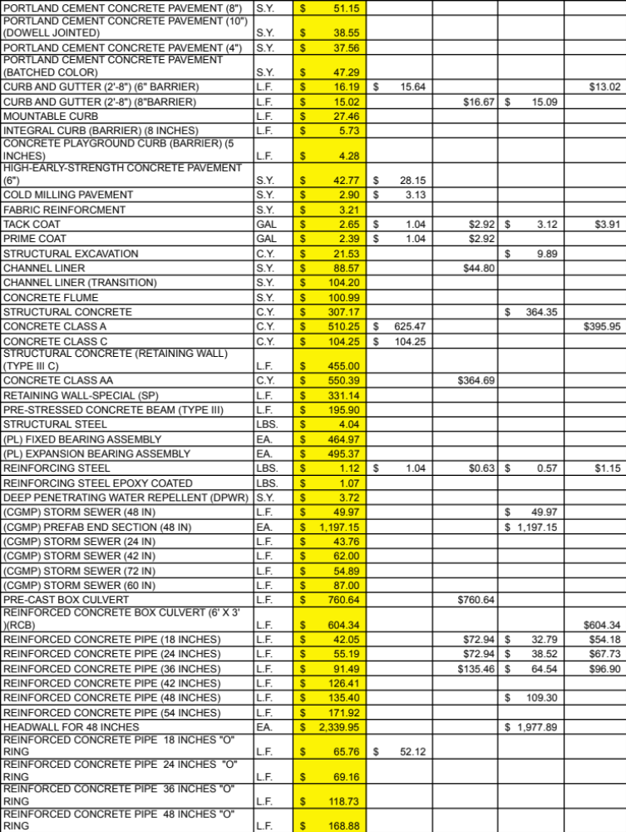

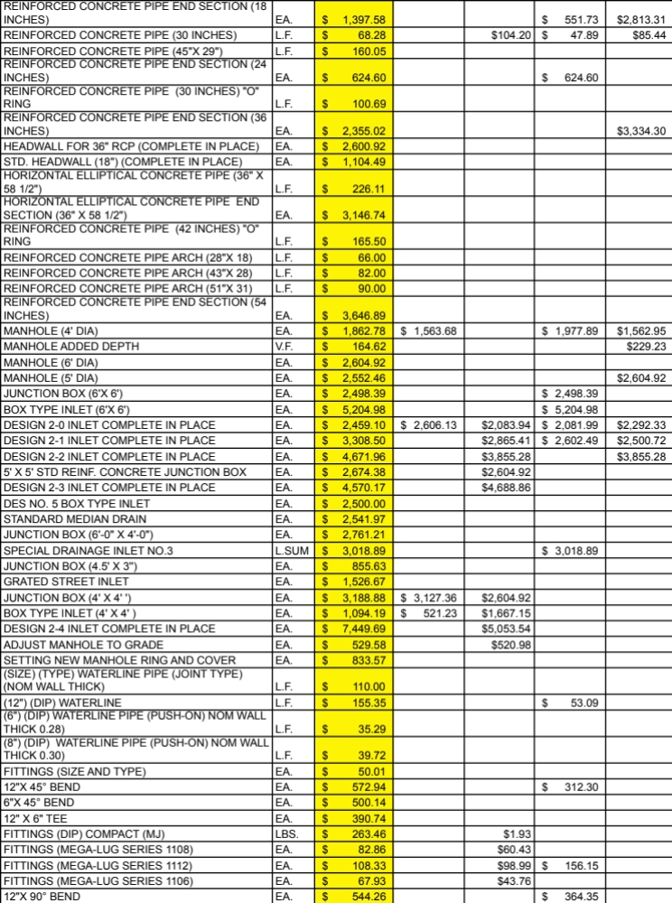

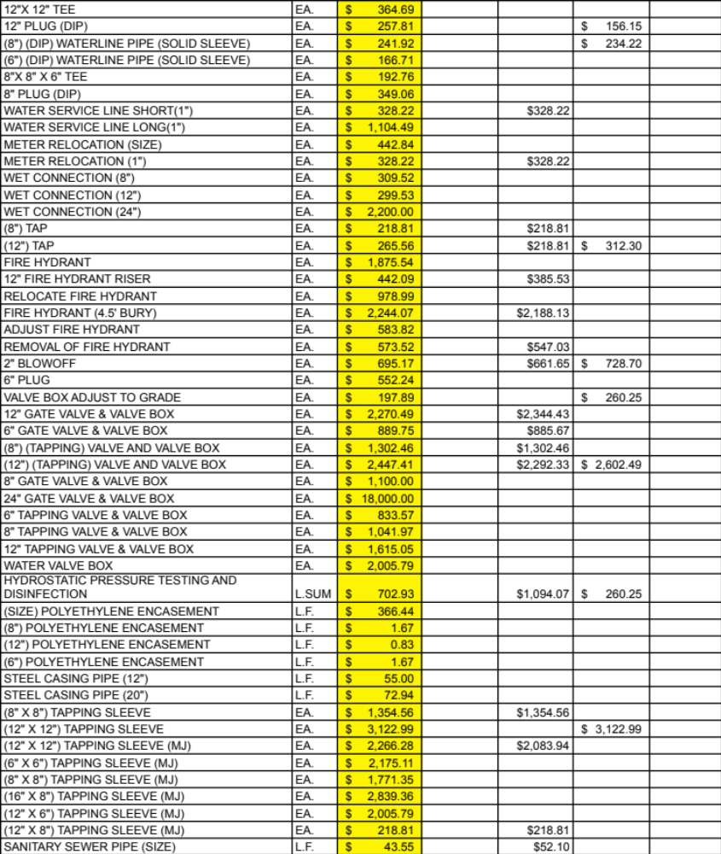

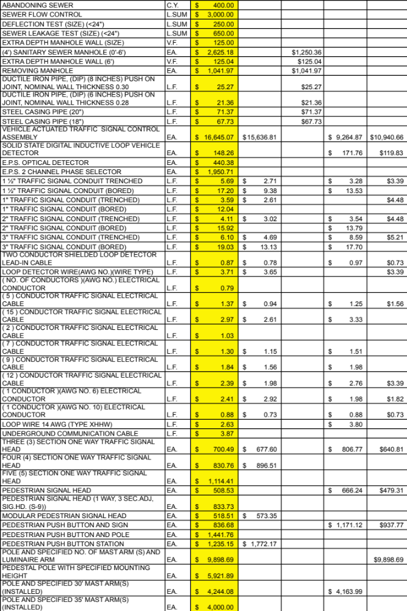
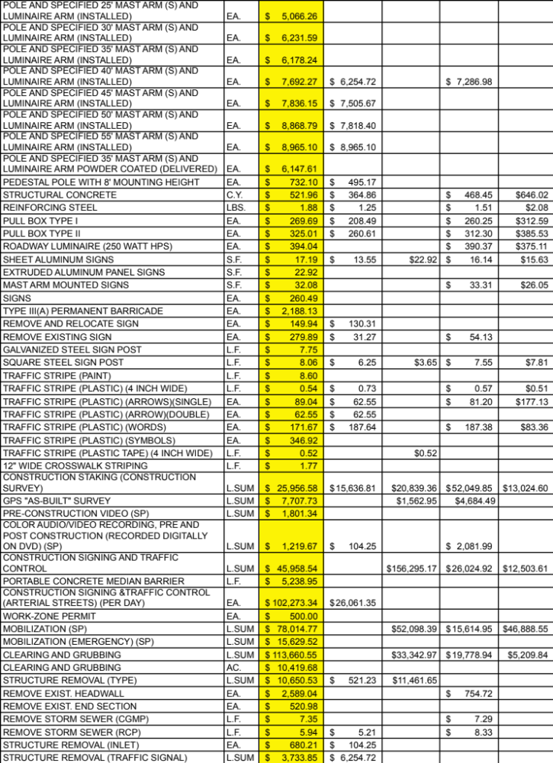

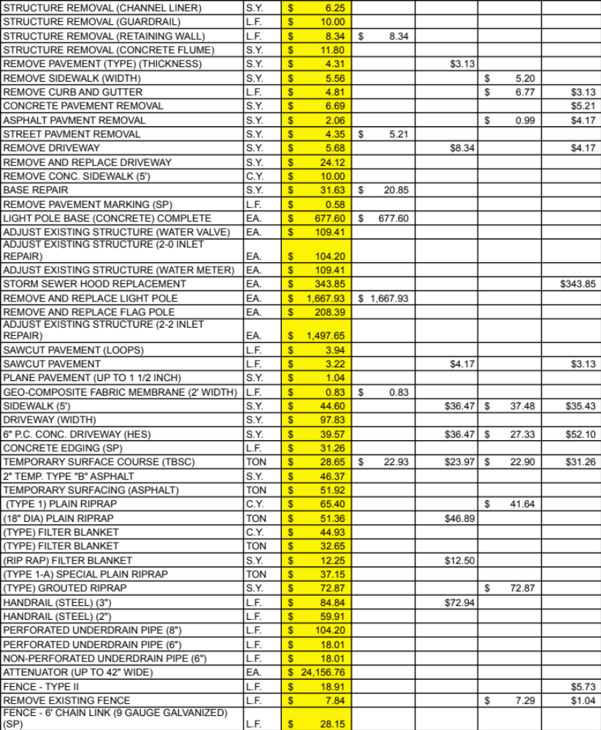

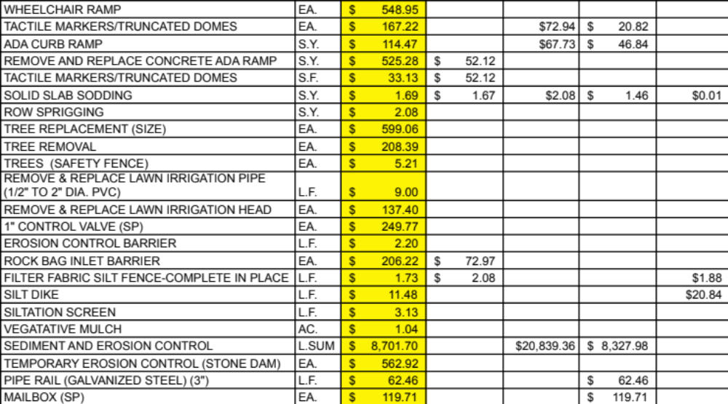

The average shown is for all twelve road widening projects. It is shown on each page for simplicity. The final four are listed below.
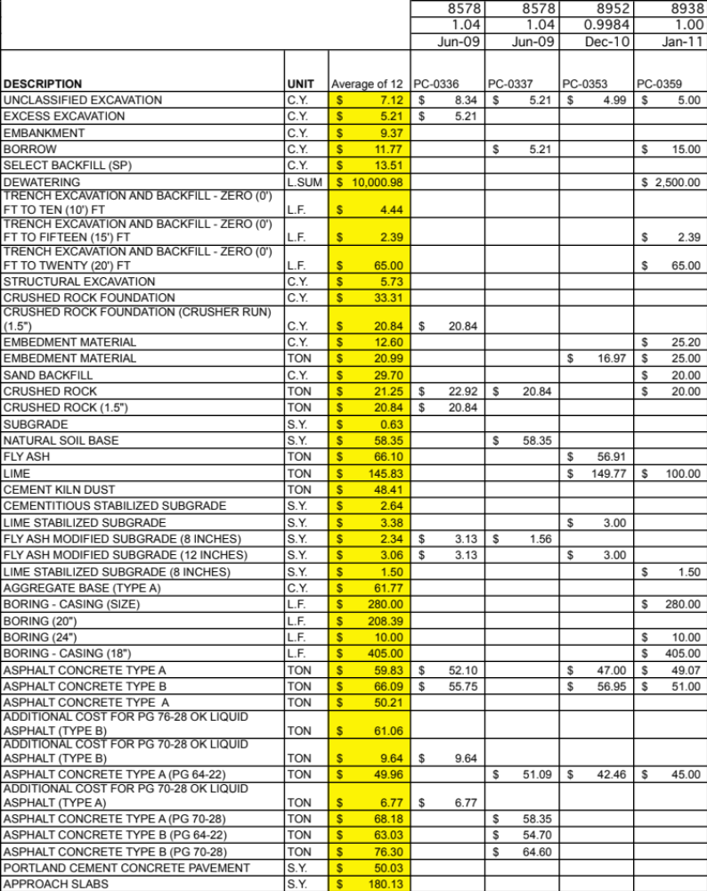

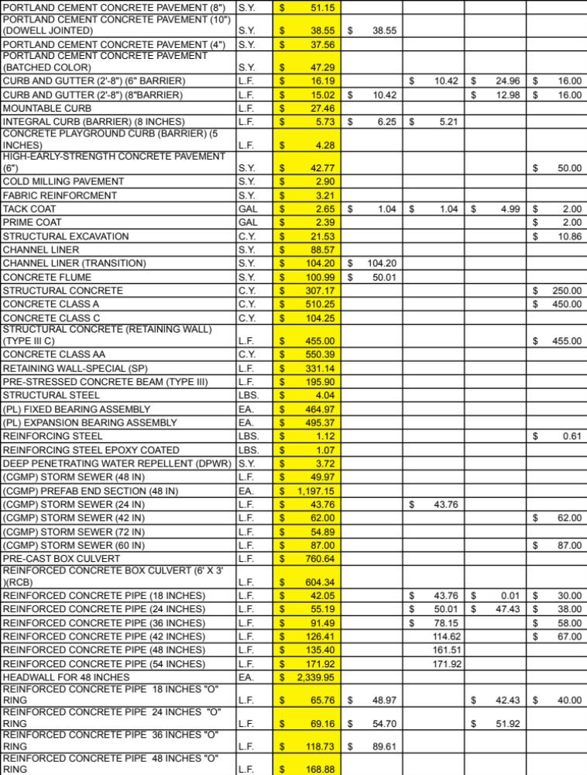

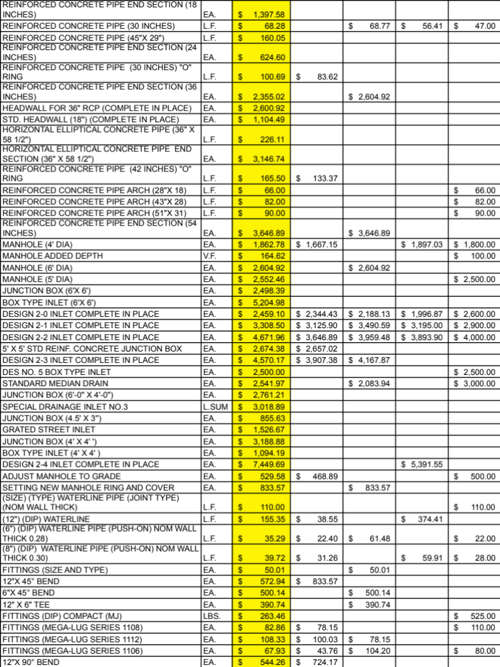

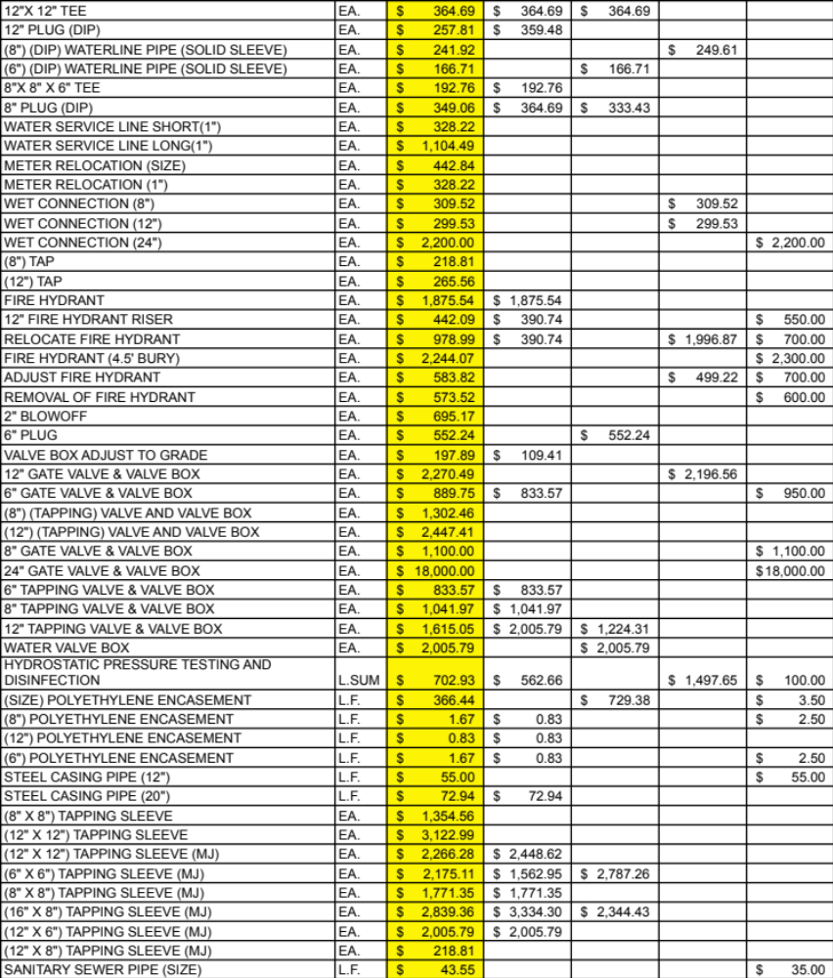

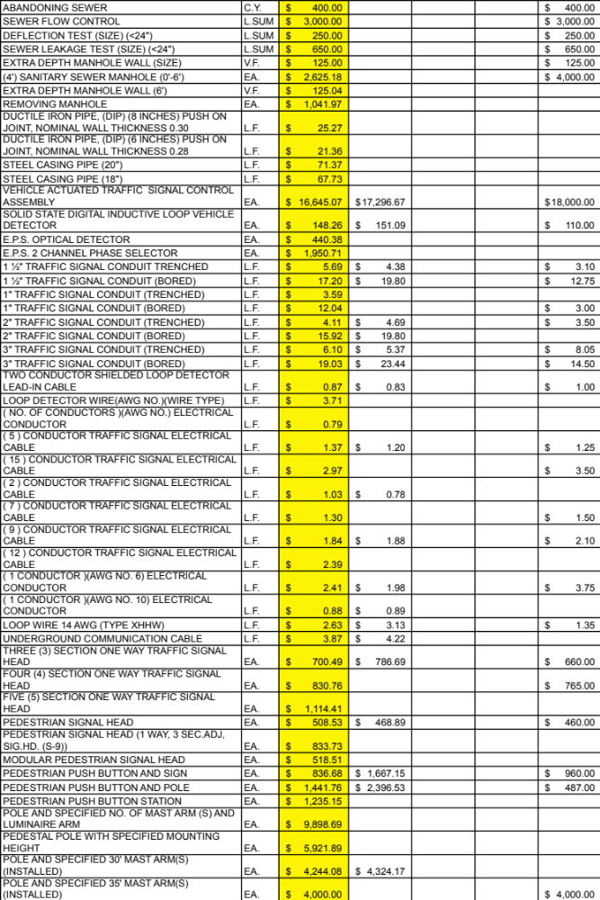
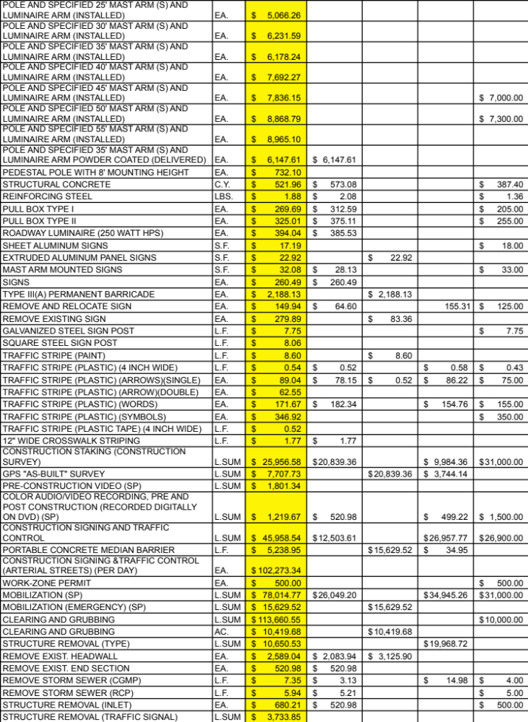

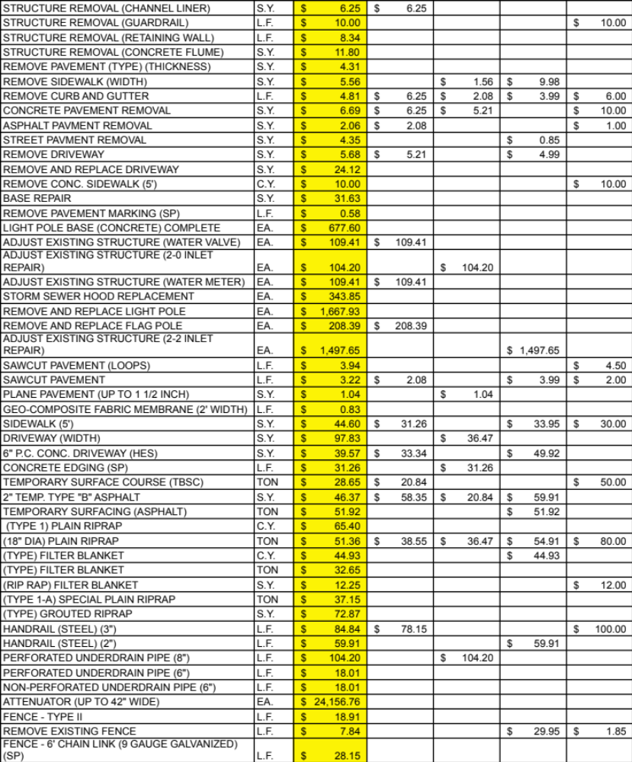

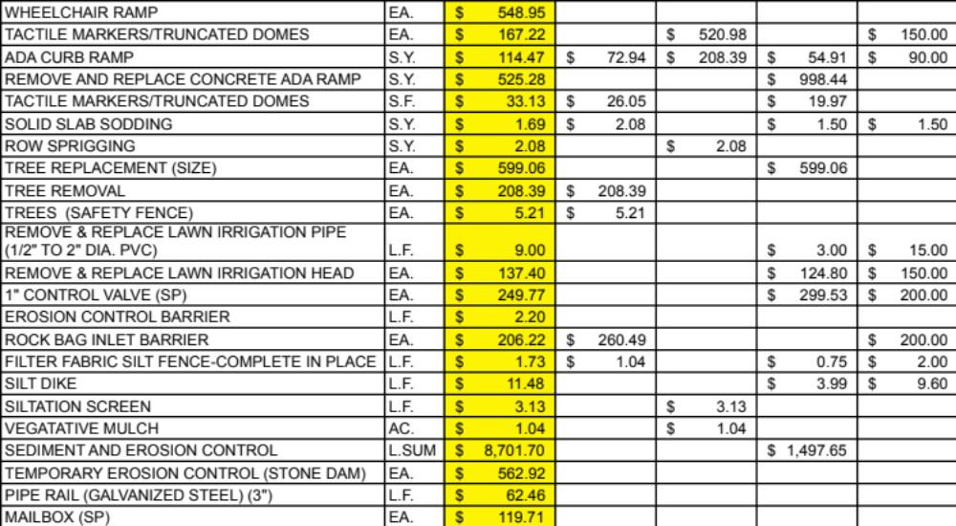

APPENDIX 8: LEED RATING SYSTEM CREDITS
(USGBC 2005)

SS | Sustainable Sites | Cost
PR1 | Construction activity Pollution Prevention | No
1 | Site selection | No
2 | Development Density and Community Connectivity | No
3 | Brownfield redevelopment | Yes
4.1 | Alternative transportation—Public transportation access | No
4.2 | Alternative transportation—Bicycle storage and Changing rooms | Yes
4.3 | Alternative transportation—Low-Emitting and fuel-Efficient vehicles | Yes
4.4 | Alternative transportation—Parking Capacity | No
5.1 | Site Development—Protect or restore Habitat | Yes
5.2 | Site Development—Maximize open space | No
6.1 | Stormwater Design—Quantity Control | Yes
6.2 | Stormwater Design—Quality Control | Yes
7.1 | Heat island Effect—Nonroof | Yes
7.2 | Heat island Effect—roof | Yes
8 | Light Pollution reduction | No
WE | Water Efficiency
PR1 | Water use reduction | No
1 | Water Efficient Landscaping | No
2 | Innovative wastewater technologies | Yes
3 | Water use reduction | Yes
EA | Energy and Atmosphere
PR1 | Fundamental Commissioning of Building Energy systems | Yes
PR2 | Minimum Energy Performance | Yes
PR3 | Fundamental Refrigerant Management | No
1 | Optimize Energy Performance | No
2 | On-site Renewable Energy | Yes
3 | Enhanced Commissioning | Yes
4 | Enhanced Refrigerant Management | Yes
5 | Measurement and Verification | No
6 | Green Power | No

MR | Materials & Resources
PR1 | Storage and Collection of Recyclables | No
1.1 | Building reuse—Maintain Existing walls, floors and roof | Yes
1.2 | Building reuse—Maintain Existing interior Nonstructural Elements | Yes
2 | Construction waste Management | Yes
3 | Materials Reuse | Yes
4 | Recycled Content | No
5 | Regional Materials | Yes
6 | Rapidly Renewable Materials | Yes
7 | Certified wood | Yes
IEQ | Indoor Environmental Quality
PR1 | Minimum indoor air Quality Performance | Yes
PR2 | Environmental Tobacco Smoke (Ets) Control | Yes
1 | Outdoor Air Delivery Monitoring | No
2 | Increased ventilation | No
3.1 | Construction indoor air Quality Management Plan—During Construction | Yes
3.2 | Construction indoor air Quality Management Plan—Before occupancy | Yes
4.1 | Low-Emitting Materials—adhesives and sealants | Yes
4.2 | Low-Emitting Materials—Paints and Coatings | Yes
4.3 | Low-Emitting Materials—flooring systems | Yes
4.4 | Low-Emitting Materials—Composite wood and agrifiber Products | Yes
5 | Indoor Chemical and Pollutant source Control | Yes
6.1 | Controllability of systems—Lighting | Yes
6.2 | Controllability of systems—thermal Comfort | Yes
7.1 | Thermal Comfort—Design | No
7.2 | Thermal Comfort—verification | No
8.1 | Daylight and views—Daylight | No
8.2 | Daylight and views—views | No
ID | Innovation in Design
1 | Innovation in Design | No
2 | LEED Accredited Professional | No
RP | Regional Priority
1 | Regional Priority | No

APPENDIX 9: Sustainable Sites Initiative Rating System
Credits (SITES 2009a)

1 | Site Selection | Cost
PR1.1 | Limit farmland development | No
PR1.2 | Protect floodplain functions | No
PR1.3 | Preserve wetlands | Yes
PR1.4 | Preserve species | Yes
1.5 | Brownfeld/Greyfield redevelopment | Yes
1.6 | Sites within existing communities | No
1.7 | Sites to encourage alternate modes of transportation | No
2 | Pre-design Assessment & Planning
PR2.1 | Pre-design Assessment & site sustainability | No
PR2.2 | Integrated site development | No
2.3 | Engage users & stakeholders | No
3 | Site Design - Water
PR3.1 | Reduce potable water use for landscape irrigation by 50% | Yes
3.2 | Reduce potable water use for landscape irrigation by 75% | Yes
3.3 | Protect/restore riparian, wetland and shorelines | Yes
3.4 | Rehabilitate lost streams, wetlands and shorelines | Yes
3.5 | Manage on-site stormwater | Yes
3.6 | Protect/enhance on-site water resources and water quality | Yes
3.7 | Design rain/stormwater features to provide landscape amenity | Yes
3.8 | Maintain water features to conserve water and other resources | No
4 | Site Design - Soil & Vegetation
PR4.1 | Control/Manage known invasive plants found on site | Yes
PR4.2 | Use appropriate, non-invasive plants | No
PR4.3 | Create a soil management plan | Yes
4.4 | Minimize soil disturbance in design/construction | Yes
4.5 | Preserve all vegetation designated as special status | Yes
4.6 | Preserve/restore appropriate plan biomass on site | Yes
4.7 | Use native plants | No
4.8 | Preserve plant communities native to the ecoregion | Yes
4.9 | Restore plant communities native to the ecoregion | No

4.10 | Use vegetation to minimize building heating requirements | No
4.11 | Use vegetation to minimize building cooling requirements | No
4.12 | Reduce urban heat island effects | Yes
4.13 | Reduce the risk of catastrophic wildfire | No
5 | Site Design - Materials Selection
PR5.1 | Eliminate the use of wood from threatened tree species | No
5.2 | Maintain on-site structures, hardscape, and landscape amenities | Yes
5.3 | Design for deconstruction and disassembly | Yes
5.4 | Reuse salvaged materials and plants | Yes
5.5 | Use recycled content materials | No
5.6 | Use certified wood | Yes
5.7 | Use regional materials | No
5.8 | Use adhesives, sealants, paints and coatings with reduced VOC emissions | Yes
5.9 | Support sustainable practices in plant production | Yes
5.10 | Support sustainable practices in materials manufacturing | Yes
6 | Site Design - Human Health and Well-Being
6.1 | Promote equitable site development | No
6.2 | Promote equitable site use | No
6.3 | Promote sustainability awareness and education | No
6.4 | Protect/maintain unique cultural/historical places | No
6.5 | Provide for optimum site accessibility, safety & wayfinding | Yes
6.6 | Provide opportunities for outdoor physical activity | No
6.7 | Provide views of vegetation and quiet outdoor spaces for mental restoration | No
6.8 | Provide outdoor spaces for social interaction | No
6.9 | Reduce light pollution | No
7 | Construction
PR7.1 | Control/retain construction pollutants | No
PR7.2 | Restore soils disturbed during construction | Yes
7.3 | Restore soils disturbed by previous development | Yes
7.4 | Divert construction/demolition materials from disposal | Yes
7.5 | Reuse/recycle vegetation, rocks, and soil generated during construction | Yes
7.6 | Minimize generation of greenhouse gas emissions/exposure to localized air pollutants during construction | Yes

8 | Operations & maintenance
PR8.1 | Plan for the sustainable site maintenance | No
PR8.2 | Provide for storage and collection of recyclables | No
8.3 | Recycle organic matter generated during site operations/maintenance | No
8.4 | Reduce outdoor energy consumption for all landscape/exterior operations | No
8.5 | Use renewable sources for landscape electricity needs | No
8.6 | Minimize exposure to environmental tobacco smoke | Yes
8.7 | Minimize generation of greenhouse gases/exposure to localized air pollution during landscape maintenance activities | No
8.8 | Reduce emissions/promote the use of fuel-efficient vehicles | No
9 | Monitoring and Innovation
9.1 | Monitor performance of sustainable design practices | No
9.2 | Innovation in site design | No

APPENDIX 10: Greenroads Rating System Credits
(Muench et al, 2010)

PR | Project Requirements | Cost
PR-1 | Environmental Review Process | No
PR-2 | Life Cycle Cost Analysis (LCCA) | No
PR-3 | Life Cycle Inventory (LCI) | No
PR-4 | Quality Control Plan | Yes
PR-5 | Noise Mitigation Plan | Yes
PR-6 | Waste Management Plan | Yes
PR-7 | Pollution Prevention Plan | No
PR-8 | Low-Impact Development (LID) | No
PR-9 | Pavement Management System | No
PR-10 | Site Maintenance Plan | No
PR-11 | Educational Outreach | No
EW | Environment & Water
EW-1 | Environmental Management System | No
EW-2 | Runoff Flow Control | No
EW-3 | Runoff Quality | Yes
EW-4 | Stormwater Cost Analysis | No
EW-5 | Site Vegetation | Yes
EW-6 | Habitat Restoration | Yes
EW-7 | Ecological Connectivity | Yes
EW-8 | Light Pollution | No
AE | Access & Equity
AE-1 | Safety Audit | No
AE-2 | Intelligent Transportation Systems (ITS) | Yes
AE-3 | Context Sensitive Solutions | Yes
AE-4 | Traffic Emissions Reduction | No
AE-5 | Pedestrian Access | No
AE-6 | Bicycle Access | Yes
AE-7 | Transit & HOV Access | Yes
AE-8 | Scenic Views | Yes
AE-9 | Cultural Outreach | Yes
CA | Construction Activities
CA-1 | Quality Management System | Yes
CA-2 | Environmental Training | Yes
CA-3 | Site Recycling Plan | Yes
CA-4 | Fossil Fuel Use Reduction | Yes
CA-5 | Equipment Emission Reduction | Yes
CA-6 | Paving Emission Reduction | Yes
CA-7 | Water Use Tracking | Yes
CA-8 | Contractor Warranty | Yes
MR | Materials & Resources
MR-1 | Life Cycle Assessment (LCA) | No
MR-2 | Pavement Reuse | Yes
MR-3 | Earthwork Balance | Yes
MR-4 | Recycled Materials | Yes
MR-5 | Regional Materials | Yes
MR-6 | Energy Efficiency | Yes
PT | Pavement Technologies
PT-1 | Long-Life Pavement | Yes
PT-2 | Permeable Pavement | Yes
PT-3 | Warm Mix Asphalt (WMA) | Yes
PT-4 | Cool Pavement | Yes
PT-5 | Quiet Pavement | Yes
PT-6 | Pavement Performance Tracking | Yes
CC | Custom Credits | No
CC-1 | Custom Credits | No

APPENDIX 11: GreenLITES Rating System Credits
(NYSDOT 2010)

S-1: | Alignment Selection | Cost
a) | Avoidance undeveloped lands | No
b) | Minimum 100-foot buffer zone to watercourse or wetland | No
c) | Minimize overall construction “footprint” | No
d) | Vertical alignments to minimize earthwork | Yes
e) | Alignment to minimize impacts to social/environmental resources | No
f) | Alignments that optimize benefits among competing constraints | No
g) | Micro-adjustments to provide sufficient clear area for tree planting | No
h) | Clear zones seeded to reduce maintenance needs/increase carbon sequestration | No
i) | Provide a depressed roadway alignment | Yes
j) | Soil nails to stabilize a slope | Yes
S-2: | Context Sensitive Solutions
a) | Respond to the unique character or sense of place of the area | No
b) | Incorporate local/natural materials for substantial visual elements | Yes
c) | Visual enhancements | No
d) | Period street furniture/lighting/appurtenances | Yes
e) | Inclusion of visually contrasting pedestrian crosswalk treatments. | Yes
f) | Item removed, purposely left blank. | No
g) | Incorporate the NYS Bridge Manual, Section 23 - Aesthetics | No
h) | Site materials selection/detailing to reduce “heat island” effect | No
i) | Permanently protect viewsheds through environmental/conservation easements | No
j) | Color anodizing of aluminum elements | Yes
k) | Decorative bridge fencing | Yes
l) | Use of concrete form liners | Yes
m) | Imprinting/tinting concrete/asphalt mow strips, gores and/or snow storage areas | Yes
S-3: | Land Use/Community Planning
a) | Use of more engaging public participation techniques | No
b) | Enhanced outreach efforts | No
c) | Projects better enabling use of public transit | No
d) | Apply “Walkable Communities” and/or “Complete Streets” concepts | Yes
e) | Increase transportation efficiencies for freight by dedicated rail, intermodal facilities or unit trains | No
f) | Agreement with public/private entities for environmental betterment, technological advancement, or financial assistance/relief to the department | No
g) | Local and regional plans beyond those generated by the MPO | No
h) | Project reports and community outreach materials available online beyond project-specific Web page | No
i) | Item deleted, keep as place holder. | No
j) | Establishment of recreational access facility | No
k) | Establishment of a new recreational facility like pocket park, roadside overlook, roadside picnic rest area, etc. | No
l) | Enhance existing recreational facility or facilities’ access | No
S-4: | Protect, Enhance or Restore Wildlife Habitat
a) | Consolidate stream, wetland or ecological mitigation areas, or dedicated “eco viaducts” | No
b) | Enhancements to existing wildlife habitat | Yes
c) | Partial mitigation of habitat fragmentation by over-sizing culverts for wildlife passage | Yes
d) | Use of natural-bottomed culverts | Yes
e) | Wildlife crossing structures for safe passage of wildlife across highways | Yes
f) | Wetland restoration, enhancement, or establishment above and beyond a wetland-related permit | Yes
g) | Minimize use of lands that are part of a significant contiguous wildlife habitat | No
h) | Use of wildlife mortality reduction measures such as right-of-way fence, moose signs, etc. | Yes
i) | Item deleted, keep as place holder | No
j) | Item deleted, keep as place holder | No
k) | Stream restoration/enhancement | Yes
l) | Installation of mowing markers to protect natural areas and wetlands | Yes
m) | Scheduling/logistic requirements to avoid disrupting wildlife nesting/breeding activities | Yes
n) | Permanently protect new or expanded habitat through an environmental or conservation easement | No
S-5: | Protect, Plant or Mitigate for Removal of Trees and Plant Communities | Yes
a) | Avoidance/protection of significant contiguous stands of established, desirable trees and/or vegetation communities | No
b) | Designs which demonstrate an anticipated ultimate net increase in tree canopy cover within the project limits | Yes
c) | Re-establishment/expansion of native vegetation into reclaimed work areas or abandoned roadway alignments. | Yes
d) | Use of trees, large shrubs or other suitable vegetation | Yes
e) | Use of native species for seed mixes and other plantings | No
f) | Avoidance/protection of individual significant trees and localized areas of established desirable vegetation | Yes
g) | No ultimate net loss of tree canopy within the project limits or mitigation with trees to the extent possible for trees lost | Yes
h) | Planting trees, shrubs and/or plant material in lieu of traditional turf grass | Yes
i) | Removal of undesirable plant species to preserve desirable overall species diversity | Yes
j) | Preserving, replacing, or enhancing vegetation to maintain the character of unique areas | Yes
W-1: | Stormwater Management (Volume and Quality)
a) | Improve water quality/habitat by stream restoration, additional wetlands protection, and permanent stormwater management practices | Yes
b) | Eliminate discharges from unpermitted sources which enter or flows to the right-of-way | No
c) | Demonstrate pollutant loading reductions to adjacent water resources by Best Management Practices (BMPs) | No
d) | Reduction in overall impervious area | Yes
e) | Item deleted, keep as place holder. | No
f) | Staged construction for less than five acres of bare soil exposed and site runoff is controlled | Yes
g) | Documenting non-stormwater discharges from unpermitted sources but cannot be eliminated | No
W-2: | Best Management Practices (BMPs)
a) | Use of highly permeable soils for infiltration trenches or basins, bioretention cells or rain gardens, grass buffers | Yes
b) | Use of other structural BMPs including wet or dry swales, sand filters, filter bag, stormwater treatment systems | Yes
c) | Inclusion of “permeable pavement” such as grid pavers | Yes
d) | Minimize the project's overall impervious surface area increase | No
e) | Include grass channels | Yes
f) | Designate a qualified environmental construction monitor to provide construction oversight | No
M-1: | Reuse of Materials
a) | 75% or more of topsoil removed for grading is reused on site | Yes
b) | Design the project so that “cut-and-fills” are balanced to within 10 percent | Yes
c) | Reuse of excess fill (“spoil”) within the project corridor | Yes
d) | Specify rubblizing or crack and seating of Portland Cement Concrete pavement | Yes
e) | Reuse of previous pavement as subbase during full-depth reconstruction projects | Yes
f) | Reuse of excess excavated material, asphalt pavement millings, or demolished concrete | Yes
g) | Processing of demolished concrete to reclaim scrap metals and create a usable aggregate | Yes
h) | Salvaging removed trees for lumber or similar uses other than standard wood-chipping | Yes
i) | Surplus excavated material on nearby highways for slope flattening/eliminate guide rail or fill | Yes
j) | Surplus excavated material, concrete, or millings at nearby abandoned quarries for approved DEC reclamation plan | Yes
k) | Specify that 50% or more of topsoil removed for grading is reused on site | Yes
l) | Design the project so that cut and fills are balanced to within 25 percent | Yes
m) | Reuse of granite curbing | Yes
n) | Reuse of elements of the previous structure | Yes
o) | Designing an on-site location for chipped wood waste disposal from clearing and grubbing operations | Yes
q) | Make scrap metals available for reuse or recycling | Yes
p) | Specifying the recycling of chipped untreated wood waste for use as mulch and/or ground cover | Yes
M-1: | Reuse of Materials Continued
r) | Identify approved, environmentally acceptable and permitted sites for disposal of surplus excavated material | Yes
s) | Implement a project specific DEC Beneficial Use Determination for re-use of otherwise waste material from New York State | Yes
t) | Specify the salvage and/or moving of houses rather than demolition for disposal in landfills | Yes
u) | Reuse of major structural elements such as bridge piers, bridge structure, etc. | Yes
M-2: | Recycled Content
a) | Use tire shreds in embankments | Yes
b) | Use recycled plastic extruded lumber or recycled tire rubber | Yes
c) | Specify hot-in-place or cold-in-place recycling of hot mix asphalt pavements | Yes
d) | Recycled glass pavements and embankments as drainage material or filter media | Yes
e) | Specify asphalt pavement mixes containing Recycled Asphalt Pavement (RAP) | Yes
f) | Specify Portland cement pavement mixes containing Recycled Concrete Aggregate (RCA) | Yes
g) | Use crumb rubber or recycled plastic for noise barrier material | Yes
h) | Use of Porous Pavement Systems in light duty use situations | Yes
M-3: | Locally Provided Material
a) | Specify locally available natural light weight fill; Geotechnical staff to help in locating | Yes
b) | Specify local seed stock and plants | Yes
M-4: | Bioengineering Techniques
a) | Utilize soil bioengineering treatments along water bodies/wetlands. | Yes
b) | Utilize soil biotechnical engineering treatments along water bodies/wetlands | Yes
c) | Use targeted biological control to reduce invasive species | Yes
d) | Utilize soil biotechnical engineering treatments NOT along water bodies/wetlands | Yes
e) | Utilize soil bioengineering treatments or soil biotechnical engineering treatments in upland areas | Yes
M-5: | Hazardous Material Minimization
a) | Substantially minimizes hazardous materials, or increases the interval, or improves durability of hazardous substances | Yes
b) | Specifies less hazardous materials/avoids generating contaminated wastes by reducing volatile organic compounds (VOCs,) hazardous air pollutants (HAPs) or toxic metals/components | No
c) | Removing and disposing of contaminated soils beyond what is necessary for project construction | Yes
d) | Item deleted, keep as place holder | No
E-1: | Improve Air Quality by Improving Traffic Flow
a) | Special use lane (HOV/Reversible/Bus Express) | No
b) | Innovative interchange design and/or elimination of freeway bottleneck | No
c) | Specify new roundabout(s) | No
d) | Implementation of a robust Traffic Management/Traveler Information System operation | No
e) | Installation of a closed-loop coordinated signal system | Yes
f) | Installation of a transit expresses system(s) | No
g) | Expansion of a Traffic Management/Traveler Information System operation | Yes
h) | Implementation of a corridor-wide access management plan | No
i) | Limiting/consolidating access points along highway | No
j) | Improving a coordinated signal system and other signal timing and detection systems | Yes
k) | Adding bus turnouts | No
l) | Installing higher capacity controllers (model 2070s) to improve flow and reduce delay at intersections | No
m) | Infill of and/or preparation within existing system coverage to increase or improve future Traffic Management/Traveler Information | Yes
n) | Traffic/incident management/traveler information systems/strategies to manage traffic during construction | Yes
o) | Installation of isolated systems to provide for spot warning | Yes
E-2: | Reduce Electrical Consumption
a) | Solar/battery powered street lighting or warning signs | Yes
b) | Replace overhead sign lighting with higher type retro-reflective sign panels | Yes
c) | Use of LED street lighting | No
d) | Solar bus stops | No
e) | Use of LED warning signs/flashing beacons | No
f) | Retrofit existing street/sign lighting with high efficiency types | Yes
E-3: | Reduce Petroleum Consumption
a) | Provide new Park & Ride lots | No
b) | Provide new intermodal connections | No
c) | Bicycle amenities at Park & Rides and transit stations | Yes
d) | Item deleted, keep as place holder. | No
e) | Operational improvements of an existing Park & Ride lot | Yes
f) | Improve an existing intermodal connection | Yes
g) | Reduce mowing areas, reestablish natural ground cover and/or seed with low maintenance species | No
h) | Use of warm mix asphalt | Yes
i) | Reduce either the Department’s or the local community’s carbon footprint | No
j) | Work Zone Traffic Control scheme chosen is the alternative that overall requires the least amount of petroleum | Yes
k) | Shading through vegetation at Park & Ride to cut down on heat island effect and automotive air conditioning by waiting motorists | Yes
E-4: | Improve Bicycle and Pedestrian Facilities
a) | New grade-separated (bridge or underpass) bike/pedestrian crossing structure | Yes
b) | Separate bike lane at intersection | Yes
c) | New separated bike path or shoulder widening to provide for on-road bike lane | Yes
d) | Create new or extend existing sidewalks | Yes
e) | New pedestrian signals | Yes
f) | Align within the ROW as to enable separated multi-use paths or other bicycle/pedestrian facilities in the future | No
g) | Work with local communities to create parallel bike routes where state roads are not suitable for less experienced cyclists | No
h) | Sidewalk or bikeway rehabilitation, widening, realignment or repair | Yes
i) | Upgrading pedestrian signals, inclusion of pedestrian buttons and/or adding audible signal, countdown timers | Yes
j) | Installation of bikeway signs, "Share the Road" signs, and/or Sharrow (shared lane) pavement markings | Yes
k) | Shoulder restoration for bicycling | Yes
l) | Inclusion of five-rail bridge rail system for bicyclists | Yes
m) | Installation of permanent bicycle racks | Yes
n) | New crosswalks | Yes
o) | New curb bulb-outs | Yes
p) | New raised medians/pedestrian refuge islands | Yes
q) | New speed hump/speed table/raised intersection | Yes
E-4: | Improve Bicycle and Pedestrian Facilities Continued
r) | New curbing, to better define the edge of a roadway and to provide vertical separation of pedestrian facilities | Yes
s) | Highway barrier or repeating vertical elements between roadway and walk/bikeway to better separate/delineate travel ways | Yes
t) | Installation of bicycle detectors (quadrupoles) at signalized intersections | Yes
u) | “All Stop” phase programmed into a traffic signal and/or button actuated “No Turn On Red” LED sign | No
v) | Permanent digital “Your Speed is XX” radar speed reader signs | Yes
w) | Overhead flashing beacon, lighted “Crosswalk” sign, half-signal or pedestrian hybrid “hawk” signal at pedestrian crossing | Yes
x) | Advanced warning of crosswalk with signs and yield pavement markings (white triangles) | Yes
y) | In-street plastic pylon “State Law — Yield to Pedestrians within Crosswalk” signs and/or Pedestrian Self-Serve Crosswalk Flags | Yes
z) | Use of durable cast iron detectible warning units embedded in concrete | Yes
aa) | Add/replace crosswalks with high visibility, reduced wear, staggered ladder bar crosswalks | Yes
E-5: | Noise Abatement
a) | Construction of a new noise barrier | Yes
b) | Incorporate traffic system management techniques to reduce prior noise levels | No
c) | Provide a buffer zone for adjacent receptors | No
d) | Provide sound insulation to public schools | Yes
e) | Diamond grinding of existing Portland Cement Concrete (PCC) pavement | Yes
f) | Rehabilitation of an existing noise wall | Yes
g) | Berms designed to reduce noise | Yes
h) | Provide planting to improve perceived noise impacts | Yes
E-6: | Stray Light Reduction
a) | Retrofit existing light heads with full cut-offs | Yes
b) | Item deleted, keep as place holder. | No
c) | Use cut-offs on new light heads | Yes
I- 1: | Innovation
a) | Innovative ways to provide a more environmentally, economically and/or sustainable transportation system | No
I-2: | Unlisted
a) | Contribute to a more sustainable transportation system but not specifically listed in this document | No
I-3: | NYC Street Design Manual
a) | Include NYCDOT Street Design Manual items not in the scorecard | No

APPENDIX 12: INVEST Rating System Credits
(Bevan et al. 2012)

 | System Planning | Cost
SP‐1: | Integrated Planning: Land Use and Economic Development | No
SP‐2: | Integrated Planning: Natural Environment | No
SP‐3: | Integrated Planning: Social | No
SP‐4: | Integrated Planning: Bonus | No
SP‐5: | Access & Affordability | No
SP‐6: | Safety Planning | No
SP‐7: | Multimodal Transportation and Public Health | No
SP‐8: | Freight and Goods Movement | No
SP‐9: | Travel Demand Management | No
SP‐10: | Air Quality | No
SP‐11: | Energy and Fuels | No
SP‐12: | Financial Sustainability | No
SP‐13: | Analysis Methods | No
SP‐14: | Transportation Systems Management & Operations | No
SP‐15: | Linking Asset Management and Planning | No
 | System Planning Continued | Cost
SP‐16: | Infrastructure Resiliency | No
SP‐17: | Linking Planning and NEPA | No
 | Project Development Criteria
PD‐1: | Economic Analysis | No
PD‐2: | Life‐Cycle Cost Analyses | No
PD‐3: | Context Sensitive Project Delivery | No
PD‐4: | Highway and Traffic Safety | No
PD‐5: | Educational Outreach | No
PD‐6: | Tracking Environmental Commitments | No
PD‐7: | Habitat Restoration | Yes
PD‐8: | Stormwater | Yes
PD‐9: | Ecological Connectivity | No
PD‐10: | Pedestrian Access | Yes
PD‐11: | Bicycle Access | Yes
PD‐12: | Transit & HOV Access | Yes
PD‐13: | Freight Mobility | No
PD‐14: | ITS for System Operations | Yes
PD‐15: | Historical, Archaeological, and Cultural Preservation | No
PD‐16: | Scenic, Natural, or Recreational Qualities | No
PD‐17: | Energy Efficiency | Yes
PD‐18: | Site Vegetation | Yes
PD‐19: | Reduce and Reuse Materials | Yes
PD‐20: | Recycle Materials | Yes
PD‐21: | Earthwork Balance | Yes
PD‐22: | Long‐Life Pavement Design | No
PD‐23: | Reduced Energy and Emissions in Pavement Materials | Yes
PD‐24: | Contractor Warranty | Yes
PD‐25: | Construction Environmental Training | Yes
PD‐26: | Construction Equipment Emission Reduction | Yes
PD‐27: | Construction Noise Mitigation | Yes
PD‐28: | Construction Quality Control Plan | Yes
PD‐29: | Construction Waste Management | Yes
 | Operations and Maintenance Criteria
OM‐1: | Internal Sustainability Plan | No
OM‐2: | Electrical Energy Efficiency and Use | No
OM‐3: | Vehicle Fuel Efficiency and Use | No
OM‐4: | Reuse and Recycle | No
OM‐5: | Safety Management | No
OM‐6: | Environmental Commitments Tracking System | No
OM‐7: | Pavement Management System | No
OM‐8: | Bridge Management System | No
OM‐9: | Maintenance Management System | No
OM‐10: | Highway Infrastructure Preservation and Maintenance | No
OM‐11: | Traffic Control Infrastructure Maintenance | No
OM‐12: | Road Weather Management Program | No
OM‐13: | Transportation Management and Operations | No
OM‐14: | Work Zone Traffic Control | No

APPENDIX 13: Framework of Credits
Average Cost per Square Foot
Credit | Sustainable Sites | Credit | Ave. Cost | Type
SSP1 | Construction Activity and Pollution Prevention | Req | $ - | H
SS1 | Site Selection | 1 | $ - | N
SS2 | Development Density & Community Connectivity | 1 | $ - | N
SS3 | Brownfield Redevelopment | 1 | $ - | N
SS4.1 | Alt. Trans. - Public Transportation Access | 1 | $ - | S
SS4.2 | Alt. Trans. - Bicycle Storage & Changing Rooms | 1 | $0.17 | S
SS4.3 | Alt. Trans. - Low Emitting & Fuel Efficient Vehicles | 1 | $0.04 | S
SS4.4 | Alt. Trans. - Parking Capacity | 1 | $ - | S
SS5.1 | Site Development - Protect or Restore Habitat | 1 | $ - | N
SS5.2 | Site Development - Maximize Open Space | 1 | $ - | N
SS6.1 | Stormwater Design - Quantity Control | 1 | $0.43 | H
SS6.2 | Stormwater Design - Quality Control | 1 | $ - | H
SS7.1 | Heat Island Effect - Non-roof | 1 | $0.43 | S
SS7.2 | Heat Island Effect - Roof | 1 | $2.29 | S
SS8 | Light Pollution Effect | 1 | $0.24 | H
 | Water Efficiency
WE1.1 | Water Efficient Landscaping - Reduce by 50% | 1 | $0.42 | H
WE1.2 | Water Efficient Landscaping - No potable water use or no irrigation | 1 | $ - | H
WE2 | Innovative Wastewater Technologies | 1 | $ - | H
WE3.1 | Water Use Reduction - 20% Reduction | 1 | $0.23 | H
WE3.2 | Water Use Reduction - 30% Reduction | 1 | $ - | H
 | Materials & Resources
MRP1 | Storage & Collection of Recyclables | Req | $0.04 | S
MR1.1 | Building Reuse - Maintain 75% of existing walls, floors & roof | 1 | $ - | H
MR1.2 | Building Reuse - Maintain 95% of existing walls, floors & roof | 1 | $ - | H
MR1.3 | Building Reuse - Maintain 50% of interior non-structural elements | 1 | $ - | H
MR2.1 | Construction Waste Management - Divert 50% from disposal | 1 | $2.26 | S

MR2.2 | Construction Waste Management - Divert 75% from disposal | 1 | $ - | S
MR3.1 | Materials Reuse - 5% | 1 | $ - | S
MR3.2 | Materials Reuse - 10% | 1 | $ - | S
MR4.1 | Recycled Content - 10% (post-consumer + 1/2 pre-consumer) | 1 | $0.11 | S
MR4.2 | Recycled Content - 20% (post-consumer + 1/2 pre-consumer) | 1 | $0.55 | S
MR5.1 | Regional Materials - 10% extracted, processed & manufactured regionally | 1 | $ - | S
MR5.2 | Regional Materials - 20% extracted, processed & manufactured regionally | 1 | $ - | S
MR6 | Rapidly Renewable Materials | 1 | $ - | S
MR7 | Certified Wood | 1 | $0.44 | S
 | Indoor Environmental Quality
EQP1 | Minimum IAQ Performance | Req | $ - | N
EQP2 | Environmental Tobacco Smoke (ETS) Control | Req | $0.01 | N
EQ1 | Outdoor Air Delivery Monitoring | 1 | $0.18 | N
EQ2 | Increased Ventilation | 1 | $ - | N
EQ3.1 | Construction IAQ Management Plan - During construction | 1 | $0.06 | N
EQ3.2 | Construction IAQ Management Plan - Before Occupancy | 1 | $0.05 | N
EQ4.1 | Low-Emitting Materials - Adhesives & Sealants | 1 | $0.21 | N
EQ4.2 | Low-Emitting Materials - Paints & Coatings | 1 | $4.52 | N
EQ4.3 | Low-Emitting Materials - Carpet Systems | 1 | $9.82 | N
EQ4.4 | Low-Emitting Materials - Composite Wood & Agrifiber Products | 1 | $ - | N
EQ5 | Indoor Chemical & Pollutant Source Control | 1 | $3.62 | N
EQ6.1 | Controllability of Systems - Lighting | 1 | $0.06 | H
EQ6.2 | Controllability of Systems - Thermal Comfort | 1 | $0.62 | N
EQ7.1 | Thermal Comfort - Design | 1 | $1.11 | N
EQ7.2 | Thermal Comfort - Verification | 1 | $0.14 | N
EQ8.1 | Daylight & Views - Daylight 75% of spaces | 1 | $0.10 | H
EQ8.2 | Daylight & Views - Views for 90% of spaces | 1 | $ - | N
 | Innovation & Design Process
ID1.1-4 | Innovation in Design | 1 | $ - | N
ID2 | LEED Accredited Professional | 1 | $1.43 | N

