UNIVERSITY OF OKLAHOMA
GRADUATE COLLEGE

ELECTROSENSORY AND METABOLIC RESPONSES OF WEAKLY ELECTRIC FISH TO CHANGING WATER CONDUCTIVITY

A THESIS
SUBMITTED TO THE GRADUATE FACULTY
in partial fulfillment of the requirements for the
Degree of
MASTER OF SCIENCE

By
SHANNON D. WISER
Norman, Oklahoma
2022

ELECTROSENSORY AND METABOLIC RESPONSES OF WEAKLY ELECTRIC FISH TO CHANGING WATER CONDUCTIVITY

A THESIS APPROVED FOR THE
DEPARTMENT OF BIOLOGY

BY THE COMMITTEE CONSISTING OF

Dr. Michael Markham, Chair

Dr. Caryn Vaughn

Dr. Ricardo Betancur

© Copyright by SHANNON D. WISER 2022
All Rights Reserved.

Table of Contents
List of Tables v
List of Figures vi
Abstract viii
Introduction 1
Methods 6
Results 12
Discussion 14
References 39

List of Tables

Table 1. ANOVA table for omnibus tests of respiration rate across species and water conductivity .......................................................................................................................22
Table 2. Pairwise comparisons for all combinations of species and water conductivity following significant omnibus ANOVA tests ...................................................................23

List of Figures

Figure 1. Schematic of EOD production in wave- and pulse-type fish. ...........................24
Figure 2. Schematic of the EOD recording apparatus.......................................................26
Figure 3. Schematic of the respirometry apparatus...........................................................27
Figure 4. EOD waveform parameters................................................................................29
Figure 5. Raw data and analysis of oxygen consumption for a single B. gauderio during intermittent flow respirometry ..........................................................................................30
Figure 6. Representative EOD recordings from a single B. gauderio before and after a rapid increase in water conductivity..................................................................................31
Figure 7. Change in EODa from low conductivity to high conductivity for B. gauderio and E. virescens.................................................................................................................32
Figure 8. EODa responses of B. gauderio and E. virescens to increased water conductivity over six days ................................................................................................33
Figure 9. Representative change in the EOD waveform of a single B. gauderio from Day 0 to Day 6 in high conductivity.........................................................................................34
Figure 10. Changes in EODa, P1a, and P2a of B. gauderio in response to increased water conductivity.......................................................................................................................35
Figure 11. Changes in EODa, P1 duration, and P2 duration of B. gauderio in response to increased water conductivity.............................................................................................36
Figure 12. Relation of respiration rate to body condition for B. gauderio and E. virescens............................................................................................................................37
Figure 13. The metabolic responses of B. gauderio and E. virescens to increased water conductivity........................................................................................................................38

Abstract

South American weakly electric fishes (Gymnotiformes) use self-generated electric fields, known as electric organ discharges (EODs), for sensory processes such as navigation and communication. EOD production incurs significant metabolic costs that can be as high as 30% of the daily energy budget. EOD amplitude (EODa) in the water is determined by the fish’s electric organ (EO) output and the electrical conductivity of the surrounding water. Water conductivity in neotropical habitats varies with both natural seasonal rainfall/drought cycles and in response to unnatural anthropogenic effects (e.g., deforestation, dams, and industrial runoff). These changes in water conductivity alter the fish’s EODa in accordance with Ohm’s law. A rapid increase in water conductivity should result in a relative decrease in EODa, likely affecting electrosensory performance. Some species are known to modulate EO output in response to circadian cues and social encounters, which leads to the question of whether weakly electric fish might compensate for EODa loss by increasing EO output following rapid increases in water conductivity. I hypothesized that if fish compensate for increased water conductivity by increasing EO output, this will be associated with an increase in metabolic rate, a tradeoff that would likely preserve electrosensory performance by incurring additional metabolic cost. Conversely, if fish do not increase EO output after a change to high water conductivity this will result in maintaining a constant metabolic rate, and likely force a tradeoff in electrosensory performance. I measured EODa and metabolism during changes from low to high water conductivity in two gymnotiform species, the pulse-type Brachyhypopomus gauderio and the wave-type Eigenmannia virescens. Following the conductivity increase B. gauderio showed a decrease in EODa that was proportional to the change in water conductivity as expected and then recovered EODa by 20.2 ± 4.3% over six days but with no associated increase in metabolic rate. This suggests a compensation mechanism that requires no metabolic investment, such as impedance matching, or a physiological tradeoff wherein energy is diverted from other physiological processes to increase EO output. E. virescens showed a much smaller decrease in EODa after the transition to high conductivity, and EODa then remained constant over the following days, accompanied by a decrease in metabolic rate. These unexpected and divergent responses between species could be the result of differences in reproductive life history or evolutionary adaptation to different aquatic habitats. Continued investigation of electrosensory responses to changing water conditions will be essential for understanding the effects of anthropogenic disturbances on gymnotiforms, and potential physiological mechanisms for adapting to a rapidly changing aquatic environment.

Introduction

South American freshwater ecosystems are dependent on water movement, or hydrological connectivity, for maintaining habitats that are home to an estimated 5000 species of fishes (Reis et al., 2016). Water enters freshwater ecosystems directly as rainfall and indirectly via runoff which facilitates the transportation of terrestrial organic and inorganic materials into the aquatic ecosystem. Water is then reintroduced into the hydrologic cycle via direct evaporation, evapotranspiration from the Amazon’s tall canopy trees and the deep-rooted lower canopy shrubs, (Coe et al., 2011; Costa & Foley, 1997) or discharge into the Atlantic Ocean (Castello & Macedo, 2016). Hydroconnectivity directly affects water quality parameters including nutrient and carbon cycling, salinity, total dissolved solids, and water oxygenation (Castello & Macedo, 2016; Covino, 2017). Hydroconnectivity disruptions, or hydrological alterations, are caused by anthropogenic activities that negatively impact a habitat’s characteristics by disrupting its natural geomorphology and biogeochemistry, or by altering natural climate patterns. These anthropogenic disturbances include deforestation, dams, mining, industrial waste disposal, and agricultural runoff – events that promote hydrological alterations and can result in poor water quality, barriers that inhibit aquatic migration, and altered seasonal weather patterns (Castello & Macedo, 2016).
Deforestation for land developments, such as housing, agriculture, or mining, disrupt the hydrologic cycle by reducing rainwater absorption and evapotranspiration via native plant roots and leaves, causing what was once sustainable rainfall to result in flooding and excessive runoff (Coe et al., 2011; Costa & Foley, 1997). Even when native foliage is replaced with agricultural crops, the same consequences occur due to commercial crops having fewer leaves and shallower root systems than native plants. (Giambelluca et al., 2002). Deforestation at a regional scale amplifies these effects by creating a negative feedback loop that results that reduces seasonal rainfall (Castello & Macedo., 2016). As a result, reductions in rainfall and its associated runoff can disrupt natural seasonal changes in water flow needed to regulate conditions such as water conductivity.
Similar to the repercussions of deforestation, dams can reduce or prevent seasonal floods, and depending on the spatial impact, alter seasonal rainfall patterns. In addition, dams block the transport of organic and inorganic materials that are essential for healthy ecosystems, negatively impacting life downstream and causing eutrophication from accumulation of blocked decomposing materials. These conditions are made worse when pollutants from mining and agricultural activities enter freshwater ecosystems as runoff. Mining runoff includes pollutants such as mercury (Hg), a metal that is used for amalgamating gold, which reacts with river or stream microorganisms to create the highly toxic compound methylmercury (MeHg) (Zhang & Wong, 2007). More generally, metal-rich runoff increases aquatic ionic concentrations. Agricultural runoff creates similar effects when excess ammonium and phosphate ions used as fertilizer for commercial crops enter an ecosystem resulting in increased eutrophication and associated increases in ionic concentrations.
Changes in ionic concentrations, especially salinity, are a common consequence of many anthropogenic disturbances, resulting in corresponding changes in the water’s electrical conductivity. Although most freshwater fishes are able to adapt to changes in water conductivity, experienced as osmotic stress (Kultz, 2015), the South American weakly electric gymnotiform fishes may experience an additional type of stress caused by changes in water conductivity.
Gymnotiform fishes generate electric fields, known as electric organ discharges (EODs), and detect distortions of these electric fields for sensory processes such as navigation, communication, and foraging. In all gymnotiform species, the EOD is produced by an electric organ (EO) that extends bilaterally along the body and into the tail (Figure 1). The EO is comprised of electrogenic cells, known as electrocytes, that produce the EOD via coordinated action potentials (APs). Electrocyte APs are elicited by a pacemaker nucleus via spinal electromotor neurons which innervate the posterior end of the electrocyte at a large cholinergic synapse. An electrocyte is electrically excitable on its posterior end where it expresses voltage-gated Na⁺ and K⁺ channels. In some species, the posterior electrocyte region is also electrically excitable, while in others the electrocyte becomes more passive towards the anterior end. Electric current, generated by ionic currents through the voltage-gated channels, is directed along the fish’s body and produces an electrical current that flows through the surrounding water (Markham, 2013) (Figure 1).
Gymnotiform species are categorized either as wave-type fishes that produce EODs at continuous frequencies of ~100-2000 Hz, or as pulse-type fishes that generate EODs at low intermittent rates of ~10-100 Hz. In all species examined to date, EOD production incurs significant metabolic costs: as high as 30% of the daily energy budget in wave fishes and 20% in pulse fishes. (Lewis et al., 2014; Salazar & Stoddard, 2008; Salazar et al., 2013). The primary determinant of the metabolic cost of EOD production is the energy required by the electrocyte’s Na+/K+ ATPases to restore ionic gradients across the membrane after each action potential (Lewis et al., 2014).
EOD amplitude (EODa; measured as electrical potential in water) likely coincides with the fish’s electrosensory range – the distance at which fish can detect objects or communicate with conspecifics (Rasnow, 1996). EODa is determined, in part, by water conductivity. However, the effects of water conductivity on EODa may appear counterintuitive. In accordance with Ohm’s Law, which states that for a constant electrical current, electrical potential is inversely related to conductivity, EODa is determined by the fish’s electric organ (EO) output and water conductivity. Increased conductivity reduces EODa if EO output is constant, while decreased conductivity increases EODa at a constant EO output. Some species have shown decreased sensory performance in higher water conductivity than in lower water conductivity (MacIver, 2001), suggesting that increased water conductivity may degrade a fish’s ability to forage or detect prey.
Many species of electric fish modulate EO output over minutes to hours in response to circadian cues and social encounters (Markham et al., 2009; Markham & Stoddard, 2005), which suggests that electric fishes might be able to compensate for the effects of increased water conductivity on EODa by increasing EO output accordingly. If they do compensate by increasing EO output, an important second question that follows is whether the increase in EO output requires additional metabolic investment in EOD production. Given the high metabolic costs of EOD production under normal circumstances, any additional metabolic investment could make EOD production physiologically unsustainable forcing a decrease in sensory ability.
To address these questions, I studied the electrosensory and metabolic responses of pulse- and wave-type gymnotiform species to rapid increases in water conductivity. I measured EODa as a metric of electrosensory performance and I measured metabolic responses by intermittent flow respirometry. In increased water conductivity, I hypothesize that if the fish increases EO output to compensate for the reduced EODa, this response will cause an associated increase in metabolic rate, likely as a tradeoff to preserve electrosensory ability. Conversely if the fish does not increase EO output, it will maintain a constant metabolic rate, likely forcing a tradeoff in electrosensory performance.

Methods

Animals and water treatment

The fish used for this study were the wave-type gymnotiform Eigenmannia virescens and the pulse-type gymnotiform Brachyhypopomus gauderio. E. virescens were obtained through tropical fish importers and B. gauderio were obtained from an on-campus breeding colony at the University of Oklahoma. Fish were housed in an indoor recirculating aquarium system with a 12L:12D light cycle, at 26°C, and fed live black worms ad libitum. Water for the animals was prepared from reverse-osmosis purified and deionized water. Water conductivity was controlled using a concentrated pH-buffered saline solution (Walter’s Solution) consisting of deionized water containing (in mM): CaSO₄•2H₂0 (732), MgSO₄ (83), KCl (107), NaH₂PO₄•H₂0 (17), FeC₆H₅O₇ (7). Fish care and experimental protocols were approved by the Institutional Animal Care and Use Committee of the University of Oklahoma.

Experimental Timeline

EOD recordings and respirometry experiments were performed separately but under standardized water conductivity parameters. Fish were acclimated to the Low Conductivity condition (100 ± 50 μS) for a minimum of 7 days before data collection began to eliminate stress related to changing water conditions during baseline measurements. Measurements were collected within the Low Conductivity condition for two days (Day -2 and Day -1) before Walter’s solution was added on Day -1 to raise conductivity to the High Conductivity condition (300 ± 50 μS), which was stable 24h later (designated as Day 0). Measurements then continued from days 0 through 6 in the High Conductivity condition. The Control Condition (respirometry experiments only) followed the same experimental timeline, but fish remained in the Low Conductivity condition throughout the experiment.

EOD Measurements

The EODs of seven B. gauderio and seven E. virescens were measured continuously during experimental days -2 through 6. Fish had constant access to food throughout the experiment.
Procedures for measuring calibrated EODs in free-swimming fish followed standard methods reported earlier (Stoddard et al., 2003). The measurement tank consisted of a 285-liter glass aquarium (120 cm x 44 cm x 44 cm) that was electrically shielded with grounded aluminum mesh screen. The aquarium was divided into three compartments with fiberglass screen panels and a mesh tube in the center compartment connected the outer two compartments such that the fish could swim between the outer compartments by passing through the center tube (Figure 2). A custom-built amplifier detected when the fish was centered in the tube, which then triggered a real-time digital processor (Tucker-Davis Technologies RP8, Gainesville, FL) to digitize the EOD at 48 kHz across a different pair of nichrome wires at opposite ends of the tank. EODs were amplified at 500x gain and low-pass filtered at 500 kHz (Cygnus FLA-01, Cygnus Tech, Delaware Water Gap, PA).

Respirometry

The mass specific respiration rate (mM O₂/g/min) of 14 E. virescens and 14 B. gauderio were measured once during the Low conductivity condition (day -1) and twice in the High conductivity condition (days 1, and 6). Under the Control condition, respiration was measured in additional E. virescens (n=14) and B. gauderio (n=14) following the same schedule as the experimental group (days -1,1, and 6).
Fish were acclimated to individual open flow respiration chambers for a minimum of 18 hours before respiration measurements to ensure fish were in a post-absorptive state so digestion would not affect their metabolic rate. The prolonged acclimation period also served to prevent transient changes in respiration rate caused by initial stress when fish are first placed in the chamber. Each fish’s length was recorded once at the start of the experiment and weight was recorded after each respiration measurement. EOD frequency (Hz) was recorded for the E. virescens, once, at the start of the experiment. To control for background oxygen consumption caused by the chamber’s microbial activity, background respiration was recorded immediately after each fish’s respirometry measurement from the empty chamber after the fish was removed, and respiration measurements were corrected accordingly.
The respiration chamber (Figure 3) was a translucent acrylic cylinder, 24 cm in length and 5 cm in diameter, with threaded polyoxymethylene caps on each end (AlphaCool, Model 15719, Braunschweig, Germany). During acclimation, end caps had three 1-cm holes that were large enough to allow water exchange but small enough that fish could not swim out of the chamber. During respiration measurements, end caps with a single G1/4-threaded interface attached to quick-connect fittings (Colder Products Company, Roseville, MN) attached to aquarium tubing and a 9-volt aquarium pump (Figure 3).
During open circulation, oxygen saturated water from a large outer tank was pumped through the respiration chamber, while during closed circulation the pump circulated water through the respiration chamber without introducing new water from the outer tank (Figure 3). Open and closed circulation was controlled by connecting and disconnecting the tubing from the inflow side of the pump. The outflow side of the pump passed water through a custom-constructed acrylic plastic measurement chamber, where water oxygen concentration was measured with a NeoFox phase fluorometer (Ocean Optics, Orlando, FL), from a RedEye oxygen indicator patch (Ocean Optics) adhered to the interior of the measurement chamber (Figure 3). Oxygen concentration was recorded from the NeoFox unit on a laptop PC using NeoFox Viewer software (Ocean Optics).
On each measurement day, respiration rate was measured during a single closed circulation period lasting 10 minutes. Measuring during a single closed circulation period limited contamination of the recording chamber by gas bubbles that build up when repeatedly switching from open to closed circulation. This approach was validated with preliminary data recorded using three consecutive cycles of 10-minute closed circulation periods alternating with open circulation periods. These validation data showed no statistical differences in the mass specific respiration rate (mM O₂/g/min) across the three consecutive circulation periods, indicating that one circulation period is sufficient and reliable.

Data Analysis

EOD Waveform Parameters

For both B. gauderio (n=7) and E virescens (n=7), EODa was measured from the negative minimum to the positive maximum of the EOD waveform (Figure 4). Additional EOD parameters for B gauderio included the amplitude of the EOD’s positive first phase (P1a) and the amplitude of the second negative phase (P2a), measured from zero volts to the positive peak or negative minimum, respectively. The durations of P1 and P2 were measured as the duration of each phase at 50% of peak amplitude (Figure 4).
Change in EOD waveform parameters over time and differences between species were analyzed with univariate analysis of variance (ANOVA). Comparisons between before and after rapid conductivity change assessed the immediate effects of increased water conductivity on EOD parameters. Comparisons between Day 0 and Day 6 assessed changes in the same EOD characters during continued exposure to High Conductivity. All analyses were performed with MATLAB (MathWorks, Inc. Natick MA). Data are presented as mean ± SEM.

Respirometry Analyses

Respiration rate was derived from a linear regression fit to the decline in water oxygen concentration during the closed circulation periods (Figure 5). Data were considered valid only if r² for the regression exceeded 0.99. The corrections for background respiration and mass of each fish were calculated according to accepted standard practices (Svendsen et al., 2016). A two-way analysis of variance (ANOVA) was then used to compare the mass specific respiration rates across species and across water conductivities. Significant omnibus tests were further analyzed by post hoc pairwise comparisons with experiment-wise alpha maintained at 0.05 by Tukey’s hsd. A linear regression was also used to test for correlations of respiration rate with body condition index (BCI; weight(g) divided by length(cm)) in both species and a separate linear regression tested for a correlation of BCI with EOD frequency in E. virescens.

Results

Effects of Water Conductivity on EOD Waveform Parameters

In the Low Conductivity condition EODa was higher at baseline for B. gauderio (3.21 ± 0.48 mV/cm) than for E. virescens (1.14 ± 0.31 mV/cm; F(_{1,12}) = 13.03, p = 0.0036) (Figure 7). After the addition of Walter’s Solution on Day -1, water conductivity stabilized by mid-day on Day 0. The increased water conductivity resulted in decreased EODa from 3.21 ± 0.45mV/cm to 1.7 ± 0.30 mV/cm for B. gauderio, and from 1.15 ± 0.29 mV/cm to 0.89 ± 0.18 mV/cm for E. virescens (Figures 6, 7). Note the larger decrease for B. gauderio (F_{(1,24)} = 17.7, p = 0.003). After this initial decline, EODa increased over the course of 6 days in B. gauderio by 20.2% ± 4.3% but did not increase in E. virescens, changing by only -0.05% ± 6.1% (Figure 8) (F_{(1,12)} = 7.43, p = 0.018). In B. gauderio EOD P1a and P2a increased in tandem with EODa during the 6 days in high conductivity, with P1a increasing by 21.8% ± 3.8% and P2a increasing by 26.6% ± 6.3% (Figures 9, 10), with no differences between EODa, P1a, and P2a after six days (F(_{2,18}) = 0.45, p = 0.647). The durations of P1 and P2 did not increase as did EODa, with P1 duration changing only by -1.3% ± 1.4%, and the P2 duration by -0.3% ± 1.8% (Figure 11)(F_{(2,18)} = 18.96, p < 0.001; post-hoc comparisons via Tukey’s HSD).

Effects of Water Conductivity on Metabolic Rate

Respiration rate was not correlated with BCI in E. virescens (R² = 0.054, p = 0.39), while respiration rate was weakly correlated with BCI in B. gauderio (Figure 12; R² = 0.198, p = 0.04). Because respiration rate was mildly correlated with BCI in only one species, I did not control for BCI during subsequent analysis.
In all experimental conditions, the respiration rate was significantly higher for E. virescens than for B. gauderio (Figure 13; species main effect: F_{(1,175)} = 141.4, p < 0.0001). After the addition of Walter’s Solution to increase water conductivity on Day -1, water conductivity stabilized by mid-day on Day 0. A significant species by conductivity interaction (F_{(3,175)} = 4.93, p = 0.0025), with post-hoc pairwise comparisons by Tukey’s HSD (Tables 1 and 2), supports that respiration rate in E. virescens decreased immediately after the change to the High Conductivity condition while the respiration rate of B. gauderio remained constant after the change to High Conductivity. The respiration rates for both E. virescens and B. gauderio did not change over six days in High Conductivity. In the Control condition, respiration rates for both species remained constant throughout the experiment.

Discussion

Species Differences in Response to Increased Water Conductivity

Following a rapid increase in conductivity EODa decreased in accordance with Ohm’s law only in the pulse-type B. gauderio, while the wave-type E. virescens unexpectedly showed only a small decrease in EODa. During the following six days of stable high conductivity, B. gauderio began recovering EODa within 48 hours, ultimately increasing EODa by approximately 20% after 6 days. Surprisingly, during the rapid conductivity increase and the six subsequent days in high conductivity, there was no change in metabolic rate for B. gauderio, even as EODa increased, while metabolic rate decreased after the rapid increase in water conductivity for E. virescens even as EODa remained constant (Figure 13).
Since EODa determines the fish’s electrosensory range (Assad et al., 1999; Nelson & MacIver, 1999), these results suggest that B. gauderio prioritizes the maintenance of sensory range during periods of increased water conductivity through some mechanism of recovering EODa that does not increase total metabolic rate. Under the same conditions, the EODa of E. virescens did not decrease as expected when measured several hours after the addition of a saline solution to the water, suggesting perhaps a rapid physiological mechanism that adjusts EODa to changes in conductivity faster than my measurements could detect. The decreased metabolic rate observed in E. virescens may or may not be associated with any such mechanism. Several factors, alone or in concert, could account for the widely divergent responses of these species to disruptions in electrosensory and electric communication performance after sudden increase in water conductivity.

Habitat and Reproductive Life History of B. gauderio and E. virescens

Differences in habitat offer one potential explanation for the observed differences between species. E. virescens inhabits deep waters with historically stable water conditions (Silva et al., 2003), whereas B. gauderio inhabits a variety of aquatic environments including riverbanks, slow-moving creeks, and floodplains (Giora & Malabaraba, 2009). Thus, B. gauderio may be adapted to habitats where rapid changes in water conductivity are common, whereas E. virescens may be suited for less variability than B. gauderio and is instead well-adapted for a limited range of change.
Divergent reproductive life histories could also explain why B. gauderio restores EODa while E. virescens does not. Semelparous species, such as B. gauderio, have one breeding period before death while iteroparous species, such as E. virescens, have multiple breeding periods over the species’ lifespan. Urgency to mate, such as a terminal investment in reproduction, could in part explain why B. gauderio responds to increased conductivity by directing effort into EODa recovery, thus prioritizing communication. A similar pattern of preserving communication during stress occurs when B. gauderio males increase both EODa and EOD duration in response to food deprivation, again perhaps as a terminal investment in reproduction (Gavassa & Stoddard, 2012).
In contrast, the decrease in the metabolic rate of E. virescens could be a characteristic of iteroparity, possibly suggesting an effort to conserve energy and wait for conditions to improve. However, this is inconsistent with earlier reports of that behavior where E. virescens reduced energetic costs under hypoxia by diminishing EODa, but without an associated reduction in metabolic rate (Reardon, 2011). Furthermore, when under metabolic stress from food deprivation, E. virescens reduces EODa over several days, possibly as a reproductive strategy to conserve energy until conditions improve (Sinnett & Markham, 2015).

Mechanisms for EODa Compensation in B. gauderio

Contrary to my expectations, B. gauderio showed no increase in metabolic rate associated with their gradual increase in EODa. This outcome can only be explained in one of two ways: either B. gauderio recovers EODa by increasing metabolic investment in EO output while reducing metabolic investment in other physiological processes, or somehow increases EODa without increasing EO output.
One possibility is that B. gauderio invests more energy in EOD production by diverting metabolic resources from other physiological processes. These types of metabolic tradeoffs are common among animals (Stearns, 1989; Zera & Harshman, 2001; Moore & Hopkins, 2009). For example, when exposed to increased water temperatures, the resting metabolic rate (RMR) of the Antarctic fish, Trematomus bernacchii, increases initially in a temperature-dependent fashion. The RMR then returns to baseline levels over the course of 9 weeks but that happens with an associated decrease in body mass (Sandersfeld et al., 2015). Another example can be seen in the trade-off between energy conservation and increased predation in the mourning dove, Aristolochia macroura. During the winter months when food availability is low, A. macroura uses regulated nocturnal hypothermia to conserve energy. However, this energy saving behavior comes at the expense of increased predation due to an associated reduction in flight ability (Carr & Lima, 2013).
If B. gauderio is instead increasing EODa without additional metabolic investment in EO output, perhaps the only feasible mechanism for doing so is impedance matching (Carlson et al., 2019). In any electrical circuit, impedance is the opposition to the flow of energy from a power source, which can be either internal to the source (source impedance) or external to it (load impedance). Impedance matching is accomplished by adjusting the source impedance to match the load impedance, or vice-versa, to maximize power transfer from the source to the load. Impedance, in terms of EODa, represents all the resistance between the electric organ (source) and the water (load). It has been proposed that gymnotiforms match source impedance in low conductivity water by increasing EO output and match load impedance in high conductivity water by some means of increasing current output (Carlson et al., 2019). One way B. gauderio could be matching the load impedance in high conductivity water is by reducing the membrane resistance of the electrocytes as occurs during stress and social activity in other gymnotiforms (Markham et al., 2009), thereby reducing the internal resistance of the EO without requiring additional metabolic investment.
In all studies published to date where B. gauderio increases EODa by increasing electrocyte power output and metabolic investment in EOD production, increased EODa is accompanied by corresponding increases in EOD duration, P1 duration, and P2 duration (Markham & Stoddard, 2005, 2013; Salazar & Stoddard, 2008). This was not the case in the present study, wherein B. gauderio increased EODa with no accompanying changes in EOD duration, P1 duration, and P2 duration, suggesting a different physiological mechanism is at work. Furthermore, biological and environmental factors have shown to elicit different changes in P1 and P2 amplitude (Markham & Stoddard, 2013); however, because the P1 and P2 amplitudes increased equally, this further supports the possibility that EODa increases in the present study are occurring through mechanisms other than increasing electrocyte power output, again making impedance matching the most plausible explanation.

EODa Stability in E. virescens

In accordance with Ohm’s law, EODa should be reduced by half when water conductivity is increased by a factor of two but, for E. virescens, EODa decreased very little after water conductivity was doubled. This outcome is perplexing and begs for explanation. In this experiment, the effects of conductivity on EODa were assessed by comparing EODa before addition of Walter’s solution to EODa measured several hours later, after conductivity had stabilized. Measured in this manner, the EODa of E. virescens did not decrease significantly. One possible explanation is that E. virescens employs a rapid mechanism to compensate for changes in conductivity within a matter of minutes or hours. Such changes would not have been detected with the methodology used in the present study.

E. virescens Reduces Metabolic Rate When Conductivity Increases

Another surprising finding of this study was that E. virescens showed a large decrease in metabolic rate after water conductivity increased. One possible explanation is that this decrease in metabolic rate is the result of lower activity levels in electrosensory areas of the brain. Electrosensory processing in the brain incurs high metabolic costs (Sukhum et al., 2016; Nilsson, 1996), driven in part by large populations of neurons firing 1:1 with the EOD rate (Salazar et al., 2013). Reduced EODa in high water conductivity could reduce activity levels in these neuronal populations, thereby reducing overall metabolic demand in peripheral and central neural systems that encode and process electrosensory information (Carlson, 2016). However, because the decrease in EODa was not significant for E. virescens, further investigation is needed to test this possibility.

Limitations of the Present Study

An important limitation of this work is that I exposed fish to only two different water conductivities. Perhaps the shift from 150 ± 50 μS to 350 ± 50 μS was not large enough to elicit a metabolic response from B. gauderio or an EODa response in E. virescens. Another variable not considered within the study design was the normal water conditions in each species’ habitat. Instead, the conductivities were standardized for both species creating the possibility that one or both conductivity phases could have unintentionally been more favorable to one species. Sex differences, age, and the developmental stage of each fish were not considered due to limitations in fish available. These variables should be explored in future studies.

Future Directions

Further research is needed to address how weakly electric fish respond to anthropogenic disturbances in water quality and should include a larger diversity of species and a wider range of water conditions. This includes examining response differences between species who differ significantly in EOD frequencies, species whose EO is derived from muscle tissue (myogenic) versus neural tissue (neurogenic), and comparisons between Neotropical gymnotiforms and Afrotropical mormyrid electric fish. Further investigation involving different magnitudes of change in water conductivity is needed to determine how E. virescens responses to increased water conductivity. Additionally, the effects of rapid transitions from high to low conductivity (opposite to this study), and prolonged exposure to altered water conductivity should be explored. Continued examination is necessary to determine what sensory mechanism in B. gauderio initiates the increase of EODa in high conductivity. Possible mechanisms include the direct sensing of water osmolarity or conductivity, or electrosensory detection of the reduction in EODa. It will be important to assess the nature and extent of how changes in EODa affect sensory performance with respect to navigation, object detection, and prey detection/capture. Additionally, future research should examine whether communication or social interactions are altered or impaired after increases in water conductivity.

Conclusion

Anthropogenic activity in South America freshwater ecosystems is already producing extensive hydrological disruptions and decreases in biodiversity. These trends are expected to continue to deteriorate (IPCC, 2022) if preventative actions are not immediately implemented (Kuemmerlen et al., 2022). As hydrological disruptions accelerate, electric fishes may be disproportionately harmed relative to other freshwater fishes as pollution harms physiology in general, but also degrades their primary sensory and communication modalities (Markham et al., 2016). As a result, the loss of these species, or any species to an ecosystem, would not only be a consequence of climate change, but also could act as a driver of climate change (Hooper et al., 2012). The findings of this study suggest that weakly electric fish may display widely divergent responses to changes in water conditions and emphasizes that a more comprehensive and comparative analysis of how electric fish respond to hydrological disruptions will be essential for predicting the consequences of anthropogenic disturbances to neotropical aquatic habitats.

Table 1. ANOVA table for omnibus tests of respiration rate across species and water conductivity.
Source | Sum of Squares | d.f. | Mean square | F | P value
species | 1.229 | 1 | 1.229 | 141.44 | 0.00000000
conductivity | 0.0757 | 3 | 0.0252 | 2.90 | 0.03630925
species*conductivity | 0.1286 | 3 | 0.0429 | 4.93 | 0.00258975
Error | 1.521 | 175 | 0.009
Total | 3.292 | 182

Table 2. Pairwise comparisons for all combinations of species and water conductivity following significant omnibus ANOVA tests (Table 1). Experiment-wise alpha is maintained at 0.05 by Tukey’s hsd.
Condition 1 | Condition 2 | P value | Significant
E. virescens, Low | B. gauderio, Low | 0.0000 | *
E. virescens, Low | E. virescens, High | 0.0034 | *
E. virescens, Low | B. gauderio, High | 0.0000 | *
E. virescens, Low | E. virescens, Low-Control | 0.0049 | *
E. virescens, Low | B. gauderio, Low-Control | 0.0000 | *
E. virescens, Low | E. virescens, High-Control | 0.0001 | *
E. virescens, Low | B. gauderio, High-Control | 0.0000 | *
B. gauderio, Low | E. virescens, High | 0.0000 | *
B. gauderio, Low | B. gauderio, High | 1.0000
B. gauderio, Low | E. virescens, Low-Control | 0.0006 | *
B. gauderio, Low | B. gauderio, Low-Control | 0.9983
B. gauderio, Low | E. virescens, High-Control | 0.0000 | *
B. gauderio, Low | B. gauderio, High-Control | 0.9987
E. virescens, High | B. gauderio, High | 0.0000 | *
E. virescens, High | E. virescens, Low-Control | 0.9680
E. virescens, High | B. gauderio, Low-Control | 0.0000 | *
E. virescens, High | E. virescens, High-Control | 0.8561
E. virescens, High | B. gauderio, High-Control | 0.0000 | *
B. gauderio, High | E. virescens, Low-Control | 0.0000 | *
B. gauderio, High | B. gauderio, Low-Control | 0.9906
B. gauderio, High | E. virescens, High-Control | 0.0000 | *
B. gauderio, High | B. gauderio, High-Control | 0.9872
E. virescens, Low-Control | B. gauderio, Low-Control | 0.0227 | *
E. virescens, Low-Control | E. virescens, High-Control | 1.0000
E. virescens, Low-Control | B. gauderio, High-Control | 0.0019 | *
B. gauderio, Low-Control | E. virescens, High-Control | 0.0049 | *
B. gauderio, Low-Control | B. gauderio, High-Control | 1.0000
E. virescens, High-Control | B. gauderio, High-Control | 0.0001 | *
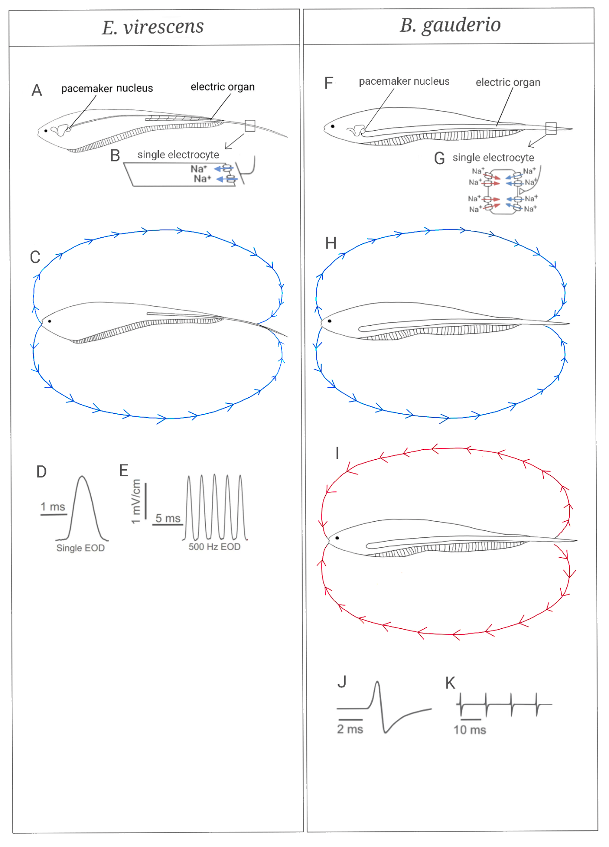
Figure 1. Schematic of EOD production in wave- and pulse-type fishes. For both E. virescens (A) and B. gauderio (F), the EOD is produced by an electric organ (EO) that extends bilaterally along the body and into the tail. The EO is comprised of electrogenic cells, electrocytes (B, G) that produce the EOD via coordinated action potentials (APs). Electrocyte APs are elicited by a pacemaker nucleus via spinal electromotors neurons which innervate the posterior end of the cell at a large cholinergic synapse. In the wave-type E. virescens, each electrocyte is electrically excitable on its posterior end where it expresses voltage-gated Na⁺ channels and becomes electrically passive at the anterior end causing the electric current generated by ionic currents through the voltage-gated channels to flow along the fish’s body in the rostral-caudal direction (C), going out towards the fish’s head, into the surrounding water, and then returning near the fish’s tail. The EOD is a single monophasic pulse (D), and E. virescens generates EODs at continuous frequencies of 200-600 Hz (E). In the pulse-type B. gauderio each electrocyte is electrically excitable on both its posterior and anterior ends where the membrane expresses voltage-gated Na⁺ and K⁺ channels (G). The first phase of the biphasic EOD is produced by ionic currents through the posterior voltage-gated channels that flow along the fish’s body in the rostral-caudal direction (H), followed by a second AP on the electrocyte’s noninnervated anterior end, creating electric current that flows in the reverse direction along the fish’s body in the caudal-rostral direction (I). The resulting EOD is a biphasic pulse (J), and B. gauderio generates EODs at low intermittent rates of ~10-100 Hz (K). Panels B,D,E,G,J, and K are adapted from Salazar et al (2013). Panels A, C, and H are adapted from Sinnett & Markham (2015).

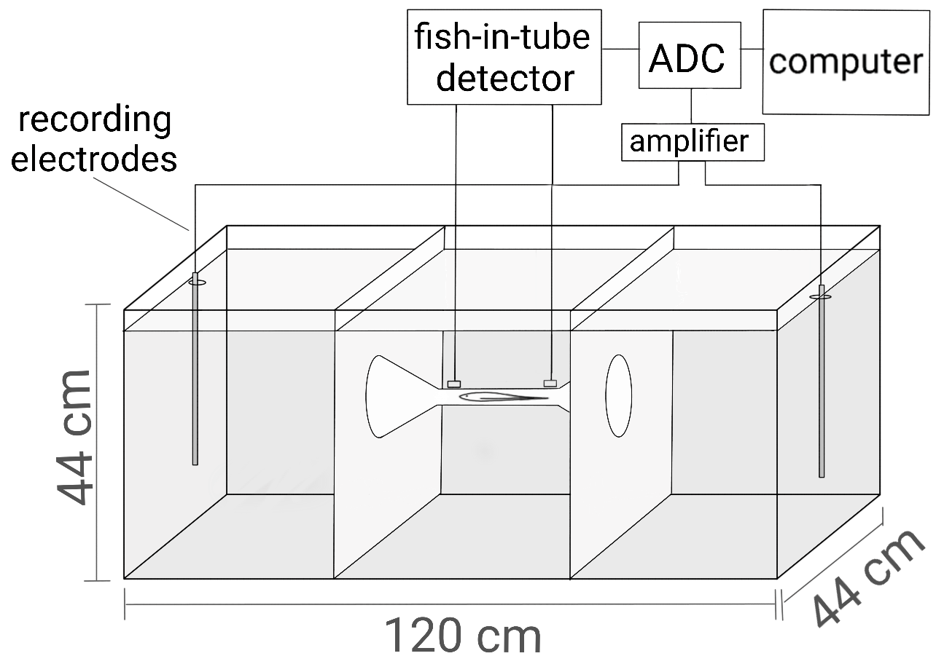
Figure 2. Schematic of the EOD recording apparatus. The fish was placed in a 285-liter tank that was divided into three compartments via fiberglass screen panels and electrically shielded with grounded aluminum screen. The fish could swim freely between the two outer compartments only by passing through a mesh tube in the center compartment. A custom-built amplifier detected when the fish was centered in the tube, which then triggered a real-time digital processor to digitize electric organ discharges (EODs) at 48 kHz across a different pair of nichrome wires at opposite ends of the tank. Adapted from Stoddard et al (2003).
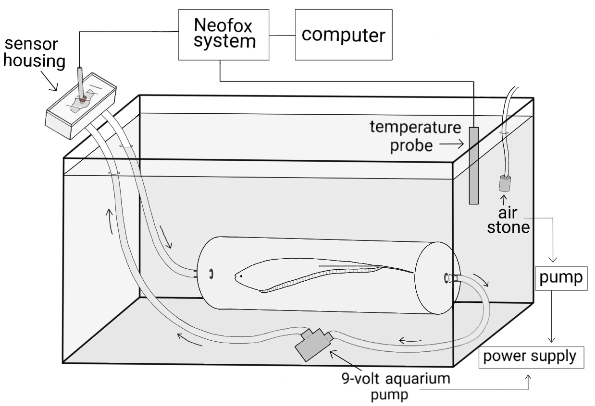Figure 3. Schematic of the respirometry apparatus. The fish was placed in a transparent acrylic cylinder fitted with quick-connect fittings on both ends and attached to clear vinyl tubing. A 9-volt aquarium pump circulated water through the respiration chamber and then through the oxygen sensor housing. A RedEye oxygen indicator patch was adhered to the interior of the sensor housing and an external fiber-optic cable illuminated the indicator patch and captured patch fluorescence under the control of a NeoFox phase fluorimeter. Data from the fluorimeter was digitized and recorded on a PC running NeoFox data acquisition software. The respiration chamber and pump were held within a 5-gallon tank filled with oxygen-saturated water. A temperature probe connected to the NeoFox fluorimeter was used for temperature correction of oxygen recordings. Closed and open circulation conditions were achieved by connecting and disconnecting, respectively, the tubing from the inflow side of the pump. During open circulation, oxygen saturated water from the outer tank was pumped through the respiration chamber, while during closed circulation the pump circulated water through the respiration chamber without introducing new water from the outer tank.

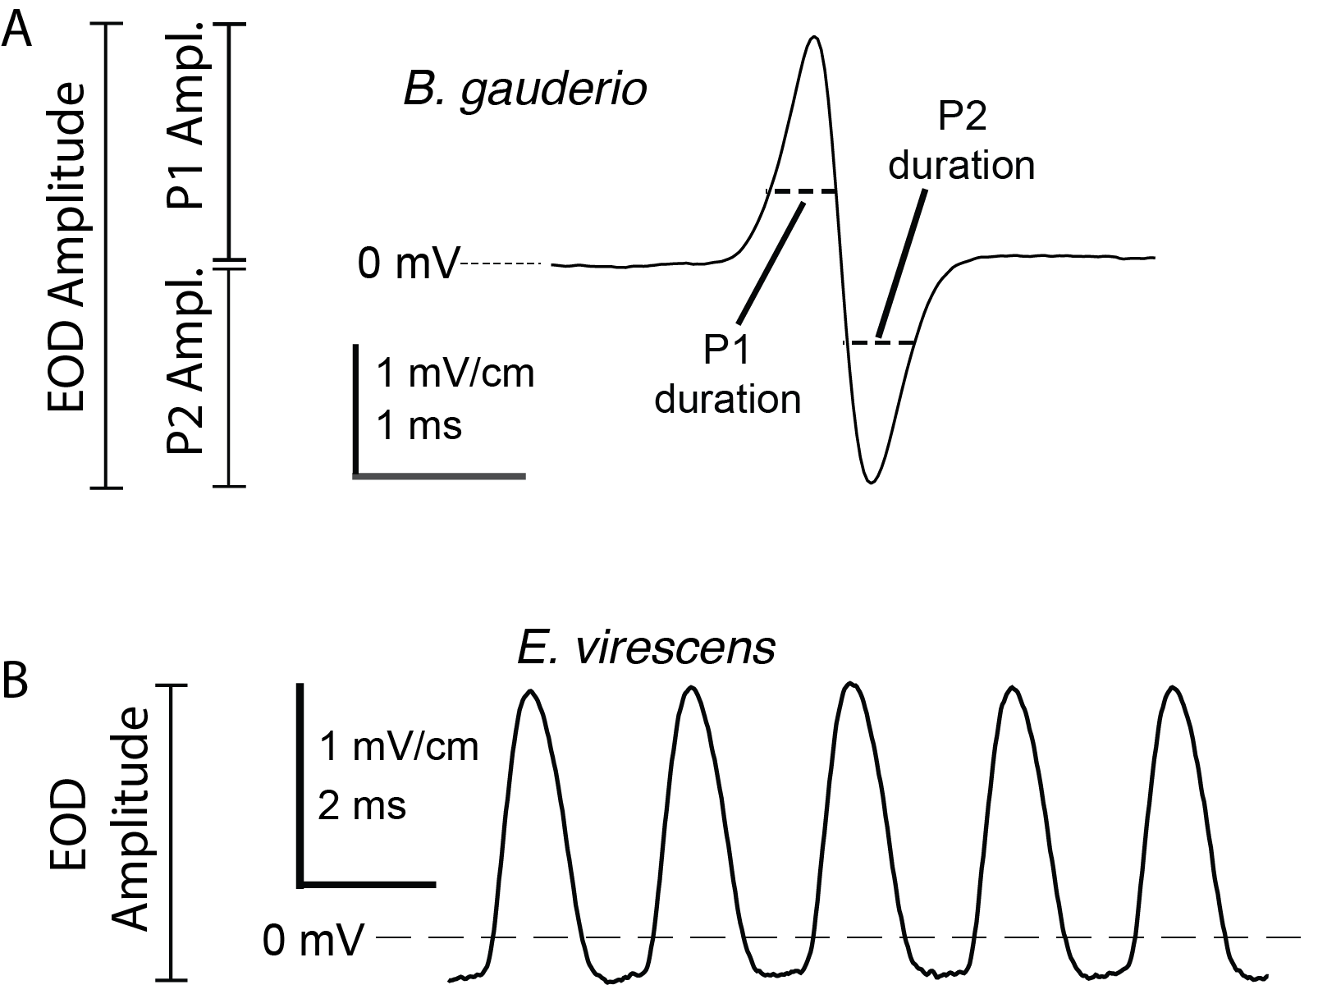
Figure 4. EOD waveform parameters. (A) The EOD of B. gauderio is a biphasic pulse with an initial positive phase (P1) followed by a negative second phase (P2). The EOD amplitude (EODa) is measured from the positive peak to the negative peak, while P1 amplitude is measured from 0 mV to the positive peak, and P2 amplitude is measured from 0 mV to the negative peak. The durations of P1 and P2 are measured as the width of the phase at 50% amplitude. (B) The EOD of E. virescens is a monophasic positive pulse, repeated at high frequencies. Amplitude is measured from the waveform minimum to the positive peak.

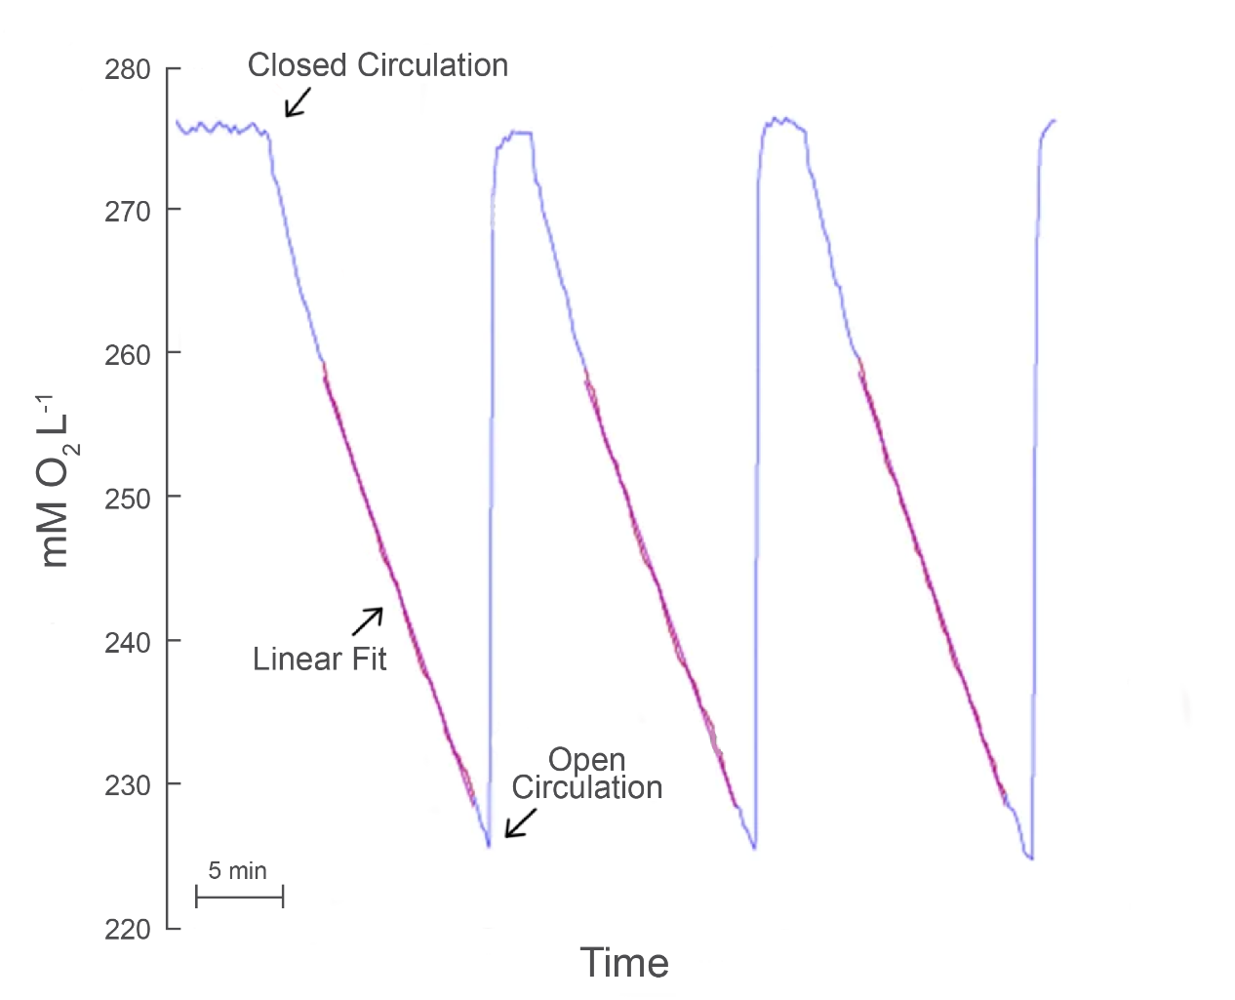
Figure 5. Raw data and analysis of oxygen consumption for a single B. gauderio during intermittent flow respirometry. The blue line represents water oxygen concentration measured in mM O₂ * L⁻¹, with baseline measured at the beginning of the recording during open circulation when water in the measurement chamber is saturated to atmospheric O₂. The magenta lines represent least-squares linear fits to the decline in oxygen concentration during the last portion of each closed circulation period. The slope of the linear fits gives the rate of oxygen consumption during closed circulation. When open circulation is restored, oxygen concentration quickly and exponentially increases back to baseline.
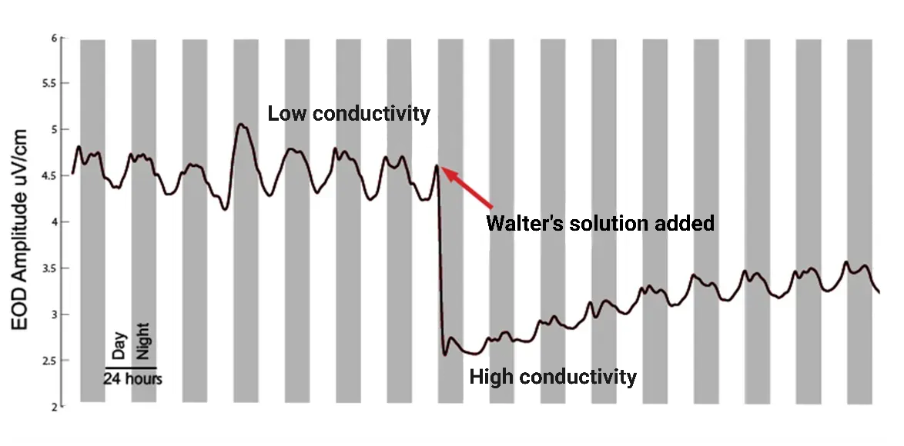
Figure 6. Representative EOD recordings from a single B. gauderio before and after a rapid increase in water conductivity. EOD amplitude (EODa) was recorded for 8 days before, and 8 days after water conductivity was increased from low conductivity (150 ± 50 μS) to high conductivity (350 ± 50 μS). EODa decreased rapidly when Walter’s Solution was added before gradually increasing during the subsequent 8 days in high conductivity.

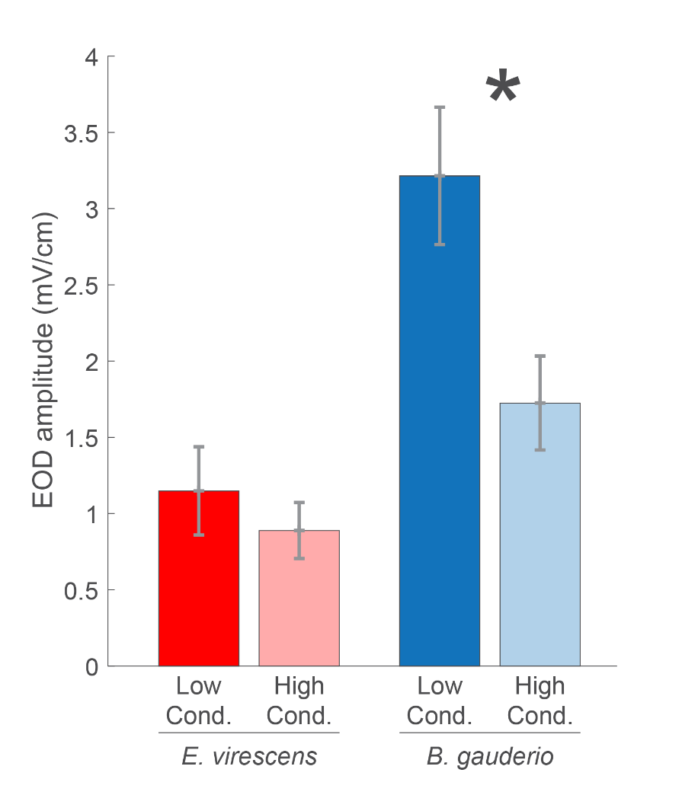
Figure 7. Change in EODa from low conductivity (dark bars) to high conductivity (light bars) for E. virescens (wave type; n=7) and B. gauderio (pulse type; n=7). While EODa decreased for both species, B. gauderio’s EODa had a much steeper decline in response to increased water conductivity than that in E. virescens.

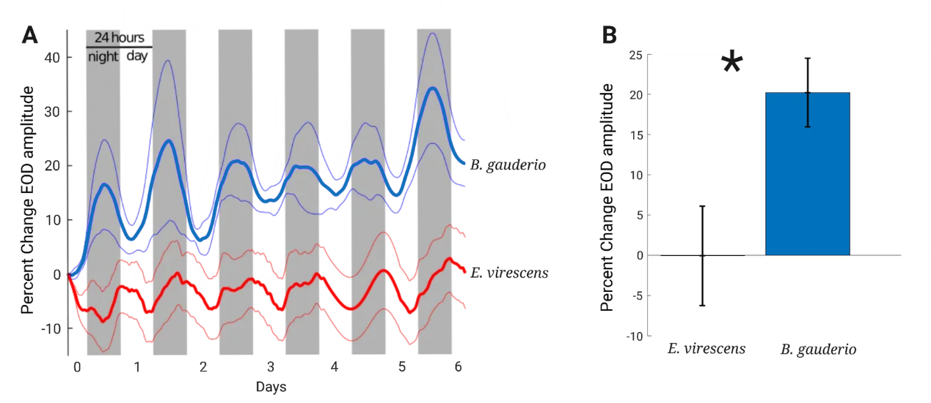
Figure 8. EODa responses of B. gauderio (n=7) and E. virescens (n=7) to increased water conductivity over six days. A) EOD amplitude (EODa) recorded for six days after water conductivity was increased from low conductivity (150 ± 50 μS) to high conductivity (350 ± 50 μS). Walter’s Solution was added on Day -1 to increase water conductivity, which was stable 24h later (designated as Day 0). Bold lines represent EODa normalized to mid-day on Day 0, while the thin lines indicate SEM. B. gauderio increased EODa gradually during the subsequent six days in high conductivity, but for the wave-type fish E. virescens EODa remained relatively constant. B) Percent change in EODa after six days in high conductivity water (D0 to D6). B. gauderio increased EODa by 20.2% ± 4.3% while E. virescens showed no major change in EODa (-0.05% ± 6.1%).

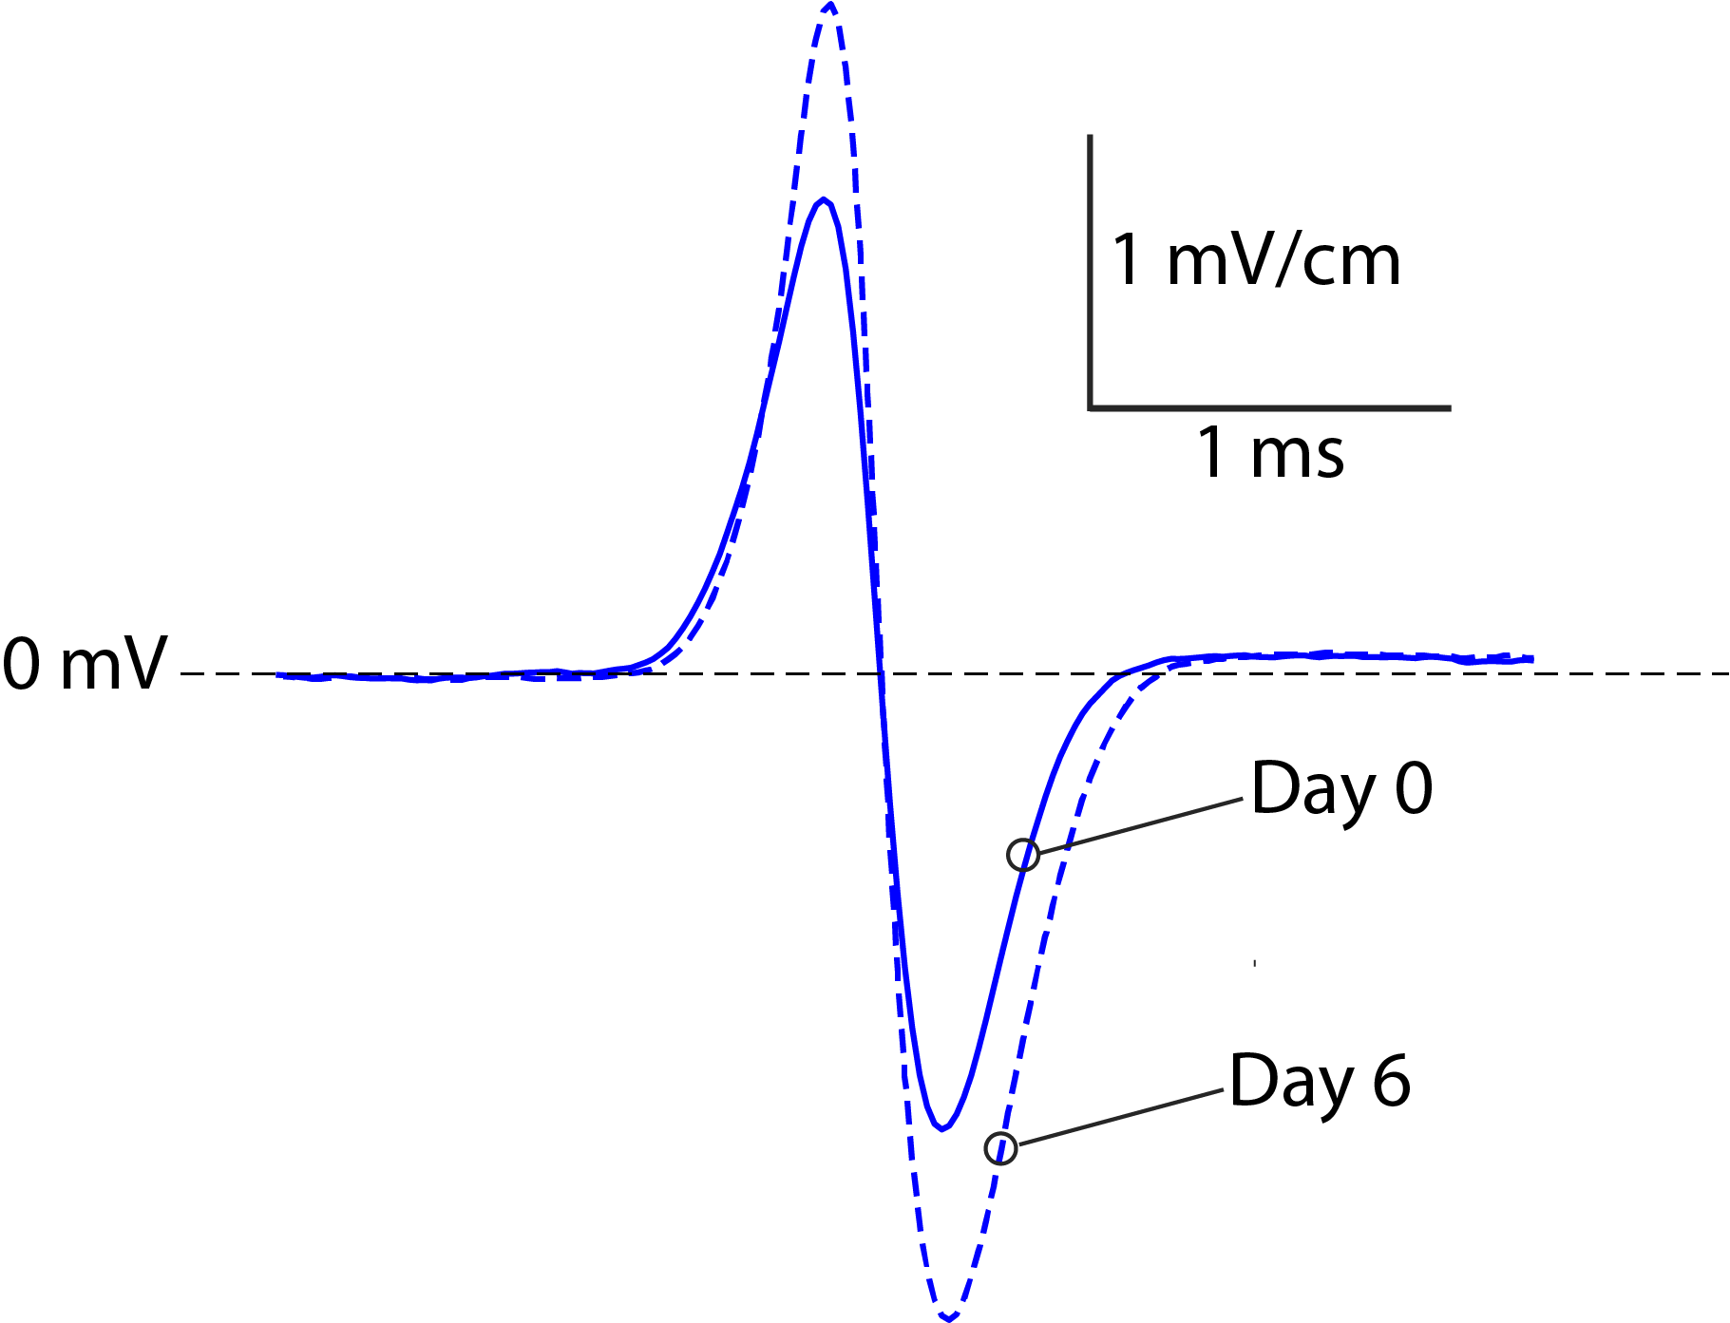
Figure 9. Representative change in the EOD of a single B. gauderio from Day 0 (solid blue line) to Day 6 (dashed blue line) in high conductivity. On Day 0, water conductivity was increased from a low conductivity (150 ± 50 μS) to a high conductivity (350 ± 50 μS). The EOD P1 and P2 amplitudes increased in equal magnitudes from day 0 to day 6 while the EOD P1 and P2 durations remained constant.

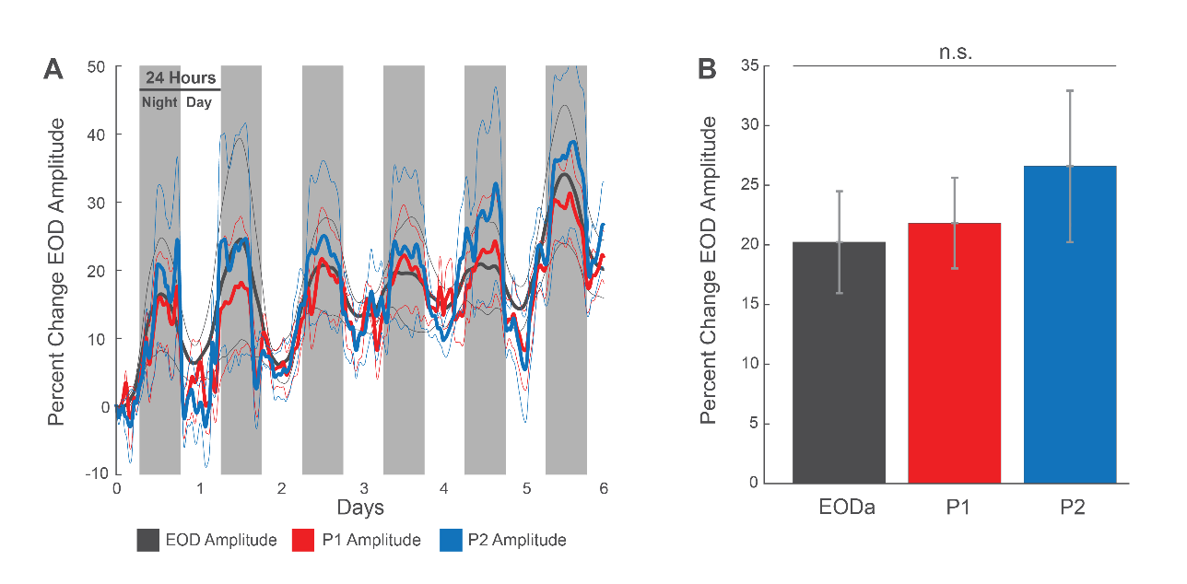
Figure 10. Changes in EOD amplitude (EODa; black), Phase 1 amplitude (P1a; red), and Phase 2 amplitude (P2a; blue) of the pulse-type B. gauderio (n=7) in response to increased water conductivity. A) The EODa, P1a, and P2a were recorded for six days following a water conductivity increase from low conductivity (150 ± 50 μS) to high conductivity (350 ± 50 μS). Walter’s Solution was added Day -1 to increase water conductivity, which was stable 24h later, designated as Day 0. Values for EODa, P1a, and P2a are normalized to mid-day on Day 0. Bold lines represent means while the thin lines indicate SEMs. The EODa, P1a, and P2a of B. gauderio increased in tandem during the subsequent six days in high conductivity. B) Percent change in EODa, P1a, and P2a after six days in high conductivity water (D0 to D6). The increases in EODa, P1a, and P2a were indistinguishable.

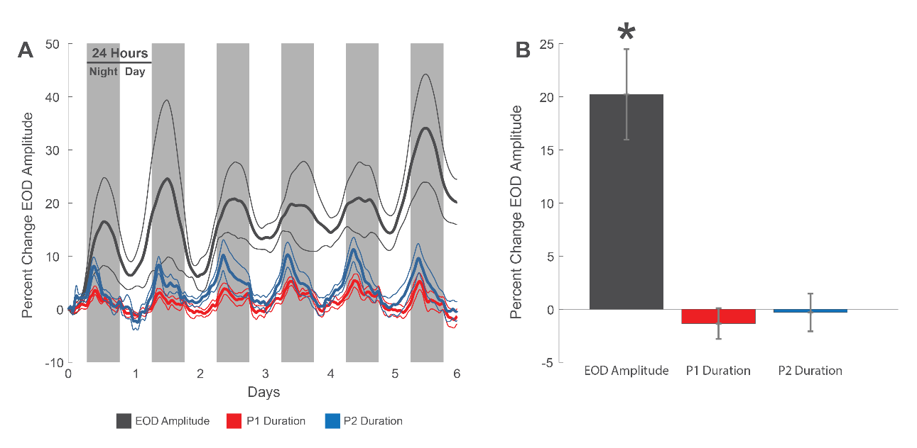
Figure 11. Changes in EOD amplitude (EODa; gray) P1 duration (red), and P2 duration (blue) of B. gauderio (n=7) in response to increased water conductivity. P1 duration and P2 duration are measured as the duration of each phase at 50% of peak amplitude. A) The EOD, P1 duration and P2 duration were recorded for six days following a water conductivity increase from low conductivity (150 ± 50 μS) to high conductivity (350 ± 50 μS). Walter’s Solution was added Day -1 to increase water conductivity, which was stable 24h later, designated as Day 0. Bold lines represent EODa normalized to mid-day on Day 0, while the thin lines indicate SEM. The EODa of B. gauderio gradually increased equally during the subsequent six days in high conductivity while the P1 duration and P2 duration remained constant. B) Percent change in EODa, P1 duration, and P2 duration after six days in high conductivity water (D0 to D6). B. gauderio increased EODa by 20.2 ± 4.3% while the P1 and P2 durations did not increase.

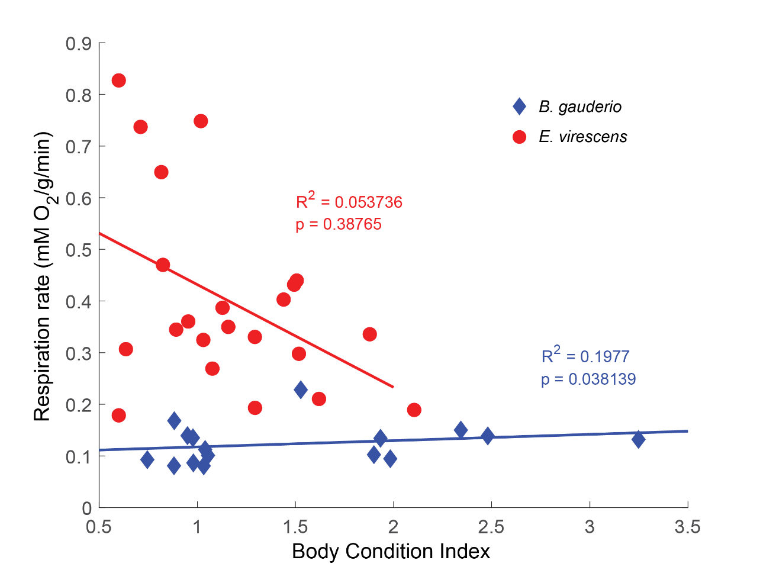
Figure 12. Relation of respiration rate to body condition for B. gauderio (n=16) and E. virescens (n=22). Prior to each respirometry measurement body condition index (BCI; weight/length) was calculated for each fish. Respiration rate was not correlated with BCI in E. virescens (red), while respiration rate was positively correlated with BCI and B. gauderio (blue).

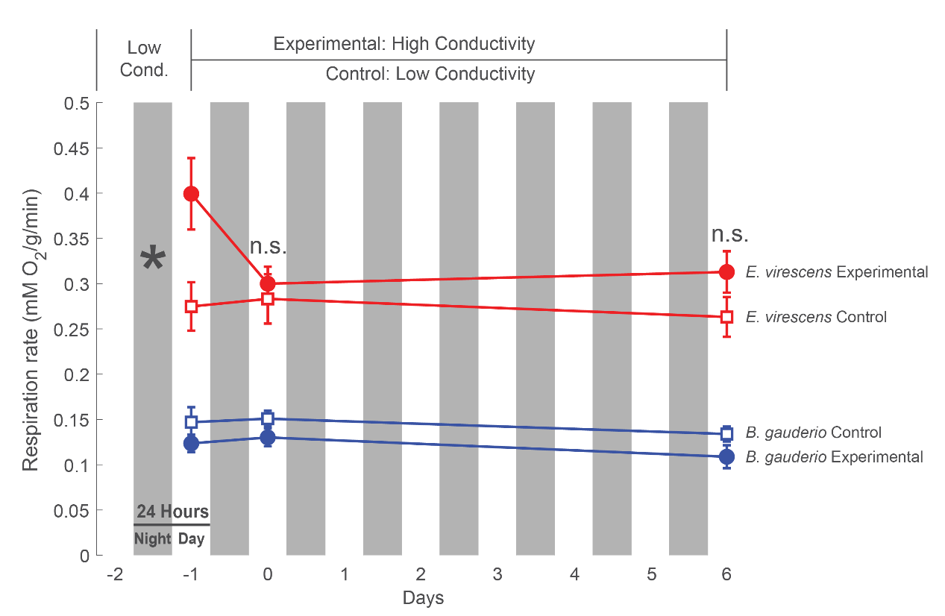
Figure 13. The metabolic responses of B. gauderio (n=14) and E. virescens (n=14) to increased water conductivity. The experimental values (circles) and control values (squares) show the respiration rates (mMO₂/g/min) of in E. virescens (red) and B. gauderio (blue). Experimental treatment: Water conductivity increased from Low Conductivity condition (150 ± 50 μS) to a High Conductivity condition (350 ± 50 μS). Respiration was measured once in the low condition immediately before water was increased and then measured again on day 1 of the high condition and on day 6 of the high condition. Control treatment: water conductivity was kept at (150 ± 50 μS) and respiration rates were measured at the same intervals as the experimental treatment. The respiration rate of E. virescens decreased in high conductivity while the respiration rate of B. gauderio remained constant in both conditions. In all conditions E. virescens had a significantly higher respiration rate than B. gauderio. In the control condition, respiration rates for both species remained constant.

References

Assad, C., Rasnow, B., & Stoddard, P. (1999). Electric organ discharges and electric images during electrolocation. Journal of Experimental Biology, 202 ( Pt 10)(Pt 10), 1185-1193.
Carlson, B. (2016). The costs of a big brain: Extreme encephalization results in higher energetic demand and reduced hypoxia tolerance in weakly electric African fishes. Proceedings of the Royal Society. B, Biological Sciences, 283(1845), 20162157.
Carlson, B., Sisneros, Joseph A, Popper, Arthur N, & Fay, Richard R. (2019). Electroreception : Fundamental insights from comparative approaches / Bruce A. Carlson, Joseph A. Sisneros, Arthur N. Popper, Richard R. Fay, editors. (Springer handbook of auditory research ; v. 70). Cham: Springer.
Carr, J., & Lima, S. (2013). Nocturnal hypothermia impairs flight ability in birds: A cost of being cool. Proceedings of the Royal Society. B, Biological Sciences, 280(1772), 20131846.
Castello, L., & Macedo, M. (2016). Large-scale degradation of Amazonian freshwater ecosystems. Global Change Biology, 22(3), 990-1007.
Coe MT, Latrubesse EM, Ferreira ME, Amsler ML (2011) The effects of deforestation and climate variability on the streamflow of the Araguaia River, Brazil. Biogeochemistry, 105, 119–131
Costa, M., & Foley, J. (1997). Water balance of the Amazon Basin: Dependence on vegetation cover and canopy conductance. Journal of Geophysical Research, Washington, DC, 102(D20), 23973-23989.
Covino, T. (2017). Hydrologic connectivity as a framework for understanding biogeochemical flux through watersheds and along fluvial networks. Geomorphology (Amsterdam, Netherlands), 277, 133-144.
Gavassa, S., & Stoddard, P. (2012). Food restriction promotes signaling effort in response to social challenge in a short-lived electric fish. Hormones and Behavior, 62(4), 381-388.
Giambelluca TW (2002) Hydrology of altered tropical forest. Hydrological Processes, 16, 1665–1669.
Giora, J., & Malabarba, L. R. (2009). Brachyhypopomus gauderio, new species, a new example of underestimated species diversity of electric fishes in the southern South America (Gymnotiformes: Hypopomidae). Zootaxa, 2093(1), 60-68.
Hooper, D., Adair, E., Cardinale, B., Byrnes, J., Hungate, B., Matulich, K., . . . O'Connor, M. (2012). A global synthesis reveals biodiversity loss as a major driver of ecosystem change. Nature (London), 486(7401), 105-108.
IPCC, 2022: Climate Change 2022: Impacts, Adaptation, and Vulnerability. Contribution of Working Group II to the Sixth Assessment Report of the Intergovernmental Panel on Climate Change [H.-O. Pörtner, D.C. Roberts, M. Tignor, E.S. Poloczanska, K. Mintenbeck, A. Alegría, M. Craig, S. Langsdorf, S. Löschke, V. Möller, A. Okem, B. Rama (eds.)]. Cambridge University Press. In Press.
Kuemmerlen, M., Batista-Morales, A., Bruder, A., Turak, E., & De Oliveira Roque, F. (2022). Conservation of Latin America freshwater biodiversity: Beyond political borders. Biodiversity and Conservation, 31(4), 1427-1433.
Kultz, D. (2015). Physiological mechanisms used by fish to cope with salinity stress. Journal of Experimental Biology, 218(Pt 12), 1907-1914.
Lewis, J., Gilmour, K., Moorhead, M., Perry, S., & Markham, M. (2014). Action potential energetics at the organismal level reveal a trade-off in efficiency at high firing rates. The Journal of Neuroscience, 34(1), 197-201.
Markham, M. (2013). Electrocyte physiology: 50 years later. Journal of Experimental Biology, 216(Pt 13), 2451-2458.
Markham, M., Ban, Y., McCauley, A., & Maltby, R. (2016). Energetics of Sensing and Communication in Electric Fish. Integrative and Comparative Biology, 56(5), 889-900.
Markham, M., McAnelly, M., Stoddard, P., & Zakon, H. (2009). Circadian and social cues regulate ion channel trafficking. PLoS Biology, 7(9), E1000203-1000203.
Markham, M., & Stoddard, P. (2005). Adrenocorticotropic Hormone Enhances the Masculinity of an Electric Communication Signal by Modulating the Waveform and Timing of Action Potentials within Individual Cells. The Journal of Neuroscience, 25(38), 8746-8754.
Markham, M., & Stoddard, P. (2013). Cellular mechanisms of developmental and sex differences in the rapid hormonal modulation of a social communication signal. Hormones and Behavior, 63(4), 586-597.
MacIver MA, Sharabash NM, Nelson ME (2001) Prey-capture behavior in gymnotid electric fish: motion analysis and effects of water conductivity. J Exp Biol 204:543–557, pmid:11171305.
Moore, I., & Hopkins, W. (2009). Interactions and trade-offs among physiological determinants of performance and reproductive success. Integrative and Comparative Biology, 49(4), 441-451.
Nelson, M., & Maciver, M. (1999). Prey capture in the weakly electric fish Apteronotus albifrons: Sensory acquisition strategies and electrosensory consequences. Journal of Experimental Biology, 202(Pt 10), 1195-1203.
Nilsson, G. (1996). Brain and body oxygen requirements of Gnathonemus petersii, a fish with an exceptionally large brain. Journal of Experimental Biology, 199(Pt 3), 603-607.
Rasnow, B. (1996). The effects of simple objects on the electric field of Apteronotus. Journal of Comparative Physiology A, 178(3), 397-411.
Reardon, E., Parisi, A., Krahe, R., & Chapman, L. (2011). Energetic constraints on electric signalling in wave-type weakly electric fishes. Journal of Experimental Biology, 214(Pt 24), 4141-4150.
Reis, R., Albert, J., Di Dario, F., Mincarone, M., Petry, P., & Rocha, L. (2016). Fish biodiversity and conservation in South America. Journal of Fish Biology, 89(1), 12-47.
Salazar, V., Krahe, R., & Lewis, J. (2013). The energetics of electric organ discharge generation in gymnotiform weakly electric fish. Journal of Experimental Biology, 216(Pt 13), 2459-2468.
Salazar, V., & Stoddard, P. (2008). Sex differences in energetic costs explain sexual dimorphism in the circadian rhythm modulation of the electrocommunication signal of the gymnotiform fish Brachyhypopomus pinnicaudatus. Journal of Experimental Biology, 211(Pt 6), 1012-1020.
Sandersfeld, T., Davison, W., Lamare, M., Knust, R., & Richter, C. (2015). Elevated temperature causes metabolic trade-offs at the whole-organism level in the Antarctic fish Trematomus bernacchii. Journal of Experimental Biology, 218(Pt 15), 2373-2381.
Silva, A., Quintana, L., Galeano, M., & Errandonea, P. (2003). Biogeography and breeding in Gymnotiformes from Uruguay. Environmental Biology of Fishes, 66(4), 329-338.
Sinnett, P., & Markham, M. (2015). Food deprivation reduces and leptin increases the amplitude of an active sensory and communication signal in a weakly electric fish. Hormones and Behavior, 71, 31-40.
Stearns, S. (1989). Trade-Offs in Life-History Evolution. Functional Ecology, 3(3), 259-268.
Stoddard, P., Markham, M., & Salazar, V. (2003). Serotonin modulates the electric waveform of the gymnotiform electric fish Brachyhypopomus pinnicaudatus. Journal of Experimental Biology, 206(Pt 8), 1353-1362.
Sukhum, K., Freiler, M., Wang, R., & Carlson, B. (2016). The costs of a big brain: Extreme encephalization results in higher energetic demand and reduced hypoxia tolerance in weakly electric African fishes. Proceedings of the Royal Society. B, Biological Sciences, 283(1845), 20162157.
Svendsen, M., Bushnell, P., & Steffensen, J. (2016). Design and setup of intermittent-flow respirometry system for aquatic organisms. Journal of Fish Biology, 88(1), 26-50.
Zera, A., & Harshman, L. (2001). The physiology of life history trade-offs in animals. Annual Review of Ecology, Evolution, and Systematics, 32, 95.
Zhang L, Wong MH (2007) Environmental mercury contamination in China: Sources and impacts. Environment International, 33, 108–121.

