University of Oklahoma

Graduate College

zOOMORPHIC REPRESENTATIONS IN EARLY CYCLADIC ART:
A CATALOGUE REFERENCE LIST

A thesis

submitted to the Graduate Faculty

in partial fulfillment of the requirements for the

Degree of

Master of Arts in Art History

By

MARIAH LOUANN ASHBACHER
Norman, Oklahoma
2017

ZOOMORPHIC REPRESENTATIONS IN EARLY CYCLADIC ART:
A CATALOGUE REFERENCE LIST

A thesis approved for the
School of Visual Arts

By

______________________________
Dr. Rozmeri Basic, Chair

______________________________
Dr. Mary Jo Watson

______________________________
Dr. Allison Palmer

© Copyright by MARIAH LOUANN ASHBACHER 2017
All Rights Reserved.
I dedicate this thesis to my husband, Todd, and to my children, Christian, Parker and Madison.

Acknowledgements
I would like to acknowledge the mentoring I received from Dr. Rozmeri Basic over the last four years, who introduced me to the Aegean Bronze Age. It is because of her that I decided to study Art History. Through my studies at the School of Visual Arts, I became acquainted with several professors who shaped my education, including Dr. W. Jackson Rushing, III, Dr. Robert Bailey, Professor Victor Youritzin, and Professor B. Byron Price. I also want to particularly mention Dr. Mary Jo Watson and Dr. Allison Palmer, who along with Dr. Basic, have been sources of immeasurable inspiration as art historians, professors, and women. I thank them for their contribution to this thesis as members of my committee and for shaping me as an emerging art historian.

Table of Contents
Acknowledgements iv
List of Figures vii
Abstract viii
Chapter 1: Introduction 1
Geographic and Environmental Background 6
Animals in Cycladic Culture 11
Bronze Age Chronology 14
Methodology 22
Chapter 2: Literature Review 24
Role of Migration in Cultural Exchange 27
Maritime Trade in Early Bronze Age Aegean 31
Religion and Funeral Rites 34
Chapter 3: Animal Presentations in Cycladic Art 43
Domesticates 50
Sheep/Rams 50
Pigs…… 51
Bovines 52
Wild Animals 54
Hedgehogs 54
Birds… 57
Frogs… 64
Snakes.. 65
Feline… 66
Flies/Bees 68
Marine Objects 69
Mythological Animals 70
Manticore 70
Chapter 4: Conclusion 73
A Brief Note on the Current State of Research 75
Bibliography 83
Appendix A: Catalog Reference List, Chronological 98
Early Cycladic I (3200 BCE-2800/2700 BCE) 100
Early Cycladic II (2800/2700 BCE-2400/2300 BCE) 115
Early Cycladic III (2400/2300 BCE-2000 BCE) 196

List of Figures

Figure 1: The Cycladic Islands. Renfrew, The Emergence of Civilization, 137. 76
Figure 2: Axes of migration into the Cyclades. Broodbank, An Island Archaeology, 132. 77
Figure 3: Neolithic sites in the Cyclades. Broodbank, An Island Archaeology, 122. 78
Figure 4: The early prehistoric culture sequence in the Cycladic Islands. Renfrew, The Emergence of Civilization, 150. 79
Figure 5: The Early Prehistoric Culture Sequence in the Cycladic Islands; Renfrew, The Emergence of Civilization, 150. 80
Figure 6: Chart of chronological and typological development of Cycladic figurines; Getz-Gentle, Early Cycladic Art in North American Collections, 48. 81
Figure 7: Part of a large floor composition from Strofilas, Andros; Televantou, "Strofilas: A Neolithic Settlement on Andros," 49. 82
Figure 8: Rock pecking showing a canoe carrying a person and an animal, from Korphi t'Aroniou on Naxos; Broodbank, An Island Archaeology, 98. 82
Figure 9: Ring-shaped idol pendant from Strofilas and Keros-Syros 'frying pan', Chalandriani; Televantou, "Strofilas: A Neolithic Settlement on Andros," 52; National Archaeological Museum website, accessed 3/19/17. 82

Abstract
The focus of my thesis is to examine the noteworthy role that three-dimensional zoomorphic figures played in Cycladic Art during the Early Bronze Age Aegean period. The importance of animals for this period, clearly documented by their artistic representations, has largely been surpassed by scholarship on the anthropomorphic figures found in and around burial sites. It is my intention with this study, and an accompanying reference list of sixty-nine works, to provide evidence that supports the importance of the animals, their relationship to the communities of the islands, and to discuss the reasons and iconography behind their artistic production.
Previously, the zoomorphic objects discussed here have been studied considering the archaeological context of their discovery, as part of a chronological group or on an individual basis only for their aesthetic qualities. However, by compiling them as an isolated corpus of objects, and then arranging them chronologically, new interpretations become apparent. When these considerations are combined with existing information known about the settlements and cemeteries where they were excavated, established hypotheses about other artifacts, and comparative data concerning cultures of contact, it is possible to come to new perspectives concerning the role of animal objects in the Early Cycladic period. I propose that the three-dimensional zoomorphic figures represented in the catalog reference list are in the categories of votives and occasionally cult images used in domestic cult activity.

Chapter 1: Introduction
Five thousand years ago, on a fractured island group in the Aegean Sea, dozens of small, tightly-knit communities were flourishing during the beginning of the Bronze Age in the Cyclades, (Fig.1). This early Cycladic period (c.3200-2000 BCE) is primarily defined by the myriad anthropomorphic marble figurines found in and around burial sites on these islands. A smaller corpus of figures are the three-dimensional representations of animals and these lesser-known objects are the focus of my thesis. I have compiled sixty-nine animal figures into a catalog reference list that includes the most recent state of research on these objects. Paintings, sculptures and clay modeled animals are part of human history, and the beginning of art history starts with their depictions in Lascaux in France, Altamira in Spain, caves in China, and other sites throughout the world. The Cycladic islands were populated with animals that constituted an important part of their lives. It is my intention in this thesis to provide evidence that supports the importance of the animals, their relationship to the communities of the islands, and to discuss the reasons and iconography behind their artistic production.
Geographically, the Cyclades represent an archipelago in the temperate zone, bordered by three continents, situated in the Aegean Sea and connected via the Hellespont, Sea of Marmara, Bosporus, the Black Sea and the Danube. The islands act as wind funnels—a low atmospheric pressure in Africa sucks in cold air from the North. These winds, called meltemia today, were referred to in antiquity as the Etesian winds. Whatever the Cycladic islands may be lacking in sources of fresh water and arable land, they have made up for in other natural resources, such as marble and obsidian. Referring to natural resources, the Cyclades can be categorized into marble-dominant, schist-dominant, and volcanic geologies. Most of the islands were good sources of marble, except for the volcanic islands of Thera and Melos. In antiquity, the islands of Naxos and Paros, in particular, were famous for their marble quarries while emery was found only at Naxos. These two islands were associated with the palest-firing clay, while Melos was the only source of obsidian in the entire Aegean. The source of copper, silver and lead for the Aegean was Lavrion, at the southern tip of Attica, and the island of Siphnos; in fact, there are very few lead or silver artifacts known from the Early Cycladic period. Kythera is also known as an important source of copper used to make the alloy bronze. True bronze is a copper-tin alloy, and appears only in the late Early Cycladic II period. The nearest access point for tin was probably Anatolia, where it was brought from Afghanistan.
There are two distinct groups of non-marble stone artifacts in the Cyclades. The first group is those made of a green jade-like stone, and the other are those objects made of “soapy” stones, like chlorite schist. Since the jade-like stone is found only in small pieces, the objects fashioned from it tend to be very small (see the amulet objects in the appendix-catalog.) The colors range from a pale celadon to a rich dark green. The lighter varieties are almost translucent in color (see object J9 in the appendix-catalog); but, overall the stone is “compact and fine-grained, durable, and takes a lustrous polish.”
The geographical placement, the natural resources of the islands, the technological and agricultural advances of the Neolithic Revolution and the mentality of a group of settlers to be set apart all conspired to create the perfect conditions for the blossoming of a unique civilization. Christos Doumas calls the island mentality a peculiar blend of both a conservative and liberal spirit. While the people of the Early Cycladic islands constantly struggled to survive and daily fought against the natural elements, their view of the sea as an open horizon led to enhancements which made them ripe for a flourishing culture. “These challenges broadened the early mariners’ minds, stimulating their rational conception and logical explanation of the cosmos, free from prejudice and superstition, making them the precursors of the Ionian philosophers.”
Previously, the zoomorphic objects discussed here have been studied considering the archaeological context of their discovery, as part of a chronological group or on an individual basis, and only for their aesthetic qualities. However, by compiling them as an isolated corpus of objects into a catalog, and then arranging them chronologically, new ideas emerge, and when combined with existing information known about the sites and settlements/cemeteries where they were excavated, established hypotheses about other artifacts (such as the marble figurines), and comparative data concerning cultures of contact, it is possible to arrive at new ideas concerning the role of zoomorphic objects in the Early Cycladic period. I propose that the three-dimensional zoomorphic representations functioned as either votive figures or cult images, subordinate to the marble anthropomorphic images, and played noticeable roles in public and domestic rituals. Furthermore, because of the fractured geography of the islands, and the lack of a central administration which might oversee ritual activity, maritime trade is largely responsible for the diversity of the objects. Each island had its own local culture with a few locations acting as major trading ports for import/export business which transferred an “international spirit.” Though the islands are grouped together geographically and chronologically, I argue that they cannot be grouped together as one homogenous culture.
To better define specific roles of the objects, I would like to refer to discussions on divine and cult images by Joannis Mylonopoulous in his article “Divine Images Versus Cult Images: An Endless Story about Theories, Methods, and Terminologies.” According to the author, the Cycladic Bronze Age period is difficult to assess due to lack of written documentation, and functions and meanings of artifacts “are based on the archeological context and the formal and stylistic features.” Furthermore, he emphasizes the facts that animals and hybrid creatures inhabited scenes of a religious character but failed precisely to identify elements for making one figure or object divine. Therefore, it is obvious that in the “arts of Bronze Age Aegean, the attributes were polyvalent visual signs that could be used in different contexts with varying meanings.”
In the case of the Cycladic zoomorphic objects, the situation is even more complex, since they were mostly poorly documented when found, and also modern scholarship considers them less significant than the marble figurines. Perhaps the original purpose of these images was to take part as votive offerings in domestic or household cult rituals in which figurines had dominant roles. During these activities, islanders give gifts to their gods in the shape and forms of animals, utilize cult images, perform libation rites, and even wear the marks of their divinities as ritual tattooing. One of the definitions of cult activity is that it “had to be repetitive,” thus requiring the constant production of votives which, if real animals were considered as options, the communities would have depleted their livestock. Therefore, predominately modest in scale and diverse in media, the zoomorphic objects became an economical solution to pleasing their gods, while special attention remained focused on production of anthropomorphic figurines. Limited natural resources influenced the artistic production of the Aegean artisans, which is the subject of next segment.

Geographic and Environmental Background
The earliest evidence of habitation in Greece begins with the Paleolithic era. Deposits at Franchthi Cave, in the southeastern Argolid near the modern-day village of Koilada, show an unbroken human presence since 22,000 BCE (and possibly even earlier) through 3,000 BCE Other recent Paleolithic discoveries include Theopetra cave in Thessaly, Mesolithic discoveries at Klisoura Cave in the Northeast Peloponnese, and the Cave of the Cyclops in the Sporades Islands. However, continuous settlements didn’t begin until the Pre-pottery Neolithic, around the 7th millennium BCE when in this aceramic period, humans made the transition from hunter-gatherers to a sedentary lifestyle. The first continuous settlements were primarily in Thessaly, and the first to be investigated was Sesklo. Settlements spread north into Macedonia and South to Boeotia, Argolis, and Messenia, and by the end of the 7th-millennium, people migrated to the island of Crete.
According to the theory of the “East-West cultural drift,” painted pottery, metallurgy, writing and agrarian culture originates from the Ancient Near East, and continued as people migrated west into Europe (barley, wheat, goats and sheep are not indigenous to Greece). The origins of Neolithic culture lay in the fertile crescent between Iran and Jericho and diffused via Asia Minor. The Sesklo culture points to similarities from Çatalhöyük and Hacilar in Anatolia, both of which date back to the 7th and 8th millennia BCE respectively. The Neolithic period in Greece spans approximately 3000 years without any severe interruptions. Finds of Melian obsidian in the Mesolithic levels at Franchthi Cave prove that the Cyclades were visited since 7000 BCE. In the Cyclades, there are two distinct Neolithic cultures: Saliagos and Kephala. The Late Neolithic Saliagos culture, named for the small islet located between Paros and Antiparos which dates from around 5000/4800 BCE-3700 BCE, produced marble figurines of the seated steatopygous type and standing variety well-known from the Mainland and Crete (Doumas describes them as the direct descendants of the style of figurines found in the Early Neolithic areas of Thessaly and Macedonia). Similarly, from Saliagos comes the so-called Brettidole-style figurines-- a schematic violin-shaped figurine with a minimum of modeling, recognizable in schematic figures in the Early Bronze Age nearly 2000 years later. To avoid the logical assumption that the more abstract schematic figurine was a precursor to the more modeled, seated figures, it is important to note that, just as in the later Early Cycladic period, both the representational and the stylized style of figurines existed and were manufactured contemporaneously. Ironically, the relatively short-lived Kephala culture, named for the site on the island of Kea which dates from the Final Neolithic period (around 3300 BCE-3200 BCE) produced no known marble sculptures. The Kephala culture is also associated with Athens, Thorikos and the Kitsos Cave in Attica, as well as Kolonna on Aegina, (Fig. 3). While the Saliagos Culture spread across several sites on different islands, and the Kephala Culture was concentrated to several locations on the island of Kea, none of the communities could have survived without mutual contacts. With the typical settlement consisting of only 50-150 occupants, exogamous marriages were necessary for viable demography. John Bintliff even goes on to suggest that one must imagine the existence of venues for communal social gatherings between settlements, though no evidence to suggest this has yet been found.
Life in the Cyclades at this early stage had both advantages and disadvantages. As previously discussed, the geographical fragmentation of the islands and the scarcity of natural resources for subsistence inevitably posed many issues for the initial settlers. However, Doumas points out that these same disadvantages were used by the islanders to their benefit. The fragmentation led to autonomy, which is the hallmark of the Early Cycladic period and frugality of their means of subsistence led to a maximum exploitation of island resources, and inventiveness (especially in the realm of artistic production and innovations). Additionally, the dependence of the islanders on nearby landmasses led to the continued development in seafaring, and inevitably, to a thriving sea trade.
Likewise, the sea had this same duality. It protected external invasions and hostile interventions from foreign aggressors, as well as prevented an influx of unsupportable populations. The location of the islands in the Aegean Sea became an island-hopping bridge for seafarers and encouraged communication with other communities from different areas of the Mediterranean:
In a way communication was the islanders’ prerogative, enabling them to select or reject not only material goods but also ideas brought from elsewhere. Both were quickly adopted and adapted to the islanders’ needs, their foreign character annulled as they were assimilated into the recipient culture.
Neolithic Cycladic settlements, situated on coastal sites and low hills near the sea, were naturally well-defended. The architecture at both Saliagos and Kephala consists of buildings with one or two, small rectangular rooms. Inhabitants cultivated cereals, tended domesticated animals (sheep, goats, and few bovine), hunted birds and small island deer, and gathered wild lentils, peas, figs, plums, and grapes. Evidence of pottery, basket-making, weaving, jewelry and metallurgy are found among the various sites of both cultures. At Kephala, copper slag was found in crucibles with metal finds consisting of bronze weapons and tools: axes, daggers, spatulas, chisels, awls, needles, pins and tweezers. Jewelry materials were clay, shells, copper and stone. The pottery of Saliagos is dark-surfaced both with unburnished and burnished technique. Characteristic shapes include open bowls on high pedestaled feet with geometric, both rectilinear and curvilinear designs, in a white matte. Chipped stone is exclusively obsidian, probably arrowheads; blades are rare. Conversely, at Kephala among the chipped obsidian were six examples of imported flint/chert while a larger portion of the locally-worked obsidian consists of blades than at Saliagos. Pottery shapes are bowls, jars, and scoops. Impressions left on sherds show woven mats and cloth. The decoration consists of mostly incised, and pattern-burnishing or red/white paint applied after firing. In both cultures, many similarities can be found in connection with the subsequent EC I period (Grotta-Pelos), to suggest a continuation of culture.

Animals in Cycladic Culture
In attempting to determine the symbolism behind the zoomorphic representations and the use of the objects, it is important to first examine the role animals played in the lives of the early islanders, and the types of animals that existed during this time. Based on a report from 2008, in a study of the economy of the Late Neolithic site Ftelia, Mykonos, found that all fauna found on the islands, whether wild or domestic, would have been transported by people. They are all mainland types, and furthermore, the endemic fauna had become extinct before the end of the Pleistocene era. At the Late Neolithic settlement of Ftelia, located today at Ftelia Beach on the large northern inlet of Mykonos, the faunal remains are strongly dominated by ovicaprids (sheep and goats), making up 85% of the assemblage, while pigs were rare at only 12%, and cattle represent 3%. Faunal remains found on Saliagos at the Late Neolithic level, included sheep and goat (83.5%), pig (12.1%), and cattle (3.5%). Marine faunal remains were largely fish bones, 97% of which were identified as very large tuna, and at least 35 different species of shellfish.
Ovicaprids were brought to and raised in the Cyclades for their suitability to the environment. Sheep are better adapted to the drier climate, and goats are better adapted to rockier environments. The scarcity of pigs and cattle are due to the fact that the Cyclades do not have sufficient pastures for raising these animals. Based on the available natural resources, the islanders did not attempt to transport mainland economy to the islands, but rather they made selective and deliberate decisions to modify the existing model of the mainland economy to the specific conditions of the islands. Furthermore, it is suggested that rarity of certain animals points to a strictly exploitive use, including possibly feasting or a ritualistic function. Phoca-Cosmetatou reports that almost half of all cattle remains at Ftelia come from enclosed areas, possibly related to cult practices since 34% of cattle bone deposits are reported as burnt.
Foxes and Beech Martens were introduced during the Late Neolithic period or later, perhaps to exterminate “commensal animals.” There is no evidence of cervids (deer) living in the Cyclades, but the few remains point to islanders bringing them for exploitive purposes. The presence of suids (pigs) is open for speculation since the slaughter pattern of mainly young pigs (six months old or less) may suggest domestication or a small breed of wild boar.
Comparison of the faunal remains of three major Early Cycladic sites reveals similar statistics. At Dhaskalio on Keros, sheep and goat bones comprise 98-99% of all faunal remains, with goats outnumbering sheep. Similarly, comparative results from Markiani on Amorgos and Akrotiri on Thera show 85% and 95% respectively. Other animal remains represented, in order of quantity of remains, are pig (Sus domesticus), cattle (Bos taurus), red deer (Cervus elaphus), dog (Canis familiaris), hare (Lepus europaeus), and mustelid (Mustelidae). Very few bird bones were recovered, and it is not clear if they were uneconomical to catch, or if their consumption did not feature into Early Cycladic culture. It is important to note that sheep, goats, pigs, and cattle are the only animals consistently found at all three sites, while the remaining mammal bones mentioned comprise a very small portion of faunal remains and are not consistently found throughout. Bones come mainly from fill deposits and do not seem to have any discernable relation to the building with which they are associated. Therefore, no conclusions can be drawn about their use regarding ritual activities and cult practices. However, Katerina Trantalidou does point out that in the latter phases of the settlement, the concentration is higher at the summit of the site, which is also the case with Markiani and at Ayios Georgios on Kythera.
Other archaeological analyses of the bone deposits do not find any evidence for preference of age or gender of the animals consumed, though most animals are shown to be butchered at young ages, 1-3 years. Since there is also no contextual evidence showing ritual deposits, communal meals, or social distinction of animal consumption, no conclusions other than domestic use/consumption can be drawn based on the faunal remains.

Bronze Age Chronology
Chronology (Simplified Sequence):
Early Cycladic: 3200 BCE-2000 BCE
Early Cycladic I: 3200 BCE-2800/2700 BCE
Early Cycladic II: 2800/2700 BCE-2400/2300 BCE
Early Cycladic III: 2400/2300 BCE-2000 BCE
Middle Cycladic: 2000 BCE-1600 BCE (Minoan Domination)
Late Cycladic: 1600 BCE-1200/1100 BCE (Mycenaean Domination)
A discussion of the chronology of the Aegean Bronze Age is a complex and on-going process. Numerous scholars of Aegean archaeology have attempted to introduce new systems of relative chronology, in addition to the fact that calibrated radiocarbon dates shift the absolute chronology. Doumas reveals that to situate objects and events into a relative chronology, and to define the beginning, middle and end, methods have been “devised and agreed upon,” which include stratigraphy and typology. A discussion of the chronology is important to this thesis because during the approximate 1,200-year period of the Early Cycladic period, many stylistic changes occurred in the production of objects, making it necessary to arrange the objects chronologically.
The tripartite relative chronology of the Aegean Bronze Age was first established by Sir Arthur Evans during his excavations on Crete at the beginning of 1900. Based on the Three Ages chronological system, he established a timeline which divided the civilization into an early, middle and late period. By 1918, A.J.B. Wace and C.W. Blegen applied the same system to the Greek mainland and the Cyclades. Later on, the phases are combined with cultural labels: Minoan (Crete), Helladic (Greek mainland) and Cycladic (Cycladic Islands) and this system was also used to establish sub-phases within each period using Roman numerals.
Unfortunately, the system is not perfect and archaeological finds do not always fit neatly into these categories. Often, objects are re-dated to an earlier or later period, and in 1965, Renfrew attempted to replace the relative chronology system with a cultural sequence for the assemblages instead, named for the main locations of finds: Grotta-Pelos, Keros-Syros, Phylakopi, (Fig. 4). The Grotta-Pelos culture is known primarily from the cemeteries of the pre-city level at Phylakopi (Phylakopi O) on Melos, Grotta on Naxos, and from other sites on Melos, Naxos, Amorgos, Siphnos and smaller islands. Most notably the Keros-Syros culture is known from Dhaskalio on Keros and Chalandriani cemetery on Syros, where the bulk of the objects are found, but also Mt. Kythnos on Delos, Naxos, Amorgos, Ios, and Thera. The Phylakopi I culture refers to the First City level at the settlement of Phylakopi on Melos, while other finds attributed to this cultural period come from Paroikia on Paros.
In addition to the cultural sequence, there are also various “groups” or “types” which define a more localized culture contemporary with the larger cultural sequences but not included in them. Some of these groups, named for the locations, are Plastiras, Kampos, Kastri, Amorgos, and Christiana. These labels and groupings attempt to define the diversity of material culture of the Cycladic Islands, whereas the tripartite system gives the illusion of cultural uniformity. Renfrew criticizes the simplified sequence, saying that alone it “fails to observe the basic principle of archaeological classification, that archaeological cultures represent assemblages of artefacts, having extension in space as well as in time.”
It is obvious that this system has failed to completely replace the tripartite system as there are no chronological dates assigned to the groups. However, Renfrew suggests not a replacement of the simplified sequence, but to use the cultural terminology in reference to finds and assemblages and the simplified sequence in reference to chronology. Still, that proves too complicated; however, Renfrew’s The Emergence of Civilization does remain the classic study of Early Cycladic civilization. The author has described Cycladic culture as being not one dominant region, but consisting of a group of autonomous areas, “each with something to contribute to the international spirit of the time.” To complicate matters more, scholars tend to use both the tripartite system and Renfrew’s cultural system interchangeably. This has led to the Grotta-Pelos culture being associated with EC I, Keros-Syros culture being associated with EC II, and Phylakopi being associated with EC III. In theory, it appears one terminology is the equivalent of the other, when in reality Renfrew’s cultural system does not follow the strictures of the tripartite chronological dating and overlaps do exist, (Fig. 4).
The three cultures are very different from each other and do not replace each other throughout the Cyclades at the same time. For instance, it is clear that the Keros-Syros culture continues to flourish on Syros (in the form of the late Kastri group of the culture) while the Phylakopi I culture is underway in the south, and on Paros, the Keros-Syros culture is not yet documented. On Syros, there is as yet no evidence of the Grotta-Pelos culture, and it is possible that the Keros-Syros culture had other antecedents. While both the tripartite chronology and the cultural sequences have proponents and detractors in the Aegean archaeological community, for the purposes of my thesis, the universally accepted tripartite chronology will be primarily employed, and the cultural sequence will be referred to when appropriate.
In this earliest period of the Bronze Age in the Cycladic islands (EC I), our knowledge is restricted totally to the cemeteries due to the lack of any preserved architectural remains of settlements. One theory for the lack of architectural remains is that settlements were built of perishable materials. This is unlikely, given the fact islanders had access to stronger, permanent building materials, and that previous Neolithic settlements were built of stone. An alternate hypothesis suggests that if each cemetery served one extended family for many generations, then only one or two lone structures would be associated with the site, not a full settlement. It would be difficult for a single structure to survive or be detected with intense erosion over millennia. Another consideration which supports this theory is the wide geographical distribution, especially on larger islands such as Naxos or Paros.
The cemeteries of this phase are located on gentle slopes, oriented toward the downward incline, in small clusters of about 10-15 graves. Each grave holds a single inhumation, lying on its right side and highly contracted—knees are flexed to the abdomen—bound with twine or bands, nearly identical to the single, primary inhumations of Neolithic Çatalhöyük. Grave goods consisting of what may be presumed to be personal property (jewelry, vessels, tools), but not communal property (querns, storage jars, and cooking pots); children were buried without offerings. Platforms located adjacent to the cemetery, made of stones and/or sea pebbles were possibly associated with funerary rites. Each cemetery probably serviced the burial needs of extended families for three to four centuries of the EC I period.
This middle period of the Early Cycladic culture (EC II) is considered to be the climax of the cultural and economic power. The number of known settlements multiplies substantially, as do evidence of fortifications. Whereas in the proceeding period, settlements were known to be located at coastal sites (for defense purposes), now settlements are found to be in all areas of a given island: coastal, inland, on low hills and promontories. In this period, many variations occur in each settlement, both in architecture and burial customs. Although there is more architectural evidence present than EC I, it is difficult to isolate characteristic features. Each settlement is influenced by local conditions, materials, and culture. At Kastri on Syros, excavations have revealed courtyards existed among the houses with entrances to separate buildings located within the courtyard. The structures themselves had flat roofs, either of branches, clay or large schist slabs supported by timber beams. Floors were either earthen, paved with flagstones or bedrock. Walls were of unworked schist slabs and mortar. Doumas suggests that the design of house models and hut pyxides found could suggest that structures had gabled roofs, probably covered with a kind of thatch since no tiles have been found, such as at the House of the Tiles at Lerna (Lerna III, Early Helladic II, ca. 2750 BCE-2200 BCE)on the mainland.
The cemetery of Chalandriani on Syros is an interesting exception to the other Cycladic cemeteries of EC II, organized in clusters, like in EC I, more than 600 “beehive-shaped” graves exist. They are small rock-cut tombs in the hillside, lined with corbelled dry-stone masonry. Many of the tombs have niches in the walls where the grave goods are placed, which can account for the quality of preservation of the objects in relation to others found throughout the islands. This has also been noted at Louros on Naxos, where marble figurines were found standing upright in a niche.
The evidence of more sophisticated settlement plans and denser cemeteries with multiple inhumations in the same grave points to population growth in concentrated areas. One suggestion is that the EC I farmsteads were being abandoned gradually for urban living. Dense settlement populations demanded occupations such as metalworking, shipbuilding, sailing, and similar activities. This paved the way for fully-fledged urbanization seen in the subsequent EC III period. Advances in agriculture and metallurgy accompany increased evidence, in weapons and defenses, for occurrences of conflict and warfare. Given the dependence on maritime activity, one suggestion is the emergence of piracy.
Inexplicably, in the EC III period, there is a drastic decrease in the number of sites which can be attributed to this period. Most of what is known comes from Phylakopi on Melos, the so-called First City phase, and is the first which can be called a town. The structures featured straight plastered walls with right-angled corners situated on compact blocks on narrow streets. The consistency of the city plan is a marked contrast to the informal settlement plans of EC II. Coastal sites which remain become ports in EC III and later harbor towns in the succeeding Minoan period of the Middle Bronze Age. All known settlements except Phylakopi and Dhaskalio (which continues through EC III) are abandoned within the first part of EC III.
Contact with other sites is dated to this phase by a particular form of pottery known as the ‘duck askos.' However, problems exist at the site of Phylakopi. The cemetery was looted before systematic excavations by Atkinson in 1904. It is probable that metallurgy continued to be practiced at this site, but no finds support this, and there are no major works of art, as in the Keros-Syros phase, but it is believed that folded-arm figurines continued, as do schematic figurines of the Phylakopi I type. Only a few graves in proximity to Phylakopi can be assigned to this period, but burials of children occur in pithoi intramurally.

Methodology
Several methods were employed in interpreting the function and meaning of the Cycladic artifacts, including historiography, formalism, iconology, and semiotics. Historiography is important to develop hypothetical theories of the function of the objects. Familiarity with existing theories of votive images and cult practices in the Bronze Age Aegean enable me to propose my contribution to interpretations of the Cycladic zoomorphic works.
Formal analysis is an essential for creating the catalog, as a visual description accompanies each object, thus describing formal elements of line, shape, space, color, light and dark where applicable, including media. Iconography is crucial for identifying specific species of the animal being represented (i.e. hedgehog, pig, sheep/ram, dove, frog, etc.) that can help determine function and meaning behind each object. Disagreements do exist between scholars regarding the appearances of some. A very good example of this is a terracotta vessel from the Chalandriani cemetery in Syros which dates to Early Cycladic II (c. 2800-2300 BC, Keros-Syros period) (V11 in the appendix-catalog) that Marija Gimbutas classifies as a bear, while Pat Getz-Gentle refers to the same object as a hedgehog. Lastly, some of the zoomorphic objects have either painted or incised decorative elements (or perhaps did have at one time, which may be evidenced by traces). Semiotics help in determining the symbolism of these elements such as in the case of aforementioned vessel (V11) where the animal has a painted cross-hatching or “net” pattern on its back, while on its belly, legs and paws a series of parallel, horizontal lines are painted. The lines on the animal’s back could signify the rows of spines on a hedgehog, especially since the animal appears to be in a ‘hunched’ position at the shoulders. Similarly, the horizontal lines on the abdomen may signify the motion of the hedgehog when it rolls itself into its characteristic ball shape. Since the methodology of semiotics and iconography are closely linked, it is important to mention here that Gimbutas interprets the horizontal lines, or what she calls “tri-lines” as being associated with “becoming” or “beginning”—in other words, fertility. These ideas all inform my interpretations of these animals.

Chapter 2: Literature Review
Examining existing printed and online sources initiated my interest in compiling a catalog of objects with references to their iconography and function. These materials include general surveys of the Aegean Bronze Age, catalogs of Aegean and Cycladic artifacts, museum publications, excavation reports, and individual monographs. Recently, Cynthia Shelmerdine and Eric Cline have each edited similar volumes covering the entire Aegean Bronze Age, including the Cycladic, Minoan, and Mycenean civilizations (c. 3000 BCE-1000 BCE). As a general survey of prehistoric Greece, both volumes have contributions by leading archaeological scholars and include chronology, history, material culture, and thematic topics.
The catalogs written by Pat Getz-Gentle (also published under Pat Getz-Preziosi) are indispensable in both compiling the animal artifacts and in her analyses, especially her most groundbreaking work which was the identification of fifteen individual Cycladic masters and a painstaking examination of marble figures which she attributes to the work of each master. This is the first time, to my knowledge, that any definitive attempt was made to identify objects made by individual craftsmen, with the implication being the separation of occupations within the communities, rather than craftwork created strictly in domestic settings.
In Stone Vessels of the Cyclades in the Early Bronze Age, Getz-Gentle continues her studies on Early Cycladic sculpture, this time focusing on receptive forms rather than the figurative forms. Focusing on the EC I and EC II periods, she examines each vessel form and material, providing art historical analysis of decoration and use. Though not considered a catalog, with “roughly eight hundred reasonably well-preserved Cycladic stone receptacles,” in existence, it is a comprehensive study in typology like her previous studies with the marble figures. A short and concise study of both the vessels and the figurative sculptures was published earlier in association with the J. Paul Getty Museum, Early Cycladic Sculpture.
In 1977, Getz-Gentle provided the English translation of the important catalog, Art and Culture of the Cyclades in the Third Millennium, B. C., edited by Jürgen Thimme. The catalog was the result of an ambitious exhibition held at the Badisches Landesmuseum in Karlsruhe, Germany. The museum, already the holders of an impressive collection of Early Cycladic art, assembled works from over eighty museums and private collections worldwide, including more than six hundred objects. The catalog goes even further in its discussion, including some important works which could not be borrowed for the exhibition. In 1987, Getz-Gentle co-authored a catalog for a similar exhibition at the Virginia Museum of Fine Art, which was the first exhibition devoted entirely to Early Cycladic art held only in North American collections.
As to function and symbolism of the objects, archaeologist Marija Gimbutas is the major source for my thesis. She has authored a series of groundbreaking texts concerning cult practices of “Old Europe” and conducted decades of in-depth, vital research regarding prehistoric iconography in Europe, including her controversial approach in archaeomythogy and the Kurgan Hypothesis. However, her feminist approach to the study of prehistoric Europe is still as valuable today, as when her studies began at Harvard more than sixty years ago. In The Goddesses and Gods of Old Europe, Gimbutas discusses stereotypical religious figures which continually appear in each prehistoric culture and finds that there are no representations of a Father-god until after a migration/invasion of peoples from the Pontic steppes. In The Language of the Goddess, Gimbutas analyzes the recurring motifs and artistic themes in the artifacts of the European prehistoric cultures, which point to similarities of cult practices to the same stereotypical goddesses of European prehistory. Finally, in Civilization of the Goddess, she discusses the settlements patterns, social structures, religion and art and lifestyle of Neolithic cultures of Europe.
British archaeologist Colin Renfrew remains one of the fathers of modern Cycladic archaeology, along with Christos Doumas. With more than one hundred forty publications on archaeology, archaeological theory, and European prehistory, particularly in the Aegean, his 1972 major work The Emergence of Civilization: The Cyclades and the Aegean in the Third Millennium B.C. remains the seminal publication on Early Cycladic culture. The book is a comprehensive study of each period of the Early Cycladic culture, and more importantly introduces his theory of a cultural chronology, rather than an absolute chronology.
Modern advances in archaeology (post-processual) have enabled scholars to hone research to very specific areas important to this thesis, such as zooarchaeology, studies in agricultural archaeology, migratory archaeology (migrationism and diffusionism). The studies of Marco Masseti have provided the zooarchaeological research necessary, especially his identification of endemic and non-endemic species through art. Cyprian Broodbank and John F. Cherry have contributed much to the discourse of migration and maritime activity, which enabled me to discuss external cultural influences contributing to the artistic productions during the early Cycladic period.

Role of Migration in Cultural Exchange
A recent genome project used DNA analysis to confirm theories that Neolithic farmers migrated into Europe approximately 9,000 years ago by island hopping from the Near East to Anatolia and across the Aegean, (Fig. 2). The study proposed three possible routes by which Neolithic man could have crossed into Southern Europe via the Levantine Corridor. The first proposed route was overland north into Anatolia, then across the Dardanelles and the Bosporus, into Thrace and Macedonia and south into Greece. The second was a maritime route from the Aegean coast of Anatolia to the Mediterranean islands and into Greece and Southern Europe. A maritime course from the Levantine coast into the Mediterranean islands and Greece was the third proposed route. By analyzing “genome-wide autosomal single nucleotide polymorphisms (SNPs) from a dataset of 32 populations”, the scholars found that their data was consistent with the hypothesis that “a maritime route connecting Anatolia and Southern Europe through Dodecanese and Crete was the main route used by the Neolithic migrants to reach Europe.”
This idea has been long theorized by archaeologists such as Renfrew, Broodbank, Davison, Perlès, and Cherry. For example, a Neolithic review written by Jean-Paul Demoule and Catherine Perlès in 1993 states that while the precise origins of the Neolithic groups of Thessaly cannot be traced, the absence of Early Neolithic sites in Greek Thrace and Macedonia (compared to Early Neolithic sites in Turkish Thrace) supports the island-hopping migration theory. The authors state that maritime activity has been known in Greece since the Pleistocene era and is supported by the scattering of Early Neolithic sites across the Mediterranean (Crete, Cyprus, and Corsica). Demoule and Perlès, however, capitulate that “the extensive alluviation may also have hidden Early Neolithic sites in northern Greece, especially if they were short-term occupations.” The genome study concluded that the overland route was less likely given that C-14 dating of archaeological finds suggests that Neolithic sites in mainland Greece (Thessaly, Argolid, and Peloponnese) are older than those of Thrace and Macedonia. Of the remaining two options for maritime routes, the Anatolian route, rather than the Levantine route, was more plausible given distances and archaeological finds connecting the Aegean to Anatolia. In the same way that new modes of scientific analysis were used to re-examine migration patterns, I believe new technology, or long existing technology not traditionally used in archaeology, can be used to re-examine the corpus of animal figurines, possibly arriving at new conclusions.
Jeremy B. Rutter suggests that the inhabitation of the Cyclades may have been associated with exploitation of the tuna runs rather than with exploitation of the major source of the Cyclades which was obsidian from Melos. As he points out, Melian obsidian had been mined from the island at least 6,000 years before Saliagos. Since the first settlements are found near deep bays, this acted not only as a storm shelter, but as a necessary marine resource since boats were beached, rather than anchored, and marine life was a vital requirement to the Bronze Age diet. John Bintliff proposes that the advent of the ard plow in the 6th millennium and secondary products from animal domestication were key stimuli for the occupation of the less “attractive” environments of the Cyclades. However, Cyprian Broodbank disputes this, arguing that the ox-drawn plow would have held little relevance to agriculture in the Cyclades due to the limited availability of arable land and the high grazing demands of draft animals. He goes on to state that island agriculture probably took the form of “small intensively hoed fields throughout the Neolithic and Early Bronze Age.” In analyzing factors influencing migration to the Cyclades, it must be noted, however elementary it seems, that migration was deliberate. Island settlers faced many logistical problems, including, for instance, bringing with them by boat viable breeding populations of domesticated animals, as well as aspects beyond their control like environmental and biogeographical factors. Other issues for their consideration included three aspects identified by John Cherry as area, distance, and configuration. Area was the paramount factor where larger islands were more visible targets, but they also offered a large diversity of habitats and resources. Cherry also points out that the “altitudinal zonation and landform variability have important implications for biotic diversity, which in turn affects the riskiness of island life and the likelihood of a population becoming extinct or choosing to abandon the island.” Distance, he writes, seems simple enough but encompasses more than the linear distance from the nearest jumping off point. Considerations such as the widest water barrier, wind and currents, navigational skills, and endurance of the colonists for the trip all played a part. Lastly, island configuration refers to an island’s relation to other land masses: whether it is isolated or part of a cluster or chain.

Maritime Trade in Early Bronze Age Aegean
The fact that the Early Cycladic islanders had seafaring technology has already been established through the discussion of their migration to the islands. In this section, I will discuss scholarship on how maritime trade contributed to the island economy and therefore further cultural and artistic exchange across Europe and Mediterranean. By the end of EC I, contacts with places beyond the Cyclades began to intensify with the zenith occurring in the EC II period. Similarities in the pottery of both the Cyclades and the mainland, as well as in jewelry with the North Aegean and the Balkans, can attest to contact with these regions and artifacts with Cycladic origins, or in the style of Cycladic objects, are found in Attica, Euboea, the northern coast of Crete, the Eastern Aegean islands and the west coast of Asia Minor. These places also had an influence on the Cycladic islanders, for instance, the so-called sauceboat pottery shape is believed to be a mainland convention, and the depas cup shape originates in Anatolia. This time of exchange, not only of goods but innovations and ideas, is what Colin Renfrew terms “the international spirit.”
An increase in maritime activity in EC II changes the social structure of the islands from fairly even communication between settlements to maritime movement routed through a few main centers, (Fig. 5). Broodbank proposes a theory of four “trader sites,” which dominated the EC II Keros-Syros period: Chalandriani on Syros, Ayia Irini on Kea, Dhaskalio-Kavos on Keros, and Phylakopi on Melos. He points to their relatively large size, wealth of marble, pottery and metal object finds, and they “possess a quasi-monopoly in the uncommon Keros-Syros painted wares as well as in rare pieces of extra-Cycladic material.” This change creates a division, as well as an increase in maritime imagery and symbols reflecting “intensifying ideologies, cycles of competitive display and conspicuous consumption at the centers with traders, navigators or the others vying for ephemeral power.” Nothing which is known suggests control by hereditary leaders or ruled territories from which they might draw tribute, as is the case on the mainland and in Crete at this time. Broodbank argues that the Cycladic Islands during the Early Bronze Age “may have remained ‘egalitarian’ insofar as it was free of institutional social hierarchies.” Instead, social power is tied to maritime control.
Also, the longboats being used by the EC II period needed larger crews, which mean coordinating long-distance voyages with the agricultural calendar to secure labor. Since settlements were small, it is not reasonable to believe that separate labor forces for agriculture and maritime activity existed; the farmers were also the sailors. Initial successes probably attracted others wishing to capitalize, which in turn inspired competition for more ambitious voyages and raids on smaller communities (evidenced by the increased number of fortifications built at settlements during the EC II).
Indeed, a striking feature of this period is the large amounts of exports leaving the Cyclades (attested to by archaeological finds outside the islands) compared to the very little amount of imports. Broodbank suggests that one reason for this may be that the commodities for which the islanders traded were perishable and consumable. But a more intriguing theory is that they received knowledge rather than objects from more “exotic” centers like Troy, Lerna, and Knossos. “For an emphasis on customs learned rather than objects obtained would certainly help to explain the inflow of exotic social practices, witnessed in the drinking and pouring shapes of the Greek mainland and Anatolian styles made from local fabrics within the islands.” I suggest that this theory of “goods for knowledge” may explain why zoomorphic representations are infrequent in the 1200 years of the Early Cycladic Bronze Age, and yet, they are much more prevalent in the cultures of the surrounding regions. Of the sixty-nine objects cataloged here, fifty-eight (84%) are from the EC II period. Of those, thirty-nine (67%) are known or thought to originate from these “trader sites” per Broodbank. Furthermore, the familiarity and influx of the figures from other cultures, and/or the application of them in rituals originates from this “international spirit.” This will hopefully become apparent when the figures and their comparanda are examined.

Religion and Funeral Rites
Before a discussion begins on the zoomorphic figurines, the role and function of the marble figures needs to be discussed briefly. It has been mentioned that the zoomorphic representations were interconnected in function with the marble figurines and sometimes the animal objects were found together or in proximity to each other. The figurines fall into two categories: naturalistic and stylized. Though the stylized examples look more “primitive” in rendering, both occur at the same time throughout the Early Cycladic period. Neither does it refer to any lack of ability or experience on the part of the craftsman. The style is intentional and what may be referred to as a different manner of expression; and, both the stylized and the naturalistic examples can be further divided into many ‘sub-types,' (Fig. 6).
The overwhelming majority of the marble figurines are female. The few known males are usually depicted in a professional activity: warrior/hunter, musician, cupbearer. It is my belief that these male figures are votaries, or “servants” of the female figurines, which I believe represent a goddess. Marija Gimbutas, in her studies of prehistoric religions in Europe, refers to this type as “Stiff White Lady.” It is a stereotypical style found in many cultures with common features: nude, folded or extended arms, a “supernatural” vulva (represented in Cycladic art as a pubic triangle), long neck, faceless or masked. She is simultaneously a symbol of birth, rebirth, and death; she is a life-giver and a death-wielder. Instead of many gods and goddess, like the much later Ancient Greeks, this goddess has many variants in one. In her main existence as the Great Goddess or Goddess Creatrix, she functions in different aspects: Bird Goddess, Snake Goddess, Mistress of Animals, Death, and more. Ideologically, all of her many aspects can be summed up in three main concepts—birth, renewal/regeneration, and fertility. Even death did not signify an ultimate end, but it was part of nature’s cycle and immediately coupled with regeneration. Burial was analogous to planting seeds in a field.
Colin Renfrew lays out an argument of thirteen points concerning the use of figurines in the Cyclades. While not excluding the theory of the female marble figurines representing the ‘Great Goddess,’ he discusses that there is not sufficient evidence to fully accept this conclusion. The author argues that to attempt to define the comprehensive meaning of the objects is premature. Rather, he argues that it is a more valuable effort to determine their use. He limits his argument to the obvious fact that “without exception, our only good contexts for these sculptures or ‘figurines’ are from graves.” Based on this basic criterion of provenance, he begins his hypothesis on the functions of the figurines connected with specific reasons for the grave goods. Renfrew lists four reasons for the inclusion of grave goods in a burial, first, as personal objects of the deceased, it is appropriate to believe items would be included. In this category might be included tool-kits, items of personal adornment, or any other object associated with the deceased in life. He suggests “in some cases, because ownership of the property of a deceased person could be thought to carry risks to the living who might retain it.” This statement is indicative of a spiritual component related to the afterlife.
Secondly, objects might be included (or not) in graves as an expression of social status, either in life or at the time of death. Whereas wealthy graves might be a reflection of wealth in life, high social rank, or honors for an age grade (i.e. an elder); conversely, graves with little-to- no grave goods could be a reflection of poverty, low social standing or a less than honorable manner of death (i.e. suicide, executed captive, etc.) Included objects could be those which would pose useful to the deceased in the afterlife: foodstuffs, concubines, musicians for entertainment, and the like. And lastly, an object might accompany the deceased but be intended to serve some other supernatural purpose: to serve a deity, offerings of respect to garner favor in the afterlife, or as in the case of later Greek mythology, a coin for Charon, the ferryman who escorts souls across the Styx river into Hades.
Some grave goods also occur in settlements, which suggests their use in life. Renfrew points out that settlement finds at both Phylakopi and Ayia Irini, mainly figurines which also occur in graves, are sufficiently numerous to suggest that these are not stray pieces leftover from workshops. Rather, they must have had a purpose within the settlement. The suggestion that these objects were toys can be rejected on two points. First, children were predominantly buried in pithoi with no grave goods, and second, that while age and gender information of cist grave interments may be insufficiently studied, it is accepted that these represent adult burials. Additionally, the intrinsic value of the objects, particularly in labor to create them, and the varying scale of some of the objects makes the toy-use theory unlikely.
There is sufficient evidence to show that not all damages of the objects can be ascribed to burial (whether ritualistic or otherwise). Pat Getz-Preziosi discussed this point extensively, specifically the folded-arm figurines showing evidence of repair prior to burial. In fact, the only figurine thought for sure to be broken deliberately at burial is the life-sized folded-arm figurine from the National Archaeological Museum in Athens (#3978), which had to be broken to fit the grave. The evidence concerning whether or not a practice of deliberate ritualistic breakage of objects occurred at burial is uncertain. While some figurines show evidence of repair, many are broken and exhibit no repair. Conversely, others have been found in their entirety in graves. One theory is that while some effort was made to repair broken objects while being used in the settlement, some were broken while being used in the settlement but not repaired before being deposited in the grave (and therefore, not ritually broken).
Associations of grave goods with the gender of the interred is a difficult issue. There is a lack of data concerning skeletal remains and accompanying objects. While on the one hand, it might be considered ‘safe’ to conclude a priori that tools and weaponry would accompany a male burial, it is difficult to assume what objects would be considered typical to accompany a female burial. Therefore, one cannot conclude that figurines belong either to a male or female grave. Also, there are problems with the provenance of found objects (not knowing if they originated from either graves or settlements through systematic excavations). Unfortunately, a large portion of all Cycladic art (the majority of all Early Cycladic art) has no certain provenance—either originating from illicit excavations or early legitimate excavations which did not document context to the extent that is expected today. Crucial information is lost when objects are removed without documentation: location of objects within the grave, relation of objects to each other and the body, location of the grave in relation to other graves and the knowledge of their objects, and much more. Without this information, which can never be recovered, nothing can ever be certainly determined about use or meaning. It should be noted however that most graves from the Early Cycladic period of the Bronze Age contain nothing at all in the way of grave goods. Therefore, it cannot be assumed that finding grave goods relates to the wealth of the deceased but must have some other relevance which is not yet discernable.
Renfrew points out that regarding quantities of figurines found in graves, there does appear to be some conventions, but defining the conventions proves problematic. As he discusses, excavations have shown that the upper limit of the number of canonical folded-arm figurines seems to be two in a single grave. However, stylized figurines are known to occur in larger numbers. The supposed conventions, which may perhaps reflect an aspect of a belief system, are difficult to define. There is no evidence that even a single figurine was a requirement, and in fact, they occur in only a small percentage of graves overall.
The preceding discussion leads Renfrew to the following conclusions. Figurines were probably not an indication of status, and certainly not made especially for the purpose of burial. Any function they might have provided in an afterlife must be a reflection of use in life too, especially relating to a religious or ritual role. Renfrew suggests the figurines had a place in cult practices, possibly a signification of sodality, and their presence in graves most likely relates to personal possession by the deceased and/or accompaniment for supernatural agency. The author points out that the burial of cult figures in graves was not necessarily a common practice in prehistoric communities, although there is some evidence to suggest this is the case at the Chalcolithic cemetery in Varna, and later in Mycenaean chamber tombs with Phi and Psi forms. Once establishing the theory of cult practice, the author further hypothesizes that the association with the deceased and cult practice was on a personal level related to a domestic or household cult.
It is important to note, as Renfrew does, that there is no evidence of shrines at this time. Given the small size of settlements, it is not likely that any will be found. While some researchers point to the so-called hut pyxis found at Melos to suggest the presence of sanctuaries, as well as the research of Christos Tsountas at Kato Akrotiri on Amorgos, and the rock art at Korphi t’Aroniou, there were no other findings of objects to support the theory of ritual association at these sites.
To consider the hypothesis of domestic or household cults, one must consider other finds and grave goods which might have ritual significance such as marble vessels, residues of pigments, amulets, and pottery, the so-called “frying pans,” in addition to the zoomorphic forms of these objects. Renfrew proposes that evidence for domestic cults will be widespread throughout a settlement given that households would have had their own rituals, using objects specific to those rituals. Furthermore, he suggests that Ayia Irini and Phylakopi might be prime areas to support this given the distribution of figurine fragments; however, at the time of publishing more study was still needed to support the hypothesis. It is not clear if those studies were ever carried out. I believe Renfrew’s theory of domestic cults is convincing, especially when one considers that the islands were not as homogenous and cohesive as is generally thought. As discussed in the “Chronology” portion of this thesis, there were many local cultures within the wider classifications. Additionally, there is no evidence for central administration, as with the succeeding Minoan and Mycenaean civilizations. In fact, it could be argued that daily life among the Cycladic islanders more closely resembles that of Çatalhöyük three millennia earlier than of the succeeding cultures.
When considering the theory of domestic cults, it must be asked what features one would expect to find in a shrine or sanctuary. Renfrew does lay out criteria for a ritual center to be used by a portion of the population, such as a building set aside for cult purposes. Also, one might expect to find a concentration of artifacts in a variety of contexts, such as funerary, a workshop, a distribution point, ritual discard as an offering, ritual middens in the processes of cleaning a sanctuary area. However, it seems that this point in his hypothesis is more applicable to a central ritual cult and not the domestic household cults for which he argues. Would one expect to find this for individual household shrines? It may be that shrines and sanctuary areas were not inside the settlements, but set apart deliberately. It has been suggested that Keros and Amorgos were two such ritual centers.
With his hypothesis, which is limited to the anthropomorphic figures, Renfrew defines three distinct categories for these objects: votaries, votives, and cult images. Votaries are representative of those bound to a religious life, or some form of worship and rituals. As in the case of the musician figurines, for instance, he proposes that they are dedicated to the service of a deity. Votives are a gift or offering in themselves to a deity, in the form of effigy. An example would be the contemporary Sumerian votive figures, from the Early Dynastic I-II period (ca. 2900–2350 BCE), from the Square Temple in Eshnunna, Mesopotamia (which is present day Tell Asmar, Iraq). Cult images are objects of worship, representing a deity or the symbolic representation of the divine nature/character. I argue that by applying Renfrew’s terminology the zoomorphic figures represented here are in the categories of votives and cult images used in domestic cult activity.

Chapter 3: Animal Presentations in Cycladic Art
In this chapter, I will discuss the representations of the animals, which have been included in the appendix. References to the objects in the catalog will be made by the numbers I have assigned them. In the catalog, objects have been labeled with the common animal species name except in cases where the identification is uncertain, or there is not enough supporting scholarly theories to make a hypothesis. In such cases, the objects have simply been labeled “zoomorphic.”
The oldest known art in the Cyclades is the rock art represented at the Final Neolithic stage at Strofilas on Andros, and the Cycladic rock art is also the earliest examples of monumental rock art in the Aegean. Andros is the second largest island in the Cyclades (an area of about 380 km²⁾, Naxos being the largest (an area of about 429 km²). Archaeologists excavated the remains of an impressive wall, which is the earliest example in the entire Aegean of an indisputable fortification. The rock art, covering an area of approximately 200 m², represents stone-pecked or engraved pictorials with both a narrative, naturalistic character and schematic, symbolic nature. In a very large composition, depictions of animals, animal husbandry, hunting (deer, wolves, jackals), and maritime activity with one ship depicting animal cargo are the first known zoomorphic representations in the Cyclades, (Figs. 7, 8).
In addition to the zoomorphic representations, there are ring-shaped motifs, repeated over forty times across the large composition. Televantou reports that this depiction is a well-known Neolithic symbol and is a very significant connection in that it belongs to an international communication code of the period, occurring over a geographical area from the Peloponnese to the Balkans and Varna. It is known from Dimini, on the mainland, in the pottery, and in stone, clay, silver and gold pendants from other regions. Most likely the symbol represents a schematic human form, perhaps female, and is considered religious in nature, possibly of a deity. The location, a supposed hall, in which the composition is found suggests a ritual purpose. “Here cult and religious practices would also be connected to the supreme power represented mainly in the domain of one element, i.e. water, and most certainly the sea, which played a pivotal role in the life of the settlement’s population.” Finds of stone-pecked pictorial representations of rock art at Korphi t’Aroniou on Naxos, dated to EC II, shows that this artistic practice continued into the Early Bronze Age.
George Toufexis extensively studied animal figurines from Neolithic Thessaly, mapping them on a classification dendrogram and based on morphological, functional and semiotic criteria. In his studies, he finds that almost all animal figurines were of baked clay, with only a few examples of stone and very rare representations made of shell. They vary in size, from about 4-10 centimeters on average with the bodies mostly shaped from a solid mass, with the separately shaped extremities and other protrusions. The author notes that the overwhelming majority of animal figurines from Neolithic Greece are of domesticated species, with wild animal representations being much scarcer. Examining the one hundred eighty Thessalian animal figurines from private collections alone, 62% are domesticates, while only 9% are wild animals (the percentage of the remainder could not be identified). In comparison to the catalog included in the appendix here, animal representations of the Early Cycladic appear to be about equal: 45% wild animals, 46% domesticates and 9% undetermined. Toufexis does concede that identification should be considered subjective due to highly schematic rendering and poor preservation. These are similar issues encountered when interpreting Early Cycladic art.
Another dramatic difference between the animal representations on the mainland and those of the Cyclades is the presence of theriomorphic masked figurines (humans with animal masks). Toufexis argues that half-human and half-animal representations may indicate the “existence…of a liminal zone between the animal and human world, where ‘dramatic’ practices of uncertain content may have taken place.” Additionally, the mainland features animal representations which are not found in the Cyclades, such as bears, for example. Numerous examples from the Late and Final Neolithic are found in eastern Macedonia. A shell pendant in the form of a bear from the Late Neolithic was found at Kitsos Cave in Attica, and an Early/Middle Neolithic example of a bear is known from Nea Nikomedeia in Central Macedonia. Also, differing from the Cyclades, is the representation of possibly dead/slaughtered animals, based on protomes from the mainland have incisions/gashes on the head or protruding tongues in a manner which recalls dead animals. This may point to the growing dependence on domestic animals in the procurement of meat.
Interestingly, Toufexis points out that few probable sheep are identified among the figurines. The percentages of identified domesticates are as follows: cattle, 58%; sheep/goats, 16%; pigs, 12%; and dogs, 14%. Among the wild fauna, birds dominate, but their identification may be overstated in relation to others because of they are relatively easy to recognize. The percentages of wild fauna represented are as follows: birds, 59%; snakes, 24%; and rarely boar, bears, frogs, hedgehogs, monkeys, lizards, fishes, caterpillars, beetles, and worms. Conspicuously missing is the deer. Faunal evidence suggests that the deer was commonly hunted in Neolithic Greece.
The appearance of animal figurines in the Late/Final Neolithic in Thessaly and other northern areas of Greece can be attributed to a greater reliance on the domestication of animals and small-scale farming at established settlements. While the appearance of animal figurines in the Late/Final Neolithic in Southern Greece and the Peloponnese can be attributed to transhumance and nomadic pastoralism.
In the study of prehistoric cultures where no textual sources exist, such as the Early Cycladic period, the material culture becomes crucial in attempting to decipher “past systems of thought, values, and perception, to qualitative aspects of peoples’ lives.” Animal representations in prehistoric art is a seemingly simple concept, but with complex implications. Howard Morphy argues that the complexity in animal representations does not lie in the fact that people were trying to represent the natural world around them, but rather encode it; furthermore, he argues that encoding involves culture. Using a window as a metaphor, we are not simply looking into another world since the world is distorted by the glass with intricate patterns that we must learn to see through. In learning how to see through the intricacies of the glass (as culture), we learn about the structure of the cultural system responsible for the images.
Encoding the meaning ‘horse’ in a geometric sign, in a highly schematic figure, or in a detailed and elaborated figurative representation involves encoding meaning within quite different systems, with different conditions of interpretation, the potential for producing different messages, and with different aesthetic effects.
Since it has been established that actual animals were probably not frequently used in a ritual activities or cult practices, and that the marble anthropomorphic figurines were probably used in domestic and household cults, it may be concluded then that animal representations (votive figures and cult images) held a specially encoded significance, for example as a proxy for animal offerings or as talismans, as in the case of the various amulets, which will become clear in the following discussion. In the art of the Early Cycladic period, the significance and encoding for which Morphy argues was variable from island to island, due to the geographical fragmentation, the influences received from outside sources (which also may have differed from island to island), and the amalgamation of the settlers, coming from both the mainland Greece and the Near East.
Morphy sets forth a model of five stages in interpreting prehistoric art. While these steps largely apply to parietal art or other two-dimensional compositions, there is some usefulness in applying these steps to three-dimensional objects. Furthermore, the steps are the same basic method for interpreting any work of art from any period, the difference being access to textual sources. The first step, according to Morphy, is determining what the object/image is and locating them in time and space. Secondly, one must determine how it encodes meaning, or as Morphy states, how it represents. The next step involves examining the relationships between images and considering composition. Then, discover what the image and its components mean, and lastly, interpreting the image and compositions as part of a wider cultural system. In applying this method to the three-dimensional animal representations, I will determine what the object is, i.e. the type of animal and the period to which it belongs. The typology and other features such as body position and decoration, and the relationship between these features, will determine how meaning is encoded. By using what is already known about burial, grave goods, symbolism present in other EC artifacts and comparisons with contemporary cultures I will interpret the meaning of the symbolism and then be able to place the zoomorphic objects within the wider cultural framework.
In the Ancient Near East, a study of animal representations reveals many of the same qualities seen in the Early Cycladic period. This is not surprising since it is believed the Cycladic islanders were émigrés from the Near East. Representations of wild animals were those that they considered dangerous or powerful, with certain animals being linked to the characteristics of gods. However, although their gods had animal associations, they are not generally depicted as appearing with animal features. Representations of animal skins and masks were expressions of power for a hero, god, or demon, as well as metaphors for kingship. Domesticated animal representations were used to communicate ideas about fertility: mothers nursing their young, feeding on lush vegetation, and male-female pairs alluding to sexual reproduction. Ritual activity was associated with animal depictions, including sacrifice, ceremonial hunts, decoration on sacred objects and luxurious vessels as votives.
Marija Gimbutas, in her lifetime studies of prehistoric cultures, refers to “Old Europe.” This is a term she applies to pre-Indo-European cultures of Europe. Gimbutas describes them as “matrifocal and probably matrilinear, agricultural and sedentary, egalitarian and peaceful” and worshiping a Goddess Creatrix in her many aspects: life-giving, fertility-giving, and birth-giving, for example. This is a sharp contrast to the succeeding patriarchal cultures, which infiltrated Europe in three waves from the Russian steppe, between c. 4500 BCE and 2500 BCE. The female divinities were replaced with male divinities, and after 2500 BCE a mélange of both mythic systems developed. Gimbutas argues that for more than 20,000 years, from the Upper Paleolithic to the Neolithic and beyond, Goddess worship persisted in Europe and is shown by “the continuity of a variety of a series of conventionalized images.” Gimbutas acknowledges that each prehistoric European culture was distinct; however, the diffusion into the Balkan Peninsula and Danubian regions was “a product of hybridization of Mediterranean and Temperate southeast-European peoples and cultures.”
Since it has been established that migration into Europe occurred from the Near East (Anatolia, Levant, and Mesopotamia) via the Aegean region, I believe it is appropriate to apply Gimbutas’s studies to the analyzation of Early Cycladic art. Indeed, she makes many references to Early Cycladic art, and as an archaeologist participated in many excavations of prehistoric settlements, most notably at Sitagroi with Colin Renfrew. By looking at some of these animal types, we can re-evalutate some of their identifications and functions. Lost in most scholarship is an assessment of these actual animals, their character and function, in Bronze Age society.

Domesticates

Sheep/Rams
According to Gimbutas, the ram is considered to be the sacred animal of the Bird Goddess. Given the importance of sheep/rams and goats to Neolithic subsistence since the advent of animal domestication, it is perhaps not surprising that this animal would emerge as a prevalent cult image. Ram imagery can also be traced to ancient Near Eastern Sumeria and is also associated with several ancient Egyptian cults. In ancient Greece, the ram is sacrificed to Cybele, the Mother-Goddess in a rite known as criobolium, and it is also sacred to Hermes.
In the catalog, there are at least thirty objects (approximately 42%) thought to represent rams or sheep. Specifically, in catalog objects (V1) and (V2), the incised decoration on the surface of the body, which could be described as parallel chevrons, possibly representing fleece, could be the motif associated with the Bird Goddess. Since the protomes and vessel fragments are separated from the original vessel, we cannot know if painted or incised decoration on the original vessel also featured motifs associated with the Bird Goddess. However, some of them may have been attached to the so-called sauceboat vessels. Gimbutas points out that these were also found in Early Helladic II period. The shape is characteristic of a water bird (duck?), and the addition of the ram head with horns would suggest an association with the cult of the Bird Goddess.

Pigs
The domesticated pig, or sow, is the sacred animal of the Pregnant Goddess. Pigs have large litters, which lends to their fertility symbolism. Often in Vinča and Karanovo cultures the Pregnant Goddess is marked with lozenge shapes (pig eyes) and wearing pig masks. Pigs grow into their rounded bodies quickly and were probably seen as allegories of seed and field fertility, regarded as “magically” influencing the crops. In the later ancient Greek civilization, pigs were sacrificed at Thesmophoria, agrarian festivals dedicated to Demeter and terracotta pig votive figurines are often found in shrines to Demeter, the goddess of corn and fertility and mother to Persephone. In brief, the story involves Persephone being kidnapped by Hades, god of the Underworld. When he allows her to visit her mother for part of the year, the earth is verdant (Spring and Summer), but, when she returns to Hades, Demeter grieves, and all fertility is gone from the earth (Autumn and Winter.) She is believed to be “descended” from much older earth goddesses worshiped for the fertility of crops. In ancient Egyptian mythology, the pig is sacred to Isis as the Great Mother.
The scarcity of pig imagery in Early Cycladic art may be a reflection of the rarity with which the bones are also found in settlements. There was simply not enough space, or resources to raise pigs and the terrain is too rocky. Because of the compacted spaces on the islands hygiene may also have been an issue. Only the bones of young pigs are typically found in settlements, which indicated they were imported at a certain age to be consumed, but were not raised.

Bovines
Bovines are only rarely represented in EC I-II, whereas in contrast, they are the most popular animal represented in the North Aegean Early Bronze Age and Early Helladic art. No doubt the increased popularity on the mainland is a reflection of the ability to raise bovines there on spacious open plains. The best representations possibly of bovines (ox/cow/bull) in the Early Cycladic period comes from the last phase, EC III (Phylakopi I), from the town of Phylakopi on Melos. The two examples are nearly identical, except for the incised decoration on the body. The example in Athens (V22) features parallel chevrons with a series of short vertical lines connecting the chevron above to the chevron below, while the Cambridge example (V21) appears to have incised vertical lines across the body. However, half of the body has been reconstructed, so that any other design motif is not discernable; on both examples, the head has been replaced by a spout.
Bulls have a long connection with birth and regeneration. For example, at Çatalhöyük, many examples of sculpted, uterine-shaped bucrania were found. The Egyptian hieroglyphic symbol for the uterus is a two-horned uterus of a cow. These animals are ubiquitous in Minoan iconography and the so-called ‘horns of consecration’ were originally interpreted by Sir Arthur Evans to be representations of real bull horns, representative of the sacred bull. Since then many interpretations have followed including associations with the Egyptian hieroglyph for ‘mountain’ and an astronomical symbol for the sun.
In Early Cycladic art, bull horns are motifs for amulets as in a necklace from Despotiko, and from a grave on Ano Kouphonisi, a small cow or bull pendant was found together with phallic beads. Finally, from Melos, a pyxis which features a building model, has a motif above the door which may be interpreted as an early form of ‘horns of consecration.' In the vessels (V21, V22) I believe associate the bull with the waters of life. The choice of using a vessel which holds liquid, the zig-zag and linear patterns on the body are representative of water or rivers, and the decision to replace the head with a spout from which the waters will flow support this. These vessels were probably used in libation rituals.

Wild Animals

Hedgehogs
Hedgehogs were prevalent across the Aegean in the Bronze Age and still are today. They are nocturnal animals and therefore have a lunar association. Because they are known to hibernate, they are associated with Death and Regeneration, which explains why they are often found in cemeteries and tombs. Ancient beliefs include the power to rejuvenate, beautify, have an influence over sexual activity, and ability to heal wounds (when the fat of the animal is applied).
The painted decorative motifs, which are the best-preserved example, seen on the Syros vessel (V11), are argued by Gimbutas to symbolize the net motif (cross-hatching on its back, presumably also representing its spiny quills), and the tri-line motif on its stomach (which can be seen as representations of the hedgehog rolling itself into a protective ball). The net motif is associated as a symbol of becoming and often appears with complimentary symbols: egg, vulva, uterus, fish bladder forms, and plant leaves. The implication is that the net is connected to aqua-cosmogony—the life source, the birth of humans, animals and plants—and therefore the Birth-Giving Goddess. Interestingly, in the cultures of Gimbutas’s Old Europe, the hedgehog is associated with the uterus. The German word for a cow’s uterus, which after giving birth remains enlarged and covered in warts, is the word for hedgehog, “Igel.” The tri-line motif is known to appear concurrently with the net.
Large, hollow animal figures, like these, are usually rhyta and known from children’s graves in Mycenaean or Geometric periods. Although the Syros vessel has often been referred to as a bear, especially by earlier scholars, it is believed now to represent a hedgehog. I propose that the vessels, (V11-V15), which show an animal sitting upright on its hind legs and holding a bowl with its forepaws, represent hedgehogs. This argument is a large departure from prevailing theories which identify (V12) and (V13) as pigs. However, I believe this to be a misidentification, just as the Syros vessel was originally believed to be a bear. We cannot always rely on visual appearance alone in these simplified animals, but we can learn more by looking at their historical context. Referring specifically to the Syros hedgehog, Thimme quotes J.L. Caskey, the archaeologist responsible for original excavations at Ayia Irini, where a hedgehog fragment was found:
The animal is an example of Cycladic whimsy. There is no need to speculate about the species represented; in spirit it is to be likened to one of our own favorite toys, the Teddy-bear…. The evidence is sufficient, however…to identify the creature represented…as a hedgehog. The rendering is careful and naturalistic. The quills are indicated by a broad pattern of cross-hatching on the well-known example from Syros as well as on later Mycenaean, Assyrian and Egyptian representations of hedgehogs. As early as Neolithic times terracotta hedgehogs repeatedly occur in the Vinča and Cucuteni cultures of the Balkans.

I propose that the differences in aesthetics can be attributed to local culture, which has been established in the discussions on chronology and the maritime trade. “The selection of a stylized or exaggerated form is best understood as the craftsperson’s wish to emphasize a particularly desirable or representative quality of the animal.” Because of the lack of central administration, community, or worship, it is not reasonable to think that the craftsmanship would be uniform or formulaic. These objects are wild animals represented with human qualities (sitting upright, holding a bowl), which may mean they represent a divinity in an animal disguise or a sacred animal in service of a deity. The intriguing feature of these vessels, having only a single opening for pouring out liquids and no secondary opening for a person to pour the liquid into the vessel, might be symbolic of the disguised deity symbolically pouring out of itself from within. Broodbank, in reference to the Syros vessel, calls it a “drinking hedgehog figurine.” I argue that the liquid was probably fresh water—a precious resource of life-giving liquid. This animal, chosen for representation because of certain qualities associated with it, may be modeling behavior for devotees. If we follow Renfrew’s theory of domestic cults, the hedgehogs would be considered cult images and used in household rituals. They may even have been manufactured at home, which would also explain the aesthetic differences.

Birds
The popular notion of birds is that as a symbol of the soul, which relates largely to Christianity; however, the symbolism dates back much further. The Egyptian ba hovers over the mummy in tomb paintings, and commonly, migration of birds may have been interpreted by ancient peoples as a “mysterious seasonal disappearance and reappearance” similar to that of hibernating animals, which symbolizes re-emergence and rebirth. In both cases, spring brings new life, and water birds, like snake and frogs, have a special significance since they inhabit both land and water. Gimbutas argues that their representation both in the form of vessels and as decoration on vessels connotes the life-giving power of liquids (specifically fresh water) poured as libation offerings.
Doves are the most commonly identified bird imagery in Early Cycladic art. “The choice of the dove as an ornament of ritual objects suggests that this bird was sacred to the great goddess of the Cyclades just as it was to her Mycenaean successor.” Doves are sacred to both Aphrodite and Zeus, bringing them ambrosia, while Athena and Hera both assumed the form of a dove in the writings of Homer. Doves are birds of spring and may be associated with the reincarnation of the soul and the prevalence of their occurrence in Early Cycladic art primarily at Keros, is one reason why Keros is thought to be a ritual center. This is especially true for the Dove Trays (V4 and V5, and the fragments F1-F3), which are only found on Keros. The shape is nearly identical to the enigmatic ‘frying-pan,' and in both cases the true function is unknown. One suggestion is that it may have been filled with grain as an offering to a deity represented by the doves. Marco Masseti has identified several bird species from later Minoan frescos, among them the rock dove. From wall frescoes from Ayia Irini on Kea, Sector Alpha at Akrotiri on Thera and the ‘blue monkey and blue bird’ fresco from the House of Frescoes at Knossos, he recognized identical depictions of the rock dove. The wild species of the rock dove is still reported in the Aegean Islands and on Crete.
Of the remaining bird vessels from the catalog (V7-V10), the two-headed bird pyxis is of particular interest. The representation of two bird heads on one vessel may be explained by Gimbutas’s theory of the “power of two.” A double representation (Siamese twins) symbolizes intensification of potency and abundance. Though this vessel is the only depiction of a double in zoomorphic figures, it is well attested to in various sites and phases of the Vinča culture and at Çatalhöyük, c. 6500 BCE. In the Aegean and Anatolia, representations of two-headed figurines continue into the Archaic Greek period, and Gimbutas surmises that they represent a double aspect of the Bird Goddess as two sisters. While the figurines from the other cultures allude to the Bird Goddess through beaks, masks and symbolic marks, the figurine here is overtly representative.
The symbolic interpretation of the jewelry, the amulets, and pins, remains the same, but the functions vary. Amulets may have been worn by islanders for the protection of the Bird Goddess, or to embody power or characteristics of the goddess by wearing the representation. They could have been worn daily, or only during ritual practices. Since dove representations are found primarily at Keros, and Keros is thought to have been a pan-Cycladic ritual center, one theory concerning bird amulets may be that they were worn only by priests or shaman at Keros. There is, however, no evidence supporting this.
Pins may have been used for the same purposes, but as fasteners for clothing. Although, Broodbank argues that pins may have been used for ritual tattooing. This theory may be supported by paint traces found on the marble idols, and Elizabeth Hendrix observed paint traces on more than two hundred figurines. Motifs on the figurines included anatomical, jewelry, and symbolic elements. The presence of symbolic motifs painted on various parts of the figurines might point to a practice of ritual tattooing. Four pins with a dove finial have been cataloged here from the Chalandriani cemetery on Syros. These were found during the excavations (five hundred forty graves) carried out by Christos Tsountas in 1898. From 2002-2008, Marisa Marthari carried out a rescue excavation at Chalandriani where twenty-eight previously undisturbed graves of the corbelled type were found. In Grave VII three bone pins were found: one with a finial carved like a marble idol, one pin’s finial was missing, and the third was a bird pin, “much damaged,” presumably like the four cataloged here.
Swans are known in Early Cycladic art only as an element of the marble “harper” figurines. There are only ten such figures known to me with a human figure similar in form to the folded-arm figurines, identified as male and seated on a chair or stool, holds a lyre or harp. His arms are positioned in the act of holding the instrument as if about to play, while the sound box rests on his leg. The distinctive shape of the frame of the instrument is thought to be the neck and head of a swan.
Swans have a long history of symbolism in most religions of the ancient world and are often associated with music. Among the many species of swans, only two can “sing:” the Cygnus musicus inhabited North Africa, Greece, and southern Russia, and the Cygnus cygnus inhabited Iceland, northern Europe, and Asia. This shows that the physical distribution of the swan covered the ancient world and explains how it manages to appear in most world mythologies. Particularly in ancient Greek mythology and relating to music, is the tale of Orpheus, the mythical musician born of a Thracian King and the Muse, Calliope. Orpheus was given a golden lyre (said to be invented by Hermes) by god Apollo, and he became the greatest musician among men. Plato describes the tale of Er of Pamphylia, who after dying in battle awaited with other souls to choose his lot. He notes that Orpheus chooses to be a swan in his next life, while Thamyras chose to be a nightingale. And, “birds, on the other hand, like the swan and other musicians, wanting to be men.” The swan is also the sacred bird of Apollo, god of music and poetry. Zeus appears to Leda as a swan, and out of their consummation, Leda gives birth to two eggs from which are born Helen (of Troy) and Clymenestra.
Gimbutas argues for the relationship between prehistoric musical instruments and the Bird Goddess, proposing that she is the patron of music in prehistoric European societies. While the instruments themselves are very rarely preserved, since they were made of perishable materials, they are known through artistic representations. It is, of course, not known if the Early Cycladic islanders had an instrument exactly like the one represented in the corpus of harper figurines. However, it stands to reason that if the craftsmen represented it, they at least had knowledge of such an instrument. The swan-necked lyre motif carries over to the succeeding Minoan culture, and into ancient Greek mythology.
The one object in the catalog, which indirectly relates to birds, is the marble egg figurine (F7). Though its provenance cannot be confirmed, other objects from the Ortiz Collection are included in the catalog by Thimme, and therefore are to be included here. The egg can be seen as a source of life and extra nourishment, and Gimbutas proposes that the symbolism is not one of the obvious birth, but one of rebirth relating to a belief in the repeated creation of the world. Today, and since ancient times, the egg is a symbol in rites of spring, and she points to Baltic and Slavic countries, who celebrate spring with the burial of an egg in plowed earth, to ensure the renewal of vegetation. The egg shape of burial pithoi may symbolize the womb of the goddess from which life would re-emerge.
Mikre Vigla on Naxos is a small Bronze Age settlement on a hill at the promontory. Excavations yielded finds of Early Cycladic material, almost all fragmentary. Three fragments (531-533) have a possible bird identification, however, it is uncertain. The hypothesis is based on the fact that the fragments appear to be “spreading out” at the rear. R.L.N. Barber speculates that object 531 could be comparable to a bird similar to those from Petsofas in Crete. And, 533 could have been set on a rod and attached to a vessel, owing to a groove on the underside. Because of the uncertainty, they are mentioned here, but not included in the catalog.
Two types of vessels, the ‘duck’ askos and the beak-spouted jug, may or may not represent animals. I believe the name refers to a similarity in shape or features, but are not zoomorphic representations. Therefore, they have not been included in the catalog. Beak-spouted jugs, known from EC II and continuing, have a wide, funneled mouth, which tilts backward at the neck, thus resembles a bird lifting its beak upward. The body is spherical, and the association with birds continues in its decoration, as they are sometimes painted with zoomorphic motifs including birds, quadrupeds, and fish. Duck askoi, or duck vases, are known from EC III mainly at Phylakopi. Stampolidis and Sotirakopoulou report that in the first Phylakopi excavations, the workers referred to them as ducks. This is probably because of the shape of the vase resembling the body of a duck and having a spout like the bovine and snake vessels: short tubular neck and flat rimmed spout. If they do represent ducks, the symbolism would be the same—related to the Bird Goddess, with the head replaced by a spout from which the “waters of life” flow. Though this has a ritual connotation, the fact that they were largely exported is interesting but does not necessarily mean that they were used ritually by those who imported the vessels.

Frogs
Like hedgehogs, Gimbutas writes that frogs (or toads, and also fish) were both funerary and life symbols simultaneously. They are equated with the uterus of the life-giving goddess, with the notion that regenerative symbolism derives from their aquatic environment and parallels the womb with amniotic fluid. Frog representations can be found as far back as the Upper Paleolithic, in the form of a frog-woman hybrid. The frog amulet cataloged here (J2), is very much like an example from Achilleion, Thessaly (Sesklo, Early Neolithic, Late 7th millennium BCE). The Sesklo frog, from Gimbutas’s excavations in 1973-74, appears anthropomorphic in nature, having human-like arms, a neck (though the head is missing), and a pubic triangle. Though no head is represented in the Cycladic object, I believe the V-shaped notch carved at one end represents an anthropomorphic pubic triangle. The pubic triangle is a ubiquitous symbol in Early Cycladic art, seen on the marble idols and frying pans, and is representational of the life-giving goddess. It is comparable to the many vulvar representations found in Paleolithic parietal art. An even more interesting comparison is the shape of the frog with the ancient swastika symbol, which is found in nearly all ancient cultures and is thought to be one of the oldest symbols in existence. The symbol, having arms which appear to rotate around a fixed center point, is probably the precursor to the spiral and the meander. The cyclical movement is symbolic of perpetual regeneration and manifestation.

Snakes
The symbols associated with the snake are the same as those of the Bird Goddess, especially waterfowl due to the snake’s ability to exist both on land and in water. The symbolism of the snake is not in the body, but in the energy exuded by the coiling (a spiral), which was held sacred, according to Gimbutas. As a symbol, it is transfunctional: life creation, fertility, increase, and regeneration. Gimbutas argues that the association of snakes with water symbolism conveys life energy and this may apply to the vessel represented in the catalog by (V23). The vessel, in the shape of a coil, which culminates in a rearing head (spout), is covered in chevron shapes depicting scales of the snake’s skin. The use of the snake as a vessel is the association with water, and additionally, the chevrons are symbolic of the Bird Goddess. Snake Goddess representations are prevalent in the Minoan culture and known from house shrines, as well as the famous faience Snake Goddess sculptures recovered from an underground repository at the palace of Knossos. As household divinities, snakes are protectors assuring fertility, health, and increase and as a patron divinity, the life force is inextricably tied to members of the family, living and dead. The hibernation and sloughing of skin enhance the symbolism of renewal and immortality.
One object of particular interest is a post-canonical female marble figurine with the head of a snake. The only known example in all of Aegean Art, the small figurine curves forward, giving it a bow-shaped profile. The elongated neck forms the head of a snake, with an incised slit representing a mouth. The head is very reminiscent of the rearing cobra motif of Ancient Egypt, known as Uraeus. The other incised features are typical of a Folded-Arm figurine, including the incised pubic triangle.

Feline
One object (P1), a protome which scholars speculate may be a bovine, I propose represents a wild cat of some species. Though lion representations are not known from the Early Cycladic period, they do persist on the mainland, in later Minoan and Mycenaean cultures, and from contemporary surrounding regions with which the Cycladic islander would have had trade contact. Katsarou and Schilardi have identified this protome as probably representing a bovine (c.f. object description in the catalog). However, it is precisely the given description by the authors, which to me suggests a feline representation.
A Minoan seal referred to as the Mother of the Mountain (Late Minoan II, c. 1400 BCE), shows a ‘mistress of animals’ motif. A female (possibly a deity) stands atop what has been interpreted as a mountain, with two antithetical lions flanking her. Behind her is an altar with many horns of consecration while before her stands a male giving a gesture of adoration as she reaches her staff toward him, possibly a blessing. The seal is known today only from a drawing made in 1901 by Emile Gilliéron, Sr., an artist employed by Sir Arthur Evans. Gilliéron sketched the image from five fragments. Through an examination of later Minoan frescoes, Masseti identified scenes he describes as “free elaborations of iconographic models not of Minoan origin.” Instead, he argues that they represent depictions which appear to have drawn inspiration from contemporary Egyptian pattern books and points to evidence of cultural contact between Crete and Egypt as early as the Egyptian Early Dynastic Old Kingdom and First Intermediate Period, c. 3000 BCE-1900 BCE. One fresco from the Villa of Hagia Triada at Phaistos depicts an unidentified species of feline stalking a pheasant, and it derives from Egyptian Nilotic scenes, popular at the time.
The ancient writer, Pausanias (110 CE-180 CE) refers to lions in his account of Nemea saying, “In these mountains is still shown the cave of the famous lion, and the place Nemea is distant some fifteen stades.” And additionally, he writes:
The mountainous part of Thrace, on this side of the river Nestus, which runs through the land of Abdera, breeds among other wild beasts lions…These lions often roam right into the land around Mt. Olympus, one side of which is turned towards Macedonia, and the other towards Thessaly and the river Peneius.

A recent study published in the Journal of Zoology seems to support the accounts of Pausanias, and other ancient authors such as Aristotle and Herodotus, reporting:
Art and artefacts of Neolithic and Bronze Age indicate that male lions with big manes were present in southwestern Eurasia and north-eastern Africa at the inception of these civilizations, including Egypt at c. 6–5.5 Ka ago, southern Mesopotamia at c. 4.7 Ka ago, northern Caucasus at c. 4 Ka ago and Greece at c. 3.5 Ka ago. These records have led some authors to suggest that European cave lions survived in the Balkans and Asia Minor into historical times.

These descriptions support the idea that lions, or some large feline species, existed in this region of the world during the time these sculptures were created.

Flies/Bees
The amulets (J12) and (J13) are interpreted as flies, however, I propose they may also represent bees. Both flies and bees have an association with the bull in prehistoric art, particularly owing to the “mysterious” phenomenon of insect swarms appearing in animal carcasses. Gimbutas points to the writings of several ancient authors regarding the connection of the bull and insects, which dates back to the Neolithic in art across the Near East and Europe, in particular, Porphyry, who describes the bee (melissa in Greek) as being begotten by the bull, “and souls that pass to the earth are bull-begotten.”
Flies were sacred to Ancient Greeks, associated with both Zeus and Apollo, possibly representing the omnipresence of the gods. Breeding from decay, along with their ceaseless buzzing (especially around field animals), makes them unbearable and representative of a ceaseless quest. In Ancient Phoenicia, Beelzebub was known as the Lord of the Flies, was an agent of destruction and putrefaction. Wearing an amulet of a fly may be protection against these symbolic powers, rather than an attempt to channel them. Bees are symbols of industriousness and associated with Artemis and Demeter. As symbols of immortality, it was believed by the Ancient Greeks that departed souls may enter bees while in Ancient Egypt, bees are givers of life and therefore birth, death, and resurrection. Additionally, the bee was the emblem of the Pharaoh of Lower Egypt.

Marine Objects
This section is included here for interpretation, not for objects of marine life included in the catalog, but because three-dimensional representations of marine life are conspicuously missing from the catalog. To the Cycladic islanders, the sea must have been their source of life, and archaeological records show an abundance of marine remains being consumed, with awareness if a crop failed, they had food from the sea. The sea was their source of contact with other communities, brought trade, and provided protection. It is puzzling that there are no three-dimensional representations of marine life and motifs known. There are plenty of painted and incised decorations on pottery, and objects made from the shells, such as jewelry, but three-dimensional objects are missing. Given the beauty with which a dove is carved from greenstone, or the delicate nature of a tiny dove finial carved from bone, or the modeling of a hedgehog from clay, it is certain that they had the ability.
Two possible explanations exist. First, marine life was naturally abundant, and unlike the crops for which they must have prayed to a deity for success, they didn’t necessarily have to toil for months to get provisions from the sea. However, if they did have a sea-deity to which they would pray for safe travels and protection from enemies, any votive figures provided as offerings must be at the bottom of the sea—long ago eroded by the salt waters and buried by the swirling sands of incoming storms.

Mythological Animals

Manticore
Only one object (J10) gives thought of a mythical creature—the manticore. The mythical beast, the manticore, is Persian in origin and in Farsi, the name mardkhora means man slayer. If this amulet does represent the mythical Near Eastern manticore, there could be many reasons for it. On the other hand, I admit that this amulet may represent a domesticated quadruped (sheep/bovine) of a local character aesthetic. Without the head (missing), which would provide the defining features, it is impossible to know. The theory is simply an interesting thought and based on contacts the Cycladic islanders had with foreign lands.
Ancient writers refer to Ctesias as the source of their descriptions. Ctesias of Cnidus was a Greek physician at the court of the Persian king Artaxerxes II Mnemon from 404 BCE to 398/397BCE. Ctesias wrote several books about Persia and India, which are now lost. Aristotle (384 BCE-322 BCE) writes:
There is, however, an animal of the sort, if we are to believe Ctesias. He assures us that the Indian wild beast called the 'martichoras' has a triple row of teeth in both upper and lower jaw; that it is as big as a lion and equally hairy, and that its feet resemble those of the lion; that it resembles man in its face and ears; that its eyes are blue, and its color vermilion; that its tail is like that of the land-scorpion; that it has a sting in the tail, and has the faculty of shooting off arrow-wise the spines that are attached to the tail; that the sound of its voice is a something between the sound of a pan-pipe and that of a trumpet; that it can run as swiftly as deer, and that it is savage and a man-eater.
The small amulet (J10), a quadruped made from red-colored stone (“its color vermillion”), with its tail curled upward (“its tail is like that of the land-scorpion”) brings to mind ancient descriptions of the mythical animal. Pliny the Elder (23 CE-79 CE) also writes a description much like Aristotle’s and based on Ctesias, in his Naturalis Historia. However, he describes the animal, he calls “mantichora” as originating from Ethiopia. Pausanias, however, writes:
The beast described by Ctesias in his Indian history, which he says is called martichoras by the Indians and man-eater by the Greeks, I am inclined to think is the tiger. But that it has three rows of teeth along each jaw and spikes at the tip of its tail with which it defends itself at close quarters, while it hurls them like an archer's arrows at more distant enemies; all this is, I think, a false story that the Indians pass on from one to another owing to their excessive dread of the beast.
With the written origins of the story going back at least to the fifth-century BCE., it is easy to presume that the oral history dates back much farther. From the given descriptions, head of a man and body of a lion, one cannot help but draw a parallel to the Egyptian sphinx. Egyptologists generally date the Great Sphinx of Giza to circa 2500 BCE, however, some believe it may have been built as early as the late-Predynastic period (c. 6000-3150 BCE, Neolithic).

Chapter 4: Conclusion
Previously, zoomorphic objects have been examined in the context of the cemetery, settlement, or similar archaeological site in which they were found. Since often only one (or a few) zoomorphic object may be found in a given cemetery or settlement, this approach leads to little comparative data. In compiling a zoomorphic corpus, where the objects can be studied in comparison to each other, I believe new perspectives and conclusions can be drawn on production and use. Additionally, instead of making species identifications based on only physical appearance alone, objects can be compared against the corpus, and new identifications can be made, as I have attempted to do in this thesis. Differences in object aesthetics are seen here as being representative of local culture (and the lack of central administration controlling ritual worship), combined with outside influences are attested to in the fact that there is a great variety of aesthetics within the categories of animal species. There does not appear to be any aesthetic conventions which regulate the manufacture of ritual objects. Contributing to the “international spirit” discussed in the Animal Symbolism section is Broodbank’s theory of trade centers, from which most of these figures have been excavated: Chalandriani on Syros, Ayia Irini on Kea, Dhaskalio-Kavos on Keros, and Phylakopi on Melos.
In determining the iconography of these objects and making comparisons to contemporary cultures, I propose that the religion of the Cycladic islanders revolved around a form of a Goddess Creatrix, which Marija Gimbutas has deciphered, in varying forms, in nearly all the cultures in “Old Europe.” The Goddess Creatrix takes many forms--Bird Goddess, Snake Goddess, Hedgehog Goddess—and has sacred selected animals at her disposal. The main ideas surrounding rituals and worship concern aspects of their daily subsistence: fertility, prosperity, and renewal/regeneration. In a domestic or household cult context, islanders give votive offerings, utilize cult images, perform libation rituals, and wear the marks of the goddess on their skin (ritual tattooing) and in the form of amulets or periapts. Wearing the mark of the goddess would depend on the individual need. For instance, a sailor might wear a frog, snake, or water bird amulet to symbolize existence both on land and on water, for protection and prosperity. The Goddess Creatrix herself is represented by the anthropomorphic figurines. The differences between the stylized “idols” and the folded-arm figurines are still unknown to scholars and beyond the scope of this thesis.
I propose that of the objects cataloged, most of the works can be categorized as votives. These are objects which feature receptacles for giving an offering, and the vessels themselves occur in the form of animals sacred to the Great Goddess, in her capacity mainly as the Bird Goddess. The domesticates are represented as they occur in nature, without any endowment of supernatural qualities. The only exceptions are the hedgehog vessels, which have been given anthropomorphic, human-like qualities. The rest of the works in the catalog—amulets, pins, figurines—can occasionally assume the role of cult images. These are objects, including the hedgehog vessels, which are used in worship or ritual activities as invocations, probably to endow themselves with power or protection of the Goddess. While the catalog is as comprehensive as possible now, it is far away from being complete. Future research includes adding objects to the catalog, which are unknown to me at the time of writing my thesis and possibly expanding to two-dimensional representations, to further expand and refine theories of animal representations in Early Cycladic Art and their place in Early Cycladic religion.

A Brief Note on the Current State of Research
Discussions about the current state of archaeology in the Cyclades is a bit difficult since archaeological publishing tends to be about five years behind. For instance, in 2016-17, the McDonald Institute for Archaeological Research published the volumes of excavation reports for the Kavos-Dhaskalio project season ending in 2008-09. There are many excavations occurring all over Greece, but not all of them have the aim of finding Early Cycladic evidence. Depending on the site, excavators may be focused on various time periods. In the case of Early Cycladic settlements and cemeteries, excavations continue at Kavos-Dhaskalio, under the direction of Colin Renfrew and Michael Boyd. Additionally, Early and Middle Cycladic excavations are taking place at Plaka on Andros, and a rescue excavation at Skeparnias on Amorgos. In 2012-13, the Kea Archaeological Survey took place to test results from the 1982-83 survey. The Keros Island Survey took place in 2012 to conduct a complete archaeological survey of the island of Keros. Marisa Marthari conducted further excavations at Chalandriani on Syros and Raos, Thera. An EC I cemetery, first discovered by Christos Tsountas, is being reinvestigated by Zozi Papadopoulou. Furthermore, traces of Bronze Age activity have yet to be fully explored at Agriokastro on Antiparos and Tsikniades on Naxos.

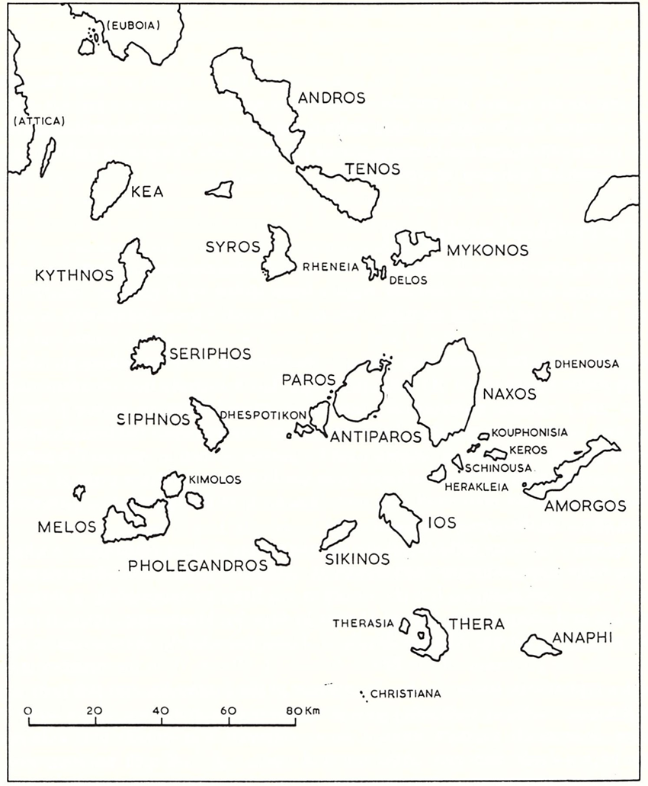
Figure 1: The Cycladic Islands. Renfrew, The Emergence of Civilization, 137.
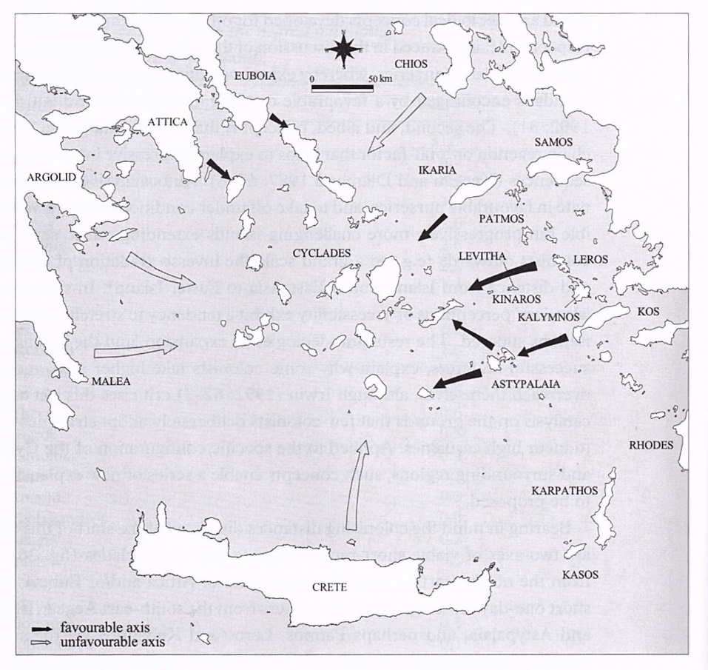
Figure 2: Axes of migration into the Cyclades. Broodbank, An Island Archaeology, 132.
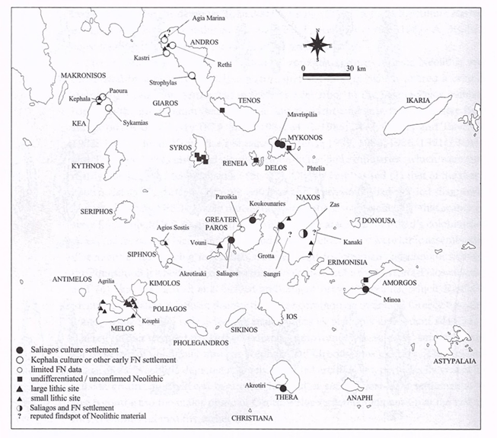
Figure 3: Neolithic sites in the Cyclades. Broodbank, An Island Archaeology, 122.

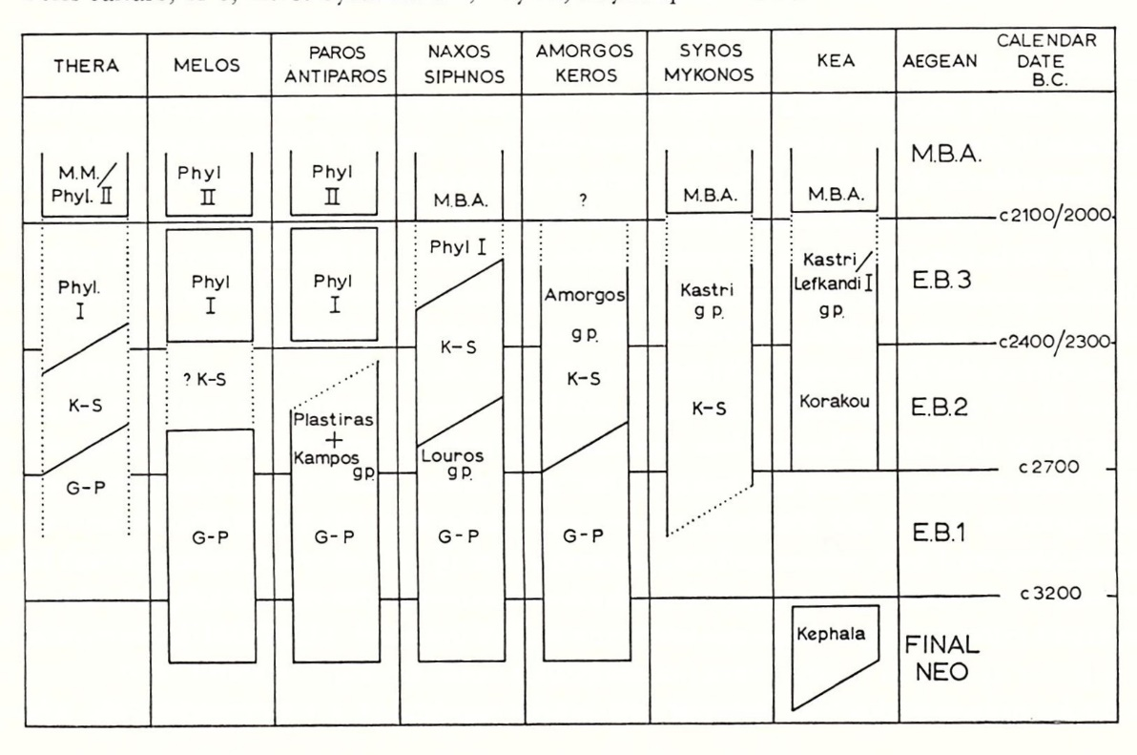
Figure 4: The early prehistoric culture sequence in the Cycladic Islands. Renfrew, The Emergence of Civilization, 150.
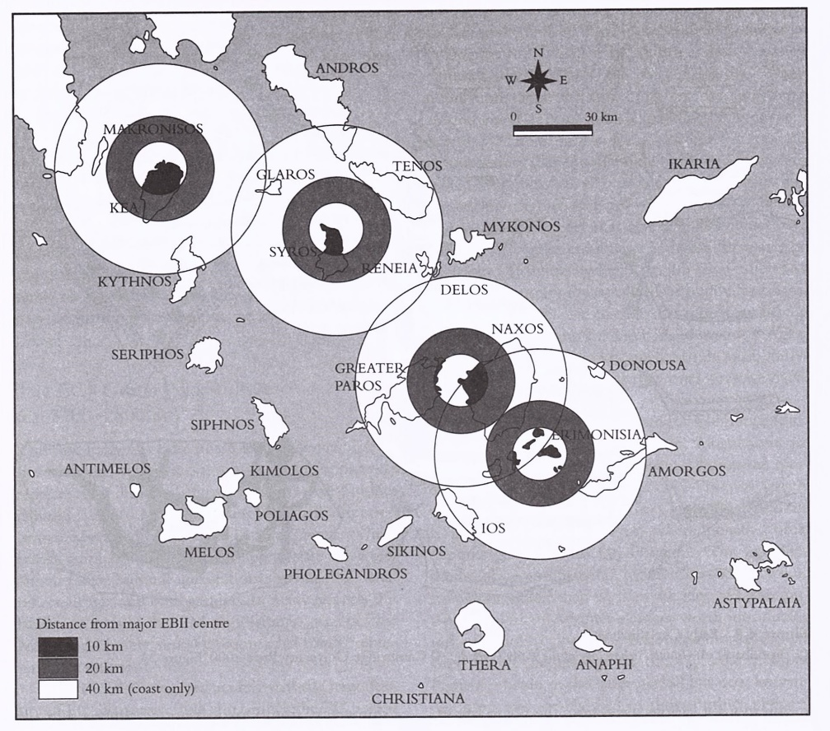
Figure 5: The Early Prehistoric Culture Sequence in the Cycladic Islands; Renfrew, The Emergence of Civilization, 150.
Figure 5: Travel ranges from major island foci; Bintliff, The Complete Archaeology of Greece, 106.
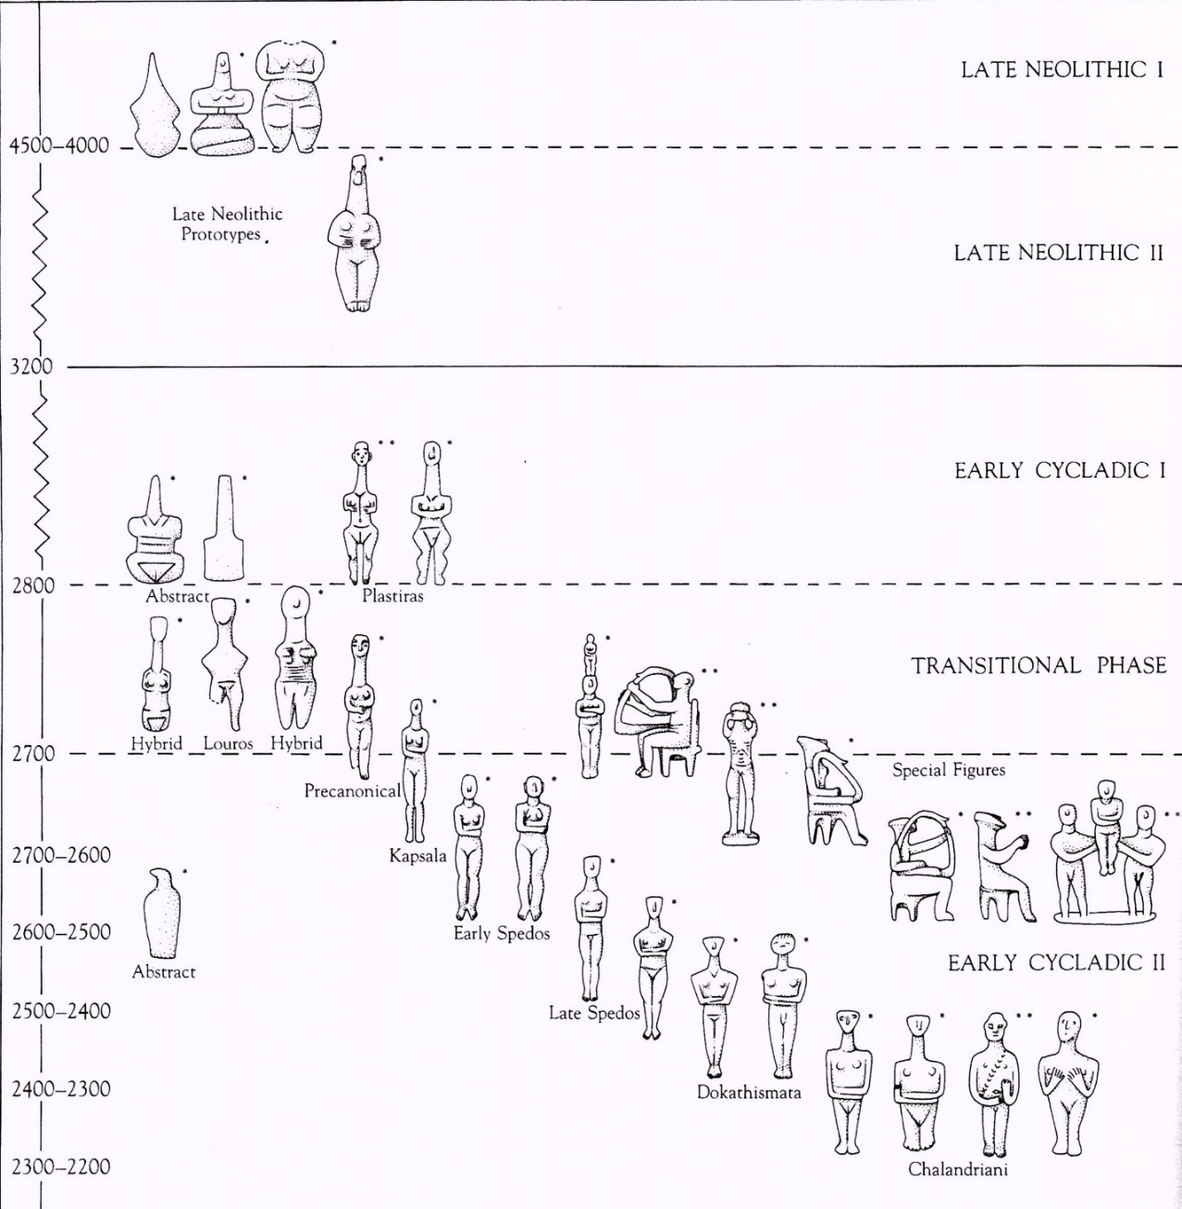
Figure 6: Chart of chronological and typological development of Cycladic figurines; Getz-Gentle, Early Cycladic Art in North American Collections, 48.
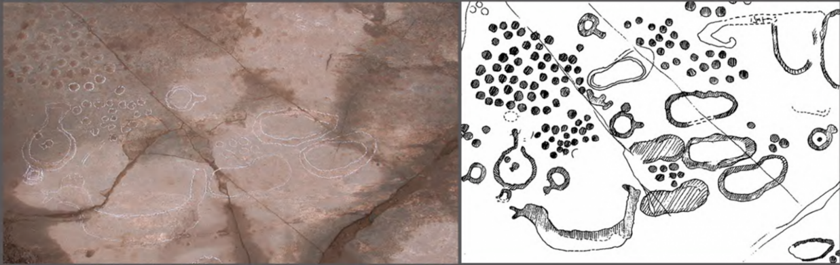
Figure 7: Part of a large floor composition from Strofilas, Andros; Televantou, "Strofilas: A Neolithic Settlement on Andros," 49.
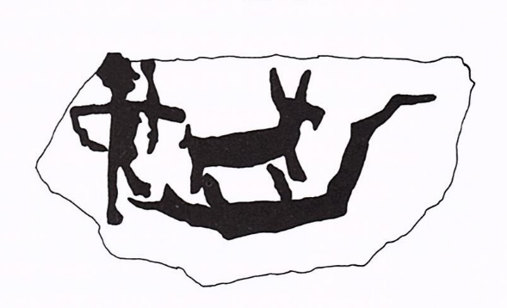
Figure 8: Rock pecking showing a canoe carrying a person and an animal, from Korphi t'Aroniou on Naxos; Broodbank, An Island Archaeology, 98.

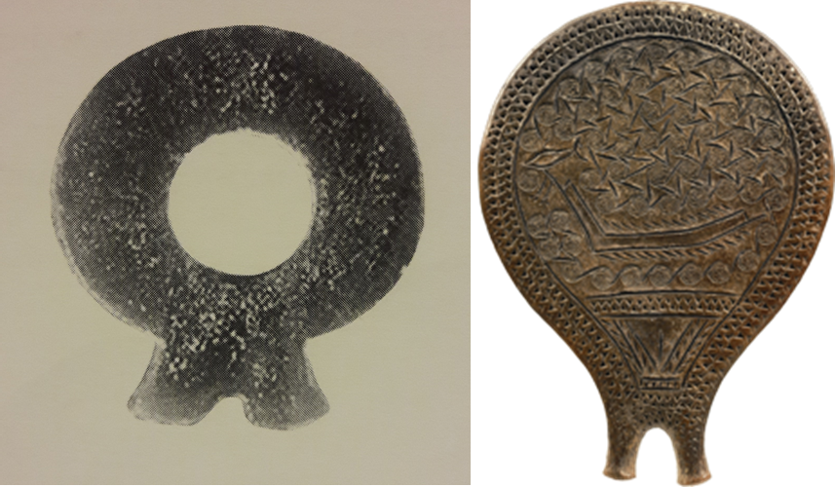
Figure 9: Ring-shaped idol pendant from Strofilas and Keros-Syros 'frying pan', Chalandriani; Televantou, "Strofilas: A Neolithic Settlement on Andros," 52; National Archaeological Museum website, accessed 3/19/17.

Bibliography
Abadía, Oscar Moro and Manuel R. Gonzáles Morales. “Paleolithic Art: A Cultural History.” Journal of Archaeological Research 21, no. 3 (Sep 2013): 269-306. Accessed 3-14-2017. http://www.jstor.org/stable/42635583.
“Animals in Ancient Near Eastern Art,” Department of Ancient Near Eastern Art, 02/2014, (New York: The Metropolitan Museum of Art). Accessed 3/6/2017, http://www.metmuseum.org/toah/hd/anan/hd_anan.htm.
Andrews, Peter, Theya Molleson and Başak Boz. “The Human Burials at Çatalhöyük.” In Inhabiting Çatalhöyük: Reports From the 1995-99 Seasons, edited by Ian Hodder, 261-278. Cambridge: McDonald Institute for Archaeological Research, 2005.
Angelopoulou, Anastasia. “The ‘Kastri Group’: Evidence from Korfari ton Amygdalion (Panormos) Naxos, Dhaskalio Keros and Akrotiri Thera,” In Horizon: A Colloquium on the Prehistory of the Cyclades, edited by Neil Brodie et al., 149- 164. Oxford: McDonald Institute for Archaeological Research, 2008.
Aristotle. History of Animals. Translated by D'Arcy Wentworth Thompson. In Complete Works of Aristotle, Delphi Classics, 2013. Kindle.
Atkinson, T.D., et al. Excavations at Phylakopi in Melos Conducted by the British School at Athens. London: Macmillan and Co., 1904.
Bach, Friedrich Teja. Shaping the Beginning: Modern Artists and the Ancient Eastern Mediterranean. Athens: N.P Goulandris Foundation and Museum of Cycladic Art, 2006.
Banou, Emily. “Minoan ‘Horns of Consecration’ Revisited: A Symbol of Sun Worship in Palatial and Post-Palatial Crete?” Mediterranean Archaeology and Archaeometry 8, no. 1 (2008): 27-47. Accessed 4/1/2017. http://maajournal.
com/Issues/2008/FullTextBanou.pdf.
Barber, R.L.N. and J.A. MacGillivray. “The Early Cycladic Period: Matters of Definition and Terminology.” American Journal of Archaeology 84, no. 2 (Apr 1980): 141-157. Accessed 12-07-2009. http://www.jstor.org/stable/504262.
------ and O. Hadjianastasiou. “Mikre Vigla: A Bronze Age Settlement on Naxos.” Annual of the British School at Athens 84 (1989): 63-162. Accessed 3/17/2017. http://jstor.org/stable/30104548.
Barrett, John C. and Paul Halstead. The Emergence of Civilisation Revisited. Oxford: Oxbow Books, 2004.
Bintliff, J. L. The Complete Archaeology of Greece: From Hunter-Gatherers to the 20th Century A.D. Malden, MA: Wiley-Blackwell, 2012.
Bloedow, Edmund F. “The Date of the Earliest Phase at Agrissa Magoula in Thessaly and Other Neolithic Sites in Greece.” Mediterranean Archaeology 5/6 (1992/93): 49-57. Accessed 9-17-2016. http://www.jstor.org/stable/24667819.
Branigan, Keith. “Cycladic Figures and Their Derivatives in Crete.” The Annual of the British School at Athens 66 (1971): 57-78. Accessed 12-07-2009. http://www.jstor.org/stable/30103228.
Brodie, Neil, et al. Horizon: A Colloquium on the Prehistory of the Cyclades. Cambridge: McDonald Institute for Archaeological Research, 2008.
Broodbank, Cyprian. “The Longboat and Society in the Cyclades in the Keros-Syros Culture.” American Journal of Archaeology 93 (1989): 319-337. Accessed 5-26- 2106. http://www.jstor.org/stable/5050584.
------. “Ulysses without Sails: Trade, Distance, Knowledge and Power in the Early Cyclades.” World Archaeology 24, no. 3 (Feb. 1993): 315-331. Accessed 01-24- 2010. http://www.jstor.org/stable/124711.
------. An Island Archaeology of the Early Cyclades: Cambridge: Cambridge University Press, 2000.
------. “The Early Bronze Age in the Cyclades.” In The Cambridge Companion to the Aegean Bronze Age, edited by Cynthia W. Shelmerdine, 47-76. Cambridge: Cambridge University Press, 2008.
------. The Making of the Middle Sea: A History of the Mediterranean from the Beginning to the Emergence of the Classical World. Oxford: Oxford University Press, 2013.
Buchholz, Hans-Gunter and Vassos Karageorghis. Prehistoric Greece and Cyprus. Translated by Francisca Garvie. London: Phaidon, 1973.
Burkert, Walter. Greek Religion. Translated by John Raffan. Cambridge: Harvard University Press, 1985.
Buxton, Richard. The Complete World of Greek Mythology. London: Thames and Hudson, 2004.
Caskey, John L. “Notes on Keos and Tzia.” Hesperia 50, no. 4 (Oct. - Dec., 1981): 320- 326. Accessed 9-22-2015. http://www.jstor.org/stable/147875.
------ and E.T. Blackburn. Lerna in the Argolid. Athens: American School of Classical Studies at Athens, 1997.
Cherry, J.F. “Pattern and Process in the Earliest Colonization of the Mediterranean Islands.” Proceedings of the Prehistoric Society 47 (1981): 41-68.
------. “First Colonization of the Mediterranean Islands.” Journal of Mediterranean Archaeology 3, no. 1 (1990): 145-221.
Chevalier, Jean and Alain Gheerbrant. A Dictionary of Symbols. Translated by John Buchanan-Brown, New York: Penguin Books, 1996.
Choremi, Alkhestis, Christina Vlassopoulou and Yianna Venieri. Kea: History and Antiquities. Translated by Myriam Caskey. Athens: Ministry of Culture Archaeological Receipts Fund, 2002.
Cline, Eric H. The Oxford Handbook of the Bronze Age Aegean. Oxford: Oxford University Press, 2010.
Clottes, Jean, David Lewis-Williams and Sophie Hawkes. Shamans of Prehistory: Trance and Magic in Painted Caves. New York: Harry N. Abrams, 1998.
Coleman, John E. “The Chronology and Interconnections of the Cycladic Islands in the Neolithic Period and the Early Bronze Age.” American Journal of Archaeology 78, no. 4 (Oct 1974): 333-344. Accessed 12-07-2009. http://www.jstor.org/
stable/502747.
------. “’Frying Pans’ of the Early Bronze Age Aegean.” American Journal of Archaeology 89, no. 2 (Apr 1985): 191-219. Accessed 08-29-2008. http://www.jstor.org/stable/504325.
Cooper, J.C. An Illustrated Encyclopedia of Traditional Symbols. London: Thames and Hudson, 1978.
“Cycladic Art: The Fat Lady of Saliagos.” The Bradshaw Foundation. Accessed 2/18/2017. http://www.bradshawfoundation.com/sculpture/cycladic
_scultpture1.php
Davaras, Costis. Hagios Nikolaos Museum. Translated by Alexandria Doumas. Athens: Editions Hannibal, n.d.
Davis, Jack L. “Review of Aegean Prehistory I: The Islands of the Aegean.” American Journal of Archaeology 96 (Oct 1992): 699-756. Accessed 5-26-2016. http://www.jstor.org/stable/505192.
Demoule, Jean-Paul and Catherine Perlès. “The Greek Neolithic: A New Review.” Journal of World Prehistory 7, no. 4 (Dec. 1993): 355-416. Accessed 9-17- 2016. http://www.jstor.org/stable/25800637.
Dickinson, Oliver. The Aegean Bronze Age. Cambridge: Cambridge University Press, 1994.
Doumas, Christos. Early Bronze Age Burial Habits in the Cyclades. Göteborg: Paul Åströms Förlag, 1977.
------. Cycladic Art: Ancient Sculpture and Pottery from the N.P. Goulandris Collection. London: British Museum Press, 1996.
------. Early Cycladic Culture: The N.P. Goulandris Collection. Athens: N.P. Goulandris Foundation and Museum of Cycladic Art, 2000.
------. “Aegean Absolute Chronology: Where Did It Go Wrong?” In Tree-Rings, Kings, and Old World Archaeology and Environment: Papers Presented in Honor of Peter Ian Kuniholm, edited by Sturt Manning and Mary Jaye Bruce, 263-274. Oxford: Oxbow, 2009.
Feldman, Marian H. “Mesopotamian Art.” In A Companion to the Ancient Near East, edited by Daniel C. Snell, 304-324. Malden, MA: Blackwell, 2007.
Fitton, J.L., ed. Cycladica. London: British Museum Publications, 1984.
------. Cycladic Art. London: British Museum, 1999.
Galanakis, Ioannis, ed. The Aegean World. Oxford: Ashmolean Museum, University of Oxford, 2013.
Getz-Gentle, Pat, Jack L. Davis and Elizabeth Oustinoff. Early Cycladic Art in North American Collections. Richmond, VA: Virginia Museum of Fine Arts, 1987.
------. Sculptors of the Cyclades: Individual and Tradition in the Third Millennium B.C. Ann Arbor: University of Michigan Press, 1987.
------. Stone Vessels of the Cyclades in the Early Bronze Age. University Park, PA: Penn State University Press, 1996.
Getz-Preziosi, Pat. “The Male Figure in Early Cycladic Sculpture.” Metropolitan Museum Journal 15 (1980): 5-33. Accessed 09-15-2009. http://www.
jstor.org/stable/1512749.
------. “Risk and Repair in Early Cycladic Sculpture.” Metropolitan Museum Journal 16 (1981): 5-32. Accessed 12-08-2009. http://www.jstor.org/stable/1512766.
------. The Obsidian Trail, or 5000-4000 Years Ago in the Cyclades. Athens: Nicholas P. Goulandris Foundation and the Museum of Cycladic Art, 1987.
Gill, David W.J. and Christopher Chippindale. “Material and Intellectual Consequences of Esteem for Cycladic Figures.” American Journal of Archaeology 97, no. 4 (Oct 1993): 601-659. Accessed 02-10-2010. http://www.jstor.org/stable/506716.
Gimbutas, Marija. The Goddesses and Gods of Old Europe, 6500-3500 BC, Myths and Cult Images. Berkeley: University of California, 1982.
------. The Language of the Goddess: Unearthing the Hidden Symbols of Western Civilization. San Francisco: Harper & Row, 1989.
------. The Civilization of the Goddess: The World of Old Europe. San Francisco: Harper, 1991.
------ and Miriam Robbins Dexter. The Living Goddesses. Berkeley: University of California Press, 1999.
Hall, James. Illustrated Dictionary of Symbols in Eastern and Western Art. New York: HarperCollins, 1994.
Hamilakis, Yannis. “The Sacred Geography of Hunting: Wild Animals, Social Power and Gender in Early Farming Societies.” British School at Athens Studies 9 (2003): 239-247. Accessed 11-15-2015. http://www.jstor.org/stable/40960352.
Hekman, Jan Jakob. “The Early Bronze Age Cemetery at Chalandriani on Syros.” PhD. Diss. Rijksuniversiteit Groningen, 2003. Accessed 02-07-16. http://www.rug.nl/ research/portal/publications/the-early-bronze-age-cemetery-at-chalandriani -on-syros-cyclades-greece(8dd13d8e-d4a4-40bc-91a6-1bb57ce032c5) .html.
Hendrix, Elizabeth A. “Painted Early Cycladic Figures: An Exploration of Context and Meaning.” Hesperia 72, no. 4 (Oct-Dec 2003): 405-446. Accessed 9-15-2009. http://www.jstor.org/stable/3182012.
Höckmann, Olaf. “Cycladic Religion.” In Art and Culture of the Cyclades in the Third Millennium B.C., edited by Jürgen Thimme, 37-51. Chicago: University of Chicago Press, 1977.
Hodder, Ian. Inhabiting Çatalhöyük: Reports From the 1995-99 Seasons. Cambridge: McDonald Institute for Archaeological Research, 2005.
Hutchinson, R.W. “Prehistoric Town-Planning in and around the Aegean.” The Town Planning Review 23, no. 4 (Jan 1953): 261-279. Accessed 01-24-2010. http://www.jstor.org/stable/40101497.
Katsarou-Tzeveleki, Stella and Demetrius U. Schilardi. “Emerging Neolithic and Early Cycladic Settlements in Paros: Koukounaries and Sklavouna.” The Annual of the British School at Athens 99 (2004): 23-48. Accessed 7-26-2016. http://www.jstor.org/stable/30071530.
------. “Some Reflections on EC Domestic Space Arising from Observations at Kkoukounaries, Paros.” In Horizon: A Colloquium on the Prehistory of the Cyclades, edited by Neil Brodie et al., 61-70. Oxford: McDonald Institute for Archaeological Research, 2008.
------ and Demetrius U. Schilardi. “Recontextualized Neolithic and Early Cycladic Figurines at the Acropolis of Koukounaries, Paros.” In Early Cycladic Sculpture in Context, edited by Marisa Marthari, Colin Renfrew, and Michael Boyd, 410- 420. Oxford: Oxbow, 2017.
Katsouros, K.A. and S.A. Katsouros. Naxos: today and yesterday. Translated by G. Cox and J. Solman. Athens: Michalis Toumbis Editions, 1987.
Kouka, Ourania. “Third Millennium BC Aegean Chronology: Old and New Data from the Perspective of the Third Millennium AD.” In Tree-Rings, Kings, and Old World Archaeology and Environment: Papers Presented in Honor of Peter Ian Kuniholm, edited by Sturt Manning and Mary Jaye Bruce, 133-149. Oxford 2009.
Kourayos, Yannos. Paros-Antiparos: History, Monuments, Museums. Athens: Adam Editions, 2004.
Lamb, Winifred. Corpus Vasorum Antiquorum. Oxford: Oxford University Press, 1936. Accessed 12/29/2016. http://www.cvaonline.org/cva/Britain.htm.
Lapatin Kenneth, Mysteries of the Snake Goddess: Art, Desire, and the Forging of History, Cambridge, MA: Da Capo Press, 2003.
Manning, Sturt and Mary Jaye Bruce, eds. Tree-Rings, Kings, and Old World Archaeology and Environment: Papers Presented in Honor of Peter Ian Kuniholm. Oxford: Oxbow, 2009.
Marangou, Lila, ed. Cycladic Culture: Naxos in the 3rd Millennium, B.C. Athens: Nicholas P. Goulandris Foundation, 1990.
Marthari, Marisa, Colin Renfrew and Michael J. Boyd, eds. Early Cycladic Sculpture in Context. Oxford: Oxbow Books, 2017.
------. “Figurines in Context at the Chalandriani Cemetery on Syros.” In Early Cycladic Sculpture in Context, edited by Marisa Marthari, Colin Renfrew and Michael Boyd, 297-309. Oxford 2017.
Masseti, Marco. “Representations of Birds in Minoan Art,” International Journal of Osteoarchaeology 7 (1997): 354-363.
------. “Taxonomic and Behavioural Aspects of the Representation of Mammals in Aegean Bronze Age.” British School at Athens Studies 9 (2003): 273-281. Accessed 11-15-2015. http://www.jstor.org/stable/40960357.
Meyers, J.L. “Islands of the Aegean.” The Geographical Journal 97 (1941): 137-156. Accessed 5-26-2016. http://jstor.org/stable/1787324.
Morphy, Howard, ed. Animals into Art. London: Unwin Hyman, 1989.
Mylonopoulos, Joannis, ed. Divine Images and Human Imaginations in Ancient Greece and Rome. Leiden and Boston: Brill, 2010.
------. “Divine Images Versus Cult Images. An Endless Story about Theories, Methods, and Terminologies.” In Divine Images and Human Imaginations in Ancient Greece and Rome, ed. Joannis Mylonopoulos, 1-81. Leiden and Boston: Brill, 2010. Accessed 04/20/2017. http://www.brill.com/divine-images-and-human-
imaginations-ancient-greece-and-rome.
Nowell, April. “From a Paleolithic Art to Pleistocene Visual Cultures.” Journal of Archaeological Method and Theory 13, no. 4 (Dec. 2006): 239-249. Accessed 3- 14-2017. http://www.jstor.org/stable/20177542.
Papadakis, Nikos. Sitia: Fatherland of Myson and Kornaros. Translated by Jane Mary Kafetzaki. Sitia: The District Council of Sitia, 1983.
Papathanasopoulos, G. National Archaeological Museum: Catalogue of Neolithic and Cycladic Collections. Athens: Melissa Editions, 1981.
Papazoglou-Manioudaki, Lena. “The Early Cycladic Figurines from the Excavations of Clon Stephanos on Syros.” In Early Cycladic Sculpture in Context, eds. Marisa Marthari, Colin Renfrew, Michael Boyd, 310-334. Oxford: Oxbow, 2017.
Pausanias. Description of Greece. Translated by W.H.S. Jones. In Complete Works of Pausanias. London: Delphi Classics, 2014. Kindle.
Peristera Paschou, et al. “Maritime Route of Colonization of Europe.” Proceedings of the National Academy of Sciences 111, no. 25 (June 24, 2014): 9211-9216. Accessed 2/23/2017. http://www.pnas.org/content/111/25/9211.full.
Phoca-Cosmetatou, Nellie. “Economy and Occupation in the Cyclades during the Late Neolithic: the Example of Ftelia, Mykonos.” In Horizon: A Colloquium on the Prehistory of the Cyclades, edited by Neil Brodie et al., 37-41. Oxford: McDonald Institute for Archaeological Research, 2008.
Plato. The Republic. Translated by Benjamin Jowett. Mineola, NY: Dover Publications, 2000. Kindle.
Pliny the Elder. Natural Histories. Translated by John Bostock and H.T. Riley. In The Complete Works of Pliny the Elder. Delphi Classics, 2015. Kindle.
Preziosi, Donald and Louise A. Hitchcock. Aegean Art and Architecture. Oxford: Oxford University Press, 1999.
Renfrew, Colin. “Cycladic Metallurgy and the Aegean Early Bronze Age.” American Journal of Archaeology 71, no. 1 (Jan 1967): 1-20. Accessed 01-27-2010. http://www.jstor.org/ stable/501585.
------. “The Development and Chronology of the Early Cycladic Figurines.” The American Journal of Archaeology 73 (Jan 1969): 1-32. Accessed 7-15-2016. http://www.jstor.org/stable/503370.
------. The Emergence of Civilization: The Cyclades and the Aegean in the Third Millennium B.C. London: Methuen, 1972.
------. “The Cycladic Culture.” In Art and Culture of the Cyclades in the Third Millennium B.C., edited by Jürgen Thimme, 17-30. Chicago: University of Chicago Press, 1977.
------. “Speculations on the Use of Early Cycladic Sculpture.” In Cycladica, edited by J.L. Fitton, 24-30. London: British Museum Publications, 1984.
------. The Cycladic Spirit: Masterpieces from the Nicholas P. Goulandris Collection. New York: H.N. Abrams and Nicholas P Goulandris Foundation, Museum of Cycladic Art, Athens, 1991.
------, et al., “Keros: Dhaskalio and Kavos, Early Cycladic Stronghold and Ritual Centre. Preliminary Report of the 2006 and 2007 Excavation Seasons.” The Annual of the British School at Athens 102 (2007): 103-136. Accessed 5-26- 2016. http://www.jstor.org/stable/30245247.
------. “Contrasting Trajectories: Crete and the Cyclades During the Aegean Early Bronze Age.” British School at Athens Studies 18 (2010): 285-291. Accessed 7- 26-2016. http://www.jstor.org/stable/23276784.
------, et al., The Sanctuary on Keros and the Origins of Aegean Ritual Practice: The Excavations of 2006-2008. Vol. 1, The Settlement at Dhaskalio. Cambridge: McDonald Institute for Archaeological Research, 2013.
------, et al., The Sanctuary on Keros and the Origins of Aegean Ritual Practice: The Excavations of 2006-2008. Volume II, Kavos and the Special Deposits. Cambridge: McDonald Institute for Archaeological Research, 2015.
Rosen, Brenda. The Mythical Creatures Bible: The Definitive Guide to Legendary Beings. New York: Sterling, 2009.
Rutter, Jeremy B. “Aegean Prehistoric Archaeology.” Dartmouth College. Last modified n.d. Accessed 2/18/2017. http://www.dartmouth.edu/
~prehistory/aegean/.
Sakellarakis, J.A. Herakleion Museum. Athens: Ekdotike Athenon, 1999.
Sapouna-Sakellariakis, E. Cycladic Civilization and the Cycladic Collection of the National Archaeological Museum of Athens. Athens: Apollo Editions, 1973.
Schoch, Robert M. "Redating the Great Sphinx of Giza." KMT: A Modern Journal of Ancient Egypt 3, no. 2 (1992): 52-59.
Shelmerdine, Cynthia W., ed. The Cambridge Companion to the Aegean Bronze Age. Cambridge: Cambridge University Press, 2008.
Snell, Daniel C., ed. A Companion to the Ancient Near East. Malden, MA: Blackwell, 2007.
Sotirakopoulou, Panayiota. “The Chronology of the ‘Kastri Group’ Reconsidered.” The Annual of the British School at Athens 88 (1993): 5-20. Accessed 12-07-2009. http://www.jstor.org/stable/30064355.
------. “Dhaskalio Kavos, Keros: The Pottery from the Investigations of the 1960s.” In Horizon: A Colloquium on the Prehistory of the Cyclades, edited by Neil Brodie et al., 115-120. Oxford: McDonald Institute for Archaeological Research, 2008.
Spivey, Nigel. How Art Made the World: A Journey to the Origins of Human Creativity. New York: Basic Books, 2005.
Stampolidis, Nikolaos Chr, and Peggy Sotirakopoulou. Aegean Waves: Artworks of the Early Cycladic Culture in the Museum of Cycladic Art at Athens. Milano: Skira, 2007.
Televantou, Christina A. “Strofilas: A Neolithic Settlement on Andros.” In Horizon: A Colloquium on the Prehistory of the Cyclades, edited by Neil Brodie et al., 43- 53. Oxford: McDonald Institute for Archaeological Research, 2008.
Thimme, Jurgen, ed. Art and Culture of the Cyclades in the Third Millennium B.C. Translated by Pat Getz-Preziosi. Chicago: University of Chicago Press, 1977.
Toufexis, George. “Animals in the Neolithic art of Thessaly.” British School at Athens Studies 9 (2003): 263-271. Accessed 5-19-2016. http://www.jstor.org/
stable/40960356.
Trantalidou, Katerina. “Glimpses of Aegean Island Communities during the Mesolithic and Neolithic Periods: the Zooarchaeological Point of View.” In Horizon: A Colloquium on the Prehistory of the Cyclades, edited by Neil Brodie et al., 19- 27. Oxford: McDonald Institute for Archaeological Research, 2008.
------. “The Animal Bones: The Exploitation of Livestock.” In The Sanctuary on Keros and the Origins of Aegean Ritual Practice: The Excavations of 2006-2008. Vol. 1, The Settlement at Dhaskalio, edited by Colin Renfrew et al., 429-442. Cambridge: McDonald Institute for Archaeological Research, 2013.
Vasilakis, Andonis. Herakleion Archaeological Museum. Athens: Adams Editions, 2000.
Vorreiter, Leopold. “The Swan-neck Lyres of Minoan-Mycenean Culture.” The Galpin Society Journal 28 (Apr 1975): 93-97. Accessed 02-13-2007. http://www.jstor.org/stable/841575.
Weinberg, Saul S. “Neolithic Figurines and Aegean Interrelations.” American Journal of Archaeology 55, no. 2 (Apr 1951): 121-133. Accessed 08-29-2008. http://www.jstor.org/stable/501279.
Wilson, David E. Keos: Volume IX, Ayia Irini, Periods I-III. Mainz am Rhein: Verlag Philipp von Zabern, 1999.
Yamaguchi, N., Cooper, A., Werdelin, L. and Macdonald, D. W., “Evolution of the Mane and Group-Living in the Lion (Panthera leo): A Review”. Journal of Zoology 263 (2004): 329–342. Accessed 4/30/2017. doi:10.1017/
S0952836904005242.
Zafiropoulou, F. “Cycladic Finds from Keros.” Athens Annals of Archaeology 1 (1968): 97-100.
------. Naxos: Monuments and Museum. Athens: Krene Editions, 1988.

Appendix A: Catalog Reference List, Chronological
Early Cycladic I (3200 BCE-2800/2700 BCE)
V1. Sheep Kernos
V2. Sheep Kernos Fragment
V3. Pig Pyxis
J1. Zoomorphic Amulet
J2. Frog Amulet
J3. Dove Amulet
J4. Zoomorphic Amulet
P1. Zoomorphic Head Protome

Early Cycladic II (2800/2700 BCE-2400/2300 BCE)
V4. Large Plate, “Dove Tray”
F1-3. Dove Tray Fragments
V5. Large Plate, “Dove Tray” Fragments
V6. Dove Lid, Spool Pyxis
V7. Two-headed Bird Pyxis
J5-8. Pin
F4. Bird Figurine
J9. Bird Periapt
F5-6. Bird Figurine
F7. Egg Figurine
V8. Bird Pyxis
V9. Bird Pyxis, Fragment
V10. Bird Askos
V11-13. Hedgehog Vessel
V14-15. Hedgehog Vessel Fragment
V16. Ram Vessel Fragment
V17. Ram Rhyton Fragment
V18. Two Zoomorphic Vessel Fragments
J10. Zoomorphic Amulet, Quadruped
J11. Zoomorphic Amulet, Bird
J12-13. Fly/Bee Amulet
F8-10. Ram Figurine
J14. Pin
V19-20. Pig or Sheep Pyxis Fragment
P2-10. Ram Protome
P11-15. Ram Head Spout Fragments
P16. Ram Head Spout Fragment
P17-22. Ram Protomes

Early Cycladic III (2400/2300 BCE-2000 BCE)
V21-22. Theriomorphic Vase
V23. Ring-Shaped Vessel (Annular Askos)

Early Cycladic I (3200 BCE-2800/2700 BCE)
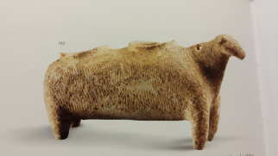
Photo Credit: Ashmolean Museum, University of Oxford

V1. Sheep Kernos
Medium: marble
Period: EC I
Date: 3200-2800 BCE
Dems: H 11, L 22, W 4.5 cm
Provenance: possibly Amorgos
Location/Access. no.: Ashmolean, GR. AN1912.71
Description: An oblong body, with four short legs. Two cups are hollowed out into the top of the animal’s body. A lug forms the tail and a hole is drilled into the neck. A series of short, diagonal incisions alternating all over the body forms the representation of fleece. This object was purchased in Athens, but when and by who is unknown. Sir Arthur Evans gave the vessel to the museum in 1912. Therefore, the provenance is uncertain. It is suggested in the initial report that the find spot may be Amorgos, but it is uncertain why this suggestion was made.

Notes:
Pat Getz-Gentle, Jack L. Davis and Elizabeth Oustinoff, Early Cycladic Art in North American Collections, (Richmond, VA: Virginia Museum of Fine Arts: Seattle, 1987), 55.
Susan Sherratt, Catalogue of Cycladic Antiques in the Ashmolean Museum: The Captive Spirit, Vol. I, (Oxford: Oxford University Press, 2000), 124-25.
———, Catalogue of Cycladic Antiques in the Ashmolean Museum: The Captive Spirit, Vol. II, (Oxford: Oxford University Press, 2000), pls. 103-105; col. pl. 5.
Yannis Galanakis, ed, The Aegean World, (Oxford: Ashmolean Museum, University of Oxford, 2013), 91-92.

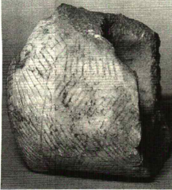
Photo Credit: Thimme, Art and Culture of the Cyclades in the Third Millennium B.C., 339.

V2. Sheep Kernos, fragment
Medium: marble
Period: EC I
Date: 3200-2800 BCE
Dems: H 7.6 cm, L 6.8 cm
Provenance: “from Attica”
Location/Access. no.: Private Collection, Germany
Description: “A fragmentary zoomorphic pyxis which originally had two receptacles carved out of its barrel-shaped body. The vessel has small v-shaped stump-like feet and a suspension hole in the hind end. The entire exterior surface is decorated with broad panels of carefully incised, superimposed chevrons or zigzags. The treatment of the surface of this vessel is similar to that of the zoomorphic double pyxis from Amorgos in Oxford...Condition: yellowish surface, partly heavily encrusted with brownish deposits and root marks. Only a portion of the rear end, with one receptacle, survives; the break surfaces are heavily encrusted.” (Thimme, 523)

Notes:
Pat Getz-Gentle, Jack L. Davis and Elizabeth Oustinoff, Early Cycladic Art in North American Collections, (Richmond, VA: Virginia Museum of Fine Arts, 1987), 86, fn 6.
———, Stone Vessels of the Cyclades in the Early Bronze Age, (University Park, PA: Penn State University Press, 1996), 347, pl. 78b; text, 138. Notes to Plates: fragment to a vessel similar to Ashmolean Sheep; part of hind end with one container; see also fig. 73b, p 137.
Jürgen Thimme, ed, Art and Culture of the Cyclades in the Third Millennium B.C., trans. Pat Getz-Preziosi, (Chicago: University of Chicago Press, 1977), 339, 523; no.366.

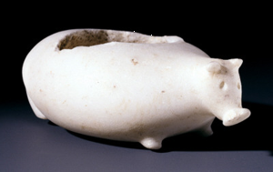
Photo Credit: Renfrew, Cycladic Spirit, 166.
V3. Pig Pyxis
Medium: marble
Period: EC I, Grotta-Pelos, Plastiras Group
Date: 3200-2300 BCE
Dems: H. 4 cm, L: 12.7 cm , W: 7.9 cm , D.rim: 4.5 cm
Provenance: Unknown (Possibly Naxos)
Location/Access. no.: Museum of Cycladic Art, NG0285
Description: “A vessel in the form of a pig. The head is sculpted in the round with the ears and snout rendered in relief and small depressions probably for inset eyes. On the underside, four tiny protuberances represent the legs, on which the trotters are cloven by a fine incision. On the rear of the vase the rudimentary tail is carved in relief. A small hollow in the back constitutes the container. The quality of the workmanship and the naturalistic conception are characteristic of the Plastiras phase.” (Doumas, 77) “The rim of the cavity is chamfered to receive the lid, now lost. Only three more intact and three fragmentary examples of marble zoomorphic pyxides are known, which represent sheep, pigs or hedgehogs, as well as a two-headed bird. Only clay zoomorphic askoi (flasks), usually in the form of a duck, are known from the Early Cycladic III period, while there are also sporadic examples in the form of a bovine or a snake.” (Museum of Cycladic Art, https://www.cycladic.gr/en/exhibit/ng0285-zoomorfi-pixida)
Notes:
Christos Doumas, Cycladic Art: Ancient Sculpture and Pottery from the N.P. Goulandris Collection, (London: British Museum Press, 1996), 72.
Colin Renfrew, The Cycladic Spirit: Masterpieces from the Nicholas P. Goulandris Collection, (New York: H.N. Abrams and Nicholas P Goulandris Foundation, Museum of Cycladic Art, Athens, 1991), pl 110.
———, Early Cycladic Culture: The N.P. Goulandris Collection, (Athens: N.P. Goulandris Foundation and Museum of Cycladic Art, 2000), 77, no. 39.
Jürgen Thimme, ed., Art and Culture of the Cyclades in the Third Millennium B.C., trans. Pat Getz-Preziosi, (Chicago: University of Chicago Press, 1977), 99, fig. 80.
Pat Getz-Gentle, Jack L. Davis and Elizabeth Oustinoff, Early Cycladic Art in North American Collections, (Richmond, VA: Virginia Museum of Fine Arts, 1987), 70-71, figs. 38a, 38b.

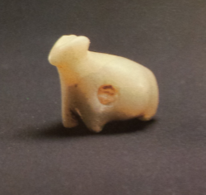
Photo Credit: Renfrew, Cycladic Spirit, 56.
J1. Zoomorphic Amulet
Medium: pale green soft stone
Period: EC I, Grotta-Pelos, Pelos Group
Date: c. 3200-2800 BCE
Dems: L: 1.7 cm
Provenance: unknown
Location/Access. no.: Museum of Cycladic Art, NG0184
Description: “A quadruped. Triangular head on which the ears are indicated by a deep cut on the crown. Small protuberances in the lower part denote the legs. A horizontal suspension hole above the forelegs.” (Doumas, 69)
Notes:
Christos Doumas, Cycladic Art: Ancient Sculpture and Pottery from the N.P. Goulandris Collection, (London: British Museum Press, 1996), 63.
———, Early Cycladic Culture: The N.P. Goulandris Collection, (Athens: N.P. Goulandris Foundation and Museum of Cycladic Art, 2000), 69, no. 17.
Colin Renfrew, The Cycladic Spirit: Masterpieces from the Nicholas P. Goulandris Collection, (New York: H.N. Abrams and Nicholas P Goulandris Foundation, Museum of Cycladic Art, Athens, 1991), pl. 19.
Nikolaos Stampolidis and Peggy Sotirakopoulou, Aegean Waves: Artworks of the Early Cycladic Culture in the Museum of Cycladic Art at Athens, (Milano: Skira, 2007), pl. 2.
Pat Getz-Gentle, Stone Vessels of the Cyclades in the Early Bronze Age, (University Park, PA: Penn State University Press, 1996), 186, 359, fig. 102 no. 25.

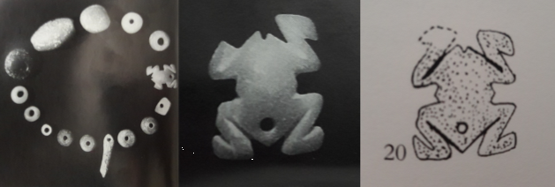
Photo Credit: Marangou, Cycladic Culture: Naxos in the 3rd Millennium, B.C., 58-59, and Getz-Gentle, Stone Vessels of the Cyclades in the Early Bronze Age, 186.
J2. Frog Amulet (splayed)
Medium: jadelike, soft stone
Period: EC I
Date: ca. 3200-2700 BCE
Dems: H. 1.4 mm, L. 1.1 mm
Provenance: Naxos, Akrotiri cemetery, grave 8
Location/Access. no.: Naxos Archaeological Museum, 2007
Notes:
Lila Marangou, ed., Cycladic Culture: Naxos in the 3rd Millennium, B.C., (Athens: Nicholas P. Goulandris Foundation, 1990), 58-59, no. 26.
Nikolaos Stampolidis and Peggy Sotirakopoulou, Aegean Waves: Artworks of the Early Cycladic Culture in the Museum of Cycladic Art at Athens, (Milano: Skira, 2007), 56 fig. 60.
Pat Getz-Gentle, Stone Vessels of the Cyclades in the Early Bronze Age, (University Park, PA: Penn State University Press, 1996), 186, 359-60, fig. 102 no. 20.

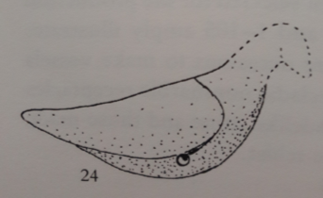
Photo Credit: Getz-Gentle, Stone Vessels of the Cyclades in the Early Bronze Age, 186.

J3. Dove Amulet
Medium: jadelike, soft stone
Period: EC I
Date: 3200-2700 BCE
Provenance: Ano Kouphonisi
Location/Access. no.: Naxos Archaeological Museum
Notes:
Pat Getz-Gentle, Stone Vessels of the Cyclades in the Early Bronze Age, (University Park, PA: Penn State University Press, 1996), 186, 359-60, fig. 102 no. 24.

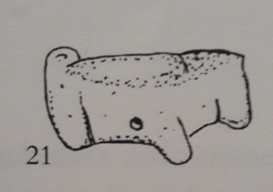
Photo Credit: Getz-Gentle, Stone Vessels of the Cyclades in the Early Bronze Age, 186.
J4. Zoomorphic Amulet
Medium: jadelike, soft stone
Period: EC I
Date: 3200-2700 BCE
Dems: N/A
Provenance: Ano Kouphonisi
Location/Access. no.: Naxos Archaeological Museum
Description: made of the same material, a soft green, jade-like stone as J1, J2, J3 and J9; this piece is fragmentary, missing the head which would help determine the species through identifying characteristics (i.e. presence of ram’s horns); all that can definitively be said is that it represents a quadruped. However, similar to J10, the tail appears to be curled and a hole has been drilled in the abdomen, presumably for hanging on a string of beads as in both J2 and J10.
From Aegean Waves: “Necklaces had beads of silver, common or semiprecious stones, seashells and bone, while a single gold bead has been found in a tomb on Naxos. Amulets were made of semiprecious stones in the shape of quadrupeds, birds, stars, frogs, droplets, flies or phalluses, and were either worn in isolation or strung as bead on necklaces.”
Notes:
Pat Getz-Gentle, Stone Vessels of the Cyclades in the Early Bronze Age, (University Park, PA: Penn State University Press, 1996), 186, 359-60, fig. 102 no. 21.
Nikolaos Stampolidis and Peggy Sotirakopoulou, Aegean Waves: Artworks of the Early Cycladic Culture in the Museum of Cycladic Art at Athens, (Milano: Skira, 2007), 70.

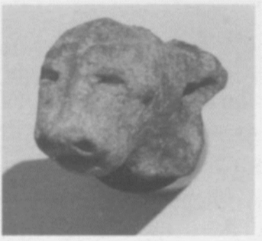
Photo Credit: Katsarou and Schilardi, “Emerging Neolithic and Early Cycladic Settlements in Paros”, 29, fig. 5c.
P1. Zoomorphic Head
Medium: clay
Period: EC I-II, Kampos phase
Date: 2700-2300 B.C.
Dems: H. 3 cm
Provenance: Paros, Koukournaries, Lower Plateau
Description: recovered from a secure and undisturbed context; excavated in 1991. Unusual in that it was not found in either a grave or associated with any architectural features. The layer above was a mix of Mycenaean, Geometric and later pottery. Though the protome is hollowed out from the back, as if to pour liquids, no opening appears from the front and therefore it could not have been part of a rhyton. The fabric is coarse clay, fired to a red-brown and gray color, with no signs of polishing or other treatment. “The cylindrical head narrows towards the lower front part denoting the animal’s muzzle. The rendering of the animal’s facial features is exceptionally naturalistic and expressive: a slightly plastic rib for the nose runs along the full length of the head. On either side the eyes are indicated by small deep incisions. At the front of the head-cylinder two small holes are made for nostrils, and a very deep groove denotes the animal’s open mouth. But none of the three apertures goes through to the interior of the vessel. Par of the upper left side of the head, which probably carried the animal’s horns, is missing. Below the head a thick rippled neck is a detail further strengthening the identification of the figurine as a bovine.” (“Recontextualized,” 414)
While the authors speculate that this represents a bovine, I propose that this is a feline representation, and the only one known to me in Early Cycladic three-dimensional art. I point to the style of the ears, which are well defined and modelled. They are not pricked forward, or laying elongated and flat, as we have seen in other representations of animals, whether wild or domesticates. Additionally, the muzzle is not elongated. The nasal bones of the skull are well-defined. And the eyes are represented by two deep impressions which appear to be more linear, rather than rounded as in other representations. However, since this likely dates to the transitional Kampos period, either the feline or bovine representation could be appropriate since I have found no other comparative representations in Early Cycladic art. However, for other comparisons see the quartzite lion cub figurine, Egyptian, Early Dynastic, c. 3100-2900 BCE, Gallatin Collection, The Metropolitan Museum of Art, New York, accession no. 66.99.2; and the Mother Goddess statuette from Çatalhöyük, c. 5750 BCE, The Museum of Anatolian Civilizations, Ankara.

Notes:
Stella Katsarou-Tzeveleki and Demetrius U. Schilardi, “Emerging Neolithic and Early Cycladic Settlements in Paros: Koukounaries and Sklavouna,” The Annual of the British School at Athens 99 (2004): 23-48. Accessed 7-26-2016, http://
www.jstor.org/stable/30071530. See figure 5c on page 29, text page 36, fn 71- 75.
Stella Katsarou-Tzeveleki and Demetrius U. Schilardi, “Some Reflections on EC Domestic Space Arising from Observations at Koukounaries, Paros,” in Horizon: A Colloquium on the Prehistory of the Cyclades, eds. Neil Brodie et al., 61-70, (Oxford: McDonald Institute for Archaeological Research, 2008), 67, fig 8.5c.
Stella Katsarou and Demetrius U. Schilardi. “Recontextualized Neolithic and Early Cycladic Figurines at the Acropolis of Koukounaries, Paros.” in Early Cycladic Sculpture in Context, eds. Marisa Marthari, Colin Renfrew, Michael Boyd, 410-420, (Oxford: Oxbow, 2017), 414-415.

Early Cycladic II (2800/2700 BCE-2400/2300 BCE)
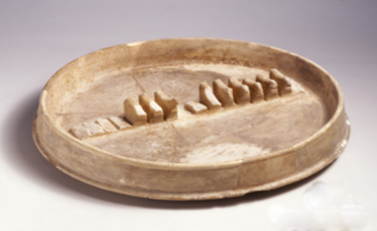
Photo Credit: Stampolidis and Sotirakopoulou, Aegean Waves, pl. 59.
V4. Large Plate, “Dove Tray”
Medium: marble
Period: EC II, Keros-Syros, Syros Group
Date: 2800-2300 BCE
Dems: H.: 5.1 cm, D.rim: 39 cm , D.base: 41.5 cm
Provenance: possibly Keros
Location/Access. no.: Museum of Cycladic Art, NG0329
Description: “The slightly convex base of the dish projects about 5 mm beyond the walls. The rolled rim is emphasized outside by a shallow groove…In addition there is a row of integral birds on its internal diameter. It seems that when the dish was carved a strip of marble of the same height was left…which was then divided by notches into sixteen sections of unequal thickness. Each section was subsequently worked to form a bird. The process is attested by chisel marks on the sides of the birds. The differing heights of the birds also indicated that each was carved independently. The discovery of fragments of a similar vessel on Keros hints at the possible provenance of the ‘dove vase.’” (Doumas, 129)
Notes:
Christos Doumas, Cycladic Art: Ancient Sculpture and Pottery from the N.P. Goulandris Collection, (London: British Museum Press, 1996), 134.
———, Early Cycladic Culture: The N.P. Goulandris Collection, (Athens: N.P. Goulandris Foundation and Museum of Cycladic Art, 2000), 129, no.168.
Colin Renfrew, The Cycladic Spirit: Masterpieces from the Nicholas P. Goulandris Collection, (New York: H.N. Abrams and Nicholas P Goulandris Foundation, Museum of Cycladic Art, Athens, 1991), pl 112.
Jürgen Thimme, ed., Art and Culture of the Cyclades in the Third Millennium B.C., trans. Pat Getz-Preziosi, (Chicago: University of Chicago Press, 1977), 101, fig. 82.
Nikolaos Stampolidis and Peggy Sotirakopoulou, Aegean Waves: Artworks of the Early Cycladic Culture in the Museum of Cycladic Art at Athens, (Milano: Skira, 2007), pl. 59.
Pat Getz-Gentle, Jack L. Davis and Elizabeth Oustinoff, Early Cycladic Art in North American Collections, (Richmond, VA: Virginia Museum of Fine Arts, 1987), 69, fig 37a. See page 314: “Several fragments of another example, measuring 38 cm across and having a row of perhaps 15 doves were found during investigations on Keros, along with fragments of two or three other vessels of the same type.” See also F3 and V5.
———, Stone Vessels of the Cyclades in the Early Bronze Age, (University Park, PA: Penn State University Press, 1996), pl. 71; 124-26; fig. 65b; p. 346-47.

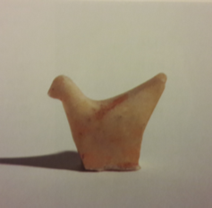
Photo Credit: Renfrew, Cycladic Spirit, 167.
F1. Dove Tray Fragment
Medium: marble
Period: EC II, Keros-Syros, Syros Group
Date: 2800-2300 BCE
Dems: H.: 4 cm, L: 5.3 cm
Provenance: possibly Keros
Location/Access. no.: Museum of Cycladic Art, 305
Description: “A schematically rendered bird. The chisel marks on its sides suggest that it comes from a vessel similar to” the so-called Dove Vase/Tray. (Doumas, 130)
Notes:
Christos Doumas, Cycladic Art: Ancient Sculpture and Pottery from the N.P. Goulandris Collection, (London: British Museum Press, 1996), 130.
———, Early Cycladic Culture: The N.P. Goulandris Collection, (Athens: N.P. Goulandris Foundation and Museum of Cycladic Art, 2000), 130, no.169.
Colin Renfrew, The Cycladic Spirit: Masterpieces from the Nicholas P. Goulandris Collection, (New York: H.N. Abrams and Nicholas P Goulandris Foundation, Museum of Cycladic Art, Athens, 1991), pl. 111.
Pat Getz-Gentle, Jack L. Davis and Elizabeth Oustinoff, Early Cycladic Art in North American Collections, (Richmond, VA: Virginia Museum of Fine Arts, 1987), 69, fig 37b.
———, Stone Vessels of the Cyclades in the Early Bronze Age, (University Park, PA: Penn State University Press, 1996), pl. 71; 124-26; fig. 65d; 347.

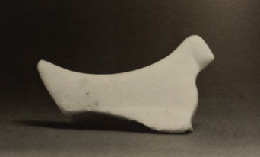
Photo Credit: Getz-Gentle, Early Cycladic Art in North American Collections, 314.
F2. Dove Tray Fragment
Medium: marble
Period: EC II
Date: 2700-2200 BCE
Dems: H 3.4 cm, L 6.2 cm, W 2 cm
Provenance: possibly Keros
Location/Access. no.: Private Collection

Description: “Schematic in form, the bird is nevertheless carefully shaped: when viewed from the top, it narrows toward the head and tail and at the top of the back. The head is set off by a short groove and on one side the wing is suggested; the body is distinguished from the slightly broader base by light incision. This is lower on the left side than on the right side.” (Getz-Gentle, Early Cycladic Art in North American Collections, 314.)

Notes:
Pat Getz-Gentle, Jack L. Davis and Elizabeth Oustinoff, Early Cycladic Art in North American Collections, (Richmond, VA: Virginia Museum of Fine Arts, 1987), 314, no.135; does not appear to belong to any known dove tray.
———, Stone Vessels of the Cyclades in the Early Bronze Age, (University Park, PA: Penn State University Press, 1996), 124-26, fig. 65c, p. 357.

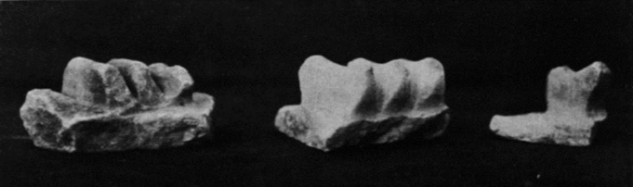
Photo Credit: Zafiropoulou, “Cycladic Finds from Keros,” 100, figs 5-6.
F3. Doves, Tray Fragments
Medium: marble
Period: EC II, Keros-Syros, Syros Group
Date: 2800-2300 BCE
Dems: N/A
Provenance: Keros
Notes:
Pat Getz-Gentle, Jack L. Davis and Elizabeth Oustinoff, Early Cycladic Art in North American Collections, (Richmond, VA: Virginia Museum of Fine Arts, 1987), 69, fig. 37a. See page 314: “Several fragments of another example, measuring 38 cm across and having a row of perhaps 15 doves were found during investigations on Keros, along with fragments of two or three other vessels of the same type.”
F. Zafiropoulou, “Cycladic Finds from Keros”, Athens Annals of Archaeology 1 (1968): 100, figs 5-6.

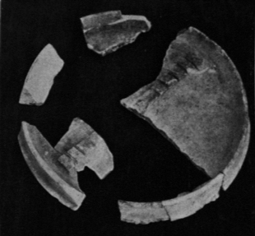
Photo Credit: Zafiropoulou, “Cycladic Finds from Keros,” 100, figs 5-6.
V5. Large Plate, Dove Tray Fragments
Medium: marble
Period: EC II, Keros-Syros, Syros Group
Date: 2800-2300 BCE
Provenance: Keros
Notes:
Pat Getz-Gentle, Jack L. Davis and Elizabeth Oustinoff, Early Cycladic Art in North American Collections, (Richmond, VA: Virginia Museum of Fine Arts, 1987), 69, fig 37a. See page 314: “Several fragments of another example, measuring 38 cm across and having a row of perhaps 15 doves were found during investigations on Keros, along with fragments of two or three other vessels of the same type.”
F. Zafiropoulou, “Cycladic Finds from Keros”, Athens Annals of Archaeology 1 (1968): 100, figs 5-6.
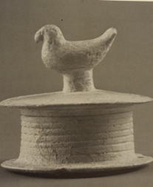
Photo Credit: Getz-Gentle, Early Cycladic Art in North American Collections, 313.
V6. Dove Lid, Spool Pyxis
Medium: marble
Period: EC II
Date: 2700-2200 BCE
Dems: H: 8.1 cm, 4.4 cm height of vessel
Provenance: possibly Naxos
Location/Access. no.: Menil Collection, CA 5207
Description: “A small cylindrical spool-shaped pyxis decorated with encircling grooves…, but with two aligned string holes…The lid exhibits a cylindrical knob crowned by a dove, which is at present unparalleled. The bird may be compared to the free-standing marble dove in the Ortiz Collection…Condition: brownish, encrusted surface with root marks; the floor is heavily encrusted. Intact except for minor damage along the rim of the lid and base.” (Thimme, 517)

Notes:
Jürgen Thimme, ed., Art and Culture of the Cyclades in the Third Millennium B.C., translated by Pat Getz-Preziosi, (Chicago: University of Chicago Press, 1977), 99, fig. 80.
Pat Getz-Gentle, Jack L. Davis and Elizabeth Oustinoff, Early Cycladic Art in North American Collections, (Richmond, VA: Virginia Museum of Fine Arts, 1987), 70-71, figs. 38a, 38b.
———, Stone Vessels of the Cyclades in the Early Bronze Age, (University Park, PA: Penn State University Press, 1996), 284 (J5): “The dove knob is at present unparalleled” listed with Menil Collection, acquired before 1964.

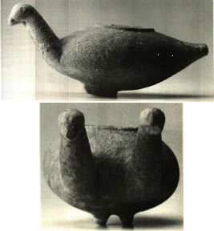
Photo Credit: Getz-Gentle, Stone Vessels of the Cyclades in the Early Bronze Age, 348.
V7. Two-headed Bird Pyxis
Medium: marble
Period: EC II
Date: 2700-2300 BCE
Dems: H: 6.7 cm, L: 14.6 cm
Provenance: unknown
Location/Access. no.: Badisches Landesmuseum Karlsruhe, 80/97
Description: Like the marble pig pyxis from the Museum of Cycladic Art, the cavity is chamfered to receive a lid, now lost. Getz-Gentle describes this pyxis as “fanciful or mythical twin-headed bird, the heads set on long, rather erect necks on one side, the opposite side elongated into a tail, and the underside provided with a pair of partially preserved elongated feet.” (Getz-Gentle, Stone Vessels of the Cyclades in the Early Bronze Age, 141.)

Notes:
Pat Getz-Gentle, Jack L. Davis and Elizabeth Oustinoff, Early Cycladic Art in North American Collections, (Richmond, VA: Virginia Museum of Fine Arts, 1987), 70-71, fig. 38c.
———, Stone Vessels of the Cyclades in the Early Bronze Age, (University Park, PA: Penn State University Press, 1996), pl. 79c, p. 348, text 141.

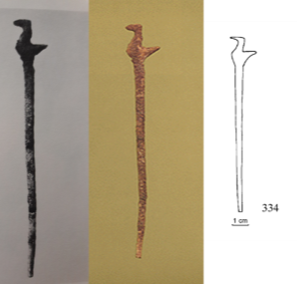
Photo Credit: Thimme, Art and Culture of the Cyclades in the Third Millennium B.C. 124-25; Hekman, “The Early Bronze Age Cemetery at Chalandriani on Syros,” 349; Sapouna-Sakellariakis, Cycladic Civilization and the Cycladic Collection of the National Archaeological Museum of Athens, pl. 26.
J5. Pin
Medium: bone
Period: EC II
Date: 2800/2700 BCE-2400/2300 BCE
Dems: L: 0.113 m
Provenance: Syros, Chalandriani, Grave 355
Location/Access. no.: National Archaeological Museum Athens, 5120
Description: “Yellow-white bone, probably of sheep or goat. Broken into three pieces, mended. Think brittle boen pin with a small bird at the top.” (Hekman, 236)
Notes:
E. Sapouna-Sakellariakis, Cycladic Civilization and the Cycladic Collection of the National Archaeological Museum of Athens, (Athens: Apollo Editions, 1973), 26, pl. 26.
G. Papathanasopoulos, National Archaeological Museum: Catalogue of Neolithic and Cycladic Collections, (Athens: "Melissa" editions, 1981), 134-135, pl. 62.3.
Jan Jakob Hekman, “The Early Bronze Age Cemetery at Chalandriani on Syros,” PhD. Diss., Rijksuniversiteit Groningen, 2003, accessed 02-07-16, http://www.rug.nl/ research/portal/publications/the-early-bronze-age-cemetery-at-chalandriani-on- syros-cyclades-greece(8dd13d8e-d4a4-40bc-91a6-1bb57ce032c5).html, 236, 349.
Jürgen Thimme, ed., Art and Culture of the Cyclades in the Third Millennium B.C., translated by Pat Getz-Preziosi, (Chicago: University of Chicago Press, 1977), 124-125, fig. 97.

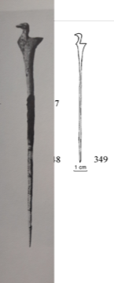
Photo Credit: Thimme, Art and Culture of the Cyclades in the Third Millennium B.C., 124-25; Hekman, “The Early Bronze Age Cemetery at Chalandriani on Syros,” 350.
J6. Pin
Medium: bone
Period: EC II
Date: 2800/2700 BCE-2400/2300 BCE
Dems: L: .10 m
Provenance: Syros, Chalandriani, Grave 356
Location/Access. no.: National Archaeological Museum Athens, 5294
Description: “Long thin pin with circular section narrowing towards the pointed tip; the head mounted with carved bird. Complete, mended from several fragments.” (Hekman, 237)

Notes:
Jan Jakob Hekman, “The Early Bronze Age Cemetery at Chalandriani on Syros,” PhD. Diss., Rijksuniversiteit Groningen, 2003, accessed 02-07-16, http://www.rug.nl /research/portal/publications/the-early-bronze-age-cemetery-at-chalandriani-on- syros-cyclades-greece(8dd13d8e-d4a4-40bc-91a6-1bb57ce032c5).html, 237, 350.
Jürgen Thimme, ed., Art and Culture of the Cyclades in the Third Millennium B.C., translated by Pat Getz-Preziosi, (Chicago: University of Chicago Press, 1977), 124-125, fig. 97.

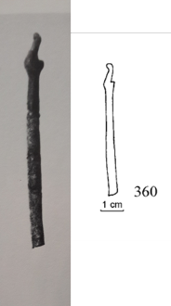
Photo Credit: Thimme, Art and Culture of the Cyclades in the Third Millennium B.C., 124-25; Hekman, “The Early Bronze Age Cemetery at Chalandriani on Syros,” 351.
J7. Pin
Medium: bone
Period: EC II
Date: 2800/2700 BCE-2400/2300 BCE
Dems: L 0.061 m
Provenance: Syros, Chalandriani, Grave 359
Location/Access. no.: NAMA, 5132
Description: “Thin pin with circular section, and small bird on the head. Mended.” (Hekman, 238)

Notes:
Jürgen Thimme, ed., Art and Culture of the Cyclades in the Third Millennium B.C., translated by Pat Getz-Preziosi, (Chicago: University of Chicago Press, 1977), 124-125, fig. 97.
Jan Jakob Hekman, “The Early Bronze Age Cemetery at Chalandriani on Syros,” PhD. Diss., Rijksuniversiteit Groningen, 2003, accessed 02-07-16, http://www.rug.nl /research/portal/publications/the-early-bronze-age-cemetery-at-chalandriani-on- syros-cyclades-greece(8dd13d8e-d4a4-40bc-91a6-1bb57ce032c5).html, 238, 351.

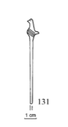
Photo Credit: Hekman, “The Early Bronze Age Cemetery at Chalandriani on Syros,” 337.

J8. Pin
Medium: bone
Period: EC II
Date: 2800/2700 BCE-2400/2300 BCE
Dems: L 0.074 m
Provenance: Syros, Chalandriani, Grave 242
Location/Access. no.: National Archaeological Museum Athens, 11846.1
Description: “Short pin with round section preserved in three pieces, probably incomplete; top mounted with small bird, possibly a dove. Encrustation of blue pigment on the surface.” (Hekman, 216)

Notes:
Jan Jakob Hekman, “The Early Bronze Age Cemetery at Chalandriani on Syros,” PhD. Diss., Rijksuniversiteit Groningen, 2003, accessed 02-07-16, http://www.rug.nl /research/portal/publications/the-early-bronze-age-cemetery-at-chalandriani-on- syros-cyclades-greece(8dd13d8e-d4a4-40bc-91a6-1bb57ce032c5).html, 216, 337.
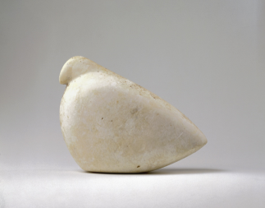
Photo Credit: The George Ortiz Collection, https://www.georgeortiz.
com/objects/greek-world/048-bird-dove-or-partridge-cycladic/.
F4. Bird Figurine
Medium: marble
Period: EC II
Date: 2700-2300 B.C.
Dems: H.: 13.4cm, L: 17.4 cm
Provenance: Unknown
Location/Access. no.: 48, Geneva, The George Ortiz Collection
Description: “Condition: whitish marble with smooth surface, polished in parts, one side thickly incrusted with hard brown deposits with root marks. It seems that both the dove and the partridge were indigenous to the Cyclades and to Anatolia. This unique figure has always been described as a dove and Cycladic, but both description and attribution are open to discussion. Crete was also once given as a provenance. The marble itself, the very hard incrusted brown limestone deposits, sculptural characteristics such as the way the flat bottom tails up, the modelling of the head, the abstract and schematic appearance of the whole and the indication of an originally white polished surface might suggest a work from Anatolia, contemporary with the Kilia-type anthropomorphic idols. The bird might be attributed to Crete or the Cyclades, since it is in keeping with their ritual customs, and it may be added that there is no definite parallel from elsewhere.” On view: Musée d'Art et d'Histoire, Geneva: 1971-1973 (Ortiz Collection Website)
Notes:
Jürgen Thimme, ed., Art and Culture of the Cyclades in the Third Millennium B.C., trans. Pat Getz-Preziosi, (Chicago: University of Chicago Press, 1977), 365, 540, no.433.
“The George Ortiz Collection”, accessed 01/21/2017, https://www.georgeortiz.com /objects/greek-world/048-bird-dove-or-partridge-cycladic/.

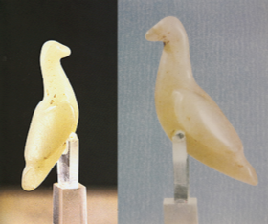
Photo Credit: Hellenic Ministry of Culture and Sapouna-Sakellariakis, Cycladic Civilization and the Cycladic Collection of the National Archaeological Museum of Athens., pl. 23.
J9. Bird Periapt
Medium: green stone
Period: EC II
Date: 2800-2300 BCE
Dems: L. .038m
Provenance: Paros, Pyrgos cemetery (grave 105)
Location/Access. no.: National Archaeological Museum Athens, 4825
Description: “Elegant miniature stone bird resembling a dove, of translucent greenish stone. An exceptional example of the high standard of Cycladic lapidary work. At the bottom of the body there is a hole, most probably for hanging from the neck (periapt). It was in the same grave as the other periapts and various beads which adorn the dead.” (Papathanasopoulos, 137)
Notes:
Cyprian Broodbank, An Island Archaeology of the Early Cyclades, (Cambridge: Cambridge University Press, 2000), 252, fig. 81c.
E. Sapouna-Sakellariakis, Cycladic Civilization and the Cycladic Collection of the National Archaeological Museum of Athens, (Athens: Apollo Editions, 1973), 26, pl. 23.
G. Papathanasopoulos, National Archaeological Museum: Catalogue of Neolithic and Cycladic Collections, (Athens: "Melissa" editions, 1981), 137, fig. 65.
Pat Getz-Gentle, Stone Vessels of the Cyclades in the Early Bronze Age, (University Park, PA: Penn State University Press, 1996), 186, 359, fig. 102 no. 1.

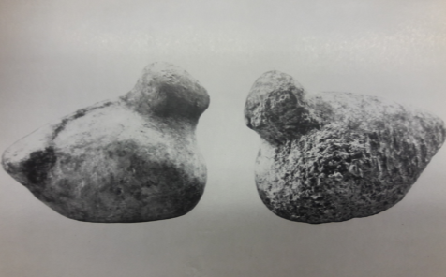
Photo Credit: Sapouna-Sakellariakis, Cycladic Civilization and the Cycladic Collection of the National Archaeological Museum of Athens, pl. 55.
F5-6. Bird Figurines
Medium: stone
Period: EC I-II
Date: 3200 BCE-2300 BCE
Dems: N/A
Provenance: Akrotiraki, Siphnos
Location/Access. National Archaeological Museum Athens, 4947
Description: Thimme describes these as the largest of the known bird examples (except for the bird from the Ortiz Collection, F7). He refers to three examples from Siphinos (two pictured here), “found in a grave together with red colored matter, a shell bowl, and spherical grinders.” Thimme speculates that these birds, too, were used as grinders. (Thimme 540)
Notes:
E. Sapouna-Sakellariakis, Cycladic Civilization and the Cycladic Collection of the National Archaeological Museum of Athens, (Athens: Apollo Editions, 1973), 29, pl. 55.
Jürgen Thimme, ed., Art and Culture of the Cyclades in the Third Millennium B.C., translated by Pat Getz-Preziosi, (Chicago: University of Chicago Press, 1977), 540.
Zozi D. Papadopoulou, “Sculptures from Akrotiraki, Siphnos and Its Cemetery,” in Early Cycladic Sculpture in Context, eds. Marthari, Marisa, Colin Renfrew and Michael J. Boyd, (Oxford: Oxbow Books, 2017), 115.

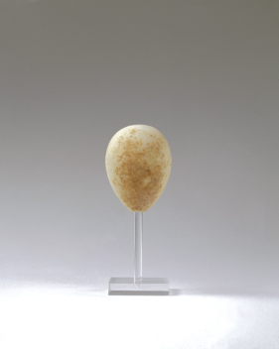
Photo Credit: The George Ortiz Collection, https://www.georgeortiz.com/objects/greek-world/047-egg-cycladic/.
F7. Egg Figurine
Medium: marble
Period: Early Cycladic
Date: 3200-2100 B.C.
Dems: H.: 4.5 cm
Provenance: Unknown
Location/Access. no.: 47, Geneva, The George Ortiz Collection
Description: “Condition: slight weathering and partially incrusted with ochre limestone deposits. The purpose of this object is not known. Pierced with a hole 4 mm in diameter and 9.5 mm deep1, it might have served as a knob or finial. Exhibited and Published: Kunst der Kykladen, cat. no. 473, pp. 542, 374 ill.” (The George Ortiz Collection Website)

Notes:
“The George Ortiz Collection”, accessed 01/21/2017, https://www.georgeortiz. com/objects/greek-world/047-egg-cycladic/.

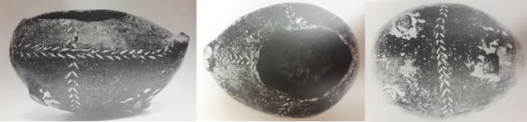
Photo Credit: Marangou, Cycladica, 112, fig. 19.
V8. Bird Pyxis
Medium: clay
Dems: H 7.5 cm; L. 14 cm
Provenance: Amorgos; Presented by N. Sigalas, 1952
Location/Access. no.: Museum of Chora, Katapola Collection, inv. No. K32
Description: “Small, zoomorphic, bird-like pyxis. Three small protuberances on the bottom of the object represent feet. The back is hollowed out to form a sort of bowl (rhyton?); the head is missing. Black clay, with incised lines forming stylized leaves filled with white slip. The decoration is perhaps intended to emphasize the bird-like qualities of the vase.” This is one of eight clay vases brought into the museum by inhabitants of Amorgos, probably found in their fields. (Marangou, 100-101)
Notes:
L. Marangou, “Evidence for the Early Cycladic Period on Amorgos,” in Cycladica, ed. J.L. Fitton, (London: British Museum Publications, 1984), 99-115.

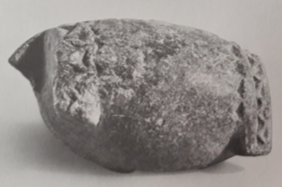
Photo Credit: Thimme, Art and Culture of the Cyclades in the Third Millennium B.C., 339.
V9. Bird Pyxis Fragment
Medium: chlorite-schist
Period: EC II-III
Date: 2800-2000 BCE
Dems: H: 4.2 cm, L: 8.1 cm
Provenance: “from Attica”
Location/Access. no.: Private Collection, Germany
Description: “A fragmentary zoomorphic pyxis with an ellipsoidal body which is flat at the ends. On one end the remains of a thin flat segment-shaped disk project at right angles. The decoration consists of two bands of Kerbschnitt which encircle the front and back of the body, continuing onto the feet. Condition: gray-blue, weathered surface. Half of the vase and the ends of the feet are missing; part of the projecting disk is broken away. The material was identified by x-ray examination at the Institut für Petrographie und Geochemie of Karlsruhe University.” (Thimme, 523)

Notes:
Jürgen Thimme, ed., Art and Culture of the Cyclades in the Third Millennium B.C., trans. Pat Getz-Preziosi, (Chicago: University of Chicago Press, 1977), 339, 523, no.367.

Photo Not Available

V10. Bird Askos
Description: Referring to the twin-headed bird pyxis (V7), Getz-Gentle writes, “The closest parallels for the piece are an Early Cycladic terracotta askos in the form of a bird—perhaps a dove—found in a cemetery context on Ano Kouphonisi that in turn closely resembles another askos from the cemetery at Koumasa on Crete (Betancourt, fig 29c. History of Minoan Pottery, Princeton, 1985) and two typical EC I-II/EM I-II incised terracotta bottles, transformed into three-footed long-necked birds, also found on Crete, in the cemetery of Aghia Photia near Siteia.” The larger one is illustrated below.
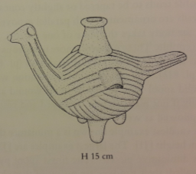
Photo Credit: Getz-Gentle, Stone Vessels of the Cyclades in the Early Bronze Age, 141.
Notes:
Pat Getz-Gentle, Stone Vessels of the Cyclades in the Early Bronze Age, (University Park, PA: Penn State University Press, 1996), 141.

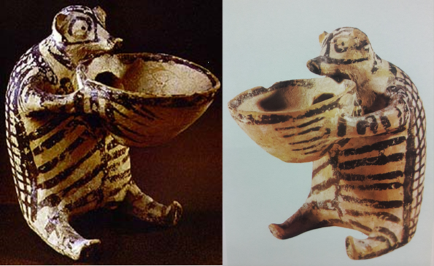
Photo Credit: Papathanasopoulos, National Archaeological Museum: Catalogue of Neolithic and Cycladic Collections, 165, fig. 87; Stampolidis and Sotirakopoulou, Aegean Waves, 36.
V11. Hedgehog Vessel
Medium: clay
Period: EC II, Keros-Syros Culture
Date: 2800-2300 BCE
Dems: H: 10.8 cm
Provenance: Chalandriani, Syros
Location/Access. no.: National Archaeological Museum, Athens, 6176
Description: “Fine-medium, light brown fabric with similar core. Light yellow slipped surface with painted decoration in dark grey-brown. A sitting hedgehog with legs spread in front and holding a conical cup between extended arms. Hole through the back of the cup into hollow body of animal. On the body are vertical, horizontal and oblique lines; the head is painted with anatomical details: eyes, nose and ears; on the conical cup a solid line runs along the rim and horizontal lines across the body. The animal is probably a hedgehog of the species Erinaceus concolar, which is still found in the Cyclades. The back is decorated with a netted pattern of crossing lines, perhaps representing the spikes. In its paws it holds a common conical cup which is connected through an opening to the hollow body of the animal.” (Hekman, 132, 277)
Notes:
Cyprian Broodbank, An Island Archaeology, (Cambridge: Cambridge University Press, 2000), 215-16.
G. Papathanasopoulos, National Archaeological Museum: Catalogue of Neolithic and Cycladic Collections, (Athens: Melissa Editions, 1981), 165, fig. 87.
Jan Jakob Hekman, “The Early Bronze Age Cemetery at Chalandriani on Syros,” PhD. Diss., Rijksuniversiteit Groningen, 2003, accessed 02-07-16, http://www.rug.nl /research/portal/publications/the-early-bronze-age-cemetery-at-chalandriani-on- syros-cyclades-greece(8dd13d8e-d4a4-40bc-91a6-1bb57ce032c5).html.
Jürgen Thimme, ed., Art and Culture of the Cyclades in the Third Millennium B.C., trans. Pat Getz-Preziosi, (Chicago: University of Chicago Press, 1977), 47, fig. 27.
Nikolaos Stampolidis and Peggy Sotirakopoulou, Aegean Waves: Artworks of the Early Cycladic Culture in the Museum of Cycladic Art at Athens, (Milano: Skira, 2007), 36.
Pat Getz-Gentle, Jack L. Davis and Elizabeth Oustinoff, Early Cycladic Art in North American Collections, (Richmond, VA: Virginia Museum of Fine Arts, 1987), 28-29, fig 20.

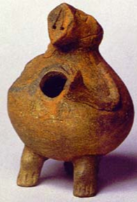
Photo Credit: Fitton, Cycladic Art, 36.
V12. Hedgehog Vessel
Medium: clay
Period: EC II, Keros-Syros
Date: 2700-2200 BCE
Dems: H. 12 cm
Provenance: possibly Melos
Location/Access. no.: British Museum, GR 1929.1112.1
Description: Thought to be a pig, however I argue the vessel is part of a corpus representing hedgehogs. Animal originally held a bowl in it forepaws connected to the opening in its chest.
Notes:
J. Lesley Fitton, Cycladic Art, (London: British Museum, 1999), 36.

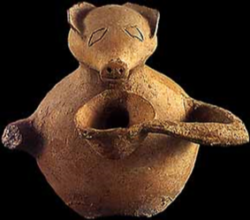
Photo Credit: Renfrew, Cycladic Spirit, pl. 84.
V13. Hedgehog Vessel
Medium: clay
Period: EC II, Keros-Syros
Date: 2700-2300 BCE
Dems: H. 16 cm
Provenance: Panormos, Naxos
Location/Access. no.: Museum of Cycladic Art, 102
Description: “The roughly globular body of the vase terminates above the neck and head of an animal, on which the ears and snout (now broken) have been modelled and the eyes and mouth denoted incision. Projecting from the position of the handles are the forelimbs of the quadruped, which curve forwards like human arms and hold a bowl, in one piece with the animal, just below its mouth. At the bottom of the bowl is a hole for filling and emptying the vessel, that is the hollow body of the animal.” Marangou states this vase was originally in the Naxos Archaeological Museum (no.4728 “confiscated”). (Marangou, 106)
Notes:
Colin Renfrew, The Cycladic Spirit: Masterpieces from the Nicholas P. Goulandris Collection, (New York: H.N. Abrams and Nicholas P Goulandris Foundation, Museum of Cycladic Art, Athens, 1991), pl. 84.
G. Papathanasopoulos, National Archaeological Museum: Catalogue of Neolithic and Cycladic Collections, (Athens: Melissa Editions, 1981), 165, fig. 87.
Jürgen Thimme, ed., Art and Culture of the Cyclades in the Third Millennium B.C., trans. Pat Getz-Preziosi, (Chicago: University of Chicago Press, 1977), 47, fig. 27.
L. Marangou, ed., Cycladic Culture: Naxos in the 3rd Millennium BC (Athens: Nicholas P. Goulandris Foundation and Museum of Cycladic Art, 1990), 106, no. 102.
Nikolaos Stampolidis and Peggy Sotirakopoulou, Aegean Waves: Artworks of the Early Cycladic Culture in the Museum of Cycladic Art at Athens, (Milano: Skira, 2007), 32-33, 36.

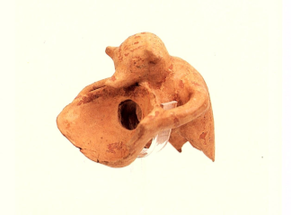
Photo Credit: from postcard
V14. Hedgehog Vessel Fragment
Medium: clay
Period: EC II
Date: 2700-2300 BCE
Dems: H. 12 cm
Provenance: Ayia Irini, Kea
Location/Access. no.: Archaeological Museum Kea, no. 80
Description: Orange buff, fine painted ware. Found in the fill beneath the Lower Western Road. (Keos, 257) “Theriomorphic Pot; Reserved: head with elongated snout and protruding ears; upper torso (hollow, with circular opening into back of bowl); arms holding bowl. Missing: front of bowl; most of lower body; base. Smooth surface with yellowish buff slip on ext. Reddish brown painted décor: multiple chevron pattern on tomp of head; band on snout; eyes rendered by two dotted lozenges; band on neck; vertical striping on arms (perhaps fingers were rendered in paint); a stripe running down each flank from shoulder; back outlined and covered in cross-hatching (clothing?); bowl with solid painted rim and a blob of paint in bottom of interior.” (Keos, 83-84)

Notes:
Alkhestis Choremi, Christina Vlassopoulou and Yianna Venieri, Kea: History and Antiquities, trans. Myriam Caskey, (Athens: Ministry of Culture Archaeological Receipts Fund, 2002), 14.
David E. Wilson, Keos: Volume IX, Ayia Irini, Periods I-III, (Mainz am Rhein: Verlag Philipp von Zabern, 1999), 83-84, pl. 21, 70.
J.L. Caskey, “The Early Bronze Age at Ayia Irini in Keos,” Archaeology 23, no. 4 (Oct. 1970), 339-342, accessed 5-20-2015, http://jstor.org/stable/41674195.
Jürgen Thimme, ed., Art and Culture of the Cyclades in the Third Millennium B.C., trans. Pat Getz-Preziosi, (Chicago: University of Chicago Press, 1977), 49, fig. 28.

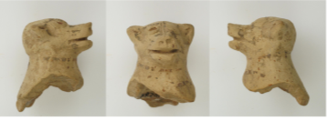
Photo Credit: Renfrew, et al., Kavos and the Special Deposits, CD-ROM
V15. Hedgehog Vessel Fragment
Medium: clay
Period: EC II
Date: 2700-2300 BCE
Dems: H: 39 mm, L: 25 mm, W: 29 mm
Provenance: Kavos, Keros
Special Finds no.: 20323
Description: “Clay. Fine ware. Orange-red fabric with light greyish slip. Painted bichrome-black and red/brown. Head and neck with a small section of shoulders and chest. The preserved portion is hollow, including the head, into the top of which a lump of clay was pressed. The head is naturalistic in shape, laterally rounded on tope with a pronounced and elongated muzzle. The nostrils are shown as two small indentations, whil a horizontal groove gives the impression that the mouth is open. The pricked ears have natural-looking cavities; the eyes were added as small clay pellets, the right one partly missing. An incised line bisects the front of the face, from the top of the head to the tip of the muzzle. A brown collar-like band encircles the cylindrical neck, while a similar band, partially preserved below the first one, continued onto the adjacent area of the body, now missing. The vessel is in the form of an upright animal.” (Renfrew et al., Kavos and the Special Deposits, 318.
Notes:
Colin Renfrew, Olga Philaniotou, Neil Brodie, Giorgos Gavalas, and Michael J. Boyd, The Sanctuary on Keros and the Origins of Aegean Ritual Practice: The Excavations of 2006-2008. Volume II, Kavos and The Special Deposits, (Cambridge: University of Cambridge and McDonald Institute for Archaeological Research,2015), 318.
**Will be discussed further by Sotirakopoulou in Volume V, forthcoming.

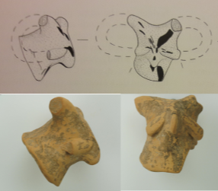
Photo Credit: Renfrew, et al., Kavos and the Special Deposits, CD-ROM.
V16. Ram Vessel Fragment
Medium: clay
Period: EC II
Date: 2700-2300 BCE
Dems: H: 34mm, L: 31 mm, W: 44 mm
Provenance: Kavos, Keros
Special Finds no.: 1725

Description: “Fine-ware, orange-buff. Self-slipped. Painted bichrome-black and reddish/brown. Wheelmade. The head and neck of a small vessel. The muzzle is elongated, and points slightly downward. The horns are preserved only where they emerge from the sides of the head with a lateral orientation, and again where they end on the cheeks. Faint traces of black paint are visible on the nose, while below the muzzle a black painted band continues to the neck. At the back of the head a reddish-brown band extends to the neck and horns. The latter are painted red. In addition, a painted band is preserved on the left horn. Wheel-marks are visible on the interior. Encrusted both inside and outside.” (Renfrew et al., Kavos and the Special Deposits, 319)
Notes:
Colin Renfrew, Olga Philaniotou, Neil Brodie, Giorgos Gavalas, and Michael J. Boyd, The Sanctuary on Keros and the Origins of Aegean Ritual Practice: The Excavations of 2006-2008. Volume II, Kavos and The Special Deposits, (Cambridge: University of Cambridge and McDonald Institute for Archaeological Research,2015), 319.
**Will be discussed further by Sotirakopoulou in Volume V, forthcoming.

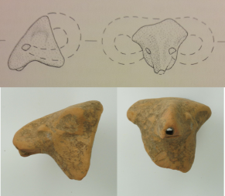
Photo Credit: Renfrew, et al., Kavos and the Special Deposits, CD-ROM
V17. Fragment, Ram Rhyton
Medium: clay
Period: EC II
Date: 2700-2300 BCE
Dems: H: 35mm, L: 38mm, W: 35mm
Provenance: Kavos, Keros
Special Finds no.: 20010

Description: “Fine ware, light orange. Self-slipped. Painted bichrome-black and red. The head and a part of a neck of a small vessel. The elongated muzzle is pronounced, and points downward. A small, deliberately made hole through at the top of the muzzle. The lower edge of the hole is slightly chipped in one spot. The horns are preserved only where they terminate on the cheeks. Faint traces of red paint on the top of the head, black on the side of the neck. Encrusted.” (Renfrew et al., Kavos and the Special Deposits, 319)
Notes:
Colin Renfrew, Olga Philaniotou, Neil Brodie, Giorgos Gavalas, and Michael J. Boyd, The Sanctuary on Keros and the Origins of Aegean Ritual Practice: The Excavations of 2006-2008. Volume II, Kavos and The Special Deposits, (Cambridge: University of Cambridge and McDonald Institute for Archaeological Research,2015), 319.
**Will be discussed further by Sotirakopoulou in Volume V, forthcoming.

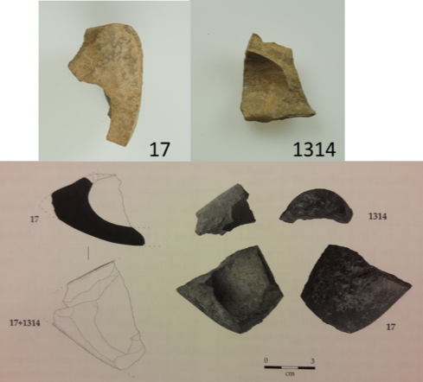
Photo Credit: Renfrew et al., Kavos and the Special Deposits, 479 and CD-ROM.
V18. Two zoomorphic vessel fragments
Medium: white marble
Period: EC II
Date: 2700-2400 BCE
Provenance: Kavos, Keros
Special Finds no.: 17 + 1314
Description:
“Two joining fragments belong to a zoomorphic multiple vessel: 17 is a body fragment, possibly from the foot of a zoomorphic vessel, preserving one quarter of a carved spherical compartment. This joins with 1314, another part of the same vessel preserving another quarter of the interior of a compartment spherical at the opening and ellipsoid in section. The vertical rounded rim projects from the body. The shape of the body suggests that these pieces belong to a bird-like vessel.” (Renfrew et al., Kavos and the Special Deposits, 481)
Notes:
Colin Renfrew, Olga Philaniotou, Neil Brodie, Giorgos Gavalas, and Michael J. Boyd, The Sanctuary on Keros and the Origins of Aegean Ritual Practice: The Excavations of 2006-2008. Volume II, Kavos and The Special Deposits, (Cambridge: University of Cambridge and McDonald Institute for Archaeological Research,2015), 479-81.
**Will be discussed further by Sotirakopoulou in Volume V, forthcoming.

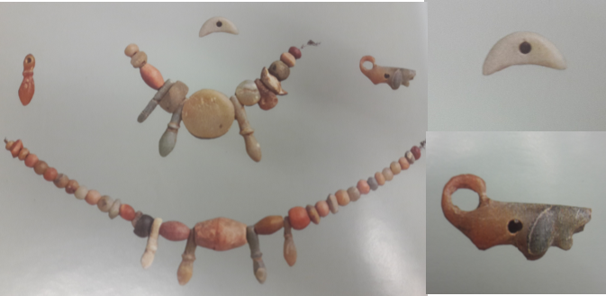
Photo Credit: Papathanasopoulos, National Archaeological Museum: Catalogue of Neolithic and Cycladic Collections, 136-37.
J10. Zoomorphic Amulet, Quadruped
Medium: red stone
Period: EC II
Date: c. 2800-2300 BCE
Provenance: Despotiko, Zoumbarias Cemetery, Grave 135
Location/Access. no.: National Archaeological Museum Athens, 4882
J11. Bird Amulet
Medium: jade-like soft stone
Period: EC II
Date: c. 2800-2300 BC
Provenance: Despotiko, Zoumbarias Cemetery, Grave 135
Location/Access. no.: National Archaeological Museum Athens, 4882

Description: “The necklace, which adorned the deceased in the grave, consists of almost fifty smallish polychrome stone beads and periapts of assorted shapes and sizes. A small jadeite bird and a red stone quadruped with its tail curved upwards like a link, are among the miniature amulets of exquisite artistry.” (Papathanasopoulos, 137)
Notes:
G. Papathanasopoulos, National Archaeological Museum: Catalogue of Neolithic and Cycladic Collections, (Athens: Melissa Editions, 1981), 136-37, pl. 64.

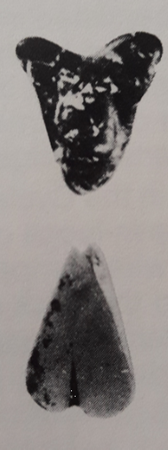
Photo Credit: Thimme, 128.
J12-13. Fly/Bee Amulets
Provenance: Siphnos
Description: Not much is known about these amulets; the only publication these were found in was Thimme’s catalog, and unfortunately not much information was given. Thimme identifies them as ‘flies’, however I propose they could represent schematically modeled bees. More examination is needed.
Notes:
Jürgen Thimme, ed., Art and Culture of the Cyclades in the Third Millennium B.C., trans. Pat Getz-Preziosi, (Chicago: University of Chicago Press, 1977), 126, 128, fig. 105.
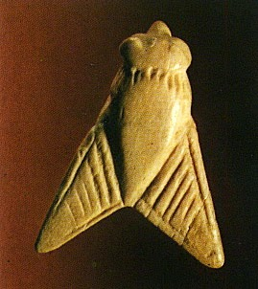
Comparanda: Minoan seal in the shape of a fly, from Arkhanes, Crete (Middle-Late Minoan Period, c. 2200 BCE-1100 BCE)
Photo Credit: http://antiquatedantiquarian.blogspot.com/2015/04/the-minoans-seals-and-sealings.html

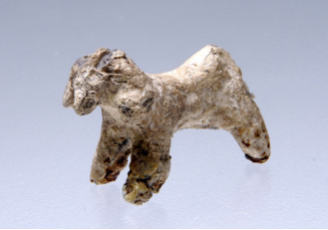
Photo Credit: Stampolidis and Sotirakopoulou, Aegean Waves, pl. 64.
F8. Ram Figurine
Medium: lead
Period: EC II Syros phase
Date: c. 2700-24/2300 BC
Dems: H: 1.9 cm, L: 3.2 cm
Provenance: unknown
Location/Access. no.: Museum of Cycladic Art, NG0478
Description: Similar to F9 and F10; only a small number of total objects from the Early Cycladic period are known in lead: three lead rams, four anthropomorphic figures, four models of boats, a seal, and clamps used for object repair in antiquity.
Notes:
Nikolaos Stampolidis and Peggy Sotirakopoulou, Aegean Waves: Artworks of the Early Cycladic Culture in the Museum of Cycladic Art at Athens, (Milano: Skira, 2007), 55, pl. 64.

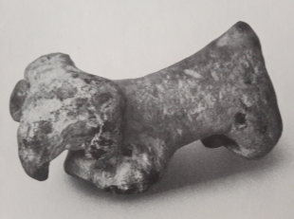
Photo Credit: Thimme, Art and Culture of the Cyclades in the Third Millennium B.C., 364.
F9. Ram Figurine
Medium: lead
Period: EC II Syros phase
Date: c. 2700-24/2300 BC
Dems: H: 1.4 cm, L: 3.2 cm
Provenance: unknown
Location/Access. no.: Badisches Landesmuseum Karlsruhe, 76/42
Description: “As small figurine in the form of a ram with a downward-curving muzzle and a slightly concave back…According to information supplied by the former owner of this figurine, it was found with the torsos of two canonical Cycladic idols (one pregnant) and fragments of a marble bowl. Condition: a hard white encrustation covers nearly the entire surface. All four legs are bent; intact.” (Thimme, 539-540)

Notes:
Jürgen Thimme, ed., Art and Culture of the Cyclades in the Third Millennium B.C., trans. Pat Getz-Preziosi, (Chicago: University of Chicago Press, 1977), 364, 539, no. 431.

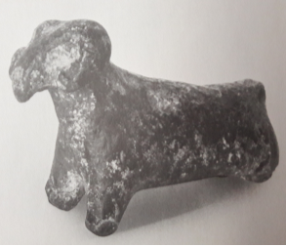
Photo Credit: Thimme, Art and Culture of the Cyclades in the Third Millennium B.C., 364
F10. Ram Figurine
Medium: lead
Period: EC II Keros-Syros phase
Date: c. 2700-24/2300 BC
Dems: H: 2.3 cm, L: 3.4 cm
Provenance: unknown
Location/Access. no.: Private Collection, Baden-Württemberg
Description: “A small figurine in the form of a ram with a downward-curving muzzle. Condition: brown-blackish surface. All four legs are broken at varying heights; the end of the tail is chipped. On the underside, there is a hole 4mm deep: it is unclear whether this is ancient or modern.” (Thimme, 540)
Notes:
Jürgen Thimme, ed., Art and Culture of the Cyclades in the Third Millennium B.C., trans. Pat Getz-Preziosi, (Chicago: University of Chicago Press, 1977), 364, 540, no.432.
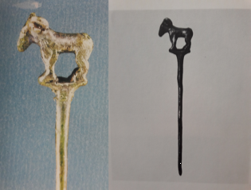
Photo Credit: Sapouna-Sakellariakis, Cycladic Civilization and the Cycladic Collection of the National Archaeological Museum of Athens, pl. 23; Thimme, Art and Culture of the Cyclades in the Third Millennium B.C., 124-125.
J14. Pin
Medium: silver
Period: EC II
Date: 2800-2300 BCE
Dems: L: 9cm
Provenance: Amorgos, Dokathismata, Grave A
Location/Access. no.: National Archaeological Museum Athens, 4730
Description: silver pin with a ram finial. “A silver pin the head of which is a miniature modelled ram on a flat base. The execution is remarkably realistic. This rare pin comes from a rich Cycladic grave which contained other precious items of silver and bronze jewelry.” (Papathanasopoulos, 134)
Notes:
E. Sapouna-Sakellariakis, Cycladic Civilization and the Cycladic Collection of the National Archaeological Museum of Athens, (Athens: Apollo Editions, 1973), 26, pl. 23.

G. Papathanasopoulos, National Archaeological Museum: Catalogue of Neolithic and Cycladic Collections, (Athens: Melissa Editions, 1981), 134-135, pl. 62.5.
Jürgen Thimme, ed., Art and Culture of the Cyclades in the Third Millennium B.C., trans. Pat Getz-Preziosi, (Chicago: University of Chicago Press, 1977), 124-125, fig. 98.
Pat Getz-Gentle, Jack L. Davis and Elizabeth Oustinoff, Early Cycladic Art in North American Collections, (Richmond, VA: Virginia Museum of Fine Arts, 1987), 23, fig. 17.

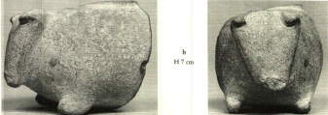
Photo Credit: Getz-Gentle, Stone Vessels of the Cyclades in the Early Bronze Age, 348.
V19. Pig or Sheep Pyxis, Fragment
Medium: marble
Period: EC II
Date: 2700-2300 BCE
Dems: H: 7 cm, L: 8.3 cm
Provenance: unknown
Location/Access. no.: J. Paul Getty Museum, L. 89. AA.21
Description: This vessel has ears pricked forward. The end of the snout is missing, and no eyes are represented. The representation is likely of a sheep or pig.
Notes:
Pat Getz-Gentle, Stone Vessels of the Cyclades in the Early Bronze Age, (University Park, PA: Penn State University Press, 1996), 348 pl. 79 b, text 140: “fragment in the form of a hedgehog?, forepart only, snout missing”; see also p. 139, fig. 75b.

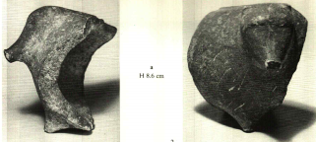
Photo Credit: Getz-Gentle, Stone Vessels of the Cyclades in the Early Bronze Age, 348.
V20. Pig or Sheep Pyxis, Fragment
Medium: marble
Period: EC II
Date: 2700-2300 BCE
Dems: H8.6 cm, L 8.6 cm
Provenance: possibly Paros
Location/Access. no.: Badisches Landesmuseum Karlsruhe, 76/166
Description: “A fragmentary zoomorphic pyxis with a spherical body and a head with pointed snout. The vessel stood originally on four v-shaped stump-like feet…” (Thimme, 523) Thimme compares this to the hedgehog vessels found on Syros, Kea and Naxos; and also to a vessel from MoCA thought to be a pig. Getz-Gentle speculates that this vessel is intended to be a hedgehog. (Vessels of the Cyclades in the Early Bronze Age, 140). However, I argue that it (as well as the pyxisV8) is more likely a domesticated animal, either a sheep or pig.
Notes:
Jürgen Thimme, ed., Art and Culture of the Cyclades in the Third Millennium B.C., trans. Pat Getz-Preziosi, (Chicago: University of Chicago Press, 1977), 340, 523, no.368.
Pat Getz-Gentle, Stone Vessels of the Cyclades in the Early Bronze Age, (University Park, PA: Penn State University Press, 1996), 347-48, pl. 79a; text 140: “forepart only; fragment in the form of a “hedgehog?”; see also p. 139, fig 75a.

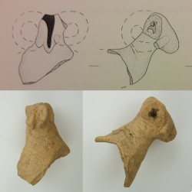
Photo Credit: Renfrew et al., Kavos and the Special Deposits, 314 and CD-ROM
P2. Ram Protome
Medium: clay
Period: EC II
Date: 2700-2300 B.C.
Dems: H. 57 mm, L. 40 mm, W. 39 mm
Provenance: Kavos, Keros
Special Finds no.: 2040
Description: “Fine fabric, pink. Painted bichrome (black and red) dark-on-light. Urfirnis. Head, neck and a small part of the vessel’s spout…only the ends of the horns are preserved, attached to the cheeks. Because both horns broke off close to the head, the hollow interior of the protome is exposed to view. Two bands of black paint remain: one begins at the top of the head and continues along the animal’s back; the other stretches from the top of the head to the end of the muzzle. Traces of red/brown paint are visible on the horns. In all probability, the piece was the finial of a sauceboat spout.” (Kavos and the Special Deposits, 313)
Notes:
Colin Renfrew, Olga Philaniotou, Neil Brodie, Giorgos Gavalas, and Michael J. Boyd, The Sanctuary on Keros and the Origins of Aegean Ritual Practice: The Excavations of 2006-2008. Volume II, Kavos and The Special Deposits, (Cambridge: University of Cambridge and McDonald Institute for Archaeological Research,2015), 313.
**Will be discussed further by Sotirakopoulou in Volume V, forthcoming.

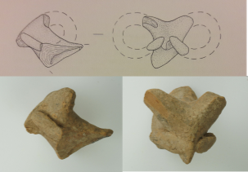
Photo Credit: Renfrew et al., Kavos and the Special Deposits, 314 and CD-ROM.
P3. Ram Protome
Medium: clay
Period: EC II
Date: 2700-2300 B.C.
Dems: H. 39 mm, L. 37 mm, W. 36 mm
Provenance: Kavos, Keros
Special Finds no.: 2168
Description: “…fine fabric, orange/brown. Self-slipped throughout. Painted dark-on-light. Head with pointed muzzle, neck and part of the vessel’s spout. The origin of the horns, where they begin their backward curve, and their termination, where they attach to the cheeks, are preserved; the middle portions are missing. Very faint traces of black paint are visible in several places, along the head, back of the neck and the horns, while better preserved black paint can be observed on the surviving parts of the right horn. Encrusted all over. In all probability, the piece was the finial of a sauceboat spout.” (Kavos and the Special Deposits, 313)

Notes:
Colin Renfrew, Olga Philaniotou, Neil Brodie, Giorgos Gavalas, and Michael J. Boyd, The Sanctuary on Keros and the Origins of Aegean Ritual Practice: The Excavations of 2006-2008. Volume II, Kavos and The Special Deposits, (Cambridge: University of Cambridge and McDonald Institute for Archaeological Research,2015), 313.
**Will be discussed further by Sotirakopoulou in Volume V, forthcoming.

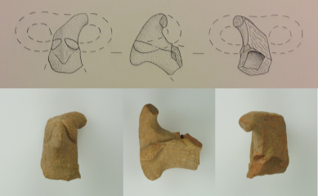
Photo Credit: Renfew et al., Kavos and the Special Deposits, 315 and CD-ROM.
P4. Ram Protome
Medium: clay
Period: EC II
Date: 2700-2300 B.C.
Dems: H. 42 mm, L. 35 mm, W. 16 mm
Provenance: Kavos, Keros
Special Finds no.: 20013
Description: “…fine fabric, orange. Self-slipped throughout. Fragmentary head, neck and a part of a vessel’s spout. Much of the right side of the head including the most of the right horn is missing. The muzzle is pointed. The left horn is broken off near the points of attachment to the head and cheek. Similarly, only a bit of the right horn remains on the cheek. Encrusted all over. In all probability, the piece was the finial of a sauceboat spout.” (Kavos and the Special Deposits, 315)
Notes:
Colin Renfrew, Olga Philaniotou, Neil Brodie, Giorgos Gavalas, and Michael J. Boyd, The Sanctuary on Keros and the Origins of Aegean Ritual Practice: The Excavations of 2006-2008. Volume II, Kavos and The Special Deposits, (Cambridge: University of Cambridge and McDonald Institute for Archaeological Research,2015), 315.
**Will be discussed further by Sotirakopoulou in Volume V, forthcoming.

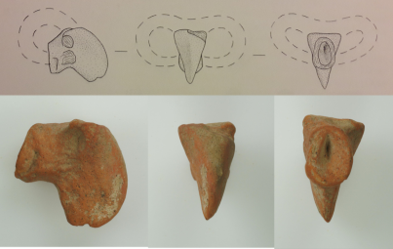
Photo Credit: Renfrew et al., Kavos and the Special Deposits, 315 and CD-ROM.
P5. Ram Protome
Medium: clay
Period: EC II
Date: 2700-2300 B.C.
Dems: H. 39 mm, L. 35 mm, W. 20 mm
Provenance: Kavos, Keros
Special Finds no.: 20016
Description: “…fine fabric, orange. Head with pointed muzzle, neck and a small part of the vessel’s spout. The horns are missing, but the break surfaces where they were attached are visible. Badly weathered, and encrusted. In all probability, the piece was the finial of a sauceboat spout.” (Kavos and the Special Deposits, 315)
Notes:
Colin Renfrew, Olga Philaniotou, Neil Brodie, Giorgos Gavalas, and Michael J. Boyd, The Sanctuary on Keros and the Origins of Aegean Ritual Practice: The Excavations of 2006-2008. Volume II, Kavos and The Special Deposits, (Cambridge: University of Cambridge and McDonald Institute for Archaeological Research,2015), 315.
**Will be discussed further by Sotirakopoulou in Volume V, forthcoming.

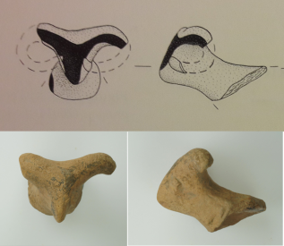
Photo Credit: Renfrew, et al., Kavos and the Special Deposits, 315 and CD-ROM.
P6. Ram Protome
Medium: clay
Period: EC II
Date: 2700-2300 B.C.
Dems: H. 43 mm, L. 42 mm, W. 32 mm
Provenance: Kavos, Keros
Special Finds no.: 20157
Description: “…fine fabric, pink. Buff slipped. Painted dark-on-light. Urfirnis. Head, neck and a part of a vessel’s spout. The muzzle is pointed. The right horn, oriented sideways, is preserved only near its point of attachment to the head. The left horn points to the side and then curves backward; a small section remains attached to the cheek. Traces of black urfirnis paint are visible on the top of the head, on the back of the head and neck, on the horns, and on the side of the muzzle. In all probability, the piece was the finial of a sauceboat spout.” (Kavos and the Special Deposits, 315-16)
Notes:
Colin Renfrew, Olga Philaniotou, Neil Brodie, Giorgos Gavalas, and Michael J. Boyd, The Sanctuary on Keros and the Origins of Aegean Ritual Practice: The Excavations of 2006-2008. Volume II, Kavos and The Special Deposits, (Cambridge: University of Cambridge and McDonald Institute for Archaeological Research,2015), 315-16.
**Will be discussed further by Sotirakopoulou in Volume V, forthcoming.

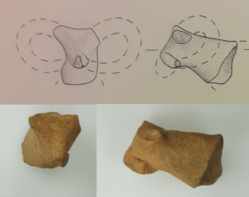
Photo Credit: Renfrew et al., Kavos and the Special Deposits, 316 and CD-ROM.
P7. Ram Protome
Medium: clay
Period: EC II
Date: 2700-2300 B.C.
Dems: H. 44 mm, L. 24 mm, W. 23 mm
Provenance: Kavos, Keros
Special Finds no.: 20701
Description: “…fine fabric, brownish/pink. Painted. Head, neck and a part of a vessel’s spout. The pointed end of the muzzle is damaged. Both horns are missing from close to their points of attachment to the head; a small section of the left horn remains attached to the cheek. Two dots of dark paint are visible, enough to reveal that the protome had been painted. Very weathered. In all probability, the piece was the finial of a sauceboat spout.” (Kavos and the Special Deposits, 316)

Notes:
Colin Renfrew, Olga Philaniotou, Neil Brodie, Giorgos Gavalas, and Michael J. Boyd, The Sanctuary on Keros and the Origins of Aegean Ritual Practice: The Excavations of 2006-2008. Volume II, Kavos and The Special Deposits, (Cambridge: University of Cambridge and McDonald Institute for Archaeological Research,2015), 316.
**Will be discussed further by Sotirakopoulou in Volume V, forthcoming.

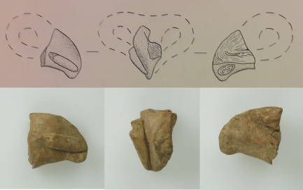
Photo Credit: Renfrew et al., Kavos and the Special Deposits, 316 and CD-ROM.
P8. Ram Protome
Medium: clay
Period: EC II
Date: 2700-2300 B.C.
Dems: H. 25 mm, L. 25 mm, W. 19 mm
Provenance: Kavos, Keros
Special Finds no.: 6831
Description: “…fine fabric, pink. Painted dark-on-light. Part of the muzzle with the end of the right horn where it attaches to the cheek Faint traces of black paint are visible on the muzzle. Encrusted. Probably part of the finial of a sauceboat spout.” (Kavos and the Special Deposits, 316)
Notes:
Colin Renfrew, Olga Philaniotou, Neil Brodie, Giorgos Gavalas, and Michael J. Boyd, The Sanctuary on Keros and the Origins of Aegean Ritual Practice: The Excavations of 2006-2008. Volume II, Kavos and The Special Deposits, (Cambridge: University of Cambridge and McDonald Institute for Archaeological Research,2015), 316.
**Will be discussed further by Sotirakopoulou in Volume V, forthcoming.

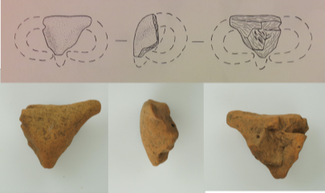
Photo Credit: Renfrew, et al., Kavos and the Special Deposits, 316 and CD-ROM.
P9. Ram Protome
Medium: clay
Period: EC II
Date: 2700-2300 B.C.
Dems: H. 34 mm, L. 28 mm, W. 12 mm
Provenance: Kavos, Keros
Special Finds no.: 20014
Description: “…fine fabric, orange. Top of the head with the beginning of a horn oriented sideways. Probably part of the finial of a sauceboat spout.” (Kavos and the Special Deposits, 316)
Notes:
Colin Renfrew, Olga Philaniotou, Neil Brodie, Giorgos Gavalas, and Michael J. Boyd, The Sanctuary on Keros and the Origins of Aegean Ritual Practice: The Excavations of 2006-2008. Volume II, Kavos and The Special Deposits, (Cambridge: University of Cambridge and McDonald Institute for Archaeological Research,2015), 316.
**Will be discussed further by Sotirakopoulou in Volume V, forthcoming.
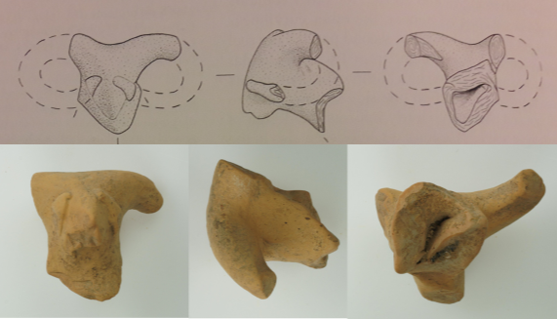
Photo Credit: Renfrew, et al., Kavos and the Special Deposits, 314 and CD-ROM.
P10. Ram Protome
Medium: clay
Period: EC II
Date: 2700-2300 B.C.
Dems: H. 48 mm, L. 40 mm, W. 36 mm
Provenance: Kavos, Keros
Special Finds no.: 2445
Description: “…fine fabric, grey core, orange surfaces. Self-slipped throughout. Painted bichrome (black and red) dark-on-light. Head, neck and a part of the vessel’s spout. The end of the pointed muzzle is chipped. The horns end on cheeks, somewhat less carefully than on the other protomes. The right horn is missing from close to its point of attachment to the head, while the left horn is oriented sideways and then backwards. The middle section is missing. Faint traces of black paint are visible below the muzzle, on the horn and around the neck; red paint can be observed at the top of the head where horns begin. In all probability, the piece was the finial of a sauceboat spout.” (Kavos and the Special Deposits, 313-15)

Notes:
Colin Renfrew, Olga Philaniotou, Neil Brodie, Giorgos Gavalas, and Michael J. Boyd, The Sanctuary on Keros and the Origins of Aegean Ritual Practice: The Excavations of 2006-2008. Volume II, Kavos and The Special Deposits, (Cambridge: University of Cambridge and McDonald Institute for Archaeological Research,2015), 313-15.
**Will be discussed further by Sotirakopoulou in Volume V, forthcoming.

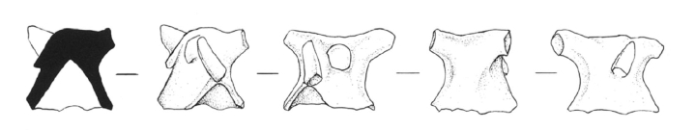
Photo Credit: Renfrew et al., “Keros: Dhaskalio and Kavos”, 116.

P11-15 Ram’s Head Spout Fragments
Medium: clay
Period: EC II
Date: 2700-2400 BC
Provenance: Keros, possible imports
Excavation. no.: Coo42, B1 L4
Description: “There are five animal head protomes in the form of a ram or bull from sauceboat spouts, similar to those known from the north-east Peloponnese and thought to probably have been imported from that area.” (Renfrew et al., 115)
Notes:
Renfrew, Colin et al., “Keros: Dhaskalio and Kavos, Early Cycladic Stronghold and Ritual Centre. Preliminary Report of the 2006 and 2007 Excavation Seasons.” The Annual of the British School at Athens 102 (2007): 103-136. Accessed 5- 26-2016 http://www.jstor.org/stable/30245247.

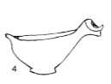
Illustration of intact sauceboat showing the ram’s head protome. (Renfrew et al., “Keros: Dhaskalio and Kavos”, 118).

Photo Not Available

P16. Ram’s Head Spout Fragments
Medium: clay
Period: EC II
Date: 2700-2300 B.C.
Dems: H, 22 mm; L, 17 mm; W, 10mm
Provenance: Kavos, Keros
Special Finds no.: 20015
Description: “Fine fabric, buff. Painted dark-on-light. The narrow end with trace of what appears, especially on the interior to be a spout. Faint traces of black paint along the outer surface. Probably part of the finial of a sauceboat spout.” Identification uncertain; Very little remains. (Kavos and The Special Deposits, 316)
Notes:
Colin Renfrew, Olga Philaniotou, Neil Brodie, Giorgos Gavalas, and Michael J. Boyd, The Sanctuary on Keros and the Origins of Aegean Ritual Practice: The Excavations of 2006-2008. Volume II, Kavos and The Special Deposits, (Cambridge: University of Cambridge and McDonald Institute for Archaeological Research, 2015), 316.
**Will be discussed further by Sotirakopoulou in Volume V, forthcoming.

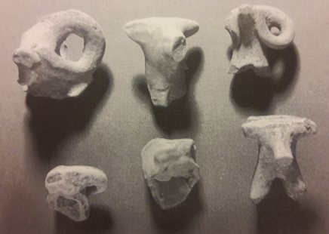
Photo Credit: Sotirakopoulou, “Dhaskalio Kavos, Keros: The Pottery from the Investigations of the 1960s,” 119.
P17-22. Ram Protomes
Medium: clay
Period: EC II
Date: 2700-2400 BC
Provenance: Keros, looted area
Excavation. no.: Naxos Archaeological Museum
Description: Six animal head protomes, probably rams, from the 1960’s excavations conducted by Doumas (Sept 1963) and Zapheiropoiulou and Tsakos (1967).
Notes:
Panayiota Sotirakopoulou, “Dhaskalio Kavos, Keros: The Pottery from the Investigations of the 1960s,” in Horizon: A Colloquium on the Prehistory of the Cyclades, ed. Neil Brodie et al., (Oxford: McDonald Institute for Archaeological Research, 2008), 115-120.

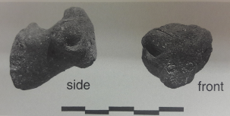
Photo Credit: Wilson, Keos, pl. 102.
P23. Ram’s Head
Medium: clay
Period: EC II
Date: 2700-2300 B.C.
Dems: L .044, W. .033
Provenance: Ayia Irini, Kea; Room D.1
Location/Access. no.: Chora Museum, CM.459, K8.199
Description: “Missing one horn and end of muzzle; coarse fabric; dark red surface typical of Period III; long sloping neck; triangular face, flattened. Right horn curled forward above the right eye (incised circle). Mouth indented by potter’s thumbnail. Head may have been a handle on a pot. Secondary use as a polisher is suggested by smoothed base of neck with traces of abrasion.” Possibly a protome. Found in the removal of paved floor and wall foundations. (Keos, 165, 258)
Notes:
David E. Wilson, Keos: Volume IX, Ayia Irini, Periods I-III, (Mainz am Rhein: Verlag Philipp von Zabern, 1999), pl. 102, SF 406.

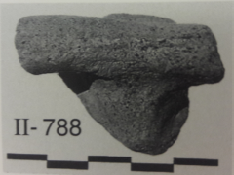
Photo Credit: Wilson, Keos, pl. 71.
P24. Ram’s Head
Medium: clay
Period: EC II
Date: 2700-2300 B.C.
Dems: H: 0.037 m, W: 0.05 m
Provenance: Ayia Irini, Kea; Beneath Room A.9
Description: Orange buff, semi-fine to coarse ware. “Ram’s (?) head, applied to a jar (?)/pithos (?) body sherd...small triangular head surmounted by a thick horizontal bar (horns?) broken at both ends...deposit on and above floor associated with hearth and walls.” (Keos, 88, 260)
Notes:
David E. Wilson, Keos: Volume IX, Ayia Irini, Periods I-III, (Mainz am Rhein: Verlag Philipp von Zabern, 1999), pl. 71, II-788.

Early Cycladic III (2400/2300 BCE-2000 BCE)
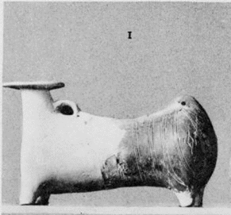
Photo Credit: Lamb, Corpus Vasorum Antiquorum, 480.
V21. Theriomorphic Vase
Medium: clay
Period: EC III
Date: ca. 2300-2000 BC
Dems: H. .136 m, L. .245 m
Provenance: possibly Phylakopi, Melos
Location/Access. no.: Fitzwilliam, Cambridge, UK, GR.50.1902
Description: Similar to object V22; reconstructed; pairs of vertical lines and lozenge motif incised on the body. “Notice the pierced lug, givng the effect of a tail, on the hind-quarters. Hand-made, of reddish-brown burnished clay… [lozenge motif] is repeated three times on each flank.” (Lamb)

Notes:
Winifred Lamb, Corpus Vasorum Antiquorum, Great Britain (Oxford: Oxford University Press, 1936), Great Britain fasc.11, Cambridge fasc.2., pl. 1 (480) 1.

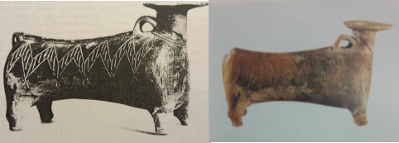
Photo Credit: Buchholz and Karageorghis, Prehistoric Greece and Cyprus, 363; Sapouna-Sakellariakis, Cycladic Civilization and the Cycladic Collection of the National Archaeological Museum of Athens, pl. 9.
V22. Theriomorphic Vase
Medium: clay
Period: EC III
Date: ca. 2300-2000 BC
Dems: H. 11.4 cm, L. 13.1 cm
Provenance: Phylakopi, Melos
Location/Access. no.: National Archaeological Museum Athens, 5698
Description: “Early Cycladic monochrome vase in the form of an animal; spout with wide rim in place of head; ridge and two loops on back; incised zigzag decoration on both sides, double line at base of neck, incised lozenges on chest” (Buchholz, 99)
Notes:
E. Sapouna-Sakellariakis, Cycladic Civilization and the Cycladic Collection of the National Archaeological Museum of Athens, (Athens: Apollo Editions, 1973), 25, pl. 9.
Hans-Gunter Buchholz and Vassos Karageorghis, Prehistoric Greece and Cyprus, trans. Francisca Garvie, (London: Phaidon, 1973), 99, 363, no.1190.
T.D. Atkinson, et al., Excavations at Phylakopi in Melos Conducted by the British School at Athens, (London: Macmillan and Co., 1904), 91, fig 75, pl. IV.7.

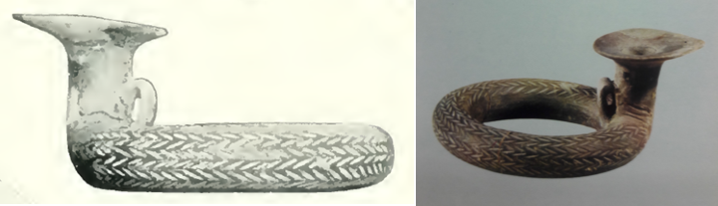
Photo Credit: Atkinson, Excavations at Phylakopi in Melos, 91; Papathanasopoulos, National Archaeological Museum: Catalogue of Neolithic and Cycladic Collections, 177.
V23. Ring-shaped Vessel (annular askos)
Medium: clay
Period: EC III
Date: 2300-2000/1900 BC
Dems: .08 m
Provenance: Phylakopi, Melos
Location/Access. no.: National Archaeological Museum Athens, 5697
Description: “Unique clay annular vase (askos) of excellent manufacture, elegant unusual form reminiscent of a coiled snake, with its head erect. The outside of the cylindrical body of the vase bears incised decoration of dense chevrons in successive rows, imitating the scaly surface of the snake skin, the mouth of the vase is at right angles to the body and terminates in a broad tongue-like lip. On the back of the neck there is a wide vertical pierced handle, perhaps of the suspension of the vase. The surface of the askos is brownish-red in color and bears traces of smoothing.” Papathanasopoulos, 177

Notes:
G. Papathanasopoulos, National Archaeological Museum: Catalogue of Neolithic and Cycladic Collections, (Athens: Melissa Editions, 1981), 177, fig. 99.
T.D. Atkinson, et al., Excavations at Phylakopi in Melos Conducted by the British School at Athens, (London: Macmillan and Co., 1904), 91, 306. pl. IV.9; incisions suggest serpent, spout instead of head, hollowed body.

Christos Doumas, Early Cycladic Culture: The N.P. Goulandris Collection, (Athens: N.P. Goulandris Foundation and Museum of Cycladic Art, 2000), 14.
Cyprian Broodbank, An Island Archaeology of the Early Cyclades, (Cambridge: Cambridge University Press, 2000), 78.
Pat Getz-Preziozi, The Obsidian Trail, or 5000-4000 Years Ago in the Cyclades, (Athens: Nicholas P. Goulandris Foundation and the Museum of Cycladic Art, 1987), 50.
Broodbank, An Island Archaeology, 79.
Cyprian Broodbank, The Making of the Middle Sea: A History of the Mediterranean from the Beginning to the Emergence of the Classical World, (Oxford: Oxford University Press, 2013), 68. Another speckled variety was sourced at Giali, a small volcanic island in the Dodecanese.
Broodbank, Making of the Middle Sea, 69; Getz-Preziosi, Obsidian Trail, 34.
Broodbank, An Island Archaeology, 79. For a brief description of raw materials found in the Aegean, see also Oliver Dickinson, The Aegean Bronze Age, (Cambridge: Cambridge University Press, 1994), 28-29.
Cyprian Broodbank, “The Early Bronze Age in the Cyclades,” in The Cambridge Companion to the Aegean Bronze Age, edited by Cynthia W. Shelmerdine, (Cambridge: Cambridge University Press, 2008), 61.
Pat Getz-Gentle, Stone Vessels of the Cyclades in the Early Bronze Age, (University Park, PA: Penn State University Press, 1996), 185. The jade-like stone has been identified in various ways across the literature including jadite, nephrite, and more. However, at the time of publishing her study on the stone vessels, Getz-Gentle reports that none of the relevant objects have been subjected to petrographic scrutiny and therefore a precise determination on the identification of the stone cannot be made.
Getz-Gentle, Stone Vessels of the Cyclades in the Early Bronze Age, 186. The author suggests that because of the stated properties the stone was obviously chosen for its aesthetic appeal, and perhaps like the Chinese and their jade, the Early Cycladic islanders believed the stone possessed certain qualities which may be passed to the one in possession of objects made from the green stone.
Doumas, Early Cycladic Culture, 16.
Joannis Mylonopoulos, “Divine Images Versus Cult Images: An Endless Story about Theories, Methods, and Terminologies,” in Divine Images and Human Imaginations in Ancient Greece and Rome, ed. Joannis Mylonopoulos, (Leiden and Boston: Brill, 2010), accessed 04/20/2017, http://www.brill.com/divine-images-and-human-imaginations-ancient-greece-and-rome.
Mylonopoulous, “Divine Images Versus Cult Images,” 13.
Mylonopoulous, “Divine Images Versus Cult Images,” 13.
Mylonopoulou, “Divine Images Versus Cult Images,” 7.
Jeremy B. Rutter, “Aegean Prehistoric Archaeology,” Dartmouth College, n.d., accessed 9/27/2013, http://www.dartmouth.edu/~prehistory/aegean/.
J.L. Bintliff, The Complete Archaeology of Greece: From Hunter-Gatherers to the 20th Century A.D., (Malden, MA: Wiley-Blackwell, 2012), 33. Though human activity was present at Franchthi since the Upper Paleolithic (30-17 k.y.a.) occupation was abandoned and then reoccupied around 13 k.y.a. Additionally, since that time consistent occupation is evidenced until the Bronze Age, it was never continuous throughout the entire year, as hunter-gatherer populations were migratory.
Edmund F. Bloedow, “The Date of the Earliest Phase at Agrissa Magoula in Thessaly and Other Neolithic Sites in Greece,” Mediterranean Archaeology 5/6 (1992/93): 49-57, accessed 9-17-2016, http://www.jstor.org/stable/24667819. In this article, the author argues against a so-called Aceramic Neolithic period. He uses calibrated radiocarbon dates to present a more precise sequence beginning with the Early Neolithic.
Walter Burkert, Greek Religion, translated by John Raffan, (Cambridge: Harvard University Press, 1985), 11.
This refers to Gordon Childe’s seminal work The Dawn of European Civilization first published in 1925, which argues for a dissemination of culture from what he deems as “the Orient” through the Aegean and then to the rest of Europe via the Balkans. For a concise summary of the prevailing theories see Broodbank, An Island Archaeology, p. 46-47.
Burkert, Greek Religion, 11; Christos Doumas, Cycladic Art: Ancient Sculpture and Pottery from the N.P. Goulandris Collection, (London: British Museum Press, 1996), 15.
John E. Coleman, “The Chronology and Interconnections of the Cycladic Islands in the Neolithic Period and the Early Bronze Age,” American Journal of Archaeology 78, no. 4 (Oct 1974): 333-344, accessed 12-07-2009, http://www.jstor.org/stable/502747; Broodbank, An Island Archaeology, 44.
Doumas, Cycladic Art, 15; Rutter, “Aegean Prehistoric Archaeology”, accessed 2/18/17, http://www.dartmouth.edu/~prehistory/aegean/.
Roughly contemporary with the Middle-Late Neolithic periods of Mainland Greece, however the pottery is more closely analogous with Anatolia rather than Mainland Greece or Crete. Similar artefactual discoveries have been found at neighboring sites of Grotta, Sangri and Zas Cave on Naxos. See Rutter, “Aegean Prehistoric Archaeology”, accessed 2/18/17, http://www.dartmouth.edu/~prehistory/aegean/.
See the “Lady of Saliagos”, c. 5000 BC., Archaeological Museum of Paros, accession no. 887. This is the earliest known representational Cycladic sculpture. “Cycladic Art: The Lady of Saliagos,” The Bradshaw Foundation, accessed 2/18/2017, http://www.bradshawfoundation.com/sculpture/cycladic_scultpture1.php.
Doumas, Cycladic Art, 15.
The island is also known as Keos and Tzia. Other contemporary sites on the island include Paoura, Sykamia and Ayia Irini. Evidence of metalworking has been dated contemporaneously with Knossos on Crete, Pefkakia in Thessaly and Sitagroi in Macedonia. See Rutter, “Aegean Prehistoric Archaeology”, accessed 2/18/2017, http://www.dartmouth.edu/~prehistory/aegean/.
Doumas, Cycladic Art, 15
J.F. Cherry, “First Colonization of the Mediterranean Islands,” Journal of Mediterranean Archaeology 3, no. 1 (1990): 164; Rutter, “Aegean Prehistoric Archaeology”, accessed 2/18/2017, http://www.dartmouth.edu/~prehistory/aegean/.
Broodbank, The Making of the Middle Sea, 236-37. On Kephala copper from Lavrion in Attica was smelted. Additionally, metal finds of copper, gold, silver and lead from the Balkans were found there. Gold and silver objects, trinkets rather than tools or other utilitarian objects share a remarkable parallel with Neolithic finds in burials at Varna in Bulgaria.
Bintliff, Complete Archaeology of Greece, 103.
Doumas, Early Cycladic Culture, 16. Information from this entire page comes from this source.
Nikolaos Chr. Stampolidis and Peggy Sotirakopoulou. Aegean Waves: Artworks of the Early Cycladic Culture in the Museum of Cycladic Art at Athens, (Milano: Skira, 2007), 19; Broodbank, An Island Archaeology, 44.
Stampolidis and Sotirakopoulou, Aegean Waves, 19.
Rutter, “Aegean Prehistoric Archaeology”, accessed 2/18/2017, http://www.dartmouth.edu/~prehistory/aegean/.
For further details, see Stampolidis and Sotirakopoulou, Aegean Waves, 20. Many similarities are thought to exist in the treatment of burials, suspected libation rituals, and grave goods.
Nellie Phoca-Cosmetatou, “Economy and Occupation in the Cyclades during the Late Neolithic: The Example of Ftelia, Mykonos,” in Horizon: A Colloquium on the Prehistory of the Cyclades, ed. Neil Brodie et al., (Oxford: McDonald Institute for Archaeological Research, 2008), 38.
Phoca-Cosmetatou, “Economy and Occupation in the Cyclades,” 38.
Rutter, “Aegean Prehistoric Archaeology”, accessed 2/18/17, http://www.dartmouth.edu/~prehistory/aegean/.
Phoca-Cosematatou, “Economy and Occupation in the Cyclades,” 38-40. Information from this entire paragraph comes from this source.
Katerina Trantalidou, “Glimpses of Aegean Island Communities during the Mesolithic and Neolithic Periods: the Zooarchaeological Point of View,” in Horizon: A Colloquium on the Prehistory of the Cyclades, ed. Neil Brodie et al., (Oxford: McDonald Institute for Archaeological Research, 2008), 23.
Trantalidou, “Glimpses of Aegean Island Communities,” 24-25.
Katerina Trantalidou, “The Animal Bones: The Exploitation of Livestock,” in The Sanctuary on Keros and the Origins of Aegean Ritual Practice: The Excavations of 2006-2008. Vol. 1, The Settlement at Dhaskalio, eds. Colin Renfrew et al., (Cambridge: McDonald Institute for Archaeological Research, 2013), 440.
Trantalidou, “The Animal Bones: The Exploitation of Livestock,” 432. See Table 20.1.
Trantalidou, “The Animal Bones,”433.
Trantalidou, “The Animal Bones,” 440-441; For a concise description of fauna endemic to Greece see also Dickinson, The Aegean Bronze Age, 28.
For a complete list of sites known by island see “Appendix I: Gazetteer of Neolithic and Early Bronze Age Sites in the Cycladic Islands” in Renfrew, The Emergence of Civilization, 507-525.
For a detailed and in-depth discussion of chronology see: R.L.N. Barber and J.A. MacGillivray, “The Early Cycladic Period: Matters of Definition and Terminology,” American Journal of Archaeology 84, no. 2 (Apr 1980): 141-157, and Colin Renfrew, “The Development and Chronology of the Early Cycladic Figurines,” The American Journal of Archaeology 73 (Jan 1969): 1-32.
Relative chronology refers to dating objects/events in relation to dates of other objects/events.
Absolute chronology refers to determining the age of an object or date of an event in numerical years.
Christos Doumas, “Aegean Absolute Chronology: Where Did It Go Wrong?” in Tree-Rings, Kings, and Old World Archaeology and Environment: Papers Presented in Honor of Peter Ian Kuniholm, eds. Sturt Manning and Mary Jaye Bruce (Oxford: Oxbow, 2009), 263. The relative chronological system and cultural sequences were universally accepted until scientific dating methods were introduced in the 1960’s.
Renfrew, The Emergence of Civilization, 53-54.
Ourania Kouka, “Third Millennium BC Aegean Chronology: Old and New Data from the Perspective of the Third Millennium AD,” in Tree-Rings, Kings, and Old World Archaeology and Environment: Papers Presented in Honor of Peter Ian Kuniholm, eds. by Sturt Manning and Mary Jaye Bruce (Oxford: Oxbow, 2009), 133.
Cynthia W. Shelmerdine, ed., The Cambridge Companion to the Aegean Bronze Age, (Cambridge: Cambridge University Press, 2008), 3. For example, the focus of this thesis covers the Early Cycladic (abbreviated EC) period and its three sub-phases (EC I, EC II, and EC III).
In 1977, Doumas also introduced a similar cultural sequence based on cemeteries. See Christos Doumas, Early Bronze Age Burial Habits in the Cyclades, (Göteborg: Paul Åströms Förlag, 1977).
Additionally, two short-lived transitional phases exist. The Kampos phase falls between Grotta-Pelos and Keros-Syros; and the Kastri phase falls between Keros-Syros and Phylakopi. However, some scholars do not treat them as separate phases, but groups within EC I and EC II respectively. See Stampolidis and Sotirakopoulou, Aegean Waves, 21.
Colin Renfrew, The Emergence of Civilization: The Cyclades and the Aegean in the Third Millennium B.C. (London: Methuen, 1972), 147, 153.
Renfrew, The Emergence of Civilization, 186, 190; Renfrew, “Cyclades,” in The Oxford Handbook of the Bronze Age Aegean (ca. 3000-1000 BC), edited by Eric Cline (Oxford: Oxford University Press, 2010), 83-95. 1900
Broodbank, An Island Archaeology, 53. See also Appendix 2: “Local Groups within the Grotta-Pelos and Keros-Syros Cultures of the Cyclades,” from Colin Renfrew, The Emergence of Civilization, 527-538.
Colin Renfrew, “The Cycladic Culture,” in Art and Culture of the Cyclades in the Third Millennium B.C., ed. by Jürgen Thimme, (Chicago: University of Chicago Press, 1977), 20.
Renfrew, “The Cycladic Culture,” 20.
Colin Renfrew, “Cycladic Metallurgy and the Aegean Early Bronze Age,” American Journal of Archaeology 71, no. 1 (Jan 1967): 1-20, accessed 01-27-2010, http://www.jstor.org/stable/501585, 1-2.
Renfrew, “The Cycladic Culture,” 20.
For a concise overview of the discourse concerning Cycladic chronology, see: Broodbank, An Island Archaeology, 53-55.
Doumas, Early Cycladic Culture, 20.
Stampolidis and Sotirakopoulou, Aegean Waves, 22.
Doumas, Early Cycladic Culture, 21.
Stampolidis and Sotirakopoulou, Aegean Waves, 20.
Peter Andrews, Theya Molleson & Başak Boz, “The Human Burials at Çatalhöyük,” in Inhabiting Çatalhöyük: Reports From the 1995-99 Seasons, edited by Ian Hodder, 261-278 (Cambridge: McDonald Institute for Archaeological Research, 2005), 263.
Doumas, Early Cycladic Culture, 20.
Barber and MacGillivray, “The Early Cycladic Period: Matters of Definition and Terminology,”149.
Stampolidis and Sotirakopoulou, Aegean Waves, 24.
John L. Caskey, and E.T. Blackburn, Lerna in the Argolid, (Athens: American School of Classical Studies at Athens, 1997), 14.
Doumas, Early Cycladic Culture, 28.
Doumas, Early Cycladic Culture, 27.
Hekman, “The Early Bronze Age Cemetery at Chalandriani on Syros,” 62.
Stampolidis and Sotirakopoulou, Aegean Waves, 26.
Doumas, Early Cycladic Culture, 29.
Doumas, Early Cycladic Culture, 29.
Renfrew, “The Cycladic Culture,” 26.
Renfrew, The Emergence of Civilization, 186.
Doumas, Early Cycladic Culture, 37. Ayia Irini, Phylakopi, Akrotiri, Paroikia, and Grotta.
Barber and MacGillivray, “The Early Cycladic Period: Matters of Definition and Terminology,” 150.
Renfrew, “The Cycladic Culture,” 28,
Barber and MacGillivray, “The Early Cycladic Period: Matters of Definition and Terminology,” 152.
Marija Gimbutas, The Language of the Goddess: Unearthing the Hidden Symbols of Western Civilization, (San Francisco: Harper & Row, 1989), 119.
Getz-Gentle, Stone Vessels of the Cyclades, 140-41.
Gimbutas, The Language of the Goddess, 92.
Getz-Gentle, Pat, and Jack de Vries. Personal Styles in Early Cycladic Sculpture. Madison: University of Wisconsin Press, 2001. Getz-Gentle, Pat. Sculptors of the Cyclades: Individual and Tradition in the Third Millennium B.C. Ann Arbor: University of Michigan Press, 1987.
Getz-Gentle, Stone Vessels of the Cyclades in the Early Bronze Age, (University Park: Pennsylvania State University Press, 1996).
Getz-Gentle, Stone Vessels of the Cyclades in the Early Bronze Age, xxi.
Pat Getz-Preziosi, Early Cycladic Sculpture, (Malibu: J. Paul Getty Museum, 1985).
Pat Getz-Gentle, Jack L. Davis and Elizabeth Oustinoff, Early Cycladic Art in North American Collections, (Richmond, VA: Virginia Museum of Fine Arts, 1987).
Marija Gimbutas, The Civilization of the Goddess: The World of Old Europe, (San Francisco: Harper, 1991).
Colin Renfew, The Emergence of Civilization: The Cyclades and the Aegean in the Third Millennium B.C., (London: Methuen, 1972).
Peristera Paschou, et al. “Maritime Route of Colonization of Europe,” Proceedings of the National Academy of Sciences 111, no. 25 (June 24, 2014): 9211-9216, accessed 2/23/2017 http://www.pnas.org/content/111/25/9211.full. All the information on this page relates to this source.
Jean-Paul Demoule and Catherine Perlès, “The Greek Neolithic: A New Review,” Journal of World Prehistory 7, no. 4 (Dec. 1993): 365, accessed 9-17-2016, http://www.jstor.org/stable/25800637.
Demoule and Perlès, “The Greek Neolithic”, 365.
Paschou et al., “Maritime Routes”, 9215.
These might include use of 3-D printing, the Scanning Electron Microscope (SEM), non-destructive carbon dating, computed tomography (CT) scans, light detection and ranging, or LIDAR, multispectral imaging (MSI), hyperspectral imaging and more. It is my belief that many of the objects in the catalog accompanying this thesis have never been examined using any modern processes.
Rutter, “Aegean Prehistoric Archaeology”, accessed 2/18/2017, http://www.dartmouth.edu/~prehistory/aegean/.
Bintliff, Complete Archaeology of Greece, 103.
Bintliff, Complete Archaeology of Greece, 103.
Broodbank, An Island Archaeology, 82.
See “Table 1: Earliest Occupation Dates for the East Mediterranean Islands” in John Cherry, “Pattern and Process in the Earliest Colonization of the Mediterranean Islands,” Proceedings of the Prehistoric Society 47 (1981): 54-55. Though these dates are low in comparison to modern data, it does provide a good frame of reference.
Cherry, “First Colonization,” 199.
Cherry, “First Colonization,” 199.
Cherry, “First Colonization,” 200.
During the EC I period, short-range sailing occurred—intercommunity and interisland—probably for the purposes of shuttling foodstuffs and animals, marriage alliances, access to raw materials, and the like. See: Cyprian Broodbank, “The Early Bronze Age in the Cyclades,” in The Cambridge Companion to the Aegean Bronze Age, edited by Cynthia W. Shelmerdine, (Cambridge: Cambridge University Press, 2008), 63.
Stampolidis and Sotirakopoulou, Aegean Waves, 62.
Renfrew, Emergence of Civilization, 34, 451.
Broodbank, “The Early Bronze Age in the Cyclades,” 65.
Cyprian Broodbank, “Ulysses without Sails: Trade, Distance, Knowledge and Power in the Early Cyclades,” World Archaeology 24, no. 3 (Feb. 1993): 315-331, accessed 01-24-2010, http://www.jstor.org/stable/124711. 316-318.
Broodbank, “Ulysses without Sails,” 318.
Broodbank, “The Early Bronze Age in the Cyclades,” 65.
Broodbank, “The Early Bronze Age in the Cyclades,” 56.
Broodbank, “The Early Bronze Age in the Cyclades,” 56.
Broodbank, “The Early Bronze Age in the Cyclades,” 65.
Broodbank also points out other main ports which could have been recipients of Cycladic imports: Kolonna and Manika in the Saronic and Euboean Gulfs, Mochlos and Poros in Crete, Palaman at Skyros and Poliochni at Lemnos, both in the North Aegean. See: Broodbank, “The Early Bronze Age in the Cyclades,” 64.
Broodbank, “Ulysses without Sails,” 326-27.
Stampolidis and Sotirakopoulou. Aegean Waves, 42.
Gimbutas, The Language of the Goddess, 198.
Gimbutas, The Language of the Goddess, 316.
Colin Renfrew, “Speculations on the Use of Early Cycladic Sculpture,” in Cycladica, edited by J.L. Fitton, 24-30. (London: British Museum Publications, 1984), 25-28.
Renfrew, “Speculations,” 25.
Renfrew, “Speculations,” 25.
Renfrew, “Speculations,” 25.
Richard Buxton, The Complete World of Greek Mythology, (London: Thames and Hudson, 2004), 211-12.
Renfrew, “Speculation,” 25.
Pat Getz-Preziosi, “Risk and Repair in Early Cycladic Sculpture.” Metropolitan Museum Journal 16 (1981): 5-32, accessed 12-08-2009, http://www.jstor.org/stable /1512766.
Statue of the folded-arm figurine type stands at 1.52 meters, made of Parian marble; found in a grave at Amorgos and dates to the Early Cycladic II period (Keros-Syros Culture, 2800-2300 BC).
Renfrew, “Speculation,” 26.
Renfrew, “Speculation,” 26.
Olaf Höckmann, “Cycladic Religion,” in Art and Culture of the Cyclades in the Third Millennium B.C., ed. Jürgen Thimme, 37-51, (Chicago: University of Chicago Press, 1977), 40.
Renfrew, “Speculation,” 26.
Renfrew, “Speculations,” 27.
Renfrew, “Speculations,” 27.
Renfrew, “Speculations,” 27.
Renfrew, “Speculations,” 27.
Renfrew, “Speculations,” 28.
Marian H. Feldman, “Mesopotamian Art,” in A Companion to the Ancient Near East, ed. Daniel C. Snell, 304-324, (Malden, MA: Blackwell, 2007), 312-313.
Renfrew, “Speculations,” 28.
Mylonopoulos, “Divine Images Versus Cult Images,” 8. There are three elements for statues/object to be defined as cult images: 1. History of miracles, 2. Location in specially designed architectural setting like temple or shrine and 3. They had to be consecrated with magic-religious rituals.
Christina A. Televantou, “Strofilas: A Neolithic Settlement on Andros.” in Horizon: A Colloquium on the Prehistory of the Cyclades, edited by Neil Brodie et al., 43-53, (Oxford: McDonald Institute for Archaeological Research, 2008), 45-47.
Televantou, “Strofilas: A Neolithic Settlement on Andros.” 49.
It is also significant to note the similarity in shape to the EC II so-called ‘frying pans,' for which no known use can be determined, (Fig. 9). The connection of the Neolithic ring-shaped motifs to the EC II ‘frying-pans’ is important to show a continuation of culture. Additionally, the idea that the ring-shaped motifs may symbolize a schematic female form is supported in the ‘frying-pans’, many of them having an incised pubic triangle above the handle like those on the female marble idols.
Televantou, “Strofilas: A Neolithic Settlement on Andros,” 47.
George Toufexis, “Animals in the Neolithic art of Thessaly,” British School at Athens Studies 9 (2003): 263-271, accessed 5-19-2016, http://www.jstor.org/stable /40960356.
Only a few hollow examples exist; décor is mostly painted, rather than incised.
Toufexis, “Animals in the Neolithic Art of Thessaly,” 263-269.
Toufexis, “Animals in the Neolithic Art of Thessaly,” 264.
Toufexis, “Animals in the Neolithic Art of Thessaly,” 268-269.
Howard Morphy, ed., Animals into Art, (London: Unwin Hyman, 1989), 1.
Morphy, Animals into Art, 2.
Morphy, Animals into Art, 2.
Morphy, Animals into Art, 3.
“Animals in Ancient Near Eastern Art,” Department of Ancient Near Eastern Art, 02/2014, (New York: The Metropolitan Museum of Art), accessed 3/6/2017, http://www.metmuseum.org/toah/hd/anan/hd_anan.htm.
Gimbutas, The Goddesses and Gods of Old Europe, 9-10.
Gimbutas, The Goddesses and Gods of Old Europe, 13.
Gimbutas, The Language of the Goddess, 75.
See protomes P11-15 in the appendix catalog, for an artistic rendering of the sauceboat form with an attached ram-head protome. This form would combine the bird-like form of the sauceboat, with the ram’s head to complete the association with the Bird Goddess
Gimbutas, The Language of the Goddess, 79.
Note that within the corpus of Early Cycladic folded-arm figurines some are depicted as pregnant. For two examples see #309, The Goulandris Collection, The Museum of Cycladic Art and #68.148, Bastis Collection, Metropolitan Museum of Art, both from EC II, (2800/2700 BCE-2400/2300 BCE).
James Hall, Illustrated Dictionary of Symbols in Eastern and Western Art, (New York: HarperCollins, 1994), 39.
Gimbutas, The Language of the Goddess, 146.
Burkert, Greek Religion, 13.
Richard Buxton, The Complete World of Greek Mythology, (London: Thames and Hudson, 2004), 72-73.
Hall, Illustrated Dictionary of Symbols, 176.
Katsarou, Stella and Demetrius U. Schilardi. “Recontextualized Neolithic and Early Cycladic Figurines at the Acropolis of Koukounaries, Paros.” in Early Cycladic Sculpture in Context, eds. Marisa Marthari, Colin Renfrew, Michael Boyd. 410-420, (Oxford: Oxbow, 2017), 415.
Gimbutas, The Language of the Goddess, 266.
Emily Banou, “Minoan ‘Horns of Consecration’ Revisited: A Symbol of Sun Worship in Palatial and Post-Palatial Crete?” Mediterranean Archaeology and Archaeometry 8, no. 1 (2008): 27-47, accessed 4/1/2017, http://maajournal.com/Issues /2008/FullTextBanou.pdf.
Höckmann, “Cycladic Religion,” 49. These objects are not catalogued here.
Gimbutas, The Language of the Goddess, 256.
Gimbutas, The Language of the Goddess, 81.
Gimbutas, The Language of the Goddess, 256.
Gimbutas, The Language of the Goddess, 89. For a comparative figure, see the faience hedgehog from the Egyptian Collection at the Brooklyn Museum of Art (65.2.1), which dates to c. 1938-1700 BCE, XII Dynasty-early XIII Dynasty (Middle Kingdom), from Deir el Nawahid, Egypt. The representation of the hedgehog quills/spines are depicted as “knobby”, wart-like features.
Lena Papazoglou-Manioudaki, “The Early Cycladic Figurines from the Excavations of Clon Stephanos on Syros,” in Early Cycladic Sculpture in Context, eds. Marisa Marthari, Colin Renfrew, Michael Boyd, 310-334, (Oxford: Oxbow, 2017), 320.
Thimme, Art and Culture of the Cyclades, 523.
“Animals in Ancient Near Eastern Art,” Department of Ancient Near Eastern Art, New York: The Metropolitan Museum of Art, 02/2014, accessed 3/6/2017, http://www.metmuseum.org/toah/hd/anan/hd_anan.htm.
Broodbank, An Island Archaeology, 215. Aside from the Cycladic hedgehogs cataloged here, Broodbank mentions that the Syros vessel has comparanda from Manika in Euboia and Cheliotomlylos in Corinthia.
Gimbutas and Robbins, The Living Goddess, 14.
Thimme, Art and Culture of the Cyclades, 540.
Hall, Illustrated Dictionary of Symbols, 19.
Gimbutas, The Language of the Goddess, 195.
Marco Masseti, “Representations of Birds in Minoan Art,” International Journal of Osteoarchaeology 7: 354-363 (1997).
Gimbutas, The Language of the Goddess, 161.
Gimbutas, The Language of the Goddess, 171.
Broodbank, “The Early Bronze Age in the Cyclades,” 63.
Elizabeth A. Hendrix, “Painted Early Cycladic Figures: An Exploration of Context and Meaning.” Hesperia 72, no. 4 (Oct-Dec 2003): 405-446, accessed 9-15-2009, http://www.jstor.org/stable/3182012.
Marthari, Marisa. “Figurines in Context at the Chalandriani Cemetery on Syros,” in Early Cycladic Sculpture in Context, eds. Marisa Marthari, Colin Renfrew and Michael Boyd, 297-309, (Oxford 2017), 307. In the article, she makes only one mention of the pin in the context of being found in the same grave as the others. Therefore, it is not catalogued here for lack of information, but will appear in future research.
The so-called harpers are not included in the catalog here since they are considered to be anthropomorphic figurines with zoomorphic elements. However, the swan representation deserved to be mentioned here.
Vorreiter, Leopold. “The Swan-neck Lyres of Minoan-Mycenean Culture.” The Galpin Society Journal 28 (Apr 1975): 93-97, accessed 02-13-2007, http://www.jstor.org/stable/841575.
Buxton, The Complete World of Greek Mythology, 171-173.
Plato, The Republic X.317, trans. Benjamin Jowett, (Mineola, NY: Dover Publications, 2000), Kindle.
Vorreiter, “The Swan-neck Lyres of Minoan-Mycenean Culture,” 93.
Buxton, The Complete World of Greek Mythology, 98.
Gimbutas, The Language of the Goddess, 71-73.
Marija Gimbutas and Miriam Robbins Dexter. The Living Goddesses. (Berkeley: University of California Press, 1999), 14.
Gimbutas, The Language of the Goddess, 213.
Gimbutas, The Language of the Goddess, 213.
R.L.N. Barber, “Terracotta Figurines from Mikre Vigla, Naxos,” in Early Cycladic Sculpture in Context, eds. Marisa Marthari, Colin Renfrew, Michael Boyd. 455-465. (Oxford: Oxbow, 2017), 459.
Stampolidis and Sotirakopoulou, Aegean Waves, 36-37.
Stampolidis and Sotirakopoulou, Aegean Waves, 37. See also, Atkinson, T.D., et al. Excavations at Phylakopi in Melos Conducted by the British School at Athens. (London: Macmillan and Co., 1904), 88-89.
Gimbutas, The Language of the Goddess, 251.
Gimbutas and Robbins, The Living Goddesses, 27.
Gimbutas, The Language of the Goddess, 252.
Jean Chevalier and Alain Gheerbrant, A Dictionary of Symbols, trans. John Buchanan-Brown, (New York: Penguin Books, 1996), 956.
Chevalier and Gheerbrant, A Dictionary of Symbols, 956.
Gimbutas, The Language of the Goddess, 121.
Gimbutas, The Language of the Goddess, 125.
Kenneth Lapatin has written extensively on the authenticity of the so-called Minoan Snake Goddesses. Many of the known snake goddesses are now acknowledged as forgeries. See his book Mysteries of the Snake Goddess: Art, Desire, and the Forging of History, (Boston: Houghton-Mifflin, 2002).
Gimbutas, The Language of the Goddess, 136-37.
Doumas, Early Cycladic Culture, 194. Object is not included in the catalog, since it is considered among the Folded-Arm Figurine corpus, having a zoomorphic element. The Goulandris Collection, Museum of Cycladic Art, #332, EC II, Keros-Syros, Syros Group, 2800 BCE-2300 BCE.
Katsarou, Stella and Demetrius U. Schilardi. “Recontextualized Neolithic and Early Cycladic Figurines at the Acropolis of Koukounaries, Paros.” in Early Cycladic Sculpture in Context, eds. Marisa Marthari, Colin Renfrew, Michael Boyd, 410-420, (Oxford: Oxbow, 2017), 415.
Donald Preziozi and Louise A. Hitchcock, Aegean Art and Architecture, (Oxford: Oxford University Press, 1999), 97.
Kenneth Lapatin, Mysteries of the Snake Goddess: Art, Desire, and the Forging of History, (Cambridge, MA: Da Capo Press, 2003), 73.
Masseti, “Representations of Birds in Minoan Art.”
Masseti, “Representations of Birds in Minoan Art.”
Pausanias, Description of Greece, Book II (2.15.2), Kindle.
Pausanius, Descsription of Greece, Book VI (6.5.4), Kindle.
N. Yamaguchi, A. Cooper, L. Werdelin, and D. W. Macdonald, “Evolution of the Mane and Group-Living in the Lion (Panthera leo): A Review,” Journal of Zoology 263 (2004), 329–342, accessed 4/30/2017, doi:10.1017/S0952836904005242.
Gimbutas, The Language of the Goddess, 270.
Gimbutas, The Language of the Goddess, 270.
Chevalier and Gheerbrant, A Dictionary of Symbols, 396-97.
J.C. Cooper, An Illustrated Encyclopedia of Traditional Symbols, (London: Thames and Hudson, 1978), 70.
Hall, Illustrated Dictionary of Symbols, 11.
Cooper, An Illustrated Encyclopedia of Traditional Symbols, 19.
Brenda Rosen, The Mythical Creatures Bible: The Definitive Guide to Legendary Beings, (New York: Sterling, 2009), 107.
Aristotle, History of Animals, Book II, Part I, Kindle.
Pliny the Elder, Natural Histories, Book VIII, ch. 30, Kindle.
Pausanias, Description of Greece, 9.21.4, Kindle.
Schoch, Robert M. "Redating the Great Sphinx of Giza," KMT: A Modern Journal of Ancient Egypt 3, no. 2 (1992): 52-59. More recently, archaeologists from Hebrew University in Israel, at Tel Hazor unearthed fragments of a sphinx in August 2012. The hieroglyphic inscription accompanying the find dedicates the sphinx to Mycerinus, who ruled Egypt circa 2500 BCE and was the builder of the smallest of Giza's three great pyramids. This find is the first statue ever found dedicated to the king, and the first time an Egyptian statue has ever been found in the Levant. I am hopeful that a discovery of this nature may yet be found in the Cyclades, giving further evidence to the ‘international spirit.’ See: Jonah Mandel, “Unique Egyptian Sphinx Unearthed in North Israel,” Phys.org (July 9, 2013), accessed 4/15/2017, https://phys.org/news/2013-07-archaeological-tel-hazor-sphinx-fragment.html.

