UNIVERSITY OF OKLAHOMA

GRADUATE COLLEGE

THE IMPACT OF THE LIGHTS OUT TEXAS ADVISORY CAMPAIGN ON NIGHT SKY BRIGHTNESS AND BIRD COLLISION FATALITIES

A THESIS

SUBMITTED TO THE GRADUATE FACULTY

in partial fulfillment of the requirements for the

Degree of

MASTER OF SCIENCE

By

GRACE E. TRANKINA
Norman, Oklahoma
2024

THE IMPACT OF THE LIGHTS OUT TEXAS ADVISORY CAMPAIGN ON NIGHT SKY BRIGHTNESS AND BIRD COLLISION FATALITIES

A THESIS APPROVED FOR THE
SCHOOL OF BIOLOGICAL SCIENCES

BY THE COMMITTEE CONSISTING OF

Dr. Jeff Kelly, Chair

Dr. Eli Bridge

Dr. Kyle Horton

© Copyright by GRACE E. TRANKINA 2024
All Rights Reserved.

Table of Contents
Abstract vi
Chapter 1: Does the Lights Out Texas advisory campaign lead to darker skies? 1
Measurement Sites and Methods 4
Set up 4
Data Analysis 6
Results 9
Discussion 10
Chapter 2: The influence of lunar cycle and migration traffic on bird window collision fatalities during Lights Out, Texas 14
Introduction 14
Methods 18
Study sites and collision monitoring 18
Variables 20
Analysis 21
Results 22
Spring models 22
Fall models 23
Discussion 24
Figures 29
Figure 1.1. 29
Figure 1.2. 30
Figure 1.3. 31
Figure 1.4. 32
Figure 1.5. 33
Figure 1.6. 34
Figure 1.7. 35
Figure 2.1. 36
Figure 2.2. 37
Tables 38
Table 1.1. 38
Table 1.2. 39
Table 2.1. 40
Table 2.2. 41
Table 2.3. 42
Table 2.4. 43
Supplemental Tables 44
Table S1. 44
Table S2. 47
Table S3. 49
Table S4. 51
Table S5. 52
Table S6. 52
Table S7. 53
Table S8. 54
Table S9. 55
Table S10. 56
Table S11. 57
References 58

Abstract
Chapter 1: Light pollution caused by artificial light at night (ALAN) is accelerating across the globe. ALAN interferes with biological processes such as nocturnal bird migration in several ways including mortality through bird window collisions. Some cities have started light reduction advisory campaigns during migration seasons to combat the adverse effects of ALAN on birds, but there has yet to be quantification of sky brightness reduction during these advisories. I measured night sky brightness (NSB) in metro Dallas and Houston, Texas using Sky Quality Meters (SQMs) on 12 Lights Out, Texas advisory participant building rooftops in attempts to document the efficacy of the program. I detail the conditions of the night sky in both cities, however, detectable difference in NSB was inconclusive during the 2022-2023 seasons. Overall, the cities of Dallas and Houston experienced high levels of light pollution and periods of natural darkness are largely muted. More research using data integration at multiple scales and in-depth modeling of factors contributing to the complexity of nighttime brightness in urban environments is needed.
Chapter 2: Campaigns to reduce artificial light at night (ALAN) are implemented in cities across the United States to promote the safe passage of birds during spring and fall migration seasons. ALAN attracts birds to brightly lit spaces which exacerbates the mortality of nocturnally migrating species in many ways, including via bird window collisions. There is evidence that reduced window lighting reduces the occurrence of bird window collisions, but there have yet to be studies documenting the effect of local skyglow on fatality counts. I present generalized linear models assessing nightly nocturnal fatalities in the cities of Dallas and Houston during the 2022-2023 Lights Out, Texas monitoring season as compared to regional migration traffic rate and local atmospheric conditions including weather, lunar, and night sky brightness (NSB). Migration traffic rate has the strongest positive relationship with bird window fatalities across cities and seasons. Occasionally, weather variables that are conducive to bird migration in the spring and fall were also positively related to fatalities. Moon illumination percent was also consistently negatively associated with bird fatalities across cities and seasons. While these mechanisms are unclear, I hypothesize a more complex relationship between natural light, artificial light, and glass is at play. While NSB was not a significant variable in the models, the Lights Out, Texas campaign retains potential for effectiveness at the window scale. More research is needed on scales and complex interactions at which these variables influence bird mortality.

Chapter 1: Does the Lights Out Texas advisory campaign lead to darker skies?

Authors: Grace E. Trankina¹, Kyle G. Horton², Carolyn S. Burt², Cheyenne A. Black³, Maggie Leon-Corwin³, Andrew S. Fox³, Hank C. Jenkins-Smith³, Carol L. Silva³, Jeffrey F. Kelly¹
Affiliations:
¹ School of Biological Sciences, University of Oklahoma, Norman, OK, USA, 73019
² Department of Fish, Wildlife, and Conservation Biology, Colorado State University, Fort Collins, CO, USA, 80523
³ Institute for Public Policy Research and Analysis, University of Oklahoma, Norman, OK, USA, 73019
Introduction
Artificial light at night (ALAN) accompanies most man-made infrastructure, to the extent that ALAN is often used as a metric of urbanization (Zhao et al. 2021). There is evidence of a strong connection between the presence of humans and the diminished quality of the night sky (Pun and So 2012). Previously estimated to be increasing at a rate of 2% per year based on satellite imagery, ALAN is now estimated to have increased at 10% per year in the visible spectrum from 2011 to 2022 suggesting rampant acceleration of light pollution across the globe (Kyba et al. 2017; Kyba et al. 2023). Satellite imagery has limited spatial and temporal resolution and is bias towards longer wavelengths, thus tests using ground-based citizen science observations have documented greater acceleration of light pollution in the atmosphere than detectable by satellite (Kyba et al. 2023; Miller et al. 2013). ALAN provides humans the ability to navigate walkways and roadways during non-daylight hours and foster a sense of security (Boyce 2019; Svechkina et al. 2020a). However, in most astronomical and biological settings, ALAN is a clear form of pollution with negative effects seen across ecosystems (Burt et al. 2023; Longcore and Rich 2004).
Across the United States and Europe, 99% people live under light polluted conditions (Falchi et al. 2016). ALAN radiates into the air space and is further scattered by clouds and air particulates which results in brightening of skies well beyond the point source of ALAN (Aubé et al. 2016; Benn and Ellison 1998; Guo et al. 2023; Kyba et al. 2011; Ściężor and Kubala 2014). Light pollution is monitored using many different techniques including Sky Quality Meter (SQM) photometers (Puschnig et al. 2022), CCD cameras (Duriscoe 2013; Falchi 2011), and satellite imagery such as the Visible Infrared Imaging Radiometer Suite (VIIRS) (Levin and Zhang 2019). SQM networks have been employed to monitor light pollution in places such as Austria, Spain, Italy, and the Netherlands and provide spatially and temporally refined ground-based measurement of skies at specific sites of interest (Puschnig et al. 2022).
In addition to astronomy research, it should be noted that art, literature, math, science, religion, language, and concepts of time are just some examples of culture that draw on the night sky and that dark skies are broadly considered a universal heritage (Gallaway 2014; UNESCO 2023). Light pollution is also damaging to physical human health and is linked to circadian disruption, endocrine disruption, and cancer (Al-Naggar and Anil 2016; Chepesiuk 2009; Svechkina et al. 2020b). In addition to human biology, ALAN is an evolutionarily novel pollutant thus poses many challenges for wild animal’s breeding ecology, perception of day length, predator exposure, and migration (Swaddle et al. 2015).
Adverse effect of ALAN on species migration is well documented in the literature, particularly of birds (Burt et al. 2023a; Van Doren et al. 2017; Van Doren et al. 2021). Though bird window collisions can occur at any time, nearly 80% of migratory birds in the U.S. migrate at night and most collisions take place through the night and early morning which is thought to be exacerbated by ALAN (Horton et al. 2019a; Riding et al. 2021). ALAN drives nocturnal migrant window collisions via attraction and disorientation to light sources and skyglow, and are the second largest source of avian mortality, resulting in upwards of nearly 1 billion fatalities annually across the United States and Canada (Burt et al. 2023a; Loss et al. 2015). Mass collision events, when hundreds of bird fatalities occur over the course of one night, have occurred in many major U.S. cities and are often cited in popular media (Bartels 2017; Leffer 2023). These events bolster recognition of ALAN as a threat to migratory birds, providing conservation stakeholder organizations with cause to incite mitigating action (Farnsworth et al. 2024). For example, in response to nearly 400 songbirds striking a single lit building in Galveston, Texas in 2017, Texan by Nature and The Houston Audubon Society began the Lights Out, Texas campaign (henceforth: LOT) (Texan by Nature 2022).
LOT is a voluntary program that encourages cities and their citizens to extinguish nonessential lights from the hours of 2300-0600 during a multi-week fixed advisory period that correlates with peak bird migration in the spring and fall (Texan by Nature 2022). The goal of LOT is to 1.) increase participation in the program to reduce light pollution, 2.) reduce migratory bird mortality, and 3.) coordinate local volunteer efforts to collect and report data (Texan by Nature 2022). Currently, the success of LOT is measured via participation pledges signed, social media engagement, collision monitoring volunteer hours, and the number of collision fatalities reported (Texan by Nature 2022). However, the effectiveness of LOT to reduce night sky brightness (NSB) has yet to be quantified. On a national scale, Houston and Dallas are ranked 2nd and 3rd respectively for posing the greatest exposure of migrating birds to ALAN proportionate to their migration intensity, and both have well established light reduction advisory campaigns making them ideal cities to investigate the effect of these campaigns (Horton et al. 2019a). I investigated the assumption that LOT leads to darker skies and present the quantification of NSB in Dallas and Houston in effort to provide meaningful insight on the efficacy of the Lights Out, Texas program in 2022-2023.

Measurement Sites and Methods

Set up
I used Unihedron Sky Quality Meters (SQMs) to measure night sky brightness, a tool commonly used throughout the astronomical field (Falchi 2011; Kyba et al. 2015; Posch et al. 2018; Pun and So 2012; Puschnig et al. 2014a; Sànchez de Miguel et al. 2017). I will refer to measures from SQMs as night sky brightness, or NSB, which is a representative measure of the scattered light in the atmosphere from all celestial and artificial sources as opposed to the direct radiance of ALAN sources (Puschnig et al. 2014a). SQMs, along with most satellite remote sensing tools of ALAN, are biased towards detecting redder wavelengths and the response between light amplification and atmospheric variables is often wavelength dependent (Kómar and Nečas 2023; Kyba et al. 2012). However, we did not correct for wavelength biases.
NSB is reported in logarithmic unit magnitudes per square arc second (mag arcsec⁻²) where larger values indicate darker skies. Typical measurements range between 16.0–22.0, where a historic pristine clear night sky is assumed to be 21.6 mag arcsec⁻² (Unihedron 2024). Relatively small numerical changes in mag arcsec⁻² equate to a large difference in NSB, and a 5-unit increase in NSB corresponds to a 100-times darker sky; therefore a 1-unit change is equivalent to a 20 times darker sky, and a 0.1-unit change is equivalent to a 2 times darker sky and so on (Unihedron 2024).
For this study, I measured NSB using SQMs in metro Dallas (32.77 N, 96.79 W) and Houston (29.76 N, 95.36 W), Texas, USA to assess the efficacy of LOT at reducing city wide light pollution (Figure 1.1). SQM model LU-DL was chosen for its portability and narrow field of view. Each SQM is calibrated by manufacturer Unihedron and autonomously logs data to internal storage without need for wired electric or ethernet hookups making it ideal for rooftop placement. The half width half maximum sensitivity is approximately 10°, meaning that each 10° away from zenith the sensitivity to a light source is a factor of 10 lower, which reduces interference of ALAN sources adjacent to the SQM by narrowing the field of view to the sky overhead (Cinzano 2005).
In total, 12 known LOT participants were selected as SQM host locations in urban areas for the duration of the study period. Six were deployed in Dallas in April 2022, five in Houston in April 2022, and one in Houston in September 2022. One extra sensor was placed in September 2022 at Fort Boggy State Park (FBSP) (31.18 N, 95.97 W) in Centerville, Texas, USA to establish a comparative baseline of a relatively dark sky in sparsely populated rural Texas (Figure 1.1). In each city, four SQMs were placed on buildings of varying sizes located in the central downtown districts and two SQMs were placed in the periphery of each city at suburban areas (Figure 1.2). Each SQM was mounted to a weighted milk crate and pointed at zenith (Figure 1.3). SQM placement on building roofs depended on the agreed terms with properties and accessibility. SQMs were placed in the most direct center of the rooftop if possible, and away from walls and avoiding obstructions, overhead lighting, and low areas where water may pool.
Data were collected from 18 April 2022 – 10 January 2024 including four LOT advisory periods each spring and fall in 2022-2023. The advisory period spanned 21 nights each spring, 55 nights in fall 2022 and 54 nights in fall 2023. Observations were recorded every 5 minutes between the hours of 2300-0400 local time to encompass the recommendation of the LOT advisory without twilight interference, for a total of 60 observations per location per night. The sample units were nights, as opposed to calendar dates, with the morning hours 0000-0400 retaining their continuity with the preceding hour of 2300-2359.
SQM application for astronomy research purposes typically reduces data to moonless and cloudless skies to avoid confounding atmospheric variation across nights and seasons. In this case, the LOT advisory encompasses a relatively short time duration that occurs independent of atmospheric conditions. The aim was to assess the spatiotemporal conditions under which LOT effort is effective thus, all nights regardless of atmospheric condition were considered.

Data Analysis
SQM reading interference from short term events such as unusually bright (lightning, fireworks, etc.) or dark (lens blockage from debris) readings have been documented (Puschnig et al. 2014a; Unihedron 2024), and to account for such outliers the data were filtered within and across nights for each location. First, of the 60 observations recorded per location per night, the upper and lower 5% of data were eliminated. From there, the upper and lower 5% of observations per location across all recorded nights at that location were also eliminated. Finally, I summarized the data set to the average of the 25% darkest observations per night per location to further reduce potential interference of moonrise, anthropogenic noise, and to reduce potential autocorrelation between observations. This resulted in 1 NSB value per night per location. Nights that occurred during the advisory were assigned the treatment “Lights Out”. All other nights were assigned “Lights On”.
Natural light contribution from the moon varies within a month and throughout the year. Like the sun, the elevation of the moon in the sky changes with the seasons. The moon is higher in the sky thus reflects more sunlight in the winter and reflects less light when it is lower on the horizon in the summer. To understand how the artificial light is changing in the sky during the LOT advisory, it must be addressed how bright the sky would have been in metro Dallas and Houston had the advisory not taken place. SQM data is not available of the night sky conditions prior to the advent of LOT, so the baseline NSB conditions in these areas during the specific times of interest are unknown. So, the time periods directly before and after LOT advisory period were used for comparison, which serves as a proxy for expected contribution of natural light by averaging the sky during slightly higher and slightly lower moon elevation conditions.
To do this, Lights On nights were reduced to a sequence of nights with equivalent duration of moon phase period that occurred directly before and after each LOT advisory period. The period that preceded each LOT advisory was assigned treatment “Lights On before” and the period that followed was assigned “Lights On after”. For example, the Spring 2023 Lights Out advisory began 22 April 2023, and had a 11% illuminated waxing crescent and ended 21 days later 12 May 2023 with a 42% illuminated third quarter moon. The corresponding Lights On nights were selected as nights with equivalent number of days and moon phase, in this case 21 nights from 24 March – 14 April 2023 were assigned Lights On before, and 21 nights from 21 May – 11 June 2023 were assigned Lights On after. The same process was repeated for each spring and fall season.
Accounting for conditions only before or after the LOT advisory instead of both, despite adjusting for moon phase, would result in under or over representation of natural light contribution to NSB readings due to the seasonal fluctuations of moon brightness from its elevation. This method enabled direct comparison of Lights Out and Lights On values through estimated adjustments of temporal changes in moonlight contribution to NSB. The spring 2022 season was eliminated from analysis because the observations preceding and proceeding the Lights Out period were not available. Selection resulted in 390 nights per location with 260 Lights On nights and 130 Lights Out nights. Lights On nights were averaged together by moon phase period resulting in 130 Lights On nights and 130 Lights Out nights for each location. Nights were then averaged by season and treatment resulting in 1 per spring or fall season and per Lights On or Lights Out lighting treatment. Lights On and Lights Out values were then differenced for each season. With 6 locations, this resulted in 18 treatment difference values per city. I evaluated the effect of the LOT advisory campaign on NSB in Dallas and Houston by testing these Lights Out and Lights On difference values for each city and season from 2022-2023 using a two-tailed t-test. I predicted darker skies during the Lights Out intervals, correlating with higher measured NSB and thus I expected to observe positive difference values. All analyses were performed in R 4.3.2 (R Core Team 2023).

Results
The nightly averages by city of all data observations collected from 18 April 2022 to 10 January 2024 in Dallas ranged from 13.5–17.2 mag arcsec⁻² with an average of 15.9 mag arcsec⁻² (Figure 1.4). In Houston, nightly averages from 20 April 2022 to 10 January 2024 ranged from 13.7–17.2 mag arcsec⁻² with an average of 15.8 mag arcsec⁻² (Figure 1.4). The nightly averages significantly differed, t₁₂₂₂ = 2.41, p = 0.016, between cities, Houston was on average 2.5-times brighter than Dallas. Differences across urbanization type showed suburban Dallas ranged from 13.6–17.4 mag arcsec⁻² with an average of 16.2 mag arcsec⁻² and suburban Houston ranged on average 14.7–18.4 mag arcsec⁻² with a mean of 16.6 mag arcsec⁻². The average across nights from downtown locations ranged from 13.3–17.1 mag arcsec⁻² with a mean of 15.9 mag arcsec⁻² in Dallas, and downtown Houston locations ranged from 13.0–17.2 mag arcsec⁻² with a mean of 15.4 mag arcsec⁻². In Dallas, urban SQM sites were significantly brighter than the suburban sites, t₂₇₂₈ = 6.57, p = 6.124e-11, with urban NSB measuring 4.7-times brighter on average than suburban NSB. In Houston, urban SQM sites were significantly brighter than the suburban sites, t₃₀₈₇= 36.27, p = < 2.2e-16, with urban NSB measure 24.4-times brighter on average than suburban NSB.
At FBSP, nightly averages from 20 August 2022 to 13 January 2024 ranged from 15.2–21.8 mag arcsec⁻² with an average of 19.9 mag arcsec⁻² (Figure 1.4). Dallas and Houston were 80 and 82 times brighter respectively than Fort Boggy State Park on average. The urban centers regularly experienced conditions equivalent to a natural night sky with 95% moon illumination.
The summarized data that were used for testing the LOT advisory ranged from 15.4–17.0 mag arcsec⁻² in Dallas and 15.0–17.3 mag arcsec⁻² in Houston (Table 1.1, Figure 1.5). I tested for normality in the distribution of differences between treatments and found differences to be normally distributed in both cities (Dallas, Shapiro-Wilk test, W = 0.91, p-value = 0.11; Houston, Shapiro-Wilk test, W = 0.98, p-value = 0.95). The fall 2022 season in Dallas was the only season in which the sky was significantly darker during Lights Out than during Lights On (estimate = 0.46, p-value = 0.00028, N=6) (Table 1.2, Figure 1.6). The fall 2022 LOT season in Dallas experienced a 0.47 difference in NSB, equivalent to a 9.4-times light reduction during the LOT advisory. None of the Lights On vs. Lights Out differences in NSB in Houston were significantly greater than zero. Spring 2023 LOT season was significantly less than zero in both cities (Dallas: estimate = -0.45, p = 0.00005, N = 5. Houston: estimate = -0.28, p = 0.009, N = 6) indicating 9- and 5.6-times brighter skies during the LOT period in Dallas and Houston respectively (Table 1.2, Figure 1.7).

Discussion
The results indicate that the cities of Dallas and Houston experience high levels of light pollution. The light pollution in these urban areas mimics the brightness of perpetual moonlight, resulting in average NSB values comparable to that of a full moon in FBSP. Natural lunar driven fluctuations in NSB overtime are only visible in Dallas and Houston in the lower, brighter range of values and top out around 17 mag arcsec⁻²; phases of darkness, the upper, darker range of naturally occurring NSB values from 17–22 mag arcsec⁻² are largely nonexistent in these urban centers. Light pollution is one of the few pollutants that does not have legacy effects and when ALAN sources are extinguished it is expected that the night sky will be darker. However, in this analysis there was inconclusive evidence that LOT is effective at reducing NSB consistently seasons and cities.
The night sky was measurably darker in this assessment during the fall 2022 LOT season in Dallas. One possible reason for this difference could be a direct result of LOT to reduce light pollution at zenith. However, if this were the case the overall effectiveness of LOT to measurably reduce light pollution across space and time was limited. In other years in both cities, sky brightness was not different across treatments in the fall, so we can imply that the methodological approach was not consistently biased towards detecting a darker shift in the fall. However, there are a multitude of indirect factors that could explain this trend, including the possibility of fewer business operations and events taking place in downtown areas due to the COVID-19 pandemic, which was observed in several major cities across the globe during total lockdown and carrying over to post lockdown (Nigam et al. 2022).
The night sky was measurably brighter during the spring 2023 LOT season in both Dallas and Houston. There were no a priori hypothesis as to why this may be, but explanations may be due to environmental factors. It is possible that atmospheric conditions that induce greater light refraction in the sky are more common in the springtime such as greater cloud cover, greater air particulate matter, and lower leaf area index (Aubé et al. 2016; Guo et al. 2023; Kyba et al. 2011; Puschnig et al. 2022; Ściężor and Kubala 2014). Under high humidity conditions, which are often more common in the spring, particulate matter aggregation can increase through more uptake of water and greater light refraction (Aubé et al. 2016; Pesava et al. 2001). Zenith brightness increased with higher cloud optical thickness and lower cloud base height altitude when tested in humid coastal urban areas (Kómar and Nečas 2023). It is possible that the spring season of LOT experiences cloud conditions that amplify light at night more frequently than other times of the year that were used for comparison. At times that ALAN refracted by clouded conditions can be brighter than full moon conditions which could greatly influence the output of NSB comparison across time (Puschnig et al. 2014b). Without another spring season to corroborate this finding, it remains inconclusive as to the precise reason for this change.
Under the confines of this study, results were inconclusive at detecting change in night sky brightness during LOT. The methodology using SQMs on rooftops and temporal averaging to draw comparisons between treatments may be insufficient for detecting change for multiple reasons. Metro Dallas and Houston are vast urban areas with many sources of ALAN. The contribution of the ALAN reduced by LOT participants may not be detectable in the sky at zenith, which the direction of SQM measurement is limited to. It is also possible that the temporal comparative analysis did not sufficiently correct for atmospheric conditions that contribute to NSB change such as weather and lunar patterns. Additional limitations of studying the effects of LOT remain its relatively short duration that restricts the ability to only consider moonless and cloudless nights.
However, LOT retains the potential to meet campaign goals and biologically relevant outcomes via light reduction, such as fewer collisions occurring at building façades with reduced lighting (Lao et al. 2020; Parkins et al. 2015; Van Doren et al. 2021). Other ALAN reduction advisory programs have documented successful light reduction at building façades using digital photography analysis (Evans Ogden 2002). Experimental studies that evaluate the effectiveness of SQMs to detect extinguished lights in complex urban environments would be valuable. Integration of data from multiple scales such as digital photography of façades, SQMs, CCD cameras, and satellite imagery would also prove useful at uncovering which scales LOT is effective.
LOT takes the first steps of fostering awareness about light pollution and its impacts. There is robust evidence that the urban centers of Dallas and Houston are far brighter than surrounding rural areas and historic pristine night skies because of ALAN. This study corroborates previous research that natural lunar patterns that result in variable night sky brightness are largely diminished in urban and suburban areas (Puschnig et al. 2014a). Darkness is a rapidly diminishing resource; thus, greater intervention is needed to improve the condition of night skies (Kyba et al. 2015).

Chapter 2: The influence of lunar cycle and migration traffic on bird window collision fatalities during Lights Out, Texas

Authors: Grace E. Trankina¹, Kyle G. Horton², Carolyn S. Burt², Cheyenne A. Black³, Maggie Leon-Corwin³, Andrew S. Fox³, Hank C. Jenkins-Smith³, Carol L. Silva³, Samantha Q. Blake¹, Jeffrey F. Kelly¹
Affiliations:
¹ School of Biological Sciences, University of Oklahoma, Norman, OK, USA, 73019
² Department of Fish, Wildlife, and Conservation Biology, Colorado State University, Fort Collins, CO, USA, 80523
³ Institute for Public Policy Research and Analysis, University of Oklahoma, Norman, OK, USA, 73019

Introduction
Light pollution disrupts migration across taxa and is particularly well documented in birds (Burt et al. 2023a). Nearly 80% of migratory birds in the United States migrate at night, making them particularly vulnerable to light pollution (Horton et al. 2019a). Evidence of the impact of artificial light at night (ALAN) on avian migrants dates to the 1800s, where observations of circling migrants and collisions with lighthouses and ships showcased a clear relationship with ALAN. Today, ALAN continues to impact ecological processes as its prevalence increases (Burt et al. 2023a; Longcore et al. 2012; Kyba et al. 2017). Light pollution affects birds across scales; distance light sources attract birds on the horizon and disorient them locally (Burt et al. 2023a). Skyglow confounds habitat selection and is one of the top predictors in bird migration stopover density which increases the likelihood of birds passing through brightly lit spaces (Horton et al. 2023; McLaren et al. 2018). Migrants occupy urban spaces at higher-than-expected rates as a function of ALAN, with both near and distant light sources on the landscape altering bird migration movements (La Sorte et al. 2017; Jimenez et al. 2024, in review). Once drawn into the built environment by ALAN, birds may become disoriented, exposing them to local threats such as predation risk, over expenditure critical energy resources, and collisions with structures (Avery et al. 1976; Evans Ogden 1996; Van Doren et al. 2017; Van Doren et al. 2021).
Bird window collisions account for more than one billion bird fatalities per year in the United States and Canada (Loss et al. 2015). Myriad research exists linking anthropogenic and environmental conditions to bird window collisions. Characteristics of man-made structures such as glass coverings (e.g. windows, glass doors, transparent façades) have been found to affect the rate of bird window collisions, possibly due to failure to perceive glass (Klem 2008). In addition to glass, the physical surroundings of structures such as greenspace impacts collision risk (Gelb and Delecretaz 2009; Hager et al. 2014; Schneider et al. 2018). Life history traits are also thought to contribute to window collision susceptibility, and characteristics of migratory, insectivorous, woodland dwelling species have been found to have greater vulnerability to window collisions (Elmore et al. 2021). Species that exhibit nighttime flight calling behavior are at greater risk of ALAN exacerbated bird window collisions thought to be due to attraction towards conspecifics and thus further attraction towards highly lit spaces (Winger et al. 2019).
Higher migration traffic, greater number of birds aloft, that occurs during pulses of migration in the spring and fall is frequently associated with greater number of collisions (Basilio et al. 2020; Elmore et al. 2021; Hager et al. 2009; Lao et al. 2023; Nilsson et al. 2021; Riding et al. 2021; Scott et al. 2023; Van Doren et al. 2021). A complex relationship exists between the atmospheric influence on migration traffic and thus on collisions (Chen et al. 2024; Lao et al. 2023; Miles et al. 2010; Norevik et al. 2019; Scott et al. 2023; Syposz et al. 2018) in that weather-driven collision mechanisms encompass both favorable conditions that increase migration traffic and inclement conditions that hinder collision avoidance (Scott et al. 2023).
Favorable weather that is conducive to migration is characterized by high air pressure in the spring, low air pressure in the fall, low cloud cover, low precipitation, favorable wind direction (tailwinds), low wind speed, and relatively warm temperatures each of which, in turn, has been significantly correlated with greater collision occurrence (Bozó et al. 2018; Cooper et al. 2023; Hamer et al. 2020; Haest et al. 2020; Marra et al. 2005; Nilsson et al. 2019; Schekler et al. 2022; Scott et al. 2023; Syposz et al. 2018; Van Doren & Horton 2018; Van Doren et al. 2021; Wainwright et al. 2016; Welcker & Vilela 2019). Conversely, greater collisions have also been found to have the opposite directional relationship with each of the aforementioned atmospheric variables in some cases, which supports mechanisms of inhibited collision avoidance possibly due interrupted navigation, increased stress, or changes in flight altitude (Chen et al. 2024; Lao et al. 2023; Scott et al. 2023).
Additionally, the influence of atmospheric conditions could extend to variation in sky brightness from natural and artificial sources. There is some evidence that moon illumination percent is negatively related to collisions suggesting that (Miles et al. 2010; Scott et al. 2023; Van Doren et al. 2021). This relationship could be driven by a mechanism between navigational cues and migration or possibly with interaction with ALAN. Collisions may occur any time, but most collisions of nocturnal migrants take place through the night and into the early morning, which is thought to be exacerbated by ALAN (Riding et al. 2021). The impact of ALAN has been most well studied at the local scale, with several studies documenting strong positive correlations of lit glass façades with bird window collisions (Evans Ogden 2002; Lao et al. 2020; Parkins et al. 2015; Riding et al. 2021; Van Doren et al. 2021). Specifically, Van Doren et al. (2021) documented significant reduction of collisions that occurred at windows of the McCormick Place in Chicago with the implementation of reduced lighting practice at those windows. Parkins et al. (2015) also found greater collisions that occurred at lit windows and that this relationship was strongly correlated as a function of glass area. However, Lao et al. (2020) found that ALAN at windows was the most influential component in predicting bird collisions independent of glass area. The incorporation of ALAN in collision models in these studies has been limited to light emission assessment at individual façades using digital photography or controlled lighting practice. A lack of research exists on the effect of scale on the relationship of ALAN and bird collisions.
Despite the complexity of factors that contribute to bird window collisions, limiting unnecessary ALAN with intent to mitigate collision mortalities has become a well-received low-cost tactic promoted by local conservation organizations (Loss et al. 2023). In response to the mass collision event in Galveston of nearly 400 birds in a single night, local organizations began campaigning for Texas city governments, businesses, and individuals to engage in a voluntary light reduction program during seasonal migration called Lights Out Texas (henceforth: LOT) with the specific intent to reduce negative impacts of ALAN on nocturnal migrating birds (Bartels 2017). Annually, two billion migrant birds in the U.S. travel through Texas, making it a crucial part of migration flyways for one-third of all spring migrants and one-fourth of all fall migrants (Dokter et al. 2018; Horton et al. 2019b). LOT can be attributed to a 10-times darker sky in some seasons and years, though the consistency of the advisory’s effectiveness limited (See Chapter 1). Despite the strong potential for LOT to reduce ALAN at windows and emanating into the airspace, research is lacking on the influence of the latter on bird window collisions.
I analyzed bird collision monitoring data from the cities of Dallas and Houston, Texas USA from 2022-2023 to assess the relationship between nocturnal migrant fatalities and a regional assessment of skyglow, defined here as night sky brightness (NSB). I investigated the effects of nightly migration traffic and atmospheric conditions including NSB, lunar patterns, and weather on nocturnal bird fatalities and hypothesized that darker nights would be associated with fewer fatalities. As bird populations decline and voluntary light reduction advisory programs gain popularity in the United States as a means of mitigating collision-caused mortality, it is essential to understand the mechanisms by which NSB influences bird window collisions (Rosenberg et al. 2019; Loss et al. 2023).

Methods

Study sites and collision monitoring
To test the effect of NSB on collision fatalities, I selected the study area of Dallas, Texas (32.77 N, 96.79 W) and Houston, Texas (29.76 N, 95.36 W). On a national scale, Dallas and Houston are ranked 3rd and 2nd respectively for posing the greatest threat of ALAN exposure to migrating birds relative to their migration intensity, and both have well established collision mortality monitoring programs making them ideal cities to investigate the effect of NSB on collision fatalities (Horton et al. 2019a). In each city, 10 buildings were monitored for bird window collisions by volunteers led by Texas Conservation Alliance in Dallas and Houston Audubon in Houston. The building route was walked daily during a date range set by the organizing agency correlating with the LOT advisory in randomized order beginning before sunrise typically from the hours of 0600 to 1100. All fatal and nonfatal bird window collisions from both cities were documented on the Lights-Out-Texas-Bird-Window-Collision-Project iNaturalist page. Each observation included time, date, location, species identification, photos, and collision fatality outcome. Incidental collision observations that were not a part of the official 10-buildings selected for survey but were found along the walking route were also reported and considered in analysis. Surveys that recorded zero fatalities were included in the analysis while missed surveys were excluded.
Monitoring took place annually from March to May and from September to November; the total number of collisions reported during 2022-2023 was 1,405 in Dallas and 278 in Houston (Table 2.1). To address the effects of nightly conditions on collisions, only nocturnal migrants were included in analysis. Nocturnal collisions that resulted in onsite fatality were used for analysis because the report of nonfatal outcomes were less detailed. It was assumed that fatalities reported in the morning had occurred over night, thus daily fatality counts were compared to the atmospheric conditions of the preceding night. Carcass removal and observer error was not accounted for as these factors can result in underestimation of mortality and can be influenced by building and weather-related correlates of interest (Lao et al. 2023). Observations that were partial remains, feathers only, and nestling birds were excluded due to the likelihood that the cause of mortality was something other than a window collision. All species identifications from iNaturalist were confirmed. Observations (Dallas, n=24; Houston n= 8) that could not be identified to the species level (e.g. ant depredation or collection inaccessibility) but were likely nocturnal migrants, such as warblers were retained (Table S1). Only complete observations with data for all variables of interest were included. Based on these exclusion criteria, 860 and 158 observations were used for analysis for Dallas and Houston respectively (Table 2.1).

Variables
I placed Unihedron Sky Quality Meters (SQMs) model LU-DL on four building rooftops in central downtown Dallas and Houston for a total of eight SQMs. NSB measurement from SQMs provide overall luminance of scattered light in the sky; these sites were selected to obtain NSB data that are representative of the night sky where collision monitoring takes place in each city. NSB data were reduced to the hours of 2300-0400 and summarized following the protocol from Chapter 1 per location to aide in standardization across nights by minimizing influence of dawn, moon rise, dawn, and anthropogenic noise. The nightly outputs were then averaged across the four locations to produce one value per city per night.
I compiled the atmospheric variables air pressure, cloud cover, humidity, moon elevation degree, moon illumination percent, precipitation, temperature, wind direction, and wind speed for both cities for comparison (Table 2.2). Because wind direction degree is a circular variable, I transformed values by taking the absolute difference from 180, which allows for linear analysis of wind on a north south gradient with 0 representing southerly winds (favorable in the spring) and 180 representing northerly winds (favorable in the fall). All atmospheric variables were averaged over the hours of 2300-0400 because these are the same hours of interest that LOT is currently recommended while matching the hours of SQM data reduction to reduce dawn interference. Nightly migration traffic rate (individuals/km/h) was obtained using the R package bioRad (Dokter et al. 2019) from the nearest Next Generation Weather Radar station, station KFWS for Dallas and KHGX for Houston. KFWS is 71 km from downtown Dallas and KHGX is 46 km from downtown Houston and data represent regional migration activity.

Analysis
To avoid multicollinearity, I tested the relationship among explanatory variables via pairwise correlation analysis. Moon illumination percent and moon elevation degree were the only highly collinear pair (r ≥|0.7|). Although the natural lighting of the night sky is affected by both moon illumination percent and elevation degree throughout months and seasons, only moon illumination percent was retained. All explanatory variables were scaled and centered around the mean.
Spring and fall seasons were analyzed separately for each city, as the relationship between atmospheric conditions and bird window collision has been observed to vary across space and time. The response variable for all the global models was nightly nocturnal fatality counts. Fatality counts were not normally distributed (Shapiro-Wilk normality test, p < 2.2e-16) and data were over dispersed (function dispersion test in package AER) thus, were analyzed using a negative binomial generalized linear model (GLM) (R 4.3.2, R core team). Explanatory variables for all global models were air pressure, cloud cover percent, relative humidity, moon illumination percent, NSB, precipitation, temperature, linearized wind direction degree, wind speed, and year.
I generated a full submodel set and assessed model fit using Akaike’s Information Criterion (AIC, MuMIN (Bartoń 2023)). All models with ΔAICc < 2 were considered top models and present the model average of the top models and the null model for comparison (Burnham and Anderson 2002). I used conditional averages of the regression coefficient estimates for each parameter in the top models, as is recommended when assessing a particular variable of interest (Grueber et al. 2011). Variable importance values are the summed Akaike weights of all models that included the variable from the model set with ∆AICc < 2.

Results
In Dallas, 860 fatalities of 66 species were identified and 158 fatalities of 34 species were identified in Houston during the 2022-2023 migration seasons (Table S1, Table S2). The nightly number of spring fatalities ranged from 0-12 in Dallas and 0-6 in Houston, and fall counts ranged from 0-26 in Dallas and 0-9 in Houston. The most frequent fatalities in Dallas were White-throated sparrow (n = 167), Lincoln’s Sparrow (n=149), and Ovenbird (n=73) and in Houston were Ovenbird (n=43), Indigo Bunting (n=16), and Common Yellowthroat (n=13) (Table S1, Table S2). Five buildings (N = 60) accounted for 54% of all fatalities documented from 2022-2023 in Dallas, and the building with the greatest number of fatalities accounted for 31% of total fatalities (Table S3). Similarly, three buildings (N = 17) accounted for 54% of all fatalities in Houston from 2022-2023 and 25% were attributed to one building (Table S4). During the study period, Dallas and Houston averaged NSB readings of 16.2 and 15.8 mag arcsec⁻² respectively.

Spring models
Spring model selection resulted in 5 top models in Dallas and 6 top models for Houston (Table 2.3). Migration traffic rate, moon illumination percent, and year had high variable importance in both cities, in addition to temperature and wind direction in Dallas, and night sky brightness and cloud cover in Houston (Table 2.2). In Dallas, higher migration traffic, decreased moon illumination, higher temperatures, unfavorable wind direction, and year2022 were significantly associated with increased nightly fatalities (Table S5, Figure 2.1a). In Houston, higher migration traffic, decreased moon illumination, brighter skies, less cloud cover, and year2023 were significantly associated with increased nightly fatalities (Table S5, Figure 2.1b).
Model selection and averaging was also done for each year because of its high variable importance and significance across cities. Spring model selection resulted in 2 top models for 2022 and 4 top models for 2023 in Dallas and 5 top models for 2022 and 10 top models for 2023 in Houston (Table S6, Table S7). From model averaging, moon illumination percent was a significant predictor for spring migration fatalities in both years and cities. A negative relationship of moon illumination was the only significant explanatory relationship in top model averages for both cities in 2022 (Table S8). For spring 2023 both cities had significant relationships with higher migration traffic. Variables significantly associated with greater fatalities in the Dallas spring 2023 model also included higher temperature, unfavorable wind direction, and lower air pressure while Houston less cloud cover was also significant (Table S8).

Fall models
Fall model selection resulted in 17 top models in Dallas and 8 top models for Houston (Table 2.4). In Dallas, higher migration traffic, higher air pressure, year2023, lower precipitation, and greater cloud cover were significantly associated with increased nightly fatalities (Table S5, Figure 2.2a). In Houston, higher migration traffic, decreased moon illumination, and favorable wind direction were significantly associated with increased nightly fatalities (Table S5, Figure 2.2b).
Model selection and averaging was also done for each year to achieve greater temporal precision in the assessment of explanatory variable effects for fall migration despite its lower variable importance than spring (Table 2.2). In Dallas, fall model selection resulted in 15 top models for 2022 and 5 for 2023, while in Houston, there were 12 top models for 2022 and 4 for 2023 (Table S9, Table S10). Moon illumination percent had high variable importance and significance across cities years, except Houston fall 2022 (Table S11). Less moon illumination was a significant driver for greater fall fatalities in Dallas 2023 and Houston 2023 (Table S11). However, the direction of the relationship was opposite in Dallas 2022, where greater moon illumination significantly contributed to greater fatalities (Table S11). Increased migration traffic rate was significantly positively associated with greater fatalities in both cities and years except for Dallas fall 2022 (Table S11). Additionally, higher air pressure and favorable wind direction were significantly associated with greater nightly fatalities in Dallas 2023 and Houston 2023 respectively (Table S11).

Discussion
High migration traffic rate and low moon illumination percent were significantly correlated to greater number of observed nocturnal fatality counts across seasons and cities. The episodic nature of migration in the spring and fall results in a high proportion of birds aloft on relatively few nights thus resulting in greater number of collisions and fatalities during these high passage periods (Horton et al. 2021; Van Doren & Horton 2018). Although weather variables didn't consistently rank as top predictors across all seasons and cities, they frequently played a significant role in increasing bird window collisions when conditions were favorable for bird migration. In the absence of migration traffic rate in the models, presumably nightly weather conditions would serve as the main drivers of fatal collisions in both cities. Such conditions include high air pressure, low cloud cover, low precipitation, warm spring temperatures, decreased wind speed, and favorable wind direction in the fall.
Additionally, moon illumination percent was frequently negatively related to the number of nocturnally fatalities observed. This finding may reiterate that amiable atmospheric conditions, including lunar cycle, that are favorable for migration will drive migration traffic rate and thus collision fatalities. It is also possible that when moon illumination is low, birds passing through urban centers are exposed to chronically illuminated conditions that have greater contrast to dark places as compared to when moon illumination is high, there is little difference in NSB between lit and unlit areas (See Chapter 1). Thus, this findings could indicate a greater influence of ALAN on bird window collision fatalities during periods of less natural light. Other studies have documented that during periods with less moonlight, ALAN was a greater attractant to birds and increased collision risk (Miles et al. 2010; Scott et al. 2023; Van Doren et al. 2021). It has also been found that when ALAN is intentionally reduced during nights with less moonlight, mortality via disorientation and grounding is reduced (Miles et al. 2010).
The relationship with the moon differed in Dallas during fall 2022 with significantly positive relationship between moon illumination percent and bird window fatalities. This was the only season that the LOT period was significantly darker than normal conditions, so it is possible there is an interaction between natural and artificial lighting such that when artificial is decreased then the illumination of the moon may act as a more influential illuminating agent of windows when ALAN is reduced resulting in greater number of collisions (See Chapter 1).
NSB was a significant predictor for bird window fatalities during spring migration in Houston, where darker nights were significantly associated with fewer fatalities. However, NSB had relatively low variable importance in the spring 2022-2023 model, and when assessed by year decreased moon illumination was the only significant factor. It is important to keep in mind that a relatively “dark” urban sky is still several magnitudes brighter than a pristine night sky, and that the natural oscillations of NSB are largely muted in urban areas with high levels of light pollution (See Chapter 1). This overall lack of NSB fluctuation over time in the night sky in urban areas could further explain the lack of significance of NSB across seasons and cities.
The results suggest that collision risk is greatest on nights with high migration traffic and a less illuminated moon. Intervention should begin its focus on spatial and temporally targeted campaigns where the greatest risk to birds exists. Commonly implemented efforts to mitigate collision risk includes a two-pronged approach of ALAN reduction and bird-safe glass implementation. These implementations are not mutually exclusive and are applicable on a case-by-case basis. For the purposes of this analysis, I focus on the implications of the results for bird friendly lighting practices.
Since 2017, LOT has engaged with stakeholders to implement an ALAN reduction and collision monitoring program across the state in timing with regional migration traffic. LOT has a temporally adaptable scale with critical advisories recommended during predicted peak migration and a full migration advisory that extends several weeks before and after peak migration. Supporting organizations also share real time lights out alerts for highest priority nights – those that are predicted to pose greatest collision risk based on high migration traffic via models such as BirdCast (https://birdcast.info/). Greater forecast awareness and campaigns around a few high-traffic nights have potential to greatly improve the current state of bird window collisions by increasing participation on the most crucial nights. Incorporation of spatially and temporally refined atmospheric conditions including lunar phase into the prediction of the highest priority alerts could further optimize effort.
For lighting cities in the long term, adoption of the DarkSky International and Illuminating Engineering Society model city lighting plan with the five principles of dark sky friendly lighting would more strongly aide in reducing astronomical and ecological light pollution with ensured consistency (Welch et al. 2024). Though greater precision can be achieved through conditional implementation of a lights out advisories, it also presents greater likelihood of fickle participation. Increased emphasis on limiting ALAN following these principles would extend light pollution protection to farther reaching ecological, human, and astronomical contexts. As more is understood about light pollution, lighting technology, and its effects on ecological process adaptive solutions will be needed to implement effective strategies that balance human utility and minimize ecological impact (Gaston et al. 2012). Long-term long-lasting change will take time and will require deep incorporation of a convergent framework incorporating forecasting, social science, public policy, and a diverse network of stakeholders (Burt et al. 2023b).
The Dallas and Houston metro areas are highly lit spaces, and though LOT in its current state does not measurably reduce light pollution at zenith, it is possible that the program retains potential to achieve biologically relevant outcome via light reduction at the façade scale (See Chapter 1). Given the high proportion of collision fatalities that occur at a relatively few numbers of structures, further investigation is needed to identify the specific characteristics of these buildings that may drive greater collision fatalities and incorporation of tailored solutions to prevent migrant mortality. I present evidence that there is a relationship between bird window fatalities and natural lighting, thus continued promotion and participation in LOT has great potential to sow awareness on the importance of ALAN reduction in the community. Further investigation into the scale at which migrants are impacted by NSB would prove fruitful in isolating the mechanisms by which ALAN contributes to bird window fatalities.

Figures
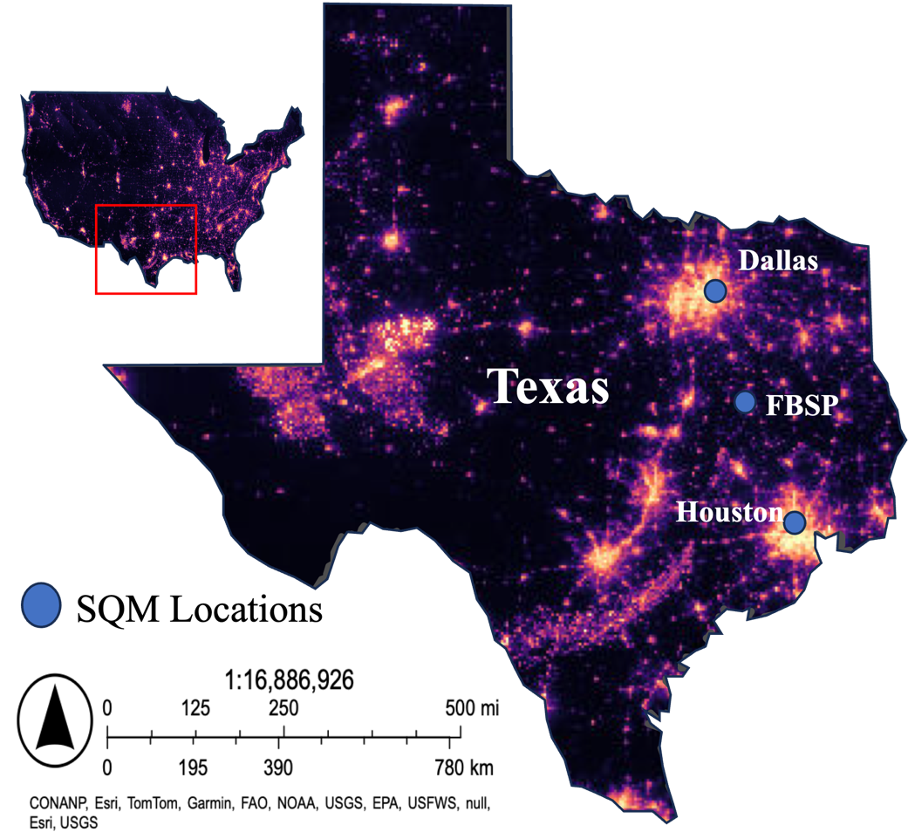

Figure 1.1. Study area of Sky Quality Meter (SQM) host locations in Dallas, Fort Boggy State Park (FBSP), and Houston, Texas, USA. ALAN distribution as seen from space in yellow, from the VIIRS Nighttime Lights Monthly Cloud-Free Composite layer in ESRI imagery as of January 2024.

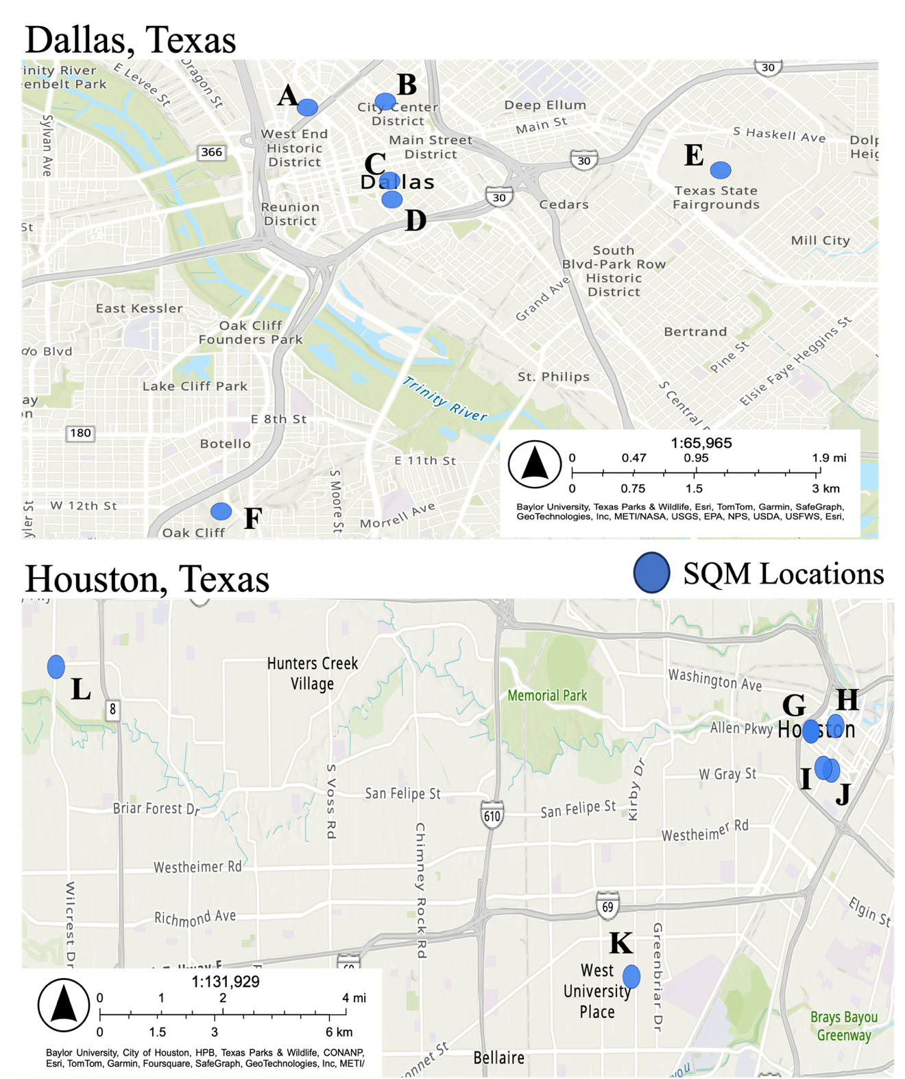
Figure 1.2. Sky Quality Meter (SQM) host locations in Dallas and Houston, Texas USA.

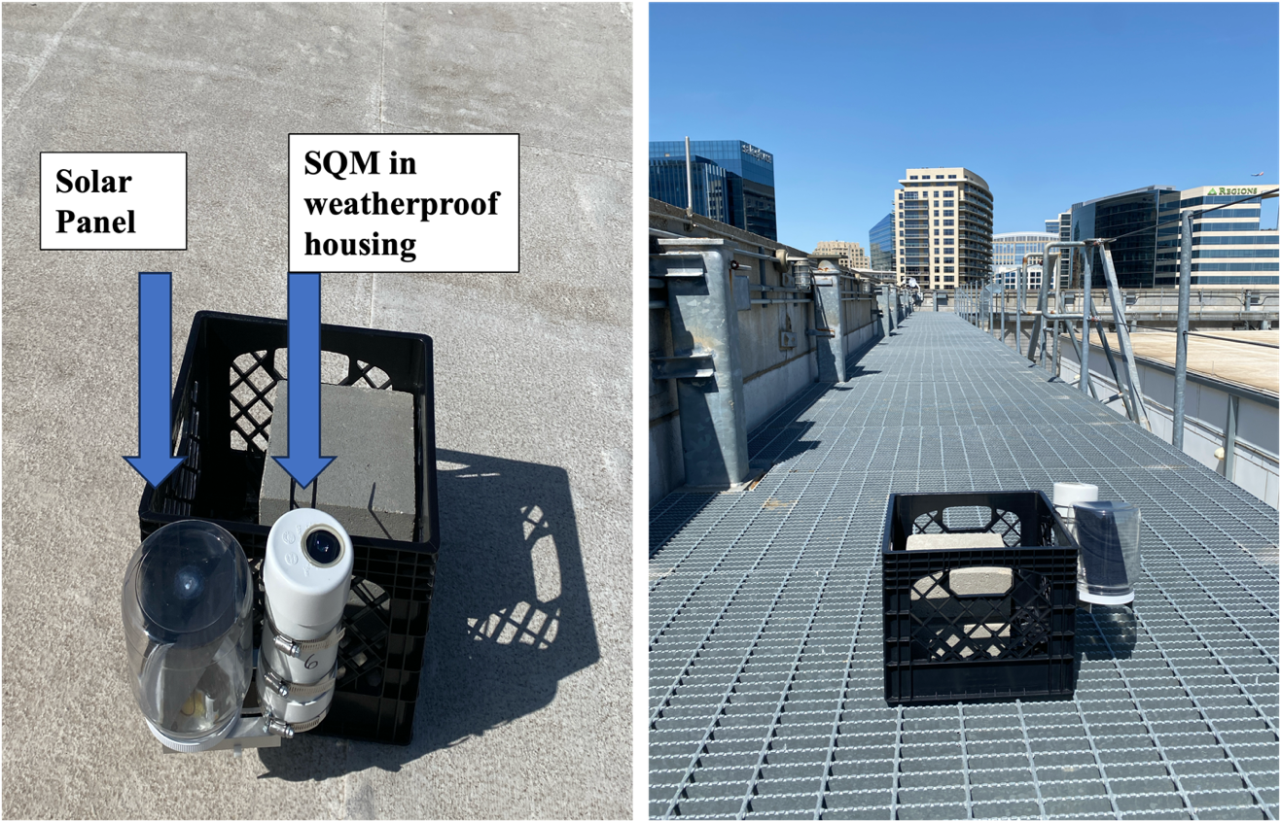
Figure 1.3. Sky Quality Meter LU-DL mounted to weighted milk crate and deployed on host location rooftop.

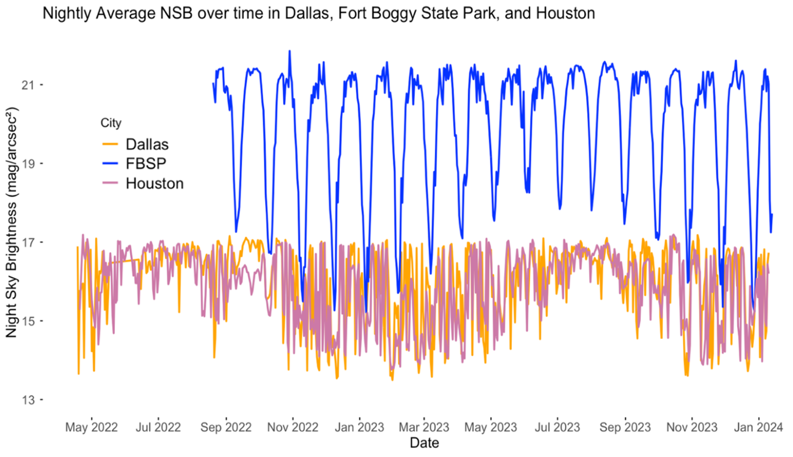
Figure 1.4. Nightly average night sky brightness (NSB) over the study period from April 2022 to January 2024 in Dallas, Fort Boggy State Park (FBSP) and Houston, Texas, USA. A higher NSB corresponds to a darker sky.

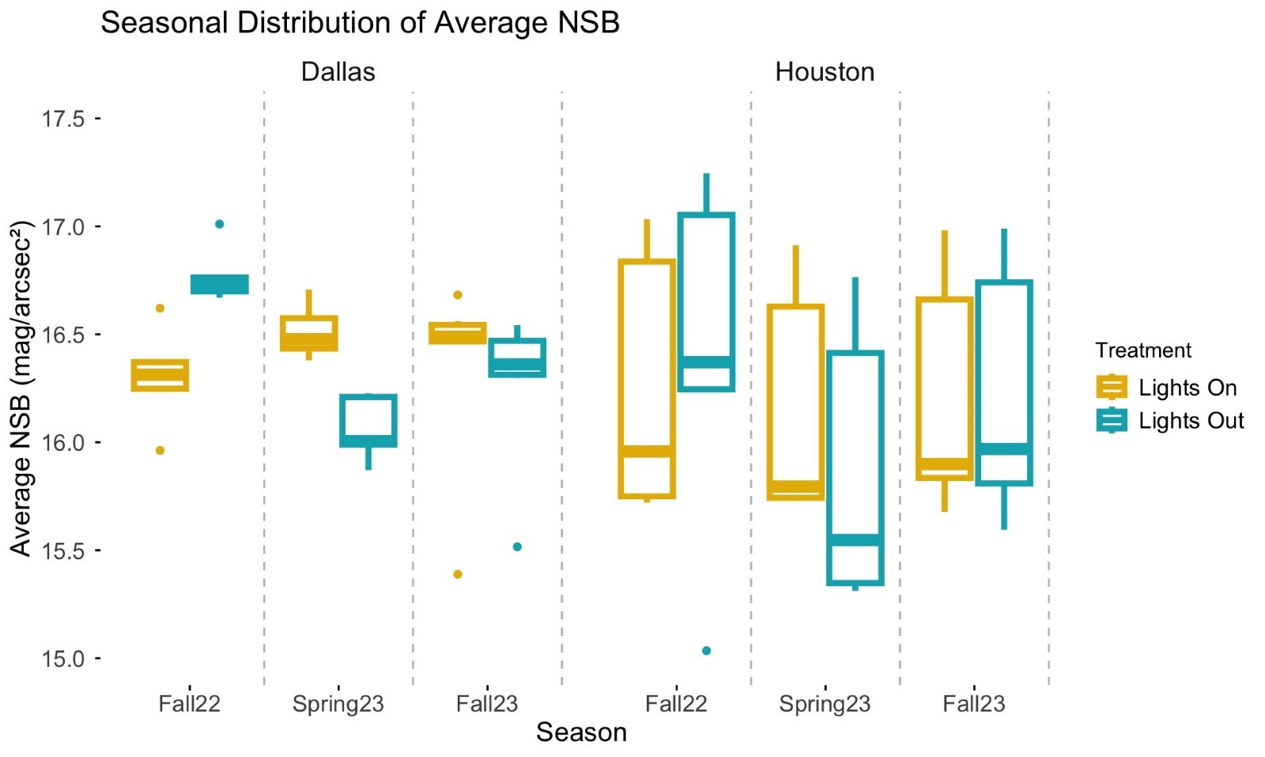
Figure 1.5. Distribution of average night sky brightness (NSB) values across city, season, and treatment. A greater NSB indicates darker skies.

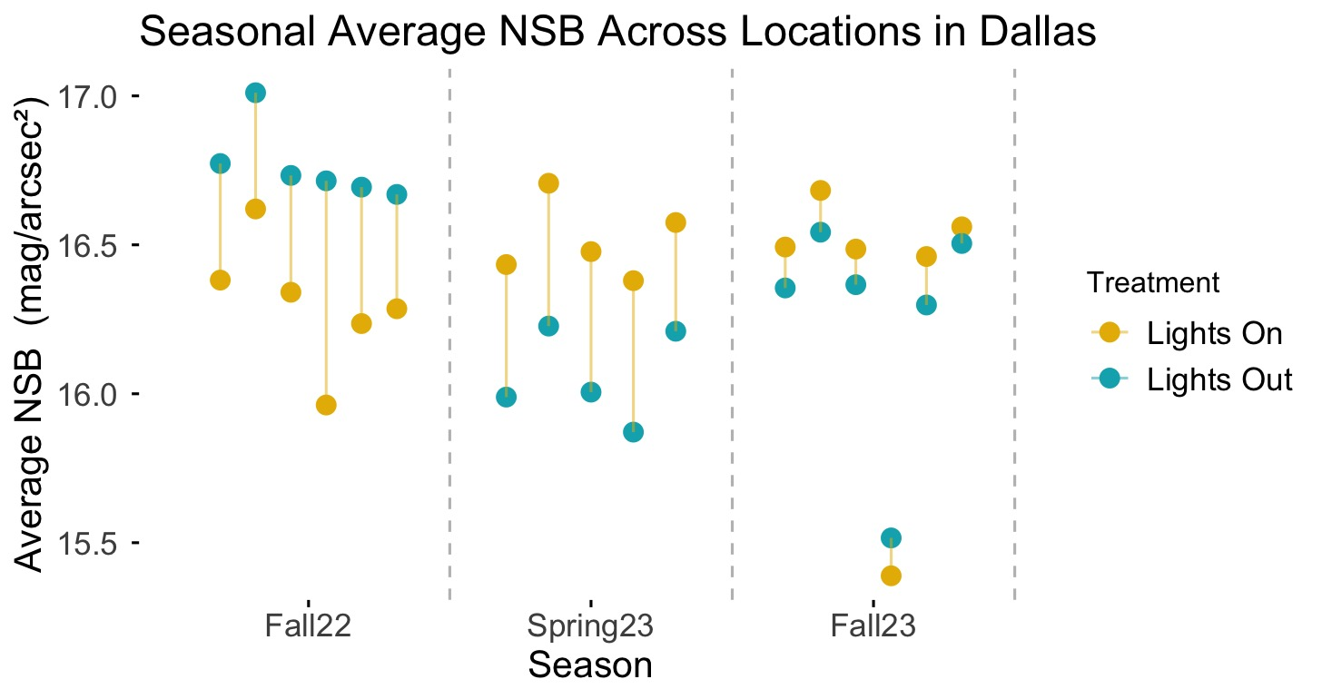
Figure 1.6. Night sky brightness (NSB) averages across seasons and treatments in Dallas, Texas paired by host location.

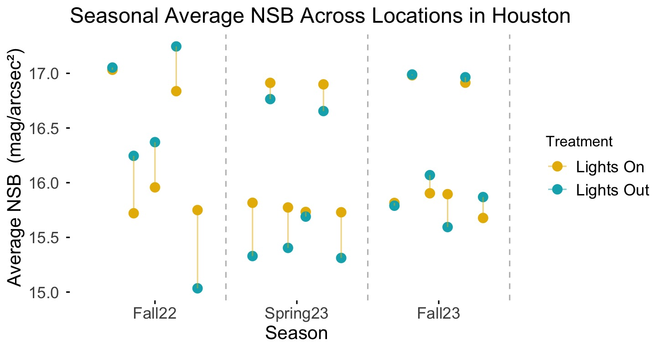
Figure 1.7. Night sky brightness (NSB) averages across seasons and treatments in Houston, Texas paired by host location.

Figure 2.1. Directional relationships between nightly fatality counts and statistically significant covariates from spring models in Dallas (A) and Houston (B), Texas.
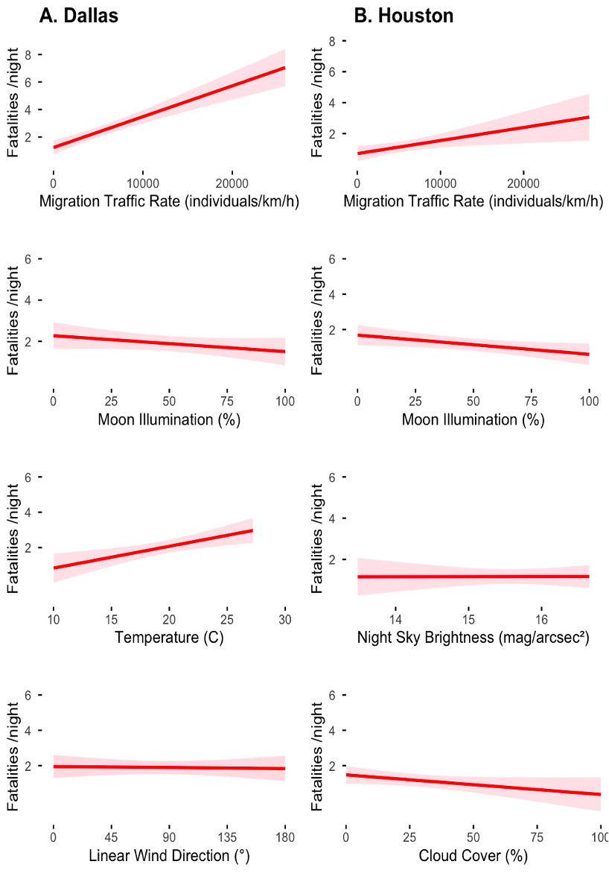
Figure 2.2. Directional relationships between nightly fatality counts and statistically significant covariates from fall models in Dallas (A) and Houston (B), Texas.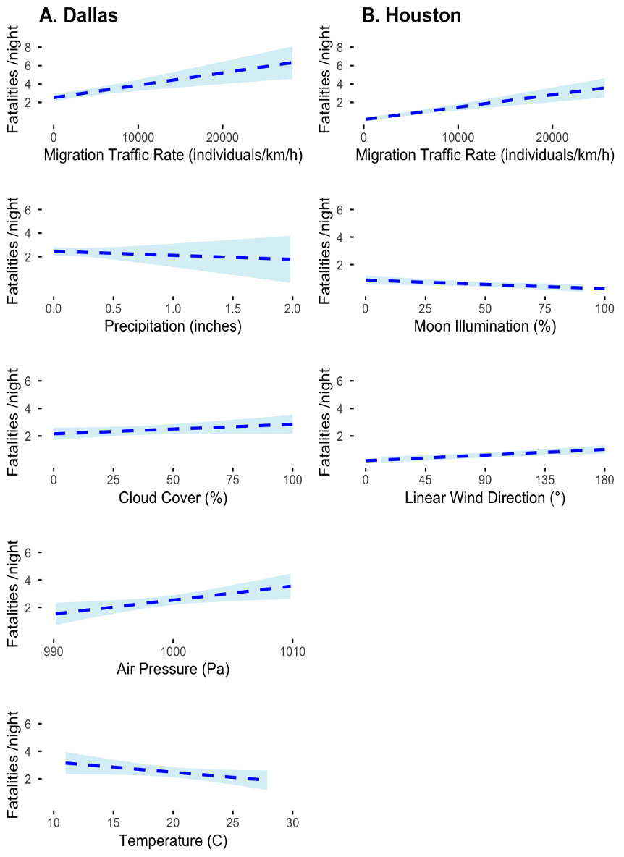

Tables
Table 1.1. Night sky brightness (mag arcsec⁻²) estimates for each location, season, and treatment, including the difference between treatments. Higher values indicate darker skies.

Location | City | Season |  | Lights Out Estimate | Lights On Estimate |  | Difference
A | Dallas | Fall22 | 16.71 |  |  | 15.96 | 0.75
A | Dallas | Spring23 | NA |  |  | NA | NA
A | Dallas | Fall23 | 15.52 |  |  | 15.39 | 0.13
B | Dallas | Fall22 | 16.69 |  |  | 16.24 | 0.46
B | Dallas | Spring23 | 15.87 |  |  | 16.38 | -0.51
B | Dallas | Fall23 | 16.30 |  |  | 16.46 | -0.16
C | Dallas | Fall22 | 16.73 |  |  | 16.34 | 0.39
C | Dallas | Spring23 | 16.01 |  |  | 16.48 | -0.47
C | Dallas | Fall23 | 16.37 |  |  | 16.49 | -0.12
D | Dallas | Fall22 | 16.77 |  |  | 16.38 | 0.39
D | Dallas | Spring23 | 15.99 |  |  | 16.43 | -0.44
D | Dallas | Fall23 | 16.36 |  |  | 16.49 | -0.14
E | Dallas | Fall22 | 17.01 |  |  | 16.62 | 0.39
E | Dallas | Spring23 | 16.23 |  |  | 16.71 | -0.48
E | Dallas | Fall23 | 16.54 |  |  | 16.68 | -0.14
F | Dallas | Fall22 | 16.67 |  |  | 16.29 | 0.38
F | Dallas | Spring23 | 16.21 |  |  | 16.57 | -0.37
F | Dallas | Fall23 | 16.50 |  |  | 16.56 | -0.05
G | Houston | Fall22 | NA |  |  | NA | NA
G | Houston | Spring23 | 15.33 |  |  | 15.82 | -0.49
G | Houston | Fall23 | 15.79 |  |  | 15.81 | -0.03
H | Houston | Fall22 | 15.03 |  |  | 15.75 | -0.72
H | Houston | Spring23 | 15.31 |  |  | 15.73 | -0.42
H | Houston | Fall23 | 15.87 |  |  | 15.68 | 0.19
I | Houston | Fall22 | 16.37 |  |  | 15.96 | 0.41
I | Houston | Spring23 | 15.69 |  |  | 15.73 | -0.04
I | Houston | Fall23 | 15.59 |  |  | 15.90 | -0.30
J | Houston | Fall22 | 16.25 |  |  | 15.72 | 0.53
J | Houston | Spring23 | 15.40 |  |  | 15.77 | -0.37
J | Houston | Fall23 | 16.07 |  |  | 15.90 | 0.17
K | Houston | Fall22 | 17.25 |  |  | 16.84 | 0.41
K | Houston | Spring23 | 16.66 |  |  | 16.90 | -0.24
K | Houston | Fall23 | 16.96 |  |  | 16.91 | 0.05
L | Houston | Fall22 | 17.05 |  |  | 17.03 | 0.02
L | Houston | Spring23 | 16.76 |  |  | 16.91 | -0.15
L | Houston | Fall23 | 16.99 |  |  | 16.98 | 0.01
Table 1.2. Two-tailed t-test output comparing night sky brightness (mag arcsec⁻²) estimates for each city, season, and treatment. p < 0.05 bolded to indicate statistical significance.

 | Estimate | N | Statistic | p-value
Dallas
Fall 2022 | 0.460 | 6 | 7.714 | 0.00058
Spring 2023 | -0.454 | 5 | -18.596 | 0.00005
Fall 2023 | -0.081 | 6 | -1.828 | 0.12708
Houston
Fall 2022 | 0.130 | 5 | 0.572 | 0.59801
Spring 2023 | -0.285 | 6 | -4.103 | 0.00933
Fall 2023 | 0.015 | 6 | 0.204 | 0.84655

Table 2.1. Survey effort used to detect collisions of migratory birds with buildings in downtown Dallas and Houston in 2022 and 2023.

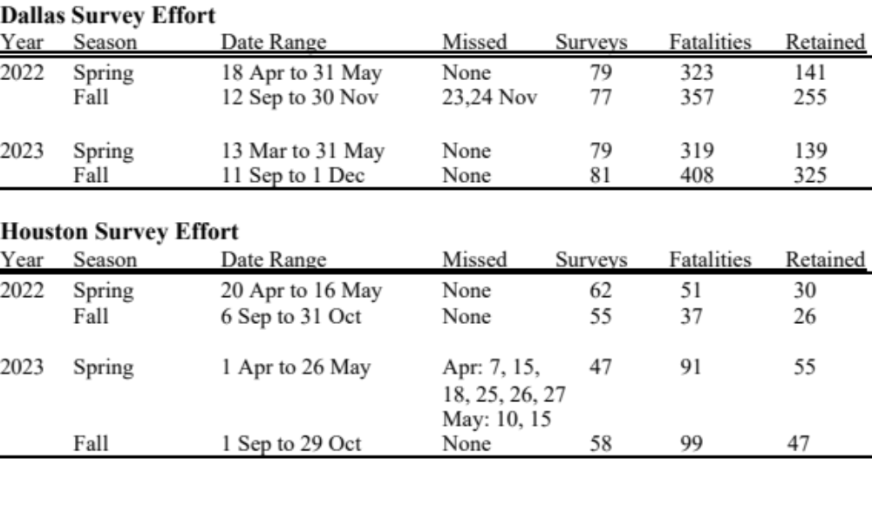

Table 2.2. Explanatory variable details and sum of model weights over all models in the spring and fall model set that include that variable.

Variable | Short Name | Units | Resolution | Source | Dallas Variable Importance |  | Houston Variable Importance
 |  |  |  |  | Spring | Fall | Spring | Fall
Air Pressure | air | Pascals (Pa) | 5-minute | TexMesonet | 0.27 | 0.69 | 0.00 | 0.10
Cloud Cover | cloud | Percent (%) | 8x daily | NOAA | 0.00 | 0.80 | 0.62 | 0.26
Relative Humidity | humid | Percent (%) | 5-minute | TexMesonet | 0.13 | 0.04 | 0.00 | 0.00
Migration Traffic | mtr | Birds per kilometer per hour (birds/km/hr) | 1x daily | KFWS / KHGX | 1.00 | 1.00 | 1.00 | 1.00
Moon Illumination | moon | Percent (%) | 5-minute | Unihedron | 1.00 | 0.00 | 1.00 | 1.00
Night Sky Brightness | NSB | Magnitudes per square arcsecond (mag arcsec⁻²) | 5-minute | Unihedron | 0.13 | 0.09 | 0.88 | 0.13
Precipitation | precip | Inches (in) | 1x daily | TexMesonet | 0.13 | 0.89 | 0.16 | 0.00
Temperature | temp | Degrees Celsius (°C) | 1x daily | TexMesonet | 1.00 | 0.52 | 0.00 | 0.08
Wind Direction | windD | Degrees at 10 meters (°) | 5-minute | TexMesonet | 1.00 | 0.00 | 0.00 | 1.00
Wind Speed | windS | Meters per second at 10 meters (m/s) | 5-minute | TexMesonet | 0.00 | 0.17 | 0.00 | 0.11
Year | year | Calendar year | na | na | 1.00 | 0.21 | 0.52 | 0.22

Table 2.3. Selection of top models up to ∆AIC_{c} <2 to assess the influence of atmospheric conditions and migration traffic on nightly fatality counts in spring for Dallas. Intercept presented for comparison. K (number of model parameters); logLik (log of maximum likelihood value); AICc (probability of the model to fit the data); ∆AICc (measure of each model relative to the model with the smallest AIC); w_{i} (Akaike weight); PseudoR² (Nagelkerke pseudo R² for GLMs).

Rank | Parameters/Models | K | logLik | AIC_{c} | ∆AIC_{c} | w_{i} | PseudoR²
 | Dallas
 | Spring fatalities ~
1 | mtr + moon + year + temp + windD | 6 | -208.98 | 430.79 | 0.00 | 0.34 | 0.32
2 | mtr + moon + year + temp + windD + air | 7 | -208.05 | 431.23 | 0.44 | 0.27 | 0.33
3 | mtr + moon + year + temp + windD + NSB | 7 | -208.76 | 432.65 | 1.85 | 0.13 | 0.32
4 | mtr + moon + year + temp + windD + humid | 7 | -208.80 | 432.72 | 1.92 | 0.13 | 0.32
5 | mtr + moon + year + temp + windD + precip | 7 | -208.80 | 432.72 | 1.93 | 0.13 | 0.32
Intercept |  | 1 | -229.46 | 460.96 | 30.16 | 0.00 | 0.00
 | Houston
 | Spring fatalities ~
1 | mtr + moon + NSB + cloud + year | 6 | -98.92 | 211.11 | 0.00 | 0.26 | 0.26
2 | mtr + moon + NSB + cloud | 5 | -100.33 | 211.56 | 0.46 | 0.20 | 0.22
3 | mtr + moon + NSB + cloud + year + precip | 7 | -98.17 | 212.07 | 0.96 | 0.16 | 0.27
4 | mtr + moon + NSB | 4 | -101.78 | 212.14 | 1.04 | 0.15 | 0.19
5 | mtr + moon | 3 | -103.11 | 212.56 | 1.45 | 0.12 | 0.16
6 | mtr + moon + NSB + year | 5 | -101.02 | 212.93 | 1.83 | 0.10 | 0.21
Intercept |  | 1 | -109.06 | 220.18 | 9.07 | 0.00 | 0.00

Table 2.4. Selection of top models up to ∆AIC_{c} <2 assessing atmospheric condition on nightly fall fatality counts in Dallas and Houston. K (number of model parameters); logLik (log of maximum likelihood value); AICc (information score); ∆AICc (measure of each model relative to the model with the smallest AICc); w_{i} (Akaike weight); PseudoR² (Nagelkerke pseudo R² for GLMs). Intercept presented for comparison.

Ranks | Parameters/Models | K | logLik | AIC_{c} | ∆AIC_{c} | w_{i} | PseudoR²
 | Dallas
 | Fall fatalities ~
1 | mtr + precip + cloud + air | 5 | -368.83 | 748.06 | 0.00 | 0.11 | 0.15
2 | mtr + precip + cloud + temp | 5 | -368.97 | 748.35 | 0.28 | 0.09 | 0.15
3 | mtr + precip + cloud + air + temp | 6 | -368.02 | 748.59 | 0.53 | 0.08 | 0.16
4 | mtr + precip + cloud + temp + windS | 6 | -368.16 | 748.87 | 0.81 | 0.07 | 0.16
5 | mtr + precip + air | 4 | -370.44 | 749.14 | 1.07 | 0.06 | 0.13
6 | mtr + precip + cloud + air + year | 6 | -368.30 | 749.16 | 1.09 | 0.06 | 0.16
7 | mtr + precip + cloud + air + windS | 6 | -368.41 | 749.37 | 1.31 | 0.06 | 0.16
8 | mtr + air | 3 | -371.61 | 749.38 | 1.32 | 0.06 | 0.12
9 | mtr + precip + cloud + air + temp + year | 6 | -368.45 | 749.46 | 1.40 | 0.05 | 0.16
10 | mtr + cloud + air | 4 | -370.61 | 749.47 | 1.41 | 0.05 | 0.13
11 | mtr + precip + cloud + air + temp + year | 7 | -367.46 | 749.68 | 1.61 | 0.05 | 0.17
12 | mtr + precip + year | 5 | -369.68 | 749.75 | 1.69 | 0.05 | 0.14
13 | mtr + precip + cloud + temp + NSB | 6 | -368.60 | 749.76 | 1.70 | 0.05 | 0.16
14 | mtr + precip + cloud + temp + humid | 6 | -368.66 | 749.87 | 1.81 | 0.04 | 0.15
15 | mtr + precip + cloud + air + temp + windS | 7 | -367.57 | 749.89 | 1.82 | 0.04 | 0.17
16 | mtr + precip + cloud + air + NSB | 6 | -368.73 | 750.02 | 1.96 | 0.04 | 0.15
17 | mtr + precip + air + temp | 5 | -369.82 | 750.04 | 1.97 | 0.04 | 0.14
Intercept |  | 1 | -381.72 | 765.47 | 17.40 | 0.00 | 0.00
 | Houston
 | Fall fatalities ~
1 | mtr + moon + windD | 4 | -106.47 | 221.31 | 0.00 | 0.21 | 0.31
2 | mtr + moon + windD + cloud | 5 | -105.69 | 221.94 | 0.63 | 0.15 | 0.32
3 | mtr + moon + windD + NSB | 5 | -105.89 | 222.34 | 1.03 | 0.13 | 0.32
4 | mtr + moon + windD + year | 5 | -105.97 | 222.49 | 1.18 | 0.12 | 0.32
5 | mtr + moon + windD + windS | 5 | -106.06 | 222.68 | 1.37 | 0.11 | 0.32
6 | mtr + moon + windD + cloud + year | 6 | -104.97 | 222.72 | 1.40 | 0.10 | 0.33
7 | mtr + moon + windD + air | 5 | -106.12 | 222.80 | 1.48 | 0.10 | 0.32
8 | mtr + moon + windD + temp | 5 | -106.36 | 223.27 | 1.96 | 0.08 | 0.32
Intercept |  | 1 | -125.09 | 252.21 | 30.90 | 0.00 | 0.00

Supplemental Tables

Table S1. Breakdown of the 860 fatality counts in Dallas, Texas by species per monitoring season from 2022-2023 including totals by species across years.

Common Name | Scientific Name | Spring22 | Fall22 | Spring23 | Fall23 | Species Total
Acadian flycatcher | Empidonax virescens | 1 |  |  |  | 1
Alder flycatcher | Empidonax alnorum |  |  | 1 |  | 1
American coot | Fulica americana |  | 1 |  |  | 1
American redstart | Setophaga ruticilla |  |  | 5 |  | 5
American woodcock | Scolopax minor |  | 12 | 1 | 14 | 27
Baltimore oriole | Icterus galbula |  | 2 |  |  | 2
Bewick's wren | Thryomanes bewickii |  |  |  | 4 | 4
Black-and-white warbler | Mniotilta varia | 4 | 8 | 4 | 4 | 20
Black-throated green warbler | Setophaga virens |  |  | 1 |  | 1
Blue grosbeak | Passerina caerulea |  |  |  | 1 | 1
Brown thrasher | Toxostoma rufum |  | 2 |  | 2 | 4
Canada warbler | Cardellina canadensis |  |  | 1 |  | 1
Chestnut-sided warbler | Setophaga pensylvanica |  |  | 3 |  | 3
Chipping sparrow | Spizella passerina |  |  |  | 3 | 3
Clay-colored sparrow | Spizella pallida | 3 | 5 | 3 |  | 11
Common yellowthroat | Geothlypis trichas |  | 9 | 12 | 10 | 31
Dark-eyed junco | Junco hyemalis |  | 7 |  | 2 | 9
Dickcissel | Spiza americana |  |  |  | 1 | 1
Eastern phoebe | Sayornis phoebe |  |  | 1 |  | 1
Eastern whip-poor-will | Antrostomus vociferus |  |  |  | 1 | 1
Golden-crowned kinglet | Regulus satrapa |  | 5 | 1 |  | 6
Grasshopper sparrow | Ammodramus savannarum | 3 | 16 | 9 | 35 | 63
Gray catbird | Dumetella carolinensis | 2 |  | 1 |  | 3
Hermit thrush | Catharus guttatus |  |  |  | 2 | 2
House wren | Troglodytes aedon | 1 | 8 | 1 | 9 | 19
Indigo bunting | Passerina cyanea | 13 | 5 | 4 | 3 | 25
Kentucky warbler | Geothlypis formosa | 4 |  |  |  | 4
Least flycatcher | Empidonax minimus |  |  |  | 1 | 1
LeConte's sparrow | Ammodramus leconteii |  | 1 |  | 1 | 2
Leiothlypis warblers | Genus Leiothlypis |  |  |  | 1 | 1
Lincoln's sparrow | Melospiza lincolnii | 15 | 32 | 17 | 85 | 149
Magnolia warbler | Setophaga magnolia | 2 |  | 1 |  | 3
Mallard | Anas platyrhynchos |  |  | 1 |  | 1
Marsh wren | Cistothorus palustris |  | 1 |  | 4 | 5
Mourning warbler | Geothlypis philadelphia | 2 | 11 | 6 | 11 | 30
Nashville warbler | Leiothlypis ruficapilla | 11 | 10 | 4 | 10 | 35
New World sparrows | Family Passerellidae |  | 3 | 1 | 2 | 6
New World warblers | Family Parulidae |  | 1 | 1 | 4 | 6
Northern parula | Setophaga americana | 1 |  |  |  | 1
Northern waterthrush | Parkesia noveboracensis | 4 |  | 3 | 3 | 10
Olive-sided flycatcher | Contopus cooperi |  |  |  | 1 | 1
Orange-crowned warbler | Vermivora celata |  | 1 | 1 | 12 | 14
Orchard oriole | Icterus spurius |  | 1 |  |  | 1
Ovenbird | Seiurus aurocapilla | 34 | 6 | 31 | 2 | 73
Painted bunting | Passerina ciris | 7 |  | 4 |  | 11
Perching birds | Order Passeriformes |  | 2 | 4 | 1 | 7
Pine warbler | Setophaga pinus |  | 2 |  | 1 | 3
Red-breasted nuthatch | Sitta canadensis |  | 1 |  |  | 1
Rose-breasted grosbeak | Pheucticus ludovicianus | 1 |  | 1 |  | 2
Ruby-crowned kinglet | Regulus calendula |  | 4 |  | 3 | 7
Savannah sparrow | Passerculus sandwichensis |  |  |  | 2 | 2
Sedge wren | Cistothorus stellaris |  | 3 |  | 4 | 7
Setophaga warblers | Genus Setophaga |  |  |  | 1 | 1
Slate-colored junco | Junco hyemalis |  |  |  | 1 | 1
Song sparrow | Melospiza melodia |  | 7 |  | 7 | 14
Sora | Vermivora celata |  | 5 |  |  | 5
Summer tanager | Piranga rubra | 1 | 1 | 1 | 2 | 5
Swainson's thrush | Catharus ustulatus | 1 |  | 2 |  | 3
Swainson's warbler | Limnothlypis swainsonii | 1 |  |  |  | 1
Swamp sparrow | Melospiza georgiana |  | 1 |  | 2 | 3
Tennessee warbler | Leiothlypis peregrina | 7 | 1 | 2 |  | 10
Tyrant flycatchers | Family Tyrannidae |  |  |  | 1 | 1
Virginia rail | Rallus limicola |  | 2 |  | 2 | 4
White-throated sparrow | Zonotrichia albicollis | 19 | 74 | 8 | 66 | 167
Willow flycatcher | Willow flycatcher | 1 |  |  |  | 1
Wilson's warbler | Cardellina pusilla |  | 1 |  | 1 | 2
Yellow warbler | Setophaga petechia |  |  |  | 1 | 1
Yellow-bellied flycatcher | Empidonax flaviventris |  |  | 2 |  | 2
Yellow-billed cuckoo | Coccyzus americanus | 1 |  |  |  | 1
Yellow-breasted chat | Icteria virens | 2 | 3 |  | 2 | 7
Yellow-rumped warbler | Setophaga coronata |  |  | 1 |  | 1
Zonotrichia sparrows | Genus Zonotrichia |  | 1 |  |  | 1

Table S2. Breakdown of the 158 fatality counts in Houston, Texas by species per monitoring season from 2022-2023 including totals by species across years.

Common Name | Scientific Name | Spring22 | Fall22 | Spring23 | Fall23 | Species Total
Baltimore oriole | Icterus galbula |  | 1 |  |  | 1
Black-and-white warbler | Mniotilta varia | 3 | 7 | 2 |  | 12
Blackburnian warbler | Setophaga fusca | 1 |  | 1 |  | 2
Blue grosbeak | Passerina caerulea | 1 |  | 1 |  | 2
Chuck-will's-widow | Antrostomus carolinensis |  |  | 3 | 1 | 4
Common gallinule | Gallinula galeata |  |  | 1 |  | 1
Common yellowthroat | Geothlypis trichas | 2 | 6 | 1 | 4 | 13
Eastern whip-poor-will | Antrostomus vociferus |  |  |  | 2 | 2
Empidonax flycatchers | Family Tyrannidae |  |  |  | 1 | 1
Grasshopper sparrow | Ammodramus savannarum |  | 1 |  |  | 1
Hooded warbler | Setophaga citrina | 1 |  | 1 |  | 2
House wren | Troglodytes aedon |  | 1 |  | 2 | 3
Indigo bunting | Passerina cyanea | 1 | 2 | 9 | 4 | 16
Kentucky warbler | Geothlypis formosa |  |  | 2 |  | 2
Lincoln's sparrow | Melospiza lincolnii |  |  |  | 3 | 3
Magnolia warbler | Setophaga magnolia |  |  | 1 |  | 1
Mourning warbler | Geothlypis philadelphia |  |  |  | 2 | 2
Nashville warbler | Leiothlypis ruficapilla |  |  |  | 2 | 2
New World warblers | Family Parulidae |  |  |  | 3 | 3
Nightjars and Nighthawks | Family Caprimulgidae |  | 1 |  |  | 1
Northern parula | Setophaga americana |  |  | 1 |  | 1
Northern waterthrush | Parkesia noveboracensis | 1 |  | 1 | 1 | 3
Orchard oriole | Icterus spurius | 1 |  | 1 | 1 | 3
Ovenbird | Seiurus aurocapilla | 14 | 2 | 23 | 4 | 43
Rose-breasted grosbeak | Pheucticus ludovicianus |  | 1 |  |  | 1
Sedge wren | Cistothorus stellaris | 1 |  |  | 4 | 5
Sora | Vermivora celata |  |  |  | 1 | 1
Swainson's thrush | Catharus ustulatus |  |  | 1 |  | 1
Tennessee warbler | Leiothlypis peregrina | 2 |  | 1 |  | 3
Virginia rail | Rallus limicola |  | 1 |  | 1 | 2
Waterthrushes | Genus Parkesia |  |  |  | 1 | 1
White-eyed vireo | Vireo griseus |  |  |  | 1 | 1
Wilson's warbler | Cardellina pusilla |  |  |  | 4 | 4
Winter wren | Troglodytes hiemalis |  | 1 |  |  | 1
Wrens | Family Troglodytidae |  | 1 |  |  | 1
Yellow warbler | Setophaga petechia |  |  | 1 |  | 1
Yellow-billed cuckoo | Coccyzus americanus | 2 |  | 2 |  | 4
Yellow-breasted chat | Icteria virens |  | 1 | 1 | 4 | 6
Yellow-throated warbler | Setophaga dominica |  |  | 1 |  | 1
Yellowthroats and Allies | Genus Geothlypis |  |  |  | 1 | 1

Table S3. Breakdown of the 860 fatality counts in Dallas, Texas by building per monitoring season from 2022-2023 including totals by building across years.
Building Name | Address | Spring22 | Fall22 | Spring23 | Fall23 | Building Total
1900 Pacific Residences | 1900 Pacific Ave | 0 | 0 | 0 | 2 | 2
1920 Pacific Apartments | 1920 Pacific Ave | 0 | 0 | 1 | 0 | 1
306 S Record St | 306 S Record St | 0 | 0 | 0 | 1 | 1
400 Record | 400 S Record St | 2 | 1 | 4 | 11 | 18
Aloft Dallas Downtown | 1033 Young St | 1 | 0 | 0 | 0 | 1
AMLI Fountain Place | 1800 N Field St | 4 | 9 | 1 | 8 | 22
AT&T | 308 S Akard St | 0 | 0 | 0 | 1 | 1
Atelier Apartments | 1801 N Pearl St | 0 | 1 | 0 | 0 | 1
Bank of America Plaza | 901 Main St | 1 | 4 | 4 | 5 | 14
Bryan Tower | 2001 Bryan St | 6 | 25 | 8 | 18 | 57
Campisi's | 1520 Elm St | 1 | 0 | 0 | 1 | 2
Carmine's Pizza | 2006 San Jacinto St | 0 | 1 | 0 | 1 | 2
Chase Tower | 2200 Ross Ave | 3 | 4 | 2 | 5 | 15
City Hall | 1500 Marilla St | 8 | 11 | 9 | 17 | 45
Corgan Building | 401 N Houston St | 2 | 4 | 1 | 5 | 12
Dallas Courthouse | 600 Commerce St | 3 | 5 | 1 | 6 | 15
Dallas Marriott Downtown | 650 N Pearl St | 5 | 7 | 0 | 0 | 12
Dallas Symphony Orchestra | 2301 Flora St | 2 | 2 | 0 | 0 | 4
Dallas World Aquarium | 1801 N Griffin St | 0 | 1 | 0 | 0 | 1
El Centro Campus | 801 Main St | 0 | 0 | 0 | 1 | 1
EmployerDirect Tower | 2100 Ross Ave | 1 | 4 | 3 | 6 | 14
Employers Casualty Building | 1301 Young St | 1 | 3 | 2 | 2 | 8
Fairmont Dallas | 1717 N Akard St | 0 | 0 | 0 | 1 | 1
First Baptist Dallas | 510 N Ervay St | 4 | 4 | 0 | 4 | 12
First City Centre | 1700 Pacific Ave | 1 | 1 | 4 | 5 | 11
Greyhound Bus Station | 800 Commerce St | 1 | 0 | 0 | 0 | 1
Harwood Center | 1999 Bryan St | 1 | 0 | 0 | 0 | 1
Hyatt Houst Dallas/Uptown | 2914 Harry Hines Blvd | 0 | 1 | 0 | 0 | 1
J.E.J. Central Library | 1515 Young St | 0 | 3 | 1 | 6 | 10
JW Marriott Dallas Arts District | 2000 Ross Ave | 0 | 0 | 3 | 3 | 6
K.B.H. Convention Center | 650 S Griffin St | 51 | 72 | 44 | 101 | 268
KPMG Centre | 717 N Harwood St | 0 | 0 | 0 | 1 | 1
KPMG Plaza | 2323 Ross Ave | 0 | 1 | 0 | 0 | 1
Legal Aid of Northwest Texas | 1515 Main St | 0 | 1 | 0 | 0 | 1
McKinney and Olive | 2021 McKinney Ave | 1 | 0 | 1 | 0 | 2
National Shrine Cathedral | 2203 Ross Ave | 0 | 1 | 0 | 0 | 1
Omni Dallas Hotel | 555 S Lamar St | 5 | 2 | 4 | 11 | 22
One Main Place | 1201 Main St | 1 | 0 | 0 | 0 | 1
One Victory Park | 2323 Victory Ave | 0 | 1 | 0 | 0 | 1
Pacific Place | 1910 Parcific Ave | 4 | 14 | 12 | 13 | 43
Perot Museum | 2201 N Field St | 2 | 13 | 0 | 10 | 25
Plaza of the Americas | 600 N Pearl St | 2 | 10 | 9 | 21 | 42
Renaissance Tower | 1201 Elm St | 5 | 6 | 7 | 7 | 25
Republic Center | 325 N St Paul St | 2 | 3 | 0 | 8 | 13
Ross Avenue Parking Garage | 1707 Ross Ave | 0 | 1 | 0 | 0 | 1
Ross Tower | 500 N Akard St | 0 | 3 | 1 | 10 | 14
Santander Tower | 1601 Elm St | 17 | 21 | 6 | 12 | 56
Sheraton Dallas Hotel Conference Center | 421 N Harwood St | 0 | 0 | 2 | 7 | 9
Sheraton Hotel | 400 Olive St | 1 | 0 | 1 | 1 | 3
St Paul Place | 750 N St Paul St | 0 | 7 | 1 | 4 | 12
T.B.P. YMCA | 601 N Akard St | 0 | 0 | 0 | 4 | 4
Terrace Condominiums | 2323 N Houston St | 0 | 0 | 1 | 0 | 1
The Catholic Foundation Plaza | 2210 Flora St | 0 | 1 | 0 | 0 | 1
The Mayflower Apartments | 411 N Akard St | 0 | 3 | 0 | 0 | 3
The National Residences | 1401 Elm St | 1 | 2 | 2 | 2 | 7
The Retail Connection | 2525 McKinnon St | 1 | 0 | 0 | 0 | 1
Trammell Crow Center | 2001 Ross Ave | 1 | 0 | 4 | 4 | 9
Winspear Opera House | 2403 Flora St | 0 | 1 | 0 | 0 | 1
Table S4. Breakdown of the 158 fatality counts in Houston, Texas by building per monitoring season from 2022-2023 including totals by building across years.

Building Name | Address | Spring22 | Fall22 | Spring23 | Fall23 | Building Total
1000 Main | 1000 Main St | 1 | 3 | 2 | 1 | 7
601 Travis | 601 Travis St | 1 | 0 | 0 | 0 | 1
811 Main | 811 Main St | 1 | 0 | 4 | 1 | 6
919 Milam | 919 Milam St | 0 | 0 | 0 | 1 | 1
Bank of America Financial Center | 800 Capitol St | 2 | 4 | 9 | 6 | 21
CenterPoint Energy Plaza | 1111 Louisiana St | 1 | 1 | 4 | 3 | 9
Enterprise Plaza | 1100 Louisiana St | 2 | 2 | 3 | 3 | 10
First City Tower | 1001 Fannin St | 2 | 3 | 3 | 6 | 14
Fulbright Tower | 1301 McKinney St | 0 | 0 | 3 | 0 | 3
Heritage Plaza | 1111 Bagby St | 0 | 0 | 2 | 2 | 4
Hess Tower | 1501 McKinney St | 9 | 4 | 5 | 8 | 26
Houston Center | 909 Fannin St | 0 | 0 | 1 | 0 | 1
LyondellBasell Twoer | 1221 McKinney St | 0 | 0 | 0 | 1 | 1
Main at Texas | 609 Main St | 1 | 1 | 2 | 2 | 6
One Shell Plaza | 910 Louisiana St | 2 | 2 | 1 | 3 | 8
TotalEnergies Tower | 1201 Louisianna St | 0 | 0 | 1 | 0 | 1
Wells Fargo Plaza | 1000 Louisiana St | 8 | 6 | 15 | 10 | 39

Table S5. Conditional averages, confidence intervals, and p-values derived from model averaging of the city and season submodel set with ∆AICc < 2. Intercept presented for comparison. Significant results are highlighted in bold, with significance levels indicated as follows: p = 0 is marked ‘***’, p = 0.001 is marked ‘**’, and p = 0.01 is marked ‘*’. Intercept is included for comparison.

 | Spring Models |  | Fall Models
 | Dallas Spring | Houston Spring | Dallas Fall | Houston Fall
Air pressure | -0.33 [-0.73, 0.07]  p = 0.11 | na | 0.38 [0.08, 0.67]  p = 0.0011* | -0.35 [-1.11, 0.53]  p = 0.37
Cloud Cover | na | -0.50 [-0.90, -0.10]  p =0.013* | 0.17 [0.02, 0.32]  p = 0.026* | -0.28 [-0.66, 0.09]  p = 0.13
Humidity | 0.09 [-0.15, 0.34]  p = 0.47 | na | -0.09 [-0.26, 0.08]  p = 0.32 | na
Migration traffic | 0.36 [0.16, 0.55]  p = 0.00025*** | 0.55 [0.26, 0.83]  p = 0.00017*** | 0.22 [0.07, 0.36]  p = 0.0039** | 0.51 [0.19, 0.82]  p = 0.0016**
Moon illumination | -0.29 [-0.50, -0.09]  p = 0.0045** | -0.57 [-0.91, -0.22]  p = 0.0014** | na | -0.51 [-0.83, -0.20]  p = 0.0016**
NSB | -0.77 [-0.28, 0.12]  p = 0.45 | -0.37 [-0.67,-0.066]  p =0.017* | 0.07 [-0.10, 0.26]  p = 0.41 | 0.32 [-0.18, 0.82]  p = 0.21
Precipitation | -0.08 [-0.30, 0.14]  p =0.46 | 0.17 [-0.06, 0.39]  p = 0.15 | -0.19[-0.36, -0.03]  p = 0.021* | na
Temperature | 0.55 [0.23, 0.87]  p = 0.00078*** | na | -0.19 [-0.36, 0.02]  p = 0.029* | -0.12 [-0.30, 0.53]  p = 0.58
Wind direction | 0.39 [0.11, 0.67]  p =0.0062** | na | na | 0.41 [0.10, 0.71]  p = 0.0086**
Wind speed | na | na | -0.13 [-0.31, 0.05]  p =0.16 | -0.23 [-0.67, 0.20]  p = 0.30
Year | -0.74[-1.18, -0.29]  p =0.0011** | 0.65 [0.01, 1.28]  p = 0.045* | 0.20 [-0.10, 0.50]  p = 0.20 | 0.38 [-0.22, 0.98]  p = 0.22
Intercept | 1493.1 [593.5, 2392.7]  p =0.0011** | -680.5 [-2263.4, 902.3]  p = 0.39 | -83.01 [-509.7, 343.6]  p =0.70 | -171.1 [-1019.5, 677.3]  p = 0.69

Table S6. Selection of top models up to ∆AIC_{c} <2 to assess the influence of atmospheric conditions and migration traffic on nightly fatality counts in spring for Houston. Intercept presented for comparison. K (number of model parameters); logLik (log of maximum likelihood value); AICc (probability of the model to fit the data); ∆AICc (measure of each model relative to the model with the smallest AIC); w_{i} (Akaike weight); PseudoR² (Nagelkerke pseudo R² for GLMs).

Rank | Parameters/Models | K | logLik | AIC_{c} | ∆AIC_{c} | w_{i} | PseudoR²
 | Dallas
 | Spring 2022 fatalities ~
1 | moon | 2 | -75.98 | 156.40 | 0.00 | 0.67 | 0.21
2 | moon + windS | 3 | -75.44 | 157.81 | 1.41 | 0.33 | 0.23
Intercept |  | 1 | -79.41 | 160.97 | 4.57 | 0.00 | 0.00
 | Spring 2023 fatalities ~
1 | mtr + temp + windD + air + moon | 6 | -124.96 | 263.10 | 0.00 | 0.37 | 0.36
2 | mtr + temp + windD + air | 5 | -126.20 | 263.23 | 0.13 | 0.34 | 0.34
3 | mtr + temp + windD | 4 | -128.17 | 264.89 | 1.80 | 0.15 | 0.30
4 | mtr + temp + windD + air + moon + windS | 7 | -124.73 | 265.06 | 1.97 | 0.14 | 0.36
Intercept |  | 1 | -141.72 | 285.49 | 22.40 | 0.00 | 0.00

Table S7. Selection of top models up to ∆AIC_{c} <2 to assess the influence of atmospheric conditions and migration traffic on nightly fatality counts in spring for Houston. Intercept presented for comparison. K (number of model parameters); logLik (log of maximum likelihood value); AICc (probability of the model to fit the data); ∆AICc (measure of each model relative to the model with the smallest AIC); w_{i} (Akaike weight); PseudoR² (Nagelkerke pseudo R² for GLMs).

Rank | Parameters/Models | K | logLik | AIC_{c} | ∆AIC_{c} | w_{i} | PseudoR²
 | Houston
 | Spring 2022 fatalities ~
1 | moon | 2 | -33.87 | 72.26 | 0.00 | 0.28 | 0.33
2 | moon + precip | 3 | -32.87 | 72.83 | 0.57 | 0.21 | 0.38
3 | moon + windD + windS | 4 | -31.49 | 72.89 | 0.63 | 0.21 | 0.45
4 | moon + windD | 3 | -32.96 | 73.00 | 0.74 | 0.19 | 0.37
5 | moon + precip + windS | 4 | -32.17 | 74.24 | 1.98 | 0.11 | 0.42
Intercept |  | 1 | -38.67 | 79.51 | 7.25 | 0.00 | 0.00
 | Spring 2023 fatalities ~
1 | cloud + mtr + NSB + moon | 5 | -63.10 | 137.66 | 0.00 | 0.17 | 0.28
2 | cloud | 2 | -66.80 | 137.87 | 0.21 | 0.16 | 0.15
3 | cloud + mtr | 3 | -66.02 | 138.60 | 0.95 | 0.11 | 0.18
4 | cloud + mtr + NSB + moon + windD | 6 | -62.40 | 138.89 | 1.23 | 0.09 | 0.30
5 | cloud + NSB | 3 | -66.18 | 138.92 | 1.26 | 0.09 | 0.17
6 | cloud + temp | 3 | -66.26 | 139.09 | 1.43 | 0.08 | 0.17
7 | cloud + windD | 3 | -66.32 | 139.19 | 1.53 | 0.08 | 0.17
8 | cloud + NSB + moon | 4 | -65.16 | 139.28 | 1.62 | 0.08 | 0.21
9 | cloud + mtr + temp | 4 | -65.27 | 139.50 | 1.84 | 0.07 | 0.21
10 | mtr + moon + windD | 4 | -65.34 | 139.64 | 1.98 | 0.06 | 0.20
Intercept |  | 1 | -70.38 | 142.86 | 5.20 | 0.00 | 0.00

Table S8. Conditional averages, confidence intervals, and p-values derived from model averaging the spring season by city and year submodel set with ∆AICc < 2. Intercept presented for comparison. Significant results are highlighted in bold, with significance levels indicated as follows: p = 0 is marked ‘***’, p = 0.001 is marked ‘**’, and p = 0.01 is marked ‘*’.

 | Dallas Spring |  | Houston Spring
 | 2022 | 2023 | 2022 | 2023
Air pressure | na | -0.71 [-1.24, -0.17]  p = 0.009** | na | na
Cloud Cover | na | na | na | -0.69 [-1.18, 0.19]  p = 0.006**
Humidity | na | na | na | na
Migration traffic | na | 0.41 [0.16, 0.66]  p = 0.001** | na | 0.47 [0.06, 0.87]  p = 0.02*
Moon illumination | -0.61 [-0.86, -0.36]  p = 2.64e-06*** | -0.28 [-0.55, -0.007]  p = 0.04* | -1.11 [-1.70, -0.52]  p = 0.0002*** | -0.50 [-0.92, -0.75]  p = 0.02*
NSB | na | na | na | -0.39 [-0.79, 0.01]  p = 0.05
Precipitation | na | na | 0.23 [-0.009, 0.47]  p = 0.06 | na
Temperature | na | 0.72 [0.34, 1.11]  p = 0.0002*** | na | 0.36 [-0.22, 0.94]  p = 0.22
Wind direction | na | 0.49 [0.12, 0.87]  p = 0.01* | 0.46 [-0.05, 1.45]  p = 0.07 | -0.30 [-0.70, 0.11]  p = 0.15
Wind speed | 0.20 [-0.02, 0.41]  p = 0.07 | 0.09 [-0.12, 0.32]  p = 0.40 | 0.46 [-0.005, 1.45]  p = 0.05 | na
Intercept | 1.36 [1.02, 1.69]  p = < 2e-16 *** | -0.15 [-0.92, 0.61]  p = 0.69 | -0.46 [-1.14, 0.21]  p = 0.18 | -0.07 [-0.57, 0.42]  p = 0.77

Table S9. Selection of top models up to ∆AIC_{c} <2 to assess the influence of atmospheric conditions and migration traffic on nightly fall fatality counts in Dallas by year. Intercept presented for comparison. K (number of model parameters); logLik (log of maximum likelihood value); AICc (probability of the model to fit the data); ∆AICc (measure of each model relative to the model with the smallest AIC); w_{i} (Akaike weight); PseudoR² (Nagelkerke pseudo R² for GLMs). Intercept included for comparison. Variables listed in order of importance.

Rank | Parameters/Models | K | logLik | AIC_{c} | ∆AIC_{c} | w_{i} | PseudoR²
 | Dallas
 | Fall 2022 fatalities ~
1 | moon + windS + humid | 4 | -174.76 | 358.08 | 0.00 | 0.12 | 0.16
2 | moon + windS | 3 | -175.98 | 358.28 | 0.20 | 0.11 | 0.13
3 | moon + windS + precip | 4 | -174.98 | 358.52 | 0.44 | 0.10 | 0.15
4 | moon + windS + mtr | 4 | -175.36 | 359.26 | 1.18 | 0.07 | 0.14
5 | moon + windS + humid + cloud | 5 | -174.27 | 359.37 | 1.29 | 0.06 | 0.17
6 | moon + windS + humid + precip | 5 | -174.30 | 359.44 | 1.37 | 0.06 | 0.17
7 | moon + windS + NSB | 4 | -175.47 | 359.49 | 1.41 | 0.06 | 0.14
8 | moon + windS + mtr + precip | 5 | -174.34 | 359.51 | 1.43 | 0.06 | 0.16
9 | moon + windS + mtr + temp + windD | 6 | -173.26 | 359.70 | 1.62 | 0.05 | 0.19
10 | moon + windS + humid + temp | 5 | -174.50 | 359.82 | 1.75 | 0.05 | 0.16
11 | moon + windS + mtr + windD | 5 | -174.53 | 359.90 | 1.83 | 0.05 | 0.16
12 | moon + mtr + precip + temp | 5 | -174.54 | 359.91 | 1.83 | 0.05 | 0.16
13 | moon + mtr + precip | 4 | -175.69 | 359.94 | 1.86 | 0.05 | 0.13
14 | moon + windS + humid + windD | 5 | -174.60 | 360.03 | 1.95 | 0.05 | 0.16
15 | moon + windS + humid + mtr | 5 | -174.61 | 360.06 | 1.99 | 0.05 | 0.16
Intercept |  | 1 | -181.27 | 364.58 | 6.51 | 0.00 | 0.00
 | Fall 2023 fatalities ~
1 | moon + air | 3 | -189.87 | 386.05 | 0.00 | 0.33 | 0.22
2 | moon + air + mtr | 4 | -189.00 | 386.53 | 0.48 | 0.26 | 0.24
3 | moon + air + mtr + cloud | 5 | -188.35 | 387.52 | 1.47 | 0.16 | 0.25
4 | moon + air + cloud | 4 | -189.66 | 387.85 | 1.80 | 0.13 | 0.22
5 | moon + air + temp | 4 | -189.74 | 388.02 | 1.97 | 0.12 | 0.22
Intercept |  | 1 | -199.64 | 401.34 | 15.29 | 0.00 | 0.00

Table S10. Selection of top models up to ∆AIC_{c} <2 to assess the influence of atmospheric conditions and migration traffic on nightly fall fatality counts in Houston by year. Intercept presented for comparison. K (number of model parameters); logLik (log of maximum likelihood value); AICc (probability of the model to fit the data); ∆AICc (measure of each model relative to the model with the smallest AIC); w_{i} (Akaike weight); PseudoR² (Nagelkerke pseudo R² for GLMs).

Rank | Parameters/Models | K | logLik | AIC_{c} | ∆AIC_{c} | w_{i} | PseudoR²
 | Houston
 | Fall 2022 fatalities ~
1 | precip + mtr | 3 | -47.80 | 102.07 | 0.00 | 0.15 | 0.14
2 | precip + mtr + windS | 4 | -47.07 | 102.93 | 0.86 | 0.10 | 0.16
3 | precip | 2 | -49.39 | 103.00 | 0.93 | 0.09 | 0.08
4 | precip + mtr + cloud | 4 | -47.14 | 103.06 | 0.99 | 0.09 | 0.16
5 | precip + windD | 3 | -48.40 | 103.26 | 1.19 | 0.08 | 0.11
6 | precip + mtr + windS + moon | 5 | -46.04 | 103.28 | 1.21 | 0.08 | 0.20
7 | precip + mtr + moon | 4 | -47.30 | 103.38 | 1.31 | 0.08 | 0.16
8 | mtr | 2 | -49.67 | 103.57 | 1.50 | 0.07 | 0.06
9 | precip + mtr + windD | 4 | -47.40 | 103.58 | 1.51 | 0.07 | 0.15
10 | precip + cloud | 3 | -48.63 | 103.73 | 1.66 | 0.07 | 0.11
11 | mtr + cloud | 3 | -48.71 | 103.88 | 1.81 | 0.06 | 0.10
12 | mtr + windS + moon | 4 | -47.63 | 104.05 | 1.98 | 0.06 | 0.14
Intercept |  | 1 | -51.22 | 104.51 | 2.44 | 0.00 | 0.00
 | Fall 2023 fatalities ~
1 | moon + windD + mtr | 4 | -55.98 | 120.71 | 0.00 | 0.39 | 0.47
2 | moon + windD + mtr + cloud | 5 | -55.11 | 121.38 | 0.66 | 0.28 | 0.49
3 | moon + windD | 3 | -57.90 | 122.25 | 1.54 | 0.18 | 0.42
4 | moon + windD + mtr + air | 5 | -55.73 | 122.60 | 1.89 | 0.15 | 0.47
Intercept |  | 1 | -72.20 | 146.47 | 25.76 | 0.00 | 0.00

Table S11. Conditional averages, confidence intervals, and p-values derived from model averaging the fall season by city and year submodel set with ∆AICc < 2. Intercept presented for comparison. Significant results are highlighted in bold, with significance levels indicated as follows: p = 0 is marked ‘***’, p = 0.001 is marked ‘**’, and p = 0.01 is marked ‘*’.

 | Dallas Fall |  | Houston Fall
 | 2022 | 2023 | 2022 | 2023
Air pressure | na | 0.62 [0.37, 0.87]  p = 8e-07 *** | na | -0.48 [-1.70, 0.75]  p = 0.44
Cloud Cover | 0.13 [-0.12, 0.40]  p = 0.30 | 0.10 [-0.05, 0.25]  p = 0.18 | -0.45 [-1.05, 0.15]  p = 0.14 | -0.38 [-0.92, 0.15]  p = 0.16
Humidity | -0.20 [-0.46, 0.06]  p = 0.13 | na | na | na
Migration traffic | 0.21 [-0.10, 0.52]  p = 0.20 | 0.15 [0.01, 0.29]  p = 0.03* | 0.48 [0.05, 0.91]  p = 0.02* | 0.50 [0.04, 0.97]  p = 0.03*
Moon illumination | 0.36 [0.09, 0.64]  p = 0.009** | -0.30 [-0.45, -0.14]  p = 0.0001*** | -0.33 [-0.75, 0.09]  p = 0.12 | -0.63 [-1.08, -0.17]  p = 0.006**
NSB | 0.15 [-0.12, 0.42]  p = 0.28 | na | na | na
Precipitation | -0.23 [-0.55, 0.09]  p = 0.17 | na | -5.16 [-19.50, 9.18]  p = 0.48 | na
Temperature | -0.15 [-0.40, 0.10]  p = 0.25 | -0.09 [-0.29, 0.01]  p = 0.39 | na | na
Wind direction | -0.27 [-0.72, 0.18]  p = 0.24 | na | 0.25 [-0.10, 0.59]  p = 0.16 | 0.68 [0.20, 1.16]  p = 0.006**
Wind speed | na | na | -0.53 [-1.15, 0.08]  p = 0.09 | na
Intercept | 1.06 [0.74, 1.37]  p = < 2e-16*** | 1.61 [1.40, 1.82]  p = < 2e-16 *** | -2.18 [-6.31, 1.94]  p = 0.30 | -0.75 [-1.48, -0.03]  p = 0.04*

References
Al-Naggar, Redhwan A., and Shirin Anil. 2016. “Artificial Light at Night and Cancer: Global Study.” Asian Pacific Journal of Cancer Prevention : APJCP 17(10):4661–64. doi: 10.22034/APJCP.2016.17.10.4661.
Anderson, David R., and Kenneth P. Burnham. 2002. “Avoiding Pitfalls When Using Information-Theoretic Methods.” The Journal of Wildlife Management 66(3):912–18. doi: 10.2307/3803155.
Aubé, M., M. Kocifaj, J. Zamorano, H. A. Solano Lamphar, and A. Sanchez De Miguel. 2016. “The Spectral Amplification Effect of Clouds to the Night Sky Radiance in Madrid.” Journal of Quantitative Spectroscopy and Radiative Transfer 181:11–23. doi: 10.1016/j.jqsrt.2016.01.032.
Avery, Michael L. 1979. "REVIEW OF AVIAN MORTALITY DUE TO COLLISIONS WITH MANMADE STRUCTURES." Bird Control Seminars Proceedings. 2. https://digitalcommons.unl.edu/icwdmbirdcontrol/2
Bartels, Meghan. 2017. “Nearly 400 Migratory Birds Were Killed by One Texas Building in a Single Night.” Audubon News. Retrieved May 22, 2024 (https://www.audubon.org/news/nearly-400-migratory-birds-were-killed-one-texas-building-single-night).
Bartoń, Kamil. 2024. “MuMIn: Multi-Model Inference.” 1.47.5.
Basilio, Lay G., Daniele J. Moreno, and Augusto J. Piratelli. 2020. “Main Causes of Bird-Window Collisions: A Review.” Anais Da Academia Brasileira de Ciências 92:e20180745. doi: 10.1590/0001-3765202020180745.
Benn, C. R., and S. L. Ellison. 1998. “Brightness of the Night Sky over La Palma.” New Astronomy Reviews 42:503–7. doi: 10.1016/S1387-6473(98)00062-1.
Boyce, Peter R. 2019. “The Benefits of Light at Night.” Building and Environment 151:356–67. doi: 10.1016/j.buildenv.2019.01.020.
Bozó, László, Tibor Csörgő, and Wieland Heim. 2018. “Weather Conditions Affect Spring and Autumn Migration of Siberian Leaf Warblers.” Avian Research 9(1):33. doi: 10.1186/s40657-018-0126-5.
Burt, Carolyn S., Jeffrey F. Kelly, Grace E. Trankina, Carol L. Silva, Ali Khalighifar, Hank C. Jenkins-Smith, Andrew S. Fox, Kurt M. Fristrup, and Kyle G. Horton. 2023a. “The Effects of Light Pollution on Migratory Animal Behavior.” Trends in Ecology & Evolution 38(4):355–68. doi: 10.1016/j.tree.2022.12.006.
Burt, Carolyn S., Jeffrey F. Kelly, Andrew S. Fox, Hank C. Jenkins-Smith, Maggie Leon-Corwin, Ali Khalighifar, Grace E. Trankina, Carol L. Silva, and Kyle G. Horton. 2023b. “Can Ecological Forecasting Lead to Convergence on Sustainable Lighting Policies?” Conservation Science and Practice n/a(n/a):e12920. doi: 10.1111/csp2.12920.
Chen, Katherine, Sara M. Kross, Kaitlyn Parkins, Chad Seewagen, Andrew Farnsworth, and Benjamin M. Van Doren. 2024. “Heavy Migration Traffic and Bad Weather Are a Dangerous Combination: Bird Collisions in New York City.” Journal of Applied Ecology 1365-2664.14590. doi: 10.1111/1365-2664.14590.
Chepesiuk, Ron. 2009. “Missing the Dark: Health Effects of Light Pollution.” Environmental Health Perspectives 117(1):A20–27.
Cinzano, P. 2005. “Night Sky Photometry with Sky Quality Meter.” In Technical Report 9, ISTIL. V1.4. ISTIL. http://unihedron.com/projects/darksky/sqmreport_v1p4.pdf
Cooper, Nathan W., Bryant C. Dossman, Lucas E. Berrigan, J. Morgan Brown, Dominic A. Cormier, Camille Bégin-Marchand, Amanda D. Rodewald, Philip D. Taylor, Junior A. Tremblay, and Peter P. Marra. 2023. “Atmospheric Pressure Predicts Probability of Departure for Migratory Songbirds.” Movement Ecology 11(1):23. doi: 10.1186/s40462-022-00356-z.
Dokter, Adriaan M., Andrew Farnsworth, Daniel Fink, Viviana Ruiz-Gutierrez, Wesley M. Hochachka, Frank A. La Sorte, Orin J. Robinson, Kenneth V. Rosenberg, and Steve Kelling. 2018. “Seasonal Abundance and Survival of North America’s Migratory Avifauna Determined by Weather Radar.” Nature Ecology & Evolution 2(10):1603–9. doi: 10.1038/s41559-018-0666-4.
Duriscoe, Dan. 2013. “Measuring Anthropogenic Sky Glow Using a Natural Sky Brightness Model.” Publications of the Astronomical Society of the Pacific 125:1370–82. doi: 10.1086/673888.
Elmore, Jared A., Stephen B. Hager, Bradley J. Cosentino, Timothy J. O’Connell, Corey S. Riding, Michelle L. Anderson, Marja H. Bakermans, Than J. Boves, David Brandes, Eric M. Butler, Michael W. Butler, Nicolette L. Cagle, Rafael Calderón-Parra, Angelo P. Capparella, Anqi Chen, Kendra Cipollini, April A. T. Conkey, Thomas A. Contreras, Rebecca I. Cooper, Clay E. Corbin, Robert L. Curry, Jerald J. Dosch, Karen L. Dyson, Erin E. Fraser, Ross A. Furbush, Natasha D. G. Hagemeyer, Kristine N. Hopfensperger, Daniel Klem Jr, Elizabeth A. Lago, Ally S. Lahey, Craig S. Machtans, Jessa M. Madosky, Terri J. Maness, Kelly J. McKay, Sean B. Menke, Natalia Ocampo-Peñuela, Rubén Ortega-Álvarez, Amber L. Pitt, Aura Puga-Caballero, John E. Quinn, Amber M. Roth, Ryan T. Schmitz, Jaclyn L. Schnurr, Matthew E. Simmons, Alexis D. Smith, Claire W. Varian-Ramos, Eric L. Walters, Lindsey A. Walters, Jason T. Weir, Kathy Winnett-Murray, Iriana Zuria, Jesse Vigliotti, and Scott R. Loss. 2021. “Correlates of Bird Collisions with Buildings across Three North American Countries.” Conservation Biology 35(2):654–65. doi: 10.1111/cobi.13569.
Elmore, Jared A., Corey S. Riding, Kyle G. Horton, Timothy J. O’Connell, Andrew Farnsworth, and Scott R. Loss. 2021. “Predicting Bird-Window Collisions with Weather Radar.” Journal of Applied Ecology 58(8):1593–1601. doi: 10.1111/1365-2664.13832.
Evans Ogden, Lesley. 2002. “Summary Report on the Bird Friendly Building Program: Effect of Light Reduction on Collision of Migratory Birds.”
Evans Ogden, Lesley J. 1996. “Collision Course: The Hazards of Lighted Structures and Windows to Migrating Birds.” Fatal Light Awareness Program (FLAP).
Falchi, Fabio. 2011. “Campaign of Sky Brightness and Extinction Measurements Using a Portable CCD Camera.” Monthly Notices of the Royal Astronomical Society 412(1):33–48. doi: 10.1111/j.1365-2966.2010.17845.x.
Falchi, Fabio, Pierantonio Cinzano, Dan Duriscoe, Christopher C. M. Kyba, Christopher D. Elvidge, Kimberly Baugh, Boris A. Portnov, Nataliya A. Rybnikova, and Riccardo Furgoni. 2016. “The New World Atlas of Artificial Night Sky Brightness.” Science Advances 2(6):e1600377. doi: 10.1126/sciadv.1600377.
Farnsworth, Andrew, Kyle G. Horton, and Peter P. Marra. 2024. “To Mitigate Bird Collisions, Enforce the Migratory Bird Treaty Act.” Proceedings of the National Academy of Sciences 121(9):e2320411121. doi: 10.1073/pnas.2320411121.
Gallaway, Terrel, Reed N. Olsen, and David M. Mitchell. 2010. “The Economics of Global Light Pollution.” ECOLOGICAL ECONOMICS 69(3):658–65. doi: 10.1016/j.ecolecon.2009.10.003.
Gaston, Kevin J., Thomas W. Davies, Jonathan Bennie, and John Hopkins. 2012. “REVIEW: Reducing the Ecological Consequences of Night-Time Light Pollution: Options and Developments.” Journal of Applied Ecology 49(6):1256–66. doi: 10.1111/j.1365-2664.2012.02212.x.
Gelb, Yigal, and Nicole Delacretaz. 2009. “Windows and Vegetation: Primary Factors in Manhattan Bird Collisions.” Northeastern Naturalist 16(3):455–70.
Grueber, C. E., S. Nakagawa, R. J. Laws, and I. G. Jamieson. 2011. “Multimodel Inference in Ecology and Evolution: Challenges and Solutions.” Journal of Evolutionary Biology 24(4):699–711. doi: 10.1111/j.1420-9101.2010.02210.x.
Guo, Xuran, Zhen Tian, Yongqing Zhao, and Xiaoming Su. 2023. “Impact of Urban Air Pollutants on the Night Sky Brightness and Color in Hohhot.” Sustainable Cities and Society 96:104671. doi: 10.1016/j.scs.2023.104671.
Haest, Birgen, Ommo Hüppop, and Franz Bairlein. 2020. “Weather at the Winter and Stopover Areas Determines Spring Migration Onset, Progress, and Advancements in Afro-Palearctic Migrant Birds.” Proceedings of the National Academy of Sciences 117(29):17056–62. doi: 10.1073/pnas.1920448117.
Hager, Stephen B., and Bradley J. Cosentino. 2014. Surveying for Bird Carcasses Resulting from Window Collisions: A Standardized Protocol. e406v1. PeerJ Inc. doi: 10.7287/peerj.preprints.406v1.
Hager, Stephen, Heidi Trudell, Kelly McKay, Stephanie Crandall, and Lance Mayer. 2009. “Bird Density and Mortality at Windows.” The Wilson Journal of Ornithology 120:550–64. doi: 10.1676/07-075.1.
Hamer, Thomas E., Nathalie Denis, Tamre P. Cardoso, Claudia E. Rocca, Jeffrey G. Luzenski, Richard E. Harness, Elizabeth K. Mojica, James F. Dwyer, and Melissa A. Landon. 2021. “Influence of Local Weather on Collision Risk for Nocturnal Migrants near an Electric Power Transmission Line Crossing Kittatinny Ridge, New Jersey.” The Wilson Journal of Ornithology 133(2):190–201. doi: 10.1676/19-00030.
Horton, KG, BM Van Doren, HJ Albers, A. Farnsworth, and D. Sheldon. 2021. “Near-Term Ecological Forecasting for Dynamic Aeroconservation of Migratory Birds.” CONSERVATION BIOLOGY 35(6):1777–86. doi: 10.1111/cobi.13740.
Horton, Kyle G., Jeffrey J. Buler, Sharolyn J. Anderson, Carolyn S. Burt, Amy C. Collins, Adriaan M. Dokter, Fengyi Guo, Daniel Sheldon, Monika Anna Tomaszewska, and Geoffrey M. Henebry. 2023. “Artificial Light at Night Is a Top Predictor of Bird Migration Stopover Density.” Nature Communications 14(1):7446. doi: 10.1038/s41467-023-43046-z.
Horton, Kyle G, Cecilia Nilsson, Benjamin M. Van Doren, Frank A. La Sorte, Adriaan M. Dokter, and Andrew Farnsworth. 2019. “Bright Lights in the Big Cities: Migratory Birds’ Exposure to Artificial Light.” Frontiers in Ecology and the Environment 17(4):209–14. doi: 10.1002/fee.2029.
Horton, Kyle G., Benjamin M. Van Doren, Frank A. La Sorte, Emily B. Cohen, Hannah L. Clipp, Jeffrey J. Buler, Daniel Fink, Jeffrey F. Kelly, and Andrew Farnsworth. 2019. “Holding Steady: Little Change in Intensity or Timing of Bird Migration over the Gulf of Mexico.” Global Change Biology 25(3):1106–18. doi: 10.1111/gcb.14540.
Klem, Daniel. 2008. “AVIAN MORTALITY AT WINDOWS: THE SECOND LARGEST HUMAN SOURCE OF BIRD MORTALITY ON EARTH.” Proceedings of the Fourth International Partners in Flight Conference: Tundra to Tropics 244–51.
Kyba, C. C. M., T. Ruhtz, J. Fischer, and F. Hölker. 2012. “Red Is the New Black: Ho the Colour of Urban Skyglow Varies with Cloud Cover.” Monthly Notices of the Royal Astronomical Society 425(1):701–8. doi: 10.1111/j.1365-2966.2012.21559.x.
Kyba, Christopher C. M., Yiğit Öner Altıntaş, Constance E. Walker, and Mark Newhouse. 2023. “Citizen Scientists Report Global Rapid Reductions in the Visibility of Stars from 2011 to 2022.” Science 379(6629):265–68. doi: 10.1126/science.abq7781.
Kyba, Christopher C. M., Theres Kuester, Alejandro Sánchez de Miguel, Kimberly Baugh, Andreas Jechow, Franz Hölker, Jonathan Bennie, Christopher D. Elvidge, Kevin J. Gaston, and Luis Guanter. 2017. “Artificially Lit Surface of Earth at Night Increasing in Radiance and Extent.” Science Advances 3(11):e1701528. doi: 10.1126/sciadv.1701528.
Kyba, Christopher C. M., Thomas Ruhtz, Jürgen Fischer, and Franz Hölker. 2011. “Cloud Coverage Acts as an Amplifier for Ecological Light Pollution in Urban Ecosystems.” PLOS ONE 6(3):e17307. doi: 10.1371/journal.pone.0017307.
Kyba, Christopher C. M., Kai Pong Tong, Jonathan Bennie, Ignacio Birriel, Jennifer J. Birriel, Andrew Cool, Arne Danielsen, Thomas W. Davies, Peter N. den Outer, William Edwards, Rainer Ehlert, Fabio Falchi, Jürgen Fischer, Andrea Giacomelli, Francesco Giubbilini, Marty Haaima, Claudia Hesse, Georg Heygster, Franz Hölker, Richard Inger, Linsey J. Jensen, Helga U. Kuechly, John Kuehn, Phil Langill, Dorien E. Lolkema, Matthew Nagy, Miguel Nievas, Nobuaki Ochi, Emil Popow, Thomas Posch, Johannes Puschnig, Thomas Ruhtz, Wim Schmidt, Robert Schwarz, Axel Schwope, Henk Spoelstra, Anthony Tekatch, Mark Trueblood, Constance E. Walker, Michael Weber, Douglas L. Welch, Jaime Zamorano, and Kevin J. Gaston. 2015. “Worldwide Variations in Artificial Skyglow.” Scientific Reports 5(1):8409. doi: 10.1038/srep08409.
La Sorte, FA, D. Fink, JJ Buler, A. Farnsworth, and SA Cabrera-Cruz. 2017. “Seasonal Associations with Urban Light Pollution for Nocturnally Migrating Bird Populations.” GLOBAL CHANGE BIOLOGY 23(11):4609–19. doi: 10.1111/gcb.13792.
Lao, Sirena, Abigail W. Anderson, Robert B. Blair, Joanna W. Eckles, Reed J. Turner, and Scott R. Loss. 2023. “Bird–Building Collisions Increase with Weather Conditions That Favor Nocturnal Migration and with Inclement and Changing Weather.” Ornithological Applications 125(1):duac045. doi: 10.1093/ornithapp/duac045.
Lao, Sirena, Bruce A. Robertson, Abigail W. Anderson, Robert B. Blair, Joanna W. Eckles, Reed J. Turner, and Scott R. Loss. 2020. “The Influence of Artificial Light at Night and Polarized Light on Bird-Building Collisions.” Biological Conservation 241:108358. doi: 10.1016/j.biocon.2019.108358.
Leffer, Lauren. 2023. “More Than 1,000 Birds Collided With a Single Chicago Building in One Night.” Audubon News. Retrieved March 25, 2024 (https://www.audubon.org/news/more-1000-birds-collided-single-chicago-building-one-night).
Levin, Noam, and Qingling Zhang. 2017. “A Global Analysis of Factors Controlling VIIRS Nighttime Light Levels from Densely Populated Areas.” Remote Sensing of Environment 190:366–82. doi: 10.1016/j.rse.2017.01.006.
Longcore, Travis, and Catherine Rich. 2004. “Ecological Light Pollution.” Frontiers in Ecology and the Environment 2(4):191–98. doi: 10.1890/1540-9295(2004)002[0191:ELP]2.0.CO;2.
Longcore, Travis, Catherine Rich, Pierre Mineau, Beau MacDonald, Daniel G. Bert, Lauren M. Sullivan, Erin Mutrie, Sidney A. Gauthreaux, Michael L. Avery, Robert L. Crawford, Albert M. Manville, Emilie R. Travis, and David Drake. 2012. “An Estimate of Avian Mortality at Communication Towers in the United States and Canada” edited by M. Krkosek. PLoS ONE 7(4):e34025. doi: 10.1371/journal.pone.0034025.
Loss, Scott R., Binbin V. Li, Lisa C. Horn, Michael R. Mesure, Lei Zhu, Timothy G. Brys, Adriaan M. Dokter, Jared A. Elmore, Richard E. Gibbons, Tania Z. Homayoun, Kyle G. Horton, Patsy Inglet, Benjamin J. Jones, Taylor Keys, Sirena Lao, Sara S. Loss, Kaitlyn L. Parkins, Heather L. Prestridge, Georgia J. Riggs, Corey S. Riding, Katherine RI Sweezey, Anna C. Vallery, Benjamin M. Van Doren, Julia Wang, Caley Zuzula, and Andrew Farnsworth. 2023. “Citizen Science to Address the Global Issue of Bird–Window Collisions.” Frontiers in Ecology and the Environment 21(9):418–27. doi: 10.1002/fee.2614.
Loss, Scott R., Tom Will, and Peter P. Marra. 2015. “Direct Mortality of Birds from Anthropogenic Causes.” Annual Review of Ecology, Evolution, and Systematics 46:99–120. doi: 10.1146/annurev-ecolsys-112414-054133.
Marra, Peter P., Charles M. Francis, Robert S. Mulvihill, and Frank R. Moore. 2005. “The Influence of Climate on the Timing and Rate of Spring Bird Migration.” Oecologia 142(2):307–15. doi: 10.1007/s00442-004-1725-x.
McLaren, James D., Jeffrey J. Buler, Tim Schreckengost, Jaclyn A. Smolinsky, Matthew Boone, E. Emiel van Loon, Deanna K. Dawson, and Eric L. Walters. 2018. “Artificial Light at Night Confounds Broad-Scale Habitat Use by Migrating Birds.” Ecology Letters 21(3):356–64.
Miles, Will, Sarah Money, Richard Luxmoore, and Robert W. Furness. 2010. “Effects of Artificial Lights and Moonlight on Petrels at St Kilda.” Bird Study 57(2):244–51. doi: 10.1080/00063651003605064.
Miller, Steven D., William Straka, Stephen P. Mills, Christopher D. Elvidge, Thomas F. Lee, Jeremy Solbrig, Andi Walther, Andrew K. Heidinger, and Stephanie C. Weiss. 2013. “Illuminating the Capabilities of the Suomi National Polar-Orbiting Partnership (NPP) Visible Infrared Imaging Radiometer Suite (VIIRS) Day/Night Band.” Remote Sensing 5(12):6717–66. doi: 10.3390/rs5126717.
Nigam, Ritwik, Gaurav Tripathi, Tannu Priya, Alvarinho J. Luis, Eric Vaz, Shashikant Kumar, Achala Shakya, Bruno Damásio, and Mahender Kotha. 2022. “Did Covid-19 Lockdown Positively Affect the Urban Environment and UN- Sustainable Development Goals?” PLoS ONE 17(9):e0274621. doi: 10.1371/journal.pone.0274621.
Nilsson, Cecilia, Adriaan M. Dokter, Liesbeth Verlinden, Judy Shamoun-Baranes, Baptiste Schmid, Peter Desmet, Silke Bauer, Jason Chapman, Jose A. Alves, Phillip M. Stepanian, Nir Sapir, Charlotte Wainwright, Mathieu Boos, Anna Górska, Myles H. M. Menz, Pedro Rodrigues, Hidde Leijnse, Pavel Zehtindjiev, Robin Brabant, Günther Haase, Nadja Weisshaupt, Michał Ciach, and Felix Liechti. 2019. “Revealing Patterns of Nocturnal Migration Using the European Weather Radar Network.” Ecography 42(5):876–86. doi: 10.1111/ecog.04003.
Nilsson, Cecilia, Frank A. La Sorte, Adriaan Dokter, Kyle Horton, Benjamin M. Van Doren, Jeffrey J. Kolodzinski, Judy Shamoun‐Baranes, and Andrew Farnsworth. 2021. “Bird Strikes at Commercial Airports Explained by Citizen Science and Weather Radar Data.” Journal of Applied Ecology 58(10):2029–39. doi: 10.1111/1365-2664.13971.
Norevik, Gabriel, Susanne Åkesson, Arne Andersson, Johan Bäckman, and Anders Hedenström. 2019. “The Lunar Cycle Drives Migration of a Nocturnal Bird.” PLOS Biology 17(10):e3000456. doi: 10.1371/journal.pbio.3000456.
Evans Ogden, Lesley J. 1996. "Collision Course: The Hazards of Lighted Structures and Windows to Migrating Birds." Fatal Light Awareness Program (FLAP). Paper 3. http://digitalcommons.unl.edu/flap/
Parkins, Kaitlyn L., Susan B. Elbin, and Elle Barnes. 2015. “Light, Glass, and Bird—Building Collisions in an Urban Park.” Northeastern Naturalist 22(1):84–94. doi: 10.1656/045.022.0113.
Pesava, Peter, Helmuth Horvath, and Mikio Kasahara. 2001. “A Local Optical Closure Experiment in Vienna.” Journal of Aerosol Science 32(11):1249–67. doi: 10.1016/S0021-8502(01)00053-2.
Posch, Thomas, Franz Binder, and Johannes Puschnig. 2018. “Systematic Measurements of the Night Sky Brightness at 26 Locations in Eastern Austria.” Journal of Quantitative Spectroscopy and Radiative Transfer 211:144–65. doi: 10.1016/j.jqsrt.2018.03.010.
Pun, Chun Shing Jason, and Chu Wing So. 2012. “Night-Sky Brightness Monitoring in Hong Kong: A City-Wide Light Pollution Assessment.” Environmental Monitoring and Assessment 184(4):2537–57. doi: 10.1007/s10661-011-2136-1.
Puschnig, Johannes, Thomas Posch, and Stefan Uttenthaler. 2014. “Night Sky Photometry and Spectroscopy Performed at the Vienna University Observatory.” Journal of Quantitative Spectroscopy and Radiative Transfer 139:64–75. doi: 10.1016/j.jqsrt.2013.08.019.
Puschnig, Johannes, Stefan Wallner, Axel Schwope, and Magnus Näslund. 2022. “Long-Term Trends of Light Pollution Assessed from SQM Measurements and an Empirical Atmospheric Model.” Monthly Notices of the Royal Astronomical Society 518(3):4449–65. doi: 10.1093/mnras/stac3003.
R Core Team (2023). R: A Language and Environment for Statistical Computing. R Foundation for Statistical Computing, Vienna, Austria. https://www.R-project.org/
Riding, Corey S., Timothy J. O’Connell, and Scott R. Loss. 2021. “Multi-Scale Temporal Variation in Bird-Window Collisions in the Central United States.” Scientific Reports 11(1):11062. doi: 10.1038/s41598-021-89875-0.
Rosenberg, Kenneth V., Adriaan M. Dokter, Peter J. Blancher, John R. Sauer, Adam C. Smith, Paul A. Smith, Jessica C. Stanton, Arvind Panjabi, Laura Helft, Michael Parr, and Peter P. Marra. 2019. “Decline of the North American Avifauna.” Science 366(6461):120–24. doi: 10.1126/science.aaw1313.
Sánchez de Miguel, A., M. Aubé, J. Zamorano, M. Kocifaj, J. Roby, and C. Tapia. 2017. “Sky Quality Meter Measurements in a Colour-Changing World.” Monthly Notices of the Royal Astronomical Society 467(3):2966–79. doi: 10.1093/mnras/stx145.
Schekler, I., JA Smolinsky, D. Troupin, JJ Buler, and N. Sapir. 2022. “Bird Migration at the Edge - Geographic and Anthropogenic Factors but Not Habitat Properties Drive Season-Specific Spatial Stopover Distributions Near Wide Ecological Barriers.” FRONTIERS IN ECOLOGY AND EVOLUTION 10. doi: 10.3389/fevo.2022.822220.
Schneider, Rebecca M., Christine M. Barton, Keith W. Zirkle, Caitlin F. Greene, and Kara B. Newman. 2018. “Year-Round Monitoring Reveals Prevalence of Fatal Bird-Window Collisions at the Virginia Tech Corporate Research Center.” PeerJ 6:e4562. doi: 10.7717/peerj.4562.
Ściężor, T., and M. Kubala. 2014. “Particulate Matter as an Amplifier for Astronomical Light Pollution.” MONTHLY NOTICES OF THE ROYAL ASTRONOMICAL SOCIETY 444(3):2487–93. doi: 10.1093/mnras/stu1577.
Scott, Kara M., Attilla Danko, Paloma Plant, and Roslyn Dakin. 2023. “What Causes Bird‐building Collision Risk? Seasonal Dynamics and Weather Drivers.” Ecology and Evolution 13(4):e9974. doi: 10.1002/ece3.9974.
Svechkina, Alina, Tamar Trop, and Boris A. Portnov. 2020a. “How Much Lighting Is Required to Feel Safe When Walking Through the Streets at Night?” Sustainability 12(8):3133. doi: 10.3390/su12083133.
Svechkina, Alina, Boris A. Portnov, and Tamar Trop. 2020b. “The Impact of Artificial Light at Night on Human and Ecosystem Health: A Systematic Literature Review.” Landscape Ecology 35(8):1725–42. doi: 10.1007/s10980-020-01053-1.
Swaddle, John P., Clinton D. Francis, Jesse R. Barber, Caren B. Cooper, Christopher C. M. Kyba, Davide M. Dominoni, Graeme Shannon, Erik Aschehoug, Sarah E. Goodwin, Akito Y. Kawahara, David Luther, Kamiel Spoelstra, Margaret Voss, and Travis Longcore. 2015. “A Framework to Assess Evolutionary Responses to Anthropogenic Light and Sound.” Trends in Ecology & Evolution 30(9):550–60. doi: 10.1016/j.tree.2015.06.009.
Syposz, Martyna, Filipa Gonçalves, Martin Carty, William Hoppitt, and Fabrizio Manco. 2018. “Factors Influencing Manx Shearwater Grounding on the West Coast of Scotland.” Ibis 160(4):846–54. doi: 10.1111/ibi.12594.
Texan by Nature. 2022. “Spring 2022 Report.” Lights Out Texas. Retrieved October 13, 2022 (https://texanbynature.org/projects/lights-out-texas/).
UNESCO. 2024. “UNESCO Portal to the Heritage of Astronomy - Home.” Portal to the Heritage of Astronomy. Retrieved June 19, 2024 (https://web.astronomicalheritage.net/).
Unihedron. 2024. “SQM-LU-DL Operator’s Manual.” Retrieved June 24, 2024 (http://www.unihedron.com/).
Van Doren, Benjamin M., and Kyle G. Horton. 2018. “A Continental System for Forecasting Bird Migration.” Science 361(6407):1115–18. doi: 10.1126/science.aat7526.
Van Doren, Benjamin M., Kyle G. Horton, Adriaan M. Dokter, Holger Klinck, Susan B. Elbin, and Andrew Farnsworth. 2017. “High-Intensity Urban Light Installation Dramatically Alters Nocturnal Bird Migration.” Proceedings of the National Academy of Sciences 114(42):11175–80. doi: 10.1073/pnas.1708574114.
Van Doren, Benjamin M., David E. Willard, Mary Hennen, Kyle G. Horton, Erica F. Stuber, Daniel Sheldon, Ashwin H. Sivakumar, Julia Wang, Andrew Farnsworth, and Benjamin M. Winger. 2021. “Drivers of Fatal Bird Collisions in an Urban Center.” Proceedings of the National Academy of Sciences 118(24):e2101666118. doi: 10.1073/pnas.2101666118.
Wainwright, Charlotte E., Phillip M. Stepanian, and Kyle G. Horton. 2016. “The Role of the US Great Plains Low-Level Jet in Nocturnal Migrant Behavior.” International Journal of Biometeorology 60(10):1531–42. doi: 10.1007/s00484-016-1144-9.
Welcker, Jorg, and Raúl Vilela. n.d. “Weather-Dependence of Nocturnal Bird Migration and Cumulative Collision Risk at Offshore Wind Farms in the German North and Baltic Seas Jorg Welcker , Raúl Vilela.”
Winger, BM, BC Weeks, A. Farnsworth, AW Jones, M. Hennen, and DE Willard. 2019. “Nocturnal Flight-Calling Behaviour Predicts Vulnerability to Artificial Light in Migratory Birds.” PROCEEDINGS OF THE ROYAL SOCIETY B-BIOLOGICAL SCIENCES 286(1900). doi: 10.1098/rspb.2019.0364.
Zhao, Min, Changxiu Cheng, Yuyu Zhou, Xuecao Li, Shi Shen, and Changqing Song. 2021. A Global Dataset of Annual Urban Extents (1992–2020) from Harmonized Nighttime Lights. preprint. Antroposphere – Urban Environment. doi: 10.5194/essd-2021-302.

