University of Oklahoma

Graduate College

DAVE BRUBECK’S THE LIGHT IN THE WILDERNESS:
A CONDUCTOR’S ANALYSIS

A dOCUMENT

submitted to the Graduate Faculty

in partial fulfillment of the requirements for the

Degree of

DOCTOR OF MUSICAL ARTS

By

JIM FRANK GRAVES
Norman, Oklahoma
2017

DAVE BRUBECK’S
THE LIGHT IN THE WILDERNESS:
A Conductor’s Analysis

A DOCUMENT approved for the
SCHOOL OF MUSIC

By

______________________________
Dr. Richard Zielinski, Chair

______________________________
Dr. Eugene Enrico

______________________________
Dr. Sarah Ellis

______________________________
Dr. William Wakefield

______________________________
Dr. Martha Banz

© Copyright by JIM FRANK GRAVES 2017
All Rights Reserved.

DEDICATED TO MY WIFE AND BEST FRIEND,
ELIZABETH GRAVES.

Acknowledgements

My thanks, admiration, and enduring love go first of all to God followed closely by my family–Elizabeth, Sarah, Lane, and Isabelle–for the multitude of ways that they encouraged me through this process, even to the point of reminding me to “love my enemies.” My deepest gratitude goes also to my parents for instilling in me a work ethic and directing me to God.
I wish to express my sincere thanks to my committee members: Drs. Richard Zielinski, Eugene Enrico, Sarah Ellis, William Wakefield, and Martha Banz. They have guided me through each step and provided tremendous encouragement. Dr. Richard Zielinski has been particularly influential. Under his mentorship, guidance, and friendship I have grown immeasurably.
I would like to thank my students and colleagues who have endured this process and progression in my life with grace and kindness. At times you were my guinea pigs, my punching bags, my dose of reality, and even my counselors. Drs. Steve Betts, Melissa Lewis, and Melany Kyzer have given and allowed me to pursue so many opportunities.
Thank you to the Brubeck family. It was such a thrill to work with Darius, Chris, and Dan Brubeck along with Dave O’Higgins. It was a pleasure to follow the connections of the Brubecks to their extended family of friends and those that have partaken in the music–Cathy Brubeck, Tish Brubeck, Russell Gloyd, Nancy Wade, Steven Karidoyanes, and on and on. Thank you, albeit posthumously, to Dave Brubeck for your enduring art, but more importantly for the heart and soul that you breathed into The Light in the Wilderness.

Table of Contents

Acknowledgements iv
Table of Contents v
List of Tables viii
List of Figures x
Abstract xii
Chapter 1: Introduction 1
Biographical Information and The Light in the Wilderness 1
Compositional Overview 6
Purpose of the Study 8
Survey of Related Literature 9
Chapter 2: Analysis of Part 1, Movements I-II: The Desert Narrative 13
Movement I: “The Temptations” 13
Movement II: “Forty Days” 21
Movement IIa: “Forty Days”- Chorus 21
Movement IIb: “Forty Days”- Improvisation 23
Movement IIc: “Forty Days”- Brass Chorale 27
Chapter 3: Analysis of Part 1, Movements III-V: Sermons, Convictions, and Callings 29
Movement III: “Repent, Follow Me” 29
Movement IV: “The Sermon on the Mount” 31
Movement IVa: “The Sermon on the Mount”- Baritone Solo 32
Movement IVb: The Sermon on the Mount- Chorus 34
Movement V: “Repent, Follow Me/The Kingdom of God” 43
Movement Va: “Repent Follow Me”- Chorus and Baritone Solo 43
Movement Vb: “The Kingdom of God”- Baritone Solo 53
Chapter 4: Analysis of Part 1, Movements VI-VII: The Commands of Christ 55
Movement VI: “The Great Commandment” 55
Movement VII: “Love Your Enemies” 59
Chapter 5: Analysis of Interlude: Fantasia on “Let Not Your Heart Be Troubled” 70
Chapter 6: Analysis of Part 2, Movement VIII: Questions of Faith 76
Movement VIII: “What Does It Profit a Man?/Where is God?” 77
Movement VIIIa: “What Does It Profit a Man?”- Baritone Solo 77
Movement VIIIb: “Where is God?”- Chorus and Baritone Solo 77
Chapter 7: Analysis of Part 2, Movements IX-X: Meditations and Hope 88
Movement IX: “We Seek Him/Peace I Leave With You” 88
Movement IXa: “We Seek Him”- Choral Interlude or Improvisation 88
Movement IXb: “Peace I Leave With You”- Baritone Solo 89
Movement X, “Let Not Your Heart be Troubled” 90
Chapter 8: Analysis of Part 2, Movements XI-XII: Exhortations and Praises 99
Movement XI: “Yet a Little While” 99
Movement XII: “Praise Ye the Lord” 105
Chapter 9: Conclusion 111
Bibliography 120
Appendix A: The Light in the Wilderness Movement Breakdown and Text 124
Appendix B: Interview with Darius Brubeck 135
Appendix C: Interview with Chris Brubeck 145
Appendix D: Interview with Dan Brubeck 157
Appendix E: Transcription of Chris Brubeck’s Trombone Solo 164
Appendix F: Performance Program 166

List of Tables

Table 1. The Light in the Wilderness Orchestration 8
Table 2. Form Chart of Movement I 14
Table 3. Form Chart of Movement IIa 22
Table 4. Form Chart of Movement IIb 24
Table 5 Movement IIb, Overview of Orchestral Backgrounds 25
Table 6. Form Chart of Movement IIc 28
Table 7. Form Chart of Movement III 30
Table 8. Form Chart of Movement IVa 33
Table 9. Form Chart of Movement IVb 36
Table 10. Movement IVb, Overview of Textual Usage 38
Table 11. Movement Va Overview of Textual Usage 44
Table 12. Form Chart of Movement Va 46
Table 13. Form Chart of Movement VI 57
Table 14. Form Chart of Movement VII 61
Table 15. Movement VII- Orchestral Instructions for First Seven Measures 62
Table 16. Movement VII- Textual Corollary in Section 1 (mm. 12-63) 63
Table 17. Form Chart of Interlude: Fantasia on 'Let Not Your Heart Be Troubled' 72
Table 18. Form Chart of Movement VIIIb 78
Table 19. Movement VIIIb- Textual Corollary (mm. 41-85) 80
Table 20. Movement IXa- Repeat Structure 89
Table 21. Form Chart of Movement X 95
Table 22. Form Chart of Movement XI 99
Table 23. Verse by Verse Breakdown of Psalm 148:1-13 (King James Version) 105
Table 24. Form Chart of Movement XII 106

List of Figures

Figure 1, Movement I, mm 22-26 16
Figure 2, Movement I, mm 73-76 19
Figure 3, Movement IIa, mm 17-20 23
Figure 4, Movement IIb, Improvisation Guide 26
Figure 5, Movement III, baritone melody mm. 1-8 30
Figure 6, Movement IVb, Beatitude Melodies 37
Figure 7, Movement IVb, mm. 66-69 38
Figure 8, Movement IVb, mm. 100-107 42
Figure 9, Movement Va, mm. 78-82 50
Figure 10, Movement Va, mm. 101-120 51
Figure 11, Movement Va, mm. 114-217 52
Figure 12, Movement VI, mm. 1-4 56
Figure 13, Movement VII, mm. 12-19, 12-tone row #1 64
Figure 14, Movement VII, mm. 68-71, 12-tone row #2 65
Figure 15, Movement VII, mm. 72-90, 12-tone row #3 65
Figure 16, Movement VII, mm. 154-160 67
Figure 17, Movement VII, m. 184 69
Figure 18, Interlude, mm. 12-29 (from organ score) 73
Figure 19, Melodies from Movement X 74
Figure 20, Interlude, mm. 138-140 (from organ score) 74
Figure 21, Movement VIIIa, mm. 1-8 76
Figure 22, Movement VIIIb, mm. 41-46 79
Figure 23, Movement VIIIb, mm. 47-52 84
Figure 24, Movement VIIIb, mm. 104-113 86
Figure 25, Movement IXa, mm. 1-5 88
Figure 26, Movement IXb, mm. 1-26, Baritone Melody 90
Figure 27, Movement X, mm. 32-50 94
Figure 28, Movement X, mm. 51-57 96
Figure 29, Movement X, mm. 63-69, Improvisational Guide 97
Figure 30, Movement X, mm. 70-82 98
Figure 31, Movement XI, mm. 24-27 102
Figure 32, Movement XI, mm. 28-33 104
Figure 33, Movement XII, mm. 9-13 109
Figure 34, Movement XII, mm. 27-30 110
Figure 35, Letter from Darius Milhaud to Dave Brubeck 114

Abstract

The Light in the Wilderness was the first sacred choral work of renowned jazz legend, Dave Brubeck. At the time of its premier in 1968 he was 47 years old and known only as a jazz pianist. It was the success of this piece that led to the composition of seventeen major choral works, seven choral fugues, more than sixty-five miscellaneous vocal compositions, and more than forty-two chorale/anthems. After breaking up his most famous quartet–including Paul Desmond, Joe Morello, and Eugene Wright–Brubeck dedicated himself to writing large-scale “Classical” compositions. Although his jazz trio/quartet performance break was short lived, his compositional output was considerable. The premier performance of The Light in the Wilderness received tremendous success and was soon taken on tour in Europe. A thorough analysis of this work reveals a creative sense of text driven thematic and formal development using a variety of compositional constructs.
This document will provide a conductor’s analysis of the historical and musical material surrounding Brubeck’s oratorio, The Light in the Wilderness. Some analyses of this composition and other related material exists. This document expands and analyzes anew the work and provide a framework for a pedagogical approach to its preparation and performance. Correspondence with the Brubeck family and those who worked closely with Dave Brubeck contributes insights into the compositional mind of the composer and the musical commentary that he imbued on the scriptural text that was set.
The Light in the Wilderness is a stunning composition that demonstrates Dave Brubeck’s expansive compositional breadth. Brubeck makes use of quintal harmonies, tone rows, modal melodies, polyrhythms, polytonality, and chromaticism throughout. He uses jazz style and harmony, world music, and improvised meditations. With all of these constructs in place Brubeck still manages to uniformly align his message and take the listener on a coherent journey through the temptations and teachings of Christ. Brubeck should be recognized for his significant contribution to the twentieth-century American choral-orchestral repertoire.

Chapter 1: Introduction

Biographical Information and The Light in the Wilderness (1968)
Pianist, arranger, composer, leader, philosopher, innovator, army veteran, husband, father, civil rights activist, humanitarian–Dave Brubeck (1920-2012) was a renaissance man. His contributions to jazz innovation and the “West Coast school of jazz” has earned him a multitude of awards including the National Medal of the Arts from President Bill Clinton, a Lifetime Achievement Award from the Recording Arts and Sciences, the Smithsonian Medal, and a star on the Hollywood Walk of Fame. Brubeck is most famous for his renown as an innovative jazz pianist, but his musical life was divided equally between composition and performance. He has composed for numerous media outside the typical jazz ensemble settings. His output includes orchestral suites, cantatas, nocturnes, various chamber works, a mass, a piano concerto, and many more orchestral and choral works.
Dave Brubeck grew up in a musical home. He was raised on a ranch in California, but his mother was a piano teacher and he and all his siblings took lessons from her. Brubeck was interested in piano but struggled to learn to read because of his bad eyesight.
I wasn’t a good student anyway because I had a lot of trouble with my eyes. One eye was crossed… I wore glasses from the age of two, and this problem discouraged me from reading music. I could play whatever she [mother] put in front of me because I had heard it so often from her or her other students.

His struggle to read music continued to plague him through his undergraduate work at The University of the Pacific, but he continued to excel as a jazz musician and was allowed to graduate because of his great musicianship.
Dave’s education was not just in the classroom. He continued to be influenced by the great jazz and popular composers of the day. These included Gil Evans, Fats Waller, Art Tatum, Count Basie, and one of his most profound influencers–Duke Ellington.
In his senior year at The University of the Pacific, Dave found his librettist, tour manager, and lifelong companion–Iola Whitlock. Dave proposed to Iola at the end of their first date. After graduating in 1942, Dave joined the army and in September of that year he and Iola were married during a short leave from the service. The two were married for 70 years until Dave’s death in 2012.
After an incredible journey in the army during World War II, Brubeck came home and decided to study at Mills College under the guidance of Darius Milhaud. The relationship between Brubeck and Milhaud was extensive and the influences of Milhaud on Brubeck are many. Milhaud’s appreciation of jazz attracted Brubeck and many others. When asked about this time in his life, Brubeck recounted, “My brother [Howard] was Milhaud’s assistant. I had seen Milhaud before I left. If I survived the war, I knew the first thing I was going to do was go study with him because he understood me.” Milhaud’s propensity for polytonality and polyrhythm played into Brubeck’s own thoughts and developing style perfectly and became a hallmark of his compositions throughout his career.
In coming years Brubeck’s career exploded. In 1951 he started his most famous quartet featuring Paul Desmond on saxophone. It wasn’t until Joe Morello (drums) replaced Joe Dodge in 1956 and Eugene Wright (bass) replaced Norman Bates in 1957 that the quartet established itself as one of the most popular of all time. The incredible musicality of Eugene Wright earned him a place in the Dave Brubeck Quartet, but his presence in the quartet also led to their place as leaders in the civil rights movement of the 1950s and 1960s. Three white musicians playing with a black bass player caused quite a stir in tours through the southern United States. Over the next several years the DBQ cancelled a multitude of concerts due to integration issues with venues. Because of their popularity they also opened doors. In Fred Hall’s biography of Brubeck he recounts,
In Enid, Oklahoma, the Quartet was booked for a concert, but the town’s best hotel refused to give them lodging. Enid oilman Dick Knox, who liked Dave’s music, heard about the problem and came up with a novel solution: “I’ll just foreclose on that little ol’ hotel,” he said. The Quartet got the rooms.

In 1958 the Dave Brubeck Quartet toured as part of a "cultural ambassador" program in which the U.S. government sent prominent American musicians abroad to promote American arts and culture during the Cold War. In 1959 they released the album Time Out, which became the first jazz album to sell a million copies. Around this same time Dave and Iola spent a few weeks in New York City. They attended several Broadway musicals and then a concert in Central Park featuring Joe Williams with the Count Basie Orchestra. Those performances inspired Iola Brubeck to begin writing the libretto for a musical that Dave would compose about the cultural ambassador program that they had recently experienced called, The Real Ambassadors. The musical starred Louis Armstrong and premiered at The Monterey Jazz Festival in 1962. It dealt with issues of race relations around the world and was an opportunity for someone like Louis Armstrong–who by this point in his career had been dismissed as purely an entertainer rather than a serious jazz artist–to make a solemn statement about his experiences with civil rights and racism.
The volatile atmosphere of the 1960s civil rights movement, the Cold War, and the political unrest around the John F. Kennedy assassination, and the Vietnam conflict was at the forefront of the compositional thought processes of Brubeck and his contemporaries. Human rights themed music with sacred texts was a medium explored by several notable composers during this time. Brubeck’s long-time friend, Duke Ellington, wrote A Sacred Concert of Music in 1965, followed by The Second Sacred Concert (1968), and The Third Sacred Concert (1973). Leonard Bernstein’s Mass–which incorporates Jewish elements into the Tridentine Mass of the Roman Catholic Church–premiered in 1971.
In December of 1967 the “classic” quartet was dissolved and Brubeck began in earnest to do what he vowed to do during World War II. Chris Brubeck described his father’s motivation in an interview in 2016.
My father had always said to himself that if he ever survived the complete and utter madness of World War II that he wanted to write a piece like The Light in the Wilderness because he was bewildered that people that mutually called themselves “Christians” and “followers of Jesus Christ” could be so far away from any of Jesus Christ’s teachings. He wanted to write a piece that involved chorus and orchestra that would serve as his little bit for humanity and the other side of the scale that would remind hypocritical people of what the true teachings of Jesus were.

The Light in the Wilderness was the first large-scale sacred choral work by Dave Brubeck. He described it as “simply one man’s attempt to distill in his own thought and to express in his own way the essence of Jesus’ teaching.” All of the compositional structures and education that he received to this point, from hearing Bach from his mother’s piano students to studying polytonality with Milhaud, from experiencing jazz in the army to traveling the world and experiencing musical culture as part of the U.S. State Department’s Cultural Ambassador tour in 1958, influenced The Light in the Wilderness.
In January of 1968 the premier of The Light in the Wilderness was performed at the University of North Carolina in its original instrumentation: organ, percussion, chorus, and baritone soloist conducted by Lara Hoggard–former choral director at The University of Oklahoma. One month later it was presented by the Cincinnati Symphony with Frank Proto on bass, David Frerichs on jazz drums and tabla, the Miami University A Cappella Singers, operatic baritone William Justus, organist Gerre Hancock, Dave Brubeck on piano, and Erich Kunzel conducting.
Two passages of scripture that related to his experiences in the war and his relationship with his family had a seminal effect on this composition. The first movement that was penned, “Let Not Your Heart Be Troubled,” found its place in the oratorio’s second half as Movement X of XII. Dave Brubeck’s sixteen-year-old nephew Philip died from a brain tumor in 1965. The Biblical text from John 14:1-3, “Let not your heart be troubled: Ye believe in God, believe also in me” was set to provide comfort to his brother Howard and his wife June. The other event that influenced Dave Brubeck was his pondering of the Ten Commandments during and in the aftermath of World War II as described earlier.
When I was 21 in the army I wanted to write an oratorio based on the Ten Commandments, especially on, “Thou shall not kill.” We were going against Italy which was the center of Catholicism and Germany which was the center of Lutherism and the reformation of Catholicism–which was England and the other European countries, all totally ignoring the commandments. That was the first time I started wishing I could write an oratorio.

Compositional Overview
Brubeck wrote The Light in the Wilderness in two parts. I have chosen to group the movements of Part One into three subgroups: The Desert Narrative; Christ’s Sermons, Convictions and the Calling of His Disciples; and The Commands of Christ. The Desert Narrative consists of the first two movements and comprise the moments immediately following Christ’s baptism which led him to a time of fasting and praying. At the end of Jesus’ forty-days of fasting Satan tempted him. Christ’s Sermons, Convictions and the Calling of His Disciples include Movements III, IV, and V. This group of movements is mostly made up of the sermons that Jesus preached and taught to the multitudes. This subgroup concludes with the calling of his twelve disciples. The Commands of Christ includes Movements VI and VII. This is the culmination of the oratorio thus far and includes the “Greatest Commandments” summarized by Jesus as “Thou shalt love the Lord thy God with all thy heart, and with all thy soul, and with all thy mind. This is the first and greatest commandment. And the second is like unto it, Thou shalt love thy neighbour as thyself.” It also includes a further step, which becomes the climactic statement of the entire work, “Love your enemies.” Brubeck wrote an orchestral interlude, that could optionally be performed entirely on organ, titled “Fantasia on ‘Let Not Your Heart be Troubled,” that separates the two parts.
I have also chosen to group the movements of Part Two into subgroups: Man’s Questions of Faith; Meditations and Hope; and Exhortations and Praises. Man’s Questions of Faith consists of the two selections that comprise Movement VIII. The tone of the oratorio changes dramatically as man’s struggles with questions of faith are pitted against the desire to be faithful. The Meditations and Hope subgroup includes Movements IX and X. In these two movements mankind is given reassurance by a loving God. Exhortations and Praise is the final subgroup and is comprised of Movements XI and XII. Brubeck gives the listener one more exhortation from Christ before celebrating through Psalm 148. A performance of the entire piece lasts roughly 75 minutes with improvisation, or 60 minutes without improvisation.
The Light in the Wilderness puts on display two sides of Dave Brubeck–the composer and the improviser. The world is quite familiar with the jazz improviser side of Brubeck, but what he has left in this oratorio is a space for real time commentary, meditation, and a reactionary furtherance of what is already composed by whoever may have the opportunity to improvise. Brubeck’s prowess as a composer is what is truly astounding to most listeners of The Light in the Wilderness. Brubeck includes his full compositional breadth in this work as he incorporates tremendous variety in stylistic approaches and compositional techniques. The one solo role is reserved for a baritone soloist to portray Jesus. The chorus then becomes every other necessary character. In addition to serving in the vital role of narrator, “there is a continuing dialogue between Jesus and the chorus as they ask questions, reiterate his words, answer his questions, and comment on his teachings.”
Table 1. The Light in the Wilderness Orchestration
Instrument Family | Instruments
Voice | Large SSAATTBB Choir, Baritone Soloist
Woodwinds | 3 Flutes (Flute 2 doubles on Alto Flute, Flute 3 doubles on Piccolo) 2 Oboes, English Horn, 2 B♭ Clarinets, 1 Bass Clarinet, 2 Bassoons, 1 Contra Bassoon
Brass | 4 Horns, 4 Trumpets, 2 Trombones, 1 Bass Trombone, 1 Tuba
Percussion | 3 Percussion Parts ( Antique Cymbal or Orchestra Bells, Bongos, Chimes, Cymbals, Finger Cymbals, Gong, Gourd, Hand Cymbals, Jazz Drum Set, Maracas, Nail File, Ratchet, Slapstick, Small Tom, Small Washboard, Snare Drum, Suspended Cymbal, Tabla (optional), Tambourine, Temple Blocks, Timpani, Triangle, Vibraphone, Xylophone
Strings | First Violin, Second Violin, Viola, Cello, Bass
Other | Organ, Harp, Small Jazz Ensemble (Piano, Bass, Drums, more if desired)

Purpose of the Study
This document provides a conductor’s analysis of the historical and musical material surrounding Brubeck’s oratorio, The Light in the Wilderness. Some analyses of this composition and other related material exists. This document expands and analyzes anew the work and provides a framework for a pedagogical approach to its preparation and performance. Correspondence with the Brubeck family and those who worked closely with Dave Brubeck contributes insights into the compositional mind of the composer and the musical commentary that he imbued on the scriptural text that was set.
The Light in the Wilderness is a stunning composition that demonstrates Dave Brubeck’s expansive compositional breadth. Brubeck makes use of quintal harmonies, tone rows, modal melodies, polyrhythms, polytonality, and chromaticism throughout. He uses jazz style and harmony, world music, and improvised meditations. With all of these constructs in place Brubeck still manages to uniformly align his message and take the listener on a coherent journey through the temptations and teachings of Christ. Brubeck should be recognized for his significant contribution to the twentieth-century American choral-orchestral repertoire.

Survey of Related Literature
The literature mentioned in this section is representative of that which discusses the life and music of Dave Brubeck as it relates to the writing of The Light in the Wilderness. Interviews with Dave’s sons: Darius (piano), Chris (bass and trombone), and Dan Brubeck (drums) have contributed to the analysis and historical context of their father’s work. A live performance of The Light in the Wilderness with Darius, Chris, and Dan Brubeck, along with renowned jazz saxophonist Dave O’Higgins, equally contributed to the research of this oratorio.
Writings on Brubeck have been inconsistent since the 1950s. He has garnered much praise and an equal amount of criticism due in part to his commercial success. Scholars have begun to investigate the numerous choral works of Brubeck and his compositional output gleaning greater information on the composer and his genius.
Brubeck penned seventeen major choral works, seven choral fugues, more than sixty-five miscellaneous vocal compositions, and more than forty-two chorale/anthems. The most significant scholarly work presented on the major sacred choral works is that of Harmon Griffith Young in his dissertation, “The Sacred Choral Music of Dave Brubeck: A Historical, Analytical, and Critical Examination.” In Young’s chronological listing he describes the sacred choral works before 1995. He also has an analysis of The Light in the Wilderness. This study will expand Young’s analysis.
Other dissertations on Brubeck’s compositions include, “An Evaluation of the Work of Jazz Pianist/Composer Dave Brubeck,” by Danny Zirpoli (1990), “A Conductor’s Perspective of Dave Brubeck’s To Hope! A Celebration: A Mass in the Revised Roman Ritual,” by Melodie Galloway (2006), and “’Chromatic Fantasy Sonata’ by Dave Brubeck,” by Vasil Atanasov Cvetkov (2010). Zirpoli’s research provides biographical information, analyses of keyboard compositions, and pedagogical applications. Galloway’s work seeks to place Brubeck in the context of twentieth-century choral composers, especially those who wrote with an emphasis on jazz style and harmony. She then goes into detail on Brubeck’s mass, To Hope! A Celebration: A Mass in the Revised Roman Ritual. Galloway presents a movement-by-movement analysis followed by “Conductor’s Issues.” Cvetkov focuses on Brubeck’s Chromatic Fantasy Sonata and its genesis and analytical nature. He considers form, harmonic language, thematic and motivic constructions, and allusions to the works and the name of Bach.
Dave Brubeck, Improvisations and Compositions – The Idea of Cultural Exchange by Ilse Storb and Klaus-Gottard Fischer is the first book written about the internationally renowned composer and pianist. Outside of the relatively short biographical information, the significant value lies in the chronological description of Brubeck’s works and his musical development in the individual stylistic phases. It offers a description of improvisational aspects and formal categorization of Brubeck’s output. In this book, Storb wrote the biography, chronology, and a critical evaluation and classification while Fischer provided the discography.
Fred M. Hall undertook the task of creating a biography of Dave Brubeck’s life and times along with those who were a part of the Classic Brubeck Quartet. His book It’s About Time: The Dave Brubeck Story is the only book-length biography. Hall’s focus is not on analysis, but rather on the historical narrative of Brubeck’s life comprised of anecdotal vignettes.
John Salmon is a member of the faculty of The University of North Carolina at Greensboro School of Music and is distinguished as both a classical and jazz pianist. Salmon has written several articles on Brubeck’s concert piano repertoire and has significant insight into the relationship and lasting impression that Darius Milhaud left on Brubeck’s composing. Deborah Mawer also goes into great detail on the compositional influence of Milhaud on Brubeck in her chapter “Milhaud and Brubeck: French classical teacher and American jazz student,” in the book French Music and Jazz in Conversation: From Debussy to Brubeck. Additional material used is located in the “Bibliography” section at the end of this document.

Chapter 2: Analysis of Part 1, Movements I-II:

The Desert Narrative

Movements I and II comprise the wilderness narrative that directly precedes Jesus’ Messianic ministry. Movement I consists of the baptism and temptations of Christ, while the three versions of “Forty Days” that comprise all of movement II reveal Dave and Iola Brubeck’s commentary on what Christ must have experienced in his Spirit-led forty-day fast in the desert.

Movement I: “The Temptations”
The opening movement is divided into three textually derived sections: The moment of Jesus’ baptism with the Spirit of God descending from heaven, the three temptations with the dialogue between Christ and Satan, and a reprise of the text “This is my beloved Son in whom I am well pleased,” (See Table 2). Movement I is a microcosm of the entire work in that it incorporates many of Brubeck’s compositional techniques. There are significant moments of tonal ambiguity, extensive use of polychords, mixed meters – especially the use of 5/4, modal borrowing, and complex chromatic passages.
The Light in the Wilderness, somewhat atypically, begins without an overture. The first downbeat is to be the exact moment after Christ’s baptism. Brubeck said, “The baptism of Jesus was the dramatic sign for his mission to begin–and it was Jesus the teacher I wanted to understand–thus the oratorio opens with the symbolic picture of man’s spiritual rebirth.” The first section of “The Temptations” begins with a 29-measure narrative describing this scene. Muted strings on open A and E fifths from A₂ through E₆, with one high B₇ in the first violins create a tonally ambiguous quintal sound with the compound fifths on the very top. The opening chord sits in stasis for the first four measures at the dynamic level pppp. The first textual entrance of the chorus (m. 5) begins, “The heavens were opened unto Him, and He saw the spirit of God descending like a dove and lighting upon Him.”
Table 2. Form Chart of Movement I
Brubeck adds a note to the sopranos as they add another layer of open fifths, to sing with “a sound like the wind on the desert.”
The harmonic content is multifaceted and changes rapidly. As stated earlier, the tonality is ambiguous, but A-natural minor is the tonal center at the beginning of the first movement. Similar to Brahms, harmonic motion by thirds is a significant feature of Brubeck’s compositional language and is visible throughout his oratorio. The first big moment of forte (m. 13) begins the second sub-phrase (mm. 13-16). This is also the first moment we are given any tertian harmonic material (F2 or F major add 9) without an A pedal. Brubeck accents the downbeat with the submediant (F major) and immediately follows it with the orchestral accent on beat three of the same measure. The harmony of the downbeat changes from F2 to D7sus4. Brubeck is moving down by thirds and then back to quintal harmony built on A. Brubeck’s overt text painting is on display as he represents God and the Holy Spirit by splitting the sopranos into thirds and writing a descending line down the scale as they sing “the Spirit of God descending like a dove and lighting upon Him.” As the section continues Brubeck punctuates his quotation of the voice of God by employing chromatic extensions (F7#9 in m. 22) typical in jazz voicings, polychordal harmony (A♭M7/F in m. 22), and contrapuntal contrary motion using the Dorian mode built on F (mm. 23-26) (See Figure 1).
The first section begins, as stated above, with the Biblical passage from Matthew 3:16-17. The statement ends with the Spirit of God speaking the words, “This is my beloved Son in whom I am well pleased.” These eleven words are used again at the end of the movement as a closing statement after Christ has endured being tempted by Satan. In the beginning and largely throughout this movement the chorus functions as the narrator setting up the monologue of the voice of God, and later the dialogue between Christ and Satan.
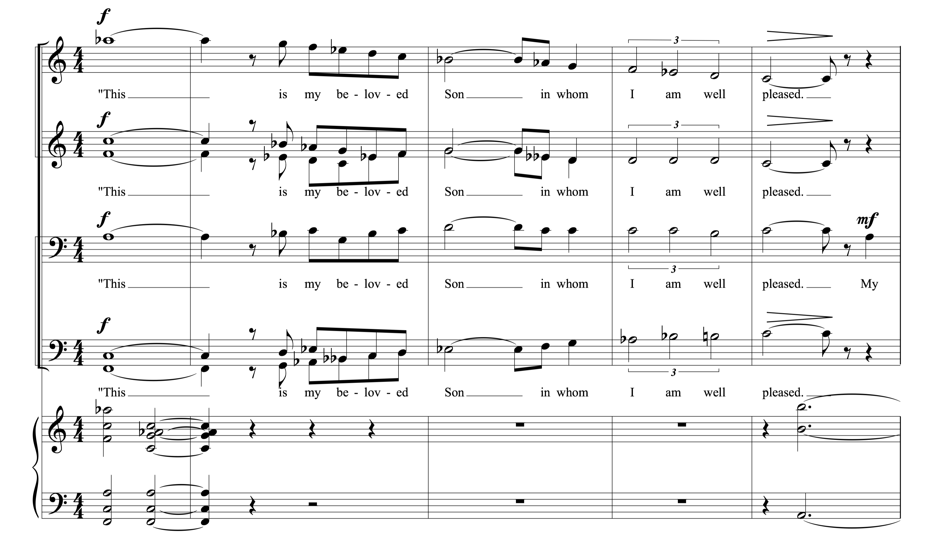
Figure 1, Movement I, mm 22-26. Copyright © 1968 (Renewed) by Music Sales Corporation and Malcolm Music Ltd. International Copyright Secured. All Rights Reserved. Used by Permission.

Outside of the first four measures that Brubeck uses to simply setup the spacious quintal scene with only the slightest crescendo, only one other portion of the first movement is not dominated by the text. Immediately following the declaration of the voice of God we are given an aggressive instrumental interlude that is the first tutti for the entire orchestra. It consists of the same 5/4 rhythmic theme that was introduced by the chorus (mm. 34-37).
Section II of the first movement begins immediately after Jesus' baptism, when he was led by the Spirit into the desert wilderness where he was tempted by the devil. This signified the beginning of his Messianic work. The chorus narrates each of the three scenes and serves as the voice of the tempter while the baritone soloist enters to provide Jesus’ response.
There is arguably no single composer that is so associated with the time signature of 5/4 as Brubeck. His biggest recorded hit was “Take Five.” It is well documented that he was keenly interested in the use of time signatures to stretch the boundaries of jazz. It therefore stands to reason that Brubeck would include 5/4 along with other compound time signatures in his oratorio. However, it should be noted that everything Brubeck did was on purpose and served the text’s message.
The temptation to rationalize one’s compromising as a means to gain idealistic ends is the theme of the wilderness dialogue between Jesus and the devil. In the choral narrative, I have given almost equal power to the scheming Tempter and the opening Voice from Heaven, both of which are written in 5/4 meter, to emphasize that in each of us (even Jesus) the tug of war between good and evil is never ending.
Brubeck wrote five 5/4 sections in the first movement. The first is the “Voice from Heaven” followed by the instrumental reprise of the same theme. The middle three are the words of the devil: temptation one, “If Thou be the Son of God, command these stones be made bread,” temptation two, “If Thou be the Son of God, cast Thyself down,” and temptation three, “All these things will I give Thee if Thou fall down and worship me.” The fifth 5/4 section is the reprise of the words of God, “This is my beloved Son in whom I am well pleased.” The first 5/4 section begins with some polyphony and ends harmonically with the text being, “set to a series of triads [polychords] with simultaneously ascending and descending chromatic lines over a pedal tone.” Each of the 5/4 sections follow the same model with similar rhythmic motives. The tempo of the opening and closing 5/4 sections is 104 beats per minute, while the three temptations are set twice as fast at 208 beats per minute. The mathematical relationship easily accommodates the transitions between sections–binding the various parts into a whole.
Brubeck’s orchestration choices in the opening movement, particularly his uses of percussion, play key motivic roles. During the three temptations the devil is
introduced with some combination of slapstick, ratchet, maracas, tambourine, or snare drum with rim shots. The rattlesnake-like sound is unmistakable and symbolizes both the desert and danger. Christ’s responses all begin with the phrase, “It is written…” Each of these statements that precede Jesus’ rebuke of the temptation based on God’s word is punctuated with the purity of an antique cymbal, orchestral bell or with finger cymbals over a thin texture of strings (See Figure 2).
The three temptations of Christ bear a literal meaning and some metaphorical meaning as well. In the vernacular language of the jazz world, “bread” was the term for money. Brubeck suggests that the bread that is offered to Jesus, reinterpreted as money, represents the hunger for power. Money is “the most commonly used tool for power among men and nations.” Brubeck urges the listener to “earnestly ponder the reasons why a starving Jesus rejected as unworthy the promise of fulfilled appetites.”
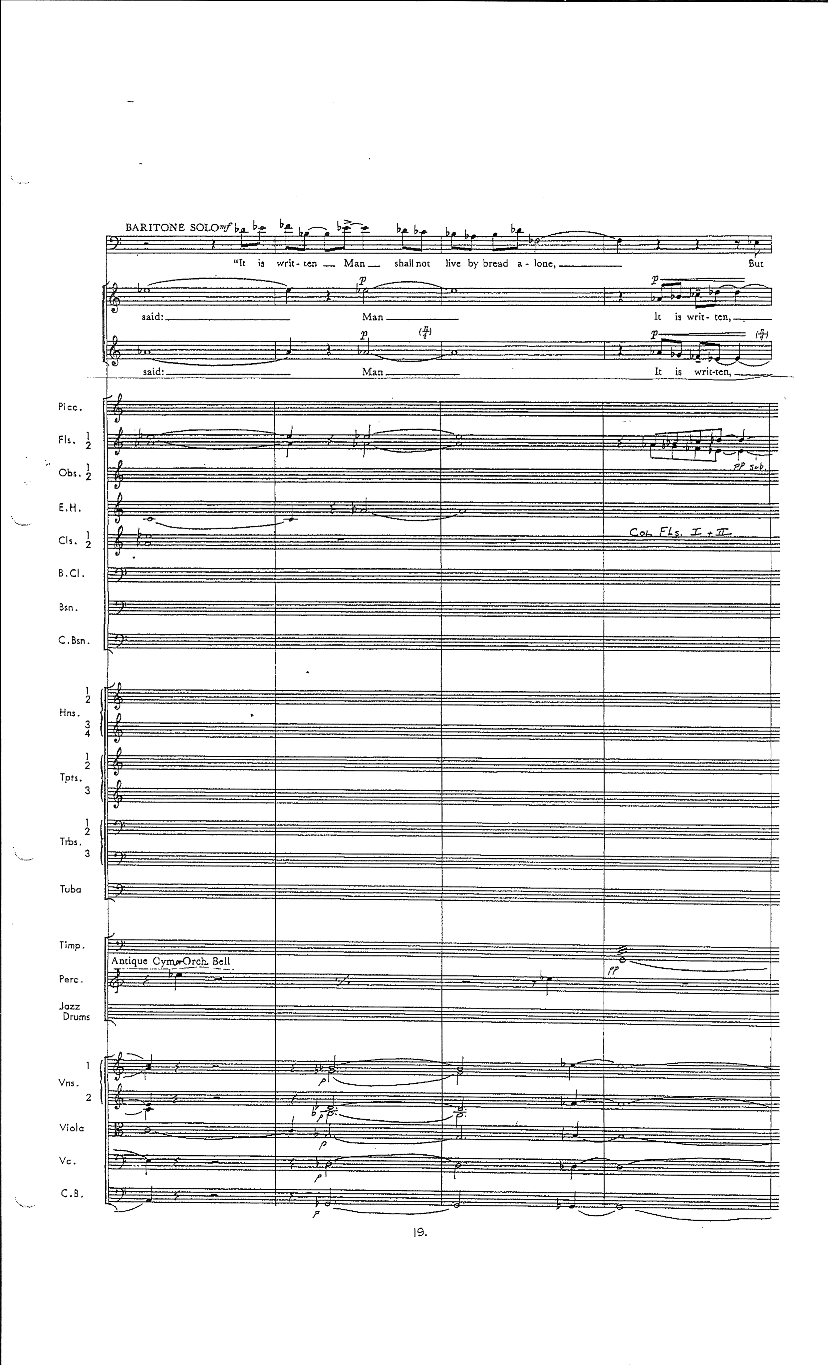 Figure 2, Movement I, mm 73-76. Full score excerpt that shows Brubeck’s orchestration with the orchestral bell or antique cymbal before the voice of Christ. Copyright © 1968 (Renewed) by Music Sales Corporation and Malcolm Music Ltd. International Copyright Secured. All Rights Reserved. Used by Permission.

Brubeck clearly demonstrated his thoughts on the next temptation with the following assertion.
The second temptation is a test of faith, a sly challenge to the ego. I think Jesus refused the power of the miracle and the spectacular leap from the “pinnacle of the Temple” so that he could demonstrate in his humanity the greater power of love and compassion. Just as one should not use the physical appetites of man for gain, neither should one prey upon his fear of the supernatural.

In the third temptation the devil presents perhaps the most alluring reward–the power to rule. “Our world’s history has been a continual demonstration of the corruption that accompanies power.” Jesus was willing to sacrifice himself for mankind, but the “price” the devil was suggesting was too great. Jesus did not seek to gain the world, but to save it. “For what does it profit a man to gain the whole world and lose his own soul?”
The final section of “The Temptations” is a reprise of the first 5/4 section returning to 104 beats per minute only slightly re-voiced and a half step lower. Brubeck ends the movement with the chorus, percussion, brass, and organ punctuated by A♭ and E♭ open fifths in the final three measures. Jesus, having withstood the final temptation, is hailed again with the reassertion of God’s pleasure. Brubeck’s transition to A♭ leads directly to the enharmonic (G#) entrance of the tenors, basses, and bassoons in movement II.

Movement II: “Forty Days”
“Forty Days” appears in The Light in the Wilderness in three versions. The first is a choral hymn accompanied by the orchestra, the second is an optional improvised version featuring the jazz trio or quartet, and the third is a chorale written for brass and organ, or organ solo. “Forty Days” was originally intended for the oratorio but the jazz trio/quartet variation was first recorded on Brubeck’s famed studio album, Time In. It was released in 1966, two years before the orchestral premiere of The Light in the Wilderness.
In each of the movements of The Light in the Wilderness there are choices to be made about how to use the scriptural text. Dave and Iola Brubeck went through the scriptures in various translations of the Bible and chose exactly what they wanted to say and highlight. “Forty Days” is the lone exception in that, this text is based on the Gospel accounts of Jesus’ forty-day fast at the beginning of his ministry, but the text was primarily written by Iola Brubeck and was based on their ideas as to what Christ experienced during his Spirit-led fast.
Whatever went on in his [Jesus’] mind during his solitary fast, it must have been a soul-searching beyond our imagination; and yet he must have asked basically the same question we all ask–Who am I? This lonely search is what I tried to express in “Forty Days,” sung first as a quiet hymn.

Movement IIa: “Forty Days”- Chorus
Movement IIa is divided into two textually derived sections. Not surprisingly, the first section is made up of 40 measures. It deals with the actual experiences Jesus may have had in the desert.
"Forty days alone in the desert, days and nights of constant prayer, seeking in the wailing wind an answer to despair," sings the chorus, in verses inspired by biblical accounts of the temptations of Jesus. "Forty days of questioning: Why was he there, in the lonely desert? Forty days of fasting and prayer, searching for his destined role..."

Table 3. Form Chart of Movement IIa

The first 20 measures begin with haunting, chant-like melodies in the tenor and bass parts. They are written in contrary chromatic motion answered by parallel fifths in the sopranos and altos. Measures 21-40 repeat the process with the sopranos and altos singing the melodies with tenor and bass responses. At the end of each of the phrases (mm. 17-20 and mm. 37-40) “both the men’s and women’s voices move in parallel fifths while moving in contrary motion to each other.
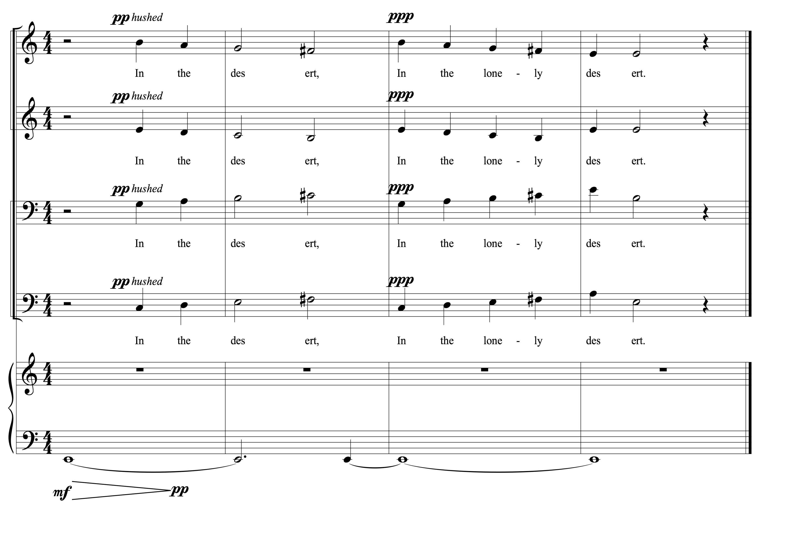Figure 3, Movement IIa, mm 17-20. Men’s and women’s voices move in parallel fifths while moving in contrary motion to each other. Copyright © 1968 (Renewed) by Music Sales Corporation and Malcolm Music Ltd. International Copyright Secured. All Rights Reserved. Used by Permission.

Measures 41-62 comprise the second section of Movement IIa. The text shifts to, “After forty days in the desert, He and God became as One.” The climactic moment of text and drama centers on the transition that Christ now must prove to mankind that He is the Son of God (m. 53). This movement proved to be very popular at one time and was even sold as a separate choral octavo as it appears in the vocal score, with organ, bass, and percussion accompaniment.

Movement IIb: “Forty Days”- Improvisation
One of the truly unique aspects of Brubeck’s first monumental oratorio, The Light in the Wilderness, is the room that he carved out for jazz improvisation to happen in the midst of a massive 20th-century choral/orchestral composition. As stated above, “Forty Days” existed in this jazz combo setting prior to Brubeck’s completion of the oratorio. Brubeck returned to “Forty Days” on multiple occasions during the 1970s and 1980s, including a symphonic instrumental version featuring Gerry Mulligan on baritone saxophone with the Cincinnati Symphony Orchestra, as well as a pair of recordings featuring his sons. He even included it on his 2004 album, London Flat, London Sharp, alongside many newly composed selections.
Numerology again appears in this movement. The 20-measure form is repeated to create groupings of 40 measures. The 20 measures break down into five four-measure phrases. He could have easily made it a 16 or 32 measure form, which is typical of jazz melodies, but elected to add the final four measures to create his 40 measures of 40 days. Darius Brubeck, in an interview with the author, highlights the following:
It has the three key centers, he wrote three versions for the oratorio as you pointed out. So he is doing something there. The minor third relationship within the key centers was a technique used by late Romantic composers. Bartók, in some of his string quartets uses minor third root movement functionally in place of the more usual perfect fourth to set up a polarity or at least the tension typically found in dominant/tonic relationships.

Table 4. Form Chart of Movement IIb
At the time that Brubeck wrote The Light in the Wilderness he was not affiliated with any particular church. In the liner notes to the 1968 album, he did list three Jewish teachers who greatly influenced his life: Irving Goleman, Darius Milhaud, and Jesus. Dave was aware of Hebrew Chant and was greatly influenced by it when composing the melodic phrases of “Forty Days.” “The idea intrigued him that most of Hebrew Chant was three pitches creating a minor third… If there was music in the mind of Jesus, as a Jew in the desert, that is what it would be.” There are no functional leading tones in the melody. All sevenths occurring melodically are lowered and therefore consistent with the natural minor or Dorian scales.
Table 5 Movement IIb, Overview of Orchestral Backgrounds
20 Measure Form: | Orchestration: | Style and Tempo:
First | Strings | Slowly with Expression
Second | Brass | Slowly with Expression
Third | Bass and Drums | Slowly with Expression
Fourth | Bass and Drums | Slowly with Expression (piano sets new tempo at the end of this variation)
Fifth | Strings | Faster tempo ♩=176-192
Sixth | Brass | Faster tempo ♩=176-192

Brubeck penned orchestral backgrounds for the improvised Movement IIb. The orchestration changes with each 20-measure pass through the form. There is some confusion in the instrumental parts as to who should play when and at what tempo. The orchestral parts allude to Table 5, while the piano improvisation guide and bass part have a lead sheet marked “Faster” to describe the tempo. Table 5 describes the original orchestration sequence. In the rented orchestral parts the phrase, “Dave sets new tempo,” is written at the end of the fourth time through the form. It should also be noted that in the original 1968 recording the orchestral backgrounds were not used.
In a 2016 full orchestral performance of The Light in the Wilderness with The Brubecks Play Brubeck Quartet featuring Darius, Chris, and Dan Brubeck and jazz saxophonist Dave O'Higgins, the fast tempo was established at the beginning of Movement IIb similar to the original 1968 recording. At Darius Brubeck’s request, the string backgrounds were added on the last two times through the form underneath soloist Dave O’Higgins on soprano saxophone. 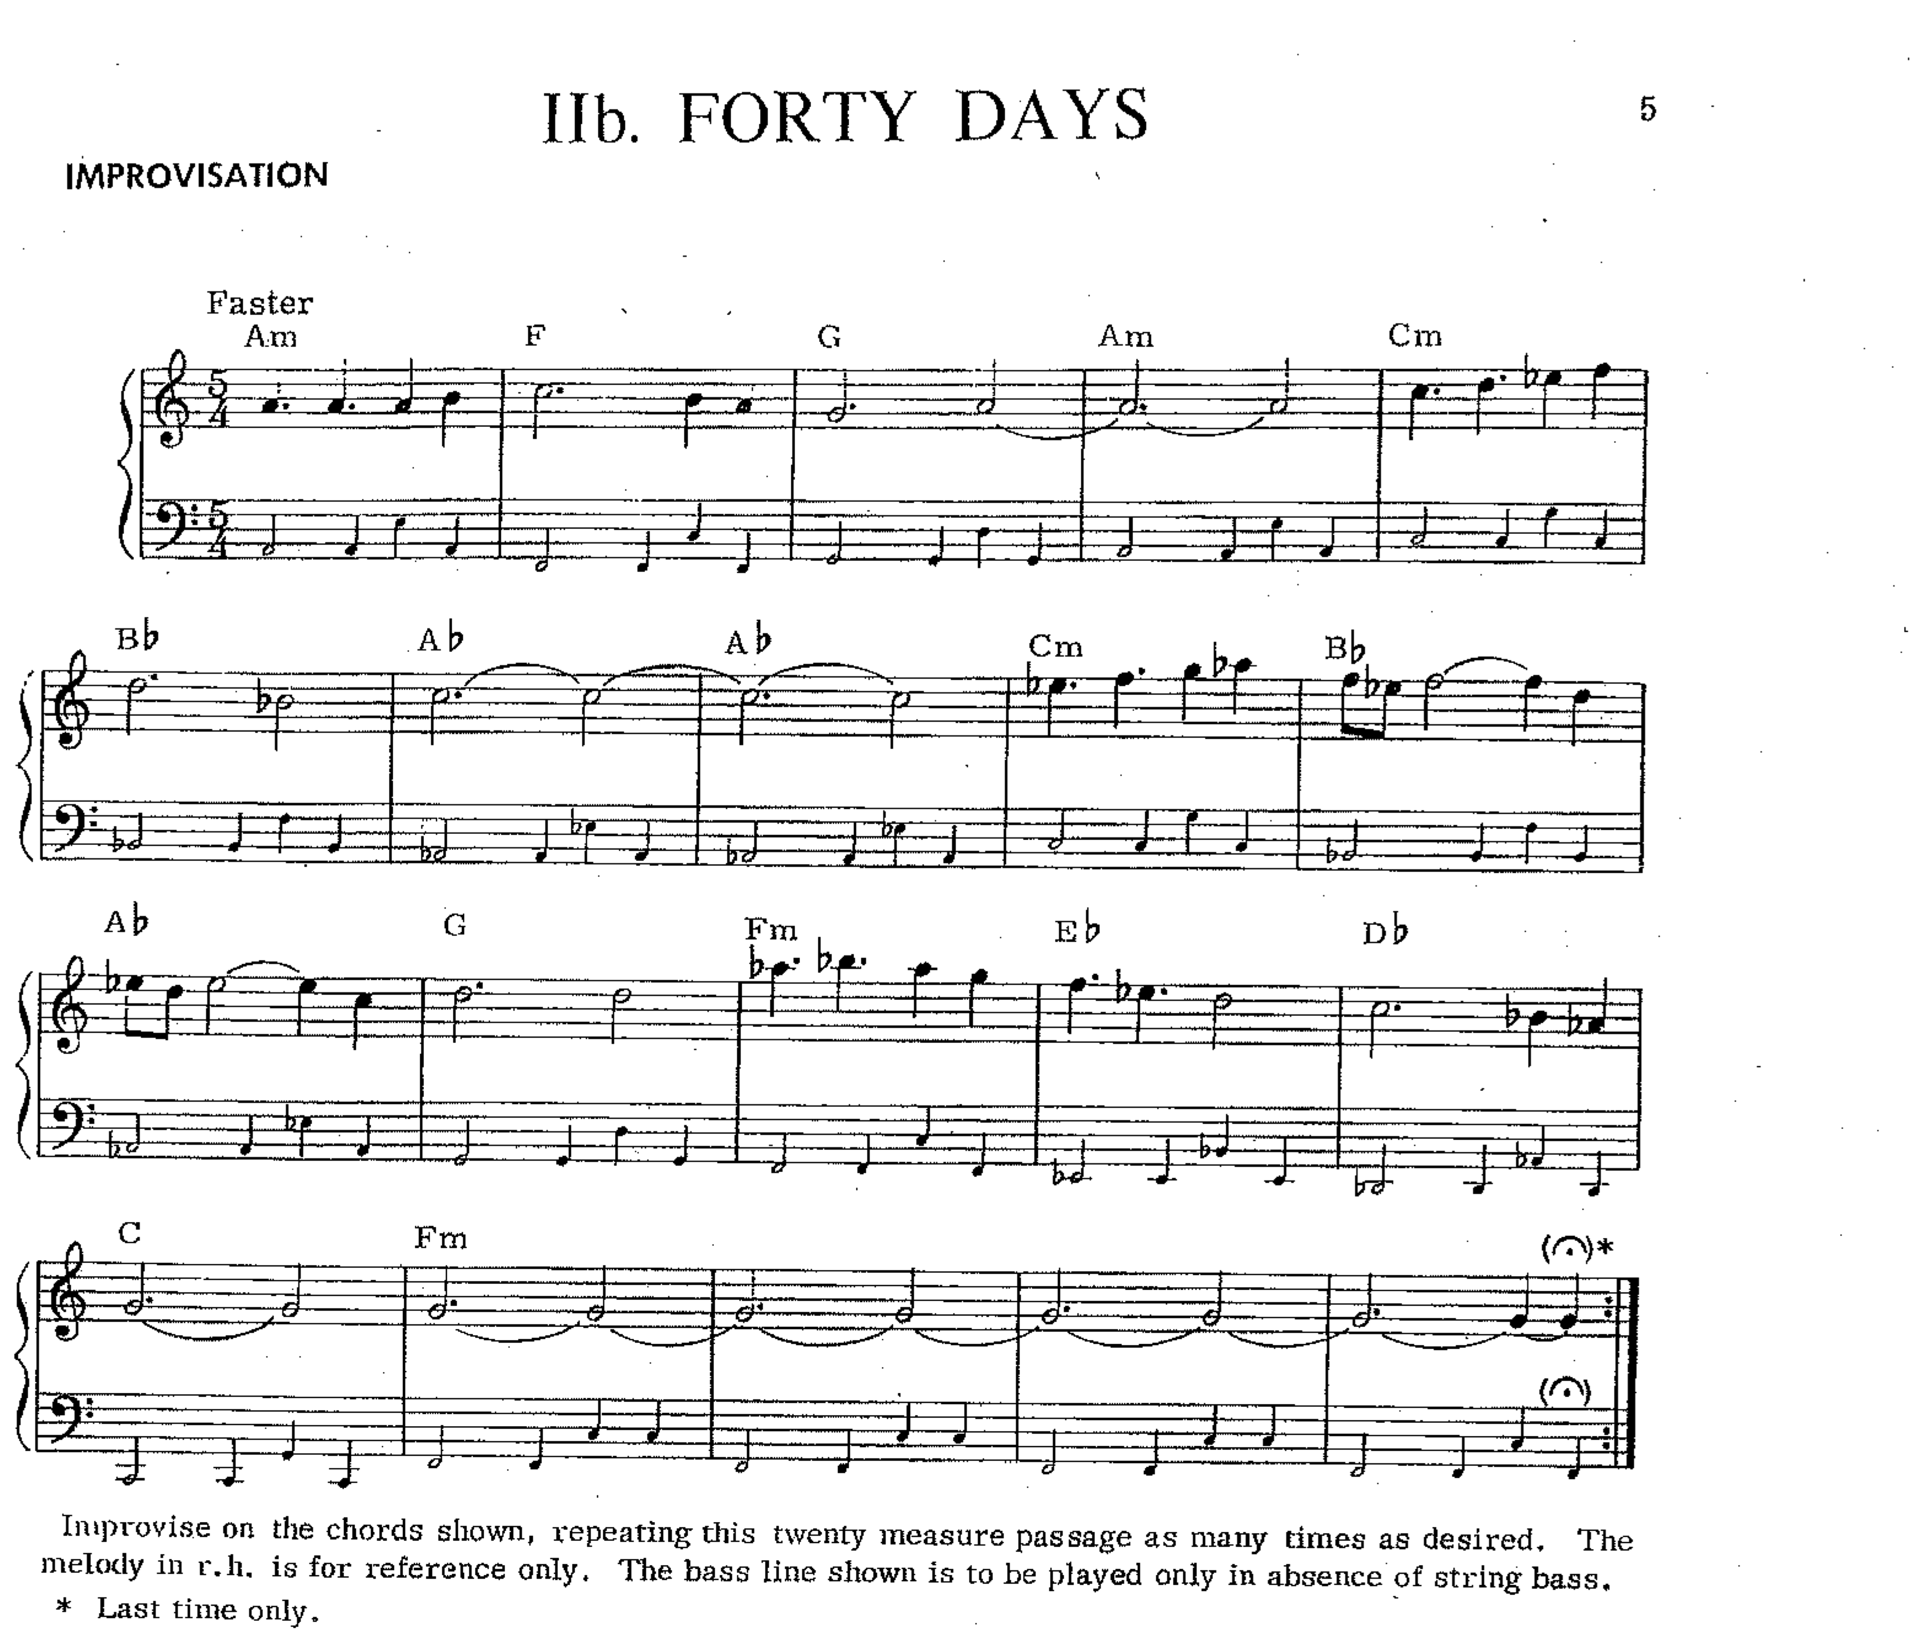
Figure 4, Movement IIb, Improvisation Guide. Copyright © 1968 (Renewed) by Music Sales Corporation and Malcolm Music Ltd. International Copyright Secured. All Rights Reserved. Used by Permission.
Movement IIb is listed, as is the case with most of the improvised movements or sections, as optional. That being said, there is much freedom in this work and it is up to the performers to decide how to best use the forces at their disposal.

Movement IIc: “Forty Days”- Brass Chorale
The final version of “Forty Days” is an “introspective instrumental passage, much in the style of a Bach chorale, in 5/4 meter.” Brubeck’s inclusion of a chorale is to be expected. Though he was raised on a ranch, his mother’s piano lessons poured music into his mind. His mother, “Elizabeth Ivey ‘Bessie’ Brubeck, had studied piano with Tobias Matthay and Dame Myra Hess and was Dave’s introduction to Bach and Chopin.” He was a musical sponge. Although he had trouble reading music, due in part to trouble with his eyes as a child, he could memorize the pieces that she taught to her other students and would play them by ear. Howard Brubeck considered Bach a substantial influence on his younger brother, “Little Dave received harmony lessons from his mother and played Bach chorales, but only as a way of becoming acquainted with musical form.” Furthermore, Dave was required to analyze the chorales and fugues of Bach in his studies with Darius Milhaud. Milhaud had them strictly follow the rules of counterpoint in their composition of chorales and fugues in the style of Bach.
This chorale is a synthesis of the previous two variations on “Forty Days.” The form is divided into four-measure phrases that follow the same basic harmonic progression as the improvised version (IIb) and maintains the 5/4 meter. However, this variation is slower and should be performed expressively. Brubeck begins with the same theme from the hymn-like choral version and further unifies the section by keeping the chromatic contrary motion (IIa). We continue to find similar compositional language. “Brubeck’s chorales, like those of Bach, are miniatures of his compositional practice and exhibit his use of asymmetrical meters, syncopation, quartal harmonies, polychords, and chromaticism.” Brubeck ends this chorale at the opposite end of the spectrum dynamically, fff, from Movement I, but he returns to the open A and E fifths. This is a fitting ending to the wilderness narrative.
Table 6. Form Chart of Movement IIc

Chapter 3: Analysis of Part 1, Movements III-V:

Sermons, Convictions, and Callings

When Jesus emerged from the wilderness he began his Messianic ministry. The first message he is said to have delivered, according to the Gospel of Matthew, is “Repent: for the kingdom of heaven is at hand.” The very next section of Matthew is the calling of Peter and Andrew. Jesus, recognizing that he was speaking to fishermen, said to them, “Follow me, and I will make you fishers of men.” Movements III, IV, and V consist of the call to follow, two variations on The Sermon on the Mount, and the repeated urge to follow him resulting in the calling of his twelve disciples.

Movement III: “Repent, Follow Me”
Brubeck combines the two texts listed above for this recitative style movement. This same text and melody return in later movements and Brubeck uses this idea as the basis for much of the rest of Part 1 of The Light in the Wilderness.
When it was clear to Jesus who he was and what he must do, he emerged from the desert wilderness with the passionate cry to rethink! (for that is what “repent” means), to look at traditional teaching with new eyes, to hear God’s word with new ears, to feel the wonder of life with the open senses of a child.

As Brubeck ends the brass chorale version of “Forty Days” with the organ and brass playing open fifths, he immediately begins the ministry of Christ. The baritone soloist’s melodic pickup note begins simultaneously with the low strings D pedal. The three two-note syllabic iterations of the word “Repent” (Figure 5, mm. 1-3) consist of an ascending minor ninth leap, an ascending major seventh leap, and a descending minor ninth leap. This rubato melody becomes a motive that recurs in movement V. This entire movement is replete with chromaticism and large, angular leaps that create deliberateness in the words of Christ. In later movements Brubeck will use specific twelve-tone rows and techniques. This movement is not strictly serial, but the melody does use all twelve pitches by the middle of measure seven (Figure 5, mm. 1-7), again by measure 14, and, excluding A♭ which is the final note of the previous section, a third time by the end of the movement.
Table 7. Form Chart of Movement III
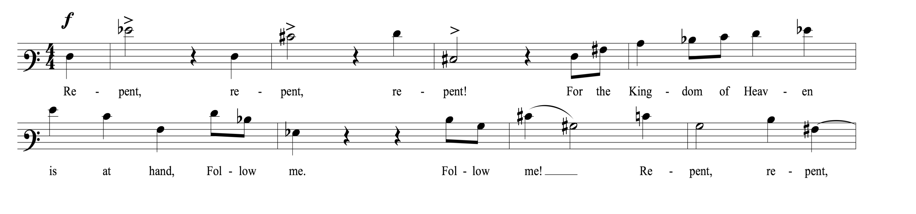Figure 5, Movement III, baritone melody mm. 1-8. Chromatic angular melody with large angular leaps. Copyright © 1968 (Renewed) by Music Sales Corporation and Malcolm Music Ltd. International Copyright Secured. All Rights Reserved. Used by Permission.

“Repent, Follow Me” is the recitative to the two versions of “The Sermon on the Mount” that follow. The baritone soloist is sparsely accompanied by the strings and some light percussion. In this movement Jesus calls not only the disciples, but also all of Galilee. This is an addition the Brubecks made to the scripture, enabling the segue into “The Sermon on the Mount.” The final phrase, “I will teach you the Kingdom of Heaven,” leads directly into the following movement.

Movement IV: “The Sermon on the Mount”
Brubeck wrote two versions of “The Sermon on the Mount.” In an interview given to Harmon Griffith Young, Brubeck explained his choice to do so was based on learning that the scripture could be translated as “blessed” or “happy.” “The first setting, sung by the baritone soloist, has an angular melody, while the chorus recites the teachings with a lively melody which resembles a pop tune. Brubeck concluded, ‘I can’t be wrong this way. I did both and they’re so different.’”
The Sermon on the Mount is the longest continuous passage of scripture where Jesus was speaking. It includes the Beatitudes, the Lord’s Prayer, and the commandment to love your enemies. Brubeck focuses both versions of “The Sermon on the Mount” on the eight Beatitudes:
(1) Blessed are the poor in spirit: theirs is the kingdom of heaven.

(2) Blessed are they that mourn: they shall have comfort.

(3) Blessed are the meek: for they shall inherit the earth.

(4) Blessed are they which do hunger and thirst after
righteousness: they shall be filled.

(5) Blessed are the merciful: for they shall obtain mercy.

(6) Blessed are the pure in heart: for they shall see God.

(7) Blessed are the peacemakers: they are the children of God.

(8) Blessed are ye, when all manner of evil is said
against you for my sake.

Movement IVa: “The Sermon on the Mount”- Baritone Solo
Movement IVa begins with the same orchestration as the previous movement. It is slightly faster than “Repent, Follow Me” and the tempo and rhythmic groove are steady. After the first violins play a four-measure introduction they hold high harmonics on D and A for the rest of the 32-measure form. The string basses begin a rhythmic ostinato pattern in conjunction with the tabla drums or bongos that carries through the entire movement. The Indian tabla drums are the preferred sound choice and give the movement a decidedly multicultural sound. As the baritone soloist enters so begins a slow ascent, which provides the only harmonic motion outside of the melody. In measure five the violas begin on D₃ and slowly ascend over eight measures. At the beginning of each phrase the D in the next octave is heard. The first eight measure ascent (mm. 5-12) is mostly chromatic: D, E♭, E, F, F#, G, A, B♭, B, C. The next eight measure ascent (mm. 13-20) adds the second violins and is all whole notes: D, E, F, G, A, B♭, C, C#. In the third phrase the violas drop out as the second violins carry on up the scale beginning on D₅ through the D natural minor scale with the added leading tone at the end. In the fourth and last eight-measure phrase the second violins continue to ascend adding the third below. This motion gives an overall lift and rising character to the entire movement.
An optional improvisation may follow the baritone melody that is accompanied by the bass and drums. The orchestral parts allude to the form being 32 measures, but this improvised section could contract or expand depending on the improvising player and conductor. The color options in the modal borrowing at the improviser’s disposal provide a rich palette of melodic options. The baritone melody establishes the quarter- note triplet as a rhythmic motive against the syncopated eighth-note groove in the ostinato bass line that the improviser could explore as well. The improvising instrument should play the last four measures (mm. 33-36) of the melody to signal the return of the baritone and strings. They return at m. 29 and play the last eight measures as a coda, adding the fermata on the final half note. Brubeck notes in the score, “Whether or not improvisation is used, the soloist’s final D should lead without break to the E♭ sung by the men to begin IVb.”
Table 8. Form Chart of Movement IVa

Movement IVb: The Sermon on the Mount- Chorus
The second version of “The Sermon on the Mount” is much faster and more animated. Brubeck may have been inspired to write two versions based on the idea that the Greek word, makariŏs could be translated as “blessed” or “happy,” but both versions serve Brubeck’s compositional narrative by being back-to-back. The first version is steady and weighty. It sounds like a sermon. In the second, the chorus functions as the exuberant crowd, reacting to, and repeating Christ’s teachings. This excitement will return in the following movement (Va) to the detriment of the overall message of Christ.
Movement IVb is divided into three major sections: The Beatitudes in 6/8, an open ended, AABA Song Form, for improvisation, and a D.S. reprise with an additional ending (See Table 9). Movement IVb once again highlights some of Brubeck’s favorite compositional techniques. He also chose to orchestrate this movement with choir and symphonic band, leaving out all of the strings except the string basses. As a whole, this movement is more tonal than much of what we have experienced chorally so far. However, Brubeck still makes extensive use of polychords, quartal harmonies–and the true hallmark of this movement–rhythmic complexity.
The attacca transition from IVa to IVb brings more than a meter change. Taking the D from the baritone soloist and beginning with an E♭ along with the direct modulation to the key of E♭ major creates a dramatic emotional lift. The first theme is repeated throughout and creates the affect for the rest of the movement. It is buoyant and dance-like (See Figure 6). Measures 1-28 make up the first phrase accompanied initially by low brass, percussion, and bass. In the second phrase (mm. 29-56) Brubeck adds the first hemiola 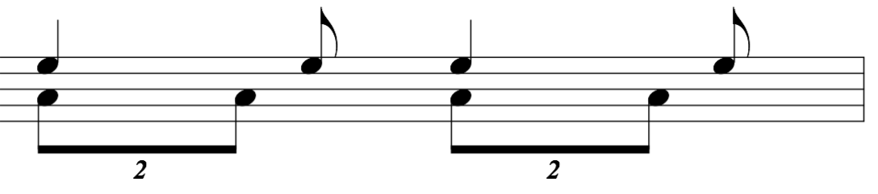 in the low brass and percussion. This rhythm persists throughout the phrase.
Each of the Beatitudes includes a part A and part B. Part A describes the members of society who are blessed; part B states their reward. For instance in Figure 6 measures 1-4, part A would consist of measures one and two, “Blessed are the poor in spirit,” while part B would be, “For theirs is the Kingdom of heaven.” When analyzing the length of each of the eight Beatitudes scripturally one finds Beatitudes 1-3 are poetically similar in length followed by the fourth that is poetically longer or “wordier.” Then again, Beatitudes 5-7 are poetically similar in length to the first three followed by the eighth that is poetically longer. Brubeck picked up on that binary Biblical phrasing and created musical phrases around that structure. The main eight Beatitudes are structured scripturally in two halves. Beatitudes 1-4 make-up the first sixteen measures of the phrase. Brubeck then writes a twelve-measure poetic reprise using highlighted words in the first six measures in a call and response style followed by six measures of the descending eighth-note sequence that is the Beatitude #4 melody. The highlighted words consist of “the poor,” “the mourners,” “the meek,” “the righteous,” “the pure,” and “the peace-makers.” All of these are the peoples in the part A sections of selected Beatitudes. Brubeck follows the same format for the second major phrase (mm. 29-56). In measures 41-44 Beatitude #8 is used to finish the sixteen-measure phrase, but poetically only the part A section will fit the eighth-note sequence. He picks up the reward for Beatitude #8 (part B), “Rejoice, be glad; for great is your reward in heaven!” in the next six-measure phrase (mm. 45-50) before repeating the eighth-note sequence of Beatitude 8a in measures 51-56.
Table 9. Form Chart of Movement IVb

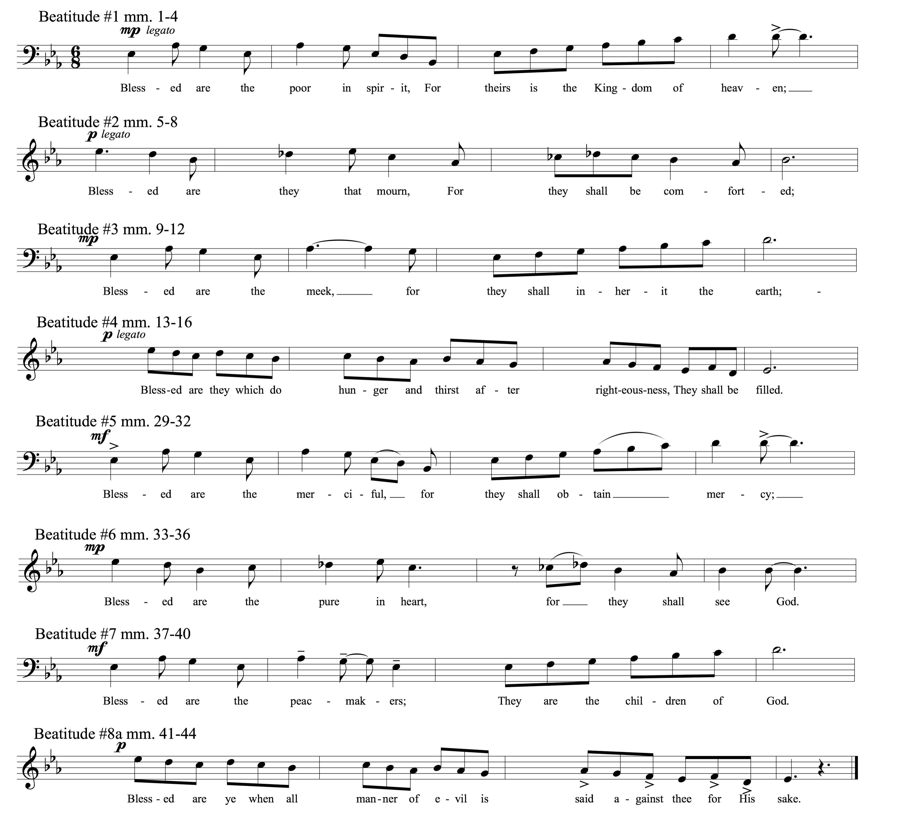Figure 6, Movement IVb, Beatitude Melodies. Copyright © 1968 (Renewed) by Music Sales Corporation and Malcolm Music Ltd. International Copyright Secured. All Rights Reserved. Used by Permission.

Dave and Iola Brubeck decided to add the text from Matthew 5:13-14 to the second version of “The Sermon on the Mount.” These are the next two verses of scripture after the Beatitudes. Jesus tells the multitudes gathered that they are “the salt of the earth” and “the light of the world.” In this part of “The Sermon on the Mount,” Christ is imploring his followers to be the light. He says, “A city set on a hill, cannot be hid.” This section leaves the melody in the soprano line and is written with contrapuntal vocal lines. Brubeck again implores parallel motion in thirds between the soprano and alto parts.
The final large phrase of Section I rhythmically augments the original melody (See Figure 7). The rhythm is primarily in 6/8 meter driven with little hemiola until the final eight measures of this section (mm. 92-99). In the final eight measures, along with the rhythmic interest, the Brubecks add text that is not part of the Biblical “Sermon on the Mount.” Matthew 8:1 is the verse immediately following “The Sermon on the Mount” in the Gospel of Matthew, followed by Luke 6:19 which is the verse immediately preceding “The Sermon on the Mount” in the Gospel of Luke. These eight measures along with their counterparts during the D.S. are the only time that the chorus speaks about the multitudes, or as narrator, rather than as the crowd of followers.
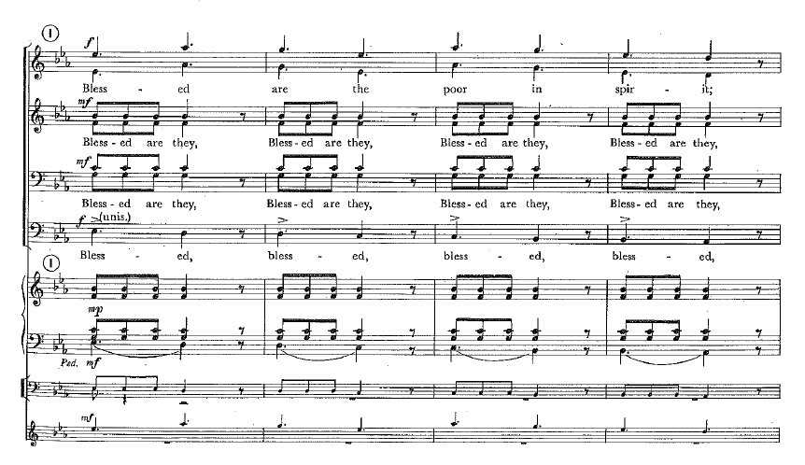Figure 7, Movement IVb, mm. 66-69. Copyright © 1968 (Renewed) by Music Sales Corporation and Malcolm Music Ltd. International Copyright Secured. All Rights Reserved. Used by Permission.
Table 10. Movement IVb, Overview of Textual Usage
Text: | Measures: | Melodic Constructs:
Beatitudes 1-4 | mm. 1-16 | 6/8; Figure 6 melody
Highlighted Words | mm. 17-22 | Call and Response
Beatitude 4 | mm. 23-28 | T, B vs. S, A layering in thirds
Beatitudes 5-8a | mm. 29-44 | 6/8; Figure 6 melody with added accompanimental hemiola ostinato
Beatitude 8b | mm. 45-50 | Homophonic
Beatitude 8a | mm. 51-56 | T, B vs. S, A layering in thirds
Matt 5:13-14 | mm. 57-65 | Contrapuntal, parallel motion in thirds plus contrary chromatic motion (no hemiola)
Beatitudes 1, 4, 2, 5a, 6a, 3 | mm. 66-91 | Augmented 6/8 ♩. melody followed by 3/4 hemiola
Matt 8:1; | mm. 92-95 | 6/8 melody with added accompanimental hemiola
Luke 6:19 | mm. 96-99 | S, A descending eighth-note sequence in thirds; T, B ascending eighth-note sequence in thirds; 3/4 contrary motion accompanimental pattern in woodwinds
Luke 6: 19  (2nd time after D.S.) | mm. 100-107 | S, A descending quarter-note sequence in thirds; T, B ascending quarter-note sequence in thirds; mirrored by brass
Beatitude 8b | mm. 108-120 | 6/8 melody and accompaniment; ♩. polychordal block chord ending

Measure 99 leads abruptly into an optional improvisation that keeps the same pulse, but changes the beat from a dotted quarter-note to the quarter-note (♩.=♩) and turns the entire movement into a medium swing tune. This is a striking shift in style and takes the audience utterly by surprise. Brubeck used a similar technique in one of his most popular jazz compositions, “Blue Rondo à la Turk,” from the hit album Time Out. It is mostly written in 9/8 meter, but he groups the eighth-notes in an atypical pattern of 2+2+2+3, as opposed to the more normal western music pattern of 3+3+3. Brubeck uses this rhythmic ostinato enough to allow the listener to adapt and accept it only to change into alternating two-measure phrases of the unequal 9/8 pattern with a swung 4/4 blues groove. Brubeck’s propensity for fusing rhythms dates back to his time spent with Milhaud and his travels around the world, specifically those sponsored by the State Department. Chris Brubeck described his father’s influence and inspiration in an interview given in 2016.
One of the things that Milhaud insisted from my dad was that when you travel the world, listen to the other music and let it inspire you. As an example of that, Dave wrote his piece Blue Rondo a la Turk after listening to a Turkish street musician playing that rhythm. He took the rhythm and then rewrote a melody.

Brubeck also discussed this inspiration in an interview for The Brubeck Oral History Project through The University of the Pacific.
I heard the street musicians. I heard them playing in 9, and I was on my way to a broadcast in Istanbul, and I asked a Turkish musician who was well-respected as a composer and musician. He was standing in front off to the side of the orchestra, and I started singing this rhythm. I said, "What is this?" Pretty quick the whole radio orchestra started playing that rhythm and jamming. And he said, "It's like our blues. It's like your blues. This rhythm is like your blues. To us it's so common."

It stands to reason that Brubeck would implore a reminiscent approach to “The Sermon on the Mount.” He takes the compound meter, 6/8, adds hemiola in different places and variations, then abruptly turns the piece into a swing tune without changing the pulse.
The form of the Movement IVb improvisation is an AABA song form. Brubeck manipulated the main melody to fit the quarter-note swing style and harmonized this movement very much like a jazz standard. Jazz chord progressions are dominated by ii-V progressions. The typical ii-V-I progression creates a sense of cadential tension and release in most of western music like an international standard currency. In jazz chord progressions added ii-Vs to a line imply passing tonalities as well as draw the listener toward prominent chords. Harmonically, Brubeck uses a common approach to his chord progression for the improvised section. It is a standard vehicle that would be familiar to jazz improvisers and allow the individual performer to create something of great interest. The improvising group plays as many choruses as is appropriate for that moment and with that ensemble. On the last time through the form the improviser is to take a second ending (mm. 33-36 of IVb Sermon on the Mount improvisation chart.) and play the quarter-note triplet melody that happens to be the same as measures 96-99 of the choral melody. This constant tempo cues conductor and orchestra that the end of the improvisation is near. The chorus and orchestra then reenter, abruptly shifting back to the original 6/8 meter (♩=♩.).
The D.S. returns the chorus and orchestra to the eighth-note anacrusis to measure 45 with the chorus singing “Rejoice, be glad; for great is your reward in heaven!” Measure 45-95 is the same as before. From measure 95 you skip rehearsal letter ‘M’ (mm. 96-99), which sent you to the improvisation, and go to letter ‘N’ (m. 100, labeled Ending). The melody at letter ‘N’ elongates that which is found at ‘M’ as running eighth-notes become quarter-notes. The entire orchestra has the same rhythm, thus creating eight measures of 3/4 time without delineating the meter change (See Figure 8).
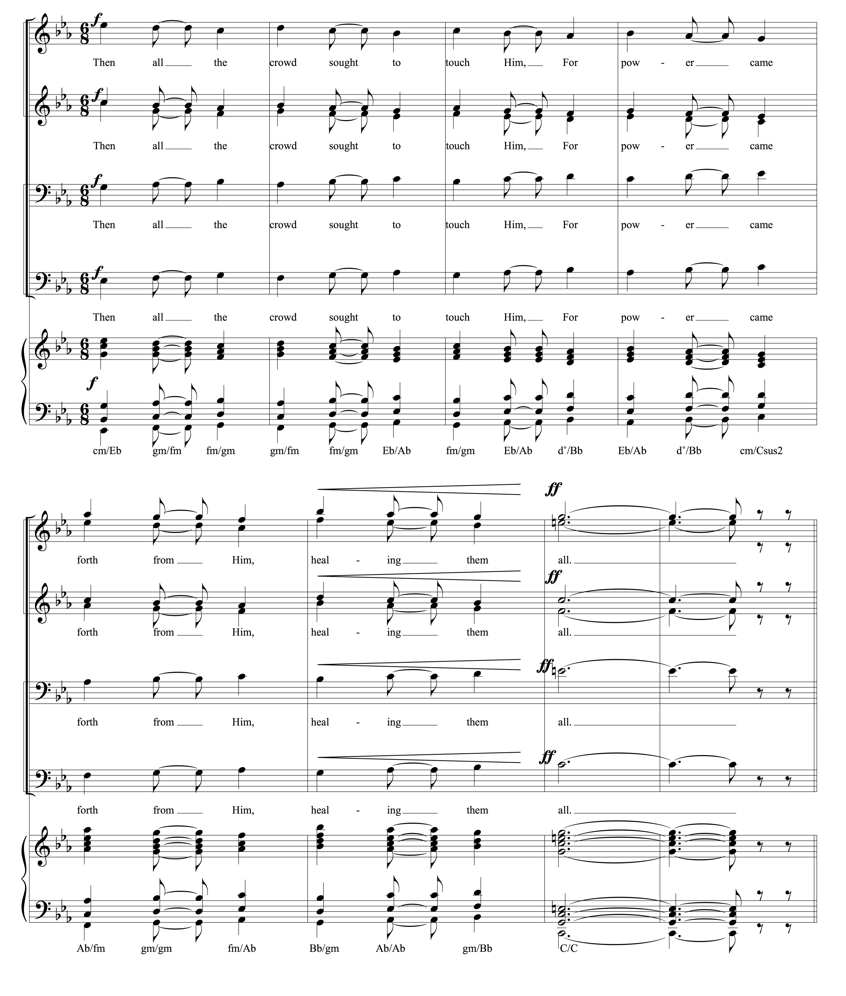
Figure 8, Movement IVb, mm. 100-107. Copyright © 1968 (Renewed) by Music Sales Corporation and Malcolm Music Ltd. International Copyright Secured. All Rights Reserved. Used by Permission.

In this eight-measure 3/4 phrase with each beat being equally accented, Brubeck breaks any monotony of the dotted quarter-note pulse. He also shows his polychordal approach very clearly as he sequences the tenors and basses along with trombones, tuba, and string bass moving upward as the sopranos and altos joined by trumpets and horns have a descending sequence. Brubeck was accustomed to playing in two keys at the same time often separated by a third. In this case he is primarily in C minor with his right hand, or treble clef parts, and in E♭ major with his left hand, or bass clef parts.
The final nine measures of the movement create another polychordal sequence at the fff dynamic level highlighting the text, “Great is your reward in heaven,” then decrescendos to pianissimo for the final chord, which transitions to the next movement. In the vocal book that includes the organ, string bass, and percussion. The final chord is Gm/E♭ or E♭ major 7. The orchestration adds more tension in the transition with the high woodwinds creating D diminished/E♭ major. This aids the transition to Movement Va

Movement V: “Repent, Follow Me/The Kingdom of God”

Movement Va: “Repent Follow Me”- Chorus and Baritone Solo
The attacca connection of Movment IVb and Movement Va is achieved by a continuation of the final chord in the chorus and woodwinds of Movement IVb through the first measure of Movement Va. On the downbeat of the first measure the string bass and timpani play a D under the D diminished/E♭ major chord being sustained by the woodwinds, thus tonicizing D and therefore reversing the direct modulation that was the transition from Movement IVa to IVb and providing the emotional space for Christ’s serious call to repentance to return.
The revolutionary concept that the last shall be made first was [Christ’s] first major sermon. The chorus, acting sometimes as the narrator and sometimes in the timeless role as the multitude, repeats the joyful promise of the Beatitues, but in their expectant hope do not heed Jesus’ exhortation to rethink as the necessary prelude. Throughout the Beatitudes there is a struggle between the solo voice of Jesus and the voice of the multitude. The chorus shouts of heavenly reward; Jesus counsels Think! Now! “The kingdom of God is within you.”

Table 11. Movement Va Overview of Textual Usage
Scripture | Text used | Biblical moment
Matt 4:17 | Repent: for the kingdom of heaven is at hand. | From Christ’s first sermon after emerging from the desert.
Matt 4:18-22 | Follow me, and I will make you fishers of men | From the calling of Simon Peter and Andrew
Matt 10:1-7 | List of Disciples; The Kingdom of Heaven is at hand | From the moment when Christ calls all of His disciples and instructs them on how to go forth and teach and preach.
John 8:10-11 | Go and sin no more | From the moment when the Pharisees brought to Him the woman caught in adultery. After shaming them and forgiving her, he said to the woman, “Go and sin no more.”
Luke 17:3-4 | Forgive | Jesus teaching his disciples about forgiveness. He tells them that if the offender repents, you should forgive him as often as necessary.
Luke 10:37 | Go and do likewise (this message is more implied than directly stated) | From the story of “The Good Samaritan.” Jesus asks which of these three acted as a neighbor? They replied, the one who showed mercy. Jesus then told them to Go and do likewise.
Mark 6:7-12 | Repent | Jesus sent out the 12 disciples in pairs, taking no provisions, to teach and preach forgiveness.
Luke 10:1-11 | The kingdom of God is come nigh unto you (not directly quoted) | From the sending out of the 72 to preach and teach in pairs.
Luke 6:12-16 | List of Disciples | List of all 12 disciples

Movement Va is an extension of the scene or vignette begun in Movement III and continued in IVa and IVb. The text here is interesting in that, unlike “The Sermon on the Mount,” this text is from a variety of Biblical moments throughout Jesus’ ministry that are woven together to say what Dave and Iola Brubeck perceive as the message.
Iola Brubeck was very thorough in her approach to scriptural texts. She was an intense researcher and scholar as she approached Biblical texts.
“She would gather a lot of information. When my dad would say, ‘I want to work on this section,’ she would research it thoroughly from all kinds of angles. She would interview friends who were priests and try to get as many perspectives on something as possible before committing to anything.”

She and Dave combined the many scenes of Christ’s ministry listed in Table 11 to show Jesus’ teachings and then how mankind (or the multitude) ultimately took His words and, in its exuberance, missed the mark. Jesus’ steadfast message remains true throughout the movement and finally is accepted in the calling out of the twelve disciples. “These simple men who answered Jesus’ call, ‘Follow me,’ were destined to walk the face of the known world and alter the course of history.”
“Repent, Follow Me,” is divided into three large sections. The original melody and tempo of Movement III with the addition of the chorus begins the movement and is then expanded. The second section primarily uses the text, “The kingdom of heaven is at hand.” Jesus first makes this statement and the chorus begins to get carried away as Brubeck transitions the movement into a swinging big band. The third and final section begins as the cacophony of sound fades and Brubeck calls out the disciples by name with a slow plodding underscoring. In this movement Brubeck again uses the compositional techniques of the twentieth-century serious composer as well as the masterful command of the jazz idiom.
Table 12. Form Chart of Movement Va
As stated above, Brubeck brings back the same chromatic, angular melody from Movement III (See Figure 5). It is accompanied by the brass initially and brings a similar recitative feeling. In measure 13 and following, the chorus takes up the message alongside the baritone soloist. The baritone is, as always, the voice of Jesus, while the chorus, in this instance, is the voice of the multitude. The chorus begins by modeling the seriousness of Christ through singing the same melodic material as Figure 5 in octaves. If one considers the first measure as a transition and the downbeat of measure two as the real beginning of the movement then Brubeck uses four 11-measure phrases to complete this first section of Movement Va.
Measures 1-45 make up the first section. Measures 2-12 feature the baritone soloist singing the original melody accompanied by a long chromatic line beginning on F in the trombones and ending on E in the second violins. Initially the chromatic line is heard with major triads a half step above the chromatic line voiced in the trumpets
(F# major/F, G major/F#, G# major/G, A major/G#). Brubeck has the upper strings take over and continues the chromaticism with a slightly different harmonic context
(G major/A, A♭ major/B♭, etc.). In measures 13-23 Brubeck adds the chorus singing the original melody with the baritone soloist reiterating his call to follow him with sparse accompaniment from the orchestra. Jesus begins to call for forgiveness in measure 24: “Forgive, for the kingdom of heaven is at hand.” The Brubecks also add text from a completely different Biblical circumstance. “Go thy way and sin no more,” comes from the Biblical story in John Chapter 8, where scribes and Pharisees bring before Jesus a woman who was caught in adultery. They are seeking to trick Jesus by placing some difficult circumstances in front of him. The Jewish law stated that they were to stone her for her sin. Jesus said to them, “Let he that is without sin among you, cast the first stone.” Jesus then knelt down and drew in the sand. As the accusers all departed Jesus stood and told the woman that she was forgiven and to “Go, and sin no more.” Understanding this passage of scripture, and taking into account that the Brubecks referenced the story of the “Good Samaritan” as well, foreshadows the depth to which Jesus’ commands are taken to the extreme. To show forgiveness to an adulterous woman was unheard of. For a Samaritan to cross racial boundaries and show love and mercy to a Jew was equally rare. These teachings lead to the “The Great Commandment” (Movement VI), and “Love Your Enemies” (Movement VII). In measures 24-34 the chorus becomes part of the accompaniment as they repeat the word “forgive,” in descending homophonic tertian harmonies with the strings. The final 11-measure phrase of the first section of Movement IVa (mm. 35-45) has the chorus leading as the baritone continues to repeat the same phrases. The quarter-note triplet plays a key role in the rhythmic interest of this section.
At rehearsal letter ‘G’ (m. 46) the mood begins to change. Jesus states “The Kingdom of Heaven is at hand!” The multitude instantly takes up this message and begins slowly building energy. The tempo changes to 112 beats per minute and eighth-note triplets setup the move to a swing feel. “As they become increasingly carried away with their own jubilant piousity, a big band shout chorus celebration ensues, complete with syncopation, walking bass line, and swing rhythm from the high-hat and cymbal.”
The second section of Movement Va is made up of 16-measure phrases. The first phrase (mm. 46-61) begins the new tempo with the triplet assuming a big role. In the second 16-measure phrase (mm. 62-77) the baritone soloist (Jesus) returns to the “Repent” melody of Figure 5 while the chorus and orchestra are fully swinging and are mostly drowning out Jesus. The baritone melody is completely at odds with the underlying swing feel. Brubeck ingeniously creates this scene of the multitude getting caught up in Jesus’ teachings and then leaving Him behind as they wrongfully interpret that message as one that makes them the conquerors. By the third 16-measure phrase (mm. 78-93) the fully orchestrated big band and chorus are playing full out and the baritone is no longer in. Notice in Figure 9 the brass shake and glissando articulations typical of big band writing. The harmonic content is consistent with Brubeck’s block chord jazz soli style writing. He uses planing up and down with the same chord voicing shape. The challenge of tuning these dense dissonant chords in the chorus is lessened through doublings in the orchestra.
The improvisation section that follows continues the big band party of the multitude. Harmonically, the improvisation keeps the chord progression of rehearsal letter L (mm. 78-93) and is in 16-measure blocks. Brubeck penned five variations on orchestral backgrounds to be played over this section. The first is just the strings; the second is the woodwinds with added doublings in the trombones; the third is brass only; the fourth is woodwinds alone; the fifth is woodwinds with trombone doubling and strings. The score lists the sixth set of the 16-measure form as jazz trio only. In the original 1968 album, Dave Brubeck improvises over all six times through the form. In keeping with all of the improvised sections, the conductor, in conjunction with the artists, should decide how to best organize the number of improvised choruses and the order in which the player or players will improvise. At the end of the improvised choruses the conductor will cue a return to rehearsal letter ‘L’ (m. 78).
Figure 9, Movement Va, mm. 78-82. Copyright © 1968 (Renewed) by Music Sales Corporation and Malcolm Music Ltd. International Copyright Secured. All Rights Reserved. Used by Permission.
At the D.S., as the chorus reenters, if a jazz lead trumpet player is available, they may be allowed to improvise in the upper register through the second ending (m. 98). In measures 94-98 the voice of Jesus finally returns and is heard over the crowd again as the texture begins to thin. He returns with the original “Repent” melody from figure 5. The chorus decrescendos through descending block chords.
The next section of the movement is dramatically different. Brubeck moves into a plodding, new slow tempo (♩=56) to symbolize the calling of the disciples.
After the tumult the disciples are solemnly chosen. As each name is called (12 different notes for the 12 disciples), timpani beats portray the measured tread of footsteps. These simple men who answered Jesus’ call, “Follow me,” were destined to walk the face of the known world and alter the course of history. “The meek shall inherit the earth.

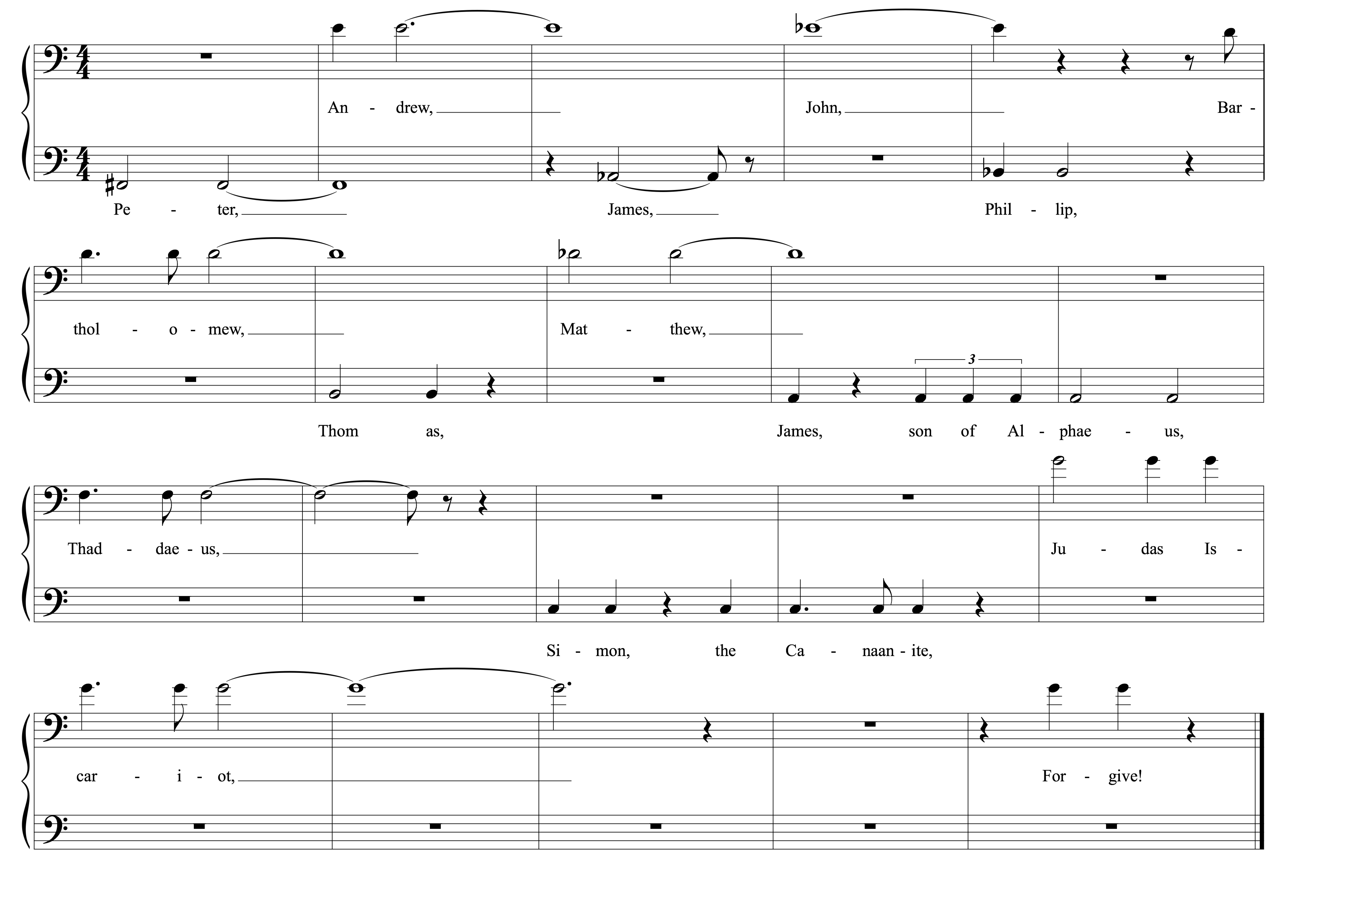Figure 10, Movement Va, mm. 101-120. Bass and tenor solo melodies of the twelve disciples. Copyright © 1968 (Renewed) by Music Sales Corporation and Malcolm Music Ltd. International Copyright Secured. All Rights Reserved. Used by Permission.
The score directs the performers to use a different solo voice, presumably from the chorus, for each apostle’s name. This is the only moment in the piece where any vocal soloists are asked for other than the baritone soloist. The effect is like a somber roll call.
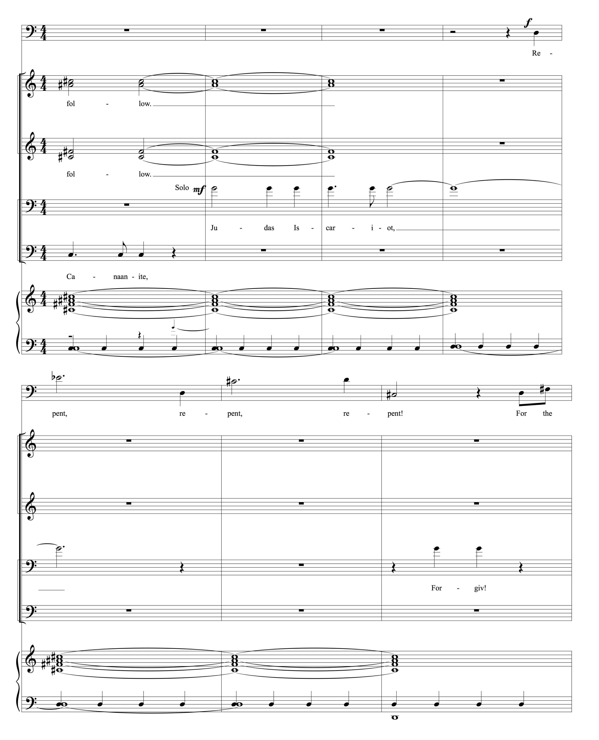Figure 11, Movement Va, mm. 114-217. Copyright © 1968 (Renewed) by Music Sales Corporation and Malcolm Music Ltd. International Copyright Secured. All Rights Reserved. Used by Permission.
The treble voices softly sing the word “Follow” on an F# major triad and sustain as the low strings and timpani move the bass line with the bass apostles notes. Each apostle is cued by the chimes playing their pitch of the twelve-tone series one beat before they sing the name. The first apostle called is Peter on a low F#. The final apostle is Judas on a G, two octaves higher. Brubeck interestingly has the final soloist sing “Judas Iscariot,” the highest note of the twelve and then adds “Forgive,” sung by the same soloist a measure later. Here Brubeck is seeming to say that we should forgive even characters as vilified as Judas, the betrayer of Jesus. Dave and Iola Brubeck are making a striking point about the teachings of Jesus. If you are to truly follow His teachings, you must repent/rethink, and forgive. Repentance and forgiveness are the cornerstones for peace. The kingdom of heaven may be at hand, the promises of the Beatitudes may be attainable, but the necessity of repentance and forgiveness is paramount as a prelude to all of Christ’s teachings.

Movement Vb: “The Kingdom of God”- Baritone Solo
Movement Vb is an extension of Movement Va. The final chord in the strings is extended as the baritone soloist makes another profound statement, “The Kingdom of God is within you.” This text comes from Luke 17:21. In this Biblical moment, the Pharisees ask Christ, “When will the Kingdom of God come?” Christ responds by saying that it is not detectable through visible signs. Many versions translate this passage as, the Kingdom of God is already among you, or in your midst. “The melody, sung over a pedal D, uses eleven chromatic pitches, E is repeated out of sequence, while the pedal D completes the twelve-pitch series.”
It is worth noting that Leo Tolstoy wrote a book entitled “The Kingdom of God is Within You.” Tolstoy’s book influenced nonviolent resistance figures like Mohandas Gandhi and Martin Luther King Jr. The philosophical stances asserted in Tolstoy’s book are in keeping with the mantra of The Light in the Wilderness. Whether Tolstoy directly influenced Brubeck is up for debate.

Chapter 4: Analysis of Part 1, Movements VI-VII:

The Commands of Christ

Now that the disciples have been called and the first few sermons of Jesus have been highlighted, Brubeck focuses on major teachings and the commands of Christ. The central teaching of Christ is often summarized in the three concepts of love that are taught in movements VI and VII. To love the Lord and love your neighbor are voiced by Jesus as the greatest commandments and the revolutionary concept of loving one’s enemy is key to Christ’s entire ministry.

Movement VI: “The Great Commandment”
Brubeck begins a new vignette with “The Great Commandment.” This scene begins with the believers gathering around to seek his wisdom.
Jesus came, he said, not to destroy the law, but to fulfill it. The chorus of the faithful, in 5/4 ostinato, asks: ‘Teach us, Master. What must we do to gain eternal life?’ Like classroom children, they repeat the basic and familiar tenet: “Thou shalt love the Lord thy God with thy whole soul, with thy whole mind, with thy whole strength; and thy neighbor as thyself.”

Dave and Iola Brubeck paired text and music in whatever way worked best for any given moment. Sometimes they would begin with a very specific text and set it to music, and sometimes they would tailor the poetry to a specific musical idea. The Brubecks begin this movement with the phrase, “Teach us Master.” Their collaboration on this selection seems to begin with this phrase as the framework.
“With a piece like “Teach us Master,” he [Dave] could hear that it would work in 5/4. It probably could have worked in something else, but you can hear that rhythmically the words work perfectly in 5/4. He probably realized that and decided to use that as a framework, then Iola started writing the text over the top of that which then helped to create the melody. My sense is, that he probably had the rhythmic thing first and then he wrote the melody later based on the Biblical extraction that they had there.

The ostinato pattern that continues throughout the entire movement is unwavering. The rhythmic pattern of two dotted quarter notes followed by two quarter notes is used in multiple places in a variety of movements, but it bears repeating that Brubeck’s motivation always remains in the moment. He is not merely setting something in 5/4 because of his success with “Take Five.” What he feels will best serve the text in each individual situation motivates him. To achieve the childlike innocence of the question, “Master, what must I do to gain eternal life?” Brubeck sets the repeated ostinato pattern in a purely tonal E♭ major setting, that includes the lilt of the 5/4 rhythmic figure.
Figure 12, Movement VI, mm. 1-4. Copyright © 1968 (Renewed) by Music Sales Corporation and Malcolm Music Ltd. International Copyright Secured. All Rights Reserved. Used by Permission.

This is the only movement where Brubeck requires a double chorus. Chorus II maintains the ostinato pattern with various words that correlate with what Jesus and Chorus I are speaking about. The three sections of “The Great Commandment” consist of Jesus teaching about love with the chorus asking questions and then reciting the answers, an optional improvisation, and the final section–similar to the first section–with Jesus foreshadowing movement VII and raising the bar by calling on his followers to love their enemies.
Table 13. Form Chart of Movement VI
Jesus begins movement VI with a twelve-measure phrase (mm. 5-16): “Blessed are the eyes that see what you see. Many prophets, many Kings have desired to see and hear what you hear.” This text is reminiscent of the Beatitudes, but serves here as an introduction to Jesus’ position as the Christ, the leader, and teacher in the discussion that is to follow. Measures 17-32 begin Chorus I’s question and answer time with Christ. The first question they ask comes again from the discourse between Jesus and the Pharisees. In the biblical accounts of Mark 12:28-31 and Matthew 22:36-39 the Pharisees are trying to catch Jesus in a mistake by asking him difficult questions. In this case, “What is the greatest commandment?” the Brubecks have made this less of a challenge to Jesus by religious leaders who are threatened by him and more from the perspective of earnest followers asking how they might gain eternal life and follow him. In the third phrase (mm. 33-56) Jesus gives the answer as Chorus I repeats the tenet like “classroom children.”
This movement can be performed in a variety of formats and orchestrations. The original recording uses the chorus, the soloist, some light percussion, and occasional additions by the pianist (Brubeck). The chorus then became the background to the improvisation after a four-measure direct modulation from E♭ major to F major. There are parts for the orchestra that double the Chorus II ostinato that can be played to maintain accurate pitch if the chorus needs. The rhythm section may also be added for additional groove.
When the baritone soloist returns (m. 93) he expounds on the original “Greatest Commandments” with the “Golden Rule” and the monumental teaching of Christ, “Love your enemies, do good to those who hate you.” As stated above, this foreshadows movement VII. The final statement of Christ in the last four measures is accented in that the ostinato has stopped and the chorus (et al.) strikingly sustains the final chord. The baritone soloist states, “You are not far from the Kingdom of God.” Jesus utters these words to one of the religious leaders as he recognizes the man’s understanding of the aforementioned “Greatest Commandments.”

Movement VII: “Love Your Enemies”
The final movement of Part I is related to Movement VI in that they both deal specifically with the commands of Christ, but Brubeck takes a different tack in “Love Your Enemies.” This scene begins aggressively with the orchestra, uses three twelve-tone themes, and is described by Brubeck as “a collage of quick jumps from modern to modal, Middle Eastern to country hoe-down, jazz, rock and roll, to martial drums.” The music moves freely through these styles to emulate the fact that Christ’s teachings are for all of humanity. “There’s always a center for me in my pieces… In The Light in the Wilderness, Christ says, ‘Love your enemies. Do good to those that hate you.’” This teaching followed him his entire life. It became one of his core personal beliefs. He would quote this teaching in countless interviews that dealt with his sacred writing.
The heart of [The Light in the Wilderness] is what I believe is the most important thing that Christ ever said, and he said it over 2000 years ago, and it could save us now. He said, “Love your enemies, do good to those that hate you.” Now you see, there’s the only answer to the world’s problems.

In the 25 years that he spent after his time in World War II, Dave Brubeck studied intently, made a significant mark on jazz, and traveled the world absorbing cultures and exchanging musical ideas. However, his experiences spent in the U.S. Army stayed with him. Dave lost many friends and most of his Army Unit in the war. His meditation on Christ’s command to “Love your enemies,” stems from this tragedy and the way the world seems determined to repeat its mistakes.
The idiocy of the entire Christian world bent on fratricide, rather than brotherhood, leads me to believe that we have missed the whole point of Jesus’ life. I puzzled as a young soldier twenty-five years ago (as I do now) at Christians who can still think in terms of “the enemy,” forgetting that devout prayers are being offered to the One God from both sides of the battle. In God’s eyes can there be an enemy?

The text of Movement VII comes primarily from the Biblical account in Luke 6:27-38, although Brubeck also uses elements of Matthew 5:39-47 and Matthew 7:1,12. There are three large sections of “Love Your Enemies.” The first section uses three twelve-tone themes. The first theme is stated by the baritone soloist, Jesus, and is purposefully angular and makes dramatic use of the baritone high range. This melody, which is used throughout the movement as the primary theme, is not dulcet or amicable in its approach to the command for love, rather it “sings more of a battle cry for courage to face the war with self.”
Table 14. Form Chart of Movement VII

Measures 1-7 are used to establish the battle. The violins state the first five notes of the primary theme while the orchestra accents with chords replete with chromatic tension. The duple accent structure against the 3/4 time signature further dramatizes the initial introduction. The piccolo finishes the twelve-tone theme (mm. 5-7) started by the violins. The first seven measures are then repeated three more times, or at least the duration of the first seven measures are repeated, as each player plays aleatoric war-like sounds of choice, as instructed in the score. It is worth noting that the full score and the individual instrumental parts give differing information about the introduction. The full score simply has the first seven measures repeated four times with the second, third, and fourth iteration requiring improvised war-like sounds. See Table 15 for a description of each part’s instructions on how to handle the introduction to Movement VII.
Table 15. Movement VII- Orchestral Instructions for First Seven Measures
Score or Instruments | Instructions
Full Score | Play first seven measures 4 times: (1)- as written. (2), (3), and (4)- Each player plays war-like sounds of choice
Organ | Play as written 4 times
Flutes/Oboes/English Horn/Clarinets/Bass Clarinet | Play first seven measures as written; Next seven measures: Play 3 times- Improvise: Make war-like noises
Bassoons/Contra Bassoon | Play first seven measures as written; Next seven measures: Play 3 times- as written (dotted-quarter octave D♭’s)
Horns/Trumpets/ Trombones/Tuba | Play first seven measures as written; Next seven measures: Play 3 times- Improvise: Make war-like noises
Percussion | Play 4 times: (1) and (3)- as written, (2) and (4)- Each player plays war-like sounds of choice
Violin 1/ Violin 2 | Play first seven measures as written; Next seven measures: Play 3 times- as written (first five notes of primary theme)
Viola/Cello/Bass | Play first seven measures as written; Next seven measures: Play 3 times- Improvise: Make war-like noises
The text of the first twelve-tone theme and the material that follows is divided in two. “The first is stated in the form of a command (in 3/4 time) with an antiphonal response from the chorus, followed by a method (in 4/4), a corollary in the Oriental manner of ‘rules of conduct,’ which helps one to obey the command.” Brubeck instructs the baritone soloist and chorus to approach the 3/4 measures with a harsh strident sound, and the 4/4 sections with softer, smoother, and more peaceful sounds (See Table 16 and Figure 13). The row is accompanied linearly with chromatic lines. Sometimes they are quartal and sometimes making use of polychordal textures. “The construction of chords with equidistant intervals results in an ambiguous tonality appropriate to the atonal melody.”
Table 16. Movement VII- Textual Corollary in Section 1 (mm. 12-63)
Command of Christ in 3/4 Time | Method in 4/4 Time
Love your enemies. | Do good to those who hate you.
Bless those who curse you. | Pray for those who abuse you.
To him who strikes you on the cheek | offer the other also.
From him who takes away your cloke | do not withhold your coat as well.

In measure 64 Brubeck slows down the tempo and settles on 4/4 time. The second twelve-tone row is used on the text of the golden rule as written in Luke 6:31. This row is used only momentarily. “It has no relationship to the other two rows in this movement or to the ones found in part two” (See Figure 14). The third twelve-tone row is used by the baritone soloist beginning in measure 73 on the text from Luke 6:32, “If you love those that love you, what credit is that to you?” The first and second twelve-tone rows not only use all twelve chromatic pitches, but also create a musical phrase and complete a grammatical thought (See Figures 13 and 14).
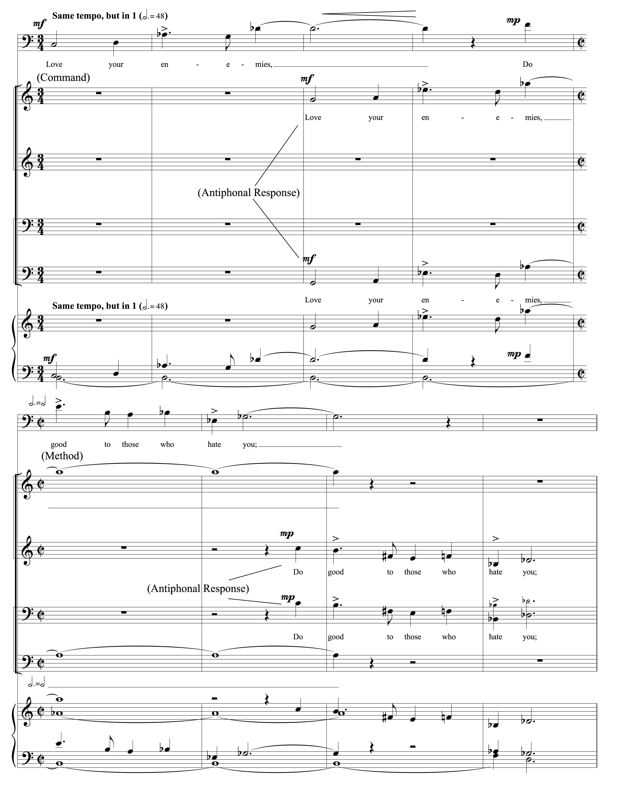Figure 13, Movement VII, mm. 12-19, 12-tone row #1. Copyright © 1968 (Renewed) by Music Sales Corporation and Malcolm Music Ltd. International Copyright Secured. All Rights Reserved. Used by Permission.
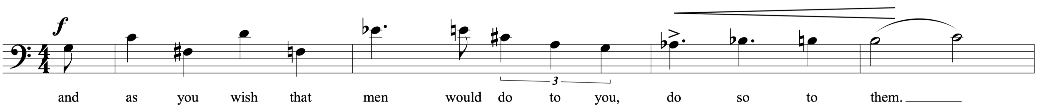 Figure 14, Movement VII, mm. 68-71, 12-tone row #2. Copyright © 1968 (Renewed) by Music Sales Corporation and Malcolm Music Ltd. International Copyright Secured. All Rights Reserved. Used by Permission.

The third twelve-tone row uses all twelve chromatic pitches, but it starts over before finishing the sentence (See Figure 15). The baritone soloist sings through the row five and a half times in this phrase (mm. 72-90) as the chorus and a sparse orchestration accompany.

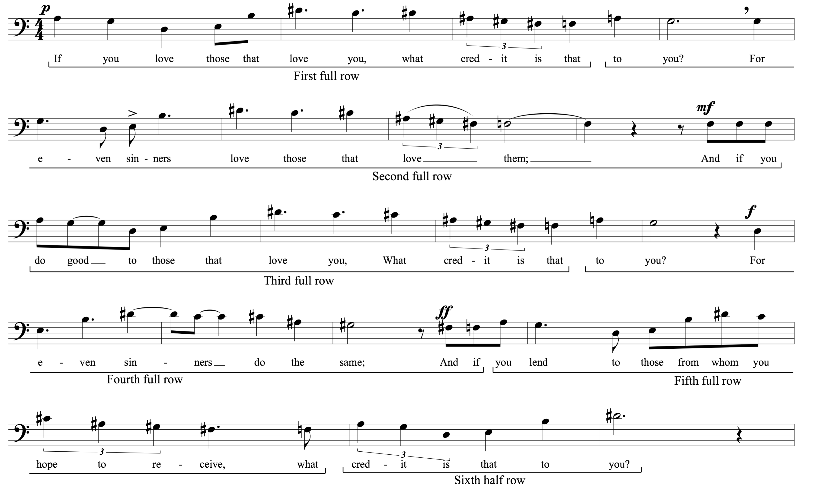 Figure 15, Movement VII, mm. 72-90, 12-tone row #3. Copyright © 1968 (Renewed) by Music Sales Corporation and Malcolm Music Ltd. International Copyright Secured. All Rights Reserved. Used by Permission.

Section II is a continuation of the previous scriptural text. Brubeck has covered Luke 6:27-34a in the first 90 measures of this movement. Measure 91 continues with the second half of Luke 6:34, “Even sinners lend to sinners to receive as much again!” However, there is a dramatic change in character and style. “Brubeck abandons dodecaphony, the tempo accelerates, and the music becomes very rhythmic.”
The first phrase of Section II (mm. 91-107) uses quartal and quintal harmonies, alternating 4/4 and 3/4 measures, and aggressive rhythmic accents. In measure 99 the baritone soloist repeats the original atonal theme, “Love your enemies,” as the chorus repeats their quintal theme on “Even sinners lend to sinners.”
The second phrase of Section II (mm. 108-121) is the “Rock and Roll” section. The drum-set and percussion parts have written out “Rock” grooves, while the baritone and chorus are instructed to sing with “Pop” singer style and “Teen-ager” style respectively.
The third phrase of Section II (mm. 122-155) begins with washboard, a move in the rhythmic groove to place the pulse on beats one and three rather than beats two and four, and an overt quote of the well-known American folk song, “Turkey in the Straw” played by the vibraphone and first violins. All of this takes place as the text shifts to Matthew 5:45: “He sends His rain on the just and the unjust.” This phrase represents the “country hoe-down” to which Brubeck alluded. Compositionally, Brubeck continues to make use of text painting on multiple levels. The baritone introduces the text, “He makes His sun rise on the evil, Makes His sun rise on the good.” The altos, tenors, and basses of the chorus take up that theme (mm. 130-133) as the divisi sopranos glissando up a perfect fourth and an octave in tandem with the trumpets. The baritone accents the word “Rise!” as well. He sings it twice (mm. 131-133), rising a perfect fourth between the two.
Figure 16, Movement VII, mm. 154-160. Copyright © 1968 (Renewed) by Music Sales Corporation and Malcolm Music Ltd. International Copyright Secured. All Rights Reserved. Used by Permission.

The fourth phrase of Section II (mm. 156-173) serves as the “Middle Eastern” phrase of the movement. Jesus sings the text, “Good measure, pressed down, shaken together, running over, will be put in your lap. For the measure you give, will be the measure you get back.” Simultaneously the oboe, later joined by the first sopranos, plays the Phrygian dominant scale–also called the fifth mode of the harmonic minor scale. In jazz terms this scale can be referred to as the Mixolydian ♭9, ♭13 scale. In Klezmer music this scale is referred to as Freygish. It is also commonly heard in Arabic and Egyptian music. The melody sung by the baritone uses the same scale (See Figure 16).
The entire second section of “Love Your Enemies” (mm. 91-173) serves as a musical montage of stylistic diversity. “Brubeck has selected this eclectic collage of musical styles to affirm that the teachings of Jesus are universal.”
The third and final section of “Love Your Enemies,” consists of an eleven-measure reprise of the main teachings and themes expressed earlier in the movement. Brubeck begins with a measure of 2/4 and adds one beat to each consecutive measure, finishing with a measure of 12/4. The baritone soloist sings the original twelve-tone theme, “Love your enemies,” with each note taking one full measure. He finishes the final three notes of the theme in the 11/4 measure. The chorus sings phrase fragments from all of the teachings of the movement – “Good measure,” (2/4); “given to you,” (3/4); “running over,” (4/4); “put into your lap.” (5/4); “Do good to those that hate you.” (6/4); etc. The final 12/4 measure consists of the original twelve-tone row sung or played across several octaves, harmonized with chromatic quartal chords, over a pedal C in the tuba, timpani and string bass. Brubeck ends Part 1 with the final note of the melody, G♭, against the pedal C creating the tritone dissonance. The tension that remains through this, the most difficult of commands, is a harsh and difficult way to end. Dave and Iola Brubeck sum up the challenge of Christ’s teachings and what they were ultimately trying to convey in the following statements made when being interviewed together.
DB: He [Jesus] comes right out and says, “Love your enemies.” To me, that’s the only thing that’s going to save this world because we’re always going to have enemies. And, if we keep trying to destroy one another, we’re not going to make it.

IB: Martin Luther King, Jr. also picked up on that. And of course that was important in the next piece that Dave wrote. But, I can remember King saying, “Love your enemies.” And he said, “That doesn’t mean you have to like your enemy, but it does mean that you have to love them.”
Figure 17, Movement VII, m. 184. Copyright © 1968 (Renewed) by Music Sales Corporation and Malcolm Music Ltd. International Copyright Secured. All Rights Reserved. Used by Permission.

Chapter 5: Analysis of Interlude:

Fantasia on “Let Not Your Heart Be Troubled”

The “Interlude” is an unnumbered movement between Part 1 (Mvmts. I-VII) and Part 2 (Mvmts. VIII-XII). It is divided into five sections and foreshadows musical material from Part 2 of The Light in the Wilderness. After the drama and intensity of “Love Your Enemies,” Brubeck created a bridge to Part 2 and makes a marked contrast in weight and mood.
The “Interlude” is subtitled “Fantasia on ‘Let Not Your Heart Be Troubled.’” The orchestral parts list it as “Orchestral Interlude- Let Not Your Heart Be Troubled.” There is, however, an additional part that is optionally available that sheds some light on the opening section of this movement. Dave Brubeck published a separate piece for organ called, Three Themes from The Light in the Wilderness. The middle movement of the three is titled, “Interlude: based on ‘Peace I Leave With You’ and ‘Let Not Your Heart Be Troubled.’” The opening section begins with an eleven-measure orchestral fanfare that leads into the first optional organ solo. Beginning in measure twelve the organist plays the entirety of Movement IXb “Peace I Leave With You.” Movement IXb is a baritone solo that is melodically comprised of at twelve-tone row accompanied by chromatic arpeggios. The “Interlude” version simply places the melody on the swell, incorporates the accompanimental arpeggiation on the great, and adds a pedaled bass line (See Figure 18).
The second section of “Interlude” introduces the themes from Movement X, “Let Not Your Heart Be Troubled.” From this point forward we are primarily following the same form as Movement X. The first trumpets begin the “Let Not Your Heart Be Troubled” melody (from Figure 19) that is then finished by the horns. In keeping with most of the 6/8 or 9/8 movements, Brubeck makes extensive use of hemiola throughout. At rehearsal letter ‘I’ Brubeck changes the timbre by dropping everyone out except the strings. The first violins play the “In My Father’s House” secondary melody against the triple-feel hemiola in the rest of the section. This melody is labeled secondary because it is less prominent than the more dominant and further developed “In My Father’s House” primary melody heard in the third section. In measure 76 the brass, winds, and percussion return and four measures later reprise the primary, “Let Not Your Heart Be Troubled” melody.
Rehearsal letter ‘L’ begins the third section. This is the introduction of the “In My Father’s House” primary melody. Brubeck divides the melody into two five-measure phrases that he sets throughout the orchestra contrapuntally. He primarily treats this phrase as a canon.
Table 17. Form Chart of Interlude: Fantasia on “Let Not Your Heart Be Troubled”
Figure 18, Interlude, mm. 12-29 (from organ score). Copyright © 1968 (Renewed) by Music Sales Corporation and Malcolm Music Ltd. International Copyright Secured. All Rights Reserved. Used by Permission.

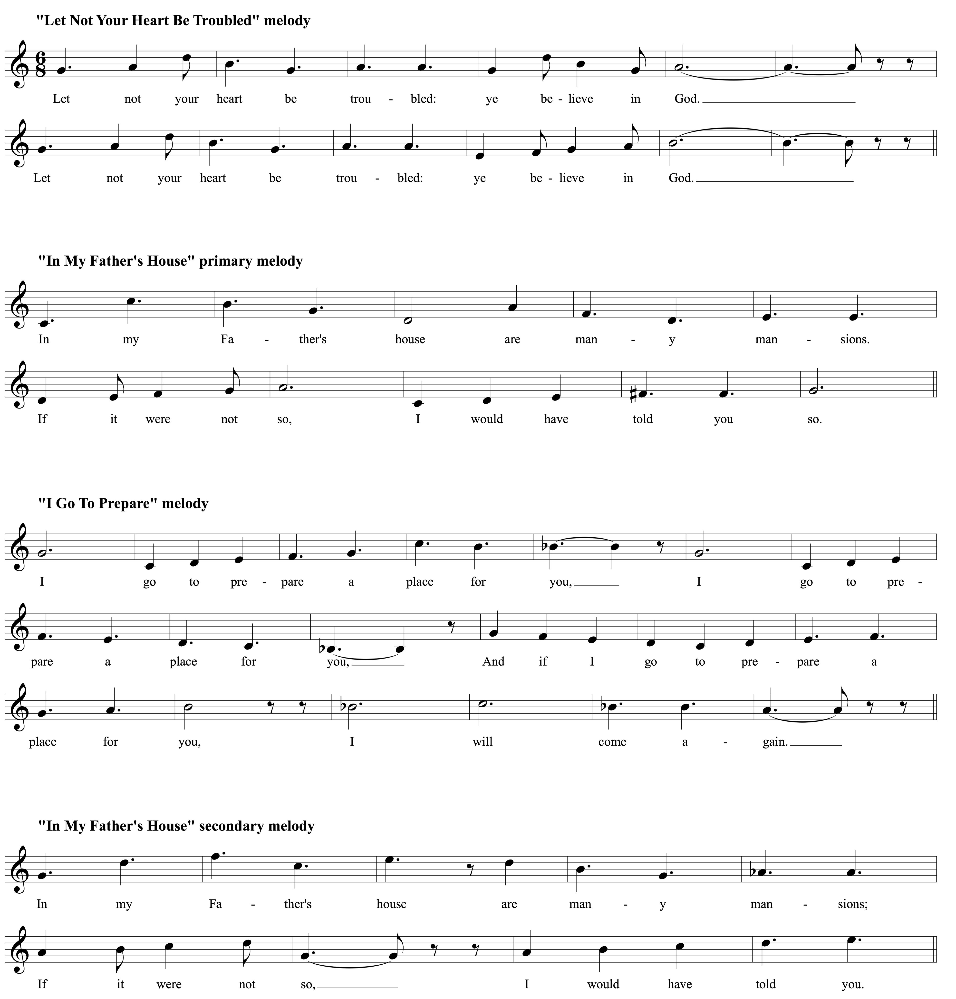 Figure 19, Melodies from Movement X. Copyright © 1968 (Renewed) by Music Sales Corporation and Malcolm Music Ltd. International Copyright Secured. All Rights Reserved. Used by Permission.

Figure 20, Interlude, mm. 138-140 (from organ score). Copyright © 1968 (Renewed) by Music Sales Corporation and Malcolm Music Ltd. International Copyright Secured. All Rights Reserved. Used by Permission.
The fourth section begins the second of the optional organ solo moments. This section resumes the canon from section three, but this time in diminution. Brubeck uses the three-measure truncation of the “In My Father’s House” primary melody with added chromatic coloration, followed by two measures of chromatic transition to the next entrance a perfect fourth away (See the first entrance in Figure 19). The use of the tritone in measure 139 (F to A♭) and the move to E♭ in measure 140 creates a lack of resolution and plunges this section forward. Each of the four entrances of the melodic canon have the same chromatic alterations.
The last section begins with a final restatement of the “Let Not Your Heart Be Troubled” melody. The concluding eleven measures consist of a large, triple forte–with crescendo–fanfare that concludes with a D major/E major polychord.
The drama of this movement is striking. The audience has just come through a tumultuous journey in “Love Your Enemies,” the ending of which is aggressively angular and challenging. In contrast, “Interlude: Fantasia on ‘Let Not Your Heart be Troubled’” sees the return of the lilt of a bright 6/8 time signature, a shift to primarily major tonalities, and the foreshadowing of significant themes of Part 2. “Rather than serving as a link between parts one and two, it is more like the Entr’acte of a Broadway musical.”

Chapter 6: Analysis of Part 2, Movement VIII:

Questions of Faith

Part 2 of The Light in the Wilderness begins with sincere contemplation. If the orchestral interlude is the Entr’acte that projects themes to come, then Movement VIII begins with poetic echoes of where we have been and what questions we should be asking. Movement VIIIa is eight-measures long and simply states the words of Christ from Matthew 16:26: “For What does it profit a man if he gain the whole world, and he lose his own soul?” This provides a direct connection to Movement I. The devil approaches Jesus for the third time and offers to give him the kingdoms of the world in all their glory if Christ will simply bow before him. “Although Jesus was prepared ultimately to sacrifice his life, the devil’s price for the earthly kingdom was far too dear. ‘For what does it profit a man to gain the whole world and lose his own soul?’” Thus Brubeck begins the meditation, questioning, and seeking of mankind.
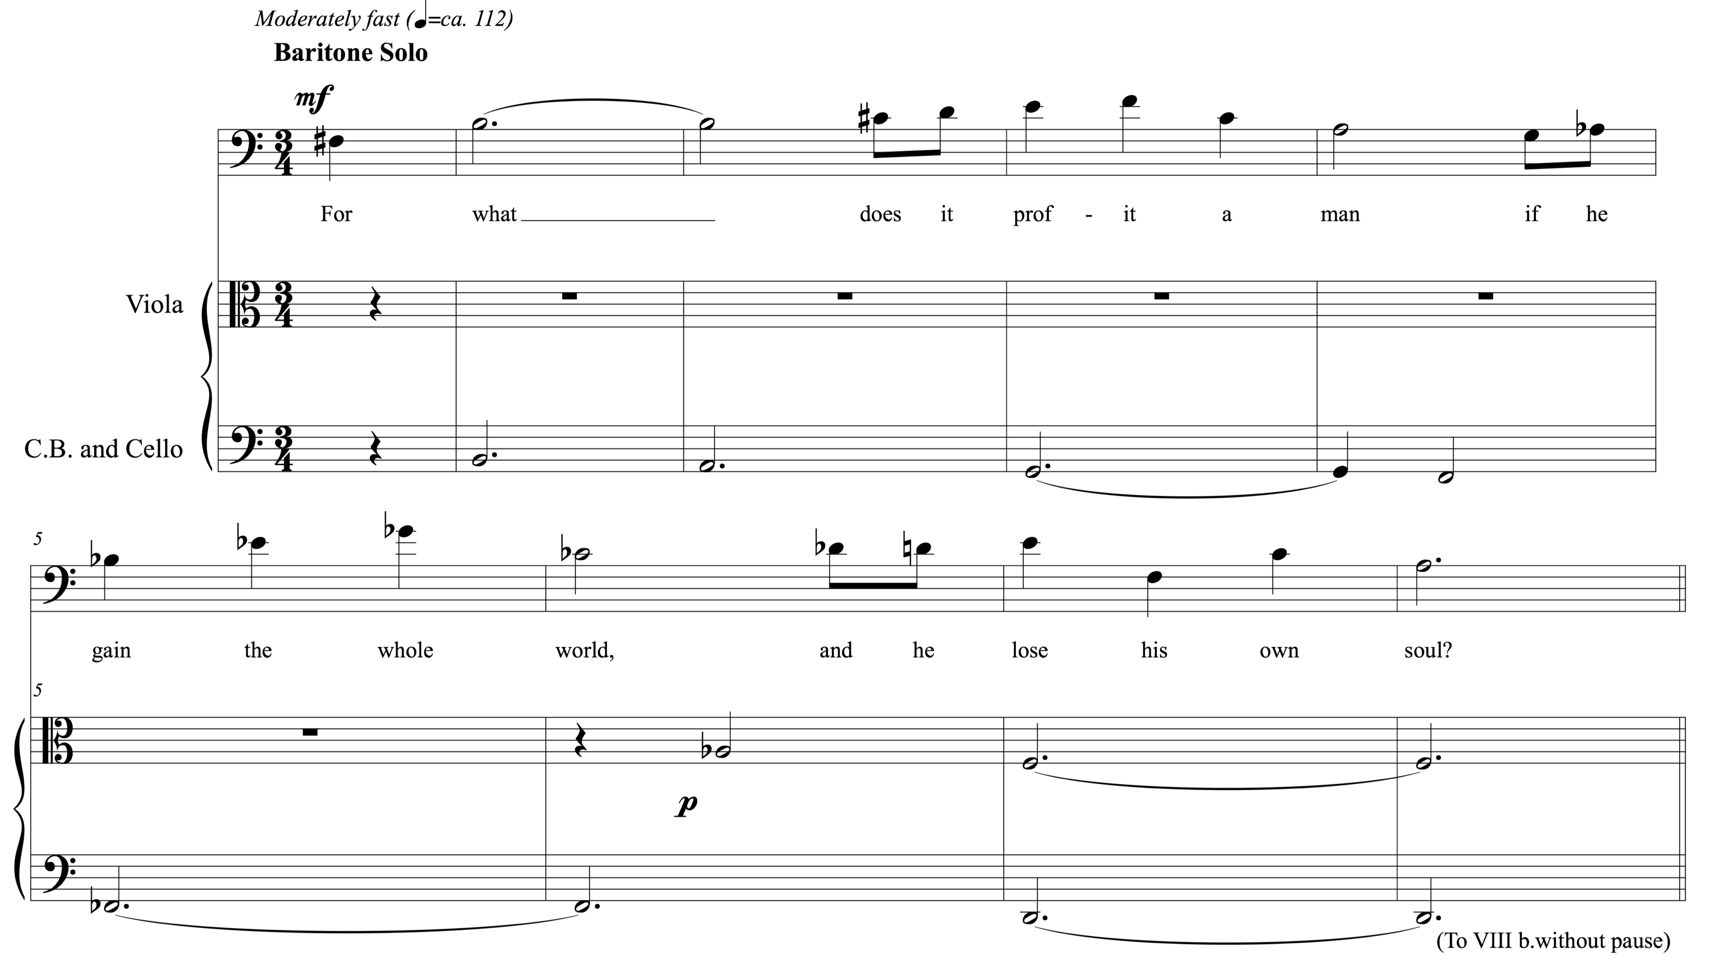 Figure 21, Movement VIIIa, mm. 1-8. Copyright © 1968 (Renewed) by Music Sales Corporation and Malcolm Music Ltd. International Copyright Secured. All Rights Reserved. Used by Permission.

Movement VIII: “What Does It Profit a Man?/Where is God?”

Movement VIIIa: “What Does It Profit a Man?”- Baritone Solo
“What Does It Profit a Man” uses a twelve-tone row as its basis. The baritone soloist must find his beginning pitch from the final D major/E major polychord of the orchestral interlude and begin with an a cappella pickup note. A descending D Dorian mode bass line beginning on B and ending on D then accompanies him. Again, Brubeck mixes the new with the old or the modal with the modern. The baritone soloist sings through the tone-row once and then sings the first eight pitches again to finish the sentence. The four-note motive created by the “lose his own soul” text is reflectively echoed at the beginning of VIIIb by the bassoon, oboe, and finally, flute creating an attacca connection.

Movement VIIIb: “Where is God?”- Chorus and Baritone Solo
The beginning of “Where is God?” is very simple. After the echoes from “What Does It Profit a Man” in the first six measures, the basses of the chorus begin the 24th Psalm. “As the psalmist’s text moves from oneness with creation to questions about our uniquely human condition, the writing becomes more complex.” “Where is God?” is the longest movement of Part 2 and evolves through the most metamorphoses. From the simple question of Jesus in Movement VIIIa and the serene beginning of VIIIb, Brubeck creates a soul-searching movement brimming with polyrhythm and diverse contrapuntal themes stacked together. “Where is God?” has five textual and motivically defined sections (See Table 18). Although “Where is God?” moves directly into IXa, it is, in and of itself, a complete thought. This movement could easily stand-alone and would come very close to portraying much of what Dave and Iola Brubeck intended for the entirety of Part 2.
Table 18. Form Chart of Movement VIIIb

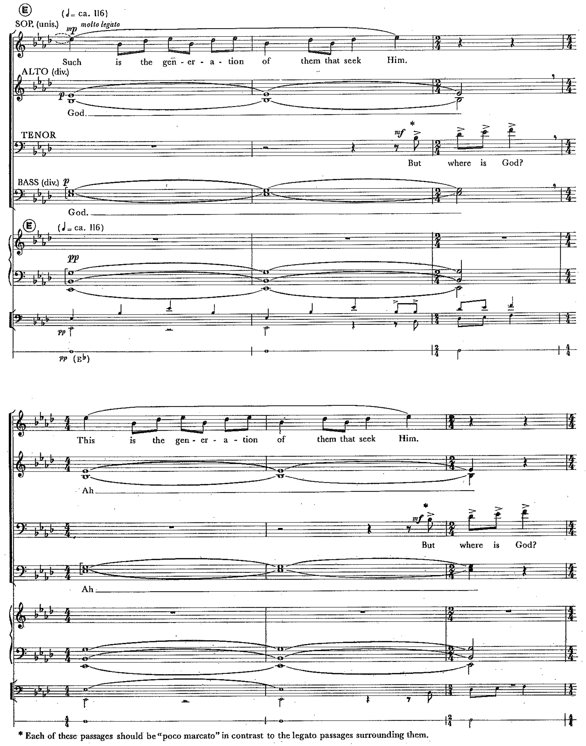 Figure 22, Movement VIIIb, mm. 41-46. Copyright © 1968 (Renewed) by Music Sales Corporation and Malcolm Music Ltd. International Copyright Secured. All Rights Reserved. Used by Permission.

The first six verses of Psalm 24 play a significant role in this movement and set the tone for Part 2 as a whole. This is the first moment that makes significant use of a text from the Old Testament. It is fitting that as the Brubecks change the textual focus from narrative to contemplative that they chose the book of Psalms, and more specifically, a Psalm of David. He is arguably the most notable Biblical figure who records deep seeded poetic questions of faith while still remaining ultimately faithful. The basses, later joined by the tenors, set the scene and then ask the question, “Who shall ascend unto the hill of the Lord, and who shall stand in His holy place?” Brubeck makes a connection with Movement IIa, “Forty Days,” as he begins with the men of the chorus and answers with the women. In the case of “Where is God,” Brubeck answers the question of the men with soprano divisi at the top of the staff, “He that hath clean hands and a pure heart.” He begins to establish forward motion using a melody comprised of the C minor pentatonic scale over F and C open fifths. Brubeck moves the melody up a fourth on his way to a key change to A♭ major and the establishment of the primary melody for the remainder of the movement (See Figure 22). The three-note “melodic motive is repeated twenty-eight times in different voices throughout the movement.” The first textual use of this motive, again, sheds light on Brubeck’s ultimate motivation. The first half of Figure 22 uses the text as it is seen in the Biblical passage, “Such is the generation of them that seek Him.” The Brubecks then change “Such,” to “This.” The word choice, Biblically speaking, is interchangeable and varying translations will use “This” instead of “Such.” The subtle change as it appears in The Light in the Wilderness creates a call to action for the generation of the present. In fact, the final line of the original recording liner notes, written by Dave Brubeck, was, “This is the generation of them that seek him.”
Figure 22 begins and establishes the 4/4, 4/4, 2/4 time signature pattern (eight-beats + two-beats) that is used through the majority of the rest of the movement. Just as Brubeck used 5/4 to “emphasize that in each of us (even Jesus) the tug of war between good and evil is never ending,” he also uses the 8+2 beat unequal time signature pattern to provide a means to continue the turmoil of being faithful (full of faith) and questioning the very existence of God. After the six measures of Figure 22, Brubeck allows the questioning apologist’s side of the debate raging within to make the eight-beat statement followed by the faith filled two-beat admonishment. The debate continues to rage as the seeking nature of the movement unfolds (See Table 19).

Table 19. Movement VIIIb- Textual Corollary (mm. 41-85)
Measure Numbers | Phrase in 4/4+4/4 measures (eight-beats) | Reply in 2/4 measure  (two-beats)
mm. 41-43 | Such is the generation of them that seek Him. -Psalm 24:6 | But where is God?
mm. 44-46 | This is the generation of them that seek Him. -Psalm 24:6 | But where is God?
mm. 47-49 | Turn not Thy face away from me, O God! -Psalm 27:9 | We seek His face!
mm. 50-52, 53-55, 56-58, 59-61 | Why hast Thou cast us off forever, O God? -Psalm 74:1 | We seek His face!
mm. 62-64, 65-67, 68-70 | Hath God forgotten to be gracious to us? -Psalm 77:9 | Oh, where is God?
mm. 71-73, 74-76, 77-79, 80-82, | This is the generation of them that seek Him. -Psalm 24:6 | But where is God?
mm. 83-85 | Help us, oh God of our salvation. We need Thee! -Psalm79:9 | Deliver us!
mm. 86-88 | (Jesus speaking) I came not to judge the world, but to save it. –John 12:47 | To save the world.

Brubeck begins a separate layer in measure 47 that becomes the basis for Movement IXa and creates a harmonic canvas with the reassuring quest for faith as its textual basis (See Figure 23). The text heard again and again is “We seek God,” or “We seek Him.” It is harmonically constructed of Fm7, E♭m7, Cm7(♭5) or C half diminished. Rhythmically it creates the first polyrhythm layer against the 8+2 beat construction by accenting a 3+3+3+1 beat pattern.
Thus far in Movement VIIIb Brubeck has established the inner debate in man. The use of several passages from the questioning or petitioning Psalms are then set against selected words of Christ. After the chorus asks, “Why hast Thou cast us off forever, oh God?” Brubeck answers with the words of Jesus, again using the baritone soloist, from John 5:40, “I know you, and ye have not the love of God in you. And ye will not come to me, that ye may have life,” (mm. 53-70). Immediately, Brubeck shifts to another rhythmic pattern that takes the foreground against the continuing 8+2 beat, three-note melody from Figure 23. In measures 71-76 the tenors and basses, along with the low woodwinds, trombones, and percussion, use an accented pattern of six dotted quarter notes plus one quarter note (♩.+♩.+♩.+♩.+♩.+♩.+♩) to project the most aggressive questions yet, “Where is God or is God dead?” followed by “Who is man and who is God?” Jesus again offers the answer, “I know God, for I am from God, and He hath sent me.” The second large section of “Where is God?” ends with cadential rhythmic homophony in measures 89-94 set in polychordal block chords. The rhythmic figure punctuates the adaptation of the text heard earlier in the piece with these words, “This is the generation, our generation, only the fool says in his heart: There is no God!”
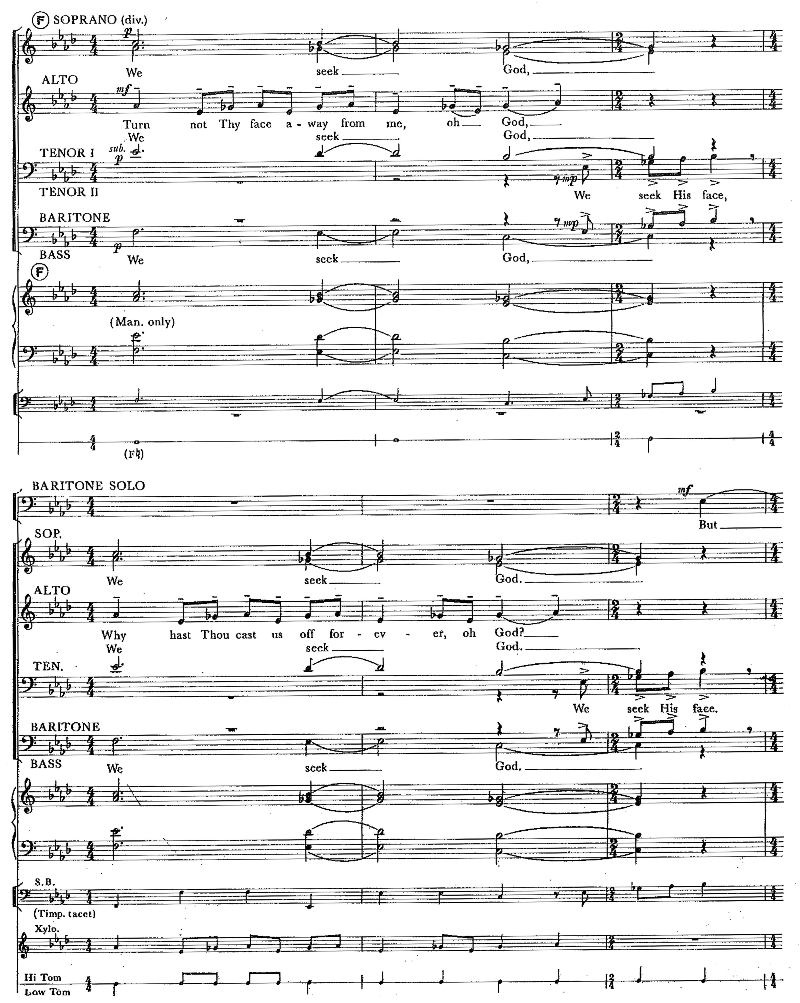 Figure 23, Movement VIIIb, mm. 47-52. Copyright © 1968 (Renewed) by Music Sales Corporation and Malcolm Music Ltd. International Copyright Secured. All Rights Reserved. Used by Permission.

The third section of Movement VIIIb also begins with the baritone soloist singing the primary melody once, and then again in an augmented rhythm as the two-part sopranos sing the melody in thirds in its original rhythmic configuration. The next sub-phrase (beginning in m. 104) sets Jesus in 5/4, singing the rhythmic pattern heard in multiple places throughout the oratorio (♩.+♩.+♩+♩), over the altos and sopranos singing the question and answer melodies of Figure 22, with the basses adding the six dotted quarter notes plus one quarter note pattern (♩.+♩.+♩.+♩.+♩.+♩.+♩) to the polyrhythmic texture (See Figure 24). Although the rhythms are complex they work together well and set an interesting groove. Likewise the text is no longer at odds with each other. All are focused on the same text organized in rhythmic counterpoint.
The fourth section of Movement VIIIb reduces the tempo and texture as the baritone begins quoting from Matthew 25: 34. In this passage of scripture Jesus is describing the final judgment of man. “And all the nations will be gathered before Him; and He will separate them from one another, as the shepherd separates the sheep from the goats.” In “Where is God?” Jesus beckons the followers forward, “Come, oh ye blessed of my Father. Inherit the Kingdom prepared for you.” The followers ask, “When did we see Thee hungry and give Thee food?” Brubeck dramatically states, with no motion from the chorus or orchestra, using the baritone soloist (mm.165-170), “Truly I say unto you, as ye did it for one of the least of my brethren, ye did it for me.” This idea followed by the dramatic block chord 5/4 section where the chorus reiterates the command of Christ to “Love one another as He loves you,” from John 13:34 is the ultimate answer that Brubeck sets to all of the preceding questions.
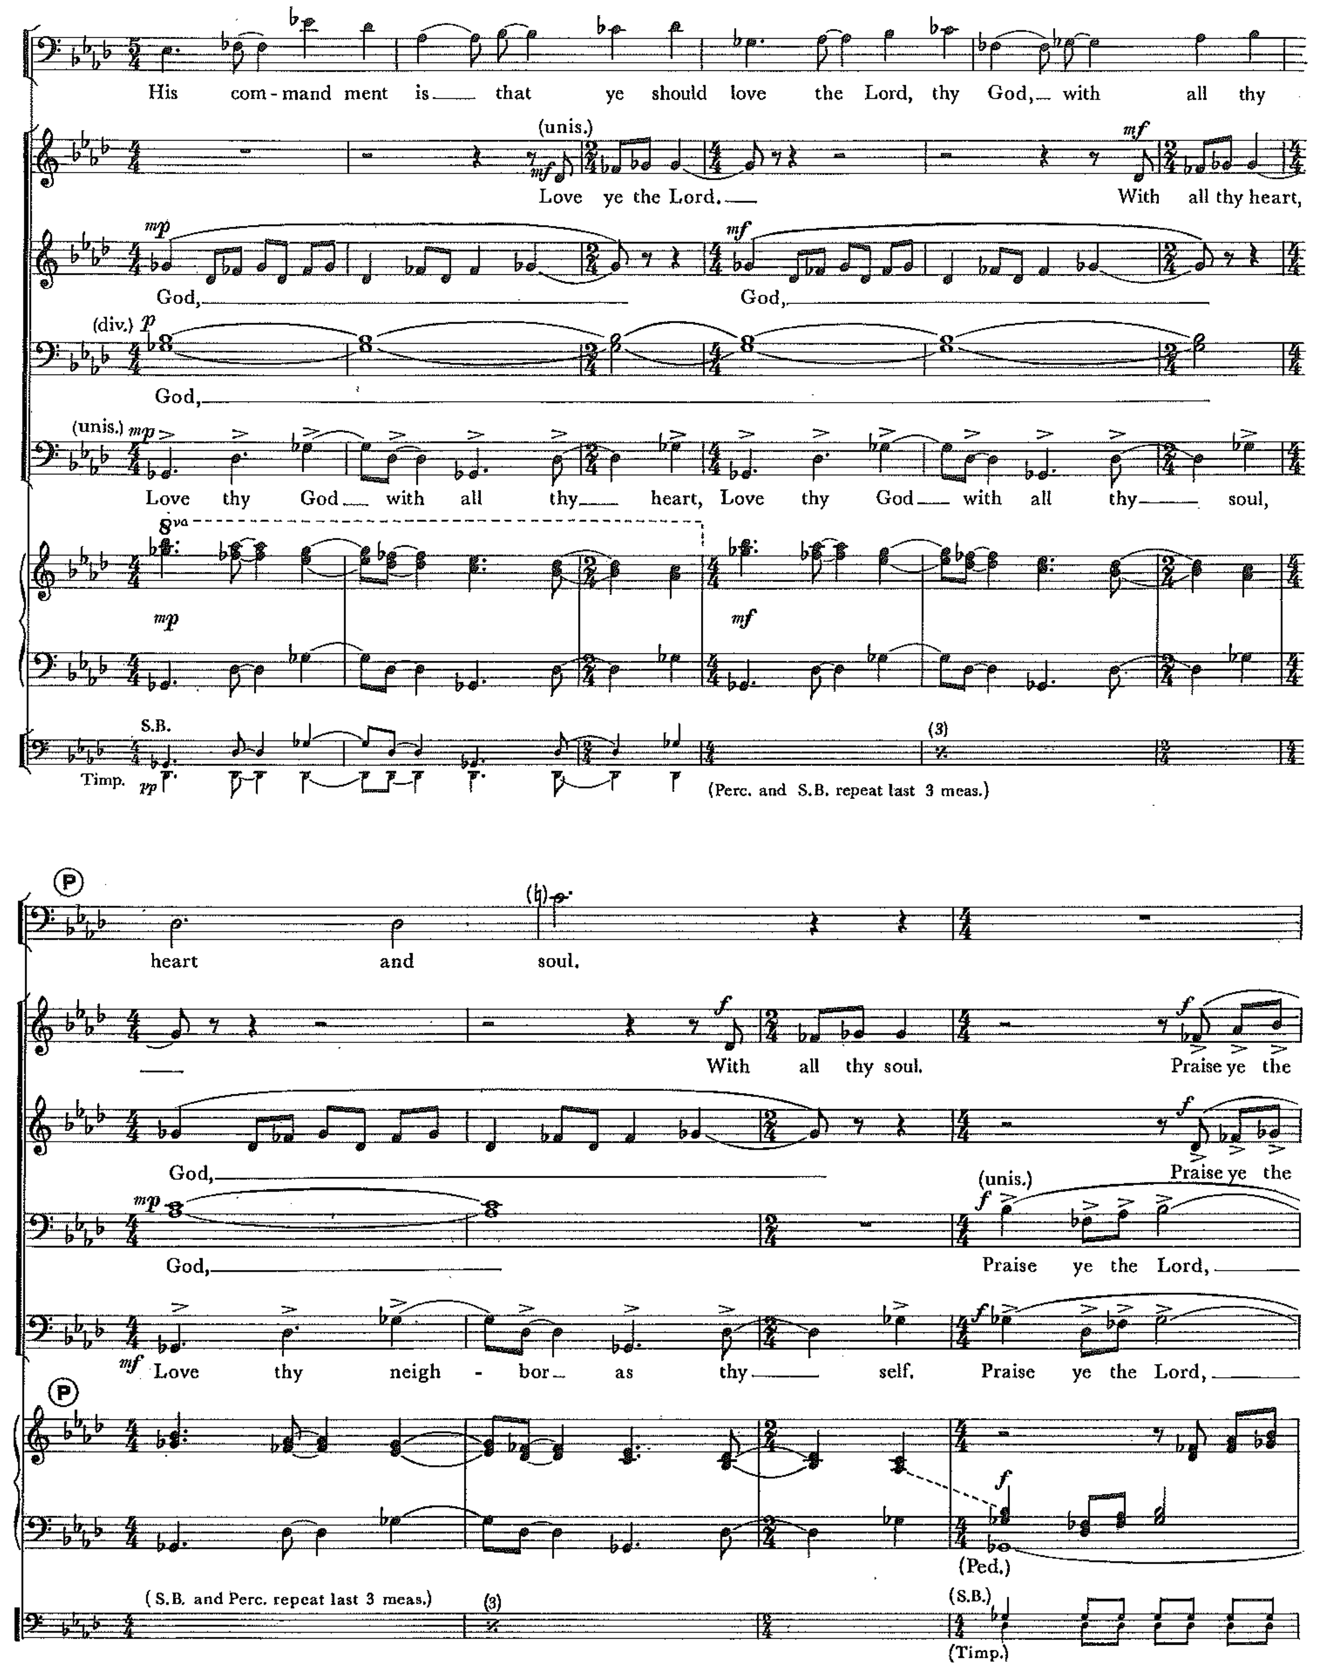 Figure 24, Movement VIIIb, mm. 104-113. Copyright © 1968 (Renewed) by Music Sales Corporation and Malcolm Music Ltd. International Copyright Secured. All Rights Reserved. Used by Permission.

The men sing Psalm 24 at the beginning of the movement. At the end Brubeck sets the same basic melody as a four-part chorale. The final question and answer end the movement, “Who shall stand in His holy place? He that hath clean hands and a pure heart.”
Movements VIIIa and VIIIb represent Dave and Iola Brubeck’s diagnosis of the human condition. As man grapples with his place in this world and his belief in God, the command to love stands firm. “In the accelerated pace of history, will the 21st century be known as the Age of Love? This is the generation of them that seek him.”

Chapter 7: Analysis of Part 2, Movements IX-X:

Meditations and Hope

Brubeck continues the mood with which he concluded “Where is God?” The turmoil of the crisis of belief has abated and Brubeck moves to meditations and promises provided to mankind by the savior and friend–Jesus.

Movement IX: “We Seek Him/Peace I Leave With You”

Movement IXa: “We Seek Him”- Choral Interlude or Improvisation
“We Seek Him” is an exquisite, albeit simple meditative movement that Brubeck labels as a Choral Interlude or Background for Piano Improvisation. It is made up of five measures total (See Figure 25). The harmonic material is comprised of Fm7, E♭m7, Cm7(♭5) or C half diminished, that was previously established in the 8+2 beat ostinato from “Where is God,” beginning in measure 47 (See Figure 23).
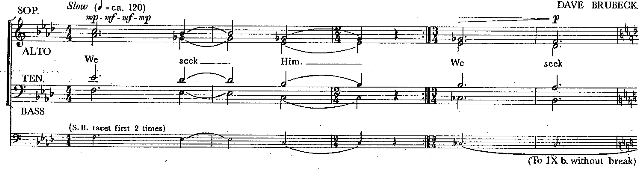 Figure 25, Movement IXa, mm. 1-5. Copyright © 1968 (Renewed) by Music Sales Corporation and Malcolm Music Ltd. International Copyright Secured. All Rights Reserved. Used by Permission.

In the instructions for improvisers, Brubeck asks the player to improvise freely using the F Phrygian scale as the basis. The improvisational colors possible under these simple conditions are rich. Dave Brubeck (in the original 1968 recording) and Darius Brubeck (in a 2016 live performance) each had similar approaches. They primarily focused their playing in the 5th and 6th octaves of the piano and used the pedal to create ethereal timbres over the choral ostinato. As with most of the improvisational moments in The Light in the Wilderness, there is freedom to dictate how many times the chorus should sing the initial three measures before proceeding. However, Brubeck mapped out the number of repeats in the full score and orchestral parts for the option of playing IXa as a choral interlude with no improvisation or as backgrounds to the piano improvisation (See Table 20). Upon playing the desired number of repeats the ensemble plays the final two measures and moves seamlessly to movement IXb without break.
Table 20. Movement IXa- Repeat Structure
Choral Interlude (no improvisation)  Play first 3 measures 4 times: | Background for Improvisation  Play first 3 measures 8 times:
(1) Chorus alone | (1-4) Chorus alone
(2) Chorus with Strings (and harp) | (5) Chorus with Brass
(3) Chorus with Woodwinds | (6) Chorus with Strings (and harp)
(4) Chorus with Strings and Woodwinds | (7) Chorus with Woodwinds
(8) Chorus with Strings, Woodwinds,
and Brass

Movement IXb: “Peace I Leave With You”- Baritone Solo
“Peace I Leave With You,” is a 26-measure baritone solo, using a twelve-tone melody, that serves as a recitative to “Let Not Your Heart be Troubled.” Interestingly, the text of Movement IXb, which sets up Movement X, comes from John 14: 27, while the majority of the text from Movement X comes from earlier in the same chapter, John 14:1-3. Harmonically and melodically Brubeck uses the same musical material here that he did in the organ solo in measures 12-37 of “Interlude: Fantasia on ‘Let Not Your Heart be Troubled,’” (See Figure 26). This slow, somewhat haunting, melody is set similarly to Movement VIIIa, but here the triplet arpeggios provide motion and a sense of ascension. The transition between IXa and IXb should not be understated. After the Fm7, E♭m7, Cm7(♭5) ostinato pattern is played for the last time, Brubeck moves from Cm7(♭5) to C♭Maj.7, to B♭m7, and then transitions directly to CMaj.7 in the first measure of IXb. The baritone soloist begins dissonantly, on a B♮ (a major seventh from the root), yet he still creates an ascending affect completed by the accompanimental arpeggiation–played by the bass clarinet–and the ascending chromatic open fifths in the low strings. In the final eight measures Brubeck writes an accelerando that ultimately arrives at the tempo of “Let Not Your Heart be Troubled.”
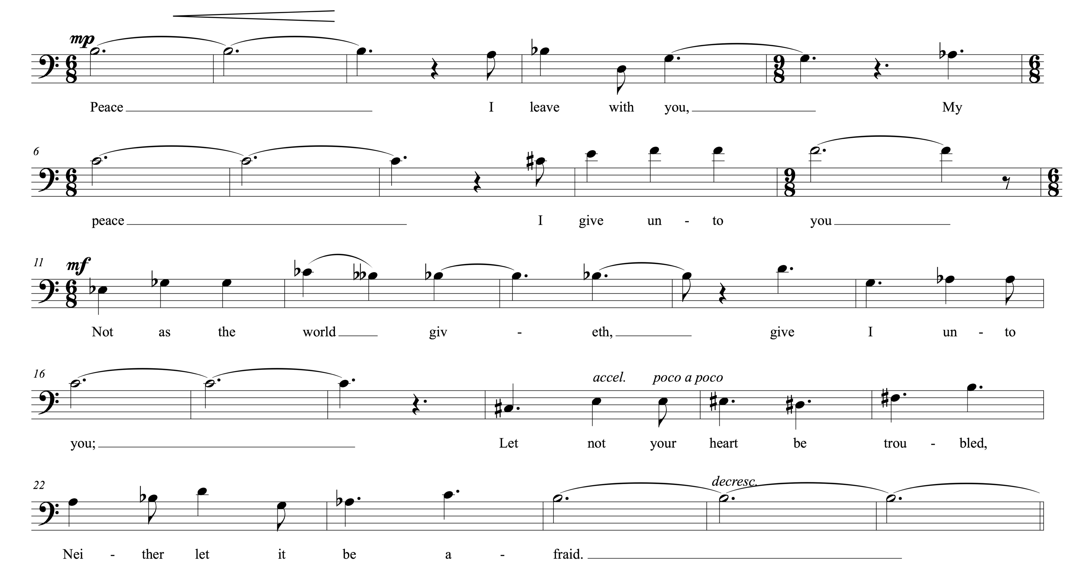 Figure 26, Movement IXb, mm. 1-26, Baritone Melody. Copyright © 1968 (Renewed) by Music Sales Corporation and Malcolm Music Ltd. International Copyright Secured. All Rights Reserved. Used by Permission.

Movement X, “Let Not Your Heart be Troubled”
“Let Not Your Heart be Troubled” was the first movement written for The Light in the Wilderness and it played an important role in influencing the composition as a whole. Brubeck composed “Let Not Your Heart be Troubled” for the memorial service of his nephew in 1965. Brubeck was very dedicated to his family. The tragedy, as Chris Brubeck describes, led Dave to Christ’s teachings in John 14.
We had a cousin named Phil that was the son of Dave’s older brother Howard… Phil was very athletic and was on the track team. He was doing very well. I can’t quite remember if it was his junior year or senior year, in any case, one day he complained to the track coach, “I’m sorry coach. I have such a killing headache that I can’t do this run.” The next day he went into the hospital doing tests and it turned out that he had a brain tumor. Not only was it horrible because he was sick and going to die from it, but it was one of those things where my uncle and his wife… had to make that horrible decision between keeping their son alive by machines for a long time, or letting him go because his brain is so destroyed by this tumor. That was the motivation to start writing “Let Not Your Heart be Troubled.”

The formal sections of “Let Not Your Heart be Troubled” are similar to what has already been discussed concerning “Interlude: Fantasia on ‘Let Not Your Heart be Troubled’” in Chapter 7. The melodies from Figure 19 are equally relevant to Movement X.
Jesus closes “Peace I Leave With You” with the phrase, “Let not your heart be troubled, neither let it be afraid.” Echoing Jesus’ words, Brubeck instructs the sopranos to sing the opening melody of Movement X in a “child-like” manner. “One by one, each section of the chorus joins the child-like theme and together complete the words from John 14:1, ‘believe also in me.’” The text is simple throughout and comes entirely from John 14:1-3. The simplicity is what truly is on display.
As a child, I did not question the literal meaning of the many mansions in my Father’s house. I am not sure of the true meaning of this passage now (although I’m sure the many mansions are as figurative as Buddha’s many ladders to heaven), but the child’s faith remains.

The dance-like buoyancy of this movement furthers the desired affect. The chorus establishes the opening theme over a pedal G, with slight rhythmic and harmonic additions from the orchestra. The accompaniment then begins to take on the vibrancy of the simple three against two hemiola that the listener expects from Brubeck, this time over alternating G major and E major chords (See Figure 27). After the baritone soloist introduces the “In my Father’s house” secondary melody (See Figure 19), Brubeck returns to his polychordal tendencies complete with, the now familiar, contrary motion. As the chorus and baritone sing “I go to prepare a place for you” at the fortissimo dynamic level, Brubeck has the baritone soloist, along with the sopranos and altos descend as the tenors and basses ascend using the following polychordal progression: A♭/B♭, C/D, B♭/E♭, A♭/F, B♭7/C, E♭, G (See Figure 28). “The men of the chorus take up the phrase ‘in my Father’s house are many mansions’ as an ostinato for and instrumental improvisation.’”
For this particular improvisation, Brubeck outlines a specific length of 32 measures (See Figure 29). As is the case with many of the improvisational moments in The Light in the Wilderness, the number of measures for the improvisation are at the conductor and improviser’s discretion. The rhythmic ostinato maintains the dotted-quarter 6/8 groove, but Brubeck repeats that pattern in five-measure phrases, rather than a more typical four or eight. The improvised section in Movement X, along with most of the improvised moments (particularly those that are written over repetitive ostinato patterns), are free for tremendous exploration. The groove itself can be manipulated within the written rhythmic framework. In the 1968 recording, Dave Brubeck played alone. He quoted material from rehearsal letter ‘N’ using polychords and triplets. He also made it swing as he transitioned to a more single line, melodically linear approach. In a 2016 live performance, featuring The Brubecks Play Brubeck Quartet, the entire quartet participated in the improvisation during “Let Not Your Heart be Troubled.” Each time the quartet played this movement, whether in rehearsal or performance, it took on a different rhythmic groove. One time it would swing, another time it would adopt a more polyrhythmic 6/8 groove, yet again it was a subtle 12/8-shuffle feel with a light backbeat. Dan Brubeck referred to this moment and his approach to improvising on the drum set during Dave’s more “Classical” works.
The improvised sections I truly see as improvised. Having done this with Dave a number of times, he would take it in a lot of different directions… Any open sections, like the one you mentioned [“Let Not Your Heart be Troubled”], I feel free to get creative. Some nights certain things work better than others, and you may discover that something may work a lot better than if you would have kept to the same thing.

After the improvised section, the chorus begins a canon on the “In my Father’s House” primary melody from Figure 19 (See Figure 30). The counterpoint unfolds and leads to a dramatic subito pp moment in measure 101, as the men of the chorus along with the baritone soloist begin the “I go to prepare” melody from Figure 19. Brubeck then combines the two melodies beginning in measure 120. The sopranos and altos, singing in octaves with the sopranos soaring to a high C, sing the “In my Father’s house” primary melody while the tenors, basses, and baritone soloist sing the “I go to prepare” melody. Brubeck closes the movement with the original “Let not your heart be troubled” melody punctuated by the baritone soloist having the final words, “Believe also in me.”
Movement X is dramatically climactic while remaining joyous. The distinct message portrayed by both Movements IX and X is one of peace and comfort. Recalling that The Light in the Wilderness was originally titled, “The Teachings and Temptations of Christ,” Brubeck wanted to remind the listener that the compassion of Christ is an important hallmark of what He offers to his followers. Jesus’ revolutionary ideas and commands, as portrayed in Part 1, are then fulfilled in His peace and promise of a future without war and pain.
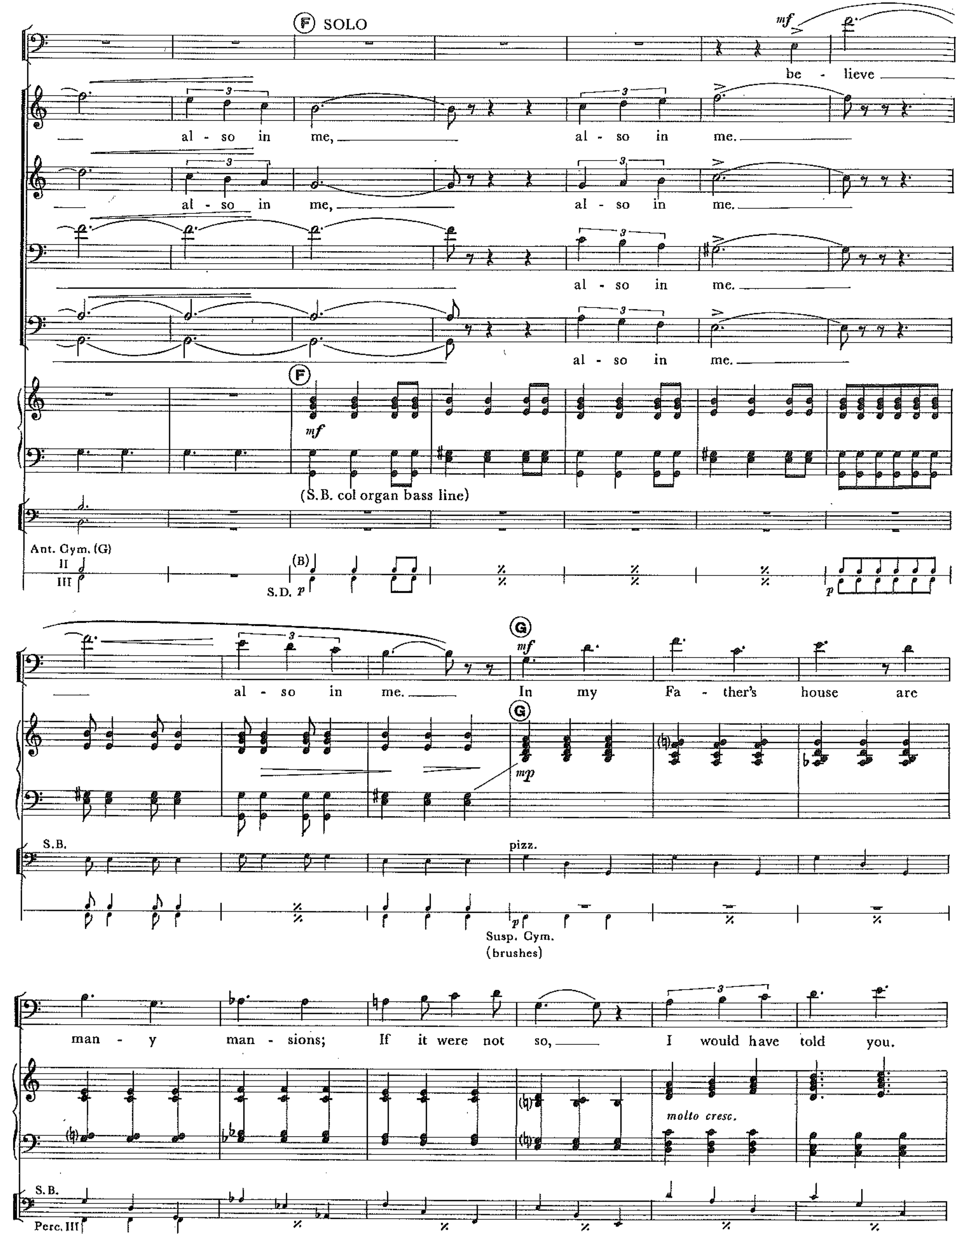 Figure 27, Movement X, mm. 32-50. Copyright © 1968 (Renewed) by Music Sales Corporation and Malcolm Music Ltd. International Copyright Secured. All Rights Reserved. Used by Permission.
Table 21. Form Chart of Movement X

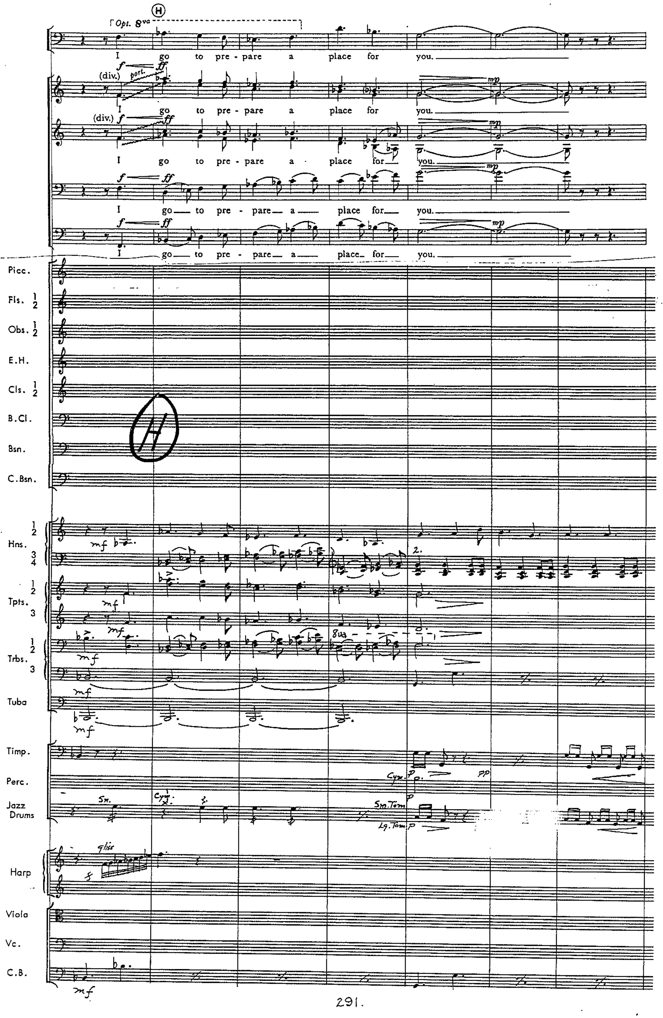 Figure 28, Movement X, mm. 51-57. Polychordal progression with contrary motion. Copyright © 1968 (Renewed) by Music Sales Corporation and Malcolm Music Ltd. International Copyright Secured. All Rights Reserved. Used by Permission.
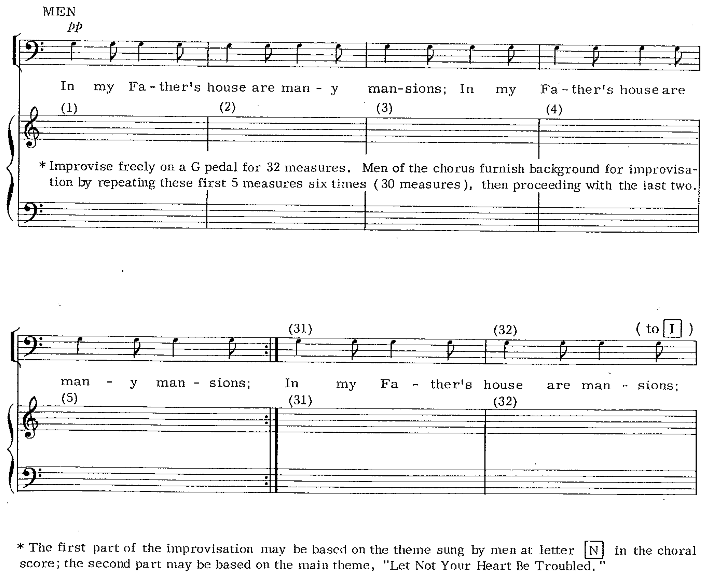 Figure 29, Movement X, mm. 63-69, Improvisational Guide. Copyright © 1968 (Renewed) by Music Sales Corporation and Malcolm Music Ltd. International Copyright Secured. All Rights Reserved. Used by Permission.

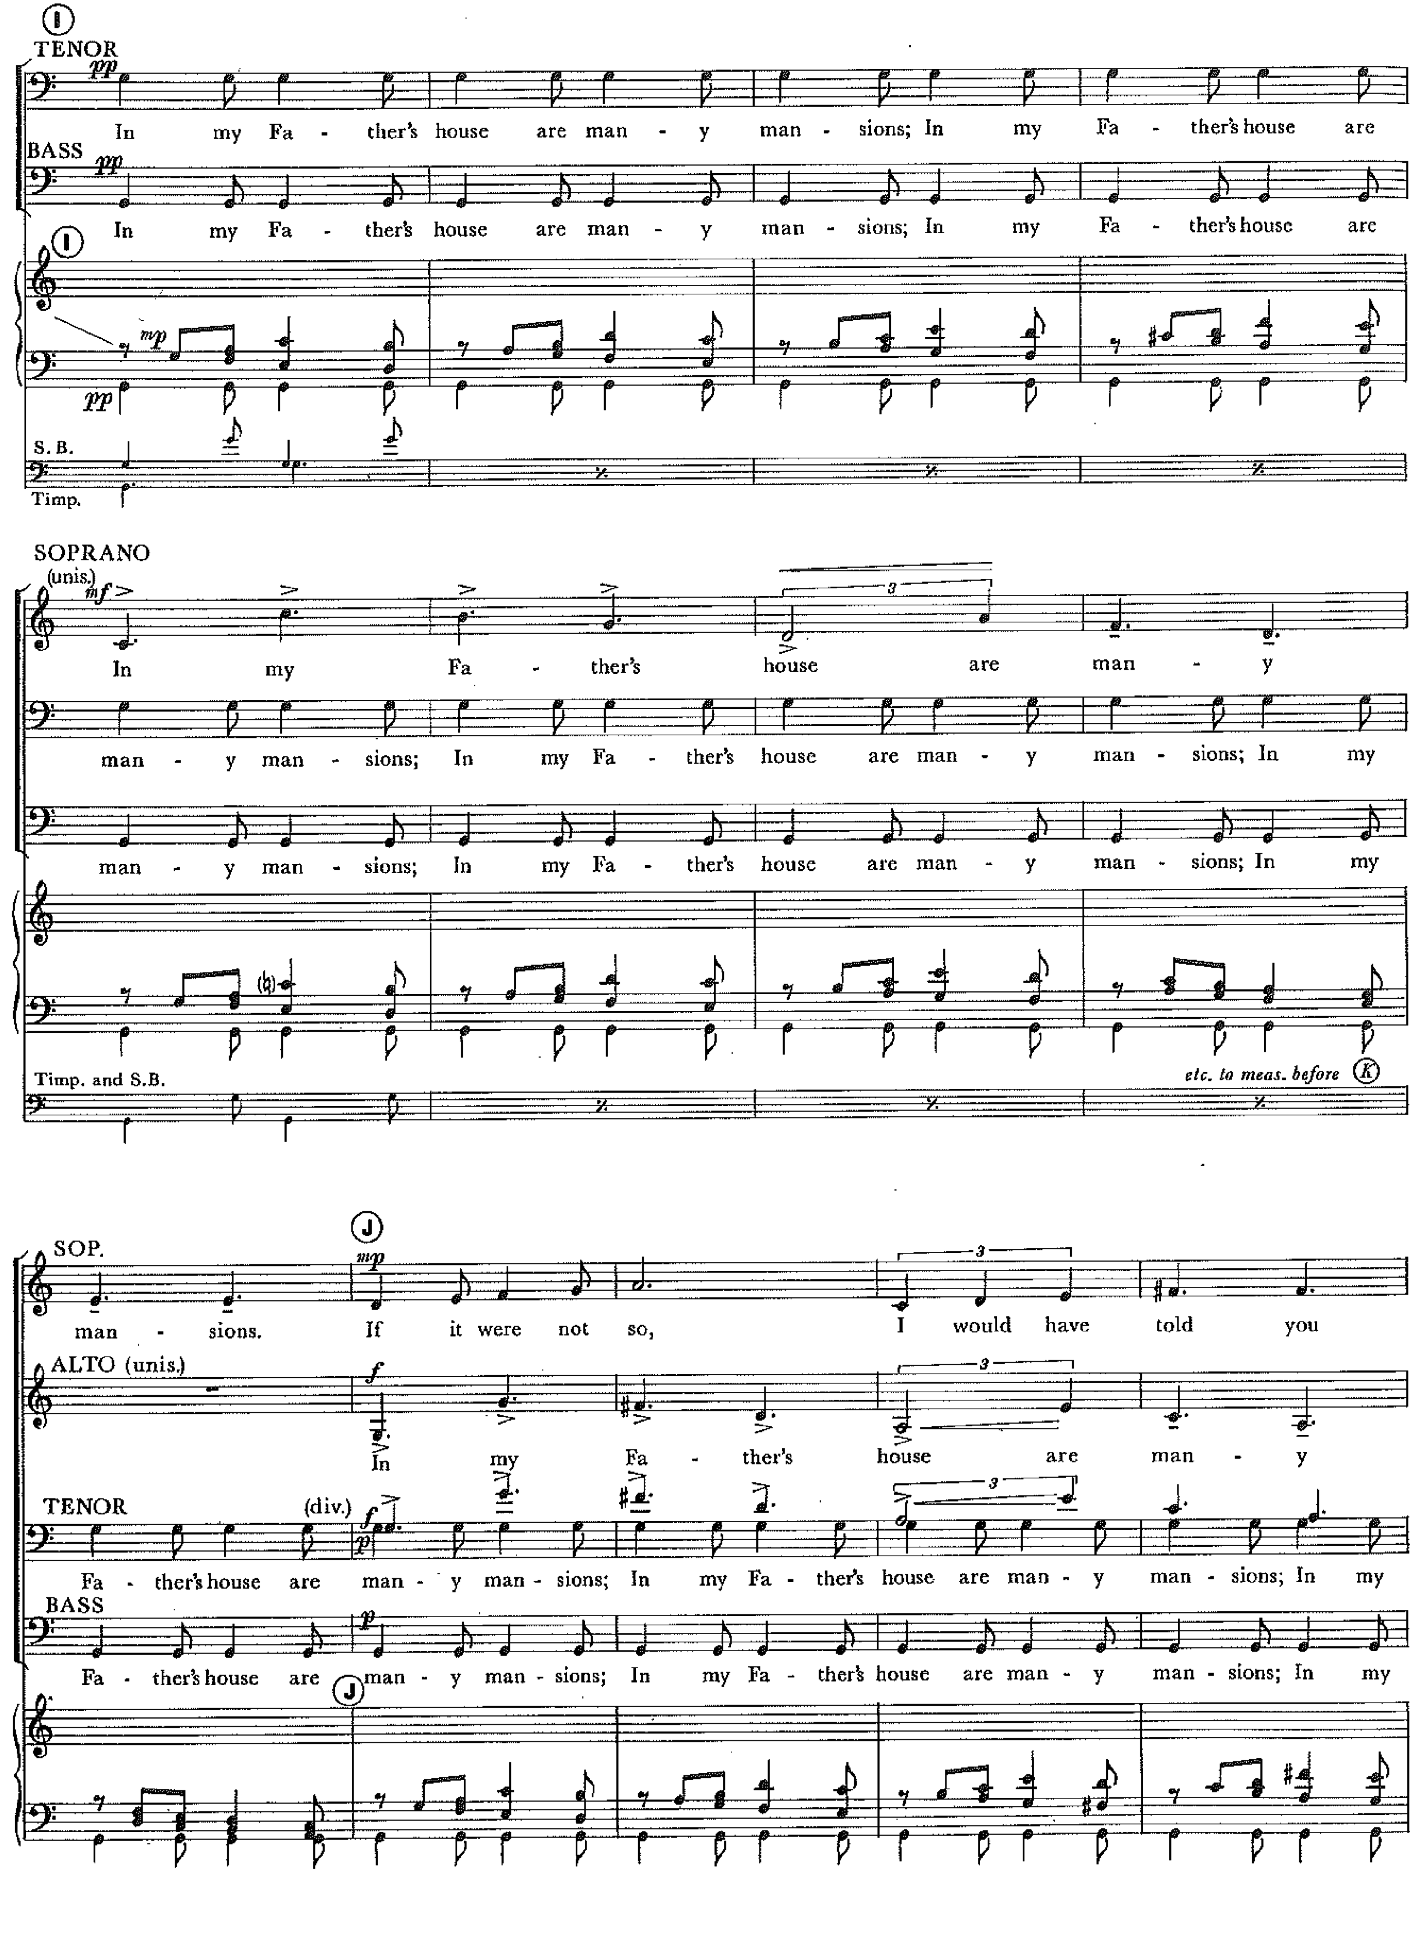 Figure 30, Movement X, mm. 70-82. Fugal/contrapuntal melodic usage. Copyright © 1968 (Renewed) by Music Sales Corporation and Malcolm Music Ltd. International Copyright Secured. All Rights Reserved. Used by Permission.

Chapter 8: Analysis of Part 2, Movements XI-XII:

Exhortations and Praises

Movements XI and XII consist of two conclusions for The Light in the Wilderness. “Yet a Little While” is Jesus’ final command, while “Praise Ye The Lord” is man’s ultimate response. Presenting Christ’s plea to walk as children of light leads to the validation and confirmation of the infinite universe and, by implication the affirmation of all life.

Movement XI: “Yet a Little While”
The penultimate movement consists of four phrases delineated by text along with harmonic and rhythmic treatment. The opening phrase is Christ alone speaking over echoed backgrounds. The second phrase uses the text “Lest darkness come upon you.” The third phrase sees the return of “Yet a Little While” featuring one of the most dramatic musical moments in The Light in the Wilderness. The final phrase is the last time the listener hears from the baritone soloist, so Brubeck spotlights his final four measures over a static accompaniment in both chorus and orchestra.
Table 22. Form Chart of Movement XI
The text for Movement XI comes from John 12:35-36. Jesus spoke this text after his triumphal entry into Jerusalem, when he predicted his death to a crowd that had gathered. Their confusion led him to the text for Movement XI.
Yet a little while is the light with you. Walk while ye have the light, lest darkness come upon you: for he that walketh in darkness knoweth not whither he goeth. While ye have light, believe in the light, that ye may be the children of light. These things spake Jesus, and departed, and did hide himself from them.

Movement XI again uses a twelve-tone row as the basis for the melody. As we have seen in the other instances of Brubeck’s twelve-tone melodies, he uses it in its original form exclusively. In the first phrase (mm. 1-8) Brubeck sets the serial melody over a series of ascending quartal chords that eventually turn tertian. In measure eight, leading to the, “Lest darkness” phrase, Brubeck begins a B♭ to C alternating sixteenth-note pattern in the timpani and low strings that turns into an eighth-note pattern sung by the chorus, thus creating an ominous foreboding alluding to the “darkness.”
In measure 20, Brubeck returns to the texture from measure one. The chorus again echoes the melody with important words from the baritone soloist’s text. In measures 24-28, he sets John 12:36 in the chorus while the baritone soloist continues to finish his earlier melodic idea. For the first time in this movement the chorus is adding to the narrative a new and complete thought, “Believe in the light, that you may be the children of light!” As the baritone soloist and chorus move together toward the word “light,” Brubeck creates an astounding moment in the oratorio (See Figure 31 and 32). For the first 25 measures of the movement the orchestra has played barely louder than piano. Beginning in measure 26, Brubeck adds the entire orchestra at pianissimo and slowly swells through a dramatic crescendo and allargando lengthening of the beat. The upper strings and woodwinds play an E♭ major triad that sustains until the final release (m. 33). On the downbeat of measure 28 the chorus, brass, and organ play an A♭ major chord over B♭. This can also be interpreted as a B♭9 sus4 chord. Brubeck resolves the B♭9 sus4 into A major on the downbeat of measure 29 with the baritone soloist, the trombones, and the celli sustaining E♭ until beat three of the same measure. The B♭9 sus4 creates tremendous tension and functions like a tritone substitution leading to A major. The ultimate tension is achieved in the half-step motion from B♭ and A♭ resolving to A♮, while the C♮ resolves to C#, creating tremendous pull for the E♭ to resolve upward to E♮. This resolution is an incredible, slow-motion lift to the heavens.
Brubeck’s musical treatment of the word light is reminiscent of Haydn who dispelled darkness with a sudden fortissimo shift from c minor to c major in his oratorio Die Schöpfung (The Creation). Not since the glorious blaze of light first streamed into the world in Haydn’s masterwork has there been a more dramatic and vivid musical depiction of light than the one created by Brubeck.

The sustained E♭ major chord in the upper strings and woodwinds maintains the polychordal nature of Brubeck’s writing. By this point, even as E♭ major is a tritone away from A major, the listener is accustomed to the added upper extensions, which create a shimmer on the final chord rather than creating more tension and unrest. In the final four measures the baritone soloist repeats the personal words, “Yet a little while is the light with you,” on a descending scale that may be interpreted as the second mode of D melodic minor. With this final statement the baritone soloist–singing as Jesus–concludes his incredible role in The Light in the Wilderness.

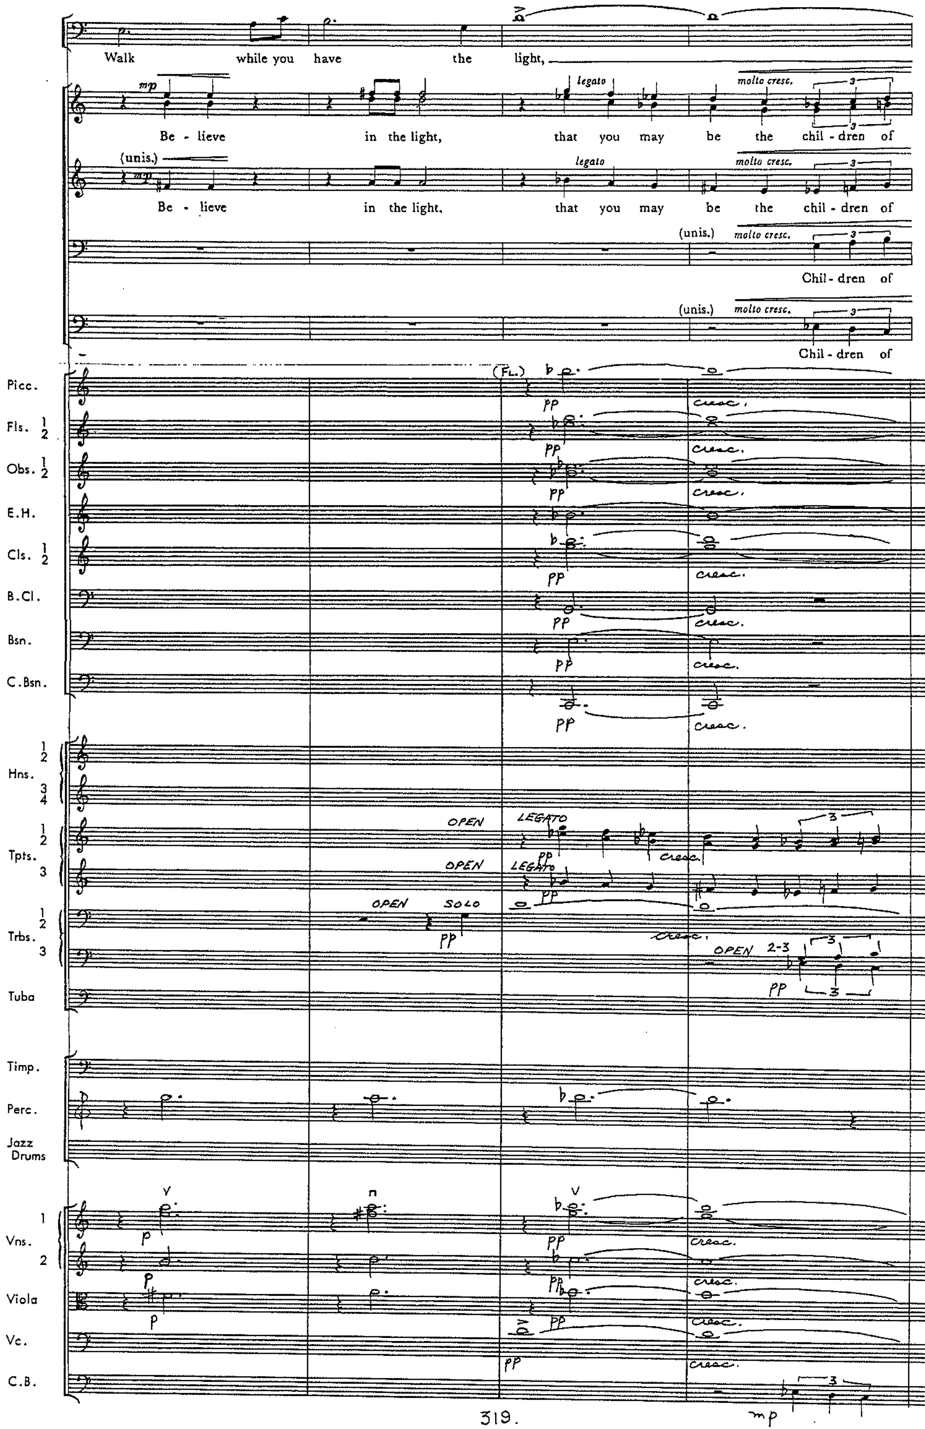 Figure 31, Movement XI, mm. 24-27. Copyright © 1968 (Renewed) by Music Sales Corporation and Malcolm Music Ltd. International Copyright Secured. All Rights Reserved. Used by Permission.
Figure 32, Movement XI, mm. 28-33. Copyright © 1968 (Renewed) by Music Sales Corporation and Malcolm Music Ltd. International Copyright Secured. All Rights Reserved. Used by Permission.

Movement XII: “Praise Ye the Lord”
The final movement of The Light in the Wilderness is a setting of Psalm 148 and serves as a celebration of all life. Brubeck calls Psalm 148 “a magnificent hymn to all creation and the almighty Creator.” In this movement, Brubeck’s ultimate compositional goal of composing and orchestrating the text is on display. He paints a vivid aural picture of the majestic close to this oratorio.
Table 23. Verse by Verse Breakdown of Psalm 148:1-13 (King James Version)
Verse | Text
Verse 1 | Praise ye the lord! Praise ye the Lord from the heavens; Praise him in the heights.
Verse 2 | Praise ye him, all his angels; Praise ye him, all his hosts.
Verse 3 | Praise ye him, sun and moon: praise him, all ye stars of light.
Verse 4 | Praise him, ye heavens of heavens, and ye waters that be above the heavens.
Verse 5 | Let them praise the name of the Lord: for he commanded, and they were created.
Verse 6 | He hath also established them for ever and ever: he hath made a decree which shall not pass.
Verse 7 | Praise the Lord from the earth, ye dragons, and all deeps:
Verse 8 | Fire, and hail; snow, and vapours; stormy wind fulfilling his word:
Verse 9 | Mountains, and all hills; fruitful trees, and all cedars:
Verse 10 | Beasts, and all cattle; creeping things, and flying fowl:
Verse 11 | Kings of the earth, and all people; princes, and all judges of the earth:
Verse 12 | Both young men, and maidens; old men, and children:
Verse 13 | Let them praise the name of the Lord: for his name alone is excellent; his glory is above the earth and heaven.

Table 24. Form Chart of Movement XII

The text is taken entirely from Psalm 148 (See Table 23). The beginning of the Psalm is an exhortation to whomever may listen. The psalmist is saying that no sentient being is exempt from the praise of the Lord. Brubeck begins Section I with the instructions in the score, “Triumphantly- as a great processional.” He is creating a scene which parades the different groups of beings and creatures before God whilst demonstrating the unity of creation. Right from the beginning Brubeck creates a sense of power and majesty. He continues to use polychordal progressions and even combines a quartal technique with one timbre and tertian polychords in another. In measures 9-16, Brubeck uses octave leaps to portray the sun, moon, and stars along with a descending chromatic line. His use of the flutes sustaining minor sevenths and major and minor sixths as they progress chromatically adds to the ethereal, “heavenly” timbre (See Figure 33).
The second section of “Praise Ye the Lord” (mm. 17-25) begins with verse five of Psalm 148. In measures 17-18 the basses have the melody accompanied by the strings, in measures 19-20 the tenors have the melody accompanied by the brass, in measures 21-23 the altos have the melody accompanied primarily by the woodwinds, and in measures 24-25 the sopranos have the melody accompanied by the strings, first trumpet, and first trombone. This is met with a dramatic shift in dynamics and tempo as Brubeck sets up the third section and the text painting that goes along with each creature or element (See Figure 34).
Movement XII has been a continual gathering of people and things that ought to lift up praises to God. Brubeck begins the final section (m. 46) with a pianissimo gathering of families and writes a continual crescendo over the next 12 measures (or 18 measures if using the alternative ending). Charles Spurgeon’s commentary on Psalm 148 encapsulates the essence of the psalmist’s and Dave Brubeck’s approach to this final section (Psalm 148:12-13 and mm.46-65):
Both sexes and all ages are summoned to the blessed service of song. Those who usually make merry together are to be devoutly joyful together: those who make up the ends of families, that is to say, the elders and the juveniles, should make the Lord their one and only end. Old men should by their experience teach children to praise; and children by their cheerfulness should excite old men to song. There is room for every voice at this concert: fruitful trees and maidens, cedars and young men, angels and children, old men and judges--all may unite in this oratorio. None, indeed, can be dispensed with: for perfect Psalmody we must have the whole universe aroused to worship, and all parts of creation must take their parts in devotion.

Figure 33, Movement XII, mm. 9-13. Copyright © 1968 (Renewed) by Music Sales Corporation and Malcolm Music Ltd. International Copyright Secured. All Rights Reserved. Used by Permission.
Figure 34, Movement XII, mm. 27-30. Copyright © 1968 (Renewed) by Music Sales Corporation and Malcolm Music Ltd. International Copyright Secured. All Rights Reserved. Used by Permission.

Chapter 9: Conclusion

After landing at Omaha Beach and being transported by train in a cattle-car, Brubeck was stationed in Verdun–at a place they called the “Mud Hole”–waiting to be assigned to the front. A truck from the Red Cross arrived with a piano in the back. When they asked if anyone played piano, Dave volunteered. This chance encounter led to Brubeck ultimately having his orders hidden by an officer named Leroy Pearlman, so Dave could lead an Army jazz band. This event likely saved his life, but as he continued through his time in the Army he had a front row seat to the tragedy of it all. In an interview given in 2009, Brubeck referred to the impact of the War, “You know I lived through World War II. In Europe. In Patton’s army. And that gives a young person – I was in my twenties – a different view of the world. Most people don’t realize that 60 million people were killed.” Dave’s dedication to his study of music and his ultimate success as a jazz artist equally led to his inspiration, but twenty-five years after his experience in World War II he decided the subject matter of his first major work would center on the themes he dealt with on troop trains and in mud holes.
The Light in the Wilderness premiered in January of 1968. While Brubeck was finishing his first large-scale sacred oratorio the world was in turmoil. In 1967 70,000 Vietnam War protesters marched in Washington D.C., U.S. astronauts were killed in Apollo 1 as the United States continued its race to the moon, there were regular reports about the conspiracy surrounding John F. Kennedy’s assassination, Muhammed Ali was stripped of his boxing title because of his refusal to serve in the military, and race riots broke out in Newark, Milwaukee, and Washington D.C. Throughout his life, Brubeck was disturbed by injustice. His experiences in the Army fighting against an enemy that was probably praying to the same God, his experience playing jazz gigs around the United States with one of–if not the first–integrated bands and being forced to cancel performances because of it, and his experiences traveling the world as a musical ambassador as sponsored by the U.S. State Department, all led him to the point of his first major choral and orchestral composition. A particular group or ensemble did not commission The Light in the Wilderness. This piece was exactly what he wanted to say and how he wanted to say it.
There are significant challenges to deal with in approaching a performance of The Light in the Wilderness. It is possible to perform Brubeck’s oratorio in its original orchestration–chorus, baritone soloist, organ, piano, bass, and percussion. Here the significant challenge lies in the difficulty of the choral parts. The density of the chromatic voicings can be quite demanding especially given the range that is required. The most difficult task falls on the sopranos. In Movement I they are asked to sing at an incredibly soft dynamic above the staff to create the desired affect. The tessitura then sits in that challenging place for a significant portion of the movement. Each of the voice parts are asked to sing to the extremes of their ranges similar to Beethoven’s Missa Solemnis. Members from other sections can be added to certain lines to bolster passages–a select group of tenors can double low alto lines, a select group of altos can double high tenor lines, etc. The difficulty of range can be attributed to Brubeck’s inexperience with choral writing. In Fred Hall’s biography of Brubeck, Dave talks about his approach to writing for voices,
I wasn’t really aware enough of the ranges, so I looked them up in a book. They had sopranos from middle C to high C above the staff, and so my first piece had high Cs for all the sopranos. Some choral directors would look at the score and decide it couldn’t be done; others got their soprano sections to sing this high C. Now, of course, I rarely write that for a soloist, but when the entire soprano section hit that high C, it became my favorite choral sound in the entire piece.

Upon completing his score, Brubeck sent a copy to Darius Milhaud. Milhaud, always the encourager and teacher, replied with hopes to hear it upon returning to the United States. At the very end he asks Dave why he wrote the tenor part in the bass clef rather than treble clef (See Figure 35).
An additional challenge is finding a baritone soloist that is capable of the vocal demands of the role of Jesus that Brubeck has set. The drama and power required is that of a Wagnerian baritone that can project through tremendous forces. Additionally the soloist must be able to sing difficult, angular lines built chromatically or atonally with impeccable intonation. There are multiple moments that require the baritone soloist to find beginning pitches through difficult harmonic contexts and enter with confidence. It is ideal to have the baritone soloist rehearse with the choir on multiple occasions because of the intertwining nature of the parts.
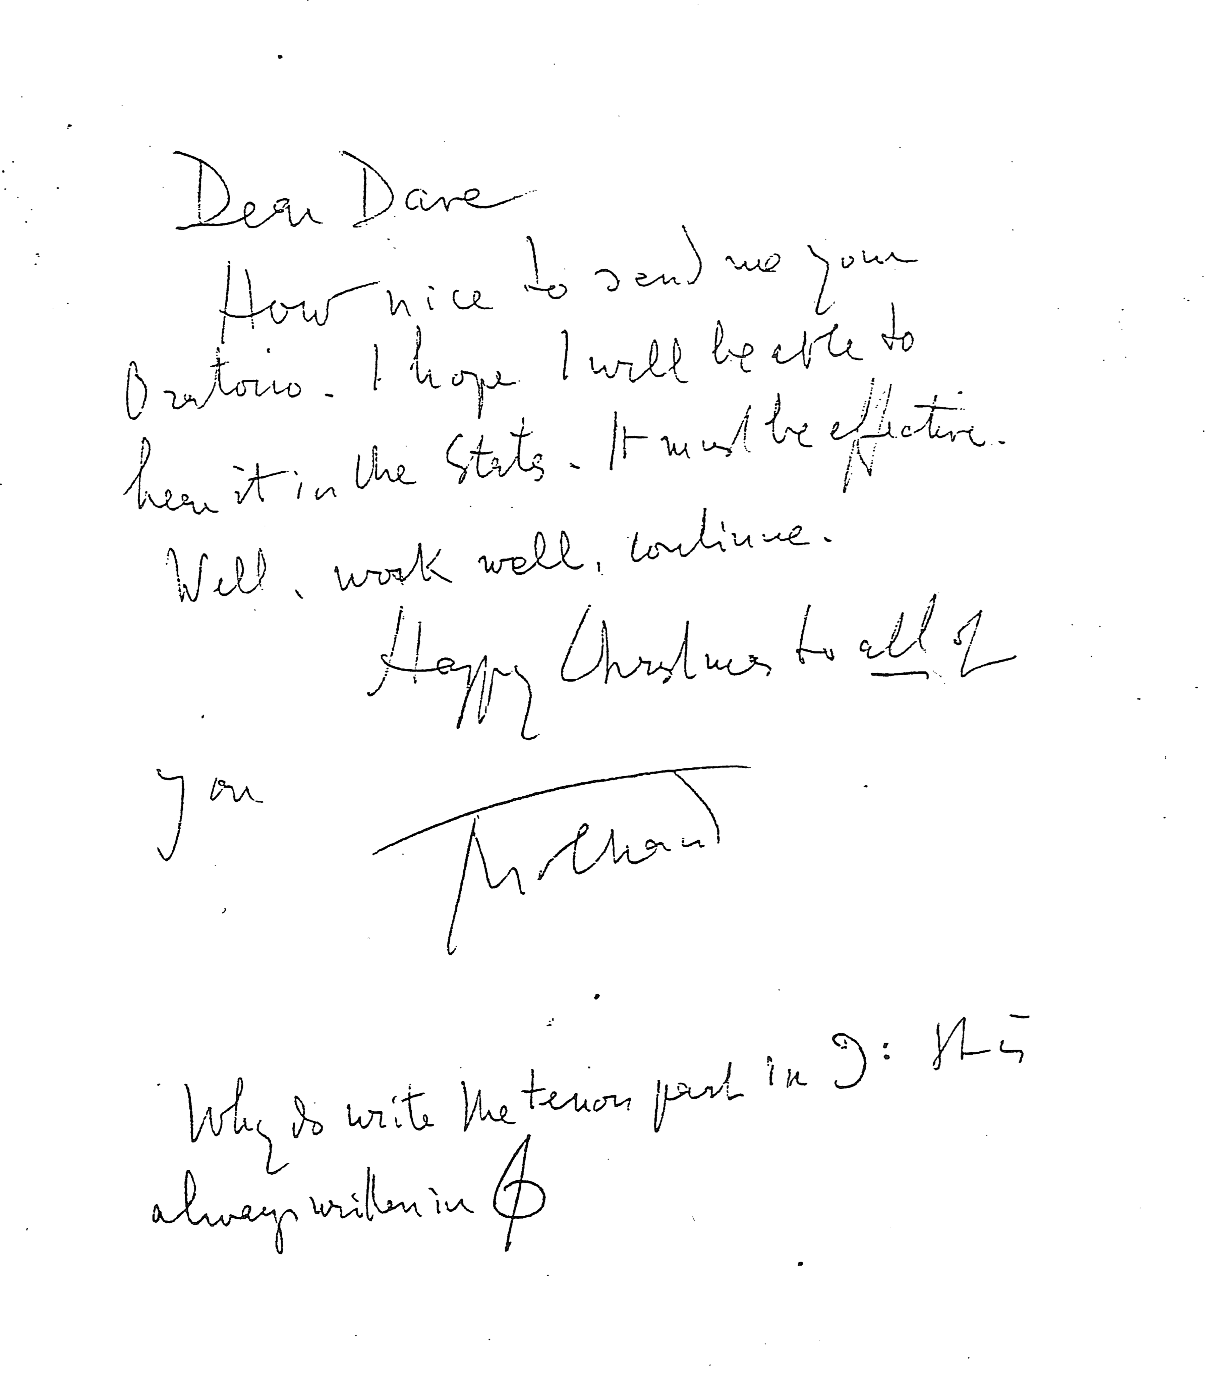 Figure 35, Letter from Darius Milhaud to Dave Brubeck
In order to accomplish a performance of the fully orchestrated work one must have numbers similar to those required in the chorus and orchestra for Verdi’s Requiem. There must be an adequate space to allow the large symphony orchestra to share the stage with a jazz trio/quartet, baritone soloist, an organ, and a large SSAATTBB choir. Obtaining the proper balances given this configuration is equally challenging. Darius Brubeck illuminates some of this struggle.
I think there is a challenge and a flaw in the whole thing…it is simply this, how do you really set up a choir, an orchestra, and a jazz group with a rhythm section so that everything balances naturally?

Proper use of sound reinforcement makes a tremendous difference and is likely required on the majority of the instrumental sections along with the chorus, baritone soloist, and jazz players. Therefore, a sound engineer that understands the proper balances and timbral demands is equally important.
The orchestral parts look deceptively simple. The challenge lies in making everything line up rhythmically and maintaining proper intonation, as parts are often playing dissonances that are uncommon in standard orchestral repertoire. The instrumental parts that are available to rent are handwritten copies. The conductor must clarify edits and explain the instrumentation choices for improvised sections. The conductor must also demand the proper interpretation of dynamics and sensitivity to the desired message. With the orchestration in mind, Brubeck’s timbral brilliance is a real highlight of The Light in the Wilderness. He paints a beautiful picture with sound and his orchestration is so deliberate and ideal for portraying the text. The coloration of the fully orchestrated sound is worth the challenge of mounting a performance. When discussing the option of performing The Light in the Wilderness with chorus, organ, piano, bass, and drums versus the fully orchestrated version, Darius Brubeck offers this opinion:
I think the real inspiration for Dave was the whole tutti. He was after that kind of impact. He was after a Beethoven 9th Symphony or a Shostakovich 5th Symphony. Not in style of course, but something that would take an audience to a different level. He wanted to make something that would be an emotional and spiritually uplifting experience that would make them look at their lives differently. He was going much further than trying to just present a piece of music.

The idea that The Light in the Wilderness was indeed Dave Brubeck’s first major choral work is largely what makes it so powerful. His inexperience with some of the musical elements is vastly overshadowed by the story that is conveyed in the brilliant marriage of melodic theme, harmonic and rhythmic complexity that somehow remains attainable for the listener, real-time improvised meditations, and a scriptural message that is unwavering. Dan Brubeck discusses the challenges and the ultimate greatness of his father’s oratorio.
In a way he kind of over wrote it. It is not an easy piece to recreate and put back together. The requirements of a full symphony and large choir make it very difficult for it to be performed. As time went on he became more aware of that. He thought that if he ever wanted his pieces to be performed he would have to simplify things. In that way [The Light in the Wilderness] is really organic. It is really what he wanted to do without any kind of thought about what it would really take to have it performed. Erich Kunzel was really giving him free reign. Dave was really grateful that Erich was so willing to do what Dave really wanted to do… I’ve found with a lot of artists that I’ll hear a record that they did early on and then anything you hear from them after that it sounds like an off shoot of whatever it was that they originally had been brewing on… That was true for Dave classically.

Composers such as Copland, Gershwin, Bernstein, Milhaud, and Ellington, have created a long line of compositions fused with elements associated with jazz into serious concert music. Jazz, like the term “Classical,” is an ambiguous label. Comparing Louis Armstrong’s swing with Ornette Coleman’s free jazz illuminates the great diversity that exists under the umbrella of the jazz genre. The jazz elements in The Light in the Wilderness are not stereotypes of style used as a caricature, but part of the diverse, all-inclusive message that Brubeck created. Brubeck was truly an innovator. His ability to create complex polyrhythmic patterns as the basis for dense polychordal progressions that became accepted by the performers and the listener shows his true genius.
The addition of improvisation by the jazz trio/quartet plays a vital role in the experience of attending a performance of The Light in the Wilderness or any number of Brubeck’s other large-scale works. Each individual improviser is given the opportunity to freely compose their commentary on the musical moment at hand. The compositional space allowed for improvisation gives the piece a vitality that makes it very much a new creation with each performance. In the words of Chris Brubeck, “it gives the piece the ability to always be fresh and recreated in the moment as opposed to literally a re-creation like a civil war reenactment.” Twenty percent of the overall performance is devoted to improvisation in The Light in the Wilderness. With the inclusion of the diverse improvisational moments the artists have the unique ability to color the entire performance with their own personal approach to the many themes presented.
The 20th-century opened the door to great diversity in music composition. Igor Stravinsky, Arnold Schoenberg, Darius Milhaud, Paul Hindemith, and Aaron Copland were all contemporaries of Brubeck who wrote large-scale ballets, operas, and oratorios. Like his contemporaries there were times that Brubeck met resistance and faced tough criticism, but his music was incredibly popular. Brubeck’s ability to meld style and compositional techniques into a piece that gave the most disciplined musician and the average listener significant material that was aurally attainable is arguably his most important contribution. Chris Brubeck discusses the reasons why The Light in the Wilderness in particular is deserving of further performance and a place in the catalog of great 20th-century oratorios.
In a magical and mystical way it really works as a powerful, original statement of music. I don’t think that Kunzel would have invested all of the energy he did to take it on tour in Europe and get the kind of reviews that it did unless there was something substantially there. When I get a chance to play it, like I did with you, I feel that there is so much of his heart and soul that it is like having a visitation, from beyond this planet, from my dad. I know that it is music, but it is imbued with so much spirit and spirituality from his perspective.

Brubeck absorbed music of celebrated composers like Bach, Debussy, and Chopin under the guidance of his mother, the classical pianist. In 1942 he was drafted into World War II and lost countless friends. He made a vow that if he survived the war that he would write a piece of music that shared the true teaching of Jesus–to “Love your enemies.” After World War II he studied with Milhaud on the G.I. Bill and was encouraged to explore a variety of musical cultures. Brubeck relentlessly pursued music through difficult times with little money for his family. He found musical partners, both white and black, that became like family and created music that no one had ever heard before. In 1958 he was asked by the U.S. State Department to become a cultural ambassador and conversely traveled the world attempting to ease tensions amidst Cold War animosity. While touring through the United States with his integrated quartet, he was forced to cancel performances based on his principles of integration and civil rights. Brubeck witnessed the tumultuousness of the United States in the 1960s through the John F. Kennedy assassination, the Vietnam War, and continuing civil rights unrest. Brubeck’s approach to The Light in the Wilderness was message based. “He wasn’t thinking about the overall structure in advance... He was thinking about what he wanted the music to convey to an audience… The text didn’t fit into the music the music was built around the text.” Dave Brubeck’s The Light in the Wilderness stands under the scrutiny of compositional quality and substance, and when the message is understood, it drives to a conclusion that challenges the listener to come to terms with ones own ability to “do good to those who hate you.”

Bibliography

Anderson, David E. “Dave Brubeck’s Sacred Music: ‘Composition as a Prayer’,” The Huffington Post, December 7, 2012. Accessed March 20, 2017. http://www.huffingtonpost.com/2012/12/07/dave-brubeck-sacred-music_n_2255533.html
Anthonissen, Juul. “An International Perspective: The Man and His Music,” Dave Brubeck Time Signatures: A Career Retrospective. New York: Columbia, 1992.
Beato, Rick. “How to Use Quartal and Quintal Harmony and Melody in Your Compositions.” Filmed (September, 2016). YouTube video, 31:32. Posted (September, 2016). https://youtu.be/DlML3adH9yQ.
Birtwistle, Andy. “Marking Time and Sounding Difference: Brubeck, Temporality and Modernity,” Popular Music, Vol. 29, No. 3 (October, 2010): 351-371.
Brubeck, Chris. Interview with Jim Graves. Personal interview. Bethany, Oklahoma, July 19, 2016.
Brubeck, Dan. Interview with Jim Graves. Personal interview. Bethany, Oklahoma, April 14, 2017.
Brubeck, Darius. Interview with Jim Graves. Personal interview. Bethany, Oklahoma, July 1, 2016.
Brubeck, Dave. The Light in the Wilderness. Delaware Water Gap, PA: Shawnee Press, 1968.
–––. Notes for Dave Brubeck’s The Light in the Wilderness, an Oratorio for Today. Performed by the Miami University A Cappella Singers and the Cincinnati Symphony Orchestra with Dave Brubeck at the piano. Directed by Erich Kunzel. Decca Records DXSA 7202, 1968, LP.
–––. Interviewed by Nick Spitzer. American Routes with Nick Spitzer: Songs and Stories from the Road. HighBridge Audio 797625. CD. 2008.
Brubeck, Dave and Iola Brubeck. Interview with Shane Sutton. “Dave and Iola Brubeck on jam sessions in India and Turkey in 1958.” Brubeck Oral History Project. 3:56. 2007. http://digitalcollections.pacific.edu/cdm/singleitem/ collection/brubeckoral/id/11/rec/4
–––. Interviewed by Shan Sutton. “Dave and Iola Brubeck on The Light in the Wilderness and the use of spiritual themes in their compositions.” Brubeck Oral History Project, 3:25. 2007. http://digital collections.pacific.edu/cdm/ singleitem/collection/brubeckoral/id/31/rec/10
–––. Interviewed by Shane Sutton. “Dave and Iola Brubeck on The Real Ambassadors and working with Louis Armstrong.” Brubeck Oral History Project,11:05. 2007. http://digitalcollections.pacific.edu/cdm/singleitem/collection/brubeckoral/id/33/rec/11
Buchanan, Heather J. and Matthew W. Mehaffey, ed. Teaching Music Through Performance in Choir Vol. 1, Chicago: GIA Publications, Inc., 2005.
Cvetkov, Vasil Atanasov. “Chromatic Fantasy Sonata by Dave Brubeck.” PhD diss., Louisiana State University and Agricultural and Mechanical College, 2010.
Galloway, Melodie G. “A Conductor’s Perspective of Dave Brubeck’s To Hope! A Celebration: A Mass in the Revised Roman Ritual.” DMA diss., The University of North Carolina at Greensboro, 2006.
Gioia, Ted. West Coast Jazz: Modern Jazz in California, 1945-1960. New York: Oxford University Press, 1992.
Green, Jonathan David. “A Conductor’s Guide to Twentieth-Century Choral-Orchestral Works in English.” DMA diss., University of North Carolina at Greensboro, 1992.
Hall, Fred M. It’s About Time. Fayetteville, Arkansas: The University of Arkansas Press, 1996.
Heckman, Don. “A Choir Boy’s Hiding Inside This Legendary Jazz Man.” Los Angeles Times, (27 December 1996). http://articles.latimes.com/1995-12-27/entertainment/ca-18142_1_choral-work/2 (accessed 10 May 2017).
Laverne, Andy. “Dave Brubeck Presents Pointers on Poly-Playing,” Keyboard Magazine, 13 (November, 1987): 104.
Lyons, Len. “Dave Brubeck,” The Great Jazz Pianists: Speaking of Their Lives and Music. New York: Quill, 1983.
Mattingly, Terry. “The Soul in Dave Brubeck’s Jazz,” On Religion Column, December 14, 2009, http://www.tmatt.net/columns/2009/12/the-soul-in-dave-brubecks-jazz (accessed March 14, 2017).
Mawer, Deborah. “Milhaud and Brubeck: French classical teacher and American jazz student,” French Music and Jazz in Conversation: From Debussy to Brubeck Cambridge, UK: Cambridge University Press, 2014.
Miller, Robert Ward. “Darius Milhaud’s La Création du Monde: the conductor’s guide to performance.” DMA thesis, University of Iowa, 2011.
McFarland, Mark. “Dave Brubeck and Polytonal Jazz,” Jazz Perspectives 3, no. 2 (2009): 153-176. Accessed February 6, 2017. http://dx.doi.org/10.1080/17494060903152396
Ramsey, Doug. “Dave Brubeck: A Life in American Music,” Liner notes for Dave Brubeck Time Signatures: A Career Retrospective, by Dave Brubeck. Columbia/Legacy COL 495201 2, 1992, CD.
Salmon, John. “Dave Brubeck: No Time to Take Five,” Piano Today (July, 2008): 2-4.
–––.“Dave Brubeck’s Chorale,” Piano Today (July, 2003): 24-29, 46-47.
–––. “Dave Brubeck’s Pioneering Explorations of Rhythm,” Chronicle of Higher Education (October 10, 1997).
–––.“Dave Brubeck: Remembrance of Madeleine Milhaud,” Piano Today (July, 2008): 22-23, 28-29, 33.
–––. “Divining Jazz,” Muse and Spirit vol. V, no. 2 (Spring/Summer, 2002): 3-4.
–––.“Master Class: Dave Brubeck’s Nocturnes,” Piano Today (April, 2007): 20, 26-28.
–––. “Ten Classic Gems for Piano from Composer Dave Brubeck,” Clavier (December, 2004): 26-31.
–––. “Thank You, Dave,” American Music Teacher vol. 62, No. 5 (April-May, 2013): 20-23.
–––. “What Brubeck Got from Milhaud,” American Music Teacher vol. 41, no. 4 (February-March, 1992): 26-29, 76.
Shapiro, Nat and Nat Hentoff. Hear Me Talkin to Ya: The Story of Jazz by the Men Who Made It. New York: Courier Corporation, 1955.
Slotterback, Floyd. "The Choral Music of Dave Brubeck." The Choral Journal 34, no. 1 (1993): 45-48. http://www.jstor.org/stable/23549360. (accessed January 30, 2017).
Spurgeon, Charles Haddon. The Treasury of David. Vol. 7. New York: Funk and Wagnalls Company, 1892.
Storb, Ilse, and Klaus-Gotthard Fischer. Dave Brubeck: Improvisations and Compositions- The Idea of Cultural Exchange, trans. Bert Thompson. New York: Peter Lang Publishing, 1994.
Wilmeth, Tom. “A Previously Unpublished Interview with Dave Brubeck.” JazzTimes, November 18, 2013. Accessed January 20, 2017. https://jazztimes.com/columns/ wilmeth/a-previously-unpublished-interview-with-dave-brubeck/
Wong, Herb, and Paul Simeon Fingerote. Jazz on My Mind: Liner Notes, Anecdotes and Conversations from the 1940s to the 2000s. Jefferson, North Carolina: McFarland and Company, Inc., Publishers, 2016.
Young, Harmon Griffith. “The Sacred Choral Music of Dave Brubeck: A Historical, Analytical, and Critical Examination.” PhD diss., University of Florida, 1995.
Zirpoli, Danny R. “An Evaluation of the Work of Jazz Pianist/Composer Dave Brubeck.” PhD diss., University of Florida, 1990.

Appendix A: The Light in the Wilderness

Movement Breakdown and Text

Part One: The Desert Narrative; Christ’s Sermons, Convictions and the Calling of His Disciples; The Commands of Christ

I. The Temptations (Matthew 3:16-17, 4:1-10)
-Chorus and Baritone Solo [7:31]

The heavens were open’d unto him,
And he saw the Spirit of God descending like a dove,
And lighting upon him:
And lo! a voice from heaven, saying,
This is my beloved Son, in whom I am well pleased.

Then Jesus was led up by the spirit
To be tempted by the devil.
He was tempted forty days and tempted forty nights,
And afterwards he hunger’d.
And then the tempter came to him and said:
“If thou be the Son of God, command these stones
be made bread!”
Then Jesus answer’d Satan and he said:
“It is written, Man shall not live by bread alone,
But ev’ry word that proceedeth out of the mouth of God.”

Then the devil taketh him up into the holy city,
And setteth him on a pinnacle of the temple,
And saith unto him: “If thou be the Son of God,
cast thyself down,
For it is written: He shall give his angels
charge concerning thee:
And in their hands they shall bear thee up,
Lest at any time thou dash thy foot against a stone.”
Jesus said to him: “It is written: thou shalt not tempt
the Lord thy God.”

Again the devil taketh him up into a very high mountain,
And showeth him all the kingdoms of the world,
and the glory of them;
And saith unto him: “All these things will I give thee,
If thou fall down and worship me.”
“It is written: thou shalt worship the Lord thy God,
And only him shalt thou serve!”

This is my beloved Son, in whom I am well pleased.

IIa Forty Days (text by Dave and Iola Brubeck based on Mark 1:12-13)
-Chorus [3:40]

Forty days alone in the desert,
Days and nights of constant prayer,
Seeking in the wailing wind an answer to despair,
Forty days of questioning: Why was he there,
In the lonely desert.
Forty days of fasting and prayer, searching for his
destined role,
Thirsting after righteousness and nourishing his soul,
Seeking inward miracles to reach his goal,
In the lonely desert.
After forty days in the desert he and God became as One;
Jesus found within himself the Father’s will is done.
He must prove to doubting men: he is the Son of God!

IIb Forty Days
-Improvisation [2:48]

IIc Forty Days
-Brass and Organ Chorale [1:00]

III. Repent, Follow Me (Matthew 4:17, 19. John 8:10-11)
-Baritone Solo [1:06]

Repent! Repent! Repent!
For the kingdom of heaven is at hand.
Follow me!
Repent! Follow me!
I will make you fishers of men.
Follow me, fishers of men!
All Galilee, come and see,
And I will teach you the kingdom of heaven.

IVa The Sermon on the Mount (Matthew 5:3-14)
-Baritone Solo with optional Improvisation [3:26]

Blessed are the poor in spirit: theirs is the kingdom of heaven.
Blessed are they that mourn: they shall have comfort.
Blessed are the meek: for they shall inherit the earth.
Blessed are they which do hunger and thirst after
righteousness: they shall be filled.
Blessed are the merciful: for they shall obtain mercy.
Blessed are the pure in heart: for they shall see God.
Blessed are the peacemakers: they are the children of God.
Blessed are ye, when all manner of evil is said
against you for my sake.

IVb The Sermon on the Mount
-Chorus with optional Improvisation [5:18]

Blessed are the poor in spirit: for theirs is the kingdom of
Heaven.
Blessed are they that mourn: for they shall be comforted.
Blessed are the meek: for they shall inherit the earth.
Blessed are they which do hunger and thirst after
righteousness: they shall be filled.
The poor, the mourners, the meek, the righteous, the pure,
the peace makers;
Blessed are they which do hunger and thirst after
righteousness: they shall be filled.
Blessed are the merciful: for they shall obtain mercy.
Blessed are the pure in heart: for they shall see God.
Blessed are the peacemakers: they are the children of God.
Blessed are ye when all manner of evil is said
against thee for His sake.
Rejoice! Be glad! For great is your reward in heaven.
For ye are the salt of the earth;
Ye are the light of the world;
A city set on a hill cannot be hid.

When he came down from the mountain great multitudes
follow’d him, shouting his praises.
Then all the crowd sought to touch him and power came
forth from him, healing them all!
The poor, rejoice! The meek, be glad! The lame, leap for joy!

Great is your reward in heaven!
Blessed are ye!

Va Repent, Follow Me (Matthew 4:17, 19; 10:1-13; 4:18-22; Mark 3:13-19; 5:7-12; Luke 17:3-4; 10:37; 6:12-16; 10:1-11; John 8:10-11)
-Baritone Solo and Chorus with improvisation [10:23]

Repent! Repent! Repent!
For the kingdom of heaven is at hand.
Follow me!
I will make you fishers of men.
Follow me, fishers of men!
Repent! Repent! Repent!
He will make us fishers of men.
Fishers of men, follow him!
Forgive, forgive, forgive!
For the kingdom of heaven is at hand.
Forgive!
Forgive!
Go thy way,
Forgive!

Forgive, go thy way, and sin no more;
Go thy way and sin no more.
Sin no more, sin no more.
For the kingdom of heaven is at hand.
The kingdom of heaven!
The kingdom of heaven is!
The kingdom of heaven is at hand! Is at hand! Is at hand!

Follow me, repent! For the kingdom of heaven is at hand.
The kingdom! The kingdom!
The holy kingdom is at hand!
(The crowd becomes increasingly carried away with
its own jubilant piousity, and drowns out the
voice of Jesus.)

The kingdom! The holy kingdom is at hand!
Follow him! Follow him!
The King is!
Follow him!
The holy kingdom is at hand!
Follow him! Follow him! Follow! Follow! Follow!
(Above the clamor of the multitude the voice of Jesus
may at last be heard, and the tumult subsides.)

Repent! Repent! Repent!

Vb The Kingdom of God (Luke 17:21)
-Baritone Solo [7:17]

The Kingdom of God is within you!

VI. The Great Commandment (Based on Matthew 13:16-17, 22:26-29, 7:12, 5:44, Mark 12:28-31)
-Double Chorus and Baritone Solo with Improvisation [4:41]

Teach us, Master Jesus!

Blessed are the eyes that see what you see;
Light our way, oh, light our way; bring us light to see.
Many prophets, many kings have desired to see,
Blessed are the eyes that see; give us light to see.
And desired to hear.
Blessed are the ears that hear; speak,
that we may hear thee.
Master, what must I do to gain eternal life?
Master, what is the first commandment?

The Lord our God is One God;
The Lord our God is One;
Our God is the One God, and the One God is Jehovah.

And thou shalt love the Lord thy God with thy whole heart;
And thou shalt love the Lord thy God with thy whole heart;
Our God is the One God; and the One God we shall love.
With thy whole soul;
With thy whole soul;
We shall love the one God; with our whole soul
we shall love Him.
With thy whole mind;
With thy whole mind;
We shall love the One God; with our whole mind
we shall love Him.
With thy whole strength!
We shall love the One God; with our whole strength
we shall love Him.
This is the Great Commandment.
Teach us, Master Jesus!
Teach us, Master Jesus!

A second one is like it: that thou shalt love thy neighbor;
Thou shalt love thy neighbor;
He that loveth God loves his neighbor;
That thou shalt love thy neighbor as thyself;
That thou shalt love thy neighbor as thyself;
He that loveth God loves his neighbor;
With thy whole soul;
With thy whole soul;
We shall love our neighbor; with our whole soul
we shall love him.
With thy whole mind;
With thy whole mind;
We shall love our neighbor; with our whole mind
we shall love him.
With thy whole strength!
With thy whole strength!
We shall love our neighbor; with our whole strength
we shall love him!
Blessed are the eyes that see; bring us light and vision.
Blessed are the ears that hear; speak, and we shall listen.
As you wish men to do to you, so also do unto them.
As we wish that others do, so we shall do to others.
As we wish that others do, so we shall do to others.
Do good to them who hate you,
Doing good to them who hate us;
Giving good for evil;
And love your enemies.
We shall love our enemies.
Oh, teach us Master Jesus!
For he that loveth God
Show us, Master; show us the way; oh, teach us,
Master Jesus!
Loves his brother, too,
He that loveth God loves his brother, too,
Yes, he that loveth God loves his brother, too.
With his whole soul;
With his whole soul;
We shall love our brother; with our whole soul
we shall love him.
With his whole mind;
With his whole mind;
We shall lover our brother; with our whole mind
we shall love him.
With his whole strength!
We shall love our brother; with our whole strength
we shall love him!
He that loveth God loves his brother, too!
For God is Love!
You are not far from the Kingdom of God.

VII. Love Your Enemies (Matthew 5:44, 39-47. Luke 6:27-38)
-Chorus and Baritone Solo [7:17]

Love your enemies; do good to those who hate you;
Bless those who curse you; pray for those who abuse you;
To him who strikes you on the cheek, offer the other also;
And from him who takes away your cloak, do not withhold
your coat as well.
Give to ev’ryone who begs;
And of him who takes away your goods, do not ask them again;
And as you wish that men would do to you, do so to them.
If you love those that love you, what credit is that to you?
For even sinners love those that love them;
And if you do good to those that love you, what credit
is that to you?
For even sinners do the same;
And if you lend to those from whom you hope to receive,
what credit is that to you?
Even sinners lend to sinners to receive as much again.
Love your enemies; do good and lend, expecting nothing
in return.
For your reward shall be great!
You will be sons of the Most High!
For He is kind to the ungrateful and the selfish.
Be merciful, even as my Father is merciful.
He sends His rain on the just and the unjust.
He makes His sun rise on the evil; makes His sun rise
on the good.
Do not judge, and you shall not be judged;
Do not condemn, and you will not be condemned.
Forgive, and you will be forgiven.
Give, and it is given to you.
Good measure, pressed down, shaken together,
running over, will be put in your lap;
For the measure you give will be the measure you get back.

Love your enemies.
Do good to those who hate you.

Interlude: Fantasia on “Let Not Your Heart Be Troubled” [3:55]
-Instrumental

Part Two: Questions of Faith; Meditations and Hope;

Exhortations and Praises
VIIIa What Does it Profit a Man? (Matthew 16:26)
-Baritone Solo [0:25]

For what does it profit a man
If he gain the whole world,
And he lose his own soul?

VIIIb Where is God? (Psalm 24:1-6, 27:8-9; 10:11; 14:1; Deuteronomy 4:29 Ephesians 1:4; Matthew 10:40; 22:37; 25:34-45; John 5:40, 42; 7:29; 12:47; 13:34; 17:21-24; 1 John 4:14)
-Chorus and Baritone Solo [7:32]

The earth is the Lord’s, and the fullness thereof;
The world, and those that dwell therein.
For He hath founded it upon the seas,
And established it upon the rivers. Who shall ascend unto the hill of the Lord?
And who shall stand in His holy place?
He that hath clean hands, and a pure heart;
Who hath not lifted up his soul unto vanity, nor sworn
deceitfully.
He shall receive the blessing from the Lord,
And vindication from the God of his salvation.
Such is the generation of them that seek Him.
But where is God?
Turn not Thy face away from me, O God!
We seek God;
We seek His face!
Why hast Thou cast us off forever, O God?
We seek God;
We seek His face!

But I know you,
And ye have not the love of God in you;

Hath God forgotten to be gracious to us?
We seek Him!
Oh, where is God?
This is the generation of them that seek Him:
Where is God?
Or is God dead?
Who is man?
And who is God?
But I know God,
For I am from God, and He hath sent me.
Help us, O God of our salvation; we need Thee! Deliver us!
I came not to judge the world, but to save it.
We seek Him,
To save the world!

This is the generation, our generation,
Only the fool says in his heart: there is no God!
I was with God before the foundation of this world.
God was with him before the foundation of this world!
His command is that ye shall love the Lord thy God,
With all thy heart and soul.
Praise ye the Lord from the heavens!
This is my commandment: that ye love one another as I
have loved you.
Come, O ye blessed of my Father; inherit the kingdom
Prepared for you.
For I was hungry and ye gave me food;
Gave him Food?
For I was thirsty and ye gave me drink;
Gave him drink?
I was a stranger and ye took me in;
Took him in?
When I was naked, ye clothed me;
Clothed him?
I was in prison and ye came unto me.

When did we see thee hungry and give thee food?
Ye gave me food!
When did we see thee thirsty and give thee drink?
Ye gave me drink!
When did we see thee sick and cast into prison,
and come to thee?
Truly I say unto you,
As ye did it for one of the least of my brethren,
Ye did it for me.
This is his commandment: love one another as
he loved you.

The earth is the Lord’s, and the fullness thereof;
The world, and those that dwell therein.
For He hath founded it upon the seas,
And established it upon the rivers.
Who shall ascend unto the hill of the Lord?
And who shall stand in His holy place?
He that hath clean hands, and a pure heart.

IXa We Seek Him (John 14:27-28)
-Choral interlude with Improvisation [1:12]

We Seek Him

IXb Peace I Leave with You (John 14:27-28)
-Baritone solo [0:46]

Peace I leave with you,
My peace I give unto you;
Not as the world giveth, give I unto you;
Let not your heart be troubled,
Neither let it be afraid.

X. Let Not Your Heart Be Troubled (John 14:1-3)
-Chorus and Baritone Solo, with improvisation [3:44]

Let not your heart be troubled:
Ye believe in God, believe also in me.
Believe also in me.
In my Father’s house are many mansions:
If it were not so, I would have told you.
I go to prepare a place for you.

In my Father’s house are many mansions!

I go to prepare a place for you;
And if I go to prepare a place for you,
I will come again.
If it were not so, I would have told you.

Let not your heart be troubled:
Ye believe in God;

Believe also in me.

XI. Yet a Little While (John 12:35)
-Baritone Solo and Chorus [2:23]

Yet a little while is the light with you.
Walk while ye have the light, lest darkness
Come upon you:
For he that walketh in darkness knoweth not
Whither he goeth.

Believe in the light
That you may be the children of light
Yet a little while is the light with you.

XII. Praise Ye the Lord (Psalm 148:1-13)
-Chorus [3:14]

Praise ye the Lord!
Praise ye the Lord from the heavens:
Praise Him in the heights!
Praise ye Him, all His angels:
Praise ye Him, all His hosts!

Praise ye Him, sun and moon:
Praise Him, all ye stars that shine!
Praise Him, ye heavens of heavens, and ye waters
that be above the heavens!

Let them praise the name of the Lord:
For He commanded and they were created.
He hath also established them for ever and ever:
He hath made a decree that shall not pass.

Praise the Lord from the earth,
Ye dragons of the deeps:
Fire, and hail; snow and vapours;
Stormy winds fulfilling His word:
Mountains, and all hills,
Fruitful trees, and all cedars:
Beasts, and all cattle,
Creeping things, and flying fowl:
Kings of the earth, and all people:
Princes, and all judges of the earth:
Young men and maidens; old men and children:
Let them praise the name of the Lord:
For His name alone is excellent;
His glory is above the earth and heaven!

Praise ye the Lord!

Appendix B: Interview with Darius Brubeck

In this interview there is reference made to a performance of The Light in the Wilderness performed by The Brubecks Play Brubeck Quartet, The Southern Nazarene University Choral Society, Jeffrey Ambrosini (baritone soloist), and professional orchestra conducted by myself. The performance was April 5, 2016.

JG: From your observations, how did Dave Brubeck approach composing his major choral works specifically, “The Light in the Wilderness?”

DB: The overall approach I believe was message based. He wasn’t thinking about the overall structure in advance. He was trying to figure out what he needed to do in order to put something across. I think the structure evolved from that rather than saying, “What are the criteria for a symphony or a sonata, etc.?” He was thinking about what he wanted the music to convey to an audience. Light in the Wilderness was textually based. It was built on the meaning of the text. The text didn’t fit into the music the music was built around the text.

JG: One author attributes four major techniques and I find all of them in his classical writing: Block Chords, Polytonality, Ostinati, Parallel harmonies, and Polyrhythm. When he composed “Light,” do you know how he set out organizationally?

DB: I will add another technique that is not typical of Dave or jazz, and that is serialism. When the twelve disciples are introduced and each one enters on a different pitch. That is an overt serial technique, of course. They are a tone-row. In discussing it with him there were times where he was using serialism in a different way once he got the idea. He would structure things not literally in tone-rows but looking to serial principles of organization. The baritone solo melody, “Repent, follow me” is difficult but it sounds quite melodic despite its serial nature. Maybe someone like Richard Strauss or Schoenberg before atonality but on the edge of it, in terms of chromaticism, might have written something like that. It is certainly not organized in terms of functional harmony. It is more like a melody with serial characteristics being harmonized from the top rather than progressionally.
In the list of techniques that you cited, I’m surprised that there isn’t more reference to the counterpoint that is used. “In my Father’s House” is a terrific fugue. I would take Block Chords out of the list because that was a typical jazz technique particularly in Dave, but also of jazz pianists in his era. They all used that, so there is nothing special about that technique.
One overall observation: This was such a breakthrough piece for him. I want to thank you for bringing this piece back into my life as more than just a memory. I’ve been living with it more ever since we performed it together because it is just so meaningful. This is especially true in Dave’s development. If I were writing a long article about it myself I would say its greatest strength and its greatest weakness is that he put everything that he knew about music at the time into it. It is all there from things that were structured harmonically like a song, “Forty Days” for instance, to serial and contrapuntal techniques. His whole vocabulary is there, which was surprisingly broad. He was also, in the very act of writing, applying techniques and actually mastering things that he hadn’t really thoroughly internalized before to that level.

JG: I read about his surfing accident in Hawaii. He hurt his hand, which in a round about way led to him having some freedom to reconnect with Paul Desmond. Did his hand injury affect his playing or his development as an artist?

DB: Ok, that is slightly wrong. He didn’t hurt his hand. He did something much worse. I was literally there. He was diving into the surf and there was a big breaker that made it seem like the water was much deeper than it was. He dove in headfirst and literally broke his neck. That is a long and dramatic story, but it did affect his playing for a long time. He was lucky not to be paralyzed. What makes some of his playing so distinctive and different has a bit to do with that. I don’t think it had anything to do with compositional techniques, but his approach to piano playing was very much influenced by having chronic back pain and having to recover a lot of coordination. He did lose some facility. Arguably that might have, as painful as it was, turned out to be a good thing because prior to the accident he was more of a traditional jazz pianist like Teddy Wilson or Art Tatum. He played more of the filigreed right-handed fleet lines. That came back into his playing after a while, but for a time he really had to thin that out in order to play at all. He compensated for that by developing interest through great harmonic density. I don’t know if you observed our hands. When I say our, I mean Chris, Dan, and me. With the genetic physical equipment that he gave us we can easily play tenths on the piano. Big span, long fingers. Playing from the shoulder was very typical of Dave and that might have been influenced by the accident. That is something of a sidetrack because it didn’t affect his intellectual understanding of how music worked.

JG: Dave doesn’t use the strings as dominantly as is typical in most orchestral writing, but the percussion really is featured in the text painting. George Gaber is thanked and credited in the score for editing the percussion parts. Do you have a sense of how much he colored the percussion section?

DB: I think we have to follow Dave’s lead and acknowledge that help. I wasn’t there, but I heard him speak with great respect about George Gaber. There is a connection in that, during the period that Dan was at North Carolina School of the Arts he came into contact with him. Gaber was world famous in that small instrumental world. I remember Dan was very excited about him. Candidly, from musician to musician, percussion writing is ten times harder than writing strings. Even in the days of music writing software it is still a pain. I can’t imagine Dave doing it without considerable help. Again, all of that went into his compositional tool bag. In subsequent pieces he continued to use percussion for orchestral effect very effectively.

JG: Dave is often quoted as not having the ability to read music at a high level. How did he approach orchestration and writing so prolifically?

DB: This is related to reading music, or what we call sight-reading- simultaneously reading and executing music. Frankly, none of us are great at that. Maybe Chris is the best of the three of us and Dave wasn’t as good as any of us, as far as that goes. However, if you sat him down with a recording and a score he would take it all on board. He’s reading the transpositions and really everything. It is the difference between a physical skill that we call “reading” as a working musician, versus “reading” in the sense of understanding music visually. Actually, he became very good at the latter. It is not such a contradiction. We use the word in two different ways but we don’t really make the distinction. Are you a good reader? Well, if you say yes, that means that you can execute what is on the page at the right tempo and right feel, etc. He could never come close to doing that. He could read at a higher level than people that were good sight-readers as far as glancing through a full score with thirty lines in front of you and he’ll see that polytonal chord. It is two different ways of understanding what reading is.

JG: Back to the compositional technique as it pertains to soloing- when looking through “Forty Days” the functional harmony is not obvious to me. This piece is so interesting because it has the three versions: chorale, improvised jazz trio or quartet, and the brass and organ variation. When you are soloing are you approaching it with a certain modal approach, or is it something else? You had a really nice linear solo, if I remember right, and I want to try and understand your approach to better understand what his approach was in soloing and in writing.

DB: I can help you there because I have been playing it for years as a stand-alone piece. It is a song form so we don’t need the whole oratorio in order to play it. Forty Days has three key centers. Again, this would be an example not of serialism, but similar in the sense that it goes to that level of abstraction. There is a level of mysticism in Dave’s sacred works. He uses numerology in Forty Days. It has the three key centers, he wrote three versions for the oratorio as you pointed out. So he is doing something there. The minor third relationship within the key centers was a technique used by late Romantic composers. Bartók, in some of his string quartets uses minor third root movement functionally in place of the more usual perfect fourth to set up a polarity or at least the tension typically found in dominant/tonic relationships. There are three different V-I’s in the progression and I play over it with those targets in mind. You might ask yourself, “Why,” or, “Who cares?” The answer lies in the fact that Dave was aware that Hebrew Chant as it probably was, according to musicologists, in Biblical times was based on that minor third. I’m not an expert and I don’t believe he was either, but the idea intrigued him that most of Hebrew Chant was three pitches creating a minor third and the different permutations and displacements. If there was music in the mind of Jesus, as a Jew in the desert, that is what it would be.
In terms of the contemporary jazz thing, you have the three key centers and their respective V-I cadences at different points in the solo. Then as far as constructing lines, you get the best results by paying attention to the scale of each key center. That is a modal approach rather than introducing secondary dominants to give a kind of hip, bop-ish harmony. You know, not adding ii-V’s and side-slipping. I’m thinking this is a Hebrew Chant in the desert with a lot of variation that goes with it. So the A minor section is really going to sound best, to put it simply, on the white keys. The C minor section you would use dorian or natural minor, but not too chromatic. The interest is in the shifting key centers and the surprisingly logically sounding resolution to F minor. The ear says, “this is normal, this makes sense,” but you could ask yourself, “Is this really true, it’s resolving to F minor?” That is the minor third root movement and parallel minors.

JG: I received a lead sheet for “Forty Days” from Russell Gloyd that was different from the improvisation guide that came with the score and parts. In the improvisation guide there are no sevenths or other extensions written into the lead sheet, but in the one I received from Russell Gloyd there are a select few. The G7 chord going to the F minor chord (m. 12) seems like an interesting section because the function of that dominant is still alluding to C minor but he takes us to F minor.

DB: Are you talking about the descending bass line C minor – B♭ – A♭ – G7 and then F minor? There is no mystery about that. Dave wouldn’t have written a G7 but Russell was just trying to indicate what key we are in for the moment. That is for someone who is not Dave or me, to answer, “Where are we?” We are in C minor. He is just telling you that. You are not really going to play it. It is just something to lean on a little bit. The reason that it sounds OK to you is because of where it is rhythmically in the overall shape of the phrase. It is a semi-cadence in C minor. It is V. In Classical Music, despite the rules of counterpoint, you’ll find that the next phrase could begin on IV, especially in minor where the parallelism isn’t as obvious because of the raised leading tone. I learned some of this language from my uncle, Howard, by the way, Dave’s older brother. Dave consulted with him quite a lot on things. Anyway, there is that and then as you descend to F minor and continue to the C major it turns out that C is a V. Then you finish by pedaling on the F. The V (G7 m. 12) could just go back to C minor but instead we’re continuing with a iv in C minor, but then going E♭, D♭, C major establishes the F minor. We just don’t know it unless you analyze in terms of scale tones in the natural minor of F. That is where the D♭comes from. Dave was so great at that stuff. For him it was almost effortless, but if you pressed him he could talk it too. Let no one say, “Oh it was just instinctive.” It was all going on in his mind, but what was instinctive was that he would come up with these beautiful things and then make them work from his desire to express something. Again, he wasn’t trying to show off. He had the knowledge to back it up.

JG: What about the connection with the libretto. There has been a lot written about their partnership (Dave and Iola Brubeck, Dave’s wife). I am just curious how much you observed in that relationship in terms of how they worked together on a project and sort of, who was pushing whom?

DB: They worked just about every way you can imagine. Sometimes the pushing was from one side and sometimes the other. If Dave had a strong musical idea he might suggest something. Just the way you might make a guide vocal. This isn’t really it, but this is how the song goes, so you can kind of move on from there before perfecting it and get the other tracks going. He would do a guide lyric that might say something in the direction of what Iola was supposed to write. Then she would really get to work on it, polish it, get the rhyme correct, etc. He would say, “It is going to go like this, now you perfect it,” or “This section has to be about this.” Then there would be other sections, particularly the moments that are truly scriptural, “Love Your Enemies,” for example where it is all there. So then he is simply setting it. That being said, even though it is all there, there is still a selection process. They had several editions of the Bible going. Most of it is the most familiar, King James. They also had a Catholic Bible, and they had more contemporary interpretations. They were drawing from multiple sources to get the words and music together in what they believed would be the most effective way.

JG: We discovered together some of the challenges of our particular group in preparing for performance. Do you have thoughts on the challenges and the relevance that this piece may or may not still have?

DB: I think there is a challenge and a flaw in the whole thing which doesn’t come at the level of the sort of things we have been talking about. It is simply this, how do you really set up a choir, an orchestra, and a jazz group with a rhythm section so that everything balances naturally? It really can’t be done. It can be done in a recording studio. It can be done by multi-tracking. It has never, completely, 100% worked live. Dave himself ultimately came to understand this. That was the challenge and he gave it his best shot.

JG: In that respect, the versatility of the piece is evident. To be able to perform it in varying instrumentations allows for adaptation. I spoke with a gentleman about his performance of the piece with the original instrumentation of choir, organ, percussion, bass, and piano. In some ways with that instrumentation you have a completely different piece with the same story. It would be interesting to perform it that way now, having done it with the full orchestra to see how much more intimate it is.

DB: I have heard it that way. I miss all the coloration. You see, whether we are talking about Dave Brubeck or Handel, to a certain extent if you want your music played you want it to fit with circumstances where it can be played. Not everyone has the resources that you have. To be able to play it the way you described it would be quite suitable for a decent sized traditional church. They would have the organ as well as the piano, probably. It wouldn’t be such complicated staging. Composers do think in those practical dimensions. I think the real inspiration for Dave was the whole tutti. He was after that kind of impact. He was after a Beethoven 9th Symphony or a Shostakovich 5th Symphony. Not in style of course, but something that would take an audience to a different level. He wanted to make something that would be an emotional and spiritually uplifting experience that would make them look at their lives differently. He was going much further than trying to just present a piece of music.

JG: Thank you so much. It has been such an incredible journey. I really appreciate your time. The whole spirit with which you and your group handled yourselves was really encouraging and inspiring. I appreciate you more than I can say.

DB: I want to emphasize that not only have I enjoyed this conversation, but I like the way you have brought me back in touch with the piece. I am very glad that you undertook to do this piece and found us. Thank you.

Appendix C: Interview with Chris Brubeck

In this interview there is reference made to a performance of The Light in the Wilderness performed by The Brubecks Play Brubeck Quartet, The Southern Nazarene University Choral Society, Jeffrey Ambrosini (baritone soloist), and professional orchestra conducted by myself. The performance was April 5, 2016.

JG: From your observations, how did Dave Brubeck approach composing his major choral works specifically, “The Light in the Wilderness?” Do you have a sense of how he set out organizationally? In other words, did he have a game plan of these are the things I want to use.

CB: I think in terms of Dave’s approach to writing this piece–especially because it was his first big oratorio–this story is important. We had a cousin named Phil that was the son of Dave’s older brother Howard, Howard was the middle brother, Henry was the oldest brother. Phil was very athletic and was on the track team. He was doing very well. I can’t quite remember if it was his junior year or senior year, in any case, one day he complained to the track coach, “I’m sorry coach. I have such a killing headache that I can’t do this run.” The next day he went into the hospital doing tests and it turned out that he had a brain tumor. Not only was it horrible because he was sick and going to die from it, but it was one of those things where my uncle and his wife June–June who was immortalized in Dave’s recording of “Theme for June” on the album Dialogues for Jazz Combo and Orchestra. My uncle Howard wrote that for his wife and Dave played it at almost every concert just like “St. Louis Blues.”–they had to make that horrible decision between keeping their son alive by machines for a long time, or letting him go because his brain is so destroyed by this tumor. That was the motivation to start writing “Let Not Your Heart be Troubled.” Going way back, I know that my father had always said to himself that if he ever survived the complete and utter madness of World War II that he wanted to write a piece like The Light in the Wilderness because he was so bewildered that people that mutually called themselves “Christians” and “followers of Jesus Christ” could be so far away from any of Jesus Christ’s teachings. He wanted to write a piece that involved chorus and orchestra that would serve as his little bit for humanity and the other side of the scale that would remind hypocritical people of what the true teachings of Jesus were. That was his big motivation.
Part of Dave studying with Milhaud on the G.I. Bill was to acquire the knowledge and the chops to tackle something that big. The other part of studying with Milhaud was practical. His brother Howard did not fight in World War II because as a kid he had been shot in the eye with a BB gun. It wasn’t bad enough that he was blinded in the eye that he was shot in, but it was enough to disqualify him for service. Howard was always the much more academic of the two musical brothers. At that point Howard Brubeck was a teaching assistant of Darius Milhaud at Mills College while Dad was still in the army. When he got out of the army there was his older brother who had unbelievable things to say about how great Darius Milhaud was.

JG: I was curious about the G.I. Bill. I surmised that fact, but was curious as to why he would put himself back in the academic environment when his career as a musician was on its way through his playing in the army and beyond.

CB: As I understand the mechanics of the G.I. Bill it was a situation where if you fought in World War II and want to go to college, the government was going to pay for it to get you rehabilitated. So it was basically free to him, his brother is there, and he had great respect for Milhaud. At some point I saw some letters from World War II written to my mom. Because of Howard already being with Milhaud that when my dad had a leave in Paris, obviously after it had been liberated from the Germans, he wrote about seeing the Paris Opera House where all of these great people were and where Darius Milhaud lived. Even when he was in the army he was aware of Milhaud.

JG: By the time Dave started writing The Light in the Wilderness he had already been delving deeply into polytonal playing. Do you have a sense of how he approached that particular compositional technique in his major orchestral/choral writing?

CB: I think an important question is, did Dave play in a way that involved polytonality before he studied with Milhaud, or was that a door that opened up after he studied with Milhaud? Milhaud’s piece The Creation of the World was a hugely important piece in my dad’s life. It was also important historically. One of the things that Milhaud insisted from my dad was that when you travel the world, listen to the other music and let it inspire you. As an example of that, Dave wrote his piece Blue Rondo a la Turk after listening to a Turkish street musician playing that rhythm. He took the rhythm and then rewrote a melody. Milhaud came to Harlem in the twenties and hearing blues scales and such by jazz musicians blew him away. Then in Milhaud’s Creation of the World you hear the clarinet solo and think about Gershwin except it was written before Rhapsody in Blue. The first courageous use of blues scales in an orchestral setting was Milhaud. The other thing that surprised me was just how polytonal Milhaud’s work is. In thinking about a few different pieces by Milhaud, he was deeply into polytonality. So much so, that he didn’t care if it didn’t sound that great. I would say that my dad’s approach and certainly my approach is to use polytonality as a compositional technique but to not let it go to the extremes of it sounding overly dissonant. Milhaud seemed to have no fear of the inherent dissonance that would occur. My approach–I am surmising that perhaps my organic approach is heavily influenced by Dave–is to use polytonality in a way that gives harmonic interest and prevents sounding utterly Romantic/Classical and square. Dave and I both felt the same way about the use of whole tone scales. If you can figure out how to use the whole tone system, but it still sounds musically attractive as opposed to far out, that is really cool. I know Dave thought he hit the jackpot with the way he wrote the disciples in Light. That is a wonderful part of that piece. I think that Dave believed, as do I, that these techniques with a classical architectural underpinning really work at making the audience feel like they are hearing something that makes sense to them even if they don’t really perceive it intellectually. Most people wouldn’t sit there and hear disciples being called by name and recognize that it is a twelve-tone row. However, at some level they sit there and recognize that it is strange and eerie and yet it is making some kind of sense. That is beautiful because for Jesus to have disciples running around with him that quit their lives to follow him is strange and eerie and hard to comprehend as well, yet it is part of the integrity that makes that section work.

JG: One of my thought processes over the last few years when thinking through compositions, especially those that have a text that was not written by the composer, is to analyze the text and then the commentary on the text that the composer is implying musically. Throughout The Light in the Wilderness there are so many places where Dave makes layers of commentary on the given text. As I have thought through the eeriness and severity when Christ is calling out his disciples, it is different from most approaches to that text that I have ever heard. He starts with the words, “Repent! Follow me.” The repetition of the word “Repent” is so prevalent and emphasized that it becomes a key aspect of what he wanted the listener to hear. Not just the idea that he called out these disciples and they became his closest of followers, but that he demanded repentance at the outset.

CB: Maybe that repentance has to do with the fact that the bombing of Düsseldorf and inversely London, etc. etc. led the whole Christian race to have a lot to repent for. Maybe that is part of that anguish and why that was so emphasized at that time. It was written 25 years after the war, which is a lot of time for things to germinate. I don’t think my dad was an angry person about it. I’ve heard people talk about Post Traumatic Stress Disorder. I learned as a kid that you sure didn’t want to jump out from behind a corner and try to scare my dad. Not a good thing. Another thing was the fact that he hated to be in elevators because of the confined space. Maybe that is left over from troop ships. It’s World War II, you are pressed in like sardines and you are thinking to yourself, “What if we get hit by a torpedo?” Generally it was not noticeable in Dave, but those are examples of even though it was years and years ago that manifestation of the effect of World War II stayed with him all of his life.
Back to polytonality, I also know from when we worked on Ansel Adams: America together that he might present me with a theme and it would be so great that I would want to develop it and re-present it using some sort of polytonality. My compositional philosophy is inherited from Dave, for instance, I would rather put something in seven rather than four because four is a little bit square. If I can figure out how to present a melody, at least the second time through, using some kind of polytonality, I will. It is a way of stretching the ears away from the traditional way and yet leaving it sounding tonal at the same time. I’m very comfortable in saying that Dave’s big goal was to make it sound somewhat tonal unless he was going for complete cacophony.

JG: Having spent a lot of time teaching the difficult vocal lines to my students, and even having the original recording that Dave performed on with Erich Kunzel as the conductor, it was not until the moments of our dress rehearsal and performance, having all of the parts and pieces together, that I was struck at how very attainable this piece was for the listener. When my students and I were working on those difficult vocal lines and in the thick of the polytonal sections that seemed so angular and difficult to hear vocally, I enjoyed the piece for what it was. Then hearing it all together, live, it really struck me at how much it made sense.

CB: That is an example of what made my dad a genius. What is a genius? I think a genius is someone who achieves extraordinary things without even necessarily knowing how they did it, by the seat of some cosmic pants. I felt that way a lot. I had the privilege of playing a lot of these pieces and even some of their premiers. I didn’t play the premier of Light in the Wilderness but I was there. I know that same feeling. For my own good and my own bad I’ve never had this huge desire to go and study how to compose. I’ve had several instances when I’ll have people who have heard my pieces come to me and ask who I studied with. No one. At one level that is true. On another level I studied by osmosis with Dave and the other person you just mentioned, Erich Kunzel. When I was working on different arrangements for him, I’d send him a pencil sketch and he would send back to me some red marks with comments like, “This will sound muddy, change it to this or that.” It was like a famous artist composition correspondence course. I only met Erich because of his work with Dave. In his own way, Erich was very much a genius too. He got a lot of disrespect from the local critic at the Cincinnati Enquirer who chased this really gifted conducting student of Pierre Monteux out of town with horrible reviews no matter what he did. After that he fell into being a “Pops Concert” conductor. Not in the sense of doing “Pink Martini” or that kind of thing, but interesting pieces by Dave Brubeck. That spread into being asked to do pieces by Doc Severinsen, and Duke Ellington. Eventually he surpassed Arthur Fiedler in terms of Pops recordings. He really believed in Dave’s genius as well. He really saw something there. He knew that Dave had technical shortcomings, but encouraged him to continue.
The piece that Dave wrote prior to Light in the Wilderness was called Elementals. When he wrote that piece, knowing that he didn’t have that much experience writing for orchestra, he would first consult with his brother, Howard. After Howard was a teaching assistant with Milhaud, he went on to teach at San Diego State, then Palomar College. When Dave wrote Elementals he would also consult with Rayburn Wright, who taught at Eastman School of Music. Ray was very famous for being able to do quick arrangements that were great. As such, his reputation led him to be the “Head Honcho” at Radio City Music Hall for decades. I’ve seen rough scores that Dave sent to Ray Wright in the same way that I would send scores to Kunzel, and Ray would have his recommendations on there.

JG: In the score for Light in the Wilderness Dave specifically acknowledged and thanked George Gaber for editing the percussion parts. Do you have a sense as to whether Gaber helped shape the percussion score or was it more editorial.

CB: I’m guessing a little bit, but my sense of that is, although George Gaber was from an academic and classical world, he probably loved Joe Morello’s playing. My guess is that in some form they met and were chatting when Dave mentioned that he was getting into orchestral percussion writing and began to pick his brain about how fast you could move drums and tune timpani, etc. I think it was more of a consultant kind of thing.
I would like to go back to this idea that you brought up about the text. I think it is really interesting to note that my mom was always very involved in putting texts together. Her mind was much more organically academic than Dave’s. Dave had lots of different Bibles. He and Iola would go through different translations to see which would be the best to set to music and which they most agreed with philosophically. They would then often skip around to different translations of the Bible. Dave also had friends that were theologians. In fact, he told me about one guy, I can’t remember his name right now, who was on one of the teams that was first approved to go and investigate the Shroud of Turin. I know that he and Dave would talk. Dave was very interested in religious questions. My mom was more intellectually interested in religious questions. She was not as interested in the spiritual aspects, but of course was completely interested in finding the right passages to include. Dave very much believed in the spiritual. To really prove that point you have to jump forward. He converted to Catholicism when he was working on the mass that he was asked to write for the church. One of the reasons he thought that he was ready to go there was because some of the really beautiful passages of that piece, like the “Our Father,” he actually dreamed. He woke up at four in the morning and realized he had just heard this beautiful music and then wrote it down. That was such a mystical experience for Dave that he said to himself, “I’ve worked on a lot of religious music and studied the Bible a lot, but somehow when working on this Catholic piece it has crossed over into the mystical world of my soul and composing music.” He thought that there must be something to it. When it comes to text there is a big influence from my mom working with my dad and the philosophical difference between them. Their beliefs were not the same, but she, of course, wanted to help him do whatever he did the best that he could.

JG: Everything that I’ve read alludes to the fact that their collaboration was at the heart of Dave’s success.

CB: Absolutely. That is true from the very mundane, which is her managing him and even coming up with the idea of him playing concerts on college campuses. She thought that their tends to be intelligent people there that would understand your music more than the average person who seems to be interested in Elvis or whatever pop music. Dave and Iola lived a life of true economic hardship. For her to believe in his talent succeeding is so astounding when there were weeks when they were surviving on $75 a week and living in one hotel room with three kids. There was a time when they spent the summer in a Quonset hut with a dirt floor near a lake. She never asked him to give it up and be an insurance salesman. She always thought that he would make it and then tried to figure out how to help him. That is pretty remarkable. That had to make it so satisfying. Add to that the history of Dave post World War II selling sandwiches in office buildings to try and get more cash flowing while still playing jobs. As it was, his ultimate success was very satisfying on all different levels.
There is another Milhaud story worth telling. As much as Milhaud knew Howard and how very bright he was, he recognized that there was some kind of kernel of genius in Dave right from the beginning. Whenever they would have lessons together, Milhaud would insist that Dave play some boogie-woogie for him. It tickled him that anyone could do that. When Milhaud would ask Dave why he wanted to study with him, Dave said that he wanted to learn how to write large-scale pieces and learn the European Classical tradition. That amused Milhaud because in France all of his composing friends thought that the only hip thing on the musical horizon was American Jazz. That is sort of similar to the famous encounter between Gershwin and Ravel. Milhaud really encouraged Dave to bring the two worlds together. The fact that he did that is one of the things that I’m really proud of Dave for. A lot of people forget that his early collaborations with Bernstein, with Howard’s help of course, really paved the way.

JG: From your perspective, what are the major challenges of Light in the Wilderness specifically? Why should it continue to be performed?

CB: It is hard for me to answer that from a perspective that isn’t very biased. I know how much it meant to my father and I remember the premier. It meant so much to him philosophically to present this collection of thoughts of Jesus. It was such a strong reaction to World War II. The main thing I would say to your question of why, is because in a magical and mystical way it really works as a powerful, original statement of music. I don’t think that Kunzel would have invested all of the energy he did to take it on tour in Europe and get the kind of reviews that it did unless there was something substantially there. When I get a chance to play it, like I did with you, I feel that there is so much of his heart and soul that it is like having a visitation, from beyond this planet, from my dad. I know that it is music, but it is imbued with so much spirit and spirituality from his perspective. The other side of that is because of the areas that are there for improvisation it gives the piece the ability to always be fresh and recreated in the moment as opposed to literally a re-creation like a civil war reenactment.

JG: Thank you so much for your time today. I really appreciate your willingness to talk with me.

CB: It was my pleasure. I’m grateful that you are trying to get the message of Dave’s music out there and I hope we get a chance to collaborate on something again.

Appendix D: Interview with Dan Brubeck

In this interview there is reference made to a performance of The Light in the Wilderness performed by The Brubecks Play Brubeck Quartet, The Southern Nazarene University Choral Society, Jeffrey Ambrosini (baritone soloist), and professional orchestra conducted by myself. The performance was April 5, 2016.

JG: From your observations, how did Dave Brubeck approach composing his major choral works specifically, “The Light in the Wilderness?” Do you have a sense of how he set out organizationally? One author attributes four major techniques and I find all of them in his classical writing: Block Chords, Polytonality, Ostinati, Parallel harmonies, and Polyrhythm. When he composed “Light,” do you know how he set out organizationally?

DB: A lot of times he would think in terms of a musical idea. For example, he might think, “I’ve got the disciples here, why don’t I give them each their own note and create a twelve-tone row.” I’m sure you are aware of that, but I think he would take a concept like that and then begin writing from that concept or principle. I’m only saying that because he would utilize different things for jazz tunes too. He would take the name of a person and use that rhythmic thing to create a song. Marian McPartland is a good example of that. He wrote a song called, “Marian McPartland” that used the rhythm of how you would say her name as the basis for the composition. He would have a thought like that and then try to set it to music. It came from an intellectual inspiration at first, then he would use that as a vehicle to try and express whatever it is that he was trying to get across.
The Light in the Wilderness is very interesting to me because that was his first real attempt to do a major work. There were a lot of pent-up ideas going back even prior to when he studied with Milhaud. He always had an interest in writing Classical Music, but I don’t think he felt up to it for a number of reasons. Some of that may have had to do with his brother [Howard] was such a Maestro and was very critical of Dave in terms of his classical abilities. He didn’t feel like he was up for the task and therefore waited a long time to take on something like that. He tried to learn as much as he could learn and even when he began writing, he would ask people like Erich Kunzel how to go about approaching certain instruments. I started to say that he began these ideas all the way back to when he studied with Milhaud, but I know that in World War II he said to himself, “If I live through this, I want to write a piece that will help the world with world peace.” I think he felt like he had made a promise to himself. He was also scared about what that meant. Whether for his brother, Darius Milhaud, or all of these people that he respected, he felt an obligation to write it as well as possible. I don’t think he felt like he was ready for that because he had never done it before. Because of that hesitancy there was this backlog of material going all the way back to when he was in World War II. There was almost 30 years of brewing ideas about what he was going to put into that.
I’ve found with a lot of artists that I’ll hear a record that they did early on and then anything you hear from them after that it sounds like an off shoot of whatever it was that they originally had been brewing on. For instance, I’ve listened a million times to the first record that Michael Brecker made. Maybe in a lot of ways it is not technically his best record, but in terms of where he was coming from it really signified what he was going to do in the future. In a lot of ways that is my favorite Brecker album because it is very raw. That was true for Dave classically. The Light in the Wilderness is my favorite of all of his classical pieces. There are great moments in all of his classical pieces, but this is my favorite.
In a way he kind of over wrote it. It is not an easy piece to recreate and put back together. The requirements of a full symphony and large choir make it very difficult for it to be performed. As time went on he became more aware of that. He thought that if he ever wanted his pieces to be performed he would have to simplify things. In that way [The Light in the Wilderness] is really organic. It is really what he wanted to do without any kind of thought about what it would really take to have it performed. Erich Kunzel was really giving him free reign. Dave was really grateful that Erich was so willing to do what Dave really wanted to do.
I think my dad really wanted to be taken seriously as a classical composer. I believe that he never really felt that the classical world did that. He was always considered a jazz player. That was a disappointment to him. He wanted to be accepted in both camps. Unfortunately that may be true for a lot of people. You could say that about Bernstein in the opposite way. He wanted to be taken seriously as a jazz writer and he was always dismissed as a classical composer/pianist. Then listening to a lot of what Bernstein wrote were unbelievable jazz standards that kind of got overlooked.

JG: One of my greatest joys and biggest fears when we were performing The Light in the Wilderness together was seeing how you, as the jazz drummer, took things in completely different directions even between the dress rehearsal and the performance. Specifically during “Let Not Your Heart be Troubled,” over the improvised ostinato section you made it swing during the dress rehearsal. I thought that is cool and the tenors and basses are going with you. Then during the performance it was a completely different groove, and much more polyrhythmic with straight eighths. In thinking about this experience I was struck by how spontaneous this piece really is. It wasn’t a recreation of a Bach St. John Passion for instance. There was a significant portion of this piece that was newly composed moment by moment as we performed. Can you discuss the improvisational aspects of Dave’s “Classical” writing and how you approach playing it?

DB: The improvised sections I truly see as improvised. Having done this with Dave a number of times, he would take it in a lot of different directions. That being said, a lot of classical guys wrote a number of pieces that included improvisation that was later transcribed and then written into the piece. Any open sections, like the one you mentioned, I feel free to get creative. Some nights certain things work better than others, and you may discover that something may work a lot better than if you would have kept to the same thing. I think that is true for a lot of guys. Obviously, there are certain things that are going to be very similar each time. “The Kingdom” is a big band swing thing. I’m not going to play the same drum fills every night, but conceptually you are locked into that style – there is not a lot of wiggle room in that one. Forty Days is a really great example. I finally got a record player set up the other day and I listened to a record that we recorded [The New Brubeck Quartet- featuring Dave, Darius, Chris and Dan Brubeck on the album: “A Cut Above.”] which was a Direct-To-Disk album that we did out of Nashville. It had a version of Forty-Days and Sermon on the Mount on it and I played the front of it on steel drum. I had forgotten that we did it that way. You know, sometimes I would play that on squeeze drum or some kind of hand drum approach and other times on drum set. That is an example of something you can take very different approaches on and it is still viable and all of those approaches work.

JG: Skipping ahead a bit, I’m intrigued by the working relationship between your mom and your dad. She did a lot of work writing poetry and libretti for pieces he would set to music. Do you have a sense of what there working relationship was? Also, how she went about organizing the libretto for this piece?

DB: I don’t know specifically about that piece. I can speak generally. She would gather a lot of information. When my dad would say, “I want to work on this section,” she would research it thoroughly from all kinds of angles. She would interview friends who were priests and try to get as many perspectives on something as possible before committing to anything. That was her approach. She would read something and extract the Biblical overall meaning. Sometimes it wasn’t directly from the Bible but was her sense of what was trying to be said–maybe not even just her sense, but what she extracted from talking to a priest, reading the Bible, and putting together all the information to say. She would then make a decision that this is what Isaiah, for example, was trying to say, or this is what we are going to say based on what he was trying to say. As far as working with my dad, I know he totally trusted my mom. Sometimes my mom would write to the music and sometimes my dad would compose to the lyrics. There was no specific rule on that. Each instance was taken individually. With a piece like “Teach us Master,” he could hear that it would work in 5/4. It probably could have worked in something else, but you can hear that rhythmically the words work perfectly in 5/4. He probably realized that and decided to use that as a framework, then Iola started writing the text over the top of that which then helped to create the melody. My sense is, that he probably had the rhythmic thing first and then he wrote the melody later based on the Biblical extraction that they had there.

JG: We’ve already touched on this a bit, but from your perspective, what are the major challenges of Light in the Wilderness specifically? Why should it continue to be performed?

DB: Recently I just performed excerpts from that piece as well as other pieces with a choir in Portland. In my group, our bass player happens to be a really good singer. On the record that we did, [“Celebrating the Music and Lyrics of Dave and Iola Brubeck”- Dan Brubeck Quartet] we recorded “Lord, Lord” [originally from Dave’s album “The Real Ambassadors” featuring Carmen McRae] and we also did, “The Desert and the Parched Land” [originally from To Hope! A Celebration (A Mass in the Revised Roman Ritual)]. We took a couple of Dave’s pieces that were really classical pieces and made them jazz pieces on our record. When we did this live with the choir we were able to pair it down and use an organ to play for some of the orchestration and it worked. The choir was around 40 people or less combined with an organ and a jazz group. The singer in my group sang what was originally an operatic baritone or even soprano melody but as a male jazz singer. It all worked really well musically and was attainable for the audience. So, it wasn’t a “bad thing” to take excerpts from different pieces–improvised movements of certain pieces, classical pieces with the choir, etc.–and put a program together. It worked surprisingly well and kept the interest of people. To me, this is a way to keep Dave’s music alive. It is rare that you are going to get all of the elements together with a choir, symphony, jazz soloists, baritone soloist, and really everything that is required to do these pieces. I’m hoping that there are more outlets to do programs like the one I described.

JG: Thank you so much for your time today. I really appreciate your willingness to talk with me. It was such a pleasure to work with you guys. You were all so collegial and supportive. Your playing inspired me and, even a year later, I still have conversations with my students about that experience. You have made a lasting impression on this community and my students. I can’t thank you enough for that.

DB: You are more than welcome. Thank you for taking it on and getting us down there.

Appendix E: Transcription of Chris Brubeck’s Trombone Solo

Movement IVa “Sermon on the Mount”

Score instructions indicate that the soloist is to improvise freely on a D pedal, using the D harmonic minor scale as the basis for the improvisation.
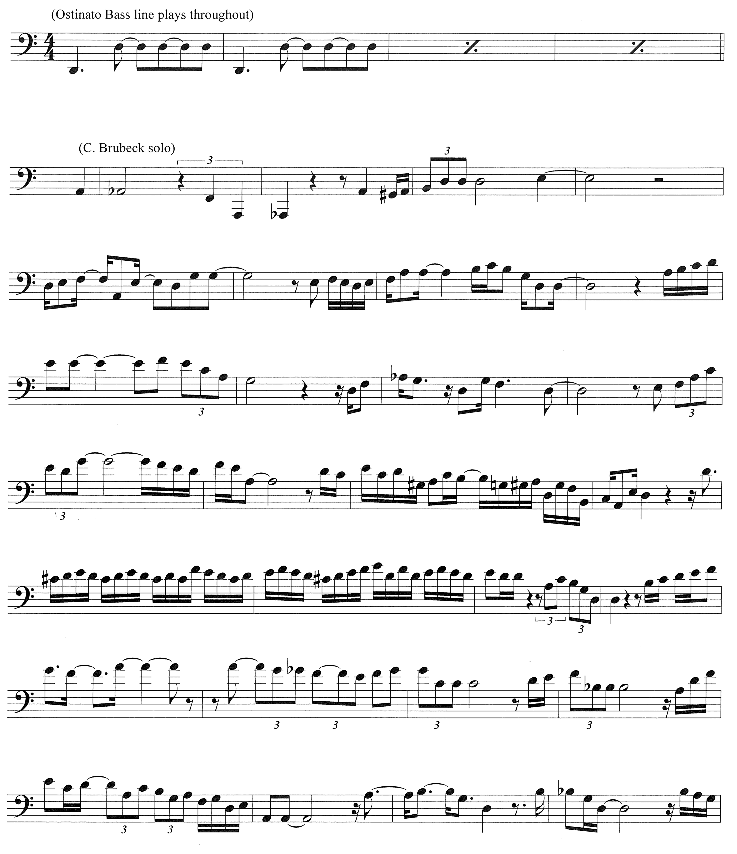
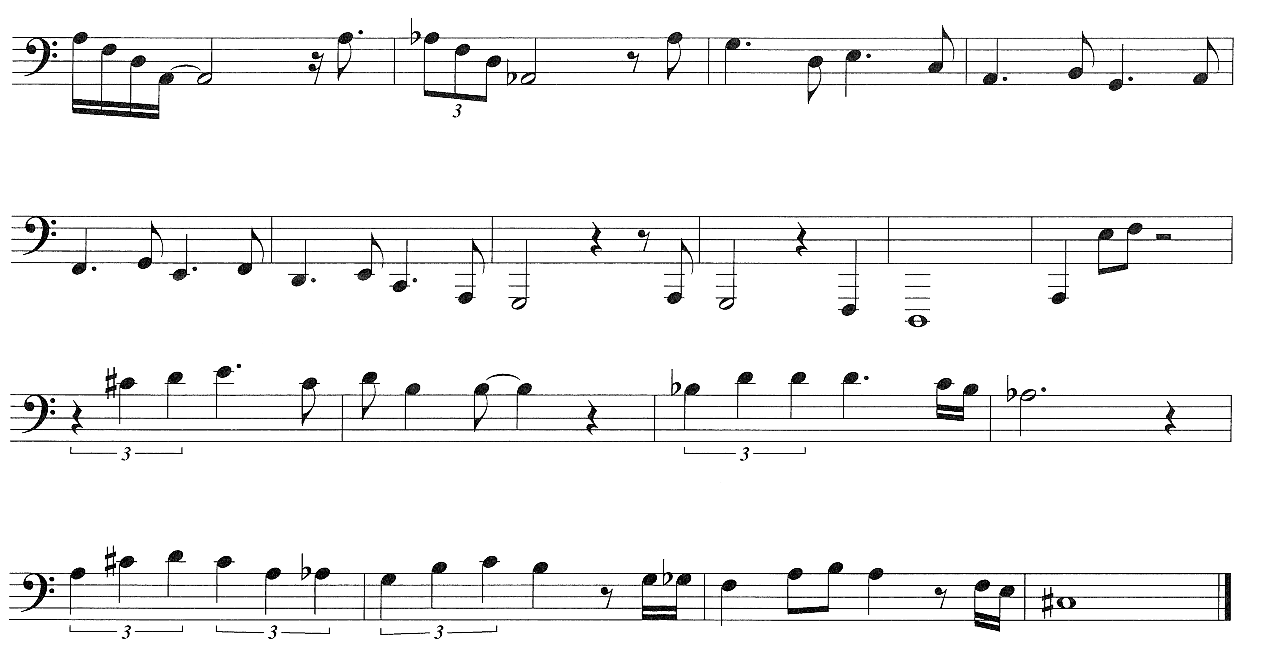
This transcription is based on an improvised solo by Chris Brubeck on a 2016 performance of The Light in the Wilderness at Southern Nazarene University. The performance featured The SNU Choral Society, baritone soloist- Jeffrey Ambrosini, and The Brubecks Play Brubeck Quartet featuring Darius, Chris, and Dan Brubeck and jazz saxophonist Dave O'Higgins. Chris Brubeck plays a large bore trombone that is commonly used by orchestral players and uncommon in straight ahead jazz settings. The above was transcribed by Andrew Sharp of Bethany, Oklahoma.

Appendix F: Performance Program

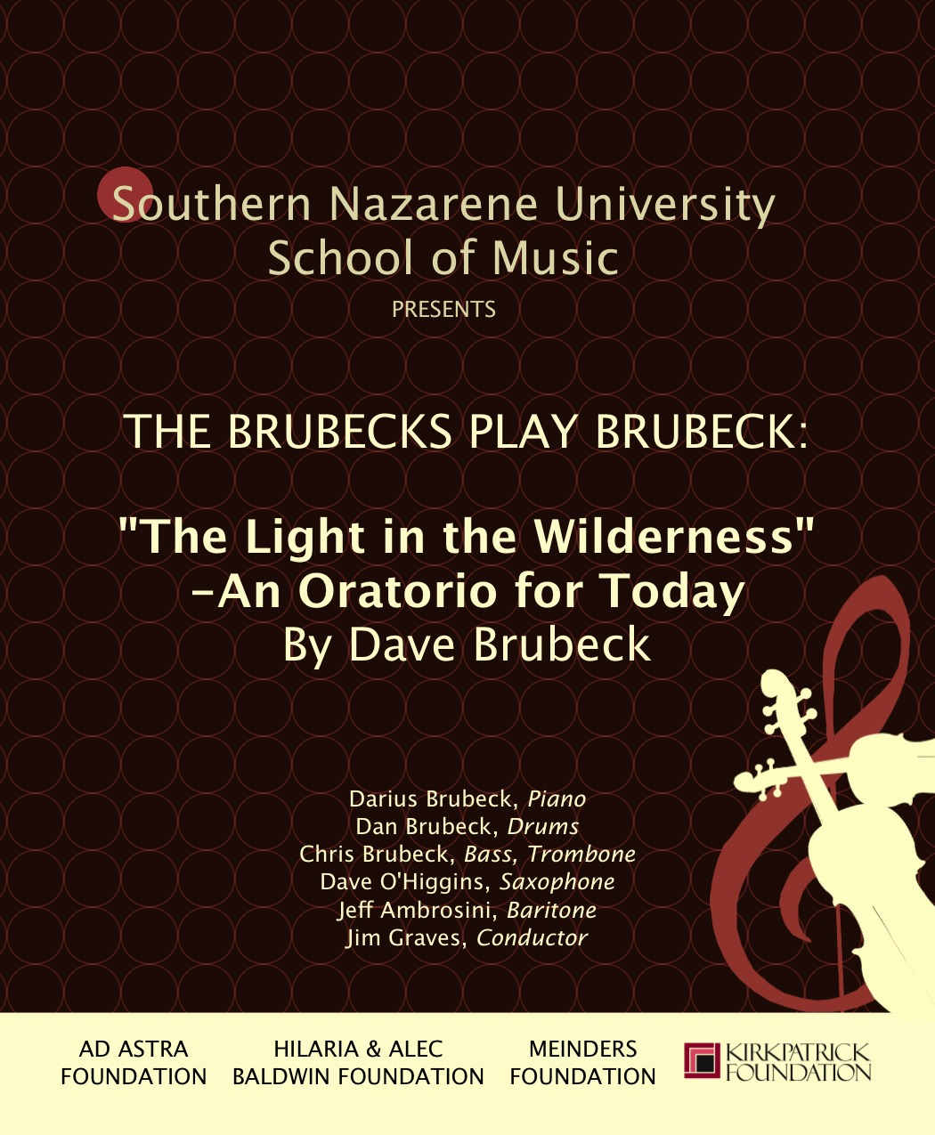

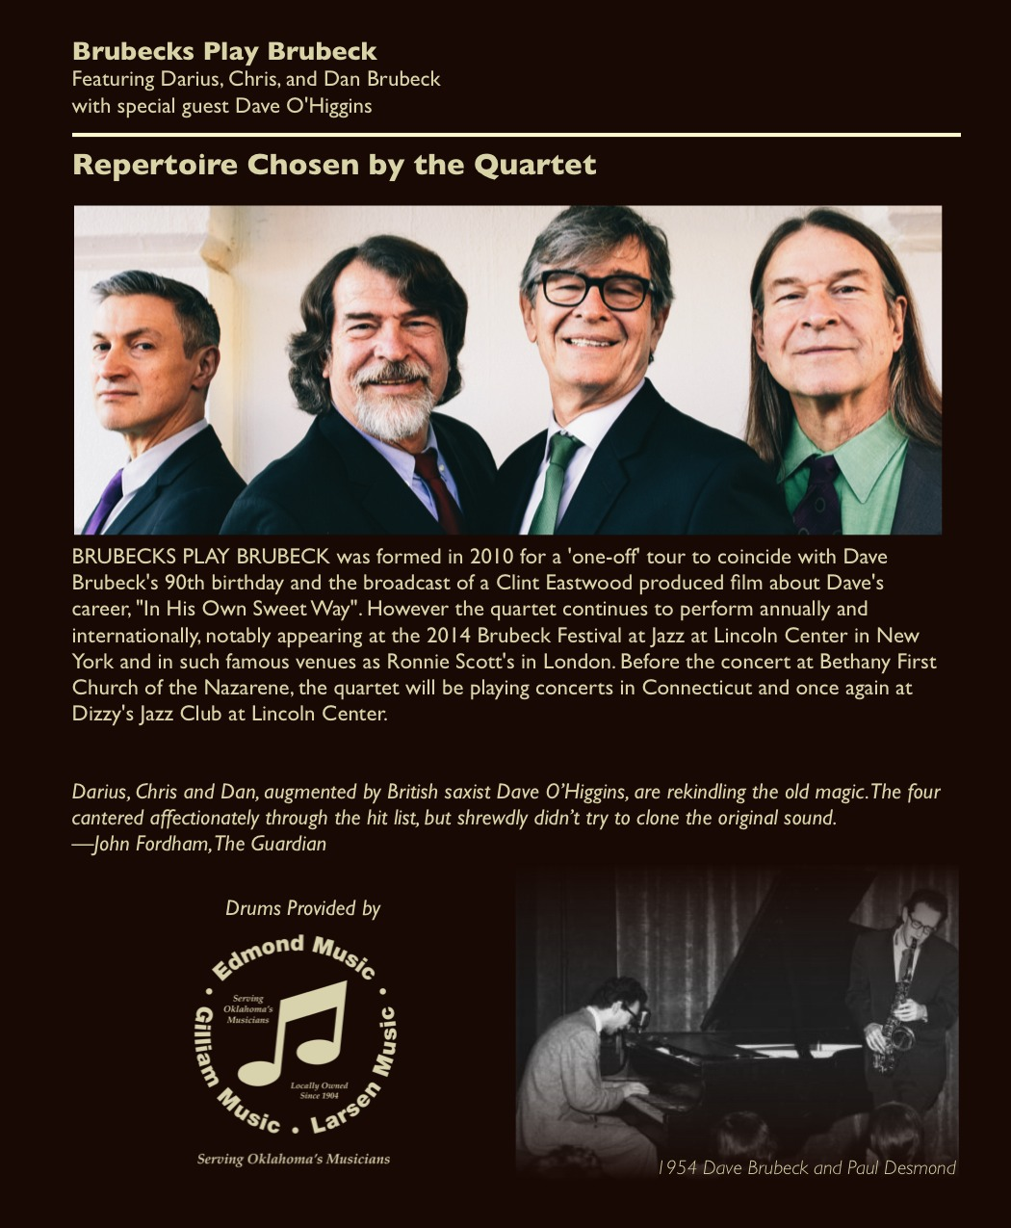

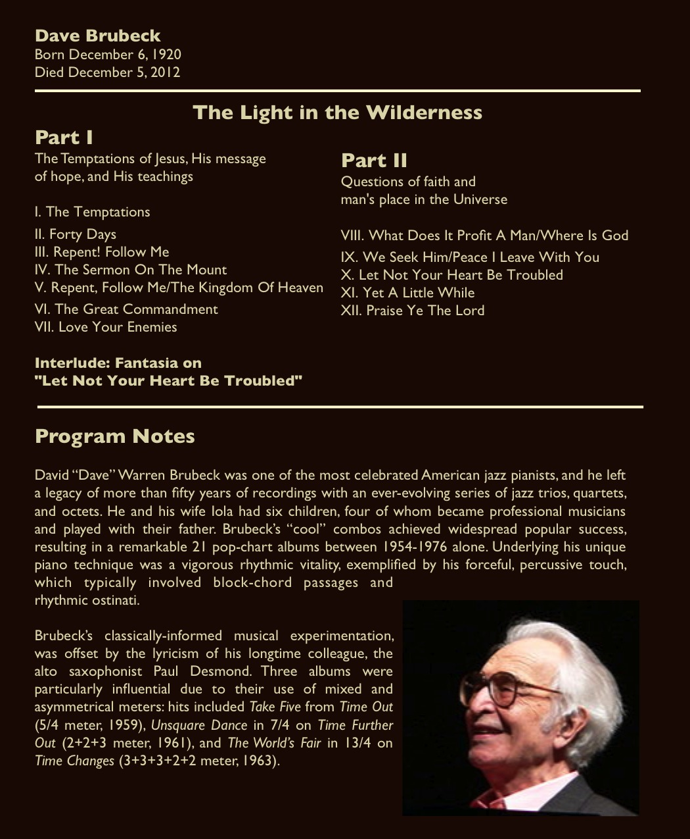

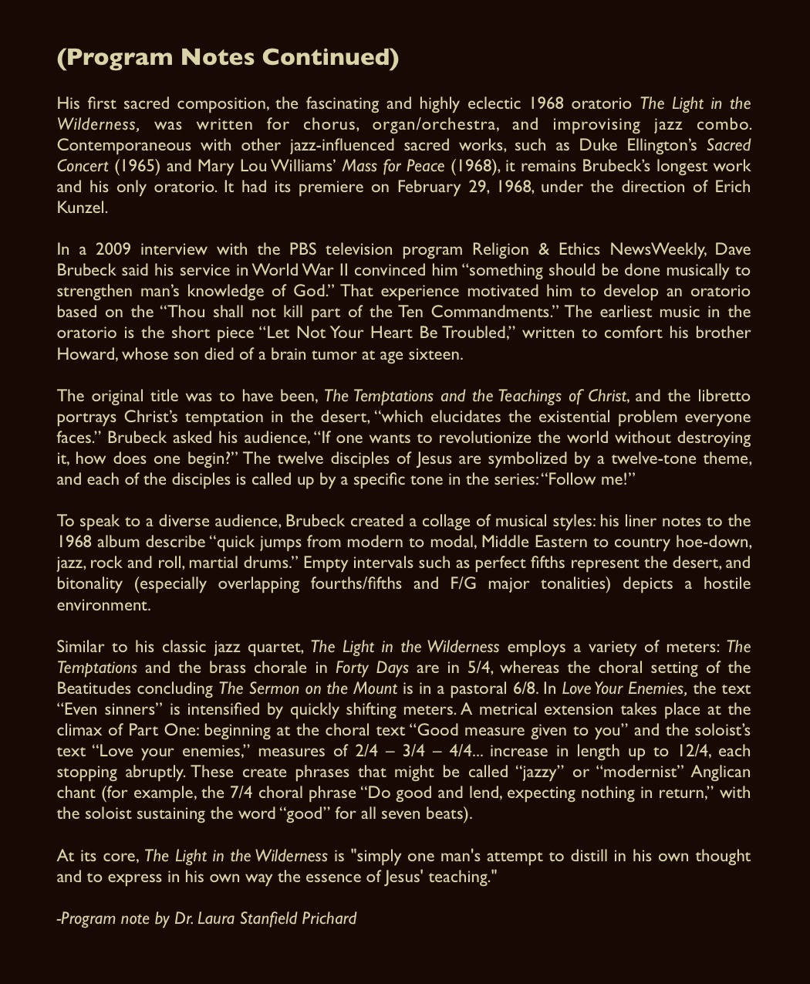

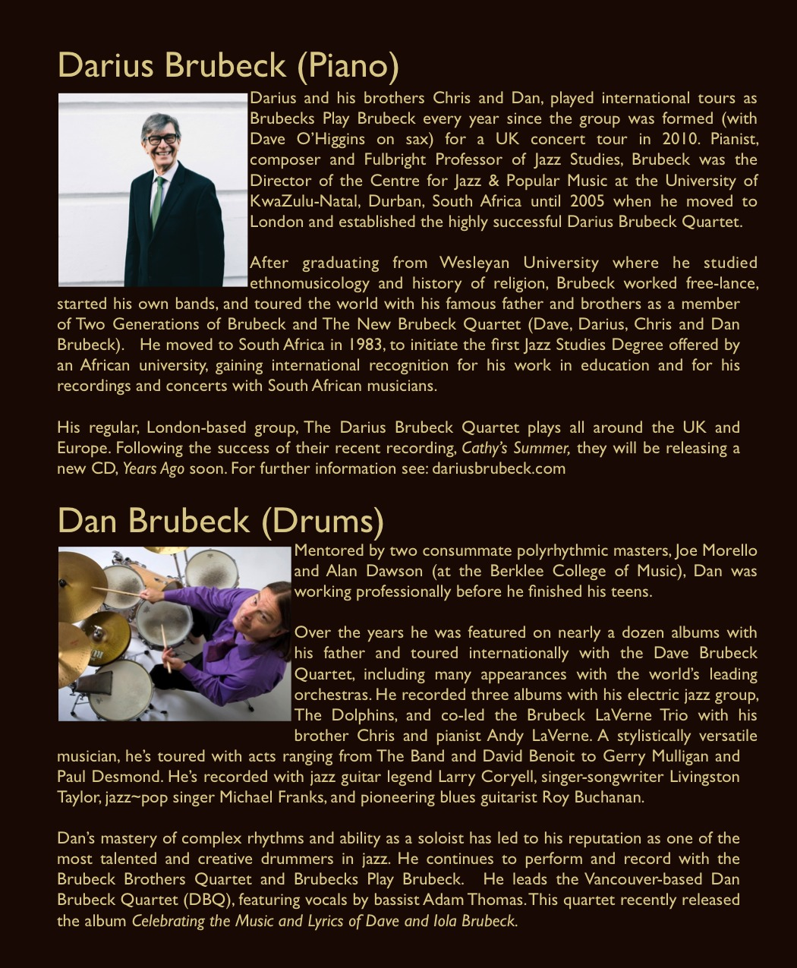

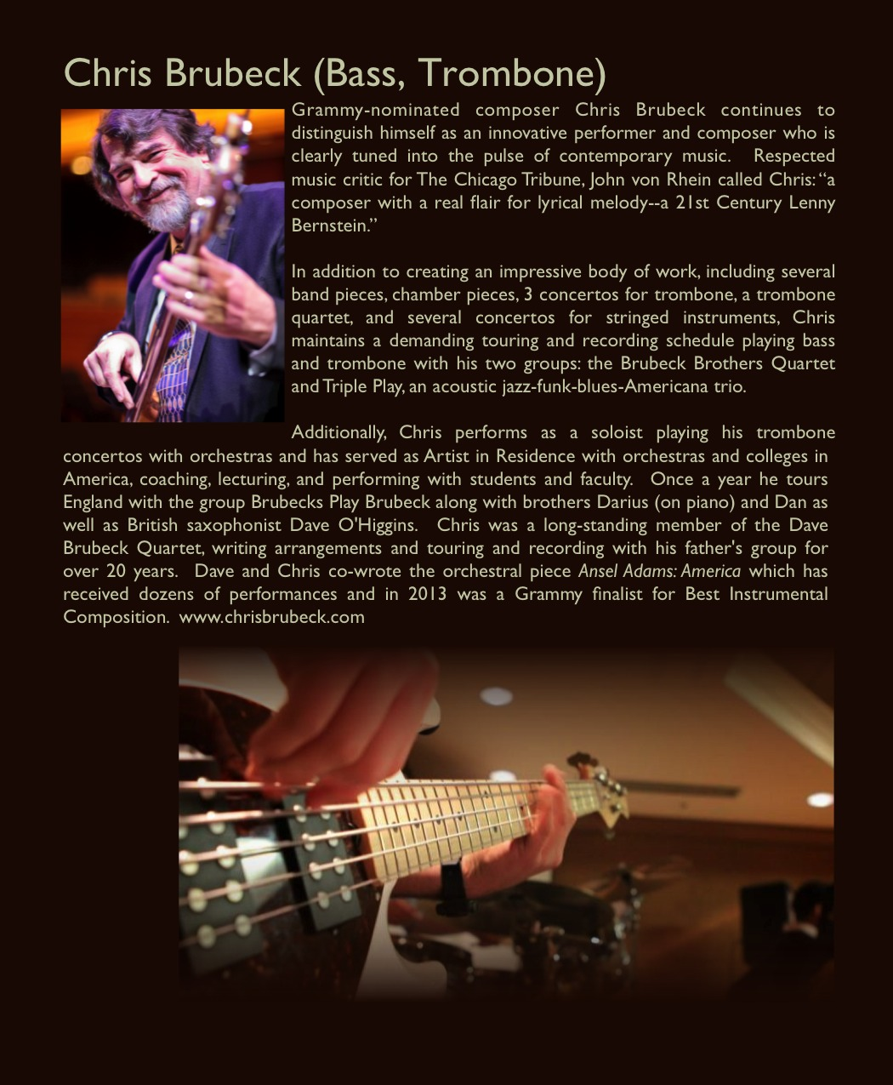

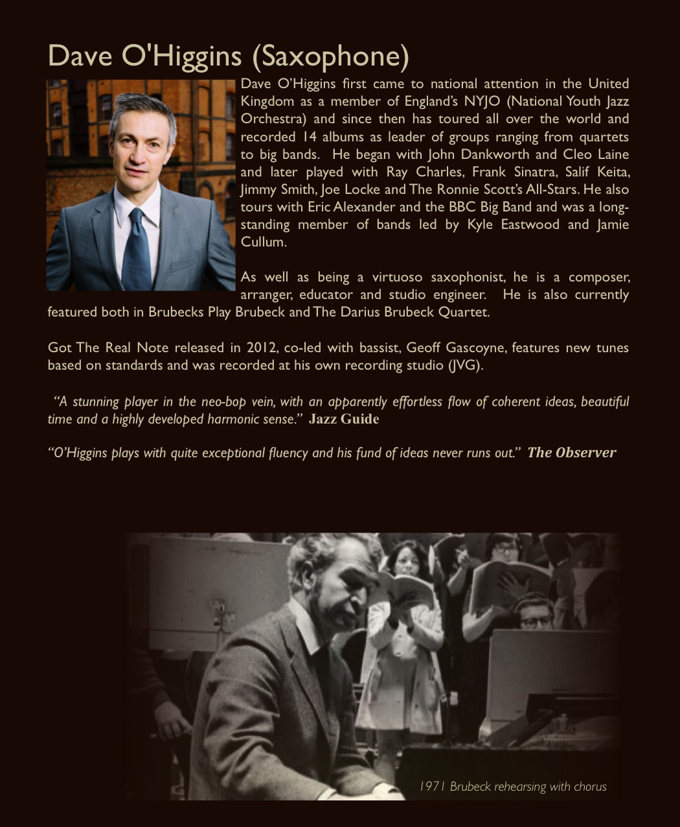

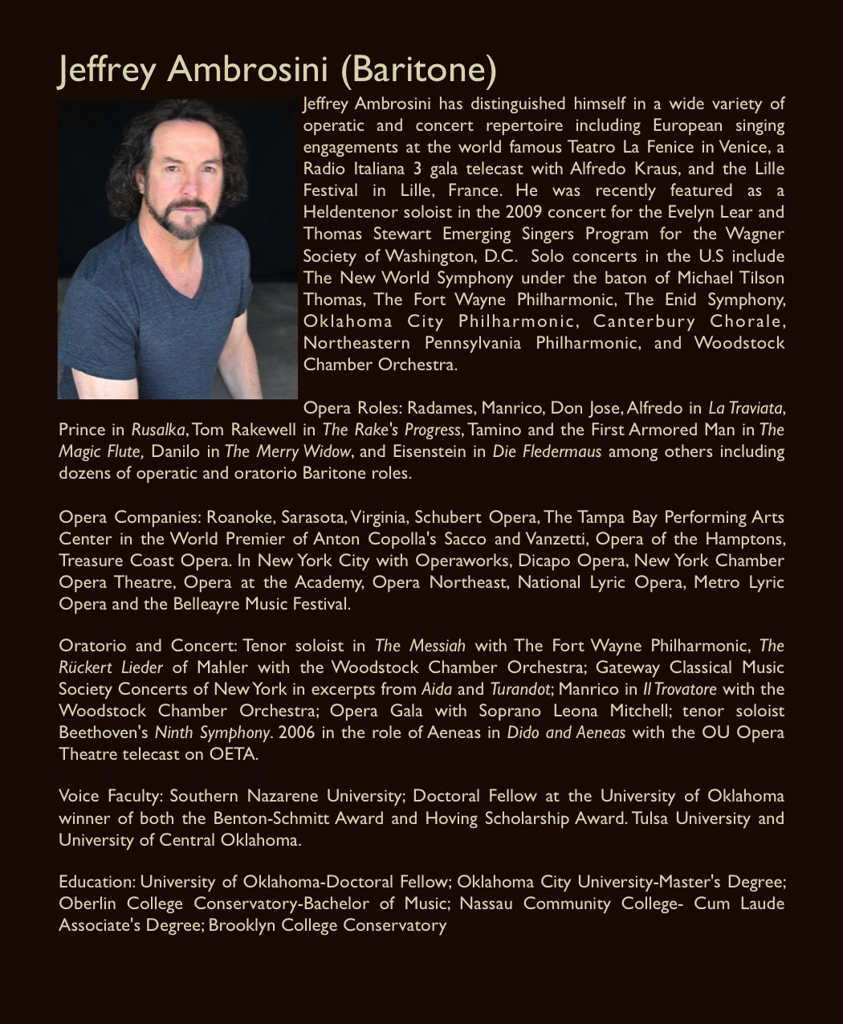

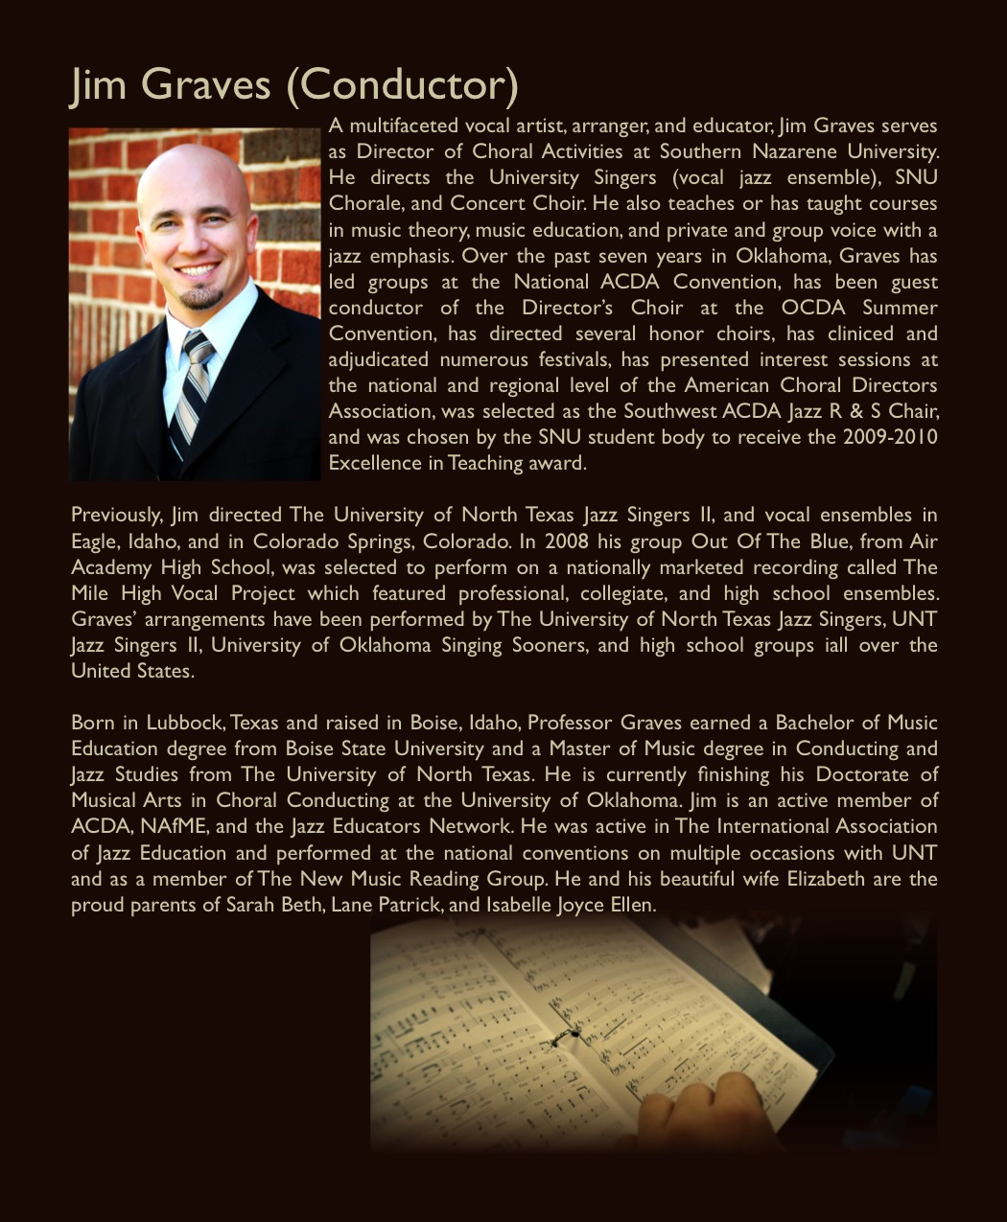

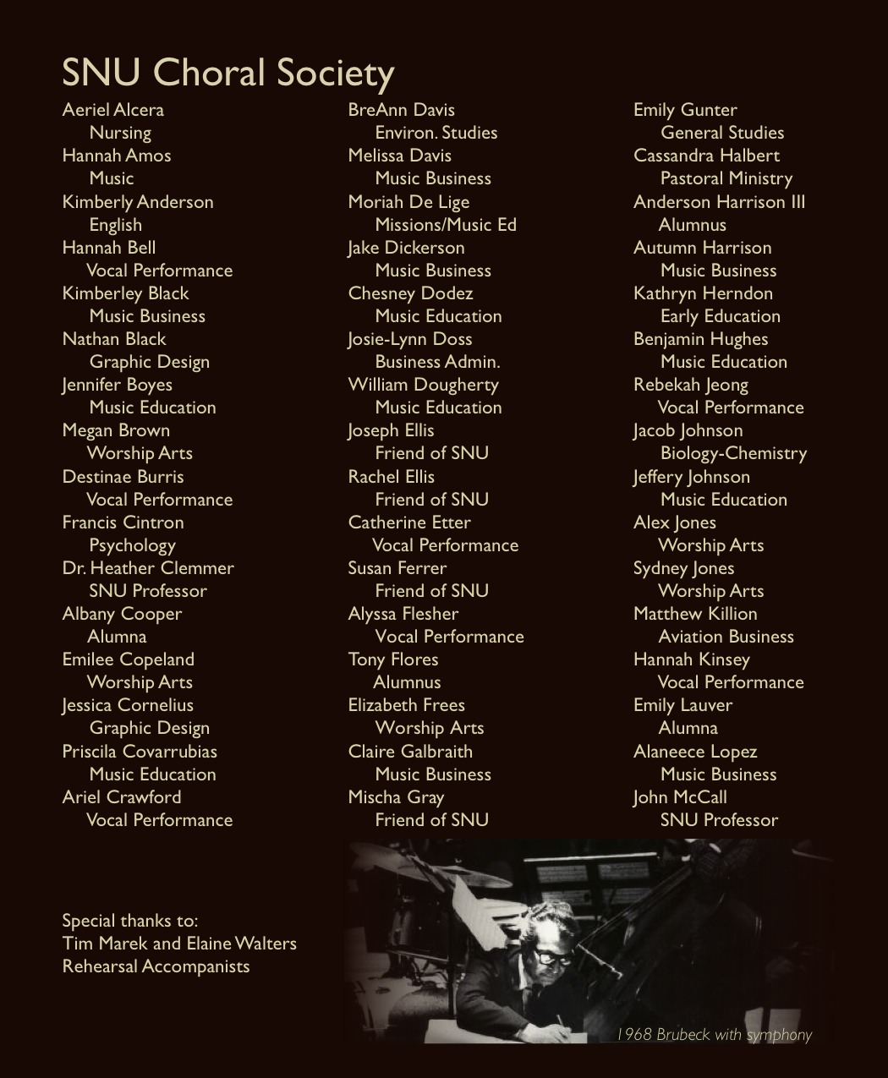

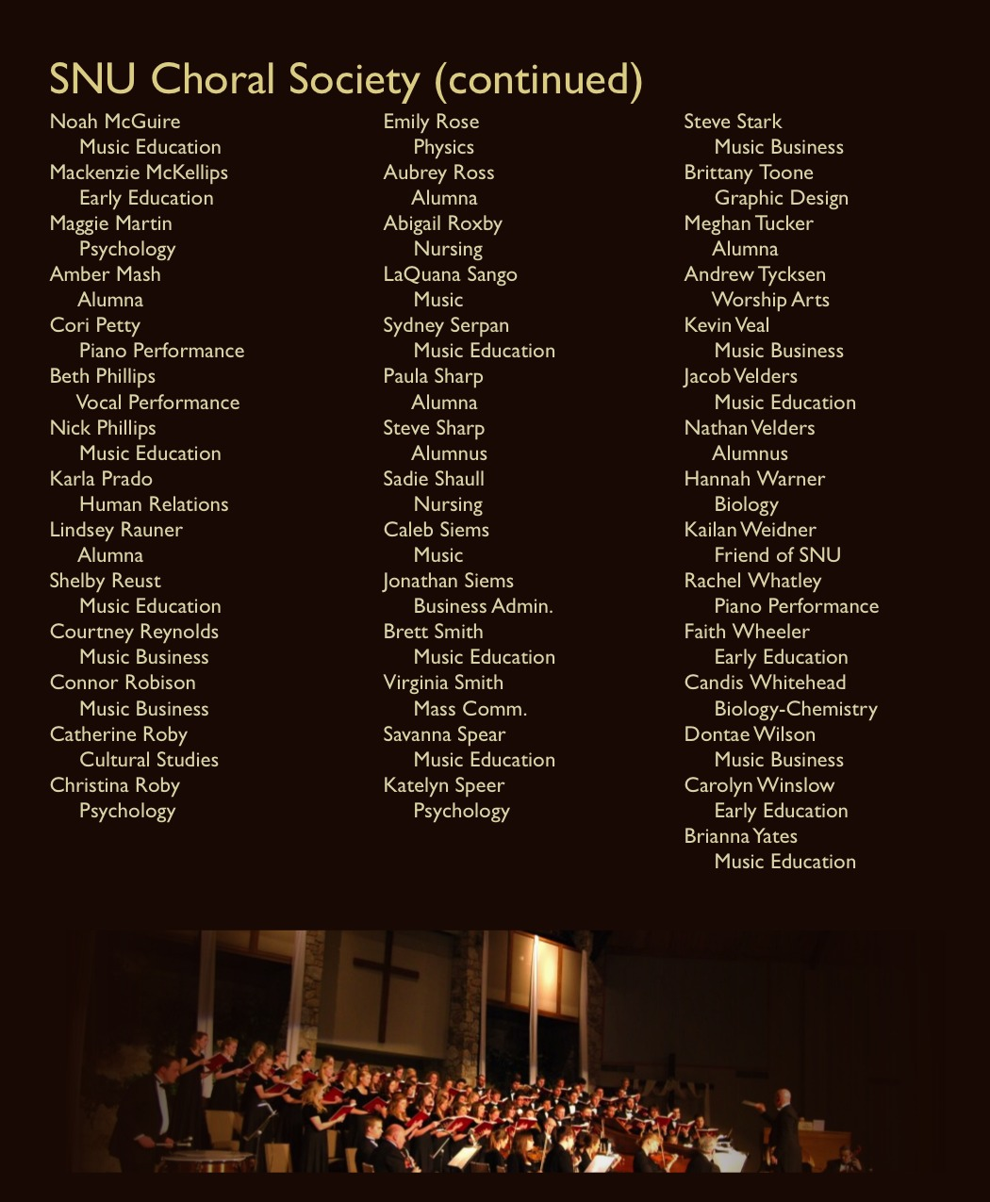

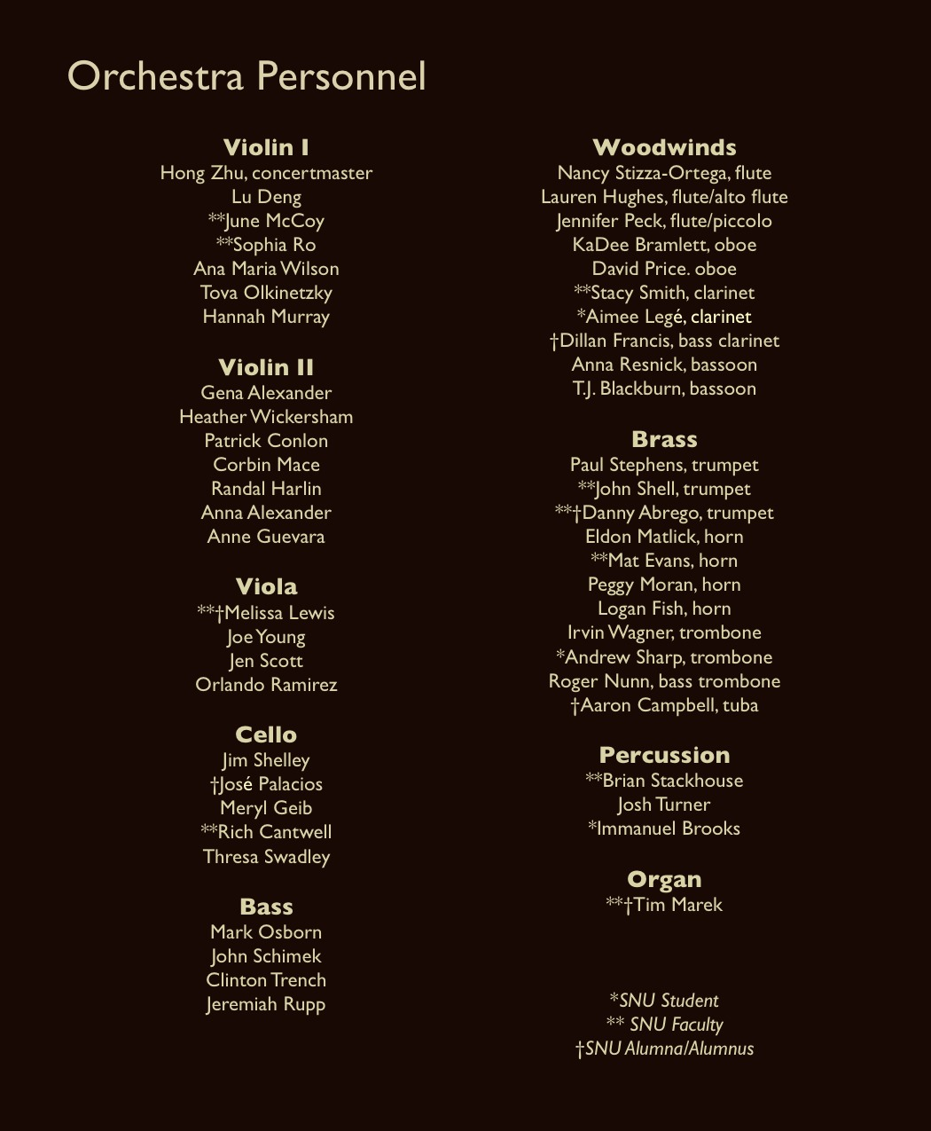

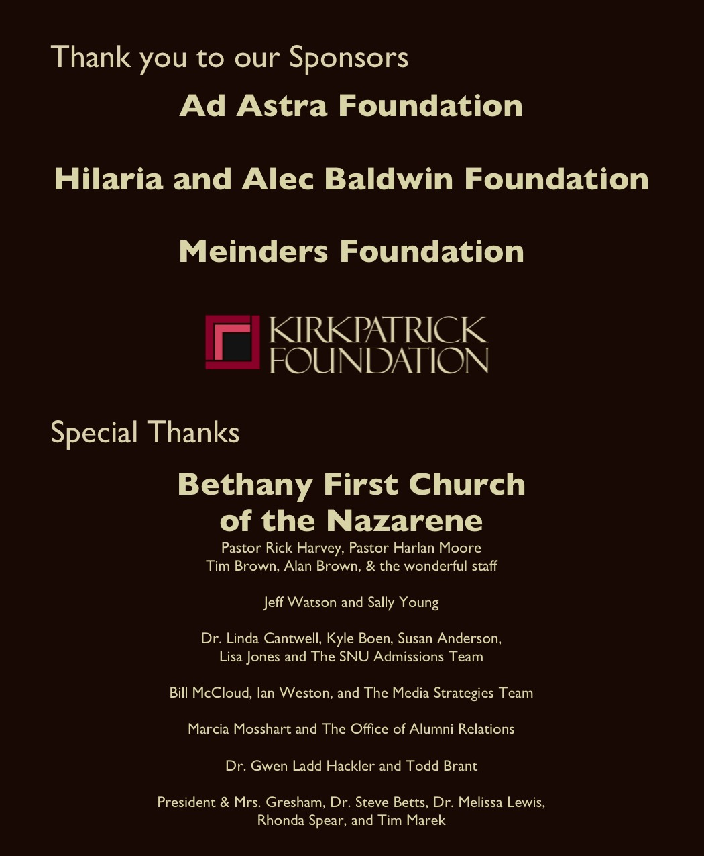

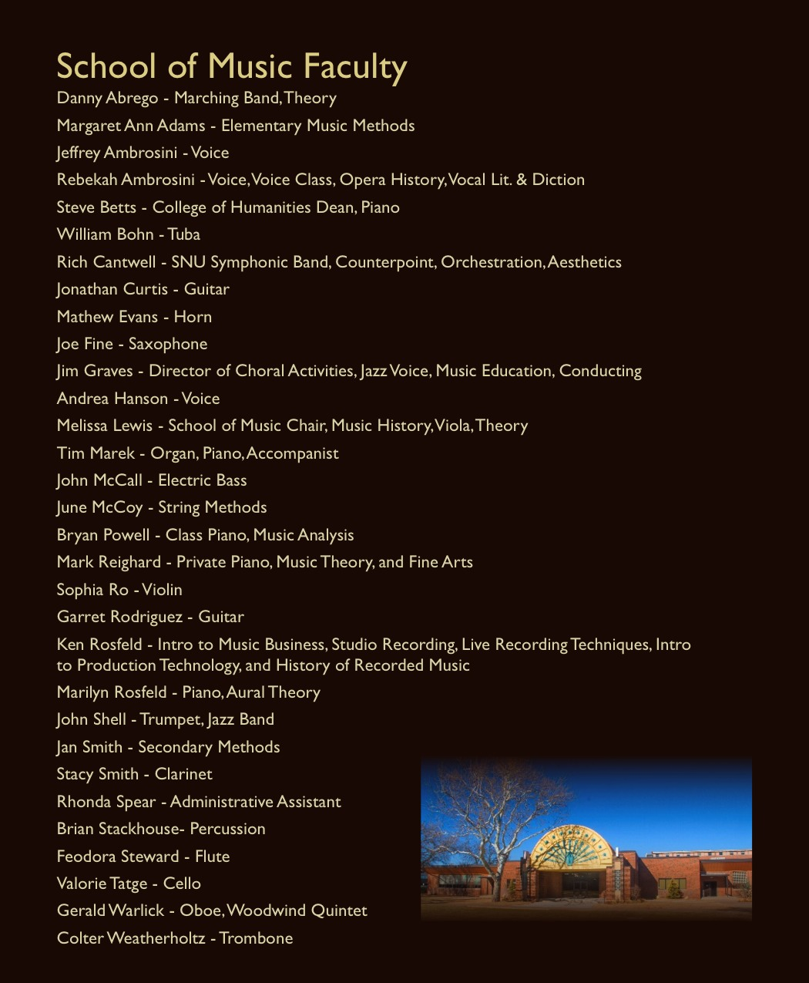

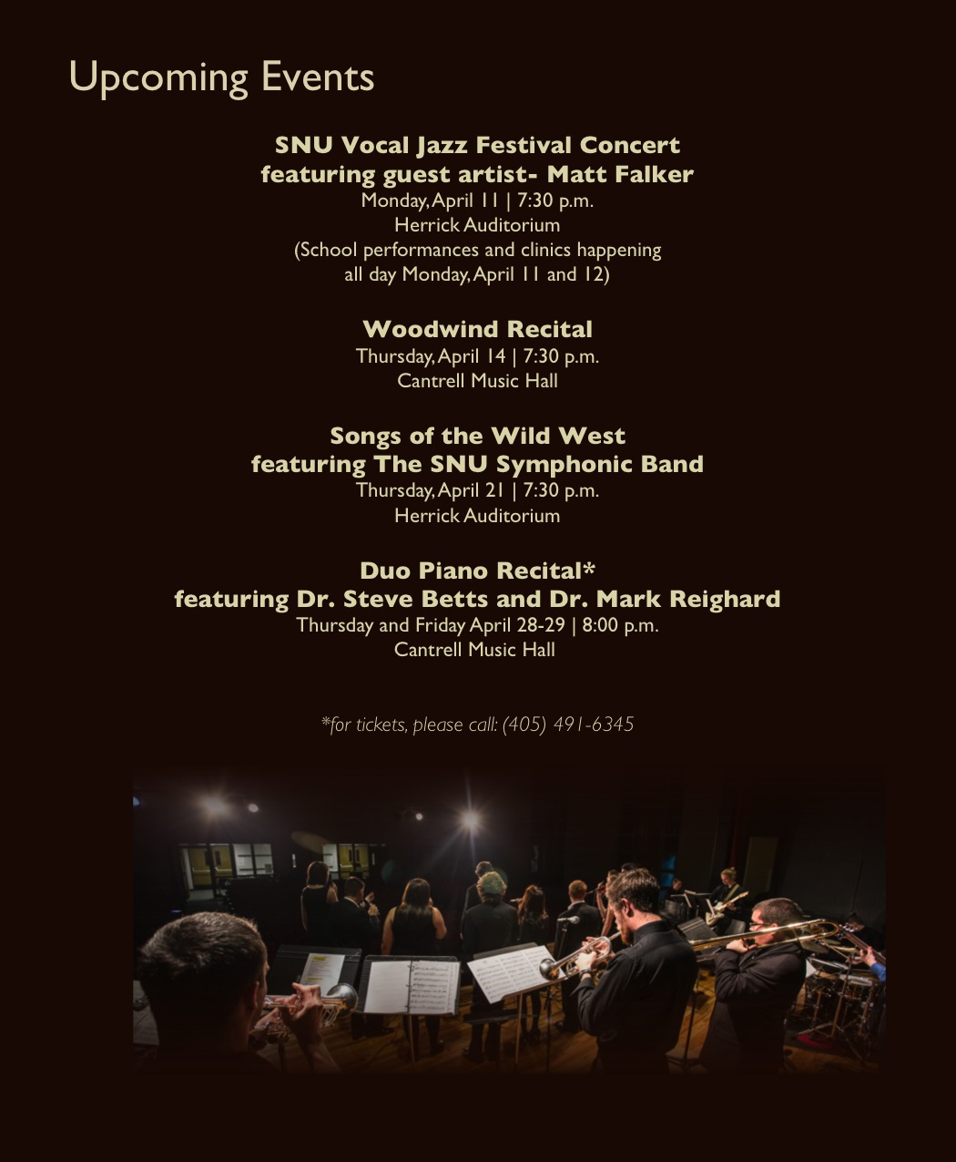

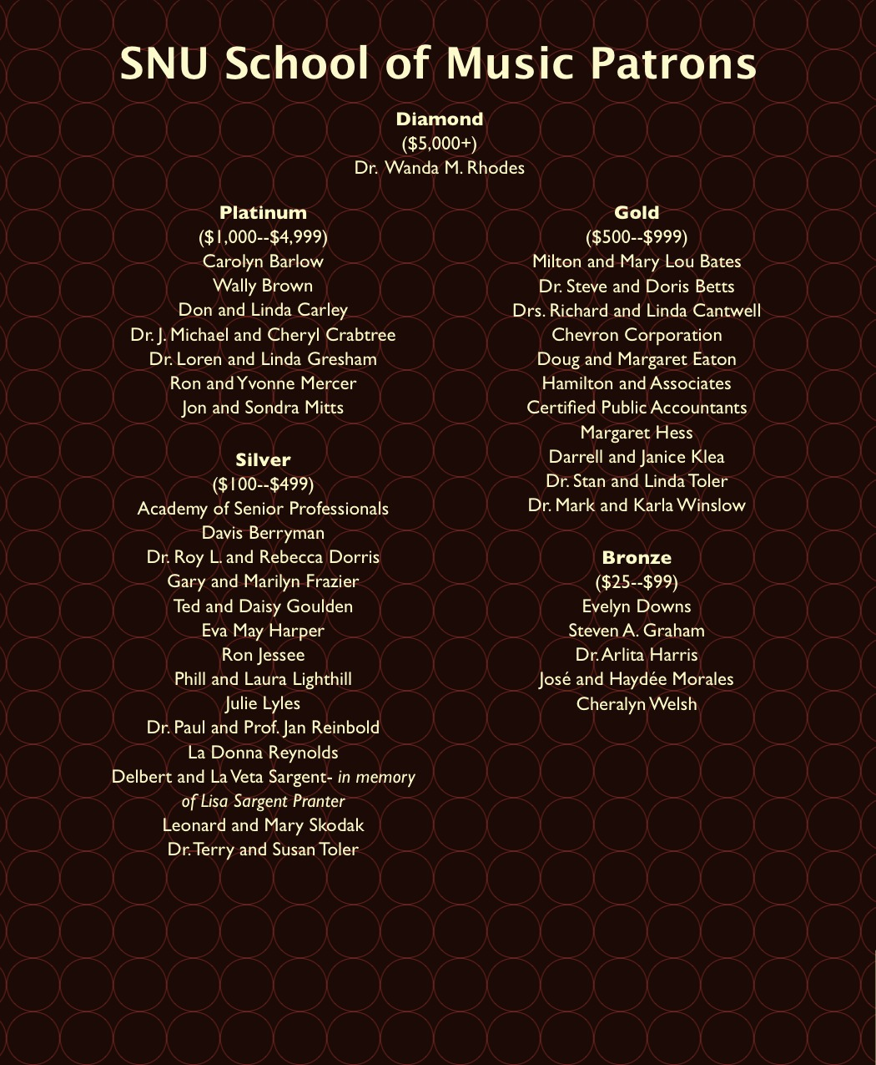

Len Lyons, “Dave Brubeck,” The Great Jazz Pianists: Speaking of Their Lives and Music (New York: Quill, 1983), 105.
Fred M. Hall, It’s About Time: The Dave Brubeck Story (Fayetteville, AR: University of Arkansas Press, 1988), 33.
Ibid., 73.
Dave and Iola Brubeck, interviewed by Shane Sutton, January 30, 2007, interview DVD2-32-RealAmbassadors, audio recording, Brubeck Oral History Project Holt-Atherton Special Collections, University of the Pacific Library, Stockton, CA.
Chris Brubeck, interview by author, July 19, 2016.
Dave Brubeck, The Light in the Wilderness, liner notes for the album, Decca/MCA 10009.
Danny Zirpoli, “An Evaluation of the Work of Jazz Pianist/Composer Dave Brubeck” (Doctoral Dissertation, University of Florida, 1990), 81.
Matthew 22:37-39
Matthew 5:44
Harmon Griffith Young, “The Sacred Choral Music of Dave Brubeck: A Historical, Analytical, and Critical Examination.” (Doctoral Dissertation, University of Florida, 1995), 194.
Based on the Human Research Determination worksheet, the IRB office has notified me that this research has been granted expedited approval for interviews pertaining to Dave Brubeck’s The Light in the Wilderness A Conductor’s Analysis.
Melodie G. Galloway, “A Conductor’s Perspective of Dave Brubeck’s To Hope! A Celebration: A Mass in the Revised Roman Ritual.” (Doctoral Dissertation, University of North Carolina at Greensboro, 2006), 3.
Harmon Griffith Young, “The Sacred Choral Music of Dave Brubeck: A Historical, Analytical, and Critical Examination.” (Doctoral Dissertation, University of Florida, 1995).
Ilse Storb and Klaus-Gotthard Fischer, Dave Brubeck: Improvisations and Compositions- The Idea of Cultural Exchange, trans. Bert Thompson (New York: Peter Lang Publishing, 1994), v.
Hall, It’s About Time, vii.
Deborah Mawer, “Milhaud and Brubeck: French classical teacher and American jazz student,” French Music and Jazz in Conversation: From Debussy to Brubeck (Cambridge, UK: Cambridge University Press, 2014).
Dave Brubeck, The Light in the Wilderness, liner notes for the album, Decca/MCA 10009.
Each Form Chart delineates the large sections of the musical form. These larger formal designations are then reduced into moderate subset bar groupings that are most often based upon text distribution and are further reduced into combinations of smaller bar groupings. Each chart also introduces meter, tempo, and text. The Form Charts use rehearsal letters along with measure numbers where possible. There are instances in the full score and orchestral parts where measure numbers are not used and rehearsal letters are the primary means of determining the location in the given movement.
Dave Brubeck, The Light in the Wilderness (Delaware Water Gap, PA: Shawnee Press, 1968), p. 3.
Dave Brubeck, The Light in the Wilderness, liner notes.
Harmon Griffith Young, “The Sacred Choral Music of Dave Brubeck: A Historical, Analytical, and Critical Examination.” (Doctoral Dissertation, University of Florida, 1995), p. 198.
Dave Brubeck, The Light in the Wilderness, liner notes.
Ibid.
Ibid.
Ibid.
Ibid.
Ibid.
Ibid.
Terry Mattingly, “The Soul in Dave Brubeck’s Jazz,” On Religion Column, December 14, 2009, http://www.tmatt.net/columns/2009/12/the-soul-in-dave-brubecks-jazz (accessed March 14, 2017).
Young, 200.
Darius Brubeck, interview by author, July 1, 2016.
Dave Brubeck, The Light in the Wilderness, liner notes.
Darius Brubeck, interview by author, July 1, 2016.
Darius Brubeck goes into depth over his improvisational approach and the compositional landmarks of the contemporary jazz combo version of “Forty Days” in the interview transcript in Appendix B.
Dave Brubeck, The Light in the Wilderness, liner notes.
John Salmon, “Dave Brubeck: No Time To Take Five,” Piano Today, (July, 2008): 2.
Storb and Fischer, 3.
Doug Ramsey, “Dave Brubeck: A Life in American Music,” Liner notes for Dave Brubeck Time Signatures: A Career Retrospective, by Dave Brubeck. Columbia/Legacy COL 495201 2, 1992, CD.
Young, 202.
Matt. 4:17 (KJV).
Matt 4:19 (KJV)
Dave Brubeck, The Light in the Wilderness, liner notes.
Young, 205.
See Appendix A for complete, movement-by-movement text.
See Appendix E for a transcription of Chris Brubeck’s trombone solo on “Sermon on the Mount,” performed on a 2016 performance of The Light in the Wilderness at Southern Nazarene University.
Dave Brubeck, The Light in the Wilderness (Delaware Water Gap, PA: Shawnee Press, 1968), p. 30.
James Strong, “Greek Dictionary of the New Testament,” The Exhaustive Concordance of The Bible (Peabody, MA: Hendrickson Publishers, 1988) 46.
Matthew 5:13-14
Chris Brubeck, interview by author, July 19, 2016.
Dave and Iola Brubeck, interviewed by Shane Sutton, January 30, 2007, interview DVD1-09-IndianTurkishJamSessions1958, audio recording, Brubeck Oral History Project Holt-Atherton Special Collections, University of the Pacific Library, Stockton, CA.
Dave Brubeck, The Light in the Wilderness, liner notes.
Dan Brubeck, interview by author, April 14, 2017.
Dave Brubeck, The Light in the Wilderness, liner notes.
John 8:1-11
Young, 209.
Dave Brubeck, The Light in the Wilderness, liner notes.
Luke 17:20
This textual variation is notable in The New International Version, New Living Translation, English Standard Version, Berean Study Bible, New American Standard, and The Holman Christian Standard to name a few of the more popular versions of the Bible.
Young, 212.
Dave Brubeck, The Light in the Wilderness, liner notes.
Dan Brubeck, interview by author, April 14, 2017.
Dave Brubeck, The Light in the Wilderness, liner notes.
Matthew 5:44
Mark 12:34
Dave Brubeck, The Light in the Wilderness, liner notes.
Dave Brubeck, in “Dave Brubeck: A Choir Boy’s Hiding Inside This Legendary Jazz Man,” interview by Don Heckman (Los Angeles Times—Calendar Section, 27, December 1995), 3.
Herb Wong, and Paul Simeon Fingerote, Jazz on My Mind: Liner Notes, Anecdotes and Conversations from the 1940s to the 2000s (Jefferson, NC: McFarland and Company, Inc., Publishers, 2016), 171.
Dave Brubeck, The Light in the Wilderness, liner notes.
Ibid.
Ibid.
Young, 215.
Ibid.
Young, 219.
Dave Brubeck, The Light in the Wilderness, liner notes.
Luke 6:38
Peter Manuel. Machael Tenzer, ed. Analytical Studies in World Music. (New York: Oxford Unversity Press, 2006), 96.
Young, 219.
Dave and Iola Brubek, interview with Shane Sutton. “Dave and Iola Brubeck on The Light in the Wilderness and the use of spiritual themes in their compositions.” Brubeck Oral History Project. 3:56. 2007. http://digitalcollections.pacific.edu/cdm/singleitem/collection/brubeckoral/id/31/rec/10
Dave Brubeck, Three Themes from The Light in the Wilderness (Delaware Water Gap, PA: Shawnee Press, 1968), 1.
As stated earlier, Brubeck allows for the performance of The Light in the Wilderness to be performed with organ, percussion and bass accompaniment. In this instance he notes that the separate publication, Three Themes from The Light in the Wilderness, can be performed as Prelude, Interlude, and Postlude for the oratorio.
Measures 12-37 are fully orchestrated using the same material as the separate organ part. If the organ piece is unavailable, or if the performance space does not have an adequate instrument, this movement may still be performed. At the time of the writing of this document, Three Themes from The Light in the Wilderness was permanently out of print. It was still available by purchasing a “used” copy on Internet sites that sell second hand or auction-style purchases. It was also not part of the rental materials available through G. Schirmer, Inc. When programing The Light in the Wilderness plan accordingly. The organ score that comes with the rental materials consists of only what is printed in the chorus/baritone/organ/percussion score. It is also noteworthy to state that the entirety of Three Themes from The Light in the Wilderness, Mvmt. II “Interlude,” lines up with the orchestral interlude. One could feasibly have the organ play throughout the movement, or in select sections to provide depth or color. On the original 1968 recording, organ can be heard from rehearsal letter ‘O’ to the end of the piece. There are two places where discrepancies exist–in essence, two additional measures–in the piece for organ and the orchestral version. Between mm. 168 and 169 there is an additional measure in the organ score and again in mm. 172 and 173.
Young, 222.
Dave Brubeck, The Light in the Wilderness, liner notes.
Ibid.
Psalm 24:3
Ibid.
Young, 224.
Psalm 24:6
Dave Brubeck, The Light in the Wilderness, liner notes.
Ibid.
John 7:29
The second half of the quoted text comes from Psalm 14:1.
Matthew 25:32
Matthew 25:37
Matthew 25: 40
Dave Brubeck, The Light in the Wilderness, liner notes.
Chris Brubeck, interview by author, July 19, 2016.
John 14:27
Young, 229.
Dave Brubeck, The Light in the Wilderness, liner notes.
Young, 229.
Dan Brubeck, interview by author, April 14, 2017.
John 12:35-36
John 12:36
Young, 232.
Dave Brubeck, The Light in the Wilderness, liner notes.
Charles Haddon Spurgeon, The Treasury of David. (New York: Funk and Wagnall Company, 1892), 7:252.
Fred M. Hall, It’s About Time: The Dave Brubeck Story (Fayetteville, AR: University of Arkansas Press, 1988), 25-31.
Tom Wilmeth, “A Previously Unpublished Interview with Dave Brubeck.” JazzTimes, November 18, 2013, https://jazztimes.com/columns/wilmeth/a-previously-unpublished-interview-with-dave-brubeck/ (Accessed January 20, 2017).
Hall, 130.
The long time friend of the Brubeck family, Nancy Wade, gave a copy of the letter from Figure 35 to the author. Ms. Wade is a Brubeck scholar and former choral director.
Darius Brubeck, interview by author, July 1, 2016.
Ibid.
Dan Brubeck, interview by author, April 14, 2017.
Chris Brubeck, interview by author, July 19, 2016.
Ibid.
Darius Brubeck, interview by author, July 1, 2016.
Timing of movements based on the original recording, The Light in the Wilderness, an Oratorio for Today. Performed by the Miami University A Cappella Singers and the Cincinnati Symphony Orchestra with Dave Brubeck at the piano. Directed by Erich Kunzel. Decca Records DXSA 7202, 1968, LP.
The words of Christ as sung by the baritone soloist are in Italics.

