University of Oklahoma

Graduate College

SOCIAL BOUNDARIES BETWEEN CERAMIC DESIGN PRODUCTION GROUPS AT CLASSIC MIMBRES SITES,
SOUTHWESTERN NEW MEXICO, A.D. 1000-1130

A Dissertation

submitted to the Graduate Faculty

in partial fulfillment of the requirements for the

Degree of

Doctor of Philosophy

By

Thomas E. Gruber
Norman, Oklahoma
2015

SOCIAL BOUNDARIES BETWEEN CERAMIC DESIGN PRODUCTION GROUPS AT CLASSIC MIMBRES SITES,
SOUTHWESTERN NEW MEXICO, A.D. 1000-1130

A Dissertation approved for the
Department of Anthropology

By

______________________________
Dr. Patricia A. Gilman, Chair

______________________________
Dr. Paul E. Minnis

______________________________
Dr. Patrick Livingood

______________________________
Dr. Daniel Swan

______________________________
Dr. Rangar Cline

© Copyright by THOMAS E. GRUBER 2015
All Rights Reserved.

In Loving Memory of John Ray Gottman

Acknowledgments
I am grateful to many who have given me guidance and support during the process that has led to the completion of this dissertation. This dissertation would not have been possible without the Mimbres Archive (now called MimPIDD) and in particular Steven LeBlanc and Michelle Hegmon who created a valuable resource. Likewise, this project would not be possible without the many researchers who have contributed to the body of data and those that contribute to the accumulation of such a large database like the Mimbres Archive.
The preparation for this research required a whole host of specialists who provided me with the training needed to complete such a complex project. I thank the entire Anthropology faculty at the University of Oklahoma, both permanent and visiting, who have given me the education needed for understanding the complexities of past and present human behavior. I specifically thank Dr. Patricia Gilman for providing me with both opportunities and experiences throughout my graduate career. Dr. Gilman and I have spent much time looking at countless sherds, discussing methodological and theoretical approaches to archaeological problems through countless independent reading groups, and spending many summers walking across the desert in southwestern New Mexico, allowing me the opportunity to think about and interact with material culture from ancient people in the most diverse way possible. I also thank all of my committee members, Dr. Patricia Gilman, Dr. Paul Minnis, Dr. Patrick Livingood, Dr. Daniel Swan, and Dr. Rangar Cline for their patience and dedication throughout the inception and creation of my research.
I also would not have completed this document without the support of Open Range Archaeology, LLC. This small company that Janna and I founded has grown to the point that is has allowed us to bring in some very capable people. Our partner R. Doyle Bowman is critical in maintains client relations and is an excellent field archaeologist. Our Office Manager Belinda Gruber has freed me form all of my fanatical responsibilities and keeps the office running. Our two staff archaeologist Sonya D. Beach and Thomas J. Thompson who while completing their own Theses have pick up ever task we have presented them with and exceeded every expectation. My wife and business partner Janna L. Gruber has ensured that I have no responsibility other than this Dissertation. I thank everyone in our office who has listened to my ramblings and supported me through this presses I hope I can now repay all of you.
Finally, my family and freinds made this journey possible. I first thank my wife, Janna, who not only provided me with the support and sanity needed for this journey, but completed her own dissertation at the same time. Next, I thank our two children, Josh and Brynna, who very effectively took my mind off this project, at inopportune times, and more times than not, just when I needed to stepped away to gain a new perspective. I must also thank my dear friends Bernard Schriever, Elizabeth Toney and Matthew Taliaferro that have challenged me and pushed me to work harder and learn more helping me form and develop the ideas in this dissertation. Finally, without Josh and Brynna’s grandparents, John and Jo Gottman, Robert and Jusim Gruber, and Karen and Steve Kemmer, aunts Belinda Gruber and Yuri Gruber, uncle Ken Gruber, and cousins Mackenzie and Carlie Gruber, who were always available to provide care for them at a moment’s notice and for weeks at a time when needed, the time required for this project would not have been available.
This dissertation is the product of both opportunity and preparation. The preparation that the faculty members provided has given me the knowledge and experience needed to ask ethical questions, analytically approach a problem, and systematically analyze data that were needed for this project. Ultimately, my family’s support allowed me the freedom to do such a time consuming task.

Table of Contents
Acknowledgments iv
Table of Contents vi
List of Tables viii
List of Figures x
Abstract xi
CHAPTER 1: Social Boundaries and Material Culture 1
Creation of Social Boundaries 5
Maintenance of Social Boundaries 8
Social Boundaries and Production Groups 10
Identifying Social Boundaries Using Material Culture 13
Operational Sequences, the French School 14
Operational Sequences, the American School 18
Examples of Identifying Social Boundaries in Archaeology 20
The Identification of Social Boundaries 22
Organization of Chapters 23
Summary 28
CHAPTER 2: The Development of Site Variation and Ceramic Design Variation in the Mimbres Region 30
Environmental Setting, Settlement Patterns, and Site Development 32
Mimbres Chronology 33
Changes in the Production of Pottery 35
Changes in the Production of Architecture 39
Settlement Patterns 45
Communal Structures 48
Chapter Summary 51
CHAPTER 3: Production And Distribution Of Mimbres Ceramics 54
Production and Distribution of Mimbres Ceramics Using INAA Studies 55
Design Variation in Boldface Black-on-white Bowls 58
Pottery Construction and Painted Design Symmetry on Mimbres Boldface Pottery 61
Rim Band Painting Production on Mimbres Classic Bowls 63
Summary 64
CHAPTER 4: Methods for Understanding the Organization of Ceramic Production Groups at Classic Mimbres Sites, A.D. 1000-1130……………… 66
The Art Historian Approach to Identifying Ceramic Painting Work Groups 67
Defining Middle Classic Period Ceramics Used in This Study 70
Identifying Variation in Motifs and Formal Elements 72
Defining the Stylistic Analysis 73
Definition of the Basic Unit of Design and Zigzag and Stepped Motifs 74
Motif Arrangement 78
The Arrangement of Stepped and Zigzag Motifs in Zones 85
Definition of the Formal Elements 87
Sites Used in This Study 91
Analytical and Statistical Tests 93
Cluster Analysis 93
Spatial Uniformity of the Production 95
Spatial Organization of Production 97
Summary 98
CHAPTER 5: Ceramic Design Production Groups in the Mimbres Region……………. 100
Cluster Analysis 102
Spatial Organization of Clusters 126
Spatial Distributions of Design Clusters 130
Spatial Distributions of Design Clusters at Cameron Creek 131
Spatial Concentrations at Mattocks 136
Spatial Concentrations at Galaz 140
Spatial Concentrations at Swarts 150
Spatial Concentrations at NAN Ranch 158
Mimbres Ceramic Design Production Analysis Results 162
The Formation and Maintenance of Social Boundaries between Ceramic Painting Production Groups in the Mimbres Region 163
CHAPTER 6: Social Boundaries in Mimbres Classic Period Sites 169
Social Boundaries in the Mimbres Region: Limitations and Future Research 170
References Cited 175
Appendix A. Summary of Whole Vessel and Motif Variables Data…………...189

List of Tables
Table 2.1. Mimbres Time Periods and Ceramic Types 34
Table 4.1. Indexes Used in This Study 94
Table 5.1. Results of the 14 Indexes Run in NbClust Package in R. 103
Table 5.2. Highest Percent of Formal Elements Used to Create Zigzag and Stepped Motifs at Cameron Creek. 105
Table 5.3. Results of the 14 Indexes Run in NbClust Package in R. 107
Table 5.4. Highest Percent of Formal Elements Used to Create Zigzag and Stepped Motifs at Mattocks. 109
Table 5.5. Results of the 14 Indexes Run in NbClust Package in R. 110
Table 5.6. Highest Percent of Formal Elements Used to Create Zigzag and Stepped Motifs at Galaz. 114
Table 5.7. Results of the 14 Indexes Run in NbClust Package in R. 116
Table 5.8. Highest Percent of Formal Elements Used to Create Zigzag and Stepped Motifs at Swarts. 119
Table 5.9. Results of the 14 Indexes Run in NbClust Package in R. 122
Table 5.10. Highest Percent of Formal Elements Used to Create Zigzag and Stepped Motifs at NAN. 124
Table 5.11. Distribution of Bowls at the Mimbres Sites Used in this Study. 126
Table 5.12. The Number of Adjoining Rooms and Isolated Rooms at Cameron Creek, Mattocks, Galaz, Swarts, and NAN Ranch. 128
Table 5.13. The Results of the Fisher's Exact Test for Difference in the Number of Adjoining Rooms. 129
Table 5.14. Rooms and Bowls in Design Production Group 1 Concentration Areas at Cameron Creek. 134
Table 5.15. Rooms and Bowls in Design Production Group 2 Concentration Areas at Cameron Creek. 135
Table 5.16. Rooms and Bowls in Design Production Group 3 Concentration Areas at Cameron Creek. 135
Table 5.17. Rooms and Bowls in Design Production Group 1 Concentration Areas at Mattocks. 138
Table 5.18. Rooms and Bowls in Design Production Group 2 Concentration Areas at Mattocks. 138
Table 5.19. Rooms and Bowls in Design Production Group 3 Concentration Areas at Mattocks. 139
Table 5.20. Rooms and Bowls in Design Production Group 1 Concentration Areas at Galaz. 142
Table 5.21. Rooms and Bowls in Design Production Group 2 Concentration Areas at Galaz. 143
Table 5.22. Rooms and Bowls in Design Production Group 3 Concentration Areas at Galaz. 144
Table 5.23. Rooms and Bowls in Design Production Group 4 Concentration Areas at Galaz. 145
Table 5.24. Rooms and Bowls in Design Production Group 5 Concentration Areas at Galaz. 146
Table 5.25. Rooms and Bowls in Design Production Group 6 Concentration Areas at Galaz. 147
Table 5.26. Rooms and Bowls in Design Production Group 7 Concentration Areas at Galaz. 148
Table 5.27. Rooms and Bowls in Design Production Group 1 Concentration Areas at Swarts. 153
Table 5.28. Rooms and Bowls in Design Production Group 2 Concentration Areas at Swarts. 154
Table 5.29. Rooms and Bowls in Design Production Group 3 Concentration Areas at Swarts. 155
Table 5.30. Rooms and Bowls in Design Production Group 4 Concentration Areas at Swarts. 155
Table 5.31. Rooms and Bowls in Design Production Group 5 Concentration Areas at Swarts. 157
Table 5.32. Rooms and Bowls in Design Production Group 1 Concentration Areas at NAN. 160
Table 5.33. Rooms and Bowls in Design Production Group 2 Concentration Areas at NAN. 160
Table 5.34. Rooms and Bowls in Design Production Group 3 Concentration Areas at NAN. 161

List of Figures
Figure 2.1. The Regions of the Southern Southwest.. 33
Figure 2.2. Number of Pithouses with Plaster from the Early Pithouse through the Late Pithouse Period. 40
Figure 2.3. Increased Pithouse Depth from the Early Pithouse through the Late Pithouse Period. 41
Figure 2.4. Increase in Remodeled Pithouses from the Early Pithouse through the Late Pithouse Period. 41
Figure 3.1. The Defined Sub-regions of Boldface Black-on-white Pottery in the Mimbres region. 60
Figure 4.1. The Five Required Elements of a Zigzag Motif. 76
Figure 4.2. Required Elements of a Stepped Motif. 78
Figure 4.3.Defined Design Structures for Classic Mimbres Painted Ceramics. 81
Figure 4.4. The Four Basic Motions of Symmetry. 83
Figure 4.5. Example of Finite Symmetry Types C2 and D2. 85
Figure 4.6. The Four Decorative Zones on Classic Geometric Bowls Used in This Study. 86
Figure 4.7. Twelve Triangle Combinations Present on Classic Black-on-white Bowls. 89
Figure 4.8. Fill Types for the Stepped and Zigzag Motifs. 90
Figure 4.9. The Mimbres Region Sites Used in This Study. 92
Figure 5.1. Scree Diagram of the Hierarchical Cluster Analysis at Cameron Creek. 103
Figure 5.2. Dendrogram of the Hierarchical Cluster Analysis at Cameron Creek. 104
Figure 5.3. Scree Diagram of the Hierarchical Cluster Analysis at Mattocks 107
Figure 5.4. Dendrogram of the Hierarchical Cluster Analysis at Mattocks. 108
Figure 5.5. Scree Diagram of the Hierarchical Cluster Analysis at Galaz 110
Figure 5.6. Dendrogram of the Hierarchical Cluster Analysis at Galaz. 113
Figure 5.7. Scree Diagram of the Hierarchical Cluster Analysis at Swarts 116
Figure 5.8. Dendrogram of the Hierarchical Cluster Analysis at Swarts 118
Figure 5.9. Scree Diagram of the Hierarchical Cluster Analysis at NAN Ranch. 121
Figure 5.10. Dendrogram of the Hierarchical Cluster Analysis at NAN Ranch. 123
Figure 5.11. Map of Cameron Creek Showing Design Cluster Areas. 133
Figure 5.12. Map of Mattocks Showing Identified Design Cluster Areas. 137
Figure 5.13. Map of Galaz Showing Identified Design Cluster Areas.. 141
Figure 5.14. Map of Swarts Showing Identified Design Cluster Areas.. 152
Figure 5.15. Map of NAN Ranch Showing Identified Design Cluster Areas 159

Abstract
The identification of social boundaries relies on the presumption that differences between production groups only reliably manifest in aspects of material culture that are not overt, because the more rote a choice made in the production of material culture the less likely it will be influenced by other social factors. The aim of this research is not to understand the size of production groups, but rather to understand the formation of social boundaries between production groups at sites in the Mimbres region during the Classic period as a means of understanding community formation. Defining design production groups in the Mimbres region can contribute to defining communities. The expectation of this microstylistic study is that it will show that some sites have less spatially definable social boundaries between design production groups than other sites showing the variability of community organization in the Mimbres region.
The choices a person makes during the creation of material culture are learned from the production group with which the individual works, and some differences in the choices people make are indicative of social boundaries between groups of people. This research will use not only production steps that are easily visible to a member of another production group but are not easily reproduced without close interaction in an attempt to understand social boundaries between production groups within Mimbres sites. The aim of this research is not to understand the size of production groups, but rather to understand the formation of social boundaries between production groups at sites in the Mimbres region during the Classic period as a means of understanding community formation.
To identify ceramic design production groups and compare variation in social organization of ceramic design production groups in the Mimbres region within a few generations, microstylistic designs are considered. In this study, I use the variation in the production of the stepped and zigzag motifs to identify design production groups or "Schools" using Beazley's terminology. The variation in the zigzag and stepped motifs includes the arrangement and placement of the motifs, the number of times the motif is repeated, and 18 formal elements, which include the differences in the general shapes of the two motifs. The arrangement of both motifs is categorized by the whole vessel's finite symmetry, the design structure. The placement of the motif is the zone the motif occurs, and how the motif is arranged in the zone. The combination of the arrangement and formal elements allows for a detailed description of each motif and how it is arranged on each bowl.
There is a recursive relationship between population growth, ritual, and pottery and room production. Galaz like other sites during the Late Pithouse period used kivas to attract people, The result was as suggested by Powell-Marti and James (2006) a population of people that sent bowls produced at Galaz to neighboring sites creating the need to produce more ceramics than needed. It is possible that the bowls being distributed to other sites were used as a means of attracting people to Galaz. In addition, the people moving the bowls may not have inhabited Galaz, but may be from other sites who took the bowls home after visiting Galaz for some ritual or communal activity helping to develop Galaz as a ritual center resulting in the creation of larger communal structures over time. As the cycle of people moving into Galaz and producing more ceramics continues, the result over time would be the increasing the number of people involved in ceramic production groups and rooms being constructed in room blocks by unrelated people from neighboring sites. The result of incorporating unrelated people and increased social interaction because of producing more ceramics than needed inhibited the development of social boundaries between ceramic production groups at Galaz.

Social Boundaries and Material Culture

The focus of this research is on the identification of social boundaries using the painted ceramics that the people living in the Mimbres region produced during the Classic period (A.D. 1000-1130). Specifically, this work is about social boundaries and how people organize themselves during the production of material culture. The goal of this study is to identify ceramic painting groups at each site used in this study and then to compare the organization of production groups between sites. The identification of social boundaries relies on the presumption that differences between production groups only reliably manifest in aspects of material culture that are not overt, because the more rote a choice made in the production of material culture the less likely it will be influenced by other social factors. LeBlanc (2004) has shown that production groups or individuals can be identified using painted designs on ceramics created in the Mimbres region. This study builds on LeBlanc’s (2006, 2010) hypothesis that Mimbres painted pottery was made by only a few people who possessed the technical mastery to create the regularity of the finely crafted ceramics produced during the Classic period. The aim of this research is not to understand the size of production groups, but rather to understand the formation of social boundaries between production groups at sites in the Mimbres region during the Classic period as a means of understanding community formation. Following LeBlanc’s (2004) hypothesis that individuals can be identified by using microstylistic differences in the painted designs of Mimbres pottery, I focus on the microstylistic differences of two geometric motifs found on Classic Mimbres bowls. I argue that the differences in the painting process of the common zigzag and stepped motifs identify design production groups in the Mimbres region. Defining design production groups in the Mimbres region can contribute to defining communities. The expectation of this microstylistic study is that it will show that some sites have less spatially definable social boundaries between design production groups than other sites showing the variability of community organization in the Mimbres region.
This research focuses on social differences in collective identities in the Mimbres region, which is a geographical area where there is some material homogeneity that is often assumed to represent a degree of cultural identity. Changes in demographic organization are frequently characterized as times when social identities are in flux. Archaeological research in and around the Mogollon Rim to the northwest of the Mimbres region has found that there are dramatic transformations in the composition of social groups in contexts of migration or conflict (Clark 2000; Duff 1999; Mills 1998; Neuzil 2008; Stark et al. 1998; Stone 2003; Wilshusen and Ortman 1999 Zedeño 1994). However, the observed differences in the social organization of the Mimbres region during the Classic period do not appear to be the result of migration or conflict but rather of aggregation. The changes in social organization as a result of aggregation in the Mimbres region do not create easily identifiable differences in the composition of their social groups, like what is seen in and around the Mogollon Rim. The specific mechanisms involved in identifying social differences in regions without conflict or migrations are therefore less frequently explored. I argue that through understanding how people organize themselves during moments of production it is possible to compare the social organization of people at sites in the Mimbres region to show that people at some sites have a different social identity than others.
The identification of social boundaries in archaeology follows two basic tenets. The first is that the mundane activities or the technological processes that are easily overlooked are best for identifying social boundaries. In particular, ceramic studies in the North American Southwest have shown that social boundaries are identifiable using low visibility aspects of production. These studies show that the social boundaries between migrant groups and local populations are identifiable using low visibility technological processes like ceramic clay composition (Clark 2000; Duff 1999; Mills 1998; Neuzil 2008; Stark et al. 1998; Stone 2003; Wilshusen and Ortman 1999 Zedeño 1994). All of these studies have relied on Carr’s (1995) idea that low visibility aspects of material culture are particularly reliable for identifying differences between groups (Eckert 2008; Neuzil 2005, 2008; Ortman 2009; Reed 2006; Stark et al. 1998, 2000; Wilson 2006). For example, Neuzil (2005, 2008) shows that the habitual and mundane acts, like corrugation spacing on utilitarian pottery and chemical compositional studies used to identify clay source choices, are productive in the documentation of migrant groups in the Safford Basin in southeastern Arizona. Likewise, Stark, Bishop, and Miksa (2000) show that the clay choice used in ceramic production is useful in identifying migrant groups who moved into the Tonto Basin. Both of these studies illustrate that most characteristics of low visibility aspects of ceramic production are particularly useful for identifying social boundaries between different groups of people within a site. Therefore, this research will use production steps that are not easily visible by a member of another production group and are not easily reproduced without close interaction in order to delineate social boundaries between production groups within Mimbres sites.
Peoples’ technological processes tend to conform to the social group within which they work. Production groups are composed of people who share ideals about the technological production steps in the creation of material culture. While individuals are working with others in a social group, each individual is sensitive to differences introduced. The individuals working in the production group evaluate the new technique before they adopt it into the group’s shared technological process. The evaluation of new techniques is how people within a group negotiate social norms, creating and eliminating differences in the shared practices of individuals.
In this chapter, I present the foundational works of Giddens and Bourdieu that provide explanation about how people change and strengthen social boundaries. , Following the works of Giddens and Bourdieu is discuss the work of Lechtman and Lemonnier who illustrate that the production of material culture is governed by technological sequences that are specific to social groups, and how archaeologists have identified and used social boundaries to identify differences in social groups. The theoretical perspective used in this study builds on the current work on social boundaries, specifically the expression of social boundaries between production groups through the production of material culture. Ultimately, the choices a person makes during the creation of material culture are learned from the production group with which the individual works, and differences in the choices people make are indicative of social boundaries between groups of people. Observed similarities in the material culture unified under a single “stylistic tradition” may not be indicative of different production groups, but the techniques used in the creation of the material culture provide a more nuanced view of the production groups’ processes that creates the “stylistic tradition”.

Creation of Social Boundaries
The term social boundary should not be seen as a rigid inflexible division. Hegmon (1998) argues that rather than boundaries there are overlapping social networks. She suggests that we should not attempt to place boundaries but instead to explain social boundaries in other terms of social relationships. How people are incorporated into and expelled from new social groups is indicative to the way in which they strengthen or dissolve the social boundaries between each other.
Social boundaries are difficult to define because individuals have multiple social boundaries at various levels within a society and can be members of many different overlapping groups. However, the best definition of social boundaries comes from Goodby (1998:161) who says, “social boundaries are abstractions and ideological constructs, recognized differently and for different reasons by people on the basis of their perceived identity, interests, and social context.” This definition emphasizes the complex relationship between someone’s perceived identity and social constraints. The social constraints provided by groups of people, who share similar perspectives or interests, create, and dissolve social boundaries between other groups of people with different perspectives or interests. To add the complexity of defining social boundaries, individuals have multiple interests and perspectives with groups of people who share similar interests and perspectives. To put this in terms of the people who lived in the Mimbres region, in person may be a member of a ceramic design production group who does not interact with the members from another potting group except to help construct agricultural features.
Giddens (1979, 1984) and Bourdieu (1977) best describe the role of individual agents and social structure in the formation and maintenance of social boundaries. With his theory of practice, Bourdieu (1977) explains how individuals act and perceive in their world. He argues that individual action governs an unconscious set of social guidelines, which he calls habitus. Likewise, he argues that each individual’s social guidelines are unique. The individual’s unique perspective of social structure provides opportunity for that person’s actions to modify other individuals’ views of the social structure. However, because individuals are unaware of these differences, they are not aware of the change, nor are they aware of the consequences of their actions. The individual is able to alter the structure but is unaware of individual differences in the perception of social structure and is unaware of any change or consequences of the change to the social boundaries.
While Bourdieu's (1977) theory explains the actions of individuals within social groups, the focus of this theory is the habitual nature of human action. This habitual nature both highlights the influential power that the social structure has over individual agency and how social boundaries are maintained once formed. Bourdieu’s belief that human action is unconscious and is performed habitually would come to be criticized in that his conceptualization of the processes involved in the reproduction of social structures and the relationship between social structure and human agency is seen as conservative and deterministic (Jenkins 1982:272–273, 278). It is the ability of individuals to evaluate their own and others’ ideals that is well suited to explain the formation and maintenance of social boundaries.
The ability of individuals to understand and evaluate their behavior against the norms of the social structure in which they are operating allows individuals the capability to form and maintain social boundaries. Giddens (1984) expands on Bourdieu’s idea and postulates that individuals have the ability to evaluate their own actions. Giddens’ description for understanding the decision making process for actions is called the stratified model of human behavior that he labels the acting self. The stratified model of the acting self involves reflexive monitoring, rationalization, and motivation of action. Giddens argues that the reflexive monitoring and the motivation of action are routine behavior and are automatic. Reflexivity (or self-consciousness) is the monitored behaviors in the ongoing flow of social life. In other words, people evaluate their (and others’) behavior based on the history of events experienced by the individual, resulting in reflexive acts. However, the rationalization of events is intentional and acts as a filter between a person's reflexive monitoring of an event and the motivation of future actions. Thus, in social interaction, the rationalization of others’ actions helps to shape an individual’s future motivation of action and reflexive monitoring. Therefore, action is a continuous process that governs the flow of reflexive monitoring. The constant negotiation in the day-to-day lives of individuals maintains the fundamental control of the choices that actors ordinarily sustain. It is the active nature of the acting self that gives individuals the ability to form and maintain social boundaries.

Maintenance of Social Boundaries
The reciprocal relationship between individuals and their social system dictates the formation and maintenance of social boundaries. The reciprocal relationship of information exchange between individuals and social systems is not static, and can be more or less restrictive, and any social restrictions in the exchange of information provides the framework for developing social boundaries between groups of people. Giddens (1984:17) refers to the social group or social system as “structure,” and he focuses on the nature of social structures, where the structure can be more or less restrictive. It is ultimately his view that social practice is mutable, and there is room for individual creativity and innovation. However, he does not argue that creativity and innovation are performed unchecked. In essence, Giddens says that, when an individual produces a behavior, the individual evaluates it before and after the behavior and then modifies the behavior to conform to social norms. Therefore, an individual is aware of what the structure (social norms) deems appropriate behavior. It is because individuals are aware of social norms that they are able to evaluate possible benefits and/or consequences of their actions. The cost benefit relationship informs the individual as to the acceptable behavior, and it is the navigation of the benefit and the cost of negotiating social boundaries that can change the social structure. Thus, under Giddens’ theory of structuration, a feedback loop informs the actions of the individual and shapes the social boundaries.
The maintenance of social boundaries is the result of people working within the social structure they create. The structure is the order of the constantly transforming relations among people. Social systems exhibit structural properties that are relative to the time and space in which they exist. Giddens (1984) argues that time and space only relate to the instances of practice and that a given practice is related to memory traces that orient the conduct of agents. In other words, at any given time and place, there are patterns of structure in the behavior of people that inform their memories, and the recall of these memories guides any current and/or future behavior of the individual. It should be added that memories are not simply recorded, but rather they are the product of rationalization at the moment of an event and at the moment the memory is recalled. It is shared memories that allow people to rationalize events similarly, and during moments of item production, people use shared memories to create the spectrum of possible choices that can be used at each production step. The shared memories of the structure between people dictate the spectrum of choices used at each step in the production of material culture.
Social structures both enable and constrain the actions of individuals (Giddens 1984). The predictability of action within society is a binding factor that solidifies a group. Predictability is based in the re-use of action. The routine in daily life provides continuity for individual agents. Social boundaries would not exist without the continued reproduction of the ideals of individuals. Routine is not accidental but is a product of reflexive monitoring of action when individuals share experiences. It is the repeated reflexive actions by individuals that produce shared experiences that in turn reinforce the ideals of societies, a process that Giddens (1984) calls “structuration.” Through this process, social boundaries are created, maintained, and dissolved over time and space.

Social Boundaries and Production Groups
The interpretation of social structures can be from multiple levels ranging from regional cooperative groups to local community based groups. This study focuses on the social structures created in production groups. Ethnographic studies illustrate that the production of material culture is not necessarily done in private but is rather often a social event where people gather together. Studies (Bunzel 1972; Coote 1992; Coote and Shelton 1992; Fenner 2008; Gell 1992; 1996, 1998, 1999; Layton 1992; Morphy 1992; 2007; Stahl 2002) have shown that there is a performance aspect of the technological processes during the creation of material culture that reinforces social ideals. One such performance aspect that influences the technological aspects of material culture is the interaction between people during product creation. As Giddens (1984) argues, the more people interact, the more they develop ideals and social norms of their social system. Bunzel (1972: 64) notes that potters working together will “gossip merrily over their work.” In doing so, the potters reinforce what they like, which are aesthetic values set by the social structure in which the potters are working. The evaluation of production steps allows individuals within work groups to adjust their production steps to conform to the expectations of the group as they create the product.
As discussed above, the person's or group's willingness to accept the ideas of others can indicate their willingness to work together as one or, conversely, to reject ideals and form new or strengthen existing boundaries. As Giddens (1984) points out, the historic relationship between the interactions of one group with another directly affects future interactions. The analysis of social groups and their boundaries can provide an understanding of how, over time, people work out differences or compound tensions that lead to the intensification or dissolution of social boundaries.
I suggest through the understanding of social boundaries it is possible to understand the relationships of people in a community. The community is the place where a person is acculturated, and those living in the community are the people who taught others to behave within the larger social system, through the local lens of the community. The shared memories that a person has with others create a perceived attachment to the group of people whose membership they share. The people who compose a group with shared memories create the community, and the material culture they produce is the remains of the human behavior within the community. Thus, material culture acts as a metaphor for the shared memories. So in other words, if we experience something, it is referenced in a time and place. It is the sense that the home or community is the place where we define space into something meaningful that helps to identify us as who we are through a history of memories.
The choices that people make during moments of production are reflective of the community in which they live. Communities are groups of people bound by shared histories and memories of histories created through interaction. History thus acts as a filter when people experience new environments, and it helps rationalize new experiences in the framework of past memories. These memories form the foundation for the inspiration of new and the maintenance of existing production steps. The equal and regular interaction of people within a community maintains the uniformity of the shared memory and, as a result, the regularity in the production steps of the material culture. However, when interaction is segregated and/or irregular social boundaries form between groups, the production steps used will differ. Social boundaries between production groups form as people no longer have and/or maintain shared memories of the production steps used in the creation of material culture.

Identifying Social Boundaries Using Material Culture
The acceptance or rejection of ideas within social groups provides identifiable differences in the material culture they produce. Social boundaries in archaeology identify different kinds of social groups ranging from ethnic to people who share similarities in the production of their material culture (Lechtman 1977; Lemonnier 1986, 1989, 1992, 1993a, 1993b; Stark 1998). Culture history has identified boundaries using material culture for almost two centuries. More recently, archaeological and ethnographic studies have focused on the relationship between material culture and people (Stark 1998). These studies show that the identification of social groups should not rely on the likeness of their material culture, but such investigations should focus on similar ways that people used to solve day-to-day challenges. These cognitive approaches are ultimately manifested in the material culture or the technological steps used to understand the relationship between material culture and people (Lechtman 1977; Lemonnier 1986, 1989, 1992, 1993a, 1993b; Stark 1998). While the identification of these social groups has provided a rich theoretical and methodological body of work, the social groups are typically seen as snapshots in history, and the processes that shaped them are left unexplored.
More recently, ethnographers and archeologists have used the ideas embodied in the technological processes used to create artifacts to understand how people solve technological problems. Technological processes are the choices people make in the creation of material culture, and they are markers of social groups (Dietler and Herbich 1998; Gosselain 1998; Lechtman 1977; Lemonnier 1986, 1989, 1992, 1993a, 1993b; Stark et al. 1998). Chaîne opératoire (sequence of operations) and technological style explain the material manifestation of life-style choices.

Operational Sequences, the French School
Leroi-Gourhan (1943, 1945, 1964a, 1964b, 1965a, 1965b, and 1970) defined the concept of chaîne opératoire or operational sequence as "a series of operations which brings a raw material from a natural state to a manufactured state" (Cresswell 1976:6). These operational sequences comprise the foundation of a society's technology and are used to produce all material culture, from tools to the organization of space within sites and structures (Leroi-Gourhan 1993:305, 319). French social scientists defined chaîne opératoire as a means of understanding the processes involved in the creation of material culture (Lemonnier 1986, 1989, 1992, 1993a, 1993b). Lemonnier has advanced the study of chaîne opératoire to explain not only the processes that are involved in the production of materials but also the life of the item after creation.
Chaîne opératoire is a means of identifying social differences that manifest in the material culture. Lemonnier (1992) argues that there are equal alternatives for doing any one thing within a social group. He shows that the technical choices made in the construction of spears, houses, hearths, and pig traps of the Anga tribes from Morobe, a province of Papua New Guinea, are socially bound. While the individuals are aware of the operational sequences of others, they choose the construction techniques taught to them by the production group with which they interact (Lemonnier 1986, 1992). Decisions made in regard to technological steps in the creation of material culture are culturally bound choices between equal alternatives. Also, choices made about the technological steps used to create a particular item of material culture are not one sided but are the product of reciprocal interaction between the person’s past experiences and the current socially accepted technological process.
Lemonnier argues, like Giddens, that there is a reflexive relationship between the decisions people make and the social system in which they are operating, but he expands this idea to include a working knowledge of other social systems that people may have encountered. Lemonnier (1992), like Hodder (1982) and Levi-Strauss (1976), says that material culture works as a system of meaning, but it is not limited to traits that directly carry meaning. The people working in a social system encounter production steps that are different from their own. Lemonnier points out that no production step or type of production should be overlooked as a potential indicator of social boundaries. He argues that the variation in material culture should not focus on only stylistic ones (the traits aimed mainly to communicate information). Rather, he says that physical aspects of material culture are equally important for identifying social boundaries. Also, material culture includes the technological traits that are involved in action in the material world. Likewise, technological traits can be seen as signs having meaning in both the real and mental aspects (Lemonnier 1992).
Technological actions, technological representations, and symbols are the three different contextual representations that an individual can employ in the creation of material culture. Technological actions are the unconscious mental operations involved in face-to-face learning within a production group. Technological representations are the specific technological knowledge the individual has. Symbols are the informational content of the technological actions. Lemonnier (1992) notes that the individual may use more than one of the three contexts to create something. The choices a person makes during the creation of material culture are a combination of the three contexts learned from the production group with which the individual works. The potential differences in the choices people make are indicative of social boundaries between groups of people.
Lemonnier (1986, 1989, 1992, 1993a, 1993b) uses five heuristically separated elements (matter, energy, objects, gestures in sequence, and knowledge) that people might employ to create an item to understand how groups produce material culture differently. He says that above all technology is social production, and that technologies are meaningful at many levels simultaneously, because technical choices are dynamic strategies often related to social identity and difference. Most importantly is that he is able to show, as a case study, that groups in Papua New Guinea intentionally choose particular technological steps to make material culture. They make intentional choices in the sequences of production with full knowledge of how other groups produce the same type of material culture. The choices made in the operational sequence, or technical choices, are culturally bound, and the differences in technical choices in an operational sequence can be used to understand the social boundaries between groups of people.
French social researchers characterized chaîne opératoire as a method for comprehension the courses of action included in the production of material society. Chaîne opératoire is a method for distinguishing social contrasts that show in the material society. Choices made with respect to technological steps in the formation of material culture are socially bound decisions between equivalent options. Decisions made about the technological steps used to create a particular item of material culture are not one sided but are the product of reciprocal interaction between the person's past experiences and the current socially accepted technological process. Material culture includes the technological traits that are involved in action in the material world. Technological actions, technological representations, and symbols are the three different contextual representations that an individual can employ in the creation of material culture. There is a reflexive relationship between the decisions people make and the social system in which they are operating. They also say that above all technology is social production, and that technologies are meaningful at many levels simultaneously, because technical choices are dynamic strategies often related to social identity and difference.

Operational Sequences, the American School
Chaîne opératoire explains how social boundaries between groups of people produce variation in material culture. Technological style is the American equivalent to the French chaîne opératoire. Lechtman (1977) defines technological style in different theoretical terms than chaîne opératoire as defined by Lemonnier (1986, 1989, 1992, 1993a, 1993b). Lechtman (1977:4) sees that the cultural patterning is usually neither cognitively known nor even knowable by people in a social group. In essence, they both talk about the behavioral level of cultural patterning of the operational sequences used to make material culture. The major difference is that while Lemonnier (1986, 1989, 1992, 1993a, 1993b) sees that people understand the differences in their operational sequences. Lechtman (1977) also explores more fully the definition of style. She says that style is not the simple creation of design but the perceived recognition of a pattern. Therefore, style can be the individual or shared culturally defined patterns that make the separate classification trees. Thus, people do not create patterns, but people perceive, define, and reproduce patterns. Lechtman also argues that the patterns observed are unrecognized by the defining group and are only visible to the external viewer. As she says, "Style can be thought of, then, as the sensible manifestation of pattern; and technological style is expressed "emic" behavior based upon primarily "etic" phenomena of nature" (Lechtman 1977:7). The observed patterns in the material culture are indicative of the technological style that is externally classified. Technological style describes the processes of variation in material culture by focusing on the technological steps that members of other production groups cannot easily see.
Contrary to Lemonnier (1986, 1989, 1992, 1993a, 1993b), Lechtman (1977) writes that the behavior involved in the creation of the organizational patterns in a society constructs and/or limits technology by encouraging one technique over another and results in a particular style. She argues that style is the result of the individual’s operational sequences, and it is the shared ideas of production that make the society. However, they both show that technological style or the operational sequence is recognizable because of its repetition. These repetitions allow us to see similarities in the formal arrangement of the patterns that we can then use to understand the social boundaries between production groups.
Thus, Giddens (1984) and Lemonnier (1986, 1989, 1992, 1993a, 1993b) define the social organization of production groups in terms of the individual where individuals have styles in the way that they do something, and it is the shared styles of individuals that makes a social group or society. However, Bourdieu (1977) and Lechtman (1977) argue that style is the result of society’s or the social group’s constraint on the individual, and the limitations and freedoms provide the choices that shape the individual’s actions. While this distinction is subtle, there are a few implications for this research. When the individual produces the style, the social group must evaluate it and determine if it is acceptable or not, allowing the individual, on a situational basis, to determine the acceptability. Thus, social boundaries are negotiated on the terms of the individual. The boundaries formed by the shared practices of the individuals compared to groups of other individuals, the individual’s ability to negotiate multiple social groups at once illustrates that person’s ability to negotiate a personal style. The social structure acts as a framework in which the individual operates, and the reproduction of technological sequences define and reshape the social boundaries between production groups. In terms of understanding differences in social boundaries between groups in the Mimbres region during the Classic period, both habitual acts and shared conscious acts used in the creation of material culture are beneficial in this study. In fact, separating habitual acts and shared conscious acts of design elements in the painting of vessels is not something that is easily distinguishable, and any distinctions would be ad hoc determinations based on theoretical interpretations.

Examples of Identifying Social Boundaries in Archaeology
Using the technological style of architecture and ceramics in the Tonto Basin in east-central Arizona, Stark et al. (1998) identify social boundaries between two different groups at two points in time. The first time is the Colonial period (A.D. 750-950), when there seems to be a population movement into the area (Stark et al. 1998:214). The second is the Classic period (A.D. 1250-1350), during which two social groups participated in the same local system (Stark et al. 1998:214). Stark et al. (1998) describe technological style as mundane activities associated with everyday life. As such, they suggest that “utilitarian” goods are more sensitive to social boundaries than non-utilitarian goods. Using ceramic construction and domestic organization or organization of structures, they find spatial organization that they attribute to a non-local Gila River social group and the local Tonto Basin social group within the same sites (Stark et al. 1998).
Another example of identifying social boundaries in archaeology can be seen in design production groups in the south of Cameroon. Gosselain (1998) uses ceramic manufacture to identify social boundaries, and he shows that people choose the local technological system even with full knowledge of another technological system. Gosselain examines the relationship between technical choices and social identity, and he argues, like Sackett (1990) and Lemonnier (1986, 1992), that style is the choice between two viable options. He finds that clay processing, firing, and post-firing techniques are poor cultural markers. However, the fashioning of pottery is different from one linguistic group to the next, which is this how he distinguishes social groups (Gosselain 1998:93).
Gosselain shows that when people move from place to place (i.e., through marriage), they are able to learn or relearn how to make the local tradition, illustrating how an individual chooses a local tradition over another. There is a close interaction between local and non-local ceramic producers during the learning phase which lasts three months to a year. After that time, the local construction process becomes the preferred technique for making pottery (Gosselain 1998:94). Gosselain’s research shows that in this case the fashioning of pottery is related to linguistic and social groups. He also points out that when people move into a new social group they are expected to learn the local tradition, showing that people can have the knowledge of more than one technical process and choose to use one over the other.

The Identification of Social Boundaries
The theoretical perspective used in this study builds on the current work on social boundaries, specifically the expression of social boundaries between production groups through the production of material culture. As previously discussed, the study of social boundaries in the North American Southwest is successful in the identification of migrant groups. While these studies have been productive in isolating nonlocal groups within particular regions and sites in the North American Southwest, they have not examined the processes that create separate groups without the influx of people who have different ways of producing material culture.
Stark et al. (1998) show that social boundaries can be used to understand local level social interaction. Local interactions are well bounded and small in scale where participants engage in regular face-to-face interactions. I will use this definition to understand social boundaries within sites in the Mimbres region. When trying to identify social boundaries in archaeology, there is a distinction between things and techniques (Dietler and Herbich 1998). There is a distinct difference in the social meaning between the techniques (creation, use, and disposal) and the product (Dietler and Herbich 1998; Gosselain 1998; Lechtman 1977; Lemonnier 1986, 1989, 1992, 1993a, 1993b; Stark et al. 1998). Researchers argue that the techniques, specifically the social and psycho-technical constraints, should be used to arrive at an understanding of the social groups and relations between them. The techniques used in the creation of the material culture can identify the differences between production groups within a “stylistic tradition.” Thus, the previous research defines techniques as a way of doing something and material culture as patterns of material attributes that result from a collection of those actions (Lechtman 1977; Lemonnier 1986, 1989, 1992, 1993a, 1993b; Stark et al. 1998).
The previous research also suggests that craft production generally takes place through observation and emulation without the use of a formal set of rules. Therefore, Dietler and Herbich (1998:247) say that, “this avoids the problem of confusing function with intention by recognizing that, while all social action is purposeful, the larger patterns that we perceive are often the unintended consequences of many choices made by social actors following different strategies but linked by certain common structurally conditioned tendencies toward action.” Ultimately, their argument is that people create style in a passive manner, and people have little to no active voice in the creation of new styles (Dietler and Herbich 1998:260). They conclude that stylistic differences between production groups because of social boundaries are mostly found in technological stylistic attributes that are done as a mundane activity (Dietler and Herbich 1998).

Organization of Chapters
The principle question of this research is to identify social boundaries between design production groups in the Mimbres region during the Classic period. In order to address this question, it is necessary first to provide the relevant theoretical background as it pertains to the archaeological study of social boundaries and the production of material culture. In this first chapter, I have discussed the process of how people learn and disseminate cultural information that then becomes the basis for the technical choices they make during moments of production. In addition to showing that the social group in which people are working provides the basic information for making decisions, it also dictates the individual’s ability to implement new ideas. The social boundaries between production groups highlight how people working within a social structure distribute information between production groups. While the limit of information between production groups is not directly indicative of how restrictive a social structure is, it does give clues as to differences in the organization of production groups since it is possible to identify similarities and differences in the material culture produced by different groups. By identifying material culture produced by different production groups and observing the spatial organization of their material culture, it is possible to understand the level of interaction between production groups.
In the second chapter, I provide the historic background of community development in the Mimbres region and show that the painted ceramics produced during the Classic period (A.D. 1000-1130) are most suitable for understanding differences in production groups. I begin with a brief discussion on Mimbres chronology including the changes in pottery and architecture. I focus on changes in architecture investment, changes in settlement patterns and the development of differences in communal structures to highlight the development of large Classic sites. The result of these changes is an increase in site sites and population in the Mimbres region. In particular, the settlement pattern data show that the large sites formed in the well-watered flood plains where presumably agriculture is more reliable and more productive. Then, using architecture, communal structures, and ceramics, I discuss the development of Classic Mimbres communities. The evidence suggests that not all Mimbres communities developed equally or in the same ways. The architectural data show that some sites developed as a product of single families gradually adding rooms to create room blocks, and yet at other sites the data suggest there were cooperative work groups that constructed rooms to create room blocks.
In Chapter 3, I discuss the production and distribution of Mimbres ceramics. This chapter begins with illustrating that the distribution of painted designs on ceramics shows that the people who lived in the Mimbres region interacted disproportionately with the larger sites. The distribution of Late Pithouse painted pottery shows that the people were not interacting evenly within the Mimbres region. The disproportionate growth and development at sites in the Mimbres region suggest that there are differences in the social organization in these sites, which would result in differences in the organization of ceramic design production groups at sites in the Mimbres region.
In Chapter 4, I discuss the methods that have traditionally been useful in the identification of social boundaries between production groups as well as how I have adapted those methods to suit my analytic goals. To identify ceramic design production groups and compare variation in social organization of ceramic design production groups in the Mimbres region within a few generations, microstylistic designs are considered. These microstyles need to be identified in commonly produced designs because of the complex nature of technological processes in motif creation on Mimbres geometric painted designs. There are numerous combinations in the painted design on Mimbres Classic bowls using the stepped and zigzag motifs. In this study, I use the variation in the production of the stepped and zigzag motifs to identify design production groups or “schools” using Beazley's (1918, 1951, 1956) terminology. The variation in the zigzag and stepped motifs includes the arrangement and placement of the motifs, the number of times the motif is repeated, and 18 formal elements, which include the differences in the general shapes of the two motifs. The arrangement of both motifs is categorized by the whole vessel's finite symmetry, the design structure as defined by Hegmon and Kulow (2005; also see Brody 2004). The placement of the motif is the zone the motif occurs, and how the motif is arranged in the zone. The combination of the arrangement and formal elements allows for a detailed description of each motif and how it is arranged on each bowl. Stepped and zigzag motifs, common on Classic Black-on-white pottery, most likely had some abstract meaning to the people who lived in the Mimbres region, but more importantly those people created ever more elaborate ways to produce the zigzag and stepped motifs on their painted pottery, resulting in a great deal of variation in the design of the motifs.
Chapter 5 presents the results of the stylistic analysis of the stepped and zigzag motifs on Mimbres Classic Black-on-white bowls. This consists of four statistical analyses to identify production groups and to understand the social boundaries between production groups. The first two tests I performed through a Jaccard Similarity Matrix, which tests the variation in the data. Using the distance coefficient of the Jaccard Similarity Matrix, I compared each site to every other site to identify how much variation there is in the production of zigzag and stepped motifs at a given site. The distance coefficient of the Jaccard Similarity Matrix I then used to create dendrograms and corresponding scree plots to produce bowl groupings of similar designs at each site. The spatial organization analysis begins by plotting each bowl into the room in which it was found. Then for each grouped cluster of bowls, I counted the number of connected rooms and used a Fisher’s exact test to compare the spatial concentrations of bowl design clusters. I then used the plotted bowl clusters to identify the areas with the greatest bowl concentration for each design to identify the spatial grouping at each site and to compare those results to the results from the other sites. All of the results suggest that the social boundaries between design production groups at Galaz are less developed than at all other sites examined.
In Chapter 6 are my concluding remarks I address the difficulty of understanding how people organize and disperse themselves during the production of material culture. I emphasis that a understanding of the organization of potting groups during the painting of Classic Black-on-white bowls helps to understand how communities maintained social cohesion in the Mimbres region during the Classic period. Additionally there needs to be a differentiation between studies that attempt to understand variation in groups over time and groups over space. As the picture of the lives of the people who lived in the Mimbres region in the Mimbres River Valley becomes clearer, greater attention should be given to understanding the relationship the people living in the large sites outside of the Mimbres River Valley had to those groups living within the Mimbres River Valley. Finally, I argue that a study that attempts to understand variations in social boundaries between groups of people need to consider the state of current research and potential indicators of social boundaries.
Finally, in this last chapter, I discuss the limitations of this study and future investigations that would be useful for further understanding social boundaries and community development in the Mimbres region. A consideration of smaller sites would be beneficial to identify the relationship of the people who inhabited those sites to the people who inhabited the larger sites and to identify the relative relatedness of these groups. As the picture of the lives of the people who lived in the Mimbres Valley becomes clearer, greater attention should be given to understanding the relationship the people living in the large sites outside the Mimbres Valley had to those groups living within the valley.

Summary
In this chapter, I present the foundational works of Giddens and Bourdieu that provide explanation about how people change and strengthen social boundaries. Lechtman and Lemonnier illustrate that the production of material culture is governed by technological sequences that are specific to social groups, and they show how archaeologists have identified and used social boundaries to identify differences in social groups. The identification of social boundaries in the North American Southwest builds on the current work, specifically the expression of social boundaries between production groups through the production of material culture. Ultimately, the choices a person makes during the creation of material culture are learned from the production group with which the individual works, and some differences in the choices people make are indicative of social boundaries between groups of people.
Therefore, this research will use not only production steps that are easily visible to a member of another production group but are not easily reproduced without close interaction in an attempt to understand social boundaries between production groups within Mimbres sites. The aim of this research is not to understand the size of production groups, but rather to understand the formation of social boundaries between production groups at sites in the Mimbres region during the Classic period as a means of understanding community formation.

The Development of Site Variation and Ceramic Design Variation in the Mimbres region

This research is concerned with the presence of ceramic painting groups and how those production groups are organized at large Classic sites in the Mimbres region. As described in the previous chapter, different production groups form social boundaries between each other. People in a community form social boundaries between other people in a community, and the people within one group develop shared histories that reinforce shared aesthetics. However, social boundaries are much more complex than simple one-to-one relationships between the people of one group to those in another. Social boundaries can form between different production groups and people in a community can be members of many different many production groups at once. Therefore, the people who compose design production groups do not necessarily have to be the same people who make up an agricultural work group. Social boundaries are situational and occur in the context of a particular production group.
People living at a site will be members of multiple groups organized around the production of a wide variety of material culture. The development of multiple production groups is fundamentally influenced by the organization of these large Classic sites on the landscape through the development of production groups. Classic period ceramic painting groups at large sites in the Mimbres region formed in concert with the formation and growth of sites in the Mimbres region and further influenced by the maintenance of social cohesion as large Classic pueblos developed. Previous research in the Mimbres region has identified some of the different patterns in the formation of the large Classic sites that are related to settlement patterns, production of living and ritual space, and ceramic production.
In this chapter, I examine the development of sites that lead up to the creation of large Classic sites used in this study. I show that people in the Mimbres Valley lived in a wide variety of sites with varying environmental settings, site sizes, organization of living and ritual space, and ceramic production resulting in some sites developing into large pueblos and others dis not. This chapter begins with a brief discussion of Mimbres region including the geographic extent of the Mimbres region. Then I provide a brief background on the Mimbres cultural chronology. The culture history begins with a temporal sequence followed by the sequence of changes in pottery and architecture. Using changes in the construction of architecture, I illustrate the increased labor in sites, which emphasizes more permanence at particular locations. The development of permanence allows production groups to form and develops social boundaries between different production groups. Following the culture history of the Mimbres region is a discussion about the changes in settlement patterns between the Late Pithouse and Classic periods to understand the development of the large Classic sites used in this study. The subtle changes in settlement pattern between the Late Pithouse period and Classic periods illustrate an increased investment of sites next to the flood plain of the Mimbres River Valley. The large Classic sites that develop are theorized to have grown as a result of agricultural intensification during the Late Pithouse period, and in some cases it is argued that ceremonial structures were used to attract people to increase the size of agricultural production groups.
This chapter then discusses the development of production groups by looking at the size of ritual space and the development and arrangement of living space. As noted in Chapter 1, the development of and participation in different types of production groups will affect the membership of ceramic painting groups. Using the arrangement of domestic architecture and the differential size of ritual facilities, it is possible to get an understanding of the potential size and organization of production groups at specific sites in the Mimbres region.

Environmental Setting, Settlement Patterns, and Site Development
The Mimbres Mogollon area is located in southwestern New Mexico with portions extending into southeastern Arizona and northern Mexico (Haury 1936) (Figure 2.1). The western border extends into Arizona generally following the San Simon River with the Hohokam region to the west. The northern border follows the San Francisco and Tularosa Rivers, and the Ancestral Puebloan region is to the north. The eastern boundary of the Mimbres region extends just past the Rio Grande with the Jornada Mogollon region to the east. The southern boundary does not extend far past the Mexican border to the northernmost part of the Casas Grandes River.

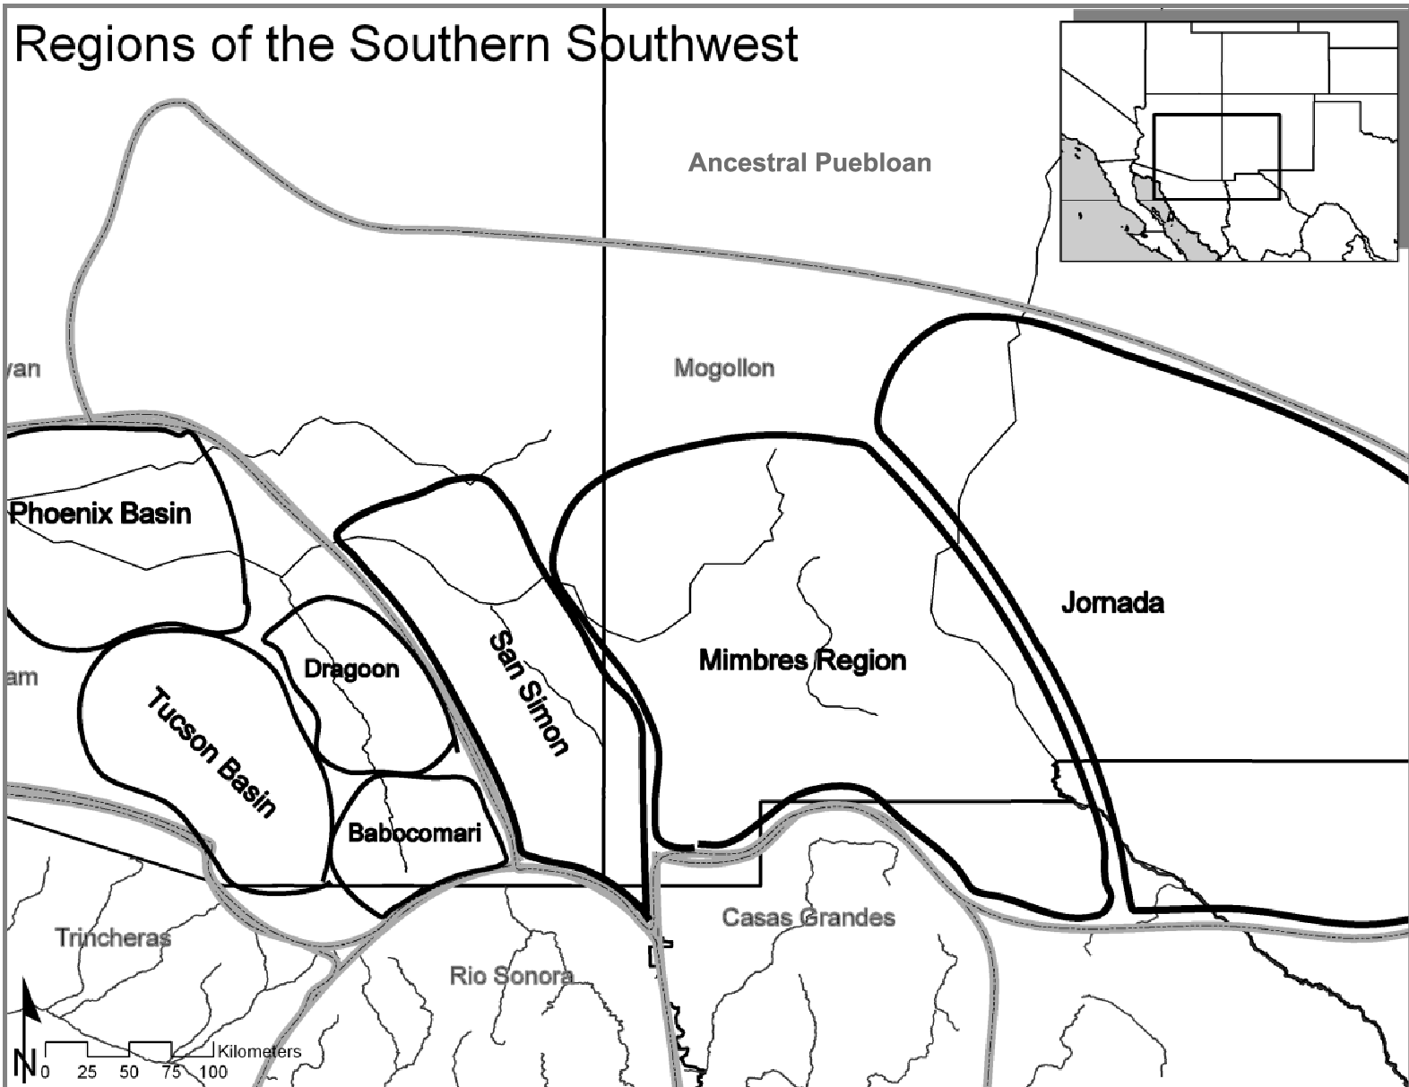
Figure 2.1. The Regions of the Southern Southwest. The map shows the regions of the southern Southwest with the major cultural regions and names bordered with gray and the names and boundaries of the cultural traditions within the major cultural areas bordered with black.

Mimbres Chronology
The chronology of the Mimbres region is well defined, based on distinctive changes in architecture, ceramics, and settlement patterns. Most chronologies of the Mimbres-Mogollon culture have been adapted from Haury (1936), followed by Anyon et al. (1981), and later refined by the ceramic chronologies defined by Shafer and Brewington (1995), and presented in Table 2.1.

Table 2.1. Mimbres Time Periods and Ceramic Types (Shafer and Brewington 1995).
Period | Phase | Painted Ceramic Type | Date (A.D.)
Late Pithouse | Georgetown | San Francisco Red | 550-650
Late Pithouse | San Francisco | Mogollon Red-on-brown | 650-750
Late Pithouse | Three Circle | Three Circle Red-on-white | 730-770
Late Pithouse | Three Circle | Style I (Boldface) | 750-900
Late Pithouse | Three Circle | Style II (Transitional) | 880-1020
Classic | Classic | Style III (Classic) | 1010-1130

The Early Pithouse period is the early formative period in the Mimbres region, and it is specifically called the Cumbre phase (A.D. 200-550) in the Mimbres Valley. Unlike the previous Archaic period, many innovations took place during the Early Pithouse period. Some of the main characteristics that archaeologists use to differentiate between the two cultural periods are the use of ceramics to make vessels, the construction of substantial pit structures, increased dependence on agriculture, and the aggregation of hunting and gathering bands into small sites along the Mimbres River (Anyon and LeBlanc 1984; LeBlanc 1983; Shafer 2003).
The Late Pithouse period is a time of great transition. The Mimbres Valley saw population growth, a shift in settlement patterns, agricultural intensification, architectural change, a marked change in ceramic production, and the appearance of grave goods. Based on temporal changes in ceramics and architecture, the Late Pithouse period is divided into the Georgetown phase (A.D. 550-650), the San Francisco phase (A.D. 650-750), and the Three Circle phase (A.D. 730-1010).
The Classic period is seen as the height of the Mimbres culture, and it starts at A.D. 1010 and ends in 1130. Although many of the characteristics of pottery construction, architecture and settlement patterns during the Classic period began in the Late Pithouse period, they continued to be refined during this period. The most significant change was a shift from subterranean pit structures to surface masonry pueblos. The Classic period saw a shift in settlement patterns to more room construction in the peripheral areas, locally produced artifacts including architecture and pottery, and a peak in population.

Changes in the Production of Pottery
The Early Pithouse period in the Mimbres region is defined as the time of initial ceramic production. The ceramics produced in the Early Pithouse period are Alma Plain and Miscellaneous Red (Anyon and LeBlanc 1984). Alma Plain is a brown pottery that takes the shape of bowls and jars and lacks any decoration (Anyon and LeBlanc 1984; Shafer 2003). Miscellaneous Red has an unpolished thin red slip on bowls and jars (Anyon and LeBlanc 1984).
The ceramics of the Late Pithouse period include plain, textured, and painted jars and bowls. The Georgetown phase ceramics include Alma Plain, San Francisco Red, and Miscellaneous Red (Anyon and LeBlanc 1984; Shafer 2003). The Alma Plain is a continuation from the Early Pithouse period. The San Francisco Red has a highly polished, deep red slip on the interiors of bowls and exteriors of jars (Anyon and LeBlanc 1984; Shafer 2003). It also has a distinct dimpling probably caused by the process of smoothing the coils during the polishing process (Anyon and LeBlanc 1984; Shafer 2003). Miscellaneous Red does not have the high polish and dimpling of the San Francisco Red and is a continuation of the Early Pithouse red pottery.
During the San Francisco period, Alma Plain, San Francisco Red, and Miscellaneous Red continue to be produced, but the production of Neck Banded, Textured, and Mogollon Red-on-brown begins (Anyon and LeBlanc 1984; Shafer 2003). The Neck Banded ceramics are brown jars that have the coils smoothed on the body with unsmoothed coils on the neck (Shafer 2003). The Textured vessels are jars and bowls that have a variety of textures including scoring, punching, and incising. Mogollon Red-on-brown has a light brown slip with red linear designs on the interiors of bowls and the exteriors of jars (Anyon and LeBlanc 1984; Shafer 2003). Many of the bowl exteriors are dimpled and highly polished like San Francisco Red ceramics.
The Three Circle phase has the greatest variety of ceramics (Anyon and LeBlanc 1984) in that it has all the ceramics of the previous periods with the exception of the Mogollon Red-on-brown. It also has Corrugated, Neck Corrugated, Three Circle Red-on-white, Boldface, and Transitional. The Neck Corrugated and Corrugated ceramics have narrower banding than the Neck Banded ceramics. Over time, the corrugation moves down the body of the vessel until the entire vessel is fully corrugated (Shafer 2003). Three Circle Red-on-white has a thick cream-colored slip with red geometric designs (Anyon and LeBlanc 1984; Shafer 2003). They were only produced for a couple of generations and compose a small percentage of the ceramics, probably because people were perfecting the firing techniques used to produce the later black-on-white ceramics (Shafer 2003). The Boldface ceramics have a brown paste, white slip, with bold line designs (Anyon and LeBlanc 1984; Shafer 2003). The designs are typically linear with wavy line hachure as filler (Anyon and LeBlanc 1984; Shafer 2003). The designs extend to the rim and lack any framing lines (Shafer 2003). Transitional ceramics follow the Boldface temporally. Transitional ceramics maintain the brown paste and white slip of the Boldface but use fine line designs bordered by bold lines (Shafer 2003).
Classic period ceramics decline in variety compared to the Late Pithouse period. In the Classic period, there is a discontinuation of San Francisco Red, Miscellaneous Red, Neck Banded, Mogollon Red-on- brown, Neck Corrugated, Three Circle Red-on-white, and Boldface, but people continue to produce early into the Classic period Alma Plain, Corrugated, Textured, and Transitional ceramics (Anyon and LeBlanc 1984). However, the complexity of geometric designs and anthropomorphic/ zoomorphic designs becomes more varied. In the Classic period, Classic ceramics appear. This type is temporally later than and a continuation of the Transitional ceramics. The Classic ceramics have thin line designs bordered by thin lines and rim bands (Shafer and Brewington 1995, 2003). Shafer and Brewington (1995) have developed a technique for identifying micro-stylistic elements to give temporal classifications for the Classic ceramics to within fifty years. They argue that the designs change every couple of generations in the Classic period (Shafer and Brewington 1995).
The variety of ceramics produced during each time period helps to illustrate the size and organization of ceramic production groups (Zedeño 1995). Zedeño (1995) has found that areas with a greater variety of ceramic types have more and diverse production groups. During the Early Pithouse period, there are fewer ceramic types than in the Late Pithouse meaning that there is a potential for more production groups during the Late Pithouse period. The greater number of production groups during the Late Pithouse period could be the result of increased population with established ceramic production groups as people move into larger sites in the Mimbres region. Conversely, there is a decline in ceramic types from the Late Pithouse period to the Classic period. This illustrates that during the Classic period ceramic production groups decline in number even, as suggested by (Blake et al. 1986), that population in the Mimbres River Valley continues to increase. The decrease in the number of ceramic types during the Classic period suggests that the ceramic production groups incorporated more people than during any previous time.

Changes in the Production of Architecture
The development of production groups in the Mimbres region begins with people becoming more sedentary. The first evidence of this can be seen in their investment in domestic architecture. The amount of investment people put into creating and maintaining architecture is divided by architecture type, including pithouses (Anyon and LeBlanc 1984; Diehl and LeBlanc 2001; Gilman 1987; LeBlanc 1983; Shafer 2003, 2006), pueblo rooms and room blocks (Anyon and LeBlanc 1984; Gilman 2006; Hegmon et al. 2006; Shafer 2003, 2006), and communal structures (Anyon and LeBlanc 1984; Gilman and Stone 2013). By understanding the amount of investment that the people in the Mimbres region used in the construction and maintenance of the architecture types, it is possible to understand they are creating a social situation in which design production groups can form and would be useful in the maintenance of social cohesion.
Starting with the first permanent or semi-permanent structures, we can get a baseline for the investment people made at sites during later periods. The Early Pithouse period domestic archetecture are round semi-subterranean structures. The pithouses are typically constructed into the soil matrix without any formal masonry, and only 29.5 percent have plaster (Anyon and LeBlanc 1984; Diehl and LeBlanc 2001:190; LeBlanc 1983:94) (Figure 2.2). The Early Pithouse period pithouse roofs are pole frames with mud covered brush (LeBlanc 1983: 60-62). The entries consist of a small step on one side of the structure (LeBlanc 1983). The average size of the pithouses is about 15 square meters with an average depth of 74.2 centimeters (Diehl and LeBlanc 2001:190) (Figure 2.3). These structures were quickly and easily made with local materials, and only 2.2 percent have evidence of remodeling (Diehl and LeBlanc 2001:190; LeBlanc 1983) (Figure 2.4). The expedient nature of the construction indicates that the structures were not meant for long-term use, and people most likely used these sites temporarily or seasonally (Kent 1991; Rafferty 1985).

Figure 2.2. Number of Pithouses with Plaster from the Early Pithouse through the Late Pithouse Period (adapted from Diehl and LeBlanc 2001).

Figure 2.3. Increased Pithouse Depth from the Early Pithouse through the Late Pithouse Period (adapted from Diehl and LeBlanc 2001).

Figure 2.4. Increase in Remodeled Pithouses from the Early Pithouse through the Late Pithouse Period (adapted from Diehl and LeBlanc 2001).

The domestic structures in the Late Pithouse period show increased investment and a shift in construction design. The average pithouse size throughout the Late Pithouse period is about 15 square meters (Anyon and LeBlanc 1984:94). The domestic structures in the Georgetown, San Francisco, and Three Circle phases change in shape, depth, and the amount of investment in the structure. The Georgetown phase structures are round, with more D-shaped structures appearing toward the end of the Georgetown phase (Anyon and LeBlanc 1984:93; LeBlanc 1983:60-62). The Georgetown and San Francisco phase domestic structures are constructed in the soil matrix without any formal masonry (Anyon and LeBlanc 1984:94). The Georgetown phase structures are round, with more D-shaped structures appearing toward the end of the Georgetown phase (Anyon and LeBlanc 1984:93; LeBlanc 1983:60-62). The structures had simple pole frame roofs with mud covered brush like the Early Pithouse structures (Anyon and LeBlanc 1984; LeBlanc 1983:60-62). The architectural investment in the Georgetown and San Francisco phases is shown by an increase in structure depth from 80 to 124 cm and the percent of plastering from 45 percent to 56 percent (Diehl 1997:190) (Figure 2.2 and 2.3). The percent of remodeling increases from 5.9 percent in the Georgetown phase to 8.3 percent in the San Francisco phase (Diehl 1997:190) (Figure 2.4). Hearths become more formalized with 85 percent having a formalized hearth in the Georgetown phase and 96 percent in the San Francisco phase (Diehl 1997:190). The Early Pithouse period and the Georgetown and San Francisco phases all show a gradual increase in architectural investment.
Domestic architecture during the Three Circle phase continues to change subtly. People begin to use cobbles in the wall construction and change to a rectangular shape (Anyon and LeBlanc 1984; LeBlanc 1983; Shafer 2003). The size of the Three Circle phase domestic structures is also about 15 square meters (Anyon and LeBlanc 1984). In the Three Circle phase, the structure depth increases to 126.1 centimeters (Diehl and LeBlanc 2001) (Figure 2.3). The percent with plaster also increases to 87.3, and the percent with evidence of remodeling is 21.1, showing the increased investment in domestic architecture (Diehl and LeBlanc 2001) (Figure 2.2 and 2.4). The percentage of domestic structures with formalized hearths is about the same as in the San Francisco phase with 94 percent of the structures having such hearths (Diehl 1997:190). In the later rectangular structures, the ramp entryway is blocked off in favor of a roof entry (Shafer 2003:41). The transition to rectangular architecture shows an increase in the depth, amount of plaster, and an increase in remodeling encourages people to form production groups. As construction becomes more complex and labor intensive, the relationships formed during the beginning stages of forming domestic architecture production groups influenced by already formed ceramic production groups or facilitate the development of ceramic production groups.
The Classic period is the time of pueblo development. Classic pueblos are typically built over Late Pithouse period pithouses (Anyon and LeBlanc 1984; LeBlanc 1983; Shafer 2003). The pueblos are groups of single story rectangular structures arranged in room blocks. The room blocks are constructed above ground with cobble-adobe walls (Anyon and LeBlanc 1984:315; Shafer 2003:43). The pueblos use both roof hatches and wall doors in their construction. The domestic use rooms in the room blocks have an average size of about 15 square meters (Anyon and LeBlanc 1984:94). The room blocks also have smaller rooms about 8 square meters or less and larger rooms over 26 square meters (Anyon and LeBlanc 1984:94). The smaller rooms serve as attached storage facilities, and the larger rooms are communal space for the room block (Anyon and LeBlanc 1984:312). Both the smaller and larger rooms lack hearths (Anyon and LeBlanc 1984).
Several studies have shown that room blocks in the early Classic period begin with a few rooms and by the end of the late Classic grow to be a conglomeration of many rooms (Hill 1997; Nelson 1993; Shafer 2003, 2006). The detailed excavation at the NAN Ranch site has produced an in depth account of room block construction. The southern room block begins with a single structure, and two generations later another room is added (Shafer 2003:88-109). The added room may be used for storage initially, but later a hearth is added, and the room becomes inhabited (Shafer 2003). Then after several more generations, the southern room block doubles in size again with the addition of a communal space (Shafer 2003). The next construction sequence adds a few small rooms to enclose an open courtyard (Shafer 2003). Just as the excavations at NAN Ranch show a pattern of construction through time, similar patterns are seen at Swarts and at Classic Mimbres sites in the Palomas drainage east of the Mimbres River Valley (Hill 1997; Nelson 1993; Shafer 2003, 2006) (Figure 2.5).
The growth of the room blocks in the Mimbres region may illustrate the development of corporate groups that formed from the original families (Hill 1987; Shafer 2003, 2006). Shafer argues that at NAN Ranch there are pit structures which are under the rooms that were constructed first in each room block, and later room blocks were placed on top of pit structiures. The single pit house under the room block is argued to represent a single family and as corporate groups were formed new rooms were constructed for them. The initial structures built in each room block tend to have a greater percent of burials and tend to be close to corporate kivas. However, the pattern of corporate groups is not universal, as Gilman (2006) suggests the formation of room blocks at the Mattocks site is the product of growth within single families. Whether the construction of room blocks is the product of corporate groups of people or single families growing and adding new rooms, the people in the Mimbres region continued to invest time and energy in sites than in earlier times.
The investment in architecture illustrates that the people who lived in the Mimbres region created a built environment. From the Early Pithouse to the Classic period, people who lived in the Mimbres region invested more work in their domestic structures. The more work people put into the construction of their domestic architecture the greater the chances that people would be interacting during the production of these structures. Ultimately, as the relationships within sites and in particular the large sites the more people would be participating in construction groups creating a social situation in which design production groups can form and are useful in the maintaining social cohesion.

Settlement Patterns
The challenges with the available land that the ancient inhabitants of the Mimbres region faced partially explain the development of large sites in the Mimbres region. The environmental setting in the Mimbres region is the basis for the settlement patterns, and the area’s potential for supporting groups of people partially explains why some sites are able to support more and varied production groups. By focusing on changes to settlement patterns I illustrate that the people who lived in the Mimbres region reorganized with population pressure and environmental conditions. In addition to illustrating the variation in sites, it is shown that environmental conditions helped to make some sites larger than other sites, which set some sites up for more and varied production groups.
The settlement pattern data show a shift in room construction in different environmental areas over time with a continuation of growth at sites in first bench/terrace above the flood plain where the large Classic sites develop. During the Late Pithouse period, the pithouse construction expands into the valley onto the first bench of the Mimbres River with a small percent remaining on the ridges and knolls above the valley (Blake et al. 1986:458). The new room construction expands during the Classic period into the side drainages along the Mimbres River (Blake et al. 1986). These data suggest that the populations in the Mimbres River Valley grew to the point that peopl were forced into the side drainages, indicating that the areas were suitable for agriculture in the flood plain were used up.
The new room construction from the Late Pithouse through the Classic period can be partially due to the environmental instability at that time. The pithouse to pueblo transition (about A.D. 900-1000) in the Mimbres region is a period of considerable climatic fluctuation with many years of below average precipitation (Minnis 1985:82-88). During this time, not only did the people who lived in the Mimbres region transition from pithouse to pueblo architecture, but they also adopted intensive agricultural technology (Creel 2006; Creel and Anyon 2003; Minnis 1985; Shafer 2003, 2006). In addition to intensifying agriculture through water control features like check dams across drainages and building irrigation systems, people living in the Mimbres Valley also began farming in marginal areas in higher elevations (Creel and Adams 1991; Minnis 1985; Stokes and Roth 1999).
The location of large sites along the Mimbres River tends to be in close proximity to large flood plains with available water (USGS 2013). One example is an upwell of water near present day San Lorenzo near the Galaz site that forms the largest aquifer in the Mimbres River Valley with modern well depth of only 32 feet (Trauger and Doty 1965:221). The location of agricultural sites in the Mimbres region tends to be near the confluence of drainages or open plains where sheet washing or water forced up by bedrock can provide well-watered agricultural fields (USGS 2013). One example comes from the Southern Mimbres Archaeological Project survey in which that research found that cultural deposits are located at the confluences and constrictions of drainages because the Cedar Mountains area both channel the water from uplands and geological upwells force the water closer to the surface (Gruber et al. 2009:46).
If this pattern holds true throughout the Mimbres region, then the area immediately surrounding Galaz would have an environmental advantage as several side drainages feed into the large flood plain (Minnis 1985; Nelson 1999). In addition, there is a large geological constriction approximately one mile south of Galaz that would drive the ground water to the surface (USGS 2013). This would have put Galaz in the center of a large well-watered flood plain. Likewise, at all other large Classic sites, a similar but slightly different condition exists where there is a large floodplain in close proximity to the site. Instead of the site being at the confluence of a few large drainages, there are many small drainages that feed the Mimbres River just upstream of the site, or the site is located along a flood plain formed by a bedrock constriction downstream. The areas surrounding the large sites are capable of supporting large field systems and may have attracted people to the sites where they would have helped to construct rooms to ultimately make the largest sites. The well-watered areas further contribute to development of large sites in the Mimbres region and contributed to the creation of more and varied construction and agricultural production groups and influencing the development of ceramic production groups.

Communal Structures
Site location may be the reason that some sites are larger than others, but ultimately it was the social practices of attracting people through communal activities, interacting with people from other sites through the distribution of ceramics, and the investment in domestic space to develop population permanence at sites that leads to the differences in production group organization. The social interactions between sites as the large sites in the flood plain along the Mimbres River grew played an important role in the development of production groups at the large sites. Gilman and Stone (2013:611) argued that communal structures were a means of attracting people during activities related to agriculture. During times of drought, the sites with more reliable water sources would tend to be able to sustain more people and have larger communal structures. Ultimately, the development of the large sites may have resulted in the growth of ritual centers and potentially differential organization of production groups.
Early Pithouse period communal structures have been poorly defined. Communal structures in the Early Pithouse period are the same shape as the pithouses of this time period, which are circular or oval. The only difference is that large pithouses on Early Pithouse sites are possibly communal structures, but it is unclear if they domestic structure (Diehl and LeBlanc 2001 and Gilman and Stone 2013).
There is a great deal of information on the Late Pithouse period communal structures due to the large number of these structures. During the Late Pithouse period, there is only one communal structure per site in use at any given time (Anyon and LeBlanc 1984). During the Georgetown phase, communal structures are oval/round with lobes or columns of earth flanking the ramp (Anyon and LeBlanc 1984). The Georgetown phase communal structures are similar in size and range from 32 to 44 square meters (Anyon and LeBlanc 1984).
The communal structures of the San Francisco have an average size of 59.7 square meters compared to 37.2 square meters for the communal structures of the Georgetown phase (Anyon and LeBlanc 1984:312). Like the latter, the communal structures of the San Francisco phase are similar in size to each other and range from 53 to 71 square meters (Anyon and LeBlanc 1984:312).
Three Circle phase communal structures change to a rectangular shape with no lobing (Anyon and LeBlanc 1984; LeBlanc 1983). The size continues to grow in the Three Circle phase with an average of 94 square meters (Anyon and LeBlanc 1984). The size is more variable, however, ranging from 37 to 175 square meters (Anyon and LeBlanc 1984). Anyon and LeBlanc (1984:140) suggest that the size of communal structures in the Three Circle phase is determined by the size of the site.
As Gilman and Stone (2013) have shown, there is an increase in variation of communal structures over time showing that the Mimbres region communal structures are less similar than the communal structures in the rest of the Mogollon region. Gilman and Stone (2013:611) suggest that communal structures in the Mimbres region were used to attract people from neighboring sites to promote the ideology and increase local and possibly regional status. The idea that the construction of communal structure was an act of attracting people to gain power and prestige also explains why some sites have large communal structures than others and grow to be larger sites than others.
The communal structures of the Late Pithouse period were retired and replaced by pueblos (Creel and Anyon 2003). The people from Galaz and Old Town usually retired communal structures through ritual burning (Creel and Anyon 2003). During the Classic period, there are two types of communal structures (Creel and Anyon 2003; Shafer 2003, 2006). There are some structures that are dedicated to individual groups within the community, and there are some that are used by the entire site (Creel and Anyon 2003; Shafer 2003, 2006). The above ground communal structures of the Classic period that replaced the semi-subterranean communal structures of the Late Pithouse period have more elaborate interior (Anyon and LeBlanc 1984; LeBlanc 1983). The interior elaboration of these structures includes a formalized rectangular hearth and the addition of a sipapu (Anyon and LeBlanc 1984; Creel and Anyon 2003; LeBlanc 1983; Shafer 2003). The hearth maintained its position midway between the entry and central post (Anyon and LeBlanc 1984; Creel and Anyon 2003; LeBlanc 1983; Shafer 2003). The sipapus were holes in the floor up to 30 centimeters deep and up to 30 centimeters wide filled with imported white sand (Shafer 2003). One large Classic communal structures at Galaz had a Military macaws wrapped in turquoise (Anyon and LeBlanc 1984; Creel and Anyon 2003; LeBlanc 1983; Shafer 2003).

Chapter Summary
The evidence for the development of more and varies production groups at Mimbres sites based on communal structures suggests that at some sites groups of people organizing for ritual purposes grew over time, and by the Classic period there are communal structures for families or corporate groups and larger communal structures for multiple families and corporate groups. Shafer emphatically argues that, “the production of Mimbres painted pottery was used to reinforce the system of values and ceremonies that sustain the corporate networks that operated the irrigation systems” (Shafer 2003:189). He suggests that the increase in the number of painted Classic vessels is the result of more public events where these vessels played a pivotal role. Shafer’s (2003) analysis of Style II and Style III vessels shows very little change in vessel size, but the number of vessels triples from the Late Pithouse period to the Classic period, which he attributes to the important role of the bowls in public events used to strengthen corporate groups.
From the Early Pithouse to Classic periods, Mimbres populations moved down into the valley bottom, their architecture changed, and ceramic production changed as some sites become larger than other sites. The populations along the Mimbres River moved down into the valley bottom and to the first bench after the Early Pithouse, and then in the Classic period the population expands up into the tributaries of the Mimbres River. The initial movement into the river bottom occurs as the people of the area begin to rely on agriculture as a primary food source. The expansion into the tributaries in the Classic period is seen as a response to the increased population in the river valley.
The development of large sites in the Mimbres region as a result of environmental conditions, arrangement of domestic architecture and the differential size of ritual facilities it is possible to get an understanding of the potential size and organization of production groups at large sites in the Mimbres region. The large Classic sites that developed are theorized to have grown as a result of agricultural intensification during the Late Pithouse period. Also during the Late Pithouse ceremonial structures were used to attract people to increase the size of agricultural production groups. The result of attracting people to more agriculturally productive land during the Late Pithouse period is the formation of greater domestic structures that require more work to create, larger communal structures, and a greater number of ceramic production groups. By the Classic period, large sites are well established in well watered areas, formalized ceremonial structures are no longer being created, domestic structures are formed in clusters or multiple room blocks, and number of ceramic production groups significantly decrees. The absence of ceremonial structures during the Classic period with the formation of ceramic production groups supports what Shafer (2003) argues is happening at NAN that pottery production became the focus of ceremonial activity and is used to reaffirm social boundaries between agricultural production groups.

Production And Distribution Of Mimbres Ceramics

This study draws from methods for identifying social boundaries used in the American Southwest, but these approaches are not appropriate for studying variation among work groups within a site. These studies rely heavily on utilitarian ceramics and chemical composition studies, which are theorized to only consider mundane and rote activities and a more reliable indicator of social boundaries. As discussed in the first chapter these ceramic studies in the North American Southwest have shown that social boundaries between migrant groups (Clark 2001; Duff 1999; Mills 1998; Neuzil 2008; Stark et al. 1998; Stone 2003; Wilshusen and Ortman 1999 Zedeño 1994). As Gosselain (1998) points out migrant groups will choose to duplicate the local technological steps in the creation pottery. Therefore, the less visible or more difficult a production step is, then it will be one of the last steps the migrant person the will learn and will be different from the production steps of the local population. However, when trying to identify ceramic production groups, which can include migrant people, pottery production needs to be understood as a social process between producers.
Studies on aesthetics have shown that the production of material culture is highly interactive, and people within work groups critique the productions steps as they are happening, showing that the work group regulates aspects of material culture that have typically been seen by others (Coote 1992; Coote and Shelton 1992; Fenner 2008; Gell 1992; 1996, 1998, 1999; Layton 1992; Morphy 1992; 2007, 2009; Shelton 1992; Stahl 2002). The evaluation of production steps allows individuals within work groups to adjust the production steps to conform to the expectations of the group during the creation of material culture. This study will draw from previous ceramic studies in the Mimbres region to develop approaches to understanding the social boundaries between ceramic design production groups at large sites in the Mimbres region.
In this chapter, I begin by discussing INAA studies that are used to identify clay source groups used in the production of Mimbres pottery as a means to identify the production and distribution of vessels in the Mimbres region. I then focus on stylistic studies in the Mimbres region that are also productive in identifying regional differences. Starting with Mimbres design studies, I show that subtle differences in the painting of designs there are regional differences. Then I show that the painting production steps are related to the construction of the bowl. I then show that bowls with figurative/iconographic designs are produce in more larger and more inclusive production group than bowls with geometric designs. Finally, I will argue that subtle variation in the designs is a productive means of identifying differences in pottery production within and between sites in the Mimbres region.

Production and Distribution of Mimbres Ceramics Using INAA Studies
Recently INAA studies set out to understand the production and distribution of ceramic production in the Mimbres region. The INAA studies in the Mimbres region identify two major trends, first there are many more source groups than other regions (Speakman 2013:198) and second NAN and sites south further to the south do not have easily distinguishable source groups during the Classic period (Speakman 2013:195). However, while this data is not currently useful for the identification of social boundaries, further research will make the INAA data useful for identifying social boundaries between ceramic production groups. Ultimately, the diverse chemical makeup of source groups is the result of the wide variety of clays and tempers used. The gathering of clays and the addition of temper could be useful social activities in the creation of Mimbres pottery when the two different technological processes are independently identified.
Recent analyses identify the production and distribution locales of Mimbres pottery using instrumental neutron activation analysis (INAA, NAA) (Creel 2014a, 2014b; Creel and Speakman 2013). Speakman’s dissertation (2013) is the most comprehensive of these, and he uses more than 2,900 samples of Mimbres-Mogollon pottery, 600 Jornada-Mogollon samples, and approximately 160 clays from 165 sites. Using these data, Speakman identifies about 35 compositional groups. Speakman argues that Three Circle Red-on-white and Mimbres Boldface and Transitional are produced throughout the entire Mimbres Valley, while there is minimal or no production of Classic period pottery in the lower valley. In particular, he argues that Classic period pottery production downstream of the NAN Ranch site is minimal or non-existent. This supports what Powell-Martí and James (2006) show that bowls are being moved around within the Mimbres region or at least the clay from which they were made. Speakman also points out that there are nearly 20 unassigned compositional groups that make up 20 percent of the sample, and further work could define source groups in the southern Mimbres River Valley. He suggests that the many different compositional groups are indicative of multiple production groups, and in order to parse out the differences between production groups other lines of data like stylistic analysis is needed to fully understand production groups.
In terms of using source groups as a step in the technological process for understanding ceramic production it must represent one step in the process. The current compositional groups are chemical signatures that include both clay and temper. Speakman (2013:202) points out that temper source groups need to be separated from the compositional studies because the wide variety of tempers used in Mimbres ceramics are contributing to the high number of source groups. Once the temper and clay are chemically separated, they can be understood as separate production steps and can be used as potential indicators of social boundaries within sites.
More recently, Creel (2014a, 2014b) has begun to combine design analysis and the presence of pottery making tools with the INAA data from the Swarts site which shows the true potential of INAA compositional studies. Creel establishes that there are a large number of pots from non-local source groups at Swarts. He also spatially plots the bowls to understand locations where the compositional groups are from. He found that the three local clay sources (2a, 2b, and 2c) are distributed evenly across the site. Creel found that only one of the four rooms with both pottery making tools and local compositional groups were had vessels from non-local compositional groups. There were also two rooms with pottery making tools in a burial, which he suggests is indicative of pottery making activity in those rooms. These individuals were buried beneath the room floors with nearly half of the compositional source groups’ samples. It appears from Creel’s (2014a, 2014b) data that the local potters at the Swarts site were using local production steps in the clay preparation in the production of their pottery.
Composition studies in the Mimbres region build on a large database of ceramic data that is providing new insights into the production and distribution of ceramics in the Mimbres region, but more work is necessary before it will be compatible with technological stylistic studies. The high number of composition groups is not enough variation to rely solely on INAA data to understand social boundaries between production groups within a site. However, when combined with other data like pottery production tools and Iconographic data it is possible to better understand the production sequence and differences between production groups can be realized.

Design Variation in Boldface Black-on-white Bowls
Beginning in the Late Pithouse period it is clear that production groups are beginning to form. Using stylistic analysis that includes both vessel form and designs regional differences are apparent. As discussed in the previous chapter there are more production groups during the Late Pithouse period than in the Early Pithouse or Classic periods. In my past studies, I have identified regional differences between production groups, but the limitation of sample size and variability in the material culture it was not possible to understand production groups within sites or even between sites for that matter. By understanding the strengths and limitations of a broad scale design analysis it is possible to understand potential analytical approaches to understanding social boundaries between sites in the Mimbres region. Using the Boldface design analysis in the Mimbres region, it is clear that differences among production groups are not represented in a few designs or motifs but rather how complex designs are produced and combined.
In previous research (Gruber 2007), I used the stylistic variation of Boldface ceramics to show that there were a few different production areas in the northern and southern Mimbres River Valley, the Gila/Reserve area Western and the area around Cameron Creek or Intermediate area (Figure 3.1). This study relied on the dissimilarity in Boldface Black-on-white designs. While the people from the identified regions used most of the same design elements, they used them in different frequencies and combinations (Gruber 2007). This research raised several questions and made me wonder if people in the Gila/Reserve area were a different social group that was mixing elements from people other than the Mimbres, or if they were trying to separate themselves from the people who lived in the Mimbres region. The most intriguing difference identified was between the northern and southern Mimbres River Valley areas as the distance the sites with a majority of the sample are located within the Mimbres River valley and not as distant as site in any other area.
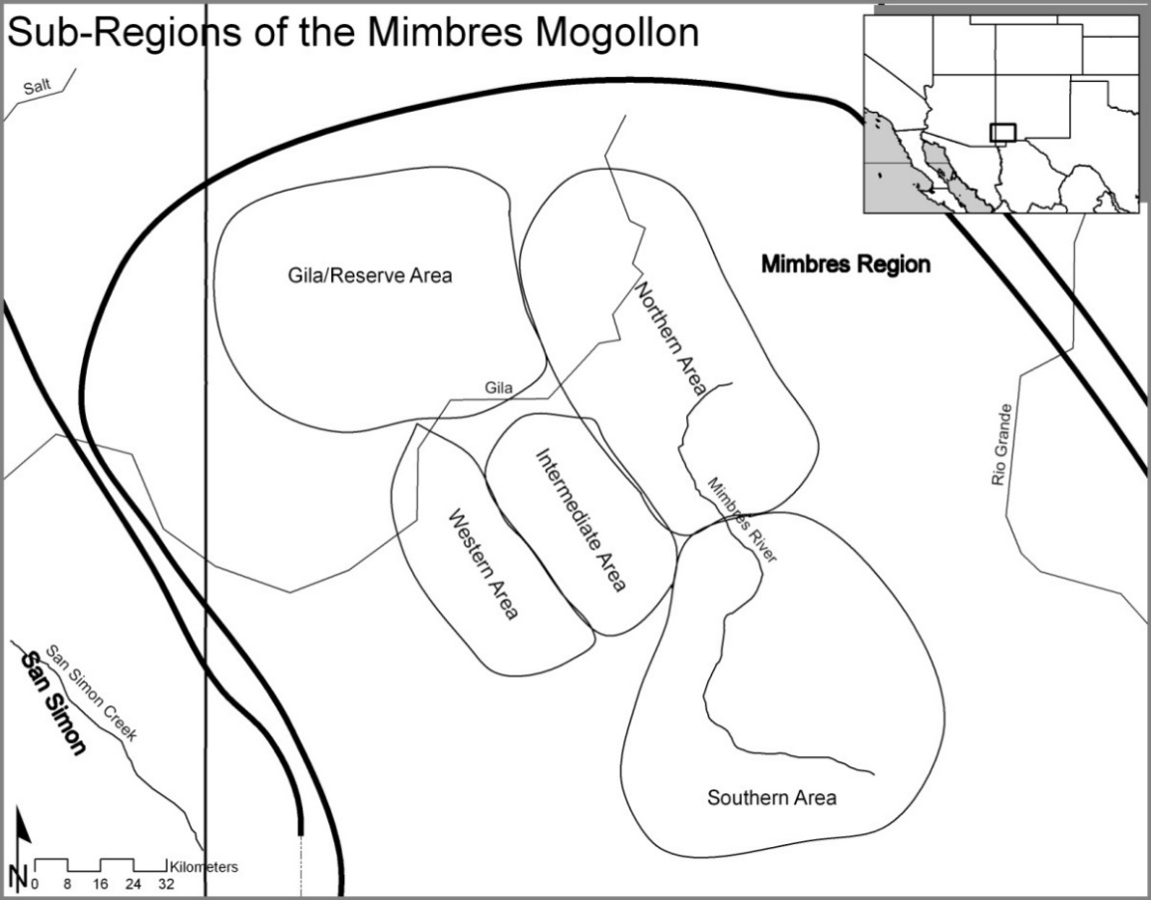
Figure 3.1. The Defined Sub-regions of Boldface Black-on-white Pottery in the Mimbres region (from Gruber 2007:59).

Further analysis showed that people in the Mimbres region of southwestern New Mexico during the Late Pithouse period planned the painted design layouts of Boldface bowls in correlation with the shapes and sizes of the bowls (Gruber 2008). Using the relationship between painted designs and vessel shapes and sizes, it is possible to understand the relationship between vessel form and painted designs on Boldface bowls. I used the symmetry of design structure to which Brody (2004) refers and taken from Gruber (2007), which includes the outline of the primary designs within the design layout. I used the primary design outline because before an artist begins the process of decorating a vessel, the painter has a preconceived notion that includes the manner in which the vessel design is divided and the outline of the primary shape (Gruber 2008). The primary shape ultimately influences the way the design space is divided on a bowl. The division of the design space then influences the primary element choice. This research finds that including the bowl shape in the form of a height width ratio with the data from my original research the results are comparable.

Pottery Construction and Painted Design Symmetry on Mimbres Boldface Pottery

Gruber (2008) focused on bowls with rotational and reflective symmetry that had two or four repeating elements showing that there is a relationship between bowl construction and painting. In this study, rotational and reflective symmetries, and two and four repeating elements are used to identify if the numbers of elements or symmetries affect the vessel shape. By comparing the height and width of the bowls with rotational and reflective symmetry and with the number of repeating elements Gruber (2008) shows that there is a relationship between the bowl diameter and the symmetry of the designs on the bowl.
Gruber (2008) found that there is a relationship between the vessel size and the design symmetry. The statistical tests showed that height and width of the rotational and reflective symmetry were significantly different. These test also show that the bowls with rotational symmetry averaged larger diameter and height and attributing to the differences in the volume of rotational and reflective symmetry bowls. However, when the height/width ratio was considered there was no difference between bowls with rotational and rotational symmetry. The height/width ratio of bowls is related to the form of the bowl and is related to the design preference of the potter. Ultimately, the bowls with rotational symmetry are on bowls with larger diameters and reflective symmetries are on bowls with smaller diameters.
The relationship between vessel shape and design symmetry on Boldface bowls shows that pottery construction and painting is a related process. The people of the Mimbres region had a clear understanding of the construction techniques used to create Mimbres Boldface bowls beyond the types of designs, the slip, and the paint color. The people who lived in the Mimbres region understood that to make a Boldface bowl it should have a white slip and have wide line strokes that always extend to the rim. The designs can also include large scrolls, wavy line hachure, and three pronged F and other rectilinear designs. This study shows that small bowls have a reflective design structure symmetry. Conversely, if the bowl is going to have a rotational symmetry the bowl should be larger. The differences defined in the bowl size and symmetry could be indicative of functional differences related to bowl size, workgroup differences, and or a relationship between the relative complexity of a rotational symmetry versus a reflective symmetry and the need for a larger working area to create the more complex design. This study shows that the painted designs and ceramic construction are related technological steps and that there are regional differences in the production of Boldface pottery. The ceramic production groups living in the Mimbres region during the late pithouse period included a people from many sites and in some cases multiple regions.

Rim Band Painting Production on Mimbres Classic Bowls
In another study, Toney and Gruber (2010a and 2010b) were able to demonstrate, using rim band combinations, that there is a difference in the production and distribution of geometric and figurative or iconographic bowls in the Mimbres region. They used 1604 Classic bowls with room block provenience at Cameron Creek, Galaz, Mattocks, NAN Ranch, and Swarts, including three room blocks at Cameron Creek, four room blocks at Galaz, two room blocks at NAN Ranch, six room blocks at Mattocks, and two room blocks at Swarts. Of the total 1604 vessels, they identified 113 different rim band combinations and grouped them as having geometric designs and figurative designs.
Toney and Gruber (2010a, 2010b) showed that the production and distribution of rim bands on bowls with geometric and figurative designs was different. We found that ceramic design production groups centered on room blocks within and across Classic period sites. However, there were no differences in rim band painting between room blocks when only figurative bowls were considered. We also looked at differences in rim band painting across sites there are few differences in the figurative bowls between sites. We found that there is a lack difference between sites in the Mimbres region in the painting of rim band on bowls with figurative designs. However, when geometric bowls were considered across sites in the Mimbres region, nearly every site was different in the painting of rim bands. Toney and Gruber (2010a, 2010b) showed that geometrics were considered more private and may have been more like the idea that Shafer (2003, 2006) suggests and were the focal point of the larger communal activates that help to bind the corporate groups in the Mimbres region. The production of rim bands in the Mimbres region again illustrates that there are identifiable differences between production groups when subtle design differences are considered on bowls with geometric designs.

Summary
The recent INAA and stylistic studies in the Mimbres region show that there are differences in the production of ceramics within and across sites. In the Mimbres region, INAA studies identify differences between sites but the differences within sites are limited. However, based on the results of the vessel form and design symmetry study, which showed that painting technological steps are related to nonprinting production steps, I am confident that once chemical signatures for clay and temper are separated and understood as separate technological steps they will be a productive line of data for understanding production groups within sites. The studies done by Gruber (2007, 2008) show there are very subtle differences in the designs of the Boldface bowls between different regions, but there were no identifiable differences within sites in the production of pottery during the Late Pithouse period. However, the technological processes of ceramic construction and painting are related and one-step influences the other. By understanding the subtle variation in the production steps, regional differences are observable in the Boldface pottery.
Building on the Late Pithouse period ceramic design analysis research Toney and Gruber (2010a and 2010b) further establish that subtle variation in designs are capable of identifying not only regional differences but differences within sites and between room blocks. However, not all bowls are useful for identifying differences within sites. The production of rim bands on ceramics with figurative designs was not different within sites, but there were differences in the production of rim bands on bowls with geometric designs within sites. The results of the rim band study suggest that different production groups produced figurative/iconographic bowls, or production groups included more and diverse number of people during the painting of these bowls than bowls with geometric designs. The more inclusive production of figurative/iconographic ceramic vessels supports ritual production of ceramics as argued by Shafer (1995, 2003, 2006). However, the figurative/iconographic bowls would not be useful for identifying production groups within a site if they are being produced communally in large production groups. Conversely, bowls with geometric designs do not appear to be produced in the same social setting and appear to be produced in smaller production groups distributed throughout sites. Therefore, this study will rely on Classic period bowls with geometric designs.

Methods for Understanding the Organization of Ceramic Production Groups at Classic Mimbres Sites, A.D. 1000-1130

This research focuses on the identification of social boundaries between ceramic painting groups. The social boundaries between groups at sites in the Mimbres region are identified using the differences in the painted geometric designs on ceramic bowls that the people who lived in the Mimbres region produced during the Classic period (A.D. 1000-1130). Specifically, the differences in the painted designs can highlight designs that not are evenly distributed across a site. Participation in ceramic painting groups provides clues as to the organization of people in a local community.
This chapter outlines the methods used to identify differences in the geometric painted designs. The chapter begins by reviewing how art historians have approached identifying individuals and production groups using painted designs on pottery. The methods for identifying potters and potting groups all rely on aspects of the structural elements that compose a motif in a design. This chapter continues by defining the zigzag and stepped motifs used in this study.
The decorative problem is the basic definition of the type, date range, and location of the design being analyzed. Following the definition of the decorative problem are the methods for recording the symmetry and the design layout. These are discussed together because they record the first lines executed in the construction of painted design on the bowl. The relative order of the designs painted on the bowl helps methodologically to maintain uniformity in the data collection by working from the largest to smallest elements. The arrangement of the motif into the zones on the bowl would be the next lines painted on the bowl. These zones record where the designs are on the bowl and also how the motifs are repeated within the zone. The final designs recorded on each bowl are the formal elements used to create the zigzag and stepped motifs. The formal elements are all of the line features and triangle elements used to create the two motifs. The last section of this chapter describes the four-step process used to analyze the bowl design and the spatial organization of bowls with similar designs and how these methods address the problem of identifying design production groups and their organization at each site.

The Art Historian Approach to Identifying Ceramic Painting Work Groups
While traditional methods for identifying social boundaries in the North American Southwest have relied heavily on utilitarian ceramics and chemical composition studies, these approaches are not appropriate studying variation among work groups within a site. However, art historians have produced methods for the identification of social boundaries among painters within a site. This study will use methods developed by art historians and applied by LeBlanc (2006, 2010) in the Mimbres region to identify individual potters. However, the focus of this study is not to identify individual potters, but instead to identify the variation in microstylistic designs between design production groups within a site.
Art historians have developed numerous ways to classify and quantify designs and even more ways to interpret the patterns produced in their studies (Beazley 1918, 1951, 1956; Boardman 1974, 1975; Hardin 1983, 1990; Hegmon 1995). Art historic methods focus on learning and teaching painted designs from generation to generation, whereas current archaeological methods focus on identifying social boundaries between groups through the identification of variation created as a result of rote learning. As described in the first chapter, rote activities are less susceptible to change than are activities that involve creative and innovative methods (Dietler and Herbich 1998; Gosselain 1998; Lechtman 1977; Lemonnier 1986, 1989, 1992, 1993a, 1993b; Stark 1998). The art historic and archaeological theoretical perspectives help our understanding of the painting process, where painted designs are created repetitively until committed to rote memory (Gosselain 1998; Lechtman 1977). As people come together to create painted ceramics, the experience is reproduced and reaffirmed by experiences of painting and viewing others’ paintings. The knowledge of past generations’ work informs the current generation’s decision-making process when choosing between equally effective methods of painting motifs during the creation of ceramic designs.
As discussed in the first chapter, the constant viewing and reproducing of one method over another develops habitual acts in the creation of ceramic designs (Bunzel 1972; Gell 1992, 1996, 1998, 1999; Hardin 1983, 1990; Hegmon 1995; Lechtman 1977; Lemonnier 1986, 1989, 1992, 1993a, 1993b; Morphy 1992; 2007; Rankovic 2009; Stark 1998). The learning of past techniques by painting students, who may not yet be producers, also involves the reaffirmation of the aesthetic norm. During the teaching process, the students are corrected and instructed to produce ceramics as the current generation of producers does (Bunzel 1972). The feedback between student and teacher also reaffirms the social norms for producing ceramics. Thus, the art historic and archaeological methodological perspectives for identifying work groups through the produced material culture of that group focus on identifying repeated production steps that constrain a group’s designs, and these repeated production steps last multiple generations (Beazley 1918, 1951, 1956; Boardman 1974, 1975, 1994; Gell 1992; 1996, 1998, 1999; Hardin 1983, 1990; Hegmon 1995; Morphy 1992; 2007; Rankovic 2009).
Developing the techniques used to identify work groups and individual artists began in the early 1900s with the work of Beazley (1918, 1951, 1956). Examining unaffiliated Greek vases from the Aegean Bronze Age, Beazley began to build a method for classifying vessels made by particular Greek artists and schools by identifying specific attributes of common motifs that an artist executed differently than other artists. An example of how he identified specific artists is the number of loops used to create the spiral found on the ankles of human figures on Greek black or red figure ceramics (Beazley 1918, 1951, 1956).
Boardman (1974, 1975, 1994), a student of Beazley, showed that not only can the artist be identified by looking at specific formal elements composing a motif, but the students who studied under specific artists could be identified. Boardman established that many of the microstylistic differences among artists in the creation of motifs are also found in the motifs of the artist’s students. Ultimately, Beazley and Boardman showed that design production groups could be identified through the microstylistic variation produced in the creation of motifs on painted ceramics.
The “Beazley technique" has been used to identify individual artists who painted or formed Moche vessels from the north coast of Peru (Donnan and McClelland 1999) and Mimbres Classic Black-on-white ceramics (LeBlanc 2004, 2006, 2010). Art historians and archaeologists have reproduced Beazley’s and Boardman’s results with great success, and in doing so the methods for identifying design production groups have expanded to include the placement of the motif on the vessel (Hardin 1983, 1990; Hegmon 1995; Hegmon and Kulow 2005), the symmetry of designs in the motif (Gruber 2007; Washburn 1977), the symmetry of the motif in relation to other motifs (Hardin 1983, 1990; Hegmon 1995), the symmetry of the entire design on the vessel (Gruber 2007; Washburn 1992, 1999; Washburn and Crowe 1988), and the execution of geometric designs (Hardin 1983, 1990; Hegmon 1995; Hegmon and Kulow 2005). These methodological approaches are designed to identify production groups and differences in the designs they produce within a site and are suitable for identifying production groups in the Mimbres region.

Defining Middle Classic Period Ceramics Used in This Study
Shafer and Brewington (1995) show the variation in the painted designs on Classic bowls between generations. Microstylistic designs have been useful in identifying differences in as little as 30-year increments at the NAN Ranch site and presumably within the Mimbres region as a whole (Shafer and Brewington 1995). Middle Classic bowls represent a large enough sample to make comparisons within sites possible and are defined using microstylistic differences.
The Classic period ceramics are divided into Black-on-white early Style III (A.D. 1010-1080), Black-on-white middle Style III (A.D. 1060-1110), Black-on-white late Style III (A.D. 1110-1130), and Polychrome (A.D. 1060-1130 (Shafer and Brewington 1995:17-22). The main difference is in the fine line designs of these ceramics. Style II has fine lines bordered by thick lines, Style II/III has fine lines bordered by fine lines only above the series of fine lines, and early Style III has fine lines bordered by fine lines on the top and bottom. The majority of the previous designs from the Style II/III ceramics are carried over into the early Style III ceramics. The main difference is in the construction of figurative designs in the early Style III. The eyes of the naturalistic figures are more proportionate to the size of the body of the figure.
Middle Style III ceramics have framing lines that bound the top and the bottom of the design field. From the early Style III ceramics, there is an increase in the number of naturalistic figures. Middle Style III naturalistic designs have the highest variety of life forms represented of all the Mimbres ceramics. The naturalistic designs are either an elaborate geometric design or an organic form accompanied by geometric rim bands. Late Style III ceramics show a decline in the complexity of the rim treatment. The rims typically have a single thick black line that wraps over the rim but does not extend to the exterior of the vessel. Late Style III naturalistic designs are more simplistic compared to middle Style III. Late Style III ceramics show extensive ware from abrasives probably due to increased domestic use. Shafer and Brewington (1995; 22) suggest that the increased wear was a result of decreased production of painted ceramics.
The last in a series of painted ceramics produced in the Classic Mimbres period is Classic Black-on-white polychrome. Polychrome ceramics overlap the middle and late Style III and differ only in the addition of the tan to gold paint. While the designs of late Style III ceramics become more simplistic, the polychrome ceramics maintain the elaborate designs of the middle Style III ceramics.

Identifying Variation in Motifs and Formal Elements
This study focuses on the variation in geometric motifs on Mimbres Classic pottery to determine whether painting design production groups are present at sites. The definition of a motif that I use comes from iconographic studies (Kubler 1969:1-4, 47-48). A motif is an element of a pattern or a theme that is a repeated design or composition. Motifs are always combinations of designs that are repeated with great percent. In Kubler’s (1969) review of iconographic methods and theory, he describes what he calls the 'thematic recognition,' which is a repeated concept that allows the viewer to recall specific stories and allegories through the observation of material culture. He believes that viewing motifs recalls thematic memories and have social meaning, and the best way to identify them is through their repeated reproduction. In this study, I will be looking at the zigzag and stepped patterns, which are themes that are repeatedly produced on Mimbres painted pottery.
Following the identification of zigzag and stepped motifs, I will classify the formal elements that compose the motif. Kubler (1969:2) defines the formal elements as the form, shape, and size of a design, including stylistic preferences made by the artist that do not contribute to the meaning of the motif. In iconographic studies, the formal element contains no social meaning, as viewed from within the culture in which the item was created. The formal elements are only part of the whole design, and there can be some variation in the formal elements in the creation of a motif. The variation in formal elements is the stylistic preference of the artist. The stylistic preference is what Beazley and subsequent researchers have used to identify individuals and design production groups (Beazley 1918, 1951, 1956; Boardman 1974, 1975, 1994; Donnan and McClelland 1999; LeBlanc 2004, 2006, 2010). This study will focus on in the identification of painting groups through the variation in the formal elements that compose motifs identified using ‘thematic recognition.’

Defining the Stylistic Analysis
The definition of the stylistic analysis provides a framework for categorizing the material culture used in this study. Hardin’s (1983) method develops a descriptive system that illustrates the rules governing the use of individual formal elements by defining four factors – 1) definition of the decorative, 2) basic unit of design and the motifs and formal elements, 3) system for the classification the designs, and 4) set of rules for using the formal elements. Hardin’s method begins with the definition of the decorative problem. The decorative problem is the specific material culture and stylistic attributes being studied. She divides the decorative problem into description of the decorative area on the object and the form of the decorated object. The decorative problem includes the boundaries of the zones of decoration, or in other words, the part or parts of the object that received the decorative treatment. In this study, I will define the decorative problem as the painted bowl interiors and the painted design zones.

Definition of the Basic Unit of Design and Zigzag and Stepped Motifs
Mimbres painted pottery is well known for its elaborate naturalistic designs and complex geometric patterns. Brody’s (2004) work with Mimbres pottery describes some of the common designs. While a majority of his book focused on the figurative designs, there are a few pages dedicated to the more common geometric designs. In his description of geometric motifs, Brody (2004:14) lists the zigzag motif and the stepped figures. In the example he uses to illustrate the zigzag and stepped figures, he shows that the zigzag and stepped motifs can coexist any place on bowl interiors. Brody (2004:156) also emphasizes that “Mimbres geometrical painting grew out of fascination for the visual potentials of ambiguity.” In this study, I will use the variation in the stepped and zigzag motifs to identify design production groups or using Beazley’s terminology, “schools.”
The zigzag and stepped motifs both have variations in their production, but both have a set of rules that defines the basic motif. A zigzag motif is an angular shape made of one or more lines characterized by sharp turns in alternating directions (Figure 4.1). The zigzag motif does not form a “U” shape but only an “S” or “Z” shape. The specific definition of the zigzag motif includes five elements that must be present. The total design sequence (Figure 4.1) is 1) a smooth line (starting at a zero degree reference point or the bottom horizontal line in Figure 4.1), 2) an angle greater than zero, 3) a wavy or zigzag line, 4) an angle greater than zero in an opposing direction from the initial angle, and 5) a smooth line (returning to zero degrees or nearly zero from the initial smooth line). If all of the preceding five elements are not present, I did not record the design combination as a zigzag motif.
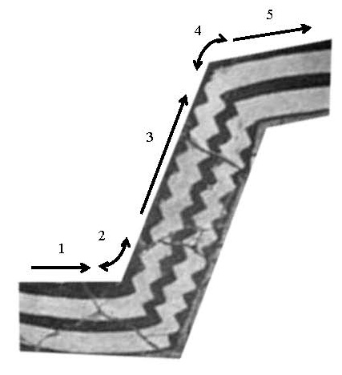
Figure 4.1. The Five Required Elements of a Zigzag Motif.

The definition of the stepped motif used in this study is a series of 90 degree turns generally running in a 45 degree slope. The specific definition of a stepped motif is any sequence of zero to 90 degree turns that alternate and move progressively away from the point of origin (Figure 4.2). As the design progresses from the first line, a 45 degree line is drawn from the first line, and all subsequent lines follow the 45 degree line. There are two basic variations of the stepped motif - a right triangle and a pyramid. The right triangle has a single series of steps terminating in a 45 to 270 degree turn, and if lines were drawn around the motif, a right triangle would be formed. The second variation is the pyramid-shaped stepped motif with the two 45 degree angles of the stepped motif facing each other to create a pyramid (Figure 4.2).

Stepped Right Triangle | Stepped Pyramid
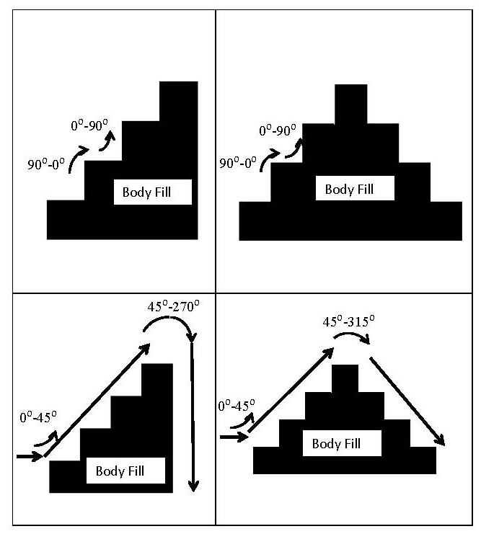
Figure 4.2. Required Elements of a Stepped Motif.

Motif Arrangement
The variations in the zigzag and stepped motif arrangements include the placement, arrangement, and number of times the motif is repeated, which include the differences between the general shapes of the stepped and zigzag motifs. The arrangement of the zigzag and stepped motifs is categorized by the whole vessel’s finite symmetry defined by Washburn (1999) and the design structure defined by Hegmon and Kulow (2005:324; also see Brody 2004). The design structure that Hegmon and Kulow (2005) use does not accurately represent the geometric pattern in the way that symmetry does, but it includes the presence of elements like banding, figurative elements, and the placement of design fields useful for my analysis. Brody (2004:134-137) notes that in the face of an infinite combination of schemes and figures, the underlying concept of the design was unaffected. He adds that within the limits of the design structure the potters’ logic allowed them the freedom to manipulate, interpolate, interpret, and invent.
The design structure of the painted Classic bowl interiors catalog the arrangement of formal elements used in the creation of the zigzag and stepped motifs. For the purpose of this study, I use the design structure to which Brody (2004) and Hegmon and Kulow (2005) refer, design zones taken from Hardin (1983), symmetry of design taken from Washburn (1992) and formal elements as defined by Hardin (1983) and Brody (2004). The design structure, design zones, and symmetry of the design were used because, before an artist begins the process of decorating a vessel, that painter has a preconceived notion about the design and its structure that includes the manner in which the vessel design is divided and the outline of the motifs. Likewise, I record the suite of designs on a bowl that classify bowls into groups that are similar to each other.
Mimbres bowls have a specific set of defined design structures that are used to understand the placement and arrangement of motifs on bowls. Figure 4.3 is the most comprehensive catalog of design structures for Mimbres painted ceramics (Hegmon and Kulow 2005:324), and I use them to identify variation in design structure. The design structure is the potter’s first few lines placed on the vessel because those lines dictate the organization of the overall design.

Figure 4.3.Defined Design Structures for Classic Mimbres Painted Ceramics (from Hegmon and Kulow 2005:324).
Drawing from Hardin’s (1983) methods, the arrangement of zigzag and stepped motif included symmetry analysis. Washburn (1999) and Washburn and Crowe (1988) have argued, using Julesz’s (1975) and Bruce and Morgan’s (1975) psychological investigations, that symmetry is not learned but is a product of the human visual system and is directly connected to a culture’s cognitive map. These arguments are similar to Sackett’s (1985, 1990) isocrestic behavior and Bourdieu’s (1977) habitus where the symmetry of designs is not actively taught or learned but is acquired through rote learning. Symmetry can be used to assess the patterns on many different designs.
Symmetry analysis flattens the design on a bowl so that all elements of the design are on a plane. The design is then separated into one of four geometric motions or symmetries that repeat elements on a plane. The possible geometric motions are mirror reflection, translation, rotation, and glide reflection (Figure 4.4). Mirror reflection, also called line reflection, is if the patterns match when the design is folded along any line between the two halves. Translation is the displacement or shift of the design element(s) in one direction over a certain distance, with the elements maintaining the pattern. Rotation is a design that can be rotated around a single arbitrary point. Glide reflection is the combination of translation and mirror reflection where one element of the design is reflected and then shifted a certain distance. The best example of glide reflection symmetry is an image of footsteps in the sand. The four basic motions of symmetry provide the basis for categorizing formal elements in design zones.

Mirror Reflection | 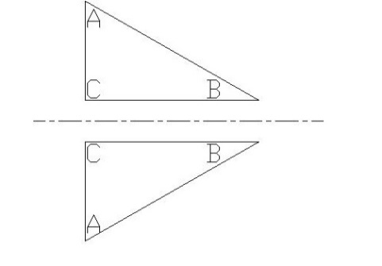
Translation | 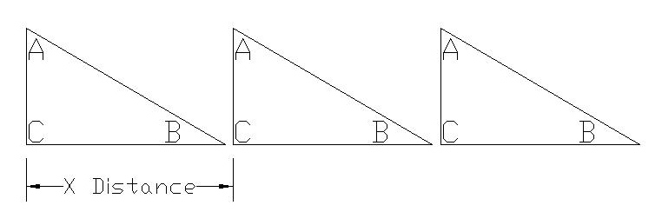
Rotation | 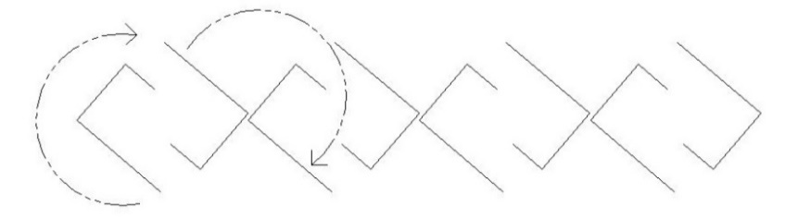
Glide Reflection | 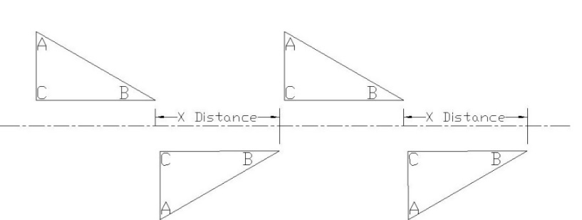

Figure 4.4. The Four Basic Motions of Symmetry.

Finite designs, that is, designs that cannot be repeated in two or three dimensions, do not have translation and so do not have glide reflection. Therefore, finite designs can only have reflection and/or rotation symmetry. There are two basic types of finite designs – cyclic (rotation) and dihedral (reflection) (Figure 4.5). Cyclic finite designs have rotational symmetry without reflection with the number of repeating elements ranging from one to infinity. Dihedral finite designs have reflection and rotational symmetry with the number of elements repeating from one to infinity. I recorded the geometric motions and the number of repeating elements. On a bowl with mirror reflection type “d” or rotation type “c,” the number of times the design is repeated around the bowl is also recorded as a number after the “c” or “d” (Figure 4.5). Washburn (1992) found that Mimbres Classic Black-on-white pottery, the type I am using in my analysis, has six basic symmetry types - c2, c3, c4, d2, d3, and d4. Figure 4.5 illustrates the method for determining the six symmetry types using c2 and d2 as examples.

 | No Rotation | 180 Degrees of Rotation
Cyclic C2  (Rotation) | 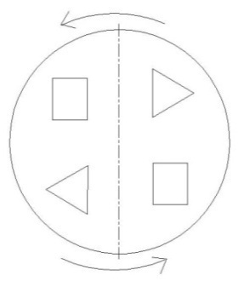 | 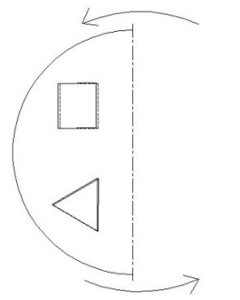
Dihedral D2  (Reflection) | 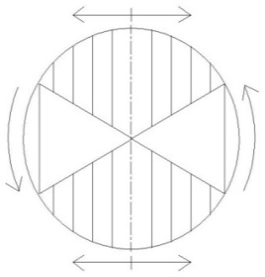 | 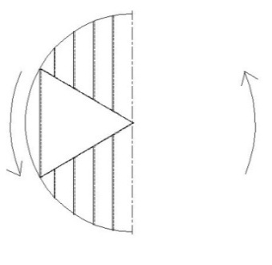
 | Design Not Folded | Design Folded in Half
Cyclic or C2  (Rotation) | 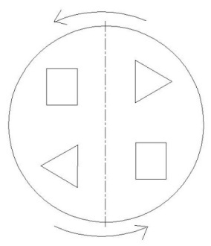 | 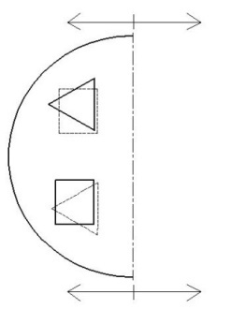
Dihedral or D2  (Reflection) | 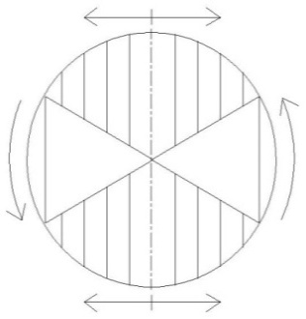 | 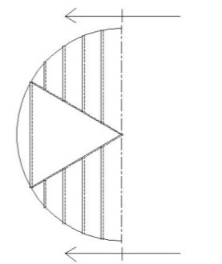

Figure 4.5. Example of Finite Symmetry Types C2 and D2.

The Arrangement of Stepped and Zigzag Motifs in Zones
The zones on Classic Mimbres pottery are the upper or rim band, with two between the bottom of the rim band and bottom center of the bowl, and the final zone in the bottom center of the bowl (Figure 4.6). The arrangement of the motif is defined as attached to the top, bottom, or center of the zone. Not all motifs are neatly within a zone, and they can overlap zones, especially for large motifs. In these cases, I recorded the motif as being within both zones. I also recorded the arrangement of the motif in the zone - whether the motif hangs from the top of the zone, rises from the bottom, or floats freely.

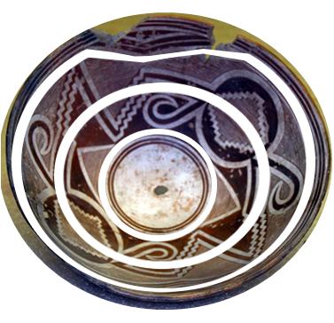
zone 4
zone 3
zone 2
zone 1

Figure 4.6. The Four Decorative Zones on Classic Geometric Bowls Used in This Study.

Zone 1 consists mostly of thick and thin painted bands which sometimes have zigzag and stepped motifs and formal elements incorporated in the banding or hanging below the banding. Zones 2 and 3 tend to be the areas where the most elaborate geometric designs are painted. They also consist of the largest surface area on the bowl, covering approximately 70 percent of the surface depending on the depth and circumference of the bowl. Zone 4 is the bottom of the bowl. It is sometimes left blank, but it may contain a continuation of a design from Zone 3, a separate design bordered by thick and/or thin lines, or an empty space bordered by thick and/or thin lines. In some cases, the design will extend from the banding in Zone 1 and continue into Zone 4, but there are always geometric bends or breaks at the intersection of each zone. There is a great deal of variation in the designs used and how motifs are laid within and across each zone.
The arrangement of the motifs in each zone includes the basic symmetry of the motif. I recorded the two dimensional symmetry in terms of whether the motif repeats around the bowl using reflection, translation, rotation, or glide reflection (Figure 4.4).

Definition of the Formal Elements
In the catalog of the stepped and zigzag motifs there are 18 formal elements that I recorded. However, spirals and eye formal elements frequently occur with stepped and zigzag motifs, and so I also recorded them even if they were not actually used in the stepped and zigzag motifs. As the stepped and zigzag motifs are predominantly created using triangle combinations, the majority of the formal elements are variations of those. Brody (2004:151) describes the 12 possible triangle combinations used on Classic pottery (Figure 4.7), and I use his terminology and definitions. There are two types of fringed lines, two types of off-set triangles, two types of negative diamonds, two types of negative rhomboids, two types of stepped figures, one type of diamond, and one type of rhomboid.
Fringed Lines 1
Fringed Lines 2
Diamonds
Rhomboids | 
Off-set Triangles 1
Off-set Triangles 2
Negative Diamonds 1
Negative Diamonds 2
Negative Rhomboids 1
Negative Rhomboids 2
Stepped Figures 1
Stepped Figures 2

Figure 4.7. Twelve Triangle Combinations Present on Classic Black-on-white Bowls (from Brody 2004:151).

I also recorded number of times each element repeated. For the zigzag, I recorded the number of lines used to make the zigzag or the number of paralleling zigzag motifs. For the stepped motif, I recorded the number of actual steps on the design on the pyramids or triangles in painting the motif.
The fill of the motif is also a formal element used to finish the overall motif. The four possible fill elements are no fill, crossing lines, checkerboard, solid, and parallel lines (Figure 4.8). The fill of the stepped motif can have multiple fill types on any one bowl. In many cases, two stepped motifs are opposite one another and have different fill types. Alternating fills around the perimeter of bowls are another possibility.

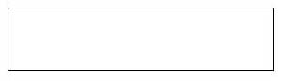 | No Fill
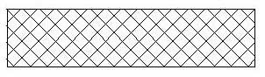 | Crossing Lines
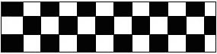 | Checkerboard
 | Solid
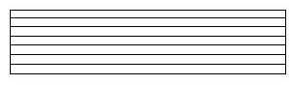 | Parallel Lines
Figure 4.8. Fill Types for the Stepped and Zigzag Motifs.

The combination of motif arrangement and formal elements allows for a detailed description of each motif and how it was arranged on each bowl. There are numerous formal element combinations in the painted designs on Classic Black-on-white bowls using the stepped and zigzag motifs. Given the number of possible combinations, each work group should only choose only a few combinations to produce painted bowls with the zigzag and stepped motifs (Beazley 1918, 1951, 1956; Boardman 1974, 1975, 1994; Bunzel 1972; Hardin 1983, 1990; Hegmon 1995). By selecting sites that have at least 30 Middle Classic bowls and a large number of rooms for groups to form into multiple design production groups.

Sites Used in This Study
The sites in the Mimbres region that have more than one hundred rooms, evidence of multiple generations, and at least 30 Middle Classic bowls with a stepped and/or zigzag motif are Cameron Creek, Mattocks, Galaz, Swarts, and NAN Ranch (Figure 4.9). The construction sequences within room blocks at NAN Ranch, Swarts, and Mattocks suggest the construction is a process that takes multiple generations (Gilman and LeBlanc n.d.; Hill 1997; Shafer 1995, 2003, 2006). Among them, the sites have 405 Middle Classic painted bowls with zigzag and/or stepped motifs. These are provenienced to rooms, making it possible to understand the spatial distribution of the bowls. Each site has more than 30 bowls with the zigzag and stepped motifs, making an adequate sample for statistical tests and spatial comparisons.

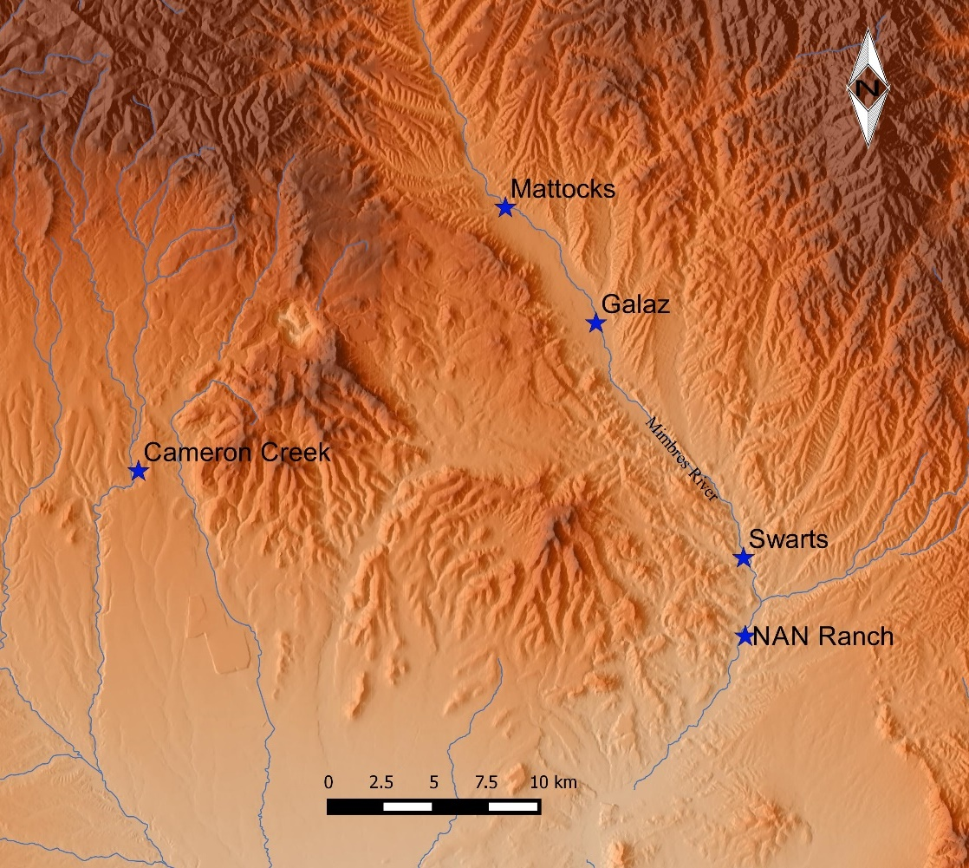
Figure 4.9. The Mimbres Region Sites Used in This Study.

In the Mimbres Valley, Shafer’s (2003: 88-109) work at NAN Ranch has shown that room blocks formed around one or a few rooms and then grow into ever-larger room blocks. Shafer’s (2003, 2006) and Gilman’s (2006) research suggests that new rooms are added for new generations. As people add rooms to room blocks, they can expand to the point where room block can become attached. These studies make it clear that social boundaries can and do exist within room blocks. While I require multiple room blocks at a site for it to be included in the sample, I do not impose boundaries such that each room block equals a painting production group.

Analytical and Statistical Tests
The bowl design evaluation began with the creation of a Microsoft Excel® spreadsheet that recorded the presence of formal elements for each bowl. To identify design production groups in the Mimbres region, I use three separate tests - one multivariate test followed by two univariate tests to identify the heterogeneity or homogeneity of bowl design. The multivariate test is a cluster analysis. The two univariate tests are spatial uniformity of the production and spatial organization of production. The multivariate analysis identified similarities in the designs, and the two univariate analysis highlighted the spatial differences in the groups of similar designs.

Cluster Analysis
The cluster analysis identifies groups of bowls with the greatest similarity using all of the attributes discussed previously. The analysis is intended to identify clusters of bowls with similar designs at each site classified into groups that may have been made by the same production group. Again, Jaccard distances are calculated between all bowls within a site to produce a distance matrix. Then a hierarchical clustering method using a complete cluster algorithm produces dendrograms and scree plots to understand the clustering of the data. The focus of this analysis is on the presence of different design elements rather than their absence. Additionally, the design of this data set is to capture subtle differences, and in doing so, any one bowl will have very few elements present in in comparison to the number of possible design elements. Therefore, the Jaccard distance, which defines the size of the intersection of presence-absence categories divided by the size of the union of the sample sets, is the appropriate distance measurement. The number of appropriate clusters is decided by examining the scree plots for elbows. This is based on the principle that natural breaks in the data are likely to be found when there is a significant leap in distances between joined clusters. After I identify the appropriate numbers of clusters using the scree plot, I then validate the number of clusters for each site using the NbClust package in R (R Development Core Team 2008). Finally, I classify the bowls into cluster groups using dendrograms.
The R package NbClust provides 30 indexes for determining the optimal number of clusters in a data set. However, not all indexes in the NbClust package are appropriate for the sparse presence-absence data in this study. The 14 indexes that this study uses are listed in Table 4.1, which includes a brief description of how each index identifies the optimal number of clusters and a reference for those interested in further reading on the method.
Table 4.1. Indexes Used in This Study (from Charrad et al. 2014)
Index | Optimal number of clusters | Reference
kl | Maximum value of the index | (Krzanowski and Lai 1988)
gap | Smallest nc such that criticalValue >= 0 | (Tibshirani et al. 2001)
db | Minimum value of the index | (Davies and Bouldin 1979)
silhouette | Maximum value of the index | (Rousseeuw 1987)
duda | Smallest nc such that index > criticalValue | (Duda and Hart 1973)
pseudot2 | Smallest nc such that index < criticalValue | (Duda and Hart 1973)
beale | nc such that critical value of the index >= alpha | (Beale 1969)
ptbiserial | Maximum value of the index | (Milligan 1980, 1981)
mcclain | Minimum value of the index | (McClain and Rao 1975)
gamma | Maximum value of the index | (Baker and Hubert 1975)
gplus | Minimum value of the index | (Rohlf 1974) (Milligan 1981)
dunn | Maximum value of the index | (Dunn 1974)
sdindex | Minimum value of the index | (Halkidi et al. 2000)
sdbw | Minimum value of the index | (Halkidi and Vazirgiannis 2001)

After the 14 index tests in the NbClust package are run, I determine the appropriate number of cluster groups for each class based on solutions that correspond to natural modes in the data that are defined by site size and number of vessels. The minimum number of clusters at each site is based on site size. Each site is a large pueblo with over 100 rooms, and so there should be more than two clusters. The maximum number of clusters at each site is based on the number of bowls. As Donnan and McClelland (1999) show in their analysis of Moche potters, each production group made nine percent of the bowls used in their study in one generation. Thus, using the average life expectancy of 35 to 50 years during the Middle Classic period (Gruber 2007), and assuming that membership to a production group would begin after 10 years of age; two generations would span the 50-year production of Middle Classic bowls. So based on Donnan and McClelland (1999), each generation would produce nine percent of the bowls used their study and I use in this study. Therefore, the upper limit of clusters should not be more than 18 percent (nine percent for each cluster) of the sample being studied.

Spatial Uniformity of the Production
Following the bowl design evaluation is the spatial organization analysis in which the bowls with similar designs are plotted on maps of each site by room to identify the spatial organization of production groups at each site. The spatial organization analysis includes uniformity of the design production groups that measures how spatially grouped design clusters are at each site and the spatial organization of production groups at each site that identifies areas where bowls were produced at each site. This is used to understand how spatially separated the production groups are. To understand the spatial organization of production groups, the spatial uniformity of the production groups was tested by comparing how many rooms with bowls from each design cluster were in rooms with shared walls. By comparing the number of rooms that share adjoining walls for each cluster of bowls, it was possible to identify production groups that are spatially concentrated in one location. It was then possible to see if the production groups incorporated people from several areas in the site or just people from a single cluster of rooms. Understanding whether production groups were composed of people from rooms across the site illustrates the differences among sites in the way that design production groups organized. If design production groups were single clusters, then the social boundaries between design production groups were more developed.
The bowls used in this study are plotted on maps of each site by clusters, and the total number of rooms with adjoining walls and rooms without adjoining rooms for each design cluster group were counted to identify how spatially concentrated the design clusters are at each site. To test differences at each site, I used a pair-wise Fisher's exact test to compare differences in the number of rooms with adjoining walls and rooms without adjoining walls for each design cluster group. Differences are categorized in two levels to identify scores that are Bonferonni correction significance, significantly different, and scores that are moderately different.
To understand the development of social boundaries between design production groups, the overlap of clusters of bowls with similar designs was used. The overlap of clusters identifies areas where a cluster of bowls with similar designs occurs in the same location as another cluster of bowls with similar designs. The overlap indicates a production group that makes two different designs and/or multiple production groups working together. The production groups that were not working together will have spatial clusters of bowls that do not overlap or have little overlap with other spatial clusters of bowls.

Spatial Organization of Production
The spatial organization of production is achieved by using a univariate analysis that identifies the highest percentage of bowls from each cluster within rooms sharing adjoining walls to capture the areas where spatial clustering of bowl designs occur at each site. For each cluster of bowls, the groups of rooms with the highest percent of bowls for the site were recorded on the maps of each site. In some cases, based on how dispersed the clusters of bowls with similar designs were at a given site, the frequencies that were recorded were low but still represent the highest percent for a given cluster group. Finally, each site was compared to other sites used in this study to identify how spatially organized the clusters of bowls with similar designs are.
As suggested in Chapter 2, the Galaz site appears to have a different social and potentially political organization. The null hypothesis for the variation of bowl designs, cluster analysis, spatial uniformity of the production, and spatial organization of production tests was that Galaz was not different from any of the other sites in the way each motif was created or in the spatial arrangement of analogous bowl designs.

Summary
The methods used in this analysis draw from art historian approaches for defining stylistic variation among individuals and groups of potters. These methods focus on subtle design variation, which I argued in Chapter 3 are useful for identifying differences between painting production groups in the Mimbres region. This study will use variation in the production of zigzag and stepped motifs painted on Middle Classic bowls to identify pottery production groups at the Cameron Creek, Mattocks, Galaz, Swarts, and NAN Ranch sites in the Mimbres region. The zigzag and stepped motif are classified by the variation of the arrangement of the placement of the motifs and 18 formal elements. The analytical tests used in this study all rely on distance coefficients calculated using the Jaccard method to identify clusters of similar designs. Building on the design cluster analysis, the bowls are plotted on maps of the sites to understand how spatially concentrated the design clusters are. Finally, using the identified design clusters, I identify the most spatially dense areas of design clusters at each site. The more similar designs are produced at each site and the more spatially diffuse the cluster groups are, and the more design clusters that overlap at a particular site when compared to other sites provides a basis for understanding the relative rigidity of social boundaries among ceramic painting production groups at each site.
Through bowl design evaluation and the spatial organization analysis, it is possible to identify production groups through identifying clusters of bowls with similar designs. By considering all lines of evidence, it is possible to evaluate social boundaries between people in Mimbres design production groups. By understanding how people in the Mimbres region organized into groups during ceramic production, it is possible to identify sites that had more or fewer internal social boundaries. Sites with more defined social boundaries could indicate that people were less inclined to work with others from different production groups. Conversely, sites with less defined social boundaries would indicate that people were more inclined to work with others from different production groups. They may not have formed multiple production groups at all but rather worked with everyone. People at the sites that do not have social boundaries between production groups could be attempting to maintain social cohesion within the site.

Ceramic Design Production Groups in the Mimbres region

In this study, I use the commonality and variation in the production of the stepped and zigzag motifs to identify differences in the organization of ceramic design production groups at Classic period sites in the Mimbres region. This analysis relies on differences in the motifs between one group and another that arise as a result of social boundaries between those groups. The motif differences may be the result of intentional choices or unconscious actions, but as discussed in Chapter 1, all steps in the production processes could be potential indicators of social boundaries. In particular, the specific differences used in the creation of the stepped and zigzag motifs are shown in this chapter to be useful in the identification of design production groups.
This chapter details the results and interpretations of the design analysis, illuminating the variation in the creation of the two motifs and the spatial distribution of the bowls with similar designs. I use four separate tests - one multivariate tests followed by two univariate tests. The multivariate is a cluster analysis. The two univariate tests are the spatial uniformity of the production and the spatial organization of production tests.
The chapter begins with cluster analysis that uses scree plots, post hoc tests run in NbClust package in R, and dendrograms to identify clusters of bowls with similar design structure and design elements at sites. The bowl clusters are the products of different production groups, but the clusters cannot be assumed to represent independent production groups, because members of one production group can be members of other production groups during the painting of different bowls.
The subsequent section uses the bowl cluster groups to understand the spatial organization of production groups. The spatial organization of production is used to understand how spatially grouped the bowl clusters are at each site, which in turn defines how production groups are distributed across a site. This distribution helps identify how inclusive production groups are at each site.
The final stage of analysis uses the bowl clusters to identify areas at sites where production groups are most concentrated. The spatial clusters are coupled with the bowl clusters to identify the production groups at each site. However, not all sites have spatially distinctive spatial cluster groups with areas represented by one single design cluster group.
In the final section in this chapter, I discuss the implications of the results of this analysis. Ultimately, this analysis provides data that support the idea that people who inhabited the Galaz site did not form independent ceramic design production groups whereas people at all other sites did. These data show that the people who lived at Galaz during the Classic period did not form social boundaries between production groups in the way that people at all other sites used in this study did.
Calculations are based on all 131 micro stylistic elements for the 395 Classic Black-on-white bowls from the five sites (Appendix A). This analysis did not test the zigzag and stepped motifs separately. Since 45 percent of the bowls used in this study had both motifs, some sites did not have enough bowls to perform such a test, and the variation in the use of each motif is part of the study.

Cluster Analysis
The cluster analysis consists of the comparison of mean distances using the Jaccard coefficient. This measures the level of similarity between painted designs at each site by using pair-wise comparisons between each bowl at each site, giving a view of the social boundaries within each site. As stated in Chapter 4, the cluster analysis groups bowls together based on their similarity using a Jaccard similarity matrix, which uses complete linkage. dendrograms created by the analysis to graphically display the relative amount of similarity introduced by each group in the analysis. Spatial grouping at a site indicates shared design construction consistent with the presence of social boundaries between those groups. I will examine each site in turn below.
The hierarchical cluster analysis using designs with stepped and zigzag motifs from the Cameron Creek site produced a scree diagram showing that the designs on the bowls clustered into three groups (Figures 5.1, 5.2, and Table 5.1). Specifically, the increase in the stress coefficient as marked by the “elbow” on the scree plot and evident in the dendrogram indicates a three cluster solution. As discussed in the previous chapter the results of the 14 indexes run in NbClust package in R show that 10 of the 14 tests are too high or too low to correspond to the natural modes at Cameron Creek, as defined by site size and number of vessels. The duda, pseudot2, and beale indexes confirm a three cluster solution at Cameron Creek. The hierarchical cluster analysis used 31 bowls with zigzag and/or stepped designs from 17 rooms, and it indicates a three cluster solution for the 31 bowls in the analysis, averaging 10.34 bowls per cluster (Figures 5.1 and 5.2, Table 5.1).
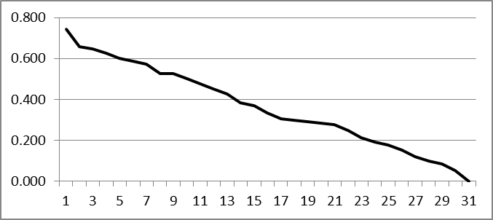
Figure 5.1. Scree Diagram of the Hierarchical Cluster Analysis at Cameron Creek (red arrow points to the “elbow”).

Table 5.1. Results of the 14 Indexes Run in NbClust Package in R.
Index | Predicted # of Clusters
kl | 24
gap | 1
db | 30
silhouette | 30
duda | 3
pseudot2 | 3
beale | 3
ptbiserial | 6
mcclain | 2
gamma | 28
gplus | 28
dunn | 28
sdindex | 28
sdbw | 30
Bowl # Dendrogram
1135 -┐---------┐
1275 -┘ |---------┐
1094 -----------┘ |---------┐
1123 ---------------------┘ |
1115 -----┐-----------┐ |-----┐
1296 -----┘ |-------┐ | |
1127 ---------┐-------┘ |-----┘ |
5816 ---------┘ | |-┐
5800 -------------------------┘ | |
1267 -------------------------┐-----┐ | |
5817 -------------------------┘ |-----┘ |
1046 ---------------┐-------------┐ | |-------┐
5810 ---------------┘ |-┘ | |
1114 -------------------┐---------┘ | |
1316 -------------------┘ | |
1304 ---------------┐-------------------┐ | |
5804 ---------------┘ |---┘ |-┐
1148 -----------------------------------┘ | |
1283 -------┐---------┐ | |
5808 -------┘ |-----------┐ | |
1176 -------┐---------┘ |-┐ | |
5807 -------┘ | |-----------┐ | |
1270 -----------------------------┘ | |---┘ |
5825 -------------------------------┘ | |
1242 -------------------------------------------┘ |
1038 -----------┐---------------------┐ |
5802 -----------┘ |-----------┐ |
1279 ---------------------------------┘ |---┘
1149 ---------------------------┐-------------┐ |
1222 ---------------------------┘ |---┘
1203 -------------------------------------┐---┘
5823 -------------------------------------┘

Figure 5.2. Dendrogram of the Hierarchical Cluster Analysis at Cameron Creek (colors highlight the clusters and are used later on site maps).

Using the formal elements that are on 70 percent or more of the bowls for any cluster group, it is possible identify some of the key differences in the painting of the zigzag and stepped motifs at Cameron Creek (Table 5.2). For Cameron Creek, 12 formal elements are found on 70 percent of bowls in at least one cluster group. Cluster 1 has the most high frequency formal elements with eight of the 12, of which five are also present in high frequency in cluster 2 and one for cluster 3. Cluster 2 has seven of the 12 design elements, of which five are frequently found in cluster 1 and none in cluster 3. All cluster groups have different combinations of high frequency elements that illustrate the differences in the motif clusters. All cluster groups have at least one high frequency formal element that the other two cluster groups only have in low frequencies.

Table 5.2. Highest Percent of Formal Elements Used to Create Zigzag and Stepped Motifs at Cameron Creek.
Formal Element | Formal Elements in Cluster Group 1 | Formal Elements in Cluster Group 2 | Formal Elements in Cluster Group 3
Design Structure 17 | 56% | 71% | 0%
1-4 Zigzag Motifs | 72% | 71% | 0%
Zigzag Motif Zone 2 | 94% | 86% | 14%
Zigzag Motif Floating | 83% | 86% | 29%
Zigzag Motif Translation | 78% | 86% | 0%
2-4 Lines Making Zigzag Motif | 78% | 86% | 29%
Zigzag Motif Fringed Lines 2 | 22% | 86% | 0%
Zigzag Motif Negative Rhomboids 1 | 72% | 29% | 0%
Step Motif Zone 1 | 39% | 0% | 71%
Step Motif Zone 2 | 78% | 0% | 29%
Step Motif Filled with Parallel Lines | 78% | 0% | 29%
Step Motif Filled with Solid | 78% | 0% | 71%

The hierarchical cluster analysis using bowls with stepped and zigzag motifs from the Mattocks site produced a scree diagram that shows the designs clustered into three groups (Figures 5.3 and 5.4, Table 5.3). Specifically, the increase in the stress coefficient as marked by the “elbow” on the scree plot and evident in the dendrogram indicates a three cluster solution. The results of the 14 indexes run in NbClust package in R show that 11 of the 14 tests are too high or too low to correspond to the natural modes at Mattocks, as defined by site size and number of vessels. The maximum number of clusters should be less than 18 percent of the total number of bowls in the sample. The kl and sdindex indexes confirm a three cluster solution at Mattocks. The hierarchical cluster analysis at Mattocks used 42 bowls with zigzag and/or stepped designs from 20 rooms, and it indicates a three cluster solution, averaging 14 bowls per cluster (Figures 5.3 and 5.4, Table 5.3).

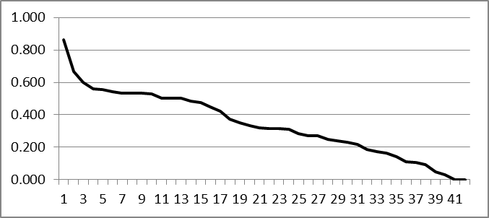
Figure 5.3. Scree Diagram of the Hierarchical Cluster Analysis at Mattocks (red arrow points to the “elbow”).

Table 5.3. Results of the 14 Indexes Run in NbClust Package in R.
Index | Predicted # of Clusters
kl | 3
gap | 1
db | 30
silhouette | 30
duda | 2
pseudot2 | 2
beale | 2
ptbiserial | 4
mcclain | 2
gamma | 30
gplus | 30
dunn | 30
sdindex | 3
sdbw | 30

Bowl # Dendrogram
4248 -┐---------------┐
7005 -┘ |-------------┐
3705 -----------------┘ |-------┐
3787 ---------------------┐---------┘ |-┐
4237 ---------------------┘ | |
3652 ---------------------------------------┘ |
1126 -------------------┐-┐ |-┐
3735 -------------------┘ |---------------┐ | |
1210 ---------------------┘ | | |
4223 -----------┐---------┐ |---┘ |
4242 -----------┘ |-------┐ | |---┐
4225 ---------------------┘ |-------┘ | |
1183 -------------------┐---------| | |
3734 -------------------┘ | | |
4265 -----------------------------┘ | |-┐
1177 -------------------------------------┐-----┘ | |
3754 -------------------------------------┘ | |
4244 ---------------------┐-----------------┐ | |
4274 ---------------------┘ | | |
3766 -------------------┐-----------┐ |-------┘ |
4269 -------------------┘ |---┐ | |
7052 -------------------------------┘ |---┘ |
1178 -------------------------------┐---┘ |
7002 -------------------------------┘ |
3729 -------------------┐---------------┐ |
4252 -------------------┘ |---------┐ |
4226 ---------------┐---------------┐ | | |
4230 ---------------┘ |---┘ | |
3645 -------------------------------┘ |---|
4238 -------------------┐-----------------------┐ | |
4254 -------------------┘ | | |
4234 -----------------┐-----┐ |-┘ |
4249 -----------------┘ |---------┐ | |
3761 -----------------------┘ |---------┘ |
3664 -------------------------┐-----┐ | |
3725 -------------------------┘ |-┘ |
1092 -------------------------------┘ |
4239 -------------------------┐---------┐ |
4282 -------------------------┘ |-┐ |
4255 -----------------------------------┘ |---┐ |
3709 -------------------------------------┘ |-------┘
4288 -----------------------------------------┘

Figure 5.4. Dendrogram of the Hierarchical Cluster Analysis at Mattocks (colors highlight the Clusters and are used later on site maps).

Using the formal elements that are on 70 percent or more of the bowls for each cluster group, it is possible identify some of the key differences in the painting of the zigzag and stepped motifs at Mattocks (Table 5.4). Five formal elements are found on 70 percent of bowls for each cluster group. Cluster 2 has the most high frequency formal elements with three of the five, of which none have high percentages in Clusters 1 and 3. Cluster 1 has one of the five, of which none have high percentages in Clusters 2 and 3. These data show that bowls in Cluster 1 has a low percent of four formal elements. Bowls in Cluster 2 have a low percent of two formal elements. Bowls in Cluster 3 have none of four formal elements. All clusters have different combinations of high frequency elements that illustrate the differences in the motif clusters.
Table 5.4. Highest Percent of Formal Elements Used to Create Zigzag and Stepped Motifs at Mattocks.
Formal Element | Formal Elements for Cluster Group 1 | Formal Elements for Cluster Group 2 | Formal Elements for Cluster Group 3
Zigzag Motif Zone 2 | 88% | 46% | 0%
Zigzag Motif Floating | 46% | 77% | 0%
2-4 Lines Making Zigzag Motif | 50% | 77% | 0%
Zigzag Motif Negative Rhomboids 1 | 13% | 92% | 0%
#Steps 5-8 | 8% | 23% | 83%
The hierarchical cluster analysis using bowls with stepped and zigzag motifs from the Galaz site produced a scree diagram that shows the designs clustered into seven groups (Figures 5.5 and 5.6, Table 5.5). The increase in the stress coefficient as marked by the “elbow” on the scree plot and evident in the dendrogram indicates a seven cluster solution. The results of the 14 indexes run in NbClust package in R show that eight of the 14 tests are too high or too low to correspond to the natural modes at Galaz, as defined by site size and number of vessels. The duda and pseudot2 indexes confirm a seven cluster solution at Galaz. The hierarchical cluster analysis at Galaz used 163 bowls with zigzag and/or stepped designs from 56 rooms, and it indicates a seven cluster solution, averaging 23.29 bowls per cluster (Figures 5.5 and 5.6, Table 5.5).

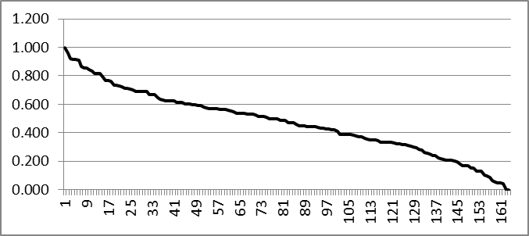
Figure 5.5. Scree Diagram of the Hierarchical Cluster Analysis at Galaz (red arrow points to the “elbow”).

Table 5.5. Results of the 14 indexes run in NbClust package in R.
Index | Predicted # of Clusters
kl | 4
gap | 1
db | 30
silhouette | 30
duda | 7
pseudot2 | 7
beale | 8
ptbiserial | 14
mcclain | 2
gamma | 30
gplus | 30
dunn | 30
sdindex | 2
sdbw | 29

Bowl # Dendrogram
2988 -┐---┐
3092 -┘ |-┐
3126 -----┘ |---┐
3014 -------┘ |---┐
2979 -----------┘ |-------┐
2934 ---------------┘ |-┐
3089 -----------------------┘ |-------┐
3013 -------------------┐-----┘ |
3341 -------------------┘ |---------┐
3231 -----┐---┐ | |
3245 -----┘ |-------------┐ | |
3100 ---------┘ |---------┘ |
5182 -----------------------┘ |---┐
3010 ---------------------┐---------------┐ | |
3031 ---------------------┘ | | |
3301 ---------------┐---------┐ | | |
3303 ---------------┘ |-------┐ |-----┘ |
2991 ---┐---------------┐ | | | |
3263 ---┘ |-----┘ | | |
3101 -----------┐-------┘ |---┘ |
3108 -----------┘ | |
2857 -------------┐---------------┐ | |
3051 -------------┘ |---┘ |
2943 ---------------┐-------------┘ |
3175 ---------------┘ |
3305 ---------┐---------┐ |
6246 ---------┘ |-------------┐ |
3377 -------------------┘ |-----┐ |
3025 -------┐-------------┐ | | |
5176 -------┘ |-----------┘ | |
3046 ---------------------┘ | |
2986 -------------┐---------┐ |-┐ |
3242 -------------┘ |---┐ | | |
3009 -------┐---------┐ | | | | |
3294 -------┘ |-----┘ |-----┐ | | |
2977 -----------------┘ | |-----┘ | |
3062 ---------------------------┘ | |-----|
3088 ---------------------------------┘ | |
2969 ---------------------------┐-----┐ | |
3327 ---------------------------┘ |-----┐ | |
3033 ---------------------------┐-----┘ | | |
3222 ---------------------------┘ |-┘ |
2984 -------------------┐---------┐ | |
5128 -------------------┘ |-----┐ | |
3224 -----------------------------┘ |---┘ |
3003 ---------------------┐---------┐ | |
3347 ---------------------┘ |---┘ |
3036 -------------------------------┘ |
3277 -----------------------------┐-------------┐ |
3333 -----------------------------┘ | |
3063 ---------------------------------┐-----┐ |---|-┐
5130 ---------------------------------┘ | | | |
3052 -----------------┐---┐ | | | |
3370 -----------------┘ |-------┐ |---┘ | |
3034 ---------------------┘ |-----┐ | | |
2963 ---------┐-------------┐ | | | | |
3056 ---------┘ |-----┘ |---┘ | |
2916 -----------------------┘ | | |
2958 -----------------------------------┘ | |
2898 -----------------┐-------------------┐ | |
2910 -----------------┘ |-------┐ | |
2871 -------------------------------┐-----┘ | | |
3212 -------------------------------┘ | | |
3145 -------------┐-----------------┐ |-┘ |
3218 -------------┘ |---┐ | |
3234 -----------------------┐-------┘ |-------┐ | |
5146 -----------------------┘ | |-┘ |
3117 -----------------------------------┘ | |
3196 -------------------------------------------┘ |
3161 -------------┐-----┐ |
3183 -------------┘ |-----┐ |
3203 -------------------┘ | |
3045 ---------┐-----┐ |---------┐ |
3291 ---------┘ |-----┐ | | |
3358 ---------------┘ |---┘ | |
3015 ---------------┐-----┘ |---┐ |
5085 ---------------┘ | | |
3071 -----------------------┐---┐ | | |
3243 -----------------------┘ |-------┘ | |
3058 -------------------------┐-┘ | |
3223 -------------------------┘ | |
3208 ---------------------┐---┐ |-┐ |
3217 ---------------------┘ |-------┐ | | |
3285 -----------------┐-----┐ | | | | |
5144 -----------------┘ |-┘ | | | |
5131 -----------------------┘ |---┐ | | |
2992 -------------------┐-┐ | | | | |
5086 -------------------┘ |---┐ | | | | |
3250 ---------------------┘ |-------┘ |-┘ | |
2940 -------------------------┘ | | |
3087 -------------------------------┐-┐ | | |
5124 -------------------------------┘ |---┘ |---┐ |
3149 -------------------┐-------------| | | |
3364 -------------------┘ | | | |
2918 ---------------┐-------------┐ | | | |
5135 ---------------┘ |---┘ | | |
3143 -----------------------------┘ | | |
3064 ---------------------┐-┐ | | |
3095 ---------------------┘ |-------┐ | | |
2956 -----------------------┘ |---------| | |
3007 -------------------------------┘ | | |
2972 -------------------┐-------┐ | | |
3349 -------------------┘ |-----┐ | | |
3239 ---------------------------┘ |-------┘ | |
2801 ---------------------┐---------┐ | | |
2826 ---------------------┘ |-┘ | |
3073 -------------------------------┘ |-┐ |
3035 ---------------------┐---------┐ | | |
3156 ---------------------┘ | | | |
3214 ---------------┐---------┐ |-------┐ | | |
5173 ---------------┘ |-┐ | | | | |
2803 -------------------------┘ | | | | | |
2912 -----------┐---┐ |---┘ | | | |
3297 -----------┘ |---┐ | | | | |
3118 ---------------┘ |-----┐ | | | | |
3151 -------------------┘ |-┘ |---┐ | | |
2806 -------------------------┘ | | | | |
3027 ---------------------┐-------┐ | | | | |
3281 ---------------------┘ |-┐ | | | | |
3072 -----------------------------┘ |-┐ | | | | |
2996 -------------------------------┘ |-┐ | | | | |
2942 ---------------------------------┘ |---┘ | | | |
3187 -----------------------------------┘ |-┘ | |
3157 -----------------------┐-----------┐ | | |
3374 -----------------------┘ |-----┐ | | |
3008 ---------------------------┐---┐ | | | | |
3169 ---------------------------┘ |---┘ | | | |
3378 -------------------------------┘ | | | |
2971 ---┐-----------┐ | | |-|
3326 ---┘ |-----┐ |-┘ |
2998 -----┐---------┘ |-------┐ | |
3216 -----┘ | | | |
3061 ---------------------┘ |-------┐ | |
2997 -------------┐-----------┐ | | | |
3012 -------------┘ |---┘ |---┘ |
2935 -------------------------┘ | |
2889 -------------------------┐-------┐ | |
2892 -------------------------┘ |---┘ |
3114 -------------------┐-------┐ | |
3200 -------------------┘ |-----┘ |
5147 ---------------------------┘ |
3080 -------┐-----------------┐ |
5190 -------┘ |-------------┐ |
3368 -------------------------┘ |---┐ |
5174 ---------------------------┐-----------┘ | |
5213 ---------------------------┘ |---|
2951 ---------------------------┐-----------┐ | |
3220 ---------------------------┘ | | |
3148 -------------------┐---┐ |---┘ |
5145 -------------------┘ |-----------┐ | |
2789 -----------------------┘ |---┘ |
3066 -------------------┐-------┐ | |
3198 -------------------┘ |-------┘ |
2954 ---------------------------┘ |
3037 -----------------------┐---------------┐ |
5129 -----------------------┘ |-----┐ |
3028 -----------------------------┐---------┘ | |
3097 -----------------------------┘ |-┘
3001 ---------------------┐---------┐ |
3219 ---------------------┘ |---------┐ |
3174 -------------------------------┘ |---┘
2880 ---------------------------------┐-----┐ |
2962 ---------------------------------┘ |-┘
3170 ---------------------------------------┘

Figure 5.6. Dendrogram of the Hierarchical Cluster Analysis at Galaz (colors highlight the clusters and are used later on site maps).

Using the formal elements that are on 70 percent or more of the bowls for any cluster group, it is possible identify some of the key differences in the painting of the zigzag and stepped motifs at Galaz (Table 5.6). For Galaz, 14 formal elements are found on 70 percent of bowls in at least one cluster group. Cluster 2 has the most high frequency formal elements with seven of the 14, of which one formal element is also present in high frequency in Clusters 1 and 4, one for Clusters 1 and 3, one for Clusters 3 and 5, one for 1, 3 and 5, and one for Clusters 3, 4, and 5. Cluster 3 has six of the 14 design elements, of which four are frequently found in Clusters 1, 2, 4 and 5 and none in Clusters 6 and 7. Cluster 1 has five of the 14 design elements, of which four are frequently found in Clusters 2, 3, 4, 5 and 6 and none in Cluster 7. Cluster 5 has four of the 14 design elements, of which four are frequently found in Clusters 1, 2, 3 and 4 and none in Clusters 6 and 7. Cluster 4 has two of the 14 design elements, of which both are frequently found in Clusters 1, 2, 3, 4 and 5 and none in Clusters 6 and 7. Cluster 7 has two of the 14 design elements, of which none are frequently found in any other cluster. Cluster 6 has one of the 14 design elements, of which none are frequently found in any other cluster. All cluster groups except Clusters 4, 5, and 6 have at least one high frequency formal element that the other two cluster groups only have in low frequencies. All cluster groups have different combinations of high frequency elements that illustrate the differences in the motif clusters.
Table 5.6. Highest Percent of Formal Elements Used to Create Zigzag and Stepped Motifs at Galaz.
Formal Element | Formal Elements for Cluster Group 1 | Formal Elements for Cluster Group 2 | Formal Elements for Cluster Group 4 | Formal Elements for Cluster Group 3 | Formal Elements for Cluster Group 5 | Formal Elements for Cluster Group 6 | Formal Elements for Cluster Group 7
C2 | 0% | 96% | 0% | 20% | 43% | 38% | 30%
C3 | 0% | 0% | 73% | 0% | 6% | 8% | 0%
C4 | 96% | 0% | 0% | 20% | 31% | 38% | 20%
1-4 Zigzag Motifs | 80% | 78% | 64% | 100% | 63% | 0% | 20%
Zigzag Motif Zone 2 | 84% | 74% | 73% | 50% | 81% | 0% | 0%
Zigzag Motif Floating | 32% | 70% | 73% | 80% | 74% | 0% | 20%
Zigzag Motif Translation | 88% | 74% | 91% | 40% | 64% | 0% | 0%
2-4 Lines Making Zigzag Motif | 56% | 87% | 91% | 40% | 83% | 0% | 10%
Zigzag Motif Repeating around Vessel 2 Times | 0% | 70% | 0% | 10% | 39% | 0% | 10%
Zigzag Motif Repeating around Vessel 3 Times | 0% | 0% | 82% | 0% | 8% | 0% | 0%
Zigzag Motif Repeating around Vessel 4 Times | 100% | 13% | 0% | 40% | 39% | 0% | 0%
1-4 Step Motifs | 0% | 0% | 0% | 0% | 38% | 31% | 80%
Step Triangle | 0% | 0% | 0% | 0% | 93% | 92% | 50%
Step Motif Filled With Solid | 0% | 0% | 0% | 0% | 69% | 46% | 90%
The hierarchical cluster analysis using bowls with stepped and zigzag motifs from the Swarts site produced a scree diagram that shows the designs clustered into five groups (Figures 5.7 and 5.8, Table 5.7). Specifically, the increase in the stress coefficient as marked by the “elbow” on the scree plot and evident in the dendrogram indicates a five cluster solution. The results of the 14 indexes run in NbClust package in R show that nine of the 14 tests are too high or too low to correspond to the natural modes at Swarts, as defined by site size and number of vessels. The duda and pseudot2 indexes confirm a five cluster solution at Swarts. The hierarchical cluster analysis at Swarts used 104 bowls with zigzag and/or stepped designs from 47 rooms, and it indicates a five cluster solution, averaging 20.8 bowls per cluster (Figures 5.7and 5.8, Table 5.7).
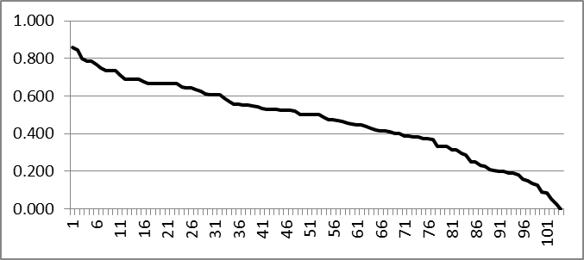
Figure 5.7. Scree Diagram of the Hierarchical Cluster Analysis at Swarts (red arrow points to the “elbow”).

Table 5.7. Results of the 14 Indexes Run in NbClust Package in R.
Index | Predicted # of Clusters
kl | 11
gap | 1
db | 30
silhouette | 30
duda | 5
pseudot2 | 5
beale | 24
ptbiserial | 3
mcclain | 2
gamma | 30
gplus | 30
dunn | 3
sdindex | 30
sdbw | 30

Bowl # Dendrogram
2521 ─┌───────────┐
2641 ─┘ │───────────┐
2408 ─────────────┘ │───┐
2506 ─────────────────────────┘ │─────────┐
2036 ─────┌─────────────┐ │ │
2355 ─────┘ │─────────┘ │
2307 ───────────────────┘ │─────┐
2238 ─────┌─────────────────┐ │ │
2625 ─────┘ │─────────────┐ │ │
2368 ───────────────────────┘ │─┘ │───┐
2062 ─────────────────────────────────────┘ │ │
2630 ─────────────┌───────────────────────────────┘ │
2703 ─────────────┘ │
10020 ─────────┌─────────────────┐ │
10030 ─────────┘ │───────────┐ │
2288 ─────────┌─────────────┐ │ │ │
2526 ─────────┘ │───┘ │ │
2211 ───────────────────────┘ │─────────│
2346 ─────────────┌───────────────┐ │ │
2545 ─────────────┘ │ │ │
2531 ───────────┌─┐ │─────────┘ │
2589 ───────────┘ │───────────┐ │ │
2277 ─────────────┘ │───┘ │
2088 ─────────────────┌───────┘ │
2432 ─────────────────┘ │
2191 ───────────────────────┌─────────────┐ │
2231 ───────────────────────┘ │───────┐ │
2135 ─────────────────────────────────────┘ │ │
2451 ─────────────┌─────────────┐ │ │
2541 ─────────────┘ │ │ │
2220 ───────┌───┐ │─────┐ │ │
2410 ───────┘ │─────────────┐ │ │ │ │
2534 ───────────┘ │─┘ │ │ │
2448 ─────────┌─────────────┐ │ │ │───│
2548 ─────────┘ │─┘ │───────┐ │ │
2549 ───────────────────────┘ │ │ │ │
2371 ─────────────────┌───────────┐ │ │ │ │
2455 ─────────────────┘ │ │ │ │ │
2434 ───────────┌─────┐ │───┘ │ │ │
9551 ───────────┘ │─┐ │ │ │ │
2553 ─────────────────┘ │─────────┘ │───┘ │
2164 ───────────────────┘ │ │
2216 ───────────────────────┌───────────────┐ │ │
2529 ───────────────────────┘ │ │ │
2030 ───────────┌─────────────┐ │ │ │
2582 ───────────┘ │─────┐ │ │ │
2266 ─────────┌─────────────┐ │ │ │─┘ │
2514 ─────────┘ │─┘ │ │ │
2274 ───────────┌───────┐ │ │ │ │
2325 ───────────┘ │───┘ │ │ │
2273 ─────┌─────────┐ │ │ │ │
2585 ─────┘ │───┘ │───────┘ │
2452 ───────────────┘ │ │
2118 ─────┌───┐ │ │
2592 ─────┘ │───────┐ │ │
2188 ─────────┘ │───────────┐ │ │
2456 ─────────────────┘ │ │ │
2205 ─────┌─────┐ │─┘ │
2525 ─────┘ │───────┐ │ │
2441 ───────────┘ │─────────┘ │
2578 ───────────────────┘ │
2120 ─────────────┌─────┐ │
2567 ─────────────┘ │─────────────────────┐ │
2173 ───────────────────┘ │ │
2137 ───────────────────────┌─────────────┐ │───────│
2138 ───────────────────────┘ │ │ │
2079 ─────────┌─────────────┐ │───┘ │
2110 ─────────┘ │ │ │
2111 ───────────────────────ô───────┐ │ │
2463 ───────────────────────┘ │─────┘ │
2146 ───────────────────────────────┘ │
2436 ─────────────────┌───────┐ │
2677 ─────────────────┘ │ │
2033 ─────────────────────────ô───────┐ │
2306 ─────────────────────────┘ │ │
2226 ───────┌─────────┐ │ │
2557 ───────┘ │─┐ │───────────┐ │
2228 ─────┌─────────┐ │ │ │ │ │
2315 ─────┘ │─┘ │───────┐ │ │ │
2516 ───────────────┘ │ │─────┘ │ │
2194 ───────────────────┘ │ │ │
2401 ───────────────────────────┘ │ │
2208 ───────────────────────────┌───────┐ │ │
2679 ───────────────────────────┘ │ │───┘
2147 ─────────────────────┌───────┐ │───┐ │
2304 ─────────────────────┘ │ │ │ │
2301 ─────────┌───────┐ │ │ │ │
2584 ─────────┘ │───┐ │─────┘ │ │
2444 ───────────┌─┐ │ │ │ │ │
2540 ───────────┘ │───┘ │───────│ │ │
2558 ─────────────┘ │ │ │ │
2265 ─────────────────────┘ │ │─────┘
2047 ───────────────┌───────┐ │ │
2213 ───────────────┘ │─────┘ │
2312 ───────────────────────┘ │
2524 ───────────────────────┌─────────┐ │
2690 ───────────────────────┘ │ │
2311 ─────────────┌─┐ │─┐ │
2640 ─────────────┘ │─────────┐ │ │ │
2539 ───────────────┘ │───────┘ │───┘
2543 ───────────────────┌─────┘ │
2575 ───────────────────┘ │
2638 ───────────────────────────────────┘

Figure 5.8. Dendrogram of the Hierarchical Cluster Analysis at Swarts (colors highlight the clusters and are used later on site maps).

Using the formal elements that are on 70 percent or more of the bowls for any cluster, it is possible identify some of the key differences in the painting of the zigzag and stepped motifs at Swarts (Table 5.8). For Swarts, 16 formal elements are found on 70 percent of bowls in at least one cluster group. Cluster 2 has the most high frequency formal elements with eight of the 16, of which five are also present in high frequency in Cluster 5, two for Clusters 3 and 4, and one in Cluster 4. Cluster 5 has seven of the 16 design elements, of which five are frequently found in Cluster 2. Cluster 4 has six of the 16 design elements, of which four are frequently found in Clusters 1, 2, and 3 and none in Cluster 5. Cluster 3 has five of the 16 design elements, of which four are frequently found in Clusters 1, 2, 3, and 4 and none in Cluster 5. Cluster 1 has two of the 16 design elements, of which two are frequently found in Clusters 3 and 4 and none in Clusters 2 and 5. All clusters except Cluster 1 have at least one high frequency formal element that the other clusters only have low frequencies. All clusters have different combinations of high frequency elements that illustrate the differences in the motif clusters.

Table 5.8. Highest Percent of Formal Elements Used to Create Zigzag and Stepped Motifs at Swarts.
Formal Element | Formal Elements for Cluster Group 1 | Formal Elements for Cluster Group 2 | Formal Elements for Cluster Group 3 | Formal Elements for Cluster Group 4 | Formal Elements for Cluster Group 5
1-4 Zigzag Motifs | 0% | 80% | 0% | 0% | 75%
Zigzag Motif Zone 1 | 0% | 80% | 0% | 0% | 3%
Zigzag Motif Zone 2 | 0% | 70% | 0% | 0% | 91%
Zigzag Motif Zone 3 | 0% | 0% | 0% | 0% | 72%
Zigzag Motif Floating | 0% | 40% | 0% | 0% | 84%
Zigzag Motif Translation | 0% | 100% | 0% | 0% | 75%
2-4 Lines Making Zigzag Motif | 0% | 90% | 0% | 0% | 81%
Zigzag Motif Negative Rhomboids 1 | 0% | 70% | 0% | 0% | 63%
1-4 Step Motifs | 100% | 10% | 75% | 3% | 6%
5-10 Step Motifs | 0% | 50% | 8% | 73% | 31%
Step Triangle | 36% | 70% | 92% | 86% | 66%
Step Motif Zone 2 | 50% | 30% | 67% | 86% | 63%
Step Motif Translation | 14% | 20% | 92% | 19% | 13%
Step Motif Stepped Figures 1 | 21% | 70% | 83% | 70% | 44%
Step Motif Filled with Parallel Lines | 71% | 50% | 42% | 70% | 38%
Step Motif Filled with Solid | 21% | 60% | 100% | 86% | 50%

The hierarchical cluster analysis using bowls with stepped and zigzag motifs from the NAN Ranch site produced a scree diagram that shows the designs clustered into three groups (Figures 5.9 and 5.10, Table 5.9). Specifically, the increase in the stress coefficient as marked by the “elbow” in on the scree plot and evident in the dendrogram suggests a three cluster solution is appropriate. The results of the 14 indexes run in NbClust package in R show that 11 of the 14 tests are too high or too low to correspond to the natural modes at Cameron Creek, as defined by site size and number of vessels. The dunn index confirms a three cluster solution at Cameron Creek. The hierarchical cluster analysis at NAN Ranch used 50 bowls with zigzag and/or stepped designs from 19 rooms and indicates a three cluster solution, averaging 16.67 bowls per cluster (Figures 5.9 and 5.10, Table 5.9).

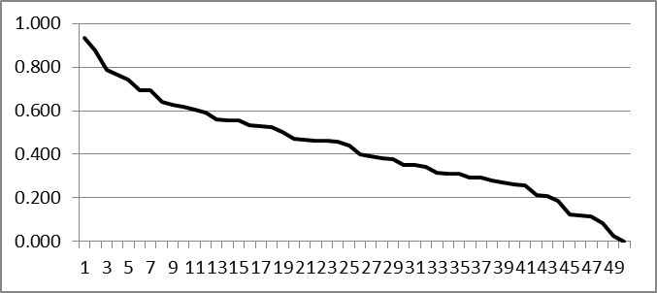
Figure 5.9. Scree Diagram of the Hierarchical Cluster Analysis at NAN Ranch (red arrow points to the “elbow”).

Table 5.9. Results of the 14 Indexes Run in NbClust Package in R.
Index | Predicted # of Clusters
kl | 8
gap | 1
db | 30
silhouette | 30
duda | 11
pseudot2 | 11
beale | 11
ptbiserial | 4
mcclain | 2
gamma | 30
gplus | 30
dunn | 3
sdindex | 29
sdbw | 30

Bowl # Dendrogram
7590 -┐-------┐
7591 -┘ |-----┐
7588 ---┐-----┘ |---------------┐
7589 ---┘ | |
7649 ---------------┘ |---┐
7636 -----------------┐---┐ | |
7662 -----------------┘ |---------┘ |---┐
7629 ---------------------┘ | |
7622 -----------------------------------┘ |---┐
7605 -----------------------------┐-----┐ | |
7674 -----------------------------┘ | | |
7648 -----------------┐-------┐ |---┘ |
7688 -----------------┘ |-----┐ | |
7656 ---------------------┐---┘ |---┘ |
7689 ---------------------┘ | |-┐
7633 -------------------------------┘ | |
7546 -------------┐-----------┐ | |
7572 -------------┘ |---------┐ | |
7642 -----------┐---------┐ | | | |
7655 -----------┘ |---┘ | | |
7630 ---------------------┘ |-------┘ |---┐
7623 -------------------┐---------┐ | | |
7660 -------------------┘ |---┐ | | |
7658 -----------------┐-------┐ | | | | |
7664 -----------------┘ |---┘ |-┘ | |
7663 -------------------------┘ | | |
7652 ---------------------------------┘ | |
7632 -------------------------┐-------------------┘ |
7650 -------------------------┘ |
7607 -----------------------------┐-----┐ |
7643 -----------------------------┘ |-------┐ |
7654 -----------------------------------┘ | |
7568 -------------┐-----------┐ |-----|
7653 -------------┘ |---------┐ | |
7585 -------------------------┘ | | |
7582 ---------┐-----------┐ |-------┘ |
7583 ---------┘ | | |
7625 ---------------------|-----------┐ | |
7548 ---------------------┘ |-┘ |
7552 ---------------------------------┘ |
7638 ---------------------------┐-┐ |
7646 ---------------------------┘ |---------┐ |
7608 -----------------------------┘ |---┐ |
7581 ---------------------┐---------┐ | | |
7635 ---------------------┘ |-------┘ | |
7561 -----------------------┐-------┘ |-----┘
7618 -----------------------┘ |
7553 ---------------------------------┐-----┐ |
7617 ---------------------------------┘ |---┘
7640 -------------------------------------┐-┘
7657 -------------------------------------┘

Figure 5.10. Dendrogram of the Hierarchical Cluster Analysis at NAN Ranch (colors highlight the Clusters and are used later on site maps).

Using the formal elements that are on 70 percent or more of the bowls for any cluster group, it is possible identify some of the key differences in the painting of the zigzag and stepped motifs at NAN Ranch (Table 5.10). For NAN, 12 formal elements are found on 70 percent of bowls in at least one cluster group. Cluster 1 has the most high frequency formal elements with six of the 14, of which one is also present in high frequency in Cluster 3. Cluster 2 has five of the 14 design elements, of which one present in high frequency in Cluster 3. Cluster 3 has five of the 14 design elements, of which two present in high frequency in Clusters 2 and 3. All clusters have at least three high frequency formal elements that the other two cluster groups only have in low frequencies. Also, all clusters have different combinations of high frequency elements that illustrate the differences in the motif clusters.

Table 5.10. Highest Percent of Formal Elements Used to Create Zigzag and Stepped Motifs at NAN.
Formal Element | Formal Elements for Cluster Group 1 | Formal Elements for Cluster Group 2 | Formal Elements for Cluster Group 3
C4 | 52% | 73% | 0%
1-4 Zigzag Motifs | 41% | 82% | 82%
Zigzag Motif Zone 2 | 62% | 82% | 55%
Zigzag Motif Zone 3 | 31% | 73% | 9%
Zigzag Motif Floating | 62% | 55% | 73%
2-4 Lines Making Zigzag Motif | 83% | 55% | 64%
Zigzag Motif Negative Rhomboids 1 | 86% | 18% | 36%
Zigzag Motif Repeating around Vessel 2 Times | 21% | 18% | 82%
Zigzag Motif Repeating around Vessel 4 Times | 52% | 82% | 9%
1-4 Step Motifs | 7% | 0% | 73%
Step Triangle | 100% | 0% | 73%
Opposing Steps | 76% | 0% | 45%
Step Motif Negative Rhomboids 1 | 83% | 0% | 45%
Step Motif Filled with Solid | 90% | 0% | 64%
These results show that more production groups at Galaz than any other site. Galaz had more than twice as many clusters as Cameron Creek, Mattocks, and NAN Ranch, with the most bowls on average per cluster (23.29) spread throughout 56 rooms (Table 5.11). Swarts has the second most and with 20.8 bowls spread throughout 47 rooms (Table 5.11). Galaz and Swarts having more clusters than any other site suggests that there are more producers or groups of producers at these sites than at Cameron Creek, Mattocks, and NAN Ranch. The large number of bowls per cluster and the high number of rooms suggest that production groups at Galaz and Swarts were large and spread widely throughout the site.

Table 5.11. Distribution of Bowls at the Mimbres Sites Used in This Study.
Site | Total Numbers of Bowls | Number of Clusters | Number of Rooms | Average Bowls per Cluster
Cameron Creek | 31 | 3 | 17 | 10.34
Mattocks | 42 | 3 | 20 | 14
Galaz | 163 | 7 | 56 | 23.29
Swarts | 104 | 5 | 47 | 20.8
NAN Ranch | 50 | 3 | 19 | 16.67

Spatial Organization of Clusters
When all bowls at each site are included, the cluster analysis supports the presence of small independent ceramic design production groups at Mattocks, Cameron Creek, and NAN Ranch but not at Galaz and possibly Swarts. To test for the spatial organization of production groups and the organization of social boundaries at these sites, the clusters need to be understood spatially. In this section, I plot the location of the clusters on maps of each site. I use these data to identify how spatially grouped the bowls from each design cluster are at each site to identify sites with small independent ceramic design production groups. The spatial uniformity of the production test is used to identify how diffuse or concentrated the production groups are across each site. The spatial uniformity of the production test uses the number of rooms with shared walls from each cluster to identify how diffuse the production groups are at each site. The shared walls of rooms are likely to identify shared room construction. This test is designed to understand the relationship between design production groups and rooms at each site.
The spatial uniformity of the production test begins by plotting the locations of the bowls within the rooms where they were found. The design cluster group assigned by cluster analysis discussed above then classifies the spatially located bowls. The level of spatial grouping of design production groups at each site is calculated by comparing groups with shared walls to ungrouped rooms or rooms with no shared walls for each bowl design cluster. Within a single vessel cluster, a count is made of all rooms with those vessels that border another room with those vessels. A separate count is made of all of the other, isolated rooms. For each site, these are summed across all vessel clusters in order to assess the relative level of spatial clustering within sites (Table 5.12). For example, the values in Table 5.12 for Cameron Creek bowls from Cluster 1 are in 10 rooms with adjoining walls and one room without any adjoining walls. Bowls from Cluster 2 are in two rooms with adjoining walls and one room without any adjoining walls. Bowls from Cluster 3 are in two room with adjoining walls and three rooms without any adjoining walls. Then I add the number of rooms with adjoining walls and rooms without any adjoining walls. Therefore, at Cameron Creek there are 14 rooms with adjoining walls and five rooms without any adjoining walls. In this way, two by two contingency tables are created between sites.
Table 5.12. The Number of Adjoining Rooms and Isolated Rooms at Cameron Creek, Mattocks, Galaz, Swarts, and NAN Ranch.
 | Total Rooms | Adjoining Rooms | Isolated Rooms
Cameron Creek | 19 | 14 | 5
Mattocks | 15 | 13 | 2
Galaz | 106 | 56 | 50
Swarts | 81 | 64 | 17
NAN Ranch | 31 | 26 | 5

When the percent of adjoining rooms at each site is compared, statistical differences are present between Galaz and Swarts, Mattocks, Cameron Creek, and NAN Ranch. The clusters at Swarts, Mattocks, Cameron Creek, and NAN Ranch show that there are more rooms sharing adjoining walls per cluster than at Galaz. I used a pair-wise Fisher’s exact test used to compare the number of adjoining rooms versus the number of isolated rooms between each pair of sites (Table 5.13). The results show that there is less spatial grouping of design production clusters at Galaz than at any other site (Tables 5.12 and 5.13). These results also show that the general spatial grouping of clusters at Swarts, Mattocks, Cameron Creek, and NAN Ranch are not statistically different from each other (p<.05) (Table 5.13). There is a statistical difference at the .05 level in the spatial distributions of design clusters between Galaz when compared to Mattocks, Swarts, and NAN Ranch and a moderate statistical difference (p<.15) between Galaz and Cameron Creek. These results illustrate that the number of adjoining rooms for each design cluster at Galaz is different from all other sites in the study including Swarts.
Table 5.13. The Results of the Fisher's Exact Test for Difference in the Number of Adjoining Rooms. * is moderate significance, and ** is significant at the .05 level ***Bonferonni correction significance .005.
 | Cameron Creek | Mattocks | Galaz | Swarts | NAN Ranch
Cameron Creek |  | 0.4263 | *0.1317 | 0.7586 | 0.4741
Mattocks | 0.4263 |  | **0.0134 | 0.7278 | 1
Galaz | *0.1317 | **0.0134 |  | ***0.0002 | ***0.0018
Swarts | 0.7586 | 0.7278 | ***0.0002 |  | 0.7908
NAN Ranch | 0.4741 | 1 | ***0.0018 | 0.7908

The results of the first test for spatial organization analyses further emphasize the differences in painting production group boundaries present at Galaz as compared to Cameron Creek, Mattocks, Swarts, and NAN Ranch. The results of the uniformity of the design production test show that the design production groups at Galaz are diffuse and less spatially concentrated in groups of rooms with shared walls than at Cameron Creek, Mattocks, Swarts, and NAN Ranch. The results thus far not only illustrate the differences between Galaz and the other four sites, but they show that the design production groups at Galaz were more widely distributed across the site. However, the uniformity of the design production test only identifies how spatially concentrated design clusters are each site, and it does not compare the spatial relationship of each concentration of design clusters to the other concentrations of design clusters at a site.

Spatial Distributions of Design Clusters
I use the spatial distributions of design clusters at each site to understand how people organized themselves into design production groups. The spatial organization of production test uses the bowls previously plotted on the site maps by design cluster to understand the overlap of design cluster groups. The overlap of clusters at a site illustrates how concentrated or diffuse social boundaries are between production groups. Sites where design clusters are spatially overlapping more than other sites indicate production groups that work together and/or are one production group with two distinct styles.
To determine the spatial relationship of each design cluster to the other design clusters at each site, I identified areas within each site where the design clusters are most densely located. The areas of densest design concentrations I identified as rooms and/or sets of rooms with shared walls having the highest percent of bowls from a specific cluster. In many cases, a room will have one or more bowls from other clusters, but these may or may not represent another design concentration. However, it is important to understand that if the defined concentration areas have bowls from other cluster groups in order to determine if they represent a true majority of bowls in the concentration area. I do not display the bowls from the other cluster groups on the maps because then maps would become overwhelmed with data and obscure the concentration areas being presented. The areas with more spatially overlapping design cluster concentrations are seen as having more production groups working together. Sites are compared to understand the differences in social boundaries between design production groups at each site.
Within each design cluster, the percent of bowls per room or groups of rooms with shared walls room are used to identify the densest spatial design clusters at each site. The goal is to identify spatial concentrations of bowl design clusters that are spatially concentrated into rooms or groups of rooms with adjoining walls. I determined these distributions by using bowl frequencies for each design cluster. Cluster groups with bowls in rooms or groups of rooms with adjoining walls that are 15 percent of the total for each design cluster group are identified as a concentration of bowl designs for each cluster group. The percent of each identified spatial concentration for each design cluster group should be at least 45 percent of the total for each design cluster group. The area or areas that have the densest spatial concentration of bowls from each bowl cluster group are marked on maps of each site. In some cases, the spatial distribution at each site may be more or less dispersed, resulting in multiple concentration areas, at sites with more dispersed spatial concentrations, there will be more low percent design clusters.

Spatial Distributions of Design Clusters at Cameron Creek
There are three design clusters at Cameron Creek, and they separate into northern room block, eastern room block, central part of southern room block, southern part of southern room block, and northern part of southern room block (Figure 5.11). Cluster 1 has concentrations in the northern room block, eastern room block, and central part of southern room block. Cluster 2 has concentrations in the southern part of southern room block. Cluster 3 has concentrations in the southern part of southern room block and northern part of southern room block. The spatial distributions show little overlap in the rooms and room groups. There is one room where Clusters 2 and 3 overlap. There is also a north-south difference between Clusters 2 and 3 and Cluster 1.

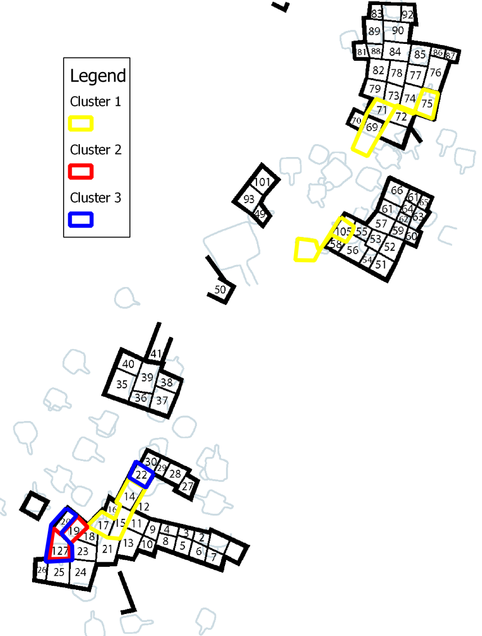
Figure 5.11. Map of Cameron Creek Showing Design Cluster Areas. Each color corresponds to the color on the dendrogram for this site.

Cluster 1 has three concentration areas (Table 5.14; Figure 5.11). The Cluster 1 concentration in the northernmost room block is in three rooms. The rooms with the Cluster 1 concentration in the northern room block also lacked any bowls with zigzag and/or stepped motifs from Clusters 2 and 3 (Table 5.14). The Cluster 1 concentration in the eastern room block consists of two rooms. The rooms with the Cluster 1 concentration in the eastern room block also lacked any bowls with zigzag and/or stepped motifs from Clusters 2 and 3 (Table 5.14). The Cluster 1 concentration in the central part of southern room block consists of three rooms. The rooms with the Cluster 1 concentration in the central part of southern room block also lacked any bowls with zigzag and/or stepped motifs from Clusters 2 and 3 (Table 5.14).

Table 5.14. Rooms and Bowls in Design Production Group 1 Concentration Areas at Cameron Creek.
 | Room Block | # of Rooms | Bowls from Cluster 1 | Bowls from Cluster 2 | Bowls from Cluster 3
Cluster 1 (total bowls in cluster n=18) | Northern Room Block | 4 | 28% | 0% | 0%
Cluster 1 (total bowls in cluster n=18) | Eastern Room Block | 2 | 28% | 0% | 0%
Cluster 1 (total bowls in cluster n=18) | Central Part of Southern Room Block | 3 | 17% | 0% | 0%

Cluster 2 has one concentration area (Table 5.15; Figure 5.11). The area associated with Cluster 2 in the southern part of the southern room block is two rooms. There is a single bowl each from Cluster 3 and Cluster 1 in the same two rooms (Table 5.15).
Table 5.15. Rooms and Bowls in Design Production Group 2 Concentration Areas at Cameron Creek.
 | Room Block | # of Rooms | Bowls from Cluster 1 | Bowls from Cluster 2 | Bowls from Cluster 3
Cluster 2 (total bowls in cluster n=7) | Southern Part of Southern Room Block | 2 | 6% | 43% | 14%

Cluster 3 is in two concentration areas (Table 5.16; Figure 5.11). The Cluster 3 concentration in the southern part of southern room block is in two adjacent rooms. In room 127, there is also one bowl each with zigzag and/or stepped motifs from Clusters 1 and 2 (Table 5.16). The Cluster 3 concentration in the northern part of the southern room block is in one room. This room lacks any bowls from Clusters 1 and 2 (Table 5.16).

Table 5.16. Rooms and Bowls in Design Production Group 3 Concentration Areas at Cameron Creek.
 | Room Block | # of Rooms | Bowls from Cluster 1 | Bowls from Cluster 2 | Bowls from Cluster 3
Cluster 3 (total bowls in cluster n=7) | Southern Part of Southern Room Block | 2 | 14% | 6% | 29%
Cluster 3 (total bowls in cluster n=7) | Northern Part of Southern Room Block | 1 | 0% | 0% | 29%

These results show that there is some spatial overlap among the clusters in the southern room block between Cluster groups 2 and 3. There is also spatial separation between Cluster 1 and Clusters 2 and 3 or between the northern and southern halves of the site at Cameron Creek. There is a lower number of bowls with zigzag and/or stepped motifs from Clusters 2 and 3 in the north and east room blocks with 21 percent of Clusters 2 and 3 combined (Appendix A). This is compared to 67 percent of the bowls with zigzag and/or stepped motifs from Cluster 1. Likewise, in the southern room block, there is a majority (71 percent) of bowls with zigzag and/or stepped motifs from Clusters 2 and 3. This is compared to 33 percent of the bowls with zigzag and/or stepped motifs from Cluster 1 (Appendix A). While there is some overlap in Clusters 2 and 3, there is a north-south break between Clusters 2 and 3 and Cluster 1. Even though there is a low percentage of bowls from Cluster 1 in the southern room block, the data suggest two design production areas, north and south, for the three bowl design clusters at Cameron Creek.

Spatial Concentrations at Mattocks
There are three design clusters at Mattocks, and they separate into the 100s room block, 200s room block, 300s room block, 400s room block, Nesbitt’s eastern room block, and Nesbitt's southeastern room block (Tables 5.17, 5.18, 5.19; Figure 5.12). Cluster 1 has concentrations are in the 200s room block, 300s room block and Nesbitt’s eastern room block. Cluster 2 has concentrations are in the 100s room block, 200s room block and Nesbitt's southeastern room block. Cluster 3 has one concentration in the 400s room block. The spatial distributions of design clusters at Mattocks show no overlap except for one room for Clusters 2 and 3 in the 400s room block (Figure 5.12).

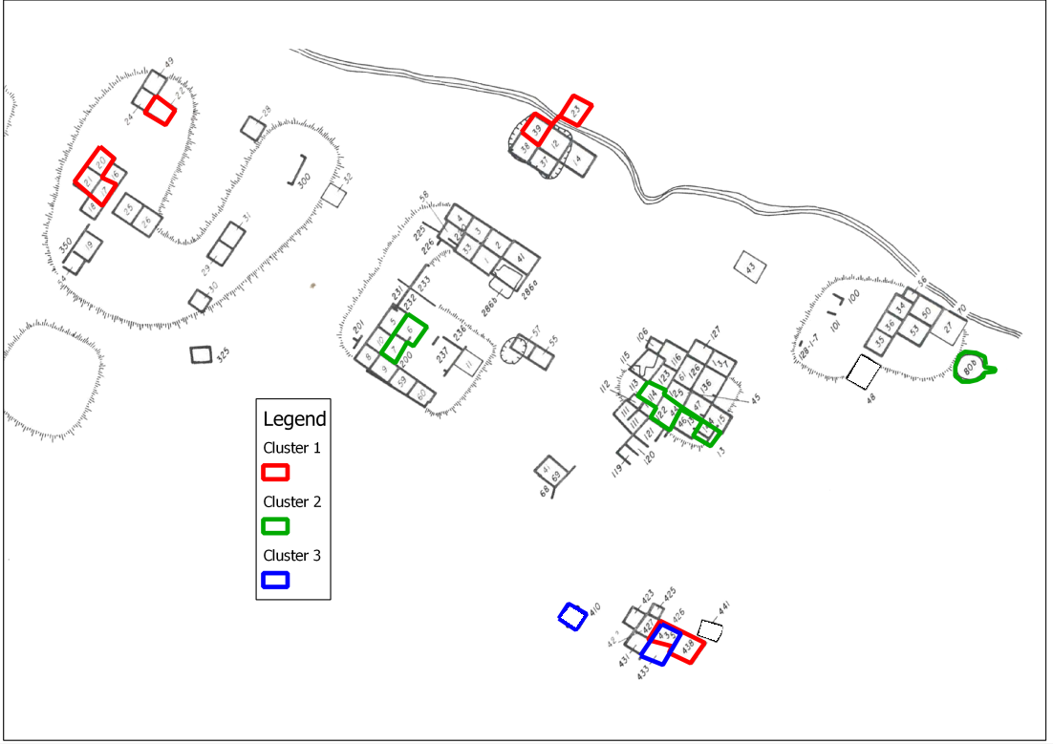
Figure 5.12. Map of Mattocks Showing Identified Design Cluster Areas. Each color corresponds to the color on the dendrogram for this site.

Cluster 1 is in three concentration areas (Table 5.7; Figure 5.12). The Cluster 1 concentration in the 300s room block is in four rooms. These Cluster 1 rooms lack any bowls with zigzag and/or stepped motifs from Cluster 2, and they have one bowl from Cluster 3 (Table 5.17). The Cluster 1 concentration in the eastern room block is in two rooms (Table 5.17). The Cluster 1 concentration in the 400s room block is in two rooms. There is a high percent of bowls with zigzag and/or stepped motifs from Cluster 3 in the 400s room block (Table 5.17).
Table 5.17. Rooms and Bowls in Design Production Group 1 Concentration Areas at Mattocks.
 | Room Block | Rooms | # of Bowls from Cluster 1 | # of Bowls from Cluster 2 | # of Bowls from Cluster 3
Cluster 1 (total bowls in cluster n=24 ) | 300s | 4 | 38% | 0% | 20%
Cluster 1 (total bowls in cluster n=24 ) | 400s | 2 | 29% | 0% | 80%
Cluster 1 (total bowls in cluster n=24 ) | Eastern | 2 | 13% | 0% | 0%

Cluster 2 is in three concentration areas: the 100s, 200s, and Nesbitt’s southeastern room blocks (Table 5.18; Figure 5.12). The area associated with Cluster 2 in the 100s room block is in three rooms (Table 5.18). The area associated with Cluster 2 in the 200s room block is in two rooms (Table 5.18). The area associated with Cluster 2 in Nesbitt’s southeastern room block is in one room (Table 5.18).
Table 5.18. Rooms and Bowls in Design Production Group 2 Concentration Areas at Mattocks.
 | Room Block | Rooms | Bowls from Cluster 1 | Bowls from Cluster 2 | Bowls from Cluster 3
Cluster 2 (total bowls in cluster n=13) | 100s | 3 | 0% | 23% | 0%
Cluster 2 (total bowls in cluster n=13) | 200s | 2 | 0% | 15% | 0%
Cluster 2 (total bowls in cluster n=13) | Southeastern | 1 | 8% | 31% | 0%

Cluster 3 is in one concentration area in three rooms in the 400s room block (Table 5.19; Figure 5.12). As mentioned before, bowls with zigzag and/or stepped motifs from Cluster 1 are also found in the 400s room block. The overlap between Clusters 1 and 3 is in room 435.
Table 5.19. Rooms and Bowls in Design Production Group 3 Concentration Areas at Mattocks.
 | Room Block | Rooms | Bowls from Cluster 1 | Bowls from Cluster 2 | Bowls from Cluster 3
Cluster 3 (total bowls in cluster n=5) | 400s | 3 | 29% | 0% | 80%

These results show that there is some overlap in one room for the three clusters, but in most areas, there is a spatial separation among clusters at Mattocks. There is overlap of Clusters 1 and 3 in room 435, but there is a lack of Cluster 3 bowl designs in all the other room blocks. In the 400s room block, Cluster 3 has 80 percent (n=4) of its vessels located here compared to 29 percent (n=7) from Cluster 1. The 400s room block has a significant percent of bowls with zigzag and/or stepped motifs from Cluster 3 but has few bowls with zigzag and/or stepped motifs from other clusters. All other room blocks have only one cluster group, which supports the delineation of separate distributions for each cluster at Mattocks. Additionally, Cluster 1 is at the north end of site, Cluster 2 is in the center, and Cluster 3 is only in 400s, suggesting a similar pattern to that at Cameron Creek - a north-south separation.

Spatial Concentrations at Galaz
There are seven design clusters at Galaz, and they separate into the western room block, the eastern room block, the northern part of the southern room block, the northern room block, and the southern part of the southern room block (Figure 5.13). Cluster 1 has concentrations in the western room block, eastern room block, and northern part of the southern room block. Cluster 2 has concentrations in the northern room block, western room block, and eastern room block. Cluster 3 has concentrations in the northern room block and eastern room block. Cluster 4 has concentrations in the northern part of the southern room and southern part of the southern room block. Cluster 5 has concentrations in the northern room block, western room block, eastern room block, northern part of the southern room block, and southern part of the southern room block. Cluster 6 has concentrations in the northern room block and southern part of the southern room block. Cluster 7 has concentrations in the eastern room block and northern part of the southern room block. The spatial distributions at Galaz have a great deal of overlap in all rooms and room groups (Figure 5.13). There is overlap between Clusters 2, 3, and 5 in the northern room block; 1, 2, 3, 5, and 7 in the eastern room block; 1, 2, and 5 in the western room block; 1, 4, 5, and 7 in the northern part of the southern room block; and 4, 5, and 6 in the southern part of the southern room block.

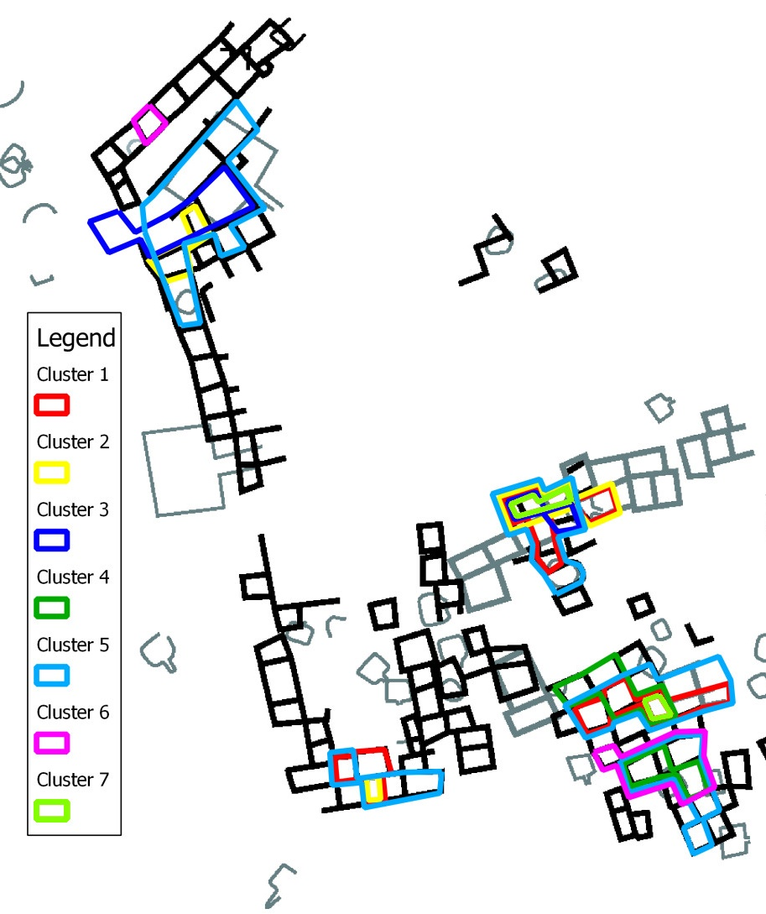
Figure 5.13. Map of Galaz Showing Identified Design Cluster Areas. Each color corresponds to the color on the dendrogram for this site.

Cluster 1 has is in three concentration areas in the western room block, the eastern room block, and the northern part of the southern room block (Table 5.18; Figure 5.13). The area associated with Cluster 1 in the western room block is in three rooms. There is a small percentage from Clusters 2, 3, and 5 (Table 5.18). The area associated with Cluster 1 in the eastern room block is in four rooms (Table 5.8; Figure 5.13). There is a significant percentage from Clusters 2, 3, 5, and 7. The area associated with Cluster 1 in the northern part of the southern room block is in four rooms (Table 5.20; Figure 5.13). There is a significant percentage from Clusters 4, 5, and 7 (Table 5.20). There is a low percent from Clusters 2, 3, and 6 (Table 5.20).
Table 5.20. Rooms and Bowls in Design Production Group 1 Concentration Areas at Galaz.
 | Room Block | Rooms | Bowls from Cluster 1 | Bowls from Cluster 2 | Bowls from Cluster 3 | Bowls from Cluster 4 | Bowls from Cluster 5 | Bowls from Cluster 6 | Bowls from Cluster 7
Cluster 1 (Total Bowls in Cluster n=25) | Western Room Block | 3 | 12% | 9% | 9% | 0% | 6% | 0% | 0%
Cluster 1 (Total Bowls in Cluster n=25) | Eastern Room Block | 4 | 20% | 30% | 27% | 0% | 21% | 0% | 30%
Cluster 1 (Total Bowls in Cluster n=25) | Northern Part of the Southern Room Block | 5 | 39% | 9% | 9% | 20% | 13% | 8% | 30%

Cluster 2 is in three concentration areas in the northern room block, the western room block, and the eastern room block (Table 5.21; Figure 5.13). The area associated with Cluster 2 in the northern room block is in two rooms with no bowls with zigzag and/or stepped motifs from any other cluster (Table 5.21). The area associated with Cluster 2 in the western room block is in one room (Table 5.21; Figure 5.13). There is a low percent from Clusters 1 and 5. The area associated with Cluster 2 in the eastern room block is in four rooms (Table 5.8; Figure 5.13). There is a significant percentage from Clusters 3 and 7. There are also a low percent from Clusters 1 and 5.
Table 5.21. Rooms and Bowls in Design Production Group 2 Concentration Areas at Galaz.
 | Room Block | Rooms | Bowls from Cluster 1 | Bowls from Cluster 2 | Bowls from Cluster 3 | Bowls from Cluster 4 | Bowls from Cluster 5 | Bowls from Cluster 6 | Bowls from Cluster 7
Cluster 2 (Total Bowls in Cluster n=23) | Northern Room Block | 2 | 12% | 9% | 18% | 0% | 4% | 0% | 30%
Cluster 2 (Total Bowls in Cluster n=23) | Western Room Block | 1 | 4% | 9% | 0% | 0% | 1% | 0% | 0%
Cluster 2 (Total Bowls in Cluster n=23) | Eastern Room Block | 4 | 0% | 30% | 0% | 0% | 0% | 0% | 0%

Cluster 3 is in two concentration areas in the northern room block and the eastern room block (Table 5.22; Figure 5.13). The area associated with Cluster 3 in the northern room block is in three rooms. There is a low percent from Clusters 2, 5, and 7. The area associated with Cluster 3 in the eastern room block is in three rooms (Table 5.8; Figure 5.13). There is a significant percentage from Cluster 2. There are also a low percent from Clusters 1 and 7.

Table 5.22. Rooms and Bowls in Design Production Group 3 Concentration Areas at Galaz.
 | Room Block | Rooms | Bowls from Cluster 1 | Bowls from Cluster 2 | Bowls from Cluster 3 | Bowls from Cluster 4 | Bowls from Cluster 5 | Bowls from Cluster 6 | Bowls from Cluster 7
Cluster 3 (Total Bowls in Cluster n=11) | Northern Room Block | 3 | 0% | 4% | 27% | 0% | 3% | 0% | 10%
Cluster 3 (Total Bowls in Cluster n=11) | Eastern Room Block | 3 | 4% | 17% | 27% | 0% | 0% | 0% | 10%

Cluster 4 is in two concentration areas in the northern part of the southern room block and the southern part of the southern room block (Table 5.8; Figure 5.13). The area associated with Cluster 4 in the northern part of the southern room block is in four rooms. There is a significant percentage from Clusters 5 and 7. There is a low percent from Clusters 2, 5, and 6. The area associated with Cluster 4 in the southern part of the southern room block is in two rooms (Table 5.8; Figure 5.13). There is a significant percentage from Cluster 5. There is also a low percent from Clusters 1, 2, 6, and 7.

Table 5.23. Rooms and Bowls in Design Production Group 4 Concentration Areas at Galaz.
 | Room Block | Rooms | Bowls from Cluster 1 | Bowls from Cluster 2 | Bowls from Cluster 3 | Bowls from Cluster 4 | Bowls from Cluster 5 | Bowls from Cluster 6 | Bowls from Cluster 7
Cluster 4 (Total Bowls in Cluster n=10) | Northern Part of the Southern Room Block | 4 | 20% | 4% | 0% | 40% | 7% | 8% | 30%
Cluster 4 (Total Bowls in Cluster n=10) | Southern Part of the Southern Room Block | 2 | 4% | 4% | 0% | 50% | 18% | 8% | 10%

Cluster 5 is in all five areas – the northern room block, the western room block, the eastern room block, the northern part of the southern room block, and the southern part of the southern room block (Table 5.8; Figure 5.13). The area associated with Cluster 5 in the northern room block is in six rooms. There is a significant percentage from Cluster 3. Also, there are low percentages from Clusters 1, 2, 4, and 7. The area associated with Cluster 5 in the western room block is in four rooms (Table 5.8; Figure 5.13). There are low percentages from Clusters 1 and 2. The area associated with Cluster 5 in the eastern room block is in seven rooms (Table 5.8; Figure 5.13). There is a significant percentage from Clusters 1, 2, 3, 6, and 7. The area associated with Cluster 5 in the northern part of the southern room block is in eight rooms (Table 5.8; Figure 5.13). There is a significant percentage from Clusters 1, 4, 6, and 7. There is a low percent from Clusters 2 and 3. The area associated with Cluster 5 in the southern part of the southern room block is in five rooms (Table 5.8; Figure 5.13). There is a significant percentage from Clusters 2, 4, 6, and 7. There is also a low percent from Cluster 1.

Table 5.24. Rooms and Bowls in Design Production Group 5 Concentration Areas at Galaz.
 | Room Block | Rooms | Bowls from Cluster 1 | Bowls from Cluster 2 | Bowls from Cluster 3 | Bowls from Cluster 4 | Bowls from Cluster 5 | Bowls from Cluster 6 | Bowls from Cluster 7
Cluster 5 (Total Bowls in Cluster n=72) | Northern Room Block | 6 | 4% | 9% | 27% | 10% | 13% | 0% | 10%
Cluster 5 (Total Bowls in Cluster n=72) | Western Room Block | 4 | 8% | 9% | 0% | 0% | 8% | 0% | 0%
Cluster 5 (Total Bowls in Cluster n=72) | Eastern Room Block | 7 | 20% | 22% | 36% | 0% | 28% | 15% | 30%
Cluster 5 (Total Bowls in Cluster n=72) | Northern Part of the Southern Room Block | 8 | 36% | 9% | 9% | 20% | 18% | 15% | 30%
Cluster 5 (Total Bowls in Cluster n=72) | Southern Part of the Southern Room Block | 5 | 4% | 13% | 0% | 50% | 26% | 31% | 20%

Cluster 6 is in two concentration areas in the northern room block and the southern part of the southern room block (Table 5.8; Figure 5.13). The area associated with Cluster 6 in the northern room block is in one room with no bowls with zigzag and/or stepped motifs from any other cluster. The area associated with Cluster 6 in the southern part of the southern room block is in four rooms (Table 5.8; Figure 5.13). There is a significant percentage from Clusters 4, 5, and 6. There is also a low percent from Clusters 1, 2, and 7.

Table 5.25. Rooms and Bowls in Design Production Group 6 Concentration Areas at Galaz.
 | Room Block | Rooms | Bowls from Cluster 1 | Bowls from Cluster 2 | Bowls from Cluster 3 | Bowls from Cluster 4 | Bowls from Cluster 5 | Bowls from Cluster 6 | Bowls from Cluster 7
Cluster 6 (Total Bowls in Cluster n=13) | Northern Room Block | 1 | 0% | 0% | 0% | 0% | 0% | 15% | 0%
Cluster 6 (Total Bowls in Cluster n=13) | Southern Part of the Southern Room Block | 4 | 4% | 4% | 10% | 50% | 13% | 38% | 31%

Cluster 7 is in two concentration areas in the eastern room block and the northern part of the southern room block (Table 5.8; Figure 5.13). The area associated with Cluster 7 in the eastern room block is in two rooms. There is a significant percentage from Clusters 2 and 3. There is also a low percent from Clusters 1 and 5. The area associated with Cluster 7 in the northern part of the southern room block is in one room (Table 5.8; Figure 5.13). There is a low percent from Clusters 1, 2, 4, 5, and 6.

Table 5.26. Rooms and Bowls in Design Production Group 7 Concentration Areas at Galaz.
 | Room Block | Rooms | Bowls from Cluster 1 | Bowls from Cluster 2 | Bowls from Cluster 3 | Bowls from Cluster 4 | Bowls from Cluster 5 | Bowls from Cluster 6 | Bowls from Cluster 7
Cluster 7 (Total Bowls in Cluster n=10) | Eastern Room Block | 2 | 8% | 22% | 18% | 0% | 7% | 0% | 30%
Cluster 7 (Total Bowls in Cluster n=10) | Northern Part of the Southern Room Block | 1 | 4% | 4% | 0% | 10% | 3% | 8% | 30%

These results show that there is overlap of all Galaz clusters with little spatial separation among cluster group concentrations. There is a separation between areas of the site that have bowls with zigzag and/or stepped motifs as a result of the absence of data for these areas. The northern room block has Clusters 2, 3, and 5 all overlapping one another with Cluster 3 having the highest percent (27 percent) of bowls with zigzag and/or stepped motifs. While the greatest percent of bowls with zigzag and/or stepped motifs in the northern room block is from Cluster 3, 27 percent of the bowls with zigzag and/or stepped motifs from Cluster 3 are also in the eastern room block. The problem with defining which group represents any one area is further compounded when we look at the eastern room block with not only 27 percent of the bowls with zigzag and/or stepped motifs from Cluster 3, but also 20 percent from Cluster 1, Cluster 2 with 30 percent, Cluster 5 with 28 percent, and Cluster 7 with 30 percent. Thus, while Cluster 3 may have the highest percent of bowls in the northern room block, Cluster 3 also has the most bowls in the eastern room block, with high proportions from four other clusters.
The pattern of multiple design groups being present in any one area repeats again when looking at southern part of the southern room, with the greatest percent from Cluster 4 at 50 percent, the greatest percent from luster 5 with 26 percent, and the greatest percent from Cluster 6 with 38 percent. In the western room block, the pattern continues, but instead of nearly all clusters having high percentages of bowls with zigzag and/or stepped motifs, they all have the lowest frequencies. The highest frequencies of bowls in the western room block with zigzag and/or stepped motifs from any of the clusters are from Clusters 1 (12 percent), 2 (9 percent), and 5 (8 percent).
However, despite the lack of separation between clusters in any area, Clusters 1, 2, 3, 6 and 7 have low percentages or are absent from areas of the site, and only Cluster 5 is evenly distributed across the site. There are fewer bowls with zigzag and/or stepped motifs from Cluster 1 in the northern room block and the southern part of the southern room block. There are fewer bowls with zigzag and/or stepped motifs from Cluster 2 in the northern part of the southern room block and the southern part of the southern room block. Cluster 5 is widely distributed and has significant quantities in all areas.
Cluster 3 only has concentrations in the eastern and northern room blocks. Cluster 4 only has concentrations in the northern part of the southern room block and southern part of the southern room block. Cluster 6 only has concentrations in the northern room block and southern part of the southern room block. Cluster 7 only has significant concentrations in the northern room block and eastern room block. At Galaz, no one area can be identified as being solely represented by one cluster group. The design cluster groups at Galaz are spread across multiple concentration areas and suggest a pattern of production groups working with people who are members of other production groups.

Spatial Concentrations at Swarts
There are five design clusters at Swarts that separate into northern part of the northern room block, southern part of the northern room block, eastern part of the northern room block, western part of the southern room block, eastern and western parts of the southern room block, and eastern part of the southern room block (Figure 5.14). Cluster 1 has concentrations in the northern part of the northern room block, southern part of the northern room block, and western part of the southern room block. Cluster 2 has only one concentration in the eastern part of the northern room block. Cluster 3 has only one concentration in the western part of the southern room block. Cluster 4 has concentrations in the northern part of the northern room block and eastern and western parts of the southern room block. Cluster 5 has concentrations in the southern part of the northern room block, western part of the southern room block, and eastern part of the southern room block. The spatial distributions of bowl clusters at Swarts show little overlap in the northern room block but substantial overlap in the southern room block (Figure 5.14).
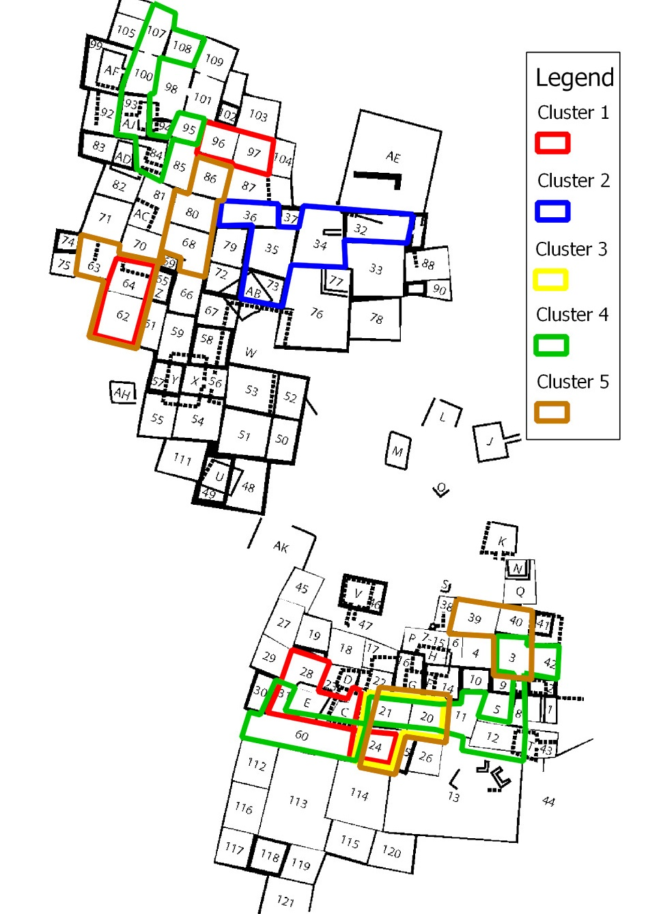
Figure 5.14. Map of Swarts Showing Identified Design Cluster Areas. Each color corresponds to the color on the dendrogram for this site.

Cluster 1 is in three concentration areas in the northern part of the northern room block, the southern part of the northern room block, and the western part of the southern room block (Table 5.27; Figure 5.14). The area associated with Cluster 1 in the northern part of the northern room block is in two rooms, and there are no bowls with zigzag and/or stepped motifs from any other cluster (Table 5.27). The area associated with Cluster 1 in the southern part of the northern room block is two rooms, and there are no bowls with zigzag and/or stepped motifs from any other cluster (Table 5.27; Figure 5.14). The area associated with Cluster 1 in the western part of the southern room block is comprised of four rooms (Table 5.27; Figure 5.14). There is also a significant percentage from Clusters 3 and 5 and a low percent from Cluster 4.

Table 5.27. Rooms and Bowls in Design Production Group 1 Concentration Areas at Swarts.
 | Room Block | Rooms | Bowls from Cluster 1 | Bowls from Cluster 2 | Bowls from Cluster 3 | Bowls from Cluster 4 | Bowls from Cluster 5
Cluster 1 (Total Bowls in Cluster n=13) | Northern Part of the Northern Room Block | 2 | 15% | 0% | 0% | 0% | 0%
Cluster 1 (Total Bowls in Cluster n=13) | Southern Part of the Northern Room Block | 2 | 15% | 0% | 0% | 0% | 0%
Cluster 1 (Total Bowls in Cluster n=13) | Western Part of the Southern Room Block | 4 | 31% | 0% | 25% | 5% | 9%

Cluster 2 is in one concentration area in the eastern part of the northern room block (Table 5.28; Figure 5.14). There is also a significant percentage from Cluster 3 and a low percent from Clusters 1, 4, and 5.
Table 5.28. Rooms and Bowls in Design Production Group 2 Concentration Areas at Swarts.
 | Room Block | Rooms | Bowls from Cluster 1 | Bowls from Cluster 2 | Bowls from Cluster 3 | Bowls from Cluster 4 | Bowls from Cluster 5
Cluster 2 (Total Bowls in Cluster n=10) | Eastern Part of the Northern Room Block | 5 | 8% | 60% | 17% | 5% | 9%

Cluster 3 is in one concentration area in the western part of the southern room block (Table 5.29; Figure 5.14). The concentration area is in three rooms. There is also a significant percentage from Clusters 4 and 5 and a low percent from Clusters 1 and 2.

Table 5.29. Rooms and Bowls in Design Production Group 3 Concentration Areas at Swarts.
 | Room Block | Rooms | Bowls from Cluster 1 | Bowls from Cluster 2 | Bowls from Cluster 3 | Bowls from Cluster 4 | Bowls from Cluster 5
Cluster 3 (Total Bowls in Cluster n=12) | Western Part of the Southern Room Block | 3 | 8% | 10% | 42% | 11% | 19%

Cluster 4 is in two concentration areas in the northern part of the northern room block and spans the eastern and western portions of the southern room block (Table 5.30; Figure 5.14). The area associated with Cluster 4 in the northern part of the northern room block is six rooms. There is also a significant percentage from Cluster 3 and a low percent from Clusters 1, 2, and 5. The area associated with Cluster 4 in the eastern and western parts of the southern room block is in nine rooms (Table 5.9; Figure 5.14). There is also a significant percentage from Clusters 1, 3, and 5 and a low percent from Cluster 2.

Table 5.30. Rooms and Bowls in Design Production Group 4 Concentration Areas at Swarts.
 | Room Block | Rooms | Bowls from Cluster 1 | Bowls from Cluster 2 | Bowls from Cluster 3 | Bowls from Cluster 4 | Bowls from Cluster 5
Cluster 4 (Total Bowls in Cluster n=37) | Northern Part of the Northern Room Block | 6 | 8% | 10% | 17% | 30% | 6%
Cluster 4 (Total Bowls in Cluster n=37) | Eastern and Western Parts of the Southern Room Block | 9 | 23% | 10% | 50% | 43% | 34%

Cluster 5 is in three concentration areas in the southern part of the northern room block, the eastern portion of the southern room block, and the western portion of the southern room block (Table 5.31; Figure 5.14). The area associated with Cluster 5 in the southern part of the northern room block is six rooms. There is also a significant percentage from Cluster 1 and a low percent from Clusters 2 and 4. The area associated with Cluster 5 in the western part of the southern room block is six rooms (Table 5.31; Figure 5.14). There is also a significant percentage from Clusters 2, 3, and 4. The area associated with Cluster 5 in the eastern portion of the southern room block is comprised of three rooms (Table 5.31; Figure 5.14). There is also a low percent from Clusters 3 and 4.

Table 5.31. Rooms and Bowls in Design Production Group 5 Concentration Areas at Swarts.
 | Room Block | Rooms | Bowls from Cluster 1 | Bowls from Cluster 2 | Bowls from Cluster 3 | Bowls from Cluster 4 | Bowls from Cluster 5
Cluster 5 (Total Bowls in Cluster n=32) | Southern Part of the Northern Room Block | 6 | 15% | 10% | 0% | 5% | 22%
Cluster 5 (Total Bowls in Cluster n=32) | Western Part of the Southern Room Block | 3 | 0% | 10% | 17% | 11% | 19%
Cluster 5 (Total Bowls in Cluster n=32) | Eastern Part of the Southern Room Block | 3 | 0% | 0% | 8% | 5% | 16%

These results show that at Swarts there is some overlap among the clusters in the southern room block, but in the northern room block there is more spatial separation between clusters. There is some overlap of Clusters 1, 3, and 5 and 4 and 5 in the southern room block. In particular, there is a great deal of overlap of clusters in these clusters in rooms 20, 21, and 24, which also have low percentages of Clusters 3, 4, and 5 with three percent of the bowls with zigzag and/or stepped motifs from Cluster 3, six percent of the bowls with zigzag and/or stepped motifs from Cluster 4, and 16 percent of the bowls with zigzag and/or stepped motifs from Cluster 5. However, when the rooms surrounding rooms 20, 21, and 24 are removed from the sample, the separation between Clusters 1, 4, and 5 is more clear. In the northern room block, the separation between cluster groups is clear with only rooms 62 and 64 having overlapping concentrations from Clusters 1 and 5. Thus, all areas other than the center of the southern room block around rooms 20, 21, and 24 have only one cluster group, supporting two separate production areas in the northern and southern room blocks for Clusters 1, 4, and 5 at Swarts.

Spatial Concentrations at NAN Ranch
There are three design clusters at NAN Ranch, and they separate into the southern room block, the northern part of the northern room block, and the southern part of the northern room block (Figure 5.15). Cluster 1 has one concentration in the southern room block. Cluster 2 has two concentrations in the northern part of the northern room block and the southern part of the northern room block. Cluster 3 has one concentration in the southern room block. The spatial distributions of bowl clusters at NAN Ranch show little overlap except for Clusters 1 and 3 in the southern room block (Figure 5.15).

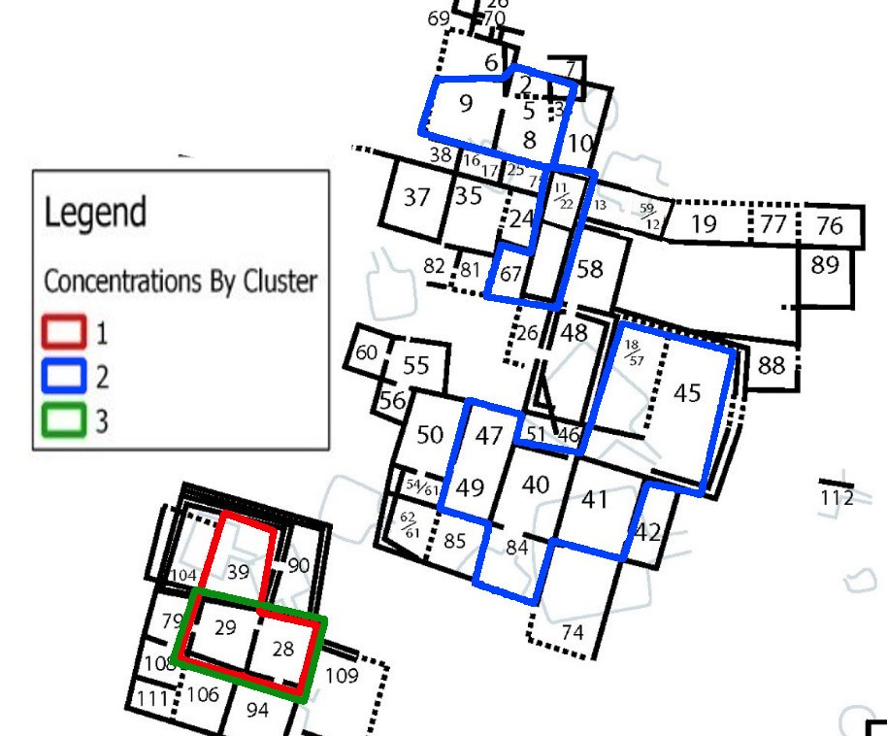
Figure 5.15. Map of NAN Ranch Showing Identified Design Cluster Areas. Each color corresponds to the color on the dendrogram for this site.

Cluster 1 is in one concentration area in the southern room block (Table 5.32; Figure 5.15). The area associated with Cluster 1 in the southern room block is in three rooms, which is the largest concentration for Cluster 1 at NAN Ranch. There is a significant percentage from Clusters 3 and 2.

Table 5.32. Rooms and Bowls in Design Production Group 1 Concentration Areas at NAN.
 | Room Block | Rooms | Bowls from Cluster 1 | Bowls from Cluster 2 | Bowls from Cluster 3
Cluster 1 (Total Bowls in Cluster n=11) | Southern Room Block | 3 | 46% | 64% | 28%

Cluster 2 is in two concentration areas in two different room blocks of the site – the northern part of the northern room block and southern part of the northern room block (Table 5.33; Figure 5.15). The area associated with Cluster 2 in the northern part of the northern room block is six rooms. There is a significant percentage from Cluster 3 and none from cluster 1. The area associated with Cluster 2 in the southern part of the northern room block is in seven rooms, which is the largest concentration for Cluster 2 at NAN Ranch. There is a significant percentage from Cluster 1 and a low percent from Cluster 3.

Table 5.33. Rooms and Bowls in Design Production Group 2 Concentration Areas at NAN.
 | Room Block | Rooms | Bowls from Cluster 1 | Bowls from Cluster 2 | Bowls from Cluster 3
Cluster 2 (Total Bowls in Cluster n=29) | Northern Part of the Northern Room Block | 6 | 0% | 20% | 18%
Cluster 2 (Total Bowls in Cluster n=29) | Southern Part of the Northern Room Block | 7 | 27% | 41% | 9%

Cluster 3 is in three concentration areas in one room block of the site – the southern room block (Table 5.34; Figure 5.15). The area associated with Cluster 3 in the southern room block is comprised of two rooms, which is the largest concentration for Cluster 3 at NAN Ranch. There is a significant percentage from Clusters 1 and 2.

Table 5.34. Rooms and Bowls in Design Production Group 3 Concentration Areas at NAN.
 | Room Block | Rooms | Bowls from Cluster 1 | Bowls from Cluster 2 | Bowls from Cluster 3
Cluster 3 (Total Bowls in Cluster n=11) | Southern Room Block | 2 | 36% | 24% | 64%

These results show that there is some overlap among the clusters at NAN Ranch, but there are areas where there is a spatial separation between cluster groups. Clusters 1 and 3 and Cluster 2 are concentrated in two different room blocks. For Cluster 1, nearly half (41 percent) of the bowls with zigzag and/or stepped motifs are in the southern room block. Likewise, 64 percent of the bowls with zigzag and/or stepped motifs from Cluster 3 are in the southern room block. The bowls with zigzag and/or stepped motifs from Cluster 2 are primarily in the northern room block. There is little difference in the spatial organization of Clusters 1 and 3.

Mimbres Ceramic Design Production Analysis Results
When all bowls with zigzag and/or stepped motifs from each site are included, the cluster analysis supports the presence of multiple production groups for Swarts, Mattocks, Cameron Creek, and NAN Ranch but not at Galaz. Galaz has the most clusters with seven, and Swarts (five clusters), Mattocks (three clusters), Cameron Creek (three clusters), and NAN Ranch (three clusters) have fewer clusters. When the bowl concentrations for each cluster are plotted on site maps, there is also a difference between Galaz and Swarts, Mattocks, Cameron Creek, and NAN Ranch. The clusters at Galaz have more spatial overlap of design cluster groups than the other sites, with many of the rooms having bowls with zigzag and/or stepped motifs from multiple clusters. Conversely, the clusters at Swarts, Mattocks, Cameron Creek, and NAN Ranch show that, while there is some overlap, the spatial organization of design clusters tend to have only one cluster per room.
To test the spatial distribution of the clusters, I used a pair-wise Fisher’s exact test to compare the number of adjoining rooms at each site with those at the other sites to test how spatially concentrated the design clusters are at each site. The results of these tests show that there is a statistically significant difference in the number of adjoining rooms at Galaz when compared to those at all other sites except Cameron Creek, which was moderately different (Table 5.5). These results support the idea that the spatial distribution of bowl designs is different at Galaz when compared to Swarts, Mattocks, Cameron Creek, and NAN Ranch.
The results of this study show that Galaz is different from all of the other sites in how ceramic painting groups produced stepped and zigzag motifs and different in how spatially diffuse the production groups are. The clusters at Galaz are spatially diffuse and not centered around groups of rooms. The cluster analysis shows that the people at Galaz have nearly twice as many clusters as any other site and have cluster concentrations that are not spatially distinctive.
The significant difference between the design production boundaries at Galaz and the other four sites shows that the people at Galaz were more interested in the social boundaries between production groups being more permeable. At Galaz, there probably were more fluid cross-production group interactions. Galaz represents a community where production groups were encouraged to be more socially integrated with each other.

The Formation and Maintenance of Social Boundaries between Ceramic Painting Production Groups in the Mimbres Region
These results build on the identified differences in the growth and development of Galaz in the Mimbres region. In addition to the results presented, Galaz is different from all other site in this study in terms of the settlement patterns, communal structures, and domestic structures. The formations of sites from the Late Pithouse to Classic periods hint at the processes that led to the differences in the social variation identified during the Classic period. At the beginning of the Late Pithouse period, people began moving into the sites on the first bench above the flood plain of the Mimbres River Valley. Galaz is located on top of the largest aquafer in the Mimbres River Valley, which would help to mitigate water problems during time of drought (Trauger and Doty 1965:221).
During the Late Pithouse period, the people at Galaz built a series of Great Kivas that that, as Gilman and Stone (2013:611) have argued, were a means of attracting people to sites. Additionally, the Great Kivas constructed at Galaz were also constructed at Old Town in the southern part of the Mimbres River Valley. The Great Kivas at Galaz and Old Town have led Creel and Anyon (2003) to investigate the differences in the construction and use of the structures at these sites. They found that not only are they Great Kivas, but the people living at these sites dismantled them through burning. These Great Kivas also had artifact offerings built into the wall matrix and left on the floors before retirement. Finally, the areas after the retirement of the Great Kivas were then used as a place where people buried their dead at Galaz and at Old Town and at Old Town one individual was buried in a manner that he touched two retired Great Kivas. While not unique to these sites, the significance that the people at Galaz and Old Town placed on the retired Great Kivas at each site continued past their retirement cannot be overlooked.
The construction of domestic structures at Galaz also appears to be different than at all other sites, although there does not seem to be any regularity in general among sites in the construction of room blocks during the Classic period. (Hegmon et al. 2006). As discussed in Chapter 2, some household studies in the Mimbres region show that family or corporate group occupied one room block and incrementally build new rooms as needed (Hegmon et al. 2006; Hill 1997; Nelson 1993; Shafer 2003, 2006), and others show that at some sites there is a long history of building, use, and abandonment of rooms by a single family (Gilman 2006). Hegmon et al. (2006:62) found that Galaz had a ratio of 16.80 for medium to small sized rooms, while other sites of similar size in the Mimbres Valley had an average of 2.29 for medium to small sized rooms. The difference between Galaz and the other sites in the ratio of medium to small rooms suggests that the people at Galaz did not organize themselves into household units but something more socially flexible than what is found at other sites.
Galaz is also a ceramic production center for the Mimbres region. Powell-Martíand James (2006) show that by systematically quantifying painted designs on Mimbres bowls, the movement of goods, people, and/or ideas through regional interaction and learning spheres can be identified. Powell-Martí and James (2006) found that, during the Classic period (A.D. 1000-1130), there was enough variation in the painted design style to see slight differences among sites. They quantified the most common designs in conjunction with INAA sourcing methods for ceramics at each site to identify social interaction among sites in the Mimbres region. Powell-Martí and James (2006) conclude that Galaz exported more bowls than they imported. They also found that the Middle Classic period was the height of exportation of bowls from Galaz. The majority of the bowls went to NAN Ranch and Cameron Creek. Conversely, Old Town was importing more than they exported during the Middle Classic period. Powell-Martíand James (2006) show that bowls in the Mimbres region were being traded and that the traded vessels increased during the Middle Classic.
During the Classic period, Galaz lacks distinct social boundaries between ceramic painting production groups. This study shows that the people at Galaz painted designs with less variation, had more design cluster groups, had more diffuse spatial organization in design cluster groups,and had more overlap in spatial concentrations of design clusters than other sites in the Mimbres region. The people living at Galaz worked and produced the two geometric bowl designs in a manner suggesting there were fluid or not well-defined social boundaries between production groups.
The large communal structures and unique ceramic production perhaps starting in the Three Circle phase and continuing through the Classic period could be related to the people at Galaz trying to attract people in the surrounding area through a specifically Galaz style of ritual or communal gathering. Further, the people at Galaz, as a result of attracting people successfully, created room blocks that were not constructed by individual families abandoning structures and constructing new rooms or growing family and/or corporate groups. Rather to facilitate unrelated people resulting in production groups that extended beyond groups of rooms or room blocks. Alternatively, the development of room blocks and Great Kivas at Galaz may be the result of producing and distributing more pottery than at other sites. If Galaz is a ceramic production center as suggested by Powell-Martí and James (2006), Creel (2014a, 2014b), and Creel and Speakman (2013), then the people, through the social activity of painting ceramics, may have never developed social boundaries between families or corporate groups. The increased social interaction as a result of ceramic production would facilitate participation in larger communal activities, decreasing the desire for families or corporate groups to cluster their rooms into household suites or flats.
However, the truth is probably somewhere between the two possibilities I have presented above, and there is a recursive relationship between population growth, ritual, and pottery and room production. Galaz, like other sites during the Late Pithouse period, used Great Kivas to attract people, The result was, as suggested by Powell-Martí and James (2006), a population of people that sent bowls produced at Galaz to neighboring sites, creating the need to produce more ceramics than needed. It is possible that the bowls being distributed to other sites was a means of attracting people to Galaz. In addition, the people moving the bowls may not have lived at Galaz, but may have been from other sites and took the bowls home after visiting Galaz for some ritual or communal activity, helping to develop Galaz as a ritual center and resulting in the creation of larger communal structures over time. As the cycle of people moving into Galaz and producing more ceramics continued, the result over time would be the increasing number of people involved in ceramic production groups and rooms being constructed in room blocks by unrelated people from neighboring sites. The result of incorporating unrelated people and increased social interaction because of producing more ceramics than needed inhibited the development of social boundaries between ceramic production groups at Galaz.

Social Boundaries in Mimbres Classic Period Sites

This study has shown that people who painted designs on Classic Black-on-white ceramics did not organize themselves in the same way at all large Mimbres Classic sites. The focus of this study specifically examined the painting of geometric designs on Middle Classic Black-on-white bowls, the height of the Mimbres Classic period in terms of population numbers and painted bowl production. This study shows a lack of design production group boundaries at the Galaz site, but at sites like Cameron Creek, Mattocks, Swarts and NAN Ranch, people formed and maintained social boundaries between design production groups. The difference in social organization between Galaz and the other four sites can be explained by considering the social organization in the Mimbres region and specifically at the Galaz site.
This research relies on the assumption that when people organize themselves regularly during production, they will develop a unique way of producing that material culture. Using differences in the production of designs that are not easily seen, it is possible to understand how those people organized themselves during production.
A majority of the research focusing on social organization comes from the Mimbres River Valley populations, and there appears to be a great deal of variation between and among sites. Most studies have focused on the variation in architecture and pottery. There is a great deal of variation in architecture and pottery over time, but during the Classic period, there is significant variation in the site layout, architecture, ceremonial structures, and settlement patterns. However, the Classic Black-on-white bowls have some similarities in iconographic designs, leading some to believe that specialists produced them. This issue is made more difficult because understanding social organization in the Mimbres region is related to not fully understanding how people organize themselves and disperse themselves during production. To address the difficulty of understanding how people organize and disperse themselves during production may be best understood by considering the creation and maintenance of social boundaries.

Social Boundaries in the Mimbres Region: Limitations and Future Research
This study contributes to ongoing studies of community in the Mimbres region. The Mimbres studies have begun to identify how communities maintained social cohesion during the Classic period by understanding the organization of potting groups during the painting of Classic Black-on-white bowls. Several studies have identified the production and distribution of pottery between sites (Speakman 2013; Powell-Martí and James 2006) and a few have begun to understand pottery production within sites using INAA data (Creel 2014a, 2014b; Creel and Speakman 2013). While the Creel (2014a, 2014b) and Creel and Speakman (2013) studies are successful at understanding the locations of potters, the relationships among potters are not fully understood.
As Hegmon (1998) argues, we should not attempt to place boundaries, but rather we should explain social boundaries in terms of social relationships among production groups. In this sense, it is possible to relate the production group to the larger social environment in which people were living. This study recognizes production as a social activity that can produce or be the product of differences in the social organization of people in a site. The negotiation of social norms that make up differences in the shared practices of individuals, rather than a rigid inflexible division between people, better explains how pottery from other groups can be spatially located within the spatial concentration of a design cluster. The mixing of pottery from multiple groups does not necessarily mean that there are not social boundaries that exist between pottery production groups, because as explained previously people belong to multiple production groups performing different activities that result in the people throughout a site interacting with people from different ceramic production groups in social situations not related to ceramic production. The amount of mixing of bowls from other production groups is related to the frequency of interactions among production groups. Thus, it is expected that bowls from multiple production groups will be present within a single spatial context, but by comparing how people at different sites mix or do not mix bowls from different production groups, it is possible to differentiate sites that have production groups that interact frequently from production groups that do not.
There are several limitations to this type of study. A study that attempts to understand variations in social boundaries among groups of people needs to consider the state of current research and potential indicators of social boundaries. This study would not be possible without the numerous studies over the last century of the people who lived in the Mimbres region. Any study that attempts to understand variation in production groups will need enough information to identify the low visibility aspects of the material culture being produced. Likewise, there needs to be a differentiation between studies that attempt to understand variation in groups over time and groups over space. This study identifies variation over space, relying on multiple sites.
This study identifies the variation in painted design production at different sites and compares the relative level of social integration among groups producing the designs within each site. Individual potters can and do cross social boundaries at varying intervals and frequencies. Because there are so many drivers contributing to a multiplicity of complex social boundaries, simply identifying production groups in the strictest sense is impossible. Even if one could identify production groups, the results would not go far in aiding our understanding of them and would still not go very far in explaining social organization. Therefore, the only meaningful use of social boundaries is through a comparison over space and/or time, thus making it possible to understand differences in the way people organize themselves during production. Through comparing how communities are formed and maintained, we can better understand how people organize themselves during production, and how production groups can reinforce or hinder community ideals.
Consideration of potential indicators of social boundaries is necessary in choosing the appropriate technological processes that will vary among groups and vice versa. As I have argued, not all things visible are noticed. The perception of differences is relative to the social setting. For example, if bowls are being produced in the open, communally, or for export, then it is possible that clay sources are also known and shared. Therefore, knowing how public the production of ceramics was would allow the understanding of the relative visibility of different technological acts. This study has shown that pottery production within one culture group was more public at Galaz and less public at all other sites.
Future studies should include avenues to expand and understand variation in ceramic production in the Mimbres region. First, this study should be expanded to identify the relationship that the microstyles on bowls have with burials to understand potential health differences in production groups. Understanding any health differences among production groups could lead to an consideration of sites that expand from founding families and those that do not. A consideration of the painted designs on bowls from smaller sites would also be useful to identify the relationship among the people who inhabited those sites to the people who lived in the larger sites. As the picture of the lives of the people who lived in the Mimbres region and in the Mimbres River Valley becomes clearer, greater attention should be given to understanding the relationships that the people living in the large sites outside of the Mimbres River Valley had to those groups living in the valley. Future studies should also include a combination of composition studies and design analyses that considers clay and temper selection as separate and equal technological steps to painted design production. As Speakman (2013:202) and Schriever (2008) indicate, not only are clay sources chosen, but there are also choices made as to the type and amount of temper used in the clay composition. This would add more production steps in the creation of pottery, leading to more potential variables and strengthening the identification of social boundaries between production groups.

References Cited
Adler, Michael A.
1989 Ritual Facilities and Social Integration in Non-ranked Societies. In The
Architecture of Social Integration in Prehistoric Pueblos, edited by
William D. Lipe and Michelle Hegmon, pp. 35-52. Crow Canyon
Archaeological Center, Cortez, CO.

Adler, Michael, and Richard Wilshusen
1990 Large-Scale Integrative Facilities in Tribal Societies: Cross-Cultural and Southwestern US Examples. World Archaeology 22:133-146.

Anyon, Roger, and Steven A. LeBlanc
1984 The Galaz Ruin: A Prehistoric Mimbres Site in Southwestern New Mexico, Maxwell Museum of Anthropology and the University of New Mexico Press, Albuquerque, NM.

Baker F.B., and L.J. Hubert
1975 Measuring the Power of Hierarchical Cluster Analysis. Journal
of the American Statistical Association 70(349):31-38.

Beale, E.M.L.
1969 Cluster Analysis. Scientific Control Systems, London.

Beazley, John
1918 Attic Red-figured Vases in American Museums. (Red-Figured Vases in American Museums series). Harvard University Press, Cambridge, MA.

1951 The Development of Attic Black-Figure. (Sather Classical Lectures, 24). University of California Press, Berkeley, CA.

1956 Attic Black-Figure Vase Painters. Oxford University Press, Oxford.

Blake, Michael, Steven A. LeBlanc, and Paul Minnis
1986 Changing Settlement and Population in the Mimbres Valley, SW New Mexico. Journal of Field Archaeology 13:439-464.

Blitz, John H.
1993 Big Pots for Big Shots: Feasting and Storage in a Mississippian Community. American Antiquity 58:80-96.

Boardman, John
1974 Athenian Black Figure Vases: A Handbook. Thames and Hudson, London.

1975 Athenian Red Figure Vases: The Archaic Period : A Handbook. Thames and Hudson, London.

1994 The Diffusion of Classical Art in Antiquity. Thames & Hudson, London.

Bourdieu, Pierre
1977 Outline of a Theory of Practice. Cambridge University Press, Cambridge.

Brody, J. J.
1977 Mimbres Painted Pottery. 1st ed. School of American Research, Santa Fe, NM.

2004 Mimbres Painted Pottery, Revised Edition. School of American Research Press, Santa Fe, NM.

Brody, J. J., and Steven LeBlanc
1983 Mimbres Pottery: Ancient Art of the American Southwest. Hudson Hills, NY.

Bruce, V. G., and M. J. Morgan
1975 Violations of Symmetry and Repetition in Visual-Patterns. Perception 4(3):239-249.

Bunzel, Ruth L.
1972 The Pueblo Potter: A Study of Creative Imagination in Primitive Art. Dover Publications, New York.

Carr, Christopher
1995a Building a Unified Middle-Range Theory of Artifact Design. In Style, Society, and Person: Archaeological and Ethnological Perspectives, edited by Christopher Carr and Jill E. Neitzel, pp. 151-170. Plenum Press, NY.

1995b A Unified Middle-Range Theory of Artifact Design. In Style, Society, and Person: Archaeological and Ethnological Perspectives, edited by Christopher Carr and Jill E. Neitzel, pp. 171-258. Plenum Press, NY.

Charrad, M., N. Ghazzali, V. Boiteau, and A. Niknafs
2014 NbClust Package for Determining the Best Number of Clusters. R package version 3.1.0, URL http://CRAN.R- project.org/package=NbClust.

Childs, S. T.
1991 Style, Technology, and Iron Smelting Furnaces in Bantu-Speaking Africa. Journal of Anthropological Archaeology 10:332-359.

Clark, John E.
2000 Towards a Better Explanation of Hereditary Inequality: A Critical Assessment of Natural and Historic Human Agents. In Agency in Archaeology, edited by M.A. Dobres, and J. E. Robb, pp. 92–112. Routledge, London.

Coote, Jeremy
1992 Marvels of Everyday Vision: The Anthropology of Aesthetics and the Cattle-Keeping Nilotes. In Anthropology, Art, and Aesthetics, edited by Jeremy Coote and Anthony Shelton. Oxford University Press, Oxford.

Coote, Jeremy, and Anthony Shelton
1992 Anthropology, Art, and Aesthetics. Oxford University Press, Oxford.

Creel, Darrell
2006 Excavations at the Old Town Ruin, Luna County, New Mexico, 1989-2003. Volume 1. U.S. Bureau of Land Management, New Mexico State Office, Santa Fe, NM.

2014a Changing Social Contexts of Mimbres Ceramic Production and Distribution. Paper presented at the 79th Annual Meeting of the Society for American Archaeology, Austin, TX.

2014b Neutron Activation Analysis of Mimbres Pottery from the Swarts Ruin. Paper presented at the 18th Annual Mogollon Conference, Las Cruces, NM.

Creel, Darrell, and Bradley Adams
1991 Investigation of Water Control Features at NAN-20. In Archaeology at the NAN Ranch Ruin: 1985 Interim Report, by Harry J. Shafer, pp. 50- 66. Anthropology Laboratory Special Report 7. Texas A&M University, College Station, TX.

Creel, Darrell, and Roger Anyon,
2003 New Interpretations of Mimbres Public Architecture and Space:
Implications for Cultural Change. American Antiquity 68(1):67-92.

Creel, Darrell, and R. J. Speakman
2012 The Mimbres Vessel Project: An Update on the Neutron Activation Analysis Effort. Paper presented at the 17th Mogollon Conference, Silver City, NM.

Cresswell, R.
1976 Avant-Propos. Techniques et Culture 1:5-6.

Crown, Patricia L., and Timothy A. Kohler
1994 Community Dynamics, Site Structure, and Aggregation in the
Northern Rio Grande. In The Ancient Southwestern Community, edited by W. H. Wills and Robert D. Leonard, pp. 103-118. University of New Mexico Press, Albuquerque, NM.

Davies, D.L., and D.W. Bouldin
1979 A Cluster Separation Measure. IEEE Transactions on Pattern Analysis and Machine Intelligence 1(2):224-227.

Diehl, Michael W., and Steven A. LeBlanc
2001 Early Pithouse Villages of the Mimbres Valley and Beyond: The McAnally and Thompson Sites in Their Cultural and Ecological Contexts. Papers of the Peabody Museum of Archaeology and Ethnology Vol. 83. Harvard University, Cambridge, MA.

Dietler, Michael, and Ingrid Herbich
1989 Tich-Matek - The Technology of Luo Pottery Production and the Definition of Ceramic Style. World Archaeology 21(1):148-164.

1998 Habitus, Techniques, Style: An Integrated Approach to the Social
Understanding of Material Culture and Boundaries. In The Archaeology of Social Boundaries, edited by M. Stark, pp. 242-273. Smithsonian Institution Press, Washington, D.C.

Donnan, Christopher B., and Donna McClelland
1999 Moche Fineline Painting: Its Evolution and its Artists. Fowler Museum of Cultural History, Los Angeles, CA.

Duda, R.O., and P.E. Hart
1973 Pattern Classification and Scene Analysis. John Wiley & Sons,
New York.

Duff, Andrew
1999 Regional Interaction and the Transformation of Western Pueblo Identities, A.D. 1275–1400. Doctoral dissertation, Department of Anthropology, Arizona State University, Tempe, AZ.

Dunn, J.
1974 Well Separated Clusters and Optimal Fuzzy Partitions. Journal Cybernetics 4(1):95-104.

Eckert, Suzanne L.
2008 Pottery and Practice. University of New Mexico Press, Albuquerque, NM.

Fenner, David E. W.
2008 Art in Context: Understanding Aesthetic Value. Swallow Press/Ohio University Press, Athens, OH.

Friedrich, M. H.
1970 Design Structure and Social Interaction - Archaeological Implications of an Ethnographic Analysis. American Antiquity 35(3):332-343.

Gell, Alfred
1992 Technology and Enchantment. In Anthropology, Art, and Aesthetics, edited by Jeremy Coote and Anthony Shelton, pp. 40–66. Oxford University Press, Oxford.

1996 Vogel's Net - Traps as Artworks and Artworks as Traps. Journal of Material Culture 1(1):15-38.

1998 Art and Agency: an Anthropological Theory. Clarendon Press; Oxford University Press, Oxford.

Gell, Alfred, and Eric Hirsch
1999 The Art Of Anthropology: Essays and Diagrams. Athlone Press, New Brunswick, NJ.

Giddens, Anthony
1979 Central Problems in Social Theory. University of California Press, Berkeley, CA.

1984 The Constitution of Society. University of California Press, Berkeley, CA.

Gilman, Patricia A.
1987 Architecture as Artifact: Pit Structures and Pueblos in the American Southwest. American Antiquity 52:538–564.

2001 Families Across the Pit Structure to Pueblo Transition in the Mimbres Region of Southwestern New Mexico. Paper presented at the Mimbres Lives and Landscapes Conference, Ladder Ranch, NM.

2006 Social Differences at the Classic Period Mattocks Site in the Mimbres Valley. In Mimbres Society, edited by Valli S. Powell-Martí and Patricia A. Gilman, pp. 66-81. University of Arizona Press, Tucson, AZ.

2010 Settling In. In Mimbres Lives and Landscapes. edited by M.C. Nelson and M. Hegmon, pp. 17–28. School for Advanced Research Press, Santa Fe, NM.

Gilman, Patricia, and Tammy Stone
2013 The Role of Ritual Variability in Social Negotiations of Early Communities: Great Kiva Homogeneity and Heterogeneity in the Mogollon region of the North American Southwest. American Antiquity 78:607-623.

Gosselain, Oliver P.
1992 Bonfire of the Inquiries - Pottery Firing Temperatures in Archaeology - What For. Journal of Archaeological Science 19(3):243-259.

1992 Technology and Style - Potters and Pottery among Bafia of Cameroon. Man 27(3):559-586.

1998 Social and Technical Identity in a Clay Crystal Ball. In The Archaeology of Social Boundaries. edited by M. Stark, pp. 242-273. Smithsonian Institution Press, Washington, D.C.

1999 In Pots We Trust - The Processing of Clay And Symbols in Sub-Saharan Africa. Journal of Material Culture 4(2):205-230.

2000 Materializing Identities: An African Perspective. Journal of Archaeological Method and Theory 7(3):187-217.

Gruber, Thomas E.
2007 Regional Diversity of Painted Designs on Mimbres Boldface (Style I) Bowls. Master’s thesis, Department of Anthropology, University of Oklahoma, Norman, OK.

2008 Identifying the Relationship Between the Painted Designs of Mimbres Boldface Bowls and Vessel Shape and Size. Paper presented at the 15th Annual Mogollon Conference, Silver City, NM.

Gruber, Thomas E., Patricia A. Gilman, Elizabeth M. Toney, Kristina C. Wyckoff, and Bernard A. Schriever
2008 Southern Mimbres Archaeological Project, Summer 2007, Cultural Resource Inventory Report. Bureau of Land Management, Las Cruces, NM.

Halkidi, M, and M. Vazirgiannis
2001 Clustering Validity Assessment: Finding the Optimal Partitioning of a Data Set. In ICDM'01 Proceedings of the 2001 IEEE International Conference on Data Mining, pp. 187-194.

Halkidi, M., M. Vazirgiannis, and I. Batistakis
2000 Quality Scheme Assessment in the Clustering Process. In Principles of Data Mining and Knowledge Discovery, Volume 1910 of Lecture Notes in Computer Science, edited by Springer-Verlag, Berlin Heidelberg, pp. 265-276. Proceedings of the 4th European Conference, PKDD 2000, Lyon, France.

Hardin, Margaret. A.
1993 The Structure of Tarascan Pottery Painting. In Structure and Cognition in Art, edited by Dorothy K. Washburn, pp. 8-24. Cambridge University Press, Cambridge.

Hegmon, Michelle
1998 Technology, Style, and Social Practices: Archaeological Approaches. In The Archaeology of Social Boundaries, edited by Miriam T. Stark, pp. 264-279. Smithsonian Institution Press, Washington, D.C.

Hegmon, Michelle, and Stephanie Kulow
2005 Painting as Agency, Style as Structure: Innovations in Mimbres Pottery Designs from Southwest New Mexico. Journal of Archaeological Method and Theory 12(4):313-334.

Hill, Mara D.
1997 Sociocultural Implications of Large Mimbres Sites: Architectural and Mortuary Behavior at Swartz Ruin, New Mexico. Master’s thesis, Department of Anthropology, Texas A&M University, College Station, TX.

Hodder, Ian
1982 Symbols in Action: Ethnoarchaeological Studies of Material Culture. Cambridge University Press, Cambridge.

Jenkins, Richard
1982 Pierre Bourdieu and the Reproduction of Determinism. Sociology 16(4):270–281.

Julesz, B.
1975 Experiments in Visual-Perception of Texture. Scientific American 232(4):34-43.

Kent, Susan
1991 The Relationship between Mobility Strategies and Site Structure. In The Interpretation of Archaeological Spatial Patterning, edited by E.M. Kroll and T.D. Price, pp. 33-60. Plenum Press, NY.

Krzanowski, W.J., and Y.T. Lai
1988 A Criterion for Determining the Number of Groups in a Data Set Using Sum-of-Squares Clustering. Biometrics 44(1):23-34.

Layton, Robert
1992 Traditional and Contemporary Art of Aboriginal Australia: Two Case Studies. In Anthropology, Art, and Aesthetics, edited by Jeremy Coote and Anthony Shelton, pp. 137-159. Oxford University Press, Oxford.

LeBlanc, Steven A.
1983 The Mimbres People: Ancient Pueblo Painters of the American Southwest. Thames and Hudson, London.

2004 Painted by a Distant Hand, Mimbres Pottery from the American Southwest. Peabody Museum Press, Harvard University, Cambridge, MA.

2006 Who Made the Mimbres Bowls? Implications of Recognizing Individuals Artists for Craft Specialization and Social Networks. In Mimbres Society, edited by Valli S. Powell-Martí and Patricia A. Gilman, pp. 109-150. University of Arizona Press, Tucson, AZ.

2010 The Painters of the Pots. In Mimbres Lives and Landscapes, edited by M.C. Nelson and M. Hegmon, pp. 74–81. School for Advanced Research Press, Santa Fe, NM.

Lechtman, Heather
1977 Style in Technology: Some Early Thoughts. In Material Culture: Styles, Organization, and Dynamics of Technology, edited by Heather Lechtman and Robert S. Merrill, pp. 3-20. West Publishing, St. Paul, MN.

Lemonnier, Pierre
1989 Bark Capes, Arrowheads and Concord: On Social Representations of
Technology. In The Meanings of Things, edited by Ian Hodder, pp. 156-171. One World Archaeology Vol. 6. Unwin Hyman, London.

1992 Elements for an Anthropology of Technology, Museum of Anthropology, University of Michigan Anthropological Papers No. 88, Ann Arbor, MI.

1993a Introduction. In Technological Choices: Transformation in Material Cultures since the Neolithic, edited by Pierre Lemonnier, pp. 1-35. Routledge, London.

1993b Pigs as Ordinary Wealth: Technical Logic, Exchange and Leadership in New Guinea. In Technological Choices: Transformation in Material Cultures since the Neolithic, edited by Pierre Lemonnier, pp. 126-156. Routledge, London.

Leroi-Gourhan, A.
1943 Evolution et Techniques I-L'Homme et la Matiére. Albin Michel, Paris.

1945 Evolution et Techniques II-Milieu et Techniques. Albin Michel, Paris.

1964a Le Geste et la Parole I-Technique et Langage. Albin Michel, Paris.

1964b Les Religions de la Préhistoire, Presses Universitaires de France, Paris.

1965a Le Geste et la Parole II-La M´emoire et les Rythmes. Albin Michel, Paris.

1965b Préhistoire de l'Art Occidental, Mazenod, Paris.

1970 Observations Technologiques sur le Rythme Statuaire. In Exchanges et Communications (Mélanges offerts á C. Lévi-Strauss), pp. 658-676. Mouton, La Hague.

Levi-Strauss, C.
1976 Structural Anthropology, Volume 2. University of Chicago Press, Chicago, IL.

McClain, J.O., and V.R. Rao
1975 CLUSTISZ: A Program to Test for the Quality of Clustering
of a Set of Objects. Journal of Marketing Research 12(4):456-460.

Milligan, G.W.
1980 An Examination of the Effect of Six Types of Error Perturbation on
Fifteen Clustering Algorithms. Psychometrika 45(3):325-342.

Milligan, G.W.
1981 A Monte Carlo Study of Thirty Internal Criterion Measures for Cluster
Analysis. Psychometrika 46(2): 187-199.

Mills, Barbara J.
1998 Ceramics and Social Contexts of Food Consumption in the Northern Southwest. In Pottery and People: A Dynamic Interaction, edited by James M. Skibo and Gary M. Feinman, pp. 99-114. University of Utah Press, Salt Lake City, UT.

Minnis, Paul E.
1981 Economic and Organizational Responses to Food Stress in Non-Stratified Societies: an Example from Prehistoric New Mexico. Doctoral Dissertation, Department of Anthropology, University of Michigan, MI.

1985 Social Adaptation to Food Stress: A Prehistoric Southwestern Example, University of Chicago Press, Chicago, IL.

2004 People and Plants in Ancient Western North America. Smithsonian Books, Washington, D.C.

Morphy, Howard
1992 From Dull to Brilliant: The Aesthetics of Spiritual Power among the Yolngu, In Anthropology, Art, and Aesthetics, edited by Jeremy Coote and Anthony Shelton, pp. 180-208. Oxford University Press, Oxford.

2007 One Sun, One Moon: Aboriginal Art In Australia. Prestel Publishing, NY.

Nelson, Margaret C.
1993 Changing Occupational Pattern among Prehistoric Horticulturalists in SW New Mexico. Journal of Field Archaeology 20:43-57.

Neuzil, Anna A.
2008 In the Aftermath of Migration: Renegotiating Ancient Identity in Southeastern Arizona. Anthropological Papers of the University of Arizona, Number 73. University of Arizona Press, Tucson, AZ.

Neuzil, Anna, and Patrick Lyons
2005 An Analysis of Whole Vessels from the Mills Collection Curated at Eastern Arizona College, Thatcher, Arizona. Technical Report No. 2005-001. Center for Desert Archaeology, Tucson, AZ.

Ortman, Scott G.
2010 Genes, Language and Culture in Tewa Ethnogenesis, A.D. 1150-1400. Doctoral dissertation, Department of Anthropology, Arizona State University, AZ.

Powell-Martí, Valli S., and William D. James
2006 Ceramic Iconography and Social Asymmetry in the Mimbres Heartland, A.D. 970-1140. In Mimbres Society, edited by Valli S. Powell-Martí and Patricia A. Gilman, pp. 151-173. University of Arizona Press, Tucson, AZ.

R Development Core Team
2008 R: A Language and Environment for Statistical Computing. R Foundation for Statistical Computing, Vienna, Austria. ISBN 3- 900051-07-0, URL http://www.R-project.org.

Rafferty, J. E.
1985 The Archaeological Record on Sedentariness: Recognition, Development, and Implications. In Advances in Archaeological Method and Theory, vol. 8, edited by Michael B. Schiffer, pp. 113-156. Academic Press, New York,, NY.

Reed, S. J. B.
2006 Electron Microprobe Analysis and Scanning Electron Microscopy in Geology. Cambridge University Press, Cambridge.

Reid, J. Jefferson, and Stephanie Whittlesey
1999 Grasshopper Pueblo, a Story of Archaeology and Ancient Life, University of Arizona Press, Tucson, AZ.

Riggs, Charles R. J.
2001 The Architecture of Grasshopper Pueblo, University of Utah Press, Salt Lake City, UT.

Rohlf, F.J.
1974 Methods of Comparing Classifications. Annual Review of Ecology and
Systematics 5:101-113.

Rousseeuw, P.
1987 Silhouettes: A Graphical Aid to the Interpretation and Validation of
Cluster Analysis. Journal of Computational and Applied Mathematics 20:53-65.

Sackett, J. R.
1985 Style and Ethnicity in the Kalahari - a Reply to Wiessner. American Antiquity 50:154-159.

1990 Style and Ethnicity in Archaeology: The Case for Isochrestism. In Uses of Style in Archaeology, edited by Margaret M. Conkey and Christine Hastorf, pp.32-43. Cambridge University Press, Cambridge .

Sassaman, Kenneth E., and Wictoria Rudolphi
2001 Communities of Practice in the Early Ceramic Traditions of the American Southeast. Journal of Anthropological Research 57:407-425.

Shafer, Harry J.
1995 Architecture and Symbolism in Transitional Pueblo Development in the Mimbres Valley, SW New Mexico. Journal of Field Archaeology 22:23-47.

2003 Mimbres Archaeology at the NAN Ranch Ruin. University of New Mexico Press, Albuquerque, NM.

2006 Extended Families to Corporate Groups: Pithouse to Pueblo Transformation of Mimbres Society. In Mimbres Society, edited by Valli S. Powell-Martí and Patricia A. Gilman, pp. 15-31. University of Arizona Press, Tucson, AZ.

Shafer, Harry J., and Robbie L. Brewington
1995 Microstylistic Changes in Mimbres Black-on-White Pottery: Examples from the NAN Ranch Ruin, Grant County, New Mexico. Kiva 61:5-29.

Schriever, Bernard A.
2008 Informal Identity and the Mimbres Phenomenon: Investigating Regional Identity and Archaeological Cultures in the Mimbres Mogollon. Doctoral dissertation, Department of Anthropology, University of Oklahoma, Norman, OK.

Speakman, Robert J.
2013 Mimbres Pottery Production and Distribution. Doctoral dissertation, Departament de Prehistòria, Història Antiga i Arqueologia, Universitat de Barcelona.

Stahl, A. B.
2002 Colonial Entanglements and the Practices of Taste: An Alternative to Logocentric Approaches. American Anthropologist 104:827-845.

Stark, Miriam T.
1998 The Archaeology of Social Boundaries. Smithsonian Institution Press, Washington, D.C.

Stark, Miriam T., Ronald L. Bishop, and Elizabeth Miksa
2000 Ceramic Technology and Social Boundaries: Cultural Practices in Kalinga Clay Selection and Use. Journal of Archaeological Method and Theory 7:295-331.

Stokes, Robert J., and Barbara Roth
1999 Mobility, Sedentism, and Settlement Patterns in Transition: The Late Pithouse Period in the Sapillo Valley, New Mexico. Journal of Field Archaeology 26:423-434.

Stone, Tammy
2003 Social Identity and Ethnic Interaction in the Western Pueblos of the American Southwest. Journal of Archaeological Method and Theory 10:31-67.

Tibshirani, R., G. Walther, and T. Hastie
2001 Estimating the Number of Clusters in a Data Set via the Gap Statistic. Journal of the Royal Statistical Society B 63(2):411-423.

Toney, Elizabeth, and Thomas E. Gruber
2010a Comparison of Geometric Design Combinations on Style I and Style III Bowls. Paper presented at the 16th Bi-annual Mogollon Conference, Las Cruces, NM.

2010b Comparison of Geometric Design Combinations on Style I and Style III Bowls in the Mimbres Valley, Southwestern New Mexico: Exploring Signals of Family/Clan Identity During the Pithouse and Pueblo Periods. Poster presented at the Society for American Archaeology annual meeting, Saint Louis, MO.

Trauger, Frederick D., and Gene C. Doty
1965 Ground Water--Its Occurrence and Relation to the Economy and Geology of Southwestern New Mexico. In New Mexico Geological Society Fall Field Conference Guidebook – 16 Southwestern New Mexico II, edited by J. Paul Fitzsimmons and Christina L. Balk, pp. 215-227. New Mexico Geological Society, NM.

Washburn, Dorothy. K.
1992 The Structure of Black-on-white Ceramic Design from the Mimbres Valley. In Archaeology, Art, and Anthropology: Papers in Honor of J. J. Brody, edited by Richard A. Bice, Meliha S. Duran, and David T. Kirkpatrick, pp. 213-224. Papers of the Archaeological Society of New Mexico No. 18, Archaeological Society of New Mexico, Albuquerque, NM.

1999 Perceptual Anthropology: The Cultural Salience of Symmetry. American Anthropologist 101:547-562.

Washburn, Dorothy K., and Donald W. Crowe
1988 Symmetries of Culture, Theory and Practice of Plane Pattern Analysis. University of Washington Press, Seattle, WA.

Wilshusen, Richard H., and Scott G. Ortman
1999 Rethinking the Pueblo I Period in the San Juan Drainage: Aggregation,
Migration, and Cultural Diversity. Kiva 64:369-399.

Wilson, G. P.
2006 Guide to Ceramic Identification: Northern Rio Grande and Galisteo Basin to A.D. 1700. 2nd ed. Technical Series, Bulletin 12. Laboratory of Anthropology, Santa Fe, NM.

Zedeño, Maria Nieves
1995 The Role of Population Movement and Technology Transfer in the Manufacture of Prehistoric Southwestern Ceramics. In Ceramic Production in the American Southwest, edited by B. J. Mills, and P. L Crown, pp. 115–141. University of Arizona Press, Tucson, AZ.

