University of Oklahoma

Graduate College

analyses of organ etudes Opp. 38, 66 and 72 by rachel laurin

A document

submitted to the Graduate Faculty

in partial fulfillment of the requirements for the

Degree of

doctor of musical arts

By

silviya mateva
Norman, Oklahoma
2016

analyses of organ etudes Opp. 38, 66 and 72 by rachel laurin

A document approved for the
school of music

By

______________________________
Dr. John Schwandt, Chair

______________________________
Dr. Sarah Ellis

______________________________
Dr. Eugene Enrico

______________________________
Dr. Vicki Schaeffer

______________________________
Dr. Maeghan Hennessey

© Copyright by SILVIYA MATEVA 2016
All Rights Reserved.

Table of Contents
List of Tables …………………………………………………………………………... v
List of Examples …………………………………………………………………….…. v
Abstract ……………………………………………………………………………… viii
Introduction………………………….………………………………………………..... 1
Chapter 1: Rachel Laurin: Biography.……..…………………………………………… 2
Chapter 2: Ken Cowan and Isabelle Demers: The relationship between composer and commissioners……...…..……………………………………………….…….... 9

Chapter 3: Analyses of Etudes Opp. 38, 66 and 72….………………………………... 19
Étude Héroïque, Op. 38……………………………………………………….. 21
Étude-Caprice, Op. 66………………………………………………………… 44
Symphonic Etude for Solo Pedal, Op. 72……………………………………... 64

Chapter 4: Conclusion……….....…………………………………………………..... 101
Bibliography…………………………………...…………………………………...... 106
Appendix: Organ Works by Rachel Laurin………………………………………….. 107

List of Tables
Table 1. Op. 38, section outline ………………………………………………….…… 22
Table 2. Op. 66, section outline ………………………………………………...…….. 45
Table 3. Op. 72, Isabelle Demers’ name inscription in variation titles ……………..... 65
Table 4. Op. 72, tonal and metrical outline of the variations ………………………… 99
List of Examples
Example 1. Op. 38, mm. 1-8 …………………………………………….…………… 24
Example 2. Op. 38, mm. 15-17 ………………………………………………………. 25
Example 3. Op. 38, mm. 24-31 ………………………………………………………. 26
Example 4. Op. 38, mm. 34-38 ………………………………………………………. 28
Example 5. Op. 38, mm. 38-43 ………………………………………………………. 29
Example 6. Op. 38, mm. 47-50 ………………………………………………………. 30
Example 7. Op. 38, mm. 59-60 ………………………………………………………. 31
Example 8. Op. 38, mm. 68-72 ………………………………………………………. 32
Example 9. Op. 38, mm. 77-78 ……………………………………………………..... 33
Example 10. Op. 38, mm. 87-88 ……………………………………………………... 34
Example 11. Op. 38, mm. 95-97 ……………………………………………………... 35
Example 12. Op. 38, mm. 98-100 ……………………………………………………. 36
Example 13. Op. 38, mm. 107-110 …………………………………………………... 36
Example 14. Op. 38, mm. 114-119 …………………………………………………... 38
Example 15. Op. 38, mm. 124-129 …………………………………………………... 39
Example 16. Op. 38, mm. 132-135 …………………………………………………... 40
Example 17. Op. 38, mm. 140-143 …………………………………………………... 41
Example 18. Op. 66, mm. 4-9 ………………………………………………………... 47
Example 19. Op. 66, mm. 19-21 ……………………………………………………... 48
Example 20. Op. 66, mm. 37-44 ……………………………………………………... 50
Example 21. Op. 66, mm. 54-58 ……………………………………………………... 52
Example 22. Op. 66, mm. 65-72 ……………………………………………………... 53
Example 23. Op. 66, mm. 77-80 ……………………………………………………... 54
Example 24. Op. 66, mm. 91-96 ……………………………………………………... 56
Example 25. Op. 66, mm. 103-111 …………………………………………………... 57
Example 26. Op. 66, mm. 123-125 …………………………………………………... 58
Example 27. Op. 66, mm. 126-133 …………………………………………………... 59
Example 28. Op. 66, mm. 143-148 …………………………………………………... 60
Example 29. Op. 66, mm. 152-157 …………………………………………………... 62
Example 30. Op. 72, Theme ………………………………………………………….. 66
Example 31. Op. 72, Var. I, mm. 1-6 ………………………………………………… 67
Example 32. Op. 72, Var. I, mm. 13-18 ……………………………………………… 67
Example 33. Op. 72, Var. II, mm. 1-8 ………………………………………………... 68
Example 34. Op. 72, Var. III, mm. 1-6 ………………………………………………. 70
Example 35. Op. 72, Var. III, mm. 7-12 ……………………………………………... 71
Example 36. Op. 72, Var. III, mm. 26-30 ……………………………………………. 72
Example 37. Op. 72, Var. IV, mm. 7-18 ……………………………………………... 74
Example 38. Op. 72, Var. IV, mm. 29-38 ……………………………………………. 75
Example 39. Op. 72, Var. V, mm. 9-28 ………………………………………………. 77
Example 40. Op. 72, Var. VI, mm. 1-7 ……………………………………………..... 79
Example 41. Op. 72, Var. VI, mm. 27-36 ……………………………………………. 80
Example 42. Op. 72, Var. VII, mm. 1-5 ……………………………………………… 81
Example 43. Op. 72, Var. VII, mm. 19-24 …………………………………………… 82
Example 44. Op. 72, Var. VIII, mm. 1-4 ……………………………………………... 83
Example 45. Op. 72, Var. VIII, mm. 5-16 ……………………………………………. 84
Example 46. Op. 72, Var. IX, mm. 1-12 ……………………………………………... 85
Example 47. Op. 72, Var. IX, mm. 25-48 ……………………………………………. 86
Example 48. Op. 72, Var. X, mm. 13-20 …………………………………………….. 87
Example 49. Op. 72, Var. XI, mm. 14-25 ……………………………………………. 89
Example 50. Op. 72, Var. XI, mm. 34-43 ……………………………………………. 90
Example 51. Op. 72, Var. XII, mm. 1-18 …………………………………………….. 93
Example 52. Op. 72, Var. XII, mm. 19-26 …………………………………………… 93
Example 53. Op. 72, Var. XII, mm. 55-58 …………………………………………… 94
Example 54. Op. 72, Var. XII, mm. 73-87 …………………………………………… 95
Example 55. Op. 72, Var. XII, mm. 106-111 …………………………..………..…… 97
Example 56. Op. 72, Var. XII, mm. 126-132 ………………………………………… 98

Abstract
Rachel Laurin (b. 1961) has become a leading female organ composer, and is recognized as such in her native Canada as well as in the United States. Almost half of her compositional output consists of solo organ works, though she has written for organ with other instruments, and made organ transcriptions of other keyboard and orchestral works. Laurin often works on commission, and has the privilege of having all of her organ works published by the prominent publishing company Wayne Leupold Editions. This document provides detailed analyses of Rachel Laurin’s three organ etudes: Étude Héroïque, Op. 38; Étude-Caprice, Op. 66 (Beelzebub’s Laugh); and Symphonic Etude for Solo Pedal, Op. 72 (Variations on “That Good Old Baylor Line”). The analyses give an insight into the composer’s harmonic language and formal structure. These particular works were chosen based on the composer’s suggestion, because she feels that they represent her musical personality well. Furthermore, this study includes a brief biography of Rachel Laurin, and it explores the relationship between the composer and the commissioners of the analyzed pieces.
The three organ etudes were commissioned for different occasions: Op. 38 for an organ competition, Op. 66 for an American Guild of Organists regional convention, and Op. 72 for a recital by Baylor University’s organ professor. An organ competition committee in Canada commissioned Op. 38; Ken Cowan, Associate Professor of Organ at Rice University, commissioned Op. 66; and Isabelle Demers, Associate Professor of Organ at Baylor University, commissioned Op. 72. All three pieces are programmatic in a sense. Op. 38 is defined by an heroic character; Op. 66 depicts the Devil’s laugh; and Op. 72 is based on a pre-existing song.

Introduction
Rachel Laurin (b. 1961), a Canadian composer and organist, writes primarily for the organ. To date she has composed 32 solo organ works, six collaborative works for organ and other instruments, and four organ transcriptions. A leading female organ composer, Laurin’s popularity continues to rise in the United States. She frequently performs organ recitals throughout Canada, the United States and Europe. She has served as organist at a few churches in Canada. Laurin is often invited to lecture at prestigious institutions such as Yale University and Cincinnati Conservatory of Music. She has twelve commercial CD recordings of her compositions and performances, and her organ works are being published by Wayne Leupold Editions on regular basis.
Despite her rising popularity as a contemporary organ composer, little has been written about Rachel Laurin’s music. The purpose of this study is to present an in-depth analysis of three of the composer’s organ works, which will serve as a catalyst for further research. The document focuses on her three organ etudes: Étude Héroïque, Op. 38; Étude-Caprice, Op. 66 (Beelzebub’s Laugh); and Symphonic Etude for Solo Pedal, Op. 72 (Variations on “That Good Old Baylor Line”). These particular works were chosen based on the composer’s suggestion, because she feels that they represent her musical personality well. A conclusion based on the detailed analyses of these works reveals the prevalent features of her compositional style and harmonic language, which may serve as a point of reference for further research on the composer.

Chapter 1: Rachel Laurin: Biography
Rachel Laurin was born in 1961 in St-Benoît, Comté des Deux-Montagnes (Two Mountains County), a village Northwest of Montreal province of Quebec in Canada. Her father Jacques Laurin was an electrician, and he repaired and sold radios and televisions in the 1950’s and 60’s. He was a representative of RCA Victor Radio Company. In the 1970’s he sold his repair shop and worked as a supervisor in a construction business. He was the mayor of St-Benoît, and when it merged with other villages to become a city, Jacques became a member of the City Council. In addition, he was a security guard for the Royal Canadian Mounted Police at the Mirabel Airport.
Though not a professional musician, Laurins’s mother Madeleine Laurin (formerly Brunet) was a pianist and served as organist at the local church. Madeleine taught piano lessons to children from the village, and eventually to her own seven children. Laurin began taking piano lessons with her mother at the age of 9. Her mother also encouraged her to play the organ. Laurin was given the organ method book of Jacques Lemmens for her first lessons when she was 14. The organ she played at her church was a Casavant.
Rachel Laurin began composing when she was 15. Her first attempts to compose happened when she would be left alone in the house. At first she did not want to share her ideas with anybody but eventually she let her mother hear her compositions. Her mother was very supporting of her composing. The first piece she wrote was for the piano and was highly influenced by Theodore Dubios’ Grand Choeur in B-flat major.
Under her mother’s tutelage, Laurin learned a lot of piano music including Mozart and Beethoven sonatas, pieces of Well-Tempered Clavier I and II by J. S. Bach, and a great deal of Brahms’ piano music. Because her mother was not a professional musician and teacher, though she was an instinctive player, she did not teach Rachel much about technique. Once Laurin had learned the notes of a piece, her mother asked her to move on to the next one. In her early musical training Laurin read a lot of piano music and was exposed to a variety of genres and styles of composition. Her exposure to so many compositions of the Common Era (1650-1900) contributed to her knowledge of the tonal harmonic language.
After taking organ lessons with her mother for a few years, Laurin studied the organ with Lucienne L’Heureux-Arel at Collegè Marguerite-Bourgeoys from 1978-1980. In 1980 she began her organ studies at the Montreal Conservatory in with Gaston Arel, Lucienne’s husband. Piano was her major instrument at first, and organ was her minor for two years. However, by the time she graduated, she had decided to major in organ.
Despite her passion for composition, Laurin did not wish to study composition with the faculty at the Conservatory because they were only teaching Avant-garde music. There was no place for tonal music in the composition department, and Laurin was not interested in much modern music. At the Conservatory Laurin studied composition privately with Raymond Daveluy. Laurin could not afford private lessons but Daveluy graciously taught her free of charge.
Since Laurin’s interest included organ, composition and improvisation, it soon became clear that Raymond Daveluy was the perfect match for her not only as a composition teacher, but also as an organ instructor. He was an organist who composed and taught improvisation, and Laurin studied the organ with him from 1982 to 1986. He did not allow her to start improvisation until after she advanced her organ playing technique. Her first compositions included pieces for choir and transcriptions of instrumental music. In 1982 Daveluy told Laurin that she was ready to write more advanced pieces, and she wrote a multi-movement piano sonata. In 1984 he encouraged her to write church music for the organ. She wrote two liturgical suites for the manuals, Suite bréve, Op. 6, Nos. 1 and 2. Those were her first organ compositions.
Laurin graduated from the Conservatory with highest honors. The degree she earned is equivalent to both Bachelors and Masters degrees in the United States. At the time of her studies, many of her colleagues went to Europe to study with famous organists such as Marie Claire Alain. However, Laurin did not feel the need to continue with more formal schooling. She wanted to explore her own voice in composition and work on her own style. Laurin dedicated a lot of her time to attending concerts in order to listen to a variety of music.
Laurin’s compositional style began with stylistic similarity to the music she knew best - Rachmaninoff and Brahms. While attending the Conservatory she was exposed to a lot of European French organ music she had never heard before – Franck, Widor and Vierne. Up to that point the only organ music she knew was by Bach. This new exposure broadened her horizons as to the tonal and registrational possibilities in organ composition. Her composition teacher, Daveluy, did not try to shape her as a composer, but rather guide her. He was a very instinctive teacher, as he helped her find her own compositional voice.
Laurin uses all her knowledge and awareness of compositional styles and harmonies as the basis of her harmonic language, but she does not want to classify it or categorize it. She knows her language is still evolving and she believes that she is not the one deciding how it changes. Laurin states that she is continuously maturing as a musician based on her constant exposure to music new to her. Over the years, people have told her that her music sounds like Mahler, Prokofiev, Vierne and other composers, which shows that her style is distinct and ever changing. As people always try to categorize what they hear, it is only natural for them to compare her music to what they already know. Laurin knows the sounds that she wants and she does not try to label them. Most of Rachel’s compositions are written for the organ or piano because she is a proficient keyboard player. However, she has always been interested in writing for all instruments. She has composed a number of chamber works for keyboard with other instruments and an organ concerto.
In 2006 she became one of the ‘house’ composers of Wayne Leupold Editions. She first met Wayne Leupold in 2005 during a convention in Ontario, Canada, where he was invited as a lecturer. She talked to him and mentioned her recent transcription of the Brahms Variations and Fugue on a Theme by Handel for the organ. Laurin asked if he would like to publish her transcription. He suggested she send him her samples and she did so with little hope that anything would come of it. Along with her transcription of the Brahms, she sent a CD of her performances, and her first organ symphony. A couple of months later, Laurin was contacted by the Wayne Leupold Editions staff to let her know that the publisher was most interested in her organ compositions. After a few more months, Wayne Leupold contacted her personally and told her that she would become a ‘house’ composer for his editions. The term ‘house’ composer means that he will publish every organ piece she composes from that point on.
Needless to say, becoming a ‘house’ composer was a big step forward in Laurin’s compositional career. She considers herself more of an old-fashioned composer. She likes writing with a pencil and a piece of paper, rather than on the computer. (The examples for Opp. 66 and 72 used in this document are given in the composer’s manuscript form, used by permissions from Rachel Laurin and Wayne Leopold Editions.) Therefore, advertising and selling her own music via the internet would be more challenging if she were to try to promote herself that way. Becoming a composer for the prominent editor was a big step forward for her. Wayne Leupold Editions distributes music worldwide and Laurin’s fame as a composer is growing fast.
Laurin prefers writing music in the morning, starting at 8 or 9 am, though the work may continue throughout the day in order to meet a deadline for a commissioned piece. Laurin ends composing by 7 pm, because she feels she is not as productive later in the night. Laurin is a very disciplined composer and she meets her deadlines on time. Even if she may not have an inspiration right that moment, she continues to work on ideas without waiting for a magic inspiration to suddenly appear. Some days she finds herself working 14 hours on a project. In addition to composing, Laurin keeps a busy schedule as a performer. She often has to balance practicing and writing music when deadlines approach.
In general, Laurin finishes the majority of her pieces during the initial process of composing. She does not do much revising once the project is done. Laurin is a visual person and she likes getting her inspiration from art galleries and nature. Outside sources stimulate her creativity.
Laurin was the Assistant Organist at St. Joseph’s Oratory in Montreal from 1986-2002. Following that, she worked as the Titular Organist at Notre Dame Cathedral in Ottawa, Canada, from 2002-2008. Since 2008 Laurin has devoted her time to composition, recital performances, master classes and lectures. She was a Distinguished Guest Artist at Yale University in 2009-2010. She has also performed in a number of major cities in the United States, Canada and Europe. Laurin has twelve recordings of her compositions and organ performances, produced by major labels such as Raven.
Laurin is an internationally recognized composer. She has won numerous composition prizes including the Prix Conrad-Letendre, the Holtkamp-AGO (American Guild of Organists) Composition Award in 2008, and First Prize at the Marilyn Mason New Organ Music Competition in 2009. She has composed more than 100 pieces for organ, voice, piano, chamber ensembles and orchestra. Almost half of her input consists of organ solos, organ transcriptions, and collaborative organ works.
Organists from all over the world commission works by Laurin. Among the most recently commissioned works are Étude-Caprice, Op. 66 (Beelzebub’s Laugh) for solo organ, commissioned and premiered by Ken Cowan, and Symphonic Etude for Solo Pedal, Op. 72 (Variations on “That Good Old Baylor Line”), commissioned and premiered by Isabelle Demers. Ken Cowan is Associate Professor of Organ at Rice University, Houston, TX and Isabelle Demers is Assistant Professor of organ at Baylor University, Waco, TX.
Nationally known radio host Michael Barone aired a two-hour program featuring Rachel Laurin’s music and organ performances on his program Pipedreams. The program was called Rachel’s Children and it aired on National Public Radio in October of 2012.
Laurin’s early exposure to music defined her career as a musician and composer. Thanks to her mother’s guidance at the piano, Laurin learned a great deal of piano music from the Common Era. She became fluent with the way tonal harmony works, which later became the basis and a springboard for her own harmonic language. Her first compositions were in the style of late Romantic composers such as Sergei Rachmaninoff, Johannes Brahms and Theodore Dubois. After going to the Montreal Conservatory, Laurin became exposed to an even greater pool of composers, whose music she had not heard before. Her harmonic palette expanded as she learned the music of Romantic organ composers such as Franck, Vierne, and Widor. Laurin dedicated a lot of time to attending concerts following her graduation from the Conservatory. She listened to a variety of musical genres and styles, which helped her develop a sense of her own musical language. She believes that her music continuously evolves based on all the music to which she is exposed. The culmination of her experiences results in her distinctive and intricate harmonic style, which is non-tonal but it is based on features borrowed from tonal harmony.

Chapter 2: Ken Cowan and Isabelle Demers: The Relationship between Composer and Commissioners

Since she often works on commission, working with performers is a major part of her job as a composer. She has to combine her creative ideas, which she draws upon from a variety of sources (old and new music, the visual arts and nature as discussed in Chapter 1), with certain requests from the commissioners. Each time she works on a commissioned piece, the process is very different. Some commissioners do not give her any guidelines, some have only general recommendations, and others prefer a more close working relationship with the composer. The variety of working relationships will be explored in this chapter.
Commissioning of Étude Héroïque, Op. 38
Étude Héroïque, Op. 38 was not commissioned for an individual, but for the Concours d'Orgue de Québec organ competition in 2006. The committee representative requested a seven-minute organ solo work, which was going to be the required piece for the final round of the competition. Laurin was given a deadline by which she had to have composed the work so the finalists could have a sufficient amount of time to learn it. She was contacted by an administrator from the competition committee and was not given any guidelines other than what the length of the work should be and the organ for which it would be written. She did not have to present drafts in progress; all she had to do is deliver the final product at the agreed upon deadline.
In the process of deciding what sort of piece to write, Laurin requested information about the other pieces in the competition. After examining the rest of the competition program Rachel decided that she would write a piece which would challenge the organists technically and musically. The competition was held at a church with a powerful and colorful four-manual Casavant, and she wanted the piece to be a showcase of that organ. Laurin decided that she would write an etude, which after the competition could be used by other organists as a concert piece. She wanted to create a staple of technical and musical consequence, which could have a permanent place in the organ repertoire. Since the competition was open to the public, she wanted to create a work that was going to be appealing to people who were not necessarily organ connoisseurs. This is one of her missions as a composer - to write music accessible for a general audience. For the competition Laurin challenged herself to write a technically advanced work with rich musical content and with appeal to a broad audience.
After exploring ideas for the etude, Rachel came up with a few parameters – first the chordal theme, then the pedal solo, and finally the rondo form. All of the mentioned techniques became the core of the entire etude. Rachel was invited to the final round of the competition and she witnessed her etude being performed three times. Laurin admits that the work turned out to be more difficult than she had planned. She recollects meeting the three competition finalists and they told her that they found the piece extremely challenging. With her good-natured sense of humor she said: “I am sorry, performers!” After her encounter with the competitors she thought that it was only fair for her to learn the piece and add it to her repertoire.
Commissioning of Étude-Caprice, Op. 66 (Beelzebub’s Laugh)
Étude-Caprice, Op. 66 (Beelzebub’s Laugh) was commissioned by Ken Cowan, Associate Professor of Organ at Rice University, Houston, TX. He commissioned the piece in 2012 and premiered it at the American Guild of Organists Region VII Convention in Austin, Texas on July 3, 2013. The piece was performed at the University of Texas, Austin, in Bates Recital Hall.
Ken Cowan, a Canadian-born organist, is the head of the organ department and Associate Professor at the Shepherd School of Music at Rice University. Additionally, he is the Organist and Artist-in-Residence at Palmer Memorial Episcopal Church in Houston, TX. Before he started taking organ lessons, Cowan studied piano at an early age with his father. In high school he studied the organ with James Bigham, who was the organist at Holy Trinity Lutheran Church in Buffalo, NY. Cowan received an undergraduate degree in organ at the Curtis Institute of Music in 1997, where his teacher was John Weaver. He graduated with a Masters degree from Yale University in 1999 and received an Artist’s Diploma in 2000, also at Yale.
Ken Cowan performs extensively in the United States with an average of 25-30 recitals per year. He also occasionally performs in Canada, Germany and France. He has ten commercial CD recordings with recording companies Pro Organo, JAV and Raven.
Before commissioning Laurin’s Étude-Caprice, Op. 66 (Beelzebub’s Laugh), Ken Cowan had played only her Étude Héroïque, Op. 38. He liked her style and thought that she would be the composer to write the piece he wanted. His hope was to receive an organ piece in the idiom of a “scherzo symphonique.” Cowan believes that “the organ repertoire could use more works which made a musical arc, beginning and ending softly.” He thinks that it is very helpful to have such a piece when scheduling an organ program. He did not have a particular organ in mind, but thought that an organ piece for a three-manual organ would be ideal.
Ken Cowan and Rachel Laurin met in Toronto at the Royal Canadian College of Organists convention in 2012, where both of them were judging at the convention’s organ competition. After the competition Cowan contacted the composer and requested a recording of her compositions, and he really enjoyed her music. Cowan thought that she should write more for the organ and he asked her to compose a piece for him, which was going to be premiered at a Regional AGO convention. He wanted the work to last about 7-8 minutes, to begin and end softly, and to get loud in the middle. He asked for the piece to be light and fast, like a scherzo. Cowan wanted a work that could be played in the middle of an organ recital program. Laurin welcomed the idea with great enthusiasm.
As Laurin began composing, she had the idea of calling the piece Beelzebub’s Laugh. (Beelzebub is an Old Testament name for the Devil.) She wanted it to resemble Paganini’s Caprice No. 13, Devil’s Laugh. Laurin wanted this piece to be, as Paganini’s caprices are for the violin, very technically challenging, but also very fun to listen to. That is the reason why she called the piece Étude-Caprice. She found a picture of Beelzebub on Wikipedia, as depicted in Dictionnaire Infernal, Paris, 1863. The Wikipedia Beelzebub article in French discusses how, in the 19th century, Beelzebub was considered to be a large bug, hence the picture in Dictionnaire Infernal. That is how Laurin got the ‘bug’ idea for the etude. The front page of the etude shows the definition, content table, and etymology of the word, all from the Wikipedia article in French.
Rachel wrote to Cowan about all her ideas; he approved of them, and let her write without any further inquiries. He did not ask to see any drafts of the piece for feedback. At some point during the process, he sent Laurin the specification for the Visser-Rowland organ in Bates Hall at University of Texas. It is a four manual, 101-rank instrument. Laurin believes that one of the reasons she can work fairly independently, without much feedback, is the fact that she is a proficient organist herself. She thinks that for technically challenging organ pieces in particular, it is very important and crucial that she plays the instrument. Because she knows the organ and its capabilities so well, as well as understanding its notation, registration and idiosyncrasies, she can do the majority of her work without having to ask for constant feedback.
When writing a piece for somebody, Laurin tries to find out more about their musical personality. She says that the process of getting to know that person as a musician helps her find inspiration. Rachel also believes that it is, in a way, paying homage to the person who commissions the work. In most cases she writes pieces for people she has met, as it is the case with Ken Cowan. She had heard him perform before, and she had talked to him in person before he commissioned the organ etude. All of that helped her be aware of his personality, not only as a person but also as a performer.
As of the date of this interview with the composer, May 15, 2015, Rachel has not learned Étude-Caprice, Op. 66. Since she has become a composer in high demand, she does not have as much time to learn all of her organ compositions. As it stands, world-class musicians like Ken Cowan are playing and promoting her works.
Cowan comments that the etude is very technically difficult, and it explores some coordination challenges, which are not often found in the organ repertoire. He says that “it is a study of repeated notes, but has an animated fugato, lots of fleeting passagework, [and a] virtuoso pedal solo.” Cowan perceives the piece as a tone poem. He states that part of the challenge is to portray a scene appropriately by giving life to the various musical ideas on the page.
Following the premier of the piece (July 2013) Cowan has performed the etude about 27 times, as of October 2015. According to Cowan’s account of his experiences with the piece on the road, the registration must be adapted from organ to organ, since Laurin’s registrational suggestions are specific for a French-style organ. He states that while the piece may be played on a two-manual instrument, it is most at home on a three-manual organ.
Commissioning of Symphonic Etude for Solo Pedal, Op. 72: Variations on ‘That Good Old Baylor Line’

Symphonic Etude for Solo Pedal, Op. 72: Variations on ‘That Good Old Baylor Line’ was commissioned by Isabelle Demers, Associate Professor of Organ at Baylor University, Waco, TX. Just like Laurin, Demers is Canadian-born and she completed her undergraduate degree in organ at the Montreal Conservatory. After earning her Bachelors degree, she received a scholarship which allowed her to spend a year in France. During that year she focused on piano more than on organ. She completed her Masters and Doctorate in organ at the Julliard School of Music, New York, NY, where she studied with Paul Jacobs.
In addition to her full time job at Baylor University, Demers is a part-time organist at St. Paul’s Episcopal Church in Waco. Demers is also an organ recitalist in high demand. She has performed in major concert halls and universities in 40 states throughout the United States, as well as Germany, England, New Zealand, Australia and Oman. She has four commercial recordings, and is currently working on others. One of her recordings is devoted to the organ works of Rachel Laurin.
Demers has known of Rachel Laurin’s work as a composer and organist for years because of Laurin’s importance as an organist at the Oratory. The two of them met in 2009 at a convention in Toronto, where Laurin heard a performance of her own piece by Demers. The two organists became acquainted and soon developed a personal and professional friendship. Demers has performed and recorded a number of Laurin’s organ works, including Étude Héroïque, Op. 38. Demers programs Laurin’s pieces in the majority of her concerts not only because she enjoys them, but also because she often hears positive reviews from the audience afterwards. Demers believes that one of Laurin’s strengths as a composer is her ability to write music for organists of various skill levels. Laurin has written some very complex and technically demanding works, but she also has compositions that are more accessible to the average organist.
In 2014 Demers contacted Laurin and asked her to write a piece for pedals only because she feels that all organists need to work on their pedal technique. Demers wanted a set of variations for the pedal, and she thought that Baylor’s Alma Mater would be a nice way to contribute to the university. Demers believes that it takes a very good composer to write well for the pedals, and she also believes Laurin is excellent in what she does as a composer because she is also an organist herself. Laurin wanted to have a set of three etudes for the organ. She had already written Opp. 38 and 66, and writing an etude for the pedals seemed like the perfect way to finish the set. The collaboration between the two women was a positive experience for both of them with an impressive outcome – Op. 72 for pedal solo.
When Demers first contacted Laurin, Isabelle asked for 8-10 minutes of pedal variations. However, by the time Laurin finished the piece, the work was about 22 minutes long. They have an understanding that the performer may choose to leave out variations in order to shorten the piece. Demers usually leaves out variations that are too difficult to work out on a given instrument. She always performs the Theme, along with Variations I, II, III, V and XII. The others she chooses depend on the organ. For example, variation XI works well on organs which have a pedal divider, which will be explained later in this paper. Demers plays the variations in the order they were intended even when she leaves out a few of them.
During the process of composing, the two collaborators were regularly in touch. Laurin would send variations to Demers for feedback. Demers would play them on the organ and then ask for alterations if desired. She asked for adjustments for only a few of the variations. For example, the tenth variation (“The Eccentric”) had a motive, which consisted of consecutive harmonic thirds moving in opposite directions. Demers found that it would be nearly impossible to play it accurately, so she asked Laurin to make adjustments. The composer and commissioner also worked a lot on the fourth variation (“The Nostalgic”), which is one of the most expressive movements in the piece. In the first draft of the variation, Laurin had the thematic material in the pedal in three-note chords. Demers noted that while it would not be technically challenging to perform it, the movement would not sound very lyrical. Laurin adjusted that by making the variation for manuals and pedal. Demers also asked for longer interludes between the thematic appearances. In the second draft (which is fairly close to the final version of the movement) the theme is stated in the pedal, while the hands provide the harmonic accompaniment. In the interludes the pedal provides the harmonic support, the left hand has the accompaniment, and the right hand plays a solo line on a reed stop. After receiving the second draft, Demers had suggestions on how to make the variation sound more “English.” She suggested the string stops registration for the accompaniment and the Clarinet for the solo voice for the interludes.
Both women confirm that the working relationship was very positive and fruitful. The two of them had the same goal – a technically challenging and musically satisfying organ etude. Demers enjoys Laurin’s sense of humor, which appears in a variety of ways. For instance, it was Laurin’s idea to give nicknames to every variation. Laurin also found a way to disguise Isabelle Demers’ name in the variations titles.
Demers says that Op. 72 can be performed on any organ, although 32-note pedalboards work better with for piece than do 30-note pedal compasses. She also thinks that a larger organ may be better suited for the piece because it allows a bigger pool of registrational possibilities from which to choose. She affirms that Laurin is a sensible composer because she gives registrational suggestions but does not expect the performer to follow them strictly. For instance, the suggested registration for the beginning of the last variation is Foundations 16’, 8’, 4’ and 2.’ Demers says she often uses only a 4’ flute for a greater contrast with the full organ used later in the movement.
A significant technical challenge of the piece is to get quickly acquainted with a variety of pedalboards. Some can be too heavy or too light; others are radiating and concave, or flat and straight. The latter may require physical adjustment of pivot points on the bench, and wider angles of turning of the body. Naturally, that is an issue for every travelling organist, but the challenge is even more apparent if the piece is for pedal solo, where quite often the whole pedal compass is used in short periods of time. Every variation addresses a different technique, so it takes stamina for the performer to demonstrate a variety of skills in short movements. Another challenge of the work is to bring out the musicality of the etude. Demers compares Op. 72 to Chopin’s piano etudes, which are very technically demanding, but which also have rich musical content. The fact that Laurin’s Op. 72 is a set of twelve variations adds an extra layer of complexity, as each variation has its own mood and character.
As of June 2015, Isabelle Demers has performed the piece more than 20 times. One of the main reasons she programs it so often is the fact that the piece is the audience’s favorite every time she plays it.

Chapter 3: Analyses of Etudes Opp. 38, 66 and 72
Laurin’s harmonic language is not tonal, but her music often has a pitch center and uses tertian harmonies. Of the three etudes, Op. 72 is the closest to the harmonic language of the Common Era. This is due to the fact that it is based on a pre-existing tune with very strong harmonic implications. The Theme has tonic, predominant, and dominant diatonic harmonies, as well as a few secondary dominants. To a great extent Laurin follows the harmonic structure of the Theme in some of the variations, which contributes to their more conservative sound. In other variations she employs, what seems to be more of her own harmonic language – pitch center with non-functional tertian harmonies.
Opp. 38 and 66 more firmly demonstrate Laurin’s harmonic style. As already mentioned, she favors tertian harmonies, but generally they do not form a harmonic progression. She makes use of key signatures but avoids establishing a key. Instead she employs a pitch center, which is usually the ‘tonic’ of the implied key. Sometimes Laurin uses the same pitch center for an entire section, other times she switches pitch centers in short periods of time (i. e. every measure). Laurin avoids establishing a key in a variety of ways. Avoiding tonic-predominant-dominant progression is one of her main means. While she does use tertian harmonies, they are usually in unusual successions. She does use diatonic and chromatic chords, but they do not have the tension-resolution effect one expects from tonal harmony. She often avoids using the leading tone, especially in minor keys, which is the strongest note pulling to tonic. Laurin uses different degrees of chromaticism, from secondary dominants to full-blown chromatic scales. Naturally, the more chromatic notes there are, the less sense of key center there is. Sequencing is another means Laurin uses in her writing as a fast way to mask a pitch center, or to move to another pitch center. Laurin sometimes writes in modified scales (i. e. major or minor scale with a couple of chromatic notes), which destabilizes the sense of a key, while still having a clear pitch center.

Étude Héroïque, Op. 38
Étude Héroïque, Op. 38 was written for the final round of the Concours d'Orgue de Québec organ competition in Canada. It was the required piece in the last round of the competition for the three finalists to perform. Often the required piece for a competition is fairly challenging, and this piece is no exception. The etude was meant to challenge the competitors in various ways. The finalists faced not only a technical and musical challenge, but they also had the responsibility of showcasing the Casavant organ to the best of their ability.
Opus 38 is in rondo form even though it does not follow the structure of the most common types of rondo - five-part rondo (ABACA), seven-part rondo (ABACABA), or sonata-rondo. Fourteen sections can be distinguished in the etude and five of them are the expected recurring rondo refrain, always in the implied home key of E minor. The piece is very tightly knitted together, which is accomplished not only by the use of the repeating refrain but also by the use of other recurring thematic material. The structure of the piece and the pitch centers are shown in Table 1.

Section number | Measure numbers | Section title | Description | Pitch center/key area
1 | 1-6 | Introduction | Dotted eight sixteenth-note pattern | E (minor)
2 | 7-26 | Toccata | Toccata-like material | E (minor)
3 | 27-37 | Refrain | Chordal Theme | E (minor)
4 | 38-48 | Toccata | Toccata-like material | E (minor)
5 | 49-56 | Lyrical Theme | Stepwise, small leaps | Incomplete chromatic scale
6 | 57-66 | Refrain | Chordal Theme | E (minor)
7 | 67-76 | Lombardic Theme | Lombardic rhythmic pattern | A-flat (major)
8 | 77-84 | Refrain | Chordal Theme | E (minor)
9 | 85-94 | Lyrical Theme | Stepwise, small leaps | Incomplete chromatic scale
10 | 95-106 | Refrain | Chordal Theme | E (minor)
11 | 107-112 | Introduction material | Dotted eight sixteenth-note pattern | E (minor)
12 | 113-122 | Refrain | Chordal Theme | E (minor)
13 | 123-130 | Lyrical Theme | Stepwise, small leaps | Chromatic scale
14 | 131-143 | Coda | Toccata, free closing material | E (minor/major)
Table 1. Op. 38, section outline.
As can be seen, the refrain appears five times, the lyrical theme three times, the toccata three times, the introductory material twice, and the lombardic pattern – once. There is no obvious pattern in the succession of the various thematic sections. As expected in a rondo form, the refrain is always in the ‘home’ key.
Laurin does not specify the manuals by name but rather uses Roman Numerals to indicate on which keyboard to play. However, based on the musical context, the following manual distribution may be assumed: the Great is considered Manual I, the Positif – Manual II, the Swell – Manual III, and the Solo - Manual IV.
The etude begins with a six-measure introduction, which is characterized by a dotted eight sixteenth-note pattern. The pattern alternates between the pedal and the manuals, thus creating a constant movement on each beat as seen in Ex. 1. Laurin asks for nearly full organ for the opening of the piece: Great and Positif – foundations 16,’ 8,’ 4,’ mixtures, and reeds 8,’ 4;’ Swell – Tutti; and Pedal – foundations 32,’ 16,’ 8,’ 4,’ 2,’ mixtures and reeds 16,’ 8,’ 4.’ In addition, the Swell and Positif are coupled to the Great, and all manuals are coupled to the pedal.
During the introduction both hands play exactly the same harmonic intervals and chords, an octave apart. The music explores both extremes of the organ – the pedal plays at the bottom of the pedalboard and the hands play in the higher registers of the manuals. The rhythm, tessitura, and registration (32’ in the pedal and mixtures in the manuals) make the introduction very intense. The tempo direction, Maestoso e energico, which in m. 3 turns into loco, further intensifies the beginning mood.
While the key signature of the piece is one sharp and E minor is implied, a key is never firmly established. The pitch center for the first two measures of the introduction is E, which is repeated in the pedal a few times, as seen in Ex. 1. The introduction consists of tertian chords and seventh chords, which can be related diatonically or chromatically to E. On the last beat of m. 1 the pedal has a D-sharp, while the hands play a minor v chord. In m. 3 there are a couple of secondary dominants without a resolution – V7/III and V9/V. Measure 4 introduces A-flat major and B-flat mm7 chords. In m. 5 G half-diminished and F mm7 continue to drift the introduction away from E minor. The section ends on a C Mm7 chord. The introduction of Op. 38 demonstrates some of Laurin’s most typical harmonic gestures – a pitch center (with a major or minor mode implication), tenuously established through a frequent repetition, and followed by tertian harmonies, which do not form typical harmonic progressions.
Example 1. Op. 38, mm. 1-8.
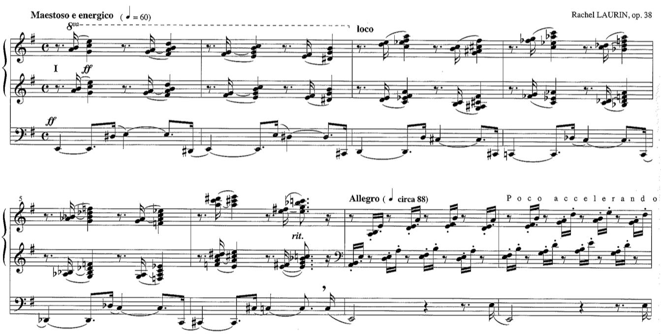
Copyright © 2012 by Wayne Leupold Editions. All rights reserved.

The second section begins in m. 7 and continues through m. 26. For the first few measures the pedal is grounded on E, which continues to be the pitch center. The hands play in a toccata figuration, containing a number of major seconds, but they are all diatonic to E minor. Measures 13 and 14 incorporate F-sharp minor and C minor triads, whose roots are a tritone apart. In those two measures the pedal plays a few augmented and diminished intervals – augmented second, diminished fourth and diminished fifth. Furthermore, an E is not used a single time in those two measures. That, coupled with the augmented and diminished intervals, creates a brief moment with no pitch center. A pedal cadenza begins in m. 15 and continues to m. 24. The first two measures of the cadenza mimic the toccata pattern and reestablish E as the pitch center, as seen in Ex. 2. The first few measures of the cadenza feature mostly pitches diatonic to E Minor, with a couple of chromatic lower neighbor tones in m. 17.
Example 2. Op. 38, mm. 15-17.
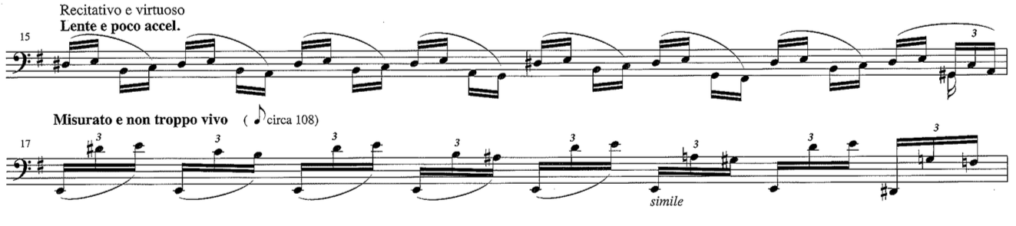
The chromaticism becomes more pervasive in mm. 18-20 as a chromatic sequence-like pattern unfolds. In some cases broken chord sonorities may be distinguished. For instance, the first three chords that are outlined in m. 19 are A-sharp diminished, B diminished, and F-sharp diminished 7. In other cases the notes form clusters (downbeat of m. 20 - B-flat, D-sharp and E.) A trill on E-natural and F takes up measure 21 and reestablishes E as the pitch center. After that, the toccata figuration comes back in mm. 22-23, this time in a descending chromatic sequence. Measures 24-26 serve as a transition to the next section, as seen in Ex. 3. In mm. 25 and 26 the hands play parallel minor triads in first inversion in an ascending chromatic fashion.

Example 3. Op. 38, mm. 24-31.
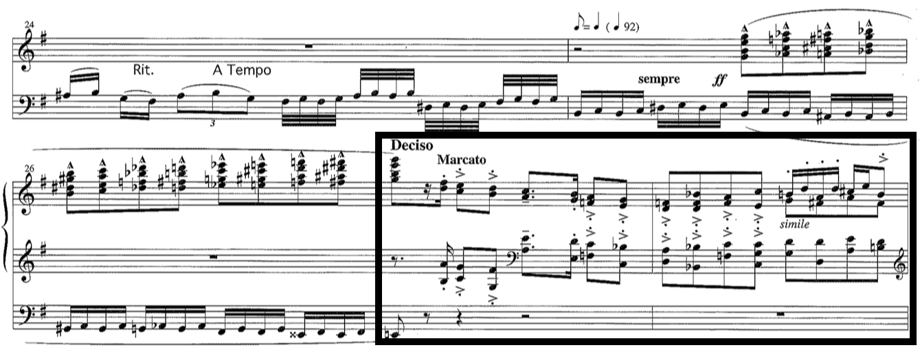
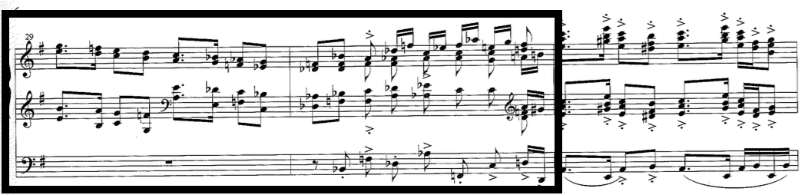
The first refrain of the rondo is presented in the third section of the etude, mm. 27-39. The refrain is in ABA form, where the A section consists of four measures and the B section has two measures. Both A sections are characterized by a two-measure melodic motive, which is repeated (with slight variations) with different harmonization. Example 3 shows the two two-measure motives in the A section.
In the first two measures of the first A section (mm. 27-28) Laurin employs two pitch centers, E and F, which alternate in a quick manner. Even though keys are not established, the two-measure phrase implies E minor, followed by a tonicization of F major, and a return to E minor. The chordal successions in these two measures are as follows (E minor is the assumed ‘tonic’): i, v7, VI, III7, iv, i7, N, V7/N, vi/N, IV/N, N, V/N, III, V/III, IV, and v. Here Laurin uses rare but possible chords such as IV and v in a minor key. By doing so she avoids establishing the key of E minor via a common progression using iv and V. Example 3 shows that the melodic motive from mm. 27-28 is presented again in mm. 29-30 with slight variation and also with a different harmonization. This time the succession of chords reads: i, b°7, VI, III7, iv, vii°7/f, f, c7, D-flat, b-flat, F, D-flat, A-flat, f, C, and d. As seen in m. 30 of Ex. 3, the second time the motive is presented, the centricity of E is more tenuously established, and a tonicization of A-flat major furthers the harmonic ambiguity.
The B section is two measures long (mm. 31-32). Measure 31 tonicizes A minor and m. 32, A-flat major. Measure 31 is by far the most harmonically conservative of the entire refrain. The only unusual feature about it is an unresolved V/V. A direct modulation brings m. 32 to A-flat major. Harmonically, m. 32 is clearly in A-flat major until the last beat, where it drifts to D major with a chromatic line in the pedal.
The A′ section, mm. 33-36, is structured similarly to the A section. The two-measure melodic material is stated twice, each time with slight melodic variation, different harmonization, and different accompaniment pattern. Measure 33 implies E minor; it has a couple of secondary dominants and a minor v chord. Measure 34 becomes progressively chromatic, which Laurin achieves by using a sequence. The last two measures of the A′ state the melodic material one last time. In m. 25, each beat has a different harmony, clearly outlined with broken chords in the pedal – E minor, C major, A-flat major, and F minor. As in all other cases when the melodic motive appears, its second half is even more chromatic. In m. 36 striking distant harmonies, such as E-flat minor and A-flat minor, prevail, as shown in Ex. 4. The very last beat of that measure quickly moves back to E minor by using A minor and B major chords (iv and V in E minor.) This is the first time in quite a while where Laurin uses a major V chord, but she resolves it to E major in the next measure, rather than E minor. Measure 37 serves as a brief transition to section four, and it employs a descending chromatic sequence.
Example 4. Op. 38, mm. 34-38.
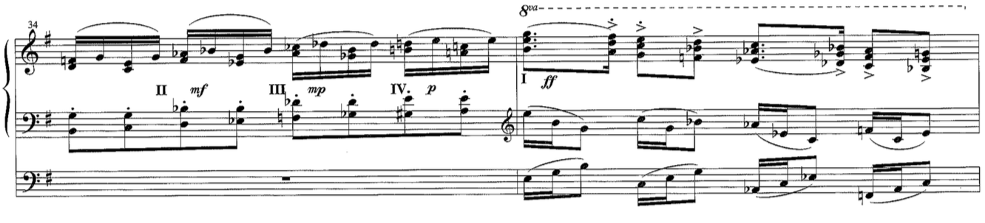
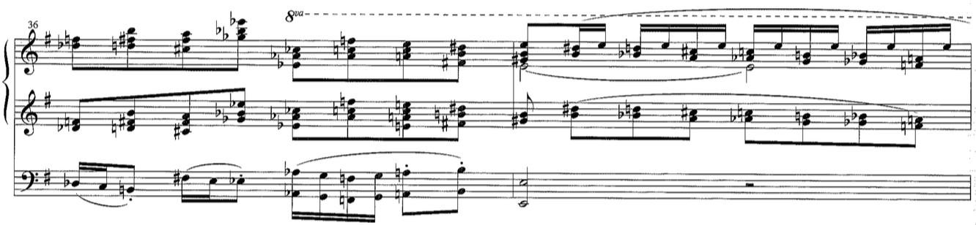
While in the first couple of sections E is the dominant pitch center, in the refrain Laurin demonstrates quick changes of pitch centers. As already mentioned, she switches pitch centers two times within two measures, or has a different tonicization in each measure. Among the more prevalent chords are E minor, F major, A minor, and A-flat major. Tertian harmonies are Laurin’s main source of harmonic material in the refrain.
The toccata pattern prevails in the fourth section, which is for the manuals only. The section continues from m. 38 through m. 47 and Laurin brings back the loco indication at m. 38. Example 5 shows that in the first half of the section (mm. 38-42) the pitch center is E, which is established by the frequent use of Es and D-sharps. While it starts diatonically, chromaticism becomes progressively more pronounced. Similar procedure is used in mm. 43-47 but this time the pitch center is A (minor), which is confirmed by the extensive use of As and G-sharps.
Example 5. Op. 38, mm. 38-43.
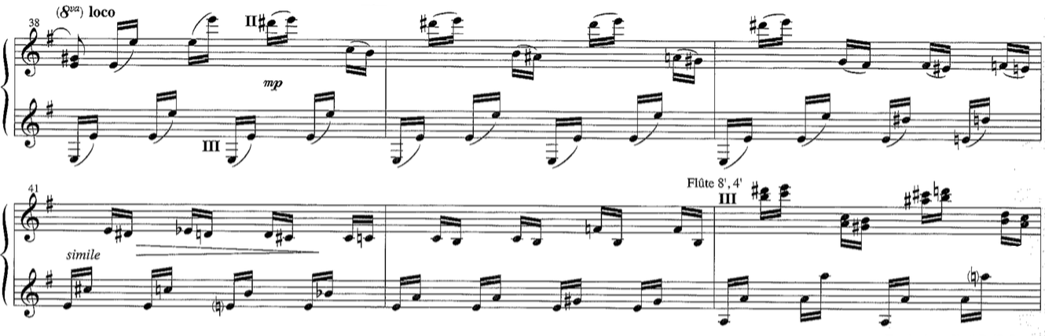
The beginning of the fifth section (m. 48) is marked with a tempo change - Poco meno mosso; Misterioso (See Ex. 6). The registration becomes more ethereal – Laurin asks for soft foundations 16’ and 8’ in the pedal, and the Sw/Ped coupler. For the manuals the registration is Voix Celeste and Gambe on the Swell, which is coupled to the Bourdon 8’ on the Great. Harmonically this section is somewhat ambiguous, because tertian harmonies are not as easy to detect. Instead, this section appears to put greater emphasis on the linear aspects than on the horizontal. The pedal has a constantly repeating pattern of four notes, which resembles the material from mm. 15 and 16. (Compare Examples 2 and 6.) The four pedal notes used in the fifth section are: C-sharp, D, A-flat, and G. Both hands play a lyrical theme in octaves, as seen in Ex. 6.

Example 6. Op. 38, mm. 47-50.
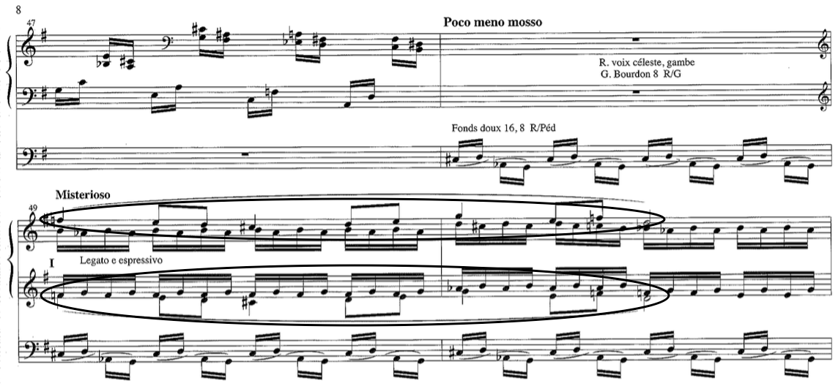
The entire section is characterized by stepwise motion and small skips, which is in contrast to the refrain and the toccata figuration. The scale, whose pitches are interspersed between all voices, presents an incomplete chromatic scale with D as the pitch center. The theme is two measures long, and it repeats a transposition of itself two more times. D is the pitch center the first time the theme appears in mm. 49-50. The second time the theme appears is in mm. 51-52, this time a minor third higher, starting on A-flat. The last time the theme is played is in mm. 53-54, an augmented third up, starting on C-sharp.
This section is an example of Laurin using a scale as the main compositional means. D as the pitch center is strongest in mm. 49-50. In those two measures the melody outlines a pentachord in D minor (C-sharp to G). Also, the pedal repeats C-sharp and D, which helps emphasize D’s importance (D as the main pitch and C-sharp as its leading tone). D, as a pitch center, loses a bit of its strength during the second and third appearances of the theme due to its transposition. The pedal, however, has the constant reminder of the D, because of the repeating pattern throughout the entire section. As already mentioned, this section is more linear. The harmonies form clusters most of the time, and the melody is the most important part, while the other voices are more or less filler. A short transition in mm. 55 and 56 connects the fifth section to the returning refrain in the sixth section. The transition is based on melodic and rhythmic features from the refrain motive. The transition increases the dynamic level, as Laurin asks for Piu f in both measures in the transition.
The sixth section, mm. 57-64, presents the second appearance of the refrain. The pitch center of the refrain is E, as expected, but this time it occurs in AB form, without the A′. The A section presents the two-measure motive, but instead of repeating it, as Laurin does in the first refrain, she inserts two measures of free material. The motive is presented in mm. 57 and 58, and the accompaniment is very rhythmically active. Harmonically, these two measures (57-58) are very similar to the first two measures of the original refrain. Descending and ascending chromatic major and minor chords in second inversion characterize mm. 59-60, as shown in Ex. 7. Due to the chromaticism, these two measures are harmonically unstable.
Example 7. Op. 38, mm. 59-60.
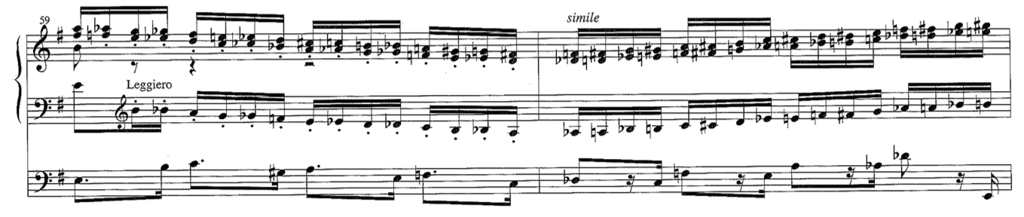
The B section is presented in similar fashion to the A section. Measures 61 and 62 contain the melodic and harmonic material found in the first refrain. The pitch center of m. 61 is A, and of m. 62, A-flat. The following two measures (63 and 64) are almost identical to mm. 59 and 60, where pitch center is not evident. A two-measure transition connects the sixth and seventh sections of the etude. The transition, mm. 65-66, contains the pitch center change leading into the new section, as well as the dynamic reduction.
Lombardic rhythm is the most notable feature of the seventh section (mm. 67-76.) As seen in Ex. 8, the hands play a repeating rhythmic pattern in chords, eighth-note dotted-quarter-note from m. 67-70, while the pedal has continuous sixteenth-note motion. The pedal has a compound melody. The top melody moves stepwise, and the bottom melody is mostly static. From mm. 71-75 the Lombardic pattern continues in the left hand with chords, while the right hand and pedal have the continuous sixteenth-note motion. The pedal continues the compound melody, and the right hand’s sixteenth notes move in stepwise motion.
Example 8. Op. 38, mm. 68-72.
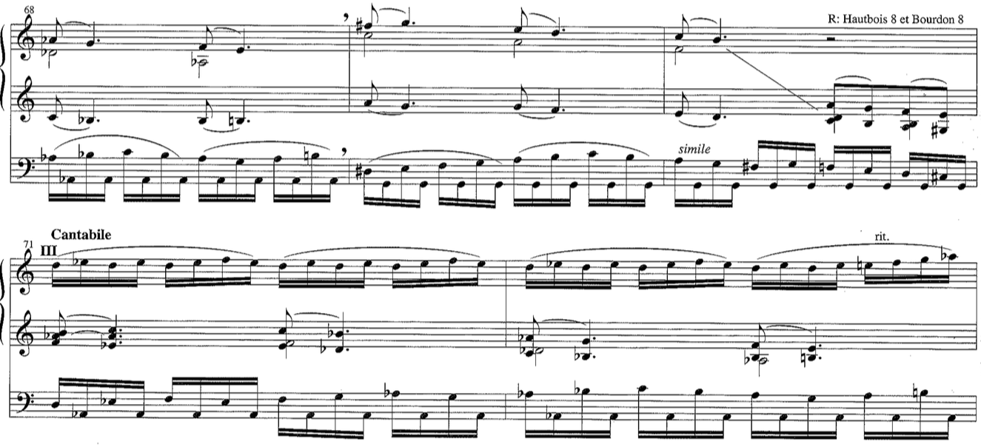
Laurin asks for soft 8’ and 4’ foundation stops on the Positif and Solo divisions, coupled. For the Pedal she asks for soft foundations 16’ and 8,’ as well as the Pos/Ped coupler. Starting in m. 71 the right hand plays on the Swell with Oboe 8’ and Bourdon 8.’ This section alternates pitch centers every two measures. The first pitch center is A-flat, after which it changes to G, which is then followed by A-flat, G and A-flat. The pitch centers are established by the constant repetition of either A-flat or G as the lower part of the compound pedal melody. Example 8 shows the alternation between A-flat and G as pitch centers.
The third refrain, mm. 77-85, is also the eighth section of the piece. This time the refrain is played in its original ABA′ form, but the texture is different and the pedal is not used. Example 9 shows that the A section starts off as a bicinium in m. 77 – the right hand plays on Trumpet 8’ and Principal 4’ on the Great, and the left hand plays on the Positif on a mf registration. Each beat has a different tertian harmony (e– C – a – F) and all four harmonies are from the first measure of the original refrain, m. 27 (See Ex. 3). In m. 78 a second voice is added in the left hand, which plays in parallel fourths and is highly chromatic. This section is an example of how Laurin favors chromatic motion coupled with parallelism to avoid establishing a pitch center.
Example 9. Op. 38, mm. 77-78.
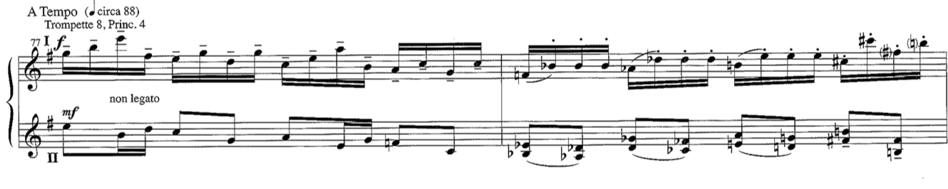
Measures 79 and 80 are presented in a similar fashion – a bicinium, followed by a three-part texture. Similarly to m. 77, m. 79 also has four tertian harmonies - e – C– A-flat – f. The B section, mm. 81-82, is played on the Great, and both hands have two notes each, which makes the texture lighter than the original refrain. Laurin uses harmonic intervals such as fourths and fifths, which hinder the establishment of a pitch center. Also, she varies the melodic material from the original B section, and that further obscures the sense of pitch center in these two measures. The A′ section brings back the bicinium for mm. 83-84, which once again lacks a firm pitch center. Laurin does not repeat the melodic material like the original refrain. Instead, a one-measure transition connects it to the ninth section. The transition, m. 85, contains a series of melodic augmented thirds followed by perfect fifths, which anticipates the intervallic pattern of the following section in the pedal.
The ninth section is nearly an exact repeat of the fifth section. It contains the softer, more lyrical stepwise theme (see Ex. 10). The only notational difference between the fifth and ninth sections is the pedal line. The ninth section uses the exact same four notes, which repeat in the pedal over and over again, however the order is different. In the fifth section the order is C-sharp – D – A-flat – G, while in the ninth section the order is C-sharp – A-flat – D – G. Laurin again uses an incomplete chromatic scale, and a pitch center is difficult to hear. The main reason for that is the changed pitch pattern in the pedal. In the fifth section D is the pitch center because C-sharp seems to work as a leading tone to D. In the ninth section, though, A-flat and C-sharp act more as a harmonic interval (an augmented third) which resolve appropriately to D and G (a perfect fifth).
Example 10. Op. 38, mm. 87-88.
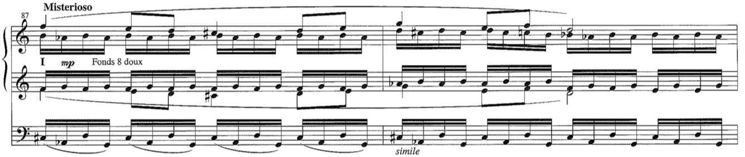
The registration in the ninth section also slightly differs from that of the fifth section. In the ninth section Laurin asks for the Swell and Positif to be coupled to the Great with 8’ soft foundation stops on all divisions. Both hands play on the Great, which is different from the fifth section where each hand plays on a different manual. For the ninth section the composer asks for soft foundation 16’ and 8’ stops in the pedal, and the Positif and Swell to pedal couplers. A two-measure transition follows the ninth section. The transition is motivically related to the refrain, employing similar melodic and rhythmic characteristics. Laurin uses the transition to further lower the dynamic. Every two beats she asks either for a manual change, or for the use of expression boxes to diminuendo.
The tenth section, mm. 95-106, presents the fourth rondo refrain, which is in its complete form of ABA′. Harmonically, the fourth refrain is the least chromatic, compared even to the initial refrain. Throughout the whole section the pedal plays in eighth-note open fifths on the first and third beats of every measure. In the A section (mm. 95-98) all fifths are built on E, firmly establishing E as the central pitch (See Ex. 11).
Example 11. Op. 38, mm. 95-97.
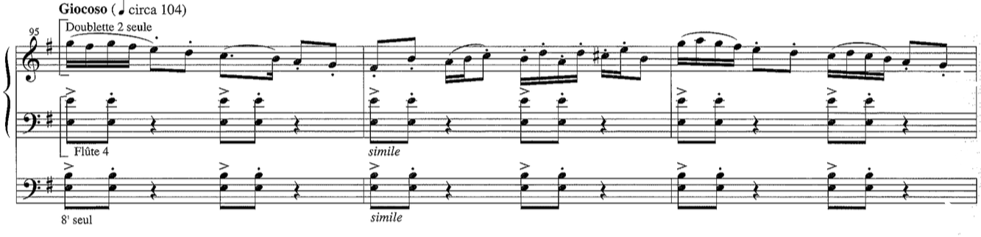
In the B section (mm. 99-100) the fifths are based on A and A-flat, thus creating tension between the two pitches in their respective measures. In the A′ section (mm. 101-104) the fifths restore the centricity of E.
In the tenth section Laurin uses registration in a unique way. There is only an 8’ in the pedal, the left hands plays on a 4’ Harmonic Flute, and the right hand plays on a Doublette 2’ in its highest register. As already mentioned, this section is the least chromatic of the refrains, and also of the entire etude. The A section is grounded on E as the pitch center. The section is mostly diatonic to E minor with only a couple of chromatic notes. As seen in Ex. 12, the B section tonicizes A minor in m. 99, and A-flat major in m. 100, just like the initial refrain’s B section.
Example 12. Op. 38, mm. 98-100.
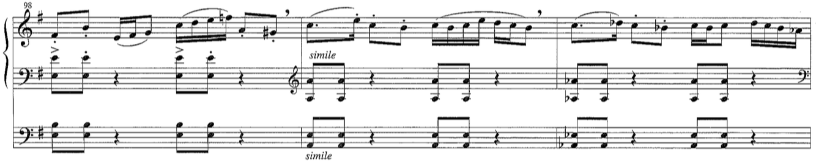
Similarly to the A section, the A′ section’s pitch center is E. The harmonies are mostly diatonic to E minor with very few non-diatonic notes. Measures 105 and 106 are transitional. They contain the rhythmic activity of the tenth section, but with a descending line in the pedal (still in fifths). Because of the pedal drone, this section is harmonically static.
The eleventh section comes as a bit of a surprise, as the entire section, mm. 107-112, is an exact repetition of the introduction, mm. 1-6. (Compare Examples 1 and 13.)
Example 13. Op. 38, mm. 107-110.
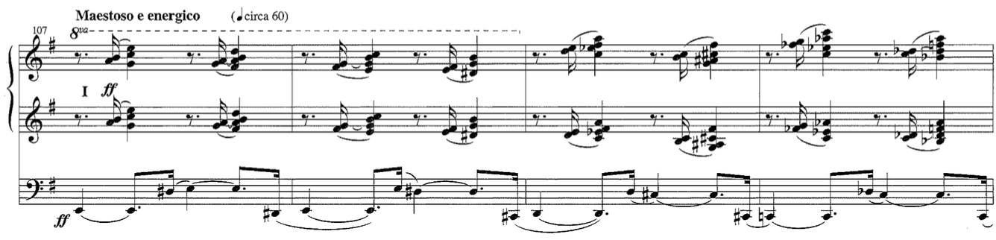
Measures 113-114 serve as a transition to the twelfth section, and they contain chromatic material, first descending and then ascending. The transition facilitates speeding up the tempo for the following section.
The twelfth section (mm. 115-122) contains the fifth and final refrain. There is no dynamic change from the previous section, so the ff dynamic continues throughout the entire refrain. In its structure, it resembles the third refrain, where the A′ section is two measures shorter than the original refrain. The A section is four measures in length, as expected (mm. 115-118). The pedal has a constant sixteenth-note motion and it features two patterns. The first pattern, seen in mm. 115 and 117 in Ex. 14, contains a compound melody, while measures 116 and 118 have mostly stepwise motion. The hands play three-voice chords in a toccata, hocket-like pattern. Harmonically, the section is a combination of straightforward progressions and harmonies distant from E minor. For example, in m. 115 the progression is in E minor as follows: i - vii° - i - vii°7/iv – iv – V7/iv – iv - vii°7/VII. In m. 116, the harmonies change rapidly without an obvious pattern before returning back to E minor: D – B-flat – F – C – G – i - vii°7/V – V. Harmonically, this measure is almost identical to the corresponding measure of the first refrain, m. 28. (See Examples 3 and 14.) Measures 117 and 118 are treated similarly. Measure 117 is exactly the same as m. 115, but m. 118 explores even more distant harmonic areas than m. 116. The tertian harmonies in mm. 118 are: d – A-flat – e – B-flat – F-sharp – C – g – g#°7. The pattern is obviously sequential for the first three beats of the measure, and the sequence goes up by whole steps.

Example 14. Op. 38, mm. 114-119.
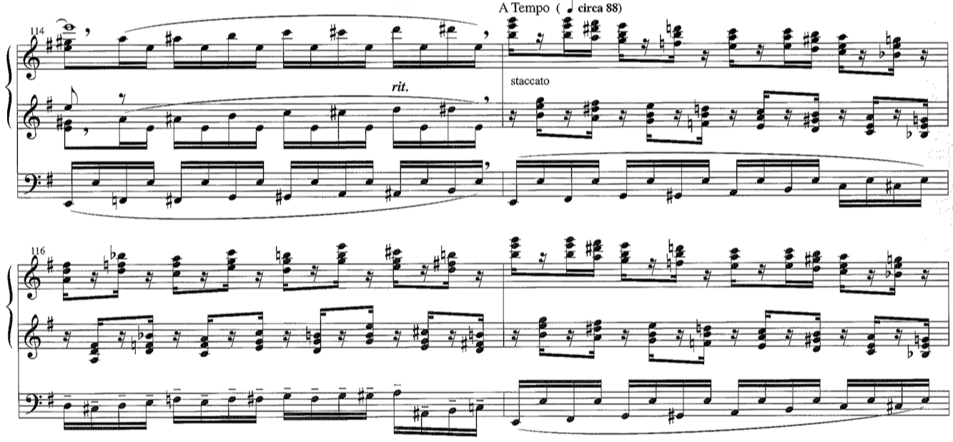
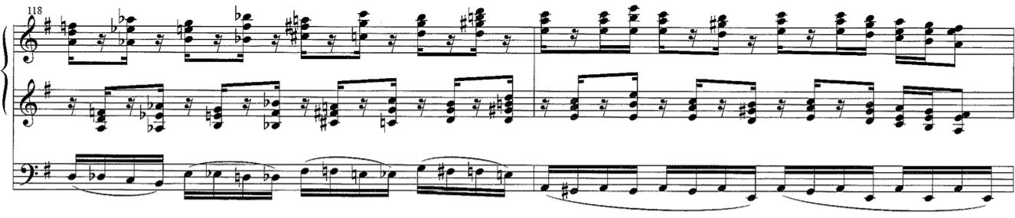
As in all other refrains, the B section alternates between pitch centers in each of its measures – A and A-flat. The harmonies in each key present alternation of the tonic and the dominant. The A′ lasts for two measures, 121-122, where m. 121 is an exact repeat of mm. 115 and 117. Measure 118 presents yet another chain of tertian harmonies, which do not have a pitch center – D – c – g – e – b-flat – G – d-flat – b. The twelfth section goes directly into the thirteenth section without a transition.
The lyrical stepwise theme appears for the third time in the thirteenth section of the etude (mm. 123-130), but this time more transformed than in its previous appearance in the ninth section. In the ninth section the theme is presented almost the same as the original, with slight alterations in the pedal. In the thirteenth section the lyrical theme is presented, and then transposed three times, rather than two, as seen in sections five and nine. In the earlier two sections, the theme was always played in the hands. Example 15 shows that in the thirteenth section, the theme takes turns being played in the pedal and in the manuals.
Example 15. Op. 38, mm. 124-129.
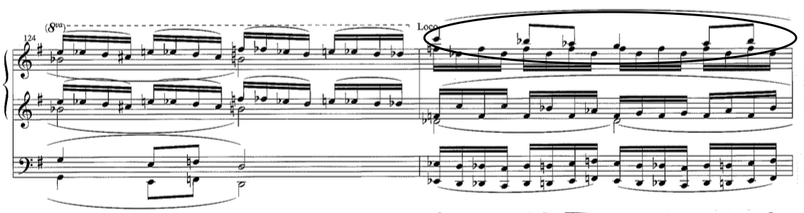
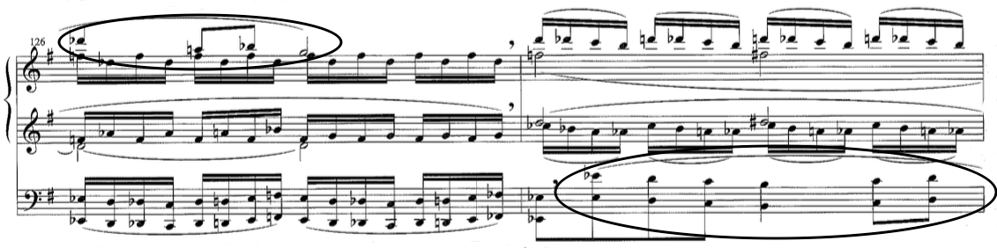
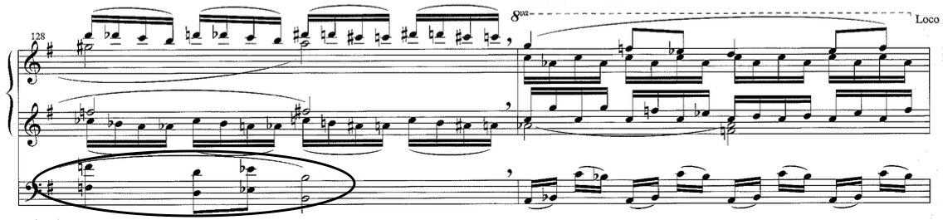
The first two times this theme was presented the registration was much quieter, but in this section Laurin does not ask for registration changes. She continues the ff dynamic from the eleventh and twelfth sections. In the fifth and ninth sections Laurin uses an incomplete chromatic scale. In the thirteenth section she uses a complete chromatic scale, which makes this section very harmonically ambiguous.
The last, fourteenth section of the piece starts in m. 131 and is played on Tutti. It is a coda and contains some toccata figurations as well as closing material. The pedal continuously plays D-sharp and E, which alludes to E being the pitch center with D-sharp functioning as the leading tone to E. The right hand plays in major, minor and diminished chords, which clash with the stability of E as the pitch center. Measures 134-135 contain four-note minor chords, played in parallel ascending motion in sixteenth notes (See Ex. 16). This is another instance in which Laurin uses parallel chromatic motion to avoid establishing a pitch center.
Example 16. Op. 38, mm. 132-135.
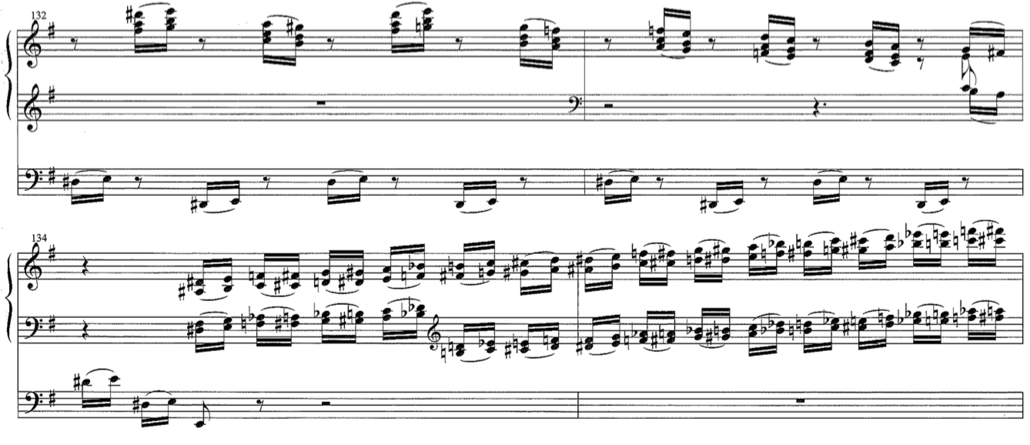
Measure 136 is a pedal solo in sixteenth-note triplets, played in a descending line. Parallel chords return in mm 137-138 but this time their quality is diminished. Another pedal solo, which covers the entire pedalboard, follows in m. 139 in fast thirty-second notes. As seen in Ex. 17, m. 140 features the toccata pattern in octaves in both hands, which begins at the bottom of the keyboard and goes all the way to G56 - the highest note on the manuals of many organs. The last three measures of the etude present an alternation between Cmm7 and E major triads. Laurin suspends the dominance of the final harmony until the very end of the etude. The piece ends on an E major chord.

Example 17. Op. 38, mm. 140-143.
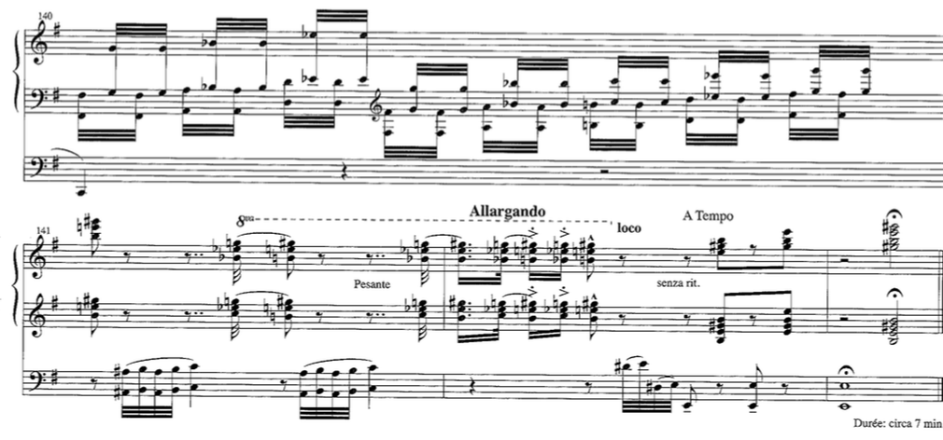
In conclusion, Étude Héroïque, Op. 38 is a rondo which does not fit the classical definition of the form. In some regards the etude resembles the sonata rondo because it has a main refrain which repeats multiple times, but is also has a recurring secondary theme, which is contrasting in character and pitch center. In the classical form of the sonata rondo, the refrain occurs four times, while the secondary theme occurs two times (ABACABA). In Rachel Laurin’s Étude Héroïque, Op. 38 the refrain is stated five times, while the secondary theme occurs three times (Refer to Table 1). The refrain is always centered around E as the pitch center; however, its structure varies each time. For example, the refrain is not always presented in its entirety. While the melody and harmonies are sometimes similar to the original refrain, they often deviate from it. The texture of the refrain is different every time – chordal, bicinium, toccata figuration, manuals only, and melody and accompaniment. The secondary theme also undergoes a transformation over the course of the piece. The first two times it is stated, the structure is nearly the same, as well as the scale in use – incomplete chromatic scale. The last time the lyrical theme is played, its structure is different, and a fully chromatic scale is used. Another difference between Laurin’s piece and the classical sonata rondo form is the addition of extra sections. While an introduction and coda can be expected, the additions of the toccata section, as well as the repeat of the introduction are out of the ordinary.
Laurin’s Op. 38 employs a variety of compositional procedures which define the harmonic language of the piece. In the refrains she uses tertian harmonies to a great extent, and establishes pitch centers, but the piece is not functionally tonal. Instead of establishing keys, she uses pitch centers. Laurin avoids establishing keys through the absence of tonic-predominant-dominant progressions. She often writes unusual successions of chords, which do not form tonal progressions. Laurin also avoids dominant function by frequent use of the minor v chord. Even though a few instances in the etude show short episodes of tonally functioning keys, that is more so the exception, than the norm. Laurin often employs brief tonicizations of distantly related chords, which contribute to the keyless sense of her harmonies. The secondary theme uses a chromatic scale, which makes it even more harmonically ambiguous than the refrain. Other techniques Laurin uses to avoid firm tonality are different degrees of chromaticism, parallelism and sequences. Sometimes she employs only a few chromatic pitches, and other times she uses a complete chromatic scale. Laurin favors the use of parallelism; most commonly she uses inverted triads in a chromatic scale. Sequences, often chromatic, are also a technique which helps avoid establishing a tonal center.
Since the piece does not function tonally, key relationships are not possible to establish. However, certain pitch centers happen with great frequency. E, A, A-flat and F are the most prominent. E is certainly the main pitch center; in a way it functions as the ‘tonic’ for the entire etude. It keeps coming back in the refrains and some of the other sections. On more local levels, A, A-flat and F are secondary pitch centers, which portray a certain sense of predominant function. If they are to be labeled according to the E ‘tonic,’ they are pitches on predominant scale degrees. A is the fourth scale degree in an E scale; A-flat is lowered fourth scale degree; and F is the lowered second scale degree (the Neapolitan). The use of the predominant pitch centers can also be found on a larger level of pitch relationships. The B section of the refrain tonicizes A minor and A-flat major every time. The second half of the fourth section of the etude is built on A, and the seventh section’s pitch center is A-flat. Similarly to her reluctance to establish key areas, on the larger level Laurin avoids using traditional pitch center relationships such as E and B (i and V), or E and G (i and III).

Étude-Caprice, Op. 66 (Beelzebub’s Laugh)
The second etude from the set, Étude-Caprice, Op. 66 (Beelzebub’s Laugh), was composed in 2012-2013 for the AGO Region VII Convention in Austin, Texas. Ken Cowan commissioned the piece and premiered it on July 3, 2013 at the University of Texas’ Bates Recital Hall. The piece was inspired by Paganini’s violin caprice Devil’s Laugh in a couple of ways. The organ etude is also a caprice - a technically demanding work. Its subtitle, Beelzebub’s Laugh, is nearly the same as Paganini’s Devil’s Laugh. Instead of using the name ‘Devil,’ Laurin uses a lesser-known name for him found in the Bible – Beelzebub. The word means Lord of the Flies (beel – lord, prince; zebub – fly.) Laurin uses its meaning as the basis for the entire etude; ‘buzzing’ sounds are the essence of the piece. The ways in which the buzzing sound is achieved will be explored in the analysis of the piece.
Similarly to Op. 38, Op. 66 is also in rondo form, however Op.66 is in a more straightforward, though not completely traditional structure of the form – ABACACABA. Even though Étude-Caprice has a more straightforward structure than Op. 38, Laurin finds a way to make the piece original and unique in other ways. Opus 66 has five refrains presented in the A sections, a contrasting theme in the two B sections, and a fughetta and pedal cadenza in the C sections. The structure of the work is shown in Table 2.

Section | Measure numbers | Description | Pitch center/Key area
A | 1-23 | Chordal theme | G (minor)/multiple pitch centers
B | 24-44 | Slower contrasting theme with sixteenth- note accompaniment | Harmonic ambiguity
A | 45-65 | Chordal theme | G (minor)/multiple pitch centers
C | 66-89 | Fughetta | Chromatic scale
A | 90-104 | All three themes from sections A, B and C | Harmonic ambiguity
C | 105-125 | Pedal cadenza based on the fugal section | Chromatic scale
A | 126-143 | Chordal theme | G (minor)/multiple pitch centers
B | 143-152 | Slower contrasting theme with sixteenth- note accompaniment | G (minor)/multiple pitch centers
A | 152-166 | Chordal theme and fugal material | G (minor)/multiple pitch centers
Table 2. Op. 66, section outline.
Harmonically, Op. 66 has a lot in common with Op. 38. To a great extent, Laurin uses techniques which typically define her harmonic language. Among these are the use of pitch centers with tertian harmonies rather than keys. While often minor or major modes are implied, she avoids establishing keys by not using tonic-predominant-dominant harmonic progressions. In addition, she changes pitch centers quickly, which furthers the sense of harmonic instability and ambiguity. She employs different degrees of chromaticism – from just a few chromatic pitches to fully chromatic scales. In Op. 66 Laurin also favors chromatic sequences and chromatic parallelism.
A short four-measure introduction opens the piece. The idea of the ‘fly’ is set up immediately. Laurin uses a succession of unisons, minor and major seconds played multiple times in both hands at different pitch levels. The pedal also has a number of minor seconds. The seconds already suggest a buzzing sound due to their dissonance. The suggested registration enhances the desired sound. Laurin suggests foundation 8,’ principal 2,’ and soft reed 8’ for the Positif; Gambe 8,’ Principal 4,’ Nazard 2 2/3,’ and Oboe 8’ for the Swell with the box closed. For the pedal Laurin asks for 16’ and 8’ soft stops. The stops on the Positif represent a gapped registration which heightens the effect of the high-pitched sound. The Swell registration contains the Nazard (a perfect 12th above the note played) which coupled with the Oboe contributes to the buzzy sound. In the introduction Laurin marks a number of crescendos and diminuendos, all of which last no longer than a beat. In addition, manual changes happen on every beat. The combination of these two features creates an illusion of the fly flying fast and changing direction rapidly. The first couple of measures of the introduction center around G. The pitch center is established by the frequent use of the note, as well as its leading tone, F-sharp. However, the end of the introduction, m. 4, ends on a cluster.
The first refrain of the etude starts in m. 5. It is played on the Great with 8’ and 4’ flutes. The right hand moves stepwise in descending harmonic thirds. The left hand has more skips and it plays either one note at a time or a two-note minor second. As seen in Ex. 18, in m. 5 G is reestablished as the pitch center. The left hand arpeggiates the G minor triad, and the right hand plays in thirds diatonic to G minor. The only chromaticism is C-sharp, which tonicizes the Dominant. Measure 6 has a new pitch center, E-flat, and the minor mode is implied. E-flat minor is one of G minor’s chromatic mediants. The brief new pitch center is confirmed by the use of E-flat minor diatonic harmonies. For the first two beats the left hand repeats two harmonic major thirds over and over again imitating of the buzzing sound of the fly. The third beat contains an ascending chromatic scale in thirty-second notes, played by both hands in minor thirds.
Example 18. Op. 66, mm. 4-9.
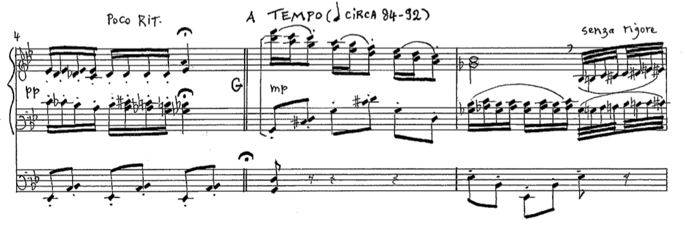
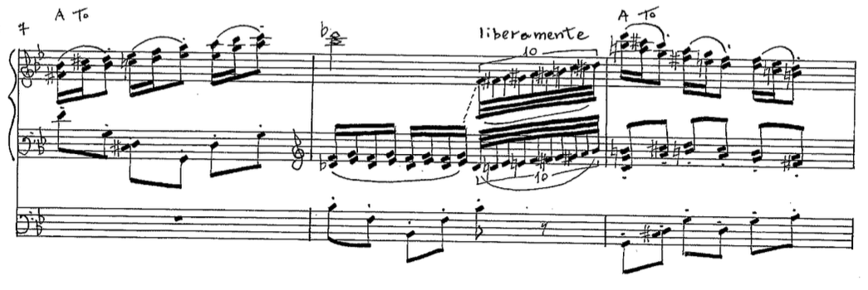Unpublished score. Used by permission from Rachel Laurin and Wayne Leopold Editions.

The idea from mm. 5 and 6 repeats in mm. 7 and 8. The pitch center in m. 7 is G again, but with more chromatic notes. The pitch center of m. 8 is B-flat, with minor mode implications. B-flat minor implies flat iii, which is another chromatic mediant of G minor.
Measures 9-12 follow the structure of mm. 5-8, but with different pitch centers. The pitch center in m. 9 is G, which is established by the presence of F-sharps (leading tones), and C-sharps (serving to tonicize V). Measures 10-12 tonicize E-flat (minor), G-flat (major), and A (major) respectively. The use of appropriate key signatures for the local ‘tonics’, and an arpeggiated bass line of the tonicized triad establish all of those pitch centers. Measures 13 and 14 are a tag based on m. 12. Laurin cancels the key signature in m. 13, and the pitch center in m. 13 is A with the major mode implied, and in m. 14, E-flat, with the minor mode implied. Measures 15-18 are based on the idea of the introduction and bring back the quick manual changes between the Swell, Positif, and Great, which create an echo effect. They also feature a number of dissonant intervals like seconds and tritones, as well as chromatic scales. Measure 18 presents a descending chromatic scale in minor triads in first inversion, which ends on C major.
Measures 19-23 conclude the first refrain. They mark a meter change –from 3/4 to 4/4, as well as a registrational change (See Ex. 19). Both the Swell and Positif have 8’ and 2’ flutes, with the swell box being closed for an echo effect with the Positif. The gapped registration and fast changes of manuals continue the idea of the restless fly.
Example 19. Op. 66, mm. 19-21.
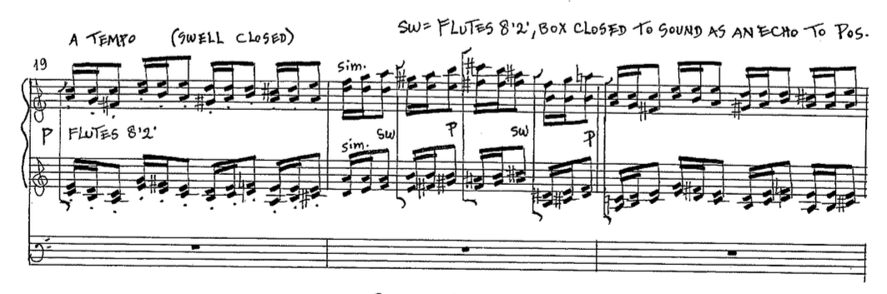
The B section, which is in 3/4, is from m. 24-44. The pedal plays in constant sixteenth-note motion, while the hands have a new contrasting chordal theme in slower note values. Both the hands and pedal play in stepwise motion. Even though the tempo marking is faster than the tempo of the refrain, the B section gives the impression of a slower tempo due to the larger note values of the theme. The hands play on soft 8’ Principal and Flute on the Positif. For the pedal Laurin suggests a soft 8’ reed such as a Voix Humaine. According to this suggestion, she wants a short-resonator, buzzier reed. For the pedal line the composer also has a verbal description ‘like a fly’ which would be enhanced by the use of a buzzier stop. The ‘fly’ idea is reinforced by the intervallic pattern of the pedal line. For the entire B section the majority of intervals in the pedal are major or minor seconds, whose dissonance coupled with the buzzy reed sound, helps depict the sound of a fly. The Flight of the Bumblebee by Nikolai Rimsky-Korsakov has surely influenced Laurin. The piece exhibits a similar idea of a swiftly moving insect, which is represented by constant motion in melodic minor seconds.
The B section contains four phrases, the first three of which have five measures, and the last one has six measures. Tonally, the section is ambiguous. The pedal plays mostly in chromatic half steps for the first three phrases. The first phrase, mm. 24-28, has a succession of triads, seventh chords and clusters, which do not belong exclusively to any one key. The succession of chords in the first phrase is as follows: a7, cluster, CMM7, a, C, a, b, A-flat, b. While the A minor triad and the B minor triad are the main harmonies of the first phrase, it is difficult to determine a pitch center. The second phrase, mm. 29-33, follows the tonal structure of the first phrase very closely. The third phrase, mm. 34-38, has a new set of harmonies, and while a pitch center is still difficult to determine, D major appears most often in this phrase. In mm. 35-37 the left hand picks up the sixteenth-note motion along with the pedal. The fourth phrase, mm. 39-44, brings a few changes, as shown in Ex. 20. It is the only phrase which is six measures long. The pedal assumes the role of harmonic support; it loses the sixteenth-note motion, and begins playing in quarter notes on a soft 16’and 8’ registration. The left hand takes over the sixteenth-note chromatic motion on the Swell on a soft 8’ reed. The right hand continues to play on the Positif with the option of adding a 4’ flute. As seen in Ex. 20, the succession of harmonic sonorities in the fourth phrase is: A-flat, c, A-flat, D7, g-sharp°7, A-flat, c, A-flat, D7 and a-sharp°7. The dominating harmony in this phrase is A-flat major. The pedal also contributes to the A-flat major dominance by having a number of A-flats and E-flats (I and V).
Example 20. Op. 66, mm. 37-44.
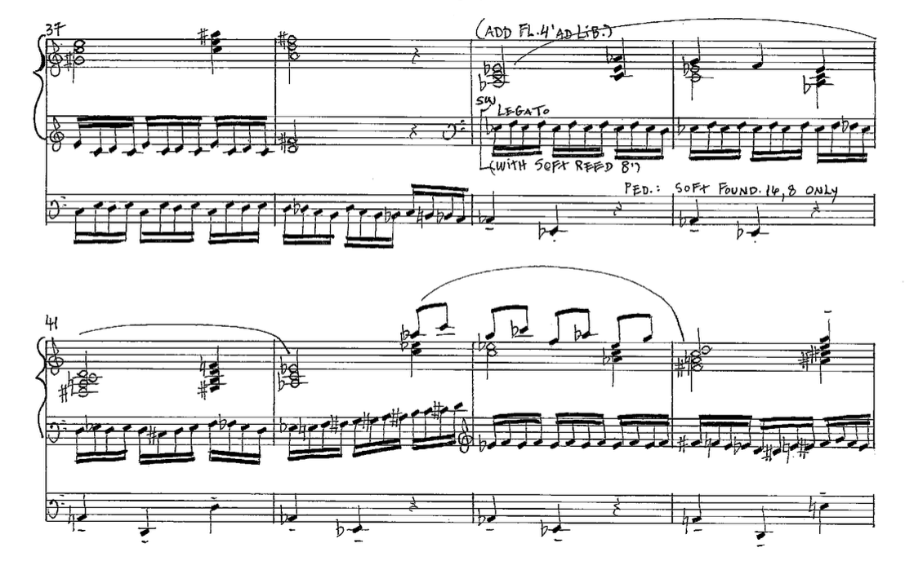
A two-measure link, mm. 45-46, connects the B section and the second refrain. The link is based on the introductory material from mm. 1-4. It incorporates manual changes from the Great to the Swell and to the Positif, with the swell box opening gradually. The second refrain starts in m. 47 and continues through m. 65. Laurin suggests an 8’ and 4’ flute registration for the Great, just like in the first refrain. She also suggests the possibility of adding an 8’ Principal to the flutes. For the Swell she asks for flutes 8,’ 4,’ and 1’ (or 1 1/3’ instead of 1’.), which differs from the original refrain’s registration. The suggested registration for the Positif is soft 8’ and 2’ stops.
The second refrain is exactly the same length as the original refrain – 19 measures. The second refrain follows the harmonic structure of the original refrain very closely, but the texture is varied. The harmonies from the first refrain recur in the corresponding measures of the second refrain – G minor, E-flat minor, B-flat minor, G-flat major, and A major. The second A section begins in m. 47. In m. 48 the left hand moves to the Swell, which is different from the original refrain. In that measure the left hand plays in thirty-second notes in a descending chromatic sequence, and the pedal plays in sixteenth notes also in a descending chromatic sequence. The right hand compliments the bottom voices with an eighth-note pattern. Measures 49-50, and 51-52 are presented in a similar fashion to mm. 47-48. The first measure of the group consists of sixteenth- and eighth-note values; the second measure of each group has a rapid thirty-second note chromatic sequence in the left hand, and a sixteenth-note chromatic sequence in the pedal. The right hand caries eighth and sixteenth-note values. Example 21 shows that from mm. 54-56, the left hand plays in a more arpeggiated fashion, covering nearly the entire manual compass. In the middle of m. 56 Laurin changes the Swell registration to principals 8’ and 4,’ and an 8’ reed. From that measure to m. 60 both hands move rapidly between all three manuals.

Example 21. Op. 66, mm. 54-58
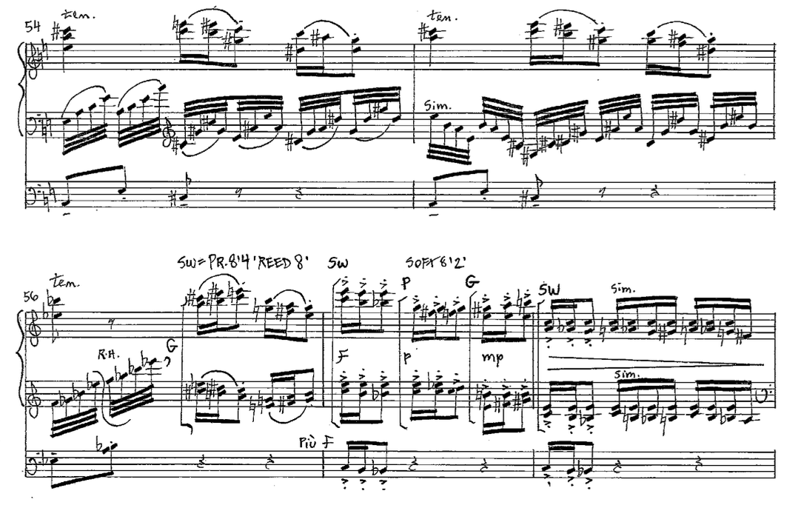
Just as in the first refrain, the composer changes the meter signature for its last five measures from 3/4 to 4/4. The 3/4 section finishes on an A-flat major chord in first inversion, which was C major in the first refrain. The last five measures of the second refrain, mm. 61-65, are an exact repetition of the corresponding measures from the first refrain, however, they are transposed a minor third up.
The C section, mm. 66-88, brings changes in a few aspects. The meter changes from simple to compound, the harmonies become more chromatic, and the section is in the form of a fughetta. The registrational suggestions are: Positif - foundations 8,’ 4,’ 2,’ mixtures and 8’ reed; Great - foundations 8,’ 4,’ 2,’ mixtures and Pos/Gt; Swell - foundations 8,’ 4,’ 2,’ mixtures and 8’ Oboe, and the pedal - foundations 16,’ 8,’ 4,’ 2,’ Bassoon 16,’ Gt/Ped and Pos/Ped.
The meter of the fughetta is 6/8, which makes this section the first one in compound meter. Laurin uses a nearly complete chromatic scale for the fughetta subject starting on E-sharp. The only pitch which is omitted in the subject is C, as seen in Ex. 22. Even though the fughetta is completely chromatic, the major mode is implied. This is achieved by the order of pitches in the first measure of the subject, which outline the B-major triad. The subject lasts for three and a half measures, mm. 66-69, as shown in Ex. 22. Its tonal ambiguity is enhanced by the use of dissonant intervals such as minor seconds and diminished fifths. Measure 68 is a sequence of the second half of m. 67, which furthers the tonal uncertainty.
Example 22. Op. 66, mm. 65-72.
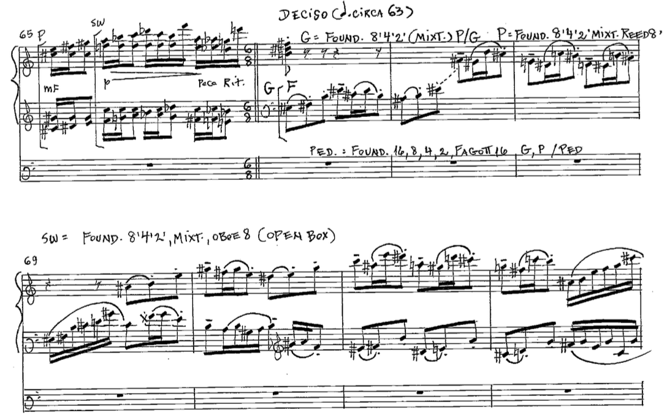
The answer begins in m. 69. Laurin deviates from the traditional way a fughetta is built by writing the answer a P4 up, rather than a P5. Measures 73-74 present a link to the third appearance of the subject, which similar to the answer does not appear on the expected pitch. In most fughettas the third time the subject appears, it starts on the pitch of the original subject. Instead, Laurin notates the third subject appearance a M2 lower than the original, on D-sharp. This time the subject is played in the pedal from mm. 75-78. As soon as the last subject is presented, a stretto of the subject begins. The right hand leads, starting on E-sharp, followed by the left hand, also starting on E-sharp, and the pedal joins last on D-sharp. As seen in Ex. 23, all subject entrances are a beat apart.
Example 23. Op. 66, mm. 77-80.
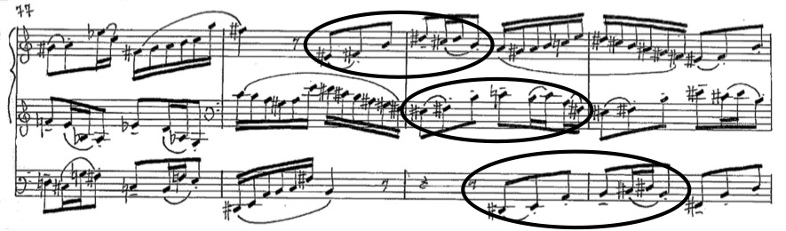
From mm. 84-88 Laurin uses fragmentation. Starting in m. 84 the pedal discontinues, while the hands gradually gain four voices. The fughetta ends in m. 88, and m. 89 serves as a transition to the next refrain. The one-measure link quickly turns the 6/8 into 3/4 by changing the metric emphasis from once every three eighth notes to once every two eighth notes.
The fugal section is written as a gradual crescendo. It starts in the Great with the Positif coupled. Right before the first pedal entrance in m. 89 the Sw/Gt coupler is added. In m. 84 the 16’ Trumpet is added to the Swell, and two measures later a 16’stop and a mixture are added to the Great. In m. 89 the Great reeds join in, which leads to Tutti in the beginning of the refrain.
The third refrain (fifth section in the etude), mm. 90-103, is the culmination of the piece. The dynamic is loudest in this section, the texture is thickest, the rhythmic patterns are most sophisticated, and the themes from sections A, B and C are combined. The entire refrain is played on a Tutti registration and in m. 99 Laurin suggests adding Chamades if desired. This A section is the only refrain which begins in a major mode. The first four measures imply F-sharp major by utilizing accidentals fitting the key. Measures 94-103 are very chromatic and no single pitch appears to be prevalent.
The hands play in two, three, and four note textures. The pedal plays in either broken octaves or in simultaneous octaves. Whenever the pedal plays in broken octaves, it outlines the first five notes of the fughetta in the C section. As seen in Ex. 24, in mm. 90 and 92 the hands play the refrain theme, while the pedal hints at thematic material from the fughetta. Laurin emphasizes the different themes by notating the hands in 3/4, while the pedal line’s beaming implies 6/8 in mm. 90 and 92. In the top voice of mm. 94-95 the melody from the first phrase in the B section appears in its original pitches, and in mm. 97-98 the second phrase from the B section appears. While the hands play phrases from the B section, the pedal continues to quote the fugal subject. In these few measures Laurin masterfully transforms the B theme from 3/4 to 6/8, as shown in Ex. 24.

Example 24. Op. 66, mm. 91-96.
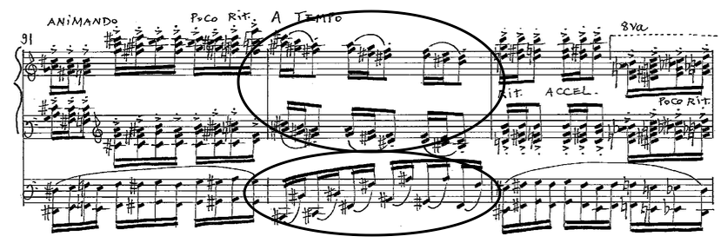
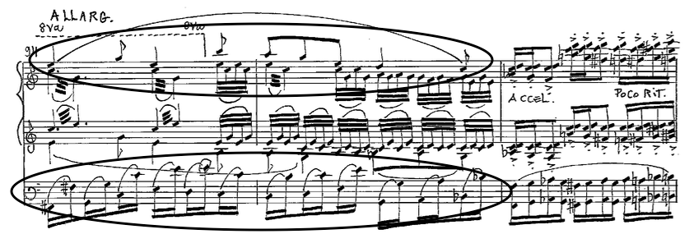
It should be noted that Laurin never changes the meter to 3/4 for the third refrain. It continues to be 6/8, like the fughetta, but she cleverly changes the beaming to reflect either 3/4 or 6/8 depending on which thematic material is being used. Measures 99-103 are notated in 4/4. Measure 104 links the refrain to the next section. In this measure there is only one voice, which is played in the pedal. Laurin uses this measure to diminish the dynamic from full organ to mf.
The sixth section is based mainly on the fugal material from the C section, therefore it will be called the C′ section. This section encompasses mm. 105-125 and is a pedal cadenza. Laurin suggests that it be performed with a lot of freedom. She uses a number of tempo markings such as rubare, ritardando, poco a poco a tempo and molto libertamente, all of which lead the performer to a rather free and expressive approach to the cadenza. The meter is 6/8, just like the first C section. From mm. 105-112 the motivic material sequences the first measure of the fugal material, as shown in Ex. 25.
Example 25. Op. 66, mm. 103-111.
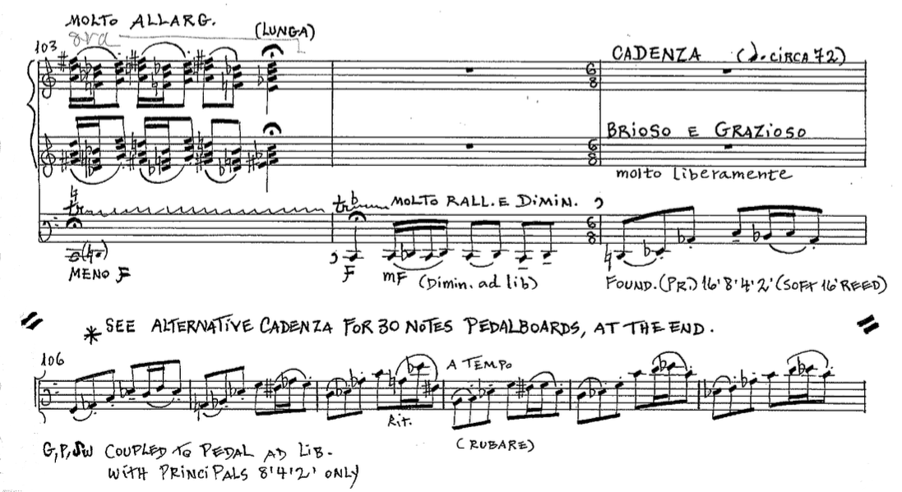
Measures 113-114 briefly interrupt the fugal material with a meter change to 4/4. Sequence is still the basis of the pedal solo, but it does not seem to relate to previous melodic ideas. In m. 115 the meter is restored to 6/8 for four measures, and the fugal material returns. From mm. 119-122 the meter changes once again, this time to 2/4, and the melodic material is linked to mm. 113-114. From m. 123 to the end of the section, m. 125, Laurin employs a thirty-second-note virtuosic run on the pedalboard, ending on a trill (See Ex. 26). Since the section is based on the chromatic fughetta subject, it is also harmonically ambiguous. The frequent use of chromatic sequencing and lack of pitch center contribute to the harmonic ambiguity.

Example 26. Op. 66, mm. 123-125.
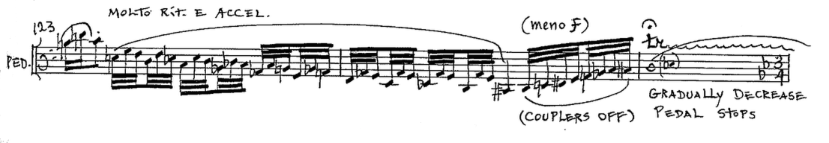
The registration for the cadenza is foundations and principals 16,’ 8,’ 4,’ and 2,’ as well as a 16’ reed. A few measures later Laurin suggests coupling all manuals to the pedal with principals 8,’4,’ and 2.’ In the second to last measure of the cadenza Laurin suggests taking off the couplers, further decreasing the dynamic in the last measure.
The fourth refrain starts in m. 126 and ends in m. 143. Its length, as well as its structure, is nearly the same as all the other refrains. As shown in Ex. 27, in mm. 126-135 the tonicized harmonies in the first two refrains return, though with even more pronounced chromaticism. The second half of the fourth refrain contains an abundance of chromaticism without a clear pitch center. Laurin varies the refrain in other ways, as she does with every other refrain. For the first six measures the pedal plays trills, while the hands have the thematic material. The right hand starts the refrain theme, and the left hand plays the inversion of the right hand’s material, starting a measure later, as seen in Ex. 27.

Example 27. Op. 66, mm. 126-133.
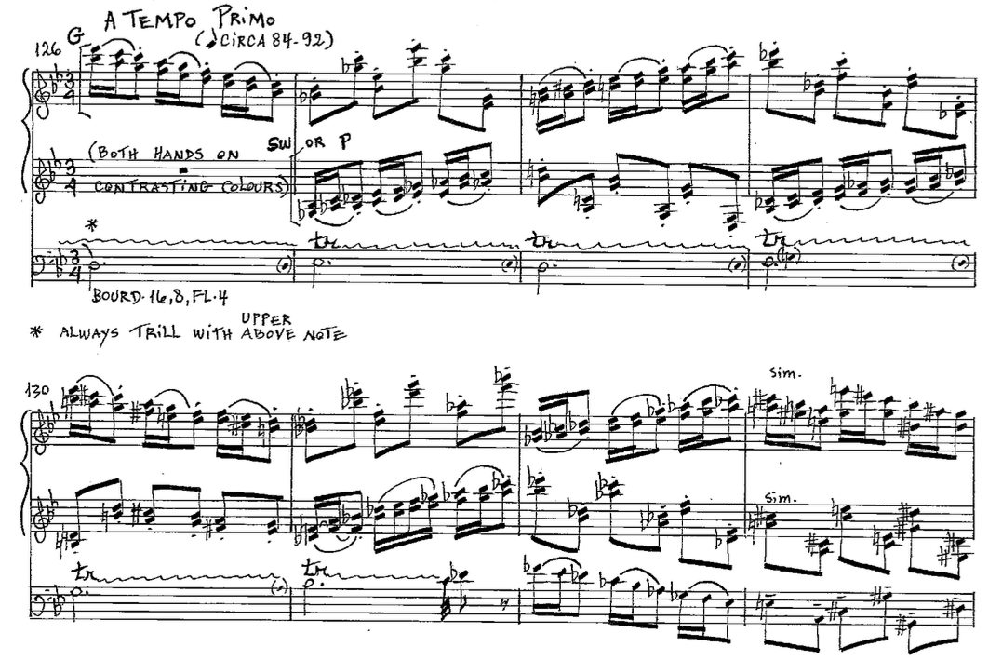
In mm. 132-135 the texture becomes contrapuntally complex. The pedal and right hand play in inversion. The left hand plays in disjunct motion. From mm. 126-135 Laurin specifies pedal registration only – Bourdon 16,’ 8,’ and Flute 4.’ For the hands she only asks for contrasting colors – the right hand plays on the Great and the left hand on the Swell (or Positif). Measures 136-138 present the echo contained in all other refrains. Laurin asks for Chamades on the Solo, principals 8,’4,’2,’ and 8’ reed for the Positif, and principals 8,’4,’ 2,’ mixtures, and Trumpet on the Swell. In the last section of the refrain, mm. 139-143, the right hand plays alone on the Solo (or Great) on a Trumpet with an optional 4’ Principal. The left hand accompanies the right hand on flutes 8, and 2’ (with an optional 4’). The section ends on a B minor-minor 7th chord.
The seventh section is a B′ and it occurs between mm. 144-153. This B′ section is half the length of the first B section. The thematic material is the same but its treatment is different. In the B section, the theme is stated in chords in both hands, while pedal has sixteenth-note runs. In the B′ section’s first phrase, the theme is played in the pedal, while the hands have busy sixteenth-note motion, mostly in first inversion triads, moving chromatically. This way, she keeps the ‘buzzing’ sound, which continuously reminds one of the fly. This can be seen in Ex. 28.
Example 28. Op. 66, mm. 143-148.
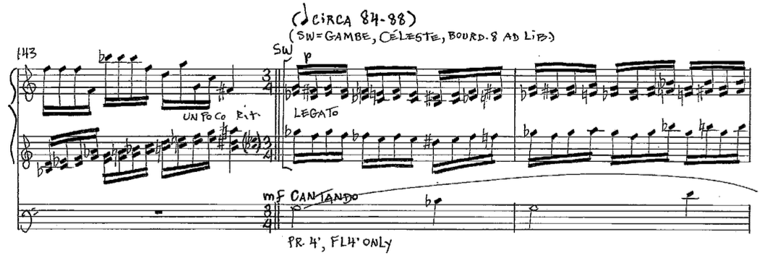
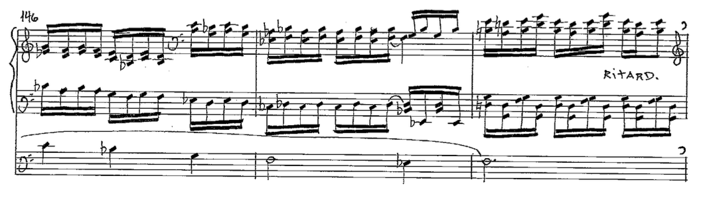
In the second phrase, the right hand and pedal have the slow moving theme, while the left hand continues the more rapidly moving accompaniment. Laurin keeps the B′ theme to B section’s unusual five-measure length. The B′ section is as tonally ambiguous as the B section. While the beginning of the first phrase, m. 144-148, outlines the G minor triad, the phrase ends on F (the lowered 7th scale degree). This destabilizes G minor by using the subtonic rather than the leading tone. In the second phrase, mm. 149-153, the pitch center shifts to D-sharp with the minor mode implied. Similarly to the first phrase, the centricity of D-sharp is destabilized, this time by ending the phrase on A, the flat fifth scale degree.
The registration for the first phrase is Principal 4’ and Flute 4’ in the pedal, and Gambe, Celeste and an optional Bourdon 8’ on the Swell for the hands. In the second phrase the right hand moves to the Great with a Harmonic Flute 8,’ and the pedal and Swell continue as before. Measure 153 serves not only as the closing measure of B′, but also as a link to the last refrain. The one-measure link is played on a soft 8’ reed, and it contains the first six notes of the fugal material from the C section. Laurin gives it a con spirito marking to denote the playful character of the fugue.
The fifth and last refrain begins at m. 154 and continues through the end of the piece, m. 166. It is the shortest of the refrains in the etude. It is a fusion of the material from the A sections and the C sections. In mm. 154 and 156 the main theme from the refrain is played on a 4’ Flute on the Great. In mm. 155 and 157 the left hand plays the first six notes from the C section fugal material on the Swell on cornet or mutation stops (See Ex. 29).

Example 29. Op. 66, mm. 152-157.
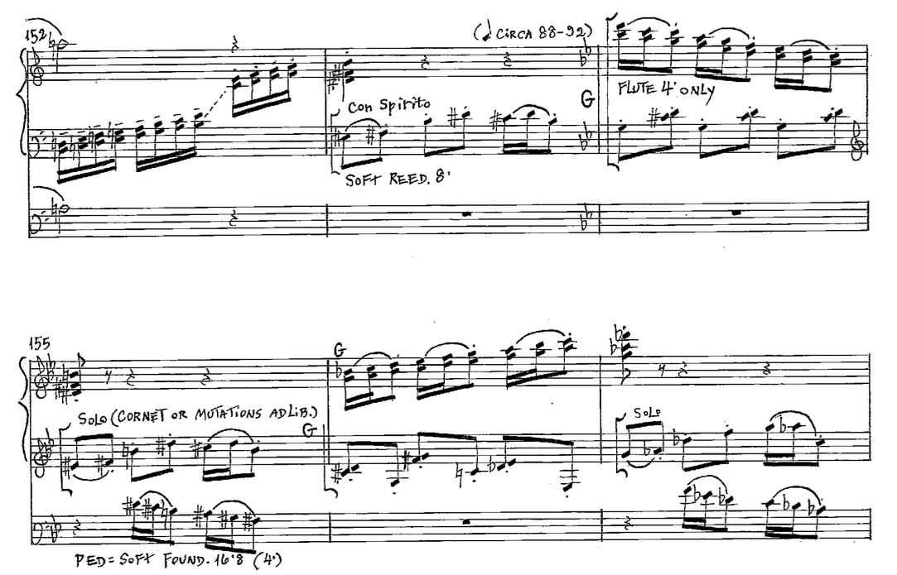
From m. 158 to the end, the A section material prevails. In m. 159 the expected 3/4 meter changes to 4/4. Laurin suggests 4’ flutes be used on both the Great and Positif for echo effect in mm. 159-161. In mm. 162-163 both hands move to the Swell and play in chromatic chords in first inversion on Oboe 8,’ Principal 4’ and optional Nazard 2-2/3.’ The registration changes in m. 164, when both hands move to the Great and play on 8’ and 4’ flutes. In the second to last measure, the hands move to the Positif and play on 4’ Flute only. The piece finishes with an open fifth on G, followed by a unison on G in the pedal and left hand. On those last two intervals the left hand plays on the Swell, which still has the 8’ reed on, thus the etude ends with a buzzy sound despite the pp dynamic. Pitch centers are almost completely absent in the last refrain. A hint of G minor is found in mm. 154, 156, and 165-166, but chromaticism prevails in the majority of the section. Measures 162-163 present parallel triads in first inversion, which is typical for Laurin.
Étude-Caprice, Op. 66 (Beelzebub’s Laugh) is in rondo form and has nine sections. To a certain extent Laurin keeps a lot of traditional features of the rondo form. For instance, all but one of the refrains have G as the pitch center. She uses contrasting material for the different A, B, and C sections. Laurin varies the material of each section in every subsequent appearance.
Harmonically, Op. 66 resembles Op. 38. Opus 66 does not function tonally; Laurin uses pitch centers with tertian harmonies instead of establishing keys through tonic-predominant-dominant progressions. In Op. 66 the pitch centers and brief tonicizations change even quicker than in Op. 38. In Étude-Caprice Laurin uses pitch centers which last anywhere from one to four measures, while in Étude Héroïque she sometimes sustains pitch centers for entire sections. Chromaticism is constantly present in Op. 66 – from a few chromatic pitches, to a more extended chromatic scale. Chromatic parallelism and sequencing also play a major part in Op. 66.
The piece very successfully portrays its title – Bellzebub’s Laugh. Laurin achieves that in a variety of ways – use of certain dissonant intervals, registration, rhythmic patterns and tempo. She met the expectations of the commissioner, Ken Cowan, who requested a piece which starts and ends softly, but reaches full organ in the middle. The composer masterfully uses the full potential of the organ by employing idiosyncratic techniques and registrations for the instrument, including a number of textural varieties (homophonic and polyphonic) and appropriate registrations to complement the textures.
Symphonic Etude for Solo Pedal, Op. 72: Variations on ‘That Good Old Baylor Line’

Laurin composed Symphonic Etude for Solo Pedal, Op. 72: Variations on ‘That Good Old Baylor Line’ in July-August of 2014 and Isabelle Demers premiered it on October 24 2014 at the Methuen Memorial Music Hall, Methuen, MA. The unofficial premier took place on October 2, 2014 at Baylor University as part of Demers’ annual faculty recital. As mentioned before, That Good Old Baylor Line is Baylor University’s Alma Mater song. The tune is taken from George Evans’ In the Good Old Summer Time, a song he wrote in 1902. The lyrics of Baylor’s version of the song are as follow:
That good old Baylor line
That good old Baylor line
We’ll march forever down the years
As long as stars shall shine
We’ll fling our green and gold afar
To light the way of time
And guide us as we go onward
The good old Baylor line.

Laurin sets the piece as a theme with 12 variations and most of them are for pedal solo. Each variation has a character description and in each of the descriptive words Laurin has underlined one or two letters. As shown in Table 3, if rearranged, the underlined letters are an inscription of ‘Isabelle Demers.’

Var. I: Modest d e
Var. II: Rational a
Var. III: Authoritative r
Var. IV: Nostalgic s
Var. V: Mischievous (Pesky!) i
Var. VI: Show-off s
Var. VII: Pessimistic/optimistic m
Var. VIII: Choleric l
Var. IX: Naïve e
Var. X: Eccentric e
Var. XI: Nonchalant l
Var. XII: Brave (Bear-like!) b e

Table 3. Op. 72, Isabelle Demers’ name inscription in variation titles.

Opus 72 is harmonically the most conservative of the three etudes. Perhaps because of the strong tonal implications of the Theme, as one might expect from an alma mater hymn, the majority of the variations (I, II, III, V, VI, IX, and XII) are tonal, with some degree of chromaticism. Variations IV, VII, and VIII are written in what seems to be Laurin’s typical harmonic idiom – tertian harmonies but non tonal, and with a strong presence of chromaticism. Variations X and XI are in a jazzy style.
Theme
The Theme, as shown in Ex. 30, is first played in the pedal on 8’ and 4’ foundation stops. The composer has provided an optional harmonization, which can be played on the Swell with soft 8’ strings and flutes registration. Laurin harmonizes the Theme tonally, in a straightforward manner, with a few secondary dominants. Minor iv represents modal mixture on the downbeat of m. 8 and V7/IV is present in m. 3. In m. 15 vii°7/vi leads to a deceptive cadence before the last phrase of the tune. The Theme is a 16-measure parallel double period. The first three four-measure phrases end on half cadences, and the final phrase ends on an imperfect authentic cadence.

Example 30. Op. 72, Theme.
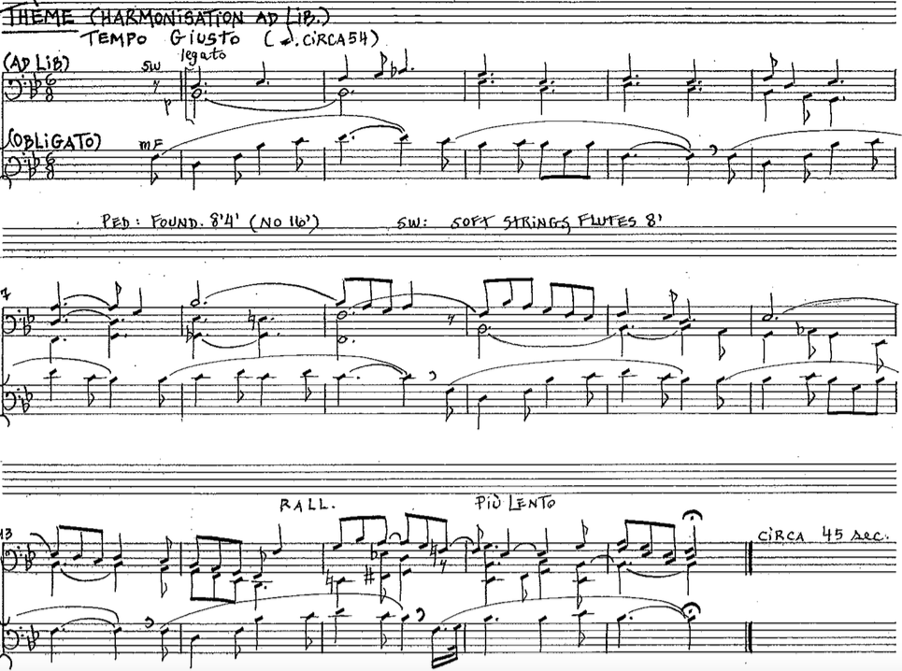
Unpublished score. Reprinted by permission from Rachel Laurin and Wayne Leopold Editions.

Variation I
The first variation is in the original 6/8 meter. Although only a single-note line is played in the pedal, with the exception of the last two measures, a sense of melody and accompaniment is obvious. The composer has achieved that by employing a compound melody. Because of the large intervallic distances between the two simultaneous melodies, there is a clear separation of registers, as seen in Ex. 31. The difference in registers helps bring out the two melodies as independent entities, but it also provides the implication of harmonic structure. The end result is a perception of melody (the Baylor theme), accompaniment and implied harmonies.
Example 31. Op. 72, Var. I, mm. 1-6.
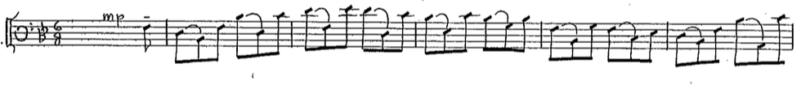
Harmonically, the first variation follows the structure of the Theme very closely. The A-flat is omitted in m. 3, but the G-flat in m. 8 is still present and the modal mixture is continued in m. 9 by adding A-flat and G-flat. In mm. 14 and 16 V7/V is introduced, which is different from the Theme. In both measures the secondary dominant is not resolved to V as expected. In m. 15 vi is tonicized, just like in the Theme, but this time Laurin uses V7/vi rather than vii°7/vi (See Ex. 32). The expected deceptive resolution to vi is destabilized by a D-flat in the vi chord, which then leads to another V/V sonority. In the last two measures, 17 and 18, Laurin adds a second voice to finish off the variation. The added voice helps continue the illusion of multiple voices, thus avoiding a hollow ending on a single note.
Example 32. Op. 72, Var. I, mm. 13-18.
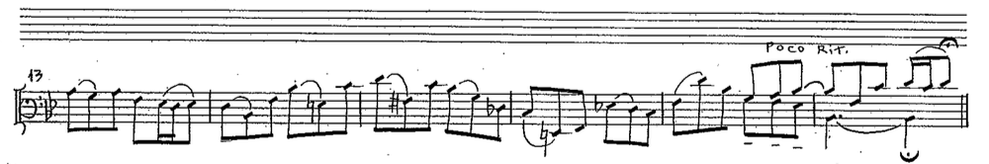
Laurin keeps the Theme melody exact until the second part of the variation. Starting at m. 11 she deviates from the original. No registrational changes are made so the registration continues to be 8’ and 4’ foundations. A simple, but elegant musical texture represents the variation’s descriptive title “Modest.”

Variation II
Similarly to the first variation, the second variation continues the idea of melody and accompaniment. Example 33 shows that in the second variation two voices are used in hocket style, where the second voice is displaced by a sixteenth note. The top voice contains the Baylor tune, while the bottom voice provides harmonic filler and rhythmic activity. This variation is in 3/4 meter, while the Theme and first variation are in 6/8.
Example 33. Op. 72, Var. II, mm. 1-8.
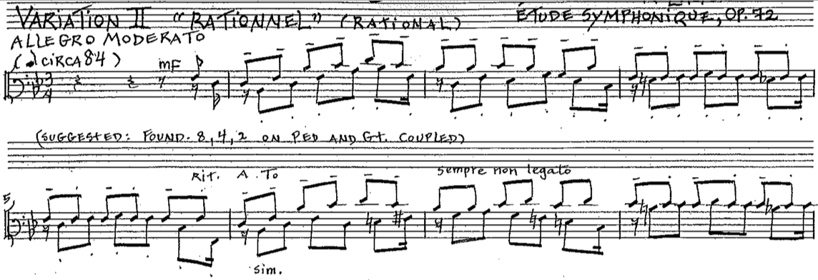
The first phrase of the Theme is stated in the first couple of measures of the variation. Two measures of free material connect the first and second phrase. Likewise, two measures of free material follow the second phrase. An eight-measure (mm.10-17) free material phrase separates the second and third phrases of the Theme. The free material is loosely based on the contour of the first two phrases and the material from mm. 4-5 and 8-9. Those eight measures (mm.10-17) are perceived as sequential although there is no specific intervallic pattern to the sequence. The eight measures are grouped in four groups of two measures, and each group follows the same pattern. The first measure of the group has an ascending arpeggiated contour, which resembles the phrases of the Theme. The second measure of the group has a descending contour with smaller skips and repeated notes that resemble the free material of mm. 4-5 and 8-9. The two-measure groups explore various harmonic areas. Measures 10-11 outline the D major triad, perhaps as a tonicization of vi. Measures 12-13 emphasize the G minor triad, which is vi in the key of B-flat. The following two measures, 14 and 15, appear to be outlining the mediant key, D minor. The most striking harmonies arrive in mm. 16-17, where G-flat major has prevalence. The chromatic mediant key quickly transitions back to B-flat major in m. 18, where the third phrase of the Theme begins. Measures 18-27, which is the end of the variation, are modeled after the first two phrases. The third phrase is followed by two measures of free material, and it is almost completely identical to the first phrase. The only exception is the last beat of m. 21. Four measures of free material follow the fourth phrase, and bring the movement to its conclusion. Laurin finishes the second variation on a complete B-flat major chord. The suggested registration is 8,’ 4,’ and 2’ on both the Pedal and the Great, with the Great being coupled to the Pedal. The description for the second variation is “Rational.”
Variation III
The third variation’s description title is “Authoritative,” and Laurin has emphasized the movement’s character in a few ways. The tempo marking is Allegro Deciso. The meter is 4/4 and the whole variation consists of sixteenth notes only, which results in a brisk tempo. Lastly, the suggested registration requires some of the loudest stops on the organ. Laurin asks for 16’, 8’, 4’, and 2’ foundations, mixtures and 16’ and 8’ reeds in the Pedal, and 8’, 4’, and 2’ foundations, mixture and Trumpet 8’ on the Great, with the Gt/Ped coupler.
In this variation the Baylor tune is not as obvious as it is in the first two variations. The composer has hidden the Theme at various places throughout the variation without an obviously discerned pattern or frequency. For example, at the beginning of the variation the first half of the first phrase of the Theme is stated in the six opening notes (See Ex. 34). The remaining seven notes, the second half of the first phrase, are unevenly interspersed from m. 2 to m. 4.
Example 34. Op. 72, Var. III, mm. 1-6.
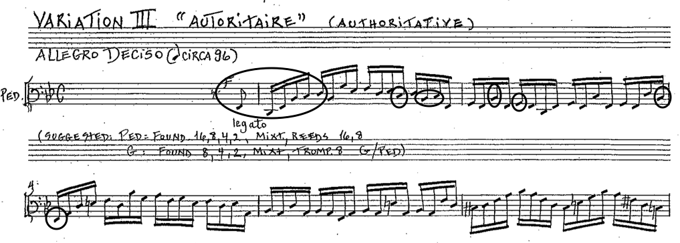
The second phrase covers a larger span beginning in m. 5 and ending in m. 12. Sometimes a measure contains one note of the melody, and others up to three notes. Laurin makes a change at the end of the second phrase. In the original Theme, the second phrase ends with a repetition of C and D, which creates a repetitive, soothing effect. In this variation, Laurin uses C-sharps instead of C naturals. Measures 13-16 serve as a transition to the third phrase. Measures 17-22, where the third phrase is exposed, are an exact repetition of mm. 1-6. Another transition follows from mm. 23-26, which connects the third and the fourth phrases. The fourth phrase finishes the variation from mm. 26-30.
The first two measures of the third variation are in B-flat major without any chromatic alterations. Measures 4 and 5 introduce E-natural, and C-sharp appears in m. 6, all of which contribute to tonicization of the mediant, D minor. Measures 5 and 6 briefly destabilize the tonic by using sequence and sequence-like procedures. In m. 5 the last three beats arpeggiate diminished and major-minor seventh chords. Measure 6 employs an exact sequence, which consists of diminished and augmented intervals. Measure 8 is a tonal sequence of m. 2; it is a sixth up and it emphasizes the submediant key, G minor. (See Examples 34 and 35.) The new tonicization becomes progressively stronger. Laurin achieves that by adding F-sharp, E-Natural, and C-sharp. The tonicization lasts until the end of m. 12 and it finishes with a half cadence in the submediant key. A scale is outlined in the higher ‘voice’ of mm. 9-12, G – A - B-flat - B-natural – C - C-sharp - D. These pitches enhance the tonicization of G minor as they outline scales degrees 1 through 5 in the submediant key.
Example 35. Op. 72, Var. III, mm. 7-12.
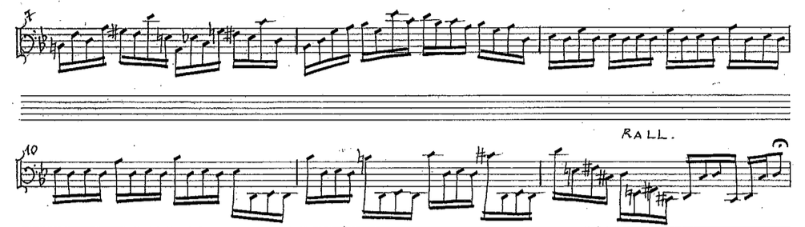
Measures 13-17 serve as a transition to B-flat major. Measures 13 and 14 nearly sequence the material from m. 2. A descending chromatic line, D through G-flat, is apparent in the lower register in mm. 14-15. G-flat leads to F, which is the dominant of the tonic key, and it further helps with the retransition to the home key.
The second half of the variation begins with an exact repetition of mm. 1-6, as mentioned before. Diminished and half-diminished chords are present in m. 23. Measure 24 starts in a similar fashion to m. 2, though at a different pitch level, and it quickly departs from the already established pattern. Tonally, m. 24 is built around the distant keys of D-flat major and B-flat minor. Measures 25 and 26 present a sweep of the whole pedalboard, while sequencing the pattern used on beat 3 of m. 2. The fourth phrase of the Theme is presented in mm. 27-30, plus a pick-up, and these four measures are perhaps the most melodically disjunct part of the whole movement, as shown in Ex. 36. The largest leaps in the melody are present in this section – tenths, an eleventh, and even a twelfth. Additionally, chromatic pitches, A-flat, D-flat, G-flat and E-natural, disrupt the centricity of B-flat major. The very last measure restores the tonal center of the main key, by an arpeggiation of the tonic chord.
Example 36. Op. 72, Var. III, mm. 26-30.
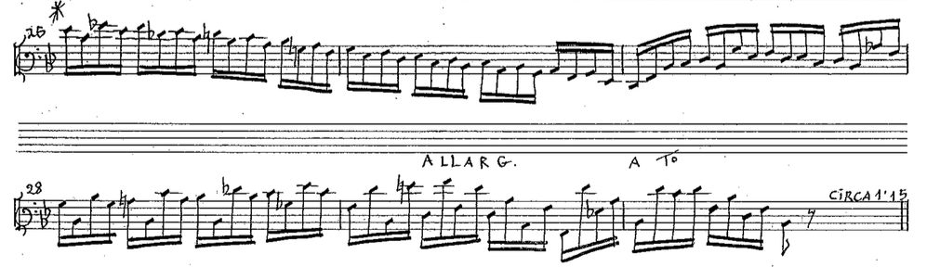
Variation IV
The title of the fourth variation is “Nostalgic.” The tempo marking is Andante Espressivo, and this is one of the more lyrical variations. This is the first variation which is not tonal. The most prevalent pitch center is D and the minor mode is implied. This contrasts to the Theme in two ways – it has a different pitch center, and a different modal feeling. The meter of the fourth variation is 6/8. This is the first variation that uses the manuals in addition to the pedal. The Theme is played in the pedal on foundations 8’ and 4.’ In the interludes the left hand and pedal provide the harmonic accompaniment and the right hand plays on a solo stop. For the accompaniment, Laurin suggests Gambe 8,’ Bourdon 8’ and Flute 4.’ The pedal has soft 8’ and 16’ Bourdons and occasionally the Sw/Ped coupler is added for balance with the Swell. For the right hand Laurin asks for a solo stop, like Clarinet 8,’ or Harmonic Flutes 8’ and 4.’ In the middle of the variation the accompaniment becomes the Gambe with the Voix Celeste. Occasionally a stop or coupler is added or taken off for dynamic change.
In the first four measures the pedal stays on D and A. The accompaniment begins in m. 2 and it contains mostly major and minor triads which move in parallel motion. In the first three measures D Dorian is implied because B-natural and C appear instead of B-flat and C-sharp. Also, the parallel motion in triads further obscures the tonality. For example, in mm. 5 and 6 seven different sonorities are played in a row – C major, E-flat major, F major, D major, G major, E minor, and A major. Starting with the pick-up to m. 10, the pedal has a different role. Rather than being the bass note for the harmonic structure, it has the Theme until m. 13, which is seen in Ex. 37. Those four measures represent a transposed inversion of the first phrase of the Theme – the intervals are the same but they are played in the opposite direction. During the pedal solo the left hand moves stepwise in parallel fifths. The motion is usually opposite to that of the pedal, which creates counterpoint.

Example 37. Op. 72, Var. IV, mm. 7-18.
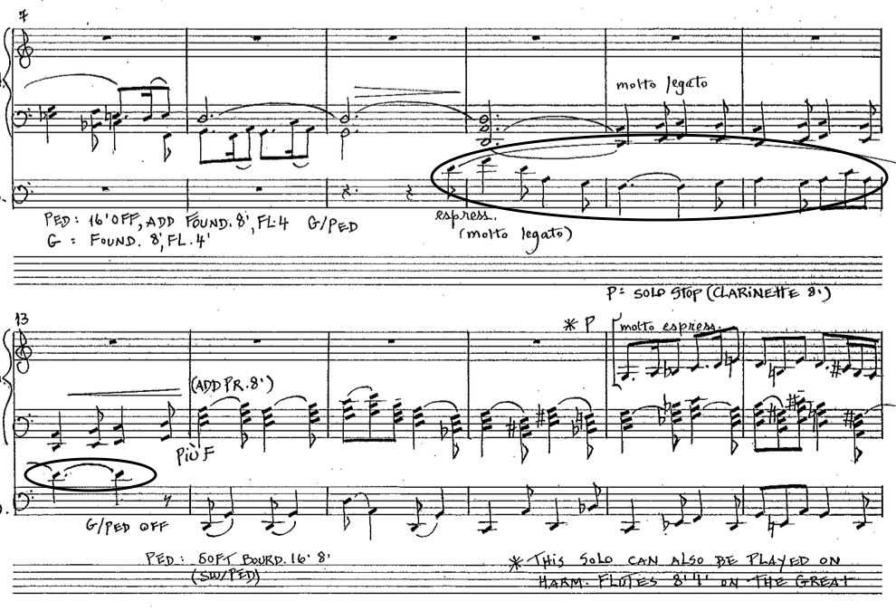
In mm. 14-16 the left hand is exactly the same as in mm. 2-4. However, the pedal in these measures is more active than in the beginning. From mm.17-21 the right hand plays on a solo stop, while the left hand and pedal accompany it. The accompaniment continues in parallel triads. The pitch center is still D, but chromatic pitches are added to the scale. The second phrase starts with the pick-up to m. 22 and continues until m. 25. The pedal still has the Theme in inversion, but this time it is more ornamented and it does not end on a D minor chord, but rather on E minor. Both hands accompany the pedal in parallel fifths. The next interlude continues from the pick-up to m. 26 until m. 31. In the first four measures the hands play in parallel motion again but this time in thirds, and the pedal has a number of open fifths. As seen in Ex. 38, in mm. 29-31 a little clarinet solo changes the texture. The left hand accompanies with triads, while the pedal moves in parallel fifths. The end of the interlude implies D major, because of the use of D, F-sharp and A. The third phrase begins with a phrase modulation to B major/minor. The hands sustain three Bs in octaves for four measures while the inner voices move in parallel octaves. The pedal presents the inversion of the Theme. In addition, a second voice is added in the pedal which plays in a canon at the octave with the bottom voice. The two voices are offset by a beat (See Ex. 38).
Example 38. Op. 72, Var. IV, mm. 29-38.
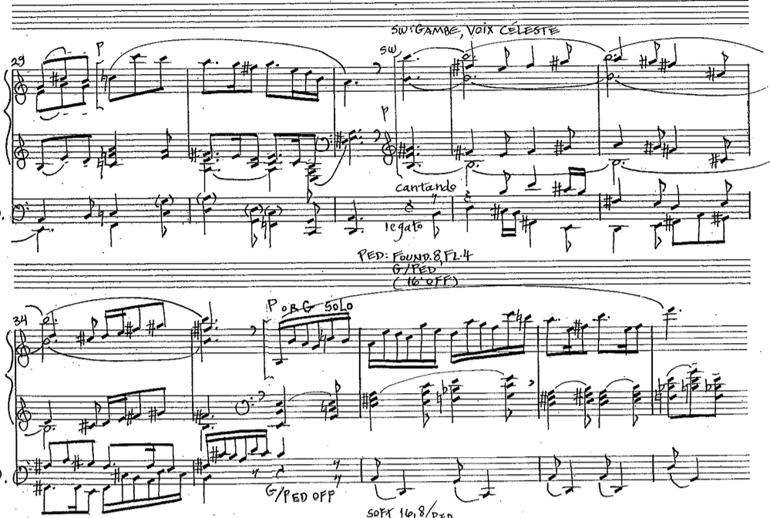
The next interlude covers mm. 35-41. The solo-accompaniment pattern returns for the first four measures of the interlude, after which the parallel triads finish it. The interlude restores D as the pitch center. The last phrase is stated in mm. 42-45. It is a variation of the second phrase in both pedal and manuals but it ends on an F-sharp minor triad. The last section of the variation goes from m. 45-56, which is the end of the variation. Similarly to the interludes, it continues to carry the parallel chord pattern. In the last four measures the pedal mimics the Theme and brings the variation to an end on a D minor chord with an added major second.
The fourth variation captures the ‘nostalgic’ mood in several ways. The minor mode defines the character of the movement. The abstract harmonies also contribute to the mood. The slow tempo, eerie registrations and inverted Theme segment further enhances the somber mood.
Variation V
‘Mischievous/Pesky!’ is the character description of the fifth variation. As in the previous variations, Laurin has masterfully put the description into music. The tempo is Vivace e leggiero, con humoro, which already suggests a playful mood for the movement. The entire variation is characterized by the use of grace notes, which further the playful annoyance. The registration Laurin suggests is Bourdon 16 and principal 2’, or the Swell coupled to the Pedal with a 16’ reed (Bassoon), flute 4’, and principal 2’. Both of these suggestions are gapped registrations, which are typically used on the organ for humorous or comical effects.
The Theme is audibly presented in the fifth variation; however, Laurin does not always use all the pitches of the Baylor tune. For instance, the composer leaves two or three notes out of each of the four phrases. Most often C (scale degree two) is left out. The first two phrases are stated from mm. 1-9. A long interlude, based on melodic and rhythmic motives from the first two phrases, follows from m.10 to m. 27. The third and fourth phrases from the Theme cover mm. 28-37.
The first two phrases are in B-flat major, but Laurin provides playful ornamentation by using lower-neighbor or chromatic lower-neighbor pitches for the grace notes, all of them a half step below the note they embellish. Example 39 shows that the entire middle section, mm. 10-27, is tonally very contrasting to the outer two parts. It quickly moves trough a variety of sonorities – c, D7, d-flat mm7, C7, d, E, d, E, g, A, G7, D-flat, G7, D-flat, and c. Some of them are diatonic to the key of B-flat major (c, d, and g.) Others are secondary dominants (D7, C7 and G7.) Still others are chromatic mediants (D-flat, and G) and some are completely foreign to the tonic key (d-flat mm7, E and A.) Even through most chords can be categorized, their succession does not function as an expected harmonic progression. The secondary dominants do not resolve to the keys they tonicize, and there is not a perceived harmonic progression. The continued use of grace notes, always a half step below the main note, furthers the tonal instability of the middle section. Measures 25-27 represent a chromatic tirade from top to bottom of the pedalboard, which completely takes away the perception of any tonal center.
Example 39. Op. 72, Var. V, mm. 9-28.
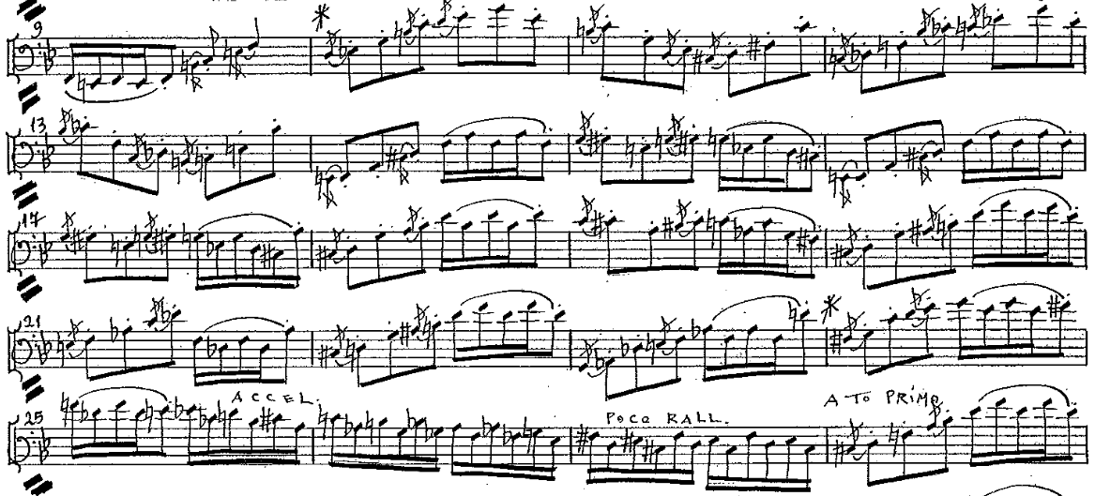

Suddenly, m. 28 brings back B-flat major. The third and fourth phrases are presented in the same fashion as the first two phrases. A four-measure tag begins at m. 34. One last time Laurin masks the tonic center by laying out two chromatic lines in contrary motion in mm. 34-35. B-flat is briefly reestablished in the last two measures.
Variation VI
The sixth variation is named ‘Show-Off’ and Laurin suggests freedom in the performance by adding the tempo indication Allegro virtuoso, alla cadenza, con fantasia. The entire variation is played on ff, which implies registration consisting of some of the loudest stops or nearly full organ. D major is the main key, but B-flat major is implied a few times throughout the variation. The main technique used here is scalar motion, diatonic and chromatic.
Even though motives from the Theme are heard throughout the variation, the Theme is never stated in its entirety. The first phrase is the only one completely audible. The first half of first phrase can be found in mm. 2-3, and the second half of the phrase in mm. 10-11. Sequence is prominently used in the sixth variation. For instance, mm. 27-44 contain several sequences in a row. Additionally, pedal scales are interspersed between the motivic material. The combination of all the mentioned characteristics makes the separation of the phrases unclear and the phrase length uneven.
“Show Off” begins with an ascending D Major scale in mm. 1-2, followed by the first half of the first phrase from the Theme (See Ex. 40). In mm. 4-5 another D major scale is played in the pedal, but this time it is both descending and ascending. The second half of the first Theme phrase is stated in mm. 6 and 7, followed by a short sequence based on it.
Example 40. Op. 72, Var. VI, mm. 1-7.
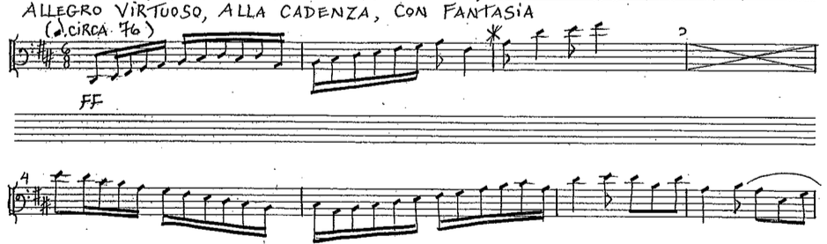
The sequence leads to more scalar motion that starts in B major, which then sequences and leads to B-flat major (D-major’s chromatic mediant.) The end of the sequence leads to a statement of the first part of the first phrase of the Theme in mm. 10-11. In m. 12 an E-flat major descending scale leads to a sequence of the second half of the first phrase. The sequence continues from m. 13 to m. 16 and it finishes with another scale, this time chromatic and ascending. A new type of sequence begins in m. 19, which combines the first half of the first phrase and a chromatic scale. The thematic material receives a different treatment, where a diminished triad is outlined. F-sharp diminished is outlined in mm. 19 and 21, and G diminished in m. 23. The first two triads are followed by a measure of a chromatic scale. The third chromatic scale runs for three measures, 24-26. Measures 27-36 continue to sequence the first part of the first phrase. Measures 27-32 have an alternating eighth-note-quarter-note pattern, while the other measures feature a six eighth-note pattern. The two prominent sonorities employed in mm. 27-36 outline the “Petrushka Chord” – C major and F-sharp major, both of which are chromatically related to D major (See Ex. 41). C major is V/F, and F-sharp major is a chromatic mediant to D.

Example 41. Op. 72, Var. VI, mm. 27-36.
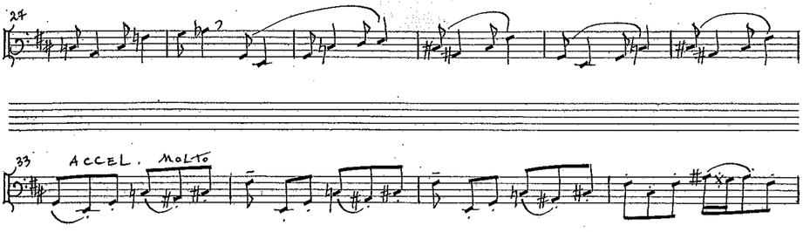
The last part of the variation starts in m. 38. One-measure ascending scales take turns with motives based on the second half of the first phrase. A final D major ascending-descending scale, covering almost the entire pedalboard, goes from mm. 44-46. In m. 47 an arpeggiated B-flat major chord contrasts with the D major mode that comes in the measures before and after it. Measure 48 presents the last half of the fourth phrase, and measure 49 concludes the sixth variation with a two-voice D-major scale in opposite directions.
Due to the fact that the sixth variation does not state the whole Theme and that there is no consistent pattern, the variation can be considered through-composed. Another feature, which distinguishes this variation from the others, is the misplaced accent of the melody. The Theme is in 6/8 and all phrases start with an eighth-note pick-up. The sixth variation is also in 6/8 but Laurin has chosen to start all phrases on the downbeat, rather than with a pick-up, which creates metric displacement.
Variation VII
The seventh variation is titled “Pessimistic/Optimistic,” from which it is apparent that two contrasting ideas are juxtaposed. Each of the characters is defined by their own rhythm, registration, and tempo. The ‘pessimist’ is expressed by slower note values, like dotted half notes. The tempo marking is Lento, senza rigore. The registration used is a soft 8’ reed (coupled from the Swell or Positive) with the tremolo and optional 8’ and 4’ soft flute stops. Expressive markings like crescendo and decrescendo are used for the ‘pessimist’ only. The tempo marking for the ‘optimist’ is Andante cantabile, and eighth-note triplets prevail. The suggested registration includes foundation stops 8’ and 4’, and a soft 16.’
The ‘pessimist’ appears four times in the variation – mm. 1-3, 8-10, 15-18, and 29-31. The ‘optimist’ is present three times – mm. 4-7, 11-14, and 19-28. Glimpses of the Theme can be found in the “Optimistic” section, but generally the tune cannot be recognized in this movement. For example, the first phrase of the Theme is found in mm. 5-6. A key is nearly impossible to define for either character, though minor mode is related to the ‘pessimist’ and major mode to the ‘optimist.’ Even though the key signature is one flat, neither D minor nor F major is clearly established and the key is masked in several ways. As seen in Ex. 42, the first phrase of the ‘pessimist’ seems to be in D minor, but it starts on A (fifth scale degree), there is a D-flat (flat first scale degree), and the phrase ends on E (second scale degree). The ‘pessimist’ is signaled by notes outlining a diminished fourth, which appear at each presentation. In the second showing of the ‘pessimist’ an E-flat and A-flat are added. In the third phrase, G-sharp and D-sharp appear.
Example 42. Op. 72, Var. VII, mm. 1-5.
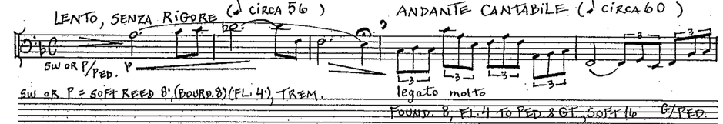
The first phrase of the ‘optimist’ is built around F major but the phrase ends on E. With each following phrase the key obscurity grows. In the second “Optimistic” phrase A-flat, B-natural, C-sharp, and E-flat are added. The third appearance of the ‘optimist’ is the longest and most harmonically obscured. While it starts with only a few accidentals, it quickly moves sequentially by adding six sharps in the process, as shown in Ex. 43.
Example 43. Op. 72, Var. VII, mm. 19-24.
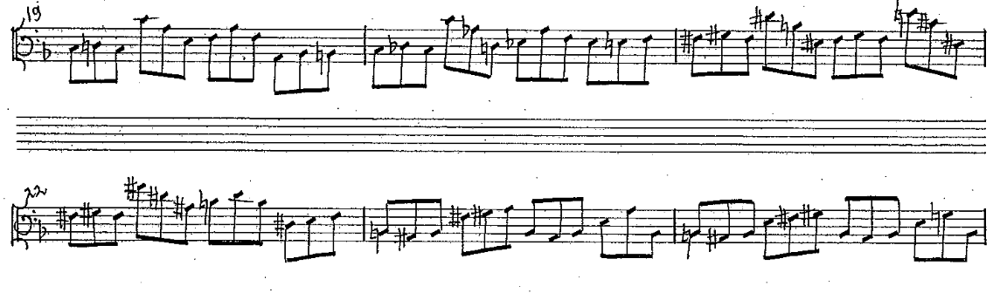
The seventh variation is one of the most harmonically abstract. A key is never stated clearly and chromaticism is used to mask the key center. Even at the very end of the variation harmonic resolution is not provided. “Pessimistic/Optimistic” ends on an E without providing a firm conclusion in D minor.
Variation VIII
“Choleric” is the title of the eighth variation. The angry irritable mood of the variation is presented through various techniques. The whole movement is played on full organ. Laurin asks for all manuals to be coupled to the pedal with 16,’ 8,’ 4,’ 2,’ mixtures, and reeds. The tempo marking is Allegro furioso, molto libertamente. The prevailing rhythm is a dotted eighth with a sixteenth note, which enhances the uneasy mood of the variation. In this movement Laurin uses a variety of textures – from one-note lines to four-note chords.
The eighth variation’s beginning and ending key signature implies B-flat minor. However, this variation is highly chromatic and the key of B-flat minor is never firmly established beyond the opening few measures and by the fact that it ends on a B-flat minor triad. The variation begins as a recitative. In the opening line starting in m. 1, an altered version of the first half of the first phrase of the Theme (except the E-natural) is presented in minor (See Ex. 44). After the first gesture, which is in sixteenth notes, the movement stops in m. 2 on a unusual seventh chord – an augmented triad with a minor seventh. The opening two measures are mimicked in mm. 3 and 4, and the chord in m. 4 is another unusual seventh chord, which consists of a major third, diminished third, and another major third.
Example 44. Op. 72, Var. VIII, mm. 1-4.
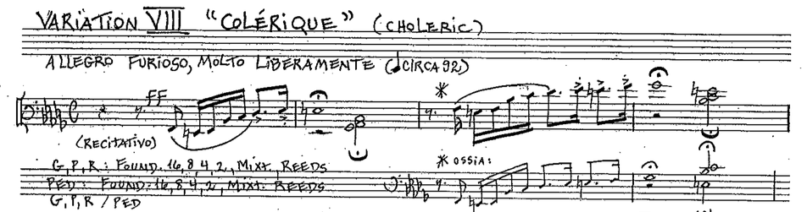
As seen in Ex. 45, starting in m. 5 the pedal plays in two to three voices in a variety of rhythmic patterns. B-flat minor is replaced by a lot of chromaticism and the lack of tonal center continues until m. 27.

Example 45. Op. 72, Var. VIII, mm. 5-16.
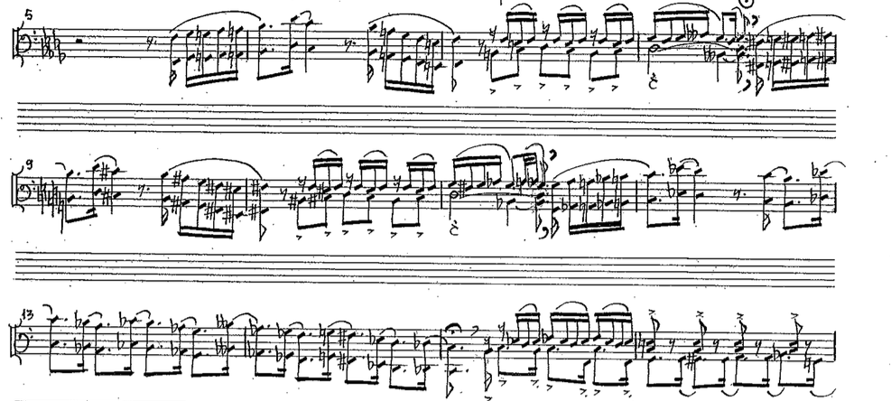
In measure 27, the opening gesture from m. 1 returns, this time in octaves. The chord that it ends on is vii°7/ V. Measures 27-44 present a condensed version of the first 27 measures. The same rhythmic patterns are used with slight omissions and variations. The opening line is stated one last time in m. 44, which this time ends on a D-flat minor chord in first inversion. A six-measure tag ends the variation with an unexpected finish on a B-flat minor triad. The unusual seventh chord from m. 4 (major third, diminished third, and another major third) precedes the final chord.
Variation IX
The title for the ninth variation is “Naïve” and the tempo marking states Allegretto con innocenza. The key is F major and meter signature is 3/4. As seen in other variations, the ninth one has interludes between the phrases of the Theme. For the interludes Laurin suggests a light reed registration, and for the theme she asks for flutes 4’ and 2.’ The interludes have two voices, while the Theme is a monody.
The first part of each phrase (or almost the whole first part) of the Theme is clearly presented in normal note order without interruption. The second half of each phrase is either highly convoluted, or nearly impossible to decipher. The length of each phrase is different. The first two phrases have the same length of five measures. The thirds phrase is 25 measures long and is characterized by sequences. The fourth phrase is nine measures in length. The interlude is five measures long every time it appears.
As shown in Ex. 46, an open-fifth (F and C) drone represents the interlude, which is also the same as the very beginning. It is played on a soft 8’ reed. The top voice is varied in some measures by a grace note, or a dotted eighth sixteenth rhythmic pattern. The first phrase begins in m. 6 and continues through m. 10 (See Ex. 46). Its first half is exposed right away, but the second half is hidden between mm. 8-10, and one of the pitches is not present in the expected order. The Theme is played as a one-note line, which often changes direction and is defined by mostly stepwise motion and small skips. Both the beginning material and Theme are in F major but the use of E-flat implies Mixolydian mode.
Example 46. Op. 72, Var. IX, mm. 1-12.
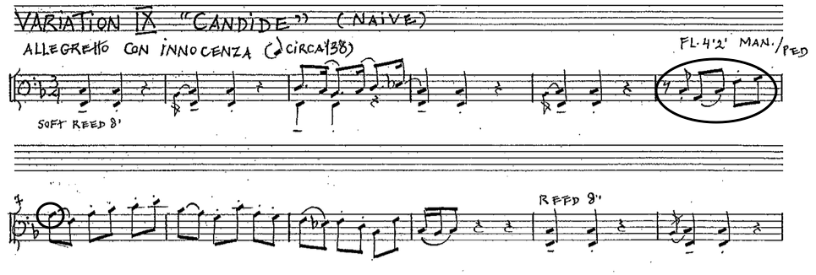
The interlude appears in mm. 11-15 with slight variations in the top voice. The second phrase is presented in a fashion similar to the first phrase. This time, in addition to the E-flat, Laurin adds a B-natural, which suggests a mixed Lydian/Mixolydian scale. The interlude appears again in mm. 21-25 but it is stated in C major. It is an exact transposition of mm. 1-5. The third phrase is the most elaborate in this variation because its span covers mm. 26-50, as shown in Ex. 47. The first six notes of the third phrase are presented at the very beginning but the other nine notes cannot be discovered easily due to the length of the phrase. Measures 26 and 27 serve as the motive of a sequence, which continues to m. 32. Two more sequences can be traced in the third phrase beginning at mm. 33 and 41.
Example 47. Op. 72, Var. IX, mm. 25-48.
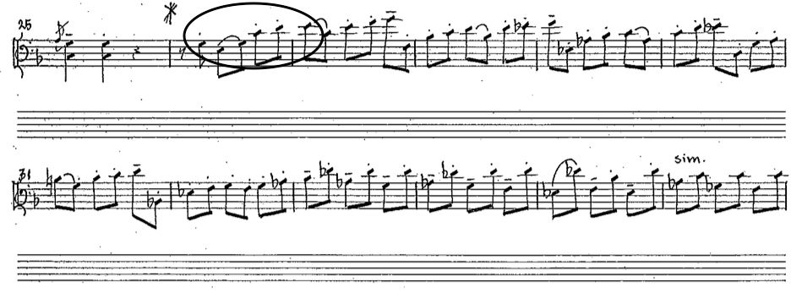
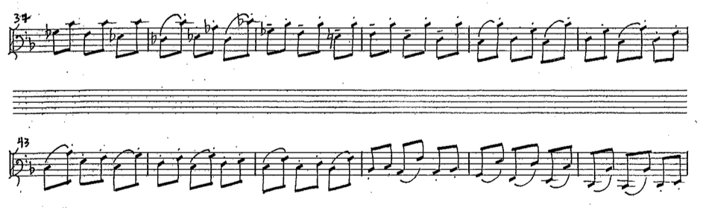
Retransition to the fourth phrase begins in m. 47 which modulates back to F major. Even though the third phrase has some stepwise motion, especially at the beginning, larger skips prevail. The interlude returns in its original state in m. 47. The fourth phrase starts in m. 56. Similarly to the other phrases, the first half is very obvious but the second half of the phrase is harder to trace. The sequential material also contributes to that fact. The variation closes with two measures of interlude material.
Variation X
The tenth variation is titled “Eccentric.” The meter is 3/4 and the only dynamic suggestion Laurin has is mf. The movement’s key signature implies B-flat major, but a great degree of chromaticism disrupts the establishment of a tonal center. As in most of the other variations, this one has interludes between the Theme phrases. The interludes are defined by chromatic harmonic minor thirds. The Theme entrances are characterized by a dotted eighth sixteenth-note pattern.
After the opening, resembling the interludes, the first Theme phrase begins in m. 5 and continues to m. 18. Only the first half of the first phrase is used as thematic material, which is being varied. From mm. 7-13 there is only one line played in the pedal, and from mm. 14-18 there are two voices (See Ex. 48). The top voice keeps the dotted eighth sixteenth-note pattern and features a lot of tritones, while the bottom voice moves in quarter notes. The Theme sounds like it is in a jazz-like style, especially in mm. 14-18 where two voices are present.
Example 48. Op. 72, Var. X, mm. 13-20.
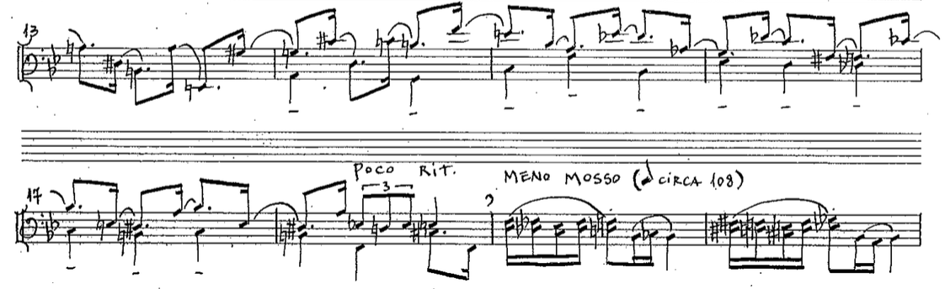
In mm. 7-13 there are a few accidentals, but even more chromaticism ensues in mm. 14-18 as a sequence develops. The interlude returns in m. 19 and continues through m. 22. The second time the Theme appears is in m. 23, but this time in E-flat major, lasting until m. 32. It follows the structure of the first Theme entrance – one voice (mm. 23-26) followed by two voices (mm. 27-33.) The last interlude occurs in mm. 34-37 and is followed by an eight-measure tag which is based on both thematic and interlude material. The movement ends on a jazzy cluster – B-flat, A-flat and C.
Variation XI
Much like the tenth variation, the eleventh variation is written in a jazzy style, and its title is “Nonchalant.” The variation has a clear accompaniment-solo division represented by two voices, and this variation works best on organs with pedal divide. The pedal divide gives the option of using two different stops, or combination of stops, for each half of the pedalboard. The lower half uses the regular pedal stops, while the manual couplers affect the higher part. For the lower voice Laurin suggests a 16’ Cello stop, and for the higher voice - a “jazzy sound.” The movement is in 4/4 and there is no key signature. Because of its repetition, G may be assumed as the pitch center of the variation. However, the extended use of chromaticism often masks the pitch center.
Laurin’s performance description for the eleventh variation states: “with a lot of rhythmical freedom like jazz improvisation.” For the most part there are two voices. Interludes are present, as in many of the other variations. Instead of four Theme phrases, there are five in this movement and each phrase has a different number of measures. Due to the improvisatory character of this variation, it is difficult to say which phrases are being varied.
This variation begins with a two-measure chromatic bass line. It descends in quarter notes and resembles the bass player’s part in a jazz ensemble. This is made even more obvious by the fact that Laurin asks for a 16’ Cello stop in the bass. In a significant part of the movement, the bass moves downwards by half steps, with an occasional large skip when low pedal C is reached. The second voice, or the solo, begins in m. 3. It vaguely outlines the first phrase and it uses a swing rhythm and blue notes. Measure 8 presents a short interlude, which leads to the second phrase. The length of the second phrase is four measures, which is one fewer than the first phrase.
Measures 13-14 contain another interlude which continues the chromatic motion, but this time in parallel major thirds. The third phrase begins in m. 15 and lasts for three measures, as seen in Ex. 49. An expected interlude goes from mm. 18-20, once again in major thirds. The fourth phrase starts in m. 21 and lasts for four measures.
Example 49. Op. 72, Var. XI, mm. 14-25.
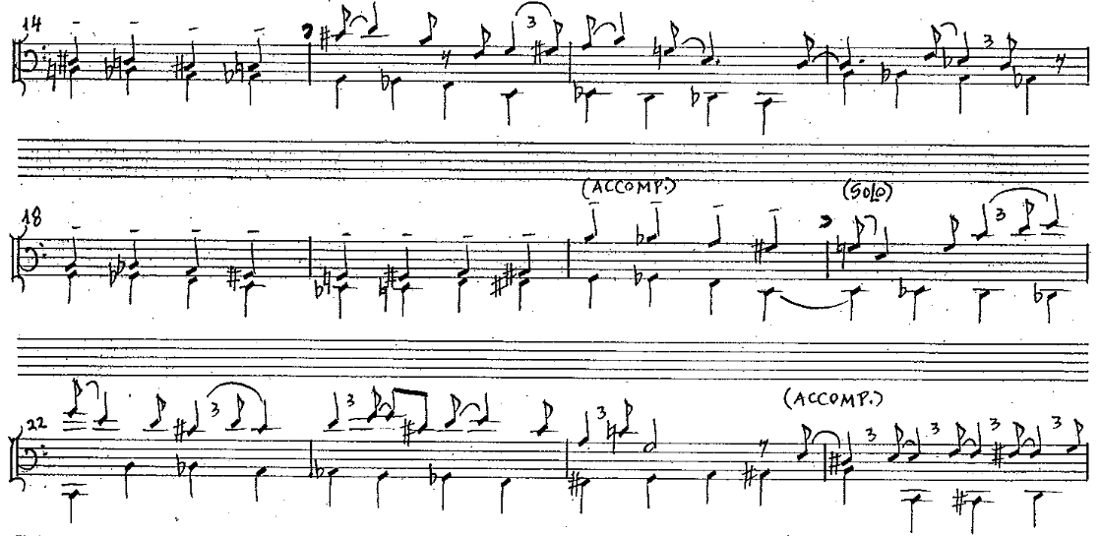
The next interlude begins in m. 25 and goes through m. 28. This interlude breaks the major thirds pattern and incorporates off-beat rhythms in m. 25. In measure 26 the two voices turn into one, and a variety of interval patterns in similar and opposite motion are explored. The fifth and last phrase begins in m. 29 and ends in m. 34. The variation closes with a nine-measure coda, which is shown in Ex. 50. It starts in m. 35 with a single voice outlining octaves. In the following measure the octaves turn into major tenths, which become major triads in m. 37. Measures 38-39 have extended harmonies typical of jazz. The last four measures of the coda have three to four voices. In each measure two of the voices are held in whole notes, while the others move chromatically. The variation ends on a G major chord in second inversion.
Example 50. Op. 72, Var. XI, mm. 34-43.
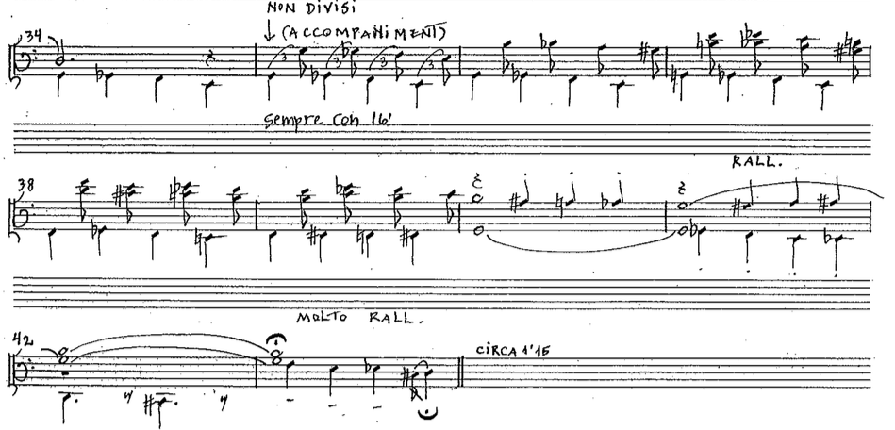
In the first half of the variation the phrase length shortens while the interlude length gets longer. The first phrase is five measures long, the second is four, and the third, three. The first interlude is one measure long, the second is two, and the third, three. Both the fourth phrase and the fourth interlude are four measures in length. The fifth phrase is six measures long and the coda lasts for nine measures.

Variation XII
The twelfth and last variation is called “Brave…Bear-Like!” This variation is the longest of all and is an impressive and massive ending to the entire etude. As expected, the last variation is written in the home key of B-flat major, but unlike the Theme, the meter is 2/4. The movement has a subtitle Rondino and has five sections, ABACA. The first section is for one manual only and exposes the whole Theme. The second section, starting in m. 19, is for the pedal only and uses free sequence-like material that is loosely related to Theme. The whole section is in sixteenth notes. The third section begins in m. 55 and is a variation of the first section. The rhythm this time is in triplets and both manuals and pedal are involved. The fourth section, which starts in m. 73, is for the pedal only, just like the second section, but the rhythm is in triplets. The fifth and last section starts in m. 101 and it is written for the manuals and the pedal. The Theme is played in the manuals with short interludes.
The entire variation is in the shape of a large crescendo - dynamic, rhythmic, and textural. Laurin is more general in the registrational suggestions here. For the opening she asks for a mf dynamic, but specifies “on the bright side.” The second section has an f dynamic indication with 16.’ In the third section the left hand plays on principals 8,’ 4,’ and 2,’ while the right hand plays on a Trumpet stop or Cornet. In the fourth section Laurin asks for foundations 16,’ 8,’ 4,’ and 2,’ plus manual to pedal coupler. In the last two measures of this section she adds full Swell and mixtures, and two measures later she asks for full Great plus 16’ reeds coupled to the pedal. In the fifth section the manuals begin ff. In the last two measures of the piece Laurin asks for full organ. The rhythmic intensification is achieved by increasingly faster note values. The first two sections are in sixteenth notes, the third and fourth sections are in sixteenth note triplets, and the last section is in thirty-second notes. Thickening of the texture also happens gradually. Only the manuals are used in the first section and only the pedal in the second. In the third section the manuals and pedal play together. While the fourth section uses only the pedal, the faster note values keep the energy of the crescendo going. In the last section Laurin uses full chords, three to four notes in each hand, in addition to thirty-second notes in the pedal.
As already mentioned, the first section is for the manuals. It is chordal with four voices most of the time, and includes lots of passing and neighbor tones. The Theme can often be heard although not all the notes are present at all times. The length of the phrases varies. The first phrase ends in m. 5, the second in m. 8, the third in m. 14, and the last phrase goes until the end of m. 18. Laurin uses mainly secondary dominants, chromatic notes and some modal mixture. For example, in m. 2 there is V7/IV, m. 3 – V/vi, m. 6 – V/iii, m. 14 - vii°7/iii, m. 17 - vii°7/IV, just to name a few. They do not always resolve the expected way. For instance, the last chord in m. 7 is V7/IV, which then goes to V/V, which never resolves. Sometimes the secondary dominants do not resolve if they are in a sequence. An example of that is found in mm. 11-13 (See Ex. 51). Modal mixture is another technique Laurin uses. An A-flat major chord sounds on the downbeat of m. 11. This sonority is flat VII in the key of B-flat major. D-flat major and G-flat major occur in mm. 16 and 17. Both keys are chromatic mediants of the home key. Sometimes Laurin uses chromatic pitches to create interesting sonorities. For instance, on the downbeat of m. 7, she adds E-natural to C and A, which creates an A minor chord. Example 51 contains the entire first section.

Example 51. Op. 72, Var. XII, mm. 1-18.
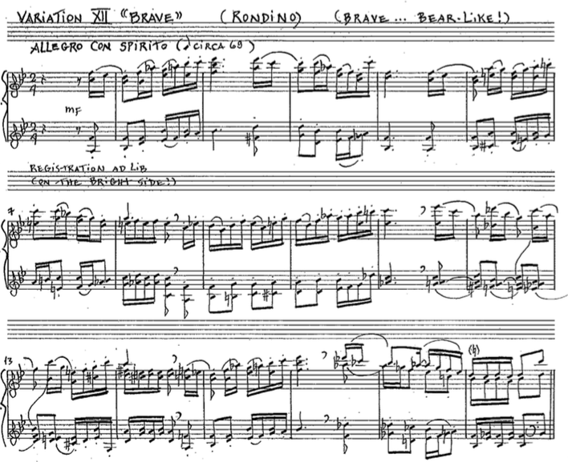
The second section starts in m. 19 and it has perpetual sixteenth-note motion. The first half of the first Theme phrase can be traced from mm. 19-23 (see Ex. 52), and 25-29 after which the material drifts from the Theme and becomes somewhat sequential. The first sequential part occurs in mm. 3-6. While it is not a sequence per se, sequential motion is apparent. The pattern goes up chromatically from C to F.
Example 52. Op. 72, Var. XII, mm. 19-26.
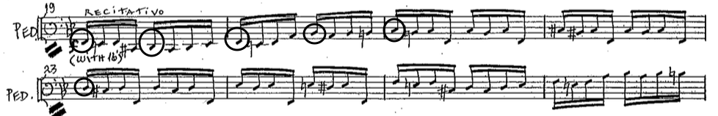
Measures 25-30 are an exact repetition of mm. 19-24 but an octave higher. Measures 31 and 32 are a link to the next pattern. The following two-measure pattern, defined by diminished fourths and fifths, begins on high F and quickly moves down to low E-natural. Two more patterns appear in similar fashion after which a slightly different version of the established pattern occurs in m. 39 and lasts for four measures. The difference is rooted in the direction of the motion – in the new pattern the motion moves up and down with much smaller intervals and encompasses only an octave. Starting at m. 43 the first pattern returns and continues to m. 46. From m. 47 through m. 52 the sixteenth-note pattern changes direction and begins to move upward by using very wide intervals (like elevenths and sevenths) and very small intervals (like minor seconds.) The last two measures of the second section segue to the next section by employing trills on high F and middle F (prolonging the dominant), both with fermatas.
Harmonically, the third section is exactly the same as the first one. The differences between the two include having the pedal play along with the manuals in the third section, along with the right hand playing sixteenth-note triplets instead of regular sixteenth notes. Also, the chords in the left hand are fuller at times. Compare Ex. 51 and Ex. 54.
Example 53. Op. 72, Var. XII, mm. 55-58.
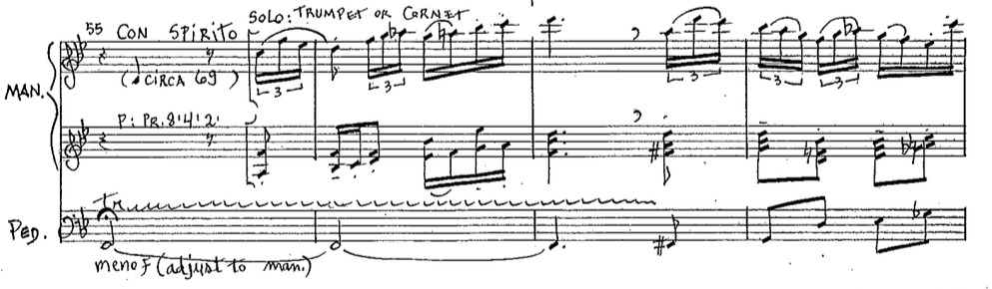
No thematic connections to the Theme can be traced in the fourth section (See Ex. 54). A sixteenth-note triplet pattern defines the whole section. The first three measures, mm. 73-75, consist of octave leaps combined with smaller intervals, seconds or thirds. All of the notes make up a scale; however, the scale is not like any of the conventional scales of Western music. The notes are: F – G-flat – A-flat – B-flat – C-flat – D-flat – E-flat – E-natural, with F being the pitch center. The following four measures, mm. 76-79, have more scalar motion with occasional small skips. The notes of these four measures make up a complete chromatic scale with D being the center of it. Measures 80-83 present yet a different treatment of the material. Laurin has added an eighth-sixteenth-note pattern as a variation of the continuous triplet, which is used simultaneously with the regular triplet. F seems to be the center but the scale is not the same as in mm. 73-75. In these four measures a sequence is combined with a repeated pattern. While the sequence goes up by step, the repeated pattern emphasizes the importance of F by surrounding it with E-natural and G-flat.
Example 54. Op. 72, Var. XII, mm. 73-87.
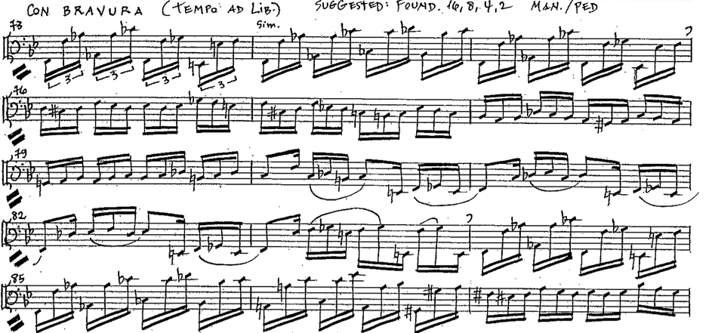
The next few measures follow the same format from mm. 73-83 but in different key areas. Measures 84 and 85 are exactly the same as mm. 73-74. Measure 86 is where the pitch center begins to change and the new area includes sharps rather than flats. Measures 87-90 are a transposition of mm. 76-79, and the new chromatic scale center is F-sharp. This time one note of the scale is missing, A-flat/G-sharp. Measures 91-94 mimic mm. 80-83, however, the pattern is turned around – the sequence is in the lower register, while the repeated pattern is in the higher register. The pitch center in this section is E. From mm. 95-98 free material is used, which is based on the previous four measures. Measures 99 and 100 are an exact repeat of the beginning two measures of the section at mm. 73-74. A two-measure link connects the fourth and fifth sections. It is a rising chromatic gesture in thirty-second notes.
The fifth section starts with the pick-up to m. 103. Just like the third section, the fifth section is a harmonic repeat of the first section but the texture is even thicker. At times both hands have three to four note chords. At the very opening of the section the Theme is stated in chords in the right hand while the left hand plays in chromatic scalar motion in thirty-second notes. From mm. 107-109 the chromatic scalar motion moves to the pedal, still in thirty-second notes, while both hands play the thematic material in chords (See Ex. 55).

Example 55. Op. 72, Var. XII, mm. 106-111.
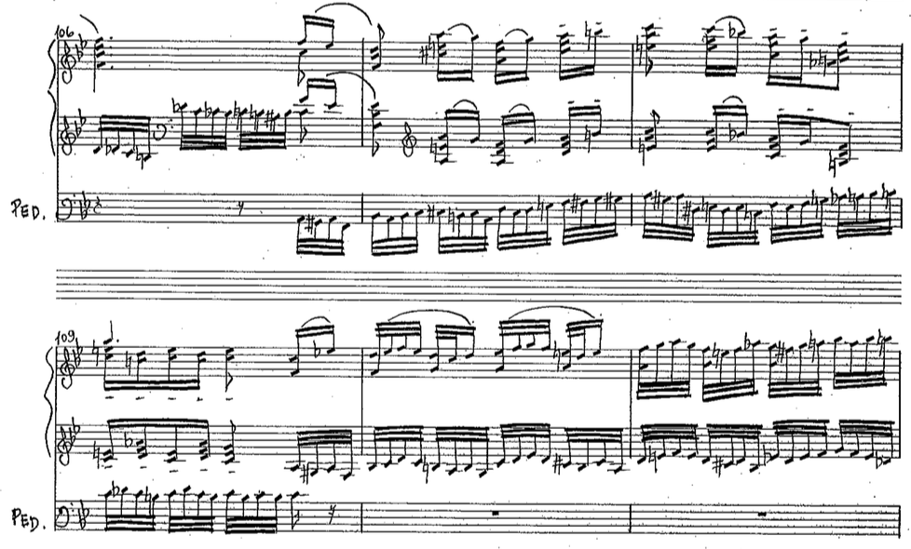
In mm. 109-111 both hands play in similar motion in thirty-second notes. The fast scalar motion resumes in the pedal in mm. 112 and the hands once again play the Theme in full chords. This continues until m. 119, which is the end of the Theme material. Laurin adds a tag from mm. 119-132. In m. 119 a chromatic ascending scale in first inversion triads in the manuals is juxtaposed with a descending scale in the pedal. The tonal center is briefly destabilized on the downbeat of m. 120 with a C mm7 chord in the manuals and a chromatic scale in the pedal. Measure 121 has a trill on E-natural and F-natural in the pedal, while the manuals play chromatically in second inversion triads. Measures 122 to the end restore B-flat major as the home key. These measures contain pedal runs and occasional chords on strong beats in the manuals. From m. 127-132 the first few notes of the Theme are stated one last time, as shown in Ex. 56. The piece finishes with a plagal cadence in thick chords.

Example 56. Op. 72, Var. XII, mm. 126-132.
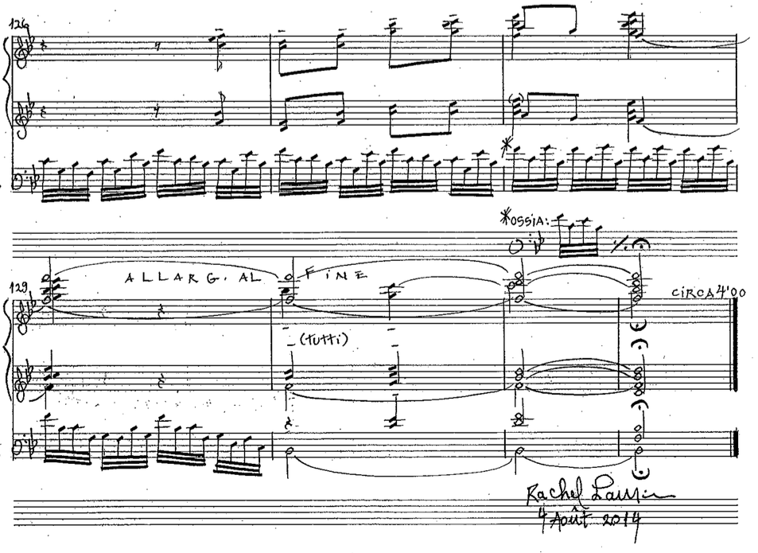
The twelfth variation is in rondo form. While the refrain appears every time in the same key and has the same harmonic structure, each subsequent presentation of the refrain is a variation of the opening refrain.

The tonal and metrical structure of the etude is found in Table 4:
Movement | Key | Meter
Theme | B-flat major | 6/8
Variation I | B-flat major | 6/8
Variation II | B-flat major | 3/4
Variation III | B-flat major | 4/4
Variation IV | Non tonal/D (minor)/multiple pitch centers | 6/8
Variation V | B-flat major | 6/8
Variation VI | D major | 6/8
Variation VII | Ambiguous  D minor/F major implied | 4/4
Variation VIII | B-flat minor | 4/4
Variation IX | F major/Mixolydian | 3/4
Variation X | B-flat (major)/harmonically ambiguous/chromaticism/jazzy harmonies | 3/4
Variation XI | G major/chromaticism/jazzy harmonies | 4/4
Variation XII | B-flat major | 2/4
Table 4. Op. 72, tonal and metrical outline of the variations.
Symphonic Etude for Solo Pedal, Op. 72: Variations on ‘That Good Old Baylor Line’ was written last in the set of etudes. Laurin showcases her versatility as a composer by demonstrating a variety of compositional styles in a Theme with variations. Variations I, II, III, V, VI, IX, and XII are written in more traditionally tonal styles. Variations X and XI are in jazzy styles and variations IV, VII and VIII use more abstract harmonic language. In this etude, Laurin’s harmonic language is defined by the use of conventional Western harmonies, unresolved secondary chords, parallelism, and a different degree of chromaticism. In addition, some of the more harmonically ambiguous variations are non-tonal but do have pitch centers and use tertian harmonies. Sometimes she uses modal scales or creates her own scales. Laurin often uses sequences as a way to quickly approach and explore distant key areas. In comparison to the other two etudes, Op. 72 has more tonally oriented key relationships. The Theme is in B-flat major and the variations are in B-flat major/minor (tonic), D major/minor and G major (mediant keys), and F major (dominant).

Chapter 4: Conclusion
The detailed analyses of Étude Héroïque, Op. 38, Étude-Caprice, Op. 66 (Beelzebub’s Laugh), and Symphonic Etude for Solo Pedal, Op. 72: Variations on ‘That Good Old Baylor Line’ by Rachel Laurin reveal common features in multiple aspects of her writing. Similar common traits in registration, form and harmony can be discerned in the three organ etudes.
The fact that Laurin is an organist herself is obvious in her organ works. She writes in an idiomatic way for the instrument, showing a thorough knowledge of the organ and its capabilities. Though her registrational suggestions hint at the use of a French-style organ, her pieces are adaptable to most any large three-manual instrument. For instance, the organs she is most familiar with have powerful reeds on all manuals, which is not necessarily the case on many American organs. Also, the French-influenced instruments have Harmonic flutes, which are often not present in American organs. However, a knowledgeable performer can find substitutes for the stops suggested.
In Op. 38 Laurin is more general in her registrational directions. She mostly asks for different dynamic levels (p, mp, mf, etc.) with occasional specific suggestions (Harmonic flutes 8’ and 4,’ Voix Celeste and Gambe, etc.). In Op. 66 she is much more specific regarding the desired sounds. Since in the majority of the piece the ‘buzzy’ sound is used to represent the ‘fly’ effect, she gives a specific stop combination (Gambe 8,’ Principal 4,’ Nazard 2 2/3,’ and Oboe 8,’). While general dynamic levels are present, most of the registrations are specific. As in Op. 66, Op. 72 has fewer generic dynamic suggestions than specific timbre combinations. Since Op. 72 is a set of variations, each movement’s title is depicted by a corresponding combination of stops. Laurin is a concertizing organist, and as such she has an understanding that registrational markings are only suggestions since no two organs are alike. In the interview conducted by the author she states that the performer should feel free to adjust the registrations to the available resources. Her registrational suggestions aim to give an idea of the general character of the particular section or movement.
All three etudes have large formal structures which are sectional and have recurring motives. Opp. 38 and 66 are both rondo forms. Op. 38 has 14 sections and the refrain does not always come back consistently, however, it is always in the ‘tonic’ key. Op. 66 is a more straight-forward rondo form and has nine sections. All but one of its recurring refrains are in the ‘tonic’ key. Op. 72 is a Theme with 12 variations, where each variation has a title describing its character. The last variation is in a five-part rondo form. Every time Laurin uses rondo form she varies the refrain in one way or another – harmonically, rhythmically, texturally, or lengthwise. In a sense, she uses variation form within the rondo form by varying each reappearance of the refrain and the secondary themes. It is important to note that Laurin favors recurring motives as a unifying factor.
Contrast is another feature favored by Laurin. She uses contrast on different levels – dynamic, texture, tempo, and character. In Opp. 38 and 66 the character and tempo of the refrains are contrasted with a recurring lyrical theme in softer dynamic, slower tempo and different texture. Likewise, each variation in Op. 72 is usually contrasting to the preceding and succeeding variations. That shows sensitive writing for the organ, avoiding prolonged sections on Tutti.
Laurin uses counterpoint sparingly. There is no apparent contrapuntal usage in Op. 38. In Op. 66 the C section is in the form a fughetta, and it is the instance of the most prominent contrapuntal writing of the three etudes. In the fourth variation of Op. 72 there is a short canonic phrase in a double pedal line.
All three etudes are programmatic, or descriptive of their respective titles. Étude Héroïque, Op. 38 depicts an heroic mood from the very beginning. In the refrains Laurin employs dotted rhythms, accent markings, thick textures and powerful dynamics to musically paint the mood of the piece. Étude-Caprice, Op. 66 (Beelzebub’s Laugh) very convincingly portrays the Devil’s representation as a ‘fly.’ Laurin uses a lot of dissonant intervals and stepwise motion to paint the buzzing sound of the fly. She couples that with registration which further brings out the buzzy sound. Symphonic Etude for Solo Pedal, Op. 72: Variations on ‘That Good Old Baylor Line’ is based on Baylor University’s alma mater. While each variation is based on the Theme, each variation also has a descriptive title, such as “Nostalgic,” “Naïve,” “Show-off,” etc. Laurin masterfully interprets the moods of each movement by incorporating appropriate registration, technique, and texture.
In the three etudes a variety of phrase length is evident. Laurin uses regular length phrases, such as two or four measures, but she also employs a number of unequal length phrases. In Op. 38 the refrain and the lyrical theme’s phrases consist of two or four measures. In Op. 66, the first phrase in the refrain is four measures long, while the second phrase is six measures. In the B section of Op. 66 the first few phrases last for five measures. In Op. 72 the length of the phrases in each movement varies – some are as short as three or four measures, while others last for more than eight measures.
The three organ etudes carry common harmonic features which characterize Laurin’s language. Opp. 38 and 66 thoroughly exhibit her compositional style. While neither work is tonal, both feature pitch centers and tertian harmonies. In Op. 38 the pitch centers last from a measure up to an entire section. In Op. 66 the pitch centers are more local and never last for more than a few measures. Both etudes demonstrate brief and quickly changing tonicizations. Opus 72 appears to feature some of her typical harmonies, but it also showcases her fluency in tonal music as well as jazz. In addition to tonality, the tonal variations in the etude feature secondary dominants, unresolved secondary dominants, chromatic mediants, and chromatic or direct modulations to distantly related keys. In all three etudes she uses different degrees of chromaticism (from only a few pitches to a complete chromatic scale), parallelism, unusual successions of chords, and diatonic and chromatic sequences. In addition, Laurin prominently uses the minor v chord in Op. 38, which strongly weakens the typical V-i relationship in Western music. She also emphasizes the predominant function by using chords such as VI, iv, and the Neapolitan. Furthermore, in Op. 66 the composer employs minor chromatic mediants. In Western music the majority of composers use major chromatic mediants to a greater degree than minor chromatic mediants. In Op. 72 she employs modal mixture and her own scales. Two of the variations are in jazzy styles, which make use of extended harmonies and blue notes.
In all three organ etudes Laurin shows thorough knowledge of Western musical harmony, and she successfully uses techniques to avoid some of the conventions of that music. While her music employs tertian harmonies, her harmonic language is distinctly unique. She favors ‘old’ musical forms such as rondo and variations, but she uses the forms in somewhat new and different ways. Her in-depth understanding of the organ makes her music idiomatic for the instrument, while still being very challenging for the organist. Rachel Laurin’s distinctive and intricate style of composing has made her a leading organ composer of the 21st century.
Rachel Laurin fell in love with music at an early age. Her exposure to a variety of styles written in the idiom of tonal music had a major influence on her own harmonic language. In her early pieces she used more traditional tonal harmonies. In the course of the years she expanded her musical vocabulary and her writing departed from strictly tonal harmonies. While her harmonic language is firmly rooted in the fundamentals of tonal harmony (i. e. tertian sonorities), it has matured to a new level, where pitch centers take over as implications of major and minor keys. The three organ works analyzed in this paper, Opp. 38, 66 and 72, represent her distinctive harmonic style. The pieces were chosen at the suggestion of the composer because she feels that they are among the compositions which best define her musical personality. While this study focuses on a small part of Laurin’s compositional output, it has revealed common features between the surveyed works. This document is among the first efforts to explore Rachel Laurin’s harmonic style, and can be used as a catalyst for further research on the composer.

Bibliography
Barone, Michael. 2015. “Rachel’s Children.” Accessed January 5, 2016. http://pipedreams.publicradio.org/listings/2012/1241/.

Baylor University. 2015. “Isabelle Demers.” Accessed January 5, 2016. http://baylor.edu/music/index.php?id=859311.

Demers, Isabelle. 2015. Accessed January 5, 2016. http://isabelledemers.org.
Cowan, Ken. 2015. Accessed January 5, 2016. http://organistkencowan.com.
Rice University. 2015. “Ken Cowan.” Accessed January 6, 2016. http://music.rice.edu/facultybios/cowan.shtml.

Laurin, Rachel. 2015. Accessed January 5, 2016. http://rachellaurin.com.
Wikipedia. Last modified December 6, 2015. Accessed January 12, 2016. https://fr.wikipedia.org/wiki/Belzébuth.

Appendix: Organ Works by Rachel Laurin
Solo
Suite bréve, Op. 6, No. 1. Ligugé, France: Europart-Music, 1988.
Suite bréve, Op. 6, No. 2. Ligugé, France: Europart-Music, 1988.
Sonata in F, Op. 7. Score, 1985.
Hommage à Lucien Daveluy, Op. 13. Score, 1988.
Scénes vosgiennes, Op. 16. Ligugé, France: Europart-Music, 1989.
Prelude, Op. 24. Score, 1992.
Variations sur un Noël Lorrain, Op. 26. Ligugé, France: Europart-Music, 1995.
Quatre Pélerinages en Lorraine, Op. 30. Ligugé, France: Europart-Music, 1996.

Three Pieces, Op. 31. Colfax, NC: Wayne Leupold Editions, 2012.
Symphony No. 1, Op. 36. Colfax, NC: Wayne Leupold Editions, 2008.

Acclamations, Op. 37. Score, 2003.

Étude Héroïque, Op. 38. Colfax, NC: Wayne Leupold Editions, 2012.
Petite Suite sure un Motet de Gerald Bales, Op. 41. Toronto, Canada: RCCO Music Publications, 2005.

Twelve short Pieces, Op. 43. Colfax, NC: Wayne Leupold Editions, 2008.
Introduction and Passacaglia, on a Theme by Raymond Daveluy. Colfax, NC: Wayne Leupold Editions, 2011.

Prelude and Fugue in F Minor, Op. 45. Chapel Hill, NC: Hinshaw Music, 2008.

Partita on “Nun danket,” Op. 47. Colfax, NC: Wayne Leupold Editions, 2009.
Epilogue, Op. 50. Colfax, NC: Wayne Leupold Editions, 2014.
A Royal Canadian Fanfare, Op. 53. Colfax, NC: Wayne Leupold Editions, 2012.

Three Bagatelles, Op. 54. Colfax, NC: Wayne Leupold Editions, 2012.
Symphony No. 2, Op. 55: Tone Poem on ‘The Fall of the House of Usher,’ by E. A. Poe. Score, 2010.

Greensboro Suite, Op. 56. Colfax, NC: Wayne Leupold Editions, 2011.
Seven Pieces, Op. 58. Colfax, NC: Wayne Leupold Editions, 2012.
Berceuse à Pierre, Op. 61. Score, 2011.
Fantasy and Fugue on the Genevan Psalm 47, Op. 62. Organ Duet, score, 2012.

Suite in D Major for Don Menzies, Op. 63. Score, 2012.
Twelve short Pieces, Volume 3, Op. 64. Colfax, NC: Wayne Leupold Editions, 2014.

Étude-Caprice, Op. 66: Beelzebub’s Laugh. Score, 2013.
Twelve short Pieces, Volume 4, Op. 68. Score, 2014.
Tone Poem for the Advent Season, Op. 69. On the Anthem Creator Alme Siderum and the Kyrie of Mass XVIII, Deus Genitor Alme. Score, 2013.

Symphonic Etude for Solo Pedal, Op. 72: Variations on ‘That Good Old Baylor Line.’ Score, 2014.

Fantasy and Fugue in D Major, Op. 73. Score, 2014.
Organ Transcriptions
Variations and Fugue on a Theme by Handel, Op. 24, by J. Brahms: Transcription Op. 11. Colfax, NC: Wayne Leupold Editions, 2008.

Sonata in B Minor, by F. Liszt: Transcription Op. 20. Score, 1991.
Concerto in D Minor, BWV 1052, by J. S. Bach, 2nd and 3rd movements: Transcription Op. 30-B. Score, 1996.

Chromatic Fantasy and Fugue in D Minor, BWV 903, by J. S. Bach: Transcription Op. 30-C. Score, 1996.

Organ with Other Instruments

Cantata ‘Veni Creator,’ Op. 10, for voice and organ. Score, 1987.
Acclamations, Op. 37, arrangement for organ, 2 trumpets, 1 trombone. Score, 2003.

Fantasia for Organ and Harp, Op. 52. Colfax, NC: Wayne Leupold Editions, 2010.

Concerto in D, Op. 59, for organ string orchestra and timpani. Colfax, NC: Wayne Leupold Editions, 2011.

Sonata for Organ and Horn, Op. 60. Toronto, Canada: RCCO Music Publications, 2011.

Introduction et Allegro, Op. 65, for organ and oboe. Score, 2012.

Unless noted, the biographical information is from an interview by the author with Rachel Laurin, via Skype, May 15, 2015.
Laurin, Rachel. 2015. Accessed November 7, 2015. http://rachellaurin.com.
Laurin, Rachel. 2015. Accessed November 7, 2015. http://rachellaurin.com.
Unless noted, the information in this section is from an interview by the author with Rachel Laurin, via Skype, May 15, 2015.
Unless noted, the information in this section is from an email message from Ken Cowan to the author, October 21, 2015, and an interview with Rachel Laurin, via Skype, May 15, 2015.
“Belzébuth,” Wikipedia, accessed January 11, 2016. https://fr.wikipedia.org/wiki/Belzébuth.
Ken Cowan, email message to author, October 21, 2015.
The information in this section is from interviews by the author with Isabelle Demers, Norman, OK, June 19, 2015, and with Rachel Laurin, via Skype, May 15, 2015.
All pieces in non-italics designate unpublished works, and are cited in accordance with the Chicago Style Manual.

