UNIVERSITY OF OKLAHOMA
GRADUATE COLLEGE

ON THE PROBLEM OF RESOLVING MONOPOLY HOLDOUTS
WITHOUT REQUIRING EMINENT DOMAIN

A DISSERTATION
SUBMITTED TO THE GRADUATE FACULTY
in partial fulfillment of the requirements for the
Degree of
DOCTOR OF PHILOSOPHY

By:

WILLIAM LINDLEY RIDLEY
Norman, Oklahoma
2023

ON THE PROBLEM OF RESOLVING MONOPOLY HOLDOUTS
WITHOUT REQUIRING EMINENT DOMAIN

A DISSERTATION APPROVED FOR THE
CHRISTOPHER C. GIBBS COLLEGE OF ARCHITECTURE

BY THE COMMITTEE CONSISTING OF:

Dr. Charles G. Warnken, Chair

Dr. Aimee Franklin, Outside Member

Dr. John Harris

Dr. Bryce Lowery

© Copyright by WILLIAM L. RIDLEY 2023
All Rights Reserved.

DEDICATION:
Dean Charles W. Graham PhD, AIA (1951-2016)
For your wisdom, courage, and foresight.

Founder:
Planning, Design, and Construction PhD Program
University of Oklahoma Christopher C. Gibbs College of Architecture
Norman, Oklahoma

ACKNOWLEDGEMENTS:

This is to gratefully acknowledge the invaluable assistance provided to this research by:
The Association of University Real Estate Officials [AUREO]

And to:

Mr. Guy Tozzoli (1922- 2013)
Project Manager/ Lead Land Assembly Negotiator
World Trade Center, NYC

FRONTISPIECE:

“Don't it always seem to go…
That you don't know what you've got ‘til it’s gone…
They paved paradise and put up a parking lot”.

Joni Mitchell

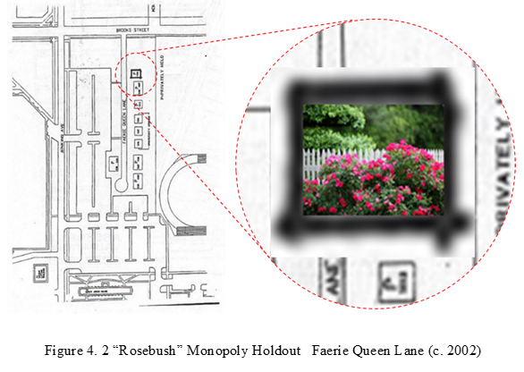

Table of Contents:
Abstract: ix
List of Figures: x
List of Tables: xi
Chapter 1: Introduction 1
Background of the Problem: 1
Statement of the Problem: 5
Purpose of the Study: 6
Primary Research Question: 9
Significance of the Study: 12
Description of the Chapters: 13
Chapter 2: Literature Review 15
Introduction: 15
Part 1: Traditional Market Failure/ Externalities Theory 15
Part 2: Codification of US Eminent Domain Policy Orthodoxy 20
Part 3: Heterodox/Grounded Theory Research Methods 23
Chapter 3: Historical Case Studies 29
Case Study #1: Columbia, Maryland (1962-1965) James Rouse Developer 29
Case Study #2: Walt Disneyworld, FL (1964-1967) Walt Disney Developer 44
Case Study #3: World Trade Center, NYC (1961-72) Guy Tozzoli Project Manager 50
Chapter 4: IRB Interview Study Results 62
IRB Research Interview Design Methodology: 62
IRB Study #1: Memorial Stadium Expansion Project Univ of OK -Norman (2005) 63
IRB Study #2: BLACKLAND Transitional Housing Project UT-Austin (2005) 66
IRB Study #3: South Campus Expansion Project UI-Urbana-Champaign (2006) 72
IRB Study #4: Clifton Heights Revitalization Project Univ of Cincinnati (2006) 75
IRB Study #5: (Counterexample) Rookwood Exchange, Norwood, OH (2006) 79
IRB Study Conclusions: 82
Chapter 5: Discussion 84
Inspiration for the Study: 84
Summary of the IRB Study Results: 85
Key Research Findings: 89
Synthesis of Research Findings: 92
Conclusions: 95
Final Observations: 96
References: 98
Appendix A: IRB “Expedited Review” Application Protocol 103
Appendix B: Case Study Transactions/Acquisitions Records 109
Appendix C: 3D Synthesis Matrix Analysis of Coursework Readings 116

Abstract:
The purpose of this study is to explore practical alternatives for resolving monopoly holdouts, i.e., without requiring eminent domain. Berman v Parker (1954) first set formal precedent by allowing eminent domain to be used for taking strictly non-blighted property. Kelo v City of New London (2005) simply reaffirmed Berman, authorizing the use of eminent domain to overcome seven monopoly holdouts, including that of Ms. Susette Kelo, for a new Pfizer Corporation headquarters, on grounds that creating new jobs and tax revenues constituted “Public Benefits” under the Takings Clause. Heller (1998) argued that using direct government intervention in this manner simply transfers monopoly ownership rights between private individuals, i.e., while leaving scarce public resources persistently underutilized as “anticommons” property… a classic market failure. Following Coase’s landmark research on free riders, this study conducted formal IRB interviews with members of AUREO [Association of University Real Estate Officials] who willingly discussed their direct participation, i.e., during ongoing campus expansion projects at four respective public universities across the US. Chapters 3 and 4 fully document the firsthand narrative accounts provided by these real-world practitioners, who described the host of innovative bargaining mechanisms they routinely employed, i.e., enabling them to successfully resolve monopoly holdouts without requiring eminent domain. As a practical alternative to longstanding policy orthodoxy, this study finds that by systematically negotiating reciprocal, mutually beneficial [Coasean] bargaining agreements with recalcitrant landowners, it is possible to successfully resolve monopoly holdouts without requiring eminent domain. While these results may seem pedestrian to the layperson, their practical implications for the practice of Regional/City Planning are profound. By employing these same innovative bargaining mechanisms, it enables urban planners/designers/administrators to continually seek out local innovators (of all stripes), partner them with youthful entrepreneurs, and create new economic, social, and political synergies, i.e., enabling any local municipality to achieve the same urban growth/redevelopment/revitalization renaissance pioneered in so-called “College Towns”.
Keywords: Coase Theorem; Market Externalities: Holdout Problem; Anticommons; Pigouvian Taxation; Takings Clause: Eminent Domain; Market Failure Theory; Samuelson Condition; Nash Equilibrium; Sustainability:

List of Figures:
Figure 3.1 Establishing Initial Target Assembly Area for Columbia, MD (1962) 30
Figure 3.2 Original Robert Moxley Plat Map (Phase 1) 31
Figure 3.3 Composite Scan of Original Moxley Plat Map (with Landowner Data) 33
Figure 3.4 (CAD-Digitized) Initial “Cedar Lane” Acquisition 1962 (Phase 1) 34
Figure 3.5 Viable Parcel Nucleus Acquisition (Phase 2) 34
Figure 3.6 Coordinated Straw-Purchasing of Viable Parcel Nucleus (Phase 2) 35
Figure 3.7 Dasher Holdout Property (Phase 2) 36
Figure 3. 8 Consolidation of Outparcels to Establish Outer Boundaries (Phase 3) 37
Figure 3.9 “Three G’s” Holdout Properties (Phase 3) 38
Figure 3.10 Final Consolidation of Remaining/Available Infill Parcels (Phase 4) 40
Figure 3.11 Final “Swiss Cheese” [aka “Spotted Leopard”] Assemblage Pattern 41
Figure 3.12 Smith Holdout Property [Schematic] 42
Figure 3.13 Current Village Pattern Columbia, Maryland (c. 2019) 43
Figure 4.1 Faerie Queen Lane Assembly Project Univ of Oklahoma, Norman (2002) 63
Figure 4.2 “Rosebush” Monopoly Holdout Faerie Queen Lane (c. 2002) 65
Figure 4.3 BLACKLAND Neighborhood Center Project Univ Texas-Austin (2004) 66
Figure 4.4 South Campus Expansion Project Univ Ill -Urbana-Champaign (2004) 72
Figure 4.5 South Campus Expansion Project Target Assembly Area (2004) 74
Figure 4.6 Clifton Heights Revitalization Project Univ of Cincinnati (2004) 75
Figure 4.7 Clifton Heights Project Target Assembly Area Univ of Cincinnati (2004) 76
Figure 4.8 Rookwood Exchange Project Norwood, Ohio (2002) 79
Figure 4.9 Rookwood Exchange Project Target Assembly Area (2002) 81
Figure A3.1 Literature Review 3D Synthesis Matrix 118

List of Tables:
Table A. 1 IRB Interview Protocol Application Format 103
Table A. 2 Initial AUREO Recruitment/Referral Tree [Sample Population (27)] 107
Table A. 3 Initial AUREO Listserv Recruitment Log 108
Table B. 1 Transactions/Acquisitions Data: Columbia, Maryland 109
Table B. 2 Transactions/Acquisitions Data: Walt Disneyworld, Orlando, Florida 112
Table B. 3 Transactions/Acquisitions Data: World Trade Center, NYC 114
Table C. 1 Chronological Distribution Table of Relevant Literature (1945-present) 116
Table C. 2 Chronological Table of Relevant Literature by Content Area and Decade 117

Chapter 1: Introduction

Background of the Problem:
Ever since Adam Smith, there has been a recognized need for the government to directly intervene in providing public goods. Unlike with strictly private goods, which can be divided up equally, public goods (such as roads, bridges, lighthouses, etc.) are not divisible, i.e., they are strictly “non-rival” and “non-excludable”, and therefore, they cannot be efficiently allocated via the “Invisible Hand”. Indeed, the classic “Public Goods Externality” problem was stated most clearly by the celebrated philosopher David Hume, i.e., more than 30 years before Smith’s “The Wealth of Nations”:
Two neighbors may agree to drain a meadow, which they possess in common; because they know each other’s mind; and each must perceive, that the immediate consequence of his failing his part, is, the abandoning of the whole project. But ’tis very difficult, and indeed impossible that a thousand persons shou’d agree in any such action; it being difficult to concert so complicated a design, and still more difficult to execute it; while each seeks a pretext to free himself of the trouble and expence, and wou’d lay the whole burden on others. Political society easily remedies both these inconveniences.
“Treatise of Human Nature” Hume, D. (1739)
As the leading proponent of pure laissez-faire capitalism, Adam Smith famously posited: “in competition, individual ambition serves the common (public) good…the best result comes from everyone doing the best for himself… By pursuing his own interest, he frequently promotes that of the society more effectually than when he really intends to promote it.” [Smith 1776]
The guiding spirit of the modern Industrial Age (c. 1760-1954) is perhaps best captured by the railroad magnate William Henry Vanderbilt, who was famously quoted as saying: “the Public be damned... they don’t pay!” when asked by a newspaper reporter if private railroads were somehow obligated to accommodate the public welfare. “Railroads are not run for the public benefit, but to pay. Incidentally, we may benefit humanity, but the aim is to earn a dividend." [Dresser 1882]

Following in the footsteps of luminaries such as Smith and Hume, classical economists (such as Mill, Sidgwick, Pigou, Samuelson, et al) universally praised the modern lighthouse, i.e., as being the textbook example of a (laissez-faire-capitalism-produced) pure public good that requires government provision. Since a passing ship neither “uses up” nor “excludes” the light from any other ship, its beacon provides a perfectly non-rival and non-exclusionary pure public good. Paradoxically, in a strictly capitalist market economy, the closer the private entrepreneur actually gets to producing a pure public good, the less is their profit-motive. Indeed, following Hume’s original assertion, namely, that there is no moral incentive for the public to pay for these benefits, the government can (and must) intervene. [Hume 1739; Smith 1776; Mill 1843; Sidgwick 1883; Pigou 1938; Samuelson 1964; Meade 1958; et al]
According to Samuelson, “(there are) certain indispensable public services without which community life would be unthinkable and which, by their nature cannot appropriately be left to private enterprise. As an “obvious” example, he noted that: “a businessman could not build (a lighthouse) for a profit, since he cannot claim a price from each user” [Samuelson 1964]. Likewise, Pigou observed that lighthouses cannot be compensated for their services, simply because they are being provided to third parties “from whom it is technically difficult to exact payment” [Pigou 1938]. For Sidgwick, lighthouses are a class of utilities “(that are) practically incapable of being appropriated by those who produce them or would otherwise be willing to purchase them” [ Sidgwick 1883]. Finally, Mill mused that since “no passing ship should be made to pay at toll on the occasion of its use, no one would build lighthouses from motives of personal interest.” [Mill 1848; Pigou 1938; Samuelson 1954]
In The Economics of Welfare (1938), Pigou observed that such instances of uncompensated services, which arise uniquely during the provision of a pure public good, occur strictly outside the economy, thus, acting as market “externalities”. Pigou’s rationale for using government intervention follows that of Hume, who argues that producers (and consumers) of pure public goods will incorporate only their own costs and benefits, i.e., while ignoring any incidental costs or benefits that may be incurred upon others. Thus, governments are viewed necessarily as “outside” agents who, by imposing taxes and/or subsidies, can “induce” these generators of externalities to moderate their behaviors, thus efficiently reaching general market equilibrium, i.e., while avoiding general market failure. This encapsulates the major assertions of orthodox Market Failure Theory [Bator 1958; Meade 1958; Samuelson 1964; Cowen 1988; et al].
In “The Theory of Externalities, Public Goods and Club Goods” (1996) Cornes and Sandler complete this longstanding theoretical discourse, i.e., by examining how reciprocal holdout/free rider externalities, acting as “uncompensated interdependencies”, inhibit the private market provision of a pure public good. To wit, by freely using the services of lighthouses without paying for them, passing ships act as “free riders”. Likewise, by intentionally withholding their services to collect these fees, lighthouse owners act reciprocally as “holdouts.” Pigou traditionally asserts that the government must intervene directly as an (external) third-party mediator assigning liability to the generators of these reciprocal externalities, i.e., determining whether “A harms B” or “B harms A.” By imposing Pigouvian taxation upon both holdouts and free riders, the government “induces” them to moderate their bargaining behaviors, so as to achieve market efficiency. Therefore, insofar as eminent domain is used to “induce” recalcitrant landowners to moderate their monopoly holdout prices, i.e., to “correct or prevent” a general market failure, it is simply a longstanding relic of Pigouvian policy orthodoxy. [Pigou 1938, Samuelson 1954; Cornes and Sandler 1996;]
In “The Problem of Social Cost” (1960) Ronald Coase successfully challenges traditional Pigouvian policy orthodoxy, arguing that simply because an externality exists, it does not mean it is causing a market failure, nor does it warrant direct government intervention. By this logic, Coase would also argue that just because a monopoly holdout arises during public land assembly negotiations, it does not mean the land assembly project must be forfeited, nor does it warrant the use of eminent domain. Therefore, the purpose of this research study is exploring practical [Coasean-inspired] alternatives for resolving monopoly holdouts, i.e., without requiring eminent domain. [Coase 1960; Coase 1974; Cheung 1973; Bieto, Gordon, and Tabarrok 2002; Klein and Majewski 1988; Liebowitz and Margolis 1994; Foldvary 1994; Tabarrok 2002]

Statement of the Problem:
Starting with Hume’s assertion, namely that eminent domain is required to overcome monopoly holdouts, was first formalized as policy orthodoxy in Kohl v United States (1875), which argued that “the ability of the government to seize property for its uses, such as creating infrastructure… cannot be preserved if the obstinacy of a private person…prevents the acquisition.” [Kohl v United States 1875]
The landmark decision of Berman v Parker (1954) set formal precedent by allowing the use of eminent domain for taking strictly private, non-blighted property, i.e., arguing that “if owner after owner were permitted to (hold out) …these integrated plans for urban redevelopment would suffer greatly." [Berman v Parker 1954]
In Poletown Neighborhood Council v. City of Detroit (1981), the Court argued that the construction of railroads, highways, and other such ‘instrumentalities of commerce’ … would be a “logistical and practical nightmare”, i.e., given the incentive of property owners to hold out. [Poletown Neighborhood Council v. City of Detroit 1981; [Wylie 1990; Greenhut 2004]
Kelo v City of New London (2005) justified the use of eminent domain for overcoming 7 holdouts, including the that of Ms. Susette Kelo, i.e., “as a comprehensive and rational approach to identify and correct a market failure”. [Kelo v City of New London 2005; Posner 2005; Kelly 2006; Berliner 2005; Malamut 2000]
Recent studies (Hornaday, Hubbard, Trimble, et al) have sought to ascertain whether any substantive legislative changes occurred in conventional eminent domain policy the State of Texas, i.e., in following the controversial Kelo decision. In Texas Government Code Chapter 2206.001 (2015) effectively re-affirmed Kelo as policy orthodoxy, i.e., by declaring that high school/college/professional sports stadiums constituted a Public Use, and that Just Compensation, allowing the Courts to increase Just Compensation (up to 250%) i.e., to prevent holdouts under the Takings Clause. [Texas Government Code Chapter 2206.001 (2015) [Hornaday 2007; Hubbard 2008; Trimble 2019]
Following the controversial Kelo decision in 2005, Bassett and Jacobs found that while 43 state legislatures eventually enacted laws restricting eminent domain for strictly private use, nevertheless, most municipal governments chose to retain these powers, i.e., simply as an entrepreneurial device for attracting lucrative corporate redevelopment projects in the aging urban centers, starting in the Reagan-era. [Bassett and Jacobs 2010; Banerjee and Loukaitou-Sideris 2014].
As established by Mill, Sidgwick, Pigou, Samuelson, et al., these longstanding policy assertions requiring the use of eminent domain to overcome monopoly holdouts, i.e., has been fully codified into policy orthodoxy by the Supreme Court. Indeed, since Kohl v United States, this sequence of landmark eminent domain cases in the Supreme Court fully chronicles the formally codification of these assertions, i.e., as standard US Eminent Domain policy. [Callies, Freilich, and Roberts 1994; Cooter and Ulen 2004; Inman and Rubinfeld 1997; Williamson 1975]

Purpose of the Study:
The purpose of this study is to explore practical alternatives challenging such longstanding policy orthodoxy, namely, finding that real-world practitioners who have successfully resolved examples monopoly holdouts without requiring eminent domain. Following the so-called “heterodox” grounded theory research design methodologies pioneered by Coase, Cheung, and Nash, et al, this study begins by conducting a comprehensive case study analysis of historical land assembly projects, i.e., examining the complete organization, planning, and operation of the land assembly negotiation process in situ. Second, it conducts formal IRB research interviews with real-world land assembly practitioners at public universities from across the US, asking them to describe the innovative bargaining mechanisms they routinely employed during land assembly negotiations in their ongoing campus expansion projects, i.e., enabling them to successfully resolve monopoly holdouts without requiring eminent domain.

This study replicates the grounded theory research methodology pioneered by Coase in his landmark study “The Lighthouse in Economics” (1974) in which he examined the complete operation of the British lighthouse system, finding that, passing ships and shippers “willingly” paid the tolls rather than becoming free-riders, i.e., openly acknowledging that they “greatly benefited” from the lighthouse services and petitioning the Crown to secure these payments, thus, refuting by existence the longstanding policy orthodoxy that “Pigouvian Taxation” is required to overcome the intractable “free rider” problem. [Mill, Sidgwick, Pigou, Samuelson, Coase 1974; Coase 1960; Tabarrok 2004],]
This study also replicates “The Fable of the Bees: An Economic Investigation” (1973) in which Cheung formally interviewed real-world beekeepers and apple-growers, demonstrating how they voluntarily reached reciprocal, mutually beneficial bargaining agreements, fully compensating each other for their respective bee-pollinating and nectar production services, i.e., without requiring any “outside” government intervention, thus, refuting by existence Meade’s orthodox policy assertion, namely, that taxes and subsidies are required to overcome so-called “ownership externalities”. [Cheung 1974; Meade 1952]
Finally, this study seeks to emulate the game-theoretical model proposed by Nash in “Non-Cooperative Games” (1951) in which he employed to formalize the type of reciprocal (non-governmental) n-person strategic bargaining game specifically envisioned by both Coase and Cheung. Following Nash’s pioneering work, recent studies on the “Holdout Problem” have analyzed the strategic game-theoretical bargaining behaviors, i.e., exhibited by real-world landowners during the Classic Land Assembly Game. [Nash 1960]
This original study is the first-of-its-kind to explore strategic holdout resolution during real-world land assembly negotiations, i.e., as first modelled by Eckart (1980), who demonstrated that when landowners bargain as part of a coalition, each will voluntarily moderate their monopoly holdout price, rather than jeopardize profits for the entire coalition. Likewise, by Strange (1998) who observed that when 2 or more holdouts are bargaining as strategic complements, if one landowner strategically lowers their monopoly price to become “price leader”, this will induce the others to moderate their prices. And lastly, Miceli and Segerson (1998) demonstrated that landowners will voluntarily moderate their monopoly holdouts, i.e., by accepting off-site “property swaps” in lieu of direct payments. Thus, each of these strategic bargaining scenarios examine how landowners can be “induced” to voluntarily moderate their holdout behaviors, i.e., rather than requiring “external” government intervention via eminent domain. [Eckart 1980; Strange 1998; Miceli and Segersen 2004]

Primary Research Question:
“How do you resolve monopoly holdouts without requiring eminent domain?”
In order to answer the primary research question motivating this study, it sought to examine, firsthand, the strategic bargaining behaviors exhibited by actual monopoly holdouts, i.e., during real-world land assembly negotiations. This study was uniquely fortunate to have collected a sufficient number of robust, well-documented case studies, spanning two successive policy regimes, i.e., those conducted at the height of the Urban Renewal era (c. 1962-65) and during the Kelo controversy (c. 2005-06).
Following the grounded theory research design methodology first pioneered by Coase, this study conducted a comprehensive case study analysis, i.e., seeking to examine the complete organization, planning, and operation of the general land assembly process in situ. For this original study, three historical land assembly projects were selected as paradigmatic case studies: Columbia, MD, Walt Disneyworld, FL, the World Trade Center, NYC. Each was similar in size, scale, scope, and duration, conducted simultaneously at the height of the Urban Renewal era (c.1962-68), and were strictly private, quasi-governmental, or public land assembly projects, i.e., having corresponding powers of eminent domain, respectively. As fully discussed in Chapter 3, each of these landmark projects provided real-world examples, i.e., fully demonstrating how these developers systematically resolved multiple instances of monopoly holdouts, without requiring eminent domain.
Because the land assembly negotiations for both Columbia and Walt Disneyworld were initially conducted in complete secrecy, both developers were able to successfully resolve all monopoly holdouts, i.e., without requiring eminent domain. As the “Crown Jewel” of Urban Renewal projects, the World Trade Center was the first project to face a binding holdout (led by urban activist Jane Jacobs) and also, the first to successfully resolve it through reciprocal bargaining, i.e., rather than exercise its full statutory powers of eminent domain, as first prescribed by Berman v Parker.
To replicate Cheung’s original field interview model, this study conducted formal IRB research interviews with professional real estate administrators at public universities, i.e., asking them to discuss their direct participation in actual land assembly negotiations, i.e., during ongoing campus expansion projects at their respective campuses. As an under-examined population, public university real estate administrators provided an ideal source of original research data. Across the US, university campuses draw from the widest possible range of sizes, types, and locations, each matching their local geography, i.e., from being completely landlocked to being on an open prairie, and everything in between. Likewise, each university is necessarily involved in ongoing land assembly, i.e., ranging from a new parking lot to a full campus expansion. The national organization, i.e., overseeing ongoing land assembly negotiations at public universities public universities is the Association of University Real Estate Officials [AUREO].
To replicate the game-theoretical bargaining model first pioneered by Nash, and later clarified and defined by Eckart, Strange, Miceli and Segerson, et al, this study sought specifically to model the strategic holdout behaviors that arise uniquely during an n-person, non-cooperative land assembly bargaining game, i.e., during real-world land assembly negotiations. From the sample population of twenty-seven “Tier 2” interviewees, as a smaller sample size of six (6) interviewees self-selected as willing participants in the more intensive “Tier 1” research interviews, i.e., to discuss their direct participation in four (4) ongoing land assembly projects at the University of Cincinnati, the University of Illinois Urbana-Champaign, the University of Texas Austin, and the University of Oklahoma Norman. In each case, the respondents fully described the procedures they employed, allowing them to negotiate one-on-one with members of the local community, i.e., successfully resolving a wide range of holdout problems without requiring eminent domain. [Nash 1960; Eckart 1980; Strange 1998; Miceli and Segerson 2010]
As fully discussed in Chapter 4, in the firsthand narrative accounts provided by the IRB interviewees, they fully described the host of innovative bargaining mechanisms they routinely employed during real-world land assembly negotiations, i.e., to resolve monopoly holdouts without requiring eminent domain. Next, they thoroughly explained how they strategically employed these mechanisms, i.e., enabling them to reach reciprocal mutually beneficial bargaining agreements to successfully resolve monopoly holdouts, that otherwise would have caused them to forfeit their projects.
This key finding of this original research study is discovering that public land assembly negotiators, in a wide range of real-world land assembly projects across the US, routinely resolve monopoly holdouts through strategic bargaining, i.e., rather than requiring eminent domain. This discovery is significant because it directly contradicts almost 250 years of longstanding policy orthodoxy, i.e., concerning our basic assertions about monopoly holdout behavior.

Significance of the Study:
The significance of this study was clearly identifying a host of practical alternatives for resolving monopoly holdouts, i.e., without requiring eminent domain. As a practical alternative to longstanding policy orthodoxy, this study finds that, by systematically negotiating reciprocal, mutually beneficial [Coasean] bargaining agreements with recalcitrant landowners, it is possible to successfully resolve monopoly holdouts without requiring eminent domain. While these results may seem pedestrian to the layperson, their practical implications for the practice of Regional/City Planning are profound. By employing these same innovative bargaining mechanisms, it enables urban planners/designers/administrators to continually seek out local innovators (of all stripes), partner them with youthful entrepreneurs, and create new economic, social, and political synergies, i.e., enabling any local municipality to achieve the same urban growth/redevelopment/revitalization renaissance pioneered in so-called “College Towns.”

Description of the Chapters:
Chapter 1: Introduction
Provides a complete roadmap for conducting this original research study. It discusses the historical background of the research topic and provides a concise statement of the problem motivating this original research. It outlines the research design methodology protocols required for conducting this research and explains how they are employed to fully answer the primary research question. Finally, it discusses the results of the study, and how these findings are significant in filling the current gap in our knowledge, i.e., concerning a practical alternative for resolving monopoly holdouts without requiring eminent domain.
Chapter 2: Literature Review
Summarizes and critically analyzes the main research arguments motivating this study. In the relevant literature, there exists a key gap in our understanding between our formal theoretical assertions and their real-world implications concerning monopoly holdout resolution. To address this gap, this formal literature review fully examines the theoretical framework behind these traditional economic assertions, their codification into longstanding policy orthodoxy, and the so-called “heterodox” research design methodologies, i.e., for finding a practical alternative for resolving monopoly holdouts behavior, thus challenging this longstanding policy orthodoxy.

Chapter 3: Historical Case Studies
Fully examines three historical land assembly projects of Columbia, MD, Walt Disneyworld, FL, and the World Trade Center, NYC. As paradigmatic case studies, each thoroughly documented how they successfully resolved monopoly holdouts without requiring eminent domain, i.e., at the height of the Urban Renewal era (c.1962-68).
Chapter 4: IRB Interview Study Results
Fully documents all the original data collected from IRB interviews conducted with AUREO [Association of University Real Estate Officials], who fully described the innovative bargaining mechanisms they routinely employed during ongoing land assembly negotiations at their respective public universities, enabling them to successfully resolve monopoly holdouts without requiring eminent domain, i.e., at the height of the Kelo controversy (c. 2005-6).
Chapter 5: Discussion
Discusses the original inspiration for conducting this study, summarizes the study results, explains the key research findings, clearly states the research conclusions, and offers some final observations, i.e., concerning further opportunities of academic investigation generated by this study.

Chapter 2: Literature Review

Introduction:
The purpose of this Literature Review is to summarize and critically analyze the main research arguments motivating this study. In the relevant literature, there exists a key research gap between orthodox theoretical assertions and their real-world consequences, i.e., concerning longstanding eminent domain policy. To address this gap, this formal review examines the ongoing polemical debate between three main bodies of academic literature; traditional economic theory, its codification as policy orthodoxy, and so-called “heterodox” economic theories, i.e., designed to challenge such longstanding policy orthodoxies.
As a “well-established part of legal and economic lore,” academics have consistently viewed monopoly holdout behavior as a potential market impediment, arising uniquely during public land assembly negotiations. Because a single holdout can permanently halt negotiations, thus causing the forfeiture of a public infrastructure project (such as a road, school, lighthouse, etc.). This strategic holdout behavior causes a general market failure, which only direct government intervention can correct, i.e., via eminent domain. [Miceli and Segerson 1998; O’Flaherty 1994, Shavell 2010, Parisi 2002; Menezes and Pitchford 2004; Munch 1976]

Part 1: Traditional Market Failure/ Externalities Theory
In his classic “Inquiry into the Nature and Causes of the Wealth of Nations” (1776) Adam Smith, the foremost champion of pure, laissez-faire Industrial Capitalism, was first to assert the need for direct government intervention in the provision of schools and other public goods, i.e., whose benefits “simultaneously affect a group of individuals” [Cornes and Sandler 1996 p.3]. Indeed, the clearest statement of the “Public Goods Problem”, as recognized in classical economics, was provided more than 30 years earlier by Smith’s friend and colleague, the celebrated empirical philosopher David Hume, who remarked:
“Two neighbors may agree to drain a meadow, which they possess in common; because ‘tis easy for them to know each other’s mind; and each must perceive, that the immediate consequence of his failing in his part, is, the abandoning of the whole project. But ‘tis very difficult, and indeed impossible, that a thousand persons shou’d agree in any such actions, it being difficult for them to concert so complicated a design, and still more difficult for them to execute it; while each seeks a pretext to free himself of the trouble and expence, and wou’d lay the whole burden on others. Political society easily remedies both these inconveniences.”
“Treatise of Human Nature” Hume, D. (1739)
In the footsteps of such luminaries as Smith and Hume, classical economists (Mill, Sidgwick, Pigou, Samuelson, et al) universally praised the modern lighthouse, i.e., as being the textbook example of a (laissez-faire-capitalism-produced) pure public good. Since each passing ship neither “uses up” nor “excludes” the light from any other passing ship, its beacon provides a perfectly non-rival and non-exclusionary pure public good. Paradoxically, in a strictly capitalist market economy, the closer the private entrepreneur actually gets to producing a pure public good, the less their profit-motive. Indeed, following Hume’s basic assertion, because there is no moral incentive for the public to pay for these benefits, the government must intervene.
In 1848, in “Principles of Political Economy” in the chapter “Of the Grounds and Limits of the Laissez-Faire or Non-Interference Principle” British economic philosopher John Stuart Mill was first to use the modern lighthouse as a textbook example of a pure public good, asserting that it must be provided by the government rather than by private enterprise, saying:
“Since it is impossible that the ships at sea which are benefited by a lighthouse, should be made to pay a toll on the occasion of its use, no one would build lighthouses from motives of personal interest, unless indemnified and rewarded from a compulsory levy made by the state”.
J.S. Mill (1848)

In 1883, in “Principles of Political Economy” in the chapter “The System of Natural Liberty Considered in Relation to Production”, Henry Sidgwick also observed:
“…there are some utilities which, from their nature, are practically incapable of being appropriated by those who produce them or would otherwise be willing to purchase them. For instance, it may easily happen that the benefits of a well-placed lighthouse must be largely enjoyed by ships on which no toll could be conveniently imposed.”
H. Sidgwick (1883)

In 1938, in “Economics of Welfare” Arthur Pigou cited Sidgwick’s lighthouse example as an instance of “uncompensated services”, i.e., in which “incidental services are performed to third parties from whom it is technically difficult to exact payment.” Finally, in 1964, in “Economics”, in the section on the “Economic Role of Government”, Paul A. Samuelson was the most forthright of all these earlier writers, asserting that: “government provides certain indispensable public services without which community life would be unthinkable and which by their nature cannot appropriately be left to private enterprise”, i.e., citing the lighthouse as an “obvious example”. [Pigou 1938; Samuelson 1964]
In The Economics of Welfare (1920), Pigou observed that such instances of uncompensated lighthouse services, which arise uniquely during the provision of a pure public good, i.e., occur strictly outside (“externally to”) a capitalist market economy, thus, they operate as market “externalities”. Pigou’s rationale for using government intervention also stems from Hume, namely, that producers (and consumers) of pure public goods incorporate only their own costs and benefits, i.e., while ignoring any incidental costs or benefits they may incur upon others. Governments intervene as “outside” agents, who, by imposing taxes and/or subsidies, can “induce” these generators of externalities to moderate their behaviors, thus efficiently reaching general market equilibrium, i.e., while avoiding general market failure [Pigou 1920; Bator 1958; Meade 1958].
In “The Theory of Externalities, Public Goods and Club Goods” (1996) Cornes and Sandler complete this longstanding theoretical discourse, examining how +/- externalities are reciprocal, i.e., acting as “uncompensated interdependencies” in the provision of a pure public good. Using Pigouvian taxation/subsidization, the government intervenes as an (external) third-party mediator, namely, to assign liability to the generator of the externality, i.e., by determining whether “A harms B” or “B harms A”. Moreover, the imposition of taxes (and/or subsidies) is meant to induce both holdouts and free riders to moderate their behaviors, so as to achieve efficiency. Likewise, insofar as eminent domain is also a form of Pigouvian taxation, i.e., which the government uses to “induce” recalcitrant landowners to moderate their monopoly holdout prices, and thus, preventing the forfeiture of a public urban redevelopment project and averting a general market failure, eminent domain is the cornerstone of longstanding Pigouvian policy orthodoxy [Cornes and Sandler 1996].
In “Economics: An Introductory Analysis” (1964) Samuelson comes closest to codifying this longstanding policy orthodoxy concerning monopoly holdout externalities. By extending the example of the lighthouse one step further, he asserts the very fact that the fees cannot be collected from free riders automatically qualifies the lighthouse as a “suitable social or public good”. However, even if private operators could somehow magically collect a fee from each passing ship—say, by radar reconnaissance--- as they would a private good at market-equilibrium price, it may not be socially optimal to continue providing the service. Why not? Because there will always be one more “external” holdout/free rider, hence, there will always be one more market failure. Because of this intractable market externality problem, he concludes that it may not be “socially worth it” to provide pure public goods at all. This is the so-called “Samuelson Condition.” [Samuelson 1964].
For Coase, there is a real-world element of tragedy in Samuelson’s assertions. On the one hand, as long as a single holdout can still cause the forfeiture of an ongoing public land assembly project, eminent domain is required to overcome the holdout, i.e., to “correct or prevent” the market failure. On the other hand, because “there’s always gonna be one more holdout,” it “may not be worth it anymore” to keep using eminent domain (i.e., the cornerstone of longstanding policy orthodoxy). In Samuelson’s words, it may not be worth it to provide these “indispensable” pure public goods (such as roads, schools, lighthouses, etc.) at all… resulting inevitably in a real-world economic tragedy. [Samuelson 1954; Coase 1960; Cheung 1973; Keynes 1936].
In “The Problem of Social Cost” (1960) Ronald Coase openly challenges such longstanding policy orthodoxy, arguing that just because the externality exists, it is not necessarily causing a market failure, nor does it immediately warrant direct government intervention [Coase 1960; Coase 1974].

Part 2: Codification of US Eminent Domain Policy Orthodoxy
Starting with Hume and Adam Smith, the longstanding theoretical economic assertions concerning holdout resolution were initially codified into policy orthodoxy in Kohl v United States (1875), which justified the use of eminent domain to seize private property, with just compensation, for the construction of government buildings in Cincinnati, Ohio, on grounds that “the ability of the government to seize property for its uses, such as creating infrastructure… cannot be preserved if the obstinacy of a private person…prevents the acquisition (i.e., by holding out).” [Kohl 1875]
Likewise, the landmark decision of Berman v Parker (1954) justified the widespread use of eminent domain for slum clearance, i.e., on grounds that large-scale public housing projects in Washington, DC, constituted “Public Benefits” under the Takings Clause. To defend its rationale, the Court argued “if owner after owner were permitted to (hold out) …these integrated plans for urban redevelopment would suffer greatly." Upon validating “Title I: Slum Clearance” (Fair Housing Act of 1949), Berman greenlighted the full “constellation” of infrastructure programs/policies launched during the Urban Renewal program, i.e., starting in the mid 1950’s. [Burns, R., contributors: Wallace, Suarez, Jackson, Caro, et al. 2002]
Poletown Neighborhood Council v. City of Detroit (1981) authorized the use of eminent domain to clear “Poletown”, an ethnic neighborhood in Hamtramck, a suburb of Detroit, Michigan, i.e., to build a new GM Cadillac production facility. It was likewise asserted that without eminent domain, “the construction of railroads, highways, and other such ‘instrumentalities of commerce’ … would be a “logistical and practical nightmare”, i.e., given the incentive of property owners to hold out.” [Poletown 1981; Wylie 1990; Nader 1990; Greenhut 2004]
Finally, in Kelo v City of New London (2005) eminent domain was used to overcome 7 holdouts, including the property of Ms. Susette Kelo, i.e., to build a new Pfizer Corporate headquarters in the “economically depressed” neighborhood of Fort Trumbull, Connecticut. The Court justified its policy rationale as being a “comprehensive and rational approach to identifying and correcting a market failure”. [Kelo 2005; Berliner 2005; Bullock 2005; Malamut 2000; Somin 2015]
Following the controversial Kelo decision, “many ordinary Americans were shocked to learn a city could condemn homes and small businesses in order to promote private development – a reality they were unaware of until the publicity surrounding Kelo drove it home to them” [Somin 2015; Berliner 2005; Bullock 2005; Malamut 2000; et al]. In "After Kelo: Political Rhetoric and Policy Responses" Jacobs and Bassett (2005) conducted a landmark nationwide survey, reporting a broad consensus still supported the traditional use of eminent domain, e.g., for abandoned/blighted property, roads, bridges, schools, etc., but were equal opposed to its strictly private use, e.g., for large-scale corporate redevelopment projects. In response to Kelo, 43 state legislatures enacted laws restricting eminent domain for strictly private use, while most municipal governments chose to retain these powers as an entrepreneurial device, i.e., for attracting lucrative corporate redevelopment projects in the aging urban centers, starting in the Reagan-era. [Jacobs and Bassett 2010; Banerjee & Loukaitou-Sideris 2014; Somin 2015]
Following the controversial Kelo decision, recent studies (Hornaday (2007), Hubbard (2009), Trimble (2019), et al) find that the State of Texas effectively re-affirmed this longstanding policy orthodoxy, i.e., as first established in Berman, and later in Kelo. Texas Government Code Chapter 2206.001 (2015) declared that high school/college/professional sports stadiums constituted a “Public Benefits”, and that Just Compensation could be increased (up to 250%), i.e., to prevent holdouts under the Takings Clause. [(Hornaday 2007; Hubbard 2009; Trimble 2019]
Nevertheless, as a formal assessment of longstanding eminent domain policy, in “Foreward” Judge Richard Posner argues that the strong adverse reaction to the Kelo decision was actually evidence of its pragmatic soundness. “When the Court declines to invalidate an unpopular government power, it tosses the issue back into the democratic arena… They will have to roll up their sleeves and fight the battle in Congress and state legislatures - where they may well succeed.” [Posner 2005; Kelly 2006]

Part 3: Heterodox/Grounded Theory Research Methods
In “The General Theory of Employment, Interest and Money” (1936): John Maynard Keynes was first to challenge what he perceived as the undue influence of traditional economic theory, i.e., upon formal policy orthodoxy, arguing that purely theoretical assertions by traditional economists and political philosophers, both right and wrong, are more powerful than is commonly understood. Keynes summarized his rationale for challenging longstanding policy orthodoxy in his famous quote:
“Practical men who believe themselves to be quite exempt from any intellectual influence, are usually the slaves of some defunct economist. Madmen in authority, who hear voices in the air, are distilling their frenzy from some academic scribbler of a few years back.”
― John Maynard Keynes 1936
In “The Lighthouse in Economics” (1974) Coase purposefully examined the real-world operations of British lighthouses, i.e., specifically challenging longstanding theoretical policy assertions by Mill, Sidgwick, Pigou, Samuelson, et al. Arguing that, despite the example of the lighthouse being used extensively in traditional literature, to his knowledge, none of these celebrated economists had ever made a comprehensive study of lighthouse finance and administration in situ. Indeed, “it appears that they simply plucked the lighthouse “out of thin air” to serve as an illustration”. Coase’s main polemic was to question:
How is it that these great men have, in their economic writings, been led to make statements (assertions) about lighthouses which are misleading to the facts, whose meaning, if thought about in a concrete fashion, is quite unclear, and which, to the extent that they imply a policy conclusion, are very likely wrong?
--- Ronald Coase 1972
In “The Fable of the Bees: An Economic Investigation” (1973) Cheung likewise interviewed real-world beekeepers and apple growers, i.e., openly challenging Meade’s assertions about bee pollination and nectar production. Arguing that whether or not Keynes was correct in his claim that policymakers are "distilling their frenzy" from economists, it appears self-evident that some economists [planners, judges, government policymakers, city officials, et al] have been distilling their policy implications from fables. [Cheung 1973; Meade 1958; Bator 1958]
“In a desire to promote government intervention, they have been prone to advance, without the support of careful investigation, the notion of "market failure." My main criticism, rather, concerns their approach to economic inquiry in failing to investigate the real-world situation and in arriving at policy implications out of sheer imagination. As a result, their work contributes little to our understanding of the actual economic system.”
--- Stephen C. Cheung 1973

In “The Lighthouse in Economics” (1974) Coase took exception to the apparent lack of academic grounding shown by these celebrated economists, whose purely theoretical policy assertions became policy orthodoxy, i.e., but they did not rigorously evaluate them in the real-world. To address this gap, Coase purposefully examined the operation of British lighthouses, finding that passing ships and shippers “willingly” paid the tolls for lighthouse services, thus refuting by existence the longstanding policy assertions by Mill, Sidgwick, Pigou, Samuelson, Meade, etc. concerning free riders. By describing the complete organization, financing, and operation of the centuries-old British lighthouse system, Coase provides a practical policy alternative for correcting intractable market externalities, i.e., without requiring direct government intervention.
In “The Fable of the Bees: An Economic Investigation” (1973) Cheung likewise challenges Meade’s theoretical assertions, i.e., requiring that the government intervene in bee-pollination and honey production. In Meade’s popular essay, he described honeybees as freely pollinating the apple blossoms without compensating them for their services, while also freely collecting the nectar for making honey without compensating the apple grower. Obviously, without bee pollination there would be no apples, and without nectar there would be no honey, inevitably resulting in a market failure. As a remedy, Meade calls for the government to impose a system of (Pigouvian) taxes and subsidies to overcome such “ownership externalities,” thereby ensuring that scarce resources are efficiently allocated. [Cheung 1973; Meade 1958; Bator 1958]
Surprised at the universal credence given to Meade’s lighthearted fable, Cheung investigated the actual pricing and contractual arrangements of beekeeping in Washington State, one of the largest apple-growing regions in the world. Looking no further than the yellow pages in the Telephone Directory (c. 1974) he found conclusive evidence showing that they routinely transact both nectar and pollination services in the marketplace. Finding the traditional analysis of this reciprocal bargaining arrangement “unnecessarily complex” Cheung conducted field interviews with actual beekeepers and apple-growers, discovering that they routinely reached formal contracts, fully compensating each other for their respective services, and that these pricing and contractual arrangements were consistent with the efficient (market-clearing) allocation of resources, thus, fully internalizing Meade’s so-called “ownership externalities” without requiring government intervention. [Cheung 1973; Meade 1958; Bator 1958]
In “Non-Cooperative Games” (1951) John Forbes Nash employed game-theoretical behavioral analysis to demonstrate how two (or more) profit-maximizing agents can reach a reciprocal “n-person” non-cooperative bargaining agreement, i.e., without requiring “external” government intervention. This is the same real-world bargaining scenario described by Cheung. In order to reach an efficient pricing and contractual agreement, both beekeepers and apple growers must possess complete information, i.e., regarding each other’s optimal profit-maximation strategies. Moreover, because both firms’ production functions are strategically interdependent, their optimal bargaining strategies are inherently reciprocal. Thus, the solution for this game is necessarily a Nash Equilibrium. [Nash 1951]
Following Nash’s pioneering work, recent game-theoretical studies have analyzed the strategic bargaining behaviors of landowners during the classic Land Assembly Game. In 1985, Eckart was first to examine the strategic resolution of monopoly holdout behavior from a purely game-theoretical point of view. Eckart demonstrated that when uninformed landowners bargain as a coalition, an individual will be induced to lower their monopoly price upon realizing it poses a negative externality that jeopardizes profits for the whole coalition. [Eckart 1985; Menezes and Pitchford 2004; Shavell 2010]
In 1995, Strange examines monopoly holdout behavior as it affects savvy landowners who have full knowledge of the market value of their property, as well as their optimal monopoly holdout price. Strange observes that when two or more savvy landowners realize that their properties are strategic complements in the assembly, by persuading one of the landowners to slightly lower their monopoly price, they can become the “price leader” thus inducing the others to lower their prices (and forcing them to accept a lower price). [Strange 1995; Munch 1976; Miceli and Segerson 2007]
In 1998, Miceli and Segerson investigate a strategic bargaining scenario whereby are negotiators encourage landowners to reach voluntary agreements such as “property swaps”, i.e., enabling them to maximize their price through direct transfer of property, rather than direct payment. In each case, using principles of game theory, developers are able to increase the likelihood of reaching mutually beneficial agreements with landowners that they may have missed otherwise. [Miceli and Segerson 1997; 1998; 2007; 2010]
In “Sequential Bargaining and Land Assembly: A New Theory of the Holdout Problem” Miceli and Segerson (2010) formally characterize the classic Holdout Problem, namely, as the “Supply Side analogue” to the traditional Free Rider Problem. This characterization is significant, because it bridges the key research gap between the current body of game-theoretical holdout/land assembly literature and the well-defined analytics of orthodox Market Externality Theory. Whereas Miceli and Segerson viewed holdouts and free riders as simple analogues, Cornes and Sandler defined them as “uncompensated interdependencies,” i.e., operating as reciprocal market externalities.
In “The Tragedy of the Anticommons: Property in Transition from Marx to Markets,” Heller clarifies and defines this reciprocal relationship between holdout and free rider externalities. Where Hardin describes the “tragedy of the commons” as the condition of market failure where the lack of private ownership leads to the tragic overutilization of scarce public resources, Heller describes the symmetric “tragedy of the anticommons”, i.e., as the reciprocal under-utilization of the same scarce resources due to “excessive” ownership rights (including zoning laws). Heller also recommends that the exercise of such excessive property rights, aka monopoly holdouts, be “re-bundled” more efficiently, e.g., via eminent domain. [Hardin 1968, Heller 1998, 2008; Buchanon and Yoon 2000]
This Literature Review fully summarizes and critically analyzes the main research arguments motivating this original study. It then examines previous landmark studies exploring the reciprocal “Free-Rider” problem, guiding the research design methodology fully employed by this original study. Following the same heterodox/grounded theory research design methodology pioneered by Coase, Cheung, Nash, et al, it is possible to refute the same longstanding orthodox policy assertions, i.e., concerning the reciprocal monopoly holdout problem.

Chapter 3: Historical Case Studies

Case Study #1: Columbia, Maryland (1962-1965) James Rouse Developer
Between November 1962 and January 1965— James Rouse privately assembled more than 13,000 acres of land for a secret residential development project --at the height of the Urban Renewal era--without requiring any eminent domain. Employing a covert network of dummy corporations, straw purchasers, and local brokers (acting unknowingly as his private real estate agents), Rouse successfully negotiated 112 individual transactions-- involving more than 600 landowners and related parties---acquiring enough contiguous land parcels to realize (at least a scaled-down version of) his original Master Plan. In fact, it was only after he had substantially completed the land assembly that Rouse publicly announced his intentions to build the planned community of Columbia, Maryland. [Tennenbaum 1996; Bloom 2004; Olsen 2003]
Phase 1: Establishing Target Assembly Area (1962)
By late 1962, Howard County, Maryland, had become a likely target for large-scale development, being situated along the path of the newly proposed route for Interstate Highway 95 in the Baltimore-Washington DC corridor. Sensing a unique entrepreneurial opportunity, private real estate broker Robert Moxley listed his own property (along with two adjoining properties owned by his family members) -- as a large assemblage providing close access to the proposed I-95 route in rural Howard County, Maryland -- just southwest of the Greater Baltimore area. Unbeknownst to Moxley, the sale of his 1,039 acre "Cedar Lane" assemblage-- also finalized the secret location of the New Town of Columbia, Maryland.
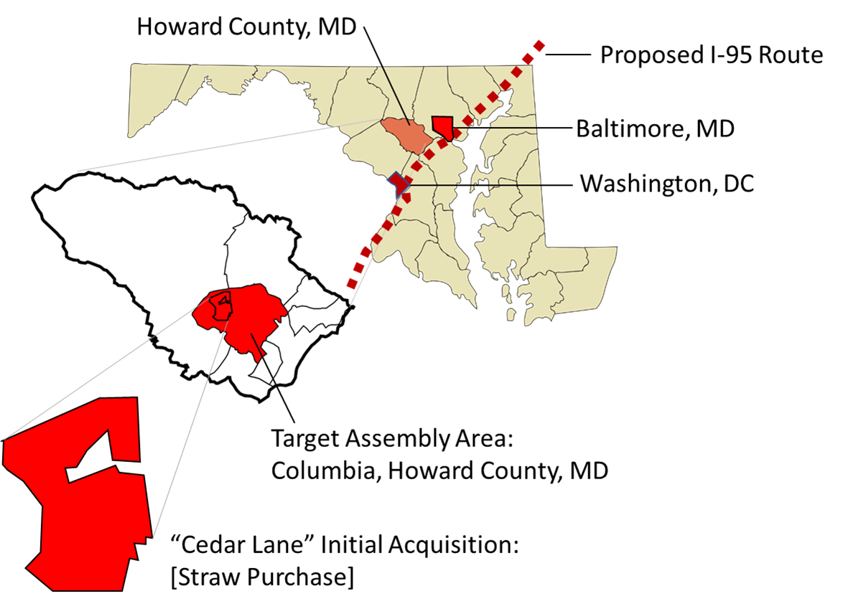
Figure 3.1 Establishing Initial Target Assembly Area for Columbia, MD (1962)
After closing the initial transaction, Moxley immediately sought listings for adjacent properties--- in hopes of discovering a pattern of interest among buyers in the immediate vicinity. As adjacent parcels began to sell--- Moxley speculated that the area surrounding “Cedar Lane” was primed for large-scale development, commissioning the creation of a large plat map to identify prospective parcels-- and compile key information about the respective landowners-- in a 15,000+ acre potential assembly area. Obviously, GIS technology was not available in 1962. Nevertheless, as an experienced military cartographer---Moxley's map was state-of-the art-- providing him with enough data to coordinate any prospective acquisitions in a large target area. The following is a facsimile of original plat map commissioned by Robert Moxley in early 1963:
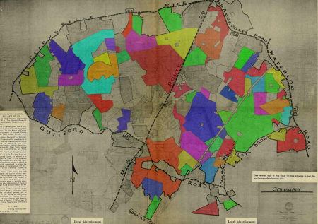
Figure 3.2 Original Robert Moxley Plat Map (Phase 1)

Observing Moxley' s unique entrepreneurial skill in negotiating the Cedar Lane acquisition, the decision was straightforward to recruit him (unknowingly) to be the principal negotiator for the entire Columbia project. Subsequently, Rouse instructed his assembly team to work closely with Moxley to gain listings for as many parcels as possible in the immediate vicinity of Cedar Lane-- to assemble a viable nucleus of parcels around this initial acquisition: Indeed, Rouse coordinated the entire covert operation through a single attorney—directing a cadre of purchasing agents from five dummy corporations acting as shill buyers-- coordinating all initial acquisitions simultaneously—while deliberately hiding the identity of the famous developer from the landowners, local realtors, and the general public as long as possible—to keep land prices from skyrocketing until the land assembly was substantially complete.
In his personal memoir “Land Acquisition: The Realtor’s Perspective" Robert Moxley describes his direct participation--- including his evolving relationship with James Rouse-- throughout the Columbia acquisition/negotiation process. According to his narrative accounts, the overall Columbia land assembly process was organized in four logical phases: the objective of Phase 1 was to establish the target assembly area for the master project—Phase 2 was to establish a viable parcel nucleus-- justifying the continuation of the project---Phase 3 was to acquire the adjacent outparcels-- eliminating as many voids as possible-- consolidating the unified assemblage to the boundaries of the proposed city. Finally, Phase 4 sought to acquire as many remaining infill parcels as possible to complete the assemblage. [Tennenbaum 1996]
The objective of Phase 1 was to establish a suitable target assembly area for the projected 22+ square mile townsite --- within the larger 254 square mile area of Howard County. Given Moxley’s keen peripatetic observations—as well as the robust chronological data provided by the Columbia Archives-- it is possible to analyze the complete operation of this process in situ. The first step in making this analysis was constructing a simple time-lapse study of parcel-aggregation during the four phases of the Columbia acquisition/negotiation process. First, a facsimile of Moxley's original plat map was scanned as four segments, and then remerged into a single composite panel, where a raster-to-vector digitization was performed by hand (in AutoCAD 2019), i.e., to create digital parcel boundaries from the original. The names of the property owners-- clearly visible in the original scan-- were cross- referenced with their corresponding names and transaction dates contained in the Howard County public records (1962-1965) -- establishing a functional time-series GIS database.
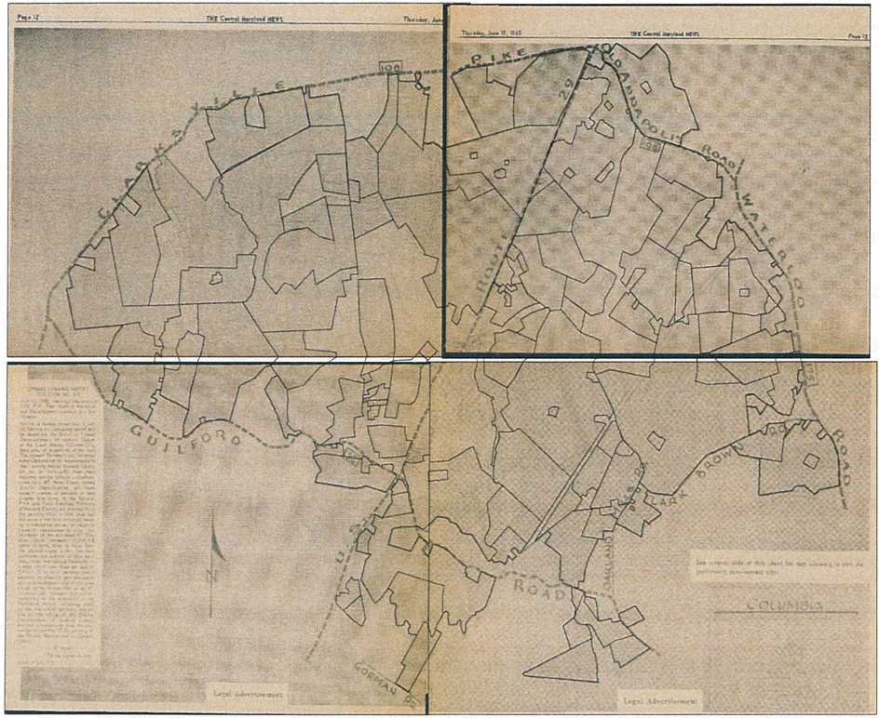
Figure 3.3 Composite Scan of Original Moxley Plat Map (with Landowner Data)
Each parcel-polygon was then grouped and color-coded as a unique data layer --according to the respective month of each transaction. Finally, each monthly parcel-group was mapped following to the chronology provided by Moxley— enabling a time-lapse study of each progressive acquisition/negotiation phase during the Columbia land assembly process.

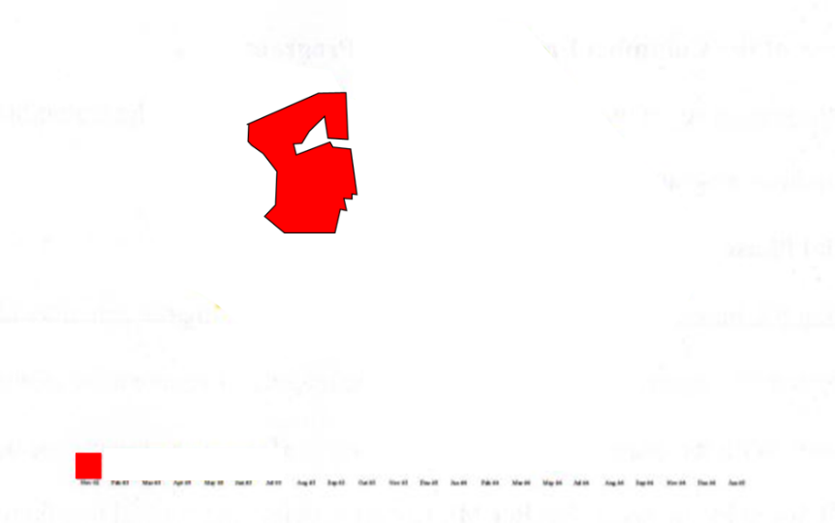
Figure 3.4 (CAD-Digitized) Initial “Cedar Lane” Acquisition 1962 (Phase 1)

Phase 2: Establishing a Viable Parcel Nucleus (1962-63)
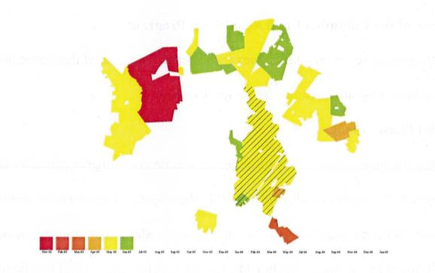
Figure 3.5 Viable Parcel Nucleus Acquisition (Phase 2)
The objective of Phase 2 was to acquire enough contiguous land parcels around Cedar Lane to establish a viable nucleus— justifying the continuation of the project. According to the original transactions data provided by the Columbia Archives, of the total 13, 371 acres that were assembled for the Columbia project, 5,793 acres (41.7%) were acquired in Phase 2. In fact, 4,368 acres (75.2%) were acquired solely in the month of May. Indeed, from November 1962 to May 1963, this land was acquired exclusively through straw purchasing/blind agency. Consequently, these records fully describe the scale and scope of Rouse’s secret acquisition/negotiation strategy. By employing a network of dummy corporations, straw purchasers, and local brokers (acting unknowingly as private real estate agents) to secretly (and simultaneously) Rouse was able to centrally coordinate all aspects on the ongoing land assembly process.
The following plate illustrates the centrally coordinated effort by Rouse’s five dummy corporations—working unknowingly through Moxley – to secure the acquisition of specific parcels immediately adjacent to Cedar Lane—establishing a viable parcel-nucleus in Phase 2: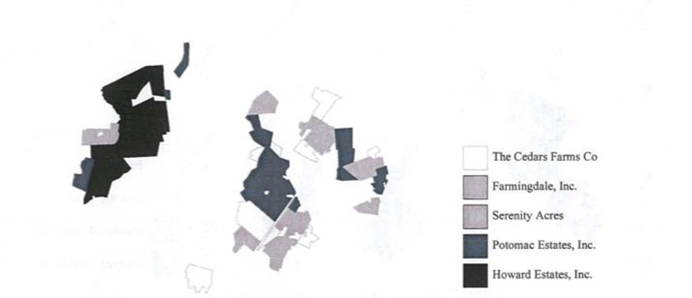
Figure 3.6 Coordinated Straw-Purchasing of Viable Parcel Nucleus (Phase 2)

By mid-May 1963, it was determined that one parcel in particular was absolutely essential to the continuity of the project. Indeed, the acquisition of the Dasher property was the “critical point” in Rouse’s plan for the new city; failure to purchase this property in a timely fashion would have resulted in the abandonment of the entire project. The following map demonstrates why the Dasher property (shown in red) was indispensable for the continuity of the overall assemblage. Hence, with the successful (and pivotal) Dasher transaction, Phase Two was concluded. Had this critical parcel not been acquired, the Columbia project would have been abandoned.
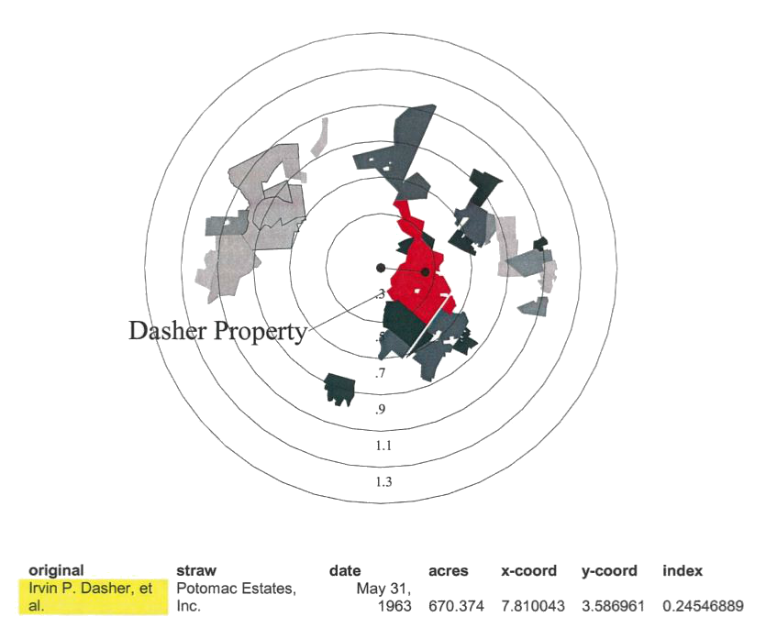
Figure 3.7 Dasher Holdout Property (Phase 2)
Around the time of the Dasher acquisition, Moxley noticed a random article in a Baltimore newspaper, highlighting the commercial developments in which James Rouse and his principals were involved. Although the article did not refer to the building of an entire city, it did cause Moxley to suspect privately that James Rouse was the ultimate purchaser of the land he had been selling. His suspicions were confirmed soon thereafter when Rouse requested to meet him personally, where he learned firsthand from Rouse that he had been assembling a large tract, and while he would still not discuss the planned use of the land he was buying, he did say it was imperative to expedite the assemblage, and not to divulge the name of the purchaser to anyone. With the Dasher acquisition in tow, and the viability of the project established, these events marked the transition to Phase 3.
Phase 3: Consolidation of Adjacent Outparcels (June 1963-July 1964)
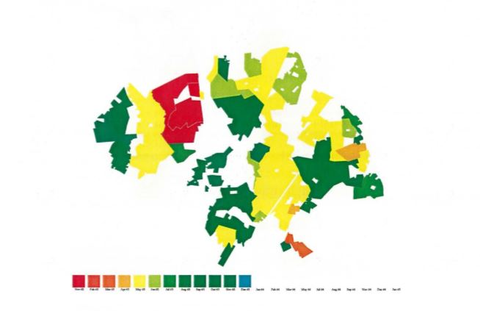
Figure 3. 8 Consolidation of Outparcels to Establish Outer Boundaries (Phase 3)
The objective of Phase 3 was to acquire the outstanding outparcels to consolidate the unified assemblage to the outer boundaries of the target area. [Note: Phase 3 also involved the acquisition of parcels lying outside the target area-- to be used for special purposes, including speculative assemblages to be used for barter as voluntary “property swaps”.]
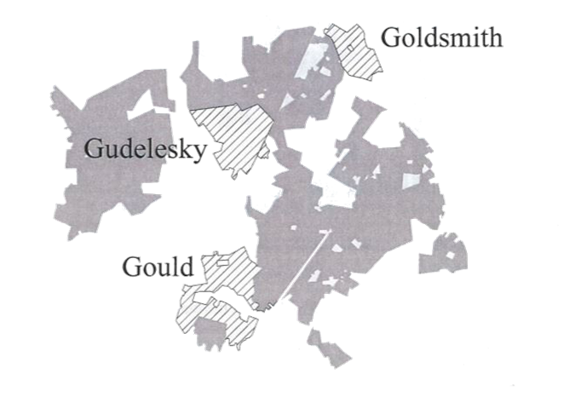
Figure 3.9 “Three G’s” Holdout Properties (Phase 3)

During their initial encounter, Rouse told Moxley that the purpose of the meeting was to ask for his help in planning the strategy for the acquisition of three very important properties, owned respectively by three very knowledgeable and shrew businesspeople. After much discussion, it was agreed that while all three outparcel properties were essential, the acquisition priority was for the Gould parcel, the Gudelesky parcel, and finally the Goldsmith parcel. The anticipated cost factor was the primary reason for the order of priority; Cedar Lane had been bought for $630 per acre, but the price was now approaching $1000 per acre. The owners of the so-called "3G's" were well aware of this price escalation, and since they were all financially secure with no need to sell, they were expected to sell only if they believed they were getting a premium price for their land: The following map shows the strategic positioning of these key outparcels relative to the assemblage completed as of August 1963:
The acquisition of the Gould property was straightforward. As the grandson of railroad magnate Jay Gould, the owner was under no financial obligation to part with the land, but he had decided to sell the acreage and put the funds in bank stock. The negotiation was therefore relatively easy, because the owner knew the value of the land as well as the potential value of the bank stock he intended to purchase, so the sales price was soon agreed upon.
During the negotiations for the Gudelesky property, the owner was extremely interested in hearing about who was buying all the land and for what purpose. However, Moxley avoided these questions and talked only about buying the property. After several meetings with the landowner and without a deal, he tried one last ploy. He assembled 4,000 contiguous acres by option in western Howard County, including the Turf Valley Country Club. He met again with the landowner and offered the 4,000 acres with its 36hole golf course in return for the parcel. This arrangement was satisfactory, and the landowner agreed to sell his 1000 acres tract on October 14, 1963, for $3,000,000.
The owner of the Goldsmith property operated the All-View Golf Course and a thoroughbred horse breeding farm situated on the property and was reputed to be a very difficult man with whom to do business. After arduous negotiations, it became increasingly obvious that he was not interested in an outright sale because of tax externalities. Furthermore, because the owner received substantial cash flow from these enterprises, Moxley located another farm suitable for raising horses, to which Goldsmith gave serious consideration for disposing of his land. Moxley then negotiated a complex, but innovative lease agreement, and completed the transaction on August 24, 1964, nearly a year from the start of the negotiations in 1963.
The acquisition of the so-called "3 G's" effectively marked the final transition into Phase 4. This transition also marked the shift from using a simultaneous to a sequential bargaining strategy, emphasizing pure entrepreneurship rather than strict secrecy to acquire select outparcels needed primarily for eliminating the voids within the boundaries of the proposed city. This shift is also reflected in a relative concentration vs. dispersion of acquisitions made before and after May 1963 respectively.
Phase 4: Acquiring Remaining/Available Infill Parcels
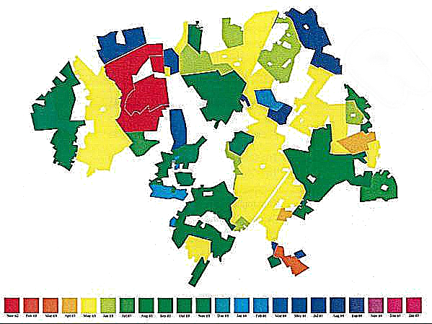
Figure 3.10 Final Consolidation of Remaining/Available Infill Parcels (Phase 4)
The objective of Phase 4 was to fill in the rest of the voids became more expensive and time-consuming, involving mostly small landowners who demanded increasingly exorbitant prices, and whose idiosyncratic valuation of their land often made it impossible to reach a bargain. Likewise, a figure/ground analysis of the final assemblage containing multiple voids resembles a "Swiss Cheese", to show that the Columbia acquisition was far from being a strictly indivisible assembly:
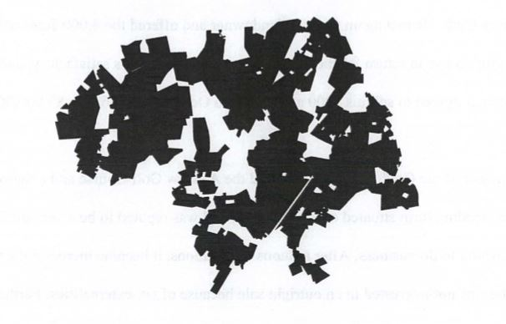
Figure 3.11 Final “Swiss Cheese” [aka “Spotted Leopard”] Assemblage Pattern

In fact, each of these voids represents a landowner holdout that both Rouse (and Moxley) was unable to resolve. The most publicized holdout involved Ms. Nancy Smith. According to Moxley, negotiations had begun for the 300+ acre Smith tract in June 1963, around the same time Rouse purchased the parcel of David Clarke. In a newspaper interview, Clarke would later recall that during negotiations, Rouse maintained a very low profile, making negotiations easier by relying on real estate agents (such as Moxley) to find the properties, reach an agreement, and return with an offer. If the deal was acceptable, they would settle immediately. If not, Rouse would quietly step in and try to construct a compromise. In the case of the Smith property, the owner simply did NOT wish to sell. This map explains Smith's dilemma.
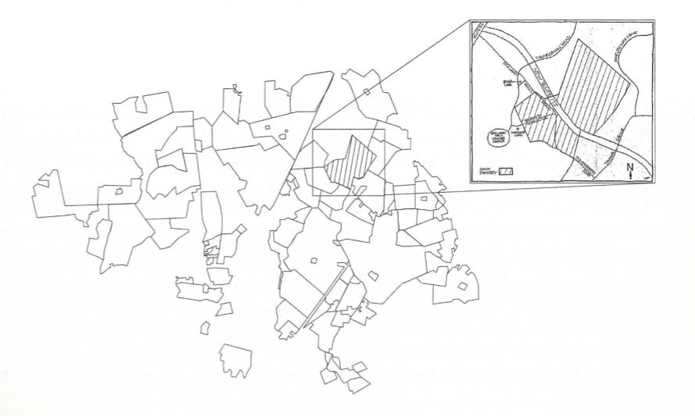
Figure 3.12 Smith Holdout Property [Schematic]

Even after most of her neighbors had already sold their farms, Smith continued to hold out. After Rouse had offered her $3,000,000, ten times more than its original price, she still refused to sell. Likewise, even after the state had condemned her land and extended Highway Route 175, she refused to cash her compensation check. Moreover, she explained her recalcitrance to deed over the land to public or private conservation groups by saying that she felt they would have no better chance of preserving it than she did. Finally, she abstained from deeding the farm to the Maryland Environmental Trust upon learning that trust properties were not exempt from condemnation. In the final analysis, Smith simply did NOT wish to sell her land, and no amount of innovative bargaining could change her mind. In fact, it may have served only to harden her position.
Concluding Remarks:
The Columbia project provides a paradigmatic case study where the developer of a strictly private land assembly project must continually update the configuration of the ongoing aggregate-assemblage in real-time, and thus, simultaneously reevaluate existing alternatives ---allowing the project to be completed-- in spite of the developer's inability to resolve all strategic holdouts.
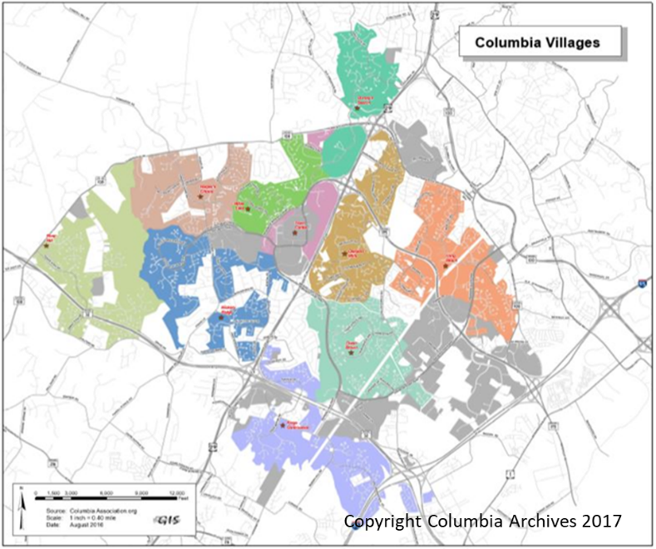
Figure 3.13 Current Village Pattern Columbia, Maryland (c. 2019)

Case Study #2: Walt Disneyworld, FL (1964-1967) Walt Disney Developer
By November 1965, Walt Disney had secretly assembled a contiguous, though irregularly shaped tract of land -- encompassing 14 sections in both Orange and Osceola Counties near Orlando, Florida. However, to realize his vision, he would require the intervention of both local and state governments—and the statutory power of eminent domain—to acquire the approximately 45 square miles (28,000+ acres) needed to complete Walt Disney World [WDW], By permitting the Disney Corp to incorporate all its holdings into the Reedy Creek Improvement District [RCID]--a public corporation-- the State of Florida granted Disney exclusive jurisdiction over land use on the resort, with blanket exemption from state zoning laws, as well as statutory eminent domain power to condemn and acquire property outside the initial WDW boundaries "for the public use". [Foldvary 1994; Bieto, Gordon, and Tabarrok 2002]
Unlike Rouse’s planned community of Columbia, Maryland-- the propriety community of Walt Disneyworld [WDW] is a quasi-governmental entity-- encompassing a large commercial real estate complex in a territory owned and operated by a private corporation--with little or any significant public-sector funding or control. With the incorporation of RCID—all interview data relating to confidential land assembly negotiations and/or holdout resolution—is proprietary and was therefore unavailable for analysis purposes. Nevertheless, it is still possible to examine key aspects of the overall land assembly process employed during the WDW project.
As verified by records provided by the Florida Secretary of State— six Disney-owned dummy corporations were operating during the initial WDW land acquisition--- and were responsible for acquiring all the land needed for the Walt Disneyworld Resort, Orlando (c.1964-67). Compass East Corporation was first incorporated in Delaware on December 7, 1964. Subsequently, Latin-American Development and Management Corp, Ayefour Corp. (a pun on Interstate 4), Tomahawk Properties, Inc., Reedy Creek Ranch, Inc., and Bay Lake Properties, Inc, all Florida-based corporations, phase. On September 30, 1966, these were all merged into the Compass East Corporation. The Reedy Creek Drainage District-- later renamed the Reedy Creek Improvement District [RCID]-- was incorporated on May 13, 1966, to manage the land owned by the merged Compass East Corporation. On September 26, 1967, Compass East Corporation was renamed to Walt Disney World Company. Coincidently, on October 21, 1965, a newspaper article by Emily Bavar appeared in the Orlando Sentinel-Sun, entitled: “Is Our "Mystery" Industry Disney?” revealing that it was indeed Walt Disney who had been secretly buying thousands of acres near Orlando. Finally, on November 15, 1965, Walt Disney publicly announced his intention to build Walt Disneyworld, Orlando.
Using the exact match terms of "Ayefour Corp", "Tomahawk Prop Inc", "Compass E Corp", "Bay Lk Prop Inc", "Latin Amer Dev Mgmt Corp", and "Reedy Creek Ranch Inc."—a query of both Orange and Osceola County databases produced a list of 64 transactions conducted during the initial WDW acquisition---citing (1) date of transaction, (2) grantor (landowner), (3) grantee (respective dummy corporation), and (4) Parcel Section ID. [See Appendix Table B.2]
The following graph shows the chronology of land transactions undertaken via Disney's network of six dummy corporations—including key dates-- during the initial WDW Orlando land assembly project. [Note: no transactions records were found for Reedy Creek Ranch, Incorporated, or the Latin-American Development and Management Corporation in the county databases.]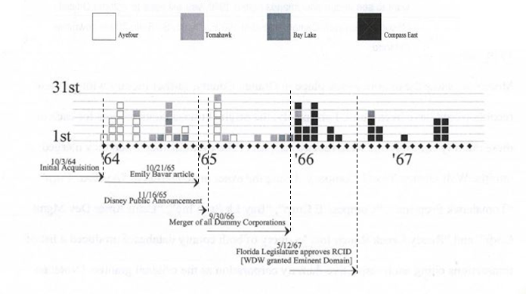
Figure 3.14 Timeline of Dummy Corporation Land Purchases for WDW

Using the parcel data provided by both Orange and Osceola County websites, the following map shows the distribution pattern --- following standard Section/Range/Township notation--- of the 64 transactions conducted by 4 dummy corporations -- during the WDW acquisition [note: each grid represents a 1-square mile section—with each interior square representing a single land acquisition within each respective section].
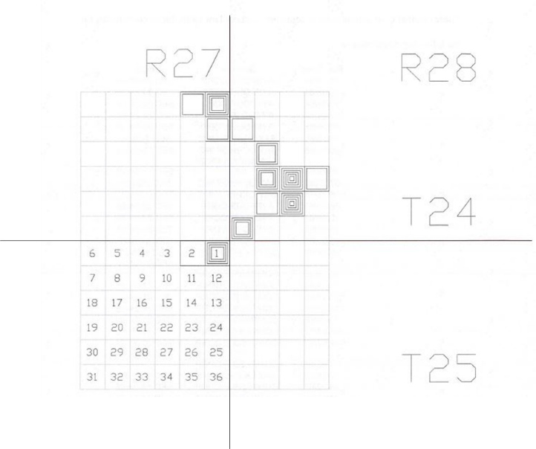
Figure 3.15 Section-Level Map of Initial WDW Land Acquisitions

The following grid overlay pattern uses the base map was downloaded from the RCID website---showing all properties currently owned by WDW in Orange and Osceola counties-- as well as unincorporated and privately-owned areas yet to be absorbed into the territory (c. 2005). It then overlays the section-level parcel-acquisitions, and finally, the distribution of parcel-acquisitions by respective WDW purchasing corporations. By overlaying all three of these maps--- it demonstrates graphically how the acquisition of each of these parcel-sections were being targeted chronologically--- establishing viable parcel nuclei--- as the key venues of the WDW Orlando destination resort.
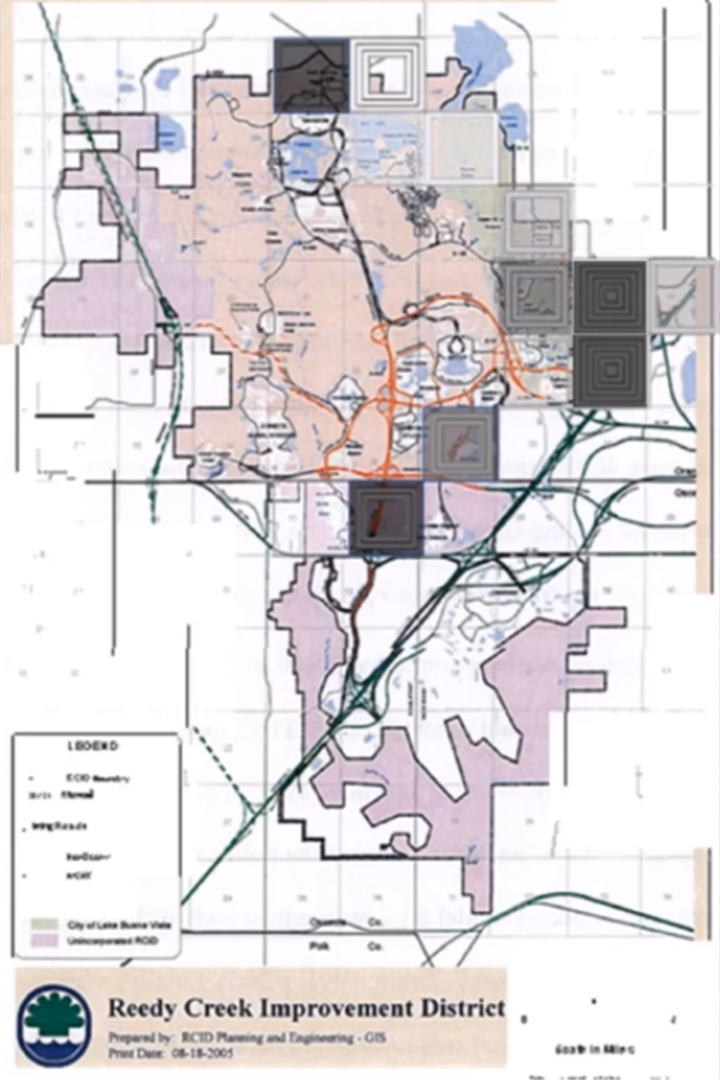
Figure 3. 1 Grid Overlay Map of Chronological Parcel Nuclei Assemblage
Concluding Remarks:
To acquire all the land needed for the WDW Orlando project, Walt Disney secretly coordinated a network of dummy corporations to negotiate transactions for parcels in specifically targeted areas, and to assemble a viable, contiguous assemblage large enough for use in a large-scale proprietary community. As a strictly private land assembly project, WDW was unique in several respects. While Disney did not have the ability to use eminent domain during the initial acquisition phase, he nevertheless sought (and received) permission to incorporate as a Special District, granting him the ability to condemn land for further development. Given the fact that any original interview data describing the actual negotiations were not available, is impossible to know the extent to which Disney's "middlemen" participated in the negotiation process. Nor can it be discerned how effective a role pure entrepreneurship played during these negotiations. Moreover, without their narrative accounts describing these real-world transactions, it is impossible to determine whether these negotiators encountered significant holdout problems, or to learn about the innovative negotiation mechanisms they used to resolve them. Most importantly, without these original interviews, it is not known whether the WDW Orlando project was ever in danger of being abandoned if the transaction of certain parcels had not been successful.
Nevertheless, given the hybrid nature of WDW's corporate structure, vis-a-vis the RCID- and due to the proprietary status of WDW’s negotiation practices-- it follows that the relative sparseness of the information available for analyzing WDW's secret land assembly negotiation mechanisms are nevertheless a testament to their effectiveness. Likewise, using only the archaeological evidence publicly available, it is still possible to observe the coordinated effort by six dummy corporations to assemble a large, contiguous land parcel--- in an area spanning approximately 12 square miles— specifically targeting key venues of the future WDW Orlando resort. In that respect, these data are pauca sed matura-- “sparse but rich”.

Case Study #3: World Trade Center, NYC (1961-72) Guy Tozzoli Project Manager

The first idea to build a “World Trade Center” in NYC was proposed by the New York State Legislature in 1943. Fifteen years later--at the height of the Urban Renewal era-- David Rockefeller proposed that Lower Manhattan be transformed into the epicenter of international finance as a “World Center of Trade” arguing that “obsolescence, deterioration, traffic congestion and slow economic strangulation had spread over such sections” -- urging that whole swaths of old markets, rotting piers, and aged buildings in Lower Manhattan be "knocked down and wiped away....”. Finally, in late December 1961, the Port Authority of New York and New Jersey formally announced its plan to build the World Trade Center [WTC] on the west side of Lower Manhattan next to the Hudson River. Lauded as the “crown jewel” of Urban Renewal projects—the WTC would also be the first in the Urban Renewal era to be “stopped in its tracks” due to a successful holdout--- requiring the powerful New York Port Authority to abandon its use of eminent domain—and reach a reciprocal agreement with a coalition of local merchants, the City of New York, and the Public-at-Large—to fully resolve the monopoly holdout, i.e., without requiring eminent domain. [Glanz and Lipton 2002, 2003; Burns 2002]
Early in its conception, Rockefeller’s proposal for the WTC required the intervention of the Port Authority of New York and New Jersey [PANYNJ] -- using its vast construction experience—its ability to issue bonds and to secure financing--—and its statutory power of eminent domain—to underwrite the massive project. For its part, the Port Authority likewise envisioned the WTC to be a vertical "Port Without Water” – a bold vehicle for resurrecting the depressed area of Lower Manhattan–--"to attract trade with a resultant stimulus to the economic well-being of the Port of New York”.
The decision to build the WTC on the west side of Lower Manhattan next to the Hudson River-- arbitrarily displacing hundreds of tenants-- came about through a purely political process. The bi-state Port Authority ultimately located the World Trade Center site on the 16-acre parcel of land –because it was uniquely situated above the Manhattan terminus of a deteriorating New Jersey commuter line--which the Port Authority then agreed to take over, renovate, and rename the PATH-- as part of the joint Port Authority Trans-Hudson/World Trade Center Bill-- approved in spring 1961 by then-governor of New York Nelson Rockefeller. 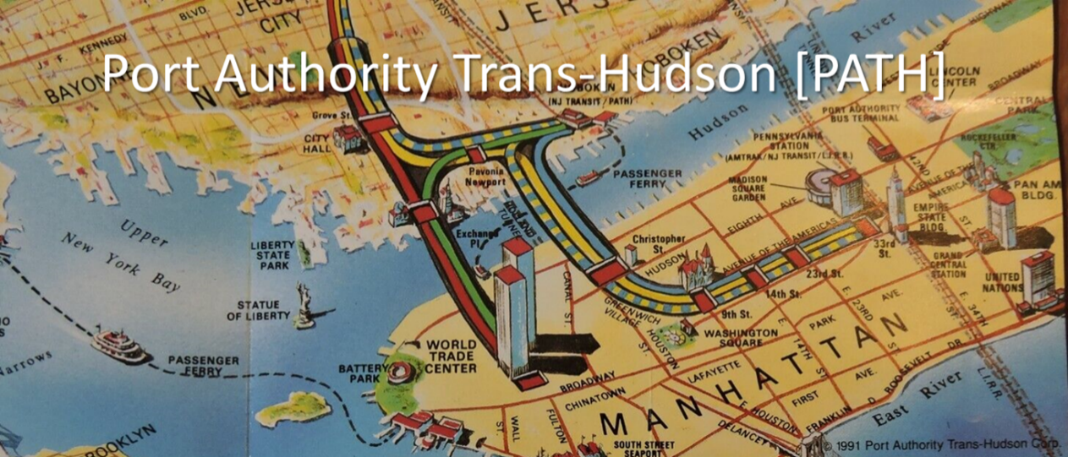
Figure 3. 2 Port Authority Trans-Hudson [PATH] Reference Map (c. 1991)

Upon finalizing the WTC project site-- the Port Authority quickly established a target assembly area--- comprising 2 “superblocks” in the run-down, yet still vibrant business district known as “Radio Row”.
Figure 3.18 Initial WTC Target Assessment Area (1962)

Prior to the December 1961 announcement, several sales had already occurred in the eventual target area-- including many in the period from 1959 to early 1962, which were not affected by the WTC announcement. Nevertheless, a group of Radio Row merchants filed a complaint against the project in the New York State courts in November 1962, asking for a temporary injunction to block the condemnations until the court case had been decided—on grounds that the WTC project would wipe out their livelihoods and that "a private real estate deal" did not qualify as a Public Use under the Fifth Amendment. While the Port Authority had routinely confronted such protests in the past, not until the land assembly of the World Trade Center would a holdout be so effective in stopping an Urban Renewal project.
In 1962, The Court initially ruled that the World Trade Center did not constitute a valid public purpose, and that therefore the legislation authorizing the condemnations was unconstitutional. However, this decision was later reversed. Finally, in May 1965, the State Supreme Court granted the Port Authority the right to use eminent domain to acquire land for the World Trade Center. Given this mandate, the Port Authority proceeded to condemn the land. In a fashion typical of a Robert Moses project, the Port Authority mailed a standard form-letter to each of the affected landowners, informing them that their property was needed for use in the World Trade Center, and that they would be compensated for relocation.
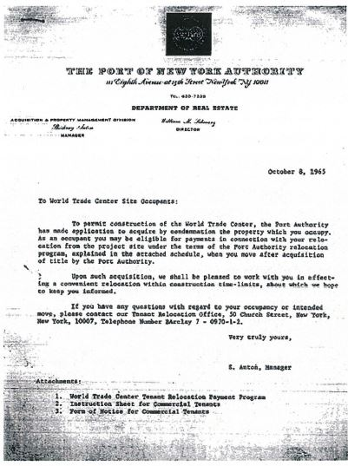
Figure 3.19 NYPA Standard Eviction Form Letter
According to guidelines set by the NY Supreme Court, the claimants' properties were to be evaluated based on their worth at the time of the taking, and to the extent that relevant and pertinent evidence supported the claimant's contention that these appraised values were not representative of fair market value, the court would consider such evidence in making its determination of fair market value and in fixing units of land value at the title vesting date. The final settlement prices set for each damage parcel, including the price of $1 paid for each of the NYC street beds in the target site. Finally, upon determining the fair market value for each damaged parcel, the Court issued each claimant an eviction notice. The following is a facsimile of the notice received by the claimant of Damage Parcel #117
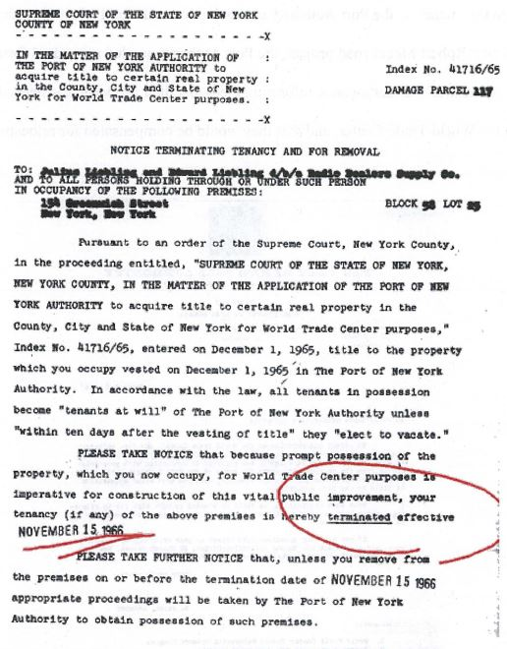
Figure 3.20 Standard Claimant Notification Letter --Parcel #117
As WTC historian James Glanz observed-- a new era of civic protest had dawned in New York City in the early 60's -- inspired by the celebrated urban activist Jane Jacobs--who had recently published “Death and Life of Great American Cities” -- and who spearheaded the civic movement to halt construction on the proposed Lower Manhattan Expressway--effectively ending the 35-year career of Robert Moses. By speaking publicly against the trade center, Jacobs motivated the group of local merchants to oppose the controversial project. In fact, their "David-and-Goliath" struggle would soon become a catalyst, drawing the city's political leaders to join in an unprecedented holdout, "freezing the project in its tracks".
Described as a "multidimensional exercise in hubris", the World Trade Center project was to be the last and most controversial project undertaken in the Urban Renewal period. According to Glanz, "this was the purest possible vision of the old ram-it-through New York, the pre-Jane Jacobs New York in which the power of eminent domain trumped all, once a great project got moving”. The so-called "power broker" mentality of Robert Moses ultimately triumphed in May 1965—when the State Supreme Court granted the Port Authority the right to use eminent domain to acquire land for the World Trade Center. (Ibid Glanz p.86)
Likewise, after campaigning to "go after unelected "power brokers" like Robert Moses", newly elected Mayor John V. Lindsey sought to reevaluate every aspect of the Port Authority's tax-exempt relationship with the city. He enlisted other opponents of the Trade Center, including powerful real estate interests, to join with the dwindling coalition of Radio Row merchants and implement a cohesive strategy to "stop the World Trade Center in its tracks". Lindsey's part in the holdout was aimed at challenging the Port Authority's tax-tempt status; they would not be granted permits to do any work on city-owned lands, including the WTC site.
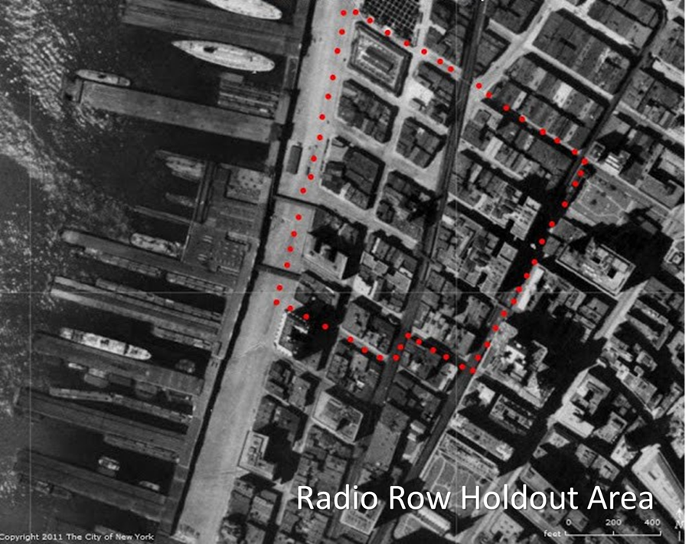
Figure 3.21 Radio Row Holdout Area

While the Port Authority publicly refused to accept the holdouts' demands-- negotiations continued behind-the-scenes. Over the next three years, Port Authority negotiators would slowly induce people to leave their shops. By January 1966, nearly all the other merchants had moved out except for Oscar Nadel --the self-appointed spokesman for the remaining merchants. In their first face-to-face encounter, Mr. Guy Tozzoli--- WTC project manager and lead negotiator for the Port Authority--offered Nadel the unprecedented concession of free retail space in the new trade center. However, Nadel refused, arguing that it would cause him to remain in commercial limbo for possibly five years until the project was complete. Less than a month later, the Port Authority offered new concessions, including a promise to pay all moving costs and even to hire a relocation firm to find spots in Manhattan as a new retail center for the merchants. Nevertheless, the holdouts viewed a maximum cash payment of $3000 as "ludicrous" and rejected the counteroffer.
When negotiations had reached a bitter standstill by early 1966, Tozzoli "dreamed up" the idea to dispose the excavated dirt from the World Trade Center's foundations (an estimated 1.2 million cubic yards) and use it as landfill to create prime shoreline property along the Hudson River—leading to the creation of New Battery Park City.
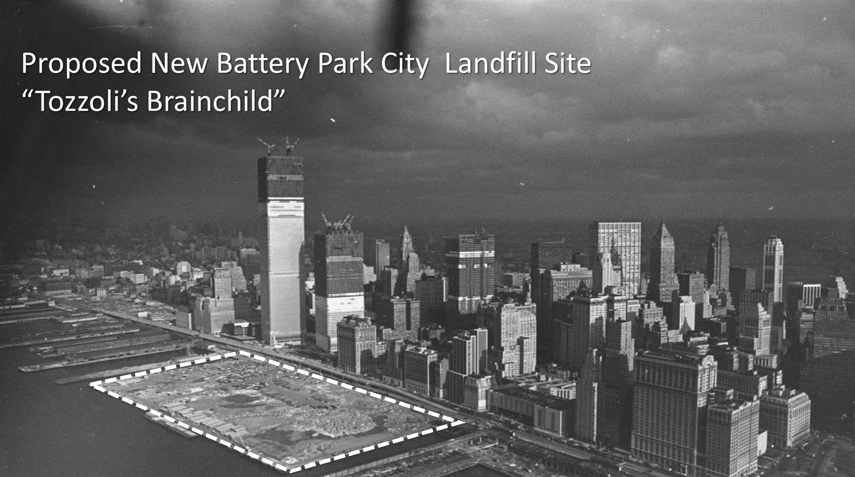
Figure 3.22 Proposed New Battery Park City Landfill Site “Tozzoli’s Brainchild.”
In addition, the Port Authority agreed to increase tax payments to the city from all its future projects—promising also to carry out a range of capital improvements such as widening city streets, renovating sewers, and creating pedestrian underpasses. Finally, the Port Authority was able to reach agreements with the remaining Radio Row merchants, who received an aggregate compensation of $8,183,770, approximately 40% of the total $19.5 million paid in the settlement.
In October 2004, this study conducted a formal “Tier 1” IRB Interview with Mr. Guy Tozzoli, Project Manager of the WTC. The purpose of this interview was to ask Mr. Tozzoli to provide a firsthand narrative account--- describing his direct experience in successfully resolving the Radio Row holdout. The following is the (IRB approved) transcription of that interview: 
Transcript of “Tier 1” IRB interview with Mr. Guy Tozzoli (Oct. 7, 2004):
[Interviewer:] I was just curious if you could describe your source of inspiration (for resolving the holdout):
[Tozzoli:] “Yes, I do remember that when I was shaving the idea just came to me-- “Hey! what if we could do something with all that dirt?!”
[Interviewer:] ‘Well, the thing I was wondering was how you actually came up with the idea, it just seems so original, and the World Trade Center was just such a monumental project.”
[Tozzoli;] (Pausing) I see what you are asking; it’s something you might ask someone like (Daniel) Burnham maybe, right?”
[Interviewer:] Exactly…Now, in one of your interviews, you did mention how the [WTC] plaza reminded you of San Marcos Piazza in Venice. You know, the whole city was built up artificially, wasn’t it? I was just wondering if that might have been part of it, you know subconsciously where the idea came from. I just wanted to ask a guy with a really cool idea where really cool ideas come from.
[Tozzoli:] “Again, (laughing) in the heat of the moment, it really just came to me. I had the once-in-a-lifetime opportunity to work on one of the greatest architectural projects of our time. Looking back though, I would still like to think that my small brainchild was part of it, too.”
“Tozzoli’s Brainchild” effectively resolved the monopoly holdout, i.e., by reaching a reciprocal, mutually beneficial bargaining agreement with the remaining Radio Row residents, the City of New York, and ultimately the Public-at-Large. As part of the final settlement, the Port Authority also agreed to increase tax payments to the city pegged at what a private developer would pay, promised to carry out a range of capital improvements like widening city streets, renovating sewers, and creating pedestrian underpasses. Furthermore, the Radio Row merchants received total payments that amounted to approximately $16.2 million in the settlement. In the first year of occupancy in the WTC, the city received a tax payment of approximately $6.2 million, with steady increases as time went on and as more tenants arrived at the Twin Towers. As Gillespie observed, “Tozzoli’s brainchild” to remove solved another problem for the Port Authority, for the expense to dispose of the excavated dirt as landfill elsewhere would have been cost prohibitive.
Tozzoli was an interesting choice as builder of the World Trade Center. While working at the Port Authority, Tozzoli was temporarily re-assigned to help Robert Moses plan the 1964 World’s Fair. Tozzoli’s role was instrumental in recruiting crucial commercial sponsors for the Fair, including Walt Disney (who was secretly assembling land for Disneyworld at the same time). In fact, as one of his last duties under Moses, he was sent in December 1961 to the Seattle World’s fair to “appropriate ideas” -- where he would meet Minoro Yamasaki-- the eventual architect of the World Trade Center, [Coincidentally, Yamasaki was also the architect of the Pruitt-Igoe Housing project in St. Louis]. That following February, Tozzoli was assigned as Project Manager for the World Trade Center.
The original idea of using reclaimed landfill to redevelop the Hudson shoreline—replacing the dilapidated shipping piers rendered obsolete by containerization (Wallace)-- was proposed by private developers in the early 60’s. In 1966, Governor Nelson Rockefeller unveiled the proposal for what would become Battery Park City. It is reasonable to infer that “Tozzoli’s Brainchild” provided the final catalyst—namely by creating the actual source of the landfill material needed to realize this proposal.

Chapter 4: IRB Interview Study Results

IRB Research Interview Design Methodology:
In order to collect the original data necessary to complete this qualitative research study, it was required to conduct formal IRB interviews with members of AUREO [Association of University Real Estate Officials], professional real estate administrators at public universities across the US, who were directly involved in managing a wide range of campus expansion projects, and who successfully resolved monopoly holdouts during ongoing land assembly negotiations, without requiring eminent domain. This formal interview process took place over a one-year period and was conducted at the peak of the Kelo controversy (2004-05). Following strict IRB interview protocols, this study actively recruited willing research participants via the nationwide AUREO email listserv. Upon completing the Informed Consent process, each respondent was first enlisted as a “Tier 2” interviewee. During these 30-minute “Tier 2” interviews, each respondent was asked to briefly describe their direct (or indirect) knowledge with the general land assembly process in situ. Next, they were asked to describe their general involvement during the land assembly negotiation process, especially concerning any experiences they may have had in resolving monopoly holdouts. At the conclusion of this initial interview, each respondent was asked to provide referrals to other colleagues who might be willing to participate in the research study. Through this iterative referral process, a sample pool of twenty-seven “Tier 2” interviewees was established. From this larger sample population, a smaller sample size of 6 (six) was then self-selected as “Tier 1” interviewees, who voluntarily agreed to discuss their direct involvement, i.e., overseeing ongoing land assembly negotiations at four (4) respective public universities. During these in-depth, 90-minute interviews, each respondent provided their firsthand narrative accounts, i.e., fully describing the innovative bargaining process they implemented during real-world land assembly negotiations, and the innovative bargaining mechanisms they routinely employed, thus, enabling them to systematically resolve a wide variety of monopoly holdouts, without requiring eminent domain.

IRB Study #1: Memorial Stadium Expansion Project Univ of OK -Norman (2005)
“Tier 1” Interviewees: Deborah Wollenberg, Chris Kuwitski [Conducted 6/2/2005]

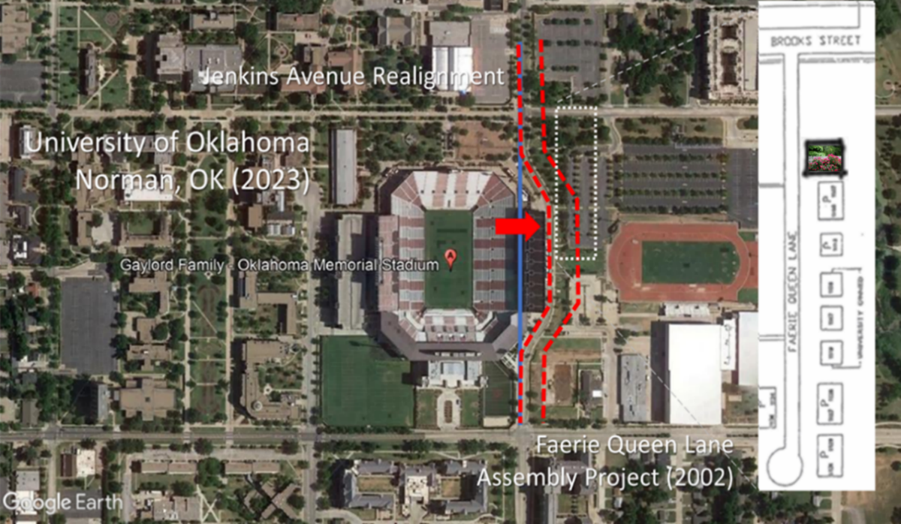
Figure 4.1 Faerie Queen Lane Assembly Project Univ of Oklahoma, Norman (2002)

In December, 2001, a private contract was awarded to expand Oklahoma Memorial Stadium, to incorporate the east side addition of 27 suites, 2300 new club seats, and an upper deck with 5,000 seats, replacement of all the stadium's existing seats, code upgrades, renovation of the north end zone academic and administrative center, and a new north end zone concourse expansion, brick facade, entry and site improvements, and with a seating capacity increase from 72,765 to approximately 81,000 upon project completion, prior to the 2003 football season.
This expansion project required the assembly of seven privately-owned parcels on Fairie Queen Road, a neighborhood of primarily rental properties located immediately east of the existing stadium. It was also necessary for the University to obtain permits from the City of Norman to allow Jenkins Avenue to be rerouted to accommodate the stadium expansion. The seven properties were professionally appraised. Five properties were then acquired through direct negotiations; one rental property owner initially held out, strictly for a monopoly price. During negotiations, the University “played the eminent domain card”, which effectively ended this holdout. The last remaining landowner held out for strictly sentimental reasons.
During the land assembly phase for the 2002 expansion of Oklahoma Memorial Stadium at the University of Oklahoma, it required taking all the adjacent private property in the Faerie Queen Lane neighborhood, i.e., located immediately east of the existing stadium on Jenkins Avenue, in Norman, Oklahoma. The last remaining monopoly holdout was a long-time Faerie Queen Lane resident, who refused to sell her home for purely sentimental reasons. [IRB interviewee] Ms. Wollenberg asked to meet with her in person at her residence and discuss the possible sale “over coffee”. During this informal meeting, the landowner explained she was an elderly widow and that she and her late husband had moved into the neighborhood as newlyweds, raised a family (including their prized rosebushes) and eventually retired there. Following their conversation, Ms. Wollenberg made a proposal, offering a voluntary property swap for a nearly identical house three blocks away, and to have “a couple of big fellas from Physical Plant” come by and transplant her prized rosebushes at the new residence. Upon accepting this agreement, the last remaining monopoly holdout was successfully resolved, i.e., allowing the OU stadium expansion project to proceed.
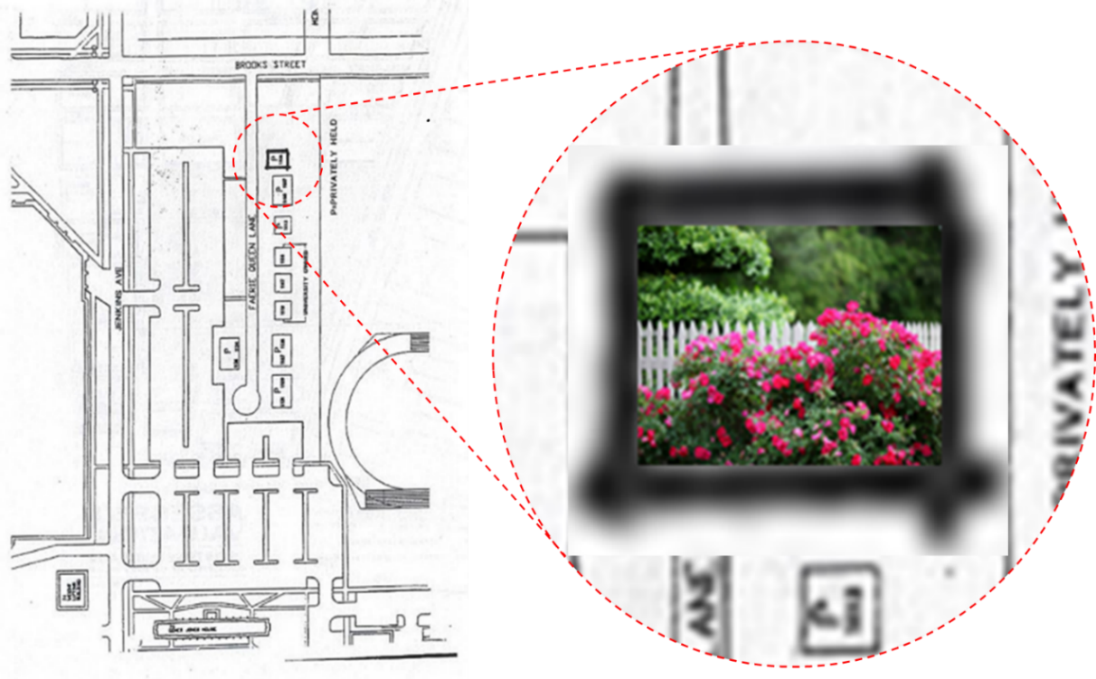
Figure 4.2 “Rosebush” Monopoly Holdout Faerie Queen Lane (c. 2002)

When asked directly about the eminent domain policy used by the University of Oklahoma, respondent(s) explained that the university sees its role in the local community as one of “stewardship and responsibility”. Furthermore, according to University President David L. Boren, the stated policy of the University of Oklahoma to “avoid whenever possible the use of eminent domain. As we have seen in other communities, using eminent domain to force people to sell properties, especially personal homes, can be painful for those involved.” Boren said OU has never used eminent domain to acquire property since he became university president in 1995:
"One of the reasons we purchase property when it becomes available is to avoid whenever possible the use of eminent domain," he said. "As we have seen in other communities, using eminent domain to force people to sell properties, especially personal homes, can be very painful for those involved. It is always best to use the willing buyer, willing seller approach. We try to think ahead, sometimes several years into the future, to identify the university's needs. The number of properties obtained by OU over the past 12 years is relatively small, especially when compared to other universities of our size including the state's other publicly supported comprehensive university."
Althea Peterson Norman Transcript Feb. 18, 2007

IRB Study #2: BLACKLAND Transitional Housing Project UT-Austin (2005)
“Tier 1” Interviewee: James Wilson [Conducted 6/7/2005]
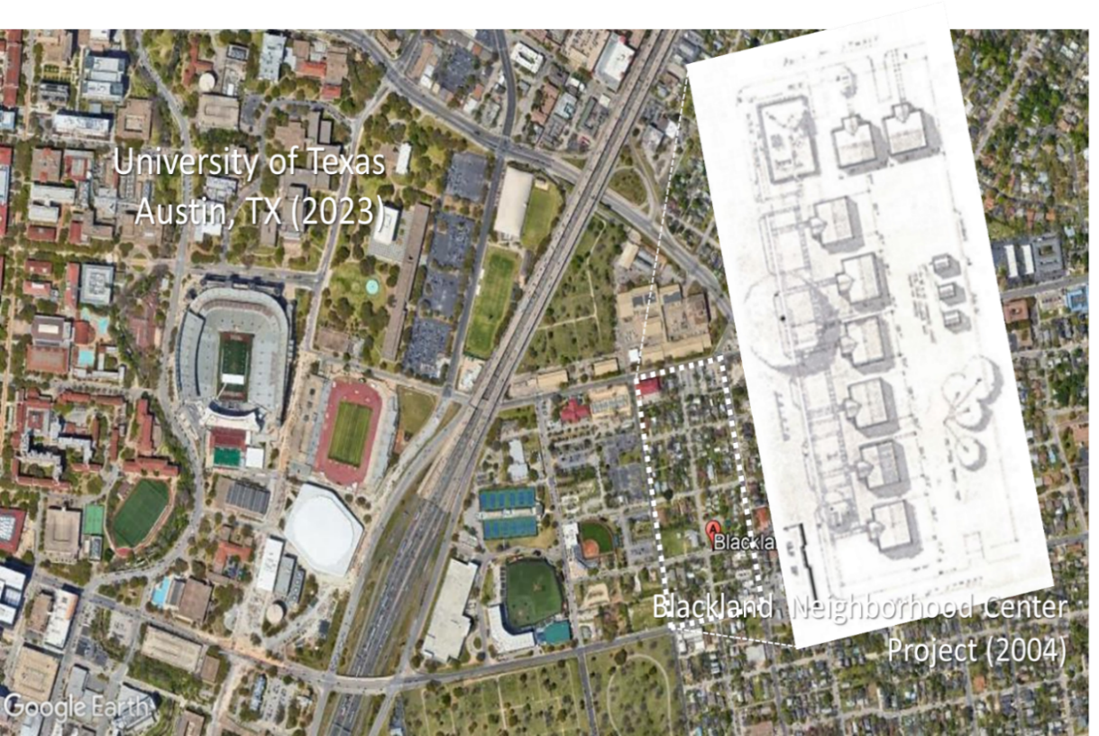
Figure 4.33 BLACKLAND Neighborhood Center Project Univ Texas-Austin (2004)

As part of a plan to acquire one half of Blackland, a vital and well-maintained African American neighborhood, involving the acquisition of a total of 180 parcels for investment purposes, the University of Texas in Austin (U.T.) also bought the houses in this 1 ½ block area. The community opposed the plan and started its own acquisition program for housing development. A homeless advocacy group proposed to use several university-owned buildings to house homeless people, a plan which community residents were initially hesitant about but eventually adopted. The university donated the houses and moving costs and leased a new site to the community for 30 years at a dollar per year. However, rehabilitation of the houses was delayed for four years due to opposition from city of Austin planning and development staff.
IRB Interviewee Professional Background:
As part of the University of Texas Real Estate System which is composed of 12 campus units across the state of Texas, the Campus Director of Real Estate has been directly involved with 10-12 expansions over the past 15 years at the University of Texas Austin [UTA]. In an initial statement concerning the approach to land assembly at UTA, the respondent asserted that there is no standard template that university real estate agents follow while conducting land assembly negotiations. Furthermore, it would be a “big mistake” to assume that a standardized plan of procedure might work for all universities or all land assembly projects. It may also be possible to share/exchange experiences between universities, but only tangentially because all land assembly projects are special cases. There is no discernable template, but only common general procedures for conducting land assembly projects.
When initiating a project, the first responsibility of the university real estate official is to be aware of the local culture, including the local market conditions, the state laws governing university acquisitions, and the approval process. Also, there must be knowledge of prior agreements made to previous/current landowners, especially with regard to any prior use of eminent domain, because “communities have a very long memory.” Depending on whether the project is a rural vs. urban setting, each has different price structures and different relationships toward the institution. The university real estate official must understand the institutional framework within which the land assembly process is to operate. Furthermore, because every institution has its own culture, e.g., Board of Regents, and the rules governing the university structure make all the difference when initiating a project. Finally, it is paramount to find areas of commonality when considering the possible use of eminent domain. Some fear it or hate it, but it can be fair if used properly. Therefore, know the local eminent domain statutes and their historical uses in the respective community.
As a contribution to Perry and Wiewel’s study of the role of the university in urban real estate development (2004), the following guidelines were recommended independently by the interviewee concerning the organization and application of community development principles in the university-community real estate development relationship:

1. Institutional Framework/Culture
It is necessary to first recognize that every university has its own unique institutional culture and is equally a product of its state and local economy. The university structure is governed by the State Board of Regents, which sets rules and regulations regarding real estate transactions, and which in turn determines whether the university is aggressive or cautious in its real estate transactions. Furthermore, depending on whether the university is public or private, the public sector enabling legislation governs how the university real estate transaction process is organized. The distinct feature between public and private institutions is Eminent Domain. Private Institutions do not have access to eminent domain, but they do have “other freedoms”. For example, private universities are not subject to open records restrictions, which allow them to acquire land through straw purchasing/blind agency.
2. Negotiation Procedures and Ethics
The first rule in negotiating is to “be upfront and be honest”; tell them what your process/project is. For example, if by using eminent domain it allows landowners tax-free reinvestment of proceeds; inform them of these tax advantages. On the other hand, if you have no intention to use ED, should you mention the possible advantages of ED? The university representative should “build bridges to make the transactions work.” Therefore, familiarize both yourself and the landowner with local ED rules.
3. Land Assembly Site Selection/Preparation
Begin with a completed/authorized Master Plan to declare the long horizon “Target Acquisition Zone”. Buy properties as they become available. Buy openly as the University, not as a blind agent, which creates mistrust. The private sector, including private universities, uses blind agents all the time, since they are not subject to open records regulations. Because land purchases can become time-sensitive, urgency vs. longer time-horizon buying strategies lead to a bigger problem, namely market volatility can increase fair market value.
4. “University Use” as “Public Use” Determination:
While most state (and especially federal) statutes are similar, it is important to observe that every institution has its own culture, namely concerning public acceptance or rejection of the use of eminent domain by a university. An interesting innovation in university land assembly involves “cross-over use” by private University Foundation, namely where land is condemned through ED and then turned over to a private University Foundation. One example of such a cross-over use involved the development of a Hotel Conference Center on University of Texas grounds transferred through ED to a private University Foundation.
5. Innovative Negotiation/Agreement Strategies:
Strive to exercise open, “good faith” negotiations with landowners. Try to find a mutually agreeable value constrained by fair market value. In certain cases, you may structure an agreement that allows landowners to generate revenue by strategically delaying/extending the closing dates. Use ED as bargaining device, for example, where the owner of the condemned property may receive tax credits. Propose a swap for comparable university property or in-trade for other non-domicile assets. Provide house-moving services free-of-charge to help current owners relocate their existing home to new premises. Finally, encourage landowners to show “community spirit” and donate property in open transactions to the university in exchange for tax credits and public recognition, e.g., getting their name on a donor plaque.
6. Landowner Hold Out Motives/Alleviation Strategies:
Landowners often hold out the sale of their home for purely sentimental reasons, leading them to form an unrealistic or irrational valuation of their property. The University may simply exercise patience and wait for a change in ownership due to economic hardship or natural causes. There are two potential bargaining scenarios where landowners will hold out for an exorbitant price. Given that open records restrictions require universities to declare their target areas of land acquisition, some landowners will be motivated to “buy in front of the University” and then hold out. Secondly, the landowner of the last needed property may also hold out. While it is sometimes possible to “design around” holdouts, alternative sites are not available in most cases, hence forcing the University to consider “playing the ED card”.
7. Standardized Negotiation/Transaction Procedures:
It is a standard practice in the State of Texas to require an authorized, independent real estate appraisal of full, fair market value for each property. Landowners must provide clear title, all applicable environmental/regulatory standards must be met, and the University is constrained by law to buy at lowest cost.
8. Incomplete Bargaining Information:
Landowners may not always know or understand appraisal theory/methods, making them uninformed or naïve during negotiations, but information is readily available to the novice landowner. Nevertheless, if for example a landowner wants $50K for a property when the University knows it’s worth $75K, the university real estate agent is not constrained “to give full information” during negotiations. In fact, they have a fiduciary responsibility to save money for the University.
9. Concluding Remarks:
In conclusion, the simple maxim to be observed during all university land assembly negotiations should be: “Always deal so you can deal with next guy”.

IRB Study #3: South Campus Expansion Project UI-Urbana-Champaign (2006)
“Tier 1” Interviewee: Dan Crawmer [Conducted 2/17/2006]
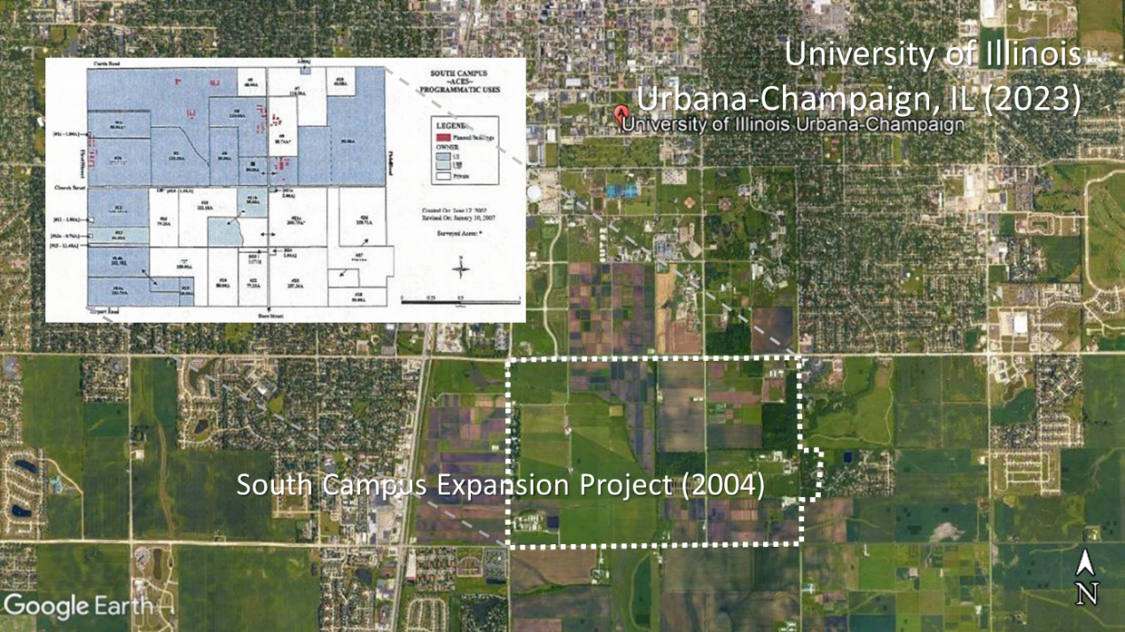
Figure 4.4 South Campus Expansion Project Univ Ill -Urbana-Champaign (2004)
According to the Master Plan of the University of Illinois at Urbana-Champaign, during the first decades of the twenty-first century, the South Campus will be required to increase in land area by fifty percent and nearly 1.9 million square feet of new buildings will need to be added. The purpose of the South Campus Master Plan was to guide future change on the South Campus by defining the organization of land uses, patterns of vehicle and pedestrian circulation, and the structure of campus open space. The South Campus is a university-owned land area of approximately 3,400 acres (five square miles). The College of Agriculture, Consumer and Environmental Sciences (ACES) is presently assigned 2,727 acres, or 79 percent of the South Campus. The South Campus is surrounded on the north, east and west by land that is largely developed in institutional, residential, and commercial uses. The south and southeast boundaries abut agricultural land.
The objectives of the South Campus Master Plan are: (1) To accommodate the long-term research land replacement and growth needs of the College of ACES in a way that fosters interdisciplinary relationships, efficiency of operation, matches program needs to the characteristics of the land and maintains close proximity to the main campus. (2) To accommodate the land and building requirements of other University units on the South Campus and develop land use patterns that consolidate related uses, encourage land conservation, and create useful open space and natural areas for research, recreational and educational purposes. (3) To improve pedestrian and bicycle systems on the South Campus and enhance the landscape quality along pedestrian, bicycle, and vehicular corridors. (4) To avoid circumstances where public roads compromise the safety and efficient operation of the South Campus research facilities. (5) To identify land for acquisition and possible sale or exchange.
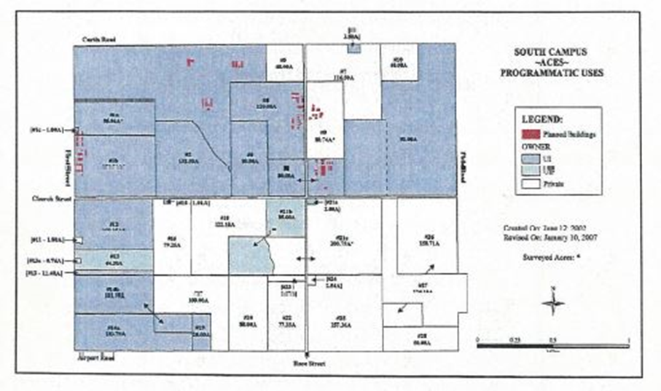
Figure 4.5 South Campus Expansion Project Target Assembly Area (2004)
By the spring of 2007, the University had purchased approximately 2500 acres, or roughly 40% of the targeted acquisition area in the South Campus Master Plan. To acquire the land, the standard procedure of the University was to initially contact landowners by mail, to explain the University’s academic need for their land, and to inform them that the University wished to purchase their property if they would be willing to sell. Of all those contacted, a small percentage (roughly 10%) sold right away, mostly selling large properties. Over time, some sales offers “trickled in”, but these eventually stopped altogether. The University Real Estate Office then identified an order of priority the properties by which they would purchase selected properties and these landowners would then be approached by university negotiators and offered the appraised value for their property. At this point, many of the landowners have hired their own appraisers. However, the State of Illinois places university negotiators under the restrictions that an offer or even the negotiated price cannot be above an acceptable appraised value. At this point, the problem is that a property owner may (and usually does) hire an appraiser that does not do a proper level of due diligence and writes an unacceptable appraisal with an inflated value. The University cannot and will not accept an appraised value based on faulty assumptions. Consequently, the negotiations always end up in court, and the value is determined by a jury that usually just averages the appraised values. Hence, this bargaining restriction creates long and costly delays in the negotiation process. The interviewee recommends that this restriction be modified so that the university has the ability to negotiate more freely with the holdouts. Specifically, the university negotiator should be permitted unilaterally to average the competing appraisal prices and allow the parties to “split the difference”. The respondent asserts that by introducing this modification, the standard bargaining procedure would be more efficient.

IRB Study #4: Clifton Heights Revitalization Project Univ of Cincinnati (2006)
“Tier 1” Interviewees: Bill Plagge, Univ of Cincinnati; [Conducted 1/23/2006].
Tom Klumb, City of Cincinnati [Conducted 2/17/2006]
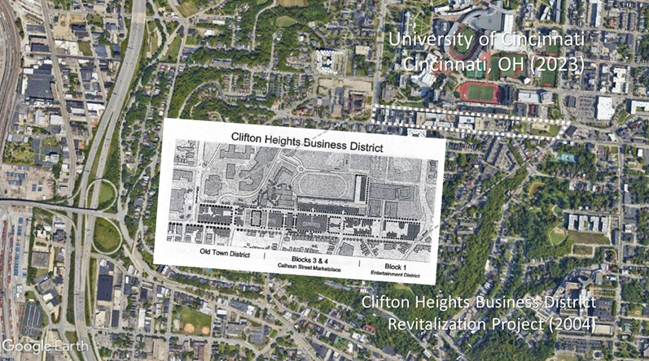

Figure 4.6 Clifton Heights Revitalization Project Univ of Cincinnati (2004)
In April 1998, the City of Cincinnati, the University of Cincinnati, the Clifton Heights Business Association and the CUF [Clifton Heights, University Heights, and Fairview] Neighborhood Association jointly proposed a revitalization plan for the Clifton Heights business district, a six-block area dominated by fast food restaurants, parking garages, and deteriorated housing stock. Lacking in green space, cultural amenities, and generators of night activity such as hotel, cinema and entertainment, planners were given three primary goals, namely promoting home ownership, revitalizing the local retail market, and creating a pedestrian-friendly business district in close proximity to the main campus. Their combined mission statement proposed “restoring vigor and diversity through reworking of the Calhoun Street environment and the increased mix of retail, housing, and offices space. The ultimate effect of this plan should be to knit together the University and residential community into something even more significant -- an identifiable uptown business neighborhood of memorable spirit and urbanity.”
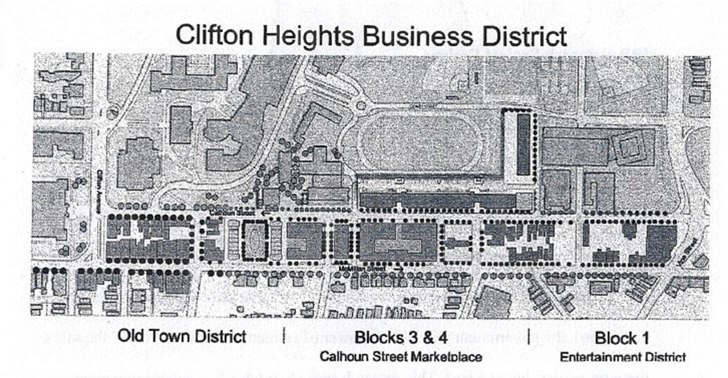
Figure 4.7 Clifton Heights Project Target Assembly Area Univ of Cincinnati (2004)
The Calhoun Street District [The District] was defined by two major axes, Calhoun Street and McMillan Avenue, connecting the commercial spine that provides the skeletal structure for substantial redevelopment. Bovis Lend Lease managed the construction of a mixed-use development bringing residential units, including student housing and retail into one central location. Key to the redevelopment is the central market square, which features a centrally located park, retail including major retail specialties, restaurants/bistros, recreational and seating complemented by friendly lighting, signage, roadway, and streetscape, as well as residential, student housing alternatives and university facilities. The project encompasses both the north and south sides of Calhoun Street in Clifton Heights. Phase I, blocks 3 and 3A consists of 289 state-of-the-art student housing units accommodating 758 beds and 46,000 square feet of retail within the six-story and eight-story, two building facility atop a 1,000-vehicle parking garage. Additionally, the redevelopment project includes 56,000 square feet of retail space, 70,000 square feet of institutional space for the University of Cincinnati and 150 residential units. Higgins Development Partners, LLC, master developer for the project, along with the University of Cincinnati and the Clifton Heights Community Urban Redevelopment Corporation partnered (public/private partnership) to create this residential/retail community.
Because of its policy not to use eminent domain, the University of Cincinnati reached an unusual, yet innovative arrangement where the City of Cincinnati would use its power eminent domain to condemn property needed for land assembly, which would then be turned over to local non-profit Neighborhood Development Corporations [NDC’s] for the Calhoun Street revitalization project. As part of its Master Plan to develop the southern edge of campus along Calhoun Street, the University also agreed to use endowment funds as start-up capital for the NDC’s, which would be repaid to the University after the properties were fully developed.
In 1972, the federal Uniform Relocation and Acquisition Act [URAA] was enacted to protect naïve and unsophisticated landowners from eminent domain abuse by government agencies. According to University of Cincinnati Real Estate Director Bill Plagge, before this landmark legislation all that would be required in a condemnation proceeding was for the landowner to be given a “take it or leave it” offer. During the land acquisition phase for the Calhoun Street project, URAA guidelines required that each landowner receive two (2) appraisals that were subject to independent review and report. As part of the negotiations, the city was also required to find the landowners comparable housing. According to public records, 19 property owners sold their land willingly, but the city filed an eminent domain action against others in 2003. While two holdout property owners eventually settled with the city, a strategic holdout by the owners of four restaurants on Calhoun Street caused the delay of a 360-unit condominium project just south of the University of Cincinnati. However, as of April 2007, local newspapers reported that a settlement was forthcoming.

IRB Study #5: (Counterexample) Rookwood Exchange, Norwood, OH (2006)
“Tier 1” Interviewee: JR Anderson Private Developer [Conducted 4/2006]
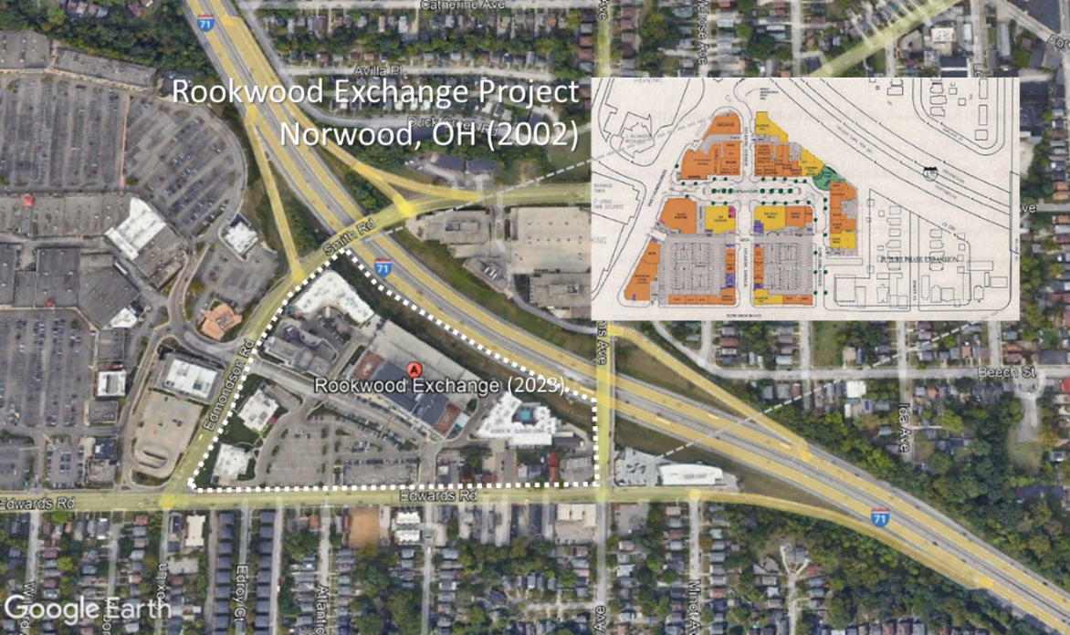
Figure 4.8 Rookwood Exchange Project Norwood, Ohio (2002)
At the conclusion of the interview with Mr. Plagge, he personally referred the private developer Mr. J.R. Anderson, who agreed to participate as a Tier 1 interviewee and fully discuss the public domain aspects of land assembly phase of the Rookwood Exchange project, which was involved in an ongoing, and highly publicized eminent domain proceeding. Early in 2002, the private development firm of Jeffrey R. Anderson Real Estate, Inc. began the planning and design of the $125 million Rookwood Exchange project, which was to be built in an area already occupied by a small 11-acre neighborhood. After reaching agreements with all but three of the landowners, Mr. Anderson approached the City of Norwood, Ohio, to ask that the neighborhood of about 70 homes and businesses be declared "blighted", and in September 2003, the city voted to use its eminent domain power to obtain the land from three remaining holdouts, who adamantly refused to reduce their asking prices.
Over the next three years, the Norwood case proceeded to the Court of Appeals and would finally reach the Ohio Supreme Court in December 2005. In the wake of the controversial Kelo decision earlier that summer, this dispute eventually made national headlines when it was brought before the Ohio Supreme Court in Norwood, Ohio v Horney. Finally, in July 2006, the court ruled unanimously for the homeowners, and the City was forced to return ownership of the three properties to the homeowners. As of 2007, the site is vacant and there are no future plans for development.
During the Tier 1 interviews with Mr. Anderson in April 2006, he explained that he made sincere efforts to resolve the holdouts through negotiations, rather than seeking eminent domain. His initial bargaining strategy had been to approach all the landowners simultaneously, and to reach mutually beneficial agreements with them as a group. According to his narrative account, he met with the landowners in open discussions and initially offered a price 25% above appraisal. He reached tentative agreements with 70 individual landowners, 90% of whom were "ecstatic" at the prospect of selling their properties to Anderson.
Anderson then expressed his frustration at being unable to persuade the two remaining owners of small rental properties, neither of whom were permanent residents in the target neighborhood, to lower their asking price. In Anderson's own words, "these (two) holdouts created a problem that put a two-year hold" on the full assembly of the project. Indeed, the decision of the two landowners to persist their holdout created 'lost opportunities for everybody'. Upon losing the Norwood case, Anderson was forced to abandon the project. His main criticism of the decision was that, by siding with the landowners, the Court was simply validating their right to demand an exorbitant price, regardless of its true market value, or of its negative impact on the other landowners.
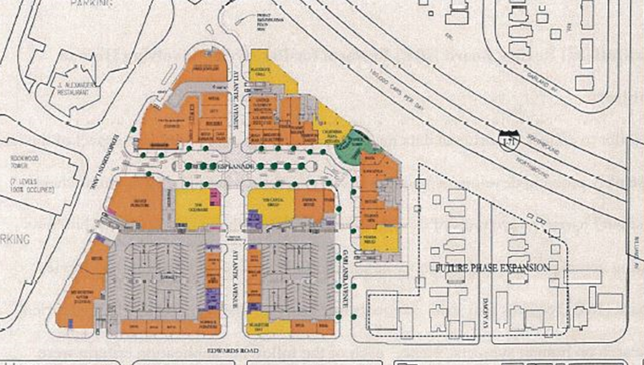
Figure 4.9 Rookwood Exchange Project Target Assembly Area (2002)
By 2005, the developer JR Anderson had privately assembled all but three properties for the Rookwood Exchange Retail Development [“Norwood”] project in the City of Norwood, a suburb of Cincinnati, Ohio. Upon providing clear and convincing evidence that the expected tax revenues from the project would exceed $2 million dollars, the amount necessary to correct their current budget deficit, Anderson convinced city officials to intervene and use eminent domain to help him overcome the remaining monopoly holdouts. However, following the controversial Kelo decision, the Norwood project received national attention and was portrayed as a bellwether case of eminent domain abuse. The holdouts hired attorneys from the Washington-based Institute of Justice, who then appealed to the Ohio Supreme Court, who eventually declared the condemnations unconstitutional, leaving the project in a standstill. The Norwood/Rookwood Exchange project provides a paradigmatic counterexample in private land assembly, namely where the failure to successfully alleviate a holdout problem led a private developer to seek eminent domain power. Furthermore, it is a real-world example to illustrate the negative externalities that a monopoly holdout imposes on the developer, the city, and the other landowners. Summary statistics provided by JR Anderson show a detailed list of (currently) negotiated settlements per each individual parcel, with data on the remaining holdouts kept confidential pending further legal action.

IRB Study Conclusions:
The purpose of this study was to explore practical, real-world alternatives for resolving monopoly holdouts, i.e., without requiring eminent domain. Berman v Parker (1954) set formal precedent by allowing eminent domain to be used for taking strictly non-blighted property. Kelo v City of New London (2005) simply reaffirmed Berman, authorizing the use of eminent domain to overcome seven monopoly holdouts, including that of Ms. Susette Kelo, for a new Pfizer Corporation headquarters, on grounds that creating new jobs and tax revenues constituted “Public Benefits” under the Takings Clause. Heller (1998) argued that using direct government intervention in this manner simply transfers monopoly ownership rights between private individuals, i.e., while leaving scarce public resources persistently underutilized as “anticommons” property… a classic market failure [Heller 1998, 2008]. Following Coase’s landmark research on free riders [Coase, this study conducted formal IRB interviews with AUREO [Association of University Real Estate Officials] who willingly discussed their direct participation, i.e., during ongoing campus expansion projects at four respective public universities across the US. Chapters 3 and 4 fully document the firsthand narrative accounts provided by these real-world practitioners, who described the host of innovative bargaining mechanisms they routinely employed, i.e., enabling them to successfully resolve monopoly holdouts without requiring eminent domain.

As a practical alternative to longstanding policy orthodoxy, this study finds that by systematically negotiating reciprocal, mutually beneficial [Coasean] bargaining agreements with recalcitrant landowners, it is possible to successfully resolve monopoly holdouts without requiring eminent domain. While these results may seem pedestrian to the layperson, their practical implications for the practice of Regional/City Planning are profound. By employing these same innovative bargaining mechanisms, it enables urban planners/designers/administrators to continually seek out local innovators (of all stripes), partner them with youthful entrepreneurs, and create new economic, social, and political synergies, i.e., enabling any local municipality to achieve the same urban growth/redevelopment/revitalization renaissance pioneered in so-called “College Towns”.

Chapter 5: Discussion

Inspiration for the Study:
The inspiration for this study came from a simple classroom exercise, i.e., using a popular marketing promotion from the mid-1950’s to discuss the seemingly intractable Holdout Problem. In 1955, the Quaker Oats Corporation launched the “Klondike Big Inch Land Promotion” --- buying 20 acres of Klondike wilderness in the Canadian Yukon --- distributing over 21 million deeds for one square inch of free land apiece—in boxes of Quaker Oats oatmeal. As a simple thought experiment, students were challenged to consider just how difficult--- if not truly impossible—it would be to manage/control all the costs of conducting over a million separate (and far-flung) land transactions--- not to mention centrally coordinating such a complex negotiation process---while resolving over a million potential holdouts--- just to assemble one acre of usable Klondike wilderness. The Holdout Problem is likewise perceived as a seemingly intractable transactions cost externality---unique to the land assembly process--- leading inevitably to market failure--- and thus, assumed to be corrected only via eminent domain. The purpose of this study was to challenge this orthodox assertion--- i.e., by asking the primary research question: “How do you resolve holdouts---without requiring eminent domain?” The most gratifying result of this study was discovering that real-world planners/developers routinely resolve monopoly holdouts without requiring eminent domain, i.e., by employing a host of innovative bargaining mechanisms in a wide range of both public and private projects--- by efficiently managing/controlling holdout-related transactions costs--- by centrally coordinating all ongoing land assembly negotiations simultaneously ---and by employing strategic game-theoretical bargaining techniques--- i.e., enabling them to voluntarily reach reciprocal, mutually-beneficial bargaining agreements with recalcitrant landowners, i.e., without requiring government intervention ---as predicted by Coase, Cheung, Nash, et al.

Summary of the IRB Study Results:
A summary of the results provides clear and convincing evidence that multiple holdout problems have been successfully resolved---in a wide variety of both public and private land assembly projects --- without requiring eminent domain. Moreover, a cursory analysis of the narrative accounts provided by the IRB interviewees--- describes the common use of a well-coordinated process--- routinely employed during a typical land assembly project--- enabling planners/developers to estimate/manage/control all holdout-related transactions costs--- target acquisitions of specific parcels from specific landowners during specific stages of parcel-acquisition--- reach reciprocal, mutually-beneficial bargaining agreements with recalcitrant landowners--- without requiring eminent domain. Because this well-coordinated process effectively internalizes a seemingly-intractable transaction cost externality – it is inherently Coasean.
A synopsis of the “Tier 2” IRB interview data--- begins with a description of the innovative mechanisms designed to control/manage holdout-related transactions costs in the typical land assembly project--- following a standard and logical four-stage parcel-acquisition process: (1) determining a suitable target area for land assembly (2) establishing a viable nucleus of parcels to justify continuation of the project (3) assembling adjacent outparcels from the nucleus to establish the boundaries of the target area, and (4) acquiring any remaining infill parcels---including off-site parcels to be used for barter--- to complete the parcel-assemblage. Given practical foreknowledge of these acquisition stages--- planners/developers target/initiate negotiations with specific landowners for specific parcels--- collecting all the information necessary for conducting these negotiations --- anticipating/resolving any potential bargaining problems that may arise---during each successive stage of parcel-acquisition. Upon establishing the initial target assembly area--- planners/developers immediately narrow the scale and scope of the project --- restricting complex negotiations to a manageable level – reducing total transactions costs---and minimizing both the total number of potential holdouts and the bargaining costs required to resolve them--- simplifying the overall land assembly negotiation process, per se. Indeed, the more accurately planners/developers can initially determine the suitability of the target assembly area--- the more likely the landowners will be to sell immediately—and the less likely they will hold out. Moreover, planners/developers can then purchase properties in the target area as soon as they become available —averting future holdout problems--- while building a substantial “land bank” of desirable parcels for future land assembly project(s).
From a logistical standpoint---the most important stage of the entire land assembly process is establishing a viable parcel-nucleus. During this stage--- it is critical to acquire each of these essential parcels --- or the project must be abandoned. In each of the 7 annotated case studies--- a unique entrepreneurial opportunity arose in the target assembly area--- triggering the initial acquisition of a select group of essential parcels—necessary to establish a viable nucleus. During the initial negotiations for the proposed New Town of Columbia, MD (1965) -- as well as the proposed Memorial Stadium Expansion at the University of Oklahoma, Norman (2001) --- each planner/developer encountered a significant holdout— threatening the abandonment of the project. Because the Columbia project was conducted under complete secrecy --- the use of eminent domain was never considered as a bargaining mechanism. Because the University of Oklahoma self-prohibited its use of eminent domain out of moral hazard--- all holdouts were required to be resolved through internal bargaining--- rather than seeking external (governmental) intervention.
Upon successfully completing this second critical acquisition stage--- the project passes a significant milestone. By ensuring the viability of the critical parcel-nucleus--- the core feasibility of the land assembly project is verified--- justifying the continuation of negotiations/acquisitions--- setting the timeline for completing the master project. In the third stage—the acquisition of the adjacent outparcels consolidates the parcel-nucleus with the outer boundaries of the target assembly area. Typically, these outparcels are not immediately available during initial negotiations---implying either that they are premium-value properties--- or they hold an exorbitant sentimental value to recalcitrant landowners. It is incumbent upon the planner/developer to employ a full complement of innovative bargaining mechanisms—to successfully resolve either type of potential holdout problems. The objective of the fourth (and final) stage is to acquire as many infill parcels as possible—to eliminate voids--- while consolidating the target assembly area as a single unified tract. Given the obvious time and resources constraints --- it may not be practicable for the planner/developer to purchase all the remaining parcels during this terminal stage. Indeed, many were not able to acquire some of these last remaining infill properties--- leaving a “Swiss Cheese” or “spotted leopard” pattern--- unable to overcome contrarian landowners--- or simply because they ran out of time and/or money. Nevertheless, the respondents described an innovative bargaining strategy during these final stages— purchasing comparable high-value properties outside the target boundaries--- and bartering them as “swap properties”—further consolidating voids in the target assembly area.
In the relevant empirical literature -- the Holdout Problem has been generally described as a labyrinth of “uncompensated interdependencies” (Cornes and Sandler). Where the inordinately high cost of coordinating and marketing holdout-related transactions ---writing contracts, finding key bargaining parties, enforcing contracts— and the bargaining/negotiating costs to resolve difficult holdout problems--- act interdependently to constitute a formal transactions cost externality—leading inevitably to a classic Market Failure (Cowen, Meade, Samuelson). Nevertheless, this study shows that real-world planners/developers routinely manage/control holdout-related transactions costs--- fully coordinate complex land assembly negotiations—and resolve actual holdout problems internally --- i.e., without requiring “external” intervention via eminent domain. These results also clearly demonstrate that the innovative mechanisms employed by these real-world planners/developers--- effectively internalizes a commonly perceived transactions cost externality--- without seeking external government intervention---making it inherently Coasean.

Key Research Findings:
The following are the key findings from the historical case studies:
Columbia, MD
- Described the employment of a logical, 4-phase land assembly planning/ acquisition/negotiation/bargaining process.
- Provided County-level mapping data (enabling a time-lapse study of the complete land assembly process in situ)
- Employed a network of Dummy Corp/Straw Purchasers/Blind Agency (Secret Bargaining)
- Described 3 strategic bargaining holdout resolution scenarios (w/o ED)
  - “Dasher Holdout” was resolved with “coalition bargaining” [Eckart]
  - “Gould-Gudelesky Holdout” was resolved with a “Price-Leadership” gambit [Strange]
  - “Goldsmith Holdout” was resolved with “off-site” property swap [Miceli and Segerson]
Walt Disneyworld, FL
- Provided evidence employing a generic, 4-phase land assembly planning/acquisition/negotiation/bargaining process.
- Providing County-level mapping/acquisitions data (enabling a time-lapse study of the initial land acquisitions)
- Employed a network of Dummy Corp/Straw Purchasers/Blind Agency (Secret Bargaining)
- Upon (secretly) establishing “project viability” for all parcel nuclei
- the destination resort, WDW self-incorporated as RCID with full statutory ED powers.
World Trade Center, NYC
- 1st durable holdout in Urban Renewal era (Radio Row/Jane Jacobs-led protest)
- 1st time in the (Robert Moses/ UR era) to reach a 4-party Voluntary, Mutually Beneficial Reciprocal, N-Party (Coasean) Bargaining Agreement, i.e., resolving monopoly holdout w/o requiring ED.
- Tozzoli’s (intuitive) Landfill solution was designed to fully “internalize” 4 unique bargaining externalities.
  - Providing the City of New York with tax revenues and new job opportunities
  - Providing Radio Row holdouts with reduced rent and other incentives.
  - Providing local businesses with prime new real estate.
  - Providing WTC with viable parcel nucleus for completing project.
University of Oklahoma Norman
- Standard university policy not to use ED.
- Make strategic land purchases (in target assembly area) to purposely avoid ED.
- Described holdout resolution scenario w/o ED (voluntary Property swap/transplant rosebushes)
- Use Network of Non-Profit Foundations/Land Trusts/Land Grants to strategically acquire land.
University of Texas Austin
- Declare a long horizon “Target Acquisition Zone”.
- Buy properties as they become available (to avoid holdouts)
- Buy openly as the University, not as a blind agent (which creates mistrust)
- Innovative Negotiation/Bargaining Agreements
  - In-trade property swaps of comparable university property/services
  - Free-of-charge relocation fees and/or house-moving services
  - Encourage property donations in exchange for tax credits and public recognition.
University of Illinois Champaign-Urbana
- Established “South Campus Expansion Plan” as Target Assembly Area
- University initially contacts all landowners by mail.
- University is restricted by policy to settle appraisal disputes in Court.
- Recommends the university be “unrestricted”, i.e., to reach voluntary, mutually beneficial bargaining agreements with recalcitrant holdouts, rather than going to Court.
University of Cincinnati
- Established “Clifton Heights Revitalization Project” as Target Assembly Area
- Standard university policy not to use ED.
- Established an Innovative Bargaining Network with City of Cincinnati, local realtors, and local non-profit Neighborhood Development Corporations [NDCs]
- centrally coordinating all land acquisitions/negotiations simultaneously.
Norwood, OH (Counter Example)
- A strictly private land assembly/development project
- Private developer Established Rookwood Exchange Project Target Assembly Area
- Private developer successfully acquired all but three monopoly holdout properties.
- Private developer sought ED powers from City of Norwood to overcome 3 (last remaining) monopoly holdouts.
- The Ohio Supreme Court ruled unanimously in favor of the 3 landowners (post Kelo controversy).
- The developer abandoned the project.

Synthesis of Research Findings:
A synthesis of the key IRB study findings clearly demonstrates the real-world employment of a complete and comprehensive methodology, i.e., enabling street-level practitioners (in all types of land assembly projects) to systematically resolve monopoly holdouts without requiring eminent domain.
By following this methodology, real-world practitioners routinely employ a four-phase targeted parcel-acquisition process, i.e., designed to simultaneously resolve the four types of monopoly holdouts arising uniquely during each sequential acquisition phase. They then employ four unique (game-theoretical) bargaining strategies, i.e., enabling them to systematically resolve each type of monopoly holdout, during each successive acquisition phase, without requiring eminent domain.
Phase A: Establishing a Suitable Target Assembly Area:
- Prior to initial-parcel-acquisition, it is necessary to pre-determinatively establish a suitable target assembly area, i.e., one that is “most suitable” for redevelopment/ revitalization/ “efficient economic re-allocation”, i.e., via the land assembly process.
- The more “suitable” the target assembly area, the more readily landowners will sell their properties immediately.
- By strategically purchasing parcels as they become available for sale in the target assembly area, this avoids any potential for resolving monopoly holdouts.
- The strategic purchase of parcels in the target area effectively minimizes/eliminates all holdout-related transactions costs, i.e., without requiring eminent domain.
Phase B: Establishing a Viable Parcel-Nucleus:
- The objective in establishing a Viable Parcel Nucleus is to create an indivisible parcel assemblage, i.e., sufficient in size to initiate (at least part of) the overall redevelopment/revitalization project.
- During this phase, it is most critical to resolve all monopoly holdouts, otherwise, the redevelopment/revitalization project will ultimately be forfeited.
- The specific type of monopoly holdout that arises uniquely during this acquisition phase, comes from the group of landowners (i.e., who know their neighbors have already “sold out”), but who are still uncertain about the potential benefits they may receive from voluntarily selling their property.
- To successfully overcome this monopoly holdout behavior, it is necessary to conduct simultaneous negotiations with all these landowners, i.e., as a bargaining coalition, explaining all their potential benefits.
- Upon discovering that each individual landowner has agreed to bargain as part of a coalition, each will be “induced” to voluntarily moderate their own monopoly price, rather than jeopardize the profitable sale for the entire coalition.
Phase C: Assembly of Adjacent Out-Parcels:
- The Out-parcels are properties immediately adjacent to the core parcel-assembly, having longstanding owners with well-established property evaluations and well-defined property rights.
- The owners of Out-parcel are typically business savvy, operating as monopolistic competitors, viewing their properties as strategic complements, i.e., during ongoing land assembly negotiations.
- By purposefully approaching the owner of the highest-value out-parcel property, they can be “induced” to voluntarily lower their monopoly price and become the Price-Leader and setting the (Cournot/Bertrand) market price, i.e., “forcing” all the remaining owners to suspend their monopoly holdouts.
Phase D: Acquiring Last Remaining In-Fill (and Off-site) Land Parcels:
- The last -remaining in-fill parcels represent properties of recalcitrant landowners, i.e., refusing to sell “for whatever reason.”
- The acquisition of in-fill parcels are desirable, i.e., for assemblage efficiency.
- Acquisition of (last-remaining) in-fill parcels is both “costly and time consuming.”
- By purchasing off-site parcels (i.e., outside the target assembly area) that are suitable as “voluntary property swaps”, as well as providing incentives such as relocation costs, recalcitrant landowners can be strategically “induced” to voluntary moderate their monopoly price, thus, effectively resolving the monopoly holdout.

Conclusions:
In this grounded theory research study, it first conducted a formal qualitative analysis of historical case studies, i.e., examining the complete operation of the land assembly planning/acquisition/negotiation/bargaining process in situ. Following strict IRB protocols, this study then conducted Tier 2 interviews with real-world practitioners, fully discussing their general involvement in monopoly holdout resolution, i.e., during actual ongoing land assembly negotiations. Finally, this study conducted in-depth Tier 1 interviews with professional practitioners, who were intimately involved with the entire acquisition/negotiation process, providing their firsthand narrative accounts describing the innovative bargaining mechanisms they routinely employed in a wide range of ongoing land assembly projects, i.e., enabling them to systematically resolve monopoly holdouts. By replicating the same research design methods pioneered by Coase, Cheung, Nash, et al., the research outcomes of study clearly demonstrate how to successfully resolve monopoly holdouts, i.e., without requiring eminent domain. QED

Final Observations:
Given the availability of novel methodology for resolving monopoly holdouts, this research has the following real-world implications for Regional/City Planning [RCPL]:
Completeness and Comprehensivity of Novel Methodology:
Following the formal IRB research protocols approved for this study, the IRB interview data are confirmed and validated as authentic. Following the search parameters prescribed in this protocol, the case study data collected for this research were verified as necessary and sufficient, i.e., providing a complete and comprehensive analysis of this novel methodology. Because this study purposefully examined a full range of land assembly project types (i.e., strictly private, quasi-governmental, and strictly public) this ensures that the novel methodology described herein is both; (1) universally applicable, and (2) independent of planning scale (i.e., local; municipal, regional, state, nations, etc.).
Hypothetical Application: Conservation Land Assembly [Nature Conservancy]:
Given a working knowledge of this novel holdout-resolution methodology, real-world practitioners of large scale Conservation land assembly projects, e.g., the Nature Conservancy, will know to organize their projects in four basic Phases; pre-establish a network of professional mediators/facilitators, enabling the entire land assembly process to be centrally coordinated, allowing ongoing negotiations to be conducted simultaneously with all the principal stakeholders, i.e., during each successive acquisition phase; seek out existing interdependencies (such as between ranchers and conservationists) to reach voluntary, mutually beneficial bargaining agreements; and employ four (game-theoretical) bargaining strategies, designed to resolve four unique types of holdout, arising uniquely during each acquisition phase.
Real-World Application: Community Benefits Agreements Process [CBAP]
Using applying the same practical methodology, real-world practitioners can facilitate the CBA process, i.e., they will be able to anticipate holdout problems as they arise uniquely during each progressive acquisition/negotiation/bargaining phases, and they will know the appropriate negotiation/bargaining strategies needed to resolve. The availability of the novel methodology may provide an alternative approach, namely for resolving the problem of NIMBY-ism, which actually takes the form of a strategic monopoly holdout.
Research Applications: Exploring New Avenues for Continued Academic Study:
Given knowledge that the four unique planning/acquisition/negotiation/bargaining phases identified in this research study are both universally applicable and independent of planning scale, this novel methodology has practically applicability to all types of ongoing land assembly/redevelopment/revitalization projects. Moreover, because each of these stages corresponds directly to a standard RCPL planning practice, it follows that significant research can be conducted in: (1) Participatory Planning; (2) Capacity-Building: Community Development Corporations; and (4) Community Benefits Agreements. By employing the same research design methodology as prescribed in this study, and by using the same original data sources (e.g., AUREO) it follows that there are substantial new avenues of practical research to be explored through continued academic study.

References:

Banerjee, T., Loukaitou-Sideris, A., “Corporate Production of Downtown Space” in Urban Design Downtown: The poetics and politics of form” Berkeley: University of California Press. 73-99. (1998)

Bator, F., “The Anatomy of a Market Failure.” Quarterly Journal of Economics 72 (August): 351-79. (1958)

Bavar, E. " Is Our "Mystery" Industry Disney?" Orlando Sentinel-Sun. Oct. 26, (1965)

Berliner, D., “Public Power, Private Gain: A Five-Year, State-By-State Report Examining the Abuse of Eminent Domain.” Institute of Justice Report Document, February 14, (2005).

Berman v. Parker, 348 U.S. 26 (1954)

Bieto, D., Gordon, P., Tabarrok, A., The Voluntary City. Ann Arbor, Michigan: University of Michigan Press, (2002)

Bloom, N. D., “Merchant of Illusion: James Rouse, America’s Salesman of the Businessman’s Utopia,” Ohio State University Press. (2004)

Buchanon, J. S., Yoon, Y. J., “Symmetric Tragedies: Commons and Anticommons”, Journal of Law and Economics, vol. XLIII April (2000)

Burns, R., “American Experience: New York: A Documentary Film. City and the World” [contributors: Wallace, Suarez, Jackson, Caro, et al] (2002)

Callies, Freilich, and Roberts, “Cases and Materials on Land Use” American Casebook Series 2nd Ed. (1994)

Cheung, S. C. "The Fable of the Bees: An Economic Investigation." Journal of Law and Economics April (1973)

Coase, R. H., "The Problem of Social Cost." Journal of Law and Economics (Vol 3): 1-44. (1960)

Coase, R. H. “The Lighthouse in Economics.” Journal of Law and Economics 17, no. 2 (October): 357-76. (1974)

Cornes, T. Sandler, R., “The Theory of Externalities, Public Goods, and Club Goods”. Cambridge University Press. p 98-102. (1996)

Cooter and Ulen, Law and Economics, Fourth Edition, Scott-Foresman, (2004)

Cowen, T., “Public Goods and Externalities: Old and New Perspectives, “The Theory of Market Failure: A Critical Examination”. Ch. 1. The Cato Institute, George Mason University Press. (1988)

Dresser, C. P., "Vanderbilt in the West" New York Times (October 9, 1882) [Cornelius Vanderbilt Quotation] (1882)

Eckart, W., "On the Land Assembly Problem." Journal of Urban Economics 364-378. Vol 18 (1985)

Foldvary, F., “Public Goods and Private Communities. Aldershot, U.K.”, Edward Elgar Publishing. [Re: Walt Disneyworld Land Assembly] (1994)

Glanz, E., Lipton, J. "The Height of Ambition "Tozzoli's Brainchild"." New York Times Magazine 8, Part 2. September (2002)

Glanz, E., Lipton, J., “City in the Sky: The Rise and Fall of the World Trade Center.” Times Books, New York, (2003)

Greenhut, S. “Abuse of Power: How the Government Misuses Eminent Domain” Seven Locks Press. (2004)

Hardin, G., "The Tragedy of the Commons." Science 1243-1248. vol 162. (1968)

Heller, M. “The Tragedy of the Anticommons: Property in Transition from Marx to Markets,” Harvard Law Review 111: 621-688. (1998)

Heller, M. The Gridlock Economy: How Too Much Ownership Wrecks Markets, Stops Innovation, and Costs Lives, New York: Basic Books. (2008)

Hornaday, A., “Imminently Eminent: A Game Theoretic Analysis of Takings Since Kelo v. City of New London”, 64 WASH. & LEE L. REV. 1619, 1640–41 (2007)

Hubbard, T. E., “For the Public’s Use? Eminent Domain in Stadium Construction”, 15 SPORTS LAW. J. 173, 177 (2008).

Hume, D. A Treatise of Human Nature, (1739) edited by Selby-Bigge, L.A., revised by Nidditch, P., Oxford University Press (Oxford). p. 538 (1976)

Inman, R. P., and Rubinfeld, D. L., “The Political Economy of Federalism,” Perspectives on Public Choice: A Handbook. Dennis C. Mueller, ed., New York: Cambridge University Press, 73-110. (1997)

Jacobs, H., Bassett, H. "After Kelo: Political Rhetoric and Policy Responses." Lincoln Institute of Land Policy. 14-21 April: (2010)

Keynes, J.M., “The General Theory of Employment, Interest and Money” (1936)

Kelly, D. “The Public Use” Requirement in Eminent Domain Law: A Rationale Based on Secret Purchases and Private Influence,” Cornell Law Review 92: 1-65. (2006)

Kelo v. City of New London, 545 U.S. 469 (2005)

Keynes, J. M., “The General Theory of Employment, Interest and Money” (1936)

Klein, B., Crawford, R., and Alchian, A., “Vertical Integration, Appropriable Rents, and the Competitive Contracting Process,” Journal of Law and Economics 21: 297-326. (1978)

Klein, D., Majewski, J., “Privatization, Regulation, and Public Repossession: The Turnpike Companies of Early America”, University of California Irvine, (1988)

Kohl v. United States, 91 U.S. 367 (1875)

Liebowitz, S., and Margolis, S., “The Fable of the Keys” Journal of Law & Economics. (1994)

Malamut, M., Esq., “The Power to Take: The Use of Eminent Domain in Massachusetts.” Pioneer Institute for Public Policy Research, White Paper No. 15, December (2000).

Meade, J.E.” External Economies and Diseconomies in a Competitive Situation.” Economic Journal 52:54-67. (1958)

Menezes, F., "The Land Assembly Problem Revisited" (with R. Pitchford), Regional Sciences and Urban Economics 34(2), 155-163, (2004)

Menezes, F., Pitchford, R. “A Model of Seller Holdout,” Economic Theory 24: 231253. (2004)

Miceli, T., Segerson K., “Sequential Bargaining and Land Assembly: A New Theory of the Holdout Problem” U Conn Department of Economics Working Paper (2011)

Miceli, T., Segerson K., "Voluntary Environmental Agreements: Good or Bad News for Environmental Protection?" Journal of Environmental Economics and Management, 109-130. Vol 36 Issue 2. (1998)

Miceli, T., Segerson K., “Public Use Limitations on Takings: A Synthesis of Recent Economic Theories” Comments on Law & Economics: (1997)

Miceli, T., Segerson K., “A Bargaining Model of Holdouts and Takings,” American Law and Economics Review 9: 160-174. (2007)

Mill, J.S., “Principles of Political Economy: Of the Grounds and Limits of the Laissez-Faire or Non-Interference Principle” (1848)

Munch, P., “An Economic Analysis of Eminent Domain,” Journal of Political Economy 84: 473-497. (1976)

Nader, R., “Foreward: Poletown: Community Betrayed.” University of Illinois Press, (1990)

Nash, J., "Non-Cooperative Games" The Annals of Mathematics 54(2):286-295. (1951)

O’Flaherty, B., “Land Assembly and Urban Renewal,” Regional Science and Urban Economics 24: 287-300. (1994)

Olsen, J., “Better Places for Better Lives: A Biography of James Rouse,” ULI- The Urban Land Institute. (2003)

Parisi, F. “Entropy in Property,” American Journal of Comparative Law 50: 595-632. (2002)

Pigou, A. The Economics of Welfare (1938)

Peterson, A., “OU takes long-term approach to property acquisitions”. Norman Transcript Feb. 18, 2007

Poletown Neighborhood Council v. Detroit - 410 Mich. 616, 304 N.W.2d 455 (1981)
.
Posner, R., "Foreward." Harvard Law Review Vol 119:31 November: 98. (2005)

Samuelson, P. “The Pure Theory of Public Expenditure,” Review of Economics and Statistics 36: 387-389. (1954)

Samuelson, P. (1964) Economics: An Introductory Analysis: “Economic Role of Government” p. 45 (6th edition), (1964)

Shavell, S. “Eminent Domain versus Government Purchase of Land Given Imperfect Information about Owners Valuations,” Journal of Law and Economics 53: 1-27. (2010)

Sidgwick, H. “Principles of Political Economy” in the chapter “The System of Natural Liberty Considered in Relation to Production” (1883)

Smith, A., “An Inquiry into the Nature and Causes of the Wealth of Nations”. Vol. 1 (2 ed.). (1778)

Somin, I., “The Grasping Hand: "Kelo v. City of New London" and the Limits of Eminent Domain” University of Chicago Press, Chicago, (2015)

Spulber, D. L., Famous Fables of Economics. Blackwell Publishers Ltd, (2002)

Strange, W., “Information, Holdouts, and Land Assembly,” Journal of Urban Economics 38: 317-332. (1995)

Tabarrok, A. ed. The Voluntary City. University of Michigan Press. p. 406. (2002)

Tennenbaum, R., ed. “Creating a New City: Columbia, Maryland” Perry Publishing (1996)

Trimble, L., “Eminent Domain a Decade After Kelo: Are Takings to Build Professional and College Sports Stadiums in Texas a Valid Public Use?”, 5 Tex. A&M J. Prop. L. 1101 (2019).

Williamson, O. “Markets and Hierarchies”. New York: Free Press. (1975)

Wylie, J., “Poletown: Community Betrayed.” University of Illinois Press, (1990)

Appendix A: IRB “Expedited Review” Application Protocol
Table A. 1 IRB Interview Protocol Application Format
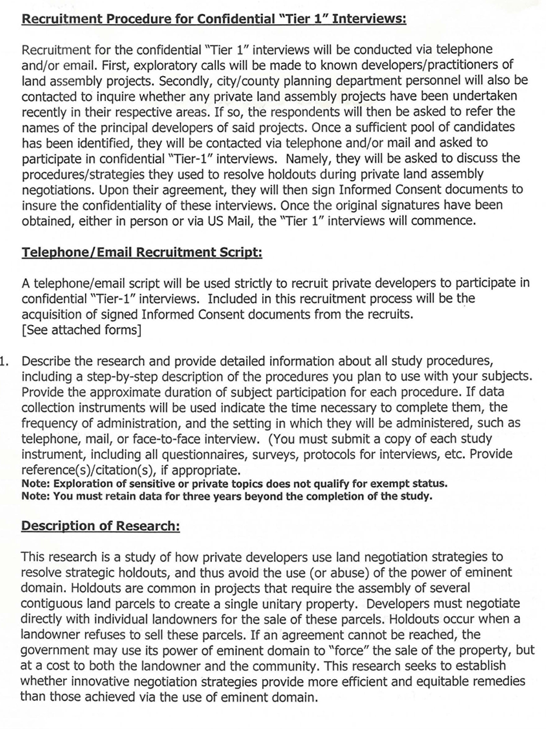
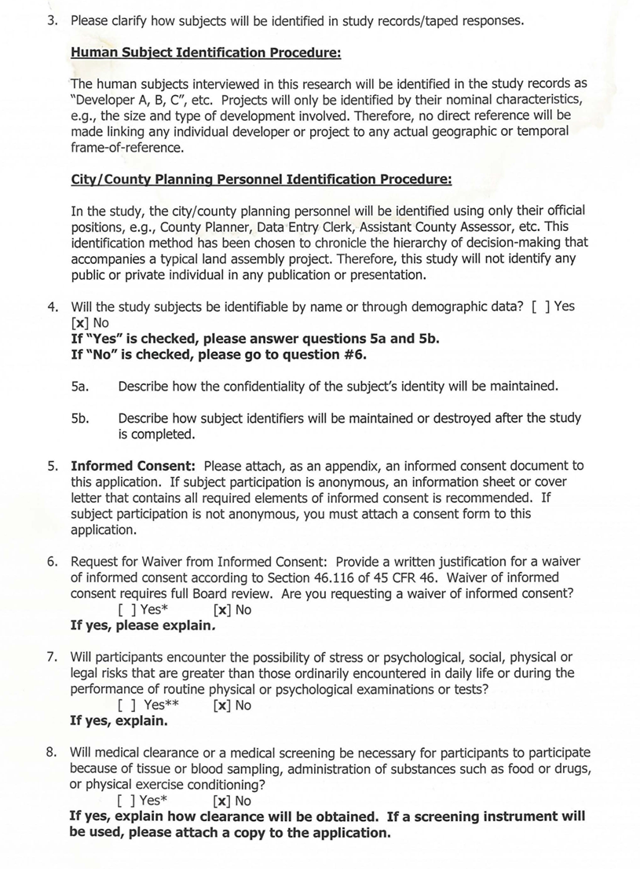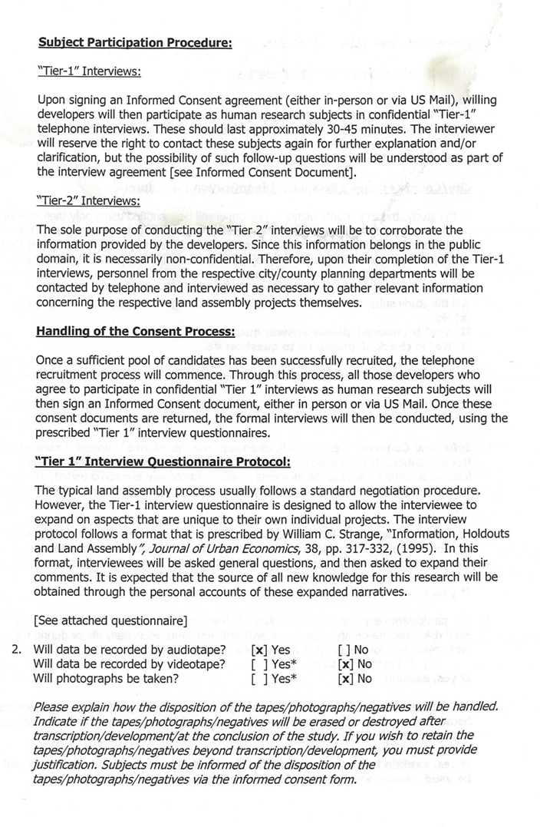
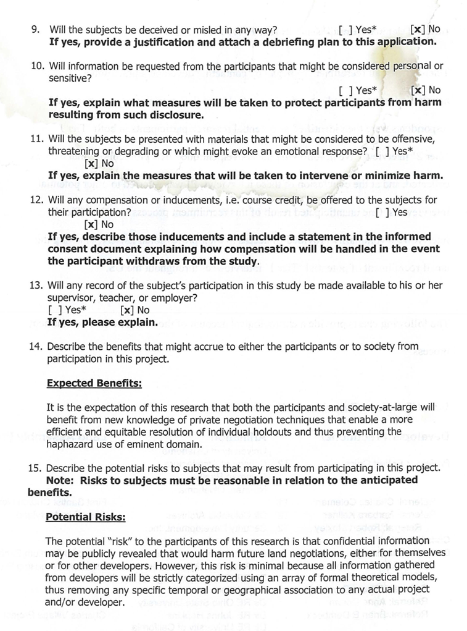

Table A. 2 IRB Interview Recruitment/Referral Tree (Tier 1 & 2)
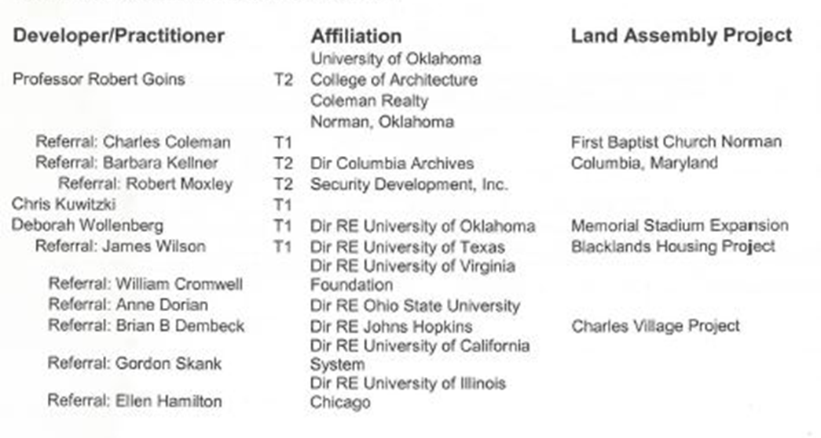
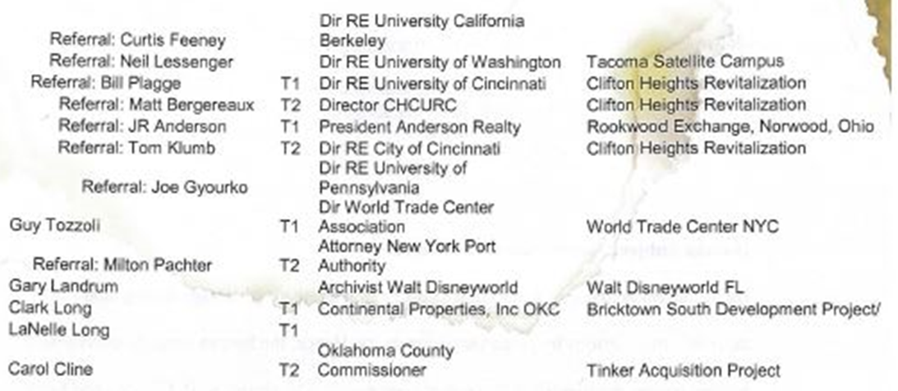

Table A. 3 Master Email Recruitment Log AUREO Listserv
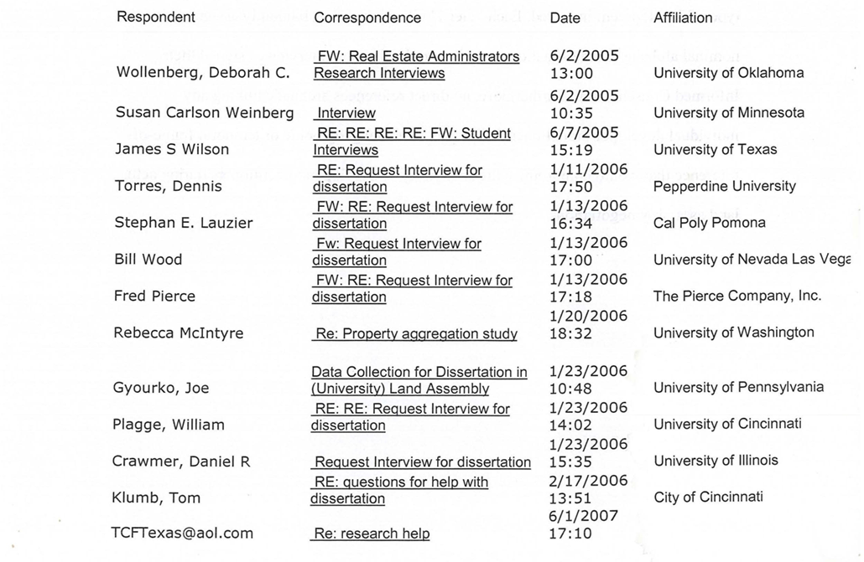

Appendix B: Case Study Transactions/Acquisitions Records
Table B. 1 Transactions/Acquisitions Data: Columbia, Maryland
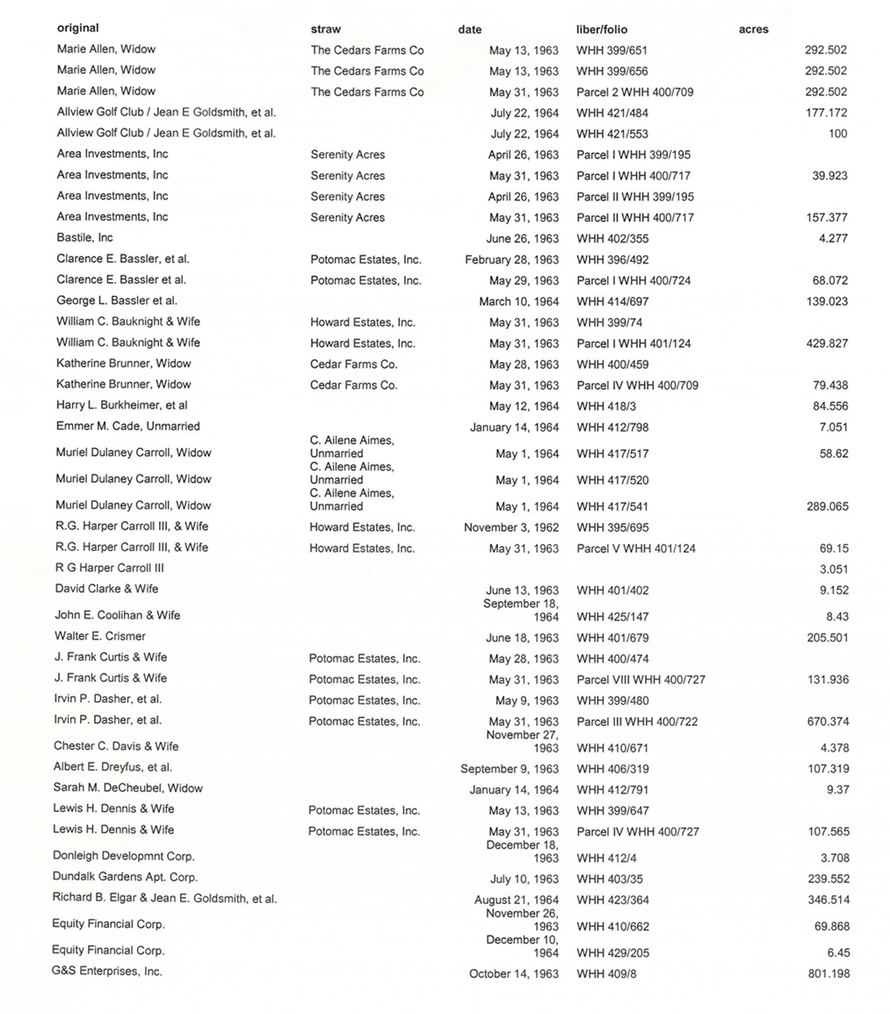

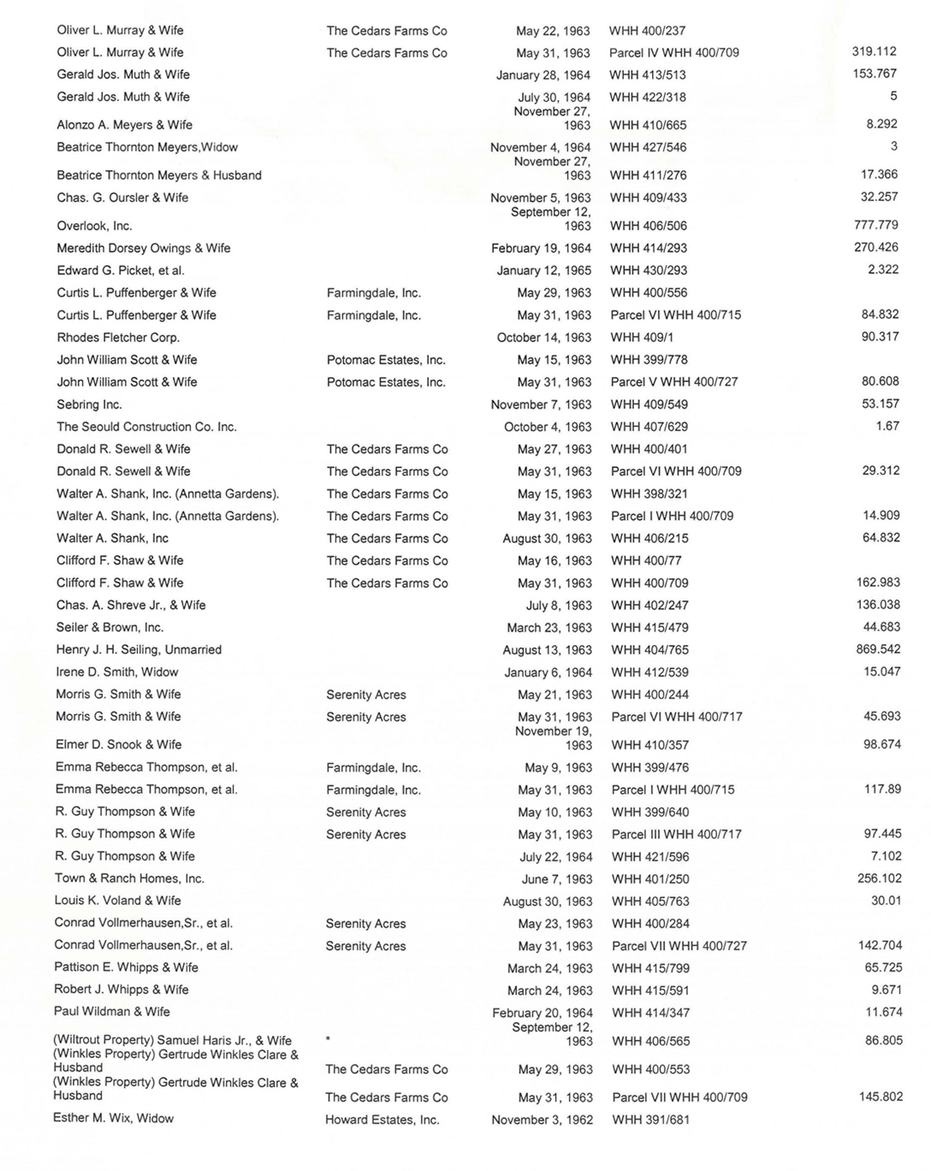

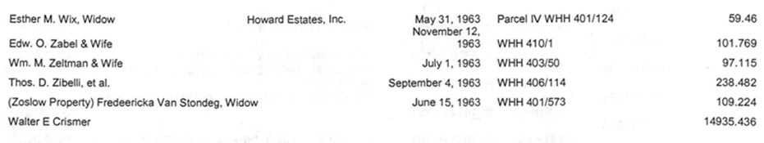
Table B. 2 Transactions/Acquisitions Data: Walt Disneyworld, Orlando, Florida
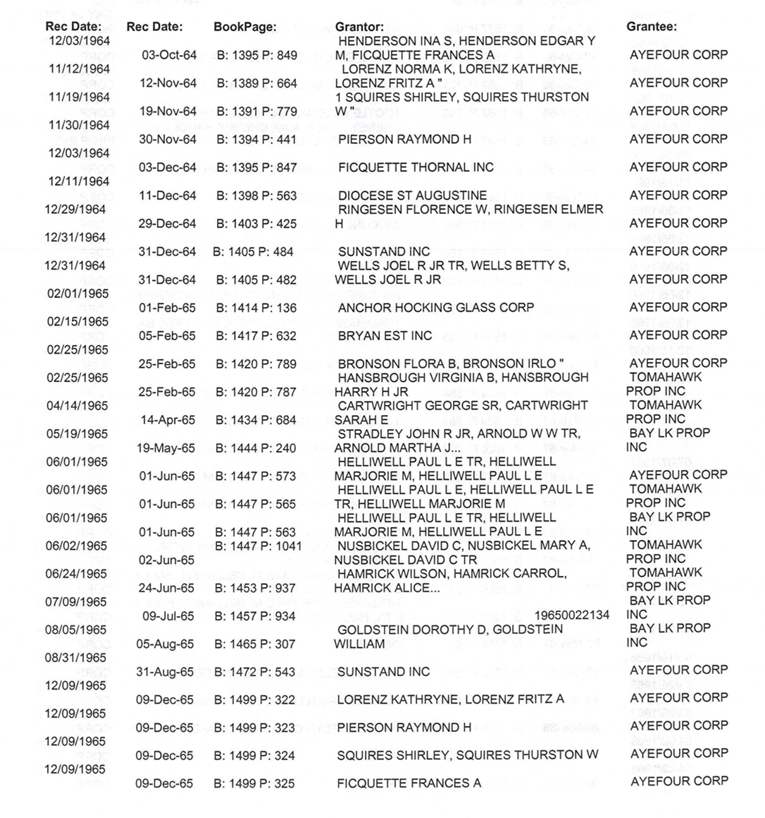
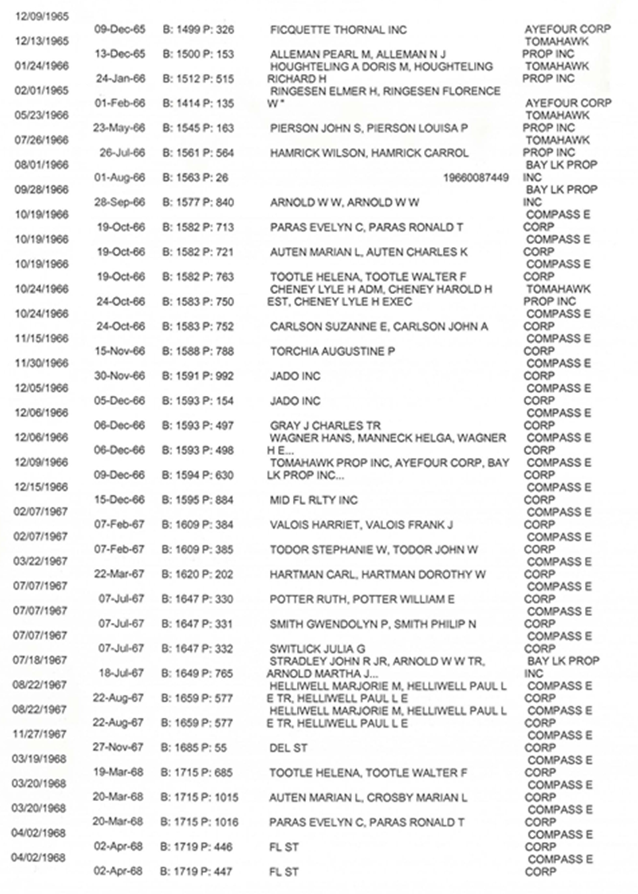
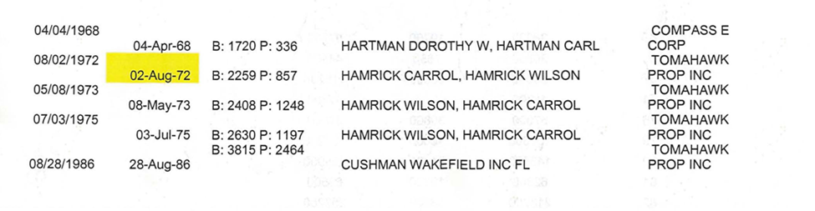
Table B. 3 Transactions/Acquisitions Data: World Trade Center, NYC
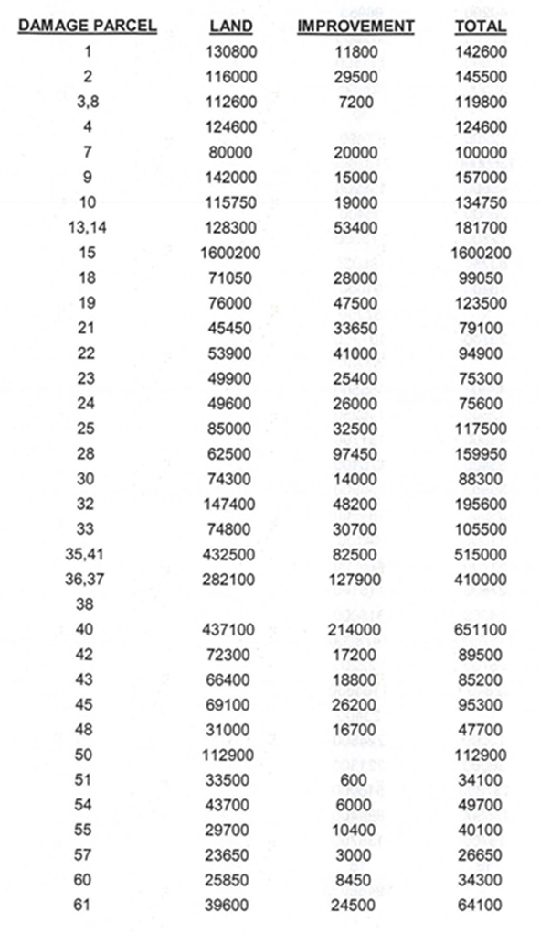
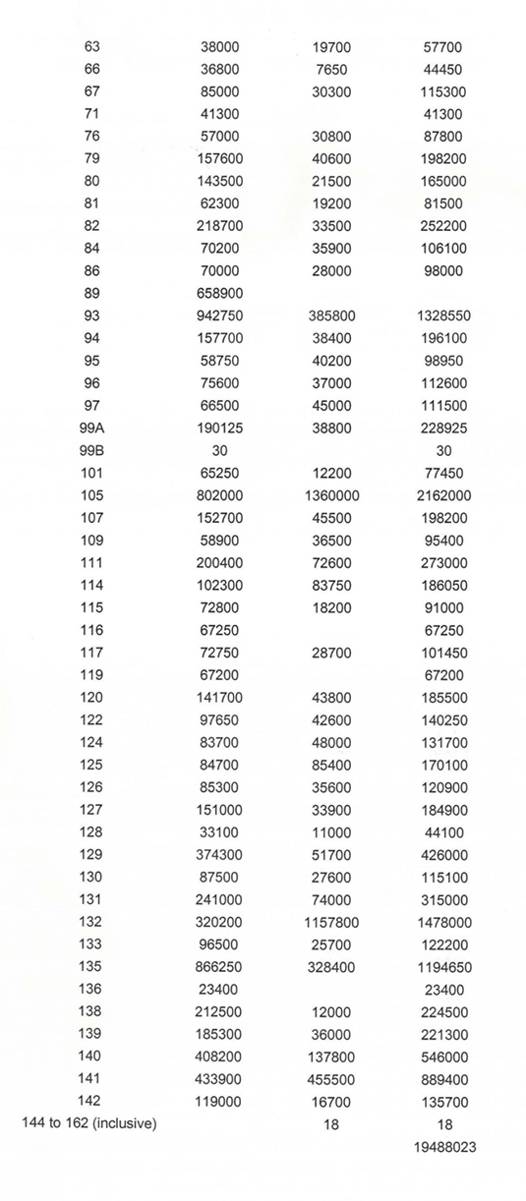

Appendix C: 3D Synthesis Matrix Analysis of Coursework Readings
All academic citations for this study were originally sourced from assigned readings in required PhD coursework from two formal disciplines: Urban Planning and Economics. These also include citations from graduate-level Directed Readings courses specifically targeting the general research topic of land assembly/holdouts/ eminent domain. The complete list of citations was first indexed in the order they appeared in their respective course syllabi, or in the Directed Readings schedule. Each group of citations was then compiled as a single bibliography by course, content area, and academic discipline. Each formal citation was then modified according to (1) index number, (2) date of publication (3) author(s), (4) title, and (5) content area. These data were then entered into a spreadsheet for analysis as a simple synthesis matrix. The master dataset of citations was first sorted by date of publication, then content area. These citation blocks were then grouped by successive decades:
Table C. 1 Chronological Distribution Table of Relevant Literature (1945-present)

By overlaying well-established milestones from Urban Planning and Public/Urban Economics onto this matrix, a thematic timeline is established by which to evaluate how each content area address (either directly or indirectly) the general topic of land assembly/ holdouts/ eminent domain through nine successive decades. A cursory analysis of Graph 1 shows that this body of literature includes 151 citations from two academic disciplines, covering nine formal content areas and spanning nine successive decades. In fact, this bibliography includes citations dating back to Fredrich Engels (1845) and Camillo Sitte (1889). Moreover, it includes publications by Childe (1965), Davis (1950), Kitto (1951) and Bass-Warner (2015) who collectively examine the earliest stages of urbanization circa 4000 BCE through the full evolution of Urban Industrialism in 1945. Thus, this synthesis matrix maps the full range and scope of all relevant publications pertinent for addressing the general topic of land assembly/holdouts/eminent domain.

Table C. 2 Chronological Table of Relevant Literature by Content Area and Decade

The following graph is a 3D-Synthesis Matrix showing the distribution of total citations from the Coursework Readings, i.e., arranged per academic discipline, per content area, and per decade.
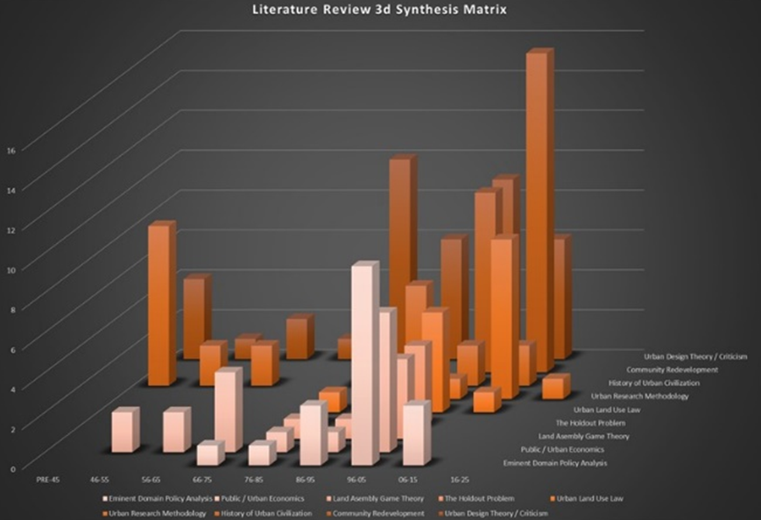
Figure A3.1 Literature Review 3D Synthesis Matrix

