University of Oklahoma
Graduate College

A Conductor’s Analysis of Three Choral Works by Jennifer Higdon

A DOCUMENT
SUBMITTED TO THE GRADUATE FACULTY
In partial fulfillment of the requirements for the
degree of
Doctor of Musical Arts

By Jeffrey Gonda
Norman, Oklahoma, 2021

A CONDUCTOR’S ANALYSIS OF THREE CHORAL WORKS BY JENNIFER HIGDON

A DOCUMENT
APPROVED FOR THE SCHOOL OF MUSIC

BY THE COMMITTEE CONSISTING OF

Dr. David Howard, Committee Chair
Dr. Richard Zielinski, Committee Co-Chair
Dr. Marvin Lamb
Dr. Roland Barrett
Dr. John Jones

©Copyright by JEFFREY GONDA II, 2021
All Rights Reserved
Acknowledgements
I wish to express gratitude to my family, especially my parents and my wife, for their constant encouragement and patience and for helping me to stay positive as I complete my degree. Thanks especially to my children for tolerating the hectic hours and the wild routine that this process has embodied.
I would like to thank Dr. David Howard and my graduate committee for all their help, guidance, and patience as they have assisted me through this project. Thank you to the University of Oklahoma School of Music for the opportunities for learning and growth it has afforded me.
I would also like to extend my gratitude to Dr. Nicole Lamartine, who introduced me to Jennifer Higdon and her choral music, and helped me to see how choral music could communicate in so many other ways. Thank you for continuing to be a mentor since my time at UW. Thanks as well to Dr. Christina Reitz and Dr. William Skoog, who have been so open and willing to share their insights into Jennifer Higdon’s Music.
Finally, I express my sincere appreciation to Dr. Jennifer Higdon, who has been so kind and welcoming through this entire process. Thank you for patiently and warmly responding to every e-mail and every question with sincerity, warmth, and generosity.

Contents
Acknowledgements iv
List of figures vi
Abstract vii
Chapter 1: Introduction and Purpose of Study 1
Procedures 5
Review of Literature 6

Chapter 2: Jennifer Higdon: Biography and Background 10
Higdon’s Compositional Style 16
Chapter 3: A Quiet Moment 22
Musical Analysis 23
Performance Considerations 26

Chapter 4: O magnum mysterium 28
Stylistic overview 29
Unifying elements 30
Structural Overview 33
Performance Considerations and challenges 35

Chapter 5: Sanctus 38
Thematic (unifying) Material in Melodic Upper Voices 40
Rhythm and Harmony in Lower Voices 46
Compositional Structure 49
Challenges and Performance considerations 51

Chapter 6: A Brief Introduction to Higdon’s Choral Catalogue 55
Alleluia 56
Deep in the Night 57
Invitation to Love 59
Hear My Voice 60
Love Came Down 61
“Our Beautiful Country” and “What Was His Name?” 61
Sing, Sing 63
somewhere i have never travelled, gladly beyond 64
Southern Grace 65
Voice of the Bard 67
Telegram 68

Chapter 7: Conclusion 69
Appendix A: Structural outline of O magnum mysterium 72
Appendix B: Structural outline of Sanctus 73
Appendix C: Assessing the Difficulty of the Small Choral Works 75
Appendix D: Alphabetical Listing with Suggested Difficulty 82
Bibliography 83
List of Figures
Figure 2-1 Alleluia, measures 39-44, soprano and alto parts 20
Figure 3-1 A Quiet Moment, ‘neighbor motive’ in mm 1,4,7, 9-16 24
Figure 3-2 A Quiet Moment, mm 17-24 25
Figure 4-1. O magnum mysterium, mm 1-9 31

Figure 4-2. O magnum mysterium, mm 7, 12-14, Flute parts 31

Figure 4-3 O magnum mysterium, mm 14-17 32

Figure 4-4 O Magnum mysterium, mm 46-47 32

Figure 5-1 Scales and pitch collections utilized in Sanctus 41

Figure 5-2 Sanctus, mm 8-9, 80-81, 42-44, 46-48, soprano and alto parts 43

Figure 5-3 Sanctus, mm 54-55 45

Figure 5-4 Sanctus, mm 22-23 46

Figure 5-5 Repeated text and corresponding rhythmic patterns in Sanctus 48

Abstract
This document explores various sacred and mystical choral compositions written by Jennifer Higdon in order to reveal stylistic traits as they appear in her choral works. The pieces that will be examined include folk song arrangements and original compositions, with analysis focusing on A Quiet Moment, O magnum mysterium, and Sanctus. The document will explore style features, unifying elements, performance considerations, and level of difficulty for Higdon’s choral repertoire. These elements will be explored in an effort to raise awareness of her choral literature, and to aid conductors in the rehearsal and performance process as it relates to her music.
Although much of Higdon’s instrumental music is found in various studies and dissertations, her choral literature has been largely overlooked to this point in scholarly writings. This document will shine a light on some of Higdon’s choral compositions. Higdon’s biography and compositional style will be summarized. Background, compositional style, form and structure, text setting and performance considerations will be considered for each work. Difficulty level of various works will briefly be considered. Various scholarly documents, interviews, and personal e-mail communications will be used to inform analysis. Previously published analyses of her other compositions will be investigated to help define stylistic traits and provide a lens to compare and contrast the style of these choral works. With this analysis, this document aims to place these choral works alongside the other renowned musical works of Jennifer Higdon.

Chapter 1: Introduction and Purpose of Study
Award-winning composer Jennifer Higdon gained considerable renown over the last twenty years. Even before winning a Pulitzer Prize and a Grammy award in 2010, she became one of the most commissioned and performed composers in the U.S. Her tone poem Blue Cathedral premiered in 2000 and rapidly became one of the most frequently performed works by a living composer. By that year she had already received numerous grants and awards for her achievements in composition. Over the course of that decade, she established herself as one of the few self-supporting composers today – Although she elects to teach and learn from a small number of composition students at the Curtis Institute of music in Philadelphia.
Due to the great success of Blue Cathedral, her Pulitzer Prize Winning Violin Concerto, and her Grammy winning Percussion Concerto (both awards were received in 2010), Higdon came to be known as an excellent composer of instrumental and orchestral music. At the same time, she also received numerous commissions to write for choral ensembles, with the bulk of her choral compositions occurring between 1997-2010.
Higdon is highly regarded as a composer and a professional. In the forward to Christina Reitz’ book, Marin Alsop writes: “…[Jennifer] is pure and simply a wonderful human being. Honest, loyal, compassionate, funny, and willing to show her flaws… She brings the same commitment to a piece for marching band or children as she does to a piece for the Philadelphia Orchestra.” Nicole Lamartine, who has worked with Higdon and conducted a large number of Higdon’s choral works described her first impression of the composer, explaining, “[I immediately felt that] I like the way she thinks. She’s logical. She has clear ideas, but she is open to new ideas and new creative thoughts about what she has already written.” William Skoog, who has studied and conducted various choral works, including the premieres of some compositions, stated “She thinks in layers most of us cannot comprehend. Every nuance, every detail of her music is so carefully crafted, so complex yet, when done properly, sounds more approachable, less difficult than it is. It sounds moving, impressive, inviting.” “Simply put, once I told Jennifer that she was ‘Samuel Barber on steroids.’ She grinned from ear to ear, and did not contest the notion.”
The impact of her Pulitzer and Grammy awards – her second Grammy came in 2018 for her Viola Concerto, and her third in 2020 for her Harp Concerto – is clearly apparent: Higdon vaulted even more clearly into the world spotlight as a master composer for instruments. Despite having composed an array of choral literature (her website includes over twenty small choral works under ten minutes, as well as four choral-orchestral works that are at least twelve minutes in length.), the choral music world seems to be relatively unaware of the composer and her contribution to choral literature. As will be discussed in the review of literature, choral music scholars have thus far mostly overlooked this body of work, with studies on her music rarely including choral compositions. Although this is not altogether unsurprising, considering the immense popularity of Higdon’s instrumental work, it is important to consider the value of her choral repertoire. Her choral music has much in common with the works that have been the focus of scholars, and it reflects her personality, as well as her ability and desire to communicate with an audience. Higdon stated in one interview: “I always tell audiences that I design my pieces so that you don’t have to know anything about classical music. I mean not only do you not have to know anything about contemporary music, but also you shouldn’t even have to know anything about classical music. What if this is your very first classical concert? I want the music to be able to speak to you even in that circumstance.”
Higdon’s compositional ethos is clearly displayed in her corpus of choral music through her use of triadic harmonies, tonal centers, and through her attention to text. Two obvious examples occur in Higdon’s textual treatment in Sanctus (2001), and O magnum mysterium (2002). Both texts have been set numerous times by choral composers. It is still very common to set the original Latin text. In her settings, Higdon chose to set both the original Latin and an English translation. Combined with clear text settings, Higdon conveys the text with clarity, while also creating contrast with the original Latin text.
Another example of her effort to communicate comes through color and instrumentation. The original score for O magnum mysterium includes choir, flutes, crystal glasses and chimes. Somewhere i have never travelled, gladly beyond is written for choir, vibraphone and piano. Sanctus is scored for unaccompanied eight-part choir. These unique settings provide very different effects and colors, while evoking a similar mystical feeling throughout.
Higdon frequently describes her compositional process as “intuitive”. She is known to use images and colors as inspiration for composition, rather than deliberately following convention and musical forms. The sounds and images from her youth served as inspiration for many of her pieces. One of the most common examples is the open intervals such as perfect fifths that can frequently be heard in many of her pieces. They evoke the images of the mountains and open spaces of her youth, and they also reflect the folk and popular styles she knew during her formative years.
Though intuition and communication drive her compositional process, her education in counterpoint, for example, is often reflected in her music because it is “embedded in her subconscious.” This combination between a desire to communicate and a thorough understanding of classical ideas and forms make Jennifer Higdon’s music of value both to the music scholar and to the uninitiated listener. Although her music demonstrates varying degrees of complexity, it never loses its value to the listener.
As many scholars have pointed out, and as this document has already suggested, Jennifer Higdon’s lack of a classical upbringing “…provided freedom from compositional systems. It undoubtedly has also contributed to her success among many contemporary art musicians and audiences with similar backgrounds.” Higdon’s freedom from compositional systems is doubtless a major cause in the heterogeneity of her compositional output. Indeed, studies on her music use various means to analyze and understand her compositional processes. Many of her pieces are written with virtuosic solo lines requiring expert performers. Some choral compositions are more accessible, but others, like Sanctus, require a very skilled choir, as it features challenging counterpoint that requires independence between all eight vocal parts.
Higdon’s demonstrable success as an instrumental composer suggests a high degree of effectiveness in her desire to engage audiences. Despite this success, the first study of any of her compositions for voice was not published until 2017, and the first publication on any of her choral works was not published until 2019. In a relatively short period of time, scholarly documents have illustrated the value of many of Higdon’s instrumental works. This study will attempt to demonstrate the same value regarding her choral works. In observing her compositional process and influences, this study will aim to examine these various choral works in an effort to aid conductors in interpreting, executing, and appreciating Higdon’s choral repertoire.
Procedures
This document introduces Jennifer Higdon’s choral works, with special focus on three early sacred choral compositions, and will comprise seven total chapters. Chapter 2 gives a biographical sketch and stylistic overview of her choral music for the choral musician that may not be familiar with her background. Chapters 3-5 will provide insight and analysis into three choral works, beginning with the most accessible, and concluding with the most difficult. Chapter 6 briefly introduces Higdon’s other small choral works and the challenges they present, in an effort to help the conductor choose music prudently for their ensemble. Chapter 7 offers a brief conclusion. As this document is aimed toward works that most choirs can perform, Higdon’s larger choral-orchestral works will not be explored.
The procedure for each section will remain largely the same for each large section of the document: Style features and general performance considerations will be discussed, and some musical examples will be utilized to illustrate those style features. The layout of each of the analysis chapters differs slightly as dictated by the requirements of each respective work, but each will include a structural analysis and a discussion of how basic elements such as melody, harmony, and rhythm reflect the composer’s style. Through personal email communication and interviews, Higdon provides many insights into the pieces that are analyzed, that will inform the performance and rehearsal considerations for each piece.
Although numerous scholarly works now exist on Higdon’s music, the studies that provide the main insight into her work are those by Brenda Phillips, Christina Reitz, Evangelia Leontis, and William Skoog. In addition, personal correspondences with multiple scholars familiar with Higdon’s work are used to give greater insight. With the help of these studies and correspondences, this document will continue to build a greater understanding of Jennifer Higdon’s work as one of the most important living composers of contemporary music in the United States. All score examples in this document are included with permission from the composer.
Review of Scholarly Literature

Jennifer Higdon remains a relatively new composer on the national scene. The body of scholarly work surrounding her music is comparatively small, but it is growing rapidly. This review will first examine the more general anthologies and volumes dealing with Higdon’s music. The latter part of the review will discuss dissertations and scholarly works that dissect her work in much greater detail, and thus will be the most relevant and useful resources for this study.
Most of the current body of literature on Jennifer Higdon comes in the form of anthologies, larger volumes, and articles, which tend to discuss Higdon as a composer among many contemporaries. Examples of such treatment include Marian Stewart’s overview of selected wind pieces as part of Timothy Salzman’s anthology of wind band music in 2012. Stewart reused much of this information in an article in 2014. These documents include a short biography of Higdon that includes some early influences on her compositional style with quotes from Higdon herself. Stewart then includes a brief analysis/summary of several instrumental works, including her Oboe Concerto, Fanfare Ritmico, and her Percussion Concerto. While that analysis doesn’t include choral works, the general analysis of the style features of Higdon’s work provides good initial insight into her biography and compositional style.
In a similar vein, Donald McKinney (2012) offers a biographic look at Higdon, but with even more focus on how her musical style has developed. His overview provides a different perspective that focuses on a larger scope, and attempts to demonstrate the conventions of the composer using a wider analysis than just works for wind band. (He remains one of the only authors to use an excerpt from any of Higdon’s choral works to evaluate her style. This excerpt from O Magnum Mysterium is very brief, as is the explanation.) McKinney provides brief biographical information, stylistic outlines and examples, and also includes a brief conversation with Higdon, along with a list of her published works through 2006.
Other books and anthologies include brief discussions of Higdon’s music. Jennifer Kelly (2013) and Robert Raines (2015) both include lengthy interviews with the composer in their volumes, each focusing on the composer’s background, compositional style and influences. Kelly’s interview focuses more on the general style features and influences, while Raines tailors the interview to focus more on how her style is affected by the challenges of the digital age. These volumes both provide a unique look into her personality and method, and each also includes selected works lists up to 2013 and 2015, respectively. Although there is some overlap in these lists, they are valuable in helping to establish a chronology of Higdon’s work. (This is especially important, since Higdon’s website lists compositions alphabetically and by category. There are also no sample scores online, so publication data is not readily available.) Additional books by various authors (such as Deena Reedy (2002), Andrew Clark (2004) and Deborah Rifkin (2010) offer useful perspective through research, analysis, and personal interviews with the composer.
The aforementioned works provide valuable detail on Higdon’s background and style, but their individual contributions have been dwarfed by the work of Christina Reitz, who completed one of the first large scale studies of Jennifer Higdon’s work in 2007. The first dissertation was a shorter analysis of flute and orchestral works by Brenda Phillips in 2005. Reitz, whose work is often found in the citations of the publications previously referenced, offered a thorough analysis of several of Higdon’s orchestral works. More importantly to this study, Reitz provides a more detailed biography and analysis of Higdon’s general style features than any of the previous scholars.
Since 2007, Reitz has continued to champion the music of Jennifer Higdon, writing the Grove music article on the composer in 2012. In 2018, Reitz published a book analyzing some of the same works covered in her dissertation, as well as some newer works, including Higdon’s opera, Cold Mountain. In the same year, Reitz published another article analyzing Higdon’s song cycle, Civil Words, effectively making Reitz the leading scholar on Higdon’s work, and she continues to champion Higdon’s compositions and publish new articles. For the purposes of this study, the most recent efforts by Reitz may be considered most valuable; the 2018 publications review compositions that have vocal lines and text. This can provide a more effective template for approaching her choral works and considering how text setting affects her compositional style.
In addition to Reitz’s very recent work, another useful dissertation was published in 2017 by Evangelia Leontis, which analyzes Higdon’s setting of text in one of her chamber works for solo voice, “Love Sweet.” In her introduction, Leontis acknowledges the fact that prior to her study, no scholarly work had attempted to discuss any of Higdon’s vocal works.
Finally, another scholar, William Skoog, presented a brief study on Higdon’s largest choral work, The Singing Rooms, in 2019. Skoog, who has conducted various works by Jennifer Higdon, is familiar with her choral compositions, and as of this writing, is also working on additional studies related to Jennifer Higdon’s choral works. In addition to his analysis of The Singing Rooms, Skoog provides a brief overview of Higdon’s compositional style as it relates to her choral work. He also provides an alphabetical catalogue listing Higdon’s choral works. This overview provides another excellent foundation that this study will expand upon.
From this rapidly growing body of scholarly literature, it is easy to see that there is still a large void when looking at Jennifer Higdon’s choral repertoire. This is even clearer when looking specifically at her choral works, where very little has thus far been explored. To date, most scholarly documents only address Higdon’s instrumental works, with very rare allusions to any vocal works, let alone her choral works. The trend in the scholarly literature to this point has clearly been to gloss over the choral side of her works, leaving a gap that is ready to be filled.
In addition to the current literature on Jennifer Higdon, it is important to note that the composer herself has been a willing primary source for scholars. Higdon considers it important to make herself available, and this is demonstrated in the scholarly literature that she has taken ample time to discuss her works. It is hoped that email and other communications with the composer will aid this study to fill in the gaps and give a clear understanding of her body of choral literature. Thanks to the work of these scholars, as well as a few short writings by Higdon on her own compositional ideas, there is a solid foundation and understanding of biographical information and history, as well as general style and compositional features, to begin an exploration of the choral music of Jennifer Higdon.
Chapter 2: Jennifer Higdon, Biography and Background
Jennifer Higdon’s biography is now well documented, thanks to numerous papers and interviews, many of which go into varying levels of detail surrounding her upbringing and early artistic education. She was born in Brooklyn, New York on December thirty first, 1962. Only six months later, her family relocated to Atlanta, Georgia, and when she was ten years old, they moved again to Seymour, Tennessee, to a 40 acre farm. Higdon’s childhood and youth were marked with various artistic experiences. Her parents had artistic backgrounds: her father taught at the Atlanta College of Art, and worked as a freelance artist specializing in avant-garde art. Her mother also painted and quilted.
Higdon’s experience with art impacted her from a very young age, as her parents exposed her to a number of artistic experiences, including rock concerts, ballet and art shows. It is often discussed in books and interviews how her exposure to avant-garde art shaped her idea of what art should be – It shaped her awareness of colors and their relationship visually, and it also helped her to realize that art must have a clear, well-thought out form. Christina Reitz explained further, quote: “[Higdon’s] early exposure to the avant-garde led her to question experimentation for its own sake; these experiences have shaped her compositional philosophy that communication to an audience of varying backgrounds is critical.”
Although she was exposed to a variety of art, her musical upbringing was almost entirely based in popular styles, with bands such as the Beatles, Simon and Garfunkel, Bob Marley, and others pop and country musicians of her childhood having a significant influence on her. Higdon did not begin any formal training until high school, when she began playing percussion in her high school marching band, and shortly after, began teaching herself flute using an old elementary flute methods book that belonged to her mother. In one interview she stated, “…I decided to take the beginning band books she had and I began to teach myself how to play. I didn't know how to read music, so I had to teach myself how to read from that elementary book. I started playing flute; we're talking extraordinarily basic stuff… my early education was from this band method handbook for flute. It is kind of a little unreal!”
As a result of her lack of exposure to classical music or music lessons, Higdon constantly believed she was behind in her schooling. “I went to college not knowing any classical music. I didn't even know the Beethoven symphonies, which just seems weird for an eighteen-year-old who wants to major in music, especially knowing what I know now. I guess I didn't know enough to be intimidated! … When I started college, I was playing catch-up with my colleagues. They had all had music lessons, and they knew quite a bit of repertoire. And it was that way all the way through my schooling; I always felt like I was trying to catch up. I'm not sure if it was actually a disadvantage, but it felt like it at the time.”
Despite these challenges, Higdon demonstrated hard work through her undergraduate and graduate programs – first at Bowling Green University, then at the Curtis Institute, and finally at the University of Pennsylvania. She credits various professors for their influence in her life, including her undergraduate flute teacher, Judith Bentley, of whom she stated: “to this day, I still think of [her] as probably the most prominent composition teacher I had.” At Curtis, she studied with Ned Rorem, who helped raise her awareness of effective text setting and writing smooth and effective melodies. While at Pennsylvania, George Crumb influenced her compositional style in various ways. Among other things, He helped her to listen more effectively, and his encouragement to use the sounds and images of her youth in rural Tennessee helped her to develop her harmonic language.
During graduate school, Higdon began to find success as a composer, despite the challenges school presented. Higdon described the difficulty of having to retake her doctoral exams multiple times as a result of her background and also of receiving roadblocks from some of her professors because quote, “There were members of my doctoral committee who claimed that I was having too much success. I didn’t fit the box of what they were expecting.”
After completing a doctoral degree in 1994, she was invited by Robert Spano – who remained an influence in her life since her time as an undergraduate at Bowling Green University – to join the faculty at the Curtis Institute in Philadelphia. Not long after, her first big break as a composer came. In 1995, she composed Shine for James DePriest and the Oregon Symphony. The commission came about thanks to ASCAP grant designed to generate opportunities for young composers. The piece brought her renown and led to several other commissions.
In 1999 her career took another huge step forward, as the Curtis Institute asked her to compose a piece for their 75th anniversary. The result was Blue Cathedral, a tone poem that she chose to write in commemoration of her late brother, who died of cancer the previous year. The piece was premiered in 2000, and over the ensuing years it rose to become one of the most frequently performed orchestral works in the United States. over the last two decades, it received over 650 performances.
By 2010, Higdon was in high demand as a composer. Among many other accomplishments, she was awarded a Pulitzer prize for her violin concerto. During that same time she acted as the composer in residence at the University of Wyoming for the 2010-2011 school year. Several of her choral pieces were performed with the composer present, including O magnum mysterium, Deep in the Night, Sanctus, somewhere i have never travelled, gladly beyond, and several folk songs excerpted from her cycle, Southern Grace. While Higdon has acted as a composer in residence at numerous locations, this residence is particularly noteworthy to this document, as Nicole Lamartine, who at the time directed the University of Wyoming Collegiate chorale, worked closely with Higdon on this music – The sample recording of Sanctus on Jennifer Higdon’s website is the one created by Lamartine and the Collegiate Chorale.
In addition to Lamartine and Robert Spano (who conducted the Premiere of the Singing Rooms in 2009, among other compositions), William Skoog of Rhodes college became a champion of Higdon’s music. Like the two previous conductors, he worked closely with Higdon over the past decade, conducting three separate performances of The Singing Rooms with the composer present, a regional premiere of Ruminations, and additional performances various smaller works.
Since her 2010 Pulitzer Prize, Higdon added numerous other awards – she now has three Grammy awards – and demand for her work has continued to grow. More and more dissertations continue to be written on various compositions. She has received a few commissions to write choral works, but with the exception of her larger work, Ruminations, these are relatively short choral compositions. Two of the more recent choral works are actually excerpted arrangements from her 2015 opera Cold Mountain. When these are set aside, the amount of choral compositions since the awarding of the Pulitzer Prize appears even smaller. This may reflect the relative lack of awareness of her music that persists in the choral world. William Skoog, who to date has the only significant publication on any of Higdon’s choral works, writes: “Mention the name Jennifer Higdon to most musicians and there is near universal recognition and acclaim for her work, essentially for her instrumental works. In opera circles, she is hailed as a rising star … However, to most choral musicians, there appears to be little awareness of her accomplishments as a composer or that she has written a substantial quantity of quality choral music.”
Since 1992, Higdon continues to compose music exclusively on commission. She still teaches composition at Curtis, though since 2002, due to increase in commissions, she decreased her teaching load to focus on composing. She lives in Philadelphia with her wife, Cheryl Lawson. Together, they founded their own independent publishing company, which received its name, Lawdon Press, from their last names combined. Cheryl Lawson acts as Vice President for the company. A more detailed biography on Jennifer Higdon can be found in Christina Reitz’s book.

Higdon’s Compositional Style
Jennifer Higdon describes her compositional style as being intuitive. Several scholars explain this approach, but Higdon’s own words give insight into her thought process. She explained in one interview “I had a lesson with George Crumb once, and he said in the lesson, ‘Jennifer, the most important thing in the end is how it sounds.’ And I remember sitting in the lesson and thinking, ‘… if that’s the most important thing, maybe I should start from that standpoint and trust that all my training will lead me.’ Now, the ironic thing is, there are three or four students doing dissertations on my pieces now… they often come to me and say, ‘Alright, can you show me your sketches and what you’ve been thinking theoretically? How did you put this together?’ …I usually don’t have many answers for them. But they find all sorts of things in my sketches. I think a lot of it maybe happens instinctively from studying enough music and having played in an orchestra and having conducted orchestras. I think there’s just a body of knowledge that just kind of accumulated over the years. And the pieces that don’t work, I throw away. I give myself permission to fail on things. I will try different languages, different styles of pieces, different speeds for things to unfold, and if it doesn’t work, I don’t keep it.”
This approach results in music that is varied in its rhythm, harmony, and use of colors and timbres. In her writings on Higdon’s instrumental works, Christina Reitz frequently refers to Higdon’s music as having a “mystical” quality. Reitz explains that, “‘Mystical’ is an applicable description of many of [Higdon’s] orchestral works that is primarily achieved through heterodox instrumentation such as the water gong, Chinese health reflex bells and crystal glasses. Although not associated with any particular religion, Higdon describes herself as a spiritual person with a strong knowledge gleaned from examining numerous literary accounts on the subject.” This description fits in many of her choral works as unique instrumentations can be found, along with open emphasis on certain harmonies such as open fifths that create a spiritual or ethereal feeling. This occurs in her choral music on texts that are overtly sacred, but also on less traditional texts, such as in Higdon’s setting of the surrealist poem somewhere i have never travelled, gladly beyond. Her part writing usually features fairly straightforward stepwise melodies to intricate contrapuntal lines with surprising rhythms and leaps. Higdon’s primary goal is to compose music devoid of esotericism. She explained, “My job is to communicate. I feel that you should be able to come to my music without having any kind of knowledge about classical music. I want to be able to speak to you on a kind of visceral level. "Accessibility" doesn't seem like a negative word to me.”
Defining stylistic trends in Higdon’s music is a difficult process thanks to the variety of her music, but some basic musical ideas seem to come across in much of her choral writing. Her writing is driven very much by the text, and by an understanding of the performer for whom she is writing. Nicole Lamartine, who worked closely with Jennifer Higdon during her residence at the University of Wyoming, explained that Higdon’s choral music could be divided into two categories: The first comprises music that is accessible enough that it can be performed effectively by most choirs, and the second that requires a much higher level of musicianship to successfully approach the work. Lamartine stated further, “To my ear… there is a melodic intent that is always tuneful, and always sonically interesting … it is singable, it makes sense, and it’s accessible to the ear of the audience.”
In writing choral music, Higdon focuses on the text. She considers both how to communicate the text effectively to an audience, and how to set the text in the most natural, logical way possible. Christina Reitz explained when discussing her observations regarding text in Cold Mountain that, “I would say that in both her choral and vocal solo writing, great attention is given to the English language and making the accents conform to the peculiarities of English. This greatly enhances the text clarity (which in [Cold Mountain] at least, was a fundamental concern for Higdon). Additionally, in both the solo and choral writing, very few melismas were used, which also enhanced the textual clarity considerably.” These considerations can be seen in Higon’s choral works as well, and the accessibility of the text is rarely a concern for the choir. Higdon’s choral works encompass a wide variety of texts, from simple folk songs, to traditional spiritual texts, to more mystical and ethereal texts by poets such as E.E. Cummings, Rumi, and Jeanne Minahan. Several of Higdon’s works feature texts she wrote herself. She admits to a preference for setting pre-written texts: “It's a little harder when it's my text because usually I'm attempting to write the text simultaneously to writing the notes themselves. If I'm using someone else's poem, there is already a "skeleton" for the structure...a huge part of the decision-making comes out of the clarity of the text (and some of the emotional elements may be there as well).”
Melodically, Higdon tends to write shorter motivic phrases that then will be expanded out in the work. Her choral melodies are generally written with steps or very small leaps – usually smaller than a fifth. As has already been alluded to, the melodies in Higdon’s music almost always make sense both to the singer and to the audience; Even in her choral partwriting that is more complex, Higdon creates voice leading that tends to move in a logical way that is usually accessible to the singer, even when the overarching texture adds much more complexity. Her melodies are usually stepwise with leaps less than a fifth, but on rare occasions, more difficult voice leading with larger leaps can be found. These melodies are often centered in a mode – Lydian and Mixolydian modes are common, but Higdon’s intuitive approach can also lead to more unconventional scales. Skoog gives poignant descriptors to Higdon’s Melodies, stating: “Lovely, lyric melodies are created for texts that are likewise lyric (calm, serene, floating and soaring) in nature. These are not as common as the shorter motives with contrapuntal development, or appear as frequently as the choral chant/chordal writing mentioned above. Therefore, when they appear, their affect is one of loveliness and contrast to the others.”
The challenge in Higdon’s more difficult melodies presents itself often through her intricate contrapuntal polyphony. In an interview with Nicole Lamartine, Higdon acknowledged that learning counterpoint in school likely had an impact on her style when writing choral melodies and harmonies. “We had to take a lot of counterpoint at Curtis… I love counterpoint … I wonder if perhaps the various rules associated with baroque or renaissance counterpoint about fifths and octaves might have somehow permeated my thinking, because I associate that counterpoint with vocal music. I have a feeling there may be some sort of connection there.”
Higdon’s choral melodies and harmonies usually are almost always built around a tonal center, and triadic harmonies and open fifth harmonies are common, especially when establishing the tonality of a piece. As her choral music becomes more difficult, secundal harmonies can often be found, and quartal harmonies are occasionally used as well. While Higdon’s more accessible choral music features some extended tertiary harmony and secundal intervals, harmony rarely moves functionally. In the more difficult pieces, bitonal chords and fully pandiatonic harmonies can be found as well.
Higdon’s textural writing is related closely to melody. Her music almost always appears to be conceived linearly. Even in pieces that are fully homorhythmic, the vocal lines seem to be conceived horizontally, as melodic lines, rather than as vertical harmonies. This plays out in A Quiet Moment, where a short motive is passed between voices, and in O magnum mysterium, where the homorhythmic lines transform from simple parallel motion to a more “contrapuntally enlivened” homophony, as each vocal line seems to have its own sense of melodic contour. In her more complex music, these independent lines weave together to create a rich tapestry of sound. In one section of Alleluia, for instance, the soprano and altos repeat independent fragments that only complete the word “Alleluia” when sung together.
Figure 2-1. – “Alleluia,” measures 39-44, soprano and alto parts
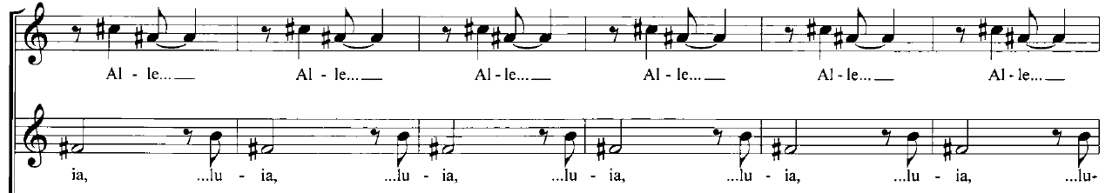
Rhythmically, Higdon’s music almost always has a strong sense of pulse throughout. This can be seen in much of her instrumental music. Her large choral work The Singing Rooms features sections of fast tempos, quick entrances, syncopated rhythms and sweeping melodic lines. Some of this can be seen in her choral writing, but many of her choral works feature much slower tempi and more restrained rhythm. She explained, “Everything I have instrumentally, most of it is fast and extraordinarily intense … The choral music provides an incredible relief. It is like breathing, because I can slow down.” Even in these slower choral works, where the music has more “time to breathe,” there is always a clear pulse driving the music forward, and usually a steady composite rhythm created between the choral voices – much like with Higdon’s polyphonic textures, the full picture of the piece can only be seen when all the voices sing their individual rhythms with the full group together.
Higdon’s flair for rhythmic excitement can be seen in some of the songs in her choral cycle Southern Grace; In her arrangement of “the Fox,” for example, the chorus sings a rhythmic, instrument-like accompaniment underneath the soloists. Even her arrangement of “Amazing Grace,” which has a slower tempo fitting the traditional hymn, the opening verse features a soloist singing the melody, while the other voices interject with short, separated notes, creating a rhythmic accompaniment figure. The piece closes as all choral parts sing fragments of the final line of texts, creating an echo effect as the piece fades.
The focus on rhythmic drive can be seen clearly in many of her instrumental works – the more complex of which feature complicated rhythms and mixed meter. Instrumental pieces such as Blue Cathedral and choral-orchestral works such as the Singing Rooms feature numerous passages where the instruments are called to play difficult rapid passages, large intervals, and off-beat entrances. In this way, Higdon demonstrates her understanding of both the strengths and limitations of the instruments and voices for which she composes. Higdon’s larger works, such as the Singing Rooms, and Ruminations, require a highly skilled orchestral compliment. The long, fast sweeping gestures, the intensity of rhythm and tempo, and frequent independent entrances (many of which occur off the beat), are a few features that make this a very challenging work, especially as far as the orchestra is concerned. For many choirs who lack a significant budget to hire performers, the size and cost of the orchestra makes it unperformable. It is worth noting that her choral writing is fairly accessible for most good choirs. Higdon wrote both the Singing Rooms and Ruminations to be performed by “good amateur choirs.” This means that if strong orchestral players are available, a good university or community chorus should not be afraid to approach these works. While the larger multimovement choral-orchestral works certainly merit more in depth analysis, this study will give attention to works that are smaller in scope and are generally more accessible to choirs of varying skill sets.
Chapter 3: A Quiet Moment
Despite being one of the shortest and most straightforward of Jennifer Higdon’s choral compositions, A Quiet Moment nevertheless represents many of her stylistic trends well. This piece is among the most accessible of Higdon’s choral works, but it still requires a strong sense of tone, intonation, rhythm, and independence of the singers, among other necessary traits. Due to its straightforward composition, A Quiet Moment makes a good introduction to many of Higdon’s stylistic conventions. In addition to the accessible structure, the piece is worth discussing due to its background. It was written for a commission and published in 1999. As was the case with Blue Cathedral and “Amazing Grace,” which were written roughly the same time, A Quiet Moment was written in memory of Higdon’s brother, Andrew Higdon. The genesis of this work was quite different from the way Higdon typically composes. She explains that creating a piece of music comes by looking at the text and following her ear to generate the music: “I don’t hear all the music at once. I just hear a measure at a time… I hear one line… and then I’ll be sitting there staring at it and the thought will occur about the next measure.” Compared to this relatively slow measure by measure process, in the case of A Quiet Moment, the piece came together in a matter of hours and came as a cathartic moment for Higdon to have the piece come together seemingly all at once. She explained how “Writing this work in one long day allowed me to release a lot of grief that I was feeling at the time.”
The resulting piece features a simplicity and sincerity that the program notes describe concisely, stating: “A Quiet Moment is about the people we meet in our lifetimes and how our souls are affected by them and how we affect others. It's a song to ourselves, to you, and to everyone we know. It's a song about living and letting go and being and saying goodbye.”
Musical Analysis
The piece is tonal throughout, and harmonically more straightforward than O magnum mysterium. Unlike most of Higdon’s other works which are only written in one voicing, this is published in three versions: Version A is the original, written for tenor and bass voices. Version B is voiced for soprano and alto, and version C for mixed chorus. This makes it one of Higdon’s most versatile pieces, as well as one that can be performed in almost any choral setting. This piece is also valuable to view through the lens of being one of Higdon’s earlier choral compositions, since it highlights many traits that will be seen in Higdon’s later works, including her sense of pulse, her use of harmony, her expressive counterpoint, and her text-driven composition. All of these traits appear on a small scale in A Quiet Moment.
The musical examples used for this document come from version B, which is scored for Soprano and alto voices in the key of C. While all of Higdon’s music features tonal centers and triadic harmony to a large degree this one is the most diatonic and is one of the few pieces that can be analyzed functionally. The piece is sectional, with three short sections of similar lengths: Measures 1-16, 17-33, and 34-44.
The first section is built on a C pedal and a simple motive that is exchanged through the upper three voices – the entire piece is built off the simple three note motive that appears in the alto 1 in the first measure. (see examples in figure 3-1)
Figure 3-1. Repetitions and expansions of the “Neighbor motive” in A Quiet Moment
m. 1, first iteration in alto part m. 4, first reiteration in soprano
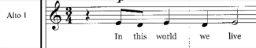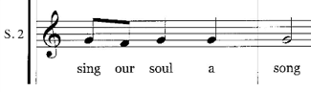
m. 7, staggered repetions
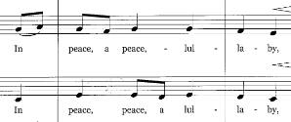
mm. 9-16, repetitions and expansion in soprano 1
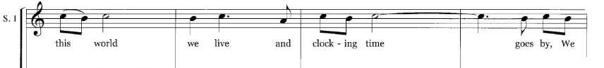
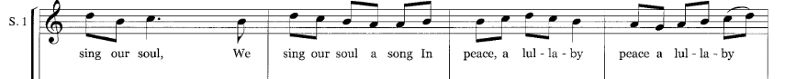
This motive could be described simply as a “neighbor motive” as it moves simply down and back by step, with an eighth-eighth-quarter rhythm. In the first section, it is repeated multiple times in imitative fashion though each of the upper three voices, while the lowest sings a C pedal. Despite the brevity of the piece, Higdon finds ways to vary and expand the motive such that it remains familiar throughout, but never feels overly repetitive. The motive is expanded slightly in the soprano voice by increasing the interval from minor/major seconds to minor thirds in the pickup to measure 11 and in measure 13 in the soprano voice.
At measure 17, where the middle section begins, it can be seen in all three of the upper voices, with the rhythm altered to steady quarter notes. the interval of the motive is expanded to include a descending third in measures 18 and 19 and altered to fit the harmony. The melodic material through this section is varied, with larger leaps leading to measure 33, though the expanding melodies never stray too far from the motive.
Figure 3-2 mm. 17-24 - “Neighbor motive” repeated and varied
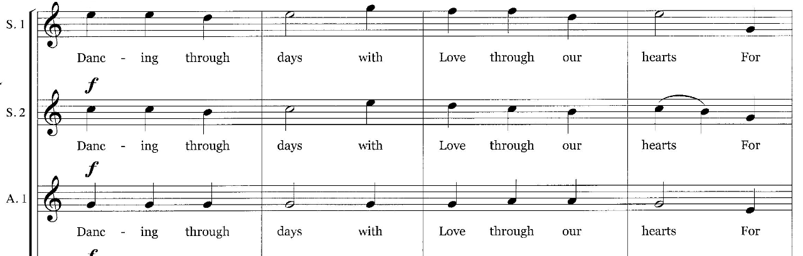
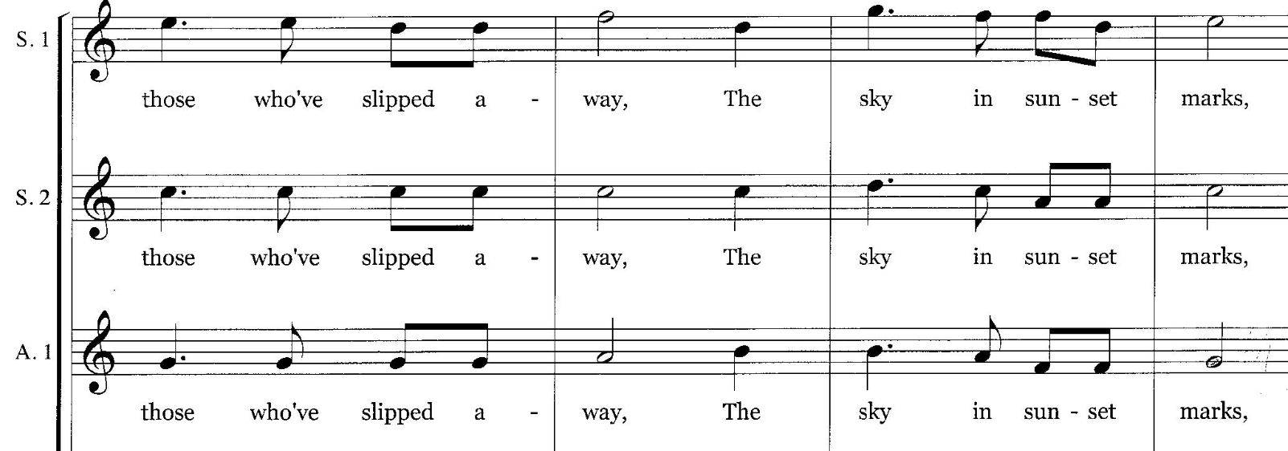
The neighbor motive once again pervades in the closing section, this time with lower and upper neighbors creating a new variant. This closing section is much more contrapuntal, with imitative entrances creating a steady eighth note feel before the molto ritardando in m. 40. Some larger leaps also separate repetitions of the motive as well. The final iteration happens in the penultimate bar, before the voices cadence on a C major chord, giving the piece a unifying feel throughout.
In addition to this motivic material there are a few other noteworthy characteristics in A Quiet Moment. With the exception of the large cadential moment in measure 33 and the molto ritardando that signals the end of the piece, the pulse of the piece is steady throughout. The composite rhythm of the piece is rarely longer than a quarter note, and Higdon generates a feeling of increased energy and tempo through greater use of eighth notes leading into the climax at measure 17. This, combined with steadily increasing dynamics, leads the listener clearly to the high point of the music. Similar approaches to the climax of the piece will be observed in O Magnum mysterium and Sanctus as well.
One final observation is regarding harmony. Like the rhythm, the harmony of this piece is more straightforward than in many of her other works – this is one of the few works that could effectively be analyzed functionally – using mainly I, IV, and V chords, with occasional suspensions and non-chord tones adding color and richness to the harmony. Unlike many of her later works, the interval of a fifth is not emphasized.
Performance Considerations
Looking purely at the notes and rhythms, it is immediately apparent that A Quiet Moment is not a terribly difficult piece. Furthermore, the background and program notes make this piece immediately relatable to the performer as well as to the audience member. The independent counterpoint in the voices is simple enough to make this piece not just a good introduction to Higdon’s music, but a good piece to help younger choirs to sing more independent polyphonic melodies with confidence. The piece is brief enough, and the main motive repeats with enough simple variation so as not to overwhelm the choir. The harmony is simple and repetitive enough that it should immediately feel familiar to any choir. The biggest challenge from a technical standpoint is the unaccompanied singing, which must have a strong foundation. The lowest voice sings a pedal tone for the first 24 measures, so the conductor will need to find creative ways to help them keep energy in their sound and support the intonation of the more melodic upper voices.
As has been discussed, communication of text is critical, and finding ways to communicate more effectively should be the goal. Higdon has stated her willingness to allow for multiple interpretations of any given piece of music, stating for example, “Having been a performer, and having to take scores and interpret them, especially new works, it can be overwhelming if absolutely every detail is marked. It’s almost paralyzing… From the times I’ve conducted… I like to have a little bit of breathing room, so I think people should have a chance to interpret my music in their own way.” She later elaborated, explaining “I have had times when people have taken something so far over the edge that it compromised the piece (and sometimes made it harder for the performers, especially in terms of breathing). I will always say something when it's too far off the mark. But I also welcome people's interpretations, because I sometimes learn something about the piece.”
This attitude toward interpretation should give the performer ample room to explore the text and musical relationships. For example, the steady quarter note and eighth note rhythms could be evocative to the performer of the ticking clock. The ¾ meter is associated with dance rhythms, so the text “Dancing through days” should easily connect to the text. In addition, Since Higdon pays careful attention to the text stress, the performer should consider how to adequately reflect that. Nicole Lamartine emphasized the importance of finding the text stress as well as the meaning: “I think a lot of times, what Jennifer puts on the page is exactly what she intends, but I think she also allows the conductor to explore a little bit, and to find the ebb and flow of the piece, because if you sing a quiet moment exactly how it is written on the page, it is nice! But when you dig a little bit, and you find the intent, you find out why she wrote it, and you [discover] how to pace the piece, it becomes much more rich.”
Chapter 4: O magnum mysterium
If A Quiet Moment is representative of the most accessible of Higdon’s choral compositions, then O magnum mysterium would represent the works that have a more moderate difficulty for choirs. The piece is set for flutes, chimes, and crystal glasses, Placing it among works such as somewhere i have never travelled, gladly beyond and Love Came Down, two other small compositions with unique instrumentations. This work was written in 2002 and premiered with the Philadelphia singers. The use of flutes was specifically requested by the commissioning choir, and Higdon chose to add the other instruments to the composition. The piece is unique in many ways, but the most interesting trait is how Higdon sets both the original Latin text together with the English text. Higdon explains that she chose this because “The choirs wanted the original Latin. I made the decision to also have the English version in as well, because I thought it would make an interesting contrast in the music (I couldn't figure out why other people had not done this). This is also the case with Sanctus, which is currently the only other piece that she has set to a non-English text.
Stylistic Overview
O magnum mysterium is over twice the length of A Quiet Moment and Higdon treats it melodically and harmonically quite differently from the former piece. Later, the structure of the piece will be discussed, but for now, it is sufficient to be aware that the piece can be analyzed as having a ternary ABA_{i} structure. It is written with triadic harmony which features more parallel motion, and despite the fact that mostly major chords make up the backbone of the harmony, a functional analysis would probably not be the most effective way to dissect the piece. This is largely due to the frequent use of whole step motion that leads to many lowered pitches that tend to obfuscate the tonality. Thought stacked triads make up a large part of the piece, it is still a good example of how Higdon’s composition seems to move linearly, with a more horizonal focus, rather than as vertical harmonies that work in traditionally functional ways. The piece begins and ends on D major chords, but the use of frequent altered pitches, parallel major and minor chords, and lack of functional harmony keeps the key signature ambiguous. In the B section, which begins after the first cadential moment, the harmony mainly shifts between Bb major and G major chords. This creates a mediant relationship of sorts as its “tonal center,” with the G major chord eventually acting as the cadential chord at the end of the section. This harmony, along with the English text, is a significant feature that separates the middle sections from the opening and closing sections.
The choral rhythm in O magnum mysterium is fairly straightforward, with only a small amount of syncopated motion. Like A Quiet moment, there is a steady sense of pulse in the choral parts, although the composite rhythm of the choir begins much more slowly, with much longer durations. It shares the trait with the former piece of shortening the durations to give the sense of increased motion as texts are repeated and dynamics increase to signal oncoming climactic moments. Much of the rhythmic activity and excitement, however, is reserved for the flute parts, which often feature off-beat entrances and thirty second note passages.
Unifying Elements
As with A Quiet Moment, there are certain musical materials that occur frequently enough to be labeled as unifying motives. While these elements are more varied due to the larger structure of this piece, they occur frequently enough to help the performer and the listener gain familiarity with them and create a cohesive work. As has already been addressed, the D major triad is a main arrival point, but the notes D and A are emphasized in the choir, glasses and flutes. The crystal glasses play the D-A perfect fifth almost throughout the entirety of both A sections. They introduce the interval at the beginning of the piece. The flutes enter on the same fifth, and though the choir enters on a D major triad, the fifth is created between the tenor and bass voices. The lower three choral voices sing in parallel motion, with the fifth continuing in the tenor and bass for the first twenty measures. Although the fifth becomes less prominent as the music transitions to the middle section, it remains the most prominent harmony throughout both A sections of this piece. The fifth is prominent with the choir and instruments, that it is reasonable to consider it a unifying figure in the piece.
The second unifying figure is an expanding neighbor motive similar to the one discussed in A Quiet Moment. As mentioned, the choir opens on a D major triad. Then, in parallel motion, the voices move down to a C major triad before moving back to their original position This repeats multiple times over the first several measures. In measure 10 it is expanded by moving further down by step to an A minor triad before returning again to D. At measure 18 the choir becomes more active, and voices become more independent, and this motive temporarily fades and disappears before the section ends in measure 32. as shifting harmonies gives way for the new tonal relationship we briefly discussed earlier. This neighbor motive returns in the second A section, but this time it appears not only in the choral voices, but in the flutes as well, as the flutes alternate between pitches A and G for nine measures. This motive disappears briefly at measure 70, but returns again in the choir in measure 81, which signals the end of the piece.
Figure 4-1. “O magnum mysterium” mm 1-9
perfect fifth established in tenor/bass parts, and stepwise lower neighbor motion established in lower voices
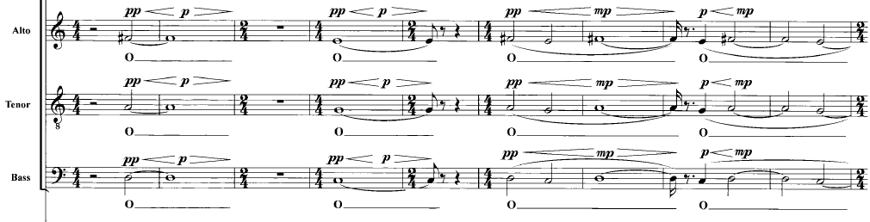
Figure 4-2. flute parts in m 7, and in mm 12-14, establishing the prominence of the fifth
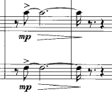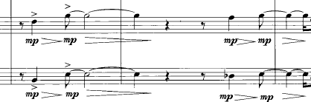
The other recurring musical motives occur in the flutes. The flutes, which can move much more freely and quickly than the choral voices, provide significant melodic and rhythmic interest, almost always entering off the beat, and frequently playing rapid sixteenth note passages that in some ways obfuscate the pulse and create a feeling of ambiguity and mystery throughout the piece (the previously mentioned repetition of the “neighbor motive” in measure 56 is a good example of one of the ways this occurs). The first instance of the flutes’ main motives occurs in measure 14 and 15 in the first flute. These motives are each made up of short three note statements (usually two thirty-second notes followed by one note of longer duration) that are reiterated, expanded, and inverted throughout the piece. the first rises to the fifth and falls to the third, and the second is a simple rising motive. These two short melodies are expanded and inverted in the next few measures, and they return in both A sections, as well as the B section.
Figure 4-3. mm 14-17 establish main flute motives – motive A with rising and falling contour, and motive B with Rising Contour. The flute 2 also demonstrates an inverted variation of this motive in measure 17
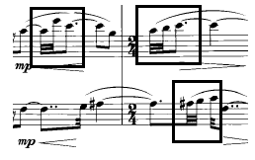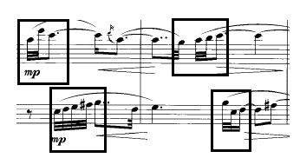
Figure 4-4. mm 46-47 flute parts reiterate main motives expand out in an intense rhythmic and melodic exclamation
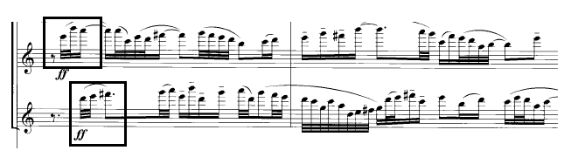
The most interesting use of this musical material occurs in the climax of the B section in measure 46. As the flutes enter following the choirs’ unaccompanied section, they reiterate the opening motives. This time, however, rather than playing as the original simple short motives, they expand into excited thirty-second note flourishes that last for the next few measures, until they rest on a fifth at the mention of “Christ the Lord.” In this way, the flutes’ unifying motive gives way to the original unifying figure of the fifth, creating a sense of familiarity and arrival in the most climactic moment.
Structural Overview
As with Higdon’s other choral works, the form is essentially dictated by the text, with O magnum mysterium functioning in a large ternary form: the two A sections feature Latin text, while the B section features English text. In the A section, parallel motion that emphasizes the D-A pitch relationship is featured. For the first 18 measures, the lower three voices sing in parallel motion, accompanying an independent soprano line. At measure 18, the altos break away from the lower voices and sing in a duet with the sopranos. Between measures 18-32, choral voices begin to move more independently and with faster rhythm featuring much more eighth note motion. The harmony, which began featuring open parallel chords under the soprano melody, gradually becomes more dense, with more seconds and thirds between parts, and the basses and sopranos singing within an octave of each other. Beginning in measure 25 and leading to the end of the section.
The crystal glasses and flutes accompany the choir throughout this section, with the flutes alternating between slower off-beat parallel fifths and the more rapid motives we discussed earlier. As the choir cadences in 32, the flutes reiterate their motives within 32nd note passages. These remind the listener of earlier musical material, and they also act as a transition to the B section.
The B section is signaled by two events: the instruments drop out, and the choir sings English text with a new harmonic idiom and a fully homorhythmic texture. For the first two phrases the choir sings unaccompanied, with the Bb major and G major chords creating the tonal backbone of the section. While other chords briefly occur – such as a D minor 9 chord in measure 43, these harmonies pass to rapidly to act as more than color chords surrounding the two main harmonies of the section.
The choir repeats short – two measure melodic fragments within each larger phrase leading up to measure 46. The choral crescendo that begins in measure 42 signals the largest climax of the piece. The choir signals the climax of the piece by increasing in dynamic, as well as by singing more rapid sixteenth note durations over the repeated melody on the text “lying in a manger.” the flutes and chimes enter on a fortissimo at measure 46. When the flutes enter, the rhythmic excitement present in the choir passes back to the flutes, lasts for 6 measures before the voices fade, and the flutes play a transition back to the A section.
The second A section is slightly longer than the first. The Latin text returns: This section begins end ends with the text “O magnum,” as well as the open fifth, creating symmetry within the section, as well as with the whole piece. The lower choral voices sing parallel chords against the independent soprano melody. The alto eventually breaks away and sings a duet with the soprano, as with the first A section. Choral voices become more independent and less homorhythmic later in the section. What sets this A section apart, however, is that it has its own climactic moment beginning in measure 70 that calls back to the climax in measure 46 in text, in range and in dynamics, though the choral texture is not as homophonic in this second climax – The sopranos sing homophonically with the flutes instead of the lower choral voices. After this final climax fades in measure 81, the piece returns to present the text “O magnum mysterium” for the last time, with the open fifths returning, and the choir gradually rising back to D major after the previous downward expansion materials from the A section again, though they are not repeated exactly. soprano and alto voices sing duets over the tenors and basses, and the choral rhythm begins to slow toward the final cadence. The piece ends similarly to how it began, with D and A doubled throughout most voices, the fifth being emphasized, as only the sopranos sing the F sharp.
Performance Considerations and Challenges
O magnum mysterium presents unique challenges to the choir that they likely have never encountered before. The unusual instrumentation requires the choir to listen and tune differently. Depending on the hall, crystal glasses might be very difficult to hear, or require sound amplification for the audience or the choir. The Atlanta Master Chorale worked around this challenge by using handbells rather than crystal glasses and having the percussionists play with a “singing bell technique,” where they touch a dowel to the handbell and move the dowel in a circular motion to create an effect similar to that of the crystal glasses. The same issue will come when balancing the chimes, which, depending on the circumstances, might overpower the flutes and choral ensemble.
Although the texture of the chorus is essentially homophonic, there are also moments that occur where the horizontal nature and natural flow of the choral lines might require the singers to think more linearly, as if they were singing a piece of polyphonic music. As both A sections reach their small climactic moments the texture is activated in what could be described as a more “contrapuntally enlivened” homophonic texture. Allowing the choir to think about how their line moves through the text and the text stress, as well as helping the singers to pay more attention to how they relate to the other parts will help.
Since parallel triads and fifths are so common in this piece, numerous exercises may be devised to get the choir to listen to that type of motion. Helping the choir to learn to move together by half and whole steps at various intervals will immediately make portions of this piece more accessible.
Focus on text communication should once again be of utmost importance. Since the natural text stress is set so effectively, this should drive the interpretation. As this piece is now nearly 20 years old, Higdon’s memory about the composition is not as clear. When asked about compositional decisions, she stated simply “You know, this is a good question, and I don't remember whether I made a conscious decision on the form before writing, or if I just followed the text...I think most likely it is the latter.” In addition, when asked if there was an idea or image that drove the composition, she reiterated “I always think about the text first (clarity and meaning), as well as the level of the singing group (because often the commissioner has asked for something specific). As far as I can remember, there were no images or ideas...just thinking about the meaning of the text and trying to write effective music.”
In considering this text and the composition, it is worth noting that Higdon’s connection to the text is not necessarily in a specific sense, like many composers who attempt to text paint every word. Oftentimes, Higdon creates more of a general aesthetic connection to the text. If the text could be boiled down to a word, the word could be mystery. This idea was echoed by Nicole Lamartine, who suggested that “[Higdon] allows the idea of mystery to be in the sonic concept of the piece through the spaciousness between the choir and the flutes.” This “spaciousness” combined with the spaciousness of the fifths that occur in the flutes, the glasses, and much of the time in the chorus, might help to engender a sense of wonder and mystery in the choir. Certainly this is not the only possible interpretation, but when comparing this piece to other well-known settings of the text, these ideas are what makes it unique.
Although a larger affect seems to be the goal, individual connections can be made as well. The most obvious example of this might be inclusion of Chimes on the English text “Christ, the Lord” immediately evokes the feeling of church bells. In this particular moment, the idea of mystery seems to give way to a traditionally sacred feeling. The flute melodies that follow after the chimes fade return the listener to the original “mysterious” affect. Certainly individual choirs may make other personal connections that will aid in giving a sincere performance of the piece
As far as Jennifer Higdon’s choral catalogue is concerned, this piece is of a moderate difficulty. It is much greater length, and the lack of support in the instrumentation (other than the sounding fifths in the crystal glasses) make for a challenge. On the other hand, the chorus is mainly homophonic throughout, the voice leading is fairly straightforward, and the lack of choral divisi make the piece more approachable. If a choir is able to negotiate these issues, this piece should provide a rewarding challenge. A recording of O magnum mysterium (in addition to the YouTube recording mentioned above) is available from the Handel & Haydn Society.
O magnum mysterium represents a more moderate difficulty among Jennifer Higdon’s choral compositions, most university and good community choruses would likely find it to be an accessible challenge. Even some advanced high school choirs likely have a strong enough skill set to consider performing the work.

Chapter 5: Sanctus
If A Quiet Moment represents everything that is accessible about Higdon’s choral music, then Sanctus represents nearly every aspect that makes her music a challenge. It is easy to argue that it is the most difficult composition Jennifer higdon has written as far as the choir is concerned. It features eight part chorus, deceitfully difficult counterpoint, constantly changing tonalities, and harmonies that often obfuscate where the true tonal center lies. Sanctus was written for a commission for the Westchester University Concert Choir in Westchester, Pennsylvania, and published in 2001.
In some ways it seems reasonable to wonder whether Sanctus, which was written for a commission for the Westchester University Concert Choir in Westchester, Pennsylvania, is overlooked among Higdon’s choral works. On Higdon’s website, it is one of the few pieces that features no program notes or reviews. In addition, the website lists an innacurate performance time of four minutes, though the attached sample recording is over six and a half minutes. While performance time on a given piece is certain to vary, this is a large difference for a piece under ten minutes in length. If this piece does in fact get overlooked, it may be due to it being one such a challenging piece.
Before looking at the composition itself, it is worth noting the both when asked about the composition and the structure of the work, Higdon’s response reflected her intuitive approach to compostion, as she simply stated that as with O magnum mysterium, she didn’t recall many specifics about what was going through her mind during the composition, but she stated the structure and melodic design likely grew naturally in response to the text. When she was asked whether the challenging counterpoint was influenced by her instrumental writing in any way, she reiterated her focus on the text in her choral music, explaining. “I'm sure all of my writing for all forces influences all of my writing for all forces. I never think of choral works instrumentally, although with the Sanctus, the piece is so old that it's likely my lack of experience in writing choral music would yield a more instrumental sound. So it could totally be accidental...without doubt!” Higdon’s acknowlegement that the challenges in Sanctus could have at least partially been the result of lack of experience writing for choral voices is interesting, especially since scholars such as Reitz have observed that from a quality standpoint, Higdon’s compositional career thus far has demonstrated remarkable consistency.
As was the case with O magnum mysterium, the Latin text was requested by the choir, and Higdon elected to include English text to create musical and textual contrast. Surely other scholars and musical analysts could likely interpret or identify specific text painting ideas within Sanctus, This piece seems to be a more compelling example of how Higdon creates an overall aesthetic feeling that reflects the affect of the text. Aesthetically the piece has a feeling of creating waves of sound, especially in the middle section. When asked about this interpretation of the music, Higdon responded, “I think I was trying to create the sensation of ecstatic celebration. I actually don't know if the effect works, as I had not written tons of choral music at that point. But thinking of this area as the building of "waves" feels right.”

Thematic (unifying) Material in Melodic Upper Voices
Since Sanctus is much more varied in its melodic design, it is more difficult to assign the terms “theme” or “unifying motive” to the music. At the same time, melodic, rhythmic, and harmonic elements do recur, either in identical fashion, or in similar enough fashion that finding these recurring elements can help the performer and the listener to “demystify” what is already a highly difficult work. Due to the focus on melodic line in Sanctus, it may be most effective to analyze the melodic or contrapuntal upper voices and the recurring themes, with their respective repetitions and variations, and the more harmonic/homorhythmic lower voices separately.
The majority of the piece is built with voices (usually lower voices) providing some type of harmonic foundation using repeated rhythmic figures. The other voices - usually the upper voices - sing intricate, overlapping contrapuntal lines. As will be shown, the melodic material itself is fairly easy to comprehend at first glance. When the music is analyzed on the whole, however, it becomes decidedly more complex and difficult for the choral musician to digest. One of the biggest reasons for this is the frequently changing tonal centers and scales usued. throughout the piece. figure 5-1 shows all of the pitch centers and scales the piece employs. As can be seen in this example, the larger formal design of the piece features alternations between Lydian and Mixolydian modes, with occasional harmonies occurring outside those alternating pitch centers – for example, the scale that occurs for only four measures beginning in measure 54 is structured similarly to an octatonic scale. The main difference is that each tetrachord has a minor third rather than a whole step, which creates two unique tetrachords in that highly chromatic sounding section. Of the measures that are not accounted for in figure 5-1, those sections are characterized by alternating chords that will be discussed later in the chapter.

Figure 5-1. Scales and pitch collections utilized in sanctus
E flat Lydian scale – measures 7-16
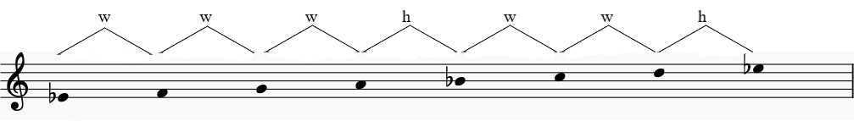
E flat Dorian scale – measures 16-21
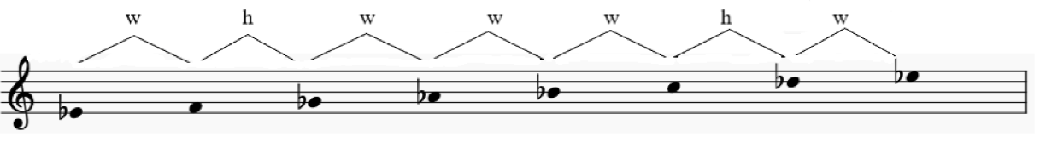
C Pandiatonic scale – measures 22-35
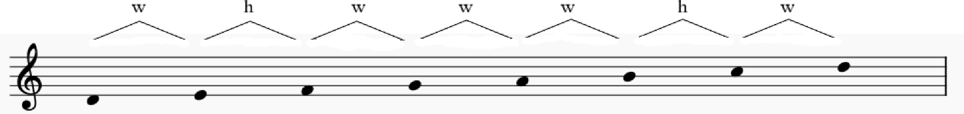
D Ionian/Aeolian hybrid scale – measures 40-51
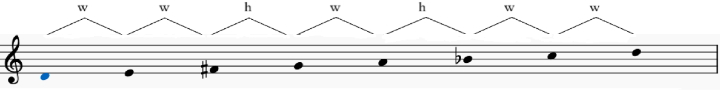
A flat Lydian, or B flat Mixolydian scale – measures 52-53, 56-57
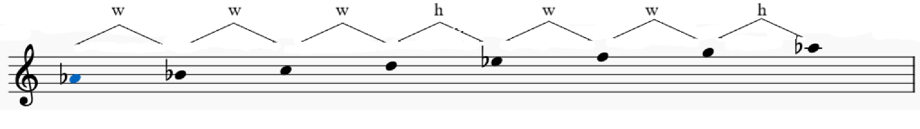

Minor 3rd tetrachord scale – measures 54-55, 58-59
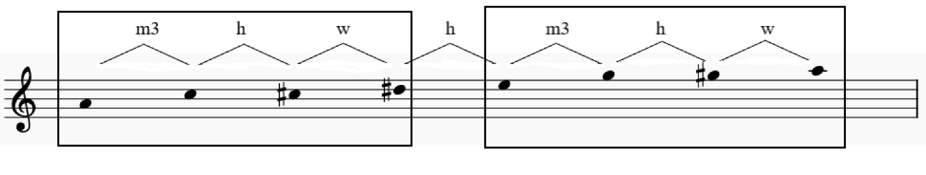
B Mixolydian Scale, measures 60-61
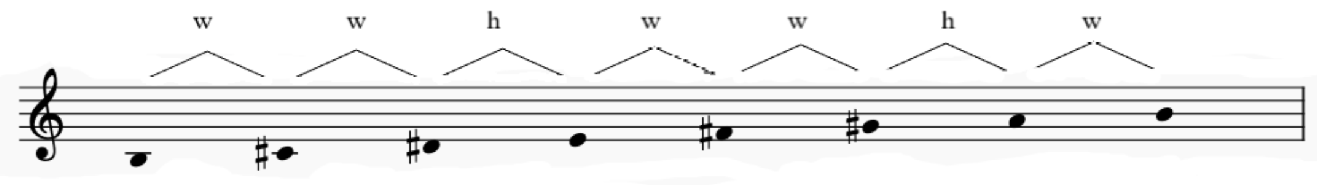
F sharp Mixolydian or F sharp Ionian (E natural and E sharp are both present) measures 62-72
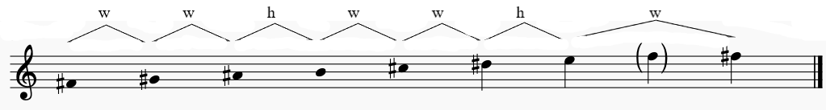
G flat Lydian scale, measures 79-89
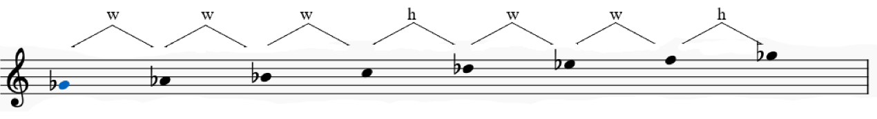
Within the melodic material of the piece, some unifying themes are stated, reiterated, and varied throughout the piece. figure 5-2 illustrates the primary statements and restatements of these themes and gives multiple examples of how the themes are restated and varied in multiple points within the piece. The melodies that connect the three main sections of the piece are straightforward enough taken out of context. Although it is reasonable to categorize the melodies from measure 8 and 9 as the main themes of the piece, it is also worth noting that as soon as they are established, Higdon begins to create variations on these relatively short melodic ideas.
Figure 5-2. mm 8-9 soprano and alto parts
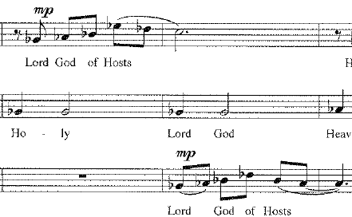
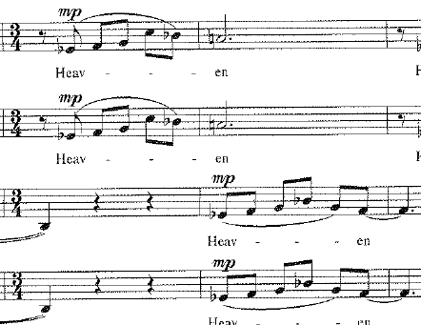
Primary themes restated in measures 80-81 in Soprano 1 and alto 1 parts
Varied melody in alto 1 part, measures 42-44
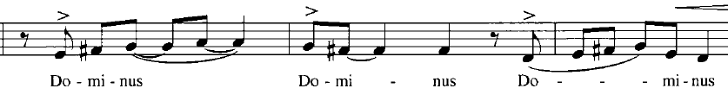
Overlapping melodies in top three voices, measures 46-48
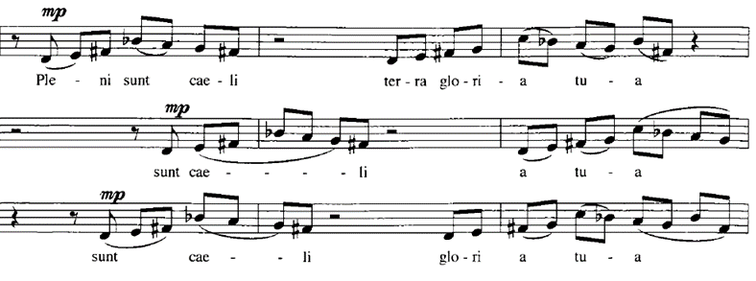
The first repetition in measure 9, for instance, sees the phrase extended and elongated, as the sopranos rise all the way to an F (a fourth higher than the highest point of the initial melody) before descending again. The next repetition, which begins in measure 16 in the soprano part, repeats with the exact same contour as in measure eight, but this time Higdon extends the phrase to reflect added text – the first phrases repeated on the word “Heaven,” while the sopranos now sing “Heaven and Earth.” (note that capitalization reflects the capitalization in the text of the piece. Also worth noting is how there is no punctuation anywhere in the text of Sanctus) This phrase is a good example of how Higdon utilizes text to drive her composition, but not necessarily in a traditional way. A more standard approach might see the word “Heaven” set to a rising contour, while “Earth” would be set to a general falling melodic contour. In Higdon’s setting, however, the initial phrase on the text “heaven” rises and falls back down. Meanwhile, the melodic contour rises again on “earth”. This indicates that, while Higdon is considering the text, deliberate use of more “traditional” text painting is not a choice she makes in her composition. It is also worth noting that this rising and falling contour is so frequent throughout the piece that it seems reasonable to surmise that specific text painting and meaning were not so much the composer’s focus, but rather the piece seems to reflect the more general affect of the text. Higdon’s comments about building waves of sound would seem to support this interpretation of the piece.
Another important quality to note about this unifying melodic contour is the use of onset. Throughout the piece, voices tend to enter at regular intervals, creating points of imitation, especially in the middle section. More often than not, these onsets occur off the beat. One notable exception to this is on the Latin text “Benedictus,” which occurs for the first time in measure 56. That text is set with three of the four upper voices entering on the beat in quick succession, with exactly one beat separating the onsets. The first sopranos enter more quickly than the other voices and enter off the beat, disrupting the regularity of the other onsets, as can be seen in figure 5-3. These irregular onsets occur right before the climax of the piece. These rapid onsets and closely overlapping lines create a greater rhythmic intensity leading to the climax of the piece. This is once again similar to the way Higdon used more rapid rhythmic durations and increasing dynamics to build to the climax in A Quiet Moment and in O magnum mysterium. Although this piece is much more complex melodically and texturally, this is a good example of how similar conventions manifest in much of Higdon’s choral music.
Figure 5-3. Regular onsets in measures 54-55
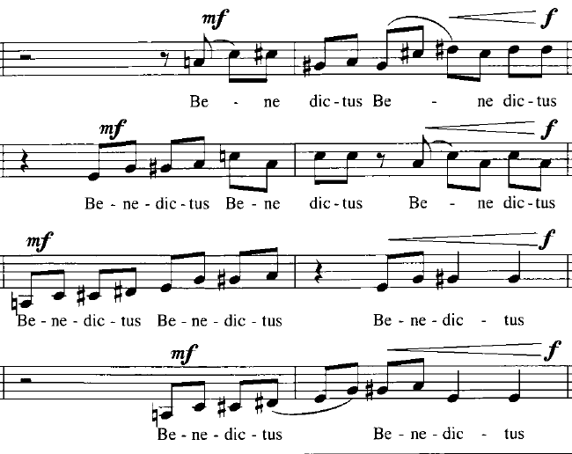
The final observation about the overall melodic contour within Sanctus is that through much of the piece, pitch contours generally rise as tension and excitement builds, and generally fall as the energy within a section dissipates. The overlap between these rising and falling melodies create the “waves of sound” affect mentioned earlier. More stagnant pitch contours can also be seen, especially once a section has reached its climax. A good example of this can be seen in measures 22-23 (Figure 5-4). In this instance, the climax is maintained through these measures as the voices either alternate between two notes or sing melodic fragments over a small range – that of a major third or less for most voices.
As the climax dissipates in the following measures, a general descending contour combines with a slow decrescendo as individual voices begin to drop out of the texture. The composite rhythm reaches its fastest point of the piece, and even though the intensity of dynamic begins to fade after these measures, the rhythmic intensity remains the same. Even as individual voices slow in measure 32, their lengthened durations are masked by the overlapping voices that
Figure 5-4. mm. 22-23 Multiple voices repeating pitches within a small range
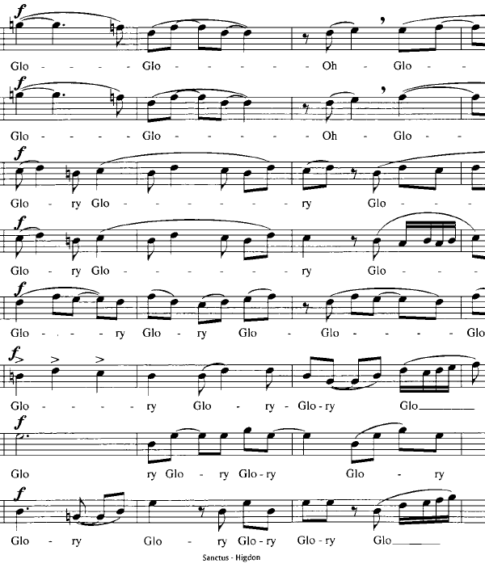
maintain this composite rhythm until the final beat of measure 34, which signals the section has finally reached its close.
Rhythm and Harmony in Lower Voices
While the melodies that occur in the upper voices create an intricate and challenging contrapuntal aesthetic, Higdon uses rhythm and harmony throughout the piece to create a foundation for those melodies. As has been seen in A Quiet Moment and O magnum mysterium, the vertical harmonies that occur are very straightforward in Sanctus. Individual words are repeated, usually with an emphasis on natural text stress, to create a sense of rhythmic foundation and pulse throughout the piece. Figure 5-5 demonstrates how these rhythmic and harmonic musical elements persist throughout most of the piece in one or more voice parts. In some cases, such as the alto 2 part in measures 62-65, a voice will alternate between the rhythmic accompaniment figures and the contrapuntal melodies. With the exception of the first “glory” section (measures 22-35), these repeated figures provide a steady rhythmic pulse and a harmonic foundation through the entire piece. For example, in both the opening and closing sections, the choir alternates between Eb major and G major chords. In measures 51-60, the bass voices reiterate the interval of a perfect fifth, alternating by half step on fifths built on A-natural and A-flat, respectively, before moving up to a B and F-sharp, creating a perfect fifth in measure 60.
With the exception of the first “Glory” section (measures 22-35), these repeated figures provide a steady rhythmic pulse and a harmonic foundation through the entire piece. For example, in both the opening and closing sections, the choir alternates between Eb major and G major chords. In measures 51-60, the bass voices reiterate the interval of a perfect fifth, alternating by half step on fifths built on A-natural and A-flat, respectively, before moving up to a B and F-sharp, creating a perfect fifth in measure 60.
In addition to providing a rhythmic pulse and harmonic foundation, Higdon uses the repetition to create driving and building energy underneath the melodies. The best example of this comes in measure 52, where the bass voices repeat “hosanna” on and eighth-quarter-eighth, rhythm. In addition to mirroring the natural text stress, the shorter rhythmic durations and sudden syncopation energize the harmonic foundation as the dynamic increases toward the main climax of the piece. In this sense. these repetition function somewhat similarly to the repeated melodies leading to the climax in the B section of O magnum mysterium.
Figure 5-5. Repeated words and corresponding rhythmic patterns in Sanctus
Measure Numbers | Voice parts | Text | Duration of repetition | Harmonic repetition
1-7 | ATB | Holy (Lord God of Hosts) |  or | E-flat major  G major
8-20 | TB | Holy | 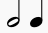 | E-flat major  G Major
36-39 | A2.  TB | Sanctus | 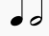  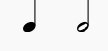  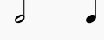 | G major + rising thirds
40-45 | A2 T2 | Dominus | 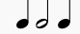 | G to D open fifth (B-flat creates minor triad in T2)
46-50 | A2, TB | Hosana  Gloria | 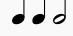 | G-A – Major second (B-flat also occurs)
52-57 | B | Hosana  in excelsis |    | A-flat to E-flat fifth  A-natural to E natural fifth
62-65 | B (A2) | Glory  Lord |   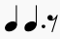 | B major, F major, and F-sharp major chords
80-88 | A2  T2 B | Holy Lord God  Lord |   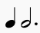 | G-flat major  A major
89-95 | SATB | Amen |  | E-flat major  G major

Compositional Structure
Once the rhythmic and melodic conventions of the piece are understood, a structural outline becomes more apparent. As will be seen, Higdon creates a structure that is symmetrical in nature. The result is that the overall form can be analyzed through the lens of multiple “traditional” structures. The piece is built with traits that make it similar to a symmetrical arch structure. There are also numerous similarities to sonata-allegro form. Since both analyses are equally feasible, they will both be briefly explained.
The structural outline in Apendix B is laid out in a way that considers the structure more as a sonata-allegro like structure, but careful effort is made to not come too close to that terminology, since labeling it strictly as such would seem a disservice and a mischaracterization of Higdon’s intuitive compositional approach. For this reason, words like “theme” are often demphasized, and melodies are referred to as “the opening melody,” or “the measure 8 melody.” This analysis deliberately leaves room for disagreement, giving the conductor freedom to interpret the structure in a way that is most effective for their ensemble.
Texts in English and Latin are often set similarly as well – for example, the words “Holy” and “Sanctus” are both repeated in similar fashions, as has already been discussed - creating unity of music and text in the piece. As with O magnum mysterium, the Latin text and English translation inform the structure of the piece. In this case, the piece begins and ends with English text, with the Latin making up the middle section of the piece. The ending sections reiterating the Latin texts and melodic themes introduced in the opening section. The overall symmetry of the text setting lends itself to the interpretation of both the arch and sonata-allegro structures.
The middle section is much more varied, bringing various rising and falling melodies using varying scales and pitch collections. Looking at both text and music, the piece works like an arch form – measures 1-7 and and 90-96 mirror each other in harmony and texture, with the choir repeating a single word with ritualistic repetition. Measures 8-21 and 80-89 both feature the same rising and falling melody in the soprano and alto voices (it seems safe to argue that all of the subsequent melodies in Sanctus are expansions or variations on this melody), while the lower voices continue to repeat individual words while alternating between two chords. Measures 22-35 and 62-79 both act as climactic moments for the piece; both feature the word “Glory” prominently, sung by choral voices that are moving much more melodically and independently, with more equal treatment of all eight voices, than in the other sections. Measures 36-61 could be considered the middle of the arch structure. This section acts almost as a development section, and highlights how this piece has traits in common with sonata form in addition to the arch like structure. The principal melody – an arched phrase - is presented in measure 8 and developed and varied in the middle section, before being restated in the closing section. While this section can certainly be broken down into smaller groups of measures (36-45, 46-51, and 52-61), the constant flow, lack of cadences, use of repeated overlapping melodies, and the and slow build toward the ultimate climax in measure 62, all coalesce to create the “waves of sound” mentioned earlier.
While analyzing this piece as an arch structure is useful, it is also of benefit to consider traits that it holds in common with sonata-allegro form. The melodies introduced in measures eight and nine act as themes of the piece, which are developed from measure 36-61, and are restated in measures 80-81 (see Figure 5-2). These structural elements help generate a sense of unity and flow within the piece.
The comparison to sonata form is useful when analyzing the structure of the piece. As can be seen in the recurring themes, measure 1-20 act as an introduction and brief exposition, while measures 80-95 act as a recapitulation and a brief closing section. The harmonies and melodies both mirror each other in these sections. The “Glory” sections that have already been mentioned not only serve as climaxes within the piece, but can be considered transitional material as well: These sections feature musical material that doesn’t reflect the thematic material, and both feature a more dense melodic texture. With few exeptions, all 8 voices move independently with mostly eighth note rhythms, creating greater rhythmic intensity. Both also eventually fade as the reach a final cadence before moving into the next section. As has already been mentioned, the middle section works as a development section for the piece.
These similarities to the arch structure and to sonata-allegro form are useful to observe for the sake of the performer and the listener, but neither of these forms were necessarily intended by the composer. Higdon stated that while she doesn’t recall much about the compositional process for Sanctus, given that this piece is now nearly twenty years old, but she said that “I suspect… I was thinking about the text and [the melody] was a result of the lines rising from measure 8.” It is reasonable to conclude, based on this, and her many other comments about her intuitive method of composition, that these similarities emerged naturally, rather than from intentional decisions by the composer.
Challenges and Performance considerations
Sanctus is among the most difficult pieces that Jennifer Higdon has composed. Lamartine explained that this was one of the first pieces she encountered as a conductor where she realized she needed a very clear and well-thought-out plan to help the choir execute the piece effectively. “It is not the type of piece that you can just open up and put in front of a choir and say ‘let’s sight read this first Section’… We [first] have to have some framework or understanding.” She emphasized the need to help the choir to hear and know where the common tones between each tonality occur. If the choir is aware of these “pivot tones” they can more effectively negotiate the numerous harmonic shifts. The frequently changing key centers and variety of scales require an ensemble that has a very strong sense of pitch. The tenor and bass voices especially must be capable of providing a strong rhythmic foundation over which the upper voices can perform their melodies with confidence. The choir must be tuned and have an impeccable sense of key in order to navigate the changing key centers. The most challenging example of this occurs beginning in measure 53. In the middle of the development section, the sopranos sing on what appears to be a B-flat Mixolydian scale. The altos and sopranos combine to outline this scale precisely, with every pitch of the scale occurring, and with each voice either beginning or ending on B-flat. the harmonic foundation, however, is an A-flat to E-flat perfect fifth. Since this interval precedes the melodies, it raises doubt as to whether B-flat Mixolydian or A-flat Lydian is the more effective tonal center. This is further complicated by the fact that this tonal center alternates with the non-traditional scale in measures 54 and 58. The result is that the piece is even more of a challenge than it would appear at first glance, as the harmonic foundation provided by the lower voices is not as supportive as it may appear.
In addition to the challenges of the frequently changing key centers and the lack of harmonic support in multiple places, the melodic voices must be aware of each other at the same time that they are independent of each other. The voices enter at fairly regular intervals: if the first enters on the second eighth note of the beat, the subsequent voices will usually follow suit on their imitative entrances, but there are also enough instances (such as measure 54, where all the upper voices enter on each respective beat within the measure, but the first sopranos enter off the beat) that the trend is not a rule that the chorus can consistently rely on. These issues require an intense attention to detail to execute effectively.
The charts presented in this chapter (see Figure 5-1 and figure 5-5) should help the conductor and singers to approach the piece – since the choir is essentially broken into groups that execute imitative contrapuntal melodies, and groups that provide rhythmic and harmonic accompaniment, the conductor can use the charts to help isolate groups in various sections, and assist them in finding the parts that correspond most directly. This can be especially helpful for those voice parts that are providing the homorhythmic accompaniment.
The tempo of the piece is fairly consistent, beginning at the suggested tempo of 60 beats per minute to the quarter note. The tempo accelerates to 80 beats per minute in both climaxes of the piece, and returns to the original tempo as the respective climaxes fade. While there is some mixed meter – the piece alternates between 4/4 and 3/4 time signatures fairly frequently – the piece should not be too difficult to conduct, so long as the chorus and conductor are able to negotiate their numerous independent onsets.
The lack of punctuation in the piece can be either a liberating or paralyzing quality in the piece. One particular example of the challenges the lack of punctuation might engender occurs in the closing section: The lack of punctuation, along with the overlapping voices, causes the last two phrases to bleed together as one: “Heaven and Earth are Full of Thy Glory Be to Thee.” For the conductor and choir this makes decisions about where to breathe difficult. The conductor may decide to simply have the choir stagger breathe through the entirety of long phrases, but the choir must then be careful to not allow the building “sound wave” to lose its momentum too soon in the phrase. While Higdon almost never includes breath marks in her scores and allows the conductor’s interpretation to have weight, these become especially important decisions to help communicate the affect of the piece.
Beyond the “logistical” elements of the piece, (note learning, tempo, intonation, etc.) The conductor and choir are left to interpret much of the score. When asked about elements of this piece, Higdon was quick to preface her response, stating: “…It's honestly pretty much impossible to remember what I was thinking back 2 decades ago when I wrote this work...I have literally written over 110 works since then (2 of which were operas), so my memory for the Sanctus is just really my guessing based on what my tendencies are in composing.” The amount of time that has passed since the composition of Sanctus, combined with her tendency to allow for freedom of interpretation on the part of the performer, together create ample space for the choir and conductor to discover and execute their own interpretation of the piece. Hopefully it will be liberating for the conductor to know that there is not a definitive interpretation of the piece, and that they are free to find the most effective means of executing this music.
These challenges make Sanctus a piece that requires much from the choir, and Higdon even suggested that not all choirs that have attempted the piece have been successful. She stated about the piece: “I wasn't sure the piece worked until I heard you all do it at the University of Wyoming… With Dr. Nicole Lamartine leading the charge, [the choir] did a magnificent job in performing this work. I was blown away and became convinced that it just needed to be done by the right group.” She said further of the piece: “I think that I shift keys too fast and too frequently in this work, and it really requires an excellent group to pull it off (it is distinctly less than ideal writing for the chorus)… It's always a shot in the dark when a work is premiered, and one is never sure how much time a piece has gotten in rehearsal. And if the group itself isn't absolutely up to the task… things may not come off well.” Lamartine added her perspective to the piece as well, stating “That was a daunting piece, but I was really happy when we got it!... It is a good challenge. Once you put in the time and the effort, you see what you can achieve and produce…[you can] create something really special.”
In many ways, Sanctus represents the greatest challenge of Jennifer Higdon’s choral works. The technical challenges will stretch the best of choirs and challenge their musicianship. It is hoped that this analysis will help to demystify many of the challenging elements for the conductor. If the choir is up to the challenge, this work offers a unique and rewarding setting of the traditional sacred text.
Chapter 6: A Brief Introduction Higdon’s to Choral Catalogue
Jennifer Higdon’s compositional library is of significant size, and while the number of choral compositions is not as large as the number of instrumental works, there is still a wide variety of works to uncover. This chapter will briefly introduce the works currently available in Higdon’s choral library while looking at style features and difficulty of each piece. These descriptions are not meant to be stylistic or comprehensive analyses, but rather as brief introductions to the style and challenge of each piece. Since many of Jennifer Higdon’s choral works have not received published recordings as of this writing, It is hoped that this will act as a helpful primer for the conductor looking to discover new compositions to introduce to their ensemble.
This chapter connects directly to appendices C and D, where the difficulty of various aspects of each piece are given a rating on a scale of 1 to 5, from most accessible to most difficult. As has already been mentioned, even the most accessible of Higdon’s works requires a higher basic skill set than those that can be found on publishers’ websites, so this scale should not be confused with other difficulty ratings. Each piece will be rated based on difficulty in various categories, including melody, harmony rhythm, texture, and onset/breath, and accessibility of music and text for both the performer and the listener. Each of these categories will be rated from 1 to 5 as well, and an overall difficulty rating will be given based on these categories. These ratings will be given after the individual pieces are discussed.
This discussion will be limited to Higdon’s works for unaccompanied chorus, or chorus and small ensemble. Higdon’s three multimovement choral-orchestral works - The Singing Rooms, On the Death of the Righteous, and Ruminations – will not be discussed in this section. Works are listed in alphabetical order, with the exception of the songs within Southern Grace, which are discussed briefly in groups based on similar characteristics. All of Higdon’s published choral works are available through Lawdon Press, with the exception of Hear My Voice, which is available through Hal Leonard Publishing.
Alleluia
Alleluia was published in 2016 for the Mendelssohn Club of Philadelphia. The text was written by Higdon. The piece, which is set for SATB chorus, is one of her most difficult choral compositions. This piece is exemplary of how Higdon creates a constant sense of flow in her music, as the eighth note composite rhythm permeates through the majority of the piece, creating seemingly unending waves of sound. Like Sanctus, this piece features surprising harmonic shifts, as the texture divides to seven parts at one point. The piece features many more stacked seconds and fourths, as well as numerous chords that extend beyond the triad. The piece features keyboard reduction, but the dense harmonies and rapid motion still require a skilled keyboard player to help give the choir a sense of tonality. In addition to the numerous challenges of the piece, helping the choir to understand their part in the full texture is critical, as choral parts often only sing fragments of larger phrases and rhythmic patterns. These complex textures help set up gratifying arrivals when the choir does come together at various climactic moments. Though perhaps not quite as difficult as Sanctus, the challenges of the piece require that special effort must be made to help the choir understand how the piece coalesces. As of this writing, there is no complete published recording of Alleluia.
Deep in the Night
Deep in the Night is the first published choral composition by Jennifer Higdon. This piece, which is roughly eight minutes in length, is scored for SSAATTBB Chorus which features text that Jennifer Higdon wrote in an effort to accommodate the commissioners desire for a piece that would accommodate Christmas, Hannukah, Kwanza, and the Winter solstice. The program notes to the piece state. “This work makes the spiritual statement that we are all guiding angels to each other in our gestures of kindness and thoughtfulness; we are a form of light on a path for those who may be searching; from our experiences, we give to our fellow human beings. The music emerges quietly, as if from darkness into light, and creates a sense of fullness through sound, thereby representing the fullness that we feel when we reach out to others. When the poetry reaches the realization that we are all angels, the musical lines separate and reach out in different directions. The music closes with a meditative and unified sound.”
Deep in the Night is a piece that will be accessible to choirs that are capable of singing unaccompanied music in an eight-part texture. The text is set with frequent rhythmic patterns that move on the beat, with very little syncopation. With the exception of the climactic section toward the end of the piece, the piece is largely homorhythmic. The middle section, from measures 51-67 features more imitative counterpoint and syncopation, but one of the main challenges to the piece comes in the juxtaposition of stacked secundal intervals (usually in the upper voices) against parallel fifth motion (usually in the lower voices). There are also a few instances of juxtaposed bitonal harmonies. Though these instances are rare, they require the ensemble to be especially aware of how each voice part relates to the others.
Unlike pieces such as Sanctus, this piece remains diatonic to a G-major key signature, but the tonal centers shift throughout the piece. This gives a sense of C-Lydian in the opening section that eventually morphs to D-Mixolydian by the end of the piece. the stacked seconds, combined with ambiguous tonal centers creates what one review described as “a chromatic, yet touching…musical idiom.” This comment likely referred to these harmonically ambiguous sections that might be more aptly described as “bitonal” or “pandiatonic,” since disparate harmonies occasionally occur at the same time. These traits make Deep in the Night a challenge, but should not place it outside the realm of possibility for advanced college and community choirs. A recording of Deep in the Night is available, performed by the New York Concert singers.

Invitation to Love
Invitation to Love, like Alleluia, was written in 2016. Both pieces were commissioned to honor an individual within the commissioning organization. Both are written for SATB chorus with divisi. Both feature a similar harmonic idiom that avoids any particular key signature, but rather they transition through multiple tonal centers. Despite these similarities, Invitation to Love sets itself apart from Alleluia in a few ways. First, the piece is set to a preexisting poem written by Laurence Dunbar, rather than Higdon’s own pre-written text. Second, while it seems fair to say that Higdon’s appreciation of counterpoint makes every piece feel like the writing is conceived horizontally rather than vertically, this piece is built much more triadically than the other. While Alleluia often creates a tapestry of sound through disparate rhythmic patterns that create a composite rhythm and texture, Invitation to Love uses clear voice leading and mostly homorhythmic motion to create lush extended tertiary harmonies. This piece is exemplary of the logic of Higdon’s musical design, as a first glance at the piano reduction might overwhelm the conductor considering whether to program the piece. However, when one looks more closely at the individual lines, it becomes clear that the voice leading almost always goes in a direction that makes sense to the listener. In addition, the rhythmic motion is much more straightforward, with less syncopation than “Alleluia.” The piece still requires an ensemble that is comfortable singing eight-part harmony that includes some sudden harmonic shifts. The extended chords require the musicians to sing minor and major seconds in tune fairly frequently. The conductor must approach the piece with careful attention to tuning, intonation, and conveying text stress and meaning. However, the simpler rhythmic and metric design, the largely homorhythmic texture, and the logical voice leading make it one of the more accessible pieces in Higdon’s catalogue. As of this writing, the only recording of Invitation to Love is in the form of a YouTube recording from the Choral Arts Initiative.
Hear My Voice
Hear My Voice, a three-minute work, is unique for being the only piece written specifically for children’s chorus, and also for being the only piece not published by Lawdon Press. The piece was commissioned as a part of the American Composers Forum and premiered in 2012. Though the piece was written for three part children’s chorus, the lowest part is written in bass clef, and is low enough that a mixed choir could easily attempt this work. The choral parts are written homophonically throughout the piece. As might be expected for a piece written for children’s chorus, the piece is repetitive and very accessible – it is also the only choral piece written by Higdon that features piano accompaniment that is harmonically supportive of the choral voices through much of the piece. The piano part also includes some of the harmonic conventions seen in various other pieces (the left hand of the piano frequently plays parallel fourths and fifths, for example). This piece makes an effective introduction to Higdon’s style, and is repetitive enough that most choirs should have no problem attempting. In fact, this may be the one piece with which it might be argued that its simplicity and repetition may place it in a realm where only less advanced choirs would desire to execute the piece. A sample recording of Hear My Voice is available through Hal Leonard online.

Love Came Down
Love Came Down is set for SATB chorus, soprano solo, and harp, and is a unique setting of a Christmas text by Christina Rossetti. As with the instrumentations in O Mangum mysterium and somewhere i have never travelled, gladly beyond, the harp provides a unique color that sets this piece apart from Higdon’s other works. In addition, Rossetti’s text gives a unique take on the Christmas holiday while staying close enough to traditional themes of Christmas to fit in a sacred program. This piece is among the most accessible for chorus. The harmony is mostly triadic, and the voice leading is as straightforward as any other Higdon piece (with the possible exception of A Quiet Moment and Hear My Voice). In addition, the rhythm is very accessible, and the natural text stress should allow the performers to communicate this piece effectively without too much effort. There are still some unexpected harmonies, and the tonality is ambiguous throughout. Combined with the chromaticism, this will be enough to challenge a less experienced choir, but while there are several unaccompanied sections for the chorus, this piece also features rare moments where the harp provides clear harmonic support and accompaniment for the singers. A recording of Love Came Down is available on various platforms as of this writing, performed by Essential Voices USA.
“Our Beautiful Country” and “What Was His Name”
“Our Beautiful Country” and “What Was His Name” are TTBB choruses from Higdon’s 2015 opera Cold Mountain. The contexts for both of these choruses are described briefly by Christina Reitz, who explains how these two choruses are connected in the opera: “Scene 10… was continually singled out by critics as one of the opera’s most profound moments… numerous similarities exist between this number and Act I’s Confederate Soldiers’ Chorus including a nearly identical tempo, rich harmonies, and homorhythmic texture for textual clarity.” Regarding the choral writing in these pieces, Reitz Writes “The consonant harmony of the chorus is non-functional and consists primarily of major chords with a sprinkling of second intervals characteristic of Higdon.” She later elaborated on this comment, stating: “I will say that although she uses consonant chords, I don't want to oversimplify it. She also has a great tendency to utilize bitonality where there will be two major chords juxtaposed upon each other. Also, she makes great use of second intervals as well so even though there are, at times, these sustained exquisite harmonies, there is also spicy dissonances utilized frequently.”
This descriptor reflects much of Higdon’s choral writing already discussed. In the case of these arrangements, however, Higdon removes much of the orchestration – the orchestral parts mainly double the choral parts in the opera – keeping only the most critical elements. For example, Soprano and alto soli replace orchestral soli, and the chorus part is condensed slightly to accommodate the removed orchestra. In addition to having similar tempos and harmonies, the texts are both somber and reflective, commenting on the loss and pain of war, but also offering beautiful and poignant moments (especially in “Our Beautiful Country”). As Reitz suggests, both pieces are highly consonant, and although the way the harmonies move make the key center ambiguous, the mostly triadic major harmonies suggest a tonal center of A-flat major, making both of these pieces more accessible. “What Was His Name” is a little bit more complicated thanks to the solo lines, and the range of “Our Beautiful Country” requires a strong bass section, but the consonant chords, clear homorhythmic text declamation and straightforward rhythmic motion that lacks the more intense syncopations of some of Higdon’s other works make these works a palatable challenge for TTBB ensembles. While recordings of these specific arrangements are not available, they are nearly identical to the tracks that can be heard in the recording of Cold Mountain.
Sing, Sing
Sing, Sing was published in 1999, the same year as A Quiet Moment. Jennifer Higdon discusses how when a piece for SATB chorus was requested, she was able to compose a tune that had been “bouncing so loudly in my head” for months. The result of this tune is a piece similar to A Quiet Moment in that its harmonies may be analyzed functionally, and harmonies remain diatonic to their major key signature. The piece also shares many traits in common with the folk song arrangements of Southern Grace. Like several of those arrangements, this piece has a straightforward harmonic structure with lilting melodies and frequently repeated rhythmic patterns. Also like the folk songs, this piece showcases Higdon’s flair for writing voices that are instrument-like in the musical texture: For the majority of the piece, voice pairs accompany the other singers with rhythmic patterns. These patterns reiterate the harmony on a nonsense syllable. Higdon changes these vocal duets through the piece, adding variety to a relatively simple texture, before the choir sings in a homophonic texture toward the end of the piece. The lilting melodies and repeated rhythmic patterns should be manageable for most choirs. The biggest challenge of the piece comes in the voice leading, which is occasionally less favorable to the singers than in later works, with rapid leaps up to a perfect fifth that would be a challenge for a choir sing precisely with good intonation. Compared to pieces like Sanctus and Alleluia, the challenges of this piece are relatively minor. There are currently no published recordings of Sing, Sing.
somewhere i have never travelled, gladly beyond
somewhere i have never travelled, gladly beyond (2006) is set to poetry by E.E. Cummings (the work’s title and the names of the composer and poet are all uncapitalized in Higdon’s score) has much in common with O magnum mysterium; both pieces are for SATB voices, roughly seven minutes long, featuring choir that is largely homorhythmic, accompanied by a small instrumental ensemble that provides a large majority of the harmonic color and rhythmic excitement of the piece. In the case of this piece, the instruments featured are piano and vibraphone, which play together with extremely varied rhythmic and melodic ideas. The vibraphone is given many difference gestures to perform, from rolling perfect fifths, to playing wide glissandos with both mallets and leaping over extreme ranges with syncopated rhythms. The piano part is difficult, frequently playing odd syncopations with disparate rhythms and grouplets. Both instruments often feel to the listener to be playing outside the tempo of the chorus. The variety of the instruments highlights the surrealist nature of the poetry. Among Higdon’s small choral compositions, this might be the best example of the composer creating a “mystical” setting in her music, since the text is not sacred, but the music generates a similar sensibility to O magnum mysterium.
Chorally, the text is approached even more directly than in O magnum mysterium. The choir is almost exclusively homophonic, the harmony is mainly triadic with perfect fifths (or occasionally fourths) permeating through various voices. As with the other piece, the choral harmony becomes denser in sections with major seconds frequenting certain sections. The voice leading is mostly stepwise, with the bass part receiving most of the larger leaps. The tonality is fairly consistent, as the harmonies are mostly diatonic to B-flat Mixolydian, with a middle section that sits in the submediant of G Mixolydian. The transitions between these tonalities are direct and easy to follow for the chorus and the listener. As with other works, the instruments are not very supportive of the choir as the sing, but they do often signal choral onsets by playing notes in the chord the choir will enter on. Assuming the instrumental contingent is available to the choir, somewhere i have never travelled, gladly beyond is one of the most compelling choral works. While the piece is more difficult than A Quiet Moment and some of the folk songs, it is also much more accessible than more difficult works like Sanctus. Multiple recordings of this piece exist as of this writing, including a sample recording on Higdon’s website and a performance by the Concord Chamber Singers.
Southern Grace
Southern Grace is the second published choral work in Jennifer Higdon’s library. As with many of these earlier works, this was commissioned for the Philadelphia Singers and premiered in 1998. While the final movement of the cycle, “Amazing Grace,” is an arrangement of the original tune, the rest are recomposed melodies of traditional folk songs. For example, “My True Love’s Hair” retains a rhythmic pattern that is very similar and evokes the original folk song “Black is the Color of My True Love’s Hair” but with a decidedly different melody. The texts are often altered from the original folk texts as well. In recomposing the melodies of most of these songs, Higdon tried to remain faithful to the spirit of the folk songs. Of all of the music in Higdon’s choral library, these most overtly evoke the encouragement Higdon received from George Crumb to use the sights and sounds of her childhood in her composition.
The songs in Southern Grace are all written for SATB chorus (many of the songs have fairly straightforward divisi). They may be grouped into two categories: “Fiddlin’” “Swing,” “The Fox,” and “Sourwood Mountain” are all set with similar stylistic traits. All three of these pieces blend nonsense syllables and dialogue, often to create an instrument like effect that accompanies the voices that sing the text – Fiddlin’ uses solfege syllables in lieu of nonsense syllables and has no text. The other three pieces in this category all feature choral voices alternating between syncopated accompanimental figures and melodic singing on the text. There are moments in all of these pieces during which the choir sings in a fully homophonic texture. Harmonically, all of these pieces are set functionally, with harmony that is almost entirely diatonic to the key they are set in. “Fiddlin” and “Sourwood Mountain” are set to a four part texture. “Swing” has some divisi, with many short, quick onsets that may challenge the choir to be extra precise, both rhythmically and harmonically. “The Fox” features a full eight-part texture. Unlike many of Higdon’s other compositions though this eight-part split features much more doubling, and if the choir is comfortable with the fast syncopated rhythms and the larger divisi, they should find that the upbeat nature, as well as the simple and clear folk texts make these pieces highly accessible.
The other four songs, “Wildwood Flower,” “My True Love’s Hair,” and “Riddle Song” and “Amazing Grace,” are all much slower, featuring more contrapuntal choral textures that require more independent voices. The texture is often more dense, and the harmonies are a bit more challenging in the vein of Higdon’s spiritual/mystical music. This is especially true for “Riddle Song,” which feature mostly independent entrances over parallel fifths in the bass line. This piece, as well as “My True Love’s Hair,” feature imitative counterpoint that might serve a choir as a primer that will help them gain an understanding of the harmony and counterpoint that is prevalent in the more difficult sacred and mystical songs. “Wildwood Flower” is also contrapuntal, featuring voices that sing in imitative duets through most of the piece. The diatonic harmony makes this piece the most accessible of this group. In “Amazing Grace,” Higdon balances the original well-known tune with her own unique setting, creating an arrangement that is both familiar and unusual. Rhythmically, it is the most straightforward of any of the songs in this cycle, and even when Higdon creates a new melody, she maintains the rhythm and contour of the original. As of this writing, there is no complete recording of Southern Grace, and the only recording that does exist is of a YouTube performance that features six of the cycle’s movements.
Voice of the Bard
Written in 2005, Voice of the Bard is a setting of a text by William Blake. The piece is set for unaccompanied tenor and bass voices, and is between 4-5 minutes long. The piece is triadic, but seems to highlight the idea of arising at the dawn, as the tempo, tonality, dynamic and vocal range all gradually rise. Phrases tend to begin at a lower range and rise to a climax before the next phrase begins again. This creates a sense of building energy throughout the piece that would seem to reflect the idea of the rising and renewing that is found in the poetry. While this piece is more rhythmic, upbeat and syncopated than many of Higdon’s works, the syncopations of this piece combined with an often conversational texture between upper and lower voices that has a creates a natural flow in the piece. For example, the tonality creates a sense of rising up, beginning on an F major sonority, rising to G major, then to D-major (with A in the bass) and finally ends on E-flat major. Each tonal center is basically major, but frequently borrows chords from the minor mode to create harmonic color. Within the gradually rising tonality, individual phrases also generally rise to create a sense of building energy, along with the increasing tempo throughout. The choir must be able to negotiate the frequent off beat-onsets, and the basses especially must maintain their intonation over frequent tonic/dominant repetitions and frequent syncopated onsets, but if a choir can manage these challenges, then this piece will prove to be very accessible to them. A recording of this piece is available from the Rutgers University Glee Club.
Telegram
Telegram, written for SATB chorus with divisi up to eight parts, is the final piece listed on Jennifer Higdon’s choral page. The text of this piece comes from a poem written by Jeane Minahan, which is made up of numerous short “Telegrams” from various places and times. The piece was written in 2014 for the Yale Glee Club. The rhythm of the piece is fairly consistent (an underlying eighth note pulse on the syllables “dot dot” or “digga dot” connects many of the short messages). Although the triadic and secundal harmonies appear similar to other works, Higdon takes opportunity to set each short message with its own unique character by altering the harmony, rhythm, and texture in a variety of ways, adding character and humor to the various disparate messages. For example, a telegram sent to God that says simply “message received” is set to a majestic eight-part E-flat major triad that humorously shifts from forte to piano over the harmonies that cadence on F major. This piece, along with some of the folk songs, highlights that, while Higdon’s music is known for the spiritual or mystical qualities that have been discussed, there are pieces like this that are quite lighthearted and even humorous and playful.
As far as difficulty for the choir is concerned, Higdon sets the text mostly on the beat with the underlying rhythm created in the “accompanimental” parts gives the piece a sense of flow. As a result, rhythmically, the piece isn’t too difficult, despite its faster tempo. On the other hand, the sudden changes from one harmonic idiom to another, the frequent motion to secundal and occasional quartal harmonies, the texture that becomes thicker, with 6 to 8 parts later in the piece make the piece more difficult. The melody of each individual part is usually fairly straightforward: Frequently individual lines alternate between two unique pitches, and the melody features mostly steps and small leaps. Indeed, for certain sections, the most difficult aspect of each voice part’s melody might be tuning half steps that occur often. The motion to unexpected harmony almost always features at least one common tone that can be used as a pivot tone into the new tonalities, and these shifts are not as complex or frequent as in Sanctus. If a choir is prepared to approach these challenges, Telegram offers a unique and interesting text that is set much more lightheartedly and upbeat than many of Higdon’s more pensive, mystical compositions. As of this writing, the only recording of Telegram exists on YouTube.
Chapter 7: Conclusion
Since Jennifer Higdon’s style is so varied, it is difficult to find compositions that completely represent her style. A Quiet Moment, O magnum mysterium, and Sanctus, however, in many ways represent well her approach to “mystical” or sacred music. The tempo of both works is similar to compositions such as Deep in the Night, and somewhere i have never travelled, gladly beyond. While only one of these pieces is a traditionally sacred text, they are all treated in a similar fashion. These works vary in difficulty, with Sanctus being the most difficult, due to a larger choral split and the other challenges presented in this document. The difficulty of all these works, whether they are written for unaccompanied choir, or whether they are written with the unique and colorful instrumentations for which Higdon is known, require singers that are independent, confident, and have a good sense of pitch and intonation. though motives are often short, there is usually a consistent flow, with few cadential points, and few moments indicated for breath. Singers must be aware of these issues.
Jennifer Higdon’s open personality allows the performer grace when interpreting her music. In one interview when she was asked about following the tempo written in her scores, she responded by explaining, “I'm not a strict tempo person. In fact, sometimes I'm telling people to do a different tempo than what I have marked, because I've discovered that ensembles change and the halls change a lot, and it really changes the piece.” This open approach gives the performer the ability, within reason, to interpret the music in a way that communicates to the performer and the audience member. Since communication is a primary goal of the composer, working to communicate the text clearly should be a focal point in the rehearsal process.
Jennifer Higdon’s choral music is a rewarding challenge for those willing to undertake the work. Though none of her pieces are easy or without challenge for the choir, the way they communicate makes the text come alive in many ways. There are certainly more unifying figures and motives in her works, which can help the performer more greatly understand the music, and therefore communicate it.
Perhaps even more importantly, Jennifer Higdon’s personality and approach to music is an example that all might do well to follow as we try to invite a larger audience to appreciate choral music and classical music. In a time when art music organizations are in need of fresh, new, engaging music, Higdon’s inviting approach might be just what is needed to help choral music and other more classical genres of music continue well into the twenty-first century.

Appendix A: Structural Outline of “O magnum mysterium”
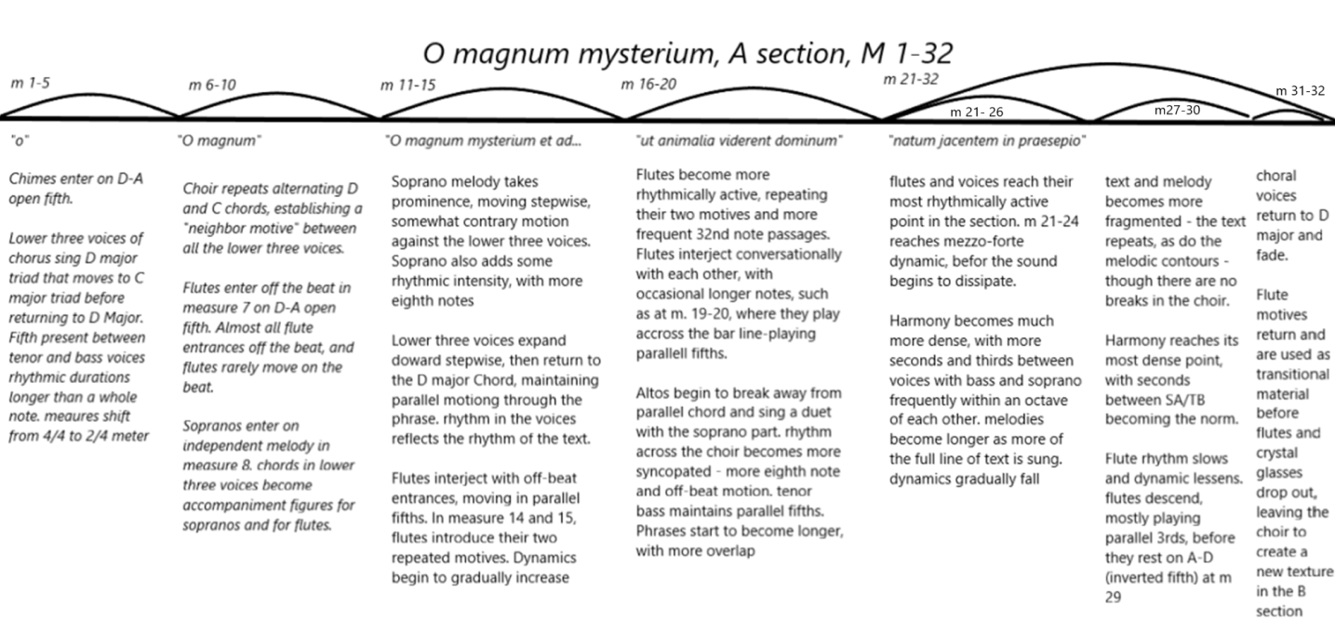
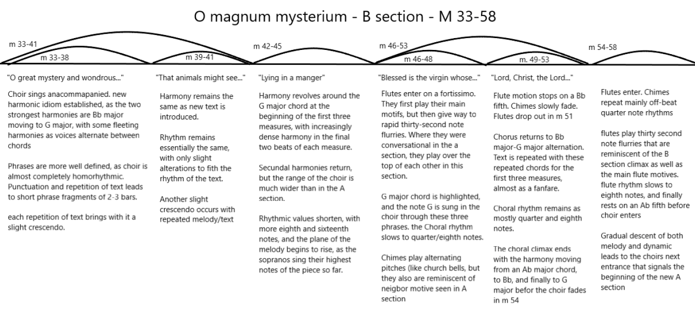
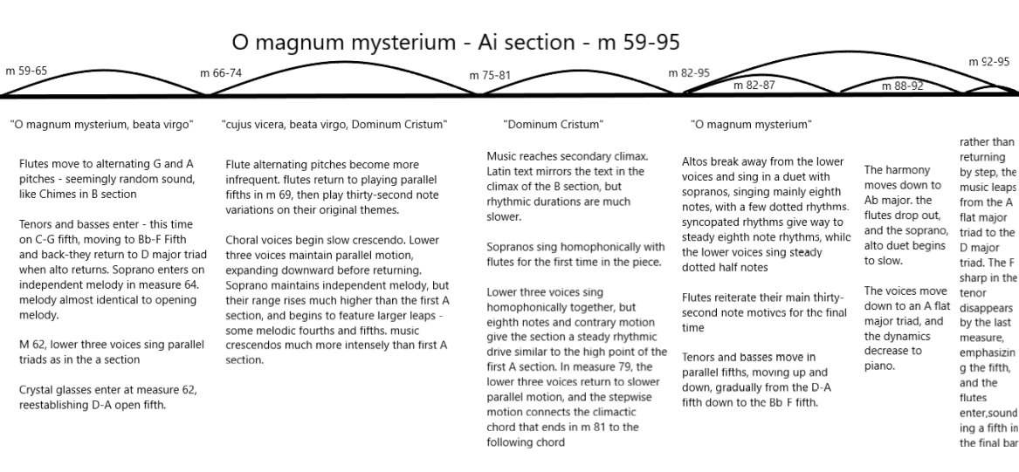
Appendix B: Structural Outline of “Sanctus”
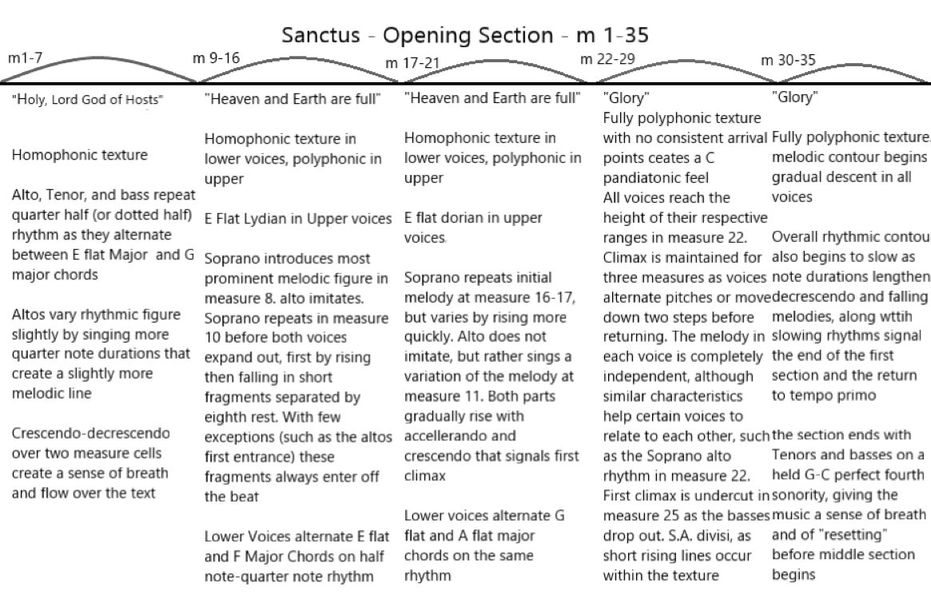
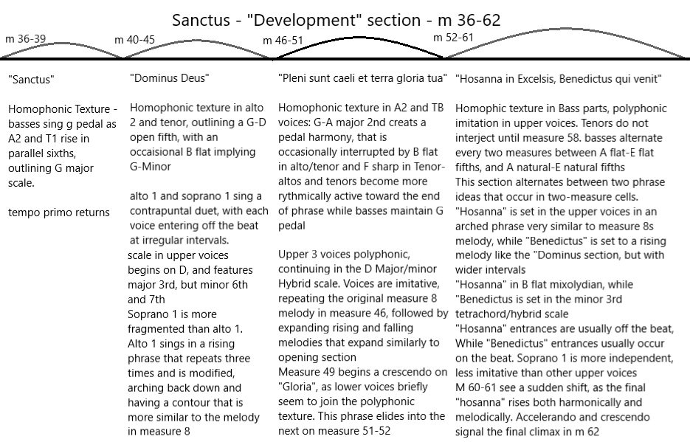
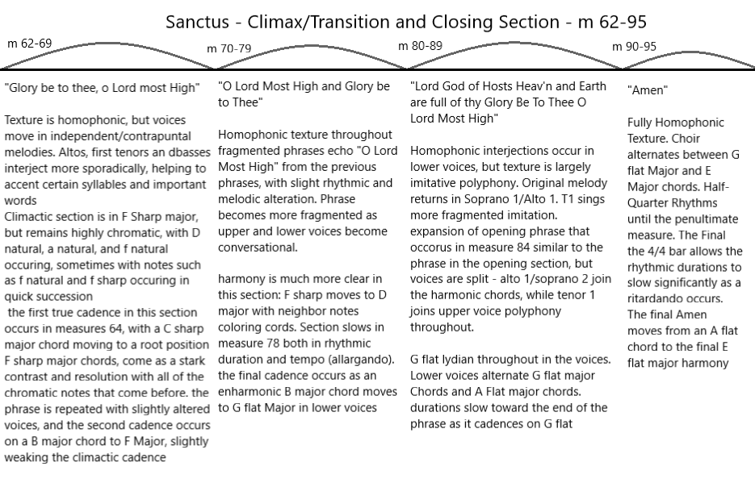
Appendix C: Assessing the Difficulty of Higdon’s Small Choral Works.
This appendix is meant to clarify how the difficulty ratings for each of Jennifer Higdon’s small choral works are determined. This relates directly to Appendix D, which lists all of Jennifer Higdon’s choral works, except her three multimovement choral-orchestral compositions. Each piece is graded on a 1-5 scale. This scale is based on the challenges observed in the three pieces analyzed, with A Quiet Moment being an example of a piece graded as Level 1, O magnum mysterium being graded as a 3, and Sanctus being graded as a 5. Based on the challenges described, pieces graded as a 1 are accessible for high school choirs or even younger choirs depending on their skill, 2 and 3 are performable for more advanced high schools and average college and community choruses, and 4 and 5 should be reserved only for advanced university and community ensembles. It is important to note that these difficulty ratings are only for the chorus. Advanced to expert players will almost always be required in Higdon’s works that include instruments. Since every choral program is unique with different strengths and weaknesses, some conductors may find that they might grade certain pieces differently based on their experience.
In addition to the overall grade, the chart attempts to clarify which elements within a given work create the difficulty. Every choir has its own strengths and weaknesses, and it is likely that each choir and conductor may see different challenges based on their unique skill level. As has already been stated, it is very difficult to categorize Higdon’s music due to its variety. Making general descriptions regarding difficulty can be an equally nebulous challenge, and the subjective nature of these descriptions means that contrary opinions are likely. Even if some disagreement occurs regarding the difficulty of any aspect of each piece, it is hoped that this can be used to make Higdon’s choral catalogue more approachable by conductors and choirs of all levels.
Melody: Melodies were analyzed with attention to the difficulty of the voice leading. It is difficult to analyze the difficulty of melody without the context of harmony and texture, especially in Higdon’s more contrapuntal/polyphonic music. Melodies graded as a 1 are largely stepwise and diatonic to a specific key signature. In A Quiet Moment, for example, melodies are almost always stepwise, with almost no leaps. Level 2 pieces have slightly more complicated melodies with more unusual onsets that are often less supported in the texture, but since they remain diatonic to a specific key, and they occur within textures that are mainly homophonic, these melodies remain accessible. Level 3 melodies usually remain stepwise with larger leaps. The difficulty of many of these melodies lies more in their relationship to harmony and texture: at Level 3 and up melodies that are relatively simple sung outside the context of the piece might seem fairly straightforward, but the harmony and texture can make hearing the melodies more difficult, even in homorhyhmic pieces such as Deep in the Night, the harmony can make the stepwise motion more difficult to hear. Levels 4 and 5 feature melodies that are further complicated by complex polyphonic textures and increasingly irregular entrances. While leaps larger than a fifth are rare, the intervals can still seem more daunting and require independent voices that can maintain their melody despite the texture and the other melodies moving around them.
Harmony: The difficulty of the harmony is intertwined with the melody, especially in Levels 1-3. Level 1 and 2 harmony is diatonic and usually can be analyzed functionally, with Level 1 being especially straightforward. In the case of Hear my Voice, the harmony is slightly more complex, but it is supported by the piano throughout the majority of the piece. Level 2 harmony becomes slightly more chromatic, and often sees more extended tertiary harmony, but remains functional, and a choir that is used to singing eight-harmony should have no trouble with this harmony. Level 3 harmony remains triadic, but functionality becomes much less common. Harmonies often remain connected to a tonal center, but increasing chromaticism often obfuscates a specific key area. Combined with the melodies, these harmonies remain fairly accessible, so long as the voices are comfortable singing more independent melodies. Levels 4 and 5 often feature some harmonic foundation that isn’t too difficult (Sanctus frequently employs perfect fifths as a harmonic foundation, but they move by half steps and change tonalities frequently, making them deceptively difficult). As with melody, more frequent changing tonal centers, and much more independent polyphony make the harmony much more difficult. Frequent secundal intervals and unexpected harmonies can occur. In the case of Alleluia for instance, the harmony is made even more difficult by the rapid tempo that requires quick harmonic shifts.
Texture: Since texture is closely related to melody and harmony, the previous descriptors should make the difficulty of texture readily apparent: Levels 1 and 2 feature mostly homophonic textures. Level 2 can feature some accompanimental figures that add interest to the texture, but remain essentially homophonic throughout. Level 3 blends clear homophony with more “contrapuntally enlivened” homophony, and occasional simple polyphony. Level 4 features more complex polyphony, often with frequent staggered entrances that are fairly regular, and Level 5 features complex polyphony with highly independent vocal lines – Even when the entrances are regular, they are sometimes so close together that each melodic line can confuse the other, as can be the case with Sanctus.
Rhythm/tempo: Rhythm and pulse are crucial elements of almost every piece by Jennifer Higdon. Level 1 features rhythm that is steady, usually with slower tempos. The rhythmic durations almost always follow the beat, or a direct subdivision of the beat (i.e. steady eighth notes as opposed to dotted or syncopated rhythms) If a dotted rhythm does occur, it usually creates a very natural pickup. Level 2 is also fairly straightforward rhythmically, but this might be complicated by a slightly faster tempo, or, as with melody, is made more complicated by offsetting of voices (as is the case with “Wildwood Flower”) syncopation remains fairly rare in Level 2 pieces, but it does occur. Level 3 is distinguished by more independent part writing in voices, with more frequent elements such as “accompaniment figures.” In some pieces, such as in Telegram, these elements make the rhythm and texture more complex. In addition, these pieces are either faster, making the rhythm a bit more challenging, or they feature more independent syncopated rhythms between the voices, even as the texture remains fairly homophonic - as is the case with Deep in the night and O magnum mysterium. Level 4 often features very rapid tempos with accompaniment figures that are not difficult to learn, but combined with the tempo and texture, require significant precision and attention to detail from the choir to keep the rhythm crisp. “The Fox” is a good example of how these rapid “accompaniment figures” occur. The syncopated rhythms and off-beat entrances in Sanctus is a good example of how these rhythms can be especially challenging, even in slower works. Alleluia is the only piece rated a Level 5 as far as rhythm is concerned, and this is due to the fast rhythmic patterns and independent vocal lines, which make sense to the listener when sung together, but present an especially difficult challenge that will require the singers to be especially rhythmic and precise.
Text: Of all these categories, difficulty of text might be the most clear cut. There are no Level 5 difficulties of text, and the only Level 4 is “Swing” due to the rapid tempo that requires the singers to sing a very fast syllabic text. Since Higdon’s focus is so often on communicating the text, most of her works are set syllabically. The more difficult texts come as text fragments or accompaniment figures on nonsense syllables occur, but the challenges to these are essentially rhythmic. Alleluia and Sanctus both feature texts rated at Level 3. This is due to the fragmentation of the text in Alleluia (Again related to the rhythmic motives) and the more irregular melismatic texts in Sanctus. Taken as a whole, if the choir can address the other issues in a piece, the text should not be that much of a concern, except perhaps as it relates to the choirs ability to communicate the text effectively.
Conductor Difficulty: The difficulty for the conductor is largely related to the other issues in the piece. Level 1 pieces are very homophonic, and as such, conducting will be limited to helping the choir shape phrases and communicate text. Level 2 features more shifting textures and entrances, but is still mostly homophonic. If entrances are offset, they are offset at regular intervals -as is the case with Wildwood Flower. Level 3 Is still mostly homophonic, but faster tempos (in the case of the folk songs) or somewhat more irregular phrases present a more difficult challenge for the conductor. Due to the more polyphonic texture, Levels 4 and 5 require the conductor to be more aware of numerous entrances and rhythmic patterns, and must be highly attentive to the syncopations and independent voices. Telegram is a particularly interesting example of this, as the mood changes considerably with every line of text. The unexpected entrances and rhythms, combined with shifting ideas in the text, make for a unique challenge for the conductor.
Overall Difficulty: The overall difficulty of each piece was determined with all of these issues in mind. The overall difficulty is not an average of the other categories, but rather an assessment based on those categories as to what choir can effectively execute the piece. Level 1 pieces can be performed by almost any choir that is comfortable singing four part harmony, since they are largely functional. Depending on the skill of the singers choirs even younger than high school might consider taking on these pieces (that is certainly the case with Hear My Voice, the one piece written for children’s chorus)
Level 2 pieces are still mainly functional harmonically, with fairly straightforward phrasing, but the more upbeat tempos or more independent voices may make them too complicated for some choirs. These pieces may make good teaching pieces for some choirs as well, with the most obvious being “Fiddlin,” since the whole piece is written with Solfege syllables as the text. Many Good high school choirs and most university choirs should be able to perform Level 2 pieces.
As stated in the harmony, Level 3 pieces are usually still triadic, but require singers that are more comfortable outside the realm of functional harmony. Even though many of these pieces are homophonic, the way the voices move require each voice part to be more independent. In addition, none of these works feature accompaniment that is supportive of the choir. More advanced high school choirs might still consider these works, and university and good community choruses should be able to execute these works effectively.
Levels 4 and 5 should be reserved for more advanced university and community ensembles. The textural difficulty, the nontraditional harmonies, and the challenging rhythms likely make these pieces unperformable for less skilled choruses. Even for these more advanced choruses, it is important to give enough time to truly help the singers in each voice part to understand how their part works independently, as well as how it fits into the larger texture. If the choirs are willing to give the necessary time and effort, these pieces can also be the most rewarding.

Appendix D. Alphabetical Listing with Suggested Difficulty
Title | Melody | Harmony | Texture | Rhythm/  tempo | Text | Conductor Difficulty | Overall Difficulty
A Quiet Moment | 1 | 1 | 1 | 1 | 1 | 1 | 1
Alleluia | 4 | 5 | 5 | 5 | 3 | 5 | 5
Amazing Grace | 3 | 4 | 3 | 2 | 1 | 2 | 3
Deep in the Night | 3 | 4 | 3 | 3 | 1 | 3 | 3
Fiddlin’ | 2 | 2 | 2 | 3 | 3 | 3 | 2
The Fox | 1 | 2 | 3 | 4 | 2 | 3 | 3
Hear My Voice | 1 | 1 | 1 | 2 | 2 | 1 | 1
Invitation to Love | 3 | 4 | 3 | 2 | 1 | 2 | 4
Love Came Down | 1 | 2 | 2 | 1 | 1 | 2 | 2
O Magnum Mysterium | 2 | 3 | 3 | 3 | 1 | 3 | 3
My True Love’s Hair | 2 | 3 | 4 | 3 | 2 | 3 | 3
Our Beautiful Country | 2 | 4 | 1 | 2 | 2 | 3 | 3
Riddle Song | 2 | 3 | 4 | 3 | 2 | 4 | 3
Sanctus | 5 | 5 | 5 | 4 | 2 | 5 | 5
Sing, Sing | 2 | 2 | 3 | 3 | 2 | 2 | 2
Sourwood Mountain | 2 | 2 | 2 | 3 | 3 | 2 | 2
Swing | 2 | 2 | 3 | 4 | 4 | 3 | 3
Somewhere I have never travelled, gladly beyond | 2 | 3 | 2 | 2 | 3 | 3 | 3
Telegram | 3 | 4 | 4 | 3 | 3 | 4 | 4
Voice of the Bard | 2 | 3 | 2 | 3 | 2 | 3 | 3
Wildwood Flower | 2 | 2 | 3 | 2 | 2 | 2 | 2
What Was His Name | 2 | 4 | 3 | 2 | 2 | 3 | 3
Bibliography

Asia, Daniel. "The Comeback of Beautiful Music." Academic Questions 29, no. 4 (2016): 478-
482.

Broffitt, Virginia. "The music of Jennifer Higdon: Perspectives on the styles and
compositional approaches in selected chamber compositions." DMA Diss., University of Cincinnati, 2010.

Calvary Chancel Choir, “Calvary Chancel Choir & Orchestra Spring Concert: Part 1,” Calvary
Presbyterian Church, May 16, 2017. YouTube video. 24:56. https://www.youtube.com/
watch?v=sYjn1hsHMC8&t=683s

Clark, Andrew. "'My Preoccupation is Writing Good Music': INTERVIEW: Jennifer Higdon's
Unconventional Background is a Big Part of Why She Writes Pieces that are Popular with both the Public and Other Musicians, Says Andrew Clark:" Financial Times, Mar 29, 2004. 17.

Essential Voices USA. Holiday Harmonies: Songs of Christmas. MP3. American Academy of
Arts and Letters, New York: Dorian Sono Luminus, 2015.

Gray, Chris. “Houston Symphony’s Season-Opener Might Be the Most Performed,
Living Composer.” Houston Chronicle, September 10, 2020. https://preview.
houstonchronicle.com/classical/who-may-be-the-most-performed-living-composer-15558125. Accessed December 16, 2020

Green, Brittany. "Comprehensive Analysis of Movement One of Jennifer Higdon's Violin
Concerto." Masters thesis, East Carolina University, 2018.

“Hear My Voice - Commissioned by American Composers Forum.” Hal Leonard Online. Hal
Leonard,2021.https://www.halleonard.com/product/viewproduct.action?itemid=121870&
amp;lid=17&amp;keywords=hear%2Bmy%2Bvoice&amp;subsiteid=1&amp;%2B.

Higdon, Jennifer. Interview by Nicole Lamartine. Laramie, Wyoming, April 22, 2011.

Higdon, Jennifer. “Invitation to Love.” Choral Arts Initiative. Brandon Elliot. December 18,
2018. Youtube Video. 4:22. https://www.youtube.com/watch?v=VHOuQYuzYLQ

Higdon, Jennifer. “Jennifer Higdon - Choral Works,” 2019.http://jenniferhigdon.com/
choralworks.html.

Higdon, Jennifer. “PROGRAM NOTES: ‘A Quiet Moment.’” Jennifer Higdon. Jennifer Higdon
Inc. Last modified 2019. http://www.jenniferhigdon.com/pdf/program-notes/A-Quiet-Moment.pdf.
Higdon, Jennifer. “PROGRAM NOTES: ‘Deep in the Night.’” Jennifer Higdon. Jennifer Higdon
inc., 2009. http://www.jenniferhigdon.com/pdf/program-notes/Deep-in-the-Night.pdf.
Higdon, Jennifer. “PROGRAM NOTES: ‘Sing Sing.’” Jennifer Higdon, 2019. http://www.jenniferhigdon.com/pdf/program-notes/Sing-Sing.pdf.
Higdon, Jennifer. “Sanctus - Sample Recording.” Jennifer Higdon. Jennifer Higdon inc., 2019.
http://www.jenniferhigdon.com/audio/Sanctus.mp3.

Higdon, Jennifer, Somewhere i have never travelled, gladly beyond. Concord Chamber Singers.
Jennifer Kelly. Recorded in Bethlehem, PA on May 24, 2013. mp3. https://soundcloud.com/concordchambersingers/somewhere-i-have-never.

Higdon, Jennifer. Southern Grace. Philadelphia, Lawdon Press. 1998.

Higdon, Jennifer. Voice of the Bard. Rutgers University Glee Club. Patrick Gardner. Recorded in
Wellesley, MA April 6, 2013. https://www.youtube.com/watch?v=J0GaAG9kh2w

Kelly, Jennifer. In Her Own Words: Conversations with Composers in the United States. Urbana:
University of Illinois Press, 2013.

Kemple, Steve. "Modern Composition." Library Journal 139, no. 20 (Dec 01, 2014): 58

Lamartine, Nicole. Interview by author, March 3, 2021.

Leontis, Evangelia Sophia. "A Discussion of Jennifer Higdon's Setting of the Poetry of Amy
Lowell in the Chamber Work "Love Sweet"." DMA diss., The University of North Carolina at Greensboro, 2017.
New York Concert Singers. A Season's Promise. MP3. Church of the Heavenly Rest, New York: New World Records, 2001.
Raines, Robert. Composition in the Digital World: Conversations with 21st-century American
Composers. Oxford, New York: Oxford University Press, 2015.

Reedy, Deena K. "A Performer's Guide to Creating a Listening Road Map: Applications to Late
Twentieth-Century Solo Flute Compositions by American Women Composers Joyce
Mekeel and Jennifer Higdon." DMA diss., The University of Nebraska - Lincoln,
2002.

Reitz, Christina L. “Civil War, Civil Words: An Exploration of Jennifer Higdon’s Song Cycle.”
Journal of the International Alliance of Women in Music 24 (1): 2018. 2–7.

Reitz, Christina L. "Comprehensive Analysis of Selected Orchestral Works by Jennifer
Higdon." PhD diss., University of Florida, 2007.

Reitz, Christina L. "Higdon, Jennifer." Grove Music Online. 2012. 25 Oct. 2018.
http:////www.oxfordmusiconline.com/grovemusic/view/10.1093/gmo/9781561592630.00
1.0001/omo-9781561592630-e

Reitz, Christina L. Jennifer Higdon: Composing in Color. Jefferson, NC: McFarland &
Company, 2018.

Rifkin, Deborah. “Musical Stories: Gesture and Texture in Jennifer Higdon’s Music 1998–
2003.” Ex Tempore: A Journal of Compositional and Theoretical Research in Music 15,
no. 1 (2010): 121–46. http://libraries.ou.edu/access.aspx?url=http://search.ebscohost.com
/login.aspx?direct=true&db=rih&AN=A719244&site=ehost-live.

Oteri, Frank J. Jennifer Higdon: Down To Earth. Other. New Music Box. New Music USA,
September 1, 2007. https://nmbx.newmusicusa.org/jennifer-higdon-down-to-earth/.

Phillips, Brend Rossow “Jennifer Higdon: A Stylistic Analysis of Selected Flute and Orchestral
Works.” DMA diss., Arizona State University, 2005.

Salvatones. “Telegram – Jennifer Higdon.” The Salvatones, Daniel Brondel. February 18, 2020.
Youtube recording. 5:06. https://www.youtube.com/watch?v=eykN7zj2xkA.

Skoog, William. “Music Text Relationship in The Choral Music of Jennifer Higdon:
Compositional Aspects Are Universally Spawned by the Text.” 2019 Hawaii University International Conferences , Last modified January 5, 2019.
https://artshumanitieshawaii.org/wp-content/uploads/2019/08/Skoog-William-2019-AHSE-HUIC.pdf.
Stewart, Marian. “Jennifer Higdon.” Essay. In A Composer's Insight. Thoughts, Analysis, and Commentary on Contemporary Masterpieces for Wind Band 5, edited by Timothy Salzman, 5:117–41. Galesville, MD: Meredith Music, 2012.

Stewart, Marian. “Jennifer Higdon’s Compositions for Wind Band.” Journal of the World
Association for Symphonic Bands and Ensembles 21 (January 1, 2014): 82–91.

Stow, Nicholas J. "A Performer's Analysis of the Compositional Approaches in Short Stories for
Saxophone Quartet by Jennifer Higdon." DMA diss., The University of Nebraska – Lincoln, 2019.

McKinney, Donald. “Jennifer Higdon,” in Women of Influence in Contemporary Music: Nine
American Composers edited by Michael Slayton. Lanham, MD:141-190. Scarecrow
Press, 2011.

Williams, Max Brenton Harkey. "Jennifer Higdon's Violin Concerto: The genesis of a twenty-
first century work." DMA diss., The Florida State University, 2010.

Donald Mckinney, “Jennifer Higdon,” in Women of Influence in Contemporary Music: Nine American Composers, ed. Michael Slayton, 141-190 (Lanham, MD: Scarecrow Press, 2011) 151.
Christina L. Reitz, "Comprehensive Analysis of Selected Orchestral Works by Jennifer Higdon" (DMA diss. University of Florida, 2007), 44. ProQuest Dissertations & Theses Global.
Christina L Reitz, Jennifer Higdon: Composing in Color, (Jefferson, NC: McFarland & Company, 2018), 12.
Christina L. Reitz, Jennifer Higdon: Composing in Color Jefferson, NC: McFarland & Company, 2018. 1
Nicole Lamartine. Zoom interview by author, March 3, 2021
William Skoog, e-mail message to author, December 17, 2020
Jennifer Higdon, Biography, (2019), Retrieved December 24, 2020, from http://jenniferhigdon.com/biography.html
Jennifer Kelly, In Her Own Words: Conversations with Composers in the United States, (Urbana, University of Illinois Press, 2013), 55.
Marian Stewart, “Jennifer Higdon,” in A Composer's Insight. Thoughts, Analysis, and Commentary on Contemporary Masterpieces for Wind Band, ed. Timothy Salzman, vol. 5 (Galesville, MD: Meredith Music, 2012), pp. 117-141, 119.
Brenda Rossow Phillips, “Jennifer Higdon: A Stylistic Analysis of Selected Flute and Orchestral Works,” (DMA diss. Arizona State University, 2005), 17.
Christina L Reitz, Jennifer Higdon: Composing in Color. (Jefferson, NC: McFarland & Company, 2018), 8.
Brenda Rossow Phillips, “Jennifer Higdon: A Stylistic Analysis of Selected Flute and Orchestral Works,” (DMA diss. Arizona State University, 2005)
Christina L. Reitz, Jennifer Higdon: Composing in Color, (Jefferson, NC: McFarland & Company, 2018).
Evangelia Sophia Leontis, "A Discussion of Jennifer Higdon's Setting of the Poetry of Amy Lowell in the Chamber Work "Love Sweet"." (DMA diss., The University of North Carolina at Greensboro, 2017.)
William Skoog, “Music Text Relationship in The Choral Music of Jennifer Higdon: Compositional Aspects Are Universally Spawned by the Text,” 2019 Hawaii University International Conferences, Last modified January 5, 2019. https://artshumanitieshawaii.org/wp-content/uploads/2019/08/Skoog-William-2019-AHSE-HUIC.pdf.
Jennifer Higdon, e-mail message to author, July 28, 2020
Donald McKinney, “Jennifer Higdon,” in Women of Influence in Contemporary Music: Nine American Composers, ed. Michael Slayton, (Lanham, MD: Scarecrow Press, 2011), 148.
Christina L. Reitz, “Civil War, Civil Words: An Exploration of Jennifer Higdon’s Song Cycle,” Journal of the International Alliance of Women in Music 24 (1): 2018, 2–7.
Evangelia S. Leontis, "A Discussion of Jennifer Higdon's Setting of the Poetry of Amy Lowell in the Chamber Work "Love Sweet"." (DMA diss., The University of North Carolina at Greensboro, 2017), 1.
William Skoog, e-mail message to author, December 17, 2020.
William Skoog, “Music Text Relationship in The Choral Music of Jennifer Higdon: Compositional Aspects Are Universally Spawned by the Text.” 2019 Hawaii University International Conferences, Last modified January 5, 2019. https://artshumanitieshawaii.org/wp-content/uploads/2019/08/Skoog-William-2019-AHSE-HUIC.pdf.
Virginia Broffitt, "The music of Jennifer Higdon: Perspectives on the styles and compositional approaches in selected chamber compositions." DMA Diss., University of Cincinnati, 2010.
Brenda Rossow Phillips, “Jennifer Higdon: A Stylistic Analysis of Selected Flute and Orchestral Works,” DMA diss. Arizona State University, 2005, ProQuest Dissertations & Theses Global.
Jennifer Kelly, In Her Own Words: Conversations with Composers in the United States. Urbana: University of Illinois Press, 2013. 51
Christina L. Reitz, Jennifer Higdon: Composing in Color Jefferson, NC: McFarland & Company, 2018. 7
Christina L. Reitz, "Comprehensive Analysis of Selected Orchestral Works by Jennifer Higdon." DMA diss. University of Florida, 2007. ProQuest Dissertations & Theses Global. 15
Robert Raines, Composition in the Digital World: Conversations with 21st-century American Composers, Oxford, New York: Oxford University Press, 2015. 115
Donald McKinney, “Jennifer Higdon” in Women of Influence in Contemporary Music: Nine American Composers edited by Michael Slayton, Lanham, MD:141-190, Scarecrow Press, 2011.
Jennifer Kelly, In Her Own Words: Conversations with Composers in the United States. Urbana. University of Illinois Press, 2013. 52.
Brenda Rossow Phillips, “Jennifer Higdon: A Stylistic Analysis of Selected Flute and Orchestra Works,” DMA diss. Arizona State University, 2005, ProQuest Dissertations & Theses Global. 8.
Ibid.
Reitz, Christina L.. "Comprehensive Analysis of Selected Orchestral Works by Jennifer Higdon." DMA diss. University of Florida, 2007. ProQuest Dissertations & Theses Global. 21
ibid
Brenda Rossow Phillips, “Jennifer Higdon: A Stylistic Analysis of Selected Flute and Orchestral Works,” DMA diss. Arizona State University, 2005, ProQuest Dissertations & Theses Global. 10
Evangelia Sophia Leontis, "A Discussion of Jennifer Higdon's Setting of the Poetry of Amy Lowell in the Chamber Work "Love Sweet"." Order No. 10263740, The University of North Carolina at Greensboro, 2017, ProQuest Dissertations & Theses Global. 13
Donald McKinney, “Jennifer Higdon” in Women of Influence in Contemporary Music: Nine American Composers edited by Michael Slayton, Lanham, MD:141-190, Scarecrow Press, 2011. 150
Chris Gray, “Houston Symphony’s Season-Opener Might Be the Most Performed, Living Composer.” Houston Chronicle, September 10, 2020. https://preview.houstonchronicle.com/classical/who-may-be-the-most-performed-living-composer-15558125. Accessed December 16, 2020
Higdon, Jennifer. “Sanctus - Sample Recording.” Jennifer Higdon. Jennifer Higdon inc. , 2019. http://www.jenniferhigdon.com/audio/Sanctus.mp3.
William Skoog, e-mail message to author, December 17, 2020.
William Skoog, “Music Text Relationship in The Choral Music of Jennifer Higdon: Compositional Aspects Are Universally Spawned by the Text.” 2019 Hawaii University International Conferences, Last modified January 5, 2019. https://artshumanitieshawaii.org/wp-content/uploads/2019/08/Skoog-William-2019-AHSE-HUIC.pdf. 1
Christina L. Reitz, Jennifer Higdon: Composing in Color Jefferson, NC: McFarland & Company, 2018. 15
Ibid. 13
ibid
Frank J. Oteri, “Jennifer Higdon: Down To Earth,” New Music Box, New Music USA, September 1, 2007, https://nmbx.newmusicusa.org/jennifer-higdon-down-to-earth/.
Christina L. Reitz, "Comprehensive Analysis of Selected Orchestral Works by Jennifer Higdon," PhD diss., University of Florida, 2007.
Donald McKinney, “Jennifer Higdon” in Women of Influence in Contemporary Music: Nine American Composers edited by Michael Slayton, Lanham, MD:141-190, Scarecrow Press, 2011. 150
Nicole Lamartine, Zoom interview by author, March 3, 2021.
ibid
Christina Reitz, email message to author, July 13, 2020.
Jennifer Higdon, email message to author, February 15, 2021.
William Skoog, “Music Text Relationship in The Choral Music of Jennifer Higdon: Compositional Aspects Are Universally Spawned by the Text.” 2019 Hawaii University International Conferences, Last modified January 5, 2019. https://artshumanitieshawaii.org/wp-content/uploads/2019/08/Skoog-William-2019-AHSE-HUIC.pdf. 22
Jennifer Higdon, Interview by Nicole Lamartine, April 21, 2011.
Ibid.
Jennifer Higdon, e-mail message to author, July 27, 2020.
Jennifer Higdon, Interview by Nicole Lamartine, April 22, 2011.
Nicole Lamartine, e-mail message to author, March 5, 2021
Jennifer Higdon, Interview by Nicole Lamartine, April 22, 2011.
Higdon, Jennifer. “PROGRAM NOTES: ‘A Quiet Moment.’” Jennifer Higdon, Last modified 2019. http://www.jenniferhigdon.com/pdf/program-notes/A-Quiet-Moment.pdf.
Jennifer Higdon, interview by Nicole Lamartine, Laramie Wyoming, April 21, 2021
Jennifer Higdon, e-mail message to author, February 15, 2021
Nicole Lamartine, Zoom interview by author, March 3, 2021.
Jennifer Higdon, e-mail message to author, July 21, 2020
Jennifer Higdon, “Atlanta Master Chorale | O Magnum Mysterium (Higdon)” Atlanta Master Chorale. Eric Nelson. YouTube video. 7:38. https://www.youtube.com/watch?v=PeDqzRPK06I
Jennifer Higdon, e-mail message to author, July 27, 2020
Ibid
Nicole Lamartine, Zoom interview by author, March 3, 2021.
Jennifer Higdon, “O Magnum Mysterium,” Handel & Haydn Society, Grant Llewellyn. May 16, 2006 track 15 on All is Bright, 2006. mp3.
Jennifer Higdon, “Jennifer Higdon - Choral Works,” 2019. http://jenniferhigdon.com/choralworks.html.
Jennifer Higdon, e-mail message to author, July 27, 2020
Jennifer Higdon, e-mail message to author, July 21, 2020
Christina Reitz, e-mail message to author, July 13, 2020
Jennifer Higdon, e-mail message to author, July 21, 2020
Jennifer Higdon, e-mail message to author, February 8, 2021
Jennifer Higdon, e-mail message to author, February 8, 2021
Nicole Lamartine, Zoom interview by author, March 3, 2021
Ibid
Jennifer Higdon, e-mail message to author, February 8, 2021
Jennifer Higdon, e-mail message to author, February 8, 2021
Jennifer Higdon, e-mail message to author, February 8, 2021
Nicole Lamartine, Zoom interview by author, March 3, 2021
Jennifer Higdon, interview by Nicole Lamartine, Laramie Wyoming, April 21, 2021
Jennifer Higdon, “PROGRAM NOTES: ‘Deep in the Night,’” Jennifer Higdon, Jennifer Higdon inc., 2009. http://www.jenniferhigdon.com/pdf/program-notes/Deep-in-the-Night.pdf.
“Jennifer Higdon - Reviews of Non Orchestral Works.” Jennifer Higdon. Jennifer Higdon Inc, 2019. http://jenniferhigdon.com/nonorchestralreviews.html.
Jennifer Higdon, “Deep in the Night.” New York Concert Singers, track 14 on A Season's Promise, MP3, Church of the Heavenly Rest, New York: New World Records, 2001
Jennifer Higdon, “Invitation to Love.” Philadelphia. Lawdon Press. 2016
Jennifer Higdon, “Invitation to Love.” Choral Arts Initiative, Brandon Elliot, December 18, 2018, Youtube Video. 4:22. https://www.youtube.com/watch?v=VHOuQYuzYLQ
“Hear My Voice - Commissioned by American Composers Forum.” Hal Leonard Online. Hal Leonard, 2021.https://www.halleonard.com/product/viewproduct.action?itemid=121870&amp;lid=17&amp;keywords=hear%2Bmy%2Bvoice&amp;subsiteid=1&amp;%2B.
Ibid.
Essential Voices USA. Holiday Harmonies. MP3. American Academy of Arts and Letters, New York, United States, New York: Dorian Sono Luminus, 2015.
Christina L. Reitz, Jennifer Higdon: Composing in Color Jefferson, NC: McFarland & Company, 2018. 213
Christina L. Reitz, Jennifer Higdon: Composing in Color Jefferson, NC: McFarland & Company, 2018. 194
Christina L Reitz, email message to author, July 13, 2020.
Jennifer Higdon, Cold Mountain, The Santa Fe Opera, Miguel Harth-Bedoya, Pentatone, 2016, mp3.
Jennifer Higdon, “PROGRAM NOTES: ‘Sing Sing,’” Jennifer Higdon, 2019. http://www.jenniferhigdon.com/pdf/program-notes/Sing-Sing.pdf.
Jennifer Higdon, Somewhere i have never travelled, gladly beyond. Concord Chamber Singers. Jennifer Kelly. Recorded in Bethlehem, PA on May 24, 2013. mp3.https://soundcloud.com/concordchambersingers /somewhere-i-have-never.
Jennifer Higdon, Southern Grace, Philadelphia, Lawdon Press, 1998.
Brend Rossow Phillips, “Jennifer Higdon: A Stylistic Analysis of Selected Flute and Orchestral Works,” DMA diss., Arizona State University, 2005.
Calvary Chancel Choir, “Calvary Chancel Choir & Orchestra Spring Concert: Part 1,” Calvary Presbyterian Church, May 16, 2017. YouTube video. 24:56. https://www.youtube.com/watch?v=sYjn1hsHMC8&t=683s
Jennifer Higdon, Voice of the Bard. Rutgers University Glee Club. Patrick Gardner. Recorded in Wellesley, MA April 6, 2013. https://www.youtube.com/watch?v=J0GaAG9kh2w
Salvatones, “Telegram – Jennifer Higdon,” The Salvatones, Daniel Brondel, February 18, 2020, Youtube video, 5:06. https://www.youtube.com/watch?v=eykN7zj2xkA.
Jennifer Kelly, In Her Own Words: Conversations with Composers in the United States, Urbana: University of Illinois Press, 2013. 45
Difficulty ratings were determined with input from William Skoog and Nicole Lamartine.

