University of Oklahoma

Graduate College

Community-level impacts of wind power in oklahoma

A thesis

submitted to the Graduate Faculty

in partial fulfillment of the requirements for the

Degree of

Master of Science in Environmental Sustainability

By

becca castleberry
Norman, Oklahoma
2017

community-level impacts of wind power in oklahoma

A thesis approved for the
Department of Geography and Environmental Sustainability

By

______________________________
Dr. John S. Greene, Chair

______________________________
Dr. Travis Gliedt

______________________________
Dr. Mark Meo

© Copyright by Becca castleberry 2017
All Rights Reserved.

Acknowledgements

I would like to thank my friends in the Department of Geography and Environmental Sustainability and lifelong friend Mallory Beery for their support and patience as I worked on this research. I would also like to thank my family members Michele Castleberry (mother), Gary Castleberry (father) and Stephen Castleberry (brother) for their support and encouragement throughout this project.
This project would not have been possible without the help and guidance of my advisor, Dr. Scott Greene. I appreciate all of the time he has spent working on this research with me throughout graduate school. I would also like to thank my committee members Dr. Travis Gliedt and Dr. Mark Meo for their involvement in this research.
Finally, I would like to thank all of my coworkers at the K20 Center. Throughout graduate school, they have provided me with such a friendly and supportive work environment, and I am very grateful to have been surrounded with such an amazing group of people.

Table of Contents

Acknowledgements iv
List of Tables vii
List of Figures viii
Abstract x
Chapter 1: Introduction 1
Chapter 2: Research Context 4
2.1 Environmental Impacts of Wind Power 4
2.2 Economic Impacts of Wind Power 7
2.3 Combined Social and Economic Impacts of Wind Power 9
2.4 Oklahoma’s Social and Economic Context 11
Chapter 3: Impacts of Wind Power on Real Estate Prices 15
Abstract 15
3.1 Introduction 15
3.2 Literature Review 17
3.3 Data and Methods 24
3.3.1 Real Estate Transaction Data 27
3.3.2 Wind Turbine Data 28
3.4 Results 29
3.4.1 Records with Valid Addresses 32
3.4.2 Unplatted Land 47
3.5 Discussion 54
3.6 Conclusion 57
Chapter 4: Impacts of Wind Power on Oklahoma’s Public Schools 59
Abstract 59
4.1 Introduction 59
4.2 Literature Review 60
4.3 Overview of Public School Funding and Ad Valorem Taxes in Oklahoma 65
4.4 Data and Methods 67
4.5 Results 69
4.5.1 Change in Local and County Revenues 69
4.5.2 Change in Student-Teacher Ratio 75
4.5.3 Change in Per-Student Expenditures 80
4.6 Discussion 85
4.7 Conclusion 87
Chapter 5: Conclusion 90
References 94

List of Tables

Table 1. Paired-Sample t-tests of Number of Sales 40
Table 2. Results of Residential ANOVA Analyses 41
Table 3. Descriptions of Variables Used in Regression Analysis 43
Table 4. Descriptive Statistics of Variables Used in Regression Analysis 44
Table 5. Regression Analysis of First Quartile of Sale Price 44
Table 6. Regression Analysis of Second Quartile of Sale Price 45
Table 7. Regression Analysis of Third Quartile of Sale Price 45
Table 8. Regression Analysis of Fourth Quartile of Sale Price 45
Table 9. Results of Unplatted ANOVA Analyses 53
Table 10. Results of Independent-Samples t-tests 71
Table 11. Results of Independent-Samples Mann-Whitney U tests 71

List of Figures

Figure 1. Counties Studied and Wind Turbine Locations, 2010 25
Figure 2. Map of Wind Turbine Buffers, 2010 30
Figure 3. Map of Wind Turbine Buffers, 2014 31
Figure 4. Median Sale Price Before and After Announcement 32
Figure 5. Median Sale Price Before and After Construction 33
Figure 6. Distribution of Sale Price 35
Figure 7. Median Sale Price by Distance (Prior to Announcement) 35
Figure 8. Median Sale Price by Distance (Post-Announcement) 36
Figure 9. Median Sale Price by Distance (Prior to Construction) 37
Figure 10. Median Sale Price by Distance (Post-Construction) 37
Figure 11. Change in Number of Sales Before and After Announcement 39
Figure 12. Change in Number of Sales Before and After Construction 39
Figure 13. Median Sale Price Before and After Announcement 47
Figure 14. Median Sale Price Before and After Construction 48
Figure 15. Median Sale Price (Prior to Announcement) 49
Figure 16. Median Sale Price (After Announcement) 50
Figure 17. Median Sale Price (Prior to Construction) 51
Figure 18. Median Sale Price (After Construction) 51
Figure 19. Map of Study Area and Wind Turbine Locations 68
Figure 20. Percentage Change in Local and County Revenue Between Districts with and without Turbines 72
Figure 21. Map of Percentage Change in Local and County Revenue 73
Figure 22. Time Series Graph of Local and County Revenue for Sharon-Mutual and Lookeba-Sickles Districts 74
Figure 23. Change in Median Local and County Revenue for all Districts 75
Figure 24. Percentage Change in Student-Teacher Ratio Between Districts with and without Turbines 76
Figure 25. Map of Percentage Change in Student-Teacher Ratio 77
Figure 26. Time Series Graph of Student-Teacher Ratio for Burlington and Fort Supply Districts 79
Figure 27. Time Series Graph of Student-Teacher Ratio for Buffalo and Ringwood Districts 79
Figure 28. Percentage Change in Per-Student Expenditures Between Districts with and without Turbines 80
Figure 29. Map of Percentage Change in Per-Student Expenditures 81
Figure 30. Time Series Graph of Per-Student Expenditures for Fargo and Lone Wolf Districts 82
Figure 31. Median Per-Student Expenditures for all Districts 83
Figure 32. Percentage Change in all Variables Analyzed by Number of Turbines 84

Abstract

Wind power development in Oklahoma has expanded rapidly in the past decade, going from no installed capacity to producing over 20 percent of the state’s energy. Given the industry’s rapid development, there has been mixed social and political acceptance within the state, with some residents showing strong support for wind turbines while others are concerned with potential effects upon health or property values from living near turbines. This research provides two case studies for the impact of utility-scale wind farms in western Oklahoma. The first case study focuses on the relationship between the wind turbines and property values in five Oklahoma counties. Sales prices of single-family homes and unplatted land were examined in relation to their distance away from wind farm construction. This effort used both multivariate statistics and hedonic pricing analysis to examine these relationships. A second analysis of the local impact of wind farms was undertaken through a spatial and statistical analysis of characteristics of public school districts with and without turbines, as public schools in Oklahoma receive approximately 30 percent of their funding from property taxes. Aspects of public school districts that were analyzed include percentage of revenue from local and county sources, student-teacher ratios, and per-student expenditures. Results show that, counter to some of the more sensationalist claims, there have been no significant decreases in sales prices in homes near wind farms in the study area. Similar results were found with the analysis of the unplatted parcels. The results from the school district analysis shows that those districts that contain wind farms have a greater percentage of revenue from local and county sources, suggesting they are less susceptible to changes in funding from state and federal sources. Furthermore, the increased local revenue stream for districts with wind turbines allows state funds to be distributed to school districts without a strong local tax base.

Chapter 1: Introduction

The wind industry in Oklahoma has grown rapidly starting in 2003, when the first wind farm was built in the state (United States Dept. of Energy, 2009). As of December, 2016, Oklahoma ranks third in the United States in installed capacity with 6,645 megawatts (MW; American Wind Energy Association, 2016). This amounts to 41 wind farms across western and central Oklahoma. Given this rapid growth, there has been mixed social acceptance of the industry within the state. For example, some Oklahoma residents are extremely supportive of the industry, while others see wind turbines as having a negative impact upon the landscape, or are concerned about noise pollution or potential health impacts when living near wind turbines. Considering these concerns and attitudes about wind turbines, the degree to which wind turbines have affected local communities in Oklahoma in terms of property values and impacts on local services such as schools is unclear. Thus, this research examines the impacts of Oklahoma’s wind industry upon real estate prices and public school districts.
According to Greene and Geisken (2013) and Ferrell and Conaway (2015), the wind industry in Oklahoma has contributed to the state’s economic development in the form of job creation, increased local spending, and lease payments to landowners. Although the impacts upon local economies have been examined, the wind industry’s potential effects upon local services such as public schools has not yet been studied within Oklahoma. Public schools in Oklahoma receive funding from federal, state, and local sources. Furthermore, public schools receive approximately 30 percent of their funding from property taxes (Office of Educational Quality and Accountability, 2016). Considering this aspect of public school funding, the wind industry has the potential to dramatically change a school district’s financial situation, particularly within districts that do not already have a strong, diverse economic base. Many such school districts exist within western Oklahoma, where the majority of Oklahoma’s wind farms are sited.
Apart from impacts upon local schools, the mixed social acceptance of the wind industry suggests local property values could potentially be impacted when turbines are nearby. Aspects of wind turbines that are viewed as undesirable by some include the appearance of the landscape, the shadow flicker effect from spinning wind turbine blades, or noise from the rotation of the wind turbines (Butler, 2009; Brown, 2013). Some residents that live near wind turbines in Oklahoma have stated that wind turbines have contributed to negative health impacts such as headaches, seizures, and heart problems (Terry-Cobo, 2014). Additionally, a number of residents are also concerned about the possibility of ice being thrown from the rotating turbine blades. Given these concerns about wind turbines, it is possible that property values of homes near wind farms could potentially be affected. This relationship between wind farms and property values has not yet been studied in great detail within the state of Oklahoma. Considering Oklahoma is now third in the nation in installed wind power capacity, the local and statewide impacts of the industry are of growing importance.
The purpose of this research is to examine aspects of community level impacts of wind power development in Oklahoma through two case studies. Chapter 2 provides an overview of wind power development in the United States in order to provide context for ways in which the state of Oklahoma may be impacted by wind power. Chapter 3 contains a multi-county analysis of real estate prices near to and far from wind turbines in relation to a project’s construction. This analysis is the first of its kind to examine impacts over such a large area within an individual state, and to also include both platted and unplatted properties in the analysis. The second case study is presented in Chapter 4, where public school characteristics such as per-pupil expenditures and local and county revenues are examined given that public schools in Oklahoma are partially funded by property taxes. In Chapter 5, key findings are synthesized, and potential future research directions and conclusions are discussed.

Chapter 2: Research Context
With increasing awareness of issues associated with the consumption of fossil fuels such as the negative effects of greenhouse gas emissions, many states are diversifying their energy portfolios to include a greater percentage of electricity generation from renewable sources such as wind or solar energy. Electricity from wind has grown substantially in the United States over the past few decades, with an installed capacity of 84,143 megawatts (MW) in 41 states (American Wind Energy Association, 2017) as of December 2016. This has grown from just 2,539 MW nationwide in the year 2000 (US Dept. of Energy, 2009). States that are leading the nation in installed capacity include Texas with 21,044 MW, Iowa with 6,952 MW, and Oklahoma with 6,645 MW. Oklahoma has experienced rapid growth in wind power starting in 2003, when the first industrial-scale 176 MW wind farm became operational (US DOE, 2009). Currently, Oklahoma is one of the top states in wind capacity, ranking third with 6,645 MW from 41 different wind farms (AWEA, 2017). This amounts to over 20 percent of the state’s electricity production (AWEA, 2017). An additional 913 MW are currently under construction in Oklahoma (AWEA, 2017), suggesting the wind industry will continue to expand within Oklahoma.
2.1 Environmental Impacts of Wind Power
One reason for the rapid expansion of wind power in the United States is a concern about the emissions and associated negative impacts of burning fossil fuels. According to the United States Department of Energy (2015), wind power in the United States decreased carbon dioxide emissions by 115,000,000 metric tons, sulfur dioxide emissions by 157,000 metric tons, and nitrogen oxide emissions by 97,000 metric tons within the year 2013 alone. Additionally, the United States Department of Energy (2015) discusses that water consumption was reduced by 36.5 billion gallons (approx. 138 billion liters) due to wind power in 2013.
The reduction in harmful emissions from fossil fuels has been shown to yield positive health impacts. Siler-Evans et al. (2013) found that the benefits of pollution reduction may vary substantially throughout the US. They attribute this difference to the types of electricity generation that are being replaced by wind turbines. For example, they discuss that expanding wind energy in the Midwest could result in the greatest improvement in pollution due to the turbines replacing coal-fired power plants while turbines in the plains may displace gas-powered plants which produce fewer emissions. When considering the entire US, they discuss that wind turbines installed in the West are the least effective in displacing emissions. For example, a turbine in California was found to only have the potential to displace 20 percent of the emissions that a turbine in Ohio could offset.
Siler-Evans et al. (2013) have outlined the potential health impacts at the national level. Greene and Morrissey (2013) conducted a case study in the state of Oklahoma in order to determine the effects of wind energy upon air quality and human health. The authors examined the reductions in carbon dioxide, sulfur dioxide, and nitrous oxides that have resulted from increased installation of wind energy in Oklahoma. Greene and Morrissey (2013) found that more than 26 million tons (approx. 23.6 million metric tons) of pollution were avoided over the course of a decade as a result of wind energy in Oklahoma. Furthermore, 90 percent of the pollution avoided consisted of carbon dioxide. Reductions in sulfur dioxide and nitrous oxides were used to determine the human health impacts. For the year 2011, Greene and Morrissey (2013) found that reductions in these pollutants resulted in a decrease of an estimated 1000 premature deaths, 2000 hospital visits, 500 cases of chronic bronchitis, and 1000 nonfatal heart attacks.
Although there are positive environmental and human health impacts of wind power in the United States, there are potential negative effects to birds, bats, and other wildlife. Kunz et al. (2007) identify bird and bat deaths as one consequence of the development of wind energy, and have measured the amount of birds and bats killed by the presence of certain wind farms. In one particular study in Tennessee, they found that approximately 11.7 birds per MW per year died as a result of the wind farm. In other studies, they found that the number of bat deaths from wind turbines ranged from 15.3 to 41.1 per MW per year. Given that wind turbines can affect bird and bat populations, Obermeyer et al. (2011) discuss how wind turbines should be strategically placed in order to minimize their negative impacts upon wildlife. They identify the turbines themselves as well as new roads built for the maintenance of the turbines as two ways by which wildlife could be negatively affected. While the turbines could affect certain bird and bat populations if improperly located, Obermeyer et al. (2011) mention that new access roads could result in habitat fragmentation which may negatively affect certain species. While Kunz et al. (2007) and Obermeyer et al. (2011) have discussed potential impacts of wind turbines upon birds and other wildlife, the United States Department of Energy (2015) identifies that careful, appropriate siting of wind turbines can minimize the harmful effects upon wildlife.

2.2 Economic Impacts of Wind Power
Aspects of wind power such as decreased emissions from burning fossil fuels, the associated health impacts, and impacts on wildlife are examples of the environmental impacts of wind power development. However, development of wind power can have several important economic impacts as well. Perhaps the most widely discussed economic aspect of wind power development is that of job creation predominantly during the construction phase, and some, although fewer, jobs created for the operation and maintenance phase of a particular wind project (i.e., the phase of a project after construction). According to the U.S. Department of Energy (2015), 50,500 people in the United States were directly employed by the wind industry in the form of manufacturing, equipment supply, construction, or operation and maintenance jobs as of 2013. Other efforts have examined job creation at more specific locations within the U.S such as the Great Plains, Texas, Oklahoma, Washington State, and North Dakota. For example, Brown et al. (2012) identify an increase on 0.5 jobs per MW of installed capacity for a study period of 2000-2008 within the Great Plains. Slattery et al. (2011) estimated a total of 4,100 full-time equivalent jobs would be created as a result of the installation of 1,398 MW of wind power in Texas. Other authors have used a case study approach to estimate the total job creation as a result of individual wind projects. For example, Greene and Geisken (2013) estimate a total of 188 direct and induced jobs were created during the construction phase as a result of the installation of a 147 MW facility in western Oklahoma, while 13 direct jobs would be created during the operation and maintenance phase of the project. Similarly, Grover (2002) estimated 185 jobs to be created during the construction of a 390 MW wind farm in Washington State, with 85 jobs to be created for the operation and maintenance phase of this facility. Leistritz and Coon (2009) follow a similar case study approach and identify that 269 jobs were created during construction, and 10 jobs during the operation and maintenance phase for a 159 MW facility in North Dakota.
In addition to job creation as a result of wind power development, communities may realize other economic benefits such as increased tax revenues as a result of income taxes, property taxes, or sales taxes from increased local spending within a community. For example, Brown et al. (2012) estimate that personal income increased by $11,000 per MW installed from 2000 – 2008 within the Great Plains. In a case study of a community in western Oklahoma, Greene and Geisken (2013) found the installation of a 147 MW wind farm contributed to an increase of $27 million in local spending during the construction phase, with an estimated $1.7 million continuing to be spent within the community each year after the construction phase.
In addition to employment, Pedden (2006), Lantz and Tegen (2009), and the Governors’ Wind Energy Coalition (GWEC, 2013) discuss how property tax revenues as a result of wind power development can provide additional revenue to be used by local services such as schools, hospitals, fire departments, and other services. Another economic benefit is that of lease payments to landowners that have wind turbines located on their property (GWEC, 2013; US DoE, 2015). Pedden (2006) and the GWEC (2013) identify economic benefits that local communities may experience as a result of wind power development. These impacts include employment, increases in income, tax revenues, and payments to landowners with wind turbines on their property. Pedden (2006) also mentions that wind power development may have a more significant impact on rural economies, particularly those where farming is the only major industry with few supporting industries.
A number of studies have quantified the economic benefits such as lease payments or increased tax revenue that communities with recent wind power development have experienced. For example, Reategui and Hendrickson (2011) estimate that landowners in the state of Texas can collectively receive $5 million annually in lease payments in 2009. More recently, AWEA (2016) calculated that a total of $222 million per year is paid to rural landowners with wind turbines on their property.
Along with lease payments, increased tax revenues can significantly benefit services within local communities. For example in a study on the economic effects of wind power in North Dakota, Leistritz and Coon (2009) estimate the expected property tax revenues associated with the project to be $456,000 per year. Furthermore, in Washington State, Grover (2002) estimates tax revenues from the proposed wind farm available to local services to be $693,000 per year. In a study of a community in western Oklahoma, Greene and Geisken (2013) estimate the increase in property tax revenue to be over $600,000 per year.
2.3 Combined Social and Economic Impacts of Wind Power
Considering the rapid growth of the wind industry in the United States, there has been much public debate on the potential impacts of wind power development upon the areas in which turbines are sited. Examples of actual or perceived impacts can include visual or noise pollution and associated lower property values due to nearby wind turbines. For example, areas with wind turbines may appear more developed (Hoen et al., 2009, Hoen et al., 2011). Additionally, Hoen et al. (2009) and Hoen et al. (2011) discuss that residents living near wind turbines could see the turbines as a negative impact on the view of a once open landscape. Butler (2009) and Brown (2013) provide more detailed overviews of the various types of nuisance litigation that have been associated with wind power development. Other authors have examined typical reasons why a particular community may oppose wind power development (Rygg, 2012; Tabassum-Abbasi et al., 2014). For example, in a study of 13 communities in Norway, the most typical arguments against wind power development were visual pollution, noise pollution, and effects upon wildlife (Rygg, 2012). Tabassum-Abbasi et al. (2014) identified similar arguments against wind power such as visual pollution such as shadow flicker, and noise from wind turbines.
Given the potential negative aspects of wind power such as noise or visual impacts in the form of shadow flicker or impacts upon the landscape, it follows that residents in communities where wind farms are sited may be concerned about potential negative impacts on property values. Hill and Knott (2010) have examined this issue in Ontario. Hill and Knott (2010) discuss that the issue of wind turbine noise is closely related to concerns about property value in their research about proper setback policies for wind farms. Jensen et al. (2014) have also examined effects on property values in the context of potential negative impacts of wind turbines in Denmark. The results in this study show a decrease in house prices in the study area between 5.3 and 15.4 percent depending on combined visual and noise impacts.

2.4 Oklahoma’s Social and Economic Context
The state of Oklahoma has a population of approximately 3.9 million (US Census Bureau, 2015) and a median income of $46,235 as of 2014 (US Census Bureau, 2014). The top employment industries in Oklahoma in 2014 in terms of number of employees are health care and social assistance, retail trade, accommodation and food services, and manufacturing with 213,226, 168,839, 143,561, and 133,064 employees respectively. Although these industries are the top in the state by number of employees, the Oklahoma Department of Commerce (2014) highlights the contributions of the oil and gas industry to Oklahoma’s economy. For example, the oil and gas industry accounts for 10 percent of the state’s GDP (Oklahoma Department of Commerce, 2014). Additionally, 29,000 new jobs were created in the oil and gas industry between 2002 and 2012 (Oklahoma Department of Commerce, 2014). According to the Oklahoma Department of Commerce (2014), Oklahoma has the second highest number of oil and gas employees in the nation (behind Texas).
Although the oil and gas industry is an important part of Oklahoma’s economy, Oklahoma’s wind industry has grown rapidly. Ferrell and Conaway (2015) highlight that the development of wind power does not affect the state’s oil and gas industry in terms of physical land requirements for petroleum well pads and wind turbines. Ferrell and Conaway (2015) recommend that petroleum well pads and wind turbines should be a minimum of 570 feet (174 meters) apart should both collapse at the same time. The state of Oklahoma has nearly 3,394 wind turbines as of December 2016 (AWEA, 2017). These turbines comprise 41 different wind farms across the state (AWEA, 2017). The majority of the wind turbines in Oklahoma are located in the central and western portions of the state. Ferrell and Conaway (2015) discuss that many of the state’s wind farms are located within counties that have experienced decreases in population or slower increases in population relative to the average growth rate of 3.9 percent for the state’s non-metropolitan counties.
Though wind power has grown substantially in Oklahoma starting in 2003, this has not been without mixed social acceptance. In a case study of Weatherford, Oklahoma, Greene and Geisken (2013) used a survey and interviews in order to determine public attitudes towards wind power. Of the people surveyed, 85 percent said they had a favorable opinion of wind power, while less than 5 percent reported negative views towards wind power, suggesting a Not-In-My-Backyard (NIMBY) attitude was not prominent within this community. Furthermore, the comments from the survey participants further illustrated the positive attitudes towards wind power. One respondent answered, “It’s crucial. It’s beautiful. We need many more farms nationwide,” while another respondent said, “I think the wind farm is great!! It helps the people with turbines on their land and the economy of Weatherford” (Greene and Geisken, 2013).
Other communities in Oklahoma, however, have not been as supportive of new wind power development. For example, during the first phase of Osage County Wind, which would include 94 turbines, residents opposed the development and claimed that the reason was to protect the prairie (Tuttle, 2011). Additionally, a class-action lawsuit was filed against Apex Clean Energy Inc. by seven landowners in Kingfisher and Canadian counties. The lawsuit was filed due to residents’ concerns over potential negative health impacts, the shadow flicker effect and noise from the turbines (Terry-Cobo, 2014). Though the development of these wind farms was opposed within the communities where they are located, the farms in Osage, Kingfisher, and Canadian Counties are operational today.
Another example of mixed social acceptance of wind power development in Oklahoma can be shown via examining residents’ response to recent state legislation. For example, Senate Bill 808 (2015) restricted the siting of wind turbines to no closer than 1.5 nautical miles from public-use, private-use, or municipal airports, public schools, or hospitals. Citizens that are against a 120-turbine wind power project in Stephens and Grady counties have applied for private-use landing strips. Given the 1.5-nautical mile setback outlined by SB 808 (2015), this would restrict how close a wind turbine can be placed to a landowner’s private-use landing strip. In an article in The Daily Oklahoman, Monies (2015) discusses that over two dozen private-use landing strips were certified by the FAA in 2015, with 15 of these landing strips located near Stephens County.
In spite of mixed attitudes towards wind power development in Oklahoma, Ferrell and Conaway (2015) highlight that Oklahoma’s largest four utilities have included wind power in their energy portfolios. These include Oklahoma Gas and Electric, Public Service Company of Oklahoma, Western Farms Electric Cooperative, and Grand River Dam Authority. According to Ferrell and Conaway (2015), Oklahoma Gas and Electric and Public Service Company of Oklahoma have estimated that the wind power they have included in their energy portfolios will save ratepayers a total of $1 billion and $723.9 million respectively over the total lifespan of the wind power projects.
Given the state’s unique socioeconomic context, recent wind power development, and vastly different public opinions on wind power, Oklahoma is an interesting and relevant location in which to examine community-level impacts of the wind industry. Examples of these impacts include changes in real estate prices for homes located near turbines. Other potential impacts of wind power include those upon local schools in terms of revenues from local and county sources, per-pupil expenditures, and student-teacher ratios. While the wind industry is already highly visible and thriving within Oklahoma, an additional 913 MW of wind power are currently under construction (AWEA, 2017), with DoE projections estimating that the amount of wind in the state could triple over the next 10-15 years, suggesting the industry will only become more prominent within the state.

Chapter 3: Impacts of Wind Power on Real Estate Prices
Abstract
Western Oklahoma has seen rapid growth in the development of wind energy over the last decade, going from no installed capacity to producing over 20% of the state's energy. Associated with that development has been mixed social acceptance of wind farms located nearby particular communities. Thus, some residents in Oklahoma are concerned about negative impacts of wind turbines such as noise or the appearance of the landscape. These potential impacts have raised concerns about property values located near wind turbines. This paper examines and quantifies the overall impact of wind turbines upon real estate prices in western Oklahoma. Sales prices and history of approximately 23,000 residential real estate records for both platted and unplatted properties in five counties were examined prior to the announcement of construction, after announcement, and post-construction. A hedonic analysis was also undertaken to examine the real estate prices of the properties near wind farms. While there may be isolated instances of lower property values for homes near wind turbines, results show no significant decreases in property values over homes near wind farms in the study area. Similar results are found for the unplatted properties. This highlights that in spite of mixed attitudes towards wind farms and misconceptions regarding the link between turbines and property values, Oklahoma’s growing wind industry can continue to thrive without negatively impacting nearby home prices.
Key words: Wind power, real estate, Oklahoma

3.1 Introduction
With increasing awareness of issues associated with the consumption of fossil fuels such as the negative effects of greenhouse gas emissions, many states are diversifying their energy portfolios to include a greater percentage of electricity generation from renewable sources such as wind or solar energy. Electricity from wind has grown substantially in the United States over the past few decades, with 41 states now with an installed capacity of 84,143 megawatts (MW) of electricity (American Wind Energy Association, 2017). This has grown from just 2,539 MW nationwide in the year 2000 (US Dept. of Energy, 2009). Oklahoma has experienced similar growth in wind power starting in 2003, when the first industrial-scale, 176 MW wind farm became operational (US DOE, 2009). Currently, Oklahoma is one of the top states in wind capacity, ranking third with 6,645 MW from 41 different wind farms (AWEA, 2017). This amounts to over 20 percent of the state’s electricity production (AWEA, 2017). An additional 913 MW are currently under construction in Oklahoma (AWEA, 2017), suggesting the wind industry will continue to expand within Oklahoma.
The rapid development of wind power in Oklahoma has benefitted the state in the form of job creation and an increased tax base from property taxes (Ferrell and Conaway, 2015). According to Dean and Evans (2014), the wind industry has created over 1,600 full-time jobs, and an increased property tax base of $42 million for Oklahoma. Other benefits to the state include an estimated $340 million in yearly labor income and $1.8 billion in economic activity as a result of wind power construction and operation (Dean and Evans, 2014). This increase in jobs and economic activity has been especially important for those counties in western Oklahoma that have seen population losses or slow growth relative to the state’s metropolitan areas, making the wind industry a vital aspect of these rural economies in its ability to increase local tax revenues.
Although job creation, an increased tax base, and lease payments to land owners are potential economic benefits that communities in Oklahoma have realized from wind power development, proposed and newly built wind farms are sometimes met with local opposition. For example, the 94-turbine Osage County Wind project was opposed due to potential negative impacts on the open landscape (Tuttle, 2011). In addition to opposition from local residents, recent state legislation has imposed another potential barrier to wind power development in Oklahoma. Recent Oklahoma law has restricted the siting of wind turbines to no closer than 1.5 nautical miles from public-use, private-use, or municipal airports, public schools, or hospitals. Considering Oklahoma’s rapid wind power development along with mixed attitudes towards wind farms, it is currently unclear what the localized economic effects in terms of real estate prices may be within communities near wind farms.
3.2 Literature Review
Considering the rapid growth of Oklahoma’s wind industry in the past 13 years, there has been much public debate on the potential impacts of wind power development upon the areas in which turbines are sited. Examples of actual or perceived impacts can include visual or noise pollution and associated lower property values due to nearby wind turbines. Butler (2009) and Brown (2013) provide overviews of the various types of nuisance litigation that have been associated with wind power development. Other authors have examined typical reasons why a particular community may oppose wind power development (Rygg, 2012; Tabassum-Abbasi et al., 2014). For example, in a study of 13 communities in Norway, the most typical arguments against wind power development were visual pollution, noise pollution, and effects upon wildlife (Rygg, 2012). Tabassum-Abbasi et al. (2014) identified similar arguments against wind power such as negative effects on birds and bats, visual pollution such as shadow flicker, and noise from wind turbines.
Given the potential negative aspects of wind power such as noise or visual impacts in the form of shadow flicker or impacts upon the landscape, it follows that residents in communities where wind farms are sited may be concerned about potential negative impacts on property values. Hill and Knott (2010) have examined this issue in Ontario, Canada. Hill and Knott (2010) discuss that the issue of wind turbine noise is closely related to concerns about property value in their research about proper setback policies for wind farms. Jensen et al. (2014) have also examined effects on property values in the context of potential negative impacts of wind turbines in Denmark. The results in this study show a decrease in house prices in the study area between 5.3 and 15.4 percent depending on combined visual and noise impacts.
Although certain residents or communities may oppose wind power development due to concerns about visual or noise pollution and the potential effects upon property value, much research has examined the positive effects of wind power. One example of a positive impact of wind power is that of job creation during the construction phase (Slattery et al., 2011; Brown et al., 2012, Greene and Geisken, 2013; US Dept. of Energy, 2015). In addition to job creation as a result of wind power development, communities may realize other economic benefits such as increased income or sales tax revenues (Brown et al., 2012; Greene and Geisken, 2013; Ejdemo and Soderholm, 2015). Additionally, the US GAO (2004), Lantz and Tegen (2009), and the Governors’ Wind Energy Coalition (2013) each discuss that property tax revenues as a result of wind power development can provide additional revenue to be used by local services such as schools, hospitals, fire departments, and other services. Another economic benefit is that of lease payments to landowners that have wind turbines located on their property (US GAO, 2004; GWEC, 2013; US DoE, 2015).
Following from the discussion of the economic benefits a community may realize from wind power development, Linden et al. (2015) discuss the relationship between community characteristics in Finland and support for wind power. Linden et al. (2015) initially hypothesized that smaller communities would be more likely to display a Not-In-My-Backyard (NIMBY) attitude. Furthermore, it was hypothesized that communities with struggling economies would be more supportive of wind power. Linden et al. (2015) concluded that both of these hypotheses were supported to some degree within the study area.
The mixed attitudes towards wind power in Oklahoma and the relationship between wind farm and property values identified by Hill and Knott (2010) and Jensen et al. (2014) suggest there are potential impacts of wind turbines on house prices and property values within the state. Previous studies on this topic exist internationally, within the United States, and at the state level. Internationally, Sims and Dent (2007) examined transactions for 1,052 sales between 2000 and 2004 in the United Kingdom and found that sale prices decreased with proximity to wind turbines. However, Sims and Dent (2007) note that there was limited availability of data due to wind farms being sited in remote locations with few households nearby. In another study of one wind farm in the UK, Sims et al. (2008) identified no link between proximity to the wind farm and house prices, but the authors note that certain homes in the study area may be affected by shadow flicker or potentially diminished views of the landscape.
Though the results of Sims and Dent (2007) and Sims et al. (2008) were somewhat inconclusive, a study in England and Wales produced different findings. For this study, Gibbons (2015) examined 1,710,293 transactions between 2000 and 2011 within 14 kilometers of wind turbines. Gibbons (2015) studied the relationship between house prices and visibility of wind turbines and found that visible turbines reduced prices by 2.4 percent in the study area. However, Gibbons (2015) notes that this could potentially be due to wind farms being located in rural areas where house prices have already been falling instead of being solely an effect of wind farm visibility.
The impacts of wind farms on land prices have also been studied in Germany. Sunak and Madlener (2016) analyzed 2,141 transactions between 1992 and 2010 in order to determine if the visibility of a wind farm had an impact on land prices. Properties near wind turbines were categorized into six groups ranging from no view of the wind farm to an extreme view of the wind farm. Furthermore, Sunak and Madlener (2016) concluded that parcels that had a medium to extreme view of the wind turbines had decreases in prices from 9-14 percent. Sunak and Madlener (2016) acknowledge that the analysis of land prices (in contrast to house prices) may make their results difficult to compare to other studies.
Given the mixed results regarding proximity to wind turbines and house or land prices, Vyn and McCullough (2014) studied both house and farmland transactions in Ontario, Canada. Data for 5,414 residential and 1,590 farmland sales were collected and analyzed. Furthermore, Vyn and McCullough (2014) identify that past studies typically either used proximity to or view of a wind farm to examine the effects upon house prices, but that their study examines both variables. Vyn and McCullough (2014) conclude that proximity to or visibility of a wind farm had no significant impacts on either house prices or farmland prices.
The impacts of wind power development on real estate prices have also been studied within the United States (Hoen et al., 2009; Hoen et al., 2011; Hoen et al., 2015). Hoen et al. (2009) and Hoen et al. (2011) analyzed 7,500 single-family home sales within 10 miles (16 km) of 24 different wind farms. These analyses included data from nine different states. Hoen et al. (2009) and Hoen et al. (2011) have hypothesized that wind power development could negatively affect real estate prices in three ways. The first way is that the view of a wind farm could make an area seem more developed, thus decreasing surrounding property values. The authors refer to this as the area stigma. The second way is that the presence of a wind farm could negatively impact the view of an otherwise open landscape. The authors refer to this as the scenic view stigma. Third, Hoen et al. (2009) and Hoen et al. (2011) hypothesize that impacts such as the shadow flicker effect or noise from wind turbines could have a negative effect upon surrounding property values. The authors refer to this as the nuisance stigma.
Hoen et al. (2009) and Hoen et al. (2011) use a hedonic pricing model to test these hypotheses. Hoen et al. (2009) describe this model as a way to estimate property value by taking into account both the characteristics of the house (e.g., square footage, number of bathrooms) along with the characteristics of the community (e.g., crime rate, distance to amenities, or proximity to cell towers or transmission lines). Hoen et al. (2009) describe that the hedonic pricing model is useful to value goods that do not have definite, observable prices within a market. Thus, the hedonic pricing model is appropriate to value non-market goods such as the view of a landscape or proximity to or view of a wind farm. Hoen et al. (2009) and Hoen et al. (2011) concluded that there were no statistically significant negative impacts on home prices for each of the three hypotheses. Thus, the authors found no statistically significant impacts on home prices based on an area appearing to be more developed due to wind turbines, or the visual impacts of the wind turbines on an otherwise open landscape, or the potential impacts such as noise or the shadow flicker effect from wind turbines.
Hoen et al. (2015) have conducted a similar study on the effects of wind power and surrounding property values. Hoen et al. (2015) examined over 50,000 single-family home sales between 1996 and 2011 within 10 miles (16 km) of a wind turbine. The sales studied were located in 27 counties in nine different states adjacent to 67 different wind facilities ranging from one turbine to 150 turbines. While Hoen et al. (2009) and Hoen et al. (2011) focused upon how the view of a wind farm or potential nuisances from a wind farm such as the shadow flicker effect or noise from wind turbines could potentially impact surrounding property values, Hoen et al. (2015) primarily focus upon wind farm announcement and construction. For example, Hoen et al. (2015) investigate sales prices of single-family homes both near to and far from wind turbines prior to a wind farm’s announcement, sales prices after a farm’s announcement, but before construction, and sales prices after a wind farm’s construction. Hoen et al. (2015) grouped the distance of homes from wind turbines into four groups – those within half a mile (1 km), those between half a mile and one mile (1 km – 2 km), those between one and three miles (2 km – 5 km), and those beyond three miles (5 km) from a wind turbine in order to examine the effects on sales prices for homes very short distances from turbines. These four groups were then split into the three time periods discussed previously (e.g., sold prior to announcement, after announcement and before construction, and after construction). Hoen et al. (2015) conclude that there were no statistically significant impacts of proximity to wind turbines and property values after the wind farm’s announcement or after a farm’s construction. Hoen et al. (2015) note that certain homes may have been affected by the proximity to wind turbines, but that these impacts were not found to be statistically significant.
While Hoen et al. (2009), Hoen et al. (2011), and Hoen et al. (2015) studied the impacts of wind farms on real estate prices across nine states, Lang et al. (2014) studied this issue at the state level within the state of Rhode Island. Lang et al. (2014) analyzed 48,554 single-family home sales within five miles of a wind turbine. The study area consisted of 10 wind turbine sites, nine of which were single-turbine sites, and one three-turbine site. These turbines ranged from 100 kilowatts (kW) to 1.5 MW. Similar to Hoen et al. (2009), Hoen et al. (2011) and Hoen et al. (2015), Lang et al. (2014) use a hedonic pricing model to estimate the impacts upon sales prices after the construction of a turbine was announced and after construction was completed. Similar to Hoen et al. (2015), Lang et al. (2014) concluded that there were no statistically significant impacts on sales prices both after construction was announced and when construction was completed.
The impacts of wind power development on surrounding real estate prices have been studied internationally, across the United States, and at the individual state level. However, a review of the literature suggests that an individual state-level analysis of this issue has only been undertaken within the state of Rhode Island (Lang et al., 2014). Furthermore Hoen et al. (2015) highlight that a study of a smaller, more localized area with the consideration of local market, neighborhood, and property characteristics may improve the effectiveness of a model used to estimate effects of wind turbines on surrounding property values. Given this recommendation from Hoen et al. (2015) and the lack of state-level analyses on wind power development on real estate prices, a state-level analysis of wind power development and potential impacts of real estate prices in Oklahoma fills a research gap. Additionally, the context of a state-level analysis of Oklahoma is drastically different from that of the analysis in Rhode Island (Lang et al., 2014). For example, Lang et al., (2014) discuss the impacts of wind turbines on surrounding property values in an urban setting, while wind turbines in Oklahoma are primarily sited in sparsely populated areas. Additionally, the wind power context in Oklahoma is drastically different from that of Rhode Island. Lang et al. (2014) investigated the impacts of nine single-turbine sites and one three-turbine site with capacity of the turbines ranging from 100 kW to 1.5 MW. However, Oklahoma has over 3,000 utility-scale wind turbines (AWEA, 2017). Lang et al. (2014) highlighted another key difference between the existing state-level study in Rhode Island and an analysis of Oklahoma. Lang et al. (2014) discuss that there is no wind industry to speak of due to small-scale nature of wind power within Rhode Island. Thus, Rhode Island has not seen positive economic impacts in the form of job creation during the construction phase or lease payments to land owners. In contrast to this, the wind industry in Oklahoma is thriving. For example, Greene and Geisken (2013) estimated that 188 jobs were created and almost $400,000 in lease payments to landowners resulted from a single 147 MW project in Weatherford, Oklahoma. The lack of state-level studies on wind power and real estate prices, the recommendations of Hoen et al. (2015), and Oklahoma’s unique context suggest that further state-level analyses, particularly in Oklahoma, fills an existing research gap.
3.3 Data and Methods
In order to examine the relationship between wind power development and real estate sales prices and transaction history in Oklahoma, real estate transaction data were collected for five counties in western Oklahoma. The counties studied were Custer, Harper, Roger Mills, Washita, and Woodward Counties. These counties were selected based upon whether at least one utility-scale wind farm was built in or near the county in or before the year 2010 in order to allow for adequate analysis of real estate sales prices and transaction history both before and after the wind farms were built. Figure 1 shows the selected counties and the wind turbine locations as of 2010.
Figure 1: Counties Studied and Wind Turbine Locations, 2010
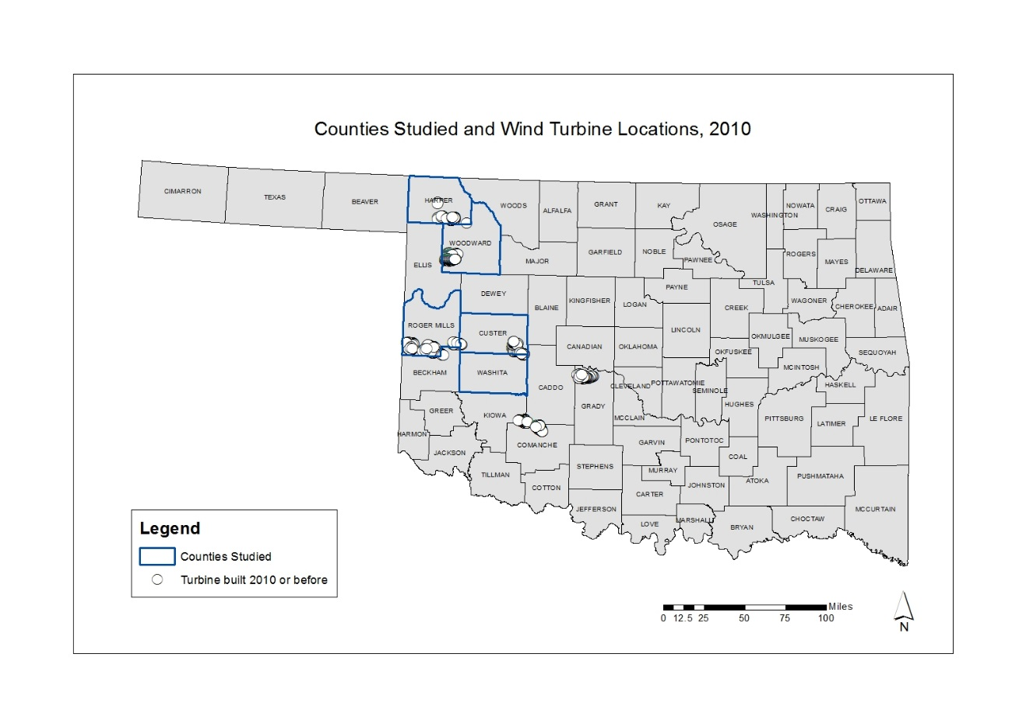
To date, the previous literature on impacts of wind farms on property values has largely focused on the impacts of residential properties (e.g., single family homes) with the exception of Vyn and McCullough (2014) whereby a combination of 7,000 residential and farmland sales were examined in Ontario. This research fills this gap by examining sales for approximately 12,000 residential properties and approximately 11,000 non-residential (or unplatted) properties. While Hoen et al. (2009, 2011, 2015) included two study locations in Oklahoma (Custer County, and Grady County), only residential sales were included. The wind farms located in Western Oklahoma are predominantly located in rural, sparsely populated areas on agricultural land. For example, the largest cities in the study area are Woodward, OK with a population of 12,051 (U.S. Census Bureau, 2010) and Weatherford, OK with a population of 10,833 (U.S. Census Bureau, 2010). This suggests a study of single-family homes in an urban setting may not fully account for the effects of wind turbines on property transaction prices across the state. Furthermore, this research expands upon the study location of Hoen et al. (2009, 2011, 2015) by analyzing transactions near wind farms in five different counties.
Although the location and scope of these studies vary considerably, the methods used to examine the impacts of wind power development upon real estate prices and transaction history are fairly consistent. Through a review of previous studies on the impacts of wind power development on real estate prices the hedonic pricing method is the most commonly used model (Sims and Dent 2007; Sims et al. 2008; Hoen et al., 2009; Hoen et al. 2011; Lang et al. 2014; Vyn and McCullough 2014; Gibbons 2015; Hoen et al. 2015; Sunak and Madlener 2016). The models used in previous studies consist of the natural log of sales price as a function of property characteristics (e.g., square footage, lot size, number of bathrooms, number of bedrooms, etc.) and distance from wind turbines. For this reason, this study used the hedonic pricing method in order to develop a model for sales prices of homes as a function of property characteristics and distance from wind turbines.
The hedonic pricing method has been used in a variety of applications to assess real estate prices as a function of house and neighborhood characteristics and other attributes of the surrounding area. For example, Kinnaman (2009) used the hedonic pricing method in order to assess the degree to which sales prices were related to landfill closures in Pennsylvania. Aroul and Hansz (2012) provide another example of the use of the hedonic pricing method. The authors studied whether or not a city’s green building program would influence surrounding property values. In this study, real estate sales in the cities of Frisco, TX (with a mandatory green building program) and McKinney, TX (no green building program) were evaluated. Aroul and Hansz (2012) concluded that real estate prices were higher in areas with mandatory green building programs.
Although the hedonic pricing method has been used in a variety of cases, one common application of the method is to assess the relationship between presence of wind farms, property characteristics, and real estate sales prices. Hoen et al. (2009) describe the hedonic pricing method as a way to estimate property value by taking into account characteristics of a property (e.g., square footage, number of bedrooms) along with the characteristics of its particular community (e.g., crime rate, distance to amenities, proximity to cell towers). Similar to the previous studies on this topic, both quantitative (e.g., square footage, number of bathrooms) and categorical variables (e.g., type of siding, condition of the property) are taken into account within the model.
3.3.1 Real Estate Transaction Data
For this study, a total of approximately 23,000 real estate transactions were analyzed for properties in Oklahoma. Of these transactions, approximately 12,000 (n = 12,093) were properties with valid addresses (e.g., urban residential properties), and 11,000 (n = 11,196) were unplatted records for which locations were determined based on the given section, township, and range. For this reason, two separate analyses were done to account for differences in the property types. For example, records with valid addresses are likely to be single-family homes on small lots within city limits whereas unplatted records are likely to consist of rural properties with large land areas. The original dataset consisted of up to four sales dates and prices for a given record, with the earliest sales date in the year 1920 and the most recent sales dates in the year 2016. Properties with no sales history were excluded from the analysis. Following from Hoen et al. (2015), a variable for distance from wind turbines was created based on half-mile (1 km), one-mile (2 km), 3-mile (5 km), and 10-mile (16 km) buffers in order to analyze differences in sales prices and number of sales between each buffer distance.
3.3.2 Wind Turbine Data
Wind turbine location data were obtained from the Federal Aviation Administration’s wind turbine location database. The total number of wind turbines as of 2010 within the five counties studied was 515 with 103 turbines in Custer, 127 in Harper, 173 in Roger Mills, 7 in Washita, and 105 in Woodward Counties. As of 2014, the number of turbines within the counties studied was 103 in Custer, 127 in Harper, 239 in Roger Mills, 62 in Washita, and 128 in Woodward Counties. For each turbine, the Federal Aviation Administration provides the date construction was scheduled to begin, the date built, and the date a turbine was assigned an aeronautical study number (ASN). According to the FAA, aeronautical studies are conducted when there is a notice of proposed construction for anything exceeding 200 feet above ground level (e.g., a wind turbine). Given that it is difficult to determine with precision the exact date construction of a wind farm was announced to the public, the date the turbines were assigned an ASN was used as an approximation for the announcement date, as the FAA wind turbine database is updated weekly and can be accessed by the public online.
Following from Hoen et al. (2015), a variable was created for sales prior to announcement, post-announcement but prior to construction, and post-construction in order to determine the number of sales within these phases of wind farm construction. Furthermore, this study follows from Hoen et al. (2015) and uses the wind farm construction phases to determine differences in sales prices for properties located within the established buffer distances (e.g., half mile [1 km], one mile [2 km], three miles [5 km], and ten miles [16 km]) prior to the farm’s announcement date, post announcement but before construction, and after the farm was built. Additionally, this research builds upon the previous literature and also analyzes the differences in the number of sales within the buffer distances. For example, this analysis determines if the number of sales within the half-mile (1 km) buffer was greater than the number of sales per number of properties within the three-mile (5 km) buffer for the three construction phases. Apart from statistical analysis, a spatial and temporal analysis of sales prices and number of sales was done for the study area in order to provide more detail on the relationship between real estate transactions and wind power development in Oklahoma.
3.4 Results
Within this section, the results of the records with valid addresses and the unplatted records are discussed separately. These sales were split into 5 categories based on distance from a wind turbine. Within the records with valid addresses, 30 were within 0.5 miles (1 km) of a wind turbine, 18 were between 0.5 and 1 mile (1 – 2 km), 1,997 were between 1 and 3 miles (2 – 5 km), 4,947 were within 3 and 10 miles (5 – 16 km), and 5,101 were outside of 10 miles (16 km) from a wind turbine as of 2010. Within the unplatted records, 203 were within 0.5 miles (1 km) of a wind turbine, 320 were between 0.5 and 1 mile (1 – 2 km), 1,002 were between 1 and 3 miles (2 – 5 km), 3,889 were between 3 and 10 miles (5 – 16 km), and 5,775 were more than 10 miles (16 km) from a wind turbine as of 2010. Figures 2 and 3 show the wind turbine buffers as of 2010 and 2014.
Figure 2: Map of Wind Turbine Buffers, 2010
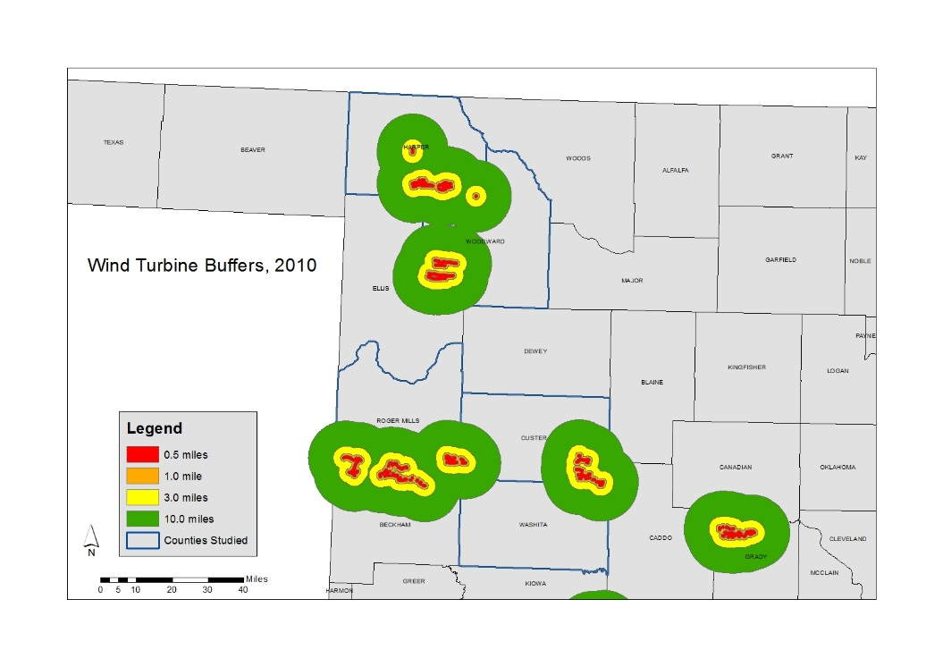

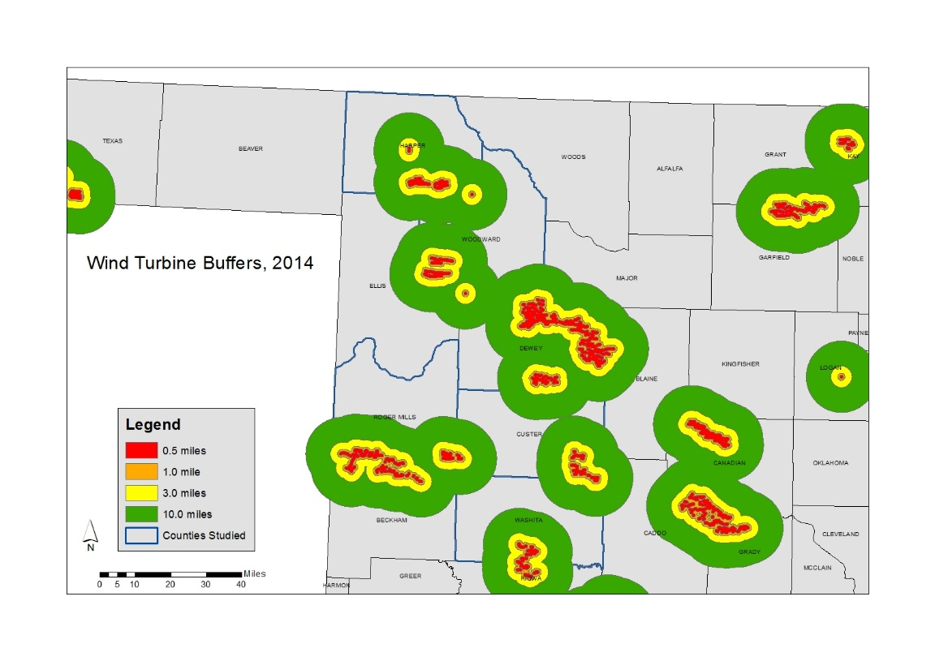
Figure 3: Map of Wind Turbine Buffers, 2014

In order to analyze differences in sales pricing and transaction history based on distance from turbines, appropriate descriptive and inferential statistical methods were used. For example, time series analyses were undertaken in order to evaluate the impacts on median sale price, announcement date and date built. Furthermore, t-tests were used in order to statistically analyze the impacts on turbine announcement and construction upon number of transactions. Additionally, analysis of variance (ANOVA) was used to analyze differences in mean sale price between groups based on distance from wind turbines. Finally, hedonic analysis using multiple regression was used to determine the degree to which distance from turbines impacts sale price while also taking into account property characteristics such as square footage, number of bedrooms, and number of bathrooms.
3.4.1 Records with Valid Addresses:
A number of records within the original data were excluded due to not having a valid address. The original data included up to four possible sales for a given record, with sale price 1 being the most recent, and sale price 4 being the earliest sale. Given that sale price 1 had the highest number of sales, this variable was chosen for detailed analysis. Figures 4 and 5 show a time series analysis of median sale price in dollars before and after the announcement date denoted by the vertical black line in the graphs.
Figure 4: Median Sale Price Before and After Announcement
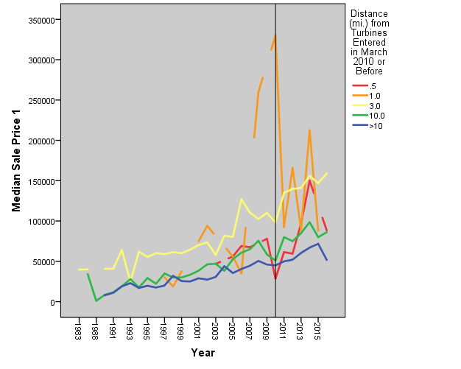

Figure 5: Median Sale Price Before and After Construction

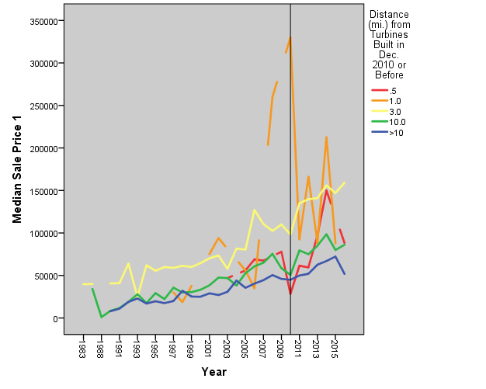

The time series analysis of median sale price and announcement and construction shows several interesting patterns. At first glance, the median sales prices for homes within 10 miles (16 km) of wind turbines are higher overall than the median sales prices of homes beyond 10 miles (16 km) of a wind turbine. Though the sales prices were higher for homes within 10 miles (16 km) of a turbine, the group between 0.5 and 1 mile (1 – 2 km) of a turbine saw the most dramatic decrease in median sale price after announcement and construction, although one possible interpretation of this result would be due to the smaller sample size within this band. However, the groups less than 0.5 miles (1 km), between 1 and 3 miles (2 – 5 km), and between 3 and ten miles (5 – 16 km) all experienced fairly pronounced increases in median sale price after announcement, with the group less than 0.5 miles (1 km) away experiencing the most dramatic change in median sale price from below $50,000 to nearly $150,000 between 2010 and 2013. Although long term trends in the sales have not been removed from this analysis, what is clear from this analysis is that is no relationship between the time of announcement or construction and any concomitant decrease in property values. In fact, there is an increase in the values after announcement and construction.
The time series analysis shows how the median sale price for all of the records has changed over time; however, sale price for the entire area is highly skewed to the right with many records selling in a typical price range and few records selling at very high prices. Figure 6 shows the distribution of sale price. For this reason, the rest of the analysis splits sale price into four quartiles, treating each of the quartiles as separate variables in order to account for the wide variability in sale price across the study area. Figures 7, 8, 9, and 10 show the median sale price of the four quartiles within each distance category before and after announcement (Figures 7 and 8), and before and after construction in 2014 (Figures 9 and 10). The year 2014 was selected in order to allow for an adequate number of sales to be analyzed after announcement and construction.

Figure 6: Distribution of Sale Price
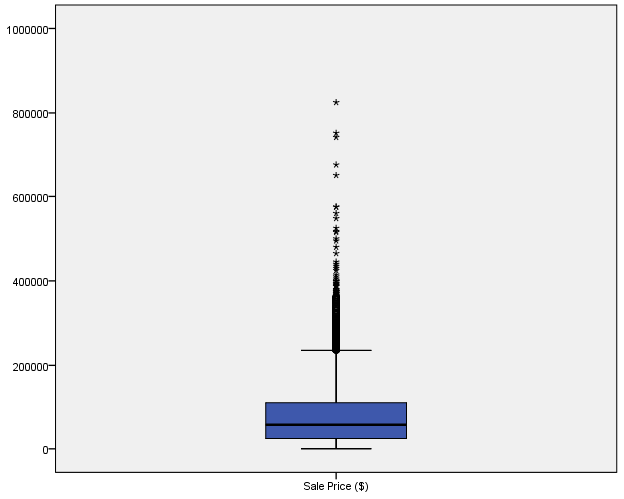

Figure 7: Median Sale Price by Distance (Prior to Announcement)
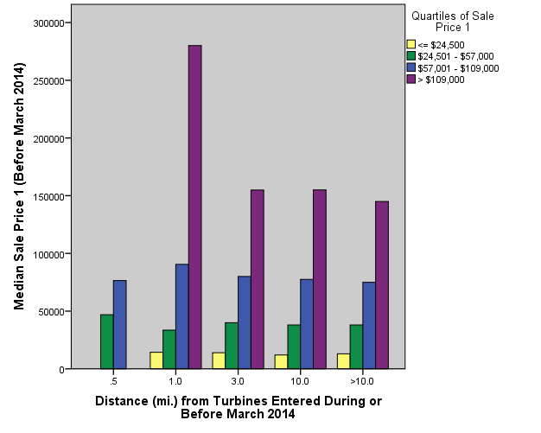

Figure 8: Median Sale Price by Distance (Post-Announcement)

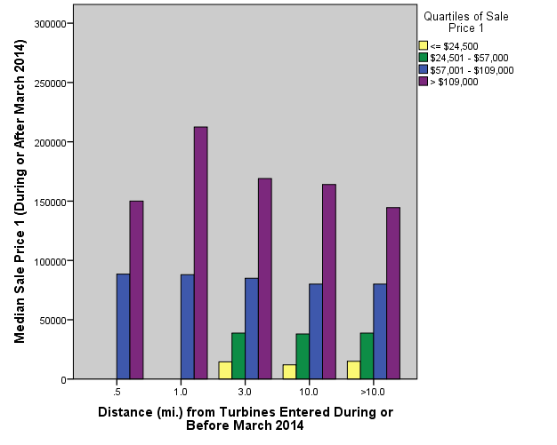

Perhaps the most pronounced difference in sale price is within the records between 0.5 and 1 mile (1 – 2 km) from a wind turbine. For example, prior to announcement, median sale price of homes in the fourth quartile within this distance was between $250,000 and $300,000, while after announcement, the median sale price dropped to between $200,000 and $250,000. This result however, can be viewed as somewhat suspect due to the very small sample size within that bin. For the third quartile, median sales prices for all distances remains the same before and after announcement. It is difficult to compare the difference in median sale price for the first and second quartiles due to the lack of sales after announcement. However, prior to announcement, homes within the second quartile sold at the highest median prices within 0.5 miles (1 km) from a turbine.

Figure 9: Median Sale Price by Distance (Prior to Construction)
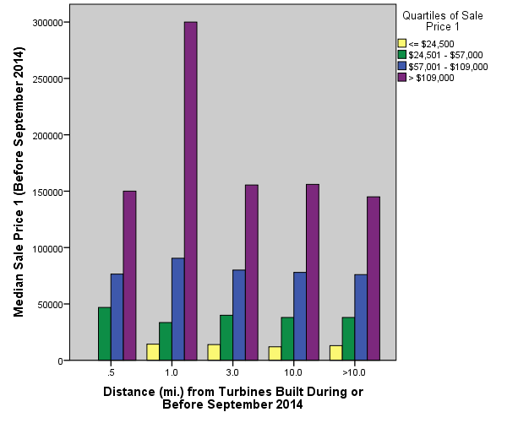
Figure 10: Median Sale Price by Distance (Post-Construction)

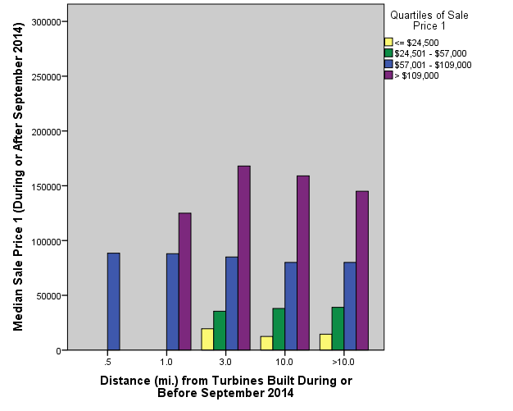

Similar to the trends observed before and after announcement, homes sold within the highest sale price quartile saw the most dramatic decrease in median sale price within the 0.5 – 1 mile (1 – 2 km) distance. Within this buffer zone, median sale price dropped from approximately $300,000 to below $150,000. However, within the homes sold 0.5 miles (1 km) or less from a turbine, median sale price for the third quartile increased by approximately $20,000 after construction.
The analysis of median sale price shows some change for the highest price quartile, and no clear pattern for the different distances. However, it is somewhat incomplete since another factor that might be important in examining the impact of the wind turbines on real estate is the number of sales for each parcel. Therefore, the next part of the analysis examines number of sales before and after announcement and before and after construction in order to determine how distance from a turbine impacts the number of times a particular home was sold. Figures 11 and 12 show the change in number of sales before and after announcement and before and after construction. A value of 0 means the number of sales after announcement or construction was equal. A negative value means the number of sales after announcement or construction decreased while a positive value means the number of sales after announcement or construction increased.

Figure 11: Change in Number of Sales Before and After Announcement
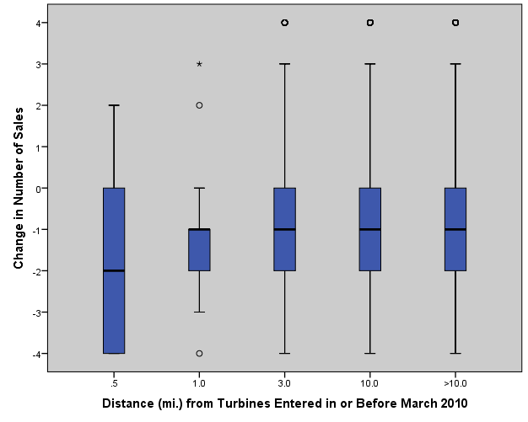

Figure 12: Change in Number of Sales Before and After Construction

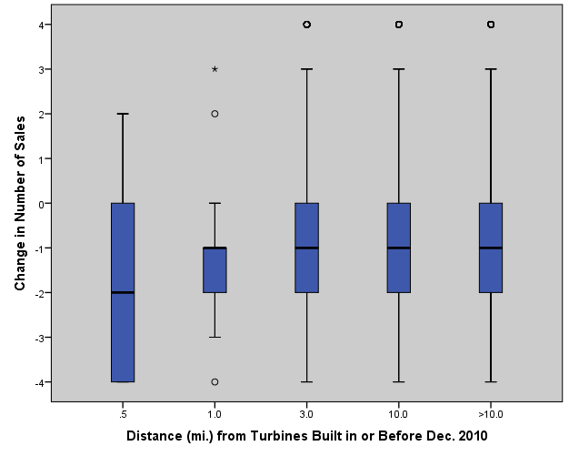
Figures 11 and 12 each show that the median number of sales for homes within 0.5 miles (1 km) of a wind turbine decreased by two both after announcement and after construction. For homes outside of 0.5 miles (1 km) from a turbine, the median number of sales decreased by one. Furthermore, Table 1 shows the statistical analysis of this relationship. For both announcement and construction, there was a statistically significant difference in median number of sales before and after announcement and before and after construction.
Table 1: Paired-Sample t-tests of Number of Sales
Null Hypothesis | Test | P-value (α = 0.05)
The median of differences between number of sales in or before March 2010 and number of sales after March 2010 is equal to zero. | Paired sample t-test | < 0.001
The median of differences between number of sales in or before December 2010 and number of sales after December 2010 is equal to zero. | Paired sample t-test | < 0.001

In addition to paired-sample t-tests, several ANOVA tests were undertaken to determine if there are differences in sale price between the different buffer zones. Although sale price is highly skewed, the distributions are closer to normal when sale price is split into quartiles. Furthermore, ANOVA is fairly robust to non-normality. In some cases, the variances were not equal, therefore a Welch statistic was calculated for cases where equal variances are not assumed. Table 2 shows the results of the ANOVA analyses.

Table 2: Results of Residential ANOVA Analyses
Variables Tested | P-value (α = 0.05)
First Quartile of Sale Price 1 and Distance from Turbines Entered in or Before March 2014 | < 0.001
Second Quartile of Sale Price 1 and Distance from Turbines Entered in or Before March 2014 | 0.019
Third Quartile of Sale Price 1 and Distance from Turbines Entered in or Before March 2014 | < 0.001
Fourth Quartile of Sale Price 1 and Distance from Turbines Entered in or Before March 2014 | N/A (due to small sampling size)
First Quartile of Sale Price 1 and Distance from Turbines Built in or Before September 2014 | < 0.001
Second Quartile of Sale Price 1 and Distance from Turbines Built in or Before September 2014 | 0.019
Third Quartile of Sale Price 1 and Distance from Turbines Built in or Before September 2014 | < 0.001
Fourth Quartile of Sale Price 1 and Distance from Turbines Built in or Before September 2014 | N/A (due to small sampling size)

For each valid test, there was a statistically significant difference in mean sale price between the different buffer zones. In addition to the ANOVA tests, the mean sale price for the second and third quartiles across each of the buffer zones of turbines built by in or before September 2014 was calculated. Within the second quartile of sale price, the highest mean sale price was within 0.5 mile (1 km) of a wind turbine at approximately $47,000 with the second highest mean sale price between 1 and 3 miles (2 – 5 km) of a turbine at approximately $40,500. The pattern within the third quartile are somewhat different with the highest mean sale price between 0.5 and 1 mile (1 – 2 km) from a turbine at approximately $90,000 and the second highest mean price between 1 and 3 miles (2 – 5 km) of a turbine at approximately $82,000. Although the patterns are interesting, the differences in sample sizes within the different buffer zones could potentially influence the means, particularly in the zones within one mile (2 km) of a turbine. Therefore, an extreme value will have a greater influence upon the mean in the 0.5 miles (1 km) or less, and 0.5 – 1 mile (1 – 2 km) zones.
The final part of the analysis is the hedonic analysis using multiple regression. The previous descriptive and inferential statistical analysis has shown some patterns between distance from an existing turbine and impacts on sale price and number of sales. However, multiple regression was used to examine the degree to which sale price can be explained by announcement date, date turbines were built, along with a variety of property characteristics. Table 3 lists the variables used and provides a description. These characteristics were included depending on if they had sufficient variability. Following from the previous analysis, the sale price variable was split into four quartiles. Within the quartiles, sale price is close to a normal distribution. Thus, four separate multiple regression analyses were performed for each quartile of sale price. When appropriate, other quantitative variables were transformed in order to be normally distributed. Finally, a number of dummy variables were created for the categorical characteristics in order to run the regression analysis. For example, the quality of the house was split into 6 dummy variables (N/A, Poor, Fair, Average, Good, Excellent). Furthermore, the regression analysis was only done to compare differences in sale price for homes within 10 miles (16 km) of an existing turbine. Table 4 shows the descriptive statistics of the quantitative variables used in the regression analysis while Tables 5, 6, 7, and 8 show the results of the multiple regression analyses.
Table 3: Descriptions of Variables Used in Regression Analysis
Variable | Description
Sale Price Q1 | First quartile of Sale Price 1
Sale Price Q2 | Second quartile of Sale Price 1
Sale Price Q3 | Third quartile of Sale Price 1
Sale Price Q4 | Fourth quartile of Sale Price 1
Square Feet | Square footage of house (natural log)
Bedrooms | Number of bedrooms
Bathrooms | Number of bathrooms
Age | 2016 minus year built
Quality | Quality of initial construction (dummy variables)
Condition | Assessed condition (dummy variables)
Exterior | Material (dummy variables)
Garage | Dummy variable (0 = no garage, 1 = garage)
E0310 | Distance (mi.) from Turbines Entered in or Before March 2010
B1210 | Distance (mi.) from Turbines Built in or Before December 2010
E0314 | Distance (mi.) from Turbines Entered in or Before March 2014
B0914 | Distance (mi.) from Turbines Built in or Before September 2014

Table 4: Descriptive Statistics of Variables Used in Regression Analysis
Variable | Minimum | Interquartile Range | Median | Maximum
Sale Price Q1 | $132 | $11,000 | $12,750.50 | $24,500
Square Feet (ln) | 5.48 | 0.46 | 6.99 | 8.35
Bedrooms | 1 | 1 | 2 | 8
Bathrooms | 1 | 1 | 1 | 7
Age (years) | < 1 year | 34 | 76 | 126
Sale Price Q2 | $24,600 | $17,625 | $38,000 | $57,000
Square Feet (ln) | 5.63 | 0.37 | 7.12 | 8.81
Bedrooms | 1 | 1 | 3 | 8
Bathrooms | 1 | 1 | 1 | 7
Age (years) | 1 | 30 | 66 | 117
Sale Price Q3 | $57,250 | $22,500 | $78,000 | $109,000
Square Feet (ln) | 5.84 | 0.37 | 7.27 | 8.49
Bedrooms | 1 | 0 | 3 | 9
Bathrooms | 1 | 1 | 2 | 7
Age (years) | 1 | 25 | 52 | 118
Sale Price Q4 | $109,300 | $70,000 | $155,000 | $825,000
Square Feet (ln) | 5.91 | 0.37 | 7.54 | 8.89
Bedrooms | 1 | 0 | 3 | 9
Bathrooms | 1 | 0 | 2 | 7
Age (years) | 1 | 25 | 36 | 112

Table 5: Regression Analysis of First Quartile of Sale Price
Adjusted R Square = 0.135
Sale Price Q1 | Constant | P-value (α = 0.05)
Constant | 6597.060 | < 0.001
Square Feet (ln) | 0.996 | 0.009
Age | 26.396 | 0.002
Condition (Fair) | 3998.141 | < 0.001
Condition (Average) | 6306.119 | < 0.001
Condition (Good) | 7890.071 | < 0.001
Exterior (Other) | -2270.812 | < 0.001
Garage | 832.345 | 0.045
Dist. (Entered 03/2010) | -251.747 | 0.004

Table 6: Regression Analysis of Second Quartile of Sale Price
Adjusted R Square = 0.062
Sale Price Q2 | Constant | P-value (α = 0.05)
Constant | 35212.808 | < 0.001
Square Feet (ln) | -1.518 | 0.024
Bedrooms | 1967.992 | < 0.001
Quality (Average) | 2203.703 | 0.001
Quality (Good) | -4023.288 | 0.018
Condition (Fair) | -2655.622 | 0.020
Exterior (Brick) | 2027.367 | 0.005

Table 7: Regression Analysis of Third Quartile of Sale Price
Adjusted R Square = 0.065
Sale Price Q3 | Constant | P-value (α = 0.05)
Constant | 80685.725 | < 0.001
Bathrooms | 2954.335 | < 0.001
Age | -100.853 | < 0.001
Quality (N/A) | -19345.207 | 0.046
Condition (Good) | 2549.008 | 0.004
Garage | 2881.973 | 0.001
Dist. (Entered 03/2010) | -402.135 | 0.001

Table 8: Regression Analysis of Fourth Quartile of Sale Price
Adjusted R Square = 0.495
Sale Price Q4 | Constant | P-value (α = 0.05)
Constant | 194847.516 | < 0.001
Square Feet (ln) | 53.695 | < 0.001
Bedrooms | -11676.857 | < 0.001
Bathrooms | 6723.888 | 0.018
Age | -1165.613 | < 0.001
Quality (Poor) | 145645.312 | < 0.001
Quality (Average) | -43077.199 | < 0.001
Quality (Excellent) | 49490.958 | 0.010
Condition (Excellent) | 34703.984 | 0.002
Exterior (Other) | -92935.823 | < 0.001
Garage | -16211.300 | < 0.001
Dist. (Entered 03/2010) | -922.798 | 0.010

Tables 5, 6, 7, and 8 show the results of the regression analyses for each of the quartiles of sale price. Although more variables were initially put into the models, only the statistically significant (α = 0.05) variables are used within the models. For each quartile except the fourth quartile of sale price, the adjusted R Square value is very low ranging from 0.062 to 0.135. Thus, although each model is statistically significant, the models explains very little of the variation in sale price (between 6.2 and 13.5 percent). Within the fourth quartile, the adjusted R Square value is 0.495, meaning the variables in the model explain almost half of the variation in sale price. However, sale price within the fourth quartile is the least normally distributed of the four quartiles. Thus the results are potentially suspect and may not be statistically valid.
Within each quartile except the third, distance from turbines entered in or before March 2010 was a significant variable within the model. Furthermore, the negative coefficient in the first, second, and fourth quartile models suggests that sale prices decrease as distance from announced turbines increases. This result is perhaps somewhat surprising, as it suggests that prices increase the closer the property is towards the turbine, which is counter to the concerns of many who feel that property values may drop when in close proximity to a utility-scale wind farm. However, splitting sale price into quartiles resulted in small sample sizes in the zones within one mile of a wind turbine; therefore, the results for that quartile may be suspect and may not be statistically valid.

3.4.2 Unplatted Land
In addition to the records with valid addresses, sales prices of unplatted land were also analyzed. Although there are two populated areas within the study area (Woodward and Weatherford), wind turbines are more commonly located in rural areas, typically agricultural land. Therefore, examining sales prices of unplatted land may provide more insight on the impacts of wind turbines upon sale prices. Figures 13 and 14 show the change in median sale price in dollars for unplatted records before and after announcement, and before and after construction as denoted by the vertical black line in the graphs.
Figure 13: Median Sale Price Before and After Announcement
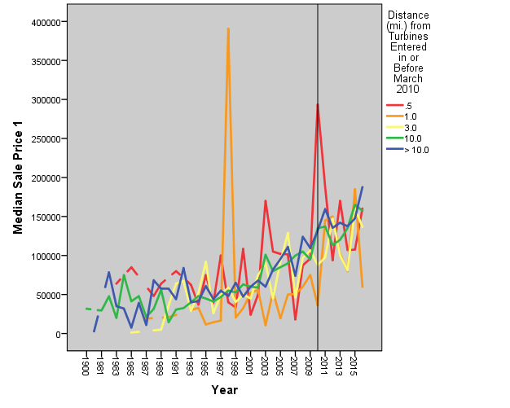

Figure 14: Median Sale Price Before and After Construction

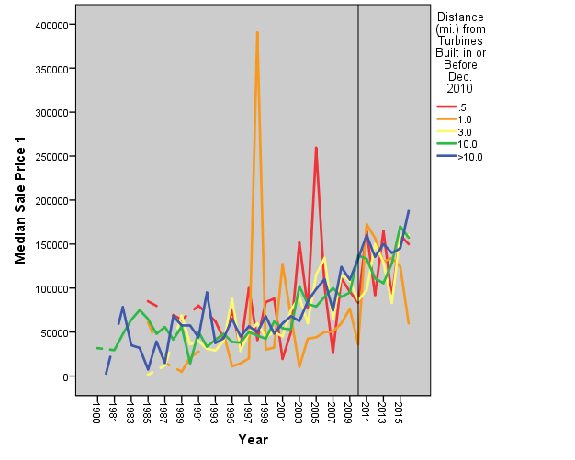
Figures 13 and 14 show some interesting patterns in median sale price before and after announcement and before and after construction. Overall, median sale price for each distance from turbines climbs fairly steadily throughout the whole time period. However, after announcement, land within 0.5 miles (1 km) of a turbine drops from a median of approximately $300,000 to $200,000. This trend differs for land between 0.5 and 1 mile (1 – 2 km) of a wind turbine. Median sale price for land in this zone increased from less than $50,000 to approximately $150,000. Furthermore, median sale price increases by about $50,000 for land between 1 and 3 miles (2 – 5 km) of a wind turbine after announcement. Similar trends are present after construction, except for median sale price of records within 0.5 miles (1 km) of a turbine increased by over $50,000.
In addition to examining median sale price over time, it is interesting to see how median sale price changes within quartiles of sale price based on distance from wind turbines. Similar to the records with valid addresses, sales price is highly skewed. Therefore, to account for its skewness, sale price was split into four quartiles. Figures 15, 16, 17, and 18 show median sale price for the four quartiles before and after announcement and before and after construction.
Figure 15: Median Sale Price (Prior to Announcement)

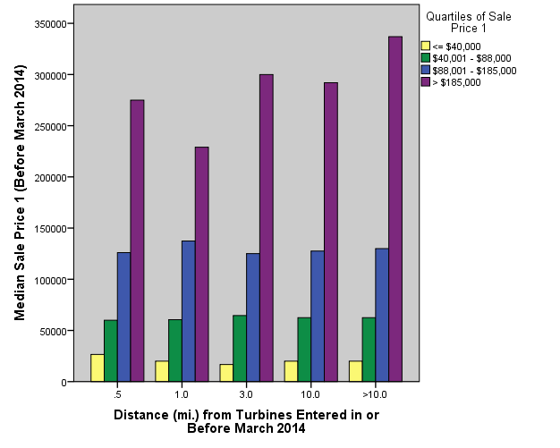

Figure 16: Median Sale Price (After Announcement)

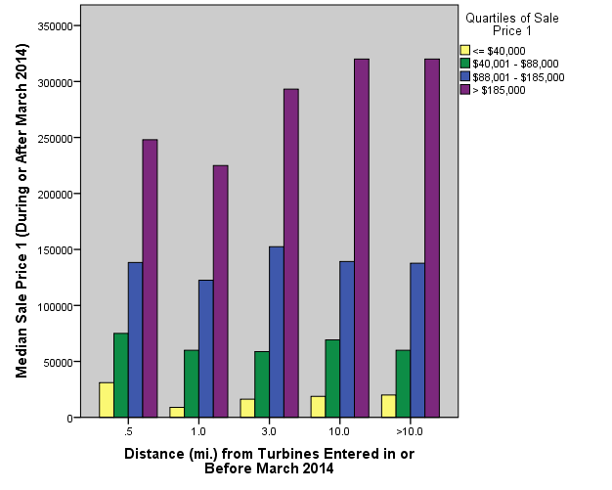

Figures 15 and 16 do not show many dramatic changes in median sale price within the quartiles before and after announcement. For the lowest quartile, median sale price is noticeably higher for land less than 0.5 miles (1 km) from a turbine after announcement, but noticeably lower for land between 0.5 and 1 mile (1 -2 km) of an announced turbine. The land within 0.5 miles (1 km) the median sale price for the highest quartile drops by approximately $25,000.

Figure 17: Median Sale Price (Prior to Construction)
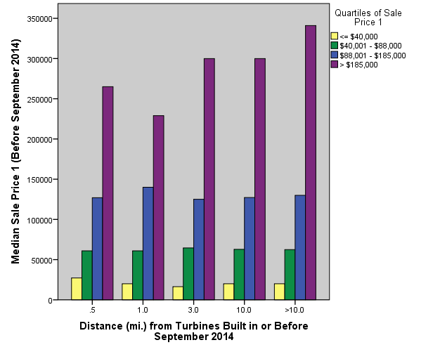
Figure 18: Median Sale Price (After Construction)

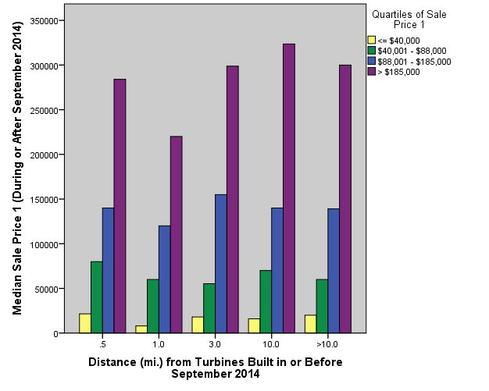
Similar to the bar charts showing median sale price before and after announcement, Figures 17 and 18 do not show dramatic changes in median sale price of unplatted land before and after construction. However, prior to construction, median sale price for the second quartile was equal within each distance from turbines while after construction median sale price for the second quartile is noticeably higher for land less than 0.5 miles (1 km) from a turbine. This suggests unplatted land prices are not dramatically different before and after announcement or before and after construction overall, but there are isolated cases where one particular quartile experiences a minor change in median sale price.
In order to further examine how sale price might be impacted by wind turbine announcement and construction, ANOVA tests were conducted. Table 9 shows the results of the ANOVA analyses. Though sale price of the records with addresses were reasonably normally distributed after splitting into four quartiles, sale price of unplatted land was not close to normally distributed in the first and fourth quartiles due to the high variability within the data. For this reason, the statistical analysis only takes into account the second and third quartiles (the middle half) of sale price. In addition to the ANOVA tests, the mean sale price for each distance from turbines built by September 2014 was calculated.

Table 9: Results of Unplatted ANOVA Analyses
Variables Tested | P-value (α=0.05)
Second Quartile of Sale Price 1 and Distance from Turbines Entered in or Before March 2014 | 0.238
Third Quartile of Sale Price 1 and Distance from Turbines Entered in or Before March 2014 | 0.337
Second Quartile of Sale Price 1 and Distance from Turbines Entered in or Before September 2014 | 0.180
Third Quartile of Sale Price 1 and Distance from Turbines Entered in or Before September 2014 | 0.413

The ANOVA analyses did not reveal any statistically significant differences in mean sale price between the unplatted land within different distances from turbines. An analysis of the means shows that within the second quartile of sale price, the highest mean sale price (over $64,000) of land is between 3 and 10 miles (5 – 16 km) from a turbine, while for the third quartile the highest mean sale price (over $136,000) is between 0.5 and 1 miles (1 – 2 km) from a turbine.
Though multiple regression was used for the records with valid addresses, it was not used for the unplatted land for a number of reasons. Most important, multiple regression for the records with valid addresses was used in order to control for the many housing characteristics that typically have an impact on price (e.g., square footage, number of bathrooms, age of the house). However, for unplatted land, these characteristics do not apply.

3.5 Discussion
The analysis of sales with valid addresses and unplatted land revealed several interesting patterns. For instance, the median sale price of homes within ten miles (16 km) of a wind turbine was higher overall than the price of homes beyond 10 miles (16 km) of a turbine. Additionally, homes within 0.5 miles (1 km) of a turbine saw a dramatic increase in median sale price both after announcement and after construction of wind turbines in 2010. Though this was a trend for the entire set of sales, different patterns were observed when sale price was grouped into four quartiles. For example, median sale price decreased for homes in the highest quartile of sale price between 0.5 and 1 mile (1 – 2 km) of a turbine after announcement and construction. However, the multiple regression analysis suggests there is a negative relationship between distance from a turbine after announcement and sale price. This trend was observed in the ANOVA analysis that showed a relationship between mean sales price and distance buffer. The mean sale prices were significantly higher less than 0.5 miles (1 km) from a turbine for the second quartile of sale price and significantly higher between 0.5 and 1 mile (1 – 2 km) from a turbine for the third quartile of sale price. The implications of this are that there is clearly no consistent relationship between the wind farms and the property values.
In addition to the records with valid addresses, several patterns were observed in the analysis of unplatted land sales. Though median sale price of land within 0.5 miles (1 km) of a turbine dropped after announcement, median sale price of land between 0.5 and 1 mile (1 – 2 km) of a turbine increased dramatically after announcement and construction. Additionally, median sale price within the second and third quartiles less than 0.5 miles (1 km) and between 1 and 3 miles (2 – 5 km) of a turbine increased noticeably after announcement. Although the ANOVA tests did not reveal any statistically significant relationships between distance from turbines after announcement and construction and sale price, land in the third quartile of sale price between 0.5 and 1 mile (1 – 2 km) from a wind turbine had a much higher mean sale price than land in the other zones.
The analysis of real estate pricing and transaction history for both residential properties with addresses and unplatted land has shown relationships between sale prices and distance from wind turbines. A number of previous studies on this topic have either been inconclusive (Sims and Dent, 2007) or have found no relationship between sale price of homes and distance from turbines (Sims et al., 2008, Hoen et al. 2015). Additionally, in some cases, visibility of turbines was shown to reduce sale prices of homes (Gibbons, 2015). Apart from residential property transactions, Sunak and Madlener (2016) concluded that sale prices of land decreased with increasing visibility of wind turbines. A number of previous studies on the impacts of wind turbines on real estate prices have been primarily focused on residential properties with the exception of Sunak and Madlener (2016). However, similar to this research, Vyn and McCullough (2014) analyzed a combination of residential and land sales and found no significant impact of proximity or visibility of wind turbines upon sale prices.
Within most of the past studies, proximity and visibility of wind turbines did not significantly impact sale prices (Sims et al., 2008; Vyn and McCullough, 2014; Hoen et al., 2015). One potential limitation of this study is that visibility of turbines was not included as a variable; however, it is known that turbines are more likely to be visible from homes within shorter distances from turbines. The statistical analysis in this study suggests that there is either no relationship or a negative relationship between distance from turbines and sale prices of homes. Thus, as distance from a turbine decreases, sale price increases for homes sold in the first, third, and fourth quartiles of sale price. This differs from the findings of Gibbons (2015) and Sunak and Madlener (2016) where prices of homes and land decreased with proximity and visibility of wind turbines. The sales price was highly skewed and was subsequently split into quartiles for the multiple regression and ANOVA analyses to produce more detailed and statistically significant result. This led to small sample sizes in the groups of homes closest to wind turbines. Thus, the results of the multiple regression and ANOVA analyses could potentially be influenced by differences in sample sizes within the buffer zones in the quartiles of sale price.
Sales price for homes and unplatted land were also analyzed descriptively. The descriptive analysis revealed that median sale price of homes within 10 miles (16 km) of a wind turbine were higher than prices of homes greater than 10 miles of a turbine, particularly those between 1 and 3 miles (2 – 5 km) of a wind turbine. However, this leads to another potential limitation of this research, which is the typical nature of real estate development in Oklahoma. For example, newer homes are likely to be built on the outer edges of city limits where turbines are more likely to be located. While the multiple regression analyses controlled for age of the house, it is possible that the higher percentage of new homes located closer to wind turbines could have influenced the trend of higher overall median sale prices closer to wind turbines.
Additionally, this study did not control for neighborhood and socioeconomic characteristics such as crime rate, education levels, and income. However, the census tracts for western Oklahoma are relatively large. Thus, since the study regions are fairly homogenous, there would not be enough variability within these characteristics to justify including them in the analysis at that scale.
3.6 Conclusion
Real estate pricing and transaction history were analyzed in Custer, Harper, Roger Mills, Washita, and Woodward counties. This analysis included approximately 23,000 total sales for both residential properties and unplatted land. In order to evaluate how distance from turbines might impact sale price, descriptive and inferential statistics such as ANOVA and hedonic analysis using multiple regression were used. Although there were a few potential limitations with the statistical analysis, the multiple regression and ANOVA analyses suggest that sale price of homes closer to wind turbines may sell at higher prices than homes farther away from turbines. A statistically significant relationship between distance from turbines and sale price was not found for the unplatted land sales, but median sale price for unplatted land increased noticeably after announcement and construction for the sales between 0.5 and 1 mile (1 – 2 km) of a turbine.
Though many authors have analyzed impacts of wind farms upon nearby home or land sale prices, very few have analyzed both. For example, wind turbines are more likely to be located on rural agricultural land; therefore, a comparison of how they might impact sale prices of homes and land differently serves to fill an existing research gap. Furthermore, the previous studies of Oklahoma have only taken into account sales of single-family homes, which may not capture exactly how wind turbines could potentially affect the state’s real estate market.
In addition to the study of both residential properties and land, Oklahoma is an interesting and relevant place in which to study impacts of wind power upon real estate sales and pricing history. For example, the literature review has shown that residents in Oklahoma have very mixed views and support when a new wind farm is proposed and built near their communities. In spite of this, wind power has grown rapidly and continues to develop within the state. Furthermore, wind power development has started to move eastward towards the state’s more populated areas. Therefore the issue of acceptance and support of new development is likely to become more prominent in the future. The results from this study show that one of the potential areas of concern of local citizens – that of a potential negative impact on real estate values from proximity to wind farms, is unfounded. This research thus alleviates one such barrier to acceptance.

Chapter 4: Impacts of Wind Power Development on Oklahoma’s Public Schools

Abstract

Wind energy development has grown significantly in western Oklahoma over the last decade, going from no installed capacity to producing over 20 percent of the state's energy by the end of 2016. Associated with that development has been an increase in tax revenue and support for local schools, including many in struggling areas. This chapter examines and quantifies the overall impact of the increased wind-industry related tax revenue in western Oklahoma. The spatial patterns of local school revenue and related variables have been analyzed and compared to available socio-economic and demographic information. Spatial and multivariate analysis has been undertaken to highlight differences in characteristics of public school districts with and without wind turbines. Results show significant differences in revenue from local and county sources between school districts with and without wind farms. However, school districts with wind farms did not have higher per-student expenditures or lower student-teacher ratios than surrounding districts. The significant change in percentage of revenue from local and county sources illustrates the relative importance of the industry, especially during challenging economic times, and particularly in those areas with fewer other revenue sources. Though school districts with wind farms did not differ from surrounding districts in terms of per-student expenditures or student-teacher ratios, the significant difference in revenue from local and county sources suggests these districts may be less susceptible to changes in funding from state and federal sources.

Key Words: Wind power, Oklahoma, Schools

4.1 Introduction
Given the potential impacts of wind power on real estate prices, wind power development could potentially influence other aspects of the state related to property values. For example, higher home values will also have higher property taxes. Thus, this higher property values potentially increase a particular community’s available revenue for local services such as schools, fire and police departments. For this reason, this chapter examines the impacts of wind power development upon Oklahoma’s public schools.
Although the wind industry has stimulated the state’s overall economy, Greene and Geisken (2013) illustrate how the development’s impact on the community depends on the community’s ability to offer the necessary goods and services required for the development of a wind farm. Additionally, AWEA (2015) shows that all of the manufacturing facilities for wind power development are in central or eastern Oklahoma while the actual wind farms are predominantly in western Oklahoma. This suggests the communities with wind farms may not realize all of the economic benefits associated with wind power development, but that these benefits are dispersed across the state. However, there are other ways in which the local communities can benefit.
4.2 Literature Review
The existing scientific literature shows the potential community-level economic impacts of the wind industry, including: job creation, the effects of job creation on local economies, increased property tax base, and its potential impacts on local services such as schools, fire and rescue, and infrastructure. Perhaps the most widely discussed economic aspect of wind power development is that of job creation. Throughout the development of a wind project, jobs are created predominantly during the construction phase, with some jobs remaining for the operation and maintenance phase. According to the U.S. Department of Energy (2015), 50,500 people in the United States were directly employed by the wind industry in the form of manufacturing, equipment supply, construction, or operation and maintenance jobs as of 2013. Since that time, the wind industry has seen sustained growth, so those numbers are clearly much higher today.
Other authors have examined job creation at more specific locations within the U.S. For example, Brown et al. (2012) identified an increase on 0.5 jobs per MW of installed capacity for a study period of 2000-2008 within the Great Plains. Slattery et al. (2011) estimated a total of 4,100 full-time equivalent jobs would be created as a result of the installation of 1,398 MW of wind power in Texas. Other authors have analyzed case studies to estimate the total job creation as a result of individual wind projects. For example, Greene and Geisken (2013) estimate a total of 148 jobs were created during the construction phase as a result of the installation of a 147 MW facility in western Oklahoma. Similarly, Grover (2002) estimated 185 jobs to be created during the construction of a 390 MW wind farm in Washington State, with 85 jobs to be created for the operation and maintenance phase of this facility. Leistritz and Coon (2009) follow a similar approach and estimate that 269 jobs were created during construction, and 10 jobs during the operation and maintenance phase for a 159 MW facility in North Dakota. Related to job creation, Okkonen and Lehtonen (2016) identified a 1.5 million euro impact to communities in northern Scotland as a result of construction and operation and maintenance jobs in the wind industry.
In addition to job creation as a result of wind power development, communities may realize other economic benefits such as increased tax revenues. Ejdemo and Soderholm (2015) identify increased tax revenues from a wind project that may be used by local governments to improve infrastructure or to purchase goods and services. The US Government Accountability Office (2004) explains how increased tax revenue can be in the form of sales tax from an increase in spending at local businesses from those employed in the wind industry during the construction phase of a particular project. More specifically, in a case study of a community in western Oklahoma, Greene and Geisken (2013) found the installation of a 147 MW wind farm contributed to an increase of $27 million in local spending. Wind power development in a community can also potentially increase tax revenues from income taxes generated from those employed in the wind industry (US GAO, 2004). Additionally, the US GAO (2004), Lantz and Tegen (2009), and the Governors’ Wind Energy Coalition (2013) each discuss that property tax revenues as a result of wind power development can provide additional revenue to be used by local services such as schools, hospitals, fire departments, and other services.
Similar to the US GAO (2004), Pedden (2006) and the GWEC (2013) identify economic benefits that local communities may experience as a result of wind power development. These impacts include employment, increases in income, tax revenues, and payments to landowners with wind turbines on their property. Pedden (2006) and the GWEC (2013) discuss how additional tax revenue can be used to support local schools, hospitals, the fire department, or local infrastructure. Pedden (2006) also mentions that wind power development may have a more significant impact on rural economies, particularly those where farming is the only major industry.
A number of studies have quantified the economic benefits such as lease payments or increased tax revenue that communities with recent wind power development have experienced. For example, Reategui and Hendrickson (2011) estimate that landowners in the state of Texas can collectively receive $5 million annually in lease payments. At the community level, lease payments can range from about $400,000 in Oklahoma (Greene and Geisken, 2013) to $413,000 in North Dakota (Leistritz and Coon, 2009) in a given year.
Along with lease payments, increased tax revenues can significantly benefit services within local communities. The US GAO (2004) identifies property tax revenues as a result of wind turbines ranged between $470,000 and $660,000 in a given year in Minnesota. Furthermore, the US GAO (2004) discussed school districts in Pecos County, Texas received approximately $5 million in a given year as a result of property tax revenues that accompanied recent wind power development. Several other studies have produced similar findings. For example in a study on the economic effects of wind power in North Dakota, Leistritz and Coon (2009) estimate the expected property tax revenues associated with the project to be $456,000 per year. Furthermore, in Washington State, Grover (2002) estimates tax revenues from the proposed wind farm available to local services to be $693,000 per year. In a study of a community in western Oklahoma, Greene and Geisken (2013) estimate the increase in property tax revenue to be over $600,000 per year.
Although a number of authors have quantified the economic benefits of wind power development at the community level in the form of jobs created, increased spending at local businesses, lease payments to property owners, and increased revenue from property taxes, little research has been done to more closely examine how exactly local services, schools in particular, have been impacted by industrial-scale wind development within their communities. Furthermore, little research has examined how communities with industrial-scale wind power differ socioeconomically from surrounding communities with no such development, although there has been some research undertaken on this. In a study of 9 counties (6 with wind farms and 3 without wind farms) in west Texas, Kahn (2013) analyzed quality of life, demographics, school quality, and property tax rates. Assuming quality of life was related to education, Kahn (2013) concluded educated residents had not been avoiding areas with wind turbines, suggesting the turbines had not affected quality of life. Additionally, Kahn (2013) identified decreased pollution when compared to electricity generation from fossil fuels as another contributing factor to quality of life in communities with wind farms.
Variables that Kahn (2013) examined related to public school quality consisted of per pupil expenditures, student-teacher ratios, and test performance. Data were collected for the 2008-2009 and 2010-2011 calendar year. The results of this analysis show that schools in counties with wind farms have experienced significant increases in per pupil spending by $1,239 per year, and decreases in student-teacher ratios by 1.98. However, it is unclear the degree to which Texas schools within counties with wind farms were affected as a result of property tax revenues. Kahn (2013) discusses that Texas reallocates property tax revenues from rich to poor districts in the state. Thus, approximately 60 percent of the new revenue from previously poor districts (those with recent wind power development) had been redistributed to districts across the state.
Similar to Kahn (2013), De Silva et al. (2016) examined the community-level impacts of wind power development at the county level in Texas. A total of 222 counties were analyzed consisting of 31 with industrial-scale wind power and 191 without wind power. Variables analyzed included employment, personal income, property taxes, and public school expenditures. De Silva et al. (2016) found modest employment benefits in the form of direct and indirect employment associated with wind power development, but that per capita income increased significantly. Furthermore, the authors found counties and schools benefited from increased property taxes. However, De Silva et al. (2016) discuss that while districts with wind power development have experienced changes in the property tax base, the relationship between increased tax base and per pupil spending is most likely less pronounced due to the school funding structure discussed by Kahn (2013) whereby local funds are distributed across the state from richer to poorer districts.
To date, the studies conducted by Kahn (2013) and De Silva et al. (2016) have most closely examined the impacts of utility-scale wind power development on local communities, public schools in particular. This shows that in-depth analysis on how wind power development affects schools has been done in only a limited number of cases, and not for Oklahoma. For instance, Kahn (2013) and De Silva et al. (2016) have examined the impacts of wind power development on Texas counties (and the implications for public schools); however, the funding structure for schools in Texas differs somewhat from that of Oklahoma. Thus, the effects upon schools of wind power development in Texas may differ from those in Oklahoma. Furthermore, the funding structure in Oklahoma is examined in order to provide additional context for the ways in which Oklahoma’s public schools may be affected by wind power development.
4.3 Overview of Public School Funding and Ad Valorem Taxes in Oklahoma
Given that wind power development can affect local property tax revenues as has been shown by the research described briefly above, it is useful to provide an overview of the funding structure of public schools in Oklahoma in order to understand how the changes in property tax revenue from wind turbines could potentially affect a particular school district. According to the Office of Educational Quality and Accountability (2016), public schools in Oklahoma received 47.7 percent of funding from the state, 11.6 percent from the federal government, and 40.8 percent from local and county sources, totaling approximately $5.9 billion for the 2014-2015 school year. Additionally, a typical school district in Oklahoma receives approximately 30 percent of its funding from property taxes (OEQA, 2016). OEQA (2016) states that school districts that receive a larger percentage of revenue from local and county sources are typically better off economically while those that receive a smaller percentage of revenue from local and county sources are worse off economically. Percentage of revenue from local and county sources varies from 67 percent in Grant County to 14.4 percent in Adair County (OEQA, 2016). However, school districts that are able to raise money from local and county revenues will not receive as much funding from the state, as state funding is allocated to districts that do not have the ability to raise money through local and county revenues (OEQA, 2016).
Although it has been shown that wind power development can increase the local property tax base, state-level policies regarding ad valorem taxes for renewable energy projects differ across the United States. DeLacy (2014) explains that some states have adopted Payment in Lieu of Taxes (PILOT) programs in order to defer the increase of property taxes. DeLacy (2014) provides an overview of different state-level policies on the taxation of renewable energy development on personal property. For example, the state of Wisconsin exempts renewables from ad valorem taxation while in Pennsylvania, only the concrete base and improvements to roads are subject to ad valorem taxation (DeLacy, 2014). Other states have adopted exemption periods for property taxes on renewable energy, ranging from a five-year exemption period in Oklahoma to a 15-year exemption period in New York (DeLacy, 2014). The five-year exemption period in Oklahoma suggests the effects of wind power development upon schools may not follow immediately after a wind farm is installed, but delayed for five years.
4.4 Data and Methods
Oklahoma’s recent and fast growth of industrial-scale wind power and the historic lower socioeconomic status of the western portion of the state suggest that wind power development may have dramatic impacts on the schools in the region. This research examines how wind power development affects public school districts located in western Oklahoma. The state of Oklahoma has a total of 517 school districts (OEQA, 2016), of which data were collected for 108, representing approximately 20 percent of the state. These districts were selected to represent the western half of the state, with approximately 37% of the 108 districts with and 63% without industrial wind turbines as of the end of 2014. Of the study area, 41 districts contained all of the state’s wind turbines, while the other districts selected were near districts with wind turbines. See Figure 19 for a map of wind turbine locations as of 2010 and the study area.
Following from the studies of Kahn (2013) and De Silva et al. (2016) where the relationships between presence of wind turbines and socioeconomic characteristics and public school attributes were analyzed at the county level in Texas, relevant variables were collected and analyzed for this research. These variables include: percentage of revenue from local and county sources, student-teacher ratios, and per-student expenditures. Data were collected for these variables at the school district level from the Office of Educational Quality and Accountability for 19 years, beginning in 1997 and ending in 2015. The year 1997 was selected as the start date since that was the first year for which the data were available at the school district level. The data were mapped and analyzed using appropriate descriptive and inferential statistical methods in order to identify spatial patterns related to wind power development and statistically meaningful differences between school districts with wind turbines and surrounding districts with no turbines. In addition, a longitudinal temporal analysis was undertaken for selected locations to further illustrate the impact of the wind farms on the region.
Figure 19: Map of study area and wind turbine locations
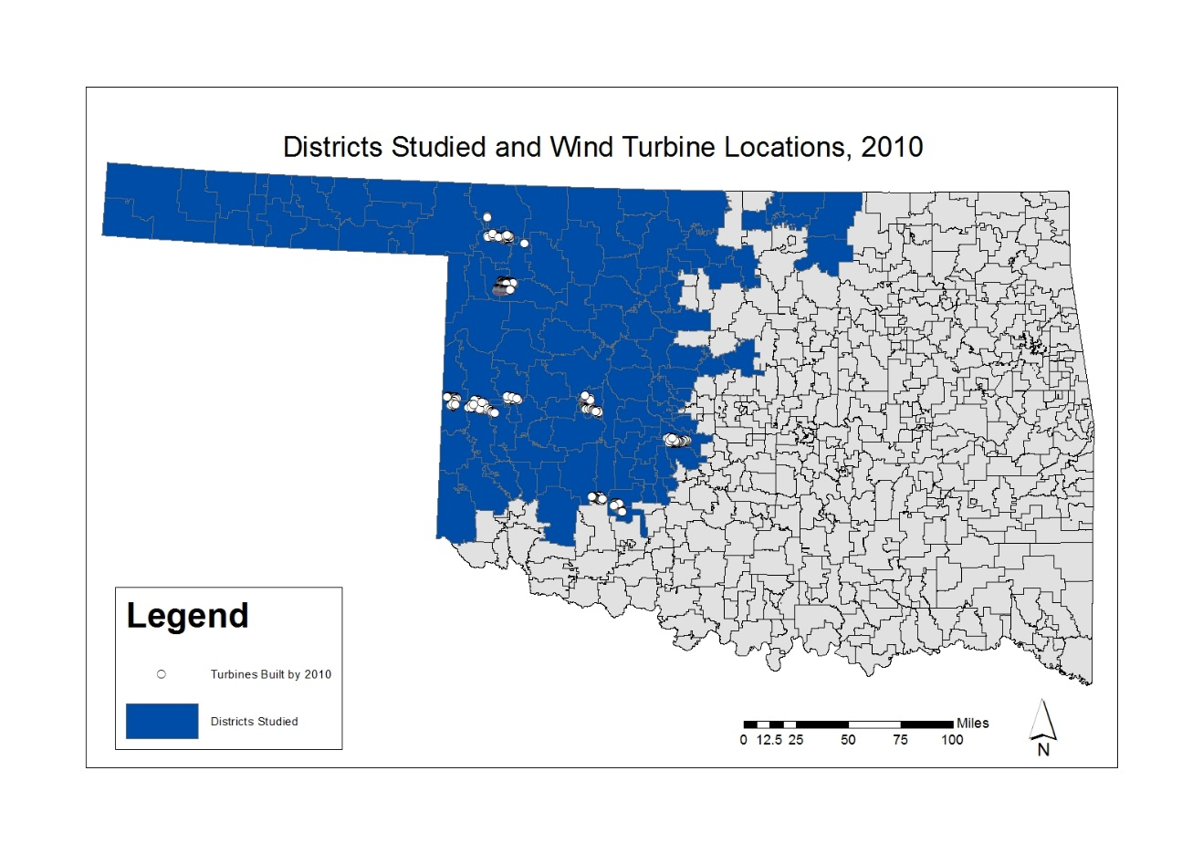
In order to determine differences between school districts with wind turbines and those without turbines, independent-samples t-tests, independent-samples Mann-Whitney U tests, and descriptive analyses were used when appropriate. For example, while it may be appropriate to use independent-samples t-tests to compare means for skewed data if sample size is greater than 30, Mann-Whitney U tests were also used since initial visual analysis of the data suggests that Gaussian assumptions may be violated in some instances. The percentage change variables were developed and selected so that the relative change would be used to standardize the impact by school district. These variables were calculated based on the total percentage change over the entire time period for which data are available (1997 – 2015). Recall that there is a five-year property tax exemption period in the state (DeLacy, 2014), so the definition of districts with and without turbines factors this into the analysis. Thus, for example, property values may increase immediately as a result of wind turbines, but the effects such as more revenue available for local services as a result of increased property taxes may not be realized by the community until after the five-year exemption period ends. The analysis described below takes this into consideration. When examining percentage of revenue from local and county sources, student-teacher ratios, and per-student expenditures, districts were split into two groups – those with turbines in 2010 or before (n = 18), and those without turbines in 2010 (n = 90), again, this is to account for the five-year ad valorem exemptions.
4.5 Results

4.5.1 Change in Local and County Revenues
The first variable that was examined was the percentage of district revenues from local and county sources. Given that the Office of Educational Quality and Accountability (2016) has identified that school districts with a greater percentage of revenues from local and county sources are typically more economically well-off than those with lower percentages of revenues from local and county sources, this variable was selected to examine if there are differences in percentage of local and county revenues between districts with wind and with turbines in 2010 or before. As above, appropriate statistical tests (e.g., independent-samples t-tests and Mann-Whitney U tests) were used. The results reveal statistically significant differences in percentage change in local and county revenues between districts with and without turbines in 2010 or before. For example, districts with turbines in 2010 or before saw an average increase in local and county revenues of approximately 55.8 percent, while districts without turbines in 2010 only saw an average increase of approximately 26.1 percent. Refer to Tables 10 and 11 for the results of the independent-samples t-tests, independent-samples and Mann-Whitney U tests (statistically significant variables are in bold in these figures). Furthermore, Figure 20 shows how the distributions of percentage change in local and county revenue differ between districts with wind turbines in 2010 or before and districts without turbines in 2010. Figure 20 shows the almost 30 percent difference in median change, and also an over 50 percent difference for the upper quartile.

Table 10: Results of Independent-Samples t-tests

Variable | Year Built | N | Mean % change | P-value (sig. at α = 0.05)
Local and County Revenues | Turbines in 2010 | 18 | 59.8 | < 0.001
 | No turbines in 2010 | 90 | 27.8
Student-Teacher Ratio | Turbines in 2010 | 18 | 5.3 | 0.889
 | No turbines in 2010 | 90 | 3.9
Per-student Expenditures | Turbines in 2010 | 18 | 90.8 | 0.435
 | No turbines in 2010 | 90 | 88.2

Table 11: Results of Independent-Samples Mann-Whitney U tests

Null Hypothesis | P-value (sig. at α = 0.05)
The distribution of percentage change in local and county revenue is the same across districts with and without turbines in 2010. | 0.001
The distribution of percentage change in student-teacher ratios is the same across districts with and without turbines in 2010. | 0.581
The distribution of percentage change in per-student expenditures is the same across districts with and without turbines in 2010. | 0.692

Figure 20: Percentage Change in Local and County Revenue Between Districts with and without Turbines

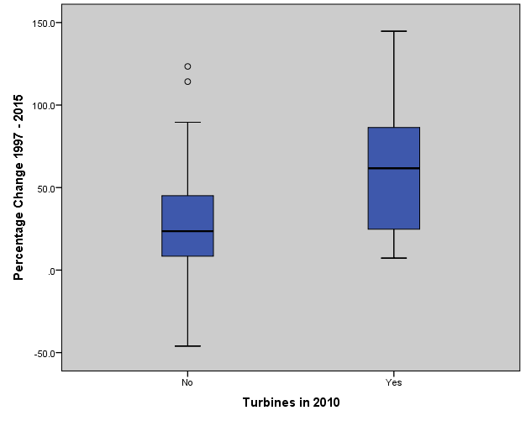

In addition to the statistical analysis, it is also useful to examine the spatial patterns of percentage change in local and county revenue across the study area. Figure 21 shows the percentage change in local and county revenue from 1997 to 2015. Overall, it appears there are several cases where a particularly high percentage change in local and county revenue (greater than 75 percent) occurs within districts with turbines. Typically these are districts with very small enrollments. Compared to the rest of the study area without turbines in 2010, typical percentage change ranged from less than zero to 75 percent.

Figure 21: Map of Percentage Change in Local and County Revenue
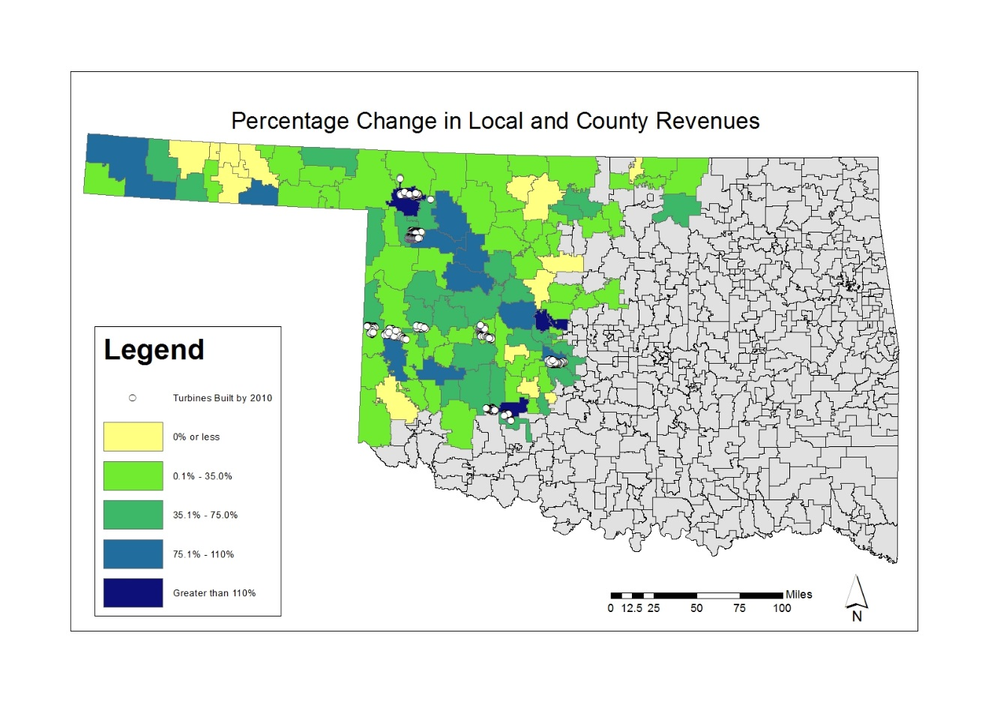
As above, it may be worthwhile to examine the temporal patterns in the relationships between the districts with and without turbines. Figure 22 shows a time series of percentage of revenue from local and county sources for the Sharon-Mutual and Lookeba-Sickles school districts. These districts were selected as they had similar enrollment and percentage local and county revenue as of 1997 with approximately 232 students enrolled in Sharon-Mutual and approximately 234 enrolled in Lookeba-Sickles. Figure 22 shows the percentage of revenue from local and county sources for Sharon-Mutual begins to spike in 2009, when turbines were built within the district, while Lookeba-Sickles does not have turbines and does not see a spike in percentage of revenue from local and county sources.
Figure 22: Time Series Graph of Local and County Revenue for Sharon-Mutual and Lookeba-Sickles Districts

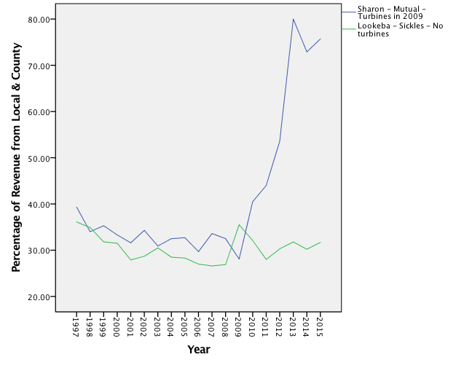
When examining the overall change in median percentage of revenue from local and county sources between districts with and without turbines in 2010, it can be seen from Figure 23 that districts with turbines in 2010 had consistently lower median local and county revenues until 2010 when the overall number of turbines results in a dramatic shift in the median values, with a markedly higher median percentage of local and county revenue in 2015 for districts with turbines in 2010 or before.

Figure 23: Change in Median Local and County Revenue for all Districts

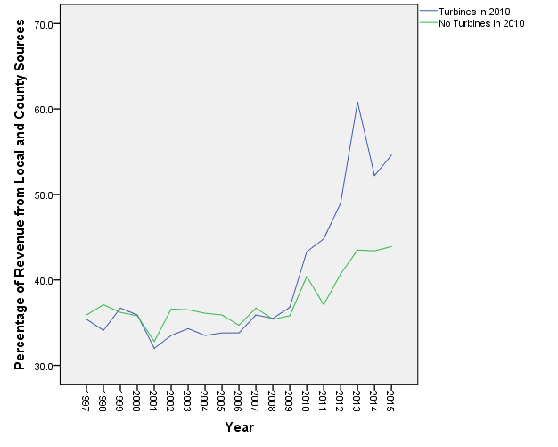

4.5.2 Change in student-teacher ratio

Given the statistically significant differences in percentage change in local and county revenues between districts with turbines and those without turbines, it was hypothesized that districts that were more financially well-off (i.e., greater percentage change in percentage of revenue from local and county sources) would have lower student-teacher ratios. Additionally, school districts with wind turbines were expected to have significantly lower student-teacher ratios following from the analysis of Kahn (2013) whereby it was concluded that counties in Texas with wind turbines had lower student-teacher ratios than those that did not have turbines. However, for this study, the independent-samples t-tests and independent-samples Mann-Whitney U tests showed no statistically significant differences in percentage change in student-teacher ratio from 1997 to 2015 between districts with turbines in 2010 or before and districts without turbines. For example, districts with wind turbines in 2010 had a mean percentage increase in student-teacher ratio of approximately 5.3 percent. Districts without turbines in 2010, however, actually saw a smaller mean percentage increase of approximately 3.9 percent. Figure 24 shows the distributions for percentage change in student-teacher ratio between districts with turbines in 2010 or before and districts without turbines in 2010. See Tables 10 and 11 for the results of the independent-samples t-tests and independent-samples Mann-Whitney U tests.
Figure 24: Percentage Change in Student-Teacher Ratio Between Districts with and without Turbines

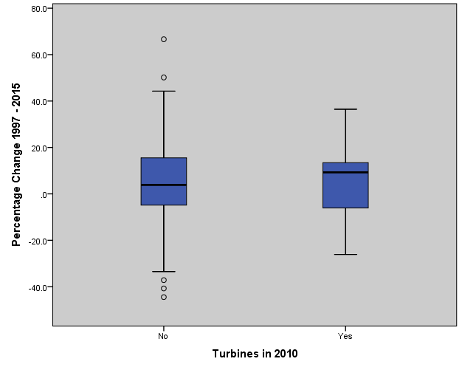
As with the local and county revenue, the spatial patterns of percentage change in student-teacher ratio across the study area were examined to gain a more complete understanding of how percentage change in student-teacher ratio may differ across districts with and without turbines in 2010. Figure 25 shows the percentage change in student-teacher ratio from 1997 to 2015. Overall, there are a few cases where a particularly noticeable percentage decrease (zero percent or less) in student-teacher ratio occurs within districts with turbines, but this is not typically the case. Most districts within the study area experienced an increase in student-teacher ratio between 0.1 percent and 20 percent.
Figure 25: Map of Percentage Change in Student-Teacher Ratio
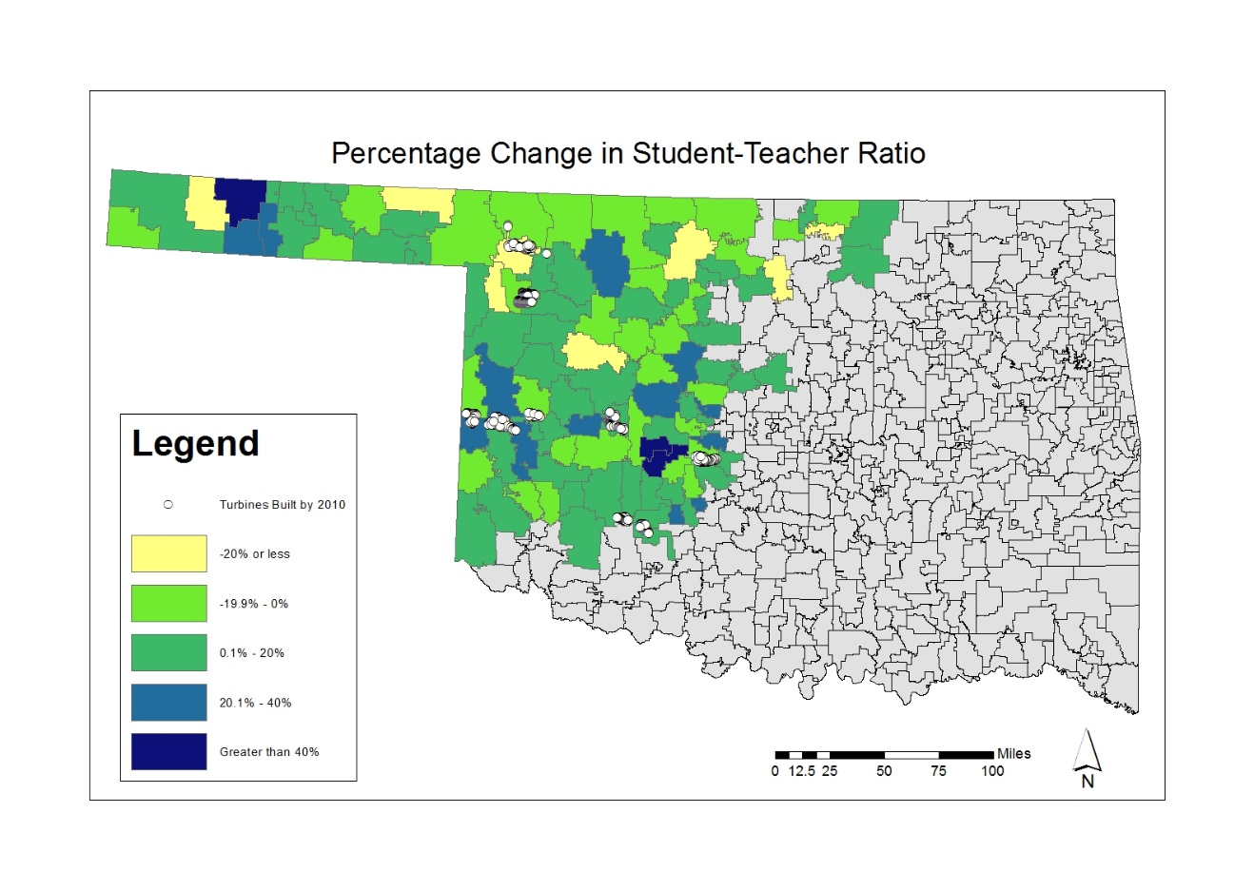
The results of the statistical and spatial analysis were expected to show significant differences between districts with wind turbines in 2010 or before and districts without turbines in 2010, but no such pattern was identified. However, by examining some isolated examples of total change in student-teacher ratio over time, a clearer picture of how this change may differ across districts with turbines and those without may develop. Figure 26 shows the change in student-teacher ratio for the Fort Supply and Burlington school districts. These districts were selected because they had similar enrollment and student-teacher ratios in 1997 with each district having a total enrollment of 165 students. Fort Supply, however sees a sharp decrease in student-teacher ratio beginning in 2009. Ultimately, the Fort Supply and Burlington school districts have a greater difference in student-teacher ratio in 2015 than in 1997, with Fort Supply having the lower student-teacher ratio of the two districts. Another interesting pattern can be seen when examining the Buffalo (enrollment of approximately 355) and Ringwood (enrollment of approximately 344) districts (see Figure 27). These districts had similar enrollment and student-teacher ratio as of 1997, but by 2015, there is a much greater difference in student-teacher ratio between the districts, with Buffalo having the lower student-teacher ratio of the districts. These figures illustrate that for selected districts, the installation of industrial wind turbines has resulted in large and significant decreases in the student-teacher ratios.

Figure 26: Time Series Graph of Student-Teacher Ratio for Burlington and Fort Supply Districts

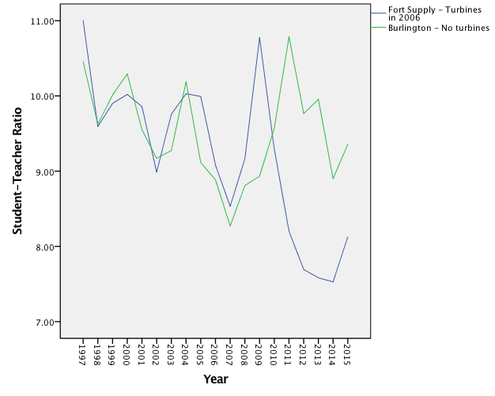

Figure 27: Time Series Graph of Student-Teacher Ratio for Buffalo and Ringwood Districts

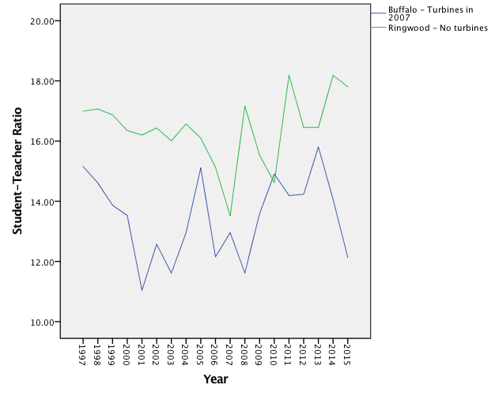

4.5.3 Change in per-student expenditures

The final variable examined for this research is that of per-student expenditures. It was originally expected that school districts with turbines installed in 2010 or before might have significantly higher per-student expenditures than districts without turbines in 2010. However, it can be seen from Figure 28 that the distributions of percentage change in per-student expenditure are fairly similar between districts with turbines in 2010 and districts without turbines. The independent-samples t-test and independent-samples Mann-Whitney U test both showed no statistically significant differences in percentage change in per-student expenditures between districts with turbines in 2010 and districts without turbines in 2010. See Tables 10 and 11 for the results of the independent-samples t-tests, and independent-samples Mann-Whitney U tests.
Figure 28: Percentage Change in Per-Student Expenditures Between Districts with and without Turbines

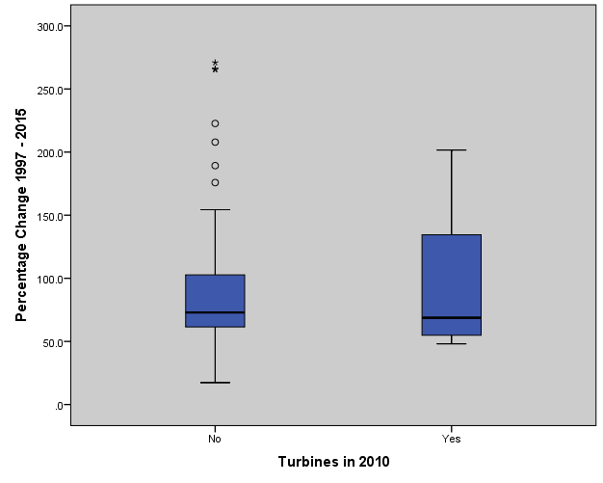
In order to visualize how districts with turbines in 2010 or before might differ from those without turbines in terms of percentage change in per-student expenditures, percentage change in per-student expenditures and wind turbine locations were mapped. Figure 29 shows a map of percentage change between 1997 and 2015 in per-student expenditures and wind turbine locations as of 2010. There are several cases where a particularly high percentage change in per-student expenditures (greater than 170 percent) occurs within districts with turbines; however, typical increases in per-student expenditures were less.
Figure 29: Map of Percentage Change in Per-Student Expenditures

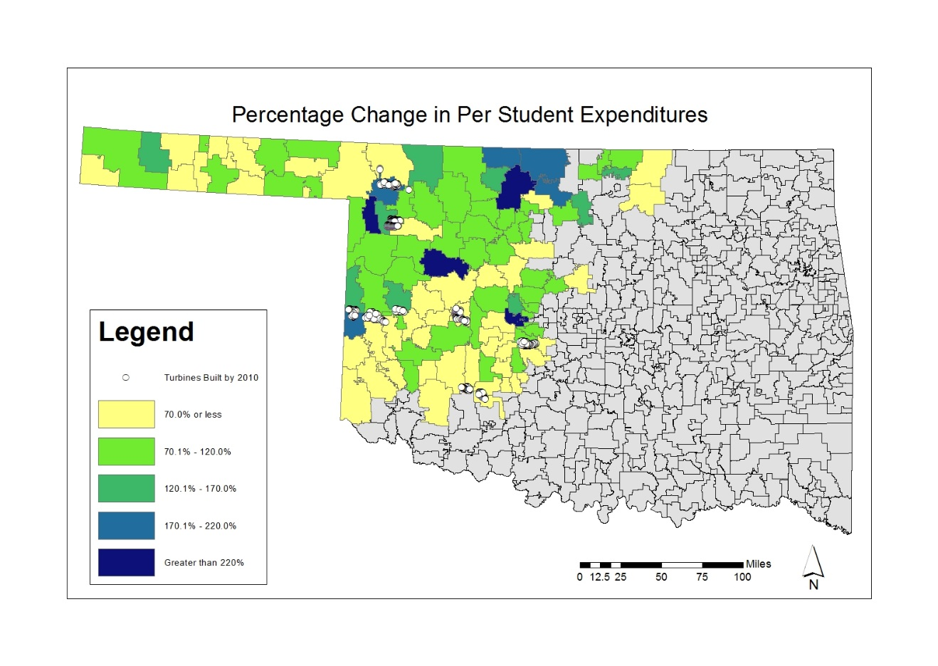
As with the analysis above, time series graphs of selected districts show how per-student expenditures have changed over time between districts with turbines in 2010 and those without turbines in 2010. A time series graph of the Fargo (209 students) and Lone Wolf (213 students) districts shows an interesting pattern (see Figure 30). The Fargo and Lone Wolf districts had similar enrollment and per-student expenditures (in dollars) as of 1997, but Fargo school district’s per-student expenditures begin to increase rapidly starting in 2009, when turbines were first built within the district. Ultimately, the two districts have a marked difference in per-student expenditures by 2015. Again, these case-by-case selections show that there are cases where the turbines have a pronounced impact.
Figure 30: Time Series Graph of Per-Student Expenditures for Fargo and Lone Wolf Districts

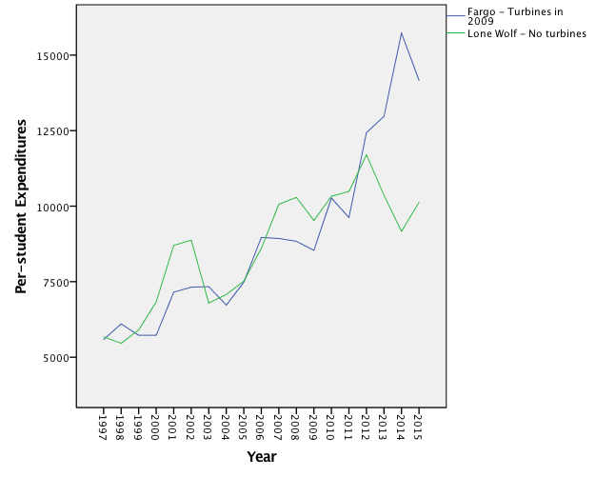
While it can be seen from isolated examples that per-student expenditures can differ substantially between school districts with turbines in 2010 and those without turbines in 2010, examining the change in median per-student expenditures between districts with and without turbines reveals the median per-student expenditure is fairly similar each year for the two groups. In fact, districts with and without turbines in 2010 had very similar median per-student expenditures as of 1997, but districts with turbines in 2010 actually had a lower median per-student expenditure by 2015 (see Figure 31). It was originally expected that districts with turbines would have higher per-student expenditures, perhaps as a result of increases in property taxes. However, the small difference in median per-student expenditures and the statistically not significant independent-samples t-test and Mann-Whitney U tests suggest this is not the case. This is perhaps due to the school funding structure in Oklahoma whereby districts that are able to raise a greater percentage of revenue from local and county sources do not receive a large percentage of funding from the state, as these state funds will be allocated to districts that cannot raise revenue from local and county sources (Office of Educational Quality and Accountability, 2016). Another explanation is that median values smooth out the impacts for those districts with smaller revenues.
Figure 31: Median Per-Student Expenditure for all Districts

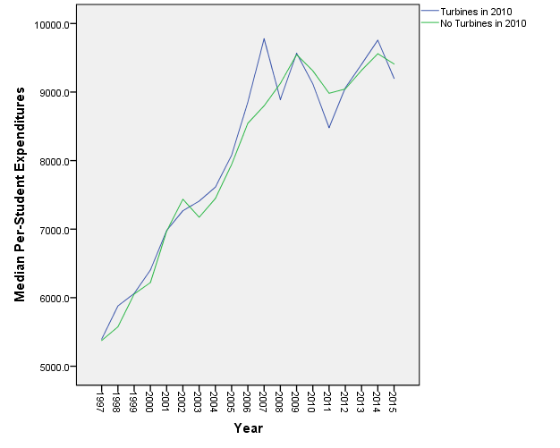
Thus far, this analysis has examined percentage change in local and county revenue, student-teacher ratio, and per-student expenditures separately based on if districts had turbines as or 2010 or did not. However, it is interesting to examine if there is a relationship between the number of turbines within a district and its characteristics. Though statistical analysis cannot be done due to the small sample size of districts with turbines, a descriptive analysis shows some interesting patterns in Figure 32. Figure 32 shows that districts with the most turbines had noticeably lower student-teacher ratios. Furthermore, percentage in revenue from local and county sources was noticeably higher for the third and fourth quartiles. There also appears to be a pattern of higher per-student expenditures within the districts with more turbines.
Figure 32: Percentage Change in All Variables Analyzed by Number of Turbines
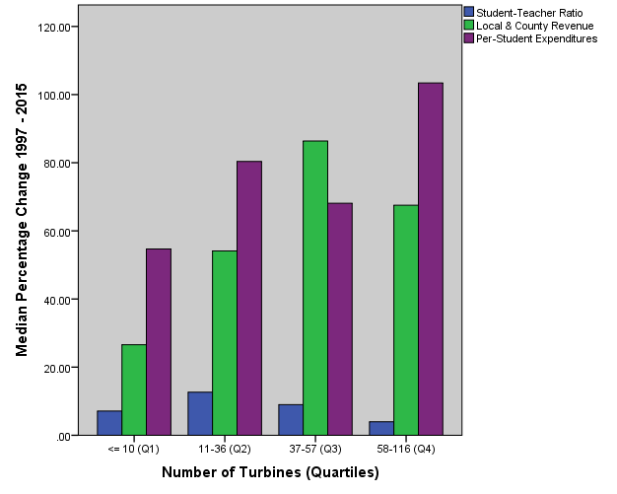

4.6 Discussion

A number of the results from the statistical tests matched previous studies in other locations, and some results were unexpected. Considering the effects of industrial-scale wind development upon property values and subsequent increase in property tax base identified by Grover (2002), the US GAO (2004), Pedden (2006), Lantz and Tegen (2009), Leistritz and Coon (2009), Reategui and Hendrickson (2011), Greene and Geisken (2013), GWEC (2013), and Ferrell and Conaway (2015), it was expected that school districts with industrial-scale wind turbines might experience a greater percentage increase in local and county revenues. Given that OEQA (2016) identified it is typical for more financially well-off districts to have a greater percentage of revenue from local and county sources, it was expected that districts with wind turbines and subsequent increases in property value and tax base would experience a greater percentage change in revenue from local and county sources. This relationship was observed in the independent-samples t-test and independent-samples Mann-Whitney U tests whereby the means and distributions of percentage change in local and county revenue were significantly different between districts with wind turbines and those without wind turbines.
Though there were statistically significant differences in percentage change in local and county revenue, the independent-samples t-test and independent-samples Mann-Whitney U test did not reveal statistically significant differences in the percentage change in the overall student-teacher ratio between school districts with wind turbines and those without turbines. It was originally expected that school districts with wind turbines might have lower student-teacher ratios considering these districts might have more funds to hire teachers due to the increased property tax base. Additionally, Kahn (2013) found a statistically significant decrease in student-teacher ratios between counties with wind turbines and those without turbines in Texas. However, Kahn (2013) only used data from the years 2008 and 2010, and compared student-teacher ratios to the state average in Texas. The examination of the individual cases shows that for selected districts this pattern is found to be true, and the difference is tremendous, but that overall the pattern is not as significant due to the number of confounding variables especially for the larger districts.
The final variable analyzed for this research was percentage change in per-student expenditures. Given that Kahn (2013) identified statistically significant increases in per-student expenditures between schools within counties that have turbines and those that do not, it was expected that school districts with wind turbines in Oklahoma might see a greater percentage increase in per-student expenditures than districts without turbines. The independent-samples t-test and independent-samples Mann-Whitney U test revealed no significant differences in the percentage change in per-student expenditures between school districts with turbines and those without turbines. Kahn (2013) and De Silva et al. (2016) each identified that local and county funds for Texas schools are reallocated from more economically well-off districts to those that are less economically well-off. The public school funding structure is slightly different in Oklahoma whereby districts that are able to raise more revenue from local and county sources do not receive as much funding from the state. Thus, it was unclear whether or not school districts with wind turbines in Oklahoma would experience a greater percentage increase in per-student expenditures than districts without turbines.
Overall, the results of this study show that the addition of wind turbines changes the nature of the revenue stream for school districts in western Oklahoma. For example, the increase in property values and subsequent higher tax base enables school districts with turbines to be more self-sufficient in terms of greater percentages of public school funding originating from local and county sources, rather than state or federal sources. Though districts with wind turbines saw greater percentage change in local and county revenues available to public schools, how exactly this influenced characteristics of the schools within the districts such as student-teacher ratios and per-student expenditures was not as clear, although the significance does seem to be more pronounced for selected smaller districts like Fort Supply. However, recall in Oklahoma the system ensures per-student expenditures across socioeconomically different school districts remains more equal than it might otherwise be if state funds were not allocated to districts without the ability to raise revenue from local and county sources, so one possible implication is that the funds from the industrial wind turbine allows the state flexibility in distributing the money across the state – so the financial gain is pronounced and significant, just not seen in the with/without analysis.
4.7 Conclusion
The purpose of this research was to conduct statistical and spatial analysis in order to examine differences in western Oklahoma school districts that have industrial-scale wind turbines and those that do not. In order to analyze these differences, data were collected for percentage of revenue from local and county sources, student-teacher ratios, and per-student expenditures for 108 school districts in western Oklahoma over 19 years, from 1997 to 2015. The statistical analysis revealed significant differences in percentage change in local and county revenues between school districts with turbines and those without turbines while no statistically significant differences in means or distributions were found in percentage change in student-teacher ratios and per-student expenditures between districts with turbines and districts without wind turbines.
Many of the studies in the literature review quantified the community-level benefits of wind power development in terms of job creation, property value, or lease payments to landowners. In terms of schools, two studies had examined the differences between student-teacher ratios and per-student expenditures as well as socioeconomic differences in Texas counties with wind turbines and those without turbines. However a similar analysis has not been done to assess how schools in Oklahoma might be affected by wind power development. The previous studies also did not examine these relationships at the individual school district scale. Given this research gap and Oklahoma’s rapid growth in the wind industry, this research provides a useful contribution to the existing literature.
The results of this research revealed statistically significant differences in percentage change in local and county revenues between school districts with and without wind turbines. However, there were no statistically significant differences in percentage change in student-teacher ratio and per-student expenditures between school districts with and without wind turbines. Although statistically significant differences were not found for each of the variables analyzed, the temporal analysis of selected school districts shows the pronounced impacts of wind power development. Apart from job creation and increases in local economic activity from wind power development, the significant differences in local and county revenues highlight the importance of the wind industry for local communities and perhaps can contribute to decreased susceptibility to changes in public school funding from state and federal sources.
Chapter 5: Conclusion
The state of Oklahoma’s energy portfolio has changed dramatically in recent years, with a significant amount of electricity now being produced by wind. The growth in wind power is particularly striking given the state’s long history of oil and gas production along with mixed social and political support. For this reason, Oklahoma is an interesting and relevant place in which to study impacts of wind power upon real estate sales and pricing history along with impacts on local schools. Furthermore, wind power development has started to move eastward towards the state’s more populated areas. Therefore, the issue of acceptance and support of new development is likely to become more prominent in the future, highlighting the importance of studying the community-level impacts of wind power within the state. The purpose of this research was to analyze real estate sales and pricing history and subsequent impacts on public schools in western Oklahoma.
Real estate pricing and transaction history were analyzed in Custer, Harper, Roger Mills, Washita, and Woodward counties. This analysis included approximately 23,000 total sales for both residential properties and unplatted land. In order to evaluate how distance from turbines might impact sale price, appropriate descriptive and inferential statistics were used. Although there were a few potential limitations with the statistical analysis such as sample size within certain buffer zones and the skewness of sales price, the statistical analyses suggested that sale price of homes closer to wind turbines may sell at higher prices than homes farther away from turbines. However, a statistically significant relationship between distance from turbines and sale price was not found for the unplatted land sales, but median sale price for unplatted land increased noticeably after announcement and construction for the sales between 0.5 and 1 mile (1 – 2 km) of a turbine.
Though many authors have analyzed impacts of wind farms upon nearby home or land sale prices, very few have analyzed both. For example, wind turbines are more likely to be located on rural agricultural land; therefore, a comparison of how they might impact sale prices of homes and land differently serves to fill an existing research gap. Furthermore, the previous studies of Oklahoma have only taken into account sales of single-family homes, which may not capture exactly how wind turbines could potentially affect the state’s real estate market. The results from this study show that one of the areas of concern of a potential negative impact on real estate values due to proximity to wind farms is unfounded. Thus, this work removes one such barrier to acceptance.
Given that public schools in Oklahoma receive approximately 30 percent of their funding from property taxes, this research examined the impacts of wind power on Oklahoma’s public schools. Differences in western Oklahoma school districts that have industrial-scale wind turbines and those that do not were analyzed statistically and spatially. In order to analyze these differences, data were collected for percentage of revenue from local and county sources, student-teacher ratios, and per-student expenditures for 108 school districts in western Oklahoma over 19 years, from 1997-2015. The statistical analysis revealed significant differences in percentage change in local and county revenues between school districts with turbines and those without turbines while no statistically significant differences were found in percentage change in student-teacher ratios and per-student expenditures between districts with turbines and districts without wind turbines.
Previous studies have examined the community-level benefits of wind power development in terms of job creation, property value, or lease payments to landowners. In terms of schools, two studies had examined the differences between student-teacher ratios and per-student expenditures as well as socioeconomic differences in Texas counties with wind turbines and those without turbines. However, a similar analysis has not been done at the school district level Oklahoma to determine how schools might be affected by wind power development. Thus, given the gaps in the existing research as well as the recent rapid expansion of wind power in the state, this research results in a useful contribution to the existing literature.
The results of this research revealed statistically significant differences in percentage change in local and county revenues ratios between school districts with and without wind turbines. However, there were no statistically significant differences in percentage change in student-teacher ratio and per-student expenditures between school districts with and without wind turbines. Although statistically significant differences were not found for each of the variables analyzed, the temporal analysis of selected school districts shows the pronounced impacts of wind power development in many individual cases. Apart from job creation and increases in local economic activity from wind power development, the significant differences in local and county revenues highlight the importance of the wind industry for local communities and perhaps contribute to decreased susceptibility to changes in public school funding from state and federal sources. Furthermore, this revenue helps schools across Oklahoma as more state funding can be distributed to school districts that are unable to support their schools through local and county revenues. Thus, this second case study highlights the wind industry’s role in fostering financial stability for schools and communities across the entire states. Thus, these two studies illustrate how wind power in Oklahoma has impacted local real estate and schools near to and far from wind turbines in the state, and thus contribute to a more detailed understanding of community-level impacts of wind power in Oklahoma.
References

American Wind Energy Association. (2017, July). U.S. Wind Energy State Facts. Retrieved from http://awea.files.cms-plus.com/FileDownloads/pdfs/Oklahoma.pdf
American Wind Energy Association. (2016, March 22). Wind power pays $222 million a year to rural landowners. Retrieved August 9, 2016, from http://www.awea.org/MediaCenter/pressrelease.aspx?ItemNumber=8609
Aroul, R., & Hansz, J. A. (2012). The Value of "Green:" Evidence from the First Mandatory Residential Green Building Program. The Journal of Real Estate Research , 27-49.
Brown, J. E. (2013). Wind Power and Nuisance Litigation. Defense Counsel Journal, 313-321.
Brown, J. P., Pender, J., Wiser, R., Lantz, E., & Hoen, B. (2012). Ex post analysis of economic impacts from wind power development in U.S. counties. Energy Economics, 1743-1754.
Butler, S. H. (2009). Headwinds to a Clean Energy Future: Nuisance Suits Against Wind Energy Projects in the United States. California Law Review, 1337-1375.
De Silva, D. G., McComb, R. P., & Schiller, A. R. (2016). What Blows in with the Wind? Southern Economic Journal , 82 (3), 826-858.

Dean, K. D., & Evans, R. R. (2014). The Statewide Economic Impact of Wind Energy Development in Oklahoma: An Input-Output Analysis by Parts Examination. Oklahoma City.
DeLacy, P. B. (2014). Renewables, Tax Credits, and Ad Valorem Taxes: Are Policies Aligned? Real Estate Issues , 39, 50-58.
Ejdemo, T., & Soderholm, P. (2015). Wind power, regional development and benefit-sharing: The case of Northern Sweden. Renewable and Sustainable Energy Reviews, 476-485.
Ferrell, S. L., & Conaway, J. (2015). Wind Energy Industry Impacts in Oklahoma. Oklahoma State University, Department of Agricultural Economics.
Gibbons, S. (2015). Gone with the wind: Valuing the visual impacts of wind turbines through house prices. Journal of Environmental Economics and Management, 177-196.
Governors' Wind Energy Coalition. (2013). Renewable Electricity Standards: State Success Stories.
Greene, J., & Geisken, M. (2013). Socioeconomic impacts of wind farm development: a case study of Weatherford, Oklahoma. Energy, Sustainability, and Society, 1-9.
Greene, J. S., & Morrissey, M. (2013). Estimated Pollution Reduction from Wind Farms in Oklahoma and Associated Economic and Human Health Benefits. Journal of Renewable Energy, 1-7.
Grover, S. (2002). The Economic Impacts of a Proposed Wind Power Plant in Kittitas County, Washington State. Wind Engineering, 315-328.
Hill, S. D., & Knott, J. D. (2010). Too Close for Comfort: Social Controversies Surrounding Wind Farm Noise Setback Policies in Ontario. Renewable Energy Law and Policy Review, 153-168.
Hoen, B., Brown, J. P., Jackson, T., Thayer, M. A., Wiser, R., & Cappers, P. (2015). Spatial Hedonic Analysis of the Effects of US Wind Energy Facilities on Surrounding Property Values. The Journal of Real Estate Finance and Economics, 22-51.
Hoen, B., Wiser, R., Cappers, P., Thayer, M., & Gautam, S. (2009). The Impact of Wind Power Projects on Residential Property Values in the United States: A Multi-Site Hedonic Analysis. Ernest Orlando Lawrence Berkeley National Laboratory.
Hoen, B., Wiser, R., Cappers, P., Thayer, M., & Sethi, G. (2011). Wind Energy Facilities and Residential Properties: The Effect of Proximity and View on Sales Prices. Journal of Real Estate Research, 279-316.
Jensen, C. U., Panduro, T. E., & Lundhede, T. H. (2014). The Vindication of Don Quizote: The Impact of Noise and Visual Pollution from Wind Turbines. Land Economics, 668-682.
Kahn, M. E. (2013). Local non-market quality of life dynamics in new wind farms communities. Energy Policy, 59, 800-807.
Kinnaman, T. (2009). A Landfill Closure and Housing Values. Contemporary Economic Policy, 380-389.
Kunz, T. H., Arnett, E. B., M., C. B., Erickson, W. P., Larkin, R. P., & M., S. J. (2007). Assessing Impacts of Wind-Energy Development on Nocturnally Active Birds and Bats: A Guidance Document. The Journal of Wildlife Management, 2449-2486.
Lang, C., Opaluch, J. J., & Sfinarolakis, G. (2014). The windy city: Property value impacts of wind turbines in an urban setting. Energy Economics, 413-421.
Lantz, E., & Tegen, S. (2009). Economic Development Impacts of Community Wind Projects: A Review and Empirical Evaluation. National Renewable Energy Laboratory.
Leistritz, F. L., & Coon, R. C. (2009). Socioeconomic Impacts of Developing Wind Energy in the Great Plains. Great Plains Research, 3-12.
Linden, A., Rapeli, L., & Brutemark, A. (2015). Community attachment and municipal economy: Public attitudes towards wind power in a local context. Environmental Science & Policy, 10-14.
Monies, P. (2015, April 1). NewsOK. Retrieved from http://newsok.com/article/5406313
Obermeyer, B., Manes, R., Kiesecker, J., Fargione, J., & Sochi, K. (2011). Development by Design: Mitigating Wind Development's Impacts on Wildlife in Kansas. PLoS ONE, 1-11.
Office of Educational Quality and Accountability. (2016, May). Retrieved from https://www.ok.gov/oeqa/School_&_District_Profiles_Reports/State_Reports.html
Okkonen, L., & Lehtonen, O. (2016). Socio-economic impacts of community wind power projects in Northern Scotland. Renewable Energy , 85, 826-833.
Oklahoma Department of Commerce. (2014). Top Economic Facts about Oklahoma's Oil and Gas Industry. Oklahoma City.
Oklahoma Senate. (2015). Enrolled Senate Bill No. 808. Retrieved from webserver1.lsb.satate.ok.us/cf_pdf/2015-16%20ENR/SB/SB808%20ENR.PDF
Pedden, M. (2006). Analysis: Economic Impacts of Wind Applications in Rural Communities. National Renewable Energy Laboratory.
Reategui, S., & Hendrickson, S. (2011). Economic Development Impact of 1,000 MW of Wind Energy in Texas. National Renewable Energy Laboratory.
Rygg, B. J. (2012). Wind power - An assault on local landscapes or an opportunity for modernization? Energy Policy, 167-175.
Siler-Evans, K., & Azevedo, I. L. (2013). Regional variations in the health, environmental, and climate benefits of wind and solar generation. Proceedings of the National Academy of Sciences in the United States of America, 11768-11773.
Sims, S., & Dent, P. (2007). Property stigma: wind farms are just the latest fashion. Journal of Property Investment & Finance, 626-651.
Sims, S., Dent, P., & Oskrochi, G. R. (2008). Modelling the Impact of Wind Farms on House Prices in the UK. International Journal of Strategic Property Management, 251-269.
Slattery, M. C., Lantz, E., & Johnson, B. L. (2011). State and local economic impacts from wind energy projects: Texas case study. Energy Policy, 7930-7940.
Sunak, Y., & Madlener, R. (2016). The impact of wind farm visibility on property values: A spatial difference-in-differences analysis. Energy Economics, 79-91.
Tabassum-Abbasi, M., Premalatha, T. A., & Abbasi, S. A. (2014). Wind energy: Increasing deployment, rising environmental concerns. Renewable and Sustainable Energy Reviews, 270-288.
Terry-Cobo, S. (2014, August 28). No clear winners in lawsuit over wind farms, law professor says. Oklahoma City, Oklahoma.
Tuttle, D. R. (2011). Osage: Unite to fight wind development in Oklahoma. The Journal Record, 1-2.
United States Department of Energy. (2009, March 5). Installed Wind Capacity. Retrieved from http://apps2.eere.energy.gov/wind/windexchange/wind_installed_capacity.asp
United States Department of Energy. (2015). Wind Vision: A New Era for Wind Power in the United States.
United States Government Accountability Office. (2004). Wind Power's Contribution to Electric Power Generation and Impact on Farms and Rural Communities.
US Census Bureau. (2012). All sectors: Geographic Area Series: Economy-Wide Key Statistics: 2012 Economic Census of the United States. Retrieved from factfinder.census.gov/faces/tableservices/jsf/pages/productview.xhtml?src=CF
US Census Bureau. (2014). Retrieved from www.census.gov/quickfacts/table/LFE041214/40
US Census Bureau. (2015). Retrieved from www.census.gov/quickfacts/table/LFE041214/40
Vyn, R. J., & McCullough, R. M. (2014). The Effects of Wind Turbines on Property Values in Ontario: Does Public Perception Match Empirical Evidence? Canadian Journal of Agricultural Economics, 365-392.

