UNIVERSITY OF OKLAHOMA
GRADUATE COLLEGE

Benchmarking of Academic Departments using Data Envelopment Analysis (DEA)

A THESIS
SUBMITTED TO THE GRADUATE FACULTY
In partial fulfillment of the requirements for the
Degree of
MASTER OF SCIENCE

By
Tasfiq ALAM
Norman, Oklahoma
2019

Benchmarking of Academic Departments using Data Envelopment Analysis (DEA)

A THESIS APPROVED FOR THE
SCHOOL OF INDUSTRIAL AND SYSTEMS ENGINEERING

BY

Dr. Andrés D. González, Chair
Dr. Shivakumar Raman
Dr. Charles Nicholson

©Copyright by Tasfiq ALAM 2019
All Rights Reserved.
Acknowledgement
I would like show my heartiest gratitude and thankfulness to the members of my Thesis Committee for their valuable advices throughout the course of my thesis. A special thank you to my advisor and mentor Dr. Andrés D. González, for continuous support, guidance and valuable inputs to improve my work in obtaining my degree. Also, I am grateful to Dr. Shivakumar Raman, for providing me with the opportunity to work in this important project, and sharing his vast knowledge on departmental benchmarking. I would like to thank Ms. Cheryl Carney and Ms. Kristi Wilson for all their support. Finally I would like to thank my parents, siblings, extended family, friends, Ashiq Mahmud, Sheikh Apurba, Pritom Saha, Shams Shahadat, Warid Islam, Kazi Huda, Redwan Nazim, Shadman Salam, Amit Islam and Rowzat Faiz for their continuous help, support and motivation.

Table of Contents
Acknowledgements.......................................................................................................................iv
Preface …………………………………………………………………………………………………………………………………….ix
Abstract.........................................................................................................................................xi
1 Introduction ………………………….….................................................................................................1
2 Literature Review ........................................................................................................................4
2.1 Efficiency and Different Methods of Measuring Efficiency ………...................................5
2.2 DEA Methodology .........................................................................................................6
2.3 DEA in Education …………………….....................................................................................7
3 Methodology ..……………………………………......................................................................................8
3.1 Selecting and Defining Inputs and Outputs ……………………………...................................10
3.2 Output ………………........................................................................................................10
3.3 Inputs ……………………………………….................................................................................10
4 DEA Models ..………………………………………….................................................................................12
4.1 Efficiency Model ……………………………………………………………………………………….........12
4.2 Benchmarking Model …………................................................................................14
4.3 Investment Model ................................................................................................15
5 Case Study .................................................................................................................................16
5.1 Results from the Efficiency Model …......................................................................22
5.2 Results from the Benchmarking Model .................................................................23
5.3 Results from the Investment Model .....................................................................23
5.4 Sensitivity Analysis ...............................................................................................30
6 Conclusions and Future Work ...................................................................................................35
References ...................................................................................................................................36

List of Figures
1.1 Number of Faculty per department (from highest to lowest) ……..……………………………….........19
1.2 Research Expenditure per Faculty per department (in 10^3) (from highest to lowest) …........20
1.3 Number of Graduate Students per department (from highest to lowest) ………………..............20
1.4 Number of Undergraduate Students per Faculty per department (from highest to lowest) ...21
1.5 Average H-Index per department (from highest to lowest) ……………………………………………....21
2 Shows the change in $ф_{p}$ with percentage increase in five inputs, respectively ……………........................................................................................................................................33
3 Shows the change in $ф_{p}$ with percentage decrease in Undergraduate Students/Faculty and Number of Graduate Students ………………………………………………….................................................34

List of Tables
1 Inputs and Outputs for the Case Study ………………………………..……..………………………………..........17
2 Descriptive statistics of the Inputs and Output ………………………………………………………………........18
3 Summary of the results from the Efficiency Model …………………………………..………………..............22
4 Summary of the results from the Benchmarking Model …………………………………………………........23
5 Cost of adding one unit and Average H-index of different faculty positions and graduate students ………………………………………………………………………………………………………………………………….24
6 $α_{lip}$ (Matrix), which is the linear effect of adding one input on the department under study to all other inputs of the Department ………………………………………………………………..……………..............26

Preface
Dr. Raman with his 28 years of vast experience in academia is inquisitive and passionate about self-evaluation and assessment of the department. He wanted to benchmark Industrial Engineering departments who are higher in rankings, so that it can work as aspiration levels for the Industrial and Systems Engineering department in the University of Oklahoma (OU). However, he was realistic about the level of improvement that could be achieved, since it can be difficult to improve departmental rankings with the subjectivity/reputation involved. Moreover, it is easier said than done. Dr. Andrés D. González, after observing Dr. Raman’s presentation about benchmarking of academic departments, suggested using Data Envelopment Analysis (DEA), as it uses mathematical modeling for evaluating efficiency and providing benchmarks for departments. The whole idea of this project has developed through that process. Dr. González already had the experience of using DEA for evaluating efficiency and benchmarking of Ciclovia-Recreativa programs, which are multi-sectorial community-based programs (Abolghasem et al., 2018). Meanwhile, Dr. González, being my adviser for my thesis, presented the idea to me, to which I happily agreed to be part of. Soon, I was involved in the project to conduct the research for the benchmarking of academic departments.
This thesis has resulted in two academic papers, (i) Benchmarking of 18 academic departments with five inputs and one output, where the relative efficiency of the departments were evaluated, also indicating departments with higher efficiency to be used as a reference set for the department under study; furthermore, suggesting a decision support model for allocating resources when a budget is given to the department for investment. Section 3, Section 4, and Section 5 of this thesis have been extracted from the paper under preparation by Alam, González, and Raman (2019). The raw data for inputs of this paper was collected from American Society of Engineering Education (ASEE) website, whereas the data for the output was obtained from the US News Rankings; (ii) Evaluating Soccer Players’ Performance using Data Envelopment Analysis. The idea for this paper was generated from a class project for the Multi-criteria Optimization course offered in the spring semester of 2019 in the Industrial and Systems Engineering department at OU, where I wanted to experiment with DEA’s application in sports related field. This paper evaluates the relative efficiency of 19 soccer players relative to their peers, and provides particular benchmark players to follow in order to maximize their efficiency. This paper is under review in Athens Journal of Sports, which is co-authored by Alam, González and Trafalis (2019).

Abstract
Departmental rankings are a primary factor in assessing the organizational performance and quality. Peer Assessment Scores are one of few metrics by which academic departmental performances are quantified. There are different metrics to determine performances of academic departments, however, it does not indicate whether the departments are performing at their full potential with the resources available. Therefore, it is critical for university departments to assess the performance efficiency, and understand whether the resources are used efficiently. In this thesis, output-oriented Data Envelopment Analysis (DEA) models are used to evaluate the efficiency of the departments relative to its peers, and benchmark departments are provided for the less efficient departments. Furthermore, an Investment Model is developed based on DEA that helps decision makers with a support-system in deciding how much resources should be dedicated to increase one or more inputs in order to increase maximum potential efficiency of the departments, when an investment budget is provided. We examined the proposed models with an illustrative case study of eighteen Industrial Engineering Departments in the USA. Five inputs and one output were considered for the case study. The inputs were Number of Faculty, Research Expenditure per Faculty, Undergraduate Students per Faculty, Number of Graduate Students, and Average H-Index, whereas the only output was Peer Assessment Score. In addition, the results were discussed along with the sensitivity analysis. Finally, conclusions of the work were mentioned, along with the opportunities for future developments.
Keywords – Data Envelopment Analysis, Relative Efficiency, Benchmarking, Resource Allocation

- Introduction
University rankings have a history of more than 25 years. When comparing educational institutions within the same country or around the globe, university and departmental rankings play a vital role (Bowman & Bastedo, 2010). According to Paxton and Bollen (2003), “In the U.S. academic system, ratings by two sources-the National Research Council and U.S. News and World Report-have become the standard means by which departmental quality is evaluated.” U.S. News and World Report (popularly known as US News) began publishing annual rankings of academic quality of colleges and graduate schools in 1983 (Lukman, Krajnc & Glavič, 2010; Clarke, 2002). Depending on the up and down in quality ratings, annual rankings can bring mixed emotions for the university departments (Monks & Enhrenberg, 1999). US News rankings are the most widespread and prominent assessment for university and departmental performance (Gnolek, Falciano & Kuncl, 2014; Bowman & Bastedo, 2010). Rankings are becoming increasingly important for all the stakeholders of universities, since prospective students refer to college and departmental rankings before committing a significant investment in higher education. However, the rankings done by US News creates controversy with their model (Tsakalis & Palais, 2004), since for graduate departmental rankings, US News asks Chairs and Directors of graduate study programs to rate departments in a survey (Paxton & Bollen, 2003). The Chairs and Directors are asked to rate the quality of the departments on a scale from 5 “distinguished” to 1 “marginal” (Paxton & Bollen, 2003). These ratings given by the department heads are known as Peer Assessment Score in the US News rankings, which is often criticized as being subjective and biased indicator of academic quality (Gnolek, Falciano & Kuncl, 2014; Sweitzer & Volkwein, 2009). Currently, the academic departments are evaluated by performance metrics like Peer Assessment Scores, however, it does not portray how efficiently the departments are using available resources.
A liking for assessment, is a distinct feature of American universities. (Moreno & Tadepalli, 2002). “Virtually everybody in the academic community gets assessed and in turn assesses someone else.” (Moreno & Tadepalli, 2002). According to Marchese (1994), a report by American Council on Education states that 97% of all educational institutions participates in assessment. “There are two aspects to assessment, the gathering of information (measurement) and the utilization of that information for institutional and individual improvement” (Moreno & Tadepalli, 2002). In order to strive for continuous improvement, strategic management comprised of efficiency analyses must be conducted in the academic departments (Duguleana & Duguleana, 2015). In the influential Organization for Economic Co-operation and Development (OECD) report, “Education at a glance”, Angel Gurria, the Secretary-General stated that, “what matters more are the choices countries make in how to allocate that spending and the policies they design to improve the efficiency and relevance of the education they provide”(OECD, 2013, p. 15). Systematic evaluation of departmental units needs to be conducted thoroughly, so that better resource allocations can take place (Moreno & Tadepalli, 2002). Educational institutions are considered to be efficient if they use available inputs effectively (Witte & Alcala, 2015). Strategic goals are set by academic departments, and the objectives are relayed to respective stakeholders (board members, faculty and alumni), however, figuring out what exactly is required to move up in rankings can be a daunting task (Gnolek, Falciano & Kuncl, 2014). Therefore, to make sure departments do not become inefficient, and in turn uses their resources to the best of their abilities, it is important to use benchmarking processes.
“Today, benchmarking is deﬁned as the process of comparing practices, procedures, and performance metrics to an established standard or best practice.” (Bosso et al., 2010). Benchmarking identifies a reference point for comparing or measuring purposes. It allows us to measure the gap between where we are and where we want to be, furthermore, tracking the progress while closing the gap (Ammons, 1999). In addition, benchmarking consists of first understanding one’s own internal processes, and later search for the best practices in other peer organizations. Lastly, taking those practices into consideration and improving organizational performances (Epper, 2010). For organizational planning and managerial decision making, performance benchmarking is essential (Post & Spronk, 1999). Due to increased competition and budget constraints in academic departments, benchmarking has become substantial for identification of improvements. Although, there are multiple works in literature developed to evaluate the relative technical efficiency of academic departments compared to its peers (Barra & Zotti, 2016; Kao & Hung, 2006; Alwadood, Noor & Kamarudin, 2011), and benchmarking of academic departments using slack-based measures (Abdullah et al., 2018), however, these works does not provide the decision makers with the decision-making framework of where to allocate the resources and how to achieve those departmental goals when an investment budget is provided.
In order to address the gaps in the academic literature, this paper proposes three models based on Data Envelopment Analysis (DEA), which focus on (i) evaluating the relative technical efficiency of academic departments compared to its peers and indicates departments or set of departments with high efficiency (efficiency = 1) to be used as benchmark for each of the department under study; (ii) providing slack-based benchmarking model to understand whether it is possible to attain higher outputs using minimum level of input; (iii) suggesting an investment support model for the Department leadership, which would help in deciding how much funds should be used to increase one or more inputs such that efficiency is improved.
Following the section, the reminder of this document is as follows: Section 2 is the literature review about different types of efficiency, different methods to evaluate efficiency, the background about the DEA models, and finally the use of DEA in educational context. Section 3 is devoted to explaining the proposed methodology, and the selection of inputs and outputs for the study. Section 4 talks about the different DEA Models used. Section 5 implements the DEA models from section 4 on a Case Study for 18 different academic departments, and the results are discussed thoroughly. Section 6 provides conclusions and opportunities for future work.
- Literature Review
For this study, to begin with, it was important to understand the different types of efficiency, and to know different methods to evaluate efficiency. Furthermore, after the different methods for evaluation of efficiency was studied, it was essential to understand why DEA was a good choice for the study. Finally, it was key to identify previous works done on the educational sector, using DEA models, in order to find the research gaps.
Therefore, the literature review is mainly divided into three parts, (i) different types of efficiency and different methods to evaluate efficiency is discussed; (ii) the background information about the DEA methodology is mentioned in detail; (iii) the uses of DEA models in educational sector is studied.
  - Efficiency and Different Methods of Measuring Efficiency
Productivity and efficiency are two concepts that have been the focus attention in recent years (Jayamaha & Mula, 2011). Efficiency analysis are conducted in many sectors, both private and public sectors, ranging from advertising, law firms, hotels, sports, and banks to education, electricity, fishing, and military contexts (Bezat, 2009). According to the paper by Coelli et al. (1998), there are two different components to efficiency, one technical efficiency and other allocative efficiency. “Technical efficiency occurs if a firm obtains maximum output from a set of inputs.” (Jayamaha & Mula, 2011). “Allocative efficiency occurs when a firm chooses the optimal combination of inputs, given the level of prices and the production technology.” (Coelli et al., 1998). Both technical and allocative efficiency combine to provide overall efficiency (Coelli et al, 1998). “When a firm achieves maximum output from a particular input level, with utilization of inputs at least cost, it is considered to be an overall efficient firm.” (Jayamaha & Mula, 2011).
There are different methods (non-parametric and parametric) in which efficiency can be evaluated (Bezat, 2009). Some of the common methods for efficiency measurement are Stochastic Frontier Analysis (SFA), Data Envelopment Analysis (DEA), Total Factor Productivity (TFP), and Malmquist Productivity Index (Fried, Lovell & Schmidt, 2008). SFA is a parametric method, which assumes that a parametric function exists between input and output measures, and treats deviations from production function as random error and inefficiency (Mortimer & Peacock, 2002). SFA is a good approach, when handling of data with certain level of uncertainty, however it is difficult to apply when there are multiple inputs and outputs involved (Kuah & Wong, 2011). Also, one of the drawbacks of SFA is that, it requires using of large number of Decision Making Units (DMUs) (Bezat, 2009). A DMU is defined as an entity, whose performance needs to be assessed. For instance, DMUs can be branches of the same bank or departments of different universities. Unlike SFA, DEA is a non-parametric approach, which can easily handle multiple inputs and outputs, without giving prior weights to inputs and outputs (Kuah & Wong, 2010). DEA is particularly useful when there are different units of measurements involved in the study, such as dollars, minutes and kilometers among others (Abolghasem et. al, 2017), which makes DEA methodology a perfect fit for evaluation of departmental efficiency.
  - DEA Methodology
In 1978, the first DEA model was developed by Charnes, Cooper, and Rhodes and it was called CCR model. It is based on overall efficiency, defined as a ratio. The CCR model is the most widely used DEA model, which works with Constant Return to Scale (CRS). “In input-oriented DEA model, the CRS assumption allows DMUs to scale up or down their inputs to achieve some constant value of outputs. An inefficient unit in the input-oriented model becomes efficient by proportionally reduction of its inputs while its outputs proportions are held constant. In output-oriented DEA model, the CRS assumption allows DMUs to scale up or down their outputs using constant values of inputs. An inefficient unit in output oriented model is made efficient by proportionally increasing of its outputs, while the inputs proportions remain the same.” (Duguleana & Duguleana, 2015). “The factor of scaling back the inputs for the same quantity of outputs is a measure of DMU efficiency. The model is called input-oriented.” Whereas another DEA where “DMU using the same inputs to produce more outputs as the analyzed DMUs and how much more outputs can be achieved by the virtual DMU. This model is called output-oriented.” (Duguleana & Duguleana, 2015). An extension of the CCR model, was developed by Banker, Charnes and Cooper (1984), also known as the BCC model (Duguleana & Duguleana, 2015). The BCC model works with Variable Returns to Scale (VRS). “A DMU which achieves economies of scale producing more outputs is an example of Increasing Returns to Scale (IRS). If some limits for outputs exist then the problem is of Decreasing Returns to Scale (DRS). A DMU operates at decreasing returns to scale (DRS) if a proportionate increase in all of its inputs conducts to a less than proportionate increase in its outputs. A mixed approach between the two cases needs Variable Returns to Scale (VRS).” (Duguleana & Duguleana, 2015). This means if an increase in inputs does not effect a proportional change in output, then it’s VRS. BCC model is used to measure the relative technical efficiency of the DMU under study. In this paper, the BCC model will be used to evaluate the relative efficiency of the departments relative to its peers.
  - DEA in Education
Majority of the previous published literatures using DEA, mainly falls under two categories. (i) studying the efficiencies of the universities; (ii) studying the efficiencies of different departments within the same university. “The papers by Abbott and Doucouliagos (2001) and Sagarra, Mar-Molinero and Agasisti (2017), and Bayraktar et al. (2013) evaluates the relative efficiency between different universities of Mexico, Australia, and Turkey respectively. Whereas the studies conducted by Barara and Zotti (2016), Goksen et al., (2015), Kao and Hung (2006), Alwadood, Noor and Kamarudin (2011), and Duguleana and Duguleana (2015), estimates the relative efficiency of academic departments within the same university.” (Alam, González & Raman, 2019). Many of the models in literature are used to measure the relative technical efficiency of the departments/institutions. Sirbu, Cimpoies and Racul (2016) in their paper, ranked the academic departments according to their performance efficiency, whereas Moreno and Tadepalli (2002) found the single measure of the efficiency for each academic departments at a public university, additionally, finding the reason behind the inefficiencies for the less efficient departments, and identifying the changes need to be made in order to improve efficiencies. On the other hand, paper by Abdullah et al., (2018), has implemented slack-based measures to conduct benchmarking using DEA, in order to improve the performance of university departments.
In this context, this paper uses the output oriented DEA-BCC model to evaluate the relative technical efficiency between departments of different Industrial Engineering Departments in USA. “The study not only evaluates the relative efficiency of different university departments, it also helps determining how much improvement is required for each department to be efficient (Alam, González & Raman, 2019). Furthermore, a model is developed to help departments’ decide where the funds/resources should be utilized to add inputs or set of inputs, when certain amount of investment budget is allocated to the department under study, such that the opportunity for growth is maximized.
- Methodology
DEA is a technique which is derived from operations research and specially designed for benchmarking purposes and for comparing operational units with one another, when there is a lack of absolute standards for efficiency (Turner, 2005). DEA is a non-parametric mathematical programming approach that evaluates the relative efficiency of a set of homogeneous organizational units called Decision Making Units (DMUs), for example bank branches or university departments (Abolghasem et al., 2018). A DMU can be defined as an entity responsible for converting input(s) into outputs(s), whose performance needs to be evaluated (Kuah & Wong, 2010).
DEA is one of the most suitable methods as it can transform multiple inputs into multiple outputs, without prior weights on the inputs and outputs (Kuah & Wong, 2010). As mentioned by Moreno and Tadepalli (2002) in their paper, “Evaluating the efficiency of departments is difficult because each department seeks to highlight criteria on which it performs well. For instance, Department A may focus on the number of majors, Department B on its success in garnering grant funds, Department C on its disseminating valuable research information to an important constituency within the state, and finally, Department D on the research productivity of its faculty, and the quality of its graduate programs. While, individually, each unit may be correct, collectively they do not advance the institution's assessment process. There is no way in which an administrator can really make sound allocation decisions from such data without using a method that compares all the departments using multiple criteria. At the same time, the method used must take into account the relative importance of the different criteria to individual units.”
“There are no definitive guides to select the inputs/outputs in department efficiency assessments. For example, Ahn, Charnes and Cooper (1989) have selected faculty salaries, state research funds, total investment in physical plans and administrative overheads as inputs and number of undergraduate enrolments, number of graduate enrollments, total semester credit hours, and federal and private research funds as outputs; while Alwadood, Noor and Kamarudin (2011) uses faculty utilization, course offering, quality of incoming students, quality of graduate students and support staff capabilities as input, whereas the quality of graduate students, number of journal papers, research grants and graduate students per department, and the number of short courses organized by departments, the number of consultancy jobs per department and percentage of staff engaging in industrial consultancy are used as outputs.
For this thesis, in the following section, we explain how the inputs and outputs were selected and defined” (Alam, González, & Raman, 2019).
  - Selecting and Defining Inputs and Outputs
“The inputs and output for evaluating the efficiency of the departments were developed based on US News Rankings, and expert consultations conducted in 2019.
  - Output
Efficiencies measures how well departments yield outputs from a given amount of inputs, the following is classified as output (Sarmiento et al., 2012):
- Peer Assessment Score- A score given determined by deans and program directors through survey. It ranges from a scale of 1-5, with 5 being the highest
  - Inputs
It is desired that the departments produce as much output as possible with given amount of inputs, the following are classified as inputs:
- Number of Faculty- Total number of faculty in each department. This indicates the strength of the department.
- Research Expenditure/Faculty- Total research expenditure of the department divided by the total number of faculty in the respective department. This input specifies the research quality and efficiency of the faculties.
- Number of Undergraduate Students/Faculty- Total number of undergraduate students in the department divided by the total number of faculty in the respective department. This input shows workload of the faculty outside of research work.
- Number of Graduate Students- Total number of graduate students in the department, indicating the potential research capability of the department.
- Average H-index- Measures the average of both the productivity and citation impact of the publications of the total number of faculty. This is often used as a proxy for the quality of research conducted by the department as a whole. Google Scholar Citations was used to collect the h-index of the faculty members of the respective departments. Only the tenured track faculty members were used (Assistant Professors, Associate Professors, Full Professors, and Chairs), excluding the emeritus faculty members and professors of practice from the list. Also, faculty members who did not have Google Scholar profiles were excluded while collecting the data. The average h-index of the faculty members was calculated for each of the respective departments and used in the data envelopment analysis.” (Alam, González, & Raman, 2019).

- DEA Models
To evaluate the academic departments, the output and inputs are taken into consideration by using three DEA models. For each department under study, a convex linear combination is formed among the departments whose efficiencies have caused from at most the same amount of input, and at least the same amount of output (Abolghasem et al., 2018). The department under study is said to be inefficient, if the linear combination results in larger output, and the departments selected for the convex linear combination will be considered as the benchmark departments for that respective department under study (Abolghasem et al., 2018).
The first model (Efficiency Model) measures the relative efficiency of the department under study to its peers. The second model (Benchmarking Model), finds the benchmark departments for each department and the amount of resources not utilized efficiently. The third model (Investment Model) determines the amount of input or set of inputs to be added by the department, when an investment budget is given, in order to maximize efficiency.
  - Efficiency Model
For calculating the relative efficiency of the decision making units (DMUs), the model proposed by Banker, Charnes, and Cooper (Banker et al., 1984), also known as BCC is used (Abolghasem et al., 2018). This model helps measuring the pure technical efficiency by comparing a DMU to a unit of similar scale. This formulation consists of a set of DMUs (N), which are the academic departments in this case, a set of inputs (I) and a set of outputs (O).
The parameter $y_{rj}$ represents the total output $r∈O$ produced by department$j∈N$. On the other hand, the parameter $x_{ij}$ represents the total input $i∈I$ used by department$j∈N$. $λ_{j}$ is the decision variable which represents the fraction of the j-th department used in the convex linear combination projecting the department under study (j = p) in to the efficiency frontier. Also, the decision variable $ф_{p}$ represents the proportional increase in the outputs of the department under study, also known as the growth factor (Abolghasem et al., 2018).
The following is the proposed Efficiency Model:
max $ф_{p}$ (1)
Subject to,
$\sum_{j∈N}{y_{rj}}λ_{j}≥ф_{p}y_{rp},{ ∀}_{r}∈O$ (2)
$\sum_{j∈N}{x_{ij}}λ_{j}≤x_{ip},{ ∀}_{i}∈I$ (3)
$\sum_{j∈N}{λ_{j}}=1$ (4)
$λ_{j}≥0, { ∀}_{j}∈N$ (5)
$ф_{p}$ free of sign (6)
The objective function in (1) maximize the proportional increase of the output for the academic department under study. The larger the value is, the greater would be the potential for the department under study to grow. The efficiency is calculated using 1/$ф_{p}$, which scales the value between 0 to 1. In (2) it is ensured that the proposed level of output should be at least equal to the current value of the department under study times the growth factor ($ф_{p}$). Constraints (3) ensures that the amount of input in the convex combination must be equal or less than the total input consumed by the department under study. Additionally, (4) takes into account the convexity of the linear combination, whereas the nature of the decision variables is defined by (5) and (6) (Abolghasem et al., 2018).
  - Benchmarking Model
The Benchmarking Model finds the set of benchmark departments for the department under study, based on the model suggested by Cooper, Seiford and Tone (2007). The optimal growth factor ($ф_{p}^{*}$) is used from the Efficiency Model by the Benchmarking model to validate whether it is possible for the department under study to increase the output levels using the minimum amount of input. The extension in the Efficiency Model leads to the Benchmarking Model by addition of the slacks ($s_{r}^{+}$ for output r $∈O$ and $s_{i}^{-}$ for input i $∈I$):
max $\sum_{r∈O}{s_{r}^{+}}$ + $\sum_{i∈I}{s_{i}^{-}}$ (7)
Subject to,
$\sum_{j∈N}{y_{rj}}λ_{j}- s_{r}^{+}=ф_{p}^{*}y_{rp},{ ∀}_{r}∈O$ (8)
$\sum_{j∈N}{x_{ij}}λ_{j}+ s_{i}^{-}=x_{ip},{ ∀}_{i}∈I$ (9)
$\sum_{j∈N}{λ_{j}}=1$ (10)
$λ_{j}≥0, { ∀}_{j}∈N$ (11)
$s_{r}^{+}≥0,{ ∀}_{r}∈O$ (12)
$s_{i}^{-}≥0,{ ∀}_{i}∈I$ (13)
The objective function in (7) maximizes the difference between the proposed inputs and outputs levels of the benchmark departments against the inputs and outputs of the department under study, by using the surpluses $s_{r}^{+}$and $s_{i}^{-}$ slacks in the set of constraints (8) and (9) respectively. Constraints 9 uses the optimal growth factor ($ф_{p}^{*}$) from the Efficiency Model as a parameter, therefore the set of constraints (2) and (3) from the Efficiency Model are equivalent to set of constraints (8) and (9) of the Benchmarking Model. Likewise the set of constraints (10) is equivalent to constraints (4). Lastly, constraints (11), (12) and (13) define the nature of the decision variables.
  - Investment Model
The Investment Model helps departments in determining which inputs to add and by what amount, when a budget is given. $α_{lip}$ is a matrix which represents the linear effect of adding one input $l∈I*$ to other inputs $i∈I$ of the department under study (p).
max $ф_{p}$ (14)
Subject to,
$\sum_{j∈N}{y_{rj}}λ_{j}≥ф_{p}y_{rp},{ ∀}_{r}∈O$ (15)
$\sum_{j∈N}{x_{ij}}λ_{j}≤x_{ip}+\sum_{l∈I*}{z_{lp}α_{lip}}, { ∀}_{i}∈I$ (16)
$\sum_{i∈I}{w_{ip}*z_{ip}}≤c$ (17)
$\sum_{j∈N}{λ_{j}}=1$ (18)
$λ_{j}≥0, { ∀}_{j}∈N$ (19)
$ф_{p}$ free of sign (20)
$z_{ip}$ $∈Z^{+}$ (21)
In the Investment Model, the objective function in (14) maximizes the growth factor of the outputs for each of the department under study. Constraints (15) are equivalent to constraints (2) of the Efficiency Model. In constraints (16), $z_{ip}$ is the decision variable, which tells the model the number of inputs to be added. In constraints (17), $w_{ip}$ is a parameter, which is the amount of money needed to add one unit of each inputs, respectively. Also, c is the budget given to the department that should not be exceeded. Constraints (18), (19) and (20) are equivalent to constraints (4), (5) and (6) of the Efficiency Model. Constraints (21) indicates the nature of the decision variable.
- Case Study
In this section, the developed DEA methodology is applied to evaluate 18 Industrial Engineering departments in the USA. In Table 1, these departments are given names from Department 1 through Department 18.
Table 1 shows the inputs and outputs selected for the study and their corresponding values. Inputs such as Number of Graduate Students and Number of Faculty are integers whereas Research Expenditure/Faculty, Undergraduate Students/Faculty and H-index are continuous parameters. The sole output, which is the Peer Assessment Score, is a continuous parameter as well. This data is collected from 2019 US News Rankings and American Society of Engineering Education website (www.asee.org). These 18 university departments were picked in such a way, so that the study can cover groups of university departments with high, mid-level and lower middle Peer Assessment Scores, respectively. This helps with the analysis, as for a lower middle ranked department, it would be difficult to mirror what a high ranked university department in doing. For that reason, groups of peer university departments were selected.
Table 1: Inputs and Outputs for the Case Study
 |  |  | Inputs |  |  | Output
Department (DMUs) | Number of Faculty | Research Expenditure/Faculty | Undergraduate Students/Faculty | Number of Graduate Students | H-Index | Peer Assessment Score
Department 1 | 61 | $173,339.21 | 21.72 | 244 | 33.40 | 4.8
Department 2 | 28 | $259,818.25 | 15.11 | 192 | 24.18 | 4.6
Department 3 | 30 | $803,591.83 | 19.00 | 146 | 14.75 | 4.1
Department 4 | 27 | $333,101 | 28.70 | 281 | 22.90 | 4
Department 5 | 25 | $106,837.72 | 17.52 | 156 | 20.90 | 4
Department 6 | 30 | $471,900 | 21.33 | 330 | 16 | 3.8
Department 7 | 27 | $102,499.96 | 10.04 | 96 | 17.47 | 3.6
Department 8 | 10 | $82,800 | 48.10 | 147 | 22.82 | 3.2
Department 9 | 14 | $161,428.57 | 16.86 | 80 | 13.38 | 3.2
Department 10 | 11 | $103,000 | 19.45 | 105 | 27.38 | 3.1
Department 11 | 15 | $147,025.60 | 32.13 | 221 | 16.25 | 3
Department 12 | 19 | $280,009.63 | 26.53 | 91 | 15.29 | 3
Department 13 | 14 | $76,986.36 | 21.79 | 107 | 14.20 | 3
Department 14 | 18 | $668,817.56 | 9.11 | 253 | 14.57 | 2.9
Department 15 | 15 | $100,567.20 | 14.73 | 49 | 14.33 | 2.7
Department 16 | 11 | $127,578.18 | 16.91 | 40 | 13.33 | 2.7
Department 17 | 13 | $289,758.92 | 36.38 | 142 | 18.86 | 2.7
Department 18 | 10 | $87,937.50 | 31.10 | 52 | 18.57 | 2.5

Table 2 shows the descriptive statistics of the inputs and outputs, namely the maximum, mean, minimum and standard deviation of each of the respective inputs and output.

Table 2: Descriptive statistics of the Inputs and Output
 |  |  | Inputs |  |  | Output
 | Number of Faculty | Research Expenditure/Faculty | Undergraduate Students/Faculty | Number of Graduate Students | H-Index | Peer Assessment Score
Maximum | 61 | $803,591.83 | 48.10 | 330 | 33.40 | 4.80
Mean | 21 | $243,166.53 | 22.58 | 151.78 | 18.81 | 3.38
Minimum | 10 | $76,986.36 | 9.11 | 40 | 13.33 | 2.50
Standard Deviation | 12.34 | $209,959.65 | 9.79 | 85.05 | 5.51 | 0.69

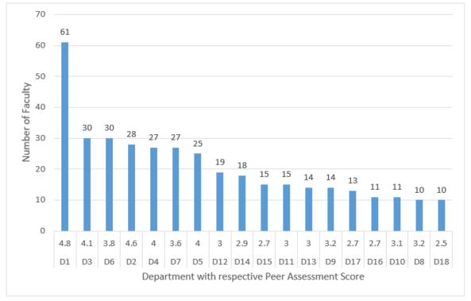
Figure 1.1 to Figure 1.5, depicts the five inputs (Number of Graduate Students, Research Expenditure per Faculty, Number of Graduate Students, Undergraduate Students per Faculty and Average H-Index) from highest to lowest order. The x-axis shows the Department number in the form of D1, D2 and so on, as well as the Peer Assessment Score of individual departments, respectively, whereas the y-axis shows the total number of the respective inputs. If you compare D6 with D2, in the Figure 1.1-1.5, although the Peer Assessment Score of Department 6 is 3.8, which is much lower compared to 4.6 of Department 2; however, D6 has higher Number of Faculty (30 to 28), higher Research Expenditure per Faculty ($471,900 to $259,818.25), and significantly higher Number of Graduate students (330 to 192). In contrast, Number of Undergraduate Students per Faculty is lower in Department 2 than Department 6 (15.11 to 21.33), and the Average H-Index of Department 2 is higher than that of Department 6 (24.18 to 16). These numbers show that the faculty of Department 2 has lower course load in terms of teaching undergraduate students, which shows improved research efficiency of the faculty members through higher Average H-Index value, still the lower Research Expenditure per Faculty conveys otherwise. This shows the presence of subjectivity in the process of departmental rankings in universities.

Figure 1.1: Number of Faculty per department (from highest to lowest)

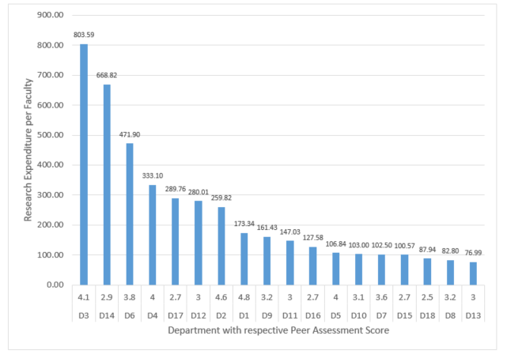

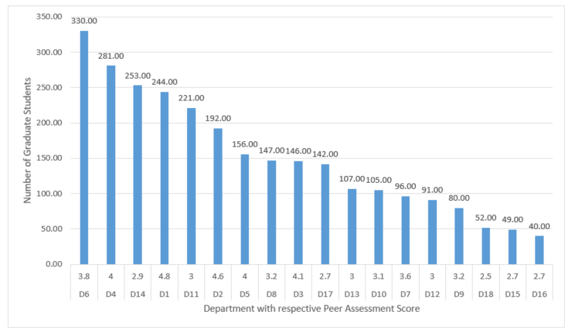
Figure 1.2: Research Expenditure per Faculty per department (in 10^3) (from highest to lowest)

Figure 1.3: Number of Graduate Students per department (from highest to lowest)
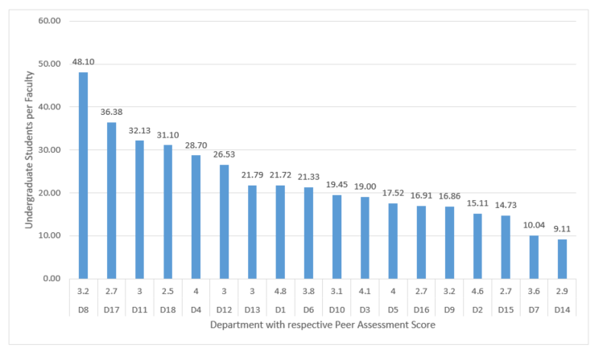
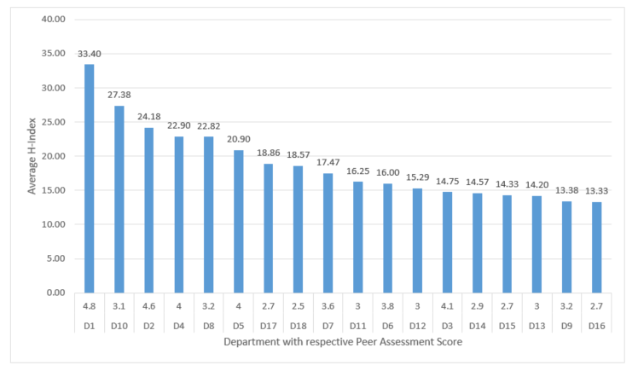
Figure 1.4: Number of Undergraduate Students per Faculty per department (from highest to lowest)

Figure 1.5: Average H-Index per department (from highest to lowest)
  - Results from the Efficiency Model

Table 3 shows the results of the evaluation of the academic departments. The Efficiency column is showing the efficiency of each of the departments, indicating how well they are currently performing with the current amount of inputs. The Reference Set shows the departments (with efficiency = 1) that are used to reach the efficiency frontier. λ column of the Reference Set gives the fraction of respective departments a particular department should benchmark to reach the efficiency frontier. For example, for optimal efficiency, Department 11 should use 68% of Department 9, 17% of Department 8, 10% of Department 5, and 5% of Department 2, as references.
Table 3: Summary of the results from the Efficiency Model
Player (DMU) | Efficiency | Reference Set | λ for each Department in the Reference Set
Department 1 | 1 | 1 | 1
Department 2 | 1 | 2 | 1
Department 3 | 1 | 3 | 1
Department 5 | 1 | 5 | 1
Department 7 | 1 | 7 | 1
Department 8 | 1 | 8 | 1
Department 9 | 1 | 9 | 1
Department 10 | 1 | 10 | 1
Department 13 | 1 | 13 | 1
Department 14 | 1 | 14 | 1
Department 15 | 1 | 15 | 1
Department 16 | 1 | 16 | 1
Department 18 | 1 | 18 | 1
Department 6 | 0.98 | 3, 9, 2 | 0.46, 0.36, 0.18
Department 11 | 0.90 | 9, 8, 5, 2 | 0.68, 0.17, 0.10, 0.05
Department 4 | 0.90 | 2, 9, 3 | 0.88, 0.08, 0.04
Department 12 | 0.88 | 9, 7, 2 | 0.62, 0.33, 0.05
Department 17 | 0.82 | 8, 9, 2 | 0.50, 0.43, 0.07

  - Results from the Benchmarking Model

Benchmarking Model finds the least amount of input required to increase the output levels for the department under study. Table 4 is the summary of the Benchmarking Model of the departments which are inefficient. For example, Department 11 is producing the current Peer Assessment Score (of 3) using excess 9.83 Undergraduate Students/Faculty and excess 116 Number of Graduate Students. This shows the department is not using its resources efficiently. If they can use their excess resources to their fullest potential to get better output, the department can become efficient.
Table 4: Summary of the results from the Benchmarking Model
DMU | Number of Faculty | Research Expenditure/Faculty | Undergraduate Students/Faculty | Number of Graduate Students | H-index
Department  6 | 6 | $0 | 3.82 | 199 | 0
Department 11 | 0 | $0 | 9.83 | 116 | 0
Department  4 | 0 | $66,630 | 13.3 | 100 | 0
Department 12 | 0 | $153,390 | 11.48 | 0 | 0
Department 17 | 0 | $202,490 | 15.54 | 39.92 | 1.19

  - Results from the Investment Model
In this section the methodology is explained by focusing on the data from Department 12. We will assume that the department is given a budget of $500,000.
In section 4.3. (Investment Model), based on the consultation with the Director of the department, the cost of hiring/adding one unit of Assistant Professors, Associate Professors, Professors, Chairs and Graduate Students were estimated and shown in Table 5. The Research Expenditure/Faculty of Department 12 is around $280,000, and the Number of Faculty is 19. Therefore, Total Research Expenditure = 19*$280,000 = $5,320,000. In order to increase the Research Expenditure/ Faculty by $1,000, (20*$281,000-19*$280,000) = $299,000 is needed from a new faculty joining the department. It is assumed that this amount of funding can be brought to the department by an Associate Professor. So, the cost of increasing the Research Expenditure/Faculty by $1,000 for Department 12 would be $102,000, i.e. cost of hiring an Associate Professor.
Table 5: Cost of adding one unit and Average H-index of different faculty positions and graduate students
 | Assistant Professors | Associate Professors | Professors | Chairs | Graduate Students
Approximate cost of hiring/adding one unit | $95,000 | $102,000 | $120,000 | $150,000 | $35,000
Average H-index | 8.40 | 16.87 | 30.78 | 40 | -

Number of Undergraduate Students/Faculty measures the workload of the faculty members. Increasing Undergraduate Students/Faculty is not a cost but income for the department, as keeping the number of faculty in the department constant, increasing the ratio means the department would get higher influx of undergraduate students in class. To increase the Undergraduate Students/Faculty ratio by 1 unit for Department 12, (19*27.53-19*26.53) = 19, new students were required. Considering the Tuition Fees for Department 12 to be around $22,000, $w_{ip}$ was estimated to be ($22,000*19), which is equal to $418,000. Since, it an income for the department, the $418,000 is given a negative value in the Investment Model.
Cost of adding one Graduate Student was estimated to be $35,000, assuming the student will be provided with a tuition waiver along with monthly stipend. Similarly, considering the cost of increasing average H-index by 1 unit for Department 12, the department needs to hire a faculty member with H-index (20*16.29 – 19*15.29) = 35.29, where 19 and 15.29 are the current Number of Faculty and average H-index of the department respectively. Therefore, the cost of increasing H-index by 1 unit would be $150,000, i.e. cost of hiring a Chair Professor, since they come with an average of 40 H-Index.
These values of $w_{ip}$ parameters are used in the Investment Model, for each of the inputs explained above.
In order to consider the effects of adding one input in the department under study on other inputs, $α_{lip}$ matrix is created as shown in Table 6. It is worthwhile to mention that $α_{lip}$ will vary from department to department based on the current values of inputs for each of the individual departments.

Table 6: $α_{lip}$ (Matrix), which is the linear effect of adding one input on the department under study to all other inputs of the Department
 | Assistant Professor | Associate Professor | Professor | Chair Professor | Research Expenditure  /Faculty | Undergraduate Students  /Faculty | Number of Graduate Students | H-Index
Assistant Professor | 1 | 0 | 0 | 0 | -6.50 | -1.33 | 2 | -0.34
Associate Professor | 0 | 1 | 0 | 0 | 1 | -1.33 | 4 | 0.08
Professor | 0 | 0 | 1 | 0 | 11 | -1.33 | 5 | 0.77
Chair Professor | 0 | 0 | 0 | 1 | 36 | -1.33 | 6 | 1.24
Research Expenditure  /Faculty | 0 | 0 | 0 | 0 | 1 | 0 | 0 | 0
Undergraduate Students  /Faculty | 0 | 0 | 0 | 0 | 0 | 1 | 0 | 0
Number of Graduate Students | 0 | 0 | 0 | 0 | 0 | 0 | 1 | 0
H-Index | 0 | 0 | 0 | 0 | 0 | 0 | 0 | 1

Adding an Assistant Professor has no impact on the number of Associate Professor, Professor and Chair Professor, hence a value of 0 is given, to show no effect on those inputs. Similarly, the effect is identical when adding an Associate Professor/Professor or Chair Professor on the other faculty members, resulting in a value of 0 for the respective members of the faculty in the department under consideration. However, adding a faculty member (Assistant Professor/Associate Professor/Professor/Chair Professor) does have an impact on Research Expenditure per Faculty, Undergraduate Students per Faculty, Number of Graduate Students and H-Index. Number of Faculty (18)*Research Expenditure per Faculty ($280,009.63) = $5,320,000. This is the total research expenditure of the whole department. Considering, an Assistant Professor brings $150,000 to the department, the new total Research Expenditure per Faculty moves to $273,500. So, to find the effect, the change in the Research Expenditure per Faculty is estimated, which is approximately ($273,500-$280,009.63) = -$6,500. A negative change meaning, with addition of a new Assistant Professor in the department, there will be -$6,500 decrease in the Research Expenditure per Faculty. Likewise, the effect of Associate Professor, Professor and Chair Professor are estimated and the values are $1,000, $11,000 and $36,000, respectively.
Also, in order to calculate the impact of adding a new faculty member (Assistant Professor/Associate Professor/Professor/Chair Professor) on the Number of Undergraduate Students per Faculty, first we calculate the total number of undergraduate students in the department. The total number of undergraduate students in the department is Number of Faculty (19)*Undergraduate Students per Faculty (26.53) = 504. So, the new Undergraduate Students per Faculty when an additional faculty member is included in the department is (504/20) = 25.2. The effect of adding a new faculty is calculated by finding the change in the Undergraduate Students per faculty, which is (25.2-26.53) = -1.33.
Assumptions have been made in order to estimate the effect of adding a faculty member (Assistant Professor/Associate Professor/Professor/Chair Professor) to the Number of Graduate Students in the department. Values of 2, 4, 5 and 6 are given in the matrix $α_{lip}$ when an Assistant Professor, Associate Professor, Professor, and Chair Professor is added, respectively.
Furthermore, to determine the effect of an additional faculty member (Assistant Professor/Associate Professor/Professor/Chair Professor) to the Average H-Index of the department, first the total H-Index of the department is calculated. Total H-Index = 19*15.29 = 290.51. From Table 5, the average H-Index of different faculty members are used. The new average H-Index, when an Assistant Professor is hired is calculated to be [(Total H-Index of the Department + Average H-Index of Assistant Professors)/New Total Number of Faculty] = [(290.51 + 8.4)/20] = 14.95. The effect of adding a new faculty to the H-Index is calculated by finding the change in the Average H-Index of the department , which is (14.95-15.29) = -0.34. Similar approach is used for Associate Professor, Professor and Chair Professor and the effects are calculated to be 0.08, 0.77, and 1.24, in that order.
When we consider increasing Research Expenditure per Faculty by $1,000, estimating its probable effect on other inputs are out of scope of this paper. As a result, a value of 0 is given to all those effects. Similar consideration is done when increasing Undergraduate Students per Faculty, and H-Index by one unit to other respective inputs of the department. However, the effect of changing one unit of Number of Graduate Students on the average H-Index is assumed to be 0.02 in our study, since without increasing the denominator (number of faculty), graduate students can increase the numerator (total H-Index) of the department. Rest of the effects of Number of Graduate Students on other inputs are considered to be 0.
Once, both $w_{ip}$ and $α_{lip}$ are determined, it is very important for the decision makers to decide what they really want with the budget provided. For instance, in this case study, for Department 12 we have restricted the total hiring of faculty in the department of at most 2 and the hiring of each kind of faculty was also restricted to at most 2. Research Expenditure per Faculty was limited increase to at most 2 units, whereas Undergraduate Students per Faculty was limited to a maximum of 2 units, meaning not more than (19*2 = 38) new undergraduate students were allowed to be added on the department. This decision was made so that increasing Undergraduate Students per Faculty does not overburden the faculty members of the department. The Number of Graduate students hiring was given a high boundary of at most 5, and increase of Average H-Index constrained to maximum of 0.5.
After all the parameters and constraints are determined, the model was run to determine which inputs to add/hire and by how much for Department 12, when a budget of $500k was provided for investment. Once the model was executed, it tells Department 12 to hire one Assistant Professor, one Professor, hire five Graduate Students and increase the Average H-Index by 0.5 units.
With the budget of $500,000, the model optimized to give an improved efficiency of 94% for Department 12, compared to 88% originally (calculated from the Efficiency Model). Department 12 needed to spend $465,000 (1*$95,000 + 1*$120,000 + 5*$35,000 + 0.5*150,000) out of the $500,000 to reach an improved efficiency of 94%. Addition of an Assistant Professor would bring about $150,000 to the department, along with an average H-Index of 8.40, while the main boost in total funding will come from the addition of a new Professor, bringing approximately $500,000 and an average H-Index of 30.78. In addition, the Number of Graduate students of the department would move from 91 to 96. Also, the Average H-Index would move from 15.29 to 15.29+0.5 = 15.79. In order to increase the average H-Index of the department by 0.5, $150,000 allocated for that purpose to set up workshops or training for the faculty members in the department, where they could be trained to write papers by thinking about appropriate audience, and writing in an attractive manner. Furthermore, funds can be allocated to attend more conferences and research meeting that would improve the chance for collaboration with more matured researchers in their respective field, increasing chances to publish papers in well-known journals, leading to improved average H-Index of the department in the long run.. All these numbers have an impact on the improvement of the relative efficiency from 88% to 94% for Department 12.
  - Sensitivity Analysis
Sensitivity analysis helps in analyzing, how the output varies by changes in one of the inputs while other inputs remain constant. Sensitivity analysis for this case study has been performed on Department 11. Sensitivity analysis for the variables conveys the allowable increase/decrease for the variables without changing the optimal LP solution. For example, when the DEA was carried out for Department 11, the lambda values for Department 9, Department 8, Department 5 and Department 2 were 0.68, 0.17, 0.10, and 0.05 respectively. Here, the allowable increase for the lambda value of Department 9 (0.68) is 0.14 and allowable decrease is 0.03, which means the value of the optimal LP solution will remain unchanged for the lambda values of Department 9 from 0.68 + 0.14 = 0.82 and 0.68 – 0.03 = 0.65. Similar conclusions can be drawn for other variables as well.
Furthermore, the Shadow Price in the Sensitivity Analysis tells us exactly how much the objective function would change, if we change the right hand side of the constraints within the given limits of allowable increase/decrease. Shadow Price is also called the marginal value for that constraint. For example, for Department 11, the Number of Faculty is 15 with allowable increase of 3.13 and decrease of 1.28. The shadow price is given as 0.018, which means provided that the constraint remains between 15 + 3.13 = 18.13 and 15 – 1.28 = 13.72, the objective function will change by exactly 0.018. Similar conclusions can be drawn for other constraints as well. Sensitivity analysis is quite useful for decision making, and it can be performed for all other departments as well.
Data of Department 11 is used as an example to construct the graphs. Figure 2 shows how $ф_{p}$ changes with percentage change in one individual input keeping all other inputs same. It is carried out for all the five inputs. The graphs in Figure 2 can help the decision makers in academic departments to make better decisions, as it shows which inputs can make the most impact in increasing the growth potential $ф_{p}$. The number of faculty in Department 11 is 15, so Figure 2.1 shows if the number of faculty increased by 20%, i.e. 18, it would increase the $ф_{p}$ to 1.17 from 1.11. It is worthwhile to see that, any increment in percentage after 20% in the Number of Faculty, $ф_{p}$ does remains constant.
Figure 2 would help the decision maker to take good informed decisions, focusing on where to look at to improve the department. Figure 2.3 and 2.4 clearly shows, increasing the Undergraduate students/Faculty or Number of Graduate Students wouldn’t make any difference on the $ф_{p}$. Following the same steps used for Department 11, the sensitivity analysis could be carried out for all other departments.
In addition, sensitivity analysis to see the change in $ф_{p}$ with decrease in the Undergraduate Students per Faculty and Number of graduate students were conducted as shown in Figure 3. Figure 3.1 clearly shows with the reduction in Undergraduate Students per Faculty by 10% and 20%, how $ф_{p}$ decreases and efficiency increases, while $ф_{p}$ becomes constant after any reduction of more than 20%. Figure 3.2 shows how the $ф_{p}$ is constant up to 50% reduction in the Number of Graduate Students, however there is a change in $ф_{p}$ after 50% reduction. Moreover, any reduction after 80% in the Number of Graduate Students is not shown in the graph since the model was giving inadmissible values as all constraints were not satisfied.
From the sensitivity analysis of each of the inputs, it could be understood that, the value of $ф_{p}$ increases to some extent with the increase in the Number of Faculty, Research Expenditure per Faculty and the Average H-Index, however, in case of the Undergraduate Students per Faculty and Number of Graduate Students, the value of $ф_{p}$ remain constant with the increase in number, while decreasing when the Undergraduate Students per Faculty and Number of Graduate Students is reduced. The decision-maker could easily see the sensitivity analysis in order to understand the areas to target in order to increase the efficiency or potential for growth in the future.

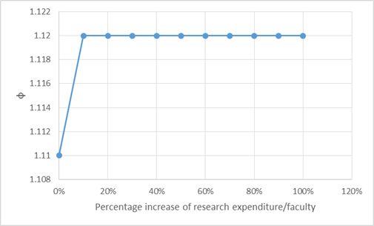
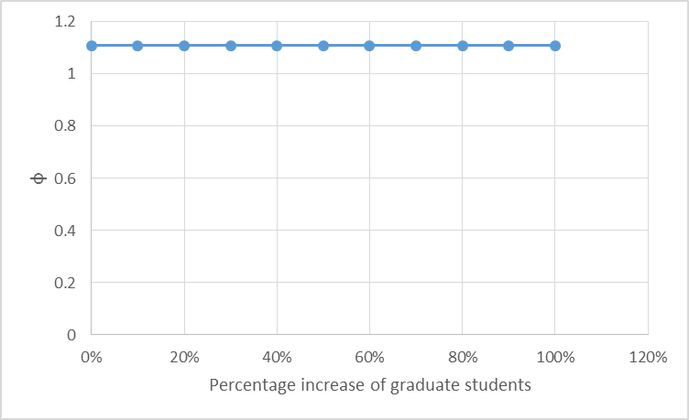
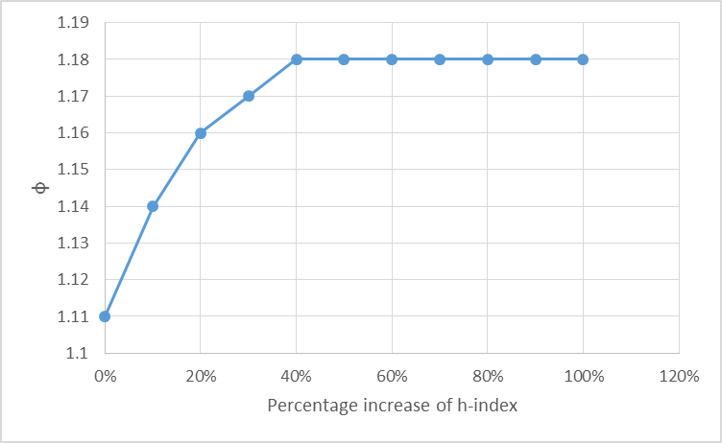
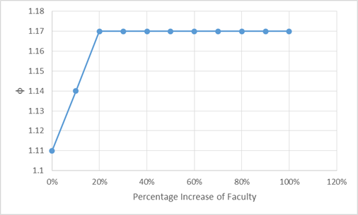
Figure: 2.2
Figure: 2.1
Figure: 2.4
Figure: 2.3

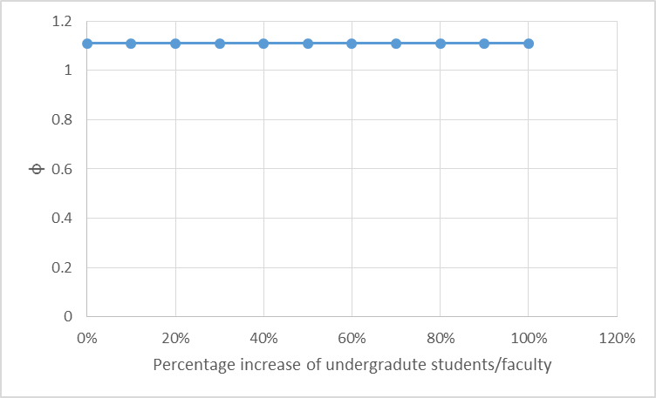

Figure 2. Shows the change in $ф_{p}$ with percentage change in five inputs, respectively
Figure: 2.5

Figure 2: Shows the change in $ф_{p}$ with percentage increase in five inputs, respectively

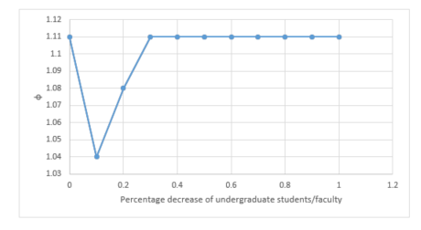

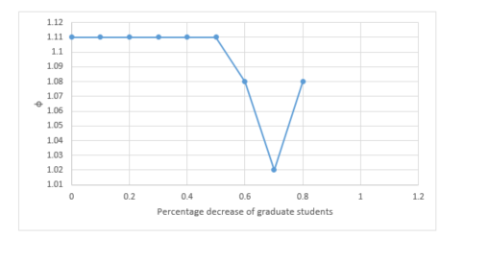
Figure: 3.1
Figure: 3.2

Figure 3: Shows the change in $ф_{p}$ with percentage decrease in Undergraduate Students/Faculty and Number of Graduate Students

- Conclusions and Future Work
For continuous improvement, it is essential for the university departments to benchmark their performances, by identifying areas requiring significant consideration, in order to achieve higher departmental performance. It is vital to have good practices within the department, so that efficient resource allocation can be applied. How well the departments are utilizing their resources can be identified by conducting efficiency analyses. In this thesis, we have proposed three output-oriented DEA models (Efficiency Model, Benchmarking Model and Investment Model) in order to evaluate the relative efficiency of academic departments compared to their peers, furthermore, indicating departments with higher efficiency (efficiency=1) to be used as a reference for each of the department under study. In addition, the Benchmarking Model provides a slack-based DEA methodology to identify possibility of higher outputs with minimum level of inputs. The main contribution to the existing DEA research is the development of the Investment Model that would provide a support-system to the department leadership and decision-makers, to decide where to allocate resources and provide directions for improving efficiency, when an investment budget is provided to the departments.
The proposed DEA models are examined on a case study with 18 Industrial Engineering Departments in the USA, with each departments consisting of five inputs and one output. The results were recorded and discussed in detail. In addition, sensitivity analysis was provided to understand the allowable increase/decrease of the variables and shadow price of the constraints, furthermore, to observe how the growth factor ($ф_{p}$) changes with changes in the inputs.
In the future, we hope to conduct the analysis with more departments, which would allow to calculate better relative efficiency values of the departments. Also, it would be interesting to use SFA to find the statistical significance of the inputs and relationship between the inputs and the outputs. Moreover, including the number of faculty members of each departments, who are in National Academy of Engineering (NAE) and fellows of different academic societies like American Society of Mechanical Engineers (ASME) as a new input, can help to address the subjectivity to some extent. Furthermore, taking into account the non-linear effects (instead of the linear effects in our case) of adding one input in the department under study to the other inputs, could further enhance the Investment Model and give more realistic results.
References
Abdullah D., Muhammad, Z., Darmawan, N., Hartono, H., Sriadhi, S., Ita, E.C., Rohman, D., Yulian, F., Heri, N., Robbi, R., Saleh, A.A., (2018). A Slack-Based Measures within Group Common Benchmarking using DEA for Improving the Efficiency Performance of Departments in Universitas Malikussaleh. MATEC Web of Conferences, 197, p.16005.
Abolghasem, S., Gomez-Sarmiento, J., Medaglia, A.L., Sarmiento, O.L., González, A.H., Castillo, A.D.H, Rozo-Casas, J.F., Jacoby, E. (2018) ‘Socio-Economic Planning Sciences A DEA-centric decision support system for evaluating Ciclovía- Recreativa programs in the Americas’, 61, pp. 90–101. doi: 10.1016/j.seps.2017.03.005.
Ahn, Charnes & Cooper, 1988. Some statistical and DEA evaluations of relative efficiencies of public and private institutions of higher learning. Socio-Economic Planning Sciences, 22(6), pp.259–269
Alam T.E., González, A.H., & Raman, S. (2019). Benchmarking of Academic Departments using Data Envelopment Analysis (DEA). Manuscript in preparation
Alwadood, Z., Noor, N.M. & Kamarudin, M.F., 2011. Performance measure of academic departments using data envelopment analysis. 2011 IEEE Symposium on Business, Engineering and Industrial Applications (ISBEIA), pp.395–399.
American Society for Engineering Education. Home: American Society for Engineering Education. Available at: http://www.asee.org/
Ammons, D., 1999. A proper mentality for benchmarking. Public Administration Review, 59(2), pp.105–109.
Banker, R., Charnes, A. & Cooper, W. (1984). Some Models for Estimating Technical and Scale Inefficiencies in Data Envelopment Analysis. Management Science, 30(9), pp.1078-1092.
Bastedo, M. & Bowman, N. (2010). U.S. News & World Report College Rankings: Modeling Institutional Effects on Organizational Reputation. American Journal of Education, 116(2), pp.163-183.
Bayraktar, E., Tatoglu, E. & Zaim, S. (2013). Measuring the relative efficiency of quality management practices in Turkish public and private universities. Journal of the Operational Research Society, 64(12), pp.1810-1830.
Bosso, J.A., Chisholm-Burns, M., Nappi, J., Gubbins, P.O., Ross, L.A. (2010). Benchmarking in academic pharmacy departments. American Journal of Pharmaceutical Education, 74(8), p.140.
Breu, T. & Raab, R. (1994). Efficiency and perceived quality of the nation's “top 25” National Universities and National Liberal Arts Colleges: An application of data envelopment analysis to higher education. Socio-Economic Planning Sciences, 28(1), pp.33-45.
Charnes, A., Cooper, W. & Rhodes, E. (1978). Measuring the efficiency of decision making units. European Journal of Operational Research, 2(6), pp.429-444.
Coelli, T.J., Prasada Rao, D.S, O’donnell, C.J., Battese, G.E., (2005). An Introduction to Efficiency and Productivity Analysis Second., Boston, MA: Springer US.
Cooper, W.W., Seiford, L.M. & Tone, K., 2006. Introduction to Data Envelopment Analysis and Its Uses: With DEA-Solver Software and References, Boston, MA: Springer US.
Duguleana, Liliana & Duguleana, Constantin, 2015. Data Envelopment Analysis for the efficiency of Academic Departments. Bulletin of the Transilvania University of Brasov. Economic Sciences. Series V, 8(2), pp.453–468.
Fried, H.O., Lovell, C.A.K. & Shelton, S.S., 2008. Efficiency and Productivity. The Measurement of Productive Efficiency and Productivity Change, pp.3–91.
Gnolek, S., Falciano, L. & Kuncl, V., 2014. Modeling Change and Variation in U.S. News & World Report College Rankings: What would it really take to be in the Top 20? Research in Higher Education, 55(8), pp.761–779.
Jayamaha, A. & Mula, J. M. (2011) ‘Productivity and Efficiency Measurement Techniques : Identifying the Efficacy of Techniques for Financial Institutions in Corresponding Author : Ariyarathna Jayamaha’, 2(5), pp. 454–460.
Kao & Hung, 2008. Efficiency analysis of university departments: An empirical study. Omega, 36(4), pp.653–664.
Lukman, Krajnc & Glavič 2010. University ranking using research, educational and environmental indicators. Journal of Cleaner Production, 18(7), pp.619–628.
Marguerite Clarke, 2002. Quantifying Quality: What Can the U.S. News and World Report Rankings Tell us About the Quality of Higher Education? Education Policy Analysis Archives, 10, p.16.
Monks, J. & Ehrenberg, R., 1999. The Impact of US News and World Report College Rankings on Admission Outcomes and Pricing Decisions at Selective Private Institutions. NBER Working Paper Series, p.7227.
Moreno, A. & Tadepalli, R., 2002. Assessing academic department efficiency at a public university. Managerial and Decision Economics, 23(7), pp.385–397
Mortimer, D. & Peacock, S. (2002). Hospital efficiency measurement. West Heidelberg, Vic.: Centre for Health Program Evaluation.
OECD (2013). Education at a Glance. OECD Indicators. OECD Publishing. http://dx.doi.org/10.1787/eag2013-en.
Paxton, Pamela & Bollen, Kenneth A., 2003. Perceived quality and methodology in graduate department ratings: sociology, political science, and economics. Sociology of Education, 76(1), pp.71–88.
Sagarra, Marti, Mar-Molinero, Cecilio & Agasisti, Tommaso, 2017. Exploring the efficiency of Mexican universities: integrating Data envelopment analysis and multidimensional scaling. Omega, 67, pp.123–133.
Sîrbu, A., Cimpoieş, D. & Racul, A. (2016). Use of Data Envelopment Analysis to Measure the Performance Efficiency of Academic Departments. Agriculture and Agricultural Science Procedia, 10, pp.578-585.
Sweitzer, K. & Volkwein, J., 2009. Prestige Among Graduate and Professional Schools: Comparing the U.S. News’ Graduate School Reputation Ratings Between Disciplines. Research in Higher Education, 50(8), pp.812–836
Tsakalis, K.S. & Palais, J.C., 2004. Improving a School's U.S. News and World Report Ranking. Journal of Engineering Education, 93(3), pp.259–263.
U.S. News & World Report. Available at: https://www.usnews.com/rankings
Vojak, B.A., Price, R.L. & Carnahan, J.V., 2003. The Relationship Between Department Rank and College Rank in Engineering Graduate Program Rankings Conducted by U.S. News and World Report. Journal of Engineering Education, 92(1), pp.65–72.
William W. Cooper, Lawrence M. Seiford & Kaoru Tone, 2007. Data envelopment analysis: a comprehensive text with models, applications, references and DEA-Solver software 2nd ed., Springer Verlag.
Witte, K. & López-Torres, L. (2017). Efficiency in education: a review of literature and a way forward. Journal of the Operational Research Society, 68(4), pp.339-363

