University of Oklahoma

Graduate College

Assessment of the bilateral relationship between muscle pennation and force production in the quadriceps femoris

A thesis

submitted to the graduate faculty

in partial fulfillment of the requirements for the

Degree of

Master of Science

By

daniel james blackwood
Norman, Oklahoma
2018

Assessment of the bilateral relationship between muscle pennation and force production in the quadriceps femoris

A thesis approved for the
Department of Health and Exercise Science

By

______________________________
Dr. Rebecca D. Larson, Chair

______________________________
Dr. Christopher D. Black

______________________________
Dr. Daniel J. Larson

© Copyright by Daniel james blackwood 2018
All Rights Reserved.

ACKNOWLEDGEMENTS
I have many people to thank for their input and support during my time in this program. I must first thank my family as they have provided unparalleled motivation and support during the past two years in addition dealing with me the previous 23 years. My dad, Dennis, you provided an example of a great work ethic that I tried to imitate as often as possible; my mother, Susan, you cared for me when I thought “I can’t handle another 3.5 years of this” during my undergrad and likely kept me from starving after I left the dorms and during the last few months; and last but not least my sisters, Erin and Brittany, you are two exceptional women who loved me unconditionally and reminded me of my potential, gave me guidance when I felt I didn’t know what to do with my life, and also reminded me to eat when I started looking too frail. I love all of you and will always be grateful for all you have done and been for me.
To my committee members: Dr. Christopher Black, thank you for being the first to convince me I had the capability to pursue a graduate degree. Dr. Dan Larson, dealing with statistics was much less overwhelming knowing you had an eye on things. To my committee chair, Dr. Rebecca Larson, thank you for your patience and willingness to work through roadblocks with me. Many times throughout the last two years I met challenges I did not expect to overcome but you gave me confidence and support that pushed me through while helping me understand how to progress and avoid similar mistakes in the future. I hope I will have the chance to work under others who understand and relate to people the way you do. Your hands-off approach gave me a wonderful opportunity to experience the process of research from start to finish while still knowing I had support when needed. I doubt many can match your ability to find time to meet with students or be available for research needs, even when it meant coming to campus early in the morning on Saturdays for DXA scans.
To my present and former lab mates Brian Pribble, Dr. Greg Cantrell, and Dr. David Lantis, you guys provided me with a great deal of knowledge during my time here and expanded my skillset within the lab immensely. I fully enjoyed getting to know each of you. Ashley Fox, you endured countless hours of pressing the ultrasound buttons and mind-numbing data analysis to help me prepare my thesis. I can’t thank you enough for enduring that boredom. When you are analyzing data next year I hope you have someone as helpful as you have been to me. John Wayland Farrell III, your input into my thesis and my life in general has me convinced you will be an exceptional mentor to your own students in the future. Your dedication to expand your knowledge of physiology and skillset in the lab setting has provided me an example of what it takes to succeed in this field. Thank you for the countless hours you spent teaching me how to structure my writing, showing me how things work in the lab and jokingly giving me a hard time about things so I wouldn’t be too serious and down on myself.
To my friends Alex White, Mitchell Lucky, Cameron Lohman, Alwyn Quarshie, Dar Patel, Ryan Humphrey, and countless others, you all have seen me at my best and worst and I cannot thank you enough for being with me through both. The encouragement you’ve given me, the laughter we’ve shared, and the bread we’ve broken together have been critical to my staying somewhat sane during this process. I am a rich man because of you and will cherish our times together as I follow my next path in life. Finally, to my subjects, thank you for all the time you volunteered to help with this project. You were studs and I fully enjoyed getting to know each of you.

TABLE OF CONTENTS
- INTRODUCTION 1
Purpose 3
Research Questions 3
Research Hypotheses 3
Null Hypotheses 4
Significance of Study 4
Delimitations 5
Limitations 5
Assumptions 5
Operational Definitions 6

- REVIEW OF LITERATURE 7
Introduction 7
Measuring PA 8
PA and Exercise 11
PA and Performance 14
Asymmetry/Summary 16

- METHODOLOGY 18
Sample 18
Inclusion Criteria 18
Exclusion Criteria 19
Research Design 19
Procedures 20
Initial Measures 20
Pennation Measurement 21
Dynamometer Testing 22
DXA Scan 23
Statistical Analysis 24

- RESULTS AND DISCUSSION 25
Results 25
Subject Characteristics 25
Group Differences 27
Combined Differences 32
Discussion 37
Main Findings 37
Asymmetry in Groups 38
Asymmetry in Individuals 40
Resistance Training 41
Bilateral Relationship between PA and FP 42

- CONCLUSION 44
Research Questions 44
Clinical Significance 45
Future Research 45
Limitations 46

References 47

APPENDIX A 51
APPENDIX B 68

LIST OF TABLES

Table 1. Subject Characteristics 26
Table 2. Differences in Leg Composition 28
Table 2A. Group Differences in Leg Composition 28
Table 2B. Leg Differences in Leg Composition 29
Table 3. Differences in PA and FP 30
Table 3A. Group Differences in PA and FP 30
Table 3B. Leg Differences in PA and FP 31
Table 4. Leg Compositional Differences 32
Table 5. Leg PA and FP Differences 35
Table 6. Correlation of Muscle PA with FP 37

LIST OF FIGURES

Figure 1.Bilateral Composition Differences 33
Figure 1A. Leg Fat Percentage Differences 33
Figure 1B. Leg Lean and Fat Mass Differences 33
Figure 1C. Leg Bone Mineral Content Differences 34
Figure 2. Bilateral PA and FP Differences 36
Figure 2A. Leg Muscle Pennation Differences 36
Figure 2B. Isometric Knee Extension Force Differences 36

ABSTRACT
Few studies have investigated the bilateral symmetry of pennation angle (PA). No research has examined the bilateral relationship between PA and force production (FP). Purpose: The purposes of this study were to: 1) determine the magnitude of asymmetry for PA and FP in the quadriceps femoris (QF) muscle group 2) determine if a correlation exists between PA and FP 3) determine if the correlation is symmetrical between limbs. Methods: Thirty-eight males age 19-32 were recruited to participate in this study. Twenty-five were resistance trained (RT) and 13 were non-resistance trained (NRT). All subjects performed the same tests during their visits and all measurements were made on both legs. The quadriceps femoris (QF) muscles were measured using B-mode ultrasound. Three screen captures were taken for each muscle: the vastus medialis (VM), vastus lateralis (VL), rectus femoris (RF) and vastus intermedius (VI). QF FP was measured on two separate visits by performing 3 knee extension maximal voluntary isometric contractions (MVICs). Lastly, leg composition was measured by DXA scan for lean mass, fat mass, and bone mineral content (BMC). For statistical analyses individuals’ legs were designated strong or weak legs based on FP. Results: No significant differences between groups for fat mass, BMC, or PA of any muscle (p > 0.05) was seen. The RT group had significantly higher lean mass in the strong (8378.3 ± 1577.2g vs. 7015.5 ± 1120.5g) and weak (8422.0 ± 1526.9g vs. 6898.5 ± 1171.5g) legs and significantly higher FP in the strong (1038.3 ± 235.0N vs. 782.3 ± 242.0N) and weak (950.6 ± 206.0N vs. 711.8 ± 235.4N) legs. The only significant difference found between legs when groups were combined was a higher FP in the strong leg (941.5 ±267.2N vs 878.1 ± 242.1). Only VI was correlated with FP (p = 0.035, r = 0.242).
CHAPTER I
INTRODUCTION
The quadriceps femoris (QF) muscle group consists of 4 muscles located on the anterior portion of the thigh. This muscle group includes the rectus femoris, vastus lateralis, vastus intermedius, and vastus medialis¹. The importance of the QF lies in its function as the primary knee extensor². While no athletic movements rely solely on the QF, the majority of force in several key movements is generated by the QF. In dynamic movements such as running, jumping, and decelerating, the QF produces the majority of the propulsive force^{3–5}. Even common movements like body weight squats or decelerating during a walk rely primarily on the QF^{6,7}. The performance of these muscles during those tasks is largely dependent on the structure of the muscle.
Muscle architecture is typically expressed in terms of muscle fiber pennation angle (PA), fiber length, and cross sectional area (CSA). PA is a measure of the angle at which muscle fibers attach to the deep aponeurosis within a muscle⁸. Fiber length is a measurement of the length of individual fibers within a muscle⁹. Because individual muscle fibers are small and challenging to observe individually the length and angle of whole fascicles, bundles of muscle fibers surrounded by a layer of connective tissue, are frequently measured in place of individual fibers¹⁰. CSA is a measure of muscle thickness in a plane perpendicular to the muscle. This measurement provides a way of estimating muscle volume. Many researchers will combine their measurements of PA and CSA and express it as physiological cross-sectional area (PCSA). This process gives a more precise depiction of the amount of muscle acting on the muscle tendon¹¹.
Prior research has shown variations in these factors often lead to differences in performance. A substantial body of evidence has shown that a strong positive correlation exists between muscle CSA and the force production (FP) of that muscle^{12–15}. Put simply, a larger muscle can produce more force. Research on varying fiber lengths has shown longer fibers have a higher capacity for contractile speed^{16,17}. This higher rate of contractile speed allows for improved performance in skills like jumping and sprinting^{16,18}. While a larger PA has been shown to correlate with a higher FP it is usually attributed to an increase in CSA¹⁹. Additionally, a larger PA also correlates to a decrease in the force per CSA¹⁴. These factors may be due to the idea that a greater PA allows for an increased amount of muscle but decreases the efficiency at which the entire muscle pulls on the tendon²⁰.
The complexity of human muscle architecture makes it difficult to maximize the efficiency of the muscle and can result in injuries that seem otherwise unavoidable²¹. As our understanding of the relationship between the components of muscle architecture and strength increases, we may be able to avoid injury and increase performance. The relationship between the strength of the hamstrings and quadriceps has been given substantial consideration for injury occurrence. Imbalances in the strength of these muscle groups have indicated a greater risk for lower body injury²¹. Prior research has also shown bilateral symmetry, or limb-to-limb asymmetry, of PA in the rectus femoris can result in decreased vertical jump power²². Bilateral asymmetry of muscle architecture and FP in the quadriceps may be a factor for these strength asymmetries which reduce performance and increase rates of injury. This study attempted to quantify the level of bilateral asymmetry present in resistance trained and sedentary males.
PURPOSE
The purposes of this study were to: 1) determine the magnitude of bilateral asymmetry for PA and FP in the QF 2) determine if a correlation exists between PA and FP 3) determine if the correlation is similar between limbs.
RESEARCH QUESTIONS
- What is the level of bilateral asymmetry for PA in the QF?
- What is the level of bilateral asymmetry for knee extension FP?
- Does a correlation exist between FP and PA in the QF?
- What is the effect of resistance training on bilateral PA asymmetry?
- What is the effect of resistance training on bilateral FP asymmetry?
- What is the effect of resistance training on the level of correlation between PA and FP in the QF?
RESEARCH HYPOTHESES
1. We hypothesized that there would be a correlation between PA and FP in the QF.
2. We hypothesized that the correlation between PA and FP in the QF would be consistent between limbs.
3. We hypothesized that resistance training would alter the correlation between PA and FP in the QF.
NULL HYPOTHESES
- We hypothesized that there would not be a relationship between PA and FP in the QF.
- We hypothesized that the correlation between PA and FP in the QF would not be consistent between limbs.
- We hypothesized that resistance training would not alter the correlation between PA and FP in the QF.
SIGNIFICANCE OF STUDY
Most sports, as well as different positions within each sport, require different levels of power and aerobic fitness. Determining the architecture and FP capabilities of musculature in young athletes could potentially lead to advancements in athletic programming, ensuring of athletic potential is maximized. These advancements could lead to the proper selection of sport and position, helping young athletes in their development.
A disproportionate strength ratio between quadriceps and hamstrings within each individual leg has been shown by Yeung et al. to significantly increase rates of hamstring injury in sprinters²³. Because disproportionate strength, or asymmetry of strength, within a leg can lead to injury; it is important to look at asymmetrical strength values between legs to determine if the same increased risk is associated with bilateral asymmetry. With further research focused on quantifying the level of architectural asymmetry this measure could potentially be used to identify individuals at higher risk for injury. Additionally, identifying normative values for asymmetry could aid in determining the presence of chronic diseases characterized by bilateral asymmetry, such as multiple sclerosis²⁴.

DELIMITATIONS
- Only males age 18-45 were recruited for this study.
- This study was not applicable to males who participate in resistance training 1 day per week.
- Participants were only recruited from the Norman area.
LIMITATIONS
- The sample was recruited only from the Norman area, thus may not be representative of all males age 18-45.
- Because each individual fiber angle of the quadriceps could not be measured in each subject the estimations may deviate slightly from true quadriceps architecture.
ASSUMPTIONS
- Individuals in the non-resistance trained group did not have muscle architecture changes in their QF from previous resistance training.
- Individuals in the resistance trained group had enough prior training to elicit muscle architecture changes.
- Each individual followed pre-testing guidelines for lower body resistance training.
- Each individual was able to perform a true MVC during testing visits.
- Each individual provided an accurate medical and health history.
OPERATIONAL DEFINITIONS
- Pennation angle (PA) -the angle at which muscle attach to the deep aponeurosis⁸.
- Force production (FP) -the product of mass and acceleration²⁵.
- Isometric contraction -a muscle action in which the muscle length does not change because the contractile force is equal to the resistive force²⁵.
- Vastus intermedius -knee extensor with highest correlation with knee extension strength²⁶.
- Aponeurosis –fibrous extension of tendon to which muscle fascicles attach²⁰.

CHAPTER II
REVIEW OF LITERATURE
INTRODUCTION
Muscle fibers in many muscles are not parallel to the muscle aponeurosis but are instead angled in a way that allows a greater amount of muscle fiber to exert force on the same length of aponeurosis^{27,28}. This arrangement, referred to as the muscle’s PA, may be beneficial for increasing the contraction speed and force during the entire range of motion for the whole muscle^{27,29}. PA is most accurately measured by using in vivo methods which can allow researchers to observe the discrepancy in angle throughout different locations in the muscle by direct observation²⁷. However, it is possible to observe the PA of a muscle without dissection with the aid of ultrasound¹⁰.
An essential muscle group for ambulation as well as performance in most athletics is the QF. Understanding the architecture and function of this muscle group is necessary for understanding and improving performance in any sport or activity which relies heavily on running, jumping, or explosive movements like those seen in Olympic lifting or martial arts. Another reason to further pursue our understanding of muscle architecture and function is examining potential for injury. Asymmetrical strength of the quadriceps and hamstrings can lead to an increased risk of injuries, however, bilateral asymmetry in the quadriceps has not been thoroughly examined²³. The better we understand the relationship between muscle architecture and muscle performance the better chance we have to identify possible asymmetries that could lead to injury or decreased performance. Understanding how muscle architecture changes in response to training may also improve our attempts to correct muscle imbalances. It is typically not feasible to measure every fiber within every muscle of a muscle group being studied, such as the QF, so it is important to understand the relationships between and within muscles in the group. Fortunately, the QF displays consistent patterns between and within muscles that allow us to make inferences about the architecture of the whole quadriceps group by measuring PA in two muscles, the vastus medialis and vastus intermedius.
MEASURING PA
Chleboun et al. (2001) tested the reliability of using ultrasound to measure muscle PA using an Acuson 128XP real-time ultrasonography scanner (Acuson Sequoia, Acuson Corporation, CA, USA) with a 5MHz 8.0-cm transducer¹⁰. This study examined the biceps femoris and compared the ultrasound results to an in vivo measurement. Ultrasound measurements were made at knee and hip angles of 0, 40, and 90 degrees for each joint. Three to seven pictures were taken along the long head of the rectus femoris. The in vivo measurements were made by removing entire fibers from cadavers and measuring the angle with a goniometer. The researchers found that measurements from the ultrasound were slightly less accurate than the in vivo measurements but not significantly different (p > 0.05, ICC = 0.87). The researchers concluded that bending at the joints did result in significant changes in PA with the highest PA coming at a 90-degree hip angle and a 0-degree knee angle¹⁰. It is important to note these measures were taken while the muscle was at rest. Additionally, previous studies indicate muscle contraction is another factor, along with joint angle, that will significantly change the muscle architecture³⁰. Therefore, to ensure consistency in measurements, subjects should be measured with consistent joint angles and with their limb completely relaxed and supported.
In order to test for correlations between knee extension strength and quadriceps architecture without measuring every muscle’s architecture independently, assumptions of a similarity in the mean structure of the quadriceps group have been created³¹. Blazevich et al. (2006) studied the assumption by assessing the relationships among the vastus lateralis (VL), vastus medialis (VM), rectus femoris (RF), and the vastus intermedius (VI) muscles³¹. Sixteen women and fifteen men who did not resistance train had the PA, muscle thickness (MT), and fascicle length (FL) of their quadriceps examined using ultrasound (Acuson Sequoia, Acuson Corporation, CA, USA). Measurements were taken with subjects lying in the supine position and knee bent and supported at a 45˚ angle. Three images of each muscle (VL, VM, RF, and VI) were collected at distal, middle and proximal portions of the muscle with VI being examined in two portions, anterior and lateral. To avoid error from curvature of fascicles as they neared the deep and superficial aponeuroses, the PA of each muscle was measured from approximately 3-4 cm from the deep aponeurosis to the center point of the deep and superficial aponeuroses. MT was determined to be the average of the distance between the aponeuroses at the three measurement sites in each muscle. FL was estimated using PA and MT. Significant correlation was found for within-muscle architecture for the VL for muscle thickness at each site (r > 0.5, P < 0.01) and for PA between proximal and middle (r = 0.48, P < 0.01) and proximal and distal ( r = 0.48, P < 0.01) sites. VM displayed a significant correlation for PA between distal and proximal sites (r = 0.41, P < 0.05) as well as MT at proximal and middle sites (r = 0.57, P < 0.01). RF displayed a significant correlation for PA between middle and distal sites (r = 0.38, P < 0.05) and MT for all sites (0.56 < r < 0.74, P = 0.000–0.002). The anterior portion of the VI displayed a significant PA correlation for the middle and distal sites (r = 0.47, P < 0.05) and for MT between the proximal and middle (r = 0.52, P < 0.01) and proximal and distal sites (r = 0.38, P < 0.05). The lateral portion of the VI displayed a significant correlation for PA between the proximal and distal sites (r = 0.71, P < 0.001) and no significant correlations for MT. A difference index was calculated to compare overall muscle structure, or architectural similarity, and revealed a low difference index for the VL, VM, and RF muscles but not for either portion of the VI. Trends between muscles were calculated using z-scores to provide a parameter for the entire quadriceps group. It was determined higher angles in the VM were indicative of higher angles in the VL and RF. A mirrored trend was also seen for individuals with a larger RF PA having a larger PA in their VL and VM. These trends were not seen in the VI when compared to other muscles. MT of one muscle was not an accurate determinant of MT in other muscles except between VL and the anterior portion of the VI. Using regression equations to determine each variables indication of whole muscle architecture it was found the MT of the VM and the PA of the VM were the two best predictors of whole muscle architecture. When looking at the interaction of muscle parameters the VL, VM, and portions of the VI showed significant correlations between MT and PA, but not for RF. The results of this study show the superficial quadriceps muscles have a similar architecture. This trend allows us to use the structure of one superficial muscle to assume, with relatively high confidence, the structure of the other superficial muscles. The results do show the VI to be only vaguely related to the superficial muscle, but not enough to make assumptions about the structure of the quadriceps as a whole. Because PA is a strong indicator of MT, and because the VM is a strong predictor of the whole muscle architecture, we can assume that measuring the PA of the VM and the VI will give us a strong idea of the whole quadriceps muscle group³¹. This assumption is necessary in order to investigate correlations between muscle architecture of the quadriceps and performance of the muscle group as a whole when it is not feasible to measure the MT and PA of each muscle individually. The data also provided a reference for which areas on each muscle (proximal, middle, or distal) are most closely related to the architecture in the other areas. These data provide us confidence to assume the architecture of the entire quadriceps group from measuring PA of the proximal anterior VI and PA of the proximal VM.
PA AND EXERCISE
PA can change after training and previous observations have allowed us to understand how PA will likely change in response to some modes of exercise. A study by Farup et al. (2012) looked at the muscle morphological changes seen from 10 weeks of resistance training (RT) and 10 weeks of endurance training (END) ³². The resistance training program consisted of 3 training sessions each week. During the sessions subjects would perform 3-5 sets of 4-10 repetitions of leg press, hamstring curl, and knee extensions with the load adjusted to a percentage of their 1RM. The first 15 sessions utilized 2 minutes of rest between sets. Rest time increased to 3 minutes between sets for the last 15 training sessions. The endurance training was structured based on subjects’ VO2max test performance. Subjects warmed up on a stationary bicycle (Kettler Ergoracer GT, Kettler, Enseparsit, Germany) then performed various exercises. The exercise for the first weekly session was 30-45 minutes of cycling at 60-75% of the athlete’s watt max. The second weekly session split the cycling into two 20 minute bouts at 70-80% of the athlete’s watt max with 5 minutes of light cycling between bouts. The third weekly sessions was split into 8 bouts of 4 minutes at 80-90% of the athlete’s watt max with 1 minute of light cycling between bouts. The findings of the study showed that RT resulted in an increase in muscle CSA of 19 ± 7% as well as a PA increase from 10.4 ± 0.9˚ to 12.9 ± 1.4˚. However, END did not evoke any significant changes in fiber CSA or PA. The authors speculated that the alterations in PA seen following the resistance training protocol were due in part to the increased muscle fiber CSA causing an increase in muscle fiber stiffness as seen in previous literature³³. The authors also speculated that the lack of alterations in PA following the endurance training protocol may be due to the fact that muscle CSA did not change after the 10 weeks of training. This is in accordance with more recent literature examining the effect of endurance training on muscle architecture in the rectus femoris³⁴. These results also supported their claim that the CSA change in the RT group is what led to the changes in muscle PA. Based on the findings of the current study it appears that resistance training is the primary exercise modality to improve PA³².
A study by Stock et al. (2016) examined how different volumes of resistance training could affect muscle architecture³⁵. This study utilized a control group who performed no resistance training, a low volume resistance group who performed two sets of 5 repetitions per exercise during each session, and a moderate volume resistance group who performed four sets of 5 repetitions per exercise during each session. The two experimental groups performed resistance training, consisting of both deadlifts and back squats, twice a week for four weeks. Extensive training was completed for each exercise before training began. The greatest effect size seen from pretest to posttest (d = 0.67) was seen in the moderate volume group’s PA of the vastus lateralis. The vastus lateralis PA in the moderate volume group showed a pretest to posttest effect size (d = 0.57). The pretest to posttest effect size for vastus lateralis muscle thickness was greater in the moderate volume group (0.48) than in the low volume group (0.26)³⁵. The results of this study conflict with previous research that suggested PA may increase following resistance training due to an increase in muscle CSA³².
This discrepancy between CSA and PA change was also seen in a study by Baroni et al. (2013), whose study examined muscle PA, CSA, and fascicle length before and after a training program³⁶. The training protocol consisted of 20 subjects who performed 12 weeks of isokinetic eccentric knee extensions. Despite a CSA change of around 7-10%, there were no significant changes in PA. The researchers concluded that the change in CSA must have been solely due to a 17-19% change observed in muscle fascicle length³⁶. In light of this study and the study by Stock et al. (2016) we must realize PA will often change with CSA, but not always to the same degree. From the data we can also assume it is possible to change CSA and PA somewhat independently of each other, specifically CSA through the implementation of eccentric resistance exercise. However, changes in fascicle length may not be common for athletes participating in typical resistance training programs as shown by Fukutani et al. (2015) who compared muscle architecture of the vastus lateralis and medial gastrocnemius in a group of 16 bodybuilders and rugby player to 11 individuals who did not regularly participate in resistance training³⁷. The results showed PA and muscle thickness were higher in the trained individuals but fascicle length was similar. This data from these studies indicate fascicle length may be somewhat stable unless a program is structured around consistent eccentric loading³⁷.
PA AND PERFORMANCE
The importance of measuring muscle PA was detailed by Ichinose et al. (1998) in a study examining the relationship between PA and force generation capability¹⁹. The relationships between muscle CSA and PA and between CSA and force generation capability were also measured. Athletes from sports requiring high force, like judo, wrestling, and gymnasts, consistently showed greater PAs on average (23.6˚) compared to other sports like sprinting, soccer, rowing, and baseball (17.8˚). The study also found that muscle PA significantly correlated with muscle CSA (r = 0.580, p < 0.05). However, the results of this study also showed that force per CSA exhibits a negative correlation, with smaller muscles being comparatively stronger than larger muscles. These findings suggest that PA may be a determining factor in an athlete’s success in a specific sport¹⁹. It may be beneficial to screen young athletes to determine their PA and muscle architecture, and use those findings to guide them towards sports where individual success is maybe likely.
A study done by Secomb et al. (2015) detailed how PA and muscle CSA of the lower limbs correlate with squat jump performance¹⁵. PA and CSA of the vastus lateralis and gastrocnemius both showed a significant correlation (p < 0.01) with performance of a squat jump, countermovement jump, and isometric mid-thigh pull with correlation ranging from moderate (r = 0.45) to very large (r = 0.73). These findings give us straightforward data that athletes with greater PAs may have greater success with jumping skills like high jump or long jump as well as sports like basketball and volleyball that incorporate a large volume of jumping¹⁵.
Another consideration for PA measurements is how it correlates with FP and FP per CSA (F/CSA). Ikegawa et al. (2008) examined the FP, CSA, and PA of the long head of the triceps brachii in 32 competitive male bodybuilders and 20 collegiately ranked Olympic weightlifters¹⁴. FP was collected by conducting a maximal isometric contraction with an isokinetic dynamometer (DTM, SAKAI medical electronics, Tokyo) and CSA was collected using an ultrasonic apparatus CSA (ALOKA SSD-120 with a circular compound scanner) specifically designed for measuring muscle without direct contact using a frequency of 5MHz. PA was measured at the triceps brachii using a B-mode ultrasonic apparatus (ALOKA SSD-500). The results showed the bodybuilders had a greater average CSA, mean isometric muscle force, and average PA (36.8 ± 10.3 cm², 4499 ± 1157 N, 34.4 ± 11.7˚) than the weightlifters (23.6 ± 5.9 cm², 3553 ± 725 N, 21.7 ± 6.22˚). However, F/CSA was significantly larger in the weightlifters (153.5 ± 22.4 N/cm²) than in the bodybuilders (127.7 ± 34.0 (N/cm²). In both groups there was a close relationship between PA and CSA while F/CSA was negatively correlated with PA, leading the authors to suggest that “the larger PA is associated with lower force generating capacity in strength trained athletes¹⁴.” This research along with the research of Stock et al. (2016) and Ichinose et al. (1998) can be viewed collectively to examine the importance of different body types as well as different types of training for athletes who wish to excel in various sports^{19,35}.
ASYMMETRY/SUMMARY
To gain an understanding of the relationship between muscle function and muscle architecture the first step is ensuring accurate measurements of both. Ultrasound measurements of the vastus medialis and vastus intermedius can provide an accurate depiction of the QF group without measuring each individual muscle^{10,31}. However, when using ultrasound we must ensure consistent limb angles within and between subjects in addition to supporting the limb to avoid muscular contraction^{10,30}. Previous research suggest larger PAs are associated with a greater FP and explosive movements like jumping^{15,19}. This data corresponds with research showing an increase in PA following resistance training^{32,35,37}. While extensive research has examined the relationship between muscle architecture and FP within a single leg no research has examined the bilateral symmetry of that relationship. It appears as though the only study examining asymmetry of PA in the quadriceps group was performed by Mangine et al (2014). However, this study only looked at bilateral asymmetry of the rectus femoris and vastus muscles and the effect of that asymmetry on vertical jump and sprint performance. The researchers did suggest PA asymmetry in women correlated with a decrease in jumping and sprinting performance, however, the magnitude of this decrease was not addressed²². Asymmetrical strength of muscle groups within a leg has also been associated with an increased risk for injury as shown by Yeung et al. (2009), who studied the relationship between hamstring and quadriceps strength²³. Considering the findings of Mangine et al. (2014) and Yeung et al. (2009) it may be beneficial to isolate the force produced from the muscles being examined in order to gain a more accurate depiction of the bilateral asymmetry of architecture, strength, and the relationship between architecture and strength^{22,23}. Identifying normal levels of bilateral asymmetry may be beneficial for maximizing lower limb efficiency, injury prevention, or recovery from injury. If the relationship between quadriceps architecture and strength appears to be consistent within healthy individuals it could also be used to identify a decreased ability to activate the entire muscle group.

CHAPTER III
METHODOLOGY
This chapter will cover the methods used for this study. This includes participant description, participant inclusion and exclusion criteria, descriptions of the data collection protocols, instrumentation, and statistical analyses used.
SAMPLE
Thirty-eight males between the ages of 18 and 45 were recruited to participate in this study. Twenty-five were lower body resistance trained (RT) and 13 were non-resistance trained (NRT). To qualify as RT the subject must have participated in lower body resistance training two or more times a week for at least 3 months prior to testing to allow sufficient time for morphological changes³⁸. To qualify as NRT the subject must not have regularly participated in lower body resistance training during the 12 months prior to testing. Participants were excluded if they had begun a resistance training program during the past 3 months. All subjects signed an informed consent document approved by the University of Oklahoma Institutional Review Board (Norman Campus). Individuals residing in the Norman area were recruited by flyers, word of mouth, and e-mail to participate.
INCLUSION CRITERIA
All participants were required to meet these criteria to be eligible for participation:
- Be in the age range of 18-35 years old
- Have participated in lower body resistance training at least twice a week during the past 3 months or have not participated in regular lower body resistance training during the past year.
EXCLUSION CRITERIA
Reasons that excluded subjects from participating in the study were as follows:
- Individual had a prior injury which limits knee range of motion.
- Individual was unable to perform a knee extension maximal voluntary contraction.
- Individual had undergone surgery that may have altered architecture of the quadriceps.
- Individual had cardiovascular diseases.
- Individual had neurological diseases.
- Individual had neurological damage.
- Individuals who started lower body resistance training 3 or fewer months before the start of the study.
- Individual who had metal implants in the lower limbs that would impact body composition assessments.
RESEARCH DESIGN
This study utilized a cross sectional design which consisted of 3 visits with at least 24 hours between visits. We requested the participants avoid any lower body resistance training or endurance training 24 hours prior to testing. Testing protocols during each visit were the same for both groups. The first visit began with an explanation of inclusion and exclusion criteria and a brief explanation of the protocols included in the study. Subjects then read and signed an informed consent form followed by filling out a physical activity readiness questionnaire (PAR-Q) and a Health Insurance Portability and Accountability Act (HIPPA) form. Once consent was given subjects completed an International Physical Activity Questionnaire (IPAQ). We then recorded age and gender before measuring height, weight, resting blood pressure (BP), and heart rate (HR). Next, we measured the PA of the VM, VL, RF, and the anterior VI of both legs starting with the right leg. This was followed by a familiarization protocol for knee extension isometric MVC using an isokinetic dynamometer. Subjects went through the familiarization for both of their legs. The order of leg familiarization was randomized for visit 1 and alternated for visits 2 and 3. During the second visit we started by measuring weight, resting BP, resting HR, and hydration status. We then tested the knee extension isometric MVC of both legs. Visit three once again began with measurements of weight, resting BP, resting HR, and hydration status. We then measured body composition and repeated the knee extension isometric MVC testing protocol.
PROCEDURES
INITIAL MEASURES
Height without shoes on was measured in centimeters to the nearest 0.5cm with the use of a stadiometer (Seca Model 242, Chino, CA). Subjects stood with their back to the wall, looking straight forward, and took a deep breath just prior to measurement. Weight without shoes or excessive clothing was measured in kilograms to the nearest 0.1kg with an electronic scale (Tanita Model BWB-800, Tokyo, Japan). During visit 3 hydration status was determined by measuring urine specific gravity with a refractometer (CLX-1, VEE GEE Scientific Inc., Kirkland, WA). BP and HR were taken following 5 minutes of rest using an automatic BP monitor (BP742 HEM-7200-Z, OMRON Healthcare Inc., Lake Forest, IL).
PENNATION MEASUREMENT
PA was collected using an ultrasound apparatus (LOGIQ S8, GE Healthcare, Little Chalfont, United Kingdom). Subjects were seated with both hips and knees at a 90˚ angle. Subjects’ backs, knees, and feet were adjusted and supported to ensure those angles could be maintained with the entire lower body completely relaxed. We measured PA of the muscles for all subjects in this order: right leg VM, right leg VL, right leg RF, right leg VIA, left leg VM, left leg VL, left leg RF, and lastly left leg VIA. All measurements were made with the probe angled perpendicular to the leg and parallel to the muscle such that an imaginary line extending out from the probe would go straight through the muscle roughly in the sagittal plane of the body. Prior to measurements a water-soluble gel was applied to the probe to maximize acoustic perfusion into the muscle, thus minimizing the amount of pressure applied to obtain a clear image of muscle fascicles. We began the measurement process by locating the anterior superior iliac spine and the superior border of the patella. This distance between these two was considered the subject’s thigh length (TL) and measurement locations were oriented based on a straight line (ML) between the two. To locate the proximal end of the VIA we used a marker to indicate the area lying 27% of TL distal from the anterior superior iliac spine along the ML. To locate the proximal end of the VM we used a marker to indicate the area lying 61% of TL distal from the anterior superior iliac spine along the ML. RF was measured in the same location as VIA and VL was measured laterally from VIA location where the leg was perpendicular to the ground. Any proximal, distal, medial, or medially or laterally deviation from these points required to find an accurate PA measurement was measured and used to locate the same position on the left leg. Three screenshots were taken for each muscle with slight lateral or medial deviations made in probe position to ensure a more complete picture of the muscle was captured. All pictures were analyzed using an on-screen protractor (MB-Ruler 5.3, MB-Softwaresolutions, Iffezheim, Germany). This was done by aligning the base line of the protractor with the aponeurosis of the muscle, then moving the origin to one end of an identifiable fascicle, and recording the angle at which that fascicle intercepted the baseline. This was done for three fascicles in each picture. The averages for all 3 pictures of each muscle were combined and this was the recorded PA. All subjects were measured by the primary researcher and compared against blind measurements of 24 subjects completed by a secondary researcher.
DYNAMOMETER TESTING
Familiarization for knee extension isometric MVC consisted of having the subject sit upright on the KinCom dynamometer (KinCom model: KC125AP, Isokinetic International, East Ridge, TN 37412) and adjusting the seat until knee and hip angles were both 90˚. The KinCom was adjusted so the rotational axis of the dynamometer head was aligned with the subject’s knee. Seat and dynamometer head position was recorded for subsequent visits. Straps were then fastened to secure the upper body to the seat to ensure leg extensors were isolated. The subject’s ankle was then strapped to the load cell of the KinCom. Subjects were asked to perform isometric knee extensions at perceived efforts of 25%, 50%, and 75% followed by one maximal effort attempt to ensure they feel comfortable with the protocol. This process was then repeated for the opposite leg.
DXA SCAN
Body composition was measured using a whole-body Lunar dual-energy x-ray absorptiometry (DXA) scanner (with software version 13.60.033, GE-Lunar Prodigy Advanced, Madison, WI). The DXA scanner was calibrated each day prior to data collection. Subjects removed their shoes, jewelry, and any clothing or personal items that may have contain metal prior to starting the scan. Subjects then were positioned in the supine position with the middle of the table aligned with the middle (sagittal plane) of their body. Subjects were asked to place their arms at their sides within the measurement zone, hands pronated perpendicular to the table, leaving space between their arms and their sides. Straps were used to secure the subject’s feet to limit movement during the scan. Following the scan, regions of interest were placed around the thigh using the proximal border of the patella and the anterior superior iliac spine as landmarks to examine composition of each leg individually. If the subject could not fit in the measurement zone a split scan was utilized. This involved moving the subject until either their left or right side were completely in the scanning zone, running the scan, then moving them until the other side of their body was completely in the scanning zone then running a second scan.
STATISTICAL ANALYSES
All results are reported as means ± standard deviation (SD). Subjects’ legs were designated as their strong or weak leg by averaging the two highest MVIC values from the second visit with the two highest values from the third visit. Two-way repeated measures ANOVAs were used to determine differences between groups’ strong and weak legs for composition (fat, lean and bone), PA, and FP. When significant interactions and effects were found, Bonferroni corrections were used to determine where specific between and within-group differences were located. Paired t-tests look at between leg differences after collapsing groups. Two Pearson’s r Correlations were used: one examined group and bilateral relationships between PA and FP and the second examined the relationship of PA of all legs combined with FP. Statistical significance was set at p ≤ 0.05. Cohen’s d effect sizes were analyzed when appropriate. A value of < 0.19 was considered trivial, 0.20-0.49 was considered a weak effect, a value of 0.50-0.79 was considered a moderate effect, and a value of > 0.80 was considered a strong effect³⁹. All statistical analyses were done using Sigmaplot for windows (Version 12.5, Systat Software Inc., Chicago, IL).

CHAPTER IV
RESULTS AND DISCUSSION
The first goal of this project was to determine if bilateral asymmetry is present for PA, FP, and the relationship between PA and FP in the muscles of the QF. The second goal was to determine if resistance trained individuals displayed similar patterns of asymmetry, if present, for these variables. This chapter will discuss the following: subject characteristics, group differences, and the bilateral relationship between PA and FP.
RESULTS
SUBJECT CHARACTERISTICS
Twenty five RT and 13 NRT males participated in this study. All subjects consented completed the entirety of the study. All RT individuals had been participating in consistent resistance training for at least 12 weeks prior to their first visit. All NRT individuals had not consistently resistance trained during the past year and were asked to refrain from beginning a training program while participating. All RT subjects refrained from lower body resistance exercise for at least 24 hours prior to testing. A paired t-test revealed a significant difference between groups for age (p = 0.04) and body fat percentage (p = 0.001) but not for height, weight, or BMI (p = 0.489, 0.152, 0.0676). Group characteristics are displayed in Table 1.

Table 1. Subject Characteristics (Mean (SD))
 |  |  | Groups
Variables
 |  | Trained (n = 25) |  | Untrained (n = 13) |  | Cohen’s d
Age (years) |  | 22.2 (2.2) |  | 23.8 (3.0)* |  | 0.61
Height (cm) |  | 180.2 (6.8) |  | 180.2 (7.1) |  | 0.00
Weight (kg)  BMI  Body Fat % |  | 89.9 (14.8)  27.6 (3.5)  19.9 (7.4) |  | 86.2 (14.6)  26.5 (3.8)  27.5 (5.4)* |  | 0.25  0.30  1.17
Differences if present were denoted using *(p<0.05). Standard deviations represent variability.

GROUP DIFFERENCES
A two-way repeated measures ANOVA determined no significant group x leg effect for %fat (p = 0.895), fat mass (p = 0.157), or bone mineral content (BMC) (p = 0.496). However, there was a significant group x leg interaction for lean mass (p = 0.037). An 18% difference was seen between the strong legs of the RT (8378.3 ± 1577.2g) and NRT (7015.5 ± 1120.5g) groups as well as a 20% between the weak legs of the RT (8422.0 ± 1526.9g) and NRT groups. Tables 2A and 2B display the difference in means (strong - weak, RT - NRT) for all leg composition measures. A second two-way repeated measures ANOVA determined no significant group x leg effect for PA [VM (p = 0.470), VL (p = 0.795), RF (p = 0.431), VI (p = 0.563)]. A significant group x leg effect was present for FP (p = 0.003). A Bonferroni post-hoc analysis revealed a significant difference in means between groups (p = 0.003) and a significant difference in means between legs of (p = < 0.001). Results are listed in Tables 3A and 3B. Because no significant group differences were present for muscle architecture or in the strong - weak difference for FP, the groups were collapsed and further analyses compared the strong and weak legs of both groups combined.

Table 2A. Group Differences in Leg Composition
 |  |  |  | Groups
Variable |  | Strong (n =38) |  |  | Weak (n = 38)
 | RT | NRT | %diff | Cohen’s d | RT | NRT | %diff |  | Cohen’s d
Lean mass (g)  Fat mass (g) | 8378.3  (1577.2)  2644.7  (1194.7) | 7015.5  (1120.5)*  3345.3  (1043.6) | 18%  -23% | 1.00  0.62 | 8422.0  (1526.9)  2684.8  (1219.7) | 6898.5  (1171.5)*  3310.9  (987.1) | 18%  -22% |  | 1.12  0.56
BMC (g) | 333.3  (70.7) | 316.5  (78.0) | 5% | 0.23 | 335.0  (65.8) | 313.4  (76.3) | 6% |  | 0.30
Differences if present were denoted using *(p<0.05). Standard deviations represent variability. RT: Resistance trained group; NRT: Non-resistance trained group; %diff: Strong - weak

Table 2B. Leg Differences in Leg Composition
 |  |  |  | Groups
Variable |  | RT (n =25) |  |  | NRT (n = 13)
 | Strong | Weak | %diff | Cohen’s d | Strong | Weak | %diff |  | Cohen’s d
Lean mass (g)  Fat mass (g) | 8378.3  (1577.2)  2644.7  (1194.7) | 8422.0  (1526.9)  2684.8  (1219.7) | 18%  -23% | 0.03  0.03 | 7015.5  (1120.5)  3345.3  (1043.6) | 6898.5  (1171.5)  3310.9  (987.1) | 18%  -22% |  | 0.10  0.03
BMC (g) | 333.3  (70.7) | 335.0  (65.8) | 5% | 0.02 | 316.5  (78.0 | 313.4  (76.3) | 6% |  | 0.04
Differences if present were denoted using *(p<0.05). Standard deviations represent variability. RT: Resistance trained group; NRT: Non-resistance trained group; %diff: Strong - weak

Table 3A. Group Differences in PA and FP
 |  |  |  | Groups
Variable |  | Strong (n =38) |  |  | Weak (n = 38)
 | RT | NRT | %diff | Cohen’s d | RT | NRT | %diff |  | Cohen’s d
VM°  VL° | 11.6  (3.0)  12.1  (2.0) | 11.6  (3.8)  11.2  (2.6) | 0%  8% | 0.00  0.39 | 11.6  (3.3)  11.5  (2.6) | 12.2  (3.8)  11.3  (2.3) | -5%  2% |  | 1.12  0.17
RF° | 12.0  (1.9) | 13.0  (2.1) | -8% | 0.50 | 12.6  (2.0) | 11.8  (2.0) | 7% |  | 0.40
VI°  FP (N) | 9.9  (1.7)  1038.3  (235.0) | 9.8  (4.2)  782.3  (242.0)* | 0%  28% | 0.03  1.07 | 10.3  (3.0)  950.6  (206.0) | 8.8  (3.0)  711.8  (235.4)* | 16%  29% |  | 0.50  1.08
Differences if present were denoted using *(p<0.05). Standard deviations represent variability. RT: Resistance trained group; NRT: Non-resistance trained group; %diff: Strong - weak

Table 3B. Leg Differences in PA and FP
 |  |  |  | Groups
Variable |  | RT (n =25) |  |  | NRT (n = 13)
 | Strong | Weak | %diff | Cohen’s d | Strong | Weak | %diff |  | Cohen’s d
VM°  VL° | 11.6  (3.0)  12.1  (2.0) | 11.6  (3.3)  11.5  (2.6) | 0%  5% | 0.00  0.26 | 11.6  (3.8)  11.5  (2.6) | 12.2  (3.8)  11.3  (2.3) | -5%  2% |  | 0.16  0.08
RF° | 12.0  (1.9) | 12.6  (2.0) | -5% | 0.31 | 13.0  (2.1) | 11.8  (2.0) | 10% |  | 0.59
VI°  FP (N) | 9.9  (1.7)  1038.3  (235.0) | 10.3  (3.0)  950.6  (206.0)* | 4%  9% | 0.16  0.40 | 9.8  (4.2)  782.3  (242.0) | 8.8  (3.0)  711.8  (235.4)* | 11%  9% |  | 0.27  0.30
Differences if present were denoted using *(p<0.05). Standard deviations represent variability. RT: Resistance trained group; NRT: Non-resistance trained group; %diff: Strong - weak
COMBINED DIFFERENCES
After collapsing the groups paired t-tests were used to assess between leg differences. Table 4 contains a breakdown of the strong and weak legs for fat%, lean mass, fat mass, and BMC. No significant differences were observed between the legs. The data displayed in figures 1A-1C illustrate the difference between the legs.
Table 4. Leg Compositional Differences (Mean (SD))
 |  |  | Legs
Variables
 | Strong (n = 38) |  |  | Weak (n = 38) |  |  |  | % Difference | Cohen’s d
Fat % | 26.5 (7.8) |  |  | 26.6 (7.7) |  |  | -0.4% |  | 0.01
Lean mass (g) | 7912.1 (1565.3) |  |  | 7900.8 (1579.2) |  |  | 0.1% |  | 0.01
Fat mass (g)  BMC (g) | 2884.4 (1180.1)  327.5 (72.6) |  |  | 2899.0 (1171.2)  327.6 (69.3) |  |  | -0.5%  0.0% |  | 0.01  0.00
Differences if present were denoted using *(p<0.05). Standard deviations represent variability.

Figure 1A. Leg Fat Percentage Differences
Differences if present were denoted using *(p<0.05). Standard deviations represent variability.
Figure 1B. Leg Lean and Fat Mass DifferencesDifferences if present were denoted using *(p<0.05). Standard deviations represent variability.

Figure 1C. Leg Bone Mineral Content Differences
Differences if present were denoted using *(p<0.05). Standard deviations represent variability.

Paired t-tests were used to determine if any significant differences were present between the strong and weak leg for FP and PA. Differences are shown in Figures 2A and 2B. Only FP was significantly different (p < 0.001). Magnitudes of difference are shown in Table 5.
Table 5. Leg PA and FP Comparison [Mean (SD)]
Legs
Variables
 | Strong (n = 38) |  | Weak (n = 38) |  | % Difference | Cohen’s d
VM (°) | 11.6 (3.2) |  | 11.8 (3.5) |  | -1.7% | 0.06
VL (°) | 11.8 (2.2) |  | 11.4 (2.5) |  | 3.4% | 0.17
RF (°)  VI (°)  Force (N) | 12.3 (2.0)  9.9 (2.8)  941.5 (267.2) |  | 12.3 (2.0)  9.8 (3.0)  878.1 (242.1)* |  | 0.0%  1.0%  7.0% | 0.00  0.03  0.25
Differences if present were denoted using *(p<0.05). Standard deviations represent variability.

Figure 2A. Leg Muscle Pennation Differences Differences if present were denoted using *(p<0.05). Standard deviations represent variability.
Figure 2B. Isometric Knee Extension Force DifferencesDifferences if present were denoted using *(p<0.05). Standard deviations represent variability.
*
Pearson’s r correlations were used to determine if a correlation was present between the PA of each individual muscle and FP. This test revealed FP was only significantly correlated with VI (p = 0.035, r = 0.242). Pearson correlation results are shown in Table 6.
Table 6. Correlation of Muscle PA with FP (n = 76)
Variables
 |  | r |  | p
VM |  | -0.022 |  | 0.053
VL |  | 0.072 |  | 0.538
RF  VI |  | 0.053  0.242 |  | 0.647  0.035*
Differences if present were denoted using *(p<0.05). Standard deviations represent variability.

DISCUSSION
This section will present a detailed account of the results found in this study for both groups separated and combined. Results will be examined with respect to previous literature.
MAIN FINDINGS
  - The difference in PA between the strong and weak limbs, as determined by knee extension MVIC, is not significantly different between resistance trained and non-resistance trained males.
  - Lean mass and FP are significantly greater in the strong and weak limbs of resistance trained males compared to non-resistance trained males.
  - The PA of the individuals muscles of the QF; the VM, VL, RF, and VI; are not significantly different between the limbs.
  - FP of a knee extension MVIC is significantly greater in the strong leg.
ASYMMETRY IN GROUPS
The results of this study showed PA in the QF muscles was not significantly different between the strong and weak legs in males, regardless of resistance training status. To our knowledge, the only prior studies which measured bilateral PA asymmetry were conducted by Secomb et al. (2015) and Mangine et al. (2014), each of which reported similar findings^{15,22}. The study by Secomb et al. examined the PA differences in the VL and lateral gastrocnemius. Reported differences were between the left and right legs, not between dominant and non-dominant based on strength, architecture, or preference. No significant difference (p > 0.05) was seen as the mean differences in PA were only 0.7% and 1.2% for the VL and lateral gastrocnemius respectively¹⁵. Mangine et al. measured the differences in PA of the RF and VL between the legs as well as between men and women. The leg with the larger CSA in the VL was designated the dominant leg. Mean differences of 3.9% and 4.8% in men and 4.3% and 4.8% in women were seen in the RF and VL respectively. Although larger than the 0.8% and 3.4% differences seen in those muscles in the current study, the differences in their study also failed to reach statistical significance (p > 0.05)²². In addition our study did not separate the limbs based on CSA but rather strength. Their study also examined the bilateral differences in muscle thickness, fascicle length, and CSA between the limbs. No measures reached statistical difference except for a 2.0% difference in CSA of the VL in men (p = 0.028)²². These results are further supported by a previous study by Masuda et al. (2003) which found no significant difference (p > 0.05) in the CSA of the QF between the kicking legs and non-kicking legs of university level soccer players¹³. Although the current study did not measure MT or CSA independently, the results of the DXA scan revealed similar findings as no significant differences in lean mass, fat mass, or BMC between the legs was found. Absolute differences in lean mass were only 0.1% between the strong (7912.1 ± 1563.5g) and weak (7900.8 ± 1579.2g) legs (d = 0.01). These previous studies paired with the results of the current study suggest muscle size and PA tend to be symmetrical between the legs in healthy young individuals.
Although symmetry was found between the legs for muscle PA, a significant difference of 7.0% in FP was present between the legs (p < 0.001). These results are similar to the results of the previously mentioned study by Masuda et al. (2003) which reported a significant difference (p < 0.05) between the limbs for isokinetic knee extensions performed at 240°/second. The 4.3% difference between legs was slightly less than the 7.0% difference seen between legs in the current study¹³. Greater differences of 10% and 5% were seen in a different study by Brown et al. (2016) which examined peak force of knee extensions 60°/sec in forwards, traditionally larger and stronger players, and backs, traditionally smaller but quicker and more agile players, of developmental-level rugby teams. Legs were separated into preferred and non-preferred based on kicking preference. Significant difference was not observed but small effect sizes were seen for higher preferred leg peak force values in the forwards (ES = 0.37) and backs (ES = 0.21). The choice to measure effect size instead of significant difference was an attempt to understand the practical significance of the findings as opposed to purely numerical significance⁴⁰.
ASYMMETRY IN INDIVIDUALS
A study by Burkett (1970) determined a 10% bilateral difference in hamstring strength would classify an athlete as “high risk” for injury. Out of 31 NFL football players in the study 6 had strength differences of 10% or greater in their hamstrings. Four of those 6 athletes suffered hamstring injuries to the weaker leg and a fifth complained of sever soreness in the weaker leg within three weeks of measurement⁴¹. A study by Croisier et al. (2008) found athletes with bilateral strength asymmetry of 15% or greater in the hamstrings could significantly reduce injury occurrence if a training program reduced the asymmetry to 5% or less²¹. In regards to performance reduction the previously mentioned study by Mangine et al. (2014) found bilateral asymmetry in the RF and VL negatively affected jumping power and sprint speed of women (p < 0.05)²². These studies illustrate the importance of understanding and measuring bilateral asymmetry and open the door for future studies to determine better methods for correcting and avoiding asymmetry. Bilateral differences in group data for this study were only as high as 7.0% for PA and FP. However, it is necessary to acknowledge the presence of significant asymmetry between the legs of individual subjects. In this study 8 RT and 7 NRT individuals recorded differences greater than or equal to 10% for FP. Additionally, 18 RT and 8 NRT individuals had greater than or equal to 10% difference in the PA of their VI. Altogether, 31 of the 38 subjects recorded 10% or greater differences between the legs for FP, VI PA, or both. Although these differences between limbs were masked by relative group symmetry, this study indicates a high prevalence of individual asymmetry can be found within a randomly sampled population of males.
RESISTANCE TRAINING
As previously mentioned, group differences as determined by 2-way RM ANOVA analysis were not significant for any factors aside from lean mass and FP in the strong and weak legs. The lack of group differences across all factors except lean mass and FP led to the rejection of the hypothesis that resistance training will affect the level of asymmetry in PA and FP. Because training appeared to have no effect on bilateral asymmetry it is necessary to understand the relationship between training and various muscle parameters. Research by Baroni et al. (2013) displayed the importance of training specificity³⁶. The researchers utilized an eccentric training protocol which led to significant increases in muscle fascicle length but not pennation, a typical adaptation seen in other training studies^{32,35}. This finding may help explain why no significant difference in PA was seen between the groups in the present study as the type of resistance training performed by the RT group was not recorded.
Prior research from Farup et al. (2012) and Stock et al. (2016) may help explain why differences between the RT and NRT groups were seen for lean mass and FP in the present study^{32,35}. Farup et al. (2012) reported 22% and 23% increases in the CSA and PA of the VL as well as a 20% increase in knee extension FP following 10 weeks of resistance training³². The differences seen were very similar to the 22%-23% greater lean masses and 28-29% greater knee extension FPs seen in the RT group of the current study. However, the bilateral differences in PA were much lower in the current study, ranging from 8% less in the RT group to 16% greater in the RT group. Stock et al. (2016) examined the effect of 4 weeks of barbell squat and deadlift training on VL strength and architecture. The researchers saw significant increases in leg extension peak torque, MT, and PA³⁵. These studies indicate it is possible for muscle architectural and strength parameters to be altered in specific ways (e.g. PA increase, FL increase) by various types of resistance training.
BILATERAL RELATIONSHIP BETWEEN PA AND FP
Previous research has extensively examined the relationship between PA and FP in the legs^{15,19,20,26}. However, to our knowledge, no research has examined the symmetry of this relationship between the legs. Gaining an understanding of how PA and FP relate across the legs could be the next step towards using these variables to determine training needs in athletes or to identify deficiencies resulting from prior injury or disease in clinical populations. After collapsing the groups each muscle was examined for a correlation with FP. Only the VI showed statistically significant correlation with FP (r = 0.242), therefore the hypothesis that PA and FP would be correlated was only true for the VI. A correlation with VI was expected based on previous research by Ando et al. (2015), who determined the VI architecture had the highest correlation with knee extension force²⁶. However, the correlation found by the researchers for MT (r = 0.74) and PA (r = 0.68) were much higher than the correlation found with PA of the VI in the current study (r = 0.242). Additionally, when separated into the stronger and weaker legs or the RT and NRT groups no significant correlation was found for either (p > 0.05). The lack of correlation when separated severely limited our ability to analyze the bilateral relationship between the measures. Therefore the hypothesis that the correlation between PA and FP would be consistent between the legs could not be investigated further. It is possible the small sample size and lack of experience of ultrasound measurements by the researchers limited the study’s ability to find correlation. This could explain why the VI was not correlated when groups or legs were measured independently and why VM, RF and VL showed no correlation with FP, which was found in previous literature⁴². If possible, future research should examine these factors with a larger group and with a researcher or trained individual who is experienced in the use of ultrasonography.

CHAPTER V
CONCLUSION
The purposes of this study were to: 1) determine the magnitude of asymmetry for PA and FP in the QF 2) determine if a correlation exists between PA and FP 3) determine if the correlation is symmetrical between limbs.
RESEARCH QUESTIONS
- What is the level of asymmetry for PA in the QF? Group differences in PA ranged from 0.0%-3.4% between the legs. No differences were significant (p > 0.05).
- What is the level of asymmetry for knee extension FP in the QF? This study found a significant difference (p < 0.001) with a magnitude of 7.0% between the strong and weak legs. Although this difference was statistically significant it may not be practically significant; differences may not be asymmetrical to the point of decreasing performance or increasing risk for injury.
- Does a correlation exist between FP and PA in the QF? Correlation was found between the VI and PA (p = 0.035, r = 0.242), but no correlation was found with any other muscle and PA (p > 0.05).
- What is the effect of resistance training on PA asymmetry? The results of this study indicate individuals who are resistance trained do not exhibit any differences in PA symmetry (p > 0.05).
- What is the effect of resistance training on FP asymmetry? The results of this study indicate individuals who are resistance trained do not exhibit any differences in FP asymmetry (p > 0.05).
- What is the effect of resistance training on the level of correlation between PA and FP in the QF? The results of this study indicate there is no significant effect of training on the correlation between PA and FP in the QF.

CLINICAL SIGNIFICANCE
The absence of architectural asymmetry and the small degree of FP asymmetry suggest that we should expect to see a reasonable degree of symmetry between the limbs for PA and FP. A difference greater than the previously stated 10% could decrease performance or even be indicative of a higher risk for injury. However, because our study only utilized an isometric knee extension, we were unable to measure how asymmetry in some individuals creates performance decrements. The lack of significant changes in symmetry in the RT group indicates resistance training may not be useful for correcting strength imbalances if the training program is not structured specifically with that in mind. However, because the results of this study were weaker than previous studies that have found stronger and more widespread, it is possible a larger study would suggest otherwise.
FUTURE RESEARCH
There are two directions this research should be taken in future studies. The first direction should be to examine these measures on a larger scale in a population who participates in sports where knee injuries are common. Following the measurements, the individuals could be tracked to determine if PA differences, isolated from FP differences, will increase the rate of injury. This population could also be used to examine the effectiveness of specific training designed to reduce asymmetry of both PA and FP on reducing rates of injury. The second direction would be to examine how specific clinical populations with unilateral injuries or strength loss differ from the results seen in the current study’s healthy population.
LIMITATIONS
The results of this study are only representative of males age 19-32 years old from the Norman area. Additionally, muscle architecture was estimated based on locations previously determined to be most representative of whole muscle architecture. Two problems were encountered during the data collection process. The first issue occurred when severe weather and/or last minute cancellations by subjects resulted in visits being more than 7 days apart for several subjects. The second issue arose during data analysis as several ultrasound images were not clear enough to determine PA. When this occurred PA of the muscle was estimated by averaging the remaining 2 images. No muscle had less than 2 useable images.

REFERENCES
1 Elias JJ, Bratton DR, Weinstein DM, Cosgarea AJ. Comparing two estimations of the quadriceps force distribution for use during patellofemoral simulation. J Biomech 2006;39:865–72. https://doi.org/10.1016/j.jbiomech.2005.01.030.
2 Andersen P, Adams RP, Sjøgaard G, Thorboe A, Saltin B. Dynamic knee extension as model for study of isolated exercising muscle in humans. J Appl Physiol 1985;59:1647–53.
3 Hamner SR, Seth A, Delp SL. Muscle contributions to propulsion and support during running. J Biomech 2010;43:2709–16. https://doi.org/10.1016/j.jbiomech.2010.06.025.
4 Nagano A, Komura T, Fukashiro S, Himeno R. Force, work and power output of lower limb muscles during human maximal-effort countermovement jumping. J Electromyogr Kinesiol 2005;15:367–76. https://doi.org/10.1016/j.jelekin.2004.12.006.
5 Jacobs R, Bobbert MF, van Ingen Schenau GJ. Mechanical output from individual muscles during explosive leg extensions: The role of biarticular muscles. J Biomech 1996;29:513–23. https://doi.org/10.1016/0021-9290(95)00067-4.
6 Isear JA, Erickson JC, Worrell TW. EMG analysis of lower extremity muscle recruitment patterns during an unloaded squat. Med &amp Sci Sport &amp Exerc 1997;29:532–9. https://doi.org/10.1097/00005768-199704000-00016.
7 Ellis RG, Sumner BJ, Kram R. Muscle contributions to propulsion and braking during walking and running: Insight from external force perturbations. Gait Posture 2014;40:594–9. https://doi.org/10.1016/j.gaitpost.2014.07.002.
8 Fukunaga T, Ichinose Y, Ito M, Kawakami Y, Fukashiro S. Determination of fascicle length and pennation in a contracting human muscle in vivo. J Appl Physiol 1997;82:354 LP-358.
9 Zhou GQ, Chan P, Zheng YP. Automatic measurement of pennation angle and fascicle length of gastrocnemius muscles using real-time ultrasound imaging. Ultrasonics 2015;57:72–83. https://doi.org/10.1016/j.ultras.2014.10.020.
10 Chleboun GS, France AR, Crill MT, Braddock HK, Howell JN. In vivo Measurement of Fascicle Length and Pennation Angle of the Human Biceps femoris Muscle. Cells Tissues Organs 2001;169:401–9. https://doi.org/10.1159/000047908.
11 Fukunaga T, Roy RR, Shellock FG, Hodgson JA, Day MK, Lee PL, et al. Physiological cross-sectional area of human leg muscles based on magnetic resonance imaging. J Orthop Res 1992;10:926–34. https://doi.org/10.1002/jor.1100100623.
12 Lieber RL, Friden J. Functional and clinical significance of skeletal muscle architecture. Muscle Nerve 2000;23:1647–66. https://doi.org/10.1002/1097-4598(200011)23:11<1647::AID-MUS1>3.0.CO;2-M [pii].
13 Masuda K, Kikuhara N, Takahashi H, Yamanaka K. The relationship between muscle cross-sectional area and strength in various isokinetic movements among soccer players. J Sports Sci 2003;21:851–8. https://doi.org/10.1080/0264041031000102042.
14 Ikegawa S, Funato K, Tsunoda N, Kanehisa H, Fukunaga T, Kawakami Y. Muscle Force per Cross-sectional Area is Inversely Related with Pennation Angle in Strength Trained Athletes. J Strength Cond Res 2008;22:128–31. https://doi.org/10.1519/JSC.0b013e31815f2fd3.
15 Secomb JL, Nimphius S, Farley ORL, Lundgren LE, Tran TT, Sheppard JM. Relationships between lower-body muscle structure and, lower-body strength, explosiveness and eccentric leg stiffness in adolescent athletes. J Sport Sci Med 2015;14:691–7. https://doi.org/10.1519/JSC.0000000000000858.
16 Abe T, Kamagai K, Brechue WF. Fascicle length of leg muscles is greater in sprinters than distance runners. Med Sci Sport Exerc 2000;32:1125–9. https://doi.org/10.1097/00005768-200006000-00014.
17 Wickiewicz TL, Roy RR, Powell PL, Perrine JJ, Edgerton VR. Muscle architecture and force-velocity relationships in humans. J Appl Physiol 1984;57:435 LP-443.
18 Abe T, Fukashiro S, Harada Y, Kawamoto K. Relationship Between Sprint Performance and Muscle Fascicle Length in Female Sprinters. J Physiol Anthropol Appl Human Sci 2001;20:141–7. https://doi.org/10.2114/jpa.20.141.
19 Ichinose Y, Kanehisa H, Ito M, Kawakami Y, Fukunaga T. Relationship Between Muscle Fiber Pennation and Force Generation Capability in Olympic Athletes. Int J Sports Med 1998;19:541–6. https://doi.org/10.1055/s-2007-971957.
20 Rastelli F, Capodaglio P, Orgiu S, Santovito C, Caramenti M, Cadioli M, et al. Effects of muscle composition and architecture on specific strength in obese older women. Exp Physiol 2015;100:1159–67. https://doi.org/10.1113/EP085273.
21 Croisier J-L, Ganteaume S, Binet J, Genty M, Ferret J-M. Strength Imbalances and Prevention of Hamstring Injury in Professional Soccer Players. Am J Sports Med 2008;36:1469–75. https://doi.org/10.1177/0363546508316764.
22 Mangine GT, Fukuda DH, LaMonica MB, Gonzalez AM, Wells AJ, Townsend JR, et al. Influence of gender and muscle architecture asymmetry on jump and sprint performance. J Sport Sci Med 2014;13:904–11.
23 Yeung SS, Suen AMY, Yeung EW. A prospective cohort study of hamstring injuries in competitive sprinters: preseason muscle imbalance as a possible risk factor. Br J Sports Med 2009;43:589–94. https://doi.org/10.1136/bjsm.2008.056283.
24 Polman CH, Reingold SC, Edan G, Filippi M, Hartung H-P, Kappos L, et al. Diagnostic criteria for multiple sclerosis: 2005 revisions to the “McDonald Criteria”. Ann Neurol 2005;58:840–6. https://doi.org/10.1002/ana.20703.
25 Baechle T, Earle R. Essentials of Strength Training and Conditioning. 3rd ed. Human Kinetics (Champaign, IL); 2008.
26 Ando R, Saito A, Umemura Y, Akima H. Local architecture of the vastus intermedius is a better predictor of knee extension force than that of the other quadriceps femoris muscle heads. Clin Physiol Funct Imaging 2015;35:376–82. https://doi.org/10.1111/cpf.12173.
27 Infantolino BW, Challis JH. Short communication: Pennation angle variability in human muscle. J Appl Biomech 2014;30:663–7. https://doi.org/10.1123/JAB.2013-0334.
28 Zajac FE. Muscle and tendon: properties, models, scaling, and application to biomechanics and motor control. Crit Rev Biomed Eng 1989:359–411. https://doi.org/10.1016/j.pcad.2015.11.006.
29 Infantolino BW, Neuberger T, Challis JH. The Arrangement of Fascicles in Whole Muscle. Anat Rec Adv Integr Anat Evol Biol 2012;295:1174–80. https://doi.org/10.1002/ar.22484.
30 Massey G, Evangelidis P, Folland J. Influence of contractile force on the architecture and morphology of the quadriceps femoris. Exp Physiol 2015;100:1342–51. https://doi.org/10.1113/EP085360.
31 Blazevich AJ, Gill ND, Zhou S. Intra- and intermuscular variation in human quadriceps femoris architecture assessed in vivo. J Anat 2006;209:289–310. https://doi.org/10.1111/j.1469-7580.2006.00619.x.
32 Farup J, Kjølhede T, Sørensen H, Dalgas U, Møller AB, Vestergaard PF, et al. Muscle Morphological and Strength Adaptations to Endurance Vs. Resistance Training. J Strength Cond Res 2012;26:398–407. https://doi.org/10.1519/JSC.0b013e318225a26f.
33 Parcell AC, Woolstenhulme MT, Sawyer RD. Structural Protein Alterations to Resistance and Endurance Cycling Exercise Training. J Strength Cond Res 2009;23:359–65. https://doi.org/10.1519/JSC.0b013e318198fd62.
34 Murach K, Greever C, Luden ND. Skeletal muscle architectural adaptations to marathon run training. Appl Physiol Nutr Metab 2015;40:99–102. https://doi.org/10.1139/apnm-2014-0287.
35 Stock MS, Olinghouse KD, Drusch AS, Mota JA, Hernandez JM, Akalonu CC, et al. Evidence of muscular adaptations within four weeks of barbell training in women. Hum Mov Sci 2016;45:7–22. https://doi.org/10.1016/j.humov.2015.11.004.
36 Baroni BM, Geremia JM, Rodrigues R, De Azevedo Franke R, Karamanidis K, Vaz MA. Muscle architecture adaptations to knee extensor eccentric training: Rectus femoris vs. vastus lateralis. Muscle and Nerve 2013;48:498–506. https://doi.org/10.1002/mus.23785.
37 Fukutani A, Kurihara T, Fukutani A. Comparison of the muscle fascicle length between resistance-trained and untrained individuals: cross-sectional observation. Springerplus 2015;4:341. https://doi.org/10.1186/s40064-015-1133-1.
38 Abe T, DeHoyos D V, Pollock ML, Garzarella L. Time course for strength and muscle thickness changes following upper and lower body resistance training in men and women. Eur J Appl Physiol 2000;81:174–80. https://doi.org/10.1007/s004210050027.
39 Cohen J. Statistical power analysis for the behavioral sciences (2nd ed.) 1988.
40 Brown SR, Brughelli M, Bridgeman LA. Profiling Isokinetic Strength by Leg Preference and Position in Rugby Union Athletes. Int J Sports Physiol Perform 2016;11:500–7. https://doi.org/10.1123/ijspp.2015-0241.
41 Burkett LN. Causative factors in hamstring strains. Med Sci Sports 1970;2:39–42.
42 Moreau NG, Simpson KN, Teefey SA, Damiano DL. Muscle Architecture Predicts Maximum Strength and Is Related to Activity Levels in Cerebral Palsy. Phys Ther 2010;90:1619–30. https://doi.org/10.2522/ptj.20090377.

APPENDIX A
IRB Approval Letter
Informed Consent
Research Privacy Form
Physical Activity Readiness Questionnaire
IPAQ

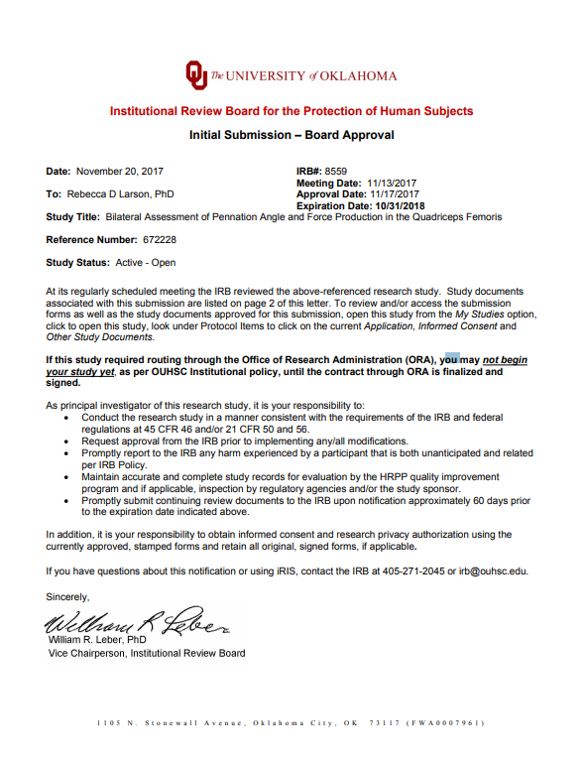

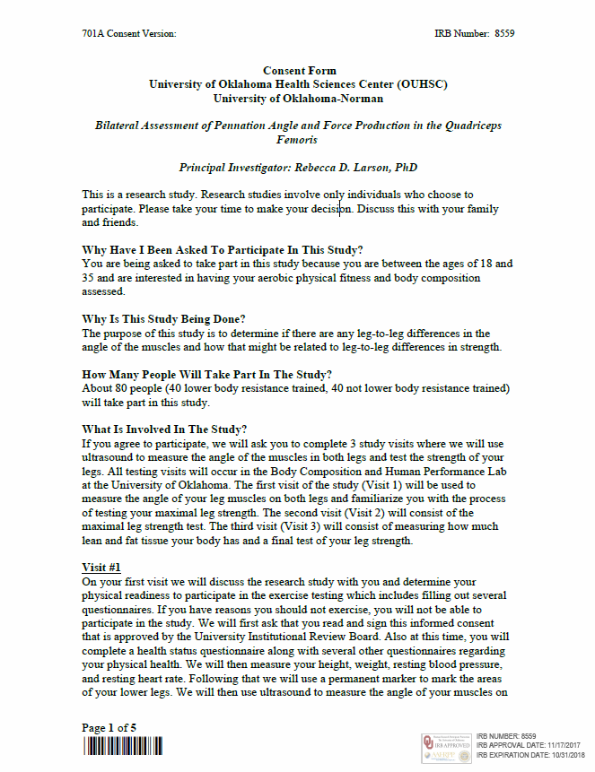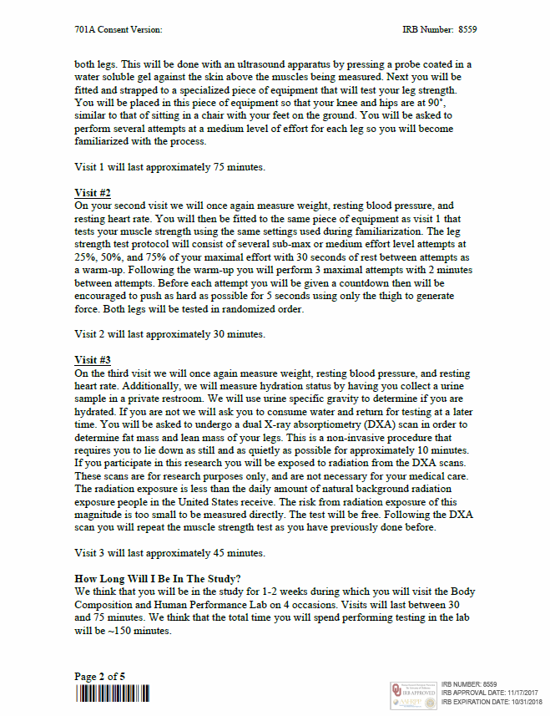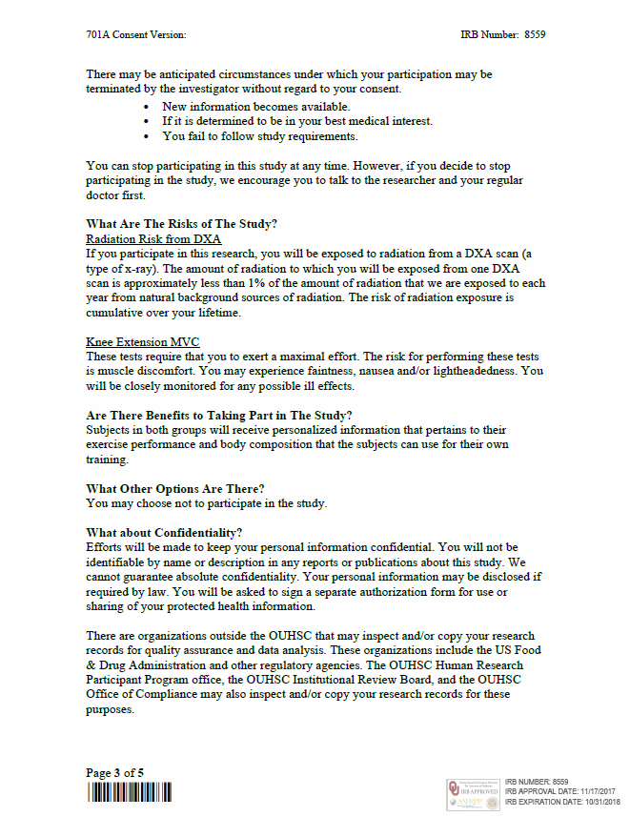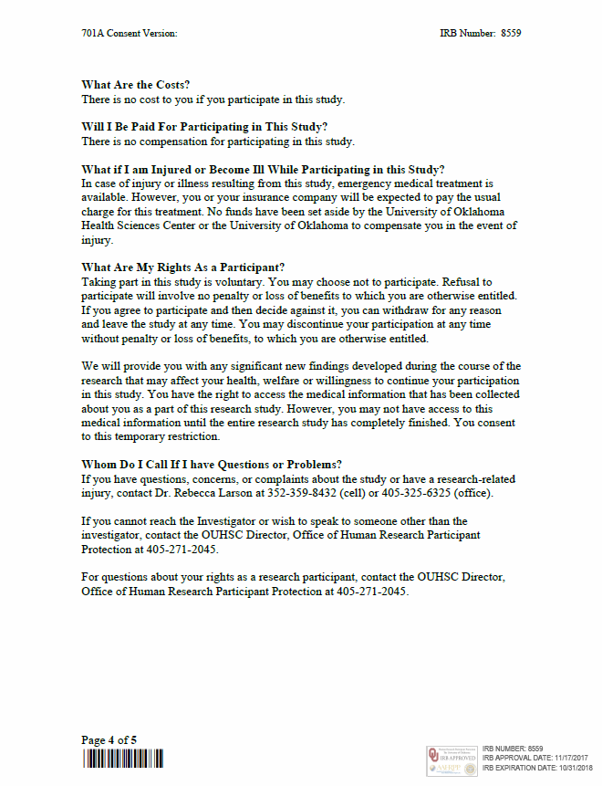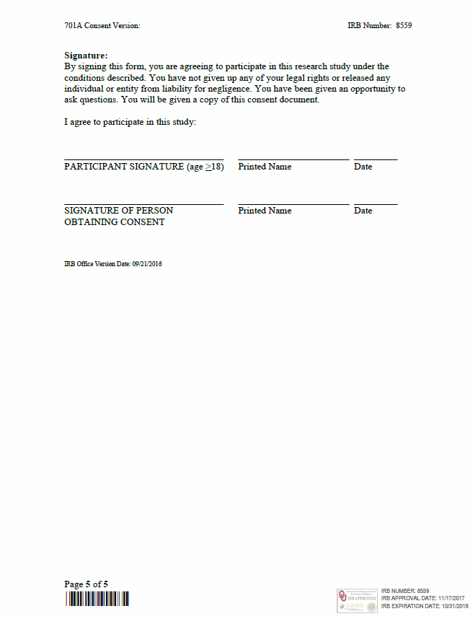
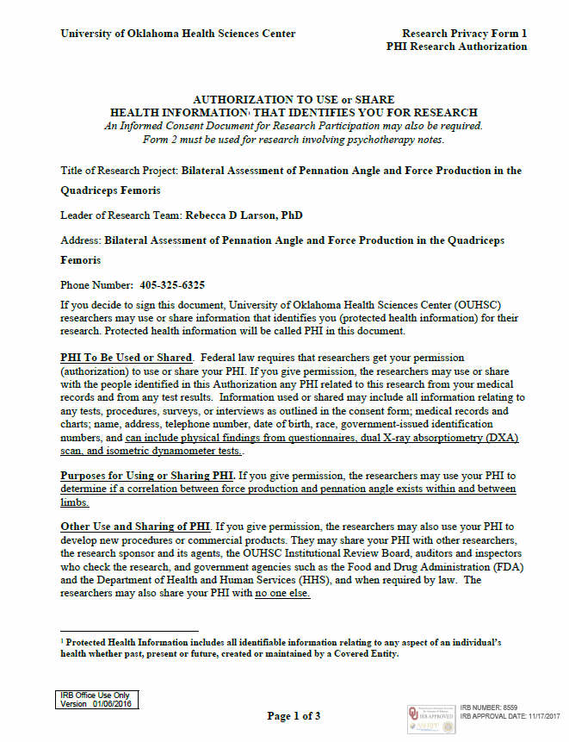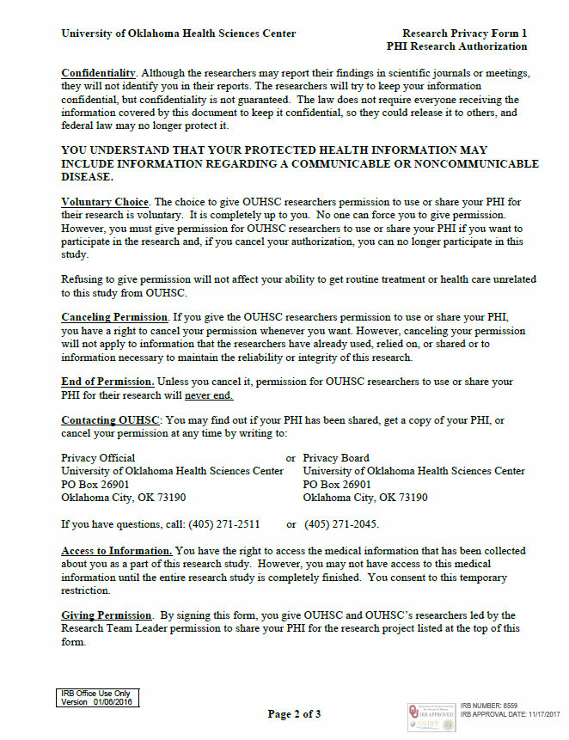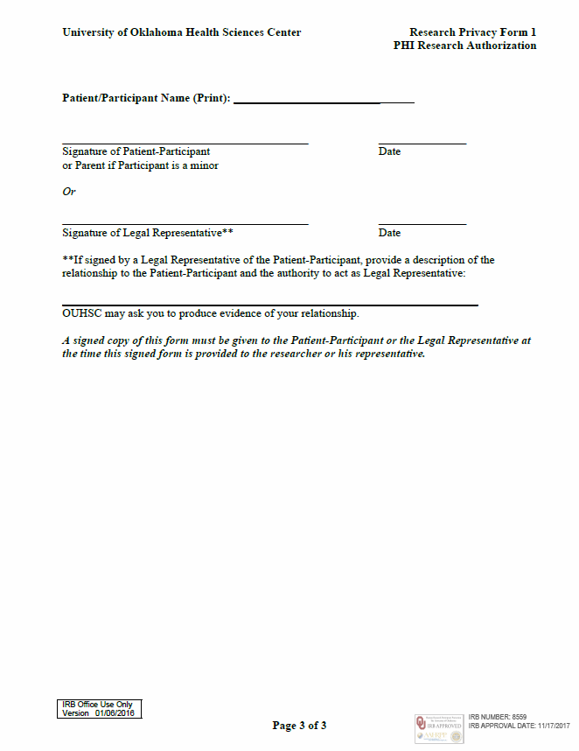
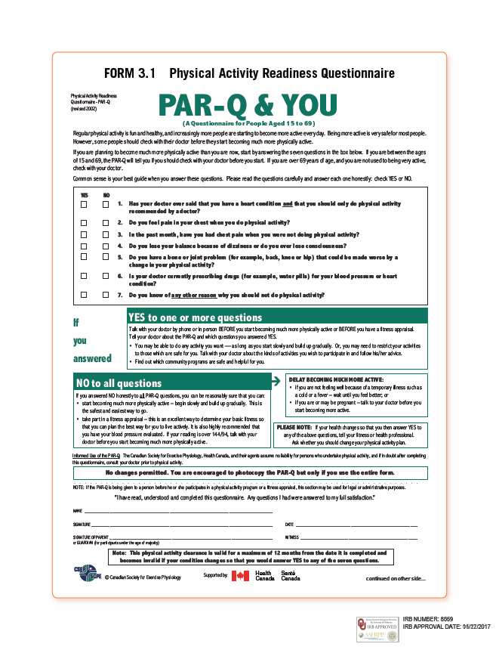
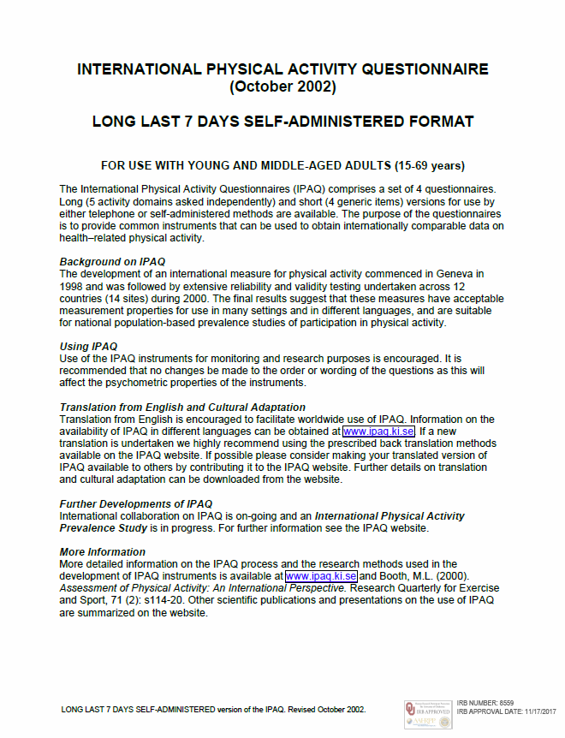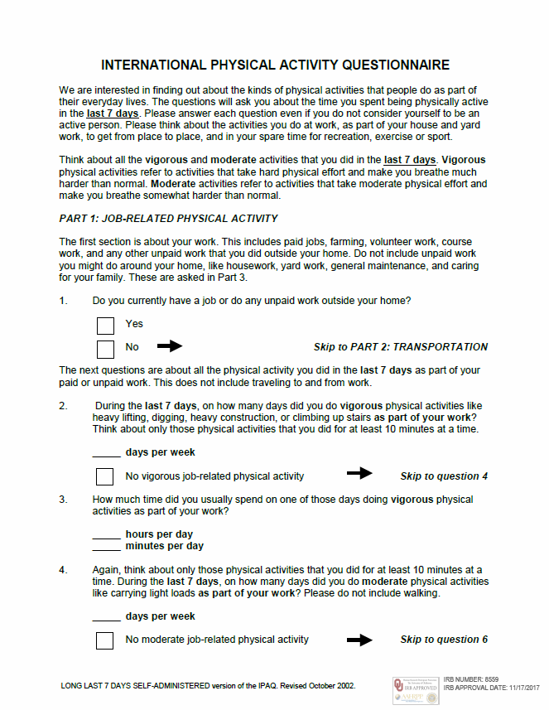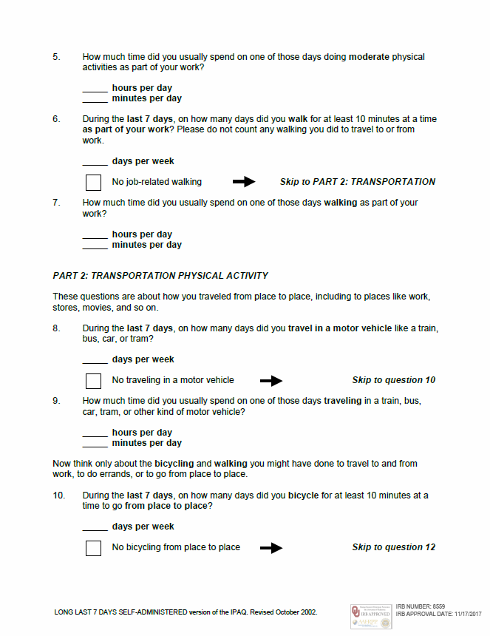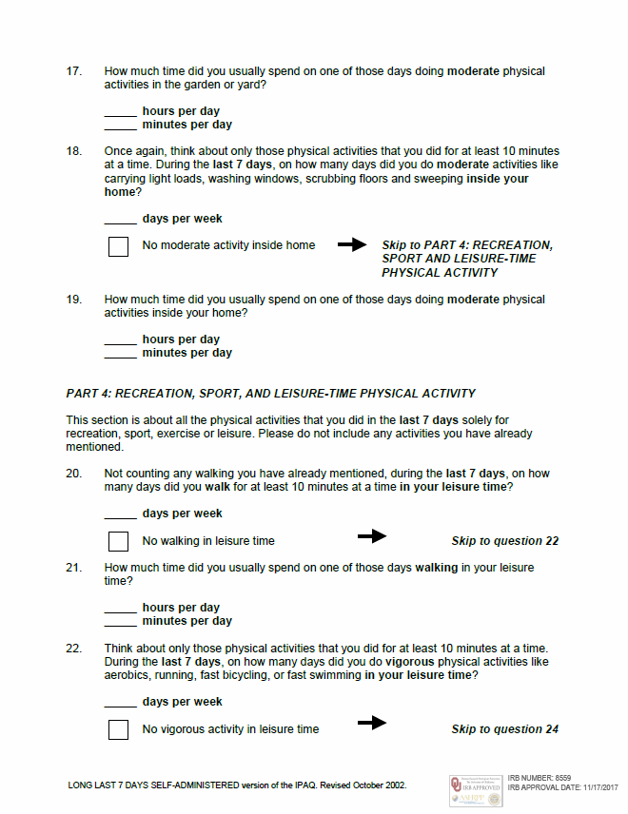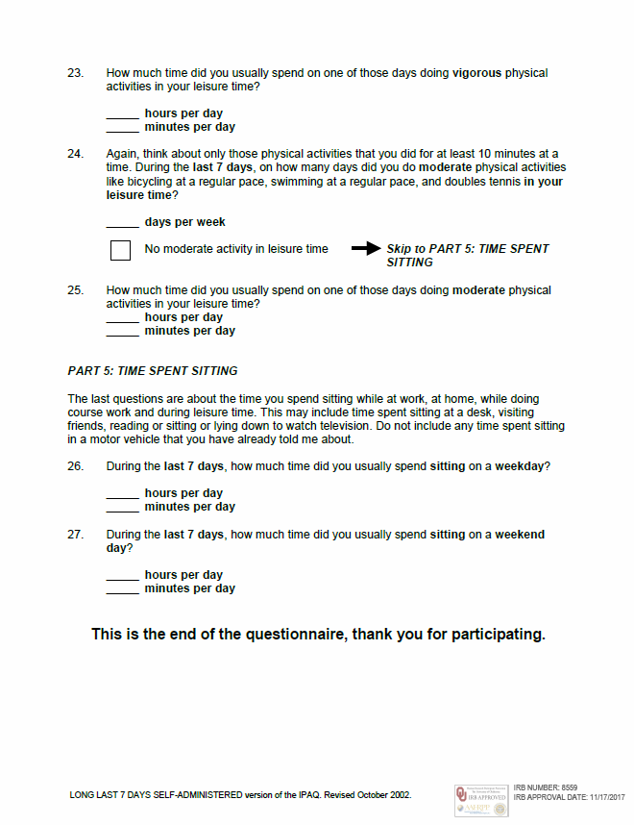

APPENDIX B
KinCom/Subject Measures Data Sheet
Pennation Measurement Data Sheet

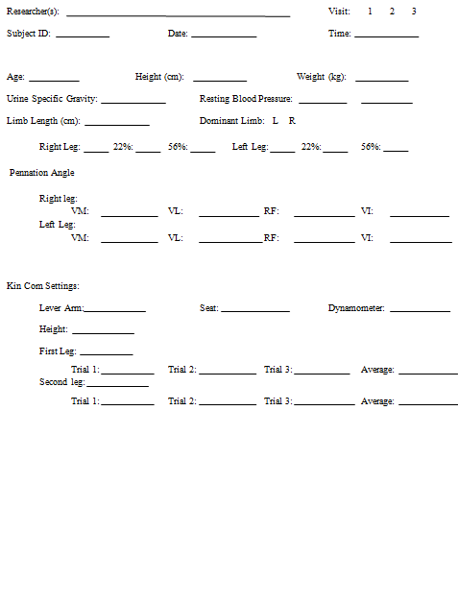
Researcher: _____
Subject: ____________

RVM 1: ___ ___ ___ avg ___
RVM 2: ___ ___ ___ avg ___ RVM avg: ___
RVM 3: ___ ___ ___ avg ___
RVL 1: ___ ___ ___ avg ___
RVL 2: ___ ___ ___ avg ___ RVL avg:___
RVL 3: ___ ___ ___ avg ___
RRF 1: ___ ___ ___ avg ___
RRF 2: ___ ___ ___ avg ___ RRF avg:___
RRF 3: ___ ___ ___ avg ___
RVI 1: ___ ___ ___ avg ___
RVI 2: ___ ___ ___ avg ___ RVI avg:___
RVI 3: ___ ___ ___ avg ___
LVM 1: ___ ___ ___ avg ___
LVM 2: ___ ___ ___ avg ___ LVM avg:___
LVM 3: ___ ___ ___ avg ___
LVL 1: ___ ___ ___ avg ___
LVL 2: ___ ___ ___ avg ___ LVL avg:___
LVL 3: ___ ___ ___ avg ___
LRF 1: ___ ___ ___ avg ___
LRF 2: ___ ___ ___ avg ___ LRF avg:___
LRF 3: ___ ___ ___ avg ___
LVI 1: ___ ___ ___ avg ___
LVI 2: ___ ___ ___ avg ___ LVI avg:___
LVI 3: ___ ___ ___ avg ___

