University of Oklahoma

Graduate College

The influence of online cues and warranting value
on impression formation

A Dissertation

submitted to the Graduate Faculty

in partial fulfillment of the requirements for the

Degree of

Doctor of Philosophy

By

brianna l. lane
Norman, Oklahoma
2015

the influence of online cues and warranting value
on impression formation

A Dissertation approved for the
Department of Communication

By

______________________________
Dr. Amy Johnson, Chair

______________________________
Dr. Ioana Cionea, Co-Chair

______________________________
Dr. Norah Dunbar

______________________________
Dr. John Banas

______________________________
Dr. Matthew Jensen

© Copyright by brianna l. lane 2015
All Rights Reserved.

Acknowledgements
I cannot believe the moment has arrived when I reflect back on the process of writing a dissertation and recognize all who have contributed to my success. How can I possibly thank all who have helped me in this venture? Lord knows, this was not a solo-journey; I could write a dissertation-length acknowledgements section.
First, I must thank my advisors and committee. I will never forget being introduced to Dr. Norah Dunbar, whose first words to me included “I want you on my team.” I could never have guessed that a simple statement would lead me down a path, both equally frustrating and rewarding, that would end with identifying myself as an experimental researcher. I am a researcher because of Norah.
I must also thank Dr. Ioana Cionea, whose response when I asked her to teach me structural equation modeling was an enthusiastic “Of course!” It was in that simple response that my dissertation began to take shape. It is because of Ioana’s enthusiasm, encouragement, and attention to detail that I have become a scholar.
My committee members have also provided unfailing support. Dr. Amy Johnson remained flexible and positive as my committee members’ roles shifted. Dr. Matthew Jensen’s criticisms came in the form of encouraging suggestions and I will always appreciate his reassuring nonverbal communication when I felt like I was floundering. Dr. John Banas was always my cheerleader while continually challenging me. My dissertation would not exist if it weren’t for those five committee members who never questioned my ability to succeed.
Second, I must thank my family. I greatly appreciate your attempt at understanding what I do and what I study, even if it was feigned interest in my research. Thank you for your support and constantly reminding me that I could do this and I was ridiculous for thinking I couldn’t. Also, thank you for becoming Sooner fans even if it was forced upon you.
Finally, I must thank my “framily.” (Yes, I did just use that word.) You know who you are. Our semi-weekly dinners helped me maintain sanity and remain productive. Your empathy was my survival tool – reminding myself that you knew how I was feeling and what I was dealing with was the only reason I finished with all my hair and teeth. And specifically to my girls, Carrisa and Alaina, what can I say? We have laughed, cried, cheered, yelled, cursed, drank, suffered, and celebrated together. There is no way I would have finished without your friendship.
Table of Contents
Acknowledgements iv
List of Tables ix
List of Figures x
Abstract xi
Chapter 1: Warranting Theory 1
Chapter 2: Warranting Theory as a Brunswik Lens Model 8
Theoretical Framework: Warranting Theory as a Brunswik Lens 8
Third-Party Cues and Warranting Value 15
Warranting Value and Impression Formation 24
Chapter 3: Pilot Study 35
Method 35
Participants 35
Procedures 36
Conditions 37
Measures 39
Results 42
Data cleaning and manipulation checks 42
Data transformation 43
Reliabilities 47
Confirmatory factor analyses 47
Conclusion 53
Chapter 4: Main Study 55
Method 55
Participants 55
Procedures 56
Measures 56
Results 57
Data cleaning and manipulation checks 57
Data transformation 59
Reliabilities 60
Confirmatory factor analyses 63
Hypotheses tests and model results 68
Chapter 5: Discussion 74
Hypothesized model 74
Theoretical implications and Brunswik lens model 81
Limitations 86
Directions for future research 87
Conclusion 91
References 94
Appendix A 100
Appendix B 116
Appendix C 119
Appendix D 120
Appendix E 123
Appendix F 124
Appendix G 127
Appendix H 128

List of Tables
Table 1. Minimum and Maximum Values Pre- and Post-Winsorization, Pilot Study 45
Table 2. Skewness and Kurtosis Values Pre- and Post-Transformations. Values of k and λ in the Transformation Equation Y* = (Y + k)^{(λ)}, Pilot Study 46
Table 3. Reliability Scores of Scales, Pilot Study 47
Table 4. Confirmatory Factor Analyses Fit Indices, Pilot Study 52
Table 5. Manipulation Check Questions by Condition, Main Study 59
Table 6. Minimum and Maximum Values Pre- and Post-Winsorization, Main Study 61
Table 7. Skewness and Kurtosis Values Pre- and Post-Transformations. Values of k and λ in the Transformation Equation Y* = (Y + k)(λ), Main Study 62
Table 8. Reliability Scores of Scales, Main Study 63
Table 9. Confirmatory Factor Analyses Fit Indices, Main Study 67

List of Figures
Figure 1. Multi-layered lens depiction, adapted from Jensen et al. (2010). 15
Figure 2. Proposed model for effects of online cues and warranting value on impressions. 34
Figure 3. Results model for effects of online cues and warranting value on impressions.. 72
Figure 4. Modified results model with post hoc paths for effects of online cues and warranting value on impressions... 73
Abstract
Warranting theory was developed as a means to understand how individuals judge whether online information is reliable and valid and how those judgments influence their impressions (DeAndrea, 2014; Walther, 2011). Information that is immune to manipulation by the person to whom the information refers has warranting value. The more warranting value information has, the greater influence it will have on impressions. Previous research has shown that online cues influence impression formation (e.g. Tong, Van Der Heide, Langwell, & Walther, 2008; Walther, Van Der Heide, Hamel, & Shulman, 2009; Walther, Van Der Heide, Kim, Westerman, & Tong, 2008). However, warranting value, theorized to mediate the relationship between cues and impressions, has only been hypothesized but not tested empirically.
This dissertation conceptualizes warranting theory as a Brunswik lens model in which individuals observe online cues, make a judgment about the warranting value of those cues, and then form impressions based on their warranting value judgment. An experiment was conducted in which participants (N = 209) were randomly assigned to view a hypothetical website similar to RateMyProfessors.com. The presence of aggregated data, the number of reviewers, the identifiability of the reviewer, and the presence of comments on the reviews were manipulated. Results of a structural equation model revealed that specific cues did not influence judgments of warranting value which indicates that the warranting process may not function as a Brunswik lens model. Results offer support for warranting theory, in that judgments of warranting value influenced impressions.
Chapter 1: Warranting Theory
People rely on the Internet to seek out information about potential employers and employees, prospective romantic partners, and others’ opinions about products they are considering buying. This information seeking also applies to potential professors in whose courses one might enroll. Over four million college students access RateMyProfessors.com each month to review or to seek out professors within their universities (About RateMyProfessors.com, n. d.). It is unknown, however, how these students know if the reviews are credible or whether they come from a professor’s actual students. It is also unknown how Internet users decide whether to trust reviews others post online. Also, if Internet users trust the information acquired online, it is unknown how that information influences their subsequent decisions, such as whether to purchase a product or to enroll in a professor’s course.
In 2002, Walther and Parks introduced the idea of a warranting construct in computer-mediated communication (CMC). The idea of warranting was developed as an expansion of ideas proposed by Stone (1995), who explained that a person’s intangible identity has a strong, unquestionable connection to the person’s physical self. However, the nature of online contexts makes it more difficult to establish undisputable warrants between an online identity and a physical person because there is no direct link between an online identity presentation and an offline body. That is, individuals can present themselves deceptively for different reasons. First, there are greater opportunities to remain anonymous online. Therefore, an indvidual’s online presentation has no connection to the offline person because no one knows who that offline person is. Second, individuals may wish to strategically present themselves online, specifically, for example, in online dating websites, when they want to create a favorable impression of themselves for other website participants. These online daters may alter or exaggerate certain characteristics they have. However, there is no indisputable connection between their strategic online presentation and their offline body. These individuals will not meet face-to-face with most of the people with whom they interact online and, therefore, their deceptions could go unnoticed.
To decipher what information is trustworthy or reliable, warranting theory claims that individuals assign warranting value to online information. Online information that provides some form of a warrant, or connection to the corporeal person, has greater warranting value than information that cannot be connected to an offline body (DeAndrea, 2014; Walther, 2011; Walther & Parks, 2002). Warranting value refers to the legitimacy and validity of identity claims in a computer-mediated context such as one’s profile on Facebook or an online dating profile. Information about a person online is likely to be seen as truthful to the extent that it is not easily manipulated by the user (Walther, 2011). For example, information included in open text boxes that request an individual to describe his body type within an online dating website could easily be fabricated. However, a photo that objectively shows a person’s body type is not as easily manipulated. Even though photographs can be altered with photo editing software, manipulating photos requires more effort than altering words in a text box. Consequently, the photographs are perceived to have higher warranting value because the cost or time to manipulate the photo is greater than the cost or time to manipulate a verbal description. Therefore, information with high warranting value can be verified and is not perceived as deceptive, whereas information with low warranting value is perceived to have been manipulated or to be deceptive. Observers of online information are suspicious of the veridicality of personal information individuals post on their own profiles because individuals have greater control over their own online self-presentations and little control over what others post online.
Simply put, information that is not easily controlled by the individual to whom it refers has high warranting value and, therefore, is deemed legitimate and valid because it relates to the real world person. Walther and Parks (2002) explain that, although previous work has considered the physical self and one’s online identity as two separate identities, warranting theory conceptualizes the relationship as a continuum of association, or variation in the strength of the connection. They describe this relationship as a continuum because information can have differing degrees of warranting value. That is, some information provides a strong connection to an offline entity, such as a photograph in which the offline person can be identified, whereas other information provides no connection to an offline body, such as a pseudonym that cannot be connected with the person to whom the pseudonym refers.
Warranting value can account for the way observers assess the match between online self-presentations and the individual’s offline body (Walther, 2011). Walther and Parks (2002) introduced warranting theory specifically to examine individuals’ online identity claims, but this theory has recently been expanded beyond identity claims to include online collaborative media and review websites in which there is no inherent identity claim (e.g., DeAndrea, Van Der Heide, & Easley, 2015; DeAndrea, Van Der Heide, Vendemia, & Vang, 2015).
The primary goals of this research are to test warranting theory 1) as a Brunswik lens model, 2) within a new context, and 3) as a process in which warranting value is a mediator between the observation of online cues and impression formation. First, warranting theory can be conceptualized from a Brunswik lens perspective, which describes how cues in one’s environment can influence an observer’s judgments. Those judgments then shape an observer’s impressions of the target (Hall & Pennington, 2013). Walther, Van Der Heide, Kim, Westerman, and Tong (2008) described the lens model as a process in which “environmental cues function as a lens through which observers make inferences about the underlying characteristics of a target” (p. 33). A lens model approach to warranting theory can reveal what online cues are used when individuals form judgments of warranting value and how those judgments influence impression formation (Hall, Pennington, & Lueders, 2014).
The second goal of the present research is to test warranting theory within a new context. Much research on warranting theory has focused on the social network site Facebook (e.g., Tong, Van Der Heide, Langwell, & Walther, 2008; Utz, 2010; Walther, Van Der Heide, Hamel, & Shulman, 2009; Walther et al., 2008). However, more recent research has applied warranting theory to new contexts such as product review websites (DeAndrea, Van Der Heide, Vendemia, et al., 2015) and online collaborative media (DeAndrea, Van Der Heide, & Easley, 2015), which has expanded the scope of warranting theory. Originally, warranting theory was proposed to describe how individuals connect one’s online identity claims to the offline entity (Walther & Parks, 2002). Parks (2011) stated that a boundary condition of warranting theory was that an online identity claim must exist for the theory to apply. The works of DeAndrea, Van Der Heide, Vendemia, et al. (2015) and DeAndrea, Van Der Heide, and Easley (2015), however, have demonstrated that observers of online information still make judgments about warranting value even when an explicit identity claim does not exist. To fully understand how individuals form impressions about online information, and make judgments about the veracity of that information, warranting theory should be expanded beyond the context of Facebook because individuals utilize the Internet for much more than social networking. For example, many people use the Internet for online shopping. In fact, the Pew Research Center found that 66% of Americans have purchased a product online but even more people would shop online if they trusted the website (Horrigan, 2008). As individuals become more dependent on technology, it is important to understand how they process and understand the information they encounter online.
This research extends warranting theory by applying it to an online context of a professor rating website very similar to RateMyProfessors.com. This type of website is similar to a product review website but involves students reading reviews about a professor and making decisions about enrolling in that professor’s course. The purpose of RateMyProfessors.com is for students who have already completed a course to rate their experience so that other students who are considering the course or professor have some information for making their decision. Over four million college students access RateMyProfessors.com each month and these students make enrollment decisions based on reviews left by other students (About RateMyProfessors.com, n. d.). Students use RateMyProfessors.com to determine whether they should take a course from a particular professor and they make their decision only after forming impressions of the professor from other students’ reviews. Specifically, RateMyProfessors.com (n. d.) claims the website “does what students have been doing forever - checking in with each other – their friends, their brothers, their sisters, their classmates – to figure out who's a great professor and who's one you might want to avoid” (n. p.). As predicted by warranting theory, certain cues within the website ought to influence participants’ perceptions of warranting value, or how accurate, believable, and reliable the reviews are, which then may influence their impressions of the professor.
The third goal of this research is to test warranting theory as a process in which warranting value is a mediator between the observation of online cues and the formation of impressions. The influence of warranting value has only been hypothesized in the warranting process, but its influence has not been empirically tested (DeAndrea, 2014). This dissertation operationalizes warranting value to empirically test its influence in the warranting process.
These three goals are achieved through an experiment that tests the influence of the presence of professor comments, the identifiability of the student reviewer, the total number of ratings, and the presence of aggregated data on participants’ judgments of warranting value and impressions of the professor. The following chapters present in detail a discussion of the Brunswik lens framework through which the warranting process can be viewed. A model testing the influence of online cues on impression formation is proposed. Next, the method and results of a pilot study designed to examine the factor structure, dimensionality, and reliability of all measures, including those measures developed for this dissertation, are presented. Chapter 4 presents the method and results of the experiment in which the hypothesized model was tested. Chapter 5 includes a discussion of these results with implications for warranting theory as a Brunswik lens model. Finally, limitations and directions for future research are presented.

Chapter 2: Warranting Theory as a Brunswik Lens Model

Theoretical Framework: Warranting Theory as a Brunswik Lens
Brunswik’s (1956) lens model provides a useful technique for conceptualizing social judgments of personality because the model allows researchers to examine both the encoding (i.e., sending a message) and the decoding (i.e., interpreting a message) processes. This perspective posits that environmental cues, such as one’s bedroom décor or photos posted on a social network site, can serve as a lens through which observers make attributions about a target (Walther et al., 2008). These indicators lead to perceptual judgments through which attributions are made. That is, cues within a person’s environment lead to judgments about that person. Those judgments influence impressions of the target. For instance, if the tire rims on a person’s vehicle are judged by an observer to be flashy and overstated, that person’s impression of the vehicle owner could be that he or she is arrogant. In another way, the judgment about the rims could be that they are very fancy and high-class, so that observer’s impression of the vehicle owner could be that the owner takes pride in his or her accomplishments. Gosling, Ko, Mannarelli, and Morris (2002) described how features of a personally created environment, such as one’s bedroom or office, could be seen as personality expressions of the individual to whom the environment belongs. These researchers had observers examine the personal workspaces of 94 workers and rate the workers’ personalities based on their environment. The observers utilized cues within the office spaces, such as the decorations and the number of magazines, books, and CDs, to make judgments of the owners’ personalities on levels of openness, extraversion, and conscientiousness. Similarly, research has found that cues regarding one’s Facebook friends, such as the number of friends one has, the friends’ attractiveness, and the comments left by the friends, are used to make judgments about the Facebook profile owner. For instance, the attractiveness of the profile owner’s friends (Walther et al., 2008) and comments left by those friends about the profile owner’s attractiveness (Walther et al., 2009) influenced impressions of the profile owner’s attractiveness. Overall, the lens model paradigm has been used to understand how observers utilize certain cues and how those cues then inform impressions.
Hall and Pennington (2013) argued that the lens model was appropriate to apply to CMC contexts because its purpose was to document behaviors associated with targets’ personalities (e.g., identity claims) and cues used by observers to form impressions of the targets. In sum, the Brunswik lens paradigm provides a method for describing how cues in one’s environment, whether CMC or face to face (FTF), are used to form impressions of a target. This perspective is useful for describing the warranting process because cues within a system inform judgments about the match between one’s online representation and the offline person, which then lead to overall impressions of the individual.
Gifford (2006) describes a modified Brunswik lens as being composed of three processes: encoding, decoding, and agreement. In Brunswik’s (1956) terms, these same three processes are called cue validity, cue utilization, and achievement, respectively. Encoding, or cue validity, is the process in which an individual’s personality manifests in certain nonverbal cues. For example, if an individual is extraverted, that person may decorate his or her environment with group photos of his or her friends. Or, an individual’s environment may contain athletic equipment because that person is competitive and enjoys sports. Decoding, or cue utilization, involves an observer interpreting those nonverbal cues and making assessments of the target’s personality. So, if an observer sees many photos in a person’s environment, that observer may then determine the person to be extraverted. Similarly, if an observer notices athletic equipment in a person’s environment, the observer could infer that the person is athletic and competitive. Agreement, or achievement in Brunswik’s (1956) terms, is the correspondence between a target’s personality and an observer’s judgments of the target’s personality. There would be high agreement if, in fact, a person is extraverted and the observer judged the person to be extraverted, or if the person was competitive and the observer believed the person to be competitive. There would be low agreement if the person was introverted, but the observer inferred from the person’s environment that the person was extraverted. Similarly, there would be low agreement if an observer thought a person was competitive when in reality that person was not. In an online context, cues on a website, such as number of friends on a Facebook profile, serve as indicators of the website owner’s personality, and observers of that website interpret those online cues in terms of the profile owner’s personality. Tong et al. (2008) found that the number of Facebook friends led to impressions of extraversion and social attractiveness. Low numbers of Facebook friends (100 or fewer) led to the impression that the profile owner was not extraverted nor socially attractive. Too many Facebook friends (over 500) led to impressions that the profile owner was desperate and spent more time online than with friends. Participants in Tong et al.’s (2008) study utilized the number of Facebook friends as a cue that had been encoded by the profile owner (i.e., the profile owner’s personality influenced the acceptance of Facebook friends), so they decoded the cue, or interpreted it, to form impressions of the profile owner’s extraversion and attractiveness. Agreement, or the correspondence between a profile owner’s actual levels of extraversion and attractiveness and an observer’s judgments of the profile owner, were not measured in Tong et al.’s (2008) study.
The Brunswik lens perspective has been applied mostly in studies examining personality constructs in FTF settings, but has also been applied to different types of mediated communication. For example, Jensen, Meservy, Burgoon, and Nunamaker (2010) examined how cues from mediated communication (video, audio, and text cues from a videotaped interview following a theft) could be used to predict judgments of involvement, tension, and arousal, which then informed impressions of truthfulness or deception of the interviewee in the video. These authors utilized a modified multi-layered lens model (an extra level of cognition added between observing cues and forming impressions) to examine how objective cues (nonverbal cues extracted from a videotaped interview) affected observers’ perceptual judgments of the interviewee’s involvement, tension, and arousal, and then how these judgments produced subjective meaning, or interpretations of the interviewee’s guilt or innocence. The cues examined by Jensen et al. (2010) included body movements and vocal variety. The judgments made based on these cues were hypothesized to inform attributions about the interviewee’s deceptiveness. In Jensen et al.’s (2010) study, the extra level of the multi-layered lens model consisted of the judgments regarding involvement, tension, and arousal, but the analysis went further to examine how those judgments informed observers’ impressions of guilt or innocence. In respect to warranting theory, this multi-layered lens approach can be used to describe how certain cues will lead to judgments of warranting value, which can then lead to impressions about a target. To clarify, the lens model includes the target’s personality as manifested in certain cues. Observers then interpret those cues. In the multi-layered approach, judgments are assigned to the cues and then those judgments are interpreted.
Jensen et al. (2010) examined nonverbal cues extracted from videos of individuals, but studies have also explored how personality characteristics can be interpreted from examining cues from one’s webpage or social network site (Gosling, Augustine, Vazire, Holtzman, & Gaddis, 2011). Facebook, in particular, has been examined through a Brunswik lens model. Walther et al. (2008) found that third party comments on one’s Facebook page influenced impressions of the profile owner’s credibility and attractiveness. Specifically, when Facebook friends left a positive comment about the profile owner, observers rated the profile owner as more attractive and more credible than when negative comments were present. Additionally, Hall and Pennington (2013) applied a lens model analysis to Facebook profiles and found that a profile owner’s personality, specifically the characteristic of self-monitoring, or the tendency to strategically present oneself in accordance with the environmental context, predicted certain Facebook cues. The researchers argued that high-self monitors would want to appear extraverted so they would construct an extraverted presentation in their Facebook profile. This construction would be manifested in certain cues, such as the number of Facebook friends, the number of people in photos, and the number of “likes” received. Hall and Pennington (2013) found that cues in the Facebook profiles of high self-monitors, such as the total number of friends and the number of “likes” received from others, influenced observers’ impressions of the profile owner’s extraversion, supporting their prediction. Similarly, the authors argued that individuals who were more honest (i.e., less strategic than high self-monitors when constructing their Facebook pages), would be judged as more conscientious. This hypothesis was supported as well. Overall, research regarding warranting theory has supported the application of a Brunswik lens model in that cues from a person’s environment (i.e., his or her Facebook profile) inform observers’ judgments about the profile owner’s personality.
Hall et al. (2014) conducted a study to explicitly test a Brunswik lens model within the context of Facebook. In their experiment, profile owners completed a questionnaire assessing their personality. Their Facebook profiles were coded for certain online cues related to their status updates (e.g., emoticon use), profile photo (e.g., photo sexiness), and Facebook friends (e.g., the total number of friends and number of friends in pictures). Observers then viewed the Facebook profile and rated the owner on dimensions of personality. They found that, with the exception of neuroticism, cues from one’s Facebook profile accurately led to impressions of that person’s personality. That is, the profile owner’s personality was manifested in certain cues, such as the total number of friends, the number of friends appearing in photos, and the emotional tone of status updates, on that person’s Facebook page. Observers, then, accurately interpreted those cues as reflections of the owner’s personality.
As previously stated, the Brunswik lens perspective is useful for examining the warranting process. DeAndrea (2014) clarified the theoretical terms in warranting theory and the warranting process by defining a warrant as any cue that legitimizes an online presentation. Warranting cues are similar to the extracted video cues examined by Jensen et al. (2010) or the Facebook cues examined by Walther et al. (2008). Warranting cues provide insight about the warranting value of information, or “a psychological construct that reflects perceptions about the extent to which information is immune to manipulation by the source it describes” (DeAndrea, 2014, p. 4). Warranting value would be analogous to the perceptual judgments outlined by Jensen et al. (2010) because they are both judgments an observer makes about cues. In Jensen et al.’s (2010) study, observers made judgments about the nonverbal cues and then those judgments of involvement, tension, and arousal led to impressions of the target’s guilt or innocence. In an online context, observers make judgments regarding the veracity or validity of online information and then form impressions based on those judgments.
The warranting principle, then, incorporates warranting cues and warranting value by claiming that the less information is perceived to be manipulated by the person to whom it refers, the more weight it will carry in impression formation. Simply put, warranting cues give insight into the warranting value of information. The warranting value then influences impression formation. The present research does not explicitly test cue validation, or the encoding process; that is, there is no measurement of the profile owner’s actual personality. However, the decoding process, or cue utilization, is explicitly tested. Cues within an online environment are examined to determine whether and how they may influence impressions of a target. The present research also employs a multi-layered approach similar to Jensen et al. (2010). It is a multi-layered lens model in that there is a middle level of cognition between observing cues and forming impressions. This middle level involves judgments about how easily manipulated the information could be and the degree of match between online information and offline identity. This process is depicted in Figure 1.
Online
cues
Warranting
value
Impressions
of target
Target’s
personality

Figure 1. Multi-layered lens depiction, adapted from Jensen et al. (2010).

Third-Party Cues and Warranting Value
According to warranting theory, information posted online about a person is likely to be seen as truthful to the extent that it is not easily manipulated by the user (Walther, 2011). In fact, information online has greater warranting value when the target of the online information, or the person to whom the online information refers, has limited control over the presentation of the information. This restricted control of information could include another person controlling the content or dissemination of information or a limited structure of the website on which the information appears (DeAndrea, Van Der Heide, Vendemia, et al., 2015; Parks, 2011; Walther et al., 2008). For example, product reviews include claims about a product, but the product owner or manufacturer has no control over the information that is posted online. Also, the product owner or manufacturer cannot control who reviews the products nor how many reviews appear on a website. According to warranting theory, product reviews have high warranting value because the product owner or manufacturer cannot control the information about the product that appears in reviews.
Specific cues within a mediated environment that can influence warranting value include the source of the information, such as a product reviewer, a Facebook friend, or the Facebook profile owner. Whether that source is identifiable could influence warranting value as well. For example, the advice given by an anonymous person on a health website should be treated with caution. If that person could be identified as a medical professional, that person’s advice would have more credence. Another cue that influences warranting value is how much control the source of the information has over the dissemination of content and over the content itself. For example, product reviews about the new iPhone found on the Apple website do not have as much warranting value as reviews found on neutral review websites because Apple has control over what reviews are posted on their website. Therefore, the reviews on that website are perceived as potentially biased and not fully accurate.
Warranting value will differ based on whether information is posted by the individual to whom the information refers or by a third party (i.e., a person or entity other than the person to whom the information refers). DeAndrea (2014) states that assigning warranting value by considering the source of information is a straightforward process because individuals have high control over the information they communicate. Because of this high control individuals have over their own communication, self-claims are thought to have low warranting value. However, individuals have little to no control over what others post, so third-party information is thought to have higher warranting value (Parks, 2011; Walther et al., 2009). Although this claim seems straightforward and obvious, research has found mixed support for the power of third party claims. Walther et al. (2009) found that, with regards to impressions of extraversion, third party comments did not necessarily influence observer impressions more than self-claims of extraversion. However, they also found, in a follow-up to their study, that third party comments had a significant effect on observers’ ratings of profile owner attractiveness, more than self-claims of attractiveness did (Walther et al., 2009). Similarly, Utz (2010) found that third party claims had a greater influence on impressions of communal orientation (operationalized by traits, such as friendliness and honesty) but not on perceptions of a target’s popularity as compared to self-claims, which had a greater effect on perceptions of popularity.
Overall, warranting theory posits that third-party information will have greater warranting value than self-claims and, therefore, would influence impressions more than self-claims would. Research results have been mixed, indicating this claim might only be supported when certain characteristics, such as extraversion and attractiveness, are examined in particular contexts, such as social network sites. Another possibility could be the lack of direct operationalization and measurement of warranting value. DeAndrea (2014) claims that no studies directly test the effects of warranting value because previous research has only examined the influence of certain cues on impressions without measuring or estimating warranting value. Because these studies have not measured warranting value, it has only been theorized but not empirically demonstrated that third-party comments have greater warranting value than self-claims.
Warranting value has been conceptualized in different ways. Information has warranting value when it can “connect the online persona to the off-line body and person” (Walther, 2011, p. 466). Also, warranting value is described as a “construct that reflects perceptions about the extent to which information is immune to manipulation by the source it describes” (DeAndrea, 2014, p. 187). Therefore, warranting value can be operationalized as two factors: 1) the perception of a connection between an online representation and offline self, and 2) the perception of limited ability to manipulate information.
When considering the effect of third party contributions, it is important to consider how third-party comments are operationalized. It is not just the presence of third party comments but also other system features that influence warranting value. The design of a website itself can provide greater credence to information. Walther and Parks (2002) argued that the warranting value of information about an individual is enhanced when the source has reduced control over the information. The design of a website can limit control of information simply by reducing text box entries in which there is complete control over the content. According to Walther et al. (2009), a personal web page should provide less warranting value than an institutionally-based web page that appears to be constructed by a webmaster or other third party. Other third-party cues that could contribute to warranting value include the ability to control the dissemination of or modify third party information, masking the source of third party information, and aggregated data (i.e., compiled information from multiple third party sources). It is reasonable to believe that one explanation for the mixed findings in previous research is due to these possible variations regarding third party content. These variations will be described in more detail in what follows.
Essentially, the more control the target of information has over third party comments, the less perceived warranting value the information has. This control can be the ability of a source to comment on reviews or to edit others’ comments. DeAndrea (2012) examined mock Facebook profiles and found that the presence of comments by the profile owner resulted in the perception that the profile owner had greater control over the information than when no comments were present. In other words, the presence of profile owner comments leads to the impression that the owner attends to the third-party information. Therefore, the profile owner is perceived to have control over the information. Third party commenters may tailor their responses if they know the profile owner can respond. Because of this perception, third party comments may be viewed as biased. Therefore, the following hypothesis is proposed:
H1: The presence of profile owner responses to third-party comments results in less warranting value demonstrated by a) less perceived match between the online representation and the offline self and b) greater perceived ability to manipulate the reviews.
Some research has shown mixed results regarding the effect of third party information, whereas other research (e.g., Utz, 2010; Walther et al., 2009) has shown that third party information has greater influence on impressions than self-claims. Additionally, if the source of the information is not believed to be truly third-party, warranting value will be lessened (DeAndrea, 2014). However, if individuals are identifiable, they are less likely to provide misleading information. For example, if a restaurant reviewer could be identified as an actual customer, the review has more credence. If the reviewer is anonymous, it could be the restaurant owner leaving the review, if it is a positive review, or it could be the restaurant’s competition, if the review is negative. Walther and Parks (2002) explained that when a system allows anonymity, the online presentation differs drastically from the physical self. The anonymity given by avatars in role-playing games, such as Second Life, allows users to explore alternate identities, such as different sexual orientations when the actual person is straight, or a male when the person is actually female. If the user is not anonymous, however, there should be less discrepancy between the online presentation and the offline person because the person would be caught and possibly ostracized by other members of the online community for presenting false information.
When the medium allows greater anonymity, the online presentation of one’s self could differ dramatically from the actual physical self. In less anonymous systems, especially if there is the potential for future face-to-face interaction, departure from an accurate description would come with more risks and potentially greater costs (Walther & Parks, 2002). Members of an online dating website must balance the desire to be attractive with the need to be authentic in their presentations because they will potentially meet face to face other members from the online community. Therefore, if the information is from an identifiable source, it is perceived to be more credible and valid information, and not as biased or deceptive. An anonymous screen name allows users to take on any identity, whereas an identifiable screen name, such as first name and last initial, restricts individuals in how they can conduct themselves online because their corporeal self can be identified. Therefore, it is proposed:
H2: Identifiability of the third-party commenter results in greater warranting value demonstrated by a) greater perceived match between the online representation and the offline self and b) less perceived ability to manipulate the reviews.
Aggregated information is also a type of third party information to which observers can assign warranting value. Aggregated data, or accumulated information, is perceived to be less biased because it is a combination of multiple third party reviews. Walther and Jang (2012) define aggregated data as “computer-generated descriptive statistics that a web page displays representing accumulations of users’ ratings, votes, or other site-related behaviors” (p. 5). For example, the number of friends a user has on Facebook is considered aggregated information and can affect the impressions observers have of a profile owner (Utz, 2010). Tong et al. (2008) found a curvilinear effect for number of Facebook friends and impressions of social attractiveness. They claimed that profile owners with an excessive amount of Facebook friends were perceived to manipulate the aggregated data in that they requested friendship and accepted friend requests without discrimination, which led to the impression that the profile owners were desperate. This perceived manipulation resulted in negative impressions of the profile owner’s social attractiveness. However, individuals with a moderate amount of Facebook friends (102 to 502 friends) were judged to be socially attractive.
In a different context, such as Amazon.com or RateMyProfessors.com, the number of individuals providing ratings is also considered aggregated information. This type of aggregated data is highly immune to manipulation; for example, Amazon.com cannot control the number of reviews purchasers post. Similarly, a YouTube.com video poster cannot control the number of views their video has. Because incidental aggregated information is more difficult to control, it has high warranting value. DeAndrea (2014) claims that the warranting value of aggregate data may increase as the number of people contributing information increases. For example, an item on Amazon.com with only three ratings will be judged differently than an item that has 100 ratings. A person will be more willing to trust the common opinion of 100 people than the common opinion of only three people because it would be possible for three biased or deceptive individuals (or even a single person reviewing the item three times) to conspire and write a false review. It would be exceedingly difficult for 100 people (or one person reviewing a product 100 times) to collaboratively deceive observers. Flanagin and Metzger (2013) found a positive relationship between the total number of ratings provided in a hypothetical movie review website and observers’ judgments of credibility, reliability, and confidence in the reviews. A high number of total reviewers resulted in greater trust in the reviews. Therefore, the higher the number of individuals contributing to the aggregated data, the greater the warranting value. The following hypothesis is posited:
H3: Larger number of ratings result in greater warranting value demonstrated by a) greater perceived match between the online representation and the offline self and b) less perceived ability to manipulate the reviews.
Besides the total number of reviewers or raters, aggregated data can also include the subjective ratings of those reviewers (Walther & Jang, 2012). McClelland (1970) examined the effect of manipulating instructor reputation by presenting negative aggregated student ratings from previous years to students currently completing course evaluations. Results showed that students who read negative ratings of their professor before rating the professor themselves were influenced by the aggregate ratings in that they rated the instructor more negatively than those students who did not see the negative ratings. McClelland (1970) demonstrated the power of third-party contributions to impression formation even when students had partaken in a course for an entire semester prior to giving their assessment. Even though these results were not in an online context, they are consistent with what warranting theory would predict because third-parties’ opinions are perceived to be more trustworthy. Additionally, aggregated data is not easily manipulated and, therefore, is considered reliable and valid.
Aggregated data includes the valence of the overall ratings, that is, whether an item on Amazon.com or a professor on RateMyProfessors.com was rated overall as positive or negative. As warranting theory predicts, information provided by a third party is perceived to have more influence on impressions than self-claims (Walther, 2011). For instance, according to warranting theory, average ratings from students for a professor on RateMyProfessors.com would have greater influence on impressions of the professor than self-claims made by the professor. If a professor presents himself or herself professionally online, and aggregated data show that the professor is credible, observers will rate the information as having high warranting value because there is a perceived match between the professor’s online self and offline self. However, there is little research directly testing the effect of aggregated user representations on perceptions of warranting value and how those perceptions affect impressions. Warranting theory predicts that aggregated online information will have higher warranting value because aggregated information is perceived to be immune to manipulation (DeAndrea, 2014). That is, an individual could not manipulate the overall average ratings of a professor or a product. Therefore, the following hypothesis is proposed:
H4: The presence of average ratings results in greater warranting value demonstrated by a) greater perceived match between the online representation and the offline self and b) less perceived ability to manipulate the reviews.
The warranting principle predicts that warranting cues perceived to have warranting value will have greater weight in influencing impression formation than cues with little or no warranting value (DeAndrea, 2014). The next section describes the impressions that warranting value could influence within the context of RateMyProfessors.com.

Warranting Value and Impression Formation
At the very core of warranting theory is the proposition that the more warranting value information is perceived to have, the more it will influence impression formation (DeAndrea, 2014). However, the theory does not specifically address how those impressions are formed nor does the theory address what types of impressions are formed. Edwards, Edwards, Qing, and Wahl (2007) and Edwards and Edwards (2013) utilized the heuristic-systematic processing model (HSM; Chaiken, 1980) to describe how information accumulation influences attitudes. This model, originally designed for persuasion settings, can be applied to online review websites. Product review websites are a persuasion setting because product reviewers post their opinions online with the intention of influencing others. Online review websites, such as Yelp.com and RateMyProfessors.com, provide individuals with information based on which they can form attitudes or opinions of their own. This dual process model describes how individuals process information heuristically (i.e., based on mental shortcuts), or systematically (i.e., based on careful examination and evaluation of the information; Chaiken, Liberman, & Eagly, 1989). Systematic processing is more cognitively taxing and requires more effort. Therefore, individuals will use mental shortcuts, which could include the use of stereotypes or biases, to process information (Chen & Chaiken, 1999). Edwards et al. (2007) describe motivation, self-efficacy, and information sufficiency as the three antecedent variables that influence whether an individual processes information heuristically or systematically. Motivation refers to the importance of a decision, self-efficacy deals with an individual’s ability to acquire and use information, and information sufficiency is the perception that adequate information has been gathered. These antecedent variables can determine if information is processed heuristically or systematically. If an individual has a high level of motivation (i.e., the decision is important), he or she is more likely to process information systematically. Similarly, if there is high efficacy (i.e., the individual is able to gather and interpret information), that person will process information systematically; if that person does not have the ability to gather or interpret information, he or she will make a decision based on heuristics. If an individual has high information sufficiency, or perceives that the information he has is adequate, he is more likely to process information heuristically (Edwards & Edwards, 2013). This process can then shape attitudes and impressions about the information (Edwards et al., 2007; Edwards & Edwards, 2013).
In an online context, individuals may use both cognitive processes, depending on the decision. For example, an online dater may quickly deny communication with a person who is covered head-to-toe in tattoos and piercings in the profile photo. In this example, the online dater did not think it was worth the effort to gather and consider all possible information about the person before deciding whether or not to engage in communication. The online dater may have relied on cognitive heuristics (e.g., criminals are covered in tattoos) because he or she lacked the motivation to engage in systematic processing. Another example is the decision to purchase a new laptop. An individual could rely on mental heuristics (e.g., friends use Macs, so it must be a better choice than other laptops), but since this is an expensive purchase, he or she has the motivation to process information systematically. This person may, therefore, read product reviews of different laptops and carefully consider the features and price of each laptop.
The HSM provides a useful framework to describe how information is processed and how decisions are made or how impressions are formed because it describes how and when individuals will put in the effort to evaluate information that will be used to form impressions. However, it does not describe what specific impressions could result from this process. For example, after viewing an instructor rating website, individuals may form impressions of the professor’s credibility, attractiveness, or intelligence. Within warranting theory research, perceptions of attractiveness and extraversion (Walther et al., 2009), communal orientation (Utz, 2010), and popularity (Hong, Tandoc, Kim, Kim, & Wise, 2012; Utz, 2010) have been examined. These studies focused on impressions formed based on cues from the specific social network site Facebook. Research has also examined warranting theory outside the context of social network sites. DeAndrea, Van Der Heide, and Easley (2015) tested warranting theory within the context of online collaborative media (e.g., a wikispace), and measured observers’ perceptions of the wikispace contributors’ task attractiveness. DeAndrea, Van Der Heide, Vendemia, et al. (2015) tested warranting theory within the context of a restaurant review website. These researchers measured the perceived quality of the restaurant and intentions to recommend the restaurant to others as impression variables.
Phelps, Lewis, Mobilio, Perry, and Raman (2004) argued that word-of-mouth communication that occurs online has exceeded traditional word-of-mouth communication (e.g., advertisements in magazines or face-to-face communication) in its influence on decision-making because of its convenience, breadth of information, and lack of face-to-face social pressure. The search for word-of-mouth communication when forming impressions or making decisions has even expanded beyond product or service reviews into an academic context. With such breadth and depth of information, as well as the convenience of accessing that information, university students are increasingly looking at professor rating websites when making decisions on their course curriculum (Edwards et al., 2007). Word-of-mouth communication, it has been argued, is more influential than pamphlets or advertising campaigns (for an overview, see Edwards et al., 2007). Specifically, in the case of instructor ratings, Borgida and Nisbett (1977) found that word-of-mouth communication from students who had taken a psychology course was more influential in other students’ decisions than mean course evaluation scores were.
RateMyProfessors.com is a popular website where students can review professors and courses they have taken at specific universities. Students can search for a specific professor at a particular university and rate that professor on items of overall quality, helpfulness, clarity, and easiness. Additionally, there is a chili pepper icon that indicates the professor’s overall “hotness,” or physical attractiveness. Alongside each review is a bar graph of the reviewers’ individual quantitative ratings of the professor’s easiness, helpfulness, clarity, and rater interest. Additionally, there is a face colored red, yellow, or green depending on if the professor was poor quality, average quality, or good quality. Furthermore, students can submit comments about the professor and the course. Some believe these ratings are biased because they are affected by emotion – students who had a terrible experience can use this medium for cathartic purposes, or as a safe haven in which they can complain (Otto, Sanford, & Ross, 2008). Some research has shown that students may be perceived as experts having had experience with the specific professor, and there could be a balance between positive and negative ratings. Regardless of the slant of student ratings, the question still remains of what types of impressions can be formed after reading a professor’s profile. For example, if a student is deciding which course to enroll in based on RateMyProfessors.com reviews, the student may form impressions of the professor’s level of difficulty. The student may also form impressions of the professor’s personality, such as the professor’s level of friendliness or helpfulness.
Research assessing impressions of instructors has used different measures of impressions. Some research has only examined general instructor impressions (e.g., Buchert, Laws, Apperson, & Bregman, 2008; Grigorovici, Nam, & Russill, 2003), using single item indicators for characteristics such as likeability or temperament. Other studies have measured instructor impressions using established scales of credibility, attractiveness, and homophily, among others (e.g., Dunbar & Segrin, 2012; Edwards et al., 2007; Guerrero & Miller, 1998; Myers et al., 2009). Research on instructor impressions has also examined various characteristics within differing contexts. For example, Guerrero and Miller (1998) had students watch videotaped lectures from professors and then measured the students’ impressions of the professors. In a videotaped lecture where there is no interaction with students like in a traditional classroom, the nonverbal behaviors of the instructor, specifically expressiveness, warmth, and involvement, were shown to influence student perceptions of instructor competence. Grigorovici et al. (2003) examined the effect of an interactive syllabus (i.e., an online syllabus with hyperlinks) on instructor impressions. They found that lower interactivity resulted in more positive impressions of the professor. Dunbar and Segrin (2012) looked at the effect of an instructor’s clothing on impressions of credibility and retention of a lecture’s material. They found that teachers who were dressed more formally were judged as more credible and that students who listened to a lecture from the moderately dressed teacher had the highest retention of learned material. Overall, research concerning impressions formed by students about their instructors has spanned contexts and cues, scrutinizing the effects different antecedents have on various impressions. Because students seek out information about potential future professors through websites such as RateMyProfessors.com and base enrollment decisions on the reviews they find, research needs to expand to examine the impressions formed within that context. Students’ enrollment decisions can affect their success in school and ultimately, their graduation. Because of these significant possible outcomes, learning how students form impressions about instructors based on online reviews is paramount.
Research regarding instructor impressions has often used the dependent variables of credibility, attractiveness, and homophily. Myers et al. (2009) used these three characteristics because “perceived instructor credibility, attractiveness, and homophily are linked to students’ perceptions of their instructor’s immediacy behaviors” (p. 125). Myers (2004) found a positive relationship linking perceived instructor credibility, attractiveness, and homophily with student communication outside the classroom. Additionally, Glascock and Ruggiero (2006) found a link between perceived instructor homophily and instructor–student interaction.
Credibility is characterized as three components: competence, character, and caring (J. C. McCroskey, 1966; J. C. McCroskey & Teven, 1999). Competence is defined as an instructor’s expertise, character is defined as an individual’s perceived honesty and trustworthiness, and caring is defined as the extent to which individuals are concerned with others’ welfare (L. L. McCroskey, McCroskey, & Richmond, 2006). Because the present research is concerned with student impressions of instructors based on online reviews, only competence is relevant for assessing professor credibility. Character and caring assess components of credibility that cannot be appropriately judged from a review website.
Similar to credibility, attractiveness is divided into the components of physical, social, and task attractiveness (J. C. McCroskey & McCain, 1974). Task attractiveness within an academic context is defined as the desire to work with an instructor, social attractiveness is defined as the desire to socialize with an instructor, and physical attractiveness is the perception of an instructor’s appearance (Myers et al., 2009). The items assessing task attractiveness require more information than can be gleaned from an online profile. Similarly, photographs are not typically included in RateMyProfessors.com profile so the only indicator of a professor’s physical attractiveness is the presence of a chili pepper icon. Physical attractiveness is not a variable of interest; the present research is concerned with impressions of the professor that could influence a student’s decision to enroll in the professor’s course. Therefore, only social attractiveness is assessed in this research. Homophily is also be included and is defined as the perceived similarity between actor and observer (J. C. McCroskey, Richmond, & Daly, 1975). Competence, social attractiveness, and homophily have all been linked to student behaviors in and out of the classroom (Myers et al., 2009). Therefore, student impressions of the professor’s competence, social attractiveness, and homophily are likely to influence their overall evaluation of the professor, which then could influence their decision to review the professor on RateMyProfessors.com.
As previously noted, the more warranting value information is perceived to have, the more it will influence impression formation (DeAndrea, 2014). If information is perceived to be a reliable match between the online presentation and the offline person, and if the information is perceived to be immune to manipulation, it stands to reason that students will have similar impressions of the professors as the reviewers. On one hand, if the reviews for a professor are negative, and the information is perceived to have high warranting value, the impressions of the professor will also be negative. On the other hand, if the reviews are positive, and the information is perceived to have high warranting value, the impressions of the professor will also be positive. In the present study, the valence of the reviews is kept constant in a positive manner. If the information is deemed valid and reliable (i.e., high in warranting value), then the presentation of the professor and the student reviews will lead to positive impressions. Therefore, the following hypotheses are proposed:
H5: Greater perceived match between the online representation and the offline self results in more positive impressions of the professor demonstrated by a) more competence, b) greater social attractiveness, c) greater homophily, and d) more behavioral intentions to interact with the professor in the future.
H6: Greater ability to manipulate website content by the professor results in diminished positive impressions of the professor demonstrated by a) less competence, b) less social attractiveness, c) less homophily, and d) fewer behavioral intentions to interact with the professor in the future.
As previously described, certain online cues, such as aggregated data, the ability to comment on others’ comments, and anonymity of a third party commenter, can influence perceptions of warranting value. Warranting value, in turn, is hypothesized to influence impressions of the target of the information. Previous research has examined the effect of cues on impression formation, but no study has explicitly tested the influence of warranting value. In fact, warranting value has only been conceptualized but never operationalized in previous research. This research proposes a modified, multi-layered Brunswik lens approach to the warranting process. That is, this research hypothesizes a Brunswik lens model in that cues within the online environment will influence impressions through an intermediate level of cognition that involves judgments about how easily manipulated the information could be and the degree of match between the online information and offline identity. Consistent with a Brunswik lens model, warranting value is predicted to mediate the relationship between observation of cues and impression formation.
To test the preceding hypotheses, an experiment was conducted in which the presence of comments on online reviews, the identifiability of the reviewer, the total number of reviewers, and the presence of aggregated data were experimentally manipulated. A structural equation model (SEM) synthesizing the hypotheses is presented in Figure 2. The SEM framework allows a researcher to determine direct as well as indirect effects between variables (Kline, 2005). The present research hypothesizes that environmental cues indirectly affect impressions through the variables of warranting value. That is, the Brunswik lens approach requires a mediation process in which warranting value mediates the relationship between the observation of cues and impression formation. Additionally, SEM allows factors to covary and will reveal if these factors do covary with one another (Kline, 2005) even though these covariances are not hypothesized explicitly.

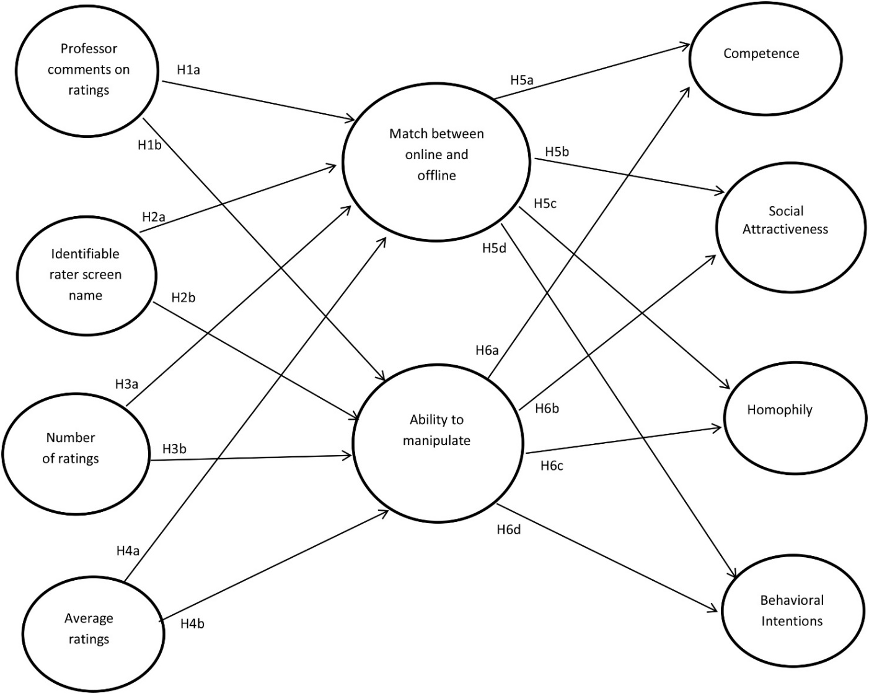
Figure 2. Proposed model for effects of online cues and warranting value on impressions.

Chapter 3: Pilot Study

Method
The purpose of the pilot study was to pre-test experimental manipulations, assess the reliability and factor structure of the dependent measures, and eliminate or rephrase items as necessary for the main study. The design was a 2 (professor comments: present or absent) x 2 (rater screen name: identifiable or anonymous) x 2 (average ratings: present or absent) x 2 (number of ratings: many or few) experimental design, resulting in 16 experimental conditions.

Participants
Participants in the study were 803 workers from Amazon’s Mechanical Turk (MTurk). Amazon.com created this crowdsourcing website in which individuals (e.g., researchers) can request Human Intelligence Tasks (HITs) be completed by multiple workers who are paid for their service. Data obtained from MTurk workers has been found to be diverse, in respect to the age range of workers, levels of education, and socio-economic status (Ross, Irani, Silberman, Six, Zaldivar, & Tomlinson, 2010). MTurk samples are no different than convenience samples with the exception that they tend to be more diverse (Berinsky, Huber, & Lenz, 2012; Buhrmester, Kwang, & Gosling, 2011).
Participants ranged in age from 18 to 64 years old (M = 34.93, SD = 11.25, Med. = 32.00). Males made up 52.7% of the sample (n = 423) and females made up the remaining 47.1% (n = 378), with two participants preferring not to report their sex. Five hundred ninety-four were White/Caucasian, 81 were Black or African-American, 73 were Asian, 32 were Hispanic, six were American Indian or Alaska Native, three were Native Hawaiian or Pacific Islander, and 14 identified themselves as some other ethnicity. The sample, all residing in the United States, was dispersed geographically with 272 from the South, 194 from the West, 169 from the Northeast, and 168 from the Midwest. Two hundred fifty-five participants had completed some college, 115 completed a two-year degree, 332 had completed a four-year degree, 85 had a Master’s degree, 5 had a doctoral degree, and 11 reported having a professional degree such as a juris doctorate or a medical degree. Participants’ occupations included accountant, administrative assistant, consultant, engineer, homemaker, information technology, programmer, retired, student, teacher, and self-employed among others.

Procedures
Information regarding the survey, such as procedures and requirements, was posted in the HIT description on MTurk. Workers who accepted the HIT were directed to an online survey hosted on Qualtrics.com. The first page of the online survey contained screening questions assessing their education level and age. Because the context of the main experiment was a professor rating website, participants were required to have had completed some college. Additionally, participants were required to be between 18 and 64 years of age to simplify Institutional Review Board classification of study participants as a non-vulnerable population. Those who passed the screening questions were directed to the next page that contained a consent form. The consent form included information about the risks and benefits of participating in the study. Participants then indicated whether they agreed to participate by selecting a mandatory radio button indicating ‘yes’ or ‘no’. If they agreed to participate, they were redirected to the next screen. If they declined, they were redirected to the end of the survey and thanked for their interest. Next, respondents who agreed to participate answered the demographic questions reported in the previous section and read instructions on how to properly use the study’s measurement scales, before completing practice items for these scales. If participants did not successfully complete the practice items, they received an error message requesting they correct their responses. They had unlimited attempts to pass the practice questions. Once they successfully completed the practice items, they were randomly assigned to view one of sixteen website pages. After viewing the webpage, participants completed items assessing the variables of interest. Participants also assessed the realism of the webpages. Participants who completed the study were compensated $1.00 for their participation. Three participants did not receive payment because they had completed the entire survey without submitting their worker ID number to receive payment. Their data were valid given their total completion time of the survey and retained for analyses. This study was approved by the researcher’s Institutional Review Board.

Conditions
The context of the experiment was a hypothetical website in which students rated a professor. The website was modeled after profiles on RateMyProfessors.com but included an identity claim from the professor (i.e., a short self-description of his teaching philosophy and identity). The professor was male across all conditions because the professor’s sex was not a variable of interest. A generic picture was included but the professor could not actually be seen in order to prevent visual biases. The purpose of including a generic photo was to make the professor’s profile and identity claims more salient to participants. The website screenshot included two student reviews with a page counter at the bottom of the screen, indicating the reviews continued on the next page. However, participants were advised they were viewing a screenshot of a webpage and therefore would not be able to advance the screen. The valence of the reviews was positive. Valence of reviews was not a variable of interest and therefore was kept constant across conditions. Website pages were varied across four independent variables: average ratings, number of ratings, professor comments, and rater screen name.
The first variable of interest was average ratings of the professor. The average ratings variable was presented in the same manner as on RateMyProfessors.com. The profile included an image of the mean ratings of overall quality, helpfulness, clarity, and easiness of the professor as well as a chili pepper icon indicating the professor’s physical attractiveness. This variable was dichotomized so that the image of aggregated ratings was either present, depicted as somewhat high ratings on a five-point scale (4.2: overall quality, 4.1: helpfulness, 4.3: clarity, 3.9: easiness) with a chili pepper, or absent, with no available aggregate ratings nor a chili pepper icon.
The second variable of interest was number of ratings. This variable was also presented in the same manner as on RateMyProfessors.com. A simple line “Number of ratings:” was included under the profile of the professor. The operationalization of this variable was also dichotomized into a high number of ratings and a low number of ratings. The high condition reported 51 raters and the low condition reported four raters.
The third independent variable was professor comments. This variable was designed similar to the format of comments on a person’s status update within Facebook as most, if not all, participants would be familiar with that design. The rater comments were presented with professor comments underneath and indented from the rating to which the comment referred. This variable was also dichotomized; professor comments were either present or absent.
The fourth independent variable was the rater’s screen name. Currently, RateMyProfessors.com does not have any rater screen name visible. To test the effect of identifiability of a third-party reviewer, rater screen name was present in dichotomized form as either identifiable or anonymous. The identifiable condition included rater screen names of first name and last initial (e.g., Janet G.). The anonymous rater name included a random set of letters and numbers (e.g., rb34h). The sixteen experiment webpages are presented in Appendix A.

Measures
All variables of interest were measured using magnitude scales. Magnitude scales are described as a ratio-level “numeric estimation – matching numbers to one’s strength of impression” (Lodge, 1981, p. 7). Participants can rate items on scales from zero on up, with 100 indicating a moderate level of agreement with the attribute measured, 0 indicating the absence of the attribute measured, and no upper bound. Higher numbers indicate more of the characteristic being measured. All scale items used in the pilot study are included in Appendix B. Reliabilities of all scales are reported in the Results section and in Table 3.
Practice magnitude items included three statements asking participants to rate how much they enjoyed watching Monday night football, how much they liked fast food, and how important it was to spend their holiday vacation with their family. Additionally, three questions tested participants’ knowledge of how to use magnitude scales asking what the lowest number one could use was, what value indicated a moderate level of agreement with a statement, and whether it was possible to use the number 245 to answer a survey item. If participants answered one of these questions incorrectly, they received an error message requesting they correct their responses. Once they answered all three questions correctly, they advanced to the next screen.
Profile match was measured using seven items developed for this study to assess the perceived match between the professor’s online representation and the corporeal professor. Higher numbers indicated greater match. These items asked participants to rate how accurate, believable, truthful, honest, realistic, representative, and convincing the professor’s profile was as compared to whom they perceived the actual person to be.
Ability to manipulate was measured using five items developed for this study to assess the possibility of the professor modifying or affecting the reviews of the rating. Higher numbers indicated greater ability to manipulate the reviews. These items asked participants to rate the possibility that the professor could provide his own review, the professor could encourage reviewers to write favorable reviews, the professor could influence the reviewers when writing their reviews, the professor could edit reviewer comments, and the professor could hire a person to write a review.
Instructor competence was measured using six items from J. C. McCroskey (1966) and three additional items from J. C. McCroskey and Teven (1999). These items asked participants to rate the extent to which the professor was reliable, informed, qualified, intelligent, valuable, expert, trained, competent, and bright.
Social attraction was measured using five modified items from J. C. McCroskey and McCain (1974). Because the items were measured using magnitude scales, items were modified so they would not need to be reverse-coded. Higher numbers indicated greater attraction. Participants were asked to rate the extent to which they felt the professor could be a friend, how easy it would be to meet and talk with the professor, if the professor could fit into their circle of friends, if they could ever establish a personal friendship with the professor, and the extent to which they would like to have a friendly chat with the professor.
Homophily was measured using four modified items from the attitudinal subscale of the homophily instrument developed by J. C. McCroskey et al. (1975) and two additional items developed by the researcher. The items asked participants to rate whether they thought the professor thought and behaved like the participant, was similar to the participant, was like the participant, acted like the participant, and was the same as the participant.
A participant’s behavioral intentions were also assessed. Six items were created for the purpose of this study. The items asked participants to rate how likely they were to take a course from the professor, recommend the professor to others, encourage their friends to take a course from the professor, take this professor’s course over another professor, check what other courses this professor was teaching, and be interested in working with this professor.
Finally, the realism of each website was assessed with three items that asked whether the website was realistic, credible, and whether it reflected an actual website that could exist on the Internet. All websites were considered realistic more than moderately (M = 200.04, SD = 138.25 for Winsorized data; see data transformation section for a description of Winsorization), credible more than moderately (M = 176.36, SD = 117.16 for Winsorized data), and reflected an actual website that could exist on the Internet (M = 283.02, SD = 251.15 for Winsorized data).

Results

Data Cleaning and Manipulation Checks
The first step in cleaning the data was to examine participant responses. The online survey was accessed a total of 1033 times. Of that total, 202 cases were deleted for not passing the screening questions, not consenting to participate, or having a significant amount of missing data. Additionally, two variables were computed based on total completion time of the survey and seconds spent viewing the website. Variables were computed such that the lower 2.5% of each distribution, or data outside two standard deviations from the mean completion time, was coded as a 1 whereas the rest of the distribution was coded as a 0, so that 1 indicates an extremely low time compared to the average completion time (i.e., less than 5.08 minutes) and viewing the website (i.e., less than 0.082 seconds). Four manipulation check questions were included in the survey to ensure participants were attentive to the content of the website. These items, included in Appendix B, asked participants to choose between 4 and 51 as the number of reviewers, choose between “Janet G.” and “jg3225p” as the name of the first reviewer, select if aggregated data were present or absent (an image of what the data looked like was included), and select if the professor commented on the reviews or not. A variable was computed to indicate the total number of manipulation check questions that each participant answered incorrectly. Values ranged from 0 (no incorrect answers) to 4 (all four incorrect answers). Two t-tests were conducted to determine if participants in the extremely low total completion times performed significantly poorly on the manipulation check questions. Results indicated that these participants (n = 18, M = 1.56, SD = 0.98) did not perform more poorly on the manipulation check questions than participants with non-extreme completion times (n = 793, M = 1.16, SD = 0.93), t(809) = -1.77, p = .08. However, participants with extremely low website viewing times (n = 21, M = 2.24, SD = 1.14) performed more poorly on the manipulation check questions than those with non-extreme viewing times (n = 782, M = 1.14, SD = 0.91), t(801) = -5.43, p < .001. Therefore, the responses of these 21 participants with an extremely low website viewing time were deleted from further analyses. Additionally, it was determined that regardless of completion time or website viewing time, those participants who failed all four manipulation check questions would also be deleted from analyses since they did not pay attention to any of the four experimental manipulations. Therefore, an additional seven cases were deleted, resulting in a total of 803 participants. Means were imputed for the remaining missing data which only occurred in the variables of competence and realism (0.37% for competence and 2.5% for realism).

Data Transformation
Prior to assessing scale structure, the data distribution was examined for extreme skewness and kurtosis. Scores were Winsorized to the 95th percentile (i.e., values higher than the 95th percentile value were changed to equal the 95th percentile value to shorten the tail of the distribution curve; Tukey, 1962; see Table 1 for pre- and post-Winsorization minimum and maximum values). Values were then transformed to reduce skewness and kurtosis, which could otherwise bias parameter estimates. Transformations are used to “create meaningful typical values and metrics, equality of spread, and linearity of relationships” (Fink, 2009, p. 388). Fink (2009) explains that researchers assume data are equally dispersed (i.e., the mean, median, and mode are all equal). However, data frequently need to be adjusted to centralize the distribution and reduce skewness and kurtosis. The transformation equation used was Y* = (Y + k)^{(λ)} (Fink, 2009). Table 2 presents the pre- and post-transformation skewness and kurtosis values.

Table 1
Minimum and Maximum Values Pre- and Post-Winsorization, Pilot Study
Variable | Minimum | Maximum | Winsorized (95%) Maximum
MATCH1  MATCH2  MATCH3  MATCH4  MATCH5  MATCH6  MATCH7  MANIP1  MANIP2  MANIP3  MANIP4  MANIP5  COMP1  COMP2  COMP3  COMP4  COMP5  COMP6  COMP7  COMP8  COMP9  SOCAT1  SOCAT2  SOCAT3  SOCAT4  SOCAT5  HOMOP1  HOMOP2  HOMOP3  HOMOP4  HOMOP5  HOMOP6  INTENT1  INTENT2  INTENT3  INTENT4  INTENT5  INTENT6  REAL1  REAL2  REAL3 | 0  0  0  0  0  0  0  0  0  0  0  0  0  0  0  0  0  0  0  0  0  0  0  0  0  0  0  0  0  0  0  0  0  0  0  0  0  0  0  0  0 | 1500  3500  1500  1500  1500  4897  1500  3.66x10¹¹  2.5x10¹⁰  1000000  9840  1000000  3.9x10¹⁴  10000  1.0x10³³  1.0x10²⁸  10000  5.8x10¹⁰  9.0x10³²  1.0x10²⁸  9.99x10¹⁸  800  5000  900  5000  1500  766  1522  2050  684  788  9877  5000  321621  9872  1500  1500  10140  1.5x10¹⁶  1500  1.0x10⁶⁶ | 320  400  379  300  400  400  385  400  500  388  150  500  500  500  500  500  500  500  500  500  500  200  300  200  216  300  150  150  150  150  150  124  500  400  400  400  450  400  540  500  1000
Note. MATCH = Match between online representation and offline self; MANIP = ability to manipulate reviews; COMP = competence; SOCAT = social attractiveness; HOMOP = homophily; INTENT = behavior intentions; REAL = website realism

Table 2
Skewness and Kurtosis Values Pre- and Post-Transformations. Values of k and λ in the Transformation Equation Y* = (Y + k)^{(λ)}, Pilot Study
Variable | Pre-Transformation |  |  |  |  | Post-Transformation
 | Skewness |  | Kurtosis |  |  | Skewness |  | Kurtosis
 | Statistic | S.E. | Statistic | S.E. |  | Statistic | S.E. | Statistic | S.E.
MATCH1  MATCH2  MATCH3  MATCH4  MATCH5  MATCH6  MATCH7  MANIP1  MANIP2  MANIP3  MANIP4  MANIP5  COMP1  COMP2  COMP3  COMP4  COMP5  COMP6  COMP7  COMP8  COMP9  SOCAT1  SOCAT2  SOCAT3  SOCAT4  SOCAT5  HOMOP1  HOMOP2  HOMOP3  HOMOP4  HOMOP5  HOMOP6  INTENT1  INTENT2  INTENT3  INTENT4  INTENT5  INTENT6 | 4.38  10.28  4.28  4.36  3.97  16.56  4.08  28.83  28.83  28.81  25.31  22.97  28.83  22.48  28.83  28.83  23.24  28.83  28.83  28.83  28.83  3.35  17.66  3.31  20.38  4.50  3.85  8.78  11.95  3.95  3.83  26.67  14.72  28.82  22.81  3.63  3.13  24.70 | 0.09  0.09  0.09  0.09  0.09  0.09  0.09  0.09  0.09  0.09  0.09  0.09  0.09  0.09  0.09  0.09  0.09  0.09  0.09  0.09  0.09  0.09  0.09  0.09  0.09  0.09  0.09  0.09  0.09  0.09  0.09  0.09  0.09  0.09  0.09  0.09  0.09  0.09 | 35.35  177.71  34.59  35.50  29.48  374.49  30.53  831.00  831.00  830.41  692.29  556.43  830.99  589.68  830.99  830.99  617.62  830.99  830.99  830.99  830.99  18.42  411.77  18.86  513.66  39.06  25.18  135.36  223.56  25.60  27.70  746.82  318.71  830.82  594.71  25.26  16.88  672.99 | 0.17  0.17  0.17  0.17  0.17  0.17  0.17  0.17  0.17  0.17  0.17  0.17  0.17  0.17  0.17  0.17  0.17  0.17  0.17  0.17  0.17  0.17  0.17  0.17  0.17  0.17  0.17  0.17  0.17  0.17  0.17  0.17  0.17  0.17  0.17  0.17  0.17  0.17 | 0.65  0.60  0.55  0.60  0.60  0.60  0.65  0.60  0.50  0.50  0.45  0.50  0.50  0.50  0.50  0.50  0.55  0.55  0.50  0.50  0.50  0.50  0.55  0.40  0.50  0.55  -ª  -  -  -  -  -  0.55  0.60  0.55  0.50  0.55  0.60 | 0.56  0.53  0.43  0.20  0.62  0.56  0.50  0.33  0.10  0.01  0.84  0.18  0.62  0.55  0.41  0.46  0.72  0.63  0.42  0.34  0.60  -0.53  -0.33  -0.56  -0.46  -0.28  0.31  0.39  0.33  0.39  0.47  0.50  0.52  0.37  0.16  0.46  0.20  0.36 | 0.09  0.09  0.09  0.09  0.09  0.09  0.09  0.09  0.09  0.09  0.09  0.09  0.09  0.09  0.09  0.09  0.09  0.09  0.09  0.09  0.09  0.09  0.09  0.09  0.09  0.09  0.09  0.09  0.09  0.09  0.09  0.09  0.09  0.09  0.09  0.09  0.09  0.09 | 0.55  0.58  1.25  0.52  1.07  1.11  0.78  -0.51  0.24  -0.40  -0.81  0.10  0.74  0.45  0.44  0.21  0.86  0.59  0.31  0.56  0.35  -0.34  0.50  -0.74  -0.34  0.45  -0.89  -0.78  -0.88  -0.74  -0.71  -1.07  0.96  0.76  0.62  0.86  0.40  0.78 | 0.17  0.17  0.17  0.17  0.17  0.17  0.17  0.17  0.17  0.17  0.17  0.17  0.17  0.17  0.17  0.17  0.17  0.17  0.17  0.17  0.17  0.17  0.17  0.17  0.17  0.17  0.17  0.17  0.17  0.17  0.17  0.17  0.17  0.17  0.17  0.17  0.17  0.17
Note: k = 0 for all transformations; Realism was not transformed since it was not used in analyses.
ª HOMOP1, HOMOP2, HOMOP3, HOMOP4, HOMOP5, and HOMOP6 did not need to be transformed because their skewness and kurtosis values did not improve with transformation. The post-transformation skewness and kurtosis values are after Winsorizing only.
Reliabilities
Scale reliability was assessed with Cronbach’s alpha to assess internal consistency. Scales were considered acceptable if the alpha value was equal to or greater than .70 (Nunnally, 1978). Alpha was low for ability to manipulate, though it was still acceptable. The low alpha was partly due to one problem item, “The professor could edit reviewer comments.” Reliability slightly improved when the problem item was removed. Based on Cronbach’s alpha results, presented in Table 3, all scales in this study have an acceptable or better internal consistency after one problem item was deleted.
Table 3
Reliability Scores of Scales, Pilot Study
Variable |  | Initial Scales |  |  |  | Revised Scales
 | N | No. of items | Cronbach  α |  |  | No. of items | Cronbach  α
MATCH | 803 | 7 | .96 |  |  | N/A
MANIP | 803 | 5 | .71 |  |  | 4 |  | .74
COMP | 803 | 9 | .97 |  |  | N/A  N/A  N/A  N/A
SOCAT | 803 | 5 | .90
HOMOP | 803 | 6 | .96
INTENT | 803 | 6 | .95
REAL | 803 | 3 | .79 |  |  | N/A
Note. MATCH = Match between online representation and offline self; MANIP = ability to manipulate reviews; COMP = competence; SOCAT = social attractiveness; HOMOP = homophily; INTENT = behavior intentions; REAL = website realism

Confirmatory Factor Analyses
The structure of all scales was assessed via confirmatory factor analyses (CFA) using LISREL 9.10 (Jöreskog & Sörbom, 2013). Each scale was assessed individually, and a measurement model that included all scales was also examined. Model fit was compared to the fit indices recommended by Hu and Bentler (1999) such that the root mean squared error of approximation (RMSEA) should be less than .06, the comparative fit index (CFI) should be greater than .95, and the standardized root mean squared residual (SRMR) should be less than .08. However, many scholars argue about the application of fit indices, cautioning against a strict reliance on cutoff points (Kenny, 2014). Browne and Cudeck (1993) claim the RMSEA cutoff point should be .10. Therefore, for this research, model fit is considered good if all three indices reach the acceptable cutoff points as described by Hu and Bentler (1999) and acceptable if they are just slightly above the criteria set by Hu and Bentler (1999). Model fit is considered adequate if two of the three indices meet or exceed the acceptable cut off points. Modifications were applied in the CFAs if the software suggestions were judged to be reasonable and theoretically appropriate (i.e., the errors of two items were permitted to covary if they had similar wording; Cole, Ciesla, & Steiger, 2007). Table 4 presents the CFA results.
The items measuring profile match performed well. Initial model fit was adequate, χ2 (14, N = 803) = 167.11 (p < .001), RMSEA = .12, 90% CI [.10, .13], CFI = .99, and SRMR = .02, but improved when the errors between the second (“The online profile of the professor is a believable description of the actual person”) and seventh indicators (“The online profile of the professor is a convincing description of the actual person”) were allowed to covary. Additionally, the errors between the third (“The online profile of the professor is a truthful description of the actual person”) and fourth indicators (“The online profile of the professor is an honest description of the actual person”) were allowed to covary, χ2 (12, N = 803) = 79.00 (p < .001), RMSEA = .08, 90% CI [.07, .10], CFI = .99, and SRMR = .01. These two covariances were judged to be appropriate because the wording and connotative meanings of each pair of items were similar.
The items measuring ability to manipulate performed adequately with all five items included, χ2 (5, N = 803) = 65.53 (p < .001), RMSEA = .12, 90% CI [.10, .15], CFI = .96, and SRMR = .05. However, the latent factor only explained 6.8% of the variance in the fourth indicator, “The professor could edit reviewer comments.” Given that this item also lowered the scale alpha from .74 to .71, this item was dropped. Model fit improved remarkably after dropping the problem item to χ2 (2, N = 803) = 4.79 (p = .09), RMSEA = .04, 90% CI [0.0, .09], CFI = .99, and SRMR = .01.
The model for professor competence was acceptable, χ2 (27, N = 803) = 228.19 (p < .001), RMSEA = .10, 90% CI [.09, .11], CFI = .99, and SRMR = .01. The covariance of errors between the fourth (“This professor is intelligent”) and ninth indicators (“This professor is bright”) was judged to be appropriate and permitted because the statements were synonyms. Overall model fit improved to χ2 (26, N = 803) = 175.22 (p < .001), RMSEA = .09, 90% CI [.07, .10], CFI = .99, and SRMR = .01. Even though the RMSEA is not less than .06, it is below the cutoff point recommended by Browne and Cudeck (1993). In addition, the other two indices met their respective criteria. Overall, this model fit was acceptable.
The initial model fit for social attractiveness was poor, χ2 (5, N = 803) = 249.67 (p < .001), RMSEA = .25, 90% CI [.22, .27], CFI = .94, and SRMR = .06. Error covariances were permitted for the second (“I think it would be easy to meet and talk with this professor”) and fifth indicators (“I would enjoy a friendly chat with this professor”) because both items assess talking with the professor. This permitted covariance improved model fit to χ2 (4, N = 803) = 10.48 (p < .05), RMSEA = .05, 90% CI [.01, .08], CFI = .99, and SRMR = .01 which was a good fit.
The initial model fit for homophily was acceptable, χ2 (9, N = 803) = 68.28 (p < .001), RMSEA = .09, 90% CI [.07, .11], CFI = .99, and SRMR = .01. RMSEA improved when the errors between the third (“This professor is similar to me”) and fourth indicators (“This professor is like me”) were permitted to covary given the meaning of the two statements is identical, χ2 (8, N = 803) = 12.42 (p = .13), RMSEA = .03, 90% CI [0.0, .05] CFI = .99, and SRMR = .01 which adjusted the model fit from acceptable to good.
The items assessing behavioral intentions performed poorly, χ2 (9, N = 803) = 320.36 (p < .001), RMSEA = .21, 90% CI [.19, .23] CFI = .96, and SRMR = .03. The errors between the second (“I would recommend this professor to others”) and third indicators (“I would encourage my friends to take a course with this professor”) and between the first (“I would take a course from this professor”) and fifth indicators (“I would check what courses this professor is teaching when I’m enrolling in courses”) were permitted to covary because each pair of statements conveys similar ideas. Model fit improved to χ2 (7, N = 803) = 84.28 (p < .001), RMSEA = .12, 90% CI [.10, .14], CFI = .99, and SRMR = .02. The RMSEA did not reach the acceptable value for a good model fit. Two of the three indices were at acceptable levels, so the overall model fit was deemed adequate.
A measurement model including all six factors and their indicators was tested. The purpose of this measurement model was to determine if any indicators cross-loaded onto a different factor (i.e., an indicator predicted variance in a different factor than specified). By default, the LISREL software allows all exogenous factors to covary. The initial model included the problem item from ability to manipulate and did not include the error covariances between indicators. Overall fit was good, χ2 (614, N = 803) = 2393.06 (p < .001), RMSEA = .06, 90% CI [.057, .062], CFI = .98, and SRMR = .06. Deleting the problem items and allowing the error covariances between indicators for the individual scales improved the overall model fit, χ2 (607, N = 803) = 1745.43 (p < .001), RMSEA = .05, 90% CI [.045, .051], CFI = .99, and SRMR = .06.

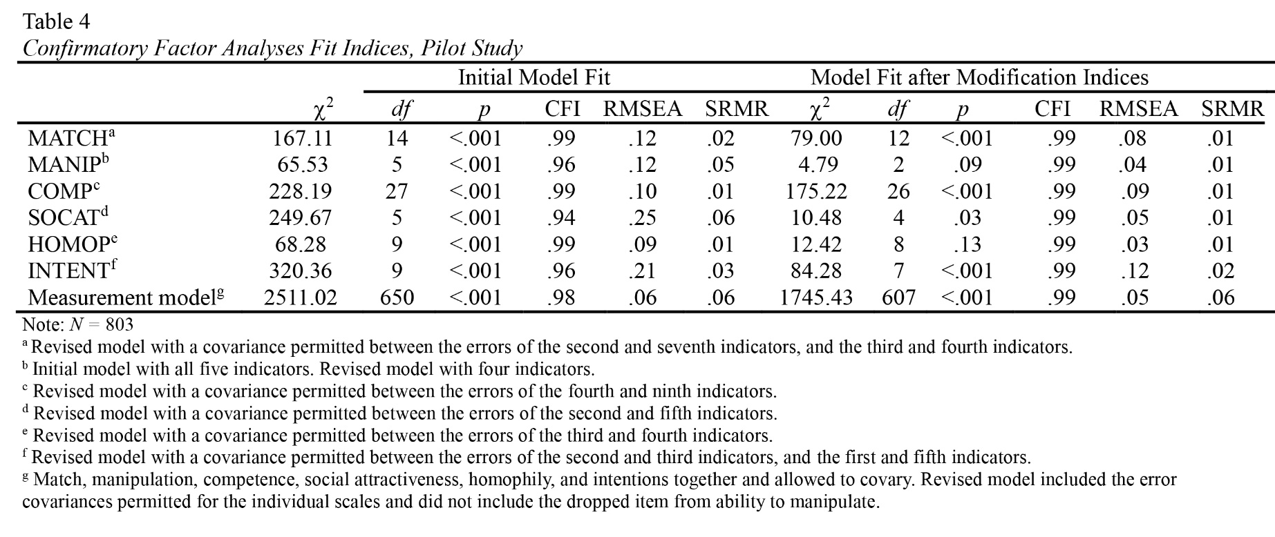

Conclusion
The purpose of this pilot study was to examine the structure of scales developed to assess warranting value as described by Walther (2011) and DeAndrea (2014). Overall, all scales performed well, with only one item dropped from the ability to manipulate scale. Additionally, Cronbach’s alphas show the scales to be reliable measures. Each measure was also unidimensional in that the indicators for each scale clearly loaded onto one factor each.
Specifically, the scale assessing ability to manipulate had one problem item. For the main study, this item was revised to read, “The professor is able to modify the comments left by reviewers.” This scale also had an acceptable Cronbach’s alpha though it was the lowest alpha of all six scales. Therefore, for the main study, each item was reworded to “the professor is able to…” or “the professor can” instead of “the professor could…” to provide a more direct rather than suggestive idea to participants. The word “could” implies a conditional, hypothetical statement whereas “can” indicates an objective ability.
It was also determined that two of the manipulation check questions were potentially confusing for participants. The first manipulation check question, which asks whether the professor commented on the reviews, was appropriate in that 85% of participants answered it correctly. Therefore, it remained unchanged in the main study. The second manipulation check question asked whether the screen name of the reviewer was identifiable or anonymous. Thirty-nine percent of respondents answered this manipulation check item incorrectly. The language of “identifiable” and “anonymous” is somewhat vague. For the main study, this manipulation check question was altered so participants must choose whether the first reviewer’s name was “Janet G.” or “jg3225p.” The third manipulation check question asked participants to select whether overall average ratings were present or absent. Although 62% of participants answered this question correctly, the remaining 38% was worrisome. Therefore, for the main study, an image of the aggregate ratings was included and stated “The profile included overall average ratings that looked similar to the following image.” Finally, 24.7% of respondents answered the fourth manipulation check question incorrectly. The question asked them to choose either 4 or 46 as the number of reviews the professor had received. It is possible that participants may have noticed the “4” but failed to notice the “6” and therefore were unaware of the true number of ratings present on the website. Therefore, the condition with the high number of ratings was changed to 51 total ratings for the main study. In this manner, the low conditions is 4 and the high condition is 51, so no numbers repeat between these two conditions.

Chapter 4: Main Study

Method
This study examined the warranting process by testing the effects of four antecedent variables on warranting value, which was then posited to affect impressions of an online persona. Similar to the experimental conditions in the pilot study, this was a 2 (professor comments: present or absent) x 2 (rater screen name: identifiable or anonymous) x 2 (average rating: present or absent) x 2 (number of ratings: many or few) experimental design, resulting in the same 16 experimental conditions.

Participants
Initially, participants included 830 students from a large Southern university. However, data cleaning was extremely conservative (this process is described in the Results section), which reduced the number of participants to 209 students. These final participants ranged in age from 18 to 34 years old (M = 19.90, SD = 2.06). Females made up 57.9% of the sample (n = 121) and males made up the remaining 41.1% (n = 86). Two participants preferred not to report their sex. One hundred seventy-three participants were White/Caucasian (33.5%), six were Black or African-American (2.9%), eight were Hispanic (3.8%), ten were Asian (4.8%), eight were American Indian or Alaska Native (3.8%), one was Native Hawaiian or Pacific Islander (0.5%), and three identified themselves as some other ethnicity (1.4%). Seventy participants were freshman, 65 were sophomores, 44 were juniors, and 26 were seniors. Four participants identified as some other class standing.

Procedures
The procedures for the main study were identical to those of the pilot study. Participants were recruited from a departmental research pool and received extra credit for participating in the study. Participants accessed an online survey. There were no screening criteria as they were currently enrolled in a university. The first page of the online survey contained a consent form. Once participants agreed to participate, they advanced to a new page that asked the demographics items reported in the previous section. They then completed practice items to learn how to use magnitude scales. Next, they were randomly assigned to view one of the sixteen experimental websites. Finally, they completed items assessing the variables of interest. The research was approved by the Institutional Review Board of the same university where data collection occurred.

Measures
Similar to the pilot study, all variables of interest were measured using magnitude scales. The same three magnitude practice items and three test items from the pilot study were used to check participants’ ability to use the scales. See Appendix B for all scales.
Profile match, competence, social attractiveness, homophily, and behavioral intentions were measured in the same way as in the pilot study. Ability to manipulate was measured using five items. Based on the pilot study, one item was revised to read “The professor is able to modify the comments left by the reviewers” and the phrasing of all five items was changed to replace “could” with “can” or “is able to.”
The realism of the websites was also evaluated using the same three items as in the pilot study (α = .58). The scale reliability was unacceptable; however, after examining participant responses, it was determined that the third item, which asked if the website reflected a real website that could exist on the Internet, did not perform similarly with the other two items (two-item α = .82). No participant rated all three realism items as zero and only five participants rated the first two items as zero but rated the third item with a score of at least 100. All websites were considered realistic (M = 188.83, SD = 130.58 for Winsorized data) more than moderately and were more than moderately credible (M = 151.00, SD = 100.22 for Winsorized data). The websites also reflected an actual website that could exist on the Internet (M = 311.85, SD = 266.78 for Winsorized data). Therefore, it was determined the websites were realistic.
For exploratory purposes, participants were also asked two open-ended questions: “What information from the webpage did you consider when forming your impressions of this professor?” and “What other information did you rely on when forming your impressions of the professor?”

Results
Data Cleaning and Manipulation Checks
First, participant responses were examined. The online survey was accessed a total of 1100 times; however, 219 cases were deleted because they had a multitude of missing data (N = 881). Different from the pilot study in which MTurk workers could only submit a completed survey once, many participants in the main study completed the online survey multiple times, possibly for fear of not receiving credit. Therefore, in cases where the survey was submitted multiple times by the same individual, the first attempt was retained and the latter attempts were deleted, resulting in 51 duplicate cases being removed from the final dataset (N = 830).
Similar to the pilot study, two variables were computed to indicate total survey completion time and total time spent viewing the website. Data were coded such that the lowest 5% of cases (less than 7.36 minutes for total completion time and less than 2.53 seconds for website viewing time) were coded as a ‘1’ and all other times were coded as a 0. This percentage of outliers was increased from the pilot study for two reasons. First, only data occurring in one tail of the distribution curve were examined (i.e., those who completed the survey in a short time but not a long time). Second, data cleaning was more stringent in the main study because the dissertation hypotheses were to be tested with this dataset. One case had extremely short total completion time and no recorded website viewing time, therefore this case was deleted. A variable was computed to indicate the total number of manipulation checks each participant answered incorrectly and t-tests were conducted to determine if an extremely short completion time or an extremely short time viewing the website significantly influenced participants’ ability to answer manipulation check questions correctly. Results indicated that individuals who completed the survey in an extremely short time (n = 35, M = 1.51, SD = 1.07) performed significantly worse on the manipulation checks that those who took their time on the survey (n = 775, M = 1.19, SD = 0.99), t(808) = 1.88, p < .05 (one-tailed; N = 811, 19 cases had missing data for manipulation check total). Similarly, participants who viewed the website an extremely short time (n = 36, M = 2.11, SD = 1.06) performed significantly worse on the manipulation checks than those who viewed the website longer (n = 767, M = 1.16, SD = 0.97), t(801) = 5.74, p < .001 (N = 803, 19 cases had missing data for manipulation check total, 8 cases had missing data for website viewing time). Therefore, those cases in the low 5% of total completion time and the low 5% of website viewing time were deleted from the dataset for a total of 75 cases removed (N = 755). Lastly, given that the SEM model was to be tested with this dataset, all participants who answered at least one manipulation check question incorrectly were deleted (n = 536), including participants who had missing data for the total number of manipulation checks incorrect (n = 10), resulting in a final number of 209 participants. Results for the manipulation checks per condition can be found in Table 5.
Table 5
Manipulation Check Questions by Condition, Main Study

 |  | Correct |  |  |  |  | Incorrect
Condition | n | Present/  High/  Identif.ª | Absent/  Low/  Anon.^{b} | Total |  | Present/  High/  Identif. | Absent/  Low/  Anon. | Total
Average Ratings | 810 | 394 | 129 | 523 |  | 14 | 273 | 287
Professor Comments | 811 | 284 | 348 | 632 |  | 111 | 68 | 179
Number of Ratings | 811 | 233 | 313 | 546 |  | 173 | 92 | 265
Reviewer Screen Name | 811 | 306 | 256 | 562 |  | 96 | 153 | 249
N = 830, 20 missing cases from average ratings, 19 missing cases from number of ratings, professor comments, and reviewer screen name
ª Identif. refers to an identifiable reviewer screen name
^{b} Anon. refers to an anonymous reviewer screen name

Data Transformation
Similar to the pilot study, variables were Winsorized to the 95th percentile. Any value higher than the 95th percentile value was changed to equal the 95th percentile value (see Table 6 for pre- and post-Winsorization minimum and maximum values). Data were also transformed to reduce skewness and kurtosis. The transformation equation used was the same as in the pilot study, Y* = (Y + k)^{(λ)} (Fink, 2009). Table 7 presents the pre- and post-transformation skewness and kurtosis values.
Reliabilities
Cronbach’s alpha was used to assess the internal consistency of the scales. Additionally, reliabilities were computed using the eigenvalue of the first principal component (PC) for each scale. The principal component reliability is calculated based on the total number of items in a scale and the eigenvalue of the first unrotated principal component. Hampson, Goldberg, and John (1987) claim this method assigns optimal weights to indicators which maximizes reliabilities. For a description of this process, see Serlin ad Kaiser (1976). Scales are considered acceptable if the alpha value is greater than or equal to .70 (Nunnally, 1978). Based on Cronbach’s alpha results and principal component reliabilities, presented in Table 8, all scales in this study have an acceptable or better internal consistency.

Table 6
Minimum and Maximum Values Pre- and Post-Winsorization, Main Study
Variable | Minimum | Maximum | Winsorized (95%) Maximum
MATCH1  MATCH2  MATCH3  MATCH4  MATCH5  MATCH6  MATCH7  MANIP1  MANIP2  MANIP3  MANIP4  MANIP5  COMP1  COMP2  COMP3  COMP4  COMP5  COMP6  COMP7  COMP8  COMP9  SOCAT1  SOCAT2  SOCAT3  SOCAT4  SOCAT5  HOMOP1  HOMOP2  HOMOP3  HOMOP4  HOMOP5  HOMOP6  INTENT1  INTENT2  INTENT3  INTENT4  INTENT5  INTENT6  REAL1  REAL2  REAL3 | 0  0  0  0  0  0  0  0  0  0  0  0  0  0  0  0  0  0  0  10  0  0  0  0  0  0  0  0  0  0  0  0  0  0  0  0  0  0  0  0  50 | 556  9999  1000  568  700  800  800  1.0x1080  1.0x1074  1.0x1081  1000  1.0x1072  6443  9677  5252  8565  3455  4566  2542  9576  7887  856  7770  200  500  6532  500  5000  5000  300  321  1000  4552  4765  9000  4882  9871  541895  9000  1000  1.0x1014 | 250  389  300  287  375  300  400  750  500  400  127  500  500  500  550  578  400  499  650  500  595  200  300  115  200  300  180  117  150  112  122  100  399  300  320  392  500  350  533  464  1500
Note. MATCH = Match between online representation and offline self; MANIP = ability to manipulate reviews; COMP = competence; SOCAT = social attractiveness; HOMOP = homophily; INTENT = behavior intentions; REAL = realism of website

Table 7
Skewness and Kurtosis Values Pre- and Post-Transformations. Values of k and in the Transformation Equation , Main Study
Variable | Pre-Transformation |  |  |  |  | Post-Transformation
 | Skewness |  | Kurtosis |  |  | Skewness |  | Kurtosis
 | Statistic | S.E. | Statistic | S.E. |  | Statistic | S.E. | Statistic | S.E.
MATCH1  MATCH2  MATCH3  MATCH4  MATCH5  MATCH6  MATCH7  MANIP1  MANIP2  MANIP3  MANIP4  MANIP5  COMP1  COMP2  COMP3  COMP4  COMP5  COMP6  COMP7  COMP8  COMP9  SOCAT1  SOCAT2  SOCAT3  SOCAT4  SOCAT5  HOMOP1  HOMOP2  HOMOP3  HOMOP4  HOMOP5  HOMOP6  INTENT1  INTENT2  INTENT3  INTENT4  INTENT5  INTENT6 | 2.48  13.75  4.17  2.25  2.41  3.18  2.50  14.46  14.46  14.46  8.04  14.46  12.58  10.87  10.46  12.38  9.59  10.99  5.20  10.01  12.21  5.06  13.96  1.10  2.17  13.52  2.92  14.07  13.85  1.96  2.23  8.57  11.88  9.33  11.16  12.14  13.47  14.46 | 0.17  0.17  0.17  0.17  0.17  0.17  0.17  0.17  0.17  0.17  0.17  0.17  0.17  0.17  0.17  0.17  0.17  0.17  0.17  0.17  0.17  0.17  0.17  0.17  0.17  0.17  0.17  0.17  0.17  0.17  0.17  0.17  0.17  0.17  0.17  0.17  0.17  0.17 | 8.78  195.09  24.24  6.93  7.52  15.09  8.71  -a  209.00  -  88.03  209.00  171.99  127.65  130.09  167.63  113.33  140.93  40.15  180.17  164.23  44.15  199.32  1.23  8.33  190.76  12.61  201.46  197.06  5.91  8.46  91.88  158.72  90.90  132.08  163.45  189.57  208.99 | 0.34  0.34  0.34  0.34  0.34  0.34  0.34  0.34  0.34  0.34  0.34  0.34  0.34  0.34  0.34  0.34  0.34  0.34  0.34  0.34  0.34  0.34  0.34  0.34  0.34  0.34  0.34  0.34  0.34  0.34  0.34  0.34  0.34  0.34  0.34  0.34  0.34  0.34 | 0.65  0.60  0.55  0.60  0.60  0.60  0.65  0.50  0.50  0.50  0.60  0.50  0.45  0.65  0.50  0.40  0.60  0.50  0.45  0.40  0.50  0.70  0.60  -b  0.70  0.60  -  -  -  -  -  0.70  0.60  0.60  0.60  0.60  0.55  0.60 | 0.09  0.44  -0.02  0.19  0.52  0.28  0.63  0.54  0.15  0.21  0.87  0.11  0.62  0.98  0.81  0.99  0.78  0.86  0.93  0.71  0.98  0.14  -0.12  0.46  0.23  0.07  0.98  0.48  0.79  0.48  0.59  0.75  0.29  0.18  0.13  0.58  0.41  0.07 | 0.17  0.17  0.17  0.17  0.17  0.17  0.17  0.17  0.17  0.17  0.17  0.17  0.17  0.17  0.17  0.17  0.17  0.17  0.17  0.17  0.17  0.17  0.17  0.17  0.17  0.17  0.17  0.17  0.17  0.17  0.17  0.17  0.17  0.17  0.17  0.17  0.17  0.17 | 0.09  0.01  0.48  0.23  0.75  0.72  0.28  0.22  0.35  -0.09  -0.81  -0.21  1.34  0.89  0.83  0.51  0.72  1.28  0.88  0.10  1.34  -0.59  0.23  -1.15  -0.62  -0.19  0.53  -0.89  -0.06  -1.04  -0.74  -0.86  0.51  0.21  0.35  0.65  0.66  0.27 | 0.34  0.34  0.34  0.34  0.34  0.34  0.34  0.34  0.34  0.34  0.34  0.34  0.34  0.34  0.34  0.34  0.34  0.34  0.34  0.34  0.34  0.34  0.34  0.34  0.34  0.34  0.34  0.34  0.34  0.34  0.34  0.34  0.34  0.34  0.34  0.34  0.34  0.34
Note: k = 0 for all transformations; Realism was not transformed since it was not used in analyses.
ª Values were too large to compute kurtosis for pre-transformed MANIP1 and MANIP3.
^{b} SOCAT3, HOMOP1, HOMOP2, HOMOP3, HOMOP4, and HOMOP5 did not need to be transformed because their skewness and kurtosis values did not improve with transformation. The post-transformation skewness and kurtosis values are after Winsorizing only.
Table 8
Reliability Scores of Scales, Main Study
 | N | No. items | Cronbach α | PC Reliabilityª
MATCH | 209 | 7 | .94 | .94
MANIP | 209 | 5 | .78 | .81
COMP | 209 | 9 | .96 | .96
SOCAT | 209 | 5 | .86 | .88
HOMOP | 209 | 6 | .92 | .92
INTENT | 209 | 6 | .93 | .93
REAL | 209 | 3 | .58 | .78
ª PC is the scale reliability calculated based on the eigenvalue of the first principal component

Confirmatory Factor Analyses
Similar to the pilot study, each scale was assessed individually, and a final measurement model which included all scales was also examined. Model fit is considered good if all three fit indices, RMSEA, CFI, and SRMR, reach or exceed the acceptable cutoff points as described by Hu and Bentler (1999). Fit is considered acceptable if they are just slightly above these criteria and is adequate if two of the three indices meet or exceed the acceptable cut off points. Modifications were applied if they were judged to be appropriate (i.e., the errors of two items were permitted to covary if they had similar wording; Cole et al., 2007). Table 9 presents the results of the confirmatory factor analyses.
Initial model fit for profile match was adequate, χ² (14, N = 209) = 78.25 (p < .001), RMSEA = .15, 90% CI [.12, .18], CFI = .97, and SRMR = .04, but improved when the errors between the second (“The online profile of the professor is a believable description of the actual person”) and seventh indicators (“The online profile of the professor is a convincing description of the actual person”) were allowed to covary, χ² (13, N = 209) = 37.71 (p < .001), RMSEA = .10, 90% CI [.06, .13], CFI = .99, and SRMR = .03. This covariance was judged to be appropriate because the wording and connotative meaning of each pair of items were similar. Overall, model fit was acceptable.
The items measuring ability to manipulate performed poorly with all five items included, χ² (5, N = 209) = 27.20 (p < .001), RMSEA = .15, 90% CI [.10, .20], CFI = .93, and SRMR = .06. The latent factor only explained 7.2% of the variance in the fourth indicator, “The professor is able to modify the comments left by reviewers.” Therefore, this item was dropped. Additionally, the errors of the second (“The professor can encourage others to write favorable reviews”) and third items (“The professor is able to influence the reviewers when writing their reviews”) were permitted to covary because they conveyed a similar idea. Model fit was good after dropping the problem item and permitting the two items covariance, χ² (1, N = 209) = 1.64 (p = .20), RMSEA = .06, 90% CI [.00, .20], CFI = .99, and SRMR = .02.
The model for professor competence was adequate, χ² (27, N = 209) = 114.91 (p < .001), RMSEA = .13, 90% CI [.10, .15], CFI = .98, and SRMR = .03. The covariance of errors between the fourth (“This professor is intelligent”) and ninth indicators (“This professor is bright”) was judged to be appropriate and permitted because the statements were synonyms for one another. Additionally, a covariance of errors was permitted between the third (“This professor is qualified “) and seventh indicators (“This professor is trained”) because the idea conveyed by the two statements is similar. Overall, model fit improved to χ² (25, N = 209) = 62.24 (p < .001), RMSEA = .08, 90% CI [.06, .11], CFI = .99, and SRMR = .03. The 90% confidence interval indicated the RMSEA could reach the cutoff point described by Hu and Bentler (1999). Given that the RMSEA is close and the other two fit indices meet their respective fit criteria, this model fit was acceptable.
The initial model fit for social attractiveness was poor, χ² (5, N = 209) = 50.88 (p < .001), RMSEA = .21, 90% CI [.16, .26], CFI = .94, and SRMR = .05. Error covariances were permitted for the second (“I think it would be easy to meet and talk with this professor”) and fifth indicators (“I would enjoy a friendly chat with this professor”) because both items assess talking with the professor. This permitted covariance improved model fit to χ² (4, N = 209) = 10.34 (p < .05), RMSEA = .09, 90% CI [.02, .15], CFI = .99, and SRMR = .02. Because the RMSEA was close to its cutoff point, this model had an acceptable fit.
The initial model fit for the indicators assessing homophily was adequate, χ² (9, N = 209) = 37.93 (p < .001), RMSEA = .12, 90% CI [.08, .17], CFI = .98, and SRMR = .03. The RMSEA improved when the errors between the third (“This professor is similar to me”) and fourth indicators (“This professor is like me”) were permitted to covary because the meaning of each statement is identical, χ²(8, N = 209) = 25.14 (p < .01), RMSEA = .10, 90% CI [.06, .15] CFI = .99, and SRMR = .03. Overall, model fit was acceptable.
The items assessing behavioral intentions initially performed poorly, χ² (9, N = 209) = 94.89 (p < .001), RMSEA = .21, 90% CI [.18, .25] CFI = .94, and SRMR = .05. The errors between the second (“I would recommend this professor to others”) and third indicators (“I would encourage my friends to take a course with this professor”) were permitted to covary because this pair of statements conveys similar ideas. This added covariance improved the overall model fit to χ² (8, N = 209) = 11.00 (p = .20), RMSEA = .04, 90% CI [.00, .10], CFI = .99, and SRMR = .02, which was a good fit.
Similar to the pilot study, a measurement model including all six factors and their indicators was tested. All factors were allowed to covary (LISREL software default setting). The initial model included the problem item from ability to manipulate and did not include the error covariances between indicators. Overall fit was acceptable, χ² (650, N = 209) = 1491.28 (p < .001), RMSEA = .08, 90% CI [.07, .08], CFI = .95, and SRMR = .07. Deleting the problem item and implementing the error covariances between indicators for the individual scales improved the overall model fit to χ² (607, N = 209) = 1193.57 (p < .001), RMSEA = .07, 90% CI [.06, .07], CFI = .97, and SRMR = .07. Overall, the model fit was acceptable.
Results from the confirmatory factor analyses revealed all indicators loaded adequately onto their respective factor. Only one item was dropped from the scale assessing ability to manipulate. These factor structures were further used in the structural equation model testing the study’s hypotheses, with all covariances between indicator errors mentioned above permitted.

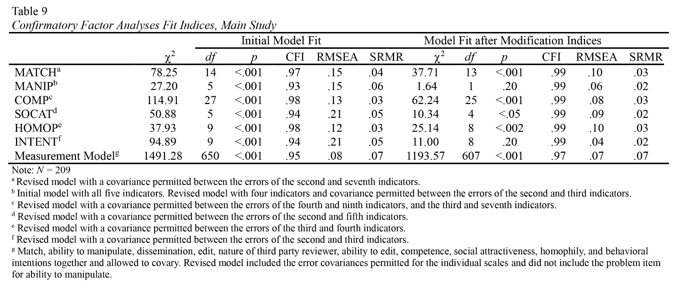
Hypotheses Tests and Model Results
A structural equation model was tested with LISREL 9.10 (Jöreskog & Sörbom, 2013), maximum likelihood estimation method. The exogenous variables (presence of comments on reviews, identifiability of the reviewer, total number of raters, and presence of aggregated data) were allowed to covary. The error variance of the four dichotomous exogenous variables was set to zero. The paths specified in the study’s hypotheses were freed and the modifications implemented in the confirmatory analyses were permitted. Model fit was adequate, χ² (754, N = 209) = 1507.68 (p < .001), RMSEA = .07, 90% CI [.06, .07], CFI = .96, and SRMR = .13. The model adequately fits the data even though only the CFI meets the fit indices as recommended by Hu and Bentler (1999). The RMSEA is very close and the 90% confidence interval and includes the cutoff value of .06. Some scholars argue for a cutoff point of .10 (e.g., Browne & Cudeck, 1993), so this value can be considered an acceptable one. Therefore, two of the three indices meet their respective cutoff points. This model was used to examine the proposed hypotheses and the results are presented in Figure 3 and detailed in what follows. The coefficients discussed are unstandardized path coefficients.
H1 proposed that the presence of profile owner comments on reviews would lead to less warranting value as seen in a) less perceived match between the online representation and the offline self and b) greater ability to manipulate reviews. H1a was supported, β = -0.35, p < .05, indicating that the presence of professor comments on the reviews led participants to perceive less of a match between the professor’s online representation and his offline self. H1b, however, was not supported, β = -0.06, p = .72. The ability for the professor to comment on student reviews did not influence the perception that the professor could modify the reviews.
H2 predicted that the identifiability of a reviewer would result in greater warranting value as seen in a) greater perceived match between the online representation and the offline self and b) less ability to manipulate reviews. This hypothesis was not supported. The identifiability of the reviewer did not influence perceived match, β = -0.19, p = .17, nor did it influence the professor’s perceived ability to manipulate reviews, β = -0.12, p = .44.
H3 posited that a higher number of total ratings would result in greater warranting value as seen in a) greater perceived match between the online representation and the offline self and b) less ability to manipulate the reviews. This hypothesis was not supported. The number of ratings did not influence the perceived match, β = -0.08, p = .57, nor did it influence the perceived ability to manipulate reviews, β = 0.14, p = .39.
H4 predicted that the presence of aggregated data would result in greater warranting value as seen in a) greater perceived match between the online representation and the offline self and b) less ability to manipulate the reviews. This hypothesis was not supported as predicted, but H4a approached significance in the opposite direction than predicted, β = -0.27, p = .08, indicating that the presence of aggregated data could result in less of a perceived match between the professor’s online representation and the offline self. The presence of aggregated data did not influence the ability to manipulate the reviews, β = 0.03, p = .84.
The next two hypotheses were concerned with the influence of warranting value on potential students’ impressions of the professor. H5 predicted that a greater perceived match between the professor’s online representation and corporeal self would result in perceiving the professor as having a) more competence, b) greater social attractiveness, c) greater homophily, and also would result in d) more behavioral intentions from participants to interact with the professor in the future. This hypothesis was supported. Greater perceived match predicted greater perceived competence, β = 0.46, p < .001, as well as greater social attractiveness, β = 0.32, p < .001. Additionally, greater perceived match resulted in greater homophily, β = 0.30, p < .001, and more behavioral intentions to interact with the professor, β = 0.39, p < .001.
H6 predicted that the professor’s ability to manipulate the reviews resulted in a) less competence, b) less social attractiveness, c) less homophily, and d) less intentions to interact with the professor in the future. This hypothesis was not supported. However, two of the sub-hypotheses were significant in the direction opposite than predicted. The ability of the professor to manipulate the reviews significantly predicted greater competence, β = 0.36, p < .001, as well as greater behavioral intentions of participants to interact with the professor, β = 0.22, p < .01. The ability to manipulate the reviews did not predict social attractiveness, β = 0.09, p =.26, nor did it predict homophily, β = 0.02, p = .75.
Two paths from competence to intentions and from homophily to social attractiveness were added following modification suggestions provided by LISREL. These paths were deemed justifiable because previous research has found connections between homophily and liking a person as well as attraction (Izard, 1960; Newcomb, 1956). Basically, this added path between homophily and social attraction signifies that the perception of similarity leads to greater social attraction. Additionally, given that the definition of competence is the instructor’s perceived expertise (J. C. McCroskey, 1966), it makes sense that an instructor’s expertise would predict student intentions to interact with that professor in the future. Adding these paths increased the R-squared of social attractiveness from .11 to .37 and increased the R-squared of behavioral intentions from .21 to .32. These new paths indicated that greater competence resulted in greater intentions to interact with the professor in the future, β = 0.47, p < .001. Also, greater perceived homophily with the professor resulted in greater social attractiveness, β = 0.55, p < .001. However, these paths also reduced the R-squared of competence from .35 to .32, and the R-squared of homophily from .09 to .08. Overall model fit with these additional paths did not differ much from the original model fit. Model fit was adequate, χ² (752, N = 209) = 1418.41 (p < .001), RMSEA = .07, 90% CI [.06, .07], CFI = .96, and SRMR = .11. The model that includes the additional post hoc paths is presented in Figure 4. Implications of adding these paths are discussed in further detail in the following section, as are the implications for warranting theory in general.

Figure 3: Results model for effects of online cues and warranting value on impressions. Solid lines represent
supported hypotheses; dotted lines represent significant results in a direction opposite than predicted.
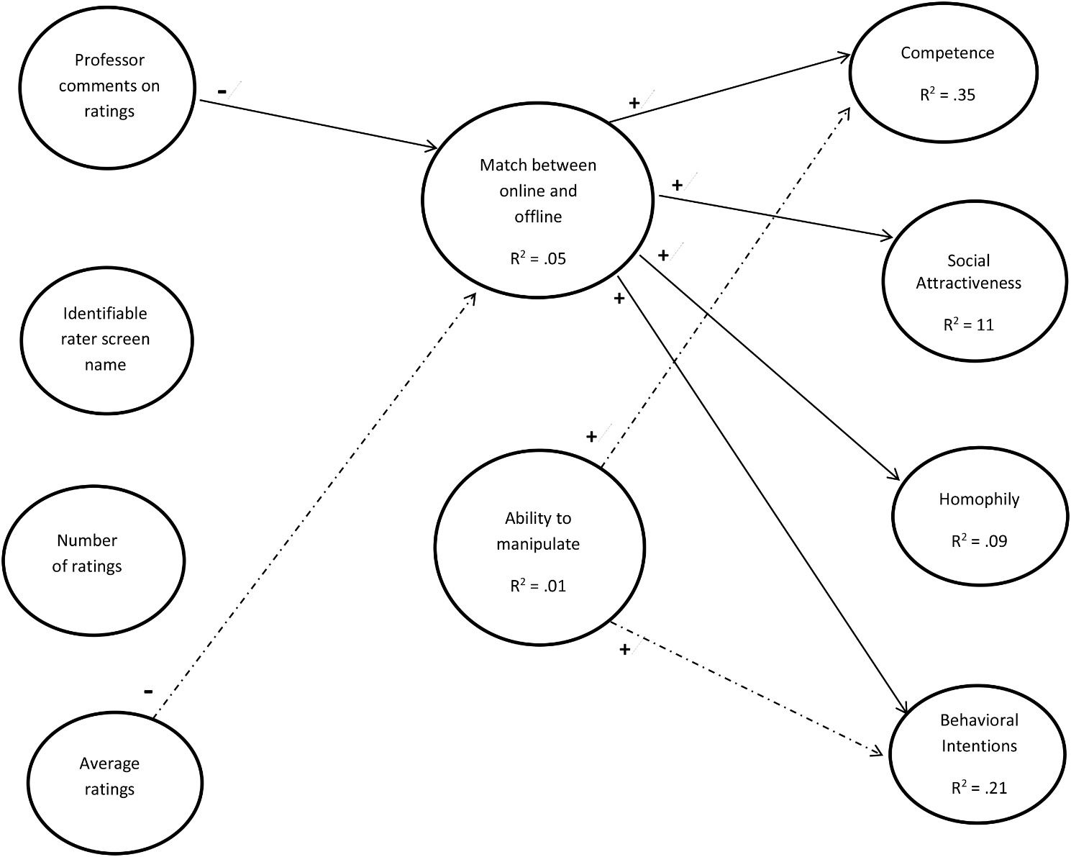

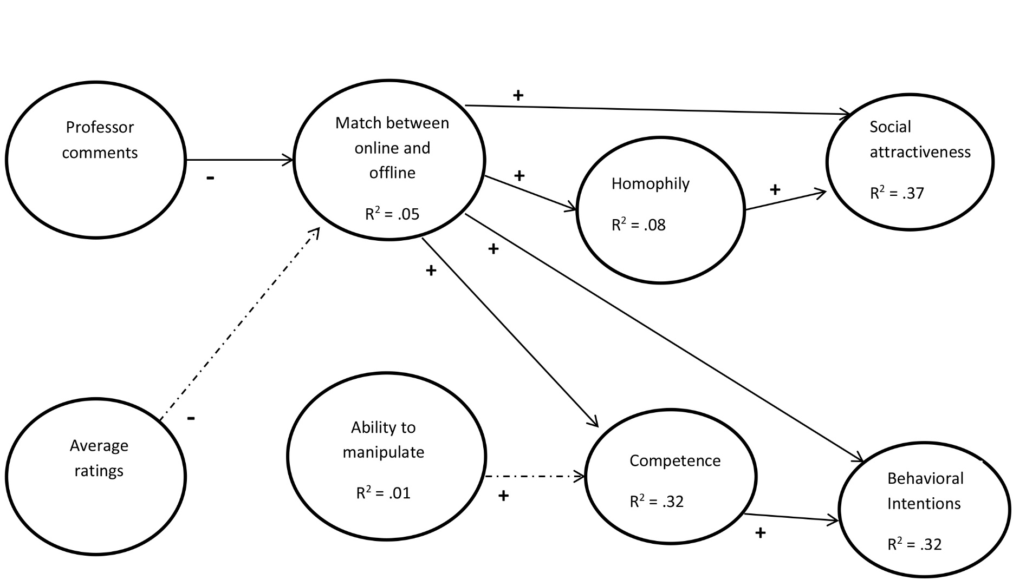
Figure 4: Modified results model for effects of online cues and warranting value on impressions with post hoc paths. Solid lines represent supported hypotheses; dotted lines represent significant results in a direction opposite than predicted.
Chapter 5: Discussion
The purpose of this research was to test warranting theory as a process in which online cues are hypothesized to indirectly affect impressions through judgments of warranting value. This process involves examining certain cues of an online profile that are believed to lead to judgments of warranting value, which, in turn, are expected to influence impressions of the online profile’s owner. This section provides a discussion of the research results presented in the previous chapter and their implications for warranting theory as well as possible explanations for the three significant paths that were contrary to hypotheses. The alternate model with post hoc paths is discussed as well as theoretical implications for warranting theory as a Brunswik lens model. Finally, limitations and directions for future research are presented.

Hypothesized Model and Post Hoc Paths
It was hypothesized that the presence of aggregated data, such as overall averaged ratings, total number of ratings, the presence of professor comments, and an identifiable reviewer would influence warranting value. Warranting value was conceptualized as two-dimensional, including a match between one’s online presentation and his or her offline self (one dimension), and the ability to manipulate the reviews presented on the website (another dimension). The first hypothesis proposed that the presence of comments from the professor would lead to less warranting value. This hypothesis was partially supported in that the presence of comments led to less of a perceived match but not to the professor’s ability to manipulate the reviews. This was the only hypothesis concerning antecedent cues that received support. DeAndrea, Van Der Heide, and Easley (2015) claimed that the structure of a website influences the perceived ability to edit reviews. In the present research, participants may have perceived the website structure as immune to manipulation. Even though the professor may have commented on reviews from students, he was not able to manipulate those reviews. It is likely participants perceived that the website structure prevented the professor’s ability to manipulate information because the website was credible. Another possibility is that because the reviews occur after the student has taken a course from the professor, there are no consequences to leaving a review, and therefore, the professor’s hypothesized ability to manipulate information by commenting on the reviews is not recognized. Students who leave reviews may never have contact with the professor again, and consequently, observers of the reviews do not perceive that the professor influenced what the reviewers wrote.
The reviewer’s identifiabilty was not a significant predictor of warranting value. According to warranting theory, masking the true source of information can be perceived as self-serving and, therefore, that information is not valuable (DeAndrea, 2014). An anonymous student reviewer could have been perceived to be the professor himself writing a favorable review and, therefore, that perception would lead to less warranting value. An identifiable reviewer should have greater immunity to manipulation, that is, greater warranting value. However, results indicated that the identifiability of the student reviewer did not influence perceptions of warranting value. This could be due to the website context. In order for an individual to manipulate information online, there must be a motivation to do so. The professor may not have the motivation to mask his or her identity and write his or her own reviews. However, if, for example, the website were a University-sponsored website that the Dean of the professor’s college would see and rely on to make salary decisions based partially on student reviews, the professor would perhaps have the motivation to mask his or her identity and write favorable reviews about himself or herself. DeAndrea, Van Der Heide, Vendemia, et al. (2015) found that a company-owned website was perceived to have greater control over the reviews that appeared on the website, and that control over dissemination is akin to the ability to manipulate information. When sponsored by the organization to which the online content refers, the website has the perceived ability to manipulate information presented on the website. This idea can be applied to a professor rating website as well. The context in which the website exists can influence judgments of warranting value.
The third and fourth hypotheses were not supported. In fact, H4a approached significance in the direction opposite than predicted, indicating that the presence of aggregated data may have led to less of a perceived match between the professor’s online presentation and offline self. When it was present, the aggregated data contained somewhat high ratings ranging from 3.9 to 4.3 on a 5.0 scale. While this is somewhat average for profiles on RateMyProfessors.com, it is possible that participants saw these ratings as too high and, therefore, not an accurate depiction of the actual professor.
The second step in the warranting process, after judgments about the warranting value of cues have been made, is to rely on those judgments to form impressions. The hypotheses testing this part of the process received mixed support. H5 predicted that a perceived match between the professor’s online and offline selves would lead to greater perceptions of the professor’s competence, social attractiveness, homophily, and students’ behavioral intentions to interact with the professor. This hypothesis was supported, which lends support to warranting theory. Walther (2011) claimed that individuals should be more confident in their impressions when information connects the online persona to the offline individual. DeAndrea (2014) stated that greater warranting value affects impressions more. The results of the current study do, in fact, show that the perception of a match between the online representation and the offline person influences impressions of the professor positively.
However, results also showed that the perceived ability of a professor to manipulate the reviews did not significantly predict three of the four measured impression variables. The one impression variable that was affected by the ability to manipulate was in the opposite direction than predicted. The results showed that a greater ability to manipulate the reviews led to greater perceptions of competence. This contradicts warranting theory’s predictions. Warranting theory predicts that if the information is high in warranting value, the impressions will be influenced in a direction similar to the online information. In this case, when warranting value was low (i.e., the ability to manipulate was high) participants viewed the professor as having greater competence rather than less competence. However, these relationships may be explained by the way items measuring manipulation were phrased. The statements were worded in a way that permitted manipulation, but did not imply manipulation had necessarily occurred. So, although the professor had the ability to manipulate reviews but may not necessarily have done so, participants still believed the professor to be a credible instructor with whom they would interact in the future.
Warranting cues may vary based on the type of website (DeAndrea, 2014), which begs the question of what specific cues constitute warranting cues within the context of a professor rating website. Included in the main study, participants answered the open-ended question “What information from the webpage did you consider when forming your impressions of this professor?” Many participants mentioned the cues of interest, such as the professor commenting on the reviews or the identity of the individuals who wrote the reviews, but, interestingly, in ways contrary to warranting theory. For example, many students said the fact that the professor commented on the reviews showed that he cared and was a good professor, not that he influenced the reviewers.
Some other potential warranting cues could include the ratings of each individual reviewer. Many participants responded that they not only looked at the overall average ratings but also at the ratings of each individual rater and that those cues influenced their evaluations. So, in the context of a professor rating website, individual ratings may be more influential than aggregated data. The influence of individual ratings rather than aggregated data has not been experimentally examined for review websites. However, Walther et al. (2009) found that comments left by one’s Facebook friends about the profile owner’s extraversion and attractiveness influenced observers’ perceptions of the profile owner’s extraversion and attractiveness. That is, the comments of individuals influenced observers’ perceptions. It stands to reason that the individual influence would still be effective for review-type websites.
Also of note, participants stated that the length of the reviews influenced their perceptions. Specifically, one participant stated “College students have better things to do than write reviews, so when they’re long and positive I become suspicious.” Another participant stated that the language used in the review was a factor; this individual used the language of the review to determine “whether or not the students seemed competent in their comments about the professor.”
Many participants claimed broad generalizations about the website as reasons for their assessments. For example, when asked what cues they relied on, participants cited the “website layout,” “the colors and the way it was presented to me,” or simply “I just took the webpage as a whole.” One participant claimed “if the website seemed credible, then I thought the professor was credible.” The central claim of warranting theory is that information influences our opinions to the extent that information cannot be manipulated by the person to whom the information refers (Walther, 2011). Individuals may evaluate the webpage as a whole and not be aware of which specific cues are more reliable than others. However, they still make judgments about the warranting value of the webpage, which influences their impressions. As previously stated, the suggested modifications to the hypothesized model included adding paths between homophily and social attractiveness and between competence and behavioral intentions. These additional paths suggest that impression formation is more complex than hypothesized. First, results from the modified model show that perceptions of homophily between the participants and the professor predict perceptions of social attractiveness. That is, greater perceived similarity between a participant and the professor led to greater social attraction. Research has demonstrated a link between friends and perceived similarity (Izard, 1960) and that similarity, or homophily, is a predictor of attraction (Newcomb, 1956).
Second, results of the model show that perceptions of instructor competence predict behavioral intentions to interact with the professor in the future. Myers (2004) found that instructor competence was positively related to student communication outside the classroom. Interestingly, competence was not related to student participation in the classroom (Myers, 2004). The measure for behavioral intentions in the present study only asked about interacting with the professor indirectly, through enrolling in the professor’s course or recommending the professor to a friend. Based on Myers’ research, it makes sense that perceived professor competence would predict behavioral intentions to interact with the professor indirectly.
The model with post hoc paths showed that homophily acts as a moderator for social attractiveness and competence acts as a moderator for intentions. That is, the perceived match between a professor’s online representation and offline self influences the perceived social attractiveness of the professor and the behavioral intentions of the observer to interact with the professor in the future, but these relationships are also influenced by homophily and competence. The R-squared of social attractiveness increases from .11 to .37 when a path is added from homophily to social attractiveness. Essentially, the perceived similarity an observer feels with a professor (i.e., homophily) increases their social attraction to that professor. The more similar a person feels to a professor, the more that person would spend time or chat with the professor. The relationship between the perceived match between the professor’s online representation and offline self and the social attractiveness of the professor becomes stronger when homophily is also considered, as homophily is a stronger predictor of social attractiveness.
Additionally, when a path is added between competence and behavioral intentions, the R-squared of the latent variable of behavioral intentions increases from .21 in the original hypothesized model to .32. The more competent an observer perceives a professor to be, the more likely that observer is to interact with the professor. The relationship between the perceived match of the professor’s online representation and offline self and behavioral intentions to interact with the professor is strengthened when the perceived competence of the professor is considered. That is, competence is a stronger predictor of behavioral intentions than the perceived match of the professor’s online and offline identities alone.
Without these added paths, there is a significant path from perceptions of the professor’s ability to manipulate reviews and behavioral intentions to interact with the professor, but this path is in the opposite direction than predicted by warranting theory. When these post-hoc paths are added to the model, that path is no longer significant. These significant paths show competence acts as a mediator between the ability to manipulate and behavioral intentions. Specifically, the perceived ability to manipulate the online reviews indirectly influences behavioral intentions of the observer through the perceived competence of the professor. Greater perceived ability to manipulate online reviews leads to greater impressions of professor competence. The more competent the professor is perceived to be, the more likely the observer is to interact with the professor in the future. The perceived ability to manipulate information does not directly influence behavioral intentions to interact with the professor.

Theoretical Implications and Brunswik Lens Model
The Brunswik lens model is used to describe how environmental cues serve as a lens through which observers make judgments about the characteristics of the target (Walther et al., 2008). This perspective can be applied to a CMC context in which the website or one’s online profile serves as the environment. Specific cues within that environment influence observers’ impressions of the profile owner. Warranting theory has been viewed as a Brunswik lens in previous research (e.g. Walther et al., 2008) in that certain online cues influenced impressions of the profile owner. The present study tested a Brunswik lens model of warranting theory in a professor rating context. Online cues from a website were hypothesized to influence judgments of warranting value. Those judgments, then, were believed to influence impressions of the professor. However, the model showed that the experimentally manipulated online cues did not influence judgments of warranting value. It is possible that the manipulated cues are, in fact, not warranting cues within a professor rating context.
The results of this model with post-hoc paths showed that impression formation may actually be more complex than originally hypothesized. It is not a simple three-step process of cues informing warranting value, which then influences impressions. The impression formation process is multi-tiered in that some impressions influence others. The results of the hypothesized model and the post-hoc modifications indicate that conceivably warranting theory is not best viewed as a Brunswik lens; it is perhaps not the specific cues that influence warranting value, but rather the influence of warranting value on impressions that research should focus on. Based on the current results, it seems warranting theory might best be viewed from an HSM persective (Chaiken, 1980). Individuals do not seem to recognize specific cues, or more specifically, they do not systematically process those cues, but they still form judgments of warranting value. If individuals have the motivation to process information systematically, rather than heuristically, the judgments of warranting value may differ, and thus, their impressions may differ from their impressions if they had processed information heuristically. As warranting theory continues to be tested and refined, efforts need to focus on the second part of the warranting process, moving from judgments of warranting value to impression formation, in addition to how individuals process specific cues. Even in the qualitative responses, many participants claimed they just looked at the website as a whole. Individuals did not seem to notice the details when viewing a website yet still formed judgments about the website’s content.
Based on the quantitative results and participants’ qualitative responses, the specific cues do not appear to lead to judgments of warranting value nor do they influence impressions of the professor. Results showed that warranting value, specifically the perceived match between a professor’s online representation and offline identity, influenced impressions but specific cues (i.e., presence of aggregated data, presence of professor comments on reviews, identifiability of the reviewer, and number of ratings) were not a factor. In fact, the results of the hypothesized model do not change when all participants are included (i.e., when participants who answered even three manipulation check questions incorrectly are included in the analysis). The influence, albeit minor, of the online cues on warranting value remains the same when individuals who did not recognize details of the website are included. Additionally, the influence of warranting value on impressions of the professor does not change when participants who did not pay considerable attention to the website are included. Researchers must then ask whether specific cues should continue to be tested within the context of warranting theory or whether future research should focus on judgments of warranting value. Tong et al. (2008) found in a post-hoc study that, even though there were significant effects in the main study for the number of Facebook friends and impressions of extraversion and attractiveness, participants did not actually pay attention to the number of Facebook friends. Tong et al. (2008) argued that the observers in their study were not consciously aware of the cue that informed their impressions. Previous research has supported the idea that specific cues in an online environment influence impressions (Tong et al., 2008; Utz, 2010; Walther et al., 2008; Walther et al., 2009), but this research did not test the warranting process in which observers were asked to judge the information for its ability to be manipulated or as representing a reliable match between an online and offline identity.
Research should continue to examine the warranting process holistically, meaning warranting theory research should include the observation of cues, judgment of warranting value, and impression formation. The current results support warranting theory in that warranting value influenced impressions; this research does not, however, support the prediction that specific cues influence judgments of warranting value. Participants seemed to form snapshot judgments of the website, then implicitly assign warranting value to the content, which influenced their impressions. Within the context of RateMyProfessors.com, students view a professor’s profile and make judgments about the credibility of the information presented (i.e., they assign warranting value) without overtly considering specific online cues presented in the website, such as the total number of ratings or the identifiability of the reviewer. Students then form impressions about the professor. Those impressions (specifically of professor competence in this research) influence the students’ decisions to enroll in the professor’s course.
A Brunswik lens model involves three processes as described by Gifford (2006): encoding, decoding, and agreement. These three processes describe how an individual’s personality is manifested nonverbally within an environment (encoding), how an observer interprets the manifestations of the individual’s personality, and that agreement is the correlation between the individual’s personality and the observer’s interpretations. The present research did not test the encoding processes, but did test the decoding process in a multi-tiered model similar to Jensen et al. (2010). In the hypothesized model, warranting value acted as a mediator between online cues and impressions. A student viewed online information presented on a professor rating website, made credibility judgments about the information, and that judgment influenced his or her impressions of the professor. The present research only partially supported this modified Brunswik lens in that specific cues did not influence credibility judgments; however, credibility judgments did influence impressions of the professor. Warranting theory may be better examined with the perspective of the HSM, which could provide perhaps a more encompassing explanation as to why certain cues are more or less influential in the judgment of warranting value and impression formation.
Warranting theory, as described by Walther (2011) and DeAndrea (2014), has been supported in previous research. However, based on the present research, the cognitive process described in the theory needs to be refined to include how the cues are processed. Previous studies have focused on the link between cues and impressions and only hypothesized that warranting value was the driving mechanism of the relationship between these two. However, warranting value has not been operationalized until recently (e.g., DeAndrea, Van Der Heide, & Easley, 2015; DeAndrea, Van Der Heide, Vendemia, et al., 2015). Warranting theory research needs to continue to focus on the link between warranting value and impression formation in addition to how specific cues are cognitively processed.

Limitations
This research is not without its limitations. The first limitation lies in the structure of the experiment. Participants were timed on how long they spent viewing the website, but not required to spend any particular amount of time viewing it. Responses from participants who spent a significantly short amount of time viewing the website were deleted from the dataset, but the overall viewing time was still somewhat short (M = 92.87 seconds, SD = 71.92, range = 3.27 to 494.88 seconds). To rectify this, the length of time participants’ spent viewing the webpage could have been controlled by an automated timer so that participants could only advance to the next screen after they spent a required amount of time viewing the website. However, it was thought this would only anger participants and create complications with survey items. For example, participants would be frustrated and quickly enter values without reading the specific items. Additionally, adding an automated timer would lessen external validity of the experiment. After the pilot study, instructions were added to the introductory paragraph to “pay close attention to the website. You will be tested on your knowledge of the content” with the intention of having participants spend more time viewing the website. It may have been more effective to create a hypothetical scenario in which participants were asked to consider taking a course from the specific professor. Participants may have been more likely to evaluate the content of the webpage if they had the motivation to do so, such as if they were considering taking a course from that professor, albeit hypothetically.
Because participants did not pay attention to the manipulated cues, three-fourths of the collected responses had to be discarded from analyses. Each manipulation check question was answered incorrectly by at least a third of participants. Even with modifications to the manipulations and the manipulation check questions following the pilot study, the objective website cues were still not noticed by the majority of participants. Including only those participants who recognized each independent variable manipulation meant deleting responses from three-fourths of the sample. This drastic reduction in participant responses suggests that participants may have processed information heuristically. They did not pay attention to specific cues, yet still formed impressions of the professor and of the website. If participants were told to view the website as if they were considering enrolling in the professor’s course, they would have had more motivation perhaps to process the information systematically. If participants had processed the information systematically, they would have spent more time viewing the website. An automated webpage timer would not motivate participants to process information systematically, but a hypothetical scenario would perhaps work better to motivate participants.

Directions for Future Research
The results of this research prompt new directions for future research. First, future research should continue examining the professor rating context. The actual website RateMyProfessors.com does not have an identity claim from the professor like the hypothetical “Rate My Instructors” website of this study; however, students are still “shopping” for a professor. RateMyProfessors.com is similar to a product review website which has been examined within the context of warranting theory (e.g., DeAndrea, Van Der Heide, Vendemia, et al., 2015). Most research on warranting theory has focused on social network sites, but research needs to be expanded to different types of websites. Testing warranting theory within different contexts enhances our understanding of the impression formation process in the case of online information that may or may not have been manipulated. For example, the Pew Research Center claims that 66% of Americans have purchased a product online and more people would shop online if they trusted the website on which they were shopping (Horrigan, 2008). Research regarding the process through which individuals judge the credibility of an e-commerce website, or judge the potential manipulability of that website, can then be applied when designing a new e-commerce website or when entrepreneurs want to move their business to an online environment. Review websites such as Yelp.com could apply warranting theory knowledge when updating their webpage design by including mechanisms that prevent manipulation or build observer confidence in the validity of the information. For example, glassdoor.com, a company review website, has the explicit message “Your trust is our top concern, so companies can't alter or remove reviews.” This explicit message serves to strengthen observers’ trust in the validity of the website. Warranting theory research can better inform companies of how they could improve their website design to build observers’ confidence in the company product.
Future research should also test warranting theory for negative professor reviews. The current research only included positive reviews from students. Warranting theory would predict that if information has high warranting value, the impressions formed would be consistent with the reviewers’ opinions. Since the present research only included positive reviews, it was hypothesized that the impressions of the professor would be positive when the information had high warranting value. Research has shown that impressions tend to coincide with the reviewers’ opinions if the information has warranting value. For example, Walther et al. (2009) found that when an individual’s Facebook friends commented favorably on the attractiveness of the profile owner, observers judged the profile owner to be more attractive. Similarly, when the commenters inferred that the profile owner may be unattractive, observers agreed with the commenters. Theoretically, this agreement should exist with professor rating websites, but this possibility was not tested.
Warranting theory should continue to be studied as a Brunswik lens model. Although this study does not fully support the Brunswik lens perspective of the warranting process, research should continue to examine these relationships as Americans are becoming more dependent on technology. According to the Pew Research Center, 53% of Internet users said giving up the Internet would be very hard. Similarly, 49% of cell phone owners said they could not give up their cell phones (Fox & Rainie, 2014). Because of this increased dependence on technology, research should continue to focus on the relationships between online cues, warranting value, and impression formation. The potential results of this research could be utilized by online companies to better market their products. Additionally, the potential results could better inform consumers of what information should be considered to be reliable and valid. Research also needs to continue to test the operationalization of warranting value. Warranting value is a multidimensional construct and it is likely, given the present and previous research, that warranting value has not been accurately operationalized. In the present study, the match between the online representation and offline self was the strongest predictor of impressions. The ability to manipulate information only predicted impressions of professor competence.
These scales need further testing and refinement to increase reliability between contexts and validity of the measurement of warranting value. For example, DeAndrea, Van Der Heide, and Easley (2015) operationalized warranting value similar to the present study as the likelihood editing occurred and the ability to edit the online information. DeAndrea, Van Der Heide, Vendemia, et al. (2015) operationalized warranting value as control over the dissemination of online information and the nature of the third party reviewer. In both cases, warranting value was shown to influence observer impressions. The warranting value scales from DeAndrea, Van Der Heide, and Easley (2015), DeAndrea, Van Der Heide, Vendemia, et al. (2015) and the present operationalization should be tested within the same context and factor analyzed to further refine a measurement for warranting value.
This theory should also be tested longitudinally. Impressions could change over time after initial impressions were formed. This potential change is important to examine because it could inform website owners of the possible strength of first impressions. For example, longitudinal studies should examine how the altering of one’s Facebook profile or one’s dating profile affects impressions of that individual. When an individual maintains a romantic relationship online, new cues will be evident as time progresses, which could alter his or her initial impression of their romantic partner. However, it is also possible that the initial impression is so strong that new incongruous information does not affect that initial impression. This possibility has been demonstrated by the idea of “catfishing,” a relationship solely online where one partner intentionally deceives the other, usually for money (Rasmussen, 2014). In a catfishing situation, the positive first impressions are too strong to become suspicious. Certain online cues may be stronger than others at maintaining impressions, but perhaps other online cues are stronger at changing impressions. For example, an individual may form a positive impression based on an online dater’s attractive profile photo, and if that online dater changed some information within their dating profile, such as their body type descriptor from “thin” to “stocky,” the observer’s first impression might not change; he or she might still think the online dater is attractive. However, the stronger cue may be that the online dater described him- or herself as “stocky” and because that cue changed, the observer’s first impression could also change. Longitudinal studies would better inform researchers of how the warranting process unfolds and which cues influence changes in warranting value and impressions.

Conclusion
The purpose of this dissertation was to test a model of warranting theory. This research examined the effects objective cues, including the presence of aggregated data, number of ratings, presence of professor comments, and identifiable reviewer, have on judgments of warranting value. Warranting value was then believed to influence participants’ impressions of a professor. Overall, results showed no significant effects of the objective cues, but warranting value, specifically the factor of match between the online representation and the offline entity, influenced impressions of the professor.
Warranting theory is being expanded into contexts other than social network sites (e.g., DeAndrea, Van Der Heide, & Easley, 2015; DeAndrea, Van Der Heide, Vendemia, et al., 2015). This broadening of the scope of application gives researchers a more thorough view of how the warranting process works when examining online information. Applying a Brunswik lens perspective to the warranting process allows researchers to decipher which online cues about a target influence observers’ perceptions of that target and how this process may work. Previous research on warranting theory has only hypothesized the driving mechanism between observing online cues and forming impressions. DeAndrea, Van Der Heide, and Easley (2015) and DeAndrea, Van Der Heide, Vendemia, et al. (2015) have begun to test the driving mechanism by operationalizing warranting value. However, warranting value is a multidimensional construct and the dimensions have not yet been fully validated. In a broader scope, warranting theory can be used to examine information acquired online when information credibility must be determined. Essentially, warranting theory claims that information is more trustworthy and credible when it is immune to manipulation (DeAndrea, 2014).
The results of this dissertation reveal that, within the context of a professor rating website, the presence of aggregated data and the presence of professor comments on online reviews influenced participants’ judgments of warranting value. However, even though these relationships were significant, their effect sizes were small. Results also revealed that the perceived match between the professor’s online presentation and offline self influenced impressions of the professor. The professor’s perceived ability to manipulate the reviews only influenced impressions of the professor’s competence. In post hoc analyses, certain impression variables were found to influence other impressions. Specifically, the perceived homophily a participant felt with the professor increased that person’s social attraction to the professor. Additionally, the professor’s perceived competence influenced participants’ behavior intentions. Overall, results revealed that specific online cues did not greatly influence warranting value, but warranting value, specifically the perceived match between the professor’s online and offline identities, influenced participants’ impressions of the professor. Furthermore, the impressions of homophily and competence influenced perceptions of social attractiveness and behavior intentions to interact with the professor.
This study contributed new knowledge of warranting theory by testing the warranting process as a Brunswik lens model, applying it to a new context (a professor rating website), and operationalizing warranting value. Future research should continue to examine warranting theory within new online contexts as well as continue refining the multi-dimensional concept of warranting value. The current research claims warranting theory might not actually function as a Brunswik lens; however, the limited results limit the strength of this claim. Warranting theory should continue to be examined in new contexts and with new cues, before deciding whether the theory needs to be modified.

References
About RateMyProfessors.com. (n. d.). Retrieved from http://www.ratemyprofessors. com/About.jsp
Berinsky, A. J., Huber, G. A., & Lenz, G. S. (2012). Evaluating online labor markets for experimental research: Amazon.com's Mechanical Turk. Political Analysis, 20, 351-368. doi: 10.1093/pan/mpr057
Borgida, E., & Nisbett, R. E. (1977). The differential impact of abstract vs. concrete information on decisions. Journal of Applied Social Psychology, 7, 258-271. doi: 10.1111/j.1559-1816.1977.tb00750.x
Browne, M. W., & Cudeck, R. (1993). Alternative ways of assessing model fit. In K. A. Bollen & J. S. Long (Eds.), Testing structural equation models (pp. 136-162). Newbury Park, CA: Sage.
Brunswik, E. (1956). Perception and the representative design of psychological experiments. Berkeley: University of California Press.
Buchert, S., Laws, E. L., Apperson, J. M., & Bregman, N. J. (2008). First impressions and professor reputation: Influence on student evaluations of instruction. Social Psychology of Education, 11, 397-408. doi: 10.1007/s11218-008-9055-1
Buhrmester, M., Kwang, T., & Gosling, S. D. (2011). Amazon's Mechanical Turk a new source of inexpensive, yet high-quality, data?. Perspectives on Psychological Science, 6, 3-5. doi: 10.1177/1745691610393980
Chaiken, S. (1980). Heuristic versus systematic information processing and the use of source versus message cues in persuasion. Journal of Personality and Social Psychology, 39, 752-766. doi:10.1037/0022-3514.39.5.752
Chaiken, S., Liberman, A., & Eagly, A. H. (1989). Heuristic and systematic processing within and beyond the persuasion context. In J. S. Uleman & J. A. Bargh (Eds.), Unintended thought (pp. 212-252). New York, NY: Guildford Press.
Chen, S., & Chaiken, S. (1999). Dual-process theories in social psychology. In S. Chaiken & Y. Trope (Eds.), Dual-process theories in social psychology (pp. 73-96). New York, NY: Guilford Press.
Cole, D. A., Ciesla, J. A., & Steiger, J. H. (2007). The insidious effects of failing to include design-driven correlated residuals in latent-variable covariance structure analysis. Psychological Methods, 12, 381-398. doi: 10.1037/1082-989X.12.4.381
DeAndrea, D. C. (2012). Participatory social media and the evaluation of online behavior. Human Communication Research, 38, 510-528. doi: 10.1111/j.1468-2958.2012.01435.x
DeAndrea, D. C. (2014). Advancing warranting theory. Communication Theory, 24, 186-204. doi: 10.1111/comt.12033
DeAndrea, D. C., Van Der Heide, B., & Easley, N. (2015). How modifying third-party information affects interpersonal impressions and the evaluation of collaborative online media. Journal of Communication, 65, 62-78. doi: 10.1111/jcom.12139
DeAndrea D. C., Van Der Heide, B., Vendemia, M. A., & Vang, M. H. (2015). How people evaluate online reviews. Communication Research. Advance online publication. doi: 10.1177/0093650215573862
Dunbar, N. E., & Segrin, C. (2012). Clothing and teacher credibility: An application of expectancy violations theory. ISRN Education, 2012, 1-13. doi: 10.5402/2012/140517
Edwards, A., & Edwards, C. (2013). Computer-mediated word-of-mouth communication: The influence of mixed reviews on student perceptions of instructors and courses. Communication Education, 62, 412-424. doi: 10.1080/03634523.2013. 800217
Edwards, C., Edwards, A., Qing, Q., & Wahl, S. T. (2007). The influence of computer-mediated word-of-mouth communication on student perceptions of instructors and attitudes toward learning course content. Communication Education, 56, 255-277. doi: 10.1080/03634520701236866
Fink, E. L. (2009). The FAQs on data transformation. Communication Monographs, 76, 379-397. doi: 10.1080/03637750903310352
Flanagin, A. J., & Metzger, M. J. (2013). Trusting expert-versus user-generated ratings online: The role of information volume, valence, and consumer characteristics. Computers in Human Behavior, 29, 1626-1634. doi: 10.1016/j.chb.2013.02.001
Fox, S., & Rainie, L. (2014, Feb 27). The Web at 25 in the U.S. Retrieved from Pew Research Center, Internet & American Life Project website: http://www.pewinternet.org/2014/02/27/the-web-at-25-in-the-u-s/
Gifford, R. (2006). Personality and nonverbal behavior: A complex condundrum. In V. Manusov & M. L. Patterson (Eds.), The SAGE handbook of nonverbal communication (pp. 159-199). Thousand Oaks, CA: Sage.
Glascock, J., & Ruggiero, T. E. (2006). The relationship of ethnicity and sex to professor credibility at a culturally diverse university. Communication Education, 55, 197–207. doi: 10.1080/03634520600566165
Gosling, S. D., Augustine, A. A., Vazire, S., Holtzman, N., & Gaddis, S. (2011). Manifestations of personality in online social networks: Self-reported Facebook-related behaviors and observable profile information. Cyberpsychology, Behavior, and Social Networking, 14, 483-488. doi: 10.1089/cyber.2010.0087
Gosling, S. D., Ko, S. J., Mannarelli, T., & Morris, M. E. (2002). A room with a cue: Personality judgments based on offices and bedrooms. Journal of Personality and Social Psychology, 82, 379-398. doi: 10.1037//0022-3514.82.3.379
Grigorovici, D., Nam, S., & Russill, C. (2003). The effects of online syllabus interactivity on students' perception of the course and instructor. The Internet and Higher Education, 6, 41-52. doi: 10.1016/s1096-7516(02)00163-x
Guerrero, L. K., & Miller, T. A. (1998). Associations between nonverbal behaviors and initial impressions of instructor competence and course content in videotaped distance education courses. Communication Education, 47, 30-42. doi: 10.1080/03634529809 379108
Hall, J. A., & Pennington, N. (2013). Self-monitoring, honesty, and cue use on Facebook: The relationship with user extraversion and conscientiousness. Computers in Human Behavior, 29, 1556-1564. doi: 10.1016/j.chb.2013.01.001
Hall, J. A., Pennington, N., & Lueders, A. (2014). Impression management and formation on Facebook: A lens model approach. New Media & Society, 16, 958-982. doi: 10.1177/1461444813495166
Hampson, S. E., Goldberg, L. R., & John, O. P. (1987). Category-breadth and social-desirability values for 573 personality terms. European Journal of Personality, 1, 241-258.
Hong, S., Tandoc, E., Kim, E. A., Kim, B., & Wise, K. (2012). The real you? The role of visual cues and comment congruence in perceptions of social attractiveness from Facebook profiles. Cyberpsychology, Behavior, and Social Networking, 15, 339-344. doi: 10.1089/cyber.2011.0511
Horrigan, J. (2008, Feb 13). Online shopping. Retrieved from Pew Research Center, Internet & American Life Project website: http://www.pewinternet.org/2008/02/13/online-shopping/
Hu, L., & Bentler, P. M. (1999). Cutoff criteria for fit indexes in covariance structure analysis: Conventional criteria versus new alternatives. Structural Equation Modeling: A Multidisciplinary Journal, 6, 1-55. doi: 10.1080/107055199095401 18
Izard, C. (1960). Personality similarity and friendship. The Journal of Abnormal and Social Psychology, 61, 47-51 doi: 10.1037/h0040056
Jensen, M. L., Meservy, T. O., Burgoon, J. K., & Nunamaker Jr, J. F. (2010). Automatic, multimodal evaluation of human interaction. Group Decision and Negotiation, 19, 367-389. doi: 10.1007/s10726-009-9171-0
Jöreskog, K. G., & Sörbom, D. (2013). LISREL 9.10 [computer software]. Lincolnwood, IL: Scientific Software International.
Kenny, D. A. (2014, Oct. 6). Measuring model fit. Retrieved from http://davidakenny.net/cm/fit.htm
Kline, R. B. (2005). Principles and practice of structural equation modeling (2nd ed.). New York, NY: Guilford Press.
Lodge, M. (1981). Magnitude scaling: Quantitative measurement of opinions. Beverly Hills, CA: Sage.
McClelland, J. N. (1970). The effect of student evaluations of college instruction upon subsequent evaluations. California Journal of Educational Research, 21, 88-95.
McCroskey, J. C. (1966). Scales for the measurement of ethos. Speech Monographs, 33, 65-72. doi: 10.1080/03637756609375482
McCroskey, J. C., & McCain, T. A. (1974). The measurement of interpersonal attraction. Speech Monographs, 41, 261-266. doi: 10.1080/03637757409375845
McCroskey, J. C., Richmond, V. P., & Daly, J. A. (1975). The development of a measure of perceived homophily in interpersonal communication. Human Communication Research, 1, 323-332. doi: 10.1111/j.1468-2958.1975.tb00281.x
McCroskey, J. C., & Teven, J. J. (1999). Goodwill: A reexamination of the construct and its measurement. Communication Monographs, 66, 90-103. doi: 10.1080/03637759909376464
McCroskey, L. L., McCroskey, J. C., & Richmond, V. P. (2006). Analysis and improvement of the measurement of interpersonal attraction and homophily. Communication Quarterly, 54, 1-31. doi: 10.1080/01463370500270322
Myers, S. A. (2004). The relationship between perceived instructor credibility and college student in‐class and out‐of‐class communication. Communication Reports, 17, 129-137. doi: 10.1080/08934210409389382
Myers, S. A., Horan, S. M., Kennedy-Lightsey, C. D., Madlock, P. E., Sidelinger, R. J., Byrnes, K., . . . Mansson, D. H. (2009). The relationship between college students' self-reports of class participation and perceived instructor impressions. Communication Research Reports, 26, 123-133. doi: 10.1080/08824090902861580
Newcomb, T. M. (1956). The prediction of interpersonal attraction. American Psychologist, 11, 575-586. doi:10.1037/h0046141
Nunnally, J. (1978). Psychometric theory. New York, NY: McGraw-Hill.
Otto, J., Sanford, D. A., & Ross, D. N. (2008). Does ratemyprofessor.com really rate my professor? Assessment & Evaluation in Higher Education, 33, 355-368. doi: 10.1080/02602930701293405
Parks, M. R. (2011). Boundary conditions for the application of three theories of computer‐mediated communication to MySpace. Journal of Communication, 61, 557-574. doi: 10.1111/j.1460-2466.2011.01569.x
Phelps, J. E., Lewis, R., Mobilio, L., Perry, D., & Raman, N. (2004). Viral marketing or electronic word-of-mouth advertising: Examining consumer responses and motivations to pass along email. Journal of Advertising Research, 45, 333-348. doi: 10.1017/S0021849904040371
Rasmussen, L. (2014). Catfished: Exploring viewer perceptions of online relationships. In A. F. Slade, A. J. Narro, & B. P. Buchanan (Eds.), Reality television: Oddities of culture (pp. 237-248). Lanham, MD: Lexington Books.
Ross, J., Irani, I., Six Silberman, M., Zaldivar, A., & Tomlinson, B. (2010, April). "Who are the crowdworkers?: Shifting demographics in Amazon Mechanical Turk". Paper presented at the 28th international conference on Human Factors in Computing Systems (CHI 2010), Atlanta, GA.
Serlin, R. C., & Kaiser, H. F. (1976). A computer program for item selection based on maximum internal consistency. Educational and Psychological Measurement, 36, 757-759.
Stone, A. R. (1995). The war of desire and technology at the close of the mechanical age. Cambridge: MIT Press.
Tong, S. T., Van Der Heide, B., Langwell, L., & Walther, J. B. (2008). Too much of a good thing? The relationship between number of friends and interpersonal impressions on Facebook. Journal of Computer-Mediated Communication, 13, 531-549. doi: 10.1111/j.1083-6101.2008.00409.x
Tukey, J. W. (1962). The future of data analysis. The Annals of Mathematical Statistics, 33, 1-67.
Utz, S. (2010). Show me your friends and I will tell you what type of person you are: How one's profile, number of friends, and type of friends influence impression formation on social network sites. Journal of Computer-Mediated Communication, 15, 314-335. doi: 10.1111/j.1083-6101.2010.01522.x
Walther, J. B. (2011). Theories of computer-mediated communication and interpersonal relations. In M. L. Knapp & J. A. Daly (Eds.), Handbook of interpersonal communication (4th ed., pp. 443-479). Thousand Oaks, CA: Sage.
Walther, J. B., & Jang, J. W. (2012). Communication processes in participatory websites. Journal of Computer‐Mediated Communication, 18, 2-15. doi: 10.1111/j.1083-6101.2012.01592.x
Walther, J. B., & Parks, M. R. (2002). Cues filtered out, cues filtered in: Computer-mediated communication and relationships. In M. L. Knapp & J. A. Daly (Eds.), Handbook of interpersonal communication (3rd ed., pp. 529-563). Thousand Oaks, CA: Sage.
Walther, J. B., Van Der Heide, B., Hamel, L. M., & Shulman, H. C. (2009). Self-generated versus other-generated statements and impressions in computer-mediated communication: A test of warranting theory using Facebook. Communication Research, 36, 229-253. doi: 10.1177/0093650208330251
Walther, J. B., Van Der Heide, B., Kim, S.-Y., Westerman, D., & Tong, S. T. (2008). The role of friends’ appearance and behavior on evaluations of individuals on Facebook: Are we known by the company we keep? Human Communication Research, 34, 28-49. doi: 10.1111/j.1468-2958.2007.00312.x

Appendix A
Experimental Webpages

Average ratings | Number of raters | Reviewer screen name | Professor comments
Absent | Low | Anonymous | Absent
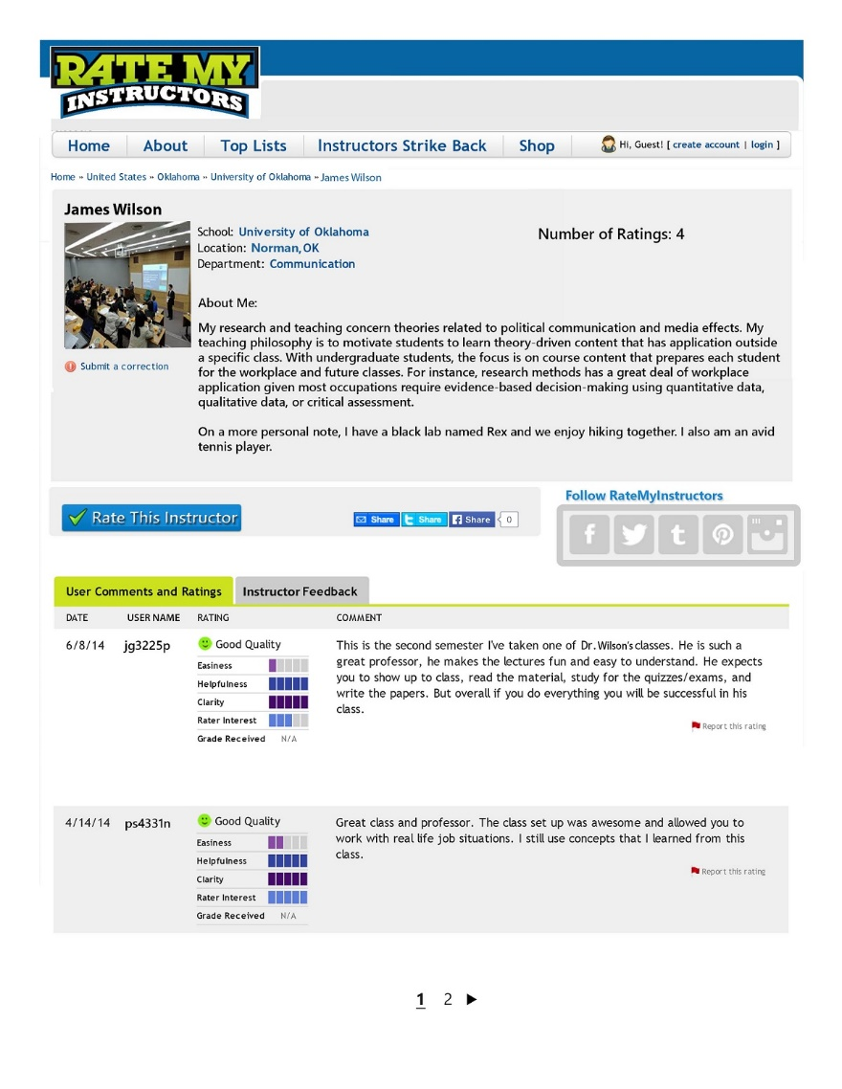
Average ratings | Number of raters | Reviewer screen name | Professor comments
Absent | Low | Anonymous | Present
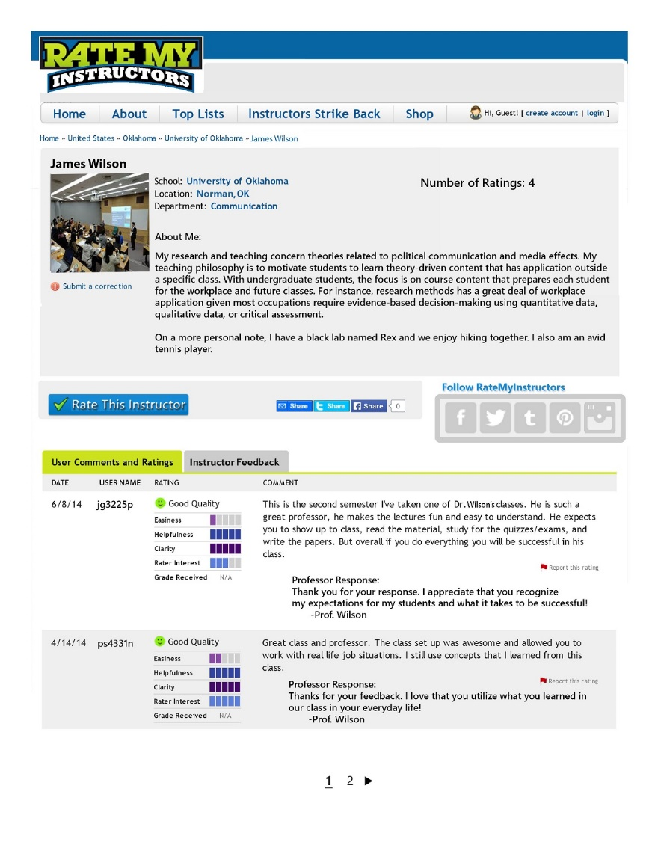

Average ratings | Number of raters | Reviewer screen name | Professor comments
Absent | Low | Identifiable | Absent
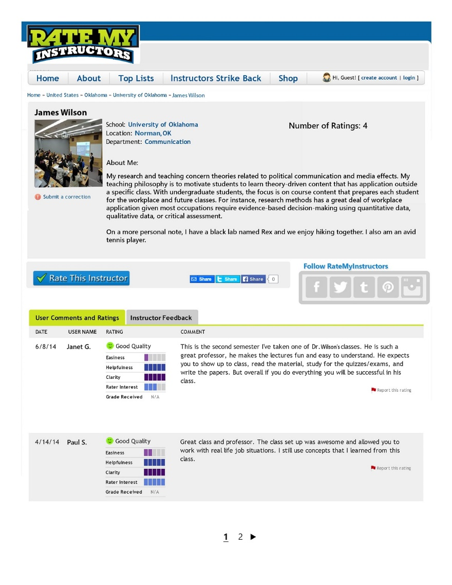

Average ratings | Number of raters | Reviewer screen name | Professor comments
Absent | Low | Identifiable | Present
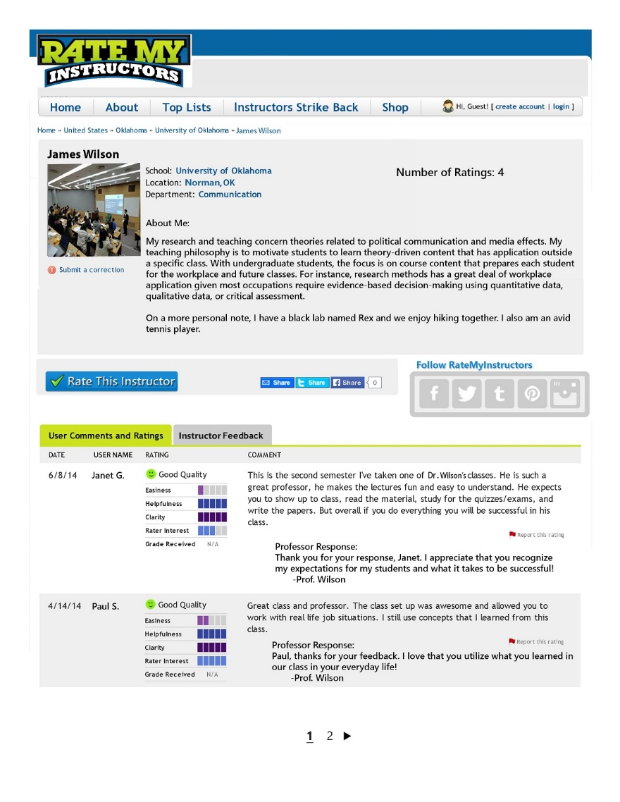

Average ratings | Number of raters | Reviewer screen name | Professor comments
Absent | High | Anonymous | Absent

Average ratings | Number of raters | Reviewer screen name | Professor comments
Absent | High | Anonymous | Present

Average ratings | Number of raters | Reviewer screen name | Professor comments
Absent | High | Identifiable | Absent

Average ratings | Number of raters | Reviewer screen name | Professor comments
Absent | High | Identifiable | Present

Average ratings | Number of raters | Reviewer screen name | Professor comments
Present | Low | Anonymous | Absent
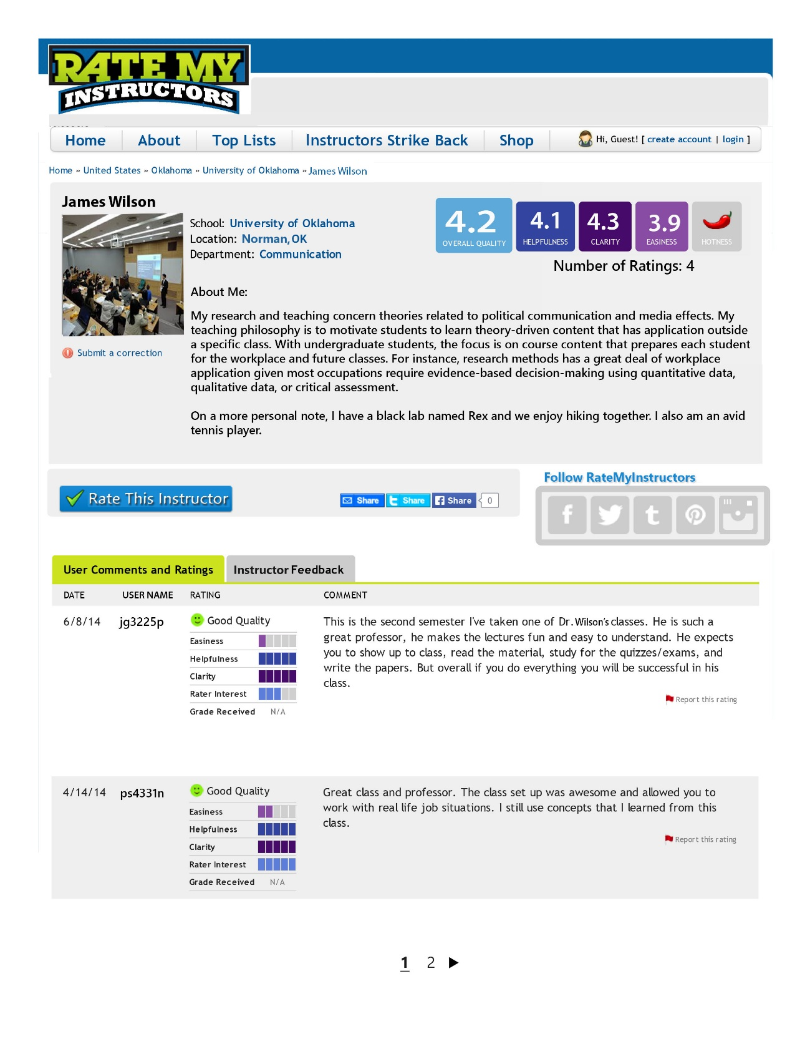

Average ratings | Number of raters | Reviewer screen name | Professor comments
Present | Low | Anonymous | Present
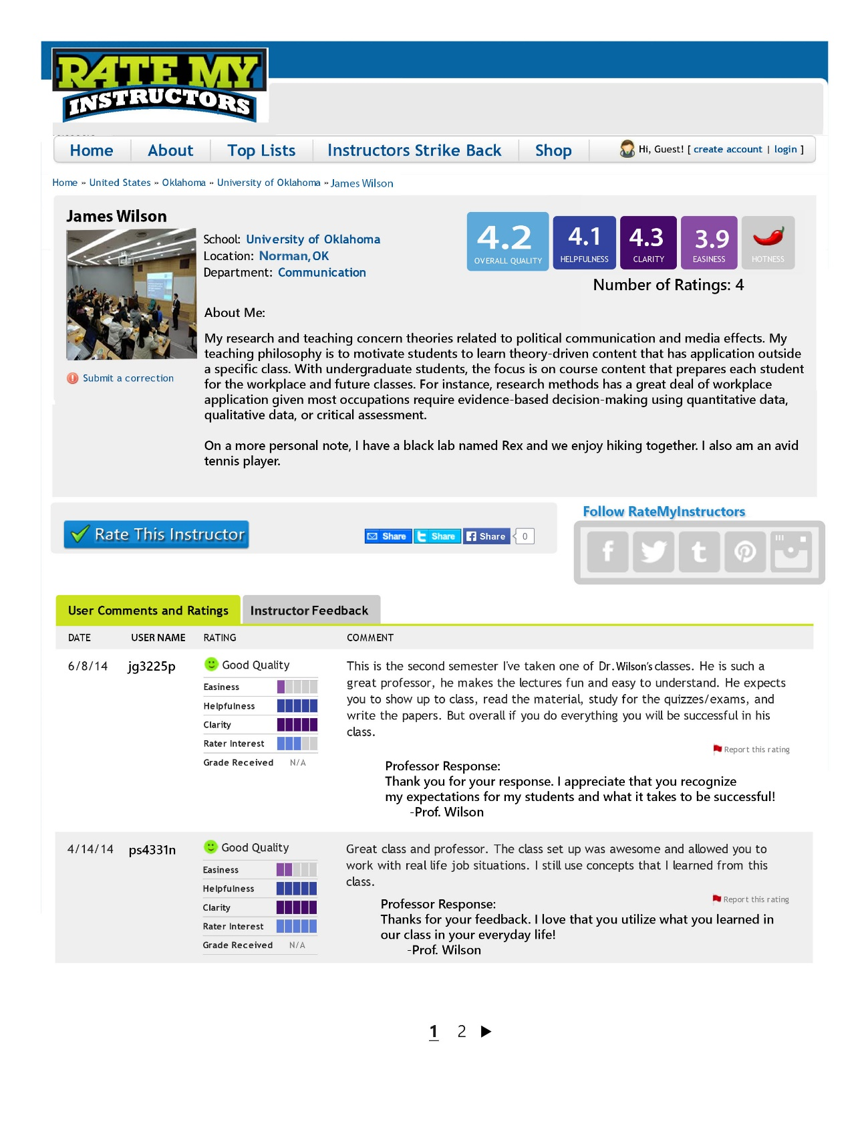

Average ratings | Number of raters | Reviewer screen name | Professor comments
Present | Low | Identifiable | Absent
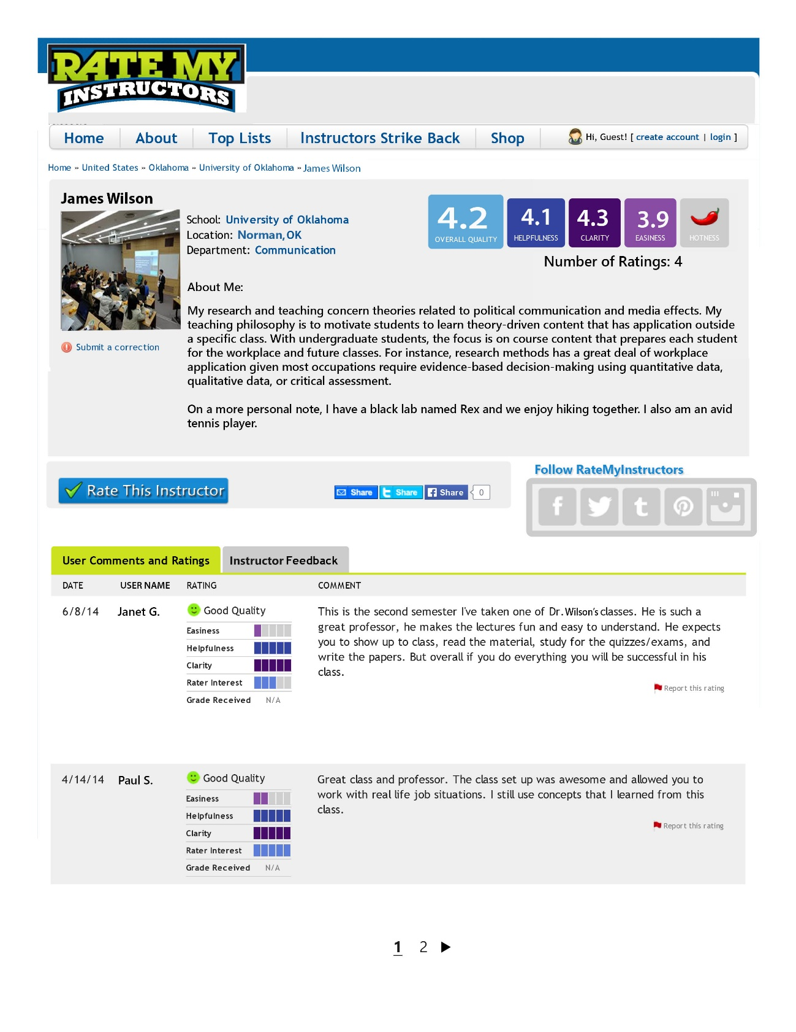

Average ratings | Number of raters | Reviewer screen name | Professor comments
Present | Low | Identifiable | Present
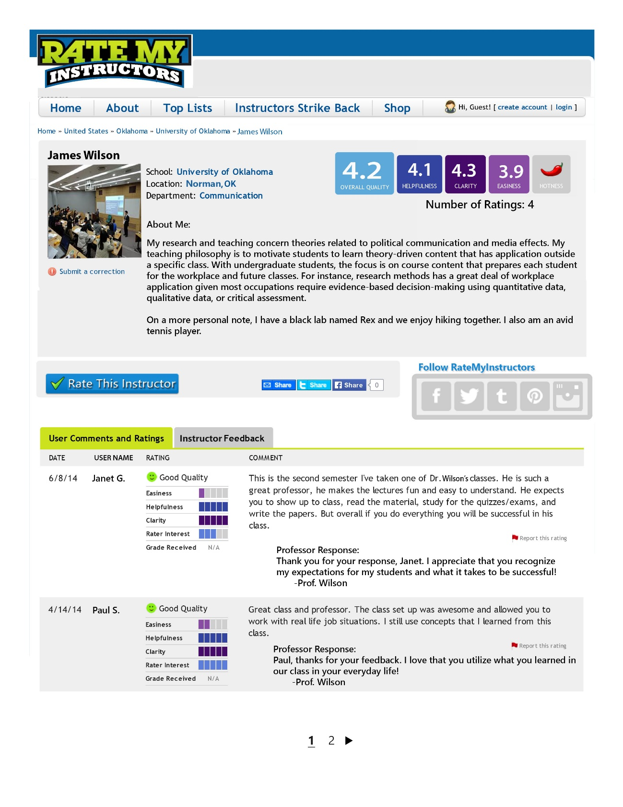

Average ratings | Number of raters | Reviewer screen name | Professor comments
Present | High | Anonymous | Absent
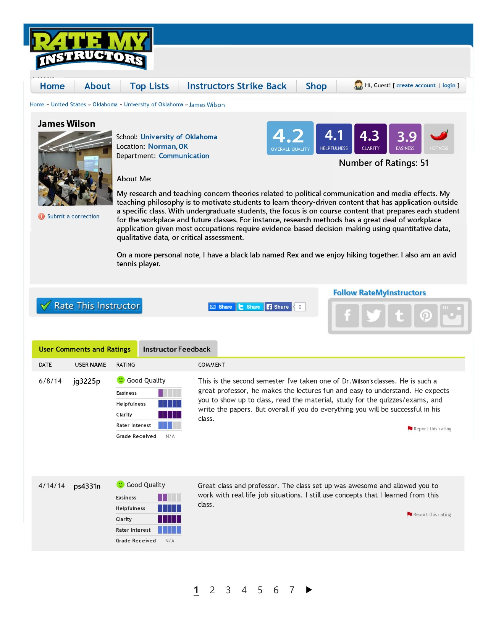

Average ratings | Number of raters | Reviewer screen name | Professor comments
Present | High | Anonymous | Present
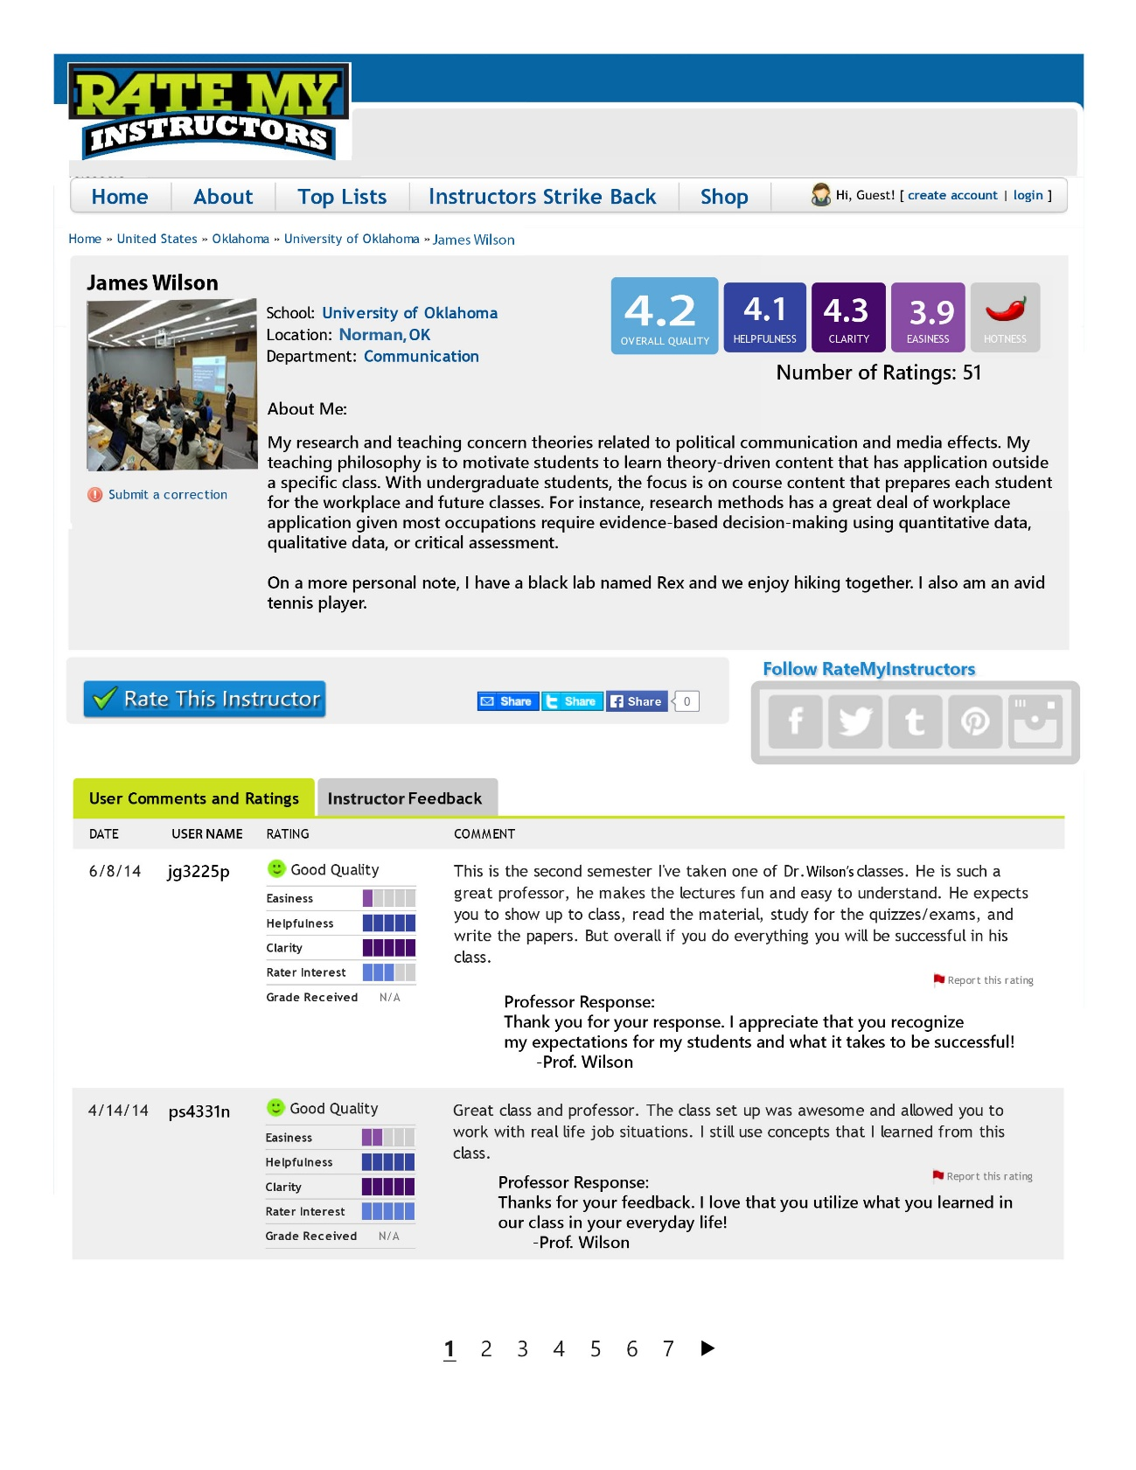

Average ratings | Number of raters | Reviewer screen name | Professor comments
Present | High | Identifiable | Absent
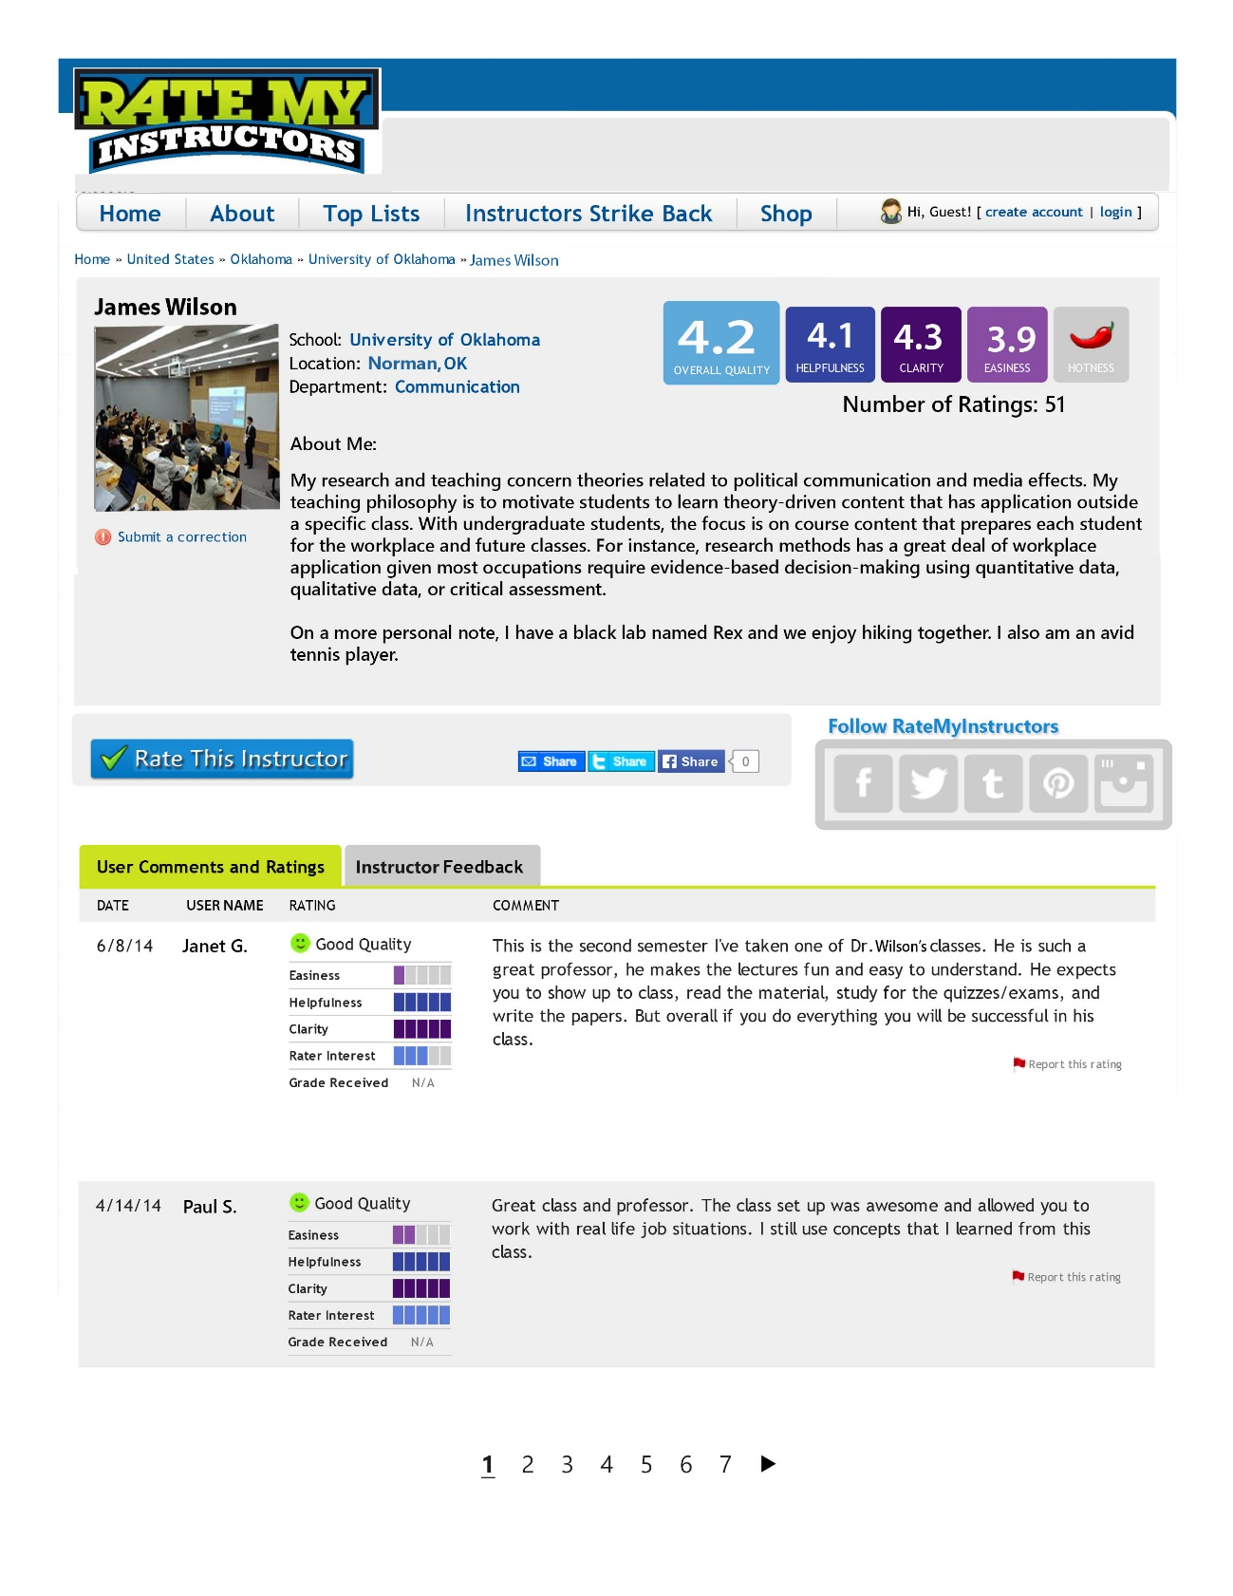

Average ratings | Number of raters | Reviewer screen name | Professor comments
Present | High | Identifiable | Present
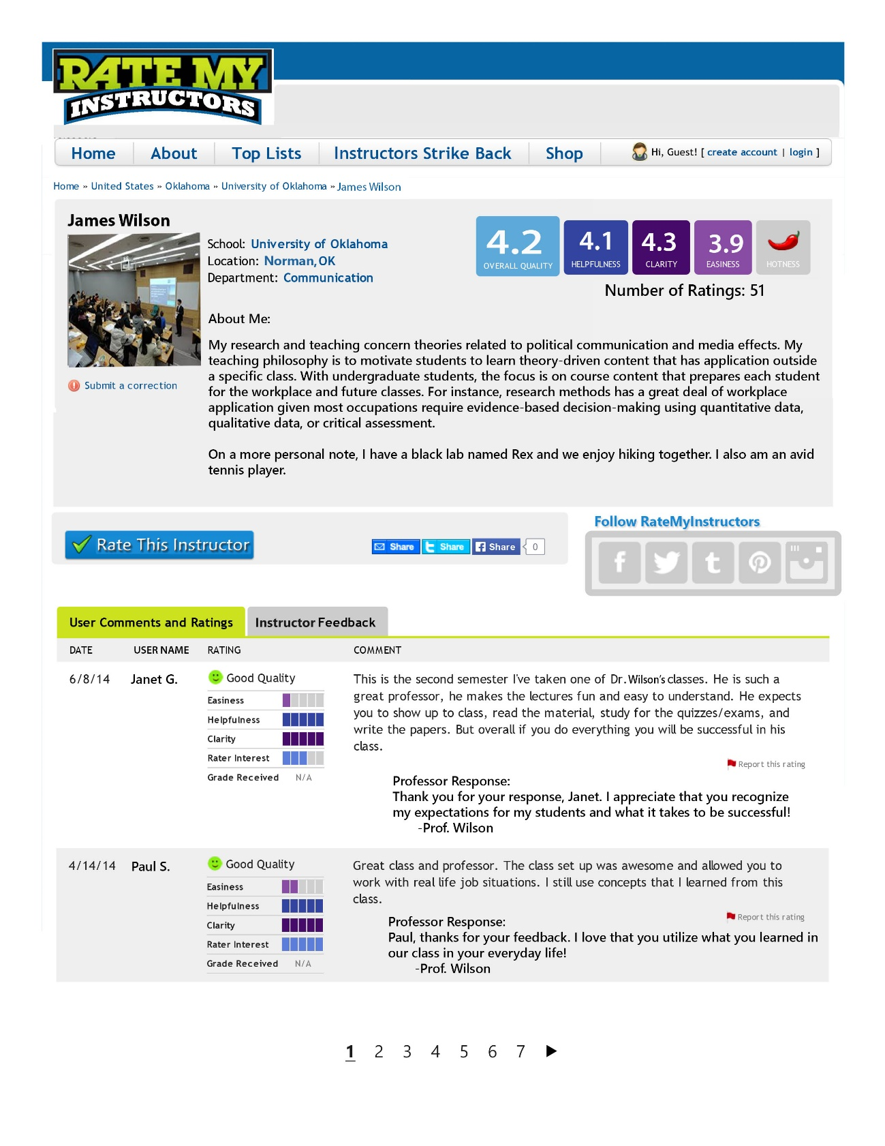

Appendix B
Scale Items from Pilot Study and Revised Items from Main Study

Profile match (no changes in main study)
- The online profile of the professor is an accurate description of the actual person.
- The online profile of the professor is a believable description of the actual person.
- The online profile of the professor is a truthful description of the actual person.
- The online profile of the professor is an honest description of the actual person.
- The online profile of the professor is a realistic description of the actual person.
- The online profile of the professor is a representative description of the actual person.
- The online profile of the professor is a convincing description of the actual person.

Manipulation
Pilot Study | Main Study
- The professor could provide his own review. | - The professor is able to provide his own review.
- The professor could encourage others to write favorable reviews. | - The professor can encourage others to write favorable reviews.
- The professor could influence the reviewers when writing their reviews. | - The professor is able to influence the reviewers when writing their reviews.
- The professor could edit reviewer comments. | - The professor is able to modify the comments left by the reviewers.
- The professor could hire a person to write reviews. | - The professor can hire a person to write reviews.

Instructor competence (no changes in main study)
- This professor is reliable.
- This professor is informed.
- This professor is qualified.
- This professor is intelligent.
- This professor is valuable.
- This professor is an expert.
- This professor is trained.
- This professor is competent.
- This professor is bright.

Social attraction (no changes in main study)
- I think this professor could be a friend of mine.
- I think it would be easy to meet and talk with this professor.
- I think this professor could fit into my circle of friends.
- I think this professor and I could establish a personal friendship with one another.
- I would enjoy a friendly chat with this professor.

Homophily (no changes in main study)
- This professor thinks like I do.
- This professor behaves like I do.
- This professor is similar to me.
- This professor is like me.
- This professor acts like I do.
- This professor is the same as me.

Behavioral intentions (no changes in main study)
- I would take a course from this professor.
- I would recommend this professor to others.
- I would encourage my friends to take a course with this professor.
- I would take a course with this professor over another professor
- I would check what courses this professor is teaching when I’m enrolling.
- I would be interested in working with this professor.

Manipulation check questions
Pilot Study | Main Study
- The professor commented on the reviews.  - Yes  - No | - The professor commented on the reviews.  - Yes  - No
- The reviewer screen name was...  - Identifiable  - Anonymous | - The reviewer screen name was...  - Janet G.  - jg3225p
- The profile included overall average ratings.  - Yes  - No | - The profile included overall average ratings that looked similar to the following image:  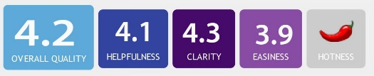  - Yes  - No
- The number of total ratings was...  - 4  - 46 | - The number of total ratings was...  - 4  - 51

Appendix C
LISREL Syntax for Pilot Study Measurement Model

!DISS PILOT
RAW DATA FROM FILE LISRELPILOT.LSF
LATENT VARIABLES
MATCH MANIP COMP SOCAT HOMO INTENT
RELATIONSHIPS
MATCH1 MATCH2 MATCH3 MATCH4 MATCH5 MATCH6 MATCH7 = MATCH
MANIP1 MANIP2 MANIP3 MANIP5 = MANIP
COMP1 COMP2 COMP3 COMP4 COMP5 COMP6 COMP7 COMP8 COMP9 = COMP
SOCAT1 SOCAT2 SOCAT3 SOCAT4 SOCAT5 = SOCAT
HOMO1 HOMO2 HOMO3 HOMO4 HOMO5 HOMO6 = HOMO
INT1 INT2 INT3 INT4 INT5 INT6 = INTENT
LET THE ERRORS BETWEEN MATCH2 AND MATCH7 COVARY
LET THE ERRORS BETWEEN MATCH3 AND MATCH4 COVARY
LET THE ERRORS BETWEEN COMP4 AND COMP9 COVARY
LET THE ERRORS BETWEEN SOCAT2 AND SOCAT5 COVARY
LET THE ERRORS BETWEEN HOMO3 AND HOMO4 COVARY
LET THE ERRORS BETWEEN INT2 AND INT3 COVARY
LET THE ERRORS BETWEEN INT1 AND INT5 COVARY
PATH DIAGRAM
END OF PROBLEM

Appendix D
Covariance Matrix for Pilot Measurement Model

MATCH1 MATCH2 MATCH3 MATCH4 MATCH5 MATCH6
-------- -------- -------- -------- -------- --------
MATCH1 70.651
MATCH2 46.866 51.406
MATCH3 34.175 27.650 22.999
MATCH4 42.844 34.012 24.864 37.076
MATCH5 49.769 40.194 27.290 34.397 48.219
MATCH6 47.873 37.220 25.601 31.915 38.577 48.992
MATCH7 62.477 55.538 35.139 44.064 54.299 50.894
MANIP1 11.059 14.429 5.074 7.536 12.883 13.175
MANIP2 6.748 8.128 3.541 4.408 6.696 4.924
MANIP3 2.150 2.793 1.321 0.280 2.949 2.619
MANIP5 6.163 8.601 4.179 3.812 6.703 6.134
COMP1 17.032 14.465 9.782 11.896 14.880 13.591
COMP2 15.865 14.230 9.198 11.093 13.933 13.108
COMP3 16.929 15.862 9.711 12.152 14.881 13.767
COMP4 16.795 14.993 9.486 11.384 14.520 14.044
COMP5 22.170 20.384 12.913 15.523 20.222 19.056
COMP6 23.380 20.403 12.867 16.096 19.802 18.938
COMP7 16.043 14.759 9.150 11.142 14.192 13.342
COMP8 17.059 15.632 9.936 12.078 15.237 13.835
COMP9 17.754 15.642 9.897 12.094 14.724 13.883
SOCAT1 8.456 6.236 4.548 6.099 6.271 6.031
SOCAT2 19.127 14.916 9.805 12.470 15.185 14.305
SOCAT3 3.827 2.420 1.929 2.715 2.817 2.743
SOCAT4 8.442 5.677 4.497 6.103 6.517 6.137
SOCAT5 17.395 14.568 9.522 12.603 13.719 13.185
HOMO1 0.811 0.472 0.449 0.663 0.668 0.613
HOMO2 0.804 0.409 0.388 0.658 0.659 0.615
HOMO3 0.667 0.305 0.344 0.525 0.624 0.557
HOMO4 0.733 0.398 0.373 0.595 0.689 0.590
HOMO5 0.723 0.350 0.419 0.597 0.591 0.512
HOMO6 0.975 0.402 0.507 0.753 0.699 0.770
INT1 23.665 21.012 13.802 16.507 20.143 18.055
INT2 30.298 23.291 16.574 19.724 24.470 23.424
INT3 20.197 15.756 11.617 13.416 16.485 16.425
INT4 27.174 21.393 14.983 17.588 21.408 21.415
INT5 21.997 18.630 12.004 14.624 19.036 17.264
INT6 29.349 22.573 15.595 19.060 24.176 23.105

MATCH7 MANIP1 MANIP2 MANIP3 MANIP5 COMP1
-------- -------- -------- -------- -------- --------
MATCH7 89.561
MANIP1 12.466 108.190
MANIP2 6.981 26.253 27.790
MANIP3 2.919 19.514 15.095 27.727
MANIP5 8.420 26.051 19.102 12.909 29.605
COMP1 20.930 4.105 2.180 0.227 3.301 16.032
COMP2 18.663 3.756 2.229 1.296 3.712 12.761
COMP3 20.625 5.110 3.222 1.799 4.507 13.447
COMP4 20.215 5.300 3.388 1.498 4.431 13.147
COMP5 27.904 5.517 4.254 1.120 4.862 18.522
COMP6 27.379 9.117 4.241 2.513 5.359 19.142
COMP7 19.681 4.947 3.459 2.390 4.838 12.887
COMP8 21.080 5.255 3.050 1.069 3.918 13.777
COMP9 20.349 6.093 3.460 1.567 4.996 13.157
SOCAT1 9.009 -1.164 0.571 0.224 -0.466 4.739
SOCAT2 21.654 3.720 3.090 1.295 1.513 9.311
SOCAT3 3.511 -0.372 0.056 -0.233 -0.735 1.758
SOCAT4 9.002 -0.711 0.260 0.217 -0.508 4.522
SOCAT5 19.666 2.747 2.844 -0.068 2.173 8.701
HOMO1 0.789 0.144 0.008 -0.079 -0.159 0.265
HOMO2 0.670 0.185 -0.026 -0.043 -0.196 0.191
HOMO3 0.648 -0.020 -0.019 -0.113 -0.176 0.184
HOMO4 0.688 0.026 -0.057 -0.168 -0.239 0.222
HOMO5 0.620 0.183 -0.006 -0.013 -0.129 0.199
HOMO6 0.856 0.098 -0.179 0.065 -0.314 0.256
INT1 28.626 4.479 3.155 1.143 3.604 15.337
INT2 33.891 2.048 -0.944 -0.648 0.503 19.599
INT3 22.700 1.048 0.352 -0.160 1.325 13.580
INT4 29.640 2.967 1.778 1.082 2.028 18.056
INT5 26.553 6.574 4.045 2.873 5.499 13.628
INT6 34.009 3.865 1.921 1.153 3.267 17.151

COMP2 COMP3 COMP4 COMP5 COMP6 COMP7
-------- -------- -------- -------- -------- --------
COMP2 15.753
COMP3 13.242 16.106
COMP4 13.483 14.269 16.549
COMP5 18.465 18.389 18.082 31.330
COMP6 18.714 19.849 20.263 26.246 34.960
COMP7 12.861 13.917 14.023 17.435 19.474 16.291
COMP8 13.358 14.796 14.205 18.824 19.878 13.847
COMP9 13.462 13.942 14.621 18.149 19.582 13.513
SOCAT1 4.176 4.441 4.185 6.611 6.144 3.706
SOCAT2 8.811 9.296 9.152 12.186 12.268 8.438
SOCAT3 1.636 1.476 1.299 2.493 2.183 1.350
SOCAT4 4.316 4.092 3.787 6.247 5.779 3.650
SOCAT5 8.640 8.950 8.528 12.352 11.840 8.209
HOMO1 0.243 0.206 0.162 0.570 0.359 0.173
HOMO2 0.162 0.157 0.106 0.513 0.266 0.124
HOMO3 0.158 0.122 0.101 0.497 0.199 0.121
HOMO4 0.171 0.137 0.123 0.552 0.251 0.113
HOMO5 0.157 0.148 0.099 0.466 0.256 0.109
HOMO6 0.157 0.115 0.080 0.542 0.370 0.086
INT1 14.630 15.764 15.459 21.755 21.699 14.192
INT2 18.294 18.869 18.493 27.229 25.960 16.742
INT3 12.866 13.254 13.037 20.167 18.743 11.696
INT4 17.756 17.844 17.312 25.221 24.835 15.418
INT5 14.455 14.146 14.277 19.194 18.403 12.686
INT6 16.955 17.139 16.458 24.816 23.128 15.536

COMP8 COMP9 SOCAT1 SOCAT2 SOCAT3 SOCAT4
-------- -------- -------- -------- -------- --------
COMP8 16.816
COMP9 14.119 16.229
SOCAT1 4.773 4.165 15.863
SOCAT2 9.572 8.870 13.287 27.294
SOCAT3 1.654 1.569 6.452 5.913 4.008
SOCAT4 4.386 3.865 13.847 13.719 6.221 16.209
SOCAT5 9.164 8.752 14.135 20.762 6.404 14.335
HOMO1 0.258 0.207 1.043 1.052 0.537 1.050
HOMO2 0.212 0.149 1.123 1.062 0.598 1.130
HOMO3 0.209 0.099 1.001 0.952 0.529 0.994
HOMO4 0.234 0.121 1.127 1.047 0.597 1.109
HOMO5 0.188 0.139 1.047 1.000 0.557 1.059
HOMO6 0.184 0.106 1.172 1.024 0.620 1.170
INT1 16.177 15.091 10.682 19.127 4.576 10.417
INT2 19.521 18.909 13.553 24.418 6.269 14.172
INT3 13.870 12.820 9.980 16.632 4.447 10.465
INT4 18.603 17.393 12.417 21.438 5.472 12.622
INT5 14.637 13.878 9.825 17.386 4.103 9.558
INT6 17.730 16.864 14.298 23.037 6.139 14.180

SOCAT5 HOMO1 HOMO2 HOMO3 HOMO4 HOMO5
-------- -------- -------- -------- -------- --------
SOCAT5 27.094
HOMO1 1.118 0.333
HOMO2 1.121 0.281 0.344
HOMO3 1.015 0.264 0.281 0.325
HOMO4 1.149 0.283 0.298 0.299 0.358
HOMO5 1.051 0.281 0.302 0.279 0.296 0.356
HOMO6 1.169 0.263 0.288 0.266 0.292 0.291
INT1 19.336 1.057 1.043 0.897 0.945 0.948
INT2 23.539 1.485 1.383 1.262 1.371 1.422
INT3 17.199 1.114 1.039 0.986 1.099 1.050
INT4 21.785 1.234 1.208 1.067 1.188 1.192
INT5 17.258 0.908 0.839 0.828 0.833 0.862
INT6 25.133 1.402 1.445 1.246 1.359 1.377

HOMO6 INT1 INT2 INT3 INT4 INT5
-------- -------- -------- -------- -------- --------
HOMO6 0.473
INT1 1.016 39.764
INT2 1.564 40.130 65.023
INT3 1.202 28.862 42.510 35.743
INT4 1.347 40.516 50.969 38.371 60.966
INT5 0.869 32.143 35.640 25.614 35.530 39.423
INT6 1.619 39.888 48.647 34.482 45.498 36.562

INT6
--------
INT6 62.202

Appendix E
LISREL Syntax for Main Study Measurement Model

!DISS MAIN
RAW DATA FROM FILE LISREL209.LSF
LATENT VARIABLES
MATCH MANIP COMP SOCAT HOMO INTENT
RELATIONSHIPS
MATCH1 MATCH2 MATCH3 MATCH4 MATCH5 MATCH6 MATCH7 = MATCH
MANIP1 MANIP2 MANIP3 MANIP5 = MANIP
COMP1 COMP2 COMP3 COMP4 COMP5 COMP6 COMP7 COMP8 COMP9 = COMP
SOCAT1 SOCAT2 SOCAT3 SOCAT4 SOCAT5 = SOCAT
HOMO1 HOMO2 HOMO3 HOMO4 HOMO5 HOMO6 = HOMO
INT1 INT2 INT3 INT4 INT5 INT6 = INTENT
LET THE ERRORS BETWEEN MATCH2 AND MATCH7 COVARY
LET THE ERRORS BETWEEN MANIP2 AND MANIP3 COVARY
LET THE ERRORS BETWEEN COMP4 AND COMP9 COVARY
LET THE ERRORS BETWEEN COMP3 AND COMP7 COVARY
LET THE ERRORS BETWEEN SOCAT2 AND SOCAT5 COVARY
LET THE ERRORS BETWEEN HOMO3 AND HOMO4 COVARY
LET THE ERRORS BETWEEN INT2 AND INT3 COVARY
PATH DIAGRAM
END OF PROBLEM

Appendix F
Covariance Matrix for Main Study Measurement Model

MATCH1 MATCH2 MATCH3 MATCH4 MATCH5 MATCH6
-------- -------- -------- -------- -------- --------
MATCH1 71.752
MATCH2 41.209 55.101
MATCH3 32.530 25.605 24.818
MATCH4 38.599 31.641 25.755 40.336
MATCH5 39.818 39.507 26.887 33.378 53.431
MATCH6 34.445 27.855 19.821 25.005 30.500 38.651
MATCH7 54.410 61.997 35.045 41.286 54.165 39.377
MANIP1 -0.645 0.767 -0.264 0.866 -1.191 2.378
MANIP2 2.221 7.084 3.730 3.515 6.170 3.032
MANIP3 2.268 2.868 3.266 2.458 3.338 3.468
MANIP5 6.110 7.116 4.111 2.301 2.844 3.697
COMP1 8.396 9.460 5.537 7.160 8.097 6.115
COMP2 28.106 39.150 20.358 26.928 28.085 25.301
COMP3 9.437 14.635 8.429 10.199 11.634 9.852
COMP4 4.339 6.399 3.519 4.389 4.847 3.950
COMP5 16.548 25.620 12.574 15.628 20.436 15.936
COMP6 10.737 8.320 6.526 9.113 7.947 9.173
COMP7 5.616 9.868 5.999 6.634 8.645 6.991
COMP8 4.415 5.412 2.541 3.401 4.457 3.508
COMP9 10.638 14.575 8.307 10.689 11.594 9.668
SOCAT1 13.739 19.731 11.834 10.278 17.283 16.131
SOCAT2 16.069 16.481 9.193 11.922 17.021 12.854
SOCAT3 66.491 48.562 38.063 41.248 69.323 60.846
SOCAT4 16.378 14.453 11.618 12.749 9.174 11.240
SOCAT5 21.007 21.439 11.994 13.397 19.917 15.130
HOMO1 77.371 51.932 49.824 65.201 74.273 71.116
HOMO2 75.822 34.010 47.128 44.764 52.199 63.865
HOMO3 64.292 56.548 48.283 54.118 53.465 58.976
HOMO4 52.900 53.227 42.167 41.824 51.810 34.086
HOMO5 69.718 25.667 41.503 36.439 48.533 54.755
HOMO6 11.478 5.101 6.613 6.507 8.892 10.545
INT1 15.250 16.307 8.319 12.454 20.066 14.515
INT2 14.638 15.725 9.574 12.429 19.229 13.615
INT3 9.520 12.978 8.483 12.029 20.087 15.154
INT4 15.801 19.583 8.726 10.728 18.424 10.835
INT5 16.257 20.008 9.999 11.513 17.923 9.878
INT6 18.195 16.645 11.274 12.751 17.082 12.805

MATCH7 MANIP1 MANIP2 MANIP3 MANIP5 COMP1
-------- -------- -------- -------- -------- --------
MATCH7 117.265
MANIP1 10.280 49.536
MANIP2 16.722 17.357 28.045
MANIP3 10.519 12.867 14.758 27.264
MANIP5 16.951 21.059 19.453 11.598 36.514
COMP1 14.841 3.644 3.853 2.203 3.347 8.243
COMP2 55.464 2.966 18.709 11.178 16.521 21.831
COMP3 19.183 3.308 6.645 3.440 5.534 8.245
COMP4 9.495 1.816 3.979 2.141 3.310 3.941
COMP5 39.365 3.094 10.623 5.142 9.512 13.267
COMP6 12.423 3.755 6.017 6.227 4.284 5.839
COMP7 14.283 1.616 5.029 1.839 3.074 6.194
COMP8 6.917 2.968 4.363 2.016 3.582 3.811
COMP9 23.781 4.039 9.072 4.551 7.283 9.338
SOCAT1 24.158 1.019 1.581 -2.308 1.251 8.536
SOCAT2 24.627 3.728 7.576 1.329 4.916 6.764
SOCAT3 70.290 12.816 -0.191 -14.826 -4.358 18.349
SOCAT4 13.584 4.387 7.714 -1.828 8.942 7.092
SOCAT5 29.370 5.164 6.364 3.817 5.648 8.057
HOMO1 117.536 58.394 18.099 8.452 6.277 30.206
HOMO2 78.983 49.596 8.316 13.557 17.740 26.214
HOMO3 95.546 26.954 -8.037 -16.601 -7.415 29.867
HOMO4 77.589 20.028 3.174 -7.546 -2.860 17.252
HOMO5 48.927 27.350 -27.813 -12.563 -4.908 20.251
HOMO6 9.487 7.620 -4.599 -0.357 -2.481 3.578
INT1 25.294 4.005 8.757 1.762 5.930 8.357
INT2 27.853 5.529 5.473 0.386 2.144 9.818
INT3 24.833 3.235 4.797 -0.098 -0.228 8.478
INT4 32.436 3.659 9.302 1.537 4.222 8.798
INT5 32.610 4.138 10.032 1.057 6.727 7.546
INT6 27.567 7.615 8.502 2.444 5.789 9.607

COMP2 COMP3 COMP4 COMP5 COMP6 COMP7
-------- -------- -------- -------- -------- --------
COMP2 125.465
COMP3 37.004 17.468
COMP4 18.578 6.898 3.854
COMP5 53.975 18.926 8.821 47.561
COMP6 31.696 11.303 5.359 15.417 17.332
COMP7 28.514 11.865 5.289 15.139 7.648 10.270
COMP8 16.212 5.940 2.968 8.683 5.173 4.615
COMP9 42.031 15.199 7.936 21.562 11.947 11.907
SOCAT1 23.521 14.444 5.725 20.655 8.268 11.062
SOCAT2 20.807 9.436 4.468 19.908 7.318 7.900
SOCAT3 11.886 15.262 5.068 35.473 13.769 8.726
SOCAT4 22.209 12.197 4.649 15.226 7.820 10.340
SOCAT5 23.257 11.347 4.928 21.368 8.338 8.867
HOMO1 130.803 50.080 21.974 83.234 48.238 38.079
HOMO2 68.393 39.105 16.148 51.716 38.392 24.152
HOMO3 68.700 42.215 13.683 55.218 28.270 29.614
HOMO4 59.634 31.700 12.335 31.461 17.061 20.052
HOMO5 32.798 25.122 7.214 38.993 19.312 18.135
HOMO6 6.793 5.955 1.241 8.425 4.425 3.421
INT1 32.970 13.365 6.494 22.280 10.830 9.481
INT2 33.331 12.912 5.996 25.196 11.461 9.653
INT3 24.643 11.368 4.896 23.844 9.118 8.598
INT4 33.493 13.391 6.533 26.334 10.198 10.336
INT5 25.759 10.827 5.066 20.408 5.080 8.639
INT6 31.670 15.121 5.973 21.867 12.368 10.328

COMP8 COMP9 SOCAT1 SOCAT2 SOCAT3 SOCAT4
-------- -------- -------- -------- -------- --------
COMP8 3.679
COMP9 6.588 20.853
SOCAT1 5.386 12.391 128.448
SOCAT2 5.470 9.709 47.616 47.912
SOCAT3 6.909 11.580 285.000 113.756 1481.331
SOCAT4 5.935 10.800 99.534 40.191 257.873 140.276
SOCAT5 6.577 11.929 56.770 38.115 150.910 58.132
HOMO1 22.374 61.166 216.676 82.035 767.302 240.170
HOMO2 14.488 39.469 180.477 54.213 685.182 186.342
HOMO3 14.058 40.583 203.577 70.603 705.090 208.608
HOMO4 9.159 27.964 192.814 71.687 652.903 197.643
HOMO5 9.362 23.097 175.240 58.915 733.716 191.373
HOMO6 1.727 3.428 27.572 6.302 114.892 29.845
INT1 7.548 13.447 30.241 27.669 97.567 26.829
INT2 6.087 14.158 28.849 24.048 80.655 24.211
INT3 5.153 11.980 29.664 22.812 106.634 22.361
INT4 7.491 15.720 32.130 29.650 81.520 28.507
INT5 5.849 11.459 19.733 19.130 43.185 19.709
INT6 7.032 14.985 34.242 24.309 77.804 35.147

SOCAT5 HOMO1 HOMO2 HOMO3 HOMO4 HOMO5
-------- -------- -------- -------- -------- --------
SOCAT5 60.367
HOMO1 136.049 2323.556
HOMO2 100.854 1230.409 1321.050
HOMO3 107.987 1356.595 1094.012 1772.747
HOMO4 103.308 1222.346 922.708 1165.111 1362.141
HOMO5 101.173 1165.443 1085.402 1095.695 966.032 1427.140
HOMO6 13.445 209.542 190.435 207.149 182.887 223.899
INT1 27.051 88.630 88.718 78.231 76.267 72.491
INT2 20.360 125.710 98.338 118.793 81.833 72.725
INT3 20.841 130.962 102.625 124.935 81.091 75.626
INT4 29.533 109.616 73.835 90.996 93.550 78.812
INT5 20.101 51.844 32.666 50.936 50.245 32.379
INT6 26.857 133.887 107.592 136.234 104.981 96.413

HOMO6 INT1 INT2 INT3 INT4 INT5
-------- -------- -------- -------- -------- --------
HOMO6 74.589
INT1 14.768 59.168
INT2 19.174 40.034 52.642
INT3 19.792 40.902 47.371 56.246
INT4 15.360 46.037 40.190 38.842 59.607
INT5 7.988 32.766 27.340 27.834 35.866 48.195
INT6 20.700 42.435 39.838 39.743 44.994 33.694

INT6
--------
INT6 66.217

Appendix G
LISREL Syntax for Hypothesized Model with Modification Indices

!DISS SEM
RAW DATA FROM FILE LISREL209.LSF
LATENT VARIABLES
AVERAT NUMRAT IDENT PRFCOM MATCH MANIP COMP SOCAT HOMO INTENT
RELATIONSHIPS
AVERATE = 1*AVERAT
NUMRATE = 1*NUMRAT
IDENTIF = 1*IDENT
PROFCOM = 1*PRFCOM
MATCH1 MATCH2 MATCH3 MATCH4 MATCH5 MATCH6 MATCH7 = MATCH
MANIP1 MANIP2 MANIP3 MANIP5 = MANIP
COMP1 COMP2 COMP3 COMP4 COMP5 COMP6 COMP7 COMP8 COMP9 = COMP
SOCAT1 SOCAT2 SOCAT3 SOCAT4 SOCAT5 = SOCAT
HOMO1 HOMO2 HOMO3 HOMO4 HOMO5 HOMO6 = HOMO
INT1 INT2 INT3 INT4 INT5 INT6 = INTENT
MATCH = AVERAT NUMRAT IDENT PRFCOM
MANIP = AVERAT NUMRAT IDENT PRFCOM
COMP = MATCH MANIP
SOCAT = MATCH MANIP HOMO
HOMO = MATCH MANIP
INTENT = MATCH MANIP COMP
SET THE ERROR VARIANCE OF AVERATE TO 0
SET THE ERROR VARIANCE OF NUMRATE TO 0
SET THE ERROR VARIANCE OF IDENTIF TO 0
SET THE ERROR VARIANCE OF PROFCOM TO 0
LET THE ERRORS BETWEEN MATCH2 AND MATCH7 COVARY
LET THE ERRORS BETWEEN MANIP2 AND MANIP3 COVARY
LET THE ERRORS BETWEEN COMP4 AND COMP9 COVARY
LET THE ERRORS BETWEEN COMP3 AND COMP7 COVARY
LET THE ERRORS BETWEEN SOCAT2 AND SOCAT5 COVARY
LET THE ERRORS BETWEEN HOMO3 AND HOMO4 COVARY
LET THE ERRORS BETWEEN INT2 AND INT3 COVARY
PATH DIAGRAM
END OF PROBLEM

Appendix H
Covariance Matrix for Hypothesized Model with Modification Indices

MATCH1 MATCH2 MATCH3 MATCH4 MATCH5 MATCH6
-------- -------- -------- -------- -------- --------
MATCH1 71.752
MATCH2 41.209 55.101
MATCH3 32.530 25.605 24.818
MATCH4 38.599 31.641 25.755 40.336
MATCH5 39.818 39.507 26.887 33.378 53.431
MATCH6 34.445 27.855 19.821 25.005 30.500 38.651
MATCH7 54.410 61.997 35.045 41.286 54.165 39.377
MANIP1 -0.645 0.767 -0.264 0.866 -1.191 2.378
MANIP2 2.221 7.084 3.730 3.515 6.170 3.032
MANIP3 2.268 2.868 3.266 2.458 3.338 3.468
MANIP5 6.110 7.116 4.111 2.301 2.844 3.697
COMP1 8.396 9.460 5.537 7.160 8.097 6.115
COMP2 28.106 39.150 20.358 26.928 28.085 25.301
COMP3 9.437 14.635 8.429 10.199 11.634 9.852
COMP4 4.339 6.399 3.519 4.389 4.847 3.950
COMP5 16.548 25.620 12.574 15.628 20.436 15.936
COMP6 10.737 8.320 6.526 9.113 7.947 9.173
COMP7 5.616 9.868 5.999 6.634 8.645 6.991
COMP8 4.415 5.412 2.541 3.401 4.457 3.508
COMP9 10.638 14.575 8.307 10.689 11.594 9.668
SOCAT1 13.739 19.731 11.834 10.278 17.283 16.131
SOCAT2 16.069 16.481 9.193 11.922 17.021 12.854
SOCAT3 66.491 48.562 38.063 41.248 69.323 60.846
SOCAT4 16.378 14.453 11.618 12.749 9.174 11.240
SOCAT5 21.007 21.439 11.994 13.397 19.917 15.130
HOMO1 77.371 51.932 49.824 65.201 74.273 71.116
HOMO2 75.822 34.010 47.128 44.764 52.199 63.865
HOMO3 64.292 56.548 48.283 54.118 53.465 58.976
HOMO4 52.900 53.227 42.167 41.824 51.810 34.086
HOMO5 69.718 25.667 41.503 36.439 48.533 54.755
HOMO6 11.478 5.101 6.613 6.507 8.892 10.545
INT1 15.250 16.307 8.319 12.454 20.066 14.515
INT2 14.638 15.725 9.574 12.429 19.229 13.615
INT3 9.520 12.978 8.483 12.029 20.087 15.154
INT4 15.801 19.583 8.726 10.728 18.424 10.835
INT5 16.257 20.008 9.999 11.513 17.923 9.878
INT6 18.195 16.645 11.274 12.751 17.082 12.805
AVERATE -0.395 -0.573 -0.212 -0.056 -0.361 -0.115
NUMRATE -0.064 -0.015 -0.059 0.019 0.088 -0.063
IDENTIF -0.211 -0.336 -0.254 -0.132 -0.199 -0.269
PROFCOM -0.293 -0.559 -0.189 -0.644 -0.606 -0.730

MATCH7 MANIP1 MANIP2 MANIP3 MANIP5 COMP1
-------- -------- -------- -------- -------- --------
MATCH7 117.265
MANIP1 10.280 49.536
MANIP2 16.722 17.357 28.045
MANIP3 10.519 12.867 14.758 27.264
MANIP5 16.951 21.059 19.453 11.598 36.514
COMP1 14.841 3.644 3.853 2.203 3.347 8.243
COMP2 55.464 2.966 18.709 11.178 16.521 21.831
COMP3 19.183 3.308 6.645 3.440 5.534 8.245
COMP4 9.495 1.816 3.979 2.141 3.310 3.941
COMP5 39.365 3.094 10.623 5.142 9.512 13.267
COMP6 12.423 3.755 6.017 6.227 4.284 5.839
COMP7 14.283 1.616 5.029 1.839 3.074 6.194
COMP8 6.917 2.968 4.363 2.016 3.582 3.811
COMP9 23.781 4.039 9.072 4.551 7.283 9.338
SOCAT1 24.158 1.019 1.581 -2.308 1.251 8.536
SOCAT2 24.627 3.728 7.576 1.329 4.916 6.764
SOCAT3 70.290 12.816 -0.191 -14.826 -4.358 18.349
SOCAT4 13.584 4.387 7.714 -1.828 8.942 7.092
SOCAT5 29.370 5.164 6.364 3.817 5.648 8.057
HOMO1 117.536 58.394 18.099 8.452 6.277 30.206
HOMO2 78.983 49.596 8.316 13.557 17.740 26.214
HOMO3 95.546 26.954 -8.037 -16.601 -7.415 29.867
HOMO4 77.589 20.028 3.174 -7.546 -2.860 17.252
HOMO5 48.927 27.350 -27.813 -12.563 -4.908 20.251
HOMO6 9.487 7.620 -4.599 -0.357 -2.481 3.578
INT1 25.294 4.005 8.757 1.762 5.930 8.357
INT2 27.853 5.529 5.473 0.386 2.144 9.818
INT3 24.833 3.235 4.797 -0.098 -0.228 8.478
INT4 32.436 3.659 9.302 1.537 4.222 8.798
INT5 32.610 4.138 10.032 1.057 6.727 7.546
INT6 27.567 7.615 8.502 2.444 5.789 9.607
AVERATE -0.222 0.418 0.105 0.274 -0.261 -0.005
NUMRATE -0.073 0.085 0.191 0.173 0.059 0.120
IDENTIF -0.813 -0.297 0.029 -0.004 -0.331 -0.148
PROFCOM -0.984 -0.375 -0.060 -0.016 0.072 -0.192

COMP2 COMP3 COMP4 COMP5 COMP6 COMP7
-------- -------- -------- -------- -------- --------
COMP2 125.465
COMP3 37.004 17.468
COMP4 18.578 6.898 3.854
COMP5 53.975 18.926 8.821 47.561
COMP6 31.696 11.303 5.359 15.417 17.332
COMP7 28.514 11.865 5.289 15.139 7.648 10.270
COMP8 16.212 5.940 2.968 8.683 5.173 4.615
COMP9 42.031 15.199 7.936 21.562 11.947 11.907
SOCAT1 23.521 14.444 5.725 20.655 8.268 11.062
SOCAT2 20.807 9.436 4.468 19.908 7.318 7.900
SOCAT3 11.886 15.262 5.068 35.473 13.769 8.726
SOCAT4 22.209 12.197 4.649 15.226 7.820 10.340
SOCAT5 23.257 11.347 4.928 21.368 8.338 8.867
HOMO1 130.803 50.080 21.974 83.234 48.238 38.079
HOMO2 68.393 39.105 16.148 51.716 38.392 24.152
HOMO3 68.700 42.215 13.683 55.218 28.270 29.614
HOMO4 59.634 31.700 12.335 31.461 17.061 20.052
HOMO5 32.798 25.122 7.214 38.993 19.312 18.135
HOMO6 6.793 5.955 1.241 8.425 4.425 3.421
INT1 32.970 13.365 6.494 22.280 10.830 9.481
INT2 33.331 12.912 5.996 25.196 11.461 9.653
INT3 24.643 11.368 4.896 23.844 9.118 8.598
INT4 33.493 13.391 6.533 26.334 10.198 10.336
INT5 25.759 10.827 5.066 20.408 5.080 8.639
INT6 31.670 15.121 5.973 21.867 12.368 10.328
AVERATE -0.780 -0.347 -0.143 -0.261 -0.134 -0.169
NUMRATE 0.382 0.102 0.080 0.338 0.030 0.109
IDENTIF -0.122 -0.163 -0.068 -0.116 -0.061 -0.069
PROFCOM -0.449 -0.241 -0.047 -0.409 -0.158 -0.164

COMP8 COMP9 SOCAT1 SOCAT2 SOCAT3 SOCAT4
-------- -------- -------- -------- -------- --------
COMP8 3.679
COMP9 6.588 20.853
SOCAT1 5.386 12.391 128.448
SOCAT2 5.470 9.709 47.616 47.912
SOCAT3 6.909 11.580 285.000 113.756 1481.331
SOCAT4 5.935 10.800 99.534 40.191 257.873 140.276
SOCAT5 6.577 11.929 56.770 38.115 150.910 58.132
HOMO1 22.374 61.166 216.676 82.035 767.302 240.170
HOMO2 14.488 39.469 180.477 54.213 685.182 186.342
HOMO3 14.058 40.583 203.577 70.603 705.090 208.608
HOMO4 9.159 27.964 192.814 71.687 652.903 197.643
HOMO5 9.362 23.097 175.240 58.915 733.716 191.373
HOMO6 1.727 3.428 27.572 6.302 114.892 29.845
INT1 7.548 13.447 30.241 27.669 97.567 26.829
INT2 6.087 14.158 28.849 24.048 80.655 24.211
INT3 5.153 11.980 29.664 22.812 106.634 22.361
INT4 7.491 15.720 32.130 29.650 81.520 28.507
INT5 5.849 11.459 19.733 19.130 43.185 19.709
INT6 7.032 14.985 34.242 24.309 77.804 35.147
AVERATE -0.120 -0.206 -0.096 0.038 0.680 -0.133
NUMRATE 0.142 0.217 -0.244 0.088 -0.485 -0.430
IDENTIF -0.028 -0.175 0.573 0.168 -0.098 0.262
PROFCOM -0.038 -0.197 -0.533 -0.274 -1.120 -0.246

SOCAT5 HOMO1 HOMO2 HOMO3 HOMO4 HOMO5
-------- -------- -------- -------- -------- --------
SOCAT5 60.367
HOMO1 136.049 2323.556
HOMO2 100.854 1230.409 1321.050
HOMO3 107.987 1356.595 1094.012 1772.747
HOMO4 103.308 1222.346 922.708 1165.111 1362.141
HOMO5 101.173 1165.443 1085.402 1095.695 966.032 1427.140
HOMO6 13.445 209.542 190.435 207.149 182.887 223.899
INT1 27.051 88.630 88.718 78.231 76.267 72.491
INT2 20.360 125.710 98.338 118.793 81.833 72.725
INT3 20.841 130.962 102.625 124.935 81.091 75.626
INT4 29.533 109.616 73.835 90.996 93.550 78.812
INT5 20.101 51.844 32.666 50.936 50.245 32.379
INT6 26.857 133.887 107.592 136.234 104.981 96.413
AVERATE -0.110 1.748 0.623 1.070 -0.658 0.705
NUMRATE 0.072 -0.899 -0.871 0.137 -0.630 -0.852
IDENTIF -0.045 0.023 -1.406 -2.041 -1.244 -1.132
PROFCOM -0.184 -3.246 -1.924 -4.670 -1.606 -1.278

HOMO6 INT1 INT2 INT3 INT4 INT5
-------- -------- -------- -------- -------- --------
HOMO6 74.589
INT1 14.768 59.168
INT2 19.174 40.034 52.642
INT3 19.792 40.902 47.371 56.246
INT4 15.360 46.037 40.190 38.842 59.607
INT5 7.988 32.766 27.340 27.834 35.866 48.195
INT6 20.700 42.435 39.838 39.743 44.994 33.694
AVERATE 0.054 -0.184 0.177 0.157 -0.068 -0.458
NUMRATE -0.036 0.044 -0.335 -0.204 0.026 0.199
IDENTIF -0.351 -0.333 -0.268 -0.281 -0.342 -0.539
PROFCOM -0.382 -0.437 -0.686 -0.783 -0.225 -0.429

INT6 AVERATE NUMRATE IDENTIF PROFCOM
-------- -------- -------- -------- --------
INT6 66.217
AVERATE -0.187 0.212
NUMRATE -0.245 -0.038 0.248
IDENTIF -0.646 -0.021 -0.012 0.247
PROFCOM -0.206 -0.009 -0.012 0.012 0.251

